The Development of an Improved Hydrophilic Ion Transport Material for Use in an Electrochemical Cell.

Laura Platt

Department of Chemistry
The University of Sheffield

Submitted to the University of Sheffield
Doctor of Philosophy

June 2014

Declaration

This thesis is submitted to the University of Sheffield for the degree of Doctor of Philosophy and has not been submitted for any other degree. I declare that all work is my own and if the work of others has been used it has been acknowledged accordingly.

……………………………………………………………………………………………………………………………..

Laura Platt
June 2014

Acknowledgements

There are many people I would like to thank for their help and support throughout my PhD study.

Firstly, I would like to thank Professor Stephen Rimmer for all his guidance, support and help. Thank you. Thank you also to Professor Patrick Fairclough and Dr Kris Hyde. Thank you for ITM Power and the E-Futures DTC. Thanks to everyone at ITM who has helped and advised, including Dr Shaun Wright, Dr Nick van Dijk, Dr Adam Jeays and Dr Andrew Ellis. Thank you all for encouragement and knowledge. I would also like to thank Professor Stephen Harding and Fahad Almutairi for their help and guidance with regards analytical ultracentrifugation analysis.

I would like to thank everyone on F Floor of the Chemistry department, all members of the Rimmer group past and present for support, discussion, cake and laser quest and also for making my time in the department and on various trips lovely. Thank you to Andrew McKenzie, Thomas Swift, Richard Plenderleith (desk buddy), Laura Kelly, Sarah Canning, Ryan Taylor, Simon Finnegan, Laura Shallcross and Kayleigh Cox-Nowak. Thank you also to everyone in the chemistry department for providing tea, solvents, glassware and all the other things you need to do a PhD. Thank you to Dr Andy Pryke. I could not have done without the help of Melanie Hannah (thank you, thank you, thank you), Rob Hanson, Dr Svetomir Tzokov, and Chris Hill. Thank you for all your help with analysis.

Thank you to my friends for understanding, listening, wine and fun when I needed it, thanks, Helen, Anna, Lucy, Kirsty, Rachel, Susan, Holly, Eleanor, Nicola and everyone else who has been fantastic.

Thank you to Jamie Shipley for being wonderful, making me smile and being understanding and supportive when I really needed it. Thank you.

Lastly, I would like to thank my parents, Janet and John, thank you for everything, moral support, food, love and everything in between. I could not have had better parents. I could not have done this without you both. Thank you.
List of Publications

Platt, L., Kelly, L. and Rimmer, S. Controlled Delivery of Cytokine Growth Factors Mediated by Core-Shell Particles with Poly(acrylamidomethylpropane sulphonate) shells. Journal of Materials Chemistry B, 2014. 2(5), p. 494-501.

Abstract
A number of strategies have been employed to synthesise polyelectrolytes and prepolymers for subsequent fabrication into thin cationic exchange membrane films which could potentially be used in a polymer electrolyte membrane electrolyser or fuel cell.
2-Acrylamido-2-methyl-1-propanesulfonic acid was used as a starting monomer and branched (highly branched poly(2-acrylamido-2-methyl-1-propanesulfonic acid) HB-PAMPS) and linear (linear poly(2-acrylamido-2-methyl-1-propanesulfonic acid L-PAMPS) polymers were synthesised via RAFT polymerisation and characterised using NMR, dilute solution viscometry (HB-PAMPS samples [η] between 0.038 and 0.098 in 1M NaCl at 25°C) and analytical ultracentrifugation (HB-PAMPS samples M_{w,app} between 95000 and 150000 g mol⁻¹). These starting polymers were used as the ionic component in semi interpenetrating network (sIPN) formulations and also as an additive in surfactant free batch emulsion polymerisations.
Proton exchange membrane fuel cells and electrolysers rely on a membrane electrode assembly to work efficiently and successfully. As part of this structure, a polymer binder can be used to create porous catalyst layer on the surface of the ionomer membrane. Ionic functionality within the binder material may further help facilitate the transfer of ions, reactants and products, with ionomer materials being investigated as potential catalyst binders. The water soluble polyelectrolyte HB-PAMPS were used as an additive replacing a surfactant in the batch emulsion polymerisation of n-butyl methacrylate (BMA). It is proposed that the PAMPS forms a core shell structure with the Poly(BMA) by acting as a macro RAFT agent due to the dithioate end groups present within the PAMPS. Further work has been conducted using PAMPS with RAFT end groups removed and assessing latexes made using these polymers as a substitute for surfactant. Particle sizes for latexes with varying amounts of PAMPS additive were measured between 121 nm and 189 nm. Kinetics of the emulsion reactions were also carried out and all batch emulsion reactions were shown to have high monomer conversion in ≤ 5 hours.
HB-PAMPS was used as the ionic component in semi interpenetrating network membranes made from either HB-PAMPS, 2-hydroxyethyl acrylate (HEMA) and divinyl benzene (DVB) or HB-PAMPS, acrylated polyurethanes and crosslinker (DVB, ethyleneglycol dimethacrylate (EGDMA) or diethylene glycol dimethacrylate (DEGDA)). Acrylated linear polyurethanes were synthesised using 4,4’-methylene diphenyl diisocyanate (MDI), poly(propylene glycol) (PPG) and 2-hydroxyethyl acrylate (HEA) (M_{w} 9200 – 16550 g mol⁻¹). The samples exhibited swelling in water and resistance to Fenton’s Reagent. However, problems with solubility meant that high loadings of polyelectrolyte could not be incorporated into the network.
Monomer starve fed emulsion polymerisations were also employed to synthesise diamine ended oligomers which could be used to form polyurea linkages within a polyurethane chain and subsequently a thin film ionomer membrane. These oligomers were made in a sequential synthesis involving the monomer starve fed emulsion polymerisation of tert-butyl methacrylate (tBMA) and 1,3 butadiene (BD), subsequent ozonolysis to cleave alkene double bonds and form shorter chain oligomers and work up to functionalise the ends of the oligomer chains. Ionic functionality can be introduced by deprotecting the t-BMA using trifluoroacetic acid. The synthesis was developed such that diamine ended oligomers were synthesised which, for example, decreased from M_{w} 39000 g mol⁻¹ to 3500 g mol⁻¹.

List of Abbreviations

ACVA 4,4′-Azobis(4-cyanovaleric acid)
AFM Atomic force microscopy
AIBN 2,2’-Azobis(2-methylpropionitrile)
AMPS 2-Acrylamido-2-methyl-1-propanesulfonic acid
AN Acrylonitrile
ATR Attenuated Total Reflectance
ATRP Atom transfer radical polymerisation
BD 1,3 Butadiene
BMA n-Butyl methacrylate
BPC Benzyl-1-pyrrolecarbodithioate
BPEA 2-(2-bromopropionyloxy)ethyl acrylate
CDCl₃ Deuterated chloroform
CMC Critical micelle concentration
CTA Chain transfer agent
DBA Dibutylamine
DB Degree of branching
DMAc Dimethylacetamide
DMF Dimethylformamide
DMFC Direct methanol fuel cell
DMSO Dimethyl sulfoxide
DVB Divinyl benzene
EDC 1-Ethyl-3-(3-dimethylaminopropyl)carbodiimide
EGDMA Ethyleneglycol dimethacrylate
EI Electron ionisation
EMA Ethyl methacrylate
EW Equivalent weight
FTIR Fourier transform infrared spectroscopy
GPC Gel permeation chromatography
HB-PAMPS Highly branched poly(2-acrylamido-2-methyl-1-propanesulfonic acid)
HEA 2-Hydroxyethyl acrylate
HDI Hexamethylene diisocyanate
HMPP 2-Hydroxy-2-methylpropiophenone
HPDA 1,6 Hexanadiolpropoxylate diacrylate
HPMA Hydroxypropyl methacrylate
IEC Ion exchange capacity
IPDI Isophorone diisocyanate
MADIX Macromolecular design via interchange of xanthates
MALS Multi angle light scattering
MDI 4,4’ Methylene diphenyl diisocyanate
MEHQ Hydroquinone monomethyl ether
M_{n} Number average molecular weight
M_{w} Weight average molecular weight
MWCO Molecular weight cut off
NMP Nitroxide mediated polymerisation
NMP N-methylpyrrolidone
NMR Nuclear magnetic resonance
N_{p} Number of particles per unit volume of latex
PAA Poly(acrylic acid)
PBI Poly(benzimidazole)
PEMFC Polymer electrolyte membrane fuel cell
PE Poly(ethylene)
PEO Poly(ethylene oxide)
PET Poly(ethylene terephthalate)
PPG Poly(propylene glycol)
PS Poly(styrene)
PTFE Poly(tetrafluoroethylene)
PVA Poly(vinyl alcohol)
PVC Poly(vinyl chloride)
RAFT Reversible addition chain transfer polymerisation
RI Refractive index
S Svedberg
SAXS Small angle X-ray scattering
SE Sedimentation equilibrium
SEC Size exclusion chromatography
SPEEK Sulfonated poly(ether ether ketone)
SV Sedimentation velocity
tBMA tert-Butyl methacrylate
TEMPO 2,2,6,6-tetramethylpiperidinyloxy
TDI Toluene diisocyanate
TFA Trifluoroacetic acid
THF Tetrahydrofuran
TIPNO 2,2,5-Trimethyl-4-phenyl-3-azahexane-3-nitroxide
TRIS Tris(hydroxymethyl)aminomethane
4-VPC 4-Vinylbenzyl-pyrrolecarbodithioate
XPS X-Ray photoelectron spectroscopy

Contents

Chapter 1 – Introduction

1.1 Hydrogen Energy and Economy……………………………………………………………………1
1.2 Fuel Cells and Electrolysers………………………………………………………………………….2
1.3 Ion Exchange Membranes…………………………………………………………………………….5
1.4 Nafion…………………………………………………………………………………………………………6
1.5 Ion Transport Through Polymer Membranes………………………………………………..7
1.6 Alternatives to Nafion………………………………………………………………………………….7
1.7 Polymers and Polymer Architecture……………………………………………………………..10
1.8 Free Radical Polymerisation………………………………………………………………………...11
1.9 Emulsion Polymerisation……………………………………………………………………………..13
1.10 Mechanism and Kinetics of Emulsion Polymerisation………………………………….14
1.11 Core Shell Polymer Particles………………………………………………………………………17
1.12 Controlled/Living Radical Polymerisation…………………………………………………..18
1.13 Nitroxide Mediated Polymerisation…………………………………………………………….18
1.14 Atom Transfer Radical Polymerisation………………………………………………………..19
1.15 Reversible Addition Fragmentation Chain Transfer Polymerisation……………..20
1.16 Polyurethanes and Polyureas……………………………………………………………………..22

Aims and Objectives……………………………………………………………………………………25
Project Outline……………………………………………………………………………………………26

Chapter 2 - Synthesis of Highly Branched and Linear Poly(2-Acrylamido-2-methyl-1-Propanesulfonic Acid) via RAFT Polymerisation.

2.1 Aims and Objectives…………………………………………………………………………………….28
2.2 Polyelectrolytes…………………………………………………………………………………………..29
2.3 2-Acrylamido-2-methyl-1-propanesulfonic acid (AMPS)……………………………….29
2.4 Branched Polymers and Degree of Branching………………………………………………..32
2.5 Self Condensing Vinyl Polymerisation…………………………………………………………...32
2.6 Branched PAMPS………………………………………………………………………………………….33
2.7 Materials and Methods…………………………………………………………………………………34
2.7.1 Synthesis of RAFT Agents…………………………………………………………….34
Synthesis of 4-Vinylpyrrolecarbodithioate……………………………………………34
Synthesis of Benzyl-1-pyrrolecarbodithioate………………………………………...36
2.7.2 Synthesis via Raft Polymerisation of Highly Branched 2-Acrylamido-2-methyl -1-propane sulfonic acid (HB-PAMPS)……………………………………….37
2.7.3 Synthesis of Linear Poly(2-acrylamido-2-methyl-1-propane sulfonic acid) (Linear–PAMPS)…………………………………………………………………………………..39
2.8 Results and Discussion………………………………………………………………………………40
2.8.1 NMR……………………………………………………………………………………………40
2.8.2 Size Exclusion Chromatography…………………………………………………...42
2.8.3 Dilute Solution Viscometry…………………………………………………………..45
2.8.4 Analytical Ultracentrifugation………………………………………………………50
2.9 Conclusions……………………………………………………………………………………………….55

Chapter 3 - Surfactant Free Batch Emulsion Polymerisation of n-Butyl Methacrylate using Highly Branched and Linear Poly(2-Acrylamido-2-Methyl-1-Propanesulfonic Acid).

3.1 Aims and Objectives………………………………………………………………………………….56
3.2 Emulsion Polymerisations Using Alternative Surfactants……………………………57
3.3 RAFT Mediated Emulsion Polymerisations………………………………………………...58
3.4 Materials and Methods……………………………………………………………………………...59
3.4.1 Emulsion Polymerisation of n-Butyl methacrylate using HB-PAMPS and Linear PAMPS……………………………………………………………………………………..59
3.4.2 Removal of RAFT End Groups Using ACVA…………………………………...60
3.5 Results and Discussion………………………………………………………………………………62
3.5.1 Formulations……………………………………………………………………………….62
3.5.2 Proposed Mechanism…………………………………………………………………...63
3.5.3 Latex Characterisation………………………………………………………………….63
3.5.4 Transmission Electron Microscopy………………………………………………..67
3.5.5 Emulsion Polymerisation Kinetics…………………………………………………70
3.6 Conclusions………………………………………………………………………………………………..74

Chapter 4

Semi-Interpenetrating Networks Using Highly Branched Poly(2-Acrylamido-2-Methyl-1-Propanesulfonic Acid) as the Ionic Component

4.1 Aims and Objectives……………………………………………………………………………………….75
4.2 Interpenetrating Networks and Semi-Interpenetrating Networks…………………….77
4.3 Ionic Polyurethanes………………………………………………………………………………………..78
4.4 Materials and Methods……………………………………………………………………………………80
4.4.1Synthesis of Polyurethane Acrylate Using Poly(propylene glycol) (PPG) and 4,4’-Methylenebis Diphenyl Diisocyanate (MDI)……………………………….….80
4.4.2 Fabrication of Semi-IPN Membranes using HB-PAMPS and Acrylated PPG/MDI Polyurethane……………………………………………………………………………..82
4.4.3 Fabrication of Semi-IPN Membranes using HB-PAMPS and HEMA/Crosslinker……………………………………………………………………………………83
4.5 Results and Discussion……………………………………………………………………………………83
4.5.1 Semi-IPN Membranes Consisting of HB-PAMPS and HEMA/Crosslinker…………………………………………………………………………………….83
4.5.2 Polypropylene Glycol and 4,4’ Methylene Diphenyl Diisocyanate Acrylated Polyurethanes…………………………………………………………………………………………...85
4.5.3 Semi-IPN Formulations and Characterisation……………………………………..87
4.5.4 FTIR………………………………………………………………………………………………….90
4.5.5 Swelling…………………………………………………………………………………………….92
4.5.6 Chemical Degradation Accelerated Stress Test Measured Using Fenton’s Reagent…………………………………………………………………………………………………….96
4.5.7 Extraction…………………………………………………………………………………………97
4.5.8 Ion Exchange Capacity………………………………………………………………………98
4.5.9 Device Testing…………………………………………………………………………………..99
4.6 Conclusions…………………………………………………………………………………………………..102

Chapter 5

Monomer Starved Emulsion Polymerisation of tert-Butyl Methacrylate and 1,3 Butadiene and The Synthesis of Telechelic Oligomers

5.1 Aims and Objectives……………………………………………………………………………………….104
5.2 Monomer Starved Emulsion Polymerisation…………………………………………………....105
5.3 Telechelic Oligomers………………………………………………………………………………………107
5.4 Cyclodextrins…………………………………………………………………………………………………108
5.5 Ozonolysis……………………………………………………………………………………………………..109
5.6 Materials and Methods…………………………………………………………………………………...110
5.6.1 Monomer Starved Emulsion Polymerisation of t-BMA and 1,3 Butadiene using a Syringe Pump……………………………………………………………………………….110
5.6.2 Monomer Starved Emulsion Polymerisation of t-BMA and 1,3 Butadiene via Butadiene Condensation……………………………………………………………………..112
5.6.3 Ozonolysis of Poly(tBMA-co-BD)………………………………………………………114
5.6.4 Carboxylic Acid Work up of Ozonised Poly(tBMA-co-BD) Latex………….114
5.6.5 Amination of Carboxylic Acid Ended Oligo(tBMA)……………………………...115
5.7 Results and Discussion…………………………………………………………………………………...116
5.7.1 Syringe Pump 1,3 Butadiene Feed……………………………………………………..117
5.7.2 Condensed Liquid 1,3 Butadiene Feed……………………………………………….120
5.8 Conclusions……………………………………………………………………………………………………128

Chapter 6

Overall Conclusions and Further Work

6.1 Branched and Linear PAMPS…………………………………………………………………………..130
6.2 Emulsion Polymerisations of n-BMA Using Branched and Linear PAMPS………….130
6.3 Semi-IPN Membranes……………………………………………………………………………………..131
6.4 Monomer Starved Emulsion Polymerisation of tBMA and 1,3 Butadiene and Telechelic Oligomer Synthesis……………………………………………………………………………...132

Chapter 7

Analytical Techniques

7.1 ¹H and ¹³C Nuclear Magnetic Resonance Spectroscopy………………………..….134
7.2 Fourier Transform Infrared Spectroscopy……………………………………………...134
7.3 THF Size Exclusion Chromatography…………………………………………………......134
7.4 Aqueous Size Exclusion Chromatography Using Charged Columns………….134
7.5 Dilute Solution Viscometry…………………………………………………………………....135
7.6 Latex Solid Content……………………………………………………………………………….136
7.7 Particle Size………………………………………………………………………………………….137
7.8 Zeta Potential……………………………………………………………………………………….137
7.9 pH………………………………………………………………………………………………………..137
7.10 Elemental Analysis……………………………………………………………………………...137
7.11 Swelling Tests…………………………………………………………………………………….137
7.12 Ion Exchange Capacity Titrations………………………………………………………...138
7.13 Transmission Electron Microscopy………………………………………………………139
7.14 Analytical Ultracentrifugation………………………………………………………………139
7.15 Mass Spectroscopy………………………………………………………………………………139
7.16 Dibutylamine Back Titration for Isocyanate Functionality……………………..139
7.17 Soxhlet Extraction………………………………………………………………………………..140

Chapter 8 - References

Appendix
Dilute Solution Viscometry Theory and Equations
Analytical Ultracentrifugation Further Graphical Results
Number of Particles per Litre of Latex Calculation
Injection Moulding Equipment

Chapter 1

Introduction

1.1 Hydrogen Energy and Economy

Hydrogen is the most abundant element in the universe and already known as an important energy source, with the thermonuclear fusion of hydrogen making the sun shine^{[1]}. Hydrogen is seen as a clean fuel with minimal polluting emissions^{[2]}. It has a high energy density (142 MJ kg⁻¹)^{[3]} when compared with other currently used fuels, for example, the energy density of crude oil is 42 MJ kg^{-1[4]}. However it is often seen as an energy carrier rather than a fuel^{[5]}. The concept of a hydrogen economy was proposed by John Bockris, an electrochemist, in 1975^{[6]}. He suggested that hydrogen would eventually be used as a fuel for transport purposes replacing gasoline and also fulfil the stationary energy requirements of industry and domestic use^{[7]}. Although abundant, hydrogen is often found as part of a larger molecule therefore it needs to be isolated at a suitable purity for specific applications^{[8]}. There are a number of methods for the production of hydrogen including steam reforming of hydrocarbons, water electrolysis and biological routes^{[8]}. Bockris proposed a sustainable vision for the hydrogen economy which involves the production of hydrogen via water electrolysis, with the electricity supplied by solar power stations. This hydrogen would then be used as a fuel, either directly combusted or used in a fuel cell^{[6, 7]}. This vision of a hydrogen economy can be seen in figure one:

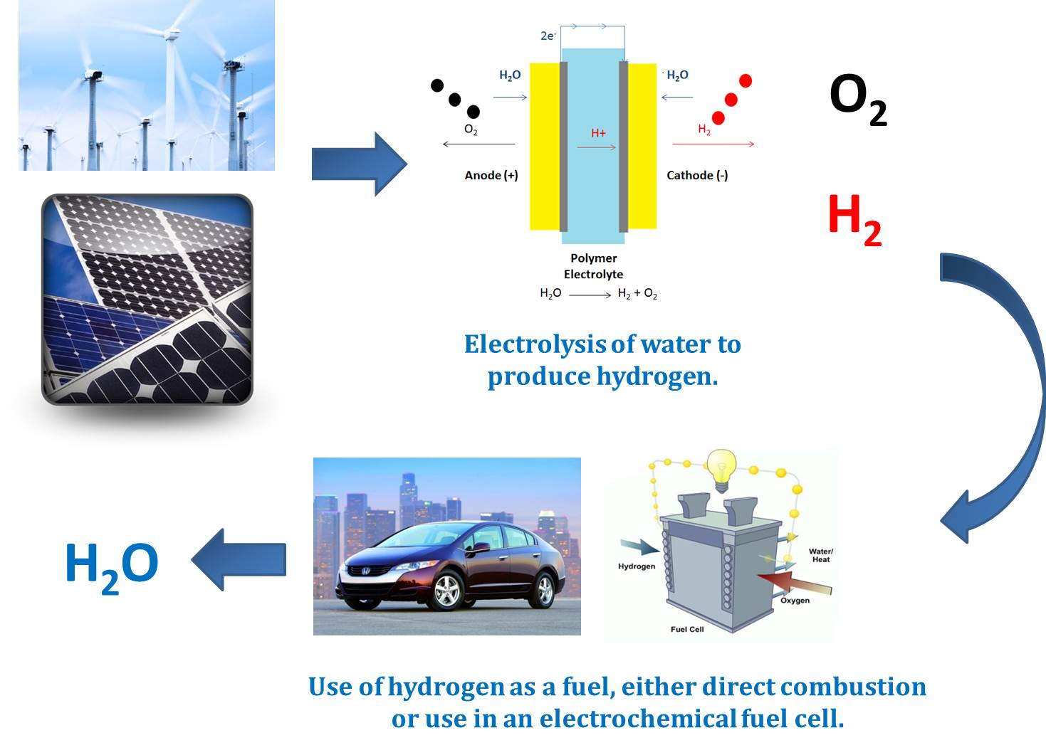
Figure 1. Renewable Hydrogen Economy. Images reproduced from Honda^{[9]} and the Institute of Physics^{[10]}.
Current infrastructure would not support this change in fuel type and a change from niche use to an envisioned hydrogen economy would take a number of decades^{[11]}. The technology required is still currently undergoing research and development to improve cost comparison with fossil fuel technologies, real and perceived safety issues, hydrogen storage and efficiency and commercialisation of devices^{[12]}.

1.2 Fuel Cells and Electrolysers

The concept of electrochemical fuel cells was pioneered by William Grove in 1838^{[13]}. The fuel cell proposed by Grove was based on Hydrogen (H₂) fuel, Oxygen (O₂) and platinum electrodes^{[14]}. H₂ and O₂ react to produce water and electrical energy. The reversal of this cell is electrolysis where water is split using electricity.

2H₂ + O₂ 2H₂O [1]

A standard fuel cell would comprise an anode (negative electrode), cathode (positive electrode) and an electrolyte together with accompanying circuit and gas inlets^{[15]}. The hydrogen gas ionises at the anode, H⁺ ions are formed and electrons released. The H⁺ ions pass through the electrolyte and at the cathode electrode O₂ reacts with the electrons and H⁺ to form water^{[15]}. This is demonstrated in the equations below showing the reaction for a Polymer Electrolyte Membrane Fuel Cell, a catalyst is required, for example; platinum or palladium. Platinum and palladium are mined in various countries including South Africa, Canada and Russia. These catalysts can prove expensive with platinum costing around $44 per gram and palladium $28 per gram (average prices as of 2014)^{[16]}.

Anode: H₂ 2H⁺ + 2e⁻ [2]
Cathode: 2H⁺ + 2e⁻ + ½O₂ H₂O [3]

There are a number of different fuel cell technologies, for example, Polymer Electrolyte Membrane Fuel Cells (PEMFC) (these can also be referred to as proton exchange membrane fuel cells), Direct Methanol Fuel Cells (DMFC), Solid Oxide Fuel Cells (SOFC), Alkaline Fuel Cells and Molten Carbonate Fuel Cells (MCFC) ^{[15]}. Although based on the same fundamental idea, there are a number of differences between these systems including operating conditions, materials, cost, raw fuel, mobile ion and optimum application. For example, solid oxide fuel cells operate at high temperature (>800°C) and use Yttria-Stabilised Zirconia (YSZ) as the electrolyte^{[4]}.

A polymer electrolyte membrane fuel cell can be seen in the following diagram:

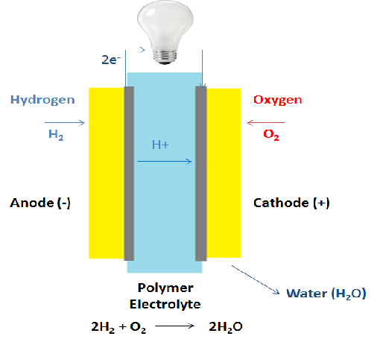

Figure 2. Polymer Electrolyte Membrane Fuel Cell.

PEMFC technology was used in the NASA Gemini flights of the 1960’s, using partially sulfonated polystyrene membranes^{[17]}. These membranes exhibited power densities of 0.4 – 0.6 kWm⁻², subsequent development increased the power density. PEMFC’s typically operate between 30 and 100°C with a H⁺ mobile ion^{[15]}. The H⁺ ion moves from anode to cathode. They typically operate at power densities of 0.7 Wcm⁻². This can vary substantially depending upon a number of factors including: polymer electrolyte material; cell design and catalyst loading. Electrolytes within the PEMFC’s are often polymers with sulfonate, quaternary ammonium or carboxylate groups^{[18]}. Nafion a perfluorinated polymer with sulfonic acid functionality is the industry standard for cation exchange fuel cell polymer electrolyte membranes. The membranes and cell set up used in fuel cells can also be used in an electrolyser, where the reactions are reversed, producing H₂ and O₂ gases^{[4]}.

Electrolysers can provide a clean source of very pure H_{2,} compared to the H₂ derived from the steam reforming of methanol which is a petrochemical process. The same principles and components are used in water electrolysis PEM devices with Nafion being the most commonly used membrane. The first PEM water electrolysers were developed by General Electric in the 1960’s^{[19]}. The choice of cell design, catalyst, the need for a very clean construction environment and high capital costs of devices has meant their commercialisation has been limited^{[20]}. Although, 70% of the cost of hydrogen produced in this manner is attributed to the electricity required, so a decrease in the power consumption of the device can compensate for the high capital expenditure^{[20]}. Hydrogen produced via an electrolyser can be used in conjunction with renewable energy sources, with the hydrogen used as an energy carrier or storage medium, compensating for the intermittent energy supply provided by the renewable resource, for example, wind turbine or solar panel^{[19]}.

Many core components of fuel cells and eletrolysers are reviewed in literature, comparing performance, design, material choice and many other parameters. A review by Wang et al indicated that more work needs to be undertaken looking at catalysts, type and loading, gas diffusion layer, and the interfaces and gas channels in the fuel cell^{[21]}. Carmo et al highlight the challenges facing the commercialisation of electrolyser devices, these include, improving electrocatalysts, development of low cost materials substitutes to expensive titanium components, develop alternative membranes which have higher durability and lower gas crossover and the requirement for more system modelling^{[19]}. Therefore identifying the research requirement for alternative polymer electrolyte materials for both fuel cells and electrolysers.

1.3 Ion Exchange Membranes

Ion exchange membranes are used in a number of applications for example: electrodialysis; separator and electrolyte in batteries; electrolysers and fuel cells; sensors and a number of industrial processes^{[22]}. Cationic and anionic groups can be present in the membrane material and polymers containing ionic groups are referred to as ionomers^{[23]}. The IUPAC definition of an ionomer is: ‘A macromolecule in which a small but significant proportion of the constitutional units have ionisable or ionic groups, or both’^{[24].} These membranes are often crosslinked to provide structural stability. Polymer electrolyte membranes often contain different hydrophobic and hydrophilic regions with the hydrophilic regions containing covalently bound ionic groups, these discreet regions are also covalently bonded forming a copolymer comprising hydrophilic and hydrophobic areas^{[25]}. Therefore, the areas will phase separate and be composed of hydrophilic ionic areas or channels in a hydrophobic matrix^{[25]}.

Ion exchange membranes can be classified according to ionic groups within the structure of the membrane including; cation exchange membranes (anionically charged groups within in the membrane), anionic exchange membranes (cationically charged groups within the membrane), amphoteric ion exchange membranes (both cationic and anionic groups within the membrane) and bipolar ion exchange membrane (a layered membrane, with a cationic exchange layer and a anionic exchange layer)^{[26]}.

A number of commercial membranes are marketed as ion exchange membranes suitable for use in a fuel cell or electrolyser. These include Flemion, a fluoropolymer made by Asahi Glass^{[27]} , Gore-Select made by Gore^{[28]} and a perfluorinated sulfonic acid membrane, Nafion, developed by DuPont^{[29]}.

1.4 Nafion

The most commercially successful and studied proton exchange membrane is Nafion which was patented by DuPont in 1964^{[30]} and is a copolymer comprising a tetrafluoroethylene backbone with perfluorovinyl ether side chains which are terminated with a sulfonic acid group. In addition to its use in fuel cells and electrolysers Nafion can be used for a number of other applications, including, chloralkali cells and electrochromic devices^{[31]}.

Figure 3. Chemical structure of Nafion.

Nafion is characterised by equivalent weight (EW) (the number of grams of dry Nafion per mole of sulfonic acid groups)^{[31]}. Commercially available Nafion is described in terms of EW and thickness. Therefore, Nafion 117 would have an EW of 1100g and thickness of 0.007 inches. Nafion conductivity when hydrated is as a result of ionisation of the sulfonic acid groups leading to solvated protons, with conductivity values of 0.08 S cm⁻¹ - 0.1 S cm⁻¹ reported^{[32]}. Conductivity is optimum when the membrane is fully hydrated. Nafion is available in the free acid and sodium salt forms.

Although Nafion is a well-studied membrane used in commercial devices there are some issues with its use. These issues include high cost, high methanol permeability and a high level of osmotic drag where water is transferred from the anode to the cathode potentially causing flooding and compromising cell performance^{[25]}. Safety during synthesis and use have also been cited as potential problems, with toxic intermediaries and corrosive gases being released at temperatures above 150°C^{[17]}. As a consequence, it has been identified as a technological need to investigate alternative polymer systems.

1.5 Ion Transport Through Polymer Membranes

There are numerous studies investigating the transport of ionic species through ionomer membranes, with Nafion being the main subject of such research^{[33, 34]}. It is proposed by Gierke after studies of Nafion using small angle x-ray experiments, that Nafion can be described using a cluster network model^{[35, 36]}. Upon hydration in polar solvents the sulfonic acid group will dissociate and form a hydrophilic phase with the solvent^{[33]}. Due to the interaction between hydrophilic and hydrophobic domains, it is proposed that inverted micelles are formed which aggregate into spheres (3nm -5nm diameter) and these clusters are connected by narrow channels (1nm – 2nm diameter) which provide a network for diffusion through the ionomer^{[33]}.

The protons move through the network when the membrane is hydrated, dissociating the proton forming a hydronium ion (H₃O⁺)^{[37]}. The water moves through the membrane via diffusion across a concentration gradient and electroosmotic drag, the charged hydronium ions dragging the polar water molecules^{[37]}. As hydronium ions move through the membrane the dissociated proton can pass to adjacent water molecules, facilitating charge transport without the bulk mass transport of water^{[37]}. This mechanism of protons ‘hopping’ between water molecules is called the Grotthuss mechanism^{[38]}. The morphology of a Nafion membrane helps to facilitate this transport mechanism and this should be considered when designing an alternative membrane chemistry.

1.6 Alternatives to Nafion

Due to the limitations of Nafion, alternatives have been investigated that are both hydrocarbon and perfluorocarbon based. There are a number of properties of a polymer electrolyte which make it suitable for use in a PEMFC or electrolyser device. Smitha et al^{[17]} identified the following as desirable:

- High proton conductivity; high currents are required with minimal resistive losses and no electronic conductivity.
- Good mechanical strength and stability.
- Chemical and electrochemical stability under operating conditions, for example, oxidising environments and elevated temperature.
- Moisture control within the fuel cell stack.
- Low fuel or O₂ bypass; maximising coulombic efficiency.
- Production costs in line with the end use of the system.

These parameters are considered routinely when investigating polymer electrolyte materials. Proton conductivity, mechanical strength, water content, chemical and thermal stability, methanol permeability (if the membrane is to be considered for use in direct methanol fuel cells) and fuel cell performance are regularly measured and compared. The ion exchange capacity (IEC) of the membranes is often measured, defined as a measure of ionic group concentration within the membrane, the IEC is expressed as the mass of dry membrane per molar equivalent of ionic conductor with the units mmol g^{-1[39]}. This parameter can be measured by titration, membranes are converted to the sodium or potassium form by treatment with a solution of known molarity, the treatment solution is then acid base titrated to calculate IEC^{[39]}. The fuel cell performance is shown to increase with increasing IEC value^{[40]}.

Work has been conducted in recent years addressing these issues, with novel materials being synthesised and investigated for the required properties. Research routes have included; modification of perfluorinated systems, the functionalization of aromatic hydrocarbon systems and composites^{[41]}. The perfluorinated membranes on which the current technology is based are expensive and have a number of issues, including the need for full hydration when in operation^{[39]} and an unsuitable level of methanol permeability. Polymer technologies which allow operation above 100°C thus improving efficiency have been investigated^{[42]}, for example, the modification of Nafion can increase the conductivity at temperatures above 100°C. Savinell et al incorporated phosphoric acid into a Nafion system and reported a conductivity of 0.05 S cm⁻¹ at 150°C^{[43]}.

Within a fuel cell system there are a number of factors which can affect the performance of a membrane. The hydration of the membrane is important, with higher conductivity observed at higher hydration levels^{[17]}. Water swelling is often a useful parameter when considering membrane suitability for fuel cell and electrolysis devices. However, the membranes can also be too wet causing flooding at the cathode (in a fuel cell) which can be problematic by slowing down the oxidation reaction^{[17]}. When the H⁺ ions travel through the membrane from anode to cathode water molecules can be carried along, causing cathode flooding, this mechanism of electro-osmotic drag has been well studied in Nafion membranes ^{[44]}. The electro-osmotic drag coefficient is a measure of the rate of the effect, defined as the mean number of water molecules dragged through the membrane per proton in the absence of a water concentration gradient^{[44]}. The thickness of the proton exchange membrane can have an effect on membrane performance so that thinner membranes have lower resistance and suffer from less water drag^{[44]}. Reducing the thickness of the membrane may adversely affect the mechanical properties of the polymer and a compromise between thickness and performance may have to be made.

There are different approaches for looking at possible polymer electrolyte materials, and materials can be classified into various categories including:

- Perfluorinated ionomer materials
- Non-fluorinated hydrocarbons
- Acid-base blend membranes
- Modifications to Nafion, including for example, the addition of zeolites, clays, conductive polymers, acid base complexes and heteropolyacids^{[39]}.

The physical characteristics and performance vary for these different approaches. However, the perfluorinated ionomers have many desired properties including chemical and thermal stability, low resistance and good proton conductivity^{[17]}.

There have been a number of different polymer systems and proposals with regard to alternative membranes. The sulfonation of different base polymers has been investigated and their suitability as a proton exchange membrane assessed, for example, poly(benzimidazole) (PBI)^{[45]} which exhibited limited ionic conductivity as a result of low water uptake, poly(arylene ether ketone)^{[46]} and poly(ether ether ketone)-block-sulfonated poly(butadiene) copolymers^{[47]} (ionic conductivity in water measured in the range of 10⁻² S cm⁻¹). Semi-IPN membranes have also been investigated, with Lin et al reporting a crosslinked poly(vinyl alcohol) (PVA), poly(styrene sulfonic acid-co-maleic acid) semi-IPN. The power density of this membrane was reported as 0.7 W cm^{-2[48]}. The use of ionic liquids in fuel cell membrane systems has also been explored. For example, Ye and co-workers have synthesised an ionic liquid gel polymer based on anhydrous proton solvent H₃PO₄, the protic ionic liquid PMIH₂PO₄, and PBI^{[49]}, the synthesized membrane was investigated for use at elevated temperature (>100°C) and exhibited proton conductivity of 2.0 × 10⁻³ S cm⁻¹ at 150 °C and under anhydrous conditions^{[49]}. Sulfonated poly(ether ether ketone) (SPEEK) has been investigated by a number of research groups, looking at SPEEK as an individual polymer and also as part of composite or system additive^{[50-53]}. SPEEK can be easily fabricated into a membrane and can be sulfonated to a high degree, thus providing the required proton conductivity^{[19]}. Although SPEEK can swell excessively and possibly dissolve if the temperature is elevated^{[19]}.

1.7 Polymers and Polymer Architecture

Integral to the PEMFC is the polymer membrane in the centre of the cell. Polymers are long chains of covalently bonded molecules, both natural, for example, proteins and polysaccharides and man-made, for example, nylon, poly(tetrafluoroethylene) (PTFE) and polyurethanes^{[54]}. The concept of chemical reactions which form high molecular weight materials by the covalent linking of small molecules was published by Herman Staudinger in 1920^{[55]}. There are a number of routes to the polymerisation of monomer units, including free radical polymerisation, condensation polymerisation, step growth polymerisation and ionic polymerisation^{[54]}.

Although the definition of a polymer as a long chain implies that the polymers are straight linear chains, complex architectures can be synthesised. Examples of complex architectures include, polymer brushes, combs, stars, branched polymers and dendrimers^{[56]}, these are illustrated in figure four.

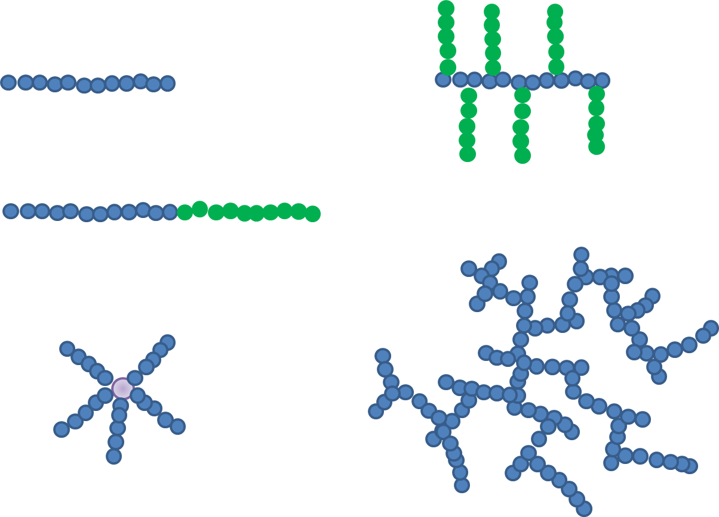
Figure 4. Examples of Polymer Architectures. From top left clockwise, linear polymer, comb polymer, hyperbranched polymer, five armed star polymer, AB block copolymer^{[56]}.
The architecture of the polymer can affect the properties of the material, including rheological properties, glass transition temperature and lower critical solution temperature^{[57]}, Polymers can be designed for the specific applications, with architecture one of the important factors which can be altered.

1.8 Free Radical Polymerisation

Free radical polymerisations are a method of chain polymerisation which occurs when an alkene π double bond opens with one electron in each direction to give a carbon chain backbone of single σ bonds^{[58]}. Many common everyday materials are formed using this technique including polyvinyl chloride (PVC) and polystyrene (PS) with almost 50% of commercially available polymers synthesised via radical polymerisations^{[59]}. The progression of free radical polymerisation occurs in four stages, initiation, propagation, chain transfer and termination.

The first step of the reaction is initiation. Useful compounds for use as free radical initiators will undergo homolytic fission to generate radicals, which subsequently react with the chosen monomer^{[60]}. Radicals are formed by decomposition of an initiator molecule, often either thermal or photolytic. Persulfates (S₂O₈), peroxides (-O-O-) and azo compounds (-N=N-) can be used as free radical initiators with decomposition routes shown in figure 5:

α,α’-Azoisobutyroniltrile decomposes to generate two cyanopropyl radicals:

Persulfates decompose to generate two sulfate radicals:

S₂O₈²⁻ 2SO₄

Figure 5. Decomposition Routes of Common Free Radical Initiators.

Ionising radiation can also be used to produce radicals, the radiation (α, β, γ or X-rays) causes the ejection of an electron, dissociation and then electron capture forming a radical^{[60]}.
The decomposition of one initiator molecule will create radical(s). The reaction of the radical with the vinyl group on the monomer will open the double bond and allow the activated monomer unit to react with other monomer units; this creates a chain (propagation). The reaction terminates when two radicals combine producing dead polymer (bimolecular termination). Termination can also occur by disproportionation, whereby in most cases hydrogen is abstracted from one end of the chain to give an unsaturated chain end and a saturated chain end. This process is outlined in the following equations:

Initiation

I 2R

R + M RM₁

Propagation

RM_{n} + M RM_{(n+1)}

Termination

RM_{n} + RM_{n} RM_{n}-M_{n}R (dead polymer)

RM_{n} + RM_{m} RM_{n}-RM_{m} (CH=CH₂) (disproportionation)

The kinetics can be related to the mechanism. During initiation the decomposition of the initiator and formation of an active monomer radical occur with the decomposition of the radical being slower than the formation of the active monomer radical meaning this is the rate limiting step^{[58]}. The propagation of chains is a rapid addition of monomer units with all monomer being consumed after a period of time^{[58]}. The rate of monomer loss can be related to the propagation rate [R_{p}] also described as the rate of polymerisation. The reaction is steady state so the rate of initiation is equal to the rate of termination^{[54]}.

1.9 Emulsion Polymerisation

Emulsion polymerisations were developed in the early 20th century with patents appearing in the late 1920’s. Mass production of materials via this technique became widespread during World War II^{[61]}. Emulsion polymerisation is a very versatile technique which is used to synthesise polymers for many different applications, including, synthetic rubbers, binders, adhesives, paints, coatings and printer inks^{[62]}. Emulsion polymerisations are a form of heterogeneous free radical polymerisation, resulting in a suspension of polymer colloids. These stable dispersions are referred to as a latex, with particle diameters in the order of approximately 100nm ^{[54]}. Polymer chains can be isolated from the suspension if required. The basic component chemicals of an emulsion polymerisation are water, a water insoluble monomer or monomers, emulsifying agent (surfactant) and water soluble free radical initiator, for example, potassium persulfate. Monomers are often hydrophobic and can include styrene, butyl methacrylate, butadiene and vinyl acetate^{[62]}. Anionic surfactants are often used for example, sodium lauryl sulphate (see figure 6). The structure of the surfactant is that of a hydrophilic charged head group with a hydrophobic hydrocarbon chain, due to this hydrophobicity the solubility of the molecule in water is limited and above a specific concentration the surfactant molecules will form a micelle, this is termed the critical micelle concentration (CMC)^{[54]}, micelle structure can be seen in figure six. Propagation of the polymerisation occurs within the hydrophobic centre of the micelle, with micelles being typically between 5 nm and 10 nm^{[63]}.

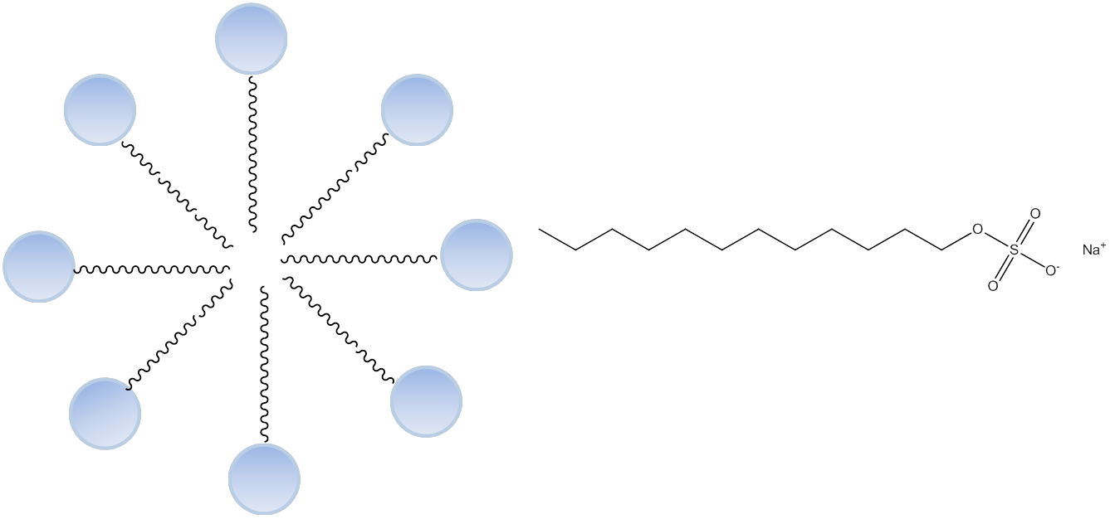
Figure 6. Micelle Structure and the Structure of Sodium Lauryl Sulfate. Surfactant concentration in water will be above the critical micelle concentration, to form these structures.
1.10 Mechanism and Kinetics of Emulsion Polymerisation.
Theories on the mechanisms and kinetics of emulsion polymerisation were published by Harkins^{[64, 65]} and Smith and Ewart^{[66]} in the mid twentieth century. The mechanism and kinetics of emulsion polymerisation is complex and can be split in to three stages (intervals). Figure seven shows schematically the mechanism of emulsion polymerisation.
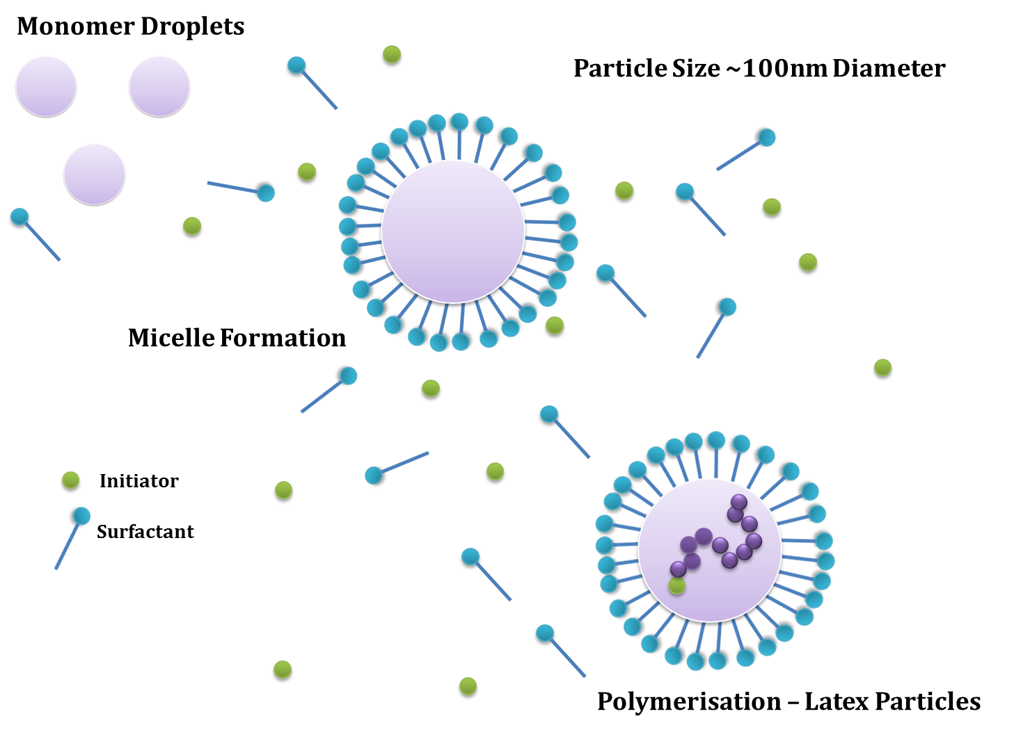
Figure 7. Schematic of Emulsion Polymerisation Mechanism.
Interval I describes the start of the polymerisation reaction, termed the particle nucleation phase. When the monomer, water and initiator components of an emulsion polymerisation are combined with surfactant above the CMC there are three phases. These comprise the aqueous phase where small amounts of monomer are dissolved in solution, the second phase where droplets of monomer (≥1µm diameter) are in suspension due to agitation and adsorbed surfactant and the third phase of monomer swollen micelles^{[54]}. Free radicals from the decomposition of initiator will polymerise with monomer dissolved in the aqueous phase. As the chains become oligomeric their hydrophobicity will increase and they will diffuse into monomer swollen micelles and propagation of those chains will continue, the particles grow in size and the surfactant micelles which don’t contain a growing polymer chain will separate and facilitate the propagating micelles. When all the micelles are exhausted this phase of the polymerisation ends^{[63]}.

Interval II is the continued propagation of the polymer chains, which is facilitated by the diffusion on monomer into the monomer swollen micelles. Indicating that the monomer droplets act as monomer and surfactant reservoirs^{[54]}. The number of particles per unit volume of latex will remain constant during this interval. Monomer diffuses into the particles at a rate which exceeds that of the polymerisation therefore the monomer concentration within the micelle will remain constant and consequently the polymerisation rate will remain constant.

Interval III is the point at which the monomer droplets have been depleted and the rate of polymerisation will decrease as the residual monomer is polymerised. The polymerisation rate and monomer conversion can be plotted to show the differences in polymerisation rate with monomer conversion. This can be seen schematically in figure eight, with the constant rate phase being between approximately 20% and 60% monomer conversion^{[63]}.

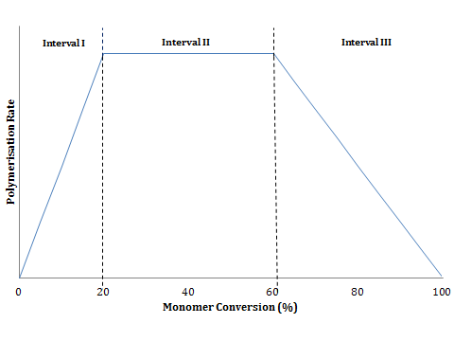
Figure 8. Monomer Conversation Compared to the Rate of Polymerisation for a Typical Emulsion Polymerisation Reaction.
Smith-Ewart kinetics can be applied to calculate the polymerisation rate (R_{p}) using the following equation^{[66]}:
R_{p} = k_{p} [M]_{p}(nN_{p}/N_{A})
Where k_{p} denotes the propagation rate constant, [M]_{p} the concentration of monomer in the particles, n is the average number of free radicals per particle, N_{p} the number of particles per unit volume of latex and N_{A} the Avogadro number^{[63]}. Surfactant and initiator concentration are important parameters with the N_{p} being proportional to the surfactant concentration and initiator concentration to the 0.6 and 0.4 powers respectively^{[63]}.

1.11 Core Shell Polymer Particles

Core shell polymer particles are comprised of composite particles containing different material components of a core and shell^{[67]}, a diagram can be seen in figure nine. These composite materials can offer differing properties when compared to the single component polymer particles, this can increase their usefulness, including functionality, for example, incorporating amine groups into the shell^{[68]}. Core shell polymer particles have been used for a number of applications including, adhesives^{[69]}, drug delivery vehicles^{[70, 71]} and surface coatings^{[72]}. Core shell polymer particles can be formed by emulsion polymerisation, dispersion polymerisation and precipitation polymerisation techniques, this can be done in sequence with the different monomers^{[67]}, for example, core particles can be formed via an emulsion polymerisation, this latex could then seed a further emulsion polymerisation enabling a shell made from a different monomer to be formed around it^{[73, 74]}. Reactions where the cores are formed in situ are also carried out and can act as a more facile method reducing the complexity and cost of the reaction^{[67]}. Core shell particles are also often cross linked to provide stability.

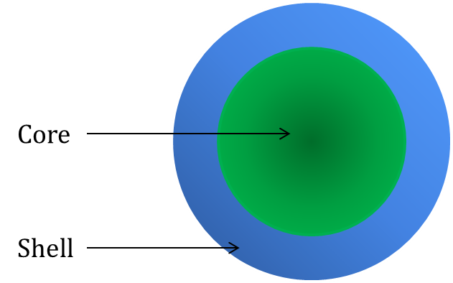
Figure 9. Core Shell Polymer Particle Structure.

1.12 Controlled/Living Radical Polymerisation

Whilst living polymerisations were reported by Szwarc in 1956^{[75]}, controlled/living radical polymerisations have been discovered and developed since the late 1970’s^{[76]}. There are a number of different methodologies, for example, nitroxide mediated polymerisations (NMP)^{[77, 78]}, atom transfer radical polymerisation (ATRP)^{[79, 80]} and reversible addition fragmentation chain transfer polymerisation (RAFT)^{[81]} all of which can be used to polymerise monomers which have vinyl functionality, however some families of monomer may be more suitable for particular techniques than others. Living polymerisations are not exclusively governed by chain transfer and termination as there is an equilibrium between the active and dormant species^{[78]}. Since 2010, IUPAC have recommend these techniques be called reversible-deactivation radical polymerisation^{[82]}. These techniques allow control over the molecular weight, composition, architecture, polydispersity and functionality^{[59]}. All of these are properties which conventional free radical polymerisation can not offer the same level of predictability and control over.

1.13 Nitroxide Mediated Polymerisation

Nitroxide mediated polymerisation (NMP) was first reported by in the 1980’s by Rizzardo et al^{[83]}. Nitroxide species are introduced to the free radical polymerisation and act as a control agent. There are a number of compounds used for this purpose including 2,2,6,6-tetramethylpiperidinyloxy (TEMPO)^{[84]}, nitroxides with spiro structures^{[85]}, and 2,2,5-trimethyl-4-phenyl-3-azahexane-3-nitroxide (TIPNO)^{[86]}. Reversible termination between the propagating radical polymer chains and the nitroxide yield a macro alkoxyamine. This is the dormant species, however upon an increase in temperature this will generate back the propagating radical and nitroxide via homolytic cleavage. Therefore establishing an activation-deactivation equilibrium and living characteristics^{[78]}. There are principally two different methods, one of which involves a free radical initiator and a nitroxide species or a unimolecular initiator can be utilised which will decompose to give the initiator radical and nitroxide^{[78]}. It has been observed by Hawker et al that the unimolecular systems may provide better control over the molecular weight and polydispersity of the polymer^{[78, 87]}. Figure 10 shows the mechanism for NMP.

Figure 10. NMP Mechanism. Route 1 denotes the unimolecular system, whereby the compound decomposes into both the initiator and nitroxide species and route 2 is the bimolecular pathway with separate initiator and nitroxide molecules. Redrawn from Nicolas and Spanswick^{[78]}.
NMP can be used to polymerise a number of monomer families including, acrylates^{[88]}, styrenes^{[89]} and vinyl chloride^{[90]}. The synthesis and choice of nitroxide or alkoxyamine is important and there has been extensive research into molecule design, synthesis and use^{[87]}. As an example, Benoit et al used phosphonate derivative alicyclic nitroxides to facilitate the polymerisation of acrylates, acrylamide, 1,3 dienes and acrylonitrile^{[86]}. These nitroxide species are different to the original TEMPO compound.

1.14 Atom Transfer Radical Polymerisation

Atom transfer radical polymerisation (ATRP) was first investigated by Kato et al^{[80]}. As a system, ATRP comprises of monomer, an initiator with a transferable (pseudo)halogen, for example, alkyl halides and a catalyst comprised of a transition metal species with an appropriate ligand^{[91]}. Radicals are generated via a reversible redox process which is catalysed by the transition metal complex. This undergoes a one electron oxidation with the simultaneous abstraction of a (pseudo)halogen from a dormant species. Polymer chains grow by the addition of radical species as in a standard free radical polymerisation. Termination does occur in ATRP, there will be a small number of these terminated chains and uniform growth which is achieved via rapid initiation and reversible deactivation^{[91]}. A schematic mechanism can be seen in figure 11:

Figure 11. ATRP Mechanism. Redrawn from Matyjaszewski and Xia^{[91]}.
ATRP can be used to polymerise a range of vinyl monomers including styrenes^{[92]}, methacrylates^{[93, 94]}, acrylamides and acrylonitrile^{[95]}. One drawback of ATRP polymerisation routes is the presence of the transition metal catalyst, for example, a copper halide, in the end product^{[91]}. This can be problematic to remove and may be detrimental for the practical use of the polymer and as such the process has not been employed extensively in industry^{[96]}. In the laboratory, the catalyst can be removed using a silica or alumina column^{[96]}, this is not always practical on a mass production scale. As a consequence, there are numerous publications addressing the removal of the catalyst from the final product be it as a post polymerisation removal method or the use of a immobilisation technique for the catalyst so that concentrations in the final product are kept to a minimum^{[97]}, including using supported catalysts^{[98]}, ion exchange removal^{[99]}, liquid extraction and repeated precipitation into a solvent which can solubilise the metal complex^{[97]}.

1.14 Reversible Addition Fragmentation Chain Transfer Polymerisation

Reversible addition fragmentation chain transfer polymerisation (RAFT) is a form of living free radical polymerisation reported by Chiefari et al in 1998^{[81]}. RAFT polymerisations use a dithioester, trithiocarbonate, xanthate or dithiocarbamate compound as a chain transfer agent (CTA)^{[100]}. In the case of xanthate use, the polymerisation is renamed macromolecular design via interchange of xanthates (MADIX)^{[101]}. The mechanism for this type of polymerisation initiates in the same manner as conventional free radical polymerisations, then the propagating radical reversibly adds on to the chain transfer agent, subsequent fragmentation of this intermediate radical forms a polymer chain with an attached RAFT moiety and a new radical which can then react with monomer to form a new propagating polymer chain^{[102, 103]}. There is a rapid equilibrium between the polymer chains with attached RAFT moieties (dormant) and the propagating radicals (active) which means that all chains have an equal probability of propagation^{[102]} leading to polymers with narrow dispersities (<1.2)^{[81]}. RAFT polymerisation can be used for a variety of functionalised monomers, for example, fluorine, carboxylic acids, hydroxyl, epoxy and betaine^{[100]}. Figure 12 is a schematic representation of the RAFT mechanism:

Figure 12. RAFT Mechanism. Redrawn From Moad et al^{[100]}.

RAFT polymerisation can be used to create polymers of varying architecture^{[56]} including stars^{[104, 105]}, grafts^{[106, 107]}, hyperbranched structures^{[108]} and block copolymers^{[109, 110]}. RAFT has been used to synthesise polyelectrolytes^{[107, 111, 112]} often as part of a copolymer system, for example a brush or graft. The use of living radical polymerisations has also been reported as part of emulsion and mini emulsion polymerisations. Velasquez et al copolymerised vinylidene chloride and methyl acrylate using a water soluble macromolecular RAFT agent based on PEO under both solution and emulsion polymerisation conditions^{[113]}, a stable latex was formed with particle sizes of approximately 500nm^{[113]}. Of the different controlled living free radical polymerisation techniques RAFT is cited as the most versatile in the range of monomers and conditions it can tolerate^{[114, 115]}.

1.16 Polyurethanes and Polyureas

Polyurethanes are a class of polymer with units joined by urethane linkages also called carbamate links, they are formed by the reaction of diisocyanates and polymerisable compounds with numerous hydroxyl groups, for example a diol or polyol^{[116]}. Polyurea is formed from the reaction of diisocyanate and diamine^{[62]}. The isocyanate is an electrophile and will therefore react with the nucleophilic hydroxyl or amine groups. The reaction between the diol and diisocyanate can require a catalyst which is either a metal salt or tertiary amine^{[117]}, for example, dibutyltin dilaurate or diazabicyclo[2,2,2]octane (DABCO), whereas the reaction between diisocyanate and diamine does not and is preferred over the diol reaction^{[118]}. This reaction is a step-growth polymerisation. Step growth polymerisation describes the reaction between two or more monomers with differing reactive functionality. Monomers need to be at least bifunctional. An example of this mechanism is the condensation reaction between monomers with carboxylic acid and hydroxyl functional groups^{[54]}. The monomers will form dimers, trimers, oligomers and eventually due to the still present functional groups a longer chain polymer^{[119]}, see figure 13:

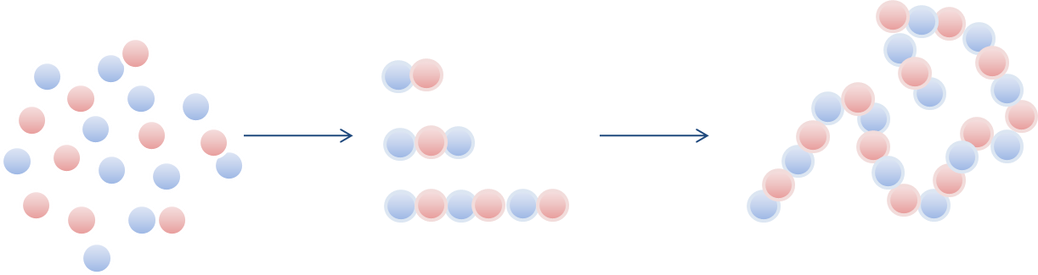
Figure 13. Schematic Representation of Step Growth Polymerisation.
Oligomeric starting materials are often used for polyurethane synthesis, for example polyesters or polyethers^{[116]}. The structure of polyurethanes is separated into hard and soft segments, with the polyester or polyether comprising the soft segment and the diisocyanate portion classified as the hard segment^{[120]}. In an elastomeric polyurethane the hard segments will form crystalline microdomains, with the soft segments remaining in amorphous randomly coiled state. However, upon stretching the soft segments become crystalline, but revert back to the amorphous state when the force is removed^{[117]}. The incorporation of ionic groups into the hard or soft segments can change the properties of the polymer and its ultimate end use.

Polyurethanes were first synthesised by Otto Bayer and co-workers in 1937^{[45]} and example uses are as elastomers, foams and paints. The main route of reaction is the urethane formation, a nucleophilic addition reaction. The basic route of synthesis is represented below:

Figure 14. Basic Scheme for Polyurethane Synthesis.
Diamines or diols can be used as chain extenders, the diols forming a urethane linkage and diamines a urea linkage^{[45]}. Chain extenders can be used to alter the polymer morphology and affect properties. Examples of suitable chain extending compounds include ethylene diamine and 1,4 butandiol. The synthesis of a polyurea is outlined below in figure 15:

Figure 15. Basic Scheme for Polyurea Synthesis.
The component compounds of the polyurethane can be aromatic or aliphatic, for example, common aliphatic diisocyanates include isophorone diisocyanate (IPDI) and hexamethylene diisocyanate (HDI), with methylene diphenyl diisocyanate (MDI) and toluene diisocyanate (TDI) common aromatic variants^{[121]}. Typical diol compounds can include polyethers terminated with hydroxyl groups, for example, poly(propylene glycol) (PPG) or polyesters, for example, poly(diethylene glycol adipate)^{[117]}. There are many examples of polyurethanes in industry, spandex, patented by Dupont is an example of an elastomeric polyurethane-urea copolymer^{[117]}. Polyurethane foams are common and can be used as insulation material, carpet underlay, synthetic sponges and in furniture^{[117]}. They are typically formed by adding water to an isocyanate terminated prepolymer, this causes an increase in the molecular weight due to the formation of urea linkages, as well as the evolution of carbon dioxide which causes the polymer to foam^{[117]}. Polyurethane coatings can also use this urea formation as a method of crosslinking. Moisture in the atmosphere will react with unused isocyanate functionality to form the urea linkages via a carbamic acid intermediate. Further to this the newly formed urea groups can react with unreacted isocyanate forming a biuret group^{[117]}, this can be observed in figure 16:
Figure 16. Urea Formation Resulting From the Reaction of Isocyanate Groups and Water.
The kinetics of the basic reaction between a diol and a diisocyanate involve sequential parallel irreversible reactions, these form oligomers and subsequent polymers^{[122]}. A simple kinetic model based on the nucleophilic addition reaction can be represented by the following equations, where A is the diol and B the diisocyanate^{[122]}:
A + B → A₁B₁
A₁B₁ + A → A₂B₁
A₁B₁ + B → A₁B₂
A₁B₁ + A₁B₁ → A₂B₂
However, the use of chain extension and monomer reactivity make this kinetic model more complicated in reality.

Aims and Project Outline
Ion exchange membranes with differing ionic functionality can be used in electrochemical devices. Continuing research has been conducted to produce a polymeric ionomer with the desirable properties, including, high ion conductivity, resistant to chemical and thermal degradation and good mechanical strength. Hydrocarbon based membranes may provide an alternative to the fluorinated polymers currently used by industry which have a number of issues.

It has been proposed that ionic polyurethanes and interpenetrating polymer networks may be suitable for use in either polymer electrolyte membrane fuel cells or electrolysers used in the hydrogen energy sector. It is proposed that membranes will be designed which have the hydrophilic ionic clusters with more hydrophobic areas allowing for the formation of channels for ion transport.

Polyurethanes with carboxylic acid functionality will be investigated for their usefulness as fuel cell or electrolyser membranes. Telechelic oligomers which are polymers of intermediate molecular weight having functionality which can facilitate further polymerisation on one or both chain ends^{[123]} are to be synthesised from the monomer starve-fed emulsion copolymerisation of t-butyl methacrylate and 1,3 butadiene (Poly(tBMA-co-BD)) with subsequent ozonolysis and further reactions to create diamine functionalised oligomers. The synthesised oligomers will be incorporated into a polyurethane/urea architecture via the formation of urea linkages between isocyanate and amine end groups, followed by subsequent deprotection of the t-butyl group to provide carboxylic acid functionality. This carboxylic acid functionality will provide the necessary means of ion transfer within the membrane. Variants will be produced to identify the optimum properties for use in this application.

Semi-interpenetrating networks and full-interpenetrating networks can be used to create an ionomer membrane. Poly(AMPS) is a sulfonic acid functionalised polymer which can be used as one component of an IPN. A highly branched PAMPS (HB-PAMPS) synthesised via RAFT polymerisation can be used as the ionic component, the branched structure providing a polymer which will be less prone to leaching from the interpenetrating polymer network (IPN) due to entanglement of the branches with the crosslinked network whilst providing the high density of sulfonic acid sites required for a highly functional membrane.

It is also proposed to use the HB-PAMPS as an additive in making ionically functional particles via the emulsion polymerisation of n-butyl methacrylate. The HB-PAMPS can be used instead or surfactant acting as a stabiliser and macroRAFT agent. These could be used as a binder material for catalyst particles in a membrane electrode assembly, which is defined as the membrane and catalyst layers within a fuel cell or electrolyser.

Project Outline

The main undertaking of this project is to synthesise and analyse various polymer systems which can be used as additives or as a complete system in a polymer electrolyte membrane fuel cell or electrolyser. It is intended undertake the following work with appropriate synthesis and analysis:

- Highly branched poly(AMPS) (HB-PAMPS) via RAFT polymerisation.
- Linear poly(AMPS) via RAFT polymerisation.
- Use of the branched and linear poly(AMPS) as emulsion polymerisation additives.
- Poly(tBMA-co-BD) with subsequent ozonolysis and work up to create diamine ended oligomers via monomer starve fed emulsion polymerisation.
- Synthesis of interpenetrating networks using HB-PAMPS and various cross linked networks (polyurethane acrylates or vinyl functional monomer mixtures) for use as polymer electrolyte membranes.
- Synthesis of ionic polyurethane/ureas using a diol, diisocyanate and the diamine functional oligomers. Where the t-butyl group can be deprotected to provide carboxylic acid functionality.

Characterisation of the prepolymers and polymer electrolyte membranes will be carried out using various techniques including NMR, SEC, dilute solution viscometry, analytical ultracentrifugation, TEM, particle size analysis, extraction studies and ion exchange capacity titrations.

Chapter 2

Synthesis of Highly Branched and Linear Poly(2-Acrylamido-2-methyl-1-Propanesulfonic Acid) via RAFT Polymerisation

2.1 Aims and Objectives

The polyelectrolyte poly(2-acrylamido-2-methyl-1-propanesulfonic acid) can be used as a component of fuel cell or electrolysis ionomer membranes^{[124, 125]}. It has been proposed to synthesise a polymer exhibiting branched architecture via RAFT polymerisation. The RAFT agent will be functional at the dithioate point allowing the polymerisation to proceed via a RAFT mechanism and possess a vinyl group to facilitate branching. It is proposed that these polymers could then be used as precursor polymers for further synthesis, including; use as stabilisers in emulsion polymerisation and as a constituent in semi-IPN membranes. The branched architecture of the polyelectrolyte would allow it to embed into the semi-IPN structure helping to prevent leaching.

Linear PAMPS samples will also be synthesised as comparison polymers and for use as a polyelectrolyte prepolymer for use in subsequent synthesis reactions.

The main objectives and outline of work for this investigation are:

- Synthesis of branching and Linear RAFT agents and characterise.
- Synthesise via RAFT Polymerisation of branched and linear PAMPS.
- Characterise the polymers in terms of composition and molecular weight using the following techniques, NMR, SEC, dilute solution viscometry and analytical ultracentrifugation.

2.2 Polyelectrolytes

Polyelectrolytes are a class of macromolecules in which a large constituent of the repeat units have ionic or ionisable groups^{[126]}. The ionic groups dissociate in solution, leaving a charged polymer chain and counterion in solution^{[127]}. The functionality can be either anionic, (for example; carboxylates and sulfates), or cationic, (for example; ammonium; quaternary ammonium ions or phosphonium salt)^{[128]}, examples of polyelectrolytes include, poly(styrene sulfonate), poly(acrylic acid) and DNA^{[127]}. Further division can categorise polyelectrolytes as weak (for example, carboxylic acids) or strong (for example, sulfonic acids). Strong polyelectrolytes will fully dissociate in solution whereas weak polyelectrolytes will not. Solutions of polyelectrolytes exhibit different characteristics to those of neutral polymers. In dilute polymer solutions intrachain interactions dominate behaviour^{[127]}. There are a number of terms and equations which can be used to describe and model these systems, with different behaviour, for example, the viscosity in a neutral polymer solution is proportional to concentration, whereas, the viscosity of a polyelectrolyte solution in proportional to the square root of the polymer concentration, this is Fuoss’ Law^{[129]}. Electrostatic interactions can be described using the Bjerrum length and the Debye length as standard^{[130]}. The Bjerrum length is the distance between two ions at which their electrostatic energy equals the thermal energy^{[130]} and the Debye length is defined as the electrostatic effect in the solution and this radius is a measure of how far these effects extend^{[127]}. As a result of this differing behaviour to neutral polymers, behaviour of the synthesised polymers needs to considered with regard to polyelectrolyte behaviour.

Free radical polymerisation techniques are the most suitable for preparing polyelectrolytes as radicals have a high tolerance to both nucleophiles and electrophiles so protecting groups are not required^{[128]}. Of the controlled living radical techniques RAFT would be very versatile as it has a high tolerance to acidic conditions^{[131]}.

2.3 2-Acrylamido-2-Methyl-1-Propanesulfonic Acid

2-Acrylamido-2-methyl-1-propane sulfonic acid (AMPS) has been investigated as a cost effective vinyl monomer with a sulfonic acid group (SO₃⁻ H⁺) thus containing a proton conductor for use in fuel cells and other applications requiring an electrolyte^{[132]}. Poly(AMPS) has been investigated for use in electrochromic devices as a proton conducting gel^{[32]}. Under conditions of low relative humidity AMPS has a higher conductivity than Nafion^{[133]}. Nafion and polystyrene sulfonic acid require 15 water molecules per sulfonic acid group to be partially hydrated, but poly(AMPS) is hydrated with six water molecules per sulfonic acid group^{[76)}. Zygadlo-Monikowska et al copolymerised AMPS and various crosslinking monomers including N,N’-methylene-bis-acrylamide, trioxyethylene dimethacrylate and trimethylpropane ethoxylate in the presence of an organic solvent and radical initiator (both UV and thermal) to form networks^{[132]}. The ionic conductivity of the electrolytes was measured (10⁻⁴ to 10⁻³ S cm⁻¹) and when AMPS comprised 20wt % of the polymer matrix, the networks were marginally lower than AMPS homopolymers.

Crosslinked copolymers of AMPS and 2-hydroxyethyl methacrylate (HEMA) have been investigated by Walker as an alternative to Nafion^{[32]}. AMPS, HEMA and ethylene glycol dimethacrylate (EGDMA) were polymerised using 2,2’-azoisobutyroniltrile (AIBN) as the free radical initiator, producing films of various AMPS and HEMA ratios. Various solvent mixtures were used including a methanol, ethanol, water mix and a dimethyl formamide (DMF) variant to alter the mechanical properties. The conductivity of the films was found to be 0.029 S cm⁻¹ for a 4% AMPS, 96% HEMA composition. When the level of AMPS was increased, the films became fragile when hydrated and conductivity measurements could not be investigated properly although the few measurements that were carried out indicated that the conductivity was higher and similar to Nafion 117^{[32]}.

Recent approaches have seen the conversion of AMPS into an ionic liquid form, conducted by neutralising the AMPS with a Brønsted base, 1-methylimidazole^{[134]}. Diao et al reported membranes composed of ionic liquid AMPS (1-Methylimidazolium 2-Acrylamido-2-methylpropanesulfonate) styrene, acrylonitrile and divinylbenzene (DVB) which were polymerised using a photoinitiator (benzoin isobutyl ether). To convert these membranes to the acidic form, samples were soaked in 1M HCl for 24 hours^{[134]}. The conductivity was measured and for a number of samples was comparable to Nafion 117 tested under the same conditions, PAMPS-DVB 70:10 had a conductivity of 5.89 x 10⁻² S cm⁻¹ compared to 5.98 x 10⁻² S cm⁻¹ for Nafion 117^{[134]}. Low methanol permeability was also reported^{[134]}.

AMPS has also been used as an addition to Nafion membranes, creating a semi-Interpenetrating polymer network (semi-IPN). Cho et al immersed Nafion 117 membranes in a mixture of AMPS, ethyl methacrylate (EMA) and 1,6-hexanediol propoxylate diacrylate (HPDA)(cross linker) dissolved in dimethyl formamide and then subsequently polymerised using benzophenone as the photoinitiator^{[135]}. The measured conductivity was similar to samples of Nafion 117 tested at the same time, with conductivity increasing as the amount of AMPS is also increased in the semi–IPN samples^{[135]}.

There are examples of poly(AMPS) being built into a semi-IPN structure. Linear poly(AMPS ) combined with polyvinyl alcohol (PVA) and subsequently cross linked with a dialdehyde, for example, glutaraldehyde^{[18]}. The aim of a semi IPN is to combine different types of polymer creating a new homogenous material, with a view to exploiting the desired properties of each material, hopefully minimising any weakness which makes the respective components of the semi-IPN unsuitable for the intended application^{[18]}. Blends of poly(AMPS) and poly(2,5-benzimidazole) (ABPBI) have been investigated by Sen et al, with various ratios of repeating polymer units explored. Under humidified conditions the conductivity of the material was 0.1 S cm⁻¹ for a ratio of ABPBI to poly(AMPS) of 1:2^{[136]}.

Of the controlled free radical methodologies, RAFT is the most suitable for acrylamido monomers although other methods, for example, ATRP have been used^{[137, 138]}. Sumerlin et al report the synthesis of linear PAMPS and poly(3-acrylamido-3-methylbutanoate) carried out using ACVA initiator and 4-cyanopentanoic acid dithiobenzoate as the RAFT agent in water at 70°C^{[137]}. The homopolymers are used as macro RAFT agents to produce more complicated block copolymer architecture^{[137]}.

2.4 Branched Polymers and Degree of Branching

Branched polymers, for example, dendrimers or hyperbranched architectures have been routinely synthesised and have found uses in a number of applications including, drug delivery and sensor technology^{[139]}. Flory theoretically examined the branching of AB_{x} monomers in 1952^{[140, 141]}, investigating the reaction of monomers with a functionality ≥ 2, this can be seen in figure 17 which schematically shows the polycondensation of an AB₂ monomer which does not form cross links. Dendrimers are regular monodisperse systems, where branched polymers are irregular polydisperse systems^{[142]}. There are three main routes to the synthesis of branched polymers including, the step growth polycondensation of AB_{x} monomers, the self-condensing vinyl polymerisation of AB* monomers and the multi-branching ring opening polymerisation of latent AB_{x} monomers^{[142]}.

Figure 17. Branched Polymer Synthesis from AB_{x} Monomer Units. Reproduced from Flory^{[140]}.

The degree of branching (DB) can be determined by NMR spectroscopy, comparing the linear (L), dendritic (D)and terminal (T) monomer units in the branched polymer^{[143]}. AB₂ monomer systems can be summarised using the following equation:
$$DB= \frac{D+T}{D+L+T}$$
However, variations of this equation depending on the monomer type for example, an AB₃ monomer unit, have been reported^{[143]}. DB values between 0.4 and 0.8 are commonly reported for hyperbranched systems^{[143]}.
2.5 Self-Condensing Vinyl Polymerisation

Self-condensing vinyl polymerisation was reported by Fréchet et al in 1995^{[144]}. AB* monomers which have one vinyl group and one initiating moiety which can be activated are used to synthesise branched polymers using a radical or cationic polymerisation technique^{[142]} often this is a controlled free radical mechanism, for example, NMP, RAFT or ATRP. The use of the AB* monomer unit allows the initiation reaction to produce two reaction sites on the monomer, one from the vinyl group and one from the B* initiating moiety, effectively making the monomer into an AB₂ unit as both initiated groups will react with a vinyl group propagating the polymer chain to create a branched structure^{[144]}. Fréchet et al used the styrene derivative monomer 3-(1-chloroethyl)-ethenylbenzene which has a vinyl group and the initiating species 1-chloroethylbenzene which can be initiated under cationic conditions, SnCl₄ was used to activate the 1-chloroethylbenzene^{[144]}. This mechanism is complex and as such the reported polydispersities were between 2 and 5, for polymers between M_{w} 68000 and 240000 g mol⁻¹. Figure 18 shows the mechanism of self-condensing vinyl polymerisation:

Figure 18. Self-condensing Vinyl Polymerisation Reproduced from Fréchet et al^{[144]}.
2.6 Branched Poly(AMPS)

Randomly branched Poly(AMPS) type polymers were synthesised by Gromadzki et al in 2010^{[138]}. Gromadzki et al synthesised the branched polymers using a self-condensing vinyl polymerisation activators generated by electron transfer atom transfer radical polymerisation (AGET ATRP)^{[138]}. 2-(2-bromopropionyloxy)ethyl acrylate is used as the branching monomer, with the content of branching units ranging from 6 mol% to 24 mol%. A mix of pyridine and water (50:50) was used as the solvent with 1,1,4,7,10,10-hexamethyltriethylenetetramine and CuBr₂ present^{[138]}. The polymers were analysed using NMR, SEC using refractive index (RI) and multi angle light scattering detection (MALS) and small angle X ray scattering (SAXS)^{[138]}.
2.7 Materials and Methods

2.7.1 Synthesis of RAFT Agents

Synthesis of 4-Vinylbenzyl-pyrrolecarbodithioate (4-VPC)

Materials
Sodium hydride (60% in mineral oil dispersion) (Sigma Aldrich), carbon disulphide (99%, Sigma Aldrich), 4-vinylbenzyl chloride (Sigma Aldrich), magnesium sulphate (Fisher), silica gel (Fluorochem) diethyl ether (Fisher) and hexane (Fisher) were used as received. Dimethyl formamide (DMF) was obtained from the Grubbs dry solvent system. Pyrrole (98%, Sigma Aldrich) was vacuum distilled over calcium hydride prior to being used.

Method
Figure 19. Reaction Scheme for 4-Vinylbenzyl-pyrrolecarbodithioate (4-VPC).

A three necked round bottom flask was fitted with a condenser and bubbler, nitrogen inlet and a pressure equalising dropping funnel. The flask was placed on a magnetic stirrer hotplate and heated and purged with nitrogen to remove any residual moisture. Sodium hydride (2.98g, 74.53mmol) was placed in the flask and DMF (80ml) added to form a suspension. Pyrrole (5.00g, 74.53mmol) as a solution in DMF (10ml) were added dropwise over 30 minutes, thus forming yellow foam. The solution was stirred at room temperature for 30 minutes and then cooled to 0°C using an ice bath. Carbon disulphide (5.67g, 74.53mmol) as a solution of DMF (10ml) were added dropwise over 10 minutes, the solution becoming dark red. The solution was stirred at room temperature for 30 minutes and then cooled to 0°C using an ice bath. 4-Vinylbenzyl chloride (11.37g, 74.53mmol) and DMF (10ml) were added dropwise over 20 minutes resulting in a brown solution and this was stirred overnight at room temperature.

The solution was extracted using diethyl ether. The product was placed in a 1l separating funnel with diethyl ether (80ml) and distilled water (80ml). The organic layer was recovered and the aqueous phase extracted (3 x 160ml diethyl ether). The organic extracts were combined and dried over magnesium sulphate then filtered using gravity filtration. Diethyl ether was then removed using rotary evaporation.

Flash chromatography on silica gel using hexane or petroleum ether 40/60 was used to purify the product. The solvent was removed using rotary evaporation. The product was a bright yellow oil with a yield of 67%. The product was stored in amber glass at -18°C under Nitrogen.

Elemental Analysis
Expected Results: Carbon 64.9%, Hydrogen 5.1%, Nitrogen 5.4%, Sulphur, 24.7%.
Actual Results: Carbon 65.3%, Hydrogen 5.1%, Nitrogen 5.3%, Sulphur 22.41%.

¹H NMR (400MHz, CDCl₃) (ppm): δ 7.59 (2H, d, Ar), δ 7.45 (2H, d, Ar), δ 7.18 (2H, m, Ar), δ 6.76 (2H, m, Ar), δ 6.35 (1H, m, RC=CH), δ 5.81 (1H, m, RC=CH), δ 4.61 (2H, s, RCH₂Ar).

¹³C NMR (100MHz, CDCl₃) (ppm): δ 199.27 (1C, C=S), δ 137.37 (1C, C=C), δ 136.24 (1C, Ar), δ 133.96 (1C, Ar), δ 120.69 (2C, Ar), δ 114.40 (2C, pyrrole Ar), δ 114.26 (1C, C=C), δ 41.53 (1C, RCH₂)

EI Mass Spec: m/z 259

Synthesis of Benzyl-1-pyrrolecarbodithioate (BPC)

Materials
Sodium hydride (Sigma Aldrich), carbon disulphide (99%, Sigma Aldrich), benzyl bromide (Sigma Aldrich), magnesium sulphate (Fisher), silica gel (Fluorochem), anhydrous dimethyl sulfoxide (Sigma Aldrich), diethyl ether (Fisher) and hexane (Fisher) were used as received. Pyrrole (98%, Sigma Aldrich) was vacuum distilled over calcium hydride prior to being used.

Method
Figure 20. Reaction Scheme for Benzyl-1-pyrrolecarbodithioate (BPC).

A three necked round bottom flask was fitted with a condenser and bubbler, nitrogen inlet and a pressure equalising dropping funnel. The flask was placed on a magnetic stirrer hotplate and heated and purged with nitrogen to remove any residual moisture. Sodium hydride (1.79g, 74.53 mmol) was placed in the flask and DMF (80ml) added to form a suspension. Pyrrole (5.00g, 74.53 mmol) was added to the stirring suspension dropwise over 20 minutes. The reaction was stirred for 30 minutes at room temperature and then cooled using an ice bath (5°C). Carbon disulphide (5.67g, 74.53 mmol) was added dropwise over 30 minutes, with the reaction stirred for a subsequent 30 minutes. Benzyl bromide (12.69g, 74.53 mmol) was added dropwise over 30 minutes and the reaction left to stir at room temperature overnight.

The solution was extracted using diethyl ether. The product was placed in a 1l separating funnel with diethyl ether (80ml) and distilled water (80ml). The organic layer was recovered and the aqueous phase extracted (3 x 160ml diethyl ether). The organic extracts were combined and dried over magnesium sulphate then filtered using gravity filtration. Diethyl ether was then removed using rotary evaporation to give a black liquid.

Flash chromatography on silica gel using hexane or petroleum ether 40/60 was used to purify the product. The solvent was removed using rotary evaporation. The product was a bright yellow oil with a yield of 58%. The product was stored in amber glass at -18°C under Nitrogen.

Elemental Analysis
Expected Results: Carbon 61.76%, Hydrogen 4.75%, Nitrogen 6%, Sulphur 27.48%.
Actual Results: Carbon 61.82%, Hydrogen 5.53%, Nitrogen 4.75%, Sulphur 22.52%.
Issues with the elemental analysis meant that samples degraded when stored prior to analysis, structure confirmed via NMR and mass spectroscopy.

¹H NMR (400MHz, CDCl₃) (ppm): δ 7.31 (6H, m, Ar), δ 6.32 (2H, m, Ar), δ 4.61 (2H, s, RCH₂Ar).

¹³ C NMR (100MHz, CDCl₃) (ppm): δ 199.37 (1C, C=S) δ 129.43 (1C, Ar), δ 128.80 (4C, Ar), δ 127.99 (1C, Ar), δ 120.99 (2C, pyrrole Ar), δ114.24 (2C, pyrrole Ar), δ 41.76 (1C, RCH₂).

EI Mass Spec: m/z 233

2.7.2 Synthesis via Raft Polymerisation of Highly Branched 2-Acrylamido-2-methyl -1-propane sulfonic acid (HB-PAMPS).

Materials
2-Acrylamido-2-methyl-1-propane sulfonic acid (Sigma Aldrich, 99%), 4,4′-azobis(4-cyanovaleric acid)(Sigma Aldrich, ≥98%), anhydrous dimethyl sulfoxide (Sigma Aldrich, ≥99%) and acetone (Fisher) were used as received. 4-Vinylbenzyl-pyrrolecarbodithioate (RAFT agent – 4-VPC) was synthesised as described previously.

Method
Figure 21. RAFT Reaction Scheme for HB-PAMPS.

AMPS, ACVA and 4-VPC were dissolved in DMSO (20ml). The yellow solution was transferred to a glass ampoule (50ml). The ampoule was evacuated on the hi-vac line; a freeze pump thaw cycle was repeated (x3) with pressure measured at 10⁻³ mbar. The ampoules were sealed with a flame and placed in a water bath at 60°C for 6 hours or more. The polymer solution was precipitated in to acetone (800ml). The acetone was decanted off, evaporated and the polymer was washed with distilled water. The precipitated polymer was placed in a weighed one necked round bottomed flask and freeze dried.

¹H NMR (400MHz, (CD₃)₂S=O)) (ppm): δ8.02 (br), δ7.46 (br, Ar), δ5.98 (1H, br, RCH=CH), δ5.56 (1H, br, RCH=CH), δ 3.34 (2H, br, CH₂CH₂SCO), δ2.72 (2H, br, RCH₂SO₃H), δ 2.53 (2H, br, RCH₂CH₂), δ 2.09 (1H, br, RCOCH), δ 1.32 (6H, br CH(CH₃)₂).

¹³C NMR (100MHz, (CD₃)₂S=O)) (ppm): δ206.50 (RC=S), δ173.44 (RC=O), δ164.79 (RSCH₂C=O), δ133.65 (Ar), δ124.45 (Ar), δ58.86 (RCH₂SO₃H), δ52 (RCHS), δ33.07 (RCH₂), δ31.15 (RCH₂), δ27.31 (RCH₃).

2.7.3 Synthesis of Linear Poly(2-acrylamido-2-methyl-1-propane sulfonic acid) using Benzyl-1-pyrrolecarbodithioate as a Chain Transfer Agent (Linear PAMPS).

Materials
2-Acrylamido-2-methyl-1-propane sulfonic acid (Sigma Aldrich, 99%), 4,4′-azobis(4-cyanovaleric acid)(Sigma Aldrich, ≥98%), anhydrous dimethyl sulfoxide (Sigma Aldrich, ≥99%) and acetone (Fisher) were used as received. Benzyl-1-pyrrolecarbodithioate was (RAFT agent – BPC) was synthesised as described previously.

Method
Figure 22. RAFT Reaction Scheme for Linear-PAMPS.

2-Acrylamido-2-methyl-1-propanesulfonic acid (Sigma Aldrich, 99%), 4,4’ azobis(4-cyanovaleric acid) (Sigma Aldrich, ≥98%) and Benzyl-1-pyrrolecarbodithioate were dissolved in anhydrous DMSO (20ml) using a molar ratio of 25:1 AMPS monomer to chain transfer agent. The yellow solution was transferred to a glass ampoule (50ml). The ampoule was evacuated using a hi-vac line, a freeze-pump-thaw cycle was repeated (x3) with pressure measured at 10⁻³ mbar. The ampoules were sealed with a flame and placed in a water bath at 60°C for 24 hours. The polymer solution was precipitated into acetone (800ml). The acetone was decanted off, evaporated and the polymer washed with distilled water. The wet polymer was placed in a pre-weighed one necked round bottomed flask and freeze dried to give a yellow solid.

¹H NMR (400MHz, (CD₃)₂S=O)) (ppm): δ10.12 (1H, br, RNH), δ7.27 (6H, br, Ar), δ6.41 (2H, br, Ar), δ5.98 (1H, br, RCH=CH), δ5.50 (1H, br, RCH=CH), δ3.31 (2H, br, CH₂CH₂SCO), δ2.40 (2H, br, RCH₂CH₂), δ1.99 (1H, br, RCOCH), δ1.23 (6H, br CH(CH₃)₂).

¹³C NMR (100MHz, (CD₃)₂S=O)) (ppm): δ173.44 (RC=O), δ128.02 (Ar), δ59.96 (RCH₂SO₃H), δ52.55 (RCHS), δ39.92 (RCH₂), δ31.70 (RCH₂), δ25.11 (RCH₃).

2.8 Results and Discussion

2.8.1 NMR Analysis

HB-PAMPS was synthesised in a number of different ratios of RAFT agent, with all formulations having a 1:1 ratio of RAFT agent to initiator (ACVA).

Sample | AMPS (mmol) | 4-VPC (mmol) | ACVA (mmol) | DMSO (ml)
HB-PAMPS 5:1 | 6.21 | 1.24 | 1.24 | 20
HB-PAMPS 10:1 | 12.42 | 1.24 | 1.24 | 20
HB-PAMPS 15:1 | 18.63 | 1.24 | 1.24 | 20
HB-PAMPS 20:1 | 24.84 | 1.24 | 1.24 | 20
HB-PAMPS 25:1 | 31.05 | 1.24 | 1.24 | 20
Table 1. Branched AMPS Formulations made using 4-VPC RAFT Agent.
The synthesised polymers were hygroscopic and stored under nitrogen at -18°C. Samples were thermally cured (60°C) for various lengths of time, including, 6, 8, 12 and 24 hours to assess the progression of the reaction, however for all subsequent work samples thermally polymerised for 24 hours were used. The HB-PAMPS 5:1 formulation did not polymerise and this synthesis was repeated to confirm this negative result.
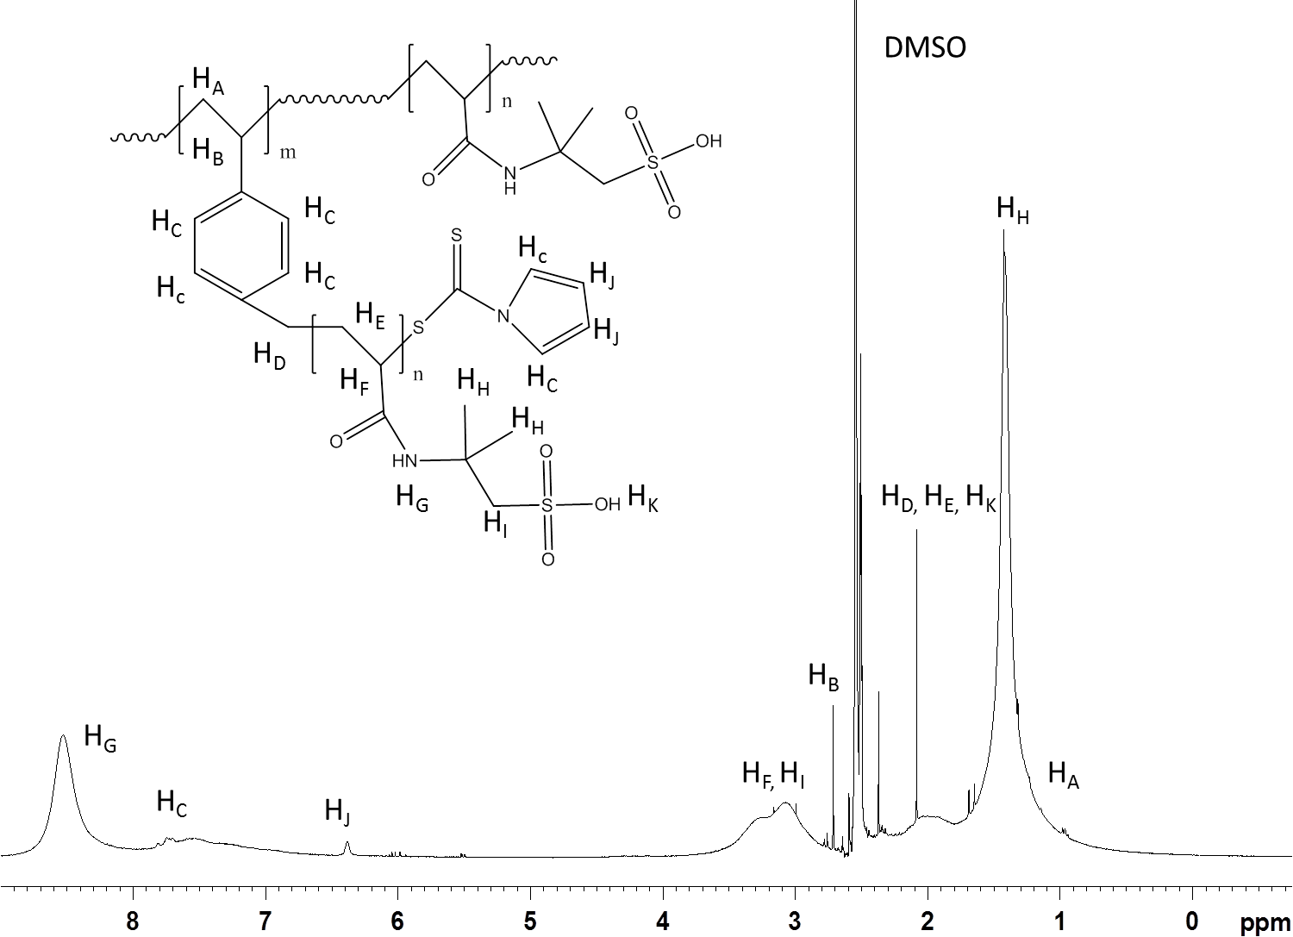
Figure 23. ¹H NMR (400MHz, (CD₃)₂S=O)) of HB-PAMPS 25:1.
Figure 23 shows the ¹H NMR spectrum for HB PAMPS 25:1, there are small peaks between δ 5 ppm - δ 6 ppm which may be residual monomer although the polymer has been precipitated. However, they are very small in comparison to the other peaks appertaining to the polymer sample.

It is proposed that reaction using the 4-VPC will proceed in a similar manner to that of self-condensing vinyl polymerisation to produce a branched structure. 4-VPC will behave as an AB₂ monomer with a vinyl group and the other initiating moiety of the dithioate group corresponding to the RAFT functionality. The degree of branching can be calculated from the ¹H NMR spectrum looking at the ratio of RAFT agent aromatic H peaks compared to the H from the methyl groups on the AMPS monomer unit (singlet peak at approximately δ 1.5 ppm corresponding to 6H).

The following equation has been used^{[108]}:

DB = Moles of RAFT Aromatic/ (Moles of RAFT Aromatic + Moles of AMPS)

DB = [(Integration Pyrrole/2)+(Integration Aromatic/6)]
[(IntegrationPyrrole/2)+(Integration Aromatic/6)]+[Integration AMPS/6]

Sample | Monomer Conversion (%) | Degree of Branching (DB)
HB-PAMPS 10:1 | 96 | 0.19
HB-PAMPS 15:1 | 98 | 0.16
HB-PAMPS 20:1 | 98 | 0.15
HB-PAMPS 25:1 | 96 | 0.09
Table 2. Degree of Branching and Monomer Conversion for HB-PAMPS.
The degree of branching increases as the amount of RAFT agent and therefore branching points is increased. Monomer conversion was calculated using the ¹H NMR of the crude polymer solvent mixture before precipitation of the solvent and comparing the vinyl groups to the methyl groups of the AMPS monomer unit. The polymers are branched, but the density of the branching points could be increased, changes in reaction condition, RAFT agent or molar ratio may facilitate this.

Linear polymer has been made using an analogous RAFT agent. This does not have the vinyl functionality located on the benzene ring of the branching RAFT agent. Benzyl-1-pyrrole carbodithioate was used to provide a RAFT functionalised linear polymer which was used in further synthesis reactions primarily in a 25:1 monomer to RAFT agent ratio. This polymer has been compared to the HB-PAMPS systems using dilute solution viscometry and has been used as a precursor polymer additive for the emulsion polymerisation of n-BMA.

2.8.2 Size Exclusion Chromatography

Size exclusion chromatography (SEC) has been problematic with regards to these particular polyelectrolyte samples and a number of different strategies have been employed, including, different eluents, columns and polymer standards. An aqueous SEC set up which used a TSKgel GMPWxl column, poly(ethylene oxide) and poly(ethylene glycol) standards, refractive index detector and 0.2M sodium nitrate/0.01M sodium dihydrogen orthophosphate eluent, was first employed to investigate the polymers. However, it was thought that the polymer chains were collapsing, therefore having a longer retention time on the column than would be expected.

SEC separates polymers based on their hydrodynamic volume (V_{h}) rather than molecular weight^{[145]}. The SEC column is packed with beads to separate the polymer based on its hydrodynamic volume in the chosen SEC eluent. Larger samples will have a shorter retention time on the column compared to smaller samples which take a longer path through the column and are detected last. Polymer chains collapse resulting in a smaller hydrodynamic volume in a ‘bad’ solvent whereas they will expand in a ‘good’ solvent^{[146]}. It is thought that the PAMPS polymers are collapsing (resulting in a smaller than actual hydrodynamic volume). The HB PAMPS samples exhibited M_{w} values of ≤ 110 g mol⁻¹ which are clearly anomalous values. The monomer pair interaction in a ‘good’ solvent is repulsive and can swell but in a ‘bad’ solvent the monomer-monomer interaction is attractive^{[54]}. In this case only the steric repulsion stops the complete collapse of the polymer chain^{[54]}. It is postulated that this is due to the possible collapse of the polymer chains in the chosen solvent systems and that the polymer chains are larger than the initial results suggested. Howere, because the values are smaller than the constituent monomers, it is thought that interaction with the column packing is the main issue in this instance. Therefore, alternative SEC systems were investigated. Example data for the initial aqueous SEC set up are detailed in table 3:

Sample | M_{n} | M_{w} | M_{z} | M_{z} + 1 | Dispersity
 | (g mol⁻¹) | (g mol⁻¹) | (g mol⁻¹) | (g mol⁻¹) | (M_{w}/M_{n})
HB-PAMPS 25:1 | 87 ± 1 | 99 ± 1 | 109 ± 1 | 119 ± 1 | 1.14
HB-PAMPS 20:1 | 90 ± 6 | 103 ± 3 | 114 ± 2 | 122 ± 2 | 1.14
Table 3. Aqueous SEC Analysis of HB-PAMPS. SEC undertaken using 0.2M sodium nitrate/0.01M sodium dihydrogen phosphate at 1ml/min flow rate as the eluent, TSKgel GMPWxl column, Hewlett Packard HP 1047A refractive index detector and PEO/PEG standards (Agilent).
Branched polymers often exhibit a smaller hydrodynamic volume than their corresponding linear analogue^{[147]}. This will affect the SEC results, possibly underestimating the molecular weight, especially if the unknown sample is compared to linear calibration standards. This will also be a factor in dilute solution viscometry measurement where a lower hydrodynamic volume will result in lower solution viscosity^{[147]}. This was a consideration when designing a SEC instrument set up to analyse the HB-PAMPS.

There are a number of strategies for the investigation of branched polymer systems, these include, SEC coupled with multi angle light scattering (MALS), which can determine absolute molecular weight and radius of gyration^{[148]}. Triple detection using a concentration detector, for example, refractive index detection, MALS and viscometric detector can provide information about the molecular weight and architecture^{[148]}. To facilitate the analysis of the branched polymers a viscometric detector (Agilent 1260 Infinity) as well as a sulfonated column (Jordi Gel sulfonated column) were fitted to the SEC instrument, with a view to minimising column interactions due to the charge repulsion. The sulfonated columns are specially designed for the analysis of anionically charged samples and as such, the column packing beads are made from divinyl benzene (DVB) cores with sulfonate groups on the surface of the beads therefore carrying an anionic charge^{[149]}. A number of different eluents were tested, with linear poly(acrylic acid) (PAA) calibration standards (Agilent), these included, 0.3M NaCl, 1M KOH and 0.08M tris(hydroxymethyl)aminomethane (TRIS)/0.15M NaCl. There were issues with the various eluents damaging the equipment. Issues with the viscometric detector set up and the analysis of the linear PAA standards reporting polydispersity values of ≥ 9 compared to certified values of ≤ 1.5, this meant that this system was not suitable for use. Although, preliminary results using the refractive index detector were obtained, table four shows example data for HB-PAMPS 25:1 and L-PAMPS 25:1:

Sample | M_{n} | M_{w} | M_{z} | M_{z} + 1 | Dispersity
 | (g mol⁻¹) | (g mol⁻¹) | (g mol⁻¹) | (g mol⁻¹) | (M_{w}/M_{n})
HB-PAMPS 25:1 | 8450 | 16000 | 26300 | 39250 | 1.89
L-PAMPS 25:1 | 750 | 7300 | 13000 | 17600 | 9.73
Table 4. Aqueous SEC Analysis of HB-PAMPS and L-PAMPS. SEC undertaken using 0.08M TRIS/0.15M NaCl at 1ml/min flow rate as the eluent, Jordi Gel sulphonated column, Hewlett Packard HP 1047A refractive index detector, and linear PAA standards (Agilent).
2.8.3 Dilute Solution Viscometry
Due to the complications in measuring the molecular weight using SEC it was concluded that a viscometric study of the PAMPS samples should be conducted. The viscosity of a polymer in solution can be directly related to the molecular weight by the Mark-Houwink equation with intrinsic viscosity [ƞ] the parameter measured by dilute solution viscometry, M the viscosity average molecular weight of the polymer and K and α constant values for a specific polymer and are dependent upon solvent and temperature, further details of the theory and equations for the technique are present in the appendix:

[ƞ] = KM^{α}

Samples were studied at 25°C in water and 1M NaCl with viscosity measured using a capillary viscometer in this case an Ubbelohde viscometer (see appendix for diagram). The concentration of the polymers ranged between approximately 1g/dL and 0.01 g/dL. Different viscosity values can be calculated and plotted to analyse the data, comparing the flow rate of the chosen solvent to that of a known concentration of polymer in solvent. The intrinsic viscosity for each polymer can be used to look at the relative molecular weight between polymers with theoretically similar architectures. In linear polymers the intrinsic viscosity will increase with increasing molecular weight, this is the same for branched polymers, however at a lower increment^{[57]}. The intrinsic viscosity is defined as the limiting value of the reduced viscosity or inherent viscosity at infinite dilution of the polymer^{[24]}, therefore the extrapolation to zero of the graph of reduced or inherent viscosity versus concentration will yield the intrinsic viscosity value.

Figure 24. Reduced Viscosity versus Concentration for HB PAMPS 25:1 and L PAMPS 25:1 at 25°C in Water.
Figure 24 shows the reduced viscosity plotted against sample concentration for HB-PAMPS 25:1 and Linear PAMPS 25:1. The PAMPS samples, both Linear and branched, exhibited polyelectrolyte behaviour when looking at the plots of reduced viscosity against concentration in water. This is the same trend as seen by Dragan et al^{[150]}, with the polymer chains expanding as the concentration of polymer in solution decreases. This is due to an increase in the Debye length which subsequently results in an increase in intramolecular repulsive interactions^{[150]}. In a neutral polymer the viscosity is proportional to the polymer concentration^{[151]}. These samples can be compared in this manner and it would appear that the linear polymer has a lower intrinsic viscosity; it is difficult to make any assumptions about the relative molecular weight as the respective architectures of the polymers are designed to be different.

1M NaCl has been used as a solvent for each polymer sample, the same graph of reduced viscosity (ƞ_{sp}/C) versus concentration gives a linear regression with much less of an upturn in the data points allowing an easier extrapolation to 0 g/dL concentration to give the intrinsic viscosity ([ƞ]). Figure 25 is a plot of the reduced viscosity and inherent viscosity versus concentration for the HB PAMPS 25:1 and Linear PAMPS 25:1 with the intrinsic viscosity the point at which both linear regressions intercept the Y axis.

Figure 25. Reduced Viscosity and Inherent Viscosity versus Concentration for HB PAMPS 25:1 and Linear PAMPS 25:1 in 1M NaCl at 25°C. Error calculated via standard error.

Figure 26. Reduced Viscosity Versus Concentration for HB-PAMPS 25:1 in Water and 1M NaCl.
Figure 26 shows the plot of reduced viscosity versus concentration for HB-PAMPS 25:1 in both water and 1M NaCl. The graph highlights the difference that using a solution with a counterion can make to the results. The use of a counterion in solution reduces the polyelectrolyte effect, represented graphically by an increased reduced viscosity at low concentration due to the polymer chains expanding as the concentration on solution decreases. This makes the plot more linear and alters the electrostatic interactions which occured when the polymer was in water.
Figure 27 is the reduced viscosity versus concentration plot for the series of branched polymers:

Figure 27. Graph of Reduced Viscosity Versus Concentration for HB PAMPS Samples. The Y axis intercept corresponds to the intrinsic viscosity. Error calculated using standard error.
The intrinsic viscosity can be used as a quantitative measure of the viscosity average molecular weight. HB-PAMPS 25:1 has the highest intrinsic viscosity and HB PAMPS 10:1 the lowest. The intrinsic viscosity values for HB PAMPS samples in 1M NaCl at 25°C as calculated using the plot of reduced viscosity versus concentration are outlined in table five:
Sample | [η] 1M NaCl at 25°C
HB PAMPS 10:1 | 0.038
HB PAMPS 15:1 | 0.077
HB PAMPS 20:1 | 0.061
HB PAMPS 25:1 | 0.098
Table 5. Intrinsic Viscosity of HB PAMPS Samples. As calculated from the reduced viscosity of the samples in 1M NaCl at 25°C.
It should be noted that these values can be compared within themselves as the polymers have the same basic composition and the analysis uses the same solvent and temperature parameters. However, the values cannot be used in the Mark Houwink equation to gain a viscometric average molecular weight as the K and α values for this particular polymer and analysis parameters are unknown. There is potential for error when carrying out this type of viscometry. Human judgement is used to time the elution of polymer solution through the capillary viscometer, this should be considered when discussing the results. At very low concentration (≤ 0.1 g/dL) the difference between the elution time of the solvent and that of the solution is very similar making timing and analysis of results more challenging.

2.8.4 Analytical Ultracentrifugation

Analytical ultracentrifugation is a technique which was employed after previous SEC analysis was found to be not entirely suitable for the strong polyelectrolytes which were synthesised. The technique of analytical ultracentrifugation was developed by Svedberg in 1924^{[152]} and has found routine use in the characterisation of proteins and DNA, but it can also be used to investigate synthetic polymers^{[153]}. This technique has the advantage of not requiring standards, a separating column or membrane^{[154]}. In a simplified sense, it comprises a standard preparative centrifuge equipped with an optical system which observes the distribution of the macromolecule over the centrifugation period^{[153]}. Two experiments can be utilised:

- Sedimentation velocity (SV) – a high centrifugal force is applied and the time course of the sample over time is analysed^{[153]}.
- Sedimentation equilibrium(SE) – a low centrifugal force is applied and a time-invariant equilibrium observed due to the diffusion balancing the sedimentation^{[153]}.

When the macromolecule in a solvent is subject to a gravitational field (ω²r) there are three forces acting on the sample^{[155]}:

- Gravitational force (F_{s}) due to the centrifugal acceleration (ω²r) inside the analytical ultracentrifuge.

F_{s} = m_{p} ω²r = (M/N) ω²r

Where m_{p} is the mass of the macromolecule, M is the molar mass of the solute and N is Avogadro’s number^{[155]}.
- Buoyant force (F_{b}) which is proportional to the mass of displaced solvent m_{s} and ω²r.

F_{b} = -m_{s} ω²r = -m_{p}ῡρ_{s} ω²r = -(M/N)ῡρ_{s}ω²r

Where m_{s} is the mass of the displaced solvent, ῡ is the partial specific volume of the solvent (reciprocal of the particle density) and ρ_{s} is the solvent density^{[155]}.
- Frictional force (F_{f}) caused by the movement of the particle through the solvent.

F_{f} = -ƒu

Where ƒ is the frictional coefficient and u is the sedimentation velocity^{[155]}.

These forces balance and the macromolecule moves with a constant sedimentation velocity represented by the following equation^{[155]}:

F_{s} + F_{b} + F_{f} = 0 = (M/N) ω²r-(M/N)ῡρ_{s} ω²r-ƒu

Rearranged to give:

M(1-ῡρ_{s}) = u ≡ s
Nƒ ω²r

It is possible to calculate the weight average molecular weight using the method of sedimentation equilibrium, with the type of optics being dependent on how this value is calculated. For absorbance optics the average slope of the plot of Ln[A] (absorbance) versus r² (the square of the radial distance from the centre of the rotor) using the flowing equation^{[156]}:

M = (dLnA/dr²) x 2RT/(1- ῡρ)ω²

Where ω is the angular velocity.

For Raleigh interference optics, which were used in this analysis, fringe displacement J vs radial displacement r, are determined and a graph of Ln[J] versus r² can be used in the same manner also giving the weight average molecular weight of the macromolecule^{[156]}.
The HB PAMPS prepared in molar ratios of AMPS to 4-VPC of 10:1, 15:1, 20:1 and 25:1 and linear PAMPS prepared in a 25:1 molar ratio were dissolved in 0.1M phosphate buffered saline (PBS) and adjusted to pH 7 using KOH. The sedimentation coefficients (measured in Svedberg units, S, 1S = 10⁻¹³ seconds) which were measured in buffer were corrected to the standard conditions of water at 20°C in terms of viscosity and density using a standard formula with values defined as s_{20, w}. In order to correct for solution non-ideality sº _{20,w} values are measured at a series of concentrations and extrapolated to zero concentration to give s _{20,w} using the “Gralen” formula:
1/s_{20,w} = (1/sº_{20,w}) x (1 + k_{s}c)
Where k_{s} is the concentration dependence coefficient.
Analysis of the M* function which is an operational point average molecular weight methodology used to assess the distribution of macromolecules in sedimentation equilibrium experiments^{[157]}. Previous methods relied on extrapolation to the cell base to measure the concentration, the M* method is less sensitive to poor cell base determination^{[158]}. The molecular weight determination using this provides the apparent weight average molecular weight, M_{w,app.} This is facilitated by using SEDFIT-MSTAR^{[158]}, a recent amendment to the MSTAR programme, which was developed by Cölfen and Harding^{[159]}. The analysis uses two different techniques to calculate the M_{w,app}, the M* extrapolation method and the hinge point method^{[158]}.
Table six details the apparent weight average molecular weight as determined by sedimentation equilibrium analysis:

Sample | s⁰_{20,w} (S) | M_{w,app} (g mol⁻¹)* | M_{w,app} (g mol⁻¹)†
HB-PAMPS 10:1 | 2.9 ± 0.1 | 95000 | 95000
HB-PAMPS 15:1 | 3.2 ± 0.1 | 100000 | 103000
HB-PAMPS 20:1 | 2.8 ± 0.1 | 100000 | 110000
HB-PAMPS 25:1 | 3.8 ± 0.1 | 150000 | -
Table 6. Sedimentation Equilibrium Data for HB-PAMPS Samples. * Apparent weight average molecular weight determined by M* method, † Apparent weight average molecular weight determined using hinge point method.
As the ratio of 4-VPC to AMPS decreases the apparent weight average molecular weight increases, this may be due to longer chains being produced due to a lower concentration of branching agent resulting in fewer propagating branches. Figure 28 provides example sedimentation coefficient results (s⁰_{20,w}) as determined from the sedimentation velocity experiments, serial dilutions are used to allow for the extrapolation of results to zero, further graphs can be seen in appendix I.
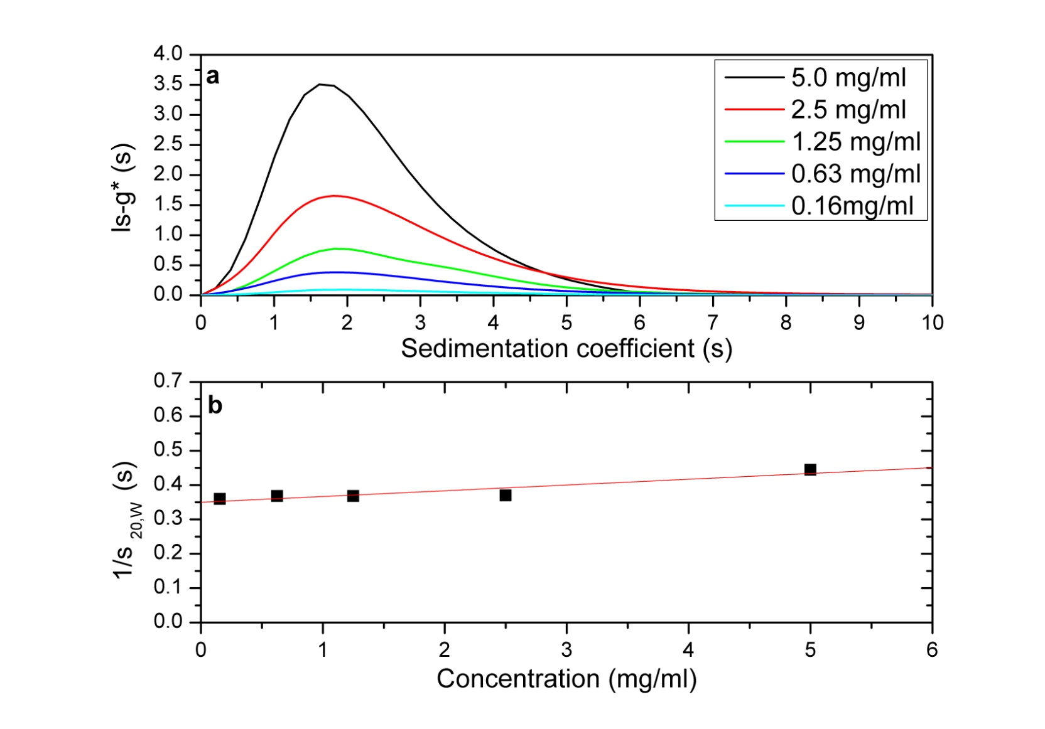
Figure 28. Sedimentation Coefficient Results for HB-PAMPS 10:1. ls-g* versus Sedimentation Coefficient (a) shows the profile of sedimentation coefficient distribution at the different loading concentrations, showing unimodiality 1/s_{20,W} versus concentration (b) shows the concentration dependence of the (weight average) sedimentation coefficient. s⁰_{20,W} = 2.9±0.1 S.
Figure 29 details the sedimentation equilibrium data for the same sample as above, HB-PAMPS 10:1. The sedimentation equilibrium run was carried out at a concentration of 0.5 mg ml⁻¹. The graphs are the output of the SEDFIT-MSTAR programme. Graph (a) is representative of the molecular weight distribution, c(M) versus M plot, with graph (b) the log concentration ln c(r) vs. r² plot, where r is the radial distance from the centre of rotation. Graphs (c) and (d) represent the M* and hinge point determination of apparent weight average molecular weight respectively. Graph (c) is a plot of M* versus r plot (open circle) and fit based on the M* transformations of the c(M) fit of the raw data (red line): the value of M* extrapolated to the cell base is the equivalent of the apparent weight average molecular weight for the whole distribution. Graph (d) is the hinge point or local apparent weight average molecular weight at radial position r (open circle) plotted against the local concentration c(r) for different radial position: the red line is the fit based on the equivalent transformations of the c(M) fit of the raw data. The dotted line indicates the point at which the apparent weight average molecular weight is obtained, for the example data r_{hinge} = 7.087cm.
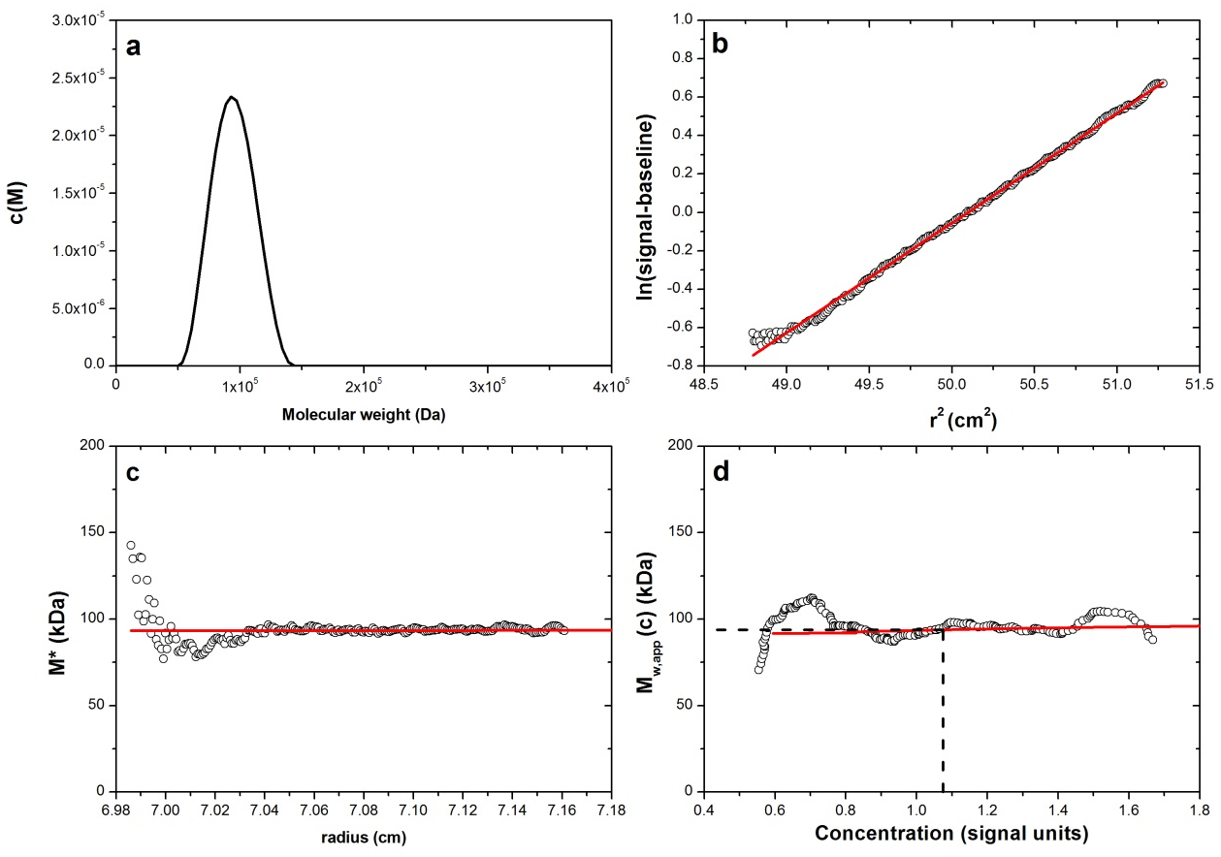
Figure 29. SEDFIT-MSTAR Data for the Sedimentation Equilibrium of HB-PAMPS 10:1.

2.9 Conclusions

Branched and linear PAMPS have been synthesised using a linear and branching RAFT agent in a number of molar ratios. However, it has been difficult to confirm the differing architectures. Samples were analysed successfully using NMR, dilute solution viscometry and analytical ultracentrifugation, however, a suitable SEC method was not found. M_{w} as reported from analytical ultracentrifugation was much larger than that reported from SEC; this is thought to be due to chain collapse and possible column polymer interactions. The strong polyelectrolyte functionality of the polymer has meant that analysis of the samples has not been trivial. As the RAFT agent to monomer ratio decreases the HB-PAMPS polymers increase in molecular weight, as analysed by analytical ultracentrifugation and dilute solution viscosity. HB-PAMPS 25:1 has a weight average molecular weight of 150000 Da and intrinsic viscosity of 0.098 (1M NaCl, 25°C), compared to HB-PAMPS 10:1 which has a weight average molecular weight of 95000 Da and intrinsic viscosity of 0.038 (1M NaCl, 25°C).

These polymers would benefit from further analysis, however they have been used successfully as a functional polymer in other applications, for example, as the ionic component in a semi-IPN membrane and as a polymeric additive in emulsion polymerisation.

Chapter 3

Surfactant Free Batch Emulsion Polymerisation of n-Butyl Methacrylate using Highly Branched and Linear Poly(2-Acrylamido-2-Methyl-1-Propanesulfonic Acid).

3.1 Aims and Objectives

Core shell particles can be used for a wide number of applications including controlled drug delivery^{[71, 160]} and paints^{[161]}. As part of the membrane electrode assembly in a fuel cell or electrolysis cell a polymer binder can be used to help fix catalyst particles in a porous layer, facilitating the flow of ions, reactants and products^{[162]}. Often a catalyst ink is created which will contain catalyst and polymer solution or emulsion, for example, platinum catalyst mixed with either 5wt% Nafion solution (Nafion dispersed in a mixture of alcohols and water) or a 60wt% PTFE emulsion^{[163]}. Therefore, it was proposed that core shell particle latexes with ionic functionality in the shell could provide a suitable material for this application.

It was thought that the water soluble HB-PAMPS and Linear PAMPS synthesised previously could be used as additives in the emulsion polymerisation of n-BMA. These polymers have dithioate end groups which can activate during the emulsion polymerisation reaction, reacting with BMA monomer units to form core shell particles with a hydrophobic centre and swollen hydrophilic outer layer with ionic functionality.

The main objectives of this investigation are:

- Use polyelectrolytes synthesised previously as additives in the batch emulsion polymerisation of n-BMA.
- Investigate the kinetics of this process, looking at the amount and type of additive.
- Characterise the latex samples using pH, solid content, monomer conversion, particle size, zeta potential and transmission electron microscopy.
3.2 Emulsion Polymerisations Using Alternative Surfactants

The key characteristics of conventional surfactants of a hydrophilic head and hydrophobic tail resulting in a amphiphilic behaviour can be mimicked by other materials which can behave in the same way as traditional surfactants, for example, polymers^{[164]}. Conventional surfactants are often low molecular weight and it has been shown that polymeric surfactants can offer some advantages including, less mobility (which can also be a disadvantage), electrosteric stabilisation and better anchoring with the particle surface^{[165]}. Polymeric surfactants are used in a number of industrial applications including dyes, personal care products and pharmaceuticals^{[166]}.

Burguiére et al used block copolymers of PS and PAA as stabilisers in the emulsion polymerisation of styrene and n-butyl acrylate^{[167]}. The amphiphilic block copolymers were synthesised via controlled living radical polymerisation in various architectures, for example, diblock, triblock and star copolymers with varied block lengths and then used instead of a conventional low molecular weight surfactant. The diblock polymers were found to be the most effective in this instance^{[167]}.

Synthesis techniques also involve polymers that can be covalently bonded to the monomer involved in the emulsion polymerisation. These polymers act as both co-reactant and stabiliser. Adler et al synthesised polyurethane macromonomer emulsifiers built up of polyester diol hydrophobic areas and hydrophilicity introduced using dimethylolpropanoic acid and isocyanates end capped with hydroxyl functional acrylate allowing for further radical polymerisation^{[168]}. The emulsion polymerisation with styrene gave a core shell morphology with the polyurethane stabiliser on the outside, this was confirmed by solid state NMR and atomic force microscopy (AFM)^{[168]}.

The monomer AMPS has been used as a polymerisable emulsifier in a semicontinous emulsion copolymerisation of methyl methacrylate, butyl methacrylate and 1,3,5-trimethyltris (3,3,3-trifluoropyropyl) cyclotrisiloxane, obtaining latex particles of 100nm, with the polymers stable at high temperatures of up to 400°C^{[169]}.

3.3 RAFT Mediated Emulsion Polymerisations

RAFT polymerisation has been explored as one way of using living radical polymerisation in a water borne system^{[170]}. The use of RAFT synthesised polymers as hydrophilic macro RAFT agents has been investigated by a number of research groups, examples of polymers used as macro RAFT agents include amphiphilic poly(ethylene oxide)^{[171]}, poly(methacrylic acid)^{[172]} and poly(N, N-dimethylacrylamide)^{[173]}. In each instance the macro RAFT agent is synthesised using a small molecule RAFT agent prior to being added into the emulsion polymerisation.

Yeole et al^{[165]} synthesised core shell polystyrene nanoparticles using a macro RAFT agent prepared via the RAFT polymerisation of sodium styrene sulfonate. A stable latex was produced which exhibited sulfonate functionality in the outer shell The concentration of the macro RAFT agent had an effect on particle formation^{[165]}. Zhang et al reported RAFT mediated emulsion polymerisation reactions based on a one pot synthesis where an amphiphilic RAFT polymer, poly(methacrylic acid-co-poly(ethylene oxide) methyl ether methacrylate) with a trithiocarbonate reactive end-group was synthesised in situ and then used in a subsequent emulsion polymerisation at varying pH values (3.5, 5 and 7)^{[174]}. The reaction was successful in creating spherical particles and other architectures (fibres and vesicles) as the molecular weight of the hydrophobic polymer section was increased, however low control was observed for pH 5 and 7^{[174]}. Zhou et al successfully used a block copolymer composed of poly(acrylic acid)-b-poly(hexaflurobutyl acrylate) as a macroRAFT agent in the emulsion polymerisation of butyl acrylate and methyl methacrylate^{[175]}. Composition and architecture were confirmed via ¹H NMR, FT-IR, TEM and x-ray photoelectron spectroscopy (XPS)^{[175]}.

Although the concept of RAFT mediated emulsion polymerisation has been discussed in some detail, it should be mentioned that NMP and ATRP techniques can also be used in this capacity^{[176]}.

3.4 Materials and Methods

3.4.1 Emulsion Polymerisation of n-Butyl Methacrylate Using HB-PAMPS and Linear PAMPS

Materials
Potassium persulfate (Sigma Aldrich, ≥99%) was used as received. n-Butyl methacrylate (Sigma Aldrich, 99%) was vacuum distilled before use. HB-PAMPS and Linear PAMPS were synthesised as described previously. Ultrapure water (18.2MΩ.cm@25°C) was used.

Method

Figure 30. Polymerisation of BMA Using HB-PAMPS or L-PAMPS as an Additive.

Ultrapure water (18.2MΩ.cm@25°C), n-BMA and HB or linear PAMPS were charged to a 1L jacketed reactor fitted with a nitrogen inlet, overhead stirrer, condenser and bubbler and heated water circulator. The reactants with BMA added last, were stirred and purged with nitrogen for approximately one hour at reaction temperature before commencing the reaction. The reaction vessel was heated to 60°C and nitrogen purged potassium persulfate (Sigma Aldrich, ≥99%) solution using ultrapure water was introduced to initiate the polymerisation. Samples (approximately 20ml) were taken from the reaction vessel at various time intervals, in order to assess monomer conversion rate and the polymerisation was quenched using hydroquinone monomethyl ether (MEHQ) (Sigma Aldrich, ≥98%). All reactions were eight hours in total.

The latex samples using HB PAMPS are not soluble due to possible crosslinking. Poly(butyl methacrylate) latexes using the linear samples were soluble and analysed using NMR (¹H and ¹³C) and SEC (THF).

Solid polymer isolated from the latexes synthesised using HB-PAMPS were not soluble in solvents suitable for NMR analysis. However, polymer from the samples synthesised using Linear PAMPS was soluble and NMR could be carried out using CDCl₃ as the deuterated solvent.

¹H NMR (400MHz, CDCl₃) (ppm): δ4.81 (2H, br, RC=OCH₂), δ4.03 (2H, br, RC=OCH₂), δ1.88 (2H, br, RCH₂CH₂), δ1.61 (2H, br, RCH₂CH₂CH₃), δ1.40 (2H, br, RCH₂CH₂CH₃), δ0.88 (3H, br, RCH₂CH₂CH₃).

¹³C NMR (100MHz, CDCl₃) (ppm): δ 177.51 (RC=OCH₂), δ64.71 (RCH₂O), δ45.44 (RCHC=O), δ30.29 (RCH₂CH₂), δ19.32 (RCH₂CH₃), δ13.75 (RCH₃).

3.4.2 Removal of RAFT End Groups Using ACVA

Materials
HB-PAMPS 25:1 as synthesised previously, DMF (Fisher), 4,4′-azobis(4-cyanovaleric acid)(Sigma Aldrich, ≥98%) and diethyl ether (Fisher).

Method

Figure 31. Reaction for the Removal of RAFT Groups from HB-PAMPS.
A three necked round bottom flask was fitted with a nitrogen inlet, condenser and bubbler and placed on a magnetic stirrer. The flask was purged with nitrogen for an hour before starting the reaction. HB-PAMPS (3.0872g) was dissolved in 40ml of DMF. The moles of RAFT agent per gram were calculated from ¹H NMR (6.11 x 10⁻⁵ mol g⁻¹). 20 molar equivalents of ACVA dissolved in 20ml of DMF were added to the stirring HB-PAMPS solution. The reaction was heated to 60°C and) stirred for 24 hours. After 24 and 48 hours respectively, 20 molar equivalents of ACVA in 20ml of DMF were again added to the reaction vessel, which was stirred under nitrogen at 60°C. 60 molar equivalents of ACVA were added in total. The reaction was completed after 72 hours.

DMF was removed by rotary evaporation and the polymer solution precipitated into diethyl ether. The polymer was reprecipitated a further two times. The resulting polymer which was dark brown and adhesive was washed with ultrapure water and freeze dried.

¹H NMR (400MHz, (CD₃)₂S=O)) (ppm): δ 8.41 (1H, br, RC=ONH), δ 7.26 (6H, Ar), δ 4.31, δ 3.26 (2H, m, RCH₂SO₃H), δ 2.85 (1H, s, ArCH₂), δ 2.72 (2H, br, ArCH₂CH₂), δ 1.42 (9H, br, RCH₃), δ 1.1 (2H, m, RCH₂).

¹³C NMR (100MHz, (CD₃)₂S=O)) (ppm): δ 173.40 (RC=O), δ 163.50 (RNHC=O), δ 162.87 (RNHC=O), δ 61.6 (RCH₂SO₃H), δ 55.6 (RCCH₂CN), δ 52 (RCHS), δ 39 (NHC2(CH₃)R), δ34 (ArCH₂), δ 31.25 (RCH₂), δ 26.73 (RCH₃).

3.5 Results and Discussion

3.5.1 Formulations

Emulsion polymerisations carried out using HB-PAMPS and L-PAMPS (25:1 AMPS to RAFT agent ratio polymers used in all cases) as additives at 60°C for eight hours produced colloidally stable latexes. Table 7 contains the formulations for successful emulsion polymerisations. Emulsion polymerisations using HB-PAMPS where the dithioate end groups were removed were also carried out under identical reaction conditions, these were not successful. The latexes using polymer with the end groups removed contained large amounts of solid coagulated polymer.

Sample | HB-PAMPS (g) | L-PAMPS (g) | Water (cm³) | BMA (cm³) | K₂S₂O₈ (g)
HB-PAMPS PBMA A | 1 | - | 500 | 100 | 1.2
HB-PAMPS PBMA B | 4 | - | 500 | 100 | 1.2
L-PAMPS PBMA A | - | 1 | 500 | 100 | 1.2
L-PAMPS PBMA B | - | 4 | 500 | 100 | 1.2
Table 7. Core Shell Emulsion Polymerisation Formulations.

Due to problems with the analysis of the linear and branched PAMPS it was decided that the RAFT polyelectrolyte additive should be added to the formulations in a weight percent basis.

3.5.2 Proposed Mechanism

The thermally generated radicals react with the dithioate chain ends present on the HB-PAMPS and L-PAMPS. The chain end radicals will react with BMA monomer units and subsequently propagate resulting in polymer chains. The predominantly hydrophobic chains aggregate to form core shell type particles with a BMA in the core and PAMPS in the outer shell^{[177]}. Cross linking of the particles synthesised using HB-PAMPS will occur due to bimolecular termination^{[177]}. Figure 32 schematically shows the process of chain propagation and particle nucleation caused by the increasing hydrophobicity of the propagating PBMA chains, resulting in a hydrophobic PBMA core with a swollen hydrophilic outer shell.

Figure 32. Schematic Diagram of the Particle Formation Process. Redrawn from Platt, Kelly and Rimmer^{[177]}.

3.5.3 Latex Characterisation
Table eight shows the latex characterisation data for both HB and linear PAMPS additive emulsion polymerisations, detailing pH, particle size, zeta potential and solid content:

Sample | pH | Particle Size (nm) | Zeta Potential (mV) | Solid Content (%)
HB PAMPS PBMA A | 2.82 | 154 ± 3 | -43 ± 4 | 16 ± 0.2
HB PAMPS PBMA B | 2.31 | 122 ± 1 | -52 ± 2 | 16.9 ± 0.3
L PAMPS PBMA A | 2.47 | 161 ± 3 | -52 ± 3 | 16.5 ± 0.03
L PAMPS PBMA B | 1.7 | 208 ± 2 | -30 ± 6 | 15.5 ± 0.06
Table 8. Characterisation of P(BMA) Latexes Made Using HB PAMPS and L PAMPS Additives.

The latexes were stable, exhibiting zeta potential values ≥ -30mV. Zeta potential is a measure of the electrokinetic potential of polymer colloids in suspension^{[24]}. Polymer colloids with a surface charge that are dispersed in a liquid will attract a counter ion, this forms a layer around the surface of the particle, the stern layer^{[178]}. This constitutes a high concentration layer near the surface that will gradually disperse creating a diffuse layer and eventually reaching an equilibrium with the counter ions in solution. The zeta potential is a measure of the potential difference between the bulk solution and the outer edge of the diffuse layer of the particle (slipping plane)^{[179]}. This is measured by applying an electrical field to the colloidal suspension and measuring the velocity of the particles^{[178]}. A schematic of a particle showing the charges and associated layers can be seen in figure 33.

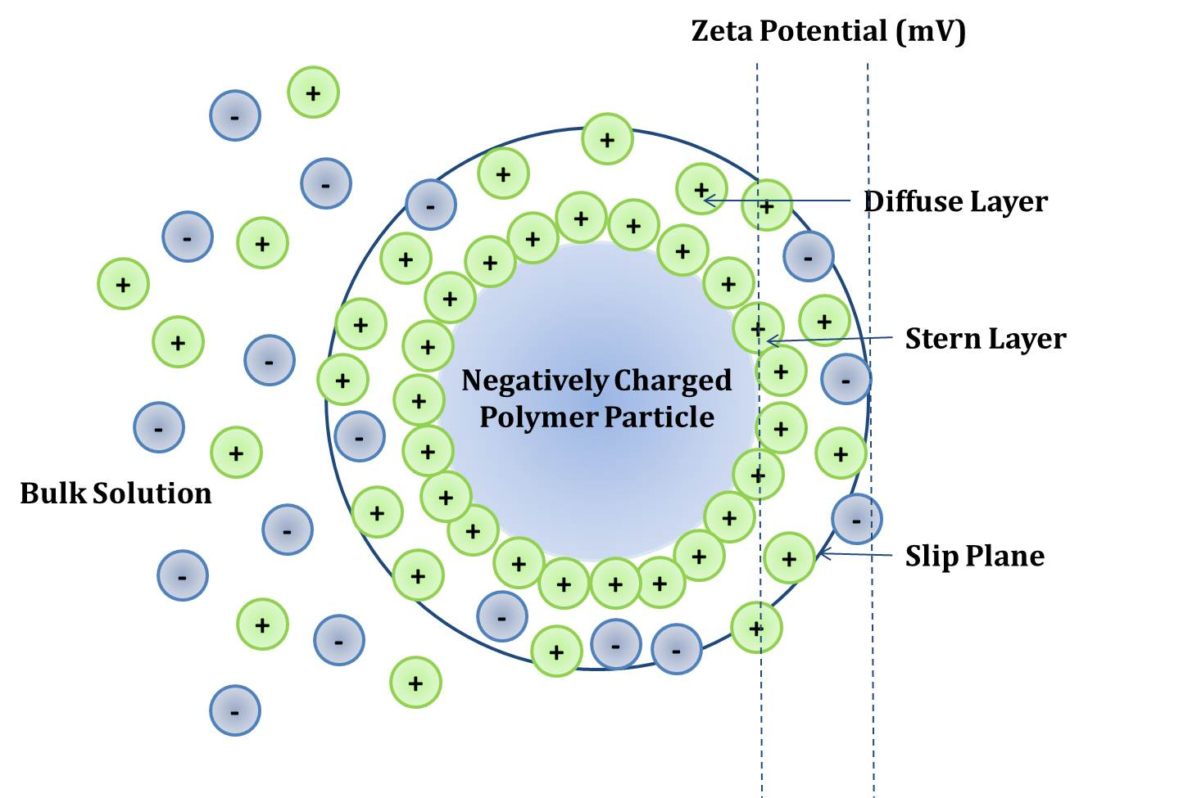
Figure 33. Zeta Potential Diagram.
Zeta potential can be used to provide an indication of the stability of the polymer particles in solution indicating how well the particles are dispersed in the solution^{[180]}. High zeta potentials (either negative or positive depending on the particle charge and counter ion) indicate stable latexes, with lower values, for example 0 mV to -10 mV indicative of particles that will aggregate and settle out^{[181]}.

pH values for the latexes decrease as the amount of polyelectrolyte present in the formulation increases. Particle sizes are smaller for the particles made using HB PAMPS. It is thought that the polymers formed using the HB PAMPS have a more meshed crosslinked structure where in contrast the particles formed using the linear polymer have a more open structure which could account for the small difference in observed particle size.

Solid polymer was isolated from the latex by precipitation into acetone. The polymers prepared using HB-PAMPS additive were insoluble in common laboratory solvents (see table 9), however the polymers prepared using L-PAMPS were soluble in a variety of solvents indicating that although the L-PAMPS contained the dithioate end groups, due to the differing polymer architecture the polymers would potential only form triblock copolymers rather than a cross linked structure^{[177]}. In all solvents where both polymer systems were insoluble some degree of swelling was observed.

Solvent | HB-PAMPS PBMA | Linear PAMPS PBMA
Methanol | X | X
Ethanol | X | X
Propan-2-ol | X | X
Acetone | X | O
Dimethyl sulfoxide | X | X
Dimethyl formamide | X | X
Tetrahydrofuran | X | O
Diethyl Ether | X | X
1,4 Dioxane | X | X
Ethyl Acetate | X | X
Water | X | X
Toluene | X | X
Hexane | X | X
Petroleum Ether | X | X
Chloroform | X | O
Dichloromethane | X | O
Table 9. Solubilities of Solid Polymer Precipitated from the Emulsion Polymerisation of n-BMA Using HB or Linear PAMPS. X indicates insoluble, O indicates soluble.
The polymers made using L PAMPS were analysed using SEC with THF eluent. These polymers exhibit high molecular weights and dispersities of less than two.
Sample | M_{n} | M_{w} | M_{z} | M_{z} + 1 | Dispersity
 | (g mol⁻¹) | (g mol⁻¹) | (g mol⁻¹) | (g mol⁻¹) | (M_{w}/M_{n})
L PAMPS BMA A | 154250 ± 17700 | 306300 ± 60000 | 527900 ± 157000 | 825000 ± 327900 | 1.98
L PAMPS BMA B | 176800 ± 17700 | 274700 ± 23400 | 386800 ± 31000 | 505900 ± 37700 | 1.55
Table 10. SEC Results for P(BMA) Polymers Synthesised Using L PAMPS (THF).

Figure 34. Differential Distribution Curves for L PAMPS PBMA Isolated Polymer. SEC Using THF Eluent.
The differential distribution curves of the polymers as obtained from SEC using THF eluent show a normal distribution. It was not possible to assess HB-PAMPS PBMA A and HB-PAMPS PBMA B using this analysis technique, due to the insolubility of the solid polymer.

3.5.4 Transmission Electron Microscopy

Latex particles were observed via transmission electron microscopy (TEM). Latex samples were stained with uranyl formate and it was possible to see uniform spherical particles. There were issues with polymer particles burning in the beam of the TEM instrument therefore it was difficult to observe the particles in more detail. There are two size distributions present which were confirmed using light scattering measurements clearly showing bimodal distributions. Although, the instances of smaller particles are much lower than the larger particles, this can be seen in both the TEM micrographs and particle size distribution graphs.

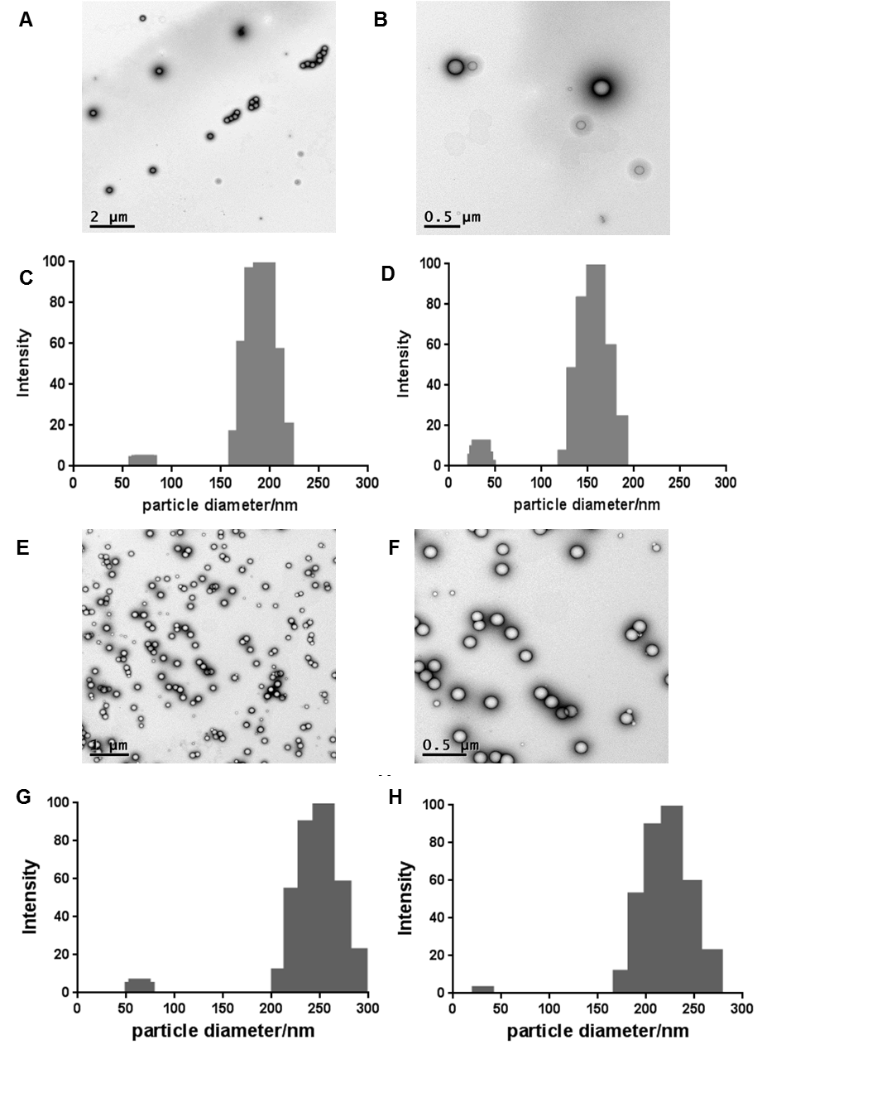
Figure 35. TEM Micrographs of Emulsion Polymerisation Particles. A and B TEM Micrographs of HB-PAMPS PBMA Latex Particles, C HB-A and D HB-B Particle Size Distributions. E and F TEM Micrographs of L-PAMPS PBMA A and L-PAMPS PBMA B, G L-PAMPS A and H L-PAMPS B Particle Size Distributions^{[177]}.

The diameters of the larger particles lie between 150nm and 300nm as measured during particle size analysis. However there are smaller particles of less than 70 nm present in all latex samples.

3.5.5 Emulsion Polymerisation Kinetics

The emulsion polymerisations were sampled to investigate the progress of the reaction, these samples were assessed in terms of monomer conversion and particle size. Monomer conversion was measured gravimetrically. Samples were taken at timed intervals throughout the polymerisation and were quenched with hydroquinone monomethyl ether (MEHQ) and then cooled in an ice bath. Samples were analysed in triplicate, with points on all graphs being an average of all samples. The samples were not however analysed straight away, therefore there are some erroneous results which where mass appears to have been lost, this is most likely not the case and a function of when the samples were analysed.

Figure 36. Average Monomer Conversion over Time of the Emulsion Polymerisations of n-BMA using HB PAMPS.

Figure 37. Average Monomer Conversion over Time of the Emulsion Polymerisations of n-BMA using L PAMPS.
Figures 36 and 37 compare the reactions with different polymer additives and two different PAMPS concentrations in the formulation. Figure 36 shows HB PAMPS PBMA and figure 37 L PAMPS PBMA. All polymerisations were completed to high conversion within four hours. In both HB PAMPS and L PAMPS systems, the rate of polymerisation is increased with increasing amount of PAMPS additive. The comparison between figures 36 and 37 indicates that polymerisations in the presence of HB PAMPS were faster than those using L-PAMPS. The polymerisations using HB-PAMPS had progressed to high monomer conversion (≥ 98%) by 120 minutes, with the L-PAMPS samples requiring 240 minutes to progress to similar monomer conversion. However, although the polymers were added in the same weight percent concentrations, the polymers had differing concentrations of RAFT moieties. The amount of RAFT agent per gram of polymer was calculated from ¹H NMR with the HB PAMPS containing 6.11 x 10⁻⁵ mol g⁻¹ and L PAMPS 8.74 x 10⁻⁴ mol g⁻¹. The L PAMPS have more RAFT moieties and do appear to have a slower rate of reaction, possibly due to the increased control provided by having more RAFT functionality present.

Figure 38. Particle Size Changes Over The Time Period of The Emulsion Polymerisation Using HB PAMPS Additives.

Figure 39. Particle Size Changes Over The Time Period of The Emulsion Polymerisation.
Figures 38 and 39 show the changes in particle size over time for each of the reactions. For all reactions, the particle size was variable at the beginning of the reaction as would be expected during interval I of an emulsion polymerisation reaction, but by the point of complete conversion at approximately four hours for all reactions the particles did not alter in size. The samples were stored as a whole solution, or polymer particles and monomer, therefore the particles may have swollen in the monomer, causing variability on the particle size in the first hour of the reaction. The PBMA particles synthesised using HB PAMPS additive had smaller particle sizes overall than the PBMA particles synthesised using Linear PAMPS. The number of particles per unit volume of latex remains relatively constant near the end of the polymerisation^{[63]}, but will change at the beginning of the reaction. The number of particles per unit volume of latex can be calculated using the solid content of the latex and the average particle diameter of the latex:

Sample | Latex Final Number of Particles per Litre of Latex (N_{p})
HB PAMPS PBMA A | 1.95 x 10¹⁸
HB PAMPS PBMA B | 8.64 x 10²²
L PAMPS PBMA A | 2.82 x 10²²
L PAMPS PBMA B | 3.61 x 10²²
Table 11. Number of PBMA Particles per Litre of Latex.
Apart from HB-PAMPS-PBMA -A all samples had similar N_{p}. This reaction had progressed to high monomer conversion by 120 minutes which may mean that there was less time for particles to form, resulting in a lower number of particles. The same emulsion polymerisation reactions were carried out where the RAFT groups on the AMPS polymer had been removed through the reaction with ACVA. The polymer produced from this reaction had no RAFT end groups as confirmed by the absence of peaks associated with the pyrrole groups present on the RAFT end group on the NMR spectra. Elemental analysis of the HB PAMPS to look for the presence of sulphur was not suitable in this instance due to the abundant presence of sulphur in the monomer unit. The emulsion polymerisation carried out using this polyelectrolyte additive resulted in latex which coalesced to form a large mass of solid in the reactor, with a reduced amount than expected of colloidally stable latex. This batch emulsion polymerisation was repeated and the same result observed. Further work would need to be carried out to look at the reaction conditions and amount of stabilising polyelectrolyte if this were to be a viable method of batch emulsion polymerisation.
3.6 Conclusions

HB-PAMPS and Linear PAMPS have been successfully used in the emulsion polymerisation of n-BMA to create core shell particles with polysulphonate shells. This method is a shell first approach, with the water soluble HB or linear PAMPS dissolved in the starting aqueous emulsion matrix. After initiation and propagation of the chains, the growing particles self-organise into a hydrophobic PBMA core and a swollen hydrophilic shell. It is proposed that the RAFT group allows the PAMPS to anchor to the end of the polymer chains.

These latexes were colloidally stable (zeta potential ≤ -30 mV), did not coagulate on storage and were of high molecular weight where this could be quantified. The majority of latexes particles were between 150 nm and 210 nm in diameter, but distributions were bimodal with some smaller particles between 40 nm and 70 nm. Emulsion polymerisations carried out using HB-PAMPS progressed at a faster rate, than polymerisations in the presence of L-PAMPS, to high monomer conversion (≥ 98%).

Chapter 4

Semi-Interpenetrating Networks Using Highly Branched Poly(2-Acrylamido-2-Methyl-1-Propanesulfonic Acid) as the Ionic Component.

4.1 Aims and Objectives

The commercially available ionomer material Nafion contains sulphonic acid groups, which act as the ionic functionality of the material. It has been proposed that AMPS may provide a cheap alternative way of introducing sulphonic acid groups into an ionomer membrane. Previous experiments with AMPS have yielded both branched and linear polymers which can be used as the ionic component in an ionomer membrane. One method of incorporating these polymers into a membrane which has good mechanical properties, high ionic conductivity and good chemical stability is to incorporate the polymer into a semi-IPN, where the other chemical components are comprised a linear polymer or monomer system and crosslinker. Vinyl functionality on the linear polymer or monomers mean that the molecule can be polymerised into a cross linked polymeric material using a free radical mechanism, initiated either thermally or by ultraviolet (UV) radiation. It is postulated that although not chemically bonded, the branched nature of the PAMPS will embed it into the cross linked matrix, minimising losses. Also allowing channels to form due to the more hydrophobic nature of the cross linked polyurethane polymer when compared to the hydrophilic nature of the strong polyelectrolyte PAMPS. These channels will help to facilitate the flow of ions through the ionomer membrane.

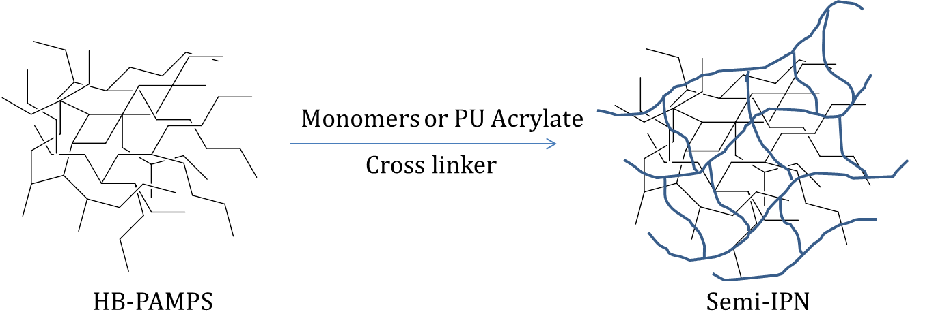
Figure 40. Branched Polymer Embedded in a Semi-IPN Network.

The aim of this work is to use the HB-PAMPS polymers synthesised in chapter two as a component in a semi-interpenetrating network ionic membrane for use in an electrolyser and fuel cell. There are two potential methods for the linear cross linked component:

- Linear polyurethane prepolymer with acrylated chain ends providing the vinyl functionality required for further free radical polymerisation. A bifunctional monomer which can act as a crosslinker can also be used to create a crosslinked network, for example, divinyl benzene (DVB) or ethyleneglycol dimethacrylate (EGDMA).
- Monomer mixture which will polymerise into a cross linked structure embedding the branched polymer, there are a number of monomers which may be suitable, for example, HEMA, 2-hydroxypropyl methacrylate (HPMA) or N, N-dimethylacrylamide.

The samples will be analysed in a number of ways including for example, swelling measurements at different temperatures in water, ion exchange capacity, Fourier transform infrared spectroscopy (FTIR), and chemical degradation studies.

The objectives of this work are outlined below:

- Synthesise acrylated linear polyurethanes using poly(propylene glycol) (PPG) and 4,4’-methylenebis diphenyl diisocyanate (MDI) and characterise the polymer.
- Fabricate semi-IPN’s with an ionic component using HB-PAMPS and either linear prepolymer and appropriate crosslinker or a monomer mix with an appropriate crosslinker.
- Characterise the membranes and conduct testing to assess their suitability as an ionic membrane for use in an electrochemical device.

4.2 Interpenetrating Polymer Networks and Semi-Interpenetrating Polymer Networks

The IUPAC definition of an interpenetrating polymer network (IPN) is ‘a polymer comprising two or more networks which are at least partially interlaced on a molecular scale but are not covalently bonded to each other and cannot be separated unless chemical bonds are broken’^{[24].} This can allow for the combination of different types of polymers, for example, a polyurethane and a polyacrylate to achieve the desired physical and chemical properties^{[182]}. There are a number of different synthesis methods suitable for fabricating IPN polymers networks, including in situ sequential synthesis, where the prepolymers, crosslinker and initiators of each polymer are combined and the reactions are carried out simultaneously or sequential synthesis where one polymer is made and the monomer, crosslinker and initiator of the second polymer is swollen into the starting crosslinked polymer^{[183]}. In an IPN network all the constituent polymers are crosslinked, however, in a semi-IPN one of the polymers is not crosslinked. The semi-IPN consists of a linear or branched polymer which is penetrated on a molecular scale^{[126]}. Often the non crosslinked linear or branched polymer can be extracted with solvent^{[18].} Diagrammatic examples of these networks can be seen in figure 41:

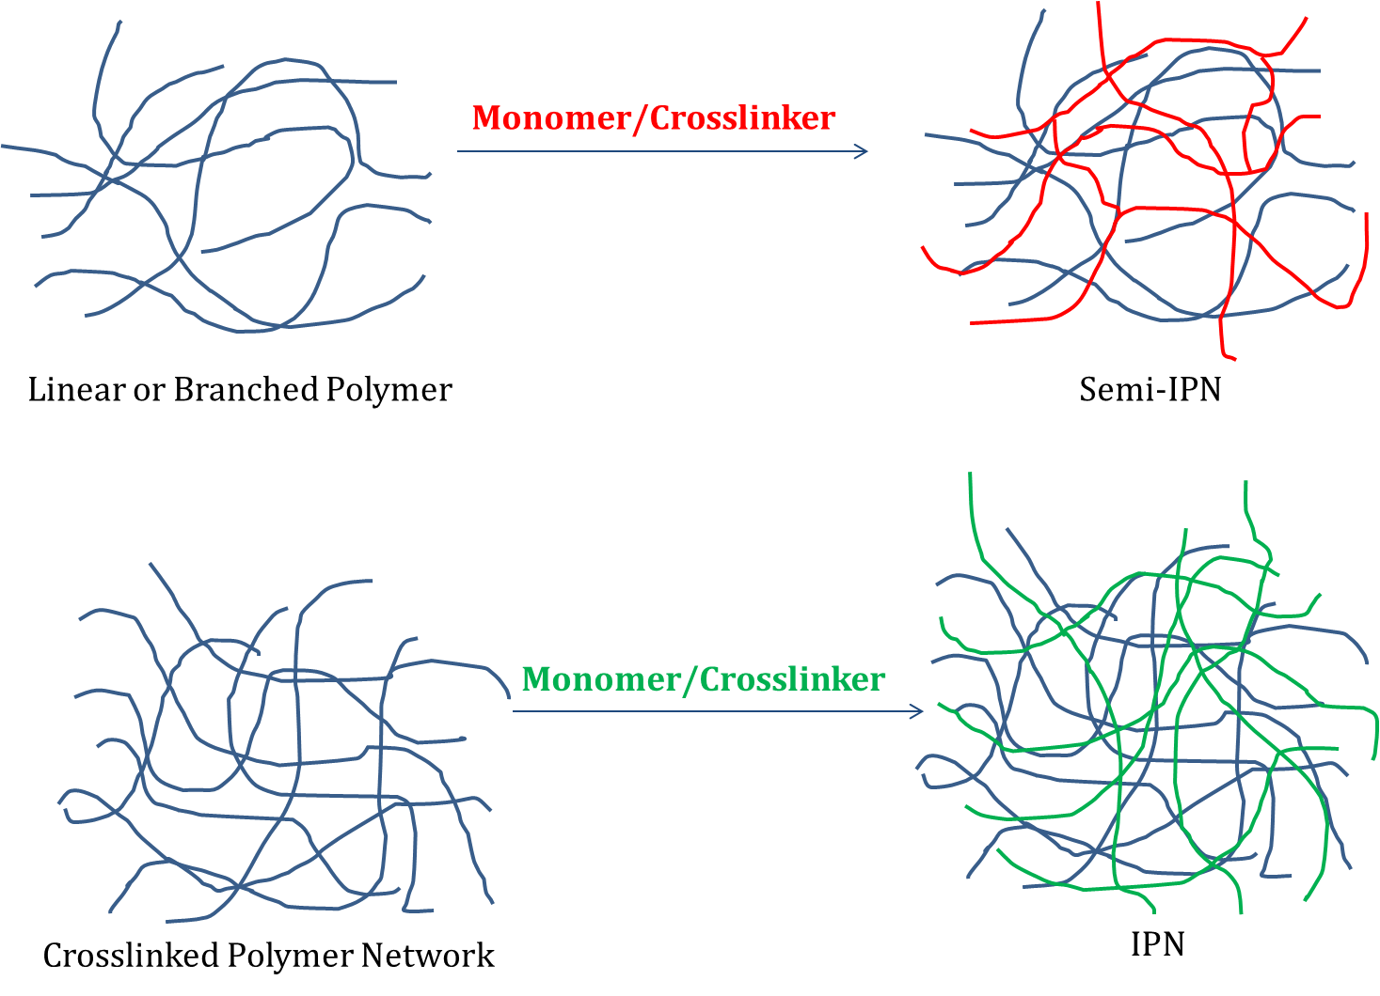
Figure 41. Schematic Diagrams Showing semi-IPN and IPN Formation.
IPN and semi-IPN structured polymers can be used for a number of applications with research conducted into their use as fuel cell membranes^{[135, 184-186]}, biomaterials^{[187]} and adhesives^{[188]}.

4.3 Ionic Polyurethanes

Ionic Polyurethanes have a number of applications including coatings, electrolyte materials, and tissue engineering^{[189]} as well as being considered for use in fuel cells and electrolysers. The use of ionic polyurethanes as polymer electrolytes for fuel cell and batteries has been explored, with a number of examples of anionically and cationically conductive polymers ^{[190-193]}. As well as coatings for various applications polyurethanes in the field of lithium batteries have been investigated, where lithium ions migrate between the electrodes of the electrochemical device during charging and discharging^{[194]}.

Polyurethanes have been selected for investigation due to good chemical stability and mechanical properties^{[194]}. Investigations into the physical properties of polyurethanes with sulfonate, carboxylate or quaternary ammonium ions were undertaken by Santerre and Brash^{[195]}, with amino acids attached to the sulfonate groups in the hard segment via sulfonamide linkages. The tensile properties were enhanced and it was speculated that the electrical properties may make this a suitable alternative to Nafion^{[195]}.

The study of ionic polyurethanes as a solid electrolyte in lithium batteries has been studied by Fragiadakis et al^{[196]}, polyurethanes with the capability to conduct Li⁺ or Na⁺ were synthesised, anionic groups being covalently bonded to the chains.

Semi-IPN polyurethane ionomers have been prepared, with Jaisankar et al studying a semi-IPN comprised of polyurethane an ionomer and poly(vinyl chloride) (PVC)^{[197]}. Polyurethane was prepared by reacting polycaprolactone diol (PCDL) and toluene diisocyanate (TDI) to create a prepolymer terminated with the isocyanate group, 2,4-dihydroxy benzoic acid treated with triethylamine (TEA) was added to the prepolymer to synthesise an ionic polyurethane^{[197]}. Different ratios of PCDL to TDI were investigated. The semi-IPN was constructed by combining the polyurethane ionomer with PVC, dissolved in THF. The membranes being made in a heated mould^{[197]}. The thermal stability of the synthesised semi-IPN was greater than the constituent homopolymers, and good mechanical properties were observed, with the tensile strength and hardness increasing as the ratio of isocyanate to diol and ionic content of the polyurethane increases^{[197]}.

Investigations into ionomers for battery devices have been carried out by Wang et al using polyurethane in a blend with sulfonated polyether. Polyurethane was blended with poly(ethylene oxide) (PEO) grafted with sodium sulfonate side chains and solution cast to form a membrane^{[198]}. Composites of thermoplastic polyurethane and sulfonated poly(ether ether ketone) (SPEEK), sulfonated polystyrene and polyaniline, an electronically conductive polymer, have been tested for fuel cell capability^{[199]}.

Inclusion of carboxylic acid groups in the polyurethane structure has been reported in a number of publications ^{[120, 200, 201]}. In the field of biomaterials, the carboxylic acid group within the polymer would act as an ‘anchor site’ for protein attachment ^{[202]}. Xu et al reported high ionic conductivity from carboxylated polyethylene oxide based polyurethanes synthesized from poly(ethylene glycol)(PEG), MDI and 2,2'-bishydroxymethyl propionic acid^{[203]}. Many ionomers investigated for fuel cell applications are sulfonic acid based, with the carboxylic acid membranes performing less well in testing^{[204]}. There have been reports of sulfonic acid groups incorporated into a polyurethane or polyurea structure. Patents detailing the use of a sulfonated diamine in a polyurea formulation along with a polyisocyanate prepolymer have been cited as being a solid polymer electrolyte for use in a fuel cell^{[205]}. The sulfonic acid or carboxylic acid groups are neutralised before polymerisation occurs, avoiding side reactions^{[205]}.

4.4 Methods

4.4.1 Synthesis of Polyurethane Acrylate Using Poly(propylene glycol) (PPG) and 4,4’-Methylene Diphenyl Diisocyanate (MDI).

Materials
Poly(propylene glycol) average Mn ~425 (Sigma Aldrich) and 2-hydroxyethyl acrylate (Sigma Aldrich, 96%) were dried in a vacuum oven before use. 4,4’-methylene diphenyl diisocyanate (Sigma Aldrich, 98%), anhydrous dimethyl sulfoxide (Sigma Aldrich, ≥99.9%), dibutyltin dilaurate (Sigma Aldrich, 95%), toluene (Fisher), methanol (Fisher), dibutylamine (Sigma Aldrich, ≥99.5%), bromocresol green, acetic anhydride (Sigma Aldrich ≥98%), pyridine (Sigma Aldrich, ≥99.9%), hydrochloric acid (VWR) and phenolphthalein were used as received.

Method

Figure 42. Synthesis of Polyurethane Acrylate
A 500ml flange flask in an oil bath was fitted with a five necked lid fitted with, overhead stirrer, temperature probe and dry nitrogen inlet (desiccant (drierite)) tube and gas exchange bottle fitted to the nitrogen line). The apparatus was heated to 80°C and purged with N₂ for 24 hours prior to the reaction. Poly(propylene glycol) (PPG) of known molecular weight was used for all reactions and reactants in the chosen OH:NCO ratio measured. This can be titrated for hydroxyl value. PPG was charged to the reactor and stirred for one hour heated to 40°C. The reaction was cooled to room temperature before a slurry of MDI in DMSO was added with continuous stirring. Approximately 0.5ml of dibutyltin dilaurate was added to the reaction. Temperature was monitored and the reaction cooled with an ice bath if it was measured as being above 50°C. Isocyanate content titrations (see analysis chapter) were used to monitor the progress of the reaction and allow for the calculation of HEA amount for end capping. Reaction times varied between one hour and four hours. HEA was added and stirring continued. A clear gel polymer was obtained; this was stored at -18°C.

¹H NMR (400MHz, CDCl₃) (ppm): δ 7.36 (8H, br, Ar), δ 7.0696 (8H, br, Ar), δ 6.46 (3H, m, RC=CH), δ 6.13 (3H, m, RC=CH), δ 5.73 (3H, m, RC=CH), δ 4.97 (1H, s, RCH-O), δ 4.41 (2H, br, RCH₂-CH-O), δ 4.22 (2H, br, RCH₂-CH-O), δ 3.83 (2H, br, ArCH₂Ar), δ 3.41 (2H, br, ArCH₂Ar), δ 1.31 (3H, br, CH-CH₃), δ 1.08 (3H, br, CH-CH₃).

¹³C NMR (100MHz, CDCl₃)(ppm): δ153.51 (1C, RNHC=O), δ 132.71 (1C, RCH₂=CH), δ 130.61 (1C, RCH₂=CH), δ 129.19 (6C, ArC), δ 118.81 (2C, δ ArC), δ 66.12 (ROCH₂), δ 60.44 (RCH₂O), δ 40.77 (1C, ArCH₂Ar), δ 17.17 (1C, RCH₃).

4.4.2 Fabrication of Semi-IPN Membranes using HB-PAMPS and Acrylated PPG/MDI Polyurethane

Materials
HB-PAMPS (RAFT agent ratios indicated in the results section) was synthesised as in chapter two and acrylated polyurethane was synthesised, characterised and deemed suitable for further synthesis. Anhydrous dimethyl sulfoxide (Sigma Aldrich, ≥99%) and di(ethylene glycol) diacrylate (Sigma Aldrich, 75%) were used as received. Ethylene glycol dimethacrylate (Sigma Aldrich, 98%) was treated with inhibitor remover beads prior to use (MEHQ appropriate). Divinyl benzene (Sigma Aldrich, 80%) was washed with 1M NaOH prior to use. 2-Hydroxy-2-methylpropiophenone (Sigma Aldrich, 97%) and diphenyl(2,4,6-trimethylbenzoyl)phosphine oxide (Sigma Aldrich, 97%) were used as received.

Method
Various ratios of HB-PAMPS and acrylated polyurethane were mixed with crosslinker, from a selection including EGDMA, DVB or DEGDA and UV initiator, the sample was stirred until homogenous and nitrogen bubbled through the mixture. Moulds were prepared using quartz glass plates, PET film was spray mounted to each quartz plate and a PTFE mould placed between the plates with a long hypodermic needle placed between the plates allowing mixture to be injected. These components are secured using large bulldog clips to produce a liquid tight but UV permeable mould (see appendix section for photograph and schematic). The samples were placed under a UV light (Dymax Bondbox) and polymerised for 15 minutes until solid.

4.4.3 Fabrication of Semi-IPN Membranes using HB-PAMPS, HEMA and Crosslinker.

Materials
HEMA (Corrnelons) and 2-Hydroxy-2-methylpropiophenone (Sigma Aldrich, 97%) were used as received. Divinyl benzene (Sigma Aldrich, 80%) was washed with 1M NaOH prior to use. Acrylonitrile (AN) was vacuum distilled before use. HB-PAMPS (RAFT agent ratios indicated in the results section) was synthesised as in chapter two. Ultrapure water (18.2MΩ.cm@25°C) was used in all formulations.

Method
HB-PAMPS was placed in a beaker equipped with a magnetic stirrer bar and dissolved in ultrapure water. The solution was combined with HEMA, DVB, acrylonitrile and HMPP in various proportions. Formulations which were miscible were then polymerised under a UV lamp (Intelliray, 100% intensity). For the test membranes, a 15cm x 10cm ultra high molecular weight polyethylene bag mould was made and 10ml of polymer/monomer solution injected into the bag, this was then placed in a glass and metal jig and positioned under the lamp. All samples were cured for 15 minutes under the UV lamp until solid.

4.5 Results and Discussion

4.5.1 Semi-IPN Membranes Consisting of HB-PAMPS and HEMA/Crosslinker

The patent for ITM standard materials states that the free radical polymerisable membranes are constructed from a monomer formulation consisting of a hydrophobic monomer, hydrophilic monomer, a monomer with ionic functionality, crosslinking monomer and water^{[206]}. Therefore, materials were designed as a direct comparison to these materials using the HB-PAMPS as the ionic component. Although it is possible to use AMPS as a co-monomer polymerising it directly into the linear and crosslinked architecture, it was thought that the use of a branched polymeric component should be assessed. It was postulated that the branched polymer may alter the mechanical properties and performance and possibly increase the density of ionic functionality within the membrane. Polymer and monomer mixtures were prepared by stirring components at room temperature and consequently the miscibility and ratio of the components was important. Acrylonitrile (AN) was chosen as the hydrophobic monomer and HEMA as the hydrophilic component, the hydrophilicity imparted by the pendant hydroxyl group. However, solutions containing AN were not miscible so the hydrophobic monomer was omitted from the formulation. The amount of crosslinker was varied in a number of formulations. Table 12 outlines formulations which were polymerised into thin film membranes:

Sample | HB-PAMPS 25:1 (g) | HEMA (g) | DVB (g) | H₂O (g) | HMPP (g)
Semi-IPN 1wt%DVB | 2 | 10 | 0.1 | 1.5 | 0.1
Semi-IPN 3wt%DVB | 2 | 10 | 0.3 | 1.5 | 0.1
Semi-IPN 5wt% DVB | 2 | 10 | 0.5 | 1.5 | 0.1
Table 12. Formulations of Semi-IPN Membranes based on HB-PAMPS, HEMA and DVB.
Electrochemical cells are operated at elevated temperature to improve the efficiency of the cell, for example, in an electrolysis cell, operation at elevated temperature will improve the electrode kinetics and reduce the overpotential of the cell^{[19]}. As a result, it is important to assess the thermal stability of the ionomer. Large dimensional changes due to degradation mechanisms may prove problematic for cell longevity. The water uptake of the polymer is an important consideration for membrane performance and structural integrity. The morphology of the polymer can affect the ion transport through the membrane and performance. Nafion exhibits clusters of sulfonic acid groups in its morphology, with the hydrophobic PTFE backbone and hydrophilic sulfonic acid pendant groups^{[207]}. Membranes are designed to emulate this hydrophobic hydrophilic arrangement. It is to this end that a hydrophobic polyurethane component in combination with the hydrophilic HB-PAMPS may be a better material than the formulations outlined in table 12.

4.5.2 Polypropylene Glycol and 4,4’ Methylene Diphenyl Diisocyanate Acrylated Polyurethanes

Linear polyurethane prepolymers were made as described in the method these materials were acrylated using 2-hydroxyethyl acrylate (HEA) to provide vinyl functionality which could be used to further polymerise the polyurethane into a semi-interpenetrating network. The hydroxyl functionality of the HEA capping the isocyanate chain ends. Successful reaction of the HEA with isocyanate functionality can be seen via ¹H NMR with vinyl peaks observed between δ 5 ppm and δ 6.5 ppm. A number of different PPG, MDI based polyurethanes were synthesised with differing ratios of isocyanate to hydroxyl, for example 1.05:1 and 1.10:1. For this use it was important to have an excess of isocyanate available for further reactions to provide the hydroxyl functionality of the HEA a reaction site on the polyurethane chain. The exact amount of HEA to be added to the reacting polyurethane was calculated using a non aqueous back titration of isocyanate, reacting a sample of the polyurethane with 0.1M dibutylamine in toluene and using 0.1M HCl in methanol for the titration to calculate the remaining moles of isocyanate functionality in the reaction bulk. Acrylated polyurethanes were titrated after the addition of HEA ensuring there was no residual isocyanate functionality which may interact with functional groups present on the constituents of the synthesised polymer networks. The linear polyurethane was analysed using ¹H and ¹³C NMR to look for polyurethane linkages and vinyl functionality. The ¹H NMR spectrum of polyurethane after precipitation into methanol can be seen in figure 43:

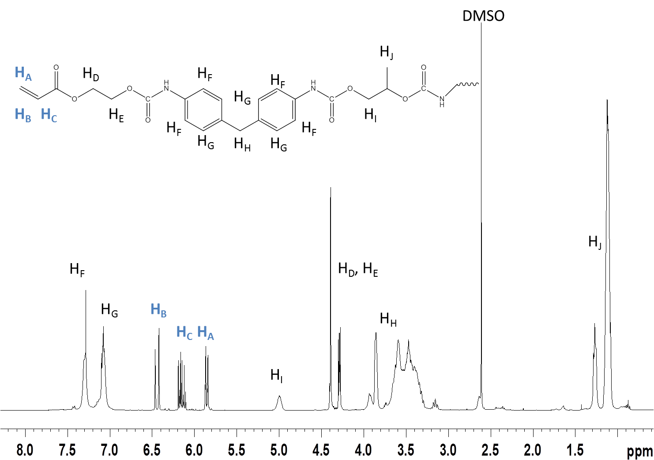
Figure 43. ¹H NMR (400MHz, CDCl₃) Showing the Vinyl Groups for Further Polymerisation. DMSO is used in the synthesis of the polymer and has proven difficult to remove even after repeated precipitation and drying.
The acrylated polyurethane prepolymers were analysed using SEC with THF eluent (linear poly(styrene) standards):
Sample | M_{n} | M_{w} | M_{z} | M_{z} + 1 | Dispersity
 | (g mol⁻¹) | (g mol⁻¹) | (g mol⁻¹) | (g mol⁻¹) | (M_{w}/M_{n})
1.05:1 NCO:OH A | 6800 ± 50 | 16550 ± 150 | 28100 ± 250 | 40300 ± 250 | 2.43
1.10:1 NCO:OH A | 5700 ± 300 | 16100 ± 350 | 27200 ± 600 | 38450 ± 350 | 2.82
1.10:1 NCO:OH B | 4100 ± 1250 | 9200 ± 400 | 17550 ± 1000 | 36400 ± 100 | 2.24
Table 13. THF Eluent SEC Results for Acrylated Polyurethane Samples. Error calculated using standard error.
The increase in the isocyanate to hydroxyl functionality decreased the molecular weight of the polymer measured using THF eluent SEC. The increase in isocyanate groups will decrease the molecular weight of the polymer as there are less hydroxyl functional ends compared to the isocyanate ends, stunting longer chain growth. However, this will provide more sites for the reaction between the hydroxyl functionality present on the HEMA molecule, creating the desired vinyl functionality on the end of the polyurethane chain.
Figure 44. Differential Distribution of Polyurethane Acrylates. Results obtained using THF eluent SEC.
Figure 44 shows the differential distribution of polymers outlined in table 13. There is a slight shoulder on the differential distribution curve for all the polyurethane acrylates analysed, suggesting a bimodal distribution, it is difficult to attribute the curve characteristics to a particular phenomenon, this can be seen in figure 43.
These polymers were precipitated into methanol to remove DMSO and impurities. The polymers were a gel like solid which formed thread like fibres when manipulated. Care was taken to ensure that no water was present in the reaction vessel during synthesis. If excessive bubbling of the reaction mixture was observed indicating the reaction of isocyanate and water creating urea and releasing CO_{2,} the synthesis reaction was deemed unsuccessful and the sample not further investigated.
4.5.2 Semi-IPN Formulations and Characterisation
A number of different formulations were prepared, as with the HEMA and DVB based membranes outlined in section 4.4.1, mixtures were limited by the miscibility of the constituents. However, all formulations which underwent further investigation were clear, miscible solutions before polymerisation using UV radiation. UV curing was chosen as this is ITM’s preferred polymerisation route. DMSO was chosen as a suitable solvent for use in these solutions, as both HB-PAMPS and the polyurethane are soluble in appropriate proportions. Formulations were designed to consist of the ionically functional polymer, linear polyurethane acrylate, a cross linker suitable for free radical polymerisation and free radical initiator. It was not thought necessary to protect the sulfonic acid functionality of the HB-PAMPS as the polyurethane had no residual isocyanate functionality due to end capping with HEA. Initially DVB was chosen as the crosslinker as its structure makes it resistant to hydrolysis which can be a problem for ionomers designed for this application due to the hydrolytic environment of the cells. However, these membranes did not polymerise very well and were of a paste like consistency rather than a solid polymer and could not be removed from the PTFE or PE as a complete film. UV exposure time was increased (between 5 minutes and 1 hour); unfortunately, the problem was not mitigated by increasing the length of UV exposure. Ethyleneglycol dimethacrylate (EGDMA) and di(ethyleneglycol) diacrylate (DEGDA) were used in formulations as the crosslinking monomer, these membranes were opaque when wet and dry, but cured into a solid which could be readily removed from the PTFE mould and handled prior to analysis. Figure 45 shows the structure of the three chosen crosslinking molecules:
Figure 45. Cross Linking Molecules Used in the Fabrication of Polyurethane/HB-PAMPS Semi-IPN Formulations. 1. Divinyl benzene. 2. Ethyleneglycol dimethacrylate. 3. Di(ethyleneglycol) diacrylate.
The issue with EGDMA and DEGDA is hydrolysis of the ester causing chain scission. Acid or alkali environment will hydrolyse the ester group. It was thought that these should be used as it is unknown how much of a problem this would be.
The amount and type of ionic component (polymeric AMPS and AMPS monomer were both used) and crosslinker were varied in various formulations. Samples PU sIPN A – D used previously synthesised HB PAMPS where PU sIPN E – G used AMPS monomer. The following formulations were prepared:
Sample | PPG/MDI Polyurethane (g) | DVB (g) | DMSO (g) | DTBPO (g) | HB-PAMPS (g)
PU sIPN A | 5 | 0.5 | 3.3 | 0.1 | 0.5
PU sIPN B | 5 | 0.5 | 3.3 | 0.1 | 1
PU sIPN C | 5 | 0.5 | 3.3 | 0.1 | 1.5
PU sIPN D | 5 | 0.5 | 3.3 | 0.1 | 2
Sample | PPG/MDI Polyurethane (g) | DVB (g) | DMSO (g) | DTBPO (g) | AMPS Monomer (g)
PU sIPN E | 5 | 1 | 3.3 | 0.1 | 0.5
PU SIPN F | 5 | 1 | 3.3 | 0.1 | 1
PU sIPN G | 5 | 0.5 | 3.3 | 0.1 | 0.5
Table 14. Semi-IPN Formulations Using DVB as the Crosslinker. Formulations in red were not miscible solutions and therefore not taken forward into a cured membrane.
Formulations which used EGDMA and DEGDA as the cross linker were more successful in forming a fully polymerised film. DEGDA also acted as a good solvent for the mixture and as such the amount of DMSO was lowered, membranes with increased amounts of DMSO containing DEGDA did not polymerise. Formulations were prepared which had increased amounts of HB-PAMPS 1.5g and 2g, the mixtures were not miscible.
Sample | PPG/MDI Polyurethane (g) | EGDMA (g) | DMSO (g) | DTBPO (g) | HB-PAMPS (g)
PU sIPN H | 5 | 1 | 3.3 | 0.1 | 0.5
PU sIPN I | 5 | 1 | 3.3 | 0.1 | 1
Sample | PPG/MDI Polyurethane (g) | DEGDA (g) | DMSO (g) | DTBPO (g) | HB-PAMPS (g)
PU sIPN J | 5 | 3 | 1 | 0.1 | 0.5
Table 15. Semi-IPN Formulations Using EGDMA and DEGDA as Crosslinkers.
Samples which contained half the amount by mass of crosslinker were fabricated, however, these would not cure, the cure time was increased from 15 minutes to 1 hour incrementally but the solution would not polymerise. Further samples varying the ratio of solvent in the polymer network were also fabricated; however, their mechanical integrity was not as good as the samples in table 15. Therefore, the majority of further investigation and analysis was conducted on the semi-IPN’s formulations detailed in table 15.
4.5.4 FTIR
Samples were analysed using FTIR which can be used a non-destructive test for polymers which are cross linked solid polymers, where liquid phase NMR and SEC are not suitable. Figure 46 and 47 show examples of FTIR spectra for the two different chemistries of semi-IPN which have been prepared:
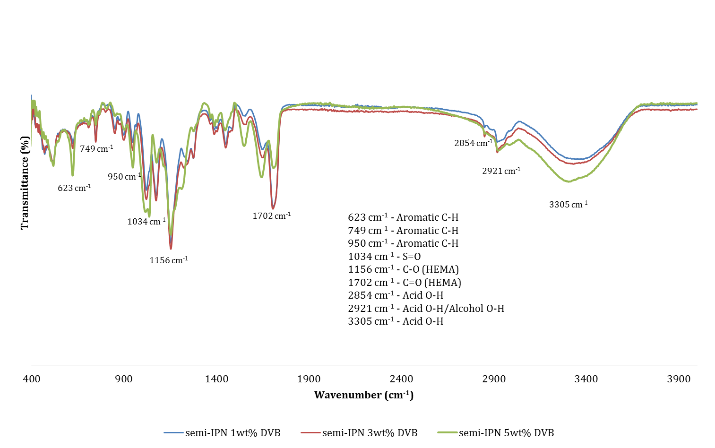
Figure 46. FTIR Spectrum for semi-IPN Membranes made using HB-PAMPS/HEMA/DVB/Water.
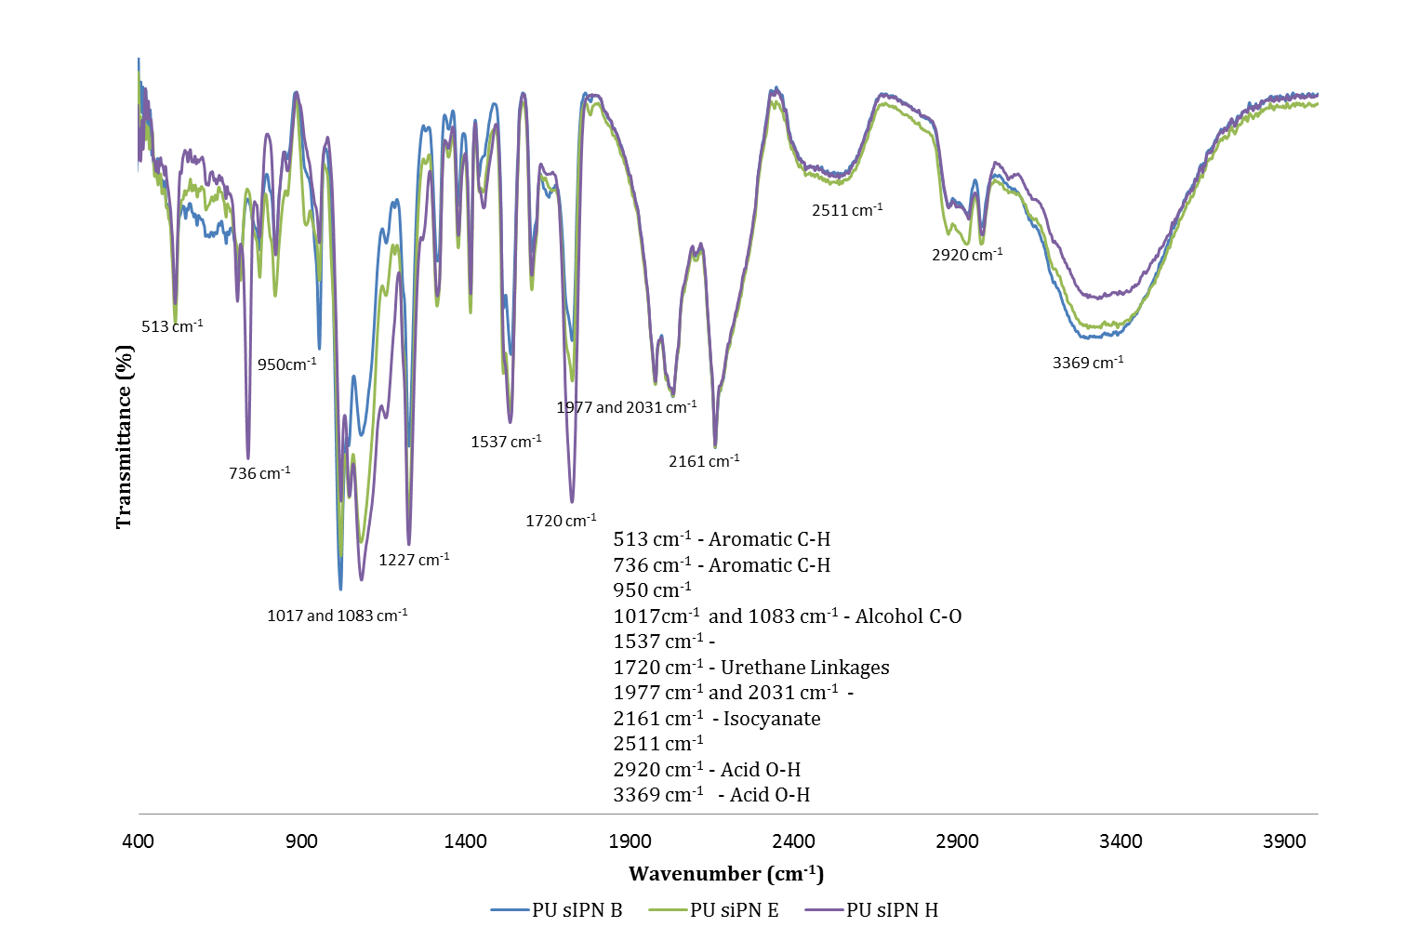
Figure 47. FTIR Spectrum for Membranes Made Using PU/Cross linker and HB-PAMPS or AMPS Monomer.
The FTIR spectra shown above, are representative of the two differing chemistries have different characteristic spectra. Various features can be identified, including the acid O-H stretch in both figure 46 and 47. Studies of the IR spectra of polyurethanes suggest that urethane linkages can be seen between 1640 cm⁻¹ and 1735 cm^{-1[208]} suggesting that the peak at 1720 cm⁻¹ in figure 47 could be attributed to urethane linkages present in the polyurethane. However, there are isocyanate groups present in the membrane (2161 cm⁻¹) suggesting that further optimisation of the process is required.
As there are very few differences between the formulations of each chemistry it is hard to see differences in the spectra between the individual membranes. However, this could prove a suitable quality control measure if solid membranes were put into production.
4.4.5 Swelling
Water content and dimensional stability are important parameters to consider when developing a fuel cell or electrolyser membrane^{[209]}. Cells are often operated at elevated temperature to increase the efficiency of the cell^{[209]}. The swelling characteristics of proton exchange membranes in water are an important parameter to consider. Samples were hydrated in ultrapure water (18.2MΩ.cm@25°C) and heated to elevated temperature (60°C) and held there over time to mimic the conditions of prolonged operation which the membrane would be subjected to in a cell. Membranes are weighed as cured, when hydrated and then dried to constant mass using a vac oven. The following equations outline the different parameters which can be evaluated:
Water Uptake = ((Hydrated Mass-Cured Mass)/Cured Mass) x 100
Water Content = ((Hydrated Mass-Dried Mass)/Hydrated Mass) x 100

Water uptake is a good parameter indicating the dimensional change of the polymer when hydrated in water. Water content of the polymer can be considered when evaluating membrane performance. The mechanisms of proton transfer through the membranes are governed by the water content of the membrane.
Sample | Water Uptake 60°C (%) | Water Content 60°C (%)
semi-IPN 1wt%DVB | 80.7 ± 0.4 | 55 ± 1.8
semi-IPN 3wt% DVB | 54.8 ± 1.8 | 48.4 ± 1.3
semi-IPN 5wt% DVB | 54.3 ± 0.9 | 45.6 ± 1
Sample | Water Uptake 60°C (%) | Water Content 60°C (%)
PU sIPN A | 85.3 ± 13 | 87.1 ± 0.4
PU sIPN B | 256.7 ± 42 | 89.3 ± 2
PU sIPN E | -3.53 ± 4 | -
PU sIPN F | -20.1 ± 8 | -
PU sIPN G | 72.5 ± 24 | 71.7 ± 10
PU sIPN H | -16.93 ± 1 | -
PU sIPN I | -8.09 ± 2 | -
PU sIPN J | -10.45 ± 0.4 | -
Table 16. Water Uptake and Water Content of sem-IPN Membranes. Samples were hydrated for 24 hours before measurements to calculate water uptake and content.
The membranes which appeared to shrink upon hydration will have had some exchange of solvent, water for DMSO. However, this may not be complete after 24 hours. This dimensional shrinkage was not looked upon favourably. Large dimensional changes in a membrane electrode assembly may result in poor catalyst contact, delamination of the assembly and ultimately poor performance in a cell.

Figure 48. Swelling Data for semi-IPN Samples Fabricated Using HB-PAMPS and HEMA/DVB.
Increasing the amount of crosslinker decreased the water uptake of the polymer, with samples also exhibiting a slower loss of mass over time. However, all membranes lost mass after the initial water uptake expansion. The loss of mass over time when the membrane is fully hydrated at 60°C suggests that the membrane is degrading; this may be due to the hydrolysis of the polymer causing chain scission which could be accelerated by the acidic environment. The reduced water uptake at 90°C may also indicate a degradation mechanism, in this case the elevated temperature may be increasing the rate of degradation. This may be a problem if the fuel cell or electrolyser is operated at higher temperature in an effort to improve efficiency, ultimately reducing the operational lifetime of the device. It is possible that the HEMA repeat units are hydrolysing to methacrylic acid. However, this may also be as a result of the loss of HB-PAMPS from the network.

Figure 49. Water Uptake of PU sIPN Samples Made Using 0.5g (5%) DVB Crosslinker.
Samples detailed in figure 47 had a lower water uptake when hydrated at 90°C than at 60°C, with all samples decreasing in mass over time, suggesting degradation when exposed to hydration at elevated temperatures. Increasing the crosslinker may slow down degradation. However, the water uptake of the membrane will be lower which may compromise performance.

Figure 50. Water Uptake Swelling in Water Over Time at 60°C of Membranes made using EGDMA and DEGDA Crosslinkers.
Samples made using EGDMA and DEGDA cross linkers detailed in figure 50 appear to decrease in mass upon hydration in water. There is approximately 30% solvent (DMSO) in the membrane formulations. Therefore there will be some degree of exchange between the solvent and water, although, the membranes have taken up water, as can be observed by the water content. This suggests that the crosslinking is more effective in these systems as less swelling is observed or that there is serious degradation of the system and possible washing out of the polymer system, including possibly the ionic polymer.
The swelling properties of the membranes suggest that large differences in the physical properties of the membranes can be made by changing the crosslinker and loading of the ionic polymer or inert polymer.
4.5.6 Chemical Degradation Accelerated Test Measured Using Fenton’s Reagent.
The degradation of membranes over time and in different conditions can be tested in a number of ways. Hydrogen Peroxide (H₂O₂) and the free radicals HO· and HO₂· can be generated during fuel cell operation, therefore the resistance against these oxidants is considered important for new materials^{[210]}. Although longevity testing of a device is necessary to commercialise products, accelerated tests can give an indication of durability. Fenton’s reagent can be used as an ex situ test medium for accelerated stress tests of the membrane^{[210]}, Fenton’s reagent is a solution of H₂O₂ and Fe²⁺ :
H₂O₂ + Fe²⁺ → Fe³⁺ + OH· + OH⁻
The degradation of Nafion was observed by Healy et al, who compared the organic compounds generated from fuel cell tests and Fenton’s test and compared them using NMR and found them to contain the same degradation products^{[211]}, thus confirming the suitability of Fenton’s reagent as a good accelerated testing methodology. In practice, metals ions for example, Cu²⁺ and Fe²⁺ can be present in the system due to corrosion of fuel cell components, for example, any metal end plates and fittings^{[210]}.
A Fenton’s test solution of 3wt% H₂O₂, 4ppm Fe²⁺ (Iron(II)sulphate was used) in ultrapure water was used to hydrate membrane PU sIPN H, PU sIPN I and PU sIPN J at 60°C. The change in mass of the polymer samples over time was assessed for up to 7 days and this can be seen in figure 51:

Figure 51. Fenton’s Test of semi-IPN Formulations Using EGDMA and DEGDA Crosslinkers.
It is clear that the Fenton’s reagent will degrade the ionomer material, causing a reduction in the mass of the sample. The Fenton’s reagent became cloudy, with small unquantifiable pieces of sample breaking off. Therefore, the error on these samples was significant, between 1% and 12% across all samples. However, all the samples were still present in the Fenton’s reagent after seven days. The reagent was remade and changed for all measurements after 12 hours of the experiment starting.
4.5.7 Extraction
The most robust samples were extracted via the soxhlet method using isopropyl alcohol (IPA) to remove the ionic component. This test was designed to look at the mechanism of embedding the branched ionically functional polymer. Elemental analysis of the samples was undertaken before and after extraction, with samples carried out in triplicate. Samples chosen for extraction were PU sIPN A, E, F, H and I. Samples A, E, F and F use DVB as the cross linker and H and J EGDMA and DEGDA. Table 17 shows the percentage loss in mass (extractable component) and the percentage of ionic component and solvent by sample constituent:

Sample | Extraction (%) | Ionic Content (%) | Solvent Content (%)
PU sIPN A | 45.4 ± 0.1 | 5.3 | 35.1
PU sIPN E | 62.3 ± 8.6 | 5.04 | 33.3
PU sIPN F | 61.8 ± 9.7 | 9.6 | 31.7
PU sIPN H | 17.4 ± 5.9 | 5.05 | 33.3
PU sIPN J | 15.9 ± 2.4 | 5.2 | 10.4
Table 17. Extraction of Ionomer Membranes Using IPA as the Solvent to Remove the Ionic Component. Error calculated using the standard error of three samples. Ionic content and solvent content are theoretical values.
Elemental analysis looking at the sulfur content of the ionomer before and after extraction confirms that the HB-PAMPS is extracted from the solvent; this can be observed in table 18:
Sample | Carbon (%) | Hydrogen (%) | Nitrogen (%) | Sulfur (%)
PU sIPN E Before | 55.35 | 8.14 | 2.3 | 10.49
PU sIPN E After | 68.61 | 7.76 | 3.11 | 0
PU sIPN F Before | 50.91 | 7.78 | 2.36 | 9.95
PU sIPN F After | 59.86 | 7.5 | 3.41 | 1.97
PU sIPN H Before | 51.75 | 7.26 | 2.46 | 9.63
PU sIPN H After | 55.99 | 7.22 | 3.29 | 0.94
PU sIPN J Before | 53.82 | 7.31 | 1.99 | 5.88
PU sIPN J After | 58.4 | 7.07 | 2.06 | 0.5
Table 18. Elemental Analysis of sIPN Membranes Before and After Soxhlet Extraction.
This may be a concern as the membranes need to be hydrated in water at elevated temperature and the harsh conditions in a fuel cell or electrolyser may drive the HB-PAMPS out of the sample. Although the loss in mass is reduced significantly when comparing PU sIPN H and J which were made using EGDMA and DEGDA crosslinkers to sample A which used DVB. DVB is not a suitable crosslinker for this system.
4.5.8 Ion Exchange Capacity
The ion exchange capacity of the membranes was measured via the treatment of membrane with 0.01M KHCO₃ and then subsequent titration of this solution against 0.01M HCl. This allowed calculation of the moles of KHCO₃ removed by the membranes ionic functionality and the ion exchange capacity (mmol g⁻¹) (see analysis chapter for the methodology and calculations). The quoted ion exchange capacity value of Nafion 110 is ≥ 0.91 mmol g^{-1[212]}. The higher the ion exchange capacity of the membrane, the more potential sites for ion transport. Therefore providing an indication of the membrane performance in a fuel cell or electrolyser. Table 19 shows the ion exchange capacity values measured via titration:
Sample | IEC (mmol g⁻¹)
semi-IPN 1wt% DVB | 0.17
semi-IPN 3wt% DVB | 0.12
semi-IPN 5wt% DVB | 0.16
PU sIPN A | <0.01
Pu sIPN B | <0.01
PU sIPN E | <0.01
PU sIPN F | <0.01
PU sIPN G | <0.01
PU sIPN H | 0.07
PU sIPN I | 0.18
PU sIPN J | 0.08
Table 19. Ion Exchange Capacity Measured by Titration.
The semi-IPN membranes made using HB-PAMPS/HEMA/DVB and the PU/HB-PAMPS membranes made using EGDMA and DEGDA did ion exchange when hydrated in 0.01M KHCO_{3.} However, the samples made using DVB did not. Samples were repeated and increased amounts of polymer and changes to the treatment solution did not change the results. The membranes were conditioned (hydrated at 60°C and dried) before hydration in 0.01M KHCO₃ and it can be postulated that the HB-PAMPS or AMPS monomer was washed out of the membrane during this pre-treatment. This aside, the IEC values are much less than the reported ≥ 0.91 mmol g⁻¹ for Nafion 110, indicating that performance would be compromised. Higher loadings of polyelectrolyte are required to improve this, however, miscibility proved problematic.
4.5.9 Device Testing
The membranes made using the HB-PAMPS/HEMA/DVB mixture were deemed the most appropriate samples to use in an electrolyser test. The poor mechanical properties of the PU sIPN samples meant that they could not be handled when in a thin enough film (≤ 0.2mm hydrated ideally). A semi-IPN with 1wt% DVB was fabricated as a larger membrane (15cm x 15cm) and hydrated in ultrapure water at 60°C for 24 hours prior to its use in an electrolysis cell. The tests were conducted at ITM using their test cell set up apparatus and protocols. The efficiency of the electrolyser is inversely proportional to the potential determined by the current density^{[213]}. This determines the rate of hydrogen production per unit of the active area of the cell^{[213]}. More hydrogen is produced if the voltage is higher. However, this would result in a lower efficiency of the cell. 2V or lower at the chosen current density (in this case 1A cm⁻²) of the cell would be an acceptable potential difference. The cell test set up can be seen in figure 52.
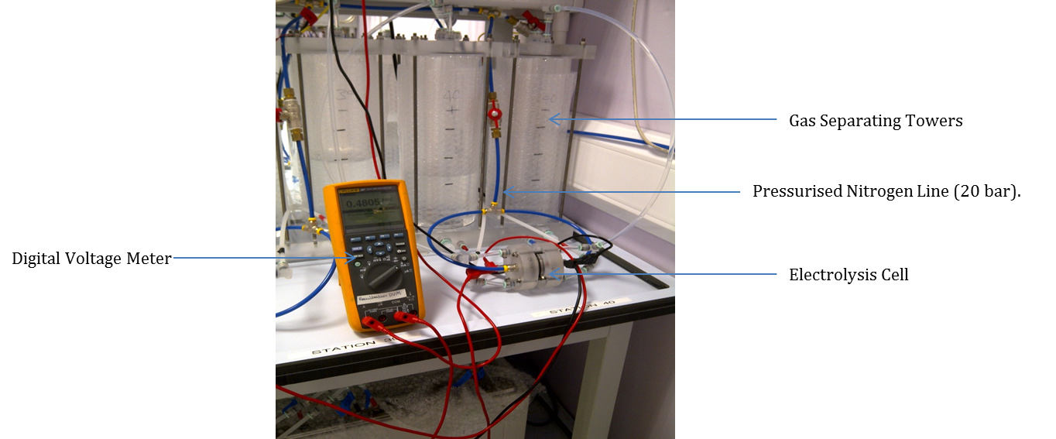
Figure 52. Electrolysis Cell Test Set Up.
The cells were made of poly(methyl methacrylate), with a titanium piston on each side allowing for the pressurisation of the cell (20 bar nitrogen). Catalyst was placed at both the anode and cathode side of the electrolysis cell. At the anode (+) terminal a platinum coated 5µm pore titanium sinter was used. At the cathode (-) terminal a 15µm titanium sinter was used in conjunction with BC Cloth Sigracet 25BC 0.2mg cm⁻² PtC 20% Vulcan Nafion post coat. These were the standard catalysts in use at ITM at the time of the experiment, thus allowing for direct comparison with their materials. The cell was tightened to a torque of 0.75cN.m. The active area of the cell was 8cm², this value is used when considering the current density of the cell.

Figure 53. IV Curves for semi-IPN 1wt% DVB Membranes.
The current density of the membrane which was 0.16mm in the fully hydrated state was 2.46V at 1 A cm⁻¹ with the membrane with a hydrated thickness of 0.21mm in the fully hydrated state was 2.88V at 1A cm⁻¹. After the initial testing schedule the samples were left on test for longevity, no parameters were changed. Longevity testing involves running the cell at constant current density (1A cm⁻¹) and observing the change in voltage, thereby assessing the performance of the cell and giving an indication of lifetime.

Figure 54. Longevity testing of semi-IPN membranes based on HB-PAMPS and HEMA/DVB.
After the initial voltage rise of the first day, the voltage decreased when the cell was ran at constant current for both cells. This may be an indication of membrane degradation, which could result in thinning of the membrane. The performance of these cells was above 2V at 1A cm⁻¹ so they would not be suitable for use in a device. The large sudden voltage drop in the 0.16mm thick sample indicates that there is a tear in the membrane, suggesting that the mechanical properties of the membrane are not suitable for purpose. Due to the force exerted on the membrane when clamped in a cell, it was difficult to assess the polymer after use with catalyst layers stuck to the membrane and breaking when the membrane electrode assembly was pulled apart.
4.6 Conclusions
Solid polymer membranes were fabricated which comprised poly(AMPS) or AMPS monomer, crosslinker and either HEMA or acrylated polyurethane. It was proposed that the polyurethane would be more resistant to hydrolysis which can lead to chain scission and subsequent degradation and loss of performance capability. There were a number of problems with these membranes including; poor miscibility of the proposed membrane components resulting in low loadings of ionic polymer; large amounts of solvent present in formulations which were then UV polymerised trapping in solvent and loss of mass over time indicating degradation and subsequent chain scission in both water and Fenton’s reagent at 60°C. The polyurethane acrylate semi-IPN networks were hard to polymerise using UV radiation and although solid films were formed they were easily broken upon handling and could not be handled when thin enough for use in a fuel cell. Thus they were not suitable for testing in a device. Samples were difficult to remove from the PTFE mould and would need to be scraped off and could not be removed as a solid film. Ion exchange capacity titrations indicated that the semi IPN structure could not be loaded with enough polyelectrolyte to have a sufficient ionic content for efficient ion transport.
Membranes which were deemed suitable for testing in a cell (HB-PAMPS/HEMA/DVB formulations) did not exhibit voltages lower than 2V at 1A cm⁻², which was deemed the minimum required for further investigation of the formulation. A voltage drop during longevity testing suggested instability and degradation, possibly leading to thinning of the membrane. Although, this was difficult to quantify when inspecting the used membrane electrode assembly after testing.

Chapter 5

Monomer Starved Emulsion Polymerisation of tert-Butyl Methacrylate and 1,3 Butadiene, Ozonolysis and Further Polymerisations

5.1 Aims and Objectives

Monomer starved emulsion copolymerisations with diene comonomers can be used to synthesise copolymers with alkene double bonds in the backbone of the polymer chain^{[214-216]}. The ozonolysis of synthesised polymers can be used to cleave the double bonds and after subsequent work up produce diamine ended telechelic oligomers. These telechelic oligomers with functionality on both ends of the short chain can be further polymerised to produce a linear polyurea which can be incorporated into a polymer electrolyte membrane.

The copolymerisation of t-butyl methacrylate and 1,3 butadiene provides polymers with the main chain unsaturation required for oligomer synthesis. Although initially there is no ionic functionality the t-butyl groups on the tBMA monomer can be deprotected using trifluoroacetic acid (TFA) to provide carboxylic acid functionality in a polyurea/polyurethane formulation. The protection of the carboxylic acid group as the t-butyl ester allows for the use of emulsion polymerisation, followed by ozonolysis and polyurea synthesis which would not be possible if the carboxylic acid functionality was present on the starting monomer.

The objectives of this investigation are:

- Synthesise Poly(tBMA-co-BD) with a high fraction and even distribution of BD monomer units.
- Ozonise the latexes to produce telechelic oligomers, ideally M_{n} 7000 g mol⁻¹.
- Add carboxylic acid and amine end groups to the oligomers.
- Use these telechelic oligomers to produce polyureas with carboxylic acid functionality in the soft segments.

This is a step wise synthesis which can be represented in the following flow chart:

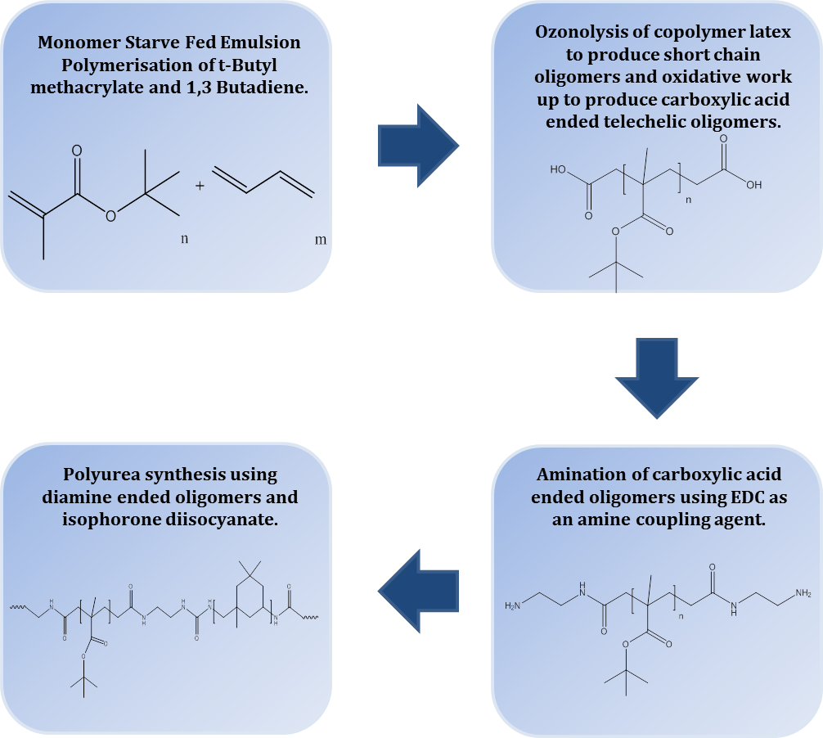

Figure 55. Flow Chart of the Step Wise Synthesis Route to Ionic Polyurethanes.
5.2 Monomer Starved Emulsion Polymerisation

Emulsion polymerisations are routinely carried out as a batch process where all components of the polymerisation reaction are present at the start. However, this provides limited control over the polymerisation. When undertaking a copolymerisation more control over the composition may be required to get the polymer required for end use^{[217]}. A monomer starve fed strategy can be used, where monomers are fed into the reaction vessel over a set time period at a slow flow rate. If the flow rate is slow enough a pseudo steady state can be achieved, where the rate of polymerisation equals the flow rate of the monomer(s) addition^{[217]}. If this is successful, instantaneous conversions can be achieved and the composition of the copolymer can be controlled depending on the flow rate and ratio of monomers in the feed^{[217]}. The pseudo steady state is only maintained during interval II of the emulsion polymerisation, thus the composition of copolymers produced during intervals I and III may be different^{[217]}. If the flow rate is too fast the copolymerisation will become flooded and analogous to the batch polymerisation process affording minimal control over composition^{[214]}.

Liu et al use monomer starve fed emulsion polymerisation to produce 2,3-dihydroxypropan-1-methacrylate acetonide-stat-butadiene^{[214]}. The BD fraction of the polymer altered the T_{g} of the polymer, T_{g} decreasing as the BD fraction increased^{[214]}. Only one T_{g} was observed, indicating that the BD was distributed evenly through the copolymer, chains of BD homopolymer may have produced a second T_{g}^{[214]}. Previous work in the Rimmer group has also addressed the monomer starve fed emulsion polymerisation of n-BMA and BD which produced copolymer that could be cleaved via ozonolysis to produce shorter chain oligomers^{[218]}.

This process of monomer starve fed emulsion polymerisation can be used for a number of copolymer systems. Ovando-Medina et al copolymerised vinyl acetate and butyl acrylate under starve fed conditions confirming homogenous copolymer compositions (copolymer content of ∼40wt%) which was not obtained during the analogous batch process^{[219]}. Styrene butadiene rubber which is the polymer used in mass production of tyres can be made using this method of emulsion polymerisation^{[62]}. This technique is used routinely in industry to produce polymers with useful properties and there are numerous patents encompassing the process, including polymers designed for printing^{[220]} and biomaterials^{[221]}.

The synthesis of homopolymers by this process has also been reported^{[220]}. They have been employed as a means of controlling particle formation and size and also molecular weight^{[220]}. It has been observed that a larger number of polymer particles can be generated under monomer starve fed conditions^{[222]}.

5.3 Telechelic Oligomers

Oligomers are short polymer chains of intermediate molecular weight^{[24]}. A telechelic oligomer has functionality which can often facilitate further polymerisation or chemical reaction on one or both ends of the macromolecule (α and ω)^{[123]} . Telechelic oligomers can be prepared in a number of ways including chain cleavage with work up and controlled radical polymerisations^{[123]}. They are often used in further polymerisations as cross linkers and chain extenders and can be the building blocks for polymers with complex architectures^{[223]}. The functionality ƒ can be quantified using the following equation^{[223]}:

ƒ = Number of Functional Groups
Number of Polymer Chain Ends

Ozonolysis of polymers with alkene double bonds in the chain is a degradative method for producing telechelic oligomers via cleavage of the double bond and functionalisation of the ozonised end, with the molecular weight of the oligomer determined by the carbon-carbon double bond content^{[215]}. Rimmer et al have used ozonolysis to constructively degrade different polymers with alkene double bonds and with subsequent treatment have produced end group functionality including carboxylic acid^{[218]}, hydroxyl^{[216]} and aldehyde^{[214]}. The thermal degradation to cleave these bonds has also been reported. Sasaki et al undertook controlled thermal degradation of poly(propylene-ran-ethylene) and poly(propylene-ran-1-butene)at 390°C to produce oligomers with functionality at one or both ends^{[224]}.

Controlled radical polymerisation can also be used to synthesise telechelic oligomers. The control over molecular weight, architecture and functionality afforded by these techniques allow for telechelic oligomer synthesis^{[223]}, but these methods are not discussed further here.

5.4 Cyclodextrins

The use of a monomer that is gaseous at room temperature can be problematic for emulsion polymerisation reactions. Previous work by Rimmer and co-workers has looked at the role of Cyclodextrins in emulsion polymerisations both as a surfactant substitute^{[225]} and solubility aid helping to incorporate the BD into the copolymer^{[218]}.

Cyclodextrins are ring oligosaccharides comprised of α-(1,4) glucopyranose units. There are three main species of cyclodextrin α, β and γ composed of 6, 7 and 8 glucopyranose units respectively, larger molecules have been made but have found little use^{[226]}. Cyclodextrins were discovered by Villiers in 1891^{[227]}, with further work and characterisation carried out by Schardinger in 1903 who isolated both α and β cyclodextrins^{[228]}. Due to the placement of the primary and secondary hydroxyl groups on the wider part of the ring and the apolar C₃ and C₆ hydrogen and ether like oxygens on the inside^{[226]}, the cyclodextrin will have a hydrophilic water soluble outside and a hydrophobic cavity in the centre^{[226]}. This allows the cyclodextrins to form solid inclusion complexes which allow a hydrophobic guest molecule(solid, liquid or gas) of the appropriate size to enter the hydrophobic cavity at the centre of the molecule forming the inclusion complex^{[226]}. No covalent bonds are made or broken in the process with the guest molecule being temporarily trapped in a dynamic equilibrium^{[226]}.

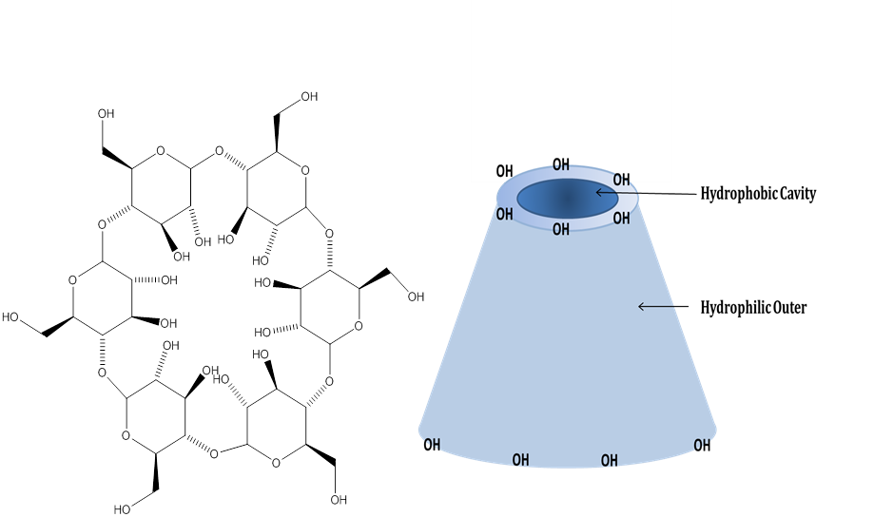

Figure 56. α-Cyclodextrin and Its Use as a Solid Inclusion Complex.
Cyclodextrins have many uses including drug delivery systems^{[229, 230]}, fragrance, food and dye complexation^{[231]} and as artificial enzymes^{[232]}.
5.5 Ozonolysis

Ozone (O₃) is an allotrope of oxygen which can be made synthetically via an electrical discharge generator^{[233]} or via the photolysis of oxygen caused by UV light^{[234]}. It was first discovered by Christian Friedrich Schönbein in 1839, who observed a peculiar smell when he electrolysed water and attributed this to a new chemical substance^{[235]}. Ozone is naturally formed in the stratosphere due to the UV radiation from the sun and shields the earth from short wavelength UV^{[236]}. Ozone has many applications in industry including water purification, manufacture of pharmaceuticals^{[237]} and the constructive degradation of polymers.

The mechanism for the ozonolysis of alkenes was proposed by Criegee in 1953^{[238]}, however these reactions were also studied previously by Harries^{[239]}. Alkene double bonds are cleaved by ozone and a number of intermediaries are formed. Criegee details the three stages of the reaction. Initally, a primary ozonide is formed by the 1,3 dipolar addition of ozone to the alkene, forming for example, a molozonide. This unstable intermediate decomposes to form a carbonyl and a carbonyl oxide. These compounds will then undergo a further addition and a more stable secondary ozonide will form. This can be seen schematically in figure 57:

Figure 57. Criegee Mechanism of the Ozonolysis of Alkenes. Redrawn from Criegee^{[238]}.
Work up of the secondary ozonide can provide a functional end. Oxidative work up will generate carboxylic acid functionality and reductive work up will generate aldehyde or ketone groups.

5.6 Materials and Methods

5.6.1 Synthesis of Poly(t-Butyl methacrylate-co-Butadiene) Latex via Monomer Starve Fed Emulsion Polymerisation: Method 1, Using a Syringe Pump for the Separate Addition of 1,3 Butadiene.

Materials
1,3 Butadiene (Sigma Aldrich, +99%), potassium persulfate (Sigma Aldrich, +99%), β-cyclodextrin hydrate (Sigma Aldrich), potassium hydrogen phosphate (Sigma Aldrich, ≥98%) Dowfax 2A1 and Calfax DB-45 (sodium dodecyl diphenyl oxide disulfonate, Pilot Chemicals) were used as received. t-Butyl methacrylate (Sigma Aldrich,98%) was vacuum distilled prior to use.

Method
A 1l jacketed reactor equipped with overhead stirrer, condenser, nitrogen inlet, monomer inlet (a double glass inlet for gas and liquid) and a heating water circulator was cleaned and heated to 80°C. A solution of ultrapure water (450ml, 18.2MΩ.cm@25°C), β-cyclodextrin (3.6g) potassium hydrogen phosphate (0.4g) and either Calfax DB-45 or Dowfax 2A1 was charged to the reactor and purged with nitrogen for an hour prior to the reaction. Potassium persulfate (1.2g) was dissolved in ultrapure water (50ml) and purged with nitrogen for an hour. t-Butyl methacrylate was charged to a two necked round bottom flask on a magnetic stirrer, fitted with a nitrogen inlet and monomer feed tube and purged with nitrogen for an hour prior to reaction. The t-BMA monomer was fed into the reactor using a peristaltic pump (Watson Marlow 505S) at a rate of 0.1ml min⁻¹.

After nitrogen purging the potassium persulfate initiator solution was injected into the reactor and the t-BMA and BD monomer feeds started. 1,3 Butadiene was fed into the reactor via a computer controlled syringe pump (ml min⁻¹). The overhead stirrer was set to 5. The ambient temperature in °C and pressure in mm Hg were recorded. A white latex was formed when all monomers had been consumed.

The latex was removed from the reactor and stored at room temperature. The latex was white and had the appearance of milk. Solid polymer was obtained by coagulating the latex into acetone (800ml). The polymer was vacuum filtered and washed with methanol and distilled water. The white solid polymer was dried in the vacuum oven at 40°C.

5.6.2 Synthesis of Poly(t-Butyl methacrylate-co-Butadiene) Latex via Monomer Starve Fed Emulsion Polymerisation: Method 2, Condensing the 1,3 Butadiene into a Monomer Mixture Prior to Addition.

Materials

1,3 Butadiene (Sigma Aldrich, +99%), potassium persulfate (Sigma Aldrich, +99%), α-cyclodextrin (Sigma Aldrich), potassium hydrogen phosphate (Sigma Aldrich, ≥98%) Dowfax 2A1 and Calfax DB-45 (sodium dodecyl diphenyl oxide disulfonate, Pilot Chemicals) were used as received. t-Butyl methacrylate (Sigma Aldrich, 98%) was vacuum distilled prior to use.

Method
A 1l jacketed reactor equipped with overhead stirrer, condenser, nitrogen inlet, monomer inlet (a glass inlet that allowed the monomer feed to enter underneath the water level of the reaction matrix) and a heating water circulator was cleaned and heated to 80°C. A solution of Millipore water (450ml, 18.2MΩ.cm@25°C), α-cyclodextrin (3.82g) potassium hydrogen phosphate (0.4g) and either Calfax DB-45 or Dowfax 2A1 was charged to the reactor and purged with nitrogen for an hour prior to the reaction. Potassium persulfate (0.6g) was dissolved in Millipore water (25ml) and purged with nitrogen for an hour and then injected into the reactor at the start of the reaction.

t-Butyl methacrylate was charged to a graduated ampoule fitted with a young’s tap and B19 quick fit socket, this was cooled in an ethanol/dry ice bath and the volume of monomer recorded. A 1,3 butadiene cylinder fitted with regulator and PTFE tube was attached to a quick fit gas inlet adaptor and clipped to the ampoule. Cotton wool coated in liquid nitrogen was used to cool the neck of the ampoule and 1,3 butadiene gas allowed to flow into the cooled monomer mixture until the desired volume of liquid 1,3 butadiene was present and a small excess of approximately 1ml (due to losses when the ampoule is evacuated). The ampoule head space is then evacuated using a hi-vac line.

t-BMA/1,3 butadiene monomer mixture was fed into the reactor using a peristaltic pump (Watson Marlow 505S) which was calibrated to prior to use, allowing monomer to be fed in at the chosen rate with the ampoule left in the ethanol/dry ice bath to prevent loss of monomer (this was shaken periodically as the monomers are sparingly miscible). Marprene tubing is used on the pump head and PTFE tubing threaded through suba seals to attach to the reactor and ampoule for the rest of the set up. Initiator (1.2g K₂S₂O₈/50ml millipore H₂O) was fed in to the reaction via a peristaltic pump (Watson Marlow 505S).

Reaction times were either approximately 8 hours or 16 hours, with reactions stopped when all the monomers had been added. White latexes with the appearance of milk were formed when all the monomers had been consumed. The latex was removed from the reactor and stored at room temperature. Solid polymer was obtained by coagulating the latex into acetone (800ml). The polymer was vacuum filtered and washed with methanol and distilled water. White solid polymer was dried in a vacuum oven at 40°C.

¹H NMR (400MHz, CDCl₃) (ppm): δ 5.25 (2H, br, RCH=CH), δ 2.05 (2H, br, RC=CCH₂), δ 1.48 (3H, br, RCH₃), δ 1.05 (2H, br, RCH₂).

¹³C NMR (100MHz, CDCl₃) (ppm): δ 176.45 (1C, C=O), δ 138.87 (2C, RCH=CH), δ 80.84 (1C, CO), δ 46.25 (1C, C-C=O), δ 28.02 (4C, RCH₃), δ 18.10 (1C, RCH₂).

5.6.3 Ozonolysis of Poly(tBMA-co-BD) Latex

Latex of poly(t-BMA-co-BD) (200ml) was charged to a 1l three necked round bottom flask equipped with a pressure equalising dropping funnel. Millipore water (200ml) was added to dilute the latex. The latex was stirred and toluene (50ml) was added dropwise over 4 hours. The latex was stirred at room temperature for 24 hours before ozonolysis. A condenser and inlet for ozone were fitted to the flask and then put in an ice bath. Oxygen was passed through an electrical discharge generator (Type BA, Wallace and Tiernan, UK), generating ozone at a rate of 1.74g h⁻¹. Ozone was bubbled through the swollen latex for 6 hours and the latex. The reaction was purged with nitrogen for approximately an hour after ozonolysis to disperse any residual ozone.

5.6.4 Synthesis of Oligo (t-butyl methacrylate-co-butadiene) With Carboxylic Acid End Groups.

The latex was not removed from the ozonolysis flask and set up. Selenium dioxide (4g) and hydrogen peroxide solution (35% v/v) were added to the ozonised latex. The latex was heated to 80°C and refluxed for 24 hours.

The oligomers were purified using ion exchange resin. Amberlite IRA 400 (Cl) was added to a conical flask with the latex (100ml). The resin and latex were shaken (orbital shaker on a low setting) for approximately 6 hours. The latex was decanted and added to a conical flask containing more Amberlite IRA 400 (Cl) and shaken overnight. The latex was further purified by placing in dialysis tubing (MWCO 12,000-14000 Daltons) in a beaker of distilled water. The water was changed twice a day for approximately one week. Toluene was removed using the rotary evaporator. Water was azeotropically removed by the addition of ethanol and then removed under reduced pressure.

¹H NMR (400MHz, CDCl₃) (ppm): δ 2.14 (2H, br, RCH₂), δ 1.81 (2H, br, RCH₂), δ 1.46 (3H, br, RCH₃), δ 1.09 (2H, br, RCH₂).

¹³C NMR (400MHz, CDCl₃) (ppm): δ 175.9 (1C, RC=O), δ 83.61 (OCCH₃), δ 47.23 (1C, RCH₂), δ 27.78 (1C, RCH₃).

5.6.5 Amination of Oligomers with Carboxylic Acid End Group Functionality

Materials
Ethylenediamine (Sigma Aldrich) and 1-(3-dimethylaminopropyl)-3-ethylcarbodiimide hydrochloride (EDC) (Alfa Aesar) and Calfax DB-45 surfactant were used as received.

Method

Oligo(tBMA) COOH latex (75ml) was charged to a three necked round bottom flask with magnetic stirrer. A condenser and pressure equalising dropping funnel were fitted to the apparatus. Calfax DB-45 was added to the latex and was stirred vigorously. 1-(3-diaminopropyl)-3-ethylcarbodiimide hydrochloride (EDC) was dissolved in 45ml of Millipore water. The reaction flask was placed in an ice bath and the EDC solution added slowly. Ethylenediamine (4.808g) was added over a period of 1.5 hours using the attached dropping funnel. Slight effervescence was observed. The ice bath was removed and the latex allowed left to stir for approximately 24 hours at room temperature.

The latexes were placed in dialysis tubing (MWCO 12,000 – 14,000 Daltons) and submerged in ultrapure water. Daily changes of water were carried out for approximately two weeks.

¹H NMR (CDCl₃, 400MHz) (ppm): δ 4.97 (2H, br, RNH₂), δ 4.02 (2H, br, RH₂NH), δ 2.88 (2H, br, NH₂CH₂), δ 1.97 (2H, br, CH₂C=O), δ 1.48 (3H, br, RCH₃), δ 0.95 (2H, br, RCH₂).

¹³C NMR (CDCl₃, 400MHz)(ppm): δ 176 (1C, RC=O), δ 80.80 (1C, ROCCH₃), δ 46.21 (1C, RNHCH₂), δ 27.77 (1C, RCH₃).

5.7 Results and Discussion

Two approaches have been employed to achieve the incorporation of BD into the polymer:

- Condensing the BD into a monomer mixture with the tBMA.
- Direct injection of BD into the reactor underneath the level of the water.

Direct injection of the BD yielded limited results, with unacceptably small quantities of BD incorporated into the backbone. The ozonolysis of the resulting latexes did not produce oligomers of small enough molecular weight (≤ 7000 g mol⁻¹ M_{n}) to be suitable for further polymerisation. Condensing the butadiene and adding the co-monomers as a liquid/liquid mixture yielded much better results with the amount of butadiene incorporated into the polymer increasing as the feed ratio of BD to tBMA was increased. However, this approach is not without problems because at the low temperatures required to prevent volatilisation of BD the two monomers are not fully miscible, meaning that the mixture pumped into the reaction vessel was inhomogenous at times which would affect the incorporation ratios of the constituent monomers.

BD is a conjugated diene with a boiling point of -4.4°C therefore it is a gas at room temperature and its incorporation into an emulsion polymerisation at elevated temperature and atmospheric pressure is not a trivial task. It is slightly soluble in water (735mg per litre^{[240]}) and previous work in the research group^{[214, 216, 218]} has shown that it can be incorporated into a copolymer synthesised via monomer starved emulsion polymerisation. Different monomers have different reactivity ratios, so that preferential reaction of monomers at different stages of the polymerisation can produce blocky or compositionally disperse copolymers, which may not be suitable for the intended use of synthesising telechelic oligomers with narrow dispersities^{[241]}. To produce a copolymer of the desired composition a starve fed approach can be employed^{[242]}. Monomers are fed into the emulsion polymerisation reactor at slow feed rates, creating a pseudo steady state where the flow rate of the monomer is equal to the rate of polymerisation^{[217]}. In theory monomer units are added to the chain as they are pumped into the reaction allowing even distribution of the differing monomers in a mixed feed. It was deemed desirable for this investigation to have an even distribution of alkene double bonds along each polymer chain. This would then produce oligomers of similar sizes when the polymer was ozonised (low polydispersity). Issues regarding the gaseous nature of BD at room temperature were also considered, in a batch process at room temperature and pressure the BD may volatilize before it can be incorporated into the copolymer^{[218]}. Therefore, a monomer starve fed strategy was the most suitable. As well as the monomer starve fed process, a solubilizing agent for BD was used, in this case cyclodextrin (both α and β), which were used to decrease the instantaneous vapour pressure of the BD^{[218]}.

5.7.1 Syringe Pump 1, 3 Butadiene Feed

The syringe pump addition method was developed and used within the Rimmer group for the copolymerisation of n-BMA and BD, with some success^{[218]}. However, this method was difficult to reproduce and there were consistent problems with equipment failure and a lack of reproducibility when good results were obtained. The syringe pump fed in BD at a constant rate throughout the 16 hour reaction period, with cyclodextrin added as a solubility aid for the BD. Although the gaseous and liquid monomers were fed in underneath the level of the water in the reactor, minimal amounts were incorporated into the final polymer backbone. There were numerous emulsion polymerisation reactions which resulted in PBMA homopolymer latex with no BD content. A number of different reaction conditions were tested, including reaction temperature, which was increased from 70°C to 80°C, type and amount of cyclodextrin, the apparatus set up (stoppering of inlets and condenser) and the addition of an initiator feed to aid with monomer conversion. The initiator feed was designed to ensure that the emulsion polymerisations went to high conversion. However, it may have changed the kinetics of the reaction, prolonging interval I as particles continue to nucleate. Table 20 shows formulations and reaction condition changes for the syringe pump latexes:

Sample | tBMA (ml) | BD (mol) | K₂S₂O₈ (g) | Cyclodextrin (g) | Temperature (°C)
P(tBMA-co-BD) A | 0.62 | 0.19 | 1.2 | β 3.6 | 70*
P(tBMA-co-BD) B | 0.62 | 0.93ⱡ | 1.2 | β 3.6 | 80
P(tBMA-co-BD) C | 0.62 | 0.93 | 1.2 | β 3.6 | 80
P(tBMA-co-BD) D | 0.62 | 0.11 | 1.2 | β 3.6 | 80
P(tBMA-co-BD) E | 0.62 | 0.07 | 1.2 | β 3.6 | 80
P(tBMA-co-BD) F | 0.62 | 0.11 | 0.6/1.2† | β 3.6 | 80
P(tBMA-co-BD) G | 0.62 | 0.07 | 0.6/1.2† | β 3.6 | 80
P(tBMA-co-BD) H | 1.23 | 0.07 | 0.6/1.2† | β 3.6 | 80
P(tBMA-co-BD) I | 1.23 | 0.07 | 0.6/1.2† | α 3.08 | 80
P(tBMA-co-BD) J | 1.23 | 0.07 | 0.6/1.2† | α 6.16 | 80
Table 20. Reaction Conditions and Formulations for Syringe Pump Addition Reaction. ⱡ Previous work in the group used formulations which had a much higher BD fraction on the initial formulation; it is thought this may cause flooding of this monomer so the content was reduced. *Previous work at 70°C only produced P(BMA) homopolymer. †Addition of an initiator feed.
All reactions used 0.4g K₂HPO₄ as a buffer, approximately 500ml or 525ml of water if the initiator feed is used with 3g of sodium dodecyl diphenyl oxide disulfonate (Calfax DB-45 or Dowfax 2A1) surfactant. Table 20 is not a complete list of all the synthesis reactions carried out. However, the data does show the evolution of the synthesis route and the main reaction and formulation changes. Poole et al^{[218]} indicated that α cyclodextrin was better than β cyclodextrin as a solubilising agent for BD, as a result of this work β cyclodextrin was substituted for α cyclodextrin. BD was added to the reaction in ml and the moles of BD are calculated using the ideal gas equation using the ambient temperature and pressure of the lab as recorded at the start of each synthesis reaction:

PV=nRT

Where P is the pressure, V is the volume, n is the amount of substance measured in moles, R is the ideal gas constant (8.31441 J K⁻¹ mol⁻¹) and T is the temperature.

Sample | Particle Size (nm) | Zeta Potential (mV) | pH | Solid Content (%)
P(tBMA-co-BD) A | 343 ± 6 | 32 ± 3 | 3.06 | 13.3 ± 0.03
P(tBMA-co-BD) B | 66 ± 0.2 | -69 ± 4 | 2.32 | 12.1 ± 0.01
P(tBMA-co-BD) C | 63 ± 4.1 | -68 ± 5 | 2.25 | 8.5 ± 0.02
P(tBMA-co-BD) D | 94 ± 0.8 | -67 ± 4 | 2.33 | 14.5 ± 0.03
P(tBMA-co-BD) E | 85 ± 1.7 | -94 ± 3 | 2.37 | 14.2 ± 0.06
P(tBMA-co-BD) F | 478 ± 14 | -9 ± 4 | 2.11 | 5.1 ± 0.03
P(tBMA-co-BD) G | 826 ± 51 | -34 ± 4 | 2.09 | 8.7 ± 0.1
P(tBMA-co-BD) H | 81 ± 0.6 | -61 ± 0.4 | 1.79 | 14.1 ± 0.8
P(tBMA-co-BD) I | 90 ± 1.2 | -62 ± 0.1 | 2.04 | 14 ± 1.6
P(tBMA-co-BD) J | 67 ± 1.7 | -66 ± 2 | 2.41 | 9.2 ± 0.6
Table 21. Latex Characterisation Data for Syringe Pump Addition P(tBMA-co-BD) Emulsion Polymer Latexes.
Latex samples A, F and G have much larger particles sizes than the other samples. Solid coagulate was observed in the reactor and the latex, it can be proposed that these larger particle sizes are due to micro-coagulation of particles in the latex. The lower than expected solid content also indicates that the solid polymer had coagulated out of the latex dispersion.

Of the P(tBMA-co-BD) samples listed above only samples B, F, and J contained 1.7%, 6.2% and 12.7% BD in the resultant polymer samples respectively, observed and calculated using ¹H NMR. These samples were analysed by SEC using THF eluent (linear poly(styrene) standards) the results of this analysis can be seen in table 22:

Sample | M_{n} | M_{w} | M_{z} | M_{z} + 1 | Dispersity
 | (g mol⁻¹) | (g mol⁻¹) | (g mol⁻¹) | (g mol⁻¹) | (M_{w}/M_{n})
P(tBMA-co-BD) B | 17900 ± 200 | 30100 ± 50 | 44900 ± 1100 | 59300 ± 3400 | 1.68
Oligo(tBMA) B | 6200 ± 800 | 10200 ± 1500 | 16400 ± 3200 | 24000 ± 6200 | 1.65
P(tBMA-co-BD) F | 28000 ± 450 | 55550 ± 150 | 95050 ± 100 | 137900 ± 1000 | 1.98
Oligo(tBMA) F | 8500 ± 800 | 17200 ± 2300 | 30650 ± 3100 | 43100 ± 2300 | 2.02
P(tBMA-co-BD) J | 38200 ± 300 | 82700 ± 400 | 143200 ± 1250 | 208200 ± 2700 | 2.16
Oligo(tBMA) J | 25300 ± 1600 | 65400 ± 6350 | 145200 ± 13100 | 246700 ± 9400 | 2.58
Table 22. THF Eluent SEC Results for Syringe Pump Addition Polymer and Oligomers.
Although the ¹H NMR calculation indicated that there were more double bonds present in the polymer the BD fraction was not high enough to allow for the formation of oligomers ≥ 7000 g mol⁻¹ M_{n} in all case apart from sample B. It was difficult to reproduce this positive result. This could be as a result of uneven distribution of BD in the polymer chain, with runs of BD present. As a result of these continuous poor results it was deemed appropriate to attempt another method of BD addition to achieve a higher fraction of butadiene addition and a more reproducible and reliable method.

5.7.2 Condensed Liquid BD Feed

It was proposed to condense the butadiene gas into a liquid/liquid monomer mixture with the tBMA and feed this in to the reactor using the pump, varying the molar ratio of tBMA to BD with a view to increasing the fraction of BD in the final copolymer. Monomers were fed into the reactor via a peristaltic pump at a rate of 0.16ml/min. The condensed BD was mixed with t-BMA in an ampoule and kept cool using an acetone/dry ice bath and stirred whilst being fed into the reactor. This monomer was shaken frequently as the BD liquid (0.64 g cm⁻³) is less dense than the tBMA (0.875 g cm⁻³) and formed layers. It was not possible to keep the tubing cool so the monomer mixture warmed in the tubing before being fed into the reactor resulting in the BD being added as a gas, small bubbles could be seen in the monomer feed as it entered the reactor. The monomer feed was inserted so as to add the monomers underneath the water level; this helped to alleviate the problem of BD collecting as a gas in the head space within the reactor.

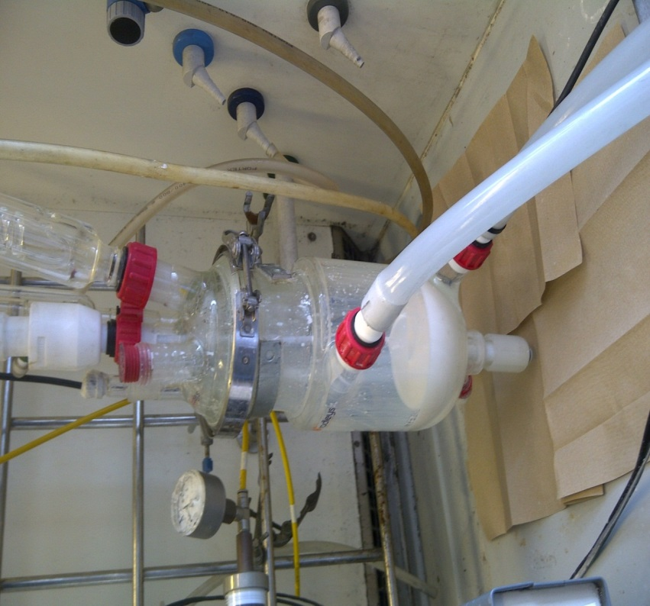
Figure 58. Jacketed Reactor (1L) for Synthesis Via Emulsion Polymerisation.

The reaction conditions were kept constant with differences in the monomer feed ratio of t-BMA:BD altered. Water (525g), sodium dodecyl diphenyl oxide disulfonate surfactant (Calfax DB-45, 3g), buffer (potassium hydrogen phosphate, 0.4g) and α-cyclodextrin (3.82g) were all kept constant. The critical micelle concentration of Calfax DB-45 is 0.07 g/l^{[243]}, therefore the surfactant was added in excess of this concentration.

Sample | K₂S₂O₈ (g) | tBMA (g) |  | tBMA (mol) |  | BD (g) | BD (mol)
P(tBMA-co-BD) 14.1:1 | 0.6/1.2* | 70 | 0.49 |  | 1.92† |  | 0.035
P(tBMA-co-BD) 10.4:1 | 0.6/1.2* | 70 | 0.49 |  | 2.56† |  | 0.047
P(tBMA-co-BD) 5.1:1 | 0.6/1.2* | 70 | 0.49 |  | 5.12† |  | 0.095
Table 23. tBMA and BD Emulsion Polymerisation Formulations for Condensing BD Reactions. * 0.6g added initially with 1.2g added via a feed (0.16ml/min) throughout the reaction. † Mass of BD calculated from the volume and density (0.64 g cm⁻³), varied amounts as a result of the condensation procedure.

Latex samples were analysed in terms of particle size, zeta potential, pH and solid content, with the solid polymer being isolated from the aqueous phase (precipitated into acetone) and analysed via ¹H and ¹³C NMR and THF SEC.

Sample | Particle Size (nm) | Zeta Potential (mV) | Solid Content (%) | Monomer Conversion (%)* | Butadiene (%)†
P(tBMA-co-BD) 14.1:1 | 69 ± 1 | -37 ± 3 | 12.9 ± 0.7 | 96 | 3.5
P(tBMA-co-BD) 10.4:1 | 295 ± 4 | -61 ± 7 | 11.2 ± 0.07 | 84 | 4.3
P(tBMA-co-BD) 5.1:1 | 71 ± 1 | -42 ± 11 | 16 ± 0.8 | 100 | 12.6
Table 24. Latex Characterisation Data for Liquid Liquid Monomer Feed Emulsion Polymerisations. *Monomer conversions were calculated gravimetrically. † Butadiene percentage was calculated using the ratio of tBMA methyl group peaks to alkene peaks.
The latexes were deemed to be colloidally stable, with all latexes exhibiting a zeta potential ≥ -30 mV. Particle sizes were similar, although this would be expected as the amount of surfactant was kept constant with only a relatively small change in the amount of monomer present in terms of BD. Surfactant concentration controls the particle nucleation phase of the polymerisation and this in turn affects the particle size and particle size distribution^{[63]}. Nevertheless, the particle size of P(tBMA-co-BD) 10.4 :1 is significantly higher than the other samples; this could be as a result of particle aggregation. The solid content and monomer conversion are also lower than the other samples, solid coagulum may have formed and settled out, reducing the polymer content of the latex.

¹H NMR can be used to measure the degree of main chain unsaturation. Alkene double bonds can be seen in the region between δ 5.5 ppm and 7.5 ppm. The comparison between the hydrogen present on the BD alkene unit and the hydrogen present in methyl groups on the tBMA units can provide an indication of the amount of BD incorporated into the polymer as a percentage of the monomer feed.

Sample | Butadiene (%) | Percentage of Butadiene Feed Incorporated (%)
P(tBMA-co-BD) 14.1:1 | 3.5 | 49
P(tBMA-co-BD) 10.4:1 | 4.3 | 44
P(tBMA-co-BD) 5.1:1 | 12.6 | 69
Table 25. Butadiene incorporation into the emulsion polymerisation synthesised samples.
It can be seen from table 25 that not all BD gaseous monomer was incorporated into the copolymer. Due to the gaseous nature of the monomer, high conversion for the BD can be difficult, with further optimisation of the process required to increase the copolymerisation tBMA to BD ratio, as the higher the fraction of BD present, the smaller the oligomers that can be produced.
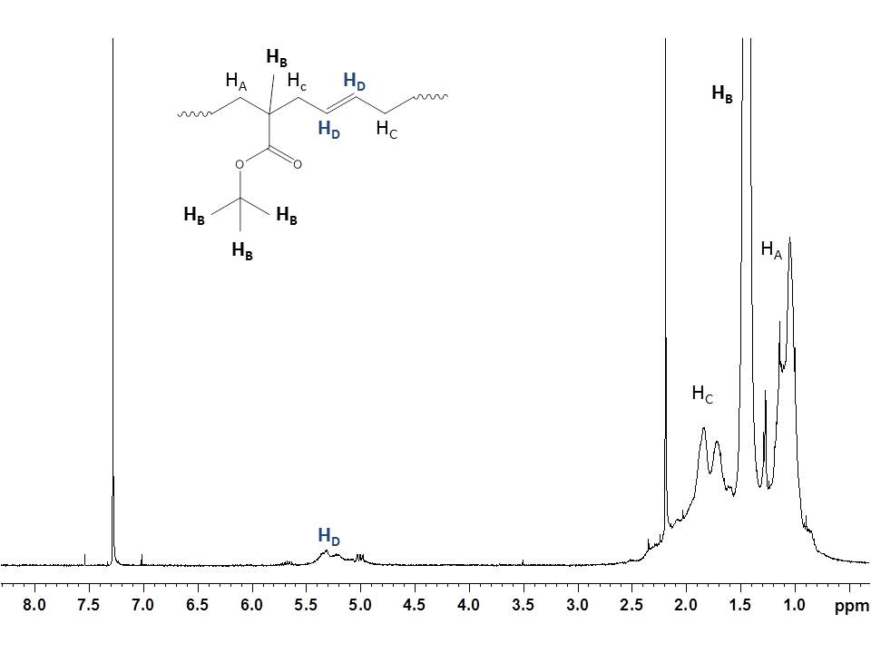
Figure 59. ¹H NMR (CDCl₃, 400MHz) Poly(tBMA-co-BD) solid polymer. The singlet at 2.2 ppm is as a result of residual acetone in the sample.
Figure 59 shows the different peaks from the ¹H NMR which can be used to calculate the percentage of double bonds compared to the units of tBMA.
¹H NMR of the carboxylic acid ended oligomer shows that the peak at δ 5.0 – 5.5 ppm is not present after ozonolysis indicating that the double bonds along the backbone of the polymer were cleaved via ozonolysis. Following ozonolysis, the peaks observed between δ 5 ppm and δ 5.5ppm in figure 59 are not present (see figure 61) indicating that the alkene double bonds have been broken and ozonides formed. These oligomers underwent oxidative work up using H₂O₂ and SeO₂ to produce carboxylic acid ended oligomers. Figure 60 shows the mechanism of ozonolysis based on the Criegee mechanism with oxidative work up. After treatment with ozone a primary ozonide will form which will decompose to form a carbonyl and carbonyl oxide. In water, the carbonyl oxide forms a hydroxyl hydroperoxide.
Figure 60. Ozonolysis Mechanism of P(tBMA-co-BD).
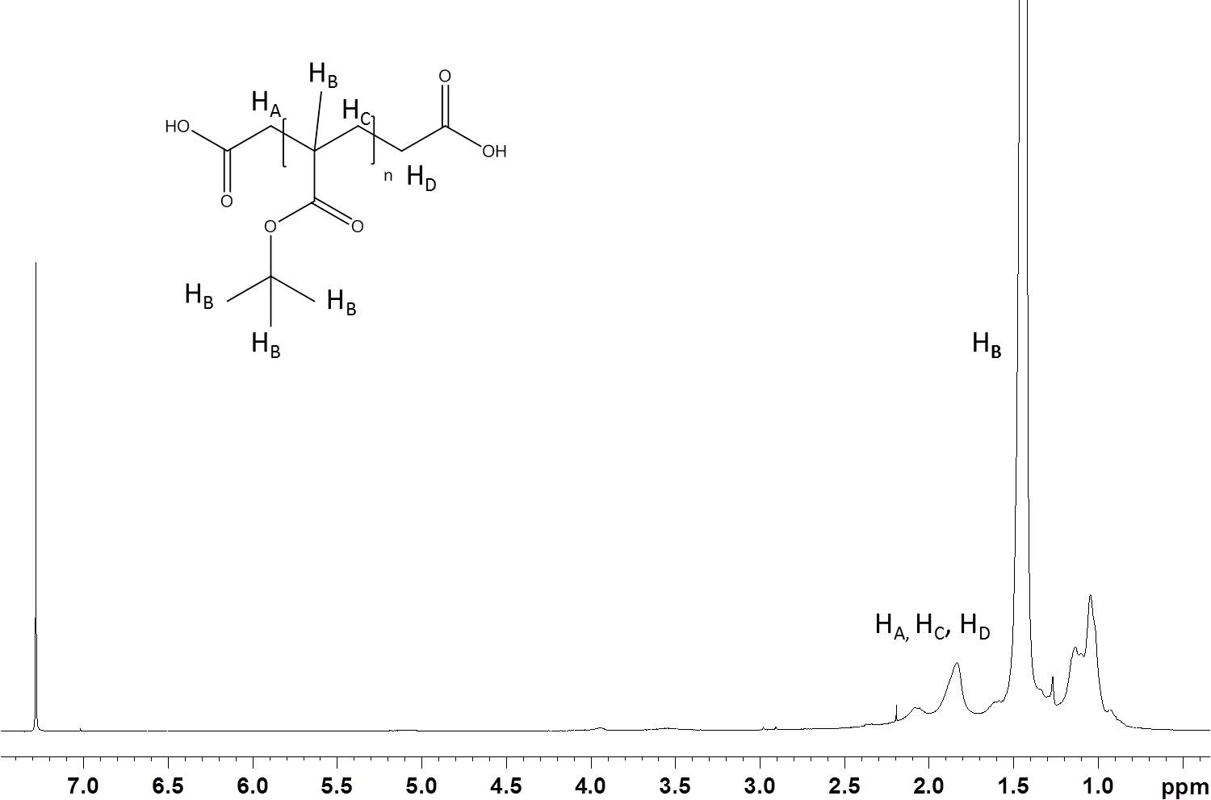
Figure 61. ¹H NMR Oligo(tBMA) COOH End Functionality.
Figure 61 is the ¹H NMR spectrum of Oligo(tBMA) with carboxylic acid end group functionality and confirms due to the absence of alkene peaks that ozonolysis can be used to degrade the polymer and produce short chain oligomers.
SEC analysis using THF eluent was used to look at the molecular weight of the polymers and subsequent oligomers.

Sample | M_{n} | M_{w} | M_{z} | M_{z} + 1 | Dispersity
 | (g mol⁻¹) | (g mol⁻¹) | (g mol⁻¹) | (g mol⁻¹) | (M_{w}/M_{n})
P(tBMA-co-BD) 14.1:1 | 198750 ± 4000 | 442100 ± 8600 | 765650 ± 14850 | 1064500 ± 17800 | 2.22
Oligo(tBMA) 14.1:1 | 13300 ± 500 | 47400 ± 6800 | 115400 ± 27800 | 180200 ± 52300 | 3.57
P(tBMA-co-BD) 10.4:1 | 15300 ± 200 | 30150 ± 1850 | 54350 ± 5450 | 86200 ± 10400 | 1.97
Oligo(tBMA) 10.4:1 | 7400 ± 100 | 20400 ± 300 | 49000 ± 1000 | 83200 ± 2300 | 2.76
P(tBMA-co-BD) 5.1:1 | 18300 ± 200 | 39000 ± 2000 | 75000 ± 11200 | 125600 ± 32700 | 2.12
Oligo(tBMA) 5.1:1 | 1500 ± 0 | 3500 ± 100 | 6850 ± 600 | 11800 ± 2350 | 2.35
Table 26. THF SEC Results Comparison for Poly(tBMA-co-BD) and Oligo(tBMA). Error calculated using standard error.
The ozonised samples have substantially lower molecular weights than the starting material polymer samples. It is clear that there is more main chain unsaturation in P(tBMA-co-BD) 5.1:1 when compared to P(tBMA-co-BD) 10.4:1 although the polymers have similar starting material molecular weights, M_{n} 15300 g mol⁻¹ (10.4:1) and M_{n} 18300 g mol⁻¹ (5.1:1) . P(tBMA-co-BD)14.1:1 is a much larger polymer than other starting material samples. It has been observed previously that an increase in BD fraction in the monomer feed can decrease the molecular weight of the copolymers^{[214]}. This may be due to an increased rate of termination attributed to the monomer starve fed conditions of the synthesis^{[214]}.

Figure 62. Differential Distribution of Polymers and Oligomers as Obtained After Ozonolysis.
The P(tBMA-co-BD) polymers have narrower polydispersities than the oligomers, this may be due to uneven distribution of alkene double bonds along the backbone of the polymer, resulting in a larger variation in the size of the polymer chains. Further optimisation of the feed may be able to minimise the variation, distributing the alkene double bonds so that there is less variation in the molecular weight distribution of the oligomers.

The Kolmogorov-Smirnov test compares two different sets of data and tests the hypothesis the two independent samples represent two different populations of data and is a nonparametric test^{[244]}. Statistical comparison using this test between the starting material and corresponding oligomer indicates that the samples are statistically significant (p value < 0.05) all p values were < 0.0001 highlighting the differences in molecular weight between the polymer and oligomer, confirming that the samples are different and that the oligomers are smaller.

Fourier Transform Infrared Spectroscopy (FTIR) carried out on the solid polymer and oligomer samples, show a small broad peak in the range of the N-H stretch for primary and secondary amines (3350-3400 cm⁻¹), with the rest of the polymer and oligomer similar. This similarity would be expected as only the end groups are modified with the majority of the oligomer chain remaining unaffected. This can be seen in figure 63. ¹H NMR analysis of the oligomers confirms the presence of a peak at approximately δ 5ppm which corresponds to the primary amine present on the end of each oligomer chain.

Figure 63. FTIR Comparison of Polymer and Diamine Functionalised Oligomer. Broad peak observed corresponding to the primary and secondary amine stretch (N-H).
One way of assessing whether amination has occurred is to look at the elemental analysis of oligomers before and after the addition of ethylene diamine in the presence of amine coupling agent EDC. The following table compares the elemental percentage content of carboxylic acid ended oligomers and diamine ended oligomers:

Sample | Carbon (%) | Hydrogen (%) | Nitrogen (%)
Oligo(tBMA) COOH 14.1:1 | 62.78 | 9.02 | 0
Oligo(tBMA) NH₂ 14.1:1 | 63.74 | 9.34 | 1.41
Oligo(tBMA) COOH 10.4:1 | 64.82 | 9.68 | 0
Oligo(tBMA) NH₂ 10.4:1 | 63.64 | 9.9 | 2.83
Oligo(tBMA) COOH 5.1:1 | 64.62 | 9.41 | 0
Oligo(tBMA) NH₂ 5.1:1 | 52.79 | 9.72 | 2.05
Table 27. Elemental Analysis Comparison of Carboxylic Acid Ended Oligomers and Diamine Ended Oligomers.
From the small peak present in FTIR, NMR and elemental analysis it can be seen that the oligomers have diamine end group functionality which can be used for further polymerisation reactions including for example, the synthesis of polyureas.

5.8 Conclusions

Of the two routes to P(tBMA-co-BD) latex using emulsion polymerisation the use of a syringe pump to inject gaseous BD at a known rate had limited success, whereas the condensation of BD so that it was in a liquid mix with the tBMA was more successful, even though not all the BD was incorporated for the emulsion polymerisation synthesis reactions undertaken. The ozonolysis to create telechelic oligomers was successful in constructively degrading the polymer so as to produce short chain oligomers which could then subsequently be worked up to produce telechelic oligomers with carboxylic acid functionality and diamine functionality. The current emulsion polymerisation method produces colloidally stable latexes in which most of the monomer was converted into polymer.

Drawbacks of the syringe pump method were problems with the equipment, coalescence of the polymer particles and unreproducible incorporation of BD into the copolymer. Although in some cases there was butadiene present, it appeared to be unevenly distributed in the copolymer.

The condensation of BD and incorporation of BD in the same liquid monomer feed was reproducible and produced short chain oligomers, however in one instance the latex still suffered from particle aggregation. Although this method is not optimised and changes to the flow rate and emulsion polymerisation formulation may be needed, it produced oligomers of the desired size (≥ 7000 g mol⁻¹ M_{n}) which could be worked up to produce the required end group functionality.

Chapter 6

Overall Conclusions and Further Work

6.1 Branched and Linear PAMPS

The branched polymers and similar linear versions of the PAMPS were synthesised, isolated and analysed. However, the development of a suitable SEC method for the analysis of the linear and branched polymers would be of great benefit. A triple detection system with a concentration detector, MALS and viscometric detector would provide information about the molecular weight and architecture of the polymer. More analysis of the kinetics of the polymerisation may increase understanding of the mechanism, and the parts played by the RAFT and self-condensing vinyl polymerisation mechanisms.

Comonomers could be used to change the properties of the polymer which may extend the range of suitable applications. Acrylamide, divinylbenzene or acrylic monomers may beneficially change the polymer properties. It may be beneficial to change the RAFT agent. Although RAFT is a versatile technique, the strong polyelectrolyte nature of the monomer may be more suited to a different RAFT agent. Alternative RAFT agents could be tested to find the most suitable molecule.

6.2 Emulsion Polymerisations of n-BMA Using Branched and Linear PAMPS

Although these synthesis reactions were successful in producing high monomer conversion stable latexes, there is further work that can be conducted. In terms of further analysis of the synthesised polymer systems, XPS could be used to investigate the surface chemistry of the polymer particles, this would help confirm the structure of the core shell particles.

Changes in the formulation may be utilised to try and alter particle size and change the properties of the polymer particles. A study using HB-PAMPS and L-PAMPS with the same moles of RAFT per gram may be useful for understanding the structure and kinetics of the different latexes. An assessment as to whether or not PAMPS is solubilised in the water of the matrix may also help to assess the level of sulphonation. Optimisation of the process for making latex from PAMPS with no RAFT group may provide useful material for comparison. However, these would only be charge stabilised latexes with no anchor point for the PAMPS creating a different structure and latex with different properties.

Experimental data for these latexes in an industrial application such as polymer binder or biomaterial would help assess their usefulness and help to guide further modifications to the synthetic process. These polymers have already been used as delivery particles for growth factors required for the generation of new blood vessels^{[245]}. Changes in the hydrophobic monomer may provide particles better designed for the proposed use. This process would work for most hydrophobic monomers with vinyl functionality, for example, styrene and butyl acrylate. These polymeric systems may exhibit better properties in terms of a polymer catalyst binder material. Modification of monomers to provide this vinyl functionality could be undertaken and these could then be used in the emulsion polymerisation reactions. For example, polycaprolactone diol could be end capped with acrylated groups forming a macromonomer^{[246]}. Polycaprolactone is a biodegradable polymer which may enable the particles to be used as a drug delivery vehicle^{[247]}.

6.3 Semi-IPN Membranes

There were a number of issues with these polymer membranes which further work and optimisation of the fabricated semi-IPN membranes may improve.

Issues with miscibility may be improved by changing the solvents used to solubilise the mixtures. DMSO is a polar aprotic solvent; other similar solvents may be more suitable, for example, DMF, N-methylpyrrolidone (NMP) or Dimethylacetamide (DMAc). The ion exchange to a salt form of the HB-PAMPS or AMPS monomer may also help to change the miscibility of the mixtures. Membranes made in the salt form could be protonated after fabrication via ion exchange in an acidic solution, for example, 1M HCl or 1M H₂SO₄. Altering the monomers used may also change the properties of the prepolymer or monomer mixtures making them more compatible in terms of miscibility. The harsh environment and degradation concerns need to be addressed when looking to change chemical components. Changes to the PPG/MDI polyurethane, for example, chain extension with ethylenediamine may make the prepolymer more compatible. Thermal or gamma radiation curing of the systems may create polymers with improved physical properties.

The low loadings of ionic component in the polymer could be improved by incorporation of an ionic component into the backbone of the polyurethane. Diol and diamine compounds which have sulfonic acid or carboxylic acid functionality can be utilised, for example, hydroquinonesulfonic acid potassium salt or 2,5-diaminobenzenesulfonic acid. The compounds can be neutralised before polymerisation and could be used as dopant chain extender in a polyurethane or polyurea formulation. The membrane can be ion exchanged after fabrication to provide the desired acidic functionality. This approach would provide ionic functionality in both parts of the interpenetrating network.

A casting approach rather than crosslinked vinyl system may be better to create a polymer blend of the samples. Casting using DMF or NMP solvent should be attempted.

6.4 Monomer Starved Emulsion Polymerisation of tBMA and 1,3 Butadiene and Telechelic Oligomer Synthesis

Further work can be done to optimise the monomer starved emulsion polymerisation process and work to use the diamine ended telechelic oligomers as starting materials in the synthesis of ionic polyureas/polyurethanes.

Changes to the flow rate of the monomer feed, amount of surfactant and initiator and conducting the experiment with and without the initiator feed could provide useful information and allow the synthesis of polymers which can be tailored to a specific application. Strategies for the incorporation of more of the butadiene feed (which was never more than 69%) could be explored. This may involve changes to the apparatus, for example, less head space in the reactor and further stoppering, or further changes in the amount and type of cyclodextrin to help with BD solubility. Kinetics of the reaction with and without the initiator feed would provide useful information to look at the formation of polymer and help to design a methodology which provides high monomer conversion and a high fraction of BD incorporation.

Work to look at the use of oligomers in a polyurea formulation could be carried out. Titration for amine content and then use of the diamine ended oligomer using Isophorone diisocyanate as the hard segment. The fabrication of membranes from these oligomers is key for their use as a polymer electrolyte. A trifunctional hydroxyl compound could be used as a cross linking chain extender, with the membrane solution poured into a mould and dried.

Chapter 7

Analytical Techniques

7.1 ¹H and ¹³C NMR
A Bruker Avance 400 Spectrometer was used for all NMR analyses with ¹H at 400MHz and ¹³C at 100MHz. Deuterated chloroform (CDCl₃) and deuterated dimethyl sulfoxide ((CD₃)₂S=O) were purchased from Sigma Aldrich and used as received for all samples. Spectra were analysed using Topspin (Bruker). The standard program used for ¹H NMR (400MHz), CPD250ppm program used for ¹³C NMR (100MHz).

7.2 FTIR
Analysis of samples in the solid state was undertaken using a Perkin Elmer Spectrum 100 FTIR Spectrometer using Spectrum software for measurement and analysis. An attenuated total reflectance (ATR) accessory was used, meaning that samples required no sample preparation other than drying.

7.3 THF SEC
Analysis of samples was undertaken using filtered (0.45µm vacuum filtration) GPC grade THF (stabilised with 250ppm butylated hydroxytoluene) (Fisher) as the mobile phase, high molecular weight column (PL mixed ‘B’) and an ERMA ERC-7512 refractive index detector. The instrument was calibrated using poly(styrene) standards between M_{w} 630 g mol⁻¹ and 6,200,000 g mol⁻¹ or poly(methyl methacrylate) standards between M_{w} 780 g mol⁻¹ and 2,022,000 g mol⁻¹ (Agilent EasiVial). GPC grade toluene (Fisher) was used as a flow rate marker and samples were filtered through a 0.45µm PTFE syringe filter before injection. Sample concentration was 1 mg/ml. Eluent flow rate was 1ml/min. Cirrus SEC software (Agilent) was used for measurement and analysis.

7.4 Aqueous SEC using Charged Columns
Analysis of samples was undertaken using filtered (0.45µm vacuum filtration) 0.08M TRIS (Sigma Aldrich, ≥99.8%)/0.15M NaCl (VWR, 99.7%) prepared with millipore water (18.2MΩ.cm@25°C) as the mobile phase, Jordi Gel DVB Sulfonate GPC columns and a Hewlett Packard HP 1047A refractive index detector. The instrument was calibrated using poly(acrylic acid) standards between M_{w} 1930 g mol⁻¹ and 1,100,000 g mol⁻¹ (Agilent). Samples were prepared in a 1mg/ml concentration and filtered through a 0.45µm PTFE syringe filter before manual injection via an injection loop. Eluent flow rate was 1ml/min. Cirrus SEC software (Agilent) was used for measurement and analysis.

7.5 Dilute Solution Viscometry
The viscosity of polymer solutions of varying concentrations (g/dL) was measured using an Ubbelohde viscometer (Rheotek PSL 1 68035) (see figure 61). Solutions were made using 1M sodium chloride (VWR, 99.7%) made using millipore water (18.2MΩ.cm@25°C). A known volume of polymer solution was charged to the viscometer and internal dilutions carried out (10ml of starting stock solution with serial solvent dilutions). Accurate glass pipettes (grade A) were used for solution measurements and transfer. A viscometric water bath (Rheotek) at 25°C ± 0.2°C was used for all measurements with samples equilibrated for 15 minutes prior to measurements. All measurements were repeated in triplicate and measured using a digital stopwatch to 2 decimal places of a second.

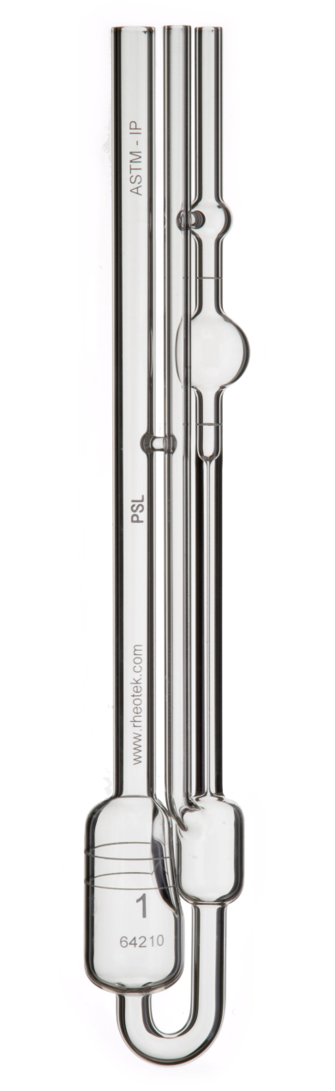
Figure 64. Ubbelohde Viscometer. Reproduced from: Rheotek (available from: http://www.rheotek.com/assets/rheotek/sub_cat_docs/PSL%20Capillary%20Sizes%202010_allround.pdf)
7.6 Latex Solid Content
Latexes were analysed to determine solid content by measuring the mass of latex and then drying to constant mass in a vacuum oven (40°C). The following equation was used:

Solid Content (%) = (mass of dry latex (g)/mass of wet latex (g)) x 100

Samples are carried out in triplicate.

7.7 Particle Size

Brookhaven Instruments zeta potential analyser using ZetaPALS particle size analyser software. Samples were diluted using 10mmol potassium chloride prior to analysis. Samples were dilute to a point where the counts were between 500kcps and 1Mcps. The latexes analysed for this investigation were diluted to 1µl in 25ml.

7.8 Zeta Potential
Brookhaven Instruments zeta potential analyser using ZetaPALS particle size analyser software, using an electrode suitable for aqueous samples. Samples were diluted using 1mmol potassium chloride prior to analysis and the instrument standardised using BI-ZR3 reference material before each set of samples. Reference conductance was measured as 320µS ± 10%.

7.9 pH
Mettler Toledo SevenEasy pH meter was used calibrated using pH 4 and pH 7 buffer solutions (Hanna Instruments).

7.10 Elemental Analysis
A Perkin-Elmer 2400 CHNS/0 Series 2 Elemental Analyser was used to determine the percentage content of carbon, nitrogen, sulphur and hydrogen.

7.11 Swelling Tests
The semi-IPN membranes were hydrated in ultrapure water at 30°C, 60°C and 90°C (one 2cm x 1cm rectangle in ~20ml of water. The samples were weighed using a four decimal place Ohaus Adventurer Pro analytical balance and were measured using digital callipers correct to two decimal places of a millimetre (Mitutoyo). The following equations were used to analyse results:

Water Uptake ((Hydrated Mass-Cured Mass)/Cured Mass) x 100

Linear Expansion ((Hydrated Length-Cured Length)/Cured Length) x 100

The samples were measured over time, with the fresh hydration water used after each measurement. For mass measurements excess water was removed using lint free paper.

The water content of the polymer can be calculated by drying the hydrated polymer sample to constant mass and using the following equation:

Water Content ((Hydrated Mass-Dried Mass)/Hydrated Mass) x 100

7.12 Ion Exchange Capacity Titration
Titrations to determine Ion Exchange Capacity (IEC) were carried out using a Mettler Toledo T50 Auto-Titrator.

Pre dried samples of membrane (~1g) were hydrated in 50ml of 0.1M potassium bicarbonate (KHCO₃) (Sigma Aldrich) for 24 hours whilst gently stirring at room temperature. After treatment the 0.1M potassium bicarbonate is titrated against 0.1M hydrochloric acid (HCl) (standard solution, Sigma Aldrich), the initial solution without treatment is also titrated. The mass of the hydrated membrane is also measured. The following equations are used to derive the IEC of the sample in mmol g⁻¹.

Concentration of KHCO₃ (M) = Volume of HCl (L) x Concentration of HCl (M)
Volume of Solution (L)

Moles of KHCO₃ Removed by the Sample
= Volume of KHCO_{3 Start} x Conc. of KHCO₃ _{Start} – Volume of KHCO_{3 End} x Conc. of KHCO_{3 End}

IEC of Dry Sample = Number of Moles of KHCO₃ Removed (mmol)
Mass of Dried Membrane (g)

The hydrated IEC can be calculated by substituting dried mass for hydrated mass.

7.13 Transmission Electron Microscopy

TEM was carried out using a FEI Tecnai Spirit Microscope operating at 100kV. Latex samples (50 µl) were loaded onto gold mesh sample mounts using a Gilson pipette, left for approximately one minute and the excess blotted. These were then allowed to air dry. Samples were stained with uranyl formate solution in water and allowed to dry fully before TEM.

7.14 Analytical Ultracentrifugation

Sedimentation velocity and sedimentation equilibrium were performed in a Beckman Optima XL-I analytical ultracentrifuge equipped with Rayleigh Interference Optics and a 30mW laser wavelength 675 nm. 12 mm optical path length double sector (solution/reference solvent) cells were used in an 8-hole rotor run at speeds between 40,000-45,000 revolutions/minute, at a temperature of 20.0°C. Scans were taken every 1 minute and capture by a CCD camera. Sedimentation coefficients and sedimentation coefficient distributions were then evaluated using the SEDFIT algorithm^{[248]}. Sedimentation coefficients, s (in Svedberg units S, where 1 S = 10⁻¹³ sec) measured in the buffer were corrected to standard conditions of the density and viscosity of water at 20.0°C using a standard formula, to give s_{20,w} values (where the 20,w means corrected to the density and viscosity of water at 20.0ºC).

7.15 Mass Spectroscopy

Mass spectroscopy was carried out using a VG Autospec which is a high resolution magnetic sector spectrometer with samples carried out by electron ionization (EI).

7.16 Dibutylamine Back Titration for Isocyanate Functionality

0.1M Dibutylamine (DBA) (Sigma Aldrich) in Toluene (Fisher) and 0.1M HCl (VWR) in methanol (Fisher) were prepared using volumetric glassware. The burette (class B) was filled with 0.1M HCl and three 10ml samples of 0.1M DBA titrated to obtain a blank value (average of three samples. A 10ml glass pipette (class B) was used to measure the titration sample. Bromocresol green (solution in IPA) (Sigma Aldrich) was used as the indicator, with the colour changing from blue in the starting solution to yellow at the end point.

To analyse the polyurethane, a sample was taken from the reactor at the required time point. The polymer was divided into three approximately equal samples and placed in three separate pre-weighed conical flasks. The sample mass was noted. 10ml of 0.1M DBA in toluene was added to each flask and the sample was stirred and heated gently (~40°C) until the sample had dissolved. Indicator was added and the sample titrated against 0.1M HCl, with the titre noted.

The following equations were used to calculate the residual NCO content of the reaction bulk and subsequent amount of HEA to be added to allow capping of the polymer providing the desired acrylate functionality:

Moles of NCO per gram (NCO (g)) = (T_{b} – T_{p})M_{HCl}/1000
W_{p}
Where T_{b} is the blank titration value, T_{p} is the polyurethane titration value and W_{p} the mass of the polyurethane samples.

The moles of NCO left in the reaction is equal to:

Moles of NCO in the reaction bulk = NCO (g) x (total reaction mass – mass of samples removed from the reaction)

This can then be used to calculate the mass of HEA required for the reaction with residual isocyanate present at that point in the reaction.

7.17 Soxhlet Extraction

sIPN samples were extracted using soxhlet apparatus. The polymer sample was dried to constant mass and the sample mass recorded. The polymer sample was placed in a cellulose soxhlet thimble. Extraction was conducted using soxhlet apparatus, see figure 62. Propan-2-ol (Fisher, HPLC grade) was chosen as the organic solvent to extract the HB-PAMPS, due to it being a good solvent for the polyelectrolyte component, but the PU is insoluble. Samples were extracted for 48 hours, with all samples carried out in triplicate. After extracted the samples were dried to constant mass in a vacuum oven and the following equation used to calculate the mass loss of the polymer:

Extraction (%) = ((mass before – mass after)/mass after) x 100

Elemental analysis of the polymer before and after extraction was carried out. This was conducted to investigate the sulphur content of the polymer network.

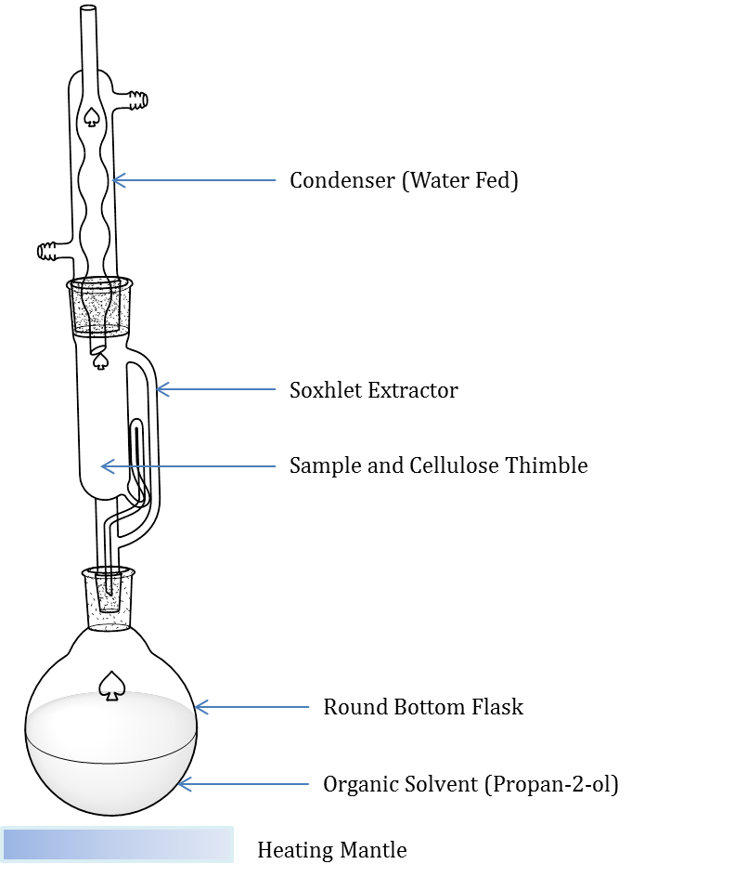
Figure 65. Soxhlet Apparatus.

8. References

1. Jones, L.V., Stars and Galaxies. Greenwood Guides to the Universe. 2010, California: Greenwood Publishing Group.
2. Gabriele Zini, P.T., Solar Hydrogen Energy Systems: Science and Technology for the Hydrogen Economy. 2012, Italy: Springer.
3. Balat, M., Potential importance of hydrogen as a future solution to environmental and transportation problems. International Journal of Hydrogen Energy, 2008. 33(15): p. 4013-4029.
4. Huggins, R.A., Energy Storage. 2010, New York: Springer.
5. Gosselink, J.W., Pathways to a more sustainable production of energy: sustainable hydrogen—a research objective for Shell. International Journal of Hydrogen Energy, 2002. 27(11–12): p. 1125-1129.
6. Bockris, J., Energy: The Solar Hydrogen Alternative. 1975, Sydney: Australia and New Zealand Book Co.
7. Andrews, J. and B. Shabani, Re-envisioning the role of hydrogen in a sustainable energy economy. International Journal of Hydrogen Energy, 2012. 37(2): p. 1184-1203.
8. Sorensen, B., Hydrogen and Fuel Cells: Emerging Technologies and Applications. 2012, Oxford: Academic Press Elsevier.
9. Ltd, H.M.C. The Honda Worldwide Site. 2013 [cited 2013 01/12/2013]; Available from: http://world.honda.com/.
10. Physics, I.o. Fuel Cells. 2013 [cited 2013 01/12/2013]; Available from: http://www.iop.org/resources/topic/archive/fuel/.
11. Barreto, L., A. Makihira, and K. Riahi, The hydrogen economy in the 21st century: a sustainable development scenario. International Journal of Hydrogen Energy, 2003. 28(3): p. 267-284.
12. Elam, C.C., et al., Realizing the hydrogen future: the International Energy Agency's efforts to advance hydrogen energy technologies. International Journal of Hydrogen Energy, 2003. 28(6): p. 601-607.
13. Grove, W.R., On a New Voltaic Combination. Philosophical Magazine and Journal of Science, 1838. 13.
14. Appleby, A.J., From Sir William Grove to today: fuel cells and the future. Journal of Power Sources, 1990. 29(1–2): p. 3-11.
15. Larminie, J.D., A. , Fuel Cell Systems Explained. 2 ed. 2003, Chichester: Wiley.
16. Matthey, J. Johnson Matthey Precious Metals Management. 2014 [cited 2014 November 2014].
17. Smitha, B., S. Sridhar, and A.A. Khan, Solid polymer electrolyte membranes for fuel cell applications--a review. Journal of Membrane Science, 2005. 259(1-2): p. 10-26.
18. Chikh, L., V. Delhorbe, and O. Fichet, (Semi-)Interpenetrating polymer networks as fuel cell membranes. Journal of Membrane Science, 2011. 368(1–2): p. 1-17.
19. Carmo, M., Fritz, D.L., Mergel, J., Stolten D., A Comprehensive Review on PEM Water Electrolysis. International Journal of Hydrogen Energy, 2013. 38(12): p. 4901-4934.
20. Grigoriev, S.A., V.I. Porembsky, and V.N. Fateev, Pure hydrogen production by PEM electrolysis for hydrogen energy. International Journal of Hydrogen Energy, 2006. 31(2): p. 171-175.
21. Wang, Y., et al., A review of polymer electrolyte membrane fuel cells: Technology, applications, and needs on fundamental research. Applied Energy, 2011. 88(4): p. 981-1007.
22. Sata, T., Ion Exchange Membranes: Preparation, Characterization, Modification and Application. 2004, Cambridge: The Royal Society of Chemistry.
23. IUPAC, Terminology of polymers containing ionizable or ionic groups and of polymers containing ions, in IUPAC Gold Book. 2006.
24. Wilkinson, A.D.M.a.A., IUPAC. Compendium of Chemical Terminology, 2nd ed. (the "Gold Book"). . 1997, Blackwell Scientific Publications: Oxford.
25. Fisher, A.M., Polymer Electrolyte Membrane and Method of Fabrication U.S. Patent, Editor. 2001, Motorola Inc: United States.
26. Sata, T., Ion Exchange Membranes: Preparation, Characterisation, Modification and Application. 2004, Cambridge: The Royal Society of Chemistry.
27. Glass, A. Flemion Fluoropolymer Ion Exchange Membrane. 2011 2011 [cited 2011; Available from: http://www.agc.com/english/csr/env/products/11.html.
28. Gore. Fuel Cell Components. 2011 [cited 2011; Available from: http://www.gore.com/en_xx/products/electronic/fuelcells/index.html.
29. DuPont. DuPont Automotive Nafion Membranes. 2011 [cited 2011; Available from: http://www2.dupont.com/Automotive/en_US/products_services/fuelCell/nafion.html.
30. James, C.D., Franklin, Gresham William, Fluorocarbon vinyl ether polymers. 1966, Pont DU.: United States.
31. Mauritz, K.A. and R.B. Moore, State of Understanding of Nafion. Chemical Reviews, 2004. 104(10): p. 4535-4586.
32. Walker, C.W., Proton-conducting polymer membrane comprised of a copolymer of 2-acrylamido-2-methylpropanesulfonic acid and 2-hydroxyethyl methacrylate. Journal of Power Sources, 2002. 110(1): p. 144-151.
33. Thampan, T., et al., Modeling of Conductive Transport in Proton‐Exchange Membranes for Fuel Cells. Journal of The Electrochemical Society, 2000. 147(9): p. 3242-3250.
34. Yi, J.S. and T.V. Nguyen, An Along‐the‐Channel Model for Proton Exchange Membrane Fuel Cells. Journal of The Electrochemical Society, 1998. 145(4): p. 1149-1159.
35. Gierke, T.D., G.E. Munn, and F.C. Wilson, The morphology in nafion perfluorinated membrane products, as determined by wide- and small-angle x-ray studies. Journal of Polymer Science: Polymer Physics Edition, 1981. 19(11): p. 1687-1704.
36. Hsu, W.Y., Gierke, T.D., Ion Transport and Clustering in Nafion Perfluorinated Membranes. Journal of Membrane Science, 1983. 13(3): p. 307-326.
37. Proton Exchange Membrane Fuel Cells 8. Batteries, Fuel Cells and Energy Conversion., ed. T. Fuller, Shinhara, K., Ramani, V., Shirvanian, P., Uchida, H., Cleghorn, S., Inaba, M., Mitsushima, S., Strasser, P., Nakagawa, N., Gasteiger, H. A., Zawodzinski, T., Lamy, C. Vol. 16. New Jersey: ECS Transactions.
38. Agmon, N., The Grotthuss Mechanism. Chemical Physics Letters, 1995. 244: p. 456-462.
39. Peighambardoust, S.J., S. Rowshanzamir, and M. Amjadi, Review of the proton exchange membranes for fuel cell applications. International Journal of Hydrogen Energy, 2010. 35(17): p. 9349-9384.
40. Navessin, T., et al. The effect of membrane ion exchange capacity on the performance of PEM fuel cell. 2004.
41. Javaid Zaidi, S.M., Matsuura, T., Polymer Membranes for Fuel Cells, ed. S.M. Javaid Zaidi, Matsuura, T. 2009, New York: Springer.
42. Li, Q., et al., Approaches and Recent Development of Polymer Electrolyte Membranes for Fuel Cells Operating above 100 °C. Chemistry of Materials, 2003. 15(26): p. 4896-4915.
43. Savinell, R., et al., Polymer electrolyte for operation at temperatures up to 200°C. Journal of the Electrochemical Society, 1994. 141(4): p. L46-L48.
44. Luo, Z., et al., Electro-osmotic drag coefficient and proton conductivity in Nafion® membrane for PEMFC. International Journal of Hydrogen Energy, 2010. 35(7): p. 3120-3124.
45. Tan, N., et al., Preparation and properties of polybenzimidazoles with sulfophenylsulfonyl pendant groups for proton exchange membranes. Journal of Membrane Science, 2010. 353(1–2): p. 51-59.
46. Choi, J., et al., Polymer blend membranes of sulfonated poly(arylene ether ketone) for direct methanol fuel cell. Journal of Membrane Science, 2008. 310(1–2): p. 384-392.
47. Zhao, Y., Yin, J., Synthesis and Properties of poly(ether ether ketone)-block-sulfonated polybutadiene copolymers for PEM applications. European Polymer Journal, 2010. 46: p. 592-601.
48. Lin, C.W., Y.F. Huang, and A.M. Kannan, Cross-linked poly(vinyl alcohol) and poly(styrene sulfonic acid-co-maleic anhydride)-based semi-interpenetrating network as proton-conducting membranes for direct methanol fuel cells. Journal of Power Sources, 2007. 171(2): p. 340-347.
49. Ye, H., et al., New membranes based on ionic liquids for PEM fuel cells at elevated temperatures. Journal of Power Sources, 2008. 178(2): p. 651-660.
50. Hou, H., Polini R., Di Vona, M.L., Liu, X., Sgreccia, E., Chailan, J.F., Knauth, P., Thermal Crosslinked and Nanodiamond Reinforced SPEEK Composite Membrane for PEMFC. International Journal of Hydrogen Energy, 2013. 38(8): p. 3346-3351.
51. Mishra, A.K., Kim, N.H., Jung, D., Hee Lee, J., Enhanced Mechanical Properties and Proton Conductivity of Nafion-SPEEK-GO Composite Membranes For Fuel Cell Applications. Journal of Membrane Science, 2013. 458: p. 128-135.
52. Hande, V.R., Rath, S.K., Rao, S., Patri, M., Cross Linked Sulfonated Poly(Ether Ether Ketone)(SPEEK)/Reactive Organoclay Nanocomposite Proton Exchange Membranes (PEM). Journal of Membrane Science, 2011. 372(1-2): p. 40-48.
53. Wei, G., Xu, L., Huang, C., Wang, Y., SPE Water Electrolysis With SPEEK/PES Blend Membrane International Journal of Hydrogen Energy, 2010. 35(15): p. 7778-7783.
54. Young R.J. and Lovell, P.A., Introduction to Polymers Second Edition. 1991: Chapman and Hall.
55. Staudinger, H., Über Polymerisation. Berichte der deutschen chemischen Gesellschaft (A and B Series), 1920. 53(6): p. 1073-1085.
56. Gregory, A. and M.H. Stenzel, Complex polymer architectures via RAFT polymerization: From fundamental process to extending the scope using click chemistry and nature's building blocks. Progress in Polymer Science, 2012. 37(1): p. 38-105.
57. Zhu, X., Y. Zhou, and D. Yan, Influence of branching architecture on polymer properties. Journal of Polymer Science Part B: Polymer Physics, 2011. 49(18): p. 1277-1286.
58. Lorimer, D.J.W.J.P., Polymers. Oxfod Chemistry Primers. 2000, Oxford: Oxford University Press.
59. Matyjaszewski, K. and J. Spanswick, Controlled/living radical polymerization. Materials Today, 2005. 8(3): p. 26-33.
60. Cowie, J.M.G., Polymers: Chemistry and Physics of Modern Materials. 2nd ed. 1991, United Kingdom: Chapman and Hall.
61. Daniel, J.C., Colloidal Polymers Synthesis anc Characterisation. Surfactant Science Series, ed. A. Elaissari. Vol. 115. 2005, New York: Taylor and Francis.
62. Chern, C.-S., Principles and Applications of Emulsion Polymerization. 2008, Hoboken New Jersey: John Wiley and Sons.
63. Chern, C.S., Emulsion polymerization mechanisms and kinetics. Progress in Polymer Science, 2006. 31(5): p. 443-486.
64. Harkins, W.D., A General Theory of the Mechanism of Emulsion Polymerisation. Journal of the American Chemical Society, 1947. 69.
65. Harkins, W.D., General theory of mechanism of emulsion polymerization. II. Journal of Polymer Science, 1950. 5(2): p. 217-251.
66. Smith, W.V. and R.H. Ewart, Kinetics of Emulsion Polymerization. The Journal of Chemical Physics, 1948. 16(6): p. 592-599.
67. Roz Azlinawati Ramli, W.A.L., Shahrir Hashim, Core-shell Polymers: A Review. RSC Advances, 2013. 3: p. 15543.
68. Li, W. and P. Li, Synthesis of Well-Defined Amphiphilic Core–Shell Particles Containing Amine-Rich Shells. Macromolecular Rapid Communications, 2007. 28(23): p. 2267-2271.
69. Grigsby, W.J., et al., Evaluation of latex adhesives containing hydrophobic cores and poly(vinyl acetate) shells: potential to improve poly(vinyl acetate) performance. International Journal of Adhesion and Adhesives, 2005. 25(2): p. 127-137.
70. Li, H., et al., Reduction-responsive drug delivery based on mesoporous silica nanoparticle core with crosslinked poly(acrylic acid) shell. Materials Science and Engineering: C, 2013. 33(6): p. 3426-3431.
71. Huang, C.-Y. and Y.-D. Lee, Core-shell type of nanoparticles composed of poly[(n-butyl cyanoacrylate)-co-(2-octyl cyanoacrylate)] copolymers for drug delivery application: Synthesis, characterization and in vitro degradation. International Journal of Pharmaceutics, 2006. 325(1–2): p. 132-139.
72. Ye, W., et al., Novel core-shell particles with poly(n-butyl acrylate) cores and chitosan shells as an antibacterial coating for textiles. Polymer, 2005. 46(23): p. 10538-10543.
73. Pérez, N., M.J. Whitcombe, and E.N. Vulfson, Molecularly imprinted nanoparticles prepared by core-shell emulsion polymerization. Journal of Applied Polymer Science, 2000. 77(8): p. 1851-1859.
74. Sherman, R.L. and W.T. Ford, Small Core/Thick Shell Polystyrene/Poly(methyl methacrylate) Latexes. Industrial & Engineering Chemistry Research, 2005. 44(23): p. 8538-8541.
75. Szwarc, M., /`Living/' Polymers. Nature, 1956. 178(4543): p. 1168-1169.
76. Ben Zhong-Tang, N.V.T., Brent S Sumerlin, Fundamentals of Controlled/Living Radical Polymerisation, ed. N.V.T. Ben Zhong-Tang, Brent S Sumerlin. 2013: Royal Society of Chemistry.
77. Georges, M.K., et al., Narrow molecular weight resins by a free-radical polymerization process. Macromolecules, 1993. 26(11): p. 2987-2988.
78. Nicolas, J., et al., Nitroxide-mediated polymerization. Progress in Polymer Science, 2013. 38(1): p. 63-235.
79. Wang, J.-S. and K. Matyjaszewski, Controlled/"living" radical polymerization. atom transfer radical polymerization in the presence of transition-metal complexes. Journal of the American Chemical Society, 1995. 117(20): p. 5614-5615.
80. Kato, M., et al., Polymerization of Methyl Methacrylate with the Carbon Tetrachloride/Dichlorotris- (triphenylphosphine)ruthenium(II)/Methylaluminum Bis(2,6-di-tert-butylphenoxide) Initiating System: Possibility of Living Radical Polymerization. Macromolecules, 1995. 28(5): p. 1721-1723.
81. Chiefari, J., et al., Living Free-Radical Polymerization by Reversible Addition−Fragmentation Chain Transfer: The RAFT Process. Macromolecules, 1998. 31(16): p. 5559-5562.
82. Aubrey D. Jenkins, R.G.J.a.G.M., Terminology for reversible-deactivation radical polymerisation previously called "controlled" radical or "living" radical polymerisation (IUPAC Recommendations 2010). Pure and Applied Chemistry, 2010. 82(2): p. 483 - 491.
83. Solomon, D.H., Rizzardo, E., and Cacioli, P., Polymerisation Process and Polymers Produced Thereby. 1986: US.
84. Hawker, C.J., A.W. Bosman, and E. Harth, New Polymer Synthesis by Nitroxide Mediated Living Radical Polymerizations. Chemical Reviews, 2001. 101(12): p. 3661-3688.
85. Miura, Y., N. Nakamura, and I. Taniguchi, Low-Temperature “Living” Radical Polymerization of Styrene in the Presence of Nitroxides with Spiro Structures. Macromolecules, 2001. 34(3): p. 447-455.
86. Benoit, D., et al., Accurate Structural Control and Block Formation in the Living Polymerization of 1,3-Dienes by Nitroxide-Mediated Procedures. Macromolecules, 2000. 33(2): p. 363-370.
87. Hawker, C.J., et al., Initiating Systems for Nitroxide-Mediated “Living” Free Radical Polymerizations: Synthesis and Evaluation. Macromolecules, 1996. 29(16): p. 5245-5254.
88. Lessard, B.H., X. Savelyeva, and M. Marić, Smart morpholine-functional statistical copolymers synthesized by nitroxide mediated polymerization. Polymer, 2012. 53(25): p. 5649-5656.
89. Dias, R.S., et al., Nitroxide-mediated radical polymerization of styrene using mono- and di-functional initiators. Chemical Engineering Science, 2007. 62(18–20): p. 5240-5244.
90. Wannemacher, T., D. Braun, and R. Pfaendner, Novel copolymers via nitroxide mediated controlled free radical polymerization of vinyl chloride. Macromolecular Symposia, 2003. 202(1): p. 11-24.
91. Matyjaszewski, K. and J. Xia, Atom Transfer Radical Polymerization. Chemical Reviews, 2001. 101(9): p. 2921-2990.
92. Jankova, K. and S. Hvilsted, Preparation of Poly(2,3,4,5,6-pentafluorostyrene) and Block Copolymers with Styrene by ATRP. Macromolecules, 2003. 36(5): p. 1753-1758.
93. Qiu, L., et al., Synthesis of lauryl methacrylate star-like polymers via ATRP. Asia-Pacific Journal of Chemical Engineering, 2009. 4(5): p. 678-682.
94. Dayananda, K. and R. Dhamodharan, ATRP of methyl methacrylate using a novel binol ester-based bifunctional initiator. Journal of Polymer Science Part A: Polymer Chemistry, 2004. 42(4): p. 902-915.
95. Pitto, V., et al., New Star-Branched Poly(acrylonitrile) Architectures: ATRP Synthesis and Solution Properties. Macromolecular Chemistry and Physics, 2004. 205(17): p. 2346-2355.
96. Canturk, F., B. Karagoz, and N. Bicak, Removal of the copper catalyst from atom transfer radical polymerization mixtures by chemical reduction with zinc powder. Journal of Polymer Science Part A: Polymer Chemistry, 2011. 49(16): p. 3536-3542.
97. Shen, Y., H. Tang, and S. Ding, Catalyst separation in atom transfer radical polymerization. Progress in Polymer Science, 2004. 29(10): p. 1053-1078.
98. Kickelbick, G., H.-j. Paik, and K. Matyjaszewski, Immobilization of the Copper Catalyst in Atom Transfer Radical Polymerization. Macromolecules, 1999. 32(9): p. 2941-2947.
99. Matyjaszewski, K., T. Pintauer, and S. Gaynor, Removal of Copper-Based Catalyst in Atom Transfer Radical Polymerization Using Ion Exchange Resins. Macromolecules, 2000. 33(4): p. 1476-1478.
100. Moad, G., E. Rizzardo, and S.H. Thang, Radical addition–fragmentation chemistry in polymer synthesis. Polymer, 2008. 49(5): p. 1079-1131.
101. Nakabayashi, K. and H. Mori, Recent progress in controlled radical polymerization of N-vinyl monomers. European Polymer Journal, 2013. 49(10): p. 2808-2838.
102. Moad, G., E. Rizzardo, and S.H. Thang, Living Radical Polymerization by the RAFT Process—A First Update. Australian Journal of Chemistry, 2006. 59(10): p. 669-692.
103. Semsarilar, M. and S. Perrier, 'Green' reversible addition-fragmentation chain-transfer (RAFT) polymerization. Nat Chem, 2010. 2(10): p. 811-820.
104. Mori, H., et al., Water-soluble poly(N-vinyl-1,2,4-triazole) star and amphiphilic star block copolymers by RAFT polymerization. Polymer, 2013. 54(8): p. 2001-2010.
105. Alam, M.Z., et al., Synthesis of azobenzene-functionalized star polymers via RAFT and their photoresponsive properties. Polymer, 2011. 52(17): p. 3696-3703.
106. Crownover, E., et al., RAFT-synthesized graft copolymers that enhance pH-dependent membrane destabilization and protein circulation times. Journal of Controlled Release, 2011. 155(2): p. 167-174.
107. Zhang, K., et al., Dual stimuli-responsive N-phthaloylchitosan-graft-(poly(N-isopropylacrylamide)-block-poly(acrylic acid)) copolymer prepared via RAFT polymerization. Carbohydrate Polymers, 2013. 92(1): p. 662-667.
108. Carter, S., et al., Highly Branched Stimuli Responsive Poly[(N-isopropyl acrylamide)-co-(1,2-propandiol-3-methacrylate)]s with Protein Binding Functionality. Macromolecular Bioscience, 2005. 5(5): p. 373-378.
109. Mertoglu, M., et al., Stimuli responsive amphiphilic block copolymers for aqueous media synthesised via reversible addition fragmentation chain transfer polymerisation (RAFT). Polymer, 2005. 46(18): p. 7726-7740.
110. Huang, X., S.I. Sevimli, and V. Bulmus, pH-labile sheddable block copolymers by RAFT polymerization: Synthesis and potential use as siRNA conjugates. European Polymer Journal, (0).
111. Qu, Z., et al., A facile route to the synthesis of spherical poly(acrylic acid) brushes via RAFT polymerization for high-capacity protein immobilization. Journal of Colloid and Interface Science, 2013. 398(0): p. 82-87.
112. Schilli, C.M., et al., A New Double-Responsive Block Copolymer Synthesized via RAFT Polymerization: Poly(N-isopropylacrylamide)-block-poly(acrylic acid). Macromolecules, 2004. 37(21): p. 7861-7866.
113. Velasquez, E., et al., Study of the solution and aqueous emulsion copolymerization of vinylidene chloride with methyl acrylate in the presence a poly(ethylene oxide) macromolecular RAFT agent. Polymer, 2013. 54(24): p. 6547-6554.
114. McCormick, C.L. and A.B. Lowe, Aqueous RAFT Polymerization: Recent Developments in Synthesis of Functional Water-Soluble (Co)polymers with Controlled Structures†. Accounts of Chemical Research, 2004. 37(5): p. 312-325.
115. Moad, G., E. Rizzardo, and S.H. Thang, RAFT Polymerization and Some of its Applications. Chemistry – An Asian Journal, 2013: p. n/a-n/a.
116. Nicholson, J.W., The Chemistry of Polymers. 2006, Cambridge: The Royal Society of Chemistry.
117. Stevens, M.P., Polymer Chemistry An Introduction. 1999, New York: Oxford Unniversity Press.
118. Flores, J.D., et al., Direct RAFT polymerization of an unprotected isocyanate-containing monomer and subsequent structopendant functionalization using "click"-type reactions. Polymer Chemistry, 2010. 1(2): p. 213-220.
119. Enrique Saldivar-Guerra, E.V.-L., Handbook of Polymer Synthesis, Characterisation and Processing
ed. E.V.-L. Enrique Saldivar-Guerra. 2013, Hoboken, New Jersey: Wiley.
120. Čulin, J., et al., Motional heterogeneity and phase separation of functionalized polyester polyurethanes. European Polymer Journal, 2004. 40(8): p. 1857-1866.
121. Meier-Westhues, U., Polyurethanes: Coatings, Adhesives and Sealants. European Coatings Tech Files. 2007, Hannover: Vincentz.
122. Krol, P., Synthesis methods, chemical structures and phase structures of linear polyurethanes. Properties and applications of linear polyurethanes in polyurethane elastomers, copolymers and ionomers. Progress in Materials Science., 2007. 52: p. 915-1015.
123. Rimmer, S. and S. Collins, The use of radical polymerization in the synthesis of telechelic oligomers. Reactive and Functional Polymers, 2006. 66(1): p. 177-186.
124. Zhong, S., et al., Polymer electrolyte membranes with high selectivity based on silicon-containing sulfonated polystyrene/acrylate, poly(vinyl alcohol) and poly(2-acrylamido-2-methyl-1-propanesulfonic acid). Journal of Power Sources, 2013. 238(0): p. 485-491.
125. Sonmez, G., P. Schottland, and J.R. Reynolds, PEDOT/PAMPS: An electrically conductive polymer composite with electrochromic and cation exchange properties. Synthetic Metals, 2005. 155(1): p. 130-137.
126. Wilkinson, C.b.A.D.M.a.A., Compendium of Chemical Terminology, 2nd ed. (the "Gold Book"). 1997.
127. Dobrynin, A.V., Rubinstein, M., Theory of Polyelectrolytes in Solutions and at Surfaces. Progress in Polymer Science, 2005. 30: p. 1049-1118.
128. Laschewsky, A., Recent trends in the synthesis of polyelectrolytes. Current Opinion in Colloid & Interface Science, 2012. 17(2): p. 56-63.
129. Fuoss, R.M., Viscosity function for polyelectrolytes. Journal of Polymer Science, 1948. 3(4): p. 603-604.
130. Muthukumar, M., Polymer Translocation. 2011, Florida: CRC Press. Taylor and Francis.
131. Lowe, A.B. and C.L. McCormick, Reversible addition–fragmentation chain transfer (RAFT) radical polymerization and the synthesis of water-soluble (co)polymers under homogeneous conditions in organic and aqueous media. Progress in Polymer Science, 2007. 32(3): p. 283-351.
132. Zygadlo-Monikowska, E., et al., Proton conducting gel polyelectrolytes based on 2-acrylamido-2-methyl-1-propanesulfonic acid (AMPSA) copolymers with polyfunctional monomers: Part I. Anhydrous systems. Journal of Power Sources, 2006. 159(1): p. 385-391.
133. Karlsson, L.E., B. Wesslén, and P. Jannasch, Water absorption and proton conductivity of sulfonated acrylamide copolymers. Electrochimica Acta, 2002. 47(20): p. 3269-3275.
134. Diao, H., et al., High Performance Cross-Linked Poly(2-acrylamido-2-methylpropanesulfonic acid)-Based Proton Exchange Membranes for Fuel Cells. Macromolecules, 2010. 43(15): p. 6398-6405.
135. Cho, K.-Y., et al., Proton conducting semi-IPN based on Nafion and crosslinked poly(AMPS) for direct methanol fuel cell. Electrochimica Acta, 2004. 50(2–3): p. 588-593.
136. Sen, U., et al., Proton conducting polymer blends from poly(2,5-benzimidazole) and poly(2-acrylamido-2-methyl-1-propanesulfonic acid). Journal of Applied Polymer Science, 2011. 120(2): p. 1193-1198.
137. Sumerlin, B.S., et al., Water-Soluble Polymers. 84. Controlled Polymerization in Aqueous Media of Anionic Acrylamido Monomers via RAFT. Macromolecules, 2001. 34(19): p. 6561-6564.
138. Gromadzki, D., A. Tereshchenko, and R. Makuška, Synthesis by self-condensing AGET ATRP and solution properties of arborescent poly(sodium 2-acrylamido-2-methyl-N-propane sulfonate). Polymer, 2010. 51(24): p. 5680-5687.
139. Liu, M. and J.M.J. Fréchet, Designing dendrimers for drug delivery. Pharmaceutical Science & Technology Today, 1999. 2(10): p. 393-401.
140. Flory, P.J., Molecular Size Distribution in Three Dimensional Polymers. VI. Branched Polymers Containing A—R—Bf-1 Type Units. Journal of the American Chemical Society, 1952. 74(11): p. 2718-2723.
141. Caminade, A.-M., Dendrimers as Chemical Sensors, in Dendrimers. 2011, John Wiley & Sons, Ltd. p. 361-374.
142. Yates, C.R. and W. Hayes, Synthesis and applications of hyperbranched polymers. European Polymer Journal, 2004. 40(7): p. 1257-1281.
143. Hölter, D., A. Burgath, and H. Frey, Degree of branching in hyperbranched polymers. Acta Polymerica, 1997. 48(1-2): p. 30-35.
144. Jean M. J. Frechet, M.H., Ivan Gitsov, Sadahito Aoshima, Marc R. Ledue, R. Bernard Grubbs, Self-Condensing Vinyl Polymerisation: An Approach to Dendritic Materials. Science, 1995. 269(5227): p. 1080-1083.
145. Gaborieau, M., et al., Separation of complex branched polymers by size-exclusion chromatography probed with multiple detection. Journal of Chromatography A, 2008. 1190(1–2): p. 215-223.
146. P.J, F., Principles of Polymer Chemistry. 1953: Cornell University.
147. Wever, D.A.Z., F. Picchioni, and A.A. Broekhuis, Branched polyacrylamides: Synthesis and effect of molecular architecture on solution rheology. European Polymer Journal, 2013. 49(10): p. 3289-3301.
148. Hanneke M. L. Thijs, M.A.R.M.a.U.S.S., Application possibilities of preparative size exclusion chromatography to analytical problems in polymer science. e-Polymers, 2007.
149. Jordi. Jordi Gel DVB Sulfonated Plus. 2013 [cited 2013 20/11/2013]; Available from: http://jordilabs.com/products/category/jordi-gel-dvb-sulfonatedplus-2/.
150. Dragan, S., M. Mihai, and L. Ghimici, Viscometric study of poly(sodium 2-acrylamido-2-methylpropanesulfonate) and two random copolymers. European Polymer Journal, 2003. 39(9): p. 1847-1854.
151. Dobrynin, A.V. and M. Rubinstein, Theory of polyelectrolytes in solutions and at surfaces. Progress in Polymer Science, 2005. 30(11): p. 1049-1118.
152. Theodor Svedberg, K.O.P., Johannes Henrik Bauer, The Ultracentrifuge. International Series of Monographs on Physics. 1940: The Clarendon Press.
153. David Scott, S.E.H., Arthur Rowe, Analytical Ultrcentrifugation Techniques and Methods, ed. S.E.H. David Scott, Arther Rowe. 2005, Cambridge: RSC Publishing.
154. Rowe, S.E.H.a.A.J., Insight Into Protein Protein Interactions From Analytical Ultracentrifugation. Biochemical Society Transactions, 2010. 38: p. 901-907.
155. Walter Machtle, L.B., Analytical Ultracentrgifugation of Polymers and Nanoparticles. 2006, Germany: Springer.
156. Harding, S., Determination of Absolute Molecular Weights Using Sedimentation Equilibrium Analytical Ultracentrifugation, in Microscopy, Optical Spectroscopy, and Macroscopic Techniques, C. Jones, B. Mulloy, and A. Thomas, Editors. 1994, Humana Press. p. 75-84.
157. Creeth, J.M. and S.H. Harding, Some observations on a new type of point average molecular weight. Journal of Biochemical and Biophysical Methods, 1982. 7(1): p. 25-34.
158. Schuck, P., et al., SEDFIT-MSTAR: molecular weight and molecular weight distribution analysis of polymers by sedimentation equilibrium in the ultracentrifuge. Analyst, 2014. 139(1): p. 79-92.
159. Cölfen, H. and S.E. Harding, MSTARA and MSTARI: interactive PC algorithms for simple, model independent evaluation of sedimentation equilibrium data. European Biophysics Journal, 1997. 25(5-6): p. 333-346.
160. Chan, Y., et al., Acid-cleavable polymeric core–shell particles for delivery of hydrophobic drugs. Journal of Controlled Release, 2006. 115(2): p. 197-207.
161. Borthakur, L., T. Jana, and S.K. Dolui, Preparation of core–shell latex particles by emulsion co-polymerization of styrene and butyl acrylate, and evaluation of their pigment properties in emulsion paints. Journal of Coatings Technology and Research, 2010. 7(6): p. 765-772.
162. Li, Y.S., T.S. Zhao, and Z.X. Liang, Effect of polymer binders in anode catalyst layer on performance of alkaline direct ethanol fuel cells. Journal of Power Sources, 2009. 190(2): p. 223-229.
163. Su, H., et al., Optimization of gas diffusion electrode for polybenzimidazole-based high temperature proton exchange membrane fuel cell: Evaluation of polymer binders in catalyst layer. International Journal of Hydrogen Energy, 2013. 38(26): p. 11370-11378.
164. Meyers, D., Surfactant Science and Technology. 2006, Hoboken New Jersey: Wiley.
165. Yeole, N., D. Hundiwale, and T. Jana, Synthesis of core–shell polystyrene nanoparticles by surfactant free emulsion polymerization using macro-RAFT agent. Journal of Colloid and Interface Science, 2011. 354(2): p. 506-510.
166. Tadros, T., Polymeric surfactants in disperse systems. Advances in Colloid and Interface Science, 2009. 147–148(0): p. 281-299.
167. Burguière, C., et al., Block Copolymers of Poly(styrene) and Poly(acrylic acid) of Various Molar Masses, Topologies, and Compositions Prepared via Controlled/Living Radical Polymerization. Application as Stabilizers in Emulsion Polymerization. Macromolecules, 2001. 34(13): p. 4439-4450.
168. Adler, H.-J., K. Jahny, and B. Vogt-Birnbrich, Polyurethane macromers—new building blocks for acrylic hybrid emulsions with outstanding performance. Progress in Organic Coatings, 2001. 43(4): p. 251-257.
169. Xu, L., et al., Preparation and characterization of a novel fluoro-silicone acrylate copolymer by semi-continuous emulsion polymerization. Journal of Fluorine Chemistry, 2013. 153(0): p. 68-73.
170. McLeary, J.B. and B. Klumperman, RAFT mediated polymerisation in heterogeneous media. Soft Matter, 2006. 2(1): p. 45-53.
171. Rieger, J., et al., Amphiphilic Poly(ethylene oxide) Macromolecular RAFT Agent as a Stabilizer and Control Agent in ab Initio Batch Emulsion Polymerization. Macromolecules, 2008. 41(12): p. 4065-4068.
172. Wi, Y., et al., Soap-free emulsion polymerization of styrene using poly(methacrylic acid) macro-RAFT agent. Polymer, 2008. 49(26): p. 5626-5635.
173. Rieger, J., et al., Surfactant-Free RAFT Emulsion Polymerization Using Poly(N,N-dimethylacrylamide) Trithiocarbonate Macromolecular Chain Transfer Agents. Macromolecules, 2010. 43(15): p. 6302-6310.
174. Zhang, W., et al., RAFT-mediated one-pot aqueous emulsion polymerization of methyl methacrylate in presence of poly(methacrylic acid-co-poly(ethylene oxide) methacrylate) trithiocarbonate macromolecular chain transfer agent. Polymer, 2013. 54(8): p. 2011-2019.
175. Zhou, J., L. Zhang, and J. Ma, Fluorinated polyacrylate emulsifier-free emulsion mediated by poly(acrylic acid)-b-poly(hexafluorobutyl acrylate) trithiocarbonate via ab initio RAFT emulsion polymerization. Chemical Engineering Journal, 2013. 223(0): p. 8-17.
176. Cunningham, M.F., Controlled/living radical polymerization in aqueous dispersed systems. Progress in Polymer Science, 2008. 33(4): p. 365-398.
177. Platt, L., L. Kelly, and S. Rimmer, Controlled delivery of cytokine growth factors mediated by core-shell particles with poly(acrylamidomethylpropane sulphonate) shells. Journal of Materials Chemistry B, 2014. 2(5): p. 494-501.
178. Xu, R., Particle Characterisation: Light Scattering Methods. Particle Technology Series. 2001, Netherlands: Kluwer Academic Publishers.
179. Pamela J. Watson, P.A.T., Study of Zeta Potential for Material Particles in Chemical Additive Solution. Bureau of Mines Information Circular. 1989, United States: United States Department of the Interior.
180. Hasani Bijarbooneh, F., et al., Aqueous Colloidal Stability Evaluated by Zeta Potential Measurement and Resultant TiO2 for Superior Photovoltaic Performance. Journal of the American Ceramic Society, 2013. 96(8): p. 2636-2643.
181. Hanaor, D., et al., The effects of carboxylic acids on the aqueous dispersion and electrophoretic deposition of ZrO2. Journal of the European Ceramic Society, 2012. 32(1): p. 235-244.
182. Klempner, D., Interpenetrating Polymer Networks. Angewandte Chemie International Edition in English, 1978. 17(2): p. 97-106.
183. Sperling, L.H., Interpenetrating Polymer Networks, in Encyclopedia of Polymer Science and Technology. 2002, John Wiley & Sons, Inc.
184. Delhorbe, V., et al., Polyelectrolyte/fluorinated polymer interpenetrating polymer networks as fuel cell membrane. Journal of Membrane Science, 2013. 429(0): p. 168-180.
185. Luu, D.X., Kim, D., Proton conductingelectrolytemembranesbasedonthependant-sulfonated poly(arylene etherketone)/polyorganosiloxaneinterpenetrating polymer networks. Journal of Membrane Science, 2013. 430: p. 37-43.
186. Pu, H., Lou, L., Guan, Y., Chang,Z., Wan, D., Proton exchange membranes based on semi-interpenetrating polymer networks of polybenzimidazole and perfluorosulfonic acid polymer with hollow silica spheres as micro-reservoir. Journal of Membrane Science, 2012. 415-416: p. 496-503.
187. Dragan, E.S., Design and applications of interpenetrating polymer network hydrogels. A review. Chemical Engineering Journal, 2014. 243: p. 572-590.
188. Joo, H.S., Do, H. S., Park, Y. J., Kim, H. J., Adhesion Performance of UV Cured Semi-IPN Structure Acrylic Pressure Sensitive Adhesives. Journal of Adhesion Science and Technology, 2006. 20(14): p. 1573-1594.
189. Tant, M.R., Maurtiz, K.A., Wilkes, G.L ed. Ionomer: Synthesis, Structure, Properties and Applications. 1 ed. 1997, Blackie Academic and Professional.
190. Zhu, W., et al., Study of polyurethane/sulfonated dimethyl fumarate complex. Journal of Applied Polymer Science, 2002. 84(1): p. 67-74.
191. Wang, S. and K. Min, Solid polymer electrolytes of blends of polyurethane and polyether modified polysiloxane and their ionic conductivity. Polymer, 2010. 51(12): p. 2621-2628.
192. Tian, L.y., W.h. Zhu, and X. Tang, Polymer gel electrolytes based on thermoplastic polyurethane. Journal of Applied Polymer Science, 2003. 90(9): p. 2310-2315.
193. Lavall, R.L., et al., Novel polymer electrolytes based on thermoplastic polyurethane and ionic liquid/lithium bis(trifluoromethanesulfonyl)imide/propylene carbonate salt system. Journal of Power Sources, 2010. 195(17): p. 5761-5767.
194. Wang, X., et al., Syntheses and characterizations of soft-segment ionic polyurethanes. Journal of Polymer Science Part B: Polymer Physics, 1999. 37(8): p. 837-845.
195. Santerre, J.P. and J.L. Brash, Physical Properties of Nonionomeric and Ionomeric Segmented Polyurethanes: Effect of Sulfonate, Carboxylate, and Quaternary Ammonium Ions in the Hard Segment. Industrial & Engineering Chemistry Research, 1997. 36(4): p. 1352-1359.
196. Fragiadakis, D., et al., Molecular Mobility, Ion Mobility, and Mobile Ion Concentration in Poly(ethylene oxide)-Based Polyurethane Ionomers. Macromolecules, 2008. 41(15): p. 5723-5728.
197. Jaisankar, S.N., et al., Preparation and properties of semi-interpenetrating polymer networks based on polyurethane ionomer/polyvinyl chloride. Journal of Materials Science, 2000. 35(5): p. 1065-1068.
198. Wang, X., et al., Ionic conduction of polyurethane/sulfonated polyether blends. Journal of Applied Polymer Science, 2003. 89(9): p. 2369-2373.
199. Vasanthakumari, R., Design and Development of Thermoplastic Polyurethane Based Composite Membranes. ASME Conference Proceedings, 2010. 2010(44045): p. 21-26.
200. Suen, M.-C., et al., Water remaining properties of nonwoven fabrics treated with the polyurethane polymers containing carboxylic acid group and the thermal and structural characterization of the polymers. Journal of Applied Polymer Science, 2008. 107(4): p. 2618-2625.
201. Poussard, L., et al., Hemocompatibilty of new ionic polyurethanes: influence of carboxylic group insertion modes. Biomaterials, 2004. 25(17): p. 3473-3483.
202. Phaneuf, M.D., et al., Chemical and Physical Characterization of a Novel Poly(Carbonate Urea) Urethane Surface with Protein Crosslinker Sites. Journal of Biomaterials Applications, 1997. 12(2): p. 100-120.
203. Xu, H., et al., Carboxylated polyethylene oxide polyurethane ionomer and its ionic conductivity. Acta Polymerica Sinica, 1996(3): p. 328-329.
204. Vielstich, W., Gasteiger, H.A., Yokokawa, H. , ed. Handbook of Fuel Cells: Advances in Electrocatalysis, Materials, Diagnostics and Durability Volumes 5 and 6. 2009, Wiley.
205. Takuya Hasegawa, S.T., Tetsuya Samura, Polyurea Electrolyte and Production Method Thereof, W.I.P. Organisation, Editor. 2010, Nissan Motor Co Ltd.
206. Highgate, D.J., Method of Performing Elecrochemical Reaction, W.I.P. Organisation, Editor. 2005, ITM Fuel Cells Ltd.
207. Wu, L., et al., Advances in proton-exchange membranes for fuel cells: an overview on proton conductive channels (PCCs). Physical Chemistry Chemical Physics, 2013. 15(14): p. 4870-4887.
208. McDaniel, P.L., Johnson, G.L., Kniss, J.G., Miller, J.W., Sabram, K.A. Fiber Optic FTIR: A Novel PUR/PIR Catalyst Development Tool. [cited 2014; Available from: http://www.remspec.com/pdfs/Urethane%20development.pdf.
209. Sammes, N., Fuel Cell Technology: Reaching Towards Commercialisation. Engineering Materials and Processes, ed. N. Sammes. 2006, London: Springer Verlag.
210. Zhang, S., et al., A review of accelerated stress tests of MEA durability in PEM fuel cells. International Journal of Hydrogen Energy, 2009. 34(1): p. 388-404.
211. Healy, J., et al., Aspects of the Chemical Degradation of PFSA Ionomers used in PEM Fuel Cells. Fuel Cells, 2005. 5(2): p. 302-308.
212. Hillman, D.M., et al., The reaction between Nafion sulfonyl fluoride precursor membrane and 1,4-dimethylpiperazine does not yield reliable anion-exchange membranes. Journal of Materials Chemistry A, 2013. 1(4): p. 1018-1021.
213. Barbir, F., PEM Electrolysis For Production of Hydrogen From Renewable Sources. Solar Energy, 2005. 78(5): p. 661-669.
214. Liu, Z., J. Ebdon, and S. Rimmer, Telechelic oligo(2,3-dihydroxypropylmethacrylate acetonide)s with aldehyde end functionality prepared by ozonolytic cleavage of poly(2,3-dihydroxypropan-1-methacrylate acetonide-stat-butadiene), prepared by monomer starve-fed emulsion polymerization. Reactive and Functional Polymers, 2004. 58(3): p. 213-224.
215. Ebdon, J.R., N.J. Flint, and S. Rimmer, Degradative Routes to Telechelic Oligomers and Macromonomers. Journal of Macromolecular Science, Part A, 1995. 32(S5-6): p. 603-611.
216. Rimmer, S., J.R. Ebdon, and M.J. Shepherd, Polymer-supported reagents as aids in controlled degradation of polymers containing ozonides in the main chain to give telechelic oligomers. Reactive and Functional Polymers, 1995. 26(1–3): p. 145-155.
217. Herk, A.M.v., Chemistry and Technology of Emulsion Polymerisation. 2nd ed. 2013, United Kingdom: John Wiley and Sons.
218. Poole, J., S. MacNeil, and S. Rimmer, Semicontinuous Emulsion Polymerization of Butyl Methacrylate and 1, 3-Butadiene in the Presence of Cyclodextrins and Cytocompatibility of Dicarboxylic Acid Telechelic Oligo(butyl Methacrylate)s Derived from Ozonolysis of the Latexes. Macromolecular Chemistry and Physics, 2011. 212(18): p. 2043-2051.
219. Ovando-Medina, V., R. Peralta, and E. Mendizábal, Semicontinuous microemulsion copolymerization of vinyl acetate and butyl acrylate: high solid content and effect of monomer addition rate. Colloid and Polymer Science, 2009. 287(5): p. 561-568.
220. Chen, Y., F. Jahanzad, and S. Sajjadi, Semicontinuous Monomer-Starved Emulsion Polymerization as a Means to Produce Nanolatexes: Analysis of Nucleation Stage. Langmuir, 2013. 29(19): p. 5650-5658.
221. Gernot Frackman, A.G., Hans Ulrich Moritz, Peter Sluka, Carboxylated Latex Particles, W.P. Office, Editor. 2006, Roche Diagnostics Gmbh: France.
222. Sajjadi, S., Particle formation under monomer-starved conditions in the semibatch emulsion polymerisation of styrene. Part II. Mathematical modelling. Polymer, 2003. 44(1): p. 223-237.
223. Tasdelen, M.A., M.U. Kahveci, and Y. Yagci, Telechelic polymers by living and controlled/living polymerization methods. Progress in Polymer Science, 2011. 36(4): p. 455-567.
224. Sasaki, D., et al., Preparation of telechelic oligomers by thermal degradation of propylene copolymers. Journal of Analytical and Applied Pyrolysis, 2007. 80(2): p. 312-318.
225. Rimmer, S. and P.I. Tattersall, Emulsion polymerizations in the presence of β-cyclodextrin. Polymer, 1999. 40(24): p. 6673-6677.
226. Del Valle, E.M.M., Cyclodextrins and their uses: a review. Process Biochemistry, 2004. 39(9): p. 1033-1046.
227. Villiers, A., Sur la fermentation de la fécule par l'action du ferment butyrique. C. R. Acad. Sci., 1891. 112.
228. Szejtli, J., Past, Present and Future of Cyclodextrin Research. Pure and Applied Chemistry, 2004. 76(10): p. 1825-1845.
229. Zhang, J. and P.X. Ma, Cyclodextrin-based supramolecular systems for drug delivery: Recent progress and future perspective. Advanced Drug Delivery Reviews, 2013. 65(9): p. 1215-1233.
230. Yuan, Z., et al., Chitosan-graft-β-cyclodextrin nanoparticles as a carrier for controlled drug release. International Journal of Pharmaceutics, 2013. 446(1–2): p. 191-198.
231. Hedges, A.R., Industrial Applications of Cyclodextrins. Chemical Reviews, 1998. 98(5): p. 2035-2044.
232. Zhou, Y., C.M. Pedersen, and M. Bols, Artificial enzyme activity from cyclodextrins with cyanohydrins on the secondary rim. Tetrahedron Letters, 2013. 54(20): p. 2458-2461.
233. Clemens Von Sonntag, U.V.G., Chemistry of Ozone in Water and Waste Water Treatment. From Basic Principles to Applications. 2012, London: IWA Publishing.
234. Drobny, J.G., Radiation Technologies for Polymers. 2nd ed. 2012, Florida: CRC Press Taylor and Francis.
235. Rubin, M.B., The History of Ozone. The Schonbein Period, 1839 - 1868. Bulletin For The History of Chemistry, 2001. 26(1): p. 40 - 56.
236. Cataldo, F., The action of ozone on polymers having unconjugated and cross- or linearly conjugated unsaturation: chemistry and technological aspects. Polymer Degradation and Stability, 2001. 73(3): p. 511-520.
237. Cook, G.A., Industrial uses of ozone. Journal of Chemical Education, 1982. 59(5): p. 392.
238. Criegee, R., Mechanism of Ozonolysis. Angewandte Chemie International Edition in English, 1975. 14(11): p. 745-752.
239. Harries, C., Ueber die Einwirkung des Ozons auf organische Verbindungen. Justus Liebigs Annalen der Chemie, 1905. 343(2-3): p. 311-344.
240. Organisation, W.H. 1,3 Butadiene. 2013 [cited 2013 26/07/2013]; Available from: http://www.euro.who.int/__data/assets/pdf_file/0018/123057/AQG2ndEd_5_3butadiene.pdf.
241. Herbert, I.R., Statistical analysis of copolymer sequence distribution, in NMR Spectroscopy of Polymers, R. Ibbett, Editor. 1993, Springer Netherlands. p. 50-79.
242. Davis, K.M.a.T.P., Handbook of Radical Polymerization. 2003, Canada: John Wiley and Sons
243. Company, P.C., Calfax DB-45 Data Sheet. Pilot Chemical Company: Cinncinati Ohio.
244. Sheskin, D.J., Handbook of Parametric and Nonparametric Statistical Procedures: Third Edition. Third Edition ed. 2004: Chapman and Hall/CRC.
245. Platt, L., L. Kelly, and S. Rimmer, Controlled delivery of cytokine growth factors mediated by core-shell particles with poly(acrylamidomethylpropane sulphonate) shells. Journal of Materials Chemistry B, 2013.
246. Kweon, H., et al., A novel degradable polycaprolactone networks for tissue engineering. Biomaterials, 2003. 24(5): p. 801-808.
247. Cheon Lee, S., et al., Polymeric micelles of poly(2-ethyl-2-oxazoline)-block-poly(ε-caprolactone) copolymer as a carrier for paclitaxel. Journal of Controlled Release, 2003. 89(3): p. 437-446.
248. Dam, J. and P. Schuck, Calculating Sedimentation Coefficient Distributions by Direct Modeling of Sedimentation Velocity Concentration Profiles, in Methods in Enzymology, L.J. Michael and B. Ludwig, Editors. 2004, Academic Press. p. 185-212.

Appendix

Dilute Solution Viscometry Theory and Equations

The dilute solution viscosity of a polymer in solution will have a higher viscosity than the solvent alone, with the magnitude of the viscosity related to the hydrodynamic volume of the polymer in the chosen solvent^{[54]}. Intrinsic viscosity [η] is the most important parameter allowing the viscometric average molecular weight of the polymer to be calculated using the Mark Houwink Equation:

[η] = KM^{α}

There are a number of mathematical equations which are used to compare the elution time of the solvent to that of the dilute polymer solution. The relative viscosity (η_{rel}) is the ratio of the viscosity of solution to that of the solvent:

η_{rel} = η/η₀

Where η is the viscosity of the solution (elution time) and η₀ the viscosity of the solvent (elution time)^{[24]}.

The relative viscosity increment (previously specific viscosity)(η_{i}) is the ratio of the difference between the viscosity of the solution and the solvent to that of the solvent^{[24]}:

η_{i} = (η – η₀)/η₀

The reduced viscosity (η_{red}) is the ratio of the relative viscosity increment to the mass concentration of polymer in solution[24]:

η_{red} = η_{i}/c

Where c is the mass concentration of the polymer in solution.

The inherent viscosity (η_{inh}) is the ratio of the natural logarithm of the relative viscosity to the mass concentration of the polymer^{[24]}:

η_{inh} = lnη_{rel}/c

The intrinsic viscosity is the limiting value of the reduced viscosity or inherent viscosity at infinite dilution of the polymer^{[24]}:

[η] = lim(η_{i}/c) = limη_{inh}
c→0 c→0

Analytical Ultracentrifugation Further Graphical Results

HB-PAMPS 15:1

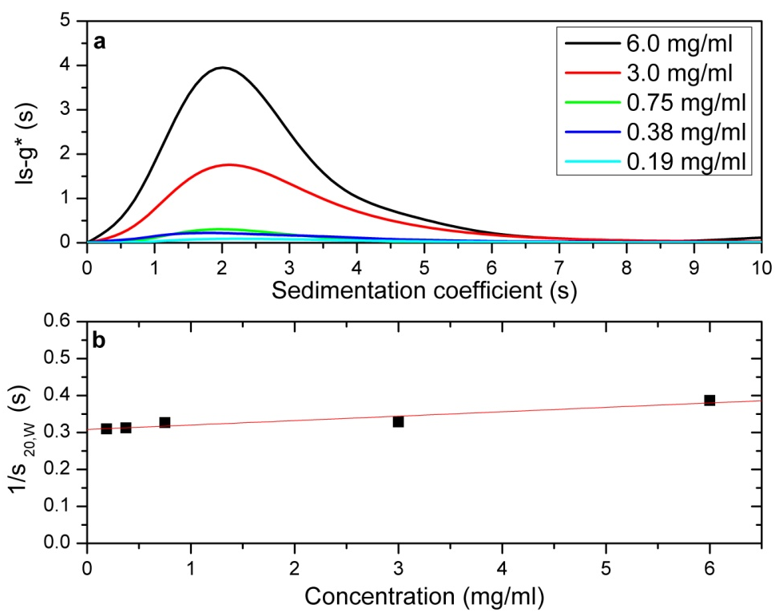
Figure 66. Sedimentation Coefficient Results for HB-PAMPS 15:1. ls-g* versus Sedimentation Coefficient (a) shows the profile of sedimentation coefficient distribution at the different loading concentrations, showing unimodiality 1/s_{20,W} versus concentration (b) shows the concentration dependence of the (weight average) sedimentation coefficient. s⁰_{20,W} = 3.2 ± 0.1 S.

HB PAMPS 20:1
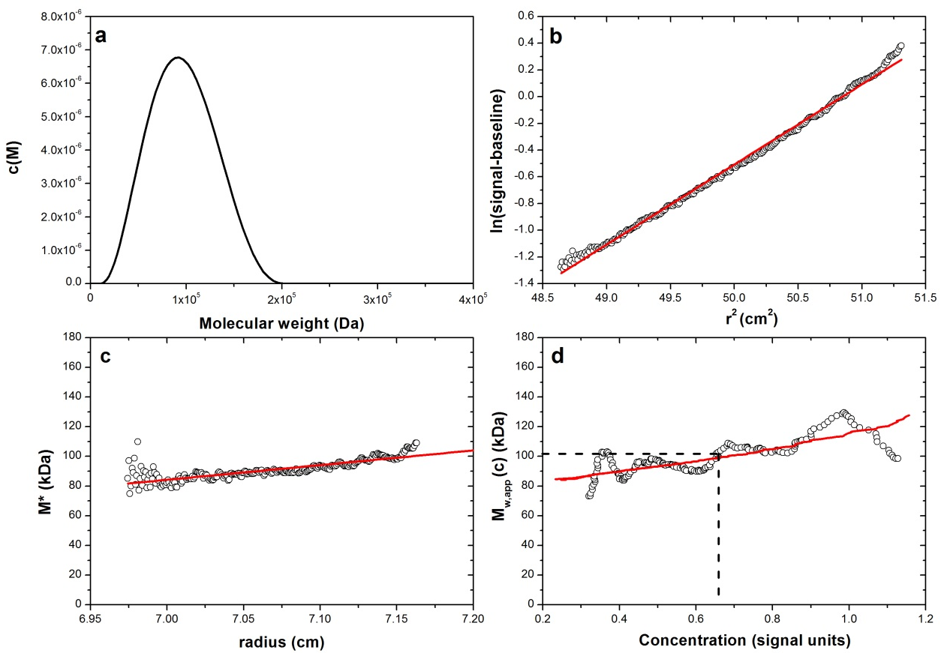
Figure 67. SEDFIT-MSTAR Data for the Sedimentation Equilibrium of HB-PAMPS 15:1.
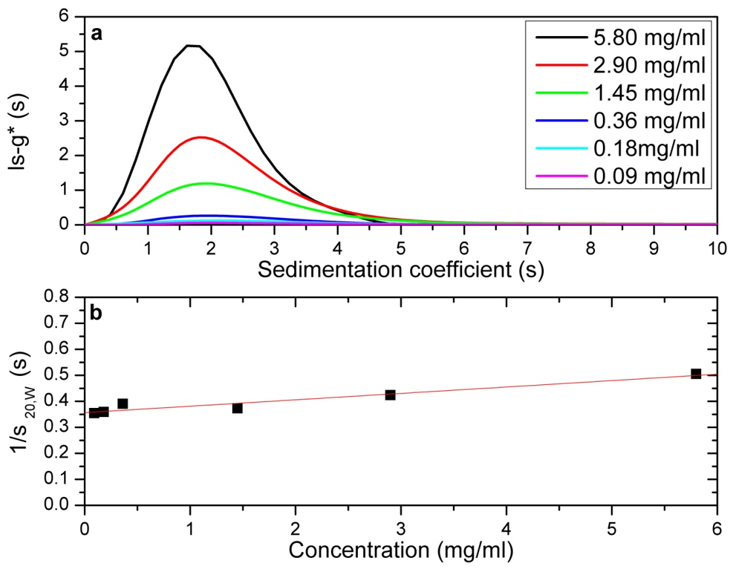
Figure 68. Sedimentation Coefficient Results for HB-PAMPS 20:1. ls-g* versus Sedimentation Coefficient (a) shows the profile of sedimentation coefficient distribution at the different loading concentrations, showing unimodiality 1/s_{20,W} versus concentration (b) shows the concentration dependence of the (weight average) sedimentation coefficient. s⁰_{20,W} = 2.8 ± 0.1 S.
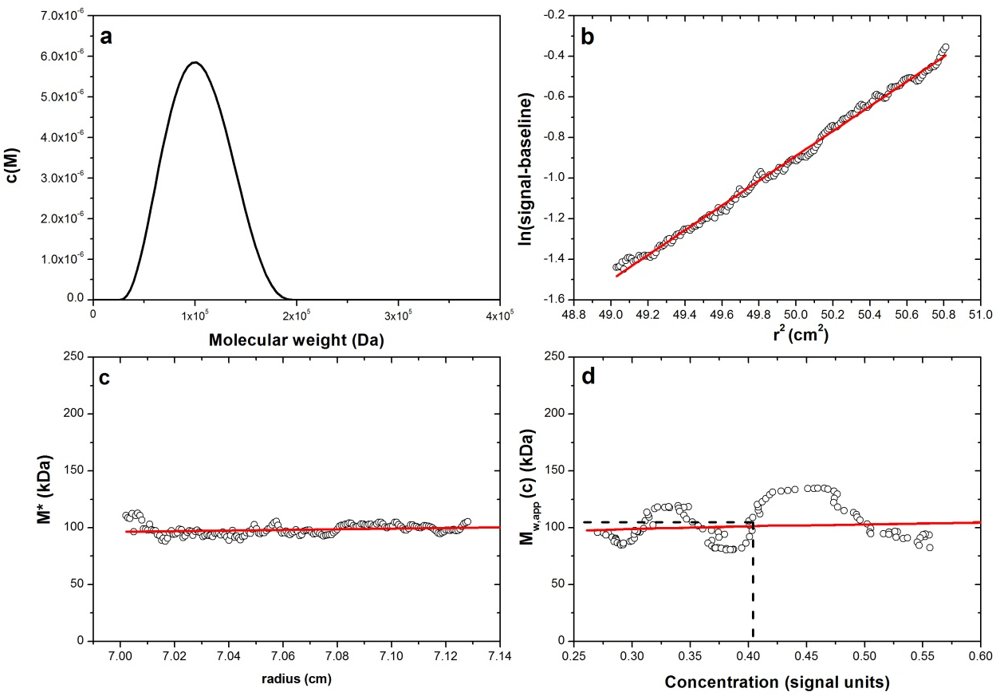
Figure 69. SEDFIT-MSTAR Data for the Sedimentation Equilibrium of HB-PAMPS 20:1.

Number of Particles per litre of Latex Calculation
Example: HB PAMPS PBMA A
Latex Solid Content = 16.87% therefore in 1 litre of latex approximately 168.7g is polymer.
Density of PBMA = 1.07 g cm⁻³
Volume of a Sphere =4/3 πr³
Volume of Latex Sphere with Particle Diameter - 151.6 nm
Conversion to m =151.6/1000000000 = 1.516 x 10⁻⁷ m
Particle Volume = 4/3 π (1.516 x 10⁻⁷/2)³
= 1.8239 x 10⁻²¹ m³
Particle Mass = 1.07*(1.8239 x 10⁻²¹)
= 1.9516 x 10⁻²⁴ g
Number of Particles per litre of latex (N_{p}) = 168.7/1.9516 x 10⁻²¹
= 8.64 x 10²²

Injection Moulding Equipment for the Fabrication of Membranes

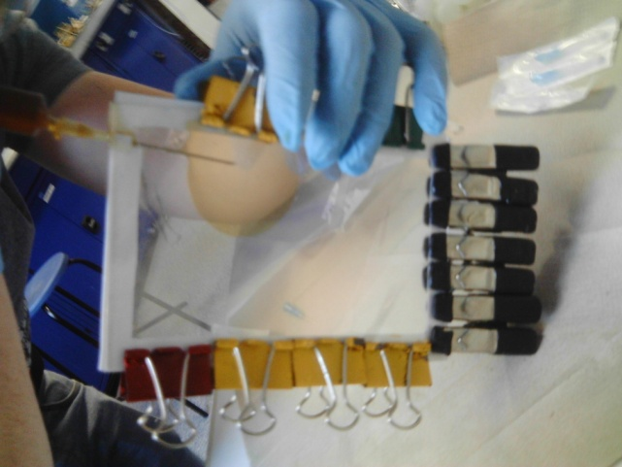
Figure 70. Injection Moulding Equipment.

