Chapter 3:
Experimental Techniques

In this chapter I describe the processes through which samples are fabricated and analysed. I fabricated Ni₈₁Fe₁₉ nanowire structures using electron beam lithography and lift-off processing with metallization by thermal evaporation. Structural analysis was performed using atomic force microscopy (AFM) and DW motion was analysed with focused magneto-optic Kerr effect (MOKE) magnetometry.

3.1. Electron Beam Lithography (EBL)

A tool employed to pattern nanostructures [1, 2, 3] used in computer architectures nowadays is Electron Beam Lithography (EBL). EBL system is similar to a scanning electron microscope but the electron beam is used to define structures. The EBL system used here is a Raith 150, capable of writing sub-100 nm scale features. Structures were designed in GDSII (Graphic Database System) software which includes a Computer Aided Design (CAD) system where the structures are drawn by specifying the coordinates for each point that defines the structure.

The samples were prepared on Si (100) substrates where polymethylmethacrylate (PMMA) was deposited and spun at 3000 rpm to assure a uniform coverage of the substrate. Then, they were baked on a hot plate at 170ºC to cross-link the PMMA. The polymer was then exposed to the electron beam in the electron beam lithography system where under the electron flux, chemical bonds between PMMA molecules are broken. The electrons come from a heated filament or a current passing through the filament that emits electrons. Then, the exposed PMMA is removed by development (described later). After that metallization (§ 3.2.) is achieved which will result in nanostructures like those in [4, 5].

The chamber with the substrates is brought to low pressure to avoid electron scattering on residual particles and then introduced in the EBL machine. Before writing the patterns on the sample, the sample position on the holder is established, then several optical adjustments are made like focusing (a different focal point will result in a wider structure) and astigmatism (to assure a good focusing both on horizontal and vertical) corrections to ensure correct writing of the structures. Other parameters, including filament voltage (V=10 kV), aperture size (a=30 μm) and condenser lens working distance are set. These parameters along with the quality and thickness of the resist determine the quality of the structures written. The aperture size and working distance dictates the resolution. The voltage affects the quality of the beam since the Gaussian profile might be affected by the backscattered electrons after the interaction with the sample. A large voltage also means that the beam can go deeper in the material and affect the Si substrate not only the resist.

The lithography system was used to pattern PMMA deposited on Si as described previously. The polymer resist is electron sensitive and exposed to the electron beam becomes more soluble by breaking the chemical bonds between the molecules. The electron beam follows the shapes designed in the GDSII platform.

The electron beam used by the Raith system comes from a heated filament that emits electrons when the current passes through it. The filament determines the intensity of the electron beam. The total electron dose (number of electrons per unit area) received by the exposed resist is defined as the product of the beam current and the dwell time (the time that the beam stays on each pixel) divided by the spacing between successive points.

There are two ways of defining the width of the patterned structures in EBL either by writing them as successive lines (raster lines) specifying the width of the structure in GDSII platform or as a single line by adjusting the dosage and the time the beam stays on each pixel (fig. 3.1.(a)). The second method provides a smoother edge roughness but due to the overlapping of the writing on the start and end points, the resulting structures are slightly deformed (fig. 3.1.(b)).

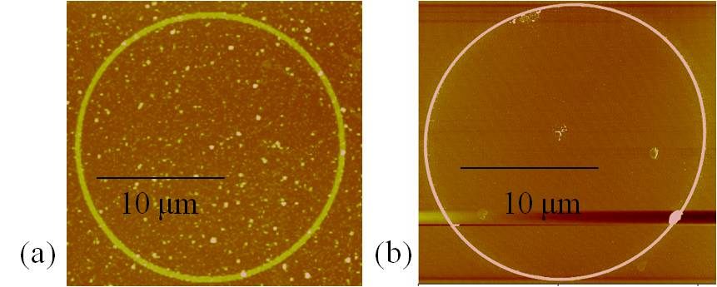
Fig. 3.1. 300 nm wide ring, 10 nm thickness and 10 μm radius after EBL and metallization using (a) raster lines and (b) single pixel lines

When patterning nanometer structures, the proximity effect can be seen if the structures are too close together (fig. 3.2.(a)). In this case, the Gaussian shape of the beam resulting form the backscattered electrons widens the wires and they might not end up as separate structures. Another problem might occur in the lift-off process (described later) and the structures will result like in fig. 3.2.(b). The desired case is presented in fig. 3.2.(c) where the structures are separated entirely.
(a)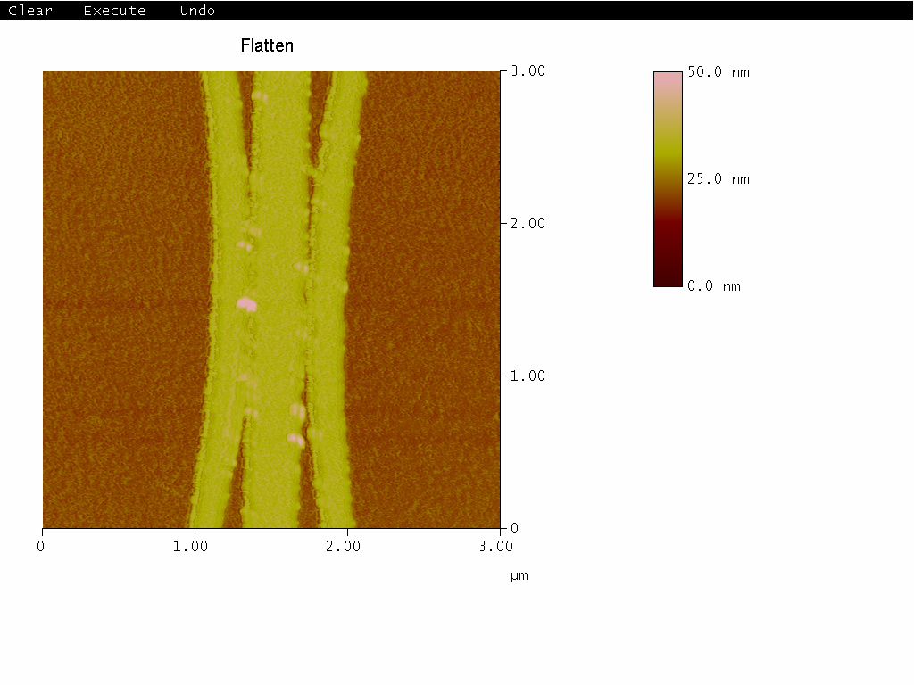 (b)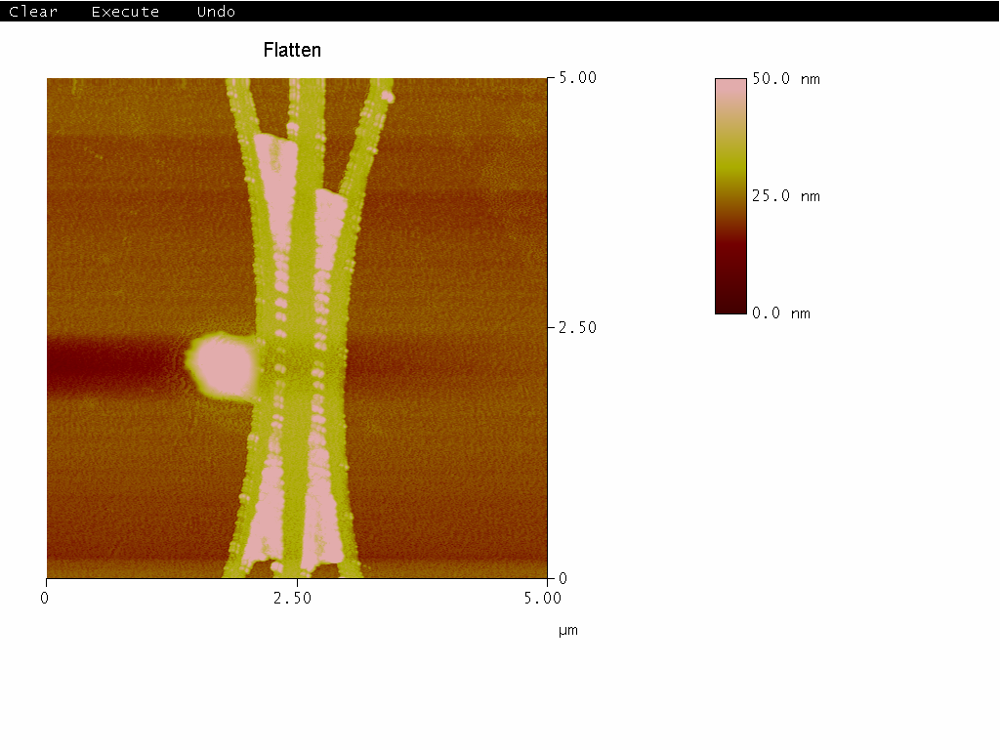 (c)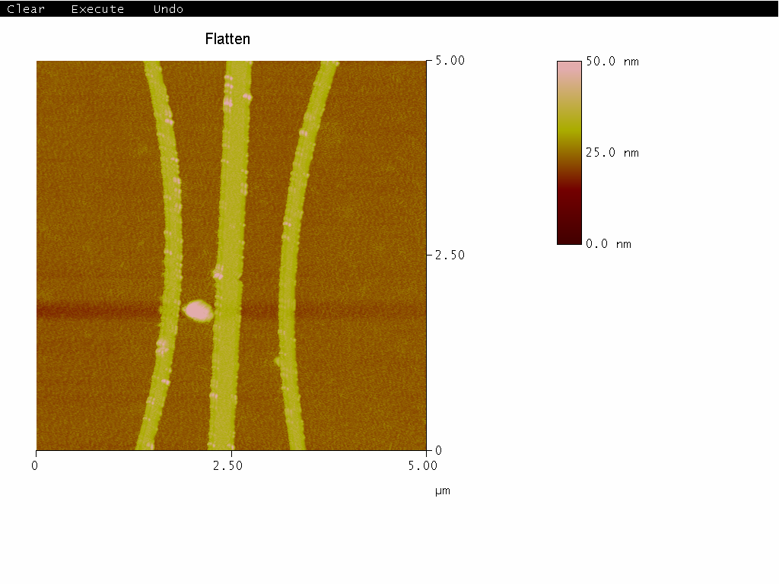
Fig. 3.2. AFM images of structures after patterning and lift-off: the distance between the structures is (a) 100 nm, (b) 200 nm (c) 400 nm. The curves are written as single pixel lines while the straight wire is defined using multiple raster lines.

After being exposed to the electron beam in the lithography process, the sample is developed in methylisobutylketone (MIBK) and isopropanol (IPA). This removes the PMMA exposed to the electron beam to leave a PMMA mask with gaps corresponding to the designed structures.

3.2. Thermal Evaporation

Thermal evaporation is a deposition technique based on resistive heating, used to prepare thin films. This method involves the transformation of a powder material into vapour when a current passes through an alumina crucible’s winding where the material is placed. The thermal energy gained by the heated particles is transformed into kinetic energy which allows the particles to travel in the vacuum chamber as a molecular beam [6].
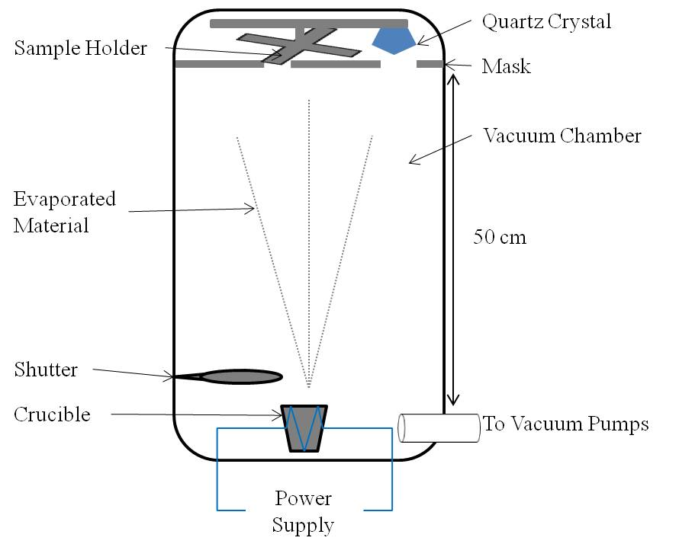
Fig.3.3. Thermal evaporator components: sample holder, quartz crystal, mask, vacuum chamber, evaporated material, shutter, crucible, power supply and vacuum pumps

The device used here is a custom-built Wordentec thermal evaporator and is shown schematically in fig. 3.3. The main components are the aluminium coated tungsten crucible where the powdered precursor material is placed, the shutter which prevents the material to reach the sample surface, the sample holder where are placed the substrates and the vacuum pumps. The crucible is connected to a power supply. When the current passing through the crucible increases, its temperature also rises. The device presents a small angular distribution of the particles. The working distance (the distance between the crucible and the substrate) is about 50 cm to allow a long mean free path for the particles and ensure a homogenous deposition on the substrate [6]. A quartz crystal film thickness monitor is placed next to the sample holder to measure the deposition rate. This rate gives the thickness of the deposited material on the sample, in Angstroms. The mask and rotating sample holder allows the growth of several samples with different thicknesses without breaking vacuum. The vacuum pumps allow a pressure of 10⁻⁷ mbar to be achieved before growth. The permalloy (Ni₈₁Fe₁₉) used here has an evaporation temperature of 1000ºC at 10⁻⁷ mbar [7].

To improve the quality of the material deposited on the samples, the deposition material is first evaporated to cover the chamber walls without the sample being exposed. The thickness of the sample is confirmed with an Atomic Force Microscopy (AFM) described in § 3.3.
After depositing permalloy, the sample is placed in acetone in an ultrasonic bath to remove the remaining PMMA mask along with the permalloy deposited on top of it. This lift-off process leaves permalloy structures on the Si substrate in patterns defined by the EBL writing.

3.3. Atomic Force Microscopy (AFM)

Scanning probe microscopes (SPM) are often used to image surface topology. A particular type of SPM is the atomic force microscope (AFM). A main part of the microscope is the tip that comes in close contact with the sample surface. The very end of the tip is usually a few atoms wide, which is obtained by etching or cutting [8]. These microscopes produce the image through Van der Waals forces between the tip attached to a cantilever and sample surface. Due to these interactions, the tip is attracted or deflected. The cantilever is connected to a piezoelectric sensor that converts its movement into electrical impulses (laser based detection). As a result, a map is generated by correlating the position of the probe on the sample surface with the height of the surface. The image is achieved by scanning the sample line by line (raster lines). The resolution of the resulting image is given by the volume of interaction of the tip with the sample but also by the shape of the tip. The tip can be as small as 5 nm lateral and 0.01 nm vertical resolution [9] or single atomic resolution in best systems [10].

There are several approaches to using an AFM. The main modes of operating depend on the sample surface and material used: contact, non-contact and tapping modes. They are characterized by the tip-surface interaction, i.e. an attractive regime between the tip and the sample surface for contact mode and a repulsive regime for non-contact and tapping mode. In contact mode the tip moves over the sample while the deflection of the cantilever is kept constant. A disadvantage is that the tip can damage the sample while scanning it and distort the image due to frictional and adhesive forces [11, 12, 13]. In non-contact mode the cantilever oscillates but it provides low resolution images due to the greater tip-sample separation [11, 12, 13]. Tapping mode is based on cantilever oscillations, where amplitude changes describe surface topography. The tip taps the sample surface and is deflected by the forces between the sample’s atoms and the tip. This mode gives better resolution than non-contact mode and it doesn’t damage the sample surface like contact mode. Also specific for tapping mode is a resonant frequency around which the cantilever oscillates [11, 12, 13]). The interaction in tapping mode creates a phase change in the cantilever oscillations. This is used to provide a signal.

The tip deflection is determined by measuring the change in position of a laser beam reflected from the cantilever on a quadrant photodiode (fig. 3.4.). From this change in the intensity of the laser signal, a map is generated by the computer [14].

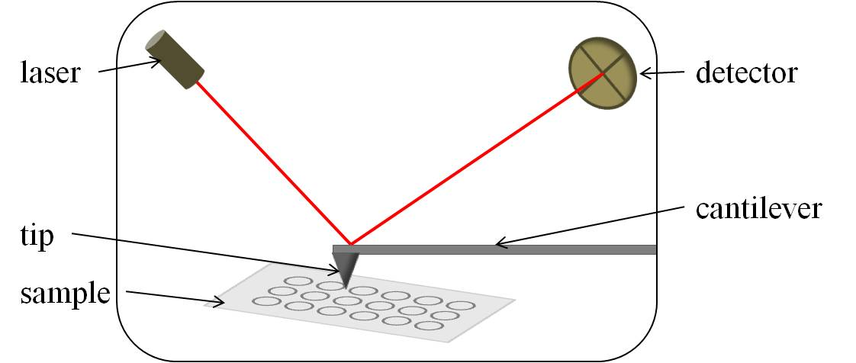
Fig. 3.4. Schematic of the AFM scanning the sample surface. As the tip scans the sample, the cantilever is deflected and the laser pointing on top of it changes the reflected direction thus resulting in higher or lower intensity of the detected signal.

The system used in this study is Digital Instruments Dimension 3000 AFM with a Digital Instruments NanoScope IIIa controller. The commercial (Veeco) tips are a four sided pyramid with a radius of curvature at the tip end of 10 nm [15, 16, 17]. Here, the AFM was used to image nanostructures (by lithography § 3.1. and evaporation § 3.2.) and confirm the thickness and wire width but also to check for any lithographic defects. My study used only the tapping mode due to the nature of the material used (permalloy is a soft material and using contact mode would result in damaging the sample [18] while a non-contact mode would give a poor resolution of the structures).

3.4. Magneto-Optic Kerr Effect (MOKE) Magnetometry
3.4.1. Light interaction with samples

Magneto-optic Kerr effect (MOKE) magnetometry was used to analyse patterned magnetic nanostructures, obtained as previously described in § 3.1. and § 3.2.

Light is an electromagnetic wave where the electric and the magnetic field vectors are perpendicular to each other and to the direction of propagation. During its propagation, these vectors’ direction or amplitude oscillate. When the electric vector’s oscillation has a projection on a plane of a line, a circle or an ellipse, the light is polarised linear, circular or elliptical.

Circular polarised light has two chiralities (clockwise or anticlockwise), depending on the direction of propagation of the wave and the rotation of the electric field vector. According to the right hand law, the direction of rotation obeying this law is right polarised while the other is left polarised [19]. Circular polarised light has a constant amplitude electric vector [19]. Linear polarised light can be seen as a superposition of left and right polarised light [19, 20].

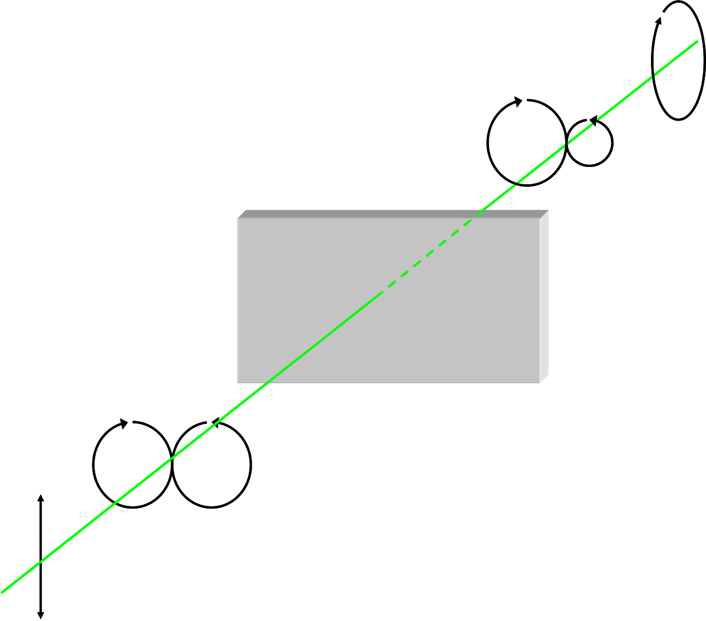
Fig. 3.5. Circular dichroism: linear polarised light is described by left and right circular polarised light. When light interacts with the sample one chirality of the circular polarised light is absorbed more than the other.

When polarised light interacts with materials, the light is transmitted, reflected or absorbed. ‘Dichroic’ materials absorb different polarizations to a different extent [21]. When this occurs with circularly polarised light the property is called circular dichroism [22]. Circular dichroism transforms plane polarised light into elliptical polarised light. When circular polarised light interacts with a material, left and right (i.e. clockwise and anticlockwise) circular polarised light are absorbed by different amounts (fig. 3.5.). Light interacting with materials placed in magnetic fields produces magnetic circular dichroism. The light’s direction of propagation is parallel to the magnetic field direction [23].

When light passes through a non-magnetic material, the number of electrons with spin up is equal with the number of electrons with spin down. When a magnetic material is placed in a magnetic field, the up and down electrons will gain different amounts of energy from the field and split energetically with respect to Fermi level. When interacting with electrons in a magnetic material, linear polarised light seen as left and right circular polarised light is absorbed by different amounts [24, 25]. Which one will be absorbed more depends on the majority spin polarisation in the sample, i.e. the direction and magnitude of magnetisation. The magnetic circular dichroism mean that linearly polarised incident light becomes elliptically polarised after interacting with the material.

The interaction of light with a transparent magnetic sample was first described by Faraday, in what became known as Faraday Effect [26]. In this effect, light rotates its polarization vector when passing through a transparent magnetic sample. This rotation is proportional to the amplitude of the magnetic vector of the sample.

The magneto-optic Kerr effect (MOKE) also emerges from magnetic circular dichroism but is observed in reflection [27]. While the Faraday effect requires transparent samples, MOKE is observed from a wide range of magnetic materials including bulk metals. Similar to the Faraday effect, in MOKE the polarised light interacts with the magnetic sample and its polarization is rotated. After reflection, the light changes both intensity and polarization. The reflected light is often not linearly polarised but elliptically polarised.

3.4.2. Configurations for MOKE measurements

The linear polarisation directions of light can be characterised relative to the optical plane of incidence: ‘p-polarised’ light has E in the plane of incidence and ‘s-polarised’ light as E perpendicular to the plane of incidence.

The interaction between the polarised light and the sample’s magnetisation can be described in three configurations: longitudinal, transverse and polar. For longitudinal MOKE, the magnetisation is in the plane of the sample and parallel to the optical plane of incidence, in transverse MOKE the magnetisation is in the plane of the sample surface but perpendicular to the optical plane of incidence, in polar MOKE the magnetisation is perpendicular to the sample surface (fig. 3.6.).

MOKE response depends on the magnetic material, the angle of incidence and also on the incident light (the wavelength). Polar MOKE is maximum when the light falls normally on the sample (both s and p light fall normally on the sample) while at glazing incidence polar MOKE is weak. Longitudinal MOKE is strongest at glazing incidence and weakest at normal incidence while transverse MOKE is weak for both glazing and normal incidence but strong for a 45º angle of incidence.

The strength of each effect is determined by the angle of incidence of the polarized light on the sample, on the magnetic material used and incident polarisation of light: s or p for longitudinal and polar MOKE causing a rotation of the polarisation of the reflected light and p only for transverse MOKE which changes the amplitude of the reflected light. In this study, the MOKE was used in the longitudinal configuration with p-polarized light.

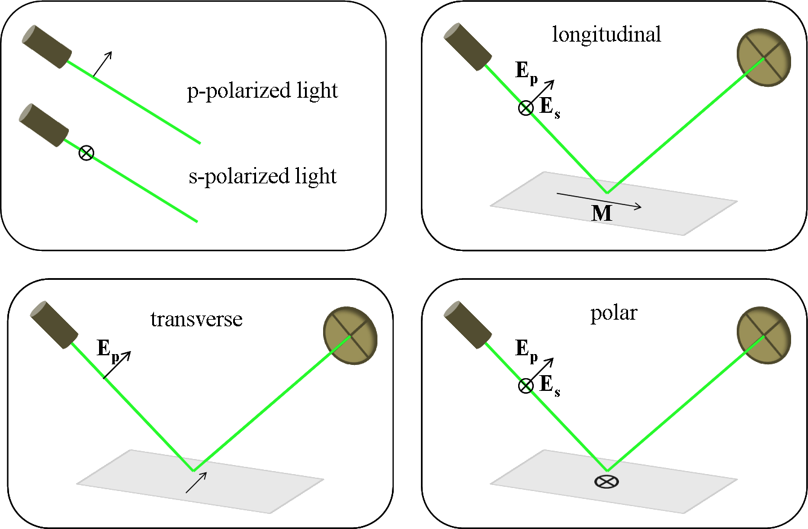
Fig. 3.6. Basic configurations on how MOKE can be used depending on the light’s polarization and the sample’s magnetisation direction, M.

3.4.3. MOKE magnetometer: optical components

The MOKE magnetometer used here is similar to one described previously [28] and depicted in fig. 3.7. Two optical paths are described here, with a green line for the laser path and a blue line for white light. White light is used to help locate the structures on the sample.

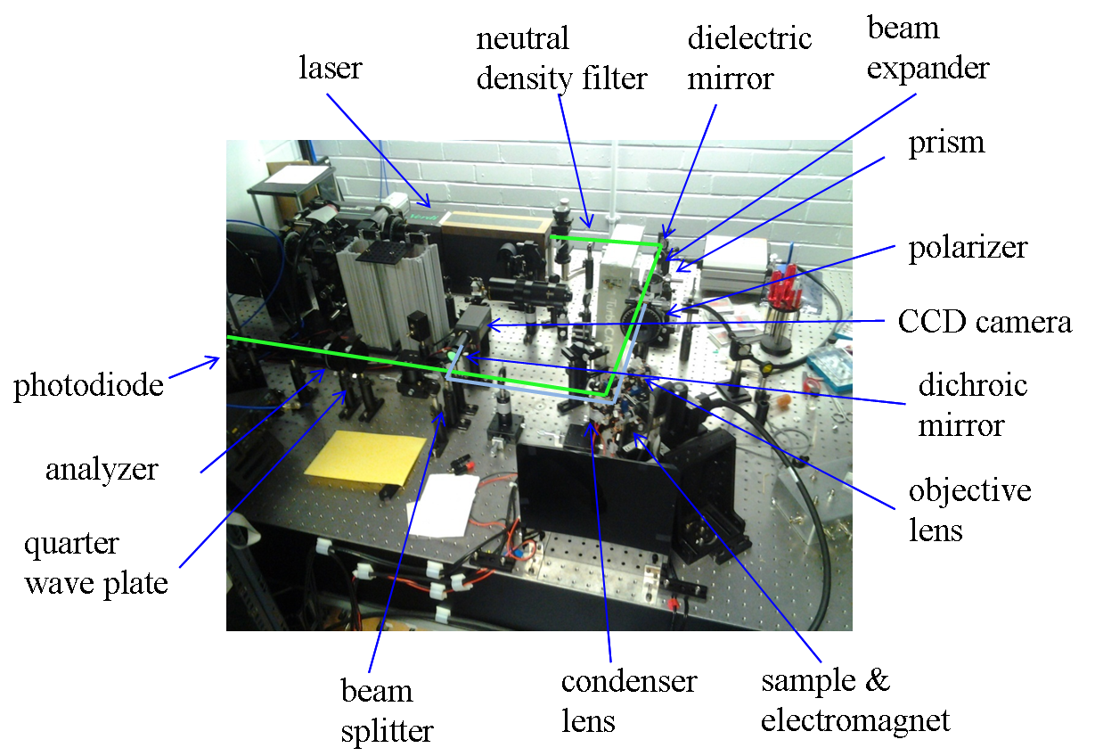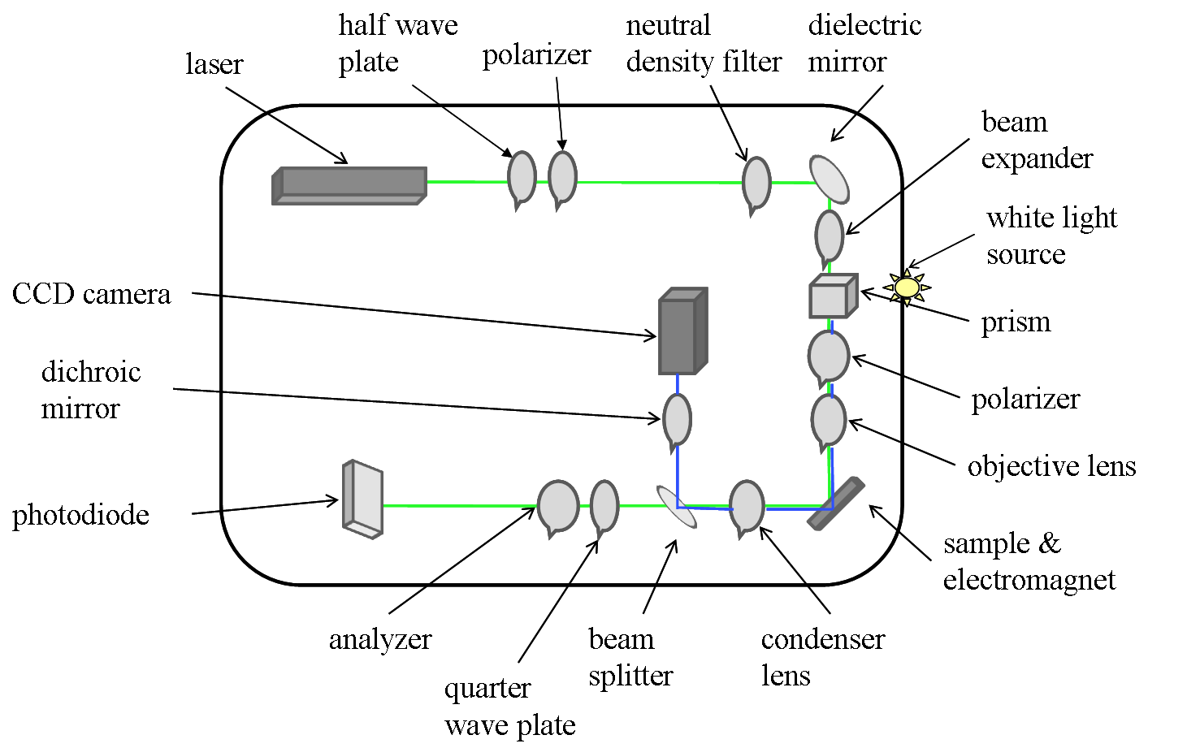
Fig.3.7. Picture and schematic diagram of MOKE magnetometer. Green line represents laser path and blue line white light path.

The laser is a diode-pumped solid-state laser (Coherent Verdi) operating at λ=532 nm with an output power that can vary between 0 and 2.2 W. The laser has a low signal to noise ratio for the maximum output power. Because the intensity of light can be too high and damage the sample, part of the intensity is taken out with a half-wave plate and a polariser. A neutral density filter can be included to attenuate further more the intensity of the laser beam. It is particularly used more for white light imaging to attenuate the laser beam and allow the structures and laser spot to be imaged together with a CCD camera. It is also used when the laser is operated at full power in order to avoid damaging the sample. A dielectric mirror changes the optical path by 90º. The next object in the optical path is a beam expander which is used to reduce the focused spot size at the sample ($d=\frac{1\text{.}\text{27f}λ}{d_{0}}$, where f=focal length of lens, λ=optical wavelength, d₀=incident beam diameter). A polarising prism is used to bring in the laser path white light for imaging. From this point the laser and white light follow an identical path up to the beam splitter where they separate again.

The polariser is a Glan-Taylor polarizing prism with an extinction ratio less than 10⁻⁵ it is used to create p-polarised laser light at the sample. There is always a degree of imperfection in the polarized light due to the polariser being less than 100% efficient; the level of polarization imperfection varies with the analyser angle [28]. The objective lens is an antireflection coated aspheric lens (focal length, f=50 mm) and is used to adjust the laser focus.

The sample is placed at 45º with respect to the beam’s direction, so the laser spot will not have a perfect Gaussian profile in the plane of incidence, but an elliptic one. The sample is placed inside a quadrupole electromagnet which generates magnetic fields on the x (in plane with the laser and light path) and y (perpendicular to the laser and white light path) directions in the plane of the sample. It consists of 8 coils each with 72 turns around an iron core.

The condenser lens is identical to the objective lens and is used to focus the image. A beam splitter beyond this reflects 10% of light to the camera for imaging and lets the rest through for magnetometry measuring.

The CCD camera image is observed on the white-light monitor. The camera’s chip is protected from the intensity of the laser beam by a dichroic mirror, but still the laser power is sufficient to saturate the camera, so additional laser attenuation is used to see the spot on the sample surface [28].

The quarter wave plate converts the elliptical polarized light to a linear polarized light. The analyser converts the rotation of the polarized light into an intensity signal. The analyser and the quarter-waveplate are adjusted iteratively until minimise the signal. Then, the analyser is rotated away from this extinction position by 1-2º which will allow the light rotated after the interaction with the sample (Kerr rotation) through.

The photodiode can be moved left-right and up-down and senses laser light intensity, which contents the Kerr information. It converts the incident light intensity signal to a voltage signal.

The motion controller Newport ESP300 is connected to the PC and controls the sample holder’s motion on vertical and horizontal and it can also rotate the sample. It is connected to the computer and it can change the sample’s position on the holder by the amount specified on computer’s software.

3.4.4. MOKE magnetometer: electronic components

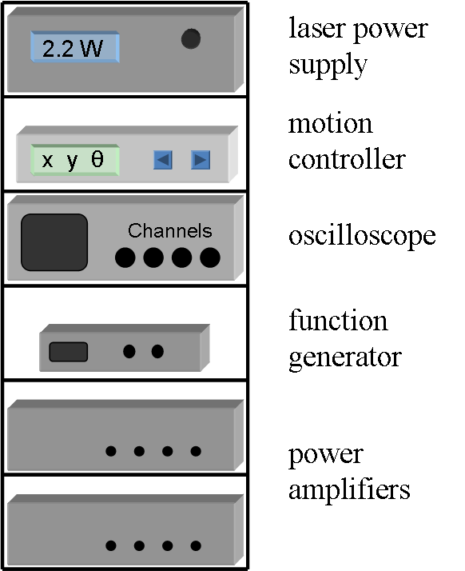
Fig. 3.8. Electronic components of MOKE magnetometer which, connected to the optical components and personal computer, help analyse the magnetic structures.

Because MOKE signal changes are usually small (few % for magnetic thin films, 0.01 – 0.1% for magnetic nanostructures), it is amplified by a Princeton Applied Research model 181 signal pre-amplifier. The signal is then passed through an Isotech IDM201 multimeter to allow the dc signal level to be observed.

An Agilent Infiniium 54832D MSO oscilloscope records the signal from the pre-amplifier either as single-shot or averaged measurement over several field-cycles. The oscilloscope has four analogue input channels (channel 1 for horizontal field, channel 2 for vertical field, channel 3 for Kerr signal from the voltmeter and channel 4 the optical reference channel). The oscilloscope also has 16 digital channels, one of which is used to record a square wave reference signal to provide a trigger and define the length of one hysteresis loop. The bandwidth of the oscilloscope is limited to 20 MHz to reduce high frequency noise. The oscilloscope averages the signal for several loops measured and then sends this signal to a personal computer which averages the signal further by bandwidth reduction and nearest neighbour averaging.

The signal from the pre-amplifier is also sent to a Signal Recovery 7225 DSP lock-in amplifier. The result is an intensity map that distinguishes between magnetic structures and uncovered substrate. This provides a more precise method of locating structures on the sample then using white light imaging alone.

Magnetic fields are generated by Kepco BOP 20-5M bipolar power amplifiers connected to the coils of the electromagnet. The temporal profile of the magnetic field for x and y components can be defined separately either with a function generator or by files created on the computer using a digital to analogue converter.

Small pick-up coils around the electromagnet pole-pieces and connected to the oscilloscope are used to measure the field. The x and y fields can be generated independently. The differential of the magnetic field is measured with this loop through Faraday’s induction law ξ=-AdB/dt, where ξ is the induced electromagnetic force, A is the area of the loop, B the magnetic field and t time. The magnetic field is obtained by integrating this equation with respect to time. In order to have a rotating magnetic field the x and y components are phase shifted by π/2. The field measured from the quadrupole is calibrated with a Gaussmeter.

Bibliography:

- R. P. Cowburn, D. K. Koltsov, A. O. Adeyeye, M. E. Welland, Europhysics Letters, 48 (1999) 221-227
- A. Eckert, K Mountfield, Journal of Vacuum Science and Technology, 22 (2004) 2936-2942
- X. M. Yang, A. Eckert, K. Mountfield, H. Gentile, C. Seiler, S. Brankovic, E. Johns, Journal of Vacuum Science and Technology, 21 (2003) 3017-3020
- M. Negoita, T. J. Hayward and D. A. Allwood, Applied Physics Letters 100 (2012) 072405
- D. A. Allwood, G. Xiong, C. C. Faulkner, D. Atkinson, D. Petit, R. P. Cowburn, Science, 309 (2005) 1688
- E. Steinbeiss, “Thin film deposition techniques (PVD)”, Lecture notes in physics: “Spin electronics”, Springer Berlin, 2001, cap. 13
- Thin Film Evaporation Guide, Vacuum Engineering and Materials Co., Inc., http://www.vacengmat.com/downloads/VEM_Thin_Film_Evaporation_Guide.pdf
- Phil Russel, AFM Probe Manufacturing, Appalachian State University
- Hong-Qiang Li, AFM modes
- http://newscenter.lbl.gov/news-releases/2013/05/30/atom-by-atom/
- http://www.nanoscience.com/education/afm.html
- http://www.chembio.uoguelph.ca/educmat/chm729/afm/details.htm#summary
- http://www.eng.utah.edu/~lzang/images/Lecture_10_AFM.pdf
- A Practical Guide to Scanning Probe Microscopy (SPM), Veeco
- http://www.nanoandmore.com/afm-tips.php
- AFM Probe Training, Support Note 374, Revision A, Part Number: 013-374-000
- http://www.nanoandmore.com/afm-tips.php
- Mathew Bryan, Nucleation and propagation of domain walls in Permalloy nanostructures, PhD thesis, University of Sheffield, 2008
- Berkley course, vol III, Waves, Editura didactica si pedagogica, Bucuresti 1987
- http://www.enzim.hu/~szia/cddemo/edemo14.htm
- http://scienceworld.wolfram.com/physics/Dichroism.html
- http://www.enzim.hu/~szia/cddemo/edemo14.htm
- http://www.princeton.edu/~achaney/tmve/wiki100k/docs/Magnetic_circular_dichroism.html
- J. Stohr, Journal of Magnetism and Magnetic Materials 200 (1999) 470-497
- J. Stohr, Journal of Electron Spectroscopy and Related Phenomena 75 (1995) 253-272
- http://scienceworld.wolfram.com/physics/FaradayRotation.html
- J. Kerr, Philosophical Magazine 3 (1877) 321
- D A Allwood, G Xiong, M D Cooke, R P Cowburn, Journal of Physics D: Applied Physics, 36 (2003) 2175-2182

