Chapter 2:
Magnetic Materials.
Magnetic Nanowires.
DWs in Nanowires

In this chapter I give an introduction to magnetic materials, their internal structure, domains and DWs and the energies contributing to their formation. I also describe DW motion under applied magnetic fields and how their motion is influenced by material defects. I then describe the types of DWs that arise in nanowires and how they can be moved in these structures before describing the particularities of ring-shaped nanowires and how DWs propagate in them. I conclude with a summary of the applications of DWs in magnetic nanowires, including interactions with ultra-cold atoms.
2.1. General Description of Magnetic Materials

Magnetic materials were discovered in ancient times as naturally formed rocks that contained iron (magnetite). The first time magnetic materials were mentioned was by Thales of Miletus when he noticed that magnetic rocks of magnetite attract iron [1]. Later on it was observed that a piece of magnetic material could point to the magnetic north pole and so it was used by sailors (lodestone) [2]. Later on, around years 1500, William Gilbert studied lodestones and pieces of iron and mapped Earth’s magnetic field [1, 2]. However, it is only recently (the past 200 years) that magnetic materials were studied and considered for applications beyond a simple compass.

Thales of Miletus considered magnetic materials to have a soul which attracts iron [1]. This ‘soul’ is now explained as magnetic poles at the end of the magnets, a north and a south pole. If a north and a south pole are brought close together they attract while two north or two south poles repel. A magnetic material generally (except for materials with flux-closure) consists of pairs of north pole-south pole and they cannot be separated (If we cut a magnetic material into small pieces we still end up with pairs of poles). Magnetic poles produce a magnetic field. When a non-magnetized magnetic material is brought close to a magnetized material it will become magnetized as well.

The equations 2.1. to 2.3. below show the relationship between the magnetic field’s induction $\vec{B}$, magnetization $\vec{M}$(the sum of the atomic magnetic moments) and the magnetic field intensity $\vec{H}$.

$$\begin{aligned}\vec{B}=μ_{0}\left(\vec{H}+\vec{M}\right) \\ \vec{M}=μ_{r}\vec{H} \\ χ=1+μ_{r}\end{aligned}$$ | (2.1.)
 | (2.2.)
 | (2.3.)

where μ₀ is the free space permeability, μ_{r} is the material’s relative permeability and χ is the magnetic susceptibility. These are proportionality constants between the field’s induction, intensity and magnetization. Equations (2.2.) and (2.3.) are valid for homogenous materials.

Diamagnetic materials are characterized by a usually weak induced magnetisation that opposes an applied magnetic field, i.e. negative magnetic susceptibility (Faraday noticed that a piece of bismuth is rejected by the magnetic field [3]). Paramagnetic materials have a weak induced magnetisation and positive magnetic susceptibility [4]. The other three categories of materials have regular but different arrangements of atomic magnetic moments in their structure: ferromagnets have all magnetic moments aligned parallel, antiferro – spins are aligned antiparallel and ferri – spins are antiparallel but the magnitude differs.

2.2. Internal Energies of Ferromagnetic Materials

Ferromagnetic materials such as Ni, Fe, Co and their alloys are characterised by an internal structure of domains separated by DWs. The domains are regions within magnetic materials with aligned magnetic moments within them, but their overall magnetic moments are not necessarily aligned with each other [5]. These adjacent domains are separated by DWs (described later in §2.3.), which are transition regions through which the magnetisation rotates from one domain direction to another.

The configuration and dynamics of magnetisation in a material depend on the interplay of a number of energy terms which, in order to minimize the total energy of the material, creates domains. These are: exchange energy, magnetocrystalline anisotropy energy, shape anisotropy energy, induced anisotropy, magnetostrictive energy, magnetostatic (demagnetising) energy, and Zeeman energy. A description of the origins and form of each of these energies is given below:

2.2.1. The exchange energy is an internal interaction that tends to align atomic magnetic moments (but not necessarily parallel – i.e. anti-ferromagnets or ferrimagnets) in a material [5]. The atomic magnetic moment of the ferromagnetic elements Ni, Co and Fe arises from the spin (and orbital contribution) of 3d electrons. The quantum arrangement of these electrons is governed by Hund’s rules [5] and a parallel alignment of the 3d electrons’ spins is favourable for minimum exchange energy. This alignment arises from the exchange of electrostatic interactions between neighbour electrons [6] and is expressed as

$E_{\text{exchange}}=−2\sum_{i,j}{J_{i,j}\vec{S_{i}}⋅\vec{S_{j}}}$ (2.4.)

where J_{i,j} is the exchange integral, is the kinetic spin moment of electron i.

Unlike ferromagnetic materials, in antiferromagnetic materials the atomic moments are arranged in two interleaved lattices and aligned antiparallel by the exchange interaction (due to J_{i,I} being negative for these materials). Ferrimagnetic materials have a similar arrangement with antiferromagnets but the two lattices have different constituent atomic moment magnitudes to produce a net magnetisation overall.

2.2.2. The magnetocrystalline anisotropy energy is the energy within a material which aligns the magnetisation along certain crystallographic directions [5]. The origin of the anisotropy energy comes from spin-orbit coupling interacting with the crystalline structure through electrostatic fields [5]. This determines the crystallographic directions, or ‘easy axes’, along which magnetisation prefers to lie [4, 5]. When a magnetic field is applied in a different direction from an easy axis, magnetisation rotates towards the field’s direction [5, 7]. The directions that cost the largest amount of magnetocrystalline anisotropy energy to align magnetisation to are named ‘hard axes’ [4]. The difference between the two energies, the energy required to magnetize the material along a hard axis and the one required to magnetized the material along an easy axis, is the anisotropy energy E_{anisotropy}, which for cubic crystals is expressed as:

$E_{\text{anisotropy}}=K_{1}{\text{sin}}^{2}ϕ+K_{2}{\text{sin}}^{4}ϕ$ (2.5.)

where φ is the angle between the easy axis and the magnetisation direction and K₁ and K₂ the magnetocrystalline constants for the appropriate material and crystal structure.

Polycrystalline permalloy can be produced with randomly oriented crystallographic axes. With the typical ~10 nm size of crystallites produced by thermal evaporation §3.2. and the 100+ nm size of domain walls, the already small magnetocrystalline anisotropy effectively becomes averaged further towards zero [7].

2.2.3. Zeeman energy is the energy that arises when a magnetic moment is placed in a magnetic field. For a ferromagnetic material, the magnetisation is used to obtain an energy density for the element as a whole:

$E_{\text{Zeemann}}=−μ_{0}\int_{V}{\vec{M}⋅\vec{H}\text{dV}}$ (2.6.)

where is the applied magnetic field and μ₀ is the free space permeability (4 π 10⁻⁷ H/m).

When an external magnetic field is applied to a material, the magnetisation of each individual domain is rotated to align with the applied field’s direction (details on this rotation are given below in §2.3.).

2.2.4. Demagnetising energy/ Magnetostatic energy. When a ferromagnetic material has a net magnetisation, the uncompensated magnetic charges at the edge of the material create a magnetic field , known as demagnetization field, inside the material, in the opposite direction to the magnetisation fig. 2.1.

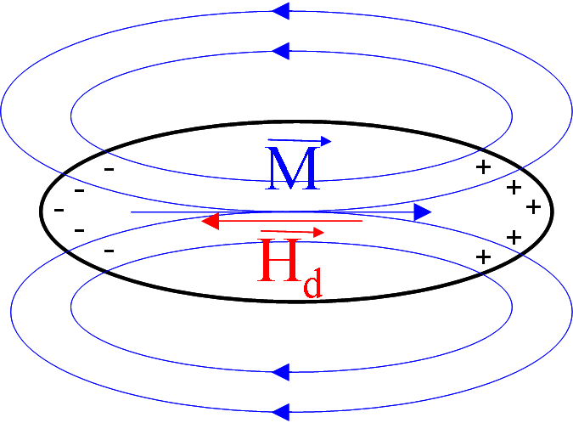
Fig. 2.1. Demagnetising field inside a magnetic material, where + and - represent the charges inside the material which create the demagnetising field.

This is given by

$\vec{H_{d}}≃−N_{d}\vec{M}$ (2.7.)

where N_{d} is the demagnetising factor, a tensor [8, 9,10] that depends on the material’s shape and the direction considered. For example, with N_{dx}, N_{dy} and N_{dz} representing the demagnetising factors in the orthogonal directions x, y and z: N_{dx}=1 and N_{dy}=N_{dz}=0 for an infinite yz plane; N_{dx}=N_{dy}=N_{dz}=1/3 for a sphere; and N_{dx}=0 and N_{dy}=N_{dz}=1/2 for an infinite cylinder along the x axis.

The demagnetising field creates energy inside the material. Magnetostatic energy resulting from the interaction of material’s magnetisation with the demagnetising field is
$E_{\text{magnetostatic}}=−\frac{1}{2}μ_{0}\int_{V}{\vec{M⋅\vec{H_{d}}\text{dV}}}$ (2.8.)

Equation 2.8. is derived from the Zeeman energy, equation 2.6. Magnetostatic energy is an important consideration in the formation of magnetic domains and in the magnetic configuration of nanostructured soft magnets, both considered below [11, 12, 13].

2.2.5. Magnetoelastic energy. Magnetostriction is observed as the deformation of a material when a magnetic field is applied to it. The extent of magnetostriction, λ is defined by:

$λ=\frac{Δl}{l}$ (2.9.)

where l is the original length of the material and Δl is the change in length. λ depends on the magnitude of the applied field, temperature and crystallographic direction in which the field is applied. When the applied field cannot change the shape of the material due to a tightly packed structure of the atoms in the lattice it creates internal stresses in the material which requires more energy in order to create domains; this is the magnetoelastic energy.

However, the material used throughout this thesis (permalloy – Ni₈₁Fe₁₉) has near zero magnetostriction [7] and so magnetoelastic energy is neglected from consideration in any calculations.

2.2.6. Thermal energy. The effect of temperature on a ferromagnetic material is to increase the amplitude of thermal vibrations (described by specific heat) [2] and to perturb the alignment of spins. As a result, the magnetisation of a ferromagnetic material decreases as the temperature increases up to a limiting temperature, the Curie point, T_{c}. Above T_{c}, ferromagnetic order (and a permanent magnetic moment) disappears and the material becomes paramagnetic, characterised by a random orientation of spins inside the material.
At lower temperatures, thermal energy in a ferromagnetic material assists overcoming potential barriers, such as those associated with magnetisation reversal. This leads to coercivity (defined below) being both temperature and time-dependent for all ferromagnetic materials. The temperature dependence of overcoming a single (magnetic) energy barrier E_{a} is characterized by a relaxation time τ as:

$τ=τ_{0}\text{exp}\left(\frac{E_{a}}{k_{B}T}\right)$ (2.10.)

where $τ_{0}=1/{f_{0}}$, f₀ is the attempt frequency, k_{B} Boltzmann constant and T the temperature.

The above energy terms lead to a coupling of the crystal and magnetic systems. Thermal excitation of a material therefore introduces local fluctuations in the ferromagnetic order. Due to the exchange interaction, these fluctuations propagate and are known as ‘spin waves’ or ‘magnons’ [14, 15]. Artificial excitation of spin waves is possible and has led to the emergence of ‘magnonic’ technology [16, 17].

2.3. Domains in magnetic materials

A single ferromagnetic domain structure results in minimum exchange energy and, if oriented along a magnetic easy axis, minimum magnetocrystalline anisotropy energy but also a large demagnetising energy (fig. 2.2.(a)).

(a) 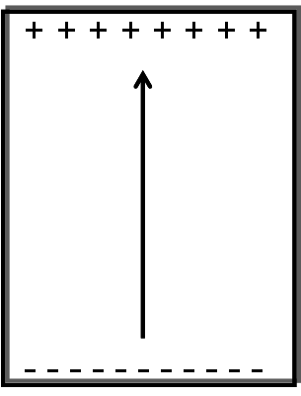 (b) 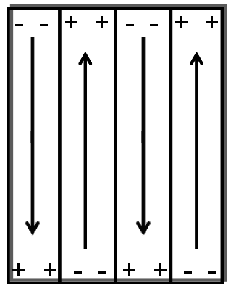 (c) 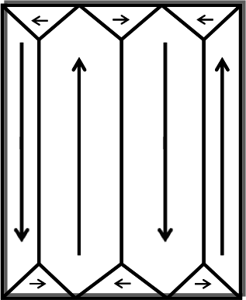
Fig. 2.2. DW formation in magnetic materials. The arrows represent magnetisation directions for domains and the + and – represent uncompensated charges.

In order to reduce the demagnetising field, multiple domains are formed (fig. 2.2.). The more domains that exist, the lower the demagnetising field within the material. However, the resulting increase in the number of DWs causes an increase in exchange energy. A stable domain configuration is reached when the sum of the exchange, magnetocrystalline anisotropy and demagnetising energies is minimum.

Further reduction in the internal demagnetising field results from the formation of ‘closure domains’ perpendicular to the easy axis domains (fig. 2.2.(c)). These closure domains appear in materials with easy axes perpendicular to each other (i.e. cubic anisotropy) [18] These reduce the surface magnetic charging but usually remain relatively small due to the high exchange energy they introduce.

2.4. DWs in bulk and thin film materials

If the transition of magnetisation direction from one domain to the next would occur suddenly over a single atomic spacing, the exchange energy would be very high. Instead, the magnetic moments usually rotate across a DW transition region to reduce the exchange energy associated with the reversal.

DWs are areas of magnetic materials, reduced in dimensions (typically tens-hundreds of nm), that connect two or more domains. Inside each DW the magnetic moments rotate from the direction of the first domain to the direction of the other domain with a small angle between each moment in order to keep the exchange energy as small as possible.

(a) 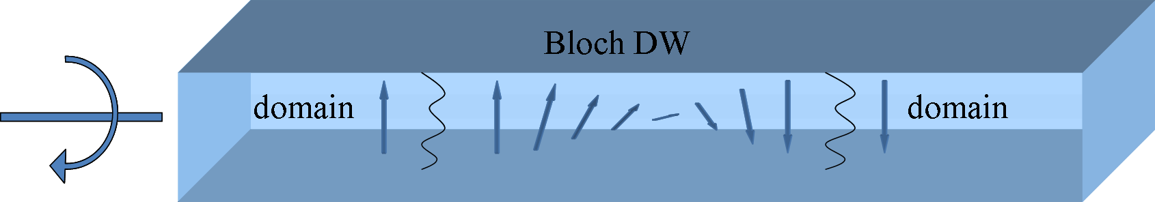
(b) 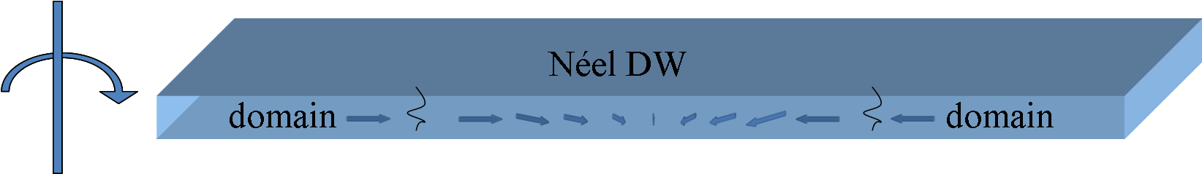
Fig. 2.3. (a) Bloch DWs in bulk materials and (b) Néel DWs in thin film materials.

The exchange energy in DWs is smaller when the transition occurs over a few atomic planes. The exchange energy tends to widen the wall over as many planes as possible. However, the anisotropy energy limits the thickness of the wall since the magnetic moments in the wall align over hard axes. For Bloch walls, the wall’s surface energy is the sum of the exchange energy and the anisotropy energy [5]:

$σ_{\text{DW}}=σ_{\text{ex}}+σ_{a}=\frac{{Aπ}^{2}}{\text{Na}}+\text{KNa}$ (2.11.)

where A is the the exchange stiffness coefficient $A=\frac{{\text{JS}}^{2}}{a}$, where J is the exchange integral, S is the atomic spin quantum number, N number of atoms in the wall, K the anisotropy constant and a the interatomic spacing. The energy minimised results in:

$\frac{dσ}{\text{dN}}=0⇒N=\frac{π}{a}\sqrt{\frac{A}{K}}$ (2.12.)

Typical wall widths vary between a few nanometres (e.g. in hard magnets) to several hundred nanometres according to:

$δ_{\text{DW}}=\text{Na}=π\sqrt{\frac{A}{K}}$ (2.13.)

So, the wall energy is:

$σ_{\text{DW}}=\frac{{Aπ}^{2}}{π(A/K)^{1/2}}+Kπ{\left(\frac{A}{K}\right)}^{1/2}=2π\sqrt{(\text{AK})}$ (2.14)

In bulk materials and thick films Bloch DWs are most common, in which the magnetisation rotates in the volume of the sample. Because of reduced dimensions in thin films, a Bloch wall fig. 2.3.(a) will present magnetic poles so a Néel wall fig. 2.3.(b) is preferred because the magnetisation rotates in the plane of the sample [2]. Magnetic nanostructures present other kind of DWs discussed further in §2.5.

2.5. DW movement in magnetic materials

When a magnetic field is applied to the material it will expand ferromagnetic domains with magnetisation parallel to this field at the expense of other domains. This is mediated by DW propagation. As the field increases, DWs move further into the regions previously occupied by unfavourable domains by increasing the domain with the magnetization lying parallel to the applied field. A similar situation is depicted in fig. 2.4.(a) for the case of a ferromagnetic nanowire.

Considering a demagnetized material under small magnetic fields, DWs typically only move small distances until they experience a significant energy barrier (position a in fig. 2.4.(b)). For a further increase in the field, DWs will start to overcome successive energy barriers, undergoing rapid movement between energy barriers (e.g. defects) in so-called ‘Barkhausen jumps’ [19]. The nature of this motion is irreversible, and if the field is removed the DWs will not return to their original position and the material will remain magnetised. Under the highest fields, anti-parallel domains are removed completely and the magnetisation of the entire material becomes aligned with the applied field direction (fig. 2.4.(a)). If the applied field’s direction is not along one of the material’s easy axes, significant fields can be required to saturate the material.

(a) 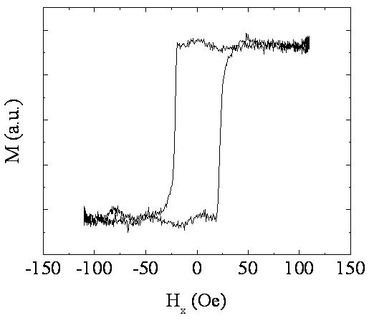 (b) 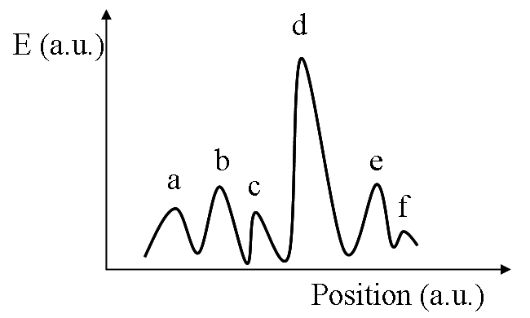
Fig. 2.4. (a) Hysteresis loop of a straight magnetic nanowire 600 nm wide, 10 nm thick and 53 μm long. (b) Energy barriers in materials created by defects as described in [4]. When a DW moves inside a magnetic material it encounters defects that pins it. Depending on the nature of each defect, the DW pinning could be stronger (point d) or weaker.

If the applied field is removed, energetically the DWs will tend towards their original positions. However, due to energy variations created by defects, the DWs will get a different arrangement each time, even if the net magnetisation is the same. This means that the volume of domains along the previous field direction will be larger than those in the opposite direction, so the material will have an overall non-zero magnetisation (remanent magnetisation). In order to bring the magnetisation to zero, a magnetic field is applied in the opposite direction. For a certain field value (coercive field) DWs are arranged so that the overall magnetisation of the material is zero.

This process is shown in figs. 2.4. underlining the energy barriers that DWs have to overcome when rotating or moving in order to align the magnetic moments of domains to the direction of the field. Fig. 2.4.(b) shows energy barriers and wells that a DW has to overcome when, during its movement, encounters defects in the material. All kind of magnetic or non-magnetic defects cause lattice distortions around them which create energy barriers that DWs have to overcome during their movement and makes the magnetisation process to require more energy, higher remanence and coercivity and in consequence, wider hysteresis. Non-magnetic impurities act to reduce the saturation magnetisation (except for those which increase the magnetic moment due to the details of the electron orbital overlap in certain crystal structures) due to the decrease of concentration of magnetic moments. More non-magnetic moments can form clusters which will pin the DWs and increase the remanence and the coercivity [4]. The coercive force decreases when the number of impurities decreases and internal tensions are removed [5]. Another kind of defect can be encountered in thin films where, when the DWs move through it, they get stuck in areas where the surface is thinner due to an energy well created by the surface roughness.

Thermal effects affect DW depinning events, in which thermal energy allows DWs to overcome energy barriers without increasing the applied field.

2.6. Nanoscale magnetism. DWs in nanowires

Magnetic nanowires are stripes of magnetic materials, typically hundreds of nanometres wide, tens of nanometres thick and lengths that can go up to several micrometres. The material used throughout this thesis is Permalloy (Ni₈₁Fe₁₉) which also is an archetype material. For polycrystalline Permalloy, magnetically soft face-centred cubic (fcc) crystallites the magnetocrystalline energy is much smaller than the shape anisotropy (§2.2.), due to the shape of the nanowire.

(a) (c)
(b) (d)
Fig. 2.5. Schematic of DWs in nanowires (a) transverse wall up (b) transverse wall down (c) vortex wall clockwise (d) vortex wall anticlockwise.

In patterned magnetic structures of Permalloy the shape anisotropy is dominant which causes the magnetisation to lie along the length of the wire – i.e. the wire’s long axis becomes the magnetic easy axis. Due to the dimensions of nanowires, domains in Permalloy materials can only lie along the wires and the DWs that separate them are almost always across the wire. The walls separate domains oriented towards (or away from) each other. This leads to the so-called ‘head-to-head’ (H2H; fig. 2.5.(a) & (c)) or ‘tail-to-tail’ (T2T; fig. 2.5.(b) & (d)) configurations, which are distinct from the walls discussed earlier occurring in bulk and thin film materials. DWs in nanowires propagate along the easy axis.

These H2H (or T2T) DWs can be mainly transverse and vortex [20] (but other kind of walls can be observed like asymmetric transverse walls [21]) and for each configuration, there are two rotation direction (chiralities): up (fig. 2.5.(a)) and down (fig. 2.5.(b)) for transverse walls and clockwise (fig. 2.5.(c)) and anticlockwise (fig. 2.5.(d)) for vortex DWs. In transverse DWs the magnetic moments rotate from the direction of one domain up or down to the direction of the other (fig. 2.5.(a), (b)). In vortex walls the magnetisation rotates around a central point (fig. 2.5.(c), (d)). DWs also carry a magnetic charge and, therefore, are a source of magnetic field. This is important for the atom trapping applications described in Chapter 1.

Since magnetostatic and exchange energy are the dominant energy terms in determining the structure of DWs in nanowires, the spin arrangement of transverse walls means they have higher magnetostatic energy and lower exchange while vortex walls have lower magnetostatic energy and higher exchange energy [11, 12, 13]. Furthermore, the transverse wall has a V-shape in order to minimize the magnetostatic energy [13]. As consequence, transverse DWs form in thinner and narrower wires while vortex walls form in thicker and wider wires. In [13] another phase boundary is noticed for small thicknesses, below 5 nm where vortex walls were observed while in [22] near the phase boundary between transverse and vortex walls, asymmetric transverse walls are observed. These walls do not necessarily correspond to the lowest energy so that thermal energy can make DWs to transform by crossing the energy barrier between the two wall types [12]. Another factor that affects DW structure is the applied magnetic field, which can deform [23], transform [24] or switch between the two wall types [22, 25].

2.7. DW movement in nanowires

The motion of DWs in nanowires is governed by the Landau-Lifshitz-Gilbert (LLG) equation [26, 27, 28, 29, 30] (eq. 2.15.) which describes the magnetisation dynamics and two spin torque terms which describe interaction with current [31]

$\frac{∂\vec{M}}{∂t}=−γ\vec{M}×\vec{H_{\text{eff}}}+α\vec{M}×\frac{∂\vec{M}}{∂t}−\left(\vec{u}⋅∇\right)\vec{M}+β\vec{M}×\left[\left(\vec{u}⋅∇\right)\vec{M}\right]$ (2.15.)

Where γ is the gyromagnetic ratio and α is the damping factor, the effective applied field, the velocity due to the applied current, β the non-adiabaticity parameter and $\vec{M}$ is the magnetisation. The effective field, is the sum all energy terms described above § 2.2. differentiated by magnetisation and divided by μ₀.

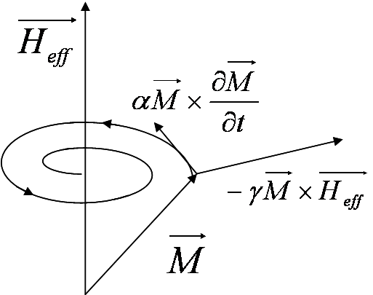
Fig. 2.6. Schematic diagram of precessional and damping terms in Landau-Lifshitz-Gilbert equation

Here the first term ($−γ\vec{M}×\vec{H_{\text{eff}}}$) describes precessional motion due to the effective applied field while the second ($α\vec{M}×(∂{\vec{M}}/∂t)$) is a damping term showing that the magnetisation tends to align with the applied field when damping occurs, both depicted in fig. 2.6. Damping can occur due to eddy currents or spin-scattering processes and α includes all these processes [7, 32]. Damping shows that the speed of the DW dissipates in a ferromagnetic material [33]. The last two terms are adiabatic ($−(\vec{u}⋅∇)\vec{M}$) and non-adiabatic ($β\vec{M}×\left[\left(\vec{u}⋅∇\right)\vec{M}\right]$) terms, respectively, [34] for current-induced DW motion. However, the present study only deals with field-induced DW motion (first two terms).

The LLG equation means that when a field is applied, the DW magnetisation first precesses orthogonal to the applied field (first term in LLG). This then creates a demagnetizing field through the thickness of the wire. This demagnetizing field acts on the DW magnetisation, causing it to precess. This precession is orthogonal to the demagnetizing field and moves the DW in the direction of applied field. Without damping, this would be an oscillation and the DW wouldn’t have any net movement.

If we consider nanowires of magnetic materials, an applied field moves the DWs. The velocity of DWs depends on the magnitude of the applied field. There is an upper limit for the velocity that a DW can experience due to the emergence of anti-vortices that appear while the DWs traverse the nanowire [35, 36]. This is called Walker breakdown, where transformations in the wall structure appear and the DW velocity decreases [13]. After this point, the velocity increases again for very high fields where vortices, anti-vortices and also edge roughness have a limiting effect on DW velocity [13].

When applying a magnetic field to a nanowire the magnetisation interacts with the field and so magnetic domains may be nucleated, increased or decreased, moved or annihilated. If we consider a nanowire with the magnetisation lying along the long axis, when an external magnetic field is applied in the opposite direction, the magnetic moments in the wire rotate as a result of the torque applied. This will nucleate a DW in the wire. As the field magnitude is increased, the DW propagates to the other end of the wire, and switches the structure. The saturation magnetisation is the magnetisation at which all time-averaged magnetic moments are aligned [7]. Due to defects in the structure which may create and act as a site for DWs annihilation at different fields and temperature, the switching occurs at different fields thus showing that it is a thermal activated process. Defects might pin DWs and the depinning may occur at different applied fields.

Before this breakdown, in low fields the DWs move linearly with the field in a viscous regime, with constant velocity predicted by an analytical model in a bulk material [27, 37, 38] (this velocity is different from $\vec{u}$ because it depends only on the applied field):

$v=μH=\frac{γΔ}{α}H$ (2.16.)

where μ is known as the DW mobility (in units of m s⁻¹Oe⁻¹) or m s⁻¹ (A/m)⁻¹) and Δ is the wall width. In [36] this was first used as the basis for predicting DW motion properties in a nanowire and in [39] was developed further to look at various particular situations.
In a real material, the velocity will be affected by impurities and edge roughness that will decrease the theoretically predicted velocity (equation 2.16.) [36]. Two regimes were seen in DW motion under applied fields, viscous at low fields and turbulent above a certain field (Walker field) [36]. At low fields, where defects can be significant a non-linear velocity-field characteristic is often seen. At moderate fields, the linear behaviour predicted by the equation 2.16. is seen. Then the onset of Walker breakdown leads to a ‘negative differential mobility’ – i.e. the velocity starts to drop with increasing in field. At higher fields still, the DW velocity increases again, sometimes to very high values.

The velocity of DWs is strongly dependent on the magnetic field intensity and DWs should propagate in nanowires even for small applied fields. But, in a real material there are defects that will pin the DW. To be able to move it again we would have to increase the magnetic field intensity.

2.8. Edge roughness

The edge roughness of a nanowire can have a significant effect on DW velocity. Edge roughness in patterned structures is always present to some extent, regardless of the fabrication method used. In [40] is showed that if the edge roughness increases, the DW nucleation field will increase due to the rearrangement of the spins at the wire edges. The roughness has a larger contribution if the wires width is smaller. In [36, 40, 41, 42] was studied the influence of a deliberately induced edge roughness on the DWs velocity. In [40] are presented the experimental data from nanowires with natural edge roughness and artificial roughness. The authors used materials with out of plane magnetisation resulting in low DWs velocities. In [36] were used Permalloy nanowires and studied micromagnetic simulations of field induced DW movement in wires, and considered wires with and without edge roughness, concluding that edge roughness suppresses Walker breakdown. In [39] is showed that either the roughness profile or other factors also influence the coercivity of the structures. In [40] was showed that due to edge roughness, the arrangement of spins is altered compared to rectangular shapes, which increased the coercivity field. Coercivity increases with edge roughness amplitude.

2.9. Impurities

Another factor that affects DWs velocity is magnetic and non-magnetic impurities. If we deliberately introduce impurities in a nanowire they will act as pinning sites for DWs, when they travel in the nanowire. The pinning strength will be affected by the impurity size (atomic weight) and type (Ga has a different behaviour due to spin orbit coupling as compared to Tb, Dy or Ho) [43].

In [44] is showed that impurities increase the damping parameter of Permalloy when doped with Ho. Other studies included more rare-earth dopants that increase the damping parameter like Tb, Dy, Ga and Ho and show that although the damping parameter for Ga is quite large, the permalloy doped with Tb and Dy have higher damping [43, 45]. The damping increases mainly due to a change in exchange energy of the wire. For Permalloy doped with Tb, Dy and Ho of 0 to 8% the damping increases gradually from zero to 0.1 for Ho, 0.16 for Tb and 0.2 for Dy while for Ga up to 15% the increase in damping parameter is very small [43].

2.10. Notches in nanowires

Deliberately fabricated ‘defects’ in the profiles of patterned nanowires have been studied extensively as a mean of controlling and positioning DWs. In particular, notches cut in the wire edge or protrusions extending out of the wire present either an energy barrier or energy well to a passing DW. The shape of the additional wire feature and the magnetic configuration of the DW determine the energetic nature of the interaction and, therefore, how the DW is pinned.

There are several factors that act on DW pinning in the notch on one side or the other. First of all there is the DW type transverse or vortex (vortex wall are always pinned on one side or the other of the notch), then the DW chirality (up or down for transverse walls and clockwise or anticlockwise for vortex walls) [46].

Similar to edge roughness discussed earlier, geometric imperfections create a change in the energy landscape and the DW finds in that geometric defect or next to it an energy minimum [13]. In order to be able to move the DW further in the wire the applied field must be increased to overcome the energy barrier of the trap.

Maintaining the chirality of DWs is crucial in the case of asymmetric notches due to dimensions (the triangular shape of a transverse wall) and also to the charge distribution along the DW [47]. A transverse DW will be pinned at one side if the central spin is antiparallel to the notch depth (fig. 2.7.(a) & (b)) or in the middle of the notch if the central spin is parallel with the notch (fig. 2.7.(c)). Also for vortex walls the DWs will be pinned at one side or the other of the notch (fig. 2.7.(d), (e), (f) & (g)). Pinning the DWs at one side of the notch requires a greater amount of energy to pass the energy barrier of the notch and then to escape the notch potential (fig. 2.7.(a) & (b)). But in the case of DWs pinned in the notch the energy required for depinning is that of escaping the energy well created by the notch or even the notch might not pin at all the DW [13]. Transverse walls are attracted in notches due to a smaller size of the wire, since the wall energy scales with its size [13].

Since removing a DW from a notch-based pinning site requires overcoming an energy step, depinning fields are usually highly temperature-dependent. For example, thermally activated processes lower the depinning field with as much as 40-60% [48, 49] compared to simulations at 0 K. However, these are statistical average values and the thermal influence often introduces a strong stochastic behaviour with a significant shot-to-shot variation.

(a)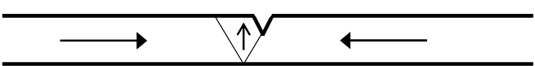 (d) 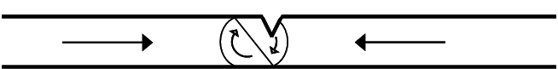
(b)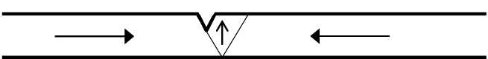 (e) 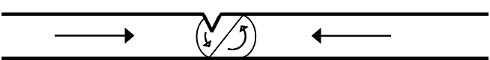
(c)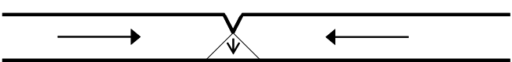 (f) 
(g)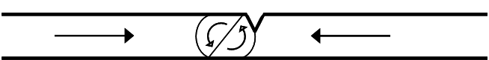

Fig. 2.7. Equilibrium position for the two types of DWs transverse up (a) and (b) and down (c) in an upper notch. or vortex walls [13] which are repelled by constrictions but pinned near by (d), (e), (f), (g) [35, 50].

The wire width influences the depinning field [51] as well as the notch depth which increases the depinning field [52]. A notch deeper than 60% of the wire width will not increase the depinning field further and the rest of the structure will be reversed by nucleating a DW in the notch [51].
Corners are another type of constriction that pin DWs. Here, the applied field reverses direction either abruptly (after changing the field direction suddenly from along the wire to perpendicular to the wire) or a rotating field is applied in the corner which moves the DW smoothly in the corner [48, 53, 54, 55]. Also rotating fields are used for semi-circular structures to propagate DWs [56].

2.11. Ring shaped nanostructures

Magnetic nanowires can have many different shapes besides the straight wire shape [19, 22], such as L-shape [57], disks [58, 59, 60], rings [13, 61, 62, 63, 64], ellipse [65, 66], half-rings [67], or even more complicated shapes [68] according to the application they are to be used for. Each of these shapes allows particular magnetisation configurations to be obtained.

Ring shaped ferromagnetic nanowires are symmetric structures in which magnetisation circulates around the ring (for Permalloy materials used here). In soft ferromagnetic ring shaped nanostructures two stable states at remanence can be distinguished known as the ‘onion’ state and the ‘vortex’ state [69, 70]. The onion state is obtained when a strong magnetic field is applied on the ring and then removed. Upon relaxation, the ring will contain two domains in which magnetisation circulates around the ring in opposite directions (fig. 2.8.(c)), separated by a head-to-head and a tail-to-tail DWs. DWs in rings form either transverse or vortex configurations depending on the ring wire width and thickness as described earlier in §2.5 for straight nanowires. The vortex state is represented by magnetisation circulation around the ring, fig. 2.8.(a) & (b) [71, 72] similar to the one characteristic for disk elements, without the vortex core [71].

(a)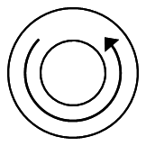(b)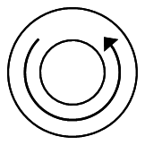(c)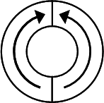
Fig. 2.8. Stable states at remanence of ring-shaped nanowire structures (a) clockwise and (b) anticlockwise vortex state and (c) onion state

For small rings as analysed by [73], after setting the ring in the onion state, as the field decreases the DWs move towards each other and annihilate and form the vortex state, seen as a sharp transition in the hysteresys loop in fig. 2.9. This can occur by decreasing one domain and increasing the other so that the two DWs will come close together and annihilate or form metastable 360º DWs [70, 72, 73, 75]. Which DW rotates towards the other depends on pinning potentials in the ring. Furthermore, as the field decreases, this remanent vortex state changes again to a reverse onion state seen by another sharp transition in the loop, by nucleating two DWs and propagating them until they reach the reverse onion state [69]. Generally hysteresis loops show two step transitions. Depending on the rings’ geometrical parameters the hysteresis loops can also present one or three steps [72, 76].

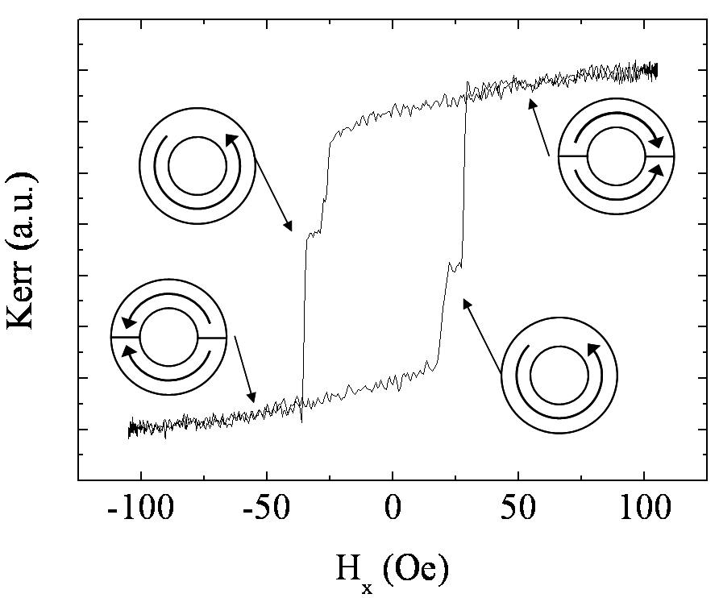
Fig. 2.9. Hysteresis loop from a permalloy ring, 10 μm radius showing onion and vortex states that form.

In the vortex state the magnetisation can circulate clockwise or anticlockwise in the ring. Usually the vortex circulation is given by the spin orientation on the edge [77, 78] and is a stochastic property of the structure due to it’s symmetry often influenced only by thermal fluctuations [70, 77, 78]. The edge roughness due to fabrication processes (as presented in Chapter 3) has a great influence on spin orientation [72, 78] but also on the fields where the transition onion to vortex or vortex to onion state occurs [70].

Thermal energy can influence the number of meta-stable states in rings, switching fields and present multiple switching routes because temperatures smaller than room temperature require more field for DWs to travel in rings in the absence of thermal fluctuations [79].

One way of controlling vortex circulation is by having a geometrical imperfection such as a notch in the structure [80, 81, 82], which will pin one DW (as described in §2.9.). When the field is reduced, only the other DW will propagate in the ring and come close to the first one and annihilate. Other studies have used split-rings to nucleate, pin and annihilate DWs [83]. In [84] is presented a method of reading the vortex state circulation through magnetoresistance measurements.

The analysis of ferromagnetic nanorings is developed further in Chapter 4 where single rings are analysed when a rotating magnetic field is applied, and the DWs are rotated in the ring.

Bibliography:

- Michael Fowler, Historical Beginnings of Theories of Electricity and Magnetism, U Va Physics, 1997
- Cullity and Graham, Introduction to magntic materials, 2nd edition, IEEE Press, Wiley, A John Wiley and Sons, Inc
- David Halliday, Robert Resnick, Physics, volume II, Editura didactica si pedagogica Bucuresti, 1975, chapter 37
- P. Notingher, Magnetic Materials for Electrotechnic - lecture notes, Politechnic University, 2007-2008
- Charles Kittel, Introduction to solid state physics, Editura tehnica, Bucuresti 1972
- H. M. Rosenberg, The Solid State 3rd ed., New York, USA: Oxford University Press, 1998
- Mathew Bryan, Nucleation and propagation of domain walls in Permalloy nanostructures, PhD thesis, University of Sheffield, 2008
- R. C. O'Handley, Modern magnetic materials: Principles and applications, New York: John Wiley and Sons, 2000
- D.G. Porter, M.J. Donahue, Journal of Applied Physics 95 (2004) 6729
- A. Aharoni, Journal of Applied Physics 83 (1998) 3432
- R.D. McMichael, M.J. Donahue, IEEE Transaction on Magnetics, 33 (1997) 4167
- C. A. F. Vaz, T. J. Hayward, J. Llandro, F. Schackert, D. Morecroft, J. A. C. Bland, M. Klaui, M. Laufenberg, D. Backes, U. Rudiger, F. J. Castano, C. A. Ross, L. J. Heyderman, F. Nolting, A. Locatelli, G. Faini, S. Cherifi W. Wernsdorfer, Journal of Physics: Condensed Matter 19 (2007) 255207
- M. Klaeui, Journal of Physics: Condensed Matter 20 (2008) 313001
- http://www.uni-muenster.de/Physik.AP/Demokritov/en/Forschen/Forschungsschwerpunkte/mBECswam.html
- Ulrich Rössler, Solid State Theory: An Introduction (2009), Physica-Verlag
- http://phys.org/news196926602.html
- M. Madami, S. Bonetti, G. Consolo, S. Tacchi, G. Carlotti, G. Gubbiotti, F. B. Mancoff, M. A. Yar and J. Åkerman, Nature Nanotechnology 6, (2011) 635–638
- Nicola Spaldin, Magnetic Materials: Fundamentals and Device Applications, Cambridge, 2003
- Shuqiang Yang, J. L. Erskine, Physical Review B 72 (2005) 064433
- A. Thiaville, Y. Nakatani, Spin Dynamics in confined magnetic structures, Springer Berlin, 2006, vol III
- D. Petit, H. T. Zeng, J. Sampaio, E. Lewis, L. O’Brien, A. V. Jausovec, D. Read, R. P. Cowburn, K. J. O’Shea, S. McVitie, J. N. Chapman, Applied Physics Letters 97 (2010) 233102
- Y. Nakatani, A. Thiaville, J. Miltat, Journal of Magnetism and Magnetic Materials 290 (2005) 750
- G. Meier, M. Bolte, R. Eiselt, B. Kruger, D.H. Kim, P. Fischer, Physical Review Letters 98 (2007) 187202
- H.L. Huang, S.C. Chen, Japanese Journal of Applied Physics 32 (1993) 1962
- B. N. Filippov, L. G. Korzunin, F. A. Kassan-Ogly, Physical Review B 70 (2004) 174411
- J.C. Slonczewski, International Journal of Magnetism 2 (1972) 85
- N.L. Schryer, L.R. Walker, Journal of Applied Physics 45 (1974) 5406
- J.C. Slonczewski, Journal of Applied Physics 45 (1974) 2705
- F.H. de Leeuw, R. van den Doel, U. Enz, Reports on Progress in Physics 42 (1980) 689
- J. Morkowski, H. Dotsch, P.E. Wigen, R.J. Yeh, Journal of Magnetism and Magnetic Materials 25 (1981) 39
- A. Thiaville, Y. Nakatani, J. Miltat, Y. Suzuki, Europhysics Letters 69 (2005) 990–996
- A. Hubert and R. Schäfer, Magnetic domains: the analysis of magnetic nanostructures (2000), Berlin, Germany: Springer-Verlag
- D. Wei, Micromagnetic and recording materials (2012), SpringerBriefs in Applied Sciences and Technology
- G. Tatara, H. Kohno, J. Shibata, Y. Lemaho, K. J. Lee, Journal of the Physical Society of Japan 76 (2007) 54707
- G. Beach, C. Nistor, C. Knutson, M. Tsoi, J. L. Erskine, Nature Materials 4 (2005) 741
- Y. Nakatani, A. Thiaville, J. Miltat, Nature Materials 2 (2003) 521
- A. P. Malozemoff, J. C. Slonczewski, Magnetic Domain Walls in Bubble Materials Academic, New York, 1979
- A. Thiaville, J. M. Garcia, J. Miltat, Journal of Magnetism and Magnetic Materials 242–245 (2002) 1061–1063
- M. T. Bryan, T. Schrefl, D. A. Allwood, IEEE Transactions on Magnetics 46 (2010) 5
- M. T. Bryan, D. Atkinson, R. P. Cowburn, Journal of Physics: Conference Series, 17 (2005) 40-44
- F. Cayssol, D. Ravelosona, C. Chappert, J. Ferre, J.P. Jamet, Physical Review Letters, 92 (2004) 107202
- M. T. Bryan, D. Atkinson, R. P. Cowburn, Applied Physics Letters, 85 (2004) 3510
- G. Woltersdorf, M. Kiessling, G. Meyer, J.-U. Thiele, C. H. Back, Physical Review Letters 102 (2009) 257602
- T. A. Moore, M. Klaui, L. Heyne, P. Mohrke, D. Backes, J. Rhensius, U. Rudiger, L. J. Heyderman, J.-U. Thiele, G. Woltersdorf, C. H. Back, A. Fraile Rodriguez, F. Nolting, T. O. Mentes, M. A. Nino A. Locatelli, A. Potenza, H. Marchetto, S. Cavill, S. S. Dhesi, Physical Review B 80 (2009) 132403
- I. Radu, G. Woltersdorf, M. Kiessling, A. Melnikov, U. Bovensiepen, J.-U. Thiele, C. H. Back, Physical Review Letters, 102 (2009) 117201
- M. Hayashi, L. Thomas, C. Rettner, R. Moriya, X. Jiang, S. S. P. Parkin, Physical Review Letters 97 (2006) 207205
- D. Petit, A. V. Jausovec, H. T. Zeng, E. Lewis, L. O’Brien, D. Read, R. P. Cowburn, Physical Review B 79 (2009) 214405
- D. Petit, A. V. Jausovec, D. Read, R. P. Cowburn, Journal of Applied Physics 103 (2008) 114307
- A. Himeno, T. Okuno, T. Ono, K. Mibu, S. Nasu, and T. Shinjo, Journal of Magnetism and Magnetic Materials 286 (2005) 167
- M. Klaui, C. A. F. Vaz, J. Rothman, J. A. C. Bland, W. Wernsdorfer, G. Faini, E. Cambril, Physical Review Letters 90 (2003) 097202
- L. K. Bogart, D. S. Eastwood, D. Atkinson, Journal of Applied Physics, 104 (2008) 033904
- C. C. Faulkner, D. A. Allwood, R. P. Cowburn Journal of Applied Physics 103 (2008) 073914
- A. Fernández-Pacheco, J. M. De Teresa, R. Córdoba, M. R. Ibarra, D. Petit, D. E. Read, L. O’Brien, E. R. Lewis, H. T. Zeng, R. P. Cowburn Applied Physics Letters 94 (2009) 192509
- D. Petit, A. V. Jausovec, H. T. Zeng, E. Lewis, L. O’Brien, D. Read, R. P. Cowburn, Applied Physics Letters 93 (2008) 163108
- E. R. Lewis, D. Petit, L. Thevenard, A. V. Jausovec, L. O’Brien, D. E. Read, R. P. Cowburn, Applied Physics Letters 95 (2009) 152505
- L. O’Brien, D. E. Read, H. T. Zeng, E. R. Lewis, D. Petit, R. P. Cowburn, Applied Physics Letters 95 (2009) 232502
- D. A. Allwood, N. Vernier, Gang Xiong, M. D. Cooke, D. Atkinson, C. C. Faulkner, R. P. Cowburn , Applied Physics Letters 81 (2002) 4005
- M. V. Sapozhnikov, O. L. Ermolaeva, B. G. Gribkov, I. M. Nefedov, I. R. Karetnikova, S. A. Gusev, V. V. Rogov, B. B. Troitskii, L. V. Khokhlova, Physical Review B 85 (2012) 054402
- S. Prosandeev, L. Bellaiche, Physical Review Letters 101 (2008) 097203
- A. S. Arrott, Journal of Magnetism and Magnetic Materials 258–259 (2003) 25–28
- Y. Ren, S. Jain, A. O. Adeyeye C. A. Ross, New Journal of Physics 12 (2010) 093003
- G. Bordignon, T. Fischbacher, M. Franchin, J. P. Zimmermann, A. A. Zhukov, V. V. Metlushko, P. A. J. de Groot, H. Fangohr, IEEE Transactions on Magnetics 43 (2007) 2881
- H. Shu-Ting, C. Shuang-Quan,, S. Hui-Gang, Chinese Physics B 20 (2011) 127503
- V. Rose, K. Buchanan, S.-H. Chung, M. Grimsditch, V. Metlushko, A. Hoffmann, V. Novosad, S. D. Bader, H. Ibach, Physical Review B 73 (2006) 094442
- Y. Hao, M. Walsh, M. Farhoud, C. A. Ross, H. I. Smith, J. Q. Wang, L. Malkinski, IEEE Transactions on Magnetics 36 (2000) 2996 – 2998
- H. J. Jang, D. Stone, P. Eames, E. D. Dahlberg, INTERMAG Asia 2005, Digests of the IEEE International, 2005, 2055 – 2056
- J. Rhensius, L. Heyne, D. Backes, S. Krzyk, L. J. Heyderman, L. Joly, F. Nolting, M. Kläui, Physical Review Letters104 (2010) 067201
- D. A. Allwood, G. Xiong, C. C. Faulkner, D. Atkinson, D. Petit, R. P. Cowburn, Science 309 (2005) 1688- 1692
- J. Rothman, M. Klaui, L. Lopez-Diaz, C. A. F. Vaz, A. Bleloch, J. A. C. Bland, Z. Cui, R. Speaks Physical Review Letters 86 (2001) 1098
- T. A. Moore, T. J. Hayward, D. H. Y. Tse, J. A. C. Bland, F. J. Castano,C. A. J. Ross Journal of Applied Physics 97 (2005) 063910
- C. A. F. Vaz, M. Klaui, J. A. C. Bland, L. J. Heyderman, C. David, F. Nolting, Nuclear Instruments and Methods in Physics Research B 246 (2006) 13
- C. A. F. Vaz, T. J. Hayward, J. Llandro, F. Schackert, D. Morecroft, J. A. C. Bland, M. Klaui, M. Laufenberg, D. Backes, U. Rudiger, F. J. Castano, C. A. Ross, L. J. Heyderman, F. Nolting, A. Locatelli, G. Faini, S. Cherifi, W. Wernsdorfer, Journal of Physics: Condensed Matter 19 (2007) 255207
- T. J. Hayward, J. Llandro, R. B. Balsod, and J. A. C. Bland, D. Morecroft, F. J. Castaño, C. A. Ross, Physical Review B 74 (2006) 134405
- F. J. Castano, C. A. Ross, C. Frandsen, A. Eilez, D. Gil, H. I. Smith, M. Redjdal, F. B. Humphrey Physical Review B 67 (2003) 184425
- C. A. Ross, F. J. Castaño, D. Morecroft, and W. Jung, Henry I. Smith, T. A. Moore, T. J. Hayward, and J. A. C. Bland, T. J. Bromwich, A. K. Petford-Long, Journal of Applied Physics 99 (2006) 08S501
- Y. G. Yoo, M. Klaui, C. A. F. Vaz, L. J. Heyderman, J. A. C. Bland Applied Physics Letters 82 (2003) 15
- TJ Hayward, TA Moore, DHY Tse, JAC Bland, FJ Castaño, CA Ross Physical Review B 72 (2005)184430
- TA Moore, TJ Hayward, DHY Tse, JAC Bland, FJ Castaño, CA Ross Physica B 372 (2006) 164–167
- J. H. Lee, T. J. Hayward, S. N. Holmes, B. Hong, J. Llandro, K. Cooper, D. Anderson, G. A. C. Jones, C. H. W. Barnes Journal of Applied Physics 105 (2009) 07C107
- P Vavassori, O Donzelli, M Grimsditch, V Metlushko, B Ilic Journal of Applied Physics 101 (2007)023902
- M Klaui, J Rothman, L Lopez-Diaz, CAF Vaz, JAC Bland, Z Cui Applied Physics Letters 78 (2001) 3268
- M Klaui, CAF Vaz, JAC Bland, W Wernsdorfer, G Faini, E Cambril Applied Physics Letters 81 (2002)108
- J. H. Lee, S. N. Holmes, B. Hong, P. E. Roy, M. D. Mascaro, T. J. Hayward, D. Anderson, K. Cooper, G. A. C. Jones, M. E. Vickers, C. A. Ross, C. H. W. Barnes Applied Physics Letters 95 (2009) 172505
- T. J. Hayward, J. Llandro, R. B. Balsod, J. A. C. Bland, F. J. Castaño, D. Morecroft, and C. A. Ross, Applied Physics Letters 89 (2006) 112510

