Chapter 6:
Multiple Ring Structures

In this chapter I present an analysis of multiple rings connected. The transport of DWs in such structures is affected by large periodic pinning of DWs across a correlated system. A correlation with statistical thermodynamics is made. During DWs rotation walls can be created or annihilated, so a calculation of DW population as function of probability of DW passage is presented.

6.1. Rotating fields in single rings – a reprise

As presented in Chapter 4 of this thesis it is possible to use a rotating magnetic field to drive DWs in ring-shaped nanowires at arbitrarily low speeds. The results showed that DWs move in steps around the ring due to pinning by material defects and edge roughness. Under low amplitude fields, DW motion shows a step-like behaviour and consequently lags behind the rotating field vector to a greater extent. If the field amplitude is slightly increased (to 100 Oe in the case investigated), DWs remain closer to the vector-field direction (the lag is less than 4 degrees – fig. 4.11.(a)) and their motion enters a smoother regime. Further increase in the field amplitude induces very smooth propagation of DWs in the structure and reduces the lag even more. However, this will also widen the DWs and cant the magnetic moments in the ring in the field direction. This continues up to saturation of the entire structure, which will result in a coherent motion of magnetic moments as the field rotates. The propagation of DWs is, to first approximation, continuous if we consider a smooth rotation of DWs, a constant lag and constant velocity, because we can only probe a small area of the ring with the laser spot.

High rotation frequencies dictate higher time-averaged velocities but also result in higher local velocities as DWs move between pinning points. Field frequency is one of the main factors which determine the velocity at which DWs travel in the structure and so, the local velocity when DWs travel between pinning points can be calculated.

In this chapter I extend this investigation to connected multi-ring structures to study the influence of large periodic pinning of DWs across a correlated system. This is relevant in the light of interacting magnetic systems as well as to DW atom trapping as a means of stimulating collisional atomic interactions.

6.2. Review on coupled rings

While single rings have been intensively studied for memory applications, systems of coupled rings [1, 2, 3, 4], disks [5, 6, 7, 8] or infinity-shaped nanowires [9, 10] have been studied previously, including as a means to achieve novel magnetic logic [11, 12].
The study of single rings revealed that the separation distance between rings could lead to DWs coupling by exchange mechanisms if the separation distance is less than the ring’s diameter [1]. Here, if two rings are brought into contact, the DWs that form in the onion state at the junction will couple while the other remanent state, the vortex state, will have a different sense in each ring and no DW between them fig. 6.1.(b). Their simulations also showed an opposite sense for the two rings due to exchange coupling along the edges [4] but it is not possible, in this particular study, to distinguish which ring has which sense in their magnetic force microscopy (MFM) measurements. Here, differences between the modelled and experimental magnetic configuration of the two-ring system were noted, and were possibly due to poor alignment of the field with the two-ring axis but may have reflected a slight difference in the stability of the vortex state for the two cases. In the experimental case the energy contribution of the DW was higher due to a larger connection area resulting from the lift-off compared to the modelled case where the connection area was smaller.

(a)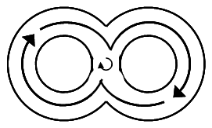 (b)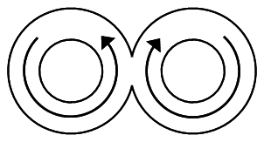
Fig. 6.1. Schematics of the systems described in [1]. (a) overlapped and (b) connected rings showing onion and vortex state for the two configurations

If the rings are overlapped they present three DWs in the onion state since the two DWs in the overlapping region merge into one [1, 3] while the vortex state present a continuous magnetization around the structure except for the overlapped region where the DW remains as shown in fig. 6.1.(a). They show that the two rings have the same chirality. The DW between the rings in vortex state diminishes the switching field for the vortex to reverse onion transition because there is no need for a DW to be nucleated (this is more obvious when the field is applied at different angles as shown in [1, 3]).

Another particularity for both systems of connected and overlapping rings is that, when the field is decreased from having created the onion state, an intermediate step in the hysteresis loop appears, possibly due to one ring remaining in the onion state while the other transforms into a vortex state [1, 3]. However, this step is not seen in simulations. In [3] they showed that the overlapped rings state changes successively from onion to vortex state and not simultaneously. Furthermore, they used notches to show that the vortex state can form simultaneously or successive in the overlapped ring system.
6.3. Spin ice structures and systems

In water ice, the translation of some hydrogen ions leads to electric dipoles being formed. However, the crystal structure means that the minimum energy rules regarding the orientation of these dipoles cannot be observed in all cases. Magnetic systems can show this frustration with their magnetic dipole arrangements. In nature there are true spin ice materials, in which crystal structure leads to frustration. Researchers also developed ‘engineered structures’ where due to geometry, magnetic spins are in a frustrated state [13, 14], so the name spin ice.

Structures of rings with spin ice structure were studied by [4] in connected one-, two- and three-ring systems. When two or more rings were brought in contact, the dipole interactions changed the magnetization direction locally from the orientation direction given by the edge roughness. If two rings presented opposite vortex states, the third ring, which was in contact with the other two, exhibited frustration between competing magnetic vortex states.

The hysteresis loop for a three ring structure showed a smoother transition compared to one ring, which showed obvious steps corresponding to onion to vortex and vortex to onion transitions. This indicated that the vortex state was not that stable [4].

The contact area between the rings is important in the movement of DWs in rings. Rose et al. also showed that the coercivity decreases as the contact length increases [4]. DW movement in one ring can trigger the movement of DWs in adjacent rings, so the switching field decreases as the contact length increases [4]. Edge roughness is more significant for small contact lengths. The preferred reversal path is by having the top ring in vortex state and the bottom two rings in vortex state with opposite chirality [4].

The studies were extended to systems of more rings connected [2] where connecting parts of the rings show a magnetization aligned to the shape of the ring in order to reduce the demagnetizing energy.

6.4. Multiple rings structures design

Based on the studies presented in Chapter 4 on single rings and previous reports investigating systems of one, two or more rings connected or overlapped, this chapter presents an analysis of connected rings similar to the ones depicted in fig. 6.1.(b). The rings are made of 30 nm thick Ni₈₁Fe₁₉ using electron beam lithography (see §3.1.) and have a radius of 2.5 μm and track-widths of 400 nm. Various structures comprising different numbers of rings were fabricated and studied. These consisted of a single ring (fig. 6.2.(a)) as presented in Chapter 4, two rings held ‘horizontally’ (fig. 6.2.(b)), two rings held ‘vertically’ (fig. 6.2.(c)), four rings in a 2 × 2 matrix (fig. 6.2.(d)), nine rings in a 3 × 3 matrix (fig. 6.2.(e)), 16 rings in a 4 × 4 matrix (fig. 6.2.(f)), 25 rings in a 5 × 5 matrix (fig. 6.2.(g)) and 36 rings in a 6 × 6 matrix (fig. 6.2.(h)). For this study, therefore, any structure with more than two rings was designed in a square matrix arrangement.

The ring structures were each analysed with MOKE magnetometry (see §3.4.) using a laser beam that covered the structure of interest entirely. This was achieved with the fully-focussed, ~5 μm diameter laser spot for the one-, two- and four-ring systems. For larger structures, the laser spot was defocused to ensure complete coverage. The whole-structure analysis this allowed is in contrast to the localised measurements used previously for single ring analysis, Chapter 4. The analysis of the MOKE signal from the multi-ring systems was similar to the procedure used for single rings presented in Chapter 4 with an in-plane rotating magnetic field of different amplitudes. The background subtraction was omitted this time because we compared loops from different structures under the same conditions. However, with the multi-ring structures the focus of the analysis was on the behaviour of DWs as they passed through wire junctions.

The one-ring system was analysed first. As in Chapter 4, the ring was first placed into the onion state with two DWs by applying a field of 400 Oe to saturate the ring magnetization and then removing the field to allow the magnetisation to relax. Once nucleated, the DWs could propagate around the ring under in-plane rotating applied fields. As described in Chapter 4, under low field amplitudes, the DWs could be pinned by defects and if one DW became pinned and the other rotated until it reached the first one, they annihilated to leave the ring in a vortex state. This condition yields no MOKE signal due to the vortex state symmetry and null spatially averaged magnetization.
(a)1: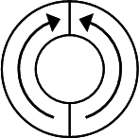(b)1 x 2: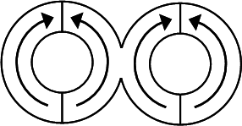(c)2 x 1: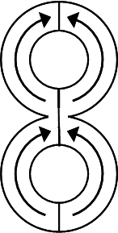(d)2 x 2: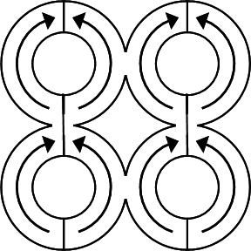 (e)3 x 3: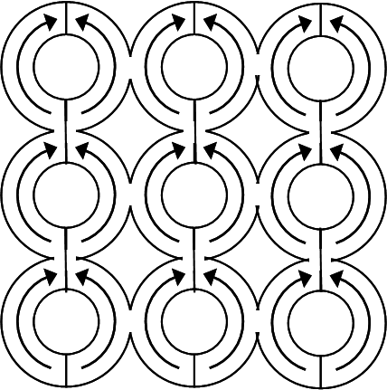
(f)4 x 4: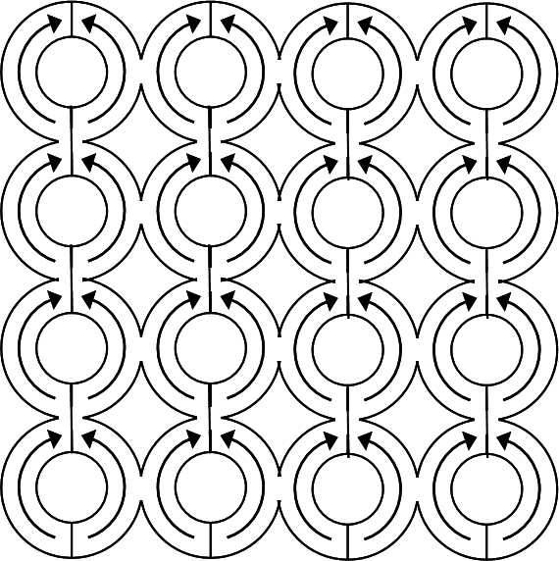(g)5 x 5: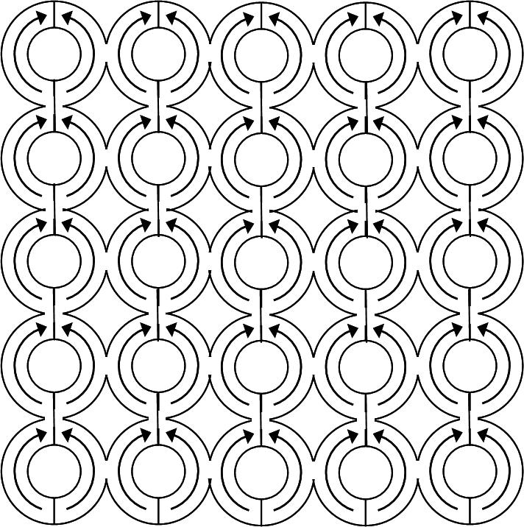 (h)6 x 6: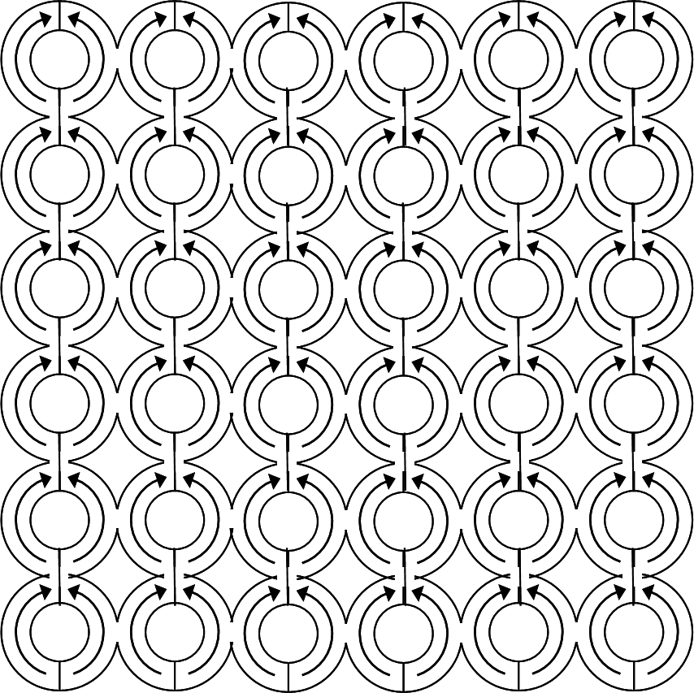
Fig. 6.2. Structures analysed in order to understand more complex ring structures comprising n² rings all in onion state.

Rings structure | Number of connections
Rings structure | Zero | One | Two  (Corner) | Three  (Edge) | Four  (Bulk)
1 | 1 | - | - | - | -
1 x 2 | - | 1 | - | - | -
2 x 1 | - | 1 | - | - | -
2 x 2 | - | - | 4 | - | -
3 x 3 | - | - | 4 | 4 | 1
4 x 4 | - | - | 4 | 8 | 4
5 x 5 | - | - | 4 | 12 | 9
6 x 6 | - | - | 4 | 16 | 16
n x n | - | - | 4 | 4*(n-2) | (n-2)²
Table 6.1. Rings structures are defined in terms of number of rings on each column and row. The table presents an analysis for each ring and the number of connections each ring has with other rings in the structure.

With systems of increased number of rings, the same procedure was applied to nucleate and propagate DWs in the rings. However, the minimum field amplitudes increased from the single-ring case due to the stronger pinning from wire junctions in the multi-ring structures. The individual constituent rings in the structures can be characterised as being connected to zero, one, two, three or four rings. Rings connected to zero other rings are single rings. Those connected to one ring are structures of two rings, one row two columns or one column two rows. Given the square matrix arrangement of multi-ring structures employed here, rings connected to two others are ‘corner’ rings. Three connections signify an ‘edge’ ring. Four connections indicate a ‘bulk’ ring. The number of each ring category for each of the structures investigated is summarized in Table 6.1.

As seen by others, [1, 3] each connected ring can be either in vortex or onion state regardless of the state of its neighbours. Due to using a MOKE laser spot that covered each structure entirely, we were unable to infer a precise microscopic domain configuration in any case. However, the whole-structure analysis does allow an ensemble behaviour to be observed. Rings can be extrapolated to predict the general system of n² rings.

6.5. Thermodynamic behaviour of magnetic systems

As the field rotates it drags the DWs with it. As explained above, each ring can potentially change their state between onion and vortex state every field cycle. The discussion gets more complicated considering that the vortex state sense can be either clockwise or anticlockwise, depending on the field rotation direction, but for simplicity we will only consider a generic vortex state and not make the difference between the two. This allows us then to characterise the domain configuration of a ring system in terms of whether each constituent ring is in the vortex (V) or onion (O) state. For example, the two-ring system can be in one of four states: V-V, O-V, V-O or O-O (fig. 6.3.). The onion state is a higher energy (remanent) configuration, so the system can be described as having three energy levels, the non-degenerate V-V (ground state) and O-O (highest energy state) configurations, and the twofold degenerate O-V/V-O (mid-range energy) configuration.

As explained earlier, annihilation can occur when a defect or junction in this case pins one DW and rotates the other up to the point where the first one is and so they will annihilate when in contact. The first DW is unable to move further since the potential energy of the pinning site is larger than the Zeeman energy of the field to first approximation, if we ignore the temperature dependent depinning.

Another way of introducing DWs in a ring is when a DW from the adjacent rings comes into the junction area. It can expand in the next ring and create a head-to-head and a tail-to-tail DW. This is more likely to occur in structures where a ring in vortex state has neighbours two rings in onion state. This way one ring will introduce a head-to-head DW and the other one a tail-to-tail DW.

This is similar to the statistical case of two particles and two chambers, as shown in fig. 6.4. The probability of having both particles in one chamber fig. 6.4.(a), the second chamber fig. 6.4.(d) or one particle in the first chamber and the second in the second chamber or the other way fig. 6.4.(b) & (c), is $p=\frac{1}{2^{n}}$, where n is the number of particles in both chambers. We cannot tell the difference between the particles, which one is in the first or the second chamber, we can only tell the number of particles in each chamber, see Table 6.2. and Table 6.3. This case can be extended further to a larger number of particles using statistical thermodynamic methods.

(a)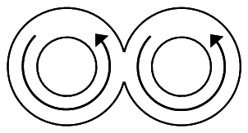 (b)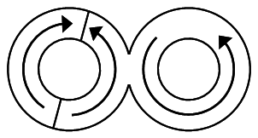
(c)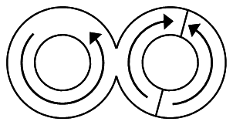 (d)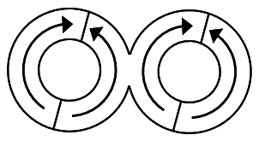
Fig. 6.3. Two rings held horizontally with or without DWs. The four cases that can occur at any point in the measurements: (a) vortex-vortex V-V (b) onion-vortex O-V (c) vortex-onion V-O (d) onion-onion O-O

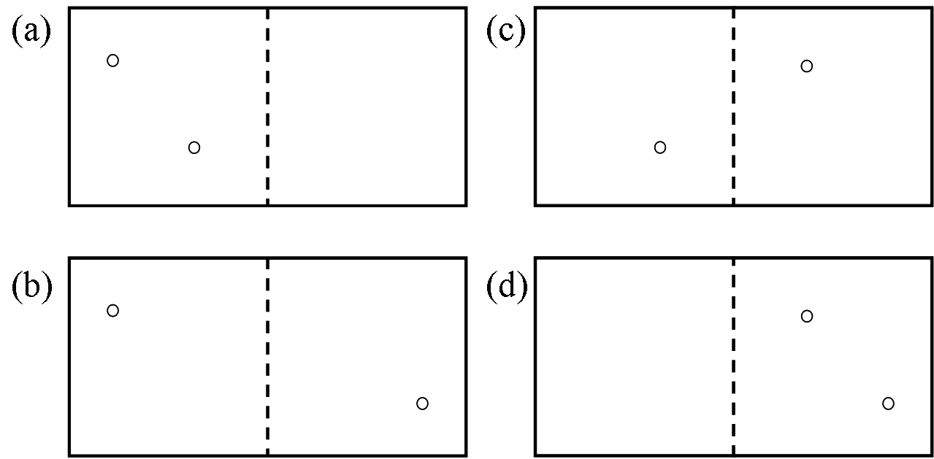
6.4. Correlation with statistics of the ring system. A similar example to the ring system in fig 6.3.

2 rings | Chamber 1 | Chamber 2 | probability
2 rings | 0 | A B | 1/2²
2 rings | A | B | 1/2²
2 rings | B | A | 1/2²
2 rings | A B | 0 | 1/2²
Table 6.2. Distribution of two identical particles A and B in chambers 1 or 2 and the probability for that event to happen

Considering four particles in the same two boxes, we can have in chamber 1: zero, one, two, three or all four particles while in chamber 2: four, three, two, one and zero particles. Again the probability for one event to happen is $p=1/{2^{n}}$. This is summarised in Table 6.3.

4 rings | Chamber 1 | Chamber 2 | probability | Group probability
4 rings | 0 particles | 4 particles
4 rings | 0 | A B C D | 1/2⁴ | 1/2⁴
4 rings | 1 particles | 3 particles
4 rings | A | B C D | 1/2⁴ | 4/2⁴
4 rings | B | A C D | 1/2⁴ | 4/2⁴
4 rings | C | A B D | 1/2⁴ | 4/2⁴
4 rings | D | A B C | 1/2⁴ | 4/2⁴
4 rings | 2 particles | 2 particles
4 rings | A B | C D | 1/2⁴ | 6/2⁴
4 rings | A C | B D | 1/2⁴ | 6/2⁴
4 rings | A D | B C | 1/2⁴ | 6/2⁴
4 rings | B C | A D | 1/2⁴ | 6/2⁴
4 rings | B D | A C | 1/2⁴ | 6/2⁴
4 rings | C D | A B | 1/2⁴ | 6/2⁴
4 rings | 3 particles | 1 particles
4 rings | B C D | A | 1/2⁴ | 4/2⁴
4 rings | A C D | B | 1/2⁴ | 4/2⁴
4 rings | A B D | C | 1/2⁴ | 4/2⁴
4 rings | A B C | D | 1/2⁴ | 4/2⁴
4 rings | 4 particles | 0 particles
4 rings | A B C D | 0 | 1/2⁴ | 1/2⁴
Table 6.3. Distribution of four identical particles A, B, C and D in chambers 1 or 2 and the probability for that event to happen

The same probability applies to the ring systems, where n is the number of rings and the two states are the magnetic ‘vortex’ or ‘onion’ configuration of each ring.

In our measurements we can only see (n+1) cases, where n is the number of particles in both chambers as above or rings in our systems, because we cannot determine which individual rings have DWs and those that don’t. Since the measurement is a global measurement where the laser spot covers the entire structure we will only see an overall behaviour of the system. Essentially, our measurement determines how many rings have DWs (O-state) and how many don’t (V-state) but does not identify which rings are which. This is similar to the statistical case described above in fig. 6.4. for two particles.

Similar to a canonical ensemble characterised by the energy of the overall system, a structure of multi-rings is characterised by the state in which, each individual ring is found. In the case of a canonical ensemble the temperature is the one changing the state of the system while for our ring system is the applied magnetic field.

6.6. DWs population in multi-ring systems

Every field cycle the number of rings in each state might differ from previous because adjacent rings can introduce DWs in a ring in vortex state or DWs can annihilate in the ring. By performing global measurements on a structure we cannot tell which rings are in vortex or onion state.

If we consider a bulk ring, where W is the DW population. For each half cycle, the change in DW population is a balance of an increase, W⁺, due to DWs passing a junction and dividing and a decrease, W⁻, annihilation of a pinned DW,

$δW=W^{+}−W^{−}$ (6.1.)

The increase of DW population depends on the probability of having a DW present to pass through a junction, W, the probability of passing through the junction, P_{pass}, and the probability of having no DW on the other side which won’t lead to an increase in DW population, (1-W). So, the probability to have an increase in DW population is

$W^{+}=W(1−W)P_{\text{pass}}$ (6.2.)

On the other hand, the probability of DWs to annihilate depends on the probability of having a DW to be pinned, W, the probability of DW being pinned, (1-P_{pass}), and the probability of this DW making it through two junctions to perform annihilation, P_{pass}². So, the probability to have a decrease in DW population is

$W^{−}=2W(1−P_{\text{pass}})P_{{\text{pass}}^{2}}$ (6.3.)

where the factor of 2 indicates that two DWs are lost in an annihilation event.

However, we have to consider the likelihood of not having another DW coming the other way from the adjacent ring at the junction where annihilation is taking place (probability 1-W) or of having a DW in that adjacent ring at the junction but it does not propagate through the ring either (probability WP_{pass}). So, the total probability to have a decrease in DW population is

$\begin{aligned}W^{−}=2W(1−P_{\text{pass}})P_{{\text{pass}}^{2}}((1−W)+W(1−P_{\text{pass}})) \\ 2W(1−P_{\text{pass}})P_{{\text{pass}}^{2}}(1−{\text{WP}}_{\text{pass}})\end{aligned}$ (6.4.)

So, DW population after half cycle is:

$δW=\text{ W}(1−W)P_{\text{pass}}−2W(1−P_{\text{pass}})P_{{\text{pass}}^{2}}(1−{\text{WP}}_{\text{pass}})$ (6.5.)

For equilibrium, $δW=0$, which gives

$W=\frac{1−P_{\text{pass}}+P_{{\text{pass}}^{2}}}{1−P_{{\text{pass}}^{2}}+P_{{\text{pass}}^{3}}}$ (6.6.)

Plotting this equation shows that DW population is minimum for a probability of DW passage of 0.3-0.4 as depicted in fig. 6.5. below:

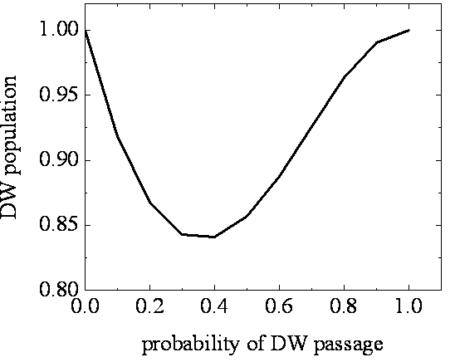
Fig. 6.5. DW population in a multi-ring system depending on the probability of DW passage only for bulk rings.

In the case of a system with boundaries, there will be rings on the edge f_{e} and on the corners f_{c} of the system. This means that the portion of bulk rings is

$f_{b}=1−f_{e}−f_{c}$. (6.7.)

So, we define the parameter A:

$A=f_{b}P_{{\text{pass}}^{2}}+f_{e}P_{\text{pass}}+f_{c}$ (6.8.)
For all junctions, the analysis above for W⁺ should hold and the formula (6.2.) remains. However, the terms for W⁻ will differ because the second DW arriving to complete the annihilation has to overcome a different number of junctions. For bulk, it must overcome two junctions, hence the P_{pass}² term. A DW in an edge ring will only have to overcome one junction, so this term will be reduced to P_{pass.} A DW in a corner ring, meanwhile, will have no junctions to overcome so the term simply becomes 1.

W⁻ now takes a more complex form:

$W^{−}=2WA(1−P_{\text{pass}})(1−{\text{WP}}_{\text{pass}})$ (6.9.)

At the equilibrium, we obtain

$W=\frac{1−\left(\frac{A}{P_{\text{pass}}}\right)(P_{\text{pass}}−1)}{1−A(P_{\text{pass}}−1)}$ (6.10.)

So, knowing the probability of DWs passing through the junction, we can calculate the DWs population. In practice, it is more difficult to calculate the passing probability because it depends strongly on the applied field but also on material defects. There are other ways of approximating the number of DWs in the structures, from MOKE loops, as described later in the analysis of fig. 6.10.

6.7. Rotating fields in multi-ring systems. Comparison between structures

The structures schematically described in fig. 6.2. were analysed. For all of them the laser spot covered the whole structure and the measurements are global measurements. Here, the loops are the average of ~150 cycles. The laser spot was defocused for large structures comprising 9 rings or more to cover the entire structure.

In order to understand the behaviour of multi-ring systems and how different numbers of rings in the structures affect the measured signal I have analysed the one-, two- and four-ring structures first, fig. 6.6.

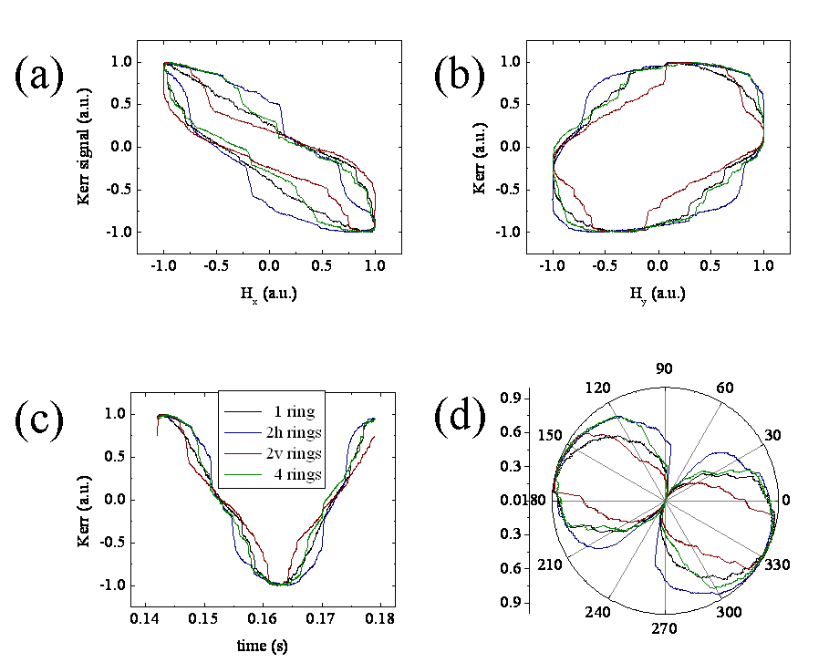
Fig. 6.6. Kerr loops for one ring (black line), two rings held horizontally (blue line) and two rings held vertically (wine line) and four rings (olive line) with respect to (a) H_{x}, (b)H_{y}, (c) time and (d) polar plot.

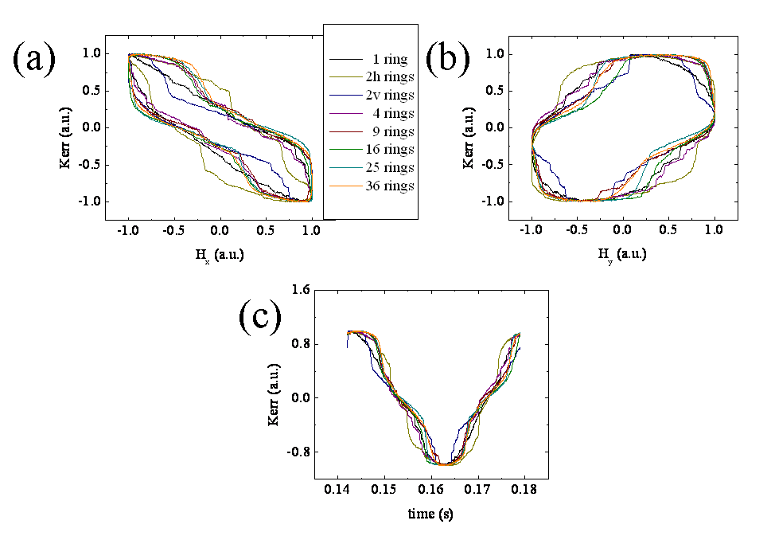
Fig. 6.7. Kerr signal vs (a) Hx, (b) Hy and (c) time for the ring systems analyzed and comparison on the tendency of the loops for an increased number of rings.

The two vertical rings (wine lines) show a plateau in the Kerr loop vs H_{x} around H_{x}=0 fig. 6.6.(a) similar to the plateau presented in [15]. So, a vertical increase in the number of ring structures is reflected in a plateau near H_{x}=0. Another particularity is that the Kerr signal vs H_{y} fig. 6.6.(b) has a smoother increase to the maximum Kerr signal and in time fig. 6.6.(c), the signal has a very narrow peak. Also the polar plot shows flat lobes fig. 6.6.(d).

On the other hand two rings connected horizontally (blue lines) show a fast transition to higher Kerr signal unlike the blue one, for Kerr signal vs H_{y} fig. 6.6.(b) a wider loop and a large peak in the time loop. Here the polar plot shows large lobes fig. 6.6.(d).

The loops for four rings are between the loops for two rings on the horizontal and those on vertical and very close in shape with the loops for one ring, for all plots.

The plots presented in fig. 6.7. use the lowest field amplitude rotating field that give a Kerr signal from each structure, which varied from one structure to another. The fields are H(36)=92Oe, H(25)=91Oe, H(16)=92Oe, H(9)=91Oe, H(4)=100Oe, H(2h)=99Oe, H(2v)=108Oe, H(1)=126Oe. The field and the Kerr signal were normalised to allow a comparison between the shape of the loops.

As previously shown in fig. 6.6. the loops for two rings both on horizontal and vertical are different from all other loops fig. 6.7. The symmetry is broken for these systems and we can study the effects of increasing the number of rings in horizontal and vertical directions separately. When the system is a square matrix again the shape of the loops are similar to each other and also to that of the single ring. This is the case for both clockwise and anticlockwise field rotations.

Another way of understanding how rings with or without DWs influence the shape of the Kerr signal and also how DW creation and annihilation occurs is by subtracting a high field signal from the Kerr signal for minimum fields analysed fig. 6.8. The subtraction was done in order to see clearly the effect of pinning by junctions. This way we are able to see the differences which occur in low fields corresponding to DW creation and annihilation.

So, the loops for 2h structure (fig. 6.8.(a)&(d)) show the depinning of DWs from junctions, when H_{x}=0 and H_{y}=min/max. These spikes are present on both sides of these loops since there are two DWs in both rings and during one field cycle both HH and TT DWs depin from the junction. So, every half cycle a HH from one ring and a TT DW from the second one meet in the junction and form a larger DW which then splits into two walls again, as described schematically in fig. 6.8. Also in fig. 6.8.(a)&(d) other spikes are visible which might suggest depinning form defects. On the other hand, 2v structure present the depinning spikes for H_{x}=min/max and H_{y}=0. When a similar analysis is done for multi-ring structures, 36 rings, the loops present spikes for both H_{x}=min, 0, max and H_{y}=min, 0, max as shown in fig. 6.8.(c)&(f).

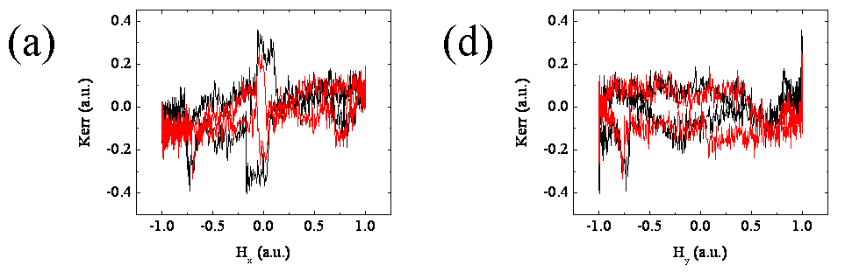
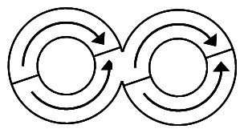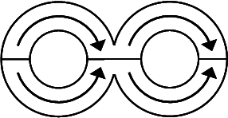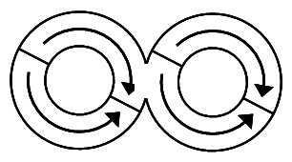
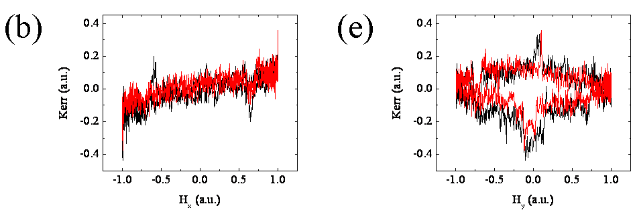
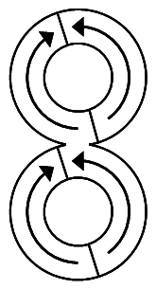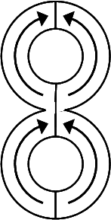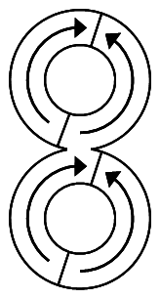
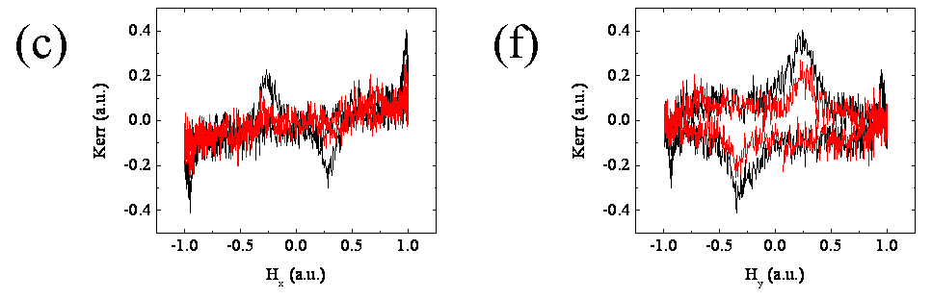
Fig. 6.8. Magnetisation ‘difference’ loops from 2h, 2v and 36 ring structures between single shot MOKE loops at minimum fields (2h: 100 and 108 Oe, 2v: 108 and 117 Oe, 36: 91 and 99 Oe) and averaged MOKE data (for field amplitude of 2h: 117 Oe, 2v: 125 Oe, 36:107 Oe). Plots present data as a function of (a), (b)&(c) normalised field component H_{x}, (d), (e)&(f) normalised field component H_{y}.

Below, fig. 6.9, I present the comparison between the averaged loop at 107 Oe and single shot loops at 90 Oe for 36 ring structure.

Although there isn’t much difference between single shot loops, the differences between the averaged loop and the single shots are quite clear. The Kerr loops vs H_{x} are slightly shifted to lower fields fig. 6.9.(a), the Kerr loops vs H_{y} are slightly smaller than the averaged one 6.9.(b) indicating, according to the analysis presented in fig. 6.6.(b) that either there are more rings on the vertical covered by the laser spot or more DWs in rings. Since the measurements were made under the same conditions, just by changing the field amplitude, it is unlikely for the laser spot to cover a different number of rings in each case. This assumption is also seen in fig. 6.9.(c) which based again on fig. 6.6.(c) indicates more rings with DWs on the vertical. This analysis suggests that there might be some large defects in the structure or even junctions which might pin the wall, which would make difficult DWs movement at 90 Oe compared to 107 Oe when all walls rotate in the ring. These differences are not seen for 99 Oe.

Analysing by comparison single shoot loops from 36 ring structure for the smallest applied field, 90 Oe and a larger field, 107 Oe, and comparing the loops with those for 2h rings at 117 Oe and respectively 2v rings at 125 Oe, we could find a way of determining the number of rings with and without DWs. The higher field, 107 Oe, for 36 ring structure, was plotted because at this field DWs should rotate in rings without having creation and annihilation events. In fig. 6.10.(a) the difference in the transition for 2h (from Kerr=0.5&H_{x}=0 to Kerr=0.25&H_{x}=0) and 2v (from Kerr=0.75&H_{x}=0.5 to Kerr=0.5&H_{x}=0.5) corresponds to 0.5 on the field scale. In fig. 6.10.(b) the difference in the transition for 2h (from Kerr=0.75&H_{x}=0.75 to Kerr=0.25&H_{x}=0.75) and 2v (from Kerr=0.75&H_{x}=0.25 to Kerr=0.5&H_{x}=0.25) corresponds to 0.5 on the field scale. The difference between 2h two rings held horizontally and 2v two rings held vertically is 0.5 on a normalised scale where the difference between the structures is 50% in number of rows and columns.

On the other hand, the difference between 36 ring structure higher field fig. 6.10. black straight line and the lowest field fig. 6.10. red dashed line measured as above corresponds to 0.12. Since one ring in the whole structure corresponds to 0.16 it means that there is one ring more on the vertical which gives signal as compared to the horizontal number of rings.

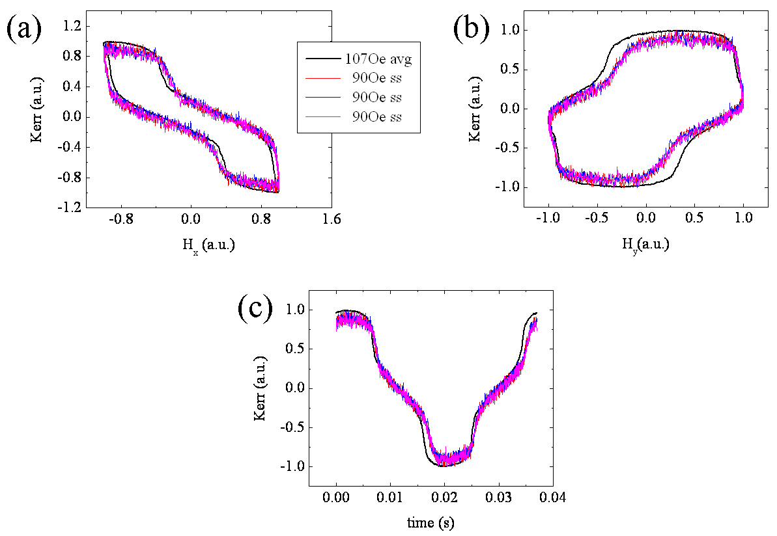
Fig. 6.9. Comparison between averaged loop at 107 Oe and single shots at 90 Oe for 36 rings. as a function of (a), normalised field component H_{x}, (b) normalised field component H_{y} (c) and time.

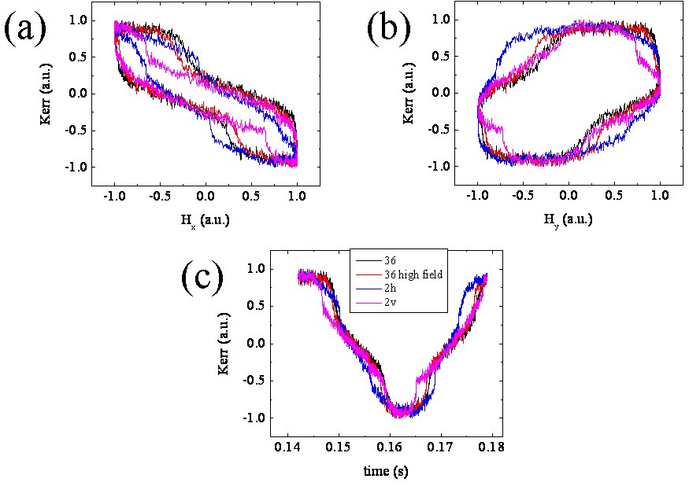
Fig. 6.10. Kerr signal comparison between single shot loops for 36 rings lowest field 90 Oe (black line), 36 rings higher field 107 Oe (red line), 2 rings held horizontally at 117 Oe (blue line) and 2 rings held vertically at 125 Oe (pink line) versus (a) H_{x} (b) H_{y} (c) time

6.8. Conclusions

In this chapter I have analysed multiple ring structures of 1, 2h, 2v, 4, 9, 16, 25 and 36 rings. The main idea behind this analysis is to understand how DWs from adjacent rings are introduced in their neighbour rings and also how DWs pinning might lead to annihilation. The analysis is somehow similar to a thermodynamic system where having or not having DWs in rings corresponds to having or not having a certain particle in one chamber. A profile of DWs in structures is presented. Experimental data come to confirm the theory where, the largest structure analysed appears to have a larger number of rings with walls on the vertical then horizontal alignment.

Bibliography:

- Y Ren, S Jain, A O Adeyeye, C A Ross, New Journal of Physics 12 (2010) 093003
- G. Bordignon, T. Fischbacher, M. Franchin, J. P. Zimmermann, A. A. Zhukov, V. V. Metlushko, P. A. J. de Groot, H. Fangohr, IEEE Transactions on Magnetics 43 (2007) 2881
- H. Shu-Ting, C. Shuang-Quan, S. Hui-Gang, Chinese Physics B 20 (2011) 127503
- V. Rose, K. Buchanan, S.H. Chung, M. Grimsditch, V. Metlushko, A. Hoffmann, V. Novosad, S.D. Bader, H. Ibach, Physical Review B 73 (2006) 094442
- M. V. Sapozhnikov, O. L. Ermolaeva, B. G. Gribkov, I. M. Nefedov, I. R. Karetnikova, S. A. Gusev, V. V. Rogov, B. B. Troitskii, L. V. Khokhlova, Physical Review B 85 (2012) 054402
- S. Prosandeev1, L. Bellaiche, Physical Review Letters 101 (2008) 097203
- S. Jain, Y. Ren, A. O. Adeyeye, N. Singh, Physical Review B 80 (2009) 132401
- Anthony S. Arrott, Journal of Magnetism and Magnetic Materials 258–259 (2003) 25–28
- L. Bocklage, B. Krüger, R. Eiselt, M. Bolte, P. Fischer, G. Meier, Physical Review B 78 (2008) 180405
- A. Drews, B. Krüger, G. Meier, S. Bohlens, L. Bocklage, T. Matsuyama, M. Bolte, Applied Physics Letters 94 (2009) 062504
- S. R. Bowden, U. J. Gibson, Journal of Physics: Conference Series 200 (2010) 072033
- S. R. Bowden, U. J. Gibson, IEEE Transactions on Magnetics 45 (2009) 12
- http://www.nature.com/nature/journal/v439/n7074/edsumm/e060119-01.html
- http://www.futurity.org/science-technology/new-spin-for-nanotechnology/
- A. A. Khajetoorians, J. Wiebe1, B. Chilian, S. Lounis, S. Blügel, R. Wiesendanger, Nature Physics 8 (2012) 497

