Chapter 5:
Linear Transport of DWs

In this chapter I present the design and analysis of a structure that allows linear transport of DWs over large distances at arbitrarily low velocities. The structure consists of successive half-rings connected in an ‘undulating’ wire. A rotating in-plane magnetic field drives the DWs through the wire. When a DW reaches the junction between successive half rings, the field chirality changes direction. An analysis of several applied field amplitudes is presented and the probability of switching for each half-ring is calculated.

5.1. Introduction

Unlike the approach presented in previous chapter where DWs are transported around a ring, the approach presented here instead uses DW motion in linear undulating nanowires in which the DW is geometrically confined in its motion to allow arbitrarily low velocities to be achieved.

A similar structure was presented in [1] where successive undulating wires were used to support an array of DWs and create an ‘atom mirror’ that reflects paramagnetic atoms from its surface.

5.2. Methodology

Chapter 4 showed how DWs in ring-shaped ferromagnetic nanowires can be moved cyclically at arbitrarily low speeds using an in-plane rotating magnetic field. This idea is now developed further by controlling DW motion in a similar manner to when using the rings but with an extended structure.

Fig. 5.1. shows a schematic picture of the undulating wire used here. It consists of eight half-rings connected end-to-end and with an additional quarter turn of wire at one end to assist with initialisation (see below). Each ring section had a diameter of 10 μm to create a structure of overall length 80 μm. The structures were made from 30 nm thick thermally evaporated permalloy using electron beam lithography and lift-off (see §3.1. for details). The wire width was 400 nm throughout. The field rotations were performed over a time scale commensurate with a 27 Hz rotation frequency.

A sequence of magnetic fields H_{x} (in the x-direction) and H_{y} (in the y-direction) were applied to create and propagate a single DW through the undulating structure. First, a field pulse of H_{x} = -400 Oe and 44.5 ms duration nucleated a head-to-head DW in the left side of the nanowire (fig. 5.2.(a)). This method of introducing DWs was chosen over using a DW injection pad to avoid adding a DW on each half-cycle of applied field.

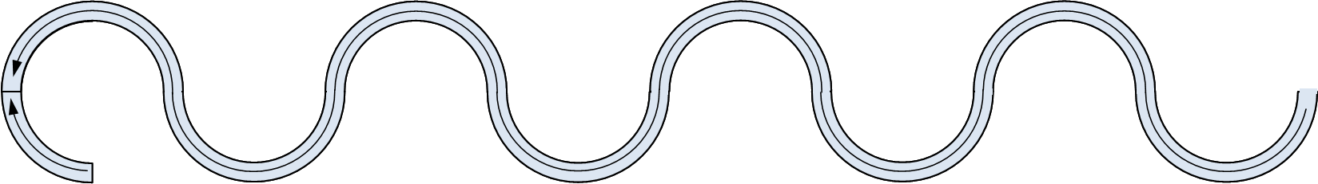
Fig. 5.1. Schematic of the nanowire geometry used for linear transport of DWs with controlled velocity. The ring geometry has been ‘unwrapped’ to form an undulating nanowire 80 μm long, 400 nm wide, undulation diameters 10 μm and 30 nm thick.

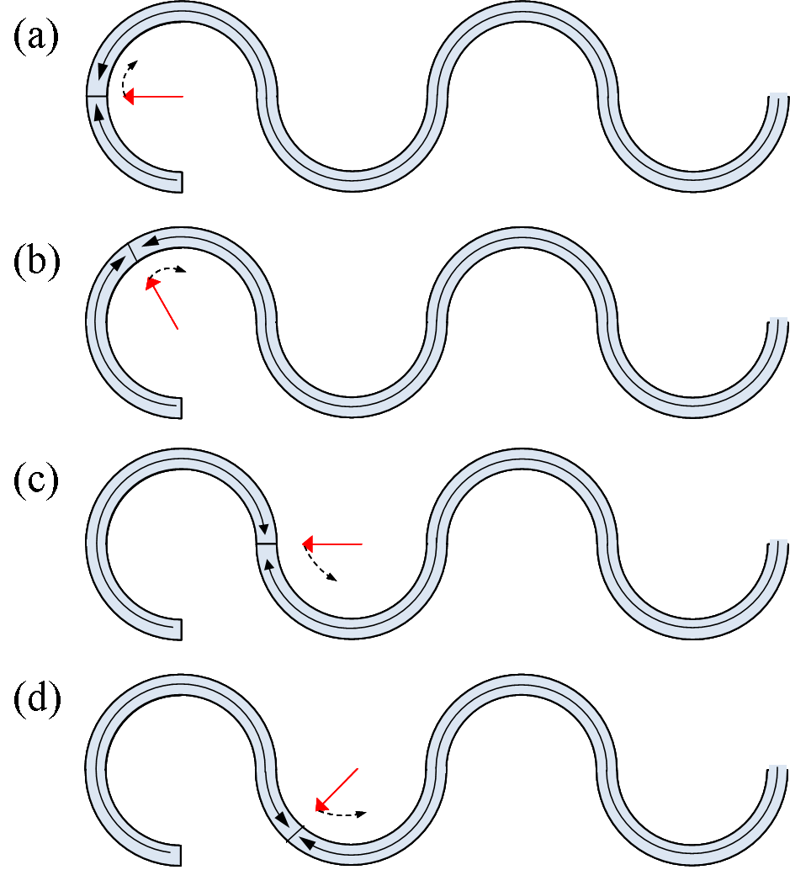
Fig 5.2. Schematic diagram showing DW propagation in the structure. (a) DW nucleation in the structure. (b) DW propagation in the first half-ring of the structure. (c) field reversal from clockwise to anticlockwise and (d) DW propagation in the second half-ring of the structure

A rotating magnetic field of amplitude H_{rot} was then applied along the negative x-direction (H_{x} = - H_{rot}) and rotated clockwise for one half-cycle (fig. 5.2.(a)), through H_{x} = 0 and H_{y} = H_{rot} until H_{x} = H_{rot} and H_{y} = 0. In principle, this field rotation moves the DW from the initialisation position to the point of inflexion between the first two half-rings (fig. 5.2.(c)). The applied field was then reversed linearly (not rotated) to be directed in the –x-direction again, i.e. H_{x} = H_{rot}. This reversal was not abrupt due to the inductance of the electromagnet. During this reversal a small field H_{y} = -20 Oe (amplitude H_{stable}) was applied to ensure the DW didn’t propagate back in the reverse direction (as a rule, H_{stable} was applied in the opposite direction to the H_{y} component of the previous half-cycle field rotation). During this field reversal, H_{x} exerted no torque on the DW. The field rotation direction (‘chirality’) was reversed to anti-clockwise for the next half-cycle to, in principle, move the DW to where the second and third half-rings meet. At this point, H_{x} was again reversed while H_{stable} was applied. Propagation through the rest of the structure consisted of clockwise field rotation for propagation through odd numbered half-rings and anticlockwise for even numbered half-rings with H_{stable} applied along the ± y-direction during H_{x} reversal.

The transport of DWs in the undulating wire was analysed with the focussed magneto-optic Kerr effect (MOKE) magnetometer described in §3.4. The ~ 5 μm laser spot was placed on the apex of each half-ring in turn during application of the magnetic field sequence described above. The structure was analysed for three different applied field magnitudes of H_{rot} = 82 Oe, 107 Oe and 137 Oe at an effective field rotation frequency of 27 Hz. Data traces were obtained from single field sequences and from the average of ~100 cycles to improve the signal-to-noise ratio. A stabilisation field H_{stable} = ± 20 Oe was used throughout.

5.3. Results and analysis

The MOKE analysis for H_{rot} = 82 Oe is shown in fig. 5.3. The first two half-rings (bottom blue and pink lines) show clear transitions at the expected positions in the field sequence, as indicated by the vertical blue rectangles. However, single shot measurements showing only the desired transition were difficult to obtain due to a large number of loops showing the DW bouncing back and forth between the first two half-rings, as suggested by the averaged loops (dotted lines). From the third half-ring (olive) onwards, the multi-cycle averaged MOKE signal of reversal is weak, offering very poor signal-to-noise. Single shot data traces (continuous lines) didn’t show any clear transitions they were omitted from the plot in fig. 5.3. This indicates that a DW was introduced to the structure by the initialisation sequence but struggled to propagate further than the second half-ring, perhaps due to a lithographic defect in the wire at this position that caused DW pinning.

The averaged loops for the first two half-rings show other peaks besides the expected switching in the first half-ring. This might be due to DW moving back-and-forth in these regions of the structure over successive parts of the field cycle.

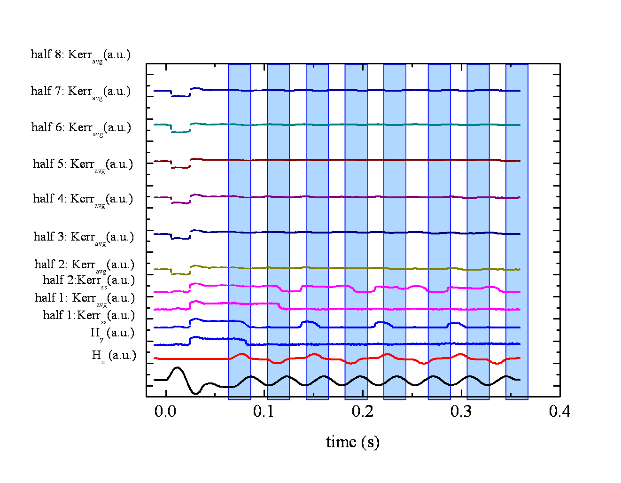
Fig. 5.3. Switching of each half-ring with a rotating magnetic field and the correlation with the applied field sequence. The first two halves (blue and pink) present also single shot loops (continuous line) where the switching is revealed. The blue vertical rectangles indicate where the structure should switch for each half ring.

Increasing the field amplitude to H_{rot} = 107 Oe, the switching of each half-ring becomes more obvious (fig. 5.4.). The slight increase in applied magnetic field and, therefore, Zeeman energy allows the DW to travel more easily in the structure and helps the DW to overcome pinning by defects. There remains a reduction in the averaged MOKE signal as points further from the initialisation position are probed, which indicates that a degree of DW pinning is still occurring through each half-ring. Figure 5.4. halves 4 (blue) and 5 (purple) also show additional oscillations in the averaged MOKE signal after the expected DW transition, again indicating a degree of back-and-forth DW motion following a pinning event. However, selected single-cycle measurements show that when DW motion proceeds as expected these oscillations are not present in the signal. Averaged data from last two half-rings 7 (dark green) and 8 (blue) don’t show any indication of DWs passing, although it is possible to obtain single shot measurements that indicate DWs sometimes propagated to the very end of the structure.

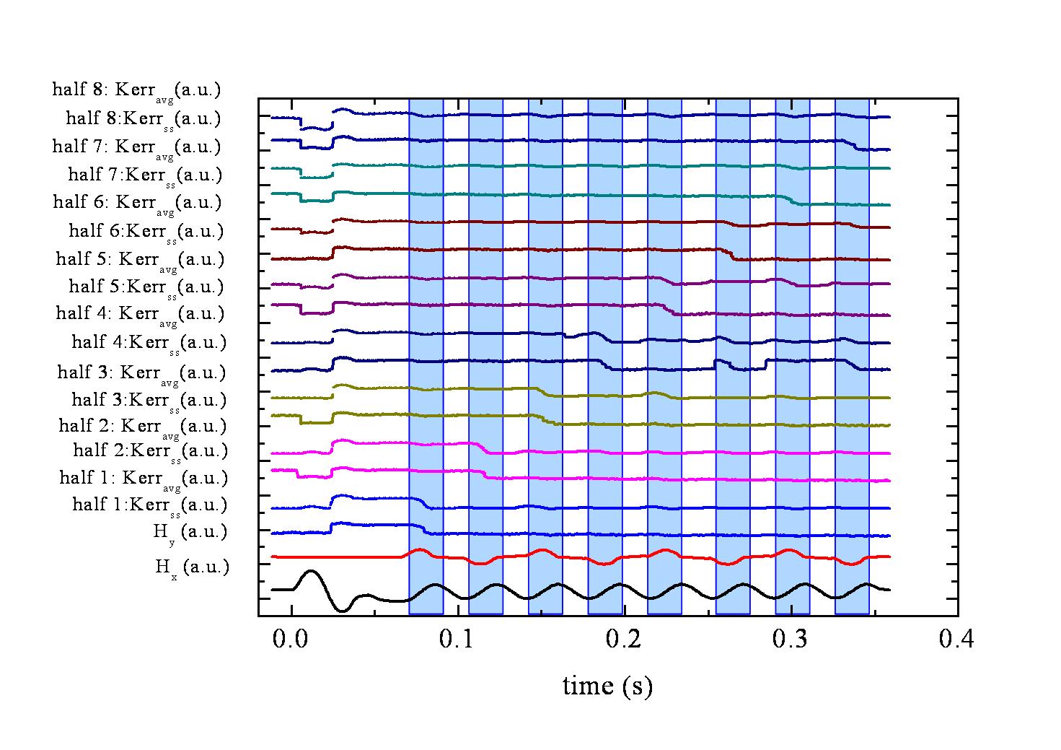
Fig. 5.4. Switching of each half-ring (single shoot continuous line and averaged loop the dotted line) of the structure with an applied rotating magnetic field of 107 Oe and the correlation with the applied field sequence The blue vertical rectangles indicate where the structure should switch for each half ring.

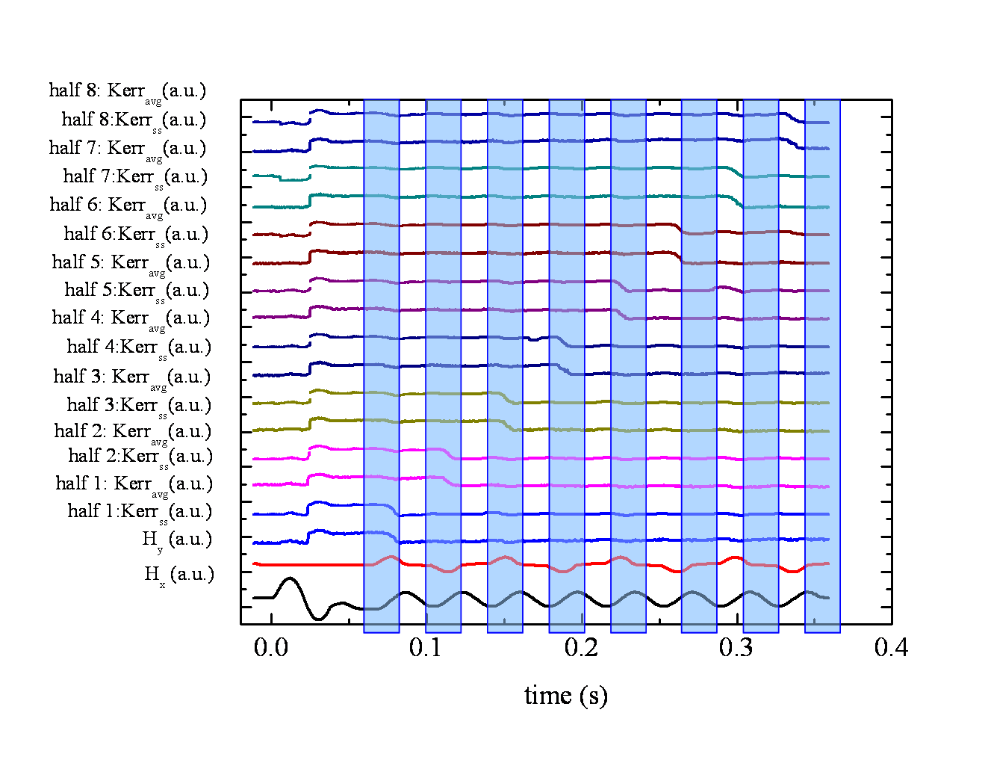
Fig. 5.5. Switching of each half-ring (single shoot continuous line and averaged loop the dotted line) of the structure with an applied rotating magnetic field of 137 Oe and the correlation with the applied field sequence. The blue vertical rectangles indicate where the structure should switch for each half ring.

A further increase in the applied field to 137 Oe allowed DWs to be propagated through the entire structure more clearly. Examination of the averaged MOKE traces from positions through the undulating wire structure (fig. 5.5) shows that the DW transitions occur at and only at the expected times in the applied field sequence. Single cycle MOKE signals all agree with the averaged traces, indicating the high reliability of this process. This indicates that the additional Zeeman energy of the system allowed the DWs to overcome reliably the pinning potential of any residual defects without the unwanted creation of additional DWs.

This experiment demonstrates that half-ring nanowire structures can be connected to allow controlled linear propagation of DWs in nanowires. Correlated with the analysis in §4.8 which determines how spread a DW is when the applied field increases, there can be determined an optimal field at which the atoms can be transported. Also, further optimization in the structure design (wider wire) can allow propagation of DWs for longer distances.

5.4. Single shot loops

Although figs. 5.3., 5.4., 5.5. present single shot loops showing only the desired transitions, other loops showed unusual behaviour. These are discussed below to interpret the DW behaviour in these cases.

For the 5th half-ring and an applied field of 137 Oe a single shot measurement showed switching later than expected, as shown in fig. 5.6. The transition was expected where the vertical black lines are, one period earlier than shown (a period means one half-rotation of field clockwise and one half-rotation anticlockwise). This most likely occurred due to the DW being pinned by a defect at some point before the 5th half-ring for one field period before depinning and moving as expected under the following field period.

Other single shot loops simply showed that the structure didn’t switch. Fig. 5.7. presents two such loops with an applied field H_{rot} = 137 Oe. The difference between the two is upon application of the initialisation field pulse when, the blue line shows that the structure didn’t switch in the previous cycle while the wine line shows that the structure switched during the previous cycle.

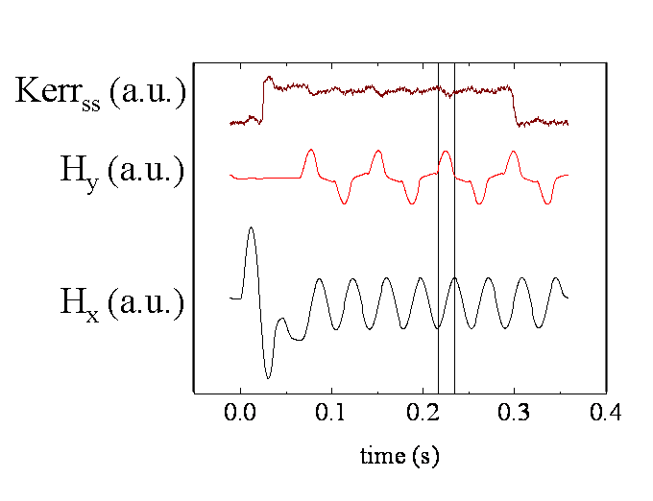
Fig. 5.6. Single shot MOKE measurement of 5th half-ring of undulating wire. Vertical lines show expected time of DW passage.

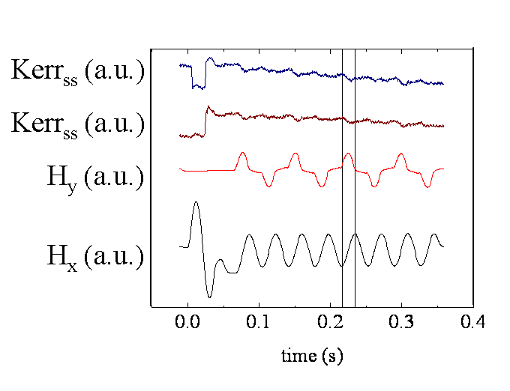
Fig. 5.7. Single shot MOKE loops of 5th half-ring of undulating wire at 137 Oe which show no switching of the structure. The difference between the two is the previous cycle which switched the structure (wine) or didn’t switch it (blue).

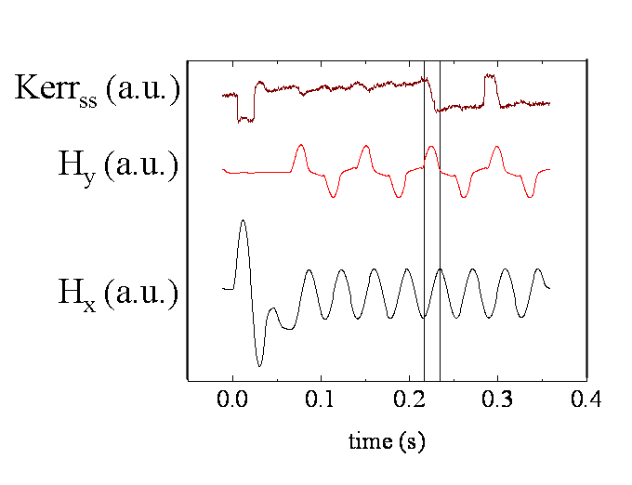
Fig. 5.8. Single shot MOKE measurements of 5th half-ring of undulating wire at 137 Oe showing DW bouncing back and forth.

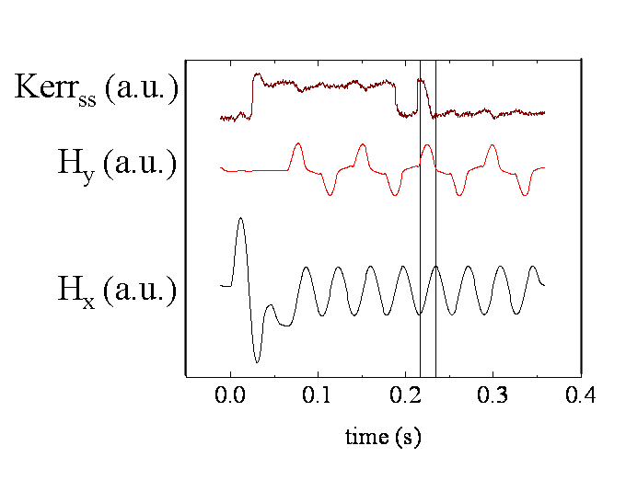
Fig. 5.9. Single shot MOKE measurements of 5th half-ring of undulating wire at 137 Oe showing that other walls might be present in the structure.

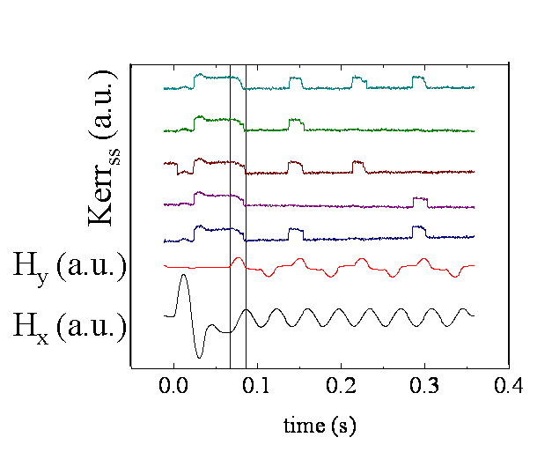
Fig. 5.10. Single shot MOKE measurements of 1st half-ring of undulating wire at 82 Oe showing DW bouncing once, twice or three times.

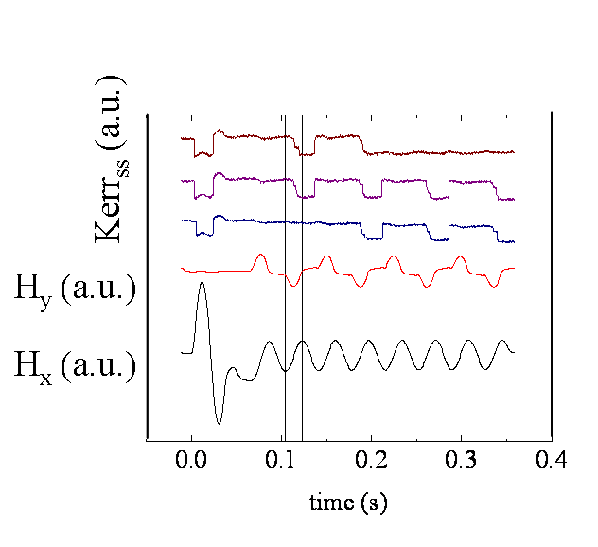
Fig. 5.11. Single shot MOKE measurements of 2nd half-ring of undulating wire at 82 Oe showing the shape of the bottom halves.
As discussed in §5.3 above, sometimes the DW travelled in the reverse direction in the nanowire structure, as depicted in fig. 5.8. This appears as a peak in the MOKE trace following the usual expected magnetic transition for controlled DW motion.

Sometimes the structure switched before the corresponding field sequence indicating that other DWs, besides the desired one, were nucleated in the structure at places other than just the initialisation position (fig. 5.9.).

DWs can cycle back-and-forth once, twice or even each time the same field rotation direction is applied, as in fig. 5.10, which was obtained with H_{rot} = 82 Oe and from the first half-ring.

When a lower (even numbered) half-ring is analyzed, the DW coming back in the structure looks slightly different. The peak position from the DW oscillation occurs half a field period out-of-phase with those from upper (odd numbered) half-rings. The peaks also have the opposite sense, being negative going peaks with lower half-rings in fig. 5.11. rather than the positive going peaks seen from upper half-rings.

Most of these failure conditions were seen for the lowest field used here, 82 Oe. While these failure conditions are of interest when analysing linear propagation of DWs, they can largely be avoided by selecting a larger drive field.

5.5. The probability of switching

The averaged measurements were used to calculate the probability of transporting the DW for each applied field and each half-ring. This was achieved by dividing the MOKE signal height of the relevant transition for the corresponding field sequence of the analysed half-ring by the transition height when the initialisation pulse is applied, where the probability of switching is 100%. The results shown here come from the plots presented in the blue lines of figs. 5.3., 5.4. and 5.5.

The probability of switching depends strongly on the applied field strength. For the lowest applied field, the transport of the DW was seen for the first two half-rings. The probability calculated for the switching of the magnetization at the lowest field used in experiments, H_{rot} = 82 Oe, could have been influenced by the shape of the loop.
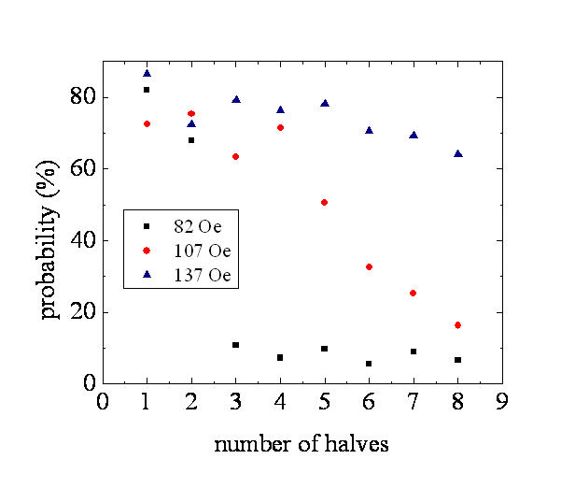
Fig. 5.12. Probabilities of switching for each half-ring of an undulating nanowire under different applied field amplitudes as derived from averaged signals in figs. 5.3., 5.4. and 5.5. Data shown for ■ 82 Oe, ● 107 Oe and ▲ 137 Oe.

The probability of switching for all half-rings in the structure was calculated even if the transition height was very small. It was calculated based on the analysis presented for the last two halves at 107 Oe where, although there is no obvious transition in the averaged loop, the single shot measurement showed a transition where expected. This shows that the switching probability is a true probability. Based on this assumption, was also calculated the probability of switching for 82 Oe. For this field the switching probability is high for the first two halves while for all the other halves is less than 10%.

Increasing the field to 107 Oe showed DWs going through first four half-rings relatively reliably but beyond this the probability of DWs going past successive half-turns decreased markedly. The gradual reduction in this probability indicates that DWs are lost through various half-rings the structure. The probability of switching decreases linearly with each half with a slope of -9.02524±1.31·10⁻¹⁵.

A further increase in the field to 137 Oe showed that most DWs go through the whole sequence with an even smaller decrease in the successful propagation of DWs through the structure. The highest field presents a similar linear decrease as 107 Oe but with a different slope, of -2.34702±0.65.

The velocity the DWs achieve as they travel through the structure is calculated similar the calculations presented in chapter 4 ($v=2πrν$, where r is the ring radius of 5 μm and ν is the frequency of the applied field). With this structure the velocity DWs have as they travel linearly is 0.42 mm/s which corresponds to a radius of 5 μm unlike the rings used with a radius of 10 μm. The velocity is completely controllable with the rotating field frequency.

5.6. Conclusions

This chapter presents a new method of transporting DWs in planar ferromagnetic nanowires over extended linear distances by confining them to 1D propagating potential wells.

This technique not only allows DWs to be accurately positioned, but also to be moved at arbitrary, user-defined velocities. The results have demonstrated the feasibility of transporting DWs over linear distances as large as 80 μm, at average velocities as small as 0.42 mm/s.

I have showed that pinning by defects can cause a fraction of DWs to be lost from the propagating potential well, and conclude that further development of the nanowire geometry and/or applied field sequence used will be required to improve the techniques reliability. Increasing the field to 137 Oe showed a reliable propagation of the wall through the entire structure.

Some failure conditions are also presented but most of them occur for the lowest field, 82 Oe, where the Zeeman energy required to drive the wall in the structure is smaller than the pinning potential of defects.

The probability to have a wall transported increases with the applied field so that for the higher field, 137 Oe, our study indicate a reliable propagation of the wall through the whole structure.

Bibliography:

- T. J. Hayward, A. D. West, K. J. Weatherill, T. Schrefl, I. G. Hughes, D. A. Allwood, Journal of Applied Physics 110 (2011) 123918

