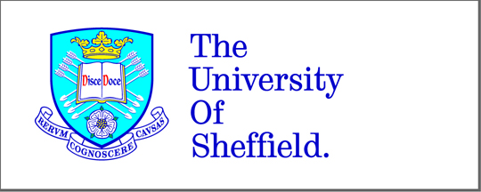

Domain walls in ferromagnetic nanowires for atom trapping applications

Madalina Negoita

Submitted for the title of Doctor of Philosophy
September 2013

Supervisors:
Dr. Dan Allwood
Prof Dr. Mike Gibbs
Dr. Tom Hayward

