May 2013

The University Of Sheffield

A

April Elenor Frearson

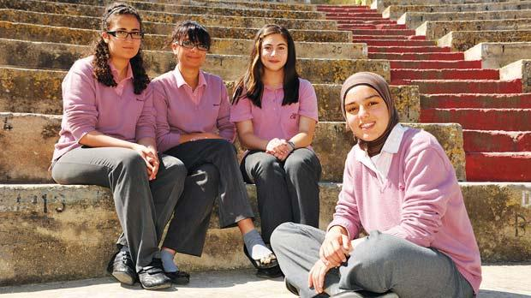
“A Q-Methodological study to explore Muslim girls’ viewpoints around how a secondary school setting can promote and support their inclusion.”
Research Thesis submitted in part requirement for the Doctor of Educational and Child Psychology
Department of Educational Studies
Abstract
Previous research in the area of meeting the inclusive needs of female Muslim pupils has explored parents’ views, and head teachers’ views (Parker-Jenkins, 1995). There has also been an almost exclusive focus on female Muslim pupils in predominantly ethnic areas (Mac an Ghaill, 1988, 1991.
Q-methodology is a research tool which boasts quantitative and qualitative features and aims to provide descriptive accounts of a range of views around a topic. Q-methodology was used to explore the following research questions: (1)What are the viewpoints of female secondary-school aged Muslim pupils on how a secondary school can promote and support their inclusion? (2) How do the viewpoints within the current study relate to previous research and literature? and, (3) What are the implications for schools and EPs in relation to the viewpoints provided by the participants in the current study?
25 female Muslim pupils from one secondary school in a predominantly white area participated in the study. Five main viewpoints were found (two of which were bipolar). These viewpoints are as follows:
Factor 1: Individualist approach to inclusion in a school that creates a sense of belonging based upon valuing and respecting Muslim identity.
Factor 2: A collectivist approach to inclusion in a school that supports the process of social integration.
Factor 3: (positive): Muslim others as significant to feeling included.
Factor 3 (negative): A school that provides an Islamic classroom environment and curriculum.

Factor 4: A school which extends inclusion to activities and events outside of school.
Qualitative interpretations are provided for each of the five factor viewpoints, and the implications of these in relation to education, practice and past research are explored.

