

Exploring variation in prescribing practices in rare diseases: the case of prescribing tolvaptan for autosomal dominant polycystic kidney disease

Matthew John Gittus

A thesis submitted in partial fulfilment of the requirements for the degree of Doctor of Philosophy

The University of Sheffield
Sheffield Centre for Health and Related Research (SCHARR)
School of Medicine and Population Health

Submission date: 15 May 2026

Acknowledgements
I thank my supervisors, James Fotheringham for his invaluable guidance and commitment to fostering independent thinking; Alicia O’Cathain for her expertise in mixed methods research and gentle encouragement throughout; and Albert Ong for providing his vast experience and knowledge of ADPKD.
Thanks should go to the participating kidney centres, as this research would not have been possible without their support. I am particularly grateful to the lead clinicians and their wider healthcare teams who contributed their time to participate in the multiple case study. Especially, as this involved them discussing their practices, which I appreciate may have been challenging at times. I am also thankful to the people with ADPKD who provided their data to the RaDaR database, agreed to their appointments being observed, and participated in the PPI group.
Special thanks should be given to the National Registry of Rare Kidney Diseases (RaDaR) team for allowing me to use their database, and specifically to David Pitcher, for his time and expertise in supporting the statistical analysis. I would also like to thank Louese Dunn and Sam Walmsley from the Sheffield Clinical Research team for their support during the application for ethical approval.
Additionally, I would like to acknowledge the financial support from The Healthcare Improvement Studies (THIS) Institute, which made this research possible.
And finally, I would like to express my gratitude to my mother for the strong foundation, and her unwavering belief in me. Thanks should also go to my partner, Gavin, for his seemingly endless patience and understanding. I could not have done this without you.

Abstract
Background
Rare diseases pose a challenge to healthcare systems. Autosomal dominant polycystic kidney disease (ADPKD) is a rare kidney disease that has a single disease-modifying therapy, tolvaptan. However, its use varies between UK kidney centres. Little is known about how clinicians make prescribing decisions in ADPKD. This study examined variation in tolvaptan prescribing and factors influencing decision-making across UK kidney centres.
Methods
This mixed-methods study had four phases. An overview of 26 systematic reviews was conducted to adapt a conceptual model of prescribing decision-making to chronic conditions. ADPKD registry data was used to identify variation in tolvaptan prescribing across UK kidney centres. A multiple case study of three kidney centres was conducted with 12 interviews, 23 observations and 8 documents to explore reasons for this variation; the conceptual model was then refined for rare diseases. The final phase was a national survey to measure the extent to which these factors varied between centres.
Results
The overview identified factors relevant to prescribing decision-making in chronic conditions. Registry data showed variation in tolvaptan prescribing between kidney centres, mainly in initiation among eligible patients. The multiple case study suggested that variation arose from multiple interacting factors. Service configuration appeared to shape patient identification, eligibility assessment and initiation. Dedicated tolvaptan clinics improved coordination of prescribing. Although national guidelines define eligibility, centres varied in which criteria were used and how they were applied. Clinical leadership shaped prescribing norms. Pharmacist involvement appeared to increase guideline-adherence. How risks were communicated to patients varied and appeared to influence patient uptake. Survey data demonstrated variation across centres in all these factors.
Conclusions
Variation in tolvaptan prescribing for ADPKD between UK kidney centres appears to be influenced by differences in service configuration, clinical leadership, and local interpretation of eligibility criteria. This suggests that both system and clinician-level factors may shape prescribing decision-making in rare diseases and contribute to unwarranted variation in practice.

Plain language summary
Background and aims of the research
Rare diseases are health problems that affect only a small number of people. For a health problem to be called a rare disease, it has to affect fewer than 1 in 2,000 people. They can be challenging for healthcare systems because there is often limited research into these health problems and some clinicians see people with them less often so can be less experienced.
Autosomal dominant polycystic kidney disease (ADPKD) is a rare kidney disease that is passed down through families. It causes fluid-filled sacs, called cysts, to grow in the kidneys. Over time, more cysts form and the ones already in the kidneys grow larger. This can damage the kidneys and reduce how well they work. For many people, this can cause the kidneys to stop working altogether (kidney failure). A medication called tolvaptan can slow this process in some people, but it is not suitable for everyone.
In the UK, kidney centres seem to use tolvaptan in different ways. It is not clear why this happens or how clinicians decide whether to prescribe tolvaptan. This study aimed to learn how these decisions are made and why prescribing may vary between kidney centres. Knowing this may also help explain how clinicians decide whether to prescribe medications for people with other rare diseases.
Design and methods
This research had four main parts. First, it looked at how clinicians decide whether to prescribe medications for long-term health problems like diabetes and high blood pressure. This helped guide the other parts of the research. Second, national data was used to see how tolvaptan is prescribed to people with ADPKD and whether there are differences between kidney centres. Third, three kidney centres were visited to see how they prescribe tolvaptan. This was done by talking to clinicians, observing appointments between clinicians and people with ADPKD, and looking at documents that are used to help clinicians make decisions. Finally, a survey was sent to all the kidney centres in the UK to ask questions about their centre and how they prescribe tolvaptan.
What was found?
Looking at the evidence from other long-term health problems showed that clinicians’ decisions to prescribe medications are influenced by many different factors. These included things like who the patient is, how clinicians weigh up the risks and benefits, clinicians’ experience, workload in the clinic, costs of the medication, and external factors like guidelines and expert advice.
The national data showed that there were differences between centres in how tolvaptan was prescribed to people with ADPKD. There were a large number of people who could be prescribed tolvaptan but did not start on it. Some kidney centres started more people on tolvaptan than expected, while others did so less often. There were also people who were not supposed to be prescribed tolvaptan according to the guidelines but were prescribed it, but this number was smaller. Most kidney centres prescribed tolvaptan in a similar way for this group of people.
The main difference between the three kidney centres that were visited was how people were assessed to decide whether they could start tolvaptan. These differences seemed to be driven by the structure of the clinics, how doctors and other clinicians made decisions, and how information was given to people with ADPKD.
Kidney centres with separate tolvaptan clinics seemed to be more organised. This made it easier to deliver the treatment and more likely that it would be prescribed in the same way. This involved sharing prescribing responsibilities across the team to make the treatment easier to deliver.
Clinicians at the kidney centres used the same guidelines to help them make decisions. However, the tests used to decide whether someone can take tolvaptan were different across the three kidney centres. This was based on the opinions of the senior doctor and whether the test was available. Leadership played an important role in shaping how often tolvaptan was offered and how quickly kidney centres started using it after it was available to be prescribed. Involving pharmacists and other members of the healthcare team helped make sure prescribing was done in a similar way within a kidney centre. How doctors and other members of the healthcare team spoke to people with ADPKD about tolvaptan affected whether, and when, they would start it. Finally, kidney centres that look at how they prescribe tolvaptan to people with ADPKD in a structured way (through audits) have an opportunity to learn from and improve their practice.
Findings from the survey showed similar differences between the three kidney centres to kidney centres across the UK. This suggests that the patterns in how tolvaptan is prescribed, and what caused these differences between the three kidney centres, may also be relevant to these other centres.
What does this mean?
How the clinic is structured, which tests are used to decide if someone can take tolvaptan, and who is making decisions, appear to explain differences in how tolvaptan is prescribed in kidney centres.

Table of contents
Acknowledgements 2
Abstract 3
Plain language summary 4
Table of contents 6
List of abbreviations 9
Glossary 11
List of tables 14
List of figures 15
Declaration 16
Chapter 1 – Introduction 17
1.1 Prescribing in rare diseases 17
1.2 Tolvaptan in autosomal dominant polycystic kidney disease (ADPKD) as a case of prescribing for a rare disease 18
1.3 Research question, aims and objectives 19
1.4 Researcher voice, positionality and reflexivity 19
1.5 Context of the doctoral research 20
1.6 Study design and research methods 21
1.7 Type of thesis 22
1.8 Structure of the thesis 22
1.9 Dissemination 23
Chapter 2 – Background 25
2.1 Chapter outline 25
2.2 Rare diseases: definitions, prevalence and challenge 25
2.3 Prescribing as a decision-making process 28
2.4 Rare diseases add an additional layer of complexity in prescribing 36
2.5 ADPKD as a case to explore factors influencing prescribing decisions in rare diseases 37
2.6 Research gap 45
2.7 Chapter summary 47
Chapter 3 – Methodology 48
3.1 Chapter outline 48
3.2 Research question, aims and objectives 48
3.3 Methodology 49
3.4 Integration within mixed methods research 61
3.5 Rigour and trustworthiness 61
3.6 Reflexivity 64
3.7 Ethical considerations across the programme of research 65
3.8 Patient and public involvement (PPI) 68
3.9 Chapter summary 71
Chapter 4 – Systematic review (overview of systematic reviews) of factors influencing prescribing decision-making in chronic conditions 72
4.1 Chapter outline 72
4.2 Manuscript 73
4.3 Chapter summary 103
Chapter 5 – Variation in tolvaptan prescribing for autosomal dominant polycystic kidney disease in the United Kingdom and its impact on quality of life and costs 104
5.1 Chapter outline 104
5.2 Manuscript 105
5.3 Chapter summary 123
Chapter 6 – Understanding variation between kidney centres in the implementation of tolvaptan in the management of autosomal dominant polycystic kidney disease: a multiple case study 124
6.1 Chapter outline 124
6.2 Manuscript 125
6.3 Chapter summary 151
Chapter 7 – Developing a conceptual model of prescribing decision-making in rare diseases: insights from tolvaptan prescribing for autosomal dominant polycystic kidney disease 152
7.1 Chapter outline 152
7.2 Manuscript 153
7.3 Chapter summary 175
Chapter 8 – Variation in tolvaptan prescribing pathways for autosomal dominant polycystic kidney disease: a national survey of clinical practice 176
8.1 Chapter outline 176
8.2 Manuscript-style report 177
8.3 Chapter summary 190
Chapter 9 – Discussion 191
9.1 Introduction 191
9.2 Summary of main findings 191
9.3 Integration of findings 192
9.4 Interpretation of findings in relation to the wider literature 196
9.5 Strengths and limitations 207
9.6 Transferability of findings 209
9.7 Influence of PPI on the programme of research 209
9.8 Reflexivity 210
9.9 Unique contributions to knowledge 212
9.10 Recommendations for clinical practice and policy 213
9.11 Future research priorities 214
9.12 Conclusions 216
References 217
Appendices 257
Appendix 1. Author contributions 257
Appendix 2. Ethical approval documents 262
Appendix 3. Additional details on the methods for the systematic review (Phase 1) 268
Appendix 4. Publication materials for journal article 1 (Chapter 4) 293
Appendix 5. Additional details on the methods for the analysis of registry data (Phase 2) 326
Appendix 6. Publication materials for journal article 2 (Chapter 5) 346
Appendix 7. Additional details on the methods for the multiple case study (Phase 3) 365
Appendix 8. Publication materials for journal articles 3 & 4 (Chapters 6 & 7) 374
Appendix 9. Additional details on the methods for the survey of clinical practice (Phase 4) 404
Appendix 10. Publication materials for the national survey of clinical practice (Chapter 8) 407

List of abbreviations
Common abbreviations that are used in this thesis are included; this list is not exhaustive.
ADPKD Autosomal Dominant Polycystic Kidney Disease
CPG Clinical Practice Guideline
CT Computed Tomography
EMA European Medicines Agency
ERA European Renal Association
ESKD End Stage Kidney Disease
EU European Union
HTA Health Technology Assessment
KDIGO Kidney Disease Improving Global Outcomes
KRT Kidney Replacement Therapy
MHRA Medicines and Healthcare products Regulatory Agency
MIC Mayo Imaging Classification
MRI Magnetic Resonance Imaging
NHS National Health Service
NICE National Institute for Health and Care Excellence
PKD Polycystic Kidney Disease
PPI Patient and Public Involvement
PROPKD Predicting Renal Outcome in Polycystic Kidney Disease
PV Patient View
QRA Qualitative Residual Analysis
RA Renal Association
RaDaR Registry of Rare Kidney Diseases
REC Research Ethics Committee
REPRISE Replicating Evidence of Preserved Renal function: Investigation of Safety and Efficacy
SMC Scottish Medicines Consortium
TEMPO Tolvaptan Efficacy and safety in Management of Polycystic kidney disease and its Outcomes
UK United Kingdom
UKKA United Kingdom Kidney Association
US Ultrasonography
USA United States of America
WHO World Health Organization

Glossary
The definitions in this glossary are used in this thesis. This list is not exhaustive.
ADPKD clinic
A specialist outpatient clinic in a kidney centre that diagnoses, assesses, manages and monitors people with ADPKD, including consideration of disease-modifying therapies.
Audit trail
A systematic documentation of all stages of the research process that could enable external reviewers to trace the development of the research from raw data through to findings and conclusions.
Axiology
The role of values, ethics and researcher judgement in the research process.
Case
A bounded system studied in its natural context, defined by the phenomenon of interest and its surrounding environment.
Case study
A qualitative research approach that involves an in-depth, detailed examination of a particular case (or cases) within a real-world context.
Clinician
A healthcare professional who provides direct care to patients. This term encompasses a wide range of roles including doctors, nurses, pharmacists, physiotherapists, occupational therapists etc.
Condition-specific clinic model
A clinic model in which care is organised around a single disease or a narrowly defined group of conditions e.g. ADPKD clinic or renal genetics clinic.
Disease modifying therapy
A treatment that targets the underlying cause of a diseases to delay, slow down or reverse progression.
Epistemology
A researcher’s assumptions about how knowledge is constructed and understood.
European Renal Association
A professional nephrology society that promotes research, education and clinical practice for kidney disease in Europe.
General nephrology clinic
An outpatient clinic in a kidney centre that assesses, diagnoses and provides ongoing management for a broad range of kidney diseases.
Generalist clinic model
A clinic model where patients with a broad range of kidney diseases are seen together within the same clinic.
Health board
A regional organisation responsible for planning and delivering NHS services in Scotland and Wales. This is equivalent to a hospital trust in England and Northern Ireland.
Hospital trust
An organisational unit within NHS services in England and the Health and Social Care in Northern Ireland responsible for delivering regional hospital and specialist services. This is equivalent to a health board in Scotland and Wales.
Kidney centre
A nephrology department within a secondary care hospital that provides specialist assessment, treatment and long-term management of people with kidney disease through both inpatient and outpatient care.
National Health Service
The collective term for the four separate publicly funded healthcare systems in the United Kingdom: NHS England, NHS Scotland, NHS Wales and Health and Social Care (Northern Ireland).
National Institute for Health and Care Excellence
An independent public body that provides evidence-based guidance and recommendations for health and social care in England.
National Registry of Rare Kidney Diseases (RaDaR)
A UK Kidney Association initiative that collects and analyses data on people with rare kidney diseases.
Ontology
A researcher’s assumptions about what exists and the structure of reality.
Positionality
A researcher’s interpretative lens that is shaped by their prior experience, theoretical commitments and sociocultural context.
Reflexive journal
A documented record of a researcher’s ongoing reflexive practice during the research, with particular attention to how their positionality may influence data collection, analysis and interpretation.
Reflexivity
The process of critically examining how a researcher’s positionality influences all stages of the research process and its outcomes.
Renal Association
The previous name for the UKKA. See UK Kidney Association.
Renal genetics clinic
A specialist outpatient clinic in a kidney centre that diagnoses, assesses, manages and monitors people with inherited kidney diseases.
Research paradigm
A researcher’s worldview or philosophical framework, including their beliefs, values and assumptions, that guides the research process.
Scottish Medicines Consortium
A national body that evaluates and provides guidance on the use of medications within NHS Scotland.
Triangulation
The use of multiple methods or data sources to enhance the credibility of a study by comparing and contrasting findings.
Tolvaptan clinic
A specialist outpatient clinic at a kidney centre that focuses on initiating, monitoring and titrating the dose of tolvaptan in the management of ADPKD.
Tolvaptan care pathway
The structured clinical and organisational activities through which kidney centres deliver tolvaptan.
Unit of analysis
The primary analytical focus of the study. In some designs, this can be the case itself, while in embedded designs there may be subunits within the case (e.g. individuals, teams or events).
United Kingdom Kidney Association
The national professional society in nephrology for the United Kingdom that supports the delivery of kidney care, education and research.

List of tables
Table 1. International definitions of rare diseases expressed as prevalence thresholds 26
Table 2. Factors influencing physician prescribing behaviour and relation to theory (Murshid and Mohaidin, 2017) 34
Table 3. Comparison of prescribing in acute and chronic conditions 35
Table 4. Mixed methods design types, adapted from (Creswell and Plano Clark, 2017) 51
Table 5. Trustworthiness and quality characteristics of quantitative and qualitative research methods, adapted from (Lincoln and Guba, 1985) 62
Table 6. Overview of PPI activities and key contributions to programme of research 70
Table 7. Eligibility criteria reported according to the SPIDER framework 77
Table 8. Characteristics of included systematic reviews 82
Table 9. Summary of qualitative findings 85
Table 10. Summary of quantitative factors in relation to qualitative findings 96
Table 11. Characteristics of kidney centres and participants 112
Table 12. Characteristics of patients eligible for tolvaptan, stratified by initiation status 113
Table 13. Characteristics of patients initiated on tolvaptan, stratified by eligibility status 115
Table 14. Estimated net potential savings from initiating tolvaptan in eligible patients who were not initiated in the UK and estimated costs of initiating ineligible patients, by PAS discount level 118
Table 15. Data collection methods undertaken at each case site 131
Table 16. Characteristics of cases participating in the multiple case study 132
Table 17. Summary of cross-case comparison in tolvaptan implementation and prescribing practices across the three study cases 136
Table 18. Key themes linking implementation to prescribing practices in cases 148
Table 19. Professional roles and clinical contexts of interview participants 159
Table 20. Factors affecting prescribing decision-making for tolvaptan for ADPKD mapped to the existing conceptual model of prescribing decision-making in chronic conditions 160
Table 21. Respondent-reported estimates of service characteristics across kidney centres 184
Table 22. Joint display of findings from Phases 3 and 4 195

List of figures
Figure 1. The prescribing process based on the WHO 6-step model (De Vries et al., 1994) 29
Figure 2. A conceptual model of physician decision-making (Murshid and Mohaidin, 2017) 33
Figure 3. Timeline of ADPKD and tolvaptan events 41
Figure 4. Overview of the research design 53
Figure 5. Flow chart of mixed methods design 60
Figure 6. Conceptual model of physician decision-making (Murshid and Mohaidin, 2017) 76
Figure 7. PRISMA flowchart 80
Figure 8. The conceptual model of prescribing decision-making in chronic conditions 94
Figure 9. Participant flow diagram 112
Figure 10. Forest plot of predictors for initiation in eligible patients 114
Figure 11. Tolvaptan initiation in eligible patients by kidney centre; adjusted for age, CKD stage, and year of eligibility 115
Figure 12. Forest plot of predictors of eligibility in initiated patients 116
Figure 13. Tolvaptan eligibility in initiated patients by kidney centre; adjusted for CKD stage 117
Figure 14. Diagram of the Consolidated Framework for Implementation Research adapted to the tolvaptan care pathway (faded constructs were not identified in cases), adapted from Damschroder et al. (2022) 134
Figure 15. Conceptual model of prescribing decision-making in rare diseases based on ADPKD and tolvaptan findings 171
Figure 16. Flow diagram of survey participants and drop-out rates at each stage/section 182
Figure 17. Configuration of clinicians involved in tolvaptan services at each kidney centre 185
Figure 18. Professional involvement in the tolvaptan prescribing pathway stratified by consultant-type leading service and decision-making model 185
Figure 19. Methods for providing patient information on tolvaptan 186
Figure 20. Combinations of eligibility criteria used by kidney centres 188

Declaration

I, the author, confirm that the Thesis is my own work. I am aware of the University’s Guidance on Academic Integrity (https://www.sheffield.ac.uk/study-skills/assessment/academic-integrity/academic-integrity). This work has not previously been presented for an award at this, or any other, university.

– Introduction

Prescribing in rare diseases
Prescribing is the most common patient-level intervention in the National Health Service (NHS) and the second highest area of spending after staffing costs (NHS Digital, 2026). Prescribing costs in England were £20.6 billion in 2023 (National Health Service Business Services Authority, 2024). Prescribing decision-making is considered a complex and highly context-dependent process that is influenced by many factors, each of which can be weighed differently (Carter, Chapman and Watson, 2021). It is important to understand how these decisions are made in clinical practice and the factors that influence them to ensure prescribing is safe, effective and equitable (Maxwell, 2016).
Rare diseases are conditions that affect a small number of people in the general population, typically less than 1 in 2,000 (European Commission, 2020). Due to their rarity and often limited evidence base, there is greater uncertainty associated with these conditions that further increases the complexity of prescribing decisions and can lead to variation in practice (Department of Health and Social Care, 2021; Nguengang Wakap et al., 2020). This variation can have both clinical and economic consequences (López-Bastida et al., 2016). From a clinical perspective, rare diseases are generally associated with substantial impairment to health-related quality of life that is comparable to, or worse than, that reported in more common conditions (Delaye, Cacciatore and Kole, 2022). Where effective medications exist for rare diseases, they can lead to clinically meaningful improvements in patient survival, morbidity and quality of life in treated populations (Onakpoya et al., 2015). There are also important economic considerations. Although rare disease medications are used by relatively few patients, they account for approximately 7% of total pharmaceutical expenditure in Europe (Mestre-Ferrandiz et al., 2019) and 11% in the United States (IQVIA Institute, 2020).
Decision-making is recognised to be difficult when evidence is limited or there is uncertainty, such as in rare diseases (Budych, Helms and Schultz, 2012). However, there are relatively few studies describing how prescribing decisions are made for rare disease medications (Zybarth et al., 2024). Most of the existing literature on prescribing decision-making has been based on research conducted in primary care and is heavily focused on common acute conditions, particularly infections and short-term pain, reflecting a predominance of these scenarios in this setting (Little et al., 2004; Tonkin-Crine, Yardley and Little, 2011). Prescribing in this context is highly protocol-driven, based on a more established evidence base and often has short-term predictable outcomes, so it is therefore unlikely to be directly transferable to rare diseases (Almutairi et al., 2025; Tonkin-Crine, Yardley and Little, 2011). There is a need for further research to develop a conceptual model of prescribing decision-making in rare diseases to better understand prescribing in this context. Conducting research for a specific medication and rare disease context may facilitate the development of such a model.

Tolvaptan in autosomal dominant polycystic kidney disease (ADPKD) as a case of prescribing for a rare disease
Specialist kidney care in the United Kingdom (UK) is delivered through the National Health Service (NHS) by nephrology departments in acute hospital trusts, often referred to as kidney centres or units (UK Renal Registry, 2025). There are currently 72 adult kidney centres in the UK (UK Kidney Association, 2024).
ADPKD is the most common inherited kidney disease affecting over 12 million people worldwide and up to 70,000 in the UK (Grantham et al., 2008). It is characterised by the progressive development of kidney cysts and an associated gradual decline in kidney function. This leads to kidney failure in the majority of cases (Chapman et al., 2015; Cornec-Le Gall, Alam and Perrone, 2019). Outpatient care for people with ADPKD at kidney centres in the UK can be delivered through ADPKD, renal genetics or general nephrology clinics.
Traditionally, the management of ADPKD has been largely supportive with a focus on blood pressure control, monitoring of kidney function and treatment of complications. Tolvaptan was the first disease-modifying therapy available for people with ADPKD (National Institute for Health and Care Excellence, 2015a). In this thesis, the term ‘tolvaptan care pathway’ refers to the clinical and organisational activities through which kidney centres deliver tolvaptan to people with ADPKD. While guidelines have been published with clear eligibility criteria (Gittus et al., 2025a; Renal Association, 2016), anecdotal reports and limited high-level analyses suggest possible variation in tolvaptan prescribing between UK kidney centres (Chong, Harris and Ong, 2022).
As a relatively common rare disease with an approved medication, published prescribing guidelines and suspected variation in prescribing practice, ADPKD presents a useful case through which to explore prescribing decision-making in rare diseases. Understanding the mechanisms underlying prescribing in this context could help to improve access to tolvaptan and outcomes for people with ADPKD. This may also be used to inform the development of a conceptual model of prescribing in rare diseases.

Research question, aims and objectives
The primary research question was:
“Is there variation in the prescribing of tolvaptan for adults with ADPKD across UK kidney centres and what factors explain any observed variation?”
The aims of this thesis were to examine variation in tolvaptan prescribing across UK kidney centres and to develop an explanatory account of the factors shaping this variation.
The five objectives were:
- To develop a conceptual model of prescribing decision-making in chronic conditions
- To quantify current variation in tolvaptan prescribing practices between UK kidney centres when compared to guidance from the National Institute for Health and Care Excellence (NICE) and the Renal Association (RA)
- To identify variation between kidney centres in the implementation of tolvaptan care pathways
- To identify the factors influencing healthcare professionals’ decisions to initiate tolvaptan at kidney centres
- To develop a conceptual model of prescribing decision-making in rare diseases

Researcher voice, positionality and reflexivity
Positionality and reflexivity are closely related but distinct concepts. Positionality refers to the researcher’s interpretative lens shaped by their prior experience, theoretical commitments and sociocultural context. Reflexivity is the process of critically examining how this lens influences all stages of the research process and its findings (Alvesson and Sköldberg, 2017). Although traditionally associated with qualitative research in applied health research, these concepts are increasingly recognised as important for quantitative and mixed methods approaches, and were considered during all phases of this programme of research (Jamieson, Govaart and Pownall, 2023). This section outlines my positionality in relation to the research. Reflexive considerations are presented within the methodology chapter (Section 3.6), where the anticipated influence of my background is acknowledged and accounted for in the design and conduct of the research. This is then revisited in the discussion chapter (Section 9.8) to consider how it influenced the research process and findings. First-person language is used deliberately in this thesis where it is appropriate to describe my positionality and research actions.
I have been a doctor in training for the last eleven years, with the last six years being in a nephrology training post at the Sheffield Teaching Hospitals Trust. This has regularly put me into regular contact with people with ADPKD. Through this clinical work, I became interested in how tolvaptan is prescribed, as I have observed it being used differently by clinicians and became aware of variation across kidney centres. My clinical experience of managing people with ADPKD prompted wider engagement with ADPKD community, which has influenced my understanding of variation in clinical practice and shaped my perspective on prescribing in ADPKD.
I have been a trainee representative on the UK Kidney Association clinical guidelines committee for the last two years. This is a multidisciplinary group of clinicians and expert patients that oversees the development of guidelines for the UK nephrology community. Through this role, I have developed an understanding of how guidelines are developed, and co-authored an updated commentary on the use of tolvaptan in the management of ADPKD (Gittus et al., 2025a). I have also been a member of the UK ADPKD Clinical Study Group for the last 4 years. This is a research group of nephrology researchers and expert patients that aims to advance ADPKD research in the UK through collaboration. These roles have provided a wider understanding of variation in ADPKD management and has contributed to my awareness of how clinical judgement and context influence prescribing decisions. My involvement with the PKD charity has included providing teaching to patients, reviewing patient-facing information and engaging in discussions with people that have ADPKD. These activities have given me an insight into their expectations and priorities regarding medications.
Collectively, these experiences have shaped my understanding of variation in clinical practice and prescribing decisions in ADPKD, and motivated me to develop a programme of research focused on variation in tolvaptan prescribing practices for ADPKD.

Context of the doctoral research
I undertook this research as part of a Doctoral Fellowship funded by The Healthcare Improvement Studies (THIS) Institute, which is a UK research organisation that focuses on healthcare improvement science and methodological innovation (The Healthcare Improvement Studies Institute, 2025). Although I had a longstanding interest in qualitative and mixed methods research, this fellowship provided the first opportunity for me to apply these approaches within an applied research context. The overall focus of the fellowship was the examination of variation in tolvaptan prescribing in the management of ADPKD, using a multi-phase mixed-methods approach known as qualitative residual analysis (Onwuegbuzie, Leech and Collins, 2008).
Qualitative residual analysis involves: (i) measuring variation using routine data and the factors affecting it, (ii) undertaking qualitative research on a small number of diverse cases to identify new factors, (iii) collecting or identifying data on these new factors, and then (iv) using this data with the original routine data to explain further variation in practice. This is a long process and is larger than a PhD. Therefore, for this thesis, I chose to present the first three phases of qualitative residual analysis alongside a systematic review of factors influencing prescribing decision-making for chronic conditions. I am in the process of completing the final phase of qualitative residual analysis in the last few months of my THIS Institute Doctoral Fellowship.

Study design and research methods
This is a mixed methods study with four sequential methods:
Phase 1 A systematic review (overview of systematic reviews) was undertaken to synthesise evidence on factors influencing prescribing decision-making in chronic conditions. This informed refinement of an existing conceptual model of prescribing decision-making for any conditions to the context of chronic conditions (Murshid and Mohaidin, 2017).
Phase 2 Quantitative analysis of registry data from the ADPKD cohort within the UK National Registry of Rare Kidney Diseases (RaDaR) to identify variation between kidney centres in tolvaptan prescribing against national guidance.
Phase 3 Three kidney centres with diverse prescribing practices were selected for a multiple case study exploring factors influencing the implementation of tolvaptan care pathways and clinician decision-making.
Phase 4 A national survey of clinical practice was undertaken to measure the prevalence of factors identified in the case studies.
Together, the findings enabled the development of an explanatory account of variation in prescribing practices for tolvaptan in the management of ADPKD in the UK and the development of a new conceptual model of prescribing decision-making in rare diseases.

Type of thesis
The University of Sheffield offers different types of PhDs. This thesis is a ‘publication format’ thesis, also known as a ‘journal format’ thesis, which is often undertaken to support the dissemination of the research findings without the need for a prolonged post-submission publication process (University of Sheffield, 2026). This format has been growing in popularity and involves presenting findings as a series of journal articles, some of which are published or submitted, and some of which will be submitted after thesis submission (Mason et al., 2025; Robinson, 2023). The journal articles are presented in their original journal format, including the use of ‘we’ in line with the conventional journal article writing style.
There are four journal articles within this thesis:
Phase | Journal article
Phase 1 Systematic review | Gittus, M., O’Cathain, A., Miller, K., Oklopcic, A., Ong, A. C. M., & Fotheringham, J. (2025). A conceptual model of factors potentially influencing prescribing decisions for chronic conditions: an overview of systematic reviews. BMC Medicine, 23(1), 364.
Phase 2 Analysis of registry data | Gittus, M., Pitcher, D., O’Cathain, A., Ong, A. C. M., Simms, R., Fotheringham, J. (Submitted). Variation in tolvaptan prescribing for autosomal dominant polycystic kidney disease in the United Kingdom and its Impact on quality of life and costs.
Phase 3 Multiple case study | Gittus, M., Fotheringham, J., Ong, A. C. M., O’Cathain, A. (Submitted). Understanding variation between kidney centres in implementation of tolvaptan in the management of autosomal dominant polycystic kidney disease: a multiple case study.
Phase 3 Multiple case study | Gittus, M., Fotheringham, J., Ong, A. C. M., O’Cathain, A. (In preparation). A. Developing a conceptual model of prescribing decision-making in rare diseases: insights from tolvaptan prescribing for autosomal dominant polycystic kidney disease.
The contribution of each of the co-authors can be found in Appendix 1. The survey of clinical practice in Phase 4 will be published in conjunction with the reanalysis of registry data in a final journal article.

Structure of the thesis
The thesis comprises of nine chapters, including this introduction.
Chapter 2: Background on rare diseases, the prescribing process and variation in clinical practice. It introduces a theory-based conceptual model of prescribing decision-making in general and demonstrates how the decision-making process may vary in different contexts. It identifies that there is limited understanding of the factors that influence prescribing decision-making for rare diseases and how these may contribute to variation in practice. It then positions ADPKD and its sole disease-modifying therapy, tolvaptan, as a suitable case to examine these factors for rare diseases in general.
Chapter 3: Overview of methodology for the programme of research.
Chapter 4: Systematic review (an overview of systematic reviews) that synthesises wider literature and adapts the existing conceptual model of factors influencing prescribing decisions in general to chronic conditions (published journal article).
Chapter 5: Quantitative registry data analysis of tolvaptan prescribing (submitted journal article).
Chapter 6: Variation in tolvaptan prescribing in three UK kidney centres (submitted journal article).
Chapter 7: Factors influencing clinicians’ decisions to initiate tolvaptan for autosomal dominant polycystic kidney disease to help build a new conceptual model of prescribing decision-making in rare diseases (journal article in preparation for submission).
Chapter 8: National survey of clinical practice to assess practices and factors influencing tolvaptan prescribing in UK kidney centres.
Chapter 9: Discussion of the main findings, comparison with existing literature, strengths and limitations and recommendations for clinical practice and future research.
Due to the word count limitations imposed by journals, some details of the methods have not been included in Chapters 4 to 8. Additional details have been provided in the appendices.

Dissemination
Publications
Gittus, M., O’Cathain, A., Miller, K., Oklopcic, A., Ong, A. C. M., Fotheringham, J. (2025). A conceptual model of factors potentially influencing prescribing decisions for chronic conditions: an overview of systematic reviews. BMC Medicine, 23(1), 364.
Submitted
Gittus, M., Pitcher, D., O’Cathain, A., Ong, A. C. M., Simms, R., Fotheringham, J. Variation in tolvaptan prescribing for autosomal dominant polycystic kidney disease in the United Kingdom and its impact on quality of life and costs. Submitted to PLOS One.
Gittus, M., Fotheringham, J., Ong, A. C. M., O’Cathain, A. Understanding variation between kidney centres in the implementation of tolvaptan in the management of autosomal dominant polycystic kidney disease: a multiple case study. Submitted
In preparation
Gittus, M., Fotheringham, J., Ong, A. C. M., O’Cathain, A. Developing a conceptual model of prescribing decision-making in rare diseases: insights from tolvaptan prescribing for autosomal dominant polycystic kidney disease. In preparation for Orphanet Journal of Rare Diseases.
Conference oral presentations
Gittus, M., O’Cathain, A., Ong, A. C. M., Fotheringham, J. One drug, different approaches: a mixed-methods study exploring variation in tolvaptan prescribing across UK kidney centres. Presented at European Renal Association (ERA) Congress 2026 (Annual international conference for kidney professionals).
Conference poster presentations
Gittus, M., O’Cathain, A., Ong, A. C. M., Fotheringham, J. Centre-level variation in tolvaptan prescribing for ADPKD in the UK. Presented at UK Kidney Week 2023 (Annual national conference for UK kidney professionals).
Gittus, M., O’Cathain, A., Ong, A. C. M., Fotheringham, J. A critical review of patient information on tolvaptan for ADPKD with enhancement by AI. Presented at UK Kidney Week 2025.
Gittus, M., O’Cathain, A., Ong, A. C. M., Fotheringham, J. Beyond national guidance: variation in tolvaptan prescribing practices for ADPKD: a multiple case study. Presented at UK Kidney Week 2026

– Background

Chapter outline
This background chapter introduces rare diseases as a group of low prevalence conditions that present challenges that can influence clinical management. It then outlines the prescribing process, discusses underlying theories and models, and highlights how context influences decision-making and may lead to variation in practice. The chapter ends with a detailed overview of ADPKD, introduces tolvaptan as the sole disease-modifying therapy and positions ADPKD as a case for exploring broader factors influencing prescribing decisions in rare diseases.

Rare diseases: definitions, prevalence and challenge

Defining rare diseases and prevalence
Rare diseases are typically chronic conditions that result in long-term illness, disability and premature death in children and adults (World Health Organization, 2025). Most are genetic in origin, with an estimated 70 to 80% having a confirmed or suspected genetic basis (Marwaha, Knowles and Ashley, 2022). They are a diverse group of conditions with differences in the organs affected, disease severity and patient outcomes, but are characterised by a low prevalence (Richter et al., 2015).
There is no universally agreed definition for a rare disease, with prevalence thresholds varying by region and country (Table 1). The European Commission’s definition of a rare disease is the most widely cited and was adopted in this thesis: a condition affecting fewer than 1 in 2,000 people (European Commission, 2020). Within this definition, prevalence varies considerably, with some rare diseases affecting many thousands of people worldwide, whereas ‘ultra-rare’ diseases may only affect a few dozen (Department of Health and Social Care, 2021).
An estimated 6,000 to 8,000 conditions meet the definition of a rare disease. Although each is individually rare, they are collectively common. Approximately 3.5–5.9% of the global population has a rare disease which is equivalent to around 300 million people (Nguengang Wakap et al., 2020). This aggregated prevalence is best understood in comparison with more common chronic conditions. For example, hypertension affects approximately 30% of adults globally, chronic kidney disease (CKD) approximately 14%, and diabetes approximately 11% (Genitsaridi et al., 2026; Mark et al., 2025; Mills, Stefanescu and He, 2020).
Table 1. International definitions of rare diseases expressed as prevalence thresholds
Country | Source | Reported prevalence | 1 in N prevalence*
WHO | (World Health Organization, 2021) | <65 in 100,000 | <1 in 1,538
Brazil | (Wainstock and Katz, 2023) | < 65 in 100,000 | <1 in 1,538
United States | (Food and Drug Administration, 2022) | <200,000 | <1 in 1,700
Argentina | (Wainstock and Katz, 2023) | <5 in 10,000 | <1 in 2,000
Australia | (Australian Government, 2022) | <5 in 10,000 | <1 in 2,000
Canada | (Canadian Organization for Rare Disorders, 2023) | <1 in 2,000 | <1 in 2,000
Chile | (Wainstock and Katz, 2023) | <5 in 10,000 | <1 in 2,000
Ecuador | (Wainstock and Katz, 2023) | <5 in 10,000 | <1 in 2,000
European Union | (European Commission, 2020) | <1 in 2,000 | <1 in 2,000
Mexico | (Wainstock and Katz, 2023) | <5 in 10,000 | <1 in 2,000
Panama | (Wainstock and Katz, 2023) | <5 in 10,000 | <1 in 2,000
Singapore | (Singapore Medicines Act, 2005) | <1 in 2,000 | <1 in 2,000
Japan | (Hayashi and Umeda, 2008) | <50,000 | <1 in 2,480
South Korea | (Kang and Choi, 2023) | <20,000 | <1 in 2,588
Columbia | (Wainstock and Katz, 2023) | <2 in 10,000 | <1 in 5,000
India | (Organization for Rare Diseases India, 2023) | <1 in 5,000 | <1 in 5,000
Russia | (Federal Regulation, 2011) | <1 in 10,000 | <1 in 10,000
Taiwan | (Song et al., 2012) | <1 in 10,000 | <1 in 10,000
Turkey | (Kiliç et al., 2013) | <1 in 100,000 | <1 in 100,000
Peru | (Wainstock and Katz, 2023) | <1 in 100,000 | <1 in 100,000
China | (He et al., 2018) | <1 in 500,000 | <1 in 500,000
* Prevalence thresholds expressed as 1 in N individuals and ordered from higher to lower prevalence thresholds. Where only case counts were reported, values were calculated from published prevalence using 2024 country population data (World Bank Group, 2024). World Health Organization (WHO).

Challenges in the clinical management of rare diseases
Although rare diseases are a diverse group of conditions, many of the challenges in the healthcare setting are shared due to their low prevalence. These challenges can be considered from the perspective of different stakeholders.

People living with rare diseases
People living with rare diseases often describe a ‘diagnostic odyssey’ spanning several years and involving multiple clinicians before an accurate diagnosis is made (Black, Martineau and Manacorda, 2015). This is often attributed to their low prevalence, non-specific symptoms and disease heterogeneity leading to variation in presentation and disease severity (Gunes et al., 2025). After diagnosis, they may face additional barriers in accessing specialist care and medications which leads many to become their own advocates (Gunes et al., 2025; Molster et al., 2016). To address this, condition-specific clinics and centralisation of care into expert centres have been advocated. This has been shown to improve patient outcomes and efficiency, but can increase the burden on patients, as long-distance travel and out-of-pocket expenses are often associated with attending these appointments (Walton et al., 2023).

Clinicians
Many rare diseases are unfamiliar to clinicians outside of specialist centres. Due to their low prevalence, it can be difficult for clinicians to gain experience managing these conditions (Lopes et al., 2018; Phillips et al., 2024). The high heterogeneity in presentation and disease severity associated with rare diseases can also increase uncertainty. This makes clinicians managing people with rare diseases often reliant on published guidelines, specialist expertise or peer networks to support their decision-making (Chaudhary and Kumar, 2025).

Healthcare systems
Meeting the healthcare needs of people living with rare diseases is widely recognised to be difficult. Constrained healthcare budgets, limited resources and a shortage of expertise can fragment care and lead to health inequities (Uhlenbusch, Löwe and Depping, 2019). Condition-specific clinics or centralisation of care in expert centres may address some of these issues but these can place additional burden on those with a rare disease as discussed above (Morris et al., 2022).

Research and academic community
Conducting rare disease research can be challenging. Patient recruitment can be difficult due to low prevalence and geographically dispersed populations (Stoller, 2018; Taruscio and Gahl, 2024). This may require innovative trial designs or the use of real-world data (Dayer et al., 2024). However, the low prevalence means it may be difficult to obtain statistically significant results (Melnikova, 2012). Aside from the low prevalence, researching rare diseases may be difficult as many are highly heterogeneous, have fewer funding opportunities and would require multi-speciality collaboration as they often involve multiple organs (Dayer et al., 2024).

Pharmaceutical industry
Developing medications for rare diseases can be challenging for pharmaceutical companies due to small patient populations. This can create uncertainty around development pathways and potential commercial returns. As a result, rare disease medications can be perceived as higher risk to develop. This may partly explain why many rare diseases do not have an approved medication and those that do, often only have a single therapeutic option (European Parliament, 2026). To encourage the development of new medications for rare diseases, many regions have introduced incentives such as orphan drug designation, market exclusivity and regulatory support (McCabe, Claxton and Tsuchiya, 2005).

Health technology assessment organisations
Rare diseases can present challenges to health technology approval bodies, such as the National Institute for Health and Care Excellence (NICE) and Scottish Medicines Consortium (SMC). Rare disease medications often have high costs, limited evidence and uncertain long-term outcomes that make it difficult for them to meet standard technology appraisal cost-effectiveness thresholds. As a result, medications may not be approved if they do not meet this threshold or they may be restricted to specific subgroups (Basu et al., 2025). This led to the introduction of the Highly Specialised Technologies programme for ultra-rare diseases which has an up to 10-times higher cost-effectiveness threshold than for more common conditions (National Institute for Health and Care Excellence, 2026).

Prescribing as a decision-making process
Prescribing is the most common patient-level intervention in the National Health Service (NHS). Medications are central to modern healthcare, being used for “the prevention and treatment of illness, maintenance of health and management of chronic conditions” (Royal Pharmaceutical Society, 2013). Given this, it is not surprising that prescribing costs are the second highest area of spending after staffing costs. In 2023, the total expenditure on medications in NHS England alone was £20.6 billion (NHS Business Services Authority, 2024). While prescribing is ubiquitous across the NHS, it is inherently complex and context-dependent (Carter, Chapman and Watson, 2021). In many cases, the prescribing decisions of clinicians are multifactorial. A better understanding of the factors considered by clinicians when making these decisions could support safer, more efficient and equitable prescribing (Maxwell, 2016). The first step towards understanding how prescribing decisions are made is to consider the prescribing process itself which is discussed in the following sections.

The prescribing process
Prescribing is a complex, multi-step process that involves a range of stakeholders. The key steps are outlined in the World Health Organisation (WHO) guide to good prescribing (De Vries et al., 1994), illustrated in Figure 1. Although it was developed in the 1990s, this description of the prescribing process remains widely used due to its simplicity and relevance to decision-making in clinical practice (Tichelaar et al., 2020). However, it is important to recognise that this process does not reflect the shift in healthcare from medical paternalism to patient-centred care and shared decision-making (Sandman and Munthe, 2010). For this reason, these aspects have been incorporated into the descriptions of the six steps of the prescribing process in the following subsections.
Figure 1. The prescribing process based on the WHO 6-step model (De Vries et al., 1994)
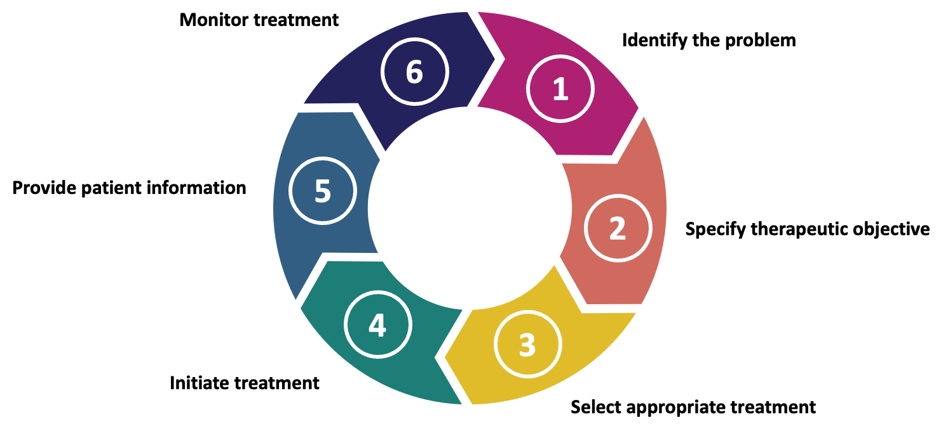

Identify the problem
Identifying a patient’s health problem entails reviewing clinical history, examination and investigation findings to determine whether they are eligible for treatment. This can be based on the available evidence, guideline recommendations and patient characteristics (Thistlethwaite, Ajjawi and Aslani, 2010). Contextual factors at the clinician-level such as their experience with the condition or medication, or system-level such as time pressures or resource availability may influence this step of the prescribing process (Freedman et al., 2021; Vreugdenhil et al., 2023).

Specify therapeutic objective
Specifying the therapeutic objective is the identification of the treatment’s intended outcome which could be to control symptoms, prevent complications or improve quality of life. In modern practice, this step is increasingly informed by shared decision-making whereby clinicians and patients collaboratively agree treatment goals based on the available clinical evidence as well as the preferences and expectations of both clinicians and patients (Krist et al., 2017; Thistlethwaite, Ajjawi and Aslani, 2010).

Select appropriate treatment
Selecting the appropriate treatment involves considering the choice of medication (if there are options), doses, frequency and formulation. Decisions are informed by guidelines, local formularies, drug availability and the wider healthcare team (Davari, Khorasani and Tigabu, 2018). Patient requests for specific medications are becoming increasingly common which can influence the selection of which medication is considered appropriate (Toiviainen, Vuorenkoski and Hemminki, 2005). Outside of these clinical and system factors, sales and marketing by pharmaceutical companies may also be influential at the individual and centre-level (Thistlethwaite, Ajjawi and Aslani, 2010).

Initiate treatment
Initiating treatment involves implementing the prescribing decision by generating the prescription and coordinating with other members of the healthcare team to conduct prescription reviews, ensure appropriate dispensing and support administration. Prescriptions are often electronic and may be supported by clinical decision support systems which can prompt consideration of alternatives or highlight safety issues (Chen et al., 2023). Prescription reviews are typically undertaken by pharmacists or pharmacy technicians to identify safety concerns, potential medication interactions or patients that are not eligible for the prescribed medication. The stringency and thoroughness of this prescription review can influence whether a patient ultimately receives the treatment (Duncan et al., 2019; Khan and Aslani, 2021). Prescriptions can only be dispensed if the medication is available. Geographic and socioeconomic barriers may prevent this, particularly in rural or underserved areas. Stock shortages, restricted access to specialist pharmacies, or changes in supplier can all prevent initiation which may prompt prescribers to select alternatives or defer treatment altogether (Scoggins et al., 2006). Finally, prescribers may hesitate to initiate treatments if safe and reliable administration cannot be guaranteed. This is most often related to medication and patient characteristics (Hartjes et al., 2025).

Provide patient information
Providing patient information is the step in the WHO good prescribing guide that focuses on giving patients clear instructions and warnings to support them to take medications safely and effectively (Pollock, Bazaldua and Dobbie, 2007). However, information is also provided to patients during the specification of therapeutic objectives and selection of appropriate treatment to support their informed and active participation in shared decision-making (Elwyn et al., 2012). In both contexts, providing information is important to ensure patient satisfaction, treatment adherence and outcomes. This information can be given verbally during consultations or non-verbally through written materials. How this information is framed is important for patient understanding and can influence the uptake of medications (Coulter and Ellins, 2007; National Academies of Sciences, 2017).

Monitor treatment
Monitoring includes the evaluation of the effectiveness, safety and patient adherence of a medication through follow-up consultations and laboratory tests. This may lead to dose changes, switching to alternative medications or discontinuation. The need for monitoring may influence whether a medication is prescribed. At the healthcare system level, monitoring requires additional resources that could make initiating a medication unfeasible. In practice, monitoring requirements may also deter patients from starting a medication, as patients may then perceive the medication to be high risk or find attending additional appointments burdensome (Picco et al., 2021).

Describing variation in prescribing practices
As illustrated in Section 2.3.1, prescribing involves multiple steps and decision points, this makes it inherently prone to variation (Davari, Khorasani and Tigabu, 2018). Variation in prescribing practices refers to measurable differences in how clinicians select, dose or monitor medications for the same conditions (Maxwell, 2016). Not all variation is undesirable, as it may reflect appropriate personalisation of care (Atsma, Elwyn and Westert, 2020). Wennberg (2002) describes variation in terms of warranted and unwarranted variation:
- Warranted variation: This is due to the different demographic, socioeconomic or clinical profile of the patients seen by a healthcare provider
- Unwarranted variation: This is unrelated to demographic or any other factors external to the provider and can be linked to non-evidence-based or inefficient clinical practice, management failings or other centre-level factors
The overall goal should be to reduce unwarranted variation, which can reflect gaps in professional knowledge, inconsistency in its application and wider system-level influences, while preserving warranted variation that takes into account patient characteristics and preferences (Mulley, 2010). However, separating warranted from unwarranted variation can be difficult. Andersen and Mooney (1990) encapsulate this dilemma:
“If variations represent evidence of inappropriate care, which care is inappropriate? Are the regions, institutions, or practitioners with high rates over-providing, or are the low ones under-providing, or does the ‘best’ lie somewhere in the middle?”
The determination of whether variation is warranted or unwarranted is highly context-dependent (Sutherland and Levesque, 2020). Even within UK kidney centres, different patient case-mixes, service configurations, specialist expertise, and resource availability have been demonstrated, which may all contribute to variation in practice (Castledine et al., 2013; Doctor, Gale and Chan, 2023; UK Renal Registry, 2025). Variation also depends on what is chosen as the reference point for comparison. Variation could be measured by comparing practices to other hospitals, historical trends in the same service, or evidence-based recommendations in guidelines (Bottle and Kristensen, 2024; Tomson and Van Der Veer, 2013).

Implications of unwarranted variation
Variation in prescribing practices may have implications for patient outcomes, healthcare resource use and health equity. When eligible patients do not receive a medication, this can represent a missed opportunity to improve their health outcomes (Walker et al., 2017). Conversely, prescribing a medication to a patient who is not eligible may expose them to unnecessary risks and potential harm, without an opportunity for any meaningful benefits (Mekonnen et al., 2021). Both scenarios can have economic implications. Untreated eligible patients may incur higher lifetime healthcare costs due to worsening disease or complications, while unnecessary treatment may be considered inefficient use of resources that could be allocated to effective care elsewhere (Nouhi et al., 2019). Variation may also contribute to unequal access to medications which raises concerns for health equity (Harvey et al., 2023).
A wide range of factors have been described as influencing prescribing decisions and contributing to variation in practice (Davari, Khorasani and Tigabu, 2018). Understanding these influences is essential to explain why variation occurs and to minimise unwarranted variation where possible (Sutherland and Levesque, 2020). As demonstrated in Section 2.3.1, prescribing is a complex process. Evidence from studies of clinical behaviour suggests that complex healthcare processes may not be fully understood through descriptive approaches alone. Structured methods are therefore needed to explore the underlying factors that may contribute to variation in practice (Eccles et al., 2012; Michie, Van Stralen and West, 2011).

Conceptual model of prescribing decision-making
A theory is a set of principles that explain a phenomenon and predict how its components behave under different conditions (Glanz, Rimer and Viswanath, 2008). These theories can be used to develop conceptual frameworks or models, terms which are often used interchangeably (Gray and Sockolow, 2016). Conceptual frameworks typically provide a broad structure for organising relevant factors, whereas conceptual models represent a more focused representation of how these factors are thought to interact and influence an outcome (Nilsen, 2020).
In an attempt to understand variation in prescribing practices and the factors influencing prescribing decisions, authors have developed a range of theories and models. These include behavioural theories, implementation frameworks and models of clinical decision-making which tend to address specific aspects of prescribing behaviour rather than providing an integrated account of the factors influencing prescribing.
Murshid and Mohaidin (2017) present one of the few conceptual models for prescribing that combines multiple theoretical perspectives within a single model (Figure 2 and Table 2). Their model highlights the roles of key stakeholders in the prescribing process, including marketing efforts, patients, pharmacists, and contextual factors.
Figure 2. A conceptual model of physician decision-making (Murshid and Mohaidin, 2017)
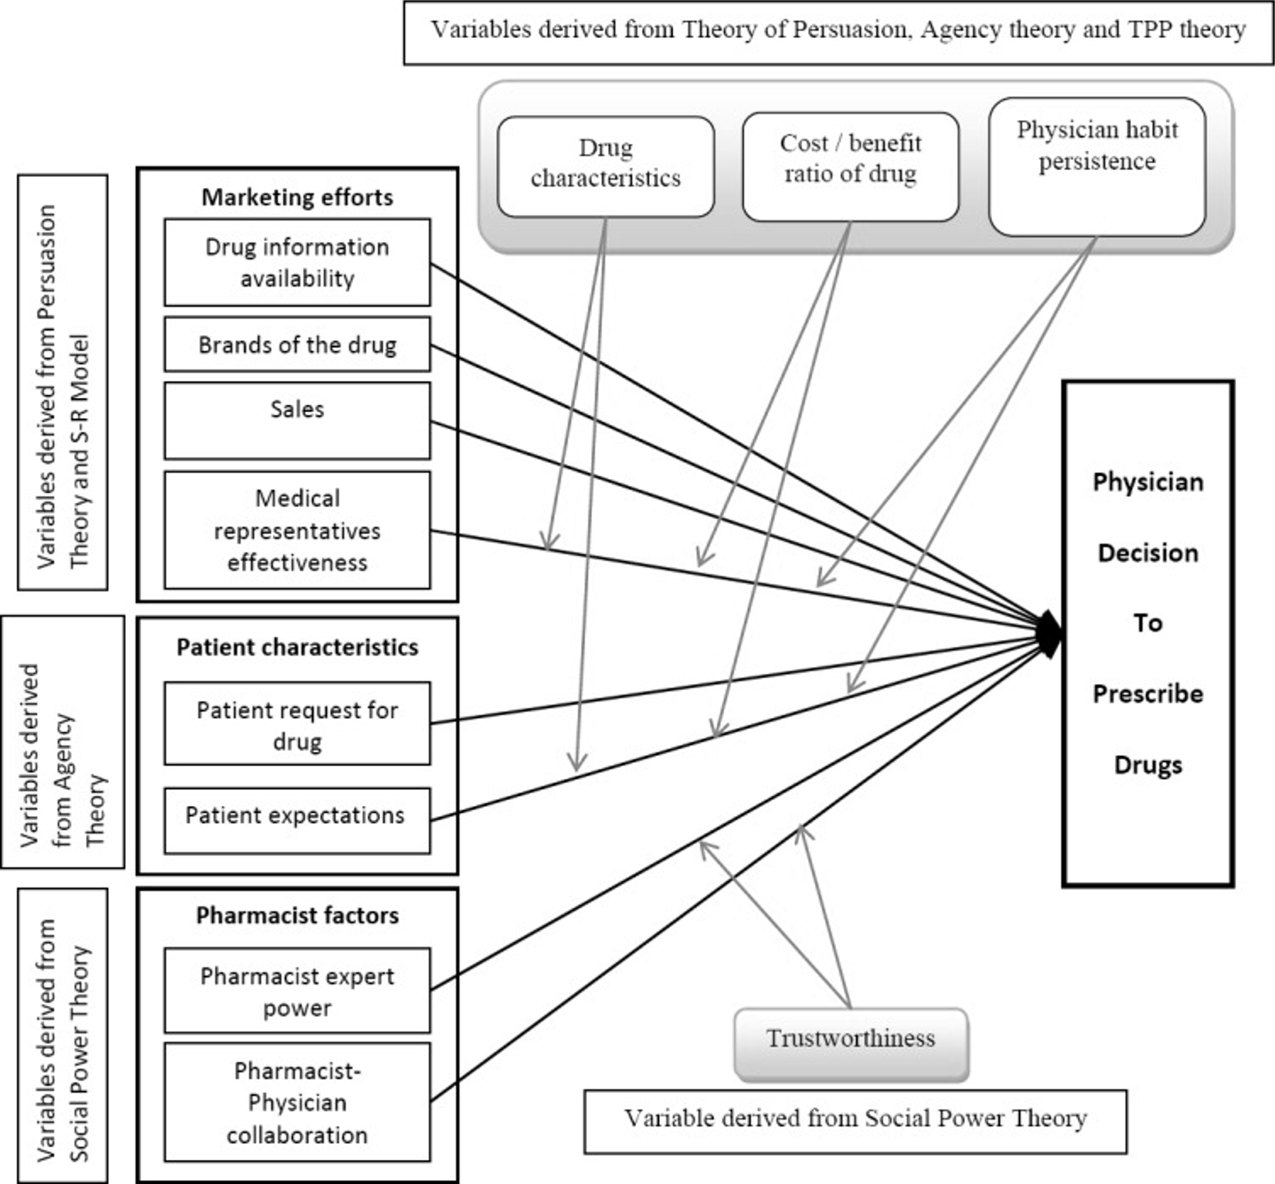

Table 2. Factors influencing physician prescribing behaviour and relation to theory (Murshid and Mohaidin, 2017)
Factor categories | Component | Theory
Marketing efforts | Drug information | Theory of Planned Behaviour Persuasion Theory
Marketing efforts | Brands of the drug | Theory of Planned Behaviour Persuasion Theory
Marketing efforts | Engagement activities | Theory of Planned Behaviour Persuasion Theory
Marketing efforts | Medical representative effectiveness | Theory of Planned Behaviour Persuasion Theory
Patient characteristics | Patient request for drug | Agency Theory
Patient characteristics | Patient expectations | Agency Theory
Pharmacist factors | Pharmacist-physician collaboration | Social Power Theory
Pharmacist factors | Pharmacist expert power | Social Power Theory
Contextual factors | Trustworthiness | Social Power Theory
Contextual factors | Physician habit persistence | Theory of Planned Behaviour
Contextual factors | Cost-benefit ratio of a drug | Theory of Planned Behaviour
Contextual factors | Drug characteristics | Theory of Planned Behaviour

The conceptual model proposed by Murshid and Mohaidin (2017) was selected to inform data collection and analysis across the phases in this programme of research as it incorporates a broad range of factors that can influence prescribing decision-making. Earlier models tended to focus on isolated factors influencing prescribing decisions and were physician-focused (Hemminki, 1975; Knapp and Oeltjen, 1972; Kyle, Nissen and Tett, 2008).
Murshid and Mohaidin (2017) present a model that extends the range of stakeholders involved in the prescribing process. Within their model, pharmacists are described as having their own expert power, whereas earlier models frequently omitted them or positioned them primarily as dispensers (Gallan, 2004; Raisch, 1990; Singh, 2008). It also incorporates patients as influential in decision-making, although patient autonomy and shared decision-making are not included (Sandman and Munthe, 2009). However, the prescribing authority ultimately remains with physicians, who are described as the final decision-makers. This could be considered exclusionary in modern healthcare, as prescribing responsibilities are increasingly shared or independently undertaken by other members of the healthcare team (Deslandes et al., 2022).
There are some important limitations to consider when using conceptual models. They may oversimplify complex clinical practices, be overly generic and omit contextual factors, or be highly context-specific which limits their application beyond the original setting (Príncipe et al., 2023). The majority of research into prescribing decision-making has been conducted within primary care with a focus on acute conditions such as infections and short-term pain (Little et al., 2004; Tonkin-Crine, Yardley and Little, 2011). As a result, theories, models and frameworks developed from this evidence base may not fully reflect decision-making processes in other clinical contexts.

Prescribing in acute versus chronic contexts
How prescribing decisions are made depends on the clinical context, with prescribing for acute and chronic conditions representing two common scenarios. Key differences are summarised in Table 3 and discussed further below.
Table 3. Comparison of prescribing in acute and chronic conditions
Feature | Acute conditions | Chronic conditions
Example | Antibiotics in infections | Antihypertensives in hypertension
Purpose | Curative or immediate symptom relief | Slow disease progression, reduce long-term complications or improve quality of life
Risk vs benefit | Immediate risk often outweighs potential harm | Benefits often delayed and not certain; risks more apparent
Decision-making context | Urgent decisions | Less urgent decisions; potential for clinical inertia
Shared decision-making | Less opportunities for patient involvement; patient requests | Greater patient involvement; adherence priority
Feedback/Reassessment | Effects apparent quickly; early indication if modification needed | Slow or no feedback

When prescribing for acute conditions, the intention is typically curative or to provide immediate relief through a targeted short-term medication. An example of this is the prescribing of antibiotics to treat an acute infection (Poluektova et al., 2023). The immediate risk of clinical deterioration without treatment often outweighs the potential harms of a medication, encouraging initiation even when clinical information is incomplete (Pandolfo et al., 2022). The effects of medications are often apparent quickly which provides immediate feedback to enable timely reassessment and modification of the treatment regimen if required (Rawson et al., 2016). Decisions are often made in time-pressured environments with high workloads so clinicians often rely on ‘rules of thumb’, clinical guidelines or empiric protocols (Charani et al., 2011; Rawson et al., 2016). The urgency of decision-making in this context means that opportunities for formal shared decision-making can often be limited. Limited time can also increase the influence of patient requests as clinicians may be more likely to initiate a medication to avoid prolonged negotiation, even if the clinical benefit is uncertain (Coenen et al., 2006).
In contrast, when prescribing for chronic conditions, the intention is often to slow disease progression, reduce the risk of future complications, and improve long-term outcomes or quality of life (Department of Health and Social Care, 2012). The benefits of medications for chronic conditions are often less certain and realised over years rather than days, whereas risks are much more apparent (Fried et al., 2014). This is in part because these prescribing decisions frequently occur in the context of multimorbidity and polypharmacy which increase the cumulative risk when prescribing medications (Fried et al., 2014; Nicholson et al., 2024). These factors can combine to reduce the perceived urgency to initiate a medication and contribute to clinical inertia which can be described as the “recognition of a problem, but failure to act” (Phillips et al., 2001). An example in nephrology would be recognising that a patient has progressive chronic kidney disease and indications for treatment initiation (e.g. renal-angiotensin system blockade), but the prescription of an appropriate medication is either delayed or not undertaken. This effect may be amplified when evidence is limited, implementation is complex or there are high-intensity monitoring requirements (Mair and May, 2014). It also tends to involve more shared decision-making than prescribing for acute conditions with patient perspectives and expectations being more actively considered, given the need for long-term adherence to achieve treatment benefits (Ward et al., 2020).
These differences suggest that theories and conceptual models of prescribing developed in general or based on acute conditions may not fully take into account the factors influencing prescribing for chronic conditions.

Rare diseases add an additional layer of complexity in prescribing
As discussed in Section 2.2, rare diseases are a diverse group of typically chronic conditions that can introduce additional challenges for prescribing due to their low prevalence, disease heterogeneity, and limited evidence base. Clinicians often have less experience managing these conditions which increases uncertainty and can contribute to greater variation in prescribing practices (Phillips et al., 2024). Prescribing decisions in rare diseases are particularly high-stakes due to potential clinical and economic consequences (López-Bastida et al., 2016). They are considered to impose a greater burden on patients leading to worse health-related quality of life than for many common conditions (Delaye, Cacciatore and Kole, 2022). Where effective medications exist, evidence shows they can significantly reduce this burden and improve outcomes. Examples of this include cystic fibrosis (Dwight and Marshall, 2021), cardiac amyloidosis (Prata et al., 2025) and motor neurone disease (Armengol et al., 2024). Although rare disease medications are used by relatively few patients, they account for a significant proportion of healthcare expenditure. This is estimated at approximately 7% of total pharmaceutical expenditure in Europe (Mestre-Ferrandiz et al., 2019) and 11% in the United States (IQVIA Institute, 2020).
Despite these potential consequences, there appears to be no established theories or conceptual models that comprehensively explain how prescribing decisions are made for rare diseases. Most existing studies focus on single stakeholders, isolated stages of the prescribing process or extrapolate from conditions that do not reflect the complexity and uncertainty associated with rare diseases (Yoon et al., 2023). A targeted literature search was conducted in MEDLINE (Ovid) to identify literature relevant to prescribing decision-making in rare diseases using Medical Subject Headings (MeSH terms) for Rare Diseases and the top five rare diseases with the highest number of industry projects in the UK between 2016 and 2021 and ADPKD (Bainbridge, 2023). The search strategy is included in the additional details on the methods for the systematic review. This identified only two potential studies for inclusion, with one on the factors influencing symptom management decisions in cystic fibrosis and another on the influence of pharmaceutical company engagement activities on the decision to prescribe rare disease medications in general. Given the limited evidence base identified, there is a need to use a rare disease as a case through which to explore prescribing decision-making in this context.

ADPKD as a case to explore factors influencing prescribing decisions in rare diseases

Overview of ADPKD

Epidemiology
Autosomal dominant polycystic kidney disease (ADPKD) is the most common inherited kidney disease, affecting over 12 million people worldwide (Chebib et al., 2023) and up to 70,000 in the UK (NHS, 2023). It has an estimated worldwide prevalence of 2.7 in 10,000 people (0.72 in 2,000) (Solazzo et al., 2018) and therefore meets the European Commission’s definition of a rare disease (European Commission, 2020). It is the fourth leading cause of kidney failure worldwide and accounts for 5–10% of patients receiving kidney replacement therapy (Chapman et al., 2015; Cornec-Le Gall, Alam and Perrone, 2019).

Genetics and heterogeneity
ADPKD has an autosomal dominant pattern of inheritance and is characterised by high penetrance but variable phenotypic expression. This means that the condition is passed down through families but the presentation and disease severity can vary both between families (interfamilial) and within families (intrafamilial). This reflects the complex interplay of genetic, epigenetic and environmental factors (Lanktree et al., 2019). Approximately 70–85% of individuals with a clinical diagnosis have an identifiable pathogenic variant on genetic testing. Among genetically confirmed cases, most are caused by pathogenic variants in PKD1 (encoding polycystin 1) and PKD2 (encoding polycystin 2), accounting for approximately 75–80% and 15–20%, respectively. PKD1-related disease is typically earlier in onset and more severe. Rare variants in other “minor” genes, including GANAB, DNAJB11 and IFT140, amongst others, account for a small number of cases (approximately 1–3%) and are often associated with milder or atypical disease (Lanktree et al., 2021).

Pathophysiology
The polycystin proteins encoded by the PKD genes form a signalling complex that is most prominently located in the primary cilia of renal tubular epithelial cells. The main functions of this complex are the detection of fluid flow in renal tubules, regulation of intracellular calcium signalling, maintenance of normal tubular architecture and balancing of cell proliferation. Pathogenic variants in the polycystic kidney genes disrupt the normal polycystin pathway which reduces intracellular calcium, increases cyclic adenosine monophosphate (cAMP) levels and activates protein kinase A (Ong and Harris, 2005). These changes lead to cellular proliferation, fluid secretion and fibrosis, which collectively lead to the progressive development of cysts in the renal tubule and the destruction of non-cystic kidney tissue (Harris and Torres, 2014).

Diagnosis
ADPKD is usually diagnosed between the ages of 30 and 50, when symptoms and signs start to appear. A clinical diagnosis of ADPKD is usually made based on age-dependent ultrasound imaging criteria which is particularly challenging in those with atypical clinical features, without family history or younger age (Pei et al., 2009). Genomic testing is increasingly being recognised as an important alternative as it can offer earlier and more accurate detection than imaging alone (Harnan et al., 2025). It also provides valuable information for prognosis and family planning, as well as helping to guide clinical management and the screening of relatives (Pei and Watnick, 2010).

Clinical features
ADPKD presents with a wide range of renal and extrarenal manifestations. Kidney cyst formation and enlargement can lead to abdominal pain, distension, haematuria, recurrent urinary tract infections and kidney stones (Ong et al., 2026). The structural changes associated with the disease lead to a gradual decline in kidney function over time in most cases, with around 50% of people requiring kidney replacement therapy through dialysis or transplantation by the age of 60 (Higashihara et al., 1998). In addition to kidney involvement, people with ADPKD may also have a combination of extrarenal manifestations such as liver cysts, intracranial aneurysms and valvular dysfunction (Cornec-Le Gall, Alam and Perrone, 2019). ADPKD is recognised to have a significant impact on quality of life due to the chronic pain, fatigue, psychological distress and functional limitations that are experienced by people living with the condition (Gittus, Harris and Ong, 2023; Gittus et al., 2026).

Markers of disease progression
As ADPKD exhibits significant variability in disease progression, there is a need for reliable and predictive markers to guide management. Age-indexed estimated glomerular filtration rate (eGFR) and rate of decline (eGFR slope) are commonly used to assess and predict loss in kidney function. However, significant kidney enlargement often precedes any decline in eGFR by years or even decades. This limits the utility of eGFR-based markers for early risk stratification (Chebib and Torres, 2021). As a result, other indicators of disease progression have been developed. These include kidney length which can be measured by ultrasound and total kidney volume (TKV) measured by magnetic resonance imaging (MRI). More recently, risk stratification tools have been developed to better predict disease progression (Bhutani et al., 2015). These include the Mayo Imaging Classification (MIC) and the Predicting Renal Outcome in Polycystic Kidney Disease (PROPKD) score. The MIC predicts disease progression based on their height-adjusted TKV and age (Irazabal et al., 2015), whereas the PROPKD score integrates genetic and clinical factors (Cornec-Le Gall et al., 2016).

Service configuration
In the UK, ADPKD care is primarily delivered within secondary care through local kidney centres in NHS hospital trusts or regional boards. Outpatient care for ADPKD is typically structured as a condition-specific or generalist clinic model. A condition-specific clinic model involves all, or the majority, of people with ADPKD being followed up within a single dedicated clinic, such as an ADPKD or renal genetics clinic. In this context, the renal genetics clinic functions as a condition-specific clinic due to the predominance of ADPKD patients within their caseloads. By contrast, the generalist clinic model involves people with ADPKD being seen across multiple general nephrology clinics alongside patients with a wide range of kidney conditions. In some areas, these general nephrology clinics can refer complex patients or those requiring specialist treatment to specialist ADPKD clinics at other NHS trusts within their region, often described as a hub-and-spoke model (NHS England, 2017).

Management
There is currently no cure for ADPKD. For many years, the management of ADPKD had focused on controlling symptoms and complications such as high blood pressure, pain, urinary tract infections and cyst haemorrhage/infections (Ong et al., 2026). The combination of a high symptom burden and kidney failure in most cases underpinned efforts to develop medications to slow disease progression. Tolvaptan was the first disease-modifying therapy available for the management of ADPKD and remains the only licensed medication of this type for this rare disease (Torres et al., 2012).

Tolvaptan for ADPKD: From mechanism of action to clinical use
Tolvaptan represented a major shift away from purely supportive management towards targeting the underlying disease process in ADPKD. In the UK, it was approved by the National Institute for Health and Care Excellence in 2015 for adults with ADPKD and evidence of rapidly progressive disease (National Institute for Health and Care Excellence, 2015b). Its approval was accompanied by requirements that initiation and monitoring be restricted to kidney centres in secondary care due to its adverse effects and safety profile (Ong et al., 2015).

Mechanism of action
Unlike traditional diuretics, tolvaptan acts as an aquaretic facilitating the excretion of free water without losing electrolytes by selectively inhibiting the vasopressin 2 (V2) receptor (Schrier et al., 2006). Early clinical uses were to correct hyponatraemia (low sodium) and reduce fluid overload in people with congestive heart failure, liver cirrhosis and the syndrome of inappropriate antidiuretic hormone (SIADH) (British National Formulary, 2026).

Clinical trials
Pre-clinical trials in animal models suggested that tolvaptan may also have a role in slowing kidney cyst growth in ADPKD. This effect occurs through V2 receptor blockade which reduces vasopressin-stimulated cAMP thought to drive the proliferation of cyst cells and fluid accumulation. This led to the evaluation of tolvaptan’s effectiveness in the management of ADPKD in clinical trials (Gattone et al., 2003). Early evaluation in the Tolvaptan Efficacy and Safety in Management of Polycystic Kidney Disease and its Outcomes (TEMPO) 2:4 trial established safe regimes and reported slower cyst growth in those who received tolvaptan. These findings were confirmed in the TEMPO 3:4 trial which showed a reduction in TKV as well as a slower decline in estimated glomerular filtration rate (eGFR) in early-stage disease. In the Replicating Evidence of Preserved Renal Function (REPRISE) trial, it was shown that kidney function could be preserved in some patients with more advanced kidney disease. Post-hoc analyses also identified an association between tolvaptan and reduced patient-reported kidney pain (Casteleijn et al., 2017). These clinical trials were the main evidence base used in the regulatory licensing and approval of tolvaptan. Since its approval, many guidelines have been developed and updated to support clinicians when making prescribing decisions in clinical practice (Figure 3).
Figure 3. Timeline of ADPKD and tolvaptan events
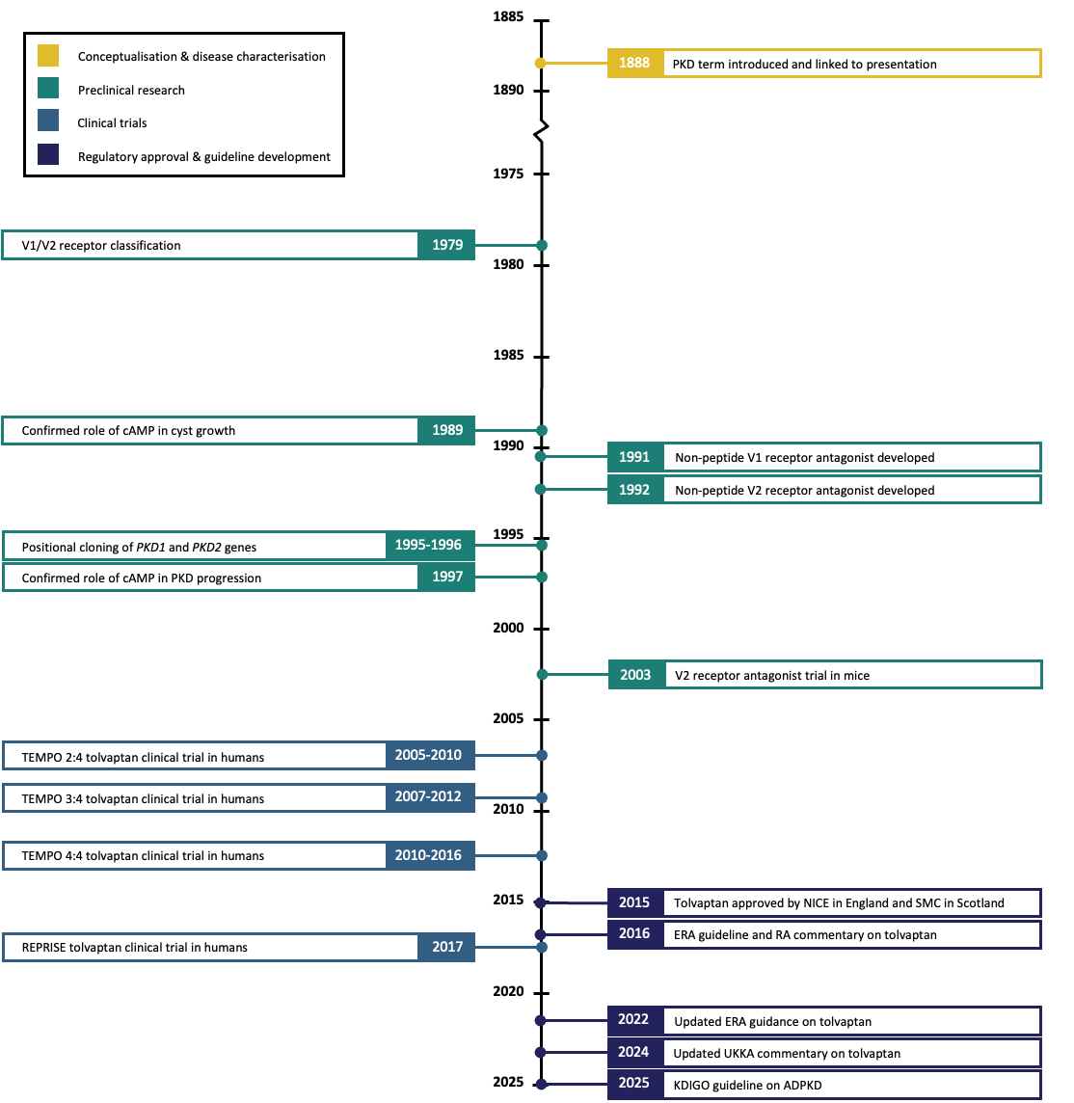
Autosomal Dominant Polycystic Kidney Disease (ADPKD), Cyclic Adenosine Monophosphate (cAMP), European Renal Association (ERA), Kidney Disease: Improving Global Outcomes (KDIGO), Polycystic Kidney Disease (PKD) Renal Association (RA), Replicating Evidence of Preserved Renal Function (REPRISE), Tolvaptan Efficacy and safety in Management of Polycystic kidney disease and its Outcomes (TEMPO), United Kingdom Kidney Association (UKKA), Vasopressin 1 (V1), Vasopressin 2 (V2)

Adverse effects and monitoring
The most frequently reported adverse effects of tolvaptan are increased thirst, dry mouth, polyuria and dehydration. Some patients report significant polyuria, producing up to eight litres of urine per day (Bellos, 2021; Müller et al., 2022). This is frequently cited as the main reason for discontinuation (Naranjo et al., 2022; Rao et al., 2025). Another rare but important adverse effect that was identified by the clinical trials was drug-induced liver injury. This led regulatory authorities, including the Medicines and Healthcare products Regulatory Agency (MHRA) in the UK, to mandate liver function monitoring when taking tolvaptan. This is monthly for the first 18 months and then every three months thereafter (Medicines and Healthcare products Regulatory Agency, 2014).

Regulatory licensing and commissioning policies
Tolvaptan is currently the only disease-modifying therapy that has been licensed for the management of ADPKD. As of August 2024, it has been granted marketing authorisation in over 43 countries including Australia, Canada, the European Union, Hong Kong, Indonesia, Japan, Korea, New Zealand, Norway, Switzerland, Taiwan, Turkey, the United Kingdom (UK) and the United States (Otsuka Pharmaceutical Co. Ltd, 2024).
In the UK, tolvaptan was first marketed by Otsuka Pharmaceuticals as Jinarc® under a controlled distribution agreement due to the risk of liver injury (Medicines and Healthcare products Regulatory Agency, 2014). Before tolvaptan could be prescribed to patients in kidney centres, clinicians were required to complete an online training programme that was provided by the pharmaceutical company. The controlled distribution agreement was discontinued in 2022 as monitoring for liver injury was believed to have become standard practice, which meant training was no longer mandated (The Prescription Medicines Code of Practice Authority, 2024). In January 2024, Teva UK received approval from the MHRA to market a generic version of tolvaptan. Thus, kidney centres may now use the Otsuka Pharmaceuticals branded Jinarc® or the generic version of tolvaptan from Teva UK.
The funding of tolvaptan is different in England than the other three nations in the UK. In England, tolvaptan is funded nationally through the high-cost drugs commissioning policy which requires local hospital trusts (organisational units within NHS England) to purchase the medication up-front through their pharmacy budgets. When tolvaptan has been prescribed to a patient, the hospital trusts then claim the cost back from NHS England. In the other three nations, funding is centralised and comes from the regional NHS boards in Scotland and Wales, and Health and Social Care boards in Northern Ireland. Thus, the clinician and hospitals do not take direct financial responsibility for the medication in these regions.

Guidelines for tolvaptan
Following health technology appraisals, the National Institute for Health and Care Excellence (NICE), which provides guidance on the use of medications in the NHS England, and the Scottish Medicines Consortium (SMC), the equivalent body for NHS Scotland, issued recommendations on how tolvaptan should be used in clinical practice (National Institute for Health and Care Excellence, 2015b; Scottish Medicines Consortium, 2016). Both organisations recommended tolvaptan be used for people with a confirmed diagnosis of ADPKD and “rapidly progressing disease”. Prescribing and monitoring were restricted to clinicians with expertise in managing people with ADPKD in the secondary care setting. This guidance is included below:
NICE (England & Wales) – TA458 (National Institute for Health and Care Excellence, 2015b):
Tolvaptan is recommended as an option for treating autosomal dominant polycystic kidney disease in adults to slow the progression of cyst development and renal insufficiency only if:
- there is evidence of rapidly progressing disease
- they have chronic kidney disease stage 2 or 3 at the start of treatment
SMC (Scotland) – SMC No. 1114/15 (Scottish Medicines Consortium, 2016)
To slow the progression of cyst development and renal insufficiency of autosomal dominant polycystic kidney disease (ADPKD) in adults with chronic kidney disease stage 1 to 3 at the initiation of treatment with evidence of rapidly progressing disease.

The Renal Association (RA), now known as the United Kingdom Kidney Association (UKKA), is a professional organisation for kidney care in the UK that issues clinical guidelines and best-practice recommendations for the management of kidney diseases. In 2016, they issued recommendations in a commentary on the NICE guidelines that outlined eligibility criteria and defined “rapidly progressing disease” based on the following criteria (Renal Association, 2016):
- At the initiation of treatment, patients should be aged over 18 years
- Eligible patients should have an established diagnosis of ADPKD and CKD stage 2-3 in England and Wales (eGFR 30-89 ml/min/1.73m²) or stage 1-3 in Scotland (eGFR ≥30 ml/min/1.73m²)
- Evidence of rapid disease progression
  - A sustained decline in eGFR of ≥2.5 ml/min/1.73m² per year (5 results over 5 years)
  - A sustained decline in eGFR of ≥5 ml/min/1.73m² over 1 year
  - An increase in TKV of ≥5% per year measured on 3 consecutive imaging scans
- Evidence of risk of progression
  - MIC 1C-E
  - PROPKD score >6
Many other organisations worldwide have provided recommendations for the use of tolvaptan in the management of ADPKD, including those in Japan (Advisory Committee for Progressive Kidney Diseases, 2014), Europe (Gansevoort et al., 2016; Müller et al., 2022), Canada (Soroka et al., 2017), and Australia and New Zealand (Tunnicliffe, 2023). Some kidney centres providing care for people with ADPKD in the secondary care setting within the UK have also produced their own local guidelines. In 2024, the commentary was updated (Gittus et al., 2025a).

Rationale for using ADPKD as a case in rare diseases
The use of a single condition as a model to explore broader clinical and system issues is well recognised in health services research. Conditions such as chronic obstructive pulmonary disease (McKee et al., 2020) and type 2 diabetes mellitus (Timpel et al., 2020) are frequently used as cases for chronic conditions. This approach has also been applied in more specialised areas such as Parkinson’s disease, where it has been used to illustrate how integrated care strategies for one chronic neurological disorder can generate insights that are transferable to other chronic neurological conditions (Bloem et al., 2020). This supports the use of ADPKD in this thesis as a case to explore broader issues in prescribing decision-making and variation in practice for rare diseases in general.
ADPKD was selected as the case in this programme of research based on its disease characteristics, the availability of an approved disease-modifying therapy with published guidelines, established data infrastructure, research team expertise and evidence suggesting variation in practice.
First, ADPKD is a relatively common rare disease with an estimated prevalence of 0.72 in 2,000 people (Solazzo et al., 2018). While it meets the definition of a rare disease and shares many of the associated challenges, its greater prevalence means that research is more feasible than in less prevalent or ‘ultra-rare’ diseases (Gunes et al., 2025). This increases the likelihood of achieving adequate sample sizes and statistical power in quantitative analyses which is a common challenge in rare disease research (Stoller, 2018; Taruscio and Gahl, 2024). ADPKD can arise from pathogenic variants in multiple genes which contribute to variability in disease severity and progression. This introduces some uncertainty when determining prognosis and adds complexity to the decision-making process, particularly in relation to risk-benefit assessments for new medications (Woodward et al., 2022). These features make ADPKD a useful case for studying prescribing decision-making under uncertainty.
Second, tolvaptan is the only approved disease-modifying therapy which focuses clinical decision-making on eligibility for a single treatment. National guidelines are available that can be used as a benchmark for prescribing decisions, against which variation in prescribing practices between centres can be assessed. In England, NHS trusts are legally required to make medications recommended by NICE available within three months of publication (National Institute for Health and Care Excellence, 2023). Although the other three nations do not have any mandates, in Scotland, it is advised that recommended medications should be routinely available (The Scottish Government, 2012). As a result, eligible people with ADPKD in the UK should all have access to tolvaptan in principle.
Third, there is an existing national registry, the National Registry for Rare Kidney Diseases (RaDaR), that collects routine data on people with rare kidney conditions from kidney centres across the UK (UK Kidney Association, 2022). This makes conducting data analysis more feasible as data is centralised and readily available.
Fourth, the selection of ADPKD was also informed by my clinical experience and academic interests as discussed in Section 1.4. This was supported by the wider research team’s established expertise in ADPKD and variation in practice, alongside experience in analysing large routinely collected datasets. These factors further enhanced the feasibility of conducting robust research in this area.
Finally, there is a suggestion that variation in tolvaptan prescribing for ADPKD may exist. Chong, Harris and Ong (2022) reported a four-fold difference in the per-capita number of tolvaptan prescriptions across integrated care boards in the UK using NHS Digital data. It is important to note that this did not distinguish tolvaptan use for ADPKD from other indications, such as heart failure or SIADH. In Japan, Inoue et al. (2020) also reported regional variation with some prefectures (administrative jurisdictions) prescribing up to 21 times more tolvaptan than others. While useful for describing broad trends in tolvaptan prescribing, they do not explain how or why such variation occurs in clinical practice at the kidney centre level. This highlights an important gap in the evidence base and further supports the use of ADPKD as a case in which to examine variation in prescribing practices.

Research gap
Rare diseases are characterised by low prevalence, disease heterogeneity and often limited evidence which can reduce clinician experience and increase uncertainty in clinical decision-making (Phillips et al., 2024). Current understanding of factors influencing prescribing decision-making is largely derived from studies of acute conditions which may not take into account the complexity in other contexts, such as chronic conditions and rare diseases (Little et al., 2004; Tonkin-Crine, Yardley and Little, 2011). This understanding is important as these factors may contribute to variation in prescribing practices (Eccles et al., 2012; Michie, Van Stralen and West, 2011). Previous research has described variation in the prescribing of medications for rare diseases, such as tolvaptan for ADPKD, but has given limited attention to the underlying factors (Chong, Harris and Ong, 2022; Inoue et al., 2020). Thus, there is an evidence gap not only in understanding how tolvaptan is prescribed for ADPKD, but also in the current understanding of the factors influencing prescribing decisions for rare diseases in general. Addressing this gap requires the quantification of variation in tolvaptan prescribing for ADPKD and an improved understanding of the underlying decision-making processes.

Chapter summary
- This chapter has set out the conceptual and contextual foundations for examining prescribing decision-making in rare diseases and positions ADPKD as a suitable case.
- Rare diseases are a diverse group of conditions characterised by their low prevalence. They often share challenges including diagnostic uncertainty, disease heterogeneity and limited evidence bases. These factors can contribute to variation in clinical management and decision-making in practice.
- Prescribing is a complex multi-stage process that is highly context-dependent and shaped by many interacting patient, clinician, organisational and system-level influences. Variation in prescribing is common in clinical practice, especially in contexts with high levels of uncertainty or complexity, such as rare diseases.
- Existing conceptual models of prescribing have largely been developed in acute care settings, so they may not fully explain the complexity of decision-making in chronic conditions or rare diseases.
- ADPKD is a relatively common rare disease associated with significant clinical and psychosocial consequences. Tolvaptan is the sole disease-modifying therapy available for people with ADPKD to slow the growth of kidney cysts and kidney disease progression. Guidelines are available to support clinical decision-making but existing research suggests there may be variation in prescribing practices.
- Overall, ADPKD provides a suitable case for examining variation in prescribing and the mechanisms underlying decision-making in rare disease contexts.

– Methodology

Chapter outline
This chapter provides an overview of the methodology used in this programme of research. The chapter starts with the research question, aims and objectives. It is followed by a discussion of the research paradigm informing this research and a rationale for adopting a mixed methods design. The methodology for each phase are then presented sequentially. The methods used in each of the phases can be found in the individual journal articles (Chapters 4-8). Given the word count limitations of the journal articles prepared for publication, additional details in the methods can be found in the associated appendices. Ethical considerations and patient and public involvement (PPI) are included at the end of the chapter.

Research question, aims and objectives
The primary research question was:
“Is there variation in the prescribing of tolvaptan for adults with ADPKD across UK kidney centres and what factors explain any observed variation?”
The aims of this thesis were to examine variation in tolvaptan prescribing across UK kidney centres and to develop an explanatory account of the factors shaping this variation.
The five objectives were:
- To develop a conceptual model of prescribing decision-making in chronic conditions
- To quantify current variation in tolvaptan prescribing practices between UK kidney centres when compared to guidance from the National Institute for Health and Care Excellence (NICE) and the Renal Association (RA)
- To identify variation between kidney centres in the implementation of tolvaptan care pathways
- To identify the factors influencing healthcare professionals’ decisions to initiate tolvaptan at kidney centres
- To develop a conceptual model of prescribing decision-making in rare diseases

Methodology

Research paradigm
Research questions and the methods used to answer them are informed and influenced by their underlying philosophical perspectives. These perspectives, or paradigms, serve as a lens through which the researcher views the world. Within each paradigm are underlying philosophical assumptions of ontology (nature of reality), epistemology (nature of knowledge), axiology (role of values) and methodology (approach to inquiry) (Pretorius, 2024). Making these assumptions explicit strengthens the clarity of the research design and influences methodological choices (Giles and Harrison, 2023).
The paradigm adopted in this programme of research was critical realism. Critical realism asserts that an objective reality exists independently of human observation, but that a researcher’s understanding of it is always shaped by social, historical, and cultural contexts, as well as by the methods used to study it (Archer et al., 1999). This means knowledge is fallible and inherently incomplete, such that research involves inferring the mechanisms that generate observable events rather than relying on observations alone (Bhaskar, 2013). Critical realism also acknowledges that research is value-laden, in that values and prior experiences shape the selection of research questions, analytical decisions and interpretation of findings (Sayer, 1999).
Reality in critical realism is stratified into three levels (Fletcher, 2017):
- Empirical: what a researcher can observe or experience, akin to the visible part of an iceberg
- Actual: events that occur regardless of whether they are observed, lying just below the surface
- Real: the underlying structures and mechanisms that generate those events that are not directly observable
Within this paradigm, variation in tolvaptan prescribing can be understood across these three levels of reality. Observable prescribing patterns represent the empirical level, while prescribing decisions and events occurring in clinical settings, whether observed or not, sit within the actual level. The underlying mechanisms driving this variation, such as clinician reasoning and organisational influences, exist at the real level and are not directly observable, but are inferred from clinicians’ accounts, behaviours and observed prescribing patterns (ontology).
While critical realism does not dictate specific methods to generate knowledge, it suggests that answering the research question in this thesis requires approaches capable of identifying both observable prescribing patterns and the underlying mechanisms (Stutchbury, 2022). The knowledge generated in this programme of research consists of quantitative prescribing data and qualitative accounts through which inferences about the mechanisms leading to variation in prescribing practices of tolvaptan can be developed (epistemology).
The focus of this programme of research was informed by my clinical and professional experience, which recognises variation in tolvaptan prescribing as an important issue due to its implications for the consistency of care and potential for unwarranted variation in clinical practice (axiology).

Mixed methods research
Research typically adopts a quantitative, qualitative or mixed methods study design depending on the research question being addressed. Quantitative research uses numerical data and statistical analysis to identify patterns, trends or outcomes (Watson, 2015). Qualitative research gathers participants’ opinions, attitudes and lived experiences (Lim, 2025).
Mixed methods research combines these approaches within a single programme of research. It generally includes at least one quantitative method with structured data collection and statistical analysis, alongside at least one qualitative method with semi-structured or unstructured data collection and thematic analysis (O'Cathain, Murphy and Nicholl, 2007). By integrating these two approaches, mixed methods research includes both the measurable outcomes and underlying mechanisms to provide a more comprehensive understanding of complex phenomena than either method alone (Creswell and Plano Clark, 2017).
Applied health research has historically relied on quantitative research methods. Over the last three decades, there has been a marked increase in mixed methods research reflecting a growing recognition that quantitative data alone cannot fully address the complexity of health services (O'Cathain, Murphy and Nicholl, 2007). It usually focuses on primary research and does not include secondary research such as systematic reviews. However, there is no reason why it cannot include a systematic review and so the overview of systematic reviews is included here alongside the primary research methods, comprising of the analysis of routine data, multiple case study and survey. The following sections present a rationale for the mixed methods approach and describe the study design according to the Good Reporting of A Mixed Methods Study (GRAMMS) checklist (O’Cathain, Murphy and Nicholl, 2008).

Rationale for the mixed methods approach
Mixed methods approaches are common in applied health research because they allow researchers to address the complexity of healthcare delivery and engage with a broader set of questions than quantitative or qualitative methods alone (Curry et al., 2013). Specific reasons for adopting a mixed methods approach can include explanation (qualitative data explains qualitative findings), interpretation (one helps interpret the other without assigning causality), exploration (qualitative cases explore quantitative patterns), sampling (quantitative data informs selection of qualitative participants), development (one method informs the design of tools, instruments or hypotheses for the other), and triangulation (agreement or complementarity of findings is sought by combining methods) (O'Cathain, Murphy and Nicholl, 2007). It can also be used to address two linked, but equally important, research questions (O'Cathain and Thomas, 2006).
A mixed methods approach was required to address the aims of this research, which were to examine the extent of the variation in tolvaptan prescribing across kidney centres in the UK and explore the underlying factors contributing to this variation. These aims would be difficult to achieve using quantitative or qualitative approaches alone.

A description of the mixed methods design used in this programme of research
When conceptualising mixed methods research designs, there are some important considerations: (i) the order of the quantitative and qualitative components (sequential, concurrent or multiphase), (ii) which component is implemented first, (iii) the priority given to each component, and (iv) the phase of integration. These combinations are summarised in Table 4 (Creswell and Plano Clark, 2017).
Table 4. Mixed methods design types, adapted from (Creswell and Plano Clark, 2017)
Order | Implementation | Priority | Phase of integration
Sequential designs
Explanatory | Quantitative first | Usually quantitative | Interpretation
Exploratory | Qualitative first | Usually qualitative | Interpretation
Transformative | Either approach first | Any priority | Interpretation
Concurrent designs
Triangulation | Concurrent | Preferably equal | Interpretation or analysis
Nested | Concurrent | Any priority | Analysis
Transformative | Concurrent | Any priority or equal | Usually analysis
Multiphase designs
> 2 phases | Sequential or concurrent | Usually equal | Usually analysis

The design used for the programme of research, of which this thesis is a part
As stated in Chapter 1, this thesis is part of a wider programme of research for a THIS Institute Doctoral Fellowship. The mixed-methods design for the primary research had a qualitative residual analysis (QRA) approach. This is a sequential multiphase design, in which both components have equal priority and integration occurs during the interpretation phase. It was originally described by Fry, Chantavanich and Chantavanich (1981) as ‘ethnographic residual analysis’ in which quantitative results are used to identify cases that deviate from expected outcomes (large residuals) that are then explored through ethnography. In this context, ethnography is a qualitative research method in which researchers study a group of people by observing and (sometimes) participating in their environment (Symbaluk and Hall, 2024). However, ethnography is not always used in QRA and other methods such as interviews, focus groups, observations or document analysis may be undertaken, either on their own or as part of a multiple case study design (Onwuegbuzie, Leech and Collins, 2008). QRA has been used within healthcare research, particularly in the context of emergency medicine and trauma care studies in the UK (Mason et al., 2006; O’Cathain et al., 2013; Sammy, 2019). For example, O'Cathain et al. (2014) and Sammy (2019) used a QRA approach to identify factors influencing avoidable emergency admissions and mortality in older major trauma patients, respectively.
QRA was selected because it provided a structured approach to explicitly link quantitative patterns with qualitative insights. This approach was well-positioned to explain variation between kidney centres and generate contextualised insights into the underlying mechanisms. The design for this programme of research comprised of four phases. First, an analysis of registry data to quantify variation between kidney centres and inform sampling for the subsequent phase. Second, a multiple case study to explore underlying variation in the implementation of tolvaptan care pathways and identify factors influencing decision-making that may lead to this variation. Third, a national survey of clinical practice at kidney centres completed by ADPKD lead clinicians to assess the relevance of the qualitative findings to nephrology centres across the UK. Finally, a reanalysis of the registry data using the data on new factors measured in the survey, to assess whether factors identified explain previously observed variation between centres.
The research design in this thesis
The design for the thesis is slightly different from that in the fellowship. It also follows a sequential mixed methods approach, but with Phase 1 being a systematic review of prescribing decision-making in chronic conditions to offer a conceptual model for the primary research. This is reported in journal article 1. This was followed by Phases 2-4, which is the primary research: Phase 2, the analysis of registry data, followed by Phase 3, a multiple case study, followed by Phase 4, a national survey of clinical practice. The reanalysis of the registry data is not included in this thesis because the sequential nature of the design meant it could not be completed within a three year full time PhD, and Phases 1-4 were sufficient for a PhD. For the primary research, kidney centre-level prescribing of tolvaptan was analysed to identify patterns of prescribing and centres which deviated from NICE guidelines. The results from this analysis are reported in journal article 2. Then, three kidney centres with different prescribing practices and contexts were explored through a multiple case study using qualitative methods. This aimed to identify mechanisms that may explain the observed variation in prescribing practices between kidney centres. While analysing the data, the implementation of the tolvaptan care pathway in the cases was identified as an important explanatory focus for understanding variation between kidney centres. This formed the basis for journal article 3. The Phase 3 multiple case study also identified factors influencing clinicians’ prescribing decision-making for tolvaptan that could be used to develop a new conceptual model for prescribing decision-making in rare diseases. This is reported in journal article 4. The fourth phase generated new centre-level data through a survey and assessed whether the insights from the multiple case study were relevant to other kidney centres in the UK. The insights from the multiple case study and newly generated centre-level data will be used to refine the original model and reanalyse the data from the national registry (not reported here). Figure 4 illustrates the four phases of the programme of research in line with guidance described by Creswell and Plano Clark (2017) when visually representing mixed methods research.
Figure 4. Overview of the research design
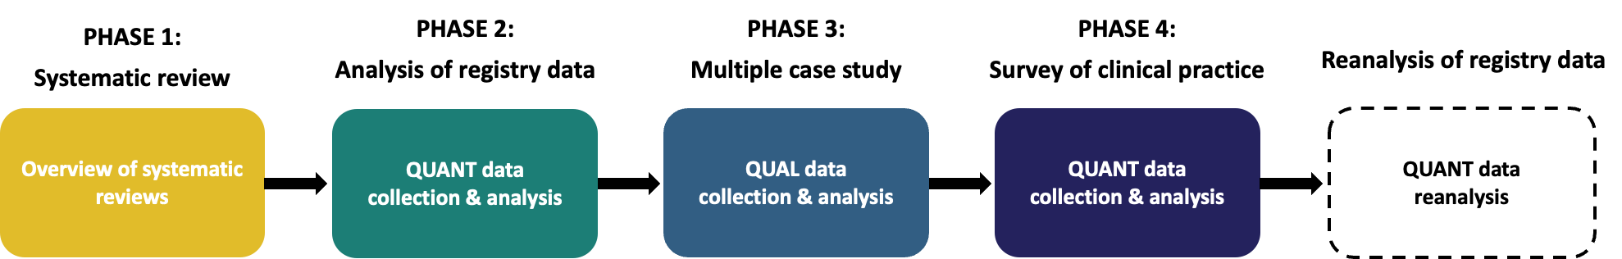

Methodology for each phase

Phase 1 – Systematic review
An overview of systematic reviews, also known as a systematic review of reviews or umbrella review, synthesises evidence from existing systematic reviews and meta-analyses (Hunt et al., 2018). This method provides a high-level synthesis of consistent findings, discrepancies and gaps across disease areas that can generate insights that may not be apparent in individual reviews. It also offers a pragmatic and efficient means of drawing on the large volume of existing evidence in an area to answer broader research questions (McKenzie and Brennan, 2017).
There is little published evidence describing how prescribing decisions are made in practice for rare diseases, including ADPKD. As discussed in Section 2.4, a targeted literature search identified only two relevant studies on prescribing factors influencing prescribing decision-making for rare diseases, which were not sufficient to support the development of a conceptual model. Evidence from other, more common, chronic conditions provided the closest available proxy. Both common chronic conditions and rare diseases involve the initiation of long-term, non-curative medications intended to modify disease progression or symptoms over time, and are often undertaken in the context of uncertain long-term benefits and risks. Although this overview of systematic reviews was unlikely to take into account all the factors influencing prescribing decisions for rare diseases, it provided a useful foundation in this programme of research to understand prescribing initiation in the related context of chronic conditions. The new conceptual model of prescribing decision-making adapted for the context of chronic conditions was then available to inform the design and interpretation of the later phases of the programme of research.

Phase 2 – Analysis of registry data
The primary research began with an analysis of kidney centre-level tolvaptan prescribing to identify variation between UK kidney centres. The analysis was conducted at the kidney centre level using routine data collected on people with ADPKD. Variation was defined as differences in kidney centre-level tolvaptan prescribing relative to NICE and RA guidelines, focusing on eligible patients who were not initiated and patients initiated who did not meet eligibility criteria.
Registry data is particularly suited to examining variation in clinical practice as they include routinely collected information across multiple centres and heterogeneous patient populations. This allows the assessment of real-world treatment patterns and differences in care delivery between centres. This can then be used to drive quality improvement and greater equity in healthcare (Gliklich, Dreyer and Leavy, 2014). In this programme of research, the analysis of registry data also informed purposive case selection of kidney centres for the Phase 3 multiple case study.
The National Rare Kidney Disease Registry (RaDaR)
RaDaR is a UKKA initiative that generates data on patients with rare kidney diseases across all four UK nations (England, Scotland, Wales and Northern Ireland). It is the largest rare kidney disease registry globally, including 35,000 patients recruited from over 109 sites. Data is collected from patients with over 40 different rare diseases, including ADPKD. The aim of the registry is to facilitate translational and epidemiological research into rare diseases. Membership is voluntary, with patients recruited by their local healthcare team. At recruitment, they are consented to participate in wider research.
Data is generated through manual entry and automatic data retrieval from PatientView, an online platform providing kidney patients access to their laboratory results. At the time of analysis in 2024, the ADPKD cohort consisted of 8,302 people with ADPKD. The data collected includes patient characteristics (age, ethnicity and gender), disease characteristics (primary diagnosis, comorbidities and genomic results), current medications, laboratory results (eGFR) and kidney imaging (UK Kidney Association, 2023b).
Patient-level data cannot be exported from the UK Kidney Association servers. Therefore, all analyses are undertaken by the RaDaR in-house statistician team. Researchers wishing to use RaDaR data must submit an application to the RaDaR data analysis group, which reviews proposals for scientific and governance approval. Once approved, the researchers submit a detailed statistical analysis plan to the RaDaR statistician team. Analyses are then conducted collaboratively through an iterative process with clarification and refinement of the analysis plan to ensure appropriate implementation of the intended methods. See the additional details on the methods for the analysis of the registry data for both the full application form and statistical analysis plan.
To my knowledge, there are no other registries describing tolvaptan prescribing for ADPKD at a national level in the UK. An alternative potential data source that was considered is NHS Digital prescribing data, which routinely collects administrative prescribing information across England. However, this dataset is not disease-specific, includes prescriptions for multiple indications, and data is not available at the individual centre level (reporting is typically aggregated to regions). In addition, they do not include patient-level data that is required to assess treatment eligibility.

Phase 3 – Multiple case study
Multiple case study design
According to Yin (2009), a case study is “an empirical inquiry that investigates a contemporary phenomenon within its real-life context”. This research sought to investigate the prescription of tolvaptan for people with ADPKD (the phenomenon) within UK kidney centres (the context). Yin (2009) distinguishes between four types of case study design based on two dimensions: (i) whether a single case or multiple cases are studied, and (ii) whether the case is examined holistically (a single unit of analysis) or through embedded subunits (multiple units of analysis).
A multiple-case holistic case study design was selected to enable systematic exploration of tolvaptan prescribing practices, contextual factors and mechanisms within and across kidney centres. Within each case, attention was given to the implementation of the ‘tolvaptan care pathway’ which includes how kidney centres identify eligible patients, assess eligibility, initiate prescribing and monitor patients in practice.
The multiple case study approach described by Yin (2009) was used to guide case selection, data collection and analytic procedures because it provides a clear, structured and accessible framework for applying multiple case study methodology in practice. His approach is compatible with a critical realist perspective. It supports explanation-building across cases and the use of multiple sources of evidence, which can be used to develop accounts of underlying mechanisms. Yin’s approach also aligns with recent guidance on conducting case study research in an applied health setting described (Greenhalgh, 2025). Both highlight the benefits of clear case definitions, well-defined data sources and explicit analytic procedures. Other authors have highlighted the suitability of the approach described by Yin (2009) for applied health research, particularly when conducting a multiple case study as part of a broader mixed methods design (Baxter and Jack, 2008; O'Cathain et al., 2014).
Case definition
Each kidney centre constituted a case. The unit of analysis was the kidney centre.
Case selection
Yin (2009) emphasises that case study research should not aim for statistical generalisation to a population. Instead, it should rely on analytical generalisation whereby findings from individual cases are used to develop, refine or challenge theoretical explanations of the phenomenon of interest.
A multiple case study design with three cases was chosen for this programme of research. The inclusion of three cases reflected the need to balance explanatory depth with the feasibility of delivering the research within the time constraints of the PhD. Yin (2009) suggests that multiple case designs commonly include between two and ten cases selected based on ‘replication logic’ and the aims of the programme of research.
Yin (2009) recommends that case selection in multiple case study designs should be guided by what he describes as ‘replication logic’, rather than statistical representativeness. Importantly, replication in this context does not refer to repeating the same results, but to systematically testing whether theoretical propositions hold across different cases. Within this logic, cases may be selected for literal replication (where cases are selected to produce similar findings) or theoretical replication (where cases are selected to produce contrasting findings). In practice, case selection may also be influenced by pragmatic considerations such as access or feasibility. However, these do not represent a distinct logic and should be considered alongside ‘replication logic’.
In this programme of research, cases were purposively selected to support theoretical replication (Yin, 2009). Kidney centres from the Phase 2 analysis of registry data, showing variation in tolvaptan prescribing relative to NICE and RA guidelines were selected. Contextual features of each centre, including organisational size and geography, were also considered to ensure a diverse sample was selected.
Sources of evidence/data collection
Evidence within case studies commonly comes from a variety of sources: documents, archival records, interviews, quantitative surveys, direct observations, participant-observation and physical artefacts (Yin, 2009). Yin (2009) recommends using multiple sources of evidence so that findings are supported by “converging lines of evidence”. This process is often described as data triangulation within case study research and is considered to enhance the credibility and dependability of findings (Noble and Heale, 2019). In this multiple case study, three sources of evidence were used: qualitative interviews with clinicians, direct observations of clinic appointments and organisational documents relevant to tolvaptan prescribing.
Qualitative interviews with clinicians involved in the prescribing process of tolvaptan were selected as the primary source of evidence, as they enable an in-depth exploration of clinicians’ decision-making, offering insight into reasoning and attitudes that are not directly observable through other data sources (Kvale and Brinkmann, 2009). Interviews can be structured (fixed questions asked in the same order with no deviation), semi-structured (guided questions with flexibility to probe and explore reasons) or unstructured (open conversations with no pre-set questions). A semi-structured interview design was chosen to enable factors in the conceptual model from the systematic review to be explored while also allowing participants to influence the direction and content of the interview (Edley and Litosseliti, 2010). This balance is particularly helpful for less experienced qualitative researchers, as it provides structure to ensure key areas are covered while retaining flexibility (Moser and Korstjens, 2018). Healthcare professionals were selected as participants for their insight into the organisation of kidney centres and ADPKD services, and their central role in initiating tolvaptan.
Direct observations were included to complement interview data. This enabled comparison between reported accounts (from interviews) and clinical practice (from observations). Observations are particularly valuable for providing an account of real-time interactions and contextual factors that may not be fully articulated in interviews (Chand, 2025). In case study research, direct observation is recognised as an important source of evidence to help understand behaviours and interactions within their natural context (Fix et al., 2022). Observation was undertaken in a targeted manner rather than through prolonged ethnographic immersion, reflecting the infrequent nature of tolvaptan prescribing and constraints in observing relevant clinic encounters (Patton, 2014).
Organisational documents were included because they provided access to both internal processes and policy-level information. Documents are considered key sources of evidence for understanding context and decision-making processes, particularly when used alongside other data sources (Bowen, 2009; Yin, 2009). Document analysis was selected to enhance understanding of tolvaptan care pathways and organisational influences on prescribing decisions that may not have been identified in interviews or direct observations (Converse et al., 2015).
Other potential data sources were considered. There are limited opportunities for archival records or physical artefacts to be generated in the decision-making process for tolvaptan prescribing. One potential source could be patient’s medical records which may document that tolvaptan was discussed. However, the reasons underlying prescribing decisions are often not well documented (Demsash et al., 2023). Quantitative staff surveys could have been used but as there is a low number of clinical staff involved in tolvaptan prescribing in each kidney centre, this would generate a low volume of data and would lack the depth that would be gained through interviews and observations (Braun et al., 2021). Focus groups were considered as an alternative to one-on-one interviews. However, discussing their practice in a group setting could introduce social desirability bias, as participants may avoid comments that reflect negatively on themselves, their colleagues or their kidney centre (Bispo Júnior, 2022; Stokes and Bergin, 2006). Furthermore, the hierarchical nature between professionals at different kidney centres and within the same centre could risk certain voices dominating discussions, thereby limiting the depth and diversity of perspectives (Sim and Waterfield, 2019). Thus, individual interviews were determined to be a more appropriate source of evidence. Finally, patient interviews could have been included to gain insight into patients’ perspectives on prescribing tolvaptan. However, discussions with the patient and public involvement group indicated that patients are generally not involved in, or aware of, the decision-making process for tolvaptan. As such, patient perspectives were considered unlikely to meaningfully explain centre-level variation.
Analysis procedures
Yin (2009) recommends that analysis in case study research should be guided by the research question and underlying models or frameworks. Two such structures were used to analyse the qualitative data generated in this multiple case study. First, the Consolidated Framework of Implementation Research (CFIR) 2.0 was used during the analysis of variation between kidney centres with attention given to the implementation of tolvaptan care pathways (reported in journal article 3). Second, the conceptual model of prescribing decision-making in chronic conditions developed in Phase 1 was used to support the analysis of factors influencing prescribing decision-making in rare diseases (reported in journal article 4). Yin (2009) advises that data from each source of evidence should be analysed separately, compared and then integrated to develop an overall interpretation of the case. In applied health research, Greenhalgh (2025) recommends using an established approach to organise, categorise and integrate data from these multiple sources. For this multiple case study, qualitative data was analysed using the Framework Method for the analysis of qualitative data described by Gale et al. (2013). This approach facilitates structured coding, categorisation and charting of data into thematic matrices to support both within-case and cross-case comparison. Once analysis was complete, the factors identified as influencing the prescribing of tolvaptan were included in the Phase 4 survey.

Phase 4 – National survey of clinical practice
A survey is a systematic method for collecting self-reported information about individuals’ knowledge, attitudes and behaviour (Fink, 2003). Good survey design is essential to ensure that the responses accurately reflect participants’ views, and that bias and measurement error are minimised (Ponto, 2015). Boynton and Greenhalgh (2004) outline good practice when conducting research using surveys. They recommend that surveys should be designed to collect information relevant to the research objectives and only used if they are able to give meaningful answers. Questions should be worded to avoid leading or double-barrelled questions with mutually exclusive responses. Although piloting does not guarantee validity or reliability, it can identify issues such as questions that are difficult to interpret, response burden and functionality. Where possible, established reporting guidance for survey research should be followed to ensure rigour and reproducibility.
In mixed methods research, surveys are commonly used to complement qualitative findings by providing broader contextual data and enabling comparison across different settings (Creswell and Plano Clark, 2017; Tariq and Woodman, 2013). The survey of practice was included in this programme of research to assess whether insights from the multiple case study were relevant to other UK kidney centres and to generate new centre-level data to supplement the registry RaDaR dataset and enable reanalysis of registry data in Phase 4. A survey was selected because it provided an efficient and systematic method for collecting structured information from multiple kidney centres (Blair, Czaja and Blair, 2013). Generating new data was necessary given the limited number of variables included in the RaDaR database. Specifically, there is little information on the organisational context of kidney centres such as staffing, tolvaptan care pathways or clinic structures.
Alternatives to conducting a survey were considered, but each had limitations making them less suitable for this phase of the programme of research. Using other existing databases to describe prescribing practices was not feasible as there are none that were suitable. Collating organisational documents from kidney centres across the UK would be possible but unlikely to include the factors identified in the multiple case study. Therefore, a survey was considered the most appropriate method allowing systematic collection of standardised centre-level data in a structured and timely manner.

Overview of mixed methods study design
A flow chart of the mixed methods design is shown in Figure 5, summarising the methods and outputs across the programme of research.
Figure 5. Flow chart of mixed methods design
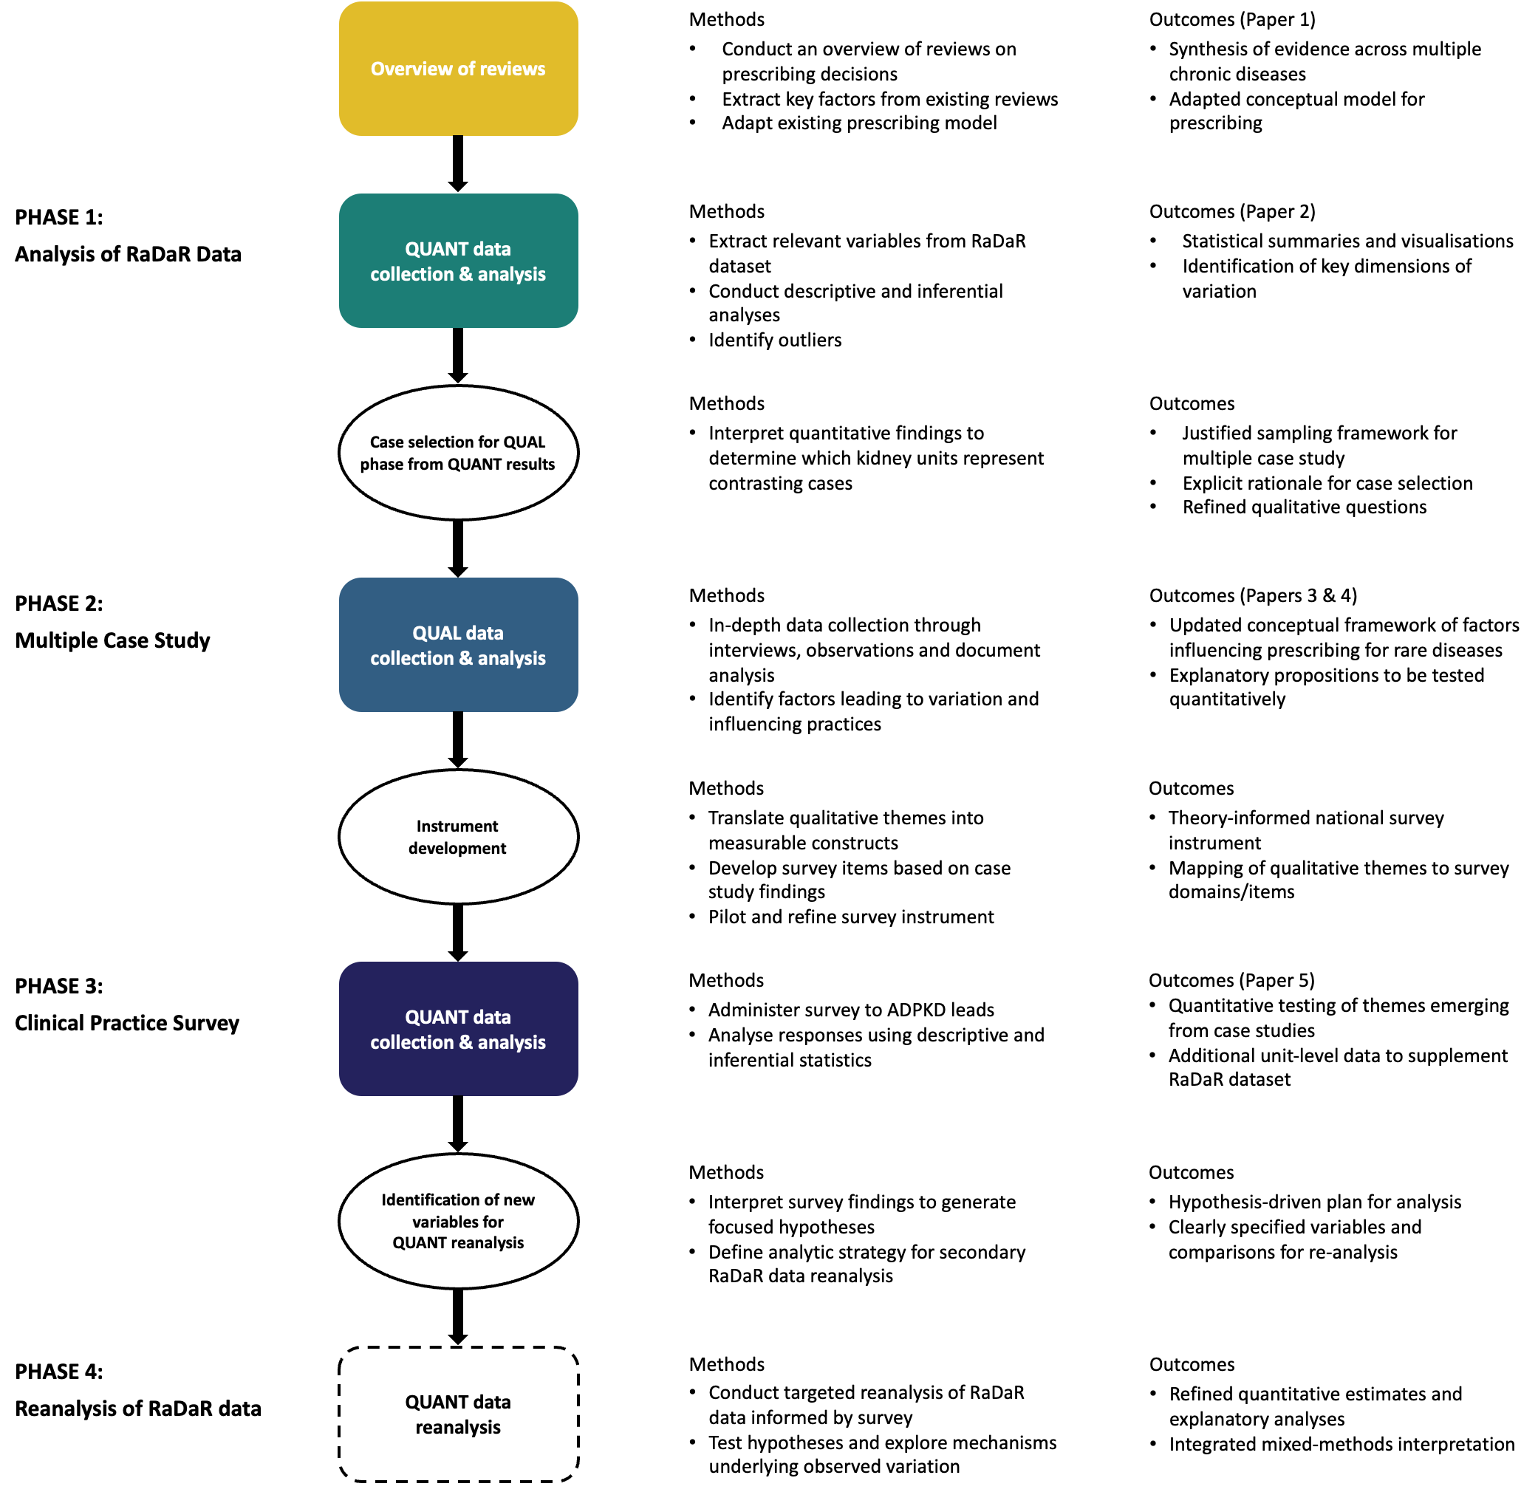
Autosomal Dominant Polycystic Kidney Disease (ADPKD), Qualitative (QUAL), Quantitative (QUANT), National Registry of Rare Kidney Diseases (RaDaR)

Integration within mixed methods research
Integration of data or findings within mixed methods research is important (Bryman, 2006). Integration occurred in this programme of research by each phase informing a subsequent phase or phases. The conceptual model of prescribing decision-making in chronic conditions developed in the systematic review in Phase 1 informed the data collection and analysis of the multiple case study in Phase 3. Analysis of registry data in Phase 2 was used to select cases for the multiple case study in Phase 3. The qualitative findings from the multiple case study in Phase 3 and the systematic review in Phase 1 guided the development of the questionnaire used in the Phase 3 survey of clinical practice.
Triangulation is a methodological approach to integrating findings from multiple methods. It involves comparing findings to assess whether they agree (convergence), offer complementary insights on the same issue (complementarity) or appear to contradict each other (dissonance) (Erzberger and Prein, 1997; Farmer et al., 2006; Foster, 1997). There may also be instances where findings are present in only one of the components (silence) (Farmer et al., 2006). The most detailed description of how to carry out methodological triangulation is described by Farmer et al. (2006) as ‘the triangulation protocol’. This involves the production of a coding matrix to display findings from each component. Although the triangulation protocol was developed for qualitative data, this approach to integration can also be applied within mixed methods approaches (O'Cathain, Murphy and Nicholl, 2010). In this programme of research, the triangulation protocol was applied at the interpretation stage after the separate analysis of the qualitative and quantitative components in Chapter 9. This was conducted to allow the comparison and integration of findings from the multiple case study in Phase 3 and the national survey of clinical practice in Phase 4.

Rigour and trustworthiness
Creswell and Plano Clark (2017) emphasise that mixed methods studies should demonstrate quality in both quantitative and qualitative components using appropriate criteria for each, with overall quality strengthened through effective integration (as demonstrated in Section 3.4). Accordingly, this programme of research addressed quality through rigour for quantitative components and trustworthiness for qualitative components. Rigour reflects the extent to which study design, measurement and analysis produce reliable and accurate results. It is typically evaluated through internal validity, external validity, reliability and objectivity (Cook, Campbell and Day, 1979). Trustworthiness reflects the confidence that readers can place in the findings. It is typically considered through credibility, transferability, dependability and confirmability (Lincoln and Guba, 1985). Table 5 summarises these criteria.
Table 5. Trustworthiness and quality characteristics of quantitative and qualitative research methods, adapted from (Lincoln and Guba, 1985)
Quantitative research | Qualitative research | Explanation
Internal validity | Credibility | The degree of confidence in the findings
External validity | Transferability | The extent to which the findings have applications in other contexts
Reliability | Dependability | The extent to which the findings are consistent and could be replicated
Objectivity | Confirmability | The degree of neutrality or extent to which the findings are shaped by the respondents and not by the researcher’s biases, motivation or interest

Phase-specific approaches taken to ensure rigour and trustworthiness are outlined below, followed by considerations at the broader programme level.
In Phase 1 (systematic review), the Cochrane Handbook for Systematic Reviews of Interventions (Higgins and Green, 2024) was used to provide a structured approach to study identification, selection, data extraction and synthesis. This enhanced both the transparency and reproducibility of the review methods. Methodological quality of the included systematic reviews was assessed using the Assessing the Methodological Quality of Systematic Reviews (AMSTAR) 2 critical appraisal tool (Shea et al., 2017). This provided a systematic appraisal of the risk of bias and robustness of the included reviews. Where qualitative evidence was included, the Confidence of Evidence form Reviews of Qualitative research (GRADE-CERQual) tool was used when considering the confidence in the synthesised qualitative findings. Together, these approaches strengthened the methodological rigour of the review process and the trustworthiness of the synthesised findings.
In Phase 2 (analysis of registry data), processes to ensure methodological rigour followed guidance for registry-based research. This emphasises the importance of data quality assurance, standardised definitions and transparent analytic methods to support the validity and reliability of findings (Gliklich, Dreyer and Leavy, 2014). Systematic data cleaning and validation were undertaken to ensure data accuracy and support internal validity. Implausible or erroneous entries were managed according to predefined criteria. Exposures, outcomes and covariates were clearly defined before the quantitative analysis. To enable assessment of external validity, the RaDaR dataset, its context and the number of UK kidney centres undergoing analysis were clearly described. Analysis was conducted by the RaDaR statistician following a statistical analysis plan that I developed. This was also reviewed by my supervisory team. This enhanced the consistency and supported the reproducibility of the analysis.
In Phase 3 (multiple case study), the study design and conduct were informed by established case study methodology (Yin, 2009) and guidance on conducting case study research in an applied health (Greenhalgh, 2025). Credibility was enhanced through several approaches. Purposive case selection was undertaken based on the quantitative findings from the registry analysis to ensure the cases reflected diverse practices and contexts. Iterative refinement of the data collection tools was undertaken as potential explanations were identified during data collection. Within-method data triangulation also supported the credibility of findings. Thick descriptions of cases and context enable the assessment of transferability. Dependability was supported through detailed fieldnotes, coding frameworks and an audit trail of analytic decisions. Debriefing with my supervisors strengthened confirmability by enabling ongoing reflection on how my assumptions and perspectives may have influenced the research. Finally, access to detailed prescribing practices of centres from the registry was not used during primary qualitative data collection and analysis to minimise preconceptions potentially influencing interpretations.
In Phase 4 (national survey of clinical practice), questionnaire design and survey administration followed principles of the Tailored Design Method described by Dillman, Smyth and Christian (2014). Internal validity was enhanced by developing the questionnaire based on the qualitative findings from Phase 3 and piloting it to ensure clarity and relevance. Reporting of the research context allowed readers to assess the generalisability. Standardised survey administration, using uniform instructions and delivery procedures, as well as systematic data cleaning, enhanced the reliability and objectivity of the data generated.
Although audit trails are typically described in the context of qualitative research, they have been increasingly described in the context of mixed methods research (Gaglio et al., 2020; Newman, Lim and Pineda, 2013; Scherman and Zimmerman, 2023). An audit trail was maintained throughout the programme of research in line with the guidance described by Lincoln and Guba (1982). This documented my research activities, methodological decisions, evolving interpretations and reflexive journal entries. The use of an audit trail is considered important for several reasons. It provides a transparent record of the research process that can support dependability and strengthen credibility by demonstrating a systematic and rigorous approach (Ahmed, 2024; Lincoln and Guba, 1982). When a reflexive journal is included, this can enhance confirmability by demonstrating how a researcher’s positioning and interpretative decisions have influenced the research process (Flick, Alejandro and Stoffel, 2025). Reflexivity is discussed further in the next section.

Reflexivity
Building on the discussion of positionality and reflexivity in Section 1.4, this section outlines how the potential influence of my role as a clinician-researcher was acknowledged and accounted for through the design and conduct of the research process. A reflexive journal provided a structured way to support this process.
For Phase 2 (analysis of registry data), I recognised the potential for my clinical experience to influence the selection and specification of variables included in the analysis. To address this, I arranged pre-analysis meetings with my supervision team and the RaDaR statistician to discuss variable selection and justification. There was also the potential for my background to influence interpretations of observed variation; discussions were undertaken with my supervision team as part of the iterative reflexive process to support analytic rigour and transparency in my interpretations.
For Phase 3 (multiple case study), before conducting data collection, I was aware that my role as a clinician-researcher placed me in a position that was neither fully insider nor fully outsider in relation to the participating centres (Green and Thorogood, 2004). Having a clinical background managing people with ADPKD placed me as an insider to the clinical domain, while my lack of employment or embedded role within the participating kidney centre positioned me as an outsider to their local contexts or practices. This positioning provided an understanding of the clinical context and facilitated access and rapport with participants, while also allowing a degree of analytical distance.
The primary reflexive consideration related to my insider position, as this is known to carry a risk of assumptions, blind spots and over-familiarity when conducting qualitative research (Chavez, 2008). To account for this, the topic guide used during the interviews was designed to include open-ended questions and neutral prompts to encourage more detailed accounts of participants’ perspectives and practices. This is included in the additional details on the methods for the multiple case study. The pilot interview was undertaken to allow consideration of the phrasing of questions and identify any inadvertent assumptions embedded within the interview guide. This was then able to be adapted before conducting the interviews at the case sites.
For the observations of appointments, I was aware that my clinical background could influence how I interpreted observed practice. In response to this, I incorporated a brief discussion with the clinicians into the observation to provide an opportunity to review and reflect on my interpretations, particularly as there was the potential for observed behaviours to be interpreted in multiple ways. The multiple case study was where I anticipated the greatest potential influence of my clinical background on data collection. This led to my decision to complete a journal entry after every interview and observation to document my initial interpretations and how my positionality may have influenced data collection. This was then reviewed at the interpretation stage of the multiple case study. Following analysis of the data, I arranged to have meetings with my supervision team and PPI group, so I would have the opportunity to present my initial interpretations and explore alternative explanations. This was intended to support reflexive engagement with the data by challenging any interpretations that may have been influenced by my clinical background.
For the national survey of clinical practice (Phase 4), I was aware that having knowledge of prescribing practices at other centres through discussions with colleagues in the ADPKD clinical study group could potentially influence the selection and framing of questions when designing the survey. To account for this, I planned for the draft questionnaire to be discussed with my supervision team and the PPI group before dissemination. This was to help ensure that questions were neutrally framed, comprehensive and not unduly shaped by my prior assumptions.

Ethical considerations across the programme of research
All research involving human participants must be scientifically sound and adhere to established ethical principles. Ethical approval for the analysis of the registry data in Phase 2 was granted by the University of Sheffield Research Ethics Committee (reference 056645) on 17/08/2023. Approval for subsequent phases was then attained from the Dulwich Research Ethics Committee (reference number 24/PR/106) on 21/03/2024. In addition, permission was obtained from each NHS site involved in the multiple case study to conduct research on that site. Copies of approval letters from the University of Sheffield Research Ethics Committee and Dulwich Research Ethics Committee are included in Appendix 2. Throughout the programme of research, I ensured that my mandatory training in research ethics and data management was kept up to date. Details of the main ethical considerations for each phase in the programme of research are included in the following sections.

Ethical considerations in Phase 1 – Systematic review
Ethical approval was not required for this systematic review (overview of systematic reviews) as it used publicly available data and did not involve any primary data collection or participant information.

Ethical considerations in Phase 2 – Analysis of registry data
Phase 2 involved secondary analysis of routinely collected patient-level data from the RaDaR database. Although secondary analysis is often perceived to be relatively low risk, there are some important ethical considerations (Tripathy, 2013).
One key consideration is the need to ensure that the secondary use of data aligns with the consent originally provided by participants (van Gils-Schmidt et al., 2025). Patients recruited to RaDaR already gave consent for their data to be used in future research. To ensure the proposed analysis adhered to this consent, an application was submitted to the RaDaR Data Analysis Group. This group consists of substantive employees of the UK Kidney Association, statisticians, clinicians and patient representatives. They approved the analysis as ethically appropriate, confirmed that it complied with the governance framework of the registry, aligned with the patients’ original consent and would be in the interest of patients.
The main risk often considered in secondary analysis of data is the potential harm from breaches in confidentiality and identification of participants. This is particularly relevant given the rare disease context where anonymisation may be less protective due to low prevalence and high identifiability (Courbier, Dimond and Bros-Facer, 2019). For this reason, RaDaR does not permit patient-level data to leave their servers, and statistical analyses must be undertaken by the RaDaR statistics team under the guidance of the researcher. Only the minimum data necessary to answer the research question was analysed, with no unnecessary or extraneous information requested. All findings were presented at the cohort or kidney centre level; indirectly standardised ratios were used instead of raw counts to further reduce disclosure risk. These measures align with principles of data minimisation (Information Commissioner’s Office, 2025) and statistical disclosure control in health research (Office for National Statistics, 2021).

Ethical considerations in Phase 3 – Multiple case study
Key ethical considerations for the multiple case study included: participant consent, confidentiality, transparency when blinding, and my personal safety.
Participation was voluntary. It was acknowledged that participation could be considered an inconvenience, but the burden to participants would be minimal. To minimise this burden further, the interview was arranged to suit the participant’s preferred time and location wherever possible. For the observations, these were undertaken in existing clinics to avoid any unnecessary disruption. Clinicians and patients received detailed information regarding the multiple case study through a written participant information sheet included with their invitation letter. As there is no fixed guidance on the appropriate amount of notice to give potential participants, pragmatically, two weeks was selected. To safeguard against coercion or undue influence of patients, invitations were sent by local administrative staff with the aim of preserving participants’ freedom to choose whether to participate without researcher influence.
The Research Ethics Committee queried whether it was necessary for the me to access patient databases or clinic lists at participating sites to identify eligible patients for the observations. It was agreed that this would involve unnecessary exposure of identifiable patient data. For this reason, local clinical or administrative staff identified and approached eligible patients on my behalf. While this increased the workload for sites, it was judged to be ethically preferable and more consistent with principles of data minimisation (Information Commissioner’s Office, 2025).
An encrypted audio recording device was used for the interviews to maintain participant confidentiality. Data handling was conducted in line with the requirements of the Data Protection Act 2018 (UK Government, 2018). Paper copies of consent forms and fieldnotes were stored securely in a locked cabinet in the renal research department at Sheffield Teaching Hospitals Trust and were only accessible to me. All audio recordings were uploaded to an encrypted University of Sheffield network folder before being deleted from the recording device. To maintain confidentiality and prevent identification, each participant was assigned a unique ID number for use in reports, presentations and publications. In some cases, it was necessary to redact information that may have indicated the identity of the individual or centre, given the relatively small ADPKD nephrology community.
Participating sites were not informed of their prescribing characteristics at the time of recruitment or during data collection. This information was also unavailable to me until after the initial data analysis was complete. Informed consent was therefore obtained based on the full disclosure of the aims, methods and nature of participation in the multiple case study, rather than site-level prescribing characteristics. While this approach could be viewed as only partially transparent, revealing site-specific prescribing characteristics could have influenced behaviour and responses, which would have undermined the credibility of the programme of research (Yin, 2018). This balance between transparency and scientific integrity was addressed through the offer of debriefing at the end of the multiple case study, should participating centres wish to know their prescribing characteristics.
Finally, my personal safety was considered during clinic observations and face -to-face interviews. All in-person data collection occurred on hospital grounds at case sites. The supervisory team was made aware of the location and expected timing before attending the case site to collect data. The primary supervisor was contacted by phone following the completion of each clinic observation or face-to-face interview.

Ethical considerations in Phase 4 – National survey of clinical practice
Surveys are often considered low risk, especially if they only involve healthcare professionals and do not collect patient-level data (Dillman, Smyth and Christian, 2014). Although there is no risk of physical harm to participants, there can be a risk of informational or psychological harm that requires ethical consideration (Whicher and Wu, 2015). Due to the QRA study design, there was a need to link a response made by a representative of a kidney centre with registry data for that kidney centre. This limitation to anonymity was discussed with the Research Ethics Committee, which agreed that the most appropriate approach was to be transparent with potential participants. For this reason, the lack of anonymity and underlying reasons were included in the email invitation to the survey, the participant information sheet and at the start of the survey. Although this may have deterred some participants, it was important to be transparent as it allowed participants to make an informed decision prior to taking part in the survey. This approach aligns with principles outlined by UK Research and Innovation, which indicate that researchers should make any limits to anonymity or confidentiality clear and transparent when obtaining consent (UK Research and Innovation, 2026).
Data security was a key ethical consideration for the survey, as the data collected was potentially related to identifiable roles within a relatively small clinical community. To ensure the data remained secure, the questionnaire was administered using the Qualtrics platform, which provides secure, encrypted data transmission and storage (Qualtrics, 2026). Access to the survey data was restricted to the research team, with data downloaded and stored on password-protected devices in accordance with the University of Sheffield data governance policies. Survey data was exported in a secure format, then stored in secure folders on the University of Sheffield X: drive and backed up in line with data governance requirements.

Patient and public involvement (PPI)
Patient and public involvement in research refers to the active collaboration between patients, carers, members of the public and researchers to shape the research process (National Institute for Health and Care Research, 2024). A defining characteristic of PPI is that it should be undertaken “with” or “by” members of the public rather than “to” or “for” them (Brett et al., 2014). It is recommended at all stages of the research process, from conceptualisation of the research question to specific aspects of study design, including data collection, data analysis, interpretation and dissemination (Turk, Boylan and Locock, 2017). Including PPI in research has benefits for research projects, researchers and members of the public. For a research project, it can enhance the relevance, improve the quality and enhance the dissemination of findings. Researchers can develop a greater understanding and insight into their research area. Members of the public can feel more empowered and valued as well as become more knowledgeable about their condition (Brett et al., 2014).
Two approaches were undertaken. First, a PPI group was established specifically for this programme of research consisting of people with ADPKD and/or CKD who could provide insight and guidance throughout the research. The PPI group consisted of six members, although not all members attended every meeting. All members were White and aged over 55 years. The group was therefore predominantly composed of older White adults. Information on socioeconomic deprivation, educational attainment and health literacy was not collected systematically. Members were recruited through established patient networks at Sheffield Teaching Hospitals Trust and participated voluntarily in the research. The key impacts included the refinement of patient-facing materials, the development of the case vignette used in the qualitative interviews, and the inclusion of questions about the written materials provided to patients in the multiple case study and survey. Second, the PKD Charity and UKKA PKD clinical study group were engaged to ensure they were aware of the research being undertaken and how data from people with ADPKD was being used. The details of the PPI meetings, and the key impacts and changes that were implemented as a result, are summarised in Table 6.

Table 6. Overview of PPI activities and key contributions to programme of research
Activity type | Date | Participants | Phase(s) informed | Format | Key impact | Changes made
PPI meeting | 28/01/2022 | 6 patients | Programme wide | Virtual meeting | Provided input on overall study design and confirmed relevance for patients. Emphasised importance of equity and avoiding inappropriate prescribing. | Influenced the study design by incorporating equity in access to medications and appropriate prescribing as central concepts.
UKKA PKD Clinical Study Group meeting | 14/11/2023 | 13 nephrologists, 2 patients | Programme wide | In-person meeting | Agreed with the need to examine broader prescribing practices and perspectives beyond the case study sample. | Inclusion of the survey to assess wider prescribing practices and perspectives.
PPI meeting | 26/01/2024 | 5 patients | Phase 3 | Virtual meeting | Identified some minor issues with clarity and wording in the patient-facing materials. Provided additional context for clinical vignette to be used in case study. | Revised patient information leaflet to be more accessible. Adapted the clinical vignette to include family history of ADPKD and incorporate patient request for medication.
PKD Charity meeting | 03/07/2024 | 2 patients | Programme wide | Virtual meeting | Confirmed that variation in access to and experience of ADPKD treatment (including tolvaptan) is present for the wider ADPKD community. Explained that there were differences in leaflets given to patients that might influence uptake. | Inclusion of questions about patient information in topic guide and survey.
PPI meeting | 20/06/2025 | 4 patients | Phase 3, Phase 4 | Virtual meeting | Opportunity to discuss high-level findings from the multiple case studies to see whether this aligned with their experiences. Highlighted areas of ambiguity in questionnaire and overall length potentially being prohibitive. | Modified survey questions to improve clarity and removal of “not sure” response category. Reinforced need to shorten questionnaire.
PPI meeting | 16/02/2026 | 3 patients | Programme wide, Phase 4 | Virtual meeting | Provided interpretation and confirmed survey findings in relation to variation in practices and potential impact of unequal access. | Increased emphasis on variation in practice and inequities in access to medications in survey discussion.

Chapter summary
- Critical realism was identified as the research paradigm underpinning the programme of research, providing the ontological and epistemological foundation for the mixed methods design.
- A mixed methods design was selected as it allowed the quantification of prescribing variation and examination of the underlying mechanisms that might explain this variation.
- The mixed methods design used in this programme of research was a sequential, multiphase mixed methods design consisting of a systematic review, analysis of registry data, multiple case study and a national survey of clinical practice.
- Integration in this programme of research primarily occurred through the sequential design whereby each phase informs a subsequent phase or phases. Phases 3 and 4 were integrated in the interpretation stage following the separate analysis of these phases using the triangulation protocol.
- Methodological quality was addressed through established criteria for rigour and trustworthiness. Quantitative phases were guided by principles of validity, reliability and objectivity. Whereas, qualitative phases were informed by credibility, transferability, dependability and confirmability.
- Reflexive practice was embedded throughout the programme of research.
- Ethical approval was obtained before commencement of any phases in the programme of research. Key ethical considerations during the programme of research were presented.
- Patient and public involvement was undertaken throughout the programme of research through a dedicated PPI group at the Sheffield Teaching Hospitals alongside engagement with key stakeholder organisations.

– Systematic review (overview of systematic reviews) of factors influencing prescribing decision-making in chronic conditions

Chapter outline
This chapter presents the systematic review (overview of systematic reviews) of factors influencing prescribing decision-making in chronic conditions. The verbatim text of the journal article is presented as published in BioMed Central (BMC) Medicine. The contribution of each co-author is detailed in Appendix 1. Further details on the methods and the supplementary materials published with the journal article are presented in Appendices 3 and 4.

Manuscript

A conceptual model of factors potentially influencing prescribing decisions for chronic conditions: an overview of systematic reviews
Gittus, M., O'Cathain, A., Miller, K., Oklopcic, A., Ong, A.C.M., Fotheringham, J. A conceptual model of factors potentially influencing prescribing decisions for chronic conditions: an overview of systematic reviews. BMC Med. 2025 Jul 1;23(1):364. doi: 10.1186/s12916-025-04194-9. PMID: 40598148; PMCID: PMC12217990.

Abstract
Background
Nearly half of all adults are affected by chronic conditions, with long-term medications often being the primary intervention. Although models like that of Murshid and Mohaidin contribute to our understanding of prescribing behaviours, they are not specific to chronic conditions and may not reflect the full range of influential factors relevant to long-term care. A better understanding of the factors that may influence healthcare professionals’ decision-making could help inform policy and guidelines, as well as identify targets for future research and interventions.
Methods
An overview of systematic reviews was undertaken, following the 2020 PRISMA guidelines. PubMed, Embase, Web of Science, Cochrane Library and Google Scholar were searched from 01/01/2013 to 07/11/2023. Quality assessment was undertaken using the AMSTAR 2 tool. Screening, data extraction and synthesis were conducted. Confidence in findings was assessed using the GRADE-CERQual tool. An existing generic conceptual model of prescribing decision-making was adjusted to specifically reflect chronic conditions.
Results
Twenty-six reviews published between 2013 and 2023 were included, synthesising 689 primary studies. Patient factors that may influence prescribers’ decisions included age, ethnicity, education, and rurality of residence. Prescribers described assessing individual patient characteristics when weighing the risks and benefits, with a tendency to prioritise risks, especially for patients with multiple comorbidities or complex needs. Prescribers’ approach to risk may be influenced by their clinical experience, care setting and assessment tools. High workload and competing priorities may lead to clinical inertia with potential delays or medications not being initiated. Shared decision-making may not always be shared equally between patients and prescribers. Beyond direct medication costs, prescribers may also consider broader healthcare costs, such as the need for monitoring and necessary support staff. External factors, such as guidelines, may be helpful in navigating risks. Their effectiveness may be greater when they offer specific recommendations tailored to prescribers’ population characteristics.
Conclusions
Prescribers need to navigate multiple challenges when making prescribing decisions for people with chronic conditions. This overview of systematic reviews suggests possible interrelated factor categories influencing prescribing decisions. The conceptual model may be used as a framework for future research and development of interventions.
Keywords: Long-term medications, Chronic conditions, Chronic diseases, Prescribing, Decision-making
Introduction
Chronic conditions represent a significant and growing health issue, affecting nearly half of all adults (Australian Government, 2023; Boersma, Black and Ward, 2020). The World Health Organization defines them as “long duration, non-communicable” diseases caused by “a combination of genetic, physiological, environmental and behavioural factors” (World Health Organization, 2023). Conditions must persist for at least six months to be labelled chronic (Gordon, Miller and Britt, 2018). They are a leading cause of mortality, accounting for 74% of deaths and contribute to 85% of healthcare expenditure worldwide (National Center for Chronic Disease Prevention and Health Promotion, 2023; World Health Organization, 2023). The prescription of long-term medications is often the primary intervention to control disease progression, reduce complications and improve patient outcomes (National Institute for Health and Care Excellence, 2015a; Rodis et al., 2017; Unni, 2023). However, prescribing decision-making in chronic conditions is complex and is likely to differ from that in acute conditions (Brunner-La Rocca et al., 2016; Haslbeck and Schaeffer, 2009).
Prescribing decision models, such as the conceptual model by Murshid and Mohaidin (2017) (Figure 6), amongst others (Godin et al., 2008; Higgins and Green, 2024; McIntosh et al., 2016), suggest several factor categories that may influence prescriber behaviour, including patient characteristics, pharmacist factors, marketing efforts, and contextual factors, as well as trust between physicians and pharmacists. However, these models do not distinguish between prescribing in chronic and acute conditions, despite the different objectives of these prescribing contexts (Assal, 1999). Acute prescribing is typically urgent and symptom-driven, focusing on immediate relief or resolution of illness (Waldman and Terzic, 2019). Whereas chronic prescribing often aims to slow disease progression, so it may require a more proactive approach and involves long-term monitoring (Sellappans, Lai and Ng, 2015). Existing models may not fully account for the influence of prescriber characteristics nor incorporate some additional factors identified in the wider literature, such as clinical guidelines (Carter, Chapman and Watson, 2021), disease severity or risk assessment scores (Lane and Lip, 2012), and clinical decision support systems (Shahmoradi et al., 2021). Thus, there is a need to reassess existing models, with a specific focus on chronic conditions.

Figure 6. Conceptual model of physician decision-making (Murshid and Mohaidin, 2017)

The existing literature on prescribing in chronic conditions includes systematic reviews describing factors that are believed to influence prescribing decisions for specific medication classes or single disease types. Due to the breadth and complexity of these factors, decision-makers may struggle to navigate and synthesise the existing evidence. To address this, an overview of systematic reviews was conducted to provide a comprehensive overview of the factors that may influence prescribing practices. By collating, synthesising and summarising the available evidence, this overview aims to clarify key factors that may shape prescribing decisions for long-term medications in chronic conditions and provide a chronic condition-specific model. This model may help better inform policy development and identify potential targets for future research and interventions.
The objectives of this overview were to address the following research questions:
- What are the factors that may influence the prescribing of long-term medications for chronic physical health conditions?
- What changes, if any, are needed to an existing prescribing model by Murshid and Mohaidin (2017) to better reflect the factors that may influence prescribing for chronic conditions?
Methods
Study design and protocol
We conducted an overview of systematic reviews following guidance from Cochrane (Gates et al., 2020; Glenton et al., 2021; Hunt et al., 2018), and the Enhancing Transparency in Reporting the Synthesis of Qualitative Research (ENTREQ) checklist (Tong et al., 2012). The overview was reported according to the 2020 Preferred Reporting Items for Systematic Reviews and Meta-Analyses (PRISMA) statement (Page et al., 2021). The protocol was registered on PROSPERO (CRD42023467276).
Scope
This overview of systematic reviews synthesised systematic reviews of qualitative, quantitative and mixed methods studies of factors that may influence prescribing in chronic physical health conditions.
Eligibility criteria
The eligibility criteria are included in Table 7 based on the SPIDER (Sample, Phenomenon of Interest, Design, Evaluation, Research type) framework (Cooke, Smith and Booth, 2012).
Table 7. Eligibility criteria reported according to the SPIDER framework
SPIDER | Justification
Sample | Adults with non-communicable chronic physical health conditions. Children were excluded due to developmental and pharmacokinetic variations, and a lower evidence base (Bourgeois et al., 2012; Ferro, 2015; Liu et al., 2014). Chronic mental health conditions were not included as non-medication approaches are typically recommended as first-line treatment in these conditions (Elkrog et al., 2022; Gartlehner et al., 2017). Communicable diseases (e.g. HIV, tuberculosis) were excluded as they are not classified as chronic, and treatment aims to prevent progression or transmission with less room for individualised prescribing (Strich, Heil and Masur, 2020).
Phenomenon of Interest | Only factors influencing medication initiation were considered. Other stages of the prescribing process, such as titration and discontinuation, were not included as they are less commonly explored in the literature.
Design | Published peer-reviewed systematic reviews. Other types of review, including rapid reviews and scoping reviews, were not included. Protocols and conference abstracts were not included.
Evaluation | Eligible systematic reviews included those with results on at least one of the following outcomes relevant to prescribing decision-making:  (i) factors influencing initiation of long-term medications  (ii) experiences of healthcare professionals making prescribing decisions  (iii) barriers and facilitators to prescribing long-term medications
Research type | As described in the scope, systematic reviews of qualitative, quantitative and mixed methods studies published in any language between 01/01/2013 and 07/11/2023 were included.
Search strategy
A comprehensive search strategy, including automated and manual search techniques, was developed using the SPIDER framework (Cooke, Smith and Booth, 2012). The following databases were searched in line with Bramer et al. (2017): MEDLINE (Ovid) (including electronic publications ahead of print), EMBASE, Web of Science (Core Collection), Cochrane Library and Google Scholar (the first 200 relevant references). The first 200 results were screened in accordance with the guidance given by Haddaway et al. (2015). Reference checking and citation searching were implemented manually to complement the initial search strategy (Goossen et al., 2020). Preliminary searches using the terms “chronic condition*” or “chronic disease*” produced an overwhelming number of irrelevant results. To refine the search, a list of chronic conditions generated by eighty-three stakeholders from an existing systematic review on self-management support for people with chronic conditions was incorporated into the search strategy, see Appendix 4 (Taylor et al., 2014). Protocols and conference abstracts were not included at the full-text stage, but a manual search was undertaken to identify any subsequent published reviews. Forwards and backwards citation searching for other reviews was conducted on the included reviews. Searches were conducted from 01/01/2013 to 07/11/2023 to ensure that the findings were relevant to current clinical practices and policies. There was no time limit for primary studies in the included reviews. There were no language restrictions. The full search strategy is in Appendix 4.
Selection of systematic reviews
The search results were imported into HubMeta; duplicates were eliminated through the automated deduplication tool and confirmed manually by one reviewer (MG). Titles and abstracts were independently reviewed by any two of three reviewers (MG, AO and KM) to evaluate eligibility against the pre-specified criteria. An initial calibration exercise was undertaken between reviewers using a random sample comprising 1% of the search results. Full-texts of all reviews identified as potentially relevant by both reviewers were retrieved and independently assessed for eligibility by each of the two main reviewers (MG and KM). Any discrepancies were resolved through discussion. If discrepancies persisted, consultation with another member of the research team was sought (JF).
Data extraction and assessment of methodological limitations
Data extracted from each systematic review included study setting, data collection methods, methodology and study design. For the systematic reviews with qualitative findings, factors from the Murshid and Mohaidin (2017) conceptual model were listed on the data extraction form to ensure systematic extraction of qualitative findings. If new factors were identified, they were added to the list of factors. Factors identified in the systematic reviews with quantitative findings were then extracted. One reviewer (MG) extracted relevant data, which was subsequently verified by a second reviewer (KM) for accuracy.
Quality assessment
To assess the quality of the included systematic reviews, the AMSTAR 2 (A Measurement Tool to Assess Systematic Reviews 2) tool was employed. This tool evaluates the methodological quality of systematic reviews based on 16 domains (Shea et al., 2017). Systematic reviews were scored independently by two reviewers (MG and KM), with any discrepancies addressed through discussion. If discrepancies persisted, consultation with another member of the research team (JF) was sought. Although AMSTAR 2 is not intended to generate an overall score, systematic reviews with significant weaknesses across critical domains may raise concerns regarding confidence in their findings (Pieper et al., 2018). Therefore, studies that lacked methodological rigour, if they scored more than 5 critical domain weaknesses, were reviewed and considered for exclusion by MG and KM through discussion.
Overlap analysis
Overlap analysis in overviews of reviews examines the extent to which primary studies appear across multiple systematic reviews. The corrected covered area metric was used, which ranges from 0 (no overlap) to 1 (complete overlap) (Lunny et al., 2021).
Synthesis
Synthesis was undertaken by one reviewer (MG) in discussion with co-authors (JF and AOC).
Qualitative research in this context explores perceptions of stakeholders concerning influences on their prescribing decisions. Factors perceived to influence their decision-making identified in the qualitative findings of the systematic reviews were synthesised narratively. Themes were identified using the Framework Method by reading the systematic reviews, identifying a thematic framework, and coding each review to that framework (Dixon-Woods, 2011; Gale et al., 2013). The conceptual model by Murshid and Mohaidin (2017) was used as a thematic framework and added to as coding progressed.
Quantitative research in this context identifies factors that have been tested by researchers for their association with prescribing behaviours. The factors tested are usually limited to those that are available to researchers or easily measured. The study designs used can identify association but not causation. Factors identified in the quantitative research in the systematic reviews were synthesised using a vote-counting approach based on direction of effect (McKenzie and Brennan, 2019).
Confidence in findings
The GRADE-CERQual tool was used to assess confidence in findings. One reviewer (MG) conducted GRADE-CERQual assessments based on four components: methodological limitations, coherence, adequacy of data, and relevance. Each component was assessed by the level of concern (no or very minor, minor, moderate or serious). A judgement was made about the overall confidence in review findings (high, moderate, low or very low). Findings were initially assigned high confidence, then downgraded if there were notable concerns within any of the four GRADE-CERQual components (Lewin et al., 2018a).
Constructing the new conceptual model
Factors related to the themes identified from qualitative research in the systematic reviews were incorporated into the conceptual model by Murshid and Mohaidin (2017), and a diagram was produced.
Results
A total of 4498 articles were identified from database searches. 104 full-text articles were assessed for eligibility. 29 systematic reviews were quality assessed, with 26 systematic reviews included. The PRISMA framework is presented in Figure 7 and the extended PRISMA flowchart in Appendix 4.
Figure 7. PRISMA flowchart
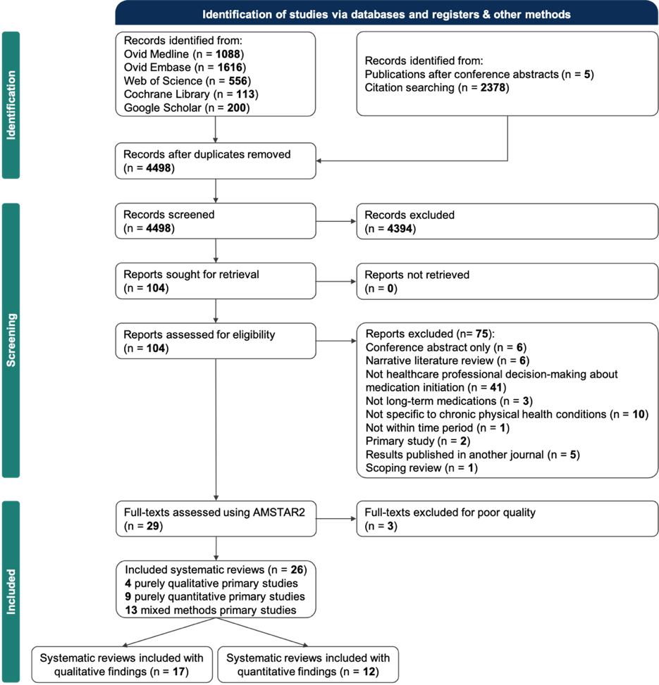
The 26 included systematic reviews had lead authors from 10 countries (see Table 8). Most reviews were conducted by authors in high-income countries and were published towards the latter part of the 2013 to 2023 period. Four reviews included only qualitative primary research studies, nine reviews included only quantitative primary research studies, and thirteen included both types and mixed methods studies. Cumulatively, they included 689 primary research studies, ranging from 3 to 69 primary studies per review. Although the inclusion criteria and search strategy encompassed any prescribers, all of the included studies focused on physicians as the primary decision-makers. Further details of the included systematic reviews are available in Appendix 4.
The “corrected covered area” was 0.03, indicating little overlap among the primary studies in the included systematic reviews. 65.4% (17/26) of the included reviews focused on cardiovascular conditions (cardiovascular disease, atrial fibrillation and hypertension).
Inter-rater reliability at the title/abstract stage of screening was 0.65 (Cohen’s kappa) and at the full-text stage was 0.89 (Cohen’s kappa).
The list of excluded systematic reviews at the full-text stage and the reasoning behind their exclusion is documented in Appendix 4. Most of the systematic reviews were of critically low quality, defined as “more than one critical flaw with or without non-critical weakness”. No systematic reviews included a list of excluded studies with justifications for their exclusion. Three systematic reviews had insufficient methodological rigour to be included in the overview of systematic reviews due to significant methodological limitations in their study design. Detailed quality assessment using AMSTAR2 is documented in Appendix 4.
Table 8. Characteristics of included systematic reviews
Authors (year) | Title | Country of first author | Condition | Medication | Methodology | Studies
(Abdelkader et al., 2023) | Prescribing patterns of antihypertensive medications: A systematic review of literature between 2010 and 2020 | Qatar | Hypertension | Antihypertensives | Mixed methods | 40
(Arshad et al., 2021) | Prescribing Patterns of Antihypertensive Medications in Low- and Middle-Income Countries: A Systematic Review | Pakistan | Hypertension | Antihypertensives | Quantitative | 26
(Bin Rsheed and Chenoweth, 2017) | Barriers that practitioners face when initiating insulin therapy in general practice settings and how they can be overcome | Saudi Arabia | Diabetes mellitus | Insulin | Mixed methods | 19
(Byrne et al., 2022) | Individual, healthcare professional and system-level barriers and facilitators to initiation and adherence to injectable therapies for type 2 diabetes: A systematic review and meta-ethnography | United Kingdom | Diabetes mellitus | Insulin and injectable hypoglycaemic agents | Qualitative | 42
(Chin et al., 2016) | The treatment gap in patients with chronic systolic heart failure: a systematic review of evidence-based prescribing in practice | Australia | Cardiovascular disease | Heart failure medications | Quantitative | 23
(Dhungana et al., 2021) | Barriers, Enablers and Strategies for the Treatment and Control of Hypertension in Nepal: A Systematic Review | Australia | Hypertension | Antihypertensives | Mixed methods | 15
(Generalova et al., 2018) | A systematic review of clinicians' views and experiences of direct‐acting oral anticoagulants in the management of nonvalvular atrial fibrillation | United Kingdom | Atrial fibrillation | Anticoagulants | Mixed methods | 10
(Iudici et al., 2014) | Prevalence and factors associated with glucocorticoids (GC) use in systemic sclerosis (SSc): a systematic review and meta-analysis of cohort studies and registries | Italy | Systemic sclerosis | Glucocorticoids | Quantitative | 23
(Ju et al., 2018) | General practitioners' perspectives on the prevention of cardiovascular disease: systematic review and thematic synthesis of qualitative studies | Australia | Cardiovascular disease | Preventative cardiovascular agents | Mixed methods | 34
(Khatib et al., 2014) | Patient and healthcare provider barriers to hypertension awareness, treatment and follow up: a systematic review and meta-analysis of qualitative and quantitative studies | Canada | Hypertension | Antihypertensives | Mixed methods | 69
(Lalor et al., 2022) | Factors influencing clinician prescribing of disease-modifying anti-rheumatic drugs for inflammatory arthritis: A systematic review and thematic synthesis of qualitative studies | Australia | Inflammatory arthritis | Disease-modifying anti-rheumatics | Qualitative | 15
(Mahmoud et al., 2023) | Meta-analysis of factors associated with antidiabetic drug prescribing for type 2 diabetes mellitus | United Kingdom | Diabetes mellitus | Oral hypoglycaemics | Quantitative | 40
(Maimaris et al., 2013) | The influence of health systems on hypertension awareness, treatment, and control: a systematic literature review | United Kingdom | Hypertension | Antihypertensives | Mixed methods | 53
(Mas Dalmau et al., 2017) | Patients' and physicians' perceptions and attitudes about oral anticoagulation and atrial fibrillation: a qualitative systematic review | Spain | Atrial fibrillation | Anticoagulants | Mixed methods | 9
(Milman et al., 2018) | Clinical inertia in the pharmacological management of hypertension: A systematic review and meta-analysis | Canada | Hypertension | Antihypertensives | Quantitative | 8
(Ng et al., 2015) | Barriers and facilitators to starting insulin in patients with type 2 diabetes: a systematic review | Malaysia | Diabetes mellitus | Insulin | Mixed methods | 25
(Oqab, Pournazari and Sheldon, 2018) | What is the Impact of Frailty on Prescription of Anticoagulation in Elderly Patients with Atrial Fibrillation? A Systematic Review and Meta-Analysis | Canada | Atrial fibrillation | Anticoagulants | Quantitative | 3
(Orayj and Lane, 2019) | Patterns and Determinants of Prescribing for Parkinson's Disease: A Systematic Literature Review | United Kingdom | Parkinson’s disease | Dopaminergic agents | Mixed methods | 44
(Osasu, Cooper and Mitchell, 2021) | Patients’ and clinicians’ perceptions of oral anticoagulants in atrial fibrillation: a systematic narrative review and meta-analysis | United Kingdom | Atrial fibrillation | Anticoagulants | Mixed methods | 34
(Pokorny et al., 2022) | Interactions with the pharmaceutical industry and the practice, knowledge and beliefs of medical oncologists and clinical haematologists: a systematic review | Australia | Cancer | Chemotherapy/  haematological agents | Mixed methods | 31
(Presta et al., 2022) | Impact of frailty models on the prescription of oral anticoagulants and on the incidence of stroke, bleeding, and mortality in older patients with atrial fibrillation: a systematic review | Italy | Atrial fibrillation | Anticoagulants | Quantitative | 23
(Pritchett et al., 2020) | Clinicians' views and experiences of prescribing oral anticoagulants for stroke prevention in atrial fibrillation: A qualitative meta-synthesis | United Kingdom | Atrial fibrillation | Anticoagulants | Mixed methods | 13
(Proietti et al., 2022) | Frailty prevalence and impact on outcomes in patients with atrial fibrillation: a systematic review and meta-analysis of 1,187,000 patients | Italy | Atrial fibrillation | Anticoagulants | Quantitative | 33
(Qadi et al., 2020) | Patients’ and health professionals’ attitudes and perceptions towards the initiation of preventive drugs for primary prevention of cardiovascular disease: a systematic review of qualitative studies | United Kingdom | Cardiovascular disease | Preventative cardiovascular agents | Qualitative | 5
(Rushforth et al., 2016) | Barriers to effective management of type 2 diabetes in primary care: qualitative systematic review | United Kingdom | Diabetes mellitus | Injectable and oral hypoglycaemic agents | Qualitative | 32
(Wilkinson et al., 2019) | Management of atrial fibrillation for older people with frailty: a systematic review and meta-analysis | United Kingdom | Atrial fibrillation | Anticoagulants | Quantitative | 20

Synthesis of qualitative findings
Twenty-eight factors perceived by healthcare professionals to influence prescribing decisions for chronic conditions were identified (see Table 9). Using the GRADE-CERQual, eight factors were assessed as high confidence, eight as moderate confidence, seven as low confidence and five as very low confidence. These factors were categorised into six key themes: (1) Patient factors perceived to influence prescribing decisions; (2) Individualised patient risk-benefit assessment predominantly focuses on the risks rather than the benefits when making prescribing decisions; (3) Clinical inertia – defined as the failure to initiate a treatment when indicated in this context (Phillips et al., 2001) – which may result from factors related to prescribers, interactions between healthcare professionals and the healthcare system; (4) Medication costs – which are important in the prescribing decision-making process and go beyond direct medication costs to the prescriber; (5) Shared decision-making – which is not always shared equally between patients and prescribers when making prescribing decisions; and (6) External factors influence prescribing decisions.
Table 9. Summary of qualitative findings
Summary of qualitative review findings | Confidence according to CERQUAL assessment | Likelihood review represents decisions | Studies contributing to the review findings
1. Patient factors
1.1 Age: Elderly patients are less likely to be prescribed high-risk medications; younger patients may be steered towards non-medical interventions. | High | Highly likely | (Abdelkader et al., 2023; Byrne et al., 2022; Lalor et al., 2022; Mas Dalmau et al., 2017; Orayj and Lane, 2019; Pritchett et al., 2020; Qadi et al., 2020)
1.2 Ethnicity: Patients from ethnic minorities may be perceived to need additional resources for decision-making and overcoming barriers. | Moderate | Likely | (Abdelkader et al., 2023; Byrne et al., 2022; Orayj and Lane, 2019; Pritchett et al., 2020)
1.3 Socioeconomic status: Lower socioeconomic status can lead to less prescribing due to lower patient awareness, reduced self-advocacy, and financial resources. | Low | Possible | (Lalor et al., 2022; Pritchett et al., 2020)
1.4 Occupational status: Fast-acting medications are preferred for patients who will be returning to work. | Very low | Unclear | (Lalor et al., 2022)
1.5 Geographical factors: Patients in rural areas have fewer medications prescribed due to the distance for monitoring and follow-up appointments. | Low | Possible | (Byrne et al., 2022; Khatib et al., 2014; Pritchett et al., 2020)
2. Individualised patient risk-benefit assessment
2.1 Barriers to understanding: Issues such as language, literacy, visual ability, cognitive state and mental health affect prescribing due to potential communication, self-management and adherence concerns. | High | Highly likely | (Byrne et al., 2022; Dhungana et al., 2021; Orayj and Lane, 2019; Osasu, Cooper and Mitchell, 2021; Pritchett et al., 2020)
2.2 Comorbidities: Multiple conditions complicate prescribing due to interaction risks and other priorities. | Moderate | Likely | (Bin Rsheed and Chenoweth, 2017; Byrne et al., 2022; Mas Dalmau et al., 2017; Orayj and Lane, 2019; Osasu, Cooper and Mitchell, 2021; Pritchett et al., 2020)
2.3 Disease features: Risk-benefit assessments vary with disease duration and symptom severity. | Low | Possible | (Lalor et al., 2022; Orayj and Lane, 2019)
2.4 Frailty: Frailty influences prescribing decisions as it increases the perceived risk. | Low | Possible | (Byrne et al., 2022; Lalor et al., 2022)
2.5 Healthcare professional identity: Experience, speciality and healthcare setting affect risk acceptance in prescribing. | High | Highly likely | (Bin Rsheed and Chenoweth; Generalova et al., 2018; Ju et al., 2018; Ng et al., 2015; Osasu, Cooper and Mitchell, 2021; Pritchett et al., 2020)
2.6 Objective measures: Disease severity markers and risk assessment tools guide prescribing. | Low | Possible | (Ju et al., 2018; Lalor et al., 2022)
3. Clinical inertia
3.1 Inadequate healthcare professional knowledge: Lack of training, experience and participation in research trials contribute to clinical inertia. | High | Highly likely | (Bin Rsheed and Chenoweth, 2017; Byrne et al., 2022; Generalova et al., 2018; Khatib et al., 2014; Lalor et al., 2022; Mas Dalmau et al., 2017; Ng et al., 2015; Osasu, Cooper and Mitchell, 2021; Pritchett et al., 2020; Rushforth et al., 2016)
3.2 Prescriber experience: Experience impacts decision-making and resistance to new medications. | Moderate | Likely | (Lalor et al., 2022; Maimaris et al., 2013; Mas Dalmau et al., 2017)
3.3 Professional responsibility: Ambiguity in responsibility can cause hesitation in starting medications. | High | Highly likely | (Bin Rsheed and Chenoweth, 2017; Byrne et al., 2022; Ju et al., 2018; Khatib et al., 2014; Mas Dalmau et al., 2017; Ng et al., 2015; Pritchett et al., 2020; Qadi et al., 2020; Rushforth et al., 2016)
3.4 Healthcare system factors: Time constraints, patient load and competing priorities contribute to clinical inertia. | Moderate | Likely | (Khatib et al., 2014; Lalor et al., 2022; Ng et al., 2015)
3.5 Colleagues of the same profession: Prescribers value their colleagues’ opinions and support when making prescribing decisions, which may reduce clinical inertia | Very low | Unclear | (Lalor et al., 2022)
4. Medication costs
4.1 Medication costs: Costs influence prescribing; justification is based on patient benefit and affordability. | High | Highly likely | (Dhungana et al., 2021; Ju et al., 2018; Lalor et al., 2022; Pritchett et al., 2020; Qadi et al., 2020)
4.2 Financial incentives: Financial incentives or reimbursement can encourage prescription of certain medications. | Low | Possible | (Byrne et al., 2022; Khatib et al., 2014; Qadi et al., 2020)
4.3 Healthcare system costs: Medications with an increased workload due to monitoring and follow-up appointments are less likely to be prescribed. | Low | Possible | (Generalova et al., 2018; Pritchett et al., 2020)
4.4 Patient affordability: Prescribers consider medication costs to prevent financial harm. | High | Highly likely | (Byrne et al., 2022; Dhungana et al., 2021; Ju et al., 2018; Khatib et al., 2014; Lalor et al., 2022; Pritchett et al., 2020)
5. Shared decision-making
5.1 Adherence: Healthcare professionals may not offer medications due to beliefs about patient adherence. | Moderate | Likely | (Bin Rsheed and Chenoweth; Ng et al., 2015; Pritchett et al., 2020; Rushforth et al., 2016)
5.2 Assumptions about patient preferences: Assumptions can lead to unequal patient involvement in decisions. | High | Highly likely | (Bin Rsheed and Chenoweth, 2017; Byrne et al., 2022; Ju et al., 2018; Khatib et al., 2014; Lalor et al., 2022; Pritchett et al., 2020; Qadi et al., 2020; Rushforth et al., 2016)
5.3 Active requests: Patient requests can influence prescribing, benefiting those with better health literacy. | Moderate | Likely | (Ju et al., 2018; Lalor et al., 2022; Orayj and Lane, 2019)
6. External factors
6.1 Sales and marketing: Pharmaceutical payments can influence prescribing decisions. | Very low | Unclear | (Pokorny et al., 2022)
6.2 Guidelines availability: Availability of guidelines positively affects prescribing. | Moderate | Likely | (Byrne et al., 2022; Dhungana et al., 2021; Pritchett et al., 2020; Rushforth et al., 2016)
6.3 Guidelines relevance: Guidelines must align with local demographics and priorities to be effective. | Moderate | Likely | (Khatib et al., 2014; Mas Dalmau et al., 2017; Orayj and Lane, 2019; Pritchett et al., 2020)
6.4 Academia: Clinical research findings can support decision-making, but their source must be perceived to be trustworthy | Very low | Unclear | (Qadi et al., 2020)
6.5 Expert opinion: The opinions of experts within a field may influence less experienced healthcare professionals’ decision-making | Very low | Unclear | (Ju et al., 2018)

Patient factors perceived to influence prescribing decisions
Patient-level factors were reported to shape prescribing decisions. Healthcare professionals described that an older patient age may influence their prescribing decisions due to health professionals considering the potential interactions of a long-term medication with other medications (Chin et al., 2016; Mahmoud et al., 2023; Proietti et al., 2022; Wilkinson et al., 2019), weighing the risks of polypharmacy alongside possible effect on comorbidities or frailty (Abdelkader et al., 2023; Byrne et al., 2022; Lalor et al., 2022; Mas Dalmau et al., 2017; Orayj and Lane, 2019; Pritchett et al., 2020; Qadi et al., 2020). When considering patients living in rural or remote areas, prescribers were concerned about barriers to follow-up appointments, monitoring, or emergency appointments, which were perceived as an additional risk (Lalor et al., 2022; Orayj and Lane, 2019; Pritchett et al., 2020). Some prescribers reported that a perceived need for additional resources for patients could lead to not prescribing some medications. This could be related to patients not speaking the dominant language of the country or having low literacy levels (Abdelkader et al., 2023; Byrne et al., 2022; Orayj and Lane, 2019; Pritchett et al., 2020). Prescribers indicated that the occupational status of patients might play a role in their decisions, with more aggressive or faster-acting medications favoured for those in employment to facilitate a quicker return to work (Lalor et al., 2022). Prescribers’ presumptions about patients’ socioeconomic status were also reported as a potential influence on prescribing decisions, with some prescribers opting not to prescribe medications if they believed the patient could not afford them (Lalor et al., 2022; Pritchett et al., 2020).
Individualised patient risk-benefit assessment predominantly focuses on the risks rather than the benefits when making prescribing decisions
When prescribing for chronic conditions, prescribers may prioritise potential risks over potential benefits (Byrne et al., 2022). They described that any potential for poor patient understanding would lead them to perceive prescribing as higher risk. This might be due to language barriers (Bin Rsheed and Chenoweth, 2017; Byrne et al., 2022; Dhungana et al., 2021), literacy levels (Byrne et al., 2022), visual impairment (Byrne et al., 2022), cognitive state (Orayj and Lane, 2019; Osasu, Cooper and Mitchell, 2021; Pritchett et al., 2020) or mental health (Orayj and Lane, 2019). Concerns about potential misunderstandings, adherence and self-management led some prescribers to decide against prescribing in these situations to avoid potential risks. Support from family, community health or social care was described by prescribers to give some reassurance that a medication would be used correctly. In some cases, this led prescribers to initiate the medication (Byrne et al., 2022; Dhungana et al., 2021; Pritchett et al., 2020; Qadi et al., 2020). Similarly, the need for regular monitoring or follow-up appointments was described as reassuring by prescribers, as any adverse effects or adherence issues could be detected and managed promptly. They described this as making them more likely to prescribe certain medications (Generalova et al., 2018; Pritchett et al., 2020).
Prescribers stated that multiple comorbidities complicated their prescribing decision-making as interactions with other medical conditions and competing priorities made risk assessment more challenging (Lalor et al., 2022; Mas Dalmau et al., 2017; Orayj and Lane, 2019; Osasu, Cooper and Mitchell, 2021). They perceived comorbidities that cause dependency or reduced coping ability as carrying the most risk, influencing the likelihood of initiating a long-term medication (Lalor et al., 2022; Mas Dalmau et al., 2017; Orayj and Lane, 2019; Osasu, Cooper and Mitchell, 2021; Pritchett et al., 2020).
Patient age was reported as a common factor in risk-benefit assessments. Some prescribers preferred to offer lifestyle changes before medications to younger patients, believing that this age group might prefer to avoid taking medications long-term (Pieper et al., 2018). They reported viewing patients with longer disease durations or more severe symptoms to have more to gain from long-term medications (Lalor et al., 2022; Orayj and Lane, 2019). If the condition persisted for too long or led to frailty, the associated benefits might not outweigh the risks (Lalor et al., 2022). Prescribers described their assessment of patient frailty as being based on clinical judgment and frailty assessment tools (Byrne et al., 2022; Lalor et al., 2022).
More experienced healthcare professionals described being more accepting of risk when prescribing long-term medications (Bin Rsheed and Chenoweth, 2017; Generalova et al., 2018; Osasu, Cooper and Mitchell, 2021; Pritchett et al., 2020). Experience was described based on the number of years in practice, but also familiarity with the medication or regular use in clinical practice (Osasu, Cooper and Mitchell, 2021). Prescriber type could influence comfort level when prescribing certain medications. Some primary care practitioners described being less comfortable with risk, preferring to defer high-risk prescribing decisions (Bin Rsheed and Chenoweth, 2017; Ju et al., 2018; Ng et al., 2015; Pritchett et al., 2020) or co-managing with specialists in secondary care (Ju et al., 2018). Prescribers stated that while they primarily relied on their clinical judgement, they were also influenced by objective measures such as disease severity markers (Bin Rsheed and Chenoweth, 2017; Lalor et al., 2022) and risk assessment tools (Ju et al., 2018).
Clinical inertia – which may result from factors related to prescribers, interactions between healthcare professionals and the healthcare system
Prescribers expressed that their lack of knowledge could contribute to delays or reluctance to initiate some medications (Bin Rsheed and Chenoweth, 2017; Byrne et al., 2022; Khatib et al., 2014; Lalor et al., 2022; Ng et al., 2015; Osasu, Cooper and Mitchell, 2021; Rushforth et al., 2016). Potential reasons cited for this were insufficient training (Generalova et al., 2018; Lalor et al., 2022; Osasu, Cooper and Mitchell, 2021), limited experience (Generalova et al., 2018; Lalor et al., 2022; Osasu, Cooper and Mitchell, 2021), limited participation in research trials (Lalor et al., 2022) or being unaware of recent advancements in the field (Khatib et al., 2014; Mas Dalmau et al., 2017; Pritchett et al., 2020). More experienced or senior prescribers described making decisions in a more efficient manner, but acknowledged that they may also be more resistant to change (Lalor et al., 2022; Maimaris et al., 2013). Some prescribers reported putting greater trust in their personal clinical experience than in new research findings (Mas Dalmau et al., 2017). Prescribers also reported that colleagues’ opinions and support can inform their prescribing decisions (Lalor et al., 2022).
Primary care practitioners described uncertainty over which medications fell within their prescribing remit (Mas Dalmau et al., 2017; Rushforth et al., 2016), with some perceiving some medications as not their responsibility (Byrne et al., 2022; Khatib et al., 2014; Pritchett et al., 2020; Qadi et al., 2020) or, not concordant with their professional role or identity (Bin Rsheed and Chenoweth, 2017; Generalova et al., 2018; Ju et al., 2018; Ng et al., 2015; Osasu, Cooper and Mitchell, 2021; Pritchett et al., 2020). They also report feeling less confident in high-risk or complex scenarios, so defer to specialists in secondary care (Bin Rsheed and Chenoweth, 2017; Ju et al., 2018; Ng et al., 2015; Pritchett et al., 2020). Both primary and secondary care prescribers noted that communication channels between them were not well coordinated or timely, which could influence their decision about whether to prescribe a medication or lead to delays (Ju et al., 2018; Khatib et al., 2014; Mas Dalmau et al., 2017; Pritchett et al., 2020).
Prescribers described having limited consultation time and competing priorities as additional barriers. The reasons for this included that the initiation of medications often needs time-intensive patient education, discussion of treatment options and shared decision-making (Khatib et al., 2014; Lalor et al., 2022; Ng et al., 2015). Large numbers of patients in clinics and prescribers’ feelings of professional burnout could make the initiation of long-term medications less of a priority (Khatib et al., 2014; Ng et al., 2015). Some prescribers described that this led them to focus on acute symptom management where decision-making is less complex (Khatib et al., 2014; Qadi et al., 2020).
Medication costs – which are important in the prescribing decision-making process and go beyond direct medication costs to the prescriber
Healthcare professionals reported that medication costs were a factor when making prescribing decisions about long-term medications (Dhungana et al., 2021; Ju et al., 2018; Lalor et al., 2022; Pritchett et al., 2020; Qadi et al., 2020). They described including these costs in their risk-benefit assessments and justifying the costs when a patient was likely to highly benefit from the treatment or faced a high risk of disease progression without it (Ju et al., 2018; Lalor et al., 2022). Although financial incentives or reimbursement might encourage them to prescribe certain medications (Khatib et al., 2014), some prescribers felt uncomfortable and did not think these approaches were ethical if they did not align with best evidence practices or the medications were not relevant for their patient population (Byrne et al., 2022; Qadi et al., 2020). In healthcare settings where care is not free at the point of access, prescribers reported factoring in the medication costs that would affect the patient to protect them from financial harm. However, these decisions were noted to be based on their perceptions rather than direct empirical knowledge of their patients’ financial circumstances (Byrne et al., 2022; Ju et al., 2018; Lalor et al., 2022; Pritchett et al., 2020). Prescribers described that while having monitoring for medications gave them some reassurance, they might not prescribe a medication if this monitoring resulted in an increased workload, resource use or need for support staff (Generalova et al., 2018; Pritchett et al., 2020).
Shared decision-making – which is not always shared equally between patients and prescribers when making prescribing decisions
Prescribers described how shared decision-making played a role in whether they initiated long-term medications. They reported sometimes choosing not to discuss long-term medications if they thought that a patient might not want to take the medication. Potential reasons for this included anticipated refusal (Bin Rsheed and Chenoweth, 2017; Ng et al., 2015; Pritchett et al., 2020; Rushforth et al., 2016), potential difficulties with adherence (Bin Rsheed and Chenoweth, 2017; Ng et al., 2015; Pritchett et al., 2020; Rushforth et al., 2016), reluctance to initiate new medications (Khatib et al., 2014), desire to avoid polypharmacy (Khatib et al., 2014), certain side effects (Lalor et al., 2022; Qadi et al., 2020), avoidance of certain treatment modalities such as injections (Bin Rsheed and Chenoweth, 2017; Byrne et al., 2022; Lalor et al., 2022; Rushforth et al., 2016) and interventions needing high levels of monitoring (Pritchett et al., 2020). Additionally, some prescribers described not discussing certain treatments with patients, fearing it might heighten patient health anxiety if it is viewed as a “last resort”, as it could reinforce patient concerns about disease progression or death (Ju et al., 2018; Lalor et al., 2022). When patients actively request a medication, prescribers reported they were more likely to initiate it (Ju et al., 2018). They did recognise that this often favoured people from higher socioeconomic backgrounds who are typically more literate and able to self-advocate. This was recognised to potentially exacerbate health inequalities (Lalor et al., 2022; Orayj and Lane, 2019).

External factors influence prescribing decisions
The role of sales and marketing in influencing prescribing decisions was only identified in one systematic review. In this review, prescribers reported that payments from pharmaceutical companies to prescribers in the oncology and haematology fields made them more likely to initiate certain medications (Pokorny et al., 2022). Other external factors were more commonly mentioned. Prescribers described guidelines positively influencing their decision-making to prescribe a long-term medication (Byrne et al., 2022; Dhungana et al., 2021; Khatib et al., 2014; Pritchett et al., 2020). However, they emphasised that for guidelines to be influential, they had to be developed using evidence from studies with participants that were similar to their local patient populations (Arshad et al., 2021; Khatib et al., 2014; Mas Dalmau et al., 2017; Orayj and Lane, 2019; Pritchett et al., 2020) and take into account any local psychosocial factors (Pritchett et al., 2020), or public health issues and priorities (Arshad et al., 2021). Any ambiguity or uncertainty in the guideline recommendations could make their prescribing decision-making more complicated, which could lead to the guideline not being used in practice. (Qadi et al., 2020). Another aspect that was mentioned by prescribers was that the use of guidelines in their decision-making depends on being able to access them easily in the moment (Byrne et al., 2022; Dhungana et al., 2021; Pritchett et al., 2020). They described this as being necessary because it was often difficult to recall recommendations unless they were part of their everyday clinical practice (Rushforth et al., 2016). Academia in the form of published research was described as influencing prescribing practices (Ju et al., 2018; Qadi et al., 2020), but some prescribers described having mistrust in this source of information (Qadi et al., 2020). Expert opinion from colleagues could also guide and support some prescribers in their decision-making (Ju et al., 2018), but the identity of these experts was not described.
To what extent does qualitative data from chronic conditions support the existing prescribing model?
The relevance of the prescribing model proposed by Murshid and Mohaidin (2017) to prescribing decision-making in chronic conditions was assessed by comparing its factors with the findings from the qualitative research in the systematic reviews. New factors and connections between these factors that could possibly influence decision-making in chronic conditions were identified from the overview of systematic reviews. Some terms were changed: “physician” was replaced with “prescriber” for broader applicability, and “drug” with “medication” to avoid negative connotations and align with contemporary clinical language.
Three new factor categories were added from our systematic reviews: prescriber, healthcare system and external organisations. In addition to physician habit persistence suggested by Murshid and Mohaidin (2017) in their conceptual model, we identified other prescriber characteristics that may possibly influence prescribing decisions, including the prescribers’ care setting, medical speciality, knowledge and experience, attitudes and beliefs, and approach to risk. The wider healthcare system may also influence prescribing decisions and may possibly lead to clinical inertia due to competing care priorities, time constraints, staff availability, and the volume of patients in clinics. Clinical guidelines, expert opinion and academia were added to the conceptual model as external organisations identified as possibly influencing prescribing decisions for chronic conditions.
The conceptual model by Murshid and Mohaidin (2017) included two factors within the patient characteristics category: patient expectations and patient requests for medication. In addition to these, the findings from the included systematic reviews introduced further factors that may influence prescribers in the context of chronic conditions. These included patient demographics (age, socioeconomic status, occupation, geography, ethnicity, and barriers to understanding), comorbidities (including frailty) and patient behaviours (adherence and attendance).
Additional contextual factors were identified to potentially moderate the factor categories influencing prescribing practices. These included condition factors (including disease severity, duration of disease and objective markers), risk-benefit assessment and shared decision-making. Some aspects of the condition were found to influence the likelihood of prescription, in particular, disease severity and duration. Costs were also identified in the included systematic reviews. However, other costs beyond medication costs were identified as possible factors, including the costs for patients and indirect costs such as monitoring or support staff.
Some factors in the Murshid and Mohaidin (2017) conceptual model were less prominent in our overview of systematic reviews. Pharmacists were not reported to be an influencing factor in the included systematic reviews. Sales and marketing factors were infrequently mentioned by prescribers in the included systematic reviews, with only one review explicitly discussing the potential impact of pharmaceutical industry payments on prescribing decisions for haematological or oncological chronic conditions (Pokorny et al., 2022). These changes are reflected in the adapted infographic (Figure 8).

Figure 8. The conceptual model of prescribing decision-making in chronic conditions
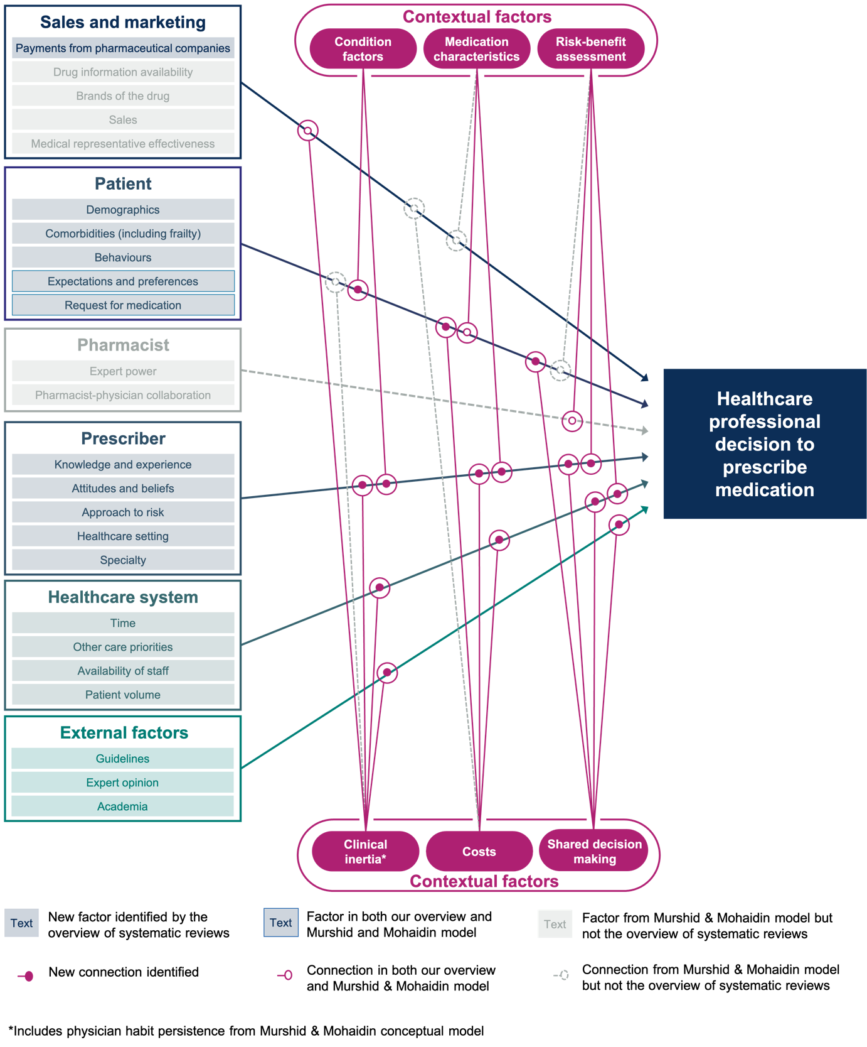

How do factors identified in systematic reviews with qualitative findings compare to those identified in systematic reviews with quantitative findings?
Factors tested in the quantitative research were categorised into the themes identified in the qualitative research (Table 10). Many of the factors described in the systematic reviews of qualitative research were not tested in the systematic reviews of quantitative research, particularly within the themes of medication costs, shared decision-making and external factors. The factors tested were primarily related to patient characteristics. Patients who were older (Chin et al., 2016; Mahmoud et al., 2023; Proietti et al., 2022; Wilkinson et al., 2019), from minority ethnic backgrounds (Abdelkader et al., 2023), living in rural areas (Arshad et al., 2021; Proietti et al., 2022), multimorbid (Arshad et al., 2021; Chin et al., 2016; Mahmoud et al., 2023; Wilkinson et al., 2019), or frail (Oqab, Pournazari and Sheldon, 2018; Presta et al., 2022; Proietti et al., 2022; Wilkinson et al., 2019) were less likely to be prescribed certain medications. Evidence of higher disease severity or activity, as measured by disease-specific scores, was associated with an increased prescribing rate (Iudici et al., 2014; Mahmoud et al., 2023; Milman et al., 2018). At the prescriber level, a higher self-reported level of knowledge (Arshad et al., 2021; Milman et al., 2018), participation in specialist training (Iudici et al., 2014) and certain specialities (Iudici et al., 2014) were associated with higher rates of prescribing.
Some factors measured in the quantitative research had not been identified in the qualitative research. These were associations between prescribing rates and patient-level characteristics. Patients who had a higher educational attainment were associated with an increased likelihood of prescription (Orayj and Lane, 2019). There was no consistent direction of effect across the included systematic reviews for patients who were female (Chin et al., 2016; Iudici et al., 2014; Mahmoud et al., 2023) or overweight/obese (Mahmoud et al., 2023). For the external factors, the authors of one study linked membership to a specific medical society with an increased likelihood of certain medications being prescribed (Iudici et al., 2014). Variation in prescribing approaches for certain medications was also associated with the prescribers’ country of origin, although no consistent direction of effect was observed (Iudici et al., 2014). The influence of pharmacists in the decision-making process was not identified in any systematic reviews of qualitative research, but this was found to be positively associated with an increased likelihood of appropriate prescribing in one systematic review of quantitative research (Milman et al., 2018).

Table 10. Summary of quantitative factors in relation to qualitative findings
Qualitative findings | Quantitative factor | Observed association with prescribing | Study
1. Patient factors
1.1 Age | Older patient age | Lower prescribing rate observed | (Chin et al., 2016; Mahmoud et al., 2023; Proietti et al., 2022; Wilkinson et al., 2019)
1.2 Ethnicity | Patient ethnicity | Inconsistent observations | (Abdelkader et al., 2023)
1.3 Socioeconomic status | NA | NA | NA
1.4 Occupational status | NA | NA | NA
1.5 Geographical factors | Patients living in rural area | Lower prescribing rate observed | (Arshad et al., 2021; Proietti et al., 2022)
NA | Female | Mixed | (Chin et al., 2016; Iudici et al., 2014; Mahmoud et al., 2023)
NA | High educational attainment | Higher prescribing rates observed | (Orayj and Lane, 2019)
NA | Overweight or high BMI | Inconsistent observations | (Mahmoud et al., 2023)
2. Individualised risk-benefit assessment
2.1 Barriers to understanding | NA | NA | NA
2.2 Comorbidities | Multi-comorbid | Lower prescribing rate observed | (Arshad et al., 2021; Chin et al., 2016; Mahmoud et al., 2023; Wilkinson et al., 2019)
2.3 Disease features | NA | NA | NA
2.4 Frailty | Nursing home residency or frailty | Lower prescribing rate observed | (Oqab, Pournazari and Sheldon, 2018; Presta et al., 2022; Proietti et al., 2022; Wilkinson et al., 2019)
2.5 Healthcare professional identity | NA | NA | NA
2.6 Objective measures | High markers of disease activity | Higher prescribing rate observed | (Iudici et al., 2014; Mahmoud et al., 2023; Milman et al., 2018)
3. Clinical inertia
3.1 Inadequate healthcare professional knowledge | Prescribers lack of knowledge | Lower prescribing rate observed | (Arshad et al., 2021; Milman et al., 2018)
3.2 Prescriber experience | More specialised training | Higher prescribing rate observed | (Iudici et al., 2014)
 | Certain specialities | Inconsistent observations | (Iudici et al., 2014)
3.3 Professional responsibility | NA | NA | NA
3.4 Healthcare system factors | NA | NA | NA
3.5 Colleagues of the same profession | NA | NA | NA
NA | Pharmacist involvement | Higher prescribing rate observed | (Milman et al., 2018)
4. Medication costs
4.1 Medication costs | NA | NA | NA
4.2 Financial incentives | NA | NA | NA
4.3 Healthcare system costs | NA | NA | NA
4.4 Patient affordability | NA | NA | NA
5. Shared decision-making
5.1 Adherence | NA | NA | NA
5.2 Assumptions about patient preferences | NA | NA | NA
5.3 Active requests | NA | NA | NA
6. External factors
6.1 Sales and marketing | NA | NA | NA
6.2 Guidelines availability | NA | NA | NA
6.3 Guidelines relevance | NA | NA | NA
6.4 Academia | NA | NA | NA
6.5 Expert opinion | NA | NA | NA
NA | Membership to medical society | Inconsistent observations | (Iudici et al., 2014)
Other
NA | Different countries | Inconsistent observations | (Iudici et al., 2014)

Discussion
Key findings
Twenty-six reviews published between 2013 and 2023 were included, synthesising 689 primary studies. Patient factors perceived to influence prescribers’ decisions included age, ethnicity, education, and level of rurality of residence. Prescribers described assessing individual patient characteristics when weighing the risks and benefits, with a tendency to prioritise risks – especially for patients with multiple comorbidities or complex needs. Prescribers’ approach to risk may be influenced by their clinical experience, the care setting and assessment tools. High workload and competing priorities may lead to clinical inertia in terms of delaying or preventing medication initiation. Shared decision-making may not always be shared equally between patients and prescribers. Beyond direct medication costs, prescribers may also consider broader healthcare costs. These can include the need for monitoring and the use of support staff for monitoring. External factors, such as guidelines, may be helpful in navigating risks. Their effectiveness may be enhanced if they provide specific recommendations tailored to prescribers’ population characteristics.
Our findings in the wider context
Our findings align with broader research from primary studies and highlight differences in prescribing decision-making from acute conditions, which is more widely studied (Dempsey et al., 2014; Kasse et al., 2024; Liu et al., 2019; Poss-Doering et al., 2020). In acute prescribing, medications may be prescribed driven by clear benefits and the immediate clinical risk of no treatment. In contrast, prescribing for chronic conditions appears to focus more on preventing disease progression and long-term complications (Dunbar-Jacob and Mortimer-Stephens, 2001). The benefits of these medications can be less immediate and more difficult to assess than in acute conditions. Consequently, healthcare professionals may place greater emphasis on potential risks, which are often more readily apparent. Risk assessments can also be considered more complex for chronic conditions. They typically include consideration of factors such as multiple comorbidities (Cahill, 2015), polypharmacy (Payne and Avery, 2011), consequences of non-compliance (Burnier, 2024; Dunbar-Jacob and Mortimer-Stephens, 2001), treatment inadequacy (Dunbar-Jacob and Mortimer-Stephens, 2001), and cumulative end-organ risk (Liu et al., 2021). While caution is needed, this heightened focus on risk may lead to overly cautious decision-making. Given that medication risks in chronic conditions may be long-term and dynamic, repeat assessments may be needed as conditions change or new medications are introduced (Thompson and Pascal, 2012).
Time constraints impact prescribing differently in acute versus chronic prescribing conditions. In acute conditions like infections, time pressures can increase the likelihood of prescribing, as some healthcare professionals prefer to avoid lengthy explanations about why antibiotics are unnecessary and challenging consultations with patients. These shorter consultations then allow them to see more patients (Dempsey et al., 2014; Liu et al., 2019; Poss-Doering et al., 2020; Yates et al., 2018). However, in chronic conditions, this overview of systematic reviews suggests that long-term medications may not be prescribed even when indicated, when there are time pressures described as clinical inertia. This may be because long-term medications involve prolonged exposure and delayed benefits, which increase the complexity of risk-benefit decision-making.
Several prescriber factors may also lead to clinical inertia, including insufficient training, limited involvement in research, lack of familiarity with guidelines and a lack of awareness about recent advancements in treatment options (Andreozzi et al., 2020; Aujoulat et al., 2014; Khunti, Davies and Khunti, 2015; Reach et al., 2017). When prescribing for chronic conditions, there may be a lack of immediate feedback on whether the medication is having the desired effect, unlike acute conditions, where the outcome is more apparent as the condition resolves quickly or symptoms are better controlled. Without clear, short-term evidence of success, prescribers may see prescribing long-term medications for chronic conditions to be a lower priority, especially if they are unaware of the evidence base for the medication or less experienced (Ryan et al., 2013). More experienced healthcare professionals may also experience inertia, finding it difficult to adopt new practices or unlearn outdated ones (Aujoulat et al., 2014; Gupta, Boland and Aron, 2017; Roumie et al., 2007; Steinman and Landefeld, 2018). This may be related to their confidence in their clinical judgement and past experiences with existing medications (Hajjaj et al., 2010).
Prescribing inertia may manifest differently across different care settings. Primary care prescribers, managing a wide range of conditions, tend to prioritise risk reduction and adhere strictly to guidelines. They have described hesitating to prescribe high-risk medications without specialist input due to concerns about potential complications (Carrier et al., 2019; Damarell, Morgan and Tieman, 2020). Communication challenges at the primary-secondary care interface further exacerbate this caution, with primary care prescribers feeling they cannot easily contact specialists for support (Boddy and Avery, 2023; Johnston and Bennett, 2019; Kozlowska et al., 2018; Sampson et al., 2015). In contrast, secondary care prescribers are reported to be more accustomed to interpreting guidelines and calculated risks for long-term benefits (Özge et al., 2023). However, they may defer medication initiation to primary care due to logistical issues or lack of detailed patient knowledge (Cope, 2022; NHS England, 2024). Unclear responsibility between primary and secondary care can lead to clinical inertia, as neither setting feels fully accountable for initiating treatment (Cettolin and Tausch, 2015), with efforts like prescribing agreements to address this (NHS England, 2024). Despite these challenges, some scholars report that primary care adopts approaches from secondary care, though with varying degrees of responsibility and occasional increases in error rates (Academy of Medical Specialities, 2023; Carter, Chapman and Watson, 2021; Garjón et al., 2012; NHS England, 2024).
The overview did not include many systematic reviews that described the impact of sales and marketing or the pharmaceutical industry on prescribing in chronic conditions. Other reviews and primary studies have demonstrated mixed findings ranging from no influence (Carter, Chapman and Watson, 2021; Denig et al., 1993; Denig, Haaijer-Ruskamp and Zijsling, 1988; Ryan et al., 1996; Schumock et al., 2004) to significant positive influence (Chren and Landefeld, 1994; Davari, Khorasani and Tigabu, 2018; Lexchin, 1993; Lurie et al., 1990). Thus, their absence does not mean that these factors do not affect prescribing decisions for long-term medications in chronic conditions. A potential explanation for the lack of detailed inclusion in our overview could be the tendency of studies assessing sales and marketing impact to focus on new therapeutic agents or single medications, which may not generate sufficient evidence to inform systematic reviews (Lublóy, 2014). Additionally, these factors can be difficult for prescribers to discuss because they may perceive them to be external to their decision-making, be concerned about potential conflicts of interest, or hesitate to reveal their true views or beliefs about whether their decisions are being influenced (Chren and Landefeld, 1994).
Guidelines featured as a factor perceived to influence prescribing practices, despite not being included in the conceptual model by Murshid and Mohaidin (2017). There are some considerations for guidelines as they may only influence decision-making if prescribers believe they adequately represent their patient population. This may be limited by clinical trial recruitment as they are not always reflective of real-world patients (Kortteisto et al., 2010; Tan et al., 2022). Although not found in our overview, other external organisations may influence prescribers, such as patient advocacy groups (Carter, Chapman and Watson, 2021; Lum et al., 2018), public opinion (Carter, Chapman and Watson, 2021) and media sources (Carter, Chapman and Watson, 2021). Clinical decision support systems may also influence prescribing decisions with the aim to make prescription decisions faster, more accessible and easier (Taheri Moghadam et al., 2021).
The factors identified in the systematic reviews with quantitative findings were predominantly patient-level factors. This is not unsurprising as these factors are relatively easy to measure and report. Although these factors are largely non-modifiable, their consideration remains important as assumptions prescribers hold about patients with these characteristics may be incorrect, and these assumptions may be modifiable. Thus, interventions at the policy or guideline levels could address this potential source of unequal patient access to medications.
A reflection on the evidence base for our overview is that, despite aiming to include all prescriber types, the studies primarily focused on physicians. There was little mention of allied healthcare professionals (Alghamdi et al., 2020; Graham-Clarke et al., 2018). This gap may reflect the dominance of physicians in both research and clinical prescribing practice (Graham-Clarke et al., 2018). Alternatively, it could be due to nurses and allied health prescribers being more involved in acute care, prescribing antibiotics and analgesics, rather than managing chronic conditions (McIntosh et al., 2016; Roumie et al., 2005). Our overview did not identify any systematic reviews in which allied healthcare professionals were the main prescribers for medications used in chronic conditions. However, systematic reviews and primary studies on prescribing more generally suggest differences in how allied health prescribers and physicians approach prescribing decisions. Pharmacists are described as being potentially more influenced by guidelines, peer recommendations and costs than their physician counterparts (Carter, Chapman and Watson, 2021; Davari, Khorasani and Tigabu, 2018; Mertens et al., 2023). Prescribing decisions among nurses may be influenced by how clear their role is (Graham-Clarke et al., 2018) and the level of support received from physician colleagues (Graham-Clarke et al., 2018; McIntosh et al., 2016). Additionally, nurses may be more concerned about potential risks (Graham-Clarke et al., 2018; McIntosh et al., 2016) and more susceptible to competing care priorities compared to physicians (Graham-Clarke et al., 2018; McIntosh et al., 2016; Roumie et al., 2005).
Strengths and weaknesses
A key strength of our review is the inclusion of both qualitative and quantitative evidence, offering a more comprehensive view of factors that may influence prescribing decisions. By incorporating perspectives from both primary and secondary care, our findings are more generalisable across the healthcare system. Additionally, the use of inclusive terminology in the conceptual model for prescribing decision-making in chronic conditions facilitates its application to a variety of prescribers. Focusing on chronic condition management, where most prescribing occurs, and decision-making is particularly complex, addresses a gap in the literature.
Our overview has some limitations. First, the inclusion of studies with diverse designs, populations and disease areas introduced heterogeneity, which complicated data synthesis. Nevertheless, this heterogeneity makes the findings more transferable to chronic conditions as a whole. Second, although the aim was to include prescribers from all backgrounds, the perspectives of allied health prescribers were not fully explored in the included systematic reviews, limiting the transferability of our findings to this type of prescriber and highlighting an area for future research. Finally, the studies included in the overview of systematic reviews were predominantly from high-income countries, so our findings may not represent the factors that influence prescribing in lower-income countries.
Implications for clinical practice and areas for future research
The findings have four implications for clinical practice. First, prescribers must be mindful of potential biases, such as assumptions about patient adherence or ability to pay for medications, to reduce the potential for care inequalities. Second, more balanced risk-benefit assessments may be needed, considering not only the risks but also the potential benefits of medications, particularly for older or frail patients. There could be a greater emphasis on shared decision-making and improved communication of risk-benefit information with patients. Third, clinicians’ experience and comfort with risk shape their decisions, highlighting a potential role for additional training or clinical decision-support systems. Fourth, clinical inertia is driven by time constraints, communication gaps at the primary-secondary care interface, and competing priorities. There is also a need for better coordination and clearer delineation of prescribing responsibilities.
Future research should distinguish between prescribing in chronic and acute conditions, as different factors may influence decision-making. While guidelines can positively influence prescribing, the clinical trials on which guidelines are based may benefit from including a diverse range of participants to reflect real-world populations. The limited inclusion of pharmacists and sales and marketing factors in our overview suggests these factors may be more difficult to identify, so they are under-reported. Future research should explore these more explicitly, using a range of methodologies to understand their role in influencing prescribing decisions. Significant knowledge gaps exist around the prescribing decisions of allied health prescribers in the management of chronic conditions, highlighting the need for targeted research to explore prescribing practices by this prescribing group.
Conclusions
The conceptual model presented, based on an overview of systematic reviews, includes many of the complexities when making prescribing decisions in chronic conditions. Unlike existing generic models, such as that proposed by Murshid and Mohaidin (2017), this model is specifically tailored to the challenges of long-term medications for chronic conditions. It suggests possible interrelated factor categories influencing prescribing. The conceptual model may be used as a framework for future research and the development of interventions related to the factors influencing prescribing decisions in chronic conditions.

Chapter summary
- This chapter presented an overview of systematic reviews which synthesised evidence on factors influencing prescribing decisions for chronic conditions.
- Multiple interacting factors were found to influence prescribing decisions across a range of stakeholders, with some key themes specific to chronic conditions.
- Prescribers described assessing individual patient characteristics, especially in risk-benefit assessments. There was a reported tendency to prioritise risks over longer-term benefits, particularly in patients with comorbidities or complex needs.
- Clinical inertia was identified as a key mechanism contributing to delayed or non-initiation of indicated medications with factors at the prescriber, interpersonal and healthcare system-level.
- Medication and associated costs of monitoring influenced prescribing decisions mainly during the risk-benefit assessment.
- Shared decision-making during the prescribing process was reported by some clinicians, but this practice was uneven and dependent on clinician attitudes.
- Influences from external factors outside of sales and marketing were more commonly reported by clinicians. These included clinical guidelines, published evidence and expert opinion.
- These findings highlighted gaps in the existing model of prescribing decision-making proposed by Murshid and Mohaidin (2017). There was a notable absence of prescriber and external factor domains as distinct components influencing prescribing decisions in the context of chronic conditions.
- This led to the adaptation of this existing conceptual model to better reflect decision-making in chronic conditions.
- This new conceptual model of prescribing decision-making in chronic conditions informed data collection and analysis in the subsequent phases of this programme of research.

– Variation in tolvaptan prescribing for autosomal dominant polycystic kidney disease in the United Kingdom and its impact on quality of life and costs

Chapter outline
This chapter presents the analysis of registry data. The verbatim text of the journal article is presented as submitted to PLOS One. The contribution of each co-author is detailed in Appendix 1. Further details on the methods and the supplementary materials published with the journal article are presented in Appendices 5 and 6.

Manuscript

Variation in tolvaptan prescribing for autosomal dominant polycystic kidney disease in the United Kingdom and its impact on quality of life and costs
Gittus, M., Pitcher, D., O'Cathain, A., Ong, A.C.M., Simms, R., and Fotheringham, J.
Submitted to PLOS One

Abstract
Background
Autosomal dominant polycystic kidney disease (ADPKD) affects over 12 million people worldwide, including an estimated 30,000–70,000 in the United Kingdom (UK). Tolvaptan is the only disease-modifying therapy approved for rapidly progressing disease. Despite national guidance, prescribing practices were hypothesised to vary by kidney centre. This variation could involve eligible patients not being initiated or non-eligible patients being initiated. This could have important consequences for healthcare costs and health-related quality of life.
Methods
The National Registry of Rare Kidney Diseases (RaDaR) collects longitudinal data from UK NHS kidney centres. This retrospective cohort study used routinely collected data (2016–2023) to examine tolvaptan prescribing across kidney centres. Kidney centre-level initiation patterns were described, assessed using mixed-effects logistic regression and visualised with funnel plots. Cost-effectiveness analyses combined observed prescribing practices under likely negotiated commercial discounts to estimate costs and quality-adjusted life year (QALY) consequences of prescribing at the national level.
Results
Our study included 3,609 people with ADPKD from 72 kidney centres. 34.8% (292/839) of patients who were eligible were not initiated on tolvaptan. Five centres (9.4%, 5/53) initiated tolvaptan significantly more than expected among eligible participants, while one centre (1.9%, 1/53) initiated significantly less. Nationally, eligible patients not being initiated on tolvaptan could result in up to £53.7 million in lost savings (assuming a 60% medication price reduction) and result in up to 1,245 lost QALYs. 26.1% (103/395) of patients initiated on tolvaptan were not eligible. Only one centre (2.4%, 1/41) had significantly fewer eligible patients than expected among initiated patients. Nationally, initiating patients who were not eligible could cost up to £15.9 million (assuming a 60% medication price reduction).
Conclusions
There is evidence of variation in tolvaptan prescribing in the UK. A substantial proportion of patients eligible for tolvaptan were not initiated at the cohort-level, with evidence of variation between centres. This suggests there may be differences in decision-making at a centre-level. A substantial proportion of patients initiated on tolvaptan were not eligible at the cohort-level, but there was limited evidence to suggest variation between centres. Together, these findings raise questions about the consistency of clinical decision-making, alignment with national guidelines, equitable access, and effective use of healthcare resources.
Keywords: ADPKD, polycystic kidney disease, CKD

Introduction
Autosomal Dominant Polycystic Kidney Disease (ADPKD) is the most common inherited kidney disorder, affecting an estimated 12.5 million worldwide (Chebib et al., 2023) and up to 70,000 people in the United Kingdom (UK) (NHS, 2023). It is characterised by progressive kidney cyst growth and kidney enlargement (Torres, Harris and Pirson, 2007). This contributes to a gradual decline in kidney function over time, with approximately half of affected individuals reaching kidney failure by age 60 (Higashihara et al., 1998). ADPKD is associated with a worse health-related quality of life than the general population, primarily due to abdominal pain and distension (Gittus, Harris and Ong, 2023; Gittus et al., 2026). It also confers high healthcare costs due to dialysis and transplantation requirements (European ADPKD Forum, 2016; Gagnon-Sanschagrin et al., 2021).
Tolvaptan is the first disease-modifying therapy available for ADPKD. It acts by antagonising vasopressin V2 receptors to alter cystogenesis pathways and reduce cyst fluid secretion (Ong et al., 2026). This mechanism explains the commonly observed adverse effects, which include increased urine output, thirst and nocturia. Two randomised controlled trials demonstrated that tolvaptan slows kidney enlargement and the decline in eGFR compared to placebo (Torres et al., 2017; Torres et al., 2016). Drug-induced liver injury was reported in these trials, which led to regular monitoring of liver function being required in clinical practice (Alpers et al., 2023).
Tolvaptan has been approved for adults with ADPKD with evidence of rapidly progressing disease in over 43 countries worldwide (Otsuka Pharmaceutical Co. Ltd, 2018). International and national guidelines have been published to support clinical decision-making and patient selection. These include the 2016 European Renal Association-European Dialysis Transplant Association (Gansevoort et al., 2016), as well as expert consensus statements from countries including Canada (Soroka et al., 2017), Australia and New Zealand (Tunnicliffe, 2023), and Japan (Advisory Committee for Progressive Kidney Diseases, 2014). Although the specifics of these guidelines vary, they are consistent in using historical eGFR decline, imaging criteria and risk stratification to define eligibility.
In 2015, the National Institute for Health and Care Excellence (NICE) approved tolvaptan for ADPKD patients in the UK with CKD stages 2–3 and “rapidly progressive disease” (National Institute for Health and Care Excellence, 2015a). The Renal Association issued recommendations for UK kidney centres, defining rapid progression as an eGFR slope of >2.5ml/1.73m²/year over 5 years or >5ml/min/1.73m² over 1 year, or an increase in total kidney volume by >5% per year. Additional measures for risk prediction may also be used based on imaging and genomic information (Renal Association, 2016). Despite these recommendations, National Health Service (NHS) Digital data shows variation in regional tolvaptan prescriptions (Chong, Harris and Ong, 2022).
Such variation could reflect two potential departures from guidelines: patients eligible for tolvaptan not being initiated, and patients initiated on tolvaptan when they did not meet the eligibility criteria. This may be influenced by centre-level differences in tolvaptan prescribing practices. Variation could also arise from patient-level factors, such as case-mix or patient preferences. However, for these to account for differences between kidney centres, they would need to vary systematically by centre and have effects independent of other measures. Well-designed standardised performance measures can adjust for factors outside the control of a centre. This allows remaining differences to more accurately reflect the potentially modifiable aspects of clinical practice (Panturu et al., 2025).
Differences in centre-level prescribing may influence both access for eligible patients and exposure of ineligible patients to tolvaptan. Based on these considerations, we hypothesised a theoretical trade-off whereby kidney centres with high initiation rates may improve access but risk initiating patients who do not meet the eligibility criteria, while kidney centres with low initiation rates may limit inappropriate use but risk not initiating patients who meet them (Atsma, Elwyn and Westert, 2020).
This study aims to quantify variation in tolvaptan prescribing across UK kidney centres. Observed patterns may suggest potential unequal access to or treatment not aligned with guidelines for the sole disease-modifying therapy in a rare disease, with possible consequences for quality of life and healthcare costs.
Materials and Methods
Study Design and Population
A retrospective cohort study was conducted using data from the National Registry of Rare Kidney Diseases (RaDaR) to evaluate tolvaptan prescribing in adults with ADPKD across UK kidney centres. The cohort included adults ≥18 years with a recorded ADPKD diagnosis, eGFR results, and medication history via PatientView, which provides live linkage of patient-level clinical and laboratory data (UK Kidney Association, 2025). However, not all kidney centres use PatientView so data completeness may vary across centres. Data completeness at a centre-level is included in Appendix 6. The study period (January 2016–September 2023) began three months following NICE approval of tolvaptan, after which it should be available at all NHS trusts (National Institute for Health and Care Excellence, 2012). Patients enrolled in tolvaptan clinical trials were excluded as prescribing occurred outside of clinician decision-making. Assessment of eligibility required sufficient laboratory data to derive eGFR slopes and medication history. Full inclusion and exclusion criteria are detailed in Appendix 6. Data cleaning occurred before analysis, this included range, consistency, and plausibility checks. Reporting followed the Reporting of Studies Conducted using Observational Routinely-Collected Health Data (RECORD) statement, an extension of the Strengthening the Reporting of Observational Studies in Epidemiology (STROBE) statement for observational studies using routinely collected data (Benchimol et al., 2015). This is included in Appendix 6.
Variables
Relevant patient characteristics in RaDaR included age, sex, ethnicity, CKD stage and eGFR. Medication characteristics for the year of eligibility and initiation were calculated as part of the study. Eligibility for tolvaptan was determined using Renal Association criteria relevant to the study period: CKD stage 2–3 with an eGFR decline >2.5 ml/min/1.73m²/year over 5 years or >5 ml/min/1.73m² over 1 year (Renal Association, 2016). Individual eGFR slopes were calculated for each patient with a minimum of three eGFR measurements over at least 1 year required to derive a slope. EGFR measurements that were inconsistent with the patient’s overall longitudinal trajectory were excluded, such as abrupt isolated declines which would likely be related to acute illness or measurement error. Imaging, genotype and risk stratification-based criteria were excluded due to inconsistent recording in RaDaR. Furthermore, expert consensus in the UK Kidney Association clinical study group suggested the use of these criteria independent of eGFR slope criteria was rare in clinical practice. Initiation was defined as the first recorded tolvaptan prescription within the study period. Key covariates included age, sex, CKD stage, and year of eligibility or year tolvaptan was initiated. These were considered to be potential predictors of tolvaptan initiation and adherence to eligibility criteria.
Statistical Analysis
Descriptive Statistics
Continuous variables were summarised as mean (SD) or median (IQR), and categorical variables as counts and percentages. The distribution of patient characteristics across kidney centres was descriptive.
Patient-level Predictors
Univariable logistic regression was performed for each variable to assess its association with the outcomes. Variables significant at p <0.05 or deemed clinically important were included in multivariable mixed-effects logistic regression models with the kidney centre as a random intercept to account for clustering.
Two logistic regression models were constructed:
- Initiation among eligible patients based on recorded eligibility criteria in RaDaR (binary outcome: 1 = initiated, 0 = not initiated)
- Eligibility based on recorded eligibility criteria in RaDaR among initiated patients (binary outcome: 1 = eligible, 0 = ineligible)
Odds ratios with 95% confidence intervals were reported for all variables.
Kidney centre-level variation
Variation between kidney centres was assessed using indirectly standardised ratios (ISRs). For each kidney centre, observed events (initiations or eligible patients) were compared against expected events based on patient-level characteristics to produce kidney centre-specific ratios. An ISR >100 indicates more events than expected, whereas an ISR <100 indicates fewer events than expected. Funnel plots were used to visualise variation, with control limits set at ±2 and ±3 standard deviations, corresponding to 95% and 99.8% confidence intervals, respectively. Adjustment for overdispersion was applied to account for extra-binomial variation (Spiegelhalter, 2002).
Health and cost implications
A deterministic budget impact and cost-effectiveness model was developed to estimate the consequences of patients eligible for tolvaptan not being initiated and patients initiated on tolvaptan who were not eligible. Both were assessed based on the recorded eligibility criteria in RaDaR. This was undertaken in accordance with the Principles of Good Practice for Budget Impact Analysis Report by the International Society for Pharmacoeconomics and Outcomes Research (ISPOR) (Sullivan et al., 2014). Budget impact calculations incorporated estimates from the analysis of RaDaR in the earlier components of the study, published tolvaptan uptake rates and the median treatment duration derived from two comparable United States cohorts (Perrone et al., 2025; Rao et al., 2025). There was no UK data available to inform the median treatment duration, but as shown in Appendix 6, the characteristics of these cohorts were similar to the ADPKD cohort in RaDaR. To account for patient preferences, an uptake of 30.5% was assumed based on the findings of Calvaruso et al. (2023). Five medication pricing scenarios were applied based on tolvaptan’s list price (National Institute for Health and Care Excellence, 2015a) and hypothetical discounts that may be available through the patient access scheme (23% (Dolan, 2019), 60% (UK Parliament, 2023), 70% (British Generic Manufacturers Association, 2020) and 90% (British Generic Manufacturers Association, 2020)).
A cohort-based simulation projected annual eGFR decline over 10 years using baseline eGFR from the study with published estimates of the mean and standard deviation of annual eGFR decline in ADPKD patients (Fitzmaurice, Laird and Ware, 2012). Treatment effects were incorporated by adjusting the mean annual decline. For each year, the probability of reaching kidney failure was calculated using a normal approximation of eGFR decline and Z-scores relative to the kidney failure threshold. Expected eGFR trajectories for treated and untreated cohorts were calculated, and cumulative kidney failure-free years were estimated that accounted for pre-dialysis death. Gross potential savings from delaying progression to kidney failure were calculated using annual dialysis costs, adjusted for medication, monitoring costs and early discontinuation. Exact 95% confidence intervals for binomial proportions were calculated using the Clopper-Pearson method (Tollefsen, 2023). Results were expressed as the equivalent number of total hip replacements to aid interpretation.
Statistical Software
All statistical analyses were conducted in Statistical Analysis System (SAS Institute, 2016, Version 9.4). Funnel and forest plots were generated using Microsoft Excel for Mac (Microsoft Corporation, 2019, Version 16.78.3). Deterministic budget impact analysis incorporating scenario analyses and parameter uncertainty were also undertaken using Microsoft Excel for Mac (Microsoft Corporation, 2019, Version 16.78.3).
Ethics
Ethics approval was granted by the Dulwich Research Ethics Committee in March 2024 (REC reference 24/PR/0106).
Results
Cohort characteristics
A total of 8,135 patients were in the RaDaR ADPKD cohort from 89 kidney centres. Sequential application of inclusion criteria yielded 3,609 patients with complete laboratory and medication data for analysis from 72 kidney centres (Figure 9). Of the 4,526 excluded patients, the main reasons for exclusion were the absence of live linkage (32%, 1,457/4,526) and the absence of a recorded medication history (49%, 2,225/4,526). Participant exclusions were not evenly distributed but were driven by a small number of high-volume kidney centres accounting for a large proportion of missing data at each stage (Appendix 6); 17 kidney centres did not have any medication history or live linkage data.

Figure 9. Participant flow diagram
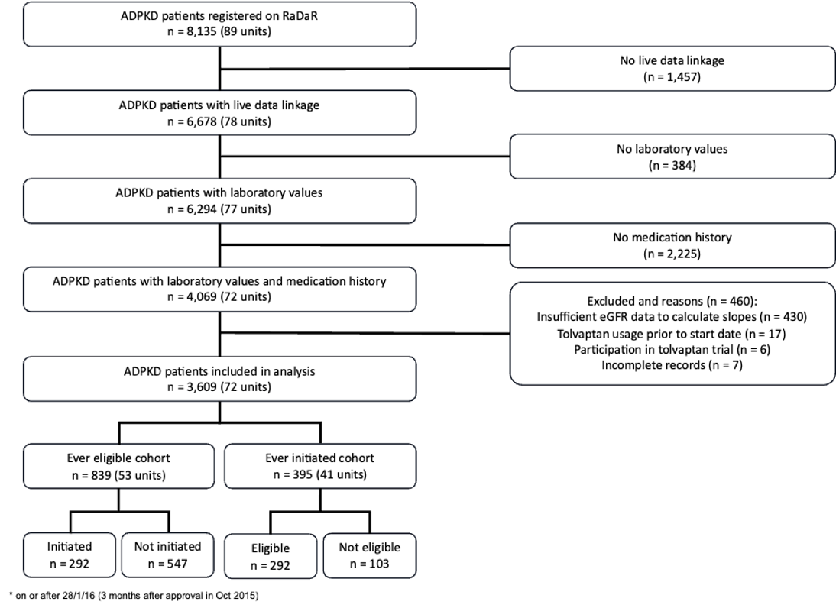

The mean number of patients per kidney centre was 50 (range 1 to 322). 51% female and 78% were of white ethnicity (Table 11).
Table 11. Characteristics of kidney centres and participants
Variable | Value
Included kidney centres | 72
Patients per kidney centre (mean, range) | 50 (1–322)
Age at recruitment to RaDaR (mean, SD) | 54.2 (13.4)
eGFR at RaDaR recruitment (mean, SD) | 44.2 (25.6)
Sex (n (%)) | Female: 1,851 (51.3%), Male: 1,758 (48.7%)
Ethnicity (n (%)) | White 2,807 (77.8%)  Not recorded 357 (9.9%)  Refused 152 (4.2%)  Asian 126 (3.5%)  Black 106 (2.9%)  Other 35 (1.0%)  Mixed 26 (0.7%)
Patients eligible for tolvaptan who were not initiated
Patients eligible for tolvaptan, by initiation status
839 patients were eligible for tolvaptan with 65.2% (547/839) not initiated on tolvaptan during the study period. Patients who were not initiated despite meeting eligibility criteria had slightly slower disease progression, with a 1-year eGFR decline that was on average 0.2 ml/min/1.73m² slower than in initiated patients (-7.07 vs -7.27 ml/min/1.73m² respectively) and a 5-year decline that was on average 0.22 ml/min/1.73m² faster (-4.48 vs -4.26 ml/min/1.73m² respectively). See Table 12 for the overview of initiated vs non-initiated patients eligible for tolvaptan.
Table 12. Characteristics of patients eligible for tolvaptan, stratified by initiation status
 | Patients eligible for tolvaptan (n = 839)
Variable | Initiated (n = 292) | Not initiated (n = 547)
Age at tolvaptan initiation (mean (SD), n) | 45.5 (9.9), n = 292 | -
eGFR prior to tolvaptan initiation (mean (SD), n) | 47.5 (14.6), n = 292 | -
eGFR slope in year prior to first eligible (mean (SD), n) | -7.27 (9.4), n = 291 | -7.07 (10.8), n = 509
eGFR slope in 5 years prior to first eligible (mean (SD), n) | -4.26 (3.0), n = 157 | -4.48 (3.4), n = 327
Years from RaDaR recruitment to eligibility (mean (SD), n) | -0.43 (1.5), n = 292 | -0.22 (2.1), n = 547

Patient-level predictors of initiation in eligible patients
In multivariable mixed-effects analysis, several factors were associated with the likelihood of initiation. Older age was associated with a lower likelihood of initiation (adjusted OR 0.964, 95% CI: 0.950–0.979, P<0.0001). Compared with CKD stages 1–2, individuals with CKD stages 3a and 3b had a higher likelihood of initiation (adjusted OR 3.77; 95% CI: 2.43–5.85 and adjusted OR 4.45; 95% CI: 2.83–7.02, respectively). Finally, the likelihood of being initiated varied with year of eligibility (global p=0.03). The highest likelihood of initiation was observed in 2017, this remained stable between 2018 and 2020, and then declined from 2021 onwards. Univariable and multivariable mixed-effects logistic regression results are summarised in Figure 10.

Figure 10. Forest plot of predictors for initiation in eligible patients
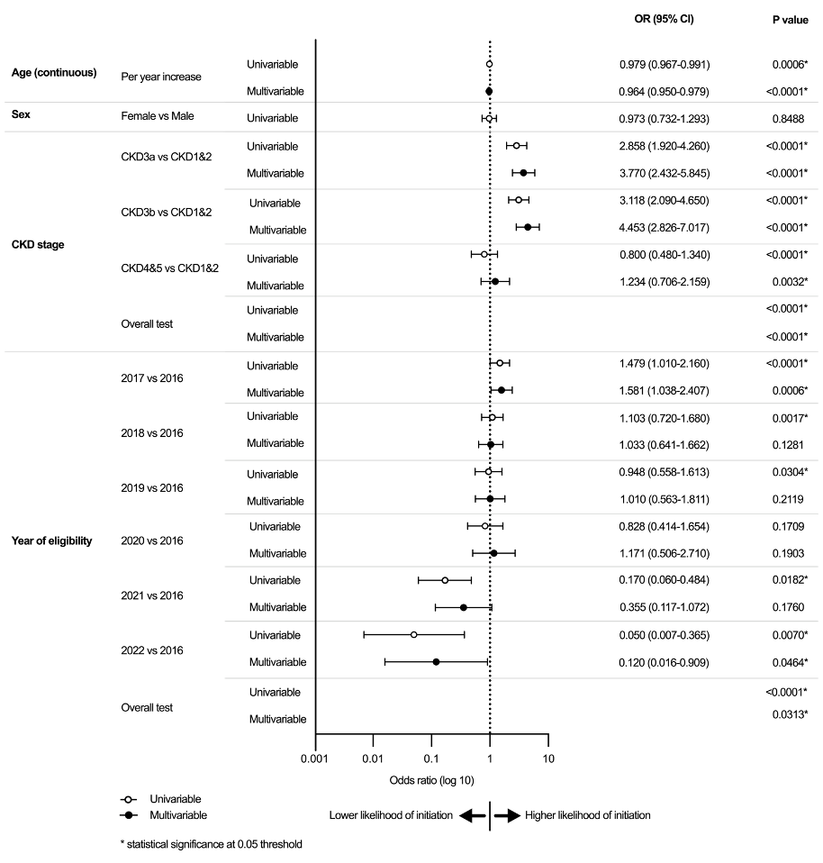
Initiation in eligible patients by kidney centres
Analysis of indirectly standardised ratios (ISRs) of tolvaptan initiation in eligible patients showed variation across the 53 included kidney centres (adjusted for age, CKD stage and year of eligibility). Only one kidney centre (1.9%) had significantly fewer patients initiated than expected among eligible patients, falling below the 3SD control limit. Five kidney centres (9.4%) were found to have significantly more patients initiated than expected among eligible patients, above the 2SD control limits. Adjusted funnel plots are included in Figure 11 and unadjusted funnel plots in Appendix 6.

Figure 11. Tolvaptan initiation in eligible patients by kidney centre; adjusted for age, CKD stage, and year of eligibility
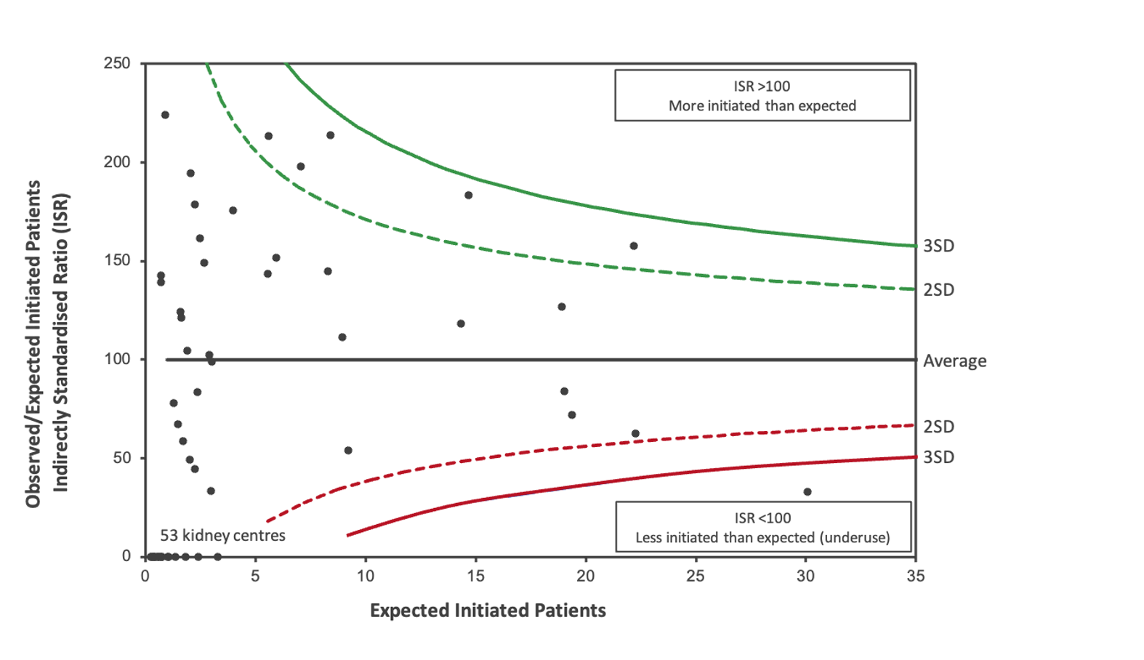
Patients initiated on tolvaptan who were not eligible
Patients initiated on tolvaptan, by eligibility
395 patients were initiated on tolvaptan, with 26.1% (103/395) not eligible according to the Renal Association criteria. Ineligible patients who were initiated had a higher mean age at initiation of 48.3 years compared with 45.5 years in eligible patients. Mean eGFR before initiation was lower in patients who were not eligible than those who were eligible (47.5 vs 50.4 ml/min/1.73m²). Patients who were not eligible exhibited less rapidly progressive disease: the 1-year eGFR decline was 9.55 ml/min/1.73m² slower than in patients who were not eligible than those that were eligible (2.28 vs -7.27 ml/min/1.73m²), and the 5-year decline was 3.87 ml/min/1.73m² slower (-0.39 vs -4.26 ml/min/1.73m² per year). See Table 13 for the overview of ineligible vs eligible patients initiated on tolvaptan.
Table 13. Characteristics of patients initiated on tolvaptan, stratified by eligibility status
 | Patients initiated on tolvaptan (n = 395)
Variable | Eligible (n = 292) | Ineligible (n = 103)
Age at tolvaptan initiation (mean (SD), n) | 45.5 (9.91), n = 292 | 48.3 (10.2), n =103
eGFR prior to tolvaptan initiation (mean (SD), n) | 47.5 (14.6), n = 292 | 50.4 (16.7), n =103
eGFR slope in year prior to tolvaptan initiation (mean (SD), n) | -7.27 (9.4), n = 291 | 2.28 (5.9), n =98
eGFR slope in 5 years prior to tolvaptan initiation (mean (SD), n) | -4.26 (3.0), n = 157 | -0.39 (2.0), n =94
Years from RaDaR recruitment to eligibility (mean (SD), n) | -0.43 (1.5), n = 292 | -
Patient-level predictors of eligibility in initiated patients
In univariable analysis, only CKD stage was a predictor of eligibility in initiated patients (overall test across CKD stages, p<0.0001). Compared to individuals with CKD stages 1–2, those with CKD3a were more likely to be eligible when initiated (OR 1.85, 95% CI 1.06–3.25, p=0.0006 and OR 3.23, 95% CI 1.84–5.66, p<0.0001, respectively), and CKD4 or CKD5 were less likely to be eligible (OR 0.12, 95% CI 0.04–0.37, p<0.0001), indicating greatest initiation in late and then early-stage CKD for people not eligible. Age, sex and year of initiation were not significantly associated. Multivariable mixed-effects adjustment for age, sex and year of initiation did not change the associations observed in univariable analyses; therefore, only univariable results are shown in Figure 12.
Figure 12. Forest plot of predictors of eligibility in initiated patients
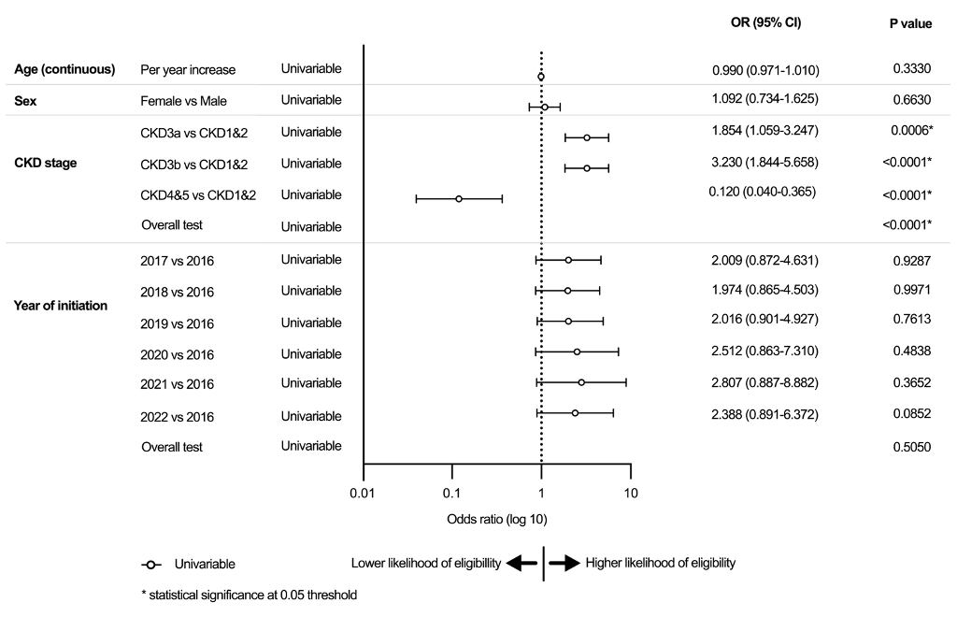
Eligibility in initiated patients by kidney centres
Analysis of indirectly standardised ratios (ISRs) of tolvaptan eligibility in initiated patients across the 41 kidney centres included in the analysis (adjusted for CKD stage) revealed limited variation in practice. Only one kidney centre (2.4%) had significantly fewer eligible patients than expected among initiated patients, falling below the 2SD control limit. Adjusted funnel plots are shown in Figure 13 and unadjusted funnel plots in Appendix 6.

Figure 13. Tolvaptan eligibility in initiated patients by kidney centre; adjusted for CKD stage
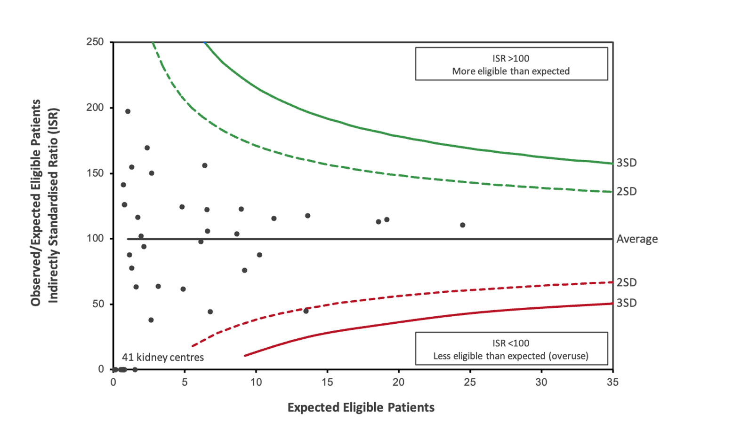
Combined patterns of variation in tolvaptan prescribing
We hypothesised that there may be a theoretical trade-off. Centres with high initiation rates may improve access for eligible patients but risk initiating a greater proportion of patients who were not eligible. By contrast, centres with low initiation rates may restrict initiation among patients who were not eligible but risk initiating a smaller proportion of patients who were eligible. However, the correlation between the proportion of eligible patients initiated and the proportion of initiated patients meeting eligibility criteria was weak and non-significant (r = 0.09, p = 0.63), suggesting that these behaviours occur independently (Appendix 6).
Health and cost implications of variation in practice
At a cohort-level, 65.2% of patients eligible based on recorded eligibility criteria for tolvaptan were not initiated. Initiating tolvaptan in this group could potentially save £78.2 million by delaying or avoiding dialysis, assuming a patient uptake of 30.5% based on the study by Calvaruso et al. (2023), extrapolated to the UK ADPKD population. After accounting for medication and monitoring costs, discontinuation and pre-dialysis death, the associated net savings could range from £19.4 million at list price to £70.8 million with a 90% patient access scheme discount (Table 14). A 60% medication discount was applied, reflecting the typical level of patient access scheme agreements in the UK (UK Parliament, 2023), which would result in a real-world cost saving of £53.7 million. Considering the health impact of patients eligible for tolvaptan not starting treatment, the incremental quality-adjusted life years (QALYs) gained per patient treated with tolvaptan is estimated at 0.8977. Across the eligible ADPKD population not initiated on tolvaptan in the UK, this would equate to a total of 1,245 QALYs lost.
At a cohort-level, 26.1% of patients initiated on tolvaptan were not eligible based on recorded eligibility criteria. Not initiating treatment in this group could potentially save between £4.8 million with a 90% discount and £38.1 million at list price if it were assumed prescriptions were not eligible according to all Renal Association eligibility criteria, extrapolated to the UK ADPKD population (Table 14). This takes into account medication and monitoring costs, assuming 2.74 years duration based on existing studies (Perrone et al., 2025; Rao et al., 2025). Based on anecdotal information regarding patient access schemes in the UK, the most likely real-world cost savings would be £15.9 million at a 60% discount. Appendix 6 provides the underlying model and calculations supporting these results.

Table 14. Estimated net potential savings from initiating tolvaptan in eligible patients who were not initiated in the UK and estimated costs of initiating ineligible patients, by PAS discount level
 |  | Starting eligible patients not previously initiated |  | Not starting ineligible patients previously initiated
PAS discount | Source | Net potential savings (95% CI) (£ million) | Equivalent hip replacements (n) | Overall cost (95% CI) (£ million) | Equivalent hip replacements (n)
0% discount | Company submission to NICE HTA (National Institute for Health and Care Excellence, 2015b) | 19.4 (15.1–24.2) | 2,084 | 38.1 (31.0–45.4) | 4,093
23% discount | Medicaid Drug Rebate program (Dolan, 2019) | 32.5 (29.2–36.2) | 3,497 | 29.6 (24.1–35.3) | 3,178
60% discount | UK Parliament document (UK Parliament, 2023) | 53.7 (51.9–55.7) | 5,772 | 15.9 (12.9–19.0) | 1,707
70% discount | Lower limit generic reduction (British Generic Manufacturers Association, 2020) | 59.4 (58.0–60.9) | 6,387 | 12.2 (9.9–14.5) | 1,310
90% discount | Upper limit generic reduction (British Generic Manufacturers Association, 2020) | 70.8 (70.3–71.4) | 7,616 | 4.8 (3.9–5.7) | 515

Discussion
Summary of key findings
In this national cohort of 3,609 patients with ADPKD across 72 UK kidney centres, differences were identified in tolvaptan prescribing in relation to nationally specified eligibility criteria. Among 839 eligible patients, 65.2% (547/839) were not initiated. These patients demonstrated eGFR slopes comparable to those who were initiated. Kidney centre-specific rates of initiation in eligible patients also varied, with one prescribing significantly less than expected to eligible patients and five prescribing significantly more after adjustment for patient case-mix. Among 395 patients initiated on tolvaptan, 26.1% (103/395) were not eligible. These patients who were not eligible were older and had slower disease progression. Kidney centre-specific rates of eligibility in initiated patients showed minimal deviation, with only one kidney centre prescribing to significantly fewer eligible patients than expected. We hypothesised a theoretical trade-off between access and inappropriate use across kidney centres, but the two behaviours appeared to occur independently.
Our findings could have important clinical and economic consequences. Patients eligible for tolvaptan who were not initiated may carry substantial opportunity cost. Extrapolated UK-wide estimates suggest potential net savings of up to £53.7 million, assuming a patient uptake of 30.5%, equivalent to 5,772 NHS total hip replacements, and could result in a loss of 1,245 QALYs. Conversely, patients initiated on tolvaptan who were not eligible could cost up to £15.9 million, if it is assumed that all patients were not eligible according to any of the Renal Association eligibility criteria. This cost would be equivalent to 1,707 NHS total hip replacements. Overall, the largest health-system gains could potentially come from increasing initiation among eligible patients, as the potential gains would exceed the cost of treating a small number of patients who were not eligible.
Comparison with Previous Studies
Previous national evaluations of tolvaptan use have relied on reimbursement or insurance claims aggregated by region. While useful for broad trends, these datasets lack the granularity needed to assess variation at the kidney centre level. Chong, Harris and Ong (2022) reported a four-fold difference in prescribing across UK regions using NHS Digital reimbursement data. However, they did not distinguish ADPKD from other indications for tolvaptan, such as heart failure or the syndrome of inappropriate antidiuretic hormone secretion. In Japan, Inoue et al. (2020) reported substantial regional variation in tolvaptan prescribing, with some prefectures prescribing up to 21 times more than others. These studies support our findings that there is variation in tolvaptan prescribing in clinical practice. However, none of these studies reported prescribing in reference to nationally specified eligibility criteria, or considered the economic and health consequences of variation observed in practice, so further comparisons cannot be undertaken.
The 65.2% of patients eligible for tolvaptan who were not initiated on tolvaptan could be in part related to patient refusal, which was not recorded in RaDaR and has not been published for the UK ADPKD population. In Canada, Calvaruso et al. (2023) reported a 30.5% uptake among high-risk patients at a single kidney centre using Mayo Imaging Classes; this was used in our health and economic analysis. However, for such patient-level factors to fully explain observed centre-level variation, they would have to vary systematically across centres and independently of the covariates included. While observed variation may therefore overestimate missed opportunities, residual differences after adjustment are still likely to reflect centre-level practice (Panturu et al., 2025). The 26.1% of patients initiated on tolvaptan who were not eligible could be related to true prescribing outside of established guidelines or based on the other eligibility criteria that were previously thought to be used infrequently in clinical practice.
An unexpected finding was a positive 1-year eGFR slope in patients initiated on tolvaptan who were not eligible compared with eligible patients (2.28 vs -7.27 ml/min/1.73m²). This may reflect patients who previously met eGFR slope criteria but no longer fulfilled them at the time of initiation. Alternatively, tolvaptan may have been initiated earlier in the disease course during a phase of hyperfiltration, as demonstrated by the Consortium for Radiologic Imaging Studies of Polycystic Kidney Disease (CRISP) study, which showed that early stage ADPKD patients with TKV <750ml can have positive eGFR slopes (Grantham et al., 2006). In such cases, clinicians may be considering additional risk factors outside of the formal eligibility criteria, such as family history, anticipated rate of progression or accommodating patient requests (Gittus et al., 2025b).
Although RaDaR records patient-level data, this cannot fully explain the observed variation in our study. Previous evidence syntheses in both guideline implementation in rare diseases and prescribing decision-making in chronic conditions have reported that practices are influenced by factors at the level of patients, prescribers, healthcare systems and external organisations (Gittus et al., 2023a; Gittus et al., 2025b). However, it is unclear to what extent and in what ways these factors contribute to the variation in prescribing patterns observed in our cohort.
Strengths and Limitations
This is the first national-level analysis of real-world tolvaptan prescribing using a large ADPKD cohort, reporting patterns at both the patient and kidney centre-level. The inclusion of economic modelling is an additional strength, quantifying the potential health and cost implications associated with prescribing patterns. This provides policy-relevant insights into the resource implications of variation. Identification of kidney centres with differing prescribing patterns may also help guide targeted qualitative research.
Three limitations should be noted. First, there was missing data, but this was largely at the level of whole kidney centres rather than individual patients. Even among included centres, patient numbers were relatively small, in some cases, which could reduce the precision of centre-level estimates. Other authors have recognised similar limitations in registry analyses (Cox et al., 2020; Liu et al., 2015; UK Kidney Association, 2023a). The Real-World Evidence Framework published by NICE recognised the value of using routinely collected clinical data to provide insights into treatment patterns, outcomes and resource use that can inform economic analyses, even when data is less complete or detailed than clinical trial data (National Institute for Health and Care Excellence, 2022). Second, patient-level reasons for non-initiation, such as preferences, reproductive considerations, or lifestyle impact from aquaretic adverse effects, were not recorded. Third, although eligibility for tolvaptan was only based on eGFR slopes due to the lack of imaging and genetic data, this is in line with expert consensus on tolvaptan prescribing practices.
Implications and Recommendations
While these findings are derived from UK data, the underlying issues of access to high-cost medications, guideline adherence, and variation in prescribing are relevant to ADPKD care in other healthcare systems. Beyond ADPKD, this approach demonstrates how national registries can be used to characterise treatment variation and resource implications in rare diseases more broadly.
Our findings may have important implications for patient outcomes and NHS resource use. Patients eligible for tolvaptan who were not initiated may reflect patient refusal or missed opportunities to access a sole disease-modifying therapy. Patients initiated on tolvaptan when not eligible suggest that prescribing may sometimes occur outside published recommendations or that other eligibility criteria thought to be rarely used are being applied in clinical practice.
Further research through qualitative methods is needed to better understand the clinical, organisational and contextual factors that may explain the observed variation in tolvaptan prescribing.
Conclusions
There is evidence of variation in tolvaptan prescribing in the UK. A substantial proportion of patients eligible for tolvaptan were not initiated at the cohort-level, with evidence of variation between centres. This suggests there may be differences in decision-making at a centre-level. A substantial proportion of patients initiated on tolvaptan were not eligible at the cohort-level, but there was limited evidence to suggest variation between centres. Together, these findings raise questions about the consistency of clinical decision-making, alignment with national guidelines, equitable access, and effective use of healthcare resources.

Chapter summary
- This chapter presented findings from a national analysis of tolvaptan prescribing in people with ADPKD using data from the RaDaR database across UK kidney centres.
- Among patients eligible for tolvaptan, a substantial proportion of people with ADPKD were not initiated on tolvaptan.
- The rates of initiation among eligible patients varied between kidney centres even after adjustment for key case-mix factors, with six centres outside the control limits.
- Among patients initiated on tolvaptan, a notable proportion did not meet eligibility criteria.
- There was minimal evidence of variation between kidney centres in the rates of eligibility among patients initiated on tolvaptan, with only one centre outside the control limits.
- Health economic modelling suggested that variation in prescribing may be associated with considerable economic consequences.
- Targeting an increase in initiation among eligible patients could yield greater health and cost benefits than targeting a reduction in treatment in patients who are not eligible.
- Overall, these findings suggest there may be potential missed opportunities and off-guideline prescribing of tolvaptan, alongside centre-level variation in prescribing practices in ADPKD.

– Understanding variation between kidney centres in the implementation of tolvaptan in the management of autosomal dominant polycystic kidney disease: a multiple case study

Chapter outline
This chapter presents the findings from the multiple case study. The verbatim text of the journal article is presented as submitted. The contribution of each co-author is detailed in Appendix 1. Further details on the methods and the supplementary materials that will be published with the journal article are presented in Appendices 7 and 8.

Manuscript

Understanding variation between kidney centres in the implementation of tolvaptan in the management of autosomal dominant polycystic kidney disease: a multiple case study
Gittus, M., Fotheringham, J., Ong, A.C.M., and O'Cathain, A.
Submitted to BMC Nephrology

Abstract
Background
Autosomal Dominant Polycystic Kidney Disease (ADPKD) affects an estimated 12.5 million people worldwide and up to 70,000 in the United Kingdom (UK). Tolvaptan is the only disease-modifying therapy available. Despite national guidelines, prescribing appears to vary across UK kidney centres. The aim was to explore the organisational, individual, and contextual factors influencing the implementation of tolvaptan care pathways.
Methods
We conducted a multiple case study of three UK kidney centres in the National Health Service. Cases were selected based on their prescribing practices. Within each case, semi-structured interviews, clinic observations and document analyses were undertaken (December 2024–September 2025). Data was analysed using the Framework Method and mapped to the Consolidated Framework for Implementation Research (CFIR).
Results
Twelve clinician interviews, twenty-three clinic observations, and eight documents were analysed. Implementation was primarily influenced by factors in the ‘Outer Setting’, ‘Inner Setting’, and ‘Individuals’ domains of the CFIR. At the ‘Outer Setting’, Cases 2 and 3 benefited from prior participation in the tolvaptan clinical trials and use of professional networks to facilitate a rapid launch of a new pathway without additional funding. This enabled early adoption compared to Case 1. At the ‘Inner Setting’, Case 2’s condition-specific clinic model with a single renal genetics clinic allowed systematic application of eligibility criteria and timely initiation of tolvaptan, while Case 1’s generalist clinic model with multiple clinics appeared to lead to variable application of eligibility criteria and delays in initiation. Case 3 had a hybrid model combining aspects from the other cases and capacity challenges due to high patient volumes. At the ‘Individuals’ level, proactive clinicians led the management of the tolvaptan care pathway in Case 2, which could maximise treatment access, whereas less experienced staff in Case 1 appeared to limit early use. Case 3 reported occasional off-guideline use, potentially contributing to more use relative to other centres nationally.
Conclusion
Without additional dedicated funding, tolvaptan was implemented within existing structures. The condition-specific clinic model appeared to enable more consistent implementation and prescribing, while the generalist clinic model and hybrid model introduced greater variation, which could lead to fewer initiations in eligible patients and more initiations in non-eligible patients. These insights may guide the implementation of other rare disease medications to improve equity and access.
Keywords: ADPKD, multiple case study, qualitative research, interviews

Introduction
Autosomal Dominant Polycystic Kidney Disease (ADPKD) is the most common genetic kidney disorder. It is characterised by kidney cysts and affects an estimated 12.5 million worldwide (Chebib et al., 2023). Tolvaptan is the only medication proven to slow disease progression and delay the onset of kidney failure. It has been licensed in over 43 countries (Gittus et al., 2025a). Its clinical use requires careful consideration of benefits and risks, including aquaretic adverse effects and drug-induced livery injury (Torres, Harris and Pirson, 2007).
Up to 70,000 people in the United Kingdom (UK) have ADPKD. In 2015, tolvaptan was approved by the National Institute for Health and Care Excellence (NICE) for people between CKD stages 2–3 (eGFR 30–89) with rapidly progressive disease. As with all newly approved medications, it was mandated by NICE that it should be available at all National Health Service (NHS) hospitals within three months of approval (UK Government, 2013). The UK Renal Association issued guidelines for prescribers defining rapid progression based on decline in estimated glomerular filtration rate (eGFR) and kidney size measured using ultrasound or magnetic resonance imaging (MRI) (Renal Association, 2016). A 2023 update incorporated risk stratification tools, including the Mayo Imaging Classification (MIC) and Predicting Renal Outcome in Polycystic Kidney Disease (PROPKD) score (Gittus et al., 2025a).
Despite proven effects and published national guidelines, prescribing rates appear to vary across UK kidney centres, which cannot be fully explained by patient case-mix (Gittus et al., 2023b). Such variation raises the possibility of inconsistent implementation of tolvaptan care pathways across centres, which may result in some patients who meet eligibility not receiving it, risking faster disease progression, while others may be exposed to treatment-related harms without clear benefits.
Implementation research recognises that variation in how interventions are delivered across settings can affect outcomes (Greenhalgh et al., 2004; Greenhalgh et al., 2017). The Consolidated Framework for Implementation Research (CFIR) provides a structured approach to examine factors influencing implementation that can lead to variation in practice (Damschroder et al., 2022). This study aims to explore how tolvaptan care pathways were implemented across UK kidney centres and how this may relate to variation in prescribing practices.
Methods
Study design
The multiple case study explored how tolvaptan care pathways were implemented across NHS kidney centres, identifying determinants of successful adoption and differences that might influence prescribing outcomes. Consistent with the approach to multiple case studies described by Yin (2018), each kidney centre was treated as a case. The unit of analysis was the kidney centre. Within each case, attention was given to the implementation of the ‘tolvaptan care pathway’, including how kidney centres identify eligible patients, assess eligibility, initiate prescribing and monitor patients in practice. Our approach aligned with recently published applied health research guidance on conducting an implementation science case study (Greenhalgh, 2025).
The study adopted a critical realist perspective (Archer et al., 1999; Bhaskar, 2013). Reporting follows the consolidated criteria for reporting qualitative research (COREQ), which is included in Appendix 8 (Tong, Sainsbury and Craig, 2007).
Research team and reflexivity
Data collection and analysis were conducted by the lead researcher (MG), a male academic kidney doctor with experience in ADPKD and qualitative research. The wider team of clinical (JF, ACMO) and mixed-methods researchers (AOC) contributed to the design, methods and interpretation of findings. MG did not have any prior relationships with participants. The potential influence of MG’s background was accounted for through regular team discussions and considerations of alternative interpretations.
Setting and case selection
The NHS is a publicly funded healthcare system in the UK providing universal access to care, free at the point of delivery. Kidney services are typically organised within acute hospitals (called trusts). ADPKD care is delivered by general nephrology teams and/or specialists in ADPKD or genetic kidney diseases. NICE appraises medications through its technology appraisal programme and issues guidelines on their use in the NHS.
Three adult NHS kidney centres were purposively selected from 2016–2023 National Registry of Rare Kidney Diseases (RaDaR) data to explore variation between eligibility criteria for tolvaptan and observed initiation across centres (Gittus et al., 2023b). Case selection was informed by quantitative patterns of variation in initiation relative to eligibility status, rather than assessments of clinical appropriateness.
Cases 1 and 2 represented centres of differing size that demonstrated lower non-initiation among eligible patients and lower initiation among patients not meeting eligibility criteria. Case 3 was selected as a contrasting case, with higher non-initiation among eligible patients and a higher initiation among patients not meeting eligibility criteria.
Population and recruitment
The ADPKD clinical lead at each kidney centre was approached by email. At each case, purposive sampling was undertaken for clinicians involved in ADPKD care in qualitative interviews. Clinics conducted by these clinicians were selected for direct observation (Patton, 1990; Yin, 2018). Clinicians were invited to participate via email. Clinic observations were scheduled based on clinician and researcher availability and opportunities to observe patients being considered for or initiated on tolvaptan. All participants provided written informed consent. Although the focus of the observations was clinicians, letters were sent to patients at least two weeks prior to their appointment at a clinic, so they were aware of the research. Consent was obtained from patients immediately before their clinic appointment.
Data collection
Data collection was performed between December 2024 and September 2025 by the lead researcher (MG). The lead researcher, local gatekeepers (i.e. ADPKD clinical leads facilitating access to participants) and participants were blinded to each centre’s observed prescribing practices. The lead researcher (MG) was given this information at the end of the analysis process. National benchmarking data from the Getting It Right First Time (GIRFT) initiative were not reviewed before or during data collection to avoid this influencing site selection, data collection or data analysis (Getting It Right First Time (GIRFT), 2021).
Data was collected by the lead researcher through semi-structured interviews with clinicians involved in any aspect of tolvaptan prescribing, clinic observations, and local documents relevant to tolvaptan prescribing to enable a comprehensive understanding of the implementation processes within each case. Semi-structured interviews were conducted with clinicians using a topic guide based on a conceptual model of prescribing decision-making in chronic conditions, Appendix 8 (Gittus et al., 2025b). A clinical vignette was introduced at the end of the interview as a method to elicit discussions about potential patient-level factors, Appendix 8. Both materials were developed by the research group and piloted in interviews with two nephrology clinicians at the lead researcher’s NHS trust. Interviews were conducted face-to-face at the case site or remotely via Microsoft Teams by the lead researcher (MG). The mean duration of interviews was 54 minutes (range 43–120 minutes). Non-participatory clinic observations were conducted face-to-face or remotely via telephone by the lead researcher (MG) attending clinics where tolvaptan was discussed with patients. The lead researcher made handwritten notes during observations, using a structured template which included the constructs of the aforementioned conceptual model (Gittus et al., 2025b). Clinics lasted 3–4 hours, and individual patient appointments had a mean duration of 18 minutes (range 13–30 minutes). All interviews and observations were audio-recorded using an encrypted device and transcribed by the University of Sheffield transcription services. Fieldnotes from the interviews and observations were supplemented with analytic memos and reflexive journal entries (Appendix 8). Gatekeepers at each kidney centre were asked for documents about local policies for tolvaptan prescribing. In accordance with the critical realist perspective (Archer et al., 1999; Bhaskar, 2013) and Yin (2009), the focus was on generating sufficient depth and diversity across different sources to enable cross-case comparison and theoretical explanation.
Data analysis
Interview transcripts, observation fieldnotes and documents were managed in NVivo software (Lumivero, Version 15) and analysed using the Framework Method for the analysis of qualitative data described by Gale et al. (2013). The lead researcher (MG) developed an analytical framework based on the CFIR 2.0 (Damschroder et al., 2022), which consists of 67 constructs across five domains: ‘Innovation’, ‘Outer Setting’, ‘Inner Setting’, ‘Individuals’, and ‘Implementation Process’. An adapted version of the updated CFIR diagram was developed to illustrate how the domains and constructs were applied to the tolvaptan care pathway. The lead researcher (MG) familiarised himself with the data then coded it deductively to relevant CFIR constructs, with additional codes generated where data did not align with the framework. The coding tree is included in Appendix 8. Coded data was charted in Microsoft Excel 2019 for Mac (Microsoft Corporation, 2019, Version 16.78.3) to enable comparison within and between cases. Each case was analysed separately then a cross-case pattern matching analysis was undertaken (Yin, 2018). Following guidance from Damschroder et al. (2022), the final stage involved translating CFIR-coded findings into high-level themes to facilitate interpretation and presentation. Quotes were labelled by case and participant type. Where including these details risked identifying individuals or centres, quotes were presented without attribution to maintain anonymity.

Results
Description of participants and data sources
The case study dataset comprised 12 semi-structured interviews, fieldnotes from 23 observations of consultations across 5 clinic visits, and 8 documents across the three kidney centres (see Table 15). Two general nephrologists at Case 1 declined to participate in interviews, citing workload and staff absences. Another consultant was approached, and they agreed to participate. No clinicians or patients declined participation in the observed clinics. Case 1 included fewer clinic observations than the other cases. This reflected the low number of patients referred to the tolvaptan clinic during the study period. Although general nephrology clinics were part of the tolvaptan pathway at this case, the very low frequency of ADPKD-specific decisions in these clinics meant that observations there were unlikely to yield additional insights.
Table 15. Data collection methods undertaken at each case site
 | Case 1 | Case 2 | Case 3
Interviews | - 1 Lead tolvaptan clinic nephrology consultant  - 2 General nephrology consultants  - 1 Renal pharmacist | - 1 Lead renal genetics nephrology consultant  - 1 Nephrology trainee  - 2 Renal pharmacists | - 1 Lead renal genetics nephrology consultant  - 1 Renal genetics nephrology consultant  - 1 Renal nurse  - 1 Renal pharmacist
Clinic Observations | - 1 tolvaptan clinic consultation with 1 patient | - 10 renal genetics clinic consultations with 10 patients  - 3 tolvaptan clinic appointments with 3 patients | - 9 renal genetics clinic consultations with 9 patients
Documents | - Summary documents of potential eligibility criteria (used by the tolvaptan clinic only)  - Drug company patient information leaflet about tolvaptan | - Standard operating procedure to guide prescribing, initiation and monitoring of tolvaptan  - Local guideline for eligibility assessment (available to all clinicians)  - Patient information leaflet designed by the kidney centre about tolvaptan | - Standard operating procedure to guide prescribing, initiation and monitoring of tolvaptan  - Local guideline for eligibility assessment (available to all clinicians)  - Patient information leaflet designed by the kidney centre about tolvaptan

Description of the three cases
Table 16 summarises the characteristics of the three kidney centres forming the cases in this study. Case 1 was a small kidney centre with an estimated fewer than 150 ADPKD patients and ADPKD care organised in a generalist clinic model with multiple general nephrology clinics. Case 2 was a large kidney centre with an estimated 301–600 ADPKD patients with ADPKD care organised in a condition-specific clinic model with a single renal genetics clinic. Case 3 was also a large kidney centre with an estimated 301–600 ADPKD patients, but ADPKD care was organised in a hybrid model with a renal genetics clinic and multiple general nephrology clinics.
Table 16. Characteristics of cases participating in the multiple case study
Characteristic | Case 1 | Case 2 | Case 3
Variation in practice | Prescribing in appropriate patients higher than average | Prescribing in appropriate patients higher than average | Higher than expected rates of potential missed opportunities and inappropriate initiations
Setting | Teaching hospital | Teaching hospital | Teaching hospital
Catchment area | 3,400 km² | 5,300 km² | 1,200 km²
Approximate population catchment size | 0.8 million | 1.0 million | 1.4 million
Approximate ADPKD patient numbers | <150 | 301 to 600 | 301 to 600
Number of nephrology consultants | 8 | 18 | 18
Organisation of ADPKD care | Generalist clinic model | Condition-specific clinic model | Hybrid model
Location of ADPKD follow-up | Multiple general nephrology clinics | A single renal genetics clinic | A single renal genetics clinic and multiple general nephrology clinics
Professional roles directly involved | 1 consultant, 1 pharmacist | 1 consultant, 1 trainee, 2 pharmacists | 2 consultants, 1 nurse
Tolvaptan clinic model | Initially no tolvaptan clinic. Later consultant and pharmacist-led clinic | Pharmacist-led clinic | Rotating junior clinical fellow then later nurse-led clinic
Year of tolvaptan clinic adoption | 2020 | 2016 | 2016
Involvement in original clinical trial/s for tolvaptan | No | Yes | Yes
Clinic structure* | 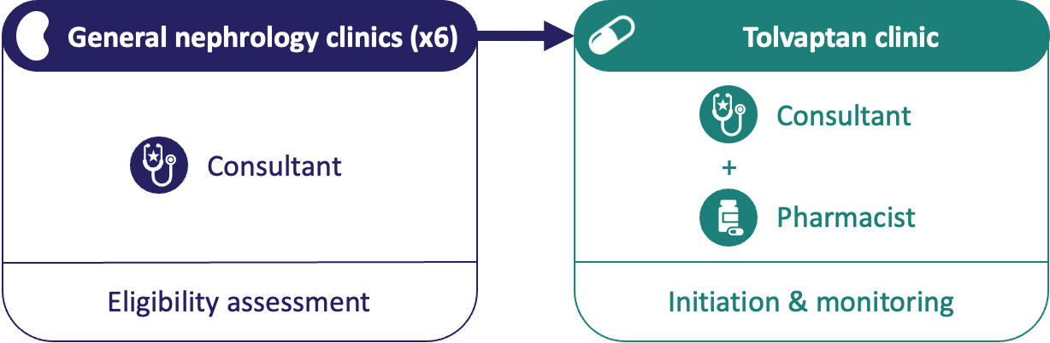 | 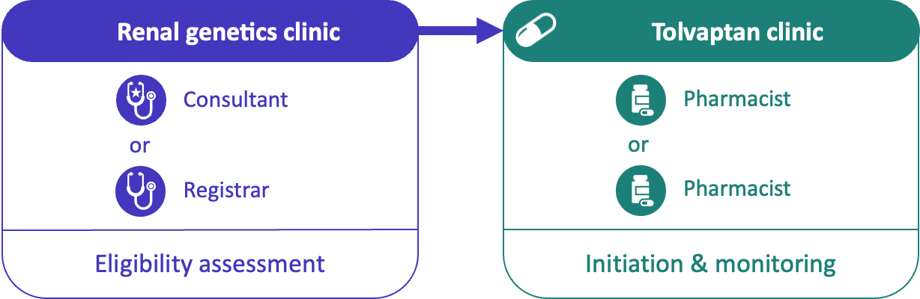 | 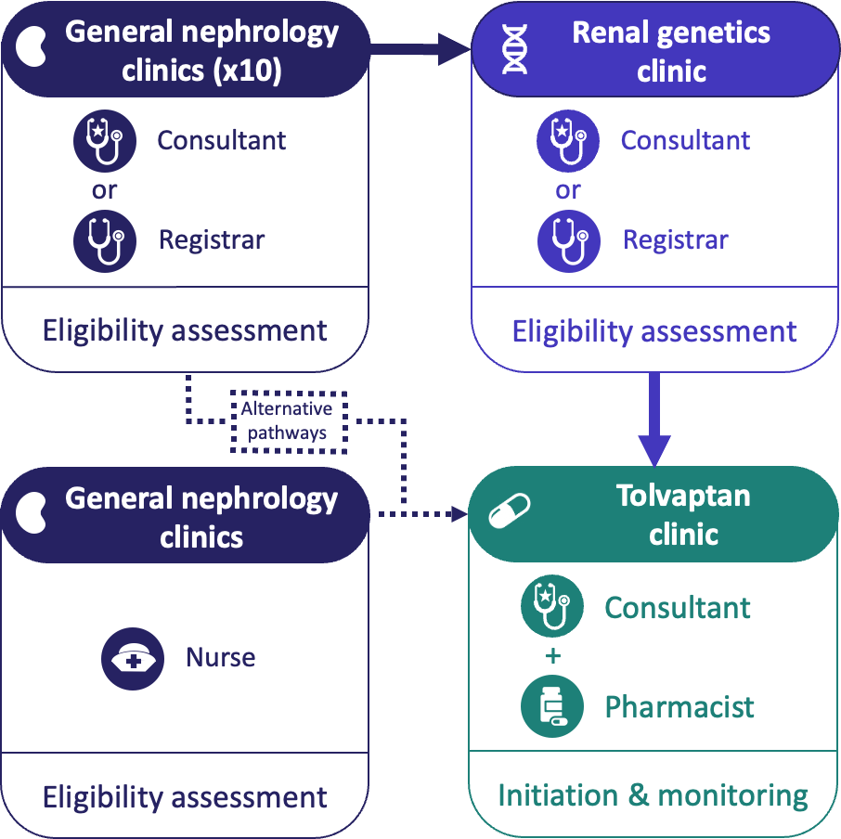
*see Appendix 8 for more detailed versions of clinic structures

Overview of findings
Differences in implementation approaches and prescribing practices across the three cases are summarised and mapped to the CFIR domains and constructs in Figure 14 and Table 17. Three of the domains featured prominently in the data: ‘Outer Setting’, ‘Inner Setting’ and ‘Individuals’. Of the 67 CFIR 2.0 constructs, 55 were evidenced across the three cases. Several constructs were not identified, including formal leadership roles outside of the implementation team (high and mid-level leaders), incentive systems, and processes in planning or assessing needs.
Implementation of tolvaptan across three NHS kidney centres varied by: the speed of introducing tolvaptan into the NHS; condition-specific clinic models versus generalist clinic models; leadership; specialist versus generalist expertise; how patients were assessed and investigated for eligibility; grade and discipline of implementation team members; operational context and implementation outcomes; and communication with patients.

Figure 14. Diagram of the Consolidated Framework for Implementation Research adapted to the tolvaptan care pathway (faded constructs were not identified in cases), adapted from Damschroder et al. (2022)

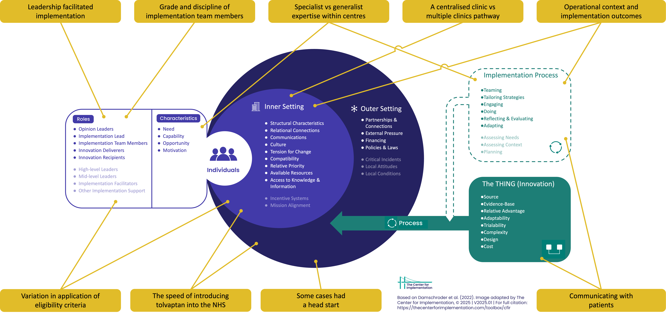

Table 17. Summary of cross-case comparison in tolvaptan implementation and prescribing practices across the three study cases
Domain/Construct | Cross-case summary | Case 1 | Case 2 | Case 3
I. Innovation
A. Innovation Source | NICE and UKKA approved tolvaptan and provided credible guidelines across all cases. | Same across all cases.
B. Innovation Evidence Base | Robust clinical trials supported effectiveness. Confidence in evidence base consistent across cases. | Same across all cases.
C. Innovation Relative Advantage | Tolvaptan offered measurable benefits over standard care. Sole disease-modifying therapy available. | Same across all cases.
D. Innovation Adaptability | Clinics and workflows adapted to accommodate tolvaptan pathway within existing resources. | Same across all cases.
E. Innovation Trialability | Limited direct piloting of pathway but pseudo-piloting at Case 2 and 3 through clinical trials. | Not possible to formally test or pilot pathway on a small scale. No participation in clinical trials. | Not possible to formally test or pilot pathway on a small scale. Clinical trial as pseudo testing/piloting.
F. Innovation Complexity | Prescribing relatively straightforward as clear eligibility criteria. Monitoring introduces more complexity within existing resources. | Same across all cases.
G. Innovation Design | No formal design for implementation. Specifically noted that there was no design included in NICE guidelines. | Same across all cases.
H. Innovation Cost | High cost of tolvaptan when first approved; not centrally funded but reimbursed through commissioning | Same across all cases.
II. Outer Setting
A. Critical Incidents | No large-scale and/or unanticipated events disrupted implementation or delivery of the innovation identified in cases. | Not identified in cases.
B. Local Attitudes | No sociocultural values or beliefs at wider outer level observed in cases. | Not identified in cases.
C. Local Conditions | No obvious economic, environmental, political or technological conditions facilitating delivery of the tolvaptan care pathway in cases. | Not identified in cases.
D. Partnerships & Connections | Trial involvement and access to professional networks supported early familiarity with eligibility, rapid clinic development, and timely prescribing. Minimal trial participation and network access slowed implementation. Industry engagement was minimal across all cases. | Limited involvement in clinical trials and approval processes, restricted access to informal professional networks, and minor engagement with industry meant slower familiarity with eligibility criteria, fewer opportunities to sense-check clinic design, and reliance on formal materials. | Engagement in trials and the NICE approval process, combined with access to formal and informal professional networks and minimal industry interaction, supported early familiarity with eligibility criteria, rapid clinic development, and timely, informed decision-making. | Participation in trials, access to formal and informal professional networks, and minimal industry engagement enabled early familiarity with eligibility criteria, rapid development of the clinic, and supported effective sense-checking of clinic processes and prescribing decisions.
E. Policies & Laws | Policy-driven urgency and regulatory pressure to make tolvaptan available in three months. | Same across all cases.
F. Financing | No external funding available beyond coverage of medication costs. | Same across all cases.
G. External Pressure | External audit monitoring and scrutiny influencing cases differently. | Negative audit feedback prompted internal review, audits and subsequent restructuring of pathway and prescribing culture. | Positive audit feedback reinforced existing clinic structures and implementation approach | Negative audit feedback received. Discussed with colleague in informal network but no changes to clinic structure or processes were made.
III. Inner Setting
A. Structural Characteristics | Clinic structure shaped timing of initiation and workflow; condition-specific clinic model improved consistency, hybrid model introduced variability. | Initially distributed prescribing in individual general nephrology clinics then newly formed tolvaptan clinic; assessment remained in general nephrology clinics. Wide range of conditions reducing focus. | Pathway implemented within existing renal genetics clinic, new tolvaptan clinic developed, small numbers in implementation team supported consistent and timely implementation. Focused on disease area and tolvaptan prescribing feeling “primed”. | Hybrid model with some sharing of responsibility between general nephrology and renal genetics clinics; introduction of renal nurse to lead tolvaptan clinic but eligibility assessments remain responsibility of renal genetics specialist.
B. Relational Connections | Communication and relationships impacted implementation; better coordination improved adoption. | Tolvaptan clinic telephone on a different day to general nephrology clinics, once monthly. | Tolvaptan clinic on the same day at the same location weekly. Easier communication between professionals in clinics. | Tolvaptan clinic on a separate day, once fortnightly. Limited communication between tolvaptan clinic and renal genetics clinic.
C. Communications | Strong communication structures supported implementation and sharing of learning. Weaker links impeding implementation and slowing implementation as well as introducing variation in practice. | Smaller centre so easier for information distribution. | Large centre but small number of clinicians involved in tolvaptan pathway. Easy distribution of information and learning. | Large centre with small number of clinicians involved in tolvaptan pathway. Involvement of general nephrologists who are not involved in communications to the same degree. Interactions between generalists and specialists varies by individuals.
D. Culture | Shared perceived value of prescribing tolvaptan for patients given limited treatment options and disease impact. | Same across all cases.
E. Tension for Change | Motivation driven by external mandate in Case 1. Patient demand in Cases 2 & 3 and greater desire to help patient group. | Implementation driven primarily by external requirements, with limited locally perceived urgency for change. | Strong perceived need for change driven by unmet patient demand and desire to provide timely access to treatment. | Perceived need for change largely driven by patient demand, with moderate urgency relative to available service capacity.
F. Compatibility | Alignment of workflow and eligibility criteria influenced ability to integrate tolvaptan pathway. | Eligibility assessment relied primarily on eGFR slopes, limited use of additional investigation due to less confidence and access. | Comprehensive use of all eligibility criteria incorporating systematic assessment with near-universal imaging and genetic testing, supporting confident and greater opportunities for being determined to be eligible. | Selective use of imaging & genetic testing, balancing risk and benefits of performing additional investigations.
G. Relative Priority | Prioritisation of tolvaptan adoption linked to specialist attitudes and perceived patient need. | Low priority initially. No additional funding or staffing available. Not prioritised compared to other areas with easier access to renal nurses. | High priority given attitudes and perspectives of specialists. High desire to start people on treatment.
H. Incentive Systems | No incentives and rewards or disincentives and punishments related to tolvaptan pathway. | Not identified at cases.
I. Mission Alignment | No clearly articulated mission relevant to implementation identified. | Not identified at cases.
J. Available Resources | Staff, expertise, and equipment influenced ability to implement pathway efficiently. | Magnetic resonance imaging not readily available. | No access issues.
K. Access to Knowledge & Information | Use of eligibility criteria and guidelines aligned with staff experience and access to information. | No access to specialist ADPKD expertise or genetic testing knowledge. | Specialist ADPKD expertise readily available at the centre. | Specialist ADPKD expertise readily available at the centre.
IV. Individuals
Roles subdomain
A. High-level Leaders | No high-level leaders directly involved in tolvaptan implementation. | Not identified at cases.
B. Mid-level Leaders | No mid-level leaders directly involved. | Not identified at cases.
C. Opinion Leaders | Early identified opinion leaders driving early implementation. | No local opinion leaders initially but potentially implementation lead could be considered opinion leader later. Other participants described asking questions and following their approach. | Clear local opinion leader who participated in clinical trials, NICE approval process and manages renal genetics clinic. | Clear local opinion leader who participated in clinical trials and manages renal genetics clinic.
D. Implementation Facilitators | No individuals identified with expertise to assist, coach or support implementation. | Not identified at cases.
E. Implementation Leads | Opinion leaders driving early implementation. Lack of opinion leader associated with slower implementation and variation in practice. | No clearly identifiable implementation lead initially, formal leadership later but had less influence than other cases due to distributed service structure. | Clear leadership from the outset, coordinating service design, clinician engagement and early adoption. | Clear implementation lead from the outset, providing clinical direction and maintaining momentum during implementation.
F. Implementation Team Members | Team composition influenced workflow, eligibility assessment and variability in practice. | Implementation initially led by separate clinicians in their own clinics then by a single clinician and pharmacist, good relationships. | Clinicians and two pharmacists, experienced trainee involvement, shared responsibility for eligibility assessment but mainly doctors. | Clinicians and specialist nurse, inexperienced trainee involvement, communication barriers due to separate clinics.
G. Other Implementation Support | Other implementation support not identified in case. | Not identified at cases.
H. Innovation Deliverers | Deliverers actively implemented pathway. Roles largely consistent across cases. | Same across all cases.
I. Innovation Recipients | Engagement varied by case. Centres with earlier uptake leads to more proactive approaches. | Patients engaged when eligible for treatment. | Patients engaged early in process. Tolvaptan re-discussed routinely if declined or stopped treatment. | Patients engaged when eligible for treatment. Tolvaptan re-discussed but not routinely, more likely if high risk for progression.
Characteristics subdomain
A. Need | No clear need for individual professionals identified. | No clear deficits for individuals that would be addressed by implementation of tolvaptan pathway.
B. Capability | Clinical experience shaped capability and confidence. | Lower familiarity with tolvaptan. Less experience with eligibility assessment. Less routine integration into assessment workflow. Limited systems to identify patients proactively. Workflow not structured for routine assessments. | High expertise in renal genetics with confident eligibility assessment. Routinely integrated tolvaptan into standard care. Systems and workflow support proactive identification. Able to easily embed routine assessments. | Specialist knowledge supports confident assessments. Inclusion of less specialised and less experienced staff (trainees) introduced variability. Workflow allows proactive and reactive strategies.
C. Opportunity | Workflow and staffing influenced ability to implement pathway. | Initially not sufficient scope for tolvaptan pathway to be implemented. No scope for leadership as not an established role and no time allocated. | Clear opportunity to implement tolvaptan pathway within renal genetics clinic. Power as an experienced specialist with expertise in renal genetics. | Clear opportunity to implement tolvaptan pathway within renal genetics clinic. Power as an experienced specialist with expertise in renal genetics.
D. Motivation | Motivation to implement linked to experience, patient demand, and workflow structure. | Greater caution with conservative eligibility interpretation. Less normalisation of assessment process. Reactive, eligibility-triggered discussions. Delayed patient engagement. | Confident and persuasive in treatment discussions. Positioned tolvaptan as standard/default option. Persuasive encouragement. Early patient engagement. | Confident overall. Balanced approach with context-sensitive decisions.

V. Implementation Process
A. Teaming | Coordination influenced consistency and timeliness of adoption. | Limited coordination initially with implementation distributed across clinics and clinicians. More coordinated after introduction of tolvaptan clinic. | Coordinated team led by consultant with specialist expertise. | Hybrid with coordinated small inner team led by consultant with specialist expertise. Wider team involving generalist and large number of decision-makers making it harder to coordinate.
B. Assessing Needs | No systematic assessment of deliverer or recipient needs observed in cases. | Not identified at cases.
C. Assessing Context | No barriers/facilitators not explicitly assessed prior to implementation in cases. | Not identified at cases.
D. Planning | No clear planning of roles, responsibilities, steps, milestones, goals or measures other than the implementation of the tolvaptan pathway. | Not identified at cases.
E. Tailoring Strategies | Pathway adapted to local clinic structure, workflow, and patient population. | Tailored approach to general ethos of continuity of care under same consultant and reduce travel for patients. | Tailored implementation to ensure delivered within single clinic setting. | Tailored approach to manage high volume of patients at centre.
F. Engaging | Engagement approaches influenced uptake. Proactive engagement improved early initiation. | Minimal engagement of generalists; pharmacist not initially engaged; leadership absent early. Patients engaged reactively when eligibility criteria triggered; discussions cautious. | Specialist consultant and pharmacists actively engaged; trainee involvement; leadership drove adoption; coordinated team. Patients engaged proactively; tolvaptan framed as default; repeated early discussions. | Specialists and nurse involved; no pharmacist involvement; trainee involvement variable; engagement inconsistent across team. Patients engaged context-sensitively; discussions timed to minimise anxiety; proactive.
G. Doing | Clinic execution influenced timeliness of initiation and patient uptake. | Initiation in 1-2 months; eligibility-triggered discussions; delays in initiation; some patient loss. | Initiation same-day or within 1–2 weeks; proactive routine discussions; minimal patient loss. | Initiation variable, months in some cases; intermediate proactive/reactive approach; capacity issues caused delays and some patient loss.
H. Reflecting & Evaluating | Audits helped identify gaps and maintain consistency; absent audits limited feedback. | Internal audit prompted by external audit. Identified tolvaptan pathway not sufficiently implemented leading to missed patients. | Internal audits to confirm successful implementation and consistent approach to assessing eligibility and initiating. | No internal audits due to barriers of very distributed care, large numbers and insufficient informational technology support.
I. Adapting | Patient materials and workflow adapted to local context to support uptake and feasibility. | Minimal adaptation. Maintained manufacturer leaflet. Workflow slow to integrate | Adapted patient materials and service delivery to local workflow. Integrated clinic efficiently | Adapted materials. Workflow adapted to hybrid structure. Selective application of eligibility criteria.

The speed of introducing tolvaptan into the NHS (Outer setting, Inner setting)
NICE mandates that approved medications be available to patients within three months, including tolvaptan (UK Government, 2013). This applied to all cases. Clinicians reported that the medication has a strong evidence base underpinning the guidelines from NICE and the Renal Association (now UK Kidney Association), which they used to inform their practice. Eligibility criteria were defined by NICE and the Renal Association, but they did not offer any operational guidelines. Although medication costs were reimbursed through commissioning arrangements, centres were required to deliver the mandated monitoring and associated services without additional dedicated funding. The financial implications of implementation appeared to be less of a barrier at larger centres (Cases 2 and 3) compared with the smaller centre (Case 1), potentially reflecting greater resource availability or flexibility.
Some cases had a head start (Outer setting)
There were differences between cases in terms of their partnerships and connections, which influenced how prepared they were for change. Case 1 had not been involved in the tolvaptan effectiveness trials, and clinicians reported initial uncertainty about how to implement tolvaptan, leading to a slower, more cautious approach. By contrast, Cases 2 and 3 had both participated in tolvaptan effectiveness trials, so the healthcare teams were aware of the potential logistical challenges of delivering tolvaptan. This supported early implementation.
“I think it definitely helped being in the trials. We knew more what to expect when it was approved. We already had patients that had been taking it.” (Specialist nephrology consultant, Case 2)
There were also differences between cases in terms of access to informal professional networks, which could offer advice about implementation. Consultants in Case 1 reported limited use of these, relying on published materials. In contrast, lead consultants in Cases 2 and 3 actively leveraged professional contacts to share service designs and approaches.
This advantage was mitigated by an NHS initiative called GIRFT (Getting It Right First Time (GIRFT), 2021), published in 2021. This initiative provided external audit feedback on tolvaptan prescribing to kidney centres after the clinics were established. At Case 1, the report identified less successful implementation and underuse of tolvaptan, prompting internal audits and the introduction of a dedicated tolvaptan clinic in 2022. Similar feedback at Case 3 did not lead to changes in practice, with questions about the reliability of the approach taken by the initiative and support from peer discussions confirming a similar approach providing reassurance.
A single condition-specific clinic model vs multiple clinics in a generalist clinic model (Inner structure)
With no guidelines on implementation or resources for restructuring clinics, the pre-existing structure of centres shaped the implementation of tolvaptan. In Case 1, the pathway was initially incorporated into multiple general nephrology clinics across multiple hospital sites to maintain their ethos of care continuity and provide coverage across a large geographical area. This generalist clinic model involved multiple prescribers acting independently without a clear implementation lead, which slowed early implementation and contributed to variability in practice. As one consultant explained:
“It was a bit haphazard. People’s practices were different and their criteria for starting [tolvaptan] wasn’t entirely clear… It was difficult to be certain whether everybody that would be eligible for it, was being offered it and whether everybody that was starting on it actually met the inclusion criteria.” (General nephrology consultant, Case 1)
The later introduction of a central tolvaptan clinic and identification of a lead consultant helped to standardise processes. However, the responsibility for eligibility assessments and referral decisions remained distributed across general nephrology clinics. Recognising the potential for variation to persist under this model, one consultant described conducting internal audits and being in the process of developing an automated method to identify eligible patients based on routinely collected eGFR readings. However, the automated process had not yet been introduced at the time of the multiple case study.
In contrast, Case 2 managed all ADPKD patients centrally within an existing renal genetics clinic, which can be described as a condition-specific clinic model. This facilitated the implementation of the tolvaptan care pathway and newly developed tolvaptan clinic into this service. The small, well-aligned team eased implementation, ensured consistent practice, provided clear oversight, and supported communication and sharing of knowledge.
Case 3 adopted a hybrid clinic model, with ADPKD patients managed in the renal genetics clinic and multiple general nephrology clinics. Implementation was mainly the responsibility of the renal genetics team, but included general nephrology consultants referring patients to the renal genetics clinic. Communication and dissemination of knowledge was more challenging due to the larger number of staff involved. Although there was a small central implementation team responsible for eligibility assessment, the overall service was large and the pathway complex, involving a large number of clinicians, which was observed to make coordination difficult and reduce oversight. One consultant described some colleagues not being aware of tolvaptan and observed high variability in the number of referrals received. One consultant explained during the clinic observations that ideally all ADPKD patients would be managed in the one renal genetics clinic, but that this was not possible due to large patient numbers at the centre.
These structural characteristics shaped how patients were identified and assessed for treatment. In Case 1, consultations with people with ADPKD were infrequent for individual consultants and alongside those with other conditions in general nephrology clinics. One consultant reported this made it difficult to keep tolvaptan at the forefront of their mind amidst competing demands. In contrast, at Case 2, clinicians in the renal genetics clinics described feeling “primed” to identify eligible patients as it was something they were doing regularly. The service structure in Case 3 meant aspects from Cases 1 and 2 were combined.
Leadership facilitated implementation (Individuals)
The characteristics of clinical leadership shaped how the tolvaptan service was implemented and normalised across cases. At Case 1, there was no obvious opinion leader to undertake the role of implementation lead because all the consultants were generalists. This changed following the national audit, and one consultant undertook a lead role in the tolvaptan clinic to standardise the approach, but expressed scepticism about its effectiveness, which may have contributed to underuse at their centre.
“I was very sceptical about it… we all were. It seemed to have quite a lot of side effects and the benefit is there, but it’s not huge. So we offered it to patients, but we didn’t push it particularly.” (General nephrology consultant, Case 1)
In contrast, Cases 2 and 3 had opinion leaders from the start. As renal genetics clinic leads who had participated in the tolvaptan clinical trials, they became implementation leads. Other clinicians interviewed described them as the “driving force” behind service implementation, guiding how the service approached eligibility assessments and prescribing decisions.
Specialist vs generalist expertise within centres (Individuals, Implementation process)
Centres with specialist expertise demonstrated higher system-level motivation and capability to implement the tolvaptan care pathway. At Case 1, consultants described less frequent contact with ADPKD patients, which limited their experience of prescribing tolvaptan and meant they rarely observed the impact of treatment. They appeared to have lower motivation to proactively identify and initiate eligible patients, with clinicians relying primarily on routine blood tests. When tolvaptan was offered, clinicians described residual scepticism and reported they did not particularly encourage patients to consider tolvaptan. They offered tolvaptan only when patients clearly met the routinely collected eGFR criteria. Similarly, in Case 3, specialist consultants described the general nephrologists acting as gatekeepers to the renal genetics clinic but recognised that they had less awareness of tolvaptan and eligibility criteria, so not all were motivated to refer patients.
The specialist-led teams in Cases 2 and 3 actively promoted identification of eligible patients, supported timely initiation and reinforced the value of treatment. This created a culture where clinicians across the centre were more engaged and willing to integrate tolvaptan into routine care, rather than relying solely on routine lab thresholds or ad-hoc investigations. This included confidence in assessing patients for eligibility and presenting information to patients in what they called a “balanced” and “realistic” way. One consultant perceived that a patient’s likelihood of receiving tolvaptan was significantly higher if they saw a specialist.
There was reported variation in the culture between specialists in Cases 2 and 3, with Case 2, the policy was to “follow the rules” and adhere to guidelines, whereas specialists in Case 3 reported increasingly prescribing outside the CKD stage and eGFR slope criteria for high-risk patients, drawing on their experience and awareness of similar practice at other centres. This highlights that while specialist expertise strengthens centre-level motivation and capability, local-practice norms and individual clinician judgement also influence how the pathway is implemented.
Leadership and specialist expertise within the team guided the way tolvaptan was communicated to patients. One consultant reported that, in Case 1, tolvaptan discussions were largely reactive, being initiated only after patients met routine eligibility thresholds. Individuals at Case 2 reported a more proactive approach, framing tolvaptan as the default pathway and raising it anticipatorily and repeatedly. In clinic observations, it was noted that these latter clinicians emphasised benefits, minimised risks and actively encouraged patients to try tolvaptan given the lack of alternative disease-modifying options.
“I just say ‘every time I see you, I’ll be looking for a reason to start it, not a reason not to start it. This is their first chance to try a disease-modifying drug. I guess I give it the hard sell.” (Specialist nephrology consultant, Case 2)
Variation in application of eligibility criteria (Inner setting, Individuals)
Clinicians at different centres reported differing interpretations of eligibility criteria in national guidelines. Although UK NICE and UKKA guidelines do not specify an age cut-off, some cases applied informal restrictions based on patient age, and prescribing culture differed for patients at the lower end of the CKD treatment window.
For clinicians at Cases 1 and 3, no formal or informal age cut-offs were applied, with one consultant stating that applying an age cut-off could be considered “ageist” and that even modest delays in progression could be beneficial for older patients to avoid kidney replacement therapy (KRT). However, at Case 2, the culture was not to prescribe tolvaptan to patients beyond age 60 years, as they believed reaching this age without needing KRT suggests less aggressive disease and no indication for tolvaptan. Clinicians at Case 1 also reported that initiating tolvaptan in patients in their 50s could delay transplantation to a point where outcomes might be less favourable.
At Cases 1 and 3, the culture at the site was that patients nearing the lower end of the treatment window had “missed the boat” with tolvaptan prescribing no longer being beneficial or appropriate. However, at Case 2 these same patients were viewed to have a “final chance” to get the benefit from the medication before becoming ineligible.
“So me and [lead consultant] had a discussion about a patient whose eGFR was dropping off… And we agreed that it probably won't make much of a difference. It's such a massive undertaking… I just think is it worth it?" (Specialist nephrology consultant, Case 2)
There were also differences between cases in the criteria used to determine rapid progression and patient eligibility. At Case 1, eligibility assessment relied almost entirely on routinely collected eGFR data, with genomic testing not performed due to limited staff expertise and restricted availability. As a result, the criteria that used these investigations were rarely used, and patients who would have qualified under these criteria were missed.
Clinicians at Case 2 described systematically applying all eligibility criteria which was supported by observed practice in clinics. Routine care included almost universal genomic testing and MRIs allowing the use of risk stratification tools. MRIs were commonly repeated to assess for changes in Mayo Imaging Classification.
Case 3 adopted an intermediate approach by selectively applying eligibility criteria when patients expressed interest in taking tolvaptan. Most patients were reported to have had a single MRI, and around half had genomic testing, with avoidance of unnecessary patient harm cited as the rationale.
Grade and discipline of implementation team members (Individuals)
Roles and composition of the implementation team also influenced implementation through influencing how eligibility criteria were applied, prescribing culture and how discussion styles influenced patient uptake. Pharmacists viewed themselves as more risk-averse, so acted as a “safety check” for the more proactive prescribing of physicians by adhering closely to guidelines and focusing on potential risks. Nursing staff described themselves as more practical and patient-focused, taking into account the psychosocial aspects of treatment.
“We should all be having conversations with patients about it, but the truth of the matter is we all have a set amount of time and you have different focuses.” (Renal pharmacist, Case 2)
The involvement of nephrology trainees, a qualified doctor undertaking specialist training in nephrology, contributed to implementation differently between cases. Case 1 had no trainees. At Case 2, an experienced trainee regularly reviewed people with ADPKD as one of the key implementation team members. In contrast, at Case 3 there was more ad-hoc trainee involvement; they were described by one consultant as unfamiliar with tolvaptan and less confident discussing treatment options, which was thought to lead to missed opportunities and lower patient uptake.
Operational context and implementation outcomes (Inner setting, Implementation process)
How the tolvaptan care pathway was implemented also introduced the potential for delays and missed prescribing opportunities. At Case 1, the tolvaptan clinic was conducted monthly via telephone, which relied on patients to get back in contact if they wanted to start treatment. This created the potential for delays, and as one pharmacist reported, some patients were lost to follow-up, so they did not start treatment.
At Case 2, the renal genetics and tolvaptan clinic occurred concurrently at the same location. Observations indicated that this facilitated close communication and coordination between team members, meaning patients often accessed treatment on the same day.
Operational challenges were most noticeable at Case 3. The tolvaptan clinic being held on a separate day to the renal genetics clinic was described by one consultant as reducing their oversight of implementation. Patients could be started on tolvaptan through alternative pathways, bypassing the renal genetics clinic, leading to inconsistent decision-making. Document analysis of the standard operating procedure showed that the tolvaptan clinic was introduced to deliver the medication and monitoring, but clinic observations indicated that eligibility was being reassessed, discussions revisited, and patients remained in the clinic if unsure. These additional activities appeared to emerge naturally over time rather than being a deliberate change. As a result, clinic capacity was reduced, and initiation of new patients could take longer, with some patients waiting months. One consultant described in an interview that this could influence patient uptake of tolvaptan by undermining their confidence in and perceived importance of the medication.
“We’ve met people waiting months to start tolvaptan… patients probably think ‘well god they don’t want us to start if they’re just flinging leaflets at us once a month, but not starting it’.” (Specialist nephrology consultant, Case 3)
Communicating with patients (Innovation, Implementation process)
While Case 1 continued to use the pharmaceutical company leaflet for tolvaptan to inform patients about the benefits and side effects of tolvaptan, Cases 2 and 3 adapted communication materials to form a local leaflet. Clinicians in these latter cases described the pharmaceutical company’s leaflet as not reflective of real-world tolvaptan use and focused heavily on the safety concern for hepatotoxicity highlighted in the tolvaptan clinical trials. They thought that this made the leaflets “overly negative” which they thought discouraged patient uptake. This was supported by document analysis of the pharmaceutical company leaflet.
“We didn’t want people to be scared off [by the pharmaceutical company leaflet], so much that they wouldn’t start taking it… so we just mocked up our own.” (Renal Pharmacist, Case 2)
Engaging patients when re-offering tolvaptan following discontinuation or refusal formed part of how the care pathway was operationalised and sustained over time, with differing cultures between cases. At Case 1, re-offering was rare and only occurred if there was a perceived change in patient circumstances. In contrast, Case 2 regularly revisited tolvaptan with eligible patients but with a softer approach, which was seen in the clinic observations. Case 3 adopted a selective strategy, re-offering mostly to patients perceived to be at the highest risk.
“Lots of people have tried it and then if they stop it, they come back to see me and I’m still talking about it. And some of them do go back to have another go at it.” (Specialist nephrology consultant, Case 2)
Mapping key themes to prescribing outcomes
To summarise how implementation factors shaped prescribing practices, the potential for each factor to lead to the prescribing outcome is outlined in Table 18. The position of each case in the analysis of registry data is also documented for comparison with the findings for each case.
Table 18. Key themes linking implementation to prescribing practices in cases
 | Non-initiation among patients meeting guideline eligibility criteria |  |  | Initiation among patients not meeting guideline eligibility criteria
 | Case 1 | Case 2 | Case 3 | Case 1 | Case 2 | Case 3
Clinic structure | Distributed at initial assessment (▲), multiple decision-makers (▲), introduction of tolvaptan clinic over time (▼), single lead consultant (▼), audit (▼) | Good oversight of ADPKD patients (▼), limited number of assessors (▼) | Some patients remain in general clinics (▲), tolvaptan clinic at capacity (▲) | Pharmacist-involvement (▼) | Pharmacist-involvement (▼) | No pharmacist involvement (▲)
Eligibility criteria | Limited use of other criteria (▲) | N/A | Not all eligibility criteria used for all patients (▲) | Strict guideline adherence (▼) | Patients being assessed by multiple methods (▲) | Prescribing outside guidelines (▲), patients being assessed by multiple methods (▲)
Local prescribing practices | Initial caution (▲), initial scepticism (▲), reactive (▲), less structured revisiting (▲), GIRFT pressure (▼), later more proactive (▲) | Encouraging/persuasive culture (▼), revisiting after decline or failure (▼) | Middle ground prescribing culture (▲▼) | Less confident prescribing (▼), scepticism (▼) | Very proactive culture (▲), overall following guidelines (▼) | Balanced prescribing culture (▲▼)
Communicating with patients | Pharmaceutical company leaflet (▲), selective promotion (▲) | Local more balanced leaflet (▼) | Local more balanced leaflet (▼) | N/A | N/A | N/A
Summary of findings for case study | High non-initiation among eligible patients initially but later low levels | No suggested non-initiation among eligible patients | Mixed but high risk of non-initiation among eligible patients | No suggested initiation in patients not meeting eligibility | No suggested initiation in patients not meeting eligibility | Some initiation in patients not meeting eligibility, increasing frequency over time
RaDaR analysis based on 2016-2023 data | Lower non-initiation among eligible patients | Lower non-initiation among eligible patients | Higher non-initiation among eligible patients | Lower initiation among patients not meeting eligibility criteria | Lower initiation among patients not meeting eligibility criteria | Higher initiation among patients not meeting eligibility criteria
▲ = factor associated with increased likelihood of outcome ▼ = factor associated with decreased likelihood of outcome ▲▼ = mixed or context-dependent influence

Discussion
Main findings
This study explored the factors influencing the implementation of tolvaptan care pathways and prescribing practices in UK adult kidney centres. Implementation was primarily influenced by factors within the ‘Outer Setting’, ‘Inner Setting’, and ‘Individuals’ domains of the CFIR. At the ‘Outer Setting’, Cases 2 and 3 benefited from prior participation in the clinical effectiveness trial for tolvaptan and use of professional networks to facilitate learning for a rapid launch of a new pathway without additional funding. This enabled early adoption compared to Case 1. At the ‘Inner Setting’, Case 2’s specialist-led condition-specific clinic model enabled systematic application of eligibility criteria and timely initiation of tolvaptan, while Case 1’s generalist clinic model could cause variable application of eligibility criteria and delays in initiation. Case 3 had a hybrid model combining aspects from Cases 1 and 2, with capacity challenges due to treating ADPKD patients in high patient volume generic clinics. At the ‘Individuals’ level, proactive clinicians led the management of the tolvaptan pathway in Case 2, which could maximise treatment access, whereas less experienced staff appeared to contribute to eligible patients not being initiated on the medication in Case 1. Case 3 reported occasional off-guideline use, potentially contributing to initiation in patients who were not eligible for the medication.
Interpretation of findings in relation to prior research
Registry (Gittus et al., 2023b) and reimbursement studies (Chong, Harris and Ong, 2022) have documented potential variation in tolvaptan prescribing between kidney centres but provided limited insights into why such variation occurs. Although medication costs are reimbursed through commissioning mechanisms, the absence of dedicated funding to support implementation and monitoring placed implementation responsibilities on local centres. This aligns with prior literature suggesting that operational costs and workforce capacity are key determinants in the adoption for resource-intensive medications (Medlinskiene et al., 2021).
Our findings are consistent with other studies assessing the implementation of new medications, such as the introduction of direct-acting antivirals for Hepatitis C (Rogal et al., 2017). This demonstrated that strong clinical evidence and published guidelines alone do not ensure consistent and widespread adoption of new medications. Implementation research has highlighted the importance of organisational processes and service-level operationalisation in shaping uptake, particularly where guidelines focus on eligibility rather than how care pathways should be organised locally (Pereira et al., 2022; Peters et al., 2022). However, the absence of detailed operational recommendations may reflect appropriate flexibility given variation in service structures and resource constraints. However, this flexibility also permits the development of locally adapted pathways, which can contribute to variation in patient identification and prescribing patterns (Damschroder et al., 2009).
A systematic review similarly highlighted the role of peer influence on the implementation success of new medications (Medlinskiene et al., 2021). Others have described this as the “prescribing contagion effect” where peer support can accelerate the implementation of services and uptake of new medications (Iyengar, Van den Bulte and Valente, 2011). Similarly, participation in clinical trials has been associated with early adoption of medications through increased familiarity with the evidence and confidence in operational delivery (Lublóy, 2014). Without access to clinical networks or early trial experience, centres rely on external feedback and local experience to build expertise. This is more challenging in settings with lower patient volumes, where limited case exposure constrains opportunities for learning and refinement of practice. Improvement can also take time, meaning some patients may miss opportunities or have delayed access to medications (Lublóy, 2014). External pressure from outside organisations has been shown to potentially improve implementation, as observed in Case 1 in response to GIRFT feedback (Sarkies et al., 2023). Although not seen in our study, other studies have noted this can lead to overcorrection with inappropriate prescribing due to fear of further scrutiny (Sarkies et al., 2023).
Within centres, the condition-specific clinic models led to greater implementation of the tolvaptan care pathway as well as the identification of patients, eligibility assessments and timely initiation. This is consistent with the wider literature, which shows that specialist condition-specific clinics improve access to guideline-based medications. Proposed mechanisms from the management of heart failure include the concentration of specialist expertise, coordinated care pathways and dedicated resources, which are recommended to reduce barriers to identifying eligible patients and delivering guideline-based medications efficiently (Chambers and Lancellotti, 2020; Chambers et al., 2020; Ramsay et al., 2025).
Our findings fit well with an existing implementation framework, the CFIR, indicating the important role that implementation of pathways in health services for new medications plays, rather than guidelines alone. Implementation factors acted at the ‘Outer Setting’, ‘Inner Setting’ and ‘Individuals’ domains. This aligns with prior CFIR-informed implementation studies, which demonstrate the importance of contextual and organisational factors in shaping implementation outcomes (Kirk et al., 2015), while also adding to the limited evidence on the implementation of newly approved medications in rare diseases.
Strengths and limitations
A key strength of this study is the in-depth study of prescribing practices across contrasting organisational contexts. By including the perspectives of clinicians involved in different components of the care pathway and by using multiple methods of data collection, findings were triangulated. Limitations include the potential for the researcher to collect data and analyse through a lens influenced by their own clinical expertise in ADPKD and their contribution to writing guidelines on the use of tolvaptan. This was mitigated through regular research team discussions. Also, RaDaR statistics were intentionally withheld from the lead researcher until they had completed their analysis in case knowledge of prescribing rates in a centre narrowed their data collection and analysis. Finally, findings reflect a specific period of service implementation and prescribing (2024–2025), so practices may have evolved since then in these three cases. Nonetheless, the factors identified as influential in the implementation of tolvaptan care pathways for ADPKD are likely to be transferable to other settings implementing complex or specialist medications, including those in rare diseases.
Implications
For services, this study highlights how implementation strategies shape medication prescribing. Kidney centres internationally could review the organisation of their pathways, with centres prescribing less tolvaptan to eligible patients considering cohorting ADPKD care into a single condition-specific clinic or conducting internal audits. For policymakers, fostering clinical networks and shared learning may accelerate early implementation and reduce variation. For researchers, the study demonstrates CFIR’s applicability to rare diseases, providing insights to guide the implementation of other complex treatments and improve patient access. Future research could quantify the potential impact of implementation factors on tolvaptan prescribing to identify appropriate interventions.
Conclusions
In the absence of additional dedicated funding to implement new pathways, approaches to the implementation of tolvaptan in the UK were primarily based on existing service structures. Condition-specific, specialist-led pathways may support more timely and consistent prescribing, whereas generalist or hybrid models may lead to more complex implementation with delays and missed opportunities for prescribing. The way in which tolvaptan care pathways were implemented influenced who was assessed, when assessment occurred, and by whom, which potentially led to variation in adherence to guidelines and different prescribing practices. These findings may inform the implementation of other complex medications in rare diseases, helping to reduce unwarranted variation and improve patient access.

Chapter summary
- This chapter presented the findings of the multiple case study that focused on how tolvaptan care pathways were implemented in UK kidney centres and how this may have led to variation in tolvaptan prescribing practices.
- Analysis was informed by the Consolidated Framework for Implementation Research (CFIR), which provided a structured lens for identifying how factors at the ‘Outer Setting’, ‘Inner Setting’, ‘Individuals’ and ‘Implementation Process’ shaped the implementation of tolvaptan care pathways.
- Findings demonstrated that implementation of the same medication (referred to as an innovation in the CFIR) differed between cases due to variation in service configuration, clinical leadership, specialist expertise and the organisation of care pathways.
- These differences influenced how patients were identified, how eligibility for tolvaptan was assessed and how treatment decisions were communicated with patients and enacted in practice.

– Developing a conceptual model of prescribing decision-making in rare diseases: insights from tolvaptan prescribing for autosomal dominant polycystic kidney disease

Chapter outline
This chapter presents the findings from the multiple case study. It has been presented in the format of a journal article ready for submission to the Orphanet Journal of Rare Diseases. The contribution of each co-author is detailed in Appendix 1. Further details on the methods and the supplementary materials that will be published with the journal article are presented in Appendices 7 and 8.

Manuscript

Developing a conceptual model of prescribing decision-making in rare diseases: insights from tolvaptan prescribing for autosomal dominant polycystic kidney disease
Gittus, M., Fotheringham, J., Ong, A.C.M., and O'Cathain, A.
In preparation for the Orphanet Journal of Rare Diseases

Abstract
Background
Prescribing rates can vary widely even when evidence-based guidelines are available. Models of prescribing suggest that variation is influenced by patient characteristics, pharmacist involvement, marketing efforts, and contextual factors. Rare diseases pose additional challenges compared with more common chronic conditions. This may potentially limit the applicability of generic prescribing models to rare disease contexts. Autosomal Dominant Polycystic Kidney Disease (ADPKD) is a rare, progressive kidney disease that affects up to 70,000 people in the United Kingdom. Tolvaptan is the only approved disease-modifying therapy for rapidly progressive disease, but its use appears to vary in clinical practice. Using tolvaptan in ADPKD as a case allows the exploration of factors influencing prescribing in a rare disease and the development of a conceptual model of prescribing decision-making in rare diseases.
Methods
Semi-structured interviews, clinic observations and document analysis were undertaken with clinicians at three NHS kidney centres in the United Kingdom (UK) between December 2024 and September 2025. An existing conceptual model of prescribing decision-making in chronic conditions was used within the data collection and analysis. Relevant factors were mapped to this existing model to develop a model for rare diseases.

Results
Twelve semi-structured interviews with clinicians, 23 clinic observations and 8 documents were analysed to explore tolvaptan prescribing in ADPKD. Tolvaptan prescribing for ADPKD fitted well with the conceptual model of prescribing decision-making in chronic conditions. However, six factors appeared particularly influential in rare disease prescribing: therapeutic scarcity, small patient numbers, disease heterogeneity, highly influential experts and informal networks, well-informed patients, and high medication costs. These findings informed a conceptual model of prescribing decision-making in rare diseases, which consists of a multi-stage process from patient identification to shared decision-making between clinicians and patients.
Conclusions
In rare diseases such as ADPKD, prescribing decisions are influenced by some factors that are shared with more common chronic conditions, but have influences that are specific to, or amplified within rare diseases.
Introduction
While rare diseases are typically chronic, they present additional challenges compared with more common chronic conditions. Their low prevalence means some clinicians may only have seen a few cases, which can limit their experience with the condition and make decision-making more difficult (European Commission, 2020; European Parliament, 2026). Some of these rare diseases do not have approved medications, while others have expensive ones that have been approved based on small or less robust clinical trials (Eichler et al., 2023; Hale, Morris and Barker-Yip, 2023). These challenges may explain why prescribing in the real-world can differ from guideline recommendations (Thoonsen et al., 2024; Wang et al., 2023). Understanding why this variation occurs requires a structured approach to examine the multiple factors that influence clinicians’ prescribing decisions and how these factors interact in the context of rare diseases (Grol and Grimshaw, 2003; Nguyen et al., 2020).
Conceptual models of prescribing decision-making, such as that by Murshid and Mohaidin (2017), provide a framework to understand prescribing decisions by organising these factors into patient characteristics, pharmacist factors, marketing efforts, and contextual factors. However, these models are largely derived from theoretical models or research on factors influencing prescribing for acute conditions, where medications are usually prescribed short-term to relieve symptoms or resolve illness (Kasse et al., 2024; Thompson et al., 2019). Prescribing in chronic conditions instead often focuses on slowing disease progression, preventing long-term complications, and balancing risks and benefits which may only become apparent later (Watt, 2000). A one-size-fits-all conceptual model is unlikely to account for the complexity of prescribing for both acute and chronic conditions.
In a previously published overview of systematic reviews, we identified factors influencing prescribing decisions that were common across chronic conditions. We developed a conceptual model of prescribing decision-making specific to chronic conditions, which included patient characteristics, individualised risk–benefit assessment, clinical inertia, medication costs and resource implications, shared decision-making processes, and external factors, such as clinical guidelines. However, the challenges presented by rare diseases may limit how these more generic conceptual models can help to understand decision-making when prescribing in the context of rare diseases.
Autosomal dominant polycystic kidney disease (ADPKD) is the most common inherited rare kidney disease affecting an estimated 12 million people worldwide and up to 70,000 people in the United Kingdom (UK) (Grantham et al., 2008). ADPKD is inherited in an autosomal dominant pattern, which means each child of an affected parent has a 50% chance of inheriting the condition. It is characterised by the progressive development of kidney cysts leading to kidney enlargement, decline in kidney function and kidney failure (Ong et al., 2015). Many people with ADPKD report worse health-related quality of life compared to the general population due to increased pain, abdominal distension and psychosocial distress (Gittus, Harris and Ong, 2023). In 2015, tolvaptan was approved by the National Institute for Health and Care Excellence (NICE) as the first disease-modifying therapy for people with ADPKD in CKD stages 2–3 with rapidly progressive disease (National Institute for Health and Care Excellence, 2015a). Following approval, the Renal Association (RA), and later the UK Kidney Association (UKKA), provided guidance for prescribers in the UK. They defined rapid progression using eligibility criteria based on estimated glomerular filtration rate (eGFR) decline, imaging-based kidney sizes and risk stratification tools (Gittus et al., 2025a; National Institute for Health and Care Excellence, 2015a). Using tolvaptan for ADPKD as a case for prescribing in a rare disease, we examined the factors that influence tolvaptan prescribing and their implications for a conceptual model of prescribing decision-making in rare diseases.
Methods
Study design
A multiple case study design across three NHS kidney centres was undertaken to explore variation between kidney centres in the implementation of tolvaptan care pathways and prescribing practices for ADPKD (Gittus et al., manuscript submitted). This multiple method dataset from qualitative interviews with clinicians, observation of clinics, and of local prescribing practice documents provided an opportunity to identify factors affecting prescribing practices for ADPKD as a rare disease and consider its implications for a conceptual model of prescribing decision-making in rare diseases. Full methodological details are described in the related manuscript (Gittus et al., manuscript submitted); a summary is provided here. Reporting follows the consolidated criteria for reporting qualitative research (COREQ) (Tong, Sainsbury and Craig, 2007) (Appendix 8).
Setting
The National Health Service (NHS) is a publicly funded healthcare system in the UK that provides universal access to care that is free at the point of delivery. Kidney services in the NHS are typically delivered through acute hospital trusts. ADPKD care is provided within these services by general nephrologists and/or nephrologists with specialist expertise in genetic kidney diseases. Prescribing of medications within the NHS is guided by national policy. In England and Wales, NICE evaluates medications through its technology appraisal programme and issues guidelines to inform their use within the NHS. In Scotland, the Scottish Medicines Consortium fulfils a similar role.

Data collection
Three adult NHS kidney centres were purposively selected from 2016–2023 National Registry of Rare Kidney Disease (RaDaR) data to explore the variation between tolvaptan eligibility and observed initiation across centres. Cases 1 and 2 represented centres of differing size that demonstrated lower non-initiation among eligible patients and lower initiation among patients not meeting eligibility criteria. Case 3 was selected as a contrasting case, with higher non-initiation among eligible patients and a higher initiation among patients not meeting eligibility criteria.
Data was collected between December 2024 and September 2025 through semi-structured interviews with clinicians contributing to prescribing decisions, non-participant observation of clinics managing ADPKD patients and document analysis (e.g. local prescribing guidelines, standard operating procedures and patient information leaflets). Semi-structured interviews were conducted with clinicians using a topic guide based on an existing conceptual model of prescribing decision-making in chronic conditions (Gittus et al., 2025b), Appendix 8. Interviews included a clinical vignette to elicit discussion of patient-level factors influencing prescribing, Appendix 8. Both materials were developed by the research team and piloted with two nephrology clinicians at Sheffield Teaching Hospitals Trust; this data was not included in the analysis. Interviews were conducted face-to-face at the case site or remotely via Microsoft Teams by the lead researcher (MG). The mean duration of interviews was 54 minutes (range 43–120 minutes). Non-participatory clinic observations were conducted face-to-face or remotely via telephone by the lead researcher at clinics where discussions regarding tolvaptan were anticipated. The mean duration of observations was 18 minutes (range 13–30 minutes). Both interviews and observations were audio-recorded and transcribed verbatim by the University of Sheffield transcription service. Fieldnotes were taken during data collection, alongside analytic and reflexive journal notes to support interpretation and critical reflection (Appendix 8). Local gatekeepers (i.e. ADPKD clinical leads facilitating access to participants) provided local documents related to the prescribing of tolvaptan.
Data analysis
Interviews were transcribed verbatim. Transcripts, reflections and documents were imported into NVivo software (Lumivero, Version 15). We analysed data using the Framework Method for the analysis of qualitative data described by Gale et al. (2013). Analysis began with familiarisation of the data followed by coding using an analytical framework based on the existing conceptual model of prescribing decision-making in chronic conditions (Appendix 8). The framework was applied systematically to all transcripts and documents and iteratively refined through team discussions.
Results
Description of participants and data sources
Twelve interviews were conducted with clinicians involved in the delivery of tolvaptan at the three kidney centres. This included all the clinicians directly involved in ADPKD care. Their professional roles and clinical context are included in Table 19. Given the small size of the centres and the potential for identification, further demographic details of participants are not reported to preserve anonymity. Twenty-three appointments were observed across five clinic visits within the three kidney centres. Observations included consultations in renal genetics (n = 19) and tolvaptan clinics (n = 4). Eight documents were analysed: local guidelines (n = 2), information leaflets (n = 3), standard operating procedures (n = 2), and a summary of clinical trial outcomes (n = 1).
Table 19. Professional roles and clinical contexts of interview participants
Code | Professional role | Primary clinic context | Centre size
C1  C2  C3  C4  C5  C6  R1  P1  P2  P3  P4  N1 | Consultant nephrologist (lead)  Consultant nephrologist  Consultant nephrologist  Consultant nephrologist (lead)  Consultant nephrologist (lead)  Consultant nephrologist  Nephrology trainee  Renal pharmacist  Renal pharmacist  Renal pharmacist  Renal pharmacist  Specialist nurse | General nephrology/Tolvaptan clinic  General nephrology  General nephrology  Renal genetics  Renal genetics  Renal genetics  Renal genetics  Tolvaptan clinic  Tolvaptan clinic  Tolvaptan clinic  Tolvaptan clinic  Tolvaptan clinic | Small  Small  Small  Large  Large  Large  Large  Small  Large  Large  Large  Large

Overview of factors
Findings were mapped to the factors of the conceptual model of prescribing decision-making in chronic conditions (Table 20). 26 of the 30 factors in the original model were identified, plus an additional 13 factors which had not previously been described, which fell under the patient, other healthcare professionals, healthcare system, sales and marketing and external factors domains.
The four factors in the original model that were not evident were in the sales and marketing domain and included payments, brands of the drug, sales and medical representative effectiveness.

Table 20. Factors affecting prescribing decision-making for tolvaptan for ADPKD mapped to the existing conceptual model of prescribing decision-making in chronic conditions
Factor | Consideration | Illustrative quote(s)
Patient
Demographics | Age | “You know if someone was 80, I wouldn’t offer it…. They just wouldn’t cope with the side effects. And you really have to think, would it decrease the likelihood of them getting end-stage renal failure in their lifetime.” (C5)
 | CKD stage | "Ok I've never recommended it to someone whose eGFR is less than 30.” (C5)  "We have started people over 90 [ml/min/1.73m² eGFR], which we didn't used to.” (C6)
Comorbidities | Urological conditions, cognitive impairment, learning difficulties | "I think we have around five patients with learning difficulties on tolvaptan. So when you're trying to set them up, you need to find out they've got a process of getting the prescription, blood tests and finding out what their support network is." (P1)
Behaviours | How treatment fits into patient’s daily life | "At the end of the day I think it is the patient that's got to decide they want to do it. It's a big undertaking really. It can have a big impact on people’s lives with the side effects, the monitoring and stuff.” (P1)
Expectations & preferences | Family/peer experiences of the disease and medication | “They’ve all got family, they’ve all either talked about it with other people, they’ve got family members on it. We talked to a young woman who had a brother that had been on it, he didn’t tolerate it at all. So she said she didn’t want it, so I didn’t continue to offer it.” (C2)
Requests for medication | More requests than for other medications | “Patients do request it. It’s less surprising that people haven’t heard of it and it’s more common for people to say tell me more about this new drug for PKD.” (C1)
Knowledge * | High patient knowledge | “I think the PKD charity do a good job of promoting tolvaptan as a new treatment, and they’ve got a PKD app now that gives good information about tolvaptan. I think patient knowledge around this drug has increased over the last five years or so.” (C1)
Life stage * | Older patients | “You make a judgement as to how much length of life they might have left or how much of their kidney life they have left. Yeah, it is just a judgement when it comes down to it.” (R1)
 | Other considerations (employment, carer responsibilities, childbearing age) | “You have to think about everything. Like what they do for work as that might make things more difficult if they cannot get to the bathroom or get enough water to drink.” (P4)
Prescriber
Knowledge & experience | Disease-specific experience | "I suspect that late adopters because they've not been involved in studies, they're less familiar and it's just like their real world experience of it is reduced and therefore they think about it a lot less often and can be less confident making decisions." (C4)
 | Other experiences | “I guess the side effect that worries me most is, you know, is someone who gets severe liver injury. But again, that’s partly because of my background. So I am slightly paranoid about prescribing a drug that can cause liver failure.” (C1)
Attitudes & beliefs | Different attitudes and beliefs around medications | "I have to say that when tolvaptan first came along I was very sceptical about it… we all were [consultants at centre]. It seemed to have quite a lot of side effects and the benefit is there but it's not huge. And we offered it to patients but we didn't push it particularly." (C1)  "I tell them this is the first chance to try a disease-modifying drug, we've got a chance to slow this down. I give it the hard sell." (C4)
Approach to risk | Some more risk adverse in general | "There probably are differences yes, I'm just trying to think… So I cannot really think of a good phrase, but one is a bit more gung-ho than the other.“ (P2)
Healthcare setting | Not identified, all secondary care
Speciality/level of specialism | Specialist in ADPKD or renal genetics vs generalist | “It makes a difference if you’re someone who is a specialist who is seeing patients [with ADPKD] day in day out compared to someone that might only see someone with ADPKD once in a while. Tolvaptan isn’t going to be at the forefront of their mind and they’ll have less experience doing it so they’re probably less confident.” (R1)
Other healthcare professionals (clinicians)
Expert power | Skillsets of different healthcare professionals | “I think you can’t be a good pharmacist unless you’re safety conscious and have attention to detail and things like that. We’re all very risk averse.” (P3)
Pharmacist-physician collaboration | Managing more risk accepting medics | “It [tolvaptan prescribing] fits quite well into the pharmacist remit, and it was a good opportunity for us to get, get involved with that. I’m not making any assessment myself as to whether they’re eligible for tolvaptan, although obviously I check when I’ve got a new patient referred that they meet the criteria." (P2)
Shared responsibility/ accountability * | Removing barriers and reducing workload | “Before we had the tolvaptan clinic we had to do it all. Consent people, tell them about the risks and benefits, prescribe it and then monitor it. I think all that put people off [prescribing tolvaptan].” (C1)
Healthcare system
Time | Considerable time to consent, discuss benefits-risks and support treatment if no supporting staff | “Before we had the tolvaptan clinic we had to do it all. Consent people, tell them about the risks and benefits, prescribe it and then monitor it. I think all that put people off [prescribing tolvaptan].” (C1)
Other care priorities | Competing priorities if in general clinic | “When you’re in a busy mixed clinic with five others waiting and I’m an hour late. I will forget about [tolvaptan], as I’m doing other things, we would all forget.” (C2)
Availability of staff | No additional funding for staff | "As with all kind of NHS things, the kind of funding wasn't there really, we couldn't really free up any pharmacist time to get involved in the clinic, which is a shame because it would have been ideal for a pharmacist to be involved.” (P3)
Patient volume | Capacity issues | “I don’t think we’ve got capacity in the tolvaptan clinic at the minute. There’s no room in the clinic to bring these patients in to start them on tolvaptan. I think some people are waiting perhaps a couple of months and they’re quite keen to get started.” (P4)
Local leadership/Peer influences * | Highly influential | “He [Lead consultant] is the go-to for everything, basically. What he doesn't know isn't worth knowing. And if he says something, don't argue with him because you'll be wrong.” (C2)
Decision location * | Primed in specialist clinics vs less familiar at general clinics | “When you’re in a busy mixed clinic with five others waiting and I’m an hour late. I will forget about [tolvaptan], as I’m doing other things, we would all forget.” (C2)
Cohorting care * | Cohorting patients within condition-specific clinics increases clinicians’ experience and knowledge | "It helps having patients all in one clinic because then you're in that mindset whereas other renal units don't have their patients all together, they have more mixtures of patients, so they'll be seeing transplant patients amongst general nephrology amongst everything else. So it's quite hard to switch mindset when the patient mix is so diverse I think." (C4)
Available resources * | Access and use of different investigations to assess eligibility | "We don't do a massive amount of genetics, and we certainly wouldn't do someone's genetics to work out whether they need a tolvaptan prescription." (C1)  "Every single patient in this clinic gets genetic testing and sometimes it may require multiple rounds of genetic testing." (R1)  “It’s hard sometimes to get an MRI. So we don’t routinely check kidney size.” (C2)
Local guidelines * | Local guidelines, where they exist, can be influential but depend on easy access | “I think [other kidney centre], they had a nice little flowchart thing that we used to use as well because somebody printed it out, so that was helpful.” (C2)
Internal audit * | Internal audit ensures standardised approach and identified potential areas for improvement | “When we last did an audit. There weren’t any patients with progressive CKD in that group that hadn’t been offered tolvaptan. So we don’t think there’s a big pool of people who aren’t being referred on [to the tolvaptan clinic].” (C1)
Sales and marketing
Payments | Not identified
Drug information availability | Information packs provided to clinicians for use in practice alongside mandatory learning | “[Pharmaceutical company] came out and told us about it. They gave us a nice shiny packet and then told us about the training programme. But that was just at the very start, the training hasn’t continued. I think having that made it easier." (C3)
Brands of the drug | Not identified
Sales | Not identified
Medical representative effectiveness | Not identified
Promotional events * | Educational events | “They [pharmaceutical company] had a whole series of roundtable discussions that people could attend. It was mainly about identifying people that would be eligible and how best to, you know, initiate [tolvaptan], holding people’s hands essentially.” (C4)

External factors
Guidelines | Published guidelines | “We just use the UKKA one. I must admit I don't eyeball the guidelines every week now because I helped write it and so that's just what's in my head now.” (C4)
 | Local guidelines from other centres | “To be honest , its quicker to go and look at the [other kidney centre] guideline rather than trying to get the link. You just type into Google and it comes up. When you’re in a busy clinic, trying to find it just delays it more than you need. They had a nice little flowchart thing that we used to use as well because somebody printed it out, so that was helpful.” (C3)
Expert opinion | Small number of highly influential experts | "When all these studies started the most engaged centres were [name of four centres]. So I've been in meeting with representatives from all those places so I think we all probably have a similar approach.” (C4)
Academia | Specialist experts publishing | "We're all good at attending CPD and listening to other people, going to things like the Renal Association, ERA, ASN that kind of thing. If there's anything... [other hospital lead consultant] writes everything, anything, we read it." (C1)
Clinical trials * | Clinical trials provided early experience and confidence | "Yeah I think it definitely helped being in the trials. We knew more what to expect when it was approved. We already had patients that had been taking it." (C6)
External audit * | Comparisons to other centres | "One of the things that was picked out in GIRFT was how many people were being prescribed tolvaptan... So we had one of the lowest tolvaptan prescription rates and we got somewhat pilloried for it actually. The person doing the review was pretty concerned about it. That led us to start thinking about your practice and should we be a bit more proactive?” (C1)
Informal professional networks * | Highly influential on the approach to prescribing | "When all these studies started the most engaged centres were [name of four centres]. So I've been in meeting with representatives from all those places so I think we all probably have a similar approach. But late adopters of tolvaptan, who knows what they're doing and what they think of it?" (C4)
Contextual factors
Condition factors | Small patient numbers | "I suspect that late adopters because they've not been involved in studies, they're less familiar and it's just like their real world experience of it is reduced and therefore they think about it a lot less often." (C1)
 | High clinical burden | “Well, we have a couple of patients who take it primarily for pain, but, but normally, they meet all the other criteria anyway” (R1)
 | Heterogeneity | “I think part of it is that everyone with it [ADPKD] is so different. It makes it a bit harder to know who would benefit or who should have it [tolvaptan]” (C4)
Medication characteristics | Sole treatment option | "I know that some centres just give tolvaptan to everyone with ADPKD, but I wouldn't necessarily do that, I think there has to be an indication for it. I suppose they are just wanting to help and there aren’t any other options." (C5)
 | Risks | "You should make a clinical judgement of whether the patient is going to be in the right group to receive it, they're expensive, they've got risks." (C6)
Risk-benefit assessment | Individualised risk-benefit | “So me and [lead consultant] had a discussion about a patient recently whose eGFR was dropping off… And we kind of agreed that it probably won’t make much of a difference. Because I think it’s such a massive undertaking… I just think is it worth it?” (C5)
Clinical inertia | Initial scepticism | “I have to say that when tolvaptan first came along I was very sceptical about it. We all were [consultants at centre]. But it seemed to have quite a lot of side effects and the benefit is there but it’s not huge. And we offered it to patients but we didn’t push it.” (C1)
Costs | High medication costs | “For some people cost is always an issue, particularly if you’re in management circles. People always talk about the cost of stuff. It wasn’t nationally commissioned or whatever, people were worried about the cost initially.” (C4)  "You should make a clinical judgement of whether the patient is going to be in the right group to receive it, they're expensive, they've got risks." (C6)
 | Other costs | “It’s not just the medication. It is everything that goes along with it… the monitoring, staff to support it, delivering the medication… there’s lots of things you wouldn’t think about.” (P2)
Shared decision-making | High patient involvement in decisions | "I think it is about being open and honest with your patients, it's about giving them... I mean some may say you should only talk about the options that are suitable for them, but I think it's good to say look, these are the options for all the patients but actually you're not suitable for these ones yet." (C5)
* Additional factors not found in the conceptual model of prescribing decision-making in chronic conditions (Gittus et al., 2025b)
Beyond the individual factors presented in Table 20, several broader themes that were specific to or amplified in rare diseases were identified. These included therapeutic scarcity, small patient numbers, disease heterogeneity, highly influential experts, highly informed patients and patient requests, and high costs. The following sections explore these themes in greater depth.
Decision-making under therapeutic scarcity
Clinicians described the limited availability of disease-modifying therapies for ADPKD as influencing their prescribing decisions for tolvaptan. Tolvaptan represented the first opportunity for patients to receive a disease-modifying treatment. One clinician described being highly motivated and personally invested in offering tolvaptan to maximise potential benefits because it was the only option available after a long period without treatment options.
“From an early stage I was like an early adopter of tolvaptan and realised it was the first ever disease-modifying drug we had, and I was very keen to try it in as many people as possible.” (C4)
During the clinic observations, this was observed to encourage more flexible prescribing decision-making. Some clinicians appeared to prioritise their clinical judgement over strict eligibility criteria, driven by a desire to benefit the patient. In practice, clinicians applied this flexibility in several ways: initiating treatment outside the approved CKD treatment window, adjusting thresholds for borderline ineligible patients, and initiating the medication based on having a diagnosis of ADPKD alone.
For patients with normal kidney function above the formal CKD stage treatment criteria, some clinicians used their clinical judgement to identify those potentially at risk of future rapid disease progression, based on family history or genetic cause, and used this to justify prescribing outside the national guidance. As one clinician explained:
“We have started people over 90 [ml/min/1.73m² eGFR], which we didn’t use to. You know from family history sometimes, there’s been family history where they’re all on dialysis at forty so you know they are at high risk. Why start when GFR starts dropping, it seems wrong to me.” (C5)
A similar approach was applied by other clinicians to patients at the margins of eligibility, particularly when symptom burden was high, and it was believed tolvaptan might help relieve symptoms.
While some clinicians reported small movements in application of the eligibility criteria for tolvaptan, therapeutic scarcity was also described by one clinician as leading to a disregard for eligibility criteria. One consultant was aware of colleagues at a different kidney centre (not included in the multiple case study) who initiated tolvaptan if a patient had a diagnosis of ADPKD, irrespective of the eligibility criteria. They described encountering multiple patients transferred from that centre already receiving tolvaptan despite never meeting eligibility criteria, which they cited as evidence supporting this observation.
"I know that some centres just give tolvaptan to everyone with ADPKD, but I wouldn't necessarily do that, I think there has to be an indication for it. I suppose they are just wanting to help and there aren’t any other options" (C6)
Impact of small patient numbers on clinician experience and care organisation
Some clinicians reported seeing relatively few patients with ADPKD compared with other kidney conditions, particularly in the small kidney centre. As a result, they described being less familiar with guidelines, less experienced with tolvaptan, and less confident making prescribing decisions for tolvaptan. Clinicians in some centres managed this by cohorting ADPKD patients into condition-specific clinics. The small number of clinicians in these clinics saw most or all patients with ADPKD at that centre which they felt provided opportunities for them to develop greater experience and increased confidence when making prescribing decisions. They also described how having patients together in one clinic made them feel “primed” to look for eligible patients.
One clinician reported that there was not a dedicated ADPKD or renal genetics clinic at their centre because there were too few patients and no additional funding to support one. As a consequence, a large number of consultants at their centre were involved in managing people with ADPKD, including assessing eligibility for tolvaptan and making prescribing decisions. This potentially made it difficult for an individual clinician to gain sufficient experience to feel confident in their prescribing decisions.
"It is the size [of the kidney centre], because we are much smaller, we don't get enough [patient] numbers to run different specialist clinics. Now, of course, there is a disadvantage with that, which is becoming even more with there being more and more new medications. You can’t actually have expertise in everything. It’s impossible.” (C2)
Disease heterogeneity leading to individualised prescribing
Clinicians described that disease heterogeneity made it challenging to assess risks and potential benefits, this had implications when identifying patients who would benefit from tolvaptan. This was particularly true for less experienced clinicians, who had fewer previous cases to draw on when making clinical judgements in the face of variable disease presentations and trajectories. Risk stratification tools, such as the Predicting Renal Outcome in Polycystic Kidney Disease score (Cornec-Le Gall et al., 2016) or Mayo Imaging Classification (Irazabal et al., 2015), were identified as ways to address this heterogeneity by quantifying risk and guiding decision-making. However, multiple clinicians recognised the limitations of these tools as the information required was not always readily available and these investigations were not easily accessible in their centres. As a result, they felt that tools were used inconsistently and clinical judgement remained a central component of risk assessment.
There is no upper age cut-off according to the Medicines and Healthcare products Regulatory Agency marketing authorisation (license), NICE approval or RA/UKKA guidelines in the UK. However, clinicians reported that patient age was an important factor in decision-making, but they held different views. This variation was closely related to the heterogeneity in ADPKD disease trajectories with clinicians describing patients becoming eligible for tolvaptan at different ages. Some clinicians focused on the immediate benefit of treatment, considering whether starting tolvaptan now would meaningfully slow disease progression for that individual in reference to their remaining length of life.
"You make a judgement as to how much length of life they might have left or how much of their kidney life they have left. Yeah, it is just a judgement when it comes down to it." (R1).
Other clinicians also focused on immediate benefit but had an informal age cut-off for starting tolvaptan of around 60 years. They reasoned that if a patient had not required kidney replacement therapy by this age, this would mean they have less aggressive disease, so would benefit less from tolvaptan. They described that their informal threshold also reflected available evidence from European guidelines (Gansevoort et al., 2016) and clinical trials, which included patients up to 65 years but suggested less benefit for those older than 55 years (Torres et al., 2017).
Others weighed the consequences of starting tolvaptan for future treatment. Within this group, some expressed concern that initiating tolvaptan in middle age might defer transplantation to older age when transplant eligibility is lower and surgical risk is higher. Others emphasised that initiating tolvaptan in older patients could delay progression so that kidney replacement therapy might never be required. Finally, some clinicians were guided by ethical principles, arguing that withholding treatment based on age alone would be “ageist”.
Highly influential experts and concentration of expertise
Clinicians described seeking advice from colleagues whom they considered to be experts in ADPKD when making prescribing decisions. This was particularly common when tolvaptan was first approved, when uncertainty was greatest. Many clinicians in the sample reported contacting colleagues at other kidney centres through informal channels, such as email or instant messaging, to discuss overall approaches, individual cases, and “sense-check” their decisions. These interactions were typically conversational rather than formal requests for second opinions. Access to these informal networks appeared to vary between clinicians meaning that opportunities to seek reassurance or advice from experienced colleagues were not equally available. Although this seeking of expert opinion appears in the existing model for chronic conditions, it was noticeable that a very small number of highly experienced clinicians were frequently referenced as sources of information, and their views appeared to carry considerable influence on the prescribing decisions of other clinicians.
“If there's anything that [expert] writes, everything, anything, we read it." (C1)
Highly informed patients and collaborative decision-making
Patient’s prior knowledge was described by clinicians as influencing how they approached prescribing decisions. They described that much of this knowledge came from the experiences of family members, reflecting the inherited nature of ADPKD, and from peers through support groups or online communities. This information was described as influencing patients’ attitudes toward tolvaptan. Negative experiences of advanced ADPKD, such as severe symptoms or the need for dialysis, were described as increasing patient willingness to consider tolvaptan and sometimes prompted requests for the medication. Whereas negative experiences when taking tolvaptan sometimes led clinicians to approach discussions about tolvaptan more gently, to not discuss tolvaptan at all, or to avoid re-offering it if already declined.
"They've all got family, you know, they've all either talked about it with other people, they've got family members on it. We talked to a young woman who had a brother that had been on it. He didn't tolerate it at all. So she said she didn't want it, based on her brother's experience. It was clear she did not want it ever, so I didn’t continue to offer it." (C2)
When patients requested tolvaptan, clinicians described balancing these requests against formal eligibility criteria and their clinical judgement. Most reported not feeling pressured to prescribe, which was attributed to having a long-standing, close patient-clinician relationship that allowed for open and honest discussions. Less experienced clinicians, however, described sometimes feeling that patient requests created a sense of pressure or acted as a strong reminder to review eligibility and carefully weigh up the decision.

High-costs being mainly a system-level consideration
Costs were not a key consideration for most clinicians when deciding whether to prescribe tolvaptan. Among the few clinicians who mentioned costs, their concerns were about not wasting public money by ensuring that patient eligibility criteria were met for this high-cost medication and that clinicians had some confidence that patients were likely to benefit before starting them on treatment. In these cases, cost considerations appeared to heighten scrutiny of prescribing decisions, with one clinician who was slightly sceptical of how beneficial tolvaptan was, questioning whether other lower-cost interventions had been optimised. Clinicians in senior or managerial roles were more likely to mention cost considerations, reflecting responsibility for departmental budgets and reimbursement processes.
“For some people cost is always an issue, particularly if you’re in management circles. People always talk about the cost of stuff. It [tolvaptan] wasn’t nationally commissioned or whatever, so people were worried about the cost initially.” (C4)
As well as the medication costs, there were other costs, such as monitoring patients on tolvaptan over time, specialist nurse time spent contacting patients, and offering interventions to support the use of tolvaptan such as patient education sessions. Clinicians described these as a challenge specifically for smaller centres as clinicians reported that funding was not available to cover non-medication costs.
“We simply haven't got enough nurses to do it. There’s not that many patients really so we'd be taking a nurse from somewhere else where they're doing something far more useful.” (C1)
Updated model prescribing model for rare diseases
The revised model for prescribing decision-making in rare diseases based on the factors influencing prescribing for tolvaptan in the management of ADPKD conceptualises prescribing as a multi-stage decision-making process. This contrasts with the single unified step indicated in the conceptual model of prescribing decision-making in chronic conditions. It outlines a sequence of clinically meaningful steps: patient identification, eligibility assessment, risk-benefit assessment, feasibility assessment and shared decision-making through which prescribing decisions are progressively refined. Contextual factors from the previous model were incorporated as some of these steps or within other domains. The model also incorporates rare disease specific influences that were identified in the qualitative findings: therapeutic scarcity, small patient numbers, disease heterogeneity, very influential experts, well-informed patients and high costs. This is illustrated in Figure 15.
Figure 15. Conceptual model of prescribing decision-making in rare diseases based on ADPKD and tolvaptan findings
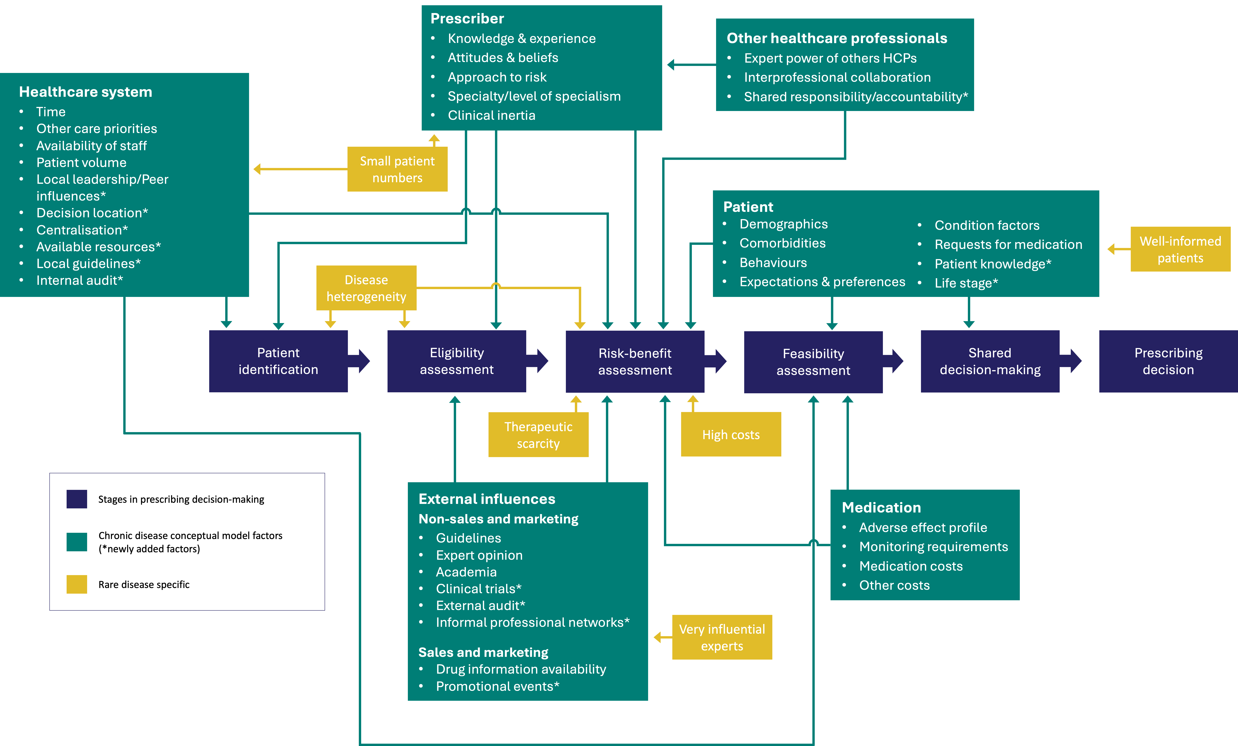

Discussion
Summary of key findings
Overall, the findings from this study suggest that many influences for decision-making in chronic conditions were also relevant to tolvaptan. However, there were also factors specific to the context of this rare disease, and others appeared amplified. Decisions extended beyond formal eligibility criteria and are often individualised. Clinician experience, attitudes to risk and degree of specialisation, along with system factors such as clinic structure, staffing and timing, all influence patient identification, eligibility assessment and feasibility of prescribing. Rare disease-specific factors further determine prescribing decisions through therapeutic scarcity, small patient numbers, heterogeneity, concentrated expertise, highly informed patients, and high costs. Consequently, prescribing decisions for tolvaptan in the management of ADPKD can be considered a staged and highly context-dependent process rather than a single discrete decision.
Interpretation of the findings in the context of existing literature
Our study findings should be interpreted in the context of broader literature on prescribing decision-making and behaviours in rare diseases. While substantial research has examined the development, regulation and access to medications for rare diseases, less attention has been directed toward how clinicians make prescribing decisions in real-world practice. Our study contributes to this gap by identifying factors that influence prescribing for medications in the management of a rare disease.
Around 5% of rare diseases worldwide have an approved medication, and most of those only have one treatment option, reflecting the substantial therapeutic scarcity that clinicians caring for people with rare diseases face (Tambuyzer, 2010). Our study identified that this has important consequences for prescribing decisions, as it might lead to a more flexible interpretation of eligibility criteria. Other authors have found a similar phenomenon in the context of prescribing for people with spinal muscular atrophy (McGraw et al., 2017; Rosenberg et al., 2023). There are suggestions that this may be driven by professional responsibility, ethical obligation or therapeutic imperative to intervene. This may even be true when medications have uncertain efficacy, modest benefits or potential for harm (Aartsma-Rus et al., 2011; Alum et al., 2025; Groft and Paz, 2010). In other rare diseases, such as Duchenne muscular dystrophy, the combination of scarce medications and high disease burden may amplify the pressures for clinicians to prescribe medications (Aartsma-Rus et al., 2011).
Our findings show how, in rare diseases such as ADPKD, low patient numbers can limit clinician experience and confidence, which shapes how care is organised and prescribing decisions made. Without cohorting patients with the same rare disease within a dedicated single clinic, it may be difficult for clinicians to encounter enough patients to gain sufficient experience and knowledge for confident decision-making. This has been recognised as a barrier to implementation of guidelines for rare diseases in general (Gittus et al., 2023a). Furthermore, many international organisations have advocated for centralisation of expertise and coordination of services to meet the challenges of low patient numbers and variable clinical experience (European Commission, 2017; European Parliament, 2026; World Health Organization, 2025).
The influence of disease heterogeneity on prescribing decisions in ADPKD mirrors observations in other rare diseases, where phenotypic variability and small patient cohorts complicate the interpretation of evidence and management decisions such as prescribing medications (Chaudhary and Kumar, 2025). As a result, there is a need for individualised assessments based on clinical judgement when prescribing for people with rare diseases (Chaudhary and Kumar, 2025; Lazareva et al., 2023). Risk stratification tools have been developed to mitigate some of this heterogeneity and quantify potential risks, but their usability in clinical practice can be limited. Similar findings have been found for other rare diseases such as transthyretin amyloidosis (ATTR) where prescribing outcomes are thought to be influenced by clinical judgements of overall health status based on age, disease severity and comorbidities (Lavall et al., 2026). Risk stratification tools also exist in ATTR (Gillmore et al., 2018), but these have been found not to be routinely used to inform treatment decisions in clinical practice (Lavall et al., 2026).
Clinical expertise in rare diseases is often concentrated among relatively few specialists, in contrast to common conditions where knowledge is more widely distributed across professional communities (Greenhalgh et al., 2004; Schieppati et al., 2008). Evidence from studies of physician behaviour outside of rare diseases suggests that clinicians often rely on professional networks, peer influence and collectively constructed knowledge, rather than formal guidance (Gabbay and Le May, 2004; Iyengar, Van den Bulte and Lee, 2015; Wang, Larrain and Groene, 2023). In our study, a similar phenomenon was observed with lead consultants, informal networks and external experts playing a prominent role in shaping the prescribing decisions of individual clinicians. In rare disease contexts, as demonstrated for phenylketonuria, the limited number of highly experienced experts may concentrate expertise within a small group, giving greater visibility and influence to their perspectives. This may then influence prescribing decisions more broadly (Griffiths et al., 2025; van Wegberg, Romani and Van Spronsen, 2025).
Patients and families affected by rare diseases often develop substantial disease-specific knowledge through long-term engagement with clinical care, patient registries and peer networks. This can lead to informed and collaborative treatment discussions, particularly when evidence is sparse or uncertain (Babac et al., 2019). In our study, clinicians described feeling able to resist patient requests without fear of harming the therapeutic relationship, which was fostered through long-standing follow-up, recognised specialist expertise of clinicians and open communication. Evidence from other studies suggests that when a collaborative, trust-based relationship develops, patients are more likely to participate constructively in shared decision-making rather than exert pressure on clinicians’ decision-making (Babac et al., 2019; Elwyn et al., 2012; Merker et al., 2021). This contrasts with prescribing in acute conditions, such as acute infections, where many clinicians have described prescribing antibiotics against their clinical judgement due to pressure from patient requests (Macfarlane et al., 1997; Rinaldi, Bullo and Schulz, 2025).
There are some aspects of prescribing for ADPKD which may differ from other rare diseases. Unlike many rare diseases, where evidence is limited or based on small or underpowered trials (Chen et al., 2024; Pavan et al., 2017; Pontes et al., 2018), tolvaptan was evaluated in multiple studies before approval for use in the management of ADPKD. This means clinicians managing patients with ADPKD have a stronger evidence base to inform their prescribing decisions than many other rare diseases. Guidelines for ADPKD are readily accessible, and clinicians in our study reported being aware of national guidance and eligibility criteria. This contrasts with some other rare diseases, especially ultra-rare diseases, where guidance may be absent, poorly disseminated or inconsistent. In such contexts, clinicians may rely even more on informal expert networks and anecdotal experiences to inform their prescribing decisions (Gittus et al., 2023a; Pai et al., 2019).
Strengths and limitations
A key strength of this study is the inclusion of different types of clinicians from kidney centres of varying size, organisational structures and levels of specialist expertise. This enabled exploration of how prescribing decisions were shaped not only by individual interpretation, but also by institutional context and experience managing ADPKD. The use of an existing conceptual framework with a strong theoretical foundation strengthened the analysis by enabling systematic interpretation of the factors influencing prescribing decisions. In terms of limitations, this study focused on a single medication with notable adverse effects and monitoring requirements for a single rare disease. ADPKD is one of the more prevalent rare diseases, so prescribing decisions may be different in ultra-rare conditions where the patient population is even smaller and clinical exposure even lower. As in many qualitative studies, there is a potential risk of social desirability bias whereby participants may, consciously or unconsciously, present themselves favourably. The transferability of this study to settings outside of the UK may have limitations due to the differences in commissioning structures around drugs for rare diseases and national guidance on drug use between countries.
Implications
Our findings have important implications for clinical practice, healthcare systems and policymakers. Prescribing tolvaptan in ADPKD is highly context-dependent and shaped not only by formal eligibility criteria but also clinical experience, risk perception and local organisational factors. Recognising that these influences exist may help clinicians balance individualised patient care against adherence to evidence-based guidelines. Low patient numbers and disease heterogeneity underscore the value of condition-specific clinics and cohorting patients. This can support clinicians to gain more experience and confidence making prescribing decisions, which may lead to greater consistency. For policymakers, these findings highlight the need to consider practical implementation challenges, such as clinic structure, staffing, and access to specialists when developing guidelines. Future research should examine factors influencing prescribing in other rare diseases to allow further iteration of the model presented here. This may help to better guide interventions that strengthen evidence-informed practice in the rare disease setting.
Conclusions
In rare diseases such as ADPKD, prescribing decisions are complex and context-dependent. They are influenced by some factors shared with more common chronic conditions, alongside influences that are new or amplified due to small patient numbers, disease heterogeneity and therapeutic scarcity. Expertise tends to be concentrated with highly influential experts guiding practice and greater shared decision-making.

Chapter summary
- This chapter presented the second analysis of the multiple case study that focused on the factors influencing prescribing decision-making for tolvaptan in the management of ADPKD.
- There was strong overall alignment between rare and chronic condition prescribing domains, particularly across patient, prescriber, healthcare system and contextual factors.
- A few factors from the conceptual model of prescribing decision-making in chronic conditions were not evident or were less relevant in this rare disease setting, especially those relating to sales and marketing.
- A number of factors were found to be either unique to prescribing for rare diseases or amplified compared with more common chronic conditions. These included: therapeutic scarcity and beneficence, small patient numbers, disease heterogeneity, highly influential experts, highly informed patients and patient requests, and high direct and indirect costs.
- Overall, the findings suggest that while existing prescribing models were broadly applicable, they required adaptation to reflect some of the challenges associated with rare diseases.

– Variation in tolvaptan prescribing pathways for autosomal dominant polycystic kidney disease: a national survey of clinical practice

Chapter outline
This chapter presents the findings from the national survey of clinical practice, which formed Phase 4. It has been presented in the format of a journal article for the purposes of this thesis, but will be combined with the planned reanalysis of the registry data for submission to a journal. The contribution of each co-author is detailed in Appendix 1. Further details on methods and supplementary materials that will be published with the journal article are presented in Appendices 9 and 10.

Manuscript-style report

Abstract
Background
Autosomal Dominant Polycystic Kidney Disease (ADPKD) is the most common inherited cause of kidney failure. Tolvaptan is the first disease-modifying therapy available to slow disease progression. Despite guidelines, there is evidence of potential variation in prescribing practices across UK kidney centres. Some of this variation appears to relate to differences in the implementation of tolvaptan care pathways between centres. Understanding national variation in the assessment, initiation and monitoring of tolvaptan could improve access to this important medication for people with ADPKD.
Methods
We conducted a cross-sectional survey of ADPKD lead clinicians at UK adult kidney centres using Qualtrics between September and December 2025. The questionnaire was developed from a conceptual model of prescribing decision-making and findings of a multiple case study on variation in tolvaptan prescribing practices. Questions focused on service configuration, eligibility assessment, initiation processes and monitoring practices. Descriptive statistics were used to summarise responses.
Results
61% of kidney centres (44/72) responded to the survey, with representation across all four nations. Reported ADPKD caseloads and cohorts of people taking tolvaptan varied across kidney centres. Most centres (61%, 25/41) initiated 0–1 patients monthly on tolvaptan. Staff involved in the tolvaptan care pathway varied; the most common combination was a consultant nephrologist and a specialist pharmacist (33%, 13/40). Consultant nephrologists with specialist expertise in ADPKD/renal genetics were most commonly the primary decision-maker at centres (72%, 29/40). Eligibility decisions were most commonly made by single prescribers (43%, 17/40), and assessments occurred in both general and specialist clinics. Half of centres (20/40) had dedicated tolvaptan clinics. Although all centres reported using eGFR slopes to determine eligibility, there was variation in the use of non-eGFR criteria. 59% (23/29) reported scanning ≤25% of patients. The median proportion of patients undergoing genomic testing across centres was 40%. 66% (27/41) reported using internal audit or service evaluation to evaluate prescribing practices.
Conclusions
There is considerable variation in how tolvaptan is delivered to patients in the UK. Variation was observed in service configuration, eligibility assessment approaches and how treatment is initiated. These findings highlight opportunities to standardise practice and support more equitable access to tolvaptan in UK kidney centres.
Keywords: ADPKD, clinical practice, variation, questionnaire
Introduction
Autosomal dominant polycystic kidney disease (ADPKD) is the most common inherited cause of kidney disease and the fourth leading cause of kidney failure worldwide (Chapman et al., 2015; Cornec-Le Gall, Alam and Perrone, 2019). It is characterised by progressive cyst growth leading to an increase in total kidney volume, loss of kidney function and significant morbidity (Ong et al., 2015).
Tolvaptan is the first disease-modifying therapy shown to slow the progression of ADPKD and has been approved for use in over forty-three countries worldwide (Otsuka Pharmaceutical Co. Ltd, 2018). It was approved for use in adults with ADPKD meeting specific criteria in England and Wales in 2015 and in Scotland in 2016 (National Institute for Health and Care Excellence, 2015a; Scottish Medicines Consortium, 2016). Guidelines to inform its use have been published by multiple organisations worldwide. In 2016, the Renal Association issued recommendations for prescribers in United Kingdom (UK) kidney centres (Renal Association, 2016), which were subsequently updated by the UK Kidney Association (UKKA) in 2025 (Gittus et al., 2025a).
A recent national cross-sectional registry analysis conducted by the authors demonstrated variation in prescribing practices between kidney centres (Gittus et al., manuscript submitted). Further investigation through a multiple case study suggested that some of this variation may result from different approaches when implementing tolvaptan care pathways (Gittus et al., manuscript submitted). However, there is a lack of contemporary national data describing how tolvaptan care pathways are structured, how eligibility is assessed, and how treatment is initiated. Understanding these aspects of ADPKD care is important to help identify unwarranted variation, inform service planning and support equitable access. The aim of this study was to describe current UK practice in the assessment, initiation and monitoring of tolvaptan for people with ADPKD.
Methods
We conducted an online cross-sectional survey to assess practices and factors influencing tolvaptan prescribing in UK kidney centres. The survey was developed and distributed using the Qualtrics platform, with data collection from September to December 2025. This study was reported in accordance with the Consensus-based checklist for Reporting of Survey Studies (CROSS) (Sharma et al., 2021). This is included in Appendix 10.

Participants and sampling
ADPKD lead clinicians at 72 adult kidney centres listed by the UKKA were invited to participate. These lead clinicians were identified using ADPKD patient recruitment data from the National Registry of Rare Kidney Disease (RaDaR), with the clinician recruiting the most patients at each centre contacted. It is acknowledged that not all centres listed by the UKKA will manage ADPKD patients, as some kidney centres may refer this patient population to specialist kidney centres.
Questionnaire development
The survey was conducted as a component of a mixed-methods research study exploring variation in tolvaptan prescribing for ADPKD. The primary purpose was to provide additional data to support the reanalysis of registry data, which required non-anonymised responses. The questionnaire was developed using the findings from a conceptual model of prescribing decision-making developed for the context of rare diseases (Gittus et al., manuscript pre-submission) and a multiple case study on variation in tolvaptan prescribing practices in the management of ADPKD (Gittus et al., manuscript submitted). The instrument comprised of five sections with 32 items. These were primarily closed questions to facilitate rapid completion and free-text fields for additional context where appropriate. This follows common practice in health services surveys where closed responses have been found to improve response rates and analytical efficiency (Turk et al., 2018). Justification for the questions in the questionnaire and mapping of the questions to the conceptual model developed in the multiple case study is included in Appendix 10. A draft version was piloted with two ADPKD clinical specialists at Sheffield Teaching Hospitals NHS Trust and with a public and patient involvement group consisting of three individuals with ADPKD and/or CKD. Feedback informed the revision of the questionnaire to reduce length and improve question clarity. The finalised survey instrument and accompanying email invitation are provided in Appendix 10.
Data collection
Invitations containing personalised survey links were emailed by MG to the ADPKD clinical leads at UK kidneys. Participants were asked to forward the survey invitation to a colleague if they considered them more appropriate. Two reminders were issued at two-week intervals, and a final invitation was sent to non-responders by ACMO to maximise participation. To minimise duplicate responses, manual checks were performed on returned data consistent with best practices for online surveys to prevent multiple site entry bias (Eysenbach, 2004). Detailed respondent characteristics were not collected to minimise the risk of participant identification in the context of a rare disease and to maintain a focus on centre-level practice.
Data analysis
Descriptive statistics (frequencies and percentages) were used to characterise centre responses. All analyses were conducted in Python (Python Software Foundation, 2023, Version 3.14.2). Graphical representations of the data were produced using Microsoft Excel for Mac (Microsoft Corporation, 2019, Version 16.78.3) and Python (Python Software Foundation, 2023, Version 3.14.2). Free-text responses were analysed using conventional (inductive) content analysis (Hsieh and Shannon, 2005).
Ethics and confidentiality
The study received ethical approval from the Dulwich Research Ethics Committee in March 2024 (REC reference 24/PR/0106). Given the necessity for linked centre-level data, fully anonymous responses were not feasible, and this was explained to potential participants in the participant information sheet, email invitation and survey opening page. It was recognised that this might reduce the response rate for the survey. To safeguard confidentiality and limit potential identification, demographic data was restricted to the minimum (centre affiliation, professional role and centre lead status). Completion of the questionnaire was taken as implied consent to participate.
Results
Survey response and completion
A total of 72 UK kidney centres were invited to participate, with 70.8% (51/72) accessing the survey and 61.1% (44/72) consenting to and starting the survey. Of these, 88.6% (39/44) completed all items while 11.4% (5/44) stopped before finishing. Figure 16 is a flow diagram of survey participants.
Figure 16. Flow diagram of survey participants and drop-out rates at each stage/section
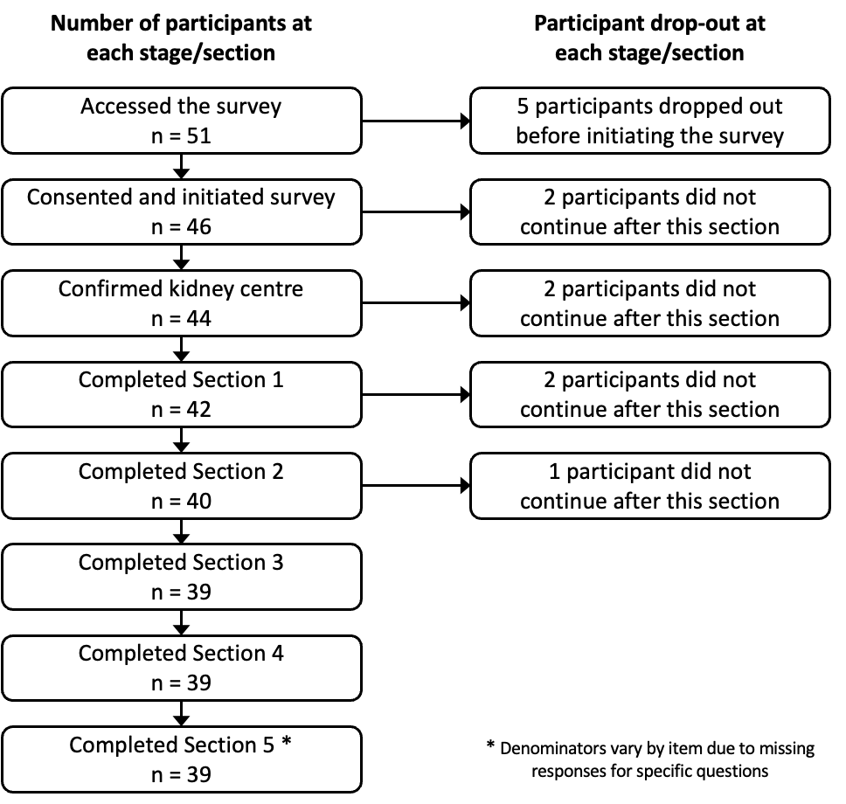
Characteristics of respondents
The 44 respondents included centres across all four UK nations (England n = 36, Northern Ireland n = 3, Scotland n = 4, Wales n = 1). Most respondents were consultant nephrologists (43/44, 97.7%), with the remaining respondent being a specialist nurse.
ADPKD population and tolvaptan prescribing
Reported ADPKD caseloads varied widely across kidney centres, with a relatively even distribution across small, medium and large services (Table 21). Three centres reported managing a very large ADPKD caseload. The size of the current tolvaptan cohort varied across kidney centres. Small cohorts were uncommon with 3/41 (7.3%) of centres managing fewer than 10 patients. Most centres reported moderate size cohorts with 10/41 (24.4%) managing 10–20 patients, 12/41 (29.3%) managing 21–40 patients, and 7/41 (17.1%) managing 41–60 patients. Larger cohorts (>60 patients) were reported by 9/41 (22.0%) of centres. 25/41 (61.0%) of centres reported a small number of patients (0–1) being initiated on tolvaptan per month. Reported patient uptake varied across centres but was mostly high, with 33/41 (80.5%) of centres reporting uptake above 60%. These statistics in relation to the approximate catchment area of the kidney centre are presented as a heatmap in Appendix 10 (Office for Health Improvement and Disparities, 2022).
Only one centre reported that there was a limit to the number of patients that could be initiated on tolvaptan at their centre. Just over half of centres, 19/37 (51.4%), were involved in the clinical trials that led to the approval of tolvaptan. 27/41 (65.9%) of centres reported conducting local audits or service evaluations for tolvaptan prescribing in ADPKD. Respondents’ views on the benefits of tolvaptan for people with ADPKD were mostly positive. Of 32 responses, 12/32 (37.5%) indicated a substantial benefit, 16/32 (50.0%) moderate benefit, 3/32 (9.4%) limited benefit and 1/32 (3.1%) no benefit at all.

Table 21. Respondent-reported estimates of service characteristics across kidney centres
Characteristic | Kidney centres (%)
Number of patients in ADPKD caseload, excluding dialysis and transplant
<150 (“small”) | 16 (38.1%)
150–300 (“medium”) | 11 (26.2%)
301–600 (“large”) | 12 (28.6%)
>600 (“very large”) | 3 (7.1%)
Number of patients in tolvaptan cohort
<10 | 3 (7.1%)
10–20 | 10 (23.8%)
21–40 | 12 (28.6%)
41–60 | 7 (16.7%)
>60 | 9 (21.4%)
Number of patients started on tolvaptan per month
0–1 | 25 (61.0%)
2–3 | 11 (26.8%)
4–5 | 4 (9.8%)
>7 | 1 (2.4%)
Reported patient uptake
0–20% | 3 (7.3%)
21–40% | 2 (4.8%)
41–60% | 3 (7.3%)
61–80% | 14 (34.1%)
81–100% | 19 (46.3%)

Tolvaptan treatment pathways and decision-making
The most common configuration of the healthcare team involved in the tolvaptan care pathway at centres was a consultant nephrologist with a renal pharmacist, with 13/40 (32.5%) centres describing this configuration. All centres reported that a consultant nephrologist was involved in the pathway, 21/40 (52.5%) of centres reported having a specialist renal pharmacist(s), 9/40 (22.5%) a specialist renal nurse(s) and 11/40 (27.5%) a nephrology trainee(s) (Figure 17).

Figure 17. Configuration of clinicians involved in tolvaptan services at each kidney centre
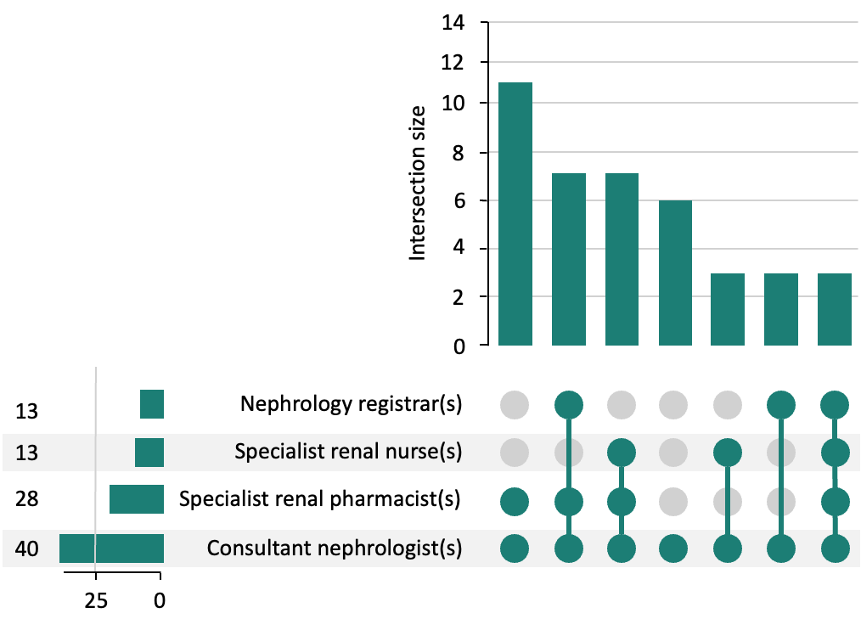
Specialist ADPKD/renal genetics consultant-led services were more common than general consultant-led services (72.5%, 29/40 versus 27.5%, 11/40). Prescribing decision-making models varied across kidney centres, with decisions most commonly made by a single clinician (57.8%, 23/40), followed by multiple individual clinicians independently (30.0%, 12/40) and multi-disciplinary team discussion (27.5%, 11/40). The relationship between service leadership, prescribing model and staffing is presented in Figure 18 and as a table in Appendix 10.
Figure 18. Professional involvement in the tolvaptan prescribing pathway stratified by consultant-type leading service and decision-making model
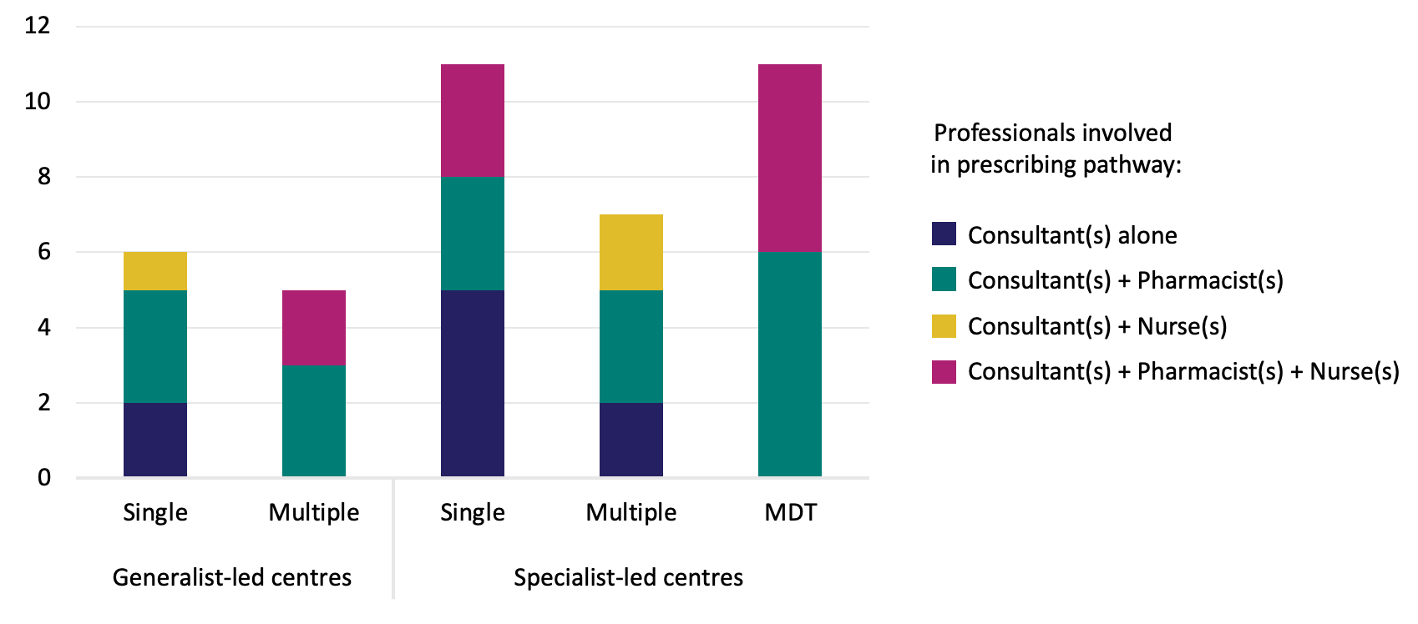
There was substantial variation in where eligibility for tolvaptan was initially assessed. 18/40 (45.0%) of centres initially assessed eligibility in general nephrology clinics, 17/40 (42.5%) in specialist clinics (ADPKD clinic or renal genetics clinic) and the remaining 5/40 (12.5%) patients were assessed in both general and specialist clinics. 20/40 (50.0%) centres reported having a dedicated tolvaptan clinic where patients could be monitored on tolvaptan, with the remaining centres monitoring tolvaptan through the clinic where they were initially assessed for eligibility. 14/20 (70.0%) of centres with tolvaptan clinics were introduced in the three years following approval of tolvaptan. The time from eligibility assessment to initiation of tolvaptan varied across centres. In most centres, tolvaptan was started quickly: on the same day or during the same clinic visit (12.5%, 5/40), within 1 week (22.5%, 9/40), or within 1–4 weeks (42.5%, 17/40). Fewer centres reported a longer interval of 1–3 months (17.5, 7/40) or more than 3 months (2.5%, 1/40).
Guidance, local documentation and patient information
One-third of centres (13/39) reported having local guidelines to support prescribing decision-making for tolvaptan. UKKA guidance was the guidance most reported being used by kidney centres, with 30/39 (77%). 25/39 (64%) reported having local guidance that was available to clinicians at their centre. Other resources were cited by respondents, but at lower rates, see Appendix 10 for more details. All centres reported providing verbal information in the clinic as part of discussions about tolvaptan. This was frequently supplemented by written information, with 19/39 (49%) of centres providing the pharmaceutical company leaflet and 8/39 (21%) of centres providing a local leaflet. Many centres provided information through multiple methods, as shown in Figure 19.
Figure 19. Upset plot showing the methods for providing patient information on tolvaptan
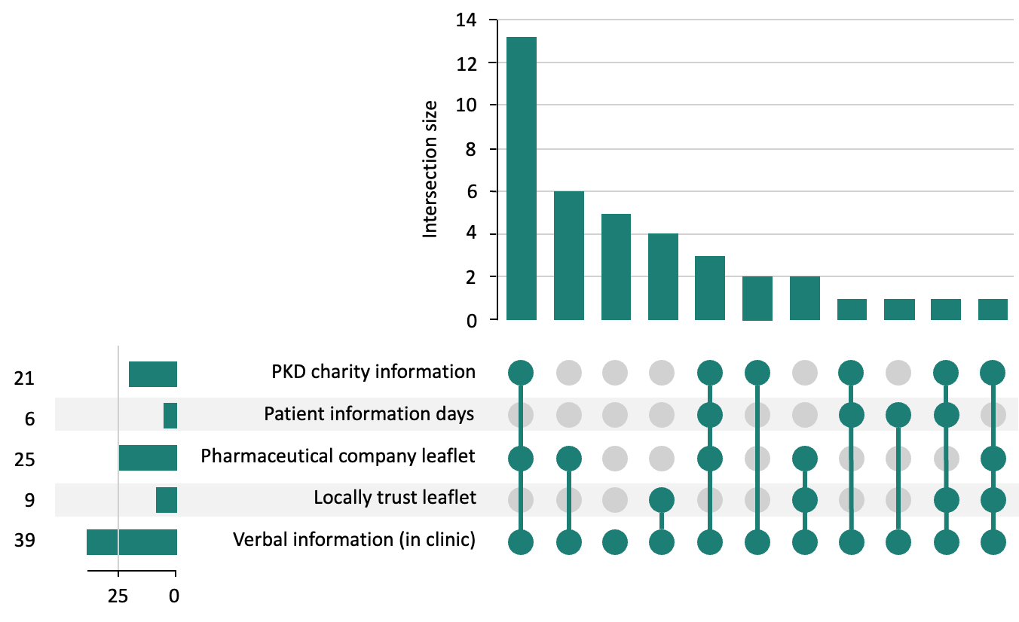
Eligibility of people with ADPKD for tolvaptan
Variation in CKD stage-based eGFR thresholds for tolvaptan prescribing was observed across centres. Upper eGFR thresholds were reported by 35/39 (89.7%) of centres. These aligned with the national health technology assessment criteria in 34/35 (97.1%) of centres. In England, Wales and Northern Ireland centres the upper threshold was 89 ml/min/1.73m² according to NICE guidance, whereas in Scotland, the upper threshold was ≥90 ml/min/1.73m² according to SMC guidance. One centre in England (1/35, 2.9%) reported prescribing to patients with an eGFR ≥90 ml/min/1.73m² outside the NICE eligibility criteria. Lower eGFR thresholds were reported by 33/39 (84.6%) of centres. The majority used the lower threshold of 30 ml/min/1.73m² (60.6%, 20/33), consistent with both NICE and SMC guidance. 7/33 (21.2%) of centres reported lower thresholds below this level (eGFR 15 ml/min/1.73m² (n = 2), 20 ml/min/1.73m² (n = 2), and 25 ml/min/1.73m² (n = 3)). 6/33 (18.2%) of centres reported higher thresholds than recommended in the guidelines (35 ml/min/1.73m² (n = 2), 60 ml/min/1.73m² (n = 4)). Approaches to identifying and assessing eligibility for tolvaptan based on rapid disease progression varied across centres. Responses indicated that eGFR slope was used in 39/39 (100.0%) of centres, kidney length measured by ultrasound in 30/39 (76.9%), total kidney volume measured by ultrasound in 8/39 (20.5%), and total kidney volume measured by MRI in 20/39 (51.3%). When considering the risk stratification tools, Mayo Imaging Classification (MIC) was used in 23/39 (59.0%) and the Predicting Renal Outcome in Polycystic Kidney Disease (PROPKD) score in 14/39 (35.9%). Figure 20 shows the range of eligibility criteria combinations used by kidney centres, with eGFR slope and kidney length measured by ultrasound being the most common. Where eligibility measures were not routinely used, centres cited limitations in local availability of MRI, radiological support for TKV calculations, difficulties using the PROPKD risk stratification tool and less experience in requesting genomic testing. 6/39 (15.4%) of centres reported using one of the other non-eGFR eligibility criteria to initiate tolvaptan when the eGFR slope threshold was not met. The remaining centres did not use these non-eGFR criteria as standalone indications for initiation, but to increase confidence in decisions made based on the eGFR slope criterion. 30/39 (76.9%) of centres reported formally assessing patients at each appointment for tolvaptan. 3/39 (7.7%) of centres reported using an automated tool to flag people with ADPKD who would be eligible for tolvaptan. Of those centres without access to an automated tool to identify eligible patients, 25/36 (69.4%) believed having one would be beneficial.

Figure 20. Combinations of eligibility criteria used by kidney centres
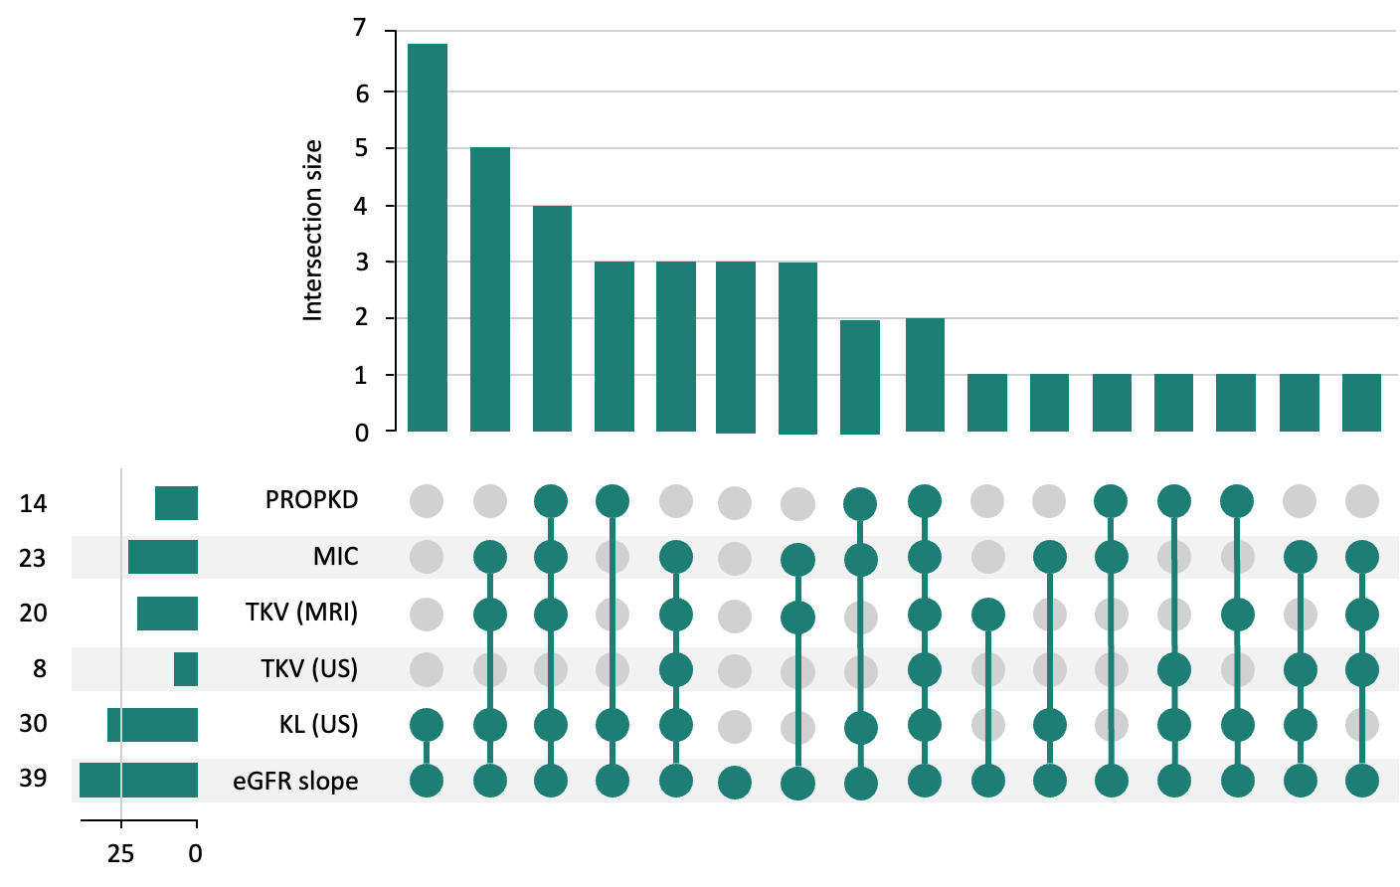
Patterns of imaging and genomic testing varied across centres. Magnetic Resonance Imaging (MRI) to determine kidney volume was used infrequently in centres, with 23/39 (59.0%) scanning ≤25% of patients and only 7/39 (17.9%) scanning >50% of their patients. Routine repeat MRI was uncommon, with 31/39 (79.5%) of centres not performing regular follow-up scans and no consensus across centres regarding the frequency of repeat imaging. Access to genomic testing was reported by 25/39 (64.1%) of centres. However, the proportion of patients offered testing varied widely, with a median of 40% (IQR 12.5–77.5%) and an overall range of 5–100%.
Discussion
Main findings
In this national survey of UK kidney centres, substantial variation in the organisation and delivery of tolvaptan services was found. While nephrologists were consistently central to prescribing decisions, decision-making models varied. Service configuration was heterogenous, with eligibility assessments being undertaken in specialist ADPKD/renal genetics and general nephrology clinics. Approximately half of the kidney centres reported having dedicated tolvaptan clinics. There was variable involvement of the wider multi-disciplinary team members across centres. CKD stage eligibility criteria were largely consistent with national guidance, although a small proportion of centres reported using thresholds outside recommended ranges. Assessment of eligibility based on rapid disease progression showed the greatest heterogeneity, with universal use of eGFR slopes but variable uptake of imaging and risk stratification tools.
Comparison with existing literature
Our findings are broadly consistent with earlier surveys examining tolvaptan prescribing and ADPKD management, while also demonstrating changes in practice over time. A previous UK study in 2022 by Chong, Harris and Ong (2022), conducted in the context of the earlier Renal Association guidance, focused on a narrower set of issues than our survey, namely, assessment criteria. It reported that eGFR was the primary method used to assess eligibility for tolvaptan, followed by kidney length measured by ultrasound. Approximately half of respondents used MRI-derived total kidney volumes. Similar patterns were observed in the present study with the exception of an increase in the use of genotype-based stratification with the Predicting Renal Outcomes in Polycystic Kidney Disease (PROPKD) prognostic scoring system used by 36% (14/39) of centres compared with 21% (3/14) in the earlier study (Chong, Harris and Ong, 2022).
International data also demonstrates heterogeneity in the use of imaging and prognostic tools. A survey of Canadian nephrologists reported wide variation in the use of kidney imaging for ADPKD management, and no respondents reported the use of the PROPKD score when assessing eligibility for tolvaptan (Yi et al., 2020). This likely reflects temporal and system-level differences, with increased availability and integration of genetic testing into routine ADPKD care in the UK. Our study supports this hypothesis, given that 64% of centres reported routinely performing genetic testing. Another reason for the underuse of the PROPKD score compared to the Mayo Imaging Classification may be that the data required is often not routinely collected, and the age of symptom onset is often not recalled by patients.
Strengths and limitations
This research has two main strengths. First, this was the first national study to comprehensively describe the structure and delivery of tolvaptan services across UK kidney centres, including treatment pathways, decision-making processes, and the eligibility criteria used in routine practice. Second, the response rate was 61%, which is higher than typically reported for web-based physician surveys, which are usually in the range of 35% to 50% (Cho, Johnson and VanGeest, 2013; Cunningham et al., 2015; Meyer et al., 2022). Furthermore, respondents were recruited from kidney centres across all four nations in the UK. If responses were anonymised, the response rate may have been higher, but this was not possible due to the purpose of the survey. This research has some limitations. Firstly, as with most surveys, the study is subject to responder bias, which is particularly relevant when asking about adherence to guidelines. Secondly, data was self-reported and provided by a single respondent per centre, so responses may not fully reflect practice across all clinicians within a service.
Implications for clinical practice and research
Our findings have important implications for both clinical practice and future research. Variation in the service configurations and eligibility assessment practices was demonstrated between kidney centres, indicating potential inconsistency in tolvaptan prescribing across the UK. Improved access to imaging and radiology services, alongside training and support for the interpretation of genomic test results, may support wider use of eligibility criteria not routinely used across all centres for tolvaptan. Internal audits were not undertaken at all centres, which may limit the identification of potentially eligible patients, feedback on practice and opportunities to reduce within-centre variation. Automated tools were used by a small number of centres, although other centres expressed a desire to adopt them to support the identification of eligible patients. There is an opportunity for standardisation of the information provided to patients about tolvaptan, which could be through a nationally developed leaflet co-developed with ADPKD patients or organisations such as the PKD Charity. From a research perspective, studies linking eligibility criteria to patient outcomes and evaluations of the real-world added value of advanced risk stratification tools may inform future service optimisation and guideline development.
Conclusions
There is substantial variation in the organisation and delivery of tolvaptan services between UK kidney centres, particularly in the combination of eligibility criteria used. Eligibility decisions are consistently consultant-led, but local infrastructure and resource availability may influence the adoption of imaging and genetic tools.

Chapter summary
- This chapter presented findings from a national survey of UK kidney centres describing variation in the organisation and delivery of tolvaptan services for people with ADPKD.
- There was substantial heterogeneity in service configuration, including differences in clinic structure, multidisciplinary team involvement and the presence or absence of a dedicated tolvaptan clinic.
- Around half of centres reported having a tolvaptan clinic.
- Eligibility assessment relied most commonly on eGFR slope and kidney length measured by ultrasound, but a wide variety of combinations of criteria were reported.
- A small number of centres reported setting eGFR limits outside the approved eGFR range for tolvaptan.
- These findings corroborate and extend the findings of the preceding multiple case study and provide a national context for understanding variation in tolvaptan prescribing and opportunities to improve equitable access.

– Discussion

Introduction
This programme of research examined variation in the prescribing of tolvaptan for adults with autosomal dominant polycystic kidney disease across UK kidney centres, to identify underlying mechanisms and contextual factors that shaped this variation. This chapter describes the main findings and positions them within the wider evidence base. The methodological strengths and limitations of the programme of research are critically appraised, alongside the transferability of the findings to other rare disease contexts. The role of patient and public involvement during the research process is also considered, together with reflexivity in relation to the conduct and interpretation of the research findings. The unique contribution of the thesis to existing knowledge is then outlined. Recommendations for clinical practice and policy are presented, followed by future research priorities. The chapter concludes with the overall conclusions from the programme of research.

Summary of main findings
This sequential mixed methods study consisted of four phases: a systematic review, analysis of registry data, multiple case study, and a national survey of clinical practice.
The systematic review identified that prescribing decisions in chronic conditions are influenced by multiple interacting factors across a range of stakeholders, with several recurring themes identified. Prescribing decisions were influenced by patient characteristics. During risk-benefit assessments, clinicians approached risk differently, but there was an overall tendency to prioritise risks over benefits. Decisions were also shaped by clinician experience, workload and care setting. Shared decision-making was a feature in prescribing for chronic conditions, but did not necessarily occur. Costs were often considered and were not restricted to medication costs. Finally, external factors such as guidelines and expert opinion also influenced decision-making. This conceptual model shaped the next phases of the research.
Registry data showed variation in tolvaptan prescribing between kidney centres, mainly in initiation among eligible patients, with 8.3% (6/53) of centres outside control limits on the funnel plot. Less variation was observed in the eligibility of initiated patients, with 2.4% (1/41) of centres outside the control limits on the funnel plot. This variation was associated with potentially significant health and economic consequences. The next phase explored the potential causes of this variation.
Findings from the multiple case study identified mechanisms that appeared to be leading to this variation at the organisational, clinician and patient-level. Service configuration shaped patient identification, eligibility assessment and initiation. Tolvaptan care pathways based in general nephrology clinics were less likely to identify eligible patients, involved more decision-makers and were associated with less consistent prescribing. Dedicated tolvaptan clinics appeared to improve care coordination, reduce perceived burden of prescribing, and enhance the feasibility of tolvaptan initiation. Clinical leadership was primarily responsible for shaping prescribing norms within cases. Pharmacist involvement supported shared responsibility for prescribing and adherence to guideline recommendations. Although national guidelines define eligibility, cases varied in which criteria were used and how they were applied. More specialist-led cases appeared to exercise greater flexibility in prescribing. Differences between cases in the framing of risk information and the supporting materials used to communicate risks to patients appeared to shape patient uptake of tolvaptan. Identified factors were synthesised to inform the development of a new conceptual model of prescribing decision-making in rare diseases. This introduced key factors specific to rare diseases: small patient numbers, disease heterogeneity, therapeutic scarcity, high medication costs, a limited number of very influential experts and well-informed patients.
The final phase explored the extent of variation between kidney centres in these factors. In a UK-wide survey of clinical practice, variation in practice was considerable. 45% (18/40) of centres reported that decision-making about eligibility for tolvaptan takes place in general nephrology clinics, while 50% (20/40) of centres reported having a dedicated tolvaptan clinic. 53% (21/40) of centres reported having a renal pharmacist. Although all centres reported using eGFR slopes as the main indication, there was substantial variation in the usage of other non-eGFR based eligibility criteria. 15% (6/39) of cases reported using these criteria independent of eGFR slopes.

Integration of findings
The main findings from the multiple case study (Phase 3) and the national survey of clinical practice (Phase 4) were compared to explore how the two phases relate to one another. This integration was considered in terms of whether findings appeared to agree (convergence), offer complementary information on the same issue (complementarity), appear to contradict each other (dissonance), or a finding was present in one phase but not the other (silence) (O'Cathain, Murphy and Nicholl, 2010).
These constructs were used as an analytical framework to examine how the explanatory mechanisms identified in the multiple case study components (Phase 3) were reflected in their presence, distribution and variation across UK kidney centres in the national survey of clinical practice (Phase 4), rather than to assess equivalence or causal agreements between datasets. In this context, convergence between datasets was not anticipated, given the different analytical purposes of the two phases. A joint display was used to map survey findings against the main themes derived from the multiple case study (Table 22).
Overall, the findings demonstrated high complementarity, whereby the survey data situated and extended the explanatory mechanisms identified in the multiple case study, demonstrating their presence and variation across UK kidney centres.
Table 22. Joint display of findings from Phases 3 and 4
Key theme | Multiple case study (Phase 3) | National survey of clinical practice (Phase 4) | Integration (Phase 3 – Phase 4 relationship)
Service configuration
Condition-specific vs generalist clinic models | Condition-specific clinic models improve oversight, patient identification and prescribing consistency. | - 43% of centres managed people with ADPKD in condition-specific clinics  - 45% of centres managed people with ADPKD in general clinics  - 13% of centres managed people with ADPKD in both clinics | Complementary: Variation in clinic models identified in Phase 3 was reflected across the wider national sample in Phase 4.
Dedicated tolvaptan clinics | Dedicated tolvaptan clinics share prescribing responsibility to reduce perceived burden and thresholds for initiation. | - 50% of centres have a dedicated tolvaptan clinic | Complementary: Tolvaptan clinics present in Phase 3 are not universal across kidney centres in Phase 4.
Eligibility assessment criteria
Different eligibility criteria used | Centres use eligibility differently which can lead to centre-level variation. Some centres proactively use multiple criteria. | - 100% of centres use eGFR slopes  - 77% of centres use US kidney length  - 21% of centres use US total kidney volume  - 51% of centres use MRI total kidney volume  - 51% use MIC  - 36% use PROPKD | Complementary: Wide variation in the eligibility criteria used across cases in Phase 3 is reflected across the wider sample of kidney centres in Phase 4.
Independent vs dependent use of criteria | The most proactive centres use non-eGFR criteria as an independent criterion whereas others use these criteria to support decisions based on eGFR slopes. | - 15% of centres use non-eGFR criteria independently | Complementary: Some centres, mainly specialist centres, using non-eGFR criteria independently present in both Phases 3 and 4.
Resources needed to support eligibility assessment | Not all centres have equal access to resources or specialist expertise to interpret the results of investigations for the eligibility criteria, potentially leading variation in their use. | - 61% of centres perform genomic testing (median proportion of patients offered 40% (range 5-100%))  - 21% of centres perform repeat MRI | Complementary: Different levels of access to resources and specialist expertise in Phase 3 are present in the wider sample of kidney centres in Phase 4.
Different application of thresholds and eligibility criteria | Centres apply NICE thresholds for CKD stage based on eGFR differently with some centres prescribing outside of these thresholds. Centres may also apply eligibility criteria such as eGFR slopes differently for patients, especially those at the borderline of eligibility if there are perceived benefits. | - 3% of centres used an upper eGFR threshold above NICE criteria  - 21% of centres used a lower threshold below NICE criteria  - 18% of centres used a lower threshold above NICE criteria | Partially complementary: Anecdotes about other kidney centres prescribing outside of CKD stage thresholds in Phase 3. Centres in Phase 4 identified to use different CKD stage thresholds. Application of eligibility criteria, such as eGFR slopes not assessed in Phase 4.
Automated tools | Automated tools are not routinely used but could support centres to identify eligible patients more consistently. | - 8% of centres used automated tools to identify eligible patients  - 69% of centres without an automated tool believed it would be helpful | Complementary: Limited use of automated tools in Phase 4 supports Phase 3 findings that this may represent an area for service improvement.
Leadership at centres
Leadership structure | Centres differed in leadership structure, which was associated with different prescribing approaches. | Not included in the survey | Silence: Leadership structure only illustrated in Phase 3.
Experience of lead clinicians | Lead clinicians with specialist experience are more likely to be involved in trials and have access to informal networks which improves confidence with prescribing tolvaptan. | - 73% of centres with a lead clinician who is a specialist in ADPKD/renal genetics | Partially complementary: Phase 4 demonstrated not all centres have lead clinicians with specialist expertise, meaning potentially unequal access to experience from trials and networks.
Perspectives of lead clinicians | Level of caution and scepticism regarding tolvaptan influences how proactive prescribing practices are at centres. | - Lead clinician at centres perceived benefit of tolvaptan: 38% substantial, 50% moderate, 9% limited, 3% none | Complementary: Scepticism in some clinicians potentially influencing prescribing practices in Phase 3 potentially supported by Phase 4 demonstrating some lower perceived benefit, but not directly tied to practices.
Wider healthcare team members
Multidisciplinary input | Having other members of the healthcare team involved in the tolvaptan prescribing process brings complementary skillsets and shares responsibility which reduces perceived burden and thresholds for initiation. Pharmacists improve adherence to guidelines. | - Centres with availability of staff: 100% consultant nephrologist, 53% pharmacist(s), 23% nurse(s), 28% nephrology trainee(s) | Complementary: Wide range of staffing combinations providing tolvaptan at centres in Phase 4, suggesting relevance of findings from Phase 3.
Communicating with patients
Verbal information | Risk and benefit information is presented differently across different kidney centres which may influence patient uptake. | Not included in the survey | Silence: Differences in approaches to risk and benefit discussions in verbal information were only assessed in Phase 3.
Written Information materials | Local patient information leaflets present information in more balanced manner than pharmaceutical information leaflets so have less tendency to deter patients. | - 49% of centres provide pharmaceutical patient information leaflet  - 21% of centres provide local information patient information leaflet | Complementary: Different approaches to providing written information from Phase 3 demonstrated in Phase 4.
Proactive vs reactive approaches to discussions | Early and consistent discussion of tolvaptan with patients promotes greater uptake. | Not included in the survey | Silence: Degree of proactively when discussing tolvaptan only assessed in Phase 3.
External and internal audit
External audit | External audits, such as Getting It Right First Time (GIRFT), can provide feedback on prescribing but the degree to which this influences practice varies. | Not included in the survey | Silence: Impact of external audits only included in Phase 3.
Internal audit | Internal audits support reflection and awareness of practices to improve consistency within centres. | - 66% of centres conduct internal audits/service evaluations | Complementary: Over half of kidney centres described undertaking internal audits in Phase 4 so they can benefit from improved consistency through reflection as suggested in Phase 3.

Interpretation of findings in relation to the wider literature
This section discusses the main findings of the programme of research in relation to the wider literature. Findings from all phases are presented within a shared thematic structure to examine the factors influencing variation in tolvaptan prescribing practices across kidney centres.

Service configuration influences patient identification, eligibility assessment and prescribing practices

Condition-specific vs generalist clinic models
The multiple case study and survey identified three main service configurations for the delivery of ADPKD care in the UK: condition-specific (a single dedicated ADPKD or renal genetics clinic), generalist (multiple general nephrology clinics) and hybrid clinic models. Tolvaptan care pathways were embedded within these existing clinic models, with eligibility assessment and prescribing decisions occurring within the clinics in which people with ADPKD were managed.
The findings of the multiple case study suggest that these service configurations may contribute to variation in patient identification, eligibility assessment and prescribing decisions between kidney centres. Having a condition-specific clinic model appeared to improve consistency in prescribing and an oversight of the ADPKD population, whereas the generalist clinic model appeared to have less consistency and greater levels of within-centre variation in practice.
Similar associations between service configuration and implementation have been reported in other clinical settings. In heart failure care, condition-specific clinic models have been associated with more consistent implementation of guideline-approved medications compared with care provided through multiple generalist-led clinics (Chambers and Lancellotti, 2020; Chambers et al., 2020; Ramsay et al., 2025).
These differences may arise because service configurations shape the functioning of clinical microsystems. According to the framework described by Nelson, Batalden and Godfrey (2011), a clinical microsystem is the “small, functional, front-line units that provide health care”, which in the context of this research is represented by a clinic. Centres with a condition-specific clinic model may function as a single, tightly bound, clinical microsystem. This facilitates more integrated working with tighter feedback loops and the development of consistent routines within the microsystem, in part, related to having a small number of decision-makers. In contrast, generalist clinic models may be considered to consist of multiple semi-autonomous clinical microsystems, with each clinic representing its own microsystem. This often involves more decision-makers, which makes it more difficult to ensure that care is coordinated and consistent, as each microsystem can develop its own routines, norms and approaches. Consequently, there is greater potential for variation to occur at a system level. The relationship between these semi-autonomous microsystems may be further understood through the loosely coupled systems theory. Organisational units (equivalent to microsystems) operating in the same system remain only weakly coordinated in the absence of integrative mechanisms, such as internal audit, feedback or case discussions (Orton and Weick, 1990). This may help explain why greater variation in prescribing practices was observed in the kidney centres with a generalist, or hybrid, clinic model.
Beyond influencing coordination, service configuration also appeared to influence clinician experience and learning. A condition-specific model enabled exposure to people with ADPKD to be concentrated amongst a smaller number of clinicians, which created repeated opportunities to apply eligibility criteria and observe treatment trajectories. This repeated exposure appeared to build familiarity, reduce uncertainty and increase clinicians’ confidence, contributing to more proactive prescribing. In contrast, in generalist clinic models, these opportunities are shared across a larger number of clinicians, so initiation may remain cautious and therapeutic inertia is more likely. This aligns with evidence on volume-outcome and experience-performance relationships in healthcare, where repeated exposure improves consistency and quality in healthcare (Birkmeyer et al., 2003).
Similar experience related variation has been described in other therapeutic areas. In type 2 diabetes, differences have been observed in insulin initiation between clinicians and settings related to their level of experience. Clinicians with greater exposure to the initiation and management of insulin are more likely to initiate treatment in eligible patients, whereas those with less exposure have a greater tendency to delay or avoid initiation. The risk of hypoglycaemia is frequently cited as a barrier to clinicians initiating treatment. These concerns appear to be more influential in settings where clinicians have less experience of insulin use, and therefore less confidence derived from prior experiences of safe initiation and follow-up (Campbell et al., 2019; Chenoweth, 2017; Ng et al., 2015).
A similar experience-risk relationship may help interpret the findings of the multiple case study. Clinicians at the centre with the generalist clinic model described being concerned about the risk of liver injury, whereas clinicians in centres with a condition-specific clinic model described prescribing tolvaptan to many people without encountering significant liver injury. This appeared to reduce the salience of this risk in their decision-making. The influence of clinicians’ approach to risk on prescribing decision-making was also identified in the overview of systematic reviews conducted in this thesis (Gittus et al., 2025b).

Dedicated tolvaptan clinics
Another difference in service configuration across kidney centres identified in the survey was the presence of a pharmacist or nurse-led tolvaptan clinic, with around half of centres reporting that they had such a clinic. The multiple case study demonstrated that the presence of a tolvaptan clinic effectively redistributed some components of the prescribing process that would otherwise fall to the prescribing doctors, including issuing prescription scripts, organising repeat prescriptions and ongoing monitoring.
Although there is extensive literature on the benefits of monitoring clinics in contexts such as anticoagulation (van Walraven et al., 2006), their potential role in influencing prescribing decision-making has not been fully explored. From an implementation science perspective, this reduces both practical and cognitive barriers to prescribing by redistributing workload and embedding structured support for prescribing decisions within the tolvaptan pathway. This may be especially relevant when patients are borderline or perceived to need additional support (Grol and Wensing, 2004; Thaler and Sunstein, 2008).

Differences in operationalisation of eligibility criteria

Different eligibility criteria used
The overview of systematic reviews in this thesis demonstrated that guidelines which outline recommendations and eligibility criteria can influence prescribing decision-making for chronic conditions. An earlier systematic review by Gittus et al. (2023a) identified that one of the barriers to the implementation of guidelines in the context of rare disease was a lack of awareness of the recommendations. However, the practice survey demonstrated that the lead clinicians at the majority of kidney centres (77%) were aware of and used the UKKA guidelines to support eligibility assessments. This suggests that awareness may not be the main reason for variation between centres.
The recommendations in the RA and UKKA guidelines identify eGFR slopes, imaging-based measures and risk-stratification tools as potential criteria that can be used to assess patient eligibility for tolvaptan. Both the multiple case study and survey suggest that eligibility decisions were largely based on eGFR slope criteria, but there was varied use of the non-eGFR criteria. Use of these criteria ranged from none to the use of all criteria across centres. This variation may contribute to differences in tolvaptan prescribing between centres.
Different approaches to the use of the eligibility criteria may be explained using Normalisation Process Theory (May et al., 2007). This explains how practices become embedded in routine clinical practice. In kidney centres, eGFR measurements form part of standard monitoring, are routinely collected and are readily available within hospitals. This repeated exposure within everyday practice may contribute to clinicians’ familiarity with eGFR slope assessment, which may explain its widespread use in eligibility assessments. In contrast, the non-eGFR criteria require clinicians to actively decide to undertake an additional investigation, follow-up and interpret the results.
Although relatively few medications appear to provide multiple alternative criteria for determining eligibility. Studies in oncology indicate that when guidelines define eligibility based on multiple biomarkers and clinical information, their usage is often different in real-world practice. Prescribing becomes anchored to a dominant route, which is usually the most routinely tested or readily available criterion (Baron et al., 2024; Nadler et al., 2022).

Independent versus dependent use of eligibility criteria
As discussed in the previous section, the recommendations from the RA and UKKA guidelines present eGFR and non-eGFR criteria as eligibility criteria that can be used independently. The findings of this research suggest variation between centres in whether they are used independently. The survey demonstrated that the majority of centres use the non-eGFR only as supporting evidence in patients who already meet the eGFR slope criteria, whereas a small proportion of centres apply them as independent criteria to initiate tolvaptan when patients do not meet the eGFR slope criteria.
The variation in whether non-eGFR criteria were used independently or dependently may reflect broader processes described in implementation research. In this context, clinicians do not apply guideline criteria as fixed algorithms but instead translate them into locally constructed decision strategies, especially if there are multiple criteria without a clear hierarchy. This can be shaped by their experience, peer interaction, perception of the medication, and organisational factors (Gabbay and Le May, 2004). Other studies have suggested that ambiguity or vagueness in clinical guidelines can make recommendations open to individual judgement, which can reduce adherence and lead to variation in practice (Codish and Shiffman, 2005; Francke et al., 2008; Gittus et al., 2023a). However, both the RA guideline and the UKKA update clearly indicate that these eligibility criteria can be used independently, so does not account for their differential use as independent versus dependent criteria in kidney centres. This is important as in ADPKD the increase in kidney size measured by some of these non-eGFR slope criteria precedes kidney function decline (Alan et al., 2019), so the independent use of non-eGFR may contribute to variation in patient access to tolvaptan across kidney centres.

Resources needed to support eligibility assessment
Resources and specialist expertise appeared to influence which eligibility criteria are used in kidney centres. The survey and multiple case study showed that there may be differences in access to MRI and genomic testing between kidney centres. These observations are supported by the wider literature as there is significant variation in access to genomic testing in kidney services (Doctor, Gale and Chan, 2023) and imaging more broadly (Department of Health and Social Care, 2017).
The Non-adoption, Abandonment, Scale-up, Spread and Sustainability (NASSS) framework highlights how adoption and embedding of complex interventions (including new medications or guidelines) are shaped by interactions between technological, organisational and systemic factors (Greenhalgh et al., 2017). In the context of tolvaptan prescribing, where these resources and structures are present, non-eGFR criteria may be more readily embedded in routine practice. However, where they are less available, their use may remain more intermittent and discretionary. The different availability of resources may contribute to the variation in eligibility assessment between centres and resulting prescribing practices.

Different application of thresholds and eligibility criteria
Variation in prescribing behaviour between centres also appeared to be influenced by the extent to which eligibility criteria were considered strict boundaries or flexible thresholds open to interpretation within a broader assessment of anticipated clinical benefit. The survey showed that some centres prescribed tolvaptan outside the CKD eligibility thresholds defined in the NICE and RA/UKKA guidelines. The multiple case study provided a potential explanation for this variation, suggesting that prescribing above the upper CKD threshold was driven by anticipated future rapid disease progression. This was not observed across all centres, potentially reflecting differences in the experience and clinical judgement of the lead clinicians. This is explored further in the next section.
Similar patterns have been described in other clinical contexts. In oncology, prescribing has been described to occur outside the criteria outlined in guidelines if there is a potential benefit to that individual patient (Otte et al., 2017; Shelton et al., 2019). It also reflects a broader pattern in clinical practice where some clinicians may interpret eligibility criteria more flexibly in the context of conditions that are progressive and have potentially irreversible disease trajectories. This may be particularly true when there are limited treatment options, like in ADPKD and many other rare diseases (Cabana et al., 1999; Gabbay and Le May, 2004). This has the potential to lead to variation in prescribing practices between centres, as these practices are not universal.

Automated tools
One of the consultants in the multiple case study described being in the process of developing an automated method of identifying eligible patients using routinely collected eGFR criteria, which would function as a clinical decision support system. This approach was intended to address within-centre variation between clinicians, as they had recognised that their generalist clinic model did support clinicians to consistently identify eligible patients. In the survey, automated methods of identifying eligible patients were only performed at a small number of UK kidney centres.
Similar clinical decision support systems have been implemented in other disease areas. Karlsson et al. (2018) evaluated an automated system to identify atrial fibrillation patients at an increased risk of thromboembolism to be reviewed for anticoagulation. They found that the intervention was associated with a small improvement in guideline-concordant prescribing. However, a systematic review by Roshanov et al. (2013) demonstrated that the effectiveness of clinical decision support systems is variable, being dependent on the level of integration into routine practice and the clinical workflow design.
Kidney centres that already have automated tools may be better at identifying eligible patients. However, the association between automated tools and improved prescribing practice requires testing before widespread implementation.

Clinical leadership as a driver of centre-level variation in prescribing approaches

Leadership structure
In the multiple case study, variation in tolvaptan prescribing also appeared to be influenced by the presence, nature, and distribution of clinical leadership within kidney centres. When present within a centre, lead clinicians played an active role in determining how the service was configured, patients were assessed for eligibility, and tolvaptan was prescribed. However, leadership structures were not uniform and largely reflected the service configuration.
The influence of lead clinicians can be understood through the Diffusion of Innovations theory, with ADPKD lead clinicians at kidney centres acting as local opinion leaders. These are people within a system that are considered “persuasive agents of behavioural change” who can influence the attitudes or behaviours of others informally (Flodgren et al., 2011; Greenhalgh et al., 2004). As in the multiple case study, when present, they are at the centre of interpersonal communication networks and are responsible for the flow of information. Flodgren et al. (2011) demonstrated in their systematic review that opinion leaders can be effective in promoting evidence-based practice, but their effectiveness varies depending on the characteristics of the opinion leaders and the context. The absence of opinion leaders has been associated with increased variability and lower rates of adoption or implementation (Salwen and Stacks, 2014). Thus, kidney centres with absent or less developed leadership structures may have greater within-centre variation and lower tolvaptan prescribing rates.

Experience of lead clinicians
The degree of specialism and experience of clinicians was found to influence both prescribing decision-making in chronic conditions (Gittus et al., 2025b) and the implementation of guidelines in rare diseases (Gittus et al., 2023a). In the multiple case study, lead clinicians with a specialist interest in ADPKD or renal genetics appeared to have greater experience with tolvaptan. As discussed in Section 9.4.1.1, this may be a result of the service configuration at the centre. However, additional experience appeared to be acquired through participation in the original clinical trials for tolvaptan, as well as through engagement in informal networks with specialist clinicians at other centres. Collectively, these experiences appeared to be associated with a more proactive approach to tolvaptan prescribing. Centres without lead clinicians that have a specialist interest in ADPKD or renal genetics may have less access to experiential learning through clinical trials and informal networks. Importantly, this may have an influence on prescribing at the centre, as approaches appear to align with the practices of the lead clinician. The survey demonstrated that around three quarters of kidney centres described themselves as being led by a clinician with a specialist interest in ADPKD or renal genetics, and around half of the kidney centres were involved in the clinical trials.
There is limited wider literature regarding the impact of participation in clinical trials on clinician prescribing behaviour. Andersen, Kragstrup and Søndergaard (2006) assessed the effect of participating in an asthma clinical trial on general practitioners’ subsequent prescribing practices. In this study, participation in the clinical trial did not lead to improved guideline adherence, but did increase the use of the trial sponsor’s medication. However, this was in the context of a very common condition in primary care, so it may be difficult to compare to the findings in this research. In contrast, there is a substantial body of literature demonstrating that professional networks can shape prescribing behaviour through “social contagion” effects, where prescribing habits and clinical opinions can spread rapidly through professional and social ties. Clinicians embedded within these professional networks show greater willingness to adopt new medications and have higher rates of uptake (Centola, 2020; Christakis and Fowler, 2011; Donohue et al., 2018).

Perspectives of lead clinicians
The overview of reviews in this thesis identified that the perspective of prescribers was one of the factors influencing prescribing decision-making for chronic conditions. In the survey and multiple case study, clinicians held differing perspectives on the benefits of tolvaptan. Most lead clinicians in the survey reported that they believed tolvaptan had a moderate or substantial benefit, but a small proportion believed there was limited or no benefit. Different perspectives were also evident in the multiple case study. One lead clinician described being sceptical about the potential benefits. However, the lead clinician at another centre had seen many patients benefit from taking tolvaptan, so was much more convinced of its benefits. As discussed in the previous section, prescribing approaches at centres appeared to align with those of their lead clinician.
The perspectives of the lead clinicians appeared to be highly influential on the other clinicians within the healthcare team in the multiple case study, including when making value judgements about whether the anticipated benefits of tolvaptan justified its perceived burdens. These judgements related to clinicians’ perceptions of the magnitude of tolvaptan’s treatment effect and whether this was sufficient to outweigh the adverse effects, risk of hepatotoxicity, monitoring requirements and the impact on quality of life associated with treatment. Although these judgements were made within the context of the available evidence, they reflected individual clinicians' interpretations of the balance between benefit and harm rather than differences in the evidence itself. Consequently, patients with similar clinical characteristics could receive different treatment recommendations depending on how clinicians weighed these competing considerations. Reducing unwarranted variation may therefore require greater support for evidence-based decision-making including clearer guidance on interpreting treatment benefit, multidisciplinary discussion of borderline cases, regular audit and benchmarking of prescribing decisions, and shared decision-making tools.
Similar effects have been shown in other disease settings. In the context of rheumatoid arthritis, rheumatologists reported that the perspectives of the clinical lead in the department had a significant influence, which could either facilitate or inhibit the prescription of biologics. Similar to the findings in the multiple case study, this was related to their attitudes towards new medications, perceived risks and benefits of the medication, and to some degree, financial considerations (Kalkan et al., 2014).

Wider healthcare team members supporting consistency in practice
Involvement of other healthcare professionals, in addition to doctors, appeared to influence the consistency of tolvaptan prescribing at centres, even though they are not prescribing tolvaptan. This was demonstrated in the multiple case study where pharmacists appeared to support consistent eligibility assessment and reduce the likelihood of tolvaptan being prescribed outside of guideline recommendations. However, survey data indicated that pharmacist involvement in the tolvaptan care pathway was not universal. Around half of the kidney centres reported having a pharmacist.
In rare diseases, the wider literature has highlighted the key role of pharmacists due to the complexity of decision-making, high costs, monitoring requirements, and governance structures (Alaba, 2025; Cunico and Leite, 2023). Evidence from other disease areas demonstrates that active involvement of pharmacists in the prescribing process is associated with improvements in prescribing appropriateness and adherence to guideline-based care, especially when the responsibility for prescribing decisions is divided across multiple clinicians (Chambers et al., 2024; Riordan et al., 2016; Spinewine et al., 2013).
Thus, kidney centres without pharmacists to support the delivery of tolvaptan may therefore have higher rates of prescribing outside of guideline recommendations and less consistent approaches.

Communicating with patients varying between kidney centres

Verbal information
The multiple case study demonstrated differences in the emphasis clinicians placed on the risks and benefits of tolvaptan during consultations. In the wider literature, there is evidence that discussions about risks and benefits are not uniform even when the same evidence is available. This is believed to be related to the experiences, attitudes and perspectives of the clinicians (Edwards et al., 2005; Schwartz, 1994). How risks are presented may influence their salience, this may in turn influence patients’ perception and decision-making (Edwards et al., 2000; Garrud, Wood and Stainsby, 2001; Moxey et al., 2003; Richter et al., 2020). This can then lead to differences in the uptake of medications (Carling et al., 2010; Edwards et al., 2000; Moxey et al., 2003).
Rare diseases may be particularly sensitive to the framing of risks and benefits, as there is often uncertainty, limited evidence bases and high reliance on clinician interpretation (Babac et al., 2019; Budych, Helms and Schultz, 2012). Systemic differences in how the risks and benefits are discussed at kidney centres may contribute to the variation in patient uptake of tolvaptan.

Written information materials
In the survey, written materials were one of the main methods of providing patients with information. Most kidney centres gave patients a pharmaceutical company leaflet, whereas a smaller number supplemented or replaced this with a locally developed leaflet. Clinicians in the multiple case study provided an explanation for the development of local leaflets, pharmaceutical company leaflets were believed to be too risk-focused and “scaremongering”. This was thought to deter some patients from starting tolvaptan.
Patient-facing materials that focus heavily on side effects and drug interactions were found in a focus group study by Herber et al. (2014) to provoke negative emotional reactions in patients. This was perceived to inhibit rational decision-making and medication uptake by patients.
As there is variation between centres in the source of the written materials provided to patients during the prescribing process, this may lead to differences in patient uptake at a centre-level.

Proactive vs reactive approaches to discussions
In the multiple case study, differences between centres were observed in how and when tolvaptan was discussed with patients. In some kidney centres, clinicians introduced tolvaptan early and revisited it across multiple consultations, even if they initially declined. This appeared to “prime” patients before formal eligibility and supported gradual familiarisation with the medication.
These findings are consistent with evidence from shared decision-making and risk communication literature (Coulter and Collins, 2011; Elwyn et al., 2012). In complex or high-risk treatment decisions, patients may benefit from information being given gradually over time rather than in a single consultation. Furthermore, early and repeated discussion is believed to reduce cognitive burden and provide patients with time to make more informed decisions. This is particularly relevant to ADPKD as the decision to take tolvaptan involves uncertain long-term outcomes, consideration of potential risks and adverse effects, and discussion of potentially emotional topics, such as kidney failure (Torres et al., 2025). Different approaches to these discussions between kidney centres may therefore influence patient uptake of tolvaptan.

Audit providing an opportunity to reflect on practice and improve consistency

External audit
In the multiple case study, the GIRFT initiative provided kidney centres with benchmarked comparative data on tolvaptan prescribing without recommendations on how or whether to change their practice. Across all three centres, the initial effect of this benchmarking was an increased awareness of their prescribing practices and whether their tolvaptan prescribing activity was higher or lower than that of other centres. However, there was a difference in the response of centres to this information. One centre changed their service configuration and prescribing approach, another contextualised the findings through their peer network but did not change practice, and the third was already aligned with other centres, so they believed there was no need to change.
These differences in responses are consistent with the wider literature, which demonstrates that the impact of external audit on practice is variable and context-dependent. In the systematic review by Ivers et al. (2025), external audit was found to have a small to moderate effect on clinical practice. This effect is greatest when it includes benchmarking against peers, repeated audits, attribution to centres and recommendations on how to improve practice. However, the extent to which feedback translates into practice depends on perceived relevance and local capacity or ability to respond (Grol and Wensing, 2004; Ivers et al., 2025). As demonstrated earlier, there are differences in the resources and expertise available at different kidney centres. So, external audit may act as a mechanism through which existing variation is made more visible and practice can be standardised. But it may potentially amplify differences between kidney centres if there is unequal capacity to respond to the feedback.

Internal audit
Audit processes within kidney centres appeared to improve a kidney centre’s awareness of their prescribing practices in the multiple case study. This was particularly evident in the centre with the generalist clinic model, which introduced internal audit following the GIRFT report that suggested they were underprescribing. In contrast, the centre without a structured internal audit process reported that they were not aware of the practices of their general nephrology colleagues in the centre, but believed their overall practices were in line with those of other centres. However, the analysis of registry data suggested that fewer eligible patients than expected were receiving tolvaptan at their centre which could be related to within-centre variation. In the survey, two-thirds of centres reported undertaking internal audits to assess their prescribing practices, which means the remaining third are less likely to have an awareness of their practices. This is important as centres with high within-centre variation miss the opportunity to potentially improve the consistency of their prescribing practices.
The effect of internal audit is particularly relevant to medications as their prescribing rates are not static after approval, and there is a tendency for rates to decline over time (Manfouo and Seifert, 2025). This finding was also observed for tolvaptan in the analysis of registry data in this thesis.
Wider literature on internal audit highlights its importance in making clinical practice visible and enabling the identification of variation within centres. Where such systems are absent or inconsistently implemented, changes in practice may be less readily identified or addressed. This may result in variation persisting between centres and potentially becoming more pronounced (Hysong, Best and Pugh, 2006; Ivers et al., 2025).

Strengths and limitations

Strengths
The key strength of this programme of research was the mixed methods design, which included a systematic review, routine clinical data, a multiple case study and a national survey of clinical practice. This supported a greater breadth and depth when examining variation in prescribing practices between kidney centres and exploring the underlying decision-making processes. The integration between the sequential methods strengthened the programme of research. For example, using the registry to identify diverse cases for the multiple case study facilitated the identification of factors not included in the conceptual model of prescribing decision-making in chronic conditions. Conducting a national survey following the multiple case study strengthened the programme of research in two ways. Firstly, it suggested that the findings from the multiple case study may be relevant to kidney centres across the UK. Secondly, it will enable further analysis of the registry data with additional centre-level data to explain variation in prescribing of tolvaptan for APKPD.

Limitations
The limitations of each phase have been described in preceding chapters.
As with many sequential mixed methods studies, the quantitative and qualitative components were conducted during different time periods. This may have introduced temporal misalignment and contextual mismatch (Bryman, 2007). The registry data covered 2016 to 2023, the multiple case study data was collected in 2024 to 2025 and the survey data in 2025. To address this limitation, participants in the multiple case study were asked to comment on previous practice when tolvaptan was first implemented, changes throughout the period covered by the registry data, and on current practices. This was considered in the analysis of the multiple case study. This issue will be important to consider in the future reanalysis linking centre-level data survey data to the registry data. The time period for the registry data will have to cover a number of years due to the frequency of tolvaptan prescribing at centres, but will cover as recent a period as possible.
The interpretation of the underlying mechanisms leading to variation in tolvaptan prescribing between centres was largely informed by clinician perspectives. Patient interviews or focus groups may have provided additional insight into the factors influencing uptake of tolvaptan. This may have included the impact of verbal and written information on patient decision-making, perceptions of treatment benefits and burdens, and the practical challenges of incorporating treatment requirements into daily life. This may have provided a more complete understanding of how prescribing decisions are experienced by patients and whether factors considered by clinicians align with patient priorities and preferences.
The patient characteristics of the RaDaR cohort should be considered when interpreting the findings. The cohort was predominantly White, with 77.8% of participants recorded as White. Although this is broadly similar to the ethnic distribution of England and Wales reported in the 2021 Census (81.7% White) (UK Government, 2022), the ethnic distribution of people living with ADPKD in the UK is not well established. Consequently, the cohort may not fully capture the diversity of people living with ADPKD. This limited the ability to assess whether ethnicity was associated with differences in prescribing decisions and patient access to tolvaptan. Other characteristics that may influence healthcare access, including socioeconomic deprivation, health literacy and language barriers, were not available within the registry and could not be assessed. Similarly, participation in a national rare disease registry requires engagement with specialist healthcare services and willingness to contribute data for research purposes. Consequently, individuals who experience barriers to accessing specialist care, including those related to socioeconomic circumstances, geography, language, digital exclusion or healthcare engagement, may be less likely to be represented.
The characteristics of the case study sites included in the multiple case study should also be considered when interpreting the findings. The three case study sites were all kidney centres in urban settings, and therefore may not reflect the experiences of kidney services serving rural populations. More urban kidney centres may have greater access to specialist services, healthcare infrastructure and research networks, which could influence pathways for identifying patients and delivering tolvaptan. In addition, although the sites served different geographical populations with varying demographic characteristics, the influence of these population differences was not identified as an explanatory factor during cross-case comparison.
Within the multiple case study, clinicians described considering individual patient circumstances when making prescribing decisions, including patient age, life stage, ability to adjust their lifestyle to treatment requirements, and the potential impact on work and daily activities. However, other factors identified in the systematic review as influencing prescribing decisions, including socioeconomic circumstances, treatment affordability, ethnicity, health literacy and ability to access to specialist care, were not identified within clinician accounts. The absence of these factors from clinician accounts does not necessarily indicate that they do not influence prescribing, but may reflect the characteristics of the patients encountered, the clinicians interviewed, or the focus of data collection.
Although the PPI group included people with lived experience of ADPKD and/or CKD, it may not have been fully representative of the wider ADPKD population. All members of the PPI group were White and aged between 55 and 68 years. Although information on socioeconomic deprivation, educational attainment and health literacy was not collected systematically, members were recruited through established patient networks at Sheffield Teaching Hospitals Trust and voluntarily participated in research. As such, they may have been more engaged with their healthcare and may have had higher health literacy than the wider ADPKD population. Consequently, the research priorities they identified and the feedback they provided may not fully reflect the perspectives of younger people, individuals from ethnic minority backgrounds, those living in areas of greater socioeconomic deprivation or those with lower health literacy.

Transferability of findings
The transferability of mixed methods studies is considered rather than generalisability (Tashakkori and Teddlie, 1998). As the programme of research was conducted within the UK, findings may reflect features specific to the UK population demographics, policy and funding environment, and healthcare system. The conceptual model developed for prescribing decision-making in rare diseases was based on international studies in a systematic review of chronic conditions as well as prescribing for tolvaptan for ADPKD in the UK, so it may have more international transferability. ADPKD is a relatively common rare disease that is largely managed by a single speciality and has a more established treatment landscape than other rare diseases. As a result, the conceptual model for prescribing decision-making in rare diseases would benefit from research in the context of other rare diseases to improve the transferability of the findings.

Influence of PPI on the programme of research
The patient and public involvement (PPI) group had meaningful contributions throughout the programme of research.
Members of the PPI group provided feedback on the data collection materials in both the multiple case study and the national survey of clinical practice. These included the patient information leaflet, invitation letter, interview topic guide, case vignette and questionnaire. Their suggestions for the patient-facing documents helped to ensure that the information provided was accessible and clarified the purpose of the observations. This may in part explain why no patients declined to participate in the observations. Having a patient perspective on the factors that they thought were considered when they were initiated on tolvaptan helped to develop a case vignette that was based on real patient experiences and introduced more equipoise that led to further discussion in the interviews. The inclusion of questions in the interview topic guide and survey regarding how information about tolvaptan is given to patients arose from discussions in one of the PPI group meetings.
Their contributions were also important when interpreting the data generated during the programme of research. Discussions with members of the PPI group highlighted that often written information had a greater impact on their decision-making than verbal information. This supported the development of a plausible explanation for the observed variation in prescribing practices between centres. Differences in the framing of information in patient information leaflets at centres may influence patient understanding and subsequent tolvaptan uptake.
Discussions with the PPI group members and the PKD Charity influenced the dissemination of the research. They indicated that they would be interested in the research findings given the potential implications for equitable access to tolvaptan and the impact on their health. This led to the inclusion of a plain language summary in this thesis and a planned online educational event hosted by the PKD Charity to discuss the findings.

Reflexivity
Before undertaking this programme of research, my understanding of reflexivity was largely restricted to viewing my clinical background as something that should be acknowledged at the outset, but primarily as a potential source of bias. However, as the research progressed, my approach to reflexivity became more active and nuanced, with reflexivity representing a way to acknowledge my background and its influence on the research rather than something that could be fully bracketed or neutralised. In this section, I discuss several points during the programme of research where this became particularly evident.
The multiple case study provided the clearest example of how my positionality influenced the research process. As discussed in the methodology chapter (Section 3.6), I was aware that my role as a clinician-researcher positioned me as neither fully an insider nor an outsider. Having a shared clinical background helped to build rapport with participants, and they appeared to be more comfortable openly discussing their prescribing practices than I had expected. However, during the analysis of the early interviews, I identified occasions where I had relied on assumed knowledge. After recognising this, my approach to data collection in the later interviews was refined by actively seeking clarification and probing further to ensure that I had not made any assumptions and that important nuances were not being missed. When reviewing the later interviews, they had greater richness and depth in participants’ accounts of prescribing decision-making.
Prior to data collection in the multiple case study, I had considered that my clinical background was the main aspect of my positionality that could influence data collection. However, I am now aware that my developing experience in conducting qualitative research may also have influenced data collection. When reviewing the transcripts from the first few interviews, I had a greater verbal presence than intended. There were also occasions where I had interrupted the participant and steered the discussion towards items in the topic guide. This prompted an adjustment in my interviewing approach. In subsequent interviews, I encouraged the participant to lead the discussion by avoiding intervening in silences and tolerating departures from the topic guide. When reviewing later transcripts, these moments where the discussion deviated from the topic guide added the most explanatory depth to participants’ accounts.
During the analysis, I shared the early themes that I had identified through the data coding process with my supervision team and PPI group to ensure that these accurately reflected the data and were not influenced by my prior assumptions of experiences. As mentioned in the PPI section, in one PPI group meeting, the potential role of patient information leaflets in influencing patient decision-making was discussed. Prior to this discussion, I had focused heavily on clinician decision-making as the main source of variation between centres. I had not considered that there would be differences in the patient information leaflets provided to patients and the role this could have on their decision-making. This likely reflects my clinical background, as a clinician, I had focused on the areas that clinicians would be directly involved in. Specifically, these were the interpretation of guidelines and risk-benefit assessments. As I suspect will be the case for many clinicians, I have not read any of the leaflets that I provide to patients, so I assumed that these would be largely factual and standardised, so would not have an impact at a centre-level. This highlights how my clinical position shaped not only what I initially focused on but also what I implicitly treated as uniform or peripheral to decision-making.
Another phase where reflexivity was particularly evident was during the design of the survey. As a clinician, I was aware that being asked about your clinical practice can be a sensitive topic. This is especially relevant to this survey as responses were not anonymous. As a result, questions were written to minimise social desirability bias, where research participants may provide answers aligned with perceived expectations or norms. An example of this was avoiding directly asking participants whether they prescribed tolvaptan outside of the recommended eligibility criteria. Instead, the question was rephrased to ask the eGFR range within which they typically initiated tolvaptan. This illustrates how my clinical position influenced not only the content of the survey but also the way that questions were framed in anticipation of how participants might respond.

Unique contributions to knowledge
This thesis makes several unique contributions to knowledge. First, it presents the first conceptual model of prescribing decision-making in chronic conditions. Second, it provides empirical evidence of variation in tolvaptan prescribing between UK kidney centres moving the field beyond anecdotal descriptions of differences in practices between clinicians. Third, it provides explanations for that variation. Finally, it presents the first conceptual model of prescribing decision-making in rare diseases.

Recommendations for clinical practice and policy
The following recommendations have been developed based on the key findings of this programme of research and wider evidence base, and are intended to help reduce unwarranted variation by addressing factors primarily at the system-level.
Recommendation 1: Cohort care for ADPKD within kidney centres
Consolidate ADPKD care within condition-specific ADPKD or renal genetics clinics rather than distributed general nephrology clinics. If this is not possible there should be mechanisms in place to improve consistency through internal audit, feedback loops, case-based discussions or automated patient identification.
Recommendation 2: Develop dedicated tolvaptan clinics at kidney centres
Establish dedicated tolvaptan clinics to support prescribing of tolvaptan in kidney centres and share prescribing responsibilities across members of the healthcare team.
Recommendation 3: Undertake routine audit and feedback on prescribing practices
Implement regular internal audits of tolvaptan prescribing rates in relation to patient eligibility. External organisations should continue to provide external audit through analysis of registry data or initiatives such as Getting It Right First Time (GIRFT), but should provide targeted feedback.
Recommendation 4: A team-based approach including wider healthcare professionals should support tolvaptan initiation and monitoring
Involve pharmacists or other healthcare professionals in tolvaptan pathways where possible to improve consistency, share prescribing responsibilities and support patient education.
Recommendation 5: Strengthen clinical leadership and access to specialist networks
Identify a clinical lead for ADPKD/tolvaptan within kidney centres and strengthen specialist networks to support shared learning and knowledge exchange.
Recommendation 6: Standardise patient information materials
Develop standardised national/regional patient information leaflets to ensure more consistent patient information, including the presentation of risks and benefits.
Recommendation 7: Policymakers may like to consider how medications could be best implemented in practice
During guideline development, policymakers may like to consider how these medications may be best implemented in clinical practice and signpost clinicians to appropriate methods. Following the publication of guidelines, research should be undertaken on the best way to implement the medication in clinical practice.

Future research priorities
These are key areas where further research is required to address remaining uncertainties in how variation in tolvaptan prescribing arises across kidney centres and in its broader relevance to rare disease contexts.
Priority 1: Evaluate interventions to reduce unwarranted variation in tolvaptan prescribing in APKPD
There remains uncertainty about which interventions would be effective in reducing unwarranted variation in tolvaptan prescribing across kidney centres. Future research should evaluate the impact of different approaches to standardising prescribing practice. Interventions could include introducing condition-specific clinic models and dedicated tolvaptan clinics, widespread involvement of pharmacists, or the use of decision-support tools. The potential impact of different interventions will be considered in the remaining part of the THIS Institute Fellowship, with the combination of the survey and registry data used to identify the explanatory power of different factors affecting prescribing of tolvaptan in APKPD.
Priority 2: Explore patient decision-making and determinants of tolvaptan uptake
This programme of research did not include patient perspectives. Future research is needed to examine patient decision-making using qualitative or mixed methods research. This could include experimental approaches, such as discrete choice experiments, to assess how information framing influences treatment preferences and uptake in the context of a rare disease.
Priority 3: Assess the transferability of identified prescribing variation mechanisms across other rare disease contexts
Although rare diseases share many common challenges, it is not certain whether the mechanisms underlying variation in tolvaptan prescribing are specific to ADPKD or reflect broader patterns across other rare disease contexts. Understanding this is important as interventions developed to reduce unwarranted variation in tolvaptan prescribing practices could be implemented in other rare diseases. Future research should be undertaken in other rare disease settings using a similar approach to that outlined in this thesis. This would also support refinement of the conceptual model for prescribing decision-making in rare diseases developed in this thesis and improve its broader applicability.
Three candidate rare diseases have been identified to be particularly suitable for future research.
- Cystic fibrosis would be a suitable condition to explore variation in prescribing for rare diseases further. It has a long-established registry of patient and centre-level data (Taylor-Robinson et al., 2018). It also has a strong tradition of health services research focused on treatment outcomes, service delivery and models of care (Southern et al., 2023). Similar to ADPKD, it can be considered a more common rare disease so would be a useful comparator. Management is similarly delivered through a mixture of specialist and more general centres. Multiple approved disease-modifying therapies are available with associated guidelines, including cystic fibrosis transmembrane conductance regulator (CFTR) modulators and mucolytic agents such as deoxyribonuclease (DNAase) (Smyth et al., 2014; Villanueva et al., 2017). Registry-level data has demonstrated that the use of DNase medications varies across centres in the UK (Granger, Davies and Keogh, 2022), which could be explored through a similar approach to that outlined in this thesis.
- Hereditary transthyretin amyloidosis given the presence of multiple disease-modifying therapies (including tafamidis, patisiran and vutrisan) and the availability of a structured prognostic tool to guide treatment selection (Ando et al., 2013; Gillmore et al., 2018; Wechalekar, Gillmore and Hawkins, 2016). Despite the availability of guidelines, variation has been reported in the use of disease-modifying therapies across centres and in the application of prognostic tools. This suggests potential inconsistency in implementation of this rare disease medication (Lavall et al., 2026).
- Spinal muscular atrophy given the availability of disease-modifying therapies such as nusinersen. Similarly to ADPKD, eligibility for these medications is not a simple binary decision and requires clinical judgement. Clinicians must consider functional status, severity of symptoms and technical feasibility of administration (National Institute for Health and Care Excellence, 2019). These characteristics may explain variation in treatment initiation observed between centres but requires further exploration (Okamoto, 2026; Pechmann et al., 2019).

Conclusions
Variation in tolvaptan prescribing for ADPKD between UK kidney centres appears to be influenced by differences in service configuration, clinical leadership and local interpretation of eligibility criteria. This suggests that both system and clinician-level factors may shape prescribing decision-making in rare diseases and contribute to variation in practice.
This thesis addressed its aims through a mixed methods approach. It quantified variation in tolvaptan prescribing across UK kidney centres, examined differences in the implementation of tolvaptan care pathways, and demonstrated the relevance of these findings to kidney centres across the UK. It also identified factors influencing prescribing decisions for tolvaptan, and developed conceptual models of prescribing decision-making for both chronic conditions and rare diseases.
Overall, the findings suggest that efforts to reduce variation in tolvaptan prescribing may require interventions outside of the dissemination of guidelines. Instead, attention should be given to service design, leadership structures and support for consistent interpretation and implementation of eligibility criteria, which may reduce unwarranted variation between kidney centres.

References
Aartsma-Rus, A., Furlong, P., Vroom, E., van Ommen, G.-J., Niks, E., Straathof, C., Verschuuren, J., Ferlini, A. and Hagger, L. (2011) 'The risks of therapeutic misconception and individual patient (n= 1)“trials” in rare diseases such as Duchenne dystrophy', 21(1), pp. 13-15.
Abdelkader, N., Awaisu, A., Elewa, H. and El Hajj, M. S. (2023) 'Prescribing patterns of antihypertensive medications: a systematic review of literature between 2010 and 2020', Exploratory Research in Clinical and Social Pharmacy, pp. 100315.
Academy of Medical Specialities (2023) General practice and secondary care: Working better together. Available at: https://www.aomrc.org.uk/wp-content/uploads/2023/05/GPSC_Working_better_together_0323.pdf (Accessed: 09/09/2024).
Advisory Committee for Progressive Kidney Diseases (2014) Evidence-Based Clinical Practice Guidelines for Polycystic Kidney Disease. Available at: https://jsn.or.jp/en/guideline/pdf/PKD_eng.pdf (Accessed: 28/04/2026).
Ahmed, S. K. (2024) 'The pillars of trustworthiness in qualitative research', Journal of Medicine, Surgery, and Public Health, 2, pp. 100051.
Alaba, M. J. (2025) Pharmacist contribution in rare diseases. PhD, University of Malta.
Alan, S., Shen, C., Landsittel, D. P., Grantham, J. J., Cook, L. T., Torres, V. E., Chapman, A. B., Bae, K. T., Mrug, M. and Harris, P. C. (2019) 'Long-term trajectory of kidney function in autosomal-dominant polycystic kidney disease', Kidney International, 95(5), pp. 1253-1261.
Alghamdi, S. S. A., Hodson, K., Deslandes, P., Gillespie, D., Haines, K., Hulme, E., Courtenay, M. and Deslandes, R. (2020) 'Prescribing trends over time by non-medical independent prescribers in primary care settings across Wales (2011–2018): a secondary database analysis', BMJ Open, 10(10), pp. e036379.
Almutairi, A., Coyer, F., Keogh, S. and Hughes, J. (2025) 'Factors influencing pain management in patients presenting to the emergency department: A mixed-method systematic review', International Journal of Nursing Studies, 172, pp. 105214.
Alpers, D. H., Lewis, J. H., Hunt, C. M., Freston, J. W., Torres, V. E., Li, H., Wang, W., Hoke, M. E., Roth, S. E. and Westcott-Baker, L. (2023) 'Clinical pattern of tolvaptan-associated liver injury in trial participants with autosomal dominant polycystic kidney disease (ADPKD): an analysis of pivotal clinical trials', American Journal of Kidney Diseases, 81(3), pp. 281-293. e1.
Alum, E. U., Ekpang Ii, J. E., Ekpang, P. O., Ainebyoona, C., Nwagu, K. E., Nwuruku, O. A. and Muhammad, K. (2025) 'Toward an ethical future for orphan drugs: balancing access, affordability, and innovation', Journal of Medical Economics, 28(1), pp. 1869-1886.
Alvesson, M. and Sköldberg, K. (2017) Reflexive methodology: New vistas for qualitative research. London, UK: SAGE Publications Ltd, p. 1-216.
Ameli, J. (2015) 'Communicable diseases and outbreak control', Turkish Journal of Emergency Medicine, 15, pp. 20-26.
Andersen, M., Kragstrup, J. and Søndergaard, J. (2006) 'How conducting a clinical trial affects physicians' guideline adherence and drug preferences', JAMA, 295(23), pp. 2759-2764.
Andersen, T. F. and Mooney, G. (1990) The Challenges of Medical Practice Variations. London, UK: The MacMillan Press.
Ando, Y., Coelho, T., Berk, J. L., Cruz, M. W., Ericzon, B.-G., Ikeda, S.-i., Lewis, W. D., Obici, L., Planté-Bordeneuve, V. and Rapezzi, C. (2013) 'Guideline of transthyretin-related hereditary amyloidosis for clinicians', Orphanet Journal of Rare Diseases, 8(1), pp. 31.
Andreozzi, F., Candido, R., Corrao, S., Fornengo, R., Giancaterini, A., Ponzani, P., Ponziani, M., Tuccinardi, F. and Mannino, D. (2020) 'Clinical inertia is the enemy of therapeutic success in the management of diabetes and its complications: a narrative literature review', Diabetology & Metabolic Syndrome, 12, pp. 1-11.
Archer, M., Sharp, R., Stones, R. and Woodiwiss, T. (1999) 'Critical realism and research methodology', Alethia, 2(1), pp. 12-16.
Armengol, V. D., Darras, B. T., Abulaban, A. A., Alshehri, A., Barisic, N., Ben-Omran, T., Bernert, G., Castiglioni, C., Chien, Y.-H. and Farrar, M. A. (2024) 'Life-saving treatments for spinal muscular atrophy: global access and availability', Neurology: Clinical Practice, 14(1), pp. e200224.
Arshad, V., Samad, Z., Das, J., Almas, A., Rashid, N., Virani, S. S., Bloomfield, G. S., Jafar, T. H. and Ahmed, B. (2021) 'Prescribing patterns of antihypertensive medications in low-and middle-income countries: a systematic review', Asia Pacific Journal of Public Health, 33(1), pp. 14-22.
Assal, J. P. (1999) 'Revisiting the approach to treatment of long-term illness: from the acute to the chronic state. A need for educational and managerial skills for long-term follow-up', Patient Education and Counseling, 37(2), pp. 99-111.
Atsma, F., Elwyn, G. and Westert, G. (2020) 'Understanding unwarranted variation in clinical practice: a focus on network effects, reflective medicine and learning health systems', International Journal for Quality in Health Care, 32(4), pp. 271-274.
Aujoulat, I., Jacquemin, P., Rietzschel, E., Scheen, A., Tréfois, P., Wens, J., Darras, E. and Hermans, M. P. (2014) 'Factors associated with clinical inertia: an integrative review', Advances in Medical Education and Practice, 5, pp. 141-147.
Australian Government (2022) What we’re doing about rare diseases. Available at: https://www.health.gov.au/topics/chronic-conditions/what-were-doing-about-chronic-conditions/what-were-doing-about-rare-diseases (Accessed: 03/04/2024).
Australian Government (2023) Prevalence of chronic conditions. Available at: https://treasury.gov.au/policy-topics/measuring-what-matters/dashboard/prevalence-chronic-conditions (Accessed: 05/02/2024).
Babac, A., von Friedrichs, V., Litzkendorf, S., Zeidler, J., Damm, K. and Graf von der Schulenburg, J.-M. (2019) 'Integrating patient perspectives in medical decision-making: a qualitative interview study examining potentials within the rare disease information exchange process in practice', BMC Medical Informatics and Decision Making, 19(1), pp. 188.
Bainbridge, K. (2023) 'Rare diseases research landscape project report', National Institute for Health and Care Research Open Research, 3(45), pp. 45.
Baron, J. M., Widatalla, S., Gubens, M. A. and Khalil, F. (2024) 'Real-world biomarker test ordering practices in non–small cell lung cancer: interphysician variation and association with clinical outcomes', JCO Precision Oncology, 8, pp. e2400039.
Bart, A., Hall, G. A. and Gillam, L. (2024) 'Gillick competence: an inadequate guide to the ethics of involving adolescents in decision-making', Journal of Medical Ethics, 50(3), pp. 157-162.
Basu, A., Thomas, S. K., Chapman, R. H. and Spangler, J. (2025) 'HTA Evidence in Rare Diseases: Just Rare or Also Special? A. Basu et al', Pharmacoeconomics, 43(11), pp. 1271-1279.
Baxter, P. and Jack, S. (2008) 'Qualitative case study methodology: Study design and implementation for novice researchers', The Qualitative Report, 13(4), pp. 544-559.
Bellos, I. (2021) 'Safety Profile of Tolvaptan in the Treatment of Autosomal Dominant Polycystic Kidney Disease', Therapeutics and Clinical Risk Management, 17, pp. 649-656.
Benchimol, E. I., Smeeth, L., Guttmann, A., Harron, K., Moher, D., Petersen, I., Sørensen, H. T., von Elm, E. and Langan, S. M. (2015) 'The REporting of studies Conducted using Observational Routinely-collected health Data (RECORD) statement', PLOS Medicine, 12(10), pp. e1001885.
Bhaskar, R. (2013) A realist theory of science. London, UK: Routledge, p. 1-304.
Bhutani, H., Smith, V., Rahbari-Oskoui, F., Mittal, A., Grantham, J. J., Torres, V. E., Mrug, M., Bae, K. T., Wu, Z. and Ge, Y. (2015) 'A comparison of ultrasound and magnetic resonance imaging shows that kidney length predicts chronic kidney disease in autosomal dominant polycystic kidney disease', Kidney International, 88(1), pp. 146-151.
Bin Rsheed, A. and Chenoweth, I. (2017) 'Barriers that practitioners face when initiating insulin therapy in general practice settings and how they can be overcome ', World Journal of Diabetes, 8, pp. 28–39.
Birkmeyer, J. D., Stukel, T. A., Siewers, A. E., Goodney, P. P., Wennberg, D. E. and Lucas, F. L. (2003) 'Surgeon volume and operative mortality in the United States', New England Journal of Medicine, 349(22), pp. 2117-2127.
Bispo Júnior, J. P. (2022) 'Social desirability bias in qualitative health research', Revista de Saude Publica, 56, pp. 101.
Black, N., Martineau, F. and Manacorda, T. (2015) 'Diagnostic odyssey for rare diseases: exploration of potential indicators', Policy Innovation Research Unit (PIRU), 1(1), pp. 1-65.
Blair, J., Czaja, R. F. and Blair, E. A. (2013) Designing surveys: A guide to decisions and procedures. London, UK: SAGE Publications Ltd, p. 1-440.
Bloem, B. R., Henderson, E. J., Dorsey, E. R., Okun, M. S., Okubadejo, N., Chan, P., Andrejack, J., Darweesh, S. K. and Munneke, M. (2020) 'Integrated and patient-centred management of Parkinson's disease: a network model for reshaping chronic neurological care', The Lancet Neurology, 19(7), pp. 623-634.
Boddy, N. and Avery, A. J. (2023) 'A systems approach to the safety and efficiency of prescribing at the primary–secondary care interface', Future Healthcare Journal, 10(3), pp. 205-210.
Boersma, P., Black, L. I. and Ward, B. W. (2020) 'Prevalence of Multiple Chronic Conditions Among US Adults, 2018', Preventing Chronic Disease, 17, pp. E106.
Bostock, B. (2021) 'Management of long-term conditions', A Nurse's Survival Guide to General Practice Nursing E-Book: A Nurse's Survival Guide to General Practice Nursing E-Book, pp. 149.
Bottle, A. and Kristensen, P. K. (2024) 'Variation in quality of care between hospitals: how to identify learning opportunities', BMJ Quality and Safety, 33(7), pp. 413-415.
Bourgeois, F. T., Murthy, S., Pinto, C., Olson, K. L., Ioannidis, J. P. and Mandl, K. D. (2012) 'Pediatric versus adult drug trials for conditions with high pediatric disease burden', Pediatrics, 130(2), pp. 285-92.
Bowen, G. (2009) 'Document Analysis as a Qualitative Research Method', Qualitative Research Journal, 9, pp. 27-40.
Boynton, P. M. and Greenhalgh, T. (2004) 'Selecting, designing, and developing your questionnaire', BMJ, 328(7451), pp. 1312-1315.
Bramer, W. M., Rethlefsen, M. L., Kleijnen, J. and Franco, O. H. (2017) 'Optimal database combinations for literature searches in systematic reviews: a prospective exploratory study', Systematic Reviews, 6(1), pp. 245.
Braun, V., Clarke, V., Boulton, E., Davey, L. and McEvoy, C. (2021) 'The online survey as a qualitative research tool', International Journal of Social Research Methodology, 24(6), pp. 641-654.
Brett, J., Staniszewska, S., Mockford, C., Herron-Marx, S., Hughes, J., Tysall, C. and Suleman, R. (2014) 'A systematic review of the impact of patient and public involvement on service users, researchers and communities', The Patient-Patient-Centered Outcomes Research, 7(4), pp. 387-395.
British Generic Manufacturers Association (2020) UK Generic medicines market functioning well and delivering significant savings. Available at: https://www.medicinesuk.com/view-news/uk-generic-medicines-market-functioning-well-and-delivering-significant-savings-oxera.php (Accessed: 08/09/2025).
British National Formulary (2026) Tolvaptan. Available at: https://bnf.nice.org.uk/drugs/tolvaptan/ (Accessed: 01/04/2026).
Brunner-La Rocca, H.-P., Fleischhacker, L., Golubnitschaja, O., Heemskerk, F., Helms, T., Hoedemakers, T., Allianses, S. H., Jaarsma, T., Kinkorova, J. and Ramaekers, J. (2016) 'Challenges in personalised management of chronic diseases—heart failure as prominent example to advance the care process', EPMA Journal, 7, pp. 1-9.
Bryman, A. (2006) 'Integrating quantitative and qualitative research: how is it done?', Qualitative Research, 6(1), pp. 97-113.
Bryman, A. (2007) 'Barriers to integrating quantitative and qualitative research', Journal of Mixed Methods Research, 1(1), pp. 8-22.
Budych, K., Helms, T. M. and Schultz, C. (2012) 'How do patients with rare diseases experience the medical encounter? Exploring role behavior and its impact on patient–physician interaction', Health Policy, 105(2), pp. 154-164.
Burnier, M. (2024) 'The role of adherence in patients with chronic diseases', European Journal of Internal Medicine, 119, pp. 1-5.
Byrne, J., Willis, A., Dunkley, A., Fitzpatrick, C., Campbell, S., Sidhu, M. S., Choudhary, P., Davies, M. J. and Khunti, K. (2022) 'Individual, healthcare professional and system‐level barriers and facilitators to initiation and adherence to injectable therapies for type 2 diabetes: A systematic review and meta‐ethnography', Diabetic Medicine, 39(1), pp. e14678.
Cabana, M. D., Rand, C. S., Powe, N. R., Wu, A. W., Wilson, M. H., Abboud, P.-A. C. and Rubin, H. R. (1999) 'Why don't physicians follow clinical practice guidelines?: A framework for improvement', JAMA, 282(15), pp. 1458-1465.
Cahill, P. (2015) 'Prescribing for patients with multimorbidity: aiming to tailor to patient-set goals', British Journal of General Practice, 65(632), pp. 114-5.
Calvaruso, L., Yau, K., Akbari, P., Nasri, F., Khowaja, S., Wang, B., Haghighi, A., Khalili, K. and Pei, Y. (2023) 'Real-life use of tolvaptan in ADPKD: a retrospective analysis of a large Canadian cohort', Scientific Reports, 13(1), pp. 22257.
Campbell, M. D., Babic, D., Bolcina, U., Smirčić-Duvnjak, L., Tankova, T., Mitrakou, A., Kempler, P. and Janez, A. (2019) 'High level of clinical inertia in insulin initiation in type 2 diabetes across Central and South-Eastern Europe: insights from SITIP study', Acta Diabetologica, 56(9), pp. 1045-1049.
Canadian Organization for Rare Disorders (2023) CORD - Key facts. Available at: https://www.raredisorders.ca/about-cord/ (Accessed: 27/11/2023).
Carling, C. L., Kristoffersen, D. T., Oxman, A. D., Flottorp, S., Fretheim, A., Schünemann, H. J., Akl, E. A., Herrin, J., MacKenzie, T. D. and Montori, V. M. (2010) 'The effect of how outcomes are framed on decisions about whether to take antihypertensive medication: a randomized trial', PLOS One, 5(3), pp. e9469.
Carrier, H., Zaytseva, A., Bocquier, A., Villani, P., Verdoux, H., Fortin, M. and Verger, P. (2019) 'GPs’ management of polypharmacy and therapeutic dilemma in patients with multimorbidity: a cross-sectional survey of GPs in France', British Journal of General Practice, 69(681), pp. e270-e278.
Carter, M., Chapman, S. and Watson, M. C. (2021) 'Multiplicity and complexity: a qualitative exploration of influences on prescribing in UK general practice', BMJ Open, 11(1), pp. e041460.
Casteleijn, N. F., Blais, J. D., Chapman, A. B., Czerwiec, F. S., Devuyst, O., Higashihara, E., Leliveld, A. M., Ouyang, J., Perrone, R. D., Torres, V. E. and Gansevoort, R. T. (2017) 'Tolvaptan and Kidney Pain in Patients With Autosomal Dominant Polycystic Kidney Disease: Secondary Analysis From a Randomized Controlled Trial', American Journal of Kidney Diseases, 69(2), pp. 210-219.
Castledine, C. I., Gilg, J. A., Rogers, C., Ben-Shlomo, Y. and Caskey, F. J. (2013) 'Renal centre characteristics and physician practice patterns associated with home dialysis use', Nephrology Dialysis Transplantation, 28(8), pp. 2169-2180.
Centola, D. (2020) 'Physician networks and the complex contagion of clinical treatment', JAMA Network Open, 3(1), pp. e1918585.
Cettolin, E. and Tausch, F. (2015) 'Risk taking and risk sharing: Does responsibility matter?', Journal of Risk and Uncertainty, 50, pp. 229-248.
Chambers, D., Preston, L., Clowes, M., Cantrell, A. J. and Goyder, E. C. (2024) 'Pharmacist-led primary care interventions to promote medicines optimisation and reduce overprescribing: a systematic review of UK studies and initiatives', BMJ Open, 14(8), pp. e081934.
Chambers, J. B. and Lancellotti, P. (2020) 'Heart valve clinics, centers, and networks', Cardiology Clinics, 38(1), pp. 65-74.
Chambers, J. B., Parkin, D., Rimington, H., Subbiah, S., Campbell, B., Demetrescu, C., Hayes, A. and Rajani, R. (2020) 'Specialist valve clinic in a cardiac centre: 10-year experience', Open Heart, 7(1), pp. e001262.
Chand, S. P. (2025) 'Methods of data collection in qualitative research: Interviews, focus groups, observations, and document analysis', Advances in Educational Research and Evaluation, 6(1), pp. 303-317.
Chapman, A. B., Devuyst, O., Eckardt, K. U., Gansevoort, R. T., Harris, T., Horie, S., Kasiske, B. L., Odland, D., Pei, Y., Perrone, R. D., Pirson, Y., Schrier, R. W., Torra, R., Torres, V. E., Watnick, T. and Wheeler, D. C. (2015) 'Autosomal-dominant polycystic kidney disease (ADPKD): executive summary from a Kidney Disease: Improving Global Outcomes (KDIGO) Controversies Conference', Kidney Int, 88(1), pp. 17-27.
Charani, E., Edwards, R., Sevdalis, N., Alexandrou, B., Sibley, E., Mullett, D., Franklin, B. D. and Holmes, A. (2011) 'Behavior change strategies to influence antimicrobial prescribing in acute care: a systematic review', Clinical Infectious Diseases, 53(7), pp. 651-662.
Chaudhary, A. and Kumar, V. (2025) 'Rare diseases: a comprehensive literature review and future directions', Journal of Rare Diseases, 4(1), pp. 33.
Chavez, C. (2008) 'Conceptualizing from the inside: Advantages, complications, and demands on insider positionality', The Qualitative Report, 13(3), pp. 474-494.
Chebib, F. T. and Torres, V. E. (2021) 'Assessing risk of rapid progression in autosomal dominant polycystic kidney disease and special considerations for disease-modifying therapy', American Journal of Kidney Diseases, 78(2), pp. 282-292.
Chebib, F. T., Zhou, X., Garbinsky, D., Davenport, E., Nunna, S., Oberdhan, D. and Fernandes, A. (2023) 'Tolvaptan and Kidney Function Decline in Older Individuals With Autosomal Dominant Polycystic Kidney Disease: A Pooled Analysis of Randomized Clinical Trials and Observational Studies', Kidney Medicine, 5(6), pp. 100639.
Chen, Q., Xu, Y., Qu, R., Luo, X. and Yang, Y. (2024) 'Clinical trial evidence supporting FDA approval of novel orphan drugs between 2017 and 2023', Drug Discovery Today, 29(9), pp. 104102.
Chen, Z., Liang, N., Zhang, H., Li, H., Yang, Y., Zong, X., Chen, Y., Wang, Y. and Shi, N. (2023) 'Harnessing the power of clinical decision support systems: challenges and opportunities', Open Heart, 10(2), pp. e002432.
Chenoweth, I. (2017) 'Barriers that practitioners face when initiating insulin therapy in general practice settings and how they can be overcome', World Journal of Diabetes, 8(1), pp. 28.
Chin, K. L., Skiba, M., Tonkin, A., Reid, C. M., Liew, D., Krum, H. and Hopper, I. (2016) 'The treatment gap in patients with chronic systolic heart failure: a systematic review of evidence-based prescribing in practice', Heart Failure Reviews, 21, pp. 675-697.
Cho, Y. I., Johnson, T. P. and VanGeest, J. B. (2013) 'Enhancing surveys of health care professionals: a meta-analysis of techniques to improve response', Evaluation & the Health Professions, 36(3), pp. 382-407.
Chong, J., Harris, T. and Ong, A. C. (2022) 'Regional variation in tolvaptan prescribing across England: national data and retrospective evaluation from an expert centre', Clinical Kidney Journal, 16(1), pp. 61-68.
Chren, M.-M. and Landefeld, C. S. (1994) 'Physicians' behavior and their interactions with drug companies: a controlled study of physicians who requested additions to a hospital drug formulary', JAMA, 271(9), pp. 684-689.
Christakis, N. A. and Fowler, J. H. (2011) 'Commentary—contagion in prescribing behavior among networks of doctors', Marketing Science, 30(2), pp. 213-216.
Cochrane Effective Practice and Organisation of Care (EPOC) (2017) Data collection form - EPOC resources for review authors. Available at: https://www.epoc.cochrane.org/resources/epoc-specific-resources-review-authors (Accessed: 10/04/2026).
Codish, S. and Shiffman, R. N. 'A model of ambiguity and vagueness in clinical practice guideline recommendations'. American Medical Informatics Association Annual Symposium Proceedings, Washington, DC, USA, 146.
Coenen, S., Michiels, B., Renard, D., Denekens, J. and Van Royen, P. (2006) 'Antibiotic prescribing for acute cough: the effect of perceived patient demand', British Journal of General Practice, 56(524), pp. 183.
Converse, L., Barrett, K., Rich, E. and Reschovsky, J. (2015) 'Methods of Observing Variations in Physicians' Decisions: The Opportunities of Clinical Vignettes', Journal of General Internal Medicine, 30 Suppl 3(Suppl 3), pp. S586-94.
Cook, T. D., Campbell, D. T. and Day, A. (1979) Quasi-experimentation: Design & analysis issues for field settings. Houghton Mifflin Boston.
Cooke, A., Smith, D. and Booth, A. (2012) 'Beyond PICO: the SPIDER tool for qualitative evidence synthesis', Qualitative Health Research, 22(10), pp. 1435-43.
Cope, L. C. (2022) An investigation into patient safety with non-medical prescribing. The University of Manchester (United Kingdom).
Cornec-Le Gall, E., Alam, A. and Perrone, R. D. (2019) 'Autosomal dominant polycystic kidney disease', The Lancet, 393(10174), pp. 919-935.
Cornec-Le Gall, E., Audrézet, M.-P., Rousseau, A., Hourmant, M., Renaudineau, E., Charasse, C., Morin, M.-P., Moal, M.-C., Dantal, J. and Wehbe, B. (2016) 'The PROPKD score: a new algorithm to predict renal survival in autosomal dominant polycystic kidney disease', Journal of the American Society of Nephrology, 27(3), pp. 942.
Coulter, A. and Collins, A. (2011) Making shared decision-making a reality. London: King's Fund. Available at: https://www.kingsfund.org.uk/insight-and-analysis/reports/making-shared-decision-making-reality (Accessed: 26/04/2026) Volume 621).
Coulter, A. and Ellins, J. (2007) 'Effectiveness of strategies for informing, educating, and involving patients', Bmj, 335(7609), pp. 24-27.
Courbier, S., Dimond, R. and Bros-Facer, V. (2019) 'Share and protect our health data: an evidence based approach to rare disease patients’ perspectives on data sharing and data protection-quantitative survey and recommendations', Orphanet Journal of Rare Diseases, 14(1), pp. 175.
Cox, L., Wong, E., Evans, K. M., Medcalf, J. and Pyart, R. (2020) 'The Challenges of Using UK Renal Registry Data to Audit the Care of Patients with Diabetes on Renal Replacement Therapy', Nephron, 144(9), pp. 440-446.
Creswell, J. W. and Plano Clark, V. L. (2017) Designing and conducting mixed methods research. London, UK: SAGE Publications Ltd, p. 1-512.
Cruzes, D. and Dybå, T. (2011) 'Recommended Steps for Thematic Synthesis in Software Engineering', ESEM 2011: Proceedings of the 2011 International Symposium on Empirical Software Engineering and Measurement, 1(1), pp. 275-284.
Cunico, C. and Leite, S. N. (2023) 'Role of pharmacists in the context of rare diseases: a scoping review protocol', BMJ Open, 13(11), pp. e072001.
Cunningham, C. T., Quan, H., Hemmelgarn, B., Noseworthy, T., Beck, C. A., Dixon, E., Samuel, S., Ghali, W. A., Sykes, L. L. and Jetté, N. (2015) 'Exploring physician specialist response rates to web-based surveys', BMC Medical Research Methodology, 15(1), pp. 32.
Curry, L. A., Krumholz, H. M., O’Cathain, A., Clark, V. L. P., Cherlin, E. and Bradley, E. H. (2013) 'Mixed methods in biomedical and health services research', Circulation: Cardiovascular Quality and Outcomes, 6(1), pp. 119-123.
Damarell, R. A., Morgan, D. D. and Tieman, J. J. (2020) 'General practitioner strategies for managing patients with multimorbidity: a systematic review and thematic synthesis of qualitative research', BMC Family Practice, 21(1), pp. 131.
Damschroder, L. J., Aron, D. C., Keith, R. E., Kirsh, S. R., Alexander, J. A. and Lowery, J. C. (2009) 'Fostering implementation of health services research findings into practice: a consolidated framework for advancing implementation science', Implementation science, 4(1), pp. 50.
Damschroder, L. J., Reardon, C. M., Widerquist, M. A. O. and Lowery, J. (2022) 'The updated Consolidated Framework for Implementation Research based on user feedback', Implementation Science, 17(1), pp. 75.
Davari, M., Khorasani, E. and Tigabu, B. M. (2018) 'Factors Influencing Prescribing Decisions of Physicians: A Review', Ethiopian Journal of Health Sciences, 28(6), pp. 795-804.
Dayer, V. W., Drummond, M. F., Dabbous, O., Toumi, M., Neumann, P., Tunis, S., Teich, N., Saleh, S., Persson, U. and von der Schulenburg, J.-M. G. (2024) 'Real-world evidence for coverage determination of treatments for rare diseases', Orphanet Journal of Rare Diseases, 19(1), pp. 47.
De Vries, T., Henning, R. H., Hogerzeil, H. V. and Fresle, D. (1994) Guide to good prescribing: a practical manual: World Health Organization. Available at: https://iris.who.int/bitstreams/4e79820f-9519-4687-91f6-38b89f96d334/download (Accessed: 15/03/2026).
Delaye, J., Cacciatore, P. and Kole, A. (2022) 'Valuing the "Burden" and Impact of Rare Diseases: A Scoping Review', Frontiers in Pharmacology, 13, pp. 914338.
Dempsey, P. P., Businger, A. C., Whaley, L. E., Gagne, J. J. and Linder, J. A. (2014) 'Primary care clinicians’ perceptions about antibiotic prescribing for acute bronchitis: a qualitative study', BMC Family Practice, 15, pp. 1-10.
Demsash, A. W., Kassie, S. Y., Dubale, A. T., Chereka, A. A., Ngusie, H. S., Hunde, M. K., Emanu, M. D., Shibabaw, A. A. and Walle, A. D. (2023) 'Health professionals’ routine practice documentation and its associated factors in a resource-limited setting: a cross-sectional study', BMJ Health & Care Informatics, 30(1), pp. e100699.
Denig, P., Haaijer-Ruskamp, F., Wesseling, H. and Versluis, A. (1993) 'Towards understanding treatment preferences of hospital physicians', Social Science & Medicine, 36(7), pp. 915-924.
Denig, P., Haaijer-Ruskamp, F. and Zijsling, D. (1988) 'How physicians choose drugs', Social Science & Medicine, 27(12), pp. 1381-1386.
Department of Health and Social Care (2012) Long term conditions compendium of information: Third edition. Available at: https://assets.publishing.service.gov.uk/media/5a7c638340f0b62aff6c154e/dh_134486.pdf (Accessed: 03/04/2026).
Department of Health and Social Care (2017) The NHS Atlas for Variation in Diagnostic Services. Available at: https://www.google.com/url?sa=t&source=web&rct=j&opi=89978449&url=https://fingertips.phe.org.uk/documents/DiagnosticAtlas_FINAL.pdf&ved=2ahUKEwjn_cbF2feTAxXmSkEAHTdlJp0QFnoECBwQAQ&usg=AOvVaw1HnQoExgfgq504KGqRssLY (Accessed: 18/04/2026).
Department of Health and Social Care (2021) The UK Rare Diseases Framework. Available at: https://www.gov.uk/government/publications/uk-rare-diseases-framework/the-uk-rare-diseases-framework (Accessed: 20/04/2026).
Deslandes, P., Blowers, H., Haines, K., Hodson, K. and Deslandes, R. (2022) 'Medicines prescribed by non-medical independent prescribers in primary care in Wales: a 10-year longitudinal study April 2011–March 2021', BMJ Open, 12(2), pp. e059204.
Dhungana, R. R., Pedisic, Z., Pandey, A. R., Shrestha, N. and de Courten, M. (2021) 'Barriers, Enablers and Strategies for the Treatment and Control of Hypertension in Nepal: A Systematic Review', Frontiers in Cardiovascular Medicine, 8, pp. 716080.
Dillman, D. A., Smyth, J. D. and Christian, L. M. (2014) Internet, phone, mail, and mixed-mode surveys: The tailored design method. Indianapolis, Indiana, USA: John Wiley & Sons, p. 1-528.
Dixon-Woods, M. (2011) 'Using framework-based synthesis for conducting reviews of qualitative studies', BMC Medicine, 9, pp. 1-2.
Doctor, G. T., Gale, D. P. and Chan, M. M. (2023) 'Genomics in the kidney clinic', Clinical Medicine, 23(3), pp. 246-249.
Dolan, R. (2019) Understanding the Medicaid prescription drug rebate program. Available at: https://www.kff.org/wp-content/uploads/2019/11/Understanding-the-Medicaid-Prescription-Drug-Rebate-Program-updated-3.2021.pdf (Accessed: 26/04/2026).
Donohue, J. M., Guclu, H., Gellad, W. F., Chang, C.-C. H., Huskamp, H. A., Choudhry, N. K., Zhang, R., Lo-Ciganic, W.-H., Junker, S. P. and Anderson, T. (2018) 'Influence of peer networks on physician adoption of new drugs', PLOS One, 13(10), pp. e0204826.
Dunbar-Jacob, J. and Mortimer-Stephens, M. K. (2001) 'Treatment adherence in chronic disease', Journal of Clinical Epidemiology, 54(12), pp. S57-S60.
Duncan, P., Cabral, C., McCahon, D., Guthrie, B. and Ridd, M. J. (2019) 'Efficiency versus thoroughness in medication review: a qualitative interview study in UK primary care', British Journal of General Practice, 69(680), pp. e190-198.
Dwight, M. and Marshall, B. (2021) 'CFTR modulators: transformative therapies for cystic fibrosis', Journal of Managed Care & Specialty Pharmacy, 27(2), pp. 281-284.
Ebert, J. F., Huibers, L., Christensen, B. and Christensen, M. B. (2018) 'or web-based questionnaire invitations as a method for data collection: cross-sectional comparative study of differences in response rate, completeness of data, and financial cost', Journal of Medical Internet Research, 20(1), pp. e24.
Eccles, M. P., Grimshaw, J. M., MacLennan, G., Bonetti, D., Glidewell, L., Pitts, N. B., Steen, N., Thomas, R., Walker, A. and Johnston, M. (2012) 'Explaining clinical behaviors using multiple theoretical models', Implementation Science, 7(1), pp. 99.
Edley, N. and Litosseliti, L. (2010) 'Contemplating interviews and focus groups', Research Methods in Linguistics, 155, pp. 179.
Edwards, A., Elwyn, G., Wood, F., Atwell, C., Prior, L. and Houston, H. (2005) 'Shared decision making and risk communication in practice: a qualitative study of GPs' experiences', The British Journal of General Practice, 55(510), pp. 6.
Edwards, A., Hood, K., Matthews, E., Russell, D., Russell, I., Barker, J., Bloor, M., Burnard, P., Covey, J. and Pill, R. (2000) 'The effectiveness of one-to-one risk-communication interventions in health care: a systematic review', Medical Decision Making, 20(3), pp. 290-297.
Eichler, H.-G., Kossmeier, M., Zeitlinger, M. and Schwarzer-Daum, B. (2023) 'Orphan drugs’ clinical uncertainty and prices: Addressing allocative and technical inefficiencies in orphan drug reimbursement', Frontiers in Pharmacology, 14, pp. 1074512.
Elkrog, S., Ernst, M., Rasmussen, L. and Wesselhoeft, R. (2022) 'Non-pharmacological treatment of psychiatric disorders in a nationwide population', European Psychiatry, 65(S1), pp. S333.
Elwyn, G., Frosch, D., Thomson, R., Joseph-Williams, N., Lloyd, A., Kinnersley, P., Cording, E., Tomson, D., Dodd, C. and Rollnick, S. (2012) 'Shared decision making: a model for clinical practice', Journal of General Internal Medicine, 27(10), pp. 1361-1367.
Erzberger, C. and Prein, G. (1997) 'Triangulation: Validity and empirically-based hypothesis construction', Quality and Quantity, 31(2), pp. 141-154.
European ADPKD Forum (2016) The Brussels Declaration on ADPKD. Available at: https://pkdinternational.org/downloads/eaf-brusseles-declaration-2016/EAF_Brussels_Declaration_ENGLISH_March_2016.pdf (Accessed: 08/05/2026).
European Commission (2017) European Reference Networks. Available at: https://health.ec.europa.eu/rare-diseases-and-european-reference-networks/european-reference-networks (Accessed: 19/03/2026).
European Commission (2020) Rare diseases. Available at: https://ec.europa.eu/info/research-and-innovation/research-area/health/rare-diseases_en (Accessed: 13/11/2023).
European Parliament (2026) EU rare disease action plan - European Added Value Assessment. Available at: https://www.europarl.europa.eu/RegData/etudes/STUD/2026/774708/EPRS_STU(2026)774708_EN.pdf (Accessed: 03/04/2026).
Eysenbach, G. (2004) 'Improving the quality of Web surveys: the Checklist for Reporting Results of Internet E-Surveys (CHERRIES)', Journal of Medical Internet Research, 6(3), pp. e34.
Farmer, T., Robinson, K., Elliott, S. J. and Eyles, J. (2006) 'Developing and implementing a triangulation protocol for qualitative health research', Qualitative health research, 16(3), pp. 377-394.
Federal Regulation (2011) No 323-F3 Base of Healthcare for Russian Federation Citizenship. Available at: http://www.consultant.ru/document/cons_doc_LAW_121895/ (Accessed: 27/11/2023).
Fernandez, E., Perez, R., Hernandez, A., Tejada, P., Arteta, M. and Ramos, J. T. (2011) 'Factors and mechanisms for pharmacokinetic differences between pediatric population and adults', Pharmaceutics, 3(1), pp. 53-72.
Ferro, A. (2015) 'Paediatric prescribing: why children are not small adults', British Journal of Clinical Pharmacology, 79(3), pp. 351-3.
Fink, A. (2003) The survey handbook. Thousand Oaks, California, USA: SAGE Publishing Ltd.
Fitzmaurice, G. M., Laird, N. M. and Ware, J. H. (2012) Applied longitudinal analysis. Hoboken, New Jersey, USA: John Wiley & Sons, p. 1-752.
Fix, G. M., Kim, B., Ruben, M. and McCullough, M. B. (2022) 'Direct Observation Methods: a Practical Guide for Health Researchers', PEC Innovation, 1, pp. 100036.
Fletcher, A. J. (2017) 'Applying critical realism in qualitative research: methodology meets method', International Journal of Social Research Methodology, 20(2), pp. 181-194.
Flick, U. (2022) An introduction to qualitative research. London, UK: SAGE Publications Ltd, p. 1-632.
Flick, U., Alejandro, A. and Stoffel, A. (2025) 'Reflexivity for Qualitative Research Quality and the Quality of Reflexivity', The Sage Handbook of Qualitative Research Quality. London, UK: SAGE Publications Ltd, pp. 331-345.
Flodgren, G., Parmelli, E., Doumit, G., Gattellari, M., O'Brien, M. A., Grimshaw, J. and Eccles, M. P. (2011) 'Local opinion leaders: effects on professional practice and health care outcomes', Cochrane Database of Systematic Reviews, 6(6), pp. CD000125.
Food and Drug Administration (2022) Rare Diseases at FDA. Available at: https://www.fda.gov/patients/rare-diseases-fda (Accessed: 13/11/2023).
Foster, R. L. (1997) 'Addressing epistemologic and practical issues in multimethod research: A procedure for conceptual triangulation', Advances in Nursing Science, 20(2), pp. 1-12.
Francke, A. L., Smit, M. C., de Veer, A. J. and Mistiaen, P. (2008) 'Factors influencing the implementation of clinical guidelines for health care professionals: a systematic meta-review', BMC Medical Informatics and Decision Making, 8(1), pp. 38.
Freedman, S., Golberstein, E., Huang, T.-Y., Satin, D. J. and Smith, L. B. (2021) 'Docs with their eyes on the clock? The effect of time pressures on primary care productivity', Journal of Health Economics, 77, pp. 102442.
Fried, T. R., O’Leary, J., Towle, V., Goldstein, M. K., Trentelange, M. and Martin, D. K. (2014) 'The effects of comorbidity on the benefits and harms of treatment for chronic disease: a systematic review', PLOS One, 9(11), pp. e112593.
Fry, G., Chantavanich, S. and Chantavanich, A. (1981) 'Merging quantitative and qualitative research techniques: toward a new research paradigm 1', Anthropology & Education Quarterly, 12(2), pp. 145-158.
Gabbay, J. and Le May, A. (2004) 'Evidence based guidelines or collectively constructed “mindlines?” Ethnographic study of knowledge management in primary care', BMJ, 329(7473), pp. 1013.
Gaglio, B., Henton, M., Barbeau, A., Evans, E., Hickam, D., Newhouse, R. and Zickmund, S. (2020) 'Methodological standards for qualitative and mixed methods patient centered outcomes research', BMJ, 371, pp. m4435.
Gagnon-Sanschagrin, P., Liang, Y., Sanon, M., Oberdhan, D., Guérin, A. and Cloutier, M. (2021) 'Excess healthcare costs in patients with autosomal dominant polycystic kidney disease by renal dysfunction stage', Journal of Medical Economics, 24(1), pp. 193-201.
Gale, N. K., Heath, G., Cameron, E., Rashid, S. and Redwood, S. (2013) 'Using the framework method for the analysis of qualitative data in multi-disciplinary health research', BMC Medical Research Methodology, 13, pp. 1-8.
Gallan, A. S. (2004) 'Factors That Influence Physicians' Prescribing of Pharmaceuticals: A Literature Review', Journal of Pharmaceutical Marketing & Management, 16(4), pp. 3-46.
Gansevoort, R. T., Arici, M., Benzing, T., Birn, H., Capasso, G., Covic, A., Devuyst, O., Drechsler, C., Eckardt, K.-U., Emma, F., Knebelmann, B., Le Meur, Y., Massy, Z. A., Ong, A. C. M., Ortiz, A., Schaefer, F., Torra, R., Vanholder, R., Więcek, A., Zoccali, C. and Van Biesen, W. (2016) 'Recommendations for the use of tolvaptan in autosomal dominant polycystic kidney disease: a position statement on behalf of the ERA-EDTA Working Groups on Inherited Kidney Disorders and European Renal Best Practice', Nephrology Dialysis Transplantation, 31(3), pp. 337-348.
Garjón, F. J., Azparren, A., Vergara, I., Azaola, B. and Loayssa, J. R. (2012) 'Adoption of new drugs by physicians: a survival analysis', BMC Health Services Research, 12(1), pp. 56.
Garrud, P., Wood, M. and Stainsby, L. (2001) 'Impact of risk information in a patient education leaflet', Patient Education and Counseling, 43(3), pp. 303-306.
Gartlehner, G., Wagner, G., Matyas, N., Titscher, V., Greimel, J., Lux, L., Gaynes, B. N., Viswanathan, M., Patel, S. and Lohr, K. N. (2017) 'Pharmacological and non-pharmacological treatments for major depressive disorder: review of systematic reviews', BMJ Open, 7(6), pp. e014912.
Gates, M., Gates, A., Guitard, S., Pollock, M. and Hartling, L. (2020) 'Guidance for overviews of reviews continues to accumulate, but important challenges remain: a scoping review', Systematic Reviews, 9(1), pp. 254.
Gattone, V. H., Wang, X., Harris, P. C. and Torres, V. E. (2003) 'Inhibition of renal cystic disease development and progression by a vasopressin V2 receptor antagonist', Nature Medicine, 9(10), pp. 1323-1326.
Generalova, D., Cunningham, S., Leslie, S. J., Rushworth, G. F., McIver, L. and Stewart, D. (2018) 'A systematic review of clinicians' views and experiences of direct-acting oral anticoagulants in the management of nonvalvular atrial fibrillation', British Journal of Clinical Pharmacology, 84(12), pp. 2692-2703.
Genitsaridi, I., Salpea, P., Salim, A., Sajjadi, S. F., Tomic, D., James, S., Thirunavukkarasu, S., Issaka, A., Chen, L. and Basit, A. (2026) '11th Edition of the IDF Diabetes Atlas: global, regional, and national diabetes prevalence estimates for 2024 and projections for 2050', The Lancet Diabetes & Endocrinology, 14(2), pp. 149-156.
Getting It Right First Time (GIRFT) (2021) GIRFT - Renal Medicine. Available at: https://gettingitrightfirsttime.co.uk/wp-content/uploads/2021/09/Renal-Medicine-Sept21k.pdf (Accessed: 13/03/2026).
Giles, E. L. and Harrison, S. L. (2023) 'Reflecting on the importance of theory-informed qualitative research in people with chronic respiratory disease and their carers', Chronic Respiratory Disease, 20, pp. 14799731231185128.
Gillmore, J. D., Damy, T., Fontana, M., Hutchinson, M., Lachmann, H. J., Martinez-Naharro, A., Quarta, C. C., Rezk, T., Whelan, C. J. and Gonzalez-Lopez, E. (2018) 'A new staging system for cardiac transthyretin amyloidosis', European Heart Journal, 39(30), pp. 2799-2806.
Gittus, M., Chong, J., Sutton, A., Ong, A. C. M. and Fotheringham, J. (2023a) 'Barriers and facilitators to the implementation of guidelines in rare diseases: a systematic review', Orphanet Journal of Rare Diseases, 18(1), pp. 140.
Gittus, M., Downward, L., Pitcher, D. and Fotheringham, J. (2023b) 'Centre-level variation in tolvaptan prescrbing for ADPKD in the UK', UK Kidney Week 2023.
Gittus, M., Haley, H., Harris, T., Borrows, S., Padmanabhan, N., Gale, D., Simms, R., Williams, T., Acquaye, A., Wong, A., Chan, M., Lee, E. and Ong, A. C. (2025a) 'Commentary: Tolvaptan for Autosomal Dominant Polycystic Kidney Disease (ADPKD) - an update', BMC Nephrology, 26(1), pp. 79.
Gittus, M., Harris, T. and Ong, A. C. (2023) 'Patient Perspectives on ADPKD', Advances in Kidney Disease and Health, 30(3), pp. 294-302.
Gittus, M., O’Cathain, A., Miller, K., Oklopcic, A., Ong, A. C. and Fotheringham, J. (2025b) 'A conceptual model of factors potentially influencing prescribing decisions for chronic conditions: an overview of systematic reviews', BMC Medicine, 23(1), pp. 364.
Gittus, M., Zhang, Y., Harnan, S., Sutton, A., Fotheringham, J., Ong, A. C. and Mandrik, O. (2026) 'Health-related quality of life in people with autosomal dominant polycystic kidney disease: a systematic review', Clinical Kidney Journal, pp. sfag116.
Glanz, K., Rimer, B. K. and Viswanath, K. (2008) Health behavior and health education: theory, research, and practice. San Francisco, California, USA: John Wiley & Sons, p. 1-592.
Glenton, C., Lewin, S., Downe, S., Paulsen, E., Munabi-Babigumira, S., Johansen, M., Agarwal, S., Ames, H., Cooper, S. and Daniels, K. (2021) 'Qualitative evidence syntheses within cochrane effective practice and organisation of care: developing a template and guidance', International Journal of Qualitative Methods, 20, pp. 16094069211041959.
Gliklich, R. E., Dreyer, N. A. and Leavy, M. B. (2014) Registries for evaluating patient outcomes: a user’s guide. Available at: https://effectivehealthcare.ahrq.gov/sites/default/files/pdf/registries-evaluating-patient-outcomes-4th-edition.pdf (Accessed: 28/04/2026).
Godin, G., Bélanger-Gravel, A., Eccles, M. and Grimshaw, J. (2008) 'Healthcare professionals' intentions and behaviours: A systematic review of studies based on social cognitive theories', Implementation Science, 3(1), pp. 36.
Goossen, K., Hess, S., Lunny, C. and Pieper, D. (2020) 'Database combinations to retrieve systematic reviews in overviews of reviews: a methodological study', BMC Medical Research Methodology, 20(1), pp. 138.
Gordon, J., Miller, G. and Britt, H. (2018) 'What are chronic conditions that contribute to multimorbidity?', Australian Journal for General Practitioners, 47, pp. 20-23.
Graham-Clarke, E., Rushton, A., Noblet, T. and Marriott, J. (2018) 'Facilitators and barriers to non-medical prescribing–A systematic review and thematic synthesis', PLOS One, 13(4), pp. e0196471.
Graham-Clarke, E., Rushton, A., Noblet, T. and Marriott, J. (2019) 'Non-medical prescribing in the United Kingdom National Health Service: A systematic policy review', PLOS One, 14(7), pp. e0214630.
Granger, E., Davies, G. and Keogh, R. H. (2022) 'Treatment patterns in people with cystic fibrosis: have they changed since the introduction of ivacaftor?', Journal of Cystic Fibrosis, 21(2), pp. 316-322.
Grantham, J., Cook, L., Torres, V., Bost, J., Chapman, A., Harris, P., Guay-Woodford, L. and Bae, K. (2008) 'Determinants of renal volume in autosomal-dominant polycystic kidney disease', Kidney International, 73(1), pp. 108-116.
Grantham, J. J., Torres, V. E., Chapman, A. B., Guay-Woodford, L. M., Bae, K. T., King Jr, B. F., Wetzel, L. H., Baumgarten, D. A., Kenney, P. J. and Harris, P. C. (2006) 'Volume progression in polycystic kidney disease', New England Journal of Medicine, 354(20), pp. 2122-2130.
Gray, K. and Sockolow, P. (2016) 'Conceptual models in health informatics research: a literature review and suggestions for development', JMIR Medical Informatics, 4(1), pp. e5021.
Green, J. and Thorogood, N. (2004) Qualitative Methods for Health Research. London, UK: SAGE Publications Ltd, p. 177-180.
Greenhalgh, T. (2025) 'Case studies: a guide for researchers, educators, and implementers', BMJ Medicine, 4(1), pp. e001623.
Greenhalgh, T., Robert, G., Macfarlane, F., Bate, P. and Kyriakidou, O. (2004) 'Diffusion of innovations in service organizations: systematic review and recommendations', The Milbank Quarterly, 82(4), pp. 581-629.
Greenhalgh, T., Wherton, J., Papoutsi, C., Lynch, J., Hughes, G., Hinder, S., Fahy, N., Procter, R. and Shaw, S. (2017) 'Beyond adoption: a new framework for theorizing and evaluating nonadoption, abandonment, and challenges to the scale-up, spread, and sustainability of health and care technologies', Journal of Medical Internet Research, 19(11), pp. e8775.
Griffiths, A., Dunning, L., Facey, K., Jankovic, D., Malla, C. G., Low, E., Meregaglia, M., Schmidt, F., Wilson, K. and Upadhyaya, S. (2025) 'Recommended methods for the collection of clinical expert judgment in rare diseases: Generating evidence to support reimbursement of orphan drugs', International Journal of Technology Assessment in Health Care, 41(1), pp. e76.
Groft, S. C. and Paz, M. P. (2010) 'Rare diseases–avoiding misperceptions and establishing realities: the need for reliable epidemiological data', Rare Diseases Epidemiology, 686, pp. 3-14.
Grol, R. and Grimshaw, J. (2003) 'From best evidence to best practice: effective implementation of change in patients' care', The Lancet, 362(9391), pp. 1225-1230.
Grol, R. and Wensing, M. (2004) 'What drives change? Barriers to and incentives for achieving evidence-based practice', The Medical Journal of Australia, 180(6), pp. S57.
Groves, R. M., Fowler Jr, F. J., Couper, M. P., Lepkowski, J. M., Singer, E. and Tourangeau, R. (2011) Survey Methodology. Hoboken, New Jersey, USA: John Wiley & Sons, p. 1-496.
Gunes, D., Karaca, M., Durmus, A., Ak, B., Aktay Ayaz, N., Altınel, Z. U., Aslanger, A. D., Atalar, F., Balci, M. C., Bilgin, L., Darendeliler, F., Demirkol, D., Durmaz, O., Gedikbasi, A., Inan Balci, E., Ince, E. Z., Karadag, S. G., Keskindemirci, G., Nisli, K., Ozcetin, M., Somer, A., Unuvar, A., Uysalol, M., Yildiz, E., Yuruk Yildirim, Z. N., Demirkol, M. and Gokcay, G. F. (2025) 'Challenges in the clinical management of rare diseases and center-based multidisciplinary approach to creating solutions', European Journal of Pediatrics, 184(5), pp. 281.
Gupta, D. M., Boland, R. J. and Aron, D. C. (2017) 'The physician’s experience of changing clinical practice: a struggle to unlearn', Implementation Science, 12(1), pp. 28.
Haddaway, N. R., Collins, A. M., Coughlin, D. and Kirk, S. (2015) 'The role of Google Scholar in evidence reviews and its applicability to grey literature searching', PloS one, 10(9), pp. e0138237.
Hajjaj, F. M., Salek, M. S., Basra, M. K. and Finlay, A. Y. (2010) 'Non-clinical influences on clinical decision-making: a major challenge to evidence-based practice', Journal of the Royal Society of Medicine, 103(5), pp. 178-87.
Hale, G., Morris, J. and Barker-Yip, J. (2023) 'Flexibility in assessment of rare disease technologies via NICE's single technology appraisal route: a thematic analysis', Journal of Comparative Effectiveness Research, 12(11), pp. e230093.
Harnan, S., Gittus, M., Falzon, L., Durkie, M., Mandrik, O., Ong, A. and Fotheringham, J. (2025) 'The diagnostic accuracy of ultrasound and genomic tests for the diagnosis of autosomal-dominant polycystic kidney disease: a systematic mapping review', Clinical Kidney Journal, 18(7), pp. 187.
Harris, P. C. and Torres, V. E. (2014) 'Genetic mechanisms and signaling pathways in autosomal dominant polycystic kidney disease', The Journal of Clinical Investigation, 124(6), pp. 2315-2324.
Hartjes, M. G., Elsevier, A. E., Grijpma, J. W., Richir, M. C., van Agtmael, M. A. and Tichelaar, J. (2025) 'Understanding factors that influence the drug choice of prescribers: AQ‐methodology study', British Journal of Clinical Pharmacology, 91(8), pp. 2151-2161.
Harvey, E. J., De Brún, C., Casale, E., Finistrella, V. and Ashiru-Oredope, D. (2023) 'Influence of factors commonly known to be associated with health inequalities on antibiotic use in high-income countries: a systematic scoping review', Journal of Antimicrobial Chemotherapy, 78(4), pp. 861-870.
Haslbeck, J. W. and Schaeffer, D. (2009) 'Routines in medication management: the perspective of people with chronic conditions', Chronic Illness, 5(3), pp. 184-196.
Hayashi, S. and Umeda, T. (2008) '35 years of Japanese policy on rare diseases', The Lancet, 372(9642), pp. 889-890.
He, J., Kang, Q., Hu, J., Song, P. and Jin, C. (2018) 'China has officially released its first national list of rare diseases', Intractable Rare Disease Research, 7(2), pp. 145-147.
Hemminki, E. (1975) 'Review of literature on the factors affecting drug prescribing', Social & Science Medicine, 9(2), pp. 111-6.
Herber, O. R., Gies, V., Schwappach, D., Thürmann, P. and Wilm, S. (2014) 'Patient information leaflets: informing or frightening? A focus group study exploring patients’ emotional reactions and subsequent behavior towards package leaflets of commonly prescribed medications in family practices', BMC Family Practice, 15(1), pp. 163.
Higashihara, E., Nutahara, K., Kojima, M., Tamakoshi, A., Yoshiyuki, O., Sakai, H. and Kurokawa, K. (1998) 'Prevalence and renal prognosis of diagnosed autosomal dominant polycystic kidney disease in Japan', Nephron, 80(4), pp. 421-427.
Higgins, J. P. and Green, S. (2024) Cochrane Handbook for Systematic Reviews of Interventions. Chichester, UK: John Wiley & Sons, p. 1-736.
Hsieh, H.-F. and Shannon, S. E. (2005) 'Three approaches to qualitative content analysis', Qualitative Health Research, 15(9), pp. 1277-1288.
Hughes, R. and Huby, M. (2002) 'The application of vignettes in social and nursing research', Journal of Advanced Nursing, 37(4), pp. 382-386.
Hunt, H., Pollock, A., Campbell, P., Estcourt, L. and Brunton, G. (2018) 'An introduction to overviews of reviews: planning a relevant research question and objective for an overview', Systematic Reviews, 7(1), pp. 39.
Hysong, S. J., Best, R. G. and Pugh, J. A. (2006) 'Audit and feedback and clinical practice guideline adherence: making feedback actionable', Implementation Science, 1(1), pp. 9.
Indeed (2025) Clinical Nurse Specialist yearly salaries in the United Kingdom at NHS. Available at: https://uk.indeed.com/cmp/Nhs-1/salaries/Clinical-Nurse-Specialist (Accessed: 28/11/2025).
Information Commissioner’s Office (2025) A guide to the data protection principles. Available at: https://ico.org.uk/for-organisations/uk-gdpr-guidance-and-resources/data-protection-principles/a-guide-to-the-data-protection-principles/ (Accessed: 28/04/2026).
Inoue, R., Nishi, H., Inoue, D., Honda, K. and Nangaku, M. (2020) 'Regional variance of the early use of tolvaptan for autosomal dominant polycystic kidney disease', Kidney360, 1(8), pp. 740-745.
IQVIA Institute (2020) Orphan Drugs in the United States: Rare Disease Innovation and Cost Trends Through 2019. Available at: https://rarediseases.org/wp-content/uploads/2021/03/orphan-drugs-in-the-united-states-NRD-2020.pdf (Accessed: 28/04/2026).
Irazabal, M. V., Rangel, L. J., Bergstralh, E. J., Osborn, S. L., Harmon, A. J., Sundsbak, J. L., Bae, K. T., Chapman, A. B., Grantham, J. J. and Mrug, M. (2015) 'Imaging classification of autosomal dominant polycystic kidney disease: a simple model for selecting patients for clinical trials', Journal of the American Society of Nephrology, 26(1), pp. 160-172.
Iudici, M., Fasano, S., Iacono, D., Russo, B., Cuomo, G. and Valentini, G. (2014) 'Prevalence and factors associated with glucocorticoids (GC) use in systemic sclerosis (SSc): a systematic review and meta-analysis of cohort studies and registries', Clinical Rheumatology, 33, pp. 153-164.
Ivers, N., Yogasingam, S., Lacroix, M., Brown, K. A., Antony, J., Soobiah, C., Simeoni, M., Willis, T. A. and Crawshaw, J. (2025) 'Audit and feedback: effects on professional practice', Cochrane Database of Systematic Reviews, 3(3), pp. CD000259.
Iyengar, R., Van den Bulte, C. and Lee, J. Y. (2015) 'Social contagion in new product trial and repeat', Marketing Science, 34(3), pp. 408-429.
Iyengar, R., Van den Bulte, C. and Valente, T. W. (2011) 'Opinion leadership and social contagion in new product diffusion', Marketing Science, 30(2), pp. 195-212.
Jamieson, M. K., Govaart, G. H. and Pownall, M. (2023) 'Reflexivity in quantitative research: A rationale and beginner's guide', Social and Personality Psychology Compass, 17(4), pp. e12735.
Johnston, J. L. and Bennett, D. (2019) 'Lost in translation? Paradigm conflict at the primary–secondary care interface', Medical Education, 53(1), pp. 56-63.
Ju, I., Banks, E., Calabria, B., Ju, A., Agostino, J., Korda, R. J., Usherwood, T., Manera, K., Hanson, C. S. and Craig, J. C. (2018) 'General practitioners’ perspectives on the prevention of cardiovascular disease: systematic review and thematic synthesis of qualitative studies', BMJ Open, 8(11), pp. e021137.
Kalkan, A., Roback, K., Hallert, E. and Carlsson, P. (2014) 'Factors influencing rheumatologists’ prescription of biological treatment in rheumatoid arthritis: an interview study', Implementation Science, 9(1), pp. 153.
Kang, D. and Choi, S.-E. (2023) 'Horizontal healthcare utilization inequity in patients with rare diseases in Korea', International Journal for Equity in Health, 22(1), pp. 1-9.
Karlsson, L. O., Nilsson, S., Bång, M., Nilsson, L., Charitakis, E. and Janzon, M. (2018) 'A clinical decision support tool for improving adherence to guidelines on anticoagulant therapy in patients with atrial fibrillation at risk of stroke: a cluster-randomized trial in a Swedish primary care setting (the CDS-AF study)', PLOS Medicine, 15(3), pp. e1002528.
Kasse, G. E., Humphries, J., Cosh, S. M. and Islam, M. S. (2024) 'Factors contributing to the variation in antibiotic prescribing among primary health care physicians: a systematic review', BMC Primary Care, 25(1), pp. 8.
Kessler, R. C., Keller, M. B. and Wittchen, H.-U. (2001) 'The epidemiology of generalized anxiety disorder', Psychiatric Clinics of North America, 24(1), pp. 19-39.
Keynejad, R., Spagnolo, J. and Thornicroft, G. (2021) 'WHO mental health gap action programme (mhGAP) intervention guide: updated systematic review on evidence and impact', Evidence Based Mental Health, 24(3), pp. 124-130.
Khan, M. U. and Aslani, P. (2021) 'Exploring factors influencing initiation, implementation and discontinuation of medications in adults with ADHD', Health Expectations, 24(S1), pp. S82-94.
Khatib, R., Schwalm, J.-D., Yusuf, S., Haynes, R. B., McKee, M., Khan, M. and Nieuwlaat, R. (2014) 'Patient and healthcare provider barriers to hypertension awareness, treatment and follow up: a systematic review and meta-analysis of qualitative and quantitative studies', PLOS One, 9(1), pp. e84238.
Khunti, S., Davies, M. J. and Khunti, K. (2015) 'Clinical inertia in the management of type 2 diabetes mellitus: a focused literature review', British Journal of Diabetes, 15(2), pp. 65-69.
Kidney Research UK (2023) Kidney disease: A UK public health emergency - The health economics of kidney disease to 2033. Available at: https://www.kidneyresearchuk.org/wp-content/uploads/2023/06/Economics-of-Kidney-Disease-full-report_accessible.pdf (Accessed: 28/04/2026).
Kiliç, P., Koçkaya, G., Yemşen, Ö., Tan, C., Handan Öztunca, F. and Aksungur, P. (2013) 'Orphan drug regulation in Turkey', Journal of Pharmaceutical Health Services Research, 4(3), pp. 151-153.
Kirk, M. A., Kelley, C., Yankey, N., Birken, S. A., Abadie, B. and Damschroder, L. (2015) 'A systematic review of the use of the Consolidated Framework for Implementation Research', Implementation Science, 11(1), pp. 72.
Knapp, D. and Oeltjen, P. (1972) 'Benefits-to-risk ratio in physicians use when prescribing', American Journal of Public Health, 62(10), pp. 1346-1347.
Kortteisto, T., Kaila, M., Komulainen, J., Mäntyranta, T. and Rissanen, P. (2010) 'Healthcare professionals' intentions to use clinical guidelines: a survey using the theory of planned behaviour', Implement Science, 5, pp. 51.
Kozlowska, O., Lumb, A., Tan, G. D. and Rea, R. (2018) 'Barriers and facilitators to integrating primary and specialist healthcare in the United Kingdom: a narrative literature review', Future Healthcare Journal, 5(1), pp. 64-80.
Krist, A. H., Tong, S. T., Aycock, R. A. and Longo, D. R. (2017) 'Engaging patients in decision-making and behavior change to promote prevention', Information Services and Use, 37(2), pp. 105-122.
Kvale, S. and Brinkmann, S. (2009) Interviews: Learning the craft of qualitative research interviewing. London, UK: SAGE Publications Ltd, p. 1-424.
Kyle, G. J., Nissen, L. M. and Tett, S. E. (2008) 'Pharmaceutical company influences on medication prescribing and their potential impact on quality use of medicines', Journal of Clinical Pharmacy and Therapeutics, 33(5), pp. 553-9.
Lalor, A. F., Brooker, J. E., Rozbroj, T., Whittle, S. L., Hill, C. L., Rowett, D., Buchbinder, R. and O'Connor, D. A. (2022) 'Factors influencing clinician prescribing of disease-modifying anti-rheumatic drugs for inflammatory arthritis: A systematic review and thematic synthesis of qualitative studies', Seminars in Arthritis and Rheumatism, 55, pp. 151988.
Lane, D. A. and Lip, G. Y. (2012) 'Use of the CHA2DS2-VASc and HAS-BLED scores to aid decision making for thromboprophylaxis in nonvalvular atrial fibrillation', Circulation, 126(7), pp. 860-865.
Lanktree, M. B., Guiard, E., Li, W., Akbari, P., Haghighi, A., Iliuta, I.-A., Shi, B., Chen, C., He, N. and Song, X. (2019) 'Intrafamilial variability of ADPKD', Kidney International Reports, 4(7), pp. 995-1003.
Lanktree, M. B., Haghighi, A., di Bari, I., Song, X. and Pei, Y. (2021) 'Insights into autosomal dominant polycystic kidney disease from genetic studies', Clinical journal of the American Society of Nephrology, 16(5), pp. 790-799.
Lavall, D., Knoll, K., Spethmann, S., Hahn, K., Barzen, G., Winzer, E. B., Jellinghaus, S., Schöner, L. K., Tröbs, M. and Kauffmann, D. (2026) 'Current treatment decisions in cardiac transthyretin amyloidosis: a multicentre analysis', Clinical Research in Cardiology, 115(5), pp. 1-13.
Lazareva, T. E., Barbitoff, Y. A., Nasykhova, Y. A., Pavlova, N. S., Bogaychuk, P. M. and Glotov, A. S. (2023) 'Statistical dissection of the genetic determinants of phenotypic heterogeneity in genes with multiple associated rare diseases', Genes, 14(11), pp. 2100.
Lewin, S., Bohren, M., Rashidian, A., Munthe-Kaas, H., Glenton, C., Colvin, C. J., Garside, R., Noyes, J., Booth, A. and Tunçalp, Ö. (2018a) 'Applying GRADE-CERQual to qualitative evidence synthesis findings—paper 2: how to make an overall CERQual assessment of confidence and create a Summary of Qualitative Findings table', Implementation Science, 13, pp. 11-23.
Lewin, S., Booth, A., Glenton, C., Munthe-Kaas, H., Rashidian, A., Wainwright, M., Bohren, M. A., Tunçalp, Ö., Colvin, C. J. and Garside, R. (2018b) 'Applying GRADE-CERQual to qualitative evidence synthesis findings: introduction to the series', Implementation Science, 13(Suppl 1), pp. 2.
Lexchin, J. (1993) 'Interactions between physicians and the pharmaceutical industry: what does the literature say?', CMAJ: Canadian Medical Association Journal, 149(10), pp. 1401.
Lim, W. M. (2025) 'What is qualitative research? An overview and guidelines', Australasian Marketing Journal, 33(2), pp. 199-229.
Lincoln, Y. S. and Guba, E. G. 'Establishing dependability and confirmability in naturalistic inquiry through an audit', Annual Meeting of the American Educational Research Association, New York, USA, 19/03/1982.
Lincoln, Y. S. and Guba, E. G. (1985) Naturalistic inquiry. London, UK: SAGE Publications Ltd, p. 1-416.
Little, P., Dorward, M., Warner, G., Stephens, K., Senior, J. and Moore, M. (2004) 'Importance of patient pressure and perceived medical need for investigations, referral, and prescribing in primary care: nested observational study', British Medical Journal, 328.
Little, R. J. and Rubin, D. B. (2019) Statistical analysis with missing data. Hoboken, New Jersey, USA: John Wiley & Sons, p. 1-408.
Liu, C., Liu, C., Wang, D. and Zhang, X. (2019) 'Intrinsic and external determinants of antibiotic prescribing: a multi-level path analysis of primary care prescriptions in Hubei, China', Antimicrobial Resistance & Infection Control, 8, pp. 1-12.
Liu, F., Ranmal, S., Batchelor, H. K., Orlu-Gul, M., Ernest, T. B., Thomas, I. W., Flanagan, T. and Tuleu, C. (2014) 'Patient-Centered Pharmaceutical Design to Improve Acceptability of Medicines: Similarities and Differences in Paediatric and Geriatric Populations', Drugs, 74(16), pp. 1871-1889.
Liu, F. X., Rutherford, P., Smoyer-Tomic, K., Prichard, S. and Laplante, S. (2015) 'A global overview of renal registries: a systematic review', BMC Nephrology, 16(1), pp. 31.
Liu, Y., Wang, R., Huang, R., Cao, Y., Wang, J. and Feng, D. (2021) 'Influencing factors and their relationships of risk perception and decision-making behaviour of polypharmacy in patients with chronic diseases: a qualitative descriptive study', BMJ Open, 11(4), pp. e043557.
Lockwood, C., Munn, Z. and Porritt, K. (2015) 'Qualitative research synthesis: methodological guidance for systematic reviewers utilizing meta-aggregation', JBI Evidence Implementation, 13(3), pp. 179-187.
Lopes, M. T., Koch, V. H., Sarrubbi-Junior, V., Gallo, P. R. and Carneiro-Sampaio, M. (2018) 'Difficulties in the diagnosis and treatment of rare diseases according to the perceptions of patients, relatives and health care professionals', Clinics, 73, pp. e68.
López-Bastida, J., Oliva-Moreno, J., Linertová, R. and Serrano-Aguilar, P. (2016) 'Social/economic costs and health-related quality of life in patients with rare diseases in Europe', The European Journal of Health Economics, 17(Suppl 1), pp. 1-5.
Low, J. (2019) 'A pragmatic definition of the concept of theoretical saturation', Sociological Focus, 52(2), pp. 131-139.
Lublóy, Á. (2014) 'Factors affecting the uptake of new medicines: a systematic literature review', BMC Health Services Research, 14, pp. 469.
Lum, E. P. M., Page, K., Whitty, J. A., Doust, J. and Graves, N. (2018) 'Antibiotic prescribing in primary healthcare: Dominant factors and trade-offs in decision-making', Infection, Disease & Health, 23(2), pp. 74-86.
Lunny, C., Kanji, S., Thabet, P., Haidich, A.-B., Bougioukas, K. I. and Pieper, D. (2024) 'Assessing the methodological quality and risk of bias of systematic reviews: primer for authors of overviews of systematic reviews', BMJ Medicine, 3(1), pp. e000604.
Lunny, C., Pieper, D., Thabet, P. and Kanji, S. (2021) 'Managing overlap of primary study results across systematic reviews: practical considerations for authors of overviews of reviews', BMC Medical Research Methodology, 21(1), pp. 140.
Lurie, N., Rich, E. C., Simpson, D. E., Meyer, J., Schiedermayer, D. L., Goodman, J. L. and McKinney, W. P. (1990) 'Pharmaceutical representatives in academic medical centers: interaction with faculty and housestaff', Journal of General Internal Medicine, 5, pp. 240-243.
Macfarlane, J., Holmes, W., Macfarlane, R. and Britten, N. (1997) 'Influence of patients' expectations on antibiotic management of acute lower respiratory tract illness in general practice: questionnaire study', BMJ, 315(7117), pp. 1211-1214.
Mahmoud, F., Mullen, A., Sainsbury, C., Rushworth, G. F., Yasin, H., Abutheraa, N., Mueller, T. and Kurdi, A. (2023) 'Meta‐analysis of factors associated with antidiabetic drug prescribing for type 2 diabetes mellitus', European Journal of Clinical Investigation, 53(8), pp. e13997.
Maimaris, W., Paty, J., Perel, P., Legido-Quigley, H., Balabanova, D., Nieuwlaat, R. and Mckee, M. (2013) 'The influence of health systems on hypertension awareness, treatment, and control: a systematic literature review', PLOS Medicine, 10(7), pp. e1001490.
Mair, F. S. and May, C. R. (2014) 'Thinking about the burden of treatment', BMJ, 349, pp. g6680.
Manfouo, B. and Seifert, R. (2025) 'New drugs and their performance 10 years after approval: a systematic analysis', Naunyn-Schmiedeberg's Archives of Pharmacology, 398(11), pp. 15515-15534.
Mark, P. B., Stafford, L. K., Grams, M. E., Aalruz, H., Abd ElHafeez, S., Abdelgalil, A. A., Abdulkader, R. S., Abeywickrama, H. M., Abiodun, O. O. and Abramov, D. (2025) 'Global, regional, and national burden of chronic kidney disease in adults, 1990–2023, and its attributable risk factors: a systematic analysis for the Global Burden of Disease Study 2023', The Lancet, 406(10518), pp. 2461-2482.
Marwaha, S., Knowles, J. W. and Ashley, E. A. (2022) 'A guide for the diagnosis of rare and undiagnosed disease: beyond the exome', Genome Medicine, 14(1), pp. 23.
Mas Dalmau, G., Sant Arderiu, E., Enfedaque Montes, M. B., Solà, I., Pequeno Saco, S. and Alonso Coello, P. (2017) 'Patients’ and physicians’ perceptions and attitudes about oral anticoagulation and atrial fibrillation: a qualitative systematic review', BMC Family Practice, 18, pp. 1-11.
Mason, J. (2017) Qualitative researching. London, UK: SAGE Publications Ltd, p. 1-224.
Mason, S., Frick, L., Castelló, M., Cheng, W., Chong, S. W., Díaz Villalba, L., García-Morante, M., Kong, M. S., Sakurai, Y. and Shojaeian, N. (2025) 'Prominence, promotion and positioning of the ‘thesis by publication’in six countries', Higher Education Policy, 38(3), pp. 472-492.
Mason, S., Locker, T., Carter, A., Walters, S., Stride, C. and Casson, J. (2006) What are the organisational factors that influence waiting times in Emergency, Sheffield, UK: University of Sheffield.
Maxwell, S. R. (2016) 'Rational prescribing: the principles of drug selection', Clinical Medicine, 16(5), pp. 459-464.
May, C., Finch, T., Mair, F., Ballini, L., Dowrick, C., Eccles, M., Gask, L., MacFarlane, A., Murray, E. and Rapley, T. (2007) 'Understanding the implementation of complex interventions in health care: the normalization process model', BMC Health Services Research, 7(1), pp. 148.
McGraw, S., Qian, Y., Henne, J., Jarecki, J., Hobby, K. and Yeh, W.-S. (2017) 'A qualitative study of perceptions of meaningful change in spinal muscular atrophy', BMC Neurology, 17(1), pp. 68.
McIntosh, T., Stewart, D., Forbes-McKay, K., McCaig, D. and Cunningham, S. (2016) 'Influences on prescribing decision-making among non-medical prescribers in the United Kingdom: systematic review', Family Practice, 33(6), pp. 572-579.
McKee, M., Merkur, S., Edwards, N. and Nolte, E. (2020) The changing role of the hospital in European health systems. Cambridge University Press, p. 145-180.
McKenzie, J. E. and Brennan, S. E. (2017) 'Overviews of systematic reviews: great promise, greater challenge', Systematic Reviews, 6(1), pp. 185.
McKenzie, J. E. and Brennan, S. E. (2019) 'Synthesizing and presenting findings using other methods', Cochrane Handbook for Systematic Reviews of Interventions. 2 ed: John Wiley & Sons, pp. 321-347.
Medicines and Healthcare products Regulatory Agency (2014) Tolvaptan (Samsca▼): risk of liver injury. Available at: https://www.gov.uk/drug-safety-update/tolvaptan-samsca-risk-of-liver-injury.com (Accessed: 01/04/2026).
Medlinskiene, K., Tomlinson, J., Marques, I., Richardson, S., Stirling, K. and Petty, D. (2021) 'Barriers and facilitators to the uptake of new medicines into clinical practice: a systematic review', BMC Health Services Research, 21(1), pp. 1198.
Mekonnen, A. B., Redley, B., de Courten, B. and Manias, E. (2021) 'Potentially inappropriate prescribing and its associations with health‐related and system‐related outcomes in hospitalised older adults: a systematic review and meta‐analysis', British Journal of Clinical Pharmacology, 87(11), pp. 4150-4172.
Melnikova, I. (2012) 'Rare diseases and orphan drugs', Nature Reviews Drug Discovery, 11(4), pp. 267-268.
Merker, V. L., Plotkin, S. R., Charns, M. P., Meterko, M., Jordan, J. T. and Elwy, A. R. (2021) 'Effective provider-patient communication of a rare disease diagnosis: A qualitative study of people diagnosed with schwannomatosis', Patient Education and Counseling, 104(4), pp. 808-814.
Mertens, J., Koster, E., Deneer, V., Bouvy, M. and Van Gelder, T. (2023) 'Factors influencing pharmacists’ clinical decision making in pharmacy practice', Research in Social and Administrative Pharmacy, 19(9), pp. 1267-1277.
Mestre-Ferrandiz, J., Palaska, C., Kelly, T., Hutchings, A. and Parnaby, A. (2019) 'An analysis of orphan medicine expenditure in Europe: is it sustainable?', Orphanet Journal of Rare Diseases, 14(1), pp. 287.
Meyer, V. M., Benjamens, S., El Moumni, M., Lange, J. F. and Pol, R. A. (2022) 'Global overview of response rates in patient and health care professional surveys in surgery: a systematic review', Annals of Surgery, 275(1), pp. e75-e81.
Michie, S., Van Stralen, M. M. and West, R. (2011) 'The behaviour change wheel: a new method for characterising and designing behaviour change interventions', Implementation Science, 6(1), pp. 42.
Mills, K. T., Stefanescu, A. and He, J. (2020) 'The global epidemiology of hypertension', Nature Reviews Nephrology, 16(4), pp. 223-237.
Milman, T., Joundi, R. A., Alotaibi, N. M. and Saposnik, G. (2018) 'Clinical inertia in the pharmacological management of hypertension: A systematic review and meta-analysis', Medicine, 97(25), pp. e11121.
Mladsi, D., Zhou, X., Mader, G., Sanon, M., Wang, J., Barnett, C., Willey, C. and Seliger, S. (2024) 'Mortality risk in patients with autosomal dominant polycystic kidney disease', BMC Nephrology, 25(1), pp. 56.
Molster, C., Urwin, D., Di Pietro, L., Fookes, M., Petrie, D., Van Der Laan, S. and Dawkins, H. (2016) 'Survey of healthcare experiences of Australian adults living with rare diseases', Orphanet Journal of Rare Diseases, 11(1), pp. 1-12.
Morris, S., Hudson, E., Bloom, L., Chitty, L. S., Fulop, N. J., Hunter, A., Jones, J., Kai, J., Kerecuk, L. and Kokocinska, M. (2022) 'Co-ordinated care for people affected by rare diseases: the CONCORD mixed-methods study', Health and Social Care Delivery Research, 10(5), pp. 1-220.
Moser, A. and Korstjens, I. (2018) 'Series: Practical guidance to qualitative research. Part 3: Sampling, data collection and analysis', European Journal of General Practice, 24(1), pp. 9-18.
Moxey, A., O’Connell, D., McGettigan, P. and Henry, D. (2003) 'Describing treatment effects to patients: How they are expressed makes a difference', Journal of General Internal Medicine, 18(11), pp. 948-959.
Müller, R. U., Messchendorp, A. L., Birn, H., Capasso, G., Cornec-Le Gall, E., Devuyst, O., van Eerde, A., Guirchoun, P., Harris, T., Hoorn, E. J., Knoers, N., Korst, U., Mekahli, D., Le Meur, Y., Nijenhuis, T., Ong, A. C. M., Sayer, J. A., Schaefer, F., Servais, A., Tesar, V., Torra, R., Walsh, S. B. and Gansevoort, R. T. (2022) 'An update on the use of tolvaptan for autosomal dominant polycystic kidney disease: consensus statement on behalf of the ERA Working Group on Inherited Kidney Disorders, the European Rare Kidney Disease Reference Network and Polycystic Kidney Disease International', Nephrology Dialysis Transplantation, 37(5), pp. 825-839.
Mulley, A. G. (2010) 'Improving productivity in the NHS', BMJ, 341, pp. c3965.
Murshid, M. A. and Mohaidin, Z. (2017) 'Models and theories of prescribing decisions: A review and suggested a new model', Pharmacy Practice, 15(2), pp. 990.
Nadler, E., Vasudevan, A., Wang, Y. and Ogale, S. (2022) 'Real-world patterns of biomarker testing and targeted therapy in de novo metastatic non-small cell lung cancer patients in the US oncology network', Cancer Treatment and Research Communications, 31, pp. 100522.
Naranjo, J., Borrego, F., Rocha, J. L., Salgueira, M., Martín-Gomez, M. A., Orellana, C., Morales, A., Vallejo, F., Hidalgo, P. and Rodríguez, F. (2022) 'Real clinical experience after one year of treatment with tolvaptan in patients with autosomal dominant polycystic kidney disease', Frontiers in Medicine, 9, pp. 987092.
National Academies of Sciences, E. a. M. (2017) Communicating Clearly about Medicines: Proceedings of a Workshop. National Academies Press, p. 1-124.
National Center for Chronic Disease Prevention and Health Promotion (2023) About Chronic Diseases. Available at: https://www.cdc.gov/chronicdisease/about/index.htm (Accessed: 10/11/2023).
National Institute for Health and Care Excellence (2012) The guidelines manual - Process and methods. Available at: www.nice.org.uk/process/pmg6 (Accessed: 26/04/2026).
National Institute for Health and Care Excellence (2015a) Medicines optimisation: the safe and effective use of medicines to enable the best possible outcomes. Available at: www.nice.org.uk/guidance/ng5 (Accessed: 26/04/2026).
National Institute for Health and Care Excellence (2015b) Tolvaptan for treating autosomal dominant polycystic kidney disease (TA358). Available at: https://www.nice.org.uk/guidance/ta358/chapter/3-The-companys-submission (Accessed: 03/09/2025).
National Institute for Health and Care Excellence (2019) Nusinersen for treating spinal muscular atrophy. Available at: https://www.nice.org.uk/guidance/ta588 (Accessed: 19/04/2026).
National Institute for Health and Care Excellence (2022) NICE real-world evidence framework. Available at: https://www.nice.org.uk/corporate/ecd9/chapter/introduction-to-real-world-evidence-in-nice-decision-making (Accessed: 26/04/2026).
National Institute for Health and Care Excellence (2023) Technology Appraisal Guidance. Available at: https://www.nice.org.uk/about/what-we-do/our-programmes/nice-guidance/nice-technology-appraisal-guidance (Accessed: 22/03/2025).
National Institute for Health and Care Excellence (2026) Changes to NICE’s cost-effectiveness thresholds. Available at: https://www.nice.org.uk/what-nice-does/faqs/changes-to-nice-s-cost-effectiveness-thresholds (Accessed: 09/05/2026).
National Institute for Health and Care Research (2024) Public involvement in research. Available at: https://www.nihr.ac.uk/get-involved/public-involvement (Accessed: 07/04/2026).
Nelson, E. C., Batalden, P. B. and Godfrey, M. M. (2011) Quality by design: a clinical microsystems approach. Hoboken, New Jersey, USA: John Wiley & Sons, p. 1-506.
Newman, I., Lim, J. and Pineda, F. (2013) 'Content validity using a mixed methods approach: Its application and development through the use of a table of specifications methodology', Journal of Mixed Methods Research, 7(3), pp. 243-260.
Ng, C. J., Lai, P. S., Lee, Y., Azmi, S. A. and Teo, C. H. (2015) 'Barriers and facilitators to starting insulin in patients with type 2 diabetes: a systematic review', International Journal of Clinical Practice, 69(10), pp. 1050-1070.
Nguengang Wakap, S., Lambert, D. M., Olry, A., Rodwell, C., Gueydan, C., Lanneau, V., Murphy, D., Le Cam, Y. and Rath, A. (2020) 'Estimating cumulative point prevalence of rare diseases: analysis of the Orphanet database', European Journal of Human Genetics, 28(2), pp. 165-173.
Nguyen, T., Seiler, N., Brown, E. and O'Donoghue, B. (2020) 'The effect of Clinical Practice Guidelines on prescribing practice in mental health: a systematic review', Psychiatry Research, 284, pp. 112671.
NHS (2023) Overview - Autosomal dominant polycystic kidney disease. Available at: https://www.nhs.uk/conditions/autosomal-dominant-polycystic-kidney-disease-adpkd.com (Accessed: 28/11/2025).
NHS Business Services Authority (2024) Prescribing Costs in Hospitals and the community - England 2023/2024. Available at: https://www.nhsbsa.nhs.uk/statistical-collections/prescribing-costs-hospitals-and-community-england/prescribing-costs-hospitals-and-community-england-2023-24 (Accessed: 01/03/2026).
NHS Digital (2026) Prescribing data. Available at: https://digital.nhs.uk/data-and-information/areas-of-interest/prescribing (Accessed: 30/04/2026).
NHS England (2017) Renal services. Available at: https://www.england.nhs.uk/commissioning/spec-services/npc-crg/group-a/renal-services/ (Accessed: 28/04/2026).
NHS England (2024) Responsibility for prescribing between Primary & Secondary/Tertiary Care. Available at: https://www.england.nhs.uk/wp-content/uploads/2018/03/responsibility-prescribing-between-primary-secondary-care-v2.pdf (Accessed: 17/06/2024).
Nicholson, K., Liu, W., Fitzpatrick, D., Hardacre, K. A., Roberts, S., Salerno, J., Stranges, S., Fortin, M. and Mangin, D. (2024) 'Prevalence of multimorbidity and polypharmacy among adults and older adults: a systematic review', The Lancet Healthy Longevity, 5(4), pp. e287-e296.
Nilsen, P. (2020) 'Making sense of implementation theories, models, and frameworks', Implementation Science 3.0. New York, USA: Springer Publishing, pp. 53-79.
Noble, H. and Heale, R. (2019) 'Triangulation in research, with examples', BMJ, 22(3), pp. 67-68.
Noblit, G. W. and Hare, R. D. (1988) Meta-ethnography: Synthesizing qualitative studies. SAGE Publications Ltd, p. 1-88.
Nouhi, M., Hadian, M., Jahangiri, R., Hakimzadeh, M., Gray, S. and Olyaeemanesh, A. (2019) 'The economic consequences of practice style variation in providing medical interventions: A systematic review of the literature', Journal of Education and Health Promotion, 8(1), pp. 119.
O'Cathain, A. (2006) Exploiting the potential of mixed methods studies in health services research. University of Sheffield.
O’Cathain, A., Knowles, E., Maheswaran, R., Turner, J., Hirst, E., Goodacre, S., Pearson, T. and Nicholl, J. (2013) 'Hospital characteristics affecting potentially avoidable emergency admissions: national ecological study', Health Services Management Research, 26(4), pp. 110-118.
O'Cathain, A., Knowles, E., Turner, J., Hirst, E., Goodacre, S. and Nicholl, J. (2014) 'Explaining variation in emergency admissions: a mixed-methods study of emergency and urgent care systems', Journal of Health Services Research and Policy, 2(48), pp. 1-119.
O'Cathain, A., Murphy, E. and Nicholl, J. (2007) 'Why, and how, mixed methods research is undertaken in health services research in England: a mixed methods study', BMC Health Services Research, 7(1), pp. 85.
O'Cathain, A., Murphy, E. and Nicholl, J. (2010) 'Three techniques for integrating data in mixed methods studies', BMJ, 341, pp. c4587.
O’Cathain, A., Murphy, E. and Nicholl, J. (2008) 'The quality of mixed methods studies in health services research', Journal of Health Services Research & Policy, 13(2), pp. 92-98.
O'Cathain, A. and Thomas, K. (2006) 'Combining qualitative and quantitative methods', Qualitative Research in Health Care, pp. 102-111.
Office for Health Improvement and Disparities (2022) NHS Acute (Hospital) Trust Catchment Populations. Available at: https://app.powerbi.com/view?r=eyJrIjoiODZmNGQ0YzItZDAwZi00MzFiLWE4NzAtMzVmNTUwMThmMTVlIiwidCI6ImVlNGUxNDk5LTRhMzUtNGIyZS1hZDQ3LTVmM2NmOWRlODY2NiIsImMiOjh9 (Accessed: 29/03/2026).
Office for National Statistics (2021) Statistical disclosure control. Available at: https://www.ons.gov.uk/aboutus/transparencyandgovernance/datastrategy/datapolicies/statisticaldisclosurecontrol (Accessed: 06/01/2026).
Okamoto, K. (2026) 'Real-world treatment dynamics in spinal muscular atrophy: what the SMArtCARE registry renders visible', Brain, 149(3), pp. 701-703.
Onakpoya, I. J., Spencer, E. A., Thompson, M. J. and Heneghan, C. J. (2015) 'Effectiveness, safety and costs of orphan drugs: an evidence-based review', BMJ Open, 5(6), pp. e007199.
Ong, A. C., Carriazo, S., Ma, B. M., Torra, R. and Pei, Y. (2026) 'Autosomal dominant polycystic kidney disease', The Lancet, 407, pp. 1289-1302.
Ong, A. C., Devuyst, O., Knebelmann, B. and Walz, G. (2015) 'Autosomal dominant polycystic kidney disease: the changing face of clinical management', The Lancet, 385(9981), pp. 1993-2002.
Ong, A. C. and Harris, P. C. (2005) 'Molecular pathogenesis of ADPKD: the polycystin complex gets complex', Kidney International, 67(4), pp. 1234-1247.
Onwuegbuzie, A. J., Leech, N. L. and Collins, K. M. (2008) 'Interviewing the interpretive researcher: A method for addressing the crises of representation, legitimation, and praxis', International Journal of Qualitative Methods, 7(4), pp. 1-17.
Oqab, Z., Pournazari, P. and Sheldon, R. S. (2018) 'What is the impact of frailty on prescription of anticoagulation in elderly patients with atrial fibrillation? A systematic review and meta-analysis', Journal of Atrial Fibrillation, 10(6), pp. 1870.
Orayj, K. and Lane, E. (2019) 'Patterns and determinants of prescribing for Parkinson’s disease: a systematic literature review', Parkinson's Disease, 2019, pp. 1-40.
Organization for Rare Diseases India (2023) Rare Disease Definition. Available at: https://ordindia.in/about-rd/rare-disease-definition/#:~:text=Considering%20the%20large%20population%20of,in%205%2C000%20people%20or%20less. (Accessed: 27/11/2023).
Orton, J. D. and Weick, K. E. (1990) 'Loosely coupled systems: A reconceptualization', Academy of Management Review, 15(2), pp. 203-223.
Osasu, Y. M., Cooper, R. and Mitchell, C. (2021) 'Patients' and clinicians' perceptions of oral anticoagulants in atrial fibrillation: a systematic narrative review and meta-analysis', BMC Family Practice, 22(1), pp. 254.
Otsuka Pharmaceutical Co. Ltd (2018) Otsuka's JYNARQUE™ (tolvaptan) Approved by U.S. FDA as the First Treatment to Slow Kidney Function Decline in Adults at Risk of Rapidly Progressing Autosomal Dominant Polycystic Kidney Disease (ADPKD). Available at: https://www.otsuka.co.jp/en/company/newsreleases/2018/20180425_1.html (Accessed: 16/02/2026).
Otsuka Pharmaceutical Co. Ltd 2024. Email to Matthew Gittus.
Otte, I., Salloch, S., Reinacher-Schick, A. and Vollmann, J. (2017) 'Treatment recommendations within the leeway of clinical guidelines: A qualitative interview study on oncologists’ clinical deliberation', BMC Cancer, 17(1), pp. 780.
Özge, A., Domaç, F. M., Tekin, N., Sünbül, E. A., Öksüz, N., Atalar, A., Çallı, S. Y., Fidan, Y. S., Evlice, A., Beştepe, E. E., İzci, F., Küsbeci Ö, Y., Demirel, E. A., Velioğlu, S. K. and Ungan, M. (2023) 'One Patient, Three Providers: A Multidisciplinary Approach to Managing Common Neuropsychiatric Cases', Journal of Clinical Medicine, 12(17), pp. 5754.
Page, M. J., McKenzie, J. E., Bossuyt, P. M., Boutron, I., Hoffmann, T. C., Mulrow, C. D., Shamseer, L., Tetzlaff, J. M., Akl, E. A., Brennan, S. E., Chou, R., Glanville, J., Grimshaw, J. M., Hróbjartsson, A., Lalu, M. M., Li, T., Loder, E. W., Mayo-Wilson, E., McDonald, S., McGuinness, L. A., Stewart, L. A., Thomas, J., Tricco, A. C., Welch, V. A., Whiting, P. and Moher, D. (2021) 'The PRISMA 2020 statement: An updated guideline for reporting systematic reviews', Journal of Clinical Epidemiology, 134, pp. 178-189.
Pai, M., Yeung, C. H., Akl, E. A., Darzi, A., Hillis, C., Legault, K., Meerpohl, J. J., Santesso, N., Taruscio, D. and Verhovsek, M. (2019) 'Strategies for eliciting and synthesizing evidence for guidelines in rare diseases', BMC Medical Research Methodology, 19(1), pp. 67.
Pandolfo, A. M., Horne, R., Jani, Y., Reader, T. W., Bidad, N., Brealey, D., Enne, V. I., Livermore, D. M., Gant, V. and Brett, S. J. (2022) 'Understanding decisions about antibiotic prescribing in ICU: an application of the Necessity Concerns Framework', BMJ Quality & Safety, 31(3), pp. 199-210.
Panturu, A., van Kleef, R., Eijkenaar, F. and Cattel, D. (2025) 'A framework for the design of risk-adjustment models in health care provider payment systems', Medical Care Research and Review, 82(1), pp. 43-57.
Patton, M. Q. (1990) Qualitative evaluation and research methods. London, UK: SAGE Publications Ltd, p. 1-532.
Patton, M. Q. (2014) Qualitative research & evaluation methods: Integrating theory and practice. London, UK: SAGE Publications Ltd, p. 1-832.
Pavan, S., Rommel, K., Mateo Marquina, M. E., Höhn, S., Lanneau, V. and Rath, A. (2017) 'Clinical practice guidelines for rare diseases: the orphanet database', PLOS One, 12(1), pp. e0170365.
Payne, R. A. and Avery, A. J. (2011) 'Polypharmacy: one of the greatest prescribing challenges in general practice', British Journal of General Practice, 61(583), pp. 83-84.
Pechmann, A., König, K., Bernert, G., Schachtrup, K., Schara, U., Schorling, D., Schwersenz, I., Stein, S., Tassoni, A. and Vogt, S. (2019) 'SMArtCARE-A platform to collect real-life outcome data of patients with spinal muscular atrophy', Orphanet journal of rare diseases, 14(1), pp. 18.
Pei, Y., Obaji, J., Dupuis, A., Paterson, A. D., Magistroni, R., Dicks, E., Parfrey, P., Cramer, B., Coto, E. and Torra, R. (2009) 'Unified criteria for ultrasonographic diagnosis of ADPKD', Journal of the American Society of Nephrology, 20(1), pp. 205.
Pei, Y. and Watnick, T. (2010) 'Diagnosis and screening of autosomal dominant polycystic kidney disease', Advances in Chronic Kidney Disease, 17(2), pp. 140-52.
Pereira, V. C., Silva, S. N., Carvalho, V. K., Zanghelini, F. and Barreto, J. O. (2022) 'Strategies for the implementation of clinical practice guidelines in public health: an overview of systematic reviews', Health Research Policy and Systems, 20(1), pp. 13.
Perrone, R. D., Garbinsky, D., Nunna, S., Gandhi, H. K., Fernandes, A. W., Burgos, G., Olopoenia, A., DeCongelio, M., Maculaitis, M. C. and Zhou, X. (2025) 'Effectiveness of Tolvaptan for Autosomal Dominant Polycystic Kidney Disease in US Clinical Practice With Comparison to Historical Control Data', Kidney Medicine, 7(5), pp. 100988.
Peters, S., Sukumar, K., Blanchard, S., Ramasamy, A., Malinowski, J., Ginex, P., Senerth, E., Corremans, M., Munn, Z. and Kredo, T. (2022) 'Trends in guideline implementation: an updated scoping review', Implementation Science, 17(1), pp. 50.
Phillips, C., Parkinson, A., Namsrai, T., Chalmers, A., Dews, C., Gregory, D., Kelly, E., Lowe, C. and Desborough, J. (2024) 'Time to diagnosis for a rare disease: managing medical uncertainty. A qualitative study', Orphanet Journal of Rare Diseases, 19(1), pp. 297.
Phillips, L. S., Branch Jr, W. T., Cook, C. B., Doyle, J. P., El-Kebbi, I. M., Gallina, D. L., Miller, C. D., Ziemer, D. C. and Barnes, C. S. (2001) 'Clinical inertia', Annals of Internal Medicine, 135(9), pp. 825-834.
Picco, L., Lam, T., Haines, S. and Nielsen, S. (2021) 'How prescription drug monitoring programs influence clinical decision-making: a mixed methods systematic review and meta-analysis', Drug and Alcohol Dependence, 228, pp. 109090.
Pieper, D., Antoine, S.-L., Mathes, T., Neugebauer, E. A. and Eikermann, M. (2014) 'Systematic review finds overlapping reviews were not mentioned in every other overview', Journal of Clinical Epidemiology, 67(4), pp. 368-375.
Pieper, D., Buechter, R., Jerinic, P. and Eikermann, M. (2012) 'Overviews of reviews often have limited rigor: a systematic review', Journal of Clinical Epidemiology, 65(12), pp. 1267-1273.
Pieper, D., Koensgen, N., Breuing, J., Ge, L. and Wegewitz, U. (2018) 'How is AMSTAR applied by authors – a call for better reporting', BMC Medical Research Methodology, 18(1), pp. 56.
Pokorny, A. M., Fabbri, A., Bero, L. A., Moynihan, R. and Mintzes, B. J. (2022) 'Interactions with the pharmaceutical industry and the practice, knowledge and beliefs of medical oncologists and clinical haematologists: a systematic review', British Journal of Cancer, 126(1), pp. 144-161.
Pollock, M., Bazaldua, O. V. and Dobbie, A. E. (2007) 'Appropriate prescribing of medications: an eight-step approach', American Family Physician, 75(2), pp. 231-236.
Pollock, M., Fernandes, R. M. and Hartling, L. (2017) 'Evaluation of AMSTAR to assess the methodological quality of systematic reviews in overviews of reviews of healthcare interventions', BMC Medical Research Methodology, 17(1), pp. 48.
Poluektova, O., Robertson, D. A., Rafferty, A., Cunney, R. and Lunn, P. D. (2023) 'A scoping review and behavioural analysis of factors underlying overuse of antimicrobials', JAC-Antimicrobial Resistance, 5(3), pp. dlad043.
Pontes, C., Fontanet, J. M., Vives, R., Sancho, A., Gómez-Valent, M., Ríos, J., Morros, R., Martinalbo, J., Posch, M. and Koch, A. (2018) 'Evidence supporting regulatory-decision making on orphan medicinal products authorisation in Europe: methodological uncertainties', Orphanet Journal of Rare Diseases, 13(1), pp. 206.
Ponto, J. (2015) 'Understanding and evaluating survey research', Journal of the Advanced Practitioner in Oncology, 6(2), pp. 168.
Popay, J., Roberts, H., Sowden, A., Petticrew, M., Arai, L., Rodgers, M., Britten, N., Roen, K. and Duffy, S. (2006) 'Guidance on the conduct of narrative synthesis in systematic reviews', A product from the ESRC methods programme, 1(1), pp. b92.
Poss-Doering, R., Kamradt, M., Stuermlinger, A., Glassen, K., Kaufmann-Kolle, P., Andres, E. and Wensing, M. (2020) 'The complex phenomenon of dysrational antibiotics prescribing decisions in German primary healthcare: a qualitative interview study using dual process theory', Antimicrobial Resistance & Infection Control, 9(6), pp. 1-11.
Prata, A. A., Katsuyama, E. S., Scardini, P. G., Covre, A. C., Neto, W. F., Fernandes, J. M., Barbosa, G. S., Fukunaga, C., Pinheiro, R. P. and Antunes, V. L. (2025) 'The efficacy and safety of specific therapies for cardiac Transthyretin-mediated amyloidosis: a systematic review and meta-analysis of randomized trials', BMC Cardiovascular Disorders, 25(1), pp. 296.
Presta, R., Brunetti, E., Polidori, M. C. and Bo, M. (2022) 'Impact of frailty models on the prescription of oral anticoagulants and on the incidence of stroke, bleeding, and mortality in older patients with atrial fibrillation: a systematic review', Ageing Research Reviews, 82, pp. 101761.
Pretorius, L. (2024) 'Demystifying research paradigms: Navigating ontology, epistemology, and axiology in research', The Qualitative Report, 29(10), pp. 2698-2715.
Príncipe, A. S., Filho, A. S., Machado, B. A., Barbosa, J. D., Winkler, I. and Ferreira, C. V. (2023) 'Decision support frameworks in public health emergencies: a systematic review of dynamic models in complex contexts', International Journal of Environmental Research and Public Health, 20(17), pp. 6685.
Pritchett, R. V., Clarke, J. L., Jolly, K., Clarkesmith, D., Bem, D., Turner, G. M., Thomas, G. N. and Lane, D. A. (2020) 'Clinicians’ views and experiences of prescribing oral anticoagulants for stroke prevention in atrial fibrillation: a qualitative meta-synthesis', PLOS One, 15(5), pp. e0232484.
Proietti, M., Romiti, G. F., Raparelli, V., Diemberger, I., Boriani, G., Dalla Vecchia, L. A., Bellelli, G., Marzetti, E., Lip, G. Y. and Cesari, M. (2022) 'Frailty prevalence and impact on outcomes in patients with atrial fibrillation: a systematic review and meta-analysis of 1,187,000 patients', Ageing Research Reviews, 79, pp. 101652.
Public Health Wales (2023) Hip Replacement Costs (FOI 2023 50). Available at: https://phw.nhs.wales/use-of-site/contact-us/freedom-of-information/disclosure-log/foi-2023-50-hip-replacement-costs/ (Accessed: 28/04/2025).
Qadi, O., Lufumpa, N., Adderley, N., Bem, D., Marshall, T. and Kokab, F. (2020) 'Patients’ and health professionals’ attitudes and perceptions towards the initiation of preventive drugs for primary prevention of cardiovascular disease: a systematic review of qualitative studies', British Journal of General Practice Open, 4(5), pp. 20X101087.
Qualtrics (2026) Security and Privacy Overview. Available at: https://www.qualtrics.com/platform/security/ (Accessed: 25/04/2026).
Raisch, D. W. (1990) 'A model of methods for influencing prescribing: Part II. A review of educational methods, theories of human inference, and delineation of the model', DICP—The Annals of Pharmacotherapy, 24(5), pp. 537-42.
Ramsay, A. I., Tomini, S. M., Gandhi, S., Fulop, N. J. and Morris, S. (2025) 'Centralisation of specialised healthcare services: a scoping review of definitions, types, and impact on outcomes', Health and Social Care Delivery Research, (43), pp. 1-70.
Rao, V., Ammar, S., Alshorman, A., Fravel, M., McGreal, K. A., Winklhofer, F. T., Noureddine, L., Jalal, D. I., Yu, A. S. and Mustafa, R. A. (2025) 'Real-World Tolvaptan Use in Autosomal Dominant Polycystic Kidney Disease: Insights from Two US Medical Centers', Kidney360, pp. 10.34067.
Rawson, T. M., Charani, E., Moore, L. S. P., Hernandez, B., Castro-Sánchez, E., Herrero, P., Georgiou, P. and Holmes, A. H. (2016) 'Mapping the decision pathways of acute infection management in secondary care among UK medical physicians: a qualitative study', BMC Medicine, 14(1), pp. 208.
Reach, G., Pechtner, V., Gentilella, R., Corcos, A. and Ceriello, A. (2017) 'Clinical inertia and its impact on treatment intensification in people with type 2 diabetes mellitus', Diabetes & Metabolism, 43(6), pp. 501-511.
Renal Association (2016) Commentary on the NICE Guideline on Tolvaptan for treating autosomal dominant polycystic kidney disease. Available at: https://ukkidney.org/health-professionals/guidelines/commentary-nice-guideline-tolvaptan-treating-autosomal-dominant (Accessed: 13/11/2023).
Richter, R., Giroldi, E., Jansen, J. and van der Weijden, T. (2020) 'A qualitative exploration of clinicians’ strategies to communicate risks to patients in the complex reality of clinical practice', PLOS One, 15(8), pp. e0236751.
Richter, T., Nestler-Parr, S., Babela, R., Khan, Z. M., Tesoro, T., Molsen, E. and Hughes, D. A. (2015) 'Rare disease terminology and definitions—a systematic global review: report of the ISPOR rare disease special interest group', Value in health, 18(6), pp. 906-914.
Rinaldi, A., Bullo, A. and Schulz, P. J. (2025) 'Patients’ requests and physicians’ prescribing behavior. A systematic review', Patient Education and Counseling, 136, pp. 108747.
Riordan, D. O., Walsh, K. A., Galvin, R., Sinnott, C., Kearney, P. M. and Byrne, S. (2016) 'The effect of pharmacist-led interventions in optimising prescribing in older adults in primary care: a systematic review', SAGE Open Medicine, 4, pp. 2050312116652568.
Robinson, C. (2023) 'Mainstreaming the alternative format thesis in UK higher education: a systematic narrative review of institutional policies', Perspectives: Policy and Practice in Higher Education, 27(4), pp. 140-149.
Rodis, J. L., Sevin, A., Awad, M. H., Porter, B., Glasgow, K., Hornbeck Fox, C. and Pryor, B. (2017) 'Improving Chronic Disease Outcomes Through Medication Therapy Management in Federally Qualified Health Centers', Journal of Primary Care & Community Health, 8(4), pp. 324-331.
Rogal, S. S., Yakovchenko, V., Waltz, T. J., Powell, B. J., Kirchner, J. E., Proctor, E. K., Gonzalez, R., Park, A., Ross, D. and Morgan, T. R. (2017) 'The association between implementation strategy use and the uptake of hepatitis C treatment in a national sample', Implementation Science, 12(1), pp. 60.
Rosenberg, S., Södergård, B., Rosenholm, J. M. and Rauha, J.-P. (2023) 'A qualitative study on the views of experts on the social impact of the high-priced orphan drug nusinersen', Exploratory Research in Clinical and Social Pharmacy, 9, pp. 100227.
Roshanov, P. S., Fernandes, N., Wilczynski, J. M., Hemens, B. J., You, J. J., Handler, S. M., Nieuwlaat, R., Souza, N. M., Beyene, J. and Van Spall, H. G. (2013) 'Features of effective computerised clinical decision support systems: meta-regression of 162 randomised trials', BMJ, 346, pp. f657.
Roumie, C., Elasy, T., Wallston, K., Pratt, S., Greevy, R., Liu, X., Alvarez, V., Dittus, R. and Speroff, T. (2007) 'Evidence-based medicine: Clinical inertia: A common barrier to changing provider prescribing behavior', Joint Commission Journal on Quality and Patient Safety, 33, pp. 277-85.
Roumie, C. L., Halasa, N. B., Edwards, K. M., Zhu, Y., Dittus, R. S. and Griffin, M. R. (2005) 'Differences in antibiotic prescribing among physicians, residents, and nonphysician clinicians', American Journal of Medicine, 118(6), pp. 641-8.
Royal Pharmaceutical Society (2013) Medicines Optimisation: Helping Patients to Make the Most of Medicines: Good Practice Guidance for Healthcare Professionals in England, May 2013. Available at: https://www.rcpharm.org/medicines-safety/medicines-optimisation.asp (Accessed: 06/02/2025).
Rushforth, B., McCrorie, C., Glidewell, L., Midgley, E. and Foy, R. (2016) 'Barriers to effective management of type 2 diabetes in primary care: qualitative systematic review', British Journal of General Practice, 66(643), pp. e114-e127.
Ryan, C., Ross, S., Davey, P., Duncan, E. M., Fielding, S., Francis, J. J., Johnston, M., Ker, J., Lee, A. J. and MacLeod, M. J. (2013) 'Junior doctors' perceptions of their self‐efficacy in prescribing, their prescribing errors and the possible causes of errors', British Journal of Clinical Pharmacology, 76(6), pp. 980-987.
Ryan, M., Yule, B., Bond, C. and Taylor, R. J. (1996) 'Do physicians’ perceptions of drug costs influence their prescribing?', Pharmacoeconomics, 9, pp. 321-331.
Salwen, M. B. and Stacks, D. W. (2014) An integrated approach to communication theory and research. New York, USA: Routledge, p. 432-448.
Sammy, I. (2019) Identifying Older Major Trauma Patient Characteristics and Care Process Factors that Impact on Mortality–a Mixed Methods Study. University of Sheffield.
Sampson, R., Cooper, J., Barbour, R., Polson, R. and Wilson, P. (2015) 'Patients’ perspectives on the medical primary–secondary care interface: systematic review and synthesis of qualitative research', BMJ Open, 5(10), pp. e008708.
Sandman, L. and Munthe, C. (2009) 'Shared decision-making and patient autonomy', Theoretical Medicine and Bioethics, 30(4), pp. 289-310.
Sandman, L. and Munthe, C. (2010) 'Shared decision making, paternalism and patient choice', Health Care Analysis, 18(1), pp. 60-84.
Sarkies, M., Francis-Auton, E., Long, J., Roberts, N., Westbrook, J., Levesque, J.-F., Watson, D. E., Hardwick, R., Sutherland, K. and Disher, G. (2023) 'Audit and feedback to reduce unwarranted clinical variation at scale: a realist study of implementation strategy mechanisms', Implementation Science, 18(1), pp. 71.
Sayer, A. (1999) Realism and social science. London, UK: SAGE Publications Ltd, p. 1-224.
Scherman, V. and Zimmerman, L. (2023) 'Harnessing mixed methods for research instrument development and legitimation', The Sage Handbook of Mixed Methods Research Design. London, UK: SAGE Publishing Ltd, pp. 278.
Schieppati, A., Henter, J.-I., Daina, E. and Aperia, A. (2008) 'Why rare diseases are an important medical and social issue', The Lancet, 371(9629), pp. 2039-2041.
Schreier, M. (2012) Qualitative content analysis in practice. London, UK: SAGE Publications Ltd, p. 1-280.
Schrier, R. W., Gross, P., Gheorghiade, M., Berl, T., Verbalis, J. G., Czerwiec, F. S. and Orlandi, C. (2006) 'Tolvaptan, a selective oral vasopressin V2-receptor antagonist, for hyponatremia', New England Journal of Medicine, 355(20), pp. 2099-2112.
Schumock, G. T., Walton, S. M., Park, H. Y., Nutescu, E. A., Blackburn, J. C., Finley, J. M. and Lewis, R. K. (2004) 'Factors that influence prescribing decisions', Annals of Pharmacotherapy, 38(4), pp. 557-562.
Schwartz, S. (1994) 'Heuristics and biases in medical judgment and decision making', Applications of heuristics and biases to social issues. New York, USA: Springer Publishing, pp. 45-72.
Scoggins, A., Tiessen, J., Ling, T. and Rabinovich, L. (2006) Prescribing in primary care, Understanding what shapes GPs’ prescribing choices and how might these be changed. RAND Corporation, Cambridge, UK. Available at: https://www.rand.org/pubs/technical_reports/TR443.html (Accessed: 01/04/2026).
Scottish Medicines Consortium (2016) Tolvaptan (SMC No. 1114/1115). Available at: https://scottishmedicines.org.uk/medicines-advice/tolvaptan-jinarc-fullsubmission-111415/ (Accessed: 26/04/2026).
Sellappans, R., Lai, P. S. M. and Ng, C. J. (2015) 'Challenges faced by primary care physicians when prescribing for patients with chronic diseases in a teaching hospital in Malaysia: a qualitative study', BMJ Open, 5(8), pp. e007817.
Shahmoradi, L., Safdari, R., Ahmadi, H. and Zahmatkeshan, M. (2021) 'Clinical decision support systems-based interventions to improve medication outcomes: A systematic literature review on features and effects', Medical Journal of the Islamic Republic of Iran, 35, pp. 27.
Sharma, A., Minh Duc, N. T., Luu Lam Thang, T., Nam, N. H., Ng, S. J., Abbas, K. S., Huy, N. T., Marušić, A., Paul, C. L. and Kwok, J. (2021) 'A consensus-based checklist for reporting of survey studies (CROSS)', Journal of General Internal Medicine, 36(10), pp. 3179-3187.
Shea, B. J., Reeves, B. C., Wells, G., Thuku, M., Hamel, C., Moran, J., Moher, D., Tugwell, P., Welch, V., Kristjansson, E. and Henry, D. A. (2017) 'AMSTAR 2: a critical appraisal tool for systematic reviews that include randomised or non-randomised studies of healthcare interventions, or both', BMJ, 358, pp. j4008.
Shelton, R. C., Brotzman, L. E., Crookes, D. M., Robles, P. and Neugut, A. I. (2019) 'Decision-making under clinical uncertainty: An in-depth examination of provider perspectives on adjuvant chemotherapy for stage II colon cancer', Patient Education and Counseling, 102(2), pp. 284-290.
Sim, J. and Waterfield, J. (2019) 'Focus group methodology: some ethical challenges: J. Sim, J. Waterfield', Quality & Quantity, 53(6), pp. 3003-3022.
Singapore Medicines Act (2005) Medicines Act (Chapter 176 - Section 9), Medicines (Orphan Drugs). Available at: https://sso.agc.gov.sg/SL/MA1975-OR12?DocDate=20050331&ValidDate=20160122&TransactionDate=20160122.
Singh, R. (2008) 'Network Connectedness of Pharmaceutical Sales Rep (FLE)-Physician Dyad and Physician Prescription Behaviour: A Conceptual Model', Journal of Medical Marketing, 8(3), pp. 257-268.
Smyth, A. R., Bell, S. C., Bojcin, S., Bryon, M., Duff, A., Flume, P., Kashirskaya, N., Munck, A., Ratjen, F. and Schwarzenberg, S. J. (2014) 'European cystic fibrosis society standards of care: best practice guidelines', Journal of Cystic Fibrosis, 13, pp. S23-S42.
Solazzo, A., Testa, F., Giovanella, S., Busutti, M., Furci, L., Carrera, P., Ferrari, M., Ligabue, G., Mori, G., Leonelli, M., Cappelli, G. and Magistroni, R. (2018) 'The prevalence of autosomal dominant polycystic kidney disease (ADPKD): A meta-analysis of European literature and prevalence evaluation in the Italian province of Modena suggest that ADPKD is a rare and underdiagnosed condition', PLOS One, 13(1), pp. e0190430.
Song, P., Gao, J., Inagaki, Y., Kokudo, N. and Tang, W. (2012) 'Rare diseases, orphan drugs, and their regulation in Asia: Current status and future perspectives', Intractable & Rare Diseases Research, 1(1), pp. 3-9.
Soroka, S., Alam, A., Bevilacqua, M., Girard, L.-P., Komenda, P., Loertscher, R., McFarlane, P., Pandeya, S., Tam, P. and Bichet, D. G. (2017) 'Assessing risk of disease progression and pharmacological management of autosomal dominant polycystic kidney disease: a Canadian expert consensus', Canadian Journal of Kidney Health and Disease, 4, pp. 2054358117695784.
Southern, K. W., Castellani, C., Lammertyn, E., Smyth, A., VanDevanter, D., van Koningsbruggen-Rietschel, S., Barben, J., Bevan, A., Brokaar, E. and Collins, S. (2023) 'Standards of care for CFTR variant-specific therapy (including modulators) for people with cystic fibrosis', Journal of Cystic Fibrosis, 22(1), pp. 17-30.
Spiegelhalter, D. (2002) 'Funnel plots for institutional comparison', Quality and Safety in Health Care, 11(4), pp. 390-391.
Spiegelhalter, D. J. (2005) 'Handling over-dispersion of performance indicators', Quality and Safety in Health Care, 14(5), pp. 347-51.
Spinewine, A., Claeys, C., Foulon, V. and Chevalier, P. (2013) 'Approaches for improving continuity of care in medication management: a systematic review', International Journal for Quality in Health Care, 25(4), pp. 403-417.
Steinman, M. A. and Landefeld, C. S. (2018) 'Overcoming Inertia to Improve Medication Use and Deprescribing', JAMA, 320(18), pp. 1867-1869.
Stokes, D. and Bergin, R. (2006) 'Methodology or “methodolatry”? An evaluation of focus groups and depth interviews', Qualitative market research: An international Journal, 9(1), pp. 26-37.
Stoller, J. K. (2018) 'The Challenge of Rare Diseases', Chest, 153(6), pp. 1309-1314.
Strich, J. R., Heil, E. L. and Masur, H. (2020) 'Considerations for Empiric Antimicrobial Therapy in Sepsis and Septic Shock in an Era of Antimicrobial Resistance', Journal of Infectious Diseases, 222(Suppl 2), pp. S119-s131.
Stutchbury, K. (2022) 'Critical realism: An explanatory framework for small-scale qualitative studies or an ‘unhelpful edifice’?', International Journal of Research & Method in Education, 45(2), pp. 113-128.
Sullivan, S. D., Mauskopf, J. A., Augustovski, F., Caro, J. J., Lee, K. M., Minchin, M., Orlewska, E., Penna, P., Barrios, J.-M. R. and Shau, W.-Y. (2014) 'Budget impact analysis—principles of good practice: report of the ISPOR 2012 Budget Impact Analysis Good Practice II Task Force', Value in health, 17(1), pp. 5-14.
Sutherland, K. and Levesque, J. F. (2020) 'Unwarranted clinical variation in health care: Definitions and proposal of an analytic framework', Journal of Evaluation in Clinical Practice, 26(3), pp. 687-696.
Symbaluk, D. and Hall, R. (2024) Research methods: Exploring the social world in Canadian contexts. 3rd edn. Edmonton, Alberta, Canada: MacEwan Open Books, p. 1-444.
Taheri Moghadam, S., Sadoughi, F., Velayati, F., Ehsanzadeh, S. J. and Poursharif, S. (2021) 'The effects of clinical decision support system for prescribing medication on patient outcomes and physician practice performance: a systematic review and meta-analysis', BMC Medical Informatics and Decision Making, 21, pp. 1-26.
Tambuyzer, E. (2010) 'Rare diseases, orphan drugs and their regulation: questions and misconceptions', Nature Reviews Drug Discovery, 9(12), pp. 921-929.
Tan, Y. Y., Papez, V., Chang, W. H., Mueller, S. H., Denaxas, S. and Lai, A. G. (2022) 'Comparing clinical trial population representativeness to real-world populations: an external validity analysis encompassing 43 895 trials and 5 685 738 individuals across 989 unique drugs and 286 conditions in England', The Lancet Healthy Longevity, 3(10), pp. e674-e689.
Tariq, S. and Woodman, J. (2013) 'Using mixed methods in health research', JRSM Short Reports, 4(6), pp. 2042533313479197.
Taruscio, D. and Gahl, W. A. (2024) 'Rare diseases: challenges and opportunities for research and public health', Nature Reviews Disease Primers, 10(1), pp. 13.
Tashakkori, A. and Teddlie, C. (1998) Mixed methodology: Combining qualitative and quantitative approaches. SAGE Publications Ltd, p. 1-206.
Taylor, S., Pinnock, H., Epiphaniou, E., Pearce, G., Parke, H. L., Schwappach, A., Purushotham, N., Jacob, S., Griffiths, C. J., Greenhalgh, T. and Sheikh, A. (2014) A rapid synthesis of the evidence on interventions supporting self-management for people with long-term conditions: PRISMS – Practical systematic Review of Self-Management Support for long-term conditions. Southampton, UK: NIHR Journals Library.
Taylor-Robinson, D., Archangelidi, O., Carr, S. B., Cosgriff, R., Gunn, E., Keogh, R. H., MacDougall, A., Newsome, S., Schlüter, D. K. and Stanojevic, S. (2018) 'Data resource profile: the UK cystic fibrosis registry', International Journal of Epidemiology, 47(1), pp. 9-10e.
Thaler, R. H. and Sunstein, C. R. (2008) Nudge: Improving Decisions about Health, Wealth, and Happiness. New Haven, CT, USA: Yale University Press, p. 1-312.
The Healthcare Improvement Studies Institute (2025) About THIS. Available at: https://www.thisinstitute.cam.ac.uk/about/ (Accessed: 22/04/2026).
The Prescription Medicines Code of Practice Authority (2024) CASE AUTH/3751/3/23 - EX-EMPLOYEE v OTSUKA. Available at: https://pmcpa.org.uk/media/eb3coriz/3751-case-report-26-september-2024.pdf (Accessed: 19/09/2025).
The Scottish Government (2012) Guidance to further strengthen the safe and effective use of new medicines across the NHS in Scotland. Available at: https://scottishmedicines.org.uk/media/2726/safe-and-effective-use-of-new-medicines.pdf (Accessed: 02/04/2026).
Thistlethwaite, J., Ajjawi, R. and Aslani, P. (2010) 'The decision to prescribe: influences and choice', InnovAiT, 3(4), pp. 237-243.
Thomas, J. and Harden, A. (2008) 'Methods for the thematic synthesis of qualitative research in systematic reviews', BMC Medical Research Methodology, 8(1), pp. 1-10.
Thompson, N. and Pascal, J. (2012) 'Developing critically reflective practice', Reflective Practice, 13(2), pp. 311-325.
Thompson, W., Tonkin-Crine, S., Pavitt, S., McEachan, R., Douglas, G., Aggarwal, V. and Sandoe, J. (2019) 'Factors associated with antibiotic prescribing for adults with acute conditions: an umbrella review across primary care and a systematic review focusing on primary dental care', Journal of Antimicrobial Chemotherapy, 74(8), pp. 2139-2152.
Thoonsen, A. C., van Schoten, S. M., Merten, H., van Beusekom, I., Schoonmade, L. J., Delnoij, D. M. and de Bruijne, M. C. (2024) 'Stimulating implementation of clinical practice guidelines in hospital care from a central guideline organization perspective: A systematic review', Health Policy, 148, pp. 105135.
Tichelaar, J., Richir, M., Garner, S., Hogerzeil, H. and de Vries, T. P. (2020) 'WHO guide to good prescribing is 25 years old: quo vadis?', European Journal of Clinical Pharmacology, 76(4), pp. 507-513.
Timpel, P., Lang, C., Wens, J., Contel, J. C. and Schwarz, P. E. (2020) 'The Manage Care model–developing an evidence-based and Expert-Driven Chronic Care Management Model for patients with diabetes', International Journal of Integrated Care, 20(2), pp. 2.
Toiviainen, H. K., Vuorenkoski, L. and Hemminki, E. (2005) 'Physicians’ opinions on patients’ requests for specific treatments and examinations', Health Expectations, 8(1), pp. 43-53.
Tollefsen, Y. S. (2023) Different Approaches for Calculating the Confidence Intervals for the Binomial Proportion. Norwegian University of Science and Technology.
Tomson, C. R. and Van Der Veer, S. N. (2013) 'Learning from practice variation to improve the quality of care', Clinical Medicine, 13(1), pp. 19-23.
Tong, A., Flemming, K., McInnes, E., Oliver, S. and Craig, J. (2012) 'Enhancing transparency in reporting the synthesis of qualitative research: ENTREQ', BMC Medical Research Methodology, 12, pp. 1-8.
Tong, A., Sainsbury, P. and Craig, J. (2007) 'Consolidated criteria for reporting qualitative research (COREQ): a 32-item checklist for interviews and focus groups', International Journal of Qualitative Health Care, 19(6), pp. 349-57.
Tonkin-Crine, S., Yardley, L. and Little, P. (2011) 'Antibiotic prescribing for acute respiratory tract infections in primary care: a systematic review and meta-ethnography', Journal of Antimicrobial Chemotherapy, 66(10), pp. 2215-2223.
Torres, V. E., Ahn, C., Barten, T. R., Brosnahan, G., Cadnapaphornchai, M. A., Chapman, A. B., Cornec-Le Gall, E., Drenth, J. P., Gansevoort, R. T. and Harris, P. C. (2025) 'KDIGO 2025 clinical practice guideline for the evaluation, management, and treatment of autosomal dominant polycystic kidney disease (ADPKD): executive summary', Kidney International, 107(2), pp. 234-254.
Torres, V. E., Chapman, A. B., Devuyst, O., Gansevoort, R. T., Grantham, J. J., Higashihara, E., Perrone, R. D., Krasa, H. B., Ouyang, J. and Czerwiec, F. S. (2012) 'Tolvaptan in patients with autosomal dominant polycystic kidney disease', New England Journal of Medicine, 367(25), pp. 2407-18.
Torres, V. E., Chapman, A. B., Devuyst, O., Gansevoort, R. T., Perrone, R. D., Koch, G., Ouyang, J., McQuade, R. D., Blais, J. D. and Czerwiec, F. S. (2017) 'Tolvaptan in later-stage autosomal dominant polycystic kidney disease', New England Journal of Medicine, 377(20), pp. 1930-1942.
Torres, V. E., Chapman, A. B., Devuyst, O., Gansevoort, R. T., Perrone, R. D., Lee, J., Hoke, M. E., Estilo, A. and Sergeyeva, O. (2021) 'Multicenter study of long-term safety of tolvaptan in later-stage autosomal dominant polycystic kidney disease', Clinical Journal of the American Society of Nephrology, 16(1), pp. 48-58.
Torres, V. E., Harris, P. C. and Pirson, Y. (2007) 'Autosomal dominant polycystic kidney disease', The Lancet, 369(9569), pp. 1287-1301.
Torres, V. E., Higashihara, E., Devuyst, O., Chapman, A. B., Gansevoort, R. T., Grantham, J. J., Perrone, R. D., Ouyang, J., Blais, J. D. and Czerwiec, F. S. (2016) 'Effect of tolvaptan in autosomal dominant polycystic kidney disease by CKD stage: results from the TEMPO 3: 4 trial', Clinical Journal of the American Society of Nephrology, 11(5), pp. 803-811.
Tripathy, J. P. (2013) 'Secondary data analysis: Ethical issues and challenges', Iranian Journal of Public Health, 42(12), pp. 1478.
Tunnicliffe, D. (2023) CARI Guidelines: Australian and New Zealand living guideline for pharmacological management of autosomal dominant polycystic kidney disease. Available at: https://files.magicapp.org/guideline/fd9f0bf4-a6d4-414f-9d99-d1faee62f90f/published_guideline_7280-1_1.pdf (Accessed: 31/03/2026).
Turk, A., Boylan, A. and Locock, L. (2017) A researcher’s guide to patient and public involvement. Available at: https://oxfordbrc.nihr.ac.uk/wp-content/uploads/2017/03/A-Researchers-Guide-to-PPI.pdf (Accessed: 04/03/2026).
Turk, T., Elhady, M. T., Rashed, S., Abdelkhalek, M., Nasef, S. A., Khallaf, A. M., Mohammed, A. T., Attia, A. W., Adhikari, P. and Amin, M. A. (2018) 'Quality of reporting web-based and non-web-based survey studies: What authors, reviewers and consumers should consider', PLOS One, 13(6), pp. e0194239.
Uhlenbusch, N., Löwe, B. and Depping, M., K (2019) 'Perceived burden in dealing with different rare diseases: a qualitative focus group study', BMJ Open, 9(12), pp. e033353.
UK Government (2013) The National Institute for Health and Care Excellence (Constitution and Functions) and the Health and Social Care Information Centre (Functions) Regulations. Available at: https://www.legislation.gov.uk/uksi/2013/259/pdfs/uksi_20130259_en.pdf (Accessed: 11/11/2025).
UK Government (2018) Data Protection Act 2018. Available at: https://www.legislation.gov.uk/ukpga/2018/12/contents (Accessed: 11/05/2026).
UK Government (2022) Population of England and Wales Available at: https://www.ethnicity-facts-figures.service.gov.uk/uk-population-by-ethnicity/national-and-regional-populations/population-of-england-and-wales/latest/ (Accessed: 07/08/2026).
UK Kidney Association (2022) RaDaR Registry. Available at: https://ukkidney.org/rare-renal/radar (Accessed: 16/11/2023).
UK Kidney Association (2023a) Patient Reported Experience of Kidney Care in the UK 2022. Available at: https://www.ukkidney.org/sites/default/files/Kidney%20PREM%20Report%202023%20Final.pdf (Accessed: 16/04/2026).
UK Kidney Association (2023b) RaDaR database Data Dictionary. Available at: https://ukkidney.org/audit-research/data-permissions/data/radar-database (Accessed: 18/12/2023).
UK Kidney Association (2024) UK Kidney History. Available at: https://ukkidneyhistory.org/units/ (Accessed: 09/04/2026).
UK Kidney Association (2025) RaDaR database. Available at: https://www.ukkidney.org/audit-research/data-permissions/data/radar-database (Accessed: 24/10/2025).
UK Parliament (2023) Branded Medicines Voluntary Scheme and the Life Sciences Vision. Available at: https://hansard.parliament.uk/commons/2023-05-03/debates/637A370B-DDA4-4946-9550-532B4E1B69A5/BrandedMedicinesVoluntarySchemeAndTheLifeSciencesVision (Accessed: 10/08/2025).
UK Renal Registry (2025) UK Renal Registry Summary of Annual Reprot - analyses of adult data to the end of 2023. Available at: https://ukkidney.org/audit-research/annual-report (Accessed: 28/04/2026).
UK Research and Innovation (2026) Consent. Available at: https://www.ukri.org/councils/esrc/guidance-for-applicants/research-ethics-guidance/consent/.
University Hospitals Bristol and Weston NHS Foundation Trust (2015) UH Bristol NHS Foundation Trust Private Patient Tariff 2014-15 Version 1. Available at: https://www.uhbw.nhs.uk/assets/1/21-438_-_self_pay_tariff.pdf (Accessed: 28/11/2025).
University of Sheffield (2026) Thesis formats. Available at: https://sheffield.ac.uk/rpi/pgr/examination/formats (Accessed: 22/04/2026).
Unni, E. (2023) 'Medicine Use in Chronic Diseases', Pharmacy (Basel), 11(3), pp. 100.
van Gils-Schmidt, H. J., Hinrichsen, J., Schicktanz, S. and Wöhlke, S. (2025) 'Critical consideration towards broad consent by patient experts: results of a semi-structured interview study on the secondary use of medical data', BMC Medical Ethics, 26(1), pp. 163.
van Walraven, C., Jennings, A., Oake, N., Fergusson, D. and Forster, A. J. (2006) 'Effect of study setting on anticoagulation control: a systematic review and metaregression', Chest, 129(5), pp. 1155-1166.
van Wegberg, A. M., Romani, C. and Van Spronsen, F. J. (2025) 'The influence of professionals’ personal views and values in the development of guidelines for rare diseases: an example from phenylketonuria', Orphanet Journal of Rare Diseases, 20(1), pp. 571.
Villanueva, G., Marceniuk, G., Murphy, M. S., Walshaw, M. and Cosulich, R. (2017) 'Diagnosis and management of cystic fibrosis: summary of NICE guidance', BMJ, 359, pp. j4574.
Vreugdenhil, J., Somra, S., Ket, H., Custers, E. J., Reinders, M. E., Dobber, J. and Kusurkar, R. A. (2023) 'Reasoning like a doctor or like a nurse? A systematic integrative review', Frontiers in Medicine, 10, pp. 1017783.
Wainstock, D. and Katz, A. (2023) 'Advancing rare disease policy in Latin America: a call to action', The Lancet Regional Health–Americas, 18, pp. 100434.
Waldman, S. A. and Terzic, A. (2019) 'Health Care Evolves From Reactive to Proactive', Clinical Pharmacology and Therapeutics, 105(1), pp. 10-13.
Walker, S., Spackman, E., Conrad, N., Emdin, C. A., Griffin, E., Rahimi, K. and Sculpher, M. (2017) 'Impact of missed treatment opportunities on outcomes in hospitalised patients with heart failure', Open Heart, 4(2), pp. e000726.
Walton, H., Ng, P. L., Simpson, A., Bloom, L., Chitty, L. S., Fulop, N. J., Hunter, A., Jones, J., Kai, J. and Kerecuk, L. (2023) 'Experiences of coordinated care for people in the UK affected by rare diseases: cross-sectional survey of patients, carers, and healthcare professionals', Orphanet Journal of Rare Diseases, 18(1), pp. 364.
Wang, S. Y., Larrain, N. and Groene, O. (2023) 'Can peer effects explain prescribing appropriateness? a social network analysis', BMC Medical Research Methodology, 23(1), pp. 252.
Wang, T., Tan, J.-Y., Liu, X.-L. and Zhao, I. (2023) 'Barriers and enablers to implementing clinical practice guidelines in primary care: an overview of systematic reviews', BMJ Open, 13(1), pp. e062158.
Ward, J., Kalsi, D., Barnett, N., Fulford, B. K. and Handa, A. (2020) 'Shared decision making in chronic medication use: scenarios depicting exemplary care', Research in Social and Administrative Pharmacy, 16(1), pp. 108-110.
Watson, R. (2015) 'Quantitative research', Nursing Standard, 29(31), pp. 44.
Watt, S. (2000) 'Clinical decision‐making in the context of chronic illness', Health Expectations, 3(1), pp. 6-16.
Wechalekar, A. D., Gillmore, J. D. and Hawkins, P. N. (2016) 'Systemic amyloidosis', The Lancet, 387(10038), pp. 2641-2654.
Wennberg, J. E. (2002) 'Unwarranted variations in healthcare delivery: implications for academic medical centres', BMJ, 325(7370), pp. 961-964.
Whicher, D. and Wu, A. W. (2015) 'Ethics review of survey research: a mandatory requirement for publication?', The Patient-Patient-Centered Outcomes Research, 8(6), pp. 477-482.
Whiting, P., Savović, J., Higgins, J. P., Caldwell, D. M., Reeves, B. C., Shea, B., Davies, P., Kleijnen, J. and Churchill, R. (2016) 'ROBIS: a new tool to assess risk of bias in systematic reviews was developed', Journal of Clinical Epidemiology, 69, pp. 225-234.
Wilkinson, C., Todd, O., Clegg, A., Gale, C. P. and Hall, M. (2019) 'Management of atrial fibrillation for older people with frailty: a systematic review and meta-analysis', Age and Ageing, 48(2), pp. 196-203.
Williams, J. P. (2008) 'Non-participant observation'. Thousand Oaks, California, USA: SAGE Publications Ltd.
Woodward, A. A., Urbanowicz, R. J., Naj, A. C. and Moore, J. H. (2022) 'Genetic heterogeneity: Challenges, impacts, and methods through an associative lens', Genetic Epidemiology, 46(8), pp. 555-571.
World Bank Group (2024) Population, total. Available at: https://data.worldbank.org/indicator/SP.POP.TOTL?end=2024&start=2024&view=map (Accessed: 28/04/2026).
World Health Organization (2011) Promoting rational use of medicines: WHO Regional Office for South-East Asia. Available at: https://iris.who.int/bitstreams/ebff79d2-720d-4a20-b954-f513f9b8c9b8/download (Accessed: 01/03/2026).
World Health Organization (2015) Global action plan on antimicrobial resistance. World Health Organization. Available at: https://www.who.int/publications/i/item/9789241509763.
World Health Organization (2021) International Classification of Diseases - Eleventh Revision (ICD-11). Geneva, Switzerland. Available at: https://icd.who.int/browse11 (Accessed: 13/11/2023).
World Health Organization (2023) Non-communicable diseases - Key facts. Available at: https://www.who.int/news-room/fact-sheets/detail/noncommunicable-diseases (Accessed: 10/11/2023).
World Health Organization (2025) Rare diseases: A global health priority for equity and inclusion. World Health Organization: Geneva, Switzerland. Available at: https://apps.who.int/gb/ebwha/pdf_files/EB156/B156_CONF2-en.pdf (Accessed: 03/04/2026).
Yates, T. D., Davis, M. E., Taylor, Y. J., Davidson, L., Connor, C. D., Buehler, K. and Spencer, M. D. (2018) 'Not a magic pill: a qualitative exploration of provider perspectives on antibiotic prescribing in the outpatient setting', BMC Family Practice, 19(1), pp. 96.
Yi, T. W., Levin, A., Bevilacqua, M. and Canney, M. (2020) 'A provincial survey of the contemporary management of autosomal dominant polycystic kidney disease', Canadian Journal of Kidney Health and Disease, 7, pp. 1-8.
Yin, R. K. (2009) Case study research: Design and methods. San Francisco, California, USA: SAGE Publications Ltd, p. 1-250.
Yin, R. K. (2018) Case study research and applications. San Francisco, California, USA: SAGE Publications Ltd, p. 1-352.
Yoon, S., Lee, M., Jung, H.-I., Khan, M. M., Kim, S.-Y., Kim, H. and Wasti, S. (2023) 'Prioritization of research engaged with rare disease stakeholders: a systematic review and thematic analysis', Orphanet Journal of Rare Diseases, 18(1), pp. 363.
Zybarth, D., Inhestern, L., Otto, R. and Bergelt, C. (2024) 'Uncertainties of healthcare professionals and informal caregivers in rare diseases: A systematic review', Heliyon, 10(19), pp. e38677.

Appendices

Appendix 1. Author contributions

Journal article/Chapter | Conceptualisation | Data collection / investigation | Screening  / Data extraction | Data analysis and interpretation | Writing – original draft | Writing – review and editing | Supervision
Journal article 1  Overview of systematic reviews (Chapter 3)  Gittus et al. 2025 | MG, JF, AOC | MG | MG, KM, AO | MG | MG | MG, JF, AOC, ACMO | JF, AOC, AS
Journal article 2  Analysis of registry data (Chapter 5)  Submitted | MG, JF, AOC, ACMO | DP | MG, DP | DP (analysis), MG (analysis and interpretation) | MG | MG, JF, AOC, DP, ACMO, RS | JF, AOC
Journal article 3  Multiple case study (Chapter 6)  Submitted | MG, AOC, JF | MG | MG | MG | MG | MG, AOC, JF, ACMO | AOC, JF
Journal article 4  Multiple case study (Chapter 7)  Awaiting publication | MG, AOC, JF | MG | MG | MG | MG | MG, AOC, JF, ACMO | AOC, JF
Survey of clinical practice (Chapter 8)  Awaiting publication | MG, AOC, JF, ACMO | MG | MG | MG | MG | MG, JF, AOC, ACMO | JF, AOC

Authors are listed in order of contribution for each task.
MG – Matthew Gittus, JF – James Fotheringham, AOC – Alicia O’Cathain, ACMO – Albert C M Ong, DP – David Pitcher, AO – Anja Oklopcic, KM – Katherine Miller, AS – Anthea Sutton, RS – Roslyn Simms
Chapter 4
Gittus, M., O'Cathain, A., Miller, K., Oklopcic, A., Ong, A.C.M., Fotheringham, J. A conceptual model of factors potentially influencing prescribing decisions for chronic conditions: an overview of systematic reviews. BMC Med. 2025 Jul 1;23(1):364. doi: 10.1186/s12916-025-04194-9. PMID: 40598148; PMCID: PMC12217990.

I, Matthew Gittus contributed to the following sections:
- Conceptualisation
- Data collection/investigation
- Screening/Data extraction
- Data analysis and interpretation
- Writing – original draft
- Writing – review and editing

Signed: Dated: 14/05/2026 Print Name: Matthew Gittus

Signed: Dated: 14/05/2026 Print Name: James Fotheringham

Chapter 5
Gittus, M., Pitcher, D., O’Cathain, A., Ong, A.C.M., Simms, R., Fotheringham, J. Variation in tolvaptan prescribing for autosomal dominant polycystic kidney disease in the United Kingdom and its impact on quality of life and costs.

I, Matthew Gittus contributed to the following sections:
- Conceptualisation
- Screening/Data extraction
- Data analysis and interpretation
- Writing – original draft
- Writing – review and editing
Signed: Dated: 14/05/2026 Print Name: Matthew Gittus
Signed: Dated: 14/05/2026 Print Name: James Fotheringham

Chapter 6
Gittus, M., Fotheringham, J., Ong, A.C.M., O’Cathain, A. Understanding variation between kidney centres in implementation of tolvaptan in the management of autosomal dominant polycystic kidney disease: a multiple case study.

I, Matthew Gittus contributed to the following sections:
- Conceptualisation
- Data collection/ investigation
- Screening/Data extraction
- Data analysis and interpretation
- Writing – original draft
- Writing – review and editing
Signed: Dated: 14/05/2026 Print Name: Matthew Gittus
Signed: Dated: 14/05/2026 Print Name: James Fotheringham

Chapter 7
Gittus, M., Fotheringham, J., Ong, A.C.M., O’Cathain A. Developing a conceptual model of prescribing decision-making in rare diseases: insights from tolvaptan prescribing for autosomal dominant polycystic kidney disease

I, Matthew Gittus contributed to the following sections:
- Conceptualisation
- Data collection/ investigation
- Screening/Data extraction
- Data analysis and interpretation
- Writing – original draft
- Writing – review and editing
Signed: Dated: 14/05/2026 Print Name: Matthew Gittus
Signed: Dated: 14/05/2026 Print Name: James Fotheringham

Appendix 2. Ethical approval documents

University of Sheffield Research Ethics Committee approval for analysis of registry data
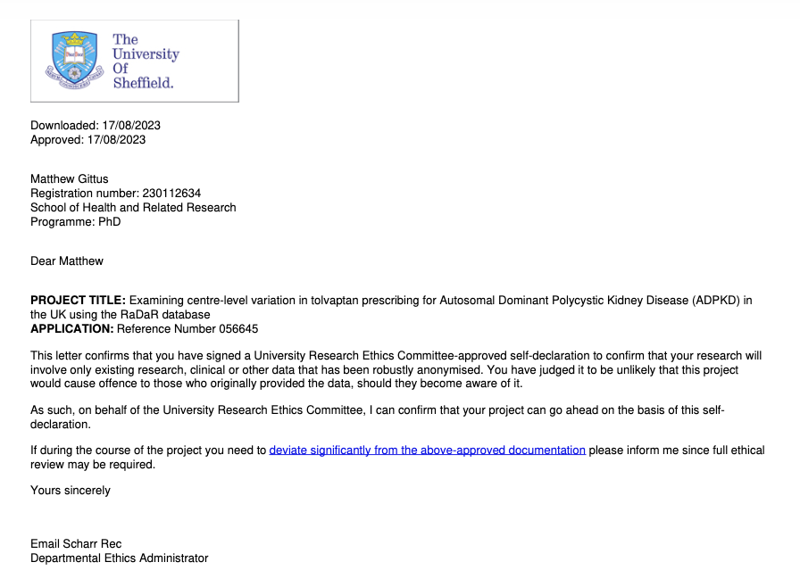

Dulwich Research Ethics Committee approval for programme of research

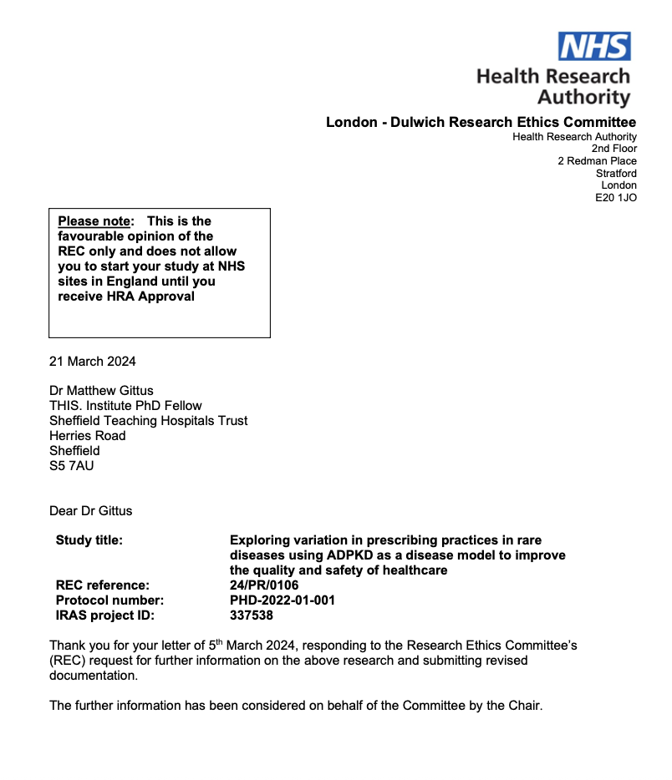

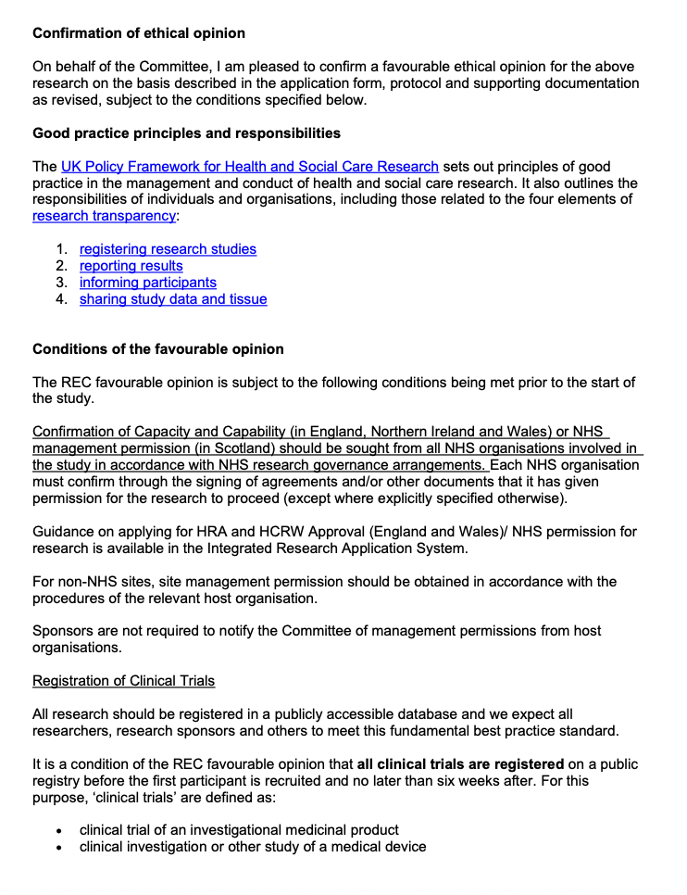

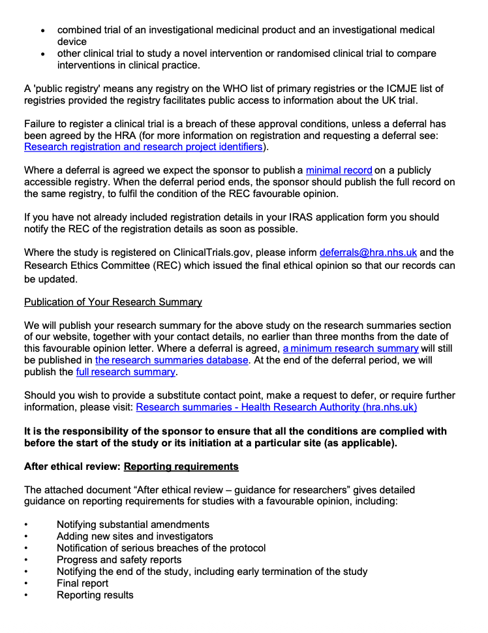

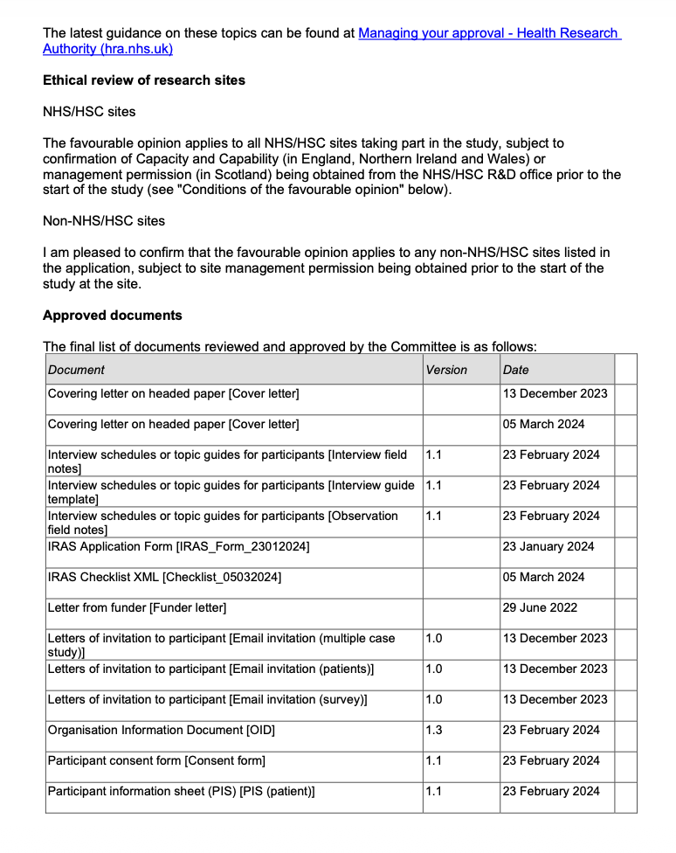



Appendix 3. Additional details on the methods for the systematic review (Phase 1)
Within this appendix, the following additional details on the methods for the overview of systematic reviews (Chapter 4) are included:
- Scoping review for factors influencing prescribing in rare diseases
- Inclusion and exclusion criteria for the systematic review of chronic diseases
- Rationale for inclusion criteria
- Development of the search strategy
- Data collection process (including an example data extraction)
- Quality and risk of bias assessment (including example forms)
- Overlap analysis
- Data synthesis
- Confidence in findings

Scoping review for factors influencing prescribing in rare diseases
# | OVID MEDLINE Search Lines (search date: 01/11/2023)
1 | Rare Diseases/
2 | Cystic Fibrosis/
3 | Idiopathic Pulmonary Fibrosis/
4 | Uveitis/
5 | Retinitis Pigmentosa/
6 | Motor Neuron Disease/
7 | Polycystic Kidney Disease, Autosomal Dominant/
8 | or/1-7
9 | Exp Drug Prescriptions/ or exp Prescriptions/
10 | (Prescri* or Prescribing Behavio?r or Prescrib* Decision* or Prescribing Practice*).ti,ab.
11 | (Initiat* or Start* or Commenc* or Induc*).ti.
12 | or/9-11
13 | exp Clinical decision-making/
14 | exp Health Knowledge, Attitudes, Practice/ or exp Attitude of Health Personnel/ or exp Practice Patterns, Pharmacists'/ or exp Practice Patterns, Nurses'/ or exp Practice Patterns, Physicians'/
15 | (Factor* or Determinant* or Behavio?r* or Practice* or Preference* or Pattern* or Decision* or Decid* or Influenc* or Impact* or Judg* or Barrier* or Facilit* or Help or Hinder or Compl* or Accept or Conform* or Approv* or Adher* or Strateg*).ti.
16 | or/13-15
17 | 8 and 12 and 16

317 results – 2 articles for inclusion were identified:
- Smirnova, N., Trandel, E.T., Dubin, E., Lowers, J., Dellon, E.P., Hempstead, S., Faro, A., Tallarico, E. and Kavalieratos, D., 2023. Clinician perspectives on barriers and solutions to symptom management in cystic fibrosis. Journal of Cystic Fibrosis, 22(6), pp.1100-1103.
- Jandhyala, R., 2020. Influence of Pharmaceutical Company Engagement Activities on the Decision to Prescribe: A Pilot Survey of UK Rare Disease Medicine Prescribers: Pharmaceutical Medicine, 34(2), pp.127-134.

Inclusion and exclusion criteria for the systematic review of chronic conditions
The review question “What are the factors that may influence the prescribing of long-term medications for chronic physical health conditions?” was devised according to the SPIDER framework (Sample, Phenomenon of Interest, Design, Evaluation, Research type) (Cooke, Smith and Booth, 2012). The eligibility criteria for study inclusion were selected according to the same framework; a summary of the inclusion and exclusion criteria is included below.
SPIDER component | Inclusion criteria | Exclusion criteria
Sample | Adults (≥18 years) with non-communicable chronic physical health conditions requiring long-term pharmacological management | Children and adolescents; individuals with chronic mental health conditions; individuals with communicable diseases (e.g. HIV, tuberculosis)
Phenomenon of Interest | Factors influencing initiation of long-term medication prescribing | Factors related to other stages of prescribing (e.g. titration, optimisation, discontinuation)
Design | Published, peer-reviewed systematic reviews | Rapid reviews, scoping reviews, narrative reviews, protocols, conference abstracts
Evaluation | Reviews reporting at least one of the following:  - factors influencing initiation  - experiences of healthcare professionals making prescribing decisions  - barriers and facilitators to prescribing | Reviews not reporting outcomes relevant to prescribing decision-making
Research Type | Systematic reviews of qualitative, quantitative, or mixed-methods studies published in any language between 01/01/2013 and 07/11/2023 | Reviews published outside the specified date range; non-systematic evidence syntheses

Rationale for inclusion criteria
Adults
The systematic review focused on prescribing decision-making for adults, as this reflects a more standardised and comparable clinical context in which prescribing decision-making could be considered. Prescribing is often guided by established evidence bases, consistent dosing practices and more uniform decision-making processes. This means the included systematic reviews should be less heterogeneous in terms of the factors influencing decision-making processes, which is intended to enhance the interpretation of findings.
Prescribing decision-making in children differs from that in adults. There is often a less consistent evidence base and fewer guidelines in paediatric medicine, so medications are often used outside of their license (Ferro, 2015). Physiological and anatomical differences give rise to more pharmacokinetic considerations. Determining appropriate dosing regimens is particularly difficult (Fernandez et al., 2011). Shared decision-making often involves parents or guardians, but can involve children depending on their age and maturity. This makes decision-making more complex as clinicians must consider consent and the child’s level of competence alongside parental preferences (Bart, Hall and Gillam, 2024). Factors relating to child welfare and safeguarding responsibilities are also often considered, which further complicates decision-making. Finally, risk tolerance is often lower when prescribing medications for children than adults, so how clinicians approach the risk-benefit assessment is more likely to be cautious (Ferro, 2015).
Chronic conditions
Prescribing for chronic conditions was selected because they involve long-term disease trajectories, and clinicians must take into account a wide range of factors in their decision-making. This creates greater scope for clinical judgement, uncertainty and complex risk-benefit assessments (Nicholson et al., 2024). This makes them particularly suited to the study of prescribing decision-making processes. In contrast, acute conditions typically involve only short-term medications, which are more often protocol-driven with standardised prescribing pathways (Poluektova et al., 2023). The inclusion of both acute and chronic conditions would have introduced substantial clinical and methodological heterogeneity, which would make meaningful interpretations more difficult to achieve during the overview. Rare diseases are typically chronic conditions, but there is insufficient literature to conduct a systematic review to inform the development of a conceptual model. More common chronic conditions are the closest available proxy.
Physical health conditions
Prescribing in the context of physical health conditions differs from that of mental health conditions. Non-pharmacological interventions are frequently recommended as the first-line intervention in the management of mental health conditions (Keynejad, Spagnolo and Thornicroft, 2021). There is also likely greater diagnostic certainty, more fluctuant symptoms and more symptom-response driven practices. Treatment pathways differ from those in physical health conditions with greater trial-and-error prescribing, frequent switching and dose adjustment in the context of prescribing for mental health conditions (Kessler, Keller and Wittchen, 2001). Thus, there are likely to be different factors influencing prescribing decisions and behaviours for mental and physical health conditions. For this reason, mental health conditions were excluded, and only physical health conditions were included in this overview to reduce heterogeneity.
Non-communicable
Non-communicable diseases were selected as these conditions are characterised by long-term disease trajectories that often require medications. Prescribing decisions for non-communicable diseases often involve the consideration of long-term risks, benefits, patient preferences and uncertainty in treatment response (Bostock, 2021). Communicable diseases were excluded, as treatment pathways are often more acute or time-limited, so are more in-keeping with decision-making for acute conditions. Treatment pathways are often more protocol-driven or episodic. They are also strongly influenced by public health considerations (e.g. transmission control or resistance), which are not a factor in non-communicable diseases (Ameli, 2015; World Health Organization, 2015). Decision-making is less individualised and less open to clinical judgement than in non-communicable conditions. Thus, including both would introduce greater heterogeneity due to the different prescribing contexts.
Factors influencing prescribing decision-making or experiences of healthcare professionals when making prescribing decisions
Healthcare professionals are considered the primary decision-makers in prescribing decisions (World Health Organization, 2011). These decisions are believed to be shaped by not only clinical guidelines and evidence but also their professional experiences, risk perceptions, organisational pressures and interactions with patients (Cabana et al., 1999). Including systematic reviews that examined healthcare professionals’ experiences of prescribing decisions was therefore essential to understand how prescribing occurs in clinical practice and to identify factors that may contribute to variation between recommended and actual prescribing behaviour. No restriction was placed on the type of healthcare professional making decisions, so the overview reflects real-world prescribing, which increasingly involves other members of the healthcare team (Graham-Clarke et al., 2019).
Systematic reviews
An overview of systematic reviews does not reanalyse primary studies but includes evidence from existing evidence syntheses. This allows the synthesis of a large and diverse body of evidence across multiple settings to produce broader interpretations of a particular phenomenon of interest. The systematic reviews included were all peer-reviewed as this ensured greater methodological rigour and transparency to the overview (Higgins and Green, 2024).
Any study design
Systematic reviews including primary studies with qualitative, quantitative and mixed-methods designs were included to ensure a comprehensive synthesis of evidence relating to prescribing decision-making. Restricting inclusion to a single methodological approach would risk excluding relevant dimensions of prescribing behaviours and limit the explanatory depth of the overview.
Study period
The publication period from January 2013 to November 2023 was selected to ensure that findings reflected contemporary clinical practice, prescribing guidelines, and healthcare systems. No restrictions were placed on the date of primary studies within the included reviews.

Development of the search strategy
A scoping search for key articles was first undertaken to inform the development of the search strategy. From this initial set of relevant studies, keywords and associated MeSH/Emtree terms were identified and structured using the SPIDER framework. I developed and refined the search strategy through consultation with an information specialist. The search strategy was first developed for the MEDLINE (Ovid) database, then adapted for use across the other databases.

Data collection process
The data items extracted from each systematic review included in the overview of systematic reviews are summarised below. A data extraction form was developed based on the data extraction and assessment form published by the Cochrane Collaboration (Cochrane Effective Practice and Organisation of Care (EPOC), 2017). It was piloted on a random selection of five studies, which represented approximately 20% of the included studies. Piloting was conducted to confirm that all relevant data was extracted while avoiding the extraction of unnecessary information (Higgins and Green, 2024). Data extraction was undertaken by a single reviewer, then checked for accuracy and completeness by a second reviewer in line with guidance from the Cochrane Collaboration (Higgins and Green, 2024). Any inaccuracies were corrected, and when queries were raised, the two reviewers resolved this through discussion. Due to the different study designs of the included studies in the systematic reviews and highly heterogeneous disease areas, there was no intention of undertaking a meta-analysis, so double data extraction was not required. An example data extraction form is included following this section.

Data items for extraction

Data item | Details
Study details | Author, Year of publication of systematic review, title
Country of origin | Country or countries of the review authors’ affiliations
Databases searched | Number and names of databases
Date range of search | Start and end dates of systematic review
Publication date range | Publication years of primary studies included in the review
Number of included studies | Total number of primary studies included in the review
Origin of studies | Countries or regions where the primary studies were conducted
Setting | Healthcare setting(s) examined e.g. primary care, secondary care, community care
Disease area | Chronic physical health condition(s) addressed
Primary study types | Type of primary studies included e.g. qualitative, quantitative, mixed methods
Funding source | Reporting funding source for the systematic review
Other | Other notes from the discussion which may have influenced the study’s conclusions

Example data extraction form

Data extraction form
Review author: Review data:
Study features:
Author
Title
Year of publication
Journal
Country
Publication type

Inclusion criteria:
Adults only?
Chronic physical health condition?
Long-term medication?
Factors influencing initiation?
Within date range (01/01/13-07/11/23)
Systematic review?

Decision

IF THE STUDY DOES NOT MEET THE ABOVE CRITERIA, IT SHOULD NOT BE CONSIDERED FURTHER

Review aims and scope:
Aims and objectives
Disease area
Phenomenon of interest
Healthcare setting(s)

Eligibility criteria:
Population
Intervention/Exposure
Comparison
Outcomes/focus
Study

Search characteristics:
Databases searched
Date range of search

Included evidence base:
Number of included primary studies
Origin of primary studies
Primary study design(s) included

Findings/results:
Themes or categories
Authors’ interpretation
Contextual factors

Quality assessment:
Assessment of rigour
Credibility, transferability, dependability, confirmability, reflexivity

Discussion:
Key discussion points
Further research
Limitations
Conclusions

Review funding and transparency:
Funding source

Other notes

Quality and risk of bias assessment
Background
Methodological guidance in evidence synthesis supports inclusion of both quality and risk of bias assessments when appraising systematic reviews in overviews of reviews. Considering both reduces the risk of inaccurate appraisal arising from either poor reporting, but otherwise robust methods, or well-reported but methodologically weak reviews (Lunny et al., 2024).
Methodological quality reflects how rigorously a review has been designed and conducted. It is included in overviews of reviews for two main reasons. First, it may inform which reviews should be included in the overview. Second, it supports interpretation of the findings by allowing the methodological strengths and limitations of included reviews to be included when drawing conclusions (Pollock, Fernandes and Hartling, 2017).
Risk of bias refers to the extent to which limitations in the review process could have introduced systematic error which could affect the credibility of findings. The stages within the review process where systematic errors can occur include: study identification, selection, appraisal, or synthesis. These errors may lead to an over or underestimation of effects, or misrepresentation of influencing factors (Higgins and Green, 2024).
Assessments of methodological quality or risk of bias may be limited by incomplete or unclear reporting in systematic reviews. This does not necessarily mean that the review has been conducted poorly, but it does restrict evaluation of study quality and risk of bias. The use of structured critical appraisal tools can make this process more transparent by recording incomplete or unclear reporting (Higgins and Green, 2024; Shea et al., 2017).
In line with established methodological guidance, appraisal of quality and risk of bias was not just based on overall summary scores. If only summary scores are used this has the potential to mask critical weaknesses in key domains. Instead, the potential impact of an inadequate rating for each domain was considered and an overall judgement made whether to include a review (Shea et al., 2017; Whiting et al., 2016).
Quality assessment in this overview of systematic reviews
The Methodological quality of the included systematic reviews was assessed using the AMSTAR 2 (A MeaSurement Tool to Assess Systematic Reviews) checklist (Shea et al., 2017). AMSTAR 2 was selected for this overview as it is a widely accepted tool that has been validated by multiple authors. It has been adapted to be used for systematic reviews of both randomised and non-randomised studies of healthcare interventions (Pollock, Fernandes and Hartling, 2017). AMSTAR 2 assesses the methodological aspects of a systematic review using a checklist of domains and the overall rating. It consists of 16-items of which seven are considered critical domains that can critically affect the validity of a review and its conclusions.
Each included systematic review was assessed using the AMSTAR 2 tool. Quality assessment was undertaken by two reviewers independently. Any discrepancies were resolved through discussion. This process was implemented to enhance the reliability of the quality appraisal process, recognising that judgements of methodological quality may be influenced by reviewer experience and interpretation. An example quality assessment form used in this overview is included on the next page.

Example quality assessment form (AMSTAR2)
Review author: Review data:

Author
Title
Year of publication

1. Did the research questions and inclusion criteria for the review include the components of PICO?
Yes
Partial Yes
No
Unclear
Not Applicable
For Yes  Population  Intervention  Comparator group  Outcome | Optional (recommended):  Timeframe for follow-up?  Yes  No
2. Did the report of the review contain an explicit statement that the review methods were established? (CRITICAL DOMAIN)
Yes
Partial Yes
No
Unclear
Not Applicable
For Partial Yes:  The authors state that they had a written protocol of guide that included ALL the following:  Review question(s)  A search strategy  Inclusion/exclusion criteria  A risk of bias assessment | For Yes:  As for partial yes, plus the protocol should be registered and should also have specified:  A meta-analysis/synthesis plan, if appropriate, and  A plan for investigating causes of heterogeneity  Justification for any deviations from the protocol
3. Did the review authors explain their selection of the study designs for inclusion in the review?
Yes
No
Unclear
Not Applicable
For Yes, the review should satisfy ONE of the following:
Explanation for including only RCTs
Explanation for including only NRSI
Explanation for including both RCTs and NRSI
4. Did the review authors use a comprehensive literature search strategy? (CRITICAL DOMAIN)
Yes
Partial Yes
No
Unclear
Not Applicable

For Partial Yes (all the following):  Searched at least 2 databases  Provided key word and/or search strategy  Justified publication restrictions | For Yes, should also have (all the following):  Searched the reference lists/bibliographies of included studies  Searched trial/study registries  Included/consulted content experts in the field  Where relevant, searched for grey literature  Conducted search within 24 months of completion of the review
5. Did the review authors perform study selection in duplicate?
Yes
No
Unclear
Not Applicable
For Yes (either of the following):
At least two reviewers independently agreed on selection of eligible studies and achieved consensus on which studies to include
Two reviewers selected a sample of eligible studies and achieved good agreement (at least 80%), with the remainder selected by one reviewer
6. Did the review authors perform data extraction in duplicate?
Yes
No
Unclear
Not Applicable
For Yes, either one of the following:
At least two reviewers achieved consensus on which data to extract from included studies
Two reviewers extracted data from a sample of eligible studies and achieved good agreement (at least 80%), with the remainder extracted by one reviewer
7. Did the review authors provide a list of excluded studies and justify the exclusions? (CRITICAL DOMAIN)
Yes
Partial Yes
No
Unclear
Not Applicable
For Partial Yes:  Provided a list of all potentially relevant studies that were read in full-text form but excluded from the review | For Yes, must also have:  Justified the exclusion from the review of each potentially relevant study
8. Did the review authors describe the included studies in adequate detail?
Yes
Partial Yes
No
Unclear
Not Applicable
For Partial Yes (ALL the following):  Described populations  Described interventions  Described comparators  Described outcomes  Designed research designs | For Yes, should also have ALL the following:  Described population in detail  Described intervention and comparator in detail (including doses where relevant)  Described study’s setting  Timeframe for follow-up

9. Did the review authors use a satisfactory technique for assessing the risk of bias in individual studies that were included in the review? (CRITICAL DOMAIN)
Yes
Partial Yes
No
Unclear
Not Applicable
NSRI - For a Partial Yes, must have assessed RoB:  From confounding, and  From selection bias | NSRI - For a Yes, must have assessed RoB:  Methods used to ascertain exposures and outcomes, and  Selection of the reported result from among multiple measurements or analyses of a specified outcome
10. Did the review authors report on the sources of funding for the studies included in the review?
Yes
No
Unclear
Not Applicable
For Yes:
Must have reported on the sources of funding for individual studies included in the review

11. If meta-analysis was performed did the review authors use appropriate methods for statistical combination of results? (CRITICAL DOMAIN)
Yes
No
No meta-analysis conducted
Unclear
Not Applicable
NSRI - For Yes:
The authors justified combining the data in a meta-analysis
AND they used an appropriate weighted technique to combine study results and adjusted for heterogeneity if present
AND they statistically combined effect estimates from NSRI that were adjusted for confounding, rather than combining raw data, or justified combining raw data when adjusted effect estimates were not available
AND they reported separate summary estimates for RCTs and NSRI separately when both were included in the review
12. If meta-analysis was performed, did the review authors assess the potential impact of RoB in individual studies on the results of the meta-analysis or other evidence synthesis?
Yes
No
No meta-analysis conducted
Unclear
Not applicable
NSRI: - For Yes:
Included only low risk of bias RCTs
OR, if the pooled estimate was based on RCTs and/or NSRI at variable RoB, the authors performed analyses to investigate possible impact of RoB on summary estimates of effect

13. Did the review authors account for RoB in individual studies when interpreting/discussing the results of the review? (CRITICAL DOMAIN)
Yes
No
Unclear
Not Applicable
For Yes:
Included only low risk of bias RCTs
OR, if RCTs with moderate or high RoB, or NSRI were included the review provided a discussion of the likely impact of RoB on the results
14. Did the review authors provide a satisfactory explanation for, and discussion of, any heterogeneity observed in the results of the review?
Yes
No
Unclear
Not Applicable
For Yes:
There was no significant heterogeneity in the results
OR If heterogeneity was present the authors performed an investigation of sources of any heterogeneity in the results and discussed the impact of this on the results of the review
15. If they performed quantitative synthesis did the review authors carry out an adequate investigation of publication bias (small study bias) and discuss its likely impact on the results of the review? (CRITICAL DOMAIN)
Yes
No
No meta-analysis conducted
Unclear
Not applicable
For Yes:
Performed graphical or statistical tests for publication bias and discussed the likelihood and magnitude of impact of publication bias
16. Did the review authors report any potential sources of conflict of interest, including any funding they received for conducting the review?
Yes
No
Unclear
Not Applicable
For Yes:
The authors reported no competing interests
OR The authors described their funding sources and how they managed potential conflicts of interest

Number of critical domain weaknesses
Final rating
Included in overview of systematic reviews

Notes

Risk of bias assessment in this overview
Assessing the methodological quality of systematic reviews is often included on its own in overviews of systematic reviews. While this provides a structured assessment of quality and identifies critical weaknesses that may compromise the reliability of review findings, it doesn’t explicitly evaluate the risk of biases in the included systematic reviews (Higgins and Green, 2024).
As a result, I conducted a separate risk of bias assessment in the overview of systematic reviews. I selected the ROBIS (Risk of Bias in Systematic Reviews) checklist as it was specifically designed for systematic reviews and focuses on the trustworthiness of conclusions. It consists of a series of domain-level judgements across three separate phases: Phase 1– assessing relevance, Phase 2 – identifying concerns about bias in the review process and Phase 3 – judging risk of bias (Whiting et al., 2016). An example of the risk of bias assessment form used in this overview is included on the next page.

Example risk of bias assessment form (ROBIS)

Review author: Review data:
Author
Title
Year of publication

Phase 1: Assessing relevance

Category | Target question
Patient/Population(s):
Intervention(s):
Comparator(s):
Outcome(s):

Does the question addressed by the review match the target question?
Yes No Unclear

Phase 2: Identifying concerns with the review process

Domain 1
1.1 Did the review adhere to pre-defined objectives and eligibility criteria?
Yes Partial Yes Partial No No No information
1.2 Were the eligibility criteria appropriate for the review question?
Yes Partial Yes Partial No No No information
1.3 Were eligibility criteria unambiguous?
Yes Partial Yes Partial No No No information
1.4 Were any restrictions in eligibility criteria based on study characteristics appropriate (e.g. date, sample size, study quality, outcomes measured)?
Yes Partial Yes Partial No No No information
1.5 Were any restrictions in eligibility criteria based on sources of information appropriate (e.g. publication status or format, language, availability of data)?
Yes Partial Yes Partial No No No information
Concerns regarding specification of study eligibility criteria:
Low High Unclear

Domain 2: Identification and selection of studies
2.1 Did the search include an appropriate range of databases/electronic sources for published and unpublished reports?
Yes Partial Yes Partial No No No information
2.2 Were methods additional to database searching used to identify relevant reports?
Yes Partial Yes Partial No No No information
2.3 Were the terms and structure of the search strategy likely to retrieve as many eligible studies as possible?
Yes Partial Yes Partial No No No information
2.4 Were restrictions based on date, publication format, or language appropriate?
Yes Partial Yes Partial No No No information
2.5 Were efforts made to minimise error in selection of studies?
Yes Partial Yes Partial No No No information
Concerns regarding methods used to identify and/or select studies:
Low High Unclear

Domain 3: Data collection and study appraisal
3.1 Were efforts made to minimise error in data collection?
Yes Partial Yes Partial No No No information
3.2 Were sufficient study characteristics available for both review authors and readers to be able to interpret the results?
Yes Partial Yes Partial No No No information
3.3 Were all relevant study results collected for use in the synthesis?

Yes Partial Yes Partial No No No information
3.4 Was risk of bias (or methodological quality) formally assessed using appropriate criteria?
Yes Partial Yes Partial No No No information
3.5 Were efforts made to minimise error in risk of bias assessment?
Yes Partial Yes Partial No No No information
Concerns regarding methods used to collect data and appraise studies:
Low High Unclear

Domain 4: Synthesis and findings
4.1 Did the synthesis include all studies that it should?
Yes Partial Yes Partial No No No information
4.2 Were all pre-defined analyses reported or departures explained?
Yes Partial Yes Partial No No No information
4.3 Was the synthesis appropriate given the nature and similarity in the research questions, study designs and outcomes across included studies?
Yes Partial Yes Partial No No No information
4.4 Was between-study variation (heterogeneity) minimal or addressed in the synthesis?
Yes Partial Yes Partial No No No information
4.5 Were the findings robust, e.g. as demonstrated through funnel plot or sensitivity analyses?
Yes Partial Yes Partial No No No information
4.6 Were biases in primary studies minimal or addressed in the synthesis?
Yes Partial Yes Partial No No No information
Concerns regarding the synthesis and findings:
Low High Unclear

Phase 3: Judging risk of bias

Domain | Concern | Rationale for concern
1. Concerns regarding specification of study eligibility criteria
2. Concerns regarding methods used to identify and/or select studies
3. Concerns regarding methods used to collect data and appraise studies
4. Concerns regarding the synthesis and findings

Risk of bias in the review | Response
A. Did the interpretation of findings address all of the concerns identified in domains 1 to 4? | Yes  Partial Yes  Partial No  No  No information
B. Was the relevance of identified studies to the review’s research question appropriately considered? | Yes  Partial Yes  Partial No  No  No information
C. Did the reviewers avoid emphasising results on the basis of their statistical significance? | Yes  Partial Yes  Partial No  No  No information
Risk of bias in the review
Low High Unclear

Overlap analysis
Overviews of systematic reviews have the potential for overlap in primary studies because they are often broad in scope and cover many systematic reviews with the same topics. This means there is a risk of double-counting, over-precision and bias. Double-counting is where the same primary study is included in more than one review, which means that its findings contribute multiple times to the evidence base of the overview through different included reviews. This can lead to over-precision because repeated studies make findings appear more consistent which may lead to biased conclusions (Pieper et al., 2012). Overlap analysis in overviews of systematic reviews addresses these methodological challenges. Its ensures the independence of the included evidence and the robustness of synthesised findings (Higgins and Green, 2024; Pieper et al., 2014). The Corrected Covered Area (CCA) is a widely used quantitative measure that has been used to assess the degree of primary study overlap in overviews of reviews by calculating the percentage of overlapping studies.
The CCA is calculated using the formula:
$$CCA= \frac{N_{r}-N_{s}}{N_{t}-N_{s}}$$
where:
N_{r} = total number of occurrences of primary studies across all reviews (i.e., counting duplicates)
N_{s} = number of unique primary studies
N_{t} = total number of included reviews × N_{s}
The formula accounts for both the total number of included primary studies and the number of repeated occurrences across reviews. This provides a corrected measure of overlap that standardises overlap relative to the number of reviews. Common thresholds used when interpreting the CCA include 0–5% indicating slight, 6–10% moderate, 11–15% high and >15% very high overlap. Performing an overlap analysis allowed identification of areas where primary studies were repeatedly represented, which informed the level of confidence that could be placed in the overall conclusions of the overview (Pieper et al., 2014).

Data synthesis
Multiple methods may be appropriate when synthesising evidence in systematic reviews (Higgins and Green, 2024). Potential approaches include thematic synthesis (Thomas and Harden, 2008), meta-aggregation (Lockwood, Munn and Porritt, 2015), meta-ethnography (Noblit and Hare, 1988), narrative synthesis (Popay et al., 2006), and framework synthesis (Dixon-Woods, 2011).
Framework synthesis approaches are particularly appropriate where an existing conceptual model or framework is available to structure and interpret findings. This approach aligned with one of the main objectives of the overview of systematic reviews, which was to adapt the existing prescribing model by Murshid and Mohaidin (2017) to better reflect the factors that may influence prescribing for chronic conditions. This approach involved coding the data from the systematic reviews to the factors in the existing model (deductive coding), but new factors were also incorporated into the synthesis (inductive coding) (Dixon-Woods, 2011).
Alternative synthesis approaches were considered. An inductive thematic synthesis was considered, but this was deemed to be less appropriate given the availability of an existing conceptual model and the objective of the overview of systematic reviews. Narrative synthesis was also considered but was not selected as a standalone approach, as it would be more difficult to organise and compare the findings due to the number of included systematic reviews. Meta-aggregation or meta-ethnography were not considered to be appropriate due to the heterogeneous nature of the data being synthesised in systematic reviews.
Confidence in findings
Assessing confidence in findings is undertaken in systematic reviews to ensure that readers are aware of the strength and consistency of the underlying evidence base when interpreting findings (Lewin et al., 2018b). Confidence in the factors was assessed using the GRADE-CERQual approach (Lewin et al., 2018a). This CERQual tool was chosen as it provides a transparent and user-friendly framework for assessing how much confidence to place in the findings for each factor. This assessment is based on the methodological limitations of contributing studies, relevance to the review question, agreement across data sources, and the adequacy of the supporting data. Each finding was assigned a level of confidence (very low, low, moderate or high). This was then used to support the interpretation of the strength and reliability of the evidence within each theme.

Appendix 4. Publication materials for journal article 1 (Chapter 4)

Reporting checklist for overview of systematic reviews (PRIOR) checklist
Section  Topic | # | Item | Location reported
TITLE
Title | 1 | Identify the report as an overview of systematic reviews. | Title page
ABSTRACT
Abstract | 2 | Provide a comprehensive and accurate summary of the purpose, methods, and the results of the overview of systematic reviews. | Abstract
INTRODUCTION
Rationale | 3 | Describe the rationale for conducting the overview of systematic reviews in the context of existing knowledge. | Background - paragraph 2
Objectives | 4 | Provide an explicit statement of the objective(s) or question(s) addressed by the overview of systematic reviews. | Methods - scope
METHODS
Eligibility criteria | 5a | Specify the inclusion and exclusion criteria for the overview of systematic reviews. If supplemental primary studies were included, this should be stated, with a rationale. | Methods - eligibility criteria
Eligibility criteria | 5b | Specify the definition of “systematic review” as used in the inclusion criteria for the overview of systematic reviews. | Methods - eligibility criteria
Information sources | 6 | Specify all databases, registers, websites, organisations, reference lists and other sources searched or consulted to identify systematic reviews and supplementary primary studies (if included). Specify the date when each source was last searched or consulted. | Methods - search strategy
Search strategy | 7 | Present the full search strategies for all databases, registers and websites, such that they could be reproduced. Describe any search filters and limits applied. | Appendix 3
Selection process | 8a | Describe the methods used to decide whether a systematic review or supplemental primary study (if included) met the inclusion criteria of the overview of systematic reviews. | Methods – selection of systematic reviews
Selection process | 8b | Describe how overlap in the populations, interventions, comparators, and/or outcomes of systematic reviews was identified and managed during study selection. | Methods – data extraction
Data collection process | 9a | Describe the methods used to collect data from reports. | Methods – data extraction
Data collection process | 9b | If applicable, describe the methods used to identify and manage primary study overlap at the level of the comparison and outcome during data collection. For each outcome, specify the method used to illustrate and/or quantify the degree of primary study overlap across systematic reviews. | Methods – overlap analysis
Data collection process | 9c | If applicable, specify the methods used to manage discrepant data across systematic reviews during data collection. | NA
Data items | 10 | List and define all variables and outcomes for which data was sought. Describe any assumptions made and/or measures taken to identify and clarify missing or unclear information. | Appendix 3
Risk of bias assessment | 11a | Describe the methods used to assess risk of bias or methodological quality of the included systematic reviews. | Methods - quality assessment
Risk of bias assessment | 11b | Describe the methods used to collect data on (from the systematic reviews) and/or assess the risk of bias of the primary studies included in the systematic reviews. Provide a justification for instances where flawed, incomplete, or missing assessments are identified but not re-assessed. | Methods - quality assessment
Risk of bias assessment | 11c | Describe the methods used to assess the risk of bias of supplemental primary studies (if included). | Methods - quality assessment
Synthesis methods | 12a | Describe the methods used to summarise or synthesise results and provide a rationale for the choice(s). | Methods – synthesis
Synthesis methods | 12b | Describe any methods used to explore possible causes of heterogeneity among results. | NA
Synthesis methods | 12c | Describe any sensitivity analyses conducted to assess the robustness of the synthesised results. | NA
Reporting bias assessment | 13 | Describe the methods used to collect data on (from the systematic reviews) and/or assess the risk of bias due to missing results in a summary or synthesis (arising from reporting biases at the levels of the systematic reviews, primary studies, and supplemental primary studies, if included). | Methods - overlap analysis
Certainty assessment | 14 | Describe the methods used to collect data on (from the systematic reviews) and/or assess certainty (or confidence) in the body of evidence for an outcome. | Methods - confidence in findings
RESULTS
Systematic review and supplemental primary study selection | 15a | Describe the results of the search and selection process, including the number of records screened, assessed for eligibility, and included in the overview of systematic reviews, ideally with a flow diagram. | Results - paragraphs 1 & 2
Systematic review and supplemental primary study selection | 15b | Provide a list of studies that might appear to meet the inclusion criteria, but were excluded, with the main reason for exclusion. | Appendix 3
Characteristics of systematic reviews | 16 | Cite each included systematic review and supplemental primary study (if included) and present its characteristics. | Table 8
Primary study overlap | 17 | Describe the extent of primary study overlap across the included systematic reviews. | Results - paragraph 3
Risk of bias in systematic reviews | 18a | Present assessments of risk of bias or methodological quality for each included systematic review. | Results - paragraph 4
Risk of bias in systematic reviews | 18b | Present assessments (collected from systematic reviews or assessed anew) of the risk of bias of the primary studies included in the systematic reviews. | Appendix 3
Risk of bias in systematic reviews | 18c | Present assessments of the risk of bias of supplemental primary studies (if included). | Appendix 3
Summary or synthesis of results | 19a | For all outcomes, summarise the evidence from the systematic reviews and supplemental primary studies (if included). If meta-analyses were done, present for each the summary estimate and its precision and measures of statistical heterogeneity. If comparing groups, describe the direction of the effect. | Results - synthesis of qualitative findings
Summary or synthesis of results | 19b | If meta-analyses were done, present results of all investigations of possible causes of heterogeneity. | NA
Summary or synthesis of results | 19c | If meta-analyses were done, present results of all sensitivity analyses conducted to assess the robustness of synthesised results. | NA
Reporting biases | 20 | Present assessments (collected from systematic reviews and/or assessed anew) of the risk of bias due to missing primary studies, analyses, or results in a summary or synthesis (arising from reporting biases at the levels of the systematic reviews, primary studies, and supplemental primary studies, if included) for each summary or synthesis assessed. | Appendix 3
Certainty of evidence | 21 | Present assessments (collected or assessed anew) of certainty (or confidence) in the body of evidence for each outcome. | Table 9
DISCUSSION
Discussion | 22a | Summarise the main findings, including any discrepancies in findings across the included systematic reviews and supplemental primary studies (if included). | Discussion - key findings
Discussion | 22b | Provide a general interpretation of results in the context of other evidence. | Discussion - our findings in the wider context
Discussion | 22c | Discuss any limitations of the evidence from systematic reviews, their primary studies, and supplemental primary studies (if included) included in the overview of systematic reviews. Discuss any limitations of the methods used in the overview of systematic reviews. | Discussion - strengths and weaknesses
Discussion | 22d | Discuss implications for practice, policy and future research (both systematic reviews and primary research). Consider the relevance of the findings to the end users of the overview of systematic reviews e.g. healthcare providers, policymakers, patients, among others. | Discussion - implications for clinical practice and areas for future research
OTHER INFORMATION
Registration and protocol | 23a | Provide registration information for the overview of systematic reviews, including register name and registration number, or state that the overview of systematic reviews was not registered. | Methods - study design and protocol
Registration and protocol | 23b | Indicate where the overview of systematic reviews protocol can be accessed, or state that a protocol was not prepared | Methods - study design and protocol
Registration and protocol | 23c | Describe and explain any amendments to information provided at registration or in the protocol. Indicate the stage of the overview of systematic reviews at which amendments were made. | NA
Support | 24 | Describe sources of financial or non-financial support for the overview of systematic reviews, and the role of the funders or sponsors in the overview of systematic reviews. | Declarations
Competing interests | 25 | Declare any competing interests of the overview of systematic reviews' authors. | Declarations
Author information | 26a | Provide contact information for the corresponding author. | Declarations
Author information | 26b | Describe the contributions of individual authors and identify the guarantor of the overview of systematic reviews. | Declarations
Availability of data and other materials | 27 | Report which of the following are available, where they can be found, and under which conditions they may be accessed: template data collection forms; data collected from included systematic reviews and supplemental primary studies; analytic code; any other materials used in the overview of systematic reviews. | Declarations
Locations indicate where each checklist item is included in this thesis

List of chronic conditions used to inform search strategies
# | Chronic conditions
1 | Addictions – substance and alcohol, etc.
2 | ADHD
3 | Allergic rhinitis/rhinitis/sinusitis/rhinosinusitis
4 | Allergy/anaphylaxis
5 | Amnesia
6 | Amputations
7 | Anaemia
8 | Angina
9 | Angiooedema
10 | Ankylosing spondylitis (and other arthritic conditions)
11 | Antenatal screening for haemoglobinopathies – sickle cell and thalassemia, Downs
12 | Anxiety and stress disorders (including complex and post-traumatic stress disorders)
13 | Aphasia
14 | Asthma
15 | Ataxia’s
16 | Atrial fibrillation
17 | Autism
18 | Autoimmune disorders (e.g. lupus, Sjögrens syndrome)
19 | Blood disorders
20 | Brain injuries (including stroke and TIAs)
21 | Bronchopulmonary dysplasia (chronic lung disease of infancy)
22 | Burn injuries
23 | Cancer
24 | Cardiac arrhythmias
25 | Cerebral palsy
26 | Childhood constipation
27 | Chronic fatigue syndrome/ME
28 | Chronic kidney disease
29 | Chronic obstructive pulmonary disease
30 | Chronic pain
31 | Coeliac disease
32 | Congestive heart failure
33 | Connective tissue diseases
34 | Coronary heart disease
35 | Crohn’s disease
36 | Cystic Fibrosis
37 | Dementia
38 | Depression
39 | Diabetes: Type I
40 | Diabetes: Type II
41 | Digestive conditions, stomach ulcers, oesophagus, reflux
42 | Dizziness
43 | Dyslexia or dyspraxia
44 | Eating disorders (anorexia/bulimia)
45 | Eczema
46 | Endocrine disorders (thyrotoxicosis, hypothyroidism, hypogonadism, Cushing syndrome, Addison’s disease)
47 | Endometriosis
48 | Epilepsy
49 | Fibromyalgia/chronic widespread pain
50 | Gout
51 | Gynaecological problems, chronic pelvic pain
52 | Haemophilia and other coagulation disorders
53 | Heart failure
54 | Hepatitis B
55 | Hepatitis C
56 | HIV
57 | Hypertension
58 | Inflammatory bowel disease
59 | Irritable bowel disease
60 | Learning disabilities
61 | Low back pain
62 | Lung fibrosis
63 | Lupus
64 | Malaria
65 | Medically unexplained symptoms
66 | Migraine
67 | Mood disorders (not only depression, but mania and bipolar disorders)
68 | Motor neurone disease
69 | Multimorbidity
70 | Multiple sclerosis
71 | Multisystem autoimmune diseases (MSAIDs, including lupus)
72 | Muscular dystrophy(ies)
73 | Neuralgias (including, head and back pain)
74 | Newborn screening programme diseases, including thyroid disease, hearing loss
75 | Obesity
76 | Obstructive sleep apnoea
77 | Occupational lung disease (various)
78 | Osteoarthritis
79 | Osteoporosis
80 | Other slowly degenerative neurological conditions
81 | Parkinson’s disease
82 | Peripheral vascular disease
83 | Personality disorders
84 | Phobias
85 | Physical disabilities
86 | Polycystic ovary disease
87 | Post-traumatic stress
88 | Progressive supranuclear palsy
89 | Psoriasis
90 | Rare disease, genetic disorders
91 | Sarcoidosis
92 | Sensory problems/disabilities (deafness/blindness)
93 | Severe skin conditions
94 | Sickle cell disease
95 | Skin conditions
96 | Sleep disorders
97 | Speech deficits
98 | Spina bifida
99 | Spinal injuries
100 | Stroke/transient ischaemic attacks
101 | Tuberculosis
102 | Urinary Incontinence
103 | Urticarial

Search strategies
MEDLINE (Ovid) search strategy
# | MEDLINE (Ovid) Search Lines (searched 07/11/2023)
1 | exp rhinitis/
2 | ((vasomotor or allerg* or non-allerg* or nonallerg* or non allerg*) and rhinitis).ti,ab.
3 | exp amnesia/
4 | (amnesi* or memory loss).ti,ab.
5 | amputation, surgical/
6 | amputation, traumatic/
7 | (amputation or amputee*).ti,ab.
8 | exp anemia/
9 | an?emia.ti,ab.
10 | exp cardiovascular disease/
11 | (angina or myocardial isch?mi*).ti,ab.
12 | exp angioedema/
13 | (angioedema or (hereditary adj (angioedema* or angioneurotic edema*))).ti,ab.
14 | exp arthritis/
15 | ((rheumatic or rheumatoid) adj3 (arthrit* or artrit* or diseas* or condition* or nodule*)).ti,ab.
16 | exp aphasia/
17 | (primary progressive aphasia or aphasia or dysphasia).ti,ab.
18 | exp ataxia/
19 | ((cerebell* or spinocerebell*) adj (ataxia* or incoordination)).ti,ab.
20 | exp autoimmune diseases/
21 | (addison* disease or autoimmune thyroid disease or ank* spondy* or h?emolytic an?emia or multiple sclerosis or myasthenia gravis or immune thrombocytopen* purpura or scleroderma or polyarteriti* nodosa or pernicious an?emia or vitiligo or psoriasis or primary biliary cirrhosis).ti,ab.
22 | exp hematologic diseases/
23 | (leukaemi* or myeloma or lymphoma).ti,ab.
24 | exp stroke/
25 | exp brain ischemia/
26 | ischemic attack, transient/
27 | (stroke or poststroke or post-stroke or cerebrovascu* or brain vasc* or cerebral vasc* or cva* or apoplexy* or sah).ti,ab.
28 | ((brain* or cerebr* or vascular or cerebel* or intracran* or intracerebral* or subarachnoid) adj (accident or isch?mi or infarct* or thrombo* or emboli* or occlus* or h?morrhage or h?matoma* or bleed*)).ti,ab.
29 | exp burns/
30 | (burn* or scald*).ti,ab.
31 | exp neoplasms/
32 | (cancer* or oncolog* or neoplasm* or carcinom* or tumo?r* or malignan* or leuk?emia).ti,ab.
33 | exp arrhythmias, cardiac/
34 | cardiac arrhythm*.ti,ab.
35 | cerebral palsy/
36 | cerebral pals*.ti,ab.
37 | celiac disease/
38 | (c?eliac adj (disease or sprue or syndrome)).ti,ab.
39 | (gluten adj (enteropath* or sensitiv* or hypersensitiv* or intoleran*)).ti,ab.
40 | exp connective tissue diseases/
41 | (connective tissue disease* or sharp syndrome or polymyositis or systemic sclerosis or scleroderma).ti,ab.
42 | exp myocardial ischemia/
43 | (heart disease* or myocardial ischemia or coronary disease* or coronary artery disease* or coronary heart disease* or myocardial infarct*).ti,ab.
44 | exp hypersensitivity/
45 | exp allergy/ and immunology/
46 | anaphylaxis/
47 | (allerg* or hypersensitivit* or tierg* or intolerance or anaphyla*).ti,ab.
48 | exp asthma/
49 | bronchial spasm/
50 | bronchoconstriction/
51 | ((bronchial* or respiratory or airway* or lung*) adj (hypersensitive* or hyperreactiv* or allerg* or insufficiency)).ti,ab.
52 | (bronch* adj3 (constrict* or spas*)).ti,ab.
53 | (asthma* or wheez* or bronchoconstrict* or antiasthma* or anti-asthma* or bronchal hyperreactivity or bronchospas*).ti,ab.
54 | atrial fibrillation/
55 | ((atrial or atrium) adj fibril?at*).ti,ab.
56 | fatigue syndrome, chronic/
57 | exp epilepsies, myoclonic/
58 | (dravet syndrome* or severe myoclonic epilepsy of infancy or severe myoclonic epilepsy in infancy or severe polymorphic epilepsy of infancy).ti,ab.
59 | exp kidney failure, chronic/
60 | (chronic adj (kidney or kidney) adj (disease* or failure or insufficien*)).ti,ab.
61 | (CKD or CRF or CRD or ESKD or ESRD or ESRF).ti,ab.
62 | exp pulmonary disease, chronic obstructive/
63 | (obstruct* adj (pulmonary or lung* or airway* or airflow* or bronch* or respirat*)).ti,ab.
64 | (chronic* adj bronchiti*).ti,ab.
65 | (chronic obstructive pulmonary disease or chronic obstructive airways disease or lung disease or emphysema* or COPD or CAL or COAD or COLD or CBD or AECB).ti,ab.
66 | exp heart failure/
67 | ((heart or cardiac or myocardial) adj (failure or decompensation)).ti,ab.
68 | ((congestive or acute or decompensat* or chronic) adj heart failure).ti,ab.
69 | exp dementia/
70 | ((cerebr* or brain or cogniti*) adj (deteriorat* or insufficient* or disease or syndrome or impair*)).ti,ab.
71 | (mild cognitive impairment or dement* or alzheimer* or binswanger* or benign senescent forgetfulness).ti,ab.
72 | ((dilated or congestive) adj cardiomyopath*).ti,ab.
73 | (lewy* adj bod*).ti,ab.
74 | ((memory* or mental*) adj (declin* or deteriorat* or impair* or los*)).ti,ab.
75 | exp diabetes mellitus/
76 | (diabet* adj3 type adj3 (one or "1" or I)).ti,ab.
77 | (diabet* adj3 type adj3 (two or "2" or II)).ti,ab.
78 | ((insulin or noninsulin or non-insulin) adj2 (resistan* or depend*)).ti,ab.
79 | (diabet* or DM or DM1 or DM2 or T1D or T1DM or T2D or T2DM or NIDDM or IDDM or MODY).ti,ab.
80 | glucose ?tolerance.ti,ab.
81 | endometriosis/
82 | (endometrios* or endometrioma? or adenomyo* or adenomyoma? or adenometriti* or adenomyosit* or adenomyometriti*).ti,ab.
83 | exp epilepsy/
84 | exp seizure/
85 | (epilep* or seizure* or aura* or convulsion*).ti,ab.
86 | exp hypertension/
87 | (hypertens* or (blood adj pressure)).ti,ab.
88 | exp hepatitis, chronic/
89 | (chronic adj hepatitis).ti,ab.
90 | exp HIV/
91 | (hiv infect* or hiv disease*).ti,ab.
92 | exp inflammatory bowel diseases/
93 | (crohn* disease or crohn's enteritis* or ulcerative coliti* or terminal ileitis or granulomatous coliti* or ileocoliti*).ti,ab.
94 | irritable bowel syndrome/
95 | ((irritable or functional or spastic) adj1 (bowel or colon)).ti,ab.
96 | (IBS or mucous colit* or gastrointestinal syndrome* or functional gastrointestinal).ti,ab.
97 | exp migraine disorders/
98 | (migraine or megrim or hemicrania).ti,ab.
99 | exp multiple sclerosis/
100 | (multiple sclerosis or MS or demyelinating disease*).ti,ab.
101 | exp osteoarthritis/
102 | (osteoarthr* or OA).ti,ab.
103 | (degenerative adj (arthritis or joint*)).ti,ab.
104 | exp parkinson disease/
105 | (parkinson* disease or PD or parkinson*).ti,ab.
106 | cystic fibrosis/
107 | (cystic fibrosis or CF or mucoviscidosis or (fibrocystic disease adj pancrea*)).ti,ab.
108 | exp gastroesophageal reflux/
109 | ulcer/
110 | exp esophagitis/
111 | ((gastroesophageal or gastrooesophageal or gastro ?esophageal) adj reflux).ti,ab.
112 | (GORD or GERD or GOR or GER).ti,ab.
113 | (gastric adj3 (acid or reflux)).ti,ab.
114 | (reflux adj (oesophagitis or esophagitis)).ti,ab.
115 | ((peptic or gastric or duodenal or stomach or oesophageal or esophageal) and ulcer*).ti,ab.
116 | dizziness/
117 | exp vertigo/
118 | (vestibular neuritis or benign paroxysmal positional or BPPV or acoustic neuroma or meniere* disease or labyrinthinitis or vestibular neuronitis or vertigo*).ti,ab.
119 | exp eczema/
120 | (eczema or atopic eczema or atopic dermatitis).ti,ab.
121 | exp endocrine system diseases/
122 | (thyrotoxicosis* or hyperthyroid* or hypothyroid* or hypogonad* or cushing* syndrome or cushing disease or addison syndrome or addison disease or acromegaly or congenital adrenal hyperplasi*).ti,ab.
123 | fibromyalgia/
124 | (fibromyositis syndrom* or pain syndrome or fibromyalgia syndrom* or fibromyalgia* or fibrositi* or fibromyositis or rheumatism or diffuse myofascial).ti,ab.
125 | exp gout/
126 | (gout or gouty arthriti* or toph* or podagra or pseudogout).ti,ab.
127 | exp blood coagulation disorders/
128 | (h?emophili* or von willebrand disease or clotting factor deficiency or clotting factor disease or hypercoagulable or thrombophilia).ti,ab.
129 | exp learning disabilities/
130 | (((learning or intellectual) and (disabilit* or disorder or impairment or difficulties)) or special needs).ti,ab.
131 | exp pulmonary fibrosis/
132 | ((cryptogenic or idiopathic) adj fibrosing alveoliti*).ti,ab.
133 | (fibrocystic pulmonary dysplasia or idiopathic pulmon* fibros*).ti,ab.
134 | exp lupus erythematosus, systemic/
135 | (lupus or SLE).ti,ab.
136 | exp malaria/
137 | (malaria or plasmodium).ti,ab.
138 | medically unexplained symptoms/
139 | medically unexplained symptoms.ti,ab.
140 | exp motor neuron disease/
141 | (motor neuron* disease* or MND).ti,ab.
142 | exp muscular dystrophies/
143 | ((duchenne or pseudohypertrophic or becker or facioscapulohumeral or limb-girdle or myotonic) adj muscular dystrophy).ti,ab.
144 | exp obesity/
145 | (obes* or overweight or (over adj weight) or over-weight).ti,ab.
146 | exp sleep apnea, obstructive/
147 | ((sleep* or nocturnal) adj2 (apnea* or apnoea*)).ti,ab.
148 | (sleep* adj2 disordered adj2 breathing).ti,ab.
149 | ((sleep* or nocturnal) adj2 (hypopnea* or hypopnoea* or hypo-apnea* or hypo-apnoea* or apneic-hypopneic or apnoeic-hypopnoeic)).ti,ab.
150 | (OSA or SAHS or OSAHS).ti,ab.
151 | asthma, occupational/
152 | (asbestosis* or pneumoconiosis or black lung or hard metal lung disease or silicosis or talcosis).ti,ab.
153 | exp osteoporosis/
154 | (osteoporo* or bone density or calcaneus).ti,ab.
155 | exp neurodegenerative diseases/
156 | (amyotrophic lateral sclerosis or multiple sclerosis or huntington* disease or multiple system atrophy or prion disease).ti,ab.
157 | exp peripheral vascular diseases/
158 | (peripheral arterial occlusi* or peripheral artery occlusi* or peripheral arterial isch?emi* or peripheral artery isch?emi*).ti,ab.
159 | (peripheral vascular disease* or peripheral arterial disease* or peripheral artery disease*).ti,ab.
160 | ((limb* or lower extremity) adj isch?emi*).ti,ab.
161 | (intermittent and (occlusion or claudication)).ti,ab.
162 | exp disabled persons/
163 | (physical disabilit* or spinal cord injur* or motor learning disability* or dwarfism).ti,ab.
164 | polycystic ovary syndrome/
165 | (polycystic ovary syndrome or polycystic ovarian syndrome or PCOS).ti,ab.
166 | supranuclear palsy, progressive/
167 | (progressive supranuclear pals* or PSP or richardson* syndrome or (steele richardson olsezewski adj (disease or syndrome)) or (steele-richardson-olsezewski adj (disease or syndrome))).ti,ab.
168 | exp psoriasis/
169 | psoriasis.ti,ab.
170 | rare diseases/
171 | (rare dis* or rare diagnos* or orphan dis*).ti,ab.
172 | exp sarcoidosis/
173 | (sarcoid or sarcoidosis).ti,ab.
174 | exp deafness/
175 | exp blindness/
176 | visually impaired persons/
177 | (hearing loss or hearing aid* or deaf* or hearing impairment or hearing disorder).ti,ab.
178 | (visual impairment or visually impaired or visual disorder or vision impairment).ti,ab.
179 | exp anemia, sickle cell/
180 | (((h?emoglobin s disease or hbs disease or sickling disorder) and h?emoglobin s) or ((sickle cell adj (disease* or an?emia or disorder*)) or SCD)).ti,ab.
181 | exp skin diseases/
182 | exp dyssomnias/
183 | (dyssomnia or sleep disorder*).ti,ab.
184 | exp speech disorders/
185 | ((communication or learning or consciousness or perceptual or speech or voice or psychomotor) adj disorder*).ti,ab.
186 | spina bifida occulta/
187 | (spina bifida or myelomeningocele).ti,ab.
188 | exp spinal injuries/
189 | ((spine or spinal or vertebr* or neck or cervical or lumbar or sacral or thoracic or cord or whiplash) adj2 (injur* or damag* or trauma* or fracture* or compress* or contus* or lacerat* or transect* or lesion*)).ti,ab.
190 | exp tuberculosis/
191 | (tuberculosis or TB).ti,ab.
192 | exp urinary incontinence/
193 | urinary bladder, overactive/
194 | (bladder* adj3 (overactiv* or incontin* or continence)).ti,ab.
195 | ((stress* or mixed or urg* or urin* or overflow*) adj3 (incontinen* or continence)).ti,ab.
196 | exp urticaria/
197 | urticaria*.ti,ab.
198 | chronic disease/
199 | ((chronic* or long-term) adj2 (diseas* or ill* or disorder* or condition*)).ti,ab.
200 | or/1-199
201 | exp Drug Prescriptions/ or exp Prescriptions/
202 | (Prescri* or Prescribing Behavio?r or Prescrib* Decision* or Prescribing Practice*).ti,ab.
203 | (Initiat* or Start* or Commenc* or Induc*).ti.
204 | or/201-203
205 | exp Clinical decision-making/
206 | exp Health Knowledge, Attitudes, Practice/ or exp Attitude of Health Personnel/ or exp Practice Patterns, Pharmacists'/ or exp Practice Patterns, Nurses'/ or exp Practice Patterns, Physicians'/
207 | (Factor* or Determinant* or Behavio?r* or Practice* or Preference* or Pattern* or Decision* or Decid* or Influenc* or Impact* or Judg* or Barrier* or Facilit* or Help or Hinder or Compl* or Accept or Conform* or Approv* or Adher* or Strateg*).ti.
208 | or/205-208
209 | (Medline or systematic review).tw. or meta-analysis.pt.
210 | 200 and 204 and 208 and 209
211 | limit 210 to yr="2013-current"

EMBASE (Ovid) search strategy
# | OVID EMBASE Search Lines (search date: 07/11/2023)
1 | exp rhinitis/
2 | ((vasomotor or allerg* or non-allerg* or nonallerg* or non allerg*) and rhinitis).ti.
3 | exp amnesia/
4 | (amnesi* or memory loss).ti.
5 | amputation, surgical/
6 | amputation, traumatic/
7 | (amputation or amputee*).ti.
8 | exp anemia/
9 | an?emia.ti.
10 | exp cardiovascular disease/
11 | (angina or myocardial isch?mi*).ti.
12 | exp angioedema/
13 | (angioedema or (hereditary adj (angioedema* or angioneurotic edema*))).ti.
14 | exp arthritis/
15 | ((rheumatic or rheumatoid) adj3 (arthrit* or artrit* or diseas* or condition* or nodule*)).ti.
16 | exp aphasia/
17 | (primary progressive aphasia or aphasia or dysphasia).ti.
18 | exp ataxia/
19 | ((cerebell* or spinocerebell*) adj (ataxia* or incoordination)).ti.
20 | exp autoimmune diseases/
21 | (overact* disease or autoimmune thyroid disease or ank* spondy* or h?emolytic an?emia or multiple sclerosis or myasthenia gravis or immune thrombocytopen* purpura or scleroderma or polyarteriti* nodosa or pernicious an?emia or vitiligo or psoriasis or primary biliary cirrhosis).ti.
22 | exp hematologic diseases/
23 | (leukaemi* or myeloma or lymphoma).ti.
24 | exp stroke/
25 | exp brain ischemia/
26 | ischemic attack, transient/
27 | (stroke or poststroke or post-stroke or cerebrovascu* or brain vasc* or cerebral vasc* or cva* or apoplexy* or sah).ti.
28 | ((brain* or cerebr* or vascular or cerebel* or intracran* or intracerebral* or subarachnoid) adj (accident or isch?mi or infarct* or thrombo* or emboli* or occlus* or h?morrhage or h?matoma* or bleed*)).ti.
29 | exp burns/
30 | (burn* or scald*).ti.
31 | exp neoplasms/
32 | (cancer* or oncolog* or neoplasm* or carcinom* or tumo?r* or malignan* or leuk?emia).ti.
33 | exp arrhythmias, cardiac/
34 | cardiac arrhythm*.ti.
35 | cerebral palsy/
36 | cerebral pals*.ti.
37 | celiac disease/
38 | (c?eliac adj (disease or sprue or syndrome)).ti.
39 | (gluten adj (enteropath* or sensitiv* or hypersensitiv* or intoleran*)).ti.
40 | exp connective tissue diseases/
41 | (connective tissue disease* or sharp syndrome or polymyositis or systemic sclerosis or scleroderma).ti.
42 | exp myocardial ischemia/
43 | (heart disease* or myocardial ischemia or coronary disease* or coronary artery disease* or coronary heart disease* or myocardial infarct*).ti.
44 | exp hypersensitivity/
45 | exp allergy/ and immunology/
46 | anaphylaxis/
47 | (allerg* or hypersensitiv * or tierg* or intolerance or anaphyla*).ti.
48 | exp asthma/
49 | bronchial spasm/
50 | bronchoconstriction/
51 | ((bronchial* or respiratory or airway* or lung*) adj (hypersensitive* or hyperreactive* or allerg* or insufficiency)).ti.
52 | (bronch* adj3 (constrict* or spas*)).ti.
53 | (asthma* or wheez* or bronchoconstrict* or antiasthma* or anti-asthma* or bronchal hyperreactivity or bronchospas*).ti.
54 | atrial fibrillation/
55 | ((atrial or atrium) adj fibril?at*).ti.
56 | fatigue syndrome, chronic/
57 | exp epilepsies, myoclonic/
58 | (dravet syndrome* or severe myoclonic epilepsy of infancy or severe myoclonic epilepsy in infancy or severe polymorphic epilepsy of infancy).ti.
59 | exp kidney failure, chronic/
60 | (chronic adj (kidney or kidney) adj (disease* or failure or insufficien*)).ti.
61 | (CKD or CRF or CRD or ESKD or ESRD or ESRF).ti.
62 | exp pulmonary disease, chronic obstructive/
63 | (obstruct* adj (pulmonary or lung* or airway* or airflow* or bronch* or respirat*)).ti.
64 | (chronic* adj bronchiti*).ti.
65 | (chronic obstructive pulmonary disease or chronic obstructive airways disease or lung disease or emphysema* or COPD or CAL or COAD or COLD or CBD or AECB).ti.
66 | exp heart failure/
67 | ((heart or cardiac or myocardial) adj (failure or decompensation)).ti.
68 | ((congestive or acute or decompensat* or chronic) adj heart failure).ti.
69 | exp dementia/
70 | ((cerebr* or brain or cogniti*) adj (deteriorat* or insufficient* or disease or syndrome or impair*)).ti.
71 | (mild cognitive impairment or dement* or alzheimer* or binswager * or benign senescent forgetfulness).ti.
72 | ((dilated or congestive) adj cardiomyopath*).ti.
73 | (lewy* adj bod*).ti.
74 | ((memory* or mental*) adj (declin* or deteriorat* or impair* or los*)).ti.
75 | exp diabetes mellitus/
76 | (diabet* adj3 type adj3 (one or “1” or I)).ti.
77 | (diabet* adj3 type adj3 (two or “2” or II)).ti.
78 | ((insulin or noninsulin or non-insulin) adj2 (resistan* or depend*)).ti.
79 | (diabet* or DM or DM1 or DM2 or T1D or T1DM or T2D or T2DM or NIDDM or IDDM or MODY).ti.
80 | glucose ?tolerance.ti.
81 | endometriosis/
82 | (endometrios* or endometrioma? Or adenomyo* or adenomyoma? Or adenometriti* or adenomyosit* or adenomyometriti*).ti.
83 | exp epilepsy/
84 | exp seizure/
85 | (epilep* or seizure* or aura* or convulsion*).ti.
86 | exp hypertension/
87 | (hypertens* or (blood adj pressure)).ti.
88 | exp hepatitis, chronic/
89 | (chronic adj hepatitis).ti.
90 | exp HIV/
91 | (hiv infect* or hiv disease*).ti.
92 | exp inflammatory bowel diseases/
93 | (crohn* disease or crohn’s enteritis* or ulcerative colitis* or terminal ileitis or granulomatous colitis* or ileocoliti*).ti.
94 | irritable bowel syndrome/
95 | ((irritable or functional or spastic) adj1 (bowel or colon)).ti.
96 | (IBS or mucous colit* or gastrointestinal syndrome* or functional gastrointestinal).ti.
97 | exp migraine disorders/
98 | (migraine or megrim or hemicrania).ti.
99 | exp multiple sclerosis/
100 | (multiple sclerosis or MS or demyelinating disease*).ti.
101 | exp osteoarthritis/
102 | (osteoarthr* or OA).ti.
103 | (degenerative adj (arthritis or joint*)).ti.
104 | exp parkinson disease/
105 | (Parkinson* disease or PD or parkinson*).ti.
106 | cystic fibrosis/
107 | (cystic fibrosis or CF or mucoviscidosis or (fibrocystic disease adj pancrea)).ti.
108 | exp gastroesophageal reflux/
109 | ulcer/
110 | exp esophagitis/
111 | ((gastroesophageal or gastrooesophageal or gastro ?esophageal) adj reflux).ti.
112 | (GORD or GERD or GOR or GER).ti.
113 | (gastric adj3 (acid or reflux)).ti.
114 | (reflux adj (oesophagitis or esophagitis)).ti.
115 | ((peptic or gastric or duodenal or stomach or oesophageal or esophageal) and ulcer*).ti.
116 | dizziness/
117 | exp vertigo/
118 | (vestibular neuritis or benign paroxysmal positional or BPPV or acoustic neuroma or meniere* disease or labyrinthinitis or vestibular neuronitis or vertigo*).ti.
119 | exp eczema/
120 | (eczema or atopic eczema or atopic dermatitis).ti.
121 | exp endocrine system diseases/
122 | (thyrotoxicosis* or hyperthyroid* or hypothyroid* or hypogonad* or cushing* syndrome or cushing disease or acromegaly or congenital adrenal hyperplasi*).ti.
123 | fibromyalgia/
124 | (fibromyositis syndrom* or pain syndrome or fibromyalgia syndrom* or fibromyalgia* or fibrositi* or fibromyositis or rheumatism or diffuse myofascial).ti.
125 | exp gout/
126 | (gout or gouty arthriti* or toph* or podagra or pseudogout).ti.
127 | exp blood coagulation disorders/
128 | (h?emophili* or von willebrand disease or clotting factor deficiency or clotting factor disease or hypercoagulable or thrombophilia).ti.
129 | exp learning disabilities/
130 | (((learning or intellectual) and (disabilit* or disorder or impairment or difficulties)) or special needs).ti.
131 | exp pulmonary fibrosis/
132 | ((cryptogenic or idiopathic) adj fibrosing alveoliti*).ti.
133 | (fibrocystic pulmonary dysplasia or idiopathic pulmon* fibros*).ti.
134 | exp lupus erythematosus, systemic/
135 | (lupus or SLE).ti.
136 | exp malaria/
137 | (malaria or plasmodium).ti.
138 | medically unexplained symptoms/
139 | medically unexplained symptoms.ti.
140 | exp motor neuron disease/
141 | (motor neuron* disease* or MND).ti.
142 | exp muscular dystrophies/
143 | ((overacti or pseudohypertrophic or becker or facioscapulohumeral or limb-girdle or myotonic) adj muscular dystrophy).ti.
144 | exp obesity/
145 | (obes* or overweight or (over adj weight) or over-weight).ti.
146 | exp sleep apnea, obstructive/
147 | ((sleep* or nocturnal) adj2 (apnea* or apnoea*)).ti.
148 | (sleep* adj2 disordered adj2 breathing).ti.
149 | ((sleep* or nocturnal) adj2 (hypopnea* or hypopnoea* or hypo-apnea* or hypo-apnoea* or apneic-hypopneic or apnoeic-hypopnoeic)).ti.
150 | (OSA or SAHS or OSAHS).ti.
151 | asthma, occupational/
152 | (asbestosis* or pneumoconiosis or black lung or hard metal lung disease or silicosis or talcosis).ti.
153 | exp osteoporosis/
154 | (osteoporo* or bone density or calcaneus).ti.
155 | exp neurodegenerative diseases/
156 | (amyotrophic lateral sclerosis or multiple sclerosis or huntington* disease or multiple system atrophy or prion disease).ti.
157 | exp peripheral vascular diseases/
158 | (peripheral arterial occlusi* or peripheral artery occlusi* or peripheral arterial isch?emi* or peripheral artery isch?emi*).ti.
159 | (peripheral vascular disease* or peripheral arterial disease* or peripheral artery disease*).ti.
160 | ((limb* or lower extremity) adj isch?emi*).ti.
161 | (intermittent and (occlusion or claudication)).ti.
162 | exp disabled persons/
163 | (physical disabilit* or spinal cord injur* or motor learning disability* or dwarfism).ti.
164 | polycystic ovary syndrome/
165 | (polycystic ovary syndrome or polycystic ovarian syndrome or PCOS).ti.
166 | supranuclear palsy, progressive/
167 | (progressive supranuclear pals* or PSP or richardson* syndrome or (steele richardson olsezewski adj (disease or syndrome)) or (steele-richardson-olsezewski adj (disease or syndrome))).ti.
168 | exp psoriasis/
169 | psoriasis.ti.
170 | rare diseases/
171 | (rare dis* or rare diagnos* or orphan dis*).ti.
172 | exp sarcoidosis/
173 | (sarcoid or sarcoidosis).ti.
174 | exp deafness/
175 | exp blindness/
176 | visually impaired persons/
177 | (hearing loss or hearing aid* or deaf* or hearing impairment or hearing disorder).ti.
178 | (visual impairment or visually impaired or visual disorder or vision impairment).ti.
179 | exp anemia, sickle cell/
180 | (((h?emoglobin s disease or hbs disease or sickling disorder) and h?emoglobin s) or ((sickle cell adj (disease* or an?emia or disorder*)) or SCD)).ti.
181 | exp skin diseases/
182 | exp dyssomnias/
183 | (dyssomnia or sleep disorder*).ti.
184 | exp speech disorders/
185 | ((communication or learning or consciousness or perceptual or speech or voice or psychomotor) adj disorder*).ti.
186 | spina bifida occulta/
187 | (spina bifida or myelomeningocele).ti.
188 | exp spinal injuries/
189 | ((spine or spinal or vertebr* or neck or cervical or lumbar or sacral or thoracic or cord or whiplash) adj2 (injur* or trauma* or fracture* or compress* or contus* or lacerat* or transect* or lesion*)).ti.
190 | exp tuberculosis/
191 | (tuberculosis or TB).ti.
192 | exp urinary incontinence/
193 | urinary bladder, overactive/
194 | (bladder* adj3 (overactive* or incontin* or continence)).ti.
195 | ((stress* or mixed or urg* or urin* or overflow*) adj3 (incontinen* or continence)).ti.
196 | exp urticaria/
197 | urticaria*.ti.
198 | chronic disease/
199 | ((chronic* or long-term) adj2 (diseas* or ill* or disorder* or condition*)).ti.
200 | or/1-199
201 | exp Drug Prescriptions/ or exp Prescriptions/
202 | (Prescri* or Prescribing Behavio?r or Prescrib* Decision* or Prescribing Practice*).ti,ab.
203 | (Initiat* or Start* or Commenc* or Induc*).ti.
204 | or/201-203
205 | exp Clinical decision-making/
206 | exp Health Knowledge, Attitudes, Practice/ or exp Attitude of Health Personnel/ or exp Practice Patterns, Pharmacists’/ or exp Practice Patterns, Nurses’/ or exp Practice Patterns, Physicians’/
207 | (Factor* or Determinant* or Behavio?r* or Practice* or Preference* or Pattern* or Decision* or Decid* or Influenc* or Impact* or Judg* or Barrier* or Facilit* or Help or Hinder or Compl* or Accept or Conform* or Approv* or Adher* or Strateg*).ti.
208 | or/205-207
209 | (Medline or systematic review).tw. or meta-analysis.pt.
210 | 200 and 204 and 208 and 209
211 | limit 210 to yr=”2013-current"

Web of Science search strategy
# | Web of Science Search Lines (searched 07/11/2023)
1 | TI=((vasomotor or allerg* or non-allerg* or nonallerg* or "non allerg*") and rhinitis)
2 | TI=(amnesi* or "memory loss")
3 | TI=(amputation or amputee*)
4 | TI=an?emia
5 | TI=(angina or "myocardial isch?mi*")
6 | TI=(angioedema or (hereditary NEXT (angioedema* or angioNEXTotic edema*)))
7 | TI=((rheumatoid or rheumatic) NEXT (arthrit* or artrit* or diseas* or condition* or nodule*))
8 | TI=("primary progressive aphasia" or aphasia or dysphasia)
9 | TI=((cerebell* or spinocerebell*) NEXT (ataxia* or incoordination))
10 | TI=(addison* disease or autoimmune thyroid disease or ank* spondy* or h?emolytic an?emia or multiple sclerosis or myasthenia gravis or immune thrombocytopen* purpura or scleroderma or polyarteriti* nodosa or pernicious an?emia or vitiligo or psoriasis or primary biliary cirrhosis)
11 | TI=(leukaemi* or myeloma or lymphoma)
12 | TI=(stroke or post stroke or post-stroke or cerebrovascu* or "brain vasc*" or "cerebral vasc*" or cva* or apoplexy* or sah)
13 | TI=((brain* or cerebr* or vascular or cerebel* or intracran* or intracerebral* or subarachnoid) NEXT (accident or isch?mi or infarct* or thrombo* or emboli* or occlus* or h?morrhage or h?matoma* or bleed*))
14 | TI=(burn* or scald*)
15 | TI=(cancer* or oncolog* or neoplasm* or carcinom* or tumo?r* or malignan* or leuk?emia)
16 | TI=cardiac arrhythm*
17 | TI=cerebral pals*
18 | TI=(c?eliac NEXT (disease or sprue or syndrome))
19 | TI=(gluten NEXT (enteropath* or sensitiv* or hypersensitiv* or intoleran*))
20 | TI=(connective tissue disease* or sharp syndrome or polymyositis or systemic sclerosis or scleroderma)
21 | TI=(heart disease* or myocardial ischemia or coronary disease* or coronary artery disease* or coronary heart disease* or myocardial infarct*)
22 | TI=(allerg* or hypersensitivit* or tierg* or intolerance or anaphyla*)
23 | TI=((bronchial* or respiratory or airway* or lung*) NEXT (hypersensitive* or hyperreactiv* or allerg* or insufficiency))
24 | TI=(bronch* NEXT (constrict* or spas*))
25 | TI=(asthma* or wheez* or bronchoconstrict* or antiasthma* or anti-asthma* or bronchal hyperreactivity or bronchospas*)
26 | TI=((atrial or atrium) NEXT fibril?at*)
27 | TI=(dravet syndrome* or "severe myoclonic epilepsy of infancy" or "severe myoclonic epilepsy in infancy" or "severe polymorphic epilepsy of infancy")
28 | TI=(chronic NEXT (kidney or kidney) NEXT (disease* or failure or insufficien*))
29 | TI=(CKD or CRF or CRD or ESKD or ESRD or ESRF)
30 | TI=(obstruct* NEXT (pulmonary or lung* or airway* or airflow* or bronch* or respirat*))
31 | TI=(chronic* NEXT bronchiti*)
32 | TI=("chronic obstructive pulmonary disease" or "chronic obstructive airways disease" or "lung disease" or emphysema* or COPD or CAL or COAD or COLD or CBD or AECB)
33 | TI=((heart or cardiac or myocardial) NEXT (failure or decompensation))
34 | TI=((congestive or acute or decompensat* or chronic) NEXT heart failure)
35 | TI=((cerebr* or brain or cogniti*) NEXT (deteriorat* or insufficient* or disease or syndrome or impair*))
36 | TI=("mild cognitive impairment" or dement* or alzheimer* or binswanger* or "benign senescent forgetfulness")
37 | TI=((dilated or congestive) NEXT cardiomyopath*)
38 | TI=lewy* NEXT bod*
39 | TI=((memory* or mental*) NEXT (declin* or deteriorat* or impair* or los*))
40 | TI=(diabet* NEXT type NEXT (one or "1" or I))
41 | TI=(diabet* NEXT type NEXT (two or "2" or II))
42 | TI=((insulin or noninsulin or non-insulin) NEXT (resistan* or depend*))
43 | TI=(diabet* or DM or DM1 or DM2 or T1D or T1DM or T2D or T2DM or NIDDM or IDDM or MODY)
44 | TI=glucose ?tolerance
45 | TI=(endometrios* or endometrioma? or adenomyo* or adenomyoma? or adenometriti* or adenomyosit* or adenomyometriti*)
46 | TI=(epilep* or seizure* or aura* or convulsion*)
47 | TI=(hypertens* or (blood NEXT pressure))
48 | TI=(chronic NEXT hepatitis)
49 | TI=("hiv infect*" or "hiv disease*")
50 | TI=(crohn* disease or crohn's enteritis* or ulcerative coliti* or terminal ileitis or granulomatous coliti* or ileocoliti*)
51 | TI=((irritable or functional or spastic) NEXT (bowel or colon))
52 | TI=(IBS or "mucous colit*" or "gastrointestinal syndrome*" or "functional gastrointestinal")
53 | TI=(migraine or megrim or hemicrania)
54 | TI=("multiple sclerosis" or MS or "demyelinating disease*")
55 | TI=(osteoarthr* or OA)
56 | TI=(degenerative NEXT (arthritis or joint*))
57 | TI=("parkinson* disease" or PD or parkinson*)
58 | TI=(mucoviscidosis or cystic fibrosis or CF or (fibrocystic disease NEXT pancrea*))
59 | TI=((gastroesophageal or gastrooesophageal or gastro ?esophageal) NEXT reflux)
60 | TI=(GORD or GERD or GOR or GER)
61 | TI=(gastric NEXT (acid or reflux))
62 | TI=(reflux NEXT (oesophagitis or esophagitis))
63 | TI=((peptic or gastric or duodenal or stomach or oesophageal or esophageal) and ulcer*)
64 | TI=(vestibular neuritis or benign paroxysmal positional or BPPV or acoustic neuroma or meniere* disease or labyrinthinitis or vestibular neuronitis or vertigo*)
65 | TI=(eczema or atopic eczema or atopic dermatitis)
66 | TI=(thyrotoxicosis* or hyperthyroid* or hypothyroid* or hypogonad* or cushing* syndrome or cushing disease or addison syndrome or addison disease or acromegaly or congenital adrenal hyperplasi*)
67 | TI=(fibromyositis syndrom* or pain syndrome or fibromyalgia syndrom* or fibromyalgia* or fibrositi* or fibromyositis or rheumatism or diffuse myofascial)
68 | TI=(gout or gouty arthriti* or toph* or podagra or pseudogout)
69 | TI=(h?emophili* or von willebrand disease or clotting factor deficiency or clotting factor disease or hypercoagulable or thrombophilia)
70 | TI=(((learning or intellectual) and (disabilit* or disorder or impairment or difficulties)) or special needs)
71 | TI=((cryptogenic or idiopathic) NEXT fibrosing alveoliti*)
72 | TI=("fibrocystic pulmonary dysplasia" or "idiopathic pulmon* fibros*")
73 | TI=(lupus or SLE)
74 | TI=(malaria or plasmodium)
75 | TI=medically unexplained symptoms
76 | TI=("motor neuron* disease*" or MND)
77 | TI=((duchenne or pseudohypertrophic or becker or facioscapulohumeral or limb-girdle or myotonic) NEXT muscular dystrophy)
78 | TI=(obes* or overweight or (over NEXT weight) or over-weight)
79 | TI=((sleep* or nocturnal) NEXT (apnea* or apnoea*))
80 | TI=(sleep* NEXT disordered NEXT breathing)
81 | TI=((sleep* or nocturnal) NEXT (hypopnea* or hypopnoea* or hypo-apnea* or hypo-apnoea* or apneic-hypopneic or apnoeic-hypopnoeic))
82 | TI=(OSA or SAHS or OSAHS)
83 | TI=(asbestosis* or pneumoconiosis or black lung or hard metal lung disease or silicosis or talcosis)
84 | TI=(osteoporo* or bone density or calcaneus)
85 | TI=(amyotrophic lateral sclerosis or multiple sclerosis or huntington* disease or multiple system atrophy or prion disease)
86 | TI=(peripheral arterial occlusi* or peripheral artery occlusi* or peripheral arterial isch?emi* or peripheral artery isch?emi*)
87 | TI=(peripheral vascular disease* or peripheral arterial disease* or peripheral artery disease*)
88 | TI=((limb* or lower extremity) NEXT isch?emi*)
89 | TI=(intermittent and (occlusion or claudication))
90 | TI=(physical disabilit* or spinal cord injur* or motor learning disability* or dwarfism)
91 | TI=(polycystic ovary syndrome or polycystic ovarian syndrome or PCOS)
92 | TI=(progressive supranuclear pals* or PSP or richardson* syndrome or (steele richardson olsezewski NEXT (disease or syndrome)) or (steele-richardson-olsezewski NEXT (disease or syndrome)))
93 | TI=psoriasis
94 | TI=(rare dis* or rare diagnos* or orphan dis*)
95 | TI=(sarcoid or sarcoidosis)
96 | TI=(hearing loss or hearing aid* or deaf* or hearing impairment or hearing disorder)
97 | TI=(visual impairment or visually impaired or visual disorder or vision impairment)
98 | TI=(((h?emoglobin s disease or hbs disease or sickling disorder) and h?emoglobin s) or ((sickle cell NEXT (disease* or an?emia or disorder*)) or SCD))
99 | TI=(dyssomnia or sleep disorder*)
100 | TI=((communication or learning or consciousness or perceptual or speech or voice or psychomotor) NEXT disorder*)
101 | TI=(spina bifida or myelomeningocele)
102 | TI=((spine or spinal or vertebr* or neck or cervical or lumbar or sacral or thoracic or cord or whiplash) NEXT2 (injur* or damag* or trauma* or fracture* or compress* or contus* or lacerat* or transect* or lesion*))
103 | TI=(tuberculosis or TB)
104 | TI=(bladder* NEXT3 (overactiv* or incontin* or continence))
105 | TI=((stress* or mixed or urg* or urin* or overflow*) NEXT3 (incontinen* or continence))
106 | TI=urticaria*
107 | TI=((chronic* or long-term) NEXT (diseas* or ill* or disorder* or condition*))
108 | #107 OR #106 OR #105 OR #104 OR #103 OR #102 OR #101 OR #100 OR #99 OR #98 OR #97 OR #96 OR #95 OR #94 OR #93 OR #92 OR #91 OR #90 OR #89 OR #88 OR #87 OR #86 OR #85 OR #84 OR #83 OR #82 OR #81 OR #80 OR #79 OR #78 OR #77 OR #76 OR #75 OR #74 OR #73 OR #72 OR #71 OR #70 OR #69 OR #68 OR #67 OR #66 OR #65 OR #64 OR #63 OR #62 OR #61 OR #60 OR #59 OR #58 OR #57 OR #56 OR #55 OR #54 OR #53 OR #52 OR #51 OR #50 OR #49 OR #48 OR #47 OR #46 OR #45 OR #44 OR #43 OR #42 OR #41 OR #40 OR #39 OR #38 OR #37 OR #36 OR #35 OR #34 OR #33 OR #32 OR #31 OR #30 OR #29 OR #28 OR #27 OR #26 OR #25 OR #24 OR #23 OR #22 OR #21 OR #20 OR #19 OR #18 OR #17 OR #16 OR #15 OR #14 OR #13 OR #12 OR #11 OR #10 OR #9 OR #8 OR #7 OR #6 OR #5 OR #4 OR #3 OR #2 OR #1
109 | TS=(Prescri* or Prescribing Behavio?r or Prescrib* Decision* or Prescribing Practice*)
110 | TI=(Initiat* or Start* or Commenc* or Induc*)
111 | #109 OR #110
112 | TI=(Factor* or Determinant* or Behavio?r* or Practice* or Preference* or Pattern* or Decision* or Decid* or Influenc* or Impact* or Judg* or Barrier* or Facilit* or Help or Hinder or Compl* or Accept or Conform* or Approv* or Adher* or Strateg*)
113 | TS=(Medline or systematic review or meta-analysis)
114 | #108 AND #111 AND #112 AND #113

Cochrane Library search strategy
# | Cochrane Library Search Lines (search date: 07/11/2023)
1 | MeSH descriptor: [Rhinitis] explode all trees
2 | ((vasomotor or allerg* or non-allerg* or nonallerg* or non allerg*) and rhinitis):ti
3 | MeSH descriptor: [Amnesia] explode all trees
4 | (amnesi* or "memory loss"):ti
5 | MeSH descriptor: [Amputation, Surgical] explode all trees
6 | (amputation or amputee*):ti
7 | MeSH descriptor: [Anemia] explode all trees
8 | an?emia:ti
9 | MeSH descriptor: [Cardiovascular Diseases] explode all trees
10 | (angina or myocardial isch?mi*):ti
11 | MeSH descriptor: [Angioedema] explode all trees
12 | (angioedema or (hereditary NEXT (angioedema* or angioneurotic edema*))):ti
13 | MeSH descriptor: [Arthritis] explode all trees
14 | ((rheumatic or rheumatoid) NEXT (arthrit* or artrit* or diseas* or condition* or nodule*)):ti
15 | MeSH descriptor: [Aphasia] explode all trees
16 | ("primary progressive aphasia" or aphasia or dysphasia):ti
17 | MeSH descriptor: [Ataxia] explode all trees
18 | ((cerebell* or spinocerebell*) NEXT (ataxia* or incoordination)):ti
19 | MeSH descriptor: [Autoimmune Diseases] explode all trees
20 | (addison* disease or autoimmune thyroid disease or ank* spondy* or h?emolytic an?emia or multiple sclerosis or myasthenia gravis or immune thrombocytopen* purpura or scleroderma or polyarteriti* nodosa or pernicious an?emia or vitiligo or psoriasis or primary biliary cirrhosis):ti
21 | MeSH descriptor: [Hematologic Diseases] explode all trees
22 | (leukaemi* or myeloma or lymphoma):ti
23 | MeSH descriptor: [Stroke] explode all trees
24 | MeSH descriptor: [Brain Ischemia] explode all trees
25 | MeSH descriptor: [Ischemic Attack, Transient] explode all trees
26 | (stroke or poststroke or post-stroke or cerebrovascu* or brain vasc* or cerebral vasc* or cva* or apoplexy* or sah):ti
27 | ((brain* or cerebr* or vascular or cerebel* or intracran* or intracerebral* or subarachnoid) NEXT (accident or isch?mi or infarct* or thrombo* or emboli* or occlus* or h?morrhage or h?matoma* or bleed*)):ti
28 | MeSH descriptor: [Burns] explode all trees
29 | (burn* or scald*):ti
30 | MeSH descriptor: [Neoplasms] explode all trees
31 | (cancer* or oncolog* or neoplasm* or carcinom* or tumo?r* or malignan* or leuk?emia):ti
32 | MeSH descriptor: [Arrhythmias, Cardiac] explode all trees
33 | cardiac arrhythm*:ti
34 | MeSH descriptor: [Cerebral Palsy] explode all trees
35 | cerebral pals*:ti
36 | MeSH descriptor: [Celiac Disease] explode all trees
37 | (c?eliac NEXT (disease or sprue or syndrome)):ti
38 | (gluten NEXT (enteropath* or sensitiv* or hypersensitiv* or intoleran*)):ti
39 | MeSH descriptor: [Connective Tissue Diseases] explode all trees
40 | (connective tissue disease* or sharp syndrome or polymyositis or systemic sclerosis or scleroderma):ti
41 | MeSH descriptor: [Myocardial Ischemia] explode all trees
42 | (heart disease* or myocardial ischemia or coronary disease* or coronary artery disease* or coronary heart disease* or myocardial infarct*):ti
43 | MeSH descriptor: [Hypersensitivity] explode all trees
44 | MeSH descriptor: [Hypersensitivity] explode all trees
45 | MeSH descriptor: [Allergy and Immunology] explode all trees
46 | MeSH descriptor: [Anaphylaxis] explode all trees
47 | (allerg* or hypersensitivit* or tierg* or intolerance or anaphyla*):ti
48 | MeSH descriptor: [Asthma] explode all trees
49 | MeSH descriptor: [Bronchial Spasm] explode all trees
50 | MeSH descriptor: [Bronchoconstriction] explode all trees
51 | ((bronchial* or respiratory or airway* or lung*) NEXT (hypersensitive* or hyperreactiv* or allerg* or insufficiency)):ti
52 | (bronch* NEXT (constrict* or spas*)):ti
53 | (asthma* or wheez* or bronchoconstrict* or antiasthma* or anti-asthma* or bronchal hyperreactivity or bronchospas*):ti
54 | MeSH descriptor: [Atrial Fibrillation] explode all trees
55 | ((atrial or atrium) NEXT fibril?at*):ti
56 | MeSH descriptor: [Fatigue Syndrome, Chronic] explode all trees
57 | MeSH descriptor: [Epilepsies, Myoclonic] explode all trees
58 | (dravet syndrome* or "severe myoclonic epilepsy of infancy" or "severe myoclonic epilepsy in infancy" or "severe polymorphic epilepsy of infancy"):ti
59 | MeSH descriptor: [Kidney Failure, Chronic] explode all trees
60 | (chronic NEXT (kidney or kidney) NEXT (disease* or failure or insufficien*)):ti
61 | (CKD or CRF or CRD or ESKD or ESRD or ESRF):ti
62 | MeSH descriptor: [Pulmonary Disease, Chronic Obstructive] explode all trees
63 | (obstruct* NEXT (pulmonary or lung* or airway* or airflow* or bronch* or respirat*)):ti
64 | (chronic* NEXT bronchiti*):ti
65 | ("chronic obstructive pulmonary disease" or "chronic obstructive airways disease" or "lung disease" or emphysema* or COPD or CAL or COAD or COLD or CBD or AECB):ti
66 | MeSH descriptor: [Heart Failure] explode all trees
67 | ((heart or cardiac or myocardial) NEXT (failure or decompensation)):ti
68 | ((congestive or acute or decompensat* or chronic) NEXT heart failure):ti
69 | MeSH descriptor: [Dementia] explode all trees
70 | ((cerebr* or brain or cogniti*) NEXT (deteriorat* or insufficient* or disease or syndrome or impair*)):ti
71 | ("mild cognitive impairment" or dement* or alzheimer* or binswanger* or "benign senescent forgetfulness"):ti
72 | ((dilated or congestive) NEXT cardiomyopath*):ti
73 | (lewy* NEXT bod*):ti
74 | ((memory* or mental*) NEXT (declin* or deteriorat* or impair* or los*)):ti
75 | MeSH descriptor: [Diabetes Mellitus] explode all trees
76 | (diabet* NEXT3 type NEXT (one or "1" or I)):ti
77 | (diabet* NEXT3 type NEXT (two or "2" or II)):ti
78 | ((insulin or noninsulin or non-insulin) NEXT (resistan* or depend*)):ti
79 | (diabet* or DM or DM1 or DM2 or T1D or T1DM or T2D or T2DM or NIDDM or IDDM or MODY):ti
80 | glucose ?tolerance:ti
81 | MeSH descriptor: [Endometriosis] explode all trees
82 | (endometrios* or endometrioma? or adenomyo* or adenomyoma? or adenometriti* or adenomyosit* or adenomyometriti*):ti
83 | MeSH descriptor: [Epilepsy] explode all trees
84 | MeSH descriptor: [Seizures] explode all trees
85 | (epilep* or seizure* or aura* or convulsion*):ti
86 | MeSH descriptor: [Hypertension] explode all trees
87 | (hypertens* or (blood NEXT pressure)):ti
88 | MeSH descriptor: [Hepatitis, Chronic] explode all trees
89 | (chronic NEXT hepatitis):ti
90 | MeSH descriptor: [HIV] explode all trees
91 | (hiv infect* or hiv disease*):ti
92 | MeSH descriptor: [Inflammatory Bowel Diseases] explode all trees
93 | (crohn* disease or crohn's enteritis* or ulcerative coliti* or terminal ileitis or granulomatous coliti* or ileocoliti*):ti
94 | MeSH descriptor: [Irritable Bowel Syndrome] explode all trees
95 | ((irritable or functional or spastic) NEXT (bowel or colon)):ti
96 | (IBS or mucous colit* or gastrointestinal syndrome* or functional gastrointestinal):ti
97 | MeSH descriptor: [Migraine Disorders] explode all trees
98 | (migraine or megrim or hemicrania):ti
99 | MeSH descriptor: [Multiple Sclerosis] explode all trees
100 | (multiple sclerosis or MS or demyelinating disease*):ti
101 | MeSH descriptor: [Osteoarthritis] explode all trees
102 | (osteoarthr* or OA):ti
103 | (degenerative NEXT (arthritis or joint*)):ti
104 | MeSH descriptor: [Parkinson Disease] explode all trees
105 | (parkinson* disease or PD or parkinson*):ti
106 | MeSH descriptor: [Cystic Fibrosis] explode all trees
107 | (cystic fibrosis or CF or mucoviscidosis or (fibrocystic disease NEXT pancrea*)):ti
108 | MeSH descriptor: [Gastroesophageal Reflux] explode all trees
109 | MeSH descriptor: [Ulcer] explode all trees
110 | MeSH descriptor: [Esophagitis] explode all trees
111 | ((gastroesophageal or gastrooesophageal or gastro ?esophageal) NEXT reflux):ti
112 | (GORD or GERD or GOR or GER):ti
113 | (gastric NEXT (acid or reflux)):ti
114 | (reflux NEXT (oesophagitis or esophagitis)):ti
115 | ((peptic or gastric or duodenal or stomach or oesophageal or esophageal) and ulcer*):ti
116 | MeSH descriptor: [Dizziness] explode all trees
117 | MeSH descriptor: [Vertigo] explode all trees
118 | (vestibular neuritis or benign paroxysmal positional or BPPV or acoustic neuroma or meniere* disease or labyrinthinitis or vestibular neuronitis or vertigo*):ti
119 | MeSH descriptor: [Eczema] explode all trees
120 | (eczema or atopic eczema or atopic dermatitis):ti
121 | MeSH descriptor: [Endocrine System Diseases] explode all trees
122 | (thyrotoxicosis* or hyperthyroid* or hypothyroid* or hypogonad* or cushing* syndrome or cushing disease or addison syndrome or addison disease or acromegaly or congenital adrenal hyperplasi*):ti
123 | MeSH descriptor: [Fibromyalgia] explode all trees
124 | (fibromyositis syndrom* or pain syndrome or fibromyalgia syndrom* or fibromyalgia* or fibrositi* or fibromyositis or rheumatism or diffuse myofascial):ti
125 | MeSH descriptor: [Gout] explode all trees
126 | (gout or gouty arthriti* or toph* or podagra or pseudogout):ti
127 | MeSH descriptor: [Blood Coagulation Disorders] explode all trees
128 | (h?emophili* or von willebrand disease or clotting factor deficiency or clotting factor disease or hypercoagulable or thrombophilia):ti
129 | MeSH descriptor: [Learning Disabilities] explode all trees
130 | (((learning or intellectual) and (disabilit* or disorder or impairment or difficulties)) or special needs):ti
131 | MeSH descriptor: [Pulmonary Fibrosis] explode all trees
132 | ((cryptogenic or idiopathic) NEXT fibrosing alveoliti*):ti
133 | (fibrocystic pulmonary dysplasia or idiopathic pulmon* fibros*):ti
134 | MeSH descriptor: [Lupus Erythematosus, Systemic] explode all trees
135 | (lupus or SLE):ti
136 | MeSH descriptor: [Malaria] explode all trees
137 | (malaria or plasmodium):ti
138 | MeSH descriptor: [Medically Unexplained Symptoms] explode all trees
139 | medically unexplained symptoms:ti
140 | MeSH descriptor: [Motor Neuron Disease] explode all trees
141 | (motor neuron* disease* or MND):ti
142 | MeSH descriptor: [Muscular Dystrophies] explode all trees
143 | ((duchenne or pseudohypertrophic or becker or facioscapulohumeral or limb-girdle or myotonic) NEXT muscular dystrophy):ti
144 | MeSH descriptor: [Obesity] explode all trees
145 | (obes* or overweight or (over NEXT weight) or over-weight):ti
146 | MeSH descriptor: [Sleep Apnea, Obstructive] explode all trees
147 | ((sleep* or nocturnal) NEXT (apnea* or apnoea*)):ti
148 | (sleep* NEXT disordered NEXT breathing):ti
149 | ((sleep* or nocturnal) NEXT (hypopnea* or hypopnoea* or hypo-apnea* or hypo-apnoea* or apneic-hypopneic or apnoeic-hypopnoeic)):ti
150 | (OSA or SAHS or OSAHS):ti
151 | MeSH descriptor: [Asthma, Occupational] explode all trees
152 | (asbestosis* or pneumoconiosis or black lung or hard metal lung disease or silicosis or talcosis):ti
153 | MeSH descriptor: [Osteoporosis] explode all trees
154 | (osteoporo* or bone density or calcaneus):ti
155 | MeSH descriptor: [Neurodegenerative Diseases] explode all trees
156 | (amyotrophic lateral sclerosis or multiple sclerosis or huntington* disease or multiple system atrophy or prion disease):ti
157 | MeSH descriptor: [Peripheral Vascular Diseases] explode all trees
158 | (peripheral arterial occlusi* or peripheral artery occlusi* or peripheral arterial isch?emi* or peripheral artery isch?emi*):ti
159 | (peripheral vascular disease* or peripheral arterial disease* or peripheral artery disease*):ti
160 | ((limb* or lower extremity) NEXT isch?emi*):ti
161 | (intermittent and (occlusion or claudication)):ti
162 | MeSH descriptor: [Disabled Persons] explode all trees
163 | (physical disabilit* or spinal cord injur* or motor learning disability* or dwarfism):ti
164 | MeSH descriptor: [Polycystic Ovary Syndrome] explode all trees
165 | (polycystic ovary syndrome or polycystic ovarian syndrome or PCOS):ti
166 | MeSH descriptor: [Supranuclear Palsy, Progressive] explode all trees
167 | (progressive supranuclear pals* or PSP or richardson* syndrome or (steele richardson olsezewski NEXT (disease or syndrome)) or (steele-richardson-olsezewski NEXT (disease or syndrome))):ti
168 | MeSH descriptor: [Psoriasis] explode all trees
169 | psoriasis:ti
170 | MeSH descriptor: [Rare Diseases] explode all trees
171 | (rare dis* or rare diagnos* or orphan dis*):ti
172 | MeSH descriptor: [Sarcoidosis] explode all trees
173 | (sarcoid or sarcoidosis):ti
174 | MeSH descriptor: [Deafness] explode all trees
175 | MeSH descriptor: [Blindness] explode all trees
176 | MeSH descriptor: [Visually Impaired Persons] explode all trees
177 | (hearing loss or hearing aid* or deaf* or hearing impairment or hearing disorder):ti
178 | (visual impairment or visually impaired or visual disorder or vision impairment):ti
179 | MeSH descriptor: [Anemia, Sickle Cell] explode all trees
180 | (((h?emoglobin s disease or hbs disease or sickling disorder) and h?emoglobin s) or ((sickle cell NEXT (disease* or an?emia or disorder*)) or SCD)):ti
181 | MeSH descriptor: [Skin Diseases] explode all trees
182 | MeSH descriptor: [Dyssomnias] explode all trees
183 | (dyssomnia or sleep disorder*):ti
184 | MeSH descriptor: [Speech Disorders] explode all trees
185 | ((communication or learning or consciousness or perceptual or speech or voice or psychomotor) NEXT disorder*):ti
186 | MeSH descriptor: [Spina Bifida Occulta] explode all trees
187 | (spina bifida or myelomeningocele):ti
188 | MeSH descriptor: [Spinal Injuries] explode all trees
189 | ((spine or spinal or vertebr* or neck or cervical or lumbar or sacral or thoracic or cord or whiplash) NEXT (injur* or damag* or trauma* or fracture* or compress* or contus* or lacerat* or transect* or lesion*)):ti
190 | MeSH descriptor: [Tuberculosis] explode all trees
191 | (tuberculosis or TB):ti
192 | MeSH descriptor: [Urinary Incontinence] explode all trees
193 | MeSH descriptor: [Urinary Bladder, Overactive] explode all trees
194 | (bladder* NEXT (overactiv* or incontin* or continence)):ti
195 | ((stress* or mixed or urg* or urin* or overflow*) NEXT (incontinen* or continence)):ti
196 | MeSH descriptor: [Urticaria] explode all trees
197 | urticaria*:ti
198 | MeSH descriptor: [Chronic Disease] explode all trees
199 | ((chronic* or long-term) NEXT (diseas* or ill* or disorder* or condition*)):ti
200 | 1 or 2 or 3 or 4 or 5 or 6 or 7 or 8 or 9 or 10 or 11 or 12 or 13 or 14 or 15 or 16 or 17 or 18 or 19 or 20 or 21 or 22 or 23 or 24 or 25 or 26 or 27 or 28 or 29 or 30 or 31 or 32 or 33 or 34 or 35 or 36 or 37 or 38 or 39 or 40 or 41 or 42 or 43 or 44 or 45 or 46 or 47 or 48 or 49 or 50 or 51 or 52 or 53 or 54 or 55 or 56 or 57 or 58 or 59 or 60 or 61 or 62 or 63 or 64 or 65 or 66 or 67 or 68 or 69 or 70 or 71 or 72 or 73 or 74 or 75 or 76 or 77 or 78 or 79 or 80 or 81 or 82 or 83 or 84 or 85 or 86 or 87 or 88 or 89 or 90 or 91 or 92 or 93 or 94 or 95 or 96 or 97 or 98 or 99 or 100 or 101 or 102 or 103 or 104 or 105 or 106 or 107 or 108 or 109 or 110 or 111 or 112 or 113 or 114 or 115 or 116 or 117 or 118 or 119 or 120 or 121 or 122 or 123 or 124 or 125 or 126 or 127 or 128 or 129 or 130 or 131 or 132 or 133 or 134 or 135 or 136 or 137 or 138 or 139 or 140 or 141 or 142 or 143 or 144 or 145 or 146 or 147 or 148 or 149 or 150 or 151 or 152 or 153 or 154 or 155 or 156 or 157 or 158 or 159 or 160 or 161 or 162 or 163 or 164 or 165 or 166 or 167 or 168 or 169 or 170 or 171 or 172 or 173 or 174 or 175 or 176 or 177 or 178 or 179 or 180 or 181 or 182 or 183 or 184 or 185 or 186 or 187 or 188 or 189 or 190 or 191 or 192 or 193 or 194 or 195 or 196 or 197 or 198 or 199
201 | MeSH descriptor: [Drug Prescriptions] explode all trees
202 | MeSH descriptor: [Prescriptions] explode all trees
203 | (Prescri* or Prescribing Behavio?r or Prescrib* Decision* or Prescribing Practice*):ti,ab
204 | (Initiat* or Start* or Commenc* or Induc*):ti
205 | 201 or 202 or 203 or 204
206 | MeSH descriptor: [Clinical Decision-Making] explode all trees
207 | MeSH descriptor: [Health Knowledge, Attitudes, Practice] explode all trees
208 | MeSH descriptor: [Attitude of Health Personnel] explode all trees
209 | MeSH descriptor: [Practice Patterns, Physicians'] explode all trees
210 | MeSH descriptor: [Practice Patterns, Pharmacists'] explode all trees
211 | MeSH descriptor: [Practice Patterns, Nurses'] explode all trees
212 | (Factor* or Determinant* or Behavio?r* or Practice* or Preference* or Pattern* or Decision* or Decid* or Influenc* or Impact* or Judg* or Barrier* or Facilit* or Help or Hinder or Compl* or Accept or Conform* or Approv* or Adher* or Strateg*):ti
213 | 206 or 207 or 208 or 209 or 210 or 211 or 212
214 | (Medline or systematic review or meta-analysis):ti,ab
215 | 200 and 205 and 213 and 214

Google Scholar search strategy
Google Scholar (search date: 10/10/2023)
Search for review articles between 2013 and 2023, limited to the first 200 studies
“prescribing OR prescriptions AND factor OR factors OR determinant OR determinants OR barrier OR barriers OR facilitator OR facilitators OR influence OR influencing OR decision OR deciding OR behaviour OR attitudes AND systematic review OR meta-review OR meta-analysis OR meta review OR meta analysis OR review -antibiotic -non-medical -opioid”

Detailed preferred reporting items for systematic reviews and meta-analyses (PRISMA) diagram
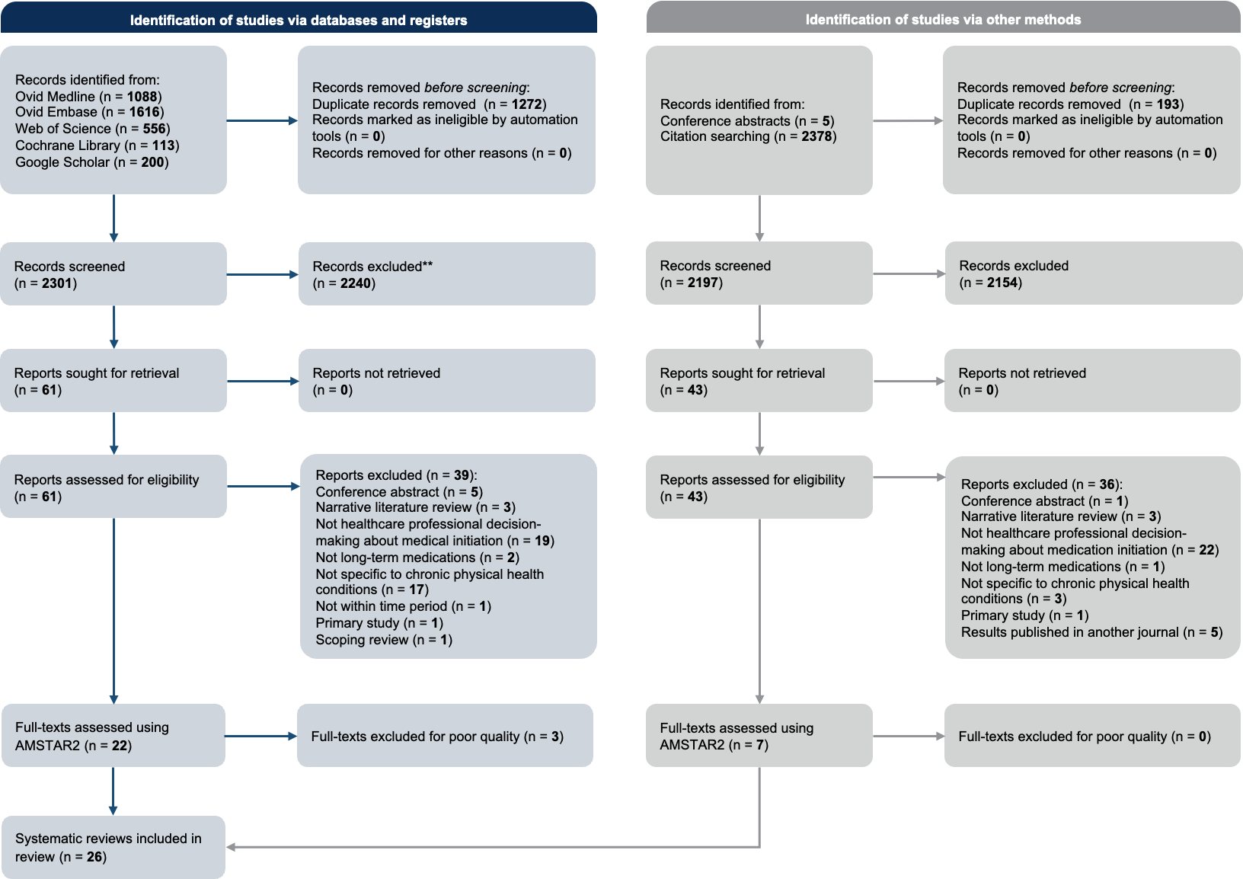

Details of included studies
Study Year | Country of origin | Databases (n) | Date range of search | Publication date range | Studies (n) | Origin of studies | Setting | Disease area | Study type | Funding source
(Abdelkader et al., 2023) | Qatar | 10 | Jan 2010 – Mar 2021 | 2010 – 2020 | 40 | International | Primary, Secondary | Hypertension | Mixed | University
(Arshad et al., 2021) | Pakistan | 3 | Jan 2000 – Jan 2019 | 2000 – 2018 | 26 | International | Primary, Secondary | Hypertension | Quantitative | None
(Bin Rsheed and Chenoweth, 2017) | Saudi Arabia | 8 | Jan 1994 – August 2014 | 2005 – 2014 | 19 | International | Primary, Secondary | Diabetes | Mixed | Not reported
(Byrne et al., 2022) | United Kingdom | 8 | Jan 2006 – Feb 2021 | Not reported | 42 | International | Primary, Secondary | Diabetes | Qualitative | Pharmaceutical company
(Chin et al., 2016) | Australia | 4 | Jan 2000 – Jan 2015 | 1994 – 2012 | 23 | International | Secondary | Cardiovascular disease | Quantitative | None
(Dhungana et al., 2021) | Nepal | 6 | Jan 2000 – Jan 2020 | Not reported | 15 | Nepal | Primary, Secondary | Hypertension | Mixed | None
(Generalova et al., 2018) | United Kingdom | 4 | Unknown | 2013 – 2016 | 10 | International | Primary, Secondary | Atrial fibrillation | Mixed | None
(Iudici et al., 2014) | Italy | 1 | Jan 2000 – Mar 2013 | 2005 – 1013 | 23 | International | Secondary | Systemic sclerosis | Quantitative | None
(Ju et al., 2018) | Australia | 5 | Inception – Apr 2018 | 1997 – 2017 | 34 | International | Primary | Cardiovascular disease | Mixed | Not reported
(Khatib et al., 2014) | India | 3 | Unknown | Not reported | 13 | USA | Primary | Diabetes | Mixed | Pharmaceutical company
(Lalor et al., 2022) | Canada | 3 | Inception – Feb 2013 | Not reported | 69 | International | Primary, Secondary | Hypertension | Mixed | None
(Mahmoud et al., 2023) | Australia | 3 | Inception – Jun 2021 | 2004 – 2019 | 15 | International | Secondary | Inflammatory arthritis | Mixed | Governmental body
(Maimaris et al., 2013) | United Kingdom | 4 | Jan 2009 – Jan 2021 | 2013 – 2023 | 40 | International | Primary, Secondary | Diabetes | Quantitative | University
(Mas Dalmau et al., 2017) | United Kingdom | 7 | Inception – May 2013 | 1992 – 2011 | 53 | International | Primary, Secondary | Hypertension | Mixed | Research organisation
(Milman et al., 2018) | Spain | 4 | Inception – May 2013 | 1994 – 2012 | 9 | International | Primary, Secondary | Atrial fibrillation | Mixed | Governmental body
(Ng et al., 2015) | Malaysia | 4 | Inception – Jun 2014 | Not reported | 25 | International | Primary, Secondary | Diabetes | Mixed | Research organisation
(Oqab, Pournazari and Sheldon, 2018) | Canada | 3 | Unknown | 2009 – 2015 | 3 | International | Primary, Secondary | Atrial fibrillation | Quantitative | None
(Orayj and Lane, 2019) | United Kingdom | 4 | Jan 1967 – Mar 2018 | Not reported | 44 | International | Primary, Secondary | Parkinson’s disease | Mixed | University
(Osasu, Cooper and Mitchell, 2021) | United Kingdom | 4 | Jan 1990 – Jan 2018 | 1995 – 2018 | 34 | International | Primary, Secondary | Atrial fibrillation | Mixed | None
(Pokorny et al., 2022) | Australia | 4 | Inception – Feb 2021 | 2007 – 2021 | 31 | International | Secondary | Cancer | Quantitative | University
(Presta et al., 2022) | Italy | 2 | Inception – May 2022 | 2008 – 2022 | 23 | International | Primary, Secondary | Atrial fibrillation | Quantitative | None
(Pritchett et al., 2020) | United Kingdom | 4 | Inception – Jun 2018 | 2001 – 2019 | 13 | International | Primary, Secondary, Tertiary | Atrial fibrillation | Mixed | Governmental body
(Proietti et al., 2022) | Italy | 2 | Inception – Sep 2021 | 2009 – 2021 | 33 | International | Primary, Secondary | Atrial fibrillation | Quantitative | None
(Qadi et al., 2020) | United Kingdom | 9 | Inception – Sep 2018 | 2011 – 2015 | 5 | Europe | Primary | Cardiovascular disease | Qualitative | University
(Rushforth et al., 2016) | United Kingdom | 5 | Jan 1980 – Mar 2014 | 1998 – 2014 | 32 | International | Primary | Diabetes | Qualitative | None
(Wilkinson et al., 2019) | United Kingdom | 5 | Inception – Oct 2017 | 2008 – 2017 | 20 | International | Primary, Secondary | Atrial fibrillation | Quantitative | Research organisation

Details of excluded studies at full-text screening stage
Author (year) | Title (limited to 4 words) | Reason for exclusion
Al et al (2022) | Prevalence, contributory factors and | Not healthcare professional decision-making about medication initiation
Albitar et al (2020) | Adherence to Global Initiative | Narrative literature review
Alhawassi et al (2015) | Hypertension in older persons | Not healthcare professional decision-making about medication initiation
Bain et al (2019) | Interventions to improve insulin | Not healthcare professional decision-making about medication initiation
Bajorek et al (2007) | Management of warfarin in | Primary study
Bakr et al (2018) | A systematic review of | Not healthcare professional decision-making about medication initiation
Blasco-Blasco et al (2020) | Barrier and facilitators to | Not healthcare professional decision-making about medication initiation
Bo et al (2017) | Oral anticoagulant therapy for | Narrative literature review
Bora et al (2023) | The effectiveness of clinical | Not healthcare professional decision-making about medication initiation
Borzecki et al (2005) | Barriers to hypertension control | Not healthcare professional decision-making about medication initiation
Brax et al (2017) | Association between physicians' interaction | Not specific to chronic physical health conditions
Brundisini et al (2015) | Type 2 diabetes patients' | Not healthcare professional decision-making about medication initiation
Bul et al (2022) | Frailty and oral anticoagulant | Not healthcare professional decision-making about medication initiation
Bul et al (2022) | Frailty and oral anticoagulant | Results published in another journal
Bungard et al (2000) | Why do patients with | Narrative literature review
Dhungana et al (2021) | Trends in the prevalence | Not healthcare professional decision-making about medication initiation
Egerton et al (2017) | A systematic review and | Not long-term medications
Ettehad et al (2016) | Blood pressure lowering for | Not healthcare professional decision-making about medication initiation
Fahey et al (2005) | Educational and organisational interventions | Not healthcare professional decision-making about medication initiation
Fickweiler et al (2017) | Interactions between physicians and | Not specific to chronic physical health conditions
Gabbay et al (2020) | Addressing Therapeutic Inertia in | Narrative literature review
Gebreyohannes et al (2021) | Thromboprophylaxis for patients with | Conference abstract only
Gebreyohannes et al (2021) | Non-adherence to thromboprophylaxis guidelines | Narrative literature review
Glynn et al (2010) | Self-monitoring and other non-pharmacological | Not healthcare professional decision-making about medication initiation
Griffin et al (2017) | Impact of metformin on | Not healthcare professional decision-making about medication initiation
Hagen et al (2016) | Quality of community-based osteoarthritis | Not healthcare professional decision-making about medication initiation
Hart et al (2007) | Meta-analysis: antithrombotic therapy to | Not healthcare professional decision-making about medication initiation
He et al (2022) | Impact of frailty on | Not healthcare professional decision-making about medication initiation
Huang et al (2013) | Impact of pay-for-performance on | Not healthcare professional decision-making about medication initiation
Iudici et al (2013) | Glucocorticoids in systemic sclerosis | Results published in another journal
  Jarrar et al (2021) | Factors influencing oral anticoagulant | Conference abstract only
Jeyaruban et al (2015) | Management of gout in | Not healthcare professional decision-making about medication initiation
Kataoka et al (2020) | Cumulative network-meta-analyses, practice | Not healthcare professional decision-making about medication initiation
Kaushik et al (2020) | Challenges in insulin initiation | Not healthcare professional decision-making about medication initiation
Lam et al (2022) | Prescribing behavior of antidepressants | Not specific to chronic physical health conditions
Lotfi et al (2016) | Knowledge, beliefs and attitudes | Not specific to chronic physical health conditions
Lundby et al (2019) | Health care professionals' attitudes | Not healthcare professional decision-making about medication initiation
Malik et al (2019) | Meta-analysis of direct-acting | Not healthcare professional decision-making about medication initiation

AMSTAR2 quality assessment

Risk of bias assessment tool for systematic reviews (ROBIS)
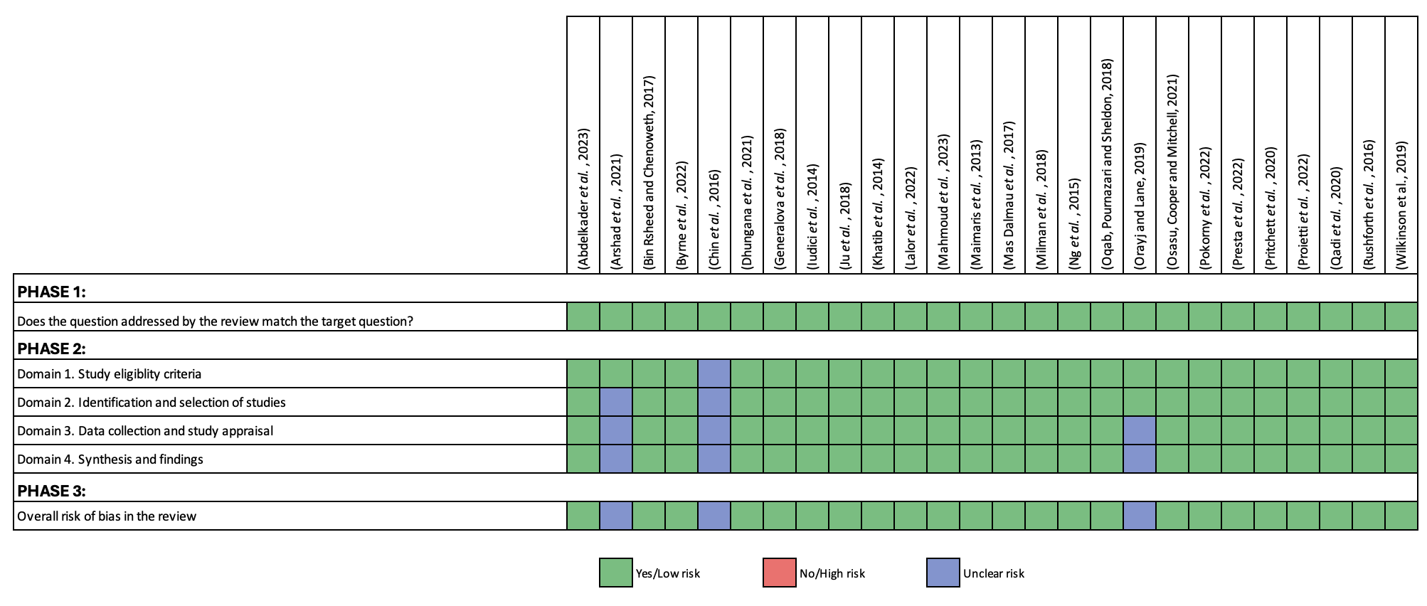

Appendix 5. Additional details on the methods for the analysis of registry data (Phase 2)
Within this appendix, the following additional details on the methods used for the analysis of registry data (Chapter 5) are included:
- Data source
- Sampling strategy
- Data processing
- Outcomes and measures
- Predictive modelling and analysis
- Health and economic implications
- Reanalysis of registry data
- RaDaR full analysis application form and statistical analysis plan

Data source
The RaDaR dataset
The National Registry of Rare Kidney Diseases (RaDaR) database collects data from 107 NHS trusts, which includes all adult and paediatric kidney centres in the United Kingdom. It is the largest rare kidney disease registry globally and has been continuously collecting data since 2010. It includes information on 29,500 individuals across 40 different rare kidney conditions, with data generated through both manual entry and automatic data retrieval from PatientView (an online platform providing kidney patients access to their laboratory results) (UK Kidney Association, 2025). At the time of analysis in 2024, the ADPKD cohort consisted of 8,302 people. The data collected includes patient characteristics (age, ethnicity and gender), disease characteristics (primary diagnosis, comorbidities and genomic results), current medications, laboratory results and kidney imaging (UK Kidney Association, 2023b).
Inclusion criteria
The study cohort included all people with ADPKD recorded in the RaDaR database who met the following criteria:
- Aged ≥18 years at any point during the study period (01/01/2016 to 13/01/2024)
- A confirmed ADPKD diagnosis
- Registered to one of the 72 kidney centres in the UK
- Medication data available from PatientView
- Sufficient eGFR data to calculate 1-year or 5-year slopes (at least three eGFR readings)

Sampling strategy
The sample size was determined by the available data, as all individuals with complete data would be included in the regression.

Data processing
Data extraction and dataset assembly
The raw dataset was extracted from RaDaR into Microsoft Excel by the RaDaR statistician. Variables extracted included demographic characteristics, serial estimated glomerular filtration rate (eGFR) measurements and recorded medication history. Centre-level identifiers were retained to enable assessment of variation across UK kidney centres.
Data cleaning and validation procedures
The dataset underwent structured cleaning and validation before analysis through discussion between the RaDaR statistician and myself. This included the removal of duplicate patient records and the standardisation of longitudinal eGFR data to ensure consistency and temporal ordering of laboratory results. Range and plausibility checks were applied to key variables. EGFR values were assessed for physiological plausibility and longitudinal sequences were reviewed to identify inconsistencies such as implausible reversals in renal function trajectory or erroneous data ordering. Where clear data entry errors were identified and could be corrected using predefined logical rules, amendments were made by the RaDaR statistician under my instruction. Records with unresolved inconsistencies were flagged and excluded from further analyses.
Management of missing data
Missing data was expected due to the heterogeneity of PatientView coverage across centres and variability in manual data entry practices. Missingness was assessed across all key variables, including eGFR measurements, tolvaptan exposure status and covariates required for adjustment in the models. No formal imputation of missing data was undertaken. The pattern of missingness was non-random as PatientView participation varied by centre (Little and Rubin, 2019).

Outcomes and measures
Outcomes of interest
The primary outcomes were people with ADPKD who were eligible for tolvaptan but not initiated and those who were initiated on tolvaptan despite not being eligible. These outcomes were aggregated at the kidney centre level to assess variation in prescribing practices between centres.
Outcome measures
The primary outcome measures were derived from patient-level data and included:
- Prescription of tolvaptan – defined as the first recorded tolvaptan prescription during the study period
- Eligibility for tolvaptan – assessed using patient-level laboratory data according to (Renal Association, 2016) based on eGFR slopes:
  - Decline in eGFR >2.5ml/min/1.73m2 per year over 5 years, or
  - Decline in eGFR >5ml/min/1.73m2 over 12 months
Eligibility was defined retrospectively over the full observation period, such that individuals were classified as eligible if they met these criteria at any point during follow-up since registration to RaDaR. In patients initiated on tolvaptan, eGFR decline was assessed using serum creatinine-derived eGFR measurements (based on at least three available measurements). Eligibility was assessed longitudinally. However, in the regression models, eligibility status was defined as the first qualifying event (i.e. the first observed instance of meeting the eligibility criteria).
Alternative eligibility criteria in the Renal Association (2016) guideline, including the change in total kidney volume (TKV) and Predicting Renal Outcome in Polycystic Kidney Disease (PROPKD) score were not included due to low data completeness and infrequent usage in UK kidney centres anecdotally.
Outcomes were evaluated over an eight-year period (01/01/20216 – 13/01/2024). The start date was three months after NICE published the technology appraisal guidance recommending tolvaptan for ADPKD in October 2015, in line with the requirement for NHS trusts in England to make recommended medications available (National Institute for Health and Care Excellence, 2023). The end date was the date of data extraction.
Patient-level outcomes were aggregated at the kidney centre using the centre where each participant was registered in RaDaR. This allowed assessment of variation in prescribing practice at the kidney centre level.

Predictive modelling and analysis
Developing an initial prediction model from the RaDaR dataset

Identification of patient characteristics for inclusion in the model
Patient characteristics utilised in the multivariable mixed-effects logistic regression analysis were those routinely available in the RaDaR database:
- Patient-related variables – age, sex
- Physiology-related variables – CKD stage, eGFR
- Healthcare-related variables – year of eligibility
Patient and physiology-related variables included in the analysis were selected based on the findings of the conceptual model developed in Chapter 4 (Gittus et al., 2025b). The year of eligibility was also included in the model as it was assumed that the likelihood of tolvaptan being prescribed could change with time due to the dissemination of research findings, guidance and familiarity with the medication.

Statistical analysis
Univariable logistic regression analysis was first performed for each covariate. Covariates showing a statistically significant association with tolvaptan initiation (p <0.05) were included in a multivariable mixed-effects logistic regression model to identify independent predictors. A random intercept for the kidney centre was included to account for clustering of patients within centres. The unit of analysis for regression was at the patient level with clustering by centres. No centre-level covariates were included in the primary model. No formal internal validation of the predictive models was undertaken as the analysis was exploratory and aimed to explain variation rather than develop a clinical prediction tool. Exploratory sensitivity analyses were conducted to assess the robustness of findings to key model specifications and eligibility definitions, including variation in eligibility thresholds and regression model covariate structure.
1. Model for initiation among eligible patients
A multivariable mixed-effects logistic regression model was developed to predict the probability that an eligible patient would be initiated on tolvaptan according to RA eligibility criteria. The outcome variable was binary, coded as 1 if the patient was initiated and 0 if not. The predicted probability of initiation for each patient was calculated as:
$$P\left(initiation\right)= \frac{1}{1+e^{-\left(b_{0}+b_{1}X_{1}+b_{2}X_{2}+…+b_{n}X_{n}\right)}}$$
Where X₁, X₂, … X_{n} are patient covariates, b₀ is the intercept and b₁, b₂, … b_{n} are regression coefficients. Summing these probabilities across patients within each kidney centre yielded the expected number of initiations, which was then compared with the observed number to calculate the Indirectly Standardised Ratio (ISR):
$$ISR=\frac{Observed Initiated Patients (O)}{Expected Initiated Patients (E)} x100$$
An ISR greater than 100 indicates that a centre initiated more eligible patients than expected; an ISR less than 100 indicates that a centre initiated fewer eligible patients than expected. These ISRs were used to construct funnel plots showing centre-level adherence to eligibility criteria, with control limits adjusted for overdispersion and relevant patient-level factors.
2. Model for eligibility among initiated patients
A separate multivariable mixed-effects logistic regression model was developed to estimate the probability that an initiated patient met the eligibility criteria. The outcome variable was binary, coded as 1 if the patient met the eligibility criteria and 0 if not. Predicted probabilities were summed across initiated patients within each centre to produce the expected number of eligible patients. An ISR was calculated in a similar manner to the first model. An ISR greater than 100 indicates that a centre had more initiated patients who were eligible than expected, whereas an ISR less than 100 indicates that fewer of the initiated patients were eligible than expected.
Comparing prescribing rates between kidney centres in the UK
Two funnel plots were constructed from the calculated ISRs to compare centres, with different numerators and denominators aligning with the two models above:
- Tolvaptan initiation among eligible patients by kidney centre
- Eligibility among patients initiated on tolvaptan by kidney centre
Control limits for the funnel plots were calculated assuming a binomial distribution. Overdispersion was estimated empirically from the data and incorporated into the funnel plot control limits following the method described by Spiegelhalter (2005). Funnel plots were presented both unadjusted and adjusted for statistically significant patient-level variables identified in the logistic regression models.
For each kidney centre, the ISR was plotted against the expected number of events. Control limits were shown at both ±2 and ±3 standard deviations from the expected value, corresponding approximately to 95% and 99.8% confidence intervals (CI), respectively. Kidney centres outside the 95% or 99.8% CI limits were considered centres of interest and eligible for inclusion in the multiple case study, in line with the QRA approach (O'Cathain, 2006).

Health and economic implications
A deterministic budget impact and cost-effectiveness model was developed based on the principles outlined by Sullivan et al. (2014). The aims of this analysis were to estimate the consequences of not initiating eligible patients and initiating patients who were not eligible. Budget impact calculations incorporated estimates from the RaDaR analysis, published tolvaptan uptake rates and median treatment duration. Different pricing scenarios were applied based on the list price and hypothetical discounts available through the patient access scheme (PAS) based on published evidence.
A cohort-based simulation projected annual eGFR decline over 10 years using baseline eGFR from the analysis of registry data, with the annual decline in eGFR, and tolvaptan treatment effect from an existing study (Fitzmaurice, Laird and Ware, 2012). Gross potential savings from delaying progression to kidney failure were calculated using annual dialysis costs and projected cumulative kidney failure free years obtained from the disease progression modelling, accounting for pre-dialysis death. Cost differences and early discontinuation were accounted for in calculations. Results were expressed as the equivalent number of total hip replacements to aid interpretation. Probabilistic sensitivity analyses and exact 95% confidence intervals for binomial proportions were calculated using the Clopper-Pearson (inverse binomial) method (Tollefsen, 2023).

Reanalysis of registry data
Although this phase falls outside the scope of the PhD submission, it is included for completeness. This extends the modelling approach developed in Phase 2 by transitioning from an ISR-based benchmarking approach to a fully multilevel logistic regression approach incorporating additional predictors identified in Phase 4. This allows direct estimation of between-centre variation while improving adjustment for patient and centre-level covariates.
Patient and centre-level variables will be evaluated for their predictive value using univariable analyses, with significant predictors (p <0.05) included in a multilevel logistic regression model. This approach will allow each centre’s baseline prescribing behaviour to be included while testing the effect of newly identified factors.

The refined model will then be used to:
- Assess the contribution of each variable to the variance between centres
- Identify outlier centres and compare them to those from the initial model to determine whether predictive accuracy improved
- Simulate hypothetical scenarios by adjusting actionable variables to estimate potential changes in prescribing behaviour
Model performance will be assessed using metrics appropriate for multilevel models, including the proportion of variance explained at patient and centre levels and intraclass correlation coefficients. Sensitivity analyses will be conducted to evaluate the robustness of the findings.

RaDaR full analysis application form and statistical analysis plan

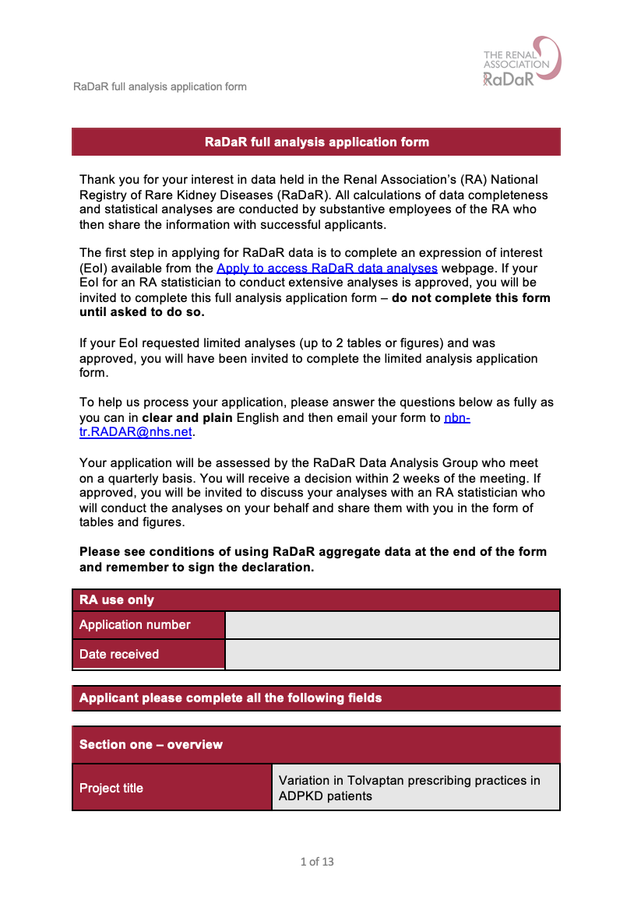

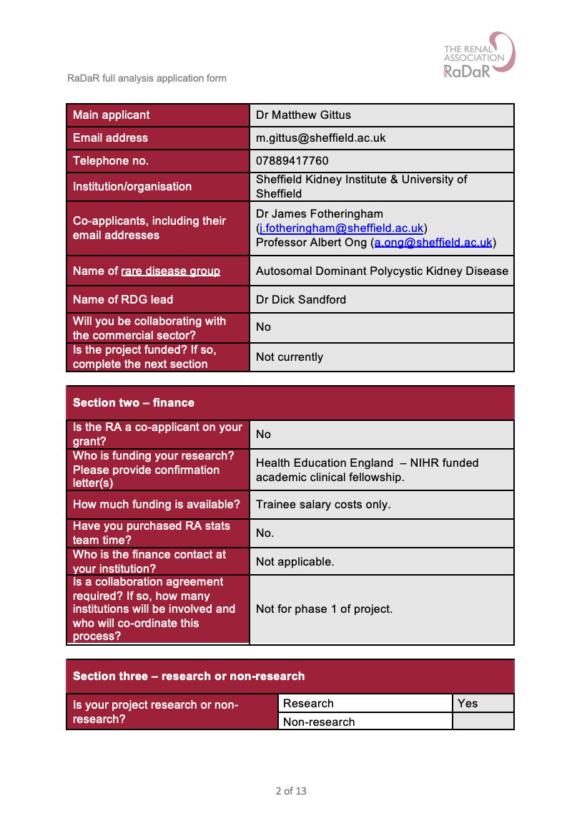

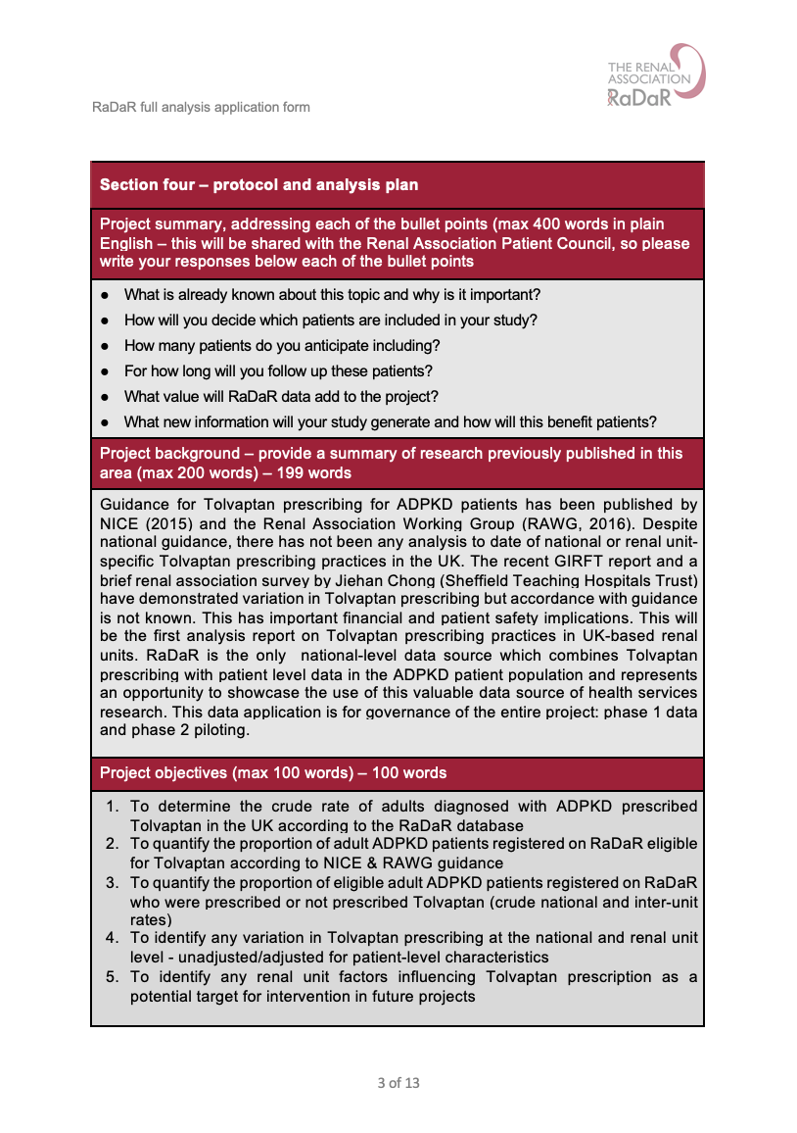

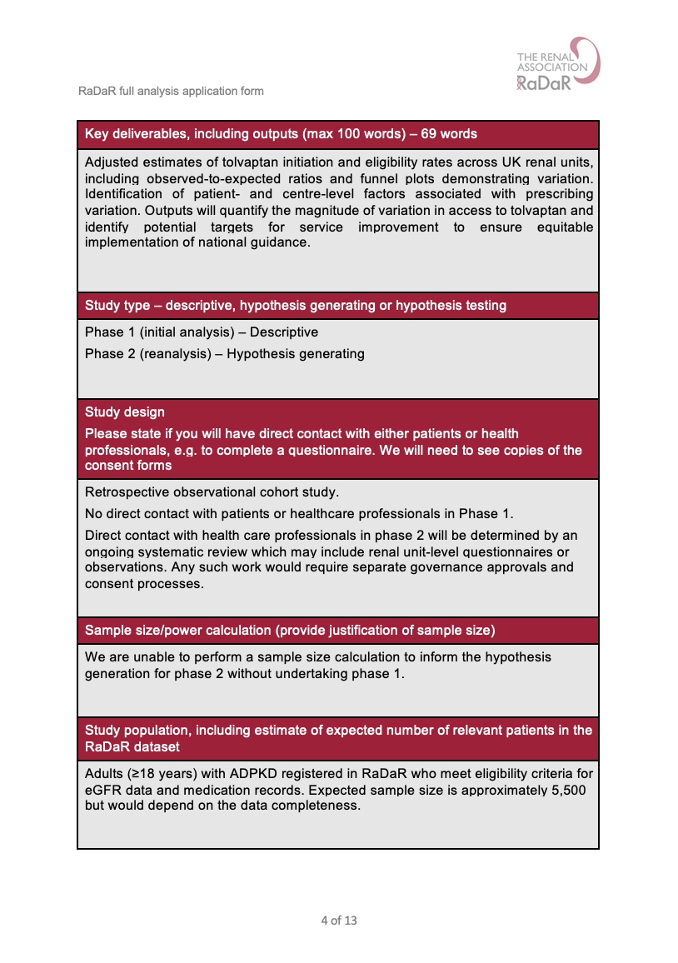

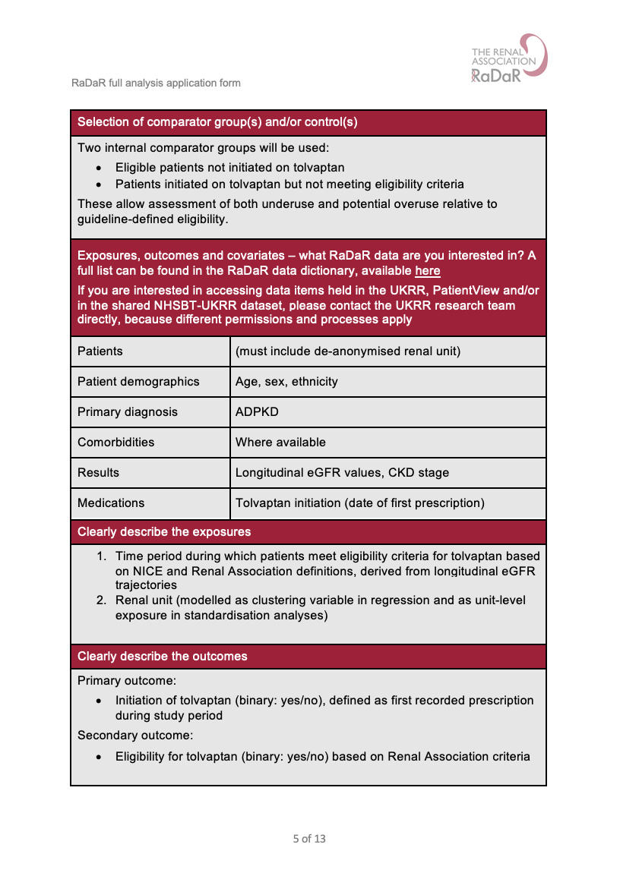

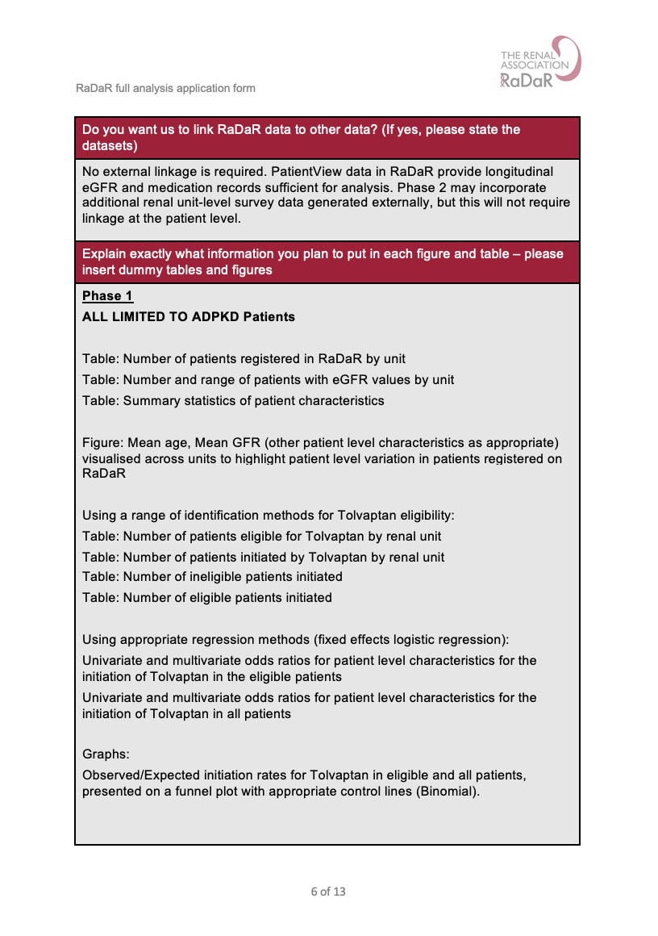

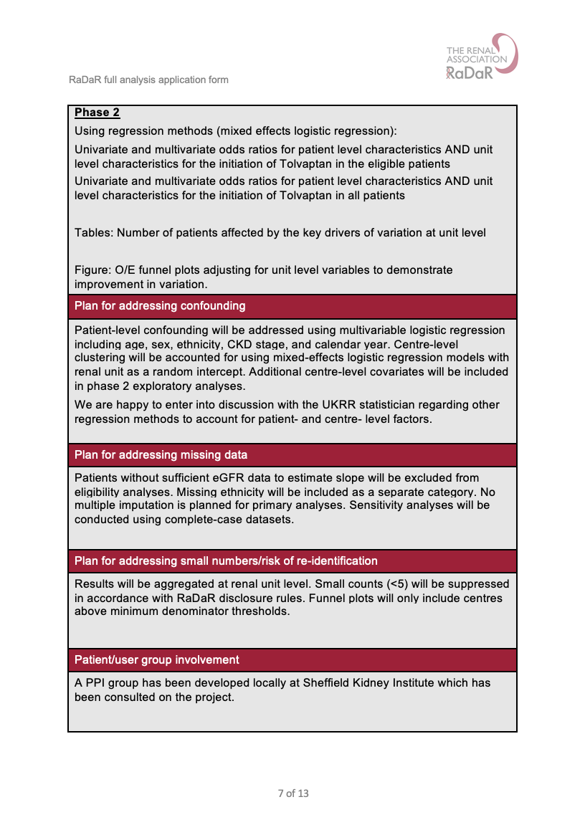

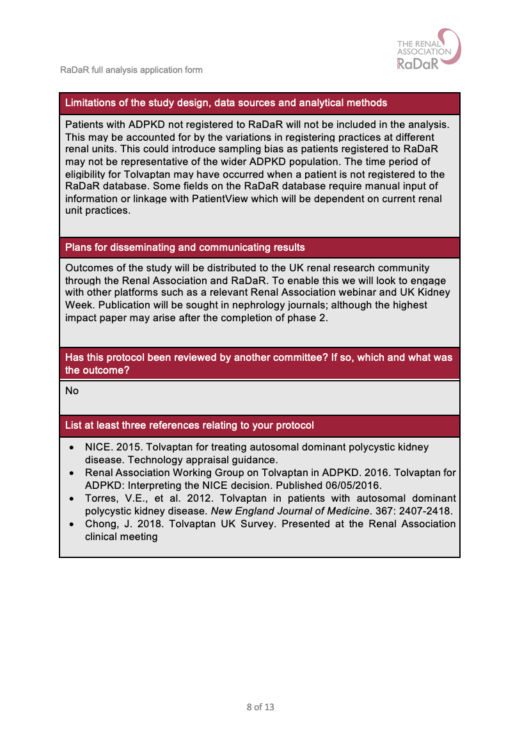

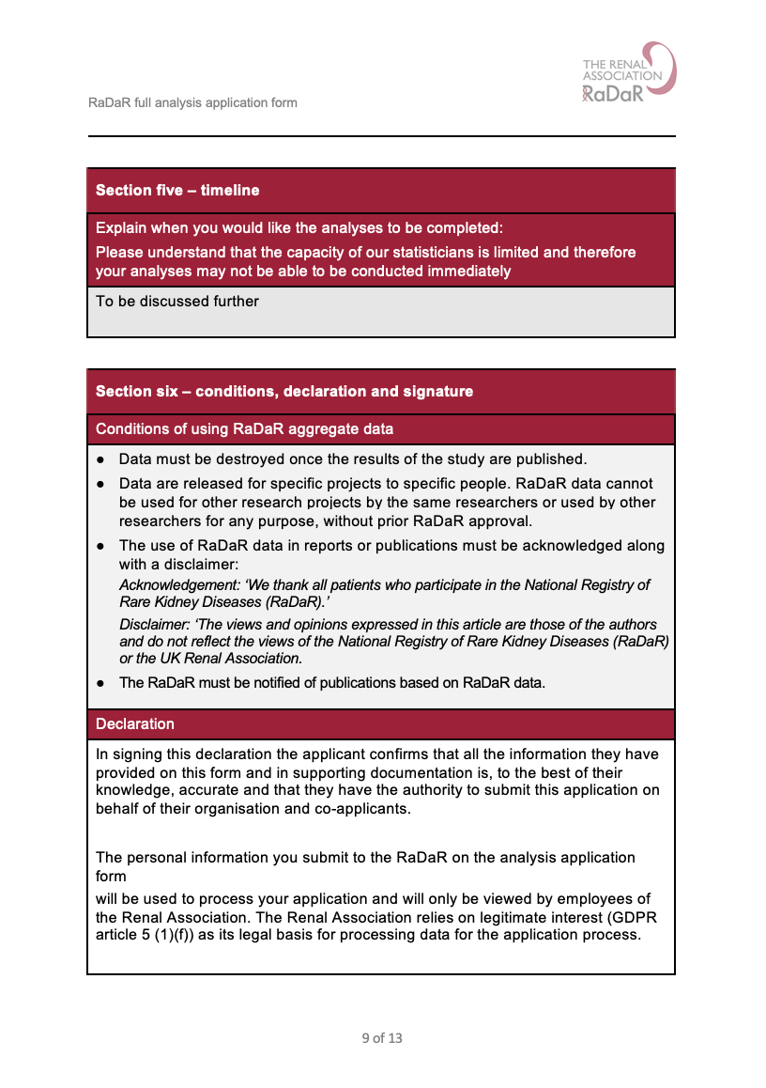



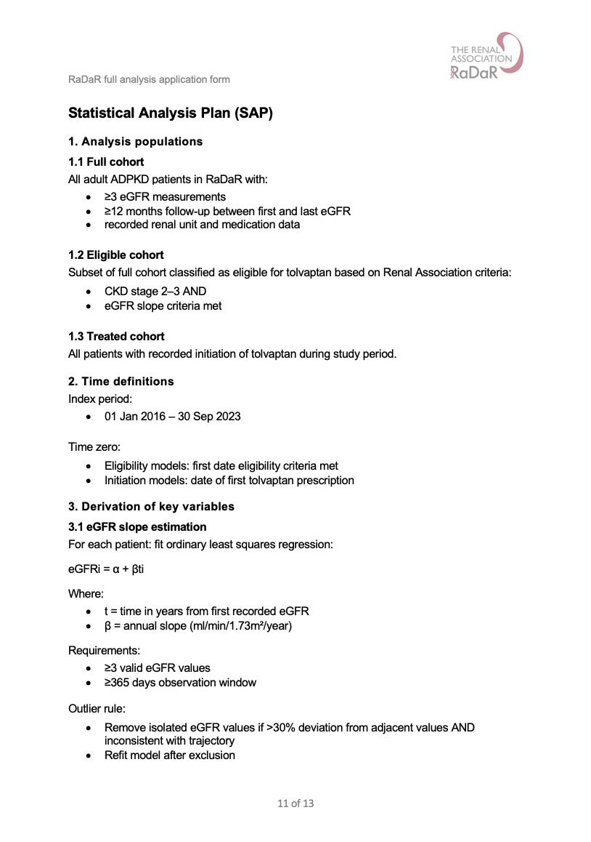

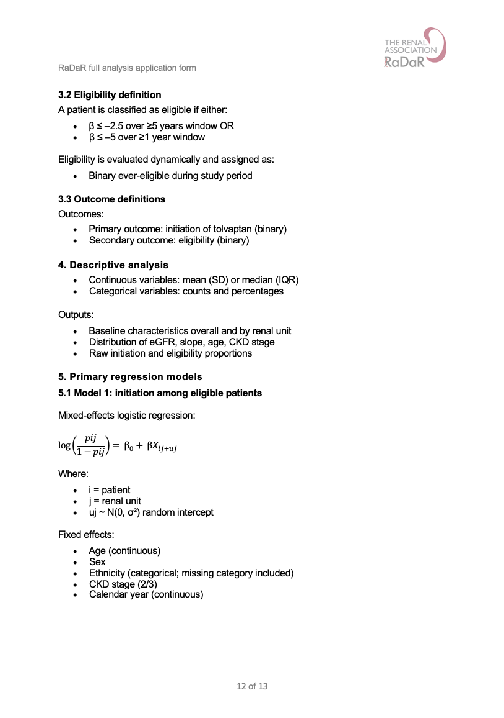

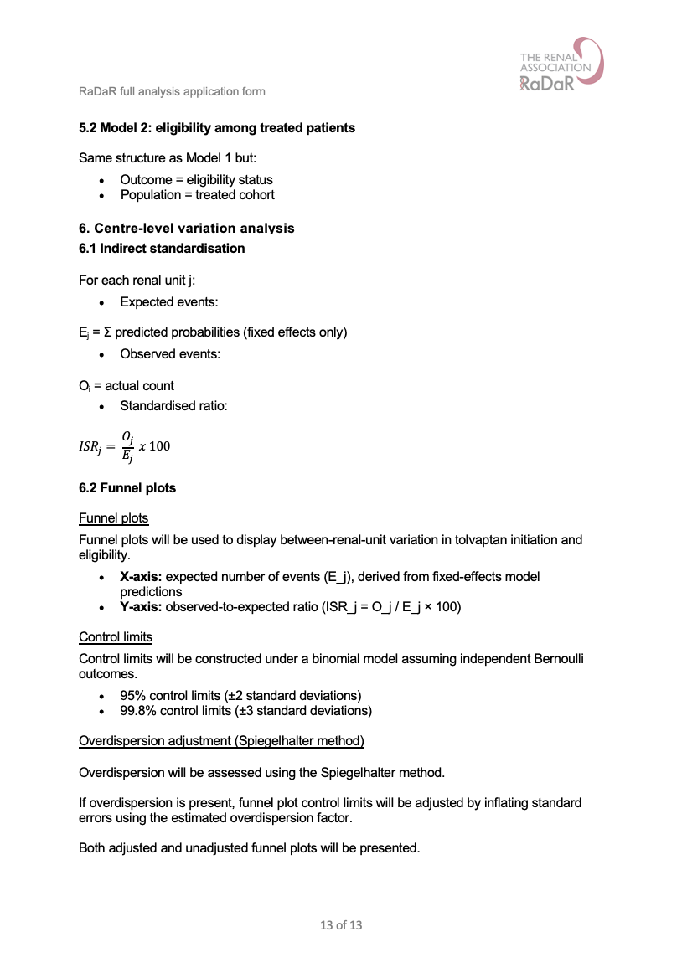

Appendix 6. Publication materials for journal article 2 (Chapter 5)

Inclusion and exclusion criteria
Inclusion criteria | Exclusion criteria
- Adult aged >18  - ADPKD diagnosis  - Registered to one of the 72 kidney centres in the UK  - Enrolled to RaDaR  - Medication data available from PatientView  - Sufficient eGFR data to calculate 1-year or 5-year slopes | - Individuals without any recorded medication data  - Incomplete or missing eGFR measurements

ADPKD study characteristics
Characteristic | (Rao et al., 2025) | (Perrone et al., 2025) | RaDaR dataset
Mean age at initiation (years)  Female (%)  Mean eGFR at initiation (ml/min/1.73m²)  Median duration (years) | 44.4  52.0  NA  2.9 | 43.1  40.0  56.3*  2.6 | 45.5  51.3%  47.5  NA
* not measured at baseline, measured at month 1

Data completeness of the RaDaR dataset
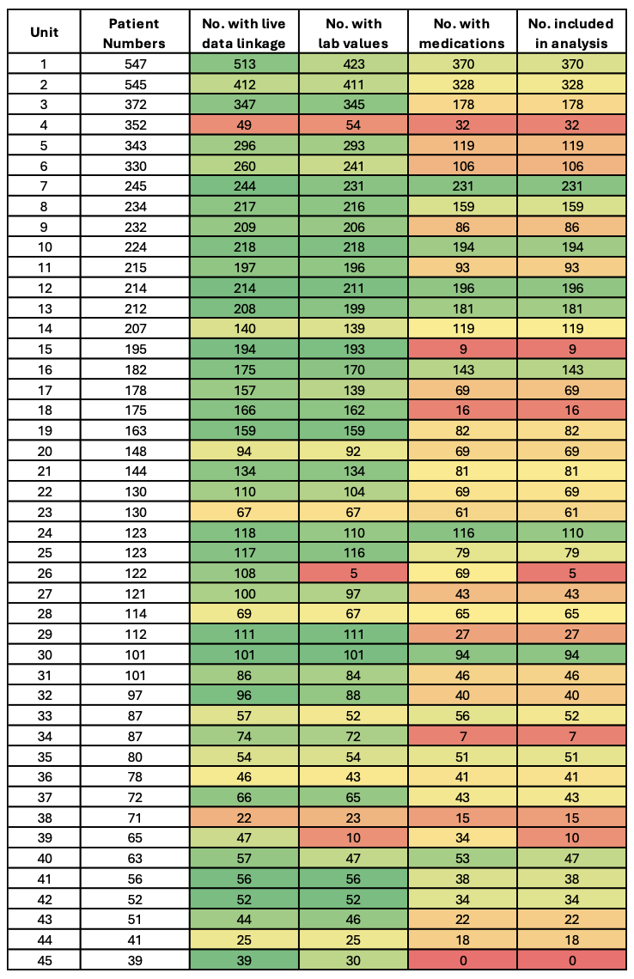
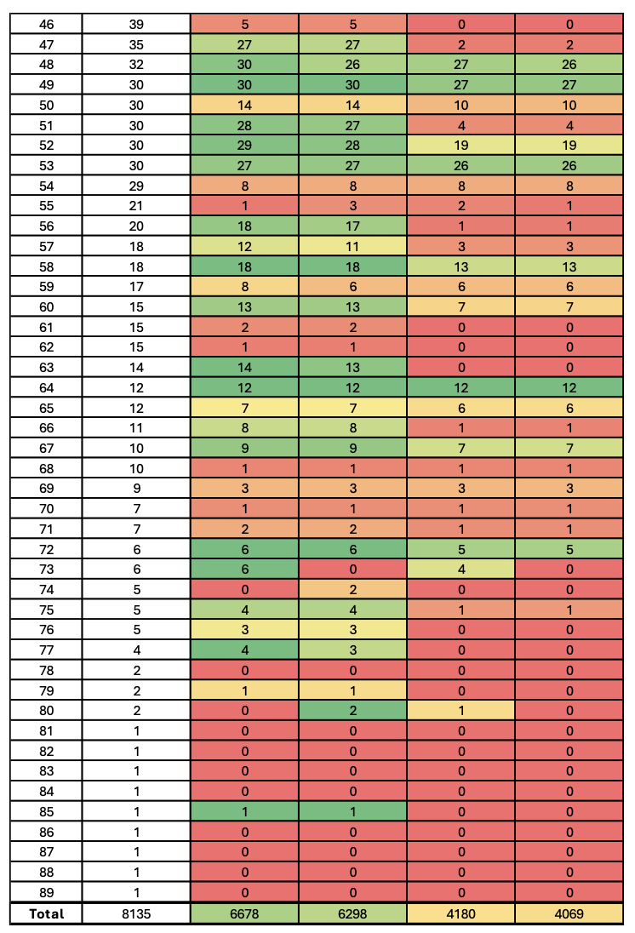
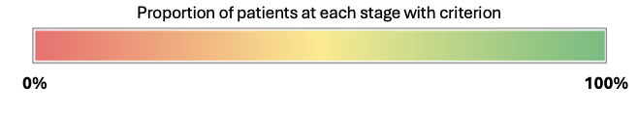

Reporting checklist for the analysis of registry data (RECORD statement)
 | Item | STROBE items | Location | RECORD items | Location
Title and abstract
 | 1 | (a) Indicate the study’s design with a commonly used term in the title or the abstract | Title page | RECORD 1.1: The type of data used should be specified in the title or abstract. When possible, the name of the databases used should be included | Title page
 | 1 | (b) Provide in the abstract an informative and balanced summary of what was done and what we found | Abstract |  | Title page
 |  |  |  | RECORD 1.2: If applicable, the geographic region and timeframe within which the study took place should be reported in the title or abstract | Abstract
 |  |  |  | RECORD 1.3: If linkage between databases was conducted for the study, this should be clearly stated in the title or abstract | NA
Introduction
Background and rationale | 2 | Explain the scientific background and rationale for the investigation being reported | Background - paragraphs 1-6
Objectives | 3 | State specific objectives, including any prespecified hypotheses | Background - paragraph 7
Methods
Study design | 4 | Present key elements of study design early in the paper | Methods - study design
Setting | 5 | Describe the setting, locations, relevant dates, including periods of recruitment, exposure, follow-up, and data collection | Methods - study design
Participants | 6 | (a) Cohort study - Give the eligibility criteria, and the sources and methods of selection of participants. Describe methods of follow-up Case-control study - Give the eligibility criteria, and the sources and methods of case ascertainment and control selection. Give the rationale for the choice of cases and controls | Methods - study design | RECORD 6.1: population selection (such as codes or algorithms used to identify subjects) should be listed in detail. If this is not possible, an explanation should be provided. | Methods - study design
 |  |  |  | RECORD 6.2: Any validation studies of the codes or algorithms used to select the population should be referenced. If validation was conducted for this study and not published elsewhere, detailed methods and results should be provided. | NA
Participants | 6 | Cross-sectional study - Give the eligibility criteria, and the sources and methods of selection of participants  (b) Cohort study - For matched studies, give matching criteria and number of exposed and  Unexposed  Case-control study - For matched studies, give matching criteria and the number of controls per case | NA |  | NA
 |  |  |  | RECORD 6.3: If the study involved linkage of databases, consider use of a flow diagram or other graphical display to demonstrate the data linkage process, including the number of individuals with linked data at each stage. | NA
Variables | 7 | Clearly define all outcomes, exposures, predictors, potential confounders, and effect modifiers. Give diagnostic criteria, if applicable. | Methods - variables | RECORD 7.1: A complete list of codes and algorithms used to classify exposures, outcomes, confounders, and effect modifiers should be provided. If these cannot be reported, an explanation should be provided. | Methods - variables
Data sources/ measurement | 8 | For each variable of interest,  give sources of data and details  of methods of assessment  (measurement).  Describe comparability of  assessment methods if there is  more than one group | Methods – variables
Bias | 9 | Describe any efforts to address potential sources of bias | Methods – variables
Study size | 10 | Explain how the study size was arrived at | Methods - study design
Quantitative variables | 11 | Explain how quantitative  variables were handled in the  analyses. If applicable, describe  which groupings were chosen,  and why | Methods - study design
Statistical methods | 12 | (a) Describe all statistical methods, including those used to control for confounding  (b) Describe any methods used to examine subgroups and interactions  (c) Explain how missing data was addressed  (d) Cohort study - If applicable, explain how loss to follow-up was addressed  Case-control study - If applicable, explain how  matching of cases and controls was addressed  Cross-sectional study - If applicable, describe analytical methods taking account of sampling strategy  (e) Describe any sensitivity analyses | Methods – statistical analysis
Data access and cleaning methods |  |  |  | RECORD 12.1: Authors should describe the extent to which the investigators had access to the database population used to create the study population. | NA
 |  |  |  | RECORD 12.2: Authors should provide information on the data cleaning methods used in the study. | Methods - study design
Linkage |  |  |  | RECORD 12.3: State whether the study included person-level, institutional-level, or other data linkage across two or more databases. The methods of linkage and methods of linkage quality evaluation should be provided | NA
Results
Participants | 13 | (a) Report the numbers of individuals at each stage of the study (e.g., numbers potentially eligible, examined for eligibility, confirmed eligible, included in the study, completing follow-up, and analysed) | Figure 9 | RECORD 13.1: Describe in detail the selection of the persons included in the study (i.e., study population selection) including filtering based on data quality, data availability and linkage. The selection of included persons can be described in the text and/or by means of the study flow diagram. | Figure 9
Participants | 13 | (b) Give reasons for non-participation at each stage. | Figure 9 |  | Figure 9
Participants | 13 | (c) Consider use of a flow diagram | Figure 9 |  | Figure 9
Descriptive data | 14 | (a) Give characteristics of study participants (e.g., demographic, clinical, social) and information on exposures and potential confounders | Table 14
Descriptive data | 14 | (b) Indicate the number of participants with missing data for each variable of interest | Appendix 6
Descriptive data | 14 | (c) Cohort study - summarise follow-up time (e.g., average and total amount) | NA
Outcome data | 15 | Cohort study - Report numbers of outcome events or summary measures over time  Case-control study - Report numbers in each exposure category, or summary measures of exposure  Cross-sectional study - Report numbers of outcome events or summary measures | Results
Main results | 16 | (a) Give unadjusted estimates and, if applicable, confounder-adjusted estimates and their precision (e.g., 95% confidence interval). Make clear which confounders were adjusted for and why they were included | Results
Main results | 16 | (b) Report category boundaries when continuous variables were categorized | NA
Main results | 16 | (c) If relevant, consider translating estimates of relative risk into absolute risk for a meaningful time period | NA
Other analyses | 17 | Report other analyses done - e.g., analyses of subgroups and interactions, and sensitivity analyses | Results
Discussion
Key results | 18 | Summarise key results with reference to study objectives | Discussion - summary of key findings
Limitations | 19 | Discuss limitations of the study, taking into account sources of potential bias or imprecision. Discuss both direction and magnitude of any potential bias | Discussion - strengths and limitations | RECORD 19.1: Discuss the implications of using data that were not created or collected to answer the specific research question(s). Include discussion of misclassification bias, unmeasured confounding, missing data, and changing eligibility over time, as they pertain to the study being reported. | Discussion -strengths and limitations
Interpretation | 20 | Give a cautious overall interpretation of results considering objectives, limitations, multiplicity of analyses, results from similar studies, and other relevant evidence | Discussion - comparison with previous studies
Generalisability | 21 | Discuss the generalisability (external validity) of the study results | Discussion - implications and recommendations
Other information
Funding | 22 | Give the source of funding and the role of the funders for the present study and, if applicable, for the original study on which the present article is based | Declarations
Accessibility of protocol, raw data and programming code |  |  |  | RECORD 22.1: Authors should provide information on how to access any supplemental information such as the study protocol, raw data, or programming code. | Declarations
Locations indicate where each checklist item is included in this thesis

Unadjusted funnel plots and correlation between indirectly standardised ratios
Funnel plot of initiated patients (unadjusted)
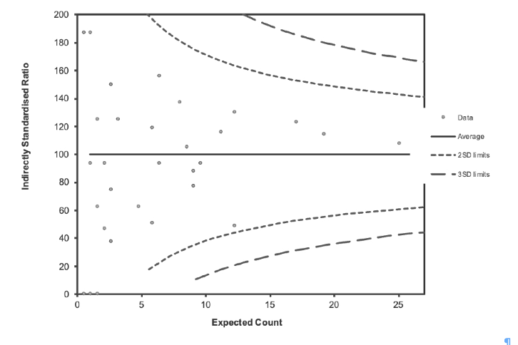
Funnel plot of eligible patients (unadjusted)
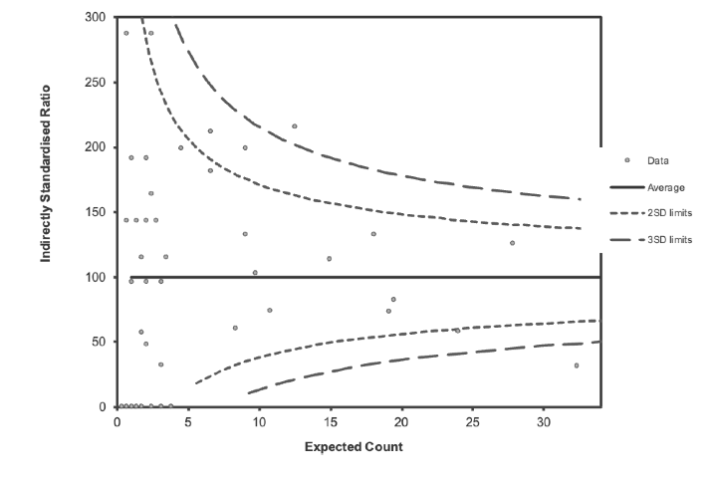

Relationship between indirectly standardised eligibility and initiation ratios

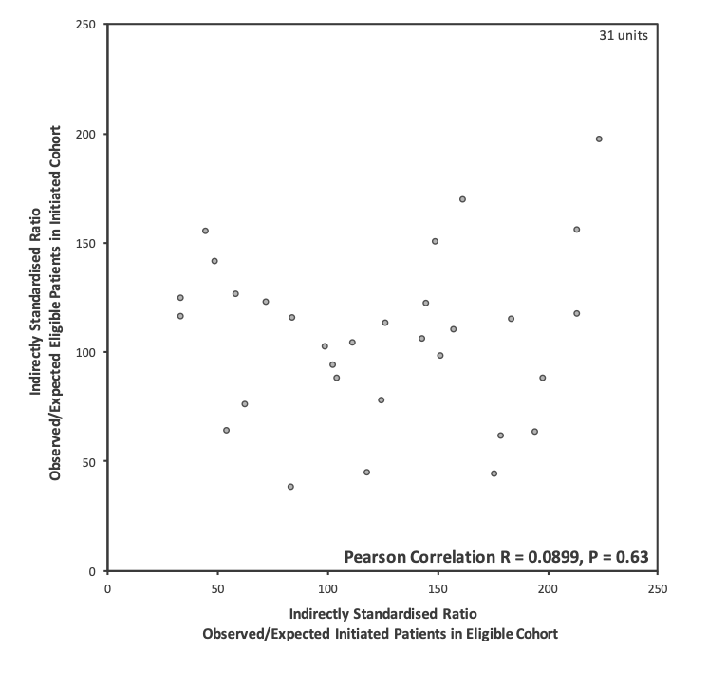

Worked example calculations
Estimated national impact of initiating tolvaptan in ineligible people with ADPKD
 | Medication Discount Scenarios
Parameter | 0% discount | 23% discount | 60% discount | 70% discount | 90% discount
ADPKD patients in the UK (n) | 30,000 | 30,000 | 30,000 | 30,000 | 30,000
RaDaR ineligible patients initiated (n) | 103 | 103 | 103 | 103 | 103
RaDaR total ADPKD patients | 3,609 | 3,609 | 3,609 | 3,609 | 3,609
Proportion of eligible not initiated (%) | 2.85 | 2.85 | 2.85 | 2.85 | 2.85
Estimated eligible not initiated in UK (%) | 856 | 856 | 856 | 856 | 856
Median duration tolvaptan (y) | 2.74 | 2.74 | 2.74 | 2.74 | 2.74
Monthly cost tolvaptan per person (£) | £1,313.38 | £1,011.30 | £525.35 | £394.01 | £131.34
Annual cost tolvaptan per person (£) | £15,760.54 | £12,135.61 | £6,304.22 | £4,728.16 | £1,576.05
Monthly cost monitoring per person (£) | £55.41 | £55.41 | £55.41 | £55.41 | £55.41
Annual cost monthly monitoring per person (£) | £664.92 | £664.92 | £664.92 | £664.92 | £664.92
Annual cost 3 monthly monitoring per person (£) | £221.64 | £221.64 | £221.64 | £221.64 | £221.64
Overall cost tolvaptan and monitoring monthly for 18 months then 3 monthly (£) | £38,062,983.33 | £29,559,027.00 | £15,878,749.44 | £12,181,377.13 | £4,786,632.50
Overall cost (upper CI of proportion of ineligible initiated) (£) | £45,453,853.87 | £35,298,643.90 | £18,962,001.76 | £14,546,693.08 | £5,716,075.71
Overall cost (lower CI of proportion of ineligible initiated) (£) | £31,041,656.30 | £24,106,390.95 | £12,949,659.74 | £9,934,326.98 | £3,903,661.46
Cost of total hip replacement (£) | 9,300 | 9,300 | 9,300 | 9,300 | 9,300
Equivalent number of total hip replacements | 4093 | 3178 | 1707 | 1310 | 515

Worked example of calculating the estimated impact of not initiating tolvaptan in eligible people with ADPKD (no medication discount)
Metric |  | Value |  | Data source | Calculation
Number of ADPKD patients in the UK |  | 30,000 |  | Lower estimate from NHS data(NHS, 2023)
RaDaR eligible patients not initiated (n) |  | 547 |  | Study
RaDaR total ADPKD patients |  | 3,609 |  | Study
Proportion of eligible not initiated (%) |  | 15.16% |  | Calculated | = 547/3609
Estimated eligible not initiated in UK (%) |  | 4,547 |  | Calculated | = 30,000*0.1516
Tolvaptan patient uptake |  | 30.5% |  | (Calvaruso et al., 2023)
Estimated eligible not initiated in UK initiated (%) |  | 1,386.82 |  | Calculated | = 4,547*1,387
Annual decline in eGFR (ml/min/1.73m²/year) (Mean (SD)) |  | -7.07 (10.78) |  | (Torres et al., 2016), (Torres et al., 2021)
Tolvaptan effect (ml/min/1.73m²/year) |  | -1.66 |  | (Chebib et al., 2023)
Annual mortality in non-KF ADPKD patients (%) |  | 1.84 |  | (Mladsi et al., 2024)
Estimated KF-free years gained (years) |  | 2,484.58 |  | Calculated
Annual cost of HD per patient (£) |  | 34,000 |  | Kidney Research UK(Kidney Research UK, 2023)
Gross potential savings (£) |  | 78,232,470.14 |  | Calculated | 2,484.58*34,000
Median duration tolvaptan (y) |  | 2.74 |  | Median of (Rao et al., 2025) and (Perrone et al., 2025)
Daily cost tolvaptan per person (£) | 43.15 |  | (National Institute for Health and Care Excellence, 2015b)
Monthly cost tolvaptan per person (£) | 1,313.38 |  | Calculated |  | =43.15*30.44
Annual cost tolvaptan per person (£) |  | 15,760.54 |  | (National Institute for Health and Care Excellence, 2015b)
Total cost tolvaptan per person for median duration (£) |  | 43,183.88 |  | Calculated | = 15,760.54*2.74

Monthly cost monitoring per person (£) | 55.41 | (University Hospitals Bristol and Weston NHS Foundation Trust, 2015):  - £35.00 for outpatient facilities per 15 minutes  - £13.33 for clinical chemistry blood test  Average NHS specialist nurse salary from Indeed.com(Indeed, 2025):  £7.08 for 15 minutes nurse time | = 35.00 + 13.33 + 7.08
Annual cost monthly monitoring per person (£) | 664.92 | Calculated | = 55.41*12
Annual cost three monthly monitoring per person (£) | 221.64 | Calculated | = 55.41*3
Total cost monitoring per person for median duration (£) | 1,272.21 | Calculated | = ((2.74-1.24)*664.92) + ((2.74-1.5)*221.64)
Total cost tolvaptan and monitoring per person for median duration (£) | 44,456.09 | Calculated | = 43,183.88+1,272.21
Patient discontinuation before 3 months (%) | 5 | Estimated
Total cost tolvaptan and monitoring for cohort excluding 5% discontinuation (£) | 58,570,154.68 | Calculated | = 44,456.09*(1,387*(1-0.05))
Total cost tolvaptan and monitoring for cohort for 5% only taking tolvaptan for 3 months (£) | 284,798.81 | Calculated | = ((1,313.38+55.41)*3)*(1,387*0.05)
Total cost tolvaptan and monitoring for cohort including 95% continuation and 5% discontinuation (£) | 58,854,953.49 | Calculated | = 58,570,154.68 + 284,798.81
Net potential savings incorporating tolvaptan costs (£) | 19,377,516.65 | Calculated | = 78,232,470.14 - 58,854,953.49
Net potential savings (upper CI of proportion of eligible not initiation) (£) | 15,058,080.27 | Calculated | Inverse binomial
Net potential savings (lower CI of proportion of eligible not initiation) (£) | 24,159,475.42 | Calculated | Inverse binomial
Cost of total hip replacement (£) | 9,300 | Midpoint of NHS Wales estimate(Public Health Wales, 2023)
Equivalent number of total hip replacements | 2,084 | Calculated | = 21,053,658.97/9,300

Estimated national impact of not initiating tolvaptan in eligible people with ADPKD
 | Medication Discount Scenarios
Parameter | 0% discount | 23% discount | 60% discount | 70% discount | 90% discount
ADPKD patients in the UK (n) | 30,000 | 30,000 | 30,000 | 30,000 | 30,000
RaDaR eligible patients not initiated (n) | 547 | 547 | 547 | 547 | 547
RaDaR total ADPKD patients | 3,609 | 3,609 | 3,609 | 3,609 | 3,609
Proportion of eligible not initiated (%) | 15.16 | 15.16 | 15.16 | 15.16 | 15.16
Estimated eligible not initiated in UK (%) | 4,547 | 4,547 | 4,547 | 4,547 | 4,547
Tolvaptan patient uptake (%) | 30.50 | 30.50 | 30.50 | 30.50 | 30.50
Estimated eligible not initiated in UK initiated (%) | 1,387 | 1,387 | 1,387 | 1,387 | 1,387
Annual decline in eGFR (ml/min/1.73m²/year) (Mean (SD)) | -7.07 (10.78) | -7.07 (10.78) | -7.07 (10.78) | -7.07 (10.78) | -7.07 (10.78)
Tolvaptan effect | -1.66 | -1.66 | -1.66 | -1.66 | -1.66
Estimated KF-free years gained (see appendix 6) | 2484.58 | 2484.58 | 2484.58 | 2484.58 | 2484.58
Annual cost of HD per patient | £34,000 | £34,000 | £34,000 | £34,000 | £34,000
Gross potential savings (£) | £84,475,664.59 | £84,475,664.59 | £84,475,664.59 | £84,475,664.59 | £84,475,664.59
Median duration tolvaptan (y) | 2.74 | 2.74 | 2.74 | 2.74 | 2.74
Monthly cost tolvaptan per person (£) | £1,313.49 | £1,011.38 | £525.39 | £394.05 | £131.35
Annual cost tolvaptan per person (£) | £15,760.54 | £12,135.61 | £6,304.22 | £4,728.16 | £1,576.05
Total cost tolvaptan per person for median duration (£) | £43,183.87 | £33,251.58 | £17,273.55 | £12,955.16 | £4,318.39
Monthly cost monitoring (£) | £55.41 | £55.41 | £55.41 | £55.41 | £55.41
Annual cost monitoring monthly (£) | £664.92 | £664.92 | £664.92 | £664.92 | £664.92
Annual cost monitoring three monthly (£) | £221.64 | £221.64 | £221.64 | £221.64 | £221.64
Total cost monitoring per person for median duration (£) | £1,272.21 | £1,272.21 | £1,272.21 | £1,272.21 | £1,272.21
Overall cost tolvaptan per person (£) | £44,456.09 | £34,523.80 | £18,545.76 | £14,227.38 | £5,590.60
Patient discontinuation before 3 months (%) | 5% | 5% | 5% | 5% | 5%
Overall cost tolvaptan and monitoring at median duration including 5% discontinuation (£) | £58,570,154.68 | £45,484,526.76 | £24,433,734.03 | £18,744,330.59 | £7,365,523.71
Total cost tolvaptan and monitoring for cohort for 5% only taking tolvaptan for 3 months (£) | 284798.81 | 3200.38 | 1742.41 | 1348.37 | 560.28
Total cost tolvaptan and monitoring for cohort including 95% continuation and 5% discontinuation (£) | £58,854,953.49 | £45,487,727.15 | £24,435,476.45 | £18,745,678.96 | £7,366,083.98
Overall costs incorporating tolvaptan and monitoring for cohort (£) | £19,377,516.65 | £32,525,996.84 | £53,677,899.75 | £59,394,630.27 | £70,828,091.31
Net potential savings (upper CI of proportion of eligible not initiation) (£) | £24,159,475.42 | £36,240,356.77 | £55,674,818.06 | £60,927,375.17 | £71,432,489.39
Net potential savings (lower CI of proportion of eligible not initiation) (£) | £15,058,080.27 | £29,172,377.29 | £51,877,985.54 | £58,014,636.42 | £70,287,938.17
Cost of total hip replacement (£) | £9,300 | £9,300 | £9,300 | £9,300 | £9,300
Equivalent number of total hip replacements | 2,084 | 3,497 | 5,772 | 6,387 | 7,616

Cohort-level simulation of eGFR decline, KF risk and treatment effect
Years to Kf (t) | Starting eGFR | KF threshold | eGFR between starting and KF threshold | Annual decline mean from study (μ) | Annual decline sd from study (σ) | Xt | Z-score | Cumulative probability not reaching KF by t years | Proportion reaching Kf (%)
5 | 47.5 | 9.3 | 38.2 | 7.07 | 10.78 | 7.64 | 0.052875696 | 0.521084525 | 47.89%
6 | 47.5 | 9.3 | 38.2 | 7.07 | 10.78 | 6.366666667 | -0.06524428 | 0.473989753 | 52.60%
7 | 47.5 | 9.3 | 38.2 | 7.07 | 10.78 | 5.457142857 | -0.14961569 | 0.440533914 | 55.95%
8 | 47.5 | 9.3 | 38.2 | 7.07 | 10.78 | 4.775 | -0.212894249 | 0.415704724 | 58.43%
9 | 47.5 | 9.3 | 38.2 | 7.07 | 10.78 | 4.244444444 | -0.262110905 | 0.39661797 | 60.34%
10 | 47.5 | 9.3 | 38.2 | 7.07 | 10.78 | 3.82 | -0.30148423 | 0.381522637 | 61.85%
11 | 47.5 | 9.3 | 38.2 | 7.07 | 10.78 | 3.472727273 | -0.333698769 | 0.369303439 | 63.07%
12 | 47.5 | 9.3 | 38.2 | 7.07 | 10.78 | 3.183333333 | -0.360544218 | 0.359220098 | 64.08%
13 | 47.5 | 9.3 | 38.2 | 7.07 | 10.78 | 2.938461538 | -0.383259598 | 0.350763646 | 64.92%
14 | 47.5 | 9.3 | 38.2 | 7.07 | 10.78 | 2.728571429 | -0.402729923 | 0.343573459 | 65.64%
15 | 47.5 | 9.3 | 38.2 | 7.07 | 10.78 | 2.546666667 | -0.419604205 | 0.337387308 | 66.26%
5.40 | 47.5 | 9.3 | 38.2 | 7.07 | 10.78 | 7.07 | 0 | 0.5 | 50.00%

Cohort-level simulation of eGFR decline, kidney failure risk and treatment effect
Year | Cohort | Adjusted for 1.84% annual mortality | Starting eGFR | Annual decline eGFR mean (sd) | Starting eGFR for HD | Mean effect | Expected eGFR untreated | Expected eGFR treated | Z untreated | Z treated | Cum Prob not KF untreated | Cum Prob not KF treated | Annual Prob reach KF (untreated) | Annual Prob reach KF (treated) | Change N_KF | Contribution to total years saved
1 | 1,387 | 1,387 | 47.5 | 7.07 | 10.78 | 9.3 | 1.66 | 40.43 | 42.09 | 2.888 | 3.042 | 0.998 | 0.999 | 0.002 | 0.001 | 1.059
2 | 1,387 | 1,361 | 47.5 | 7.07 | 10.78 | 9.3 | 1.66 | 33.36 | 36.68 | 2.232 | 2.540 | 0.987 | 0.994 | 0.011 | 0.004 | 9.017
3 | 1,387 | 1,336 | 47.5 | 7.07 | 10.78 | 9.3 | 1.66 | 26.29 | 31.27 | 1.576 | 2.038 | 0.942 | 0.979 | 0.045 | 0.015 | 40.864
4 | 1,387 | 1,312 | 47.5 | 7.07 | 10.78 | 9.3 | 1.66 | 19.22 | 25.86 | 0.920 | 1.536 | 0.821 | 0.938 | 0.121 | 0.041 | 110.598
5 | 1,387 | 1,288 | 47.5 | 7.07 | 10.78 | 9.3 | 1.66 | 12.15 | 20.45 | 0.264 | 1.034 | 0.604 | 0.850 | 0.217 | 0.088 | 178.582
6 | 1,387 | 1,264 | 47.5 | 7.07 | 10.78 | 9.3 | 1.66 | 5.08 | 15.04 | -0.391 | 0.532 | 0.348 | 0.703 | 0.257 | 0.147 | 152.302
7 | 1,387 | 1,241 | 47.5 | 7.07 | 10.78 | 9.3 | 1.66 | -1.99 | 9.63 | -1.047 | 0.031 | 0.147 | 0.512 | 0.200 | 0.191 | 13.397
8 | 1,387 | 1,218 | 47.5 | 7.07 | 10.78 | 9.3 | 1.66 | -9.06 | 4.22 | -1.703 | -0.471 | 0.044 | 0.319 | 0.103 | 0.193 | 0.000
9 | 1,387 | 1,195 | 47.5 | 7.07 | 10.78 | 9.3 | 1.66 | -16.13 | -1.19 | -2.359 | -0.973 | 0.009 | 0.165 | 0.035 | 0.153 | 0.000
10 | 1,387 | 1,173 | 47.5 | 7.07 | 10.78 | 9.3 | 1.66 | -23.2 | -6.60 | -3.015 | -1.475 | 0.001 | 0.070 | 0.008 | 0.095 | 0.000
 |  |  |  |  |  |  |  |  |  |  |  |  |  |  |  | Total = 2,484

Upper 95% CI:
Year | Cohort | Adjusted for 1.84% annual mortality | Starting eGFR | Annual decline eGFR mean (sd) | Starting eGFR for HD | Mean effect | Expected eGFR untreated | Expected eGFR treated | Z untreated | Z treated | Cum Prob not KF untreated | Cum Prob not KF treated | Annual Prob reach KF (untreated) | Annual Prob reach KF (treated) | Change N_KF | Contribution to total years saved
1 | 1,496 | 1,496 | 47.5 | 7.07 | 10.78 | 9.3 | 1.66 | 40.43 | 42.09 | 2.888 | 3.042 | 0.998 | 0.999 | 0.002 | 0.001 | 1.143
2 | 1,496 | 1,468 | 47.5 | 7.07 | 10.78 | 9.3 | 1.66 | 33.36 | 36.68 | 2.232 | 2.540 | 0.987 | 0.994 | 0.011 | 0.004 | 9.726
3 | 1,496 | 1,441 | 47.5 | 7.07 | 10.78 | 9.3 | 1.66 | 26.29 | 31.27 | 1.576 | 2.038 | 0.942 | 0.979 | 0.045 | 0.015 | 44.076
4 | 1,496 | 1,415 | 47.5 | 7.07 | 10.78 | 9.3 | 1.66 | 19.22 | 25.86 | 0.920 | 1.536 | 0.821 | 0.938 | 0.121 | 0.041 | 119.292
5 | 1,496 | 1,389 | 47.5 | 7.07 | 10.78 | 9.3 | 1.66 | 12.15 | 20.45 | 0.264 | 1.034 | 0.604 | 0.850 | 0.217 | 0.088 | 192.621
6 | 1,496 | 1,363 | 47.5 | 7.07 | 10.78 | 9.3 | 1.66 | 5.08 | 15.04 | -0.391 | 0.532 | 0.348 | 0.703 | 0.257 | 0.147 | 164.275
7 | 1,496 | 1,338 | 47.5 | 7.07 | 10.78 | 9.3 | 1.66 | -1.99 | 9.63 | -1.047 | 0.031 | 0.147 | 0.512 | 0.200 | 0.191 | 14.450
8 | 1,496 | 1,314 | 47.5 | 7.07 | 10.78 | 9.3 | 1.66 | -9.06 | 4.22 | -1.703 | -0.471 | 0.044 | 0.319 | 0.103 | 0.193 | 0.000
9 | 1,496 | 1,289 | 47.5 | 7.07 | 10.78 | 9.3 | 1.66 | -16.13 | -1.19 | -2.359 | -0.973 | 0.009 | 0.165 | 0.035 | 0.153 | 0.000
10 | 1,496 | 1,266 | 47.5 | 7.07 | 10.78 | 9.3 | 1.66 | -23.2 | -6.60 | -3.015 | -1.475 | 0.001 | 0.070 | 0.008 | 0.095 | 0.000
 |  |  |  |  |  |  |  |  |  |  |  |  |  |  |  | Total = 2,680

Lower 95% CI:
Year | Cohort | Adjusted for 1.84% annual mortality | Starting eGFR | Annual decline eGFR mean (sd) | Starting eGFR for HD | Mean effect | Expected eGFR untreated | Expected eGFR treated | Z untreated | Z treated | Cum Prob not KF untreated | Cum Prob not KF treated | Annual Prob reach KF (untreated) | Annual Prob reach KF (treated) | Change N_KF | Contribution to total years saved
1 | 1,280 | 1,280 | 7.07 | 10.78 | 9.3 | 1.66 | 40.43 | 42.09 | 2.888 | 3.042 | 0.998 | 0.999 | 0.002 | 0.001 | 0.978 | 1,280
2 | 1,280 | 1,256 | 7.07 | 10.78 | 9.3 | 1.66 | 33.36 | 36.68 | 2.232 | 2.540 | 0.987 | 0.994 | 0.011 | 0.004 | 8.325 | 1,280
3 | 1,280 | 1,233 | 7.07 | 10.78 | 9.3 | 1.66 | 26.29 | 31.27 | 1.576 | 2.038 | 0.942 | 0.979 | 0.045 | 0.015 | 37.726 | 1,280
4 | 1,280 | 1,211 | 7.07 | 10.78 | 9.3 | 1.66 | 19.22 | 25.86 | 0.920 | 1.536 | 0.821 | 0.938 | 0.121 | 0.041 | 102.106 | 1,280
5 | 1,280 | 1,188 | 7.07 | 10.78 | 9.3 | 1.66 | 12.15 | 20.45 | 0.264 | 1.034 | 0.604 | 0.850 | 0.217 | 0.088 | 164.870 | 1,280
6 | 1,280 | 1,166 | 7.07 | 10.78 | 9.3 | 1.66 | 5.08 | 15.04 | -0.391 | 0.532 | 0.348 | 0.703 | 0.257 | 0.147 | 140.608 | 1,280
7 | 1,280 | 1,145 | 7.07 | 10.78 | 9.3 | 1.66 | -1.99 | 9.63 | -1.047 | 0.031 | 0.147 | 0.512 | 0.200 | 0.191 | 12.368 | 1,280
8 | 1,280 | 1,124 | 7.07 | 10.78 | 9.3 | 1.66 | -9.06 | 4.22 | -1.703 | -0.471 | 0.044 | 0.319 | 0.103 | 0.193 | 0.000 | 1,280
9 | 1,280 | 1,103 | 7.07 | 10.78 | 9.3 | 1.66 | -16.13 | -1.19 | -2.359 | -0.973 | 0.009 | 0.165 | 0.035 | 0.153 | 0.000 | 1,280
10 | 1,280 | 1,083 | 7.07 | 10.78 | 9.3 | 1.66 | -23.2 | -6.60 | -3.015 | -1.475 | 0.001 | 0.070 | 0.008 | 0.095 | 0.000 | 1,280
 |  |  |  |  |  |  |  |  |  |  |  |  |  |  |  | Total = 2,294

Mean discounted base-case results per patient (probabilistic mean estimates) (National Institute for Health and Care Excellence, 2015b)

Parameter | No active treatment | Tolvaptan (Excl. PAS) | Tolvaptan (Inc. PAS)
Total LYG | 16.76 | 17.58 | 17.58
Incremental LYG | 12.63 | 13.54 | 13.54
Total QALYs | - | 0.82 | 0.82
Incremental QALYs | - | 0.91 | 0.91
Incremental Cost | - | [redacted] | [redacted]
ICER (£ per QALY) | - | £23,500 | £34,769

Incremental Cost-Effectiveness Ratio (ICER), Life Years Gained (LYG), Patient Access Scheme (PAS), Quality Adjusted Life Years (QALYs)
*Values derived from probabilistic sensitivity analysis (1,000 iterations; 500 patients)

Appendix 7. Additional details on the methods for the multiple case study (Phase 3)
Within this appendix, the following additional details on the methods used for the multiple case study (Chapter 6 & 7) are included:
- Selection of case study sites
- Data collection methods
- Data analysis

Selection of case study sites
Case selection strategy
Purposive selection is the intentional selection of cases to best address the research aims and explore the phenomenon of interest, rather than be representative of the wider population (Patton, 2014). Cases were purposively selected from kidney centres in the quantitative component (Phase 2) of the qualitative residual analysis based on their deviation from modelled expected prescribing rates and the aim to identify centres with contrasting patterns of variation.
Specifically, it was considered whether the kidney centres had prescribing practices outside the 95% confidence interval control limits for centre-level prescribing. These kidney centres were considered “outliers”, with high residuals (high levels of variation not predicted by the model). Kidney centre characteristics were also considered in the selection, specifically kidney centre size.
The figures below are the adjusted funnel plots from Phase 2. The short-dashed lines represent the 95% control limits (±2SD), while the long-dashed lines represent the 99.8% control limits (±3SD). Points falling outside the short-dashed line have ISRs more than 95% confidence limits away from their expected value, and those beyond the long-dashed lines are outside the 99.8% confidence limits. The cases selected for inclusion in the multiple case study are indicated by the circles.
Tolvaptan initiation in eligible patients by kidney centre, adjusted for age, CKD stage, and year of eligibility
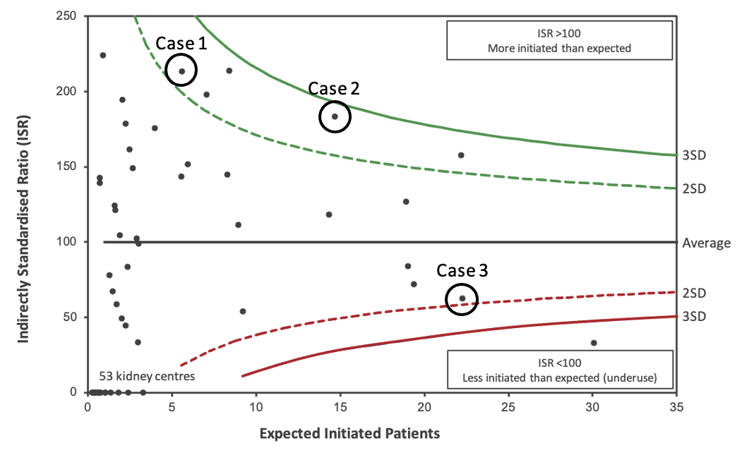
Tolvaptan eligibility in initiated patients by kidney centre, adjusted for CKD stage
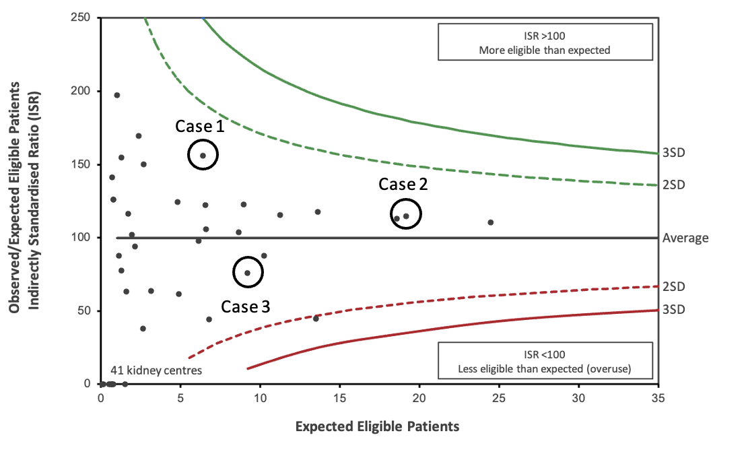

Cases 1 and 2 represented kidney centres of differing size, both showing higher than expected initiation among eligible patients (statistically significant) and higher than expected eligibility among initiated patients (not meeting statistical significance). Case 3 acted as a contrasting kidney centre with lower than expected rates for both (not meeting statistical significance). This selection of diverse cases aimed to allow in-depth exploration of how contextual and organisational factors may influence prescribing across different kidney centres (Yin, 2009).
Blinding
Case selection was conducted using a blinded approach, where neither I nor the participants at the sites were aware of the prescribing practices of the centres. Suitable cases for inclusion in the multiple case study were identified by my primary supervisor in line with my description of the centres that would be of interest. The identities of the selected centres were only revealed after data collection and initial analysis for the multiple case study had been completed. This approach was adopted to minimise potential bias in data collection and interpretation, ensuring that participants’ responses and my interpretations were not influenced by prior knowledge of the centres and their prescribing practices.
Case recruitment and access
I approached the lead consultant responsible for ADPKD services at each centre to enquire whether they would be interested in participating in the study. The initial approach included an introductory email with the project protocol attached. This was followed by an informal Microsoft Teams meeting to discuss the study further.

Data collection methods
Data collection and analysis were conducted iteratively throughout the case study, allowing ongoing refinement of the data collection processes in line with the case study methodology described by Yin (2009). A case study protocol was used to guide and standardise data collection procedures across cases. This is recommended by (Yin, 2009) to ensure consistency and contribute to the overall trustworthiness of the findings.
Three data collection methods were employed in each case:
- Semi-structured interviews
- Direct observations
- Document analysis
Semi-structured interviews
A semi-structured approach was used to support consistency in interviewing across participants and cases while retaining a degree of flexibility to explore topics introduced by participants in greater depth.
Sampling strategy
A purposive sampling technique was used to identify and recruit suitable participants for the interviews (Mason, 2017). Participant recruitment was undertaken pragmatically and involved all clinicians at the kidney centres directly involved in providing care to people with ADPKD. Prescribing tolvaptan can involve a wide range of clinicians so it was important to ensure they were represented in the interview participants. The roles of these participants were consultant nephrologists (general, clinical genetics or ADPKD-specific), specialist nephrology trainees, specialist renal pharmacists and specialist renal nurses.
Recruitment procedure
The lead consultant responsible for ADPKD services acted as a local collaborator. They provided the email addresses for all clinicians involved in ADPKD care at their kidney centre. I then approached the potential participants by email. The email sent included the participant consent form and the participant information sheet. Consent forms were sent 1–2 weeks before the agreed date for the interview and were signed immediately before the interview.
Sample size
The aim of sampling was to achieve sufficient depth and diversity of perspectives rather than traditional data saturation, given the limited number of clinicians at each site. Before data collection took place at the participating kidney centres, it was anticipated that between 3 and 5 clinicians would be involved in the prescribing process at each site, which formed the sample size for the interviews. This was considered sufficient to provide rich, informative insights into prescribing decision-making.
The topic guide
The topic guide for the semi-structured interviews was developed before data collection started. This was initially informed by the overview of systematic reviews undertaken in Phase 1. It was then revised through discussions with my supervision team and the patient and public involvement (PPI) group. Throughout the data collection process, it developed iteratively analysis was occurring concurrently. Both open-ended questions and more focused questions around the factors identified by the overview of systematic reviews were included.
Case vignette
Vignettes have been widely used in health services research to compare how participants respond to hypothetical situations that reflect real-world practice (Hughes and Huby, 2002). A case vignette was developed to reflect a real-life scenario with input from the PPI group and included characteristics that would make them borderline for the eligibility criteria recommended in the Renal Association guidelines. The primary reason for its inclusion was to act as a structured tool to elicit more details on the clinical decision-making undertaken when determining whether a patient is eligible for tolvaptan. The vignette was piloted on two clinicians with expertise in ADPKD at the Sheffield Teaching Hospitals Trust, identified through convenience sampling. When used during the data collection, it was presented to all participants at the end of the interview to avoid influencing participants’ accounts of their routine practice and to allow exploration of decision-making based on their own experiences. The case vignette is included in Appendix 8.
Piloting
A pilot interview was conducted with one consultant nephrologist with expertise in managing people with ADPKD at Sheffield Teaching Hospitals Trust before formal data collection. Piloting was undertaken to test the topic guide and case vignette in practice. This interview was used to refine the wording, structure and sequencing of questions. It was not included in the final dataset. Although pilot interviews are not mandated by Yin (2009), he does advocate that data collection procedures should be refined and trialled before fieldwork. Other authors, including Kvale and Brinkmann (2009), Flick (2022) and Mason (2017), advocate for pilot or trial interviews before formal data collection to ensure the relevance of questions and improve the overall flow of interviews.
Data collection
Most interviews took place face-to-face within the participating hospitals in a neutral seminar or clinic room to ensure a degree of privacy and minimise the risk of interruption. However, some staff preferred to be interviewed in their offices and on occasion, no alternative locations were available. A small number of interviews took place over Microsoft Teams due to the availability of participants. Interviews were audio-recorded using an encrypted handheld audio recorder. Following each interview, the audio recordings were transcribed by ScHARR transcription services and fieldnotes scanned. Instructions were provided to the transcription team to ensure changes in tone, volume, gaps and other contextual noises were recorded. All transcripts were anonymised and stored securely in line with the University of Sheffield’s data governance procedures. Upon receiving the transcripts, they were reviewed to ensure accuracy before being formally analysed. Audio recordings were deleted from the audio recorder after transcriptions were returned. Participants were not provided with a transcript of the interview as member checking was not undertaken.
Handwritten fieldnotes were taken during the interviews to provide a descriptive account of events, context and key interactions. Key quotes were recorded verbatim. These were supplemented by analytic memos that were written later on the same day to record early interpretative thinking, identify patterns and potential explanatory mechanisms. Reflexive journal entries were added to the reflexive journal to document how my background may have influenced data collection and interpretation.
Direct observations
Non-participant observations were conducted to understand the interactions between clinicians and patients within the setting where care is provided to people with ADPKD. Non-participant observations are those where observations are undertaken without actively participating in the activity (Williams, 2008). Non-participant observation was chosen to minimise my influence on clinical interactions and to observe routine clinical practice in its natural context. The primary aim of this was to enable comparison with interview findings.
Sampling strategy
Visits for the direct observations were scheduled according to each site’s clinic schedule. The sampling strategy involved the local collaborator reviewing patient lists to identify suitable appointments for observation. People with ADPKD were flagged, and those meeting eligibility criteria for tolvaptan were prioritised to ensure that the observations included the most relevant clinical interactions and decision-making processes.
Recruitment procedure
Clinicians conducting the appointments were those who had participated in the interviews, so they had already been consented to their participation. People with ADPKD attending the clinic were sent an introductory letter and patient information sheet 1–2 weeks before their appointment. This was sent via post by research nurses or administrative staff at the kidney centre. Patients were consented immediately before their appointment. In the case of the telephone clinic, this patient was sent a copy of the consent form, and this was completed over the phone. The signed consent form was then returned to the case via the post using a provided envelope with a pre-paid stamp.

Sample size
Direct observations were planned for 5–10 clinic appointments per case, as this was determined to provide sufficient breadth whilst remaining feasible within the constraints of a Doctoral Fellowship. For Cases 1 and 2, the observations were conducted face-to-face. However, Case 3 only conducted the clinic over the telephone, so the observation was undertaken in-person with the patient on speakerphone.
Data collection
Both face-to-face and telephone observations were recorded using an encrypted handheld audio recorder. Observation transcripts and fieldnotes were processed as described in the interviews section. Similar analytic memos and reflexive journal entries were made after data was collected. Following each observation, a brief discussion was held with the clinician to clarify my interpretation of events and address any questions that had arisen during the observation.
Document analysis
Organisational documents related to the prescription of tolvaptan were collected from each case site. Purposive sampling was undertaken with specific documents for the analysis, including standard operating procedures, local guidelines and patient information leaflets. The local collaborator at each case was asked to provide these documents, as they are not readily available to the general public. All documents were anonymised to prevent identification of the case and scanned before being uploaded to NVivo 15. Hard copies were stored securely in a locked filing cabinet.
Conceptual sufficiency
The pragmatic approach of conceptual sufficiency was adopted rather than seeking traditional data saturation. Given the limited number of clinicians available at each site, the aim was to achieve sufficient depth and diversity of perspectives to support explanatory analysis. This involved all clinicians directly involved in the management of people with ADPKD at the centre due to the small size of the healthcare teams. It was also extended to clinicians indirectly involved in tolvaptan prescribing in general nephrology clinics, where appropriate. Data collection focused on ensuring that the developing explanatory model was able to explain the mechanisms underlying variation. This approach prioritised conceptual rigour and theoretical completeness over exhaustive data collection (Low, 2019).

Data Analysis
As mentioned above, data analysis occurred in parallel with data collection, and results of the analysis being used to further refine data collection. Interview transcripts, observation fieldnotes, and relevant documents were managed in NVivo software (Lumivero, Version 15) and analysed using the Framework Method for the analysis of qualitative data. The steps involved in the Framework Method are illustrated below (Gale et al., 2013).
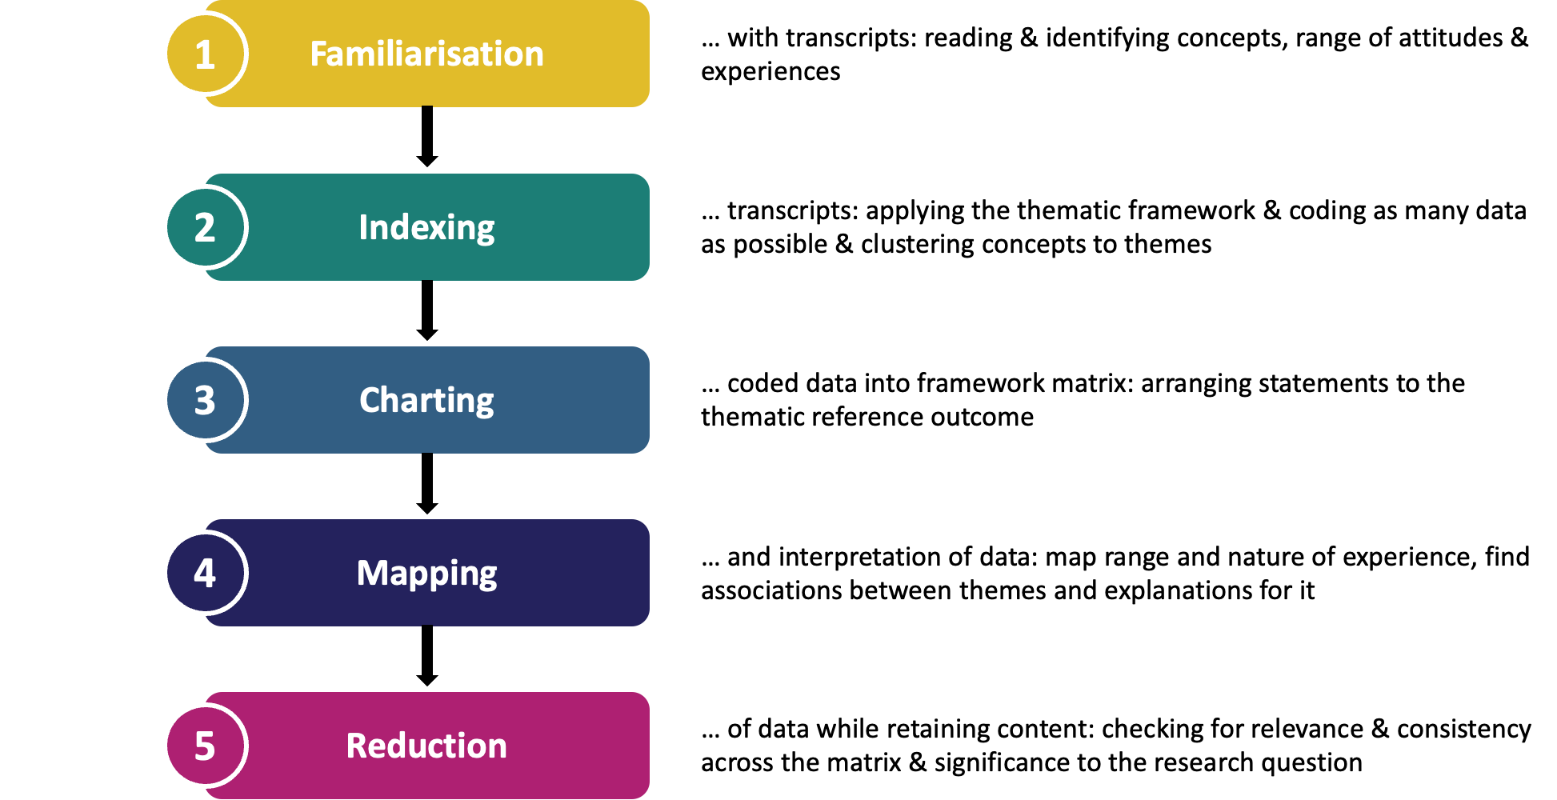
The Framework Method was chosen because it provides a transparent and pragmatic approach, which is suited to examining real-world prescribing practices. It supports the use of pre-existing frameworks to guide systematic coding while retaining flexibility to include new factors. In this study, two frameworks informed the analysis: the Consolidated Framework for Implementation Research (CFIR) 2.0 and the conceptual model of prescribing decision-making for chronic conditions developed in the overview of systematic reviews. This approach allowed for deductive coding to predefined factors in both frameworks, alongside inductive coding of additional factors derived from the data. This approach also facilitated comparison across multiple kidney centres and integration of multiple data sources. The Framework Method aligns with a critical realist approach. It enables examination of observed practices using theory-informed frameworks to identify the mechanisms shaping prescribing behaviours (Cruzes and Dybå, 2011). A clear chain of evidence was maintained from raw data through coding and analysis to interpretation, in line with case study methodological guidance by Yin (2009).
There were two stages of data analysis:
- Implementation science framework-based framework analysis
- Prescribing conceptual model-based framework analysis
Implementation science framework-based framework analysis
The aim of this analysis was to explore how tolvaptan care pathways were implemented in different kidney centres in the UK using an established implementation science framework, the Consolidated Framework for Implementation Research (CFIR) 2.0.
An analytical framework was developed by the primary researcher based on the CFIR 2.0, which consists of 67 constructs across five domains: ‘Innovation’, ‘Outer Setting’, ‘Inner Setting’, ‘Individuals’ and ‘Implementation Process’. The CFIR 2.0 was selected due to its widespread use in health services research and its comprehensive multi-level structure for examining implementation factors. Data was coded deductively to the CFIR constructs. Coded data was charted in Microsoft Excel for Mac (Microsoft Corporation, 2019, Version 16.78.3) to enable comparison within and between cases, followed by cross-case pattern-matching analysis (Gale et al., 2013). Findings were then translated into high-level themes to facilitate interpretation, with quotes labelled by case and participant type. An adapted CFIR 2.0 diagram was used to map the constructs to the tolvaptan care pathway.
Prescribing conceptual model-based framework analysis
The aim of this analysis was to explore the factors influencing prescribing decisions for tolvaptan using the existing conceptual model of prescribing decision-making in chronic conditions presented that was developed in Phase 1. A secondary aim was to develop a conceptual model of prescribing decision-making in rare diseases.
Data was initially coded deductively to the existing model, with additional codes generated where information did not align with the model. The model was then refined iteratively based on discussions with the wider research team to ensure the model included newly identified factors relevant to the study aims. Data was coded using a similar approach to the first stage. However, cross-case comparison was not undertaken as the focus was on identifying mechanisms influencing prescribing decision-making rather than comparing implementation across sites. The conceptual model diagram was adapted to include the factors relevant to prescribing decision-making for rare diseases based on those influencing prescribing decisions for tolvaptan in the management of ADPKD.

Appendix 8. Publication materials for journal articles 3 & 4 (Chapters 6 & 7)

Case study data collection materials

Interview topic guide

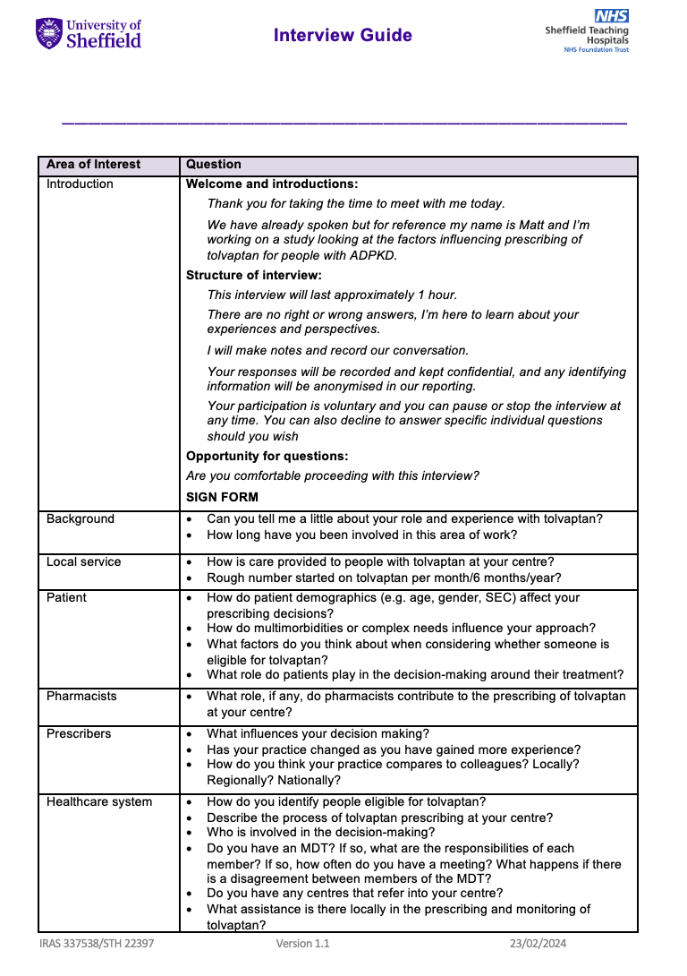



Fieldnotes template used in interviews

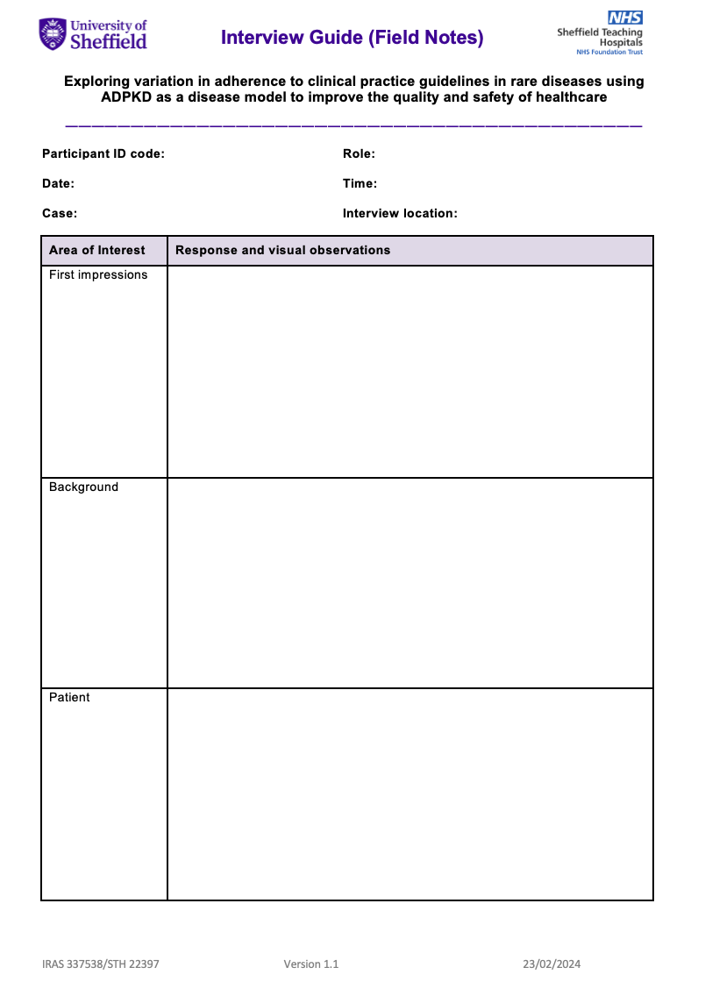





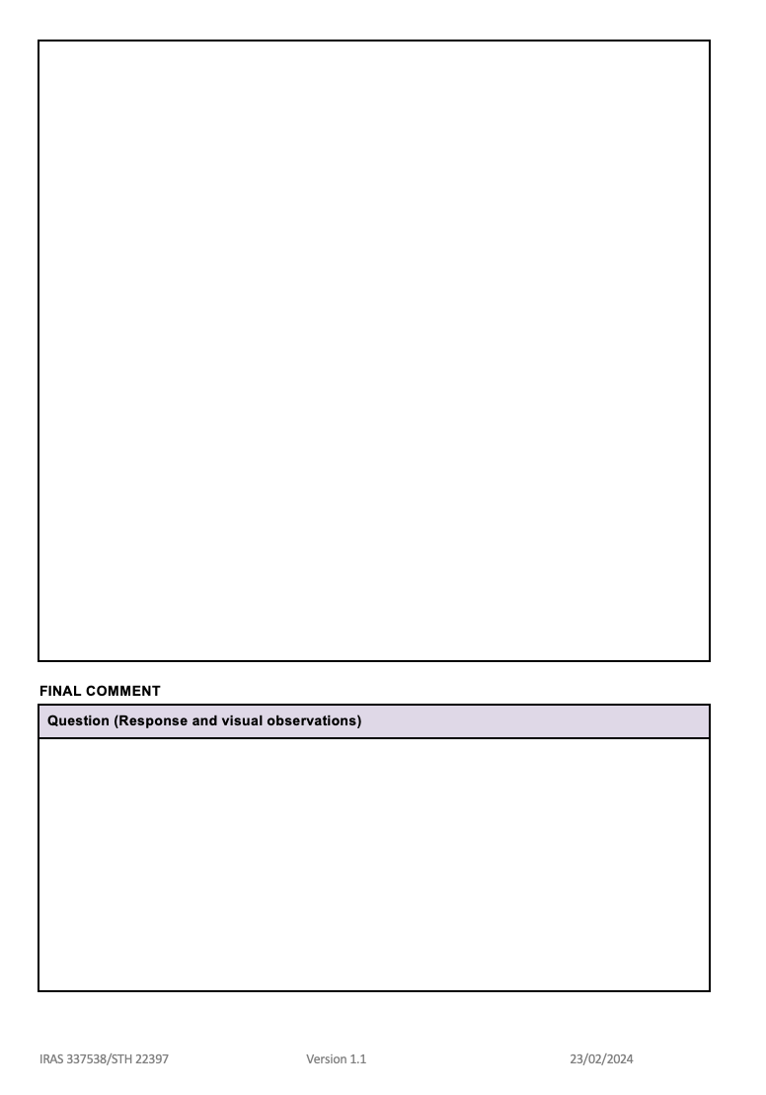

Fieldnotes template used in observations

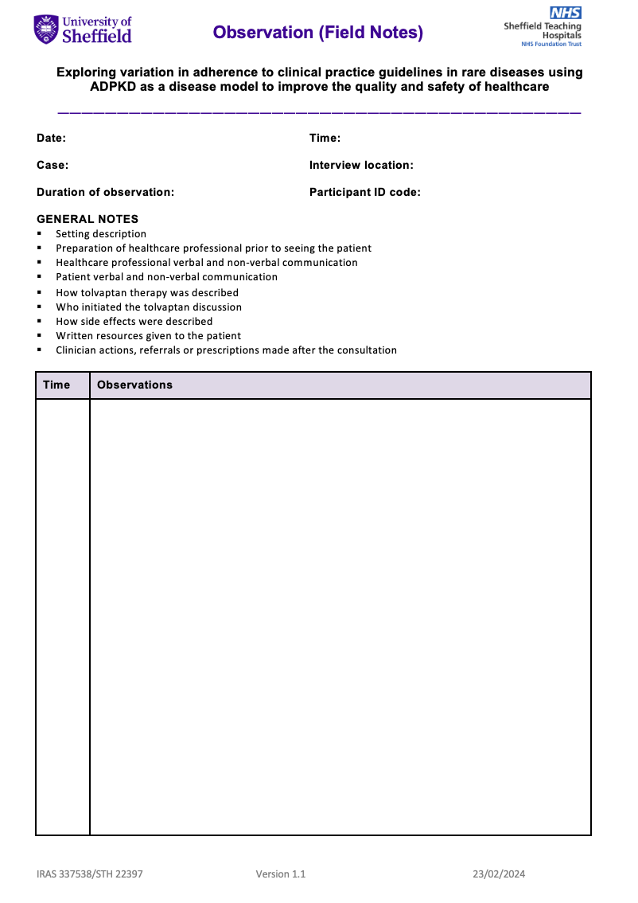



Participant consent form



Participant information sheet for professionals (Interview)

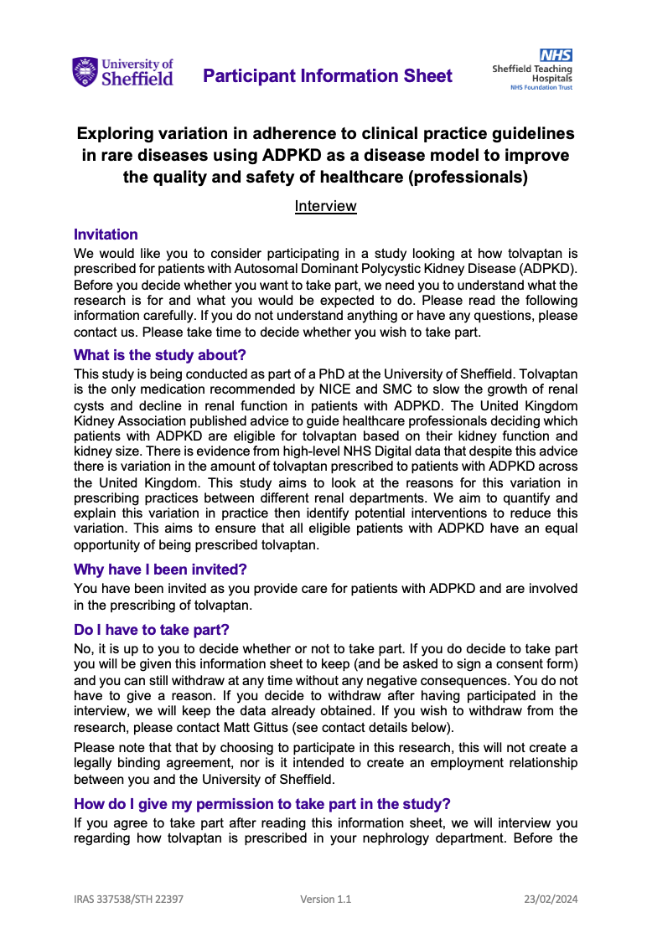







Participant information sheet for professionals (Observations)

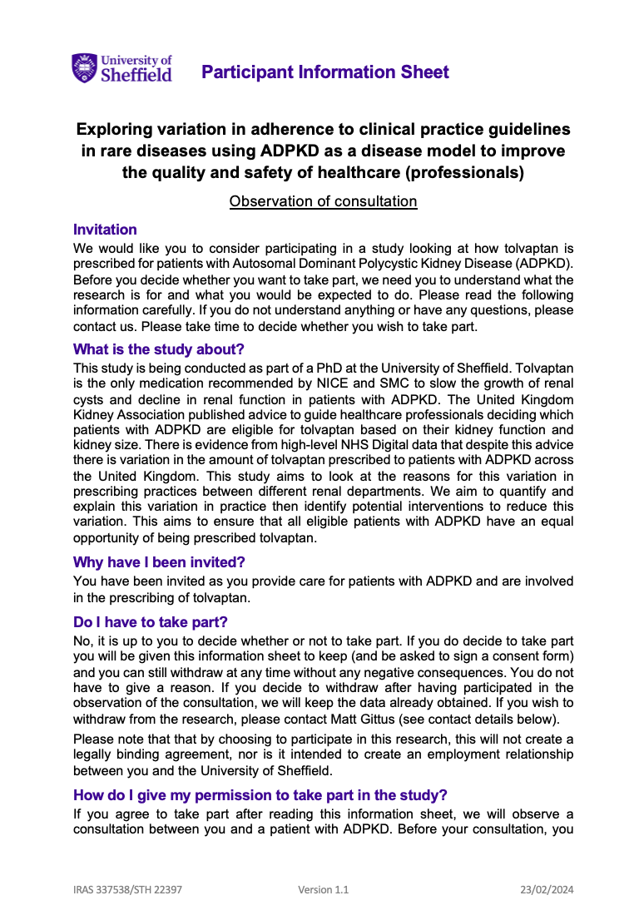

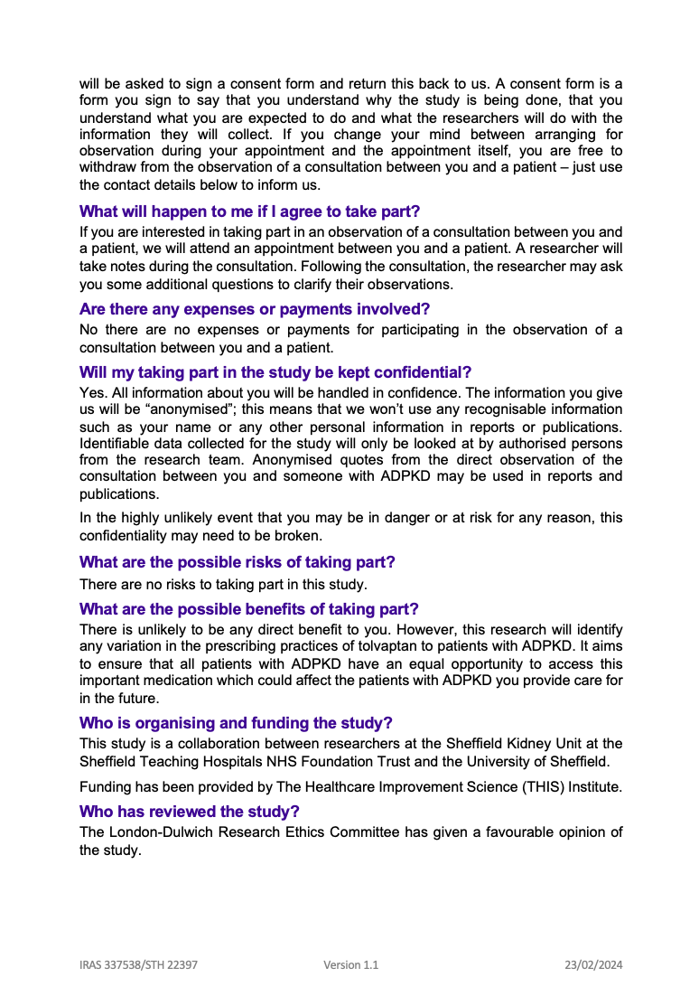





Participant information sheet for patients

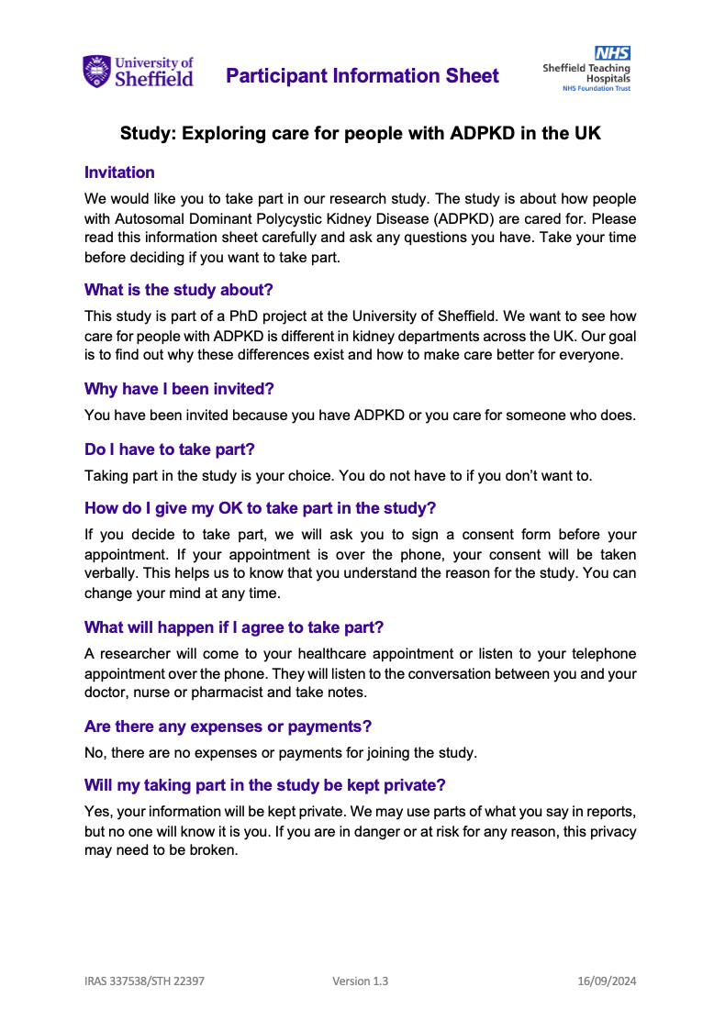





Clinical vignette for semi-structured interviews
Mrs Roberts, a 42 year old woman with ADPKD, presents for follow-up. Diagnosed incidentally at age 35, her family history includes her mother who was on dialysis by age 60. No other medical history other than well-controlled asthma.
Her recent bloods show a serum creatinine of 110 umol/l (eGFR 48). The most recent ultrasound showed “numerous cysts”, the largest being 5cm on the left kidney. Her kidney volume on an MRI 12 months ago was 920ml. She’s asymptomatic other than occasional bilateral flank pain. No recent history of haematuria, UTIs or cyst rupture.
Mrs Roberts’ is concerned about disease progression and inquiries about interventions, particularly tolvaptan. But worries about its side effects affecting her quality of life and job.

Reporting checklist for qualitative studies for journal articles 3 & 4
Consolidated criteria for reporting qualitative studies (COREQ checklist) (journal article 4)
Item No |  | Guide Questions/Description | Reported on  Page #
Domain 1: Research team and reflexivity
Personal Characteristics
1. Interviewer/ facilitator |  | Which author/s conducted the interview or focus group? | Methods - data collection
2. Credentials |  | What were the researcher’s credentials? E.g., PhD, MD | Methods - research team and reflexivity
3. Occupation |  | What was their occupation at the time of the study? | Methods - research team and reflexivity
4. Gender |  | Was the researcher male or female? | Methods - research team and reflexivity
5. Experience and training |  | What experience or training did the researcher have? | Methods - research team and reflexivity
Relationship with participants
6. Relationship established |  | Was a relationship established prior to study commencement? | Methods - research team and reflexivity
7. Participant knowledge of the interviewer |  | What did the participants know about the researcher? e.g. personal goals, reasons for doing the research? | Methods - research team and reflexivity
8. Interviewer characteristics |  | What characteristics were reported about the interviewer/facilitator? e.g. Bias, assumptions, reasons and interests in the research topic | Methods - research team and reflexivity
 | Domain 2: study design
 | Theoretical framework
 | 9. Methodological orientation and Theory | What methodological orientation was stated to underpin the study? e.g. grounded theory, discourse analysis, ethnography, phenomenology, content analysis | Methods - data collection
 | Participant selection
 | 10. Sampling | How were participants selected? e.g., purposive, convenience, consecutive, snowball | Methods - setting and case selection
 | 11. Method of approach | How were participants approached? e.g., face-to-face, telephone, mail, email | Methods - population and recruitment
 | 12. Sample size | How many participants were in the study? | Methods - population and recruitment
 | 13. Non-participation Setting | How many people refused to participate or dropped out? Reasons? | Results - description of participants and data sources
 | 14. Setting of data collection | Where was the data collected? e.g., home, clinic, workplace | Methods - population and recruitment
 | 15.Presence of non-participants | Was anyone else present besides the participants and researchers? | Methods - population and recruitment
 | 16. Description of sample | What are the important characteristics of the sample? e.g. demographic data, date | Table 18
 | Data collection
 | 17. Interview guide | Were questions, prompts, and guides provided by the authors? Was it pilot tested? | Appendix 8
 | 18. Repeat interviews | Were repeat interviews carried out? If yes, how many? | NA
 | 19. Audio/visual recording | Did the research use audio or visual recording to collect the data? | Methods - data collection
 | 20. Field notes | Were field notes made during and/or after the interview or focus group? | Methods - data collection
 | 21. Duration | What was the duration of the interviews or focus group? | Methods - data collection
 | 22. Data saturation | Was data saturation discussed? | Methods - data collection
 | 23. Transcripts returned | Were transcripts returned to participants for comment and/or correction? – No | NA
 | Domain 3: analysis and findings
 | Data analysis
 | 24. Number of data coders | How many data coders coded the data? | Methods - data analysis
 | 25. Description of the coding tree | Did the authors provide a description of the coding tree? | Methods - data analysis
 | 26. Derivation of themes | Were themes identified in advance or derived from the data? | Methods - data analysis
 | 27. Software | What software, if applicable, was used to manage the data? | Methods - data analysis
 | 28. Participant checking | Did participants provide feedback on the findings? | NA
 | Reporting
 | 29. Quotations presented | Were participant quotations presented to illustrate the themes/findings? Was each quotation identified? e.g., participant number | Results
 | 30. Data and findings consistent | Was there consistency between the data presented and the findings? | Results
 | 31. Clarity of major themes | Were major themes clearly presented in the findings? | Results
 | 32. Clarity of minor themes | Is there a description of diverse cases or a discussion of minor themes? | Results
Locations indicate where each checklist item is included in this thesis

Consolidated criteria for reporting qualitative studies (COREQ checklist) (journal article 4)
Item No | Guide Questions/Description | Reported on Page #
Domain 1: Research team and reflexivity
Personal Characteristics
1. Interviewer/ facilitator | Which author/s conducted the interview or focus group? | Methods - data collection
2. Credentials | What were the researcher’s credentials? E.g., PhD, MD | See journal article 3
3. Occupation | What was their occupation at the time of the study? | See journal article 3
4. Gender | Was the researcher male or female? | See journal article 3
5. Experience and training | What experience or training did the researcher have? | See journal article 3
Relationship with participant
6. Relationship established | Was a relationship established prior to study commencement? | See journal article 3
7. Participant knowledge of the interviewer | What did the participants know about the researcher? e.g. personal goals, reasons for doing the research? | See journal article 3
8. Interviewer characteristics | What characteristics were reported about the interviewer/facilitator? e.g. Bias, assumptions, reasons and interests in the research topic | See journal article 3
Domain 2: study design
Theoretical framework
9. Methodological orientation and Theory | What methodological orientation was stated to underpin the study? e.g. grounded theory, discourse analysis, ethnography, phenomenology, content analysis | Methods - study  design
Participant selection
10. Sampling | How were participants selected? e.g., purposive, convenience, consecutive, snowball | See journal article 3
11. Method of approach | How were participants approached? e.g., face-to-face, telephone, mail, email | See journal article 3
12. Sample size | How many participants were in the study? | See journal article 3
13. Non-participation Setting | How many people refused to participate or dropped out? Reasons? | See journal article 3
14. Setting of data collection | Where was the data collected? e.g., home, clinic, workplace | See journal article 3
15.Presence of non-participants | Was anyone else present besides the participants and researchers? | See journal article 3
16. Description of sample | What are the important characteristics of the sample? e.g. demographic data, date | Results - description of participants
Data collection
17. Interview guide | Were questions, prompts, and guides provided by the authors? Was it pilot tested? | Methods - data collection
18. Repeat interviews | Were repeat interviews carried out? If yes, how many? – No | N/A
19. Audio/visual recording | Did the research use audio or visual recording to collect the data? | Methods - data collection
20. Field notes | Were field notes made during and/or after the interview or focus group? | Methods - data collection
21. Duration | What was the duration of the interviews or focus group? | See journal article 3
22. Data saturation | Was data saturation discussed? | See journal article 3
23. Transcripts returned | Were transcripts returned to participants for comment and/or correction? – No | N/A
Domain 3: analysis and findings
Data analysis
24. Number of data coders | How many data coders coded the data? | See journal article 3
25. Description of the coding tree | Did the authors provide a description of the coding tree? | Appendix 8
26. Derivation of themes | Were themes identified in advance or derived from the data? | Methods - data analysis
27. Software | What software, if applicable, was used to manage the data? | Methods - data analysis
28. Participant checking | Did participants provide feedback on the findings? – No | N/A
Reporting
29. Quotations presented | Were participant quotations presented to illustrate the themes/findings? Was each quotation identified? e.g., participant number | Results
30. Data and findings consistent | Was there consistency between the data presented and the findings? | Results
31. Clarity of major themes | Were major themes clearly presented in the findings? | Results
32. Clarity of minor themes | Is there a description of diverse cases or a discussion of minor themes? | Results
Locations indicate where each checklist item is included in this thesis

Coding trees – journal articles 3 & 4
Coding tree for multiple case study using the Consolidated Framework of Implementation Research (journal article 3)
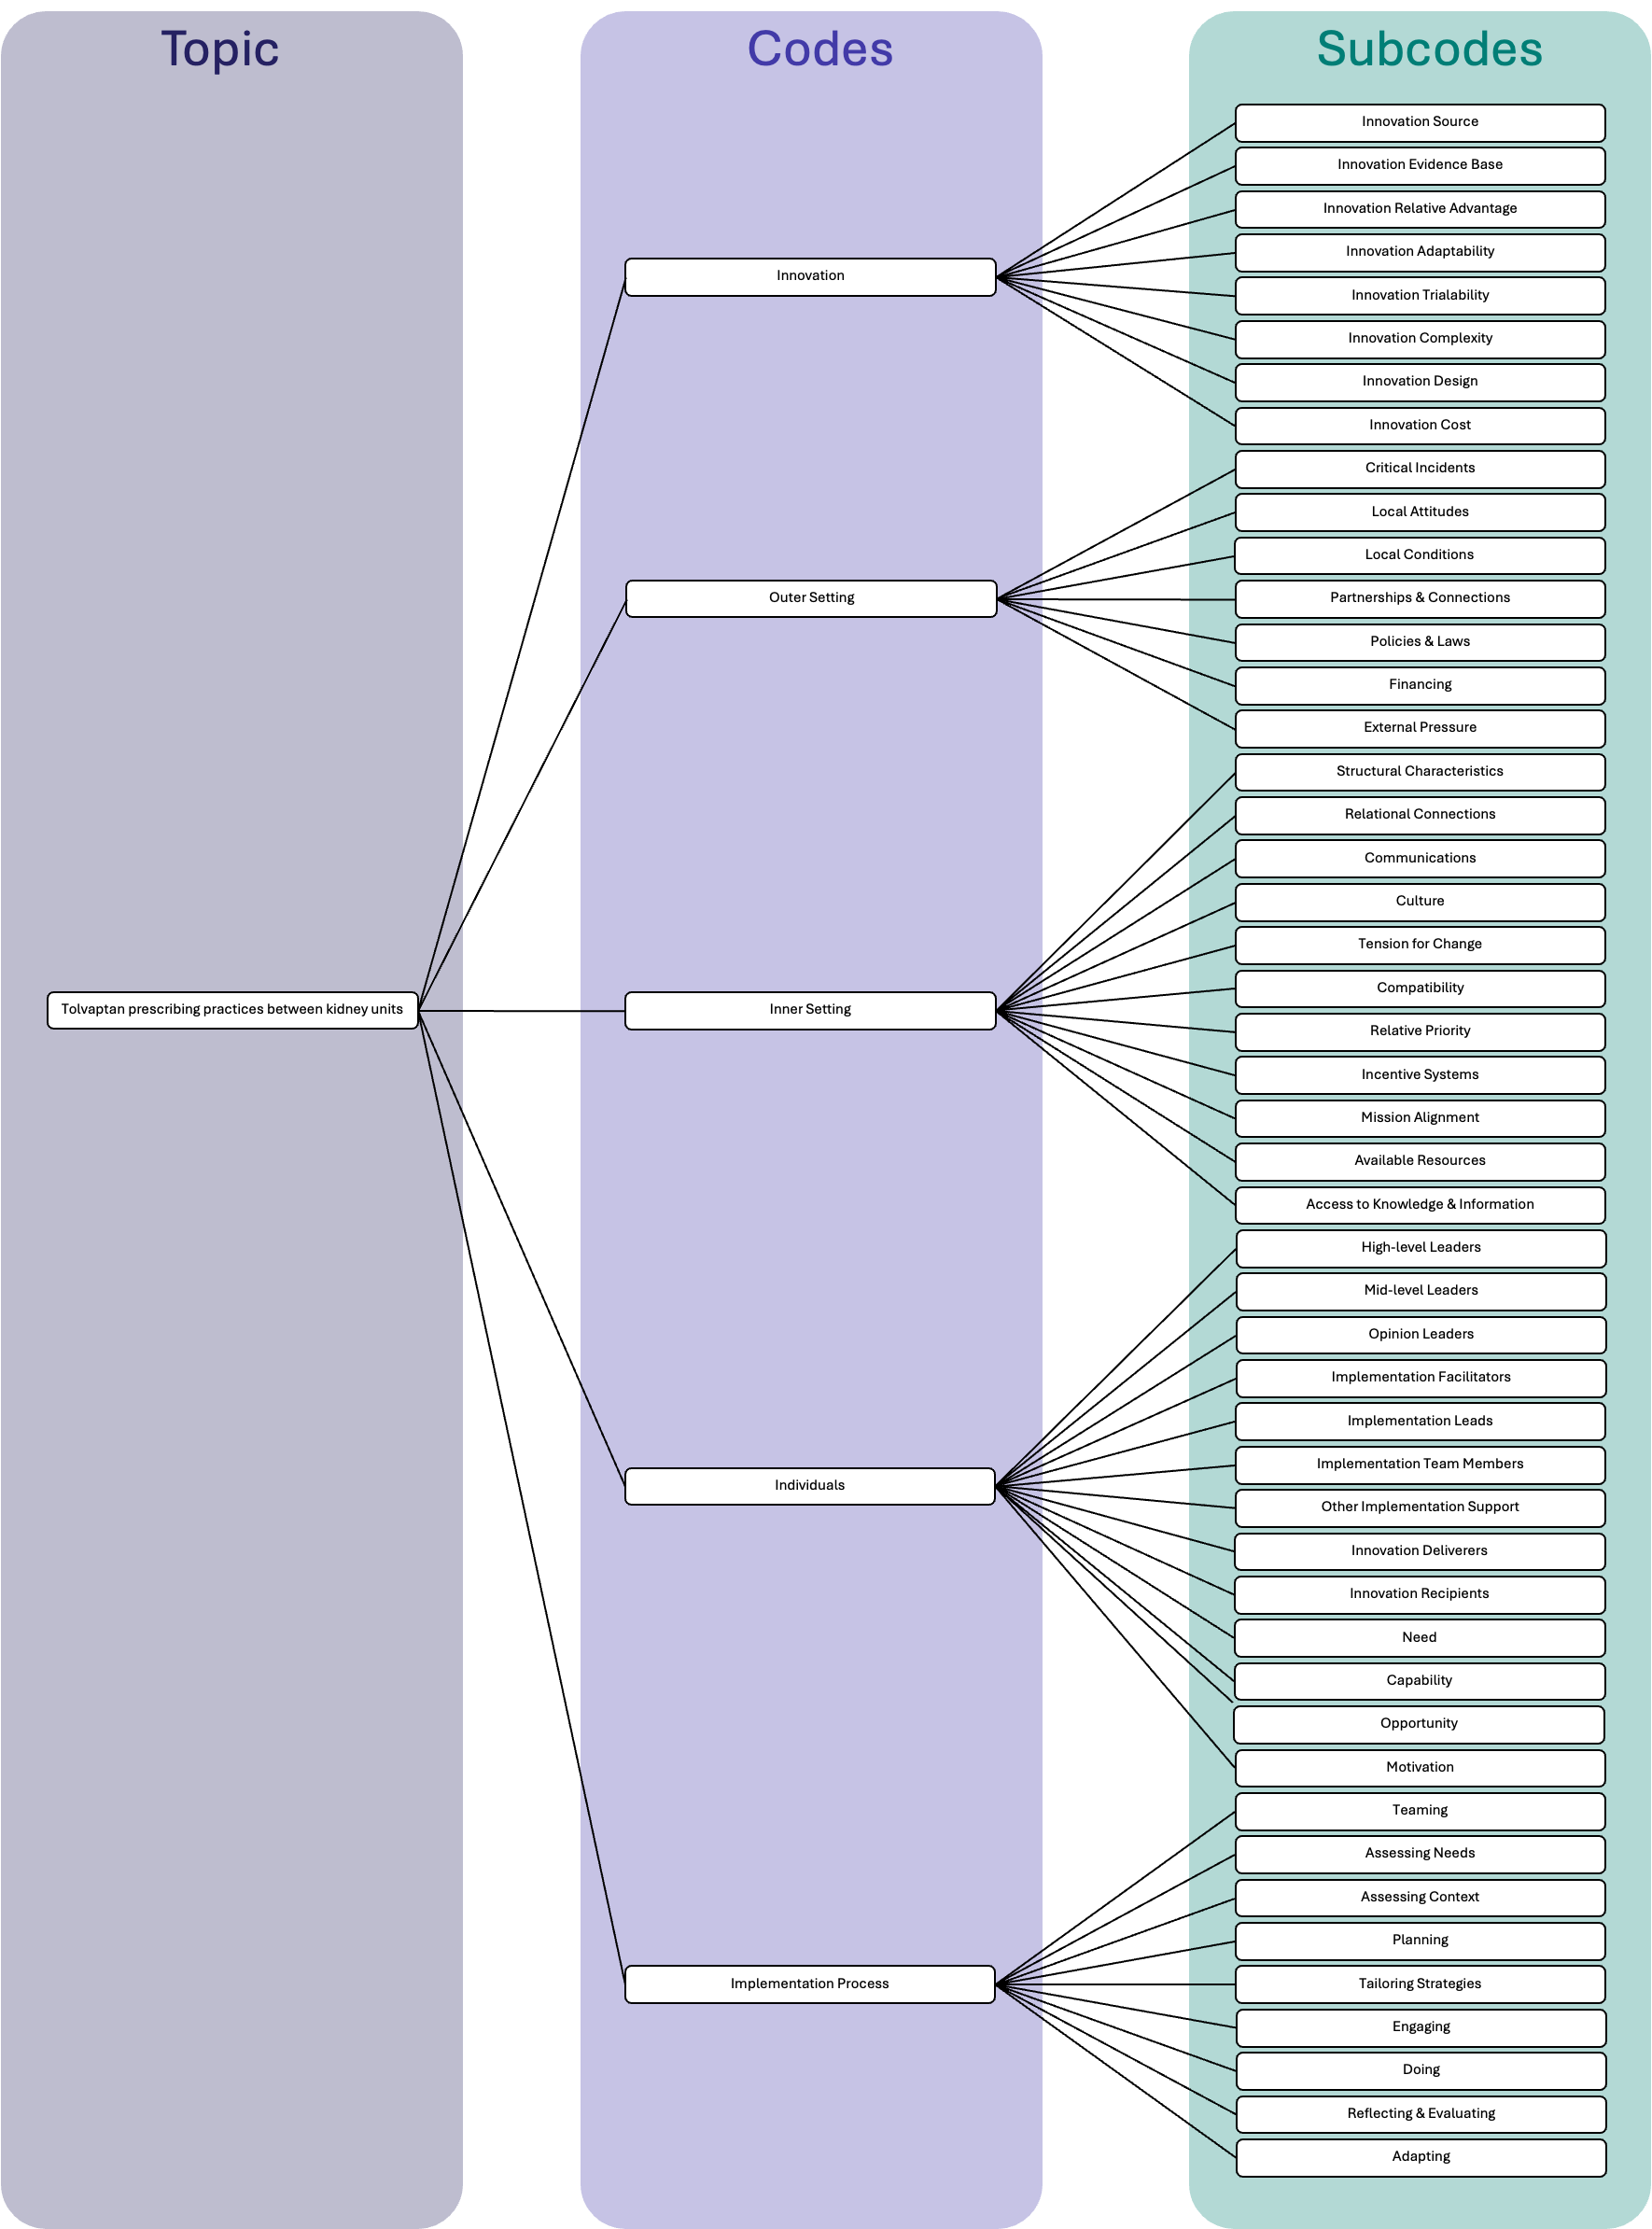
Coding tree for multiple case study using the conceptual model of prescribing decision-making in chronic conditions (journal article 4)
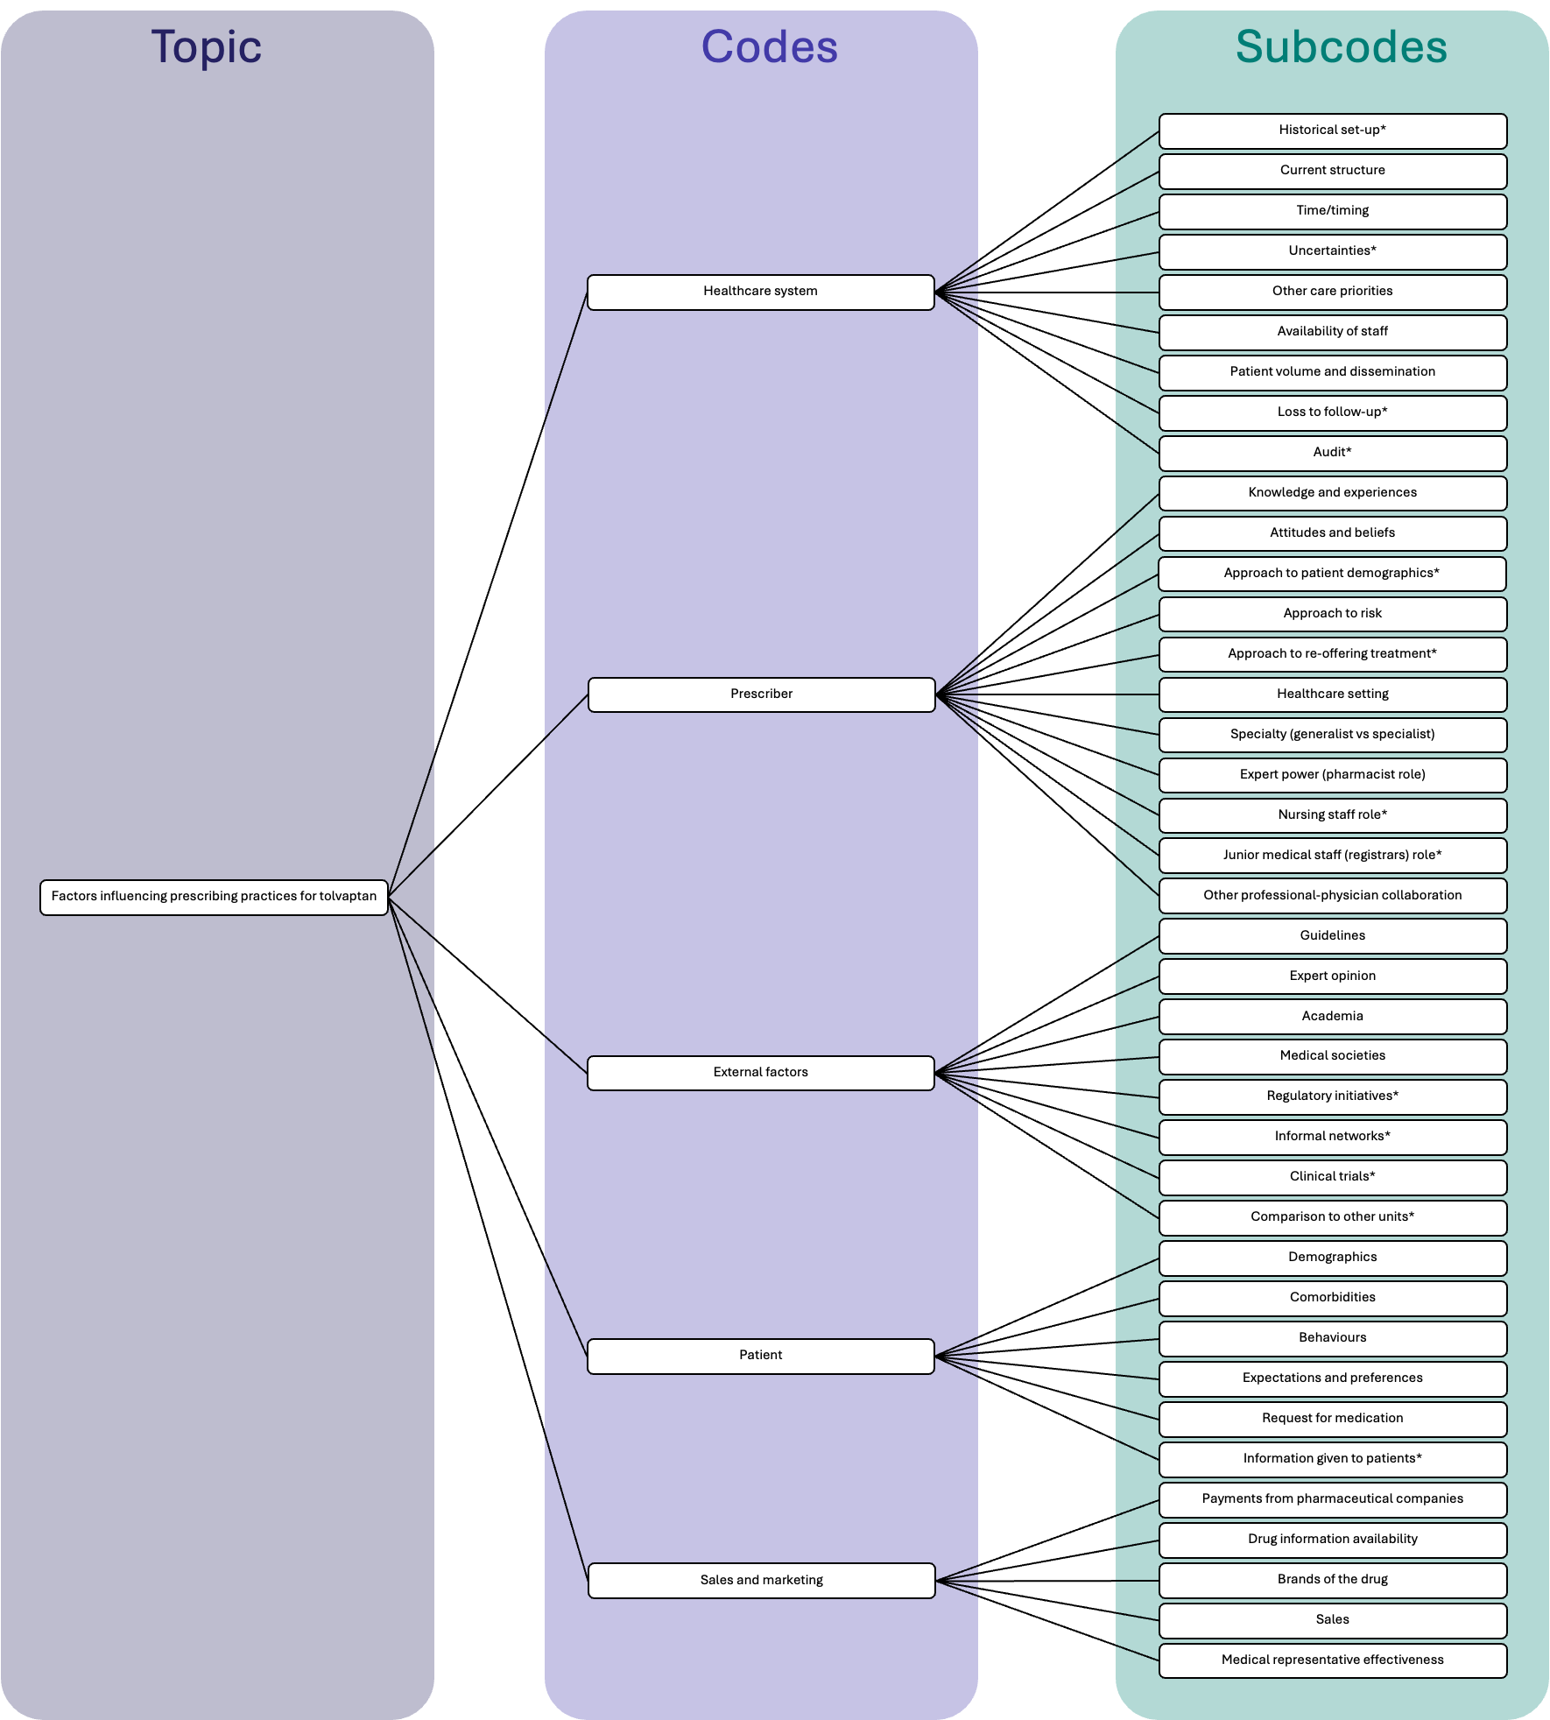

Prescribing pathways
Case 1 prescribing pathway
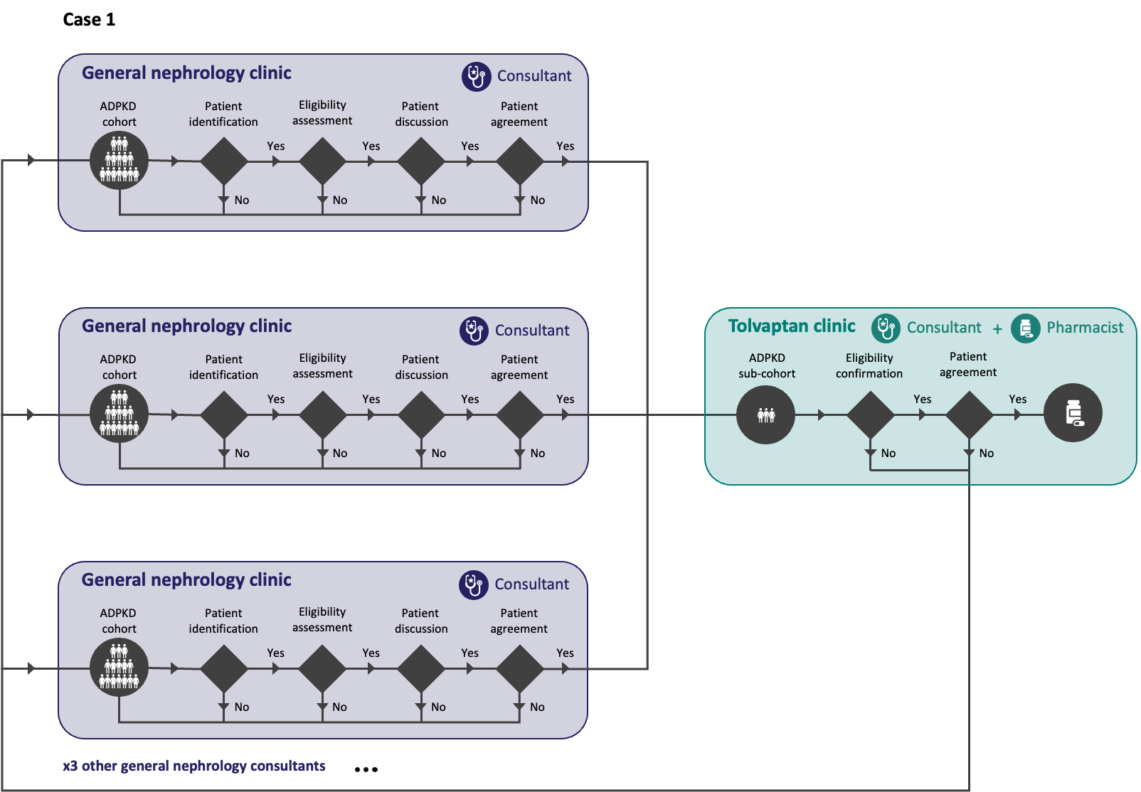

Case 2 prescribing pathway
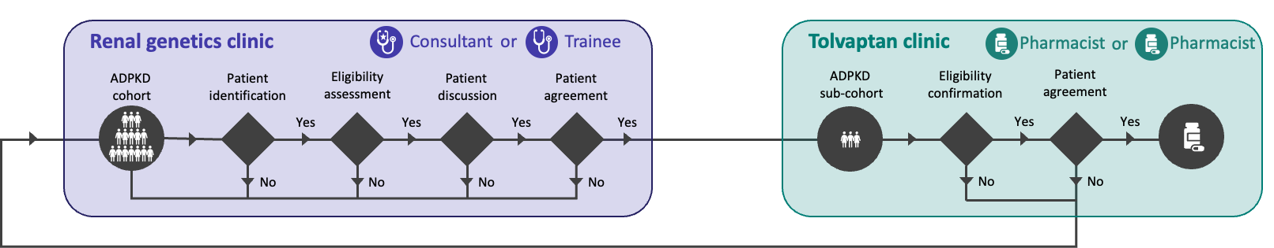

Case 3 prescribing pathway
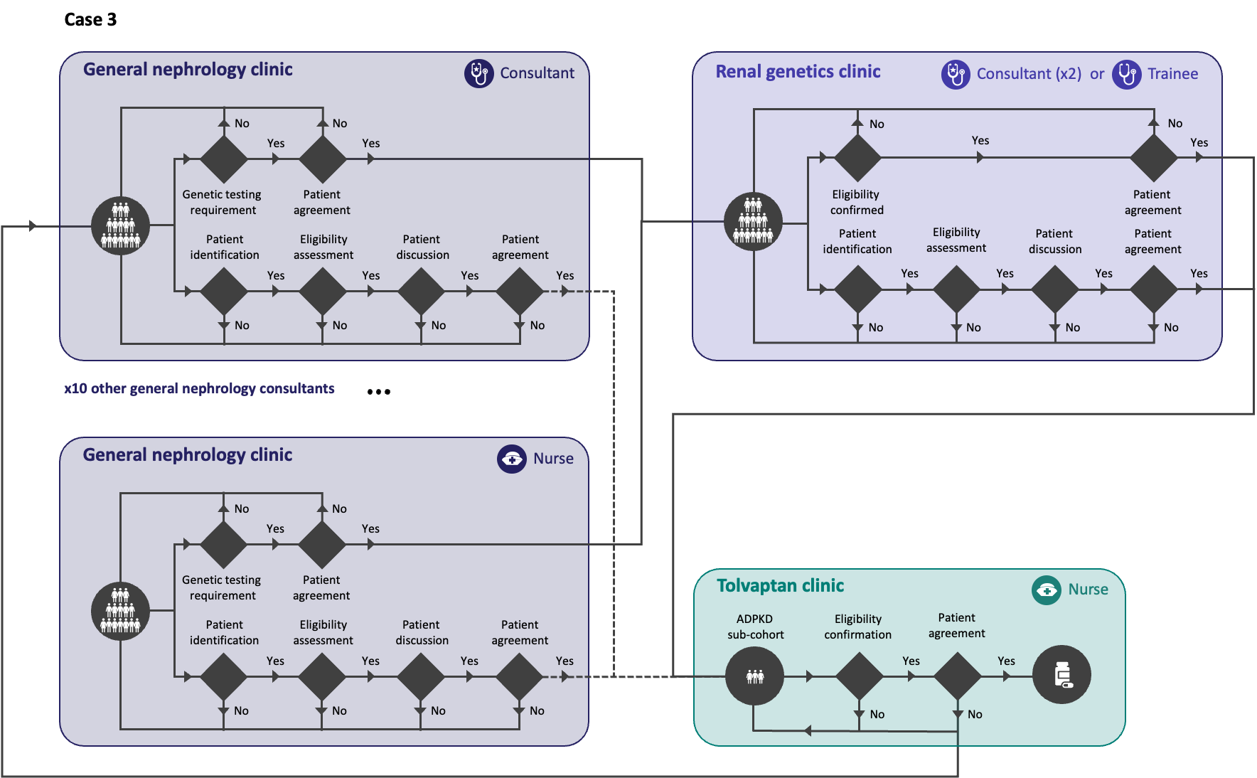

Appendix 9. Additional details on the methods for the survey of clinical practice (Phase 4)
Within this appendix, the following additional details on the methods used for national survey of clinical practice are included:
- Questionnaire development
- Piloting of the questionnaire
- Sampling
- Data collection
- Data analysis

Questionnaire development
The questionnaire was developed to examine variation in approaches to the prescribing of tolvaptan across kidney centres and to generate centre-level data that could be used in the reanalysis of registry data. Questions were informed by the findings from the multiple case study and the conceptual model developed in Phase 3 (Chapter 7).
The questionnaire was primarily structured using a closed-response format (i.e. Likert-type scales, categorical options and binary responses) to facilitate standardised analysis and integration in the quantitative modelling of the reanalysis of registry data. This analysis required binary or categorical responses. Open-text responses were included where additional detail was required.
The design of the questionnaire was guided by the core principles described by Dillman, Smyth and Christian (2014). It was kept as concise as possible. The respondents were clinicians who are likely to be busy and have a limited amount of time to respond to surveys. Longer lengths have been found to add to respondent burden and increase measurement error, as fatigue may lead respondents to skip questions or choose superficial reasons (Groves et al., 2011). This was particularly relevant to this programme of research, as any incomplete or low-quality responses would result in the centre being excluded from that component of the analysis.
The questionnaire was developed in the Qualtrics online platform (Qualtrics XM, Provo, Utah, USA) using the University of Sheffield template, which includes the colour scheme and logo for the University. This was undertaken to improve the perceived trustworthiness and legitimacy of the questionnaire. The use of Qualtrics also provided a clear layout and standardised format to improve the usability of the questionnaire. Conditional logic was incorporated to ensure respondents were only presented with questions that were relevant based on their prior responses to further reduce respondent burden. For example, a follow-up question on when the tolvaptan clinic was introduced was only presented if a dedicated tolvaptan clinic had been identified at the centre in an earlier question.
The draft questionnaire was reviewed by the wider research team. Through their feedback, it was iteratively refined to improve clarity, remove redundant questions and ensure that questions were aligned with the objectives of the programme of research. The final questionnaire is included in Appendix 10.

Piloting of the questionnaire
The initial version of the questionnaire was piloted with two clinicians from Sheffield Teaching Hospitals Trust with expertise in ADPKD who were identified through convenience sampling. Participants were asked to complete the survey acting as the lead consultant for a kidney centre. Feedback was requested on clarity, relevance, structure, sequencing and response options. Based on this piloting some errors in the survey logic were detected, and the survey length was reduced to reduce respondent burden.
Three participants in the Patient and Public Involvement group were given a copy of the electronic questionnaire. They were asked to give feedback on the relevance of the questions from the patient perspective and the clarity of the questionnaire. Based on this feedback the response categories for some questions were adjusted to ensure meaningful differentiation between the options. Additionally, “not sure” responses were removed to encourage definitive responses, and improve the interpretability of the data.

Sampling
The survey was given to clinical leads responsible for ADPKD services at UK kidney centres. A sampling frame was constructed using RaDaR registry data to identify all UK kidney centres with active ADPKD cohorts. Within each centre, the consultant with the highest recorded number of ADPKD patients was identified and used as a proxy for the clinical lead. They were the primary contact for the survey at that centre, but they were asked in the invitation email to forward the email on to a colleague if they thought they may be better placed to complete the survey.

Data collection
The distribution of surveys can be face-to-face, postal or electronic; these can be either filled in by the researcher (face-to-face) or completed by the respondent. An electronic survey that participants could complete independently was chosen. Although online surveys may yield lower response rates than paper versions, they are more cost-effective, faster, easier to analyse and have better completion rates (Ebert et al., 2018). Clinical leads were invited to respond to the survey via email using personalised invitations, which have been found to increase response rates (Dillman, Smyth and Christian, 2014). Using the Qualtrics platform allowed respondents to access the survey through the web-based platform, or via their mobile phone, which has been found to improve accessibility and response rates (Dillman, Smyth and Christian, 2014). As mentioned in the ethical considerations, it was not possible to fully anonymise responses as the centre identity was required to link the survey data to the registry data. This was described in the email invitation, with confidentiality assured so that those responding had informed consent and the process was transparent.

Data analysis
Data was checked for completeness, consistency and coding before analysis. Partially completed surveys were included in the analysis. All available responses were used at the item level to maximise the use of available data. As a result, denominators varied across questions depending on the completion by respondents. Missing data was not included in the analysis. Where multiple responses were received from the same centre, duplicate responses were identified, and only the first completed response was retained for analysis.
Analyses were descriptive and exploratory in nature, with formal hypothesis testing reserved for the reanalysis of registry data. Free-text responses were analysed using qualitative content analysis with inductive categorisation of responses to support interpretation of the quantitative results. This was selected as the responses were all short in nature, so a structured content analysis approach was more appropriate rather than fully interpretative thematic analysis (Schreier, 2012).
Responses were analysed in Python (Python Software Foundation, 2023, Version 3.14.2) with categorical variables derived from the structured responses and binary recording undertaken where required to facilitate comparison across centres and integration with registry data. Graphical representations of the data were produced using Microsoft Excel for Mac (Microsoft Corporation, 2019, Version 16.78.3) and Python (Python Software Foundation, 2023, Version 3.14.2).

Appendix 10. Publication materials for the national survey of clinical practice (Chapter 8)

Email invitation for the survey
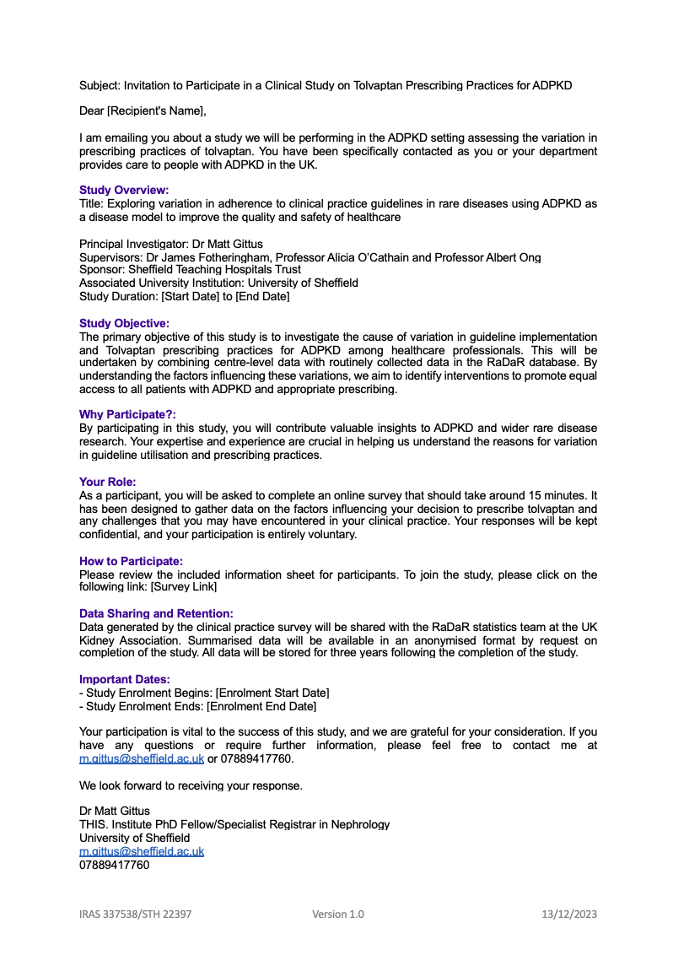

Questionnaire

Information about this survey
This survey is part of a doctoral research project at the University of Sheffield, supported by The Healthcare Improvement Studies (THIS) Institute. The study explores variation in prescribing practices of tolvaptan for people with ADPKD and aims to understand potential reasons for differences in current practice.
More details about this survey, the wider study and your involvement can be found in the Participant Information Sheet.
We ask you to tell us what kidney centre you work in to link your responses with RaDaR data. Your centre’s identity will be kept confidential, and no individuals or centres will be named or identifiable in any reports or publications. Without this information, we cannot answer whether the factors reported influence tolvaptan initiation.
If you are happy to proceed, please press “Next page” to begin. To ensure your response is recorded, please complete to the end. The questionnaire should take approximately 10 minutes to complete.
By starting this survey, you give your consent to take part in the study and for the data you provide to be used for research.
--------------------------------------------------------------------------------------------------------------------------------------
Section 1 - ADPKD population and tolvaptan prescribing at your centre
Q1. Please enter the name of your kidney centre
(Used only to link with RaDaR data; you or your centre will not be named in reports or publications)

Q2. To the best of your knowledge, approximately how many people with ADPKD (excluding those on dialysis or post-transplant) are currently under active follow-up at your centre?
(please select one option)
- Less than 150
- 150 to 300
- 301 to 600
- More than 600
Q3. To the best of your knowledge, approximately how many people with ADPKD are currently receiving tolvaptan at your centre?
(please select one option)
- Less than 10
- 10 to 20
- 21 to 40
- 41 to 60
- More than 60
Q4. To the best of your knowledge, approximately how many people with ADPKD are started on tolvaptan each month at your centre?
(please select one option)
- 0 to 1
- 2 to 3
- 4 to 5
- 6 to 7
- More than 7
Q5. To the best of your knowledge, approximately what proportion of people with ADPKD at your centre start on tolvaptan after being deemed eligible and offered tolvaptan?
(please select one option)
- 0 to 20%
- 21 to 40%
- 41 to 60%
- 61 to 80%
- 81 to 100%

Q6. Is there a limit to the number of people who can be on tolvaptan at your centre? (e.g. due to monitoring or other resource limitations)
(please select one option)
- Yes
- No
- Not sure
>> If Q6. Is there a limit to the number of people who can be on tolvaptan at your centre?... Yes Is Selected
Q6a. Is your centre currently at or near this limit, potentially restricting the number of new patients being initiated on tolvaptan?
(please select one option)
- Yes
- No
- Not sure
Q7. Was your centre a recruiting centre for any of the randomised controlled trials for tolvaptan?
(please select one option)
- Yes
- No
- Not sure
Q8. Does your centre conduct local audits or service evaluations related to tolvaptan prescribing for ADPKD?
(please select one option)
- Yes, regularly
- Yes, occasionally
- No
- Not sure
--------------------------------------------------------------------------------------------------------------------------------------

Section 2 - Tolvaptan treatment pathways and decision-making at your centre
Q9. Who is involved in the tolvaptan treatment pathway at your centre? (includes all stages from eligibility assessment to monitoring)
(please select all that apply)
- Consultant nephrologist(s)
- Nephrology specialist registrar(s)
- Specialist renal pharmacist(s)
- Specialist renal nurse(s)
- Other (please specify):

Q10. Where does the initial assessment of eligibility for tolvaptan take place at your centre?
(please select all that apply)
- General nephrology clinic
- Clinical genetics clinic
- Polycystic kidney disease clinic
- Tolvaptan clinic
- Other (please specify):

Q11. How are decisions about eligibility for tolvaptan made at your centre?
(please select one option)
- By a single prescriber
- By multiple individual prescribers independently
- By a multi-disciplinary team (MDT) through joint discussion
- Other (please specify):

Q12. Who is primarily responsible for determining eligibility for tolvaptan at your centre?
(please select one option)
- General nephrology consultant(s)
- Nephrology consultant(s) with ADPKD/Clinical genetics interest
- Nephrology specialist registrar(s)
- Specialist renal nurse(s)
- Specialist renal pharmacist(s)
- Other (please specify):

Q13. If patients are determined to be eligible, where is tolvaptan initiated at your centre?
(please select all that apply)
- General nephrology clinic
- Clinical genetics clinic
- Polycystic kidney disease clinic
- Tolvaptan clinic
- Other (please specify):

Q14. To the best of your knowledge, what is the typical time between a patient being assessed as eligible for tolvaptan and initiated on treatment at your centre?
(please select one option)
- Same day/same clinic visit
- Within 1 week
- Between 1 and 4 weeks
- Between 1 and 3 months
- Longer than 3 months
- Not sure

Q15. What factors, if any, can influence the time from being assessed as eligible for tolvaptan to the medication being initiated?
(please select all that apply)
- Appointment scheduling
- Clinic capacity
- Administrative delays
- Patient decision-making
- Coordination across service
- None of the above/usually not an issue
- Other (please specify):

Q16. Who is primarily responsible for monitoring people with ADPKD whilst they are on tolvaptan at your centre?
(please select all that apply)
- The individual prescriber
- A named consultant with a specialist interest in ADPKD/Clinical genetics
- Specialist renal nurse
- Specialist renal pharmacist
- No clearly established responsibility - monitoring is informal or ad hoc
- Other (please specify):

Q17. If patients are determined to be eligible and initiated, where are people on tolvaptan monitored at your centre?
(please select one option)
- General nephrology clinic
- Clinical genetics clinic
- Polycystic kidney disease clinic
- Tolvaptan clinic
- Outside of a formal clinic
- Other (please specify):

>> If Q13. If patients are determined to be eligible, where is tolvaptan initiated at your centre?... Tolvaptan clinic Is Selected) or Q17. If patients are determined to be eligible and initiated, where are people on tolvaptan monitored... Tolvaptan clinic Is Selected
Q17a. In which year was the tolvaptan clinic first introduced at your centre? (please provide the approximate year if the exact year is not known)
--------------------------------------------------------------------------------------------------------------------------------------
Section 3 - Surveillance imaging and genetic testing
Q18. To the best of your knowledge, approximately what proportion of people with ADPKD at your centre have had Magnetic Resonance Imaging (MRI) to determine kidney size/kidney volume?
(please select one option)
- 0 to 25%
- 26 to 50%
- 51 to 75%
- 76 to 100%
Q19. Do you routinely repeat kidney MRI scans for people with ADPKD?
(please select one option)
- Yes
- No
>> If Q19. Do you routinely repeat kidney MRI scans for people with ADPKD? (please select one option) Yes Is Selected
Q19a. What is the usual interval for repeating magnetic resonance imaging (MRI) of kidneys in your centre?
(please select one option)
- 0 to 1 year
- 1 to 2 years
- 2 to 5 years
- 5 to 10 years
- No set pattern
Q20. Does your service offer diagnostic genetic testing for people with a clinical diagnosis of ADPKD?
(please select one option)
- Yes
- No
>> If Q20. Does your service offer diagnostic genetic testing for people with a clinical diagnosis of ADPKD? (please select one option) Yes Is Selected
Q20a. What percentage are currently offered genetic testing?
(please indicate on slider in 5% intervals)
--------------------------------------------------------------------------------------------------------------------------------------
Section 4 - Local documentation and patient information
Q21. Does your centre have any local guidance that supports healthcare professionals making tolvaptan prescribing decisions for people with ADPKD?
(please select one option)
- Yes
- No
- Not sure

Q22. Which of the following, if any, do you use to inform your decision to prescribe tolvaptan for people with ADPKD?
(please select all that apply)
- Local guidelines or standard operating procedures
- Guidelines from other kidney centres
- UKKA guidance
- KDIGO guidance
- NICE guidance
- Primary research outside of guidelines
- Expert opinion
- None of the above
- Other (please specify):

Q23. How do people with ADPKD receive information about tolvaptan at your centre?
(please select all that apply)
- Verbal information in clinic (general nephrology clinic/clinical genetics clinic/polycystic kidney disease clinic)
- Verbal information in tolvaptan clinic
- Locally developed patient information leaflet
- Pharmaceutical company patient information leaflet (e.g. Otsuka or Teva pharmaceuticals)
- Patient information days
- PKD charity information
- Other (please specify):

--------------------------------------------------------------------------------------------------------------------------------------

Section 5 - Eligibility of people with ADPKD for tolvaptan
Q24.Do you prescribe tolvaptan with an upper limit or lower limit eGFR?
- Upper limit – Please specify: ________
- Lower limit – Please specify: ________
Q25. Are the following measures being routinely used at your centre when making decisions about eligibility for tolvaptan?
(please select one option for each measure listed)
 |  |  | Yes | No
eGFR slope
Kidney length (ultrasound)
Total kidney volume (MRI)
Mayo imaging classification
PROPKD score
Total kidney volume (ultrasound)
>> If Q25. Are the following measures being routinely used at your centre when making decisions about eligibility... – No Is Greater Than 0

Q25a. If any of the previous methods are not routinely used at your centre, what are the main reasons?
(please select all that apply)
- Not available locally (e.g. MRI or genetic testing not accessible)
- Lack of radiology support (e.g. to calculate Total Kidney Volume)
- Genetic testing not routinely performed
- Measure not included in local guidelines or protocol
- Measure not felt to influence prescribing decisions
- Lack of time or staff resources to implement
- Unfamiliarity with how to calculate/use the measure
- Other (please specify):

Q26.If a patient at your centre does not meet the eGFR slope threshold, do you ever use one of the other criteria in isolation?
- Yes
- No
Q27. Do you formally assess eligibility for tolvaptan at each outpatient appointment for people with ADPKD who are not currently on treatment?
(please select one option)
- Yes
- No
- Not sure

Q28. Which factors, if any, limit your ability to formally assess the eligibility of people with ADPKD for tolvaptan at your centre?
(please select all that apply)
- Limited clinic time
- Patient complexity/co-morbidities
- Uncertainty about eligibility criteria
- Service limitations or delays
- IT issues or limitations
- Competing clinical priorities
- Lack of prompts or reminders
- Insufficient expertise for calculating total kidney volume
- Insufficient information to calculate PROPKD score
- None of these
- Other (please specify):

Q29. Does your centre use any automated tools to flag people with ADPKD who may be eligible for tolvaptan (e.g. a system that scans eGFR slopes or other criteria across all ADPKD patients, without clinician input)
(please select one option)
- Yes (please specify what automated tool or method you use)
- No - but I think it could be helpful
- No - and I don't think it is necessary
- Not sure
Q30. Please indicate your views on the benefits of tolvaptan for people with ADPKD
(please select one option)
- No benefit at all
- Limited benefit
- Moderate benefit
- Substantial benefit
- Very significant benefit

Q31. Which of the following best fits your clinical role?
(please select one option)
- Consultant nephrologist
- Specialist registrar
- Specialist renal nurse
- Specialist renal pharmacist
- Other (please specify)

Q32. Are you the lead for ADPKD at your centre?
(please select one option)
- Yes
- No
- Not sure
- Other

Please note any additional information or comments you think would be relevant below
--------------------------------------------------------------------------------------------------------------------------------------
Thank you for completing the survey. Your responses have been submitted. If you have any questions or would like further information about the study, please contact Dr Matt Gittus (mjgittus1@sheffield.ac.uk).

Rationale for survey questions
Section |  | Question | Question Type (Response Type) | Rationale
1 | ADPKD population and tolvaptan prescribing at your centre | Q1. Please enter the name of the kidney centre where you are employed? | Open (free text) | To link responses with RaDaR data while keeping centre identity confidential.
1 | ADPKD population and tolvaptan prescribing at your centre | Q2. To the best of your knowledge, approximately how many people with ADPKD (excluding those on dialysis or post-transplant) are currently under active follow-up at your centre? | Closed (categorical, single choice) | To quantify centre caseload variation.
1 | ADPKD population and tolvaptan prescribing at your centre | Q3. To the best of your knowledge, approximately how many people with ADPKD are currently receiving tolvaptan at your centre? | Closed (categorical, single choice) | To quantify tolvaptan cohort at centres.
1 | ADPKD population and tolvaptan prescribing at your centre | Q4. To the best of your knowledge, approximately how many people with ADPKD are started on tolvaptan each month at your centre? | Closed (categorical, single choice) | To explore prescribing rates across centres.
1 | ADPKD population and tolvaptan prescribing at your centre | Q5. To the best of your knowledge, approximately what proportion of people with ADPKD at your centre start on tolvaptan after being deemed eligible and offered tolvaptan? | Closed (categorical, single choice) | To assess uptake once eligibility is established.
1 | ADPKD population and tolvaptan prescribing at your centre | Q6. Is there a limit to how many people can be on tolvaptan at your centre? (e.g. due to monitoring or other resource limitations) | Closed (categorical, single choice) | To identify service/resource capacity constraints.
1 | ADPKD population and tolvaptan prescribing at your centre | Q6a. Is your centre currently at or near this limit, potentially restricting the number of new patients being initiated on tolvaptan? | Closed (categorical, single choice) | To establish whether prescribing is currently constrained by limits.
1 | ADPKD population and tolvaptan prescribing at your centre | Q7. Was your centre a recruiting centre for any of the randomised controlled trials for tolvaptan? | Closed (categorical, single choice) | To see if research participation influences practice.
1 | ADPKD population and tolvaptan prescribing at your centre | Q8. Does your centre conduct local audits or service evaluations related to tolvaptan prescribing for ADPKD? | Closed (categorical, single choice) | To identify quality improvement activities related to prescribing.
2 | Tolvaptan treatment pathways and decision-making at your centre | Q9. Who is involved in the tolvaptan treatment pathway at your centre? (includes all stages from eligibility assessment to monitoring) | Closed (multiple choice, tick all that apply) | To identify the relevant workforce roles across eligibility assessment, initiation, and monitoring.
2 |  | Q10. Where does the initial assessment of eligibility for tolvaptan take place at your centre? | Closed (categorical, single/multiple choice) | To understand variation in clinical settings for assessment.
2 |  | Q11. How is the decision about eligibility for tolvaptan typically made in your centre? | Closed (categorical, single choice) | To assess whether decisions are made individually or via MDT.
2 |  | Q12. Who is primarily responsible for determining eligibility for tolvaptan at your centre? | Closed (multiple choice, tick all that apply) | To identify main clinical roles in eligibility assessment.
2 |  | Q13. If patients are determined to be eligible, where is tolvaptan initiated at your centre? | Closed (categorical, single/multiple choice) | To understand service pathways for treatment initiation.
2 |  | Q14. To the best of your knowledge, what is the typical time between a patient being assessed as eligible for Tolvaptan and initiated on treatment at your centre? | Closed (categorical, single choice) | To explore potential delays between assessment and treatment.
2 |  | Q15. What factors most commonly influence this timing at your centre? | Closed (multiple choice, tick all that apply) | To identify barriers (service, patient, administrative).
2 |  | Q16. Who is primarily responsible for monitoring people with ADPKD whilst they are on Tolvaptan at your centre? | Closed (multiple choice, tick all that apply) | To explore variation in responsibility for monitoring.
2 |  | Q17. If patients are determined to be eligible, where are people on tolvaptan monitored at your centre? | Closed (categorical, single/multiple choice) | To assess follow-up pathways across centres.
2 |  | Q17a. Which year was the tolvaptan clinic introduced at your centre? | Open (free text) | To document when dedicated clinics were established.
3 | Surveillance imaging and genetic testing | Q18. To the best of your knowledge, approximately what proportion of people with ADPKD at your centre have had magnetic resonance imaging (MRI) to determine kidney size/kidney volume? | Closed (categorical, single choice) | To assess uptake of imaging-based risk stratification.
3 | Surveillance imaging and genetic testing | Q19. Do you routinely repeat MRI of kidneys after people with ADPKD have been diagnosed? | Closed (categorical, single choice) | To explore surveillance practices.
3 | Surveillance imaging and genetic testing | Q19a. What is the usual interval for repeating MRI of kidneys in your centre? | Closed (categorical, single choice) | To explore variation in imaging frequency across centres.
3 | Surveillance imaging and genetic testing | Q20. Does your service offer diagnostic genetic testing for people with a clinical diagnosis of ADPKD? | Closed (categorical, single choice) | To explore how genetic testing is used which could inform PROPKD scores.

4 | Local documentation and patient information | Q21. Does your centre have any local guidance that supports healthcare professionals making tolvaptan prescribing decisions for people with ADPKD? | Closed (categorical, single choice) | To identify presence of local clinical governance.
4 | Local documentation and patient information | Q22. Which of the following do you use to inform your decision to prescribe tolvaptan for people with ADPKD? | Closed (multiple choice, tick all that apply) | To assess influence of guidelines, research, and expert opinion.
4 | Local documentation and patient information | Q23. How do people with ADPKD receive information about tolvaptan at your centre? | Closed (multiple choice, tick all that apply) | To explore variation in patient information provision.
5 | Eligibility of people with ADPKD for tolvaptan | Q24. Do you prescribe tolvaptan with an upper limit or lower limit eGFR? | Open (free text) | To ascertain whether prescribing outside NICE CKD thresholds occurs.
5 | Eligibility of people with ADPKD for tolvaptan | Q25. Are the following measures being routinely used at your centre when making decisions about eligibility for tolvaptan?: eGFR slopes, Kidney length (ultrasound), Total kidney volume (MRI), Mayo imaging classification, PROPKD score | Closed (matrix, Yes/No for each measure) | To explore adoption of different eligibility measures.
5 | Eligibility of people with ADPKD for tolvaptan | Q25a. If any of the previous methods are not routinely used at your centre, what are the main reasons? | Closed (multiple choice, tick all that apply) | To identify barriers to using specific eligibility measures.
5 | Eligibility of people with ADPKD for tolvaptan | Q26. If a patient at your centre does not meet the eGFR slope threshold, do you ever use one of the other criteria in isolation? | Closed (categorical, single choice) | To determine relationship between eGFR and non-eGFR criteria.
5 | Eligibility of people with ADPKD for tolvaptan | Q27. Do you formally assess eligibility for tolvaptan at each outpatient appointment for people with ADPKD who are not currently on treatment? | Closed (categorical, single choice) | To assess consistency of eligibility reassessment.
5 | Eligibility of people with ADPKD for tolvaptan | Q28. What do you think are the main factors that could limit formal eligibility assessment in each outpatient appointment at your centre? | Closed (multiple choice, tick all that apply) | To identify service, resource, or knowledge barriers.
5 | Eligibility of people with ADPKD for tolvaptan | Q29. Does your centre use any automated tools to flag people with ADPKD who may be eligible for tolvaptan (e.g. a system that scans eGFR slopes or other criteria without clinicians having to manually review) | Closed (categorical, single choice) | To assess use of decision-support technology.
5 | Eligibility of people with ADPKD for tolvaptan | Q30. Please indicate your views on the benefits of tolvaptan for people with ADPKD. | Closed (categorical, Likert-type scale) | To explore clinicians’ perception of treatment benefit.
5 | Eligibility of people with ADPKD for tolvaptan | Q31. Which of the following best fits your clinical role? | Closed (categorical, single choice) | To profile respondent roles.
5 | Eligibility of people with ADPKD for tolvaptan | Q32. Are you the ADPKD lead at your centre? | Closed (categorical, single choice) | To determine leadership responsibilities among respondents.

Mapping of questions to conceptual model of prescribing decision-making in rare diseases
Survey Question (brief summary) | Model Domain | Factor
Q1. Name of kidney centre | Contextual factors | Condition factors (centre-level)
Q2. Number of ADPKD patients under follow-up | Contextual factors | Condition factors (small patient numbers / patient volume)
Q3. Number currently receiving tolvaptan | Contextual factors | Condition factors (patient volume)
Q4. Number started on tolvaptan each month | Contextual factors | Condition factors (patient volume, clinical burden)
Q5. Proportion starting tolvaptan after eligibility | Contextual factors | Risk-benefit assessment, Clinical inertia
Q6. Limit on number of people on tolvaptan | Healthcare system | Availability of staff, Patient volume, Time constraints
Q6a. Centre at/near limit? | Healthcare system | Availability of staff, Patient volume, Resource limitation
Q7. Centre recruited to RCTs | External factors | Clinical trials, Expert opinion
Q8. Local audits/service evaluations | Healthcare system | Internal audit, Local guidelines
Q9. Who is involved in treatment pathway | Prescriber / Other HCPs | Knowledge & experience, Expert power, Shared responsibility
Q10. Location of initial eligibility assessment | Healthcare system | Decision location, Cohorting
Q11. How eligibility decisions are made | Prescriber | Approach to risk, Attitudes & beliefs, Shared responsibility
Q12. Who is primarily responsible for eligibility | Prescriber | Knowledge & experience, Specialty/Level of specialism
Q13. Where is tolvaptan initiated | Healthcare system | Decision location, Cohorting
Q14. Typical time from eligibility to initiation | Healthcare system | Time, Other care priorities, Patient volume
Q15. Factors influencing initiation time | Patient / Healthcare system | Patient behaviours, Time, Administrative delays, Other care priorities
Q16. Who is responsible for monitoring | Other HCPs | Expert power, Shared responsibility, Pharmacist-physician collaboration
Q17. Where are patients monitored | Healthcare system | Decision location, Cohorting
Q17a. Year tolvaptan clinic introduced | Healthcare system | Local leadership, Cohorting
Q18. Proportion of patients with MRI | Healthcare system | Available resources
Q19. Routine MRI repeats | Healthcare system | Available resources
Q19a. MRI repeat interval | Healthcare system | Available resources
Q20. Diagnostic genetic testing availability | Healthcare system / External factors | Available resources, Expert opinion
Q20a. Percentage offered genetic testing | Healthcare system / External factors | Available resources, Expert opinion
Q21. Local guidance exists | Healthcare system | Local guidelines
Q22. Sources used to inform prescribing | External factors | Guidelines, Expert opinion, Academia
Q23. How patients receive information | Patient / Sales & marketing | Patient knowledge, Shared decision-making, Promotional events
Q24. eGFR limits for prescribing | Patient / Contextual factors | Demographics, Risk-benefit assessment
Q25. Measures used for eligibility (eGFR, kidney size, TKV, Mayo, PROPKD) | Patient / Prescriber / Healthcare system | Demographics, Condition factors, Available resources, Knowledge & experience
Q25a. Reasons measures not used | Healthcare system | Available resources, Time, Staff availability
Q26. Use other criteria if eGFR slope not met | Prescriber | Risk-benefit assessment, Clinical inertia
Q27. Formal assessment at each appointment | Prescriber / Healthcare system | Knowledge & experience, Time, Other care priorities
Q28. Factors limiting eligibility assessment | Prescriber / Patient / Healthcare system | Knowledge & experience, Patient complexity, Time, Available resources
Q29. Automated tools to flag eligibility | Healthcare system / Prescriber | Available resources, Knowledge & experience, Shared responsibility
Q30. Views on tolvaptan benefits | Patient / Prescriber / Contextual factors | Risk-benefit assessment, Clinical inertia, Patient expectations
Q31. Clinical role | Prescriber | Specialty/Level of specialism
Q32. Lead for ADPKD | Prescriber / Healthcare system | Local leadership, Knowledge & experience

Upset diagram of sources of information used to inform decision-making

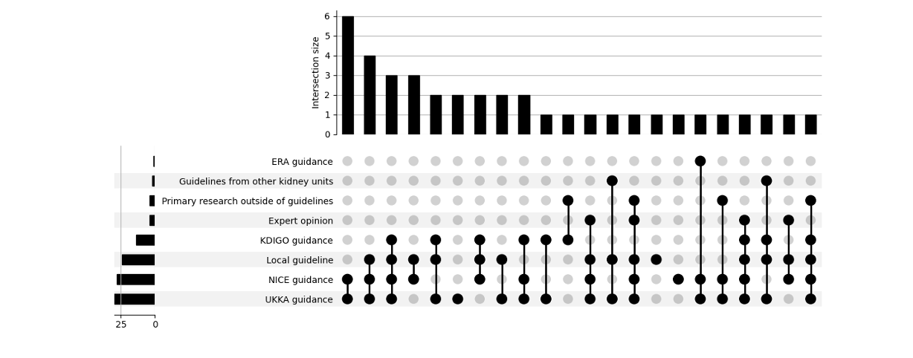

Service configurations and staffing

 |  |  | Professionals involved in tolvaptan pathway
Decision-making model | Consultant lead type | Consultant-only |  | Pharmacist | Nurse | Pharmacist & Nurse
Single (n = 17) | Specialist (n = 11) | 5 |  | 3 | 0 | 3
 | Generalist (n = 6) | 2 |  | 3 | 1 | 0
Multiple ( n = 12) | Specialist (n = 7) | 2 |  | 3 | 2 | 0
 | Generalist (n =5 ) | 0 |  | 3 | 0 | 2
MDT (n = 11) | Specialist (n = 11) | 0 |  | 6 | 0 | 5
All models (n = 40) | All types (n = 40) | 9 |  | 18 | 3 | 10

Reporting checklist for survey (CROSS checklist)
Section/topic | Item | Item description | Reported on page #
Title and abstract
Title and abstract | 1a | State the word “survey” along with a commonly used term in title or abstract to introduce the study’s design. | Title page
Title and abstract | 1b | Provide an informative summary in the abstract, covering background, objectives, methods, findings/results, interpretation/discussion, and conclusions. | Abstract
Introduction
Background | 2 | Provide a background about the rationale of study, what has been previously done, and why this survey is needed. | Introduction - paragraph 3
Purpose/aim | 3 | Identify specific purposes, aims, goals, or objectives of the study. | Introduction - paragraph 3
Methods
Study design | 4 | Specify the study design in the methods section with a commonly used term (e.g., cross-sectional or longitudinal). | Methods - paragraph 1
Study design | 5a | Describe the questionnaire (e.g., number of sections, number of questions, number and names of instruments used). | Methods - questionnaire development
Data collection methods | 5b | Describe all questionnaire instruments that were used in the survey to measure particular concepts. Report target population, reported validity and reliability information, scoring/classification procedure, and reference links (if any). | Appendix 10
Data collection methods | 5c | Provide information on pretesting of the questionnaire, if performed (in the article or in an online supplement). Report the method of pretesting, number of times questionnaire was pre-tested, number and demographics of participants used for pretesting, and the level of similarity of demographics between pre-testing participants and sample population. | Methods - questionnaire development
Data collection methods | 5d | Questionnaire if possible, should be fully provided (in the article, or as appendices or as an online supplement). | Appendix 10
Sample characteristics | 6a | Describe the study population (i.e., background, locations, eligibility criteria for participant inclusion in survey, exclusion criteria). | Methods - participants and sampling
Sample characteristics | 6b | Describe the sampling techniques used (e.g., single stage or multistage sampling, simple random sampling, stratified sampling, cluster sampling, convenience sampling). Specify the locations of sample participants whenever clustered sampling was applied. | Methods - participants and sampling
Sample characteristics | 6c | Provide information on sample size, along with details of sample size calculation. | Methods - participants and sampling
Sample characteristics | 6d | Describe how representative the sample is of the study population (or target population if possible), particularly for population-based surveys. | Methods - participants and sampling
Survey  administration | 7a | Provide information on modes of questionnaire administration, including the type and number of contacts, the location where the survey was conducted (e.g., outpatient room or by use of online tools, such as SurveyMonkey). | Methods - paragraph 1
Survey  administration | 7b | Provide information of survey’s time frame, such as periods of recruitment, exposure, and follow-up days. | Methods - paragraph 1
Survey  administration | 7c | Provide information on the entry process:  –>For non-web-based surveys, provide approaches to minimize human error in data entry.  –>For web-based surveys, provide approaches to prevent “multiple participation” of participants. | Methods - data collection
Study preparation | 8 | Describe any preparation process before conducting the survey (e.g., interviewers’ training process, advertising the survey). | NA
Ethical considerations | 9a | Provide information on ethical approval for the survey if obtained, including informed consent, institutional review board [IRB] approval, Helsinki declaration, and good clinical practice [GCP] declaration (as appropriate). | Methods - ethics and confidentiality
Ethical considerations | 9b | Provide information about survey anonymity and confidentiality and describe what mechanisms were used to protect unauthorized access. | Methods - ethics and confidentiality
Statistical  analysis | 10a | Describe statistical methods and analytical approach. Report the statistical software that was used for data analysis. | Methods - data analysis
Statistical  analysis | 10b | Report any modification of variables used in the analysis, along with reference (if available). | NA
Statistical  analysis | 10c | Report details about how missing data was handled. Include rate of missing items, missing data mechanism (i.e., missing completely at random [MCAR], missing at random [MAR] or missing not at random [MNAR]) and methods used to deal with missing data (e.g., multiple imputation). | NA
Statistical  analysis | 10d | State how non-response error was addressed. | Methods - data analysis
Statistical  analysis | 10e | For longitudinal surveys, state how loss to follow-up was addressed. | NA
Statistical  analysis | 10f | Indicate whether any methods such as weighting of items or propensity scores have been used to adjust for non-representativeness of the sample. | NA
Statistical  analysis | 10g | Describe any sensitivity analysis conducted. | Methods - data analysis
Results
Respondent characteristics | 11a | Report numbers of individuals at each stage of the study. Consider using a flow diagram, if possible. | Results - survey response and completion
Respondent characteristics | 11b | Provide reasons for non-participation at each stage, if possible. | NA
Respondent characteristics | 11c | Report response rate, present the definition of response rate or the formula used to calculate response rate. | Results - survey response and completion
Respondent characteristics | 11d | Provide information to define how unique visitors are determined. Report number of unique visitors along with relevant proportions (e.g., view proportion, participation proportion, completion proportion). | Results - survey response and completion
Descriptive  results | 12 | Provide characteristics of study participants, as well as information on potential confounders and assessed outcomes. | Results - characteristics of respondents
Main findings | 13a | Give unadjusted estimates and, if applicable, confounder-adjusted estimates along with 95% confidence intervals and p-values. | NA
Main findings | 13b | For multivariable analysis, provide information on the model building process, model fit statistics, and model assumptions (as appropriate). | NA
Main findings | 13c | Provide details about any sensitivity analysis performed. If there are considerable amount of missing data, report sensitivity analyses comparing the results of complete cases with that of the imputed dataset (if possible). | NA
Discussion
Limitations | 14 | Discuss the limitations of the study, considering sources of potential biases and imprecisions, such as non-representativeness of sample, study design, important uncontrolled confounders. | Discussion - strengths and limitations
Interpretations | 15 | Give a cautious overall interpretation of results, based on potential biases and imprecisions and suggest areas for future research. | Discussion - implications
Generalizability | 16 | Discuss the external validity of the results. | Discussion - strengths and limitations
Other sections
Role of funding source | 17 | State whether any funding organization has had any roles in the survey’s design, implementation, and analysis. | None
Conflict of interest | 18 | Declare any potential conflict of interest. | None
Acknowledgements | 19 | Provide names of organizations/persons that are acknowledged along with their contribution to the research. | NA
Locations indicate where each checklist item is included in this thesis

Survey responses by approximate kidney centre catchment area
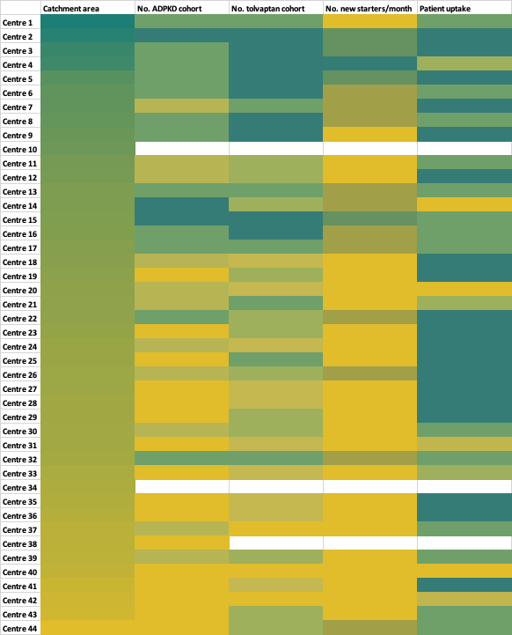
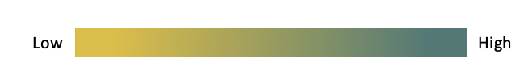
NHS Acute Trust catchment areas derived from Office for Health Improvement and Disparities (2022)

