
Genomic and transcriptomic bases of nutrient uptake in facultative and obligate ant-plant symbioses
by
George William Hirons-Alecrim
The University of Sheffield
Faculty of Sciences
School of Biosciences
January 2026

Table of Contents
Acknowledgments v
Thesis abstract vi
Chapter 1. General Introduction 1
1. General Introduction 2
1.1 Mutualisms 2
1.2 The importance and diversity of ant-plant mutualisms 3
1.3 Mutualistic dependence 6
1.4 Genomic studies of mutualism 7
1.5 Hydnophytinae 10
1.6 Thesis aims 12
1.7 References 14
Chapter 2. Building the whole genome framework for the study of experimental ant-plant symbioses 21
2.1 Abstract 23
2.2 Introduction 24
2.3 Materials and methods 26
2.3.1 Sampling and high molecular weight DNA extraction 26
2.3.2 Genome sequencing 26
2.3.3 Genome assembly 27
2.3.4 Flow Cytometry Analysis 27
2.3.5 GenomeScope Analysis 27
2.3.6 Reducing Genome Redundancy 27
2.3.7 Candidate Nitrogen gene confirmation 28
2.3.8 Gene Prediction 28
2.3.9 Functional Annotation 28
2.3.10 Characterisation of Gene Duplication 29
2.4 Results 29
2.4.1 Genome size estimation and ploidy 29
2.4.2 Genome assembly of Hydnophytum moseleyanum and Myrmecodia beccarii 31
2.4.3 Hydnophytum moseleyanum and Myrmecodia beccarii genome completeness 32
2.4.4. Genome duplication purge 33
2.4.5 Gene Prediction Results Using Helixer 35
2.4.6 Duplication types in Hydnophytum moseleyanum and Myrmecodia beccarii 35
2.5 Discussion 37
2.5.1 A genomic framework to analyse mutualistic dependence in Hydnophytinae ant-plants 37
2.5.2 Nitrogen-related candidate genes in a duplication-aware comparative framework 38
2.6 References 40
Chapter 3. Validating nutritional uptake in ant plant symbiotic relationships 43
3.1 Abstract 45
3.2 Introduction 46
3.3. Materials and methods 48
3.3.1 Formation of experimental symbioses with ghost ants 48
3.3.2 Testing whether the symbioses with ghost ants are mutualistic 52
3.3.3 Tissue sampling and preparation for isotope analysis 53
3.3.4 Isotope-Ratio Mass Spectrometry (IR-MS) 53
3.3.5 Statistical analyses and visualisation 54
3.4 Results 55
3.4.1 Ghost ants enrich domatium tissues in δ¹⁵N in both H. moseleyanum and M. beccarii 55
3.5 Discussion 59
3.5.1 Developing experimental symbioses in the Hydnophytinae 59
3.5.1 Developing experimental symbioses in the Hydnophytinae 60
3.5.2 Experimental nutrition between Hydnophytinae and ghost ants recapitulate natural interactions 62
3.5.3 Invasive ants forming mutualisms with specialised plants 64
3.5.4 Tuber function in nitrogen retention 65
3.6 Conclusion 65
3.7 References 67
Chapter 4. Mutualistic dependency modulates the transcriptomic responses underlying nutrition in ant-plant symbioses. 74
4.1 Abstract 76
4.2 Introduction 77
4.3 Materials and methods 80
4.3.1 Experimental design 80
4.3.2 RNA extraction and sequencing 81
4.3.3 Transcriptome assembly and analysis 82
4.3.4 Identification of nitrogen-related genes 83
4.4 Results 83
4.4.1 Ant-induced regulation of defence-related genes in warty tissues 84
4.4.2 Tissue-specific regulation of ammonium transporter genes in H. moseleyanum 86
4.4.3 Urease-related gene expression patterns in H. moseleyanum 90
4.4.4 Cytochrome C biogenesis genes expression patterns in H. moseleyanum 91
4.4.5 Regulation of nitrite and nitrate transporter genes in response to ant presence in H. moseleyanum 92
4.4.6 Expression pattern of nitrogen-related genes in M. beccarii 95
4.5 Discussion 98
4.5.1 Ant-induced versus constitutive nitrogen-uptake gene expression in facultative and obligate ant-plants 98
4.5.2 Ant effects on nitrogen-uptake genes are strongest in Hydnophytum moseleyanum 99
4.5.3 Weak ant responsiveness in the obligate ant-plant Myrmecodia beccarii 100
4.5.4 Defence gene expression at the domatium nutrient-exchange interface 101
4.5.5 Limitations and future directions 102
4.6 Conclusion 103
4.7. References 105
Supplementary figures 111
Chapter 5. General Discussion 119
5. General discussion 120
5.1. Establishing experimental symbioses in ant–plants 122
5.2. Warty domatium walls as the key site of nitrogen uptake in obligate Hydnophytinae 122
5.3. Mutualistic dependence is reflected in regulatory plasticity at the interface 123
5.4. Partner identity, microbiomes, and nitrogen form 124
5.5. Conclusion 125
5.6. References 126

Table of Figures
Figure 1: Internal caudex morphology and chamber differentiation in myrmecophytes. 11
Figure 2: GenomeScope k-mer frequency spectrum for Hydnophytum moseleyanum, showing k-mer coverage (x-axis) versus frequency (y-axis). 30
Figure 3: GenomeScope k-mer frequency spectrum for Myrmecodia beccarii, showing k-mer coverage (x-axis) versus frequency (y-axis). 31
Figure 4: Experimental setup for stable isotope labelling. 50
Figure 5: Experimental cohorts of Myrmecodia beccarii and Hydnophytum moseleyanum isolated on water barriers to prevent ant access. 51
Figure 6: Experimental workflow for tracing ant-derived nitrogen into Hydnophytinae domatium tissues. 52
Figure 7: Contrasting plant health between a domatium-bearing and a non-domatium-bearing plant. 56
Figure 8: Mean δ¹⁵N values in without ants and with ants treatments in Hydnophytum moseleyanum, shown by tissue type, with error bars representing ± SEM. 58
Figure 9: Mean δ¹⁵N values in without ants and with ants treatments in Myrmecodia beccarii, shown by tissue type, with error bars representing ± SEM. 59
Figure 10: Experimental design and sampling scheme.. 81
Figure 11: Volcano plot of differential gene expression between warty-like tissues of Hydnophytum moseleyanum with ants and without ants. 85
Figure 12: Volcano plot of differential gene expression between warty tissues of Myrmecodia beccarii with ants and without ants. 86
Figure 13: Heatmap of nitrogen-related genes in H. moseleyanum showing log₂-transformed normalised expression values from DESeq2 (variance-stabilised counts). 88
Figure 14: Bar plot of ammonium transporter gene expression in H. moseleyanum showing mean log₂-transformed normalised expression values from DESeq2 (variance-stabilised counts) for ants and no ants treatments. Error bars indicate ± standard error across three biological replicates. 90
Figure 15: Heatmap of nitrogen-related genes in H. moseleyanum showing log₂-transformed normalised expression values from DESeq2 (variance-stabilised counts). 92
Figure 16: Bar plot of high-affinity nitrate transporter accessory, Ig-like domain genes in H. moseleyanum, showing mean log₂-transformed normalised expression values from DESeq2 (variance-stabilised counts) for ants and no ants treatments. Error bars indicate ±standard error across three biological replicates. 94
Figure 17: Heatmap of nitrogen-related genes in M. beccarii showing log₂-transformed normalised expression values from DESeq2 (variance-stabilised counts). 95
Figure 18: Heatmap of nitrogen-related genes in M. beccarii showing log₂-transformed normalised expression values from DESeq2 (variance-stabilised counts). 97
Figure 19: Bar plot of nitrogen-related genes in M. beccarii showing mean log₂-transformed normalised expression values from DESeq2 (variance-stabilised counts) for ants and no ants treatments. Error bars indicate ± standard error across three biological replicates. 98

Acknowledgments
I would like to express my sincere gratitude to Prof Guillaume Chomicki and Dr Luke T Dunning for their guidance, expertise, and support throughout the development of this thesis. Their insight and encouragement have been invaluable to my academic growth.
I am deeply grateful to my parents for their unwavering support, patience, and encouragement at home, which made the completion of this work possible.
Finally, I wish to acknowledge God, Jesus, and the high spirituality, for the opportunities, strength, and personal growth they have granted me on this journey, and for guiding my development not only academically, but also as a soul.

Thesis abstract
Mutualisms are widespread across life and vary in their degree of dependence, ranging from facultative associations to specialised obligate relationships. The drivers and consequences of mutualistic dependence remain poorly understood, especially in ‘macro’-mutualism such as ant-plant symbioses. Ant-plant systems are well suited to addressing these questions because partner presence can be experimentally manipulated (ants can be added or excluded), the symbiosis spans a continuous spectrum from facultative to obligate association across closely related specie, and partner exchange is spatially localised to a discrete structure, the domatium, making the physiological and transcriptomic consequences of dependence experimentally tractable in a way that is difficult to achieve in more diffuse or intracellular mutualisms such as microbiome or endosymbiont systems.
In this thesis, I integrate genomics, experiments and transcriptomics to investigate how shifts toward obligate dependence reshape ant-plant function, using epiphytic Rubiaceae ant-plants (Hydnophytinae) as a model system. In chapter 2, I generated high-quality reference genomes for the obligate ant-plant Myrmecodia beccarii and the facultative Hydnophytum moseleyanum establishing a duplication-aware genomic framework that supports orthology inference and transcriptome mapping. This provides the genomic resources needed to interpret nitrogen-related candidates in a gene- and copy-aware manner across dependence levels.
In chapter 3, I established a controlled greenhouse symbiosis system between ghost ants (Tapinoma melanocephalum) and both Hydnophytinae species. Using a ¹⁵N isotope feeding assay, I show that ghost ants form nutritional mutualisms with both plants, and ant-derived fertilisation patterns match field observations, validating the system.
In chapter 4, I manipulated ant presence and nutrient availability to test whether nitrogen-uptake genes are expressed more constitutively in M. beccarii but remain inducible in H. moseleyanum. This identifies candidate genes involved in nitrogen-based nutritional symbiosis and supports a shift from inducible to constitutive expression associated with the evolution of obligate dependence.

Chapter 1. General Introduction

1. General Introduction

1.1 Mutualisms
Mutualism is a type of species interaction that involves the exchange of resources and/or services between species where every species benefits (Janzen, 1985; Bronstein, 2015; Hale and Valdovinos 2021). Mutualisms are found across the tree of life and occur in virtually every ecosystem, in fact virtually every species on Earth is involved in one or more mutualisms (Bronstein, 2001). Not surprisingly, mutualisms play key ecological roles essential for ecosystem functioning, such as pollination, seed dispersal, defence against predators and nutrition (Bronstein, 2015). Thus, the disruption of mutualisms due to human activity such as habitat destruction, defaunation or climate change can have dire consequences for ecosystems (Kiers et al., 2010; Aslan et al., 2013). Three examples of mutualism below illustrate ecological diversity and importance of mutualistic interactions. The exchange of mineral nitrogen and phosphorus from a fungus and carbon from plants, termed mycorrhizae, is common to ~80% of all land plants and is central to plant nutrition (Bonfante and Genre, 2010). Mycorrhizae have also been critical for the conquest of the land by early land plants over 450 million years ago (Field et al., 2015). Animal pollination, the process of pollen transfer mediated by pollinating agents that receive a reward such as nectar, is critical for the reproductive success of ~90% of flowering plants (Ollerton et al., 2011; Tong et al., 2023). In marine environments, coral reefs, which consist of an endosymbiosis between microscopic algae (zooxanthellae) and corals wherein the coral provides its waste (CO2, nitrogen, phosphorus) against carbon from the photosynthetic zooxanthellae. This mutualistic symbiosis provides a habitat that sustains a quarter of all marine species (EPA, 2022). More generally, mutualisms are key modulators of species richness at the ecological and evolutionary scales, by affecting species coexistence within ecosystems, and species diversification at the macroevolutionary scale (Chomicki et al., 2019).
The term “mutualism” was first mentioned in 1873 by Pierre van Beneden to describe “mutual aid” among species (Bronstein, 2015), six years before the related but distinct term “symbiosis” was introduced. The terms “mutualism” and “symbiosis” are often used interchangeably despite carrying different definitions, which has led to the misuse of both words. In 1879, Anton de Bary first defined symbiosis (Bary 1879, Bronstein, 2015) as encompassing both mutualistic and parasitic interactions yet many authors today still misuse “symbiosis” when they mean “mutualism.” The effect on fitness essentially defines the type of symbiosis. A mutualism occurs when the overall fitness benefit is positive for both species, commensalism is positive for one species and neutral for the other and parasitism/predation is positive for one and negative for the other (Leigh, 2010).
Service exchange during interactions is an alternative way to classify mutualism, which can be categorised into (i) transportation, (ii) protection, and (iii) nutrition (Bronstein, 2015).
Transportation mutualisms involve the movement of one partner, as seen in pollination. Protection mutualisms occur when one partner provides defence, either against biotic threats such as in herbivory where whistling-thorn ants (Crematogaster mimosae) defend the swollen-thorn acacia tree (Vachellia drepanolobium) from large herbivores like elephants (Loxodonta africana) (Chomicki et al., 2015; Palmer, 2023) or against abiotic stress, such as when domatia shelter ant brood from harsh environmental conditions. A classic nutritional mutualism includes Rhizobium bacteria involved in nitrogen-fixing symbioses with legumes and allies (Klinger et al., 2016).

1.2 The importance and diversity of ant-plant mutualisms
Ant-plant mutualisms have long been used as models to understand mutualism ecology and evolution (Bronstein et al., 2006). Ants and plants have coexisted for over 140 million years (Moreau et al., 2006). As a result, a wide range of interactions between ants and plants have evolved, including many mutualisms (Chomicki and Renner, 2017). There are four main types of ant-plant mutualisms: seed dispersal by ants (myrmecochory), extrafloral nectary (EFN)- based defence mutualisms, domatium-based ant-plant symbioses, and plant cultivation mutualisms. Below I outline the importance and diversity of each of these four types of ant-plant mutualisms.
Myrmecochory is a form of seed dispersal mediated by ants that feed on a lipid and protein rich appendage of seeds called elaiosomes. The ants collect the seeds, carry them, take the elaiosome and discard the seed, which can then germinate. This mutualism involves some 11,000 angiosperm species in 334 genera and 77 families that have evolved elaiosomes. These are globally distributed, with the majority being in arid warm-temperate regions (Lengyel et al., 2010; Nelsen et al., 2018). Myrmecochory enables plants to expand their range size, increasing their chance of survival and reducing competition with other plant species (Richardson et al., 2000). Myrmecochory enables plants to have the optimal chance of evading predators and to establish in new habitats (Hughes and Westoby, 1992; Azcarate and Manzanon, 2011). Specific timing, spatial pattern and volume of seed release enables plants to specifically associate with efficient ant dispersers (Leal et al., 2013).
The second type of ant-plant mutualisms is extrafloral nectary (EFN)-based indirect defence. Direct defences in plants consist of traits that provide mechanical or chemical protection on the surface such as thorns, thick leaves, poisonous compounds (War et al., 2012). In contrast to direct defence, indirect defence involves the attraction of insect predators such as ants or parasitoid wasps by offering a reward, and these insect predators will then in turn repeal herbivores from the plant. The most numerically important mutualism involved in indirect defence relies on so-called extrafloral nectaries (EFNs). Some 3941 plant species representing 745 genera in 108 families – mostly angiosperms but also present in ferns – have evolved EFNs as a method of indirect defence (Weber and Keeler, 2013). The nectar in EFNs is made up mostly of glucose and sucrose, and the EFN structure varies in size, location and form (Vannette and Fukami, 2018).
Currently, well established indirect defence ant-plant systems serve as fruitful model systems to the ecology of mutualism and trophic interactions (Heil et al., 2010; Kobayashi et al., 2008; Mondor and Addicott, 2003). EFNs-based indirect defence is often deployed in ontogenic phases where the plant is most vulnerable. This is the case in early leaf development, which is the most desirable stage for many herbivorous insects (Heil and Bueno, 2007). Many plant species have evolved an indirect defence mechanism to counter the lack of defence for vulnerable plant parts by producing EFNs rewards on the surface of the leaf, inducing ants to patrol and defend such young leaves (Heil and Bueno, 2007). Biotic and abiotic stresses induce EFN production depending on the damage induced to the plant (Heil et al., 2000; Linsenmair et al., 2001). Jasmonates derived from jasmonic acid are key compounds that have been identified in the plants’ response to biotic and abiotic stresses (Gatehouse, 2002; Heil et al., 2004). Herbivore damage acts as the primary trigger that up-regulates a plant's endogenous jasmonic acid (JA) signalling pathway (Heil et al., 2001). Elevated JA levels directly stimulate and induce the secretion of extrafloral nectar (EFN) from glands, which acts as a nutritious reward to recruit predatory ants that provide indirect defence to the plant (Heil et al., 2001; Grasso et al., 2015).
The third type of ant-plant mutualisms are domatium-based ant-plant symbioses. Such symbioses are widespread in tropical regions and involve plants that provide nesting space in an evolutionarily derived modified plant structure (domatia), and sometimes also food rewards for ants in exchange from herbivore protection or/and nutrients from the ants (Davidson and McKey, 1993). Domatium-bearing plant species involve ca. 700 species in 50 families that provide ants with protection and nesting space (Chomicki and Renner, 2015). Domatia can result from the modification of diverse plant parts, such as hollow thorns, hollow stems, or leaf pouches (Davidson and McKey, 1993; Tepe et al., 2007; Chomicki and Renner, 2015). In some species, the ant-plant symbiosis contributes towards plant nutrition with ants providing nutrients resulting from by-products from ant waste or from the remains of dead ants (Gay, 1993; Treseder et al., 1995; Chomicki and Renner, 2019). In some ant-plant symbioses, ants prevent other plants, including vines, from shading their host plant from light by pruning and with some species releasing formic acid or other toxic secretions on non-host plants, facilitating the growth of their host plants (Frederickson and Gordon, 2007; Frederickson, 2005).
Finally, the last type of ant-plant mutualisms is plant cultivation by ants. Agriculture benchmarked a time point whereby the human world progressed in sustaining communities for consumption (Pennisi, 2003). Beyond human capabilities lies complex ecological interactions that operate on ‘farming-like’ systems that evolved across the tree of life (Mueller et al., 22005; Chicklet al., 2020a). Beyond farming-like systems, true agriculture has arisen in only eusocial or subsocial insects including ants, beetles and termites that farm fungi (Mueller et al., 2005). True agriculture is defined by four key characteristics: habitual planning, cultivation, harvest, and dependency on crops for consumption (Mueller et al., 2005). Beyond fungus farming, an obligate agriculture involving one ant species – Philidris nagasau – that farms six species of epiphytic plants from the genus Squamellaria have been discovered recently in Fiji (Chomicki and Renner, 2016a). In addition to the Fijian ant-plant agriculture, a wide range of plant cultivation mutualisms by ants are called ant gardens. Ant-gardens (AGs) are ant-plant mutualisms whereby ants cultivate epiphytic plants to strengthen their nest and sometimes provide food rewards as well (Davidson, 1988). In the Neotropics, ant-garden plants lack domatia and consist in a group of epiphytes that are planted in and strengthen the carton nest of the cultivating ants. In South-East Asia and Australasia, some ant-garden plants bear domatia, and thus the ant colony lives both within the carton nest and in the domatia (Kaufmann and Maschwitz, 2006). The carton nest in which the ants sow and cultivate the epiphytes consists of vegetational debris and other biological materials that are nitrogen-rich and enable ant-plant growth (Marini-Filho, 1999). AGs are a form of ant cultivation occurring in different geographical locations: Neotropics, Australasia, Southeast Asian and Fiji (Davidson, 1988; Kaufmann and Mashwitz, 2006; Chomicki et al., 2017).

1.3 Mutualistic dependence
Mutualistic dependence, the level through which a species relies on its mutualistic partner typically involves facultative versus obligate mutualisms, the latter rely obligately on their partner for survival or reproduction. Mutualistic dependence describes the degree to which a given partner relies on its mutualistic counterpart. Ant-plant mutualisms vary in the degree of dependence each partner has on the other. At the interaction level, associations can be classified as facultative, where each partner can survive and reproduce independently with one or more species or obligate, where at least one partner relies entirely on the other for survival or reproduction (Chomicki et al., 2020b). Ant-plant associations also vary in their degree of partner specificity. Generalist species associate with a broad, unspecified range of ant partners, whereas specialist species associate exclusively or near-exclusively with one or a few ant species (Chomicki et al., 2020b). Importantly, specificity and dependence are distinct axes: a species may be a generalist yet obligate, or a specialist yet facultative in the sense that classifying them becomes a grey area as the exact criteria for their mutualism position becomes difficult to pinpoint (Dehling et al., 2021). The model systems described below Hydnophytum moseleyanum and Myrmecodia beccarii represent contrasting positions along the facultative–obligate axis.
Four pathways defining the level of mutualistic dependence have been identified: ecological constraints, trait loss, coadaptation and partner manipulation (Chomicki et al., 2020b). Below, I clarify for each pathway whether it tends to generate facultative dependence, obligate dependence, or a gradient between the two. Why some species develop a high level of dependence on their partner while others do not, is not fully understood.
The first pathway of mutualistic dependence involves environmental limitations that produce ecological constraints forcing species to depend on mutualistic partner for specific resources (Peay, 2016; Batstone et al., 2018; Chomicki et al., 2020b). Trophic levels and abiotic factors create ecological constraints influencing partner selection in mutualisms producing a gradient of dependence, ranging from facultative to obligate, depending on the severity of the constraint (Bronstein, 2009; McIntire and Fajardo, 2014; Dudley, 2015).
The second pathway of mutualistic dependence evolves through new traits favouring specific mutualistic species interactions. Specialisation inevitably excludes other species for selection. This pathway also produces a gradient, from facultative to obligate, depending on how extreme the evolved trait becomes. Mutualistic dependence occurs through the evolution of the most desirable traits in an environment requiring species adaptation to benefit at least one partner (Peay, 2016). The desirable traits develop through different mechanisms: unilateral adaptation or coevolution involving reciprocal changes (Abrahamczyk et al., 2014; Chomicki et al., 2020b). The basic idea is that the evolution of specific mutualistic traits will make those species dependent on their mutualistic partner. For instance, evolving a long corolla renders a plant dependent on a long-beaked or long-tonged pollinator.
Thirdly, mutualistic dependence can evolve from trait loss leading a species or the mutual partners to become obligate mutualists (Chomicki et al., 2020b). Loss of the trait through relaxed selection for a service or resource that is now provided by a mutualistic partner is a major pathway for the evolution of obligate dependence (Lahti et al., 2009). An obligate mutualism between the ant Philidris nagasau and the plant Squamellaria serves as an example of evolution of dependence through trait loss. Philidris nagasau ants have lost the ability to produce their own carton nest driving the need for an obligate dependence on the plant domatia for nesting (Chomicki and Renner, 2016a).
Partner manipulation is the fourth pathway for mutualistic dependence whereby one partner forces the other into dependence leading to obligate dependence (Chomicki et al., 2020b). A controlling partner benefits by restricting the other partner's options, trapping it in a state of dependence it cannot escape (Sørensen et al., 2019; Wyatt et al., 2016). The induced control prevents the partners’ ability to obtain resources making the controlled partner incapable of surviving on its own (Sørensen et al., 2019). For example, Acacia ant-plants secretes chitinase in the EFN, consumed by the ant partner Pseudomyrmex (Heil et al., 2014). Chitinase inhibits the sucrose-cleaving invertase forcing the ant to consume acacias’ sucrose (Heil et al., 2014). Another example includes plants secreting caffeine based floral nectar which enhances the pollinator's memory of the plant’s floral scent (Wright et al., 2013).

1.4 Genomic studies of mutualism
Currently, our knowledge of genome evolution in mutualisms derives from bacterial endosymbiosis that has served as the genomics foundation on a ‘micro’ level to studying obligate dependence. Endosymbiosis – where one organism lives within another – has enabled major ecological transitions by opening new niches, notably in herbivorous insects whose nutrition is supported by intracellular bacterial symbionts (Oliver et al., 2003). Bacterial endosymbionts typically have tiny genomes of less than 200 kilobases (Kb), much less than their free-living relatives (1-2 megabase (Mb)) (McCutcheon et al. 2024). Genome streamlining resulting in gene loss occurs as consequence of the endosymbiostic lifestyle, but it also drives the obligate dependence of the symbiont on the host, their functional gene loss being compensated by the host (McCutcheon and Moran 2012, Bennett and Moran, 2015, McCutcheon et al., 2024). While the genomic consequences of mutualisms with microbes, in particular endosymbioses, is relatively well understood, the effects of mutualism on genome and/or gene evolution between ‘macro’ mutualists (non-microorganisms) are poorly known. This thesis aimed to contribute to this knowledge gap.
Many endosymbioses based associations in which one organism lives within the body or cells of another are thought to originate from parasitic or commensal associations that later shift towards mutualism (Baum, 2015; Fisher et al., 2017). Although the genomic consequences of mutualism remain incompletely understood, endosymbioses provide a useful reference point because they often involve predictable genomic changes, including gene loss, metabolic complementarity, and increasing dependence between partners (Bennett and Moran, 2015; McCutcheon et al., 2019). This intimate mode of symbiosis has enabled major ecological transitions by opening new niches, notably in herbivorous insects whose nutrition is supported by intracellular bacterial symbionts (Oliver et al., 2003). Over evolutionary time, such partnerships can reshape lineages through reciprocal trait loss and compensation, effectively redistributing functions across the symbiotic consortium (Fisher et al., 2017). At the deepest timescales, endosymbiosis underpins the origins of mitochondria and plastids, which gave rise to eukaryotic respiration and oxygenic photosynthesis, respectively. In contemporary systems, symbiont-derived biochemical capabilities can likewise permit host exploitation of otherwise inhospitable environments (Fukatsu and Ishikawa, 1996); for instance, Buchnera endosymbionts enable aphids to subsist almost entirely on nutritionally incomplete phloem sap by synthesising essential amino acids that the aphid cannot itself produce or obtain from its diet, allowing aphids to exploit a food source largely unavailable to other insects (Bennett and Moran, 2015).
In some obligate endosymbioses, there is genomic integration between bacteria and the host (Wernegreen, 2012). How mutualism affects the rate of gene evolution is generally poorly known. Genomic integration leads to gene loss making species incapable of surviving independently as they rely heavily on their mutual partner that provides the function that the lost gene once performed (Fukatsu and Ishikawa, 1996; Wernegreen, 2012; McCutcheon et al., 2019). A major finding of genomic studies of endosymbiosis is the recurrent gene loss in the symbionts, which reflects the functional gain from endosymbiosis, no longer requiring original symbiont genes (Wernegreen, 2012; Uthanumallian et al., 2022). This has been shown in fungus-farming ants such as the leafcutter ant Atta cephalotes and its fungal cultivar Leucoagaricus gongylophorus, wherein the fungus has caused the ant lineage to lose its arginine biosynthesis genes, compensating instead by providing arginine directly to the ant for nutrition and rendering the host obligately dependent (Nygaard et al., 2016).Whether the evolution of obligate dependence in macro-mutualism similarly involves gene loss remains a major unanswered question, and while this thesis does not test for gene loss directly, it lays the genomic and experimental groundwork including duplication-aware reference genomes and characterisation of ant-responsive gene expression needed to address this question in future work.
Addressing questions of gene loss and evolutionary dependence in plants requires consideration of gene duplication, which is widespread due to ancient and recurrent whole-genome duplication events. Following duplication, genes may be retained, lost, or diverge in function, generating large gene families containing closely related paralogues (Panchy et al., 2016; Van de Peer et al., 2017). These duplicated genes can complicate comparative genomic analyses because apparent differences in gene content, copy number, or expression may reflect variation in genome architecture rather than evolutionary changes associated with mutualism.
Accurate assessment of genomic changes linked to obligate dependence therefore requires a framework capable of distinguishing orthologous genes from duplicated paralogues. A duplication-aware genomic framework is therefore a necessary first step for any reliable comparative genomic or transcriptomic analysis in these species. This is especially relevant here because nitrogen-transporter gene families including ammonium transporters (AMT) and nitrate transporters (NRT/NAR) often comprise multiple paralogous copies arising from ancient polyploidisation events or lineage-specific duplications (Panchy et al., 2016; Van de Peer et al., 2017).
In duplication-rich genomes, short reads can map ambiguously across highly similar paralogous copies, and without explicitly resolving orthologous from paralogous relationships, apparent differences in expression or copy number between species may reflect differences in genome architecture rather than biologically meaningful regulation (Panchy et al., 2016). Consequently, expression differences observed between facultative and obligate species could be misattributed to the evolution of dependence when they in fact reflect differences in gene copy number or assembly redundancy.
Long-read sequencing technologies have proven particularly transformative in resolving such complexity, improving assembly contiguity across repetitive and duplicated regions and supporting haplotype-aware assembly strategies essential when heterozygosity or polyploidy complicate short-read approaches (Rhoads & Au, 2015; Cheng et al., 2021). Generating duplication-aware reference genomes for both model species (Chapter 2) is therefore a necessary prerequisite for the orthology-based comparisons and tissue-resolved transcriptomic analyses presented in Chapters 3 and 4.

1.5 Hydnophytinae
Mutualistic dependence is relatively poorly studied, particularly in relation to genome evolution. The Hydnophytinae provides various mutualistic strategies, providing a great opportunity to study mutualistic dependence. There are nearly 700 known ant-plant species (Chomicki and Renner, 2015). The largest ant-plant clade is the Hydnophytinae with 105 species (Huxley and Jebb, 1991a; Huxley and Jebb, 1991c; Huxley and Jebb, 1993; Chomicki and Renner, 2016b; Chomicki and Renner, 2017; Jebb and Huxley, 2019). The Hydnophytinae is a great model system to study the evolution of mutualistic obligate dependence for several reasons. First, there are closely related species with facultative, obligate and species that form no ant mutualisms in this clade. Second, it is highly evolutionarily replicated, with obligate dependence having evolved convergently at least four independent times, and facultative mutualism having been lost independently at least 12 times, enabling the genome of species that have lost symbiosis to be compared against the genome of species that have retained symbiosis (Chomicki and Renner, 2017). Third, many facultative and obligate taxa coexist within the same environment, which facilitate comparisons by excluding confounding abiotic factors (Chomicki and Renner, 2019).

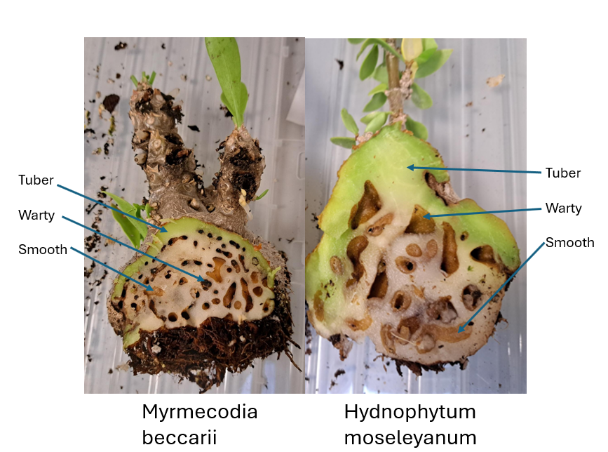

Figure 1. Internal caudex morphology and chamber differentiation in myrmecophytes.
Cross-sections of the tubers of Myrmecodia beccarii (left) and Hydnophytum moseleyanum (right) showing the inner labyrinth systems. Arrows indicate the main structural components: the protective outer tuber tissue, the dark-walled warty chambers utilised for nutrient absorption from ant waste, and the smooth-walled chambers typically utilised by ants for nesting and brood rearing.
Hydnophytinae (Rubiaceae) are epiphytic ant-plants distributed across South-East Asia, New Guinea and the Pacific. All species develop a swollen, tuber-like stem (Domatium) that is naturally hollowed into a network of interconnected chambers (Fig. 1). Some chambers have a smooth lining and serve purely as nesting space for ants, while others are lined with dense, absorptive warty structures known where ants deposit waste, debris and prey remains into these chambers, and the warty tissue absorb the resulting nitrogen and other nutrients directly from the decomposing material, forming the structural basis of the nutritional mutualism (Huxley and Jebb, 1993; Chomicki and Renner, 2015). Species vary widely in how reliant they are on this relationship, and part of their survival is anchoring themselves to trees, however little to no research has been done to say how this has anchoring mechanism functions and remains suggestive in function rather than absolute. Myrmecodia beccarii operates as an obligate mutualist, strictly relying on its symbiotic ant partner (Philidris cordata) for vital nitrogen and nutrient assimilation within nutrient-depleted mangrove habitats (Volp et al., 2022). Stable isotope tracking confirms that this tight nutritional reliance creates an obligate bond necessary for the plant's survival in the wild (Volp et al., 2022). Conversely, Hydnophytum moseleyanum displays a facultative strategy, maintaining a flexible relationship where it interfaces with broad, opportunistic, and unpredictable multi-species ant networks rather than a single specific partner (Jebb, 1991). Phylogenetic and structural mapping across these genera confirms that while M. beccarii represents a highly specialised, derived obligate lineage, H. moseleyanum retains generalist, facultative tendencies that enable it to occupy flexible niches without a strict reliance on a permanent resident colony (Chomicki et al., 2019).
Previous work on the Hydnophytinae has focused mainly on describing this morphological and ecological diversity and on reconstructing its evolutionary history using molecular phylogenetics, establishing the number and direction of transitions between non-myrmecophytic, facultative and obligate states (Chomicki and Renner, 2015; Chomicki and Renner, 2016b; Chomicki and Renner, 2017); however, the genomic, transcriptomic and physiological mechanisms underlying these transitions, remains almost entirely unexplored.
The literature on M. beccarii and H. moseleyanum has received different research focus meaning a comparison of research interests between the two is not possible. Currently, M. beccarii has displayed a high partner specificity with the ant Philidris cordata (Dolichoderinae) (Volp & Lach, 2019) that provides nitrogen directly to M. beccarii (Sommer, 1990). Whereas H. moseleyanum has received focus on its morphology, developmental anatomy, and, often using it as a model for studying specialised, tunnel-filled caudex structures. To date, no study has directly demonstrated the transfer of ant-derived nitrogen into the domatia of H. moseleyanum. Although stable isotope experiments have been conducted on H. moseleyanum by directly injecting 15N-labelled compounds into the domatia to investigate nutrient uptake by the plant. (Huxley, 1978).

1.6 Thesis aims
The key aim of this thesis is to understand the genomic basis of obligate dependence in ant-plant nutritional mutualisms, using Hydnophytum moseleyanum (facultative) and Myrmecodia beccarii (obligate) as a comparative framework. Specifically, I ask: (i) how do nitrogen-based nutritional mutualisms differ between facultative and obligate ant-plants? (ii) can ant-derived nitrogen be experimentally traced into plant tissues? (iii) do patterns of nitrogen gene expression differ between tissue types? (iv) which genes are associated with nitrogen uptake in these mutualisms? (v) how is the expression of these genes altered in the presence of ants, and does this pattern of expression (ant-inducible vs. constitutive) differ between facultative and obligate ant-plants?
To be able to address these questions, I developed a series of resources in two Hydnophytinae ant plants. In Chapter 2, I generated high-quality reference genomes for the facultative Hydnophytum moseleyanum and the obligate Myrmecodia beccarii ant plants, providing the duplication-aware framework needed for orthology assignment and reliable transcriptome mapping, as introduced in Section 1.4. In Chapter 3, I established controlled greenhouse symbioses with ghost ants (Tapinoma melanocephalum) and these two ant-plant species and validated it as a nutritional mutualism using 15N isotope labelling. In Chapter 4, I used these genomic and experimental platforms to run a large-scale manipulation of ant presence and nutrient availability, profiling tissue-specific transcriptomic responses to identify ant-responsive nitrogen pathways and to test whether obligate dependence is associated with more constitutive nitrogen-related expression than facultative dependence. Altogether, this thesis identifies how mutualism function differs between facultative and obligate dependence and identifies a key shift towards reduced plasticity in nitrogen-uptake regulation with the evolution of obligate dependence, paving the way for future work on the genomic and ecological drivers of mutualism stability.

1.7 References
Abrahamczyk, S., Souto-Vilarós, D., and Renner, S.S. (2014). Escape from extreme specialization: passionflowers, bats and the sword-billed hummingbird. Proceedings of the Royal Society B: Biological Sciences, 281, 20140888.
Aslan, C.E., Zavaleta, E.S., Tershy, B., and Croll, D. (2013). Mutualism disruption threatens global plant biodiversity: A systematic review. PLOS ONE, 8(6), e66993.
Azcárate, F.M., and Manzanón, P. (2011). A fable on voracious and gourmet ants: Ant-seed interactions from predation to dispersal. In C. Polidori (Ed.), Predation in the Hymenoptera: An evolutionary perspective (p.245). Transworld Research Network.
de Bary, A. (1879). Die Erscheinung der Symbiose.
Batstone, R.T., Carscadden, K.A., Afkhami, M.E., and Frederickson, M.E. (2018). Using niche breadth theory to explain generalization in mutualisms. Ecology. 99, 1039–50.
Baum, D.A. (2015). A comparison of autogenous theories for the origin of eukaryotic cells. American Journal of Botany, 102(12), 1954–1965.
Bennett, G.M., and Moran, N.A. (2015). Heritable symbiosis: The advantages and perils of an evolutionary rabbit hole. Proceedings of the National Academy of Sciences of the United States of America, 112, 10169–76.
Bonfante, P., and Genre, A. (2010). Mechanisms underlying beneficial plant-fungus interactions in mycorrhizal symbiosis. Nature Communications, 1, 48.
Bronstein, J.L. (2001). The exploitation of mutualisms. Ecology Letters, 4, 277-287.
Bronstein, J.L. (2009). The evolution of facilitation and mutualism. Journal of Ecology, 97,1160–1170.
Bronstein, J.L. (2015). Mutualism. In Bronstein J.L. (Ed.), Mutualism (pp. 1-2) Oxford University Press.
Bronstein, J.L., Alarcón, R., and Geber, M. (2006). The evolution of plant-insect mutualisms. The New Phytologist, 172(3), 412–428.
Chomicki, G., Janda, M., and Renner, S.S. (2017). The assembly of ant-farmed gardens: Mutualism specialization following host broadening. Proceedings of the Royal Society B: Biological Sciences, 284(1850), 20161759.
Chomicki, G., Kadereit, G., Renner, S.S., and Kiers, E.T. (2020a). Trade-offs in the evolution of plant farming by ants. Proceedings of the National Academy of Sciences of the United States of America, 117(5), 2535–2543.
Chomicki, G., Kiers, E.T., and Renner, S.S. (2020b). The Evolution of Mutualistic Dependence. Annual Review of Ecology, Evolution, and Systematics, 51, 409–432.
Chomicki, G., and Renner, S.S. (2015). Phylogenetics and molecular clocks reveal the repeated evolution of ant-plants after the late Miocene in Africa and the early Miocene in Australasia and the Neotropics. The New Phytologist, 207(2), 411–424.
Chomicki, G., and Renner, S.S. (2016a). Obligate plant farming by a specialized ant. Nature Plants, 2, 16181.
Chomicki, G., and Renner, S.S. (2016b). Evolutionary relationships and biogeography of the ant-epiphytic genus Squamellaria (Rubiaceae: Psychotrieae) and their taxonomic implications. PLOS ONE, 11(3), e0151317.
Chomicki, G., and Renner, S.S. (2017). Partner abundance controls mutualism stability and the pace of morphological change over geologic time. Proceedings of the National Academy of Sciences of the United States of America, 114(15), 3951–3956.
Chomicki, G., and Renner, S.S. (2019). Farming by ants remodels nutrient uptake in epiphytes. The New Phytologist, 223(4), 2011–2023.
Chomicki, G., Weber, M., Antonelli, A., Bascompte, J., and Kiers, E.T. (2019). The impact of mutualisms on species richness. Trends in Ecology and Evolution, 34, 698-711.
Davidson, D.W. (1988). Ecological studies of neotropical ant gardens. Ecology, 69, 1138– 1152.
Davidson, D.W., and McKey, D. (1993). The evolutionary ecology of symbiotic ant/plant relationships. Journal of Hymenoptera Research, 2, 13–83.
Dudley, S.A. (2015). Plant cooperation. Annals of Botany Plants, 7, plv113.
EPA. (2022). https://www.epa.gov/coral-reefs/basic-information-about-coral-reefs. Accessed May 2022.
Field, K.J., Pressel, S., Duckett, J.G., Rimington, W.R., and Bidartondo, M.I. (2015). Symbiotic options for the conquest of land. Trends in Ecology and Evolution, 30(8), 477- 486.
Fisher, R.M., Henry, L.M., Cornwallis, C.K., Kiers, E.T., and West, S.A. (2017). The evolution of host-symbiont dependence. Nature Communications, 8, 15973.
Frederickson, M.E. (2005). Ant species confer different partner benefits on two neotropical myrmecophytes. Oecologia, 143(3), 387–395.
Frederickson, M.E., and Gordon, D.M. (2007). The devil to pay: A cost of mutualism with Myrmelachista schumanni ants in 'devil's gardens' is increased herbivory on Duroia hirsuta trees. Proceedings of the Royal Society B: Biological Sciences, 274(1613), 1117–1123.
Fukatsu, T., and Ishikawa, H. (1996). Phylogenetic position of yeast-like symbiont of Hamiltonaphis styraci (Homoptera, Aphididae) based on 18S rDNA sequence. Insect Biochemistry and Molecular Biology, 26, 383–388.
Gatehouse, J.A. (2002). Plant resistance towards insect herbivores: A dynamic interaction. The New Phytologist, 156(2), 145–169.
Gay, H. (1993). Animal-fed plants: An investigation into the uptake of ant-derived nutrients by the far-eastern epiphytic fern Lecanopteris Reinw. (Polypodiaceae). Biological Journal of the Linnean Society, 50, 221–23.
Hale, K., and Valdovinos, F.S. (2021). Ecological theory of mutualism: Robust patterns of stability and thresholds in two-species population models. Ecology and Evolution, 11(24), 17651–17671.
Heil, M., Barajas-Barron, A., Orona-Tamayo, D., Wielsch, N., and Svatoš, A. (2014). Partner manipulation stabilises a horizontally transmitted mutualism. Ecology Letters. 17, 185– 92.
Heil, M., Fiala, B., Baumann, B., and Linsenmair, K.E. (2000). Temporal, spatial and biotic variations in extrafloral nectar secretion by Macaranga tanarius. Functional Ecology, 14, 749–757.
Heil, M., Hilpert, A., Krüger, R., and Linsenmair, K. (2004). Competition among visitors to extrafloral nectaries as a source of ecological costs of an indirect defence. Journal of Tropical Ecology, 20(2), 201-208.
Heil, M., Orona-Tamayo, D., Eilmus, S., Kautz, S., and González-Tauber, M. (2010). Chemical communication and coevolution in an ant–plant mutualism. Chemoecology, 20, 63–74.
Heil, M., and Silva Bueno, J.C. (2007). Within-plant signaling by volatiles leads to induction and priming of an indirect plant defense in nature. Proceedings of the National Academy of Sciences of the United States of America, 104(13), 5467–5472.
Hughes, L., and Westoby, M. (1992). Effect of diaspore characteristics on removal of seeds adapted for dispersal by ants. Ecology, 73(4), 1300-1312.
Huxley, C.R., and Jebb, M.H.P. (1991a). The tuberous epiphytes of the Rubiaceae 1: A new subtribe — The Hydnophytinae. Blumea: Biodiversity, Evolution and Biogeography of Plants, 36(1), 1–20.
Huxley, C.R., and Jebb, M.H.P. (1991c). The tuberous epiphytes of the Rubiaceae 3: A revision of Myrmephytum to include Myrmedoma. Blumea: Biodiversity, Evolution and Biogeography of Plants, 36(1), 43-52.
Huxley, C.R., and Jebb, M.H.P. (1993). The tuberous epiphytes of the Rubiaceae 5: A revision of Myrmecodia. Blumea: Biodiversity, Evolution and Biogeography of Plants, 37(2), 271-334.
Janzen, D.H. (1985). The natural history of mutualism. In D.H. Boucher (Ed.), The Biology of Mutualism (pp. 40-99). Oxford University Press.
Jebb, M.H.P., and Huxley, C.R. (2019). The tuberous epiphytes of the Rubiaceae 7: A revision of the genus Hydnophytum. Blumea: Biodiversity, Evolution and Biogeography of Plants, 64(1), 23-91.
Kaufmann, E., and Maschwitz, U. (2006). Ant-gardens of tropical Asian rainforests. Science, 93(5), 216–227.
Kiers, E.T., Palmer, T.M., Ives, A.R., Bruno, J.F., and Bronstein, J.L. (2010). Mutualisms in a changing world: an evolutionary perspective. Ecology Letters, 13(12), 1459–1474.
Klinger, C.R., Lau, J.A., and Heath, K.D. (2016) Ecological genomics of mutualism decline in nitrogen-fixing bacteria, Proceedings of the Royal Society B: Biological Sciences, 283(1826), 20152563.
Kobayashi, S., Asai, T., Fujimoto, Y., and Kohshima, S. (2008). Anti-herbivore structures of Paulownia tomentosa: Morphology, distribution, chemical constituents and changes during shoot and leaf development. Annals of Botany Plants, 101, 1035–1047.
Lahti, D.C., Johnson, N.A., Ajie, B.C., Otto, S.P., Hendry, A.P., Blumstein, D.T., Coss, R.G., Donohue, K., and Foster, S.A. (2009). Relaxed selection in the wild. Trends in Ecology and Evolution, 24(9), 487–496.
Leal, L.C., Lima Neto, M.C., de Oliveira, A.F., Andersen, A.N., and Leal, I.R. (2013). Myrmecochores can target high-quality disperser ants: variation in elaiosome traits and ant preferences for myrmecochorous Euphorbiaceae in Brazilian Caatinga. Oecologia. 174, 493–500.
Leigh, E.G. (2010). The evolution of mutualism, Journal of Evolutionary Biology, 23(12), 2507–2528.
Lengyel, S., Gove, A.D., Latimer, A.M., Majer, J.D., and Dunn, R.R. (2010). Convergent evolution of seed dispersal by ants, and phylogeny and biogeography in flowering plants: A global survey. Perspectives in Plant Ecology. Evolutionary Systematics, 12(1), 43-55.
Linsenmair, K.E., Heil, M., Kaiser, W.M., Fiala, B., Koch, T., and Boland, W. (2001). Adaptations to biotic and abiotic stress: Macaranga-ant plants optimize investment in biotic defence. Journal of Experimental Botany, 52(363), 2057–2065.
Marini-Filho, Onildo J. (1999). Distribution, composition, and dispersal of ant gardens and tending ants in three kinds of central Amazonian habitats. Tropical Zoology, 12(2), 289– 296.
McCutcheon, J.P., Boyd, B.M., and Dale, C. (2019). The Life of an insect endosymbiont from the cradle to the grave. Current Biology, 29(11), R485–R495.
McCutcheon, J.P., Garber, A.I., Spencer, N. and Warren, J.M. (2024) How do bacterial endosymbionts work with so few genes? PLOS Biology, 22, 1–16.
McCutcheon, J.P., and Moran, N.A. (2012) Extreme genome reduction in symbiotic bacteria, Nature Reviews Microbiology, 10(1), 13–26.
McIntire, E.J.B., and Fajardo, A. (2014). Facilitation as a ubiquitous driver of biodiversity. The New Phytologist, 201, 403–416.
Mondor, E.B., and Addicott, J.F. (2003). Conspicuous extra-floral nectaries are inducible in Vicia faba. Ecology Letters, 6, 495–497.
Moreau, C.S., Bell, C.D., Vila, R., Archibald, S.B., and Pierce, N.E. (2006). Phylogeny of the ants: Diversification in the age of angiosperms. Science, 312(5770), 101-104.
Mueller, U.G., Gerardo, N.M., Aanen, D.K., Six, D.L., and Schultz, T.R. (2005). The evolution of agriculture in insects. Annual Review of Ecology, Evolution, and Systematics, 36, 563– 595.
Nelsen, M.P., Ree, R.H., and Moreau, C.S. (2018). Ant-plant interactions evolved through increasing interdependence. Proceedings of the National Academy of Sciences of the United States of America, 115(48), 12253–12258.
Nygaard, S., Hu, H., Li, C., Schiøtt, M., Chen, Z., Yang, Z., Xie, Q., Ma, C., Deng, Y., Dikow, R. B., Rabeling, C., Nash, D.R., Wcislo, W.T., Brady, S.G., Schultz, T.R., Zhang, G., and Boomsma, J.J. (2016). Reciprocal genomic evolution in the ant-fungus agricultural symbiosis. Nature Communications, 7, 12233.
Oliver, K.M., Russell, J.A., Moran, N.A., and Hunter, M.S. (2003). Facultative bacterial symbionts in aphids confer resistance to parasitic wasps. Proceedings of the National Academy of Sciences of the United States of America, 100, 1803–7.
Ollerton, J., Winfree, R., and Tarrant, S. (2011). How many flowering plants are pollinated by animals?, Oikos, 120(3), 321-326.
Palmer, T. M. (2023). Acacia ants, Current Biology, 33(11), R469–R471.
Peay KG. (2016). The mutualistic niche: Mycorrhizal symbiosis and community dynamics. Annual Review of Ecology, Evolution, and Systematics, 47, 143–64.
Pennisi, E. (2003). Evolutionary biology. On ant farm, a threesome coevolves, Science, 299(5605), 325.
Richardson, D.M., Allsopp, N., D'Antonio, C.M., Milton, S.J., and Rejmánek, M. (2000). Plant invasions: The role of mutualisms. Biological Reviews, 75(1), 65–93.
Sørensen, M., Lowe, C.D., Minter, E., Wood, A.J., Cameron, D.D., and Brockhurst, M.A. (2019). The role of exploitation in the establishment of mutualistic microbial symbioses. FEMS Microbiology Letters, 366(12), fnz148.
Tepe, E.J., Vincent, M.A., and Watson, L.E. (2007). Stem diversity, cauline domatia, and the evolution of ant–plant associations in Piper sect. Macrostachys (Piperaceae). American Journal of Botany, 94, 1– 11.
Tong, Z.Y., Wu, L.Y., Feng, H.H., Zhang, M., Armbruster, W.S., Renner, S.S., and Huang, S.Q. (2023). New calculations indicate that 90% of flowering plant species are animal pollinated. National Science Review, 10(10), nwad219.
Treseder, K.K., Davidson, D.W., and Ehleringer, J.R. (1995). Absorption of ant-provided carbon dioxide and nitrogen by a tropical epiphyte. Nature. 375(6527), 137–139.
Uthanumallian, K., Iha, C., Repetti, S.I., Chan, C.X., Bhattacharya, D., Duchene, S., and Verbruggen, H. (2022). Tightly constrained genome reduction and relaxation of purifying selection during secondary plastid endosymbiosis. Molecular Biology Evolution, 39(1), msab295.
Vannette, R. L., and Fukami, T. (2018). Contrasting effects of yeasts and bacteria on floral nectar traits. Annals of Botany Plants, 121(7), 1343–1349.
War, A.R., Paulraj, M.G., Ahmad, T., Buhroo, A.A., Hussain, B., Ignacimuthu, S., and Sharma, H.C. (2012). Mechanisms of plant defense against insect herbivores. Plant Signaling and Behavior, 7(10), 1306–1320.
Weber, M.G., and Keeler, K.H. (2013). The phylogenetic distribution of extrafloral nectaries in plants. Annals of Botany Plants, 111(6), 1251–1261.
Wernegreen, J.J. (2012). Endosymbiosis. Current. Biology, 22(14), R555–R561.
Wright, G.A., Baker, D.D., Palmer, M.J., Stabler, D., Mustard, J.A., Power, E.F., Borland, A.M., and Stevenson, P.C. (2013). Caffeine in floral nectar enhances a pollinator’s memory of reward. Science, 339, 1202–4.
Wyatt, G.A., Kiers, E.T., Gardner, A., and West, S.A. (2016). Restricting mutualistic partners to enforce trade reliance. Nature Communications, 7, 10322.

Chapter 2. Building the whole genome framework for the study of experimental ant-plant symbioses

Chapter 2. Building the whole genome framework for the study of experimental ant-plant symbioses

George Hirons-Alecrim, Luke T. Dunning¹, and Guillaume Chomicki²

Author Affiliations:
¹Ecology and Evolutionary Biology, School of Biosciences, University of Sheffield, Western Bank, Sheffield, S10 2TN, UK.
²Department of Biosciences, Durham University, South Rd, Durham, DH1 3LE, UK.

Personal contribution: I designed and conducted all experiments, performed data analysis, and wrote each chapter draft under the supervision of Guillaume Chomicki and Luke Dunning who provided conceptual guidance, and manuscript revisions.

2.1 Abstract
This thesis aims to understand how mutualistic function, in particular nutrition, differs with the dependence of the partnership, using Hydnophytinae ant-plants as a model system. This required us to develop experimental symbioses with plants having different degrees of mutualistic dependence, and that could be experimentally manipulated in greenhouse environments. To analyse the transcriptomic responses, an essential step was the development of a genomic resource This chapter reports the high-quality reference genomes for two closely related ant plants that differ in their degree of dependence on ant partners, Hydnophytum moseleyanum (Facultative) and Myrmecodia beccarii (Obligate). Using PacBio HiFi data, we generated highly contiguous de novo assemblies for both species (contig N50 ~55-70 Mb) and produced gene predictions with a consistent annotation pipeline. Genome completeness was high in both references with a completeness of 98.9% for H. moseleyanum and 98.2% for M. beccarii. For H. moseleyanum, the initial assembly showed extensive redundancy, reflected by inflated assembly size and a high proportion of duplicated BUSCOs; iterative redundancy purging substantially reduced haplotig/allelic duplication while maintaining completeness, yielding a compact assembly suitable for downstream analyses. K-mer spectra modelling further supported contrasting genomic architectures between the two species, consistent with a tetraploid genome signature in H. moseleyanum and a diploid signature in M. beccarii, underscoring the importance of duplication-aware interpretation when comparing gene content and expression. Together, these genome resources provide a robust foundation for read mapping, orthology inference, and candidate gene identification in subsequent chapters, enabling tissue-resolved transcriptomic analyses of nitrogen acquisition and regulation at the ant-plant interface.

2.2 Introduction
Ant-plant symbioses are classic examples of mutualistic interactions in which plants provide nesting space (domatia) and, sometimes, nutritional rewards, while ants contribute defensive services or/and enhance host nutrition through deposition of waste, prey remains, and other organic material in or near plant tissues (Huxley, 1980; Heil and McKey, 2003; Rico-Gray and Oliveira; Chomicki and Renner, 2015). These associations span a continuum from facultative interactions, where plants are frequently unoccupied or can persist without ants, to highly specialised and obligate systems in which plant development, reproduction, or survival slightly linked to a narrow set of ant partners (Heil and McKey, 2003; Chomicki and Renner, 2015; Chomicki and Renner, 2017; Chomicki et al., 2020). While we know that ant-plant systems vary in their levels of dependence, with facultative versus obligate systems, the drivers of obligate dependence, and the functional differences across dependence are poorly known. Understanding this requires comparing facultative and obligate systems, experimentally manipulating key mutualistic parameters, and quantifying transcriptomic responses to link regulatory change to function.
A major radiation of epiphytic ant-plants occurs in the Rubiaceae subtribe Hydnophytinae, which includes the genera Hydnophytum, Myrmecodia, Myrmephytum, Anthorrhiza and Squamellaria (Huxley, 1978; Huxley and Jebb, 1991; Chomicki and Renner, 2017). In these taxa, seedlings develop a swollen hypocotyl/tuber that differentiates into a system of internal chambers that can house ant colonies. These symbioses are primarily nutritional, consistent with the epiphytic habitat where access to soil is limited. Thus, ant-derived inputs can represent a major nitrogen source, and experimental evidence indicates that plants can incorporate nitrogen originating from their inhabitants in their natural environment (Huxley, 1978; Chomicki and Renner, 2019; Volp, et al. 2022). Inside the domatium, chamber morphology is functionally differentiated, with smooth-walled chambers typically used for the brood, and darker, rough-walled chambers are frequently used as “waste chambers” where ants deposit debris and excreta (Huxley, 1978). However, this differentiation is only complete in obligate ant-plants that form specialised mutualistic symbioses with Dolichoderinae ants from the genera Philidris and Anonychomyrma (Chomicki and Renner, 2019). Across the Hydnophytinae, evolutionary transitions among mutualistic strategies – generalist associations, specialised associations, and autonomy – have occurred repeatedly, and mutualism breakdown is linked to ecological contexts in which effective ant partners are rare (Chomicki and Renner, 2015; Chomicki and Renner, 2017). This natural variation makes Hydnophytinae a strong comparative framework for identifying the genomic and regulatory features associated with ecological dependence.
The patterns of nutrient release (the frequency and location of ant waste deposition) are fundamentally defined by the level of dependence within the symbiosis. In obligate farming symbioses, the relationship is highly specialised and predictable; specialised ant partners actively deposit waste products directly onto hyper absorptive warty tissues located within the plant's domatia, resulting in a consistent and targeted pattern of nutrient release that provides the plant with a reliable supply of nitrogen (Chomicki and Renner, 2016, 2019). In contrast, facultative symbioses involve generalist ants that lack these targeted deposition behaviours. In these systems, the pattern of nutrient provisioning is spatially and temporally inconsistent, as it relies on the sporadic occupancy and irregular waste disposal of the ants. This biological distinction suggests that the level of symbiotic dependence dictates whether a plant utilises a steady or an opportunistic nutrient uptake strategy. Specifically, the morphological and physiological differences of obligate versus facultative Hydnophytinae inner domatium walls suggests distinct molecular behaviour of nutrient-related genes. The consistent release of nutrients exclusively in warty-wall cavities (Chomicki and Renner, 2019) could be associated with constitutive expression of the nutrient uptake toolkit, while the spatial and temporal variation in the nutrient provisioning inside the domatia of facultative ant plants could be associated with inducible expression.
Robust inference about gene content and regulation depends on genomic resources. For non-model plants, de novo reference genomes provide the scaffold needed to (i) anchor transcriptomic analyses to well-supported gene models, (ii) distinguish true copy-number differences from assembly artefacts, and (iii) enable orthology-based comparisons across taxa (Rhoads and Au, 2015; Cheng et al., 2021). Long-read sequencing has been particularly transformative for plant genomes because it improves assembly contiguity across repeats and complex regions and supports haplotype-aware assembly approaches that are essential when heterozygosity or polyploidy complicate short-read assemblies (Rhoads and Au, 2015; Cheng et al., 2021). At the same time, long-read assemblies of such genomes can retain redundant haplotypes or allelic contigs, making explicit evaluation of assembly completeness and redundancy a necessary part of resource generation (Simão et al., 2015). Reference-free profiling based on k-mer spectra provides a complementary route to infer genome properties such as heterozygosity and ploidy structure, which directly inform assembly strategy and interpretation (Ranallo-Benavidez et al., 2020).
In this chapter, we generate and describe high-contiguity long-read genome assemblies and annotations for two closely related Hydnophytinae ant-plants, the generalist and facultative Hydnophytum moseleyanum and the obligate Myrmecodia beccarii and plants. The core objective of this chapter is to establish a reliable genomic foundation that can support downstream analyses of ant-responsive transcriptional programmes and nutrient physiology in the subsequent Chapters. The resulting assemblies, gene models, and functional annotations provide the essential substrate for the transcriptomic analyses developed later, where questions of inducible versus constitutive nutrient-related responses to ant occupation can be tested in a gene-aware and orthology-aware framework.

2.3 Materials and methods

2.3.1 Sampling and high molecular weight DNA extraction
The Macherey-Nagel Nucleobond HMW DNA Kit was employed for the extraction of high molecular weight (HMW) DNA from Hydnophytum moseleyanum and Myrmecodia beccarii. Young leaves were collected and flash-frozen in liquid nitrogen and kept in a -80℃ freezer prior to extraction. Young leaves were selected to minimise secondary metabolites, maximising nuclear density and ensuring the high-purity HMW DNA required for PacBio HiFi sequencing. They were then ground up using a pestle and mortar, prior to DNA extraction. Quality control assessments, including quantification, purity evaluation, and size distribution analysis, were conducted following the manufacturer’s protocol to ensure the integrity and suitability of the extracted DNA for PacBio HiFi sequencing.

2.3.2 Genome sequencing
Whole genome sequence data was generated from Hydnophytum moseleyanum and Myrmecodia beccarii PacBio High-Fidelity (HiFi) sequencing a cutting-edge DNA sequencing technology that leverages Single Molecule, Real-Time (SMRT) sequencing to produce highly accurate long reads, known as HiFi reads (Rhoads and Au, 2015). High-molecular-weight genomic DNA from both species was sequenced using PacBio’s Single Molecule Real-Time (SMRT) long-read Sequel II platform, with library preparation and sequencing carried at the Centre for Genomic Research, University of Liverpool. Each species was sequenced to an approximate 40× genome coverage, ensuring comparable depth across taxa for downstream assembly and comparative analyses.

2.3.3 Genome assembly
HiFi were assembled using HiFiASM v0.16.1 (Cheng et al., 2021), a haplotype-resolved assembler optimised for accurate long-read data. Genome contamination was assessed based on blobtoolkit2/3.1.6 (Challis et al., 2020). Assembly contiguity was summarised using standard metrics (contig N50 and contig counts). Raw sequencing reads were processed and assembled using the --n-hap 4 parameter for H. moseleyanum and --n-hap 2 parameter for M. beccarii provided by the software developers, to account for differences in ploidy between H. moseleyanum and M. beccarii (see Results). The completeness of the assembled genomes were assessed using BUSCO 5.5.0 (Simão et al., 2015), a tool for benchmarking the completeness of genome assemblies. The Benchmarking Universal Single-Copy Orthologs (BUSCO) analysis was conducted with embryophyta_odb10 to evaluate the presence of a conserved set of single copy orthologous genes within the assembled genome.

2.3.4 Flow Cytometry Analysis
Young leaf tissue was finely chopped together with an internal reference standard in a chilled isolation buffer to release intact nuclei. The suspension was filtered through a nylon mesh, treated with RNase, and stained the nuclei with propidium iodide. We measured the fluorescence intensities using a flow cytometer, recording at least 5,000 nuclei per sample. (Royal Botanic Gardens, Kew, unpublished protocol).

2.3.5 GenomeScope Analysis
We performed a reference-free k-mer analysis using raw high-throughput sequencing reads to independently estimate genome metrics. We generated a k-mer count histogram (k=21) using Jellyfish and uploaded the frequency distribution file to GenomeScope 2.0 to model the genome profile. We evaluated the resulting distribution to quantify the total haploid genome length, repeat content, and nucleotide heterozygosity (Ranallo-Benavidez et al., 2020).

2.3.6 Reducing Genome Redundancy
To reduce redundancy in the assembled genome and generate a more accurate haploid representation, we used purge_dups v1.2.5 (Guan et al., 2020). PacBio HiFi reads were first aligned to the HiFiASM-assembled primary contigs using minimap2 v2.2.24 with the -x map-hifi preset. The resulting BAM file was used to calculate read-depth statistics (pbcstat) and to estimate cutoff values for distinguishing haploid and diploid regions (calcuts). The genome assembly was then split into smaller sequences (split_fa), and duplicated regions were identified (purge_dups) and removed (get_seqs) based on depth and alignment patterns. The final assemblies for both species were produced without purging duplicates (purge level 0), as assessed across a range of purge levels (0.05–0.3). This decision was based on the clear redundancy–completeness trade-off observed: aggressive purging caused significant loss of authentic gene content, while the unpurged assembly retained full BUSCO completeness. Given that the primary aim of this chapter is to support duplication-aware downstream analyses including classification of whole-genome duplication events retaining the full duplicate complement in the assembly is biologically justified and analytically necessary (see Results, section 2.4.4).

2.3.7 Candidate Nitrogen gene confirmation
Following initial functional annotation, BLAST searches were performed on candidate sequences to verify the specific types of nitrogen-related genes involved. We performed BLAST searches against reference databases to identify homologous sequences, annotate predicted genes, and assess potential contamination in the genome assembly. BLASTn v2.16.0 (Altschul et al., 1990) was used to compare nucleotide sequences against an NCBI database of nucleotide sequences. The tool identifies regions of similarity (local alignments) between the query sequence and sequences in the database, based on statistical significance scores. Searches were interpreted using standard alignment statistics (E-values and percent identity) to support downstream annotation and quality control.

2.3.8 Gene Prediction
To predict genes in the genomes, we relied on the deep learning-based software Helixer_v0.3.2 (Stiehler et al., 2021). This deep learning-based approach facilitated accurate and comprehensive gene predictions, crucial for comparative genomic analyses between the two species.

2.3.9 Functional Annotation
To functionally annotate predicted protein-coding genes, we used InterProScan v5.73-104.0, which integrates diverse protein signature recognition methods from multiple databases, including Pfam, TIGRFAM, SMART, Gene3D, and PANTHER (Jones et al., 2014). Input protein sequences were derived from the translated gene models identified during gene prediction.

2.3.10 Characterisation of Gene Duplication
To characterise patterns of gene duplication in H. moseleyanum and M. beccarii, we used DupGen_finder (Qiao et al., 2019) to classify duplicated genes by duplication mode. DupGen_finder infers duplicate relationships from sequence similarity and genome collinearity and assigns duplicates to categories such as whole genome/segmental (WGD), tandem, proximal, transposed, and dispersed duplication. Analyses were performed using the predicted protein-coding gene models and their genomic coordinates from the final assemblies, and summary counts of each duplication class were used for comparisons between species.

2.4 Results

2.4.1 Genome size estimation and ploidy
Flow cytometry analysis revealed an empirical genome size of 3.81 Gb for H. moseleyanum, whereas Hifiasm estimated an assembled size of 3.12 Gb. The assembly therefore recovers 81.9% of the true empirical genome size, capturing over four-fifths of the total sequence. Because the Hifiasm assembly exceeds 80% recovery, it is highly complete and well-positioned close to a chromosome-level assembly; the remaining ~18.1% of unassembled sequence likely corresponds to highly repetitive or polyploid regions that are notoriously difficult for assembly algorithms to resolve without additional long-range scaffolding data.
To assess genome size and infer ploidy in each species, we analysed k-mer frequency spectra using GenomeScope (Ranallo-Benavidez et al., 2020). For H. moseleyanum, the GenomeScope plot suggests that the genome may be tetraploid (Fig. 2). This is inferred from the presence of multiple peaks in the k-mer coverage distribution, with a primary peak at approximately 17× coverage, a secondary peak at around 34×, and a subtle shoulder between 50×–60×. Such peak patterns are consistent with polyploid genomes, in particular autotetraploids, organisms with four identical chromosome sets arising from duplication of a single species' genome, or allotetraploids, organisms with differing chromosomal sets arising from the hybridisation and genome doubling of two distinct ancestral species. The relatively low heterozygosity value (ab: 6.36%) could suggest an autotetraploid that has undergone extensive diploidisation over time, or more likely reflects an allotetraploid structure where low variation remains within the fixed subgenomes.

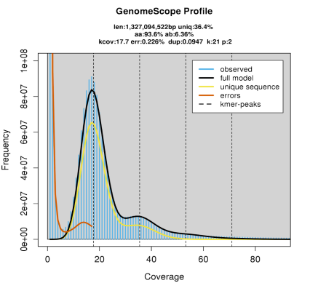

Figure 2. GenomeScope k-mer frequency spectrum for H. moseleyanum, showing k-mer coverage (x-axis) versus frequency (y-axis).
Flow cytometry analysis revealed an empirical genome size of 1.56 Gb for M. beccarii, whereas Hifiasm estimated an assembled size of 1.40 Gb, representing 89.7% recovery of the true genome. The small missing fraction (~10%, 0.16 Gb) likely represents highly condensed repetitive heterochromatic regions or centromeric repeats that are difficult for assembly algorithms to resolve. The M. beccarii assembly is therefore exceptionally complete and positioned very close to a chromosome-level architecture, requiring minimal targeted scaffolding to achieve full chromosomal resolution.
In contrast, the GenomeScope plot for M. beccarii indicates that the genome is likely diploid (Fig. 3). This is supported by the presence of a single dominant k-mer peak at around 41× coverage, with a smaller secondary hump appearing at approximately 82× close to double the coverage of the main peak. This pattern is indicative of diploid genomes, where the primary peak represents heterozygous k-mers and the secondary peak represents homozygous k-mers. The summary also supports diploidy with p:2, explicitly indicating a diploid model was used. Additionally, the heterozygosity level (ab: 9.52%) is consistent with a diploid genome that has moderate allelic variation. There is no clear evidence of additional peaks at 3× or 4× coverage intervals, which would be expected in polyploid genomes. Overall, the tight peak structure and the GenomeScope model output strongly support a diploid genome.
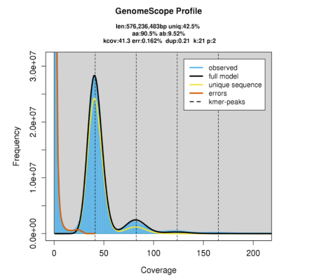

Figure 3. GenomeScope k-mer frequency spectrum for M. beccarii, showing k-mer coverage (x-axis) versus frequency (y-axis).

2.4.2 Genome assembly of Hydnophytum moseleyanum and Myrmecodia beccarii
The initial H. moseleyanum assembly generated using Hifiasm resulted in a genome size of approximately 3.12 Gb across 166 contigs, with an N50 of 55.4 Mb (Table 1). Following the first round of duplication purging, the genome size reduced slightly to 3.05 Gb and the number of contigs dropped to 100. A second round of Purge Dups substantially reduced the assembly size to 1.64 Gb and the number of contigs to 42, while increasing the N50 to 69.6 Mb, suggesting effective removal of redundant haplotypic sequences. Across all stages, the maximum contig length remained constant (~88.7 Mb), and no ambiguous bases (Ns) were introduced. GC content was consistent at ~34.07–34.09%.
Table 1. Assembly statistics for H. moseleyanum and 2 rounds of purge dups.
Assembly | Hifiasm | Purge dups rnd1 | Purge dups rnd2
Genome length (bp) | 3118793973 | 3048079284 | 1644526057
Scaffold Max length | 88688367 | 88688367 | 88688367
Scaffold Min length | 17327 | 25254 | 25254
Num contigs | 166 | 100 | 42
n50 | 55397957 | 55563477 | 69625299
GC percentage | 34.07% | 34.08% | 34.09%

The genome assembly of M. beccarii using Hifiasm produced an initial assembly size of approximately 1.36 Gb distributed across 161 contigs, with a contig N50 of 57.3 Mb (Table 2). Application of Purge Dups in two successive rounds resulted in minimal changes to the total genome size and N50, suggesting that the assembly was already relatively non-redundant. After the first round of purging, the number of contigs dropped to 51, and further reduced to 47 in the second round, indicating some removal of duplicated or low-quality contigs. The maximum contig length remained constant at ~76.7 Mb throughout, while the minimum contig length increased after the first purge. No ambiguous bases (Ns) were present in any assembly stage, and GC content remained stable at ~34.06–34.09%.
Table 2. Assembly statistics for M. beccarii and 2 rounds of purge dups.
Assembly | Hifiasm | Purge dups rnd1 | Purge dups rnd2
Genome length (bp) | 1359451153 | 1354062121 | 1353916013
Scaffold Max length | 76687565 | 76687565 | 76687565
Scaffold Min length | 7735 | 20817 | 20817
Num contigs | 161 | 51 | 47
n50 | 57284104 | 57284104 | 57284104
GC percentage | 34.09% | 34.06% | 34.06%

2.4.3 Hydnophytum moseleyanum and Myrmecodia beccarii genome completeness
BUSCO assessment was performed to evaluate genome completeness for H. moseleyanum (Table 3) and M. beccarii (Table 4). The genome of H. moseleyanum exhibited a high level of completeness, with 98.9% of BUSCOs identified as complete, of which 94.4% were duplicated and only 4.5% were single-copy. Fragmented and missing BUSCOs represented just 0.5% and 0.6%, respectively, out of a total of 1,614 BUSCO groups searched. Similarly, the M. beccarii genome showed strong completeness with 98.2% complete BUSCOs, though in contrast to H. moseleyanum, a majority (82.2%) were single-copy and only 16.0% were duplicated. Fragmented and missing BUSCOs accounted for 0.9% each. These results indicate both genomes are of high quality and completeness with H. moseleyanum showing more duplicated orthologs, potentially reflecting recent gene duplications or assembly artifacts.
Table 3. BUSCO assessment summary of genome completeness in H. moseleyanum.
Compact summary | C:98.9%[S:4.5%,D:94.4%],F:0.5%,M:0.6%,n:1614
Metric | Count | Percentage
Complete BUSCOs (C) | 1597 | 98.90%
Complete and single-copy (S) | 73 | 4.50%
Complete and duplicated (D) | 1524 | 94.40%
Fragmented BUSCOs (F) | 8 | 0.50%
Missing BUSCOs (M) | 9 | 0.60%
Total BUSCO groups searched | 1614 | -

Table 4. BUSCO assessment summary of genome completeness in M. beccarii.
Compact summary | C:98.2%[S:82.2%,D:16.0%],F:0.9%,M:0.9%,n:1614
Metric | Count | Percentage
Complete BUSCOs (C) | 1585 | 98.20%
Complete and single-copy (S) | 1327 | 82.20%
Complete and duplicated (D) | 258 | 16.00%
Fragmented BUSCOs (F) | 14 | 0.90%
Missing BUSCOs (M) | 15 | 0.90%
Total BUSCO groups searched | 1614 | -

2.4.4. Genome duplication purge
To reduce assembly redundancy and quantify the trade-off between removing haplotigs/allelic duplicates and retaining genuine gene content, we applied purge_dups across a range of purge levels and assessed each output with BUSCO (Table 5) for H. moseleyanum. As purge level increased, both assembly size and the proportion of duplicated BUSCOs declined, consistent with progressive removal of highly similar sequences. The unpurged assembly was 3.12 Gb and showed extremely high duplication (94.4% duplicated BUSCOs). With moderate purging, the assembly became substantially more compact while remaining highly complete; for example, at purge level 0.1, duplicated BUSCOs dropped to 18.2% and assembly size to 1.77 Gb, with completeness remaining high (98.1%). In contrast, the most aggressive purging (0.05) further reduced duplicated BUSCOs to 8.4% but also caused a marked loss of completeness (78.2%), indicating removal of authentic gene content alongside redundant sequences. Based on these results, the unpurged assembly was selected as the final genome for downstream analyses. The unpurged assembly retains the full duplicate complement, which is analytically necessary for duplication-mode classification and comparison of gene family evolution between species. Although this results in a larger assembly with high BUSCO duplication, the high overall completeness (98.9%) confirms that the gene space is comprehensively represented. Overall, these results highlight a clear redundancy–completeness trade-off, with intermediate purge levels (0.1–0.2) providing the best compromise if a haploid-collapsed assembly were required.
Table 5. Changes in assembly size and duplicated BUSCO proportion across purge levels in H. moseleyanum.
Purge level | Genome size (bp) | BUSCO summary
Original | 3,118,793,973 | C:98.9%[S:4.5%,D:94.4%],F:0.5%,M:0.6%,n:1614
0.3 | 3,046,647,621 | C:98.4%[S:23.3%,D:75.1%],F:0.6%,M:1.0%,n:1614
0.2 | 2,858,777,548 | C:98.3%[S:45.0%,D:53.3%],F:0.6%,M:1.1%,n:1614
0.1 | 1,770,470,185 | C:98.1%[S:79.9%,D:18.2%],F:0.7%,M:1.2%,n:1614
0.05 | 1,349,967,591 | C:78.2%[S:69.8%,D:8.4%],F:2.9%,M:18.9%,n:1614

Purge level indicates the stringency of haplotig/duplicate removal during genome purging, with lower values representing more aggressive removal of duplicated sequences. BUSCO summary: C = complete BUSCOs, S = single-copy, D = duplicated), F = fragmented, M = missing, and n = total BUSCOs assessed.

2.4.5 Gene Prediction Results Using Helixer
The Helixer gene prediction of H. moselyanum genome resulted in a comprehensive set of gene models with a total of 68,996 genes predicted. The average gene length was estimated to be 4,021 base pairs (bp), while the average number of exons per transcript was approximately 6. Gene prediction of the M. beccarii genome identified a total of 38,722 protein-coding genes. The average gene length was estimated to be 3,840 bp. Additionally, transcripts had an average oof 5.95exons per transcript, suggesting a moderate level of transcript complexity in this genome.

2.4.6 Duplication types in Hydnophytum moseleyanum and Myrmecodia beccarii
To characterise the evolutionary processes contributing to gene copy-number variation, we classified duplicated genes by duplication mode using DupGen_finder. In H. moseleyanum, (Table 6) duplicates were dominated by putative whole-genome/segmental duplications (WGD), which comprised 54,086 genes forming 64,657 duplicate pairs, indicating extensive retention of duplicated content.
Dispersed duplications were also abundant (49,190 genes; 45,882 pairs), consistent with a major contribution of non-local duplications to the genome’s duplicate complement. Transposed duplications involved 5,950 genes (7,379 pairs), suggesting ongoing duplication associated with gene relocation. In contrast, proximal and tandem duplications were comparatively rare, comprising 2,223 genes (2,386 pairs) and 1,729 genes (2,161 pairs), respectively.
Overall, WGD and dispersed duplications represent the predominant sources of duplicate genes in H. moseleyanum. Within a focused set of nitrogen-uptake candidates, duplication-mode classification indicates that the ammonium transporter loci Hm_AMT1 and Hm_AMT2 fall within the WGD/segmental duplicate class. The duplication-mode algorithm grouped these two loci into this class based on their preservation across separate, multi-gene genomic blocks, distinguishing them from single-gene transposition events. Several high-affinity nitrate uptake candidates (Hm_NAR21–Hm_NAR23), annotated as NAR2/NRT3-like partner proteins required for NRT2-mediated transport and were also classified as WGD/segmental duplicates in our duplication-mode analysis.

Table 6. Number of genes and their duplication type in H. moseleyanum.
Gene Count | H. moseleyanum Duplication type
49190 | Dispersed genes
2223 | Proximal genes
1729 | Tandem genes
5950 | Transposed genes
54086 | Wgd genes
45882 | Dispersed pairs
2386 | Proximal pairs
2161 | Tandem pairs
7379 | Transposed pairs
64657 | Wgd pairs

In M. beccarii, duplicated genes were distributed across multiple duplication classes (Table 7). Dispersed duplications were the most abundant, comprising 29,829 genes forming 25,688 duplicate pairs. Putative WGD/segmental duplicates were also common (18,810 genes; 13,599 pairs), although less prevalent than in H. moseleyanum. Transposed duplications accounted for 6,816 genes (7,358 pairs), consistent with duplication associated with gene relocation. Tandem and proximal duplicates were comparatively infrequent, involving 2,395 genes (2,018 pairs) and 2,894 genes (2,302 pairs), respectively. Overall, dispersed and WGD/segmental duplication represent the principal sources of duplicate genes in M. beccarii, with tandem and proximal duplication contributing more modestly.

Table 7. Number of genes and their duplication type in M. beccarii.
Gene Count | M. beccarii Duplication type
29829 | Dispersed.genes
2894 | Proximal.genes
2395 | Tandem.genes
6816 | Transposed.genes
18810 | Whole genome duplicated genes
25688 | Dispersed pairs
2302 | Proximal.pairs
2018 | Tandem.pairs
7358 | Transposed.pairs
13599 | Whole genome duplicated.pairs

2.5 Discussion

2.5.1 A genomic framework to analyse mutualistic dependence in Hydnophytinae ant-plants
The principal outcome of this chapter is the generation of high-quality reference genomes for Hydnophytum moseleyanum and Myrmecodia beccarii that will underpin downstream transcriptomics analyses in this thesis (Chapter 4) with the experimental ant-plant symbioses established in (Chapter 3). Using PacBio HiFi data, we produced highly contiguous de novo assemblies (contig N50 ~55-70 Mb) with high gene-space completeness (BUSCO ~98–99%). The two genomes differ markedly in duplication architecture: H. moseleyanum shows a strong excess of duplicated BUSCOs in the initial assembly and a k-mer spectrum consistent with a tetraploid-like structure (Fig. 2), whereas M. beccarii shows predominantly single-copy BUSCOs and a diploid-like k-mer profile (Fig. 3). Iterative redundancy purging in H. moseleyanum substantially reduced assembly inflation while retaining high completeness at intermediate settings, yielding a compact, analysis-ready reference. Together, these curated assemblies and annotations provide the essential genomic resources for the following chapters, enabling robust read mapping, orthology-aware comparisons, and confident interpretation of candidate pathways –especially nitrogen-related genes– within a duplication-aware framework.
Both assemblies are highly complete: the H. moseleyanum assembly recovers 81.9% of the flow cytometry-estimated genome (3.12 Gb of 3.81 Gb), while the M. beccarii assembly recovers 89.7% (1.40 Gb of 1.56 Gb). The missing fractions in both cases are attributable to highly repetitive or heterochromatic regions that are recalcitrant to assembly with current long-read approaches and do not correspond to gene-rich euchromatin. This is directly supported by the near-complete BUSCO scores (~98–99%), which demonstrate that the gene space is comprehensively represented in both assemblies.
Accordingly, the downstream analyses in this thesis including gene prediction, duplication classification, nitrogen-transporter identification, and transcriptomic read mapping are robustly supported by the assembled sequence data. The ploidy assignments for both species (tetraploid-like for H. moseleyanum; diploid for M. beccarii) remain tentative and should be confirmed by chromosome-level scaffolding or independent cytogenetic evidence; however, these uncertainties do not affect the reliability of the gene-level analyses presented in subsequent chapters, as the gene models and duplication classifications derive from the assembled sequence itself rather than from ploidy inference.

2.5.2 Nitrogen-related candidate genes in a duplication-aware comparative framework
Within a focused set of nitrogen-uptake candidates, duplication-mode classification indicates that the ammonium transporter loci Hm_AMT1 and Hm_AMT2 fall within the WGD/segmental duplicate class. Several high-affinity nitrate uptake candidates (Hm_NAR21–Hm_NAR23), annotated as NAR2/NRT3-like partner proteins required for NRT2-mediated transport (Okamoto et al., 2006; Qiao et al., 2019), are also classified as WGD/segmental duplicates in our duplication-mode analysis.
At the genome-wide level, k-mer profiling and the strong excess of duplicated BUSCOs in H. moseleyanum together support a duplication-rich (etraploid-like) genomic architecture relative to the diploid-like, largely single-copy profile of M. beccarii. The ploidy and duplication contrast matters for how nitrogen-related genes are interpreted in later analyses. First, differences in apparent copy number between species cannot be assumed to represent true biological expansion, because duplication-rich genomes are more prone to redundant sequence retention and gene-model fragmentation or splitting; copy number comparisons therefore need to be made using explicit orthology and careful curation of gene models.
Second, when genes occur as close paralogs, transcriptomic inference becomes technically more challenging, because reads may map ambiguously among similar copies; this makes duplication-aware mapping and conservative interpretation of gene-specific expression essential. More broadly, identifying nitrogen-related loci that fall within WGD/segmental duplication classes is useful because it flags gene families where paralogy is likely and where orthology and expression assignments require particular care (Panchy et al., 2016; Van de Per et al. 2017). Establishing this duplication-aware framework helps ensure that downstream transcriptomic results are attributed to biological regulation rather than to mapping ambiguity or residual annotation redundancy.

2.6 References
Altschul, S. F., Gish, W., Miller, W., Myers, E. W., and Lipman, D. J. (1990). Basic local alignment search tool. Journal of Molecular Biology, 215(3), 403–410.
Challis, R., Richards, E., Rajan, J., Cochrane, G., and Blaxter, M. (2020). BlobToolKit - Interactive quality assessment of genome assemblies. G3: Genes|Genomics|Genetics, 10(4), 1361–1374.
Cheng, H., Concepcion, G.T., Feng, X., Zhang, H., and Li, H. (2021). Haplotype-resolved de novo assembly using phased assembly graphs with hifiasm. Nature Methods, 18(2), 170– 175.
Chomicki, G., Kadereit, G., Renner, S.S., and Kiers, E.T. (2020). Trade-offs in the evolution of plant farming by ants. Proceedings of the National Academy of Sciences of the United States of America, 117(5), 2535–2543.
Chomicki, G., and Renner, S.S. (2015). Phylogenetics and molecular clocks reveal the repeated evolution of ant-plants after the late Miocene in Africa and the early Miocene in Australasia and the Neotropics. The New Phytologist, 207(2), 411–424.
Chomicki, G., & Renner, S. S. (2016). Obligate plant farming by a specialized ant. Nature Plants, 2(12), 16181.
Chomicki, G., and Renner, S.S. (2017). Partner abundance controls mutualism stability and the pace of morphological change over geologic time. Proceedings of the National Academy of Sciences of the United States of America, 114(15), 3951–3956.
Chomicki, G., and Renner, S.S. (2019). Farming by ants remodels nutrient uptake in epiphytes. The New Phytologist, 223(4), 2011–2023.
Guan, D., McCarthy, S.A., Wood, J., Howe, K., Wang, Y., and Durbin, R. (2020). Identifying and removing haplotypic duplication in primary genome assemblies. Bioinformatics, 36(9), 2896–2898.
Heil, M., and McKey, D. (2003). Protective ant–plant interactions as model systems in ecological and evolutionary research. Annual Review of Ecology, Evolution, and Systematics, 34, 425–53.
Huxley, C.R. (1978). The ant-plants Myrmecodia and Hydnophytum (Rubiaceae), and the relationships between their morphology, ant occupants, physiology and ecology. The New Phytologist, 80(1), 229-246.
Huxley, C.R. (1980). Symbiosis between ants and epiphytes. Biological Reviews, 55(3), 321– 340.
Huxley, C.R., and Jebb, M. (1991). The tuberous epiphytes of the Rubiaceae 1: A new subtribe—the Hydnophytinae. Blumea: Biodiversity, Evolution and Biogeography of Plants, 36(1), 1-20.
Jones, P., Binns, D., Chang, H.Y., Fraser, M., Li, W., McAnulla, C., McWilliam, H., Maslen, J., Mitchell, A., Nuka, G., Pesseat, S., Quinn, A.F., Sangrador-Vegas, A., Scheremetjew, M., Yong, S.Y., Lopez, R., and Hunter, S. (2014). InterProScan 5: genome-scale protein function classification. Bioinformatics, 30(9), 1236–1240.
Okamoto, M., Kumar, A., Li, W., Wang, Y., Siddiqi, M.Y., Crawford, N.M., and Glass, A.D. (2006). High-affinity nitrate transport in roots of Arabidopsis depends on expression of the NAR2-like gene AtNRT3. 1. Plant Physiology, 140(3), 1036-1046.
Panchy, N., Lehti-Shiu, M., and Shiu, S.H. (2016). Evolution of gene duplication in plants. Plant Physiology, 171(4), 2294–2316.
Qiao, X., Li, Q., Yin, H., Qi, K., Li, L., Wang, R., Zhang, S., and Paterson, A.H. (2019). Gene duplication and evolution in recurring polyploidization-diploidization cycles in plants. Genome Biology, 20(1), 38.
Ranallo-Benavidez, T.R., Jaron, K.S., and Schatz, M.C. (2020). GenomeScope 2.0 and Smudgeplot for reference-free profiling of polyploid genomes. Nature Communications, 11(1), 1432.
Rhoads, A., and Au, K.F. (2015). PacBio sequencing and its applications. Genomics, Proteomics and Bioinformatics, 13(5), 278–289.
Rico-Gray, V., and Oliveira, P.S. (2007). The ecology and evolution of ant-plant interactions, University of Chicago Press.
Simão, F.A., Waterhouse, R.M., Ioannidis, P., Kriventseva, E.V., and Zdobnov, E.M. (2015). BUSCO: Assessing genome assembly and annotation completeness with single-copy orthologs. Bioinformatics, 31(19), 3210–3212.
Stiehler, F., Steinborn, M., Scholz, S., Dey, D., Weber, A.P.M., and Denton, A.K. (2021). Helixer: cross-species gene annotation of large eukaryotic genomes using deep learning. Bioinformatics, 36(22-23), 5291–5298.
Van de Peer, Y., Mizrachi, E., and Marchal, K. (2017). The evolutionary significance of polyploidy. Nature Reviews Genetics, 18(7), 411–424.
Volp, T.M., Cernusak, L.A., and Lach, L. (2022). Epiphytic ant-plant obtains nitrogen from both native and invasive ant inhabitants. Biotropica, 54(3), 556-560.

Chapter 3. Validating nutritional uptake in ant plant symbiotic relationships

Chapter 3. Validating nutritional uptake in ant-plant symbiotic relationships

George Hirons-Alecrim¹, Luke T. Dunning¹and Guillaume Chomicki²

Author affiliations:
¹Ecology and Evolutionary Biology, School of Biosciences, The University of Sheffield, Western Bank, Sheffield, S10 2TN, UK.
²Department of Biosciences, Durham University, South Rd, Durham, DH1 3LE, UK.

Personal contribution: I designed and conducted all experiments, performed data analysis, and wrote the first draft of the chapter. Guillaume Chomicki and Luke Dunning provided supervision, conceptual guidance, and manuscript revisions.

3.1 Abstract
This thesis aims to contribute to our understanding of the drivers of mutualistic dependence, using symbioses between ants and epiphytic Hydnophytinae (Rubiaceae) plants. This requires establishing experimental symbioses with facultative and obligate plant hosts to test for the hypotheses: nitrogen deposition from ants induces dependency in ant-plants. To do so, I developed the first experimental ant-plant symbioses between ghost ants (Tapinoma melanocephalum) and two Hydnophytinae ant plants: the facultative Hydnophytum moseleyanum and the obligate Myrmecodia beccarii). While ghost ants would not be the ant natural partners with either plant species, it formed successful nutritional symbioses with both H. moseleyanum and M. beccarii and ensured comparability across facultative vs. obligate systems I tested whether these experimental symbioses form nutritional mutualisms through a feeding experiment with ¹⁵N isotope. This involved feeding the ants for 10 days with a sugar solution that contained ¹⁵N glycine and subsequently harvesting distinct plant tissues. Isotope ratio mass spectrometry revealed that both H. moseleyanum and M. beccarii domatium related tissues were significantly enriched for ¹⁵N, unlike leaves and thus show there is a nutritional symbiosis with ghost ants. The same patterns of nitrogen deposition across distinct domatium tissues in facultative vs. obligate symbioses was previously seen in the field, indicating that these novel experimental ant-plant symbioses are accurate model systems.

3.2 Introduction
Myrmecophytes (or ant-plants) are plants that form a symbiotic mutualism with ants (Davidson and McKey, 1993; Chomicki and Renner, 2015). These partnerships involve plants that offer specialised structures called domatia to accommodate ants (Davidson and McKey, 1993; Heil and McKey, 2003; Chomicki and Renner, 2015), which is especially important in tropical rainforest environments where the majority of these partnerships are found as there is a strong limitation for nesting space (Philpott and Foster, 2005; Campbell et al., 2023). In exchange, ants defend the plant from herbivores and/or supply nutrients through their faeces, ant carcasses or other detritus brought inside the domatia, a process known as myrmecotrophy (Treseder et al., 1995; Heil and McKey, 2003; Bronstein et al., 2006; Greenfield, 2022). Nutritional symbioses are expected to be most prevalent in environments where nutrients are limiting, such as in tropical canopies and poor soils (Janzen, 1974; Treseder et al., 1995), and most ant–plant symbioses are thought to be primarily nutritional rather than defensive (Chomicki and Renner, 2015
Nutritional symbioses interactions are particularly common in plants within the Rubiaceae family, which harbour both the highest number of domatium-bearing plants (165 species with domatia out of 716 species without domatia; (Chomicki, 2019)) and the largest clade of such plants with 105 species: the Hydnophytinae (Chomicki and Renner, 2015). The Hydnophytinae form a subtribe of the tribe Psychotriae and include five genera of (almost-exclusively) epiphytic domatium-bearing plants: Hydnophytum, Myrmecodia, Squamellaria, Myrmephytum and Anthorrhiza (Huxley and Jebb, 1991a; Huxley and Jebb, 1991b; Huxley and Jebb, 1993a; Huxley and Jebb, 1993b; Jebb and Huxley, 2019). The Hydnophytinae domatium derives from a modified hypocotyl (Fig. 2) (the portion of stem below the cotyledons and before the primary root) and contains a plant-made complex 3-dimensional network of cavities that leads to entrance holes here the ants can go in and out of the domatium (Huxley, 1978; Chomicki and Renner, 2017
The Hydnophytinae are an ideal model system for mutualism research as they present many evolutionary transitions in the type of interactions with ants: some species form generalist and facultative relationships with a wide range of arboreal ants, others form specialised and often obligate relationships with one of a few species of Dolichoderinae ants (genera Philidris and Anonychomyrma) while some form no associations at all with them (Huxley, 1978; Jebb, 1991; Chomicki and Renner, 2017). Ancestral state reconstructions revealed that the Hydnophytinae ancestrally formed generalist mutualisms with ants and subsequently underwent four independent transitions to specialised and obligate relationships with ants, and at least 12 independent breakdowns of the generalist symbiosis (Chomicki and Renner, 2017).
The structure of the domatium varies drastically in generalist versus specialised Hydnophytinae ant-plants: generalists have poorly differentiated inner domatium surfaces with some areas being more smooth, some warty and even some growing internal roots, especially when a cavity becomes filled with detritus; in contrast, specialised Hydnophytinae have highly differentiated smooth areas, often covered with wax and suberin, and warty surfaces which are covered with small evenly-sized and evenly-spaced warts (Fig. 1) (Huxley and Jebb, 1991a; Huxley and Jebb 1991b; Huxley, 1978; Chomicki and Renner, 2017). These morpho-anatomical differences reflect substantially distinct nutritional aspects of the symbioses: in generalist species, the plant host benefits from nutrients as a by-product of nesting, and all surfaces have the capacity to take-up nutrients, albeit at a limited rate. By contrast, in specialised species, the ants rear their brood in the smooth cavities and defecate exclusively on the warty cavities, and this behaviour is reflected in the plant physiology with the warts having a very high absorption capacity while the smooth walls have a very limited absorption capability, in some species being impermeable (Huxley, 1978; Chomicki and Renner, 2019).
Nitrogen is an essential macronutrient for plant development (Sarkar and Bakshi, 2025). It is an essential element for the synthesis of biomolecules such as nucleotides, amino acids, proteins and many others (Marcos de Leão et al. 2020). Nitrogen in the soil exists in three forms, which include organic nitrogen compounds, ammonium (NH₄⁺), and nitrate (NO₃⁻) ions (Williams and Miller, 2001). Plants primarily take up nitrogen in the form of ammonium and nitrate. Organic nitrogen compounds must first be converted into these forms before plants can absorb and utilise them (Sarkar and Bakshi, 2025). However, ants can also deposit nitrogen in different forms (Martin, 1970). In particular, the structure of the plant tissues plays a crucial role in nutrient uptake with varying surface characteristics, textures, and anatomical features influencing how ants interact with the plants and how the plant absorbs nutrients (Defossez et al., 2011).
Previous studies are limited in ant-plant nitrogen experiments. However, one notable study from Volp et al. (2022) was the first to experimentally trace ant-derived nitrogen movement into a plant using an ant-plant system. However, their work only investigated δ¹⁵N enrichment in Myrmecodia beccarii leaf tissue. In contrast, my study measures isotopic nitrogen enrichment in four tissue types (warty, tuber, smooth, and leaf) and does so in contrasting mutualism strategies. I used two species to study this contrast: Hydnophytum moseleyanum, which form generalist symbioses with a wide range of arboreal ants and Myrmecodia beccarii, which form specialised symbioses with Philidris cordata. This therefore allows a much more detailed assessment of plant nitrogen uptake than previously reported, and tests whether different mutualism strategies produce different nitrogen uptake patterns across the four tissues revealing how these two ant-plant systems vary their nitrogen uptake patterns. To test this, plants were inoculated with ghost ants (Tapinoma melanocephalum) due to their ease of forming co-dependency and availability, and ¹⁵N feeding experiments were conducted to test whether the symbioses were indeed nutritional mutualisms.
Specifically, to determine whether the presence of ants leads to enhanced nitrogen uptake across these tissues, I performed feeding experiments with nitrogen isotopes (¹⁵N). Developing this novel experimental symbiotic system was crucial to develop an experimental approach to characterise how mutualistic dependence affects mutualistic gene expression and to determine if obligate ant-plant systems take up more nitrogen than the facultative comparative system.

3.3. Materials and methods

3.3.1 Formation of experimental symbioses with ghost ants
We noticed that ghost ants appeared in our tropical greenhouse compartment at the Arthur Willis Environmental Centre (AWEC) and started to invade plants (obligate and facultative species existing without ants), nesting in the pots of most of them. We noticed that in Hydnophytinae ant-plants growing in this compartment, the ants rapidly conquered the domatium, nesting within it. The life history of ghost ants also facilitated the establishment of experimental symbioses, since this species is highly polydomous, meaning that it constantly forms satellite nests, while the ants would be genetically highly similar. This ensured that we had homogeneous colonies in genetic and behaviour terms in all plants with ghost ants. Contrary to some other plants invaded by ghost ants, which are known to tend and protect scale insects (Hemiptera: Coccidae) as a source of honeydew which is often detrimental to the host plant by promoting pest infestations and nutrient drain. Hydnophytinae ant-plants never showed any scale insects and appeared very healthy despite the large ant colonies living inside them. This likely reflects the Hydnophytinae's specialised domatium structure, which restricts access to the plant interior and may deter scale insect establishment. We thus chose Hydnophytum moseleyanum a facultative species and Myrmecodia beccarii an obligate species with distinct mutualistic dependence and let N = 3 plants per species with ghost ants, and the same number of plants without ants, isolated on an island platform (Fig. 5) to prevent ant access to plants (Fig. 6). To begin with, all plants were consistent by being exposed to ants, except for the plants that were used downstream under the controls fertiliser and ants free serving the control. An additional control in which ant-colonised plants were fed a sugar solution without ¹⁵N glycine was not included in the current design; this would have allowed confirmation that δ¹⁵N enrichment was attributable specifically to isotope transfer rather than to ant colonisation per se and should be considered in future experimental designs. This was carried out in a greenhouse setting at AWEC, at The University of Sheffield where the control plants were elevated on platforms above a barrier tray filled with water with detergent (which reduced tension surface and prevented the ants to swim) as well as 1% bleach. This setup acted as both a chemical and physical deterrent, ensuring no ants could reach the plants. We used climatic conditions close to native ones: 27°C during the day and 25°C at night, with 12 hours lights, plant watering once every 2 days and 85% humidity. All plants were potted in Westland Multi-Purpose Compost with John Innes soil with 30% perlite.

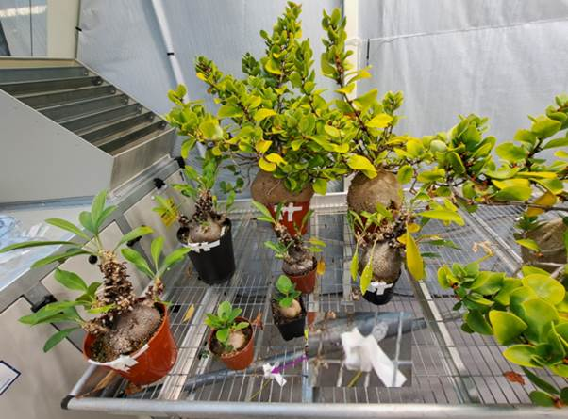

Figure 4. Experimental setup for stable isotope labelling. Several H. moseleyanum and M. beccarii plants are arranged with 1.5 mL Eppendorf tubes containing a sugary isotope mixture. The inset provides a magnified view of a single tube setup. White tape markers on the plants indicate the specific locations of the tubes, which are positioned to allow ant access and foraging.

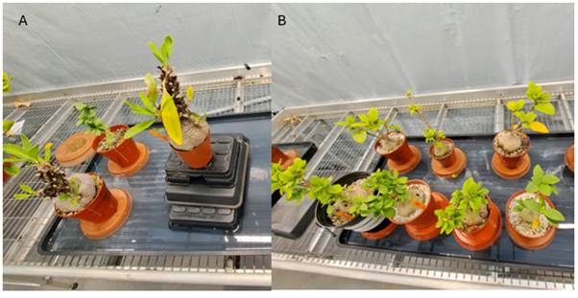

Figure 5. Experimental cohorts of M. beccarii and H. moseleyanum isolated on water barriers to prevent ant access. (A) Experimental tray consisting primarily of M. beccarii specimens, with a single H. moseleyanum individual positioned at the rear. The central plant is raised on a multi-tiered plastic pedestal. (B) Cohort comprised entirely of H. moseleyanum individuals. In both panels, individual pots are placed on inverted plastic saucers within water-filled trays, creating an artificial island system to exclude foraging ants. All trays are maintained on galvanised mesh greenhouse benches.

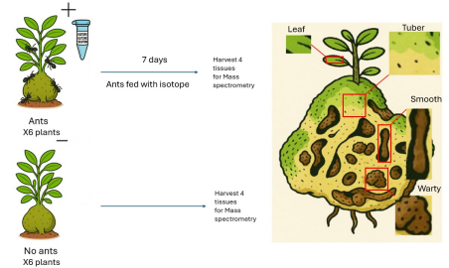

Figure 6. Experimental workflow for tracing ant-derived nitrogen into Hydnophytinae domatium tissues. 6 plants, N = 3 H. moseleyanum and N = 3 M. beccarii were used for each treatment, namely plants with ghost ants (Tapinoma melanocephalum) and without ants. Ants were fed with a sugar solution containing ¹⁵N-labelled lysine ([U-¹³C₆,¹⁵N₂]-L-lysine·2HCl) for 7 days. On the 8th day, four tissues (smooth/smooth-like, warty/warty-like and tuber in the domatium and leaves) were harvested and subjected to isotope-ratio mass spectrometry.

3.3.2 Testing whether the symbioses with ghost ants are mutualistic
The experimental system therefore originally contained Hydnophytum moseleyanum and Myrmecodia beccarii plants forming symbioses with ghost ants. To test whether these symbioses were indeed nutritional mutualisms, feeding experiments with ¹⁵N isotope were designed. This involved feeding the ants with a solution of 30% sucrose in distilled water in which Deuterated L-Lysine dihydrochloride (4,4,5,5-D₄) Isotope [U-¹³C₆,¹⁵N₂]-L-lysine·2HCl (Cambridge Isotope Laboratories, Inc) was dissolved at 1 mg/mL. Ants were fed the labelled sugar solution using 1.5 ml Eppendorf tubes sealed with cotton wicks to prevent the ants from drowning. Four feeding stations were placed at equal distance of 7 cm and 3 cm away from the tray edge for Hydnophytum moseleyanum and Myrmecodia beccarii plants. Feeding was maintained for 7 days with fresh solutions provided every 24 hours to ensure continuous isotope intake by ghost ants (Fig. 4). On the 8th day, the feeding tubes were removed and the four plant tissue types (warty, smooth, tuber, and leaf) were harvested for isotope analysis.

3.3.3 Tissue sampling and preparation for isotope analysis
We sampled four tissues for Isotope-Ratio Mass Spectrometry (IR-MS): leaves, and three domatium inner tissues namely warty (Myrmecodia beccarii) or warty-like surfaces (Hydnophytum moseleyanum), smooth (Myrmecodia beccarii) or smooth-like surfaces (Hydnophytum moseleyanum), and tuber tissue (Fig. 6). Tuber tissue is the fleshy body that connects these surfaces (i.e. the tissue inside the domatium, excluding surfaces) (Fig. 1). Tissues were selected based on their physiological roles and their interaction with ants, including tuber, warty and smooth tissues, and leaves (Chomicki et al., 2019; Pu et al., 2021). For the inner surface tissues, we dissected ~1 mm-thick tissue slices of approximately [150 mm²] surface area immediately beneath the chamber surface using a scalpel: for M. beccarii, from both warty and smooth chambers; and for H. moseleyanum, from warty-like and smooth-like chambers.
All samples were placed into small paper envelopes. They were then dried in an oven at 45°C for 24 hours. To prevent cross-contamination, each sample was processed in a new individual 2 ml grinding tube with fresh beads. After drying, samples were ground to a fine powder using a bead beater (FastPrep-24, MP Biomedicals, Santa Ana, USA).

3.3.4 Isotope-Ratio Mass Spectrometry (IR-MS)
The powdered samples (approximately [3g], weighed to 1 decimal place using a Kern ABS/ABJ Analytical balance) were loaded into tin capsules and dropped into a furnace at 1000 °C whilst in an atmosphere of oxygen. The tin ignites and burns exothermically, causing the temperature to rise to about 1800 °C, and oxidises the sample. Complete combustion is guaranteed, by passing the combustion products through a bed of chromium oxide at 1000 °C, using a helium carrier gas. A 15 cm layer of copper oxide followed by a layer of silver wool completes the combustion and removes any sulphur. The products are then passed through a second furnace containing copper at 600 °C where excess oxygen is absorbed, and nitrogen oxides are reduced to elemental nitrogen.
Water is removed by a trap containing anhydrous magnesium perchlorate. As this study measured nitrogen isotopes only, CO₂ was removed prior to GC separation using a Carbosorb trap. The gas stream then passed into a gas chromatograph (GC) where N₂ was separated and passed into a mass spectrometer where the isotopic species (i.e. ²⁸N₂ and ²⁹N₂) were ionised and separated by mass using a magnetic field, allowing calculation of the ¹⁵N/¹⁴N ratio. The isotope species are detected separately, and from the ratio, the level of ¹⁵N is calculated. Calibration of the system is made using known standards from Heather Walker (Department of Biosciences, University of Sheffield allowing both total nitrogen and ¹⁵N content to be obtained from each sample. The instrument used in Biosciences, University of Sheffield, UK is an ANCA GSL 20-20 Mass Spectrometer (Sercon, Cheshire). The istotopic composition of nitrogen is expressed as δ¹⁵N (delta notation), defined as δ¹⁵N (‰) = [(Rsample / Rstandard) − 1] × 1000, where R = ¹⁵N/¹⁴N. Values are reported relative to atmospheric N₂ (AIR) as the international standard.
In this study, enrichment refers to an increase in δ¹⁵N values in ant-colonised plant tissues relative to ant-free controls of the same tissue type. A positive δ¹⁵N value indicates that the tissue contains more ¹⁵N than atmospheric N₂, which in this experimental context reflects the incorporation of ant-derived ¹⁵N-labelled nitrogen into plant tissue. A negative δ¹⁵N value indicates ¹⁵N depletion relative to the atmospheric standard, which is expected in ant-free tissues that have not been exposed to the labelled nitrogen source. The magnitude of δ¹⁵N enrichment therefore serves as a proxy for the quantity of ant-derived nitrogen deposited in and absorbed by each tissue type.

3.3.5 Statistical analyses and visualisation
A total of 48 tissue samples (2 plant species × 2 treatments × 3 replicates × 4 tissues) were collected for stable isotope analysis. To test whether ghost ant presence leads to enhanced nitrogen uptake, and whether this differs by tissue type or mutualism strategy (generalist vs. specialist), we analysed δ¹⁵N values using a three-way factorial ANOVA.
The δ¹⁵N ratio values were obtained from IR-MS and imported into R version 4.2.2 (R Core Team, 2024), run in RStudio (Posit Team, 2024), via the readxl package (Wickham et al., 2024a; Wickham et al., 2024b). To test how plant species, treatment (ghost ants presence or absence) and the tissue influence the δ¹⁵N value, we relied on a three way factorial analysis of variance (ANOVA), using the base R 'aov' function to test the main effects of Species (2 levels), Treatment (2 levels), and Tissue (4 levels), as well as their two- and three-way interactions, using the following function: aov_model <- aov (d15N ~ Species * Treatment * Tissue, data = df), where df is the dataset containing all δ¹⁵N measurements, species identity, treatment group, and tissue type.
Model fit and assumptions (normality of residuals, homoscedasticity) were evaluated through residual and QQ plots. Where significant effects or interactions were detected, pairwise contrasts among factor combinations were calculated via the emmeans package (Lenth, 2024), applying Tukey's adjustment for multiple testing. Results for δ¹⁵N means ± Standard error of the mean (SEM) were presented in a bar plot generated with ggplot2 (Wickham, 2016). By quantifying δ¹⁵N enrichment relative to ant-free controls, we can determine where within the domatium ant-derived nitrogen is preferentially deposited and whether these deposition patterns vary across tissue types and between facultative and obligate species.
Specifically, the three-way ANOVA tests three hypotheses: (i) that ghost ant presence significantly increases δ¹⁵N values in plant tissues (main effect of Treatment), which would validate the symbiosis as nutritional; (ii) that δ¹⁵N enrichment differs across tissue types (main effect of Tissue), which would reveal the preferential sites of nitrogen deposition within the domatium; and (iii) that enrichment patterns differ between H. moseleyanum and M. beccarii (main effect of Species and Species × Treatment interaction), which would indicate that facultative and obligate mutualism strategies produce distinct nitrogen uptake patterns. Rejection of the null hypothesis in each case that ant presence, tissue type, and species have no effect on δ¹⁵N would support the hypothesis that ant-derived nitrogen deposition is both nutritionally significant and structured by mutualism strategy.

3.4 Results

3.4.1 Ghost ants enrich domatium tissues in δ¹⁵N in both H. moseleyanum and M. beccarii
Non-inhabited plant individuals of both Hydnophytum moseleyanum and Myrmecodia beccarii became inhabited by ghost ants with an estimation of 1 week due to empirical observations. Each plant had a reproductive colony with its own brood, however determining how many various colonies colonised a plant was not determinable. Contrary to other non-domatium bearing plants invaded in the greenhouse, of the non-domatium plants observed (Coffea arabica - Rubiaceae), 0% showed visible scale insect infestations and 0% showed leaf deformities or dryness attributable to ghost ant activity (Fig. 7).
Neither H. moseleyanum nor M. beccarii showed any of these symptoms, with no evidence of scale insect cultivation nor any visible plant growth deformities (Fig. 7). None of this can be statistically proven but only recorded based on limited images of the relevant greenhouse-based plants. δ¹⁵N values are reported relative to atmospheric N₂ (AIR), where a value of 0‰ represents the atmospheric standard. Positive values indicate ¹⁵N enrichment above this baseline, while negative values indicate ¹⁵N depletion relative to air.
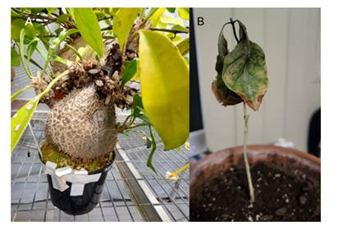
In ant-free control plants, domatium tissues can show slightly negative values, reflecting natural discrimination against the heavier isotope during nitrogen metabolism. The key comparison is therefore between ant-colonised and ant-free plants of the same tissue type.

Figure 7. Contrasting plant health between a domatium-bearing and a non-domatium-bearing plant. (A) M. beccarii colonised by ghost ants (Tapinoma melanocephalum) showing no visible signs of stress, with healthy leaves and an intact domatium housing a reproductive ant colony. (B) A non-domatium-bearing plant showing leaf deformity and desiccation. No scale insect infestations were observed on any Hydnophytinae plants throughout the study.

In this study, enrichment is defined as a significantly higher δ¹⁵N value in ant-colonised tissues relative to ant-free controls of the same tissue type and species, as tested by the statistical models described in Section 3.3.5. δ¹⁵N values are reported relative to atmospheric N₂ (AIR), where a value of 0‰ represents the atmospheric standard. Positive values indicate ¹⁵N enrichment above this baseline, while negative values indicate ¹⁵N depletion relative to air. In ant-free control plants, domatium tissues can show slightly negative values, reflecting natural discrimination against the heavier isotope during nitrogen metabolism.
The key comparison is therefore between ant-colonised and ant-free plants of the same tissue type. Full results of all statistical tests supporting the statements below are presented in. In Hydnophytum moseleyanum, the presence of ghost ants compared to no ants significantly increased δ¹⁵N values overall (two-way ANOVA, Treatment effect: F₁,₁₆ = 11.76, P = 0.003), with no significant effect of tissue type (F₃,₁₆ = 0.28, P = 0.837) and no significant Treatment × Tissue interaction (F₃,₁₆ = 1.50, P = 0.252). Tissue-specific Welch t-tests comparing ant-present and ant-free plants showed that this enrichment was significant only in warty-like domatium tissue (t = -7.54, df = 2.13, P = 0.014); tuber (t = -2.65, df = 2.14, P = 0.110) and smooth-like tissue (t = -1.36, df = 2.00, P = 0.307) showed enrichment in the same direction but did not reach significance, likely reflecting the limited statistical power of small sample sizes (n = 3 per group).
Leaves showed no significant difference between treatments (t = 1.55, df = 3.99, P = 0.195), confirming that, despite the lack of a significant Tissue or interaction effect in the overall model, the enrichment response was concentrated in domatium tissue rather than leaves. Mean δ¹⁵N enrichment across all domatium tissues of ant-present plants was 8.31‰ (range: 0.69–22.61‰) (Fig. 8). In the ant-free plants, the highest δ¹⁵N value was found in the leaves (1.52–2.04), while all domatium tissues had values in the range of -3.51 to -0.01 δ¹⁵N.
In Myrmecodia beccarii, the presence of ghost ants significantly increased δ¹⁵N values compared to ant-free controls (two-way ANOVA, F₁,₁₆ = 6.93, P = 0.018), with no significant effect of tissue type (F₃,₁₆ = 1.69, P = 0.209) and no significant Treatment × Tissue interaction (F₃,₁₆ = 1.70, P = 0.206), indicating that all tissues responded similarly to ant colonisation. Mean δ¹⁵N enrichment across all domatium tissues of ant-present plants was 45.35 ‰ (range: 10.43–177.40 ‰), representing a 5.94-fold greater enrichment compared to H. moseleyanum (8.31 ‰). Tissue-specific Welch t-tests comparing ants to ant free, revealed that this enrichment was only individually significant in smooth domatium tissue (Welch t-test: t = -12.45, df = 1.08, P-value = 0.042), while tuber (t = -3.13, df = 2.00, P = 0.088) and warty tissue (t = -1.57, df = 2.00, P = 0.257) showed enrichment in the same direction but did not reach significance, likely reflecting high inter-plant variability.
Leaves showed no significant difference between treatments (t = -0.10, df = 3.18, P = 0.925), confirming that enrichment was specific to domatium tissue. Overall, In M. beccarii, a mean δ¹⁵N enrichment of [45.35 ‰] (range: [10.43–177.4] ‰) was found in the domatium tissues, but not in leaves, and as for H. moseleyanum, the presence of ghost ants significantly increased δ¹⁵N values (ANOVA, F = 6.94, P = 0.018; Fig. 9).
However, there were substantial differences between the domatium tissues, with smooth surfaces having the lowest δ¹⁵N enrichment and warty surfaces having the highest, albeit these were non-significant. We next ran an ANOVA analysis using the full dataset including both plants and tissues. This revealed a significant higher enrichment in M. beccarii as compared to H. moseleyanum (F = 4.38, P = 0.04), reflecting the overall enrichment of domatium tissues being nearly 6-fold greater (5.94×) in M. beccarii as compared to H. moseleyanum in the presence of ghost ants. This ANOVA analysis of all data confirmed the importance of ghost ant presence leading to significantly higher δ¹⁵N values (F = 9.88, P = 0.003). The Species × Treatment interaction was also significant (F = 4.59, P = 0.04).

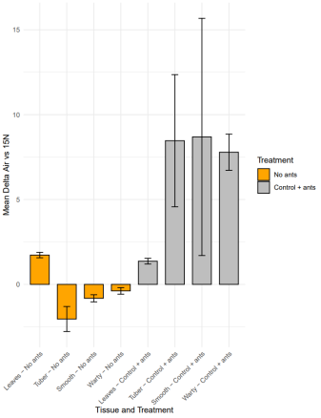

Figure 8. Mean δ¹⁵N values in without ants and with ants treatments in H. moseleyanum, shown by tissue type, with error bars representing ± SEM.

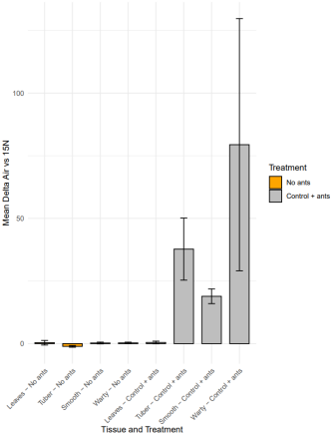

Figure 9. Mean δ¹⁵N values in without ants and with ants treatments in M. beccarii, shown by tissue type, with error bars representing ± SEM.

3.5 Discussion

3.5.1 Developing experimental symbioses in the Hydnophytinae
The central hypothesis of this chapter was that nitrogen deposition from ants induces nutritional dependency in ant-plants. The results support this: ghost ant colonisation led to significant δ¹⁵N enrichment in domatium tissues of both Hydnophytum moseleyanum (facultative) and Myrmecodia beccarii (obligate), with no equivalent enrichment in leaves or without ants controls. However, two caveats apply: first, the experimental ant partner (ghost ants) is non-native; second, sample sizes were small (N = 3 per treatment). The discussion below addresses both points.

3.5.1 Developing experimental symbioses in the Hydnophytinae
My experiments show that two Hydnophytinae ant-plants: the facultative Hydnophytum moseleyanum, which form facultative relationships with arboreal ants (Maeyama and Matsumoto, 2000) and Myrmecodia beccarii which forms an obligate symbiosis with the Dolichoderinae ant Philidris cordata (Huxley, 1978; Chomicki and Renner, 2017; Greenfield, 2022), can be reproducibly colonised by ghost ants (Tapinoma melanocephalum) and form nutritional mutualisms in greenhouse conditions. To our knowledge, this is the first reconstitution of plant/ant domatium symbioses under controlled greenhouse conditions outside the tropics.
The ease with which M. beccarii was colonised by ghost ants might appear to contradict its classification as obligate. However, obligate here refers to the plant's dependence on ant-derived nutrients for healthy growth and reproduction in nature, not to a physical inability to be colonised by other ants. Indeed, M. beccarii can be colonised by non-native ants both in the field (Volp and Lach, 2019) and in greenhouse conditions (this study), yet in the absence of any ant partner it shows reduced growth and fitness (Chomicki and Renner, 2017). The term obligate therefore describes ecological dependency on ant partners as a functional class, not exclusivity to a single ant species.
The establishment of these experimental ant-plant symbioses contrasts starkly with the existing literature: unlike all classic ant-plant systems, which have been studied exclusively under field conditions, my study creates these symbioses under controlled greenhouse conditions. Previous work has covered both terrestrial and epiphytic systems. Terrestrial examples include the Acacia plant and Pseudomyrmex ant symbiosis (Heil et al., 2009), the Vachellia plant and Crematogaster ant symbiosis (Palmer et al., 2008), the Macaranga plant and Crematogaster ant symbiosis (Quek et al., 2004), and the Piper plant and Pheidole ant symbiosis (Fischer et al., 2003). Epiphytic systems include the Dischidia plant and Philidris ant symbiosis (Treseder et al., 1995), the Caularthron orchid and Azteca ant symbiosis (Gegenbauer et al., 2012), and Hydnophytinae ant-plants (Chomicki and Renner, 2016b; Chomicki and Renner, 2019; Chomicki et al., 2020), all of which have been characterised exclusively under natural field conditions. Establishing these experimental ant-plant symbioses offers two key advances.
First, it means key variables such as partner identity, ant presence/absence, or nutrient levels can be manipulated while holding all environmental variables (both abiotic: e.g. climate and biotic: e.g. herbivory) constant, something that is logistically difficult in natural settings in the tropics. Second, this experimental approach allows us to perform analyses on experimental plants that are highly sensitive, such as RNA sequencing; this would be extremely challenging to conduct in the field in the tropics as RNA is very unstable and requires access to a laboratory.
Our findings that ghost ants, a non-native, generalist species, can successfully colonise M. beccarii and form nutritional mutualisms with it, suggests that the domatium itself is not physically restricted to Philidris cordata. This points toward the second explanation: that the obligate dependency may be driven by a specific benefit that M. beccarii provides to Philidris cordata, rather than by competitive exclusion. The establishment of experimental Hydnophytinae/ant symbioses therefore provides a novel platform to test these competing hypotheses directly, for instance by comparing colony fitness of Philidris cordata versus ghost ants when inhabiting M. beccarii under controlled conditions.
The squid/Vibrio system refers to the symbiosis between the Hawaiian bobtail squid (Euprymna scolopes) and the bioluminescent bacterium Vibrio fischeri, a classic model organism in symbiosis research. Add a brief clarifying phrase on first mention: 'the squid/Vibrio system (a model symbiosis between the Hawaiian bobtail squid, Euprymna scolopes, and the luminescent bacterium Vibrio fischeri) allows single-strain colonisation, removal, and re-introduction to dissect partner choice and host remodelling (Nyholm and McFall-Ngai, 2004; Mandel, 2016; Essock-Burns et al., 2020), similarly the Aiptasia–Symbiodiniaceae model enables aposymbiotic/symbiotic contrasts and controlled bleaching or thermal stress (Weis, 2008; Oakley et al., 2016). Likewise, the aquatic symbioses Hydra/Chlorella and Paramecium bursaria/Chlorella permit de-symbiosis and re-infection to test specificity, metabolism and gene regulation (Hamada et al., 2018; Summerer et al., 2007; Kodama et al., 2014).
Many plant-microbe symbioses are routinely reconstituted in laboratory settings for over two decades, such as legume-rhizobia N-fixing symbioses (e.g. Kiers et al., 2003), and arbuscular mycorrhizae (e.g. Kiers et al., 2011), enabling causal tests of partner quality and sanctions and sophisticated dissections of the recognition (e.g. Frank et al., 2023) and nutrient trade dynamics (Oyarte Galvez et al., 2025).
The overwhelming majority of symbioses established in laboratory involve microbes as symbionts – reconstructing symbioses with 'macro' symbionts, such as insects has been more difficult, since it is hard to both acquire and establish the condition required for these interactions, in particular when they occur in remote tropical areas. Our reconstituted Hydnophytinae symbioses now bring domatium nutritional physiology to that same experimental space, but for a macro-scale plant/animal nutritional mutualism.

3.5.2 Experimental nutrition between Hydnophytinae and ghost ants recapitulate natural interactions
A key distinction of our experimentally established symbioses is that they involve a non-native ant partner, ghost ants (Tapinoma melanocephalum). A legitimate question is therefore whether this non-native partner provides comparable nutritional interactions to the natural ant partners. This study does not directly test ghost ants against native ant partners side-by-side; rather, the comparison below is made indirectly, by comparing the δ¹⁵N enrichment patterns observed here with those previously reported in the field for native ant partners (Chomicki et al., 2019).
The expectations could in fact be quite different: H. moseleyanum, form facultative symbioses with a wide range of arboreal ants and the nutritional benefits arise from byproducts of nesting (Maeyama and Matsumoto, 2000; Chomicki and Renner, 2017) – thus one could expect that that symbiosis with a non-native partner could reproduce natural interactions. This was less clear in M. beccarii for two reasons. First, because it forms a highly specialised, obligate symbiosis with the single ant species Philidris cordata (Huxley, 1978; Chomicki and Renner, 2017; Greenfield, 2022). Second, contrary to H. moseleyanum, Myrmecodia inner domatium surfaces are highly differentiated in warty and smooth surfaces. Myrmecodia inner domatium warts have been studied since the 19th century and were thought to function in aeration (Treub, 1888) or nutrient uptake (Beccari, 1884). An early study by (Miehe, 1911) revealed that warty walls in Myrmecodia can absorb water and solutes in warty tissue while smooth walls cannot. Subsequent work revealed that warts are hyper-absorptive and are the sites of targeted fertilisation by Philidris ants which actively and exclusively defecate on these areas, and place detritus there (Huxley, 1978; Chomicki and Renner, 2019).
The term 'targeted defecation' is used here to describe this specific behaviour, whereby ants selectively deposit waste in warty chambers while using smooth chambers exclusively for brood rearing, never defecating there. This behaviour is considered targeted because it is non-random: Philidris ants consistently choose warty surfaces as defecation sites across individuals and populations, suggesting active discrimination between chamber types rather than indiscriminate waste deposition throughout the domatium (Huxley, 1978; Chomicki and Renner, 2019). In this study, we use δ¹⁵N enrichment patterns across warty and smooth tissues as a proxy to assess whether ghost ants exhibit the same targeted behaviour, or whether a functionally equivalent outcome arises through differential nutrient absorption by the two surface types.
One might expect that if ants simply defecate wherever they spend most time, defecation in warty chambers would occur by default in any ant colonising the domatium. However, the critical observation is not merely defecation in warty areas, but the exclusive targeting of warty cavities for defecation, with smooth cavities used only for brood rearing and never fertilised (Huxley, 1978; Chomicki and Renner, 2019). This behavioural partitioning, selectively depositing waste in warty but not smooth chambers is what requires explanation.
We initially hypothesised that this targeted behaviour might depend on shared evolutionary history with Hydnophytinae, as the chemical or structural cues guiding defecation site selection could be co-adapted signals between plant and native ant partner. The lack of ¹⁵N enrichment in leaves of both H. moseleyanum and M. beccarii likely reflects the short, 7-day timeline of the feeding experiment, which was designed to capture the initial location and extent of ¹⁵N deposition through ant defecation across domatium tissues, before substantial onward transport could occur. A longer feeding and growth period would likely have led to greater homogenisation of ¹⁵N across the plant via vascular transport, including detectable enrichment in leaves, particularly any leaves produced after the start of ¹⁵N feeding (i.e. new growth), since these would be expected to incorporate a higher proportion of recently absorbed nitrogen than mature, pre-existing leaves.
The feeding experiments with our new experimental symbioses revealed that (i) δ¹⁵N enrichment of smooth and warty walls is very similar in H. moseleyanum, and (ii) δ¹⁵N enrichment is low in smooth walls and high in warty walls in M. beccarii (Figs. 4, 5). These results directly recapitulate natural nutritional interactions involving natural ant partners in facultative Hydnophytinae forming symbioses with generalist ants and obligate ones forming symbioses with Philidris ants (Chomicki et al., 2019). This recapitulation demonstrates that the experimental ghost ant symbiosis functions like native ant partners in nature, validating this system as a robust model for testing the role of mutualistic dependence.
This finding is significant for three reasons. First, it demonstrates that the experimental ghost ant symbioses can be used reliably as a model system, since they reproduce the nitrogen deposition patterns observed with native ant partners in the field. Second, it allows to more directly compare Hydnophytinae with different levels of mutualistic dependence (Chomicki et al., 2020), without ant species-specific traits as confounding factors. Third, it suggests that the targeted fertilisation on warty walls but never on smooth walls in highly specialised Hydnophytinae (Huxley, 1978; Chomicki and Renner, 2019) does not involve coevolved traits with Philidris ants.
The δ¹⁵N enrichment data show that warty tissues are significantly more enriched than smooth tissues in M. beccarii (Fig. 9), mirroring patterns seen with Philidris cordata in nature (Chomicki et al., 2019). Two interpretations are possible: (i) ghost ants actively and exclusively defecate in warty chambers, as Philidris does; or (ii) ghost ants defecate throughout the domatium, but nutrients are selectively absorbed only from warty surfaces due to their higher absorption capacity. Our isotope data alone cannot distinguish between these scenarios. Future direct observation of ghost ant defecation behaviour, combined with surface permeability assays, would be needed to resolve this. Regardless of the mechanism, the functional outcome preferential nitrogen delivery to warty tissues is the same, and recapitulates the pattern seen in natural symbioses.
It is worth mentioning that ghost ants belong to the same ant subfamily of ants as their native specialised partners (Dolichoderinae), hence it is plausible that ghost ants share behavioural adaptations with Philidris ants.

3.5.3 Invasive ants forming mutualisms with specialised plants
Our greenhouse experiments show that non-native ghost ants (Tapinoma melanocephalum) readily colonise domatia of M. beccarii and H. moseleyanum and form successful nutritional mutualisms with them. These results demonstrate that even an obligate ant plant (Myrmecodia beccarii) can obtain nutritional benefits from a non-native, generalist ant under controlled conditions. This echoes field evidence that both native Philidris cordata and invasive Pheidole megacephala can provide nitrogen to M. beccarii (Volp and Lach, 2019; Volp et al., 2022).
Across ant-plant symbioses, partner quality varies widely in defence and likely nutritional provisioning, and invaders frequently alter outcomes by displacing higher-quality natives (Lach, 2003; Bruna et al., 2004; Frederickson, 2005; Gaume et al., 2005). Scholars of mutualism distinguish "cheaters", that are derived from mutualistic ancestors from "exploiters", which are ecologically similar but evolved de novo without any prior interaction with the partner (Bronstein, 2001). Theory predicts that impacts of invaders depend on the "tightness" of specialisation and the invader's competitive dominance at the host (Ness and Bronstein, 2004).
Yet, our findings, and those studying M. beccarii symbiosis with ants in the field (Volp and Lach, 2019; Volp et al., 2022) suggests that both invasive ant species (Tapinoma melanocephalum, Dolichoderinae and Pheidole megacephala, Myrmicinae) can be potent mutualists. While long-term data comparing native and invasive partners is lacking, these data suggests that some invasive species can successfully establish mutualism with even specialised species, displacing their native partners, and in turn further increasing their colonisation success.

3.5.4 Tuber function in nitrogen retention
Our greenhouse experiments show that ¹⁵N-labelled nitrogen delivered by ants accumulated preferentially in the tuber tissue of the domatium, suggesting the tuber acts as a nitrogen storage organ. Our greenhouse experiments suggest that the Hydnophytinae tuber acts as a short- to medium-term nitrogen reservoir from which N could later be remobilised to support new shoots or reproductive growth. Comparable storage-and-remobilisation roles of underground storage organs are well documented in other plants: potato tubers store and later export N (Millard, 1986; Shewry, 2003), early work on potato already showed radial heterogeneity in N content, with higher N toward the medullary zone, consistent with storage functions (Glynne and Jackson, 1919).
Experimental manipulations of the form of nitrogen can alter tuber N metabolism, fresh weight, and biochemical composition in Pinellia pedatisecta and yacon tubers (Wang et al., 2014; Kamp et al., 2019). More generally, plant developmental responses depend on both the quantity and form of N supplied (e.g. ammonium versus nitrate) (Williams and Miller, 2001). Thus, our results, together with existing knowledge on plant tubers, suggest that the domatium tubers are a central hub of nitrogen storage. More work is needed to show if and how ant-derived nitrogen can be retained in the tuber and mobilised for vegetative and reproductive development.

3.6 Conclusion
This chapter establishes new experimental symbioses between two Hydnophytinae species, the facultative and generalist Hydnophytum moseleyanum and the obligate specialist Myrmecodia beccarii. These symbioses successfully form nutritional mutualisms that recapitulates natural interactions with native ant partners and thus provides new key resources to study ant-plant mutualisms. These experimental symbioses allow us to compare the physiological responses of plants with a distinct level of mutualistic dependence on ants, while keeping all climatic variables and having the same ant partners. An important finding is that the domatium inner wall structure in Myrmecodia is mirrored by distinct ant behaviour (targeted fertilisation by defecation exclusively on warty walls), as found in natural conditions. This was previously thought to derive from coevolution with Philidris ants (Chomicki and Renner, 2019), and hence this finding opens-up new avenue to study the nutritional physiology of ant plants. This chapter forms the basis of experimental work later used in Chapter 4.
A key caveat of this study is that the experimental symbioses used ghost ants (Tapinoma melanocephalum), a non-native, invasive species, rather than the plants' natural ant partners. This raises the possibility that the nitrogen deposition patterns observed may not perfectly replicate those of native partners. However, we argue that the conclusions remain robust for three reasons. First, the δ¹⁵N enrichment patterns in both species closely mirror those reported from natural field conditions (Chomicki et al., 2019), suggesting that the functional outcome of ghost ant colonisation is ecologically equivalent. Second, ghost ants belong to the same subfamily (Dolichoderinae) as the specialist partner Philidris cordata, making shared behavioural traits plausible. Third, the facultative species H. moseleyanum associates with a wide range of arboreal ants in nature, so a non-native partner is not unreasonable for this species. Together, these points support the use of ghost ant symbioses as a valid experimental model, while acknowledging that quantitative comparisons with natural partners in the field remain an important direction for future work.

3.7 References
Beccari, O. (1884–86). Piante Ospitatrici. In Malesia (Vol. 2). Bibliografia del Institudo Sordo Muti.
Bronstein, J.L. (2001). The exploitation of mutualisms. Ecology Letters, 4(3), 277–287.
Bronstein, J.L., Alarcón, R., and Geber, M. (2006). The evolution of plant-insect mutualisms. The New Phytologist, 172(3), 412–428.
Bruna, E.M., Lapola, D.M., and Vasconcelos, H.L. (2004). Interspecific variation in the defensive responses of obligate plant-ants: Experimental tests and consequences for herbivory. Oecologia, 138(4), 558–565.
Campbell, L.C.E., Kiers, E.T., and Chomicki, G. (2023) The evolution of plant cultivation by ants. Trends in Plant Science, 28, 271–282.
Chomicki, G. (2019). The world list of plants with domatium species. (Unpublished dataset).
Chomicki, G., Kadereit, G., Renner, S.S., and Kiers, E.T. (2020). Trade-offs in the evolution of plant farming by ants. Proceedings of the National Academy of Sciences of the United States of America, 117(5), 2535–2543.
Chomicki, G., and Renner, S.S. (2015). Phylogenetics and molecular clocks reveal the repeated evolution of ant-plants after the late Miocene in Africa and the early Miocene in Australasia and the Neotropics. The New Phytologist, 207(2), 411–424.
Chomicki, G., and Renner, S.S. (2016a). Obligatory plant farming by a specialized ant. Nature Plants, 2, 16181.
Chomicki, G., and Renner, S.S. (2016b). Evolutionary relationships and biogeography of the ant-epiphytic genus Squamellaria (Rubiaceae: Psychotrieae) and their taxonomic implications. PLOS ONE, 11, e0151317.
Chomicki, G., and Renner, S.S. (2017). Partner abundance controls mutualism stability and the pace of morphological change over geologic time. Proceedings of the National Academy of Sciences of the United States of America, 114(15), 3951–3956.
Chomicki, G., and Renner, S.S. (2019). Farming by ants remodels nutrient uptake in epiphytes. The New Phytologist, 223(4), 2011–2023.
Chomicki, G., Thorogood, C.J., Naikatini, A., and Renner, S.S. (2019). Squamellaria: Plants domesticated by ants. Flora Obscura. Plants, People, Planet, 1(4), 302–305.
Davidson, D.W., and McKey, D. (1993). The evolutionary ecology of symbiotic ant/plant relationships. Journal of Hymenoptera Research, 2, 13–83.
Defossez, E., Djie´to-Lordon, C., McKey, D., Selosse, M.A., and Blatrix, R. (2011). Plant-ants feed their host plant, but above all a fungal symbiont to recycle nitrogen. Proceedings of the Royal Society B: Biological Sciences, 278(1714), 1419–1426.
Essock-Burns, T., Bongrand, C., Goldman, W.E., Ruby, E.G., and McFall-Ngai, M.J. (2020). Interactions of symbiotic partners drive the development of a complex biogeography in the squid–Vibrio symbiosis. mBio, 11(3), e00853-20.
Fischer, R.C., Wanek, W., Richter, A., and Mayer, V., (2003). Do ants feed plants? A 15N labelling study of nitrogen fluxes from ants to plants in the mutualism of Pheidole and Piper Journal of Ecology, 91(1), 126-134.
Frank, M., Fechete, L.I., Tedeschi, F., Nadzieja, M., Nørgaard, M.M.M., Montiel, J., Andersen, K.R., Schierup, M.H., Reid, D., and Andersen, S.U. (2023). Single-cell analysis identifies genes facilitating rhizobium infection in Lotus japonicus. Nature Communications, 14(1), 7171.
Frederickson, M.E. (2005). Ant species confer different partner benefits on two neotropical myrmecophytes. Oecologia, 143(3), 387–395.
Gaume, L., Zacharias, M., Grosbois, V., and Borges, R.M. (2005). The fitness consequences of bearing domatia and having the right ant partner: experiments with protective and non-protective ants in a semi-myrmecophyte. Oecologia, 145(1), 76–86.
Gegenbauer, C., Mayer, V.E., Zotz, G., and Richter, A., (2012). Uptake of ant-derived nitrogen in the myrmecophytic orchid Caularthron bilamellatum. Annals of Botany Plants, 110(4), 757-765.
Glynne, M.D., and Jackson, V.G. (1919). The distribution of dry matter and nitrogen in the potato tuber. Variety, King Edward. The Journal of Agricultural Science, 9(3), 237–258.
Greenfield, M.J. (2022). Interactions among fungi, ants, and the ant-plant Myrmecodia beccarii (Doctoral dissertation, James Cook University). James Cook University. Retrieved from https://doi.org/10.25903/1bvy-ma83.
Hamada, M., Schröder, K., Bathia, J., Kürn, U., Fraune, S., Khalturina, M., Khalturin, K., Shinzato, C., Satoh, N., and Bosch, T.C.G. (2018). Metabolic co-dependence drives the evolutionarily ancient Hydra–Chlorella symbiosis. eLife, 7, e35122.
Heil, M., González-Teuber, M., Clement, L.W., Kautz, S., Verhaagh, M., and Bueno, J.C.S. (2009). Divergent investment strategies of Acacia myrmecophytes and the coexistence of mutualists and exploiters. Proceedings of the National Academy of Sciences of the United States of America, 106(43), 18091-18096.
Heil, M., and McKey, D. (2003). Protective ant–plant interactions as model systems in ecological and evolutionary research. Annual Review of Ecology, Evolution, and Systematics, 34, 425–53.
Huxley, C.R. (1978). The ant-plants Myrmecodia and Hydnophytum (Rubiaceae), and the relationships between their morphology, ant occupants, physiology and ecology. The New Phytologist, 80(1), 229-246.
Huxley, C.R. (1980). Symbiosis between ants and epiphytes. Biological Reviews, 55(3), 321– 340.
Huxley, C.R., and Jebb, M.H.P. (1991a). The tuberous epiphytes of the Rubiaceae 1: A new subtribe — The Hydnophytinae. Blumea, 36(1), 1–20.
Huxley, C.R., and Jebb, M.H.P. (1991b). The tuberous epiphytes of the Rubiaceae 2: The new genus Anthorrhiza. Blumea, 36(1), 21–41.
Huxley, C.R., and Jebb, M.H.P. (1993a). The tuberous epiphytes of the Rubiaceae 5: A revision of Myrmecodia. Blumea, 37(2), 271-334.
Huxley, C.R., and Jebb, M.H.P. (1993b). The tuberous epiphytes of the Rubiaceae 6: A taxonomic history of the Hydnophytinae. Blumea, 37(2), 335–340.
Janzen, D.H. (1974). Epiphytic myrmecophytes in Sarawak: mutualism through the feeding of plants by ants. Biotropica, 6(4), 237-259.
Jebb, M.H.P. (1991). An account of the Rubiaceae of the Hydnophytinae. Blumea, 36, 1–61.
Jebb, M.H.P., and Huxley, C.R. (2019). The tuberous epiphytes of the Rubiaceae 7: a revision of the genus Hydnophytum. Blumea, 64(1), 23-91.
Kamp, L., Hartung, J., Mast, B., and Graeff-Hönninger, S. (2019). Impact of nitrogen fertilization on tuber yield, sugar composition, and nitrogen uptake of two yacon (Smallanthus sonchifolius Poepp. and Endl.) genotypes. Agronomy, 9(3), 151.
Kiers, E.T., Duhamel, M., Beesetty, Y., Mensah, J.A., Franken, O., Verbruggen, E., Fellbaum, C.R., Kowalchuk, G.A., Hart, M.M., Bago, A., Palmer, T.M., West, S.A., Vandenkoornhuyse P., Jansa, J., and Bücking, H. (2011). Reciprocal rewards stabilize cooperation in the mycorrhizal symbiosis. Science, 333(6044), 880–882.
Kiers, E.T., Rousseau, R.A., West, S.A., and Denison, R.F. (2003). Host sanctions and the legume–rhizobium mutualism. Nature, 425(6953), 78–81.
Kodama, Y., Suzuki, H., Dohra, H., Sugii, M., Kitazume, T., Yamaguchi, K., Shigenobu, S., and Fujishima, M. (2014). Comparison of gene expression of Paramecium bursaria with and without Chlorella variabilis symbionts. BMC Genomics, 15, 183.
Lach, L. (2003). Invasive ants: Unwanted partners in ant-plant interactions? Annals of the Missouri Botanical Garden, 90(1), 91–108.
Lee, I.Y., Park, S.J., Seo, J.H., Sim, S., Kim, J H., Gwon, Y.G., and Yong, T.S. (2017). Indoor occurrence of the ghost ant Tapinoma melanocephalum (Hymenoptera: Formicidae) in urban homes in Korea. The Korean Journal of Parasitology, 55(2), 225–228.
Lenth, R.V. (2024). emmeans: estimated marginal means, aka least-squares means (R package version 1.8.7). Retrieved from https://CRAN.R-project.org/package=emmeans
Maeyama, T., and Matsumoto, T. (2000). Colonial system of Philidris ants (Formicidae; Dolichoderinae) occupying epiphytic myrmecophytes in a tropical mangrove forest. Tropical Ecology, 41(2), 209-216.
Mandel, M.J., and Dunn, A.K. (2016). Impact and influence of the natural Vibrio–squid symbiosis in understanding bacterial–animal interactions. Frontiers in Microbiology, 7, 1982.
Marcos de Leão, R., Hülse, G., de Souza, S., and Benedito Dos Santos, T. (2020). An in-silico data mining of the ammonium transporter gene family in Ananas comosus L. Colloquia Agrariae 16,10–24.
Martin, M.M. (1970). The biochemical basis of the fungus-attine ant symbiosis. Science, 169(3940), 16–20.
Miehe, H. (1911). Javanische Studien II. Untersuchungen über die Javanische Myrmecodia. Sächsische Akademie der Wissenschaften zu Leipzig, 32, 312– 361.
Millard, P. (1986). The nitrogen content of potato (Solanum tuberosum L.) tubers in relation to nitrogen application—the effect on amino acid composition and yields. Journal of the Science of Food and Agriculture, 37(2), 107-114.
Ness, J., and Bronstein, J.L. (2004). The effects of invasive ants on prospective ant mutualists. Biological Invasions, 6(4), 445–461.
Nyholm, S.V., and McFall-Ngai, M.J. (2004). The winnowing: establishing the squid–Vibrio symbiosis. Nature Reviews Microbiology, 2(8), 632–642.
Oakley, C.A., Ameismeier, M.F., Peng, L., Weis, V.M., Grossman, A.R., and Davy, S.K. (2016). Symbiosis induces widespread changes in the proteome of the model cnidarian Aiptasia. Cellular Microbiology, 18(7), 1009-1023.
Oyarte Galvez, L., Bisot, C., Bourrianne, P., Cargill, R., Klein, M., van Son, M., van Krugten, J., Caldas, V., Clerc, T., Lin, K.K., Kahane, F., van Staalduine, S., Stewart, J.D., Terry, V., Turcu, B., van Otterdijk, S., Babu, A., Kamp, M., Seynen, M., Steenbeek, B., Zomerdijk, J., Tutucci, E., Sheldrake, M., Godin, C., Kokkoris, V., Stone, H.A., Kiers, E.T., and Shimizu, T.S. (2025). A travelling-wave strategy for plant–fungal trade. Nature, 639, 172–180.
Palmer, T.M., Doak, D.F., Stanton, M.L., Bronstein, J.L., Kiers, E.T., Young, T.P., Goheen, J.R., and Pringle, R.M. (2010). Synergy of multiple partners, including freeloaders, increases host fitness in a multispecies mutualism. Proceedings of the National Academy of Sciences of the United States of America, 107(40), 17234-17239.
Philpott, S.M., and Foster, P.F. (2005) Nest-site limitation in coffee agroecosystems: Artificial nests maintain diversity of arboreal ants. Ecological Applications, 15, 1478–1485.
Pu, Y., Naikatini, A., Pérez‐Escobar, O.A., Silber, M., Renner, S.S., and Chomicki, G. (2021). Genome‐wide transcriptome signatures of ant-farmed Squamellaria epiphytes reveal key functions in a unique symbiosis. Ecology and Evolution, 11(22), 15882-15895.
Quek, S.P., Davies, S.J., Itino, T., and Pierce, N.E. (2004). Codiversification in an ant-plant mutualism: stem texture and the evolution of host use in Crematogaster (Formicidae: Myrmicinae) inhabitants of Macaranga (Euphorbiaceae). Evolution, 58(3), 554-570.
R Core Team (2024) R: A language and environment for statistical computing. R Foundation for Statistical Computing, Vienna Austria. Retrieved from https://www.R-project.org/
Sarkar, T., and Bakshi, S. (2025). Ammonium transporter genes in millets: Insights into structure, function, evolutionary conservation, divergence, and phylogenetic analysis. Genetic Resources and Crop Evolution, 72(12), 2185–2209.
Shewry P.R. (2003). Tuber storage proteins. Annals of Botany Plants, 91(7), 755–769.
Summerer, M., Sonntag, B., and Sommaruga, R. (2007). An experimental test of the symbiosis specificity between the ciliate Paramecium bursaria and strains of the unicellular green alga Chlorella. Environmental Microbiology, 9(8), 2117–2122.
Treub, M. (1888). Nouvelles recherches sur le Myrmecodia de Java. Annales du Jardin Botanique de Buitenzorg, 7: 191.
Treseder, K.K., Davidson, D.W., and Ehleringer, J.R. (1995). Absorption of ant-provided carbon dioxide and nitrogen by a tropical epiphyte. Nature. 375(6527), 137–139.
Volp, T.M., Cernusak, L.A., and Lach, L. (2022). Epiphytic ant-plant obtains nitrogen from both native and invasive ant inhabitants. Biotropica, 54(3), 556-560.
Volp, T.M., and Lach, L. (2019). An epiphytic ant-plant mutualism structures arboreal ant communities. Environmental Entomology, 48(5), 1056–1062.
Wang, Q., Wang, K.C., Zheng, C.X., Zhu, B.C., Wang, Y.L., Yang, J.W., and Wang, W. (2014). Effect of different nitrogenous forms on growth and chemical components in tuber of Pinellia pedatisecta Schott. Journal of Plant Nutrition and Fertilizers, 20(4), 1038-1043.
Weis, V.M. (2008). Cellular mechanisms of cnidarian bleaching: stress causes the collapse of symbiosis. Journal of Experimental Biology, 211(19), 3059–3066.
Wickham, H. (2016). ggplot2: Elegant graphics for data analysis. Springer-Verlag. ISBN 978- 3-319-24277-4. Retrieved from https://ggplot2.tidyverse.org
Wickham, H., François, R., Henry, L., and Müller, K. (2024b). dplyr: A grammar of data manipulation (R package version 1.1.2). Retrieved from https://CRAN.R project.org/package=dplyr
Wickham, H., Hester, J., and Bryan, J. (2024a). readr: Read rectangular text data (R package version 2.1.5) [Computer software]. Retrieved from https://readr.tidyverse.org
Williams, L.E., and Miller, A.J. (2001) Transporters responsible for the uptake and partitioning of nitrogenous solutes. Annual Review of Plant Physiology and Plant Molecular Biology, 52, 659–688.
Zheng, C., Yang, F., Zeng, L., Vargo, E.L., and Xu, Y. (2018). Genetic diversity and colony structure of Tapinoma melanocephalum on the islands and mainland of South China. Ecology and evolution, 8(11), 5427–5440.

Chapter 4. Mutualistic dependency modulates the transcriptomic responses underlying nutrition in ant-plant symbioses.

Chapter 4. Mutualistic dependency modulates the transcriptomic responses underlying nutrition in ant-plant symbioses.

George Hirons-Alecrim, Luke T. Dunning¹ and Guillaume Chomicki²

Author Affiliations:
¹Ecology and Evolutionary Biology, School of Biosciences, The University of Sheffield, Western Bank, Sheffield, S10 2TN, UK.
²Department of Biosciences, Durham University, South Rd, Durham, DH1 3LE, UK.

Personal contribution: I designed and conducted all experiments, performed data analysis, and wrote each chapter draft under the supervision of Guillaume Chomicki and Luke Dunning who provided conceptual guidance, and manuscript revisions.

4.1 Abstract
Ant-plant symbioses are ecological partnerships where ants provide host plants with protection or nutrient input in exchange for shelter or food. In epiphytic plants, these interactions are primarily nutritional, because tropical canopy habitats limit access to soil nutrients. These mutualisms vary in their specificity ranging from facultative to obligate associations, offering a powerful system for testing how dependence shapes physiological and transcriptomic responses. Using the experimental symbioses developed in Chapter 3, I conducted a large experiment to examine how mutualistic dependence modulates the transcriptomic responses underlying nutrition in Hynophytinae ant-plant systems. I tested the hypothesis that facultative ant-plants, represented by Hydnophytum moseleyanum, would maintain an inducible nutrient-uptake system that responds to the fluctuating presence of ant partners, whereas obligate ant-plants, represented by Myrmecodia beccarii, would constitutively express nutrient-uptake genes due to consistent ant occupancy and targeted nutrient deposition within warty walls.
To test these hypotheses, I compared gene-expression profiles of facultative and obligate plants across three treatments: ants present, ants absent, and ants absent with artificial fertiliser injected in the domatium. The results partly supported the hypothesis but revealed a more complex pattern. H. moseleyanum showed the predicted inducible response, with ants triggering broad, tissue-specific up-regulation of nitrogen acquisition and assimilation genes more strongly than fertiliser, M. beccarii did not exhibit fully constitutive expression. Most nitrogen-pathway genes were largely constitutive but with targeted ant-responsive exceptions (notably MbNRT3.1), consistent with a weakly constitutive model rather than the fully constitutive system predicted. The weak effect of fertiliser on nitrate-related genes in M. beccarii is consistent with a constitutive model. If nitrogen uptake genes are always active regardless of ant presence, then adding artificial nitrogen would not be expected to further up-regulate them, as the uptake system is already running at a baseline level. This contrasts with the inducible system in H. moseleyanum. Together, the data reveals a distinct level of plasticity and efficiency in acquiring ant-derived nutrients, illuminating the genomic basis of mutualistic dependence.

4.2 Introduction
Plant/Plant/ant symbioses include both terrestrial (e.g. Acacia plants and Pseudomyrmex ants; Cecropia plants and Azteca ants) and epiphytic (e.g. Hydnophytinae plants and Philidris ants; Dischidia plants and Philidris ants) systems (Davidson and McKey, 1993; Chomicki and Renner, 2015). Terrestrial ant-plant symbioses are largely viewed as defence mutualisms in which the hosted ants patrol and defend their host plants against both insect and vertebrate herbivores (Davidson and McKey, 1993; Chomicki and Renner, 2015), although there is evidence in some species of nutritional transfer from ants to plants for instance in Piper (Fischer et al., 2003). Not surprisingly, epiphytic ant-plant symbioses are primarily nutritional mutualisms (myrmecotrophy) (Chomicki and Renner, 2015). In these systems, ant colonies hosted in the plant domatia can provide up to 80% of a plant's nitrogen uptake nutrients to the plant, through the deposition of nitrogen-rich waste (Treseder et al., 1995; Bronstein 1998; Heil and McKey 2003; Solano and Dejean 2004; Gegenbauer et al., 2012; Chomicki and Renner, 2019).
Ant-plant symbioses range from facultative associations to obligate, highly specialised interactions in which ant presence is essential for plant survival (Heil and McKey, 2003; Chomicki et al., 2020). Facultative mutualisms can involve multiple partners and are not essential for survival, but they are ubiquitous and their benefits can substantially extend a species' range (Stachowicz, 2001; Bruno et al., 2003; Afkhami et al., 2014; Bronstein 2015; Crotty and Bertness 2015). Obligate mutualisms by contrast are tight mutualisms where either one or both parties depend on the other partner, or on the trees that support them, for survival or reproduction, such as the symbiosis between corals and zooxanthellae, specialised nursery pollination mutualisms such as figs and their fig-wasps, or many ant-plant symbioses (Hoeksema and Bruna, 2000; Kiers et al. 2010; Bronstein 2015; Chomicki et al., 2020). Facultative and generalist terms refer to H. moseleyanum, as a species cable of associating with a broad range of ant partners and does not require them for survival, while specialist refers to M. beccarii, which in natural conditions forms an exclusive association with Philidris cordata, though as shown and defined in Chapter 3, it can form nutritional mutualisms with non-native partners under controlled conditions.
Nitrogen is an essential nutrient for plant growth and development, which is acquired mostly from the soil in the form of nitrate or ammonium (Vidal and Gutierrez, 2008). Epiphytic plants, which do not have access to nutrients from the soil and thus live in a nutrient-limited environment, have evolved distinct strategies to acquire nitrogen and other nutrients. Nutrients are either taken from the canopy when rain-washed nutrients land on the epiphytes/trees (Clark et al., 1998) or by associating with species that provide nitrogen directly or indirectly. Epiphytes have evolved traits that facilitate nitrogen uptake from the leaves, such as absorptive trichomes in Tillandsia (Benzing et al., 1976). The other strategy is to associate with species that provide nitrogen.
In the Neotropics, so-called tank bromeliads form mini-ponds in which a wide range of invertebrates and even amphibians thrive, which provides high-nitrogen inputs (Benzing et al., 1976; Zotz, 2016). Other species form interactions with ants, either by forming structures that facilitates their nesting (Coryanthes orchids roots (Casique et al., 2022) or Platycerium ferns leaves (Inui et al., 2009; Tanaka et al., 2009) or directly pre-made nests in the form of domatia (Chomicki and Renner, 2015). Epiphytic ant-plants form an effective strategy to survive in nutrient-poor environments (Janzen, 1974; Gay, 1993; Treseder et al., 1995; Chomicki and Renner, 2019). Ants contribute nitrogen through defecation and detritus brought inside plant domatia (Pu et al., 2021). Epiphytic ant plants that form facultative interactions with a wide range of ants lack specific structures that facilitate the uptake of ant-derived nutrients (Chomicki and Renner, 2019).
By contrast, Hydnophytinae epiphytes that form specialist symbioses with Dolichoderinae ants have evolved a clear-cut differentiation with hyper-absorptive warty chambers in which the ants defecate and smooth chambers in which the ants rear their brood (Huxley, 1978; Chomicki and Renner, 2019).
The dominant form of nitrogen deposited by ants in ant faeces is urea and its derivatives (Vidkjaer et al., 2015; Vidkjaer et al., 2016). However, domatium microbiomes including fungi and actinomycetes may transform these compounds into ammonium or nitrate before plant uptake, potentially influencing which nitrogen transporter genes are expressed. Understanding the chemical form of nitrogen available to the plant is therefore critical to interpreting gene expression patterns of nitrate, ammonium and urease-related transporters. In terrestrial, non-myrmecophytic plants, nitrogen acquisition occurs primarily in roots. Root epidermal and root hair cells express several plasma-membrane nitrate and ammonium transporters that together support uptake across a broad range of external N concentrations. Low-affinity NO3- uptake at millimolar external nitrate concentrations is mediated by NRT1/NPF transporters (including the dual-affinity sensor-transporter NRT1.1/NPF6.3), whereas at micromolar nitrate levels inducible high-affinity uptake depends largely on NRT2-NAR2 transporter complexes; NH4+ uptake is mediated by high-affinity AMT1/AMT2 transporters, and both nitrate and ammonium uptake systems are tightly regulated by external supply and internal nitrogen status (Glass et al., 2002; Krapp, 2014; Von Wittgenstein et al., 2014). In stark contrast, the molecular toolkit underlying nitrogen uptake in ant-associated epiphytes is currently unknown.
Given that facultative ant-plants associate with a broad range of arboreal ant species, partner identity and colony size are expected to vary temporally, leading to fluctuations in nitrogen input quality and quantity (Huxley, 1978; Chomicki and Renner, 2017). Evidence for such fluctuations comes from field studies showing that facultative ant-plants are frequently unoccupied or occupied by poor-quality partners (Maeyama and Matsumoto, 2000; Chomicki and Renner, 2017), in contrast to obligate species where a single specialised partner maintains consistent colony presence.
This parallels the logic of inducible defence systems in plants exposed to variable herbivory where constitutive expression is costly and inducible systems are favoured when the stimulus is unpredictable (Karban and Baldwin, 1997). By analogy, an inducible nitrogen uptake system would be adaptive in facultative ant-plants where nitrogen inputs are variable, whereas constitutive expression would be favoured in obligate species where inputs are reliable. By contrast, the obligate ant-plants have consistent nutritional inputs from their specialised Dolichoderinae ant partners, and these nutrients are provided in specific areas (warty cavities), hence we might expect a more constitutive expression of nitrogen uptake genes.
Having established experimental symbioses involving both facultative and obligate ant plants in Chapter 3, we can now ask how mutualistic dependence modulates the transcriptional architecture underlying nitrogen acquisition. To do so, we compared the nitrogen-related gene expression profiles of two myrmecophytic epiphytes with contrasting mutualism strategies: the facultative H. moseleyanum, and the obligate M. beccarii. By analysing gene expression across three tissue types (warty, smooth, and tuber) in both ant-colonised and ant-deprived conditions, as well as artificial nitrogen fertilisation included to disentangle whether gene expression changes are driven by the physical presence of ants or by the nitrogen they provide, we aim to determine the inducibility vs. constitutive aspect of the nitrogen uptake genetic toolkit in nutritional ant-plant symbioses.

4.3 Materials and methods

4.3.1 Experimental design
Prior to treatment assignment, some plants were maintained ant-free from being bought (Houserootplant) whilst others were germinated and not exposed to ants as they grew. Plants assigned to the ants present treatment were subsequently exposed to freely roaming ghost ants, while plants in the remaining treatments had ant access prevented throughout the experiment Each species was represented by nine experimental plants potted into Westland Multi-Purpose Compost with John Innes soil, assigned to three treatments (N = 3 per treatment): ants present, ants excluded, and fertiliser-only (Fig. 10). The ants excluded treatment served as the control without any intervention, allowing us to establish a baseline gene expression level against which both ant presence and fertiliser effects could be compared. These treatments allowed us to compare constitutive and inducible gene expression in response to ant presence and inorganic nitrogen supply.
The experiments were conducted in a greenhouse compartment at the Arthur Willis Environment Centre, University of Sheffield (AWEC) greenhouse under controlled conditions (approximately 75% relative humidity, 26 degrees C and ca. 10 mol m-2 day-1 photosynthetic photon flux density). Plants were watered twice a week with 3 days apart, which was sufficient to maintain healthy growth under the controlled greenhouse conditions without waterlogging the substrate or leaching nutrients. Four tissues were sampled: leaves, warty surface tissue (approximately 1 mm deep of tissue around warty surfaces), smooth surface tissue (approximately 1 mm deep of tissue around smooth surfaces), and tuber tissue. For no ants, plants were placed on plastic saucers elevating them above water level in a large tray filled with water mixed with washing detergent, creating a moat-like barrier that prevented ants from accessing the plants.
Prior to the experiment, it was confirmed that no ants were present inside the domatia of plants assigned to the no-ants treatments. The detergent served to reduce surface tension, ensuring ants could not float or cross to reach plant pots. These plant pots, each placed on an inverted saucer, were carefully placed toward the centre of the tray, away from the tray's edges, to eliminate potential bridging points that ants could use to reach the plants. The water level in the tray was maintained just below the top surface of the inverted saucers, ensuring that the plants remained elevated and dry while effectively preventing ant access. A nitrogen treatment was applied over two months by injecting a fertiliser mix into natural plant entrance holes once a week.
Plants in the fertiliser treatment received injections of a dilute solution of Gro-Sure All Purpose Liquid Plant Food (Westland Horticulture; NPK 5-3-8), prepared at 1.1 mL product per 500 mL water (approx. 0.11 g total N L-1). This concentration was chosen to approximate the nitrogen inputs that might be delivered by ant colonies within the domatium, providing a comparable inorganic nitrogen pulse without approaching phytotoxic levels (approximately 50% of the manufacturer recommended strength for standard soil). Each replicate plant was consistently treated in the same entrance hole locations.
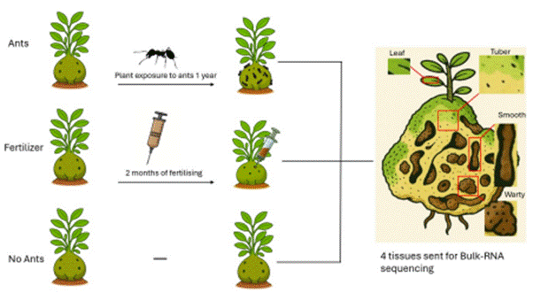

Figure 10. Experimental design and sampling scheme. All plants began ant-free; three of nine plants per species were subsequently exposed to freely roaming ghost ants, while the remaining plants were assigned either to a fertiliser-only (without ants) treatment or a without-ants control. The schematic illustrates the experimental timeline and the three treatments (ants present, fertiliser + without ants, without ants). Four tissues (leaf, tuber, warty domatium wall and smooth domatium wall) were sampled at the end of the experiment for RNA extraction and bulk RNA sequencing (plant outlines created using AI-assisted illustration).

4.3.2 RNA extraction and sequencing
Plants were dissected and samples were collected and immediately flash-frozen in liquid nitrogen on the same day. They were then kept in a -80 degrees C freezer until they were ground in liquid nitrogen using a mortar and pestle. RNA was extracted from four different plant tissues: leaves and three tissues from the domatium, namely warty surface tissue (i.e. about 1 mm deep of tissue around warty surfaces), smooth surface tissue (i.e. about 1 mm deep of tissue around smooth surfaces) and tuber tissue (tissue without inner surface within the domatium) from both M. beccarii and H. moseleyanum both grown from seeds and acquired as ~20 cm high plants from root-houseplants.com. Similarly, to obligate vs. facultative Squamellaria species (Chomicki and Renner, 2019), M. beccarii has a clear-cut differentiation between warty and smooth walls, while H. moseleyanum has less differentiated surfaces, with 'smooth-like' and 'warty-like' areas. RNA extraction relied on the RNeasy Plant Mini Kit (Qiagen). For all RNA-seq treatment, triplicates were used (with three distinct plant individuals).
Following extraction, the quality of each sample was checked by first determining the RNA concentration using Nanodrop and then quantifying the integrity (the degree to which RNA is undegraded and suitable for sequencing) of RNA using a 4200 TapeStation system. Samples with RNA concentrations greater than 10 ng/uL and RNA Integrity Number (RIN) values close to or above 7 were submitted for sequencing. To generate the RNAseq libraries we used NEBNext Poly(A) mRNA Magnetic Isolation Module followed by NEBNext Ultra II Directional RNA Library Prep Kit for Illumina and sequenced using the Illumina HiSeq 2500 Genome Sequencer (Illumina, San Diego). Libraries were sequenced to generate at least 20 million pairs of reads of 100-bp length. RNA sequencing was performed at the NERC Environmental Omics Facility (NEOF), Centre for Genomic Research, University of Liverpool. Control cavity tubers refer to tuber tissue sampled from the no-ants control plants, which were sequenced alongside the ant-present and fertiliser treatments to provide a baseline for gene expression comparisons.

4.3.3 Transcriptome assembly and analysis
Raw FASTQ files were pre-processed to remove adapter sequences and trim low-quality bases. Adapter sequences were trimmed using Cutadapt version 4.5 (Martin, 2011), with the option -O 3, ensuring that trimming occurred if at least 3 base pairs of the adapter sequence were present at the 3' end of the read. The reads were further trimmed to remove low-quality bases, with a minimum window quality score of 20. Reads shorter than 15 base pairs after trimming were discarded. Trimmed RNA-seq reads from each species were mapped to their respective reference genomes (H. moseleyanum and M. beccarii genome assemblies described in Chapter 2) using HISAT2 version 2.2.1 (Kim et al., 2019) with default parameters and Samtools 1.16.1 (Li et al., 2009) to convert the SAM file generated by HISAT2 into a sorted BAM file. Raw count matrices were generated using FeatureCounts v2.0.2 (Liao et al., 2014). Among the four tissue types (warty surfaces, smooth surfaces, tuber tissue and leaf tissue), pairwise differential expression analyses and likelihood ratio test (LRT) were performed using DESeq2 version 1.38.3 (Love et al., 2014). P-values were adjusted for multiple testing using the Benjamini-Hochberg false discovery rate procedure.

4.3.4 Identification of nitrogen-related genes
Nitrogen-related genes were identified based on a combination of literature review (Pinton et al., 2016; Hachiya and Sakakibara, 2017) and functional annotation. Candidate genes associated with nitrogen function and assimilation were first selected by consulting published studies describing nitrogen metabolism pathways and the specific nitrogen-related gene families analysed in this chapter (e.g. ammonium transporters, nitrite/nitrate transporters, urease and cytochrome c biogenesis genes). Defence-related genes including cytochrome P450, NPR1-interacting genes, PDR ABC transporters, multicopper oxidases and gamma-thionins were identified through InterProScan annotations using terms such as 'defence', 'pathogenesis', and 'stress response', and were included in the analysis to assess whether ant presence triggers broader immune or stress responses beyond nitrogen acquisition.
To annotate gene function, we ran InterProScan on the predicted protein sequences derived from the reference genome predictions for both species (M. beccarii and H. moseleyanum), which provided domain-based functional information, including gene names and descriptions. Using a custom R pipeline, we filtered the InterProScan output for annotations containing key nitrogen gene related terms and cross-referenced these with genes identified in relevant nitrogen studies. Genes meeting these criteria were selected for downstream analysis.

4.4 Results
To test the hypothesis of inducibility in H. moseleyanum and constitutive expression in M. beccarii, gene expression was compared between the ants present and no-ants treatments within each tissue and species. A gene is considered inducible if its expression is significantly higher in the ants present treatment relative to no-ants, and constitutive if it shows no significant difference between treatments. Direct comparison between the two species is not required to test these hypotheses each species is evaluated independently against its own no-ants baseline. The following genes are described in detail as they showed the most notable treatment-dependent expression patterns. Genes showing broadly constitutive or non-significant expression are summarised briefly.

4.4.1 Ant-induced regulation of defence-related genes in warty tissues
The following genes are described in detail as they showed the most notable treatment-dependent expression patterns. Genes showing broadly constitutive or non-significant expression are summarised briefly.
In Hydnophytum moseleyanum, several defence-related genes were differentially expressed in warty-like tissue in the ants vs no-ants treatments (Fig. 11). A cytochrome P450 was downregulated, whereas the NPR1-interacting gene, PDR ABC transporter, and a multicopper oxidase were both upregulated in the presence of ants.

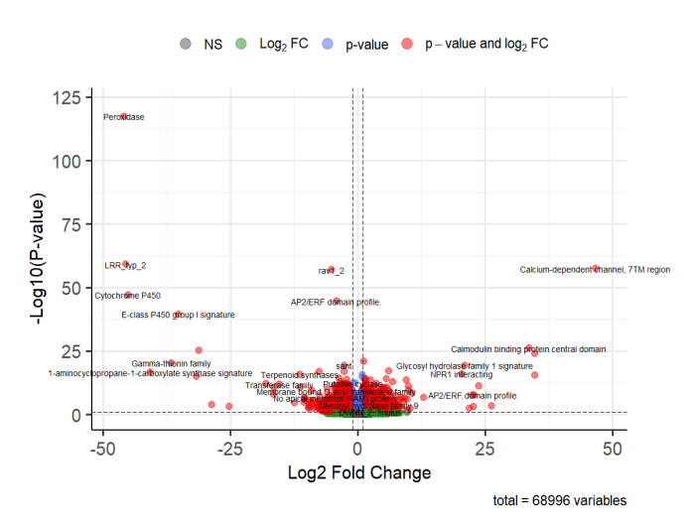

Figure 11. Volcano plot of differential gene expression between warty-like tissues of H. moseleyanum with ants and without ants. Each point represents a single gene. The x-axis shows Log₂ Fold Change, where positive values indicate higher expression in ant-present tissue relative to ant-absent tissue, and negative values indicate lower expression. The y-axis shows −Log₁₀(p-value). Dashed vertical lines indicate the Log₂ Fold Change threshold and the horizontal dashed line indicates the significance threshold (p < 0.05). Genes exceeding both thresholds are considered statistically significant differentially expressed.
In Myrmecodia beccarii warty tissue, multiple cytochrome P450 genes were selectively expressed under ant presence: two cytochrome P450 genes were upregulated, one was downregulated, and the other cytochrome P450 gene was also downregulated (Fig. 12). The D-mannose-binding lectin gene implicated in pathogen recognition and immune signalling and the allene oxide cyclase-like gene involved in jasmonate biosynthesis and wound response were both upregulated, although the latter only weakly (Fig. 12). Additionally, the nitrogen-related UDP-glucuronosyl/UDP-glucosyltransferase gene involved in detoxification and cell wall modification was upregulated in the presence of ants (Fig. 12).

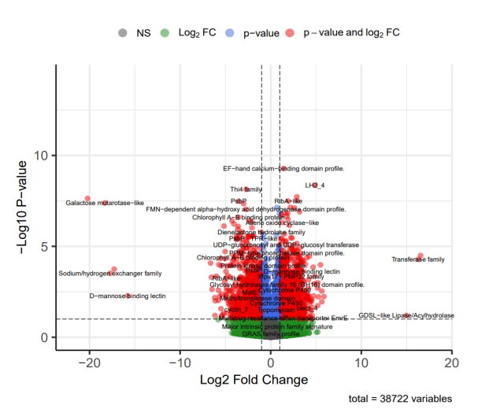

Figure 12: Volcano plot of differential gene expression between warty tissues of M. beccarii with ants and without ants. The x-axis shows log₂ fold change, and the y-axis shows –log₁₀ p-values. Red dots indicate significantly differentially expressed genes (p < 0.05). Each point represents a single gene. The x-axis shows Log₂ Fold Change, where positive values indicate higher expression in ant-present tissue relative to ant-absent tissue, and negative values indicate lower expression. The y-axis shows −Log₁₀(p-value). Dashed vertical lines indicate the Log₂ Fold Change threshold and the horizontal dashed line indicates the significance threshold (p < 0.05). Genes exceeding both thresholds are considered statistically significant differentially expressed.

4.4.2 Tissue-specific regulation of ammonium transporter genes in H. moseleyanum
Principal component analyses (PCA) of normalised gene expression data for all nitrogen-related genes are shown in Supplementary Fig. S6 and Fig. S7 for H. moseleyanum and M. beccarii respectively, illustrating the separation between treatments across tissues. Ammonium transporter genes were highly expressed across multiple tissues, with particularly strong expression in warty-like and smooth-like tissues, both when ants were present and absent (Fig. 13). AMT1;1_Hm02 and AMT3-1_Hm01 ammonium transporters were constitutively expressed across all tissues but showed increased expression in the presence of ants with no significance (Fig. 14). Similarly, AMT1;2_Hm01 and AMT1;2_Hm02 showed comparable expression patterns across tissues, with consistently higher expression in all tissues under ant presence. By contrast, fertiliser treatment only slightly increased expression in tuber tissue, with little change in warty and smooth tissues (Fig10xx). In contrast, AMT1;1_Hm01 and AMT2_Hm02 showed nearly identical expression patterns across all tissues except for tuber tissue. In tuber tissue in the treatment with ants, both genes tended to decrease in expression, whereas expression increased in ants warty and ants smooth relative to the no-ants treatment (Fig. 14). Under the fertiliser treatment, both genes showed relatively high expression in tuber tissue of no-ants control plants than in tuber tissue of fertiliser-treated plants, suggesting that the presence of inorganic nitrogen via fertiliser suppresses rather than induces ammonium transporter expression in tuber tissue.

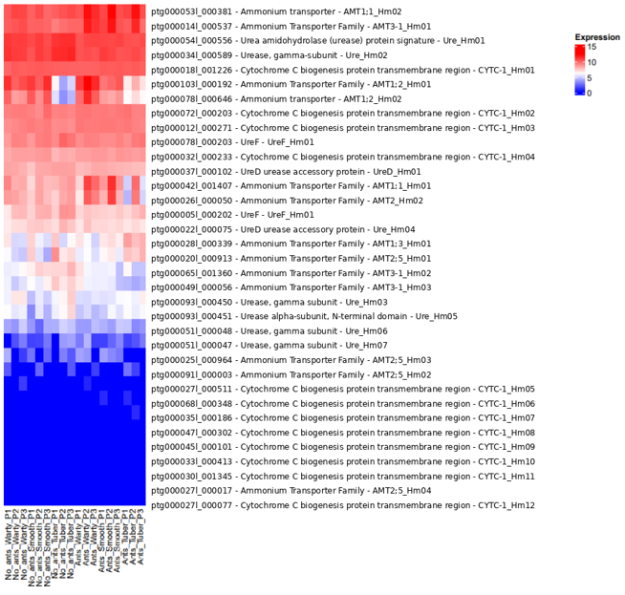

Figure 13. Heatmap of nitrogen-related genes in H. moseleyanum showing log₂-transformed normalised expression values from DESeq2 (variance-stabilised counts). Columns represent samples include no ants and ants treatments and warty-like, smooth-like and tuber tissues, with three biological replicates for each condition. Rows represent genes, which are hierarchically clustered based on expression similarity. Functional annotations are shown alongside the corresponding Helixer gene IDs on the left.
In contrast to AMT1 genes, AMT2;5_Hm01 had relatively low expression in warty tissue, which increased with ants present, although this was not significant (adjusted p = 0.47) (Fig. 13). Under ant presence, the largest expression increase occurred in tuber tissue. In contrast, AMT2_Hm02 showed a tendency for lower expression in tuber and higher expression in smooth tissue, although this difference was not statistically significant (Likelihood Ratio Test, p = 0.07). Across tissues in the fertiliser treatment (no-ants plants injected with fertiliser), AMT1;3_Hm01 and AMT2;5_Hm01 showed relatively constitutive expression, but both were expressed more highly in control cavity tubers than in fertiliser-treated cavity tubers.
The strongest increase in AMT1;1_Hm01 expression was observed in tuber tissue of ant-colonised plants (Fig. 13), potentially compensating for reduced expression in other tissues, though this increase was not statistically significant (Likelihood Ratio Test, adjusted p = 0.07). However, there was no proof that ants caused this increase in the tuber according to AMT1;1_Hm01 (Likelihood Ratio Test, adjusted p = 0.07) and AMT2_Hm02 (Likelihood Ratio Test, adjusted p = 0.14) in the same tissue.
Under fertiliser, AMT1;1_Hm01 (Likelihood Ratio Test, adjusted p = 0.07) and AMT2_Hm02 (Likelihood Ratio Test, FDR-adjusted p-value = 0.14) both genes were relatively constitutive, with higher expression in control cavity tubers than in fertilised cavity tubers. Overall, in H. moseleyanum, while the baseline expression for many transporters is high, ammonium genes had greater gene expression but not necessarily because of ants as most genes were not found to be induced by ants. In the presence of ants, tuber gene expression was drastically reduced.
AMT3-1_Hm02 and AMT3-1_Hm03 under fertiliser saw a decrease in tuber tissue expression whereas ants had much further decrease (Fig. S4). AMT2;5_Hm03 exhibited relatively low expression across all tissues, with the highest levels observed in tuber tissue (Fig. S4). In the presence of ants, its expression in tuber tissue dropped to nearly zero, while it increased in warty-like and smooth-like tissues. Fertiliser generally increased ammonium gene expression across all tissues compared to control cavity tissues. AMT2;5_Hm02 had generally low expression across all tissues, with only a slight increase in tuber tissue under ant presence and reduced expression under fertiliser.
Overall, fertiliser treatment had only minor effects on ammonium transporter expression. Most AMT genes retained similar expression patterns across tissues, indicating that fertiliser did not induce widespread transcriptional regulation comparable to that observed under ant treatments.

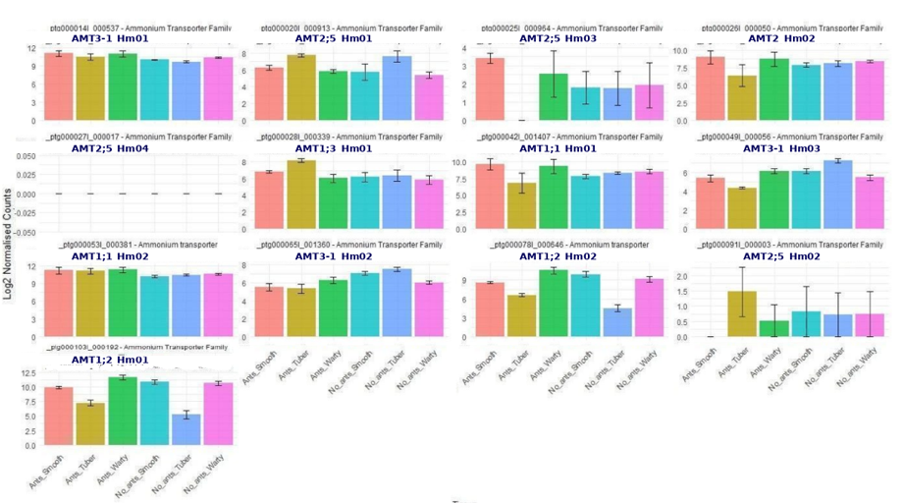

Figure 14. Bar plot of ammonium transporter gene expression in H. moseleyanum showing mean log₂-transformed normalised expression values from DESeq2 (variance-stabilised counts) for ants and no ants treatments. Error bars indicate ± standard error across three biological replicates.

4.4.3 Urease-related gene expression patterns in H. moseleyanum
Ure_Hm02 (Urease, gamma-subunit) (Likelihood Ratio Test, FDR-adjusted p-value = 0.01) showed nearly identical expression patterns in warty tissue compared to other tissues. Ure_Hm02 was expressed at relatively high levels across tissues, but their expression decreased in the presence of ants (Fig. 13). Under fertiliser treatment, Ure_Hm02 was largely constitutive, with only a slight increase in expression in warty tissue (Fig. S4). UreD_Hm01 showed relatively uniform expression across tissues in control plants, but its expression was lower across all tissues in the presence of ants, whereas fertiliser increased its expression in warty and tuber tissues. Ure_Hm04 (urease accessory protein) and UreF_Hm01 showed constitutive expression across all tissues under both treatments (non-significant, p > 0.05). Ure_Hm05 (urease alpha-subunit, N-terminal domain) and Ure_Hm07 (urease, gamma-subunit) remained unaffected by ant presence or fertiliser treatment (p > 0.05) across all tissues, except Ure_Hm07 which was induced in tuber tissue under fertiliser (FDR-adjusted p-value = 0.03). Overall, fertiliser treatment resulted in only modest changes in urease-related gene expression, with most genes remaining constitutively expressed across tissues and showing no evidence of strong fertiliser-induced regulation.

4.4.4 Cytochrome C biogenesis genes expression patterns in H. moseleyanum
Cytochrome c biogenesis genes in H. moseleyanum CYTC-1_Hm01 showed constitutive expression, with no detectable changes across tissues in response to ant presence (Fig. 13). Under fertiliser treatment, its expression remained largely unchanged, apart from a slight increase in tuber tissue (Fig. S4). CYTC-1_Hm02 and CYTC-1_Hm03 were both highly expressed across tissues, showing slight increases under both ant and fertiliser treatments, with CYTC-1_Hm03 notably increasing in tuber tissue under ant presence.
All other cytochrome c genes showed little to no detectable expression changes under either treatment (Fig. S4). Collectively, these results indicate that fertiliser treatment had little influence on cytochrome c biogenesis gene expression, with expression remaining largely constitutive across tissues.

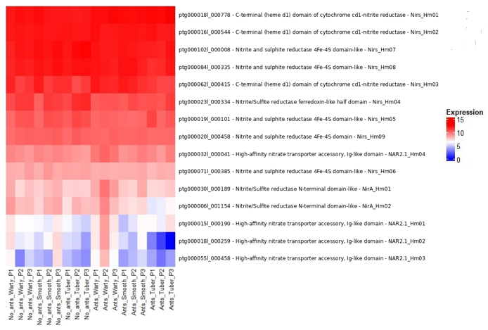

Figure 15. Heatmap of nitrogen-related genes in H. moseleyanum showing log₂-transformed normalised expression values from DESeq2 (variance-stabilised counts). Columns represent samples from no-ants and ants treatments across warty, smooth and tuber tissues (three biological replicates per condition). Rows represent genes, hierarchically clustered based on expression similarity. Helixer gene IDs and corresponding functional annotations are shown on the left.

4.4.5 Regulation of nitrite and nitrate transporter genes in response to ant presence in H. moseleyanum
The genes Nirs_Hm01 and Nirs_Hm02 (C-terminal heme d1 domain of cytochrome cd1 nitrite reductase), along with nitrite and sulphite reductase 4Fe-4S domain-like genes, showed consistently high expression across all tissues, remaining unchanged in response to ants (Fig. 15) or fertiliser treatments (Fig. S3 and Fig.S4). In contrast, Nirs_Hm03 (C-terminal heme d1 domain of cytochrome cd1 nitrite reductase) showed high expression levels that were further induced in warty-like and smooth-like tissues in the presence of ants, while tuber tissue expression increased only slightly. In contrast, Nirs_Hm04 (FDR-adjusted p-value = 0.02) (S8) and Nirs_Hm05 (Nitrite/sulphite reductase ferredoxin-like half domain) were highly expressed across tissues in the absence of ants but showed reduced expression when ants were present. Under fertiliser treatment, both genes were largely constitutive and showed little change across tissues (Fig. S4).
NAR2.1_Hm04 showed increased expression only in warty-like tissue in the presence of ants (FDR-adjusted p-value = 0.02) (S8), consistent with this tissue being a major site of nutrient uptake, whereas fertiliser produced minimal changes in expression across tissues. NirA_Hm01 and NirA_Hm02 were upregulated in the presence of ants across multiple tissues except in tuber where expression decreased, and fertiliser treatment generally elicited much lower expression in all tissues. High-affinity nitrate transporter accessory, Ig-like domain genes were expressed at low levels in the absence of ants but were clearly induced in warty-like tissue when ants were present (Fig. 16). Fertiliser treatment produced a broadly similar spatial pattern (Fig. S5), but induction by ants was markedly stronger than under fertiliser treatments. Overall, fertiliser treatment produced relatively minor changes in nitrate- and nitrite-related gene expression compared with ant treatments, with most genes maintaining constitutive expression across tissues.

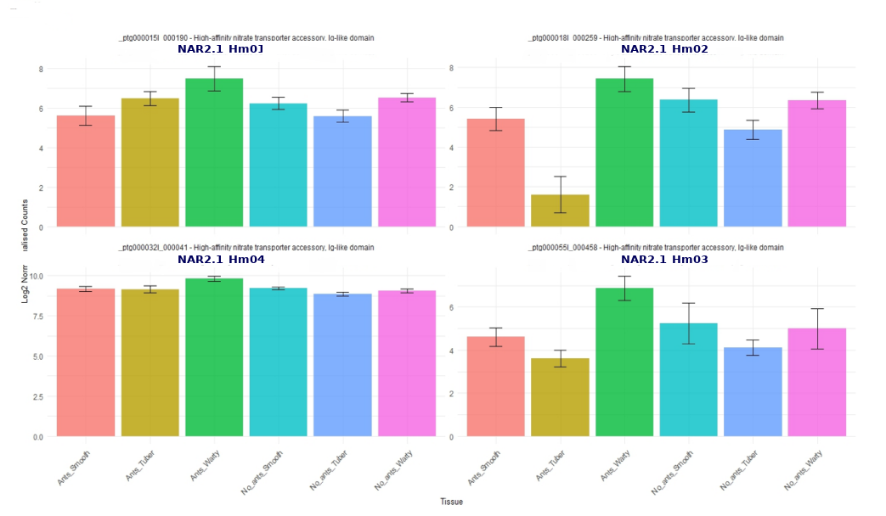

Figure 16. Bar plot of high-affinity nitrate transporter accessory, Ig-like domain genes in H. moseleyanum, showing mean log₂-transformed normalised expression values from DESeq2 (variance-stabilised counts) for ants and no ants treatments. Error bars indicate ±standard error across three biological replicates.

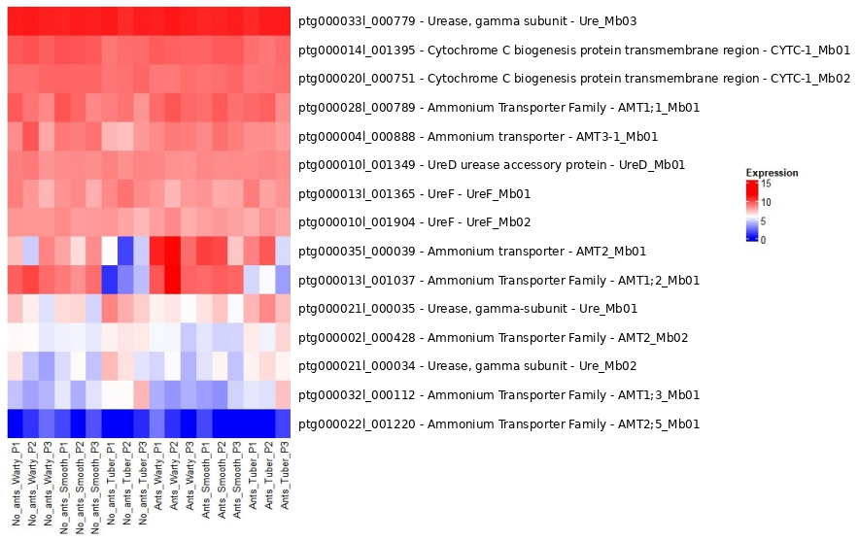

Figure 17. Heatmap of nitrogen-related genes in M. beccarii showing log₂-transformed normalised expression values from DESeq2 (variance-stabilised counts). Columns represent samples from no-ants and ants treatments across warty, smooth and tuber tissues (three biological replicates per condition). Rows represent genes, hierarchically clustered based on expression similarity. Helixer gene IDs and corresponding functional annotations are shown on the left.

4.4.6 Expression pattern of nitrogen-related genes in M. beccarii
In M. beccarii, most nitrogen-related genes were broadly constitutive across tissues and treatments, meaning expression levels remained largely stable regardless of ant presence or fertiliser. For this reason, this section focuses on genes that showed notable deviations from this constitutive pattern, as these are most informative for understanding how mutualistic dependence shapes nitrogen gene regulation. Ammonium transporter genes were broadly constitutive across tissues and treatments. However, tuber tissue expression of AMT2_Mb01 (FDR-adjusted p-value = 0.01) was significantly lower than in warty and smooth tissues and showed a slight increase by ant presence (Fig. 17). AMT1;1_Mb01 and AMT3-1_Mb01 show higher expression in the presence of ants, whereas in fertiliser treatment AMT3-1_Mb01 remained relatively unchanged (Fig. S2). AMT2_Mb02 and AMT1;3_Mb01 showed increased expression in tuber tissue in the presence of ants; under fertiliser treatment, AMT1;3_Mb01 showed a similar pattern, while AMT2_Mb02 remained essentially constitutive (Fig. S2). AMT2;5_Mb01 had low expression across all tissues and even lower under fertiliser treatment (Fig. S2). Most other nitrogen-related genes were either constitutively highly or constitutively weakly expressed, with NRT3.1_Mb01 standing out as the nitrate transporter clearly upregulated by ants (Fig. 18).
Mb_Nitrite and sulphite reductase 4Fe-4S domain-like was most strongly expressed in warty and smooth tissue, under both ants and no ants treatments, indicating constitutive expression. Ure_Mb01 and Ure_Mb02 showed their highest expression in tuber tissue under all treatments (Fig 19); however, under fertiliser Ure_Mb01 expression remained relatively constant across tissues (Fig. S2). Ure_Mb03 Urease gamma subunit, UreD_Mb01, UreF_Mb01 and UreF_Mb02 were purely constitutive under all conditions, with no clear tissue specificity and no detectable induction by ants. CYTC-1_Mb01 and CYTC-1_Mb02 showed relatively high expression across most tissues, and warty and smooth tissues were unaffected by either treatment. Fertiliser treatment in M. beccarii had no effect on nitrate related genes (Fig. S1). Overall, fertiliser treatment had minimal effects on nitrogen-related gene expression in M. beccarii, with most genes exhibiting constitutive expression and little evidence of coordinated transcriptional responses.

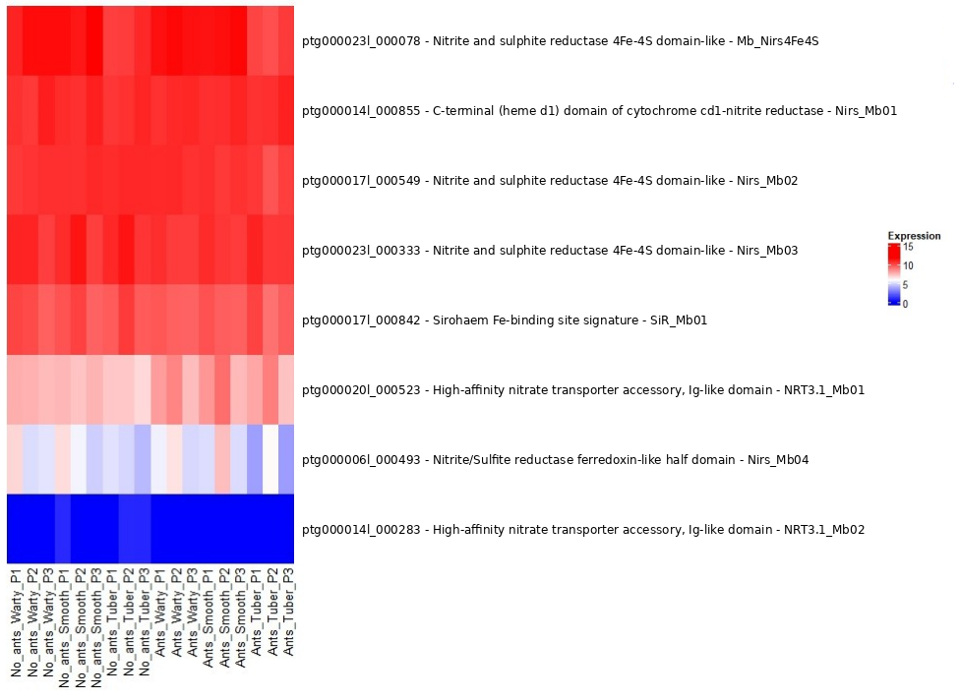

Figure 18. Heatmap of nitrogen-related genes in M. beccarii showing log₂-transformed normalised expression values from DESeq2 (variance-stabilised counts). Columns represent samples from no-ants and ants treatments across warty, smooth and tuber tissues (three biological replicates per condition). Rows represent genes, hierarchically clustered based on expression similarity. Helixer gene IDs and corresponding functional annotations are shown on the left.

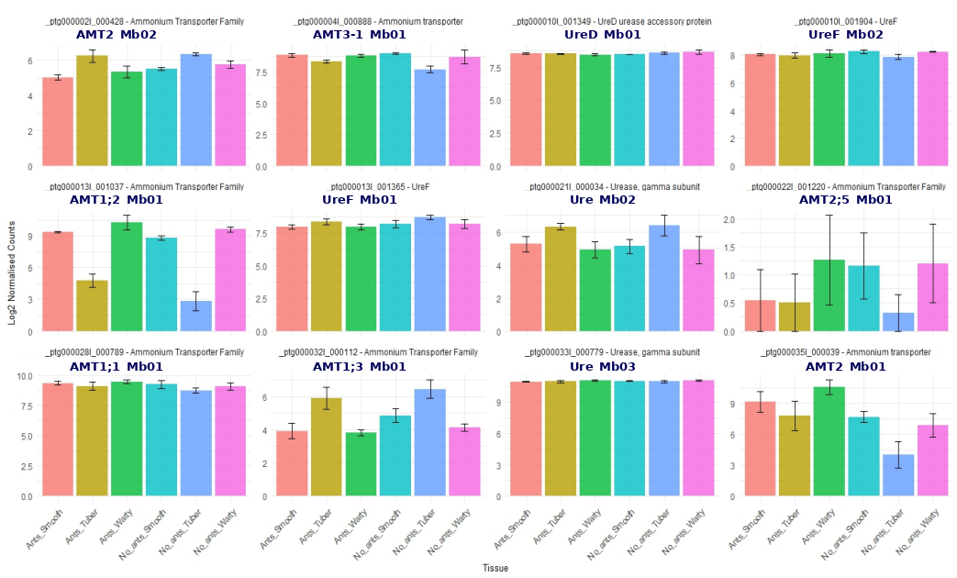

Figure 19. Bar plot of nitrogen-related genes in M. beccarii showing mean log₂-transformed normalised expression values from DESeq2 (variance-stabilised counts) for ants and no ants treatments. Error bars indicate ± standard error across three biological replicates.

4.5 Discussion

4.5.1 Ant-induced versus constitutive nitrogen-uptake gene expression in facultative and obligate ant-plants
Our central prediction was that facultative, generalist ant-plants such as Hydnophytum moseleyanum would rely on an inducible nitrogen-uptake toolkit that is upregulated when ants are present, whereas the obligate myrmecophyte Myrmecodia beccarii would show a more constitutive expression pattern, reflecting the high and predictable availability of ant-derived nutrients. The basic idea is that facultative ant-plants are expected to have greater regulatory plasticity because ant occupancy (and quality) vary in time and space — thus, inducibility allows plants to capture nutritional gains when and where ants are present, while limiting the costs by turning it off in the absence of ants. This expectation parallels theory on plant defence, which predicts that plastic, induced traits are favoured when the benefits of activation are intermittent and the costs of maintaining defence are high, whereas constitutive investment is favoured under consistently high attack or partner reliability (Karban, 2011; Mithofer and Boland, 2012). Analogously, theory on mutualisms predicts that obligate mutualists should evolve less context-dependent investment in their partners than facultative ones (Bronstein, 1994; Chomicki et al., 2020).
The transcriptomic study conducted in this thesis broadly support these expectations: H. moseleyanum shows more ant-induced modulation of nitrogen-related genes, whereas M. beccarii relies on constitutive expression, with only a few nitrogen transporters showing ant responsiveness. Similar trajectories are well documented beyond ant-plants systems: in many insect-bacterial mutualisms, environmentally acquired or conditionally beneficial associations show flexible host responses, whereas long-term obligate symbionts become developmentally integrated and metabolically indispensable, with reduced scope for facultative regulation and strong specialisation of host tissues at the exchange interface (Douglas, 2015; Moran et al., 2008).

4.5.2 Ant effects on nitrogen-uptake genes are strongest in Hydnophytum moseleyanum
Across the candidate set, the clearest signal of ant responsiveness occurred in H. moseleyanum, where several nitrogen-associated transcripts shifted in a tissue-dependent manner when ants were present. Responses were most evident in warty-like domatium tissues, which showed the greatest number of significantly differentially expressed nitrogen-related genes, followed by smooth-like tissues, while tuber tissue showed the fewest significant changes. This spatial structure matters biologically because warty domatium tissue has been proposed as a primary interface for acquisition of ant-derived nutrients in ant-housing Rubiaceae epiphytes, consistent with its distinctive anatomy and absorptive capacity (Huxley, 1978; Chomicki and Renner, 2019). The induction of a nitrate-uptake accessory component (a NAR2.1 homolog) specifically in warty tissue under ant occupancy is particularly suggestive: in well-characterised plant systems such as Arabidopsis thaliana, NAR2 proteins are required partners of high-affinity NRT2 nitrate transporters and can strongly influence nitrate uptake capacity (Okamoto et al., 2003; Wang et al., 2018).
However, not all nitrogen-related genes showed similar changes in expression across these experimental conditions. Several ammonium transporter (AMT) homologs were relatively constitutive, and where treatment effects appeared they were again tissue-specific (including cases where expression was higher in tuber tissue of no-ants control plants than in tuber tissue of fertiliser-treated plants, suggesting that the presence of inorganic nitrogen via fertiliser suppresses rather than induces ammonium transporter expression in tuber tissue). Although some ammonium transporters are constitutively expressed, their expression and activity are still tightly regulated according to nitrogen status. Consequently, ammonium transport is commonly downregulated under nitrogen sufficiency (or when reduced nitrogen is readily available), rather than simply tracking total nitrogen supply (Loqué and von Wirén, 2004; Ludewig et al., 2007). The decrease in expression of nitrite-reductase homologs when ants are present, despite ant-associated upregulation of other uptake-related components, likewise points to a shift in the form of nitrogen being processed and/or to feedback regulation of nitrate assimilation pathways (Vidal and Gutierrez, 2008; Wang et al., 2018).
Based on available evidence, the dominant form of nitrogen in ant faeces is urea and its derivatives (Vidkjaer et al., 2015; Vidkjaer et al., 2016), which would first require conversion to ammonium before plant uptake. If ant-derived nitrogen arrives primarily in reduced organic forms rather than as nitrate, this could explain the downregulation of nitrite-reductase homologs under ant presence. The plant may shift away from nitrate assimilation pathways when ammonium or urea-derived nitrogen is more readily available. Taken together, the H. moseleyanum data are consistent with a model in which ant occupancy alters local nitrogen availability and/or nitrogen form within domatia, and the plant responds primarily at the domatium interface rather than systemically across all tissues.

4.5.3 Weak ant responsiveness in the obligate ant-plant Myrmecodia beccarii
Although M. beccarii can be maintained without ants under controlled greenhouse conditions, field studies have consistently shown that it does not persist without its ant partner in nature (Huxley, 1978; Volp et al., 2022), confirming the obligate nature of this dependency outside experimental settings. The comparatively modest ant-associated shifts among the targeted nitrogen-uptake candidates in M. beccarii are consistent with our prediction for an obligate ant-plant, namely that core nutrient-acquisition machinery should be expressed more constitutively rather than being strongly induced only when ants are present. In stable nutritional mutualisms, selection can favour canalised investment in the structures and physiological pathways that underpin reliable resource capture (Bronstein, 2015; Mayer et al., 2014), reducing the need for large transcriptional reprogramming in response to short-term partner absence or presence. Thus, a 'weak' differential-expression signal is not evidence that ants are unimportant; rather, it suggests that M. beccarii may maintain a relatively steady baseline capacity for uptake and processing of ant-derived nitrogen, consistent with the ubiquitous presence of a specialised ant partner depositing nutrients in the same way in warty cavities (Huxley, 1978; Chomicki and Renner, 2019).
Two additional considerations are important. First, ant-derived nitrogen in ant-house systems can be modulated by microbial communities within domatia, including fungi that recycle and transform deposited substrates (Huxley, 1978; Leroy et al., 2011; Defossez et al., 2011; Mayer et al., 2014; Nepel et al., 2022). Thus, it is plausible that such microbial communities play an additional modulation role in addition to the plant's transcriptomic responses. A related point concerns the nature of ant faeces nitrogen forms and the possible roles of the domatium microbial communities in converting nitrogen compounds from ant faeces into distinct chemical nitrogen forms. Thus, more work on the potential role of the domatium microbiome in remodelling the available nitrogen chemical forms and how this may affect nitrogen uptake in epiphytic ant plants is needed.

4.5.4 Defence gene expression at the domatium nutrient-exchange interface
In both Hydnophytum moseleyanum and Myrmecodia beccarii, ant presence was associated with differential expression of several genes with plausible roles in immune signalling, antimicrobial defence, oxidative stress management, and secondary metabolism in warty (absorptive) domatium tissues.
In H. moseleyanum, ant presence was associated with upregulation of an NPR1-interacting gene alongside increased expression of a PDR-type ABC transporter and a multicopper oxidase, while a gamma-thionin/defensin and at least one cytochrome P450 candidate were downregulated.
In M. beccarii, the ant effect was weaker overall but included shifts in multiple cytochrome P450 candidates involved in oxidative stress and secondary metabolism and upregulation of a mannose-binding lectin candidate, implicated in pathogen recognition and immune signalling, a weakly ant-associated allene oxide cyclase-like candidate involved in jasmonate biosynthesis and wound response, and a UDP-glucuronosyltransferase candidate involved in detoxification and cell wall modification.
Taken together, these patterns suggest that even where nitrogen-uptake genes are relatively constitutive, ant occupancy can still be accompanied by targeted transcriptional changes consistent with interface protection and/or immunomodulation at the domatium surface.
This makes functional sense in ant-plant systems because the domatium wall is simultaneously a nutrient uptake surface and a persistent exposure interface: the nutrient interface implies permeability, and ant inputs concentrate organic matter and moisture that likely elevate microbial opportunity, creating selection for tight immune management. Unlike nitrogen uptake, which in obligate species can be constitutively maintained given the reliable presence of a specialised ant partner, defence gene expression may need to remain responsive rather than constitutive because the nature and intensity of microbial challenge at the domatium surface with variation with ant colony size, detritus load, and seasonal conditions requiring a responsive rather than fixed transcriptional response.
The same pattern has been shown in the warty walls of the obligate Hydnophytinae ant Squamellaria imberbis, which show transcriptomic enrichment not only for uptake-related functions but also for defence/stress-associated signatures, consistent with protecting a permeable exchange surface (Pu et al., 2021). More broadly, domatia are repeatedly interpreted as symbiotic organs where 'housing', nutrient routing and defence intersect, with evidence that different wall types can partition barrier functions from exchange functions (Chomicki et al., 2024).
Consistent with this, our data show that defence-related genes were more strongly differentially expressed in warty tissues (primary exchange surface) than in smooth tissues (see results), suggesting that the absorptive warty interface carries a greater immune management burden than the smooth brood-rearing surface. More work is needed to characterise the direct role of defence gene expression at the domatium interface of facultative and obligate ant-plants.

4.5.5 Limitations and future directions
This study yielded important new insights on ant-plant nutritional physiology and how it differs in facultative and generalist versus obligate and specialised ant-plants. However, there are also several limitations of the current dataset that needs to be discussed, and which paves the way to future work.
First, changes in the transcript abundance of nitrogen-related genes can be interpreted as a shift in potential capacity, but not as direct evidence of increased or decreased uptake. Coupling expression data with 15N tracer experiments in distinct ant context would provide this link. However, this is not a straightforward experiment to do, since approaches to test the uptake capacity requires to inject distinct 15N molecules with distinct concentrations (e.g. Gegenbauer et al., 2012; Chomicki and Renner, 2019), which requires a large sample size, but also could directly affect gene expression itself.
As noted above, another important factor concerns the type of nitrogen chemical form provided in ant faeces, and how they might be reshaped by the domatium microbiomes. Identifying the microbiome and determining its metabolic potential via metagenomics and experiments would allow it to determine how it might reshape nitrogen forms inside domatia. So far, fungi and actinomycetes have been reported from Hydnophytinae ant plants (Huxley, 1978; Diarra and Osborne-Naikatini, 2023), but their functional importance is still unknown.
Finally, the experimental approach used ghost ants (Tapinoma melanocephalum) in both Hydnophytum moseleyanum and Myrmecodia beccarii to ensure that ant species was not a factor of variation across species. Results from 15N feeding assays reported in Chapter 3 showed that they were highly consistent with responses from facultative vs. obligate ant-plants obtained by experiments performed in the natural environment (Chomicki and Renner, 2019). But it is worth noting that this ant species is not the natural partner of any of these ant-plants.

4.6 Conclusion
This chapter supports the view that ant occupancy reshapes nitrogen-related gene expression in a tissue-structured manner that differs fundamentally between facultative and obligate ant-plants. In the facultative H. moseleyanum, domatium-associated tissues show the clearest ant-linked shifts, consistent with domatia adapting their nutrient-acquisition interfaces to the temporally and spatially variable ant presence. In M. beccarii, the constitutive expression of many nitrogen-uptake genes is consistent with the continuous and reliable presence of an ant partner.
As defined earlier, M. beccarii is here referred to as specialist because it forms an exclusive association with Philidris cordata in nature; however, it is the reliability of ant presence rather than the identity of the partner that is predicted to select for constitutive rather than inducible expression. It is worth noting that ant-plants may not rely on fundamentally novel nitrogen physiology; instead, they appear to redeploy conserved plant nitrogen pathways at an anatomically and ecologically specialised interface generated by the mutualism with ants. Ideally, this claim would be supported by comparing gene expression in a closely related non-myrmecophytic plant to confirm that the same gene families are expressed in the absence of ants.
While such a comparison was beyond the scope of this study, the nitrogen transporter families identified here: NRT2, AMT and NAR2 are well-characterised conserved families in terrestrial plants (Glass et al., 2002; Krapp, 2014), supporting the interpretation that ant-plants have recruited rather than invented nitrogen acquisition machinery.
This chapter unveils that evolutionary transitions from facultative to obligate ant association are mirrored by a shift from plastic, cue-responsive regulation to canalised, standing investment. Thus, while the nutrient acquisition genetic toolkit might not drive the evolution of obligate dependency, its expression plasticity appears essential to limit the costs associated with facultative symbioses, while once obligate dependence evolved, a less plastic, more constitutive response can evolve.

4.7. References
Afkhami, M.E., McIntyre, P.J., and Strauss, S.Y. (2014). Mutualist-mediated effects on species' range limits across large geographic scales. Ecology Letters, 17(10), 1265–1273.
Benzing, D.H., Henderson, K., Kessel, B., and Sulak, J. (1976). The absorptive capacities of bromeliad trichomes. American Journal of Botany, 63(7), 1009-1014.
Bronstein, J.L. (1994). Our current understanding of mutualism. The Quarterly Review of Biology, 69(1), 31-51.
Bronstein, J.L. (1998). The contribution of ant plant protection studies to our understanding of mutualism. Biotropica, 30(2), 150–61.
Bronstein, J.L. (2015). Mutualism, in Bronstein J.L. (ed.), Mutualism. Oxford: Oxford University Press, 1–2.
Bruno, J.F., Stachowicz, J.J., and Bertness, M.D. (2003). Inclusion of facilitation into ecological theory. Trends in Ecology and Evolution, 18(3), 119–125.
Casique, J.V., Soares, M.V.B., da Silva, E.F., Kikuchi, T.Y., Andrade, E.H.A., and Mastroberti, A.A. (2022). Coryanthes macrantha (Orchidaceae: Stanhopeinae) and their floral and extrafloral secretory structures: an anatomical and phytochemical approach. Annals of Botany Plants, 14(5), plac039.
Chomicki, G., Kadereit, G., Renner, S.S., and Kiers, E.T. (2020). Trade-offs in the evolution of plant farming by ants. Proceedings of the National Academy of Sciences of the United States of America, 117(5), 2535–2543.
Chomicki, G., Metzler, D., Naikatini, A., and Renner, S.S. (2025). Compartmentalization reduces conflict in multi-partner plant-insect symbioses. Science, 389(6756), 151-156.
Chomicki, G., and Renner, S.S. (2019). Farming by ants remodels nutrient uptake in epiphytes. The New Phytologist, 223(4), 2011–2023.
Chomicki, G., and Renner, S.S. (2015). Phylogenetics and molecular clocks reveal the repeated evolution of ant-plants after the late Miocene in Africa and the early Miocene in Australasia and the Neotropics. The New Phytologist, 207(2), 411–424.
Chomicki, G., Walker-Hale, N., Etchells, J.P., Ritter, E.J., and Weber, M.G. (2024). Diversity and development of domatia: Symbiotic plant structures to host mutualistic ants or mites. Current opinion in plant biology, 82, 102647.
Clark, K. L., Nadkarni, N. M., and Gholz, H. L. (1998). Growth, anatomy, and nutrient responses of epiphytic bryophytes to atmospheric nutrient inputs in a Kenyan cloud forest. Journal of Tropical Ecology, 14(4), 453–479.
Cook, J. M., and Rasplus, J. Y. (2003). Mutualists with attitude: coevolution of fig wasps and figs. Trends in Ecology & Evolution, 18(5), 241–248.
Crotty, S.M., and Bertness, M.D. (2015). Positive interactions expand habitat use and the realized niches of sympatric species. Ecology, 96(10), 2575–2582.
Davidson, D.W., and McKey, D. (1993). The evolutionary ecology of symbiotic ant/plant relationships. Journal of Hymenoptera Research, 2, 13–83.
Defossez, E., Djiéto-Lordon, C., McKey, D., Selosse, M.A., and Blatrix, R. (2011). Plant-ants feed their host plant, but above all a fungal symbiont to recycle nitrogen. Proceedings of the Royal Society B: Biological Sciences, 278(1710), 1419-1426.
Diarra, U., and Osborne-Naikatini, T. (2023). Isolation, characterization and screening of actinomycetes associated with Fijian ant–plant symbioses. Microbiology, 169(11), 001410.
Douglas, A.E. (2015). Multiorganismal insects: diversity and function of resident microorganisms. Annual Review of Entomology, 60, 17–34.
Fischer, R.C., Wanek, W., Richter, A., and Mayer, V. (2003). Do ants feed plants? A 15N labelling study of nitrogen fluxes from ants to plants in the mutualism of Pheidole and Piper. Journal of Ecology, 91(1), 126-134.
Futuyma, D.J., and Moreno, G. (1988). The evolution of ecological specialization. Annual Review of Ecology and Systematics, 19, 207–233.
Gay, H. (1993). Animal-fed plants: an investigation into the uptake of ant-derived nutrients by the far-eastern epiphytic fern Lecanopteris Reinw. (Polypodiaceae). Biological Journal of the Linnean Society, 50, 221–23.
Gegenbauer, C., Mayer, V.E., Zotz, G., and Richter, A. (2012). Uptake of ant-derived nitrogen in the myrmecophytic orchid Caularthron bilamellatum. Annals of Botany Plants, 110(4), 757-765.
Glass, A.D.M., Britto, D.T., Kaiser, B.N., Kinghorn, J.R., Kronzucker, H.J., Kumar, A., Okamoto, M., Rawat, S., Siddiqi, M.Y., Unkles, S.E., and Vidmar, J.J. (2002). The regulation of nitrate and ammonium transport systems in plants. Journal of Experimental Botany, 53(370), 855–864.
Hachiya, T., and Sakakibara, H. (2017). Interactions between nitrate and ammonium in their uptake, allocation, assimilation, and signaling in plants. Journal of Experimental Botany, 68(10), 2501–2512.
Heil, M., and McKey, D. (2003). Protective ant–plant interactions as model systems in ecological and evolutionary research. Annual Review of Ecology, Evolution, and Systematics, 34, 425–53.
Hoeksema, J.D., and Bruna, E.M. (2000). Pursuing the big questions about interspecific mutualism: A review of theoretical approaches. Oecologia, 125(3), 321–330.
Huxley, C.R. (1978). The ant-plants Myrmecodia and Hydnophytum (Rubiaceae), and the relationships between their morphology, ant occupants, physiology and ecology. The New Phytologist, 80(1), 231–268.
Inui, Y., Tanaka, H.O., Hyodo, F., and Itioka, T. (2009). Within-nest abundance of a tropical cockroach Pseudoanaplectinia yumotoi associated with Crematogaster ants inhabiting epiphytic fern domatia in a Bornean dipterocarp forest. Journal of Natural History, 43, 1139–1145.
Janzen, D.H. (1974). Epiphytic myrmecophytes in Sarawak: mutualism through the feeding of plants by ants. Biotropica, 6(4), 237-259.
Karban, R. (2011). The ecology and evolution of induced resistance against herbivores. Functional Ecology, 25(2), 339-347.
Kiers, E.T., Palmer, T.M., Ives, A.R., Bruno, J.F., and Bronstein, J.L. (2010). Mutualisms in a changing world: An evolutionary perspective. Ecology Letters, 13(12), 1459–1474.
Kim, D., Paggi, J.M., Park, C., Bennett, C., and Salzberg, S.L. (2019). Graph-based genome alignment and genotyping with HISAT2 and HISAT-genotype. Nature Biotechnology, 37(8), 907–915.
Krapp, A., David, L.C., Chardin, C., Girin, T., Marmagne, A., Leprince, A.S., Chaillou, S., Ferrario-Méry, S., Meyer, C., and Daniel-Vedele, F. (2014). Nitrate transport and signalling in Arabidopsis. Journal of Experimental Botany, 65(3), 789-798.
Leroy, C., Séjalon‐Delmas, N., Jauneau, A., Ruiz‐González, M.X., Gryta, H., Jargeat, P., Corbara, B., Dejean, A., and Orivel, J. (2011). Trophic mediation by a fungus in an ant–plant mutualism. Journal of Ecology, 99(2), 583-590.
Li, H., Handsaker, B., Wysoker, A., Fennell, T., Ruan, J., Homer, N., Marth, G., Abecasis, G., Durbin, R., and 1000 Genome Project Data Processing Subgroup. (2009). The Sequence Alignment/Map format and SAMtools. Bioinformatics, 25(16), 2078–2079.
Liao, Y., Smyth, G.K., and Shi, W. (2014). FeatureCounts: an efficient general-purpose program for assigning sequence reads to genomic features. Bioinformatics, 30(7), 923–930.
Ludewig, U., Neuhäuser, B., and Dynowski, M. (2007). Molecular mechanisms of ammonium transport and accumulation in plants. FEBS Letters, 581(12), 2301-2308.
Loqué, D., and von Wirén, N. (2004). Regulatory levels for the transport of ammonium in plant roots. Journal of Experimental Botany, 55(401), 1293-1305.
Love, M.I., Huber, W., and Anders, S. (2014). Moderated estimation of fold change and dispersion for RNA-seq data with DESeq2. Genome Biology, 15(12), 550.
Maeyama, T., Kitade, O., and Matsumoto, T. (1997). The diverse occupant fauna in epiphytic ant-plants, Hydnophytum moseleyanum (Rubiaceae) in New Guinea. Tropics, 7, 101.
Martin, M. (2011). Cutadapt removes adapter sequences from high-throughput sequencing reads. EMBnet.journal, 17(1), 10–12.
Mayer, V.E., Frederickson, M.E., McKey, D., and Blatrix, R. (2014). Current issues in the evolutionary ecology of ant-plant symbioses. The New Phytologist, 202(3), 749–764.
Mithöfer, A., and Boland, W. (2012) Plant defense against herbivores: chemical aspects. Annual Review of Plant Biology, 63, 431–450.
Moran, N.A., McCutcheon, J.P., and Nakabachi, A. (2008). Genomics and evolution of heritable bacterial symbionts. Annual Review of Genetics, 42, 165–190.
Nepel, M., Pfeifer, J., Oberhauser, F.B., Richter, A., Woebken, D., and Mayer, V.E. (2022). Nitrogen fixation by diverse diazotrophic communities can support population growth of arboreal ants. BMC Biology, 20(1), 135.
Okamoto, M., Vidmar, J.J., and Glass, A.D. (2003). Regulation of NRT1 and NRT2 gene families of Arabidopsis thaliana: responses to nitrate provision. Plant and Cell Physiology, 44(3), 304-317.
Pinton, R., Tomasi, N., and Zanin, L. (2016). Molecular and physiological interactions of urea and nitrate uptake in plants. Plant Signaling and Behavior, 11(1), e1076603.
Pu, Y., Naikatini, A., Pérez‐Escobar, O.A., Silber, M., Renner, S.S., and Chomicki, G. (2021). Genome‐wide transcriptome signatures of ant-farmed Squamellaria epiphytes reveal key functions in a unique symbiosis. Ecology and Evolution, 11(22), 15882-15895.
Solano, P., and Dejean, A. (2004). Ant-fed plants: comparison between three geophytic myrmecophytes. Biological Journal of the Linnean Society, 83(4), 433–9.
Stachowicz, J.J. (2001). Mutualism, facilitation, and the structure of ecological communities. BioScience, 51(3), 235–246.
Tanaka, H.O., Inui, Y., and Itioka, T. (2009). Anti-herbivore effects of an ant species, Crematogaster difformis, inhabiting myrmecophytic epiphytes in the canopy of a tropical lowland rainforest in Borneo. Ecological Research, 24, 1393–1397.
Treseder, K.K., Davidson, D.W., and Ehleringer, J.R. (1995). Absorption of ant-provided carbon dioxide and nitrogen by a tropical epiphyte. Nature. 375(6527), 137–139.
Vidal, E.A., and Gutiérrez, R.A. (2008). A systems view of nitrogen nutrient and metabolite responses in Arabidopsis. Current opinion in plant biology, 11(5), 521–529.
Vidkjær, N.H., Wollenweber, B., Gislum, R., Jensen, K.M.V., and Fomsgaard, I.S. (2015). Are ant feces nutrients for plants? A metabolomics approach to elucidate the nutritional effects on plants hosting weaver ants. Metabolomics, 11(4), 1013-1028.
Vidkjær, N.H., Wollenweber, B., Jensen, K.M.V., Ambus, P.L., Offenberg, J., and Fomsgaard, I.S. (2016). Urea in weaver ant feces: quantification and investigation of the uptake and translocation of urea in Coffea arabica. Journal of Plant Growth Regulation, 35(3), 803-814.
Von Wittgenstein, N.J., Le, C.H., Hawkins, B.J., and Ehlting, J. (2014). Evolutionary classification of ammonium, nitrate, and peptide transporters in land plants. BMC Evolutionary Biology, 14(1), 11.
Wang, Y.Y., Cheng, Y.H., Chen, K.E., and Tsay, Y.F. (2018). Nitrate transport, signaling, and use efficiency. Annual Review of Plant Biology, 69(1), 85-122.
Zotz, G. (2016). Plants on plants: The biology of vascular epiphytes. Springer International Publishing.

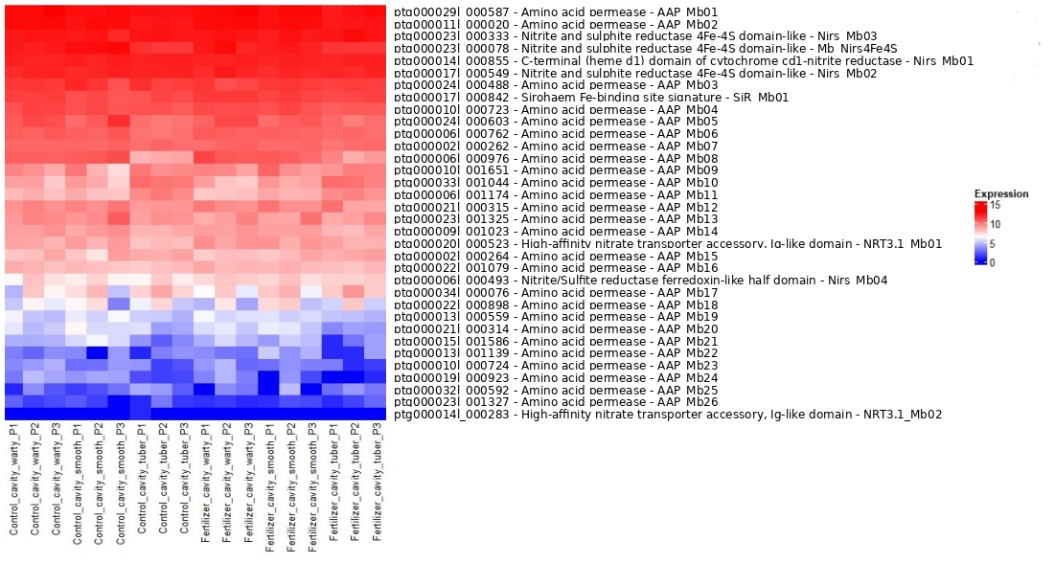
Supplementary figures

Figure S1. Heatmap of nitrogen-related genes in M. beccarii showing log₂-transformed normalised expression values from DESeq2 (variance-stabilised counts). Samples include control cavity and fertilised cavity across warty, smooth, and tuber tissues, with three biological replicates each. Genes are hierarchically clustered based on expression similarity. Gene functional annotations are attributed to Helixer arbitrary gene ids on the left side.

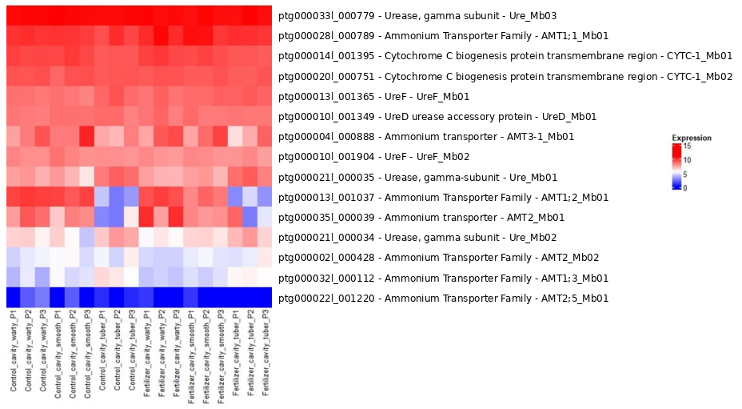

Figure S2. Heatmap of nitrogen-related genes in M. beccarii showing log₂-transformed normalised expression values from DESeq2 (variance-stabilised counts). Samples include control cavity and fertilised cavity across warty, smooth, and tuber tissues, with three biological replicates each. Genes are hierarchically clustered based on expression similarity. Gene functional annotations are attributed to Helixer arbitrary gene ids on the left side.

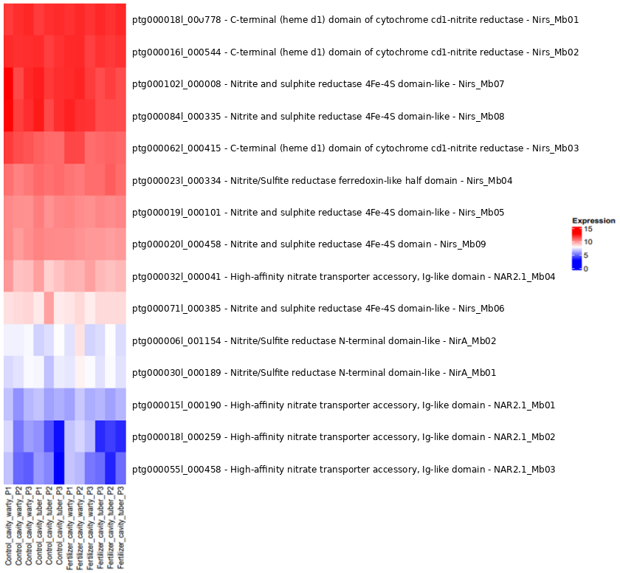

Figure S3. Heatmap of nitrogen-related genes in M. beccarii showing log₂-transformed normalised expression values from DESeq2 (variance-stabilised counts). Samples include control cavity and fertilised cavity across warty, smooth, and tuber tissues, with three biological replicates each. Genes are hierarchically clustered based on expression similarity. Gene functional annotations are attributed to Helixer arbitrary gene ids on the left side.

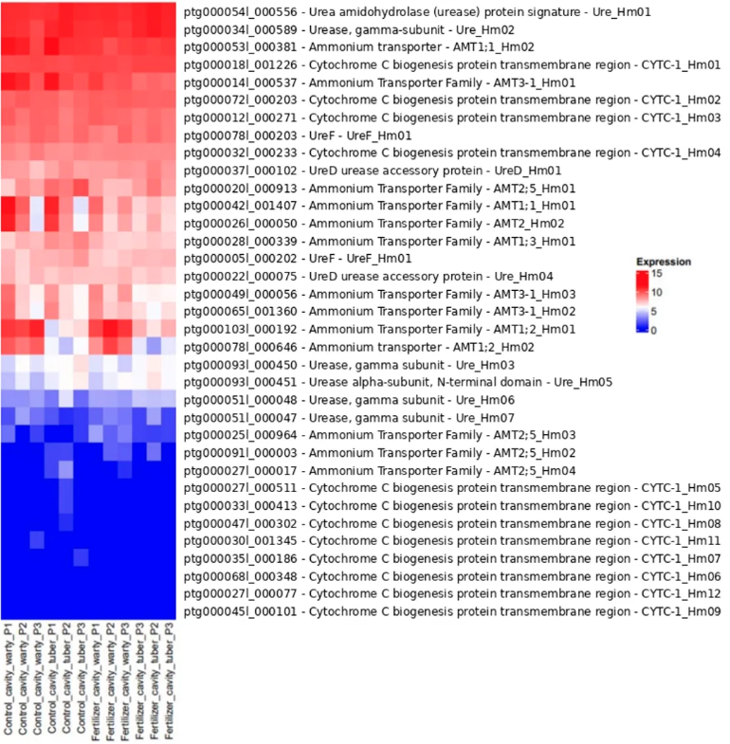
Figure S4. Heatmap of nitrogen-related genes in H. moseleyanum showing log₂-transformed normalised expression values from DESeq2 (variance-stabilised counts). Samples include control cavity and fertilised cavity across warty, smooth, and tuber tissues, with three biological replicates each. Genes are hierarchically clustered based on expression similarity. Gene functional annotations are attributed to Helixer arbitrary gene ids on the left side.

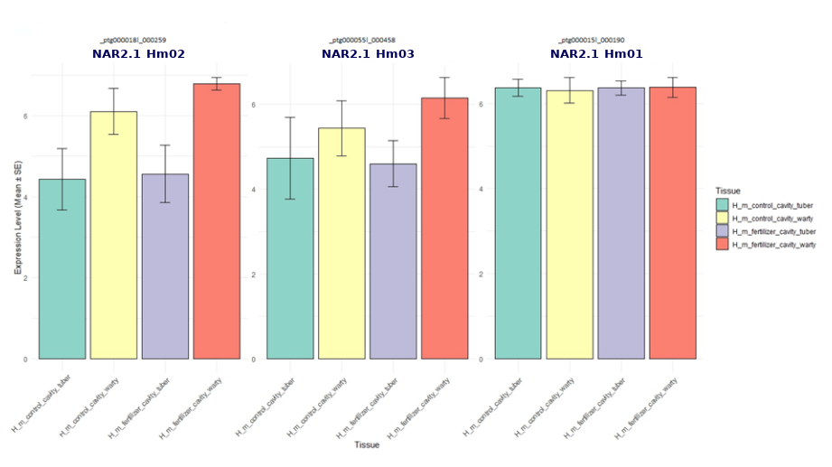

Figure S5. Bar plots with error bars for High affinity nitrate transporter accessory, Ig-like domain in H. moseleyanum in control cavity vs fertiliser cavity.

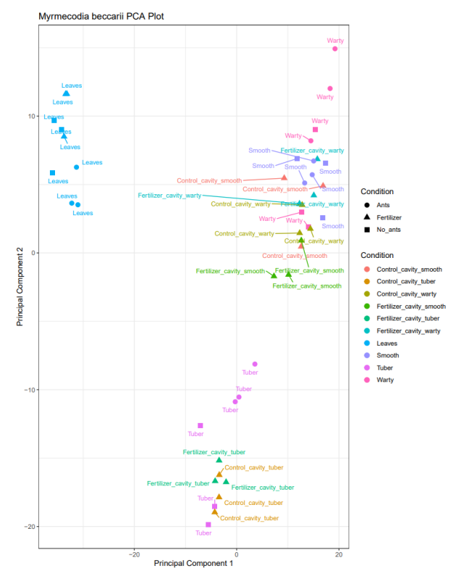

Figure S6. Principal Component Analysis (PCA) of Myrmecodia beccarii tissue samples. The plot displays the clustering of samples from four tissue types: tuber, leaves, warty, and smooth. Each tissue type includes samples from plants with ant colonisation (ants), without ant colonisation (no ants), and those treated with fertiliser.

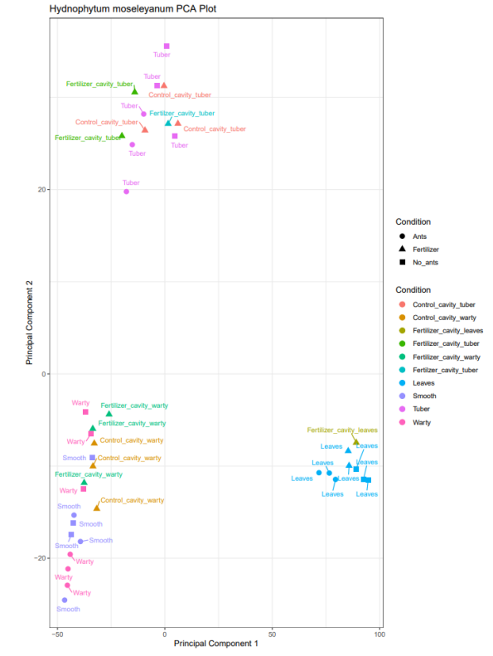

Figure S7. Principal Component Analysis (PCA) of Hydnophytum moseleyanum tissue samples. The plot displays the clustering of samples from four tissue types: tuber, leaves, warty, and smooth. Each tissue type includes samples from plants with ant colonisation (ants), without ant colonisation (no ants), and those treated with fertiliser.

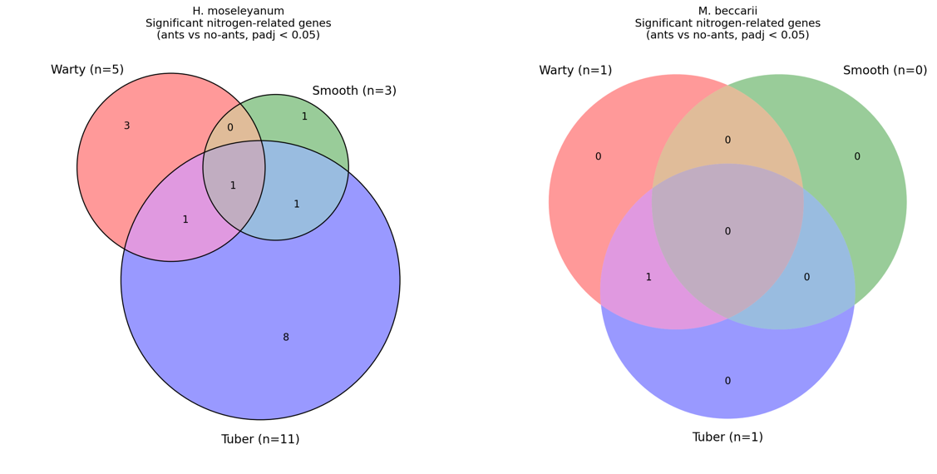
Figure S8. Overlap of differentially expressed nitrogen-related genes across tissue types in Hydnophytum moseleyanum and Myrmecodia beccarii. Venn diagrams display the number of unique and shared nitrogen-related genes significantly regulated in response to ant presence (ants vs. no-ants comparison, adjusted p-value < 0.05). Gene counts are broken down by tissue or morph structures: Warty (pink), Smooth (green), and Tuber (blue) for (Left) H. moseleyanum and (Right) M. beccarii. The value (n) denotes the total number of significant genes identified within each respective category, while values within intersections indicate overlapping genes between categories.

Chapter 5. General Discussion

5. General discussion
Mutualism is a type of species interaction that involves the exchange of resources and/or services between species where every species benefits (Janzen, 1985; Bronstein, 2015; Hale and Valdovinos 2021). Mutualisms are found across the tree of life and occur in virtually every ecosystem, in fact virtually every species on Earth is involved in one or more mutualisms (Bronstein, 2001). Accordingly, mutualisms play key roles in ecosystem functioning, such as pollination, seed dispersal, defence against predators and nutrition (Bronstein, 2015). Ant-plant mutualisms have long been used as models to understand mutualism ecology and evolution (Bronstein et al., 2006). Ants and plants have coexisted for over 140 million years (Moreau et al., 2006). As a result, a wide range of interactions between ants and plants have evolved, including many mutualisms (Chomicki and Renner, 2017).
There are four main types of ant-plant mutualisms: seed dispersal by ants (myrmecochory), extrafloral nectary (EFN)-based defence mutualisms, domatium-based ant-plant symbioses, and plant cultivation mutualisms.
Dependency in ant-plant mutualisms affects both partners’ survival and stability. In the current study, plants maintained without ants throughout the experiment showed no visible signs of reduced fitness over the experimental period, which is consistent with the short timescale of the experiment. However, this does not contradict the long-term fitness consequences of ant loss reported in field studies, as the greenhouse conditions removed the competitive and herbivory pressures that make ant partnerships essential for survival in natural tropical environments.
Likewise, ants that rely heavily on plants for food or nesting sites may struggle if plant resources decline. Dependence describes how strongly a partner’s fitness declines in the other’s absence, ranging from facultative associations to obligate relationships. Obligate mutualists require a partner to complete their life cycle, whereas facultative mutualists can persist without the partner, albeit sometimes with reduced performance. In Hydnophytinae, this obligate status is nutritional rather than strictly reproductive: Myrmecodia beccarii lacks the free-living, ant-independent populations documented for Hydnophytum moseleyanum, and depends on resident ants for nitrogen provisioning at the domatium interface (Chomicki and Renner, 2017); the experimental evidence for this dependence in M. beccarii is presented in Chapters 3 and 4 of this thesis. This dependence gradient provides a direct framework for testing how nutrient acquisition is integrated into plant physiology and gene regulation in facultative versus obligate systems.
Genomic studies of mutualisms have largely been restricted to symbiosis with microbes, most notably endosymbiosis. By contrast, genomic and transcriptomic approaches have rarely been applied to “macro-mutualisms”, including insect-plant interactions, so the underlying molecular mechanisms remain poorly understood. Concepts from endosymbiosis (e.g. Bennett and Moran, 2015; McCutcheon et al., 2019) may nonetheless provide a foundation for further understanding of genomic evolution in mutualisms.
Endosymbiosis, whereby one organism lives within another, can enable major ecological transitions, for example in herbivorous insects (Oliver et al., 2003) and can reshape lineages through trait loss and metabolic complementarity (Fisher et al., 2017). Endosymbiosis between two species has created new biochemical reactions allowing the intertwined species to survive in inhospitable habitats (Fukatsu and Ishikawa, 1996). These principles, specifically dependence driven by gene loss, offer a useful reference point, although insect-plant mutualisms may be shaped by different constraints.
This thesis investigates genomic and transcriptomic mechanisms associated with mutualistic dependence in two Hydnophytinae ant-plants – the facultative Hydnophytum moseleyanum and the obligate Myrmecodia beccarii – by testing whether nitrogen-related pathways are expressed constitutively or induced by ants, and by quantifying how ant presence alters nitrogen gene expression in each species. Within Hydnophytinae, obligate dependence on ants is a derived condition relative to the ancestral facultative state (Chomicki and Renner, 2017), and M. beccarii exemplifies this derived, obligate lineage, in contrast to the facultative H. moseleyanum studied here.
The aim of this thesis was to identify transcriptomic responses and differential gene expression associated with ant presence and nutrient status and genomic correlates gene family expansion, contraction, and copy-number variation in nitrogen-transport gene families (NRT, AMT, NAR2) underlying mutualistic dependence in an ant-plant mutualism. By focusing on two contrasting plant species Hydnophytum moseleyanum (facultative) and Myrmecodia beccarii (obligate) with different dependency strategies, this work sets out to understand the molecular and genomic factors that underpin variation in dependence on ants. A key contribution of this thesis is an integrative framework linking controlled experimentation to genome-enabled, tissue-resolved transcriptomics in a macro-mutualism, testing how ant-derived nitrogen and plant gene regulation differ between facultative and obligate systems.
Chapter 2 establishes a genomic foundation by generating high-quality reference genomes for both species and applying a duplication-aware framework that supports orthology inference and transcriptome mapping. Chapter 3 develops controlled greenhouse symbioses with ghost ants and uses ¹15N isotope tracing to test whether ant-derived nitrogen is incorporated into plant tissues under shared abiotic conditions. Chapter 4 then manipulates ant presence and nutrient availability while profiling tissue-resolved transcriptomic responses, testing whether obligate partnership is associated with reduced plasticity in nitrogen-uptake regulation relative to facultative partnerships.

5.1. Establishing experimental symbioses in ant–plants
Ant-plant mutualisms have long served as textbook systems for studying the ecological dynamics of cooperation, conflict, and partner fidelity, yet most domatium-based symbioses remain difficult to manipulate experimentally because they occur in remote tropical settings and depend on local ant assemblages (Bronstein, 2001; Chomicki and Renner, 2017). This study provides the first successful establishment of experimental symbioses between Hydnophytum moseleyanum (facultative) and Myrmecodia beccarii (obligate) with ghost ants (Tapinoma melanocephalum).
Despite ghost ants not being the native partners of either plant, they successfully colonised domatia and deposited nitrogen in patterns that closely mirror those observed in natural symbioses. This demonstrates that our greenhouse system provides a robust and scalable model for studying ant-plant nutritional interactions under controlled conditions. The development of such model systems is a major step forward, as it opens-up the amount of experimentation that can be done on these mutualisms. Field-based studies remain essential, but they are often constrained by environmental variability, partner availability, and logistical challenges. In contrast, the experimental framework established here allows precise control of symbiotic variables, direct manipulation of ant presence, and reliability.

5.2. Warty domatium walls as the key site of nitrogen uptake in obligate Hydnophytinae
The isotope-tracing experiments indicate that ant-derived nitrogen is not distributed/absorbed uniformly across domatium tissues. Instead, enrichment is concentrated at the domatium interface, consistent with the long-standing view that specialised inner wall tissues mediate nutrient acquisition in Hydnophytinae ant-plants (Beccari, 1884; Miehe, 1911). The warty inner walls emerge as the primary site of ant-derived nitrogen uptake in both species, consistent with earlier physiological and comparative work showing that warty walls are hyper-absorptive and are also the targets of ant defecation and detritus deposition in specialised Hydnophytinae (Huxley, 1978; Chomicki and Renner, 2019).
Thus, the repeated differentiation of domatium wall types across Hydnophytinae ant-plants (Chomicki and Renner, 2019) provides a clear anatomical framework for interpreting transcriptomic signals of specialised ant-plants across evolutionary replicates (Chomicki et al., 2024). Moreover, the strong ¹15N signal found in the tuber tissue provides evidence that tuber tissues also retain ant-derived nitrogen, supporting a “capture-and-storage” model in which domatia function not only as exchange organs but as entry points into longer-term nutrient allocation, analogous to storage roles documented for other tuberous organs (Glynne and Jackson, 1919; Millard, 1986).

5.3. Mutualistic dependence is reflected in regulatory plasticity at the interface
Chapters 3 and 4 together support a simple, testable framework: as ant-plant interactions shift from facultative to obligate dependence, the expression of the nitrogen-uptake toolkit becomes less plastic and more developmentally embedded at the exchange interface. This prediction is grounded in two, complementary lines of theory. First, a cost–benefit argument: inducible investment is expected when benefits are intermittent and costs are non-trivial, whereas more constitutive investment is favoured when partner services are reliable (Karban, 2011; Mithöfer and Boland, 2012) this concerns the economics of maintaining plasticity itself. Second, and distinct from this, an evolutionary argument: mutualism theory and comparative evidence show that dependence and specialisation increase, selection acts consistently on partner-facing traits within a narrower ecological setting, favouring canalised (fixed) trait expression independently of the costs of induction (Bronstein, 1994; Chomicki and Renner, 2017).
Together, these two mechanisms predict the same outcome reduced plasticity under obligate dependence but by different routes: the first through the economics of induction, the second through the narrowing of selective context under specialisation. This is important, because the first, cost–benefit framework has been developed in the context of plant defence, and this thesis shows it is also relevant, alongside the second, evolutionary framework, for understanding nutritional mutualisms. However, it is important to remember that the transcriptomic responses of the nitrogen uptake toolkit are not clear-cut in facultative versus obligate ant-plants. There is a whole range of variation with trends across genes, as indeed seen for defence responses (Karban and Baldwin, 2007).
Within this framework, the transcriptomic results are most naturally interpreted as tissue-specific modulation rather than a global “on/off” switch. In the facultative H. moseleyanum, ant presence is associated with clearer transcriptional shifts in domatium-facing tissues, consistent with a strategy in which the plant adjusts uptake and processing capacity in response to variable ant occupancy in time and space. In the obligate M. beccarii, ant-associated shifts among nitrogen candidates are comparatively modest, consistent with higher baseline investment in interface function. Importantly, a weaker differential expression signal does not imply that ants are unimportant; rather, it is consistent with canalisation, that is, standing investment that reduces the need for short-term transcriptional reprogramming in a reliably occupied symbiosis. Future work might unveil how this inductive versus constitutive nature of the nitrogen uptake genetic toolkit is controlled.

5.4. Partner identity, microbiomes, and nitrogen form
Although ghost ants recapitulate key features of domatium nutritional function (in particular the pattern of nitrogen deposition documented for facultative versus obligate Squamellaria Hydnophytinae in their natural environment partner identity could still matter in ways not captured by short-term enrichment patterns, especially for specialised systems. Work on M. beccarii in the field shows that both native and invasive ants can provide nitrogen, but the longer-term consequences for plant fitness, partner turnover, and stability of dependence remain unresolved (Volp and Lach, 2019; Volp et al., 2022).
It is also notable that the fertiliser-infection experiments do not fully reproduce the transcriptomic effects of ant presence. This could mean either that the nature and/or concentration of the nitrogen forms supplied differ sufficiently from those delivered by ants to generate a distinct transcriptomic response (fertiliser- and ant-presence treatments induced substantially non-overlapping sets of differentially expressed genes). Alternatively, ants could contribute directly to transcriptional induction – through chemical cues or mechanical stimulation – although this seems less likely here: ghost ants lack a shared evolutionary history with Hydnophytinae, and the response is strongest in the facultative species, which in nature hosts a broad range of ant partners, making specialised, coevolved chemical signalling less probable.
A second, unexplored layer is the domatium microbiome. Domatia concentrate organic substrates and moisture, creating conditions where microbes can transform nitrogen forms before uptake; in many symbioses, such microbial processing is central to what the host ultimately experiences as “partner-provided nutrition” (Douglas, 2015) Establishing whether nitrogen arrives primarily as ammonium, nitrate, urea-derived products, or microbially transformed intermediates would be the next step to understand the nutritional physiology of these ant-plant mutualisms.

5.5. Conclusion
Together, these chapters establish Hydnophytinae ant-plants as a tractable experimental system and provide the genomic and transcriptional foundation needed to test how mutualistic dependence is built at the ant-plant interface. Using reconstituted domatium symbioses, ¹15N tracing, multi-tissue transcriptomics, and new reference genomes, the thesis shows that ant-derived nitrogen is incorporated by both Hydnophytum (facultative) and Myrmecodia (obligate), but that the response is organised differently: Hydnophytum shows more ant-induced responses of nitrogen-uptake genes, whereas Myrmecodia relies more on a stable baseline programme with more genes showing constitutive expression. The central conclusion is clear: the shift to an obligate partnership is associated with reduced regulatory plasticity in nitrogen uptake at the exchange interface. This work provides important insights into the evolution of mutualism dependence, and into the physiology of ant-plant mutualisms. Future work will investigate the potential role of the microbiome in nutrition and identify specific genes that regulate these fundamentally distinct transcriptomic responses.

5.6. References
Beccari, O. (1884). Piante ospitatrici o formicarie della Malesia e della Papuasia. Malesia, 2, 1–182.
Bennett, G.M., and Moran, N.A. (2015). Heritable symbiosis: The advantages and perils of an evolutionary rabbit hole. Proceedings of the National Academy of Sciences of the United States of America, 112, 10169–10176.
Bronstein, J.L. (1994). Our current understanding of mutualism. The Quarterly Review of Biology, 69(1), 31-51.
Bronstein, J.L. (2001). The exploitation of mutualisms. Ecology Letters, 4, 277–287.
Bronstein, J.L. (2015). Mutualism. In J.L. Bronstein (Ed.), Mutualism (pp. 1-2). Oxford University Press.
Bronstein, J.L., Alarcón, R., and Geber, M. (2006). The evolution of plant–insect mutualisms. The New Phytologist, 172, 412–428.
Chomicki, G., and Renner, S.S. (2017). Partner abundance controls mutualism stability and the pace of morphological change over geologic time. Proceedings of the National Academy of Sciences of the United States of America, 114, 3951–3956.
Chomicki, G., and Renner, S.S. (2019). Phylogenetics and molecular clocks reveal the repeated evolution of ant-plants after the late Miocene. Proceedings of the National Academy of Sciences of the United States of America, 116, 998–1003.
Chomicki, G., Walker-Hale, N., Etchells, J.P., Ritter, E.J., and Weber, M.G. (2024). Diversity and development of domatia: Symbiotic plant structures to host mutualistic ants or mites. Current opinion in plant biology, 82, 102647.
Douglas, A.E. (2015). The Symbiotic Habit. Princeton University Press.
Fisher, R.M., Henry, L.M., Cornwallis, C.K., Kiers, E.T., and West, S.A. (2017). The evolution of host–symbiont dependence. Nature Communications, 8, 15973.
Fukatsu, T., and Ishikawa, H. (1996). Phylogenetic position of bacterial endosymbionts of aphids and other insects. Applied and Environmental Microbiology, 62, 1561–1566.
Glynne, M.D., and Jackson, W. (1919). Storage functions of tuberous plant organs. Annals of Botany Plants, 33, 321–339.
Hale, R., and Valdovinos, F.S. (2021). Mutualism: Ecological theory and network dynamics. Trends in Ecology and Evolution, 36, 421–432.
Huxley, C. R. (1978). The ant–plant mutualism in tropical rain forests. Biological Reviews, 53, 321–340.
Janzen, D.H. (1985). The natural history of mutualisms. In D.H. Boucher (Ed.), The Biology of Mutualism (pp. 40-99). Oxford University Press.
Jebb, M.H.P. (1991). An account of the Rubiaceae of the Hydnophytinae. Blumea, 36, 1–61.
Karban, R., and Baldwin, I.T. (2007). Induced responses to herbivory. University of Chicago Press.
Karban, R. (2011). The ecology and evolution of induced resistance against herbivores. Functional Ecology, 25(2), 339-347.
McCutcheon, J.P., Boyd, B.M., and Dale, C. (2019). The life of an insect endosymbiont from the cradle to the grave. Current Biology, 29, R485–R495.
Miehe, H. (1911). Untersuchungen über Ameisenpflanzen. Botanische Jahrbücher, 46, 1–65.
Millard, P. (1986). The nitrogen content of potato (Solanum luberosum L.) tubers in relation to fertilizer nitrogen application – the effect on amino acid composition and yields. Journal of the Science of Food and Agriculture, 37, 107–114.
Mithöfer, A., and Boland, W. (2012) Plant defense against herbivores: chemical aspects. Annual Review of Plant Biology, 63, 431–450.
Moreau, C.S., Bell, C.D., Vila, R., Archibald, S.B., and Pierce, N.E. (2006). Phylogeny of the ants: Diversification in the age of angiosperms. Science, 312, 101–104.
Oliver, K.M., Russell, J.A., Moran, N.A., and Hunter, M.S. (2003). Facultative bacterial symbionts in aphids confer resistance to parasitic wasps. Proceedings of the National Academy of Sciences of the United States of America, 100, 1803–1807.
Volp, K., and Lach, L. (2019). Invasive ants alter ant–plant mutualisms. Biological Invasions, 21, 2179–2192.
Volp, K., Lach, L., and Turner, S. (2022). Disruption and replacement of ant–plant mutualisms by invasive ants. Ecology, 103, e03578.

