

A collaborative method of enquiry exploring the views of one secondary school’s journey enacting and embedding whole-school Trauma-Informed and Relational Approaches

Jessica Farnworth

230108246

Supervised by Dr Lynne Mackay and Dr Katherine Easton

Research thesis submitted in part requirement for the Doctor of Educational and Child Psychology

The University of Sheffield, School of Education
May 2026

Acknowledgements
Thank you to everyone at Spen Valley High school who made it possible for the research to happen. Your insights and reflections have been enlightening, and I hope I have managed to convey these well in this thesis.
Thank you also to my supervisors, Dr Lynne Mackay and Dr Katherine Easton for your invaluable thoughts, guidance and containment throughout, it is much appreciated.
To my wonderful course friends and fellow Trainee Educational Psychologists who have shaped my experiences throughout this thesis. I am extremely grateful to have had the privilege of spending the last three years with you all.

To Rich, thank you for loving me unconditionally, always encouraging me, keeping me grounded and supporting me to pursue my goal.
Thank you to my incredible family and friends, particularly my Mum, Dad, Liv and Sam and Auntie Lou who have provided continuous support, always believed in me and encouraged me to aim high.

In memory of my wonderful Grandma Margaret who always gave a listening ear, told me to keep going even when things felt impossible and is my inspiration in everything I do.
“One more step around the world I go…”

Abstract
Literature emphasises the importance of positive relationships in educational settings (Cramond, 2021; Bomber, 2011), particularly given the increase in mental health difficulties for students and staff (NHS, 2021; Young Minds, 2023; NASUWT, 2024) and increases in school attendance difficulties (Children’s Commissioner, 2023).
Trauma-informed and relational approaches (TIRA) offer an alternative culture and ethos for schools, recognised to improve staff and student wellbeing and academic achievement. However, literature recognises that more research is needed to understand how TIRAs are conceptualised in mainstream secondary schools. This research intends to contribute towards filling this gap.
Situated within a critical realist ontology, contextualist epistemology and relational paradigm, the research explores the views of staff and students within one mainstream secondary school (Spen Valley High School, SVHS) situated in the Yorkshire and Humber region, who have been embedding TIRAs over the past five years. The research explored what TIRAs look like, impacts of the approach and facilitators and barriers.
Two World Cafés (WC) took place, one with staff members and another with students. This process facilitated collaborative discussions, knowledge sharing and developed collective insights about TIRA at the case study school.
Through Reflexive Thematic Analysis (RTA), five themes were developed: ‘relational safety as the foundation of school life’, ‘A place where support and wellbeing are prioritised and sustained over time’, ‘A shared approach that fosters identity, belonging and fulfilment’, “We can’t pour from an empty cup” and ‘Systemic conditions that shape a TIRA ethos’.
The findings are critically discussed alongside existing literature. These key findings reflect how TIRAs have been conceptualised at SVHS and the impacts of this culture experienced by staff and students. The findings present key facilitators including emotional warmth and attunement from staff, co-constructed co-regulation and prioritising staff wellbeing and key barriers including the lack of time and systemic constraints.

Table of Contents
Acknowledgements 2
Abstract 3
List of Figures 8
List of Tables 10
Table of Abbreviations 11
1.0 Introduction 12
1.1 Why this research? 12
1.2 Context for the research 12
1.3 Thesis chapters 13
2.0 Literature Review 14
2.1 The need for ‘something different’? 14
2.2 What are trauma-informed and relational approaches? 16
2.3 Theoretical principles underpinning trauma-informed and relational practice 19
2.3.1 Neurosequential Model 19
2.3.2 Humanist Principles 20
2.3.3 Eco-systemic perspective 22
2.4 Trauma-informed and relational approaches as a whole-school approach 23
2.4.1 Conceptualising trauma-informed and relational approaches 23
2.4.2 Embedding and sustaining trauma-informed and relational approaches 27
2.5 Impact of trauma-informed and relational approaches 28
2.6 Facilitators and barriers to embedding trauma-informed and relational approaches 30
2.6.1 Leadership 31
2.6.2 Whole school training 32
2.6.3 Staff 32
2.6.4 Time and Cost 33
2.6.5 Systemic influences 33
2.7 Trauma-informed and relational approaches within the context of UK mainstream secondary schools 34
2.8 Rationale for the current research 35
2.9 Conclusion 36
3.0 Methodology 38
3.1 Research aims 38
3.2 Methodological orientation 38
3.2.1 Ontological and epistemological position 38
3.2.2 Quantitative and qualitative research 40
3.2.3 Position statement 41
3.3. Design 43
3.3.1 Purpose and approach: rationale for qualitative case study design 43
3.3.2 World Café as a research methodology 44
3.3.3 World Café design and procedure 47
3.3.4 Data collection 51
3.4 Recruitment and participants 52
3.4.1 Recruitment of a school 52
3.4.2 Details of the participating school 52
3.4.3 Recruitment of staff participants 53
3.4.4 Recruitment of student participants 53
3.4.5 Overview of participants 54
3.5 Ethics 55
3.6 Data Analysis 55
3.6.1 Familiarisation 56
3.6.2 Coding 56
3.6.3 Generating initial themes 57
3.6.4 Developing and reviewing themes 58
3.6.5 Refining, defining and naming themes 58
3.6.6 Write up 58
4.0 Findings 59
4.1 Research themes 59
Theme 1 - Relational safety as the foundation of school life 61
Subtheme 1.1 - Students’ experiences are anchored in relational safety, co-created through staff interactions 61
Subtheme 1.2 - School as a safe, familiar base – “we’re all in it together” 64
Theme 2 - A place where support and wellbeing are prioritised and sustained over time 68
Subtheme 2.1 – Emotional regulation experiences are varied 68
Subtheme 2.2 – Practice is individualised and responsive 71
Subtheme 2.3 – Essential support systems exist 74
Theme 3 - A shared approach that fosters identity, belonging and fulfilment 75
Theme 4 - “We can’t pour from an empty cup” 78
Theme 5 - Systemic conditions that shape a TIRA ethos 79
4.2 Summary of Findings 81
5.0 Discussion 83
5.1 Introduction 83
5.2 Discussion of the themes in relation to literature 83
5.2.1 Ethos and environment 83
5.2.2 Staff development, health and wellbeing 85
5.2.3 Leadership and management 88
5.2.4 Targeted support and intervention 90
5.3 Evaluation of current study 93
5.3.1 Critical Evaluation of World Café methodology 93
5.3.2 Quality of Research Summary 94
5.3.3 Implications for Educational Psychologists 94
5.3.4 Contributions of the current research 95
5.3.5 Limitations 96
5.4 Considerations for Future Research 97
5.5 Dissemination of Research 97
6.0 Conclusion 99
References 101
Appendices 125
Appendix A: Critical consideration of additional theories 125
Appendix B: Souers and Hall (2019) Spectrum of Trauma Savvy Practices 127
Appendix C: Reflections on Governor positionality 132
Appendix D: Other approaches considered 133
Appendix E: World Café ground rules 133
Appendix F: World Café environment 134
Appendix G: World Café resources 135
135
135
Appendix H: Visual of World Café process 136
Appendix I: Reflections following the World Café 136
Appendix J: Table Host briefing and prompt sheets 136
Appendix K: World Café introduction overview 137
Appendix L: Debrief following the World Café 138
Appendix M: Written and visual artefacts 139
Appendix N: Table Host transcripts 154
Appendix N: Invitation to participate – staff 158
Appendix P: Information sheet – staff 159
Appendix Q: Consent form – staff 160
Appendix R: Invitation to participate – student 161
Appendix S: Information sheet – students 162
Appendix T: Consent form – students 163
Appendix U: Information sheet – parent/carer 164
Appendix V: Consent form – parent/carer 165
Appendix W: Ethical approval 166
Appendix X: Ethical principles and considerations 167
Appendix Y: Reflexivity journal excerpts 169
Appendix Z: Reflexive excerpts for codes and themes 173
Appendix AA: Coding 175
177
Appendix BB: Generating initial themes 177
Appendix CC: Generating initial themes 179
Appendix DD: Generating initial themes – identifying links 181
Appendix EE: Developing and reviewing themes 182
Appendix FF: Refining, defining and naming themes 186
Appendix GG: Reflexivity whilst refining and reviewing themes 188
Appendix HH: Students celebrate successes with staff 188
Appendix II: Safeguarding team availability 188
Appendix JJ: Students value peer relationships 189
Appendix KK: Students confidence and self-esteem improve 189
Appendix LL: Additional ways co-regulation and safety is facilitated for students 190
Appendix MM: Boundaries might be difficult for students to understand 191
Appendix NN: Learning is adapted through a trauma-informed and relational lens 192
Appendix OO: Additional systems that facilitate trauma-informed and relational approaches 192

List of Figures

Figure 1 - How pedagogy approaches are informed by Perry's Neurosequential Model (McCaleb & Mikaere-Wallis, 2005)
Figure 2 - Maslow's Hierarchy of Need (1943)
Figure 3 - Relationship Window (Vaandering, 2013)
Figure 4 - Bronfenbrenner's Ecological Systems Model (1979)
Figure 5 - Babcock (2020) illustration of ‘The Relational Approach’
Figure 6 - Sharples, Easton and Boughelaf (2024) framework for implementing change in schools
Figure 7 - Cherry and Froustis (2022) Sustainable Model for Change when embedding TIRA
Figure 8 - Relational orientation in practice (Vasilic, 2022, p. 385)
Figure 9 - A reflection of my personal influences
Figure 10 - WC Principles (Brown & Isaac, 2005, p. 40)
Figure 11 - WC conversation leading to large-scale change (Adapted from Newton, 2025, p. 85)
Figure 12 - WC discussion points for students
Figure 13 - WC discussion points for staff
Figure 14 - Six steps to Reflexive Thematic Analysis (Braun & Clarke, 2022)
Figure 15 - Data analysis process
Figure 16 - Thematic map, providing an overview of the key themes that emerged from the RTA process
Figure 17 - An overview of Theme 1
Figure 18 - Extracts from Tablecloth B reflecting a student’s perception of how it feels when they engage with staff
Figure 19 - Extract from Tablecloth 1 which reflect staffs’ perspective of how they go “above and beyond” to support students
Figure 20 - Extract from Tablecloth E, demonstrating the perception developed by students due to the support offered at SVHS
Figure 21 - Extract from Tablecloth B reflecting a student’s experiences of staff that is conceptualised through ‘friendship’
Figure 22 - Extract from Tablecloth A demonstrating a students’ conceptualisation of ‘family’
Figure 23 - Extract from Tablecloth E demonstrating how students position staff members as ‘protectors’
Figure 24 - Drawing from Tablecloth E, reflecting how a student perceives the school to feel, using a dove to depict feelings of peace and calm
Figure 25 - Drawing from Tablecloth E, reflecting how a student uses the metaphor of a hurricane to position their experiences in school as calm
Figure 26 - An overview of Theme 2
Figure 27 - Extract from Tablecloth A demonstrating the variety of options for students
Figure 28 - Extract from Tablecloth 5 which acknowledges the impact of the ZoR curriculum
Figure 29 - Extracts from Tablecloth A which highlights the impact of the ZoR curriculum from a students’ perspective
Figure 30 - Extract from Tablecloth C, students’ desire to have more autonomy with regulation strategies
Figure 31 - Extract from Tablecloth B which highlights student’s recognition of an individual approach to support
Figure 32 - Extract from Tablecloth 4, positioning TIRA as the ‘right’ approach, but not the ‘easy’ approach
Figure 33 - Extract from Tablecloth 3, recognising the importance of healthy challenge for students
Figure 34 - Extracts from Tablecloth 4, giving an example of the conflict of opinions with regards to boundaries of the approach
Figure 35 - Extracts from Tablecloth B which highlights the function and value of coaching groups
Figure 36 - Extracts from Tablecloth 2 that highlight the value of the staff team for some staff members
Figure 37 - Extract from Tablecloth 3, capturing how a TIRA is embodied by staff
Figure 38 - Extract from Tablecloth 5 reflecting a staff members feeling empowered by being a coach
Figure 39 - Staffs’ contributing contextualising the enjoyment they get from their role (Tablecloth 2)
Figure 40 - Extract from Tablecloth 2 that highlights the perceived care and support between staff
Figure 41 - Extract from Tablecloth 5, highlighting environmental changes

List of Tables

Table 1 – Overview of the terminology used in each research paper
Table 2 - A summary of the four components of a TIRA following a systematic literature review (Watson & Astor, 2025)
Table 3 - Dimension of adaptive implementation (De Grauwe & Haas, 2022)

Table of Abbreviations

Abbreviation | Full
AsEP | Assistant Educational Psychologist
CAMHS | Child and Adolescent Mental Health Services
CC | Conversational Café
CG | Coaching Group
CoP | Communities of Practice
CPD | Continuous Professional Development
CYP | Children and Young People
DfE | Department for Education
ECT | Early Career Teacher
EP | Educational Psychologist
EPS | Educational Psychology Service
LA | Local Authority
MAT | Multi-Academy Trust
RC | Restorative Conversation
RTA | Reflexive Thematic Analysis
SEND | Special Educational Needs and Disabilities
SLT | Senior Leadership Team
SVHS | Spen Valley High School
TEP | Trainee Educational Psychologist
TI | Trauma Informed
TIRA | Trauma Informed and Relational Approaches
WC | World Café

1.0 Introduction

1.1 Why this research?
My interest in Trauma-Informed and Relational Approaches (TIRA) developed through a range of experiences (Figure 9) including a primary teacher in a specialist social, emotional and mental health setting, where relationships with children and families were central to practice.
Later, as an Assistant Educational Psychologist (AsEP), I observed that such relational practice was not always possible in mainstream settings because of systemic pressures, outcome-driven agendas and exclusionary responses. This shaped my interest in understanding more about TIRAs.
The Department for Education ([DfE]; 2026) acknowledge that “we do not truly have an inclusive mainstream system” (pg. 40). There has been a significant decline in Children and Young People’s (CYP) mental health (NHS, 2021; Young Minds, 2020; Young Minds, 2023) with suicide attempts increasing (Young Minds, 2023). Attendance data for CYP is poor (Children’s Commissioner, 2023; DfE, 2026), which significantly impacts academic achievement (UK Parliament, 2025). Additionally, school staff experience poor emotional wellbeing (NASUWT, 2024), contributing towards a recruitment crisis (DfE, 2024a).
I acknowledge that something must change in the school system in order to make it fit for purpose and to meet the needs of staff and students (DfE, 2026). It is this broader context that cemented my decision to complete my research within this area.

1.2 Context for the research
This research uses a single case study of Spen Valley High School (SVHS), a mainstream secondary school in Kirklees, West Yorkshire, which has embedded a TIRA culture over five years. My role as a Governor is important to acknowledge (Biggerstaff & Thompson, 2008). This experience and additional contributing experiences that shape my positionality are discussed in section 3.2.3. A reflexive diary was also kept throughout the process to capture my thoughts, feelings and experiences (Appendices C, G, X and EE).

1.3 Thesis chapters
This thesis has six chapters that reflect the research process.
Chapter two is a literature review that provides an overview of the theoretical foundations and conceptual frameworks associated with TIRAs, whole-school approaches and mainstream secondary schools. This chapter also provides rationale for the research and identifies the gaps that the research intends to address.
Chapter three is the research methodology. A rationale for the chosen methodology and a comprehensive account of the steps taken for data collection and data analysis processes are discussed.
Chapter four is the findings chapter which presents the research findings from interpretative analysis, including themes and sub-themes that emerged from the data. Extracts from the data including tablecloth excerpts and table host transcripts will be included to improve transparency.
Chapter five critically discusses the findings in relation to the literature and evaluates the research. Implications for practice as well as considerations for future research are also suggested.

2.0 Literature Review
This chapter reviews literature on TIRAs, including definitions, theoretical foundations, impacts, whole-school implementation and the specific context of mainstream secondary schools, before concluding with the importance of the research within Educational Psychology (EP).
To identify relevant literature, the following databases were searched: EBSCO, PsychInfo, ERIC, Web of Science and Scopus. Google scholar was then used to identify any additional studies. To determine the relevant literature referred to throughout this research, an inclusion and exclusion criteria was developed and adhered to where possible. It was acknowledged that the volume of literature in the field varies significantly and therefore this criteria was interpreted flexibly. For example, there is substantial research on theoretical principles of TIRAs and less literature on the impact of TIRAs and whole-school approaches, particularly within secondary school contexts. The search criteria included:
- Literature from 2020 onwards
- Literature specifically within an education context
- Literature within the context of secondary schools
- Literature/research in England

2.1 The need for ‘something different’?
Increasing attention is being paid to the impact of positive relationships in educational settings (DfE, 2016; 2026). Despite academic outcomes still arguably being the primary measure of school success, relationships are increasingly being depicted as being as important as the context for learning (Bomber, 2011; Cramond, 2021). Evidence points to increasing mental health need, persistent absence and poverty among CYP, particularly since the COVID pandemic. These pressures provide a critical context for considering whether schools and CYP require more relational and inclusive approaches.
The number of CYP experiencing mental health difficulties has increased over the years (NHS, 2021; Young Minds, 2023). This was compounded by the COVID pandemic, particularly impacting vulnerable groups including children in care and those with Special Educational Needs and Disabilities (SEND) (Cherry & Froustis, 2022). In 2022, there were more than 66,000 recorded referrals to Child and Adolescent Mental Health Services (CAMHS), with 25% attempting suicide whilst waiting for support (Young Minds, 2023). Additionally, there are at least eight CYP in a class of 30 living in poverty (Department for Work and Pensions, 2022). School attendance concerns have grown, which is starting to be understood as both a symptom and cause of disengagement (DfE, 2026). Research highlights how CYP’s mental health and wellbeing influences their school attendance. Those who experience fewer emotional difficulties are more likely to be better able to attend school consistently, linked to feelings of belonging, connection and trust (Cheng et al., 2026). The school absence rate is around 7.5%, compared to 4.7% pre-pandemic and nearly one quarter of CYP were persistently absent (missing 10%+) in the academic year 2022-2023 (DfE, 2024b). Absence rates are also recognised to be higher in secondary schools by 3% (DfE, 2026b). These factors significantly impact CYP’s academic achievement (UK Parliament, 2025) and reduce access to extracurricular and enrichment activities (Cribb et al., 2022).
It has been argued that punitive and disciplinary approaches that are predominantly adopted within the UK education system negatively impact CYP’s mental health (Children & Young People Mental Health Coalition & Centre for Mental Health, 2023; Jones et al., 2023; Ijaz et al., 2024). This is largely associated with the increased numbers of consequences, suspensions and permanent exclusions CYP experience (Jones et al., 2023; Ijaz et al., 2024). Research suggests that CYP who receive frequent exclusions experience a reduced sense of belonging (Graham et al., 2019), associated with poorer wellbeing (National Children’s Bureau, 2024).
Compounding this, school staffs’ emotional wellbeing is reported to be at an all-time low. The majority of teachers feel their job adversely affects their mental health (NASUWT,2024), associated with organisational cultures and a lack of support (Education Support, 2024). These factors contribute towards the current recruitment crisis (DfE, 2024a), with only two thirds of teachers remaining in service five years post qualification (DfE, 2026a). This context is important to note, given that models of care, such as TIRAs, cannot be embedded in environments with high levels of staff churn and recruitment difficulties (Emsley et al., 2022).
A TIRA is often positioned against authoritarian models that emphasise obedience and compliance (Reay, 2022; Paglayan, 2025). While policy language has shifted from ‘managing’ behaviour towards ‘responding’ to behaviour (DfE, 2014; DfE, 2024c), tensions remain between relational practice and highly regulated school cultures (Hyman, 2012; Harvest, 2018). Researchers suggest that CYP learn best when they have positive relationships with their teachers (Teven & McCroskey, 1997; Sterrett, 2012; Lavis & Robson, 2015), which acts as a protective factor for pupil success (DfE, 2016; DfE, 2018). However, it is important to acknowledge that this is just one ideology (Chambers & Rost, 2020).
Comparatively, some research suggests that TIRAs have a wealth of positive impacts (section 2.5). Considered an alternative approach to education and a systemic and ecological endeavour (Hopkins, 2021), research on TIRAs is growing, providing a rationale for schools to embed TIRAs (Cherry & Froustis, 2022). Additionally, the most recent White Paper (DfE, 2026a) reports that “children achieve most when they feel safe and connected to their school environment” (pg. 60) and aspires for every school to be a “safe, calm and supportive place where every child feels they belong…” (pg. 60). Key messages from the White Paper (DfE, 2026a) align with a TIRA ethos (section 2.6.5), centred around CYP needing to feel safe and connected to achieve, with belonging driving engagement.

2.2 What are trauma-informed and relational approaches?
There is no consensus on a definition of ‘trauma-informed approaches’ (Maynard et al., 2019; Avery et al., 2021) and various terminology within research is used. This includes nurturing, relational inclusion, attachment-aware, school-based relationships, school safety and strengths-based approaches (Thomas et al., 2019; Jones et al., 2024; Watson & Astor, 2025). The Attachment Research Community (ARC, n.d., pg. 4) offer definitions of both attachment and trauma, acknowledging them as distinct yet overlapping concepts:
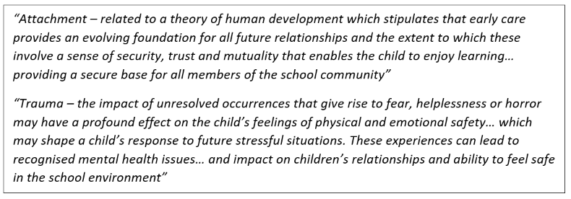
These definitions have been chosen because they are positioned within education, pertinent to the focus of this research. However, I am mindful that they do not reflect how attachment and trauma interact with systemic influences including poverty, marginalisation, school environments (Perfect et al., 2016).
Additionally, ‘relational approaches’ is a term that lacks a shared understanding (Royle, 2025). A ‘relational approach’ is informed by the idea that all behaviour is communicating an unmet need that adults need to identify so that the child can be supported appropriately (Rutledge, 2011). Georgiou & Cartmell (2025) explored how this term is conceptualised by school staff. Four key characteristics were identified: compassion, authenticity, personalisation and engagement. In addition, traits of staff who adopt ‘relational approaches’ included being caring, honest, enthusiastic, encouraging and reliable (Georgiou & Cartmell, 2025). The use of this term is growing within the field of education (Alaimo & Kelly, 2025) and frequently referred to by educational professionals (Georgiou & Cartmell, 2025). However, how ‘relational approaches’ are enacted by individuals varies, adding to the ambiguity within the field.
For the purpose of this research, the phrase ‘Trauma-Informed and Relational Approaches’ (TIRA) has been coined. This encompasses the collective understanding that although trauma-informed approaches are situated within the specific context of ‘trauma’, the approaches operationalise relational values as identified above (Office for Health Improvement and Disparities, 2022). Billington et al. (2022) alludes to the idea that language from clinical contexts does not fit the ecological realities of schools, therefore risking applying trauma-concepts without contextual nuance. Consequently, the term ‘TIRA’ aims to acknowledge that trauma-experienced individuals are embedded within school systems, while attending to the ecological conditions, relational dynamics and unique characteristics of each school community (Georgiou & Cartmell, 2025). This is fundamental to effective practices within education settings (Georgiou & Cartmell, 2025). Additionally, Alaimo and Kelly (2025) highlight the need for context-sensitive approaches that emphasise relational fidelity and ecological validity, tailored to each school’s distinct context. Given that ‘TIRA’ aligns with the language used by the case study school to describe their approach (section 3.4.2) this further justifies the decision with regards to this term.
It is essential to note that through combining ‘trauma’ and ‘relational’, this research does not seek to undermine the experiences and impact of trauma-experienced CYP who are more likely to be excluded or leave education early (Perfect et al., 2016; Bellis et al., 2018). These terms have been grouped together to orienteer towards a philosophy of genuine and universal inclusion (Venet, 2021).
Across the literature a range of overlapping terms are used. This reflects the conceptual ambiguity surrounding ‘trauma-informed’ and ‘relational’ terminology (Georgiou & Cartmell, 2025) and the tendency for trauma-informed principles to be embedded implicitly within relational frameworks. To support clarity and coherence, throughout this research I refer to these approaches collectively as ‘Trauma-Informed and Relational Approaches’ (TIRA). This does not imply that all authors explicitly adopt the same language; rather, it reflects shared principles evident across their work. Table 1 provides an overview of the literature, with each research paper’s terminology to ensure transparency for readers.
Authors (Year) | Terminology used |  | Authors (Year) | Terminology used |  | Authors (Year) | Terminology used
ARC (n.d.) | Attachment  Trauma-Aware |  | Gehris (2014) | Relationships |  | Smith (2024) | Trauma-Informed Practices
Avery et al. (2021) | School-wide Trauma Informed Approaches |  | Hanson & Lang (2016) | Trauma-Informed Care |  | Souers & Hall (2019) | Trauma-Aware  Trauma-Invested
Babcock (2020) | Relational Approach/Practice |  | Harrison & Brown (2022) | Attachment-Aware |  | Thomas et al. (2019) | Trauma-Informed Practices
Bargeman et al. (2021) | Trauma-Informed Care |  | Jones et al. (2024) | Relational-Based Approaches |  | Trivedi (2022) | Attachment  Trauma-Aware
Cherry & Froustis (2022) | Trauma Informed Education |  | Kataoka et al. (2018) | Trauma-Informed School Systems |  | Watson & Astor (2025) | Trauma-Informed Approaches
de Stigter et al. (2024) | School-Wide Trauma Informed Education |  | March et al. (2022) | School-Based Mental Health and Wellbeing Intervention |  | Weare (2015) | Social and Emotional Wellbeing
Dodds (2023) | Whole-school Relational Approaches |  | Maynard et al. (2019) | Trauma-Informed Approaches |  | Youth Endowment Fund (2023) | Trauma-Informed Schools
Education Scotland (2021) | Relational Approach |  | McKay & Macomber (2023) | Relationships
Enfield Council (2023) | Trauma-Informed Practice |  | O’Neill et al. (2022) | Trauma-Informed Practice
Garcia-Moya et al. (2019) | Relationships  Relationship Building |  | Ruttledge (2022) | Whole-school Approach Building Relationships
Table 1 – An overview of the terminology used in each research paper

2.3 Theoretical principles underpinning trauma-informed and relational practice
Neurosequential model, humanist principles and eco-systemic theory have been drawn upon to synthesise some of the core theoretical concepts that collectively contribute to and underpin a TIRA. These theories holistically consider how development, relationships and contextual influences interact, shaping the experiences of school members, relevant to the focus of the research. Additional theory such as Bowlby’s attachment theory (1969) and Relational-Cultural theory (Gergen, 2009) were considered. However, they were not incorporated into the chapter. My reflections on these supplementary readings can be found in Appendix A.

2.3.1 Neurosequential Model
The Neurosequential model (Perry, 2006) provides a framework and lens for understanding CYP’s functioning, integrating core concepts from developmental psychology and neurobiology (Bomber, 2020). It recognises how the brain develops and functions hierarchically (McCaleb & Mikaere-Wallis, 2005) and provides a way to view interactions and interventions. Perry’s model is commonly summarised as ‘regulate, relate, reason’ (Figure 1): adults support regulation before expecting relational engagement or cognitive problem-solving (Perry & Alblon, 2019).
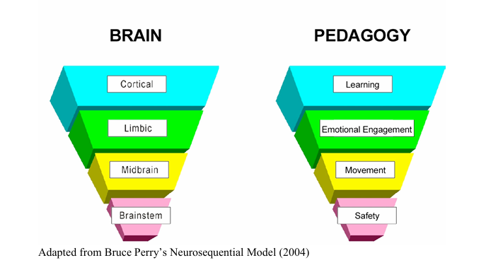

Figure 1 - How pedagogy approaches are informed by Perry's Neurosequential Model (McCaleb & Mikaere-Wallis, 2005)
Whilst Perry’s original Neurosequential model emphasises the sequence of ‘regulate-relate-reason’, more recent adaptations have introduced ‘repair/restore’ as a fourth stage (Bomber, 2020; Education Scotland, 2021). Repair/restore is a restorative opportunity (Bomber, 2020) intended to re-establish trust, safety and reaffirm connection, which enables healing, growth and resilience (Bomber, 2020). This should include adults modelling humility and mutual respect through apologising for their actions (Bomber, 2020). Without this stage, attachment security may be compromised, which could lead to ruptured relationships (Hughes, 2009).
The quality and permanence of relationships significantly influence the experiences of the interactions (Perry, 2020). Adults are understood as “relationship shapers” (McCaleb & Mikaere-Wallis, 2005, pg. 5), who help foster resilience, self-perception and relationship skills in CYP (Gellert, 2002; McCaleb & Mikaere-Wallis, 2005). Additionally, creating rich relational contexts for CYP through working with parents/carers is important (Perry & Albon, 2019).
Despite Perry’s model being underpinned by strong theoretical grounding, there are few empirical or peer-reviewed studies that validate this perspective (Howard-Jones, 2014). The model aligns closely with practice-informed theory (Thomas et al., 2019) which risks being shaped by assumptions and oversimplifying complex neuroscience (Howard-Jones, 2014).

2.3.2 Humanist Principles
The humanist perspective suggests that every child has inherent worth and potential that should be valued regardless of their behaviour, emotions or difficulties - underpinned by unconditional positive regard (Rogers, 1957). This aligns with a person-orientated climate (Rogers, 1951), fostered through non-threatening relationships, collaboration and psychological safety.
Containment (Bion, 1962) is an example of how humanism is enacted. Adults create the conditions that allow CYP to explore their emotions safely, making this experience feel more manageable and less overwhelming. Additionally, Winnicott’s (1960) notion of the ‘holding environment’ emphasises the importance of environments and relationships being predictable. This is created by an emotionally available caregiver who is present and attuned to the CYP. Humanistic psychology centres around the theoretical foundations of Maslow’s Hierarchy of need (Mustofa, 2022; Figure 2). This hierarchy suggests that CYP’s safety and belonging needs must be met in order for their esteem needs and self-fulfilment needs to develop (Woolfolk, 2019). Whilst the hierarchy is criticised for being too linear and hierarchical (Tay & Diener, 2011), humanists position growth as fluid, emphasising the importance of subjective experiences and relational conditions that enable individuals to reach their potential.
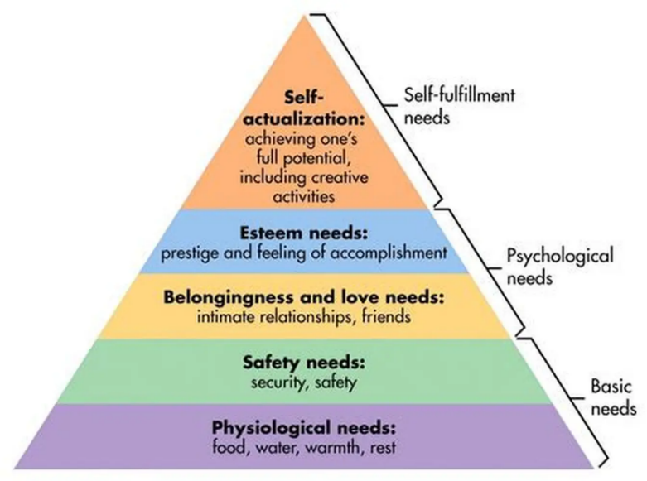

Figure 2 - Maslow's Hierarchy of Need (1943)
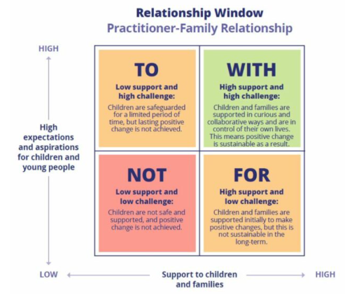
It is argued that humanistic approaches reduce the need to impose order through discipline and conformity (Porter, 1996). Behaviour is understood as a symptom of a problem and not the problem itself, which informs how adults respond, offering guidance as opposed to control (Gordon, 1991). This is termed the ‘relationships window’ (Vaandering, 2013; Figure 3). Although at first glance this may seem simplistic, it acknowledges the eco-systemic influences around CYP (Bronfenbrenner, 1979; section 2.3.3), encouraging adults to be curious about what behaviour is communicating (Bomber, 2020).

Figure 3 - Relationship Window (Vaandering, 2013)
However, concerns exist with regards to the time required to implement and embed a humanist pedagogy that requires relational habits and a culture shift (Duke & Meckel, 1984; Aloni, 2011; Bojesen, 2023). Additionally, there are risks associated with humanism becoming procedural, compounding outcome-driven practice when embedded into practice (Osler & Starkey, 2020).

2.3.3 Eco-systemic perspective
Bronfenbrenner’s ecological systems theory (Figure 4; 1979) considers the influence of family, school and socio-political systems on CYP. School is one of the most influential systems a CYP is situated within (Hanley et al., 2020), meaning it is valuable to reflect on how the culture and ethos shapes CYP’s development. Through this lens, practitioners may consider targeted interventions for CYP, as well as universal preventative approaches that promote the social and emotional development (Chafouleas et al., 2016). This moves away from pathologising, limiting narratives to describe individuals, towards offering alternative stories that facilitate growth, voice and empowerment (Whiting, 2024).
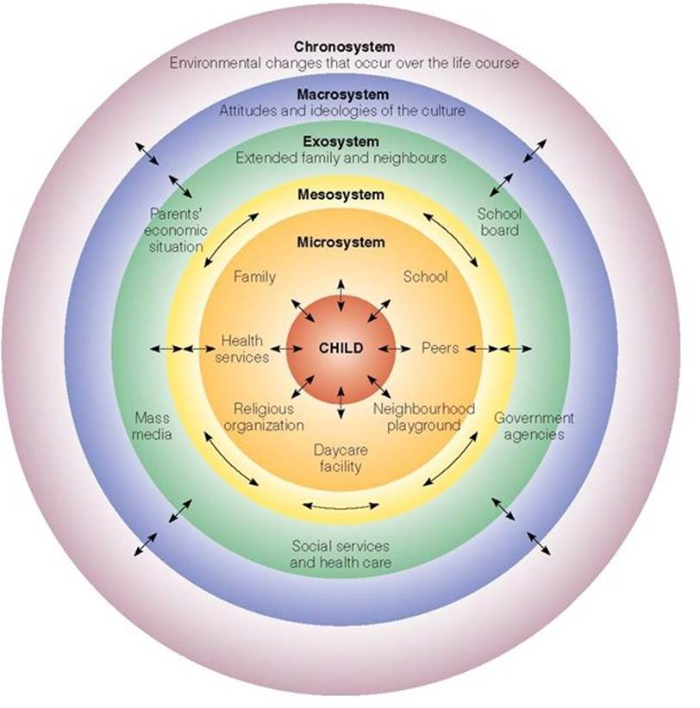

Figure 4 - Bronfenbrenner's Ecological Systems Model (1979)

2.4 Trauma-informed and relational approaches as a whole-school approach
A ’whole-school approach’ is recommended as the best way to create an ideal learning context (DfE 2021) and to promote CYP’s mental health and wellbeing (Department for Education & Public Health, 2021). The Department for Education and Public Health (2021) recommend that this includes:
- Leadership and management
- Ethos and environment
- Curriculum, teaching and learning
- Student voice
- Staff development, health and wellbeing
- Identifying need and monitoring impact
- Targeted support and intervention
- Working with parents/carers and families
For the purpose of this research, ‘working with parents/carers and families’ has been expanded to be ‘working with parents/carers, families and the wider system’. This aligns with Brighton and Hove Council (2018) recommendations with regards to a whole-school approach and recognises that TIRAs are shaped by exosystem and macrosystemic influences as well as microsystem family relationships. For TIRAs to be impactful, this must be an organisational paradigm shift, encompassing all practices, interactions, transactions and relationships (Maynard et al., 2019; Venet, 2021; Watson & Astor, 2025) that are committed to core values of inclusivity and understanding (Bateman et al., 2013; Cole et al., 2013; Sanctuary Institute, 2022). This is also encouraged by the DfE (2026a) who recognise that the mainstream system is not truly inclusive and propose reforms that consider all aspects of the school system.

2.4.1 Conceptualising trauma-informed and relational approaches
Given there is no clear consensus on how TIRAs are defined (section 2.2), the conceptualisation in schools varies (Hanson & Lang, 2016; Maynard et al., 2019; Bargeman et al., 2021). This section summarises key literature to explore these variations. Due to the limited research focused specifically on mainstream secondary schools (section 2.4), studies on whole-school approaches more broadly were also included.
Watson and Astor (2025) conducted the most recent conceptual and theoretical review consisting of 14 articles from the United Kingdom, Australia and America. These articles included frameworks such as ‘Trauma-Sensitive Schools’ (Cole et al., 2013) and ‘The Sanctuary Model’ (Bloom, 1995; Sanctuary Institute, 2022) and articles that discussed elements of TIRAs, without explicit reference to ‘trauma’. This meant articles that addressed school-based relationships more broadly were included, differing to previous systematic literature reviews (Maynard et al., 2019; Avery et al., 2021). From these papers, the review summarised several components essential to a whole-school TIRA. Caution should be taken when interpreting this review, given the lack of long-term research on TIRAs, meaning it is reliant on anecdotal and unmeasured outcomes. Four key components were identified, which are presented in Table 2, with examples from the literature about how this might look in practice.

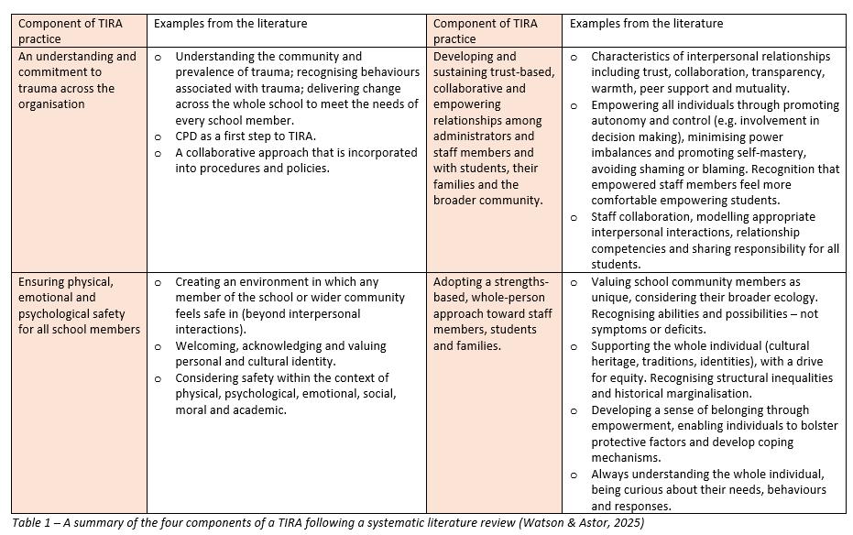
Table 2 – A summary of the four components of a TIRA following a systematic literature review (Watson & Astor, 2025)
It could be argued that these components are elements of best practice within an inclusive and equitable school environment, which may reflect tensions between aspiration and evidence. I am curious as to whether by adding terms such as ‘trauma’ into the conversation, we now view every day caring interactions as extraordinary rather than ordinary. I wonder whether this is associated with schools being positioned as distressing environments that negatively impact mental health and wellbeing (section 2.1) – illuminating a need for this to be made explicit through research.
Another framework that aims to conceptualise TIRAs for schools is Babcock (2020; Figure 5). This framework is predominantly informed by government guidelines and research (DfE, 2018; DfE 2019; Education Endowment Foundation [EEF], 2019) as opposed to empirical research used in Watson and Astor (2025). Similarly to Watson and Astor (2025), it emphasises an ethos of positivity, child-centredness and inclusivity. There are three core components of the model, which closely align with Perry’s (2006) Neurosequential Model (section 2.3.1):
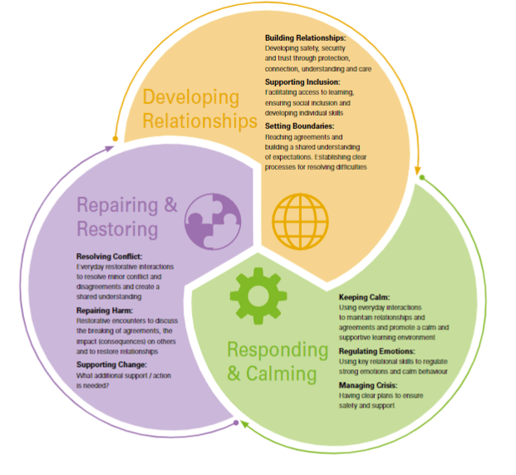

Figure 5 - Babcock (2020) illustration of ‘The Relational Approach’
Overall, the literature provides a comprehensive, multi-dimensional conceptualisation of what TIRAs might look like as a whole-school approach. Reflecting on these models, there appears to be a strong focus on behaviour and pastoral aspects in comparison to teaching and learning. This is corroborated by the literature that identifies empirical research on TIRAs and teaching and learning to be underdeveloped (Thomas et al., 2019).

2.4.2 Embedding and sustaining trauma-informed and relational approaches
It is recognised that there is a persistent policy-practice gap (Benavides et al., 2025), affecting implementation of reforms (section 2.6.5). De Grauwe and Haas (2022) suggest that credibility and opportunity for change are reduced if implementation is not thorough. It is therefore essential that consideration is given to how schools embed new approaches to promote sustainable change. There are a range of frameworks and models that exist. Two examples are discussed below, which conceptually align with the research aims and address change as a systemic, relational and multi-level process.
Four key dimension of adaptive implementation (De Grauwe & Haas, 2022) include:
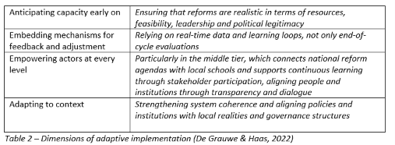

Table 3 – Dimensions of adaptive implementation (De Grauwe & Haas, 2022)
Additionally, Sharples, Easton and Boughelaf (2024) framework for implementing change (Figure 6) enhances De Grauwe and Haas (2022) four dimensions by situating change within the context of education. The model draws attention to behaviours that drive effective implementation, acknowledging change as being collaborative and social through engaging, uniting and reflecting.
To contextualise embedding and sustaining change from a TIRA lens, Souers and Hall (2019) developed a spectrum of TIRA, constructed as a developmental journey (Appendix B). This considers aspects of the whole school and positions TIRA as a continuum. Regardless of where a school or individuals considers themselves to be on the spectrum, adaptation, reflection and refinement should always take place to evolve with the everchanging dynamics of the school community (Edelman, 2023).
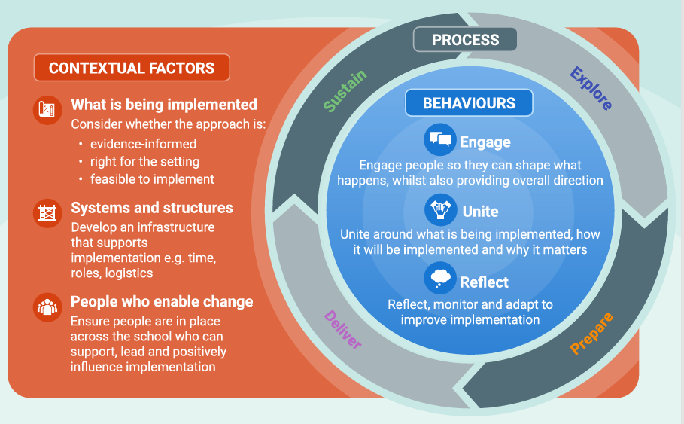
Figure 6 - Sharples, Easton and Boughelaf (2024) framework for implementing change in schools
Contextual diversity is recognised in the frameworks above as being important to consider to generate resilient and meaningful change (Benavides et al., 2025). Change is specific to local realities, meaning paths for implementation are different for everyone (Benavides et al., 2025). Sharples et al. (2024) suggest this includes taking into consideration within school factors (e.g. structures such as timetables or logistical processes) as well as socioeconomic and political factors including funding, resources, national policies and wider influences.

2.5 Impact of trauma-informed and relational approaches
The literature deemed most recent and relevant to the research aims that captures current debates and developments in the field is discussed below. Overall, there is a lack of literature about TIRAs in mainstream secondary schools. Given that the current research is situated within the context of a mainstream secondary school, careful consideration should be given to the interpretation of this literature.
de Stigter et al. (2024) completed one of the first longitudinal evaluations in Europe that explored the impacts of embedding TIRAs as a whole-school approach in primary schools. After one year, the findings suggested improved wellbeing of CYP, increased participation in lessons and improved teacher confidence to respond to CYP’s needs. They concluded that TIRAs benefit all CYP, not just those who have experienced trauma. This study is valuable given it is the first of its kind. However, the sample of Dutch schools reduces the transferability to UK schools given education systems are context-specific (Benavides et al., 2025). Additionally, findings only reflect the first year of implementation. As March et al. (2022) acknowledges, sustaining TIRA can be a significant barrier due to aspects such as staff turnover and shifting priorities (section 2.4.2).
Jones et al. (2024) used virtual semi-structured interviews with fifteen school staff in three mainstream primary schools to explore the impact of TIRAs. They concluded that TIRAs facilitate positive behaviour changes and improvements in emotional wellbeing, relationships and feelings of safety for CYP. Staff described how although authoritarian approaches may reduce behaviour that challenges in the moment, long-term change was less likely due to CYP not being taught emotional literacy skills. Whilst this research provides valuable insights, interpretation of the research should be done cautiously. The data includes school staffs’ interpretations of CYP’s experiences, rather than being direct accounts from CYP themselves. Their accounts are likely to be influenced by subjective judgements or “norm” biases which may not fully represent the CYP’s perspectives.
McKay and Macomber’s (2023) research with thirty-five school teachers in America found TIRAs to improve motivation, attitudes towards school and feelings of being cared for. Teaching staff attributed this to knowing the students better, enabling them to ‘connect before correcting’ (Siegal, 2020). However, these findings may reflect a positivity bias due to the purposive sampling technique, in advertently excluding participants who may have contradictory perspectives. Additionally, they did not collect demographic data to accurately report what year groups the teachers experiences were from.
The impact of TIRAs have also been explored for school staff. Research suggests that TIRAs can promote teacher’s well-being, as they meet a teacher’s need for relatedness (Klassen, Perry & Frenzel, 2012), increase job satisfaction (Garcia-Moya et al., 2019) and enjoyment of work (Gehris, 2014). Consequently, there is often better retention of school staff due to a culture of positivity and nurture (ARC, n.d.), improving academic outcomes for pupils (Gibson & Carroll, 2021).
For families of children who attend a school with a TIRA ethos, initial qualitative data from research with mainstream secondary schools suggests improved relationships with parents (Youth Endowment Fund, [YEF], 2023). Additionally, ARC (n.d.) suggests TIRAs can facilitate trust, improving how schools support families.
Despite the literature outlined above, to the best of my knowledge, the three wide-scale systematic reviews that have taken place have all highlighted the lack of empirical evidence within the field (Maynard et al., 2019; Avery et al., 2021; Watson & Astor, 2025). Whilst acknowledging this sparsity, Maynard et al. (2019) promote “healthy scepticism” (pg. 3). They encourage schools who are embedding TIRA to evaluate their progress and provide clear descriptions of what they are doing to add to the evolving evidence base.

2.6 Facilitators and barriers to embedding trauma-informed and relational approaches
Understanding the facilitators and barriers when embedding TIRAs is important to promote sustainability (Cherry & Froustis, 2022). Cherry and Froustis (2022) ‘Sustainable Model for Change’ (Figure 7) identifies key factors to consider. The model is particularly relevant as it is underpinned by interview and survey data collected from schools in West Yorkshire, evaluating TI programmes that were embedded in local schools, including the case study school used in this research. It was commissioned by West Yorkshire Health and Care Partnership and Violence Reduction Unit and so it is important to acknowledge the agenda of the research which may have influenced and skewed the presentation of the findings. Each part of the model will be explored in turn, drawing on additional literature where relevant.
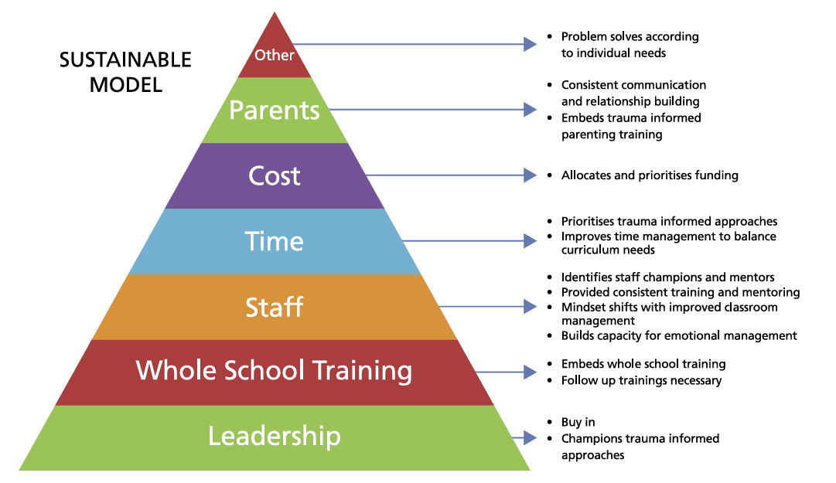
Figure 7 - Cherry and Froustis (2022) Sustainable Model for Change when embedding TIRA

2.6.1 Leadership
The role of the Senior Leadership Team (SLT) is the foundation of sustainable change (Cherry & Froustis, 2022). Recent research further stresses the importance of visible and sustained commitment from SLT (Trivedi & Harrison, 2022; de Stigter et al., 2024), who should model what they expect from staff (Trivedi & Harrison, 2022). Without SLT commitment, the sustainability and impact of the approach is significantly reduced (Coleman, 2020; Oxley, 2021). However, half of SLT report spending too much time on admin tasks (DfE, 2026a), reducing their capacity to model approaches. Pre-intervention with SLT is recommended to explore a schools’ readiness to change and level of change required (Avery et al., 2021) to ensure approaches are “woven into the fabric of the school” (Cole et al., 2005, p. 48).

2.6.2 Whole school training
Quality and bespoke whole-school training and Continuous Professional Development (CPD) that fosters collaborative and empowering ways of working (Jones et al., 2024) is also important. Such training provides the theoretical foundations needed to understand TIRAs (Harrison & Brown, 2022) and how it shapes staff practice. It also provides a space for staff to explore their own beliefs and values (Avery et al., 2021), which is pivotal, particularly if their core beliefs conflict with TIRAs (Ruttledge, 2022).
Additionally, coaching, supervision and frequent check ins (Chidley & Stringer, 2020) are recognised to be facilitating factors, supporting with the translation from training to practice (Avery et al., 2021).

2.6.3 Staff
Staff are fundamental to sustainable change (Jones et al., 2018) given that the approach is a cultural shift that must be embodied and enacted to be maintained. TIRAs are positioned as a way of being, infiltrated into “every interaction, action and decision” (Enfield Council, 2023, p.14). Additionally, TIRA relies on a unified approach, with staff having shared values, language and theoretical foundations (Education Scotland, 2021) that promotes coherence and consistency (Perry, 2020).
One aspect not considered in Cherry and Froustis (2022) model is the emotional impact of TIRA on staff. Smith (2024) found that staff were often exhausted and lacked energy due to the emotional labour of embedding these approaches, which can impact staffs’ capacity to respond relationally (Harding et al., 2019). This is particularly the case if there is a lack of adequate support (Smith, 2024). Examples of support might include emotionally containing supervision sessions, reflective spaces, opportunities to process emotional load and support for their own regulation and wellbeing (Trauma Informed Schools UK, n.d.).
Staff turnover, recruitment and retention interfere with maintaining TIRAs (Trivedi, 2022). Recommendations focus on ensuring that training is continual, induction packages prioritise TIRA and that TIRA is embedded within recruitment exercises (Trivedi, 2022).

2.6.4 Time and Cost
There are significant academic pressures and systemic demands that exist in the current educational context, impacting the implementation and embedding of TIRAs (Jones et al., 2024). Time is frequently referenced as a barrier within the literature (Cherry & Froustis, 2022; de Stigter et al., 2024; Jones et al., 2024). Staff need time to get to know CYP, support with de-escalation and respond relationally, flexibly and individually to student’s needs, which conflicts with other classroom pressures (McCluskey et al., 2019; O’Neill et al., 2022; Jones et al., 2024). Despite this, Jones et al. (2024) suggests that long-term, the time required reduces as CYP are better equipped to manage their own emotions as they have developed regulation strategies, which also reduces the funding needed to support behaviour.
Lack of funding is also recognised to make it more challenging to embed TIRA required to provide training, supervision and additional staffing to increase capacity (Cherry & Froustis, 2022; O’Neill et al., 2022).

2.6.5 Systemic influences
Parents/carers and the wider community influence the sustainability of TIRA and are recognised to be one of the core domains of implementation (Kataoka et al., 2018). Engaging families contributes towards consistent and coherent relational environments (Blitz et al., 2016) that support regulation for CYP (Chafouleas et al., 2016). Incorporating the wider community ensures that schools are culturally responsive and can meet the needs of the specific context (Bellamy et al., 2022).
Beyond Cherry and Froustis (2016) model, it is also important to consider the impact of external bodies such as the DfE and Ofsted. Weare (2015) acknowledges that guidance from Department of Health and DfE does not sufficiently support TIRAs and Ofsted agendas have led to schools prioritising academic attainment (Brearty, 2025). In the DfE (2024c) permanent exclusions guidance, scant regard is given to ‘relationships’ with a single reference to CYP accessing a “calm, safe and supportive environment” (pg.8) in the context of aspiring toward high behaviour expectations. However, the White Paper (DfE, 2026a) implicitly maps a sequence that recognises:
- Childhood has changed,
- Schools must engage children intellectually,
- Mainstream schools must become inclusive,
- Belonging drives engagement,
- Teachers and leaders need support,
- Schools must collaborate and share expertise,
- Innovation spreads improvement across the system.
This orienteers much more closely with TIRAs in comparison to previous policy (Ambition Community Trust, 2026). Additionally, the Education Secretary advises that CYP need to have a sense of power, purpose and belonging, moving away from a sole focus on academic achievement (Wood, 2024). This indicates a possible shift in agendas, aligning closely with the principles of TIRAs.

2.7 Trauma-informed and relational approaches within the context of UK mainstream secondary schools
Secondary schools have typically prioritised academic demands, reducing the focus on mental health, wellbeing and belonging (Jessiman et al., 2022; Jones et al., 2023; Hinze, 2024). Secondary school students describe their connectedness with teachers as uncommon (Garcia-Moya et al., 2019) and concerns have been raised about the consistency and quality of student-adult relationships (Murray-Harvey, 2010; Cramond, 2021). It is widely recognised in the literature, that the attainment-driven agenda has shaped the development of secondary school systems in recent years (Andrews, 2025). This has made it increasingly difficult for schools to prioritise relationships, connection and inclusion for students (Greany, Higham & Nelson, 2023). Recent data on permanent exclusions and suspensions illuminates the difficulties secondary schools face, reflecting a reliance on reactive, punitive approaches rather than addressing unmet needs and the root causes (YEF, 2023; Ijaz et al., 2024) which would align with a TIRA. Permanent exclusions and suspensions for the academic year 2023-2024 rose by about 21% compared to the year before, with over 10,000 permanent exclusions and over 900,000 instances of suspensions (Department for Education, 2025). This has life-long impacts for CYP, with permanent exclusion being one of the strongest predictors of becoming NEET (not in education, employment or training) (Joseph & Crenna-Jennings, 2024) and increasing vulnerability within criminality (Isherwood, 2023). It is therefore pivotal that secondary schools consider how they can reduce these statistics and contribute towards the holistic development of their CYP.
Teachers in secondary schools are under significant pressure associated with these attainment-driven agendas (Wilson, 2025), impacting mental health and wellbeing (Education Support, 2024; National Education Union, 2024) and relationships with student (Greaney et al., 2023). Despite this, Childs (2025) recent research found that secondary school staff identify relationships with colleagues, students and parents as being a protective factor against the wider systemic pressures (including rising workloads, heightened expectations and emotional intensity).

2.8 Rationale for the current research
Creswell (2014) emphasises the importance of identifying a research gap to provide the rationale, significance and original contribution of the study. Literature cites the need for more research on TIRAs within the context of LA secondary schools and student voice (Dodds, 2023). Prioritising student voice in research is fundamental to inclusive education (Tabor & Lomibao, 2024) and evaluating system-wide processes and procedures (Byrnes & Rickards, 2011). However, Bragg (2021) speaks of student voice “falling out of favour” (pg. 42), particularly within governing circles. Additionally, Edwards and Brown (2020) and Gillett-Swan and Baroutsis (2024) highlight how student voice is often mis-interpreted as ‘having a say’, rather than being included as part of a process of change. Gillett-Swan and Baroutsis (2024) conducted a systematic literature review consisting of 61 articles focused on student voice and staff voice. They concluded by identifying very few research papers that seek or describe the perspectives of both students and staff. Where this is documented, it is positioned in a consultative role, rather than one that places both groups in an empowered participatory position. It is this identified gap, specifically in relation to student voice, that the current research intends on addressing.
Additionally, Jones et al. (2024) recommends research exploring the thoughts and reflections of secondary school staff and students in relation to TIRA using participatory inquiry methods and Maynard et al. (2019) identifies a need for research to understand what is being implemented in the name of ‘trauma-informed’ approaches. Addressing these gaps in the literature is paramount given the pressures in secondary schools making it extremely difficult to embed and enact TIRAs (section 2.7). Rising exclusions and suspensions illustrates that schools continue to rely on reactive responses, rather than co-regulation, attunement and relational values. Without addressing this, secondary schools lack a conceptual and practical understanding of ways in which they can reduce exclusion, strengthen relationships and support the long-term holistic development of all school members.

2.9 Conclusion
This literature review offers a summary of what TIRAs are and why schools may consider it as a culture and ethos. The literature consistently reflects the need for schools to do something differently to meet the needs of all school community members, associated with increases in mental health difficulties for staff and students, soaring school absence rates and difficulties with staff retention.
Although there are difficulties conceptualising TIRAs (Bargeman et al., 2021), Watson and Astor’s (2025) four key components provide an overview of how this has been interpreted within recent literature (section 2.4.1). Alongside Babcock (2020), this provides an insight into how TIRAs may be embedded as a culture and ethos with educational settings. However, the literature within this area remains sparce. Watson and Astor (2025) conclude by identifying the need for more qualitative case studies exploring TIRA whole-school approaches to provide schools with guidance about what TIRA looks like in practice. This gap in the literature underpinned the development of RQ1, to develop an understanding about what TIRAs looks like as a whole-school approach (section 3.1).
Research indicates that when TIRAs are embedded within a school environment, improvements are seen in student engagement and motivation, CYP wellbeing, safety and connection, confidence in teachers to meet the needs of students, improved teacher wellbeing and better teacher retention. Having said this, the majority of the research is conducted in primary school settings. Furthermore, the literature generally captures the views of one population, rather than staff and students together. This informed RQ2, exploring the impacts of TIRAs from the perspective of staff and students within a secondary school context (section 3.1).
Embedding TIRAs as part of a whole-school approach is fundamental to create an ideal learning context (DfE, 2021) and to promote CYP’s mental health and wellbeing (Department for Education & Public Health, 2021). Primarily, the importance of ensuring that any frameworks drawn on as part of a TIRA are flexible and contextual, given the needs of the school, is emphasised in the literature. For sustainable change to be possible, implementation must be thorough (De Grauwe & Haas, 2022) and consider the system and structures that support or hinder implementation (Sharples et al., 2024). Some of the influencing factors identified in the literature include leadership, whole-school training, staff, time, cost, parent/carers and systemic influences (Cherry & Froustis, 2022). Therefore, RQ3 (section 3.1) intends to address the facilitators and barriers that exist for the case study school to provide a comprehensive understanding of how these are acknowledged and addressed to sustain a TIRA.
Throughout the entire literature review, the scarcity of literature focusing on mainstream secondary schools is evident, which is important to note given the difficulties secondary schools experience with increasing numbers of permanent exclusions and mental health difficulties. This helped shape the research aim and guided the methodological choices made when recruiting the case study school.

3.0 Methodology
The purpose of this chapter is to outline my epistemological and ontological position and critically discuss the research design, data collection and data analysis. Reference will be made to the ethical considerations and reflexive practice that underpinned the entirety of the research. How trustworthiness was established through credibility and reliability (Ahmed, 2024) is also included.

3.1 Research aims
Informed by my personal ontological and epistemological positioning (section 3.2.1), the research aimed to explore the experiences of staff and students attending a mainstream secondary school that embed a TIRA culture as a whole-school approach. The research sought to understand how TIRAs are conceptualised, the impact of the ethos and the facilitators and barriers to sustaining a TIRA culture across the whole school.
The research intends to address a gap in the literature (section 2.8) and provide a case study example for other secondary mainstream schools who may be interested in TIRAs.
The research questions (RQs) are:
1. What do trauma-informed and relational approaches look like from the perspectives of staff and students who attend a mainstream secondary school that adopt a whole school approach to trauma-informed and relational approaches?
2. What do school staff/children and young people see as the impact of trauma-informed and relational approaches for any aspect of the individual, school system or wider community?
3. What are the facilitators and barriers to adopting a trauma-informed and relational approach across aspects of the whole school?

3.2 Methodological orientation

3.2.1 Ontological and epistemological position
The research is situated within a critical realist ontology, contextualist epistemology and relational paradigm. This enabled a nuanced exploration of TIRAs, acknowledging that structural and institutional realities exist, yet the knowledge which constructs these realities is shaped by context and relational engagement.
Epistemology is the relationship between the researcher and reality (Punch, 2014). This is underpinned by ontology, concerning the form and nature of reality and what can be known about it (Punch, 2014). These philosophical foundations shape my conceptualisation of reality, knowledge and the methods used in the research (Daniels & Alston, 2024). Acknowledging and understanding these assumptions is essential as they influence how I chose to explore knowledge (Tomlinson, 2023).
The research is situated within a critical realist ontology, understanding reality as stratified, acknowledging that causal mechanisms and structures exist independently of our knowledge (Bhaskar, 2013). Therefore, this research explored the underlying mechanisms that shaped the observable practice within the school context. The intention of this was to acknowledge the observable phenomena of TIRAs and the subjective experiences of participants as components of a layered reality. This ontology complements the relational paradigm (see below), giving a philosophical foundation for researcher-participant relationality and acknowledging ‘what could be’ through emphasising co-construction, mutuality and reciprocity.
The epistemological grounding for the research is in contextualism. This suggests that knowledge is understood within certain contexts. Meanings made from these are shaped by contextual factors including cultural, societal and historical influences (McKenna, 2015). Contextualism is associated with the decision making around qualitative methods and data analysis processes. This includes the reflexivity required to consider the data within the context of the specific case study setting and the recognition of meaning being co-constructed between researcher and participants.
The relational paradigm and relational constructivism (whereby meaning is constructed with others; McNamee & Hosking, 2011) underpins the methodological and ethical orientation. Definitions of ‘relational paradigm’ are subjective and based on individual’s own constructions (Brigg, 2024). For this research, the relational paradigm emphasises the interconnectedness of individuals, the co-construction of meaning and the importance of dialogic engagement in educational settings (Noddings, 2012; Berg & Seeber, 2016). The research is positioned in the argument for the fundamental importance of the relational paradigm within the context of mainstream secondary education. This is described by Vasilic (2022) as “relationally attentive practice” (pg. 385; Figure 8). It is acknowledged that first and foremost relational practice orientation is a conceptual positioning tool. Therefore, in this research, innovation within practice is viewed as being valuable and critical to our understanding of such orientations.
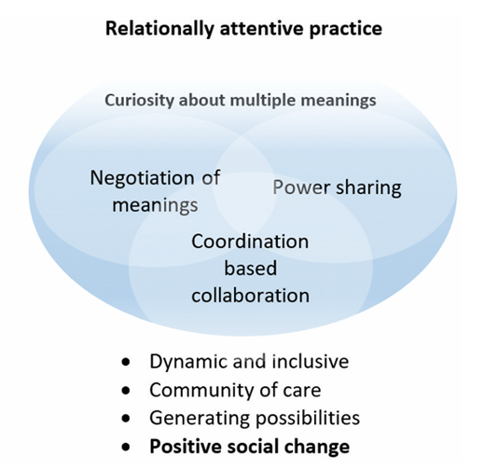

Figure 8 - Relational orientation in practice (Vasilic, 2022, p. 385)

3.2.2 Quantitative and qualitative research
In positioning this research, I critically reflected on its purpose – to understand the perspectives and experiences of staff and students – and used this to guide my assumptions about social reality, the choice of design and methods and the interpretation of data (Punch, 2014). Research can orientate towards a quantitative or qualitative positioning (Braun & Clarke, 2013). The alignment of quantitative research with “objective facts and established truths” (Gray, 2018, p. 23) felt uncomfortable because of the subjective nature of the research. The qualitative paradigm was determined to be more suitable given the exploratory and evolving nature which prioritises individuals own framing around issues. This also offers the ability to develop a deeper understanding of a phenomenon (Braun & Clarke, 2013) through embracing the messiness (Shaw et al., 2008). It was also deemed that the research met the three criteria for using qualitative methods (Rist, 1982):
- The research must lend itself to seeking “a holistic understanding of the event/situation/phenomenon” (p. 441),
- Use inductive logic meaning “the task is to study the specific and build towards the general” (p. 441),
- Conduct the research in a natural setting, as opposed to an artificial environment.
As reliability and validity are not easy to assume in qualitative research (Seale, 1999), careful planning is needed to ensure methodological rigour and trustworthiness (Braun & Clarke, 2013). Consideration was given to the pillars of trustworthiness (Ahmed, 2024):
- Credibility
- Transferability
- Dependability
- Confirmability
Throughout this chapter, how trustworthiness was achieved is demonstrated through examples and justifications for decision making.

3.2.3 Position statement
Explicitly acknowledging my values, beliefs and ethics and prioritising reflexivity is paramount to ensure the research is credible and transparent, improving trustworthiness (Biggerstaff & Thompson, 2008; Ahmed, 2024). I orienteer towards the relational paradigm in all aspects of my life and regularly reflect on experiences I have had that shape my ontological and epistemological positioning (Figure 9).
In my role as a TEP, I often see the negative impact behaviourist and authoritarian approaches have on CYP, families and school staff. Consequently, I am curious as to whether TIRA is an alternative ethos staff could enact and embed to offer CYP, school staff and parents/carers a way to feel valued and supported. I hope that this research will inform the conversations I have with school leaders in the future.
I am also a Governor at SVHS and have been for the last three years. This means I have a prior understanding of the school’s approach and operational systems. Within this role I provide a critical lens to support and challenge the school’s decision making. This positionality gives me a different perspective, which I recognise will influence the way I write about the school, analyse and interpret the data. Choosing to be a governor at this setting, highlights my alignment with TIRAs, also impacting my positionality as a researcher. Throughout the research I held a commitment to ethical and reflexive practice and used my reflexive diary and research supervision to critically reflect on my decision making and influence of this role (Appendix C).

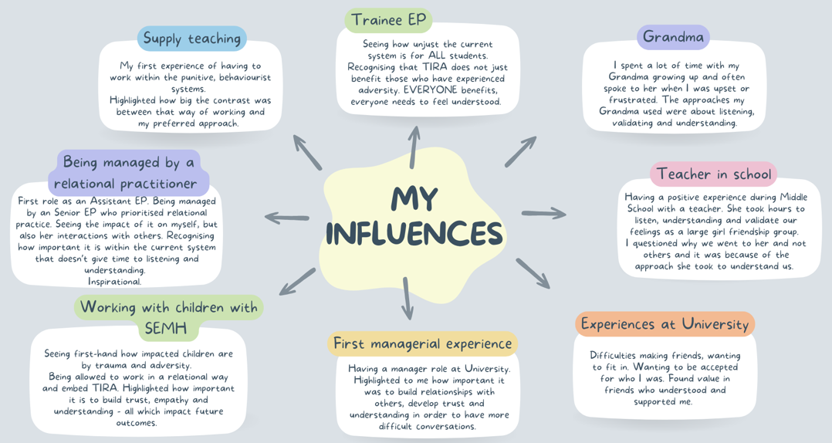
Figure 9 - A reflection of my personal influences

3.3. Design

3.3.1 Purpose and approach: rationale for qualitative case study design
There are varying definitions of a ‘case study’. For the purpose of this research, MacDonald and Walker’s (1975, p. 2) definition “the examination of an instance in action” was deemed most suitable given the research aims. However, the word ‘examination’ did not sit comfortably with me and so I replaced it with ‘inquiry’, making it more appropriate to the current context. Therefore, the definition of ‘case study’ is ‘an inquiry of an instance in action’, with ‘instance’ implying a goal of generalisation (MacDonald & Walker, 1975). The ‘case’ explored refers to the single bounded system (Smith, 1978) of the identified school community (section 3.4.2). Ethnography is recommended when studying cultures, practices and routines (Pang, 2018). However, the time required to immerse myself (Ritchie, 2019) felt unrealistic for this research. Adopting a case study design aligned closely with the qualitative orientation and philosophical underpinnings of this research, intending to build an intensive, thick description of TIRAs at SVHS. When making the decision to adopt a case study design, careful consideration was also given to the limitations of this (section 5.2.6).
Patton (1980) recommends that writing of the case study context should transport the reader into the case situation. It was agreed with the Head Teacher that the school would be identifiable within the research. This enabled me to provide a comprehensive context (sections 3.4.1 and 3.4.2). A context-sensitive ethical approach was used (Christensen & Eriksen, 2020) whereby this ethical judgement was responsive to context rather than being procedural.
Other approaches considered included Appreciative Inquiry and Realist Evaluation. Appreciative Inquiry focuses on strengths-based perspectives. The RQs in this research aimed to explore the impact, facilitators and barriers of embedding and enacting TIRAs. It therefore became apparent that it was necessary to address the difficulties and issues faced by the case study school and therefore Appreciative Inquiry was deemed not appropriate. Additionally, although Realist Evaluation would have helped explore the contexts and mechanisms for change, this approach typically addresses explicit programmes (Graham & McAleer, 2018) and would therefore not have allowed for exploration of the complex nuances of TIRAs. Additional information and detail in relation to these decisions is outlined in Appendix D.

3.3.2 World Café as a research methodology
World Café (WC) was developed by Brown and Isaac (2005) and is defined as “evolving rounds of dialogue…intimate conversations link and build on each other as people move between groups, cross-pollinate ideas and discover new insights…” (Brown & Isaac, 2005, pg. 4). The priority on intimate exchanges and development of collective wisdom facilitates constructive dialogue that builds personal relationships, fosters mutual learning and emphasises community voice (Fouché & Light, 2010; Balata, 2018; McGrath et al., 2023). Rich, contextual, qualitative data was needed to explore the RQs focusing on what TIRAs look like, the impacts and any facilitators or barriers experienced by participants. Qualitative discussions provide greater opportunity to capture insights into the micro-interactions, contextual nuances and meaning making in relation to the RQs that could not necessarily be captured or measured through quantitative means. Additionally, the overlapping nature of the RQs (e.g. how TIRAs are enacted, influences the impact) could be captured through intimate exchanges, where these interconnected dimensions could surface organically. It was hoped that by gathering this type of data, the meaning, experiences and relational processes discussed by participants could be interpreted, fundamental to addressing all of the RQs.
Two separate WCs took place to gather the data for the research (section 3.3.3), one for students and one for staff. The student WC consisted of 23 participants, and the staff WC involved 25 participants (section 3.4.5).
There are seven integrated design principles that guide WCs (Figure 10; Brown & Isaac, 2005). WC has been used across a range of sectors and for varying purposes (Löhr et al., 2020), including some educational contexts (Fullarton & Palermo, 2008; Kimber, 2024; Newton, 2025).
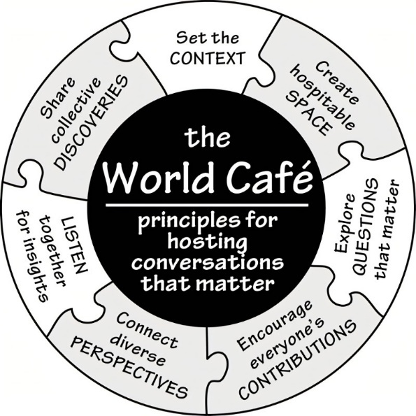

Figure 10 - WC Principles (Brown & Isaac, 2005, p. 40)
The WC consists of small café-style tables that seat four to six individuals. Participants change tables and form new discussions to build on each other’s ideas, knowledge and experiences (Schiele et al., 2022). Visual data is collected by participants recording their thoughts and feelings on tablecloths (Brown & Isaac, 2005). The tablecloths remain on the same table throughout the WC and overtime capture the trail and evolving conversations that occur. On each table there is a ‘table host’ facilitator who remains on the same table throughout (section 3.3.4).
Participants at WCs should feel welcome and valued (Brown & Isaac, 2005), facilitated by an informal environment. This could include a café name, use of creative methods (e.g. music, greenery) and considering the socio-relational dimensions of the environment, for example choice of language, dress attired and personal-touches (Brown & Isaac, 2005; Estacio & Karic, 2016).
Deciding to use the WC as a research methodology was complex and non-linear. Initially, I planned to use focus groups of up to twelve participants (Morgan, 1988). However, I was concerned about the unnatural setting of these (Cohen et al., 2018). I also disliked positioning myself as a ‘moderator’ (Cohen et al., 2018), impacting the relational experience for participants (Cohen et al., 2018) and distancing from the philosophical alignment of the research. Time constraints were also considered given the large number of participants I was keen to reach. The WC methodology addressed these concerns as it provided a way to create an informal and relaxed environment for participants, enabled me to take a ‘hosting’ role, focusing on the procedural running of the WC (e.g. time keeping) rather than having a ‘moderator’ role and enabled me to reach a large number of participants within a short period of time.
I discovered two theses that has used a WC methodology (Kimber, 2024; Newton, 2025) which provided methodological insights and helped me develop a critical understanding into how this method could be applied in educational contexts. I also drew on Löhr et al.’s (2020) work that recognises WC as an inclusionary research method. Additionally, I organised and facilitated a WC session at an Association of Educational Psychologists Local Representatives Conference in June 2025 to trial this participatory methodology (Kindon et al., 2007) and to ensure I fully understood the process (Estacio & Karic, 2016). The decision to use the WC methodology, and its alignment with the study’s philosophical orientation and aims, was informed by several factors. Its time-efficiency, combined with its capacity to support collaboration and knowledge-sharing in large groups (Löhr et al., 2020; Schiele et al., 2022). Additionally, the non-hierarchical structure of WC (Monforte, Netherway & Smith, 2023) and its emphasis on drawing solutions from participants rather than external experts (Lagrosen, 2019). This positioned participants as capable and knowledgeable, reflecting the principle of ‘co-action’ in which meaning is constructed collectively (Gergen, 2009). Finally, WC’s traditional use in generating conversations that act as catalysts for large-scale change (Brown & Isaacs, 2005) aligned closely with the intentions of this research (Figure 11).

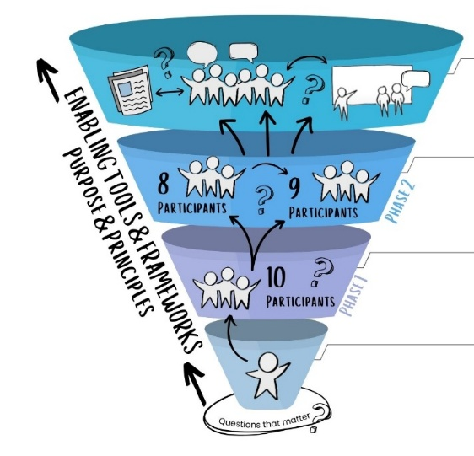

Figure 11 - WC conversation leading to large-scale change (Adapted from Newton, 2025, p. 85)

3.3.3 World Café design and procedure
During the event, the WC was referred to as ‘conversational café’ (CC) to increase transparency and make the intentions of the research clearer (Brown & Isaac, 2005). For clarity and consistency, the CCs will continue to be referred to as WCs. To collect the data, two separate WC’s took place on the same day (one for students and one for staff). Each WC was 90 minutes. Participants were encouraged to sit where they felt comfortable and ground rules were set at the start (Appendix E).
The café-style environment was created using themed décor, music and refreshments (Appendix F). Each table had large paper tablecloths, with a discussion question and stationery to record their thoughts and insights (Appendix G).
For the student WC there were no more than 4 participants on a table and for the staff WC groups were no larger than 6 in line with Löhr et al.’s (2020) recommendations. In total, there were five tables that participants moved between, spending around 10 minutes on each table (see Appendix H) with a 10-minute comfort break halfway through.
The discussion points for each table aligned with the RQs and were underpinned by simplicity, mattering, possibility and promoting evocative inquiry (Brown & Isaac, 2005). Developing the discussion points took time, critical reflection and curiosity to ensure that they were relevant to the research and accessible for participants. Each discussion point was informed by the literature on TIRAs and the RQs. I ensured that each discussion point addressed each of the RQs to develop rich data, relevant to the aim of the research. Once I had developed a draft of the discussion points, I took these to the EP TIRA working group at the Educational Psychology Service (EPS) where I am a Trainee Educational Psychologist (TEP). I facilitated a reflective session, whereby the working group discussed each of the discussion points and how they interpreted them. Additionally, time was given to critically reflect on how the discussion points and terminology used may be interpreted by participants. Gaining different perspectives was invaluable to inform my thinking and development of discussion points. Following this session, terminology was amended, for example use of the term ‘belonging’ rather than ‘connection’ to try and ensure language was accessible for CYP. Additionally, discussion points were amended to avoid questions being leading. For example, ‘what helps you to feel valued at school?’ was amended to ‘What does belonging and feeling safe at Spen Valley mean to you?’. We also discussed how to increase engagement and provide different ways to contribute, which informed how some of the discussion points were delivered (e.g. using wooden jigsaw pieces for CYP to draw or paint on and a ‘road map’ visual for staff). This experience was invaluable to ensure that the discussion points were rigorous, appropriate, free from judgement and offered participants an open invitation to explore (Brown & Isaac, 2005). It was acknowledged that “one can never tell once the questions have been brought to life in the room, how participants will respond” (Prewitt, 2011, p. 360-361) and therefore I remained open-minded and flexible throughout the process. The discussion points can be found in Figures 12 and 13. I also captured some of my reflections following the WCs (Appendix I).

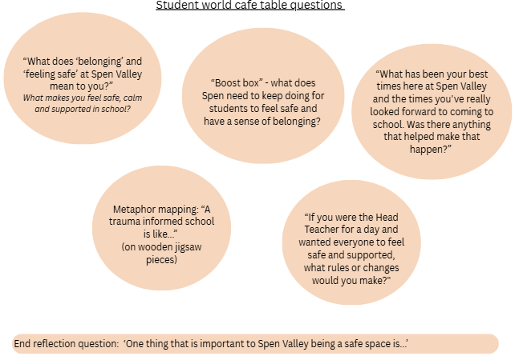

Figure 12 - WC discussion points for students

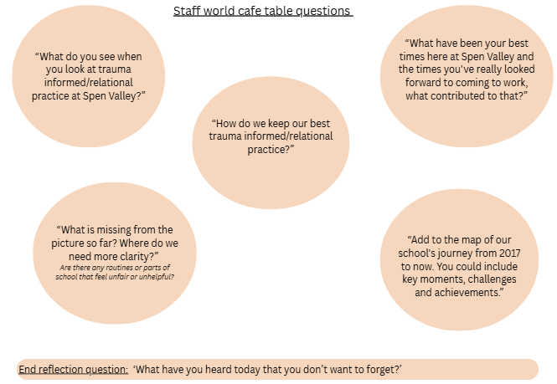

Figure 13 - WC discussion points for staff

Each table was hosted by an AsEP from the Local Authority (LA) EPS where I am currently a TEP. Research recommends training for table hosts (Kitzie et al., 2020) given the pivotal role they have in shaping the quality of discussions and depth of data collected (Klatt et al., 2025). However, Newton (2025) acknowledges that EPs have skills in facilitating and so this may not always be necessary. I recognised this debate and sought the preferences of the AsEPs. It was agreed that we would have a one hour briefing the week prior to the WC to ensure they were clear on their role and involvement. This briefing included pre-event orientation and role-specific instructions (Klatt et al., 2025). Each table host had a briefing and prompt sheet to refer to during the WCs (Appendix J). Table hosts served as a connector for the discussion rounds, providing a summary of the previous discussions to the new participants at the start of each round (Brown & Isaac, 2005; Schiele et al., 2022). These summaries were audio recorded using a voice recorder to form part of the data set.
At the start of the WC, a briefing took place for all participants (Appendix K), which shaped the way the WC took place for meanings to emerge (Brown & Isaac, 2005). I aimed to ensure this was a welcoming, calming and valuable introduction underpinned by appreciating the individuals who attended. At the end of the WC, a debrief was given (Appendix L).
It was important to acknowledge the small research base for using WC with CYP, meaning careful consideration and reflexivity was required to ensure ethical considerations were central (section 3.5). WCs can be successful with CYP to foster open dialogue, reduce power imbalances and ensure CYP’s perspectives are genuinely valued (Page & Temple-Malt, 2018). Brown and Isaac (2005) also promote reflection about ‘who is likely to be affected by the outcomes of the WC conversation?’. When considering this, CYP are central, which further emphasised the need for student participation (Brown & Isaac, 2005).

3.3.4 Data collection
There were two sources of data used in the research. This included written and visual artefacts from the paper cloths, which were photographed and annotated for data analysis (see Appendix M). Additionally, table hosts summaries were recorded and transcribed (Appendix N). As recommended, only table host summaries were recorded as opposed to the ephemeral talk from discussions (MacFarlane et al., 2017; Löhr et al., 2020; Kimber, 2024; Newton, 2025). There were concerns that if participants knew they were being recorded, it may impede the atmosphere and culture of trust (Höpfner & Promberger, 2023), distancing from the relational values. Authentic conversations were also a priority which recording may have impacted, associated with the notion of the observer paradox (Labov, 1972).

3.4 Recruitment and participants

3.4.1 Recruitment of a school
One case study school, named Spen Valley High School (SVHS), was recruited through purposive sampling. Trivedi and Harrison (2022) discuss the difficulties when researching TIRA with regards to there being no universal benchmark that schools can use to identify as being ‘trauma-informed’. Therefore, the decision to approach SVHS was based on judgement associated with their involvement with the Alex Timpson Programme (national TI initiative), as well as being recipients of The Attachment Research Community (ARC) award in 2021. Additionally, the school continues to be an ‘ARC Learning Hub’ to provide a platform to advocate for TIRA. It was therefore decided that SVHS would be an appropriate setting to explore the RQs.
The Head Teacher was the key contact for the research, facilitating access and supporting recruitment (Tsindos, 2023), consistent with best practices in school-based research (Taghap & Boyonas, 2023).

3.4.2 Details of the participating school
SVHS is situated in Kirklees LA and has around 960 students and 140 staff members. The LA is amongst the highest in the UK for child poverty, with more than 1 in 2 children growing up in poverty (End Child Poverty Coalition, 2025). The school has been implementing and embedding TIRA since 2019, which they describe as informing all aspects of school (SVHS, n.d.). They articulate that the aim of this approach is to develop strong relationships and provide a safe and trusting environment so students will attend, be able to regulate their emotions, improve their behaviour, achieve in lessons and be successful and happy adults in the world (SVHS, n.d.). All policies are underpinned by a TIRA lens, and a relationship policy exists rather than a behaviour policy. Staff receive training and CPD with a focus on TIRAs, particularly during inductions and access additional training on areas related to the needs of the school community. Recruitment processes embed TIRAs, which is specifically spoken about during these processes. The TIRAs informs safeguarding, with a focus on inclusion rather than exclusion. Student mental health and wellbeing is prioritised, and students are explicitly encouraged to share emotional responses in safe and secure environments. Neurodiversity is supported by increasing the understanding that every student has individual needs who require different adaptations and support to thrive and reach their potential. Curriculum intent is in response to the current local context, addressing social imbalances faced by students, enabling students to learn beyond their current experiences, yet allowing students to be proud of who they are, their background and local community. Community connections are valued and the school actively participates in local events as well as prioritising relationship building with families through frequent contact and regular school events.

3.4.3 Recruitment of staff participants
Purposive sampling was used to recruit staff participants because of its flexibility to consider a range of staff roles and its alignment with the constructivist paradigm (Ahmad & Wilkins, 2024). Two meetings were held with the Head Teacher to discuss the recruitment process for staff and students. This aimed to ensure that recruitment was ethical and fair. In accordance with WC guidelines (Isaac & Brown, 2005) the maximum number of staff participants was 40. Given the aim of the research, all members of school staff received an invitation to participate (see Appendix O) to provide the greatest possibility of representing the whole staff body. Staff members who expressed an interest were provided with an information sheet (Appendix P) and consent form (Appendix Q). A summary of the cohort is provided in section 3.4.5.

3.4.4 Recruitment of student participants
The process of recruiting student participants prioritised sensitivity, safety and wellbeing (NSPCC, 2023). I referred to the Department for Education CYP in research guidance (DfE, 2023) and worked closely with the Head Teacher to ensure the recruitment strategy was age-appropriate (NSPCC, 2023), prioritised diversity and was considerate of student’s individual needs. A recruitment approach was agreed in advance with the Head Teacher to minimise bias and support inclusive participation, drawing on Garnett and Northwood’s (2022) ‘referral partners’ work. My existing relationship with the Head Teacher supported trust in their commitment to student voice and inclusion. The recruitment processes aimed to ensure that students clearly understood the research purpose (NSPCC, 2023; DfE, 2023). Two meetings were held prior to recruiting students to make sure that recruitment was age-appropriate and sensitive to individual needs. Additionally, this minimised the risk of any gatekeeping by making the recruitment process as transparent and reflexive as possible. An agreed criteria was used to identify and approach potential participants that prioritised a diverse sample. This included (but was not limited to) age, year group, ethnicity, special educational needs and disabilities, pupil premium and looked after children. Furthermore, a plan was agreed about how students would be approached. The original plan to invite all students was reconsidered due to concerns about social and peer pressure (Bartholomay & Sifers, 2016). Instead, it was agreed that the Head Teacher would invite a broad group of students (informed by the agreed criteria) to a session to introduce the research. There was also an additional designated staff member who supported with processes, procedures and any student or parental concerns. This reduced the reliance on a single gatekeeper, distributing the decision-making across multiple adults and ensuring as much as possible that no one individual could unintentionally filter access to a representative student voice sample. At the introductory session, the project was explained and students received the invitation to participate (Appendix R) and information sheet (Appendix S). Following this, there was an opportunity to ask questions or clarify concerns. Students were then able to opt in and provide consent (Appendix T) if they wished to participate. It was made clear to students during the session that they could leave at any point and there would be no impact or consequences if they did not want to be involved. This was done to ensure participation was voluntary and students did not feel obliged to participate. Although not without limitations, this method was judged most likely to produce a diverse and representative sample while prioritising students’ welfare.
Parents/carers were also given information (Appendix U) and consent forms (Appendix V).

3.4.5 Overview of participants
To ensure participant anonymity given the identification of the case study school (section 3.3.1), a summary of the cohort is provided.
A total of 25 staff members participated. There were 16 female and 9 male staff members who work in a range of departments including teaching and learning, business and finance, pastoral and safeguarding and site management. Participants were aged between 26 and 52. The years working at SVHS varied between 6 months to 25 years.
A total of 23 student participants took part in the research, which consisted of 14 female and 9 male participants. Across year groups there were 6 year 7 students, 5 year 8 students, 4 year 9 students and 8 year 10 students. There was a range of male and female participants from each year group. No year 11s were included in the research due to the research taking place after they had left SVHS.

3.5 Ethics
The research was granted ethical approval by the University of Sheffield (Appendix W). The ethical decision making was underpinned by the British Psychological Society Code of Ethics and Conduct (BPS, 2021) and Health and Care Professions Council Standards of Conduct, Performance and Ethics (HCPC, 2024), as well as the University of Sheffield’s (2024) ethical guidance. Reflexivity was critical when considering aspects such as researcher competence and responsibility (BPS, 2021; HCPC, 2024). Appendix X outlines the ongoing consideration of ethical dilemmas throughout the research process.

3.6 Data Analysis
RTA was used to analyse the data, due to its inherent association with qualitative data and the qualitative paradigm (Braun & Clarke, 2022). Additionally, RTA values researchers taking a subjective stance and reflexive position (Braun & Clarke, 2022).
The process of RTA involved six phases (Figure 14). The term ‘phases’ as opposed to ‘steps’ was adopted to acknowledge the bidirectional process (Cohen et al., 2018) that is progressive, yet recursive (Braun & Clarke, 2020; Braun & Clarke, 2022).
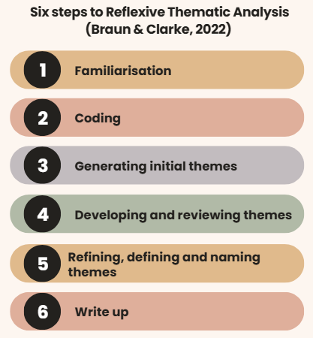

Figure 14 - Six steps to Reflexive Thematic Analysis (Braun & Clarke, 2022)
Recognising the role of myself as an instrument for analysis was fundamental to the RTA process (Nowell et al., 2017; Braun & Clarke, 2020) and to be a consciously curious researcher (Trainor & Bundon, 2020). I strived to own my perspectives (Elliott et al., 1999) and interrogate my subjectivity (Braun & Clarke, 2022). I reflected on my own assumptions, expectations, choices and actions, recorded in a reflexive diary and excerpts (Appendices Y, AA and GG; Braun & Clarke, 2022). A “practice-first approach” (Braun & Clarke, 2022, p. xxix) was adopted, acknowledging the RTA process as being one of learning by doing.

3.6.1 Familiarisation
The familiarisation phase helped to develop a deep and intimate understanding of my data set (Cohen et al., 2018; Braun & Clarke, 2022). I looked beyond the initial understanding of the data (Braun & Clarke, 2013) through immersion and critical engagement (Braun & Clarke, 2022). Data was engaged with at least twice and transcription helped enhance my familiarity.

3.6.2 Coding
Codes are defined as “the building blocks of analysis” (Braun & Clarke, 2022, p. 52). The coding phase aligned with an inductive approach (Harding & Whitehead, 2013), which ensured that themes were grounded in and developed directly from participants contributions. I was cautious not to capture multiple meanings through a single code (Braun & Clarke, 2022). Semantic and latent codes were identified (Javadi & Zarea, 2016), taking into consideration surface level meanings as well as implied meanings.
I used NVIVO coding software to facilitate this process given the large data set (Harding & Whitehead, 2013). A total of 355 initial codes were identified across the entire data set (Appendices Z and AA).
The data for each table (inclusive of one tablecloth and one transcript) was analysed for both the staff WC and the student WC. At this point, the staff and student data were analysed separately to ensure an engaged and systematic process (Braun & Clarke, 2022). The analysis alternated between staff and students which allowed for tables discussing the same RQs to be analysed closed together to start to identify any similarities or differences (Figure 15).
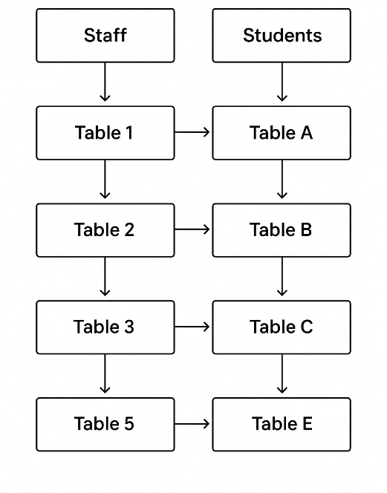

Figure 15 - Data analysis process
I decided to stop seeking additional codes once I had analysed the data set twice, refined and finalised the coding labels (Braun & Clarke, 2022).
After the coding process, data from student and staff participants were combined to align with the WC value of generating knowledge collectively (Brown & Isaac, 2005; McKenna, 2015). Therefore, the term ‘participants’ refers collectively to both staff and student participants. Where either group is referred to, this is stated clearly.

3.6.3 Generating initial themes
Using computer software for coding risks focusing on volume and breadth rather than depth and meaning (St John & Johnson, 2000) and can lead to fatigue (Braun & Clarke, 2022). Therefore, the 355 codes were printed and organised into initial themes manually (see Appendix BB). Themes were defined as patterns of “shared meaning, organised around a central concept” (Braun & Clarke, 2022, p. 77) that could be semantic, concrete or conceptual and latent.
Following this, I returned to computer software to create subthemes (Appendix CC) and identify links between the data (Appendix DD). This was enhanced through using thematic maps. At this point, I felt I had engaged in a robust and rigorous analytical process to produce a compelling story about the data (Braun & Clarke, 2022), indicting I should move onto phase four (Braun & Clarke, 2022).

3.6.4 Developing and reviewing themes
Phase four involved re-engaging with the coded data and entire data set to consider if themes could still be evolved to develop a rich and nuanced analysis that addressed the RQs (Appendix EE; Braun & Clarke, 2022). I drew on Braun and Clarke’ (2022) criteria for this, ensuring the process was recursive and thorough (Braun & Clarke, 2022):
- Focused on a single central idea or argument, not topic summaries
- Rich and diverse in the manifestation of the specific idea within the data set
- Not fragmented or multi-layered
- Distinctive with its own individual focus and boundaries

3.6.5 Refining, defining and naming themes
The process of theme definition in phase five enabled me to test the quality of the themes and led to spending more time in phase four to further refine and review the themes. I explored with presenting my themes in a range of different ways (Appendix FF) which facilitated further refinement. Frequent supervision with my academic supervisors helped me critically engage in this phase. I utilised my reflective diary to record my feelings and frustrations (see Appendix GG).

3.6.6 Write up
As I started writing up, I remained open-minded to the possibility of still making big changes to my themes (Trainor & Bundon, 2020). Initially, RQs were separated into distinct entities. However, due to the qualitative nature of inquiry, it became apparent that the RQs were hard to distinguish into separate phenomena and were inherently interwoven as participants describe the whole of their living and lived experiences. I therefore decided to combine the RQs where appropriate within the themes to improve the coherence and clarity of findings (Braun & Clarke, 2006).

4.0 Findings
In this chapter, the data analysis process and findings developed through RTA are presented. To ensure coherence and avoid fragmented meaning, all data is addressed as a whole. The RQs are outlined in section 3.1.

4.1 Research themes
A thematic map illustrates each theme and the relationships between them (Figure 16; Braun & Clarke, 2006). The themes are layered, reflecting an analytical story to provide a coherent and meaningful narrative about the data. Theme 1.2.1 ‘Relational safety as the foundation for school life’ is positioned as a central theme (Braun & Clarke, 2006), underpinning theme 1.2.2 ‘A place where support and wellbeing are prioritised and sustained over time’ and theme 1.2.3 ‘A shared approach that fosters identity, belonging and fulfilment’. Themes 1.2.4 “We can’t pour from an empty cup” and 1.2.5 ‘Systemic conditions that shape a TIRA ethos’ reflect distinctive ideas that largely addressed RQ3. Sub-themes within each of these themes are also presented.
Data extracts (tablecloth notes and table host summaries) are provided to evidence analytical claims (Braun & Clarke, 2006) and to ensure clear interpretations of participants’ voices. Student voice is identifiable through red text, staff voice in green and table host in blue. This decision was made to value all contributions, whilst orienteering towards collective sense-making (Brown & Isaac, 2005). The entire visual of each tablecloth and table host transcripts can be found in Appendices M and N, which “document and display collective knowledge” (Brown & Isaac, 2005, p.14).
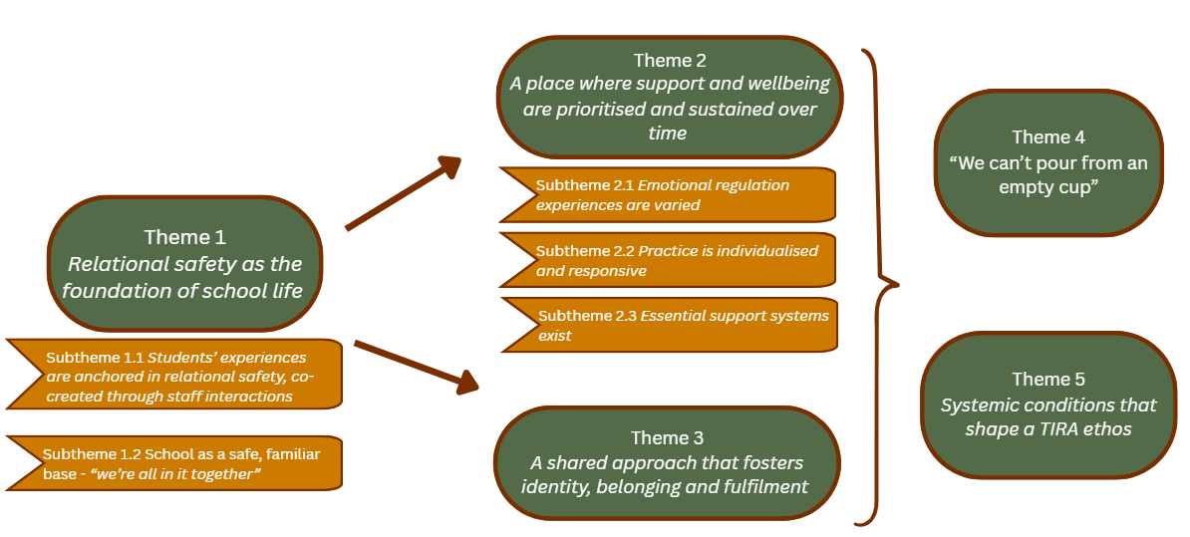
Figure 16 - Thematic map, providing an overview of the key themes that emerged from the RTA process

Theme 1 - Relational safety as the foundation of school life
This theme emerged as the central organising theme, shaping how participants experience support, safety and connection at SVHS. Participants consistently implied that staff are emotionally available and adopt care values, contributing towards school being experienced as peaceful and calm. Staff prioritise connecting with students, facilitating reciprocity and collaborative problem solving. This theme consists of two sub-themes (Figure 17):
- Subtheme 1.1 – Students experiences are anchored in relational safety, co-created through staff interactions
- Subtheme 1.2 – School as a safe, familiar base - “we’re all in it together”
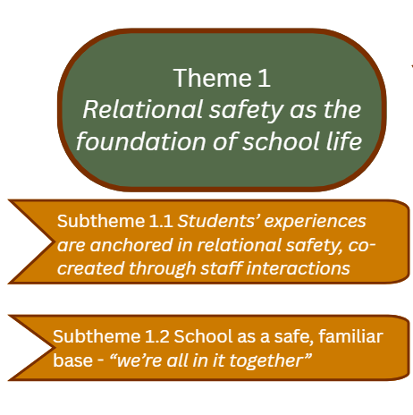
Figure 17 - An overview of Theme 1

Subtheme 1.1 - Students’ experiences are anchored in relational safety, co-created through staff interactions
This subtheme conveys how staff and students constructed meaning around ‘relational safety’. It illuminates the characteristics of relational practice and the ways these relational processes shape their experiences and outcomes.
Emotional availability from staff was attributed by students, who described interactions as “kind” (Tablecloth B), “supportive” (Tablecloth B) and “understanding”, using “humour” (Tablecloth B) and “nicknames” (Tablecloth A). Staff “ask how you are…” (Table A host summary), “always get to know you” (Tablecloth A) and have a “botheredness” (Tablecloth 1). Students spoke about staff being “patient, who never get tired of explaining” (Tablecloth A) and experienced staff as “wanting to” and “choosing to” listen as opposed to “having to” (Figure 18). These small every day human acts are referred to as “ordinary magic” (Tablecloth 2), considered as primary human goods that individuals need to survive, thrive and flourish. Student experiences of attuned adult interactions, helped to create the conditions in which they feel safe, valued and connected to adults in school. As a result, students also enjoy celebrating successes with staff (Appendix HH). Staff associated their approaches with internal motivation and genuine investment in CYP. They described “…Actually liking and spending their time with children… being genuinely interested” (Table 1 host summary). When students experience primary human goods such as relatedness and safety, it shapes how they feel and experience relationships. Students see the adult as a person with feelings and respond to them with mutual recognition and empathy, internalising the adult’s interactions:
“…students will also notice if you’re having an off day, if you’re not yourself, then they notice that because they know you as people, and they’ll have empathy for that and check in on you.”
(Table 1 Host Summary)

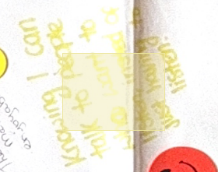
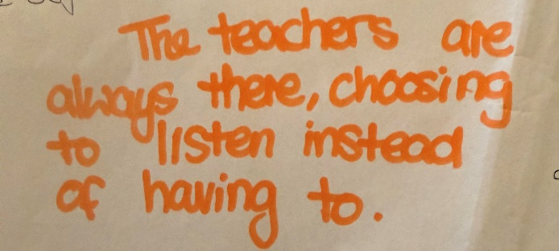

Transcription – “The teachers are always there, choosing to listen instead of having to”

Transcription – “Knowing I can talk to people who want to listen instead of having to listen”

Figure 18 - Extracts from Tablecloth B reflecting a student’s perception of how it feels when they engage with staff
For others (including both staff and students), trust was developed through collaboratively navigating difficulties. Students described how staff “help... instead of ignore” (Tablecloth B) and “make sure you’re not alone…” (Tablecloth A). Staff “make time for them [students] later in the day if they are not available” (Table A host summary), which was understood to “build trust” (Table A host summary) and dependability through “always being someone they can go back to” (Table A host summary). Students experience staff as secure bases: “when a child feels they can trust you and start to share their emotions or feel confident to ask for help” (Tablecloth 2), grounded in unconditional positive regard. It was acknowledged that investing in safeguarding support is important, as safeguarding disclosures are common due to the relational safety students experience (Appendix II). Students describe staff support as “trying as hard as they can to help us” (Tablecloth B) and staff talked about “going above and beyond” (Tablecloth 1; Figure 19). The impact of this enables school to “keep them [students], know them and value them” (Table 2 host summary). Staff are guided by care values that offer compassion, empathy and connection, positioning themselves alongside students. This alludes to values of sustained commitment and perseverance to unconditionally maintain support for students.
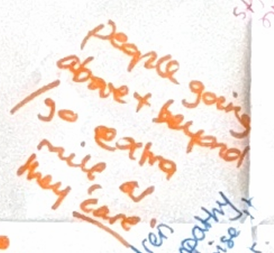

Transcription – “People going above + beyond / go extra mile as they care”

Figure 19 - Extract from Tablecloth 1 which reflect staffs’ perspective of how they go “above and beyond” to support students
Staff dialogue reflects the impact of being approachable and open for students (Table A host summary below), as opposed to feeling “shut down” (Table 1 host summary). However, one participant expressed that “sometimes the teacher listens but does not hear what they are saying…” (Table D, host summary). This suggests that when mentalisation is experienced, connections in these moments do not appear to be contingent on full understanding, rather, staff staying in the encounter with students, through holding them in mind and being curious.
“Teachers follow through on what they’ve spoken about and solving those problems… it makes a difference… builds that trust for them [students] to then be able to go back to that person in the future”
(Table A Host Summary)
“There's students that approach staff for support and they feel validated in those, and they're not shut down”
(Table 1 Host Summary)
Some students reflected on previous relationships to conceptualise their experiences at SVHS:
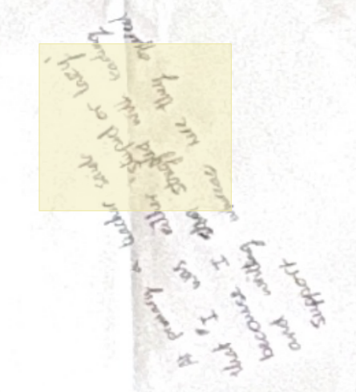

Transcription – “At primary a teacher said that I was either ‘stupid or lazy’ because I struggled with reading and writing whereas here, they offered support”

Figure 20 - Extract from Tablecloth E, demonstrating the perception developed by students due to the support offered at SVHS
In this example, the participant contrasts past interactions that elicited shame, with relational understanding, experienced as containment and compassion. Another participant expressed that “she felt like all other professionals apart from school had given up on her” (Tablecloth 2), highlighting their sustained belief in a student’s potential. These narratives distinguish CYP’s inherent worth from their difficulties. Responding with attunement as opposed to blame, contributes to students reframing their internal beliefs about themselves. There was a reoccurring sense that student’s sense of worth and capability is developed through these interactions.

Subtheme 1.2 - School as a safe, familiar base – “we’re all in it together”
This sub-theme reflects dialogue that alluded to SVHS feeling like a family and a home. Connotations were associated with feelings of safety, familiarity, calmness and shared joy. Relationships between staff and students are reciprocal, experienced as mutual exchanges that foster cooperation and positive relations. This contributes towards students’ feeling safe enough to step out of their comfort zone, growing their confidence.
For staff members, emotional and psychological safety was conceptualised through language such as “family” (Tablecloth 1), “second home” (Table 5 host summary) and “referring to student as ‘ours’…” (Tablecloth 3). Some positioned TIRAs as being “how they would treat their own child. It’s human nature, and common sense” (Table 1 host summary). This belonging discourse implies an emotionally invested staff body and conveys a sense of responsibility and ownership for relationally orientated care. School is perceived as a familial space, shaped by staff who embody protective, care-giving roles, which could be conceptualised as ‘emotional warmth’ (Cameron & Maginn, 2008). Staff spoke of “picking each other [staff and students] up on the bad days” (Tablecloth 3) and reminding each other to “take care at the weekend” (Tablecloth 3). These gestures foster relational consistency and contribute towards sustaining a relational culture.
“The family aspect that you have in this school, that you're all a team and that as a team, you support one another”
(Table 2 Host Summary)
Staffs’ conceptualisation of ‘power’ reinforced this familial pattern. Staff framed their experiences as “being someone’s person in school, helping them to make small steps of progress” (Tablecloth 2), through “sharing experiences” (Tablecloth 2). Student voice mirrors this, through engagements that create shared enjoyment and collaboration:
“…Teacher pantomime and the kids love that because it feels like they're all equal, that the teachers perform and make themselves look silly… the kids feel like they're not just doing shows, but the teachers are playing parts as well.”
(Table B Host Summary)
This creates a collective identity, with staff and students being co-participants rather than adults being separate observers. A sense of belonging is created through these experiences that emphasise a mutual exchange of respect, trust and safety, referred to as ‘reciprocity’. Relationships are understood as cultivated ‘with’ students, as opposed to ‘to’ them. Staff position themselves as “role models” (Tablecloth 2), and “helpers” (Tablecloth 2), hinting towards how they support CYP to experience security. Emphasis was placed on elements of compassionate-focused pedagogy whereby students are given voice, agency and shared ownership through these interactions.
For students, they positioned their relationships with staff as “being in it together” (Table B host summary) and “going through it with us” (Figure 21). Some described how “we can disagree but always come back together” (Figure 22). Students do not describe staffs’ functional roles, rather, they position staff within their social worlds, describing relational patterns that construct staff as support systems and emotional allies. Staff engagement is experienced as dependable and protective (Figure 23), associated with unconditional positive regard. However, students did metaphorically describe staff as “friends” (Tablecloth B). This may be an area for consideration, given the importance of staff taking charge when necessary (Cooper, Hoffman & Powell, 2018) to support CYP to feel secure. Students also discussed the importance of peer relationships (Appendix JJ).
“They're [staff] are like their friends and they feel like they're all in it together…”
(Table B Host Summary)
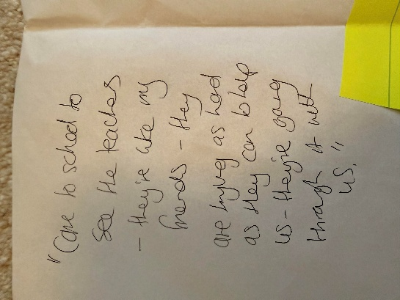

Transcription – “Come to school to see the teachers – they’re like my friends – they are trying as hard as they can to help us – they’re going through it with us”

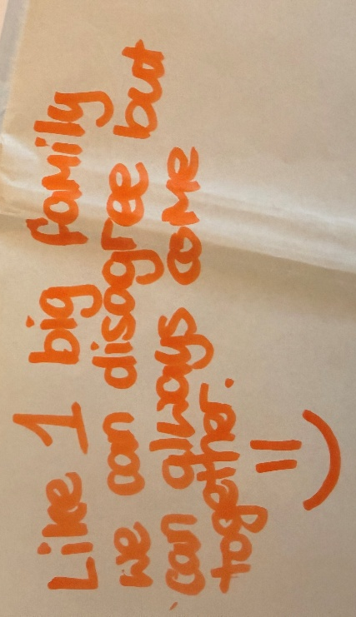
Figure 21 - Extract from Tablecloth B reflecting a student’s experiences of staff that is conceptualised through ‘friendship’

Transcription – “Like 1 big family, we can disagree but can always come together”

Figure 22 - Extract from Tablecloth A demonstrating a students’ conceptualisation of ‘family’
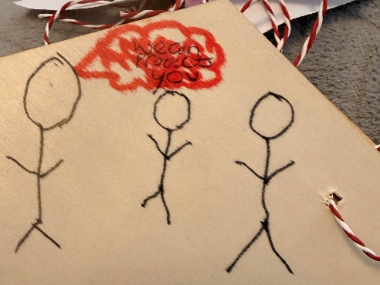
Transcription – “We can protect you”

Figure 23 - Extract from Tablecloth E demonstrating how students position staff members as ‘protectors’
Some students experienced school as peaceful and calm. This was depicted through a drawing of a dove and an accompanying quote (Figure 24). A hurricane metaphor was also used to illustrate how “they [staff] keep you in the eye of the hurricane not the storm” (Figure 25). Other students described school as an alternative to home: “A trauma-informed and relational school is like a calm environment when you don’t want to be at home or something has happened…” (Tablecloth E). This articulates how staff help keep students in the calm as opposed to the external chaos. Staff are experienced as stabilising, anchoring bodies, which creates a safe, calm and peaceful environment where CYP want to be when they experience difficulties.
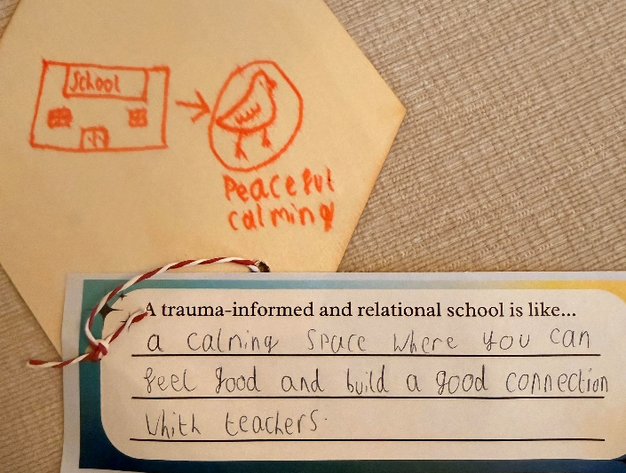

Transcription – “A calming space where you can feel good and build good connection with teachers”

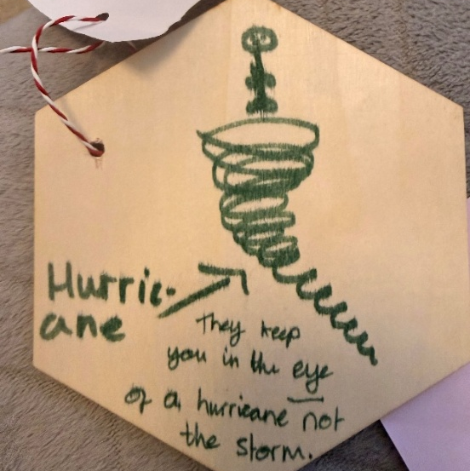
Figure 24 - Drawing from Tablecloth E, reflecting how a student perceives the school to feel, using a dove to depict feelings of peace and calm

Transcription – “Hurricane – they keep you in the eye of a hurricane not the storm”

Figure 25 - Drawing from Tablecloth E, reflecting how a student uses the metaphor of a hurricane to position their experiences in school as calm
The impact of the familial environment was captured in examples where students had felt confident and safe enough to explore their understanding of events around them (Appendix KK).

Theme 2 - A place where support and wellbeing are prioritised and sustained over time
This theme centres around the support and wellbeing offer at SVHS. It reflects dialogue about the importance of person-centred planning and differentiation. Participants discussed emotional support at SVHS, as well as an individual and bespoke approach to education. Dialogue also identified the relational infrastructure that exists, positioned as enabling TIRAs. This theme consists of three subthemes (Figure 26):
- Subtheme 2.1 – Emotional regulation experiences are varied
- Subtheme 2.2 – Practice is individualised and responsive
- Subtheme 2.3 – Essential support systems exist
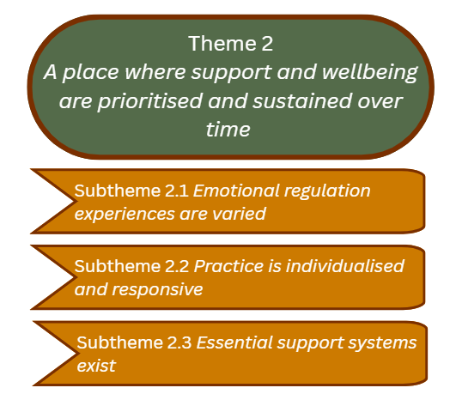

Figure 26 - An overview of Theme 2

Subtheme 2.1 – Emotional regulation experiences are varied
Students are supported to co-regulate through a range of experiences. Developing emotional literacy skills was positioned as a relational process, through co-regulation alongside an attuned key adult. Importance is placed on staff modelling emotional regulation skills that create the conditions for students to develop healthy emotional expression and regulation. Frameworks including a whole-school emotional literacy curriculum foster a shared relational language that facilitates understanding.
Participants spoke of the range of experiences available for co-regulation (Figure 27) that helped students to feel empowered to find a way to calm, settle, connect and feel held. This included: therapy animals, sensory rooms, access to outdoor spaces and a Personalised Learning Provision (PLP). The PLP was described as a relational environment that “meets personal needs for students not accessing learning” (Tablecloth 5). This space is supported by attuned adults who can mentalise and hold the emotional needs of CYP, as well as engage in co-constructed emotional wellbeing experiences (e.g. colouring or somatic activities). Co-regulating experiences were described as responding to physiological and sensory needs, recognising that a sense of calm must be established before cognitive engagement.
“We've spoken a lot about the dogs as well and the tortoise that help some people to feel calm”
“PLP, so that came up a lot, and that's a space that pupils can go to and spend time away from lessons, maybe with the digital board, with board games, with teddys and weighted blankets, there's food and drinks available”
(Table A Host Summary)
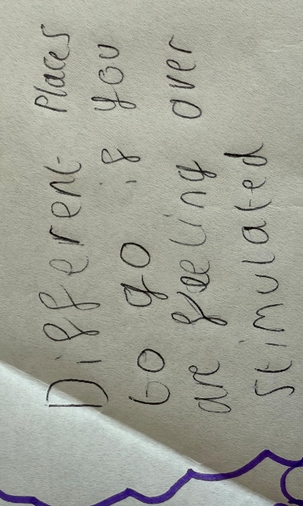

Transcription – “Different places to go if you are feeling over stimulated”

Figure 27 - Extract from Tablecloth A demonstrating the variety of options for students
“…there is lots of different choices of places that you can go to if you need to”
(Table A Host Summary)
Staff and students spoke of the ‘Zones of Regulation’ (ZoR) curriculum enabling co-regulation opportunities. Students saw ZoR as a framework for staff and students to co-construct meaning around their emotional states (Figure 28, Figure 29). This helps cultivate the relational conditions required for emotional understanding to develop. Students recognised this through commenting that co-regulation is non-judgemental and non-shaming.
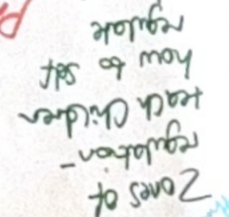
Transcription – “Zones of regulation – teach children how to self-regulate”

Figure 28 - Extract from Tablecloth 5 which acknowledges the impact of the ZoR curriculum
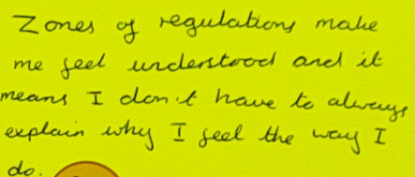
Transcription – “Zones of regulation makes me feel understood and it means I don’t have to always explain why I feel the way I do”

Figure 29 - Extracts from Tablecloth A which highlights the impact of the ZoR curriculum from a students’ perspective
“Zones of regulation being used as like a code system, so that somebody can set a feeling red or feeling yellow, and they don't have to explain that because they find it maybe more difficult to use language…”
(Table A Host Summary)
“Students started to understand their own behaviour, so they're able to do that reflective practice.”
(Table 5 Host Summary)
Additionally, staff “showing emotions and modelling regulation strategies” (Table 3 host summary) contributes to the relational field that shapes students’ understanding of emotional literacy. Staff framed emotional transparency as co-creating the conditions and shared understanding that CYP need to develop emotional literacy rather than oversharing aspects of their internal worlds. In this sense, emotional literacy was understood as an evolving relational process that is nurtured, facilitated by connections, interactions and coherent understanding. Additional structures that facilitate safety and co-regulation for students are discussed in Appendix LL.
Whilst students experienced co-regulation as empowering and valuable, some expressed a desire to have greater agency in the decision making when experiencing emotional overwhelm (Figure 30). This was positioned as a call for greater collaboration and trust around the setting of boundaries (Table B host summary below). This highlights the importance of quality support available for CYP to co-regulate, capturing how students have a desire to explore independently, whilst knowing they can return to a safe base if required.
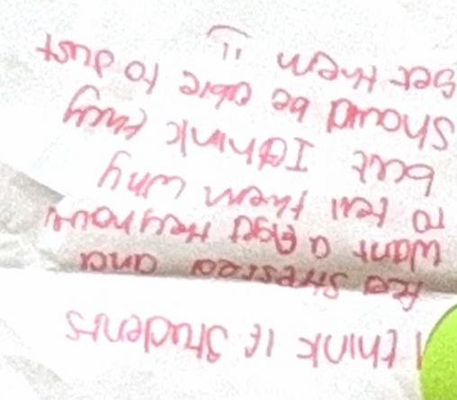
Transcription – “I think if students feel stressed and want a fidget they have to tell them why but I think they should be able to just get them”
Figure 30 - Extract from Tablecloth C, students’ desire to have more autonomy with regulation strategies
“…If you feel like you need it, you should be able to access that…you shouldn't have to have a card… because you've all got good relationships with the teachers, if you feel like you need to take time out or go for a move break, you should just be able to do that.”
(Table B Host Summary)

Subtheme 2.2 – Practice is individualised and responsive
This subtheme captures how staff tailor their interactions to students’ individual needs, guided by curiosity, including how they establish and maintain boundaries. Staff recognised how the relational conditions in which learning takes place, contribute towards knowledge production, emphasising that students’ experiences matter.
Both staff and students articulated how support to overcome difficulties is needs-led, underpinned by relational values of curiosity, active listening and empathy. Students are supported with “things they need” (Figure 31) and staff “adapt.. approaches” (Table 1 host summary), even when this is not the easiest option (Figure 32). Support to navigate challenges is viewed as being fluid, dynamic and adaptive, as opposed to a being uniformly delivered, predetermined by school policy. Students recognised that staff ask, “if everything is ok, instead of getting mad” (Tablecloth B). This implies that staff seek to understand rather than assume they know to create the conditions for CYP to co-construct the support they need.
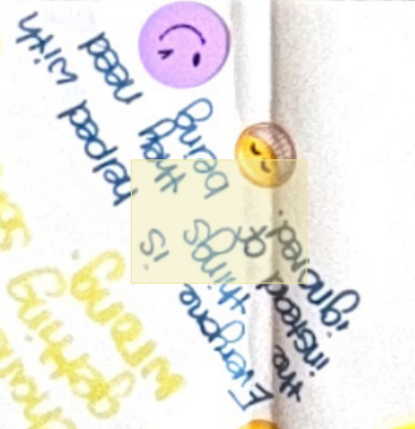

Transcription – “Everyone is helped with the things they need instead of being ignored”

Figure 31 - Extract from Tablecloth B which highlights student’s recognition of an individual approach to support
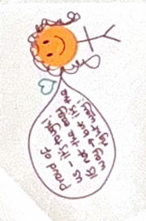

Transcription – “Proud of us – it’s tough! It’s not the easy way but it’s the right way!”

Figure 32 - Extract from Tablecloth 4, positioning TIRA as the ‘right’ approach, but not the ‘easy’ approach
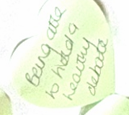
Staff acknowledge that a TIRA includes offering support and high challenge, viewed as a relational process that occurs within a safe context. The word “healthy” (Figure 33) suggests that the intensity of challenge is considerate of student’s needs, intended to be a supportive and confidence-affirming experience.
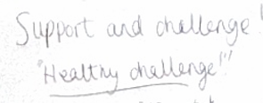

Transcription – “Being able to hold a healthy debate”
Transcription – “Support and healthy challenge!”

Figure 33 - Extract from Tablecloth 3, recognising the importance of healthy challenge for students
Tensions arose with regards to how staff respond to individual needs (Table 4 Host summary below). Some staff were uncertain about “where to draw the line” (Tablecloth 4). It was identified that this may also be confusing for students (Appendix MM). A “top down” (Table 4 Host Summary) approach, indicating stronger direction from leadership, was proposed to provide reassurance and containment (Table 4 host summary below). This implies that staff interpret boundaries not only as guidelines for supporting emotional wellbeing of students, but also as professional security.
“Consistency… in terms of like everybody [students] being treated the same, but people having different needs. And so that means being consistent is a bit difficult.”
(Table 4 Host Summary)
Others constructed boundaries as a concept that was collaboratively sustained rather than imposed. Emphasis was placed on the idea of a ‘shared understanding’: “singing from the same hymn sheet” (Tablecloth 4, Figure 34) and “trusting the process” (Tablecloth 1). Some appreciated having “ownership” (Tablecloth 2) and being able to “utilise all my skills to benefit the students I work with” (Tablecloth 1). Consistency was viewed as coherence in values and understanding values flexibly, whilst maintaining fairness. This tension could be understood to reflect the distinction between staff who are trauma informed and trauma invested (Souers & Hall, 2018).

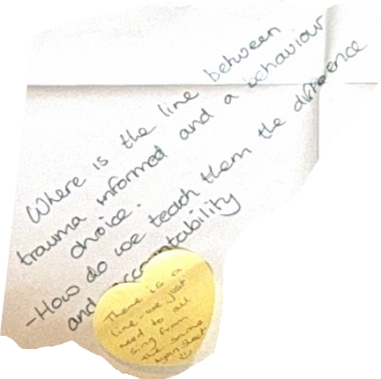
Transcription – “Where is the line between trauma informed and a behaviour choice. How do we teach them the difference and accountability?”
“There is a line we just need to all sing from the same hymn sheet”

Figure 34 - Extracts from Tablecloth 4, giving an example of the conflict of opinions with regards to boundaries of the approach
Staff also spoke about how they adapt the curriculum, taking into account students’ personal experiences as well as the local context (Appendix NN).

Subtheme 2.3 – Essential support systems exist
Discussions highlighted the support systems in place at SVHS that were positioned as facilitating a relational school climate. This differs to subtheme 2.1, which explores data that was interpreted as specifically focusing on emotional literacy skills.
Coaching groups (CGs) were seen by students as “a really important part of your day” (Table B host summary). Students described how “everyone gets a coach to talk to about anything” (Tablecloth B) and that they meet with CGs “everyday” (Tablecloth B). Students experienced them as places where you “share with friends and teachers” (Tablecloth B) and talk about “how you feel” (Tablecloth B), “without judgement” (Table B host summary). CGs were constructed as “places you feel heard” (Table B host summary), which “brings people closer” (Tablecloth A). The impact of this for students is captured in Figure 35.
CGs were described as having a safe, relational and emotional purpose, that elicited feelings of belonging and inclusion for students, rather than for administrations (e.g. attendance monitoring). However, it was implied that coaching is dependent upon the relationship between staff member and student. Some students talked about coaches as “someone who is there to help” (Tablecloth A), who “listens” (Tablecloth A), “asks about my morning” (Tablecloth A) and “checks up on me” (Tablecloth B). Conversely, others described how “coaching doesn’t work because I don’t like my coach” (Tablecloth A) and staff recognised that the impact of support is “dependent on relationship and trust” (Tablecloth 1). This offers an insight into how CGs are experienced, with their interpretations being grounded in the relational dynamics with their coach. These perceptions may reflect the attunement from the coach, skill set or the way power is used within the relationship. Such factors shape feelings of connection and safety, which influence how CGs are received and made sense of.
Coaches are available outside of CGs through “class charts” (Table 1 host summary). This means students can contact their coach at any time using technology. Outside of CGs, coaches become relational containers, creating holding environments for students. This relational availability through providing predictability and attunement, contributes towards students feeling safe, secure and valued.
“coaching is a really important part of your day because you get to feel heard, you get to say how you've been feeling and there's no judgement.”
(Table B Host Summary)
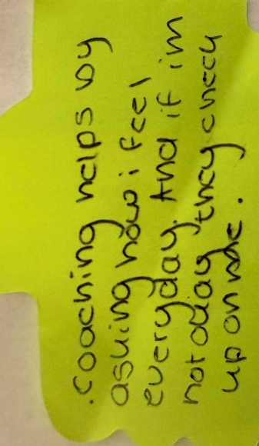
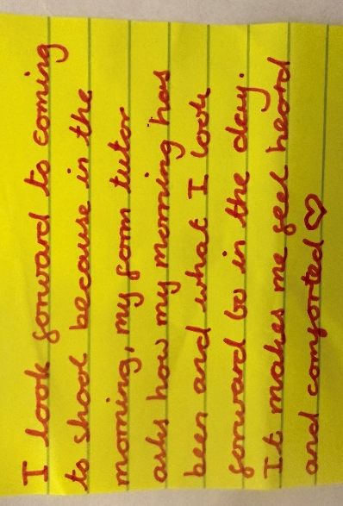

Transcription – “Coaching helps by asking how I feel every day and if I’m not okay they check up on me”
Transcription – “I look forward to coming to school because in the morning my form tutor asks how my morning has been and what I look forward to in the day. It makes me feel heard and comforted”

Figure 35 - Extracts from Tablecloth B which highlights the function and value of coaching groups
Additional systems and policies that facilitate a TIRA being embedded and sustained included: ‘restorative conversations’, a ‘kindness and respect charter’, having a ‘TI teacher’, ‘Reflect Manager’ and an alternative provision space (see Appendix OO).

Theme 3 - A shared approach that fosters identity, belonging and fulfilment
This theme offers an insight into how staff support and collaboration is central to upholding a TIRA ethos and culture. Staff recognise the influence of their emotional presence on their relationships with students. They seek to support each other’s emotional wellbeing needs and work collaboratively to enhance their practice and experience mutual regard and shared purpose. Staff enjoy working within a TIRA ethos and are committed to sustaining this culture.
Staff described the staff body as a ‘team’ who support and have each other’s backs (Figure 36), pick each other up on the bad days” (Tablecloth 3) and “working collectively – not individual departments” (Tablecloth 1). They spoke about “sharing strategies to build their own toolkits…” (Tablecloth 1) and “never being too busy” (Tablecloth 2). They acknowledged that their happiness and job satisfaction influences the way they interact and engage with students (Figure 36). Staff alluded to relational interactions being influenced by their own emotional capacity, associated with their window of tolerance (Theme 2).

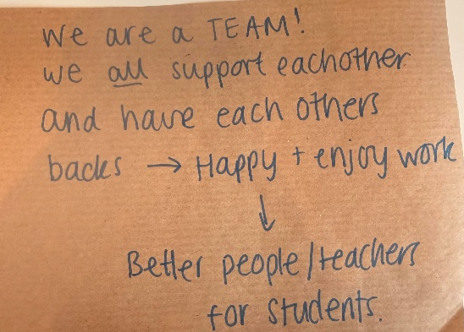
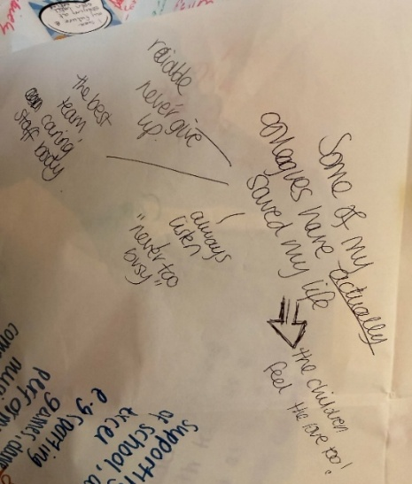

Transcription – “We are a TEAM! We all support each other and have each other’s backs Happy and enjoy work Better people/teachers for students”
Transcription – “Some of my colleagues have actually saved my life”

Figure 36 - Extracts from Tablecloth 2 that highlight the value of the staff team for some staff members
As a result of these experiences, some staff felt that “nobody feels undermined” (Table 5 host summary) and it is “safe to ask for help” (Tablecloth 3), “learning.. to be better together” (Tablecloth 3). For some, this had an existential dimension (Figure 36), suggesting that presence and availability of colleagues can feel life-preserving in moments of emotional overwhelm.
Whilst some perceived seeking help as valuable and constructive, others spoke about “a fear of asking for help… feeling like they should know it, but might not…” (Table B Host Summary). This elicited discomfort and a sense of reduced emotional safety, linked to worries about being incompetent.
Embedding and sustaining TIRAs was discussed as a collective endeavour. Staff used phrases like “one in, all in” (Tablecloth 2) and “DNA of the school” (Figure 37). Recruitment was identified as important for sustaining a TIRA: “making the right recruitment choices so that staff fit the school” (Tablecloth 3). This included additional support for new staff “particularly if they came from a C1 C2 C3 system, it’s a bit of a culture shock” (Table 4 host summary).
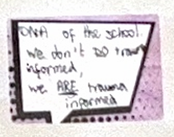
Transcription – “DNA of the school. We don’t DO trauma informed. We ARE trauma informed”

Figure 37 - Extract from Tablecloth 3, capturing how a TIRA is embodied by staff
Additionally, narratives were revealed about inclusivity and belonging for staff members. All staff being responsible for a CG, facilitates feelings of being important, valued and included (Figure 38). Staff felt “no divide… there’s no real hierarchy between staff, everybody like heads of departments, work alongside everybody else and there’s no sense of you are more important than me…” (Table 2 host summary). Through this relational culture, staff experience mutual regard and a shared purpose, contributing towards feelings of belonging, respect and a climate of inclusivity.
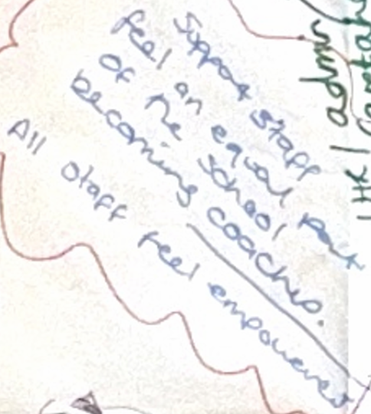

Transcription – “Support staff feel an equal part of the school becoming coaches. All staff feel empowered!”

Figure 38 - Extract from Tablecloth 5 reflecting a staff members feeling empowered by being a coach
Staff spoke about “fulfilment” (Table 2 host summary) and “enjoying coming to work every day” (Table 2 host summary) as a result of the TIRA ethos (Figure 36, Figure 39). There appeared to be a reciprocal relationship in which personal fulfilment fuelled staffs’ contribution to sustaining the shared TIRA ethos, while belonging to that shared ethos further reinforced their sense of fulfilment. Participants described how they “don’t want to work anywhere else” (Table 2 Host Summary) and “want to stay [at SVHS] … to see out their whole career” (Table 1 Host Summary). Staff conveyed a cultural commitment and emotional investment, shaped through their experiences working within - and part of – the TIRA culture. The term ‘fulfilment’ was understood as having an “impact on lives” (Tablecloth 2) and not “giving up on [on students]” (Tablecloth 2). By comparing previous experiences, staff indicated how much more motivated and fulfilled they felt, contributing towards sustaining a TIRA culture:
“…they [students] go to a secondary school, and they are got rid of fairly quickly… but you keep them here and you do a good job at keeping them here…which fed into what contributed to you coming to work, wanting to come to work.”
(Table 2 Host Summary)
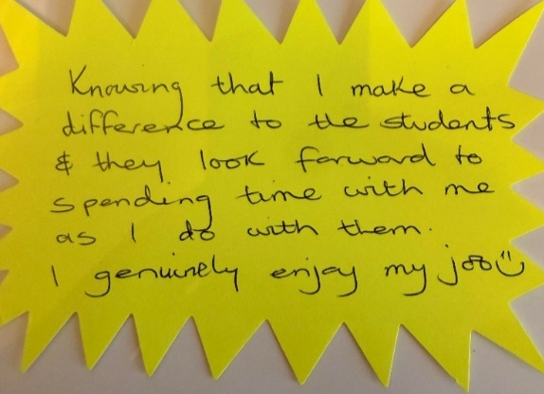

Transcription – “Knowing that I make a difference to the students and they look forward to spending time with me as I do with them. I genuinely enjoy my job”

Figure 39 - Staffs’ contributing contextualising the enjoyment they get from their role (Tablecloth 2)
There is a collective and shared identity between staff, which positions them as a cohesive team and alludes towards a strong sense of professional solidarity. Where these relational conditions are experienced, this contributes towards a sustained commitment to the school. Overall, this illustrates how organisational structures and shared values typically co-produce a culture grounded in relationality that is committed to sustaining the practice.

Theme 4 - “We can’t pour from an empty cup”
Staffs’ emotional wellbeing needs must be met for them to actively uphold and sustain a TIRA culture and ethos. Their accounts spoke about the emotional toll of TIRAs, illuminating the need to support their wellbeing. The quality of relationships with students depends on the emotional resources available to the adults who support them.
Staff “can’t pour from an empty cup” (Tablecloth 4) and experience difficulties “regulating ourselves when trying to be there for the children all the time” (Table 1 host summary). Staff recognised that “closer relationships = they [students] can take it out on you” (Tablecloth 4), which “hits harder… so the highs are highs and the lows are lows.” (Table 4 Host Summary). This implies that there is an increased emotional burden from embedding TIRAs. Staff acknowledge that they need to be regulated to support the students best, emphasising the importance of protecting their own emotional capacity.
Staff discussed the emotional support available that helps them navigate difficulties: “its overwhelming, but there is support” (Tablecloth 1) and “there’s a lot of support to deal with the challenges” (Table 1 host summary; Figure 40). Activities included “counselling”, “cuppa at three”, “hyrox exercise groups” (Tablecloth 2), and informal opportunities for connection: “listening” (Tablecloth 2) and “checking in” (Tablecloth 2), which lighten the load to prevent staff from feeling depleted. This gives an insight into how ‘support’ attends to the needs of staff, helping increase staffs’ emotional capacity to manage the demands of working in a TIRA culture.
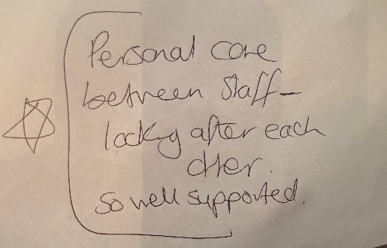
Transcription – “Personal care between staff – looking after each other. So well supported”

Figure 40 - Extract from Tablecloth 2 that highlights the perceived care and support between staff
Whilst staff valued existing support, they also expressed a desire for more opportunities to sustain their own emotional capacity: “…people talked about maybe having rewards for staff, having well-being time days, more time for staff building activities.” (Table 4 host summary). This reflects the value staff place on these opportunities and the need for time to be protected for staff wellbeing.

Theme 5 - Systemic conditions that shape a TIRA ethos
This theme brings together the systemic conditions that surround a TIRA. Time, parent/carer collaboration, governing body influences and macro-level influences were all discussed in relation to sustaining TIRAs.
Participants discussed the time needed for relationship building: “…it does take time to build those relationships, but it is worth it in the long run” (Table 1 Host Summary) and to “not gloss over things” (Tablecloth 4). Staff acknowledge that embedding TIRAs is a gradual process that requires depth and attentiveness, facilitated by time and sustained efforts.
Parents/carers were described as an important part of the schools’ ecology. Relationships with parents/carers are formed and sustained through frequent communication, parents’ evenings and supportive sessions on emotional literacy and mental health:
“…parents have been helped with understanding teenagers brains, how to respond to the children. There’s been a big uptake of that…”
(Table 5 Host Summary)
Coaches are fundamental to parent/carer engagement: “…really positive relationships between coaches and parents… has changed parental engagement” (Table 5 host summary). Coaches “actively work with families so we [staff] can work together to support their child” (Tablecloth 1). Ensuring experiences for parents/carers are “accessible” (Table 3 host summary) was important to sustain relationships and engagement. Staff viewed these collaborative relationships as being fundamental to understanding students holistically, enabling staff to “take the entire context into account” (Table 3 host summary) and support CYP’s development (Table 1 host summary). Staff understood school and home as interacting systems and placed value on being able to understand student’s full context. Students lived experiences of these relationships developed a sense of reassurance that “you always have support” (Tablecloth C).
Additionally, appointing governors who “approve of the approach and get it” (Table 5 host summary) was identified as being important to sustain a TIRA. This emphasises the importance of all areas of the school system being aligned with the culture and ethos for it to be sustained.
Staff identified macro-level constraints to embedding a TIRA culture and ethos including policies, OFSTED, funding restrictions and difficulties accessing support from external agencies (Tablecloth 4). This impacts how SVHS can “deliver provision” (Tablecloth 4), illuminating some of the obstacles that exist within the wider system, impacting SVHS ability to sustain TIRAs.
Additionally, staff expressed a wish for more mainstream secondary schools to embed a TIRA. This was associated with a desire to improve collaboration across school settings to sustain and develop a TIRA:
“…in terms of your development, you don't have a lot of other places to go that are mainstream. You might be able to go to special provisions and see what they're doing, but in terms of mainstream settings, you've no one else to look up to…”
(Table 4 host summary)
Whilst macro-level constraints were discussed, staff spoke about other ways they sustain a TIRA culture and ethos. This included “CPD” (Tablecloth 3) and making changes to the aesthetics of the school environment (Figure 41). Changing the physical environment alludes to the idea that a TIRA culture goes beyond interpersonal interactions, recognising how the physical environment can facilitate CYP’s experiences of safety.
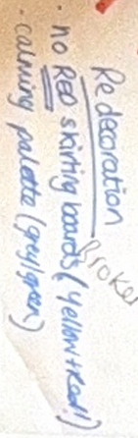
Transcription – “Redecoration. No red skirting boards. Calming Palette (grey/green)

Figure 41 - Extract from Tablecloth 5, highlighting environmental changes

4.2 Summary of Findings
In summary, the findings provide one example of how a TIRA ethos and culture is conceptualised, embedded and sustained in a mainstream secondary school. The RQs are addressed throughout each theme, to provide a coherent understanding of staff and students experiences.
Fundamental to TIRAs is how staff and students experience relational safety. This is a cultivated climate in which staff and students enact values as part of a relational ecosystem. Emotional availability from staff shapes how students understand relationships and engage in these interactions. Staff are attuned to students needs and respond with care values such as attunement, empathy and emotional warmth. This fosters relational consistency and the conditions students need to feel safe, valued, connected and included. In turn, students internalise these every day human acts and respond with mutual recognition, enhancing meaningful connections between staff and students. School is a metaphorical home and family for some, underpinned by collaboration and a collective identity. Students predominantly experience relationships as safe and metaphorically associated staff with friendship qualities. This should be carefully considered given that adults need to be stronger and wiser in order for CYP to feel safe and secure (section 5.1).
Person-centred planning, differentiation of emotional wellbeing support and co-regulation from attuned key adults, shapes how students’ experience emotional expression in school. Co-regulatory experiences prioritise basic needs as the foundation for connection, regulation and learning. A whole-school emotional literacy curriculum facilitates a shared relational language that co-constructs understanding between staff and students. Emotional literacy skills are viewed as a co-created relational process, fostered through needs-led connection and interaction. Staff cohesion is important to embed boundaries and consistency. However, this was not universally agreed upon, with some staff wanting clearer direction from leadership while others viewed boundaries as being collaboratively sustained. CGs and relationships with coaches enable CYP to experience relationships as emotionally containing, holding environments. However, these experiences are grounded in the differential relational dynamics between student and coach.
Emotional wellbeing support for staff is essential to sustaining a TIRA. Staff recognise the influence of their emotional presence on their relationships with CYP and value experiences to replenish their own emotional capacities. There is a desire for more time for wellbeing experiences, illuminating the value of these on staffs’ wellbeing. Staff seek to provide emotionally containing spaces for each other, increasing their capacity to respond with emotional warmth and genuine care. Inclusivity and belonging for staff are experienced through staff having their own CGs. Staff view creating a relational culture as being a collective endeavour, underpinned by professional solidarity and a reciprocal relationship between personal fulfilment and a shared relational ethos.
Embedding and sustaining a TIRA was understood to extend beyond the remit of SVHS. Prioritising and protecting time to embody relational practice and working collaboratively with parents/carers (facilitated by coaches) were highlighted as important systemic considerations. Macro-level constraints including Ofsted, funding restrictions and difficulties accessing support from external agencies and other schools are barriers that impact the sustainability of a TIRA culture.
How these findings contribute to the wider literature, and how they may inform other schools considering TIRAs, is discussed in section 5.2.5.

5.0 Discussion

5.1 Introduction
This chapter intends to collate and discuss the findings, building on existing literature, to answer the RQs outlined in section 3.1.
As discussed in Chapter 4, five main themes were developed concerning these RQs (Figure 16). See section 4.2 for a summary of the findings. The findings will be contextualised in the literature, and an evaluation of the research will also be presented.

5.2 Discussion of the themes in relation to literature
Due to the complexities when researching phenomena such as TIRA (Maynard, 2019) and following rigorous data analysis (Braun & Clarke, 2022), it was recognised that some of the themes coincide with each other. The majority of the literature was discussed in Chapter 2. However, some unforeseeable topics emerged from the staff and students’ experiences. Consequently, new literature is introduced where appropriate to discuss these findings and what it means for praxis.
An integrative, whole-school approach is recommended when embedding a new culture or ethos (DfE, 2021; DfE, 2026a) – discussed in section 2.4. This discussion is therefore structured by mapping the findings onto the relevant areas of a whole-school approach. This intends to illustrate how change must operate across interconnected layers to meaningfully support the enactment and embedding of TIRAs. At the start of each section, there is an introductory paragraph to outline how each section relates to one or more of the RQs.

5.2.1 Ethos and environment
The themes addressed within this section of whole-school approach include Themes 1, 2 and 4. Addressing RQ1, the findings highlight how relationships are underpinned by trust, collaboration and empowerment. Staff embody and enact humanistic and care values through perspective-taking and empathy. Linked to RQ2, when staff enact these values and embody this way of working, they are meeting the primary human needs of students, supporting them to process emotions and make sense of their experiences. Consequently, an emotionally safe school ethos is created. In relation to RQ3, to sustain this way of working, schools cannot rely on the innate skills of staff. Training and wellbeing support (e.g. supervision) is a pivotal facilitating factor to upskill staff and mitigate staff burnout. Furthermore, CGs provide an insight into how schools may develop a structure to enable TIRAs to be sustained, addressing RQ1. Facilitating this (RQ3) is the pivotal role of upskilling staff to ensure they understand the pastoral and emotional function of these spaces. The information below provides greater detail for each of the areas mentioned in this paragraph, linking findings to the relevant literature and theoretical frameworks.
Central to TIRAs is trust-based, collaborative and empowering relationships (Watson & Astor, 2025), experienced through safety, security, protection, connection, warmth, care, mutuality and transparency (Babcock, 2020; Watson & Astor, 2025). The experiences of participants at SVHS corroborates this, emerging as a central organising theme (Theme 1). Through a humanistic lens, staff meet primary human needs (Greater Good Science Centre [GGSC], n.d.). This includes relatedness, inner peace and community for students by embodying humanistic and care values (Rogers, 1957; Vaandering, 2013). Containment (Bion, 1962) is experienced through staff who are attuned to students, absorbing unprocessed feelings and providing a calm and manageable way to make sense of these. This is facilitated by holding environments (Winnicott, 1960). Participants described providing and receiving attuned and empathetic engagement, which resonates with mentalisation processes. Derived from and integrating object relations, attachment and theory of mind research, mentalisation acknowledges that we cannot know another’s mind directly but are curious to learn through co-construction (Luyten et al., 2024). It involves perspective-taking and acting with empathy, intuition and reflection (Asen & Fonagy, 2020). These concepts are reflective of Perry’s (2006) ‘reason’ stage in the Neurosequential model, that enable staff and students to co-construct appropriate support and problem solve together.
Containment, mentalisation and holding environments have therapeutic purposes, nurturing students’ capacity to thrive (Theme 1). They act as protective factors that support students’ emotional wellbeing, resilience, ability to maintain connection and remain engaged with school (GGSC n.d.; Split & Koomen, 2022) even on occasions when they experience distress. Therefore, when these relational practices are embodied by staff, it shapes the relational conditions and climate students experience, creating an emotionally safe school ethos. Acknowledging this is pivotal to sustain TIRAs. Working relationally and enacting these practices is skilled work. It is important that schools do not rely on the innate skills of staff. They need to actively invest in developing and sustaining TIRAs, to mitigate staff burnout (Brown & Biddle, 2023) and facilitate staff resilience and compassion satisfaction (Brown & Biddle, 2023) (Theme 4). Providing supervision for staff to process emotional labour as well as training (Jones et al., 2024) to enhance their understanding of psychological concepts are valuable ways this could be achieved. By doing this, there becomes an intentional shift to move beyond the general notions of kindness, into the realm of skilled, intentional and professional practice.
CGs (Theme 2) offer an insight into how schools may embed a framework to enact ‘ensuring physical, emotional and psychological safety for all school members’ (Watson & Astor, 2025). They are experienced as micro-communities where students feel known, held and supported. It is essential that schools attend to the relational conditions in which frameworks such as CGs exist (Cramond, 2021; Di Lisio et al., 2025). Coaches are fundamental to student experiences, described as “relationship shapes” (McCaleb & Mikaere-Wallis, 2005, pg. 5). Additionally, ensuring the framework aligns with a TIRA ethos is important (Sharples et al., 2024). ‘Coaching’ can be assumed to be an information giving process, with an academic focus (Abdulla, 2017). This research offers an alternative understanding, conceptualising CGs as collaborative, shared and reflective spaces, aligning with a pastoral model of practice (Best, 2014). It emphasises the importance of upskilling staff to understand and enact the pastoral function of these groups. However, this should be interpreted cautiously by other settings given that approaches are significantly influenced by environmental conditions and contextual diversity (De Grauwe & Haas, 2022; Sharples et al., 2024; Benavides et al., 2025). Although not discussed in the WC data, schools must consider when CGs will take place and their make-up of students that influence their effectiveness (Celaya et al., 2025). The research and literature focusing on CGs for students appears to be limited. Additional research may be valuable exploring this model of practice in secondary schools to gather a greater understanding of their functions, purposes and impacts in relation to enacting and embedding TIRAs.

5.2.2 Staff development, health and wellbeing
Themes addressed within this section include Themes 1, 3, 4 and 5. The findings relevant to RQ1 highlight that upholding and sustaining TIRAs is a collective responsibility, viewed as a whole-school endeavour. Additionally, a whole-school TIRA culture involves carefully tailoring recruitment, ensuring the school culture and ethos is made explicit within these processes. For RQ2, the impact of this is that sustainability of a TIRAs ethos and culture is improved. Additionally, staff feel a sense of belonging because of the collective responsibility, enhancing job satisfaction and increasing their commitment to the approach. Focused on RQ3, facilitating TIRAs is a view that staff wellbeing is an institutional responsibility and part of the organisational infrastructure to maintain the positive job satisfaction staff spoke of. Also related to RQ3, facilitating a TIRA, is regular CPD opportunities that keep staff abreast of changes and developments within the field. The discussion below builds on each of the areas introduced in this paragraph, linking findings to the relevant literature and theoretical frameworks.
It is extremely difficult to embed a new model or system within school environments that have high levels of staff turnover and difficulties recruiting (Smith & Monteux, 2023). This impacts investment, shared commitment, sustainability (Jones et al., 2024) and student learning (Nguyen et al., 2023). Staff experience TIRAs at SVHS as a whole-school endeavour (Theme 3). There is a sense of collective responsibility for upholding and sustaining TIRA values that aligns closely with the components central to staff retention of ‘building relational trust’ and ‘improving working conditions’ (Nguyen et al., 2023). Staff described increased job satisfaction, enjoyment and a sense of professional alignment when working relationally, echoed in the literature (Klassen et al., 2012; Garcia-Moya et al., 2019). Staff expressed a commitment to SVHS and a TIRA ethos, associated with them feeling able to work inclusively. These findings suggest that a TIRA culture acts as a protective organisational experience that enhances staff stability—an essential condition for sustaining TIRAs. Two ways this is facilitated at SVHS are through staff wellbeing and staff recruitment – discussed below.
With regards to staff wellbeing (Theme 4), how staff engage with a TIRA is dependent upon their own emotional capacity (Harding et al., 2019). Staff acknowledged that enacting humanistic values (including attunement and empathy) and co-regulating with students impacts on their own emotional wellbeing and capacity to respond relationally (Harding et al., 2019; Stoll & McLeod, 2020; Smith 2024; Trauma Informed Schools UK, n.d.). Comprehensive staff wellbeing support can create the conditions to minimise emotional strain and fatigue (Smith, 2024). This also reduces the risk of blocked care (Hughes & Baylin, 2012) and compassion fatigue (Stamm, 2012). These spaces must create opportunities to process the emotional intensity of their work to broaden their window of tolerance (Siegal, 1999). Consequently, the quality of connection and support for students is enhanced (Harding et al., 2019). Freedman et al. (2025) research draws our attention to a global decline in emotional intelligence, impacting organisations abilities to retain staff, increased rates of burnout and reduced resilience. It is important to consider this macro-level context that emphasises that we are expecting staff members to embed TIRAs within contexts of depleting emotional resources and strained relational capacities. Schools must intentionally cultivate emotional wisdom at an organisation level in order to sustain TIRAs. This shifts our understanding of staff wellbeing from one of individual responsibility that risks eliciting feelings of blame and shame, to an exosystemic and macrosystemic responsibility that must provide systemic containment and a culture of emotional wisdom. This is particularly tricky to achieve given societal norms that individualise resilience. Alternatively, staff wellbeing and resilience should be viewed as organisational infrastructure, achieved through leadership practices, team norms and cultural systems (which participants referred to as “DNA of the school”).
Schools have an institutional responsibility to protect staff wellbeing (DfE, 2020). It is acknowledged that the expectations on school staff as outlined in the White Paper (DfE, 2026), does not match the wider structural challenges schools face, particularly in relation to staff wellbeing (NEU, 2025; NASUWT, 2026). Purposeful consideration (Brunzell et al., 2021), commitment from SLT and a proactive approach to staff wellbeing is fundamental (DfE, 2019). For staff to co-create containing relational spaces for students, they need to experience containment and holding environments themselves (Winnicott, 1960; Oakes, 2018). Encroaching on the realms of organisational psychology, Vali (2025) proposes that the emotional intelligence of leadership is fundamental to a positive culture that improves staff engagement with their roles and job satisfaction (Hendra et al., 2021). Specifically, transformational leadership whereby leaders’ express empathy, social awareness and connect with employees (Vali, 2025) is noted to be valuable with regards to staff wellbeing and organisational performance (Wilson Heenan et al., 2023; Vali, 2025). The value of reflective supervision, colleague relational support and organised activities (e.g. exercise groups) were discussed in this research. Staff also expressed the need for more time and opportunities for wellbeing experiences. When considering ways to support staff wellbeing, efforts must be made to authentically gather staff voice to inform these decisions (Alisic et al., 2012; Benavides et al., 2025). This would ensure support is specific to staffs’ needs, including their own emotional wellbeing needs (Floman et al., 2024). One example of how wellbeing, empowerment, self-determination and belonging can be fostered is through creative opportunities such as Communities of Practice (CoP) groups. CoP create opportunities for collaborative problem solving instead of leadership enforcing clarity through top-down training (Wenger, 1998). The groups meet regularly, reflect on practice and support each other’s development, facilitating high support and high challenge (Vaandering, 2013). This strengthens collaboration, shared problem solving and fosters recognition, togetherness and shared identity (Pocock & Haines, 2024). Professional learning communities are an important component to nurture collective learning and sustainability (Koh et al., 2023). This aligns closely with a TIRA ethos through empowering individuals by promoting autonomy and control (Watson & Astor, 2025). They also help build self-determination for staff through enhancing relatedness, autonomy and competence (Dong et al., 2024). Giving staff space to explore their own beliefs and values is important within a TIRA culture (Avery et al., 2021).
In relation to staff retention (Theme 3), the importance of carefully considering recruitment was acknowledge by staff as being essential to upholding values to sustain TIRAs (Trivedi, 2022; Koh et al., 2023). This is associated with the quality and permanence of relationships shaping students’ experiences of interactions (Perry, 2020). Importance was also placed on continued professional development for staff, reflected in the literature that emphasises the need for balance between targeted staff recruitment and professional education for existing staff (Koh et al., 2023). This must be a multilevel endeavour (Fullan, 2006). Details about how SVHS incorporate TIRAs within their recruitment processes were not captured within the WC data. However, Avery et al. (2021) recommends that this process is used as an opportunity to discuss the schools’ culture and ethos, giving interviewees opportunities to ask specific questions to ensure this way of working aligns with their own epistemology and ontology (Ruttledge, 2022). This is pivotal given that when staffs’ perspectives significantly contrast with a TIRA, it can be tricky to navigate within a culture of TIRA (Ruttledge, 2022). Having said this, no quantitative data was gathered to improve the credibility of this (section 5.2.6).

5.2.3 Leadership and management
Themes that addressed ‘leadership and management’ were Themes 2 and 5. This section focuses primarily on RQ3 (facilitators and barriers). It acknowledges that a facilitating factor to embedding and sustaining TIRAs is the leadership team modelling and supporting staff to embed boundaries consistently, whilst prioritising connecting with students. Additionally, leadership prioritising and protecting time for staff to form and sustain relationships with students was recognised to be a facilitating factor. This linked to RQ2, as it was recognised that when there is not enough time, this impacts students’ emotional regulation experiences as staff are less available to co-regulate alongside them. The information below expands on each of these areas, linking findings to the relevant literature and theoretical frameworks and discussing ways in which these barriers could be addressed.
Feelings of safety and predictability for students (Powell et al., 2014), are enhanced when kindness and connection are experienced alongside confident limit setting and taking charge when needed. The findings indicated less dialogue about staff being experienced as firm and directive. For schools exploring TIRAs, boundaries and emotional warmth should be understood as intentionally cultivated practices that are mutually reinforcing. Negotiating how boundaries and consistency are sustained with emotional warmth was greatly debated in the findings (Theme 2). Babcock (2020) describes boundaries as something that should be set and maintained with empathy through shared understanding and logical consequences (Bomber, 2020). For most, this is how boundaries were conceptualised. However, greater direction from leadership was identified as important, corresponding with the literature that identifies leadership as the foundation for sustainable change (Cherry & Froustis, 2022; Trivedi & Harrison, 2022; de Stigter et al., 2024). As SVHS is five years into their journey, it may be reasonable to assume that some staff have internalised practices to a comfortable point of autonomy, while others require clear direction and scaffolding from leadership. Souers and Hall (2019) describe this as the difference between those who are ‘trauma informed’ and ‘trauma invested’ (Appendix B). Benavides et al. (2025) suggests that paths for implementation are different for everyone, with contexts influencing how TIRAs are operationalised in educational settings (Hanson & Lang, 2016; Maynard et al., 2019; Bargeman et al., 2021). Assuming that all staff members are at different points in their own TIRA practice, a CoP approach (Wenger, 2000) may be valuable. Given that CoP can empower all agents, leadership becomes a co-production of knowledge (Harrison, 2008) rather than a position of authority (Koh et al., 2023). Described by Harrison (2008) as ‘distributed leadership’, this shapes staffs’ experiences to be one of collective ability, improving organisational learning and sustainability (Harrison, 2008; Koh et al., 2023). One aspect not discussed in the findings was the experiences of Early Career Teachers (ECTs). Kim (2019) notes that ECTs retention within teaching is significantly influenced by the style of leadership, which included teachers’ involvement in decision-making and consistency and appropriateness of teacher evaluation. CoP may facilitate this by creating spaces for ECTs to feel valued and authentically included, improving belonging and emotional wellbeing. This may contribute to increasing the chances of them remaining within the profession and therefore sustaining a TIRA culture and ethos.
Findings reveal tensions with regards to the values-driven idealistic approach to TIRAs, alongside the resource-intensive associations and structural realities (Theme 5). The concept of ‘time’ was a barrier to forming, maintaining and repairing relationships with students, which is thoroughly noted in the literature (McCluskey et al., 2019; O’Neill, Guenette & Kitchenham, 2022; Jones et al., 2024). Interestingly, this was positioned through a lens of nurturing and building relationships, rather than managing and disciplining behaviour, despite reports illuminating higher workloads as a result of behaviour management (McLean & Worth, 2025). This emphasises how staff within a TIRA culture understand time as a necessary condition for building trust, connection and attunement rather than enforcing compliance. Considering this through a cost-benefit lens may be helpful (Woodhall, 2004). If efforts and investments are sustained in relationship building with CYP in the first instance, over time emotional literacy skills are more likely to develop (Jones et al., 2024). Therefore, the frequency and intensity of co-regulatory experiences is likely to lessen (Jones et al., 2024; Mullin, Sharkey & Barnett, 2024) and so the resources required reduce. This emphasises the need to sustain TIRAs to support with long-term change (Sharples et al., 2024). SLT are well placed to protect and prioritise time (Cherry & Froustis, 2022) in order to make space for TIRAs. For this to be possible, it is acknowledged that the wider macrosystem that consists of policies and curriculum demands must shift, prioritising CYP’s wellbeing needs in order to support them to achieve their potential (Jessiman et al., 2022; Jones et al., 2023; Hinze, 2024).
A discussion that was not captured in the WCs was how the policies at SVHS enable TIRAs to be sustained. Literature highlights system-level and policy changes as essential facilitators when embedding TIRAs (Watson & Astor, 2025). Staff could rely on intuitive, practice-informed knowledge to help with decision-making, implying that formal policies do not shape their lived experience of embedding TIRAs, or they may understand TIRAs as a relational endeavour not a compliance or procedural exercise. Alternatively, it could suggest a disconnect between how policies are co-constructed and infiltrated into everyday practice. Plaku and Leka (2025) emphasise the responsibilities of leadership to shape a school culture. They propose that mission statements and policies only influence culture when leaders actively embody, operationalise and reinforce them – aligning with ‘transformational leadership’ (section 5.2.2). Elbot and Fulton (2008) argue that we should move away from procedural compliance, toward intentional culture building that enables us to translate values into lived experiences. The impacts of this are observed in how staff and students feel within the school community. At SVHS, staff and students report experiencing inclusion, belonging, safety and attunement. Wenner and Campbell (2017) demonstrate that empowered teacher leadership (where educators experience agency to enact the school’s mission) strengthens school climates and relational cultures – as described by participants. Having said this, as discussed above, it is important to acknowledge where an individual is in their own journey of TIRAs (Souers & Hall, 2019) as this may influence how they would like to be supported. Leaders must consider how they keep everyone “singing from the same hymn sheet”, whilst also honouring and encouraging autonomy and self-determination that increases motivation to sustain a TIRA. This literature suggests that relational policies shape cultures, which requires active leadership, teacher agency and value-practice alignment to meaningfully sustain TIRAs.

5.2.4 Targeted support and intervention
This section of the discussion addresses Theme 2. With respect to RQ1, support to regulate emotions prioritises activities and opportunities that calm the brain stem and meet basic needs. Additionally, students are encouraged to use regulation strategies that they know help them, creating feelings of empowerment for students (RQ2). However, these findings connect to RQ3, as CYP reflected on how this could be done with greater consistency, so that students can always be autonomous to support their own emotional wellbeing (rather than only on occasions when the school system allowed for this, associated with factors such as capacity/time of staff). The rest of this section provides greater detail of these points, alongside critically considering the relevant literature within the field.
Participants spoke of co-regulation experiences being individualised, child-centred and flexible (Theme 2). This closely aligns with ‘responding and calming’ (Babcock, 2020) through developing skills and plans to manage escalation or crisis (Babcock, 2020). At SVHS, co-regulation experiences reflect a Neurosequential approach (Perry, 2006), prioritising calming the brain stem and ensuring basic needs are met (Maslow, 1943) before cognitive tasks (McCaleb & Mikaere-Wallis, 2005). Findings from students’ discussions highlight belonging to be enhanced through empowerment (Watson & Astor, 2025), for example, by developing coping strategies (Watson & Astor, 2025). Consequently, students seek greater collaboration and autonomy for co-regulatory opportunities, reflected in the literature as a long-term consequence of TIRAs (Jones et al. 2024). For schools considering a TIRA, how this is facilitated in mainstream secondary schools must be carefully considered. There appears to be a tension between the emotional literacy skills students are developing and the constraints of the school system they are situated within. Examples of school system constraints include curriculum demands that prioritise maximising students’ time in the classroom, hindering opportunities for them to access separate spaces to support emotional regulation. Safeguarding requirements also restrict freer movement, as CYP must be continuously accounted for when transitioning between classrooms and regulation spaces. This emphasises the need for schools to not only attend to developing the emotional literacy skills of CYP, but also the organisational conditions that enable CYP to use the skills. Such organisational conditions may consider factors such as how CYP who require frequent emotional regulation support do not develop gaps in their learning and how CYP are accounted for in different areas of the school. In doing so, CYP would be better able to apply the emotional literacy skills that they develop more meaningfully within their school setting. Without this, the efforts to build CYP’s emotional literacy skills risk becoming superficial or disconnected from their lived experiences.

5.2.5 Working with parents/carers, families and the wider system
This section primarily addresses Theme 5. Addressing RQ1, TIRAs are embedded more systemically by having all staff members as coaches that parents/carers can get in touch with if they have any questions or concerns. The impact of this (RQ2) is increased reliability in home-school communication as capacity is increased across the school, improving trust and frequency of communication with parents/carers (from the perspective of school staff). An additional factor identified associated with the wider system and addressing RQ3 is the barriers that are created as a result of OFSTED pressures/expectations, DfE guidance and availability of external services. Each of these areas is addressed below in greater detail, linking the findings to relevant literature, policy and theory.
At the micro-system layer, relationships with parents/carers were discussed as a valuable aspect of sustaining TIRAs at SVHS (Theme 5). They enable staff to develop holistic understandings of their students, aligning with Bronfenbrenner’s (1979) ecological systems theory. ARC (n.d.), YEF (2023) and Cherry and Froustis (2016) echo these findings. The findings stress the importance of schools considering how the systems and structures are developed to enable parent/carer relationships to be formed and maintained (Sharples et al., 2024). At SVHS, every staff member being a coach facilitates this, creating experiences for families built on trust and availability. This is one way a school may consider building the capacity to sustain parent/carer relationships that contribute towards the holistic development of CYP. Having said this, parent/carer contributions were not sought as part of the research. Additional research should seek to explore parent/carers experiences given their instrumental influence on relational environments (Blitz, Anderson & Saastamoinen, 2016) and to enhance the credibility of these findings.
Sharples et al. (2024) and De Grauwe and Haas (2022) explain that sustainability is dependent upon adapting to contexts, aligning with policies, local realities and government structures. Within the macrosystem, barriers associated with DfE and Ofsted were acknowledged by participants (Theme 5). Staffs’ desire to access more support from external agencies as well as collaborate with more schools embedding TIRAs is echoed in the DfE (2026) White Paper. This convergence between participants lived experiences and the top-down policy direction, suggests that this is a recognised national need as well as a local issue. This alignment strengthens the argument that enhancing inter-school collaboration and improving access to specialist services are not only desirable, but necessary conditions for embedding and sustaining TIRAs within mainstream school settings. Despite this, the type of collaboration is not made clear in the White Paper (DfE, 2026). Staff expressed a need to collaborate with mainstream secondary schools who have similar cultures and values. This distinction is important to acknowledge with regards to how to make collaboration most meaningful. The absence of this nuance within the White Paper (DfE, 2026) identifies a gap between national priorities and practical realities of embedding TIRA within a mainstream secondary school. This mirrors Benavides et al. (2025) perspective that there is a persistent policy-practice gap, affecting the implementation of reforms that must be considered to affect change.
Although the most recent SEND White Paper (DfE, 2026) proposes reforms more closely aligned with TIRA principles, there is currently no acknowledgement about legislative changes such as the SEND Code of Practice. Coherence across these macro-level influences is important to ensure long-term sustainable change (Sharples et al., 2024). Therefore, additional consideration should be given to how professional teams and departments will work together within the mesosystem level to facilitate effective and sustainable change. This is recommended by Association of School and College Leaders (2025) who advise there is a need for cross-governmental, strategic and joined up working, specific to the contexts of a local area to facilitate sustainability within education. If this were to be the case in England, this may encourage and support schools to enact and embed TIRAs as a whole-school approach. Consequently, collaboration between schools would be easier to facilitate – a hope for participants at SVHS.

5.3 Evaluation of current study
This section provides a critical evaluation of the research study. It will consider the WC methodology, conceptualising and measuring impact of TIRAs, contributions to the field, limitations and implications for practice. A reflection on the quality of the research will be included as well as considerations for future research and dissemination strategies.

5.3.1 Critical Evaluation of World Café methodology
The WC prioritises intimate exchanges and collective wisdom, through a participatory approach (Fouche & Light, 2010; Lohr et al., 2020). This allowed for co-construction of meaning through collaborative discussions (Berg & Seeber, 2016), aligning with the aim of the research and the contextualist epistemology (McKenna, 2015). The café-style environment and use of circular tables enabled me to create a community of care, aligning with relationally attentive practice (Vasilic, 2022, pg. 385), valuing innovative contributions.
Although WCs foster a non-judgemental and safe atmosphere (Brown & Isaac, 2005; Lohr et al., 2020), this method presented some limitations to the data analysis. The depth of the data did not always provide enough information to decipher and interpret participants experiences critically. For example, it would have been valuable to explore staffs’ experiences of school policies in greater detail through additional questions and prompts. This meant that reliance was placed on the table hosts’ interpretations of the discussions. It is possible that these did not accurately reflect the full extent of the rich discussions that took place throughout the WCs. For some table hosts, their transcripts were repetitive, capturing the entire discussion each time, as opposed to identifying and describing any further nuances or debates that took place throughout the WCs. Short briefings took place prior to the WC event (Klatt et al., 2025) that clarified facilitation skills (Newton, 2024). However, placing greater emphasis on the research aims and RQs may have been helpful to improve the confidence of table hosts and add additional credibility to the findings. In order to address the specific RQs, I also set the discussion points and parameters of the WCs. However, WCs can also be led entirely by the participants, leading to discussions on topics they are especially passionate about. It is important to acknowledge the influence that this positionality and agenda had on the nature of conversations that evolved.

5.3.2 Quality of Research Summary
Reflexivity was continuously prioritised throughout the entirety of the research, captured in my reflexive journal, to ensure I always orienteered towards a critical realist ontology. As detailed in section 3.2.3 and Figure 9, it is recognised that my own biases and experiences will have shaped my approach to data collection and analysis. Methodological rigour was always prioritised (Braun & Clarke, 2013) with considerable consideration about how I could achieve trustworthiness. Examples and justification of the four pillars of trustworthiness (Ahmed, 2024) are demonstrated through engaging in frequent supervision, extended involvement in the data set, rigorous documentation and reflexive journalling (Tong, Sainsbury & Craig, 2007; Ahmed, 2024).

5.3.3 Implications for Educational Psychologists
There are a growing number of Educational Psychology Services who are developing guidance on whole-school TIRAs (Wakefield Council EPS, 2025; Babcock, 2020). EPs often support schools by working systemically (Boyle & Mackay, 2007; Russell, 2019), viewing CYPs wellbeing through an ecological lens (Hanley et al., 2020). Given that embedding a TIRA culture should be a whole-school approach (Brighton & Hove Council, 2018; DfE, 2021; section 2.4), EPs are well placed to facilitate this work in schools. Consultative intervention is also central to EP practice (Scottish Executive Education Department, 2022; Royle & Atkinson, 2025). EP consultation is relationally orientated, underpinned by collaborative relationships that value individuals as equal (Guiney et al., 2014). The HCPC Standards of Proficiency also emphasise relational and systemic competence, requiring EPs to practice within a holistic and contextualised understanding of individuals and adapt practices across settings and systems (HCPC, 2024). This is conducive to encouraging a paradigm shift, which is further fuelled by the ‘experts at hand’ framework in the recent White Paper (DfE, 2026). Therefore, it is hoped that EPs will have greater capacity to be able to contribute to relationally orientated, consultative and system-wide support in the future.
In light of the research findings, considerations of the implications for Educational Psychologists are outlined below:
- Supporting schools to reflect on where they are in their steps towards embedding and enacting TIRAs. This would ensure that the support offered is appropriate and tailored to their individual contexts (Sharples et al., 2024; Benavides et al., 2025). EPs are well placed to support schools to reflect on frameworks such as Sharples et al. (2024) implementing change model and Souers and Hall (2019) to critically consider their next steps. This helps ensure that embedding TIRAs is not a tokenistic activity, rather an organisational paradigm shift (Maynard et al., 2019; Venet, 2021; Watson & Astor, 2025) that is a meaningful path to sustainable change. Psychological consultation tools such as Planning Alternative Tomorrows with Hope (PATH) and Appreciative Inquiry may help schools consider where they are at through a strengths-based lens.
- EPs can provide safe and reflective spaces for SLT to critically consider their decision-making. Through using solution-focused and strengths-based psychology, EPs are well placed to ask challenging questions that encourage SLT to think differently about their approaches.
- Facilitate reflective conversations with school members focusing on ecological systems theory (Bronfenbrenner, 1979). EPs are well placed to facilitate and encourage collaborative working across systems (e.g. social care, family hubs and support services).
- Opportunities such as CoP groups can be facilitated by EPs in the first instance. EPs can model the expectations of these groups and facilitate conversations to encourage collaborative conversations between staff members. Over time, EPs may work to upskill and empower staff members who then feel able to lead on these groups themselves.

5.3.4 Contributions of the current research
This research presents a case study example for other school settings to learn from if they are interested in TIRAs. The research highlights five key questions (based on the themes develop from analysis). These could be used by schools to inform discussions for schools considering or already embedding a TIRA:
- How do we create experiences for CYP to experience relational safety?
- How do we prioritise and sustain the emotional support and wellbeing experiences for students?
- How do we foster identity, belonging and fulfilment for all members of our school community?
- How do we authentically incorporate staff wellbeing within our priorities as a school?
- What are the systemic conditions that influence our ability to sustain TIRAS and how can we manage these?
To the best of my knowledge, WC as a research methodology is a relatively new concept in the EP field, with only two other EPs having used it in research (Kimber, 2024; Newton, 2025). It would be valuable for more research to take place using the WC to develop a better understanding of its applications as a research methodology specifically within educational psychology.

5.3.5 Limitations
The research focused on one case study school. Although there was a sample size of 48 participants, the findings are specific to this unique context. Therefore, the transferability of these findings should be decided by the individual who is applying the findings to their specific context (Patton, 2002). A case study approach was important to this research given the critical realist ontology and contextualist epistemology, emphasising that there is no such thing as ‘one size fits all’ (Pellegrini & Vivanet, 2021). This challenges the idea of a “recipe book approach” (Pellegrini & Vivanet, 2021, pg. 35) to pedagogy, prioritising human-centred approaches.
The recruitment process used for the student sample was at risk of positivity bias given the decision making by the Head Teacher (section 3.4.4). This could have led to participants who may have offered different perspectives not being included. However, the aims and philosophical orientations of the research did not focus on the ‘success’ of TIRAs which was made clear with the Head Teacher. Additionally, further measures were put in place to reduce the risk of positivity bias (section 3.4.4).
The RTA phases aimed to always be systematic, robust (Clarke & Braun, 2021) and reflexive (Braun & Clarke, 2022). Regular supervision also took place with other TEP researchers and academic supervisors to discuss the data set and ensure the interpretations of data were grounded in the participants’ accounts (Braun & Clarke, 2022). Despite this, I was the sole researcher who analysed the entirety of the data set. Roy et al. (2011) and Elo et al. (2014) note that having more than one researcher is preferred given the multiple interpretations of the data that occur, increasing the likelihood of developing more accurate and rich descriptions of the phenomenon being explored. Due to the boundaries and context of this research, it was not realistic for multiple researchers to engage with the data. However, clear threads of the decision making with regards to data analysis were logical and document (as described in section 3.6) to capture the iterative and contextual decisions (Pearson et al., 2025), improving the dependability.

5.4 Considerations for Future Research
Based on the findings and considering that this research was based on a case study school (Pellegrini & Vivanet, 2021), future research may consider:
- Collaborative inquiries into gathering the views and experiences of school members in other mainstream secondary schools who have embedded a TIRA culture and ethos. Watson and Astor (2025) emphasise that researching TIRAs in multiple ways is important to understand multidimensional concepts such as TIRAs.
- Exploring the experiences and perspectives of parents/carers whose children attend a school that embeds a TIRA culture and ethos.
- Understanding how a TIRA culture is infiltrated and shapes teaching and learning as part of a whole-school approach to TIRAs (Brighton & Hove, 2018; DfE, 2021).
- A narrative enquiry into staffs’ experiences of working with a TIRA ethos to develop a comprehensive interpretation of the impact of a TIRA on staffs’ mental health and wellbeing.
- Participatory research to explore and understand what coaching groups are and how they can facilitate a sense of safety and belonging for CYP.
- An action research approach to exploring how TIRAs are embedded within the macro-systems of a school to facilitate connection and collaboration between outside agencies and support networks.

5.5 Dissemination of Research
Considering how the gap between research and practice can be narrowed is important (Sedgwick & Stothard, 2021), informing the dissemination strategy. Harmsworth and Turpin (2002) identify three dissemination purposes: awareness, understanding and action which informed my decision making.
In line with BERA (2024) ethical guidelines, I acknowledge my ethical responsibility to present the findings to SVHS. Before any wider dissemination occurs, I will present the findings to governors and SLT to continue this collaboration and gather feedback (Boardman, Cont & Davey, 2024).
To develop EPs understanding of TIRAs in mainstream secondary schools, I also intend on presenting the findings within my EPS and hopefully to a TIRA regional working group. I intend on facilitating discussions within this, focusing on how the findings might inform our future practice and approaches with secondary schools.
As a TEP, I am motivated to contribute to the experiences of other TEPS. I will present my research to the TEPs at University of Sheffield towards the end of the academic year as well as explore opportunities through the British Psychological Society and strategic working groups.
I also hope to publish the research in a peer-reviewed journal article to aid further dissemination.

6.0 Conclusion
It is acknowledged that this research did not aim to evaluate the success of embedding TIRAs, rather to explore the experiences of staff and students attending SVHS - a mainstream secondary school that embed a TIRA culture. The research intended to develop an understanding of how TIRAs could be conceptualised, the impact of the culture and the facilitators and barriers to sustaining it. Using a WC methodology to gather the perspectives of staff and students, the research hoped to address a gap in the literature, providing a mainstream secondary school case study example that other schools could refer to who may be interested in TIRAs.
Each RQ has been addressed to provide a comprehensive case study example of how a mainstream secondary school has enacted and embedded TIRAs. When considering ‘What do trauma-informed and relational approaches look like from the perspectives of staff and students who attend a mainstream secondary school that adopt a whole school approach to trauma-informed and relational approaches?’ (RQ1), primarily this centred around staff adopting values of care, emotional warmth and attunement. Staff are emotionally available, actively listen to students and connect with them to understand them as individuals. CYP are supported to develop their emotional literacy skills through a range of opportunities that are flexible and individualised. Additionally, CGs provide emotionally containing spaces, supporting students as well as enhancing connections with parents/carers. TIRAs are seen as a collective endeavour, underpinned by professional solidarity, where staff work collectively to uphold and sustain a TIRA culture and ethos. Staff wellbeing is also an important and valued aspect of a TIRA. This is embedded through exercise groups, counselling, informal catch ups and emotional containment from colleagues.
In relation to RQ2 ‘What do school staff/children and young people see as the impact of trauma-informed and relational approaches for any aspect of the individual, school system or wider community?’, CYP and staff describe feeling safe, valued, respected and connected, with there being a mutual recognition and empathy between staff and students, co-creating relational safety. Participants describe the impact of this as viewing school as a metaphorical ‘home’, associated with a culture of belonging and inclusion. CYP also develop their emotional literacy skills, enabling them to be better able to manage their emotions. Discussions highlighted how CYP have a positive sense of self, linked to TIRAs being non-blaming. The impact of TIRAs in relation to job satisfaction were also captured. Staff enjoy coming to work and consequently are committed to the TIRA ethos, facilitating the sustainability of the approach. Having said this, TIRAs can be emotionally draining, illuminating the need for staff wellbeing support to be prioritised (addressed in RQs 1 and 3). Furthermore, the impact of coaches having relationships with parents enables them to understand their CYP holistically, meaning the support put in place for them is better able to meet their individual needs.
RQ3 focused on ‘What are the facilitators and barriers to adopting a trauma-informed and relational approach across aspects of the whole school?’. Key findings highlighted difficulties that occur with embedding boundaries consistently whilst prioritising relationships and connections; ensuring there is enough time protected to prioritise relationship building and emotional support; and macro-level constraints (including OFSTED, DfE guidance and access to external services) which impact schools’ ability to deliver the provision needed to meet the needs of CYP.
The research did not seek to establish a single truth with regards to conceptualising TIRAs in mainstream secondary schools, rather provide an insight into one schools individual and unique journey, contributing to the literature with regards to how TIRAs could be conceptualised. Therefore, other schools interested in this research should determine the transferability of these findings in line with their specific context.

References

Abdulla, A. (2017). Coaching students in secondary schools: Closing the gap between performance and potential. Routledge.
Adshead, G., & Fonagy, P. (2012). How mentalization changes the mind. In A. Bateman & P. Fonagy (Eds.), Handbook of mentalizing in mental health practice (pp. 349–366). American Psychiatric Publishing.
Ahmad, M., & Wilkins, S. (2024). Purposive sampling in qualitative research: A framework for the entire journey. Quality & Quantity, 59(4), 1461–1479. https://doi.org/10.1007/s11135-024-02022-5
Ahmed, S. K. (2024). The pillars of trustworthiness in qualitative research. Journal of medicine, surgery, and public health, 2, 100051.
Alaimo, G., & Kelly, C. (2025). Exploring the implementation of relational practice in a primary school to support school attendance. In Frontiers in Education (Vol. 10, p. 1602057). Frontiers Media SA.
Alisic, E., Bus, M., Dulack, W., Pennings, L., & Splinter, J. (2012). Teachers' experiences supporting children after traumatic exposure. Journal of Traumatic Stress, 25(1), 98–101. https://doi.org/10.1002/jts.20709
Aloni, N. (2011). Humanistic education: From theory to practice. In Education and humanism: Linking autonomy and humanity (pp. 35-46). Rotterdam: Sense Publishers.
Ambition Community Trust. (2026). The real narrative structure of the White Paper [PDF]. Ambition Community Trust.
Andrews, J. (2025). Reforming accountability: How England’s school system can better support pupils and teachers. Education Policy Institute. https://epi.org.uk/wp-content/uploads/2025/01/Reforming_accountability_vFINAL-.pdf.
Asen, E., & Fonagy, P. (2020). Mentalization in systemic therapy and its empirical evidence. In M. Ochs, M. Borcsa, & J. Schweitzer (Eds.), Systemic research in individual, couple, and family therapy and counselling (pp. 1–20). Springer. https://doi.org/10.1007/978-3-030-36560-8_12.
Association of School and College Leaders. (2025). A roadmap for a sustainable education system. ASCL. Retrieved from: https://www.ascl.org.uk/ASCL/media/ASCL/Our%20view/Campaigns/A-roadmap-for-a-sustainable-education-system.pdf.
Attachment Research Community (ARC). (n.d.). ARC call to action. Retrieved from: ARC call to action brochure APRIL 2024.pdf.
Attachment Research Community (ARC). (n.d.). Relational Approach to Education: Meeting the needs of our children and young people. Retrieved from: relational-approaches-a-definition.pdf.
Avery, J. C., Morris, H., Galvin, E., Misso, M., Savaglio, M., & Skouteris, H. (2021). Systematic review of school-wide trauma-informed approaches. Journal of child & adolescent trauma, 14(3), 381-397.
Babcock. (2020). Guidance for Developing Relational Practice and Policies. Retrieved from: Guidance for Developing Relational Practice and Policy
Balata, A. (2018). The World Café: A qualitative research method. University of Leeds. Retrieved from: https://www.leeds.ac.uk.
Bargeman, M., Smith, S., & Wekerle, C. (2021). Trauma-informed care as a rights-based “standard of care”: A critical review. Child Abuse & Neglect, 119, 104762.
Bartholomay, E. M., & Sifers, S. K. (2016). Student perception of pressure in faculty-led research. Learning and Individual Differences, 50, 302–307.
Bateman, J., Henderson, C., & Kezelman, C. (2013). Trauma-informed care and practice: Towards a cultural shift in policy reform across mental health and human services in Australia. A national strategic direction. Mental Health Coordinating Council, 4, 1039856216657698.
Bellamy, T., Krishnamoorthy, G., Ayre, K., Berger, E., Machin, T., & Rees, B. E. (2022). Trauma-informed school programming: A partnership approach to culturally responsive behaviour support. Sustainability, 14(7), 3997.
Bellis, M. A., Hughes, K., Ford, K., Hardcastle, K. A., Sharp, C. A., Wood, S., ... & Davies, A. (2018). Adverse childhood experiences and sources of childhood resilience: a retrospective study of their combined relationships with child health and educational attendance. BMC public health, 18(1), 792.
Benavides, M., Perez, G., & Pont, B. (2025). Adaptive implementation: from policy to practice in education reform. Retrieved from: Adaptive implementation: from policy to practice in education reform | International Institute for Educational Planning
BERA. (2024). Research ethics case studies 2024. British Educational Research Association.
Berg, M., & Seeber, B. K. (2016). The slow professor: Challenging the culture of speed in the academy. University of Toronto Press.
Best, R. (2014). Forty years of pastoral care: An appraisal of Michael Marland’s seminal book and its significance for pastoral care in schools. Pastoral Care in Education, 32(3), 175–185.
Bhaskar, R. (2013). A realist theory of science. Routledge.
Biggerstaff, D., & Thompson, A. R. (2008). Interpretative phenomenological analysis (IPA): A qualitative methodology of choice in healthcare research. Qualitative research in psychology, 5(3), 214-224.
Billington, T., Gibson, S., Fogg, P., Lahmar, J., & Cameron, H. (2022). Conditions for mental health in education: Towards relational practice. British Educational Research Journal, 48(1), 95-119.
Bion, W. R. (1962). Learning from experience. Heinemann.
Blitz, L. V., Anderson, E. M., & Saastamoinen, M. (2016). Assessing perceptions of culture and trauma in an elementary school: Informing a model for culturally responsive trauma-informed schools. The Urban Review, 48(4), 520-542.
Bloom, S. (1995). Creating sanctuary in the school. Journal for a just and caring education, 1(4), 403-433.
Boardman, K., Cont, S., & Davey, L. (2024). The ethics and integrity of research with schools, families and communities. Chartered College of Teaching. https://my.chartered.college/impact_article/the-ethics-and-integrity-of-research-with-schools-families-and-communities/
Bojesen, E. (2023). Educational resistance. Educational Philosophy and Theory, 55(5), 562–573. https://doi.org/10.1080/00131857.2021.1927702
Bombèr, L. M. (2011). What about me?: Inclusive strategies to support pupils with attachment difficulties make it through the school day. Worth Publishing.
Bombèr, L. M. (2020). Know Me to Teach Me: Differentiated Discipline for Those Recovering from Adverse Childhood Experiences: the Latest Neuroscience Applied and Made Practical!. Worth Publishing Limited.
Bowlby, J. (1969). Attachment and loss (No. 79). Random House.
Boylan, M. (2021). Trauma informed practices in education and social justice: Towards a critical orientation. International Journal of School Social Work, 6(1).
BPS. (2021). Code of ethics and conduct. British Psychological Society. https://www.bps.org.uk/guideline/code-ethics-and-conduct
Bragg, S. (2021). Student voice in education. Journal of the British Academy, 8(4), 041-051.
Braun, V., & Clarke, V. (2006). Using thematic analysis in Psychology. Qualitative Research in Psychology, 3(2), 77–101.
Braun, V., & Clarke, V. (2013). Successful qualitative research: A practical guide for beginners. Sage.
Braun, V., & Clarke, V. (2020). One size fits all? What counts as quality practice in (reflexive) thematic analysis? Qualitative Research in Psychology, 18(3), 328–352.
Braun, V., & Clarke, V. (2022). Thematic analysis: A practical guide. Sage.
Brearty, S. (2025). Independent wellbeing impact assessment of the revised Ofsted framework. Education Support. Retrieved from: https://assets.publishing.service.gov.uk/media/68b8762fcc8356c3c882aa4c/Independent_wellbeing_impact_assessment_of_the_revised_Ofsted_framework.pdf
Brigg, M. (2025). Furthering relational approaches to peace. Journal of Peace Research, 62(4), 1046-1060.
Brighton & Hove City Council. (2018). Developing an attachment aware behaviour regulation policy: A relationship-based approach to inclusion. Educational Psychology Service.
British Educational Research Association. (2024). A new national curriculum: Better learning principles and practices. BERA. Retrieved from: https://www.bera.ac.uk/blog/a-new-national-curriculum-better-learning-principles-and-practices.
British Psychological Society. (2024). The rise in Education Health and Care Needs Assessments and the current crisis in the educational psychology workforce. Retrieved from: https://www.bps.org.uk/news/rise-education-health-and-care-needs-assessments-and-current-crisis-educational-psychology.
Bronfenbrenner, U. (1979). The ecology of human development: Experiments by nature and design. Harvard university press.
Brown, J., & Isaacs, D. (2005). The World Café: Shaping our futures through conversations that matter. Berrett-Koehler.
Brown, S. P., & Biddle, C. (2023). Testing a teacher costs to caring resilience model to identify burnout mediators. Teaching and Teacher Education, 127, 104078.
Bushe, G. (2024). Appreciative inquiry. In The SAGE encyclopaedia of educational research, measurement and evaluation. SAGE.
Byrnes, L. J., & Rickards, F. W. (2011). Listening to the voices of students with disabilities: Can such voices inform practice? Australasian Journal of Special Education, 35(1), 25–34.
Cameron, R. J., & Maginn, C. (2008). The pillars of parenting: A model of effective parenting. British Association for Adoption & Fostering.
Cavanagh, M., McDowell, C., O'Connor Bones, U., Taggart, L., & Mulhall, P. (2024). The theoretical and evidence‐based components of whole school approaches: An international scoping review. Review of Education, 12(2), Article e3485.
Celaya, I., Cueto, J. A., Balaguer, A., & Ugarte, C. (2025). Coaching for secondary school adolescents: A systematic literature review. International Journal of Mentoring and Coaching in Education, 14(3), 345–364.
Chafouleas, S. M., Johnson, A. H., Overstreet, S., & Santos, N. M. (2016). Toward a blueprint for trauma-informed service delivery in schools. School mental health, 8(1), 144-162.
Chambers, C., & Rost, A. O. (2020). The history of behaviour management: Key theorists and current context. In Behaviour Management: An Essential Guide for Student and Newly Qualified Teachers (pp. 7-21). Routledge.
Cheng, Q., Thornton, E., Knowles, C., & Humphrey, N. (2024). Adolescent internalizing symptoms, school experiences, and attendance: Sex-specific within-person pathways. Journal of Youth and Adolescence, 53(8), 1602–1618.
Cherry, L. & Froustis, E, (2022) Trauma Informed Education Settings In West Yorkshire. West Yorkshire Health and Care Partnership and Violence Reduction Unit. West Yorkshire: England.
Chidley, S., & Stringer, P. (2020). Addressing barriers to implementation: an Implementation Framework to help educational psychologists plan work with schools. Educational Psychology in Practice, 36(4), 443-457.
Children & Young People’s Mental Health Coalition, & Centre for Mental Health. (2023). Behaviour and mental health in schools: Full report. Retrieved from: https://cypmhc.org.uk/wp-content/uploads/2023/06/Behaviour-and-Mental-Health-in-Schools-Full-Report.pdf
Children’s Commissioner for England. (2023). Attendance is everyone’s business. https://www.childrenscommissioner.gov.uk.
Childs, E. (2025). Teacher Wellbeing in Context: A Comparative Exploration of Factors Shaping Teacher Wellbeing Across Primary and Secondary Schools (Doctoral dissertation, University of East Anglia).
Christensen, P., & Eriksen, Ø. G. (2020). A contextual approach to ethics in research with children. In P. Christensen & Ø. G. Eriksen (Eds.), Ethics and research with children: A contextual approach (pp. 1–18). Routledge.
Clarke, M., Haines, Lyon, C., Walker, E., Walz, L., Collet-Sabé, J., & Pritchard, K. (2021). The banality of education policy: Discipline as extensive evil in the neoliberal era. Power and education, 13(3), 187-204.
Clarke, V., & Braun, V. (2021a). Thematic analysis: a practical guide. Thematic Analysis, 1 100. https://doi.org/10.53841/bpsqmip.2022.1.33.46.
Clements, A. J., Sharples, A., & Bishop, J. (2024). The World Café method for engaging groups in conversation: Practical considerations and an agenda for critical evaluation. Occupational Psychology Outlook, 3(1), 6–18. https://doi.org/10.53841/bpsopo.2024.3.1.6
Cohen, L., Manion, L., & Morrison, K. (2018). Research methods in education (8th ed.). Routledge.
Cole, S. F., Eisner, A., Gregory, M., & Ristuccia, J. (2013). Helping traumatized children learn: Creating and advocating for trauma-sensitive schools. Massachusetts Advocates for Children.
Cole, S. F., O’Brien, J. G., Gadd, M. G., Ristuccia, J., Wallace, D. L., & Gregory, M. (2005). Helping traumatised children learn: Supportive school environments for children traumatized by family violence. Massachusetts Advocates for Children.
Coleman, M. (2020). Leading the change to establish a whole-school nurturing culture. Emotional and Behavioural Difficulties, 25(1), 68-79.
Cramond, J. A. (2021). Teachers’ and students’ experiences of positive relationships in secondary education. (Doctoral dissertation, Newcastle University).
Creswell, J. W. (2014). Research design: Qualitative, quantitative, and mixed methods approaches (4th ed.). Sage.
Cribb, J., Waters, T., Wernham, T. & Xu, X. (2022). Living standards, poverty and inequality in the UK: 2022. Retrieved from: Living standards, poverty and inequality in the UK: 2022 | Institute for Fiscal Studies
Daniels, L., & Alston, L. (2024). Epistemological and ontological beliefs of educational psychology doctoral students. International Journal of Teaching and Learning in Higher Education, 35(2), 5.
De Grauwe, A. & Haas, A. (2022). It’s not me, it’s the system: A framework for analysing planning and management capacities. UNESCO. Retrieved from: It’s not me, it’s the system: a framework for analysing planning and management capacities - UNESCO Digital Library
de Stigter, R. W., Nelen, W., Delsing, M., de Berk, A., Kooijmans, R., Offerman, E., ... & Helmond, P. (2025). Implementing a school-wide trauma-informed education approach: An evaluation of Student-Outcomes during the first year of implementation. Journal of child & adolescent trauma, 18(1), 71-85.
Department for Education & Public Health England. (2021). Promoting children and young people’s mental health and wellbeing: A whole school or college approach. Department for Education. Retrieved from: https://assets.publishing.service.gov.uk/media/614cc965d3bf7f718518029c/Promoting_children_and_young_people_s_mental_health_and_wellbeing.pdf.
Department for Education. (2014). Behaviour and discipline in schools: Advice for headteachers and school staff. Department for Education. Behaviour in schools - GOV.UK.
Department for Education. (2016). Mental health and behaviour in schools: Departmental advice for school staff. Department for Education. Mental health and behaviour in schools - GOV.UK.
Department for Education. (2018). Mental health and behaviour in schools: Departmental advice for school staff. Department for Education. Mental health and behaviour in schools - GOV.UK.
Department for Education. (2019). Keeping children safe in education: Statutory guidance for schools and colleges. Department for Education.
Department for Education. (2020). Education staff wellbeing: A literature review. Department for Education. School and college staff wellbeing: evidence from England, the UK and comparable sectors
Department for Education. (2021). Promoting and supporting mental health and wellbeing in schools and colleges. Department for Education. https://www.gov.uk/guidance/mental-health-and-wellbeing-support-in-schools-and-colleges
Department for Education. (2023). Research with children and young people: Ethics and safeguarding. GOV.UK. https://user-research.education.gov.uk/guidance/ethics-and-safeguarding/research-with-children-and-young-people
Department for Education. (2024a). Education staff wellbeing and teacher retention: Progress update on the Education Staff Wellbeing Charter. Department for Education. https://www.gov.uk/government/publications/education-staff-wellbeing-charter-progress-update.
Department for Education. (2024b). Pupil absence in schools in England: 2022/23 academic year.
Department for Education. (2024c). Suspension and permanent exclusion from maintained schools, academies and pupil referral units in England, including pupil movement: Statutory guidance for schools and local authorities. Department for Education.
Department for Education. (2025). Suspensions and permanent exclusions in England: Academic year 2023/24. Department for Education. https://explore-education-statistics.service.gov.uk/find-statistics/suspensions-and-permanent-exclusions-in-england/2023-24.
Department for Education. (2026a). Every child achieving and thriving: Reforms to the schools and SEND systems in England. Department for Education.
Department for Education. (2026b). Pupil absence in schools in England: 2024 to 2025. Department for Education. Release home - Pupil absence in schools in England - Explore education statistics - GOV.UK.
Department for Work and Pensions. (2022). Children in low-income families: Local area statistics, financial year ending 2021. UK Government. https://www.gov.uk/government/statistics/children-in-low-income-families-local-area-statistics-2014-to-2021.
Di Lisio, G., Milá Roa, A., Halty, A., Berástegui, A., Couso Losada, A., & Pitillas, C. (2025). Nurturing bonds that empower learning: A systematic review of the significance of teacher–student relationships in education. Frontiers in Education, 10, 1522997.
Dodds, J. (2023). The views and experiences of school leaders implementing whole school relational approaches in a single secondary school: A reflexive thematic analysis. (Doctoral dissertation, University of Nottingham).
Dong, Q., Murata, A., Lin, X., & Cheung, R. (2024). Designing with equity: How communities of practice foster educational leaders’ development through self-determination theory (21CSLA Research-Practice Brief). 21st Century California School Leadership Academy (21CSLA). Retrieved from: Designing With Equity: How Communities of Practice Foster Educational Leaders’ Development Through Self-Determination Theory | 21CSLA.
Duke, D.L., and Meckel, A.M. (1984). Teacher’s guide to classroom management. Random House, New York.
Edelman, N. L. (2023). Trauma and resilience informed research principles and practice: A framework to improve the inclusion and experience of disadvantaged populations in health and social care research. Journal of Health Services Research & Policy, 28(1), 66-75.
Education Endowment Foundation. (2019). Putting evidence to work: A school’s guide to implementation. Guidance report. Education Endowment Foundation. Retrieved from: https://educationendowmentfoundation.org.uk/public/files/Publications/Implementation/EEF_Implementation_Guidance_Report_ 2019.pdf
Education Scotland. (2021). Regulate, relate, reason, restore: A relational approach to supporting children and young people. Education Scotland. Retrieved from: Regulate, Relate, Reason and Restore
Education Support. (2024). Teacher Wellbeing Index 2024. Education Support. Retrieved from:
https://www.educationsupport.org.uk/media/ftwl04cs/twix-2024.pdf
Edwards, A. (2005). Relational agency: Learning to be a resourceful practitioner. International Journal of Educational Research, 43(3), 168–182.
Edwards, A. (2010). Being an expert professional practitioner: The relational turn in expertise. Springer.
Edwards, S. and Brown, C. (2020) ‘Close-to-practice research: The need for student voice and the strange case of Academy x’. London Review of Education, 18 (3), 480–94. https://doi.org/10.14324/LRE.18.3.11
Elbot, C. F., & Fulton, D. (2008). Building an intentional school culture: Excellence in academics and character. Corwin Press.
Elliott, R., Fischer, C. T., & Rennie, D. L. (1999). Evolving guidelines for publication of qualitative research studies in psychology and related fields. British Journal of Clinical Psychology, 38(3), 215–229. https://doi.org/10.1348/014466599162782.
Emsley, E., Smith, J., Martin, D., & Lewis, N. V. (2022). Trauma-informed care in the UK: Where are we? A qualitative study of health policies and professional perspectives. BMC Health Services Research, 22, 1164. https://doi.org/10.1186/s12913-022-08537-3.
End Child Poverty Coalition. (2025). Child poverty in the UK: Constituency-level data 2025. Centre for Research in Social Policy, Loughborough University. https://endchildpoverty.org.uk/child-poverty-2025/
Enfield Council. (2023). E-TIPSS: Enfield Trauma-Informed Practice in Schools & Settings – Schools guidance. Retrieved from: https://www.enfield.gov.uk/__data/assets/pdf_file/0024/45339/E-TIPSS-Schools-Guidance-Final-2023.pdf
Estacio, E. V., & Karic, T. (2016). The World Café: An innovative method to facilitate reflections on internationalisation in higher education. Journal of Further and Higher Education, 40(6), 731–745.
Fitzgerald, S. P., & Oliver, C. (2006). Walking the dark side of positive organisational behaviour: Appreciating the role of the shadow. Paper presented at the annual meeting of the Southern Academy of Management, Clearwater, FL.
Floman, J. L., Ponnock, A., Jain, J., & Brackett, M. A. (2024). Emotionally intelligent school leadership predicts educator well-being before and during a crisis. Frontiers in Psychology, 14, 1159382. https://doi.org/10.3389/fpsyg.2023.1159382
Fouché, C., & Light, G. (2010). An invitation to dialogue: ‘The World Café’ in social work research. Qualitative Social Work, 10(1), 28–48.
Freedman, J. M., Freedman, P. E., Choi, D. Y., & Miller, M. (2025). The emotional recession: Global declines in emotional intelligence and its impact on organizational retention, burnout, and workforce resilience. Frontiers in Psychology, 16.
Fullan, M. (2006). The future of educational change: System thinkers in action. Journal of Educational Change, 7(3), 113–122. https://doi.org/10.1007/s10833-006-9003-9.
Fullarton, C., & Palermo, J. (2008). Evaluation of a large group method in an educational institution: The World Café versus large group facilitation. Journal of Institutional Research, 14(1), 109–117.
García-Moya, I., Moreno, C., & Brooks, F. M. (2019). The ‘balancing acts’ of building positive relationships with students: Secondary school teachers' perspectives in England and Spain. Teaching and Teacher Education, 86, 102883.
Garnett, A., & Northwood, M. (2022). Recruitment of community-based samples: Experiences and recommendations. Canadian Journal of Nursing Research, 54(3), 297–306. https://doi.org/10.1177/08445621221082652
Gehris, J. S. (2014). It's about the relationships. Journal of Physical Education, Recreation and Dance, 85(5), 5-7.
Gellert, G. (2002). Resilience in children. The First Years/ Ngā Tau Tuatahi: New Zealand Journal of Infant and Toddler Education, 4 (1), pg. 21-24.
Georgiou, J., & Cartmell, H. (2025). Working relationally in educational settings: exploring school staff perspectives on practice and their perceptions of children and young people’s experiences. Pastoral Care in Education, 1-19.
Gergen, K. J. (2009). Relational being: Beyond self and community. Oxford University Press.
Gibson, S., & Carroll, C. (2021). Stress, Burnout, Anxiety and Depression: How they impact on the mental health and wellbeing of teachers and on learner outcomes. London: Education Support.
Gillett-Swan, J., & Baroutsis, A. (2024). Student voice and teacher voice in educational research: A systematic review of 25 years of literature from 1995–2020. Oxford Review of Education, 50(4), 533-551.
Godfrey Faussett, E. (2022). Ethical dilemmas in participatory research with young people: Rethinking anonymity and recognition. Qualitative Research, 22(4).
Gordon, T. (1991). Teaching children self-discipline at home and at school. Random House, Sydney.
Graham, A. C., & McAleer, S. (2018). An overview of realist evaluation for simulation-based education. Advances in Simulation, 3(1).
Graham, B., White, C., Edwards, A., Potter, S., & Street, C. (2019). School exclusion: A literature review on the continued disproportionate exclusion of certain children. Department for Education.
Gray, D. E. (2018). Doing research in the real world (4th ed.). Sage.
Greany, T., Higham, R., & Nelson, R. (2023). The pursuit of inclusive school improvement: Case studies of schools achieving high attainment and high inclusion. Education Endowment Foundation. https://educationendowmentfoundation.org.uk/.
Greater Good Science Center. (n.d.). Greater Good Science Center at UC Berkeley. Greater Good in Education.
Grieten, S., Lambrechts, F., Bouwen, R., Huybrechts, J., Fry, R., & Cooperrider, D. (2018). Inquiring into appreciative inquiry: A conversation with David Cooperrider and Ronald Fry. Journal of Management Inquiry, 27(1), 101–114.
Guiney, M. C., Harris, A., Zusho, A., & Cancelli, A. (2014). School psychologists’ sense of self-efficacy for consultation. Journal of Educational and Psychological Consultation, 24(1), 28–54. https://doi. org/10.1080/10474412.2014.870486.
Hanley, T., Winter, L. A., & Burrell, K. (2020). Supporting emotional well‐being in schools in the context of austerity: An ecologically informed humanistic perspective. British Journal of Educational Psychology, 90(1), 1-18.
Hanson, R. F., & Lang, J. (2016). A critical look at trauma-informed care among agencies and systems serving maltreated youth and their families. Child maltreatment, 21(2), 95-100.
Harding, S., Morris, R., Gunnell, D., Ford, T., Hollingworth, W., Tilling, K., ... & Kidger, J. (2019). Is teachers’ mental health and wellbeing associated with students’ mental health and wellbeing?. Journal of affective disorders, 242, 180-187.
Harding, T., & Whitehead, D. (2013). Analysing data in qualitative research. In Nursing & midwifery research: Methods and appraisal for evidence-based practice (5th ed., pp. 141–160).
Harmsworth, S., & Turpin, S. (with Rees, A., & Pell, G.). (2002). Creating an effective dissemination strategy: An expanded interactive workbook for educational development projects. TQEF National Co-ordination Team.
Harris, A. (2008). Distributed school leadership: Developing tomorrow’s leaders. Routledge. https://doi. org/10.4324/9780203607909.
Harrison, N., & Brown, A. (2022). Alex Timpson Attachment and Trauma Awareness in Schools Programme – Working Paper 7: School staff perspectives during the Covid-19 pandemic. Rees Centre, Department of Education, University of Oxford. Retrieved from: https://www.education.ox.ac.uk/wp-content/uploads/2022/08/Timpson-working-paper-7.pdf
Harvest, H. (2018). How can EPs best support secondary school staff to work effectively with children and young people who experience social, emotional and mental health difficulties? (Doctoral dissertation, UCL (University College London).
Hayes, L., & Ciarrochi, J. (2015). The thriving adolescent: Using Acceptance and Commitment Therapy and positive psychology to help teens manage emotions, achieve goals, and build connection. New Harbinger.
HCPC. (2024). Standards of proficiency. Health and Care Professions Council. Retrieved from: https://www.hcpc-uk.org/standards/standards-of-conduct-performance-and-ethics/.
Helen Pearson, H., Myall, M., Darlington, A.-S., & Gibson, F. (2025). The approach and application of analysing inductive and deductive datasets: A worked example using reflexive thematic analysis. Qualitative Research in Psychology, 22(4), 842–886.
Hendra, M., Purba, K., Lubis, S., Ginting, R., & Edward, Y. (2021). The effect of transformational leadership and organizational culture on employee performance with job satisfaction as an intervening variable in Minhajus Sunnah Medan Foundation. International Journal of Business and Economic Law, 24(3), 174–181.
Herrera, F., Sakis, P., Ozan, J., Carr, A., & Coulton, S. (2023). Evaluation of the Trauma Informed Schools UK training and implementation (TISUK): A cluster randomised controlled trial – Protocol. Youth Endowment Fund. Retrieved from: https://www.youthendowmentfund.org.uk/wp-content/uploads/2023/10/TISUK-Trial-protocol-October-2023.pdf
Hinze, V., Montero-Marin, J., Blakemore, S. J., Byford, S., Dalgleish, T., Degli Esposti, M., ... & Kuyken, W. (2024). Student-and school-level factors associated with mental health and well-being in early adolescence. Journal of the American Academy of Child & Adolescent Psychiatry, 63(2), 266-282.
Höpfner, E., & Promberger, M. (2023). The elephant in the room: Recording devices and trust in narrative interviewing. International Journal of Qualitative Methods, 22.
Hopkins, A. (2021). A discourse analysis of how Educational Psychologists talk about Trauma-informed Practice (Doctoral dissertation, University of Essex & Tavistock and Portman NHS Foundation Trust).
Howard-Jones, P. A. (2014). Neuroscience and education: myths and messages. Nature reviews neuroscience, 15(12), 817-824.
Hughes, D. A. (2009). Attachment-focused parenting: Effective strategies to care for children. WW Norton & Company.
Hughes, D. A., & Baylin, J. (2012). Brain-based parenting: The neuroscience of caregiving for healthy attachment. W. W. Norton.
Hyman, S. (2012). The school as a holding environment. Journal of Infant, Child, and Adolescent Psychotherapy, 11(3), 205-216.
Ijaz, S., Nobles, J., Mamluk, L., Dawson, S., Curran, B., Pryor, R., ... & Savović, J. (2024). Disciplinary behaviour management strategies in schools and their impact on student psychosocial outcomes: A systematic review. NIHR Open Research, 4, 13.
Isherwood, L. (2023). NEET: Young people not in education, employment, or training and violent crime: Literature review. West Yorkshire Combined Authority. young-people-not-in-education-employment-or-training-research.pdf.
Javadi, M., & Zarea, K. (2016). Understanding thematic analysis and its pitfall. Journal of Client Care, 1(1), 34–40.
Jessiman, P., Kidger, J., Spencer, L., Geijer-Simpson, E., Kaluzeviciute, G., Burn, A. M., ... & Limmer, M. (2022). School culture and student mental health: a qualitative study in UK secondary schools. BMC public health, 22(1), 619.
Jones, R., Kreppner, J., Marsh, F., & Hartwell, B. (2023). Punitive behaviour management policies and practices in secondary schools: A systematic review of children and young people’s perceptions and experiences. Emotional and Behavioural Difficulties, 28(2-3), 182-197.
Jones, R., Kreppner, J., Marsh, F., & Hartwell, B. (2024). Supporting behaviour and emotions in school: An exploration into school staff perspectives on the journey from punitive approaches to relational-based approaches. Emotional and Behavioural Difficulties, 29(1-2), 82-98.
Jones, W., Berg J. & Osher, D. (2018). Trauma and Learning Policy Initiative (TLPI): Trauma-sensitive schools’ descriptive study. American Institute for Research.
Joseph, A., & Crenna-Jennings, W. (2024). Early adult outcomes for suspended and excluded pupils. Education Policy Institute. Early-adult-outcomes-for-suspended-pupils-FINAL.pdf.
Kaaristo, M. (2022). Everyday power dynamics and hierarchies in qualitative research: The role of humour in the field. Qualitative Research, 22(5), 743–760. https://doi.org/10.1177/14687941221096597
Kataoka, S. H., Vona, P., Acuna, A., Jaycox, L., Escudero, P., Rojas, C., ... & Stein, B. D. (2018). Applying a trauma informed school systems approach: Examples from school community-academic partnerships. Ethnicity & disease, 28(Suppl 2), 417.
Khan, S., McFarlane, A., McKeown, E., & Jones, L. (2025). Diversity, community engagement and co-design in research: A rapid review. BMJ Leader. Advance online publication. https://doi.org/10.1136/leader2024-000987.
Kim, J. (2019). How principal leadership seems to affect early career teacher turnover. American Journal of Education, 126(1), 101–137.
Kimber, L. M. (2024). Compassion-focused therapy in education: A systematic review of literature and exploration of educational psychologists’ views [Doctoral Dissertation]. Newcastle University.
Kindon, S., Pain, R., & Kesby, M. (2007). Participatory action research approaches and methods. Routledge.
Kitzie, V., Pettigrew, J., Wagner, T., & Vera, N. (2020). Using the World Café methodology to support community-centric research and practice in library and information science. Library & Information Science Research, 42(4), 101050. https://doi.org/10.1016/j.lisr.2020.101050
Klassen, R. M., Perry, N. E., & Frenzel, A. C. (2012). Teachers' relatedness with students: An underemphasized component of teachers' basic psychological needs. Journal of educational psychology, 104(1), 150.
Klatt, A., van Zeeland, E., & Henseler, J. (2025). Improving the quality of data in the World Café method: The crucial role of the table hosts. Proceedings of the Design Society.
Koh, G. A., Askell-Williams, h., & Barr, S. (2023). Sustaining school improvement initiatives: advice from educational leaders. School Effectiveness and School Improvement. 34:3, 298-330.
Labov, W. (1972). Sociolinguistic patterns. University of Pennsylvania Press.
Lagrosen, Y. (2019). The Quality Café: Developing the World Café method for organisational learning by including quality management tools. Total Quality Management & Business Excellence, 30(13–14), 1515–1527. https://doi.org/10.1080/14783363.2017.1377606.
Lavis, P., & Robson, C. (2015). Promoting children and young people’s emotional health and wellbeing: a whole school and college approach. London: Public Health England and the Children and Young People's Mental Health Coalition.
Löhr, K., Weinhardt, M., & Sieber, S. (2020). The “World Café” as a participatory method for collecting qualitative data. International Journal of Qualitative Methods, 19. https://doi.org/10.1177/1609406920916976
Luyten, P., Malcorps, S., Bateman, A., & Fonagy, P. (2024). Mentalizing individuals, families and systems: Towards a translational socioecological approach. Psychology and Psychotherapy: Theory, Research and Practice, 97, 105–113.
MacCoy, D. J. (2014). Appreciative inquiry and evaluation: Getting to what works. Canadian Journal of Program Evaluation, 29(2), 104–127.
MacDonald, B., & Walker, R. (1975). Case‐study and the social philosophy of educational research. Cambridge journal of Education, 5(1), 2-11.
MacFarlane, A., Galvin, R., O’Sullivan, M., McInerney, C., Meagher, E., Burke, D., & LeMaster, J. W. (2017). Participatory methods for research prioritization in primary care: An analysis of the World Café approach in Ireland and the USA. Family Practice, 34(3), 278–284. https://doi.org/10.1093/fampra/cmw104.
March, A., Stapley, E., Hayes, D., Town, R., & Deighton, J. (2022). Barriers and facilitators to sustaining school-based mental health and wellbeing interventions: a systematic review. International journal of environmental research and public health, 19(6), 3587.
Maslow, A. H. (1943). A theory of human motivation. Psychological Review, 50(4), 370–396.
Maynard, B. R., Farina, A., Dell, N. A., & Kelly, M. S. (2019). Effects of trauma‐informed approaches in schools: A systematic review. Campbell systematic reviews, 15(1-2), e1018.
McCaleb, M., & Mikaere-Wallis, N. (2005). Relationship-shaping: Teacher consistency and implications for brain development. Education, 7(2).
McCluskey, G., Lloyd, G., Kane, J., Riddell, S., Stead, J., & Weedon, E. (2019). Teachers are under pressure: Restorative practices, relational approaches and time. British Educational Research Journal, 45(3), 472–489.
McGrath, C., Kennedy, M. R., Gibson, A., et al. (2023). World Cafés as a participatory approach to understanding research agendas in primary care with underserved communities: Reflections, challenges and lessons learned. Research Involvement and Engagement, 9, 101.
McKay, C., & Macomber, G. (2023). The importance of relationships in education: Reflections of current educators. Journal of Education, 203(4), 751-758.
McKenna, R. (2015). Contextualism in epistemology. Analysis, 75(3), 489–503.
McLean, D., & Worth, J. (2025). Teacher labour market in England: Annual report 2025. National Foundation for Educational Research. Retrieved from: https://www.nfer.ac.uk/publications/teacher-labour-market-in-england-annual-report-2025.
McNamee, S., & Hosking, D. M. (2011). Research and social change: A relational constructionist approach. New York: Routledge.
Monforte, J., Netherway, J., & Smith, B. (2023). The World Café is an unmethod within co-produced research. Qualitative Research in Psychology, 20(3), 398–419. https://doi.org/10.1080/14780887.2023.2239728.
Morgan, D. L. (1988). Focus groups as qualitative research. Sage.
Mullin, A. C., Sharkey, J. D., & Barnett, M. (2024). Advancing trauma-informed practices in schools using the Consolidated Framework for Implementation Research. Frontiers in Education, 9, Article 1346933.
Murray-Harvey, R. (2010). Relationship influences on students' academic achievement, psychological health and well-being at school. Educational and child psychology, 27(1), 104.
Mustofa, A. Z. (2022). Hierarchy of human needs: a humanistic psychology approach of Abraham Maslow. Kawanua International Journal of Multicultural Studies, 3(2), 30-35.
NASUWT. (2024). Key findings: Wellbeing at Work Survey 2024. NASUWT. Received from: https://www.nasuwt.org.uk/static/17ad7ef2-879e-40d4-96b3c014e605746a/Teachers-Wellbeing-Survey-Report-2024.pdf
NASUWT. (2026). Schools White Paper (England). NASUWT – The Teachers’ Union. https://www.nasuwt.org.uk/advice/in-the-classroom/schools-white-paper-england.html.
National Children’s Bureau. (2024). School belonging: A literature review. Retrieved from: https://www.ncb.org.uk/sites/default/files/uploads/attachments/School%20Belonging%20-%20A%20Literature%20Review%202024_2.pdf
National Education Union. (2024). State of education 2023: Workload and wellbeing [Press release]. Retrieved from: https://www.neu.org.uk/latest/press-releases/state-education-2023-workload-and-wellbeing.
National Education Union. (2025). Joint unions say DfE proposals will heap unsustainable pressure on schools. https://neu.org.uk/latest/press-releases/joint-unions-say-dfe-proposals-will-heap-unsustainable-pressure-schools.
Newman, D. S., & Rosenfield, S. A. (2024). Building competence in school consultation: A developmental approach (2nd ed.). Routledge.
Newton, A. (2025). Can the Power Threat Meaning Framework be adopted into Educational Psychology Practice? [Doctoral dissertation]. University of Nottingham.
Nguyen, D., See, B. H., Brown, C., & Kokotsaki, D. (2023). Reviewing the evidence base on school leadership, culture, climate and structure for teacher retention: Rapid evidence assessment. Education Endowment Foundation.
NHS. (2021). Mental Health of Children and Young People in England 2021 - Wave 2 Follow Up to the 2017 Survey. Retrieved from: https://digital.nhs.uk/data-and-information/publications/statistical/mental- health-of-children-and-young-people-in-england/2021-follow-up-to-the-2017-survey
Noddings, N. (2012). The caring relation in teaching. Oxford review of education, 38(6), 771-781.
Nowell, L. S., Norris, J. M., White, D. E., & Moules, N. J. (2017). Thematic analysis: Striving to meet the trustworthiness criteria. International Journal of Qualitative Methods, 16(1), 1–13. https://doi.org/10.1177/1609406917733847.
NSPCC Learning. (2023). Research with children: Ethics, safety and promoting inclusion. NSPCC. https://learning.nspcc.org.uk/research-resources/briefings/research-with-children-ethics-safety-promoting-inclusion.
O’Neill, L., Guenette, F., & Kitchenham, A. (2022). Trauma-informed practice in schools: Teacher experiences and implementation challenges. Pastoral Care in Education, 40(2), 149–170.
Oakes, R. (2018). School as a safe place: How to support pupils’ social, emotional, mental health (SEMH) – the view of school staff in a mainstream secondary school (Doctoral dissertation). Tavistock and Portman NHS Foundation Trust/University of Essex.
Office for Health Improvement and Disparities. (2022, November 2). Working definition of trauma-informed practice. GOV.UK. Retrieved from: https://www.gov.uk/government/publications/working-definition-of-trauma-informed-practice/working-definition-of-trauma-informed-practice
Ofsted. (2022). Spen Valley High School: Inspection report. https://reports.ofsted.gov.uk/provider/23/107778.
Osler, A., & Starkey, H. (2020). Human rights education: WERA International Research Network annual report. World Education Research Association.
Oxley, L. (2021). Alternative approaches to behaviour management in schools: diverging from a focus on punishment (Doctoral dissertation, University of York).
Page, S., & Temple-Malt, E. (2018). World Café: A participatory research tool for the criminologist engaged in seeking world views for transformation. British Society of Criminology.
Paglayan, A. S. (2025). Education under authoritarian regimes. In E. K. Choi & J. Gandhi (Eds.), The Oxford handbook of authoritarian politics. Oxford University Press.
Pang, B. (2018). Ethnographic method. In U. Flick (Ed.), The SAGE handbook of qualitative data collection (pp. 83–95). Singapore: Sage.
Patton, M. Q. (2002). Qualitative research & evaluation methods (3rd ed.). 181 SAGE Publications. https://doi.org/10.1097/00006199-199109000-00006.
Patton, M.Q. (1980). Qualitative Evaluation Methods. Sage.
Pawson, R., & Tilley, N. (1997). An introduction to scientific realist evaluation. In E. Chelimsky & W. R. Shadish (Eds.), Evaluation for the 21st century: A handbook (pp. 405–418). Sage.
Perfect, M. M., Turley, M. R., Carlson, J. S., Yohanna, J., & Saint Gilles, M. P. (2016). School-related outcomes of traumatic event exposure and traumatic stress symptoms in students: A systematic review of research from 1990 to 2015. School Mental Health, 8(1), 7-43.
Perry, B. D. (2006). Applying principles of neurodevelopment to clinical work with maltreated and traumatized children. In N. B. Webb (Ed.), Working with traumatized youth in child welfare (pp. 27–52). Guilford Press.
Perry, B. D. (2020). What happened to you? Conversations on trauma, resilience, and healing. Bluebird.
Perry, B. D., & Ablon, J. S. (2019). CPS as a neurodevelopmentally sensitive and trauma-informed approach. In Collaborative problem solving: an evidence-based approach to implementation and practice (pp. 15-31). Cham: Springer International Publishing.
Plaku, A. K., & Leka, K. (2025). The role of leaders in shaping school culture. Frontiers in Education, 10, 1541525.
Pocock, A., & Haines, K. (2024). A communities of practice approach to practitioner research: Recognition and togetherness. The Language Scholar. Retrieved from: A Communities of Practice approach to practitioner research: recognition and togetherness | The Language Scholar.
Porter, L. (1996). Student behaviour: Theory and practice for teachers. Allen & Unwin.
Powell, B., Cooper, G., Hoffman, K., & Marvin, R. (2014). The Circle of Security intervention: Enhancing attachment in early parent–child relationships. Guilford Press.
Prewitt, V. (2011). Working in the café: Lessons in group dialogue. The Learning Organization, 18(3), 189–202.
Punch, K. F. (2014). Introduction to social research: Quantitative and qualitative approaches (3rd ed.). Sage Publications Ltd.
Reay, D. (2022). The rise of authoritarianism in education. Discover Society. Retrieved from: https://discoversociety.org/2022/03/02/the-rise-of-authoritarianism-in-education/
Rist, R. C. (1982). On the Application of Ethnographic Inquiry to Education: Procedures and Possibilities. Journal of Research in Science Teaching, 19(6), 439-50.
Ritchie, J. (2019). Ethnography in early childhood education. In S. A. Kuby, J. R. G. Cannella, & M. C. Wohlwend (Eds.), The SAGE handbook of qualitative research in education (pp. 147–162). Sage.
Rogers, C. R. (1951). Client-centred therapy, Constable, London.
Rogers, C. R. (1957). The necessary and sufficient conditions of therapeutic personality change. Journal of Consulting Psychology, 21(2), 95–103. https://doi.org/10.1037/h0045357
Rogers, C.R. (1978). On person power, Constable, London.
Royle, B. (2025). Identifying core components of consultation for trainee educational psychologists. The British Journal of Educational Psychology, Advance online publication, 41(3), 374–391. https:// doi.org/10.1080/02667363.2025.2497038.
Royle, J., & Atkinson, C. (2025). What makes consultation effective? Educational psychologists’ perspectives on high-value consultation practice. Educational Psychology in Practice. Advance online publication.
Ruttledge, M. (2011). Relational approaches to working with children and young people in schools. Educational Psychology in Practice, 27(2), 145–157.
Ruttledge, R. (2022). A whole school approach to building relationships, promoting positive behaviour and reducing teacher stress in a secondary school. Educational Psychology in Practice, 38(3), 237-258.
Sanctuary Institute. (2022). The sanctuary model. Sanctuary Institute. Retrieved from: www.thesanctuaryinstitute.org/about-us/the-sanctuary-model/
Schiele, H., Krummaker, S., Hoffmann, P., & Kowalski, R. (2022). The “research world café” as method of scientific enquiry: Combining rigor with relevance and speed. Journal of Business Research, 140, 280–296. https://doi.org/10.1016/j.jbusres.2021.10.075.
Scottish Executive. (2002). Review of provision of educational psychology services in Scotland. Scottish Executive.
Seale, C. (1999). The quality of qualitative research. Sage.
Sedgwick, A., & Stothard, J. (2021). Educational psychology and the dissemination of evidence to professional practice. Educational Psychology Research and Practice, 7(1), 1–12.
Sharples, J., Easton, J., Boughelaf, J. (2024). A School’s Guide to Implementation. Education Endowment Foundation: London.
Shaw, R., Dyson, J., & Peel, E. (2008). Qualitative psychology at M level: A dialogue between learner and teacher. In Qualitative psychology: A practical guide to research methods (2nd ed., pp. 295–320). Sage.
Siegel, D. J. (2020). The developing mind: How relationships and the brain interact to shape who we are. Guilford Publications.
Smith, A. (2024). The paradox of using trauma-informed practices in mainstream schools: A psycho-social exploration of educators’ experiences. (Doctoral thesis, University of Essex).
Smith, L. M. (1978). 8: An evolving logic of participant observation, educational ethnography, and other case studies. Review of research in education, 6(1), 316-377.
Souers, K. V. M., & Hall, P. (2019). Relationship, responsibility, and regulation: Trauma-invested practices for fostering resilient learners. ASCD.
Spilt, J. L., & Koomen, H. M. (2022). Three decades of research on individual teacher–child relationships: A chronological review of prominent attachment-based themes. Frontiers in Education, 7, 920985.
St John, W., & Johnson, P. (2000). The pros and cons of data analysis software for qualitative research. Journal of Nursing Scholarship, 32(4), 393–397. https://doi.org/10.1111/j.1547-5069.2000.00393.
Stamm, B. H. (2012). Helping the helpers: Compassion satisfaction and compassion fatigue in self-care, management, and policy of suicide prevention hotlines. In B. H. Stamm (Ed.), Resources for community suicide prevention (pp. 1–4).
Sterrett, W. L. (2012). From discipline to relationships. Educational Leadership, 70(2), 71-74.
Stoll, M., & McLeod, J. (2020). Guidance teachers’ and support staff’s experience of working with pupils with mental health difficulties in two secondary schools: An IPA study. British Journal of Guidance & Counselling, 48(6), 815–825. https://doi.org/10.1080/03069885.2020.1785391
Tabor, H. R., & Lomibao, L. S. (2024). Secondary Students’ Voices of Inclusion: A Critical Review of Survey Questionnaires. Journal of Innovations in Teaching and Learning, 4(1), 31-36.
Taghap, D. O., & Boyonas, M. N. M. S. (2023). Teachers and school heads’ engagement in action research: Needs and administrative support. Asia Pacific Journal of Advanced Education and Technology. https://doi.org/10.54476/apjaet/08488.
Tay, L., & Diener, E. (2011). Needs and subjective well-being around the world. Journal of Personality and Social Psychology, 101(2), 354–365. https://doi.org/10.1037/a0023779
Teven, J. J., & McCroskey, J. C. (1997). The relationship of perceived teacher caring with student learning and teacher evaluation. Communication education, 46(1), 1-9.
The World Café Community Foundation. (2023). Table menu and etiquette cards. The World Café. https://theworldcafe.com/tools-store/hosting-tool-kit/image-bank/table-cards/
Thomas, M. S., Crosby, S., & Vanderhaar, J. (2019). Trauma-informed practices in schools across two decades: An interdisciplinary review of research. Review of research in education, 43(1), 422-452.
Tomlinson, Y. N. (2023). The importance of engaging with ontology and epistemology as an ECR. The British Psychological Society. Retrieved from: The importance of engaging with ontology and epistemology as an ECR | BPS.
Tong, A., Sainsbury, P., & Craig, J. (2007). Consolidated criteria for reporting qualitative research (COREQ): A 32-item checklist for interviews and focus groups. International Journal for Quality in Health Care, 19(6), 349–357.
Trainor, L. R., & Bundon, A. (2020). Developing the craft: Reflexive accounts of doing reflexive thematic analysis. Qualitative Research in Sport, Exercise and Health, 12(3), 289–297. https://doi.org/10.1080/2159676X.2019.1628806.
Trauma Informed Schools UK. (n.d.). Trauma-informed practice: Training and whole-school approach. Trauma Informed Schools UK. https://www.traumainformedschools.co.uk
Treisman, K. (2021). A treasure box for creating trauma-informed organizations: A ready-to-use resource for trauma, adversity, and culturally informed, infused and responsive systems. Jessica Kingsley Publishers.
Trivedi, H. (2022). Attachment and trauma awareness training: Analysis of interviews with local authority programme leads (Working Paper 4). Rees Centre, Department of Education, University of Oxford. Retrieved from: https://www.education.ox.ac.uk/wp-content/uploads/2019/05/Timpson-working-paper-4.pdf
Trivedi, L., Harrison, N. (2022). Attachment aware & trauma-informed schools programmes: Positive practice examples from local authorities. Final report – May 2022. University of Oxford, Department of Education. Retrieved from: https://www.education.ox.ac.uk/wp-content/uploads/sites/2/2025/08/AATI-report_2022_website.pdf
Tsindos, T. (2023). Chapter 29: Recruitment and sampling. In Qualitative research – a practical guide for health and social care researchers and practitioners. Council of Australian University Librarians. https://oercollective.caul.edu.au/qualitative-research/chapter/unknown-29/.
UK Parliament. (2023). School attendance in England. (CBP 9710). House of Commons Library. https://researchbriefings.files.parliament.uk/documents/CBP-9710/CBP-9710.pdf
University of Sheffield. (2024). Research ethics policy. Research, Partnerships & Innovation (RPI). https://www.sheffield.ac.uk.
Vaandering, D. (2013). Restorative justice in schools: The influence of restorative justice on the relational and moral culture of schools. Journal of Moral Education, 42(2), 198–215. https://doi.org/10.1080/03057240.2012.732420.
Vali, S. M. K. (2025). The impact of emotional intelligence on leadership effectiveness and organizational performance. SN Business & Economics.
Vasilic, B. (2022). Behaviour as relational process: linking theory to practice. Educational Psychology in Practice, 38(4), 379-391.
Venet, A. S. (2021). Equity- Centered Trauma- Informed Education (Equity And Social Justice In Education). WW Norton & Company.
Villeneauve, M. (2024). The power of peers leading a community of practice: Facilitator guide. The University of Sydney. Retrieved from: https://collaborating4inclusion.org/wp-content/uploads/2024/09/07082024-Power-of-Peers-Leading-a-CoP-Facilitator-Guide-FINAL87.pdf.
Watson, K. R., & Astor, R. A. (2025). A critical review of empirical support for trauma‐informed approaches in schools and a call for conceptual, empirical and practice integration. Review of Education, 13(1), e70025.
Weare, K. (2015). What works in promoting social and emotional well-being and responding to mental health problems in schools. London: National Children’s Bureau, 1, 15.
Wenger, E. (2000). Communities of practice and social learning systems. Organisation, 7(2), 225–246.
Wenner, J. A., & Campbell, T. (2017). The theoretical and empirical basis of teacher leadership: A review of the literature. Review of Educational Research, 87(1), 134–171. https://doi.org/10.3102/0034654316653478 .
Whiting, C. (2024). Chapter 15 - Reflect. In S. Timothy-Davis, T. Billington, M. Chilokoa, & C.-M. Whiting (Eds.), Relational practice: New approaches to mental health and wellbeing in schools (pp. 191-204). Routledge. https://doi.org/10.4324/9781003451907.
Wilson Heenan, I., De Paor, D., Lafferty, N., & Mannix McNamara, P. (2023). The impact of transformational school leadership on school staff and school culture in primary schools—A systematic review of international literature. Societies, 13(6), 133.
Wilson, R. (2025). ‘Teaching wellbeing’ in secondary schools in the 2020s: A qualitative interview and focus group project with secondary school teachers in England [Doctoral dissertation]. University of Nottingham.
Winnicott, D. W. (1960). The theory of the parent-infant relationship. International Journal of Psychoanalysis, 41, 585–595.
Wood, P. (2024). Don’t focus on exam results, Education Secretary tells schools. The Telegraph. Retrieved from: https://www.telegraph.co.uk/politics/2024/11/07/dont-focus-on-exam-results-education-secretary-tells-school/
Woodhall, M. (2004). Cost–benefit analysis in educational planning (4th ed.). UNESCO International Institute for Educational Planning.
Woolfolk, A. (2019). Educational psychology (14th ed.). Pearson.
Young Minds. (2023). End the Wait Campaign. Retrieved from https://www.youngminds.org.uk/support-us/join-the-movement/end-the-wait/
Youth Endowment Fund. (2023). Trauma Informed Schools UK (TISUK) trial protocol. Retrieved from: https://youthendowmentfund.org.uk/wp-content/uploads/2023/10/TISUK-Trial-protocol-October-2023.pdf

Appendices

Appendix A: Critical consideration of additional theories

Attachment theory in the context of the classroom
Attachment is described as a “lasting psychological connectedness between human beings” (Bowlby, 1969, p. 194), which enable proximity-seeking behaviours for the purpose of safety, security and stability (Meadows, 2012; Bomber, 2020). The divert focus of attachment theory from individuals to the child-parent relational dynamic facilitates a shift in narrative from ‘what is wrong with you’ to ‘what has happened to or for you’ (Golding, 2007; Perry & Winfrey, 2021). This thinking applies to the child-teacher relationship within the classroom (Parker, 2022) and can be exceptionally powerful in shifting the conversation and widening considerations about how we can re-establish feelings of love and security.
The key role of consistent school staff is acknowledged through the lens of attachment theory (Bergin & Bergin, 2009; Cramond, 2021), recognising that nurturing relationships that provide safety and stability can be created beyond the family context (Robinson et al., 2016). Bomber (2007) describes attachment as our own patterns of relating to others who hold significance, which is variable amongst educators depending upon a CYP’s attachment style (Main & Solomon, 1986). This is also influenced by their internal working models which shape the development of future relationships (Holmes, 2014). It is understood such nurturing relationships may mitigate some of the potential negative outcomes CYP may be exposed to if they have not experienced positive relationships in other contexts (Driscoll & Pianta, 2010). Having said this, particularly in secondary schools, CYP experience daily changes in staff which is likely to impact the consistency and quality of student-adult relationships (Murray-Harvey, 2010; Cramond, 2021). This is compounded by the pressures on school staff, impacting the time they have to prioritise relationship building (Roustique-Forrester, 2005).
This theoretical understanding reflects whole-school approaches that are centred around safety, reliability and predictability (Crouch, 2015). By CYP feeling safe in their environment, they are more able to explore their difficulties and barriers to learning, which in turn, enables them to thrive (Geddes, 2006).
When considering this theory, it is however important to acknowledge the western-based notions that rely heavily on the notion of love and warmth from primary and secondary attachment figures. This is questioned in other cultures, whereby community and cultural attachments are the norm and children are supported in their early development by a range of adults from within that group (Quinn & Mageo, 2013). Not only does this provide support for biological parents, but the child’s development also encompasses a sense of sociability, community and belonging (Cliffe & Solvason, 2022). How this informs educational practice and the implementation of TIRA in schools is something that needs to continue to be explored.

Relational-Cultural Theory
Relational-Cultural theory is underpinned by Gergen’s research that describes education as a set of processes that intend to enhance relationships (Gergen, 2009). This contrasts significantly from the current UK mainstream education approach that is designed to enhance individual minds (Wortham & Jackson, 2011). Additionally, it conflicts with some of the historical psychological theories that placed emphasis on a universal human individual whose psychology can be definitively modelled (Wortham & Jackson, 2011). Gergen’s theory is underpinned by social constructionist thinking, emphasising that human knowledge, self and behaviour are constructed through relationships and dialogue, moving beyond individualist explanations (Westerman, 2013). Despite criticism as a result of introducing such a different lens through which to view human behaviour,
This focus on relationships and social interactions shaping an individuals’ character, meant Gergen believed that “all psychological processes can be reconstructed as relational processes” (Gergen, 2011, p.208). Where attachment theory describes ‘relationships’ as the coming together of two separate entities, which becomes one entity once they have formed a relationship, Gergen challenges the notion of ‘entities’ and proposes that there is a relational process that stands before entities emerging. This relational process is generated through conversation and relational dynamics that convey a range of meanings and is co-constructed between teachers, students and peers within an education context.
To offer a critical perspective, I continue to grapple with the fact that it almost entirely dismisses all other contributions made within the subarea of the discipline (Westerman, 2013) including the natural world and historical culture. I am uncertain whether this approach can be seen as the only explanation for individual interaction, particularly with the influence of culture, religion and traditions (Slife and Richardson, 2011) playing a crucial role in the development of an individual. I am also cautious that within the context of education, whilst the theory offers a philosophical foundation, this may be somewhat abstract and hard to operationalise within the school setting. In light of this, I am keen to ensure I remain curious and open minded to continue to explore alternative perspectives critically.

Appendix B: Souers and Hall (2019) Spectrum of Trauma Savvy Practices
The Spectrum of Trauma Savvy Practices. Adapted from Relationship, Responsibility and Regulation. Trauma –Invested Practices for
Fostering Resilient Learners (Souers & Hall, 2019).


Definition | A setting that not only lacks safety but also is actively unsafe for students and/or adults | A setting that does not take childhood trauma into consideration in policies and practices | A setting where stakeholders have acquired some knowledge about childhood trauma and are versed in related strategies /responses | A setting where stakeholders have consented to act on their knowledge truly working together to enhance safety across the board
Behavioural focus | Sudents are publically shamed for “misbehaviours”, triggered intentionally to prompt removal, isolation, physical restraint and are  embarrassed in their inability to  conform | Discipline practices address behaviours only, without acknowledging what might be causing disruptions | Trauma based responses/ strategies are used intermittently across the settings, including positive reinforcement, safe social emotional learning (SEL) opportunities/ curriculum | Expectations are clear and adults collaborate with students to help them navigate ways to experience success, notice their own strengths and attempts
Academic focus | Grading is punitive, students are not given multiple chances to show their growth and students are neither engaged or challenged | Teachers display a lack of flexibility in connecting with individual students and the academic focus overwhelms the whole child approach | The whole child tenets – healthy, safe, engaged, supported and challenged – are taken into consideration fairly consistently. | Staff are flexible and adaptable, ensuring opportunities for each and every child to be successful as a learner through personalised, whole child approaches

Attendance focus | There is no effort to encourage students to come to school / provision. Their absence is not the schools problem | Student attendance is recorded | Student attendance is monitored and students are encouraged to attend school | Adults partner with students, families /carers to welcome and where necessary other agencies to invite them to school. All commit to increasing attendance
Relationship focus | Staff overtly show distain or indifference to students as human beings (i.e are not mind minded) verbally and /or non-verbally. Minimal effort is made toward building relationships with sudents | The focus is on academics, test scores and the “business of education” to the detriment of building relationships | Many staff members value relationships and understand the important of connecting with students on a personal level | Adults ensure that every child has a meaningful champion/advocate in the setting emphasising relationships as a conduit for learning and instilling feelings of belonging
Responsibility focus | Student behaviours are viewed through the lends of “will/ won’t” rather than” can/ can’t (as yet)” Staff base determinations about sudents’ potential to learn and succeed on preconceived ideas and are not motivated to discover exceptions that disconfirms bias. Staff take students’ responses to events personally and interact in ways that may contribute to their lack of self-worth. | Student behaviours are often viewed through the lends of “will/ won’t” rather than” can/ can’t (as yet)” Staff jump in to rescue children at the slightest sign of struggle (doing their thinking and feeling for them). Adults typically see 70% of students as having potential and do not view themselves as a resource for the remaining 30%. Staff see their roles as solely academic and view the development of responsibility as the students’ job. | Many students view challenges as opportunities for growth and skill development. The growth mindset is prevalent among both staff and students. Staff encourage students to try new things, own their own successes and struggles. Staff believe all children / young people have potential and work to help them achieve their best. Mistakes  /missteps are seen as a natural part of learning | Adults create safe spaces where students can learn, struggle, fail, persevere and eventually succeed. Staff embolden and encourage students to tackle any task they desire, take proactive steps to support aspirations. Staff work hard to help improve self-worth, self-belief and understand that resilience is strengthened through rupture and repair. Non shaming, restorative approaches are used consistently to address differences, conflict.

Regulation focus | Staff react to dysregulated students with frustration, anger and irritation. It is not safe for students to show their true emotions so they may try and hide them from adults. | Students have no safe outlet for their emotional responses to life’s uncertainties. Staff act according to the belief that students should “pull themselves together and just get on with things”. | Staff understand the need for brain / sensory breaks and choice yet still feel they have trouble being available for students and at the same time hold them accountable for their behaviours. Staff recognise that students can’t learn well if they are not regulated and work toward creating safe environments that support learning | Students have many opportunities for practicing regulation by adults offering co-regulation experiences/ activities. Staff notice and respond to early signs of distress or upset,, teach students appropriate times and ways of accessing soothing experiences Students have been taught and given opportunities to practice how to communicate their needs effectively and healthy ways to regulate so they can learn. All stakeholders agree to foster a safe environment to help students and adults remain in a calm, alert state (upstairs brain) and not feel overwhelmed with stress, fear or terror (downstairs brain).
Other descriptors | Adults rely on the exit strategy (isolation, exclusions) and are not committed to the whole child | Adults may or may not know important information about individual students e.g. name, history of school experiences interests, goals, aspirations | There is an appetite for and systems set up to learn more about childhood trauma and what can be done to help students become successful | The whole school / team is committed to incorporating trauma  informed practices into the workplace for every pupil
Words and phrases you might hear | ●  ●  ●  ●  ●  ●  ●  ●  ●  ● | Failure  Lost cause  Worthless  Waste of time  Not my responsibility Why bother?  I’m not interested  Chaos  Punishment  Never, always | ●  ●  ●  ●  ●  ●  ●  ● | Results first I have to cover the curriculum Don’t have time  It’s not my job This is what we have always done  It works for most students  We can’t make exceptions  Sometimes | ●  ●  ●  ●  ●  ●  ●  ●  ●  ●  ●  ● | Childhood adversity / developmental trauma  At risk / vulnerability  Regulation  Relationships  Responsibility  Potential  Possibility  Strengths / assets  Competing demands  Goals  Social emotional learning  (SEL)  Safe enough, healthy enough | ●  ●  ●  ●  ●  ●  ●  ●  ●  ●  ●  ●  ●  ●  ● | Whole child  Differentiation  Enabling environments  Celebrating success and attempts  Building skills  Enjoying / savouring the moment  Let’s work together  Let’s think - curiosity / reflection  I’m here for you  Co- regulation  Disconfirming experiences  Flexibility  Collaboration / partnerships  Secure base /safety net  Predictable, consistent
 |  |  |  |  |  |  | ● | Relentless care / warmth
 |  |  |  |  |  |  | ● | Resilience
 |  |  |  |  |  |  | ● | Connecting
 |  |  |  |  |  |  | ● | Restoring and repairing
 |  |  |  |  |  |  | ● | Reducing shame
 |  |  |  |  |  |  | ● | Recovery journey
 |  |  |  |  |  |  | ● | Optimistic

Mindset needed to move forward | First, do no harm | Gain awareness and do as much as you can | Be intentional and implement knowledge | Collaborate often and refine your practices

Appendix C: Reflections on Governor positionality
Throughout the research process, I have been acutely aware of the dual role I have as both a researcher and a governor at SVHS. This positionality has shaped my thinking, my decision-making, and the way I have interpreted the data. Being a governor has given me an insider perspective on the school’s culture, priorities, and challenges, which has enriched my understanding of the context in which the research took place. I have experienced the ‘relational feeling’ of being in the school, observing first hand how staff respond to CYP with emotional warmth and attunement. Baring this in mind, it has required ongoing reflexivity to ensure that my interpretations remained grounded in the data rather than influenced by my existing knowledge and assumptions.
My governor role meant I entered the research with a pre-existing commitment to the school’s development and wellbeing. This created a tension between wanting to highlight strengths and needing to critically examine areas for growth. I found myself questioning whether I was interpreting participants’ comments too generously, or conversely, being overly critical because I was already aware of certain organisational pressures. This awareness prompted me to continually check my reactions, ask myself whose voice I was prioritising, and revisit the data with fresh eyes to ensure I was not allowing my governance responsibilities to overshadow the research aims. It has been helpful for me to think about my role as a governor as a ‘critical friend’, reducing the loyalty I feel towards the school to find certain things or interpret things too positively. I have reminded myself that where barriers or debates arise in the data, this is helpful to feedback to school within the role of a ‘critical friend’.
On occasions, my governor role felt advantageous. For example, I had an awareness of what ‘coaching groups’ are and how they function at the school, which informed my interpretations of participants discussions. I acknowledged the risk of me assuming a shared understanding with participants. However, I constantly reminded myself to remain grounded in the data and be curious about what participants interpretations of these were, documenting my assumptions in my reflexive journal and during the coding process on NVIVO.
Ethically, I was mindful of the power dynamics. I reflected carefully on how to approach this during the planning of the World Cafes, aware of how participants might perceive me and whether this influenced what they chose to share. I particularly liked the World Café as I was situated separate to the research and was not directly involved, hopefully reducing some of these concerns. Reflecting on the World Cafes, I felt my governor role contributed towards creating an informal environment because of the rapport I already had with some staff and students. I did emphasise confidentiality and voluntary participation numerous times throughout the World Cafes and in the paperwork, to try to reinforce this further.
To summarise, I have found that being a governor at the case study school has been both a resource and a responsibility. It has deepened my insights but also demanded greater reflexivity. I have had to think critically about positionality, power and interpretation and really valued academic supervision to continuously revisit this. Being a governor has shaped my commitment to presenting the findings with integrity, transparency and respect for the school community.

Appendix D: Other approaches considered
Appreciative Inquiry was explored. This approach promotes partnerships and positivity through “a cooperative search for the best in the people, their organisations and the world around them” (MacCoy, 2014, p.104). This strengths-based perspective, focusing on success (Bushe, 2024), was appealing given the exploratory nature of the research. However, Grieten et al. (2018) suggests that this can prevent participants from acknowledging the deficits and issues. Fitzgerald and Oliver (2006) term this ‘censoring’ whereby experiences or expressions judged not to fit with the norms are ‘censored’. When critically considering the RQs, it became apparent that this was necessary and so this approach was deemed inappropriate.
Realist Evaluation (Pawson & Tilley, 1997) was also considered. This approach aligned with the research as it explores contexts, mechanisms of change and outcomes. However, recognising the complex nuances of TIRA did not align with the explicit programmes that realist evaluation is most often used for (Graham & McAleer, 2018). It therefore felt inappropriate to use given the philosophical and qualitative orientation of the research.

Appendix E: World Café ground rules
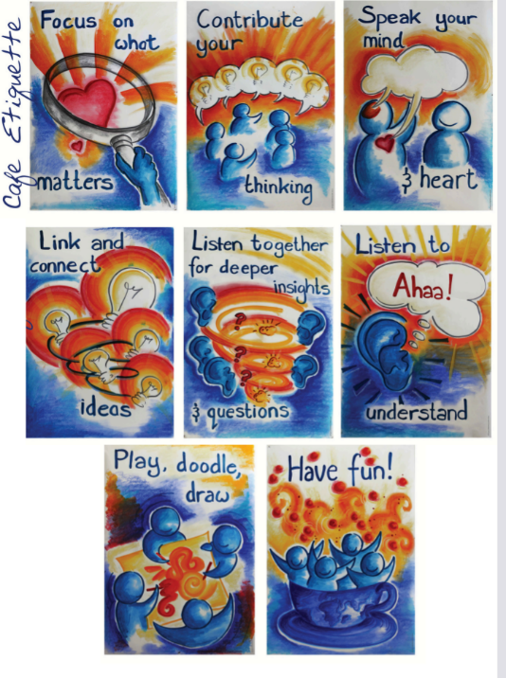
Ground rules that were placed on each table. These were discussed at the start of each World Café:

The World Café Community Foundation. (2023). Table cards image bank. The World Café. https://theworldcafe.com/tools-store/hosting-tool-kit/image-bank/table-cards/
© The World Café Community Foundation. Licensed under CC BY 4.0. https://creativecommons.org/licenses/by/4.0/

Appendix F: World Café environment
Examples of refreshments and décor used to create a café-like environment
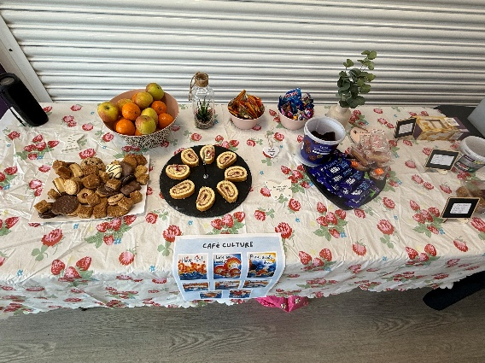

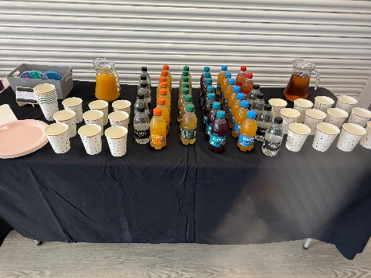
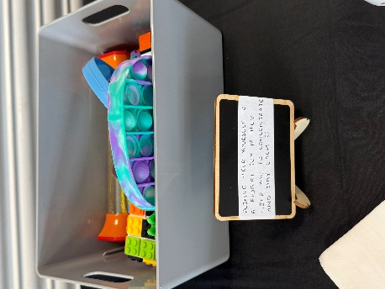

Appendix G: World Café resources
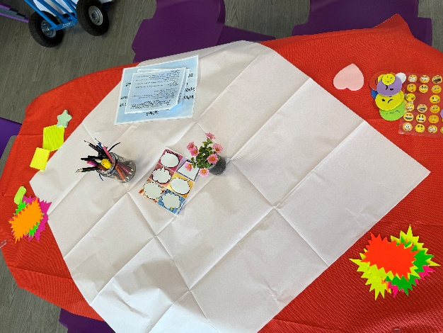
Examples of the variety of resources available to support participants to contribute their thoughts and feelings:
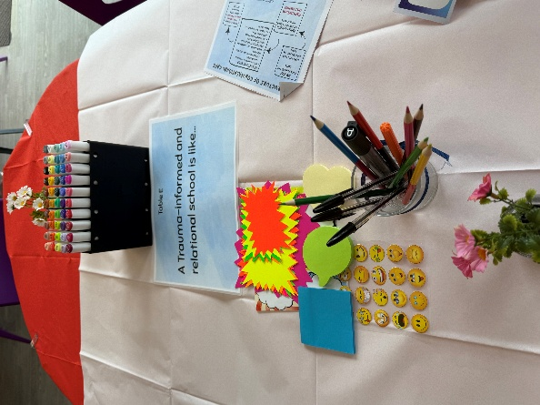
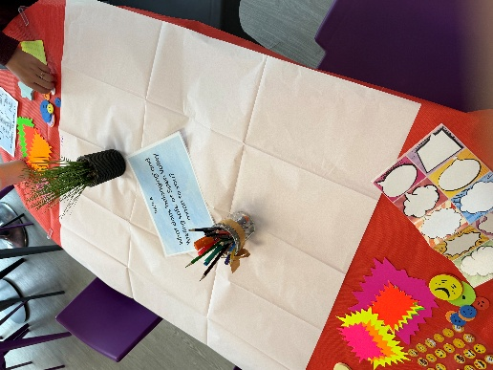
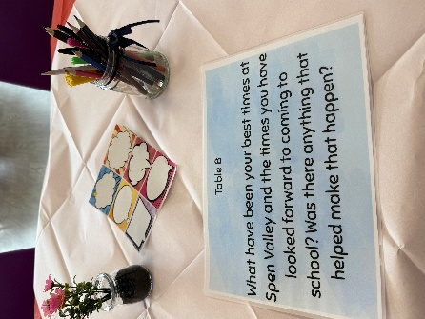

Appendix H: Visual of World Café process
Diagram of how the World Café process would happen through four rounds:
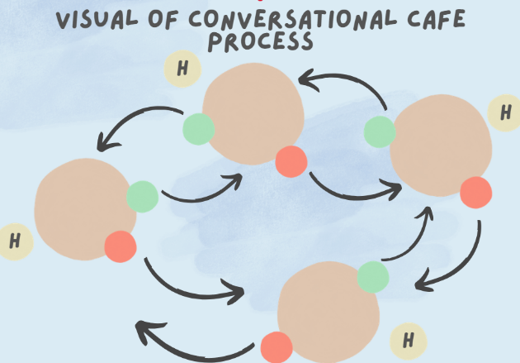

Appendix I: Reflections following the World Café
Personal reflections following facilitating the World Café sessions:
The majority of staff expressed:
- How valuable the session had been to give them space to reflect on the work they do
- Some staff were keen to utilise the model/structure in their own team meetings (half-termly/termly) to facilitate conversations and discussions
Battled with not being able to get quite as much depth through 'narratives', but was pleased to have had so many staff and students eager to participate and give their voice.
Music really facilitated a calming atmosphere.
I found it challenging to not engage in conversations/dialogue myself due to wanting to be part of the conversations and share some of my stories. This meant I withdrew myself more from the space and stood on the outskirts. I'm unsure of the impact this may have on how comfortable people felt. I think I was aware of this and so tried to go above and beyond with making the space feel hospitable, calming and safe (e.g. using music, food, drinks and fidgets). It was important to me that my relational values were demonstrated clearly. I thought a lot about how I would feel if I were participating in research and what may support me to feel calmer and more able to express my views/thoughts.

Appendix J: Table Host briefing and prompt sheets
Examples of the documentation provided to Table Hosts to refer to during the World Cafes:
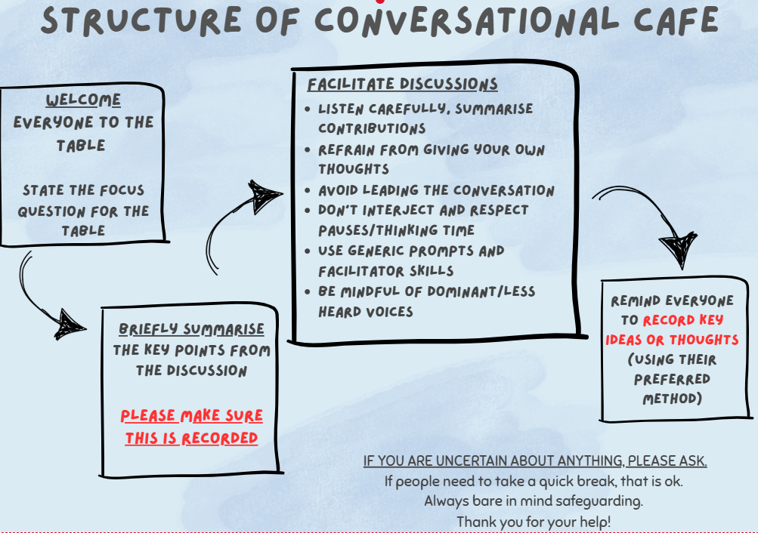

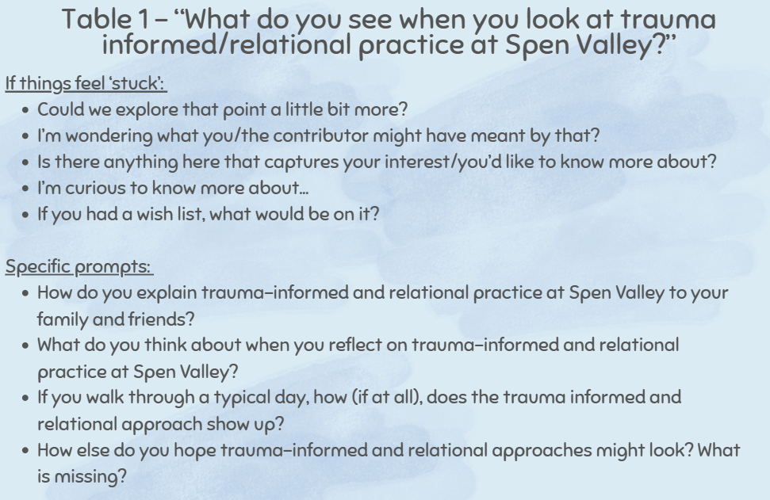

Appendix K: World Café introduction overview
Introductory slide that welcomes participants and highlighted key information that was discussed:
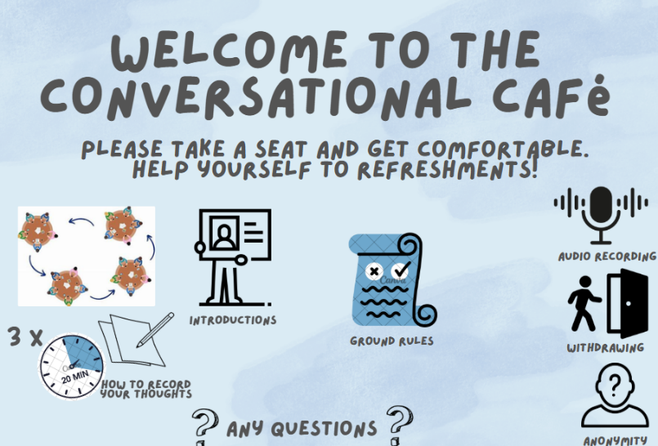

Appendix L: Debrief following the World Café
Information that was provided to all participants during a debrief following their participation in the research:
Staff information
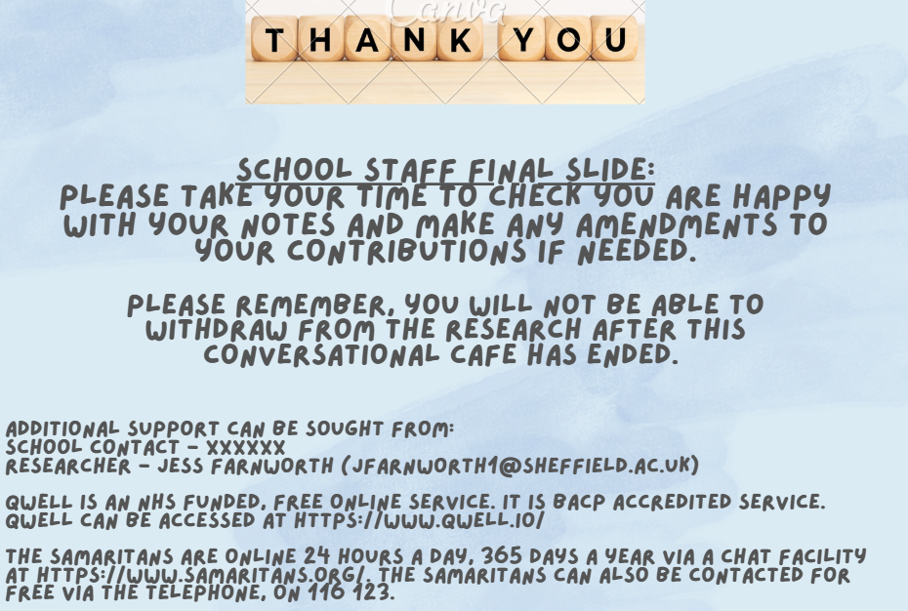

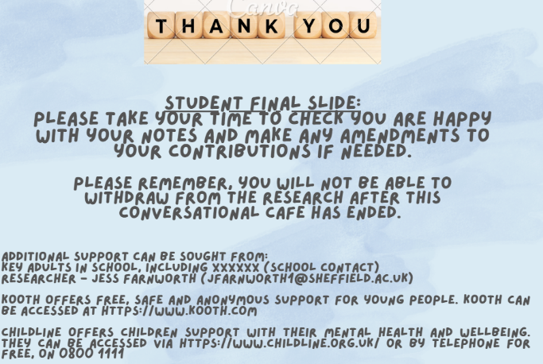
Student information

Appendix M: Written and visual artefacts
Images consist of all tablecloths used for data analysis:

Staff tablecloths
Tablecloth 1 – What do you see when you look at trauma informed and relational practice at Spen Valley High School?
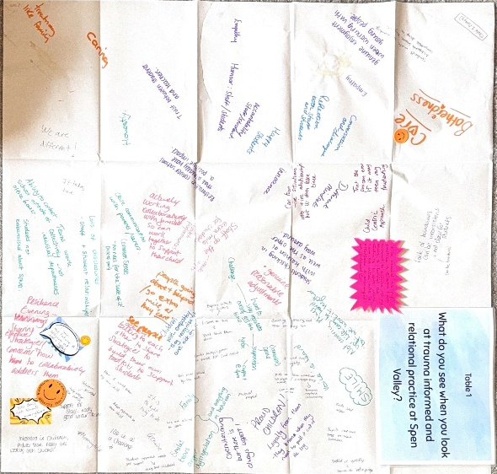

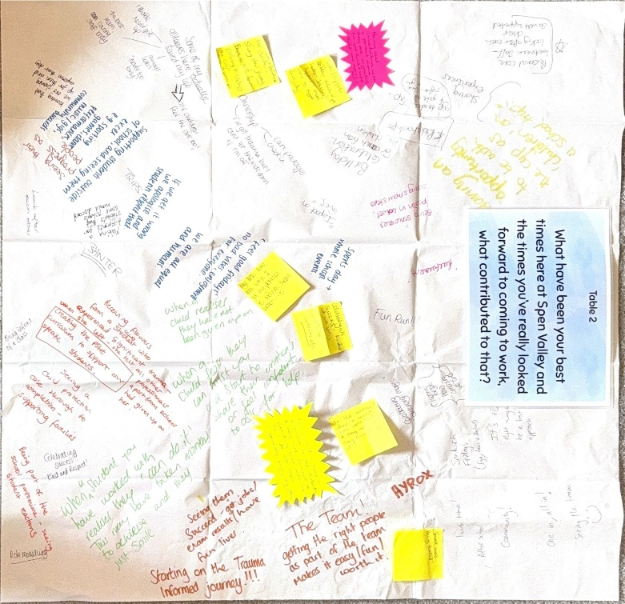
Tablecloth 2 – What have been your best times here at Spen valley and the times you’ve really looked forward to coming to work, what contributed to that?

Tablecloth 3 – How do we keep our best trauma-informed and relational practice at Spen Valley High School?
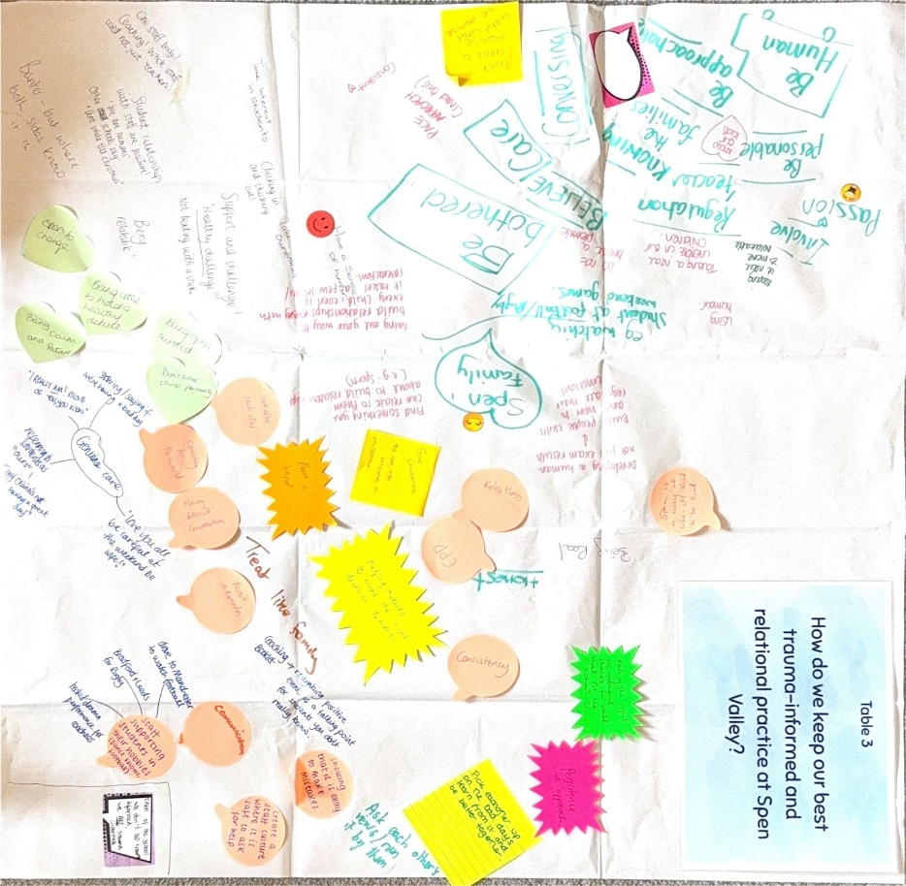

Tablecloth 4 – What is missing from the picture so far? Where do we need more clarity?
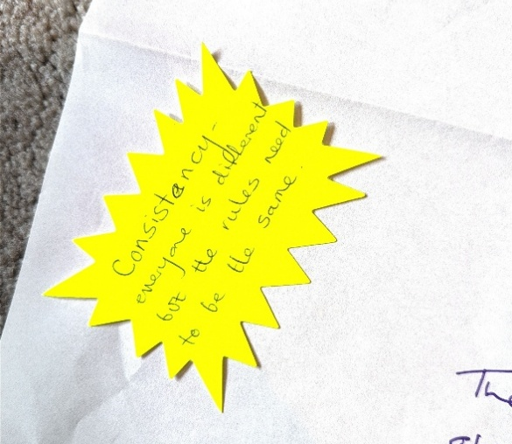
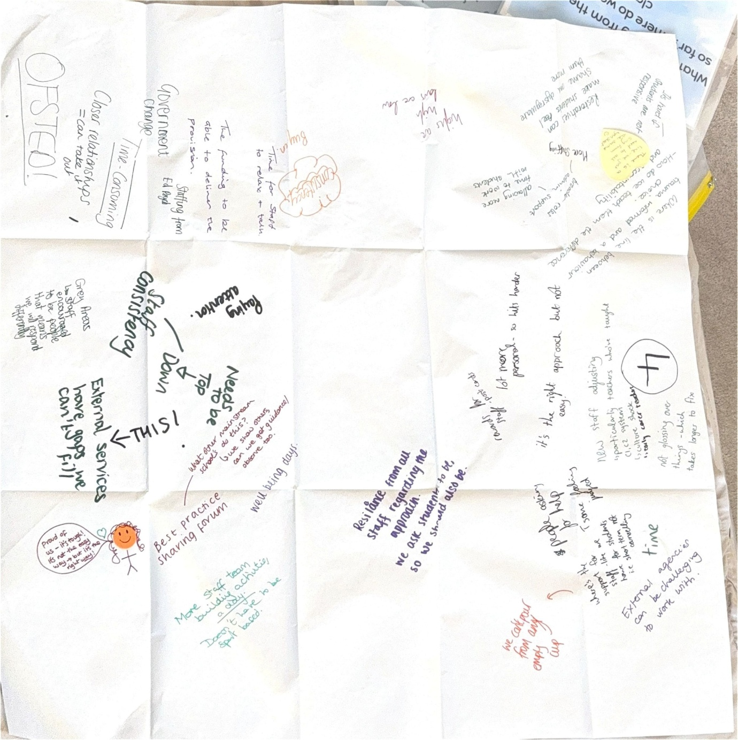

Tablecloth 5 – Add to the map of Spen Valley’s journey from 2017 (when trauma informed way of working was introduced) to now. You could include key moments, challenges and achievements.
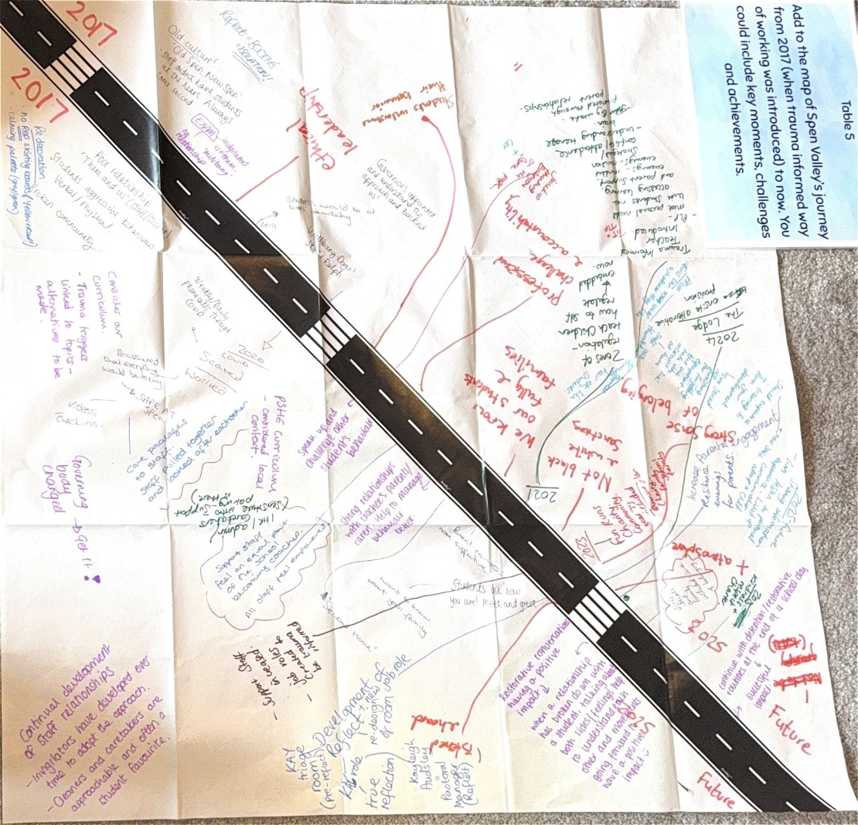

Student tablecloths
Tablecloth A – What does ‘belonging’ and ‘feeling safe’ at Spen Valley mean to you?
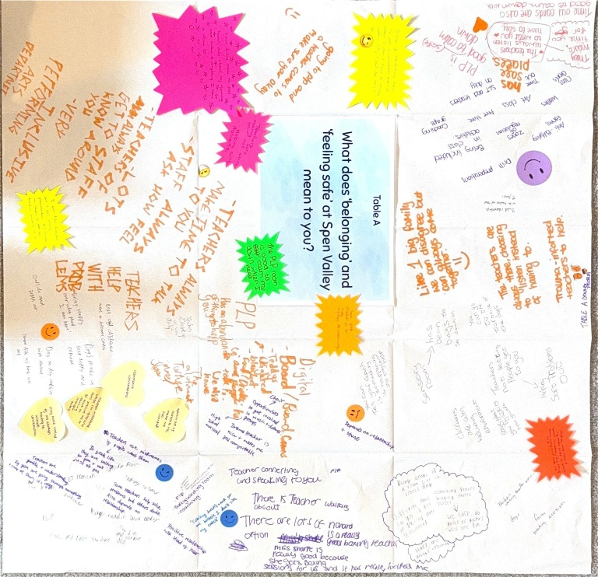

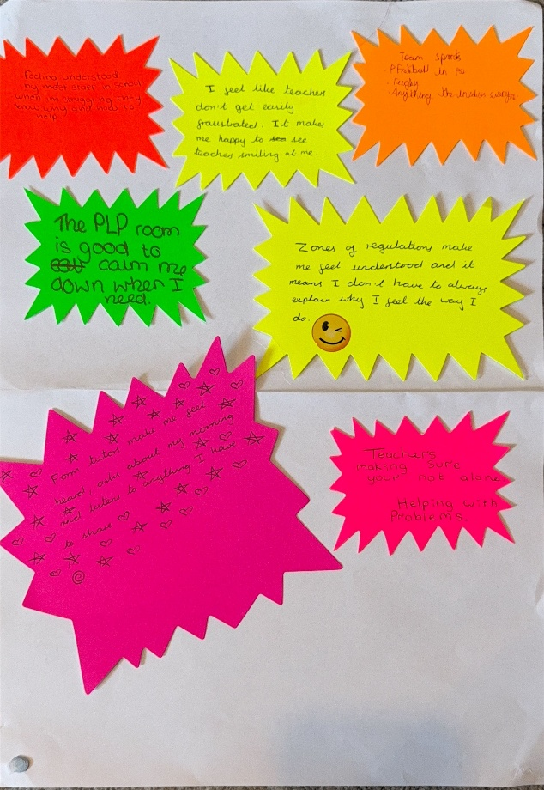

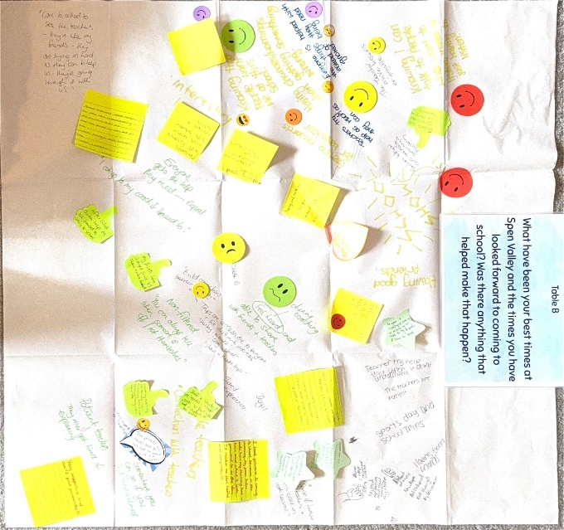
Tablecloth B – What have been your best times at Spen Valley and the times you have looked forward to coming to school? Was there anything that helped make that happen?

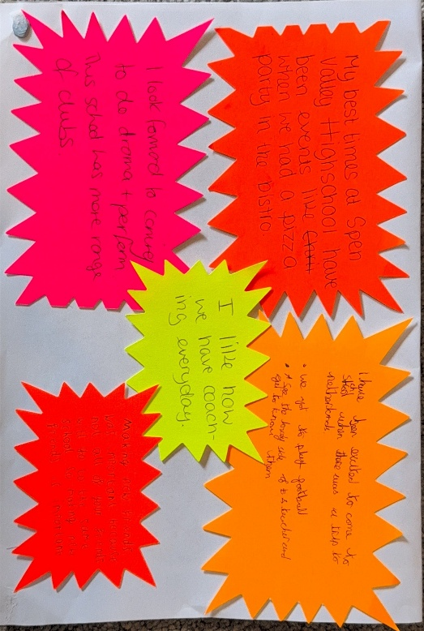

Tablecloth C – What does Spen Valley need to keep doing for students to feel safe and have a sense of belonging?

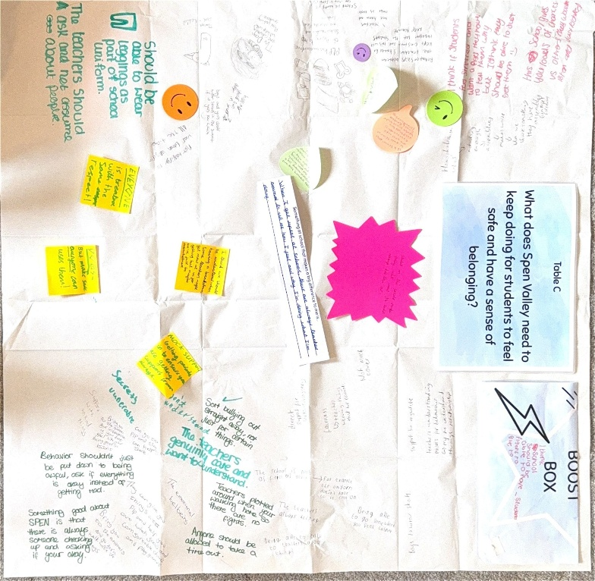

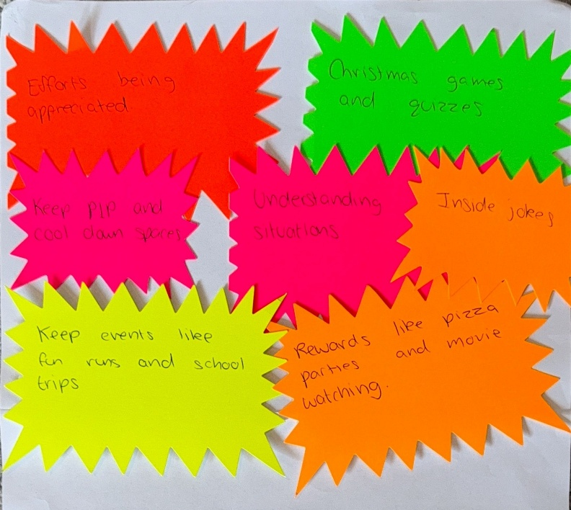

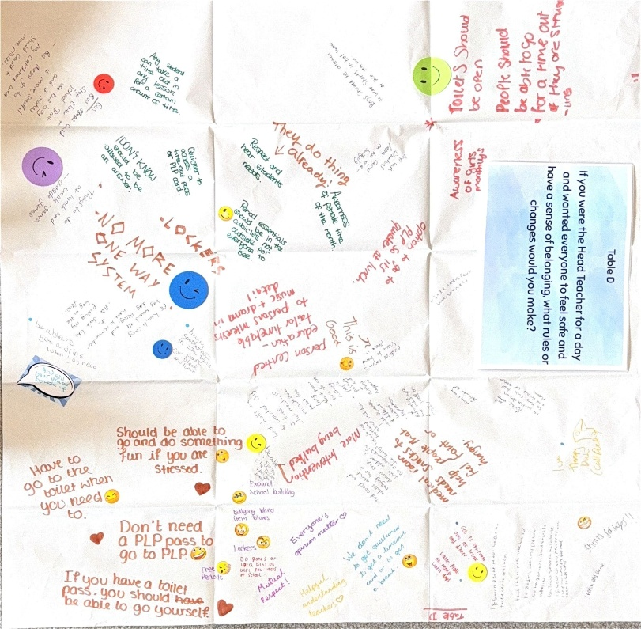
Tablecloth D – If you were the Head Teacher for a day and wanted everyone to feel safe and have a sense of belonging, what rules or changes would you make?

Tablecloth E – A trauma-informed and relational school is like…
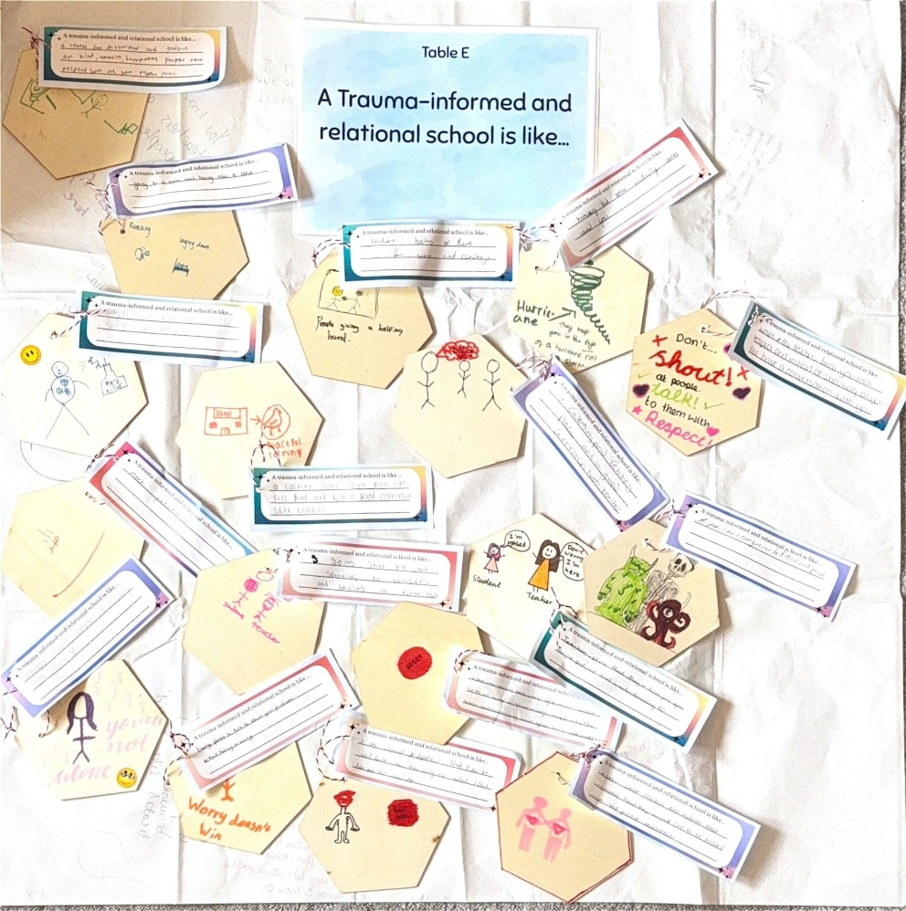

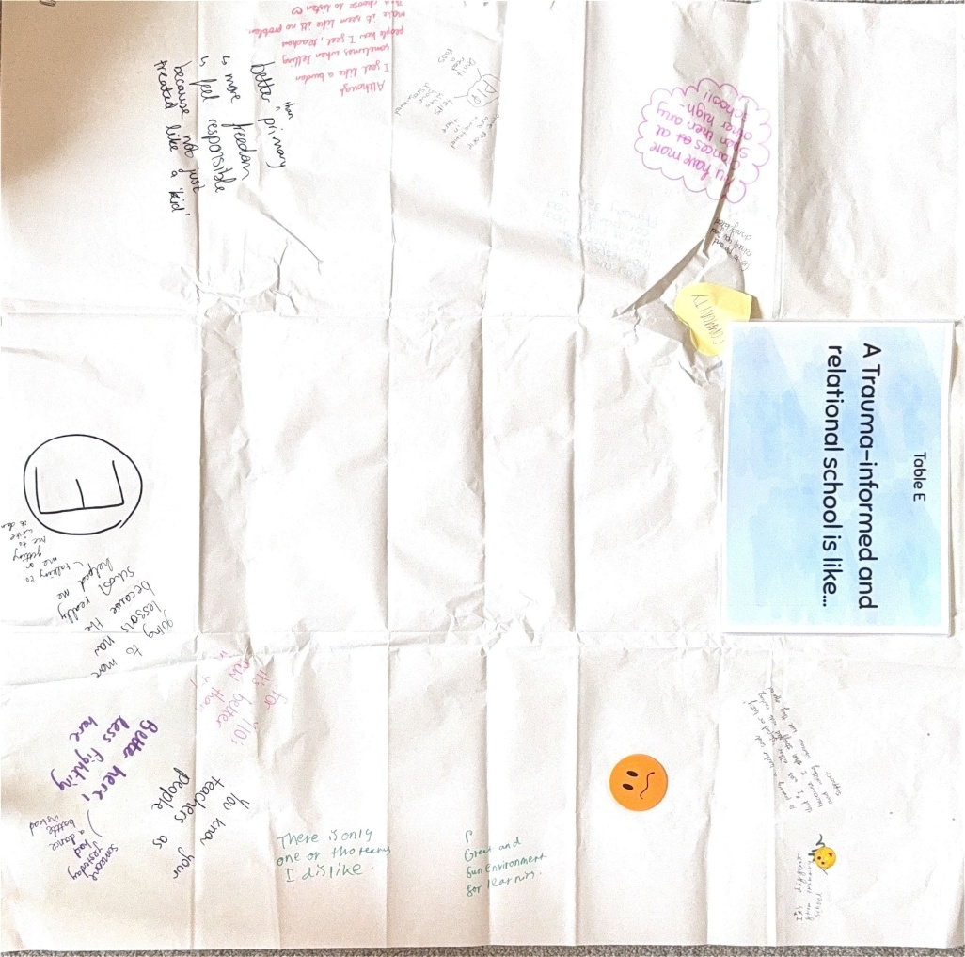

Appendix N: Table Host transcripts
Example extracts from the table host transcripts used for data analysis:
Staff Table Host transcripts
Table 1 – What do you see when you look at trauma informed and relational practice at Spen Valley High School?
So this table is focussing on what do you see when you look at trauma informed and relational practice at Spen Valley? And some of the things that the other groups have spoken about are around people being genuinely interested in children and actually liking children and wanting to work with them and to make a difference. Helping them to regulate, but it then being difficult, a bit of a challenge to then regulate ourselves when trying to be there for the children all the time. And then we spoke a little bit as well about the things that are there to help you with that, so the counsellor, HYrox, informal cuppa at 3, different things like that that might be there to support you and how you all support each other as a team and you're all there for each other and understand. We spoke about people, but going above and beyond, and the extra mile, so that might look like, so we spoke about the class charts and how the students access this outside of school time. So it's not just that you've finished the school day, go home and that's it. They've still got that ability to to contact staff and to make any safeguarding disclosures if they need to. Some people spoke about how it seems like common sense and there's not rules just other sake of rules, like detentions of forgetting your pen and things like that, and the relationships with home as well and the consistency between home and school. It was also spoke about how children are proud of the school, so they might be somewhat negative about the school towards you guys, but then if a visitor comes in they are very positive about it and want to show it off. But then we did also speak about how it can be overwhelming and some people can struggle with maybe the lack of boundaries and consistency, but there was some scope for discussion around that, so some were saying that there can actually be boundaries put in place. It's just about how you work with those but yeah.

Table 2 – What have been your best times here at Spen valley and the times you’ve really looked forward to coming to work, what contributed to that?
Our discussion point is What have been your best times here at Spen Valley and the times you've really looked forward to coming to work? What contributed to that? So the first message that was coming out was making a difference to young people's lives and feeling a sense of fulfilment in doing that. This experience expanded to knowing the children and young people that you work with and really valuing them, creating a safe space for them, and also the family aspect that you have in this school, that you're all a team and that as a team, you support one another and that makes you better people. You have better relationships and then that makes you better for the young people as well and you're happier. And then there was celebrating success that brings some of you to work, not just sporting success, but also aspects of kindness and just celebrating the young people for being who they are. So those were the main messages that have come out so far. Also, school trips was a nice one that everybody mentioned and the teacher Panto that was really enjoyed by all. So I don't know if you want to bring something else to this discussion or if you want to elaborate on that. So that is what have been your best times here at Spend Valley and the times you've really looked forward to coming to work, what contributed to that?

Table 3 – How do we keep our best trauma-informed and relational practice at Spen Valley High School?
How do we keep our best trauma informed and relational practice at Spen Valley? So, some of the key themes that we've seen so far has been around the consistency in our approach, consistency to our CPD. Not breaking promises with the kids, making sure that we're always taking an interest in them, and making them feel valued, understanding, taking that holistic approach you know, understanding the context underpinning their behaviours, using humour, showing our own emotions and actually modelling, you know, regulation strategies, all those things.

Table 4 – What is missing from the picture so far? Where do we need more clarity?
So this is more about barriers. So it's more about kind of what's missing from what you know, what's already here from the picture. Maybe where do you need more clarity? I do have more prompt questions if you need a bit more kind of ideas.
But basically the general consensus has been kind of like I think what someone summarised really well is that you know its the right approach, but that doesn’t make it easy. It's not the easiest way to do things. A lot of people talked about time, like new staff need sometimes extra time adjusting particularly because they've come from other places where they've used the consequence system.
Because you want to work in this particular way, you know, you're not glossing over problems but that means it takes more time to fix things because you wanted to actually fix things. Um, a lot of things about time and spending more time as a staff members together, and like, then we talked about maybe best practice and the fact that you’re kind of ahead of the game. It means in terms of your development, you don't have a lot of other places to go that are mainstream. You might be able to go to special provisions and see what they're doing, but in terms of mainstream settings, you've no one else to look up to which, like, sometimes is not helpful for your development because you don't know where to look or who to go to kind of thing [someone interjected “I disagree with that”].
So, that was the general consensus. Yeah, in terms of, as well, some talked about kind of being mentally draining, particularly for students who are not doing restorative stuff or we talked about you know, where there is a fine line between letting students get away with things but then also being understanding which can feel a bit difficult which affects mental wellbeing.

Table 5 – Add to the map of Spen Valley’s journey from 2017 (when trauma informed way of working was introduced) to now. You could include key moments, challenges and achievements.
OK, so we're doing a journey from 2017 to 2025 to the future of how trauma informed practice has made a difference. What can you notice? It might be positive, might have been negative. So… Old culture, like, just around 2017, didn't happen for these students at the start, students came second and no relationships. Students had aggressive behaviours, about physical, broken community. Then 2019, students could be intimidating at times. But then in 2020, it felt like they did everything in COVID very, very well, like, kept the connections with the students, kept their relationships, making them feel important and valued. Then they introduced the wellbeing dogs, Steve and Ralph. The governors appointed had an understanding and they've got that back up all the time. Students started to understand their own behaviour, so they're able to do that reflective practice. Students speak up and challenge other students’ behaviour in class, like protecting the teachers. Professional challenges and accountability. I don't know what that one means... Professional challenge... Oh, it's to professionally challenge, that empowerment to be able to professionally challenge each other and peers in a safe way. Strong relationships with the coaches, parents and carers helps you manage behaviour better because you are working together. Second home. Kids want to know about you your personal life and your family and it feels safe to do that. Students ask how you are when you meet and greet them. Not black and white sanctions. We know students fully and their families. A strong sense of belonging towards 2025 and restorative conversations, and teachers are able to talk about how they're feeling and reflect on that with the students.

Student Table Host transcripts:
Tablecloth A – What does ‘belonging’ and ‘feeling safe’ at Spen Valley mean to you?
OK, so this table is all about what does belonging and feeling safe mean to you. Okay, so some of the discussions we've had already talk about the teachers, maybe making time to talk to you about your interests, finding time for small talk, so it's not just about learning, it's about them getting to know you as a person as well. We've also talked about them making time for you if you're upset and helping you to sort problems, and how at break times there's lots of teachers around to go to and there's a big safeguarding team. So if you don't feel safe, you've got people that you can go to specifically about that. We've also spoken about some things in school that help people to feel calm, so we've spoken about different areas that people can go to if they need to, like PLP, and like the allotment if they want to spend time outside, sensory room, and we've spoken about the therapy dogs as well that help people to feel calm.. And then in terms of belonging, we've spoken about like team sports, like being part of teams, we've spoken about your coaching groups and how you can speak to your coaches and we've spoken as well about like performing arts and how those shows bring everyone together and create a bit of a community in school.

Tablecloth B – What have been your best times at Spen Valley and the times you have looked forward to coming to school? Was there anything that helped make that happen?
Our discussion point is, what have been your best times at Spen Valley and the times that you've looked forward to coming to school? Was there anything that helped make that happen? And the first groups, the main message that's come out is that the friendships that you have, that you feel like you belong, that teachers have an understanding of who you are and that coaching is a really important part of your day because you get to feel heard, you get to say how you've been feeling and there's no judgement. And someone said, you can always tell when someone's not themselves because you all know each other really well. So let's see if we can come up with our own ideas and elaborate on those.

Tablecloth C – What does Spen Valley need to keep doing for students to feel safe and have a sense of belonging?
OK, so our question is what does Spen Valley need to keep doing for students to feel safe and have a sense of belonging? So we've had lots of really interesting ideas so far. There's been a lot around sort of being made to feel safe by the relationships that you might have with staff members, asking how you are or them being able to identify maybe when you are struggling a little bit or you feeling safe enough to be able to ask for support. We've had quite a few recommendations that students have made in this group as in that are probably a little bit more similar to what you've had on the last page and they've included things around feeling like sometimes things can be a little bit unfair and there might be some injustices, but generally, they feel quite safe. and have that sense of belong here.

Tablecloth D – If you were the Head Teacher for a day and wanted everyone to feel safe and have a sense of belonging, what rules or changes would you make?
OK so the discussion point for this table is if you were a head teacher for a day and wanted everybody to feel and have a sense of belonging what changes would you make? So the previous groups before you, they seem to talk a lot about being being able to the toilet when you need to. So the toilet would be open all the time and the teacher would use their intuition and let you go if it's obvious you need it. Another one was dealing with, when you report like being bullied, so they were saying, it would better if there were restorative conversations sooner, and maybe looking at separating you from the bullies, like letting you go in different lessons so don't have to see them anymore. The toilets again. In terms of ladies' periods, they were saying it would be better if the sanitary products were in the toilet cubicle instead of on the corridor, because people can see when your collecting things. Another one was the medical room. If you feel faint or you're hungry, they don't actually officially have anything they can give you to eat. So it's a bit better if the medical room had things they could give you. They do apparently but it’s people's personal lunch, like snack. Oh, yeah, yeah. It's like the there's a really nice lady. I don't know her name, but um she's really nice and if you like feel faint or anything, she'll give you something of hers. So they were saying that as a well, that would be better if the kids could do like that. Quicker access to a time out pass or PLP card, but they're also saying that if you feel like you need it, you should be able to access that as and when anyway, you shouldn't have to have a card and they were saying if you, because you've all got good relationships with the teachers, if you feel like you need to take time out or go for a move break, you should just be able to do that.

Tablecloth E – A trauma-informed and relational school is like…
So some of the things that other people have said, is it's very different to other schools. So teachers care about you, teachers are more caring. Some people talked about how you could be a bit more calm here that there's always somebody to go to. Um, some people talk about it being much more personal Um, Some people talked about it being, you know, different to other schools, they've gone to and all about kind of community and there being like a helping hand. So some of the metaphors people have drawn were like this person drew butterflies in their tummy, but then they've drawn a thing called an anxiety killer because coming to school means that they don't have butterflies in their tummy, If that makes sense. Um, someone else drew the big, do you know the big orange guy from inside out two? So he's like, anxiety and worry. So they've said, worry doesn't win when you come to this school, someone else drew a safety net, with the person falling saying coming to a school like this is like a safety net there. Being a safety net.

Appendix N: Invitation to participate – staff
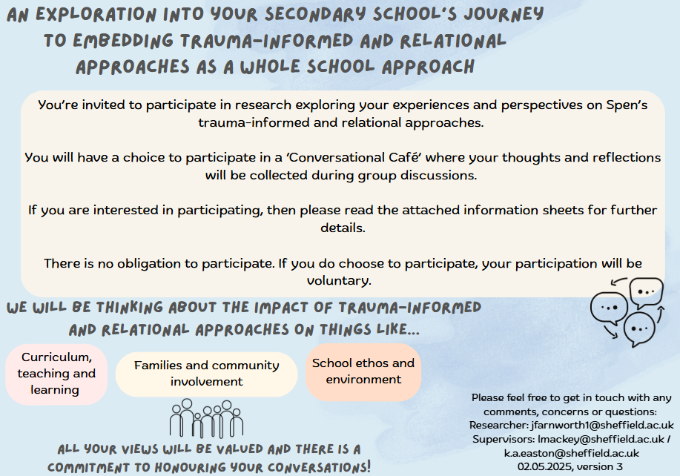
Invitation provided to staff members to request their participation in the research:

Appendix P: Information sheet – staff
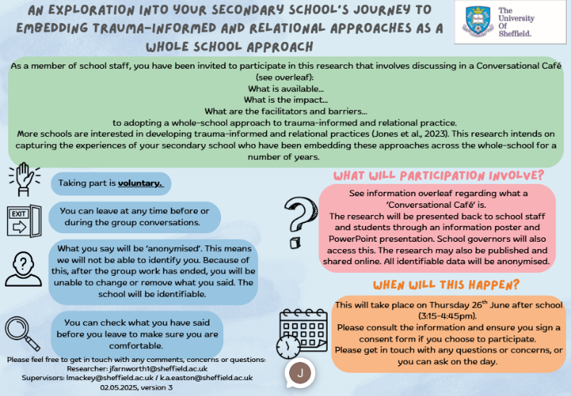
Information sheet provided to staff members who were interested in participating:

Appendix Q: Consent form – staff
Consent form that staff were required to complete prior to their involvement in the research:
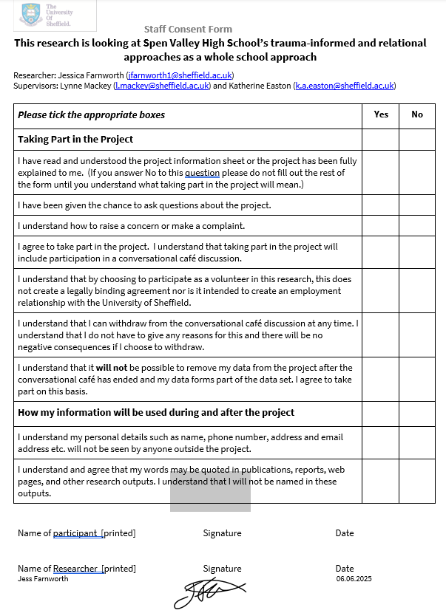

Appendix R: Invitation to participate – student
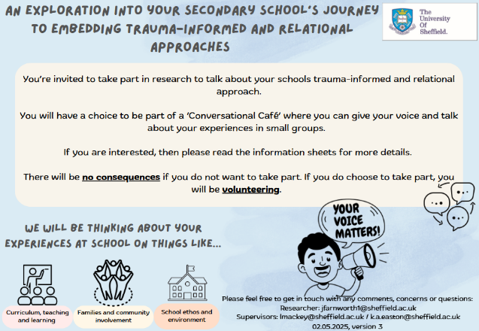
Invitation given to students to request their participation in the research:

Appendix S: Information sheet – students
Information sheet provided to students who were interested in participating:
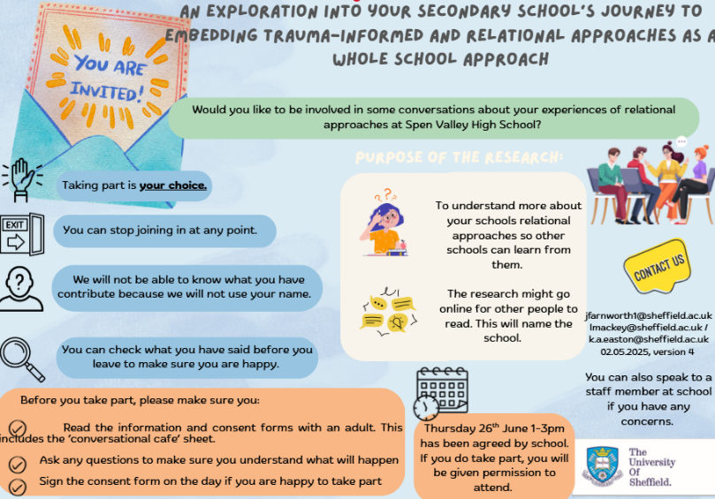

Appendix T: Consent form – students
Consent form that students were required to complete prior to their involvement in the research:
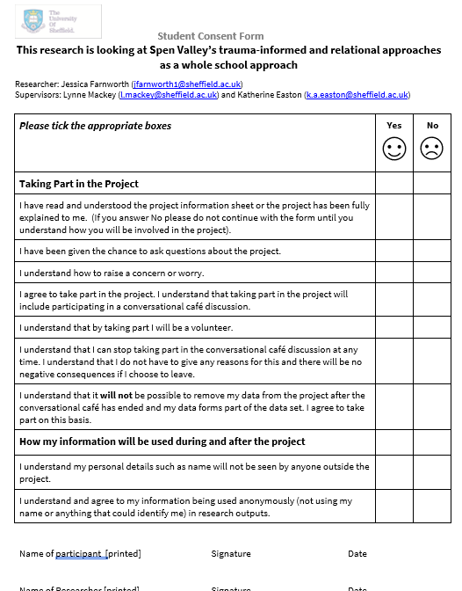

Appendix U: Information sheet – parent/carer
Information sheet provided to parents/carers whose child expressed an interest in participating in the research:
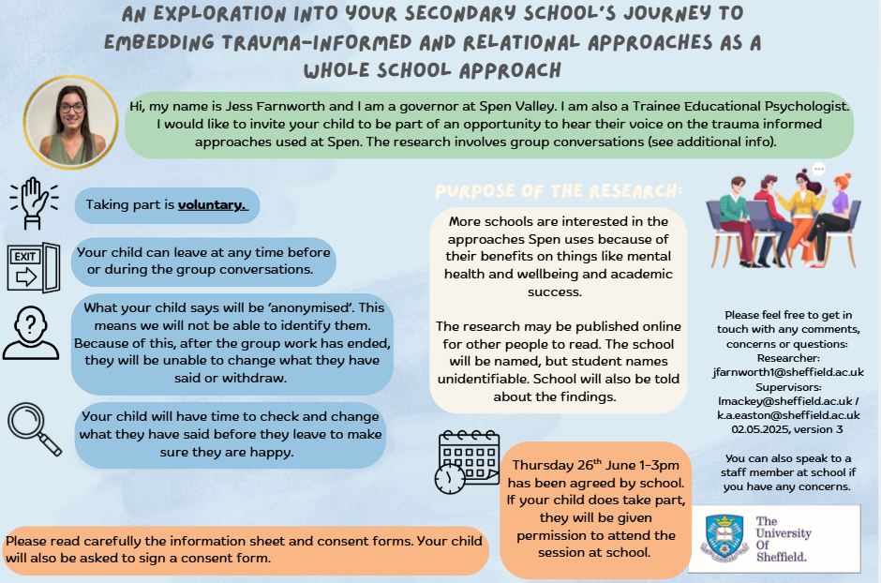

Appendix V: Consent form – parent/carer
Consent form that parents/carers were required to complete prior to the child’s involvement in the research:
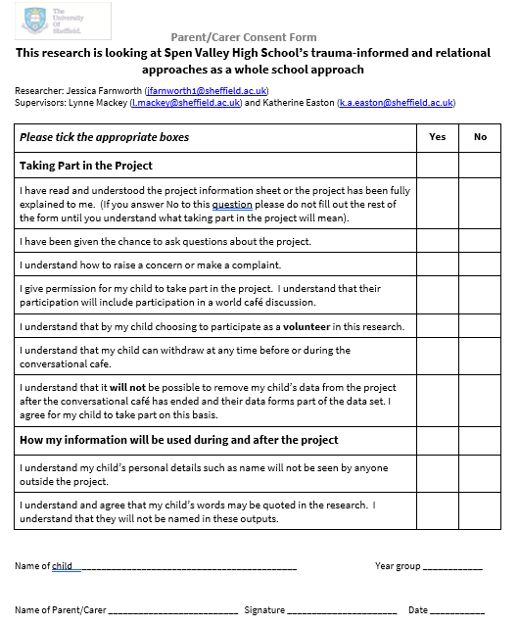

Appendix W: Ethical approval
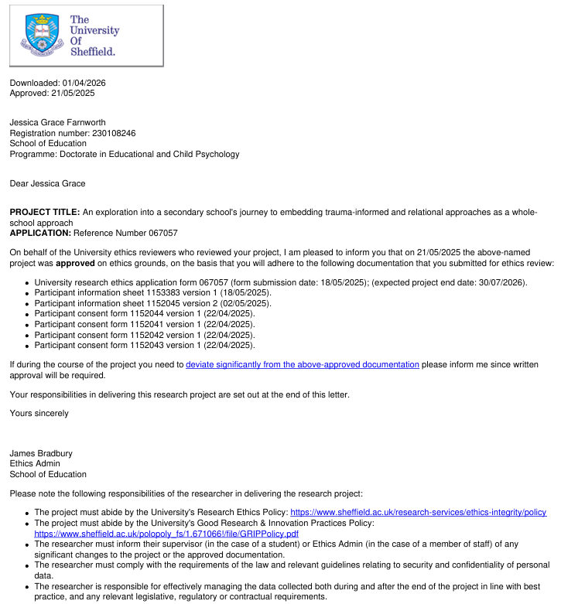
Certificate detailing Ethical Approval granted by The University of Sheffield Ethics Department:

Appendix X: Ethical principles and considerations

Ethical principal | Consideration and actions taken
Respect for participants | Informed consent  Information sheets outlined their involvement and were tailored to the audience (staff, students, parents/carer).  Consent was gained prior to the WCs from all participants and parents/carers.  Participants were given the opportunity to leave following the initial briefing and reminded they could leave at any point throughout.
Respect for participants | Special care for students  Students feeling obliged to take part was considered. Students were told there would be no consequences for not participating.  Students were reminded of their right to withdraw during the initial briefing.  All documentation was simplified using accessible language and enhanced clarity.
Respect for participants | Treating participants with dignity, fairness and sensitivity  Giving participants the equal opportunity to be involved in the research was sought as much as possible through the recruitment process, further reinforced through prior discussions with the Head Teacher.  Ways of recording information during the WC were varied and individual preferences were encouraged to ensure equal contribution.  Data was handled sensitively, ensuring participant anonymity.
Respect for participants | Power imbalances  I acknowledged the epistemological power I held as the researcher (Kaaristo, 2022). I abstained from group discussions to encourage the participants to discuss more freely (Löhr et al., 2020; Schiele et al., 2020).
Respect for participants | Equality, Diversity and Inclusion  I recognised that sampling decisions can reproduce or challenge existing inequities. Discussions with the Head Teacher aimed to ensure equal opportunities for participants.  The WC was planned to ensure accessibility, psychological safety, comfort and belonging through adaptations to refreshments, stationery and resources.
Participant wellbeing | Avoiding harm  I acknowledged that staff were giving up time and the possible stress inflicted. An agreement was made with the Head Teacher to ensure staff and students would be supported to manage their workload or commitments if they did participate.  The University of Sheffield safeguarding policy and SVHS safeguarding policy were followed. All table hosts were briefed on these policies.  Debriefs gave time for participants to ask questions, sign posted to relevant support and check contributions as once the WC had ended, participants were unable to withdraw their contributions due to the co-constructed nature of the WC.  Table hosts were also briefed and provided with prompt cards with direction on how to manage difficult conversations.
Participant wellbeing | Considering those affected  There were no concerns that the school would act unethically. However, to minimise any risk, discussions were held with the Head Teacher to ensure an ethical recruitment process.
Integrity | Honest and transparent in research aims, methods and reporting  WC introductions outlined the research intentions. Participants were reminded that once the WC had ended, they would be unable to withdraw their data due to it being anonymous and co-constructed.
Integrity | Avoiding deception  There was no deception. The research projects intentions were made clear and referred to in all paperwork and discussions.
Integrity | Declare conflicts of interest  As I am a governor at the case study school, this conflict of interest was made clear in the paperwork and at the start of the WC to maintain trust and transparency.
Integrity | Long-term consequences and sustainability  The long-term implications of the research for organisational sustainability of TIRAs were explored as part of macro-ethical considerations.
Confidentiality and data protection | Protecting participants privacy  All GDPR laws were complied with throughout the research.  Participants were reminded that the school would be named in the research, but participants would remain anonymous. Any identifiable information was redacted during transcription.  Ground rules were established at the beginning of the WC to mitigate the risk of internal confidentiality, with visuals around the room to reinforce this.

Appendix Y: Reflexivity journal excerpts
Excerpts taken from my reflexivity journal that was kept throughout the research process. Excerpts provide examples of my thoughts, feelings and reflexivity at each stage of the RTA:

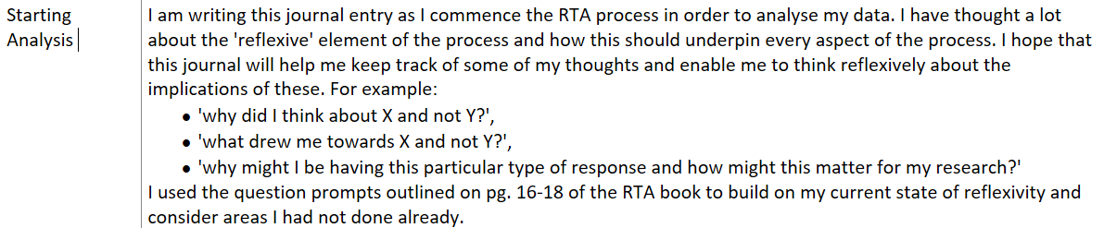
Commencing on RTA:

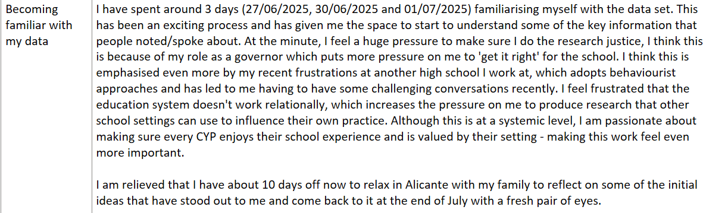
Phase 1: Familiarisation
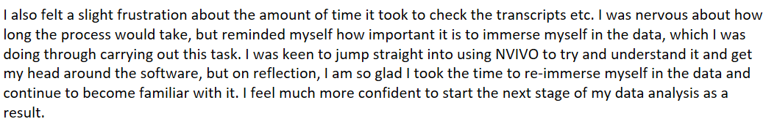

Phase 2: Coding
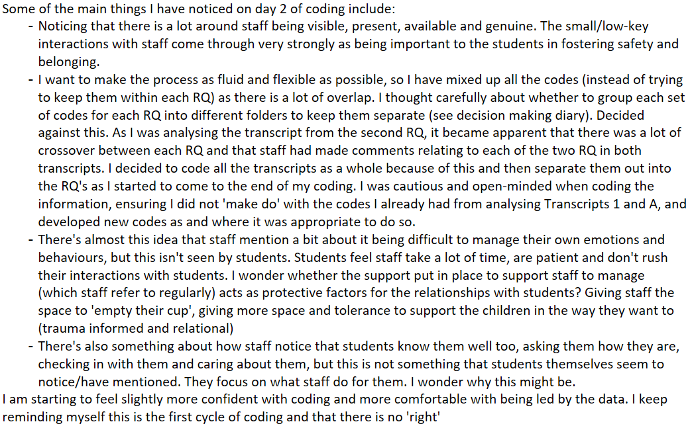

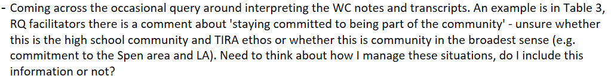

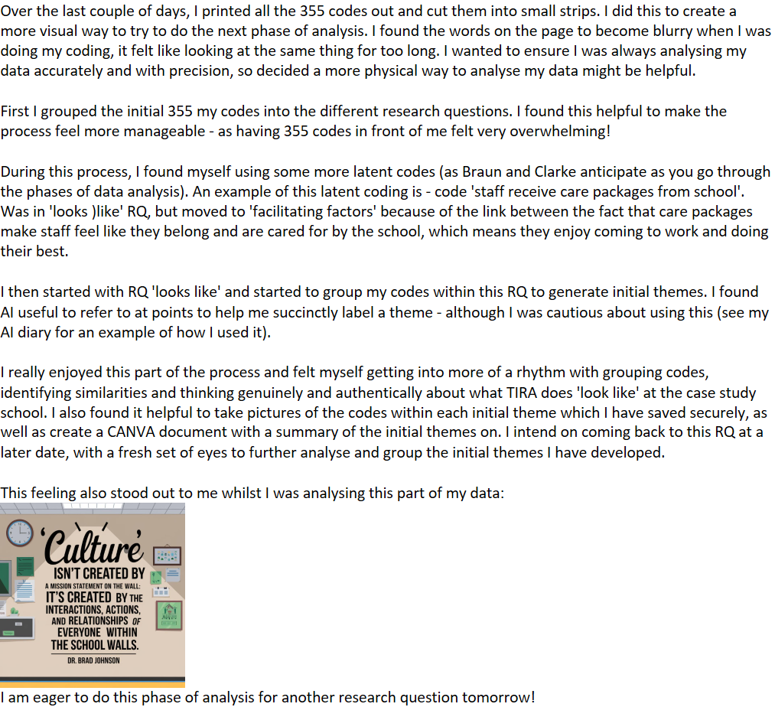
Phase 3: Generating initial themes

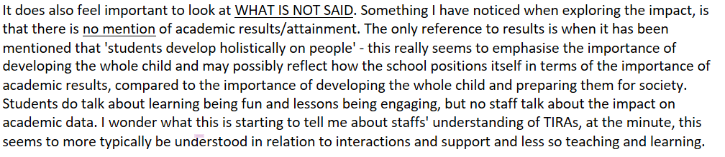

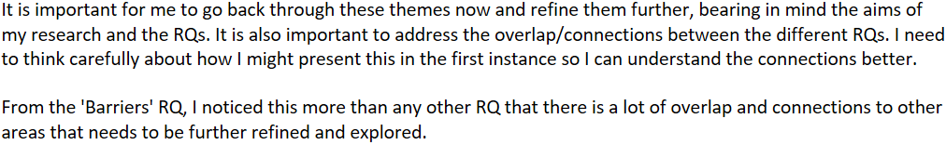
Phase 4: Developing and reviewing themes

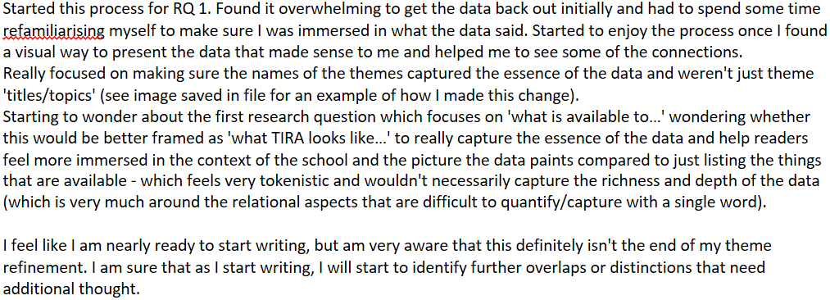
Phase 5: Refining, defining and naming themes

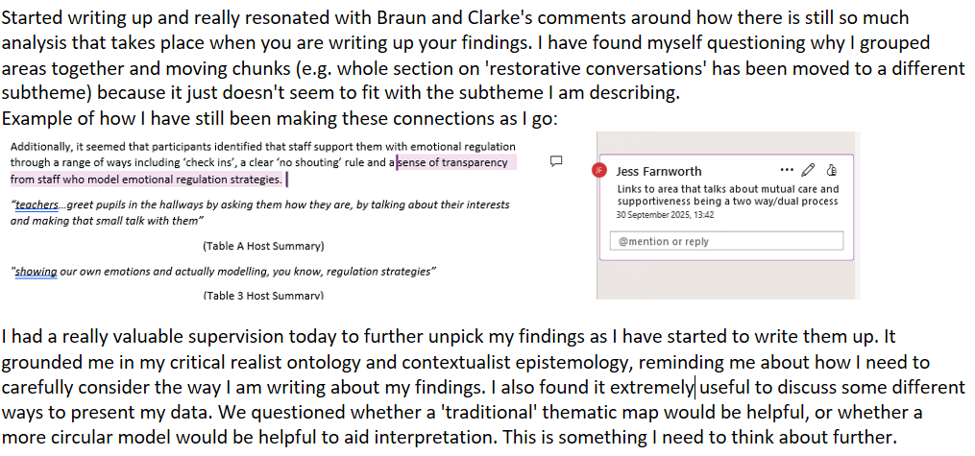
Phase 6: Write up

Appendix Z: Reflexive excerpts for codes and themes
Theme | Examples of codes from themes (and subthemes) included | Theme | Examples of codes from themes (and subthemes) included
Relational safety as the foundation of school life | Staff are visible, present and available  Staff persevere with students  Staff are patient with students  Staff are welcoming  Staff make time for students  Staff trust students  Banter between staff and students  Staff do ‘small things’  Reciprocal and equal conversations between staff and students  Staff are open and honest with students  Staff and students share experiences together  Events take place that are fun and light-hearted  Students are happy in school  Students look forward to coming to school  Students know staff well  Students enjoy spending time with staff  Students come to school to see staff  Mutual respect between staff and students  Students achieve more than they thought they could  Students become more confident to ask for help  Students develop holistically  Feelings of belonging in school  SVHS is like a family  School feels peaceful | A place where support and wellbeing are prioritised and sustained over time | Staff model accountability, taking responsibility for their actions  Support outside of school hours  Coaches are approachable  Impact of coaching depends on staff-student relationship  Restorative conversations are helpful  Approaches are child-led  Staff ask questions – behaviour indicates unmet need  Interventions are bespoke to individual needs  Reasonable adjustments are made  Emotional regulation is prioritised over learning  Different ways to communicate when students need help  ZoR scripts used to help communication  Staff greetings start with check ins  Therapeutic animals facilitate emotional regulation  Individuality is embraced  Students feel understood by staff  Students feel heard in coaching groups  We need to keep being flexible with rules  The approach has to be consistent  Staff don’t always understand  Students don’t always want to talk about their emotions  Students don’t want to be questioned all the time if needing to take a time out  Where is the line?
A shared approach that fosters identity, belonging and fulfilment | Staff listen to each other  Staff professionally challenge each other  Working across departments or teams  Autonomy for staff to utilise their own skills  Staff value each other and know each other well  All departments are one ‘team’  Motivation to build an inclusive environment  Staff look forward to coming to work  Commitment to long-term careers at SVHS  Fulfilment experienced by staff  Staff feel empowered through being coaches  Staff are committed to showing up for students  Staff team support each other  We need to keep a supportive staff team and keep being one staff body  We need to keep believing in the approach  We need to embody the approach  Its not the easy option | “We can’t pour from an empty cup” | Emotional wellbeing activities for staff  It helps having council supervision weekly  It helps having hyrox and cuppa at three  Staff support students when they feel happy and supported  Difficult for staff to always stay regulated  Staff need to be resilient  Staff care a lot, so it ‘hits harder’  Approach can feel exhausting  More time for team building  More time for rewards and wellbeing
Systemic conditions that shape a TIRA ethos | Staff have good relationships with parents  Parental support evenings in the PLP, psychoeducation  Parents show gratitude  We need to keep being accessible for families  We need to keep building our knowledge  We need other schools to work with  The approach takes a lot of time  Time is needed to unpick behaviours  Relationships take time to build  Staff need to be available to do their jobs (opportunities to work with students)  Makes it challenging when external services are difficult to access  Government changes  Not enough funding to deliver provision  Want to be able to share ‘best practice’

Appendix AA: Coding
Images and excerpts taken from the coding process for RTA that evidence the coding process and reflexivity:
Screenshot examples of NVivo codes following iterative rounds of coding:
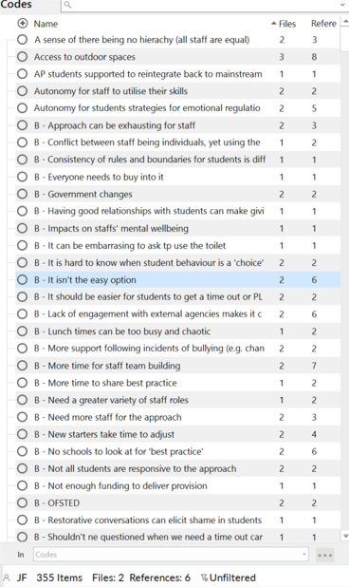
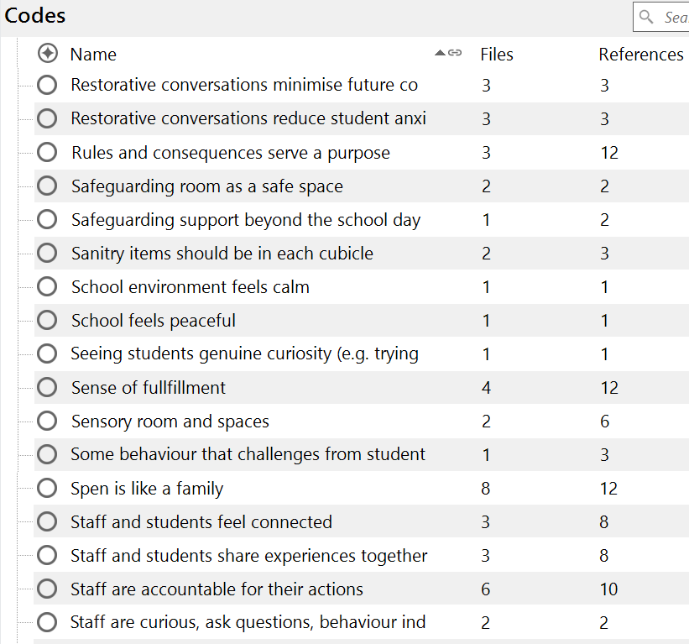

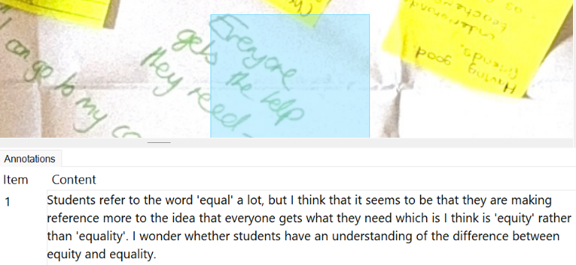
Examples of reflexivity that was recorded during the coding phase using annotations in NVivo:

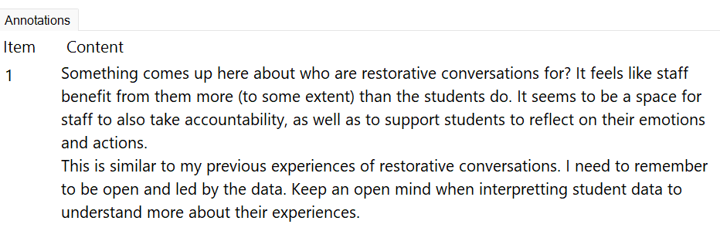

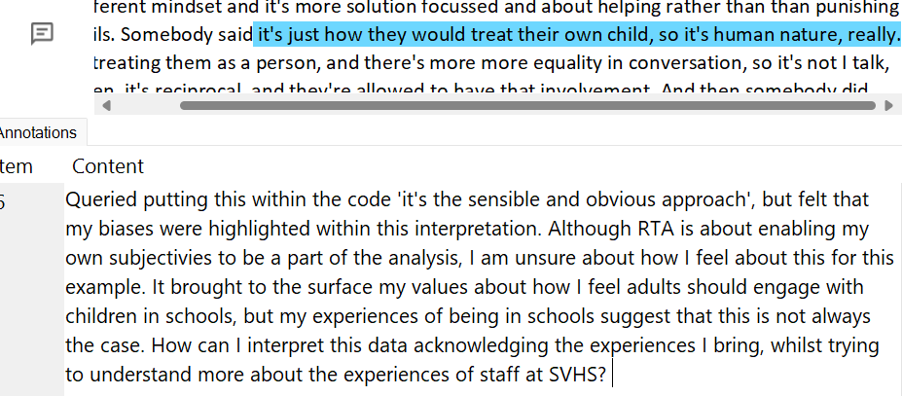

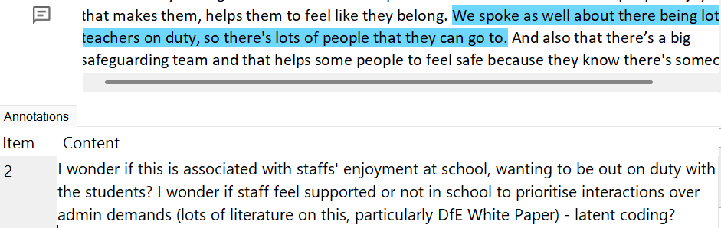

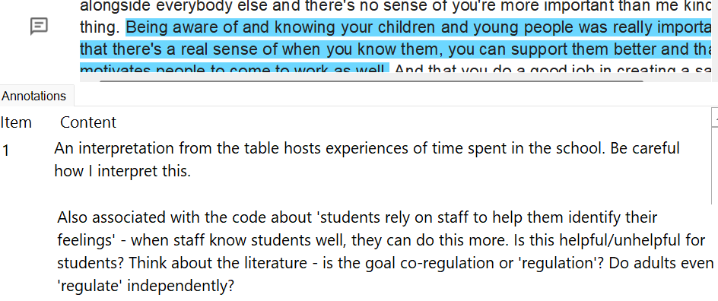

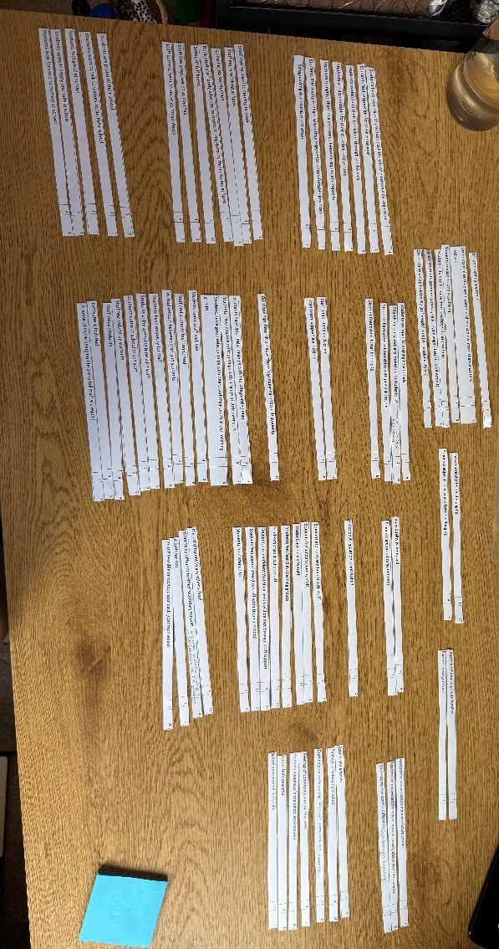

Appendix BB: Generating initial themes
Images of codes being grouped and organised:

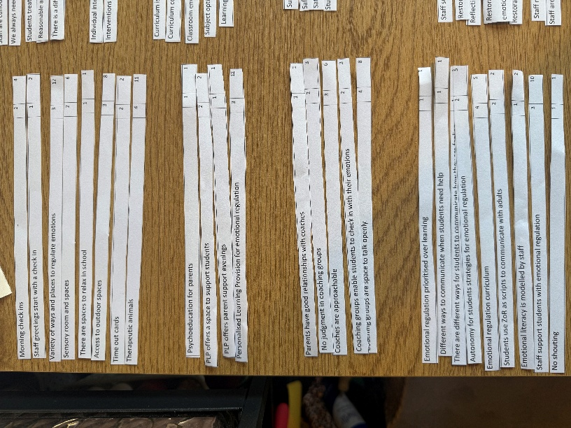

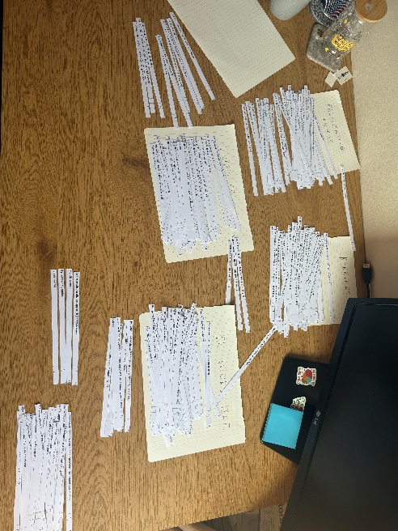

Appendix CC: Generating initial themes
Examples of initial themes developed:
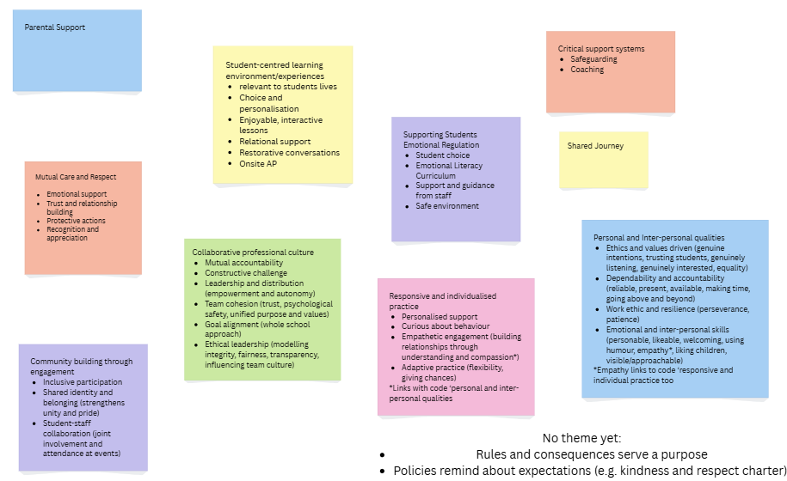
Research Question 1:

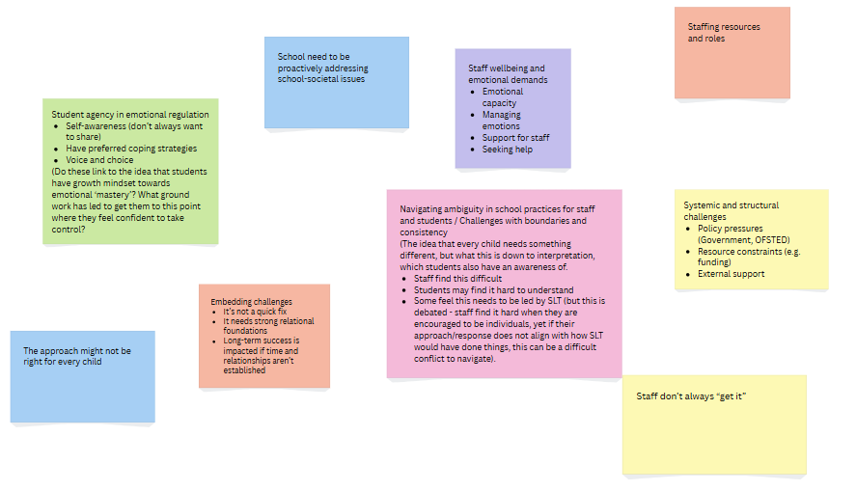
Research Question 2:

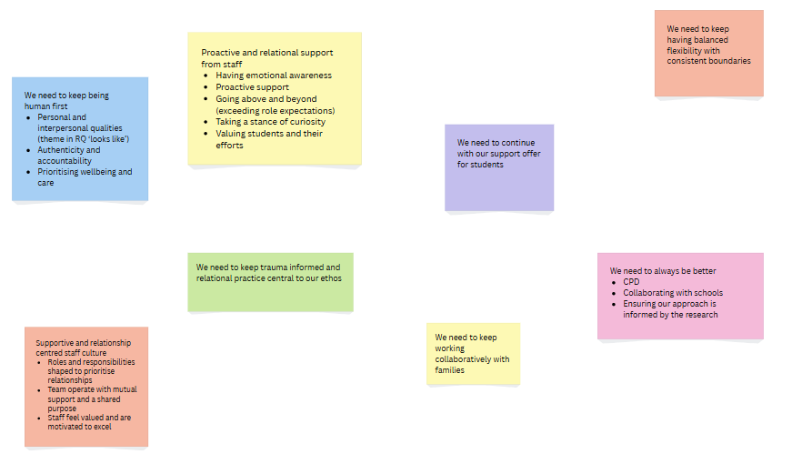
Research Question 3:

Appendix DD: Generating initial themes – identifying links
An example of where sub-themes have been identified as having links between them and are brought together to understand the data more cohesively:
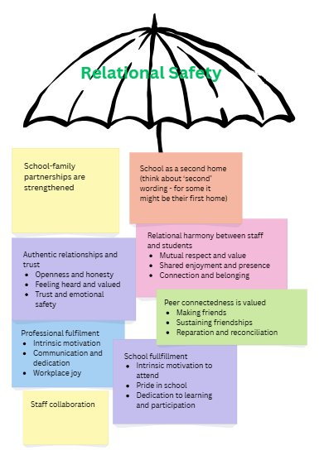

Appendix EE: Developing and reviewing themes
Examples of how the themes generated were refined to develop a rich and nuanced understanding of the data:
Research Question 1 refined themes
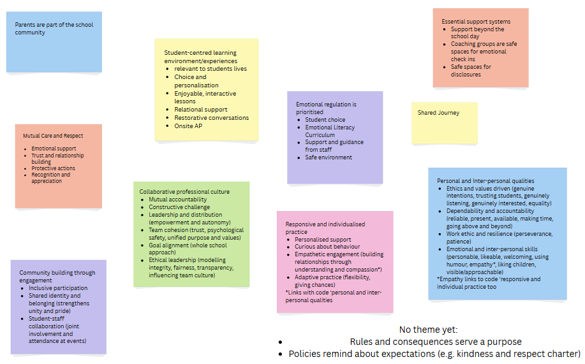

Research Question 1 further refined using thematic maps to facilitate coherence

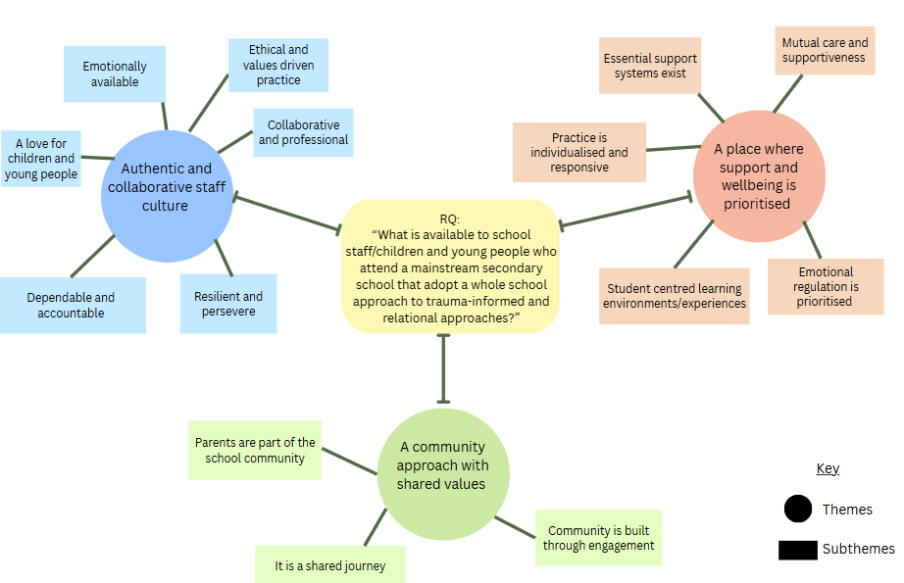

Research Question 2 refined themes
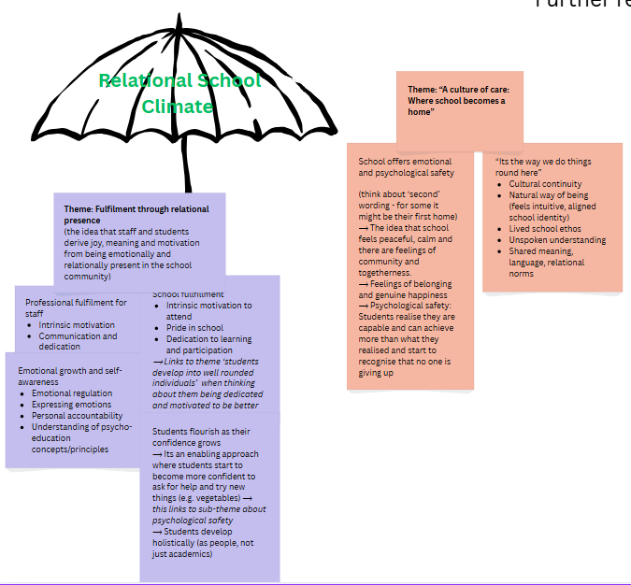

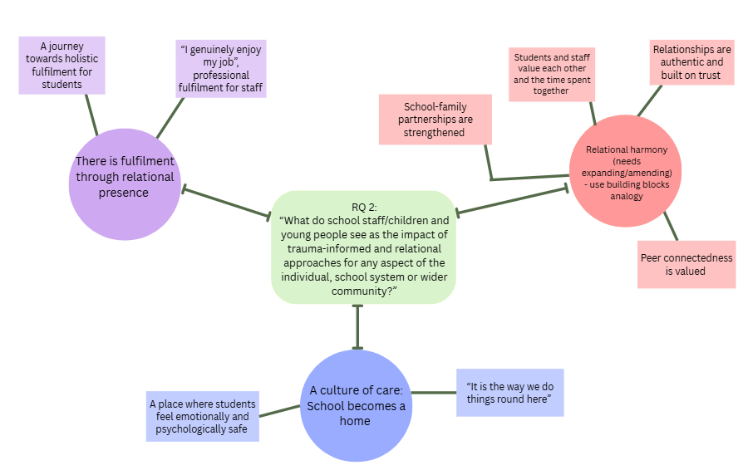
Research Question 2 further refined using thematic maps to facilitate coherence

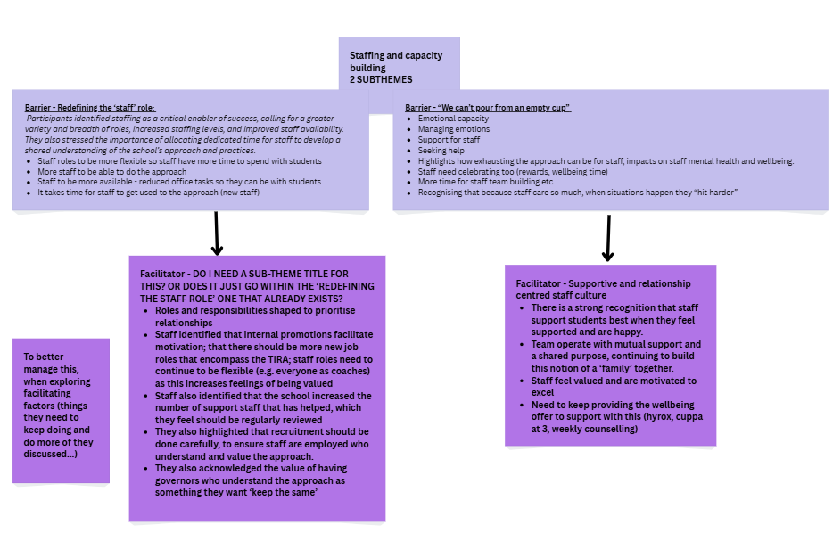

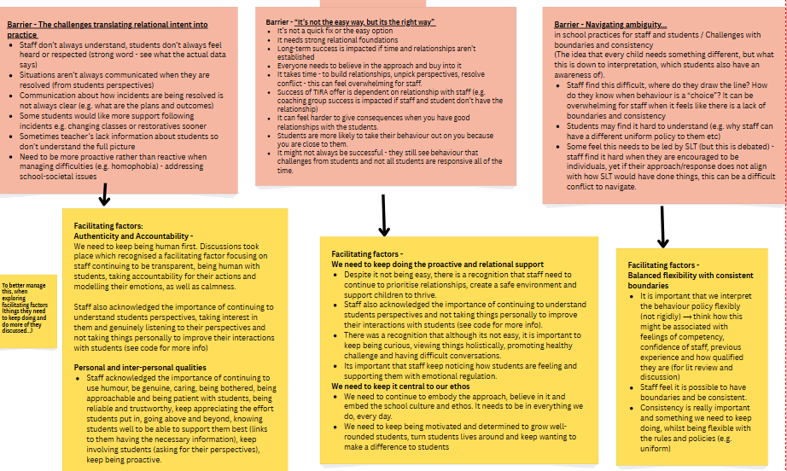
Research Question 3 refined themes

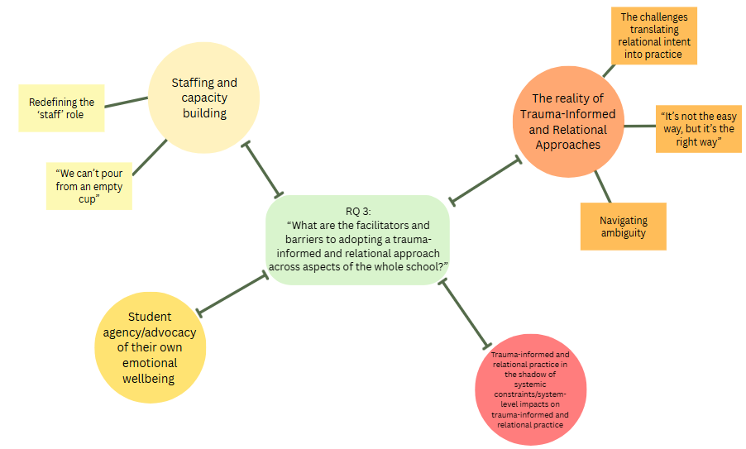
Research Question 3 further refined themes using thematic maps to facilitate coherence

Appendix FF: Refining, defining and naming themes
Examples of how different ways to understand and present the data were considered.
A hierarchical structure was deemed inappropriate due to its oversimplification of complex realities
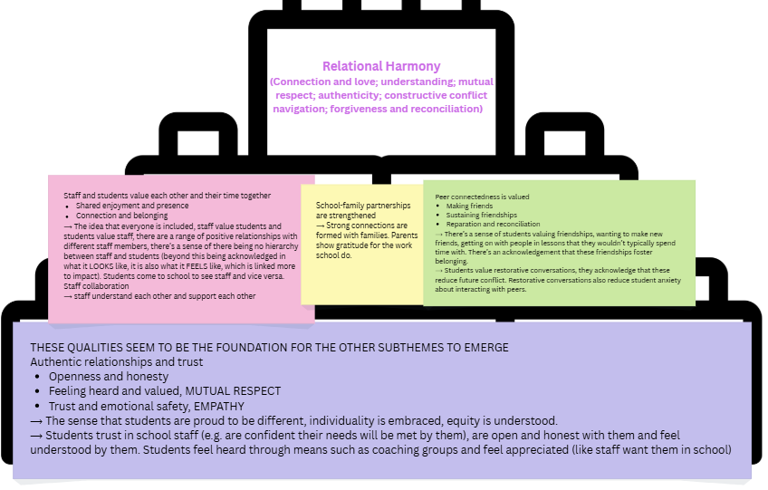

A circular framework was trialled. It was decided that there was still some overlap between themes and subthemes. I engaged with further refinement to continue to develop the themes:
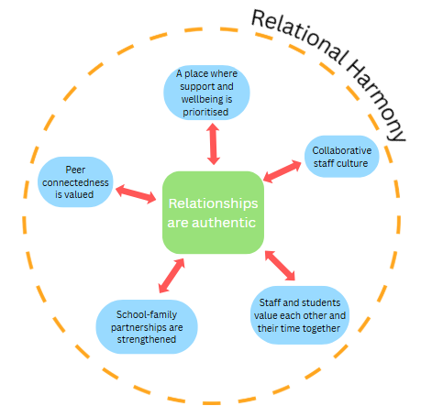

Appendix GG: Reflexivity whilst refining and reviewing themes
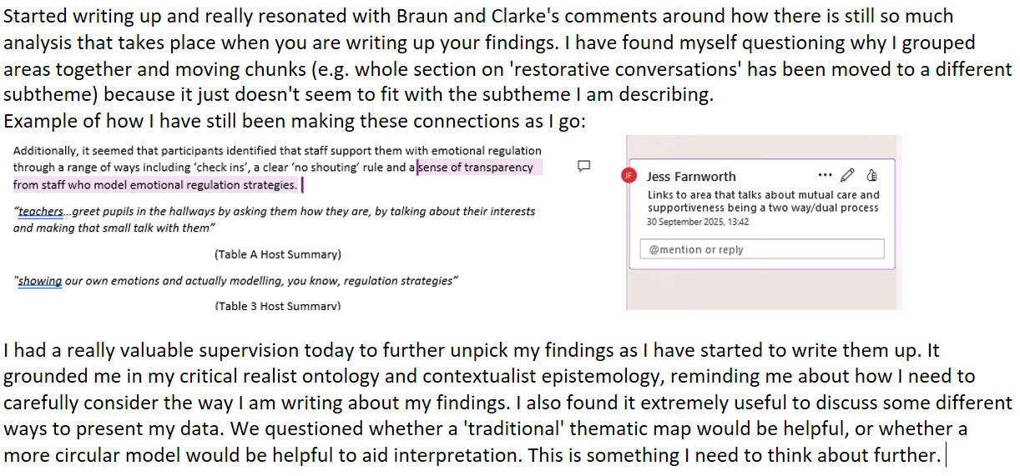

Appendix HH: Students celebrate successes with staff
Celebrating successes was also described as being important to staff and students. This is understood to be associated with the positive and trusting relationships developed:
“Pupils seek out staff if they need support, but also if they want to share their successes with them as well.”
(Table 1 Host Summary)
‘Success’ was not only conceptualised through individual achievements (e.g. sporting success) but also captured emotional wisdom by students (Table 2 host summary below). The dialogue captured within these discussions highlights how ‘success’ is operationalised as an everyday, personalised concept that is not only celebrated in academic or extra-curricular contexts but is intentionally recognised in more subtle ways.
“…not just sporting success, but also aspects of kindness and just celebrating the young people for being who they are.”
(Table 2 Host Summary)

Appendix II: Safeguarding team availability
The safeguarding team was acknowledged to be extensive. Students experienced the safeguarding team as approachable, who were always available. This contributes towards feelings of safety in school as students understand the role of the safeguarding team and have trusting relationships with them. The support was positioned as offering emotional containment for students.
“there’s a big safeguarding team and that helps some people to feel safe because they know there's someone there that's there for that specific reason.”
(Table A Host Summary)
“…they will respond to the class messages out outside at school time, so that's a big thing with the safeguarding team.”
(Table 1 Host Summary)

Appendix JJ: Students value peer relationships
Students positioned peers as being powerful anchors with regards to their sense of belonging, connection and enjoyment at school: “seeing my friends makes me look forward to coming to school” (WC tablecloth B). Friendships also contributed towards their emotional resilience.
“…the friendships that you have, help you feel like you belong...”
(Table B Host Summary)
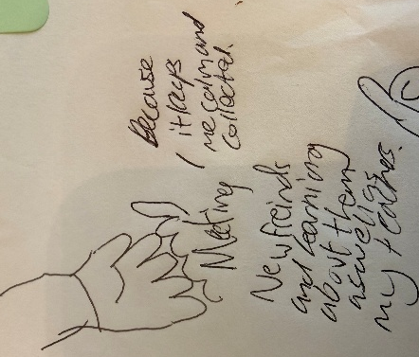

Transcription – “Making new friends and learning about them as well as my teachers, because it keeps me calm and collected”

Extract from WC tablecloth B demonstrating how students value making friends
Peer relationships were described as evolving that are strengthened over time. Students identified teachers as encouraging and supporting friendships: “My friendships have changed since Y7 and I have extra friends” (WC tablecloth B) and “Teachers support our friendships” (WC tablecloth B).
Although staff participants did not talk about friendships contributing to a sense of belonging. They acknowledged that RCs are essential to support students navigate conflict and repair relationships.

Appendix KK: Students confidence and self-esteem improve
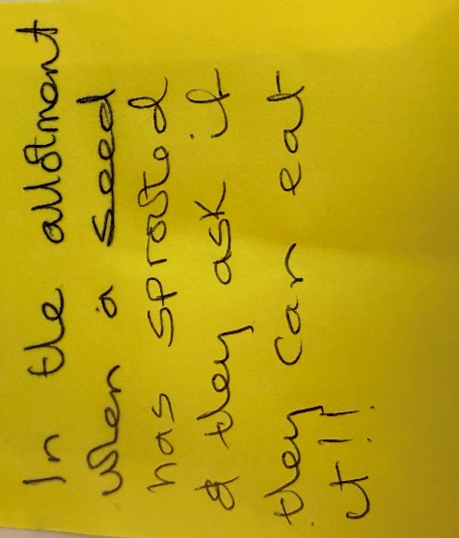
Staff referred to students “realising they can do it, when it might have taken months to achieve” (Tablecloth 2) and “start to feel confident…” (Tablecloth 2). Others observed confidence through students “feeling able to be who they are” (Table 1 host summary), reflecting characteristics of strength and individuality (Table 1 Host Summary below). These examples closely mirror the DNA-V (discoverer, noticer, advisor and values) model, underpinned by the acceptance and commitment therapy model (Hayes & Ciarrochi, 2015), enabling CYP to flourish within a safe and familiar environment.

Extract from Tablecloth 2 that gives an example of how students are more confident to experiment and try new things
“[Students]…aren’t embarrassed to be who they are about their identity and are not embarrassed if they have special needs, they are open about that”
(Table 1 Host Summary)

Appendix LL: Additional ways co-regulation and safety is facilitated for students
Some participants also acknowledged that ‘check ins’ and a clear ‘no shouting’ rule contribute towards creating a safe and calm environment. For students, respect enables them to feel seen, valued and safe (see below). This shapes their sense of self and their capacity to experience relationships as warm, gentle and relaxed. These approaches contribute towards the relational conditions necessary for co-regulation, the development of emotional literacy skills and a sense of belonging.
“teachers smile at students in the corridor… asking them how they are, by talking about their interests and making that small talk with them”
(Table A Host Summary)
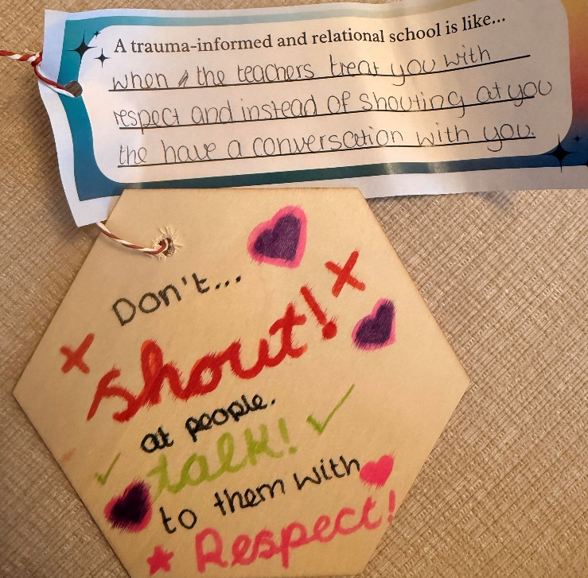

An extract from Tablecloth E which reflects a students’ conceptualisation of a ‘no shouting’ rule and the impact this has on relational engagement with staff

Appendix MM: Boundaries might be difficult for students to understand
Staff felt that different boundaries for different students may lead to confusion and a perceived sense of inequality. Staff described how students’ who work best with structure and consistency may find this difficult to understand. Having said this, students did not make direct reference to this when discussing their experiences. This suggests that this may be associated with staffs’ perceptions of their own experiences.
“there can sometimes be injustice if there's different sanctions for different pupils, because they don't necessarily understand that there's something else going on behind it that we're not able to share with other pupils”
(Table 1 Host Summary)
“sometimes there can be a bit of a lack of boundaries and that can be difficult for some pupils if they need that structure and consistency there.”
(Table 1 Host Summary)
Staff spoke about managing these difficulties by “explaining to them [students]” (Table 1 host summary) so that “they [students] can trust that the right decision has been made” (Table 1 host summary). Staff felt it was important for students to understand that differentiated boundaries are not illogical and uninformed responses, but responses to the diverse and contextualised needs of students. This dynamic emphasises the need for transparent dialogue between staff and students to enhance students’ understanding of equity.

Appendix NN: Learning is adapted through a trauma-informed and relational lens
Discussions illuminated how staffs’ insights about students inform how they “consider the curriculum” (Tablecloth 5). For example, “creating the PSHE curriculum to support our specific students” (Tablecloth 2) and “the curriculum considering the local context” (Tablecloth 5). Student’s lived experiences are valued and learning is understood as a relational and identity-based process. Alternative learning opportunities are also offered when there are “trauma triggers” (Tablecloth 5). Some participants discussed how it would be helpful “if they [SLT] shared information more… to link lessons to personal experiences of the students…” (Table B host summary). Staff are keen to ensure that students lived experiences inform the curriculum planning. Learning is a relational and identity-based process that considers students wider ecological systems (e.g. past experiences, cultural and societal influences), reflecting how learning and emotional wellbeing are interconnected. Student voice described the impact of this as learning being “enjoyable”, “welcoming” (Tablecloth A) and “fun” (Tablecloth E).
Some students linked the choice of learning, particularly options at GCSE, as eliciting a sense of belonging due to them being of interest. This alludes to the idea that students notice the personalisation in learning that is described by staff (as above) and interpret these adaptations as being meaningful, sensitive to their needs and contributing to a sense of belonging and value within the school.
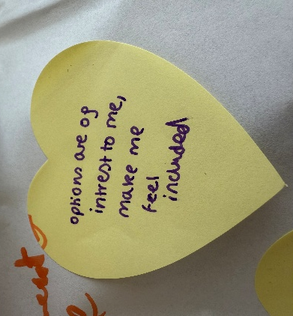
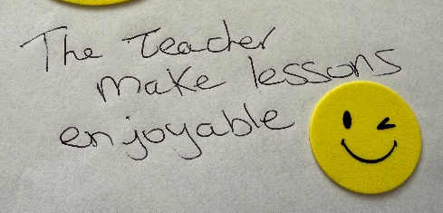

Extracts from Tablecloth A demonstrating how students feel about their learning

Appendix OO: Additional systems that facilitate trauma-informed and relational approaches
‘Restorative conversations’ (RCs) were described as “when a relationship has broken down with a student, talking about both sides/feelings help to understand each other and movements going forward to have a positive impact” (Tablecloth 5; see below). Staff model emotional literacy skills to students, such as accountability: “I’m really sorry about yesterday, I was tired and this has happened” (Table 5 host summary). They use the relational space to “model how it is OK to make mistakes, apologise for that and learn…” (Table 2 host summary) and collaboratively co-construct ways forward (see below). This has a “positive impact” (Tablecloth 5).
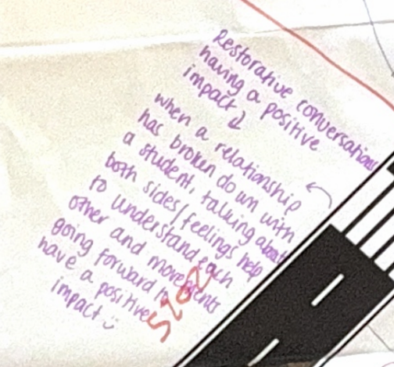

Extract from Tablecloth 5 that acknowledges the positive impact RCs are positioned as having
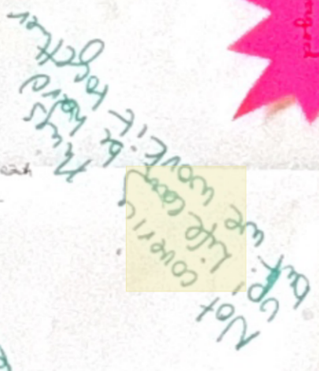

Extract from WC tablecloth 1 which reflects how staff position themselves as being open and honest with students.
Whilst RCs were explicitly named by staff, students did not label the help they received as ‘restorative conversations’. Students referred to “teachers helping with problems” (Tablecloth A), “listening to what you say” (Tablecloth A) and “helping as much as they can” (Tablecloth B). Having said this, students did refer to the impact of staff support with repairing relationships as “making it less intimidating if/when we come across each other in the future” (Table A host summary).
Although students did not explicitly refer to RCs, they did express difficulties associated with a RC framework. Some students found “getting questioned about feelings all time” (Table D host summary) as somewhat frustrating and counterproductive if “they don’t want to talk about them” (Table D host summary). They advocated for being able to say, “I don’t want to talk about it” (Tablecloth 2). This could be associated with the timing of RCs, given that RCs are most helpful when participants are emotionally regulated enough to reflect, empathise and engage in meaning-making (Alonso-Rodriguez et al., 2025). Staff also explained how RCs may “make students feel shame and dysregulate them more” (Table 4 host summary), particularly for students who are not “responsive” (Table 4 host summary). This alludes to the need for greater clarity with regards to when it is appropriate for RCs to take place, ensuring conditions of safety, empathy and attunement have been restored (Mas-Exposito et al., 2022). Without this, staff may be attempting to use RCs as a ‘tool’, in a non-relational way.
Mention was also given to a ‘Kindness and Respect Charter’ that staff can “refer to all the time” (Table 5 host summary) to “thank children for being kind and respectful” (Table 5 host summary). The charter was described as a framework to embed the TIRA culture and ethos. Although, student voice with regards to this was not captured in the data.
Roles with specific TIRA responsibilities, for example the ‘Trauma-Informed Teacher’ and ‘Reflect Manager’ were recognised as being facilitators to embed and sustain a TIRA. It could be understood that this is associated with their purpose specifically aligning with TIRAs, for example, the ‘reflect manager’ offering “true reflection” (Tablecloth 5).
An additional support system that was briefly mentioned by staff participants was the onsite alternative provision. This was articulated as enabling SVHS to “keep children” (Table 5 host summary) and support them with “emotions… to reintegrate back into class” (Table 5 host summary). The alternative provision was constructed as being a fluid concept, with a focus on reintegration back into mainstream school.

C1, C2, C3 system refers to a staged behaviour management framework that is frequently used in secondary schools in England. It typically follows the structure of C1 = warning, C2 = consequence, C3= removal.

