

The Therapeutic Palette
– How does flower colour influence emotion and behaviour in everyday landscapes?

Liwen Zhang

A thesis in the publication format submitted in partial fulfilment of the degree
Doctor of Philosophy

University of Sheffield
Faculty of Social Science
School of Architecture and Landscape

January 2026
Supervising team:
Professor Ross Cameron, School of Architecture and Landscape, University of Sheffield
Dr Nicola Dempsey, School of Architecture and Landscape, University of Sheffield

Acknowledgements
This research rests on the contributions of over 3,000 participants. Whether you braved the cold in a physical park, explored virtual worlds, or rated photographs online, your honest responses formed the soil from which this thesis grew. Without you, this work would not exist.
I owe a profound debt to my supervisors. Professor Ross Cameron, you saw a researcher in me before I did, guiding me from novice to academic and validating my "crazy ideas." Dr Nicola Dempsey, you were a guiding light, showing me how to balance academia with grace and empowering me to step up from student to colleague. Together, you created a greenhouse around me—removing obstacles and providing a protected space where I could simply focus, grow, and bloom.
To my parents, thank you for your unwavering support and for patiently listening to my research, even when the topic was foreign. A special thanks to my mother for the countless hours of childcare that allowed me to focus. To my parents-in-law, your pride has been a constant source of strength.
To my husband—my rock and fellow landscape architect. You were my professional sounding board and my partner in life, taking on the pressures of parenthood so I could carry the weight of this degree. To my daughter, who arrived in year three: you made me stronger and more positive. Looking at you, I know that understanding how environments affect our well-being is worth the effort.
Finally, to my friends and colleagues: thank you for turning a solitary project into a collective effort. Whether you were planting pansies, piloting surveys, or capturing the site through photography, your practical help was invaluable. Your companionship ensured this journey was never lonely.

Table of Contents
Acknowledgements iii
Table of Contents iv
Declaration of Authorship VIII
Declaration ix
Thesis Copyright Statement x
Abstract xi
Key Terms xii
References xiv
A Window, A Leaf, A Wave xv
1 Chapter 1: Introduction 1.1
1.1 The bridge between story and science 1.1
1.2 Background and motivation 1.1
1.3 Conceptual and theoretical framing 1.3
1.4 Evidence gaps and design tensions 1.10
1.5 The analytical approach 1.11
1.6 Aim and research questions 1.12
1.7 Structure of the thesis 1.13
References 1.14
2 Chapter 2: Methods 2.1
2.1 Orientation and coverage 2.1
2.2 How the approach evolved (A practical journey) 2.1
2.3 Common design principles and controls 2.3
2.4 The physiological pilots: Trials and lessons 2.4
2.5 Summary of methods 2.9
References 2.9
3 Chapter 3: Paper I
Flowers – Sunshine for the soul! How does floral colour influence preference, feelings of relaxation and positive up-lift? 3.1
Abstract 3.2
1. Introduction 3.2
2. Methods 3.4
3. Results 3.5
4. Discussion 3.7
5. Conclusions 3.9
References 3.9
4 Chapter 4: Paper Ii
‘Petals, People, and Pathways’ - How flower colour influences walking behaviour in a natural setting using drone-based observation? 4.1
Highlights 4.2
Abstract 4.2
1. Introduction 4.3
2. Methods 4.6
3. Results 4.14
4. Discussion 4.18
5. Conclusion 4.22
References 4.22
Supplementary 4.27
5 Chapter 5: Paper Iii
‘The Colour Palette Prescription’ – How do colour tone and colour diversity influence emotional responses in virtual green spaces? 5.1
Highlights 5.2
Abstract 5.2
1. Introduction 5.4
2. Methods 5.7
3. Results 5.17
4. Discussion 5.29
5. Conclusions 5.35
References 5.36
Supplementary 5.39
6 Chapter 6: Paper Iv
‘Blossom Buddies’ − How do flower colour combinations affect emotional response and influence therapeutic landscape design? 6.1
Highlights 6.2
Abstract 6.2
1. Introduction 6.2
2. Methods 6.4
3. Results 6.6
4. Discussion 6.12
5. Conclusion 6.14
References 6.14
Supplementary 6.17
7 Chapter 7: Synthesis And Design Guidance 7.1
7.1 From evidence to application 7.1
7.2 Cross-project verification (Triangulating the evidence) 7.1
7.3 Summary of key empirical findings 7.3
7.4 The Design Handbook: Applying the findings on site 7.4
7.5 Limitations 7.13
7.6 Conclusion 7.13
References 7.13
8 Chapter 8: Conclusion 8.1
8.1 Answers for research questions 8.1
8.2 What this thesis adds beyond the individual papers 8.2
8.3 Where the guidance applies (and where to look for limits) 8.3
8.4 What remains to be done 8.4
8.5 Closing 8.4
References 8.4
Appendices: Ethics Statement 9.6
Appendices: Survey Instruments 9.16
Appendix A: Survey Instrument for Paper I 9.16
Appendix B: Survey Instrument for Paper III 9.21
Appendix C: Survey Instrument for Paper IV 9.36

Declaration of Authorship
I, Liwen Zhang, hereby declare that this thesis and the work presented in it is my own, except where otherwise indicated. This thesis is presented in the "Thesis by Publication" format.
I am the lead author and primary investigator for all papers included in this thesis. I was responsible for the conceptualisation, methodology, software, validation, formal analysis, investigation, resources, data curation, and the drafting of all manuscripts.
The following papers were co-authored with my supervisors, Professor Ross Cameron and Dr Nicola Dempsey, who provided supervision, editorial guidance, and review throughout the research process:
- Paper I: Flowers - Sunshine for the soul! How does floral colour influence preference, feelings of relaxation and positive up-lift? (Published in Urban Forestry & Urban Greening)
- Paper II: ‘Petals, People, and Pathways’ - How Flower Colour Influences Walking Behaviour in a Natural Setting Using Drone-Based Observation (Unpublished manuscript)
Note: This paper includes an additional co-author, Xi Lu, who provided editorial guidance and review.
- Paper III: ‘The Colour Palette Prescription’ - How do colour tone and colour diversity influence emotional responses in virtual green spaces? (Unpublished manuscript)
Note: This paper includes an additional co-author, Simone Farris, who co-developed the research project and assisted with data validation and software methodology. I acted as the lead author and primary investigator for this study.
- Paper IV: 'Blossom Buddies' - How do flower colour combinations affect emotional response and influence therapeutic landscape design? (Published in Landscape & Urban Planning)
I confirm that the work submitted has not been previously submitted for a degree or diploma at this or any other university.

Declaration
Generative AI tools were used during the drafting of this thesis strictly for the purpose of language refinement, grammatical correction, and readability improvement. The intellectual content, data analysis, and scientific conclusions remain the original work of the author.

Thesis Copyright Statement
The copyright of this thesis rests with the author. Its contents are licensed under a Creative Commons Attribution-NonCommercial 4.0 International Licence (CC BY-NC), allowing copying, redistribution, and modification with credit, non-commercial use only. This thesis includes two papers published in peer-reviewed Elsevier journals. According to Elsevier's Author Rights Policy, the author can include the accepted manuscript or final article in a thesis or dissertation.
Paper I
- Citation: Zhang, L., Cameron, R.W.F., & Dempsey, N. (2023). Flowers – Sunshine for the soul! How does floral colour influence preference, feelings of relaxation and positive up-lift? Urban Forestry & Urban Greening, 79, 127795.
- Copyright: © 2023 The Authors. Published by Elsevier GmbH.
- Permission: Included under the Elsevier personal use rights for authors.
Paper IV
- Citation: Zhang, L., Cameron, R.W.F., & Dempsey, N. (2024). ‘Blossom Buddies’ − How do flower colour combinations affect emotional response and influence therapeutic landscape design? Landscape and Urban Planning, 248, 105099.
- Copyright: © 2024 The Authors. Published by Elsevier B.V.
- Permission: Included under the Elsevier personal use rights for authors.
Unpublished Works Paper II and Paper III are unpublished manuscripts. The copyright for these works rests with the author, Liwen Zhang.
All photographs, diagrams, and illustrations are the original work of the author unless otherwise cited.

Abstract
Urban green infrastructure is recognised as a vital public health resource, yet the specific design attributes that drive its restorative potential remain under-defined. While the efficacy of green vegetation is well-established, the functional influence of floral colour on emotional regulation is often dismissed as purely aesthetic. This research investigates whether flower colour can be used as a precise design tool to support two distinct therapeutic states: relaxation and uplift.
Across four papers, the enquiry progresses from establishing psychological associations to validating them in the field and untangling perceptual mechanisms in a controlled virtual environment. Paper I establishes a baseline: cool colours (blues, purples) drive relaxation, while warm colours (oranges, yellows) drive uplift. Paper II interrogates these findings in a real-world setting using drone-based behavioural mapping, demonstrating that high contrast and multicoloured planting significantly extend visitor dwell time and confirming that aesthetic salience translates into behavioural retention.
To isolate the underlying mechanisms, Paper III employs a 360° virtual environment. It reveals a critical "Design Gap": Perceived Colour Diversity—how colourful a scene feels—rather than botanical species count predicts well-being. It also identifies a temporal nuance: cool hues facilitate stress recovery, while warm hues provide an immediate mood boost without the same buffering capacity. Paper IV operationalises these insights by identifying dosage thresholds and demonstrating how warm colours can visually dominate and disrupt a relaxing scheme.
The thesis proposes a framework for "Precision Prescribing" in landscape architecture. Rather than a generic "nature dose," it argues that therapeutic outcomes are modulated by specific visual diets. By shifting focus to perceived complexity and tonal precision, the research offers actionable guidance—formalised as Palette Specification Cards—for designers to create environments that actively support their users.

Key terms
Therapeutic / Restorative
While these terms are often strictly defined as "recovery from stress/fatigue" (Kaplan, 1995; Ulrich, 1983), this thesis adopts a broader definition aligned with Salutogenesis (Antonovsky, 1979). Here, "therapeutic" refers to any environmental intervention that supports psychological well-being, encompassing both the reduction of negative states (Stress Recovery) and the promotion of positive states (Uplift/Vitality).
- Relaxed: Refers to a low-arousal positive state (Serenity/Calm). Associated with stress recovery and "cooling down."
- Uplifted: Refers to a high-arousal positive state (Joviality/Energy). Associated with vitality and "waking up."
Serenity / Joviality / Negative Affect
Names of the affect scales used in Paper III (PANAS-family items). Serenity and Joviality are the two positive subscales; Negative Affect is reported as a control.
Preference
A separate outcome recorded in Papers I, III and IV alongside relaxed/uplifted appraisals. It is treated as its own response, not a proxy for tone.
Hue family (warm / cool)
A broad colour category (e.g., blue, orange, purple) used for anchors and mixes. Warm families typically include reds, oranges and yellows; cool families include blues, blue-greens, greens and blue-purples. The thesis works with families rather than precise swatches.
Anchors
The dominant hue families that set the overall read of a palette in a scene or bed. Anchors are named at the family level (e.g., “blue-family anchor”).
Combination
The colour structure of a palette.
Analogous / Complementary
Analogous means neighbouring hue families on the hue circle (small hue steps—e.g., blue with blue-green, purple with blue-purple). Complementary means opposing hue families (large hue steps—e.g., blue with orange, purple with yellow).
Proportion
The area share of anchor families within a combination (e.g., 60:40 or 50:50).
Diversity (actual / perceived)
- Actual Diversity: The objective, nominal count of distinct flower hues or species present in a scene (e.g., "4 species").
- Perceived Diversity: The subjective estimation of variety by the observer ("how colourful it feels"). This thesis identifies Perceived Diversity as a stronger predictor of emotional response than Actual Diversity (the "Design Gap").
Surround
The background colours and materials that frame the planting in situ (e.g., adjacent beds, paving, façades). Online studies kept a neutral green surround constant so colour was the planned difference; the field study shows why the surround matters.
Local contrast
A near-field difference in hue/lightness/saturation between adjacent planting elements or between planting and surround that affects visual selection and dwell.
Framing / sequence
The warm or cool tone context before/after a brief event in short virtual sequences (Paper III).
Pass-by duration (PBD)
A low-intrusion behavioural index for path-adjacent planting: the seconds a walker’s centroid remains within a row-specific path segment, from first entry to final exit.
Legibility
How clearly the intended palette reads at typical viewing distance given anchors, combination, proportion and surround.

References
Antonovsky, A. (1979). Health, stress, and coping. New perspectives on mental and physical well-being, 12-37.
Kaplan, R. (1995). The restorative benefits of nature: Toward an integrative framework. Journal of Environmental Psychology, 15, 169–182.
Ulrich, R. S. (1983). Aesthetic and affective response to natural environment. In Behavior and the natural environment (pp. 85-125). Springer.

A window, a leaf, a wave
When I was young, I read O. Henry’s The Last Leaf. A woman, unwell and losing hope, watches the leaves outside her window fall. One remains—painted there in secret—and that small, steady sight keeps her going. The story stayed with me: that a simple view might hold someone up.
Years later, as I began to study how landscapes support well-being, I found a foundational paper showing that patients with a view of trees recovered better than those facing a wall (Ulrich, 1984). A tale I loved and a study I admired seemed to meet across a pane of glass. Story and science both suggested something modest yet powerful: what we place before the eye can matter.
During this PhD, I often walked with my now 2-year-old daughter to a nearby playground. On our route, we passed a care home with wide windows. One afternoon, a resident* waved; we waved back. It became a quiet ritual—look up, wave, wait for the answering hands. It lifted us every time. I hope it reached them too.
This thesis is about such moments and how design can make them more likely. If a small, composed view—colour arranged with care, a leaf held in sight, a glimpse of life across a window—can ease a mind or slow a step, then the details of planting are not trivial. They are part of how everyday places care for us.
For those on both sides of the glass.

* Since writing those lines, Harry is no longer there. The window remains; the wave does not. The love remains, and so does its quiet impact—it stays with us on the way to the park and in these pages. We remain, carrying it forward. Thank you, Harry.

Ulrich, R. S. (1984). View through a window may influence recovery from surgery. Science, 224(4647), 420-421.

Chapter 1: Introduction

The bridge between story and science
The gap between O. Henry’s story and Ulrich’s data is where this research sits. While science tells us that nature heals, it often fails to tell a designer how to construct that healing view. Is it the green of the leaf, or the contrast against the wall? Is it the diversity of the planting, or a specific hue that catches the eye?
Anxiety and depression are increasingly common. At any given time, about one in eight people are affected, and lifetime risk is higher (Vigo et al., 2016; WHO, 2022). These daily pressures can lower quality of life, reduce productivity, and endanger physical health (Bratman et al., 2015; Hartig et al., 2014). Yet, the gap between need and support is stark: many people do not receive timely, formal support or face long waiting times (Alonso et al., 2018; Patel et al., 2018; WHO, 2022).

Background and motivation
This reality forces a shift in perspective. Beyond clinical services, policy now places greater emphasis on prevention and early support strategies that can be used in everyday life. (Patel et al., 2018; WHO, 2022). "Social prescribing" and nature-based or “green” offers—such as guided walks and visits to parks—have received particular attention, with reviews indicating that contact with nature can lower stress, improve mood, and support well-being (Chatterjee et al., 2018; Husk et al., 2020; Twohig-Bennett & Jones, 2018; White et al., 2019).
The urgency of this requirement was thrown into sharp relief during the COVID-19 pandemic. For millions, the "daily walk" ceased to be a leisure choice and became a critical lifeline—often the only permitted reason to leave the home. During periods of confinement, the value of local, doorstep nature skyrocketed; people could not travel to distant national parks, so the street corner, the pocket park, and the view from the window became the primary resource for mental resilience (Grima et al., 2020; Ugolini et al., 2020).
This global "stress test" revealed a fragility in our urban fabric. It highlighted that therapeutic value cannot be reserved for hospitals or destination gardens; it must be woven into the everyday paths where people actually live. If a ten-minute walk is the only respite available, the quality of that walk—the colours, the engagement, the "soft fascination"—matters immensely. This thesis, though spanning the pandemic period, looks forward: it assumes that the need for accessible, restorative local environments will outlast the virus, remaining a permanent priority for public health.
However, for this to work at scale, our everyday public spaces—streets, parks, campuses, and care settings—must be designed to support it. The task is to turn the general consensus that contact with nature benefits mental well-being into clear, actionable design choices. Among the many variables available to the landscape architect, flower colour is selected as the primary focus of this thesis for three critical reasons:
- Designability: Unlike the fractal structure of a tree (which is fixed by biology) or the microbiome (which is invisible), flower colour is a deliberate aesthetic choice. It is a "high-frequency" variable that can be specified, purchased, and adjusted seasonally to suit the intended mood of a site.
- Salience: While green vegetation provides the restorative "background," it is often visually passive. Flowers act as visual magnets. Their high chromatic contrast creates a strong salience, capable of grabbing the eye and holding attention even in distracted states (Cameron & Blanuša, 2016).
- Affective Range: While green is universally associated with safety and calm, it occupies a relatively narrow band of the emotional spectrum. Flower colour offers the potential to expand this range. By introducing diverse hue families, we introduce the possibility of stimulating a wider variety of emotional responses—potentially reaching active states like vitality or uplift, rather than relying solely on passive relaxation. Exploring whether these effects can be reliably engineered in a landscape setting is a central aim of this research.
This thesis treats flower colour as a precise design variable—examining single colours, planned combinations, and diversity—to understand how we can engineer short-term feelings of relaxation and uplift (Papers I, III, IV).

Conceptual and theoretical framing
This research sits within the broader geography of "Therapeutic Landscapes." First defined by Gesler (1992), the term describes places where "physical and built environments, social conditions, and human perceptions combine to produce an atmosphere which is conducive to healing." Originally, this concept was applied to exceptional sites—spas, sacred places like Lourdes (France), or purpose-built hospital gardens—where people travel specifically to be healed (Williams, 2010). However, a shift is occurring. Researchers are increasingly turning their attention to "everyday therapeutic landscapes"—the ordinary parks, allotments, and streets where health is maintained rather than restored (Bell et al., 2018; Cattell et al., 2008).
This shift aligns with Antonovsky’s (1979) framework of Salutogenesis, which critiques the traditional medical focus on pathogenesis (treating disease). Antonovsky argued that health is not a binary switch (sick vs. well) but a continuum. In this view, the role of the environment is to provide "Generalised Resistance Resources"—supportive factors that help individuals cope with daily stressors. To design these resources effectively, we must understand the theoretical mechanisms that drive them.

Beyond the visible: The chemical and biological baseline
We know that nature heals in ways we cannot always see. A significant body of research suggests that benefits accrue through non-visual channels, often relying on immersion or physical proximity. For instance, research into Shinrin-yoku (forest bathing) indicates that inhaling phytoncides—antimicrobial volatile organic compounds emitted by trees—can enhance human natural killer (NK) cell activity and boost immune function (Li et al., 2009). Simultaneously, the "Old Friends" hypothesis suggests that regular exposure to the diverse microbiota found in natural soils is essential for training the human immune system (Rook, 2013).
Even the geometry of nature plays a role. Fractal Theory proposes that because the human visual system evolved in nature, processing the self-similar patterns of clouds and trees requires less metabolic energy than processing the hard lines of the city, inducing a physiological state of "wakeful relaxation" (Hagerhall et al., 2004).
However, while these theories offer powerful arguments for biodiverse woodlands, they struggle to explain the "Window Effect" (Ulrich, 1984). If a patient recovers faster simply by looking at a tree through glass, they are not inhaling phytoncides or touching microbes. There must be a powerful psychological pathway triggered by vision alone.
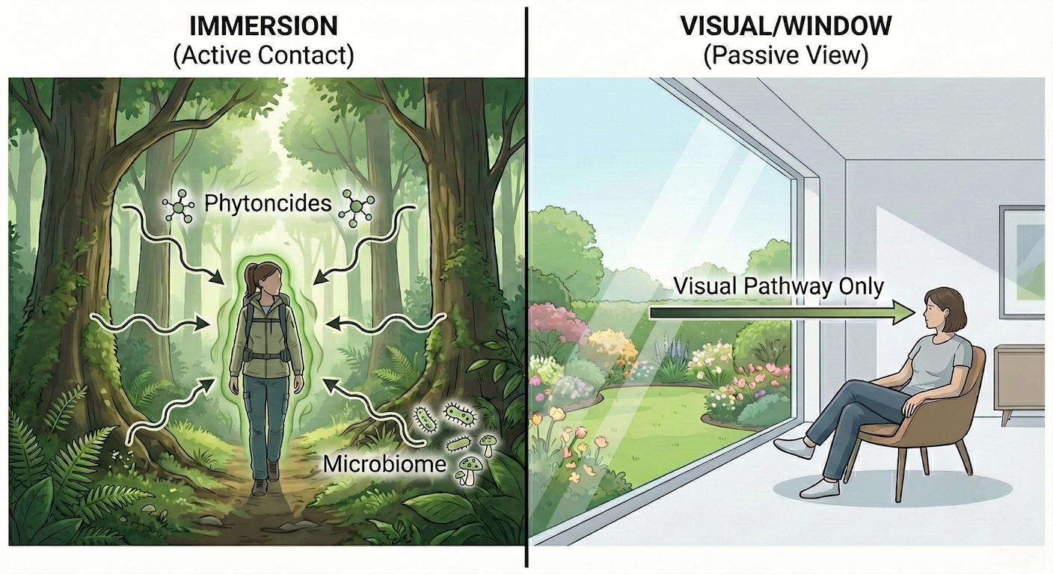
Figure 1.1 Delineation of restorative pathways. Left - Immersion: Involves multi-sensory exposure and direct biological contact. Right - Visual Access: Involves purely optical processing from a protected position (the 'window' effect). This thesis isolates the visual pathway shown on the right.

The psychological engine: Stress, Attention, and Spirit
To explain the visual impact of the landscape, this thesis relies on three complementary theories. The first two describe how nature helps us recover from negative states, while the third describes how it generates positive ones.
Stress Recovery Theory (SRT) proposes that exposure to unthreatening natural content triggers a relatively rapid, affect-first response that helps down-regulate stress (Ulrich, 1983, 1984). This response happens within minutes, reducing negative feelings and physical signs of stress, like heart rate and blood pressure, while encouraging relaxation. SRT points to features such as plants, water, and signs of safety, which our brains process easily (Hartig et al., 2014; Ulrich, 1983; Ulrich et al., 1991).
Attention Restoration Theory (ART) addresses a related pathway: recovery from directed-attention fatigue (Kaplan, 1995; Kaplan & Kaplan, 1989). Modern life demands constant attention. ART suggests that environments offering "soft fascination"—effortless, gently engaging stimuli—allow executive resources to replenish. More recent work has refined how these pathways connect to lasting nature-affinity. Lumber et al. (2017) identify five pathways to nature connection — contact, emotion, meaning, compassion, and beauty — providing theoretical grounding for aesthetic features such as flower colour as legitimate restorative routes rather than merely decorative ones.
Finally, we must look beyond mere recovery. Positive Affect Theory suggests that nature actively generates positive emotion. As highlighted by Cameron et al. (2020), nature does not merely reduce stress; it stimulates joy, interest, and vitality. In the context of the Broaden-and-Build theory (Fredrickson, 2001), these short-term feelings of "Uplift" act as a buffer, building the psychological resilience needed to bounce back from future stressors (Bratman et al., 2015; Richardson et al., 2016).

The nature of the signal (Colour)
Before examining colour as a design tool, it is necessary to define what it is. Scientifically, colour is not an inherent property of matter but a sensation created in the brain when light of specific wavelengths strikes the retina (Fairchild, 2013). However, in the context of planting design, it acts as a signal.
Biologically, flower colour evolved as a communication strategy. Angiosperms developed chromatic signals specifically to attract pollinators (insects, birds, and bats) against a green foliage background (Chittka & Raine, 2006). It is important to acknowledge that the human experience of this signal is a co-opted bystander effect; we are not the intended audience. Insects, for example, often perceive ultraviolet patterns invisible to the human eye (Kevan et al., 1996). This thesis, however, is anthropocentric: it is concerned solely with the human trichromatic response—how the visible spectrum (approximately 400–700 nm) registers in the human emotional system.
To discuss the impact of floral colour on affect, it is necessary to establish a precise vocabulary. In common parlance, "colour" is used interchangeably with "hue," but in design theory, these terms represent distinct properties (Albers, 2013; Itten, 1970). This research distinguishes between the following dimensions:
- Hue: The pure pigment or "family name" of the colour (e.g., Red, Green, Blue). It is the property that distinguishes one colour from another on the spectrum.
- Value (Lightness): The relative lightness or darkness of a colour. A high value is close to white; a low value is close to black.
- Chroma (Saturation): The intensity or purity of the colour. High chroma is vivid and dominant; low chroma is muted and greyish.
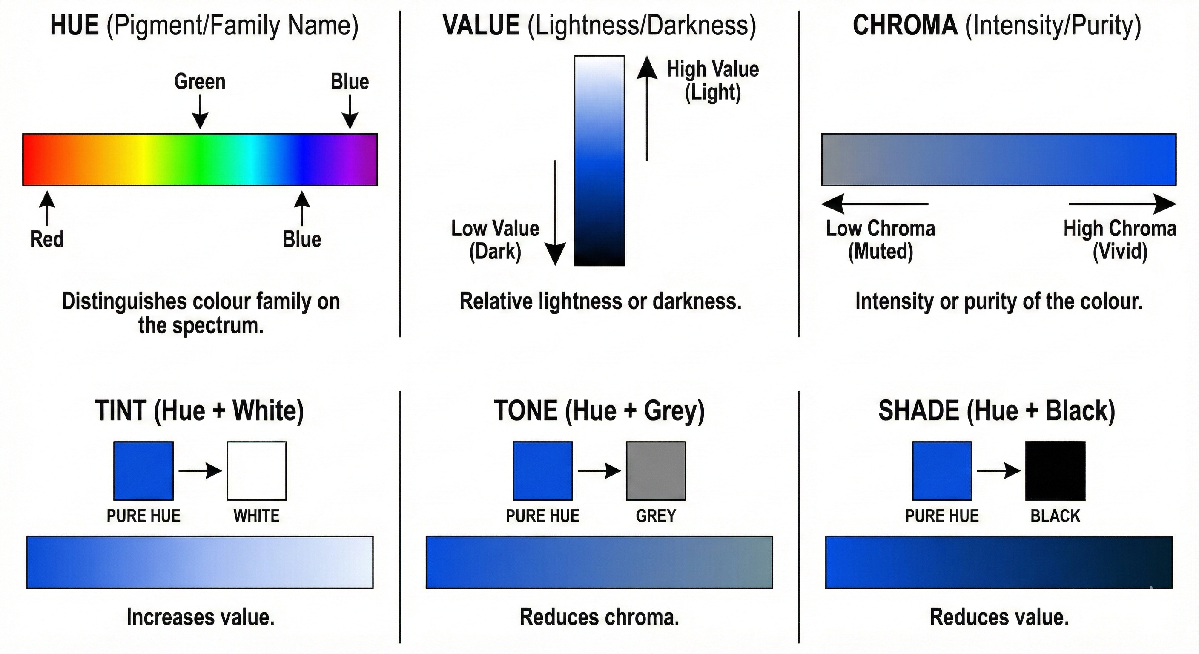
Figure 1.2 The three dimensions of colour perception.
- Tint, Tone, and Shade: In horticultural practice, a pure hue is rarely used. Instead, it is modified by mixing:
- Tint: Hue + White (e.g., Pastel Pink). Increases value.
- Tone: Hue + Grey (e.g., Dusty Rose). Reduces chroma.
- Shade: Hue + Black (e.g., Maroon). Reduces value.
Figure 1.3 Schematic representation of colour modification.
While these distinctions are critical for optical research, this thesis begins by defining the variable at the level of the Hue Family (e.g., Blue vs. Orange). This decision grounds the research in professional practice, where plants are typically specified by broad visual categories rather than precise colorimetric values. By focusing on these families first, the research establishes a robust baseline for the "Warm versus Cool" effect before finer granularities of saturation are tested.

Colour as a design tool
Colour is more than just physics; it is emotion. In planting design, colour is immediately legible and adjustable at the detail scale (Dunnett & Hitchmough, 2013). Because appearance depends on context, hue, saturation, and lightness interact with illumination and surround; the same flowers may look different across seasons and backgrounds (Fairchild, 2013; Foster, 2011; Shevell & Kingdom, 2008). Recent empirical work has reinforced flower colour as an actionable design variable. Elsadek and Liu (2020) found that viewing flowering plants in an office-like environment improved employee wellbeing, with effects modulated by flower colour.Ai et al. (2025) demonstrated that different Camellia japonica colour and form combinations produced measurable physiological and psychological responses, and Yang et al. (2025) reported that the warm–cool distinction in plant-wall flower colour systematically influenced indoor occupant health.
Links with affect are well established. Cooler hues (especially blue) more often align with calmer, relaxed emotions, and warmer hues (orange/yellow/red) with more activated, uplifted emotions (Elliot & Maier, 2014; Jang et al., 2014; Kaya & Epps, 2004; Valdez & Mehrabian, 1994). Cross-cultural studies suggest broadly similar patterns with variation in effect size, though linguistic and geographic proximity systematically shape the mapping (Jonauskaite et al., 2020; Neale et al., 2021). Preference overlays these generic trends: the ecological valence account proposes that colour preference reflects the average valence of associated objects (Palmer & Schloss, 2010).
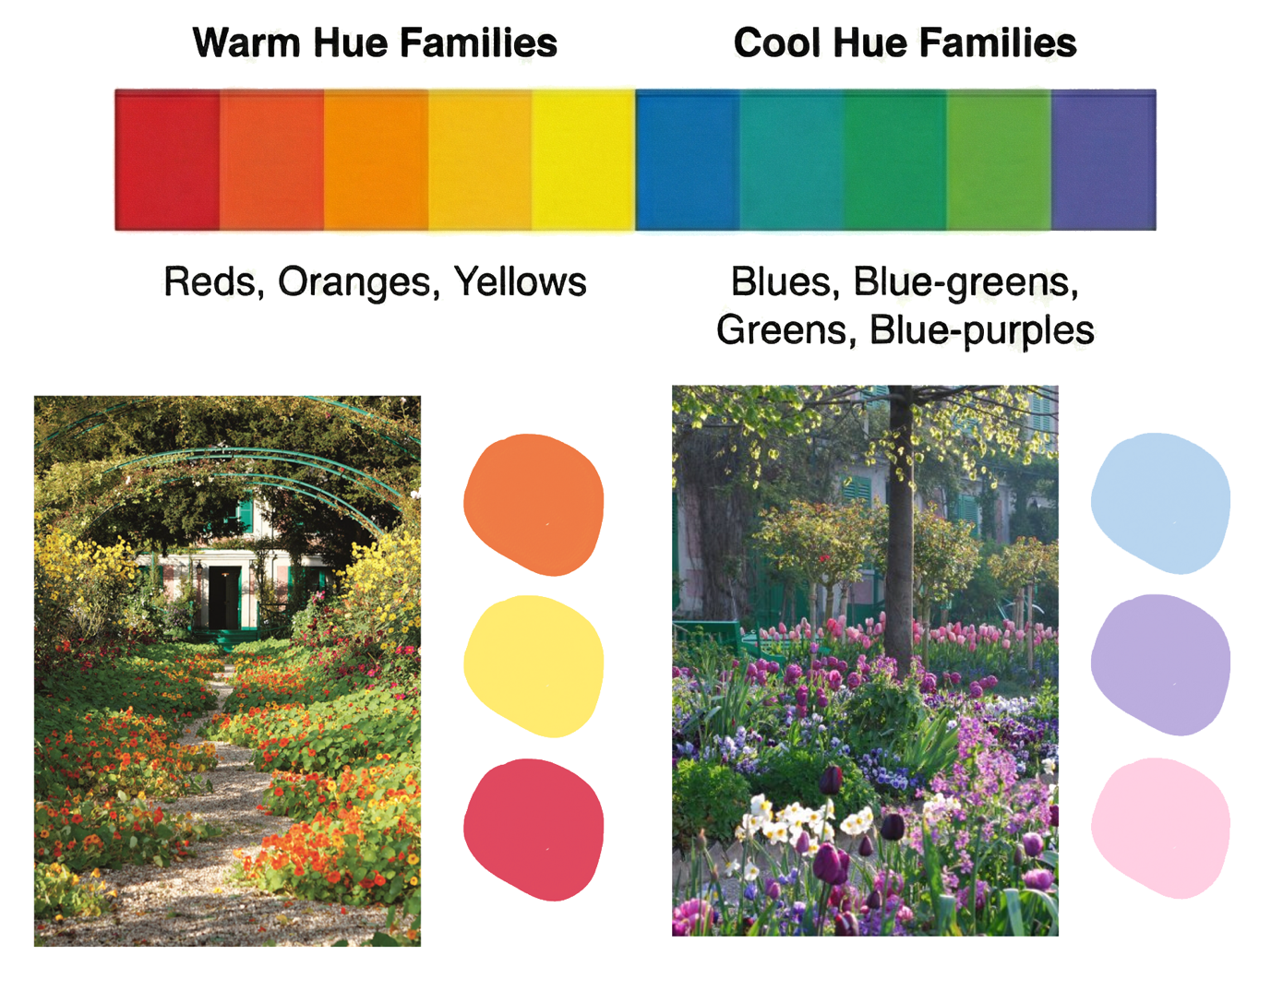
Figure 1.4 Warm versus Cool hue families. Top - Operational definition of Hue Families (Warm vs Cool). Bottom - Examples from Monet’s garden illustrate how these broad categories establish the atmospheric tone of a planting scheme. (Image: Left - Hammond, F. (2017, May 4). The garden viewed from the porch. Architectural Digest. https://www.architecturaldigest.com/gallery/claude-monet-incredible-gardens Right - Etienne. (2024, March 28). Monet's fabulous gardens at Giverny. Tacoma Rose Society. https://www.tacomarosesociety.org/monet-garden/).
However, real landscapes are not colour swatches; they present combinations. Empirical work indicates that combinations are liked when they share similarity (analogous) or offer contrast (complementary) (Itten, 1970; Ou & Luo, 2006; Ou et al., 2004a; Ou et al., 2004b; Schloss & Palmer, 2011). Importantly, the relative area of each colour—the proportion—can shift a composition from relaxed to uplifted without changing ingredients.
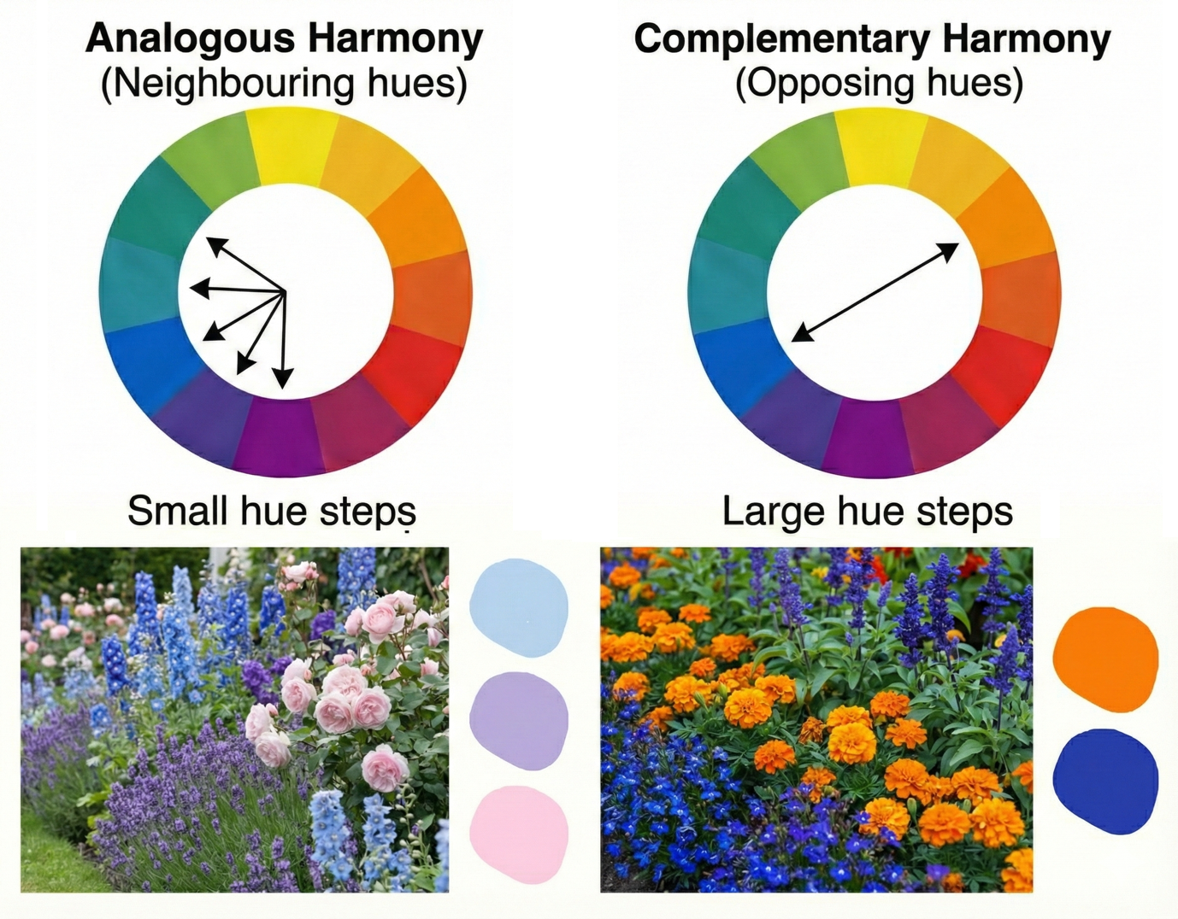
Figure 1.5 Analogous versus complementary hue relationships. Left - Analogous schemes utilise adjacent hue families to create visual cohesion. Right - Complementary schemes utilise opposing hue families to create maximum simultaneous contrast.
A brief personal note sits alongside this literature. Long before this PhD, I was drawn to Monet’s planting at Giverny. What struck me was how the feeling of a border changed not with different ingredients, but with their relative area. That sensibility—keep palettes legible and use proportion to steer tone—quietly informs how this thesis treats colour as a variable.
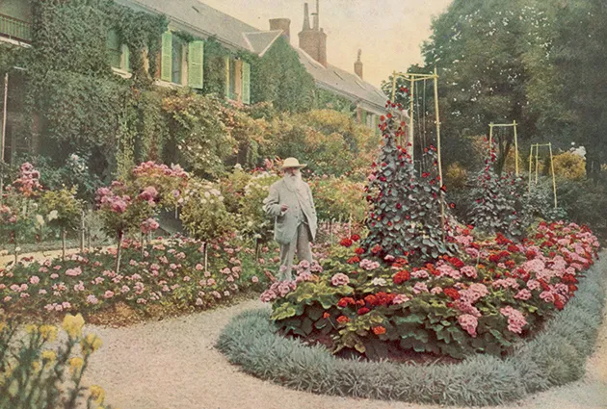
Figure 1.6 Early inspiration at Giverny (c. 1921). Monet’s use of legible palettes and distinct colour massing. (Image: Clémentel, E. (c. 1917-1926). Claude Monet in his garden at Giverny [Photograph]. Mary Evans Picture Library).
Alongside this personal inspiration, my own background and experience shaped the topic and approach. Training in fine art and landscape architecture made me attentive to how colours relate and to how small decisions shape the experience of a place. Practice, with its constraints of policy, budget, and delivery, reinforced the importance of detail. These experiences led me to test flower colour as a practical tool for creating settings that help people feel relaxed and uplifted. In designing the programme, I sought to limit the influence of my own preferences and to make key decisions open to shared checks. Specific controls, measures, and analyses are described in Chapter 2 and in the paper chapters. The aim throughout is to provide guidance that can be used in everyday and therapeutic landscapes rather than to advocate any particular palette.

Evidence gaps and design tensions
While the theories are strong, the evidence available to landscape architects is often too vague to be useful. Much of the existing work tests only a few hues, and quite a bit relies on isolated blossoms or pot displays that bear little resemblance to how planting is encountered in public space (Huang & Lin, 2020; Hůla & Flegr, 2016).
To address this, Paper I (Chapter 3) establishes a clear baseline, screening eight flower colours in realistic scenes to determine which single hues people experience as relaxing or uplifting.
From there, the work moves towards palettes, because that is how landscapes are seen. Harmony, contrast, and proportion shape whether a scene feels quiet or lively, yet applied evidence remains thin (Itten, 1970; Ou & Luo, 2006; Ou et al., 2004a; Ou et al., 2004b; Schloss & Palmer, 2011). Paper III (Chapter 5) approaches this by treating complexity as colour diversity, while Paper IV (Chapter 6) tests specific combinations with explicit control of proportions.
A further tension runs between specification and perception. Designers count ingredients on a plan, but users register what they actually see. Work on biodiversity shows that perceived richness can match or exceed actual counts in predicting well-being (Dallimer et al., 2012; Marselle et al., 2022; Southon et al., 2018). In urban green-space settings specifically, this pattern extends to positive emotional outcomes: Cameron et al. (2020) found that urban green spaces with greater avian biodiversity were associated with stronger positive emotions in visitors. This thesis therefore investigates this "Design Gap," measuring perceived colour diversity alongside nominal counts.
Finally, we must ask if these aesthetic effects translate to behaviour. Paper II (Chapter 4) takes the research into the field, using a low-intrusion behavioural index—pass-by time—to test whether chromatic characteristics register in what people do, not just what they report.

The analytical approach
This section acts as the bridge from theory to analysis. It sets out the choices that guide how results are read and reported in the chapters that follow, establishing the "lens" through which this thesis views the data.

Two threads: Relaxation and Uplift
Rather than compressing experience into a single "better mood" metric, this work keeps two threads running side by side. One is relaxation, a quieter, low-arousal state. The other is uplift, a brighter, higher-arousal state. This functional separation aligns with evolutionary models of affect regulation in nature, which treat joy and calm as distinct positive emotional states with different physiological signatures and behavioural functions (Richardson et al., 2016).

Behaviour as a signal
Alongside what people say about how they feel, we also pay attention to what people do. For path-side planting, this means using pass-by time—the time a visitor remains within a specific segment of the path—as a low-intrusion index of gentle engagement. This aligns with the concept of "soft fascination": if a planting scheme works, it should hold the eye and slow the step, even if only for a few seconds.

Palettes, not swatches
Because designers work with whole borders rather than isolated colours, the analyses follow suit. We examine structure (analogous vs. complementary) and proportion (the relative area of each colour). Where proportion might have non-linear effects—small changes tipping a composition from calm to lively—we look for those specific tipping points rather than assuming straight lines.

Perception vs. Specification
A central tension in this work is that plans count ingredients, but people register what they actually see. Therefore, perceived colour diversity ("how busy does it look?") is analysed alongside nominal counts ("how many colours are there?"). This allows us to understand the "Design Gap" between what is specified and what is experienced.

Translating to practice
Finally, the analytical goal is translation. Findings are distilled into small, usable pieces of guidance at the detail scale—species choices, proportions, and seasonal sequencing. The aim is not to produce rigid rules, but to offer tested tendencies that designers can adapt to their specific sites.

Aim and research questions
This programme asks whether flower colour can be specified at the detail scale to support relaxed and uplifted emotions—and gentle engagement—in everyday landscapes.
Aim: To identify colour choices and palette structures that reliably support relaxed and uplifted emotions, and to test whether these chromatic characteristics register in on-site behaviour.
Research Questions:
- RQ1. In realistic images of planted beds, are some single flower colours considered more relaxing or uplifting than others?
- RQ2. In a public path setting, do flower colour and colour combinations in adjacent planting influence pass-by time, and if so, how?
- RQ3. Over short encounters, do warm versus cool tone frames and colour diversity influence relaxing and uplifting appraisals?
- RQ4. In planted combinations, do analogous versus complementary structures and their proportions change how relaxing or uplifting a scene is judged?

Structure of the thesis
This thesis follows a thesis-by-publication format. Each paper (Chapters 3–6) contains a focused literature review specific to its research questions. To maintain clarity and avoid repetition, this introduction has provided the broader theoretical framework, while Chapter 2 compiles the shared methodology.
The programme was staged deliberately so that each paper builds on the last:
- Paper I (Chapter 3): An online image study establishing the baseline for single hues and highlighting the role of preference and white as a flexible element.
- Paper II (Chapter 4): A field study using a low-intrusion behavioural index (pass-by time) to test if chromatic characteristics register in natural movement on site.
- Paper III (Chapter 5): A controlled virtual-park experiment testing tone and colour diversity, specifically asking whether perceived diversity better predicts emotions than actual counts.
- Paper IV (Chapter 6): A combinations study using real plant photography to test analogous and complementary mixes under explicit proportion rules, aiming for implementable guidance.
Chapter 7 synthesises these findings into guidance for practice, and Chapter 8 concludes the thesis.

References
Ai, L., Wang, H., Feng, Y., Li, T., Li, Z., Zou, M., & Zhang, Q. (2025). The healing power of Camellia japonica L.: How flower types influence urban residents’ physiological and psychological wellbeing. Frontiers in Psychology, 16, 1489859.
Albers, J. (2013). Interaction of color. Yale University Press.
Alonso, J., Liu, Z., Evans‐Lacko, S., Sadikova, E., Sampson, N., Chatterji, S., Abdulmalik, J., Aguilar‐Gaxiola, S., Al‐Hamzawi, A., & Andrade, L. H. (2018). Treatment gap for anxiety disorders is global: Results of the World Mental Health Surveys in 21 countries. Depression and anxiety, 35(3), 195-208.
Antonovsky, A. (1979). Health, stress, and coping. New perspectives on mental and physical well-being, 12-37.
Bell, S. L., Foley, R., Houghton, F., Maddrell, A., & Williams, A. M. (2018). From therapeutic landscapes to healthy spaces, places and practices: A scoping review. Social Science & Medicine, 196, 123-130.
Bratman, G. N., Daily, G. C., Levy, B. J., & Gross, J. J. (2015). The benefits of nature experience: Improved affect and cognition. Landscape and Urban Planning, 138, 41-50. https://doi.org/10.1016/j.landurbplan.2015.02.005
Cameron, R. W., & Blanuša, T. (2016). Green infrastructure and ecosystem services–is the devil in the detail? Annals of botany, 118(3), 377-391.
Cameron, R. W. F., Brindley, P., Mears, M., McEwan, K., Ferguson, F., Sheffield, D., Jorgensen, A., Riley, J., Goodrick, J., Ballard, L., & Richardson, M. (2020). Where the wild things are! Do urban green spaces with greater avian biodiversity promote more positive emotions in humans? Urban Ecosystems, 23(2), 301-317. https://doi.org/10.1007/s11252-020-00929-z
Cattell, V., Dines, N., Gesler, W., & Curtis, S. (2008). Mingling, observing, and lingering: Everyday public spaces and their implications for well-being and social relations. Health & place, 14(3), 544-561.
Chatterjee, H. J., Camic, P. M., Lockyer, B., & Thomson, L. J. (2018). Non-clinical community interventions: a systematised review of social prescribing schemes. Arts & Health, 10(2), 97-123.
Chittka, L., & Raine, N. E. (2006). Recognition of flowers by pollinators. Current opinion in plant biology, 9(4), 428-435.
Dallimer, M., Irvine, K. N., Skinner, A. M., Davies, Z. G., Rouquette, J. R., Maltby, L. L., Warren, P. H., Armsworth, P. R., & Gaston, K. J. (2012). Biodiversity and the feel-good factor: understanding associations between self-reported human well-being and species richness. BioScience, 62(1), 47-55.
Dunnett, N., & Hitchmough, J. (2013). The Dynamic Landscape: Design, Ecology and Management of Naturalistic Urban Planting. Routledge. https://doi.org/https://doi.org/10.4324/9780429283338
Elliot, A. J., & Maier, M. A. (2014). Color psychology: Effects of perceiving color on psychological functioning in humans. Annual Review of Psychology, 65, 95–120. https://doi.org/10.1146/annurev-psych-010213-115035
Elsadek, M., & Liu, B. (2020). Effects of viewing flowering plants on employees' wellbeing in an office-like environment. Indoor and Built Environment, 30(9), 1429-1440. https://doi.org/10.1177/1420326x20942572
Fairchild, M. D. (2013). Color appearance models. John Wiley & Sons.
Foster, D. H. (2011). Color constancy. Vision research, 51(7), 674-700.
Fredrickson, B. L. (2001). The role of positive emotions in positive psychology: The broaden-and-build theory of positive emotions. American psychologist, 56(3), 218.
Gesler, W. M. (1992). Therapeutic landscapes: medical issues in light of the new cultural geography. Social Science & Medicine, 34(7), 735-746.
Grima, N., Corcoran, W., Hill-James, C., Langton, B., Sommer, H., & Fisher, B. (2020). The importance of urban natural areas and urban ecosystem services during the COVID-19 pandemic. PLoS One, 15(12), e0243344. https://doi.org/10.1371/journal.pone.0243344
Hagerhall, C. M., Purcell, T., & Taylor, R. (2004). Fractal dimension of landscape silhouette outlines as a predictor of landscape preference. Journal of Environmental Psychology, 24(2), 247-255.
Hartig, T., Mitchell, R., De Vries, S., & Frumkin, H. (2014). Nature and health. Annual review of public health, 35(1), 207-228.
Huang, Y. C., & Lin, Y. H. (2020). Effects of flower color and density on visual attention and emotional responses. Urban Forestry & Urban Greening, 47, 126567.
Hůla, M., & Flegr, J. (2016). What flowers do we like? The influence of shape and color on the rating of flower beauty. PeerJ, 4, e2106. https://doi.org/10.7717/peerj.2106
Husk, K., Blockley, K., Lovell, R., Bethel, A., Lang, I., Byng, R., & Garside, R. (2020). What approaches to social prescribing work, for whom, and in what circumstances? A realist review. Health & social care in the community, 28(2), 309-324.
Itten, J. (1970). The elements of color (Vol. 4). John Wiley & Sons.
Jang, H. S., Kim, J., Kim, K. S., & Pak, C. H. (2014). Human brain activity and emotional responses to plant color stimuli. Color Research & Application, 39(3), 307-316. https://doi.org/10.1002/col.21788
Jonauskaite, D., Parraga, C. A., Quiblier, M., & Mohr, C. (2020). Feeling blue or seeing red? Similar patterns of emotion associations with colour patches and colour terms. i-Perception, 11(1), 2041669520902484.
Kaplan, R. (1995). The restorative benefits of nature: Toward an integrative framework. Journal of Environmental Psychology, 15, 169–182.
Kaplan, R., & Kaplan, S. (1989). The experience of nature: A psychological perspective. Cambridge university press.
Kaya, N., & Epps, H. H. (2004). Relationship between color and emotion: A study of college students. College student journal, 38(3), 396-405.
Kevan, P., Giurfa, M., & Chittka, L. (1996). Why are there so many and so few white flowers? Trends in Plant Science, 1(8), 252.
Li, Q., Kobayashi, M., Wakayama, Y., Inagaki, H., Katsumata, M., Hirata, Y., Hirata, K., Shimizu, T., Kawada, T., & Park, B. (2009). Effect of phytoncide from trees on human natural killer cell function. International journal of immunopathology and pharmacology, 22(4), 951-959.
Lumber, R., Richardson, M., & Sheffield, D. (2017). Beyond knowing nature: Contact, emotion, compassion, meaning, and beauty are pathways to nature connection. PLoS One, 12(5), e0177186.
Marselle, M., Hartig, T., Cox, D., De Bell, S., Knapp, S., & Lindley, S. (2022). Pathways linking biodiversity to human health. A conceptual framework, 150, 106420.
Neale, C., Aspinall, P., Roe, J., Tveit, M. S., Tsuchiya, K., & Sugiyama, T. (2021). Color aesthetics: A transatlantic comparison of psychological and physiological impacts of warm and cool colors in garden landscapes. Wellbeing, Space and Society, 2, 100038. https://doi.org/10.1016/j.wss.2021.100038
Ou, L. C., & Luo, M. R. (2006). A colour harmony model for two‐colour combinations. Color Research & Application: Endorsed by Inter‐Society Color Council, The Colour Group (Great Britain), Canadian Society for Color, Color Science Association of Japan, Dutch Society for the Study of Color, The Swedish Colour Centre Foundation, Colour Society of Australia, Centre Français de la Couleur, 31(3), 191-204.
Ou, L. C., Luo, M. R., Woodcock, A., & Wright, A. (2004a). A study of colour emotion and colour preference. Part I: Colour emotions for single colours. Color Research & Application, 29(3), 232-240.
Ou, L. C., Luo, M. R., Woodcock, A., & Wright, A. (2004b). A study of colour emotion and colour preference. part II: colour emotions for two‐colour combinations. Color Research & Application: Endorsed by Inter‐Society Color Council, The Colour Group (Great Britain), Canadian Society for Color, Color Science Association of Japan, Dutch Society for the Study of Color, The Swedish Colour Centre Foundation, Colour Society of Australia, Centre Français de la Couleur, 29(4), 292-298.
Palmer, S. E., & Schloss, K. B. (2010). An ecological valence theory of human color preference. Proceedings of the National Academy of Sciences, 107(19), 8877-8882.
Patel, V., Saxena, S., Lund, C., Thornicroft, G., Baingana, F., Bolton, P., Chisholm, D., Collins, P. Y., Cooper, J. L., & Eaton, J. (2018). The Lancet Commission on global mental health and sustainable development. The lancet, 392(10157), 1553-1598.
Richardson, M., McEwan, K., Maratos, F., & Sheffield, D. (2016). Joy and Calm: How an Evolutionary Functional Model of Affect Regulation Informs Positive Emotions in Nature. Evolutionary Psychological Science, 2(4), 308-320. https://doi.org/10.1007/s40806-016-0065-5
Rook, G. A. (2013). Regulation of the immune system by biodiversity from the natural environment: an ecosystem service essential to health. Proceedings of the National Academy of Sciences, 110(46), 18360-18367.
Schloss, K. B., & Palmer, S. E. (2011). Aesthetic response to color combinations: preference, harmony, and similarity. Attention, Perception, & Psychophysics, 73(2), 551-571.
Shevell, S. K., & Kingdom, F. A. (2008). Color in complex scenes. Annu. Rev. Psychol., 59(1), 143-166.
Southon, G. E., Jorgensen, A., Dunnett, N., Hoyle, H., & Evans, K. L. (2018). Perceived species-richness in urban green spaces: Cues, accuracy and well-being impacts. Landscape and Urban Planning, 172, 1-10.
Twohig-Bennett, C., & Jones, A. (2018). The health benefits of the great outdoors: A systematic review and meta-analysis of greenspace exposure and health outcomes. Environmental research, 166, 628-637.
Ugolini, F., Massetti, L., Calaza-Martínez, P., Cariñanos, P., Dobbs, C., Ostoić, S. K., Marin, A. M., Pearlmutter, D., Saaroni, H., & Šaulienė, I. (2020). Effects of the COVID-19 pandemic on the use and perceptions of urban green space: An international exploratory study. Urban Forestry & Urban Greening, 56, 126888.
Ulrich, R. S. (1983). Aesthetic and affective response to natural environment. In Behavior and the natural environment (pp. 85-125). Springer.
Ulrich, R. S. (1984). View through a window may influence recovery from surgery. Science, 224(4647), 420-421.
Ulrich, R. S., Simons, R. F., Losito, B. D., Fiorito, E., Miles, M. A., & Zelson, M. (1991). Stress recovery during exposure to natural and urban environments. Journal of Environmental Psychology, 11(3), 201-230.
Valdez, P., & Mehrabian, A. (1994). Effects of color on emotions. Journal of Experimental Psychology: General, 123(4), 394–409. https://doi.org/10.1037/0096-3445.123.4.394
Vigo, D., Thornicroft, G., & Atun, R. (2016). Estimating the true global burden of mental illness. The Lancet Psychiatry, 3(2), 171-178.
White, M. P., Alcock, I., Grellier, J., Wheeler, B. W., Hartig, T., Warber, S. L., Bone, A., Depledge, M. H., & Fleming, L. E. (2019). Spending at least 120 minutes a week in nature is associated with good health and wellbeing. Scientific Reports, 9(1), 7730.
WHO. (2022). World mental health report: transforming mental health for all.
Williams, A. (2010). Therapeutic landscapes as health promoting places. A companion to health and medical geography, 207-223.
Yang, L., Yuan, L., Zhang, G., Shi, J., & Dewancker, B. J. (2025). Impact of the cool and warm colours of flowers on the plant wall on indoor human health. Indoor and Built Environment, 34(9), 1683-1694.

Chapter 2: Methods

Orientation and coverage
Because this thesis is submitted by publication, the full methodological detail—instruments, stimulus sets, sampling frames, protocols, model specifications, and ethics—sits within the methods sections of Papers I–IV (Chapters 3–6).
Chapter 2, therefore, keeps to the essentials. Its role is to show how the approach developed across the programme, to set out the common standards used to keep non-chromatic factors steady, and to record the operational lessons that shaped the work. Readers seeking detailed inclusion/exclusion rules, calibration steps, or variable coding will find this information in the relevant paper.
The chapter unfolds in three moves. Section 2.2 tells the story of how the methods evolved and why. Section 2.3 gathers the cross-cutting design principles (such as the "Green Surround" rule) used throughout. Section 2.4 documents the physiological pilots that informed our choice of outcome measures.

How the approach evolved (A practical journey)
The choice of methods was not a straight line; it was a learning loop where each study addressed the limitations of the last.

Phase 1: The Baseline (Online Images)
The research began at a time when in-person work was limited by pandemic restrictions. While this was a constraint, it also opened a door: it provided a clean way to build a baseline . We needed to know which single flower colours people associated with relaxation and uplift before we could test complex combinations.
Paper I (Chapter 3) uses computer-based photomontages. This allowed us to hold the composition, lighting, and background foliage constant while changing only the flower colour—a level of control impossible in the field (Daniel & Meitner, 2001; Stamps III, 2010). The online format reached a large, diverse audience and established the "vocabulary" of single hues. However, it revealed the familiar trade-offs of screens: the absence of scent, sound, and movement, and variability in how colours render on different devices (Epicoco et al., 2024; Sevenant & Antrop, 2011). These limitations were acknowledged, but the gain was clarity and precision in isolating hue effects.

Phase 2: The Reality Check (Field Behaviour)
Having established what people say about colour on a screen, the next step was to see if it registered in what they do on site.
Paper II (Chapter 4) moved to the field. We selected a tulip display where long rows of single colours and combinations ran beside a continuous path. Early attempts at on-site questionnaires proved difficult; in a stimulus-rich public space, stopping people disrupts their experience. We therefore shifted to behavioural mapping using a nadir-oriented drone.
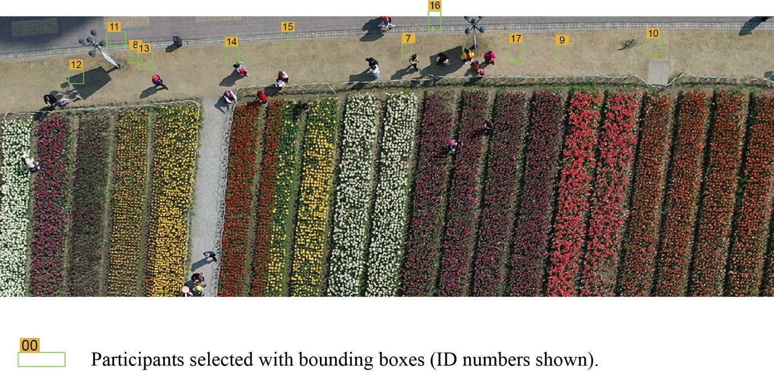
Figure 2.1 Nadir observation of pass-by behaviour. Engagement is measured as the duration a subject remains within the defined path segment.
This method allowed us to capture anonymised trajectories and calculate PBD (dwell time) without interrupting the user. It added ecological realism, but it also brought the "messiness" of the real world: clouds moved, shadows shifted, and social groups clustered. These variables were managed through strict inclusion criteria (excluding those who stopped to chat) and stable-light observation windows (Gehl & Svarre, 2013; Whyte, 1980).

Phase 3: The Middle Ground (Virtual Park)
The field study showed that real-world variables (like crowding) could obscure subtle colour effects. We needed a middle ground—more immersive than a static image, but more controlled than a busy park.
Paper III (Chapter 5) uses a 360° virtual park tour. This allowed participants to "move" through a sequence of spaces where we could manipulate the framing (warm vs. cool) and the colour diversity (two vs. four colours) while keeping the weather and lighting perfectly still. Importantly, it allowed us to introduce a mild stressor (an alarm) to test whether colour helped recovery over time—something unethical or impractical to do to unsuspecting walkers in a real park (Mochizuki-Kawai & Mochizuki, 2020).

Phase 4: Application (Controlled Photography)
The final phase returned to static images, but with a focus on application. We needed to test specific design mixes (analogous vs. complementary) and proportions (e.g., 50:50 vs. 70:30).
Paper IV (Chapter 6) uses photography of real planted plots. I grew and planted pansies in controlled boxes, then photographed them under consistent conditions. This combined the realism of living plant material (texture, slight irregularity) with the experimental control of a lab. It allowed us to produce the "Spec Card" guidance by testing exactly how much of a warm colour is needed to disrupt a cool scheme.

Common design principles and controls
Despite the different modes (online, field, virtual), a set of core principles held the programme together. These rules ensured that when we compared results, we were comparing like with like.

The "Green Surround" Rule
A key lesson from the field study (Paper II) was that context matters. In a red-dominated field, white flowers stood out starkly. In the online studies, we therefore standardised a neutral, foliage-green background. This replicates the typical condition of public planting (beds set in lawns or against hedges) and ensures that colour differences are attributed to the flowers themselves, not to a shifting background contrast (Fairchild, 2013; Shevell & Kingdom, 2008).
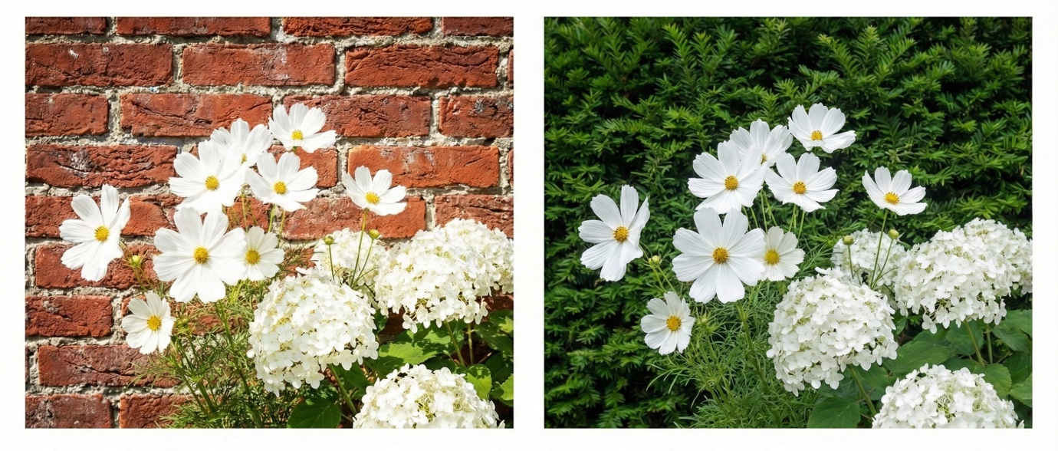
Figure 2.2 The influence of background substrate on visual salience. Left - High contrast/glare. The clash between white petals and red brick creates visual vibration. Right - Neutral/fresh. The green vegetative backdrop standardises the contrast, isolating the flower colour as the primary variable.

Defining the Outcomes (Relaxed vs. Uplifted)
To keep the "story" consistent, we mapped our affect measures to two core states throughout the thesis:
- Relaxed: Corresponds to low-arousal positive states (Serenity). We measure this to see if a design supports calming down (Russell, 1980).
- Uplifted: Corresponds to high-arousal positive states (Joviality). We measure this to see if a design supports waking up or feeling energy.
By treating these as distinct, we avoid the trap of a generic "happiness" score and can give more precise advice to designers. We utilized validated PANAS-family subscales to ensure reliability (Thompson, 2007; Watson et al., 1988).

The Behavioural Signal (Pass-by Duration / PBD)
For the field work, we defined engagement as pass-by duration: the number of seconds a walker’s centroid remained within a specific path segment. This is a "quiet" measure. It assumes that if a planting scheme is successful in creating "soft fascination" (Kaplan & Kaplan, 1989), it will hold the eye and naturally slow the pace, even if only for a few seconds.

The physiological pilots: Trials and lessons

The search for objective biomarkers (Rationale and Pilot Design)
A central challenge in landscape research is the reliance on self-report methods. While psychometric scales (like PANAS) are validated, they are subject to "focusing illusions," where participants may overstate their reaction simply because they know they are being asked about it (Schkade & Kahneman, 1998). To counter this, the original research design sought to triangulate the subjective psychological data with objective physiological evidence.
The aim was to identify if the subjective feeling of "uplift" (reported in the survey) correlated with a measurable biological shift in the autonomic nervous system. To achieve this in a field setting, a pilot study was established using portable, non-invasive devices:
For Neural Activity: Two commercial EEG headsets were trialled: the Muse S headband (Interaxon Inc.) and the Emotiv EPOC X headset (Emotiv Inc.). The Muse is a dry-electrode device, while the Emotiv uses saline-soaked felt sensors to improve conductivity.
For Cardiac Activity: The Polar H10 chest strap, a gold-standard ambulatory sensor used to measure Heart Rate Variability (HRV), widely accepted as an indicator of parasympathetic ("rest and digest") dominance.
However, as detailed below, the transition from the controlled conditions of the laboratory to the complex reality of the garden revealed significant limitations in both hardware and sensitivity.

Technical limitations of commercial EEG
Initial pilot work attempted to capture real-time neural responses using two distinct commercial EEG headsets: the Muse S and the Emotiv EPOC X. It is important to note that these devices were not selected based on cost, but on manufacturer specifications and a growing body of published studies claiming their validity for field research (Aspinall et al., 2015; Krigolson et al., 2017; Mavros et al., 2012; Roe et al., 2013). Furthermore, recent studies have successfully employed EEG to measure responses to specific plant features and flower colours, providing a strong rationale for this methodology (Ding et al., 2022; Xie & Elsadek, 2021). However, rigorous internal testing revealed critical failures in both hardware capability and participant experience in this specific field setting.
The pilot data revealed that the physical design of both headsets compromised signal fidelity in non-clinical settings.
Muse S: As a device designed for consumer meditation, the Muse S prioritizes ease of wear over signal stability. The lack of conductive gel meant that even micro-movements (e.g., visual scanning of the environment) broke the sensor connection, creating severe movement artifacts that masked the neural signal.

Emotiv EPOC X: Although this device uses saline-soaked sensors to mimic clinical "wet" connections, it struggled with physical barriers. Pilot testing revealed that hair volume acted as a significant insulator; for many participants (particularly those with longer or thicker hair), it was impossible to establish a connection sufficient to start the recording. Furthermore, the rigid frame failed to accommodate diverse head shapes, leading to electrode "floating" and data loss.
To address the signal quality issues, advanced post-processing was attempted using MATLAB (The MathWorks Inc.) and the EEGLAB toolbox (Brunner et al., 2013; Delorme & Makeig, 2004). Standard artifact removal protocols were applied, including visual inspection and Independent Component Analysis (ICA). Also, automated cleaning pipelines designed for noisy mobile EEG data, such as PREP and HAPPILEE, were used to interpolate missing channels and reference the signal (Bigdely-Shamlo et al., 2015; Lopez et al., 2021). Despite these rigorous computational attempts to "clean" the data, the signal-to-noise ratio remained too low to reliably distinguish the subtle cognitive shift of "noticing a colour" from the background noise of muscle activity.
Beyond the hardware, the devices introduced a psychological interference. To obtain even a marginal signal, participants had to be instructed to sit perfectly still and minimize blinking or jaw movement. This instruction created a "performance pressure" that directly contradicted the aim of the study. Participants could not focus on the restorative experience of the flowers because they were focused on "being a good subject" and not moving. This verified that the device itself was modifying the user's affective state, rendering the data invalid for measuring naturalistic relaxation or uplift.
Consequently, after consulting with external researchers and exhausting available software solutions for noise reduction, the decision was made to exclude these measures.

Sensitivity limits of Heart Rate Variability (HRV)
Heart Rate Variability (HRV) was trialled as an objective indicator of parasympathetic nervous system activity (relaxation), using the Polar H10 chest strap. This device is widely accepted in research as a reliable, non-invasive tool for monitoring autonomic states (Gilgen-Ammann et al., 2019).
A pilot study was conducted with a sample of 16 participants to test the sensitivity of this measure in the experimental setting. In this pilot, the device successfully captured the physiological shift associated with the induction of stress (i.e., a significant drop in HRV markers following the stressor). However, during the experimental exposure to the floral stimuli, the HRV data showed no significant variance between the different colour treatments.
This lack of sensitivity is likely attributable to the temporal dynamics of the physiological response compared to the psychological one. While self-reported emotions (captured via PANAS) can shift almost instantaneously upon recognizing a visual cue, the parasympathetic nervous system typically requires a longer latency period to down-regulate arousal and stabilise. As noted in methodological reviews (Laborde et al., 2017), short exposure windows are often insufficient for HRV metrics to reliably register a restorative effect.
Based on this lack of differentiation between treatments, the decision was made to exclude the physiological dataset from the main analysis. It is important to acknowledge that this decision was based on the "treatment" variable. Unlike parallel research (conducted by Farris (2024), with a larger sample of N=52 focusing on biodiversity), this pilot (N=16) was insufficiently powered to explore complex interaction effects, such as the correlation between HRV and perceived colour diversity.
This leaves a clear avenue for future research. The psychological data in this thesis later revealed that perception was a stronger predictor of uplift than the designed treatment (Paper III). A logical next step—post-doctorate—would be to revisit the use of HRV with a larger sample size to test if "Perceived Colour Diversity" correlates with physiological changes. It is plausible that participants who perceive planting as "highly diverse" exhibit a physiological response that is masked when data is averaged solely by treatment group in a small pilot sample.

Conclusion: Exclusion of Physiological Measures
The pilot studies demonstrated that while objective physiological data is desirable in theory, the application of commercial EEG and HRV sensors in this specific field setting proved methodologically flawed. The devices introduced significant artifacts—both in terms of signal instability and the "instructional load" placed on participants—which obscured the subtle aesthetic responses being measured.
Consequently, these physiological metrics were excluded from the final analysis.

Summary of methods
The following table summarises how the four papers fit together, showing the progression from simple hue screening to complex palette application.
Table 2.1 Overview of studies, stimuli, and key controls.
Study | Mode & Stimuli | What Changed (The Variable) | Key Controls (What stayed the same) | Outcome Measures
Paper I  (Baseline) | Online  Photomontage of daisy-like flowers | Single Hue  (8 colours) | • Green foliage background  • Composition & lighting  • No sound/scent | • Relaxed / Uplifted  • Preference
Paper II  (Field) | In-Person  Drone video of real tulip rows | Row Colour  (Single, Mix, Gradient) | • Path width & surface  • Bed geometry  • Observation weather window | • Pass-by Duration  (Behaviour)
Paper III  (Mechanism) | Virtual  360° park tour on screen | Tone & Diversity  (Warm/Cool; 2 vs 4 colours) | • Park layout & exposure time  • Green background  • Stressor timing | • Serenity / Joviality (PANAS)  • Perceived Diversity
Paper IV  (Application) | Online  Photos of planted pansy plots | Combination & Proportion  ( Analogous/Complementary 50 :50 etc.) | • Total floral area  • Background & lighting  • Plant species | • Relaxed / Uplifted  • Preference

References
Aspinall, P., Mavros, P., Coyne, R., & Roe, J. (2015). The urban brain: analysing outdoor physical activity with mobile EEG. British journal of sports medicine, 49(4), 272-276.
Bigdely-Shamlo, N., Mullen, T., Kothe, C., Su, K.-M., & Robbins, K. A. (2015). The PREP pipeline: standardized preprocessing for large-scale EEG analysis. Frontiers in neuroinformatics, 9, 16.
Brunner, C., Delorme, A., & Makeig, S. (2013). Eeglab–an open source matlab toolbox for electrophysiological research. Biomed. Tech, 58(10.1515).
Daniel, T. C., & Meitner, M. M. (2001). Representational validity of landscape visualizations: the effects of graphical realism on perceived scenic beauty of forest vistas. Journal of Environmental Psychology, 21(1), 61-72.
Delorme, A., & Makeig, S. (2004). EEGLAB: an open source toolbox for analysis of single-trial EEG dynamics including independent component analysis. J Neurosci Methods, 134(1), 9-21. https://doi.org/10.1016/j.jneumeth.2003.10.009
Ding, N., Zhong, Y., Li, J., Xiao, Q., Zhang, S., & Xia, H. (2022). Visual preference of plant features in different living environments using eye tracking and EEG. PLoS One, 17(12), e0279596. https://doi.org/10.1371/journal.pone.0279596
Epicoco, D., Jonauskaite, D., Mohr, C., & Parraga, C. (2024). Can we estimate which colors our participants see. Comparing results from different gamma correction methods. i-Perception, 15(5).
Fairchild, M. D. (2013). Color appearance models. John Wiley & Sons.
Farris, S. (2024). Does increasing urban biodiversity enhance stress recovery? New experimental evidence University of Sheffield].
Gehl, J., & Svarre, B. (2013). How to study public life (Vol. 2). Springer.
Gilgen-Ammann, R., Schweizer, T., & Wyss, T. (2019). RR interval signal quality of a heart rate monitor and an ECG Holter at rest and during exercise. European journal of applied physiology, 119(7), 1525-1532.
Kaplan, R., & Kaplan, S. (1989). The experience of nature: A psychological perspective. Cambridge university press.
Krigolson, O., Williams, C., Norton, A., Hassall, C., & Colino, F. (2017). Choosing MUSE: validation of a low-cost, portable EEG system for ERP research. Front. Neurosci. 11, 109 (2017). In.
Laborde, S., Mosley, E., & Thayer, J. F. (2017). Heart rate variability and cardiac vagal tone in psychophysiological research–recommendations for experiment planning, data analysis, and data reporting. Frontiers in Psychology, 8, 213.
Lopez, K., Monachino, A., Morales, S., Leach, S., Bowers, M., & Gabard-Durnam, L. (2021). HAPPILEE: the Harvard automated processing pipeline in low electrode electroencephalography, a standardized software for low density EEG and ERP data. bioRxiv, 2021.2007. 2002.450940.
Mavros, P., Coyne, R., Roe, J., & Aspinall, P. (2012). Engaging the brain: Implications of mobile EEG for spatial representation. eCAADe 2012-The 30th International Conference on Education and research in Computer Aided Architectural Design in Europe,
Mochizuki-Kawai, H., Matsuda, I.,, & Mochizuki, S. (2020). Viewing a flower image provides automatic recovery effects after psychological stress. Journal of Environmental Psychology, 70, 101445. https://doi.org/10.1016/j.jenvp.2020.101445
Roe, J., Aspinall, P., Mavros, P., & Coyne, R. (2013). Engaging the brain: The impact of natural versus urban scenes using novel EEG methods in an experimental setting. Journal of Environmental Sciences, 1(2), 93-104.
Schkade, D. A., & Kahneman, D. (1998). Does living in California make people happy? A focusing illusion in judgments of life satisfaction. Psychological science, 9(5), 340-346.
Sevenant, M., & Antrop, M. (2011). Landscape representation validity: a comparison between on-site observations and photographs with different angles of view. Landscape Research, 36(3), 363-385.
Shevell, S. K., & Kingdom, F. A. (2008). Color in complex scenes. Annu. Rev. Psychol., 59(1), 143-166.
Stamps III, A. E. (2010). Use of static and dynamic media to simulate environments: A meta-analysis. Perceptual and motor skills, 111(2), 355-364.
Thompson, E. R. (2007). Development and validation of an internationally reliable short-form of the Positive and Negative Affect Schedule (PANAS). Journal of Cross-Cultural Psychology, 38(2), 227–242. https://doi.org/10.1177/0022022106297301
Watson, D., Clark, L. A., & Tellegen, A. (1988). Development and validation of brief measures of positive and negative affect: the PANAS scales. Journal of personality and social psychology, 54(6), 1063.
Whyte, W. H. (1980). The social life of small urban spaces (Vol. 116). Conservation Foundation Washington, DC.
Xie, J., Liu, B.,, & Elsadek, M. (2021). How can flowers and their colors promote individuals’ physiological and psychological states during the COVID-19 lockdown? International Journal of Environmental Research and Public Health, 18(19), 10258. https://doi.org/10.3390/ijerph181910258

Chapter 3: Paper I
Flowers – Sunshine for the soul! How does floral colour influence preference, feelings of relaxation and positive up-lift?
Context for this chapter: This first paper lays the foundation for the entire programme. Before we could investigate how complex planting schemes work, we first needed to establish a "vocabulary" of single colours.
At the start of the research, it was unclear whether specific flower colours consistently triggered relaxation or uplift in a general population, or if personal preference simply overrode these associations. Conducted as an online survey (N=670), this study screens eight distinct hues using realistic photomontages. By holding the composition and green surround constant, it isolates colour as the active variable.
Role in the thesis: This chapter answers RQ1 (In realistic images of planted beds, are some single flower colours considered more relaxing or uplifting than others?). It provides the baseline data—identifying "Cool/Blue" as the driver for relaxation and "Warm/Orange-Yellow" for uplift—that justifies the colour choices used in the later field and virtual experiments. It also introduces the crucial finding that white is a "flexible" colour, appearing in both relaxed and uplifted palettes, a theme that re-emerges in the final design guidance.
Author Contribution: As lead author, I was responsible for the study conceptualisation, data collection, statistical analysis, and writing the manuscript. Co-authors provided supervisory guidance and editorial review.

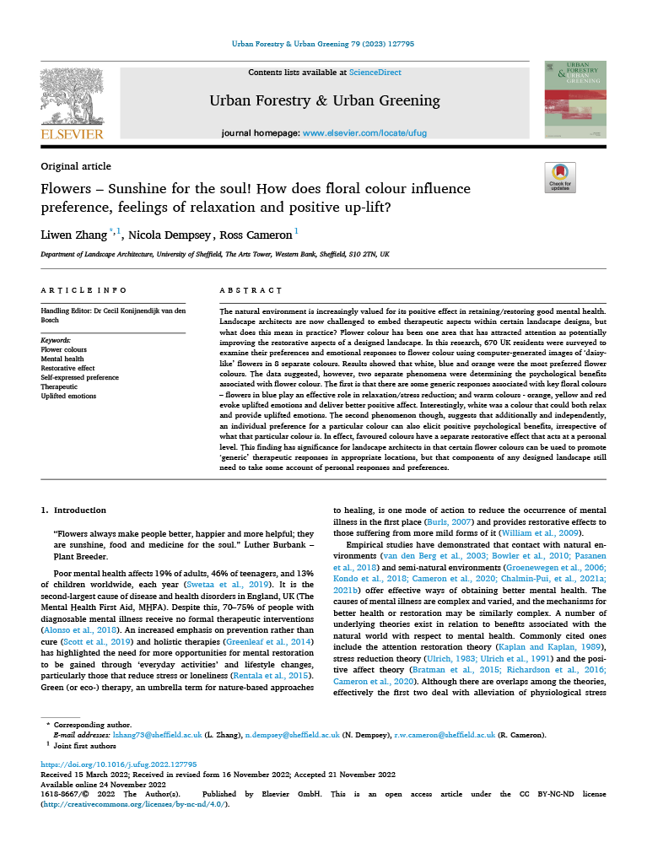
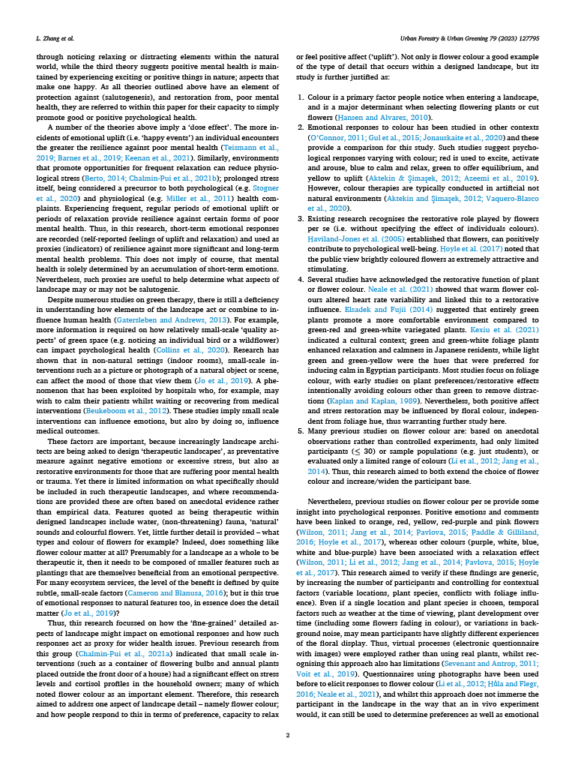
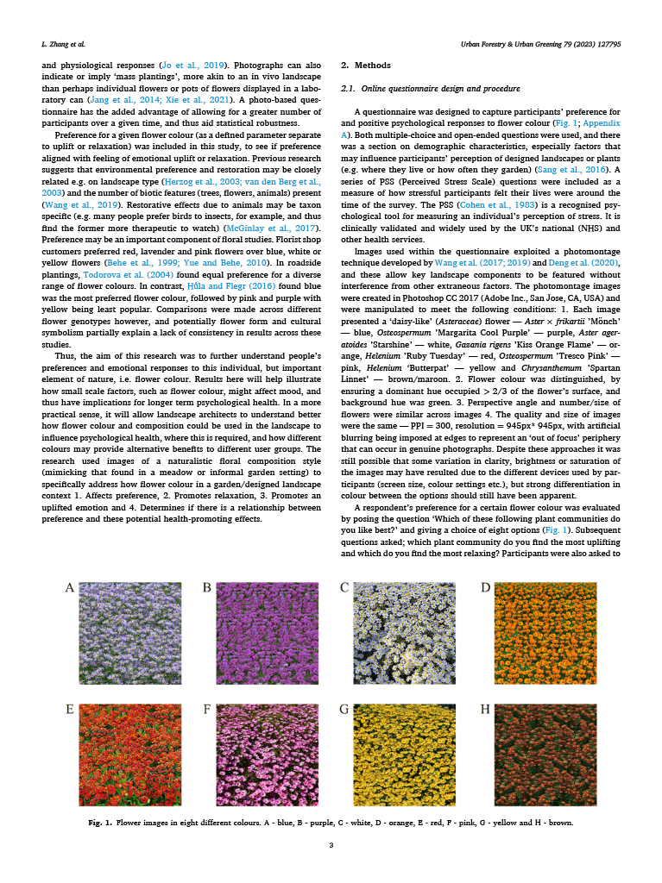
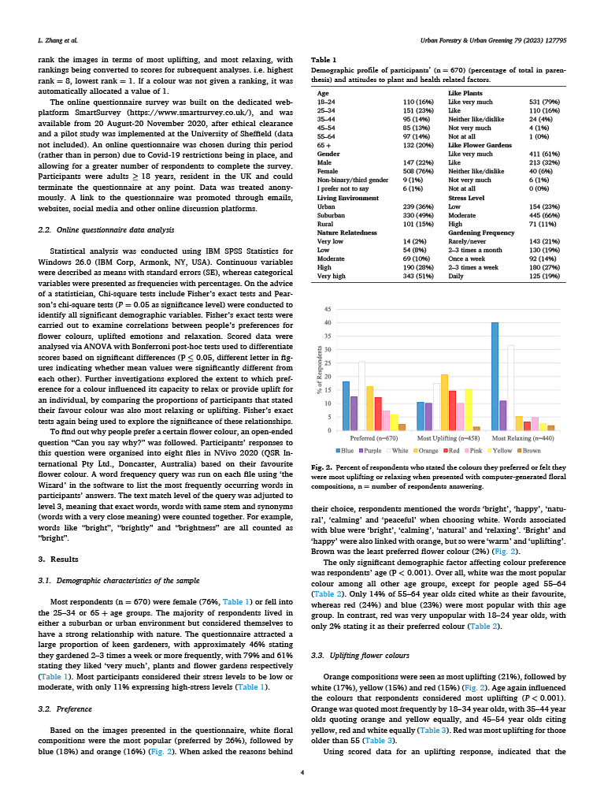
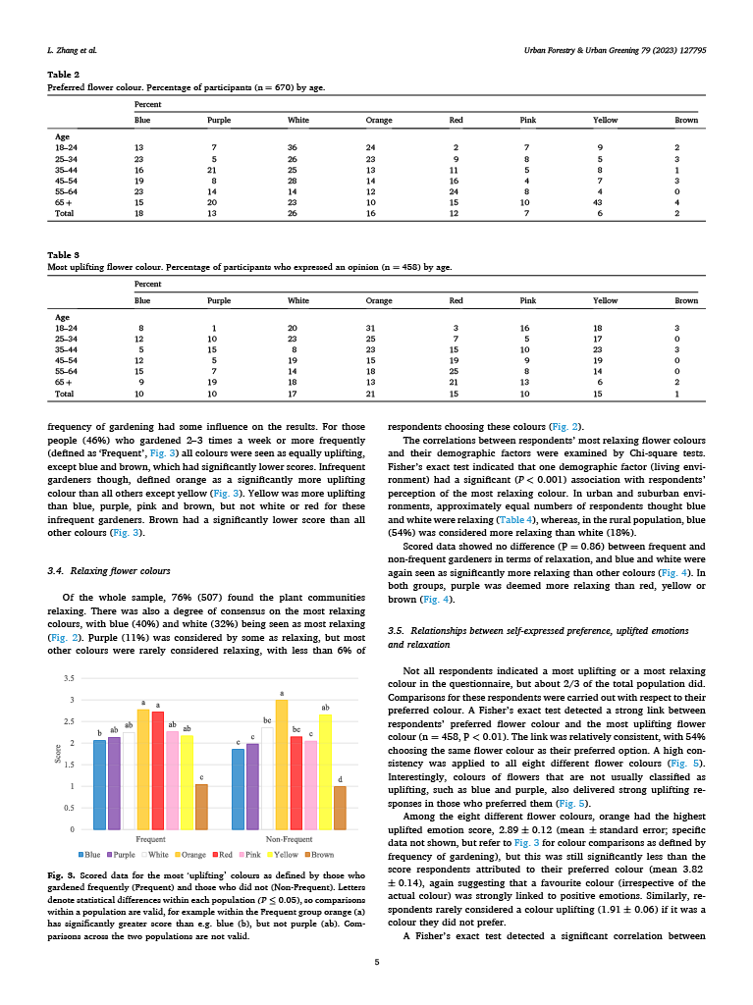
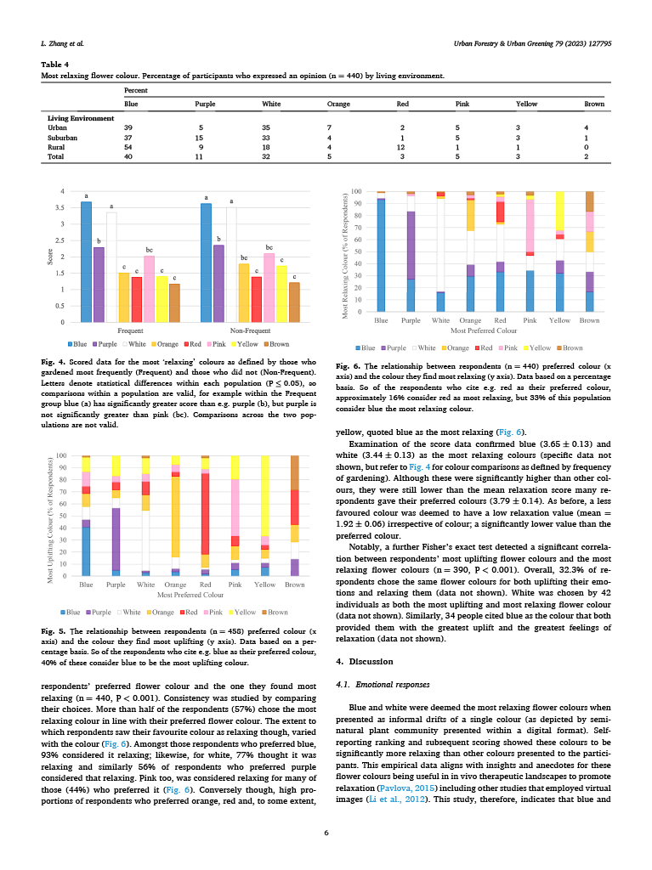
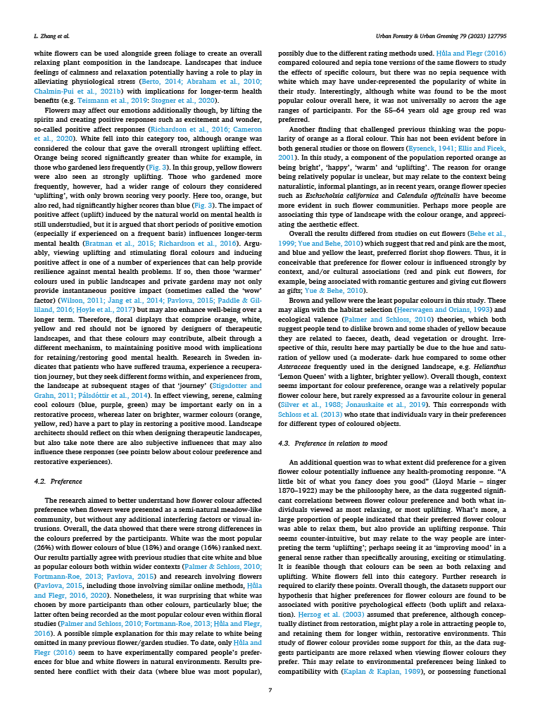
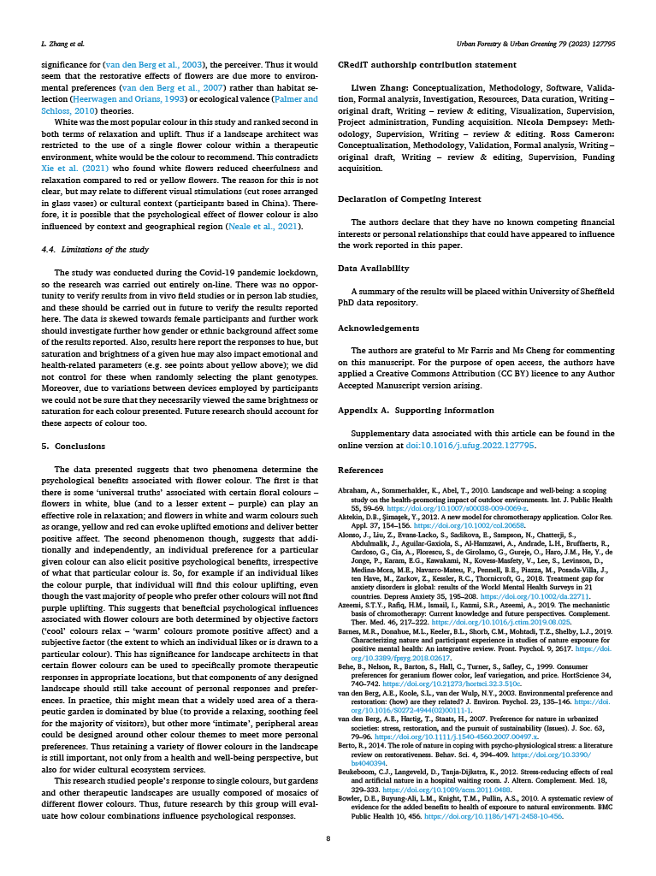
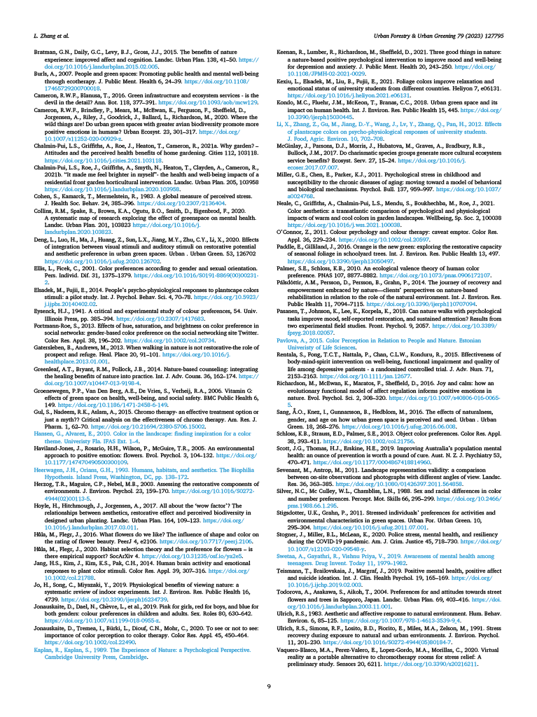


Chapter 4: Paper II
‘Petals, People, and Pathways’ - How flower colour influences walking behaviour in a natural setting using drone-based observation? [Unpublished Manuscript]
Context for this chapter: Paper I told us what people say about colour on a screen. This second paper asks whether those aesthetic reactions register in what people do in the real world.
Moving from the controlled environment of an online survey to a public park in Suzhou, China, this study addresses the "ecological validity" gap. It uses a low-intrusion method—nadir drone videography—to observe visitors walking beside long rows of tulips. By measuring pass-by time (dwell time), it tests whether the chromatic characteristics of the planting (single hues vs. mixes; high vs. low contrast) are sufficient to hold attention and slow walking pace during a natural stroll.
Role in the thesis: This chapter answers RQ2 (Do flower colour and combinations influence pass-by time?). It serves as the "behavioural reality check" for the programme. It confirms that the "soft fascination" of planting does translate into measurable behaviour, with multi-coloured and high-contrast rows holding attention longer than subtle monochrome ones. Significantly, it highlights the influence of the surroundings: showing that a red-dominated background changes how we perceive adjacent white flowers, a finding that reinforced the need for the strict "green surround" control in the subsequent chapters.
Author Contribution: As lead author, I was responsible for the study conceptualisation, data collection, statistical analysis, and writing the manuscript. Co-authors provided supervisory guidance and editorial review.

‘Petals, People, and Pathways’ - How flower colour influences walking behaviour in a natural setting using drone-based observation?
Liwen Zhang, Nicola Dempsey, Ross Cameron, Xi Lu

Highlights
- Drone video timed how long people lingered by each row of tulips.
- Multicolour rows showed the longest pass-by duration.
- Ivory and yellow colours encouraged longer stays.
- Two-colour rows were intermediate between their single hues.
- Use more colour or strong contrast.

Abstract
Urban green spaces can scaffold light‑intensity activity, but the micro‑cues that keep people walking—second by second—are rarely specified. We tested whether flower colour relates to on‑site walking in a real park. Using unobtrusive drone footage and frame‑by‑frame tracking, we measured dwell time (pass‑by duration) at one‑second resolution as 162 visitors walked past 22 tulip rows spanning 12 chromatic characteristics in Xinhu Tulip Park, Suzhou. Pass‑by duration differed by chromatic characteristic and category: multicolour rows elicited the longest durations; among single hues, ivory and yellow ranked highly; orange‑red was shortest. At the sequence scale, locally higher chromatic diversity showed a non‑significant trend towards longer totals. Two‑colour rows typically sat between their component hues (an “averaging” pattern). Together, these results provide field-based evidence that chromatic diversity and selected hues are associated with longer pass-by duration, offering low‑cost, seasonally adjustable design levers—diversity and contrast—for parks and streetscapes aiming to support everyday walking.
Keywords: Flower colour; Walking behaviour; Urban green space; Visual attention; Drone-based observation

1. Introduction
Urban walking is a fundamental component of public health, yet the specific micro-scale environmental features that encourage people to slow down, linger, and engage with their surroundings remain under-researched. While the benefits of green space for mental restoration are well established (Hartig et al., 2003), less is known about how specific planting aesthetics—second by second—shape these behaviours. In response, public health strategies have increasingly emphasised the promotion of regular, moderate-intensity activity—especially walking, which is widely accessible, cost-free, and adaptable across age groups and physical capacities (Tudor-Locke & Bassett, 2001). Walking is widely prioritised in national health policies and global guidance as a scalable, low-cost behaviour for population health (WHO, 2010, 2019).
Over recent decades, extensive research has highlighted the role of the natural environment, particularly urban green spaces, in promoting physical activity. (Giles-Corti et al., 2005; Mears et al., 2020; Poortinga et al., 2024; Raza et al., 2024; Van den Berg et al., 2003). In addition, it is evident that physical activity in natural environments not only improves people's physical health but also enhances mental well-being by making individuals feel restored, less stressed, and more positive. (Burls, 2007; Hartig et al., 2003). These findings prompt specific questions: which particular physical features in green spaces motivate people to go further (promoting more activity/exercise), remain longer, and participate more actively? Parks and other green spaces support health in two ways: first, by getting people moving (i.e. physical health by walking further or longer e.g. to reach one or more features); and second, once at a feature of interest by slower passage / close observation of that feature (e.g. viewpoints, strong visual plantings/flowers, water features, unusual or colourful animals etc.) i.e. dwell time, that can encourage / support mental restoration. Recent GPS, accelerometer, and review data indicate that exposure to green spaces is associated with increased walking and physical activity (Lee et al., 2024; Pasanen et al., 2024). Meta-analyses and reviews also show that exposure to natural settings supports restoration and mental health, consistent with attention-restoration accounts (Bratman et al., 2019; Ohly et al., 2016; Stevenson et al., 2018). We focus on this second aspect—dwell time—and measure it specifically as pass-by duration (PBD), defined as the time a participant stays and observes a potentially restorative feature. In our research these features are colourful rows of tulip (Tulipa) flowers, which participants (park visitors) walk past linearly and may stop or slow down (dwell time) to observe individual flower rows or not. By aligning pathway sections with different rows of tulips and observing how long it takes visitors to pass through these sections (by drone cameras above the site) we can correlate which tulip flower colours hold the visitors attention for longest.
Current green-space frameworks classify attributes into functional, safety, destination, and aesthetic features (Pikora et al., 2003), yet often give little attention to small-scale and short-term walking dynamics. Among these, aesthetic qualities—such as scenery, vegetation type, spatial coherence, and colour—play a critical role in recreational walking, mainly when walking is undertaken for leisure rather than transportation (Ball et al., 2006). However, aesthetic features are often not clearly defined in practice, and their impact on behaviour is seldom isolated or measured. (Gobster et al., 2007; Nasar, 1994).
Flowering plants are some of the most noticeable and culturally important features in urban green spaces, providing visual interest, seasonal changes, and multisensory appeal (Graves & Turner, 2017; Hoyle et al., 2018). Although extensive research has examined broader vegetation preferences, little attention has been paid to how specific visual features of flowers—such as colour—affect behavioural engagement. Flower colour is a perceptually salient and relatively manipulable aesthetic dimension. As noted by Hůla and Flegr (2016), it serves as a discrete aesthetic variable with high symbolic and aesthetic value. However, this characteristic remains underexplored in behavioural research (Huang & Lin, 2020; Zhang et al., 2022).
Psychology and environmental aesthetics theories have long established the importance of colour for restoration. Research shows that colour affects emotional states (Kaya & Epps, 2004), perceptions of time duration (Shi & Huang, 2017; Zakay & Block, 1997), attention processes (Elliot & Maier, 2012), and also influences decision-making and motivation (Mehta & Zhu, 2009). These effects are often framed in terms of attention: top-down (goal-driven, when people look for something specific) and bottom-up (stimulus-driven, when salient features in the environment attract visual attention (divert one’s gaze involuntarily) , e.g., strong colour contrast, novelty, clear figure–ground). This framing supports the expectation that colour can shape moment-to-moment walking. Chromatic contrast and complexity can capture attention, subtly slowing pace and extending dwell time. In what follows, we use the term “dwell time” as a plain descriptor for how long visitors linger in front of a row. We quantified PBD as the precise time a visitor’s centroid remained within the row-specific path segment (Figure 5), calculated as the number of video frames (seconds) between the first entry and final exit. This usage is distinct from “dwell time” in eye-tracking/HCI, where it refers to fixation-based measures.
Accordingly, we examined whether PBD in the landscape varies with flower chromatic diversity and with specific two-colour flower combinations. Guided by accounts of attentional capture and soft fascination, we hypothesised that multicolour floral displays and stronger contrast between the flowers and their immediate background to be associated with longer PBD (i.e. longer periods of observation), while the dwell time associated with rows of flowers composed of two colours would tend to intermediate between their component hues (Elliot & Maier, 2014; Kaplan, 1995; Nasar, 1994; Schloss & Palmer, 2011).
Numerous studies show that colours influence preferences and perceptions of proximity to environments, affecting aesthetics and design choices (Ding et al., 2022; Elliot & Maier, 2014; Graves & Turner, 2017; Hoyle et al., 2018; Nasar, 1994). Building on this literature, we treat PBD as an engagement proxy—a moment-to-moment behavioural response sensitive to visual salience and affect. Consequently, if colour heightens soft fascination or bottom-up attention, PBD should vary systematically with chromatic characteristics.
Most prior studies on planting and behaviour rely on self-reporting (questionnaires/diaries) or direct/systematic observations, each with known limitations for second-by-second engagement (e.g., recall and reactivity) (Prince et al., 2008; Silsbury et al., 2015). Laboratory work has clarified the perceptual mechanisms of colour, but field evidence linking visual aesthetics with fine-grained walking behaviour remains scarce. Objective, image-based approaches—including fixed cameras and systematic observation (McKenzie et al., 2006)—and, more recently, drones (unmanned aircraft systems, UAS) can reduce reactivity and data/actions to precise timing in public settings (McKenzie & Van Der Mars, 2015).
To address measurement challenges in situ, we quietly observed behaviour and accurately measured the time spent in various floral colour zones. Connecting perceptual aesthetics with actual behaviour, this study seeks to progress environmental psychology and offer guidance for designing urban green areas that enhance health. This includes factors/elements that draw attention within the landscape and can encourage movement towards them (for example, greater walking exercise); and how those elements may promote engagement, such as soft fascination. Further, by focusing on a single plant form within a constrained path layout, we minimise confounding influences unrelated to colour (e.g., plant morphology, width or extent of planting, wider landscape context), improving scientific validity whilst adopting a systematic approach that is easier to interpret.
Specifically, the central research questions guiding this investigation are:
- Do PBD differ when visitors are exposed to different floral colours and combinations?
- Under limited chromatic diversity, which two-colour combinations show longer PBD relative to single hues?
This study advances the literature by: (i) testing chromatic diversity and specific hues in a real-world park using unobtrusive, measures of behaviour; (ii) integrating attentional/soft-fascination incidents/responses with approach–avoidance perspectives to interpret on-site PBD; and (iii) providing actionable guidance for planting schemes (multicolour, preferred hues, and contrast with local background) to support health-promoting walking.

2. Methods

2.1 Study preparation

2.1.1 Study site selection
This study was conducted at Xinhu Tulip Park, Wujiang District, Suzhou, Jiangsu Province, China (Figure 1). The park is surrounded by residential buildings, accessible lawns, and pedestrian walkways (Figure 1). On-site measurements estimated the study area at approximately 4,000 m².
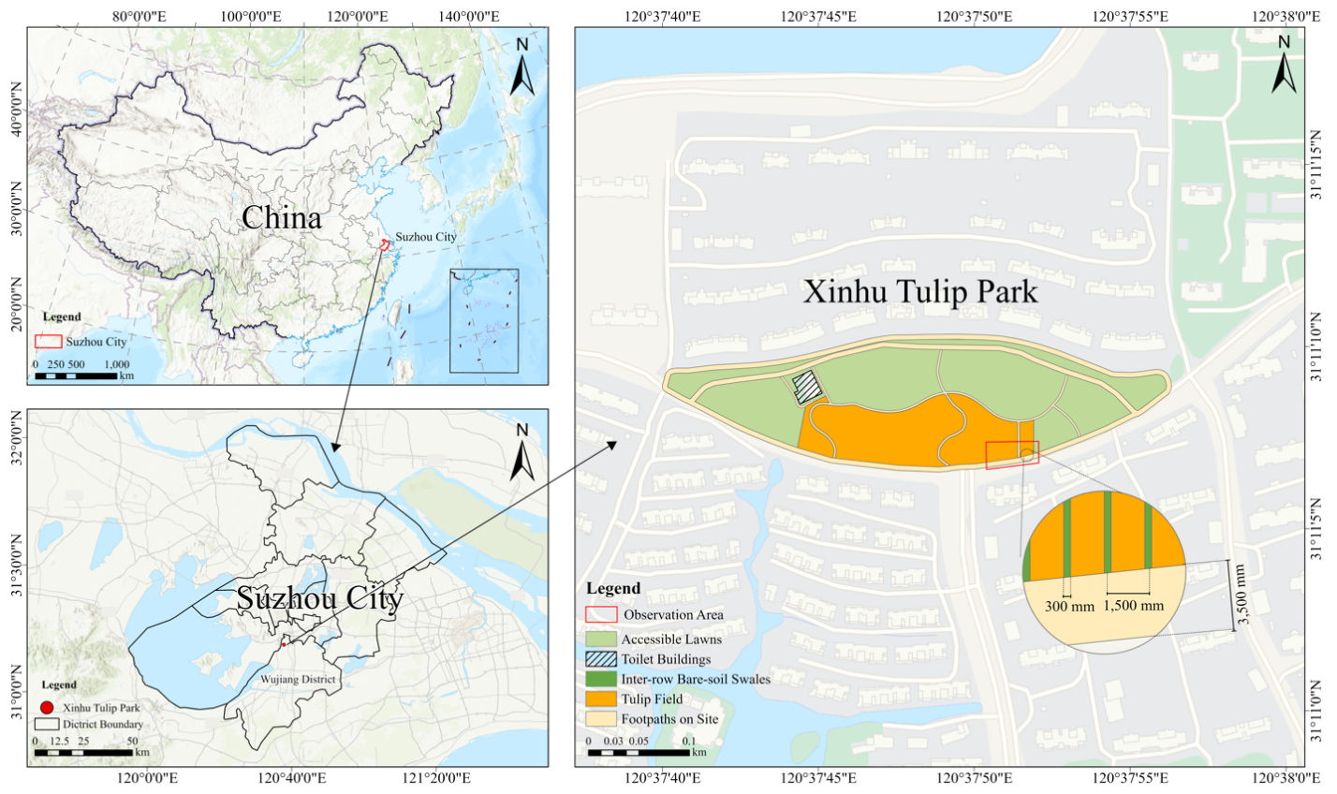
Figure 4 Study area and site layout (Xinhu Tulip Park, Suzhou, China).
The site selection was guided by Pikora et al. (2003)’s framework, which identifies four environmental features influencing walking: functional, safety, aesthetic, and destination. Each of these was thoughtfully evaluated:
  - Destination: The field was located near a residential area and open to the public 24 hours a day without entry fees. The moderate number of daily visitors allowed for the smooth, unimpeded observation of walking behaviour.
  - Functional: The tulip field was bordered by 500 mm-high bamboo fencing to prevent entry into the planting area. Visitors walked along designated 3,500 mm wide paths, weaving between the flower beds. Surrounding lawns and other areas were open for recreation but kept separate from the walking paths to facilitate analysis of walking behaviour.
  - Safety: The site was a managed, semi-enclosed area with oversight from a dedicated security team, ensuring both personal and traffic safety for visitors.
  - Aesthetic: The field exclusively contained tulips (Tulipa cultivars), which exhibit a wide variety of colours but have relatively uniform shapes and textures. Planting was organised into 22 rows, each 1,500 mm wide and separated by 300 mm swales of bare soil. This consistency in plant type and layout allowed flower colour to be isolated as the key aesthetic variable. Flower colours and row design was determined by the Local Authority Horticultural team, not the researchers of this paper.
Each flower row exhibited a distinct chromatic characteristic—monochromatic, gradient, two-colour, or multicolour—and was indexed A–L for analysis (see Figures 2 & 3). Alphabetic labels are mnemonic only; models used the letter IDs and the four categories. To isolate colour, each row comprised a single named tulip cultivar; two-colour rows paired two single-hue cultivars with approximately equal frontage, and gradient rows formed a smooth transition between neighbouring hues (e.g., yellow→orange, pink→ivory, pink→orange). This design allowed us to examine colour type and chromatic complexity in relation to PBD.

2.1.2 Measurement approach
Research on physical activity usually employs self-report instruments such as questionnaires or diaries or conducts direct or systematic observations, each with its own benefits and limitations (McKenzie & Van Der Mars, 2015; Prince et al., 2008; Silsbury et al., 2015). Given the 1,500 mm row width and typical walking speeds (about 1.4 m·s⁻¹), passing a row usually takes about 1–2 s; manual timing is impractical at this resolution. We therefore used unobtrusive drone video to capture behaviour at second-level granularity. A DJI Mavic 2 recorded overhead footage at 50 m with a nadir (vertical) camera, providing a clear top-down view of the path and rows. To minimise privacy risks, footage was captured at 50 m nadir orientation, and analyses relied solely on centroid trajectories; no personally identifiable information was collected. Meanwhile, the altitude of 50m ensured it remained unobtrusive, and that rotor noise was inaudible to pedestrians against the park’s ambient background noise.
Although the broader site included additional tulip areas, the observation segment consisted of 22 rows located near the main pedestrian entrances along the park’s primary walking route. This segment was chosen for three reasons: (1) high pedestrian traffic providing abundant behavioural data; (2) a continuous, linear layout with consistent width and minimal obstructions, ideal for drone observation and frame-by-frame movement analysis; (3) diverse colours within a controlled space, enabling colour comparisons while maintaining consistent background scenery, terrain, and visitor density.
We use “chromatic characteristics” to denote four field-realistic types: multicolour (A), monochromatic (B, C, F, H, J, L), gradient [more than one colour in the flower] (D, I, K), and two-colour combination [two Tulipa taxa with different flower colours] (E, G). “Pass-by duration” (PBD) is the time a visitor’s centroid remains within the row-specific path segment in front of each flower row. Alphabetic labels are for ease of reference; analyses used the letter IDs and the four categories. We focus on Tulipa (hybrid tulips— Division 3 Triumph forms and the visually similar Division 4 Darwin cultivars) to standardise morphology and spacing. While specific cultivar records were not retained by the park authority, all selected rows displayed uniform height and corolla shape characteristic of these divisions. Each row comprises a single named cultivar (or controlled mix), thereby isolating colour as the primary aesthetic attribute (see Figure 3).
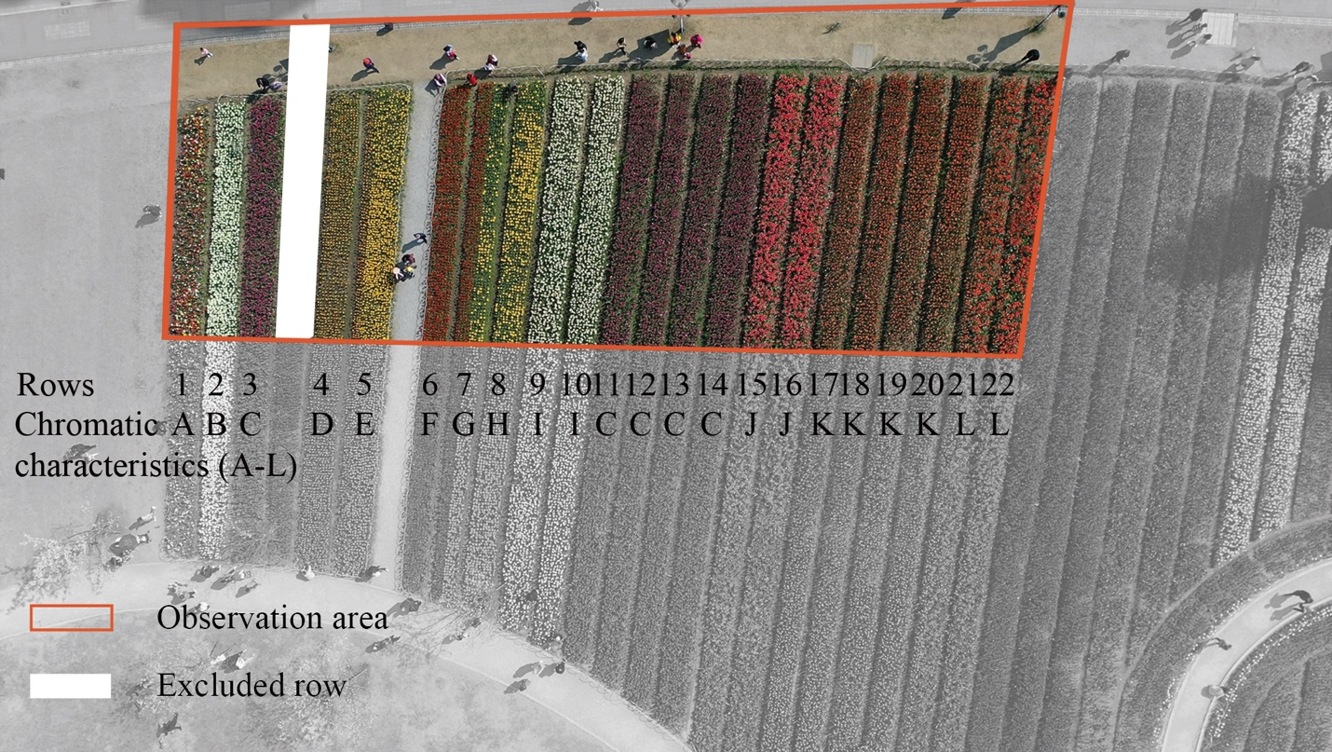
Figure 2 Observation area and row-level chromatic layout. Nadir drone image of the study plot. The red rectangle marks the observation area; rows 2–22 are labelled with their chromatic characteristics (A–L) used in the analyses.

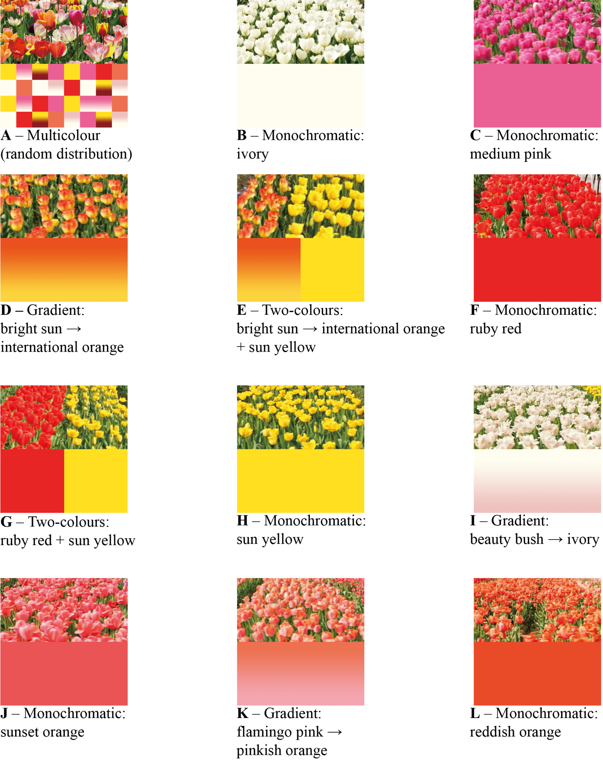
Figure 3 Twelve chromatic characteristics (A–L): field photos (top) and schematic swatches (bottom). Categories: multicolour (A), monochromatic (B, C, F, H, J, L), gradient (D, I, K), and two-colour combination (E, G). Colours are illustrative rather than calibrated.

2.2 Data collection and participant selection

2.2.1 Methodological rationale and protocol development
The choice of an unobtrusive aerial behavioural-mapping method draws on a developing tradition in landscape and pedestrian-behaviour research. Behavioural mapping of public space has long relied on ground-based observation, established by Whyte (1980) and codified by Gehl and Svarre (2013), where trained observers record visitor activity in defined zones. While these methods remain robust, they impose practical constraints: observers can survey only limited areas at a time, and their visible presence can influence the behaviours they record (Hawthorne effect). Unmanned aerial vehicles (UAVs), or drones, have emerged in the past decade as a complementary methodology for pedestrian-behaviour observation. Park and Ewing (2022) provided one of the first systematic evaluations of UAV usability for pedestrian observation, demonstrating that drone-captured footage at appropriate altitudes can yield reliable counts and trajectories without observer intrusion. More recent work by Parra-Ovalle et al. (2023) extended this approach, validating inter-rater reliability for UAV-based behavioural mapping in pedestrian streetscapes and demonstrating that drone observation can integrate with GIS-based spatial analysis to yield rich behavioural datasets at scale.
For this study, drone observation was selected over ground-based methods for three reasons. First, the public-space setting and the visual-attention focus of the research made ground-based intercept surveys disruptive: pilot attempts at on-site questionnaires during the first observation day revealed that stopping visitors interrupted the very pass-by behaviour we sought to measure. Second, the nadir (downward-facing) camera orientation eliminated participant awareness of being observed, removing social-desirability and self-presentation effects that often complicate field behavioural research. Third, the aerial vantage allowed simultaneous capture of multiple flower rows and their adjacent path segments, enabling row-level analysis of pass-by duration that ground-based observation could not deliver efficiently.
The specific protocol parameters — observation altitude, camera angle, path-segment definition, and inclusion criteria — were developed through pilot footage iteration. A 50-metre observation altitude was selected to balance image resolution against face-level anonymisation, following recommendation from Park and Ewing (2022) that altitudes above 30 metres render individual identification difficult while preserving sufficient resolution for trajectory tracking. Stable-light observation windows were chosen to minimise shadow-driven variation in flower colour rendering, consistent with the general guidance of Gehl and Svarre (2013). Inclusion and exclusion criteria — excluding visitors who stopped to converse, photograph, or cluster in groups larger than three — were adapted from Whyte's (1980) original observation conventions for public-space behaviour, modified to suit a flower-display rather than a plaza setting.

2.2.2 Operational procedures
The observations were conducted in a non-intrusive way in a public space. Drone flights followed all local rules, with footage captured gently from 50 meters above, looking straight down. We only looked at anonymised centroid paths to keep everything private. No information relating to individuals’ identity was collected. Ethical approval was obtained from the Department of Landscape Architecture’s Ethics Administrator, University of Sheffield, on 20 April 2021 (approval no. 034723); informed consent was waived for the reasons stated above.
A total of twelve 15-minute videos were recorded at different times on 24 and 25 March 2021. Two were selected for analysis: one captured between 10:00–10:15 and the other between 14:30–14:45. These sessions were chosen for their ideal lighting conditions (overcast weather) and moderate, stable foot traffic, ensuring clear observations without glare, shadows or crowding. Other videos were excluded due to poor lighting conditions, low pedestrian activity, or frequent occlusions. The temperatures were 16°C and 18°C, respectively.
Visitors included all individuals who walked the entire observation path without pausing or engaging in non-walking behaviour. Eight visitors were excluded due to phone use, waiting, or unclear behaviour. The final sample comprised 162 visitors (87 morning; 75 afternoon), consistent with urban movement studies where detailed behavioural mapping often relies on moderate samples (Gehl & Svarre, 2013).

2.3 Video processing and walking time calculation
Each 15-minute video was recorded in 4K at 30 fps and stabilised in Adobe Premiere Pro. Footage was exported into 900 stills per video (1 frame s⁻¹) while maintaining resolution and alignment. Using DarkLabel software, each participant was tagged once with a bounding box; the software then tracked the box centroid frame by frame across the observation area (Figure 4). The pre-mapped position of each flower row determined which row a participant was passing at any moment. After basic quality checks confirmed continuous tracking and correct row assignments, we recorded the walking direction for each pass-by (left-to-right or right-to-left). The primary analyses combined both directions; we also ran direction-specific checks and reported them in the Results.
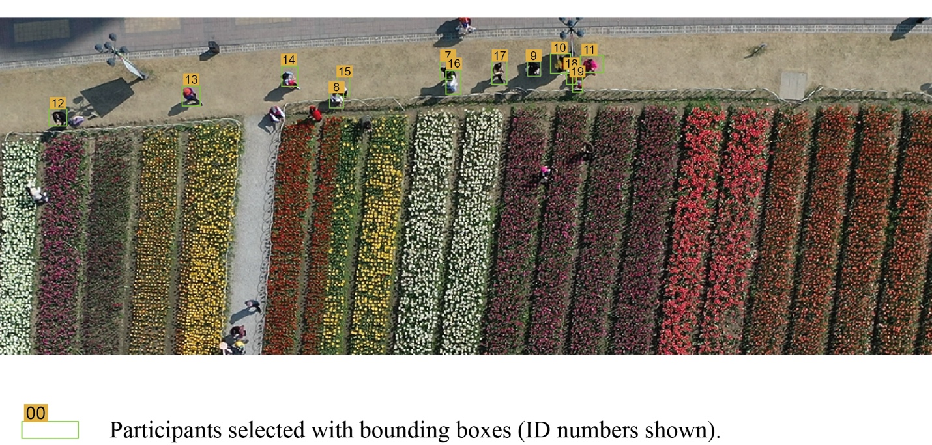
Figure 4 Participant selection and anonymised IDs in the observation area. Walkers were selected with bounding boxes and assigned study IDs for tracking. Analyses used nadir footage and centroid trajectories only.
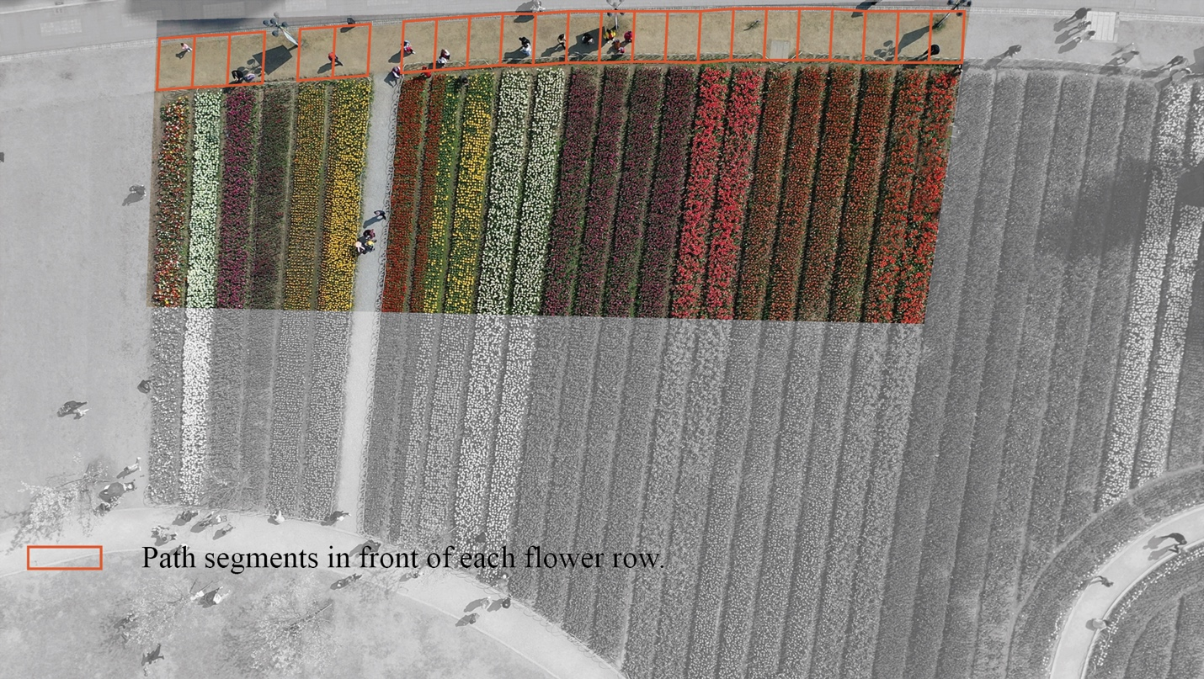
Figure 5 Segmentation of the footpath for timing PBD. The path in front of each flower row was partitioned into row-specific segments (orange rectangles).

2.4 Data analysis
We first analysed the 12 chromatic characteristics (A-L) using descriptive statistics and one-way ANOVA. We then tested differences across the four chromatic categories defined in Methods (multicolour, monochromatic, gradient, two-colour) using a one-way ANOVA and Tukey’s HSD (α = 0.05) for pairwise comparisons. To examine sequence-level effects, we grouped the 21 rows (excluding the first) into three sections (A: rows 2–8; B: 9–15; C: 16–22) reflecting high/medium/low local diversity and compared average PBD across sections via one-way ANOVA. Finally, ANCOVA tested whether two-colour rows were intermediate relative to their component single colours: E as a function of D and H, and G as a function of F and H. Row 1 (multicolour) was included in row-level analyses but was not assigned to sections. To corroborate the continuous PBD metric, we also calculated a binary stop occurrence variable. A ‘stop’ was defined as any event where a visitor remained within a row segment for ≥1.0 s (calculated based on frame count). We compared the percentage of stop events across chromatic categories.
Model assumptions (normality of residuals, homogeneity of variances, independence) were examined using standard diagnostics; Welch’s ANOVA was used where appropriate. Key inferences were also checked in a robustness analysis, trimming the upper 1% of PBD. All analyses were conducted in IBM SPSS Statistics (v. 28); two-tailed α = 0.05.

3. Results

3.1 Effect of flower colour on PBD
Consistent with the 1.5 m row width and typical walking speeds, PBD were brief and right-skewed (N = 3,564); the mean was 5.86 s, and about half were ≤ 2 s.

3.1.1 Chromatic characteristics (12 Levels)
A one-way ANOVA revealed a significant effect of chromatic characteristics on PBD (F(11, 3552) = 4.545, p < 0.001, partial η² = 0.014). Visitors spent the most time in front of rows with chromatic characteristics: A (multicolour), B (ivory), H (yellow), and G (red–yellow), while the shortest PBD was recorded for L (orange-red) (Figure 6). This pattern indicates that specific colours or combinations are associated with longer PBD. Among the monochromatic colours, L (orange-red) recorded the lowest PBD and was significantly distinct from all other hues in this category (Tukey group ‘c’), including the related tones of ruby red (F) and sunset orange (J) (Figure 6).

Figure 6 Mean PBD (s) across chromatic characteristics (A–L). Bars show means; letters above bars denote Tukey HSD groupings (α = 0.05). A = multicolour, B–L = individual monochromatic, gradient, or two-colour rows.
For completeness, a supplementary heatmap visualises row-by-session patterns across rows 1–22 with chromatic labels (Figure S1).
Across rows, we observed no consistent time-of-day differences in PBD between the morning and afternoon sessions. We also ran direction-stratified checks. Patterns were qualitatively similar left-to-right and right-to-left for most rows; any differences were small and inconsistent across chromatic characteristics (directional detail available on request). Thus the mean PBD were always greatest for the multicoloured grouping (plot A) irrespective if this was the first or last plot the visitors passed.

3.1.2 Chromatic categories (four levels)
To further understand these differences, the 12 chromatic characteristics were categorised into four types—monochromatic (B, C, F, H, J, L), gradient (D, I, K), two-colour (E, G), and multicolour (A). A one-way ANOVA showed a significant effect of categories (F(3, 3560) = 11.264, p < 0.001, partial η² = 0.009), with multicolour rows yielding approximately double the mean PBD relative to the other categories (Figure 7).

Figure 7 Mean PBD (s) by chromatic category—monochromatic, gradient, two-colour, multicolour. Letters above bars denote Tukey HSD groupings (α = 0.05).

3.1.3 Stop occurrence analysis
To validate the duration findings, we examined the proportion of visitors who explicitly stopped (paused for ≥1 s) at each row. Figure 8 illustrates that stop occurrence closely mirrored the PBD results. Multicolour rows elicited the highest stopping rate, indicating that high chromatic diversity was the most effective at arresting movement. Conversely, monochromatic rows showed the lowest stop rates, confirming that single hues—unless highly salient like yellow or ivory—were less likely to trigger a behavioural pause.

Figure 8 Stop occurrence (%) by chromatic category. Bars show the percentage of row events in which visitors stopped (≥1 s). Categories follow the definitions used in the main analyses.

3.1.4 Local chromatic diversity across sections (A–C)
To test sequence effects, rows 2–22 were grouped into three contiguous sections—Section A (rows 2–8; high diversity, each row unique), Section B (rows 9–15; medium diversity, three characteristics), and Section C (rows 16–22; low diversity, three characteristics). Using participant-level totals (N = 162), a one-way ANOVA found no statistically significant differences across sections, F(2, 159) = 2.788, p = 0.063, partial η² = 0.034, although Section A showed the longest total PBD (Figure 9).

Figure 9 Total PBD across three site sections with varying chromatic diversity—Section A – High (rows 2–8), Section B – Medium (rows 9–15), Section C – Low (rows 16–22). Bars show means with error bars = SE. Greater colour diversity may lead people to walk more slowly
A category-by-section heatmap summarises these sequence effects in matrix form (Figure S2).

3.2 Two-colour combinations relative to component colours (ANCOVA)
Although colour diversity usually led to slower walking (longer PBD), two-colour combinations did not always outperform single hues. In some instances, certain monochromatic rows resulted in longer PBD than their two-colour counterparts. To explore which specific colour combinations best sustain engagement when diversity is limited, we conducted ANCOVA comparing the PBD of two-colour combinations E (D × H) and G (F × H) with their component colours. For chromatic characteristic E, PBD was significantly predicted by its components D and H (p < 0.001). Similarly, for characteristic G, PBD was predicted by F and H (p = 0.01). Collectively, these results are consistent with an “averaging” pattern in which two-colour rows tend to yield intermediate outcomes relative to their component hues, as shown in Figure 10.

Figure 10 Monochromatic vs two-colour comparisons used in the ANCOVA analysis. Bars show mean PBD with error bars = SE for the two-colour rows E (D × H) and G (F × H) and their component single colours; two-colour rows are visually intermediate to their components.

4. Discussion

4.1 Flower colour diversity encourages prolonged walking in natural environments
The findings of this study demonstrate that flower colour, as an aesthetic element within natural environments, can help slow walking pace and focus visual attention on the adjacent flowers for longer. On average, visitors spent 5.86 s passing each row —markedly longer than the ~1.1 s theoretically required to traverse the 1.5 m segment at a typical walking pace (1.4 m/s). This indicates that the presence of flowers generally arrested movement, supporting previous research that visually rich environments enhance engagement (Hoyle & Jorgensen, 2017; Roe & Aspinall, 2011).
Multicolour rows prompted the slowest passage, and among single hues, ivory and yellow also kept people dwelling longer. In practice, more diverse colours in natural settings often lead to longer amounts of time spent in those areas. This aligns with public health goals that encourage people to spend more time in natural environments. While the effects were small and sometimes borderline statistically significant, even relatively small changes in perception can add up and have large consequences for behaviour. Prior work shows that specific park features and aesthetic qualities are linked to greater recreational use and PBD, suggesting that colour can be leveraged alongside other design attributes (Kaczynski et al., 2008; Nasar, 1994; Neale et al., 2021). The larger, section-level differences were not significant, suggesting that any diversity effect depends on the specific flower colours present —some more arresting than others—rather than on section-scale arrangement. Converging evidence from a complementary stop-occurrence indicator (Figure 8) showed the same ordering by chromatic category: multicolour rows had a higher probability of stopping than other categories, consistent with the longer PBD observed. In practical terms, planting palettes that boost chromatic diversity—or deploy preferred hues such as ivory and yellow—can slow the stroll and extend on‑site dwell time.

4.2 The psychological mechanisms behind prolonged walking time
Two complementary pathways may explain the patterns observed. First, attention capture in natural scenes. In visual search and scene-viewing, what we look at reflects a mix of top-down goals (what we intend to find) and bottom-up salience (what stands out). In planting, strong or varied/contrasting colours, clear figure–ground differences, and local feature structure (e.g., contrast, heterogeneity/variety, grouping) tend to draw the gaze and hold it longer, which shows up as longer dwell time (PBD) for multicolour or high-contrast rows (Borji, 2019; Kummerer et al., 2018; Wolfe, 2021).
Second, restoration and time perception. Scenes that are softly fascinating make people monitor time less, so they slow down and linger. Meta-analyses show reliable benefits of natural settings for attention restoration (Ohly et al., 2016; Stevenson et al., 2019). From prospective time-judgement work, when attention is absorbed by content rather than by timing, elapsed time feels shorter and people stay longer (Droit-Volet, 2013; Zakay & Block, 1997). Together, these ideas make it plausible that multicolour/high-contrast rows yield longer dwell time, while two-colour rows sit between their component hues.

4.3 Colour preference and contrast effects
Beyond overall diversity, certain single hues—particularly ivory and yellow—also ranked highly, consistent with evidence that lightness and high-valence hues (i.e. ones deemed highly pleasant) are widely preferred across contexts and linked to approach tendencies (Hurlbert & Ling, 2007; Schloss & Palmer, 2011; Taylor & Franklin, 2012).
Contrast helps explain the effect. Within the red-dominant sequences characteristic of this site, lighter hues (white, yellow) stand out against the local background. This high contrast catches the eye, encouraging people to linger (Kummerer et al., 2018; Wolfe, 2021). More generally, when flowers contrast with their background, they attract fixations and lengthen dwell time—even if the hue itself is not a favourite (Theeuwes, 1992; Wolfe & Horowitz, 2004). For design, contrast against the local background may matter as much as the hue itself.

4.4 The role of colour combinations
Two-colour rows tended to perform between their component hues—an “averaging” pattern—rather than uniformly exceeding them. Similarly, gradient rows (transitioning hues) typically elicited moderate PBDs, suggesting that while they offer more complexity than single hues, they lack the high visual disruption of the multicolour ‘random’ mixes. This aligns with colour-harmony research showing that judged harmony and preference for pairs can be predicted from the component valence and their relational properties (e.g., lightness balance, hue angle difference) (Ou & Luo, 2006; Schloss & Palmer, 2011; Szabó et al., 2010).
This finding refines the general assumption that “more colours equal more attention,” by highlighting that the quality of combinations—whether harmonious, contrasting, or clashing—matters in influencing user engagement (Moon & Spencer, 1944; Nemcsics, 2009; Ou et al., 2004a; Ou et al., 2004b; Palmer & Schloss, 2010; Schloss & Palmer, 2011). Planting multiple colours may often be impractical, so choosing colours that contrast with dominant environmental tones could be a sensible alternative, in line with the idea that flowers which stand out against their surroundings attract attention and increase dwell time (Itti & Koch, 2001; Theeuwes, 2010; Wolfe & Horowitz, 2004). When only two hues are feasible, it may be preferable for designers to choose pairs that are either harmonious or deliberately contrasting within the setting, rather than assuming that more colours automatically add engagement.

4.5 Theoretical contributions
This study extends existing theories in environmental psychology by linking visual aesthetic qualities—specifically flower colour—to measurable embodied behaviour in real-world environments. While previous research has established the influence of colour on preference and emotional responses, this study demonstrates that chromatic diversity and specific colour combinations are associated with walking pace and stopping behaviour—important micro-temporal dimensions of physical activity. These inferences were robust to checks across sessions and walking direction, and were echoed by the stop-occurrence indicator (Figure 8), confirming that chromatic diversity and salient hues sustain on-site engagement across complementary behavioural measures.
By integrating ART and approach–avoidance perspectives, which consider whether a setting invites people to linger and explore (approach) or to speed up and move on (avoidance), with drone-based behavioural observation, this research bridges environmental psychology, landscape aesthetics, and public-health behaviour research. Methodologically, our unobtrusive drone-based mapping extends “behavioural mapping” traditions beyond static counts to second-level engagement metrics, complementing lab-based colour studies with field-based (Berto, 2014; Joye & van den Berg, 2011; Whyte, 1980). Notably, our methodology—drone-recorded video, automated movement tracking, and computer-assisted timing—provides robust unobtrusive measures in naturalistic environments.

4.6 Implications for green space design
These findings have direct design implications for landscape architecture and urban green space planning. In order to promote recreational walking and encourage prolonged visits, designers might consider using a wide range of flower colours or employing strategic colour choices that have strong visual appeal and high contrast with the environment. This approach agrees with the approach-avoidance theory. (Valdez & Mehrabian, 1994), which states, in general, pleasant and arousing environments are more likely to evoke approach behaviours, including exploration and lingering. According to Nasar (1994), features such as attractive colours, engaging shapes, and a tidy layout can boost people's happiness and encourage them to interact more with their surroundings, prompting longer exploration and enjoyment of the space. Two simple design tips are: 1) incorporate a range of colours, and 2) establish contrasts with the main background.

4.7 Limitations and future research
This study has certain limitations that need to be considered. First, viewing duration served as an indirect indicator of interest or preference. However, it does not necessarily reflect subjective liking, as longer viewing times could be due to visual prominence or social factors. Secondly, since data were collected within one week, the ability to generalise the findings to different seasons, weather patterns, or visitor types is restricted. Second, all observations were drawn from a single cultural and geographic context, raising the possibility that colour preferences may vary across populations. Cross-cultural research would help determine the extent to which these findings hold in other settings. Fourth, while the results were robust across key diagnostics, including tests for homoscedasticity, and remained consistent after removing unusually long durations, the use of PBD captures only observable behaviour. Meanwhile, although using drones allowed researchers to observe people without interfering with their activities, it didn’t reveal what they were thinking or feeling, or why they stopped. Future research could examine these differences more closely using advanced statistical methods. Integrating behavioural observation with brief in-person surveys or physiological measures, such as heart rate variability, may provide a more comprehensive view of visitor engagement.

5. Conclusion
This study examined whether flower colour relates to on-site walking behaviour in a real-world park using unobtrusive drone video and frame-based timing. Multicolour rows were significantly associated with slower walking and a higher probability of stopping, confirming that high chromatic diversity effectively arrests movement. Among single hues, ivory and yellow ranked highly for increasing dwell time; and two-colour rows tended to perform between their component hues. At the sequence scale, locally higher chromatic diversity (more diverse colours) suggested greater dwell time, although section-level differences were not statistically significant. In summary, the findings indicate that chromatic diversity, contrast with the local background, and specific hue choices are associated with longer engagement, offering low-cost, designable levers for parks and streetscapes. The research has merit by linking colour aesthetics to on-site behaviour using independent unobtrusive observations, rather than e.g. lab preference ratings (where, for example, participants’ responses may be influenced by contextual factors e.g. unintentional social or psychological cues from the researchers). The results have currency in that they indicate important principles for landscape designers, for example – ensure some colour variety along pathways or provide clear contrast with the immediate background; cues that are inexpensive to implement and can be adjusted seasonally.

References
Ball, K., Bauman, A., Leslie, E., & Owen, N. (2006). Perceived environmental aesthetics and convenience and company are associated with walking for exercise among Australian adults. Preventive Medicine, 33, 434–440.
Berto, R. (2014). The role of nature in coping with psycho-physiological stress: a literature review on restorativeness. Behav Sci (Basel), 4(4), 394-409. https://doi.org/10.3390/bs4040394
Borji, A. (2019). Saliency prediction in the deep learning era: Successes and limitations. IEEE transactions on pattern analysis and machine intelligence, 43(2), 679-700.
Bratman, G. N., Anderson, C. B., Berman, M. G., Cochran, B., De Vries, S., Flanders, J., Folke, C., Frumkin, H., Gross, J. J., & Hartig, T. (2019). Nature and mental health: An ecosystem service perspective. Science advances, 5(7), eaax0903.
Ding, N., Zhong, Y., Li, J., Xiao, Q., Zhang, S., & Xia, H. (2022). Visual preference of plant features in different living environments using eye tracking and EEG. PLoS One, 17(12), e0279596. https://doi.org/10.1371/journal.pone.0279596
Droit-Volet, S. (2013). Time perception, emotions and mood disorders. Journal of Physiology-Paris, 107(4), 255-264.
Elliot, A. J., & Maier, M. A. (2012). Color-in-context theory. Advances in Experimental Social Psychology, 45, 61–125.
Elliot, A. J., & Maier, M. A. (2014). Color psychology: Effects of perceiving color on psychological functioning in humans. Annual Review of Psychology, 65, 95–120. https://doi.org/10.1146/annurev-psych-010213-115035
Gehl, J., & Svarre, B. (2013). How to study public life (Vol. 2). Springer.
Giles-Corti, B., Broomhall, M. H., Knuiman, M., Collins, C., Douglas, K., Ng, K., Lange, A., & Donovan, R. J. (2005). Increasing walking: how important is distance to, attractiveness, and size of public open space? American Journal of Preventive Medicine, 28, 169–176.
Gobster, P. H., Nassauer, J. I., Daniel, T. C., & Fry, G. (2007). The shared landscape: what does aesthetics have to do with ecology? Landscape ecology, 22, 959-972.
Graves, R. A., Pearson, S. M.,, & Turner, M. G. (2017). Species richness alone does not predict cultural ecosystem service value. Proceedings of the National Academy of Sciences, 114(14), 3774–3779. https://doi.org/10.1073/pnas.1701370114
Hartig, T., Evans, G. W., Jamner, L. D., Davis, D. S., & Gärling, T. (2003). Tracking restoration in natural and urban field settings. Journal of Environmental Psychology, 23, 109–123.
Hoyle, H., Hitchmough, J.,, & Jorgensen, A. (2017). All about the ‘wow factor’? The relationships between aesthetics, restorative effect and perceived biodiversity in designed urban planting. Landscape and Urban Planning, 164, 109–123. https://doi.org/10.1016/j.landurbplan.2017.03.011
Hoyle, H., Norton, B., Dunnett, N., Richards, J. P., Russell, J. M., & Warren, P. (2018). Plant species or flower colour diversity? Identifying the drivers of public and invertebrate response to designed annual meadows. Landscape and Urban Planning, 180, 103-113.
Huang, Y. C., & Lin, Y. H. (2020). Effects of flower color and density on visual attention and emotional responses. Urban Forestry & Urban Greening, 47, 126567.
Hůla, M., & Flegr, J. (2016). What flowers do we like? The influence of shape and color on the rating of flower beauty. PeerJ, 4, e2106. https://doi.org/10.7717/peerj.2106
Hurlbert, A. C., & Ling, Y. (2007). Biological components of sex differences in color preference. Current biology, 17(16), R623-R625.
Itti, L., & Koch, C. (2001). Computational modelling of visual attention. Nature reviews neuroscience, 2(3), 194-203.
Joye, Y., & van den Berg, A. (2011). Is love for green in our genes? A critical analysis of evolutionary assumptions in restorative environments research. Urban Forestry & Urban Greening, 10(4), 261-268. https://doi.org/https://doi.org/10.1016/j.ufug.2011.07.004
Kaczynski, A. T., Potwarka, L. R., & Saelens, B. E. (2008). Association of park size, distance, and features with physical activity in neighborhood parks. American journal of public health, 98(8), 1451-1456.
Kaplan, R. (1995). The restorative benefits of nature: Toward an integrative framework. Journal of Environmental Psychology, 15, 169–182.
Kaya, N., & Epps, H. H. (2004). Relationship between color and emotion: A study of college students. College student journal, 38(3), 396-405.
Kummerer, M., Wallis, T. S., & Bethge, M. (2018). Saliency benchmarking made easy: Separating models, maps and metrics. Proceedings of the European Conference on Computer Vision (ECCV),
Lee, C., Park, A. H., Lee, H., Bratman, G. N., Hankey, S., & Li, D. (2024). Measuring urban nature for pedestrian health: Systematic review and expert survey. Landscape and Urban Planning, 250, 105129.
McKenzie, T. L., Cohen, D. A., Sehgal, A., Williamson, S., & Golinelli, D. (2006). System for Observing Play and Recreation in Communities (SOPARC): reliability and feasibility measures. Journal of Physical Activity and Health, 3(s1), S208-S222.
McKenzie, T. L., & Van Der Mars, H. (2015). Top 10 research questions related to assessing physical activity and its contexts using systematic observation. Research quarterly for exercise and sport, 86(1), 13-29.
Mears, M., Brindley, P., Jorgensen, A., & Maheswaran, R. (2020). Population-level linkages between urban greenspace and health inequality: The case for using multiple indicators of neighbourhood greenspace. Health & place, 62, 102284.
Mehta, R., & Zhu, R. (2009). Blue or red? Exploring the effect of color on cognitive task performances. Science, 323(5918), 1226-1229.
Moon, P., & Spencer, D. E. (1944). Geometric formulation of classical color harmony. Journal of the Optical Society of America, 34(1), 46-59.
Nasar, J. L. (1994). Urban design aesthetics: The evaluative qualities of building exteriors. Environment and Behavior, 26(3), 377-401.
Neale, C., Aspinall, P., Roe, J., Tveit, M. S., Tsuchiya, K., & Sugiyama, T. (2021). Color aesthetics: A transatlantic comparison of psychological and physiological impacts of warm and cool colors in garden landscapes. Wellbeing, Space and Society, 2, 100038. https://doi.org/10.1016/j.wss.2021.100038
Nemcsics, A. (2009). Experimental determination of laws of color harmony. Part 3: Harmony content of different hue pairs. Color Research & Application: Endorsed by Inter‐Society Color Council, The Colour Group (Great Britain), Canadian Society for Color, Color Science Association of Japan, Dutch Society for the Study of Color, The Swedish Colour Centre Foundation, Colour Society of Australia, Centre Français de la Couleur, 34(1), 33-44.
Ohly, H., White, M. P., Wheeler, B. W., Bethel, A., Ukoumunne, O. C., Nikolaou, V., & Garside, R. (2016). Attention Restoration Theory: A systematic review of the attention restoration potential of exposure to natural environments. Journal of Toxicology and Environmental Health, Part B, 19(7), 305-343.
Ou, L. C., & Luo, M. R. (2006). A colour harmony model for two‐colour combinations. Color Research & Application: Endorsed by Inter‐Society Color Council, The Colour Group (Great Britain), Canadian Society for Color, Color Science Association of Japan, Dutch Society for the Study of Color, The Swedish Colour Centre Foundation, Colour Society of Australia, Centre Français de la Couleur, 31(3), 191-204.
Ou, L. C., Luo, M. R., Woodcock, A., & Wright, A. (2004a). A study of colour emotion and colour preference. Part I: Colour emotions for single colours. Color Research & Application, 29(3), 232-240.
Ou, L. C., Luo, M. R., Woodcock, A., & Wright, A. (2004b). A study of colour emotion and colour preference. part II: colour emotions for two‐colour combinations. Color Research & Application: Endorsed by Inter‐Society Color Council, The Colour Group (Great Britain), Canadian Society for Color, Color Science Association of Japan, Dutch Society for the Study of Color, The Swedish Colour Centre Foundation, Colour Society of Australia, Centre Français de la Couleur, 29(4), 292-298.
Palmer, S. E., & Schloss, K. B. (2010). An ecological valence theory of human color preference. Proceedings of the National Academy of Sciences, 107(19), 8877-8882.
Park, K., & Ewing, R. (2022). The usability of unmanned aerial vehicles (UAVs) for pedestrian observation. Journal of Planning Education and Research, 42(2), 206-217.
Parra-Ovalle, D., Miralles-Guasch, C., & Marquet, O. (2023). Pedestrian street behavior mapping using unmanned aerial vehicles. A case study in Santiago de Chile. PLoS One, 18(3), e0282024.
Pasanen, S., Halonen, J. I., Suorsa, K., Leskinen, T., Gonzales-Inca, C., Kestens, Y., Thierry, B., Pentti, J., Vahtera, J., & Stenholm, S. (2024). Exposure to useable green space and physical activity during active travel: A longitudinal GPS and accelerometer study before and after retirement. Health & place, 90, 103366.
Pikora, T., Giles-Corti, B., Bull, F., Jamrozik, K., & Donovan, R. (2003). Developing a framework for assessment of the environmental determinants of walking and cycling. Social Science & Medicine, 56, 1693–1703.
Poortinga, W., Denney, J., Kelly, K. M., Oates, R., Phillips, R., Oliver, H., & Hallingberg, B. (2024). Associations of reported access to public green space, physical activity and subjective wellbeing during and after the COVID-19 pandemic. Journal of Environmental Psychology, 97, 102376.
Prince, S. A., Adamo, K. B., Hamel, M. E., Hardt, J., Gorber, S. C., & Tremblay, M. (2008). A comparison of direct versus self-report measures for assessing physical activity in adults: a systematic review. International journal of behavioral nutrition and physical activity, 5(1), 56.
Raza, W., Bojke, L., Coventry, P. A., Murphy, P. J., Fulbright, H., & White, P. C. (2024). A Systematic Review of the Impact of Changes to Urban Green Spaces on Health and Education Outcomes, and a Critique of Their Applicability to Inform Economic Evaluation. International Journal of Environmental Research and Public Health, 21(11), 1452.
Roe, J., & Aspinall, P. (2011). The restorative benefits of walking in urban and rural settings in adults with good and poor mental health. Health & place, 17(1), 103-113.
Schloss, K. B., & Palmer, S. E. (2011). Aesthetic response to color combinations: preference, harmony, and similarity. Attention, Perception, & Psychophysics, 73(2), 551-571.
Shi, X., & Huang, X. (2017). The influence of color on time perception. Frontiers in Psychology, 8, 2061.
Silsbury, Z., Goldsmith, R., & Rushton, A. (2015). Systematic review of the measurement properties of self-report physical activity questionnaires in healthy adult populations. BMJ open, 5(9), e008430.
Stevenson, M. P., Dewhurst, R., Schilhab, T., & Bentsen, P. (2019). Cognitive Restoration in Children Following Exposure to Nature: Evidence From the Attention Network Task and Mobile Eye Tracking. Front Psychol, 10, 42. https://doi.org/10.3389/fpsyg.2019.00042
Stevenson, M. P., Schilhab, T., & Bentsen, P. (2018). Attention Restoration Theory II: A systematic review to clarify attention processes affected by exposure to natural environments. Journal of Toxicology and Environmental Health, Part B, 21(4), 227-268.
Szabó, F., Bodrogi, P., & Schanda, J. (2010). Experimental modeling of colour harmony. Color Research & Application: Endorsed by Inter‐Society Color Council, The Colour Group (Great Britain), Canadian Society for Color, Color Science Association of Japan, Dutch Society for the Study of Color, The Swedish Colour Centre Foundation, Colour Society of Australia, Centre Français de la Couleur, 35(1), 34-49.
Taylor, C., & Franklin, A. (2012). The relationship between color–object associations and color preference: Further investigation of ecological valence theory. Psychonomic bulletin & review, 19(2), 190-197.
Theeuwes, J. (1992). Perceptual selectivity for color and form. Perception & psychophysics, 51(6), 599-606.
Theeuwes, J. (2010). Top–down and bottom–up control of visual selection. Acta psychologica, 135(2), 77-99.
Tudor-Locke, C., & Bassett, D. R. (2001). The epidemiology of walking for physical activity in the United States. Medicine & Science in Sports & Exercise, 33, S572–S577.
Valdez, P., & Mehrabian, A. (1994). Effects of color on emotions. Journal of Experimental Psychology: General, 123(4), 394–409. https://doi.org/10.1037/0096-3445.123.4.394
Van den Berg, A. E., Koole, S. L., & Van der Wulp, N. Y. (2003). Environmental preference and restoration: (How) are they related? Journal of Environmental Psychology, 23, 135–146.
WHO. (2010). Global recommendations on physical activity for health. In Global recommendations on physical activity for health (pp. 60-60).
WHO. (2019). Global action plan on physical activity 2018-2030: more active people for a healthier world. World Health Organization.
Whyte, W. H. (1980). The social life of small urban spaces (Vol. 116). Conservation Foundation Washington, DC.
Wolfe, J. M. (2021). Guided Search 6.0: An updated model of visual search. Psychonomic bulletin & review, 28(4), 1060-1092.
Wolfe, J. M., & Horowitz, T. S. (2004). What attributes guide the deployment of visual attention and how do they do it? Nature reviews neuroscience, 5(6), 495-501.
Zakay, D., & Block, R. A. (1997). Temporal cognition. Current directions in psychological science, 6(1), 12-16.
Zhang, J., Sun, Y., & Xie, X. (2022). Visual preferences for flower colors in urban parks: An eye-tracking study. Frontiers in Psychology, 13, 849956.

Supplementary
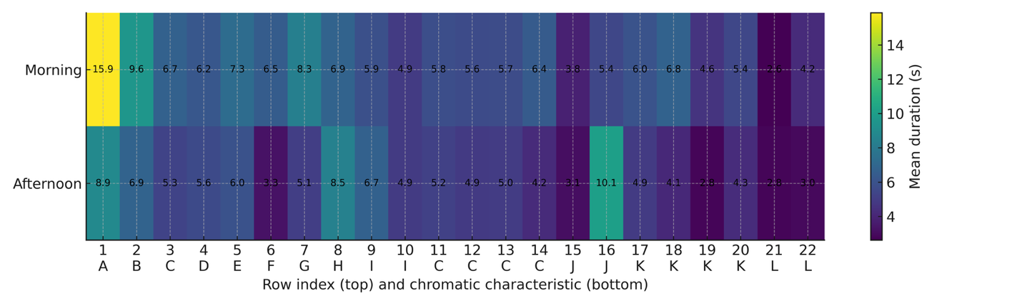
Figure S1 Mean PBD by row (1–22) and session (Morning/Afternoon). Columns are labelled with row number (top) and chromatic characteristic (A–L, bottom). Cell values are mean durations (1 decimal); higher colour intensity indicates longer times.

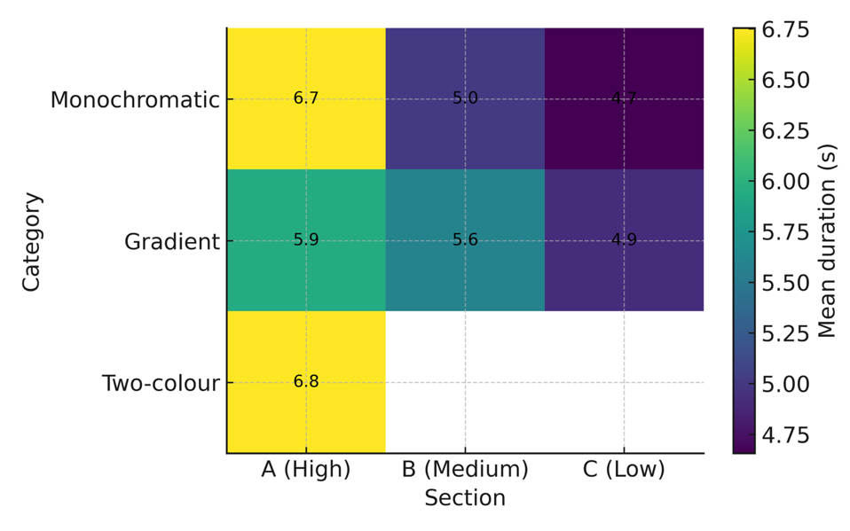
Figure S2 Mean PBD by chromatic category—Monochromatic, Gradient, and Two-colour—and site section (A = High, B = Medium, C = Low). The Multicolour category is excluded from this figure. Cell values are mean durations (1 decimal); higher colour intensity indicates longer

Chapter 5: Paper III
“The Colour Palette Prescription” – How do colour tone and colour diversity influence emotional responses in virtual green spaces? [Unpublished Manuscript]
Context for this chapter: The field study (Paper II) confirmed that behaviour shifts with colour, but the "messiness" of the real world (weather, crowds) made it hard to isolate specific mechanisms. This third paper seeks the middle ground: the immersion of a park visit combined with the experimental control of a lab.
Using a 360° virtual park tour, this study manipulates two variables: Tone (Warm vs. Cool, based on Paper I’s findings) and Colour Diversity (Two vs. Four colours). Uniquely, it introduces the distinction between Actual Diversity (what is planted) and Perceived Diversity (what the user registers), investigating which one better predicts the emotional response.
Role in the thesis: This chapter answers RQ3 (Do warm/cool frames and diversity influence appraisals over short encounters?). It bridges the gap between static views and dynamic experience. The key contribution here is the "Design Gap" finding: that perceived diversity often matters more for well-being than the nominal number of species. This challenges the standard practice of simply "counting colours" and argues for designing scenes that feel rich rather than just are rich.
Author Contribution: As lead author, I was responsible for the study conceptualisation, data collection, statistical analysis, and writing the manuscript. Co-authors provided supervisory guidance and editorial review.
‘The Colour Palette Prescription’ – How do colour tone and colour diversity influence emotional responses in virtual green spaces?
Liwen Zhang, Nicola Dempsey, Ross Cameron, Simone Farris

Highlights
- Cool flower tones facilitate stress recovery, whilst warm tones fail to buffer subsequent stress.
- Perceived colour diversity predicts emotional outcomes more accurately than objective planting metrics.
- Subjective colour perception is significantly shaped by education level, cultural background, and nature connectedness.
- Users with lower baseline negative affect perceive significantly higher colour diversity, indicating a perceptual bias.

Abstract
Flower colour is widely used to shape the affective tone of green spaces, yet practical guidance on how colour tone (warm vs. cool) and colour diversity influence emotion is limited, particularly when accounting for perceived diversity. In an online experiment (N = 1,635), participants navigated 360° virtual parks that varied by colour tone and Actual Colour Diversity (two vs. four flower colours). Affect (Joviality, Serenity, Negative Affect) was assessed at three time points under a cool sequence (Baseline → Stressor → Park) and a warm sequence (Baseline → Park → Stressor), and participants rated Perceived Colour Diversity. Cool-colour parks facilitated recovery after stress (Joviality and Serenity increased; Negative Affect decreased below baseline). Warm-colour parks improved mood initially but did not buffer the subsequent stress response. Actual Colour Diversity showed little effect on affect, though it consistently increased preference. Perceived Colour Diversity was more predictive of emotion: in cool settings, higher perceived diversity aligned with more positive affect, whereas in warm settings it was associated with lower Joviality at individual time points. Participants who perceived higher diversity also reported lower baseline Negative Affect, indicating potential perceptual bias. These findings suggest that designing for how users perceive colour, alongside what is planted, can strengthen the emotional performance of urban green spaces; cool, coherent palettes appear advantageous for restoration, while warm palettes should be used with moderation in energising contexts.
Keywords: Flower colour; Perceived diversity; Restorative environments; Affect; Virtual parks; Landscape design.

1. Introduction
Flowers play an important role in creating visually pleasing and emotionally supportive landscapes. Their contribution to psychological well-being is well-documented, with numerous studies highlighting their capacity to reduce negative emotions, elevate mood, and promote relaxation (Haviland-Jones & McGuire, 2005; Hoyle & Jorgensen, 2017; Jahani & Saffariha, 2020) For example, Mochizuki-Kawai and Mochizuki (2020) found that the presence of flowers is linked to significant improvements in mood states, and Park and Mattson (2009) reported that hospital patients exposed to flowers experienced fewer symptoms and required less pain medication. These therapeutic effects are believed to stem, in part, from flowers’ ability to stimulate endorphin release and trigger positive emotional responses (Elsadek & Liu, 2020; Xie et al., 2021).
While this study focuses specifically on flowering plants, it is important to acknowledge that plant form more broadly—including the overall shape, height, and structural arrangement of vegetation—also contributes to the aesthetic and emotional experience of landscapes. Within the floral context, previous studies have examined variables such as flower shape, scent, species richness, and abundance. Among these, colour has emerged as one of the most influential features due to its strong associations with human emotion (Valdez & Mehrabian, 1994; Xie et al., 2021). Historically, cultures around the world have used flower colours symbolically to convey emotion (Goody, 1993), and recent empirical research now supports the idea that colour plays a significant role in shaping mood.
Building on this foundation, flower colours are commonly grouped into warm and cool tonal categories to evoke different emotional responses. Warm hues (e.g., red, orange, yellow) are typically associated with excitement, joy, and energy. These colours are often used in celebratory or communal settings to create uplifting atmospheres. In contrast, cool hues (e.g., blue, purple, white) are linked to calmness, serenity, and introspection. They are widely used in spaces designed for rest and recovery, such as meditation areas and healing gardens (Hoyle & Jorgensen, 2017; Zhang et al., 2024). Empirical studies support these distinctions, showing that warm colours tend to increase arousal and positive affect, while cool colours are more effective in promoting relaxation (Zhang et al., 2023).
However, while the emotional impact of flower hues is relatively well established, translating this knowledge into practical guidance for planting design remains a challenge. One key area of uncertainty is colour diversity: How many flower colours should be used in a space to achieve the desired emotional effect? Practical design guidance remains limited: mainstream planting manuals discuss aesthetic coherence but rarely quantify colour diversity in relation to mood (Dunnett, 2019; Dunnett & Hitchmough, 2013). Designers are therefore faced with the question: Does increasing colour diversity enhance or hinder a space’s restorative potential?
While previous research has examined hue effects, fewer studies have addressed the emotional consequences of colour diversity within warm or cool palettes. For example, (Zhang et al., 2023) investigated one- and two-colour schemes, suggesting that the emotional outcome may depend more on specific hues than on diversity per se. Yet, it remains unclear whether expanding to three or four colours improves emotional responses—or creates visual complexity that reduces coherence. In particular, analogous colour combinations within warm palettes (e.g., red, orange, yellow) may risk overstimulation, whereas cool palettes might benefit from simplicity and harmony.
C. Neale et al. (2021) offer further evidence that warm and cool colours produce distinct emotional and physiological reactions, with cool colours more reliably eliciting calm and warm colours associated with alertness and sometimes overstimulation. Their cross-cultural findings support the view that colour tone and its emotional impact are consistent across contexts, underscoring the importance of careful colour planning in therapeutic landscapes.
Additionally, Farris and Cameron (2024) emphasise the complex interplay between actual and perceived environmental features—such as biodiversity—and restorative outcomes. Their work in virtual park settings shows that perceived richness may drive emotional benefits more strongly than objective metrics. This aligns with growing recognition in environmental psychology that subjective perception mediates the impact of green space design. Thus, understanding how users perceive colour diversity is likely just as important as the actual number of colours used in the planting.
Another key consideration is when exposure to colour occurs in the emotional timeline. Warm hues may help elevate mood and “protect” against later stress, while cool hues may be more effective at aiding recovery after stress (Hartig & Kahn, 2016; Ulrich & Zelson, 1991; Valdez & Mehrabian, 1994). This dual-purpose framework suggests a need to match colour strategies with the emotional goals of the space—whether energising or restorative.
The use of different Positive and Negative Affect Schedule (PANAS) subscales was necessary, as established affect regulation models (Panksepp, 2010; Posner et al., 2005; Richardson et al., 2016) propose that positive affect is comprised of two dimensions: high-arousal affect associated with enjoyment and attraction, and low-arousal affect linked to relaxation and contentment. Prior research has demonstrated that low-arousal positive affect is often overlooked in studies of affect (McManus et al., 2019). In a recent study, McEwan et al. (2021) discovered that sensory exercises during a forest bathing session enhanced low-arousal positive affect, while decreasing high-arousal positive affect. This distinction informed our decision to assess both types of positive emotion in the present study.
Three gaps remain: (i) whether Perceived or Actual Colour Diversity better predicts emotional responses; (ii) whether these effects differ by colour tone (Warm vs. Cool) and by exposure timing; and (iii) whether cultural/language context shapes perception. We address these explicitly by testing how flower colour tone (Warm vs. Cool) and Actual Colour Diversity (Two vs. Four colours) influence emotional states in immersive, nature-based settings, and by comparing Actual with Perceived Colour Diversity (how colourful participants felt the planting was). This focus on perception parallels evidence that perceived biodiversity can predict well-being more strongly than objective counts (Fuller et al., 2007). Perception is also shaped by individual differences, such as cultural background, nature connectedness, and educational level, which can influence emotional interpretation of visual environments (Ode Sang et al., 2016; Zhang et al., 2023).
To capture these dynamics, we used 360-degree virtual reality (VR) simulations that allowed participants to navigate digital parks with controlled flower colour arrangements. This immersive approach bridges the gap between tightly controlled laboratory studies and complex real-world landscapes. It also allows for greater ecological validity, as participants could explore the environment from a first-person perspective.
Virtual delivery of natural environments has become a substantial research area in environmental psychology over the past decade. Recent meta-analyses confirm that virtual nature reliably produces measurable affective benefits, with stress and anxiety reduction observed across delivery formats and short exposures of five to ten minutes typically sufficient to produce reliable shifts (Brambilla et al., 2024; Browning et al., 2020; Hubbard et al., 2025; Lopes & Falk, 2024). Within this literature, 360-degree formats are particularly relevant for landscape research because they preserve scene fidelity while allowing standardised, replicable delivery. Hedblom et al. (2019) used 360-degree photographs of park and forest environments to demonstrate stress recovery against an urban control, while Schebella et al. (2020) used 360-degree video to manipulate biodiversity perception within a controlled stimulus set.
Despite this growing body of evidence, no previous virtual-nature study has systematically manipulated flower-colour palette as the independent variable. Existing studies have varied biodiversity, vegetation density, urban-versus-natural framing, or seasonal appearance, but the chromatic composition of flowering planting has not been isolated as a controlled variable. The present study addresses this gap by extending the 360-tour methodology to chromatic manipulation and introducing perceived colour diversity as a complementary outcome to the actual-count measures typically used in virtual-nature research.
Specifically, this study investigates if / whether:
- Actual or Perceived Colour Diversity better predicts emotional outcomes.
- These effects vary by colour tone (Warm vs. Cool).
- The timing of exposure (before vs. after a stressor) interacts with colour-based emotional responses.
- Exploratory, whether there are cultural/language differences (Chinese vs. English-language respondents), particularly in perceived colour diversity.
By providing empirical evidence on the emotional effects of flower colour tone and diversity, this research contributes to clearer, design-oriented guidance for landscape architects and urban planners. Ultimately, it aims to support the creation of emotionally supportive spaces that align perceptual design with positive user experience and therapeutic goals.

2. Methods
This section outlines the study’s methodological framework, including participant recruitment, experimental design, and the virtual park exposure procedure. Details are provided on how the stressor was implemented, how emotional responses were measured, and how the data were analysed to assess the psychological effects of floral colour diversity. We used an online 360° tour to standardise colour palettes and viewing positions while reaching a large, culturally diverse sample. This approach maximised experimental control (constant layout; only colour tone/diversity varied) and feasibility for international recruitment. A brief alarm-tone stressor provided a minimal, ethically suitable perturbation in remote settings.

2.1. Participants and study design
A total of 1,714 participants were initially recruited online through general-interest postings and survey exchange platforms. Of these, 774 completed the survey in Chinese (residing in China) and 940 in English (predominantly in Europe and the United States). After excluding incomplete responses, self-reported colour blindness, completion times exceeding 30 minutes, or invalid data (e.g., identical Positive and Negative Affect Schedule [PANAS] scores across all stages), the final sample included 1,635 participants (827 in the cool-colour condition, 808 in the warm-colour condition). Details on recruitment methods and survey access are provided in Section 2.6.
Following the approach of Ode Sang et al. (2016), the questionnaire captured background characteristics including demographics (age, gender, ethnicity, education), nature connectedness (Mayer & Frantz, 2004), and childhood outdoor experience. These variables have been associated with differences in landscape preferences and emotional responses to nature (in other literature? If so, cite it here). The questionnaire also asked questions about specific images covering variations in plant species numbers, flower colour and perceptions, preferences and emotional responses to these images and other stimuli (Figure 2 & 3).

2.2. Virtual tour creation
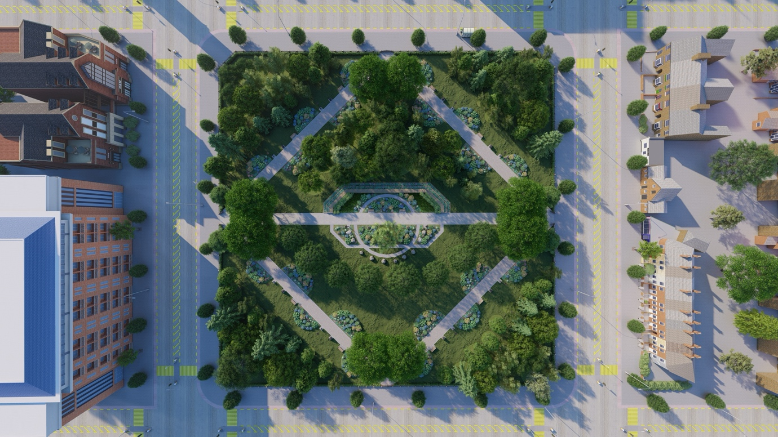
Figure 1 Virtual park layout (typical small urban park form; reference template: All Saints Park, Manchester, UK).
As established earlier, virtual nature stimuli now span several delivery formats — 2D images and video, 360-degree video, computer-generated environments (CGI), and CGI in immersive head-mounted-display (HMD) virtual reality — each with distinct trade-offs between realism, immersion, and experimental control. Four considerations guided the choice of screen-delivered CGI panoramic tours for this study. First, experimental control: rendering the park in SketchUp and Lumion allowed identical layout, lighting, and non-floral elements across conditions, with only flower-colour palette varied. This degree of stimulus control is unachievable in field or 360-video paradigms, where weather, time of day, and incidental visitors introduce uncontrolled variance. Second, device accessibility: HMD ownership remains low globally, and HMD use carries known limitations (simulator sickness, restricted session length) that would have reduced feasible sample size. Screen-based delivery enabled the recruitment of 1,635 international participants across two language groups. Third, cognitive-load minimisation: HMD use introduces a sensory novelty that can confound the affect signal of interest, whereas screen-based 360 navigation — modelled on the Google Street View interaction most participants already know — minimises learning load. Fourth, ecological relevance to landscape practice: most design reviews are presented to clients on screens rather than in HMDs, so the screen format also matches a practical design-review context.
Virtual tours of ‘designed park’ landscapes (360°) were created in SketchUp Pro (Trimble, Sunnyvale, CA, USA) and rendered with Lumion software (Act-3D B.V., Leiden, The Netherlands). The base layout followed a typical small urban park form; to enhance ecological realism we referenced All Saints Park (Manchester, UK) for its symmetrical layout, path geometry and proportions, while keeping all non-focal features generic and constant across stimuli (Fig 1). The location served solely as a design template to improve realism while holding layout constant; no inferences are drawn about Manchester. Thirty 360-degree photos of the park were linked together with Marzipano (http://www.marzipano.net.), creating a virtual tour experience similar to Google’s ‘Street View’. Just like Google’s experience, the tours were developed to be visualised on a standard 2D screen. Participants navigated the environment by clicking waypoints, exploring:
- Warm-Colour Parks: With flower beds dominated by red, orange, yellow, and white flowers
- Cool-Colour Parks: With flower beds dominated by blue, purple, pink, and white flowers
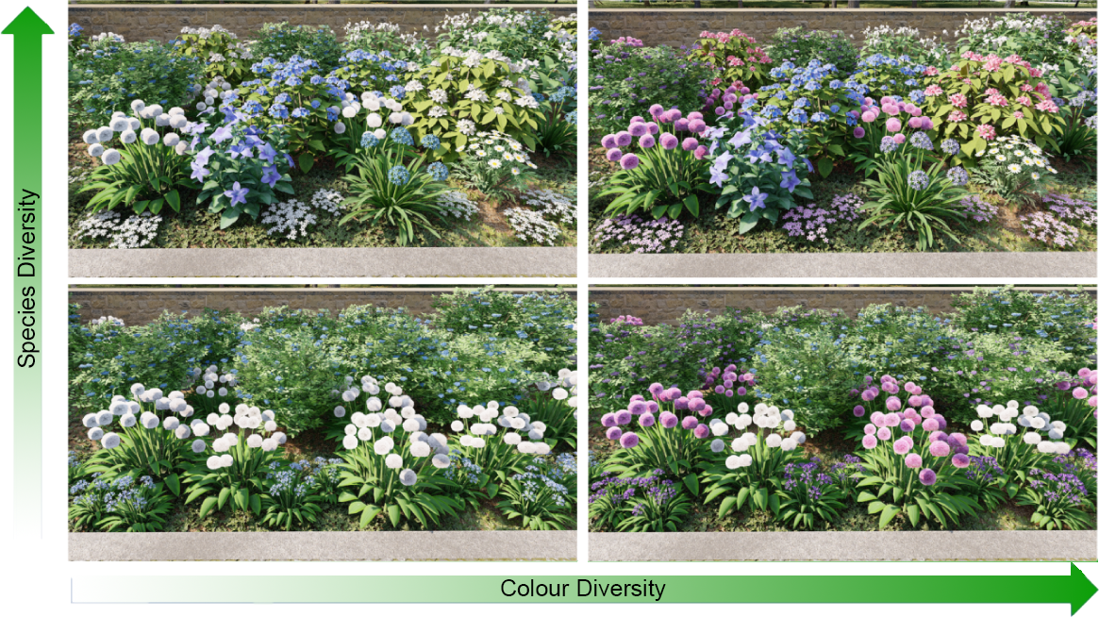
Figure 2 Planting stimuli varying species diversity (vertical) and actual colour diversity (horizontal); cool-palette example.
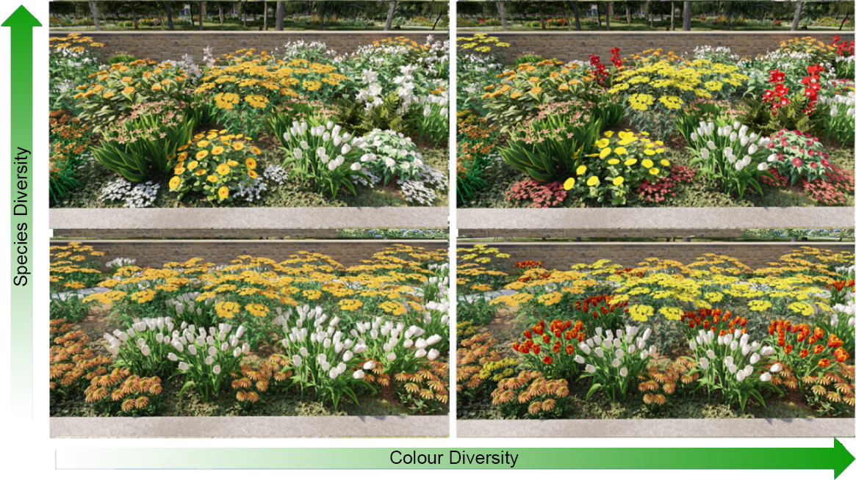
Figure 3 Planting stimuli varying species diversity (vertical) and actual colour diversity (horizontal); warm-palette example.
Participants accessed the tours using a variety of personal devices—desktop computers, laptops, tablets, and smartphones—depending on their preference and availability.
Additionally, each park varied in actual colour diversity: low diversity (two flower colours) vs. high diversity (four flower colours) (Figs 2 and 3). Other environmental elements (e.g., background species diversity) were manipulated for separate research aims, not detailed here (Farris & Cameron, 2024).

2.3. Stressor
A 15-second fire alarm sound was used as a stressor (Mochizuki-Kawai & Mochizuki, 2020). Fire alarms have been shown to reliably induce mild psychological stress in online experiments, allowing for the standardised measurement of subsequent changes in affect. The inclusion of a 15-second fire alarm in the survey was intended to simulate a sudden, unexpected event with the potential to cause distress and disrupt an individual’s emotional state. Stressors such as fire alarms have been used in previous studies to examine the effects of stress on various psychological and physiological outcomes. They can elicit a range of physiological and emotional responses, including anxiety, fear, and negative affect. In this study, the fire alarm served as a standardised and controlled stressor, enabling the measurement of participants’ emotional responses to a common aversive stimulus. The use of such a stressor may also have implications for the development of interventions to help individuals cope with and recover from stressful situations.

2.4. Measurements

2.4.1. Positive and negative affect
In this study, affect refers to state affect—participants’ momentary emotional feelings—operationalised as Positive (Joviality, Serenity) and Negative Affect. To measure state affect, we combined three subscales from two different versions of the Positive and Negative Affect Schedule (PANAS). Negative affect was assessed using the five negative items from the International Short Form of the PANAS (I-PANAS-SF) developed by Thompson (2007). Positive affect was measured using two subscales, namely Joviality and Serenity, from the PANAS-X designed by Watson and Clark (1994).
Three key outcomes were derived:
- Negative Affect (NA)
- Joviality (high-arousal positive affect)
- Serenity (low-arousal positive affect)
The final version of the questionnaire comprised 16 items, including five items for negative affect, eight for high-arousal positive affect, and three for low-arousal positive affect. Participants rated their level of emotion on a 5-point Likert scale ranging from "not at all" to "extremely".
The PANAS used in this survey included the Chinese revised version developed by Yiqun Gan in 2010 (Gan & Guo, 2010). To ensure linguistic and conceptual equivalence between the English and Chinese versions, back-translation procedures were used. Thirty psychology students were asked to categorise five emotional words into one dimension of the original scale, with any unclassifiable words recorded and reasons provided. Cultural and contextual factors were considered during the translation process, and final revisions were made to form the ultimate version. This rigorous and systematic translation process supports the reliability and cross-cultural applicability of the PANAS measures used in this study.
This selection aligns with affect-regulation models that distinguish high-arousal enjoyment from low-arousal calm, ensuring sensitivity to both joviality and serenity in nature-exposure contexts.

2.4.2. Perceived colour diversity
After viewing the park, participants answered “How colourful would you say the planting was?” on a four-point scale (1 = “Not very”, 2 = “A little”, 3 = “Quite a bit”, 4 = “Very”).
For analysis, responses were grouped into two categories:
- Low Perceived Colour Diversity (scores 1 or 2)
- High Perceived Colour Diversity (scores 3 or 4)
This categorisation enabled statistical comparison between individuals perceiving limited vs. rich colour diversity in the virtual parks.

2.4.3. Park preference
Participants were asked to rank four images from either the cool or warm colour condition based on their preference. They could rank all four images or only those they liked (e.g., ‘ACBD’, ‘AB’, or ‘C’). Rankings were then converted into scores for subsequent analysis, with the highest rank assigned a score of 4 and the lowest a score of 1. Any image not given a ranking was automatically assigned a value of 0.

2.5. Procedure
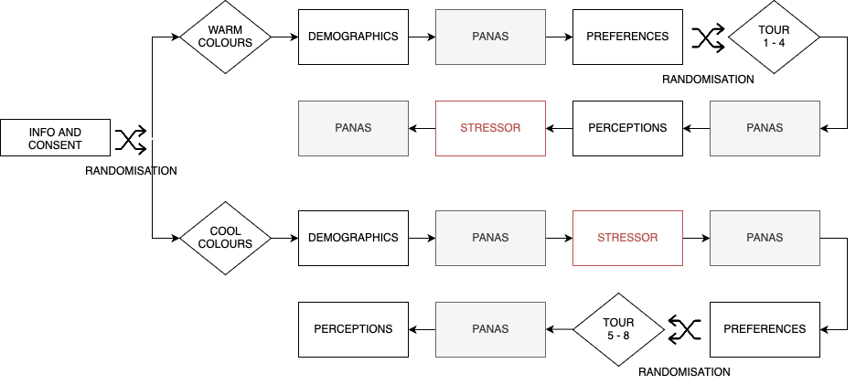
The process varied depending on whether images of cool colours or warm colours were presented (Fig 4). Based on the predominant theories (Hartig & Kahn, 2016; C. Neale et al., 2021; Ulrich, 1983; Valdez & Mehrabian, 1994; Zhang et al., 2023) cool colours were used to relieve stress, whereas warm colours were used as a prophylactic against stress responses.
Figure 4 Procedure and randomisation: warm-colour sequence Baseline → Post-Park → Post-Stressor; cool-colour sequence Baseline → Post-Stressor → Post-Park. PANAS administered at each time point; perceptions and preferences after park exposure.

2.5.1. Cool-colour condition (Stress → Park)
- Baseline PANAS: Participants completed the PANAS, reporting Negative Affect (NA), Joviality (high-arousal positive affect), and Serenity (low-arousal positive affect).
- Stressor: A 15-second fire alarm was played.
- Post-Stressor PANAS: Participants repeated the PANAS.
- Virtual Park Tour: Participants explored a cool-coloured park (two or four flower colours).
- Final PANAS and Perceptions: A third PANAS measurement was followed by questions on perceived colour diversity, preference, and open-ended reflections.

2.5.2. Warm-colour condition (Park → Stress)
- Baseline PANAS: Participants reported their initial affect states.
- Virtual Park Tour: Warm-coloured flower compositions (two or four colours).
- Post-Park PANAS: Participants re-rated their affect.
- Stressor: The same fire alarm was introduced.
- Final PANAS: Participants provided a final PANAS rating, indicating whether prior park exposure helped buffer the subsequent stress.

2.6. Data collection
The online questionnaire was built using Qualtrics (https://www.qualtrics.com) and made available between 1 March and 30 November 2022, following ethical approval and a pilot at the University of Sheffield [Approval Ref. 039698] and a pilot study (pilot data not included). Participants accessed the survey via a public link distributed through email lists, social media, websites, online discussion forums, and survey exchange platforms (SurveyCircle and SurveySwap).
To reduce sampling bias and enable an exploratory language- and culture-based comparison of perceptions, the survey was offered in English and Chinese and disseminated across multiple regions. English-speaking participants were predominantly located in Europe and the United States, while the Chinese version targeted respondents based in mainland China. Participation was open to adults aged 18 and above who were fluent in either language.
The study was introduced in general terms as exploring people’s experiences of urban green spaces, without requiring any prior interest in gardens or flowers. This approach allowed the recruitment of a more diverse sample. Participation was voluntary and anonymous, and participants could exit at any stage. The average completion time was approximately 12–15 minutes. All data were handled in accordance with ethical guidelines and data protection regulations.

2.7. Data analysis
All statistical analyses were conducted using IBM SPSS Statistics 29.0 (IBM Corp., Armonk, NY, USA). Descriptive statistics (means, standard deviations, and proportions) were used to summarise participants’ demographic characteristics and baseline measures.
To examine the emotional effects of flower colour diversity, repeated-measures analyses of variance (RM-ANOVAs) were conducted separately for the cool- and warm-colour conditions. Each model included Time as a within-subjects factor (Baseline, Post-Stressor, and Post-Park for the cool condition; Baseline, Post-Park, and Post-Stressor for the warm condition) and Actual Colour Diversity (Two vs. Four colours) and Perceived Colour Diversity (Low vs. High) as between-subjects factors. Dependent variables included Joviality, Serenity, and Negative Affect. To aid interpretation at specific time points, planned independent-samples Welch t-tests compared groups (High vs. Low Perceived Colour Diversity; Two vs. Four Actual Colour Diversity) at Baseline, Post-Park, and/or Post-Stressor as appropriate; when multiple time points were tested for the same outcome, p-values were Bonferroni-adjusted.
Where Mauchly’s test indicated a violation of the sphericity assumption, Huynh–Feldt corrections were applied to adjust the degrees of freedom and reduce the risk of inflated Type I error rates, ensuring more accurate p-values in the context of repeated measures.
To examine predictors of Perceived Colour Diversity, a binary logistic regression was conducted. The dependent variable was Perceived Colour Diversity (High vs. Low), with predictors including Actual Colour Diversity, Age, Gender, Ethnicity, Education, Survey language, Nature Connectedness (INS), and Childhood Outdoor Experience. Results are reported using odds ratios (Exp(B)), which indicate how much more (or less) likely participants with a given characteristic were to perceive High Colour Diversity. Model fit was assessed using the Hosmer–Lemeshow test.
To better understand baseline differences in affect and potential perceptual bias, group comparisons were conducted to assess whether Perceived Colour Diversity groups differed significantly across demographic variables. Welch t-tests (continuous variables) and χ² tests (categorical variables) were used where appropriate.
To investigate the influence of park preference on emotional changes, Pearson correlation analyses were conducted between preference scores and affect change scores (post minus pre). Additionally, independent-samples t-tests were used to examine differences in preference based on Actual and Perceived Colour Diversity.
A two-tailed significance level of p < 0.05 was adopted for all tests. Visualisations included bar charts for group-level preference differences and line graphs for affect trajectories. Figures display means with ±1 standard error (SE) error bars. In addition to Pearson correlations on change scores, Spearman’s rank-order correlations were computed as a robustness check given the ordinal origins of the items; conclusions were unchanged. We report Pearson in the main text and provide Spearman values in Table S1.

3. Results

3.1. Sample overview
After excluding 79 participants (4.6%) who reported colour blindness, the final sample comprised 1,635 participants. Of these, 827 were assigned to the Cool colour condition and 808 to the Warm colour condition. Participants completed the survey in either English (n = 898) or Chinese (n = 737), with all Chinese-language respondents residing in China. English-language respondents were predominantly located in Europe (particularly the United Kingdom) and the United States. Participants’ ages ranged from 18 to 65+, with 35.7% identifying as male, 63.9% as female, and 0.4% preferring not to say. Approximately 48.6% identified as Asian (primarily Chinese), 40.6% as White, and 10.9% as other or mixed ethnic groups. Over half of the sample reported an undergraduate degree; 52.4% spent “a lot” of time outdoors during childhood. Detailed demographic characteristics are presented in Table 1.
Table 1 Participant Demographic Characteristics (N = 1,635)
Variable | Category | n | %
Gender | Male | 584 | 35.7%
 | Female | 1045 | 63.9%
 | Prefer not to say | 6 | 0.4%
Age | 18–24 | 647 | 39.6%
 | 25–34 | 519 | 31.7%
 | 35–44 | 217 | 13.3%
 | 45–54 | 146 | 8.9%
 | ≥55 | 106 | 6.5%
Ethnicity | White | 663 | 40.6%
 | Asian | 794 | 48.6%
 | Other/Mixed | 178 | 10.9%
Education | High school or below | 311 | 19.0%
 | Undergraduate | 864 | 52.9%
 | Postgraduate | 460 | 28.1%
Childhood Outdoor Time | A lot | 857 | 52.4%
 | Some | 583 | 35.7%
 | Little or none | 195 | 11.9%
Nature Connectedness (INS) | High | 924 | 56.5%
 | Medium | 591 | 36.1%
 | Low | 120 | 7.4%

Perceived colour diversity was categorised into “Low” (score 1 or 2) and “High” (score 3 or 4), based on participants’ subjective ratings (scale 1–4) of the colour richness within virtual parks. Participants’ distribution by Perceived colour diversity differed across colour conditions. In the Warm colour condition, 186 participants perceived High colour diversity, while 656 perceived Low diversity. In the Cool colour condition, 299 participants perceived High colour diversity, whereas 573 perceived Low diversity.

3.2. Effects of actual and perceived colour diversity

3.2.1. Cool colour condition: recovery sequence
3.2.1.1. Joviality
A repeated-measures ANOVA revealed a significant main effect of Time (F(2, 1646) = 107.207, p < 0.001, η² = 0.115), across the three time points: Baseline, Post-Stressor, and Post-Park. This indicated that Joviality significantly decreased after the stressor and increased again following the park visit. This recovery pattern was observed in all participants, regardless of Actual or Perceived Colour Diversity (Figures 5 and 6).
The interaction between Time and Actual Colour Diversity was not significant (F(2, 1646) = 2.541, p = 0.079, η² = 0.003), indicating that the trajectory of mood change across time points did not differ between those who experienced parks with two colours versus four colours (Figure 5). Likewise, the main effect of Actual Colour Diversity was non-significant (F(1, 823) = 0.492, p = 0.483, η² = 0.001), confirming that participants’ overall level of Joviality was not influenced by the objectively manipulated number of flower colours. In sum, Actual Colour Diversity did not significantly alter either the pattern or the magnitude of emotional responses.
For Perceived Colour Diversity a significant Time × Perceived Colour Diversity interaction was found (F(2, 1646) = 5.770, p = 0.003, η² = 0.007), indicating that the pattern of mood changes over time varied between the two groups of participants. One group was associated with a greater loss of Joviality (Figure 6) after the stressor than the other. Joviality increased after exposure to the parks, but the level of increase was similar to whether the participants perceived the diversity of colour to be high or low (i.e. the increasing gradients in Figure 6 are similar). Thus, perception of colour diversity did not affect the rate of improvement in Joviality.
Finally, no significant three-way interaction was found between Time, Actual Colour Diversity, and Perceived Colour Diversity (F(2, 1646) = 0.724, p = 0.485, η² = 0.001), suggesting these two factors operated independently in influencing affective outcomes.

Figure 5 Joviality across Baseline → Post-Stressor → Post-Park in the cool-colour condition by Actual Colour Diversity (Two vs. Four); means ± SE.

Figure 6 Joviality across Baseline → Post-Stressor → Post-Park in the cool-colour condition by Perceived Colour Diversity (High vs. Low); means ± SE.
3.2.1.2. Serenity
A repeated-measures ANOVA showed a significant main effect of Time across the three time points (F(2, 1736) = 162.050, p < 0.001, η² = 0.157) , indicating that Serenity decreased after the stressor and increased again after the park experience (Figures 8 and 9).
However, the change in Serenity across time points did not significantly differ due to Actual Colour Diversity (Time × Actual: F(2, 1736) = 0.763, p = 0.467, η² = 0.001), Perceived Colour Diversity (Time × Perceived: F(2, 1736) = 1.967, p = 0.140, η² = 0.002), or their interaction (Time × Actual × Perceived Colour Diversity) (F(2, 1736) = 1.690, p = 0.185, η² = 0.002). These results suggest that neither Actual nor Perceived Colour Diversity significantly influenced the pattern of Serenity recovery.
Between-subjects analyses further revealed no significant effects of Actual Colour Diversity (F(1, 868) = 0.104, p = 0.747, η² < 0.001) or Perceived Colour Diversity (F(1, 868) = 0.799, p = 0.372, η² = 0.001) on Serenity.

Figure 7 Serenity across Baseline → Post-Stressor → Post-Park in the cool-colour condition by Actual Colour Diversity (Two vs. Four); means ± SE.

Figure 8 Serenity across Baseline → Post-Stressor → Post-Park in the cool-colour condition by Perceived Colour Diversity (High vs. Low); means ± SE.
3.2.1.3. Negative affect
A repeated-measures ANOVA revealed a significant main effect of Time across the three time points (F(2, 1736) = 117.279, p < 0.001, η² = 0.119), indicating that Negative Affect increased following the stressor and subsequently decreased after the park visit (Figures 9 and 10).
The pattern of change in Negative Affect across time points did not significantly differ by Actual Colour Diversity (Time × Actual: F(2, 1736) = 1.097, p = 0.334, η² = 0.001), Perceived Colour Diversity (Time × Perceived: F(2, 1736) = 0.847, p = 0.429, η² = 0.001), or their interaction (Time × Actual × Perceived: F(2, 1736) = 0.290, p = 0.748, η² < 0.001). These results suggest that neither Actual nor Perceived Colour Diversity significantly influenced the recovery trajectory in terms of Negative Affect.
Between-subjects analyses indicated a significant main effect of Perceived Colour Diversity (F(1, 868) = 6.952, p = 0.009, η² = 0.008), suggesting that participants who perceived higher colour diversity generally reported lower Negative Affect, but across all three time points, i.e. not just affected by the park experience. Indeed, differences were already present at the Baseline phase (Figure 10). This indicates this group (who later perceived more colour diversity) began the experiment with a more positive emotional state. This baseline difference is discussed further in section 3.3.

Figure 9 Negative Affect across Baseline → Post-Stressor → Post-Park in the cool-colour condition by Actual Colour Diversity (Two vs. Four); means ± SE.

Figure 10 Negative Affect across Baseline → Post-Stressor → Post-Park in the cool-colour condition by Perceived Colour Diversity (High vs. Low); means ± SE.

3.2.2. Warm colour condition: immediate emotional impact
3.2.2.1. Joviality
A repeated-measures ANOVA revealed a significant main effect of Time across the three time points: Baseline, Post-Park, and Post-Stressor. (F(2, 1676) = 84.243, p < 0.001, η² = 0.091). Joviality increased following the park experience and decreased notably after exposure to the stressor, leading to lower values than the Baseline (Figures 11 and 12).
There was no significant interaction between Time and Actual Colour Diversity (F(2, 1676) = 0.214, p = 0.807, η² < 0.001), and no significant three-way interaction between Time, Actual, and Perceived Colour Diversity (F(2, 1676) = 0.171, p = 0.843, η² < 0.001). The main effect of Actual Colour Diversity was also not significant (F(1, 838) = 1.802, p = 0.180, η² = 0.002), suggesting that the number of warm flower colours shown did not significantly influence either the pattern or overall level of Joviality (Figure 11).
In contrast, a significant Time × Perceived Colour Diversity interaction was identified (F(2, 1676) = 3.495, p = 0.031, η² = 0.004). This result indicates that participants who perceived Higher colour diversity showed a distinct pattern of change in Joviality compared to those perceiving Lower diversity (Figure 12). Interestingly, participants perceiving higher colour diversity reported a slight reduction in Joviality following exposure to the warm-colour park compared to their baseline levels.
Between-subjects: Perceived Colour Diversity showed a main effect (F(1, 838) = 18.020, p < 0.001, η² = 0.021). Planned Welch’s t-tests (Bonferroni-adjusted) indicated lower Joviality in the High-perceived group at Baseline (t(330.24) = −2.72, p = 0.020), Post-Park (t(343.78) = −4.85, p < 0.001), and Post-Stressor (t(355.67) = −4.31, p < 0.001). The Actual × Perceived interaction was not significant (F(1, 838) = 1.059, p = 0.304, η² = 0.001).

Figure 11 Joviality across Baseline → Post-Park → Post-Stressor in the warm-colour condition by Actual Colour Diversity (Two vs. Four); means ± SE.

Figure 12 Joviality across Baseline → Post-Park → Post-Stressor in the warm-colour condition by Perceived Colour Diversity (High vs. Low); means ± SE.
3.2.2.2. Serenity
A repeated-measures ANOVA showed a significant main effect of Time (F(2, 1676) = 150.126, p < 0.001, η² = 0.152), indicating that Serenity increased only slightly following the warm-colour park experience and then decreased notably after exposure to the stressor (Figures 13 and 14).
There were no significant interaction effects observed between Time and Actual Colour Diversity (F(2, 1676) = 0.111, p = 0.895, η² < 0.001), Time and Perceived Colour Diversity (F(2, 1676) = 0.560, p = 0.571, η² = 0.001), or for the three-way interaction (Time × Actual × Perceived Colour Diversity: F(2, 1676) = 0.814, p = 0.443, η² = 0.001). These results indicate neither Actual nor Perceived Colour Diversity significantly influenced the pattern of Serenity over time.
Between-subject analyses revealed no significant main effect of Actual Colour Diversity (F(1, 838) = 0.149, p = 0.699, η² < 0.001) and no significant interaction between Actual and Perceived Colour Diversity (F(1, 838) = 0.074, p = 0.785, η² < 0.001). However, there was a significant main effect of Perceived Colour Diversity (F(1, 838) = 6.755, p = 0.010, η² = 0.008), indicating participants perceiving Higher colour diversity generally reported lower Serenity (Figure 14).

Figure 13 Serenity across Baseline → Post-Park → Post-Stressor in the warm-colour condition by Actual Colour Diversity (Two vs. Four); means ± SE.

Figure 14 Serenity across Baseline → Post-Park → Post-Stressor in the warm-colour condition by Perceived Colour Diversity (High vs. Low); means ± SE.
3.2.2.3. Negative affect
A repeated-measures ANOVA revealed a significant main effect of Time (F(2, 1676) = 46.637, p < 0.001, η² = 0.053), indicating that Negative Affect decreased following exposure to the warm-colour park and then increased after the stressor (Figures 15 and 16). This reflects a short-term stress-buffering effect followed by negative reaction to the stressor.
No significant interactions were found between Time and Actual Colour Diversity (F(2, 1676) = 1.120, p = 0.326, η² = 0.001), Time and Perceived Colour Diversity (F(2, 1676) = 0.447, p = 0.640, η² = 0.001), or the three-way interaction (Time × Actual × Perceived Colour Diversity: F(2, 1676) = 2.035, p = 0.131, η² = 0.002). These results suggest that neither actual nor perceived colour diversity significantly impacted the pattern of change in Negative Affect across time (Figures 15 and 16). At Post-Park in the warm condition, Negative Affect did not differ significantly between Actual Colour Diversity groups (Two vs. Four), Welch’s t(778.18) = 1.56, p = 0.119.
Between-subject analyses showed no significant main effect of Actual Colour Diversity (F(1, 838) = 0.134, p = 0.715, η² < 0.001), Perceived Colour Diversity (F(1, 838) = 0.033, p = 0.856, η² < 0.001), or their interaction (F(1, 838) = 0.083, p = 0.773, η² < 0.001).

Figure 15 Negative Affect across Baseline → Post-Park → Post-Stressor in the warm-colour condition by Actual Colour Diversity (Two vs. Four); means ± SE.

Figure 16 Negative Affect across Baseline → Post-Park → Post-Stressor in the warm-colour condition by Perceived Colour Diversity (High vs. Low); means ± SE.

3.3. Predictors of perceived colour diversity
As noted in Section 3.2.1.3, participants who perceived greater colour diversity also tended to report lower Negative Affect at baseline, suggesting a potential perceptual bias influenced by individual outlook. To better understand factors influencing perceived colour diversity (high vs. low), a logistic regression analysis was performed examining the effects of actual colour diversity, demographic variables (age, gender, ethnicity, education), survey language, nature connectedness (INS), and childhood outdoor experiences.
The logistic regression model showed a statistically significant overall fit (χ²(16) = 107.63, p < 0.001), though the variance explained was modest (Cox & Snell R² = 6.1%, Nagelkerke R² = 8.8%). The Hosmer-Lemeshow test indicated good model fit (χ²(8) = 7.57, p = 0.477).
Actual colour diversity was strongly linked to perceived colour diversity (B = 0.593, SE = 0.112, p < 0.001), indicating participants assigned to high actual diversity conditions were more likely to perceive higher diversity (Exp(B) = 1.810). Higher education levels were also associated with higher perceived diversity: Bachelor's degree (B = 0.724, SE = 0.161, p < 0.001, Exp(B) = 2.063), Master's degree (B = 0.736, SE = 0.195, p < 0.001, Exp(B) = 2.087), and Doctoral degree (B = 0.633, SE = 0.304, p = 0.037, Exp(B) = 1.884).
Survey language significantly influenced perceived diversity, with Chinese-language participants more likely to perceive higher diversity compared to English-language participants (B = 0.709, SE = 0.229, p = 0.002, Exp(B) = 2.031). Conversely, higher nature connectedness scores were negatively associated with perceived colour diversity (B = -0.403, SE = 0.085, p < 0.001, Exp(B) = 0.669).
Age, gender, ethnicity, and childhood outdoor experiences were not significant predictors of perceived colour diversity.

3.4. Relationship between park preference, colour diversity, and emotional change
To further understand the role of participant preference in shaping emotional outcomes, we examined how preference for the park environment related to both emotional changes and colour diversity conditions (actual and perceived).

3.4.1. Preference and emotional change
Pearson correlation analyses revealed significant associations between park preference and changes in emotional responses. In the cool-colour condition, preference scores were positively correlated with changes in Joviality (r = 0.210) and Serenity (r = 0.171), indicating that participants who liked the park more experienced slightly greater increases in positive emotions. No significant association was found with changes in Negative Affect (r = –0.021). Spearman’s rank-order correlations supported the same pattern: Joviality (ρ = 0.107, p = 0.002), Serenity (ρ = 0.042, p = 0.231), Negative Affect (ρ = −0.058, p = 0.095).
In the warm-colour condition, weaker but still positive correlations emerged for Joviality (r = 0.088) and Serenity (r = 0.064), while the correlation with Negative Affect remained non-significant (r = –0.043). These findings suggest that preference for the park environment could play a modest but consistent role in enhancing positive affect, particularly in cool-colour restorative contexts. Spearman results were consistent: Joviality (ρ = 0.045, p = 0.202), Serenity (ρ = 0.009, p = 0.804), Negative Affect (ρ = −0.011, p = 0.758).

3.4.2. Preference and colour diversity
Independent samples t-tests were used to examine whether park preference varied according to actual or perceived colour diversity. In the cool-colour condition, participants exposed to high actual colour diversity reported significantly higher preference scores than those in low diversity conditions (t(870) = 10.94, p < 0.001). Conversely, those who perceived low colour diversity reported higher preference than those perceiving high diversity (t(870) = –3.49, p = 0.001).
In the warm-colour condition, the pattern held for actual diversity: participants in high diversity parks reported significantly greater preference (t(840) = 10.94, p < 0.001). However, perceived colour diversity had little impact on preference (t(840) = –1.81, p = 0.070).
Together, these results indicate that actual colour diversity enhances preference consistently across both colour conditions. However, perceived colour diversity interacts differently depending on the context—positively influencing preference in warm settings but showing a reversed pattern in cool-colour environments, potentially due to overstimulation or mismatches between user expectations and environmental design.

Figure 17 Preference scores (cool-colour condition) by Actual Colour Diversity (High vs. Low), stratified by Perceived Colour Diversity (High vs. Low); means ± SE.

Figure 18 Preference scores (warm-colour condition) by Actual Colour Diversity (High vs. Low), stratified by Perceived Colour Diversity (High vs. Low); means ± SE.

4. Discussion

4.1. Flower colour: restoration after stress vs protection before stress
Across both cool and warm colour conditions, participants' emotional responses were significantly shaped by their exposure to flower-filled virtual parks, but the influence of colour diversity—particularly perceived colour diversity—was more nuanced.
The data presented here indicates that exposure to a virtual park with cool flower colours restores Joviality (Figure 5) and Serenity (Figure 7) after a stress event. Negative Affect was also reduced; falling below Baseline levels (Figure 9). These patterns indicate a clear restorative effect of cool-colour flowers. The fact that the cool-colour conditions demonstrated particularly strong restorative effects following stress exposure, supports the therapeutic potential of cooler hues in facilitating emotional recovery. Cool tones have been associated with lower arousal and increased cognitive clarity (Chris Neale et al., 2021; Zhang et al., 2023), making them especially suitable for spaces designed for decompression and stress relief. This also clarifies the role of timing: when exposure occurred after a stressor (cool condition), recovery was evident, whereas when exposure came before a stressor (warm condition), initial gains did not buffer the subsequent response.
On the other hand, exposure to warm-colour flowers, whilst improving mood, did not seem to act as a protectant against subsequent stress. In warm-colour parks, higher perceived colour diversity was associated with lower Joviality at each time point, which is consistent with the idea that greater chromatic variation in warm palettes can feel visually busy and may dampen positive affect in these contexts. Joviality (Figure 11) and Serenity (Figure 13) decreased significantly after the stress event. Negative Affect also increased marginally against an initial baseline level (Figure 15). That said, there were often increases in Positive Affect (modest increases in Joviality – Figure 11 and Serenity – Figure 13) and decreases in Negative Affect (Figure 15) after the exposure to the warm flowers compared to baseline levels. For Serenity, group trajectories in warm-colour parks were broadly parallel; any small reduction among those perceiving higher diversity was not statistically reliable and should be interpreted cautiously. So warm-colour flowers were improving mood, but not to the extent they off-set completely the effects of subsequent stress. In short, warm-colour parks lifted mood but did not confer stress protection, complementing the cool-colour recovery effects.

4.2. Colour diversity (actual vs perceived)
Increasing colour diversity (from two to four colours) showed no significant influence on emotional outcomes, overall (except see points about preference below). At Post-Park in the warm-colour condition, Negative Affect was slightly higher in the higher Actual colour diversity group than in the lower diversity group, but this difference was not statistically reliable (Figure 15). In most other cases, Actual Colour Diversity did not affect trajectories or mean levels. This challenges common assumptions that increased colour richness automatically enhances mood (Fuller et al., 2007; Hoyle & Jorgensen, 2017; Jahani & Saffariha, 2020). In particular, Jonauskaite et al.'s (2020) cross-cultural study of colour-emotion associations across 30 countries demonstrated that linguistic and geographic proximity systematically shape colour-affect mappings, supporting the interpretation that language — not biological ethnicity — drives perceptual differences. Taken together, this addresses our first question: Perceived Colour Diversity was a stronger predictor of affective outcomes than Actual Colour Diversity, which showed little effect on emotion despite reliably increasing preference.
Perceived colour diversity produced intriguing results. There were two trends emerging here. The first indicated that those participants who perceived the cool colours to be diverse had lower Negative Affect even before they saw any park scenarios (Figure 10). This raises the possibility that individuals predisposed to lower Negative Affect may also perceive their environments as more colourful—potentially reflecting a broader optimistic outlook or individual perceptual bias. The same group also showed a larger drop in Joviality immediately after the stressor (Figure 6), consistent with greater emotional sensitivity.
Chinese-language respondents were more likely to report higher Perceived Colour Diversity (see Results 3.3); affect trajectories were not stratified by culture here, so cultural moderation of emotion remains a priority for future analyses.
There were no differences in Negative Affect, however, between those perceiving the warm colours to be diverse or not (Figure 16). In the group with High Perceived flower colour diversity, however, their Joviality (Figure 12) and Serenity (Figure 14) was marginally reduced after the park experience. Although this trend was not always statistically significant, it may point to reduced emotional restoration or increased overstimulation in High-diversity warm-colour environments.
Taken together, Perceived Colour Diversity predicted emotional outcomes better than Actual Colour Diversity. Further analysis of Perceived flower colour diversity showed that this was influenced by factors such as Actual colour diversity (those assigned to the higher Actual scenarios acknowledging this more), Education level (higher educational levels perceiving greater colour diversity) and Language/cultural background (Chinese participants more likely to perceive higher colour diversity). Interestingly, individuals with greater nature connectedness reported lower perceived diversity. These results align with the construct of environmental schema and the role of cultural and cognitive filters in shaping scene interpretation (Clayton & Myers, 2015; Jonauskaite et al., 2020; Scannell & Gifford, 2010). They also support findings from Farris et al. (2024), who observed that perceived biodiversity—not actual biodiversity—was more predictive of restorative outcomes in virtual park settings. This adds weight to the argument that emotional design should prioritise how users interpret their environment, not just its measurable properties. Regarding cultural differences, respondents completing the Chinese-language survey were more likely to report higher perceived colour diversity; we did not stratify affective outcomes by culture in this study, so any cultural moderation of emotion remains to be tested in future analyses.
The dual role of colour diversity in shaping preference and emotion was particularly illuminating. Actual diversity consistently increased preference ratings, likely due to the inherent visual interest and richness associated with multi-hued floral compositions (Jahani & Saffariha, 2020; Zhang et al., 2024). Yet, the role of perceived diversity was context-dependent: in cool environments, lower perceived diversity was preferred, perhaps because it aligns with users' desire for visual simplicity and calm in stress-recovery settings (Joye & van den Berg, 2011; Ulrich, 1983). Conversely, in warm contexts, higher perceived diversity had a neutral or slightly positive effect, possibly supporting engagement and mood enhancement when stress was not yet introduced.

4.3. Preference
There were relationships with the parks / flowers participants were viewing, emotional responses and preferences. People who liked what they were viewing experienced greater Joviality and Serenity. These findings suggest that preference for the park environment plays a modest but consistent role in enhancing Positive Affect, particularly in cool-colour restorative contexts. Colour and colour diversity was important. In both the cool and warm colour conditions, participants exposed to High Actual colour diversity reported significantly higher preference scores than those in Low diversity conditions (Figures 17 and 18). Thus, we can state that - more colours present is linked to higher preference. Interestingly though, those who Perceived Low colour diversity reported higher preference than those perceiving High colour diversity (Overall significant in the cool and non-significant in the warm scenarios). Again, the data are picking up mis-matches between Actual and Perceived environments. This reinforces that Actual diversity influences what people prefer, while Perceived diversity more strongly relates to how they feel.

4.4. Design implications
In sum, these findings suggest a strategic application of colour diversity based on intended emotional outcomes. For restorative zones, particularly those meant for stress relief, cool tones with visually coherent, less varied flower palettes may enhance affective benefits. For energising or transitional spaces, carefully managed warm palettes with moderate colour diversity might support alertness and engagement without overstimulation. In both cases, fostering positive perceptions through design elements that promote harmony and cognitive clarity may be more important than the sheer number of flower colours used.
Ultimately, our results advocate for a perceptually informed approach to planting design—one that moves beyond fixed metrics of diversity and instead emphasises how users interpret and emotionally engage with environments, highlighting the importance of perceptual framing, emotional disposition, and contextual sensitivity. This perceptual framework complements biophilic and salutogenic design principles (Antonovsky, 1996; Kellert et al., 2008), offering landscape architects, urban planners, and environmental psychologists actionable guidelines for enhancing emotional well-being in both virtual and real-world green spaces.

4.5. Limitations and future directions
Several limitations should be acknowledged. First, while 360° virtual tours offer control and replicability, they lack the multisensory immersion of real-world environments. Future research should validate these findings in physical settings using immersive technologies or field-based experiments.
Second, although the sample was demographically diverse and included both English and Chinese respondents, it was not globally representative (e.g., participants were mainly from China, the UK, and the US). Future studies should expand the cultural and geographic reach of the sample, particularly to explore how cultural values around nature and aesthetics influence perception.
Third, our study focused on short-term emotional changes rather than long-term psychological outcomes such as mood regulation, stress resilience, or mental health markers. Longitudinal research is needed to assess the durability and cumulative impact of colour-based design interventions.
Fourth, the stressor used in the experimental design (a mild fire alarm) may not have been sufficient to induce strong stress responses. Future work could incorporate more robust stress-inducing protocols (e.g., public speaking tasks) to better simulate real-life urban stressors.
Fifth, it is also possible that baseline emotional disposition influenced how participants perceived colour diversity. Participants who reported higher Perceived Colour Diversity also tended to report lower Negative Affect at baseline. This suggests that individual emotional outlooks may shape how environments are interpreted—an example of perceptual bias or mood-congruent appraisal (Garland et al., 2010; Scherer, 2005). Future research should explore the direction of this relationship and consider adjusting for baseline affect when interpreting perceptual outcomes. This is consistent with the broader literature on mood-congruent perception, in which negative affect has been shown to reduce perceived colour saturation and chromatic richness (Bubl et al., 2010).
Sixth, the warm and cool colour conditions were tested using different procedural orders. The cool sequence followed a recovery paradigm (Baseline → Stressor → Park), while the warm sequence followed a buffering paradigm (Baseline → Park → Stressor). This was a deliberate design choice grounded in prevailing theory, where cool colours are predicted to support stress recovery and warm colours are predicted to buffer subsequent stress (Hartig & Kahn, 2016; Ulrich, 1983; Valdez & Mehrabian, 1994). However, this means that any difference observed between warm and cool conditions cannot be cleanly attributed to colour tone alone, because the procedural order, the temporal position of the park exposure relative to the stressor, and the duration between stressor and final affect measurement all differ between the two conditions. A within-subjects design crossing both colour palettes with both procedural orders (a 2 × 2 factorial of palette × timing) would be needed to fully unpack this interaction, but would require longer participant commitment and adequate washout between sessions to avoid carry-over effects. Future research using this factorial structure could clarify whether the affective signatures observed here are driven by colour tone, by procedural timing, or by their interaction.
Lastly, while we investigated colour tone and diversity, other landscape variables—such as spatial arrangement, plant morphology, seasonal change, and biodiversity—may also play crucial roles in shaping perception and emotional outcomes. Integrated studies exploring these variables in tandem will provide a more holistic understanding of emotionally supportive green design.
Despite these limitations, this study contributes valuable evidence for the role of perceived flower colour diversity in modulating emotional experience in urban green spaces. It highlights the power of perceptual processes and suggests practical, context-sensitive strategies for optimising the restorative and aesthetic potential of urban green spaces.

5. Conclusions
Our findings show that perceived, rather than actual, flower colour diversity plays a central role in shaping emotional responses to urban green spaces. While both cool and warm-colour environments supported positive affect, only cool-colour parks offered robust emotional recovery following stress—especially among participants who perceived the environment as more colourful.
However, closer inspection suggests that these benefits may not be entirely due to the environment itself. Participants who perceived higher colour diversity also tended to report lower negative affect at baseline, raising the possibility that pre-existing emotional dispositions influenced both perception and response. This highlights a potential perceptual bias, whereby individuals with more positive outlooks may experience environments more favourably, regardless of their objective features.
Actual colour diversity—defined as the number of different flower colours—had little impact on emotional outcomes, even though it consistently enhanced visual preference. Perceived diversity, shaped by both environmental cues and individual-level factors such as education, language, and nature connectedness, emerged as a more powerful predictor of affective and aesthetic experiences.
These insights underscore the importance of designing for perception as much as for composition. For landscape architects, urban planners, and environmental psychologists, this suggests that colour-based planting strategies should not only consider the number and type of colours used but also how these are likely to be perceived by diverse users. In stress-relief settings, favouring cool tones and visual coherence may enhance restoration, while energising spaces might benefit from warm palettes applied with moderation.
Future research should validate these findings in real-world settings and further explore how individual traits, multisensory input, and cultural factors shape emotional responses to urban nature. As cities seek to build more inclusive and psychologically supportive public spaces, understanding how environments are perceived—and not just what they contain—will be key.

References
Antonovsky, A. (1996). The salutogenic model as a theory to guide health promotion. Health promotion international, 11(1), 11-18. https://doi.org/10.1093/heapro/11.1.11
Brambilla, E., Petersen, E., Stendal, K., Sundling, V., MacIntyre, T. E., & Calogiuri, G. (2024). Effects of immersive virtual nature on nature connectedness: A systematic review and meta-analysis. Digital Health, 10, 20552076241234639.
Browning, M. H., Mimnaugh, K. J., Van Riper, C. J., Laurent, H. K., & LaValle, S. M. (2020). Can simulated nature support mental health? Comparing short, single-doses of 360-degree nature videos in virtual reality with the outdoors. Frontiers in Psychology, 10, 2667.
Bubl, E., Kern, E., Ebert, D., Bach, M., & Van Elst, L. T. (2010). Seeing gray when feeling blue? Depression can be measured in the eye of the diseased. Biological psychiatry, 68(2), 205-208.
Clayton, S. D., & Myers, G. (2015). Conservation psychology : understanding and promoting human care for nature (Second edition. ed.). Chichester, England : Wiley Blackwell, 2015.
Dunnett, N. (2019). Naturalistic planting design : the essential guide. Filbert Press.
Dunnett, N., & Hitchmough, J. (2013). The Dynamic Landscape: Design, Ecology and Management of Naturalistic Urban Planting. Routledge. https://doi.org/https://doi.org/10.4324/9780429283338
Elsadek, M., & Liu, B. (2020). Effects of viewing flowering plants on employees' wellbeing in an office-like environment. Indoor and Built Environment, 30(9), 1429-1440. https://doi.org/10.1177/1420326x20942572
Farris, S., Zhang, L., Dempsey, N., McEwan, K., Hoyle, H., & Cameron, R. (2024). ‘The Elephant in the Room’–does actual or perceived biodiversity elicit restorative responses in a virtual park? Cities & Health, 1-16.
Farris, S., Zhang, L., Dempsey, N., McEwan, K., Hoyle, H.,, & Cameron, R. (2024). “The elephant in the room” – Does actual or perceived biodiversity elicit restorative responses in a virtual park? Cities & Health, 1–16. https://doi.org/10.1080/23748834.2024.2383825
Fuller, R. A., Irvine, K. N., Devine-Wright, P., Warren, P. H., & Gaston, K. J. (2007). Psychological benefits of greenspace increase with biodiversity. Biology letters, 3(4), 390-394.
Gan, Y., & Guo, M. (2010). Reliability and validity of a Chinese version of the Positive and Negative Affect Schedule (PANAS). Chinese Mental Health Journal, 24, 897–903.
Garland, E. L., Fredrickson, B., Kring, A. M., Johnson, D. P., Meyer, P. S., & Penn, D. L. (2010). Upward spirals of positive emotions counter downward spirals of negativity: Insights from the broaden-and-build theory and affective neuroscience on the treatment of emotion dysfunctions and deficits in psychopathology. Clinical psychology review, 30(7), 849-864.
Goody, J. (1993). The culture of flowers. (First Edition ed.). Cambridge University Press.
Hartig, T., & Kahn, P. H. (2016). Living in cities, naturally. Science, 352(6288), 938-940. https://doi.org/10.1126/science.aaf3759
Haviland-Jones, J., Rosario, H. H., Wilson, P.,, & McGuire, T. R. (2005). An environmental approach to positive emotion: Flowers. Evolutionary Psychology, 3, 104–132.
Hedblom, M., Gunnarsson, B., Iravani, B., Knez, I., Schaefer, M., Thorsson, P., & Lundström, J. N. (2019). Reduction of physiological stress by urban green space in a multisensory virtual experiment. Scientific Reports, 9(1), 10113.
Hoyle, H., Hitchmough, J.,, & Jorgensen, A. (2017). All about the ‘wow factor’? The relationships between aesthetics, restorative effect and perceived biodiversity in designed urban planting. Landscape and Urban Planning, 164, 109–123. https://doi.org/10.1016/j.landurbplan.2017.03.011
Hubbard, G., Verde, P. A., Barrable, A., O'Malley, C., Barnes, N., & Toner, P. (2025). A systematic literature review and meta‐analysis of virtual reality nature effects on higher education students' mental health and wellbeing. Applied Psychology: Health and Well‐Being, 17(5), e70060.
Jahani, A., & Saffariha, M. (2020). Aesthetic preference and mental restoration prediction in urban parks: An application of environmental modeling approach. Urban Forestry & Urban Greening, 54. https://doi.org/10.1016/j.ufug.2020.126775
Jonauskaite, D., Parraga, C. A., Quiblier, M., & Mohr, C. (2020). Feeling blue or seeing red? Similar patterns of emotion associations with colour patches and colour terms. i-Perception, 11(1), 2041669520902484.
Joye, Y., & van den Berg, A. (2011). Is love for green in our genes? A critical analysis of evolutionary assumptions in restorative environments research. Urban Forestry & Urban Greening, 10(4), 261-268. https://doi.org/https://doi.org/10.1016/j.ufug.2011.07.004
Kellert, S. R., Heerwagen, J., & Mador, M. (2008). Biophilic design : the theory, science, and practice of bringing buildings to life. Hoboken, N.J. : Wiley
Chichester : John Wiley distributor, 2008.
Lopes, M. K., & Falk, T. H. (2024). Audio-visual-olfactory immersive digital nature exposure for stress and anxiety reduction: a systematic review on systems, outcomes, and challenges. Frontiers in Virtual Reality, 5, 1252539.
Mayer, F. S., & Frantz, C. M. (2004). The connectedness to nature scale: A measure of individuals’ feeling in community with nature. Journal of Environmental Psychology, 24(4), 503–515.
McEwan, K., Giles, D., Clarke, F. J., Kotera, Y., Evans, G., Terebenina, O., Minou, L., Teeling, C., Basran, J., Wood, W., & Weil, D. (2021). A Pragmatic Controlled Trial of Forest Bathing Compared with Compassionate Mind Training in the UK: Impacts on Self-Reported Wellbeing and Heart Rate Variability. Sustainability, 13(3), 1380. https://www.mdpi.com/2071-1050/13/3/1380
McManus, M. D., Siegel, J. T., & Nakamura, J. (2019). The predictive power of low-arousal positive affect. Motivation and emotion, 43(1), 130-144. https://doi.org/10.1007/s11031-018-9719-x
Mochizuki-Kawai, H., Matsuda, I.,, & Mochizuki, S. (2020). Viewing a flower image provides automatic recovery effects after psychological stress. Journal of Environmental Psychology, 70, 101445. https://doi.org/10.1016/j.jenvp.2020.101445
Neale, C., Aspinall, P., Roe, J., Tveit, M. S., Tsuchiya, K., & Sugiyama, T. (2021). Color aesthetics: A transatlantic comparison of psychological and physiological impacts of warm and cool colors in garden landscapes. Wellbeing, Space and Society, 2, 100038. https://doi.org/10.1016/j.wss.2021.100038
Neale, C., Griffiths, A., Chalmin-Pui, L. S., Mendu, S., Boukhechba, M., & Roe, J. (2021). Color aesthetics: A transatlantic comparison of psychological and physiological impacts of warm and cool colors in garden landscapes. Wellbeing, Space and Society, 2, 100038.
Ode Sang, Å., Knez, I., Gunnarsson, B., & Hedblom, M. (2016). The effects of naturalness, gender, and age on how urban green space is perceived and used. Urban Forestry & Urban Greening, 18, 268-276. https://doi.org/10.1016/j.ufug.2016.06.008
Panksepp, J. (2010). Affective neuroscience of the emotional BrainMind: evolutionary perspectives and implications for understanding depression. Dialogues in clinical neuroscience, 12(4), 533-545. https://doi.org/10.31887/DCNS.2010.12.4/jpanksepp
Park, S.-H., & Mattson, R. H. (2009). Therapeutic influences of plants in hospital rooms on surgical recovery. HORTSCIENCE, 44(1), 102-105.
Posner, J., Russell, J. A., & Peterson, B. S. (2005). The circumplex model of affect: An integrative approach to affective neuroscience, cognitive development, and psychopathology. Development and psychopathology, 17(3), 715-734. https://doi.org/10.1017/S0954579405050340
Richardson, M., McEwan, K., Maratos, F., & Sheffield, D. (2016). Joy and Calm: How an Evolutionary Functional Model of Affect Regulation Informs Positive Emotions in Nature. Evolutionary Psychological Science, 2(4), 308-320. https://doi.org/10.1007/s40806-016-0065-5
Scannell, L., & Gifford, R. (2010). Defining place attachment: A tripartite organizing framework. Journal of Environmental Psychology, 30(1), 1-10. https://doi.org/10.1016/j.jenvp.2009.09.006
Schebella, M. F., Weber, D., Schultz, L., & Weinstein, P. (2020). The nature of reality: Human stress recovery during exposure to biodiverse, multisensory virtual environments. International Journal of Environmental Research and Public Health, 17(1), 56.
Scherer, K. R. (2005). What are emotions? And how can they be measured? Social science information, 44(4), 695-729.
Thompson, E. R. (2007). Development and validation of an internationally reliable short-form of the Positive and Negative Affect Schedule (PANAS). Journal of Cross-Cultural Psychology, 38(2), 227–242. https://doi.org/10.1177/0022022106297301
Ulrich, R. S. (1983). Aesthetic and affective response to natural environment. In Behavior and the natural environment (pp. 85-125). Springer.
Ulrich, R. S., Simons, R. F., Losito, B. D., Fiorito, E., Miles, M. A.,, & Zelson, M. (1991). Stress recovery during exposure to natural and urban environments. Journal of Environmental Psychology, 11(3), 201–230.
Valdez, P., & Mehrabian, A. (1994). Effects of color on emotions. Journal of Experimental Psychology: General, 123(4), 394–409. https://doi.org/10.1037/0096-3445.123.4.394
Watson, D., & Clark, L. A. (1994). The PANAS-X: Manual for the Positive and Negative Affect Schedule—Expanded form. The University of Iowa.
Xie, J., Liu, B., & Elsadek, M. (2021). How Can Flowers and Their Colors Promote Individuals’ Physiological and Psychological States during the COVID-19 Lockdown? International Journal of Environmental Research and Public Health, 18. https://doi.org/10.3390/ijerph181910258
Zhang, L., Dempsey, N., & Cameron, R. (2023). Flowers – Sunshine for the soul! How does floral colour influence preference, feelings of relaxation and positive up-lift? Urban Forestry & Urban Greening, 79. https://doi.org/10.1016/j.ufug.2022.127795
Zhang, L., Dempsey, N., & Cameron, R. (2024). “Blossom buddies” − How do flower colour combinations affect emotional response and influence therapeutic landscape design? Landscape and Urban Planning, 248, 105099. https://doi.org/10.1016/j.landurbplan.2024.105099

Supplementary
Table S1 Spearman correlations between park preference and affect change scores (Δ = post − pre). For the cool sequence, Δ = Post‑Park − Post‑Stressor. For the warm sequence, Δ = Post‑Park − Baseline. Spearman’s rank-order correlations computed with pairwise-complete cases.
Condition | Outcome | n | ρ (Spearman) | p-value
Cool | Joviality (Δ) | 823 | 0.107 | 0.002
Cool | Serenity (Δ) | 823 | 0.042 | 0.231
Cool | Negative Affect (Δ) | 823 | −0.058 | 0.095
Warm | Joviality (Δ) | 805 | 0.045 | 0.202
Warm | Serenity (Δ) | 805 | 0.009 | 0.804
Warm | Negative Affect (Δ) | 805 | −0.011 | 0.758

Chapter 6: Paper IV
‘Blossom Buddies’ − How do flower colour combinations affect emotional response and influence therapeutic landscape design?
Context for this chapter: Having established the baseline hues (Paper I), validated the behavioural response (Paper II), and explored the perception of diversity (Paper III), this final paper returns to the detail scale to solve a practical design problem: Combinations.
Designers rarely use single colours; they use palettes. This study uses high-fidelity photography of real planted plots to test specific colour theories—Analogous (harmonious) vs. Complementary (contrasting)—and, critically, the role of Proportion. It asks exactly how much "Warmth" (Orange) can be added to a "Cool" (Blue) scheme before the relaxing effect is broken.
Role in the thesis: This chapter answers RQ4 (Do analogous vs. complementary structures and their proportions change judgements?). It provides the most direct "application" data of the thesis. By identifying specific tipping points (e.g., a relaxing blue scheme loses its effect when orange exceeds ~25%), it translates the preceding theoretical findings into the concrete "Spec Card" guidance presented in the final discussion.
Author Contribution: As lead author, I was responsible for the study conceptualisation, data collection, statistical analysis, and writing the manuscript. Co-authors provided supervisory guidance and editorial review.

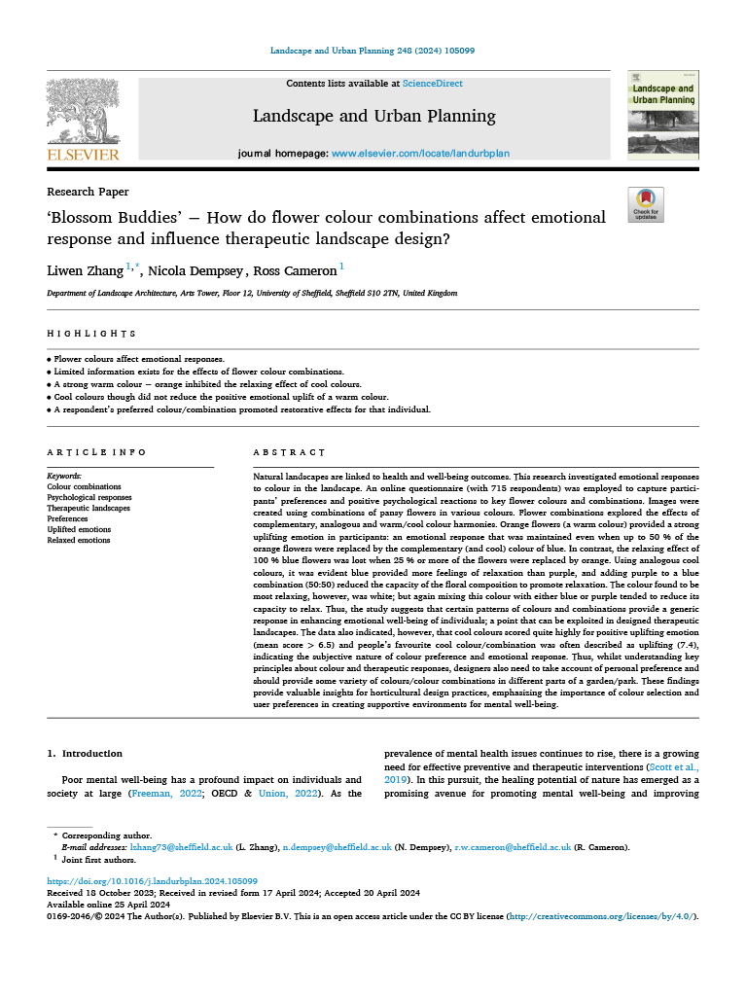
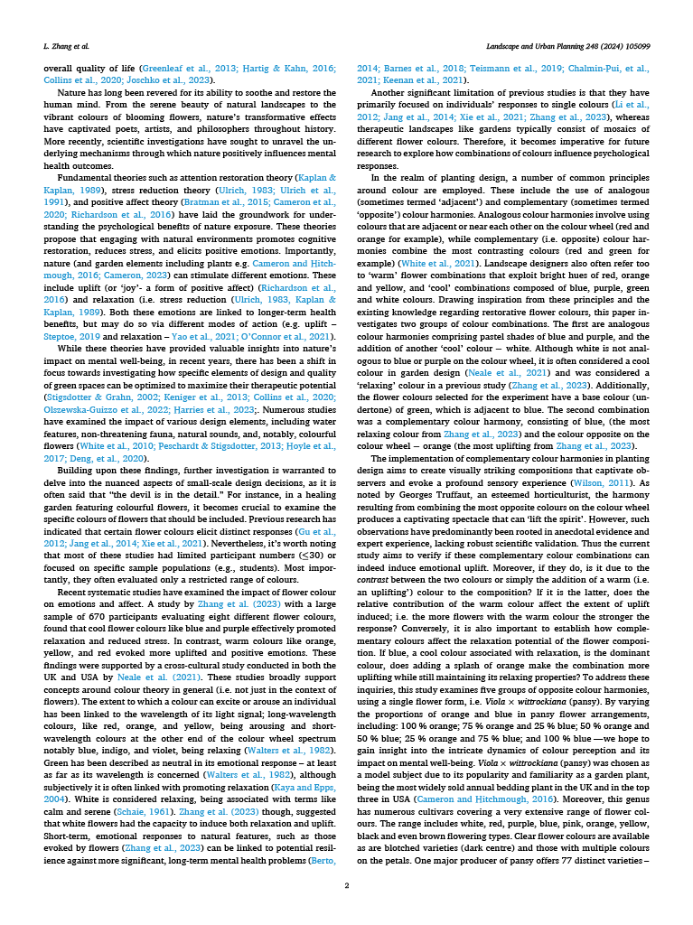
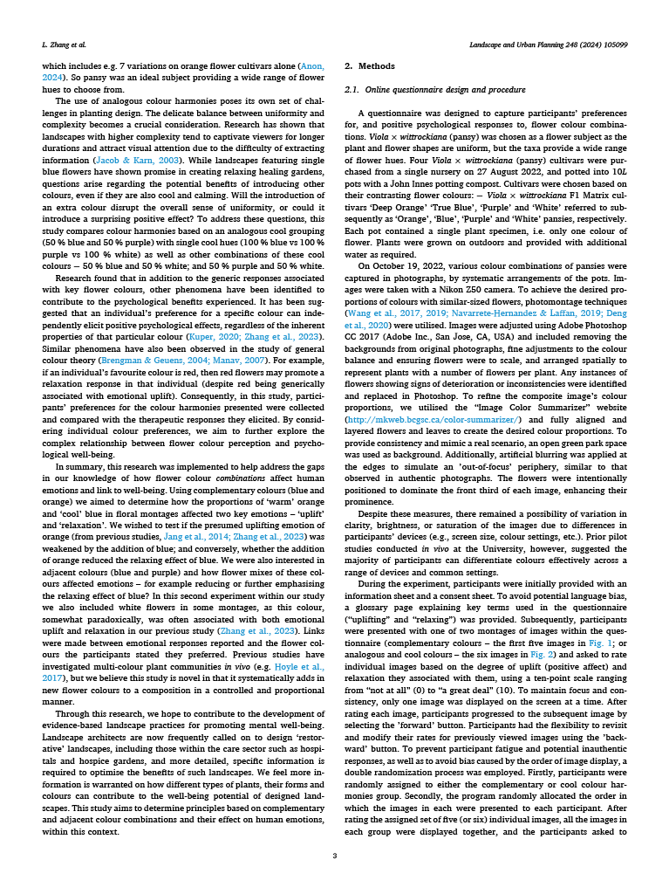
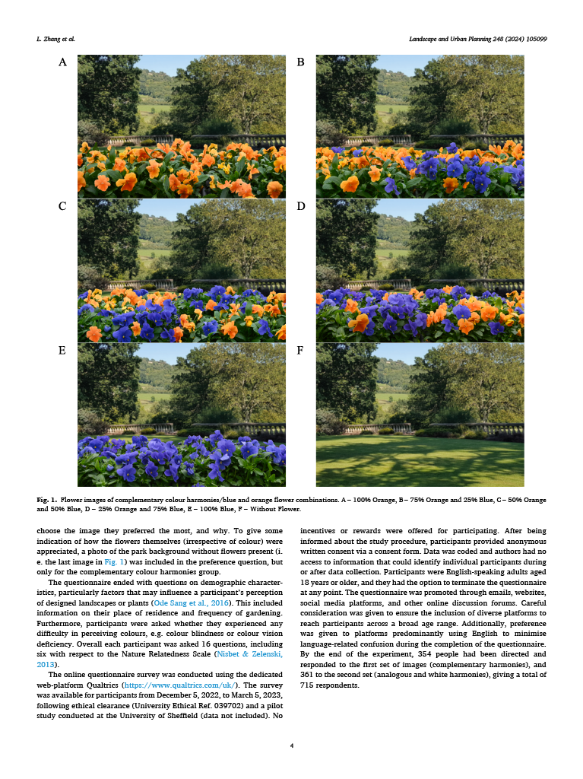
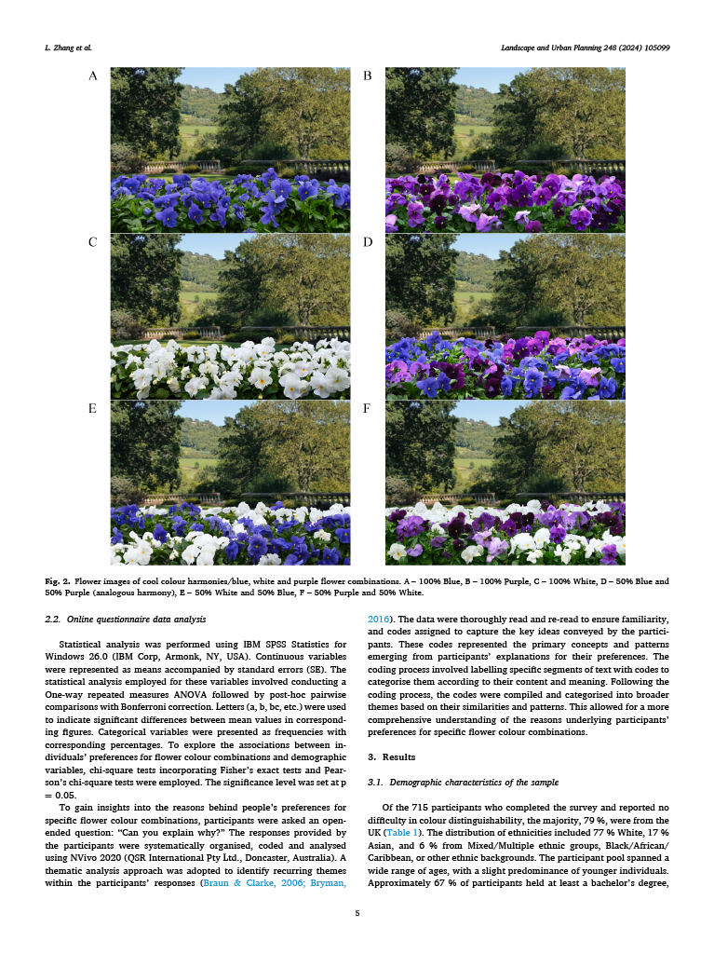
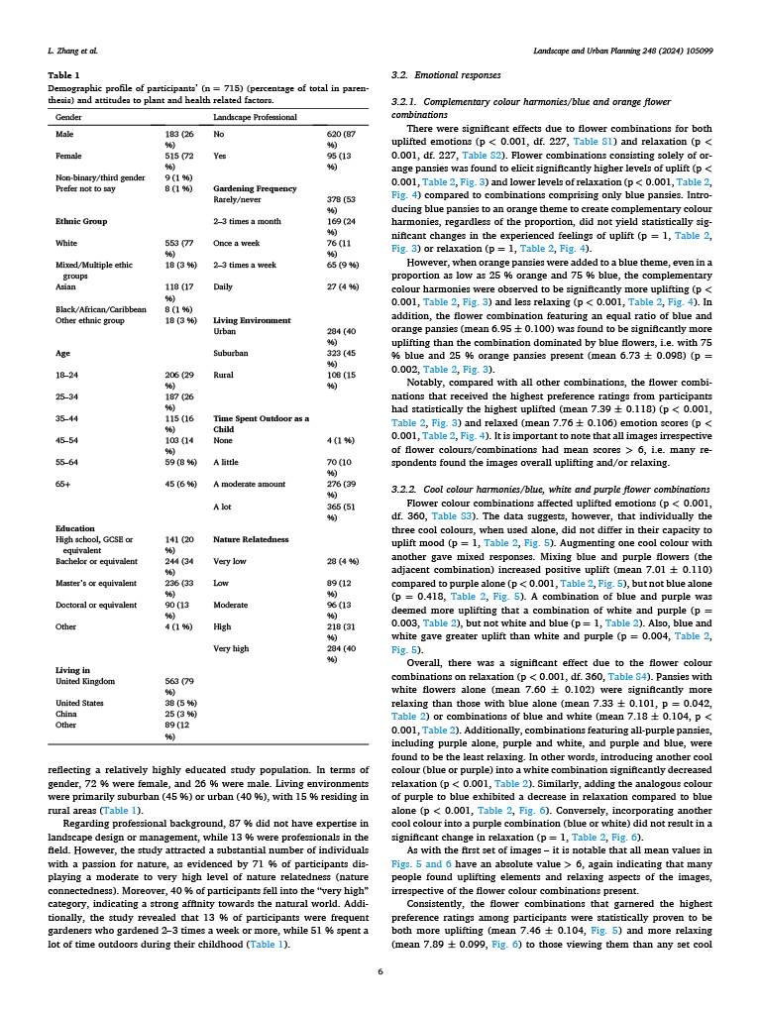
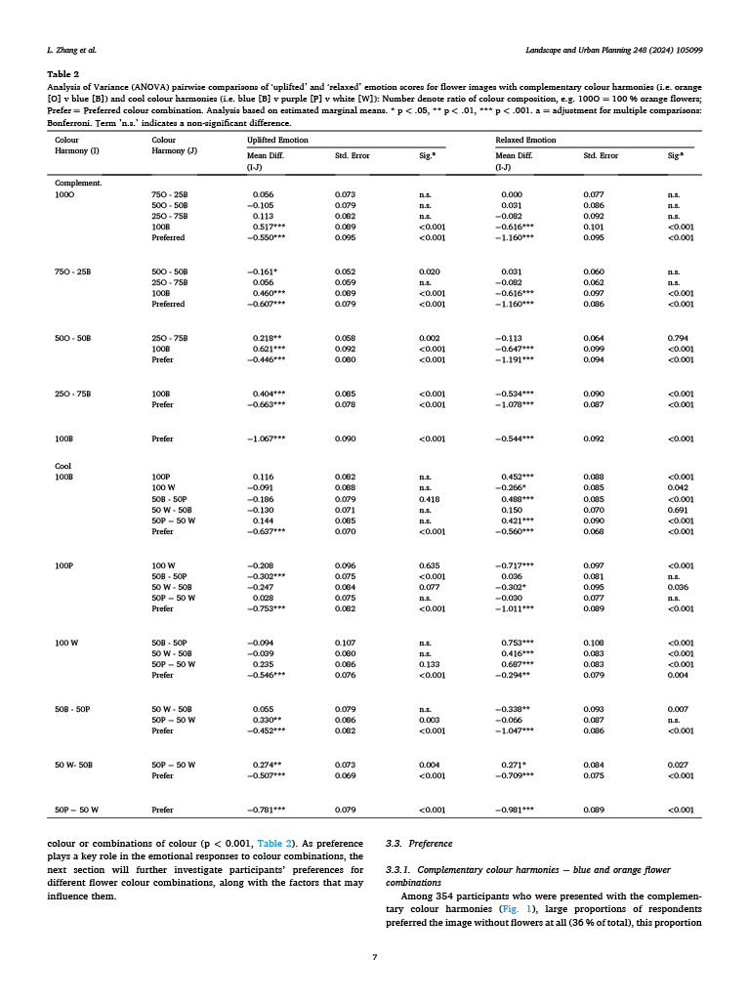
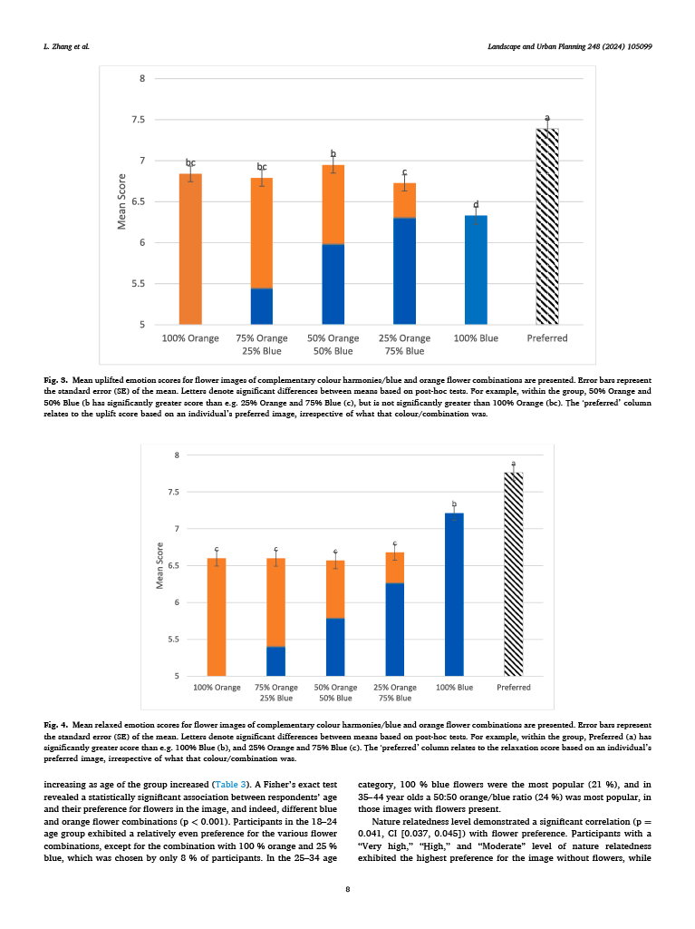
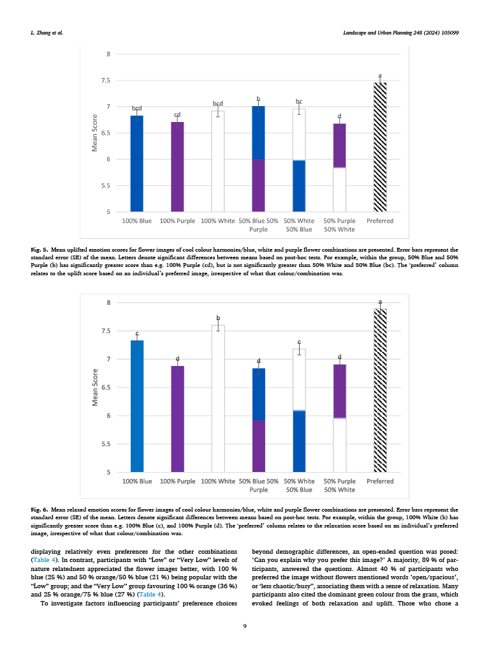
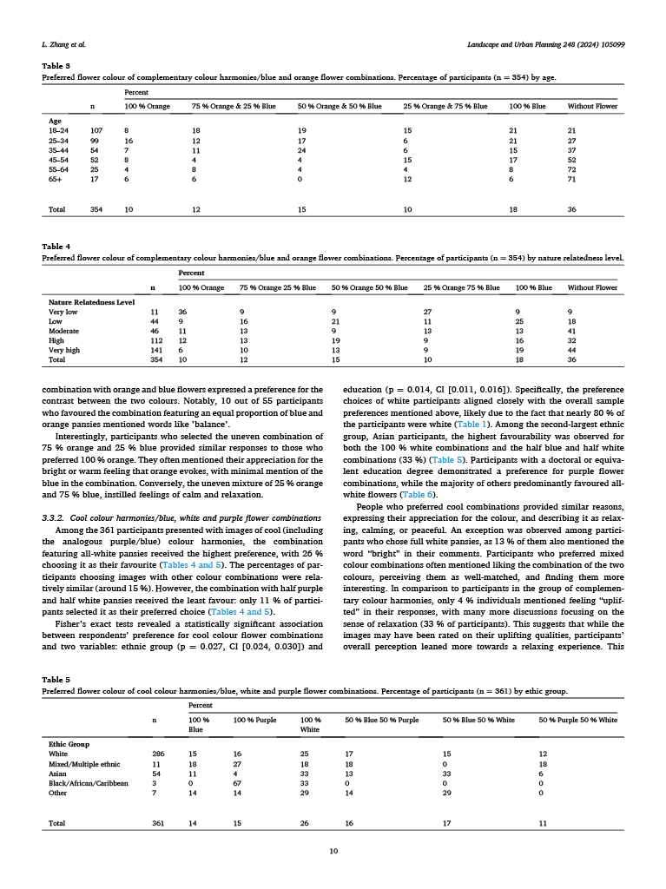
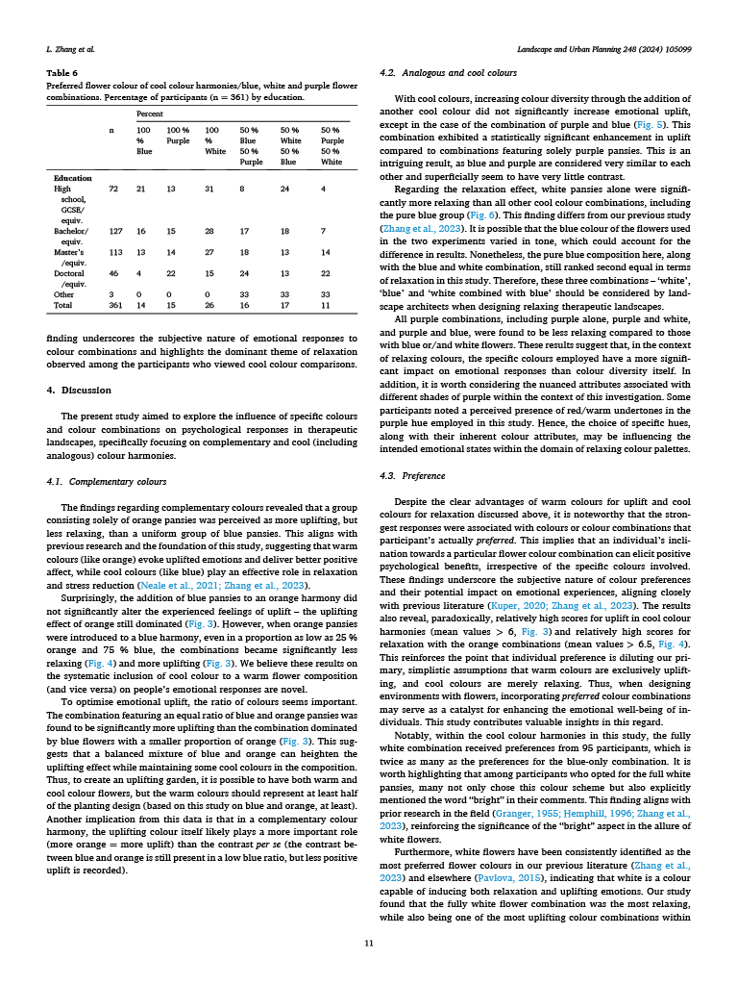
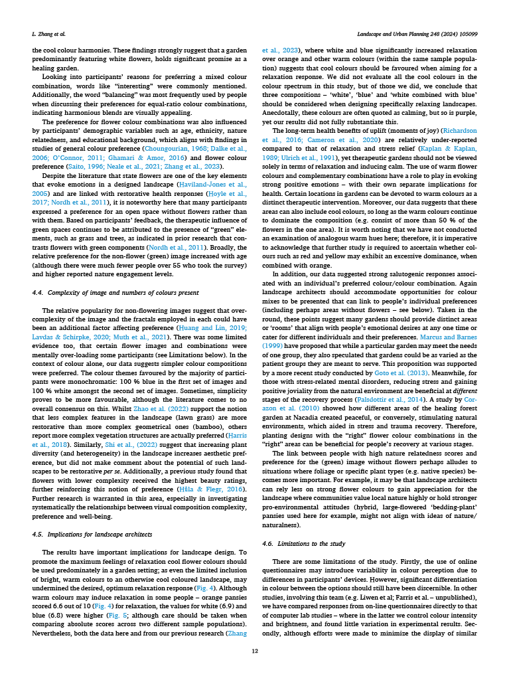
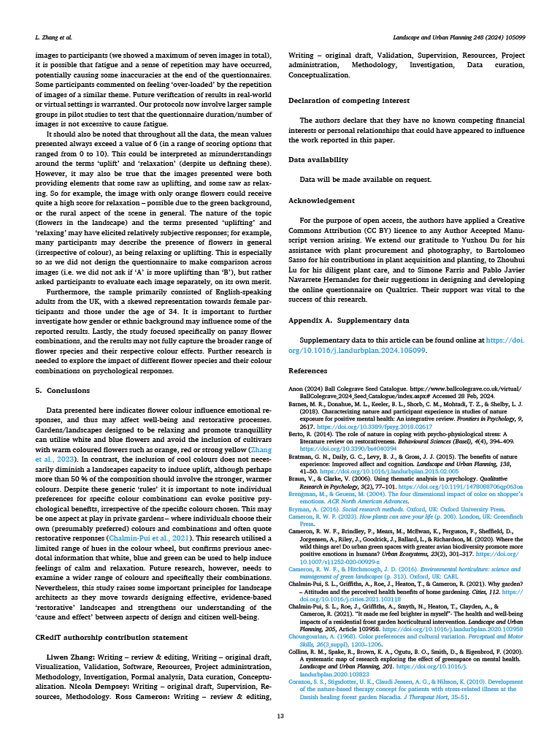
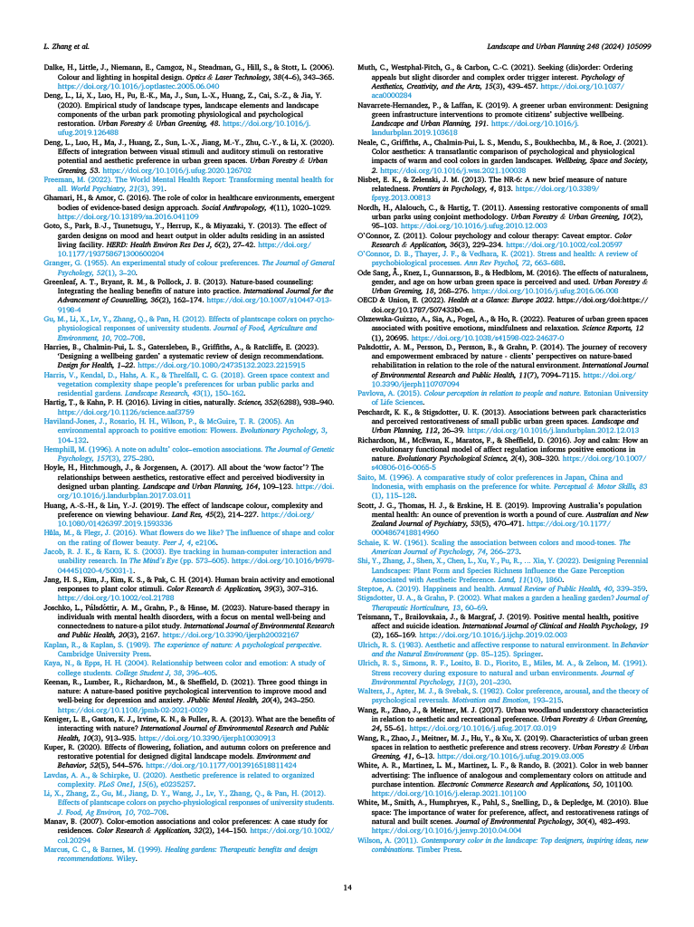

Appendix A. Supplementary data for Paper IV

Table S1. ANOVA Results of Uplifted emotion scores for flower images of complementary colour harmonies/blue and orange flower combinations
Mauchly's Test of Sphericitya
Within Subjects Effect | Mauchly's W | Approx. Chi-Square | df | Sig. | Epsilon^{b}
 |  |  |  |  | Greenhouse-Geisser | Huynh-Feldt | Lower-bound
Colour Harmony | 0.454 | 177.798 | 14.000 | <0.001 | 0.746 | 0.760 | 0.200

Tests of Within-Subjects Effects
Source |  | Type III Sum of Squares | df | Mean Square | F | Sig. | Partial Eta Squared | Noncent. Parameter | Observed Power
Colour Harmony | Sphericity Assumed | 108.035 | 5 | 21.607 | 22.282 | <0.001 | 0.089 | 111.409 | 1.000
 | Greenhouse-Geisser | 108.035 | 3.732 | 28.947 | 22.282 | <0.001 | 0.089 | 83.160 | 1.000
 | Huynh-Feldt | 108.035 | 3.802 | 28.413 | 22.282 | <0.001 | 0.089 | 84.723 | 1.000
 | Lower-bound | 108.035 | 1.000 | 108.035 | 22.282 | <0.001 | 0.089 | 22.282 | 0.997
Error (Colour Harmony) | Sphericity Assumed | 1100.632 | 1135 | 0.970
 | Greenhouse-Geisser | 1100.632 | 847.209 | 1.299
 | Huynh-Feldt | 1100.632 | 863.133 | 1.275
 | Lower-bound | 1100.632 | 227.000 | 4.849

Tests of Between-Subjects Effects
Transformed Variable: Average
Source | Type III Sum of Squares | df | Mean Square | F | Sig. | Partial Eta  Squared | Noncent.  Parameter | Observed  Power
Intercept | 68552.526 | 1 | 68552.526 | 4957.751 | <0.001 | 0.956 | 4957.751 | 1.000
Error | 3138.807 | 227 | 13.827

Pairwise Comparisons
Colour Harmony (I) | Colour Harmony (J) | Mean Diff. (I-J) | Std. Error | Sig^{.a}
100% Orange | 75% Orange 25% Blue | 0.056 | 0.073 | n.s.
100% Orange | 50% Orange 50% Blue | -0.105 | 0.079 | n.s.
100% Orange | 25% Orange 75% Blue | 0.113 | 0.082 | n.s.
100% Orange | 100% Blue | 0.517*** | 0.089 | <0.001
100% Orange | Preferred | -0.550*** | 0.095 | <0.001
75% Orange 25% Blue | 50% Orange 50% Blue | -0.161* | 0.052 | 0.020
75% Orange 25% Blue | 25% Orange 75% Blue | 0.056 | 0.059 | n.s.
75% Orange 25% Blue | 100% Blue | 0.460*** | 0.089 | <0.001
75% Orange 25% Blue | Preferred | -0.607*** | 0.079 | <0.001
50% Orange 50% Blue | 25% Orange 75% Blue | 0.218** | 0.058 | 0.002
50% Orange 50% Blue | 100% Blue | 0.621*** | 0.092 | <0.001
50% Orange 50% Blue | Preferred | -0.446*** | 0.080 | <0.001
25% Orange 75% Blue | 100% Blue | 0.404*** | 0.085 | <0.001
25% Orange 75% Blue | Preferred | -0.663*** | 0.078 | <0.001
100% Blue | Preferred | -1.067*** | 0.090 | <0.001
Based on estimated marginal means
* p < .05, ** p < .01, *** p < .001.
a Adjustment for multiple comparisons: Bonferroni.
A value of 'n.s.' indicates a non-significant difference.
Negative mean differences imply that the emotion level for Colour Harmony (I) is lower compared to Colour Harmony (J).

Table S2. ANOVA Results of Relaxed emotion scores for flower images of complementary colour harmonies/blue and orange flower combinations
Mauchly's Test of Sphericitya
Within Subjects Effect | Mauchly's W | Approx. Chi-Square | df | Sig. | Epsilon^{b}
 |  |  |  |  | Greenhouse-Geisser | Huynh-Feldt | Lower-bound
Colour Harmony | 0.464 | 173.063 | 14 | <0.001 | 0.755 | 0.770 | 0.200

Tests of Within-Subjects Effects
Source |  | Type III Sum of Squares | df | Mean Square | F | Sig. | Partial Eta Squared | Noncent. Parameter | Observed Power
Colour Harmony | Sphericity Assumed | 138.328 | 5 | 27.666 | 25.191 | <0.001 | 0.100 | 125.954 | 1.000
 | Greenhouse-Geisser | 138.328 | 3.777 | 36.626 | 25.191 | <0.001 | 0.100 | 95.139 | 1.000
 | Huynh-Feldt | 138.328 | 3.849 | 35.943 | 25.191 | <0.001 | 0.100 | 96.949 | 1.000
 | Lower-bound | 138.328 | 1.000 | 138.328 | 25.191 | <0.001 | 0.100 | 25.191 | 0.999
Error (Colour Harmony) | Sphericity Assumed | 1246.505 | 1135 | 1.098
 | Greenhouse-Geisser | 1246.505 | 857.317 | 1.454
 | Huynh-Feldt | 1246.505 | 873.629 | 1.427
 | Lower-bound | 1246.505 | 227.000 | 5.491

Tests of Between-Subjects Effects
Transformed Variable: Average
Source | Type III Sum of Squares | df | Mean Square | F | Sig. | Partial Eta  Squared | Noncent.  Parameter | Observed  Power
Intercept | 70707.036 | 1 | 70707.036 | 4976.696 | <0.001 | 0.956 | 4976.696 | 1.000
Error | 3225.131 | 227 | 14.208

Pairwise Comparisons
Colour Harmony (I) | Colour Harmony (J) | Mean Diff. (I-J) | Std. Error | Sig.ª
100% Orange | 75% Orange 25% Blue | 0.000 | 0.077 | n.s.
100% Orange | 50% Orange 50% Blue | 0.031 | 0.086 | n.s.
100% Orange | 25% Orange 75% Blue | -0.082 | 0.092 | n.s.
100% Orange | 100% Blue | -0.616*** | 0.101 | <0.001
100% Orange | Preferred | -1.160*** | 0.095 | <0.001
75% Orange 25% Blue | 50% Orange 50% Blue | 0.031 | 0.060 | n.s.
75% Orange 25% Blue | 25% Orange 75% Blue | -0.082 | 0.062 | n.s.
75% Orange 25% Blue | 100% Blue | -0.616*** | 0.097 | <0.001
75% Orange 25% Blue | Preferred | -1.160*** | 0.086 | <0.001
50% Orange 50% Blue | 25% Orange 75% Blue | -0.113 | 0.064 | 0.794
50% Orange 50% Blue | 100% Blue | -0.647*** | 0.099 | <0.001
50% Orange 50% Blue | Preferred | -1.191*** | 0.094 | <0.001
25% Orange 75% Blue | 100% Blue | -0.534*** | 0.090 | <0.001
25% Orange 75% Blue | Preferred | -1.078*** | 0.087 | <0.001
100% Blue | Preferred | -0.544*** | 0.092 | <0.001
Based on estimated marginal means
* p < .05, ** p < .01, *** p < .001.
a Adjustment for multiple comparisons: Bonferroni.
A value of 'n.s.' indicates a non-significant difference.
Negative mean differences imply that the emotion level for Colour Harmony (I) is lower compared to Colour Harmony (J).

Table S3. ANOVA Results of Uplifted emotion scores for flower images of cool colour harmonies/blue
Mauchly's Test of Sphericitya
Within Subjects Effect | Mauchly's W | Approx. Chi-Square | df | Sig. | Epsilon^{b}
 |  |  |  |  | Greenhouse-Geisser | Huynh-Feldt | Lower-bound
Colour Harmony | 0.571 | 200.538 | 20 | <0.001 | 0.825 | 0.838 | 0.167

Tests of Within-Subjects Effects
Source |  | Type III Sum of Squares | df | Mean Square | F | Sig. | Partial Eta Squared | Noncent. Parameter | Observed Power
Colour Harmony | Sphericity Assumed | 148.791 | 6 | 24.799 | 20.651 | <0.001 | 0.054 | 123.908 | 1.000
 | Greenhouse-Geisser | 148.791 | 4.951 | 30.053 | 20.651 | <0.001 | 0.054 | 102.244 | 1.000
 | Huynh-Feldt | 148.791 | 5.028 | 29.591 | 20.651 | <0.001 | 0.054 | 103.841 | 1.000
 | Lower-bound | 148.791 | 1.000 | 148.791 | 20.651 | <0.001 | 0.054 | 20.651 | 0.995
Error (Colour Harmony) | Sphericity Assumed | 2593.78 | 2160 | 1.201
 | Greenhouse-Geisser | 2593.78 | 1782.350 | 1.455
 | Huynh-Feldt | 2593.78 | 1810.196 | 1.433
 | Lower-bound | 2593.78 | 360.000 | 7.205

Tests of Between-Subjects Effects
Transformed Variable: Average
Source | Type III Sum of Squares | df | Mean Square | F | Sig. | Partial Eta  Squared | Noncent.  Parameter | Observed  Power
Intercept | 121620.879 | 1 | 121620.879 | 5261.462 | <0.001 | 0.936 | 5261.462 | 1.000
Error | 8321.55 | 360 | 23.115

Pairwise Comparisons
Colour Harmony (I) | Colour Harmony (J) | Mean Diff. (I-J) | Std. Error | Sig.ª
100% Blue | 100% Purple | 0.116 | 0.082 | n.s.
 | 100% White | -0.091 | 0.088 | n.s.
 | 50% Blue 50% Purple | -0.186 | 0.079 | 0.418
 | 50% White 50% Blue | -0.130 | 0.071 | n.s.
 | 50% Purple 50% White | 0.144 | 0.085 | n.s.
 | Preferred | -0.637*** | 0.070 | <0.001
100% Purple | 100% White | -0.208 | 0.096 | 0.635
 | 50% Blue 50% Purple | -0.302*** | 0.075 | <0.001
 | 50% White 50% Blue | -0.247 | 0.084 | 0.077
 | 50% Purple 50% White | 0.028 | 0.075 | n.s.
 | Preferred | -0.753*** | 0.082 | <0.001
100% White | 50% Blue 50% Purple | -0.094 | 0.107 | n.s.
 | 50% White 50% Blue | -0.039 | 0.080 | n.s.
 | 50% Purple 50% White | 0.235 | 0.086 | 0.133
 | Preferred | -0.546*** | 0.076 | <0.001
50% Blue 50% Purple | 50% White 50% Blue | 0.055 | 0.079 | n.s.
 | 50% Purple 50% White | 0.330** | 0.086 | 0.003
 | Preferred | -0.452*** | 0.082 | <0.001
50% White 50% Blue | 50% Purple 50% White | 0.274** | 0.073 | 0.004
 | Preferred | -0.507*** | 0.069 | <0.001
50% Purple 50% White | Preferred | -0.781*** | 0.079 | <0.001
Based on estimated marginal means
* p < .05, ** p < .01, *** p < .001.
a Adjustment for multiple comparisons: Bonferroni.
A value of 'n.s.' indicates a non-significant difference.
Negative mean differences imply that the emotion level for Colour Harmony (I) is lower compared to Colour Harmony (J).

Table S4. ANOVA Results of Relaxed emotion scores for flower images of cool colour harmonies/blue
Mauchly's Test of Sphericitya
Within Subjects Effect | Mauchly's W | Approx. Chi-Square | df | Sig. | Epsilon^{b}
 |  |  |  |  | Greenhouse-Geisser | Huynh-Feldt | Lower-bound
Colour Harmony | 0.519 | 234.741 | 20 | <0.001 | 0.811 | 0.824 | 0.167

Tests of Within-Subjects Effects
Source |  | Type III Sum of Squares | df | Mean Square | F | Sig. | Partial Eta Squared | Noncent. Parameter | Observed Power
Colour Harmony | Sphericity Assumed | 345.899 | 6 | 57.65 | 43.361 | <0.001 | 0.107 | 260.163 | 1.000
 | Greenhouse-Geisser | 345.899 | 4.869 | 71.042 | 43.361 | <0.001 | 0.107 | 211.121 | 1.000
 | Huynh-Feldt | 345.899 | 4.944 | 69.966 | 43.361 | <0.001 | 0.107 | 214.366 | 1.000
 | Lower-bound | 345.899 | 1.000 | 345.899 | 43.361 | <0.001 | 0.107 | 43.361 | 1.000
Error (Colour Harmony) | Sphericity Assumed | 2871.816 | 2160 | 1.33
 | Greenhouse-Geisser | 2871.816 | 1752.827 | 1.638
 | Huynh-Feldt | 2871.816 | 1779.767 | 1.614
 | Lower-bound | 2871.816 | 360.000 | 7.977

Tests of Between-Subjects Effects
Transformed Variable: Average
Source | Type III Sum of Squares | df | Mean Square | F | Sig. | Partial Eta  Squared | Noncent.  Parameter | Observed  Power
Intercept | 132162.891 | 1 | 132162.891 | 6670.78 | <0.001 | 0.949 | 6670.78 | 1.000
Error | 7132.395 | 360 | 19.812

Pairwise Comparisons
Colour Harmony (I) | Colour Harmony (J) | Mean Diff. (I-J) | Std. Error | Sig.ª
100% Blue | 100% Purple | 0.452*** | 0.088 | <0.001
 | 100% White | -0.266* | 0.085 | 0.042
 | 50% Blue 50% Purple | 0.488*** | 0.085 | <0.001
 | 50% White 50% Blue | 0.150 | 0.070 | 0.691
 | 50% Purple 50% White | 0.421*** | 0.090 | <0.001
 | Preferred | -0.560*** | 0.068 | <0.001
100% Purple | 100% White | -0.717*** | 0.097 | <0.001
 | 50% Blue 50% Purple | 0.036 | 0.081 | n.s.
 | 50% White 50% Blue | -0.302* | 0.095 | 0.036
 | 50% Purple 50% White | -0.030 | 0.077 | n.s.
 | Preferred | -1.011*** | 0.089 | <0.001
100% White | 50% Blue 50% Purple | 0.753*** | 0.108 | <0.001
 | 50% White 50% Blue | 0.416*** | 0.083 | <0.001
 | 50% Purple 50% White | 0.687*** | 0.083 | <0.001
 | Preferred | -0.294** | 0.079 | 0.004
50% Blue 50% Purple | 50% White 50% Blue | -0.338** | 0.093 | 0.007
 | 50% Purple 50% White | -0.066 | 0.087 | n.s.
 | Preferred | -1.047*** | 0.086 | <0.001
50% White 50% Blue | 50% Purple 50% White | 0.271* | 0.084 | 0.027
 | Preferred | -0.709*** | 0.075 | <0.001
50% Purple 50% White | Preferred | -0.981*** | 0.089 | <0.001
Based on estimated marginal means
* p < .05, ** p < .01, *** p < .001.
a Adjustment for multiple comparisons: Bonferroni.
A value of 'n.s.' indicates a non-significant difference.
Negative mean differences imply that the emotion level for Colour Harmony (I) is lower compared to Colour Harmony (J).

Chapter 7: Synthesis and Design Guidance

From evidence to application
The four studies in this thesis moved from the screen to the field and back again. While each paper answered specific questions about hue, behaviour, or diversity, the ultimate aim was to provide usable tools for practice. This chapter synthesizes those findings, pressure-testing the results across different study modes (Section 7.2) to separate context-dependent effects from robust principles (Section 7.3). It then translates these verified principles into a logic-based Therapeutic Planting Algorithm for use in design practice (Section 7.4). This translational aim sits within a wider movement towards evidence-based design guidance in horticulture and landscape architecture, exemplified by parallel efforts such as the Royal Horticultural Society's Wellbeing Garden Blueprint (Sachs et al., 2026).

Cross-project verification (Triangulating the evidence)
Scientific rigour relies on reproducibility. To validate the findings before translating them into design guidance, this section subjects the data to a process of triangulation, weaving the internal consistency of the four studies together with established external theoretical frameworks.

Triangulating the "Cool vs. Warm" Effect
The distinction between "Cool-Relaxing" and "Warm-Uplifting" emerged as the most robust finding throughout this body of work. In the online survey (Paper I), the preference for cool hues in restorative scenarios was evident but static. A potential criticism of this method is that screen calibration or the artificiality of the medium could skew results. However, Paper III replicated this finding in an immersive VR environment, and Paper IV confirmed it using living plant material in real outdoor conditions. The fact that the direction of the effect remained consistent—whether the subject was looking at a pixel, a VR render, or a physical petal—confirms this is a genuine psychological response to hue rather than a methodological artifact.
This aligns with the foundational work of Valdez and Mehrabian (1994), who mapped similar emotional associations using simple colour swatches. However, this thesis extends their findings by demonstrating that these theoretical associations remain stable even in chaotic, multi-sensory landscape settings. It confirms that the "Cool=Calm" equation is not just a laboratory curiosity but a reliable baseline for horticultural design, validating Kaufman and Lohr’s (2004) assertions regarding the calming influence of cool-toned vegetation. The robust separation of Cool-Relaxing and Warm-Uplifting effects also aligns with the evolutionary-functional model proposed by Richardson et al. (2016), which treats joy and calm as functionally distinct positive emotional states served by different environmental cues.

The "White" Paradox: Context and Contrast
The role of white proved to be the most complex variable, revealing a significant divergence between laboratory expectations and field reality. In the isolated context of Paper I, participants treated white as a "neutral" bridge. However, the field experiments revealed a more aggressive visual nature. In Paper II, white planting rows positioned next to red-dominated tulip rows triggered the highest visual saliency of all tested options. This occurred because the adjacent red-dominant sequences provided a dark, warm backdrop; against this low-value surface, the high brightness (Value) of the white flowers created a sharp luminosity contrast, transforming them from a passive 'neutral' into the most aggressive signal in the field. The same luminosity-contrast principle informs the architectural extension in the Spec Cards: against red-brick surrounds in built settings, white is predicted to read as similarly high-arousal.
This finding challenges general horticultural literature (Hobhouse, 1985; Lawson, 2015), which often categorises white merely as a "harmoniser." Instead, our data provides strong empirical support for Chevreul’s Law of Simultaneous Contrast (1839). Chevreul argued that a colour’s impact is defined by its neighbour, and our results confirm that white acts as a powerful contrast agent—popping sharply against dark backgrounds or diluting the saturation of cool borders. This suggests that white’s therapeutic value is entirely context-dependent, acting as a refresher in green settings but a potentially distracting contrast agent in hardscape environments.

Complexity: The Gap Between Count and Perception
A significant contribution of this research is the distinction between actual colour diversity and perceived diversity. Paper III explicitly demonstrated that users are poor judges of actual colour diversity; a planting with four colours arranged simply was often perceived as less diverse than a two-colour matrix planting arranged with greater visual intermingling. This suggests that the feeling of richness comes from the visual pattern (intermingling) rather than the botanical count.
This misperception explains the behavioural data in Paper II, where walkers slowed down for mixed rows not because they were counting species, but because they were engaging with the visual complexity of the pattern. This mirrors findings in urban ecology by Dallimer et al. (2012) and the integrative biodiversity-health framework of Marselle et al. (2022), who found that user well-being correlates with perceived rather than actual richness. It also refines Kaplan and Kaplan’s (1989) concept of "Soft Fascination," suggesting that therapeutic fascination is triggered by the texture and contrast distribution of the planting rather than the biological inventory. Consequently, the design guidance in Section 7.4 shifts the focus from 'Actual Colour Diversity' to 'Perceived Complexity.' In practice, since real planting almost always achieves colour diversity through species diversity, this principle is likely to generalise to species-count guidance as well — though that extension awaits confirmatory testing.

The Dominance of Preference
Finally, the data consistently highlighted the limits of universal theory. Across the demographic analysis in Paper I and the expertise comparison in Paper IV, individual differences acted as a significant moderator. For instance, expert gardeners in Paper IV showed a higher tolerance for complexity than the general public. This aligns with the Ecological Valence Theory (Palmer & Schloss, 2010), which posits that aesthetic response is learned and adaptive rather than purely hardwired. This serves as a critical counter-argument to rigid "Colour Healing" theories, suggesting instead that while universal rules work for public spaces, personal aesthetic history is the strongest predictor of restoration in private contexts. This finding parallels Chalmin-Pui et al.'s (2021) work on residential front gardens, in which the perceived wellbeing benefits of home gardening were strongly tied to individuals' active choice of plants and colours rather than to any universal botanical formula.

Summary of key empirical findings
Based on the verification above, the following six findings form the evidence base for the design guidance:
- Tone is Directional: Cool hues drive Relaxation; Warm hues drive Uplift. This is the most reliable predictor of emotional response.
- The "Orange Dominance" Threshold: In mixtures, warm colours dominate. A relaxing blue scheme loses its calming effect once orange exceeds ~25% of the area.
- Perception Trumps Reality: Perceived Diversity (how busy the scene looks) drives the emotional response more than Actual Colour Diversity (the number of distinct hues in the planting).
- Behaviour Follows Complexity: In the field, walkers linger longer next to multi-coloured or high-contrast planting, suggesting visual complexity triggers "soft fascination."
- White is Context-Dependent: White is highly sensitive to the background. It pops against red/dark backgrounds but can flatten a cool scheme.
- Preference is Critical: Personal preference for a hue often overrides its theoretical emotional association, particularly in private contexts.

The Design Handbook: Applying the findings on site
Step 1: Define the Spatial Experience
Before selecting species, determine how the site structure influences perception. Do not rely solely on physical size (m²); assess the site's capacity for visual separation.
Type A: The Multi-Zone Site (Sequential Experience)
- Definition: The user moves through distinct spaces where one area is visually separated from another (e.g., a hospital campus, a large public park, or a garden with subdivided rooms).
- The Rationale: Spatial separation allows for emotional sequencing. You can curate different experiences in different areas without creating visual conflict or fatigue.
- Action: Treat each zone as a separate brief. Define the specific emotional goal for each distinct area (e.g., "Area A is for Uplift/High Arousal," "Area B is for Relaxation/Low Arousal"), then apply the Palette Checks to each zone independently.
Type B: The Single-Volume Site (Instant Experience)
- Definition: The whole space is comprehended in a single glance. The user cannot physically move "away" from the palette (e.g., a courtyard, a waiting room view, or a pocket park).
- The Rationale: In a single volume, high visual complexity can undermine the restorative potential. Our findings show that scenes perceived as "too busy" are less likely to support relaxation.
- Action: Prioritise cohesion. Do not attempt to force conflicting zones into a single view. If a multi-purpose function is required, use Option C (Flexible/Neutral) below, relying on white and texture rather than conflicting colour bloc
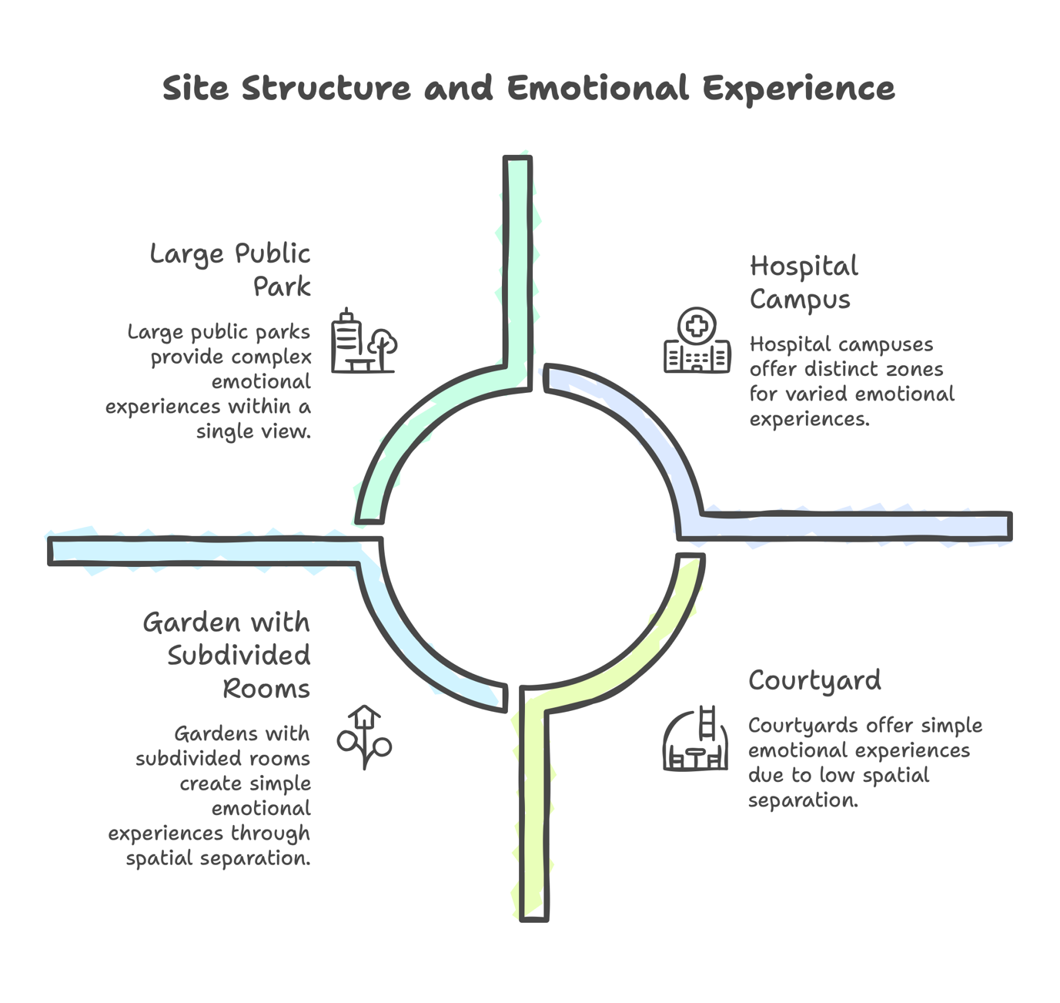Figure 7.1 Spatial typologies for design. Distinguishing between Multi-Zone Sites (sequenced emotional rooms) and Single-Volume Sites (cohesive palette requirements).
Step 2: Know Your User
The success of a therapeutic palette depends on who is looking at it. Whether you can speak to them directly or must rely on demographic data, you need to define the viewer to calibrate the palette effectively.
Path A: Direct Consultation (If you can speak to the users)
- Calibration: The "Preference Gateway": Show swatches or photos of the proposed anchor families. Ask: "Do you have a strong dislike for any of these?".
- Calibration: The "Busyness" Tolerance: Show reference images ranging from simple to complex. Ask: "Which of these looks 'boring' and which looks 'too messy'?".
Path B: General Application (If you cannot speak to the users) Use this for public parks, streetscapes, or open-access sites where you must infer user needs.
- Check Visual Capacity (Age & Ability)
  - The Factor: Ageing reduces short-wavelength sensitivity.
  - The Check: If the demographic is Older (>65), reduce reliance on subtle blue/purple distinctions. Ensure higher contrast between the planting and the surround to maintain legibility.
- Check Baseline State (Stress Level)
  - The Factor: Baseline mood appears to influence how users perceive colour richness. Paper III evidence suggested that participants with higher Negative Affect tended to perceive the same scene as less colourful, consistent with mood-congruent perceptual effects.
  - The Check: For High-Stress Environments (e.g., hospitals, crisis centres), this implies the Perceived Diversity target may need to be calibrated upwards rather than downwards — a moderately diverse actual palette may deliver an under-stimulating perceived experience to a stressed observer. This correlational finding requires confirmatory testing before adoption as a fixed rule.
- Check Gardening Culture (The "Expertise" Factor)
  - The Factor: Findings suggest that Gardeners and Non-Gardeners differ in their preferences. Gardeners often tolerate higher complexity and may prefer different palettes compared to the general public (Papers I & IV).
  - The Check: If the site is for a General Public audience (mostly non-gardeners), apply the "Non-Expert Default". Simplify the palette and use broad drifts of colour. If the site is for a gardening club or enthusiast group, you can increase the complexity (actual diversity).
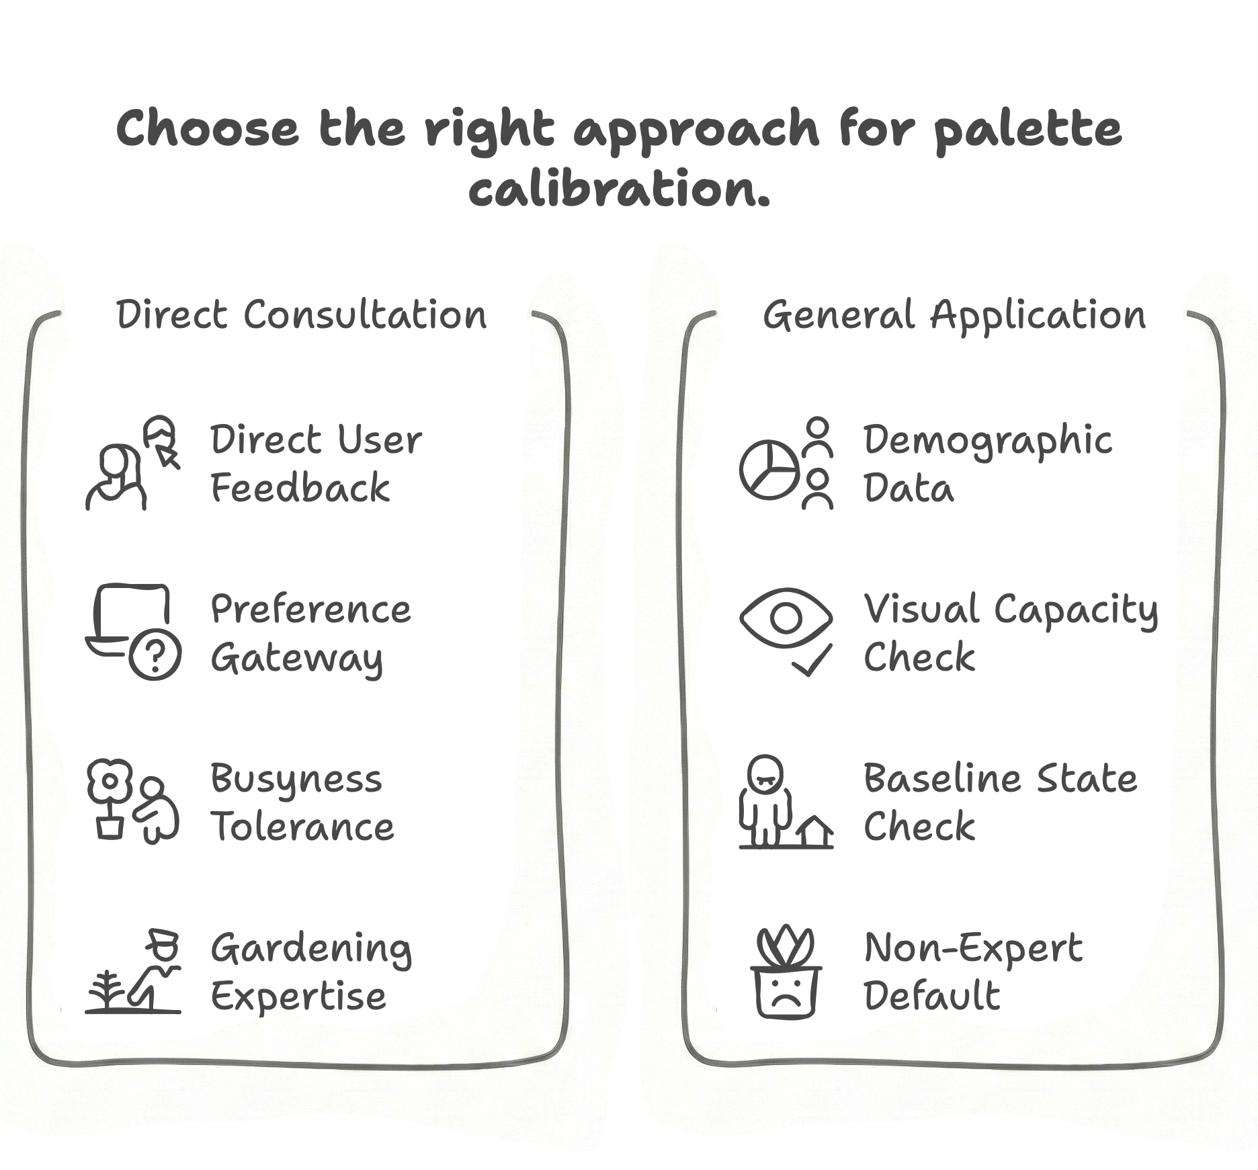
Figure 7.2 User calibration pathways. Defining the workflow for Path A (Direct Consultation) versus Path B (General Application using demographic proxies).
Step 3: Select the Goal
Choose the primary emotional aim for the zone you are designing and proceed to the relevant Specification Card.
Option A: RESTORATION (Priority: Calm, Serenity)
- Goal: To lower arousal, reduce stress, or support quiet reflection.
- Action: Go to Spec Card 1.
Option B: UPLIFT (Priority: Energy, Joviality)
- Goal: To increase arousal, support activity, or brighten a mood.
- Action: Go to Spec Card 2.
Option C: FLEXIBLE / NEUTRAL (Priority: Brightness, Texture)
- Goal: To bridge zones, provide a flexible backdrop for shared spaces, or ensure clarity in single-volume sites.
- Action: Go to Spec Card 3.
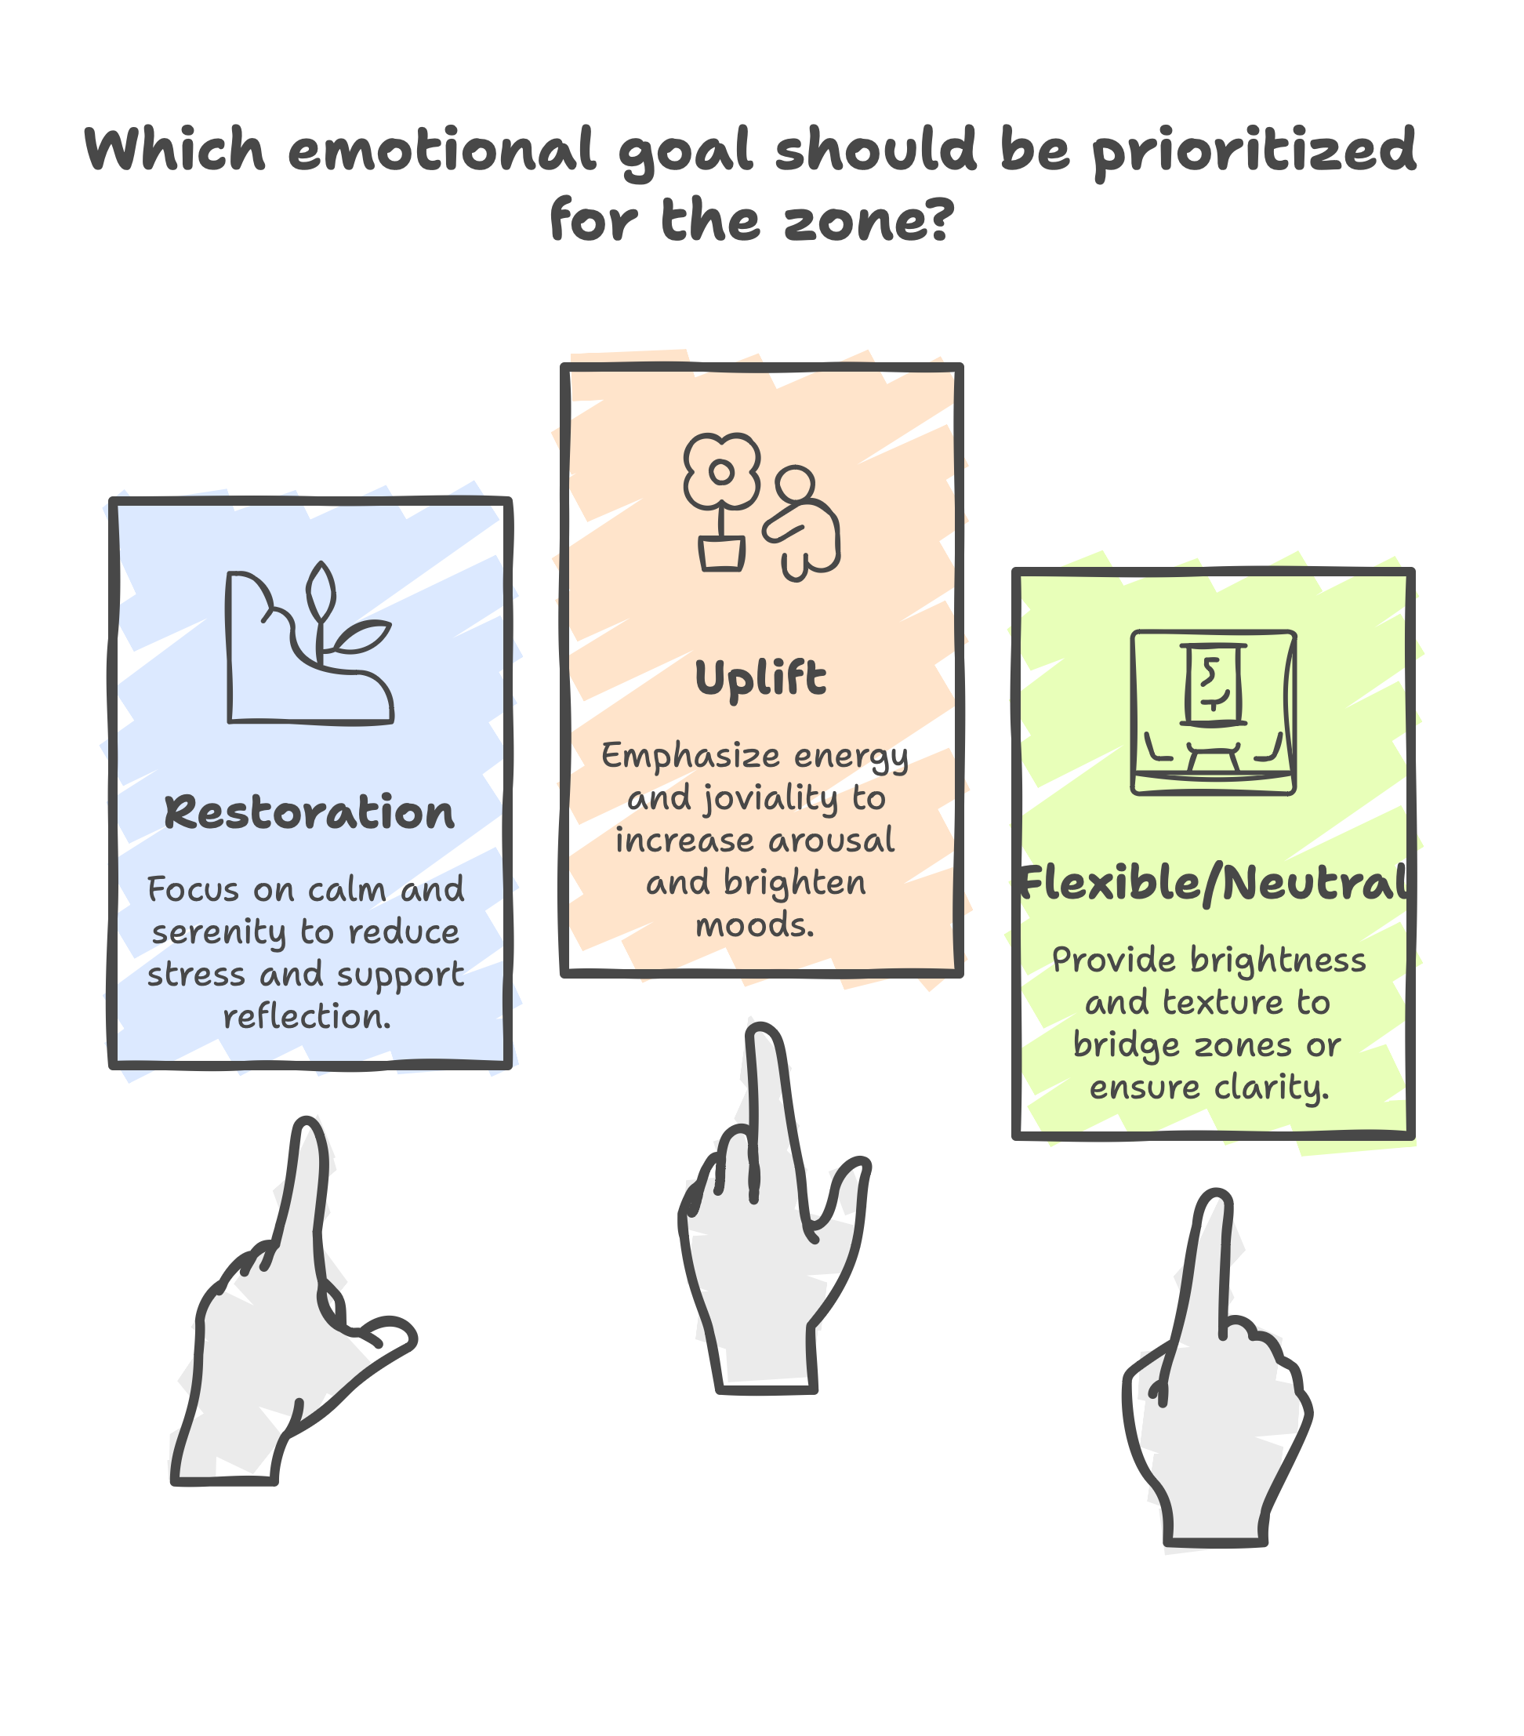
Figure 7.3 Selection of Palette Specification Cards. Mapping the primary therapeutic goal (Restoration, Uplift, or Flexible) to the appropriate planting palette.
Step 4: The Palette Specification Cards
Copy the relevant card and attach it to the planting plan to ensure the design intent survives procurement and maintenance.

SPEC CARD 1: RESTORATION (The "Calm" Palette)
DESIGN CHECK | THE RULE
1. ANCHORS | Blue and White (with Purple as secondary).  Blue alone, white alone, and the blue-and-white combination all reliably elicit relaxation (Paper I; Paper IV §4.2). Purple compositions are calming but rank below blue and white.
2. STRUCTURE | Analogous (Blue + Purple) or Cool + White (e.g., 50:50 Blue + White).  Both structures support calm and the slowing of attention associated with restoration. Avoid high-contrast multicoloured arrangements, which extend dwell time and visual engagement rather than supporting calm (Paper II).
3. PROPORTION | The 25% Threshold.  If adding a Warm accent (Orange/Yellow), it must stay below ~25% of the floral area (Paper IV). Above this, the relaxing effect breaks down and the palette tips toward uplift.
4. WHITE | Use freely as a primary or co-primary anchor.  White is one of the most relaxing single-hue choices (Paper I), and white-with-blue is tied with pure blue as the highest-relaxation composition tested (Paper IV §4.2). Treat white as a relaxing anchor, not as a contrast agent in this palette.
5. SURROUND | Check the Background.  Against Red Brick or warm-dominant surrounds, white and yellow will read as high arousal (Paper II). For relaxation, prefer cool-toned surrounds, neutral green foliage backdrops, or shaded walls.
6. CONTEXT | Best deployed for stress recovery.  Paper III shows cool palettes facilitate recovery after a stressor. In high-stress environments (e.g., hospitals, crisis centres), calibrate Perceived Diversity upwards — stressed observers tend to perceive the same scene as less colourful than relaxed observers do, so the palette may need to deliver more actual colour to land as moderately diverse.

SPEC CARD 2: UPLIFT (The "Energy" Palette)
DESIGN CHECK | THE RULE
1. ANCHORS | Warm Families (Orange, Yellow, Red).  Use these as the dominant hue to capture attention and produce immediate mood elevation (Papers I, III, IV). Orange and yellow are the strongest anchors; red supports activation but registers as less relaxing than orange/yellow.
2. STRUCTURE | Complementary (opposing hues, e.g., Blue + Orange) at an equal ratio.  Paper IV identifies an equal 50:50 Blue:Orange ratio as the most uplifting combination tested, outperforming blue-dominated or orange-dominated alternatives. Use this ratio as the default for uplift planting.
3. PROPORTION | High tolerance.  Warm hues dominate visual attention disproportionately to their area. Even at a 50:50 split with cool colours, the warm anchor maintains the uplifting effect (Paper IV).
4. WHITE | Use for freshness and brightness.  White reads as bright and active against green foliage (Papers I, IV) and supports the uplifting effect when paired with warm anchors. Effective in 10–25% proportions.
5. SURROUND | Check the Background.  Against Grey/Concrete surrounds, warm anchors are essential to add visual life. Cool palettes against grey may feel sombre. Warm-on-warm surrounds (e.g., red brick) can over-stimulate; check brightness contrast.
6. CONTEXT | Best deployed for buffering or pre-stress activation.  Paper III shows warm hues provide an immediate mood boost but lack the same post-stress recovery capacity as cool hues. Use uplift palettes in welcoming entrances, social zones, and contexts where users approach with neutral or low affect — not as the primary palette in spaces designed for users in acute stress.

SPEC CARD 3: FLEXIBLE / NEUTRAL (The "Texture" Palette)
DESIGN CHECK | THE RULE
1. ANCHORS | White + Green Foliage.  A flexible anchor pair that supports either relaxation or uplift depending on surround and structural context. White functions differently in this card than in Card 1 — here it carries the palette in the absence of strong floral hue.
2. STRUCTURE | Texture-driven.  With limited hue variation, achieve Perceived Diversity (Paper III's key predictor of affective response) through contrasting leaf forms, flower shapes, and structural rhythm rather than colour. Paper III §3.3 shows perceived diversity correlates with positive affect more reliably than actual colour count.
3. PROPORTION | Balance brightness.  White is not perceptually neutral; it functions as a high-arousal contrast agent in many surrounds (Paper II). Ensure sufficient green foliage to prevent white from becoming glaring in direct sun or against warm surrounds.
4. PERCEPTION | Target Perceived Diversity, not hue count.  Paper III demonstrates that what a scene looks like matters more than what is on the planting schedule. This card achieves Perceived Diversity through textural and structural means, so a low actual colour count can still deliver a rich perceived experience.
5. SURROUND | Check the Background.  Against Red Brick or warm-dominant surrounds, white reads as high arousal (Paper II) — the card tips toward uplift. Against Green Hedges or cool/neutral walls, the palette reads fresh and neutral, suitable for either calming or transitional zones.
6. CONTEXT | Best deployed in transitional or mixed-use spaces.  Use this palette where the same planting must serve users in different emotional states across the day (e.g., entrance plazas, civic landscapes, mixed-use therapeutic grounds). Tune the affective register through surround choice and textural intensity rather than through colour shift.

Limitations
The limitations of this guidance must be defined.
The "Snapshot" Limit: Our studies measured short-term responses (minutes). We cannot claim these effects hold for someone sitting in a garden for four hours, or over a year of seasons.
The Physiological Lesson: As detailed in Chapter 2, we found that physiological sensors (HRV/EEG) were not sensitive enough for these subtle aesthetic shifts. Therefore, this guidance is based on felt emotion (self-report) and observed behaviour, not biological stress markers.
Context Specificity: The "Spec Card" thresholds (e.g., the 25% rule) are derived from our specific test conditions. They are robust guidelines, but not universal laws of physics.

Conclusion
Design is often treated as purely subjective, a matter of taste. This thesis argues that while taste matters, the effect of colour on the mind has a structure. By understanding the levers of Tone, Proportion, and Diversity, we can design landscapes that do not just look good, but function as reliable resources for well-being.

References
Chalmin-Pui, S. L., Griffiths, A., Roe, J., Heaton, T., & Cameron, R. (2021). Why garden? – Attitudes and the perceived health benefits of home gardening. Cities, 112. https://doi.org/10.1016/j.cities.2021.103118
Chevreul, M. E. (1855). The principles of harmony and contrast of colours, and their applications to the arts. Longman, Brown, Green, and Longmans.
Dallimer, M., Irvine, K. N., Skinner, A. M., Davies, Z. G., Rouquette, J. R., Maltby, L. L., Warren, P. H., Armsworth, P. R., & Gaston, K. J. (2012). Biodiversity and the feel-good factor: understanding associations between self-reported human well-being and species richness. BioScience, 62(1), 47-55.
Hobhouse, P. (1985). Colour in Your Garden. Collins. https://books.google.co.uk/books?id=4UavAAAACAAJ
Kaplan, R., & Kaplan, S. (1989). The experience of nature: A psychological perspective. Cambridge university press.
Kaufman, A., & Lohr, V. (2002). Does plant color affect emotional and physiological responses to landscapes? XXVI International Horticultural Congress: Expanding Roles for Horticulture in Improving Human Well-Being and Life Quality 639,
Lawson, A. (2015). The Gardener’s Book of Colour. Pimpernel Press Ltd.
Marselle, M., Hartig, T., Cox, D., De Bell, S., Knapp, S., & Lindley, S. (2022). Pathways linking biodiversity to human health. A conceptual framework, 150, 106420.
Palmer, S. E., & Schloss, K. B. (2010). An ecological valence theory of human color preference. Proceedings of the National Academy of Sciences, 107(19), 8877-8882.
Richardson, M., McEwan, K., Maratos, F., & Sheffield, D. (2016). Joy and Calm: How an Evolutionary Functional Model of Affect Regulation Informs Positive Emotions in Nature. Evolutionary Psychological Science, 2(4), 308-320. https://doi.org/10.1007/s40806-016-0065-5
Sachs, A., Shearing, V., Chalmin-Pui, L., Lewis, B., & Griffiths, A. (2026). The Wellbeing Garden Blueprint for Organisations and Communities. Royal Horticultural Society, London, UK., 1.
Valdez, P., & Mehrabian, A. (1994). Effects of color on emotions. Journal of Experimental Psychology: General, 123(4), 394–409. https://doi.org/10.1037/0096-3445.123.4.394

Chapter 8: Conclusion
This thesis by publication asked whether flower colour can be used as a design variable for mental well-being in everyday and therapeutic settings, and how such choices can be specified and checked in practice. The paper chapters (3–6) presented the empirical analyses, while Chapter 7 translated these findings into steps that designers can use on site.

Answers for research questions
RQ1. In realistic images of planted beds, are some single flower colours considered more relaxing or uplifting than others?
Across the single-hue screens, cool-family colours were more often judged relaxing and warm-family colours more often uplifting. White behaved flexibly and was associated with both relaxing and uplifting appraisals, with the strength of that reading shaped by context. Where preference was collected, favourites frequently overlapped with these judgements in the same sitting. This suggests that while colour psychology provides a baseline, preference typically aligns with the intended tone even though the two outcomes are not identical.
RQ2. In a public path setting, do flower colour and colour combinations in adjacent planting influence pass-by time, and if so, how?
Yes. Segments with more than one colour and clearer local contrast held walkers slightly longer than low-contrast, single-hue stretches. The surround was found to shape salience: where a long run of one hue (e.g., red) dominated the background, adjacent white or yellow read as more salient. While pass-by time does not explain motive, it provides an objective, ecological measure of engagement that moves in tandem with palette legibility and local contrast.
RQ3. Over short encounters, do warm versus cool tone frames and colour diversity influence relaxing and uplifting appraisals?
They do, and notably, perceived diversity mattered more than actual counts. In short virtual sequences, cool frames more often supported increases in relaxation and warm frames more often supported increases in uplift, with the magnitude of change depending on where a brief stressor sat in the sequence. Crucially, people’s baseline affects influenced perceived diversity even before the tour began. This confirms that diversity is a psychological construct as much as a botanical one, necessitating design checks for 'perceived richness' alongside nominal species counts.
RQ4. In planted combinations, do analogous versus complementary structures and their proportions change how relaxing or uplifting a scene is judged?
They do, and the evidence provides usable thresholds. Analogous mixes, especially with cool anchors, were more often judged relaxing, while complementary mixes were more often judged uplifting. Proportion controlled how clearly the tone held: uplift anchored by orange persisted even at a 50:50 split with blue, whereas relaxation anchored by blue weakened once orange reached approximately 25% of the mix. Within analogous cool palettes, blue supported relaxation more reliably than purple, and mixing white with blue or purple tended to weaken relaxation rather than strengthen it.

What this thesis adds beyond the individual papers
This thesis moves beyond the isolated findings of the four papers to construct a unified methodological framework. It connects the disparate studies into a single narrative that bridges the separate literature reviews presented in Chapters 3–6, allowing the same logic of tone mapping to be traced from static images to the field and into virtual environments.
A central component of this work is the critical evaluation and development of the methods themselves. Rather than applying a single static tool, this research documented a deliberate evolution: from high-control online screening to ecological field observation, and finally to immersive virtual testing. By rigorously comparing these modes—and reporting the specific limitations of physiological sensors compared to the reliability of self-report—the thesis establishes a validated toolkit for future study. It demonstrates the utility of pass-by time as a scalable, non-intrusive metric for public space and shows how virtual environments can successfully bridge the gap between static control and dynamic experience.
Through this multi-modal approach, the research achieves cross-modal verification. By comparing results across these different methods, the thesis separates robust signals—such as the directional impact of warm versus cool tones—from context-dependent noise. This triangulation offers a higher degree of reliability for the proposed guidelines than could be derived from any single study mode.
Theoretically, the thesis extends the understanding of human-nature interaction by linking floral aesthetics to the framework of Nature Connectedness. Contemporary models identify "contact through the senses" and "emotional attachment" as distinct pathways to developing a lasting relationship with the natural world (Lumber et al., 2017). Recent meta-analytic synthesis confirms that interventions targeting these pathways reliably produce measurable improvements in nature connectedness, with downstream wellbeing effects (Sheffield et al., 2022). The present work suggests that aesthetic attributes — specifically chromatic palette — may operate as one such pathway. Critically, this research demonstrates that colour diversity acts as a mechanism for attentional capture—transforming a passive green backdrop into an active sensory experience. By increasing salience and eliciting positive affect (Joviality), diverse planting serves as a functional "gateway," activating the emotional pathway to connectedness more effectively than monochromatic green infrastructure.
Finally, the thesis synthesises these variables into a professional workflow. It addresses the 'procurement gap' by formalising the findings into the Palette Specification Card. This instrument ensures that the specific rules regarding proportion and tone survive the transition from concept plan to maintenance schedule, fixing the design intent in a way that the empirical papers alone could not.

Where the guidance applies (and where to look for limits)
The guidance applies where colour is the active variable in realistic settings. It is grounded in image-based appraisals with a controlled green surround and a light behavioural read in a planted path.
This specific focus allows for a shift in practice towards 'Precision Prescribing' within the context of public health. As noted in the Introduction (Section 1.2), current Green Prescriptions often lack specificity, recommending generic "time in nature" without defining the necessary environmental attributes. By defining the distinct affective outcomes of floral tone—identifying that 'Cool/Blue' supports Serenity while 'Warm/Orange' drives Joviality—this thesis offers the resolution required to curate specific zones for distinct therapeutic needs. Just as a pharmacist distinguishes between a sedative and a stimulant, landscape managers can effectively distinguish between a "Quiet Garden" for stress recovery and a "Vibrant Garden" for social activation.
For boundaries and cautions regarding the scale and context of these interventions, readers should refer to §7.4 rather than repeating them here.

What remains to be done
The next steps are set out in §7.5. In brief, stronger generalisation will come from multi-site and multi-season field studies. Future research requires finer sampling of proportion and the separation of hue, lightness, and saturation while keeping the surround rule intact.
Studies must unpack the drivers of perceived diversity and develop unobtrusive field measures beyond pass-by time. Finally, future work should investigate how these palette guidelines can be formally integrated into green prescribing specifications, moving from general advice to evidence-based visual prescriptions that can be tested in social or clinical pathways.

Closing
The starting point was simple: that small choices in colour might help ordinary places feel easier or more encouraging to be in. The work here demonstrates that these choices are not merely decorative, but functional. By understanding the levers of tone, proportion, and diversity, designers can make deliberate decisions that are checkable locally and recordable for the long term.
The contribution is not a universal formula; it is a clear, bounded route from evidence to practice. Yet, that route is sufficient to ensure that everyday landscapes—at a window, along a path, or in the places where people pause—actively participate in the care of those who use them.

References
Lumber, R., Richardson, M., & Sheffield, D. (2017). Beyond knowing nature: Contact, emotion, compassion, meaning, and beauty are pathways to nature connection. PLoS One, 12(5), e0177186.
Sheffield, D., Butler, C., & Richardson, M. (2022). Improving Nature Connectedness in Adults: A Meta-Analysis, Review and Agenda. Sustainability 2022, 14, 12494. In: s Note: MDPI stays neutral with regard to jurisdictional claims in published ….

Appendices

Appendices: Ethics Statement
All primary data collection for this thesis was conducted in strict accordance with the Research Ethics Policy of the University of Sheffield. Ethical approval was granted by the Department of Landscape Architecture Ethics Committee prior to the commencement of each study.
Summary of Approvals:
- Paper I: Approved on 30 July 2020 under Reference 034723.
- Paper II: Approved on 15 April 2021 as a formal amendment to Reference 034723.
- Paper III: Approved on 19 May 2022 under Reference 046104.
- Paper IV: Approved on 07 November 2022 as a formal amendment to Reference 034723.
Note on Paper II (Petals, People, and Pathways): Fieldwork for this study was conducted under a formal amendment to the existing ethical approval (Reference 034723). While this amendment authorised both face-to-face surveys and aerial observation, the final study protocol was refined on-site to prioritise safety and minimise risk. Consequently, the methodology was restricted to remote drone-based behavioural mapping only, eliminating the need for physical interaction with participants. The data collection strictly adhered to the drone safety and anonymity protocols outlined in the approved amendment.
Note on Paper IV (Blossom Buddies): This study was approved as a subsequent amendment to the primary project (Reference 034723). This revision authorised the use of multicoloured floral stimuli and the migration of the survey platform to Qualtrics.
Copies of the formal approval letters and the authorised amendment forms are provided below.

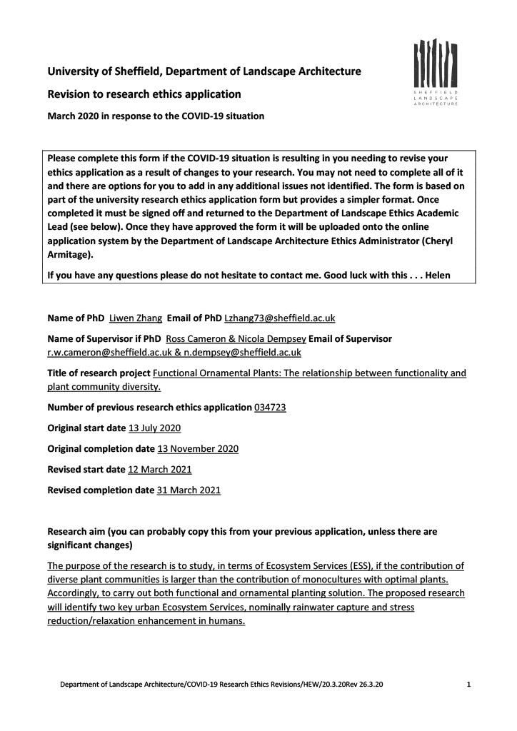
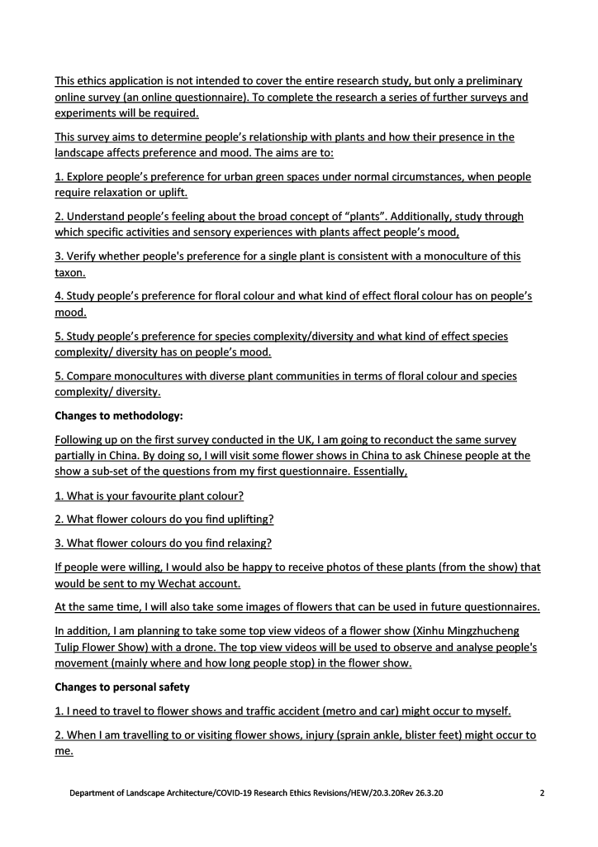
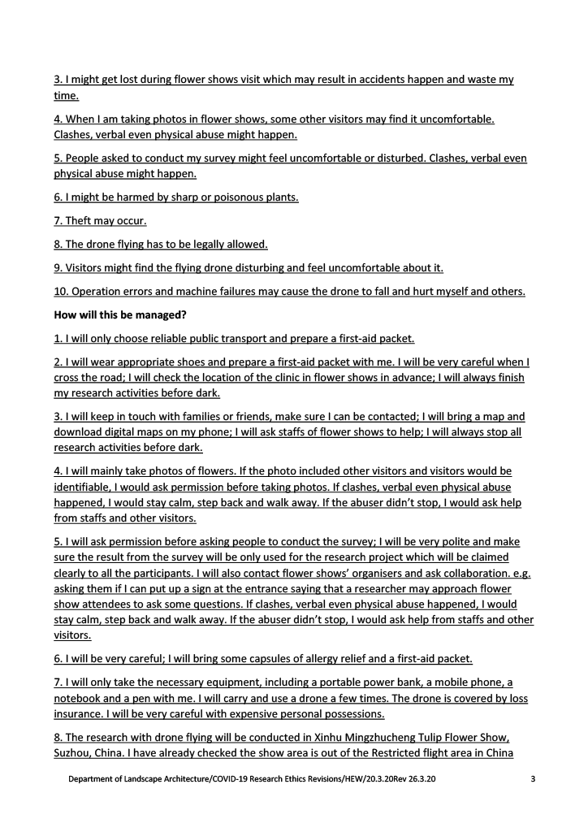
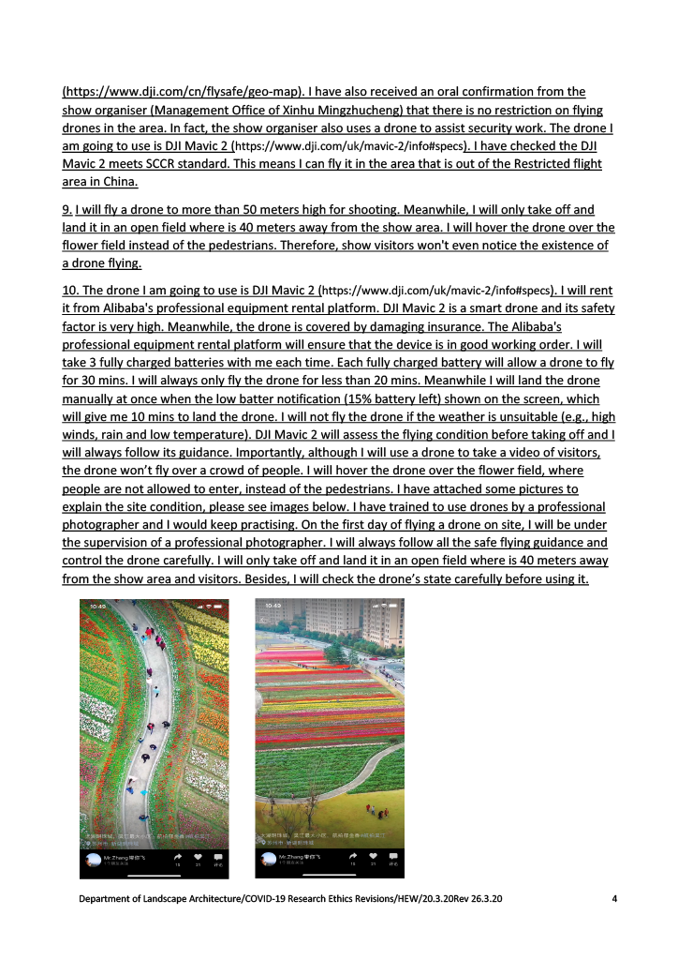
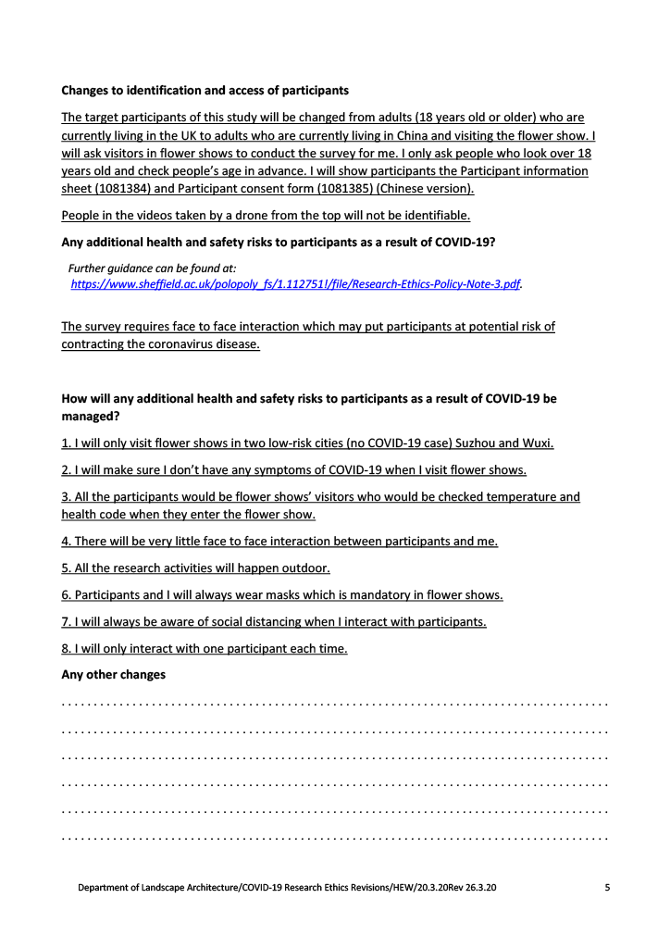
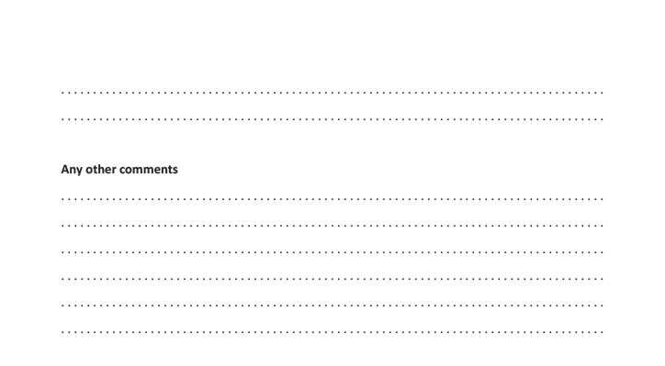

Appendices: Survey Instruments

Appendix A: Survey Instrument for Paper I
Study Title: Flowers – Sunshine for the soul! How does floral colour influence preference, feelings of relaxation and positive up-lift? Methodology: Online Questionnaire Platform: SmartSurvey Description: This survey investigated public preferences for single-colour floral displays using static photographic stimuli. Participants rated images of monocultural planting on perceived relaxation and uplift.
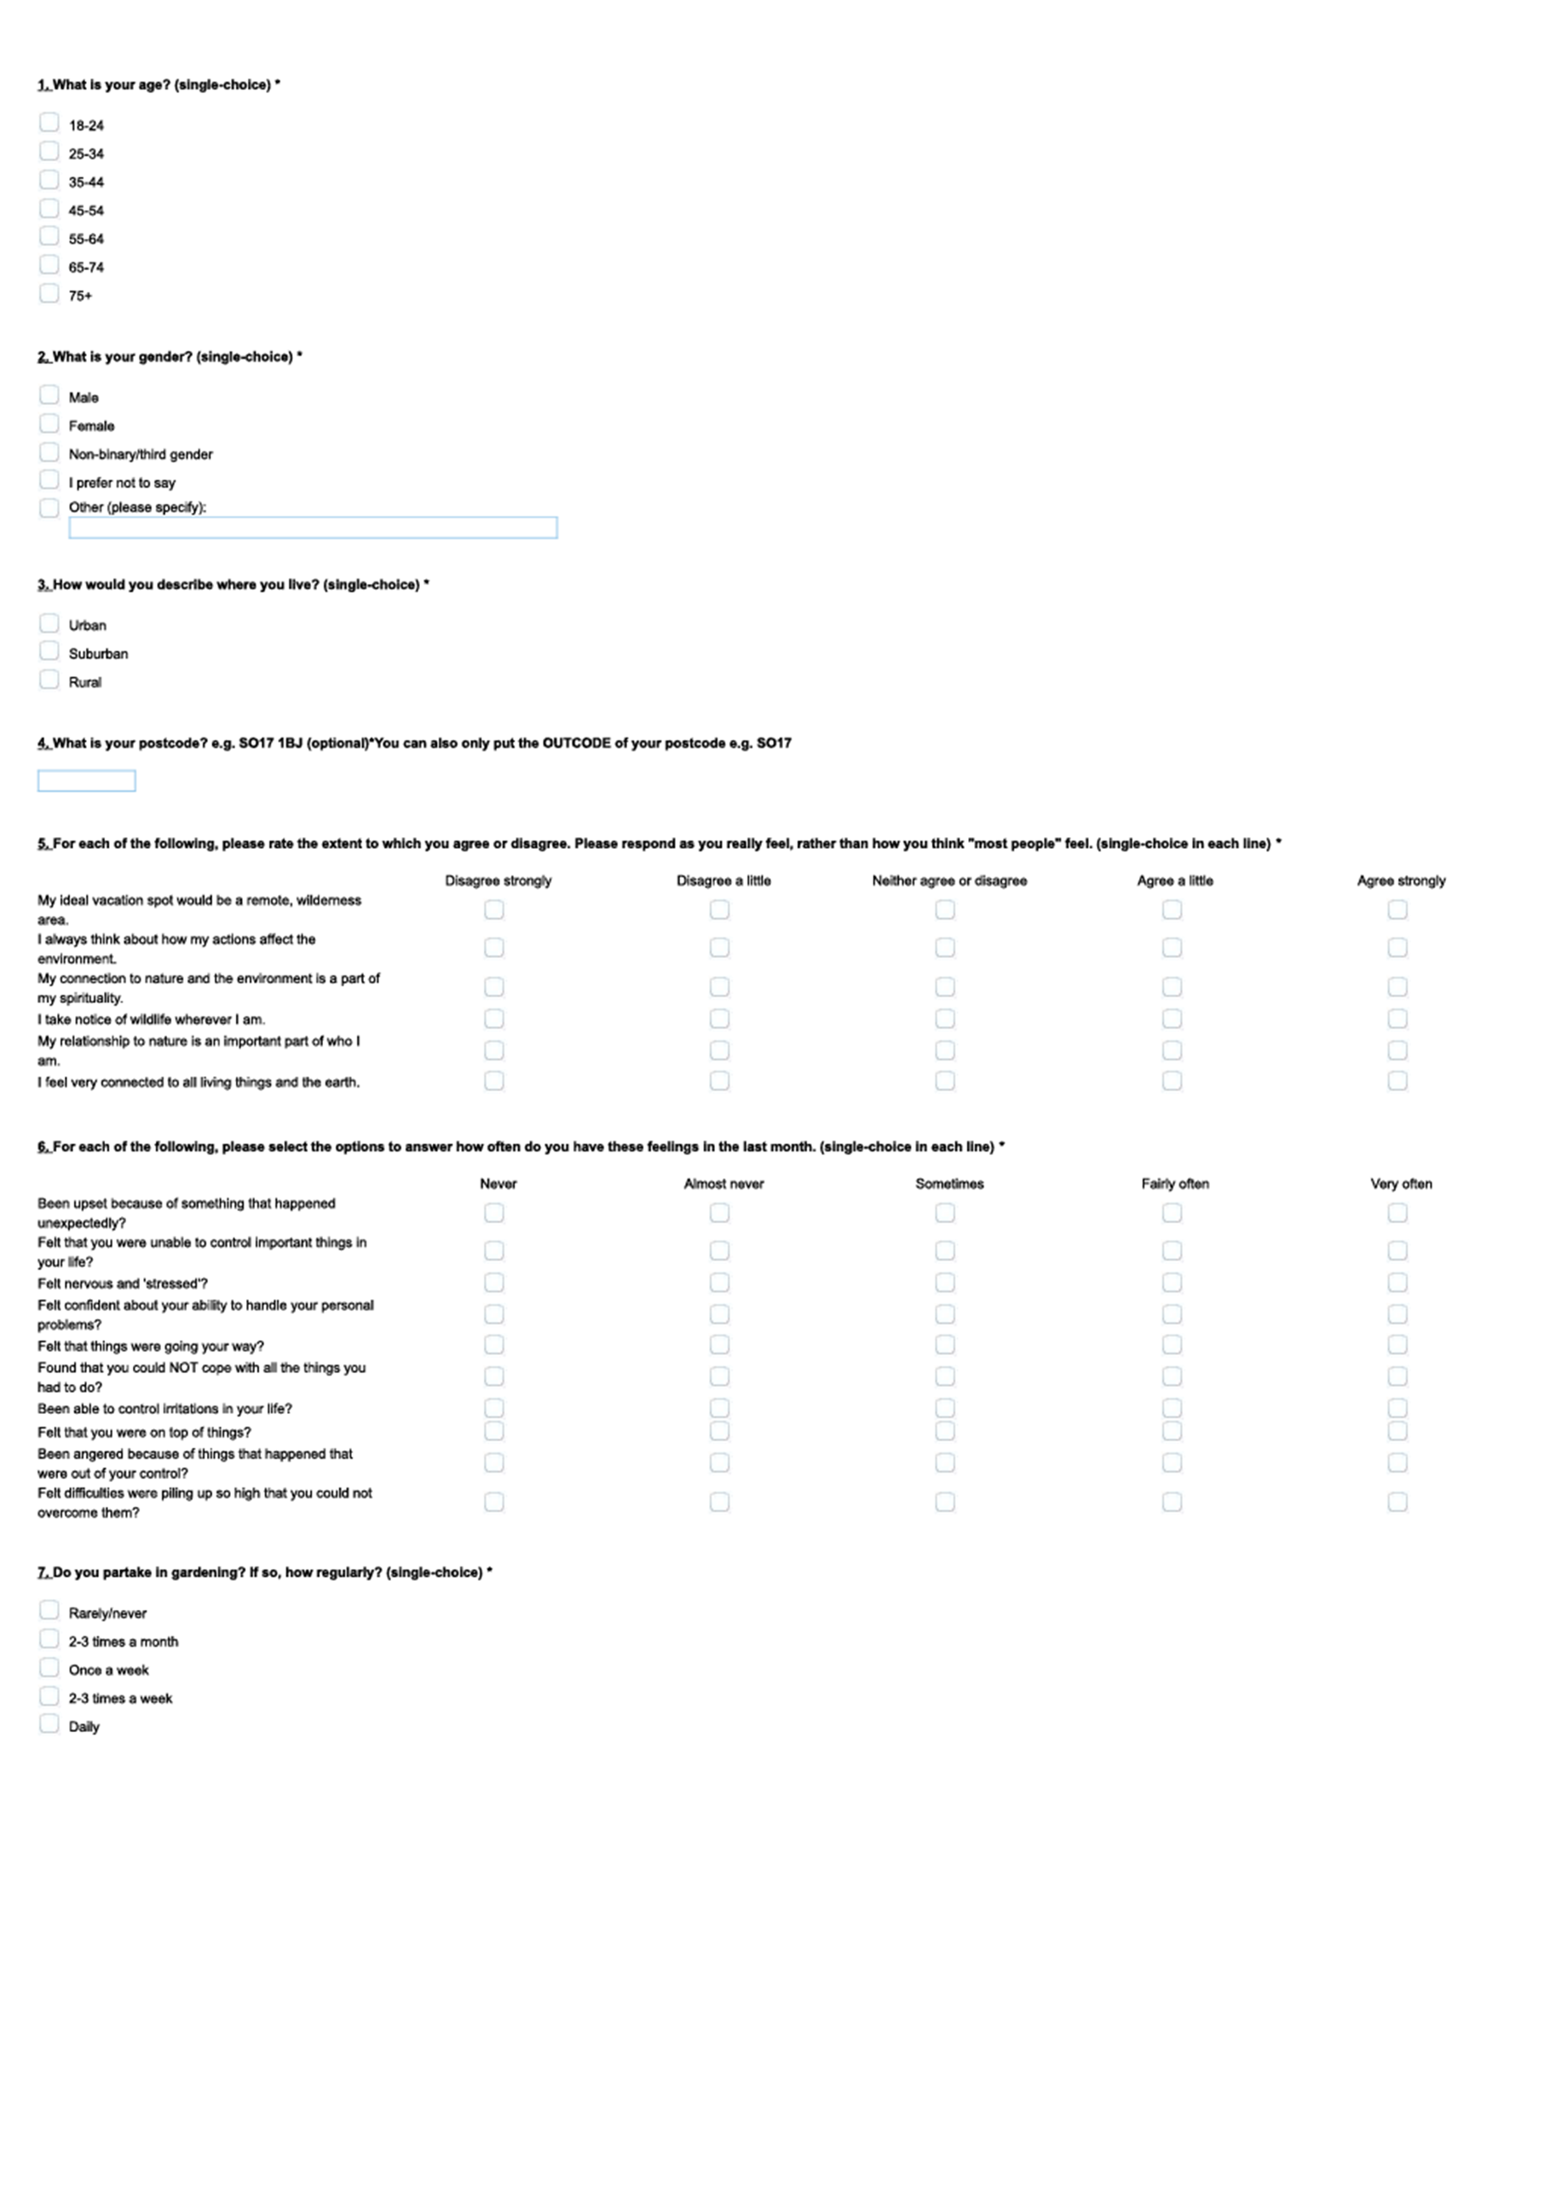
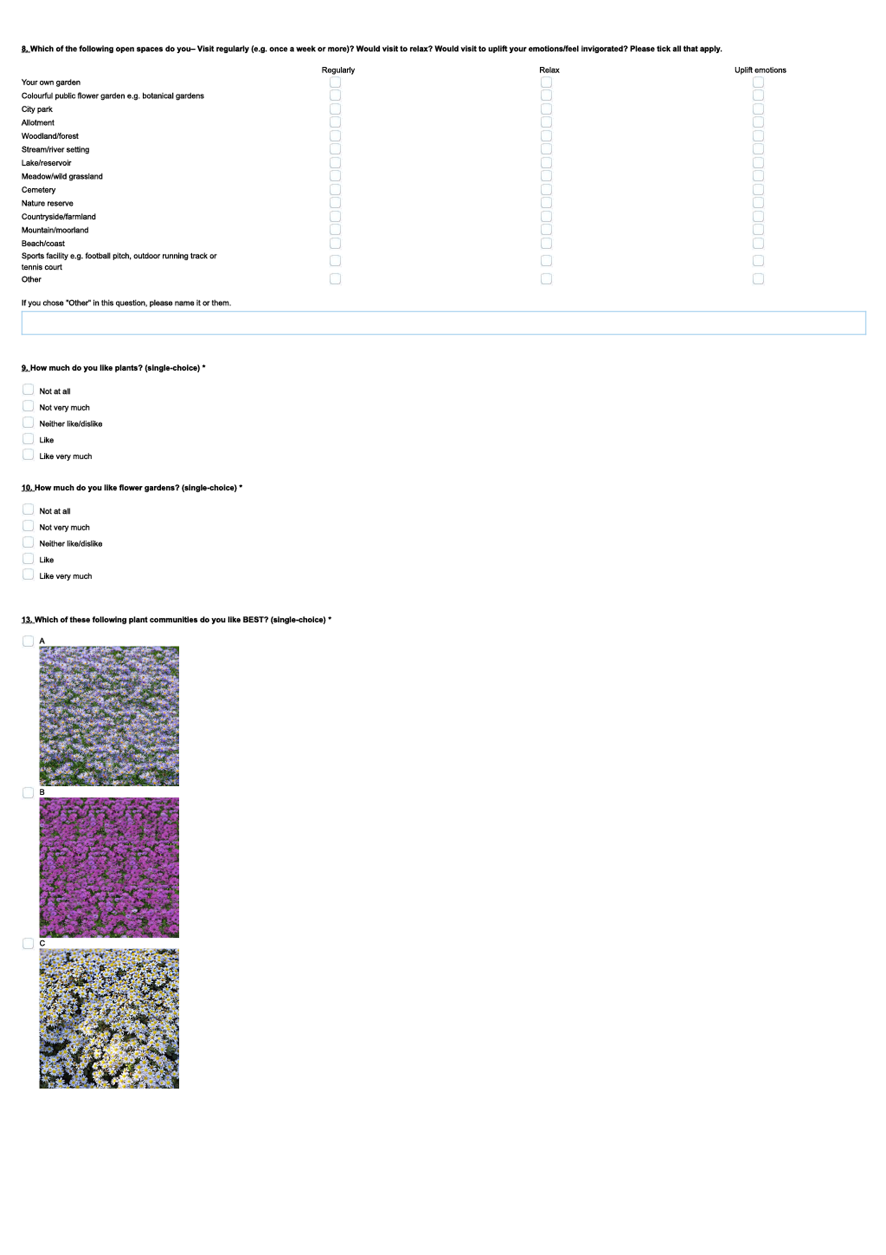
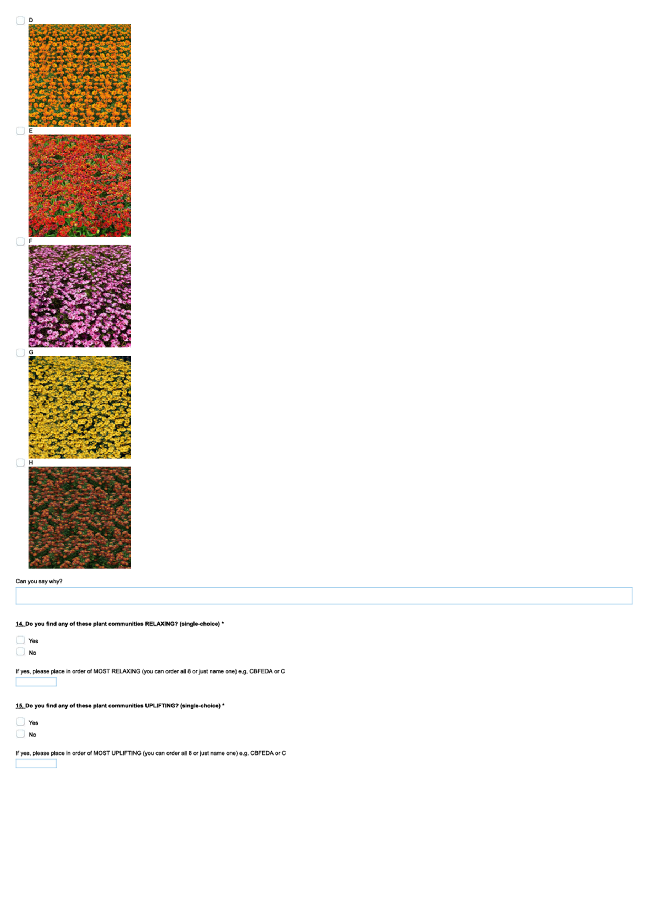

Appendix B: Survey Instrument for Paper III
Study Title: “The Colour Palette Prescription” – How do colour tone and colour diversity influence emotional responses in virtual green spaces? Methodology: Online Experiment (Virtual Environment) Platform: Qualtrics (integrated with 360° panoramic video) Description: This instrument assessed the impact of colour temperature and diversity in a controlled virtual environment. The survey flow included:
- Pre-Survey: Demographic data and baseline affect (PANAS scales).
- Stress Induction: Stroop Colour-Word Test.
- Virtual Intervention: A guided 360° tour of a virtual park.
- Post-Survey: Repeat affect measurement to assess recovery and mood change.
Note on Stimuli: The experiment utilised multiple randomisations of park designs (High/Low Diversity × Warm/Cool Tone). For brevity, this appendix includes representative examples of the survey flow for one Warm condition and one Cool condition. The structure of the questions remained identical across all experimental groups.

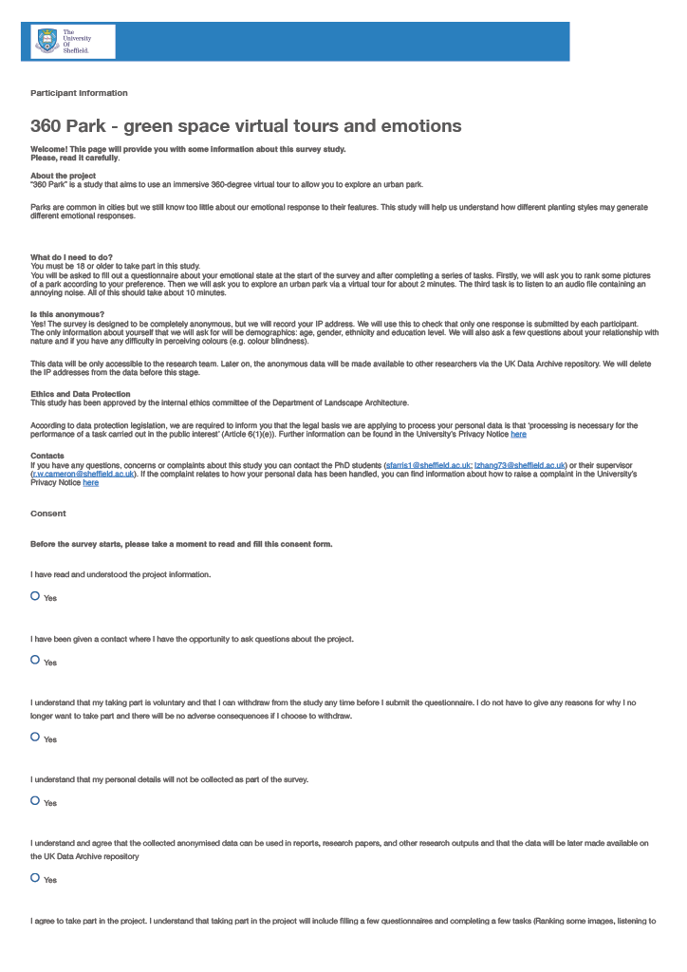
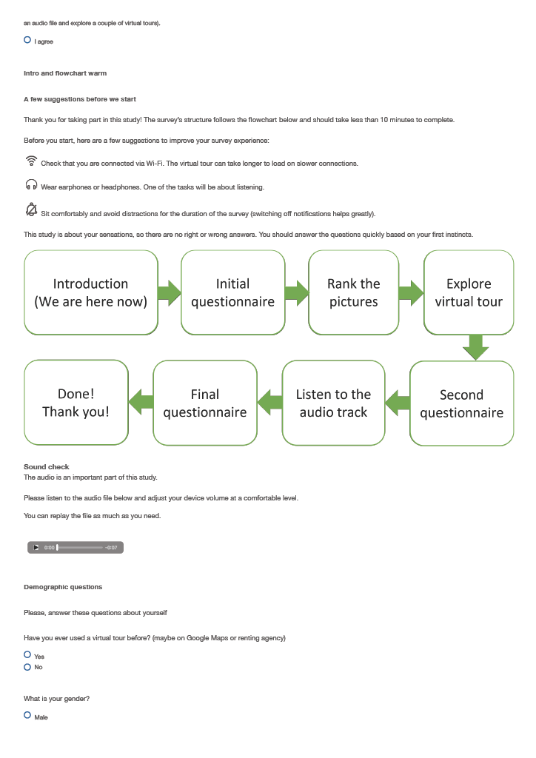
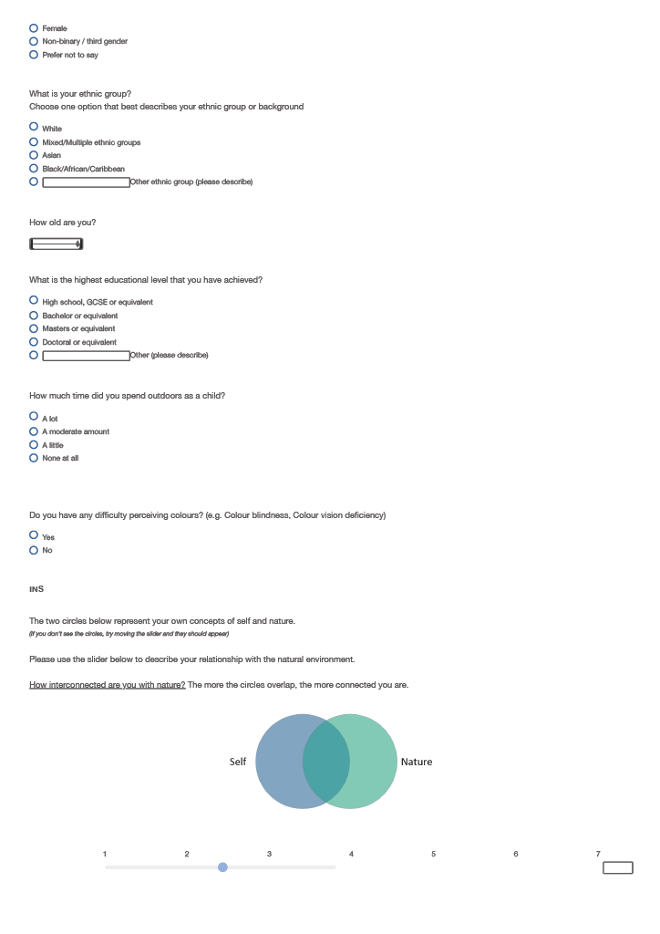
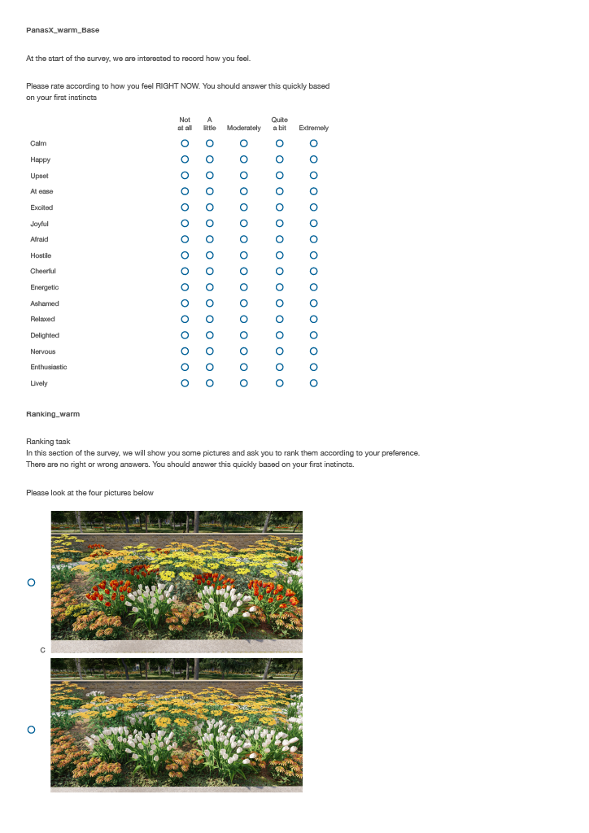
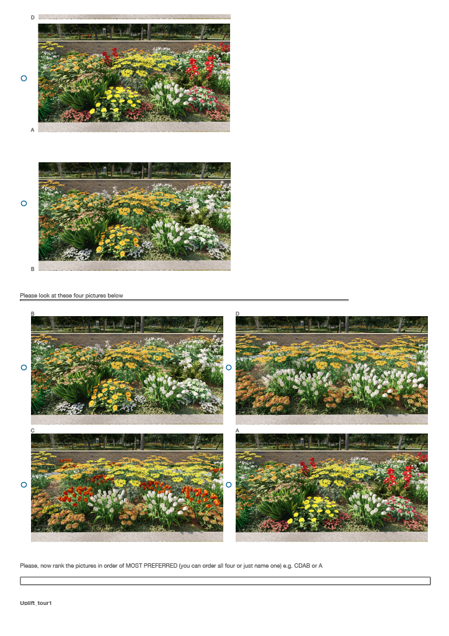
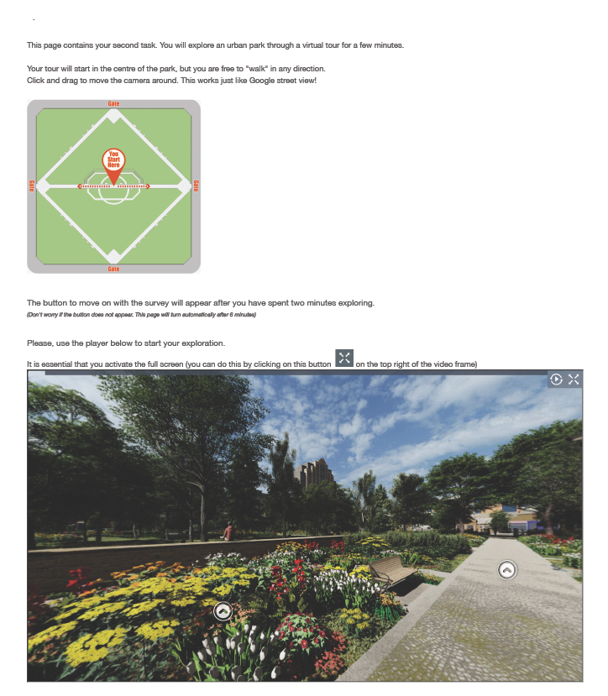
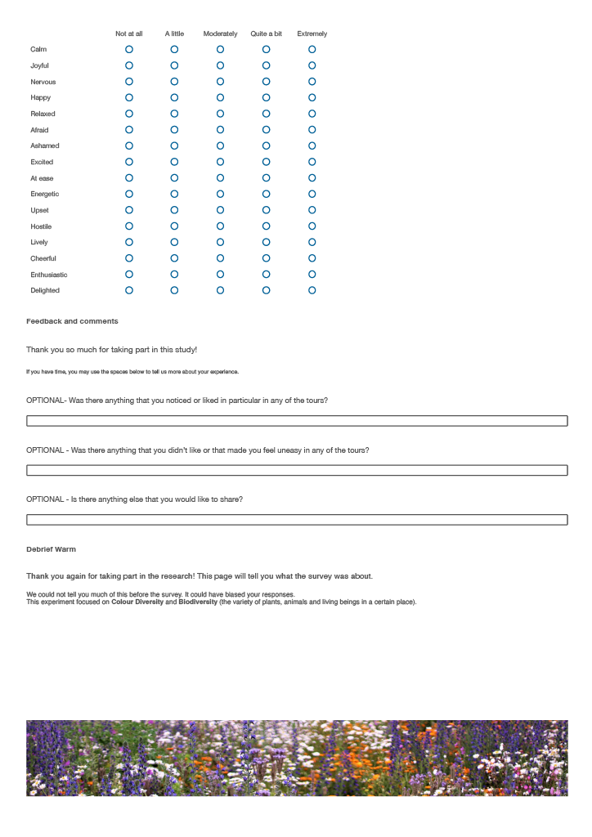
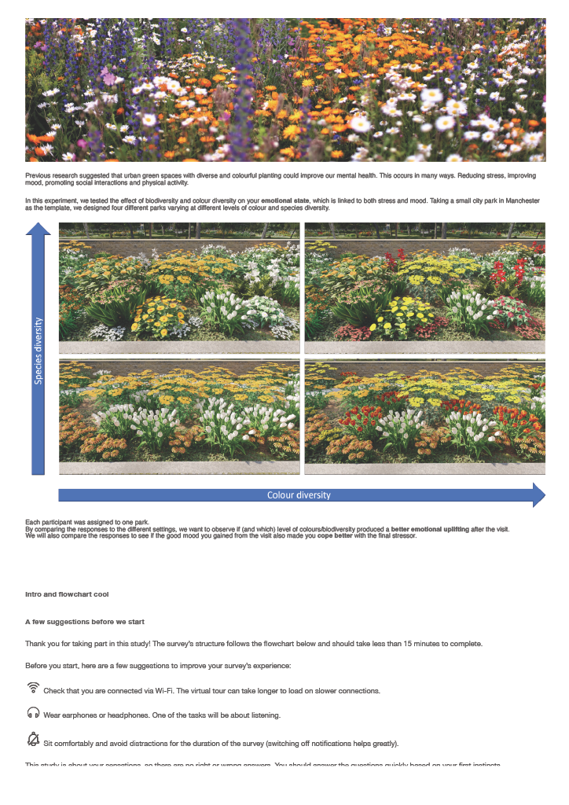
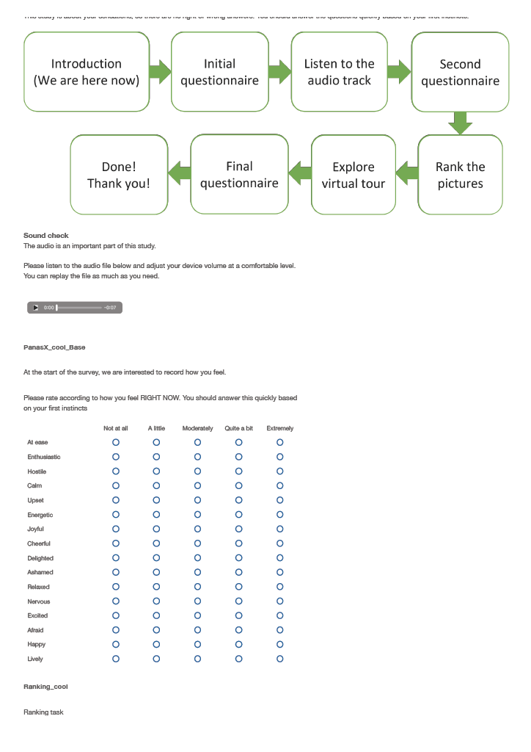
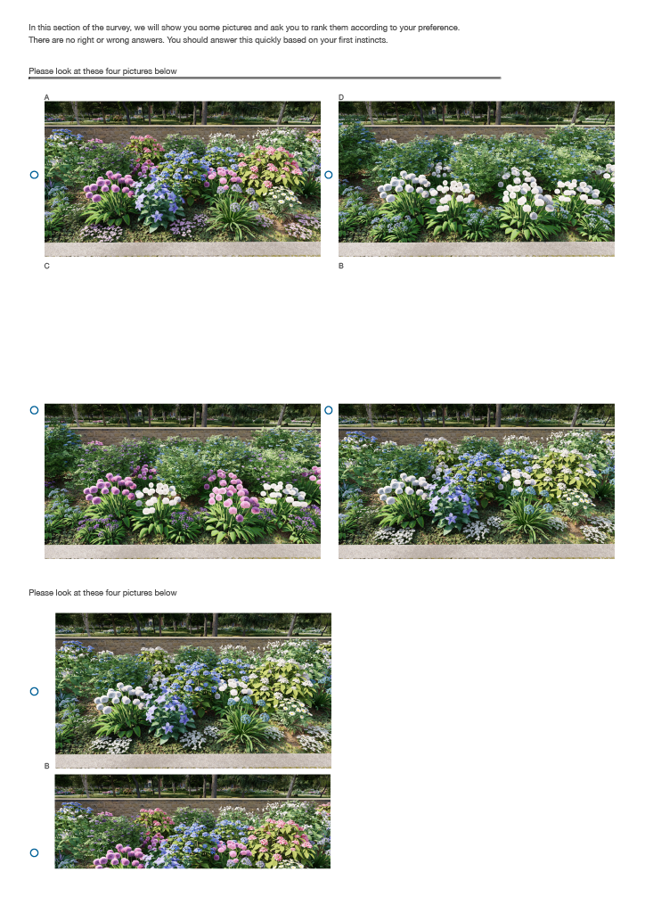
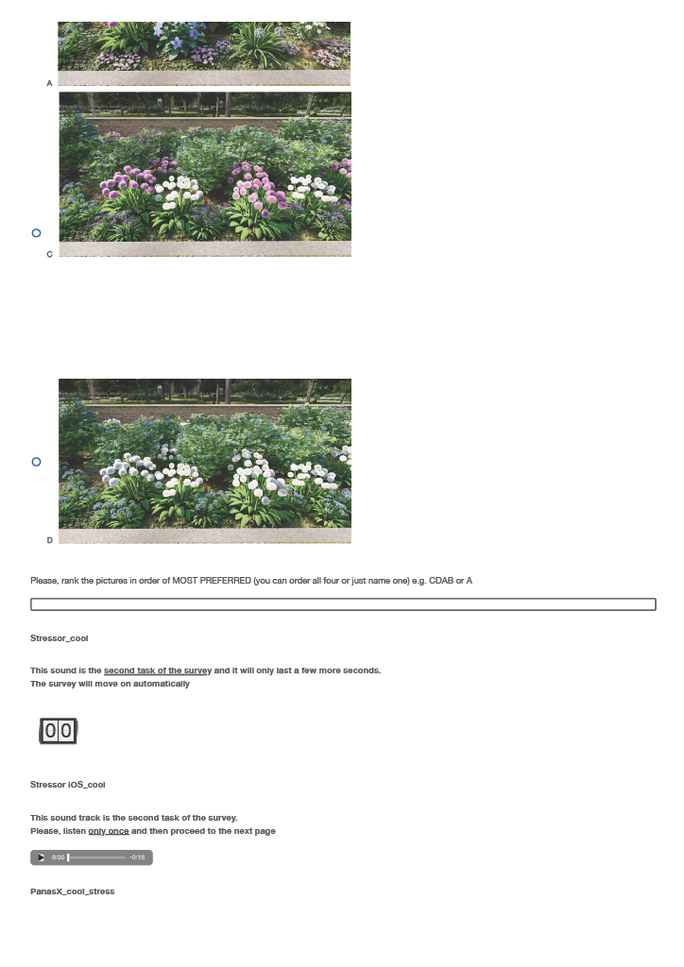
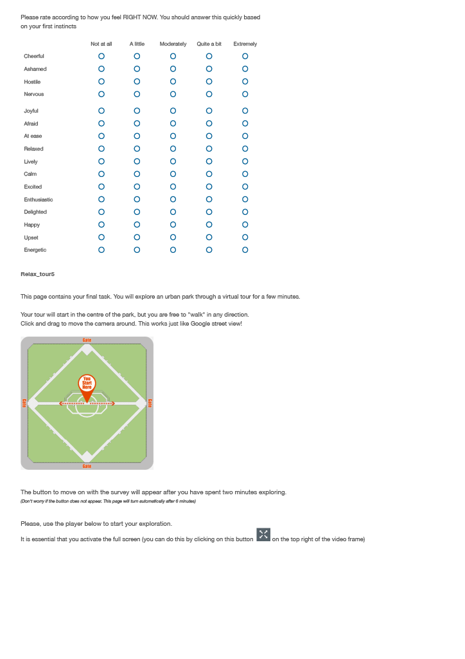
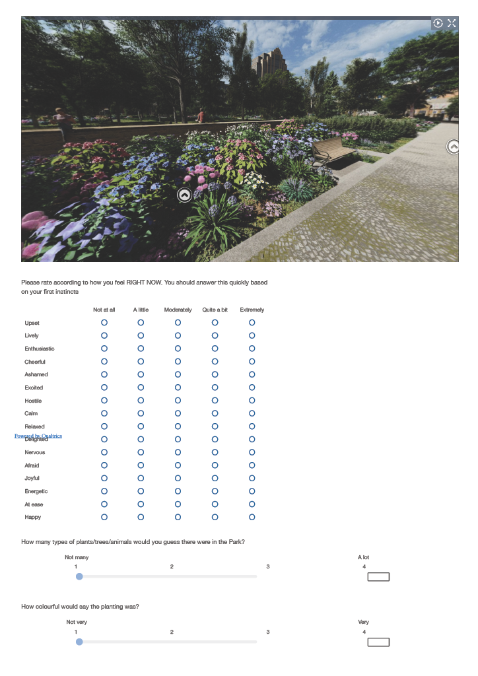
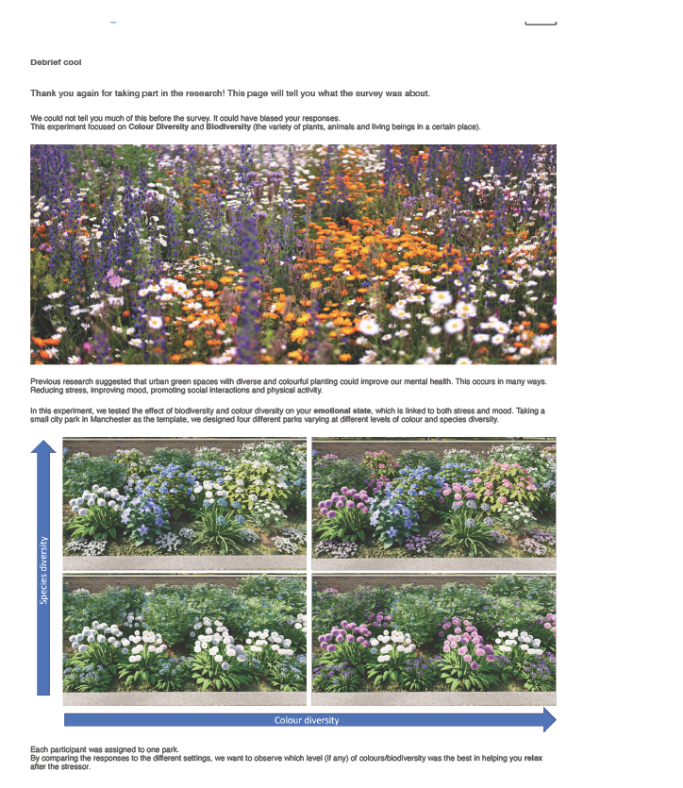

Appendix C: Survey Instrument for Paper IV
Study Title: ‘Blossom Buddies’ − How do flower colour combinations affect emotional response and influence therapeutic landscape design? Methodology: Online Questionnaire Platform: Qualtrics Description: This survey examined the emotional impact of multi-coloured floral mixtures. It utilised pairwise comparisons and rating scales to determine dosage thresholds for warm vs. cool colours and to identify "visual dominance" in mixed planting schemes.

