

‘Remember that at the core of it are young people and families who, you know, deserve access to opportunities and support that's going to enable them to thrive and flourish…’

Inclusion practitioner experiences of enacting inclusion and social justice in academised secondary schools as told through stories shared in a Community of Practice.

Ami McNamee
230108291

A thesis submitted in partial fulfilment of the requirements for the Doctor of Educational and Child Psychology

The University of Sheffield, School of Education

May 2026

Acknowledgements
In the first instance, I would like to thank participants who demonstrated care, passion and commitment to the field. Your time and the learning derived from the stories you shared have been fundamental. I have learned so much from you all.
I would also like to take this opportunity to thank the tutor team on the DEdCPsy at Sheffield, who have helped me develop a vision for the EP I aspire to become. In particular, my supervisors for this thesis, Dr Jamal Lahmar and Dr Penny Fogg, for their enthusiasm and carefully considered reflections. Additionally, to the kindness and thoughtfulness of Dr Francine Wint and her unwavering support during what has been a personally and professionally challenging doctoral journey.
My placement supervisors have also helped me to grow into the EP role. Dr Carla Tomlinson, who has supported me with laughter, empathy and kindness despite my many practice confessions.
Doctoral studies take a village, and I would also like to acknowledge mine. My good neighbour, Kath, for her critical eye, proofreading skills and for entertaining my many reflections on our walks, and Julia for her laughter and for the dinners waiting for us after delayed trips from Sheffield.
Without the support of my family, this Doctoral journey would never have started. Sadly, my dad will not see me complete this final stage, but he gave me the work ethic to see it through. My sister Paula and my mum Christine, without whom I could never have cracked on.
This thesis is dedicated to my parents, my husband, and especially my son, Theo. Sorry for all the time I have spent on computers, we can get on with our bucket list now.
3

Abstract
Narratives of English inclusive education (IE) present a broken, adversarial system that deviates from social justice (SJ) and espoused notions of educational equity, constructing a reality of exclusion, segregation, and spiralling financial and human costs. Teachers are often responsibilised for the failure of inclusion, and yet the voices of those who enact inclusion are lacking from research. This research sought to hear the narratives of practitioners in academised high schools to understand how inclusion and SJ are maintained, by sharing stories of the triumphs and tensions of delivering inclusion and SJ through a Community of Practice (CoP). Findings from this study reconceptualise inclusion as a relational, contested, contextually driven and negotiated process that is shaped and constrained by neoliberal education systems. Inclusion is grounded in key values of equity, advocacy, and rights, often provided at the individual child level. Competing systems frustrate and contradict inclusion and SJ endeavours, including accountability pressures, resource allocation and policy frameworks informed by neoliberal priorities. Practitioner narratives reveal resistance and conflict, often targeted at mesosystem and decision-makers rather than at the wider macrosystem policy. Exploration of the usefulness of engaging in a Community of Practice as a mechanism for collective coping, social learning and practice development is considered.

Table of Abbreviations
ADI | Area Deprivation Index
AP | Alternative Provision
CoP | Community of Practice
CYP | Child or young person
DfE | Department for Education
DoH | Department of Health
EHC | Education, Health and Care
EHCNA | Education, Health and Care Needs Assessment
EHCP | Education, Health and Care Plan
EP | Educational psychologist
FSM | Free School Meals
IE | Inclusive Education
LA | Local Authority
MAT | Multi-Academy Trust
NC | National Curriculum
NTA | Narrative Thematic Analysis
Ofsted | Office for Standards in Education, Children’s Services and Skills
QFT | Quality first teaching
PAC | Parliamentary Action Committee
SEMH | Social, emotional and mental health
SENDCO | Special educational needs and disability co-ordinator
SLT | Senior Leadership Team
SP | Specialist Provision
TA | Teaching Assistant
TEP | Trainee Educational Psychologist
UNESCO | United Nations Educational, Scientific and Cultural Organisation

Table of Figures
Figure number | Description | Page
1 | Model for the development of a CoP as suggested by (Cambridge et al., 2005, pp. 4-7) | 52
2 | Extract from a coding table | 63
3 | A map of all key themes as identified from my analysis | 74
4 | A Table to show an overview of participant characteristics | 76
5 | A Thematic Map of Susan’s experiences as identified by my NTA | 77
6 | Nicola’s thematic map as identified from my analysis | 87
7 | Jasmine’s thematic map based on my analysis of the data | 99
8 | Michael’s thematic map as identified from my analysis | 113
9 | Thematic map to show analysis of Ami’s data | 117

Contents
Acknowledgements 1
Abstract 2
Table of Abbreviations 4
Table of Figures 4
Introduction 10
1.1 Background 10
1.2 My interest in the study 12
1.3 Definition of terms 13
1.4 Context 15
1.5 Aims of this study 16
1.6 Importance of the study to the field of Educational Psychology 16
1.7 Structure of this thesis 18
Chapter 2: Literature Review 20
2:1 Introduction 20
2:2 Historical Context of Inclusion 21
2:3 Inclusive Education; a Contested Concept Within a System of Competing Agendas 25
2.4 An Ecological Systems Perspective of Inclusion 30
2.5 The Role of Teacher Attitude and Training in Developing Inclusion and SJ 31
2.6 The Impact of Neoliberal Policy on Inclusion 35
2.7 Towards Relational Responses to Inclusion 41
2.8 Summary 42
2.9 Methodological Learning from this Literature Review 43
3.1 Chapter Overview 45
3.2 Qualitative Research 45
3.3 Reflexivity 46
3.4 Research Paradigm 47
3.5 Axiology 48
3.6 Ontology 49
3.7 Epistemology 50
3.8 Community of Practice (CoP) 52
Stages of a CoP 53
Inquire 54
Design 54
Prototype 55
Launch 57
Grow 58
Sustain 58
3.9 Narrative Inquiry Approaches to Research 59
Why Narrative? 60
3.10 Narrative Thematic Analysis (NTA) 61
Organisation and Preparation of the Data 62
3.11 Coding Process 63
3.12 Themes 64
3.13 Positionality 64
3.14 Research Design 66
Participants 66
Ethical Considerations 67
Method of Data Collection 68
Community of Practice 69
3.15 Methodological Limitations 71
Chapter 4: Themes 74
4.1 Introduction 74
4.2 Participant Information 76
4.3 Susan 78
Themes 79
Understanding of Inclusion and SJ 79
Rights and Values Approach Applied in Context 79
Commitment to Equity and Advocacy 80
Barriers to inclusion and SJ 80
Systemic and Competing Agendas 80
Teacher Capacity 82
Increased Demand and Financial Pressure 82
Maintaining Factors 83
Relationally Supportive Pedagogy 83
Allies 84
Resistance and Social Capital 85
Collective Coping 86
Shared Values and Principles 86
4.4 Nicola 87
Themes 88
Understanding of Inclusion and SJ 88
Rights and Values-based Approach that is Applied in Context 88
Commitment to Equity and Advocacy 89
Understands Personal Power and Privilege 89
Barriers to Enacting Inclusion and SJ 90
Systemic and Competing Goals 90
Increased Demand and Financial Pressure 91
Tension Theory vs Practice 91
Maintaining Factors 94
Relationally Supportive Pedagogical Approaches 94
Allies 94
Resistance Social and Cultural Capital 95
Collective Coping 96
Shared Values and Goals 97
Renewed commitment 98
4.5 Jasmine 99
Themes 100
Rights and Values-Based Approach to Inclusion Applied in Context 100
Commitment to Equity and Advocacy 101
Barriers to Enacting Inclusion and SJ 102
Increased Need and Financial Pressures 103
Teacher Capacity 103
Maintaining Factors 106
Relationally Supportive Pedagogical Approaches 106
Inclusion and SJ Allies 108
Resistance and Use of Social and Cultural Capital 108
Collective Coping 111
4.6 Michael 112
Themes 113
A Rights and Values-based Approach that is Applied in Context 113
Barriers to Enacting Inclusion and SJ 114
Systemic and Competing Goals 114
Teacher Capacity 116
Increased Demand and Financial Pressure 116
Collective coping 117
4.7 Ami 118
Themes 119
Inclusion as a Rights-based Approach Applied in Context 119
Commitment to Equity and Advocacy 119
Barriers to Enacting Inclusion and SJ 120
Systemic and Competing Demands 120
Maintaining Factors 124
Positioning 124
Chapter 5: Discussion 126
5.1 Chapter Overview 126
5.2 Summary of Key Findings 127
5.3 Discussion 130
Key Finding One: Understanding of Inclusion and SJ 130
Key Finding Two: Barriers to Enacting Inclusion and SJ 134
Key Finding Three: Maintaining Factors 139
Key Finding Four: Collective Coping 144
5:4 Concluding Remarks 145
Chapter 6 146
6.1 Chapter Overview 146
6.2 Summary of Key Findings in Response to Research Questions 146
6.3 Contribution to Knowledge 148
6.4 Implications for Educational Psychology Practice 149
6.5 Limitations 151
6.6 Future Research 152
6.7 Final Reflection 153
References 155
Appendices 169
Appendix A: Reflections 169
Appendix B: Ethical Approval 178
Appendix C: Participant Recruitment Poster, Pilot Study and Participant Information Sheets and Consent Forms 189
Appendix D: CoP Administration 210
Appendix E: Transcript Extracts 216
Appendices References 68

Introduction

1.1 Background
“For children, the level of support they receive is too often determined by how hard their families fight, or how much their families can spend. It is clear that we must reset how we are equipping mainstream schools…. to enable all children to achieve and thrive in education” (DfE, 2026, p. 9)
The English education system of the mid-2020s is increasingly characterised in policy and research discourse as ‘broken,’ particularly in relation to its capacity to deliver equitable outcomes for children and young people (CYP) (DfE, 2026). Despite sustained policies that claim to pursue ‘inclusion’ in schools, educational structures continue to reproduce and, in some cases, intensify social inequality.
This thesis adopts a critical perspective on these developments, situating them within broader neoliberal reforms that have reshaped education since the 1980s. Such reforms, characterised by marketisation, performativity and the privileging of individual choice, have been argued to erode commitments to social justice (SJ), democratic accountability and inclusive practice (DfE & DoH, 2014; Done & Andrews, 2020; Hill & Kumar, 2009; Kerr & Ainscow, 2022). While policy rhetoric continues to promote inclusion, the enactment of these policies has, in practice, contributed to increasingly stratified, parentally-selected segregated educational experiences, particularly for those from disadvantaged and marginalised backgrounds (Allan, 2026; Done & Andrews, 2020).
The marketisation of education, where market-driven competition between schools is seen as a mechanism for higher standards and where autonomy is disguised through academisation, has led to CYP from the most disadvantaged backgrounds receiving the least benefit (Kerr & Ainscow, 2022). Evidence for inequitable education driven by neoliberal education policies points to the ever-increasing numbers of children placed in specialist provision (SP) and the rates of exclusion from school altogether (Black, 2022; Marsh et al., 2024; Potter, 2022). CYP from marginalised backgrounds are identified as being the most disadvantaged by such structural inequality, where they instead feel unwelcome and separate from school (King, 2026). This exposes a system of crippling costs for families, school practitioners, and the economy, reproducing systemic inequality (Allan, 2026).
Simultaneously, the curriculum has become more homogenised over time, under the guise of British values, and has developed in ways that privilege whiteness over diversity, alienating and further disadvantaging those from diverse and disadvantaged backgrounds (Asare, 2022; DfE & Francis, 2025). Neoliberal education policies have promoted accountability cultures where teachers (and schools) are blamed for failed economic policies, positioning them as responsible for failed inclusion (Done & Andrews, 2020; Lakes & Carter, 2011). Policies offer an illusion of equity as meaningful engagement with such principles is obscured within a system that fundamentally contradicts. This results in principles of equity becoming undermined in systems structured by individualism, competition and inequality.
This thesis seeks to move beyond policy and theoretical accounts of inclusion by spotlighting practitioners’ stories of their lived experiences of working within academised secondary schools. In doing so, it addresses a gap in previous scholarship, where the perspectives of those enacting inclusion and SJ in practices remain underexplored (Kuria & Kelly, 2023; PAC, 2025). Rather than assuming a shared or stable understanding of inclusion, this study examines how these concepts are constructed, negotiated and contested within practitioners’ narratives. It also explores whether creating structured spaces for dialogue, through a Community of Practice (CoP) can support the development of more socially just and inclusive practices. A further hope for this research is to understand whether creating opportunities to share stories is conducive to developing practice. A core aspect of the design of this research draws on my extensive personal experience working in schools across different roles, which is why I also position myself as a participant.

1.2 My interest in the study
My professional background as a former teacher, SENDCO, Local Authority (LA) practitioner and Trainee Educational Psychologist (TEP), has significantly shaped the orientation of this research. Through these roles, I have experienced firsthand the tensions between policy, practice and provision, particularly within systems that appear to prioritise procedural compliance over equitable outcomes. Although such approaches can be framed as a SJ effort to redress and compensate for educational inequality (Fox, 2015) I have come to see how my role has become embedded in a system that sustains inequality.
These experiences have informed my critical stance towards the current education system, which I perceive as increasingly shaped by marketisation and the commodification of inclusion targeted at individual CYP (Allan, 2026). However, I also recognise that my positioning may influence how I interpret participants’ accounts, particularly in privileging narratives of resistance, relational practice and systemic critique. This study, therefore, adopts a reflexive approach, acknowledging that the findings are co-constructed through the interaction between my own experiences and those of participants (Finlay & Gough, 2003).

1.3 Definition of terms
The term ‘practitioner’ has been used to describe participants in this study. It was selected due to the slight variance in roles that individuals within the CoP held. This term was chosen above others, such as professional, which I felt held connotations of power and privilege and may become confused with other roles mentioned within practitioner stories. ‘Practitioner’ was selected as it encompassed those involved in the practice of enacting inclusion within school contexts (Gregson, 2020). Although I considered the term ‘educator,’ participant more adequately reflected those involved in the research.
The concepts of inclusion and SJ are both contested and lack universally agreed-upon definitions (Artiles et al., 2006). For the purposes of this thesis, inclusion follows internationally agreed definitions such as UNESCO ‘…quality education for all while respecting diversity and different needs and abilities… and eliminating all forms of discrimination’ (UNESCO, 2019, p. 4). Fundamentally, achieving educational equity has implications for SJ. Past authors have conceptualised SJ as requiring affirmative action, resistance, and acknowledgement of the psychological effects of inequality to redress power imbalances that alleviate harm (Walster & Walster, 1975). Thus, SJ is conceptualised as both a moral and practical commitment to addressing inequity, requiring not only recognition of disadvantage but active efforts to redistribute power and opportunity at an individual and systems level (Fox, 2015; Graybill et al., 2018). Within this study, inclusion and SJ are treated as inherently interconnected, with inclusion functioning as a key mechanism through which SJ and equity may be enacted in educational contexts.
Neoliberalism is a term used to describe the current dominant ideology that has impacted policymaking since the 1980s (Thorsen, 2010; Wyile, 2013). It is premised on promotion of free-market economic theories where markets are most effective when they are deregulated and thus promotes advancements of policies that favour privatisation and competition, such as the academisation agenda in England, a reduction in the role of the state and a drive towards individualism, which critics argue intensifies social and economic inequality (Kerr & Ainscow, 2022; Lakes & Carter, 2011; Wyile, 2013). The creation of more individualistic, competitive approaches between schools is cited as a barrier to collaborative practice, which may help reduce educational inequality (Kerr & Ainscow, 2022). Kerr and Ainscow (2022) also highlight the increasing attainment gap at both primary and secondary levels between those from the most and least disadvantaged backgrounds, along with reported practices of unfair academy admissions processes which exclude CYP from the poorest backgrounds, as further examples of how marketisation has obscured SJ inclusion goals.
Marginalisation is a term that is used throughout this thesis, and is a term that lacks consensus (Messiou, 2012). In the context of this thesis, I refer to those from marginalised backgrounds who are disadvantaged by the current education system. Marginalisation describes a position where an individual does not experience belonging, in this instance, to education (Mowat, 2015).

1.4 Context
Neoliberal education policies and practices are reflected in curriculum content that has become homogenised, satisfying accountability measures such as school league tables and exam results, individualised, based on how consumers of education benefit from it, and moves away from the notion of education as a collective, social benefit (Kerr & Ainscow, 2022; Potter, 2022). Accountability measures serve to displace equity within education and create a system that is distanced from SJ goals (Edgington, 2016). The most recent review of the National Curriculum (NC) for England has found that insufficient SJ goals, together with a lack of representation and diversity, create an alienating and inequitable system (DfE & Francis, 2025). Thus, highlighting systemic tensions between equity-driven educational aims and the performative demands of accountability systems (Potter, 2022).
Education exists within stratified, interconnected systems which impact schools, communities and ultimately individual CYP. Ecosystemic theory recognises that CYP exist within a series of nested structures defined as micro, meso, macro, and exo systems within an overarching chronosystem of changes over time (Bronfenbrenner, 1976). Proximal meso and macro systems are interconnected and shape the individual at a microsystem level (Fearnley, 2022). Ecosystemic models are helpful for understanding the interrelated nature of systems on CYP in the context of education (Anderson et al., 2014). However, it fails to consider the impact of power and agency individuals have in shaping the person-context dynamic (Houston, 2017). Thus, this thesis considers both neoliberalism and ecosystemic theories as overarching frameworks that underpin this research.

1.5 Aims of this study
The aim of my study is to create conditions where practitioners can develop shared understanding and practice, and address concerns raised by a cross-party parliamentary committee that there are insufficient opportunities for such approaches within education (PAC, 2025). I also hope to understand the conditions that enable schools to enact and maintain inclusive and SJ practices (IIP, 2025). Studies that have drawn on research in deprived areas of England over a 15-year period highlight the benefits of collaboration between practitioners from different schools in developing capacity for ‘collective action, not just individual accountability’ (Kerr & Ainscow, 2022, p. 11). I seek to understand whether social learning through a CoP approach influences practice.
My research questions are as follows
- How are inclusion and SJ constructed and understood by secondary school staff?
- What supports educators in secondary schools to enact effective SJ and inclusive practices?
- How does social participation in a CoP support educators in implementing SJ and inclusive practice in schools?

1.6 Importance of the study to the field of Educational Psychology
Educational Psychologists (EPs) are uniquely positioned professionally to support inclusion through their work in the systems that enact policy (e.g., EHC process at a LA level, First-Tier Tribunal support, work with schools) whilst working with individual CYP (Atfield et al., 2023; Stanbridge, 2024). Furthermore, EPs sit outside of the immediate school mesosystem and are therefore well-placed to champion inclusion and SJ (Shriberg et al., 2011). EPs' training and understanding of cultural humility facilitate holding multiple perspectives in mind simultaneously, whilst creating momentum for change at the individual and system-wide levels (Fisher, 2020). Ethical practice guidelines state that EPs should assume a SJ perspective and seek to promote educational equity and fairness (BPS, 2018). Thus, seeking solutions to the problem of inclusion and supporting schools in engaging SJ approaches that promote greater equity within education are integral to the role of an EP (Stanbridge, 2024).
Authors have highlighted how the current system constrains EPs as time is unevenly directed to the EHC process, preventing EPs from engaging in work that may deliver systemic change within schools and wider systems that may impact on school inclusion (Atfield et al., 2023; Stanbridge, 2024). Recent doctoral research on SJ and equity in education highlights how the unique training of EPs fosters the values and commitment needed to enact SJ approaches (Kuria & Kelly, 2023; Schulze et al., 2019). Although EPs recognise social injustices, enacting SJ approaches in practice and challenging systemic inequality are often more problematic for EPs, and within the profession, there is a need to devote further attention to such matters (Fox, 2015; Fox et al., 2023). Recent literature directly calls for EPs to engage with schools and practitioners to raise awareness of SJ matters and support these organisations in developing their practice in this area (Kuria & Kelly, 2023). The SEND White Paper suggests that EPs are an under-utilised resource for delivering support to wider systems, and may be part of the solution to create greater inclusion, as they are capable of supporting schools more systemically (DfE, 2026). This study contributes to ongoing debates within Educational Psychology regarding the profession’s role in addressing systemic inequality, particularly in moving beyond individual assessment towards broader systemic engagement.

1.7 Structure of this thesis
This thesis is structured into three main parts. The first part consists of a literature review exploring the historical context of inclusion before critically examining how existing research has contextualised inclusion and SJ in schools. The second part describes the methodological decisions that have led to the design of this thesis. Finally, the findings, discussion, conclusions and implications for future research are considered.
The thesis commences with an overview of educational reform, starting in the 1970s, with a move towards a more integrated education system for CYP with SEND (Warnock, 1978) and how this has evolved into the contemporaneous system. I then undertake a critical literature review that examines how teachers are positioned and held responsible for delivering inclusion and SJ. The literature on CoP approaches as models for research and for exploring school-related problems is then reviewed.
I argue that inclusion cannot be understood as a fixed or universally applied concept, but rather as a relational and contested process shaped by the interaction between practitioner values, institutional structures and broader socio-political forces. By foregrounding practitioner narratives, this thesis seeks to illuminate the tensions between policy rhetoric and lived experience, and to explore how socially just practices are enacted, resisted and negotiated within contemporary school contexts.

Chapter 2: Literature Review

2:1 Introduction
This Chapter critically examines how inclusion and SJ are positioned within contemporary research and policy. This review is organised into three parts and critically examines how inclusion and SJ are constructed, enacted and constrained within contemporary educational research and policy. It starts by tracing the evolution of inclusion historically from welfare and rights-based discourses to the current policy landscape, before interrogating the tensions created by competing agendas, including accountability, marketisation and national identity frameworks. Drawing on ecological systems theory and neoliberal critiques, this chapter explores how these tensions operate across macro, meso, and micro levels, shaping both policy and practice (Artiles, 2020). At the time of writing, this landscape is shifting with further proposed reforms that examine the harms of the extant system while retaining, and extending, many of the structural features that have been implicated in producing inequality (DfE, 2026); inclusive education (IE) has become synonymous with educational placement and resource distribution in which CYP are commodified (Krischler, 2019).
A central argument throughout this chapter is that inclusion is not a stable or universally understood construct, but a contested and negotiated process. This is reflected in the positioning of teachers, who are simultaneously framed as agents of inclusion and held responsible for its failure, despite operating in systems that constrain their autonomy and capacity (Done & Andrews, 2020). While inclusion and SJ are extensively debated at policy and theoretical levels, comparatively little qualitative research explores how practitioners understand and negotiate these ideas in everyday school contexts (Kuria & Kelly, 2023; Schulze et al., 2019).
In response to this gap, the final section reviews the existing literature on Communities of Practice (CoP) in education and considers CoP as a potential relational and collaborative mechanism for bridging the gap between theory and practice. In doing so, this chapter establishes the conceptual, theoretical and methodological foundations for this study (explored in Chapter 3), which seeks to explore how inclusion and SJ are constructed through practitioners’ narratives within a CoP.

2:2 Historical Context of Inclusion
Studies of IE in England consistently cite the Warnock Report (1978) as laying the foundation for an education system predicated on equality of opportunity for all children (Lamb, 2019; Lindsay et al., 2020). Others argue that origins of inclusion emerged with welfare reforms in the early 1900s and gained momentum during the civil rights movement in the 1960s (Hodkinson, 2010). Education in the early half of the 20th century was characterised by segregationist approaches in which certain CYP were identified, often through medicalised discourses, deemed ineducable, and placed in specialist provision (SP) (Lindsay et al., 2020). Concepts such as ‘special educational needs’ (SEN) were introduced and became part of the educational lexicon, creating a disjuncture from medicalised discourse and were initially seen as less pathologising in tone (Warnock, 1978). The legal definition of SEN was set out in the 1981 Education Act, although there have been several iterations of the Act, it continues to reflect how CYP are defined presently (DfE, 2014). This Act also introduced a tiered system of assessments, including the Statementing process, positioning Local Authorities (LAs) as responsible for all CYP, including those with SEN, with EPs instrumental in this assessment process (Lindsay et al., 2020).
The Salamanca Conference in 1994 further established an international rights-based approach to educational inclusion, understanding that CYP with SEN were disadvantaged by the curriculum (Ainscow & César, 2006; Ainscow et al., 2013). This established a theoretical international framework for all marginalised learners, including those with disabilities (Artiles, 2020). Although Salamanca broadened the moral and political case for inclusion, its implementation within national systems narrowed inclusion to questions of disability provision, thereby limiting its wider SJ potential (Ainscow et al., 2019; Artiles, 2020). Whilst successive Governments have rhetorically asserted commitment to inclusive education, curricular developments, accountability cultures and policies such as marketisation of education through the academy system undermine inclusive education endeavours (Hodkinson, 2010).
Neoliberal policies emerged in the 1980s and were extended by successive governments, which continue to dominate policy and increasingly apply them to education. The introduction of the National Curriculum (NC) via the 1988 Education Reform Act brought national testing, intended to aid parental choice in school selection and to raise educational standards by increasing competition (Black et al., 2019). New Labour extended this approach through the development of academisation, which targeted failing schools by removing them from LA control (Black et al., 2019). Such policies have benefitted those from deprived and marginalised backgrounds least, and have seen widening social-class disparity, creating a system of vast regional disparity in educational outcomes as those CYP born into areas of the most deprivation are least likely to achieve, and where academy admission privileges has been cited as creating policies that favour CYP from more affluent backgrounds (Kerr & Ainscow, 2022; Lakes & Carter, 2011).
The politics of austerity introduced by the coalition Government following the global financial crash in 2008 increased the academy agenda, further extending neoliberal approaches to education, decreasing emphasis on education as a collective good (Done & Andrews, 2020). This has coincided with a monumental explosion in requests for statutory assessment, leading to increased educational segregation through placement in specialist provision (SP) and alternative provision (AP) (Allan, 2026; de Bruin, 2024; Lamb, 2019). School practitioners are responsiblised for inclusion, and are expected to use their ‘best endeavours’ and fulfil inclusion goals (DfE & DoH, 2014). Espoused goals of the current system position parents and CYP’s voices centrally and provide greater participation and a less adversarial system (Boddison & Soan, 2022). Instead, in reality, it has perpetuated a system of inequitable resource distribution, allowing further epistemological oppression within the system, where power imbalances fail to distribute resources equitably (Sewell, 2016). Further examples of this can be seen in First-Tier Tribunal data, where families from the most disadvantaged areas are identified as underrepresented in the data, indicating that the system becomes a route for redress for those from more affluent areas who may also have greater access to knowledge of how to access such systems (Marsh, 2022).
Simultaneously, education has become an increasingly marketised system; ending the ‘bias to inclusion’ through increasing parental autonomy via the EHC system saw parentally selected segregation pursued over mainstream inclusion, resulting in an expensive system that disadvantages CYP and their families who are positioned to fight for their child (Allan, 2026; Runswick-Cole, 2011). Positioning parents as consumers coincided with increased demand for expensive SP places and legal challenges, leading to further financial strain on LAs (Dewes, 2025). Deficient funding over time has created conditions in which LAs are ill-equipped to adequately facilitate inclusion, and school leaders feel they lack resources and capacity to provide inclusive spaces (MIME, 2024). SEND spending has increased exponentially over the past decade, and with it, increased the spending costs of placing CYP in SP (Farquaharson et al., 2025). Government responses to this were seen in the use of LA safety valve funding agreements introduced in many LAs in what Dewes (2025) defines as a neoliberal cycle where a crisis created by marketised systems of SEND reforms leads to neoliberal responses, such as increased surveillance, increased control focused on cost-cutting, rather than addressing the needs of CYP.
The current legislative system although designed with the potential for equity and SJ endeavours has created a system of segregation and reinforced educational inequality (Allan, 2026; Fox, 2015). Repeatedly, CYP are excluded from schools at a higher rate when considering contexts such as deprived socio-economic backgrounds, CYP identified with SEND, ethnicity and cared-for status highlighting a system of entrenched inequality and absence of social inclusivity (Black, 2022; DfE & Francis, 2025). The current SEND reforms signal change in reasserting an expectation of mainstream educational inclusion (DfE, 2026). This coincides with expectations for all schools to join MATs, thus continuing neoliberal policy trajectories (DfE, 2026). Whilst acknowledging flaws in the current system that contribute to educational inequality, the fundamental structures and cultures that have been attributed to such inequality remain unchanged and unchallenged (DfE & Francis, 2025). There are encouraging signs of commitment to inclusion and SJ within macrosystem political reforms, but it remains to be seen whether the current proposed reforms will sufficiently change policy and practice to deliver the systemic change the literature suggests will redress harm and drive societal transformation (Allan, 2026; Artiles et al., 2021). Educational inclusion developments illustrate a shift from inclusion as a SJ endeavour to inclusion as an administratively managed process, increasingly shaped by policy and resource allocation as opposed to educational equity.

2:3 Inclusive Education; a Contested Concept Within a System of Competing Agendas
The concept of inclusion lacks reification and shared understanding (PAC, 2025). Instead, it can be understood differently at an individual level (Booth et al., 2002). In the literature, there is limited consensus on conceptual meaning (Göransson & Nilholm, 2014). From a review of 105 relevant international papers on the topic, Göransson and Nilholm (2014) identified four hierarchical conceptions of inclusion, with limited demonstrable evidence that schools can implement or achieve an optimal community-based approach (Artiles et al., 2006; Booth et al., 2002). A recurring problem in the literature is the conflation of inclusion with physical placement (Graham et al., 2020; Krischler, 2019). This obscures the more difficult question of whether schools meaningfully foster belonging, participation and shared power (Cullinane, 2020; Gillett-Swan et al., 2024; Rose & Shevlin, 2017). A system of inclusion as integration creates one in which the language used stigmatises and problematises those within it, failing to create a system based on active participation and equitable engagement (Artiles et al., 2006; Done & Andrews, 2020; Graham, 2024; Runswick-Cole, 2008). The lack of consistency in defining inclusion and the weakness of empirical evaluation create a system in which enacting and delivering inclusion are problematic. This is confounded by competing systems that impede and contradict aspirational notions of community-driven SJ inclusion. This contestation is not merely semantic, but ideological, reflecting tensions between inclusion as a project of social transformation and inclusion as an administrative, placement-driven process (Ragusis, 2026). Reflecting Ragusis (2026) central argument of the need to consider ontology and social positioning theory critically, for IE to achieve emancipatory and transformative change, there is a need to instead actively dismantle barriers, such as neoliberal policy that obscures flourishing, and promote ‘eudaimonic bubbles’ predicated on care, relationships and equality (Ragusis, 2026).
The NC emerged under the belief that educational standards would rise and, with this, bring greater economic prosperity (Whetton, 2009). It also increased high-stakes testing, providing a means to compare data, rank performance, and hold schools accountable (Whetton, 2009; Winter, 2019). Datafication has been described as the mechanism through which standardisation, categorisation and comparisons can be made, which then become attributed to efficiency, productivity and ultimately control (Winter, 2019). Punitive measures are also then applied to schools that are deemed by surveillance measures to be failing (Kerr & Ainscow, 2022). Based on Winter’s (2019) Levianian perspective, technical accountability obscures teachers’ relational and ethical responses to CYP, which obscures the delivery of more SJ educational curricula. Streamlining of education through NC and standardised testing has produced a system in which scores lead to judgements about teachers and schools, and has created a homogenised school experience for CYP, with exploration of SJ and diversity of experience decreasing.
Divergence in the curriculum from exploring SJ, along with policy expectations on schools to adhere to ‘British-Values,’ is cited as a further aspect of policy that has had an adverse effect on creating greater educational equity (Asare, 2022; Crawford, 2017). Teaching of British-Values mandated in the Prevent-Duty outlined in the Counter-Terrorism and Security Act, 2015, created an illusion of democracy as universal agreement rather than an active process which advances through debate and dissent (Wolton, 2017). Busher and colleagues (2019) in a review of 27 empirical studies between 2015 and 2019, found that teachers associated the Prevent-Duty with Muslim extremism, linking the policy to Muslim students, resulting in inappropriate and potentially damaging referrals for CYP and argue that such policies obscure open dialogue amongst CYP and teachers, increasing surveillance and othering of pupils (Busher et al., 2019). This finding is replicated in subsequent studies (Essex et al., 2021). A study of student science teachers' understanding of inclusion during their training, using focus groups, written assignments, and interviews, found that the policy promoted othering of CYP from multicultural backgrounds and adversely affected multicultural inclusion (Essex et al., 2021). Such policies require schools to engage in surveillance of CYP and reduced emphasis on SJ approaches, which further isolate CYP from marginalised backgrounds and create educational cultures that are built on white-British societal norms as opposed to reflecting the diverse reality of British society (Crawford, 2017; Farrell, 2023; Taylor & Soni, 2017). A qualitative study based on 39 interviews representing schools, colleges, police and LA found that referrals to investigate possible radicalisation concluded that discrimination, particularly against Muslim CYP, was prevalent, with most referrals leading to no further action, indicating that they may be unnecessary (Lakhani, 2020). Teachers can be reluctant to engage in conversations that may give rise to radicalism, where opinions can be debated and critiqued, and thus avoid such topics (Taylor & Soni, 2017). Collectively, this research shows that teacher bias against marginalised CYP leads to increased surveillance, referrals and othering of children in schools. International movements such as Black-lives matter movements have created some attempts to address anti-racist content, these have been short-lived and performative rather than creating spaces for meaningful engagement and collaboration (Walker et al., 2023).
A review of anti-racist practice across the UK highlighted its absence from English research (Cushing & Govender, 2024). Education research and practice are intrinsically linked, and the limited research in this area has led to less focus on and consideration of anti-racist practice in schools. This sits amidst policy that encourages a dominant, heterogeneous perception of society and culture, permeating social policy and marginalising CYP in schools. Parallels between the absence of diversification in the NC and its impact on inclusion and belonging within education, with poorer outcomes and exclusions for CYP from marginalised backgrounds, have been highlighted in curriculum reviews (DfE & Francis, 2025). Lack of diversity within the teaching profession perhaps amplifies the problem, as there can be a reticence to deliver SJ within the curriculum in contexts where there is an absence of understanding of the lived experience of racism, leading to maintenance of the status quo and in some instances perpetuating harmful, deficit perceptions of CYP based on their faith (Busher et al., 2019; Cushing & Govender, 2024). Collectively, these policies illustrate how SJ is not just absent from policy, but reconfigured in ways that prioritise responsibilisation, surveillance, conformity and national identity over equity, critique and belonging.
An extreme example of the impact of absence in anti-racist practice in schools has been attributed to national rioting in the press (Sigsworth, 2024). Following the murder of three children by Axel Rudakubana, a young, Black man, erroneously but popularly believed to be an immigrant to the UK, led to attacks against mosques and asylum seekers and community-based violence driven by far-right ideology (Drury et al., 2026). The riots led to the arrest of 147 children. The majority of whom lived in poverty, had adverse experiences with institutions such as schools and the police, with many children being criminalised and given harsh sentences (de Souza, 2025). In a review of children’s involvement in the riots, it was noted that many of these children had unmet SEND needs and experienced a lack of belonging or absence from school (de Souza, 2025). Unrest and rioting related to matters of race involving children is a recurrent problem in British culture (Hornsby, 2025). Such events highlight a failure to enact SJ and anti-racist practices across systems, including schools, that have contributed to social dislocation and unrest, met with punitive approaches where children are criminalised rather than addressing the underlying causes of social injustice that lead to such action (Bhatt, 2026; Hornsby, 2025). These events are relevant here not as isolated acts of disorder, but as extreme manifestations of wider systemic failures in developing belonging, inclusion and anti-racist practice across institutions, including schools.

2.4 An Ecological Systems Perspective of Inclusion
Bronfenbrenner’s ecosystemic model (as described in Chapter 1) provides a useful theoretical framework for considering the interrelated systems that impact the CYP at a microsystem level (Bronfenbrenner, 1976; Mahlo, 2013). As described, multifarious, competing systems at a chrono and macrosystemic level impact on delivering inclusive approaches in schools (Anderson et al., 2014; Williams-Brown & Hodkinson, 2021). This ecological framing is central to the present study, which seeks to understand how practitioners interpret inclusion within the interaction of micro, meso, macro and chronosystem influences.
Developing effective inclusion requires counteracting often deeply embedded perceptions, ingrained through Government policy decisions at a macrosystemic level whilst simultaneously navigating other policy directives which contradict (Ainscow et al., 2013; Gandolfi & Mills, 2023). For instance, inclusion has become synonymous with medicalised discourses in which resources are attached to individual CYP, and, with this, a diagnosis industry, causing harm to the most vulnerable (Allan, 2026; Taberner, 2023). Taberner (2023) argues that overidentification of SEN amongst adversely impacts CYP from poorer socioeconomic backgrounds and those from some marginalised ethnic backgrounds. At a macrosystemic level, the standards agenda, increased parental autonomy and marketisation impacts mesosystemic structures, contributing to the development of a profitable SEN industry premised on labelling and diagnosis, which some have argued diverts resources from those with more complex needs, causing harm to CYP at a microsystemic level through increased internal and exclusion school practices (Allan, 2026; Taberner, 2023). Power is not evenly distributed in such systems; coproduction with parents, for example, has become performative, resulting in mistrust where parents from the poorest socioeconomic backgrounds are cited as having their voices heard least within the system (Allan, 2026). Thus, context, sociocultural, political, and policy factors interact to create conditions in which teachers are positioned to have the illusion of agency and autonomy to enact inclusion (Li & Ruppar, 2021; Parker, 2016). Critiques of the current macrosystemic, neoliberal policy cite how such agency has been removed from teachers. Education has become homogenised, enforced coercively through accountability and performativity, and maintained unquestioningly by those within, thereby replicating what Bourdieusian theory describes as ‘doxa’ (Potter, 2022). Under the current system, teachers and schools become the locus of blame and are responsibilised for the failure of inclusion (Done & Knowler, 2021). Successful inclusion has become connected with teacher attitude, locating it in part within individuals rather than wider systems.

2.5 The Role of Teacher Attitude and Training in Developing Inclusion and SJ
Teachers are positioned as pivotal to inclusion, with positive attitudes associated with successful outcomes for CYP with SEND in schools (Avramidis, 2000; Charitaki et al., 2022; Ewing et al., 2018). However, in other literature teachers are responsibilised for its failure and are positioned as obstructors to successful inclusion (Done & Andrews, 2020; Potter, 2022). Teachers are thus positioned within a paradox; they are constructed as central to inclusive practice yet are simultaneously constrained by the very systems that claim to depend on them. From reviewing the existing literature, I see this tension as underexplored, with the field tending to favour quantitative designs over qualitative studies (Charitaki et al., 2022; Ewing et al., 2018). I consider that such quantitative designs are incompatible with eliciting teacher narratives.
In conducting this literature review, I used search terms *inclusion, *social justice, *schools/education, and *England to gather relevant literature from English school contexts since the Children and Families Act (2014). Initially, I used Web of Science, then broadened my search to Google Scholar.
A meta-review of nine published studies using questionnaires to measure teacher attitudes to inclusion revealed weak or partial validity to the tools used in such studies, highlighting the need for increased empirical study and to select methods appropriately to elucidate teacher views within research (Ewing et al., 2018). More recent qualitative research, involving 16 teachers from mainstream, SP and AP, highlights the need for further opportunities for collaboration between schools to explore topics such as inclusion (Smythe, 2025).
Whilst there is wider evidence of research exploring teachers’ involvement in enacting SJ in countries such as the USA, there is an identified research gap in how SJ is understood and enacted within wider school contexts, and the UK in particular (Kuria & Kelly, 2023; Mills & Ballantyne, 2016; Schulze et al., 2019). Due to this literature gap, I extended the search parameters to explore similar education systems, particularly Scotland, where there has been increased focus on teacher education and SJ (Pantić, 2017; Pantić & Florian, 2015). In a systematic review of empirical research published over the preceding 10-year period, Mills and Ballantyne (2016) found a need to further embed and support teachers in developing their understanding of diversity and SJ. Positive teacher perceptions of inclusion and SJ have become synonymous with effective teacher training processes (Charitaki et al., 2022; Essex et al., 2021; Pantić, 2017).
Teacher education has been criticised for failing to provide sufficient attention to SJ matters both in content and in the absence of spaces to consider life experiences, positioning, and political and social contexts, further distancing training from SJ endeavours (Bagley & Beach, 2015). Within the current system of teacher training, there is a focus on technical skills that fails to provide spaces where teacher competence, autonomy and reflexivity are developed, limiting the opportunity to provide teachers with the skills needed to address individual needs (Essex et al., 2021; Glazzard & Thomas, 2025; Li & Ruppar, 2021; Pantić, 2017). Receiving adequate training and professional qualifications has been associated with positive teacher perspectives on inclusion, along with longer service involvement in teaching (Charitaki et al., 2022). Appropriate and reflective training that helps to equip teachers to develop an understanding of CYP, increases their agency sense of autonomy and mastery, perhaps links to self-determination theory, and may help to explain the importance of such training (Pantić, 2017; Ryan & Deci, 2017).
Successful inclusion is predicated on teachers seeing themselves as agents of SJ (Pantić & Florian, 2015). Often, teachers position themselves in this way in relation to individual pupils’ wellbeing rather than seeing their role as impacting the wider system (Pantić, 2017). This perhaps shows how the current model of inclusion of integration, where there is an expectation for CYP to fit in with the school context, rather than the organisation adapting and responding to embrace diversity and respond accordingly (Gillett-Swan et al., 2024; Graham, 2024). A small-scale study with US and UK-based participants found that delivering SJ was driven by personal values at the individual rather than the mesosystem or institutional level, further highlighting the fragility of enacting SJ at a wider whole-system level (Winter et al., 2024). Whilst inclusion can be viewed in the context of individual CYP, teacher confidence in supporting inclusion at the level of individual CYP identified with SEND, has been found to be low in qualitative studies (Smythe, 2025). The literature shows that inclusion and SJ are predicated on individual values and applied at individual rather than wider system levels. Both qualitative and quantitative studies indicate that mainstream teacher confidence to address needs tends to be low, often resulting in less positive perceptions of inclusion and is dependent on teachers receiving adequate professional development opportunities (Charitaki et al., 2022; Smythe, 2025)
Tackling SJ matters, such as anti-racism, literature suggests that teacher confidence and preparedness to approach such issues are lacking, highlighting a further need for improved teacher education (Asare, 2022). Deficit models of inclusion are applied in teacher training, which promote narrow, ability-focused conceptions of inclusion, focusing on CYP identified as low-ability, and are reinforced in practice (Essex et al., 2021). Limited notions of inclusion related to differentiated learning by ability are problematic as they lead to fixed, often deficit, conceptions of what CYP can achieve (Essex et al., 2021). This finding has been shown in a further study based on CYP with EHCP, which noted that teachers lacked understanding of how to teach CYP with SEND and differentiation was not fully understood, leading to TA support being used to adapt learning by default (Webster & Blatchford, 2019). Essex et al. (2021) also found that student teachers experience a disjuncture between the theory taught in University and the reality of practice, making it difficult to integrate inclusion into practice and leading them to view the two as contradictory. Neoliberal policy frameworks further amplify this contradiction; while teacher standards mandate inclusion, accountability measures praising attainment prioritise exam results in schools over pedagogical processes that support inclusion, showing that attempts are overridden by performativity and accompanying surveillance (Essex et al., 2021). Despite recognition of these limitations, there remains limited research exploring how teachers develop their understanding of inclusion through collaborative and practice-based approaches (IIP, 2025). Teacher education appears to reproduce, rather than resolve, the tensions of inclusive practice, emphasising technical competence and relating to subject knowledge rather than pedagogical skill in adapting and differentiating learning, while leaving limited space for reflexivity, power analysis and SJ-oriented learning.

2.6 The Impact of Neoliberal Policy on Inclusion
Three interrelated consequences emerge from this literature: first, inclusion becomes subordinated to accountability; second, schools are incentivised to manage rather than embrace difference; and third, responsibility for systemic failure is displaced onto practitioners.
As stated earlier, neoliberalism dominated policy from the 1980s onwards. Friedman (1980) argues that when markets are prevented from functioning freely, societal inequality increases, creating conditions for greater social stratification. Creating conditions where parents have increased access to privatised education and choice through a voucher system it is argued, would create more effective and efficient education (Friedman & Friedman, 1980). Voucher logic became a critical argument for neoliberal educational approaches. In the early 1990s, Chubb and Moe (1991) offered persuasive argument for applying neoliberalism to educational contexts. Citing the success of private education as more efficient economically, with superior educational outcomes compared to American public schools, Chubb and Moe (1991) advocate for neoliberal marketised systems within education. Chubb and Moe (1991) claimed private education provided superior standards, pupil behaviour, leadership and parental engagement enforced through a system of increased academic rigour via high-stakes testing and accountability. It is argued that education is improved when it follows a business-oriented model and they are ‘better organised and run’ (Chubb & Moe, 1991, p. 382). Parentally enforced power through choice of education was positioned to create a mechanism for competition, which it was anticipated would address educational inequality (Brathwaite, 2017). Despite early literature assertions about the potential for neoliberalism within education to create conditions for increased equity, more recent literature positions neoliberalism as problematic within the field of education (Brathwaite, 2017).
The notion of accountability cultures interrupting equity is demonstrated and replicated in studies that highlight a macrosystem dominated by surveillance and standards (Lamb, 2019; Lindsay et al., 2020). Under these conditions, CYP with SEND can be seen as less desirable in school structures that promote perceptions of CYP with SEND having a fixed ability and perpetuating a deficit model that such CYP may not adhere to the standards agenda (Essex et al., 2021; Potter, 2022). Accountability erodes autonomy as excessive workloads within a system of increased focus on performance management driven by data, has decreased teacher autonomy to respond individually to CYP and enact SJ approaches in the classroom (Gandolfi & Mills, 2023). Kerr and Ainscow’s (2022) mixed-methods study over a 15-year period in deprived areas of England involved interviews with diverse stakeholders, observations, analysis of local data, workshops and co-researcher models where practitioners collected data. It revealed that market-force driven educational systems increase socioeconomic and ethnic segregation, widen attainment gaps and normalise school practices such as off-rolling and selective admissions, to protect their data and thus create less equitable education (Kerr & Ainscow, 2022). A key finding in this paper was the benefit of school collaboration in sharing expertise and addressing common problems, offering a pragmatic response to neoliberal systems and hope within such structures ,which has implications for the current study (Kerr & Ainscow, 2022).
Neoliberal education agendas have created a system of exclusionary education practices in mainstream schools that are exacerbated by austerity measures (Done & Knowler, 2021). A paper drawing on teachers experiences of inclusion in an era of austerity found that inclusion was seen as a workload and financial burden (Timberlake, 2018). Whilst this research involved American teachers’ experiences, notions of inclusion as a financial burden are reflected in research into the English school system, which connected the expansion of economic austerity to increased identification of need and diagnosis which has seen CYP labelled with SEND and an increase in CYP placed away from mainstream schools (Allan, 2026; Done & Knowler, 2021). Marketisation within education not only impacts CYP with SEND, it is attributed with disadvantaging the poorest in society (Kerr & Ainscow, 2022) and excluding CYP (Black et al., 2019). Under this system, teacher autonomy to enact SJ approaches and create inclusive cultures is undermined as educational value becomes an individual consumer-led goal rather than a societal one, and teachers are increasingly responsibilised for policy failures in a system where schools become more homogenised and teachers have less autonomy to tailor support (Done & Andrews, 2020; Potter, 2022).
Following the Children and Families Act (2014), which coincided with politics of austerity, there has been rising numbers of CYP identified with SEND (Saxton et al., 2026; Stanbridge, 2024). In a review of 120 articles reporting MAT and LA-level variation in SEND provision, Saxton et al. (2026) demonstrate how neoliberal education policies have created a system of inconsistent identification and provision, with huge disparities across different parts of the country and increased exclusions. The vast expansion of MATs in the current system has created further inequality and fragmentation due to the relative absence of transparent governance and collaboration with wider systems, with marketisation charged with producing inequality (Kerr & Ainscow, 2022; Saxton et al., 2026). The system of applying free-market economics to SEND provision has seen a rapid proliferation of CYP identified with SEND placed in independent special schools, often situated outside of their community, further increasing inequality, where market-driven expansion of the sector arises with weak oversight and creates segregation, and where an absence of policy has created financial rewards for excluding rather than including CYP, resulting in near LA financial insolvency (Allan, 2026; Thomas et al., 2023).
The creation of free schools, positioned as a radical opportunity to support marginalised groups within society, claimed to be based on SJ principles, has led to further segregation, with the state relinquishing responsibility for CYP to the private sector (Farrell et al., 2017). A rapid proliferation of AP, including those provided by the private sector, to provide educational placements, often at huge expense, where mainstream ‘inclusion’ failed (Allan, 2026; Stanbridge, 2024). Whilst there can be some benefits in attending such settings, some studies offer a perspective on AP as providing a space of sanctuary and positive relationships, enabling a sense of belonging and inclusion (Malcolm, 2020; Smythe, 2025). A recent longitudinal study comparing attainment of pupils with SEND across 152 LAs who attended AP and SP identified poorer academic outcomes for CYP who attended segregated provision when compared with mainstream peers, with those entering AP and SP at high school making little demonstrative progress (Sinclair et al., 2025). Other studies that have explored data comparing CYP attending AP free schools and AP academies found, on average, a 1-grade difference at GCSE for CYP in free schools compared to AP academies (Hills et al., 2025). Hills et al., (2025) stressed that attainment overall was best for CYP who remained in mainstream school. Furthermore, CYP who were cared for, in receipt of FSM, were identified as SEN and belonged to an ethnically minoritised group, impacted attainment to a greater extent than educational placement (Hills et al., 2025). As this data set drew on populations of CYP excluded from mainstream education, it further demonstrates the inequity of education provision for such vulnerable groups, who are more commonly excluded and thus disadvantaged by the current education system (Black, 2022).
The trend away from placing CYP with SEND in mainstream schools has coincided with a dramatic increase in exclusions (Allan, 2026). CYP from marginalised groups, and those with SEND are most susceptible (Timpson, 2019). Study of the statistics related to academic achievement and exclusions shows a vast disparity between CYP from marginalised groups, and those with mental health needs do not achieve to the same standard as Caucasian peers and are less likely to experience belonging in school (Graham et al., 2019). CYP from Black backgrounds in particular are overrepresented in bottom set classes within schools, placed in SEN provisions, and more likely to be entered into lower exam tiered papers, therefore creating a ceiling on their performance in external examinations (Walker, 2023). This highlights the impact of systemic racism within education and the need to raise awareness about how oppression impacts individuals and the over-representation of marginalised groups in the SEN system (Artiles et al., 2021). Racial stereotyping highlights a failure in SJ goals of inclusivity and highlights the systematic impact of racism within UK schools (Booth et al., 2002; Graham et al., 2019; Walker et al., 2023). Government reviews into exclusion have found that a lack of diversity amongst school leadership was associated with groupthink, which helped to facilitate continued exclusions for marginalised and vulnerable groups of CYP (Timpson, 2019). Repeated studies indicate that a lack of diversity within the teaching profession, together with ignorance about the challenges presented to non-white CYP, helps to perpetuate a system of inequality and an absence of inclusion within schools, and where power is not evenly distributed (Cushing & Govender, 2024; Toliver & Hadley, 2021).
Taken together, this research shows the byproducts of neoliberal education systems and illustrate a fundamental reconfiguration of inclusion within education systems that commenced in 1980s, and has accelerated since the adoption of the Children and Families Act (2014), coinciding with proliferating academisation and austerity politics that ended an ‘inclusion bias’ (Runswick-Cole, 2011). Inclusion is no longer understood as a SJ project concerned about equity, participation and belonging, but an administrative process shaped by accountability, competition and resource allocation (Potter & Bailey, 2026; Ragusis, 2026). These forces combine: accountability frameworks incentivise performance over equity, marketisation encourages selectivity, and austerity constrains schools from responding meaningfully to diversity and instead prompts them to seek recompense through the EHC process (Allan, 2026; Black et al., 2019; Done & Andrews, 2020). As a result, inclusion is simultaneously mandated and undermined, producing a system in which responsibility is displaced onto practitioners whilst structural inequalities remain largely unopposed.

2.7 Towards Relational Responses to Inclusion
Meaningful inclusion requires strong relationships and a commitment to upholding this as a core value (Pantić & Florian, 2015). Relational practice offers a paradigmatic shift to move beyond dominant neoliberal and individualist ideologies, where the individual is responsibilised for their problems and required to find their own solutions, and instead recognises that we live as part of a community, engage in relationships with one another and with the world around us (McNamee, 2025, pp. 33-34). Greater focus has been brought to relational practice in schools, particularly in relation to EP practice (Alaimo & Kelly, 2025; Davis et al., 2025). Supporting all stakeholders within the school system to experience a sense of belonging requires teachers to cultivate relationships, collaborate, develop understanding and sensitivity to the needs of CYP (Cullinane, 2020; Whiting & Johnson, 2025). Relational approaches are multidimensional, requiring connection with communities so that teachers have a contextual understanding of the CYP and can more successfully develop socially just inclusion that is underpinned by meaningful collaboration. A recent study of seven participants who self-identified as working relationally, three of whom worked in secondary education, highlighted the importance of key values and authenticity, compassion, personalisation and engagement in developing meaningful relational practice (Georgiou & Cartmell, 2025). The importance of values-based approaches to developing successful relationships is replicated similarly elsewhere (Pantić, 2017). Barriers to relational approaches to inclusion were identified as social changes, such as privatisation and high staff workloads in schools, which prevented meaningful connection and hindered relational inclusion (Georgiou & Cartmell, 2025). Relational approaches offer a potential counter-narrative to neoliberal models of inclusion, prioritising connection, belonging and shared understanding.

2.8 Summary
This review of literature reveals a fundamental contradiction at the heart of inclusive education. While inclusion is consistently framed as a SJ imperative across decades of recent UK policy and research, the systems within which it is enacted often undermine the conditions required to realise it. Inclusion remains a contested and weakly defined concept (DfE, 2023; MIME, 2024). Frequently, it is reduced to issues of placement, categorisation and resource allocation rather than belonging, participation and equity (Artiles, 2020). Within this system, neoliberal policy agendas, including accountability, marketisation and surveillance, have intensified pressures on schools and teachers, narrowing the scope for relational, context-sensitive and socially-just practice.
Teachers are positioned within the literature in a significant paradox; they are constructed as pivotal to the success of inclusion and SJ (Ewing et al., 2018); yet they are underprepared by training, constrained by workload and accountability pressures, and frequently blamed for failures that are systemic in origin (Done & Andrews, 2020; Essex et al., 2021). This highlights a gap between policy aspiration and lived professional reality, as well as a broader disjuncture between theoretical constructions of inclusion and the conditions of practice (Essex et al., 2021).
Relational approaches offer a promising counternarrative to bureaucratic and deficit-driven, individualistic models. However, such approaches remain fragile within systems that continue to privilege performance, control and standardisation and where time and workload demand dominate (Georgiou & Cartmell, 2025; Potter, 2022). This body of literature establishes clear rationale for the current study, highlighting the needs to explore how practitioners themselves construct, negotiate and enact inclusion and SJ within their current school contexts.

2.9 Methodological Learning from this Literature Review
This section provides a brief review of relevant literature on Community of Practice (CoP) approaches. CoPs create opportunities to share stories about work-based problems; they offer a collaborative, social learning space where relationships are fostered, collective experience is valued to offer new learning and shared solutions (Brown & Duguid, 1991; Wenger, 2011; Wenger-Trayner et al., 2023). Underpinned by social learning theory, CoPs integrate community, practice, identity and meaning to engage in learning about topics that perplex, concern, and provoke passion (Wenger, 1999, p. 5). A more detailed overview of the CoP model is explored in Chapter 3. This part of the literature review seeks to contextualise the existing literature on CoP approaches within inclusive education.
Based on my searches of the extant literature, there have been few studies undertaken using a CoP to explore inclusion in schools and consider whether such approaches may be beneficial (Laluvein, 2010; Mortier, 2020). Ainscow (2005) describes inclusion as a process rather than a destination, and advocates CoP as an approach that could help promote collaboration and reification to shape learning. Mortier (2020) proposes the benefits of developing CoP approaches as an alternative to traditional top-down educational innovation, which fails to acknowledge and understand teacher experience (Mortier, 2020, p. 333). Laluvein (2010) draws on interviews with parent-teacher dyads to understand how this helped create shared meaning-making and learning, and to shape understanding of the child. In her article, she advocates for CoP approaches to transform identity, challenge misconceptions, and support collaborative problem-solving within the context of inclusion (Laluvein, 2010) . CoP approaches value diversity of experience and focuses on shared membership and identity to innovate and collaborate (Cox, 2005). Power within CoPs becomes diluted and more evenly distributed, enabling learning to develop and novel solutions to emerge as individuals within the community are bonded together by a common goal (Laluvein, 2010). Research into CoP approaches highlight the value of utilising such models within the context of education and to exploring SJ matters as they apply to practice (Lawthom, 2011). Whilst they do not claim to be a solution to resolving the problem of how inclusion is understood (Ainscow, 2005) CoP approaches are significant as they have the potential to reconcile policy critique and practice, enabling practitioners to collectively construct, challenge and refine dominant narratives of inclusion and SJ.

3.1 Chapter Overview
This Chapter explains the methodological decisions made in my study. It has been described as providing a ‘road map’ for the reader to describe how the research was conducted and explains the rationale for the key decisions relating to research design (Faryadi, 2019). Denzin and Lincoln (2011) identify component parts that delineate qualitative research, including ontology, epistemology and methodology. These concepts, as applied to research, are influenced by how the researcher is situated, and it is understood that, ‘Every researcher speaks within a distinct interpretive community, which configures in its special way, the multicultural, gendered components of the research act’ (Denzin & Lincoln, 2011, p. 11). The goal of this Chapter is therefore to outline key decisions that directly relate to the research aims and questions outlined in Chapter 1.

3.2 Qualitative Research
As explored in the literature review, there is a need to create spaces to allow practitioners to understand and express their thoughts and practices of inclusion. As qualitative methods seek to acquire knowledge from participants and assign meaning to the data, a qualitative methodology is the most appropriate method to achieve such aims (Warren, 2002).
My approach to qualitative research is an interpretative one which seeks to understand ‘…how people come to experience the world and themselves in a particular way’ (Willig, 2017, p. 18). My experiences as a former teacher and LA decision-maker involved in enacting Government policy, including the Children and Families Act (2014), have informed my decision to pursue this research and to understand secondary school educators' experiences of inclusion, rather than seeking to judge or quantify inclusion. The perspectives of those involved in enacting inclusion and SJ are missing both from policy and practice decision-making systems; much is written which provides criticality about educators’ roles in delivering inclusion, but there are gaps in understanding educators' stories and how this impacts their practice (Kuria & Kelly, 2023; Li & Ruppar, 2021; Schulze et al., 2019).

3.3 Reflexivity
Reflexivity brings transparency to researcher positioning and provides a mechanism for scrutinising influences that impact analysis and power that can privilege one particular epistemological position over another (Finlay & Gough, 2003). This research was shaped by its wider context, including the interpersonal relationships between participants and myself, which inevitably influenced how phenomena were understood (Dodgson, 2019). The study was undertaken during a period of political change impacting inclusive practice and SJ oriented approaches in schools (DfE, 2026; DfE & Francis, 2025), making contextual awareness critical. My professional experience was also significant, and I recognised my insider-outsider positioning where I shared lived experience and partial belonging to the community I was researching (Gair, 2012). Research subjectivity can enhance qualitative inquiry by providing depth and contextual insight (Gough, 2017). Acting with transparency, reflexivity and integrity were central to my methodological approach, and I shared my background and positionality from the outset to develop trust and rapport within the CoP (Dwyer, 2009).
Throughout this research I have actively created spaces for reflexivity that are predicated on developing positive interpersonal relationships whilst maintaining high ethical standards and awareness of possible tensions that can arise when participants share information about themselves (Guillemin & Heggen, 2009). To help me make note and explore ethical tensions and reflect on the experience of being a participant, I maintained a reflexive journal (see Appendix A) and used research supervision as an opportunity to explore both ethical dilemmas and my epistemological journey. Remaining reflexive throughout the research process helped me maintain self-awareness as I reflected on my own identity and the political and personal views that shaped the research, and it also showed empathy for the challenges participants faced, drawing on my own experiences (Gough, 2003). My familiarity with the phenomenon may have led me to privilege certain narratives, particularly those aligning with relational and SJ-oriented perspectives. Using the start of each CoP to clarify meaning and check understanding helped mitigate the risk of privileging certain perspectives and ensured my interpretation accurately reflected events.

3.4 Research Paradigm
My research approach is that the social world does not exist in the same way as the natural world, and contextual knowledge is relevant to understanding social phenomena (Kivunja, 2017). I understand that there is no single reality and that our worldview is informed by our positions within the world and the contexts and cultures in which they arise (Guba & Lincoln, 1994). I approached the research through an interpretivist paradigm that assumes a researcher has a subjectivist epistemology, influenced by the dynamic relationship between researcher and participants, and considers that there can be multiple realities that are socially constructed and co-constructed (Kivunja, 2017). As this research has SJ at the heart of its orientation, it seeks to uncover social oppression, taking a critical stance by exploring the historical, social, cultural, and political status quo, which has allowed injustice to be maintained in society, and achieves this by listening to the voices of those who have been marginalised (Mertens, 1999). Therefore, the transformation paradigm uses critical thinking to pursue SJ, considering sociopolitical and economic factors that reproduce social oppression reinforced by existing social stratification and power (Kivunja, 2017, p. 35). This study is primarily situated within an interpretivist paradigm with a critical-transformative orientation, seeking to address epistemic injustice within neoliberal education structures.

3.5 Axiology
This study is an exploratory one that anticipates gaining new insights into complex social phenomena by listening to participants’ stories (Howell, 2016). This research was driven by key axiological considerations and ethical values (Killam, 2013; Mertens, 2007). I will briefly explore how core transformation values or respect, benefice and justice have guided my research (Mertens, 2008). It was important to me to listen empathetically, recognising that enacting inclusion and SJ in schools was complex and tension-ridden, whilst recognising that the cultural norms and expectations within which schools operate vary (Mertens, 2008). The value of beneficence refers to ethical values such as participation, inclusion, and active involvement of participants underpinned by human rights and SJ and informed by critical theories, including critical race theory (Leavy, 2017; Mertens, 2008). The final value of creating research which furthers emancipatory agendas, understands the power of transformation to address systemic inequality as well as exploring systems that compete with SJ goals (Mertens, 2008). For example, I critically examine aspects of school cultures that may compete with operationalising inclusion and SJ in school communities.

3.6 Ontology
Ontology has been described as the way a researcher understands reality and what is known about it (Howell, 2016). Questions such as ‘What kind of being is the human being?’ and ‘What’s the nature of reality?’ underpin ontological beliefs (Denzin and Lincoln; 22). My ontological positioning aligns with critical realist perspectives that understand reality as ‘laminated,’ in which personhood is created through nature, relationships, social structure, and personality (Bhaskar, 2020). I recognise that there is power in privileging certain perceptions or realities that occur at different levels, such as social, political, cultural, ethnic, and disability values that align with the transformation paradigm (Mertens, 2007, 2008). This study acknowledges the influence of structural mechanisms, particularly in relation to systemic inequalities within education, and situates itself within a critical realist ontology.
Critical realist positioning assumes causality and that causal mechanisms intersect and influence complexly (Fryer & Navarrete, 2020). Realist perspectives appreciate the complexity of social phenomena and assume a transformative stance rooted in values such as SJ and the addressing of systemic inequality (Botha, 2020). Critical realist ontology recognises that there can be multiple explanations for a particular reality that can be observed (Fleetwood, 2014). Adopting a critical realist position helps understand what exists, gives voice, and promotes social change within research (Botha, 2025). Thus, critical realism ontology is suited to the transformative paradigm and serves as a useful framework for seeking to hear educators' stories in enacting inclusion and SJ.
This study aimed to create spaces to tell stories and construe meaning from sharing them. I approached the research with the perception that inclusion and SJ are multidimensional and causal; as such, perspectives on inclusion and SJ are shaped not just by language but also by our subjective interpretations and experiences (Lawani, 2021). Influenced by critical realist thinking approaches, it is acknowledged that the world is organised by structures and events that have the power to cultivate and generate action (Easton, 2010). My aim with this research was to consider both my own role and positionality, as well as my views on the topic, and whether this approach has social implications for developing educators' perceptions and ideas about creating more inclusive and socially just pedagogical approaches and school communities (Mertens, 2017).

3.7 Epistemology
The epistemological question explores the relationship between the researcher, participants and what can be known (Howell, 2016). Research oriented within the transformative paradigm is highly relational in its epistemological approach, recognising that privileging certain realities has consequences and that knowledge can be constructed by those who are connected to one another (Kivunja, 2017; Romm, 2015). I again align my epistemological approach with Mertens’ (2017) transformation paradigm, which holds that knowledge of the world can be viewed from different cultural perspectives and that power and inequitable power distribution affect the value given to that knowledge. Initially, I had considered that my epistemological orientation was centred on social constructionism, as social processes are socio-culturally created through language and reject positivist notions about how categories and knowledge are created (Burr, 2015). After further reflection, I considered how this approach may not fully account for the implications of power and how individuals make sense of their own experiences (Easton, 2010).
Opening dialogue and creating spaces for participants to share their stories about inclusion and SJ were important facets of developing a methodology that enabled me to respond relationally to participants with reflexivity and integrity. Creating spaces where I could empower those whose voices and experiences about matters such as inclusion and SJ have been missing from the wider pedagogical debate (Avramidis, 2000; Kuria & Kelly, 2023). I therefore chose to adopt a CoP approach due to its ability to facilitate storytelling within a community where others understand the complexity of an ever-evolving landscape and collectively seek to develop knowledge and practice, as it felt a suitable space to help facilitate action and change (Brown & Duguid, 1991; Lave & Wenger, 1991). The transformation paradigm, ‘affirms people’s right and ability to have a say in decisions which affect them and which claim to generate knowledge’ (Mertens, 2008, pp. 66-67). Therefore, active collaboration and the creation of opportunities to co-create stories were important methodological considerations.
Participatory action research dimensions, including a commitment to SJ, collaboration, involving the whole community in decision-making, and fostering mutual respect, are important to the transformation paradigm, which I reflected on in the CoP as guiding principles for this research (Bradbury & Reason, 2003). CoP enables shared construction of meaning within contested spaces (Ainscow, 2005). Developing a CoP approach to gathering the voices of those involved in enacting research was an important methodological decision, as it created a mechanism for participants to share their stories and frustrations about enacting inclusion and SJ in schools and provided a structure for my research design. Given that inclusion is understood as a socially constructed and contested process, a narrative and relational methodology is appropriate for this study; therefore, it adopts a relational and co-constructed epistemology, where knowledge is created through interaction between researcher and participants, rather than discovered as an objective truth. Below, I describe the function of a CoP and how the CoP was formed in the context of this research.

3.8 Community of Practice (CoP)
This section seeks to understand the function of a CoP, including how it develops over time both in theory and within the context of my research. A CoP is a social learning community that seeks to explore and find resolutions to practice-based problems (Wenger-Trayner et al., 2023). CoP ‘…share a concern or a passion for something they do and learn how to do it better as they interact regularly’ (Wenger, 2011, p. 1). Three core facets define a CoP:
- Domain- the function of the community and what it identifies with and cares about.
- Community- relationships within the community that are built over time and are based on the principles of trust, support, and shared commitment to a cause
- Practice- how individuals make a difference within their day-to-day work (Wenger-Trayner et al., 2023, p. 12).
It is acknowledged that CoP lack definitive clarification (Cox, 2005). A literature review related to CoP approaches described them as providing situated and organisational learning where new understanding is created through shared storytelling and where meaning and social identity are created through participation and the development of a shared social identity (Cox, 2005). As described in the literature review, CoP approaches have been explored as a mechanism for developing IE (Laluvein, 2010; Mortier, 2020). It was hoped that in selecting this approach to my study, it would replicate other studies which show that participants in the CoP, through shared learning experiences, can learn from one another and find the process a useful tool in supporting their daily practice (Mortier, 2020).

Stages of a CoP
There are six phases to a CoP, which have been developed as a suggested CoP model. These are outlined below in Figure 1:

Figure Number 1: Model for the development of a CoP as suggested by (Cambridge et al., 2005, pp. 4-7)

Inquire
The early phases of the CoP are informed by starting tentatively and working on developing a social learning team that develops and cultivates the eventual CoP (Wenger-Trayner et al., 2023). This phase is completed through informal discussions, which shape the goals and objectives of the CoP (Cambridge et al., 2005). Due to the time limitations of this study, I used supervision with course tutors who had lived experience of working in secondary education. My supervisor’s experience as a former teacher helped me shape the project's domains, along with incidental conversations I had with colleagues in secondary education and others working in the field of educational psychology. This inquiry phase also led to my pilot study, in which I asked participants about the usefulness and efficacy of developing such a research approach.

Design
The design phase involves developing a series of activities and situations that the CoP is likely to encounter and laying out a tentative timeline for the CoP (Cambridge et al., 2005). In the pilot study, I used it as an opportunity to share and gather feedback on the tentative approach I had developed before launching the CoP. This was conducted as informal, semi-structured interviews, which helped me shape my thinking about the types of questions and approaches, and the implicit biases I became more cognisant of during the interviews. Furthermore, I also used some of the ideas from this discussion to inform future discussion points and to share common ideas that arose. For example, sharing the story of one pilot study participant’s commitment to understand inclusion as a commitment to promoting aspirations for working-class learners with another who held similar aspirations. I did this as it helped me to connect with their experience and check that I had understood their perspective correctly. As an cyclically and organically evolving process, a CoP does not consist of neat, discrete steps (Wenger et al., 2002a; Wenger-Trayner et al., 2023). Instead, both the design and prototype phases commenced during the pilot phase of this study and continued as the CoP emerged and developed. The pilot study also helped me to test my model of delivering a CoP online and gain feedback about this approach. Research into virtual CoP during the COVID-19 pandemic responded to teachers’ need for flexibility and supported professional development (Ghamrawi, 2022). I found the model met the needs of pilot participants and chose to use this approach when developing the CoP.

Prototype
The prototype involved stakeholders from the intended community who were invited to share their expertise and test the assumptions of the intended CoP, so I could gauge the CoP's momentum and further refine my questions and thinking (Cambridge et al., 2005). In the context of this study, the prototype phase involved a pilot study to explore the research questions with individuals from my network of contacts, once ethical approval had been granted. These contacts were invited to join the pilot study via email, which explained that they were under no obligation to participate, and the Pilot Study Information Sheet was also shared (see Appendix C). Two short interviews were used in this phase to draw on the expertise and knowledge of those who have experience of working within academised secondary schools.
The success of CoP approaches is based on developing relationships founded on mutual respect and establishing trust so that the CoP space feels psychologically safe and supportive (Cambridge et al., 2005; Wenger-Trayner et al., 2023). Asking questions about how the process felt in my pilot study helped me think about how to develop a relational CoP. One pilot participant described the importance of creating a CoP that allowed in-person discussions so that participants could develop a sense of connection and safety. Whilst I agreed that this would create greater intimacy and that may evoke a greater sense of psychological safety and containment around such a sensitive area, I also balanced this with the reality and limitations of the project. As participants were dispersed across different areas, participant recruitment proved more challenging than I had hoped. I was also aware that asking participants to travel could stall the project further and make a CoP approach too difficult to achieve.
A further reflection from the interview was that both professional and personal experiences shape positionality on subjects related to inclusion. I noticed that one participant felt more comfortable discussing this aspect once I had stopped recording. Reflecting afterwards, there was much rich and relevant discussion about this that was not captured in the transcript. Whilst it may have been because the participant did not want this documented, I also wondered whether they might not feel it was relevant or less important in some way. As qualitative research seeks to develop an understanding of a particular problem by creating spaces where participants can talk about their lived experiences (Bourke, 2014, pp. 2-3), I wanted participants to feel that these aspects were valuable and that they could share more about themselves if they wanted to. Thinking about the conditions and how to frame this within the CoP's emerging parameters also became an important aspect of my design. I also decided to make myself a participant as this felt more authentic and enabled me to be more transparent about my positioning within the research with participants (Probst & Vicars, 2016). Furthermore, I wanted the CoP to become more egalitarian, which meant that becoming a participant and disclosing this from the beginning also felt important (Cox, 2005). The prototype phase also evolved into the first CoP meeting as I sought to collaborate with participants on the intended approach and on what would be useful for constructing the CoP, and to further think about how they saw a CoP evolving and being useful to their practice.

Launch
Three key principles underpin CoP learning approaches: the domain refers to the collective, shared knowledge of the group and a commitment to learn from one another; the community is the relationship between members that allows members to learn from one another, and the practice refers to the sharing of resources and stories which address the shared problem (Wenger-Trayner & Wenger-Trayner, 2015). Developing trust and shared relationships often precedes the full launch of the CoP (Wenger et al., 2002a). This is to help create a sense of safety so that members of the CoP feel able to share their stories, develop cohesion as a group, and feel empowered to take on responsibility and commitment to the domain under exploration (Wenger-Trayner et al., 2023). The design phase extended into the first meeting with participants, as the CoP was launched. I wanted to explore how participants understood inclusion and SJ in the first meeting and use this as an opportunity to validate their experiences with the complexity of the problem and to begin establishing rapport and shared connection within the CoP. I noticed in the earlier phases of the CoP that when I tried to think through possible solutions to complex issues related to inclusive practice I faced defensive comments and positioning. Splitting has been described as ‘the process by which perceptions of the world are dichotomously divided, for example, as good/bad or safe/unsafe’ (Holmes, 2013, p. 161). These experiences taught me that I needed to validate participants' experiences and hear their challenges first before we could share stories about possible solutions.

Grow
As the CoP developed, a shared sense of interest in or connection to the problem grew. This stage involved balancing competing demands of relationship building within a CoP and sustaining energy and commitment to addressing the domain problem and navigating what to share that is helpful and benefits other group members (Wenger et al., 2002b). I noticed that in this phase, participants became less peripheral in their involvement and moved to fuller social engagement in the CoP. The membership of the CoP was not static and consistent, which is common and expected within CoPs (Wenger-Trayner et al., 2023). Details of participant engagement in CoP sessions are included in each participant’s vignette. As the CoP developed, I felt able to be less directive. I wondered whether the group size and focus on shared values made the CoP feel more intimate, enabling members to feel safer to share their stories as trust developed. In terms of wider research on CoP approaches, the growth phases describe how learning can dynamically evolve in this phase, leading to greater involvement in the process and to learning that is less of a solitary endeavour, instead developing through social participation (Lave & Wenger, 1991).

Sustain
In this phase, CoP members reflect on the CoP’s purpose and implement improvements to practice (Wenger et al., 2002b). The CoP reviews its purpose and invites members to reconfigure their roles and experiment with new ideas and knowledge (Cambridge et al., 2005). In this research, I used the start of each CoP to check in with participants and create space for reflections. I also used it as an opportunity to revisit ideas and themes from the previous session to check that I had understood the participants' stories, address any contradictions, and make connections between stories relating to practice, often connecting them to wider themes and research (Consoli, 2021).
Clandinin and Connelly (2000) describe the complexity of participant voice as stories are multiplicitous, deriving from different influences and contexts. In line with my ontological belief that reality is multilayered and formed through relational, nature and social structures (Bhaskar, 2020). Along with my relational epistemological orientation, I sought to capture this complexity within the CoP, utilising narrative inquiry approaches to think with participants and whether I had captured their presence in the research to answer questions such as, ‘Is this you? Do you see yourself here?’ (Clandinin & Connelly, 2000, p. 148). Use of a CoP was therefore in alignment with my ontological and epistemological perspectives. This allowed participants to reflect on innovations within their practice, share how their thinking evolved, and discuss challenges related to contextual difficulties that may have prevented practice development (Brown & Duguid, 1991). It also served as the mechanism through which the CoP values were explored and clarified, and a shared identity was developed. This phase then extended to the final CoP meeting, where participants reflected more broadly about how sharing stories of inclusion and SJ in academised secondary schools supported the development of their practice.

3.9 Narrative Inquiry Approaches to Research
Telling stories is the mechanism through which we create meaning and understand our experiences (Clandinin, 2006). Narrative also helps us understand our own behaviours and the decisions we have made, which helps us understand our behaviour and that of others (Polkinghorne, 1988). It is an iterative process in which telling our past stories can lead to retelling (Clandinin & Connelly, 2000). Often, it requires us to think about the decisions we did not make, as well as making sense of the choices we have made (Polkinghorne, 1988). As demonstrated in my literature review, there are competing and conflicting narratives surrounding IE within a particular time and context (Clandinin, 2007). Narrative inquiry approaches create relational spaces where SJ issues can be explored and understood first through understanding the individual’s stories and creating a space for transformation (Caine et al., 2018).

Why Narrative?
This study sought to understand how secondary school educators understood inclusion and SJ, and whether social engagement, through storytelling within a CoP, fostered reflective learning and shared problem-solving (Carter & Adkins, 2017; Wenger-Trayner et al., 2023). A narrative approach to interviews and data analysis aligned with the goals of this research to capture the stories of those involved in enacting inclusion and SJ in schools. Narrative approaches to research position people centrally within the study (Anderson & Kirkpatrick, 2015). Epistemologically, my understanding of the world is that we are shaped by the cultures and contexts in which we operate and that power influences what is defined as knowledge (Mertens, 2017). Using a narrative approach felt closely aligned with this perspective and provided a rubric to explore data arising from the research.

3.10 Narrative Thematic Analysis (NTA)
Using NTA to analyse transcripts from the CoP enabled me to explore the language used by those with lived experience of enacting inclusive policies and to examine the historical, cultural, political, and power dynamics that underpin this complex topic within educational contexts (Bradbury & Reason, 2003). Thematic analysis (TA) is a key qualitative approach used to analyse data, which involves ‘identifying, analysing and reporting patterns (themes) within data’ (Braun & Clarke, 2006). Reflexivity is critical in this, as it involves considering the lens through which the data are analysed (Braun & Clarke, 2021). NTA is a method that supports the extraction of themes from a relational encounter that can provide insight (Ross & Green, 2011, p. 114). Narrative approaches to data analysis value the importance of context in the discourses and power dynamics of those whose stories are told; they can also serve as a mechanism to galvanise social action and create change (Riessman, 2008). Researchers are reminded of the importance of keeping the story intact, of examining micro, macro, and contextual information that shapes narratives, and of the power of the story to deliver social change (Riessman, 2008). This is understood as keeping the story within the context from which it originated and on the notion of contingency that may inform, ‘temporal order… and about the motivations and roles of the actors involved’ (McAllum et al., 2019, p. 366). How the story is created becomes a key concern of NTA (Butina, 2015). NTA has been described as having four priorities, as described by Riessman (2008, p. 54):
- How the narrative is used
- How the data is constructed into text for analysis
- Which units are analysed or investigated
- Focus on context
A narrative approach to data analysis, therefore, draws on the above priorities and seeks to retrospectively understand why something has occurred, whilst attending to personal and social factors, as well as to contextual, power-related, and influence factors that impact individuals’ interpretations of events (Polkinghorne, 1988). Butina (2015) identified key stages that reflect the process I followed in my data analysis.

Organisation and Preparation of the Data
Data from the CoP was transcribed using Google Meet. Any identifiable information, including the school's location or LA, was redacted, and pseudonyms were used to anonymise the data. This was then checked for errors before a final record was created. As I was aware of the sensitive nature of the discussion, participants were reminded of their right to redact anything they had shared at the end of each session. This reflected my axiological commitment to ensuring participants only shared content that they felt comfortable with and to empower participants to feel in control of the information they wished to share; I also sought to redress some of the participant-researcher power and make it less hierarchical by giving autonomy to my participants (Yost & Chmielewski, 2013). I was also aware of my own insider-outsider positioning and how this can blur the lines between researcher and researched or lead participants to disclose more in the moment than they may have felt comfortable with.
CoP sessions were scheduled with an approximate gap of about four weeks, depending on participants' availability. At the end of each session, I used the step described above before familiarising myself with the data. I then revisited this with the participants and started each CoP as an opportunity to reflect on what had been discussed in the previous session and to check in with participants to ensure my summary was an accurate and fair reflection. On a relational level, this promoted participation and collaboration whilst supporting me in incorporating participant involvement in the data and in checking for epistemic validity (Prilleltensky, 2003). This was presented as a slide or an infographic (see Appendix D).

3.11 Coding Process
In this stage, I first familiarised myself with the data, highlighted words and ideas that seemed to recur across the dataset, and made general comments in the margins. Once I had developed initial insight into the data, I used open coding attaching my thoughts and notes to what had been said in the CoP (Williams & Moser, 2019). Initial codes placed as comments within the margins of the transcript were often related to semantic, evidence-based comments within the dataset (Braun et al., 2019). In line with NTA approaches, the focus was on what was said rather than how it was said, with each individual’s story of developing inclusion and SJ (Riessman, 2008). Each CoP transcript was analysed individually in the first instance, with sections transferred into an Excel codebook before I reviewed and coded the data as a whole story (see Appendix E). This phase felt important in helping me to explore latent codes through the lens of a participant’s whole narrative (Braun et al., 2019). The codes were then organised into a master list (Butina, 2015). By identifying the frequency with which codes occurred within the dataset and across participant narratives through the axial coding process, I was able to categorise and refine themes further (Williams & Moser, 2019). Appendix E includes examples of my codebook to illustrate this process.

3.12 Themes
Following the initial coding, I identified 27 codes in my analysis. These codes were then selectively coded by integrating them into a coherent story and further refining the data (Williams & Moser, 2019). This helped develop four final themes as follows. Firstly, an understanding of inclusion and SJ, with subthemes of rights and a values-based approach applied in context, commitment to equity and advocacy, and understanding of power and privilege. Secondly, barriers to enacting inclusion and SJ, with subthemes: teacher skill, tension theory versus practice, systemic and competing demands, increased demand and financial pressure. Thirdly, maintaining factors that generated three master themes: relationally supportive pedagogical approaches, resistance and the use of social and cultural capital, and allies. Finally, collective coping generated two subthemes: shared values and goals and renewed commitment.
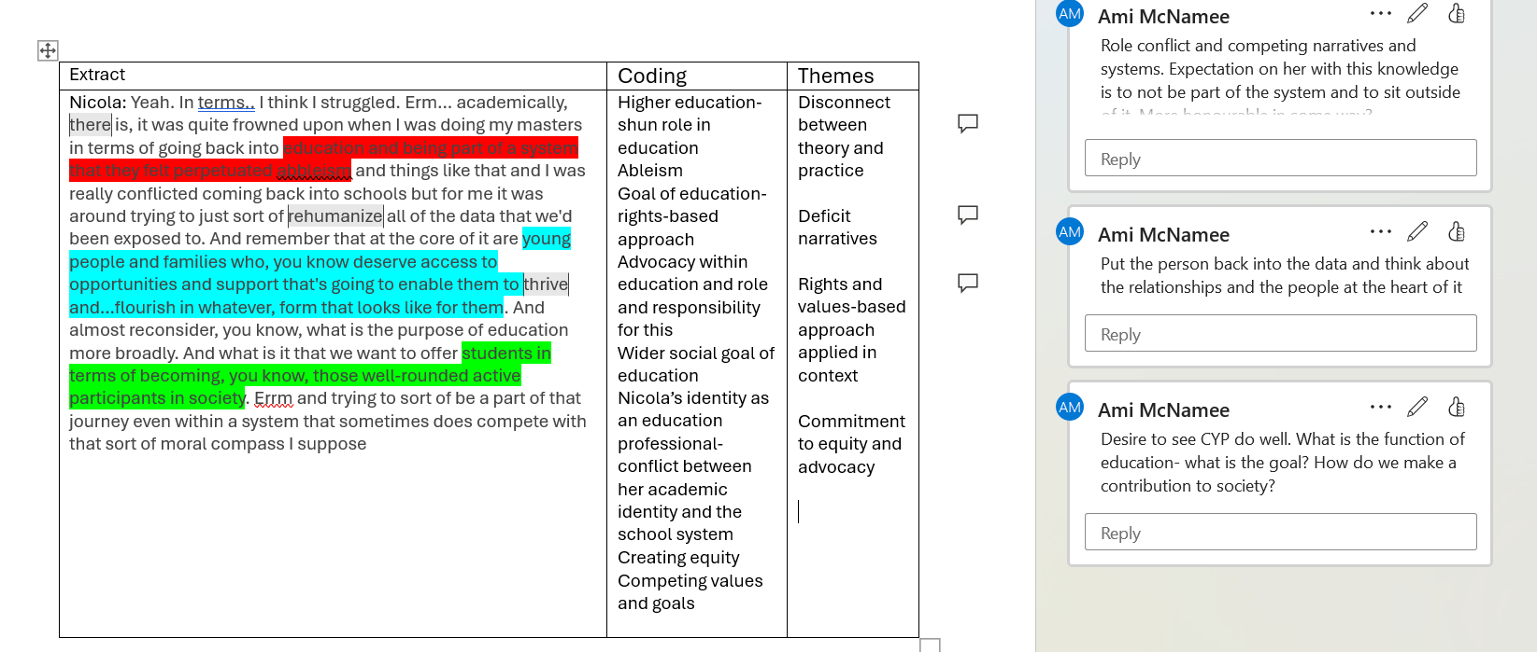Figure 2: Extract from a coding table. Nicola is a pseudonym

3.13 Positionality
The process of completing doctoral-level research coincides with a fluid shift in identity as learners transition (in my case, from advisory teacher) to researcher (Burnard et al., 2016). My desire to complete this research arose from my practice experiences in leadership roles in schools and LA practice; many stories were told of schools that were often attributed to their academy status, which did not always resonate with my practice-based experience of schools. In this way, I positioned myself as an insider-outsider in this research due to my life experience and felt sense of identity and belonging (Gair, 2012). Insider-outsider positioning is not a fixed construct, but one that evolves through the research process (Wilkinson & Kitzinger, 2013). In this research, my positioning shifted as the CoP developed, and I became more aware of challenging dominant narratives within the CoP. Based on my prior experience, I recognised that the power and panoptic position of LA decision-makers held meant that the voices of those within the system were missing, making it difficult to challenge such assertions (Foucault, 2000).
It felt important to share my former roles and how this had motivated and informed my research, so that I could act with integrity toward participants and help increase a sense of safety within the research (Dwyer, 2009). Through sharing a little about my own background, I could also relate to the common language and discourse, demonstrating greater empathy and strengthening relationships with participants (Asselin, 2003; Gair, 2012). The transformative paradigm encompasses feminism, critical race, and disability theories in research that aspires to personal and social transformation (Mertens, 2017, p. 20). Feminist research paradigms recognise that disclosure can help to reduce power imbalances within research (Yost & Chmielewski, 2013). Simultaneously, I exercised caution, aware that my insider position could pressure participants to divulge more, leading to a false sense of intimacy (Stacey, 1988, cited in Yost and Chemielewski, 2013). Operating within this space, therefore, required a high degree of reflexivity so that my story did not lead the process or obfuscate the data (Dwyer, 2009). The nature of the CoP was to co-create knowledge; I felt my positioning could add validity and enrich the process (Yost & Chmielewski, 2013). Maintaining a research diary alongside tutorials helped ensure I could explain and defend my decision-making rationale and explore matters of positionality while remaining critical and reflexive throughout the process (see Appendix A).

3.14 Research Design

Participants
My participant recruitment strategy involved using snowball sampling by inviting colleagues from the service where I am on placement to support me in recruiting participants from their networks (Naderifar et al., 2017). The participant recruitment poster and information sheet were shared with individuals within academised secondary schools (see Appendix C). Developing rapport with participants in the pilot study who found the study useful and worthwhile motivated and encouraged them to share the study's details with contacts in their networks, and this helped me recruit an additional participant (Negrin et al., 2022).
Recruitment was more challenging than anticipated. The timing of recruitment, early in the autumn term, is a busy time for secondary schools, and I wonder whether recruitment was slower than it might have been at other times of the year. My approach was to follow up on leads for potential participants when someone suggested an individual might be interested in the topic. I was also keen not to burden potential participants with repeated requests, so they would not feel pressured. Eventually, this led to the recruitment of four schools and a relatively homogenised sample (see Chapter 4).

Ethical Considerations
Ethical approval was requested and granted through the University of Sheffield’s ethics committee (see Appendix B). Given the nature of the discussion and invitation to share stories about inclusive practice, a key consideration was safeguarding the pupils and ensuring that no identifiable information about CYP was revealed. This also extended to revealing information about other members of staff at the school where individuals worked. As consent was limited to individuals who had signed the consent form, protecting the anonymity of other staff members was paramount. At the start of each meeting, reminders were given about the need to protect the anonymity of the school or community and that I would disguise and use pseudonyms to protect not only participant data but also those they taught and worked with (Clandinin & Connelly, 2000).
Ethical considerations for this research moved beyond questions of protecting anonymity towards the relational ethics that underlie narrative research (Clandinin et al., 2016). In the constructions of narratives, I wanted to remain faithful and sensitive to the intimacy that developed over time in the CoP and ensure that this was shared sensitively through the constructions of narratives (Clandinin & Connelly, 2000). Co-composing narratives and continually checking shared understanding was a fundamental component of research design driven by my research design, based on an ethos of care and commitment to ethically and relationally responsive research (Clandinin et al., 2016).

Method of Data Collection
The CoP took place online over Google Meet. Due to members of the CoP being dispersed over a large geographical area, it would not have been practical to run the CoP in person. Whilst in-person delivery may have created a more relational experience, it would have required participants to travel. As CoP approaches have developed, there are increasing models of effective online delivery that promote change and understanding of fellow participant contexts (Wenger-Trayner et al., 2023). I therefore used existing literature that provided examples of CoP models online to develop my design.
In designing the CoP, I used my pilot study to test my intended questions, ensuring they were relevant and clear and based these in part on examples from extant literature (Wenger, 1999; Wenger-Trayner et al., 2023). Initial guiding questions were kept open-ended to help facilitate discussion and build on pilot study experiences that helped participants share their stories. Through my literature review of inclusion and SJ in school contexts, I also shared definitions that seemed to reflect SJ-informed approaches to inclusion. Following the principles of the transformation paradigm, I wanted to create collaborative spaces to facilitate shared understanding. In the first CoP, I asked participants how definitions of inclusion and SJ resonated with them, rather than directing them; this felt more aligned with the inquiry into the action values that underpin the transformation paradigm (Mertens, 2008). I also used examples of articles and research to generate discussion and create spaces for reflection. Examples from presentations in the CoP are included in the appendix (see Appendix D). As explained, I would use the start of the next CoP as a review, providing a summary of what had been discussed and confirming that the story accurately reflected it. ‘Taking back’ researcher work to participants can help increase researcher credibility (Riessman, 2008, p. 197). In my research, this was an important ethical decision to create an opportunity to reformulate stories, gain permission to share them in research, and promote researcher-participant trust (Riessman, 2008, p. 198).
Each CoP meeting followed up on lines of inquiry from the previous session, and in the final CoP, the importance of understanding community context in creating inclusive and SJ school environments was discussed. For example, I wondered whether being part of a MAT, which may not be geographically located, may impact school policy and the delivery of inclusion. I also used the session to understand how participants had experienced the CoP.

Community of Practice
To support greater understanding of how the CoP evolved through this research, I will explain the preparation and administration of the CoP as it was enacted in this research. CoPs provide spaces for practitioner dialogue and the sharing of stories within evolving structures and often emerge organically in response to work-related problems (Wenger-Trayner et al., 2023). They often provide an element of continual professional development with a space for those in the CoP for reflection (Wenger-Trayner & Wenger-Trayner, 2015). I considered these elements when developing my initial CoP and used supervision with my tutors to plan the sessions with reflections from the pilot study. In the first session. For example, I had a presentation ready with the questions and some examples from literature of proposed definitions of inclusion and SJ. Appendix D provides examples. As I had not launched my CoP within the pilot study, I had no experience of asking the questions within a group rather than with individuals. I wanted to create discussion opportunities by providing definitions if none were forthcoming. This aspect was an area of over-preparation as participants were forthcoming in their stories. This meant that definitions and values that emerged from this part of the CoP did so from shared storytelling rather than by me directing ideas based on research.
I had been influenced by my research and practice, such as children’s involvement in the 2024 riots, which occurred in the early phase of this research. The Children’s Commissioner report, together with popular newspaper articles at the time criticised the NC for failing to promote understanding of SJ topics such as anti-racism. These headlines, together with some of the points from the report by de Souza (2025), were shared with participants to see if the assertions, such as children feeling disconnected from education, resonated with their practice-based experiences.
In the context of this research, there was evolving policy and practice-based developments, such as Inclusion in Practice (2025) response to the call for evidence across schools, and the Curriculum Review (DfE & Francis, 2025). An aspect of practice that emerged as an area for further understanding was what helped maintain inclusion in practice (IIP, 2025). In response to this identified gap, it became an area of questioning and exploration in the CoP. I provided summaries based on my interpretations of these developments to explore with participants. I also used some of these macrosystemic developments to promote discussion of concepts beyond the immediate school mesosystem and create opportunities for participants to reflect on these developments. Additionally, I would explain some of the language choices I made, such as the framing of pupils who attended secondary schools as children rather than young people, to invite reflections on this and justify the decisions I made.
In the final CoP session, I created space to explore my positioning and how much of me was in the CoP. This included questions and space to critique my involvement and whether participants felt influenced by my positioning on the topics explored. Although I was conscious of power and my own social capital in the CoP, I wanted participants to feel able to challenge me and to create spaces where the effects of my power were mitigated by the collective values and sense of safety developed in the CoP to allow different perspectives and critique of me in my role (Brown & Duguid, 1991). In Ami’s story, there are some examples included to show how participants challenged some of my framings and interpretations of stories.
As shown in the literature review, topics of inclusion and SJ are complicated and exist within messy and competing structures (Artiles et al., 2021). The CoP similarly reflected this complexity. This required me to use psychological skills, such as active listening summarising and validating participant stories and emotions and provide a relationally supportive context in which to explore the complex practice-based problems. In later sessions of the CoP, I felt I was able to take a less active role as participants began to reflect on the stories of others from within the CoP and showed how their learning developed incidentally from engagement in the CoP (Carter & Adkins, 2017). In these phases, I became less active in the CoP, showing how the CoP developed and became more self-organising (Cox, 2005).

3.15 Methodological Limitations
The methodological decisions I have set out in this chapter respond to the complex interplay of practitioner values, institutional and policy demands. I think selecting a narrative approach is an appropriate way to explore such dilemmas. However, I acknowledge there are methodological limitations to reflect upon and seek to interrogate this further.
Polkinghorne (1988) describes the complexity of ascribing meaning as intangible and difficult to measure. Furthermore, we only have access to our own ‘realm of meaning’, and the study of others, through language and interpretation of the content of language, is imperfect (Polkinghorne, 1988, p. 7). Whilst narrative research aims to prioritise the voices of all, the positioning of the research is such that some voices are privileged over others (Gottlieb & Lasser, 2001). My dual role as CoP facilitator and participant, ‘taking back’ previous CoP sessions and offering perspectives on inclusion and SJ, may have privileged particular interpretations, relational and moral, over alternative constructions.
Methodological limitations have been classified into broad areas of external, construct, internal and statistical conclusion validity (Clarke et al., 2023). Critically examining methodological limitations enriches the research and can have the function of increasing research credibility (Clarke et al., 2024). A key limitation of this study is the limited diversity of participants, which affects external validity. Recruitment of participants, due to the timing of this at the start of a busy school year, meant that I was slower to start the CoP meetings than my initial intended time scale allowed. This did not allow for my sampling method to produce the number of participants that may have resulted in a wider and more diverse sample (Naderifar et al., 2017). I wondered whether this impacted the CoP in terms of providing the richness of learning experience that could have arisen with a wider sample and created more debate and discussion, as different roles may have brought different stories to the surface.
A further limitation was in creating spaces for participants to interact informally between sessions (Wenger-Trayner et al., 2023). An approach, such as developing a Google Workspace, was discussed with my supervisors, but due to time constraints and potential safeguarding issues that could arise, it was felt that this study, given my inexperienced position as a TEP and researcher, was not suitable for such an arrangement. This experience, however, could have deepened learning and created spaces for further interactions among CoP members where learning could take place.
Limitations are important to consider and explain in research requiring transparency and reflexivity (Finlay & Gough, 2003). However, narrative approaches to research are valuable, offering unique perspectives (Gottlieb & Lasser, 2001), and I strove to use research supervision and reflexive diaries to reflect on the ethical decisions I was making and ensure I was maintaining participants’ dignity and rights whilst considering my own role. Some examples of these reflections are included in the Appendix (see Appendix B).

Chapter 4: Themes

4.1 Introduction
This chapter presents the findings from my Narrative Thematic Analysis (NTA) and interrogates how inclusion and SJ are constructed, negotiated and contested within participants’ narratives. Participants described the CoP as a safe space predicated on shared values and identity which facilitated storytelling about the complexities of enacting inclusion and SJ (Brown & Duguid, 1991; Carter & Adkins, 2017; Wenger-Trayner et al., 2023). It is nevertheless important to consider whether commitment to shared values obscured power dynamics within the CoP. The CoP was founded foremost as a relational experience; however, this did not mean it sought complete consensus, with some disagreements that may show how participants felt empowered to assert their positions (Cox, 2005).
Providing summaries of the previous CoP enabled me to clarify meaning whilst supporting the CoP in developing shared values and goals. It also shows how I shaped the direction of the discussion, which is explored as part of the analysis. At the end of the last CoP session, NTA was used to analyse the CoP transcripts. NTA is concerned with how the narrative is constructed and keeping these stories intact whilst paying attention to micro and macro contexts and recognising myself as an active agent, both as participant and interviewer, in the process (Riessman, 2008).
Researcher’s interpretations of the the social world are influenced by their positioning and by exploring how such positions impact interests and identities (Jacobson & Mustafa, 2019). Making visible the ways researchers acknowledge their own subjectivity and create space for continual and contextual reflexivity, and the decision points reached, reflects my axiological and ethical approach in this study (Olmos-Vega et al., 2023). To provide transparency and explain my decision-making, reflexive boxes have been used in this analysis.
In constructing this chapter, I begin by describing each participant in turn, explaining key aspects of their individual story and introducing them as a vignette. I then outline themes for each participant based on my re-reading and the construction of a coherent story aimed at accomplishing change through storytelling (Riessman, 2008). Each theme is then discussed with extracts from participants’ narratives with the goal of interpreting and retaining each participant’s story (Riessman, 2008). Transcripts are available in the appendices (see Appendix E). Thematic maps provide a visual representation of the themes I have actively constructed through my analysis of the data (Liamputtong et al., 2019; Morriss, 2024). I start by presenting a thematic map of all themes, highlighting similarities across participants' experiences.
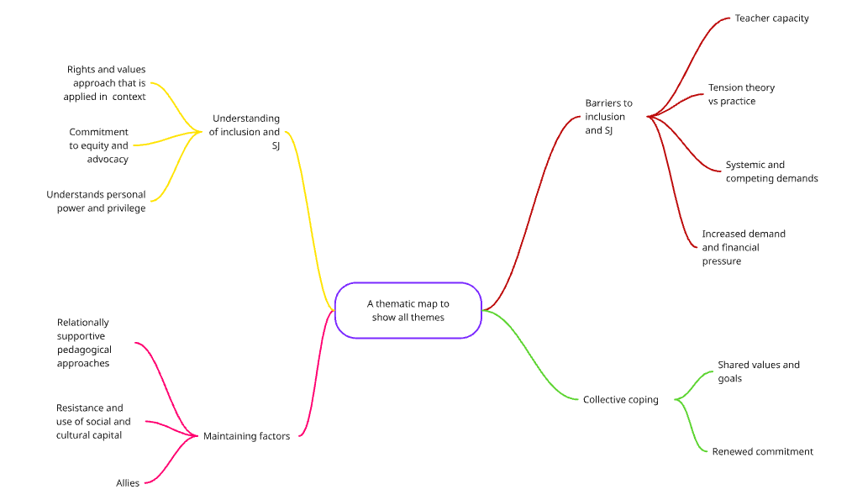
Figure 3 shows a map of all key themes as identified from my analysis.

4.2 Participant Information
Five participants were involved in the CoP. As the research seeks to explore inclusion and social justice, it was necessary to gather sensitive data to support understanding the positioning of different participants and recognise that how we identify influences qualitative research, particularly as it pertains to SJ issues, including race (Bourke, 2014). In the context of narrative analysis, the stories we tell about ourselves help to shape our individual and collective identities and make meaning of decisions and actions (De Fina et al., 2015).
As discussed in my earlier methodology, I am included in the table as I identified as a participant. No participant disclosed any accessibility needs that may have influenced their engagement with the CoP or any disability. This was another example of the sample's lack of diversity. All four of the school-based employed participants work at four different schools across the Northwest, and none are part of the same multi-academy trust (MAT). Pseudonyms are used for all participants, except me. The table below provides an overview of their characteristics.
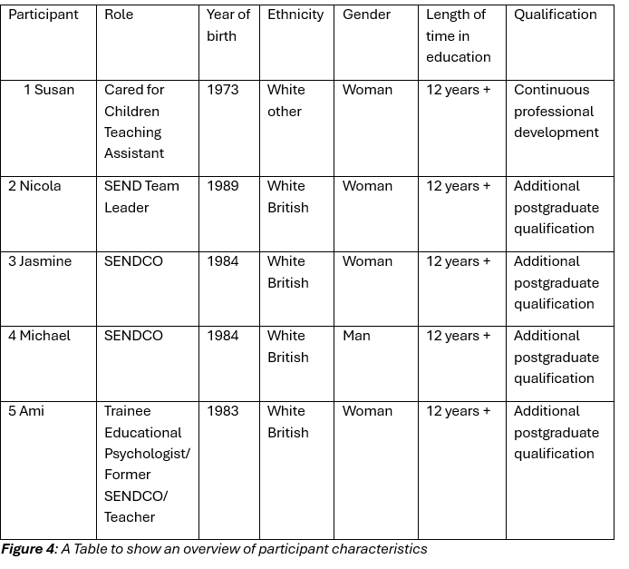
The relative absence of diversity within the sample has implications for how inclusion and SJ are reconstructed, potentially reflecting dominant perspectives within the profession.
I have written a short vignette for each participant, based on information shared with me and aim to provide context for the reader (Butina, 2015). A thematic map has been created for each participant to orient readers to the analysis and to show where themes in the overall map originate.

4.3 Susan
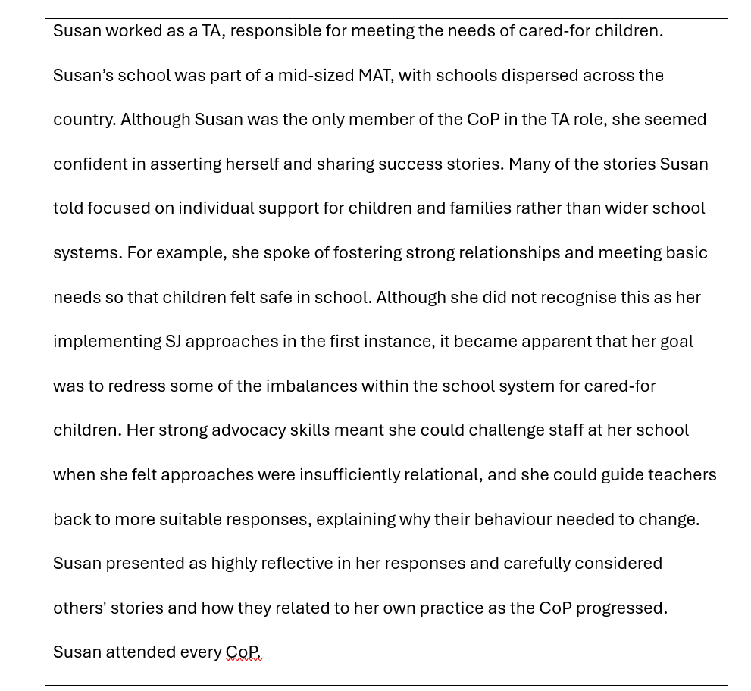
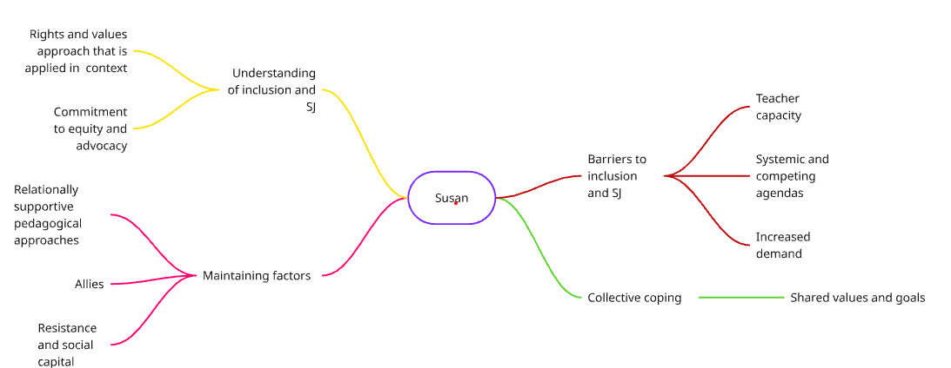
Figure 5: A Thematic Map of Susan’s experiences as identified by my NTA

Themes

Understanding of Inclusion and SJ

Rights and Values Approach Applied in Context
Susan shared her understanding of inclusion as founded on a rights-based approach. IE was understood as a fundamental right extending beyond notions of pupil ability or SEND to one where there is an expectation of flourishing:
“…no matter where you come from, your background, everybody, whether you've got disabilities, whether you're able-bodied, everybody has got the right to have an education… and to be able to thrive in that education.” (Line 40-42).
For Susan, considering the child’s context and recognising the complexity and challenges in their lives, including how parental experiences of school could influence this, were also crucial to understanding inclusion. Susan positioned herself as a bridge between home and school, providing empathy, care and support, enabling children to feel part of the school community:
“They don't all have fabulous times in school…. I think the driving force was to actually make them feel like they were included and they did have somebody for them who they could go and speak to and come and see.” (Line 672-675).

This positioning connects strongly to sociocultural theories of participation as an active, social interaction, shaped by language and to the notion of inclusion as relational belonging (Vygotsky & Cole, 1978).
Central to inclusion were core values, including acting with authenticity and integrity, as these facilitated effective connections and relationships, without which inclusion was likely to fail. Susan felt that fostering effective interpersonal skills and an ethos of care was fundamental to understanding inclusion:
“I think you've got to be the person that does care and that has got their best interest at heart… so that you allow them to feel like they belong, like you are there to help them.” (Line 1074-1077).

Commitment to Equity and Advocacy
Creating mechanisms that made all stakeholders feel valued as equals was an important part of Susan's understanding of inclusion. Commitment to equity and advocacy was extended beyond pupils to parents, who were recognised as important stakeholders and also needed an ethos of care. Fostering trusting relationships started early, creating opportunities for relationships to develop before the child started at the school:
“… [T]here's a lot of people that are scared to voice what they're thinking or voice what they're saying. But if we can go to them and we have got that rapport with them …. then it does make them feel more included…” (Line 812-814).

Susan’s words convey the power dynamics among parents, children, and school staff, and how she uses relationships to break down fear as a barrier to engagement. Relationships were positioned as an investment for future conversations that built a culture of honesty and a shared understanding.

Barriers to inclusion and SJ

Systemic and Competing Agendas

Susan perceived a disconnect between expectations of mainstream settings and specialist school settings. Stories about the efforts mainstream schools had made to accommodate needs were seen as distinct from specialist provisions, where placements had broken down. The lack of available special school places was presented as a systemic problem that created an additional workload burden within Susan’s school. Mainstream schools were positioned as more benevolent and inclusive than their special school colleagues, as they had not excluded the child. This dichotomy represented misalignment and a lack of collaboration within the system, causing frustration, which Susan presents through rhetorical questions to highlight the disparity between mainstream and specialist placements. Susan portrayed the mainstream school as persevering with inclusion, where specialist settings have used their autonomy to refuse to maintain a place:
“…[I]t is broken because if a mainstream school can do that and then the specialist school have turned around and gone actually, no, we can't meet their need. What is going wrong? Why are they not able to meet the need when we've struggled? Don't get me wrong, it's been hard work and it's been a lot of work…, but we have managed to keep them.” (Line 470-474).
The use of rhetorical questions seems to be directed back to SP, which Susan perhaps considers as not persevering or working as hard as mainstream schools. This is reflected as a point of contention between school types and is attributed to systemic failures.
Reflexive Box 1:
Perhaps because Susan sees children being displaced from education as SP placements are not maintained, Susan seems to struggle with placements breaking down. I wondered if this was because it competed with her moral framings of inclusion.

A further competing agent against inclusion and SJ was social media, which was portrayed as hindering both. Susan described how children may not be able to recognise erroneous content; this seemed particularly problematic in the context of tackling issues such as misogyny and racism. This could feel insurmountable for Susan. It also risks framing children as passive recipients of misinformation, potentially obscuring their agency to identify harmful content:
“I think a lot of what they see in social media gets in the way of everything because if it's on social media, then it's 100% true.” (Line 248-249).

Teacher Capacity
Inclusion is constructed as a time burden to an already overwhelmed workforce, and came out strongly in Susan’s narratives. The sense of an insurmountable workload, with competing agents jostling for time, was perceived as a burden that prevented adults in school from delivering inclusion:
“[T]here are only so many hours in a day and there are so many people and there is just so much that people have to do in such a short space of time and… it's just not actually possible to do everything that you are supposed to do in the time that you have.” (Line 1200-1207).

The increased identification of need and the number of individuals seeking teacher attention illustrate the tension between delivering relationally-informed inclusion and wider school systemic time pressures.

Increased Demand and Financial Pressure
Within the context of finite time, some parents were seen as adversaries who made demands and caused overwhelm, working against school staff and detracting from inclusion support for those perceived as most in need. Some parents were seen as having too much knowledge and power, which disproportionately benefited their child, rather than equally distributing time and energy to all within the system:
“I think parents are more educated about what they think their child needs. And they put the pressure on schools…. They want you to drop everything. They turn up into the reception, and it's like, I'm here now. You need to speak to me. I do think that education to a certain extent does need a whole revamp.” (Line 1274-1277).
This construction of parents as adversaries may reflect systemic resource scarcity, where advocacy is reframed as competition, drawing on neoliberal underpinnings of education and raises questions about how power is distributed within school-family relationships. It shows how Susan tentatively moves towards the need for wider policy reforms to address these competing challenges.
Reflexive Box 2:
I found this framing of parents contrasted sharply from earlier descriptions where parents were positioned as disempowered and requiring advocacy. Instead, in this example, relationships and collaboration have failed, creating the tensions Susan describes.

Maintaining Factors

Relationally Supportive Pedagogy
Having the skill to relate to children and make meaningful connections was seen as an integral component of inclusive practice. Knowing the children and their families was seen as a crucial foundation for effective inclusive approaches. Building relationships early was seen as a worthwhile endeavour that required investment throughout the transition to promote effective inclusion. Stories of successful relationship building were presented as evidence of successful inclusion:
“We attend the transition meetings or any meetings that they have in year 5, so personally from my point of view, I think that as a school we do inclusion really well.” (Line 656-657).
Susan attributed relational approaches to ensuring basic needs were met for individuals, particularly those who belonged to groups such as cared-for children:
“But what I will try and focus on is making them feel safe in school, including them, making sure that they've got friends.” (Line 214-216).
The construction of Susan as providing care and addressing the basic needs of cared-for children shows how SJ is enacted at an individual level. Although Susan did not position herself as an agent of SJ in this story, it provides examples of some of the ways she enacted SJ goals.
Reflexive Box 3
Susan did not easily identify herself as enacting SJ and limited her own involvement. By summarising some of the important work she had described earlier, she was able to provide the story about how she enacted SJ in school.

Allies
Successful inclusion, as Susan describes, seemed to depend on understanding and responding sensitively to the community's needs. Creating allyship with the wider family and breaking down barriers to school engagement were viewed as critical parts of Susan’s role in supporting inclusion. This was seen as a way of mitigating perceived parental wariness about education and promoting wider community involvement:
“Definitely, definitely local communities… it's a lot easier for pupils to feel included in school… [if] parents haven't necessarily had a good relationship with school and then that kind of feeds on into when their children are in school…” (Line 800-804).
The voices of those involved in enacting inclusion, including its recipients, were seen as important evaluators of successful IE:
“Everybody in school really should be involved in it because it's everybody's job to make people feel secure, safe, included.” (Line 1482-1483).
Susan identified successful inclusion as a collective responsibility, to be judged by all stakeholders rather than by wider macrosystemic bodies, such as Ofsted and those positioned as experts. This perhaps moves away from neoliberal accountability processes and shows how her conceptualisation of inclusion focuses on the individual experiences of those within the school system.

Resistance and Social Capital
Susan seemed empowered in her role to challenge less relational practices and to suggest alternative ways of interacting with children. Responding relationally to gently challenge adults was predicated on effective inter-staff relationships, which Susan recognised would benefit the children she supported. She describes how she uses relational approaches and her social capital to support others in recognising the need to understand why a change in approach was necessary:
“…[Y]ou can say would you just mind reframing that or saying that in a different way without feeling that you're telling them what to do or you're telling them that you're doing something wrong. ” (Line 717-719).

This seemed to demonstrate the security Susan had in her role, which enabled her to respond to those at different levels of power and to use her social capital to promote more relational approaches with children. The use of the word ‘reframe’ also perhaps alludes to how education provides an opportunity to re-story children’s lives, and, in this example, to ensuring that adults use language as a tool to facilitate this.

Collective Coping

Shared Values and Principles
Susan reflected in the final CoP session about the stories she had heard during the research and how this resonated with her. This prompted her to think about how these values were enacted in her own practice and context. Sharing practice-based stories about SJ generated reflection about her own context and the juxtaposition of different members within her school community:
“So I think that definitely the power of privilege you do need to try and balance that especially for our kids and obviously some staff members will be a lot more privileged and maybe not understand some of the hardships and some of the struggles that some of the kids might have to put up with...” (Line 1328-1332).)
This reflection perhaps shows how Susan’s thinking has changed through participation in the CoP, particularly regarding the differences between the life experiences of adults in school and children, and the importance of recognising positions and privilege within the context of education.

4.4 Nicola
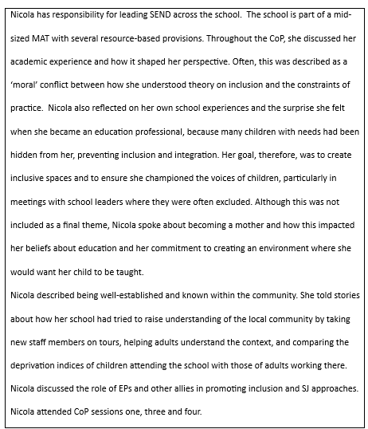
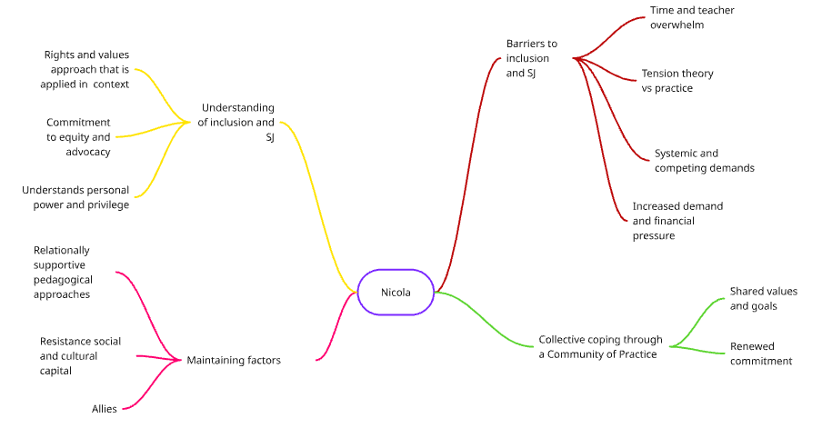
Figure 6: Nicola’s thematic map as identified from my analysis

Themes

Understanding of Inclusion and SJ

Rights and Values-based Approach that is Applied in Context
Nicola saw inclusion as being rights-based and informed by shared, collective values reflecting a moral framing, suggesting that inclusion is conceptualised as an ethical obligation rather than a statutory requirement. Positioning herself in a combative role from the outset in the CoP, she saw fulfilling this goal as requiring resistance and a ‘fight’ against competing systems. Nicola constructs enacting inclusion as a site of struggle rather than consensus, positioning herself as an agent of resistance within such contested systems:
“….[I]t's always been about rights and representation and resources and almost fighting for those rights across the board.” (Line 123-124).

Commitment to Equity and Advocacy
Achieving equity was viewed as an important goal of inclusion and SJ practices. Here, the idea of the moral purpose of education was also introduced; Nicola positioned herself as an activist and a conduit to enable children to become valuable members of society:
“…[W]e want to offer students in terms of becoming, you know those well-rounded active participants in society… and trying to sort of be a part of that journey even within a system that sometimes does compete with that sort of moral compass I suppose” (Line 75-78).

Championing the voices and perspectives of those who were felt to be disenfranchised within the school community was seen as paramount to IE. Nicola told stories of resistance to uphold rights and support individuals disenfranchised within the system. The words Nicola uses show how she considers inclusion to require action and positions it within a contested system:
“But for me, it's always been a part of being in that and sitting right in the centre of it and pushing back against some of those tensions and trying to align that, that champion and advocacy….” (Line 63-66).

To be an effective advocate, Nicola recognises her own power and responsibility to champion and challenge. Her position seems to be influenced by her own social capital and by her academic knowledge, which she utilises to redress power imbalances.

Understands Personal Power and Privilege
For Nicola, promoting equity required a collective understanding of children’s backgrounds, which was synonymous with being an agent for SJ. Understanding community backgrounds and how school staff positioning compared to stakeholders in the school was connected to greater consciousness of the disparity between the socioeconomic status of the children who attend the school, and those who are employed there:
“We did an ADI score which is just a deprivation index where you can put in the postcodes of students at school…[O]ur average student sits at 2 by comparison, staff average is a 7.6…[T]hat was quite a powerful measure to share with staff as well… it can be really quite challenging… to fully appreciate what life outside of the walls of school looks like for some of our students.” (Line 1142-1150).
Nicola’s stories about how her school has sought to deepen staff understanding of the community context highlight the importance of localised approaches to inclusion, requiring adults to sit with some of the uncomfortable realities of working in communities that serve children from poorer socioeconomic backgrounds.

Barriers to Enacting Inclusion and SJ

Systemic and Competing Goals
Nicola described a lack of equity in educational placement decisions when she compared the expectations of SPs with those of mainstream schools. Perhaps because SP places are highly prized, the power to refuse was perceived as greater in special schools. Nicola felt expectations for mainstream schools were higher than those in specialist settings. She positioned herself as the child's champion, working harder to maintain placements than specialists would. Her language choices revealed a deeper conflict as she positioned her school as a victim:
“…[W]e've had other local specialist schools say to us, actually… what you're providing is far beyond what we can provide currently. And what we've kind of become, sort of victims of trying to do the right thing.” (Line 484-487).

Nicola seeks to provide educational placement and promote belonging within an imperfect system which fails to recognise and respond to children’s individual needs, showing how she perceives enacting inclusion as a moral endeavour.
Reflexive Box 4:
Nicola’s use of the word ‘victim’ here indicates how she perhaps positions SP as not doing enough when compared to the efforts she sees her organisation taking to include children. I wondered here if the approach of SP settings not to admit or persevere with placements was seen as having less of a moral commitment to inclusion.

Increased Demand and Financial Pressure
Nicola described the growing complexity of need that has emerged over time. This has changed the school demographic and added pressure to an already overcrowded system, whilst reducing the capacity to address children’s needs. Absence of appropriate funding to meet this changing need adds pressure to what is described as a ‘diluted’ resource:
“….[W]e're currently 40% SEND…. So that normal distribution has shifted…. You know, and that's a real challenge because it's diluted the resources that we've got and the reach that we've got and not much changed in way of funding.” (Line 399-404).
This demonstrates the tension between delivering inclusion and practising relationally within a saturated system. Her story describes how school demographics have changed, which are at times located within medicalised discourses of diagnosis.

Tension Theory vs Practice
Nicola described tension between theory and practice, which she storied as the terminology and jargon surrounding SEND. She asserted that language was not used plainly, leaving teachers feeling deskilled and overwhelmed and leading them to view delivering inclusion as a more complex endeavour. This, Nicola sees, is counterintuitive, as staff have organically cultivated the necessary skills to meet needs:
“…[T]hey're already equipped with a lot of what's needed, but because of how it's framed, it kind of becomes something that seems like it should be more specialised than quality first teaching.” (Line 278-280).
Nicola’s position was rooted in her own research and experience of higher education. She positions ‘experts’ who draw too heavily on a theoretical perspective of education rather than recognising the constraints of practice. She described an internal conflict between herself as a scholar and being part of an education system that she felt perpetuated inequality, almost becoming a traitor to her own knowledge:
“…[I]t was quite frowned upon…going back into education and being part of a system that they felt perpetuated ableism… I was really conflicted coming back into schools but for me it was around trying to just sort of rehumanize all of the data…” (Line 68-72).
Creating spaces for research to understand lived experience was seen as a way of resolving this conflict:
“I don't actually know how much work has been done on the sort of front line of things and engaging with people at that. So, I suppose my worry is just a theorised school experience that isn't wholly representative of what it's actually like.” (Line 1292-1294).
When I sought clarity from Nicola and asked if this related to authentically understanding the school experience, she agreed. However, I wonder whether her stories of the inadequacy of theory in practice obscure the everyday tensions in a school system that struggles to fulfil and address children's needs, and whether they help Nicola reconcile practice constraints she positions as preventing her from delivering IE in line with the academic knowledge she holds. In her story, she draws on dominant narratives of theoretical inadequacy rather than on the inadequacies of educational provision. This demonstrates the tension between theorised concepts of inclusion and SJ and the reality of a systemically constrained school context.
Reflexive Box 5:
Nicola here draws on her social capital and educational experiences to expose the tension and illustrate how conflicted she can feel in practice when other systems perhaps make it difficult for inclusion and SJ to operate in the ways that are connected to her academic experiences and moral framings.

Nicola makes a connection between increased identification of need and medicalised discourses of children, which correspond with decreased teacher confidence in meeting those needs. Nicola describes this as problematic and describes how blame is then located within the child and reveals a critical disjuncture between academic constructions of inclusion and the lived realities of educators:
“I think the sort of the deficit-based narrative and diagnosis pathway for SEND at school that I find it harder to engage some of our staff to reframe that…I don't want to say like blame but locating blame the idea that there's a deficit there's something to be fixed and whose responsibility is it to work around that deficit and… when that is a push-pull play between staff and students.” (Line 386-392)

Complex labels are positioned as creating a barrier to their feeling able to relate to and understand the children they teach. It shows how individual agency to create relationships is thwarted by pathologising language. Nicola’s use of ‘deficit narratives’ is frequent in her stories of practice and may advance her own story by reflecting on sites of conflict and tension.

Maintaining Factors

Relationally Supportive Pedagogical Approaches
Nicola spoke about training and development in relational practice as being valuable. Her school had received support from external professionals, such as EPs, which helped develop this skill. In her story, it was important that agents supporting the school possessed the requisite values and were authentic in their approach. Building relationships was seen as having reciprocal benefits to staff in terms of helping them to feel valued as practitioners:
“….[S]ometimes they come back and they check in and you can see…the next steps that they've taken and just how fondly some of them dip in on open evenings…. [They are] genuinely complimentary of the support and relationships that they had at school. And you can hold on to that a little bit….” (Line 1463-1469).
Relational inclusion was seen as dynamic and multifaceted, serving different stakeholders within the system and providing momentum, juxtaposed with the ‘broken’ system that fractures relationships. Nicola again told stories that reiterated the importance of alignment:
“I think it's relationships with staff as well that really help that surrounded by people that share those common sorts of morals and ambitions, and that actually really value working with young people.’ (Line 1446-1449)

Allies
Stories about shared values, such as authenticity and commitment, were viewed by Nicola as a significant indicator of whether individuals were identified as inclusion allies. EPs were viewed as making an important contribution to reframing ideas about enacting inclusion beyond statutory systems, which were viewed as problematic:
“…[W]e did a piece of work…. with the lead Educational Psychologist [LA redacted], and it was very idealised. It was around transformative practice… I feel like just a redesign of curriculum… what the purpose of education is for some students and how we can sort of tap into that for students where the more traditional approaches aren't working for them.” (Line 1218-1224).
Nicola also identified school leadership as playing a critical role in creating inclusive spaces and being an important ally, but ultimately, Nicola positioned teachers as the most powerful actors in the delivery of inclusion, requiring their commitment to enact SJ approaches and embrace the belief that inclusion mattered:
“…[T]eachers are our biggest resource. They're on the interface of it daily... So, in terms of bringing allies on board creating support networks, I'm going to need them.” (Line 1174-1176).
Positioning as an ally of inclusion required commitment, empathy and embodiment of core values of authenticity. When talking about allies, Nicola spoke positively of EPs in this role compared with some ‘experts’ whom she positions as obscuring inclusion goals through the overcomplication of medicalised discourses, which are described less favourably.

Resistance Social and Cultural Capital
Helping those in leadership roles to understand and to tell the children’s stories within contexts where they were often overlooked or excluded positioned Nicola as an ally and helped demonstrate her resistance to adult-only spheres. She used her social capital to facilitate conversations about inclusion:
“What I find is missing from honestly, the bulk of referrals is any type of voice of the child. And I feel like sometimes we forget we skip that step and I'm like has anybody just asked them…” (Line 1088-1090).).
Nicola described the value of listening to children in facilitating change and shifting perspectives. For Nicola, it seemed listening to children’s voices and adopting true person-centredness went beyond tokenism, galvanising those in leadership roles into action.
Nicola identified that educating staff about the local area helped adults understand the child in context, thereby promoting SJ. Power was linked to education and cultural capital, which had a symbiotic impact on inclusion; it raised awareness of the disparity between teachers’ and pupils’ experiences whilst raising aspirations and expectations for those who lived in the area:

“So, when you're thinking about how you can use our cultural capital in terms of sort of shaping the curriculum and challenging some of that inequality and moving away from that deficit narrative…” (Line 1128-1130).

Through her stories about educating new staff on bus trips to the local area, Nicola presented this as a novel way to deepen understanding and promote empathy for children and families, as local knowledge can easily be forgotten. Raising aspirations for children in the community through SLT representation was also important, as Nicola positions this as creating optimism and helping to provide a counter-narrative, noting that some families ‘internalise’ deficit perspectives on what children may achieve because of where they live. It highlights a further way in which inclusion needs to be understood within localised contexts.

Collective Coping
Nicola was asked how she experienced the CoP and my role as a participant, and whether she felt influenced by it. She described the CoP as a space for shared values:
“No, I didn't feel steered in any way. More just reassured that it was a safe space as well, I suppose.” (Line 1628-1629).
Nicola described the relational elements of the CoP as being supportive in helping her to think about her own practice. Again, she spoke about the CoP as a place for collaboration within a group, where members share similar values and goals.
Reflexive Box 6:
As both a participant and researcher, I was aware of my own social capital and involvement in the CoP and whether participants felt able to express themselves without prejudice. Providing space for these discussions felt important to ensure participants could express themselves honestly and scrutinise my involvement in the CoP.

Shared Values and Goals
At the beginning of each CoP, I offered a summary from the previous CoP and shared the values and principles I felt had developed. I also used this as an opportunity to check language choices, such as referring to students as children rather than young people, and to share my rationale. Some of these ideas resonated strongly with participants, strengthening group identity:
“…I think that's why I really liked the term child…. I've never underestimated the power and privilege of the role that we have, and I've never wanted to exploit that in any way other than for the betterment of what can be provided for somebody.” (Line 1063-1066).
Consideration of language choices and positioning was reflected in Nicola’s story about her work. She reflected on the power of words across several contexts, highlighting the care and consideration she took in how children were spoken of and listened to (Billington, 2006).
Clarification of values and principles also helped create a shared CoP identity, which Nicola expressed as valuable. She described feelings of connection and enjoyment within the group, replacing feelings of isolation and frustration when discussing her role in practice. This highlights how collaborative spaces were viewed as supportive elements for developing practice and problem-solving:
“Things can get very myopic when you're stuck in one place, and especially when you're …. in schools for a long time,… [C]ollaboration just brings another way of thinking and considering, and it's nice to hear other people's experiences and their successes and challenges...” (Line 1603-1607).
Nicola’s use of the word ‘myopic’ may refer to how stuck and complicated enacting IE may feel in schools, leading individuals to struggle to move beyond immediate mesosystem problems. In the early stages of the CoP, inclusion was portrayed as a contested endeavour, but the softening of language to one that appreciates hearing others' stories is presented as a more optimistic lens from which to view IE. It perhaps illustrates the power of storytelling to promote action (Riessman, 2008).

Renewed commitment
Through collective storytelling, Nicola valued the reflective space created and the opportunity to share with individuals who shared similar passions. This is described as supporting Nicola to think about her own context. Nicola identified the value of collaboration to reignite energy and hope in what can often feel like a frustrating and challenging role supported to experience the CoP as an enjoyable and worthwhile endeavour:
“[I]t's revitalised it a little bit. It's not often you get the space to come together… And really sit and reflect on what is and why and what could be…. I suppose, yeah, just energises me, maybe. Yeah, I think any type of collaboration is important, isn’t it?” (Line 1596-1600).

4.5 Jasmine
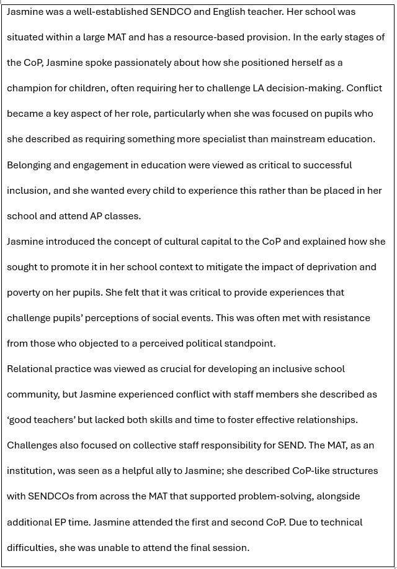
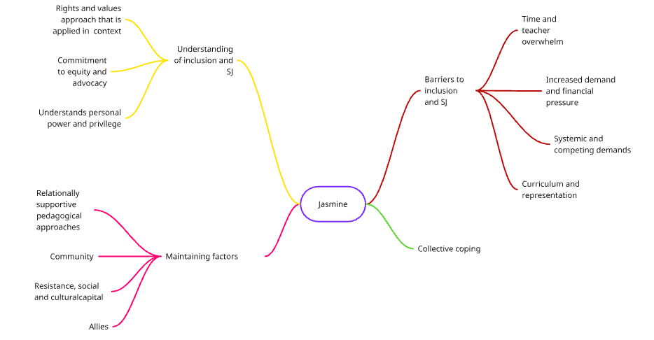
Figure 7: Jasmine’s thematic map based on my analysis of the data

Themes

Rights and Values-Based Approach to Inclusion Applied in Context
Jasmine described that effective IE was predicated on teachers’ understanding that such approaches would likely benefit all children. Inclusion and equity were achieved by all pupils having access to high-quality teaching:
“…[A] really good solid universal offer that benefits SEND pupils is not going to hinder non-SEND pupils. But it makes it easier for the teachers…” (Line 302-306).
Jasmine explained that she saw this approach as being intuitive to teachers. Rather than approaching quality-first teaching as a workload endeavour, it was seen as the norm in schools.
Jasmine reiterated how such approaches supported early identification and prevented escalation of needs. These stories reiterated how IE promoted flourishing, dichotomising this with mental health needs when inclusion had failed to address children’s needs:
‘[I]t would never get to that point where they need any sort of SEMH input because they're feeling happy in school, they're feeling motivated, they're thriving.” (Line 364-366).
Flourishing transcends the harms caused by unmet needs, leading to fewer diagnoses of SEMH difficulties and suggesting what could be achieved if policy worked in practice.

Commitment to Equity and Advocacy
The development of equitable education was a driver of inclusive education for Jasmine. Teaching children about the meaning of equity was a crucial component in achieving this goal:
“I guess the term equity is a big part of social justice and just sort of understanding that everybody needs different things in order to thrive…I think is something we're trying to teach the children a lot about.” (Line 99-101).

Jasmine described how she directly taught protected characteristics, including socially constructed categories of race and ethnicity, to support children's understanding and raise awareness of SJ and anti-oppressive practice:
“…I think they all kind of get that things like racism is a crime, but not necessarily that it would be a criminal offence to say something homophobic or to say something against someone with a disability.” (Line 118-120).

As the quote shows, it was seen to help children understand the impact of their words in the context of protected characteristics, which can be challenging. Jasmine positions this from a place of care, as a teaching and learning point rather than judgment. Teaching about SJ matters could be seen as a point of derision between the views she has and those of other community members, including parents.

Barriers to Enacting Inclusion and SJ
Jasmine identified how the curriculum can be conducive to addressing SJ issues, but described how this was abandoned as it was felt too controversial within her school:
“… I think it is the vocab that's used particularly like we've stopped teaching of Mice and Men, To Kill a Mockingbird. You know, when actually they're massively, massively useful tools in teaching racism.’ (Line 192-194).
Stories were told about how curriculum content had been thoughtfully developed to help explore social issues, only to be criticised and attacked. The language used shows how Jasmine alludes to parents being critical of SJ approaches, using ‘our children,’ perhaps as a way of asserting power:
“…[I]t's really tricky there's always someone that doesn't agree with something, and we've had backlash if we've taught an article from a certain paper. You know they've said that the political slant is. You know, you're trying to lead our children to believe this, and it's really hard.” (Line 199-202).

In the context of this comment, Jasmine also references Michael’s story, in which he describes the teacher's "backlash," suggesting that criticism of SJ approaches was multi-layered and complex. The language Jasmine uses positions her defensively as though she perhaps experiences this as an attack. The subtext of ‘leading’ perhaps implies that parents may see such approaches as a corruption of children if the political perspective differs from their own.
Reflexive Box 7:
In Jasmine’s story, she shows careful thought in introducing SJ topics to children in school. It also highlights how these efforts can be overridden and possibly unofficially policed by others within the system, leading to abandoning such efforts.

Increased Need and Financial Pressures
Jasmine described the complexity of the macrosystem in which provision was commodified through the EHC process. Rising demands in her LA are depicted as shifting the parameters for securing assessment (and funding) in a system that lacks transparency. Her story reflects one of rising need in her own school microsystem, where she feels educational placement, provision and availability of specialist placements are not matched to the severity of need:
“Finally managing to push an EHCP through… they're going to issue a plan after probably two mediations to even get it through… [and] just name the mainstream school that they’re not accessing anyway.” (Line 432-435).
This reveals the tension within a saturated assessment system, which contributes to the quiet exclusion of children. In her narrative, Jasmine introduces the notion of a ‘broken system’ which resonates and becomes repeated in the stories of other CoP members.

Teacher Capacity
Jasmine described teachers’ flexibility and ownership over SEND as a barrier to enacting effective inclusion. This highlights a point of disagreement with Nicola’s perspective that relational skills are easily understood in schools, but complicated by the theory and language, whereas Jasmine told stories about how teachers lacked necessary interpersonal skills:
“I get what Nicola is saying about that emotional literacy, but some teachers are just really not good at it…. and they just don't have any empathy for some of our kids.” (Line 307-309).
Jasmine’s use of the word ‘our’ highlights how she positions herself to take ownership and responsibility, in contrast to mainstream teachers, whom she positions as lacking empathy for pupils with SEND. Her judgement of teachers deemed ‘not good’ perhaps shows how Jasmine has assumed the role of policing mainstream teachers in her role of SENDCO as prescribed by neoliberal education policies (DfE & DoH, 2014; Done & Andrews, 2020). Instead, Nicola describes the language around ‘relational’ approaches as obscuring relationships; teachers may frame it as an additional workload burden or something requiring specialist skill, yet believe relational skills are something teachers possess. This framing individualises responsibility for inclusion, potentially obscuring structural constraints and reinforcing deficit narratives about teachers.
Technical skills and subject knowledge were insufficient to compensate for the absence of relational skills and empathy that Jasmine views as fundamental to promoting inclusive cultures:
“…[S]ome of them are great teachers. And yes, they know how to get nines out of the bag and things like that when it comes to GCSE season, but they might not be able to keep people with ADHD in the classroom for more than five minutes.” (Line 312-314).
Reflexive Box 8:

Jasmine’s comments here depart from other stories where she reflects on the challenges and workload demands of teachers, showing how she does have empathy for managing inclusion within competing systems. This seems to be a point of departure, perhaps because the children are impacted and are not included in their lessons. It is in these moments that Jasmine seems to draw on neoliberal framings of SENDCOs who are required to police teachers and exercise control.

Jasmine’s story reinforces neoliberal ideologies of individualisation within education, as the wider classroom context is ignored, and perhaps assumes the role of policing teachers. When I tried to understand more about the barriers to this, I was met with defensiveness, highlighting how confounded and defeated Jasmine could feel in the context of developing inclusive school cultures:
‘If I knew I could fix it. I think overwhelm is probably a big bit to it.’ (Line 318).
Jasmine draws on further commonly recognised and cited reasons for failed inclusion, such as excessive workload, perhaps to explain this rather than recognising that ‘fixing’ the problem may sit outside her power and may rest within wider systems and policy.
Jasmine further explores the resistance she encounters as she positions teachers who fail to take ownership of inclusion, and sees those who experience SEND as having needs that require fixing rather than understanding and adaptation. Jasmine’s frustration about children not receiving the same attention and diligence as safeguarding concerns is highlighted as a barrier to effective inclusion. Again, as prescribed by neoliberal education policies, it highlights the responsibilisation of teachers:
“It's like everyone says at the start of the year safeguarding is everyone's role, but SEND is everybody's role every teacher in the school has a SEND learner in their classroom…” (Line 370-371).
I wondered whether the lack of role diversity impacted the framing of stories about inclusion. The CoP featured school staff with responsibility for championing inclusion. Understanding the perspectives of individual class teachers, including those who are newer to their roles, and the curriculum demand seems to be missing. Jasmine’s perspective is arguably epistemologically narrow and partial, failing to acknowledge the competing roles and complexities associated with enacting inclusion and SJ in the classroom and reflects a neoliberal, individualistic perspective. Jasmine draws on details not being addressed in relation to children with SEND, comparing this to safeguarding concerns. It illustrates how she takes her policing of teachers seriously and, arguably, demonstrates the challenges of resisting responsibilisation within the school system, particularly when an individual’s role requires surveillance.
Reflexive Box 9:
In this moment, I wonder whether Jasmine experiences issues such as inclusion and SJ of being paramount when compared to other aspects of school policy administration, as she likens it to safeguarding. However, I wonder if she feels stuck when she perceives that others may not give it the same level of importance or hold similar values. It shows a disconnect between policy, where SEND is ‘every teacher’s responsibility,’ and the reality of daily practice, which may deviate from this.
In my analysis, I also think I grapple with the competing demands of being a teacher and a SENDCO and how this is a complicated and messy role within a school. Perhaps my own analysis privileges a narrative of teacher struggle over the challenges Jasmine may feel when policy and accountability measures are not taken seriously.

Maintaining Factors

Relationally Supportive Pedagogical Approaches
Jasmine described the importance of relational approaches as a vital mechanism for identifying need. This was seen as critical within the context of secondary school and predicated on teachers noticing and being proactive about identifying needs. In her role, Jasmine did not know every child in the school and relied on teachers. It demonstrates how teachers are integral allies in delivering inclusion:
“We rely a lot on teachers making referrals. So, we have a SEND referrals process so that if staff do pick up at anything around a student, whether that be something to do with their cognition, something to do with sort of their behaviour, their attentiveness in a lesson.” (Line 342-345).
The different presentation of girls who may have neurodivergent needs is presented as challenging due to ‘masking’ behaviours, which can thwart best intentions to address such needs.
For Jasmine, adaptive teaching approaches were viewed as instrumental in delivering effective inclusion. This was predicated on effective quality-first teaching processes being in place in the first instance. Jasmine described adaptive teaching within the context of resource-based provision as providing greater flexibility to support other learners without an EHC. Although she clarified that placement was meant to be part of the EHC process, she felt more autonomous to meet needs with flexible groupings, where adults had autonomy to facilitate adaptations. Her justification for using this resource outside the LA decision-making panel was that it improved learner success and inclusion:
“Supported groups. This was brought in at school as a tool to support pupils between SEND department and SLT for teaching and learning. The aim is to ensure QFT is always happening, scaffolding always in place, small groups, slower pace, teachers have autonomy to be more flexible.” (Line 726-729).
This is perhaps an interesting reflection, as resource-based provision could be seen as obfuscating IE by placing children in separate groups, often away from their peers. Furthermore, complete SENDCO autonomy may not be entirely desirable due to potential conflicts between neoliberal accountability measures and mesosystem goals, which may compromise meeting children’s needs.

Inclusion and SJ Allies
When invited to discuss what Jasmine valued most about inclusion and SJ in relation to her role, Jasmine identified the MAT structure as helpful. MAT structures facilitated additional resources as well as accountability:
“Myself - Investment in SEND department. The SEND team usually feel listened to by other staff members. I feel like we are able to challenge other staff members when necessary to support inclusion.” (Line 692-694).
The combative language choice of ‘challenge’ perhaps shows how such structures reinforce her position of authority and surveillance, in line with neoliberal perspectives on IE policy, in which the role of SENDCO becomes synonymous with powers of policing teachers rather than support.
This power was further amplified through existing mesosystem structures that Jasmine identifies as reinforcing her autonomy:
“SLT for Inclusion is often the one who will go out to battle for us in the SLT meetings. She's not scared to say it as it is.” (Line 829-830).
The language choices convey the sense that enacting IE is a contested process within school mesosystems, requiring leaders to wield power to pursue inclusion and SJ goals and to maintain them within competing systems.

Resistance and Use of Social and Cultural Capital
Jasmine introduced the idea of resistance within the CoP as she positioned herself as an advocate, championing children's rights to ensure their needs were understood and met, and using her social capital to challenge LA decision-making. Stories of conflict with those in power in LA EC decision-making roles led Jasmine to feel her moral duty was to ensure children received adequate placements, often outside the school. Jasmine belligerently criticised decisions that she felt would adversely impact a child from experiencing connection and belonging in school, even if this meant a placement in a different provision:
“I've really grown a pair this last couple of years in particular and…I think they're a bit sick of me some of them… I have to challenge it… [AP] That's not right… You know that a child needs a permanent school where they can feel a part of that community and they're not getting it.” (Line 455-461).

Challenging LA decision-making reflected a mechanism through which Jasmine could demonstrate resistance to the system. She used her social capital, as she saw it, to benefit the children, whilst acknowledging a ‘broken’ system. Absence of available places in specialist provision within the context of growing need and complexity amplifying the problem:
“…[T]here's nowhere for them to go. It's just so broken. We've got so many students in our school….where the panel have agreed they need specialist provision, but they still name us.” (Line 437-439).
Reflexive Box 10:
This story highlights the bravery Jasmine shows in sharing her stories in the CoP. She tells stories about how others may perceive her less favourably because of her desire for the right decisions to be made regarding educational placement. However, Jasmine positions children’s stable placements and experiences of belonging in education as paramount over maintaining harmony and consensus with LA decision-makers.

Jasmine defended her position to challenge decisions to place pupils back in mainstream schools following EHC assessments because the physical constraints of the building are such that the environment is not conducive to their educational success:
“…[W]e are the biggest school in….this is quite an overwhelming building for some students …” (Line 443-444).
Drawing on common discourses about mainstream school environments, Jasmine explains the physical environment as a barrier to effective IE. This is perhaps a more comfortable, logical position from which to consider why inclusion may not work for some children, rather than considering wider meso- and macrosystemic barriers. It also perhaps seems a more quantifiable reason for expressing concern about why a child’s needs may not be met.
Jasmine linked cultural capital to deprivation and saw it as a mechanism for raising awareness of wider societal issues by developing a curriculum that recognised prejudice and bias. Jasmine viewed cultural capital as a way of redressing systemic inequality, and utilising power could be used to redress systemic inequality:
“Quite a lot of SEND is environmental, in my opinion. I think they need exposure to cultural capital. We have to give that to them through enrichment and learning within the classroom, interwoven into the curriculum.” (Line 829-830).
This resistance was evident through the stories Jasmine told of providing children with access to texts that offered greater diversity. Although this could meet with parental resistance, Jasmine positions such ‘enrichment’ as providing knowledge that may help mitigate the impact of socioeconomic disadvantage.
Reflexive Box 11:
Jasmine offered cultural capital perspectives of education, explaining the importance of providing children with experiences through education to mitigate socioeconomic disadvantage. There was limited discussion within the CoP, however, about the school decision-making structures that attributed cultural capital to different learning experiences and opportunities.

Collective Coping
Jasmine was a vocal and thoughtful member of the CoP who articulated her sense of frustration and incredulity about the system she described as ‘broken.’ Her stories often prompted other CoP members to share similar thoughts about conflict within the system and their difficult feelings about this. The CoP became a ‘therapeutic’ space for sharing these difficult feelings:
“…I don’t feel I'm sort of out there on my own. I feel like there's a group of SENDCOs that I can call on and communicate with…” (Line 527-528).
Existing, informal CoP-like structures within Jasmine’s MAT, facilitated by EPs or SEND leaders, were identified as further supportive mechanisms to help manage role demands and were associated with more positive feelings about managing in stuck situations, promoting coping and problem-solving.

4.6 Michael
Michael was an experienced English teacher who was covering the SENDCO role. His school was in an inner-city area, which he described as among the highest-poverty areas in Europe. Michael’s school was part of a large, nationwide MAT. Although Michael fully participated in the first CoP, he did not continue to engage afterwards. This is reflected in his smaller thematic map shown below. It was important to Michael that education should create opportunities, especially for pupils in deprived areas.
Michael’s school sought to support children in developing an understanding of SJ through key texts that addressed matters of racism and antisemitism. However, Michael described resistance to this from parents and staff at the school, which led to the removal of such texts from the curriculum due to the ‘backlash’ the school experienced. Michael described external criticism on social media prompted his school to return to safer curriculum choices based on ‘dead white males’ rather than using texts that he saw embraced diversity and created opportunity for discussion. Although Michael valued the importance of addressing societal issues through education, neoliberal accountability cultures meant schools prioritised results over addressing SJ matters in the curriculum.
Similarly, Michael retold stories of challenging LA decision-making and felt that funding presented a major obstacle to developing effective inclusion, as what he was provided was a ‘drop in the ocean’ compared to what his school needed. Michael described telling stories in the CoP as cathartic and ‘reassuring’ as other participants had similar experiences.

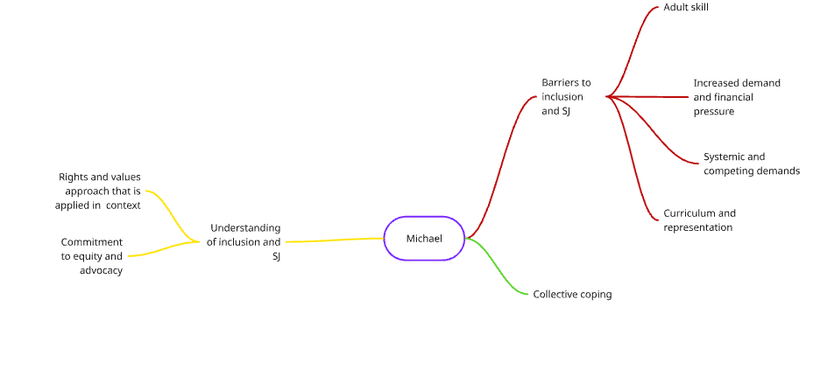
Figure 8: Michael’s thematic map as identified from my analysis

Themes

A Rights and Values-based Approach that is Applied in Context
Michael agreed with Susan’s definition of inclusion but added that the context in which the child is situated and their socioeconomic status are important factors in developing IE:
‘Just because they are from that area doesn't mean they deserve any less.” (Line 48-48).
Michael’s story described how IE and SJ provided the mechanism to overcome socioeconomic disadvantage, offering experiences and opportunities that foster meaningful learning. Geographically skewed educational opportunities have been identified as becoming further amplified by neoliberal agendas, such as academisation (DfE, 2026; Kerr & Ainscow, 2022). IE is seen as a mechanism for SJ where Michael seeks to ameliorate inequality through education.

Barriers to Enacting Inclusion and SJ

Systemic and Competing Goals
Michael described a disconnect between what he sees as the function of education and neoliberal notions of education predicated on individual results, scrutiny and accountability. Michael described feeling conflicted about wanting to do more to teach children about SJ issues, but recognised that this contradicts SJ goals and more individualist educational policy agendas:
“…[T]he focus is and always has been on results really to find the time to address these sort of societal issues. It's just where do you find the time to do it? Even though obviously it's potentially more important than results, that's not what we're judged on, is it?” (Line 153-156).

Here, Michel draws on other common discourses of teacher capacity to illustrate how problematic it can be to apply SJ in practice. His use of rhetorical questions perhaps indicates how challenging he finds the situation, and is a way of deflecting the issue back to other CoP members. My approach was to name and clarify the conflict Michael spoke about, which led him to express emotions of frustration. This helped to meet his defensiveness with compassion and empathy.
Michael described attempts to provide a curriculum that promoted understanding of different perspectives and awareness of SJ issues. He described feeling constrained by the influences of others who held strong opinions or reservations about pursuing such goals:
“…[S]o there are things that we would like to be able to say and things that we would like to be able to address but potentially feel like we're unable to…we used to study controversial texts because they did raise questions, the amount of sort of…backlash that that we've had over the last few years. …... We've just scrapped them.’ (Line 159-164).
He told a story of wider, multi-layered systemic resistance to using texts that raised social issues. This led his school to abandon exploring SJ themes to preserve harmony and avoid criticism. Resistance to utilising such approaches came from different agents:
“It’s come from parents. It's come from some teachers, members of staff…. Merchant of Venice…. homework booklet got picked up and ended up on social media and there was a big backlash…. It is frustrating. It’s frustrating.” (Line 171-173).
Michael describes the disempowerment he experienced when his school attempted to adopt a curriculum aligned with SJ agendas, and shows how deviating from the prescribed curriculum is met with external challenges and resistance. This leads schools to revert to acceptable but homogeneous curriculum choices. The language Michael uses conveys his frustration, dejection and lack of autonomy to pursue such matters; he was instead required to deliver a more homogenous curriculum based on safer ‘dead white males’ rather than raising consciousness about diversity and SJ matters. This reflects tensions between curriculum neutrality and SJ, where attempts to diversify content are constrained by perceived risks and external scrutiny.
Reflexive Box 12:
By empathising with how challenging the experience was of being forced to change the curriculum to avoid tension and recognising the SJ goals that were central to his approach to the curriculum, Michael expanded on his story. The external judgement and accountability frameworks were seen as creating a barrier to further SJ goals within education. With Michael’s framing of inclusion and SJ as a way of mitigating socioeconomic disadvantage, I also wondered if he felt exposed in moments during the CoP when SJ efforts became thwarted. Meeting this with empathy and validation, I think helped him to manage these difficult emotions and empowered to share his stories of success and failure.

Teacher Capacity

The risk of reproach and criticism seemed to cause uneasiness and resistance amongst teachers who are responsible for delivering the curriculum:
“Reluctance to address the topics, to ask, not feeling necessarily comfortable… and how to address them, worried about, you know, anything coming back on them. Everyone's in a bit of a nervous state of nervousness at all times.” (Line 188-190).
In a Foucauldian sense, it perhaps demonstrates Governmentality, where those within the system maintain it; external scrutiny and nervousness about following SJ agendas create conditions in which teachers refuse to address SJ issues, preferring to follow standard, homogeneous texts, and parents assert their power through mechanisms such as social media that help maintain the status quo (Ball, 2013). Michael expresses ‘frustration’ about wider systems that reinforce narrow curriculum choices and perhaps demonstrates how neoliberal control creates an autonomy illusion in which meso-system power is thwarted by existing power, promoting self-policing structures.

Increased Demand and Financial Pressure
Prompted by my sharing newspaper articles about funding challenges implicating inclusion in schools, Michael held strong views about how problematic this was. Michael viewed the commodification of inclusion through the EHC process as adversely impacting vulnerable pupils’ learning experiences. Funding allocated through this mechanism was translated into adult support by employing TA support:
“It's tough to have a fully inclusive school community. We need more staff, and we can't get it. And you have students who need the support most… but yet they're given… £7,000…. So, it's a drop in the ocean compared to what they need.” (Line 262-267).
For pupils with the most complex needs, Michael viewed adult support as the mechanism for delivering inclusion. Michael’s story positions the EHC system, where children’s education is commodified and marketised within neoliberal education systems. It also shows how Michael positions this value as being insufficient to meet the demands of IE.

Collective coping
Michael talked about feeling safe in the CoP to share his thoughts and frustrations about trying to deliver inclusion and SJ within a system that lacked transparency and openness:
“…(S)ometimes you feel like you're a bit of an echo chamber, and you're just sending your emails to the LA every day and not getting replies back….[It’s] reassuring to know that everyone's experiencing the same sort of thing.” (Line 500-502).
The CoP experience offers a counternarrative to the difficulties of daily practice, in which Michael positions himself as lacking power and autonomy. The collective experience of storytelling problem-sharing helps Michael to experience some ‘reassurance’ that it is a wider systemic concern.

4.7 Ami
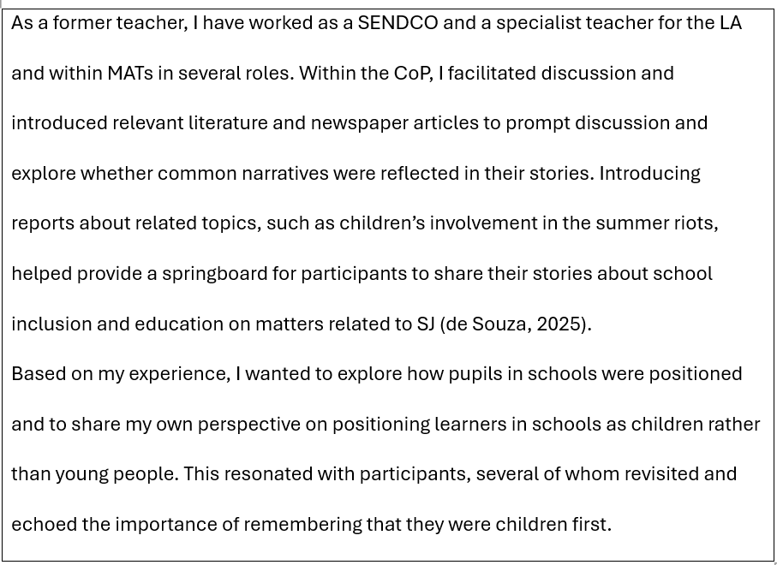

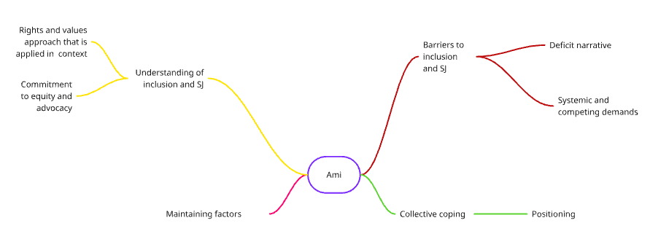
Figure 9: Thematic map to show analysis of Ami’s data

Themes

Inclusion as a Rights-based Approach Applied in Context
Based on my experiences as a SENDCO, I had wondered whether participants would take a narrow perspective of inclusion, contextualising it within SEND and educational placements. However, they quickly defined inclusion within a rights-based approach. My perspective was one which embraced the potential of inclusive education to deliver equity:
“…[I]nclusion [is more than] reductive conversations about… educational placement but… a mechanism for creating equity.” (Line 85-86).
Reflecting on my use of theory on inclusion and SJ concepts, I wonder whether my positioning may have influenced participants to align with the framings of inclusion I presented. Whilst participants initially adopted a broader perspective on inclusion, I felt that stories were mostly told in the context of individual children, reflecting a more individualistic, neoliberal positioning. When they attempted to broaden this to a collective social goal, participants told stories about how they were prevented from doing so and were policed by individuals within the system.

Commitment to Equity and Advocacy
When exploring SJ, I reflected on the stories about aspects of Susan’s role that demonstrated how she advocated for cared-for children at her school and how this facilitated more equitable education provision:
“[P]roviding… all of that nurture and…that safety and that security and that to try and I guess level the playing field and create equity in the education system for them. It sounds like you're advocating for those young people in your role.” (Line 218-221).
In this context, Susan had not positioned herself as an agent for SJ and seemed to minimise her contribution. However, I felt she was providing support that aligned with these goals and wanted to reflect this within the CoP.
In the second and third CoP sessions, when providing summaries of previous CoP sessions, I introduced the term 'child' rather than 'young person' to the CoP to reframe and reflect on the power of language. Rather than using identity-first language, I told stories about why being child-first mattered when telling stories about inclusion:
‘I'm very deliberately using the word children rather than young people or young adults. Because….I think sometimes a lot of the language that grown-ups [use] can adultify… children below the age of 16. So, I've purposely used the term children…’ (Line 863-866).
This idea resonated with participants, especially Nicola, who reflected on the importance of advocacy and on remaining cognisant of how language can create harm, including the unrealistic expectations of those in power towards pupils, particularly regarding their ability to regulate, and the unhelpful expectations adults can place on children.

Barriers to Enacting Inclusion and SJ

Systemic and Competing Demands
Although it was not one of my research questions, I had framed enacting and delivering inclusion and SJ as complex and problematised from the start in my explanation of the function of a CoP. Acknowledging the complexity of delivering inclusion and SJ in the face of competing influences reflected my own story and experiences of working as a teacher and SENDCO. Drawing on my own experience, I tried to create safety the individuals in schools are trying to do their best within a complex, ever-changing landscape:
“[E]verybody is… doing [the] best that they can within a system that is often quite challenging to… navigate.” (Line 32-33).
This was reflected in how I responded and reflected the difficult feelings that came with enacting inclusion and SJ:
“…[I]t sounds like that's come from a really good place and you've been really considered in developing your curriculum.” (Line 175-176).
Reflexive Box 13:
The framing of the CoP as a space where I could reflect on positive intentions of those within the system and ‘everyone doing their best,’ perhaps created a sense of inclusivity. However, I wonder if this was a little misleading, as my claims about unconditional positive regard were not entirely accurate, as I did challenge narratives and start to problem-solve and consider alternatives. This was met with resistance in early phases of the CoP, but developed with more reflection as the CoP became established.

Conflict and competing agendas among stakeholders, such as community members and parents, created tensions and difficulties when teaching equity and promoting understanding and tolerance. I introduced discussion points about children’s involvement in the summer riots and drew on research about vulnerable students and those with SEND becoming drawn into community conflict, resulting in children becoming criminalised. It resonated with Jasmine that attempts at developing inclusion could be thwarted by external influences:
“…. [c]hildren who kind of had come from backgrounds where they were not feeling particularly included in their own communities and …. disaffection with the police, but also children with special educational needs, particularly… ADHD.” (Ami, line 134-137).
“I think, you know those children that have those vulnerabilities of antisocial behaviours…. It's really, really tricky and again with…the flags….the rise of pupils with SEND who are sort of getting pulled into this sort of these views of misogynistic… influences and things like that….. And because they're so vulnerable, they're far more likely to just listen to other people and I guess join in.” (Jasmine, line 140-150).
Jasmine extends these concerns further, telling stories of vulnerable children being encouraged to adopt polarised views. The timing of the CoP, in October, occurred after some within local communities began displaying flags. Popular discourse at the time attributed this to right-wing sympathies and an expression of promoting nationalist and anti-immigration sentiments rather than patriotism. Jasmine seems to want to protect vulnerable children who may not fully comprehend the political sensitivity, rather than to act consciously.
Drawing on the stories Michael and Jasmine talked about, the conflict of delivering SJ within the curriculum, which seemed to compete with how teachers and schools are evaluated and judged, I reflected on the tensions within the system:
“[T]he conflict almost between….[achieving] a certain level in terms of the academic side of it and … the accountability agenda …what we're judged on rather than…. the small wins …. [and] the importance of… relationships… we're not judged by that.” (Line 376-380).
This highlights a structural contradiction between accountability-driven systems and SJ educational aims. My assertion of the story was challenged by Jasmine, who recognised the problem differently:
“No,… but they go hand in hand though, don't they? If we can't keep a child in the classroom, they're not going to come out with a good grade.” (Jasmine, line 381-382).
Instead, in line with neoliberal perspectives, accountability and inclusion could be advantageous, interrelated and interactive concepts that served children. My response to this was to accept this as part of the dominant discourse rather than to interrogate it further. This demonstrates the power of accountability measures, which are difficult to challenge and how those within the system, including myself, reinforce neoliberal agendas.
Reflexive Box 14:
The exchange between Jasmine and I, shows how participants bravely challenged my assertions and framings when they disagreed or did not feel my portrayal was accurate. This helped to show the CoP as a space where power became distributed and where my interpretations may have differed, but participants did not feel compelled to agree universally with me.

Schools experiencing overwhelm in identifying SEND became synonymous with deficit narratives, as alluded to by participants. I sought to explore this further, including evidence from my pilot study, where rates of diagnosis overwhelm the system, making providing for inclusion more challenging:
“…[E]ducators become a bit jaded because of the sheer volume and how you can manage that?... [W]hether that kind of detracts, I guess, from other YP who may have more significant needs.” (Line 395-397).
I sought to empathise with participants about chrono and macrosystem influences that exerted power over mainstream schools, compelling them to provide something bespoke and individualised for pupils within the school mesosystem, which is predicated on children accessing education as part of a collective classroom-based experience. It felt important to acknowledge how the systems did not feel fair and were often incompatible.

Maintaining Factors
The CoP existed within a time of political change in education. Whilst it preceded the SEND White Paper (DfE, 2026). The Curriculum Review was released during the CoP (DfE & Francis, 2025) I felt that some of the frustrations around the curriculum, assessment and lack of representation created some potential for a more optimistic future and I wanted to create space to explore this:
“…[E]xpectation on it being more rights represented.” (Line 1551-1552).
Participants seemed to pay limited attention to broader chronosystem influences, such as the SEND Review. Their stories focused on the child’s microsystem, the immediate school as the macrosystem, and LA decision-making at the mesosystem level. This was further reflected in the absence of discussion about wider influences, such as the revised Ofsted Framework, which placed greater emphasis on SEND and inclusion, but was given limited thought as a factor in supporting inclusion and SJ efforts. It arguably demonstrates neoliberalism in action within education and demonstrates how systems are sustained and extended without interrogation (Potter, 2022).

Positioning
From the start of the CoP, I explained to participants that I was also a participant in the research to promote transparency and act ethically as a researcher. I also used the final CoP process to talk about whether my positioning influenced the CoP:
“I've …. situated myself as part of the community. And as I started the research, I said, "Look, I'm a participant in this as well." I'll be analysing my own data and my own involvement as part of this process.” (Line 1610-1613).
Nicola explained how she found being in a CoP and found that having a researcher in the researcher-participant role helped to create shared identity and connection; this facilitated authentic engagement in the CoP:
“I valued trying to contribute to somebody that I know is as equally passionate and about all of the things that I care about and fundamentally shape what I do as well. It was nice to be aligned in that way.” (Nicola, line 1621-1623).
Transparency contributed to collective coping, as Nicola recognised that shared passion helped maintain group identity and shared goals within the CoP.

Chapter 5: Discussion

5.1 Chapter Overview
In this chapter, themes constructed through my NTA of the data identified in Chapter 4 are explored in the context of relevant literature. In psychological research, the discussion section aims to make meaning of the findings achieved in a study by exploring their relationship to previous and similar studies, considering the implications of such findings as it relates to the field of study (and in this context, EP practice) and reflecting on possible improvements for the benefit of future related research development (Taherdoost, 2022). This Chapter reveals findings from my research, conceptualised in relation to neoliberal education policies and ecosystemic theory, as well as the narrative psychological approaches used throughout this thesis.
NTA was used to analyse the data. It is understood that this is a highly interpretive approach. Thus, I acknowledge that it is a partial perspective (Riessman, 2008). However, meaningful learning points are derived from narrative analysis, where new knowledge and insights are derived from stories and lived experience (Consoli, 2021). It is also important to remember that another researcher may offer an alternative perspective on the data or identify different themes. Other reflections, whilst not central to the findings of this thesis, provide additional context and may offer a more nuanced perspective on the decision-making that led to the themes summarised below, and are included in Appendix A. These may be of interest to future similar studies. The chapter begins with a summary of the key findings, which are detailed fully in Chapter 4.

5.2 Summary of Key Findings
Inclusion is viewed as a relational and contested process, rather than a fixed set of practices or policy outcomes. Participants consistently positioned themselves morally as agents of advocacy and resistance within a system they repeatedly characterised as broken. This construction is significant, as it frames inclusion not as a coherent, institutional, and collective endeavour, but as a site of ongoing struggle requiring individual moral labour. Participants used combative language, suggesting that inclusion is contested and effortful, rather than embedded or systemically supported.
Such positioning warrants critical interrogation. While participants describe acts of resistance, such as challenging LA decisions, reframing narratives and amplifying pupil voice, these practices are largely enacted at an individual level and remain situated within existing systemic constraints. Pursuit of SP places exists at a time of practice when there has been a proliferation of special school places enacted through neoliberal Government agendas of parental-selected education segregation (Potter, 2022). Nevertheless, participants viewed this as a moral endeavour, supporting children's access to education. This perspective exists within the context of two participants who work at schools with resource-based provision, which is currently being presented as a prescribed solution to address inclusion and educational placement (DfE, 2026). From a neoliberal perspective, this may reflect processes of responsibilisation, where structural inequities are displaced onto individual practitioners, who are compelled to compensate for systemic shortcomings through personal commitment and advocacy (Done & Andrews, 2020; Potter, 2022).
This creates a critical tension: practitioners experience themselves as resisting the system, yet their actions may simultaneously sustain it. By working around systemic barriers rather than transforming them, inclusion becomes reliant on individuals' discretionary effort, raising questions about both equity and sustainability. In this sense, advocacy operates as both a mechanism of support for individual pupils and a symptom of broader systemic failure.
These findings reconceptualise inclusion as a relational, contested and contextually negotiated process, rather than a stable or universally enacted set of practices. While participants consistently framed inclusion as grounded in values of equity, advocacy and rights, their narratives reveal significant tensions between these ideals and the structural realities of schooling. Inclusion was enacted primarily through relational practice and individual advocacy, yet simultaneously constrained by systemic conditions, including accountability pressures, resource limitations and policy frameworks shaped by neoliberal priorities. This produces a fundamental contradiction; the enactment of inclusive practice relies on relational and moral engagement, while the systems within which practitioners operate often undermine the conditions required to sustain such approaches.
Furthermore, the study highlights a disconnection between academic conceptualisations of SJ and practitioner discourse. Although participants demonstrated practices aligned with social justice principles, these were rarely explicitly articulated as such, instead being framed in terms of care, meeting basic needs or upholding moral values. This demonstrates how SJ may be embedded within practice in implicit or unconscious ways, challenging dominant academic framings that position it as a consciously theorised construct.
Importantly, the findings inferred from my analysis position practitioners as operating in a paradoxical manner. They act as agents of advocacy and resistance while simultaneously navigating and, at times, policing systems, responding in ways that inadvertently maintain systems and reinforce neoliberal discourses, locating blame away from policy. This highlights the limits of individualised approaches to inclusion and underscores the need for systemic change. The CoP emerged as a critical mediating space within this context, enabling participants to collectively reflect on, reframe and make sense of their experiences, thereby bridging the divide between theory and practice.
This study contributes to the field by offering a more nuanced understanding of inclusion as an emergent and negotiated phenomenon, shaped by individual commitment, relational dynamics and structural constraint. It also highlights the importance of creating structured spaces for school practitioners to come together to engage in professional dialogue, as without such spaces, opportunities for critical reflection and the development of socially just practice may remain limited.

5.3 Discussion
Due to the interrelated nature of the themes derived from the data analysis, I have presented them as such rather than as discrete concepts.

Key Finding One: Understanding of Inclusion and SJ
Participants consistently constructed inclusion as an endeavour driven by values and rights, grounded in equity, advocacy and fairness. This stance reflected internationally endorsed definitions of inclusion (UNESCO, 2009). However, rather than representing a stable, universally agreed-upon construct, inclusion was understood as a fluid, contextually mediated process, shaped by the lived realities of school environments and by practitioners' positionality within them. This supports existing literature, which positions inclusion as dynamic and highlights the importance of context (Ainscow, 2020; Soresi et al., 2011). It also extends existing literature by illustrating how these meanings are actively negotiated within practice rather than simply applied. Values instead fluctuate, depending on context, particularly in the context of justice and an increasingly individualistic society (MacIntyre, 2013).
Participants’ use of the language of rights appeared to reflect a predominantly moral rather than legal framing (Ragusis, 2026). Inclusion was rarely discussed in relation to statutory frameworks or policy, but instead positioned as an ethical responsibility rooted in notions of fairness and SJ. This reflects how inclusion is conceptualised less as an obligatory requirement and more as a moral commitment enacted through everyday interactions. Such a framing aligns with SJ literature that emphasises ethical responsibility (Graybill et al., 2018), but it also raises questions about the extent to which reliance on moral positioning may obscure the role of structural accountability in securing equitable provision.
However, a critical tension emerges between espoused values and enacted practice. While participants articulated a commitment to inclusive principles, their narratives frequently centred on securing individual resources, SP and EHC plans. This reflects a paradox within inclusion; efforts to achieve equity are often pursued through mechanisms that individualise need and, in some instances, reinforce segregation. From a neoliberal perspective, this can be understood as the marketisation of inclusion, in which access to resources becomes contingent on individual classification and advocacy rather than collective entitlement (Done & Andrews, 2020; Done & Murphy, 2018; Kerr & Ainscow, 2022; Potter, 2022).
This tension is further complicated by the disconnect between academic conceptualisations of SJ and practitioner discourse. While participants enacted practices aligned with SJ principles, these were rarely explicitly labelled as such, instead framed in terms of care, relationships, support or ‘doing the right thing,’ not always seeing themselves as agents of SJ (Pantić & Florian, 2015). This demonstrates that SJ operates as an implicit, embodied practice rather than an explicit theoretical construct within school contexts. Such a finding highlights the need to reconsider how SJ is recognised, articulated and operationalised within educational practice (Kuria & Kelly, 2023).
Participants also demonstrated an awareness of the importance of context, particularly in relation to deprivation and community. Understanding pupils’ lived experiences was central to enacting inclusion, reinforcing the importance of relational and contextual knowledge (Walker et al., 2025). However, while microsystem and mesosystem factors were emphasised, there was comparatively limited engagement with macrosystem influences, such as national policy and structural reform. This demonstrates how broader systemic forces may become normalised and remain largely unexamined within everyday practice, reflecting Foucauldian notions of governmentality, where power operates through the internalisation of norms (Foucault, 1982). When I challenged participants about their use of power within school systems and cultures, they tended to respond defensively, seeing the problem as beyond their control or sphere of influence. The reconfiguring of EP roles within the proposed ‘expert at hand’ model may help to support teachers and schools in reimagining alternative structures for IE within schools and local areas (DfE, 2026).
These findings indicate that inclusion and SJ are not fixed constructs, but are actively produced through practitioners’ narratives, shaped by moral commitments, relational practices and systemic constraints. Instead, values are socially constructed through language, often serving a particular story or function (Gergen, 1997). This positions inclusion as a negotiated, and at times contradictory, process in which practitioners must continually reconcile their espoused values with the realities of the systems in which they operate.
Commitment to inclusion and SJ required a high degree of reflection in practice and active engagement to develop awareness of power and privilege differences between pupils and adults working in the school, and to raise consciousness and address bias (Johnson, 2024). This is connected to developing personal and contextual knowledge to effectively pursue SJ goals and work toward equity in education (Goodwin & Darity, 2019). Goodwin and Darity (2019) examined 76 articles from three international journals published between 2010 and 2016, based in Australia, the UK, and the U.S., and found that effective SJ practice was predicated on teachers having opportunities to explore and understand their own biases to provide more SJ educational practices. Recognising the impact of context and supporting teachers to develop empathy and compassion for pupils' lived experience, in addition to raising awareness of the impact of cultural capital, was seen as critical to understanding inclusion and SJ (Walker et al., 2025).
Within a system described as broken, overwhelming, and mired in contradictions, the role of teachers and the power of individual teachers to enact inclusion and SJ are vital to its success (Ainscow et al., 2013). Aligning with existing literature, participants understood that successful inclusion required teachers to feel empowered and autonomous (Charitaki et al., 2022). Creating meaningful and contextual experiences that supported pupils' understanding, together with developing an understanding of their own role and power in developing approaches that promote success, were seen as critical to developing inclusive and SJ learning experiences. However, accountability agendas, workload burdens and external surveillance meant that enacting SJ through the curriculum was problematic; teachers did not feel equipped to pursue SJ agendas within increasingly polarised community contexts, a finding replicated in literature retrospectively exploring antiracist practice in schools (Asare, 2022). Positive teacher outlook and commitment to values are in themselves insufficient to propel SJ agendas.
One participant felt that theory was disconnected from practice, leaving teachers ill-equipped for delivering inclusion and SJ (Goodwin & Darity, 2019). Transcending espoused theories, which could complicate and thwart inclusion, was counteracted by helping teachers understand the power of developing relationships with pupils and their significance, becoming a critical component in developing an effective understanding of inclusion (Saloviita, 2020). Underpinning this was leadership commitment to cultivating inclusive cultures, highlighting an alignment between CoP data and the extant literature (Ainscow et al., 2013). Success stories within the research were framed as participants felt supported by leadership and whole-school cultures. Under these conditions, creative staff development experiences created opportunities for wider discussion of SJ matters and promoted empathy for children and family contexts.

Key Finding Two: Barriers to Enacting Inclusion and SJ
Maintaining a SJ stance to inclusion is fragile, particularly in the context of the NC, where knowledge and success create hierarchical systems that disenfranchise those from disadvantaged backgrounds (Francis et al., 2017). Participants portrayed teachers as lacking confidence and autonomy in delivering SJ in the classroom, depicting them as uneasy agents of SJ, leading to abandonment of such approaches. In existing research, teachers are positioned centrally to successfully deliver a SJ curriculum that invites exploration of concepts, such as racism, requiring confidence and understanding of injustice to hold difficult conversations with children (Asare, 2022). Participants saw moral value in promoting SJ approaches and reflected on one another’s stories about this. They recognised SJ and equity should be the moral goal of education. However, they also told stories of the homogenisation of education and the influence of wider macrosystemic goals, including neoliberal accountability measures that prize individual results over social goals that work against pursuing such aims (Done & Andrews, 2020; Potter, 2022). Market-driven education policies prioritise accountability and teachers’ technical skills over the promotion of SJ, which inadequately prepares teachers to develop inclusion and SJ (Glazzard & Thomas, 2025). Feelings of frustration and possible discord were apparent as SJ approaches were abandoned. Attempts to diversify the curriculum were often limited to individual subjects that seemed to reflect individual commitment rather than strategic ones, diminishing the impact of such approaches. The Curriculum Review may offer the potential to redress such power imbalances and mandate schools to deliver curriculum content that more adequately reflects their pupils and communities, thereby supporting such endeavours (DfE & Francis, 2025). The findings suggest that educators aspire to deliver SJ goals in the curriculum, but they simultaneously conflate this with accountability agendas; the goal of policy needs to prioritise SJ approaches and empower teachers if it is to achieve greater educational equity.
As noted in the earlier analysis, narratives describe curriculum inflexibility, accountability, and school standards agendas that impede inclusion, and SJ attempts to align with other studies (Williams-Brown & Hodkinson, 2021). Whilst the aforementioned study pertains to primary teachers' experiences of inclusive education, it closely aligns with this study's findings, which show that educators want to be inclusive, but neoliberal education systems, dominated by performance indicators, make enacting IE difficult. Whilst I did not draw a direct theme from the data about preparation for adulthood and how children with SEND are assessed within the curriculum being problematic, this was alluded to in some participants' stories about the importance of what was taught and what was evaluated as successful. These critiques align with recent reviews of practice, which highlight a system that further disenfranchises those from disadvantaged backgrounds and those with SEND, and call for increased emphasis on SJ approaches (DfE & Francis, 2025). Participants held strong views about accountability measures that misalign with inclusion and SJ approaches, as reflected in neoliberal critiques of inclusion (Done & Andrews, 2020). In the context of this critique, I found it surprising that participants had limited awareness of macrosystemic policy changes that may support them in fulfilling a curriculum more closely aligned with SJ goals (DfE & Francis, 2025).
Teachers' overwhelm is positioned as impacting the longevity of inclusion. Stories are told about the insufficient time to deliver inclusion, which are constructed within a system of competing demands, particularly in the context of supporting pupils who experience deprivation, frustrating the enactment of inclusion (Walker et al., 2025). There was consensus amongst participants that the complexity of SEMH needs and rates of diagnosis had increased in mainstream schools, making it difficult to meet needs and diluting the availability of resources and support (Bodfield & Culshaw, 2023; Taberner, 2023; Timberlake, 2018). Stories of well-informed parents who were aware of their rights were positioned less favourably because of their demands for time from already exhausted teachers. Such stories may reflect how participants cope within the current system and how power has become unfairly distributed away from those with the greatest need. This echoes the current policy review, which positions a disparate system where needs are met only by those who are able to fight for it (DfE, 2026). It also raises a further potential SJ concern about the collective rights of all learners in the classroom and the additional workload burden that bureaucratic SEND systems create whilst operating in a context of reduced financial resources (Done & Murphy, 2018).
Frustrations with the SEND system, and the need to support parents with appeals to mediation and Tribunal, reflect participants' experiences of operating within a broken system (Saxton et al., 2025). Those with responsibility for SEND and inclusion positioned themselves as advocates and activists for both the child and their parents and were compelled to use their social capital and power to challenge LA decision-makers. Although appeals to the First-Tier Tribunal are the responsibility of the parent, they were often positioned in passive roles requiring educators to support and take a more active stance (Bilton et al., 2018). This reflection occurs within a context where research has consistently made connections between the rise of academisation, the politics of austerity amid a culture of individual responsibility and free-market economics focused on efficiency and competition between schools, which has seen ever-increasing numbers of children educated outside of mainstream education (Stanbridge, 2024; Taberner, 2023). System dismay was more commonly directed at mesosystem-level decision-makers in LAs, rather than at macrosystem policies that arguably create the current conditions of a SEND system in crisis (Stanbridge, 2024). In line with critiques of neoliberal education policies, it demonstrates how systems are maintained unchecked by those who operate within them (Done & Andrews, 2020; Potter, 2022).
Although policy exists to position teachers as responsible for children with SEND (DfE & DoH, 2014). Participant narratives indicate that teachers may not easily assume this role and instead are often described as feeling underprepared to address the SEND needs of pupils (Lin et al., 2026; Smythe, 2025); lacking adequate skills and training to address the SEND needs of pupils (Essex et al., 2021; Hanko, 2003). Reflecting current critiques of the SEND system, participants described a disconnect between expectations of mainstream and specialist settings, and an absence of collaboration with teachers from SP, where children with mental health needs are seen as being better placed in SP, where the environment is smaller, and there is greater scope for lower demand spaces (Smythe, 2025).
Discourses relating to teacher skill and confidence in enacting inclusion and SJ approaches signal a wider problematisation of teachers who are responsibilised for problems within a complex, austerity-driven system, where the role requires managing competing demands and inclusion is viewed as an additional workload burden (Done & Murphy, 2018; Warnes et al., 2022). Whilst participants experience sympathy and awareness of the competing demands on teachers and the complexity of accountability cultures, blame is assimilated, positioning teachers as problematic rather than policy (Warnes et al., 2022). Balancing the competing demands in the classroom within a system where teachers are under pressure and scrutiny to meet both individual needs and are judged on all children achieving specific standards makes the enactment of inclusion a highly challenging, spurious ambition, reinforcing segregated education as a solution (Done & Andrews, 2020). This framing individualises responsibility for inclusion, thereby obscuring the structural conditions that produce such pressures.
Similarly, deficit narratives about meeting children’s needs, and at times about teachers skills to provide appropriate support, were evident in participants’ narratives. While participants expressed empathy, these narratives may inadvertently reinforce medicalised and individualised understandings of difficulty, aligning with critiques of the medical model and labelling theory (Hardy & Woodcock, 2015). This coincided with participants justifying their pursuit of SP places, as teachers associated labels with falling outside the mainstream education role and thus requiring more expert support (Smythe, 2025). Raising teacher confidence and promoting an ethos and expectations in which the universal offer is flexible and responsive to the needs and diversity of children in the school, rather than viewing pupils through a deficit lens, was seen as something participants needed to address when developing inclusive cultures (Pantić & Florian, 2015).
A key finding is the tension between theory and practice. Participants described academic conceptualisations of inclusion as abstract and disconnected from daily practice, highlighting a critical disjuncture between research and practice (Lin et al., 2026). Whilst pedagogical approaches, such as the rise of relational inclusion approaches, were welcomed and viewed positively, some participants described time constraints and practical skills as being problematic in fostering genuine relationships with pupils (Alaimo & Kelly, 2025; Georgiou & Cartmell, 2025). It highlights a need for greater integration between theoretical knowledge and practitioner experience.

Key Finding Three: Maintaining Factors
Relational approaches were consistently identified as central to effective inclusion. Participants emphasised the importance of understanding pupils’ contexts, building trust and fostering a sense of belonging. As has been seen in other studies, relational approaches involve creating meaningful opportunities for children to participate in decision-making, raising the profile of their voices in spheres where they may often be excluded, and breaking down school-based barriers to parental engagement and co-production (Whiting & Johnson, 2025). Working with parents and community members helped break down barriers and ensure that everyone within the system felt seen and valued (Saxton et al., 2025). Relational approaches transcended student-teacher relationships and were also described as significant in the context of teachers working together and developing collective agency to enact inclusion, as well as in SJ approaches (Pantić & Florian, 2015). Developing relationships also facilitated early identification and was seen as a cornerstone in delivering effective inclusion, especially for pupils with SEND (IIP, 2025). However, the reliance on relational practice also highlights its fragility within systems that do not structurally support it.
Adaptive teaching and flexible provision were also identified as supportive strategies. While these approaches were viewed positively, they were not seen as sufficient to address more complex needs, particularly in relation to SEMH. Two of the four schools in this study had adapted or enhanced resource provision, which they informally utilised to place pupils without engaging in bureaucratic EHCNA. As other studies have found, smaller groupings of pupils have been shown to increase teacher empowerment and provide greater flexibility for pupils with SEND (Smythe, 2025).
The flexible arrangements and adaptations to the curriculum, which facilitate greater movement between classes, as described by participants, are also advocated in the current Government Curriculum Review and proposed reforms (DfE, 2026; DfE & Francis, 2025). However, this is not a complete panacea for inclusion, as even in contexts where schools have such approaches, participants continue to describe a struggle to address need, particularly for those with SEMH needs. This reinforces the argument that technical solutions alone cannot resolve systemic challenges. Participant views contribute to a wider debate about the need for more seismic change to existing neoliberal education systems than is currently suggested by the existing political reforms (DfE, 2026; Stanbridge, 2024).
Creating opportunities for families to collaborate and be represented was a strong theme that was constructed from my NTA. Understanding the community context was critical to enacting inclusion, and SJ approaches within an ethos where collaboration was meaningful, and problem-solving was shared, rather than positioning those in school as experts (Ainscow, 2020). The views of those who belonged to the community were seen as paramount in judging the success of achieving goals relating to inclusion and SJ approaches (Laluvein, 2010). Engagement in the CoP created space for participants to reflect on and share tacit knowledge of inclusion in their schools, and to share stories that bridged theory and practice, a theme highlighted as impacting inclusion (Mortier, 2020).
Wider-MAT structures, such as the availability of additional EP time and systems and commitment to inclusion and SJ approaches, were one way in which MAT systems were viewed as helpful in supporting inclusive approaches. Given the significance of context stressed by participants, I had wondered whether centralised MAT policies would adversely impact culturally and contextually sensitive practice. In line with other research, this was not found to be the case as needs were framed within individual schools rather than driven by centralised approaches (Wood & Legg, 2020). Contrary to some literature, MATs were not perceived as providing less inclusive spaces for children (Black et al., 2019; Heilbronn, 2016). Opportunities provided by MATs that promoted collaboration, resources and professional development, together with strong leadership, were viewed as supportive aspects in developing inclusion and SJ approaches (Wood & Legg, 2020). I also noted in the participant stories a lack of critique of the MAT system. For some participants, the sense of autonomy provided by a MAT seemed more an illusion than a reality, whereas others held different views, perhaps suggesting that autonomy may depend on which MAT a school belongs to. Participants noted the absence of available SP places, directing this at LAs, at a time when such placements have increased exponentially (Marsh et al., 2024). As the MAT was viewed positively by participants as a supportive mechanism, there was little consideration of wider macrosystem and chronosystem changes over time, including academisation, which was seen as impacting the enactment of inclusion and the possible move away from LA maintained education systems.
The role of EPs and other allies was highlighted as significant in supporting inclusive practice. The embodied values of authenticity and commitment to equity, rooted in EP practice, were viewed as useful tools for enacting SJ approaches (Schulze et al., 2019). This study adds to existing literature, which positions EPs as being suitably placed to support systemic change within schools, whilst simultaneously understanding the shared experience of all of those within the system and leading change (Stanbridge, 2024). EPs were positioned as facilitators of reflection and systemic thinking, suggesting their potential to bridge the gap between theory and practice (Brownhill & Kelly, 2025).
Cultural capital has been described as existing in three forms: the embodied state (language), objectified state (culture, including literature and art) and the institutional state (educational qualifications) (Bourdieu, 2011). Promoting awareness of cultural capital and providing educational opportunities were viewed as instrumental in mitigating the impact of deprivation, particularly for those identified as having less cultural capital. The use of important texts, including newspapers, was seen as a means of exploring current social issues and promoting children’s critical thinking skills (Bennett & Silva, 2006). Participants saw the pursuit of equity as a causal by-product of deprivation, requiring an understanding of cultural capital and opportunity to address the epistemic injustice linked to it. More recent educational reviews also draw links between established (neoliberal) educational approaches that have adversely impacted the most disadvantaged within society, and call for the development of a curriculum that more effectively reflects communities (DfE & Francis, 2025).
Participants consistently cited those with the most vulnerability, including children identified with SEND, those from deprived backgrounds, as being most disadvantaged by the system. Participants recognised systemic failures that are widely acknowledged, including in the literature and in Government (Allan, 2026; DfE, 2026; PAC, 2025). Whilst participants welcomed changes, they had limited awareness of wider political and systemic reforms, instead situating themselves within their own and their pupils’ microsystem, and the school mesosystem. It demonstrates how power is unevenly distributed, as those operating within the system maintain it unquestioningly (Potter, 2022). This draws on Foucauldian governmentality in practice; neoliberal education policies are enacted unquestioningly by those within the system who preserve it, reinforcing existing power and structures and on individuals where power ‘acts upon their actions’ (Foucault, 1982, p. 789).

Key Finding Four: Collective Coping
The CoP was experienced as a space for reflection, collaboration and professional learning. Participants described it as ‘therapeutic’ and valued the opportunity to share experiences and develop shared understandings, aligning with other studies that have explored CoP (Lawthom, 2011). The CoP design, informed by the transformation paradigm, provided participants with a relational encounter in which they shared experiences (Romm, 2015). Positioning myself as a participant from the beginning and checking meanings as they arose contributed to participants’ felt psychological safety, clarified and checked my understanding of the research data, and facilitated trust within the CoP, power-sharing, and collaboration (Mortier, 2020). However, the construction of the CoP as a ‘safe space’ requires critical consideration. Safety may have been contingent on shared values, potentially limiting the expression of alternative or dissenting perspectives.
As has been indicated in texts guiding the CoP process, shared values did not mean seeking consensus in all areas, but rather using disagreement as a space to learn from one another and to hear the voices of others within the CoP (Wenger-Trayner et al., 2023). There were disagreements within the CoP about relational practice, which promoted learning and reflection. I felt that such disagreements were reassuring, indicating participants asserted their power and that shared values did not covertly obscure power dynamics (Dahl & Soss, 2014). The CoP functioned as a mediating space, enabling participants to bridge the gap between theory and practice. Through collective reflection, participants reframed their experiences and gained new insights, highlighting the potential of such spaces to support inclusive practice.

5:4 Concluding Remarks
This study contributes to the field by reconceptualising inclusion as a relational, negotiated, and contested process, rather than a rigid set of practices or policy outcomes. Inclusion is shaped by the interplay of individual agency, relational dynamics, and structural constraints, highlighting a fundamental contradiction between practitioners' moral commitments and the systemic conditions in which they operate. It further demonstrates that SJ is often enacted implicitly within everyday practice rather than explicitly articulated.
The findings also highlight the importance of creating structured spaces for reflection and dialogue, suggesting that without such spaces, opportunities to develop inclusive and SJ practice may remain limited. CoP are a potentially valuable mechanism for bridging the gap between theory and practice, enabling practitioners to collectively construct and develop their thinking within constrained systems. Inclusion cannot be achieved through mandated policy alone; it must be understood as a negotiated, relational practice that requires systemic transformation rather than individual blame and responsibilisation.

Chapter 6

6.1 Chapter Overview
This study set out to explore how inclusion and SJ are understood and enacted by school staff, and how participation in a CoP may support the development of inclusive practice. Drawing on NTA, the research examined how practitioners construct meaning through their lived experiences, situating these narratives within broader theoretical frameworks, including ecosystemic theory and critiques of neoliberal education policy.
This chapter synthesises the key findings, outlines the study’s contribution to knowledge, considers the implications for EP practice, and reflects critically on the research limitations. It concludes by identifying directions for future research.

6.2 Summary of Key Findings in Response to Research Questions
In response to my first research question about how inclusion and SJ are constructed and understood, the findings demonstrate that inclusion is not a fixed or universally enacted construct, but a relational and contested process shaped by practitioners’ values, identities and the systemic contexts in which they operate. While participants consistently framed inclusion as a moral and rights-based endeavour, their narratives revealed tensions between ideals and the reality of academised secondary school contexts.
A central finding which relates to my second research question about what supports educators to enact effective inclusion and SJ was the importance of relational practice, which was positioned as both the mechanism and evaluator of inclusion. However, this creates a paradox, as the relational effort required to enact inclusion is often constrained by accountability pressures, workload demands and resource limitations. As a result, practitioners frequently rely on individualised advocacy to bridge the gap between policy expectations and pupil needs.
Although it was not one of the identified research questions, the study also identified a disjuncture between academic conceptualisations of SJ and practitioner discourse. While participants enacted SJ practices, these were rarely explicitly framed in theoretical terms, suggesting that SJ operates implicitly within practice.
In response to my final research question about how social participation through a CoP supports educators implement SJ and inclusive practice in schools, the CoP became a significant mediating space for collective coping, enabling participants to reflect, challenge assumptions and reframe their understanding of inclusion. This highlights the potential of collaborative professional spaces to bridgethe gap between theory and practice.
The CoP provided a structure through which participants could explore their stories about inclusion and SJ. Through collective storytelling, participants were able to talk about how they understood and enacted inclusion and SJ in their schools. The benefit of such approaches, in response to my final research question, was that by providing relationally supportive structures to explore the complicated and messy experiences of delivering inclusion and SJ, participants felt an increased sense of hope and optimism in their roles, and it helped to ‘rejuvenate’ their passion and commitment to the topic.

6.3 Contribution to Knowledge
This study makes several contributions to the field of Educational Psychology and IE. It reconceptualises inclusion as a relational and negotiated process, rather than a set of predefined practices or policy outcomes. By foregrounding practitioners’ narratives, the study highlights how inclusion is actively constructed within the tensions of everyday practice, shaped by competing moral, relational and systemic demands.
Additionally, the study contributes to understanding SJ by demonstrating that it is often enacted implicitly in practice rather than explicitly articulated. This challenges dominant academic framings and suggests a need to reconsider how SJ is conceptualised and recognised within educational contexts. It also exposes the fragility of enacting SJ through the curriculum: teachers lack confidence and view it as a burden, quickly abandoning it when confronted with external critique.
The findings extend critiques of neoliberal education by illustrating how practitioners are positioned as advocates within constrained systems. While participants experience themselves as resisting systemic inequities, their stories rely on individual advocacy narratives to express this. This may inadvertently sustain the very structures they seek to challenge, highlighting the limitations of individual agency in the absence of systemic reform.
The study contributes to the growing literature on CoPs by evidencing their role as mediating spaces that support reflection, knowledge construction and professional learning. The CoP enabled participants to bridge the gap between theory and practice, suggesting its potential as a tool for developing IE and SJ educational approaches.
At the macrosystem level, it also contributes to how IE can be created in mainstream contexts. Offering some caution and critical reflection about the use of resource-based provisions as a solution to placement concerns. Practitioner narratives suggest that specialist teachers require an understanding and empathy for the mainstream school experience. In the current context of utilising skills of teachers from SP, there is perhaps a need to consider the positioning of ‘expert’ to one of collaboration and shared problem-solving (DfE, 2026).
Finally, a methodological contribution to knowledge that integrates EP practice is also offered. CoP approaches provide a mechanism for including all stakeholders in problem-solving and developing shared meaning-making, which EPs are well-positioned to facilitate. The unique training of EPs in developing relational skills, understanding community and systemic theory, and knowledge of school systems and pedagogy is prized by participants for facilitating a structure for collective coping. As a new period of reform centred on IE with increased community solutions, it perhaps offers a methodological approach to promoting meaningful engagement (DfE, 2026).

6.4 Implications for Educational Psychology Practice
EPs are well positioned to act as facilitators of reflection (Lawthom, 2011), supporting schools in moving beyond individualised understandings of inclusion towards more holistic, contextually informed approaches (Schulze et al., 2019). This includes challenging deficit narratives, promoting relational practice and supporting staff to engage critically with issues of power, privilege and inequality.
The study also highlights the value of CoPs as a form of psychologically informed supervision and professional development, and the need for this within schools (Rae et al., 2017). EPs may play a key role in designing and facilitating such spaces, enabling practitioners to reflect on their practice, share experiences, and develop collective approaches to inclusion within schools and across LA practice. Furthermore, EPs can support schools in bridging the gap between theory and practice by translating abstract concepts into meaningful, contextually relevant strategies. This may involve working collaboratively with staff to co-construct understandings of inclusion and SJ that are grounded in their specific contexts.
In the current context of moving toward an ‘expert at hand’ model, this research shows the importance of EP involvement and holding space for those within the system to be considered (Stanbridge, 2024). When planning local arrangements for such models, this raises implications for the balance of power and the need to carefully manage how mainstream and SP educators are positioned within such contexts. It also has implications more widely for carefully considering the roles required within such groups and to carefully manage power dynamics so that such spaces become collaborative, meaningful sources of learning and development.
In the context of an evolving system of support, I have used findings from my research within service discussions to explore how an ‘expert at hand’ system may need to be approached cautiously. For example, I have cited participant’s concerns about teachers from SP understanding the mainstream context, and how when implementing such models, it is necessary to consider the positioning of all within the system to promote collaboration and meaningful problem-solving. Additionally, I am in the process of developing short summaries and accessible content based on participant stories to help support dissemination of this research to practitioners in schools.

6.5 Limitations
There were several limitations in this research. As this was doctoral research undertaken alongside my TEP role, the CoP was time-limited.
The sample size was small and relatively homogenous, with limited diversity in terms of ethnicity and professional role. This may have influenced how inclusion and SJ were constructed, potentially reflecting dominant perspectives within the profession. Reflecting on the CoP size, I wonder whether the experience felt more pressured, particularly when participants were unable to attend. This was exacerbated when one participant experienced technical difficulties in one CoP, which disrupted the flow and output of the discussion, as she was unable to be heard and was offered the option to type her responses.
I felt that I created a CoP where all members actively contributed and felt comfortable sharing their stories. Inevitably, I maintained the role of community leader, and there was insufficient growth within the CoP to allow other members to take on leadership roles that naturally evolve within CoPs (Wenger-Trayner et al., 2023).
Additionally, the use of narrative analysis means the findings constitute a co-constructed, interpretive account of participants’ experiences. My role as both researcher and participant within the CoP may have influenced the data, particularly through the introduction of themes and the shaping of discussions. While reflexivity has been used to acknowledge this, it remains a limitation.

6.6 Future Research
Inclusive education reform is a live, current political and social concern (DfE, 2026; DfE & Francis, 2025). It is acknowledged that there are insufficient opportunities for schools to come together to develop shared understandings of inclusive education and to disseminate best practice (PAC, 2025). Creating dedicated spaces for different school staff, including those in specialist provisions, to share their stories, challenges, and successes may be a helpful way to bridge the gap between a segregated school system and an era of mainstream education ‘inclusion’ hubs.
Future research could explore how inclusion and SJ are constructed across more diverse samples, including a wider range of professional roles and cultural contexts. The current SEND Review seeks to foster closer collaboration between mainstream and specialist settings, with expertise from specialist settings shared (DfE, 2026). Whilst sharing knowledge is welcomed within this debate, further research into effective ways of disseminating knowledge is needed, as is recognition of the differences between mainstream and specialist practitioner experiences, and this is one example of how CoPs across more diversified roles would be helpful.
CoP approaches which create reflective spaces for both community members and school staff to learn together and consider ways of creating social change, and study whether such models galvanise change towards more inclusive and SJ-informed schools, would also be helpful as education seeks an increased focus on inclusion and SJ (DfE, 2026; DfE & Francis, 2025; Lawthom, 2011).
Further investigation into the role of CoPs in supporting inclusive practice would also be valuable, particularly in exploring their long-term impact and scalability. A broader study that also examines how systemic change can be achieved within schools and local areas, beyond individualised advocacy, would help address the structural challenges identified in this study.

6.7 Final Reflection
This study has highlighted the complexity of enacting inclusion and SJ within contemporary education systems, demonstrating that while practitioners are deeply committed to these principles, they operate within systems that often constrain their ability to realise them fully. Recognition of power and privilege, and the creation of spaces within school systems for those within them to explore and examine this, are critical to promoting a whole-system approach to inclusion and SJ. Through relational inclusion, teachers better understand children's needs and provide adaptive teaching approaches that support inclusion.
By listening to practitioners’ stories, the research offers a more nuanced understanding of inclusion as lived and experienced in practice. Successful inclusion requires collective commitment from the whole school community, as well as the support of wider inclusion allies and, in particular, EPs, who can sit outside school systems and promote problem-solving around such topics. CoP approaches provide a helpful mechanism for those involved in enacting inclusion and SJ to share difficult feelings whilst experiencing emotional containment, and to feel rejuvenated and hopeful in their roles. It also emphasises the importance of creating spaces for reflection, dialogue and collaboration, suggesting that meaningful change requires not only individual commitment, but also collective and systemic transformation.
Inclusion cannot be realised through policy mandate. Instead, it emerges as a negotiated, relational practice shaped by practitioner values, systemic constraints and broader economic and socio-political forces. Without addressing these structural conditions, inclusive practice will remain dependent on individual effort rather than embedded within educational systems. This is imperative if education is to create more socially-just, equitable communities.

References

Ainscow, M. (2005). Understanding the development of inclusive education system.
Ainscow, M. (2020). Inclusion and equity in education: Making sense of global challenges. Prospects., 49(3), 123-134. https://doi.org/10.1007/s11125-020-09506-w
Ainscow, M., & César, M. (2006). Inclusive education ten years after Salamanca: Setting the agenda. European Journal of Psychology of Education, 231-238.
Ainscow, M., Dyson, A., & Weiner, S. (2013). From Exclusion to Inclusion: Ways of Responding in Schools to Students with Special Educational Needs. ERIC.
Ainscow, M., Slee, R., & Best, M. (2019). Editorial: the Salamanca Statement: 25 years on. International journal of inclusive education., 23(7-8), 671-676. https://doi.org/10.1080/13603116.2019.1622800
Alaimo, G., & Kelly, C. (2025). Exploring the implementation of relational practice in a primary school to support school attendance. Frontiers in Education., 10, 1602057. https://doi.org/10.3389/feduc.2025.1602057
Allan, J. (2026). Mending the (broken) SEND system in England and repaying debts to children, families and professionals. European journal of special needs education., 1-16. https://doi.org/10.1080/08856257.2026.2638593
Anderson, C., & Kirkpatrick, S. (2015). Narrative interviewing. International journal of clinical pharmacy., 38(3), 631. https://doi.org/10.1007/s11096-015-0222-0
Anderson, J., Boyle, C., & Deppeler, J. (2014). The ecology of inclusive education: Reconceptualising Bronfenbrenner. In Equality in education (pp. 23-34). Brill.
Artiles, A. J. (2020). Inclusive Education in the 21st Century Disruptive Interventions. The Educational forum., 84(4), 289-295. https://doi.org/10.1080/00131725.2020.1831821
Artiles, A. J., Harris-Murri, N., & Rostenberg, D. (2006). Inclusion as Social Justice: Critical Notes on Discourses, Assumptions, and the Road Ahead. Theory into practice, 45(3), 260-268. https://doi.org/10.1207/s15430421tip4503_8
Artiles, A. J., Harris-Murri, N., & Rostenberg, D. (2021). Inclusion as social justice: Critical notes on discourses, assumptions, and the road ahead. In Inclusive Schooling Practices Tip V 45# 3 (pp. 260-268). Routledge.
Asare, Y. (2022). The Rebirth of the Call for Antiracism in Schools: Learning from the Past. London review of education., 20(1), 11.
Asselin, M. E. (2003). Insider research: Issues to consider when doing qualitative research in your own setting. Journal for Nurses in Professional Development, 19(2), 99-103.
Atfield, G., Baldauf, B., Owen, D., Davey, C., & Monk, L. (2023). Educational psychology services: Workforce insights and school perspectives on impact.
Avramidis, E. (2000). A Survey into Mainstream Teachersʼ Attitudes Towards the Inclusion of Children with Special Educational Needs in the Ordinary School in one Local Education Authority. Educational psychology., 20(2), 191-211. https://doi.org/info:doi/
Bagley, C., & Beach, D. (2015). The marginalisation of social justice as a form of knowledge in teacher education in England. Policy futures in education., 13(4), 424-438. https://doi.org/10.1177/1478210315571220
Ball, S. J. (2013). Foucault, power, and education.
Bhaskar, R. (2020). Critical realism and the ontology of persons. Journal of critical realism., 19(2), 113-120. https://doi.org/10.1080/14767430.2020.1734736
Bhatt, C. (2026). Antiracism and the current moment. Ethnic and racial studies., 49(6), 1122-1141. https://doi.org/10.1080/01419870.2025.2555562
Billington, T. (2006). Working with children [electronic resource] : assessment, representation and intervention.
Black, A. (2022). ‘But what do the statistics say?’ An overview of permanent school exclusions in England. Emotional & behavioural difficulties., 27(3), 199-219. https://doi.org/10.1080/13632752.2022.2091895
Black, A., Bessudnov, A., Liu, Y., & Norwich, B. (2019). Academisation of Schools in England and Placements of Pupils With Special Educational Needs: An Analysis of Trends, 2011–2017. Frontiers in Education., 4, 3. https://doi.org/10.3389/feduc.2019.00003
Boddison, A., & Soan, S. (2022). The Coproduction illusion: considering the relative success rates and efficiency rates of securing an Education, Health and Care plan when requested by families or education professionals. Journal of research in special educational needs, 22(2), 91-104.
Booth, T., Ainscow, M., Black-Hawkins, K., Vaughan, M., & Shaw, L. (2002). Index for inclusion. Developing learning and participation in schools, 2.
Botha, M. (2025). Critical realism, community psychology, and the curious case of autism: A philosophy and practice of science with social justice in mind. Journal of community psychology., 53(1), e22764. https://doi.org/10.1002/jcop.22764
Bourdieu, P. (2011). The forms of capital (1986). Cultural theory: An Anthology. In (Vol. 1 no. 8193).
Bourke, B. (2014). Positionality: Reflecting on the Research Process. The qualitative report : an online journal dedicated to qualitative research since 1990., 19(33), 1. https://doi.org/10.46743/2160-3715/2014.1026
BPS. (2018). Ethical trading. Guidelines for practice for educational psychologists 2nd edition In D. o. E. a. C. Psychology (Ed.). Leicester: The British Psychological Society.
Bradbury, H., & Reason, P. (2003). Action Research. Qualitative social work., 2(2), 155-175. https://doi.org/10.1177/1473325003002002003
Brathwaite, J. (2017). Neoliberal Education Reform and the Perpetuation of Inequality. Critical sociology., 43(3), 429-448. https://doi.org/10.1177/0896920516649418
Braun, V., & Clarke, V. (2006). Using thematic analysis in psychology. Qualitative Research in Psychology, 3(2), 77-101. https://doi.org/10.1191/1478088706qp063oa
Braun, V., & Clarke, V. (2021). One size fits all? What counts as quality practice in (reflexive) thematic analysis? Qualitative Research in Psychology, 18(3), 328-352. https://doi.org/10.1080/14780887.2020.1769238
Braun, V., Clarke, V., Hayfield, N., & Terry, G. (2019). Thematic analysis 48. Handbook of research methods in health social sciences, 843-860.
Bronfenbrenner, U. (1976). The Experimental Ecology of Education. Educational researcher, 5(9), 5-15. https://doi.org/10.2307/1174755
Brown, J. S., & Duguid, P. (1991). Organizational Learning and Communities-of-Practice: Toward a Unified View of Working, Learning, and Innovation. Organization science : a journal of the Institute of Management Sciences., 2(1), 40-57. https://doi.org/10.1287/orsc.2.1.40
Burnard, P., Dragovic, T., Flutter, J., & Alderton, J. (2016). Transformative Doctoral Research Practices for Professionals (1st 2016. ed.). SensePublishers. https://doi.org/10.1007/978-94-6300-630-9
Burr, V. (2015). Social constructionism.
Busher, J., Choudhury, T., Thomas, P., & Harris, G. (2019). What the Prevent duty means for schools and colleges in England: An analysis of educationalists’ experiences.
Butina, M. (2015). A narrative approach to qualitative inquiry. Clinical laboratory science : journal of the American Society for Medical Technology., 28(3), 8.
Caine, V., Steeves, P., Clandinin, D. J., Estefan, A., Huber, J., & Murphy, M. S. (2018). Social justice practice: A narrative inquiry perspective. Education, citizenship and social justice, 13(2), 133-143.
Cambridge, D., Kaplan, S., & Suter, V. (2005). Step-By-Step guide for designing and cultivating communities of practice. Retrieved October, 26, 2009.
Carter, T. J., & Adkins, B. (2017). Situated learning, communities of practice, and the social construction of knowledge. Theory and practice of adult and higher Education, 113, 113-138.
Charitaki, G., Kourti, I., Gregory, J. L., Ozturk, M., Ismail, Z., Alevriadou, A.,…Demirel, C. (2022). Teachers’ Attitudes Towards Inclusive Education: a Cross-National Exploration. Trends in psychology = Temas em Psicologia. https://doi.org/10.1007/s43076-022-00240-0
Chubb, J. E., & Moe, T. M. (1991). Politics, Markets and America's Schools. British journal of sociology of education., 12(3), 381-396. https://doi.org/10.1080/0142569910120306
Clandinin, D. J. (2006). Narrative Inquiry: A Methodology for Studying Lived Experience. Research studies in music education, 27(1), 44-54. https://doi.org/10.1177/1321103X060270010301
Clandinin, D. J. (2007). Handbook of narrative inquiry mapping a methodology. SAGE.
Clandinin, D. J., Caine, V., & Huber, J. (2016). Ethical considerations entailed by a relational ontology in narrative inquiry. In The Routledge international handbook on narrative and life history (pp. 428-440). Routledge.
Clandinin, D. J., & Connelly, F. M. (2000). Experience and story in qualitative research. In: San Francisco: Jossey-Bass.
Clarke, B., Alley, L. J., Ghai, S., Flake, J. K., Rohrer, J. M., Simmons, J. P.,…Vazire, S. (2024). Looking our limitations in the eye: A call for more thorough and honest reporting of study limitations. Social and personality psychology compass., 18(7), e12979. https://doi.org/10.1111/spc3.12979
Clarke, B., Schiavone, S., & Vazire, S. (2023). What limitations are reported in short articles in social and personality psychology? Journal of personality and social psychology., 125(4), 874-901. https://doi.org/10.1037/pspp0000458
Consoli, S. (2021). Uncovering the hidden face of narrative analysis: A reflexive perspective through MAXQDA. System., 102, 102611. https://doi.org/10.1016/j.system.2021.102611
Cox, A. (2005). What are communities of practice? A comparative review of four seminal works. Journal of information science., 31(6), 527-540. https://doi.org/10.1177/0165551505057016
Crawford, C. E. (2017). Promoting ‘fundamental British values’ in schools: a critical race perspective. Curriculum perspectives., 37(2), 197-204. https://doi.org/10.1007/s41297-017-0029-3
Cullinane, M. (2020). An Exploration of the Sense of Belonging of Students with Special Educational Needs. Reach, 33(1), 2.
Cushing, I., & Govender, N. (2024). An anti-racist English education. English in education, 58(3), 240-257. https://doi.org/10.1080/04250494.2024.2366849
Dahl, A., & Soss, J. (2014). Neoliberalism for the Common Good? Public Value Governance and the Downsizing of Democracy. Public administration review., 74(4), 496-504. https://doi.org/10.1111/puar.12191
Davis, S. T., Billington, T., Chilokoa, M., & Whiting, C. (2025). Relational practice : new approaches to mental health and wellbeing in school.
de Bruin, K. (2024). Inclusive education: A review of the evidence. Inclusive Education for the 21st Century, 95-114.
De Fina, A., Georgakopoulou, A., & Barkhuizen, G. P. (2015). The handbook of narrative analysis (1st ed.). Wiley Blackwell.
de Souza, R. (2025). Children's Involvement in the 2024 Riots. In: Children's Commissioner.
Denzin, N. K., & Lincoln, Y. S. (2011). The Sage handbook of qualitative research. sage.
Dewes, I. (2025). The crisis in English special educational needs funding and the influence of safety valve agreements. Policy futures in education., 23(8), 1559-1574. https://doi.org/10.1177/14782103251372806
DfE. (2014). Children and Families Act. In. London: Department for Education.
DfE. (2023). Analysis of consultation responses to the SEND review: right support, right place, right time. In F. Sinclair, Zaidi, A, ICF Consulting Service Ltd (Ed.).
DfE. (2026). Every Child Achieving and Thriving. In: Crown.
DfE, & DoH. (2014). The Special Educational Needs and Disability Code of Practice. In D. f. Education & D. o. Health (Eds.). London: Crown.
DfE, & Francis, B. (2025). Curriculum and Assessment Review: Building a world-class curriculum for all. In.
Dodgson, J. E. (2019). Reflexivity in Qualitative Research. Journal of human lactation., 35(2), 220-222. https://doi.org/10.1177/0890334419830990
Done, E. J., & Andrews, M. J. (2020). How inclusion became exclusion: policy, teachers and inclusive education. Journal of education policy., 35(4), 447-464. https://doi.org/10.1080/02680939.2018.1552763
Done, E. J., & Knowler, H. (2021). Exclusion and the strategic leadership role of SENCos in England: planning for Covid‐19 and future crises. British journal of special education., 48(4), 438-454. https://doi.org/10.1111/1467-8578.12388
Done, E. J., & Murphy, M. (2018). The responsibilisation of teachers: a neoliberal solution to the problem of inclusion. Discourse : studies in the cultural politics of education., 39(1), 142-155. https://doi.org/10.1080/01596306.2016.1243517
Drury, J., Ball, R., Alejandre, J. C., Hart, N., Saunders, K. R. K., Acar, Y. G.,…Wild, R. (2026). Understanding the 2024 Summer Riots in the UK : Three Case Studies. Journal of community & applied social psychology., 36(2), e70239. https://doi.org/10.1002/casp.70239
Dwyer, S. C. (2009). The space between: On being an insider-outsider in qualitative research. International journal of qualitative methods, 8(1), 54. https://doi.org/10.1177/160940690900800105
Easton, G. (2010). Critical realism in case study research. Industrial marketing management the international journal for industrial and high-tech firms, 39(1), 118-128. https://doi.org/10.1016/j.indmarman.2008.06.004
Edgington, U. (2016). Performativity and accountability in the UK education system: a case for humanness. Pedagogy, culture & society., 24(2), 307-312. https://doi.org/10.1080/14681366.2015.1105467
Essex, J., Alexiadou, N., & Zwozdiak-Myers, P. (2021). Understanding inclusion in teacher education - a view from student teachers in England. International journal of inclusive education, 25(12), 1425-1442. https://doi.org/10.1080/13603116.2019.1614232
Ewing, D. L., Monsen, J. J., & Kielblock, S. (2018). Teachers’ attitudes towards inclusive education: a critical review of published questionnaires. Educational psychology in practice., 34(2), 150-165. https://doi.org/10.1080/02667363.2017.1417822
Farquaharson, C., Ogden, K., Phillips, D., Sibieta, D., & Snape, D. (2025). How will changes announced at Budget 2025 affect SEND spending in future? How can the government deal with historic deficits accumulated by councils? In: Institute for Fiscal Studies.
Farrell, F. (2023). Crisis Racism and the Introduction of Fundamental British Values. Fundamental British Values, Michel Foucault, and Religious Education Teacher Subjectivity: A Critical Investigation, 37-74.
Farrell, F., Duckworth, V., Reece, M., & Rigby, P. (2017). The moral frontiers of English education policy: governmentality and ethics within an alternative provision free school. Educational review., 69(3), 349-365. https://doi.org/10.1080/00131911.2016.1223018
Faryadi, Q. (2019). PhD Thesis Writing Process: A Systematic Approach--How to Write Your Methodology, Results and Conclusion. Online Submission, 10, 766-783.
Fearnley, B. (2022). Becoming a reflexive and reflective practice educator: considering theoretical constructs of Bronfenbrenner and Bourdieu for social work student field placements. Social work education, 41(1), 50-62. https://doi.org/10.1080/02615479.2020.1796954
Finlay, L., & Gough, B. (2003). Reflexivity: A Practical Guide for Researchers in Health and Social Sciences. In. Oxford: Blackwell Publishing.
Fisher, E. S. (2020). Cultural humility as a form of social justice: Promising practices for global school psychology training. School psychology international., 41(1), 53-66. https://doi.org/10.1177/0143034319893097
Fleetwood, S. (2014). Bhaskar and critical realism. The Oxford handbook of sociology, social theory, and organization studies: Contemporary currents, 182-187.
Foucault, M. (1982). The Subject and Power. Critical inquiry, 8(4), 777-795. https://doi.org/10.1086/448181
Foucault, M. (2000). Discipline and punish : the birth of the prison.
Fox, M. (2015). "What sort of person ought I to be?" - Repositioning EPs in light of the Children and Families Bill (2013). Educational psychology in practice, 31(4), 382-396. https://doi.org/10.1080/02667363.2015.1079700
Fox, M. F. J., Kandiko Howson, C., & Kingsbury, M. (2023). Equity, diversity, and inclusion - does social justice from the top trickle down? Journal of further and higher education, 47(6), 850-861. https://doi.org/10.1080/0309877X.2023.2188178
Francis, B., Mills, M., & Lupton, R. (2017). Towards social justice in education: contradictions and dilemmas. Journal of education policy., 32(4), 414-431. https://doi.org/10.1080/02680939.2016.1276218
Friedman, M., & Friedman, R. (1980). Free to choose : a personal statement. Penguin.
Fryer, T., & Navarrete, C. (2020). A short guide to ontology and epistemology. Available from tfryer. com/ontology-guide [accessed 19 March 2021].
Gair, S. (2012). Feeling Their Stories. Qualitative health research., 22(1), 134-143. https://doi.org/10.1177/1049732311420580
Gandolfi, H. E., & Mills, M. (2023). Teachers for social justice: exploring the lives and work of teachers committed to social justice in education. Oxford review of education., 49(5), 569-587. https://doi.org/10.1080/03054985.2022.2105314
Georgiou, J., & Cartmell, H. (2025). Working relationally in educational settings: exploring school staff perspectives on practice and their perceptions of children and young people’s experiences. Pastoral care in education., 1-19. https://doi.org/10.1080/02643944.2025.2593477
Gergen, K. J. (1997). The Place of the Psyche in a Constructed World. Theory & psychology, 7(6), 723-746. https://doi.org/10.1177/0959354397076001
Ghamrawi, N. (2022). Teachers’ virtual communities of practice: A strong response in times of crisis or just another Fad? Education and information technologies., 27(5), 5889-5915. https://doi.org/10.1007/s10639-021-10857-w
Gillett-Swan, J., Tancredi, H., & Graham, L. J. (2024). Putting all students at the centre. In Inclusive Education for the 21st Century (pp. 253-274). Routledge.
Glazzard, J., & Thomas, S. (2025). Ways forward: More inclusive teacher education in England. Support for learning, 40(1), 88-91. https://doi.org/10.1111/1467-9604.12498
Goodwin, A. L., & Darity, K. (2019). Social justice teacher educators: what kind of knowing is needed? Journal of education for teaching : JET., 45(1), 63-81. https://doi.org/10.1080/02607476.2019.1550606
Gottlieb, M. C., & Lasser, J. (2001). Competing Values: A Respectful Critique of Narrative Research. Ethics & behavior., 11(2), 191-194. https://doi.org/10.1207/S15327019EB1102_6
Gough, B. (2003). Deconstructing reflexivity. Reflexivity: A practical guide for researchers in health and social sciences, 21-35.
Gough, B. (2017). Reflexivity in qualitative psychological research. The journal of positive psychology., 12(3), 311-312. https://doi.org/10.1080/17439760.2016.1262615
Graham, B., White, C., Edwards, A., Potter, S., & Street, C. (2019). School exclusion: a literature review on the continued disproportionate exclusion of certain. Department for Education.
Graham, L. J. (2024). What is inclusion... and what is it not? In Inclusive Education for the 21st Century (pp. 18-37). Routledge.
Graham, L. J., Medhurst, M., Tancredi, H., Spandagou, I., & Walton, E. (2020). Fundamental concepts of inclusive education. In Inclusive Education for the 21st Century (pp. 27-54). Routledge.
Graybill, E., Baker, C. N., Cloth, A. H., Fisher, S., & Nastasi, B. K. (2018). An analysis of social justice research in school psychology. International journal of school & educational psychology., 6(2), 77-89. https://doi.org/10.1080/21683603.2017.1302850
Gregson, M. (2020). In Practice: The Importance of Practitioner Research in Vocational Education. Education sciences., 10(3), 79. https://doi.org/10.3390/educsci10030079
Guba, E. G., & Lincoln, Y. S. (1994). Competing paradigms in qualitative research. Handbook of qualitative research, 2(163-194), 105.
Guillemin, M., & Heggen, K. (2009). Rapport and respect: negotiating ethical relations between researcher and participant. Medicine, health care, and philosophy., 12(3), 291-299. https://doi.org/10.1007/s11019-008-9165-8
Göransson, K., & Nilholm, C. (2014). Conceptual diversities and empirical shortcomings - a critical analysis of research on inclusive education. European journal of special needs education, 29(3), 265-280. https://doi.org/10.1080/08856257.2014.933545
Hill, D., & Kumar, R. (2009). Global neoliberalism and education and its consequences (1st ed.). Routledge.
Hills, S., Walker, M., Guinn, J., & Kent, A. (2025). GCSE attainment in alternative provision ( AP ): A comparison of AP Free Schools and AP Academies. British educational research journal., 51(6), 3107-3120. https://doi.org/10.1002/berj.70003
Hodkinson, A. (2010). INCLUSIVE AND SPECIAL EDUCATION: Inclusive and special education in the English educational system: historical perspectives, recent developments and future challenges. British journal of special education., 37(2), 61-67. https://doi.org/10.1111/j.1467-8578.2010.00462.x
Holmes, J. (2013). Using Psychoanalysis in Qualitative Research: Countertransference-Informed Researcher Reflexivity and Defence Mechanisms in Two Interviews about Migration. Qualitative research in psychology., 10(2), 160-173. https://doi.org/10.1080/14780887.2011.586451
Hornsby, R. (2025). Babylon’s burning: An analysis of race-related rioting in the UK. Equity in education & society. https://doi.org/10.1177/27526461251371319
Houston, S. (2017). Towards a critical ecology of child development in social work: aligning the theories of Bronfenbrenner and Bourdieu. Families, relationships and societies an international journal of research and debate, 6(1), 53-69. https://doi.org/10.1332/204674315X14281321359847
Howell, K. E. (2016). An introduction to the philosophy of methodology.
IIP. (2025). Call for Evidence: Inclusion in Practice. In I. i. Practice (Ed.).
Jacobson, D., & Mustafa, N. (2019). Social Identity Map: A Reflexivity Tool for Practicing Explicit Positionality in Critical Qualitative Research. International journal of qualitative methods., 18, 1609406919870075. https://doi.org/10.1177/1609406919870075
Johnson, B. (2024). Exploring the Impact of Panoptic Heteronormativity on UK Primary Teachers Advocating for LGBTQ+ Inclusive Education. Education, citizenship and social justice., 19(2), 202.
Kerr, K., & Ainscow, M. (2022). Promoting Equity in Market-Driven Education Systems: Lessons from England. Education sciences., 12(7), 495. https://doi.org/10.3390/educsci12070495
Killam, L. (2013). Research terminology simplified: Paradigms, axiology, ontology, epistemology and methodology. Laura Killam.
King, S. (2026). “It’s just misunderstood kids”. school exclusion, SEND and the reproduction of inequality. Emotional & behavioural difficulties., 31(1), 56-71. https://doi.org/10.1080/13632752.2025.2546768
Kivunja, C. a. K., Ahemd Bawa. (2017). Understanding and applying research paradigms in educational contexts. International journal of higher education, 6(5), 26.
Krischler, M. (2019). What is meant by inclusion? On the effects of different definitions on attitudes toward inclusive education. European journal of special needs education., 34(5), 632. https://doi.org/10.1080/08856257.2019.1580837
Kuria, E. K., & Kelly, C. (2023). Exploring social justice principles within an educational psychology service. Educational psychology in practice, 39(4), 403-418. https://doi.org/10.1080/02667363.2023.2226857
Lakes, R. D., & Carter, P. A. (2011). Neoliberalism and Education: An Introduction. Educational studies : a journal of the American Educational Studies Association., 47(2), 107-110. https://doi.org/10.1080/00131946.2011.556387
Lakhani, S. (2020). Social capital and the enactment of prevent duty: an empirical case-study of schools and colleges. Critical studies on terrorism., 13(4), 660-679. https://doi.org/10.1080/17539153.2020.1810989
Laluvein, J. (2010). School inclusion and the ‘community of practice’. International journal of inclusive education., 14(1), 35-48. https://doi.org/10.1080/13603110802500950
Lamb, B. (2019, 2019). Statutory assessment for special educational needs and the Warnock report; the first 40 years.
Lave, J., & Wenger, E. (1991). Situated learning : legitimate peripheral participation.
Lawani, A. (2021). Critical realism: what you should know and how to apply it. Qualitative research journal., 21(3), 320-333. https://doi.org/10.1108/QRJ-08-2020-0101
Lawthom, R. (2011). Developing learning communities: using communities of practice within community psychology. International journal of inclusive education., 15(1), 153-164. https://doi.org/10.1080/13603116.2010.496212
Leavy, P. (2017). Research design : quantitative, qualitative, mixed methods, arts-based, and community-based participatory research approaches. The Guilford Press.
Li, L., & Ruppar, A. (2021). Conceptualizing Teacher Agency for Inclusive Education: A Systematic and International Review. Teacher education and special education., 44(1), 42-59. https://doi.org/10.1177/0888406420926976
Liamputtong, P., Braun, V., Clarke, V., Hayfield, N., & Terry, G. (2019). Handbook of Research Mentods in Health Social Science. Springer. https://doi.org/10.1007/978-981-10-5251-4_103
Lin, F., Webster, R., & Tadić, V. (2026). ‘Did I do things right?’ Teachers’ experiences of the policy–practice gap in SEND provision in secondary schools in England. European journal of special needs education., 1-19. https://doi.org/10.1080/08856257.2025.2609154
Lindsay, G., Wedell, K., & Dockrell, J. (2020). Warnock 40 Years on: The Development of Special Educational Needs Since the Warnock Report and Implications for the Future. Frontiers in Education., 4, 164. https://doi.org/10.3389/feduc.2019.00164
MacIntyre, A. (2013). After virtue. A&C Black.
Mahlo, D. (2013). Theory and practice divide in the implementation of the inclusive education policy: Reflections through freire and bronfenbrenner's lenses. Mediterranean journal of social sciences, 4(13), 163-170. https://doi.org/10.5901/mjss.2013.v4n13p163
Malcolm, A. (2020). Heads of alternative provision: committed to realising young peoples’ potential in an unregulated market. International journal of inclusive education., 24(5), 513-526. https://doi.org/10.1080/13603116.2018.1470686
Marsh, A. J. (2022). Special educational needs and disability tribunals in England 1994-2019. Research papers in Education, 37(6), 797-821.
Marsh, A. J., Gray, P., & Norwich, B. (2024). Fair funding for pupils with special educational needs and disability in England? British educational research journal., 50(3), 1064-1083. https://doi.org/10.1002/berj.3954
McAllum, K., Fox, S., Simpson, M., & Unson, C. (2019). A comparative tale of two methods: how thematic and narrative analyses author the data story differently. Communication research and practice., 5(4), 358-375. https://doi.org/10.1080/22041451.2019.1677068
McNamee, S. (2025). Humanising our practice: The radical possibilities of a relational approach. In Relational Practice: New Approaches to Mental Health and Wellbeing in Schools (pp. 10-21). Routledge.
Mertens, D. M. (1999). Inclusive Evaluation: Implications of Transformative Theory for Evaluation. The American journal of evaluation., 20(1), 1-14. https://doi.org/10.1177/109821409902000102
Mertens, D. M. (2007). Transformative Paradigm: Mixed Methods and Social Justice. Journal of mixed methods research, 1(3), 212-225. https://doi.org/10.1177/1558689807302811
Mertens, D. M. (2008). Transformative research and evaluation. Guilford press.
Mertens, D. M. (2017). Transformative research: personal and societal. International journal for transformative research., 4(1), 18-24. https://doi.org/10.1515/ijtr-2017-0001
Messiou, K. (2012). Collaborating with children in exploring marginalisation: an approach to inclusive education. International journal of inclusive education, 16(12), 1311-1322. https://doi.org/10.1080/13603116.2011.572188
Mills, C., & Ballantyne, J. (2016). Social Justice and Teacher Education. Journal of teacher education., 67(4), 263-276. https://doi.org/10.1177/0022487116660152
MIME, M. J., Nethercott, R, Mehew, w, Preston, S, Rossiter, P, Jones, L. (2024). Inclusion in London’s Schools
A review of inclusion of young people with
SEND in London. Inclusion-in-Londons-Schools-Report-Mime-London-Councils-20241104.pdf (mimeconsulting.co.uk)
Morriss, L. (2024). Themes do not emerge. An editor’s reflections on the use of Braun and Clarke’s thematic analysis. Qualitative social work., 23(5), 745-749. https://doi.org/10.1177/14733250241277355
Mortier, K. (2020). Communities of Practice: a Conceptual Framework for Inclusion of Students with Significant Disabilities. International journal of inclusive education., 24(3), 329-340. https://doi.org/10.1080/13603116.2018.1461261
Mowat, J. G. (2015). Towards a new conceptualisation of marginalisation. European Educational Research Journal, 14(5), 454-476. https://doi.org/10.1177/1474904115589864
Naderifar, M., Goli, H., & Ghaljaie, F. (2017). Snowball Sampling: A Purposeful Method of Sampling in Qualitative Research. Strides in development of medical education, 14(3), 1. https://doi.org/10.5812/sdme.67670
Negrin, K. A., Slaughter, S. E., Dahlke, S., & Olson, J. (2022). Successful Recruitment to Qualitative Research: A Critical Reflection. International journal of qualitative methods., 21, 16094069221119576. https://doi.org/10.1177/16094069221119576
Olmos-Vega, F. M., Stalmeijer, R. E., Varpio, L., & Kahlke, R. (2023). A practical guide to reflexivity in qualitative research: AMEE Guide No. 149. Medical teacher, 45(3), 241-251.
PAC. (2025). Support for children and young people with special educational needs. In P. A. Committee (Ed.): Parliamentary copyright, House of Commons.
Pantić, N. (2017). An exploratory study of teacher agency for social justice. Teaching and teacher education., 66, 219-230. https://doi.org/10.1016/j.tate.2017.04.008
Pantić, N., & Florian, L. (2015). Developing teachers as agents of inclusion and social justice. Education inquiry, 6(3), 27311.
Parker, G. (2016). AN ECOLOGICAL APPROACH TO TEACHER AGENCY; A THEORETICAL OVERVIEW. Annual Review of Education, Communication & Language Sciences, 13.
Polkinghorne, D. (1988). Narrative knowing and the human sciences. Suny Press.
Potter, S. (2022). It Goes Without Saying: How the Neoliberal Agenda is Endangering Inclusive Education. Forum for promoting 3-19 comprehensive education., 64(2), 79-86. https://doi.org/10.3898/forum.2022.64.2.08
Potter, S., & Bailey, G. (2026). The line it is drawn; the curse it is cast: A Bourdieusian exploration of inclusion. British journal of special education. https://doi.org/10.1111/1467-8578.70090
Prilleltensky, I. (2003). Understanding, Resisting, and Overcoming Oppression: Toward Psychopolitical Validity. American journal of community psychology., 31(1-2), 195-201. https://doi.org/10.1023/A:1023043108210
Probst, B., & Vicars, M. (2016). Both/and: researcher as participant in qualitative inquiry. Qualitative research journal., 16(2). https://doi.org/10.1108/QRJ-06-2015-0038
Rae, T., Cowell, N., & Field, L. (2017). Supporting teachers' well-being in the context of schools for children with social, emotional and behavioural difficulties. Emotional and behavioural difficulties, 22(3), 200-218. https://doi.org/10.1080/13632752.2017.1331969
Ragusis, A. (2026). Reviving political economy in pursuit of human emancipation: the case of Amartya Sen and Cambridge Social Ontology. New political economy., 31(1), 105-124. https://doi.org/10.1080/13563467.2025.2524630
Riessman, C. K. (2008). Narrative methods for the human sciences. Sage.
Romm, N. R. A. (2015). Reviewing the Transformative Paradigm: A Critical Systemic and Relational (Indigenous) Lens. Systemic practice and action research., 28(5), 411-427. https://doi.org/10.1007/s11213-015-9344-5
Rose, R., & Shevlin, M. (2017). A Sense of Belonging: Childrens' Views of Acceptance in" Inclusive" Mainstream Schools. International Journal of Whole Schooling, 13(1), 65-80.
Ross, J. A., & Green, C. (2011). Inside the experience of anorexia nervosa: A narrative thematic analysis. Counselling and psychotherapy research., 11(2), 112-119. https://doi.org/10.1080/14733145.2010.486864
Runswick-Cole, K. (2008). Between a rock and a hard place: Parents' attitudes to the inclusion of children with special educational needs in mainstream and special schools. British journal of special education, 35(3), 173-180. https://doi.org/10.1111/j.1467-8578.2008.00390.x
Runswick-Cole, K. (2011). Time to end the bias towards inclusive education? British journal of special education, 38(3), 112-119. https://doi.org/10.1111/j.1467-8578.2011.00514.x
Ryan, R. M., & Deci, E. L. (2017). Self-determination theory. Basic psychological needs in motivation, development, and wellness.
Saxton, J., Burn, A.-M., Zhang, X., Toulmin, H., Parker, J., Casey, H.,…Kaur, R. (2025). Barriers, enablers and outcomes reported by parents engaged with the special educational needs system in England: A qualitative study. PloS one., 20(11), e0335606. https://doi.org/10.1371/journal.pone.0335606
Saxton, J. C., Albajara Saenz, A., Williams, O., Matthews, J., Winterburn, I., Chatburn, E.,…Ford, T. (2026). Examining local level variation in Special Educational Needs and Disabilities (SEND) service provision and associated data sources in England: a scoping review. Humanities and social sciences communications., 13(1), 306. https://doi.org/10.1057/s41599-025-06319-0
Schulze, J., Winter, L. A., Woods, K., & Tyldsley, K. (2019). An international social justice agenda in school psychology? Exploring educational psychologists’ social justice interest and practice in England. Journal of educational and psychological consultation, 29(4), 377-400.
Sewell, A. (2016). A theoretical application of epistemological oppression to the psychological assessment of special educational needs
concerns and practical implications for anti-oppressive practice. Educational psychology in practice, 32(1), 1-12. https://doi.org/10.1080/02667363.2015.1090404
Shriberg, D., Wynne, M. E., Briggs, A., Bartucci, G., & Lombardo, A. C. (2011, 2011). School Psychologists' Perspectives on Social Justice.
Sigsworth, T. (2024). Labour adviser claims failure to study anti-racism in schools
helped fuel summer riots. In: Telegraph.
Sinclair, I., Luke, N., & Daniels, H. (2025). Special schools, alternative provision, and the educational attainment of children with special educational needs in England. Educational review., 1-21. https://doi.org/10.1080/00131911.2025.2520993
Smythe, F. (2025). Collaborative Practices for Inclusion of Pupils with SEND in England: Teachers’ Views from Mainstream and SEND Schools. British journal of educational studies., 73(4), 501-520. https://doi.org/10.1080/00071005.2024.2445619
Soresi, S., Nota, L., & Wehmeyer, M. L. (2011). Community involvement in promoting inclusion, participation and self‐determination. International journal of inclusive education., 15(1), 15-28. https://doi.org/10.1080/13603116.2010.496189
Stanbridge, J. (2024). We don’t need just SEND reform, we need a SEND revolution. Who’s in. In: EdPsychEd. https://www. edpsyched. co. uk/blog/we-don-t-need-send-reform-we ….
Taberner, J. E. (2023). There are too many kids with special educational needs. Frontiers in Education., 8, 1125091. https://doi.org/10.3389/feduc.2023.1125091
Taherdoost, H. (2022). How to write an effective discussion in a research paper; a guide to writing the discussion section of a research article. Journal addict y psychology, 5(2), 1-3.
Taylor, L., & Soni, A. (2017). Preventing radicalisation: a systematic review of literature considering the lived experiences of the UK’s Prevent strategy in educational settings. Pastoral care in education., 35(4), 241-252. https://doi.org/10.1080/02643944.2017.1358296
Thomas, G., Dobson, G., & Loxley, A. (2023). The increasing use of private special schools: A policy gap for inclusive education. British educational research journal., 49(6), 1357-1371. https://doi.org/10.1002/berj.3901
Thorsen, D. E. (2010). The neoliberal challenge. What is neoliberalism? Contemporary readings in law and social justice., 2(2), 188.
Timberlake, M. T. (2018). Nice, but we can’t afford it: challenging austerity and finding abundance in inclusive education. International journal of inclusive education., 22(9), 954-968. https://doi.org/10.1080/13603116.2017.1412518
Timpson, E. (2019). Timpson review of school exclusion. Dandy Booksellers Limited.
Toliver, S. R., & Hadley, H. (2021). Rhetorically speaking: on white preservice teachers’ failure to imagine an anti-racist English education. English teaching : practice and critique, 20(4), 485-500. https://doi.org/10.1108/ETPC-09-2020-0112
UNESCO. (2009). Policy Guidelines on Inclusion in Education. In. France: United Nations Educational, Scientific and Cultural Organisation.
UNESCO. (2019). Promoting inclusive teacher education. In I. Kaplan, Lewis, I (Ed.), (2nd ed.). France.
Vygotsky, L. S., & Cole, M. (1978). Mind in society: Development of higher psychological processes. Harvard university press.
Walker, J. F. (2023). Inclusive education for the 21 st century: Theory, policy and practice. Educational psychology in practice., 39(2), 253-254. https://doi.org/10.1080/02667363.2023.2181523
Walker, S., Bennett, I., Kettory, P., Pike, C., & Walker, L. (2023). ‘Deep understanding’ for anti‐racist school transformation: School leaders' professional development in the context of Black Lives Matter. The Curriculum journal., 34(1), 156-172. https://doi.org/10.1002/curj.189
Walker, T., Burbidge, E., Arden-Close, E., & Panourgia, C. (2025). Knowing me, knowing you: how school educators cope with the challenges of inclusion in deprived and non-deprived areas. International journal of inclusive education., 29(11), 1859-1874. https://doi.org/10.1080/13603116.2024.2309870
Walster, E., & Walster, G. W. (1975). Equity and Social Justice. Journal of social issues : a journal of the Society for the Psychological Study of Social issues., 31(3), 21-43. https://doi.org/10.1111/j.1540-4560.1975.tb00001.x
Warnes, E., Done, E. J., & Knowler, H. (2022). Mainstream teachers’ concerns about inclusive education for children with special educational needs and disability in England under pre‐pandemic conditions. Journal of research in special educational needs : JORSEN., 22(1), 31-43. https://doi.org/10.1111/1471-3802.12525
Warnock, M. (1978). Special educational needs: Report of the committee of enquiry into the education of handicapped children and young people (Vol. 7212). Stationery Office Books (TSO).
Warren, C. A. B. (2002). Qualitative interviewing. Handbook of interview research: Context and method, 839101, 103-116.
Webster, R., & Blatchford, P. (2019). Making sense of ‘teaching’, ‘support’ and ‘differentiation’: the educational experiences of pupils with Education, Health and Care Plans and Statements in mainstream secondary schools. European journal of special needs education., 34(1), 98-113. https://doi.org/10.1080/08856257.2018.1458474
Wenger, E. (1999). Communities of practice: Learning, meaning, and identity. Cambridge university press.
Wenger, E. (2011). Communities of practice: A brief introduction.
Wenger, E., McDermott, R., & Snyder, W. M. (2002a). Seven principles for cultivating communities of practice. Cultivating Communities of Practice: a guide to managing knowledge, 4, 1-19.
Wenger, E., McDermott, R. A., & Snyder, W. (2002b). Cultivating communities of practice : a guide to managing knowledge. Harvard Business Press.
Wenger-Trayner, E., & Wenger-Trayner, B. (2015). Introduction to communities of practice: A brief overview of the concept and its uses. In.
Wenger-Trayner, E., Wenger-Trayner, B., Reid, P., & Bruderlein, C. (2023). Community of Practice within and across organisations: A Guidebook. In. Portugal: Social Learning Lab.
Whetton, C. (2009). A brief history of a testing time: national curriculum assessment in England 1989–2008. Educational research., 51(2), 137-159. https://doi.org/10.1080/00131880902891222
Whiting, C.-M., & Johnson, S. (2025). 'There's TRUST there at the heart of it': Co-creating inclusive cultures in a relational way through the four cornerstones approach. In Relational Practice: New Approaches to Mental Health and Wellbeing in Schools (pp. 76-94). Routledge.
Wilkinson, S., & Kitzinger, C. (2013). Representing Our Own Experience. Psychology of women quarterly., 37(2), 251-255. https://doi.org/10.1177/0361684313483111
Williams, M., & Moser, T. (2019). The art of coding and thematic exploration in qualitative research. International management review, 15(1), 45-55.
Williams-Brown, Z., & Hodkinson, A. (2021). 'What is considered good for everyone may not be good for children with Special Educational Needs and Disabilities': teacher's perspectives on inclusion in England. Education 3-13, 49(6), 688-702. https://doi.org/10.1080/03004279.2020.1772845
Willig, C. (2017). The Sage handbook of qualitative research in psychology (Second edition. ed.). SAGE Inc.
Winter, C. (2019). Curriculum policy reform in an era of technical accountability:‘fixing’curriculum, teachers and students in English schools. In Teachers Matter–But How? (pp. 55-74). Routledge.
Winter, L. A., Wood, M., & Shriberg, D. (2024). Social justice and public policy: Learning from school and counseling psychologists. School psychology international., 45(4), 337-358. https://doi.org/10.1177/01430343231201858
Wolton, S. (2017). The contradiction in the Prevent Duty: Democracy vs ‘British values’. Education, citizenship and social justice, 12(2), 123-142. https://doi.org/10.1177/1746197917693021
Wyile, H. (2013). Neoliberalism, Austerity, and the Academy. English studies in Canada, 39(4), 29-31. https://doi.org/10.1353/esc.2013.0049
Yost, M. R., & Chmielewski, J. F. (2013). Blurring the line between researcher and researched in interview studies: A feminist practice? Psychology of women quarterly, 37(2), 242-250.

Appendices

Appendix A: Reflections
Reflections on Epistemological and Ontological Decisions

Initially, I considered the philosophy of this research; I concluded that my orientation was socially constructionist. I felt that many of the socially constructed labels associated with inclusion were located within language and constructed by sociocultural knowledge (Burr, 2015) I was also conscious of the power that is inherent within these discourses (Williams, 2013).
However, when reflecting on critical race theory which drew on critical realist orientations, I recognised Whilst constructions of race are socially constructed, there is a lived reality of the experience of racism across all levels of stratified society, including education (Williams, 2020). A further aspect of critical realism that resonated with me was its recognition that things do exist and that concepts such as racism emerge from intersecting social, political, economic, and biological discourses, offering an ontological structure for exploring such concepts (Frauley, 2004).
Whilst my view of the world is such that multiple realities exist, aligning with social constructionism, I also draw on elements of critical realism to acknowledge the underlying structural mechanisms that perpetuate inequality within systems, especially education. Through this research, I am not seeking an objective truth, but rather adopting it through a relational, co-constructed epistemological interaction with participants.

Reflections on NTA and Other Models for Analysis

My interest in the subject area started with stories. I was interested in the narratives created at different levels of power to create meaning. Polkinghorne (1988) describes how narrative creates meaning, linking actions and events into a single entity. ‘The narrative scheme serves as a lens through which the apparently independent and disconnected elements of existence are seen as related parts of a whole’ (Polkinghorne, 1988, p. 36). Narrative approaches allowed me to explore how inclusion and SJ are shaped and constructed by broader cultural, political and systemic influences, which align with my transformative and critical orientation (Mertens, 2008).

Narrative analysis enabled me to explore participant experience but also how they created meaning and made sense of these experiences in the stories they told. This felt particularly important when I read more about neoliberal education systems and how they obfuscated SJ endeavours.

Additionally, my interest in Community of Practice as a methodological approach was driven by its underpinnings that it is a relational experience where new meanings are created through dialogue and shared reflection (Brown & Duguid, 1991; Wenger, 2011). Narrative analysis was well-suited to capturing these stories (Riessman, 2008).

In contrast, phenomenological approaches such as IPA, indicate that ‘reality is formulated by the human mind’ (Howell, 2016, p. 72). IPA seeks to explore the depth of individual human experience rather than the phenomenon itself (Willig, 2017). IPA draws on dialogue between one another to ‘deepen understanding of a phenomenon (Willig, 2017, p. 203). Whilst my study was concerned with this aspect, I was also interested in how inclusion and SJ were constructed, negotiated and enacted in context through storytelling. NTA approaches which pay attention to contexts and how narrative is used as well as its capacity to create change through storytelling, felt more closely aligned my transformative and emancipatory goals
(Riessman, 2008).

Reflections from session 1 of the Prototype Phase

The pilot study proved helpful in giving me some different considerations from the ones I had first thought of. I assumed that matters of social justice would not be areas of concern or consideration for schools and that inclusion would instead be thought of within the special educational needs arena. The pilot study helped to change these beliefs quickly, with the pilot setting instead describing a culture of social justice and social mobility for the community the academy trust served. Conversation flowed more easily around this topic as the participant described a commitment to creating opportunities for students within the school community.

The idea of creating a workspace was also talked about as part of the pilot. Since completing more reading around Community of Practice approaches, especially those online, I was aware of creating forums where problems could be shared and feedback provided in real time rather than waiting for the next meeting. My participant raised an example about her being recorded by a student and her desire to have received some in the moment peer support. I pondered this some more and decided to take the idea to supervision. Initially I was envisaging a workspace where resources could be shared, and individuals could reflect on this. However, with the example provided, I quickly realised that setting up a workspace such as this could be problematic. I discussed this at supervision, where my supervisor team talked about the potential problems and difficulty with such a system. There was real risk of safeguarding concerns coming to the fore and problems around who would manage this. Having space to discuss these considerations helped draw a conclusion about whether to establish such an information sharing forum or not.

Reflections from Session 2 of the Prototype Phase

Using my existing contacts was helpful in the prototype phase, as I felt confident that their critical reflections would help shape the CoP to be something meaningful and useful for future participants.

*Mary’s reflections about the importance of creating a CoP that was relational and her considerations about creating a space that allowed in-person discussions so that participants could develop a sense of connection and safety felt important. Whilst I agreed that this would create greater intimacy and that may evoke a greater sense of psychological safety and containment around such a sensitive area, I also balanced this with the reality and limitations of the project. As participants were dispersed across different areas, and achieving the goal of participant involvement was proving more challenging than I had hoped, I was aware that asking participants to travel could stall the project further and make a CoP approach too difficult to achieve.

A further reflection of the interview was how both professional and personal experiences shape positionality on such subjects. Although *Mary shared some of her personal experiences in the interview, at the end, when she realised transcribing had finished, she wanted to share some reflections on the topic in relation to her child. I found it interesting that, although she was keen to share this reflection with me, she felt that the project did not allow for this more broadly or that these reflections were, in some way, less valid. This made me think about how I could create space for participants to authentically share all aspects of themselves within the CoP, rather than just their identities as educators in schools. I felt this would add depth and honesty to the process.

*Mary is a pseudonym.

Reflections on being a researcher in this study

Immediately after the first session of the CoP, I reflected on my involvement in the research process and wondered whether I was offering too much information rather than allowing it to come from the participants. Working as part of a group in comparison to running interviews with individuals felt quite different and I was conscious about trying to bring participants into the session. Running it as a group dynamic felt more challenging than individual interviews had which made the process harder to manage. For example, it felt as though there were more silences than I had encountered in the trial phase. This required me to offer more, and initially I wondered whether it could be construed as me biasing the research, as I would at times offer reflections and comments on previous research and on reflections from the pilot studies.

I also experienced a very real sense of imposter syndrome when conducting research and whether I had somehow biased the process. Although I do not feel I have a specific agenda regarding the research questions, I have ideas about inclusion and social justice in schools and their importance. I wondered whether; by offering some of the comments I did, I might be expressing my own opinions.

Looking back at the transcripts helped me realise how the group started to bond and share perspectives based on what each other had said during the meeting. At the end of the CoP, one participant described the process as ‘therapeutic.’ It appears that useful insights and ideas emerged from the shared experience created in the CoP.

The sense of frustration about how to enact SJ was a further interesting insight. Some participants spoke about trying to promote diversity and raise awareness of SJ issues through texts with young people, but this had resulted in some conflict between teachers not feeling equipped to tackle some of the difficult conversations that surround racism for example.

Parental disaffection with some of the curriculum content and ideas shared in school was a further reason for curtailing some of this work, as it had become too conflict-ridden and challenging to operationalise. This felt like quite a sad indictment on being more culturally aware and supporting CYP to develop their understanding and knowledge of matters relating to inclusion and SJ.

In terms of my general administration of the session, I wondered about how helpful it had been to have a presentation in the background. Whilst this was useful at times, I think the flow was perhaps hindered at others and I think it is important to restate the question for the benefit of the transcript. It may also help to create more equitability and natural conversation by not having this as a barrier between the participants and I in terms of conversation.

A further reflection was that being simultaneously in the role of participant as well as researcher was important. I felt greater agency to bring in some of the research, which was helpful, especially when thinking about the vulnerability of SEND learners to external influencers and sharing some of the data from the Children’s Commissioner Report into the riots the previous summer. This opened discussion and brought out themes relating to how CYP may be led by external influencers, with several of the participants offering interesting reflections about this.

Reflexive Diary Extract: Use of Research Supervision

After discussing in supervision the outcomes from the first session, I agreed it would be helpful to try to summarise and reflect on what had been shared. Reflecting on how the first CoP session had gone, I gathered a sense of how disparate systems competing and contradicting inclusion made it feel stuck. I also thought it would be helpful to use this as an opportunity to draw out the values we shared as a group. My goal in gathering this information was to confirm that my understanding of what had been said matched what was intended. The orientation of my research is intended to be as collaborative as possible, and I felt I responded with authenticity when preparing for the session.
My further hope was that by doing this it would help the CoP to develop a shared identity rooted in the problem of enacting SJ and inclusion. Whilst acknowledging some of the barriers and frustrations that come from an imperfect system is important, I was also hoping stories would emerge about what inclusion and SJ looked like in schools and how it could be maintained within such contradictions. Taking back content and checking my understanding was correct helped me to demonstrate my collaboration with fellow participants in a meaningful way and reflected the values I think are important as a researcher.

In addition, I developed the session to provide an overview of current research related to inclusion and to share some of the findings from the Inclusion in Practice work, which many schools had contributed to. Through sharing this, I also hoped to steer the CoP towards sharing elements of their practice that practitioners may feel proud of and were willing to share and to take a more solution-focused approach to thinking about how to address the sticky problem of enacting inclusion and SJ

Going into the session, I was hopeful that participants would continue to engage and that opportunities could be created for them to tell their stories and use the space to discuss some of the complexities that come with solving a problem as complex as inclusion.

Reflections on Administration and Attendance Difficulties

About half an hour before the scheduled start time, I received a couple of emails from participants who had emergencies with students and informed me they would be late. As they had not explicitly stated that they were cancelling, I was keen to keep the session going so as not to lose momentum or make others who still intended to come feel as though they were wasting their time.
At the allotted time, none of the participants joined the session. I gradually received emails about some technical problems, but was reassured that they intended to join a little late. Two of the CoP members joined. Unfortunately, one of the members could only type as the sound was not working and she was struggling with connection.
Within CoP groups, it is expected that membership can fluctuate and that there can be ‘lull’ periods (Wenger-Trayer, 2023:102), so I persevered with the session, especially as the group member with the sound issue was keen to continue by typing her responses. Continuing with the session, therefore, required quick decision-making, and I felt that, for the sake of continuity and for those who had prioritised attending, it was important to value their time and continue as planned.
I worried about whether I was putting too much on her to respond verbally, as there were no other participants who could speak, and I was concerned that she might feel uncomfortable. For example, she mentioned having ‘menopause brain’, and I was concerned that she made a comment such as this to deflect some of her own uncomfortable feelings about being in the spotlight. To help make her feel more comfortable, I drew on some of her reflections from the first session and shared many examples of practice she demonstrated. I also tried to be Jemima’s voice by reading out her comments, reflecting them back, and checking in with her to see if she had understood. She showed me this with non-verbal communication. As the focus of this session was very much about stories, I wondered whether I had done a disservice to Jemima, whose means of communication was limited to typing her responses.
Remaining mindful of the time commitment and investment in the research, I did not want to take their time for granted. I was also aware of the possible burden on Susan and did not want to lose sight of the importance of relationships on the CoP. In hindsight, I wonder if I made the right decision in continuing with the CoP, particularly on Susan. I was aware that she was the only member of the CoP in a support role and did not her to feel too much under pressure. However, I think continuing the CoP did allow her to have a greater voice and to share stories of practice and relationships she has built with children and families in school and for this to be validated. Again, though, I worried that some of my questions were drawing on language other participants had used and whether Susan was comfortable with this.
Attendance at the session was reduced due to last-minute cancellations from one participant and a lack of response from another regarding whether they could join. Whilst I sensed passion and enthusiasm from the participants, it reflects the position and competing demands educators face.

Reflections on Being a Participant in this Research

While tidying up my transcript, I noticed I had used the term ‘we’ in the CoP. For example, I said, ‘we have immense power in the job we do as teachers and educators.’ I wondered about this use of ‘we’ and how I had fallen into using this through the interview and whether this could be construed as me influencing the research and creating allyship. I also wondered about the use of the pronoun in relation to myself- I am no longer a teacher; I am a researcher in this context; I considered whether I am conflating these different roles
The reason for my concern about this was whether my comments, designed to contain and reflect what had been said, could be construed as me using my power in some way to influence the research and I felt concerned about whether it impacted the integrity of the research.
While completing additional reading and reflection on this, I have reflected further on positionality and its impact on research. Qualitative research seeks to contribute to ‘an understanding of a problem through the experiences of individuals and the particular details of the lived experiences (Bourke, 2014, pp. 2-3). I started the research by letting participants know that I, too, was a participant and explaining a little about my background.
Although I was struck by my use of the pronoun ‘we’ and how this could be interpreted, when I read back through the transcript, I realise that this was in part to deepen my empathy and in Gestalt terms, create horizontalism in the experience to acknowledge some of the power that comes with the role participants have in school and show that I had some insight into this. My intention is to use supervision to explore and discuss this further, but after my initial concern about positionality in this instance being a limitation of the research, I do not think I have steered the research covertly, but instead the use of we was more a reflection of me straddling both roles as researcher and participant, whilst demonstrating understanding and empathy for the depth and complexity of the problem.

Reflections on Using Child as a Term

When summarising the key emerging ideas from the first CoP, I explained to participants that I wanted to use the term 'child' rather than 'young person'. My rationale for doing so was that, as we were talking about secondary school pupils, they were children and should be positioned as such. I felt this had resonance when talking about SJ topics, including children who had been criminalised, and often exploited or incited to engage in criminal activity, during the 2024 summer riots. Given that we were talking about highly problematised concepts, I was aware of the literature indicating that teachers can use language to create distance from themselves and behaviour furthering exclusionary practices (Ashurst, 2014). I was also conscious of conversations focusing on children from marginalised backgrounds, where adultification can become pervasive and reinforce unhelpful stereotypes (Markova et al., 2016). I was also aware of the EP role in critically examining adultified language to help reframe and provide alternative perspectives within schools (Fox, 2009)
Whilst this did not become a key theme in the data, participants' comments, particularly from Jemima and Nicola, showed that they welcomed this perspective. They reflected on the importance of this terminology to remember that they were supporting children, and this required an acknowledgement of power relationships as well as greater empathy and understanding.

Appendix B: Ethical Approval
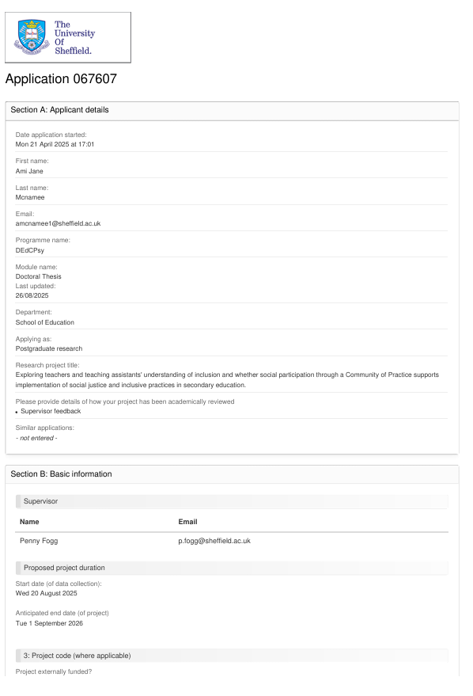

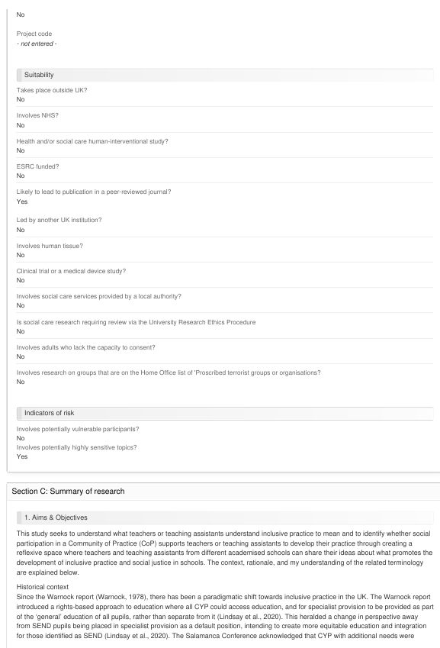

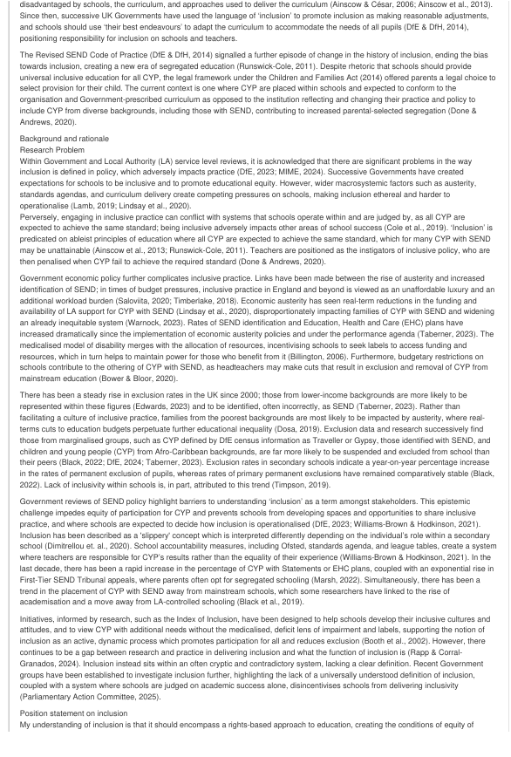
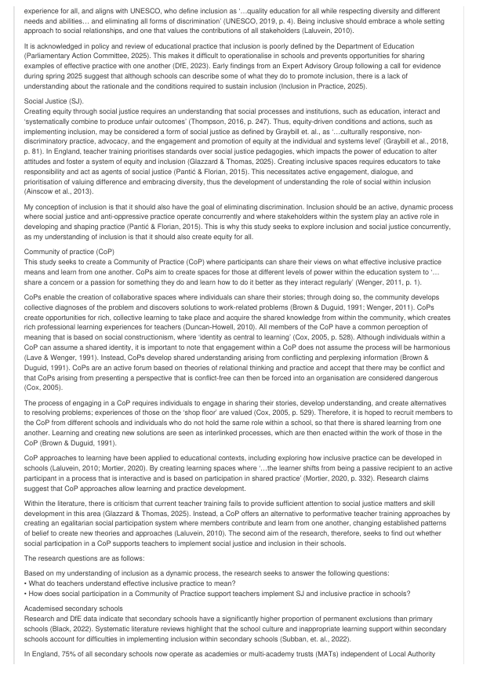
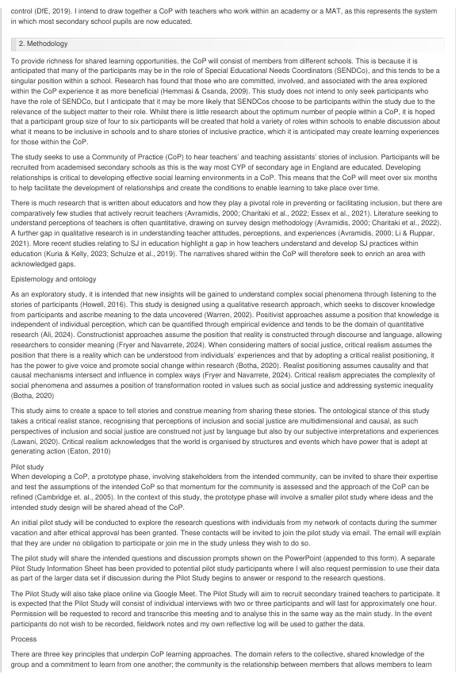
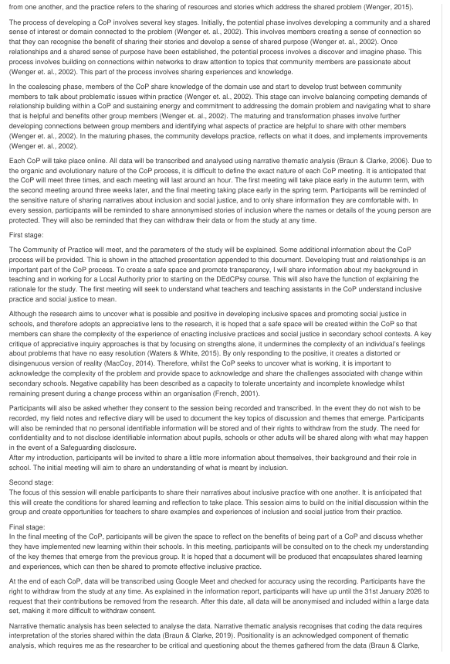
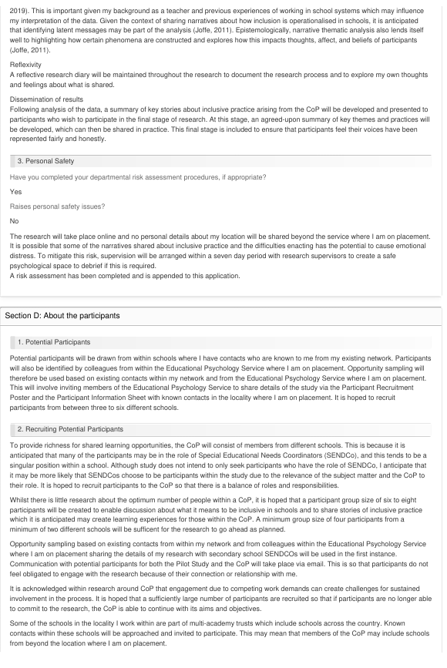
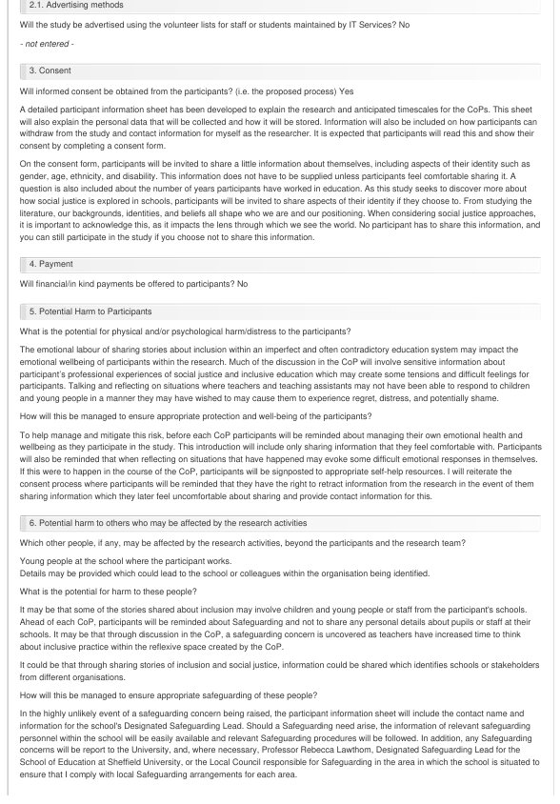
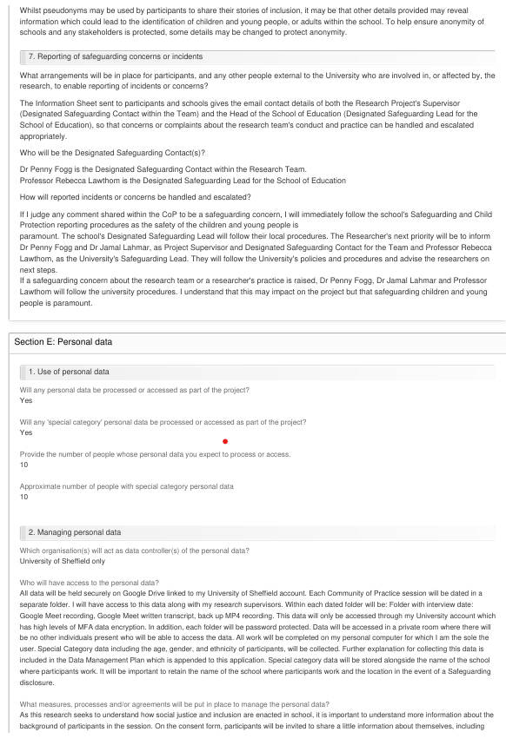
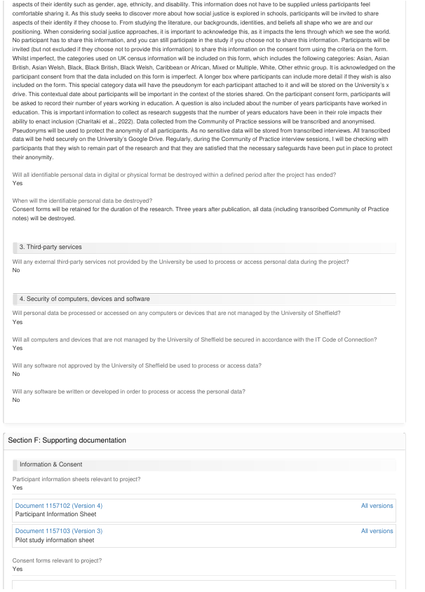
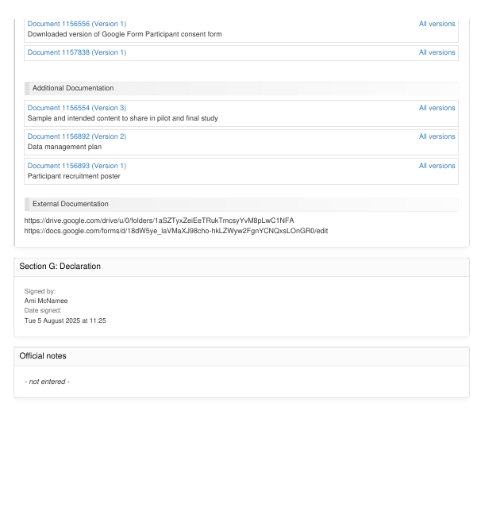

Appendix C: Participant Recruitment Poster, Pilot Study and Participant Information Sheets and Consent Forms

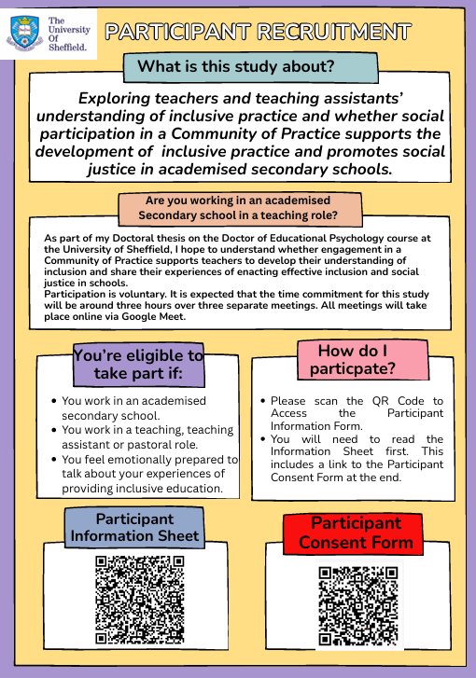


Pilot Study Participant Information Sheet
Dear Participant,
Please take time to review this information sheet. If at any point you have any questions about the study, please contact Ami McNamee at the University of Sheffield amcnamee1@sheffield.ac.uk
Research project title: Exploring teachers’ understanding of inclusive practice and whether social participation in a Community of Practice supports teachers to develop their inclusive practice and promote social justice in academised secondary schools.
Overview
This research has been developed to contribute to a Doctoral thesis in Educational Psychology.
You have been invited to participate in a pilot study to help me understand whether the structure of questions and expected discussion points will be helpful to explore with secondary school teachers in a Community of Practice group. The Community of Practice intends to explore teachers' experiences of inclusive practice in academised secondary schools in England and whether participation in Community of Practice group supports teachers in developing their practice, providing a space for reflection, sharing ideas, and enabling the development of inclusive practice and social justice.
What is the project’s purpose?
This research project seeks to respond to the following questions:
- What do teachers understand effective inclusive practice to mean?
- How does social participation in a Community of Practice support teachers in implementing SJ and inclusive practice in schools?
It is acknowledged in policy and review of educational practice that inclusion is poorly defined by the Department of Education (Parliamentary Action Committee, 2025). This makes it difficult to operationalise in schools and prevents opportunities for sharing examples of effective practice with one another (DfE, 2023). This research seeks to bridge this gap and identify what supports inclusion in academised secondary schools when knowledge is shared outside of practitioners’ settings.
Why have I been chosen?
Your perspective as an individual with experience, knowledge and skills in working in academised secondary school settings, is valued. You have been invited as a contact within my existing network to share your thoughts and ideas about the questions I have developed to use within the Community of Practice and to help shape the direction of the research. Your critical reflections on this process will help me to achieve these goals.
If you wish to answer some of the questions or points raised by the intended questions and would like to be part of the research, I also request your permission to use transcripts and interview notes as part of any analysis within the final thesis. You will be asked to complete the same participant consent form to ensure your consent for this is informed before any research-related activity commences.
Do I have to take part?
It is up to you to decide whether or not to take part. If you do decide to take part, you will be given this information sheet to keep (and be asked to sign a consent form) and you can still withdraw up until 31st January 2026. You do not have to give a reason. After this date, all data will be anonymised and included within a large data set, making it more difficult to withdraw consent. If you wish to withdraw from the research, please contact: amcnamee1@sheffield.ac.uk.
Please note that by choosing to participate in this research, this will not create a legally binding agreement, nor is it intended to create an employment relationship between you and the University of Sheffield. There is no payment made for participating in this research.
What is meant by the term Social Justice, and why are questions about my ethnicity, age, disability status and gender asked?
The Community of Practice intends to explore Social Justice as it is enacted in secondary schools. Social Justice has been described as ‘…culturally responsive, non-discriminatory practice, advocacy, and the engagement and promotion of equity at the individual and systems level’ (Graybill et al., 2018, p. 81). On the consent form, participants will be invited to share a little information about themselves, including aspects of their identity such as gender, age, ethnicity, and disability. This information does not have to be supplied unless participants feel comfortable sharing it. A question is also included about the number of years participants have worked in education. As this study seeks to discover more about how social justice is explored in schools, participants will be invited to share aspects of their identity if they choose to. From studying the literature, our backgrounds, identities, and beliefs all shape who we are and our positioning. When considering social justice approaches, it is important to acknowledge this, as it impacts the lens through which we see the world. No participant must share this information, and you can still participate in the study if you choose not to share this information.
What will happen to me if I take part?
What do I have to do?
You have been asked to participate in a pilot study to provide me with feedback about whether the questions and content developed for the Community of Practice research group are appropriate. Your reflections will help me shape the research. The research project intends to use a Community of Practice approach, which consists of a group of interested teachers who join together to ‘…share a concern or a passion for something they do and learn how to do it better as they interact regularly’ (Wenger, 2011, p. 1).
The Community of Practice will operate as a group discussion online, consisting of a cohort of different teachers and teaching assistants from different settings.
This will involve me explaining what a Community of Practice is, sharing the types of questions I intend to ask in the first stage of the research that will explore teachers’ perspectives of inclusion and social justice using definitions that are already described within research. I will then explain the second phase of the research project which consists of a series of questions that I hope to use that will elicit teachers’ narratives of inclusion. This phase of the research will allow those involved to share these stories within the Community of Practice. In the final phase of the project, the Community of Practice will meet again so that participants can talk about their experiences of being part of a Community of Practice and whether this has supported them to develop their practice. Questions designed to elicit these reflections will also be shared with you so that you can offer your perspectives on them.
The pilot study will take place online via Google Meet. With your permission, audio data will be recorded and transcribed using the function on Google Meet. The session will not include video recording. In addition, a Dictaphone will be used to record the session as a backup method of recording and transcribing the interview. A pseudonym will be created for you so that no personal or identifiable data is recorded. If you wish to join the final research cohort, you will be provided with the participant information sheet and asked to complete an additional consent form.
If you do not wish to be recorded but want to contribute to this research, I will make notes, which I will share with you afterwards to ensure it is a fair reflection of our discussion.
What are the possible disadvantages and risks of taking part?
Participating in this pilot study will involve a time commitment of around an hour. Teaching is a demanding job, and spending time engaging in research may feel like an additional workload burden. There is no expectation on you to engage in this research unless you wish to.
The focus of the research is to share experiences of inclusive practice; this can feel challenging and frustrating at times. It may be that your personal experiences of providing inclusive education could result in some difficult feelings and experiences.
What are the possible benefits of taking part?
It is hoped that this pilot study will support you to reflect on the ideas and discussion prompts suggested and allow a space to share your thoughts. It is anticipated that this will also be a space to share positive experiences and examples of how you have successfully enacted inclusive practices in your school.
Will my taking part in this project be kept confidential?
All the information that I collect about you during the course of the research will be kept strictly confidential and will only be accessible to members of the research team. You will not be able to be identified in any reports or publications unless you have given your explicit consent for this. If you agree to us sharing the information you provide (e.g. by making it available in a data archive) then your personal details will not be included unless you explicitly request this.
The only time identifying information may be shared with anyone outside of the research team will be if a Safeguarding concern were to be raised. In this instance, and following the school’s Safeguarding procedures, this would be reported to the Designated Safeguarding Lead within the school, the University, and, where necessary, Professor Rebecca Lawthom, Designated Safeguarding Lead for the School of Education at Sheffield University, or the Local Council responsible for Safeguarding in your area.
What is the legal basis for processing my personal data?
According to data protection legislation, we are required to inform you that the legal basis we are applying in order to process your personal data is that ‘processing is necessary for the performance of a task carried out in the public interest’ (Article 6(1)(e)). Further information can be found in the University’s Privacy Notice https://www.sheffield.ac.uk/govern/data-protection/privacy/general.’
As we will be collecting some data that is defined in the legislation as more sensitive (information about gender, age, ethnicity and the length of time you have been in teaching), we also need to let you know that we are applying the following condition in law: that the use of your data is necessary ‘for archiving purposes in the public interest, scientific research purposes or statistical purposes' (9(2)(j)).
What will happen to the data collected, and the results of the research project?
The pilot study will take place online via Google Meet. Ahead of the session commencing, I will ask if you consent to the session being recorded. Following the pilot study, data will then be transcribed. If you do not wish to be recorded but want to contribute to this research, I will make notes which I will share with you afterwards to ensure it is a fair reflection of our discussion.
One function of this research is to hear the voices of teachers as they enact inclusion in schools and to provide a space to share their stories of effective practice. I may include direct quotes from these stories in the final thesis and any subsequent publications. All data will be anonymised, and pseudonyms will be used to protect the anonymity of any group members or their schools. Careful consideration will be taken to ensure that any data relating to yourself, or your school is not identifiable.
Transcriptions will be held securely on the University of Sheffield’s encrypted Google Drive.
All data will be securely stored in line with GDPR requirements. No individual participant will be identifiable in the research report, presentation, or in any subsequent publication.
Due to the nature of this research, it is possible that others may find the data collected to be useful in answering future questions. It could be that others involved in similar research activity find the data interesting and seek to build on the data that has been found and may request to see the transcript data. In the event of this happening, I will seek your permission to share the transcription data. No information will be shared without your consent or your full knowledge of what this data is. No personal or identifiable data relating to you will be shared.
Will I be recorded, and how will the recorded media be used?
The audio recordings of the Google Meet interviews will then be transcribed. The transcripts made during this research will be used only for analysis and for illustration in conference presentations and lectures. No other use will be made of them without your written permission, and no one outside the project will be allowed access to the original recordings. Any details you share that could identify your school, location or any stakeholder in your school will be changed to protect the anonymity of those involved.
If you do not wish to be recorded but want to contribute to this research, I will make notes, which I will share with you afterwards to ensure it is a fair reflection of our discussion.
Who is organising and funding the research?
This research is to meet the requirements of the Doctor in Educational Psychology course at The University of Sheffield to form the basis of a thesis.
Who is the Data Controller?
The University of Sheffield will act as the Data Controller for this study. This means that the University is responsible for looking after your information and using it properly.
Who has ethically reviewed the project?
This project has been ethically approved via the University of Sheffield’s Ethics Review Procedure, as administered by The School of Education.
What if something goes wrong and I wish to complain about the research or report a concern or incident?
If you have any cause to complain about how you have been approached or to make a report of a concern or incident relating to potential exploitation, abuse or harm resulting from your involvement in this project, please contact the project’s Designated Safeguarding Contact Dr Penny Fogg during this study, you can contact my supervisor, Dr Penny Fogg by email: p.fogg@sheffield.ac.uk .
If you feel your concern or complaint has not been handled satisfactorily, you can contact the Head of the School of Education, Professor Rebecca Lawthom, by emailing r.lawthom@sheffield.ac.uk. She is the Designated Safeguarding Lead for the School of Education at Sheffield University.
If the complaint relates to how your personal data has been handled, you can contact The University of Sheffield Data Protection Officer, Luke Thompson – luke.thompson@sheffield.ac.uk.
If the complaint relates to how your personal data has been handled, information about how to raise a complaint can be found in the University’s Privacy Notice: https://www.sheffield.ac.uk/govern/data-protection/privacy/general.
Contact for further information
How do I give my permission to take part in the study?
If you agree to take part, you can give your permission by signing the consent form. This is a digital form which you can access through this link: Participant Consent Form - Google Forms
The consent form is a form you sign to say that you understand why the study is being done, that you understand what is involved, and how your data will be used. If you change your mind after signing the consent form, please email me to withdraw your consent. You do not have to give a reason.
What will happen to the data collected, and the results of the research project?
All data from the interviews will be transcribed, using the transcription tool on Google Meet. It will be anonymised, and no identifiable information (i.e., your name or the name of your school) will be collected. Pseudonyms will be used to protect the anonymity of all participants.
The research findings will be reported in an Infographic, in a presentation, and in a Doctoral thesis. It may subsequently be published in a peer-reviewed academic journal. Direct quotes may be used, but we will ensure that you cannot be identified in any way.
All electronic data will be securely stored with my Supervisor at the end of the Doctoral course (expected September 2026) for the duration of the project and deleted after three years.
Contacts for further information:
Ami McNamee (Trainee Educational Psychologist) amcnamee1@sheffield.ac.uk
Dr Penny Fogg (Research Supervisor) p.fogg@sheffield.ac.uk
Dr Jamal Lahmar (Research Supervisor) j.lahmar@sheffield.ac.uk
Thank you for considering participation in this research.

References
DfE. (2023). Analysis of consultation responses to the SEND review: right support, right place, right time. In F. Sinclair, Zaidi, A, ICF Consulting Service Ltd (Ed.).
Graybill, E., Baker, C. N., Cloth, A. H., Fisher, S., & Nastasi, B. K. (2018). An analysis of social justice research in school psychology. International journal of school & educational psychology., 6(2), 77-89. https://doi.org/10.1080/21683603.2017.1302850
Wenger, E. (2011). Communities of practice: A brief introduction.


Participant Information Sheet
Dear Participant,
Please take time to review this information sheet. If at any point you have any questions about the study, please contact Ami McNamee at the University of Sheffield amcnamee1@sheffield.ac.uk
Research project title: Exploring teachers’ understanding of inclusive practice and whether social participation in a Community of Practice supports teachers to develop their inclusive practice and promote social justice in academised secondary schools.
Overview
This research has been developed to contribute to the lead researcher’s Doctoral thesis on the Doctor of Educational Psychology Course.
You have been invited to participate in a Community of Practice designed to support teachers share their experiences of inclusive practice in academised secondary schools in England. Part of the study will be to discover whether participation in Community of Practice groups supports teachers in developing their practice and provides a reflexive space for sharing ideas, which promotes the development of inclusive practice and social justice in schools
What is the project’s purpose?
This research project seeks to respond to the following questions:
- What do teachers understand effective inclusive practice to mean?
- How does social participation in a Community of Practice support teachers in implementing social justice and inclusive practice in schools?
It is acknowledged in policy and review of educational practice that inclusion is poorly defined by the Department of Education (Parliamentary Action Committee, 2025). This makes it difficult to operationalise in schools and prevents opportunities for sharing examples of effective practice with one another (DfE, 2023). This research seeks to bridge this gap and identify what supports inclusion in academised secondary schools when knowledge is shared outside of practitioners’ settings.
Why have I been chosen?
Teachers in academised secondary schools have been selected to take part in a Community of Practice. Schools have been approached to take part based on the inclusion criteria (member of teaching staff or a teaching assistant in an academised secondary school) through contacts within my network or those who are known to me and are in the profession.
Do I have to take part?
It is up to you to decide whether or not to take part. If you do decide to take part, you will be given this information sheet to keep (and be asked to sign a consent form). You can still withdraw up until 31st January 2026. You do not have to give a reason. After this date, all data will be anonymised and included within a large data set, making it more difficult to withdraw consent. If you wish to withdraw from the research, please contact: amcnamee1@sheffield.ac.uk.
Please note that by choosing to participate in this research, this will not create a legally binding agreement, nor is it intended to create an employment relationship between you and the University of Sheffield. There is no payment made for participating in this research.
What is meant by the term Social Justice, and why are questions about my ethnicity, age, gender, and disability status asked?
Social Justice has been described as ‘…culturally responsive, non-discriminatory practice, advocacy, and the engagement and promotion of equity at the individual and systems level’ (Graybill et al., 2018, p. 81) On the consent form, participants will be invited to share a little information about themselves, including aspects of their identity such as gender, age, ethnicity, and disability. This information does not have to be supplied unless participants feel comfortable sharing it. A question is also included about the number of years participants have worked in education. As this study seeks to discover more about how social justice is explored in schools, participants will be invited to share aspects of their identity if they choose to. From studying the literature, our backgrounds, identities, and beliefs all shape who we are and our positioning. When considering social justice approaches, it is important to acknowledge this, as it impacts the lens through which we see the world. No participant has to share this information, and you can still participate in the study if you choose not to share this information.

What will happen to me if I take part?
What do I have to do?
You have been asked to participate in a Community of Practice, which consists of a group of interested teachers who join together to ‘…share a concern or a passion for something they do and learn how to do it better as they interact regularly’ (Wenger, 2011, p. 1).
The Community of Practice will operate as a group discussion online, consisting of a cohort of teachers and teaching assistants from different settings. It is hoped that participants will be able to attend three one-hour Community of Practice groups over a 6–8-month period between the autumn term, 2025, and in the early spring term, 2026. All Community of Practice groups will take place online via Google Meet.
The first Community of Practice will seek to understand what teachers in the Community of Practice understand inclusive practice to mean. Prompts based on newspaper stories will be included to help prompt the discussion.
The second Community of Practice group aims to build on the initial group and create opportunities for teachers to share examples and experiences of inclusion and social justice from their practice.
The final meeting will seek to explore whether engagement in social participation within a Community of Practice has supported participants to implement inclusion and social justice in their classrooms and schools. In this session, you will be asked to reflect on your experience of being part of a Community of Practice and talk about whether this has helped you to develop your thinking and practice about inclusion and social justice.

What are the possible disadvantages and risks of taking part?
Participating in this research will involve a time commitment of around three hours. Teaching is a demanding job, and spending time engaging in research may feel like an additional workload burden.
The focus of the research is to share experiences of inclusive practice, which can feel challenging and frustrating at times. Your personal experiences of providing inclusive education may result in some difficult feelings and experiences. Sharing these may evoke some complicated feelings for you.
What are the possible benefits of taking part?
It is hoped that engaging in this research project will support members within the Community of Practice to share positive experiences and examples of how they have successfully enacted inclusive practices in their schools. Similarly to networking experiences at professional development days, it is hoped that by meeting colleagues, shared knowledge may benefit individuals’ practices. This experience may affirm practice for many, and there may be a professional development and learning experience based on hearing from colleagues in other schools.
Will my taking part in this project be kept confidential?
All the information that I collect about you during the course of the research will be kept strictly confidential and will only be accessible to members of the research team. You will not be able to be identified in any reports or publications unless you have given your explicit consent for this. If you agree to us sharing the information you provide (e.g. by making it available in a data archive) then your personal details will not be included unless you explicitly request this.
The only time identifying information may be shared with anyone outside of the research team will be if a Safeguarding concern were to be raised. In this instance, and following the school’s Safeguarding procedures, this would be reported to the Designated Safeguarding Lead within the school, the University, and, where necessary, Professor Rebecca Lawthom, Designated Safeguarding Lead for the School of Education at Sheffield University, or the Local Council responsible for Safeguarding in your area.
What is the legal basis for processing my personal data?
According to data protection legislation, we are required to inform you that the legal basis we are applying in order to process your personal data is that ‘processing is necessary for the performance of a task carried out in the public interest’ (Article 6(1)(e)). Further information can be found in the University’s Privacy Notice https://www.sheffield.ac.uk/govern/data-protection/privacy/general.’
As we will be collecting some data that is defined in the legislation as more sensitive (information about gender, age, ethnicity and the length of time you have been in teaching), we also need to let you know that we are applying the following condition in law: that the use of your data is necessary ‘for archiving purposes in the public interest, scientific research purposes or statistical purposes' (9(2)(j)).
What will happen to the data collected and the results of the research project?
Community of Practice sessions will take place online on Google Meet. Ahead of each session commencing, I will ask if you consent to the session being recorded. Data will then be transcribed following each Community of Practice session. If you do not wish to be recorded but want to contribute to this research, I will make notes, which I will share with you afterwards to ensure it is a fair reflection of our discussion.
One function of this research is to hear the voices of teachers as they enact inclusion in schools and to provide a space to share their stories of effective practice. I may include direct quotes from these stories in the final thesis and any subsequent publications. All data will be anonymised and pseudonyms will be used to protect the anonymity of any group members or their schools. Careful consideration will be taken to ensure that any data relating to yourself, or your school is not identifiable. Details including the location of your school and name of your school will be changed to ensure that anyone reading the study would not be able to identify your setting or any stakeholders there.
Transcriptions will be held securely on the University of Sheffield’s encrypted Google Drive.
All data will be securely stored in line with GDPR requirements. No individual participant will be identifiable in the research report, presentation, or in any subsequent publication.
Due to the nature of this research, it is likely that others may find the data collected to be useful in answering future questions. We will ask for your explicit consent for transcript data to be shared if this were to be requested. No personal identifiable information relating to you, your school or any stakeholders at your school will be shared.
Will I be recorded, and how will the recorded media be used?
The audio recordings of your activities made during this research will be used only for analysis and for illustration in conference presentations and lectures. No other use will be made of them without your written permission, and no one outside the project will be allowed access to the original recordings.
Who is organising and funding the research?
This research is to meet the requirements of the Doctor in Educational Psychology course at The University of Sheffield to form the basis of a thesis.
Who is the Data Controller?
The University of Sheffield will act as the Data Controller for this study. This means that the University is responsible for looking after your information and using it properly.
Who has ethically reviewed the project?
This project has been ethically approved via the University of Sheffield’s Ethics Review Procedure, as administered by The School of Education.
What if something goes wrong and I wish to complain about the research or report a concern or incident?
If you have any cause to complain about how you have been approached or to make a report of a concern or incident relating to potential exploitation, abuse or harm resulting from your involvement in this project, please contact the project’s Designated Safeguarding Contact Dr Penny Fogg during this study, you can contact my supervisor, Dr Penny Fogg by email: p.fogg@sheffield.ac.uk .
If you feel your concern or complaint has not been handled satisfactorily, you can contact the Head of the School of Education, Professor Rebecca Lawthom, by emailing r.lawthom@sheffield.ac.uk . She is the Designated Safeguarding Lead for the School of Education at Sheffield University.
If the complaint relates to how your personal data has been handled, you can contact The University of Sheffield Data Protection Officer, Luke Thompson – luke.thompson@sheffield.ac.uk .
If the complaint relates to how your personal data has been handled, information about how to raise a complaint can be found in the University’s Privacy Notice: https://www.sheffield.ac.uk/govern/data-protection/privacy/general.
Contact for further information
How do I give my permission to take part in the study?
If you agree to take part, you can give your permission by signing the consent form. This is a digital form which you can access through this link: Participant Consent Form - Google Forms
The consent form is a form you sign to say that you understand why the study is being done, that you understand what is involved, and how your data will be used. If you change your mind after signing the consent form, please email me to withdraw your consent. You do not have to give a reason.
What will happen to the data collected and the results of the research project?
All data from the interviews will be transcribed using the transcription tool on Google Meet. It will be anonymised, and no identifiable information (i.e., your name or the name of your school) will be collected. Pseudonyms will be used to protect the anonymity of all participants.
The research findings will be reported in an Infographic, in a presentation, and in a Doctoral thesis. It may subsequently be published in a peer-reviewed academic journal. Direct quotes may be used, but we will ensure that you cannot be identified in any way.
All electronic data will be securely stored with my supervisors at the end of the Doctoral course (expected September 2026) for the duration of the project and deleted after three years.
Contacts for further information:
Ami McNamee (Trainee Educational Psychologist) amcnamee1@sheffield.ac.uk
Dr Penny Fogg (Research Supervisor) p.fogg@sheffield.ac.uk
Dr Jamal Lahmar (Research Supervisor) j.lahmar@sheffield.ac.uk
Thank you for considering participation in this research.
What do I need to do next:
Please complete the Participant Consent Form Below if you would like to participate in this study:
Participant Consent Form - Google Forms

References
DfE. (2023). Analysis of consultation responses to the SEND review: right support, right place, right time. In F. Sinclair, Zaidi, A, ICF Consulting Service Ltd (Ed.).
Wenger, E. (2011). Communities of practice: A brief introduction.

Graybill, E., Baker, C. N., Cloth, A. H., Fisher, S., & Nastasi, B. K. (2018). An analysis of social justice research in school psychology. International journal of school & educational psychology., 6(2), 77-89. https://doi.org/10.1080/21683603.2017.1302850

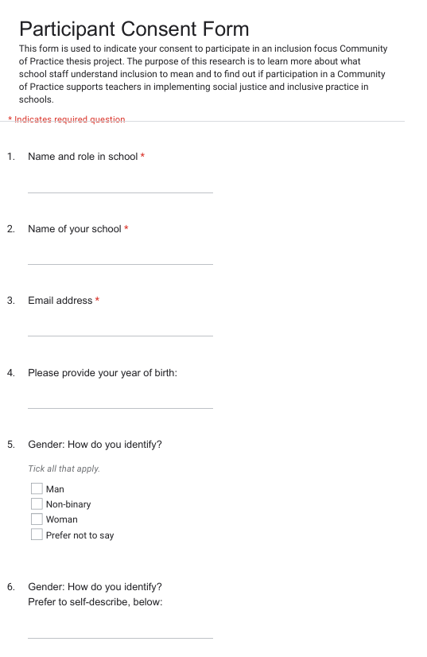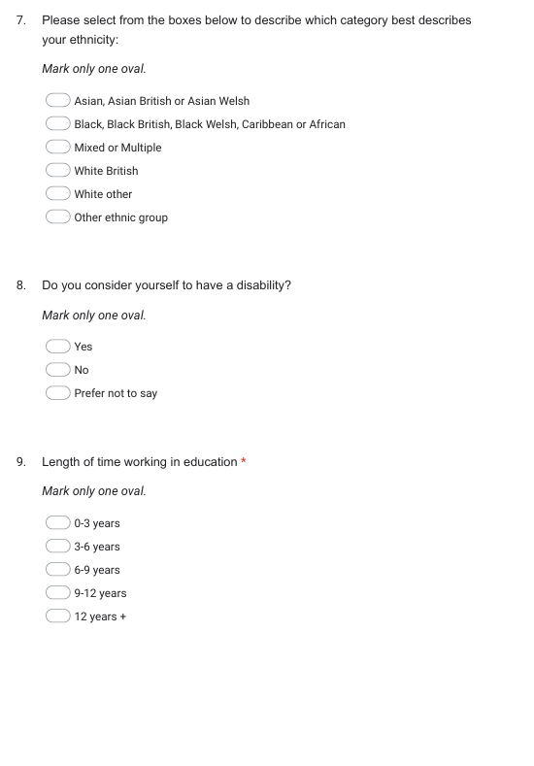

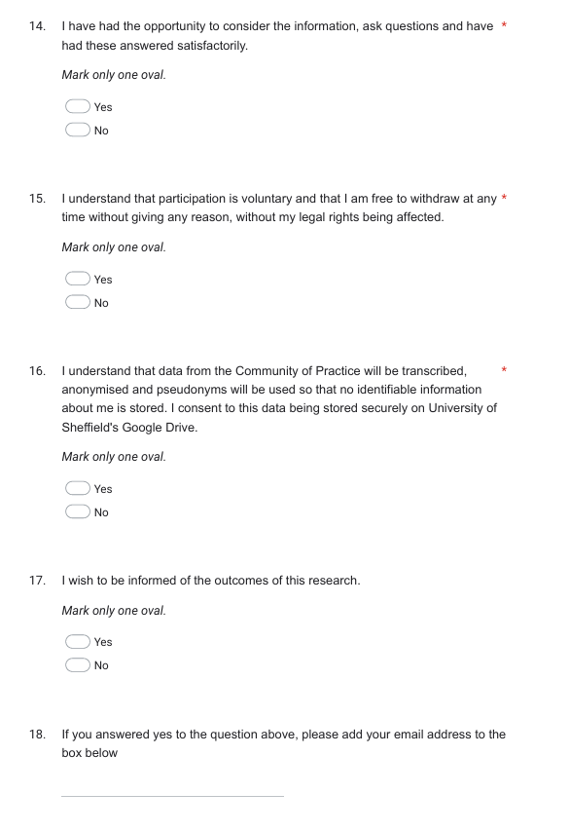
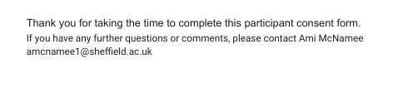

Appendix D: CoP Administration
CoP PowerPoint and Summary Information of Early Codes (used in the final CoP)
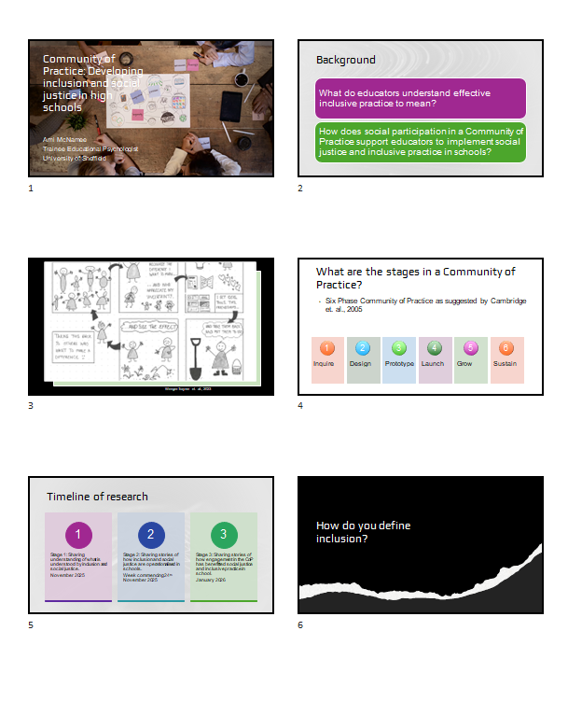
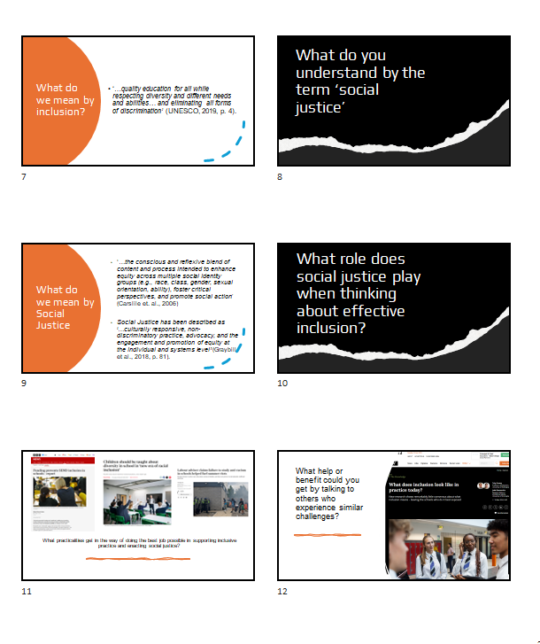
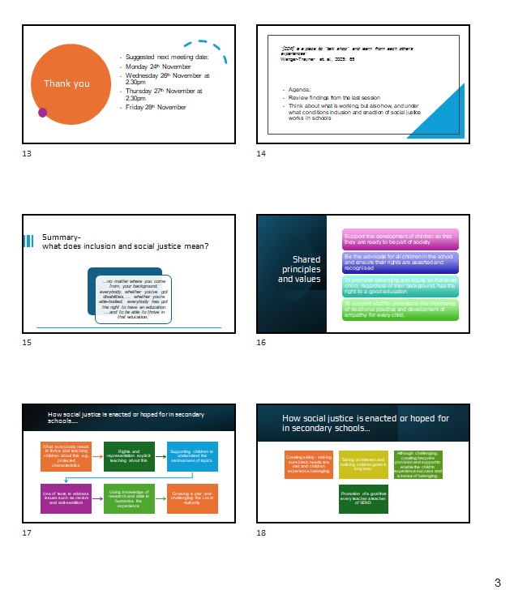

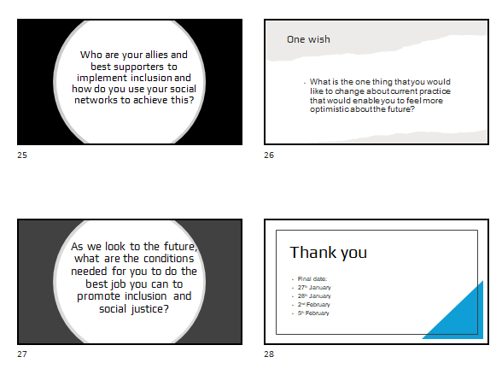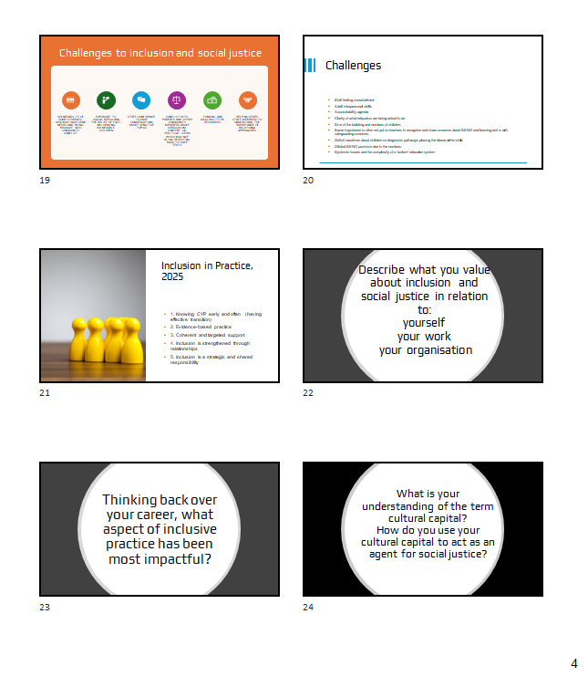

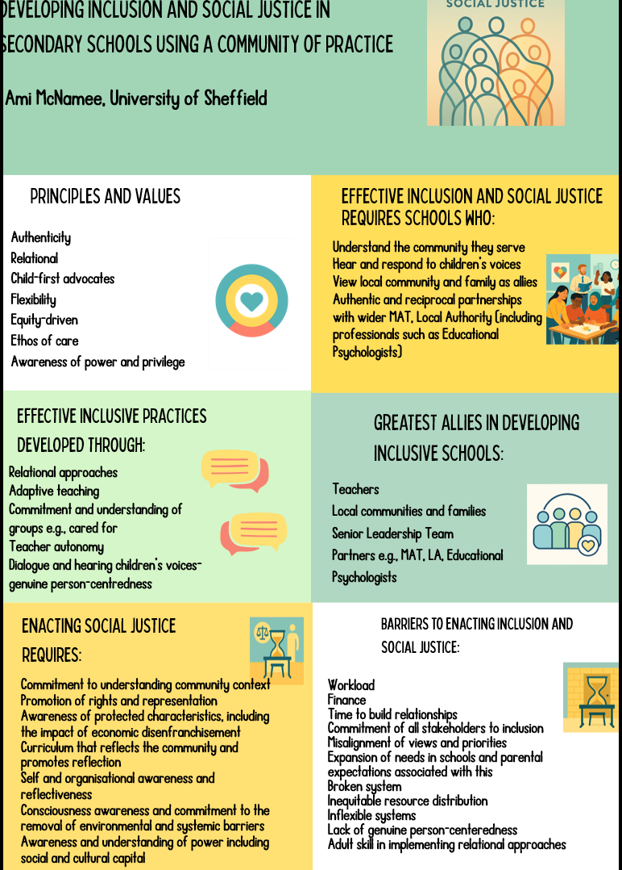

Appendix E: Transcript Extracts
Extract from Community of Practice Session 1 Attended by: Susan, Nicola, Michael, Jasmine and Ami

Ami: And its about, I suppose the angle that I'm taking on this is very much kind of I'm applying an appreciative lens that everybody is kind of doing their best that they can within a system that is often quite challenging to sort of navigate.
So this is kind of my rough timeline for the research and this kind of then leads us very nicely onto the first question of how we define inclusion. What you understand it to be and what you understand it to mean. So if anybody is happy to unmute and make a start with that [pause]
Susan: I'll go. I don't mind.
Ami: Thanks, thanks Susan
Susan: I understand it that no matter where you come from, your background, everybody whether you've got disabilities,… whether you're able-bodied, everybody has got the right to have an education errm and to be able to thrive in that education.
Ami: Ummhm. Thank you. And anyone else got any reflections on that very eloquent definition that Susan's given us there?
Michael: No, just I think obviously that's the encapsulating phrase in our school we look at it obviously there's times… where we look at it through more specific lens and ours would be being in a school that is one of the most deprived in Europe the area is one of the most deprived in Europe just because they are from that area doesn't mean they deserve any less. Yes. And they deserve just as good an education as anybody else.
Ami : Umm, I think that's a really important lens, Michael. And I think when I first came and the reason I'm kind of broadening this out into social justice. Actually, in my pilot study, I had a school that was in a very similar cohort in terms of deprivation errm in a different part of the Northwest and they were very much kind of their abiding agenda that they kind of were looking at and the lens through which they was around kind of social class and kind of promoting that social mobility particularly. Errm and that was kind of really important to them in terms of how they viewed inclusion. It was an opportunity to I guess provide those opportunities where although kind of class isn't necessarily protective characteristic that was very much the driver for them, thank you.
Nicola: I think mine's quite similar, Ami to what other people have said. I think for me it's always been a sort of a continual process rather than a fixed thing. And I think my sort of academic background came from more of a social justice and a cultural sort of disability errm exploration. And I know that, within that there were lots of opinions on the constraints of the system and the education system and the framework. But for me, it's always been a part of being in that and sitting right in the center of it and pushing back against some of those tensions and trying to align that, that champion and advocacy with obviously all of the statutory guidance and legal frameworks that sit around, sort of SEND at schools.
Ami: And do they compete,..do you think, Nicola, or do you think?
Nicola: Yeah. In terms.. I think I struggled. Erm… academically, there is, it was quite frowned upon when I was doing my masters in terms of going back into education and being part of a system that they felt perpetuated ableism and things like that and I was really conflicted coming back into schools but for me it was around trying to just sort of rehumanize all of the data that we'd been exposed to. And remember that at the core of it are young people and families who, you know deserve access to opportunities and support that's going to enable them to thrive and…flourish in whatever, form that looks like for them. And almost reconsider, you know, what is the purpose of education more broadly. And what is it that we want to offer students in terms of becoming, you know those well-rounded active participants in society. Errm and trying to sort of be a part of that journey even within a system that sometimes does compete with that sort of moral compass I suppose [laughed].
Ami: Mhm. Yeah,... absolutely. Yeah. So, there's very much competing agendas there. There's some really fascinating insights into inclusion. As I say, I've certainly been very much from the start of this assuming that we would go and probably it's just from the lens of me as a former SENCO of going down it down the route of kind of thinking about inclusion very much from the perspective of special educational needs rather than kind of broadening it out. So it's really really interesting to hear everyone's perspective.
Obviously, UNESCO kind of define inclusion.[presented the slide on the UNSESCO definition] This is certainly the kind of the rights based approach that I certainly take in terms of thinking about inclusion rather than kind of those reductive conversations about kind of educational placement but thinking about inclusion as a mechanism for creating equity which is certainly what many of you kind of have talked about and certainly kind of from some of the research that that I've kind of started to kind of look at it's about being inclusive is kind of that whole setting kind of approach and one that kind of values the contributions of all stakeholders according to the way in Lluaevin in 2010 for example. So there's a lot of that that's already kind of permeating in terms of your consciousness and how you kind of go about enacting inclusion which kind of with some of the newspaper articles and things I'm going to show you shortly doesn't suggest that that's the lens from which schools are seeing it. So it's interesting kind of that conflict I guess. and then thinking more about kind of the term social justice. what do people kind of understand by that and how do you kind of see yourselves as enacting that in schools?
Jasmine: I guess the term equity is a big part of social justice and just sort of understanding that everybody needs different things in order to thrive and…and that I think is something we're trying to teach the children a lot about.
Ami: Yeah. And…
Jasmine: I think that difference between equality and equity and helping them to understand that, you know, we all need. We all need our own individualised support in order to thrive. And that doesn't look the same for everybody.
Ami: How is the because I suppose another aspect that and I've kind of been maybe just drawn into the literature about it's really fascinating kind of insight that you've taken there but from a lot of the research that I've completed recently suggest that kind of like the promotion of British values and that we've been kind of less focused on sort of things like anti-racist practice for example in kind of the current curriculum that we're kind of asked to enact certainly since the David Cameron years is how does that land with young people?
Jasmine: I mean one thing that we do a lot about particularly in our personal development is looking at protected characteristics as a range. So we do lots and lots of work about that and they do learn about the Equalities Act and things like that.
Ami: Mhm.
Jasmine: I mean we do teach the British values but yeah I suppose there is less focus now on sort of racism but I think it's good because I think children need to understand that there's a range of protected characteristics and to understand that actually because I think they all kind of get that things like racism is a crime but not necessarily that it would a criminal offense to say something homophobic or to say something against someone with a disability. So, I suppose we're taking more that angle now.
Ami: Thank you. Does anyone else have any reflections on kind of this?
Nicola: I think for us Ami or at least the core team here at school it's always been about rights and representation and resources and almost fighting for those right across the board. even more broadly than just SEND at school…but making sure that those sort of values are what we perpetuate every day in every conversation in every interaction in every way with it, we try and manage it.
Ami: Okay, thank you. And I suppose another reason for me kind of taking this angle in terms of the research that I was kind of influenced in and interested in was particularly last summer following kind of the riots and things that happened. Errm and obviously there was quite quick new Labor government kind of came in there's quite an quick enactment kind of children being prosecuted and I don't know if anybody's seen the Children's Commissioner Report about kind of young people who were kind of what happened afterwards in terms of that but there was a lot of particularly children who kind of had come from backgrounds where they were not feeling particularly included in their own communities and where there was kind of disaffection with the police but also children with special educational needs particularly kind of conditions like ADHD who were kind of highlighted as kind of those that were kind of involved in those. So I was kind of interested in that angle when thinking about this from a secondary education.
Jasmine: I completely agree and that has been the case with us and I think, you know, those children that have those vulnerabilities are far more likely to get sort of drawn into these sort of antisocial behaviors and…
Ami: Mhm. Yeah. Mhm.
Jasmine: we have seen that happen in [area name redacted]. It's really, really tricky and again with so aspects sort of the flags and things like that that's definitely come into it and also the rise of pupils with SEND who are sort of getting pulled into this sort of these views of misogynistic errm influences and things like that. So, I think it's really really tricky with our SEND learners, that trying to get them to understand these sort of really big topics and I don't think they always get the seriousness of it. And because they're so vulnerable, they're far more likely to just listen to other people and I guess join in.
Ami: Thank you.
Michael: It's difficult as well to find the time to address these things when you've got a full curriculum to cover. And the focus is and always has been on results really to find the time to address these sort of societal issues. It's just where do you find the time to do it? Even though obviously it's potentially more important than results, that's not what we're judged on, is it?
Ami: No. And how do you find that conflict,…Michael? I can sense it in your voice that it's, Yeah.
Michael: It is frustrating. Frustrating so, there are things that we would like to be able to say and things that we would like to be able to address, but potentially feel like we're unable to. Errrm. Even to the point of some of the texts that we used to study we used to study controversial texts because they did raise questions, but the amount of sort of errm, you know backlash that we've had over the last few years. Nothing about these texts that we've studied. We've just scrapped them really and just done the standard texts. We had issues of Mice and Men which for reasons is potentially valid, but we use that text to teach about racism.
Michael: We've had issues with Merchant of Venice which we've had to drop off the curriculum because of issues with anti-semitism. But we use that text to teach about anti-semitism. So yeah, it's a bit of a minefield in the current climate I think.
Ami: Yeah. Is that worry? Where does the backlash come from, Michael?
Michael: It’s come from parents. It's come from some teachers, members of staff. Errm, we the Merchant of Venice stuff got there was a home word booklet got picked up and ended up on social media and there was a big backlash around the Merchant of Venice.[sighed] We… It is frustrating. It’s frustrating. Yeah.
Ami: And it sounds like that's come from a really good place and you've been really considered in developing your curriculum
Michael: Yeah
Ami: And yet you're kind of facing these other hurdles
Michael: Yeah
Ami: And yet it means it’s easier to kind of perform to the prescribed text is…
Michael: Yeah, definitely. Again, we've tried to include a lot of varied, diverse texts particularly in our Key stage 3 curriculum, but again [sighed], it does come with a little bit of controversy. So, I don't know [pause]. I think reverting back to dead white males is the way that it seems like it might go.
Ami: And that sounds like it's a tough one for you. Errm, particularly as an English teacher.
Michael: Yeah, it's tricky
Ami: When you said before about teachers. Is that teachers backlash…
Michael: It’s teachers Reluctance to address the topics, to ask, not feeling necessarily comfortable with the topics and how to address them, worried about, you know anything coming back on them. [Hesitate] Everyone's in a bit of a nervous state of nervousness at all times, I think.
Jasmine: Yeah, I'm English as well, so I completely agree. And I think it is the vocab that's used, particularly like we've stopped teaching of Mice and Men, To Kill a Mockingbird. You know, when actually they're massively, massively useful tools in teaching racism. But yeah, one thing we do try and do is teach some of the more I suppose social kind of events and things that are going on through the non-fiction text which when we do language paper two we try and look, at sort of, that looks at things like newspaper articles, to try and address things that are happening today so we're trying to sort of build that cultural capital. Whilst… but it's really tricky, it is, and again as Michael said there's always someone that doesn't agree with something and we've had backlash if we've taught an article from a certain paper,… You know they've said that the political slant. You know, you're trying to lead our children to believe this and it's really hard.
Ami: Umm. This sounds really challenging.Thank you. And just Susan, I hope you don't mind. I'm just bringing you in a little bit just in your role with kind of working with cared for children. Errm, and I guess whether that kind of this aspect of kind of social justice and kind of equity and things like that, whether that kind of plays into sort of the types of work that you do with with the children that you were working with.
Susan: Errm. It can do.
Ami: Mhm.
Susan: It definitely can do. Errm, what I try and focus on is just making them errm is just making them feel safe in school.
Ami: Mm
Susan: So obviously if they do come out with a particular comment, then we will discuss that or we will point out why that might not be something that we do say. But what I will try and focus on is making them feel safe in school, including them, making sure that they've got friends. Errm, making sure that they've got enough to eat, that type of thing,…rather than maybe anything a little bit more tricky politically, if you know what I mean.
Ami: Yeah. But, but I suppose equally you've kind of got that role in terms of providing all of that nurture and that safety and that security and that to try and I guess level the playing field and create equity in the education system for them. It sounds like you're advocating for those young people in your role.
Susan: Yeah, yeah definitely.
Ami: Thank you. So, there's a couple of academic references here about how social justice is understood in terms of kind of being non-discriminatory…. Errm, and kind of that advocacy and engagement and promotion of equity at both individual and systems level which kind of we've started to talk about and also started to talk about some of the challenges with enacting kind of that social justice and kind of the conflict that maybe arises between perhaps wanting to do some of this work and maybe struggling because of, kind o,f those other external influences…. that can, that can impact on you. so on the next slide, I guess, I'm gonna skip over this question. I want us to kind of think about this more [what practicalities get in the way of doing the best job possible in supporting inclusive practice and enacting social justice slide also contains newspaper headlines].
Ami:I guess we've kind of started to talk about kind of media and thinking about some of those influences. So, I kind of did a bit of when I first started to kind of develop this idea as a project, I started to kind of look at kind of common newspaper headline articles about school systems.
Ami: So hopefully you can see them on the screen. So there's a lot articles about funding preventing SEND inclusion in schools. A lot around sort of children needing to kind of be taught about diversity in diversity in new era of racial inclusion. And obviously kind of at the end of last summer, there's some advisers who sort of suggest that there's been a failure of anti-racist practice in school that's helped to kind of fuel the summer riots. Errm, and I guess it kind of lended itself to sort of thinking about, this is what the press says, but what are the practicalities getting in the way of supporting inclusion and enacting social justice. And we've started to kind of think about this, but I guess from your perspective, what things get in the way of you doing the best job possible to support inclusion? [pause waited a few seconds]
Ami: Is it any of these things or is it none of these things?
Susan: I think a lot of what they see in social media gets in the way of everything because if it's on social media then it's 100% true.
Ami: Yeah
Susan: And that's what they believe. And if they've got a certain peer group that kind of feed into the same views, then it's very very difficult to change their minds as to…err whether it's toxic masculinity or racism or anything. If they've seen it on social media, erm, then that's what they believe and it's going to be on Tik Tok, it's going to be on Instagram, it's going to be on everything.
Ami: Mhm.. That universal truth that comes from seeing things on social media and there's some powerful forces and influences on there, isn't there, around that? Sorry, Michael, did you have something to contribute there?
Michael: I agree with that BBC article about funding. We are chronically underfunded errm for a school of 1100 students. We've only got five learning support assistants
Ami: Mhm.
Michael: And it's tough to have a fully inclusive school community, we need more staff and we can't get it. And you have students who need the support most, students with EHCPs, for example, and some of these students need one-to-one support but yet they're given 7 thou we're funding £7,000 for them.
Ami: Mhm. Yeah.
Michael: So it's a drop in the ocean compared to what they need. If they need a one-to-one, it's errm, it’s difficult.
Ami: So, the math's not quite adding up between the funding that's allocated errm and…
Michael: No, definitely not. Yeah.
Ami: And what's been put in place there. Thank you. That's interesting.
Nicola: Amy, I've said it previously. I think for me the biggest challenges is around re-empowering staff and trying to remind them because I think sometimes all of the jargon that goes around, you know, trauma informed approaches and… Neurodeiverse approaches sometimes frames it what some students need is something particularly specialised and I think they sometimes forget that the power of their own emotional literacy and their ability to form relationships is sometimes a massive starting point. And I think staff feel, in my experience, a bit of a push-pull dynamic and they forget that…that they're already equipped with a lot of what's needed, but because of how it's framed, it kind of becomes something that seems like it should be more specialised than quality first teaching or okay, I understand the principles of that, but surely that goes beyond what quality first teaching is. Surely that then becomes your job. And I think… sometimes they just forget that. I think we can be guilty of it as well at school in terms of just… make everything's just too fluffy rather than just being straight to the point about what's needed and reminding them that some of that is just their own emotional literacy and their own drive…. for the betterment of young people. Errm, and that can be a really good starting point. And I think sometimes staff can feel really overwhelmed and then you get all of that overwhelmed by the complexity of needs. Then they feel undertrained, then they feel frustrated. Errm. I think it's just around balancing that as well and.. not falling foul of framing it as something super specialist that's needed [sigh].
Ami: Yeah. …it's almost like not losing sight of what you went in for and why you're kind of doing the role that you doing sort of thing? Erm, and thinking that it's something that it needs to be. Do you think psychologists have had an influence in that [laugh] in terms of a lot of the research and language and things that kind of comes out of it in terms of overcomplicating it?
Nicola: Yeah. I think so. Sometimes [laugh]. I have, nerdy conversations at home with my husband who's a deputy head teacher and he sits on leadership, I sit on support and, we often have a lot of, sort of to and fro, whole school and smaller cohort. And, he often says I'll say to him, "Can I just bounce this off you?" And he looks at me sometimes,… it's too fluffy, Nicola. Just tell them what you want them to do, plainly. Forget all of the jargon and … they'll be able to do it. I think I forget that sometimes.
Ami: That's really interesting insight. Thank you.
Jasmine: I just say I completely agree and…I think if your universal offer is good. You know, having a really good solid universal offer that benefits SEND pupils is not going to hinder non-SEND pupils. But it makes it easier for the teachers in the classroom because they're just sort of doing the same thing for everybody. And that's great… and that's how it should be. But I do feel there's a reluctance from some teachers to change, you know, the way that they want to be in the classroom. And I get what Nicola is saying about that emotional literacy, but some teachers are just really not good at it…. and they just don't have any empathy for some of our kids. And that's really, really difficult. And I'm not saying they're not good teachers…
Ami: Errm.
Jasmine: Because some of them are great teachers. And yes, they know how to get nines out of the bag and things like that when it comes to GCSE season, but they might not be able to keep people with ADHD in the classroom for more than five minutes.
Ami: What do you think the barriers are to that,…Jasmine. To them?
Jasmine: [sigh] I don't know,
Ami: Don’t know. Yeah, sorry. It's probably a bit of a daft question, isn't it?
Jasmine: if I knew I could fix it. I think overwhelm is probably a big bit to it. Where as I do think staff are you know overwhelmed.
Ami: It sounds like its that saturation.
Jasmine and Michael: Yeah
Michael: Pressure.
Jasmine: Yeah, overwhelm
Susan: Yeah. I do think staff are, you know, just don't have the time to build up those relationships that they need to build up and… I do think staff are, too busy and overwhelmed sometimes. Yeah. To get to know what to build up a positive relationship. You've got to have something in common with them and you've got to know what they like so that you can build up a conversation and that person can then feel relaxed with you. And I don't think that teachers do have the time to do that. They've got 30 kids in the class and they don't have the time to get to know each one of those kids. So if there's one that's flying under the radar, but they look like they're working, then they might just say, you know, actually they're working, they're doing okay, we'll just leave them to it." But they could be really struggling
Ami: Umhm,
Susan: and…they might just need somebody just to say, "How's your day been? Did you have a good time at the weekend when you went to such and such thing?" And that just makes them feel right. So, I'm part of the class now. I'm part of everything. But, unfortunately, there's just not time to do that.
Jasmine: It's those ones that are quiet and compliant that tend to, you know, slip through the net, isn't it? Because they don't cause anybody any problem….
Ami: Umhm. When you say slip through the net, Jasmine, what do you mean?
Jasmine: I guess so, in terms of like a SEND team we obviously don't see all the children. We rely a lot on teachers making referrals. So, we have a SEND referrals process so that if staff do pick up at anything around a student, whether that be something to do with their cognition, something to do with sort of their behaviour, their attentiveness in a lesson, all those kind of things can do sort of a referral to us. And that sort of prompts us to then sort of, perhaps have some conversations with teachers about, other teachers that teach that child to ask if they've noticed the same things in their lessons,… conversations with parents, and then it might be that we go in and sort of meet them and watch them in class, those types of things, I guess. But there's so many that particularly I think a few people do really struggle with cognition and learning when they are sort of quiet and compliant girls for me that struggle…
Ami: Right. And…
Jasmine: But because they don't rear their head. They're not disruptive. They do exactly what they're asked to do that, and that's what happens sometimes. They're, just, they’re not picked up.
Ami: Then it does that create bigger problems further down the line in terms of…
Jasmine: Yeah, absolutely. And also girls with ASC that mask as well. I find that I think early identification is key.
Ami: What's the implication of that then for you, Jasmine in your role?
Jasmine: Erm, (sigh) the earlier you can identify a SEND need the better. And I think when we don't espec… particularly if it is sort of particular sort of the communication and…language need that's when they often sort of begin to manifest as more SEMH kind of needs as children get older and I think if in an ideal world we would identify every pupil by year seven we'd put the interventions in place and it would never get to that point where they need any sort of SEMH input because they're feeling happy in school, they're feeling motivated, they're thriving… They can make friends because they've had all that input, but it doesn't work that way. and I think it's really tricky because I guess lots and lots of our teachers don't necessarily feel like SEND is their job and…
Ami: Mhm.
Jasmine: It's like everyone says at the start of the year safeguarding is everyone's role, but SEND is everybody's role every teacher in the school has a SEND learner in their classroom and… they wouldn't for a second if a child came in looking a bit disheveled and hadn't breakfast straight away. You'd put that on CPOMS. Why are the little things being picked up regarding the SEND that then are not shared? I guess.
Ami: So those communication isn't quite there. I suppose kind of Michael’s point earlier on about kind of the conflict almost between you've kind of got to get young people to a certain level in terms of the academic side of it and that's what the accountability agenda around that's kind of…what we're judged on rather than kind of the small wins that you maybe get or the kind of the importance of that relationships like Susan was saying that aspect of it we're not judged by that in terms of our daily …
Jasmine: Yeah. No,… but they go hand in hand though, don't they? If we can't keep a child in the classroom. They're not going to come out with a good grade. So…
Ami: absolutely. Thank you.
Nicola: I think Amy that's where the staff that we work with and I don't want to overgeneralise because there was a vast majority of staff that I engage with on a one-to-one level or a small group level are receptive and they're reflective. But I think the sort of the deficit-based narrative and diagnosis pathway for SEND at schoool that I find it harder to engage some of our staff to reframe that not as sort of deficit but as diversity and I think that some of that is really quite erm challenging at the moment in terms of the I don't want to say like blame but locating blame the idea that there's a deficit there's something to be fixed and whose responsibility is it to work around that deficit and… when that is a push-pull play between staff and students
Ami: Yeah, absolutely. And I wonder if, it certainly what came out of one of the pilot studies, was kind of this notion of over diagnosis or an idea around over identification and that sometimes teachers become a little bit jaded or educators become a bit jaded because of the sheer volume and how you can manage that. Erm, in terms of and whether that kind of detracts I guess from other young people who may have more significant needs if that makes any sense.
Nicola: Yeah, I mean I don't know about any other school, we're currently 40% SEND in three out of our five year groups. 25 for one of them and 28 for another. So that normal distribution has shifted so much over, sort of, definitely the last five years, but sort of extending sort of five five to eight years time. You know, and that's a real challenge because it's diluted the resources that we've got and the reach that we've got and not much changed in way of funding…Erm and it's really difficult. Yeah, 40% SEND and you're trying to get staff to be part of assess- plan- do- review cycles and contribute to those things and EHC reviews and it's really difficult as well.
Ami: How is it for other colleagues? is it similar for you? Have you noticed any kind of change in terms of your SEND populations and that impacting on your…
Jasmine: When I first started working here, our biggest area of need was cognition and learning, but we do have a cognition learning resource provision. Even with that now, our biggest area of need is SEMH. So, I've noticed a massive shift with that. Yeah.
Ami: So the picture is changing. Yeah. Okay. Thank you.
Susan: I think trying to get the right support for no matter what the need is, it just takes up so much time and so much money. Like Jasmine said, in an ideal world, you would be able to help everybody from year seven. But just the fact that if you do an ND [neurodevelopmental] pathway, you've got to do the meeting within the three hours, you can't stop it or else you have to start again. And it's just the amount of time that it takes. If you've got somebody within EHCP, you have to have a review quite regularly. And there's just not physically enough time for the SENDCo to do what they would love to do, which is to help the kids, but they've just got so much work to do. And then they've got parental meetings. It's just finding the time to do things,…
Ami: Mhm.
Susan: Finding the money for the resources, getting the right people in to help. It's just a never ending spiral really.
Jasmine: And I do feel the system's completely broken particularly, I’ve never I've been doing this job for about 10 years and this last two years, in terms of sort of back to the first picture which is the funding article it's been so, so tricky. So we're applying for pupils they're often getting knocked back if there's no cognition and learning need… Now that they suggesting there needs to be an element of a cognition and learning need even though we've got pupils where it's really really (sigh) really significant needs not attending school, harming themselves you like realising that they need something really really specialist. Finally managing to push an EHCP through getting it through going through the whole process they come back yes they're going to issue a plan after probably two mediations to even get it through by this point for them to just name the mainstream school that they not accessing anyway…
Ami: Mhm.
Jasmine: Because there's nowhere for them to go. It's just so broken. We've got so many students in our school that need specialist provision that have gone through panel where the panel have agreed they need specialist provision, but they still name us anyway.
Ami: And that sounds incredibly frustrating from your perspective…Because it sounds like you're trying to get them into somewhere where you're hoping would be better placed to meet need because you're struggling at your school if I've understood that correctly.
Jasmine: Yeah. Yeah. Absolutely. Because we are the biggest school in [names Local Authority] This is quite an overwhelming building for some students and…A lot of it is like these real intense anxieties around the building, the environment, the people, all those sorts of things and it's recognised and it even gets to the point where the local authority are agreeing that they need small and nurturing. And you read the plan and all the way through the plan it's almost written as this child needs specialist but then the name of mainstream school.

Ami: Mhm. And have you ever challenged that?
Jasmine: What, always okay…
Ami: What comes back from that? Just we've got….
Jasmine: Always not a lot. I've literally had one really recently where I've challenge the local authority. I do challenge the local authority, I used to be frightened to do that but actually I've really grown a pair this last couple of years in particular and…
Ami: Mhm.
Jasmine: I think they're a bit sick of me some of them but … but I have to challenge it because then they'll suggest something like okay send them on AP and we'll pay for it. That's not right… You know that a child needs a permanent school where they can feel a part of that community and they're not getting it…
Susan: Jasmine, have you found… because I know we definitely have… Errm. We have had pupils who they have come to this school and we've all known it's not the right school for them and we fought and fought and fought two years down the line we've managed to get them a specialist school. We've kept them here for two years and then they've lasted in the specialist school for about six months and then they've said, ‘No we can't handle their need.’ But as a mainstream school, we've managed to keep them and… look after them and keep them safe and… that.
Jasmine: Yeah. Yeah.
Susan: That like you say it is broken because if a mainstream school can do that and then the specialist school have turned around and gone actually no, we can't meet their need. What is going wrong? Why are they not able to meet the need when we've struggled? Don't get me wrong, it's been hard work and it's been a lot of work off a lot of different people, but we have managed to keep them. What is going wrong? Because it is definitely broken, but like you say, because there are no other places, you end up having to keep hold of this young person.
Jasmine: Yeah. Yeah. And then created something really bespoke because that's actually the only way you're keeping them in the building.
Susan: With resources that you don't really have.
Jasmine: You don't have.
Susan: But you pull it out of the bag and you do it.
Nicola: I say I think that's…what's happened to us. That's what we've fallen victim of and the students that we've had because we've been forced in positions where we've had to put together something entirely bespoke that at the point of transition we've had other local specialist schools say to us, actually… what you're providing is far beyond what we can provide currently. And what we've kind of become, sort of victims of trying to do the right thing.
Susan: Your own success.
Nicola: Yeah.
Jasmine: It is crazy.
Ami: Thank you. And it certainly sounds like you're very much trying to do the best that you can for these young people within a system that is fundamentally not working with you from kind of the conversation, if that's a fair assessment and a fair reflection. So I guess the final question that I've got for today before we close and thank you you've all given some really fascinating really useful insight. Thank you so much for your time. I'm very very grateful. But do you feel there's any benefit in this sort of approach? In terms of sharing and talking to others who experience these similar challenges.
Jasmine: It's quite therapeutic,…isn't it? Yeah.
Ami: It feels quite therapeutic.
Michael: I mean,…yeah, sometimes you feel like you're a bit an echo chamber and you're just sending your emails to the LA every day and not getting replies back. Although it's not good,… it is sort of reassuring to know that everyone's experiencing the same sort of thing.
Ami: Yeah, absolutely. Thanks, Michael. And I suppose the reason that I've kind of particularly focused on academised secondary schools rather than secondary schools in general is because that's the way the majority of young people are educated. And I suppose it may not feel like it, but I guess in theory academised schools have more autonomy, to a degree, than maintained schools. But I don't know whether it feels like that from your perspective or whether that's a reality or not really.
Michael: It used to feel like that. It used to feel like we could do our own thing a little bit more than nonacademised schools, but now I think funding has just meant that every school has to do things the same way really now.
Ami: So you feel it's become more homogenised because of the lack of…
Michael: Definitely. Yeah,…
Ami: Because of the lack of the squeeze on funding.
Michael: I think so.
Ami: That's really really interesting reflection. Thanks.
Jasmine: I think we do still have autonomy in terms of send to do…what we need to do because although we're part of quite a big trust, no two cohorts are the same, you know. But I think one thing that is helpful about being in an academy is the support that we get. So we have a team of SEND leaders for [names MAT] that are centralised that work with all of us. We have sort of regular SEND meetings where all of the [MAT] SENDCOs get together. So I think in that way we have just a SEND chat group with all the [MAT] SENDCOs which is good because sometimes it's just a case of I've had this email I don't know how to respond. Has anyone experienced this?
Ami: Yeah. Yeah…
Jasmine: So I suppose from my point of view being an academy I find really helpful because I don’t feel I'm sort of out there on my own. I feel like there's a group of SENDCOs that I can call on and communicate with as well as the SEND lead team as well. I find that helpful.
Ami: It's like a supportive measure kind of being, Yeah,…
Jasmine: Yeah, definitely. And sometimes it is just a bit of a rant. Yeah.
Ami: Absolutely. And you need that as well, don't you? You need to be able to kind of have those opportunities. Okay, great. Any other reflections before we stop? I'm going to stop the recording for now. Thank you.
Extract from Community of Practice Session 2 Attended by Jasmine, Susan and Ami
Ami: So this is kind of my first one. Describe what you value about inclusion and social justice in relation to yourself, your work, and your organisation? If you don't mind having a think about this, Susan, and offering your response.
Susan: I actually think that we do do inclusion really well. I don't know of any other school in the [names Local Authority] area that has a cared for child or a looked after child TA. My role was put together to make those children feel included and to have someone specific that they could go to and they could speak to. and I have one-on-ones with them. We go out when they're in year six. We go out and we attend the PEP (Pupil Education Planning) meetings.
Susan: We attend the transition meetings or any meetings that they have in year so personally from my point of view I think that as a school we do inclusion really well. That's not just for cared for children. It is also for I know that we've started attending EHCP reviews from year five and trying to meet for next year. We're going to try and meet all of the parents of EHCP pupils before they come to school and start building up that relationship. So, not only the pupils themselves feel included, but the parents and the carers, they would feel included in part of our school community. And it kind of breaks the barrier down where it's a new school, we don't really know how they work. But I do feel that we do do it really well. Obviously, we're not perfect and there are things that we could do better. but we're pretty good.
Ami: Mhm. Okay.So, that's what you really value is the fact that there's been that investment in your role and that real commitment to children who are cared for to and what do you think drives that?
Ami: Why that particular group?
Susan: I think… because we have 10 cared for children in our school which is quite a lot of children and they do take up a lot of time through various different things. They don't all have the best relationships with home. They don't all have fabulous times in school. Some of them have obviously mental health issues regarding the trauma that they've been through. So I think the driving force was to actually make them feel like they were included and they did have somebody for them who they could go and speak to and come and see. So that they weren't just because the heads of years I mean Jasmine will probably agree with this as well but the heads of years have got say between 160 and… 180 kids in their year group and they can't actually give probably the most vulnerable kids in our school the time that they need and sometimes you need to sit down and they need to get things off their chest and that can take an hour, it can take a day. And the heads of year just can't do that. The form teachers can't do that because they've got obviously lessons to go to. So I can to a certain extent do that. I can turn around and I can say right I'll move this around and then we can sit there or come on we'll go and get a hot chocolate and we'll have a chat about it.
Susan So, I think that's because, I mean, there's lots of different groups of pupils that do need a lot of intervention really and a lot of listening to and they do need to get things off the chest. But I think the cared for ones because they've got something specific and everybody knows in the school what my role is. So if they've got any issues, they know that they can come to me and that I will deal with it. whatever the issue is, whether it's not doing the homework, whether it's something more serious, rather than going I mean don't get me wrong, I still work in conjunction with the head of years. but it's just so that they do have somebody there.
Jasmine: [Wrote in the chat] Myself - Investment in the SEND department. SEND team usually feel listened to by other staff members. I feel like we are able to challenge other staff members when necessary to support inclusion. New social inclusion panel brought in by [names MAT] to support pupils when there is nothing left to try. This will include them supporting with additional EP time ETC. This will support six pupils each half term.
Ami: Okay, thank you. So, it's that dedication to that role that's really important? So I'm going to read out what Jasmine has written. She feels investment in herself and in the SEND department. So she really valued, I guess, the value that is put on her in and is that around your sort of status Jasmine and your investment in the SEND department. The SEND team usually feels listened to by other staff members and I like that we're able to challenge other staff members when necessary to support inclusion. New social. An inclusion panel brought in by the [MAT] to support pupils when there is nothing left to try. This will include them supporting with additional EP [Educational Psychology] time etc. to support six pupils each half term. So you've got that other backdrop of support that in terms of the wider organistion that you can sort of build on to support you in your role. Thank you.
Ami: Thinking back over your career, what aspect of inclusive practice do you feel has been most impactful? Is there anything from your perspective, Susan,
Susan: The things that have had the most impact on me is building relationships with both pupils and… so finding out what it is that a child needs and they might just be too shy to go and speak to a member of staff, but if you've got that relationship with them and you can sit them down and say, "Right, come on, what can we do for you? Tell me what we can do because we've started doing a lot of mapping the landscape with various different children. So I can sit down and I can ask them about all areas of school. and then I think having that relationship with both pupils and staff. So, you can go up to a member of staff and if they say, the students just said, "Well, I don't like the way that they say something to me." You can go and you can say would you just mind reframing that or saying that in a different way without feeling that you're telling them what to do or you're telling them that you're doing something wrong. So, for me it would been the most impact in my career has definitely been relationships.
Ami: Thanks Susan and… I know that we're all from the same local authority that are on the call at the moment, but that the Mapping the Landscape is around gathering the views of children, isn't it? and trying to understand a little bit more about what life is like for them. And obviously there's those pre-populated cards that you can use to help to support you with that.
Jasmine: Supported groups. This was brought in at school as a tool to support pupils between SEND department and SLT for teaching and learning. The aim is to ensure QFT [quality first teaching] is always happening, scaffolding always in place, small groups, slower pace, teachers have autonomy to be more flexible.
Ami: Is that scaffolding always in Is that kind of empowering the teachers to put in the interventions themselves in the classroom and the approaches Jasmine? Is that what you mean by that in small groups?
Jasmine: Same, but heavier adaptations this allows them to move between groups as well. If they achieve well, they can move into MS [mainstream].

Ami: So, the adapted pace of the learning and you feel that that's had a real impact. What is the impact of that type of approach?
Jasmine: Better achievement, better confidence and self-esteem.
Ami: The teacher so the teacher have got more flexibility. Do you mean in terms of children achieving better or do you mean in terms of them having more of a bespoke curriculum? Is it neither?

Jasmine: Improved outcomes. Same but heavier adaptations. This allows them to move between groups as well if they achieve well they can move into mainstream, if they struggle they can move into the HIVE.
Ami: Okay, they can move into the hive. And is that a provision that you access just from having with an EHCP or is there greater flexibility throughout the school?
Jasmine: Should be just for EHCP but we have lots come in that really struggle. We use it for many more.
Ami: And you use that as a provision just in your school setup should just be but then if you've got that I know I used to work quite a bit with resource base in my previous role as a teacher and I know that sometimes when you've got those provisions in school you use that to benefit all of your children because why wouldn't you we use it that they've got that wider offer for many of the others. So, we've touched on some important themes there. Susan's talked a lot about the importance of relational practice and that having the most impact in terms of supporting inclusive practice.
Susan : like that.
Ami: And Jasmine has talked about adaptations increased scaffolding and increased autonomy for teachers to scaffold learning and that creating greater opportunity for children to both maybe overcome some of the barriers to their learning as I'm understanding it but also enable them to access mainstream education as Last time we talked a little bit about cultural capital which Bourdieu talked about this as the notion of children of children's kind of social class impacting on their levels of qualification and the skills required to achieve that and that being very much impacted by your background.
And I know that I think one of us talked about kind of cultural capital and trying to teach children a little bit more about that and trying to have that wider understanding. So, I guess I'm thinking about this in terms of what our understanding is of cultural capital and how we use cultural capital to enable us to act as agents for social justice. So again, it's a little bit we talked about growing a pair so that we can use our cultural capital to kind of challenge those in positions of authority. I think it was Nicola who talked about using her knowledge of her own education to sort of rehumanise the data was what she talked about.
So, I was curious about this in terms of this how we promote social justice through this. I know that you talked a little bit Susan last time about that making sure those basic needs were met and that was your driver as social justice. think initially you said I don't think it really resonates with me but you gave loads of brilliant examples about how you were an agent for social justice in terms of making sure that children were fed making sure that all of those needs were met.
Susan : I think sometimes I just don't know how to explain it as well as everybody else.
Jasmine: Quite a lot of SEND is environmental (in my opinion). I think they need exposure to CC (cultural capital). We have to give that to them through enrichment and learning within the classroom interwoven into the curriculum.

Ami: Yeah. It's about thinking about those environmental factors that can influence and having that understanding and having that education and making sure that their needs are met in that regard. Is there anything else that you want to add to that?
Jasmine: Yes. I think it also links to deprivation.

Ami: So, is it about kind of the gaps in terms of them not having the same opportunities perhaps as every child as you would hope that I suppose am I saying is it about through putting in these things like Susan was talking about last time in terms of making sure that their basic needs are there and are met it's you kind of levelling the playing field if I understood that correctly is that what everybody's kind of going you seeing that as our role as was trying to create a level playing field so that we're all starting from the same position if you see what I mean. And it links to deprivation and deprivation factors being an influencer and a driver in that. Thank you.
Ami: So, this question is about kind of who are your best allies and best supporters to implement inclusion and how you use your social networks or your social capital to achieve this. From your perspective, Susan, is there anyone that you see as an ally in terms of implementing a lot of the work that you do?
Susan : Local communities. Definitely, definitely local communities. home as well because if we've got home on side and we've built relationships up with home, it's a lot easier for pupils to feel included in school rather than feel alienated because a lot of the time what happens is parents haven't necessarily had a good relationship with school and then that kind of feeds on into when their children are in school and they're just like I didn't need school So you don't really need school, that's fine. so definitely home if we can get home on side local communities. and then my mind's just gone blank. Sorry. Yeah, definitely.
Ami: So it seems like for you in your role And the way that you promote social justice and the way that you promote inclusion is, is by having those relationships first and foremost with the young person, but then extending out into maybe groups. And perhaps is it a little bit about you giving a voice to those who struggle to have a voice in other situations?
Susan : Because then there's a lot of people that are scared to voice what they're thinking or voice what they're saying. But if we can go to them and we have got that rapport with them to be able to ask them awkward questions and we can get that voice and then it does make them feel more included in school because they do feel that there's somebody that they can talk to no matter what it could be about and then obviously doing the same with home. If we've built up that relationship with home,… we might have to have an awkward conversation phone in home, but if they know that we'll be doing everything that we can and the things that we're putting into place are going to benefit the child, then they tend to be a bit more supportive and on your side.
Ami: So, it sounds like you've kind of got to do a lot of work for them to know that you've got the child's best interest,…that you've got the same values and the same goals as is that hard Susan?
Susan : Yeah, it can be. It does. you've got to know your people as well because you can't just have an awkward conversation with somebody who you've never spoken to before. you have got to build up that relationship. And if it's somebody who you have a lot of dealings through the day or the week or the month, then you do tend to build that up. And it does seem to be a little bit more if you can get home on side, then school is a bit easier for them. School becomes easier.
Jasmine: School leaders. SLT for Inclusion is often the one who will go out to battle for us in the SLT meetings. She's not scared to say it as it is.

Ami: I know that Jasmine's got to go. What I'm going to do I know Jasmine's got to go. What I might do if it's okay with everyone is set another date maybe for next week or the week after if you can possibly make it. But I might get the others to join and see if I can catch up the others and then we all join for the last got one or two questions if you don't mind if that's at all possible.
Transcript extract from Community of Practice Session 3 Attended by: Nicola, Susan and Ami
Ami: So, on the next slide, I've started to sort of summarise what and these are not particularly eloquently written, so I'm happy for any criticality on this. These were what I drew out as sort of the shared principles and values from our community of practice about the development of children so they're ready to be part of society. And although we're kind of talking in secondary context, I'm very deliberately using the word children rather than young people or young adults. because whilst children might not necessarily agree with that, I think sometimes a lot of the language that grown-ups can adultify children who are children below the age of 16. So, I've purposely used the term children rather than student rather than young person. I don't know if you've got any reflections on that.
Nicola: I just think it's really powerful in terms of I suppose just my own experiences at school sometimes and…working alongside different teams and colleagues at school and I think sometimes that the use of the word child really helps to remember that that is exactly what they are. They are not well regulated adults with the same life experiences and…the same expectancies that we place upon ourselves at school. So, I'm actually all for the use of that terminology, Ami, in terms of children, because I think it just really helps to centre the interactions and the discussions and remember that they are just children.
Ami: No, thank you. that's kind of what I went down, but I thought a best check as well. So, about being an advocate for children in school and ensuring their rights are asserted and promote belonging and equity so that every child regardless of their background has the right to a good education. To support staff to understand the importance of relational practice and development of empathy for every child. So, they were kind of what I drew out as our abiding principles that we all talked about in that first session, and these are just some ideas about how social justice is enacted and hoped and what we hope for in terms of secondary education. So, making sure that everybody has what they need to be able to thrive and teaching children about kind of different protected characteristics and the importance of recognising that and understanding that rights and representation and being really explicit in our teaching about that. Supporting children to understand the seriousness of topics. So, I think this was kind of when we were talking a little bit about some of our vulnerable learners, maybe getting into situations in the community, and I think there was reading between the lines. I don't know if I've understood this right, but I think there was a degree of adults being concerned about exploitation for some young people in terms of them getting involved, particularly when we were talking about the riots last summer. and talking about kind of some of the things that happened on social media, for example, that was kind of one of the themes that we talked about in terms of social justice, use of text to address issues such as racism and anti-semitism. using our knowledge of research and data to humanise the experience.
Ami: And I think that came from you about using your knowledge and experience that you've had from your own education and trying to sort of put the person back in behind the data if I've understood that right.
Nicola: Yeah. 100%.
Ami: And growing a pair. which I think was a phrase that was used a bit in terms of being able to challenge local authority and seeing ourselves as being a bit of an agent for social justice and sort of using our social capital I guess to sort of challenge decisions that local authority makes. The importance how social justice is enacted or hoped for in secondary schools about creating safety and making sure that basic needs are met and children experience a sense of belonging in school. taking an interest in noticing children and the importance of that and how that goes a long way.
Ami: Although really challenging, creating some bespoke provision so that children do experience that sense of belonging and promotion of the goal that every teacher is a teacher of SEND. I think that came from some of the comments sometimes that sometimes special educational needs feels like a bit of a secondary consideration, and it doesn't necessarily come up on everybody's radar at times in terms of other colleagues and something we talked about last time. These are some of the challenges that we sort of pointed out.
Ami: So, the vulnerability of some of our same students and that kind of creating some difficulties in terms of the community exposure to social media and some of our more vulnerable learners becoming influenced by things that are not necessarily fact but presented as fact and not necessarily being able to understand the nuances of things that are written on social media. Staff feeling confident and able to have conversations about sensitive topics. Conflict with other parents and other members of the community where they might disagree with kind of what you're doing and your focus on education and that being a challenge funding and availability of resources.
Ami: And we talked quite a bit about the lack of available specialist provision and sometimes I think we were talking last time that you schools were almost being asked to do more than specialist provision and to provide something that is much more bespoke within what is essentially a mainstream educational setting and creating some real tensions and frustrations. I think but also kind of the importance of having that role of supporting other staff members to understand the importance of relational approaches.
Ami: Were there any other challenges that I've not addressed there, Nicola, that you think needed to be Yeah.
Nicola: I was trying to flip back through my notes before, but I can't find them in my notebook. But I feel like that that sort of covers everything that I remember of that initial section.
Ami: And then there's a couple of other things that more sort of around staff feeling overwhelmed time. And I think that saturation and I think it was you who talked about kind of the rate of your special educational needs register kind of being ramped up; and the needs almost being amplified and that sort of watering down the provision that you're able to provide for maybe more complex learners. If I've understood that correct, if I've got that right.
Nicola: Yeah. No, no, that reflects our current position.
Ami: And sometimes some of the deficit narratives that go along that place blame within a child context. Also, some of the systemic issues within a system that feels quite broken and it feels quite combative in terms of having to go through mediation to get resources and kind of being placed in that sort of vulnerable sort of position.
Ami: So I don't know if you've come across the inclusion in practice research that came out last year. they did a call out to all schools and to educational settings and to anyone involved in education to share their response to how they enact inclusion. So it was based on 165 responses. So, it's quite a big consultation I guess that came out of it and what they have said is these are the sort of five abiding principles that allow us to enact education. So, having effective transition and knowing the child/ young person early and often, evidence-based practice coherent, and targeted support inclusion that's strengthened through relationships and certainly we talked quite a lot about that last time and inclusion being a strategic and a shared responsibility.
Ami: So a lot of these themes that have come out out from this research we've obviously talked about in our last sess session but a key critique of the responses is that there's been a focus on what schools do but we need to develop a greater understanding of how and under what conditions inclusion is likely to be sustained and the rationale behind choices that have been made. So, they focused a lot on people having given anecdotes about what they've done, but not necessarily about the conditions that are needed for that to kind of be continued through education. So, I suppose what I'm inviting us to do is to sort of bear that in mind when we kind of think about the next phase of this and how we enact that.
Ami: And obviously, at the very start of this before we started recording, you talked about a lot of the external assessment that you've had of school that validates your practice around inclusion as well. So, thinking about that the first question that I've got is for you to describe what you value about inclusion and social justice in relation to yourself, your work and your organisation?
Nicola: Yeah. I think in terms of within my own personal experiences kind of grew out of a real passion for education and… being in a very unknown at the time but privileged position in terms of my experience of education, and I definitely went into my first job at a school with a very misguided approach, I suppose. And when I think back now I was very, very surprised how blinkered my own experience of education had been and I had absolutely no idea that there were still students at a secondary level that didn't have literacy skills and the first time I met a student that wasn't able to spell their own surname I was really quite surprised and then even more genuinely surprised to almost reflect back on my own experience and know that those students were also in the same year group as me. But my exposure and understanding to that was almost just non-existent. And when I reflected on that, it felt very much like those students were just sort of set aside. They were taught in their own pathway. When I went to school, we've got A and B bands here, but they were X and Y when I went. And I had no idea that there was a third pathway at school. We almost just didn't see or interact with that cohort of students whatsoever.
Nicola: And then when I was thrown into a position where my first job was also at the same secondary school I'd attended and that humanisation of experience that you talked upon before when I got to know those students and that their experiences I felt really quite strongly that while some of the academic practice was good and it was sort of targeting key skills and…They were on, I think the actual literacy program it was an American program Ami, you might remember the name, but it was corrective reading program. That was what it was called.
Ami: Yeah. Yeah.
Nicola: And they were doing that, but it just never really fully aligned with not all of it felt comfortable at the time. And we felt just for an example like an out building at school. We're in mobile at the back of school. That's where we were. We weren't part of the main school body. And then I did that for three years. And the opportunity to go and do my degree just wasn't the right time for me at 18. I wanted money. I wanted a car. I wanted all of those things. and I went to do my degree at [names University) and I chose to do Education with Special Educational Needs. It was something I felt really passionate about.
Nicola: But the program of study there, what I didn't realise at the time is very much around cultural disability studies. And the SEN part of that program really strongly focused on sort of the cultural models of disability. I'd never been exposed to that before and that really resonated with me I suppose that in terms of that narrative and… that I'd never really heard of the term social justice prior to that and it was something that really struck me as then led on to going to do my postgrad diploma… which is just in disability studies and at the time it was quite a contentious decision from my sort of the professors on the course to go back into education. They didn't really have a fun narrative around schools and felt that often, the work that goes on in school propagates some of the challenges around social justice for people and…
Ami: Okay.
Nicola: But I always felt quite passionate that sometimes you've got to be in it to flex it as well. If I'm going to be part of a team that pushes back at some of the rigidity and part of a team that promotes inclusion and social justice and seeing the removal of environmental barriers as not privileges but essentials for people that I felt quite strongly that I needed to be in it and that was where I could make the difference.
Nicola: So I suppose that's kind of really what I've kept on in terms of from myself my own experiences then into work and then into the organisation now I feel like over time we have developed a sort of a secondary and primary to be first then leadership team that everyone's quite aligned on that pathway and even right at the top it's represented at that sort of strategic level but it very much filters down relationally And when you're in a position where you can lead a team, you have quite a lot of influence there and how people shape their own experiences day and…
Ami: Mhm.
Nicola: How they manage different situations and different queries. So, that's something that I'm always really, very conscious of, and I try and make sure that we are always looking at it from a point of equity. And sometimes say, they've got that and they've got that, but that's not what equity is, It's around making sure that they've got what they need to succeed. yeah, and I think that that sort of comes through in what we've been able to develop organisationally is the wraparound systems at school. So that we have now got well-embedded systems that allow students to almost have individual or bespoke learning pathways that don't place too much of a strain on staff demand or…tools or resources because they're already well established there and proven impactful. So, I think we're in a fortunate position with that, Ami, that actually the organisational commitment from school has been and continues to be big. does that
Ami: Okay, thank you. No, that's brilliant. And I think similarly, thanks Susan, for joining. We're just catching up on a few questions. So, apologies if these are ones you've heard before, But I know that Susan and Jasmine were talking a lot about their roles and the value that they felt in their roles as being kind of really important in terms of this. But it's really interesting to hear kind of your journey, I guess, towards this and sort of what drives you and motivates you. So, it's brilliant. Thank you.
Ami: So, thinking back over your career so far, what aspect of inclusive practice has been the most impactful, would you say?
Nicola: Gosh, Ami,… these are big questions.
Ami: I know for the end of term as well, I've not been kind, have I?...
Nicola: What aspect of inclus? Yeah.
Ami: I think. Is it helpful if I share what we talked about last time? And Susan, do please do chip in if there's anything that you want to add. I know you've already sort of had a go at this and had a think about this. I think what we talked about last time was relationship building. I think it was Susan in particular who talked very much about relationships being built and a real focus on relational practice being really flexible, really valuing kind of the role that Susan in particular, was doing with cared-for children. And I think Jasmine was talking about the adaptive teaching methods that were in the school that she's in, and having the flexibility. So, similarly to your setting, they have a resource base there for cognition and learning. I know you've had experience of that in the past as well. But I think they were very much talking about kind of having that understanding and having that flexibility in terms of their approach and…that having the most impact in terms of inclusive….
Nicola: Yeah, I think I'd be inclined to agree,… I think that emphasis, especially more recently on relational practice and for us in terms of when I think back over my career, I think I've been really fortunate to have worked with people inside of school and external professionals that have genuinely got a real authenticity to it as well. and I think that's something that has been really, really impactful. And I think linking back to what I'd said I think in the first session, just that relational approach. There's so much strength and so much power to an authentic relational network that somebody has around them that often that can be the key to unlocking loads of the next steps.
Nicola: And sometimes that I think we just forget the power that has and that people have said loss what is it how did you manage to do that and there isn't anything special to it other than I think a real consciousness around emotional literacy and a genuine desire really I suppose to help and provide a space at school that does feel safe where they do feel valued and that they can belong. And I think some of that's only been amplified by becoming a parent myself.
Nicola: But I think that's why I really liked the term child as well when you mentioned that earlier at the beginning. Just a real sense of I've never underestimated the power and privilege of the role that we have, and I've never wanted to exploit that in any way other than for the betterment of what can be provided for somebody.
Ami: Thank you. And I think it's sort of very similar to what Susan talked about last time, it was about building those relationships and…that’s having the most impact certainly in the work that you were doing as well.
Susan: I think I found as well that you've got to be a certain person to work in a school. It's not something that you can fake. The kids would know automatically if you were pretending to be somebody who is building up strong relationships with them or being empathetic with them and it just wasn't part of you. than young people, children, they do suss you out pretty quickly. So, I think you've got to be the person that does care and that has got their best interest at heart so that you can make them feel like they belong somewhere so that you can well not make them sorry so that you allow them to feel like they belong like you are there to help them. It's not something that you can just rock up and do every day if you're not that kind of person. What would you do?
Ami: Yeah. …
Nicola: Yeah. Yeah.
Ami: it's that genuine and… authenticity Nicola was saying. Yeah.
Nicola: I think that as well, Ami, and just bringing in the voice of the child as well. I sit on we have a weekly it's called IATS like an investigations and assessments. It's essentially a cause for concern team and where staff can sort of say what they've done at different ways to support what the impact of that's been and then they can request next steps from sort of that send leadership level.
Ami: Okay.
Nicola: But often what I find is missing from honestly, the bulk of referrals is any type of voice of the child. And I feel like sometimes we forget we skip that step and I'm like has anybody just asked them have we opened up a way to have a conversation or we've got loads of resources available to us that are visual as well that would take away some of that overwhelm that sometimes when somebody asks you a big open question like this one and you think I don't even know where to start. So, I think that and the real emphasis on capturing the voice of a child and having that sort of student-centred planning approach, I think has been impactful…because I know even just I think back to when I was at school, no one would have asked us that almost wouldn't have been any of our business when it was our business.
Ami: Yeah. Yeah.
Nicola: So I think that I really champion a lot at school and I think I've seen so much more of that coming through.
Ami: Brilliant. So, it's really important, again it's about relationships, isn't it? And thinking of ways that you can build on that. I've got this question about what our understanding is of the term cultural capital. So, this came out last time and I think it was a term that one of us as participants had used. So, about what our understanding is of the term cultural capital, and how do we use our cultural capital to act as an agent for social justice? So, just to give you a bit of a definition in case it's helpful. Cultural capital is described as the non-financial and social asset. So, an asset that contributes to cultural mobility and value. An accumulated cultural knowledge that supports with behaviours and demonstrates how well we fit into a cultural group. and I think we were talking about it in the context of supporting our learners from more deprived areas, but I guess does this resonate with you? Do you think about our own cultural capital and…how we use that to be an agent for social justice?
Nicola: I think we do increasingly so at school Ami and… I think we have a really careful narrative around the levels of social deprivation and where our local area and local authorities sit in terms of that national nationally. And I think often we have a very mixed staff body. We have some staff that are from the local area, and they understand all of the diversity and dynamics that [names local authority redacted] is made up of and there are as I imagine with most towns very different pockets of bits of [names local authority, redacted] that staff are familiar with.
Nicola: But then when you've got some staff traveling from out of Borough, your sort of direct route because of how [local authority] is positioned, especially with the bridge in your direct route from outside of the borough to school is very, very short and it doesn't really reflect some of the wider representation of the area. And I think we do,…
Ami: Right.
Nicola: It sounds really weird, but we do a bus tour, a run when we get new staff, and we literally just fill the mini bus up, and we go around and we look at some of the key areas in terms of where some of our students live. And I think even now it'd be fair to say that a lot of staff are often taken by surprise at some of the local areas. And I think we've also got senior leadership representation of someone that attended school and is from the local area. So, when you're thinking about how you can use our cultural capital in terms of sort of shaping the curriculum and challenging some of that inequality and moving away from that deficit narrative, which some of our students, parents and families do sort of embody themselves.
Nicola: I think that that can be quite powerful in terms of just making sure that our sort of curriculum and personal development sessions and student voice sessions and…the way that we challenge all of that inequality and barrier at school can be supported. Does that make sense?
Ami: Absolutely I think it's really really powerful in terms so you're trying to deepen that understanding of…what the area is, how the area is situated and almost what I'm hearing is that you're using people who live in that community…who really understand who are part of that community to almost they've got greater levels of cultural capital because of their experience of being in that community. So, they're trying to educate those that are new to area? Is that fair?
Nicola: Yeah, Yeah. We did an ADI score which is just a deprivation index where you can put in the postcodes of students at school and then it gives you a score of 1 to 10 with 10 being sort of the most affluent. and one obviously being the lowest and…our average student sits at two by comparison staff average s it's a 7.6.
Ami: Yeah. Mhm.
Nicola: So you can see in terms of just the staffing sort of demographic and that was quite a powerful measure to share with staff as well, especially, we do a lot of home visits, but it can be really quite challenging, I suppose, to fully appreciate what life outside of the walls of school looks like for some of our students.
Ami: Absolutely. It's really really fascinating insight and I think we talked similarly last time, didn't we, Susan, about kind of the impact of deprivation, and I think also thinking about the experiences that our families maybe have had of school that can be very different to our own as well and how you kind of form those relationships and how you support that.
Ami: And I was listening to something the other day and they reframed it rather than parents having a barrier to school in terms of their school engagement. The onus is more on the school being the barrier not the parent…
Nicola: Yeah.
Ami: If you say, ‘what's the barrier created by the school that prevents the parents from wanting to engage?’ Rather than parents have a barrier to engaging with school, is a different way I think, or reframing it. I'm not sure if I'm explaining it particularly well, but it resonates with something that Susan and Jasmine were talking about last time. And certainly, what you've said about how we better understand the communities in which we serve, I guess. Thank you. So, the next one is about who are your best allies and…best supporters to implement inclusion and how do you use your networks to achieve this?
Nicola: It's all the big questions today.
Ami: Sorry, I know at this point in the term I've not been very kind at all have I? So, thinking about who maybe outside of the organisation…who helps you enact that inclusion and how you use you sort of our social connect connection with you and I think you've kind of started to touch on this a little bit Nicola, in the last comment that you think.
Nicola: Yeah, I mean it's got to be leadership,…hasn't it? Because it's got to be systemic. It's got to come from the top as well.
Ami: Yeah.
Nicola: But then, teachers are our biggest resource. They're on the interface of it daily. You know that they're teaching, they're form tutors, they're delivering assemblies. So, in terms of bringing allies on board creating support networks, I'm going to need them. And then obviously all of the wider team people, Ami, people I've gone with people at school and then we've got some real I suppose key families as well. Families that are available to school in terms of they've got the time, they've got the capacity, they've got the desire as well to really champion and challenge and I suppose just thinking some of our parent governors as well, they can bring a really powerful parental perspective to some of that.
Nicola: But in terms of my best ally, it is teaching staff probably they've got such a powerful reach. And I think sometimes they underestimate that, don't they? In a system that can sometimes make you feel very jaded towards the end of half term, they are valued by students, they almost don't realise the power that they have sometimes.
Transcript for Community of Practice Session 4 Attended by: Nicola, Susan and Ami
Ami: I guess my goal for the session today is for us to pick up on a couple of things that have been talked about in previous kind of communities of practice and just check out my understanding and that I've understood it correctly, but also for us to think about how useful this sort of forum is for sort of thinking about inclusion and social justice and some of the things that we've been discussing.
Ami: So my first question is kind of what I know and I have just very briefly sort of touched on this is what you think of the poster in terms of it being a fair summary of what we have discussed in this community and whether I've kind of captured things properly and if there's anything that I needed to change or anything else any reflections that you had about Thank you.
Nicola: I thought it captured the real essence of everything that we've been speaking about in the other sessions when I had a quick flip through. Amy, admittedly, it was about 10 days ago now. So, I'm just trying to refresh myself with everything that was on it.
Ami: I've messed about with the values a little bit because authenticity seem to come out really strongly. Relational practice, child first advocates again with that stress on child rather than young person. Flexibility and I've sort of shifted things around a little bit and it equity is another big theme that seemed to have come out from everything that you've talked about that we've talked about in this community. an ethos of care and awareness of power and privilege. Does that seem sort of fair in terms of the values and the principles that are important to you? Yeah. Okay. But
Susan: Yeah, I think definitely the power and privilege because I remember Nicola you saying that you worked in quite a deprived area and then the school that I work at is quite unusual really because we've got a really affluent area and a really deprived area as well. So the kids can be either so I think that definitely the power of privilege you do need to try and balance that especially for our kids and obviously some staff members will be a lot more privileged and maybe not understand some of the hardships and some of the struggles that some of the kids might have to put up with on a daily basis.
Ami: And I think it sounded like there was a lot of work that was kind of being done in schools to support that and…support teachers’ understanding of that as well from the last session.
Susan: So I think to get that message across is really powerful.
Ami: Thank you. great as I'm trying to make this participatory. That's always been my goal. That it's not done to and so this is why I keep sort of checking in with you. So, apologies if it feels like I'm rehashing things we've already talked about, but I just wanted to check that I haven't misconstrued or misunderstood and check that they were fair reflections. So, my first question of the day is that last time we talked a lot about community and the importance of understanding the community and the context that children and families and that being really important in developing inclusion and enacting social justice.
Ami: And I guess I was wondering about kind of being part of a multi- academy trust where there might be centralised policies or approaches that impact on your ability to have localised and contextually sensitive approaches to inclusion and social justice. And I wondered if there is any tension there or if the MAT can be supportive in terms of those community goals that you have. Does it matter?
Nicola: I'm just trying to think off the top of my head, Amy, and I should probably already know this is that we've obviously got a number of centralised policies from a map perspective and then obviously school-led policies that are sort of ratified internally by our own SLT and then governing body. So, I feel like all of the main ones from the MAT are often the big S statutory law sort of policies.
Nicola: That's a really bad explanation of that.
Ami: No, no,…
Nicola: But I think we have got a little bit of a f flexibility in terms of our internal policy against some of our own systems and things like that. I'm just trying to
Ami: I was just curious because I've been doing more research as well, more reading around, and there's a lot about the importance of commanding kind of community context and what fits in one context doesn't necessarily fit in one in another. And I just wondered, and it may not even be anything that is relevant to you within your multi-academy trust, but I just wondered whether you've got that scope kind of to have the individuality and to be able to reflect your community or not. It could be that actually isn't something that really
Nicola: Yeah, I think we've not long done some work on our behaviour policy to bring in some of the relational and reflective approaches stronger and redefine what a return from a fixed-term exclusion looks like for a student. So, that it is less sort of punitive and the focus moves towards that reflective and restorative practice. So, we've definitely had our own internal autonomy to look at the behaviour framework in that sense and seeing some success of because it was no secret that some of our SEN students were disproportionately represented in the students that were receiving either internal isolations or fixed-term exclusions.
Nicola: So, there was evidence there that needed to be looked at and changed. And that was quite powerfully driven by our own internal senior leadership team, I'd say.
Ami: So you feel that you've still got that autonomy to sort of reflect your own community and…
Nicola: Yeah, I do. Yeah.
Ami: Okay, brilliant. And from your perspective, Susan, is it something that is an issue or… is a barrier or is supportive? Mhm.
Susan: I do feel that we do have the flexibility.
Susan: One of the schools in our trust is literally like I'd say three miles down the road. But I don't know because I've never worked at that school, but I get the feeling that we are very supportive of everybody in our school community and our school family staff, kids, everybody. and I do feel that we've got the flexibility to take a situation individually and think right what is going to be the best for this person whether or not it would be going to reflection whether or not it would be suspension or whether it's sitting down saying right this is what's happened today this is what we should be doing but let's look and see what the reasons behind it are so I think we do have the flexibility to take people's individual situations and… then work with it without any comeback really from the big guy at the top if you know what I mean. Yeah.
Ami: Do you still retain that autonomy?
Nicola: Yeah, I think similar.
Ami: Yeah. Yeah.
Nicola: I think they kind of set what, but I still think we can get to do how and the interpretation of that. I think it's quite strong here in terms of making sure that that's viewed through a lens of inclusion and alleviating barriers, and what would be the right thing to do in this type of situation, rather than anally moving through a flowchart.
Ami: So, there isn't that you've got that degree of autonomy.
Ami: I was just curious, I guess, because of the emphasis that we had last time on knowing that seemed to come out really strongly on knowing your community, knowing how
Nicola: Yeah, I still think there's a little bit of variability in it. I would definitely say there are certain demographic of students even within, sort of internally where that's better applied. I think sometimes that that can depend on the nature of need and the way it presents and advocacy who knows them. Who can be a strong advocate for some of them. I think it's there as a broad sort of directive, but I do think there are still in some inconsistencies in terms of how it's… how it's applied. And I think that sometimes depends on who's your advocate and how does your need present and a little bit
Ami: Okay, thank you.
Ami: We've talked a lot about the barriers in terms of some of the difficulties that we've had in enacting a lot of the things that we've talked about. How do you keep your commitment to inclusion and social justice going when you're faced with these complex and competing systems? Yeah
Nicola: I think I just come in every day and look at the kids' faces. I think it's just a real investment in people as well, isn't it? I've always felt really passionate about working with people, especially young people. And I think I've said it before. I'm not under the illusion that I could completely change or overhaul the system, but when I'm in it, I can force it to be flexible in some spaces where ordinarily it may not have been. I think that and just the relationships that you build with young people and their families and you see how important it is to them and I think that's very much the driving force be behind a lot of it to be fair even on the days when it feels particularly heavy or overwhelming.
Nicola: I think they're the days that I have to drive here and focus on the small things because in its totality it feels massive. But there are lots of small wins to most days. and when you can look around school as well, and you see pockets of people and staff and students and that in that moment all of those staff are providing something that's needed and without it that feels like a much harder place than to be in it and rowing.
Ami: Those little winds that you get and the relationships are kind of what helps you to know that you're on the right lines and that you're pursuing things for the right reasons.
Ami: Is that right?
Susan: I think as well…If you know somebody who possibly does struggle in school and you can support them to not have fabulous days, not to love school because school isn't for everybody and not everybody does love school, but if you can support them to come in and maybe have at least one lesson that they enjoy. So you can build on that success and then you can make it happen for maybe another lesson or you can reward them and it does build and then it does make them want to come into school and… potentially you could change their life. You don't know because they could think I hated it when I'm older. I actually want to go into something that does that. And then it's that little on effect where you've done something kind for them and then they will go on and do something kind for everybody else or for some other people.
Ami: Yeah, thank you.
Ami: Anything else from your perspective, Nicola? Sorry, I realised we cut you
Nicola: I don't know. For me sometimes I think what I've gotten better at with the support of a big team here, here at school is not getting too bogged down by the constraints of the reality of what I can do. there's still loads of creative ways that even within, the frameworks that we've got, the resources that we've got and the in-reach and outreach support that there are still actually loads that we can do. So, try not to get too bogged down on the blockers and forget that actually even within that, there's loads that we can do. We just need to have that back to business cry, that back to business head wobble, and then just go again. But I think it's relationships with staff as well that really help that surrounded by people that share those common sorts of morals and ambitions, and that actually really value working with young people.
Nicola: And then I think I did this job before I was a parent but I think there was a fundamental shift becoming a mum as well and sometimes I can't always detach myself from that and I try and approach as much of it as I can thinking if this was my little girl is this what I would want somebody else to be doing or is this how I would want somebody else to respond? yeah. Yeah.
Ami: It sounds like there's parity between kind of what you're both saying. I think Susan's talking about you never know kind of the small little chain reactions that you think about that make a big difference, and if we get too bogged down by the system it can be feel very overwhelming and we might struggle sort of to see the wood for the trees to use an overused analogy but having that support of those relationships is what helps you to keep things going and knowing that you're kind of having an impact in those little small wins. Is that fair?
Nicola: Yeah, I think so. I think also, just having done it for a number of years now, I'm sure Susan's in a similar position. I get the pleasure of what being in it now where watching students go right through and beyond and then sometimes they come back and they check in and you can see tangibly then the next steps that they've taken and just how fondly some of them dip in on open evenings when there's absolutely no reason to be here other than to come and say hello. And that's nice. I think when I first started, you were just seeing kids through a year group, but 12 years in, you get to check in with past students, and I think it's a number of them that are genuinely complimentary of the support and relationships that they had at school. And you can hold on to that a little bit, and you can know that even life beyond here is still shaped by what we're doing every day with them.
Ami: It sounds very much like there's a very much community ethos there for you as well in terms of you being part of that community too.
Nicola: Yeah, I think the team's strong sort of the SEND and inclusion team. We're big team Ami still. So, I think that's nice. It never feels like you're working in isolation even when it's hard and you're up against it. So, it's nice.
Ami: There's a real commitment there. Thank you. The other question I've got is about thinking about how we evaluate all of this type of thing around inclusion and social justice and all and all of those aspects. So my question is who should be involved in assessing the success of and failure of inclusion and social justice within educational practice and how can we use our social connections or our social capital to help promote that evaluation.
Ami: How are we judged? I guess. Mhm.
Susan: Everybody in school really should be involved in it because it's everybody's job to make people feel secure, safe, included. So, whether you're the dinner lady serving the dinners or whether you're the head teacher, it's everybody's job to make you feel to make the young people or the children feel like they belong somewhere. So I just think it's everybody's.
Nicola: Yeah, I think it's just empowering the children and the family's voice, isn't there? And how that comes through and what their experiences are more globally, I suppose. some of that, seems to be captured by things local authority area inspections when they're reaching out to a bigger focused group of families. And some of the things that we get frustrated with in terms of replicating information time and time again, and families wanting to just be able to tell it once, and try, and capture that without going through and repeating it all. And I think sometimes what I forget is that actually whilst we're a really big part sometimes in a journey around social justice and equity, we're actually quite a small part of the overall experience, aren't we? So yeah, I think, but we've struggled at secondary with family engagement really. It's much stronger in primary. We have really good relationships with our parents, but getting them in over the threshold things just like coffee mornings and some of that's made more complex by work commitments for families.
Nicola: Some of our resource-based students in particular, lots of their parents also work in schools. It's difficult to get the time off and justify how do you say you're going for a coffee when you're trying to submit your leave of absence form. But yeah, I think it would be really important to try and capture some of the family's experiences in that as well.
Ami: So it feels like that's more important than say some of those big macro systems Ofsted and local inspections and things that you were talking about feels like that's more important almost to judge your inclusivity rather than those bigger structures that you have around the judgments.
Nicola: Yeah. Sometimes Yeah.
Nicola: I think they're just sometimes the means to generate it on that bigger scale, aren't they? And see what a family's experience is of a system, right? some of our families have been doing this for years, since they were really, really young, and some of them are newer to the world of SEND and inclusion, aren't they? And yeah, I just think they provide the platforms, really, but it's not really what's important in that bit. Yeah, I think so.
Ami: So, their views are more important than anybody else's is kind of what he's saying. Is that right? Yeah.
Nicola: I think yeah, I mean they're the ones living it, isn't it? It's their lived experience. in terms of what that looks like and what they feel and experience every day. but obviously I think it's all your usual sort of stakeholders as well, isn't it? You've got your educational psychology team. I suppose even your EWO team it's trying to just pull it all together and triangulate it and be curious about it, and the attendance team are going out and times things get flagged and we meet and sometimes you just need a couple of heads on it don't you to consider it from a different angle as well but, Yeah.
Ami: Okay, thank you.
Ami: I've got just another little slide, which hopefully you can see there. Obviously, kind of we're in this state of flux in terms of curriculum review. And there's a lot of talk in that. I don't know how much time you've spent looking at it came out in November, but there's a big commitment to sort of social justice and more flexibility in the curriculum thinking about particularly around SEND learners and our students who are maybe more socially vulnerable or those groups who are particularly kind of underperformed which we've talked about in previous communities of practice.
Ami: And I wonder as we look to the future of inclusion and social justice in education, does some of the language that's coming out and some of the themes that are coming out in that review, does that make you feel more optimistic about the future of inclusion not? So I think one of the things that struck me in relation to this was about that commitment to what we talked about in the first community of practice around being able to use texts that reflected the community or reflected the issues that you wanted to talk about but having a bit of a backlash or really struggling with that because of it feels like in terms of the new curriculum there's a greater emphasis on that. I just wondered if you had any thoughts. Understandably, you might not have had time to have read in or looked at any of this. I'm just curious to see from your perspective whether you feel it could grow legs and it could have any impact. Yeah.
Nicola: I think it's representation matters, doesn't it? So, I think whilst it's still high on everybody's agenda, I think that's really important in terms of driving forward the idea of things being equitable and fair, but I haven't had a look at it in the last couple of weeks or anything. To be fair, I'm trying to remember all of the initial things that we discussed in terms of being barrier-aware and things like that, wasn't it? When
Ami: And I think from my reading of it as well there's a greater sort of flexibility on the type of provision that you can offer for SEND learners as well, particularly around the assessment system. So there's going to be a reduction in examination time, for example, and cited in that is the impact that has particularly on our SEND learners who often underachieve in the way things currently are at the moment is the kind of the scrapping of the EBACC (English Baccalaureate) as well as that just this greater emphasis on an expectation on it being more rights represented. It may be that you've not had chance or it's not kind of come into schools. It’s only come out in November and it's only in a draft form at the moment, so there's no expectation.
Ami: I was just curious to see whether there was any element of it that makes you feel a little bit more optimistic about we've talked about the broken system and about things not being representative enough of the types of communities that we serve, and I just wondered if any of this makes you feel a little bit more optimistic or not and it could be that we might not be there yet which is fine.
Nicola: I think the continued discussion around what things could look like and not sticking with structures just because they've been in place for a number of decades is important. So, I think any of those conversations that consider are there alternate ways of doing that sort of with appropriate levels of support and facilitation, how they're going to support skills to transition through to putting some of it in place is important. So, I think I would continue to welcome those discussions about what it could look like and what the hopes are while still keeping that rigor to it, isn't it? You want to be able to give them the gift of choice when they move on from school, don't you? that's really what you want to set them up for. the opportunity to take a next step in whatever format that look like for them in a way that's right.
Ami: Yeah. It is positive.
Nicola: Yeah, I don't want to be the school that's late to it or doesn't do it very well, or we can't do it because we're struggling for resourcing and things like that. But I think any discussion that looks at what could be rather than sticking with what currently is good.
Ami: Yeah, thank you.
Susan: Amy, I'm really sorry. I'm gonna have to go now, but it's been lovely to take part in it.
Ami: Thanks, Thanks ever so much.
Ami: Thank you.
Susan: Thank you.
Ami: Take care.
Susan: You too. Bye.
Ami: Bye. Just got a couple more questions, Nicola, if that's all right.
Ami: just about the experience of being in a community of practice and whether you think it's useful or not really. So my first question is what has it been like to be part of a community of practice?
Nicola: I think I've really enjoyed it, I've liked the idea of, speaking to other individuals in other schools and I think for me it's just been a reminder that, how lucky that we can be that there are schools filled with other individuals that are equally as passionate about what they do and what they provide and how that can evolve and move forward. That's been really lovely. And then obviously bringing a voice to it is important.
Nicola: Whilst it maintains all of that sort of theoretical element to it doesn't it but it moves beyond textbook and I suppose when you're researching something real and important to the fundamentals of human experience I think making sure that as much of that is participatory as possible has been nice it's been nice to be involved in nice to link back with people, who are also passionate and want to drive that forward.
Ami: Okay, thank you.
Ami: Has any aspect of your thinking or practice changed since being part of this group?
Nicola: I don't know if it's necessarily changed. I think it's revitalised it a little bit. It's not often you get the space to come together, even just for the short sort of two three hours that we have done. And really sit and reflect on what is and why and what could be so I think it's definitely brought it back to the forefront. And so I suppose yeah just energises me, maybe. Yeah, I think any type of collaboration is important isn’t it?
Ami: So, do you feel like it has added some value in terms of And I guess is there mileage in this type of approach being useful for thinking about school practice do you think?
Nicola: Things can get very myopic when you're stuck in one place, and especially when you're sitting on, sort of being in schools for a long time, you get to know, I suppose a bit like before, you get to know what and you do what you do. And sometimes, that collaboration just brings another way of thinking and considering, and it's nice to hear other people's experiences and their successes and challenges, and then coming together to look at those. I've enjoyed that.
Ami: Thank And we got a couple more, Nicola, and then we'll be done. I guess from looking back at the transcripts and everything that we've talked about, I'm very aware that I've kind of used we and very much situated myself as part of the community. And as I started the research, I said look, I'm a participant in this as well. I'll be analysing my own data and my own involvement as part of this process. I guess are you aware of how I've situated myself in the context of this research and do you think it's impacted the community of practice in any way?
Nicola: I think I very much had started it and agreed to participate knowing that you were a strong advocate within the field. I think that was very much a pull factor for me really. It was nice to having had the pleasure of working with you previously understand a little bit about where you're situated within all of this and what your hopes and drives were. So, I think very much, but I didn't and haven't ever seen that as a negative or to the experience. I think if anything, I valued trying to contribute to somebody that I know is as equally passionate and about all of the things that I care about and fundamentally shape what I do as well. It was nice to be aligned in that way.
Ami: Thank you.
Ami: That's really kind of you to say, but when you read back through the transcripts, you think, is this fair? Have I steered it too much? It's helpful to know that you didn't feel that you were being pressured into saying or delivering things.
Nicola: No, I didn't feel steered in any way. More just reassured that it was a safe space as well, I suppose. yeah. No, not steered in any way.
Ami: Okay, thank you. And that is pretty much all of the questions that I had for today. Is there anything else that you want to add or contribute in terms of the wider discussion that we've talked about in relation to all of the themes around inclusion and social justice?
Nicola: No, I don't think so. just keep us up to date with where it takes you and what grows from it and what when you're doing all of your continued thematic analysis what comes out and where does it go and I suppose how it's received and sort of the circle when I did mine very much driven by cultural representation lived experiences so it be nice to consider how it sits within the field of psychology as well given there is some sort of science and medicalised underpinning there isn't there to the discipline. So, yeah interesting to see how that fits in and is received and explored, I suppose.
Ami: Yeah, thanks. I most certainly will do. I'm going to stop the recording there but thank you very much indeed for all of your contributions. It's been invaluable having everybody as part of this, but it's also good to hear that it has felt like a safe space, and it's also felt like a worthwhile and useful endeavour for participants as well. I think that was an important driver in my research.
Nicola: Yeah, thank you.
Ami: So, I'm pleased that there's a degree of that that's been useful to other sorts of participants in the research. So, thank you for that. I'll stop the recording there.

Examples of Early Coding
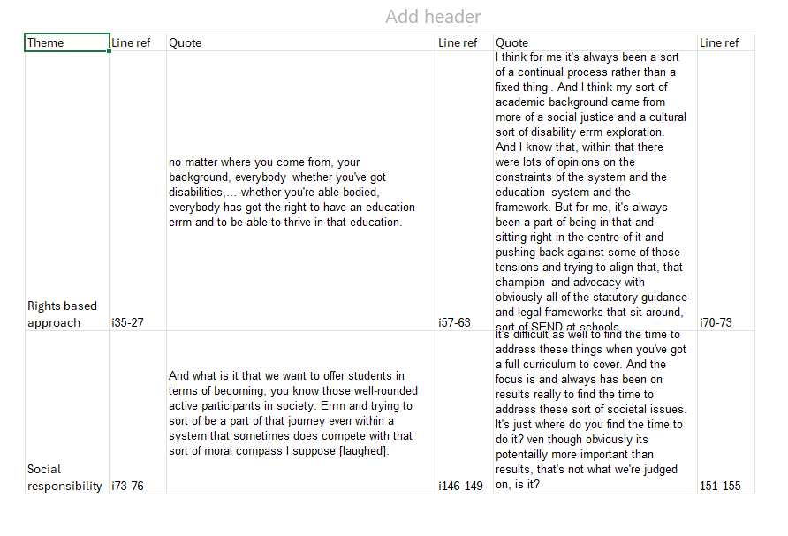

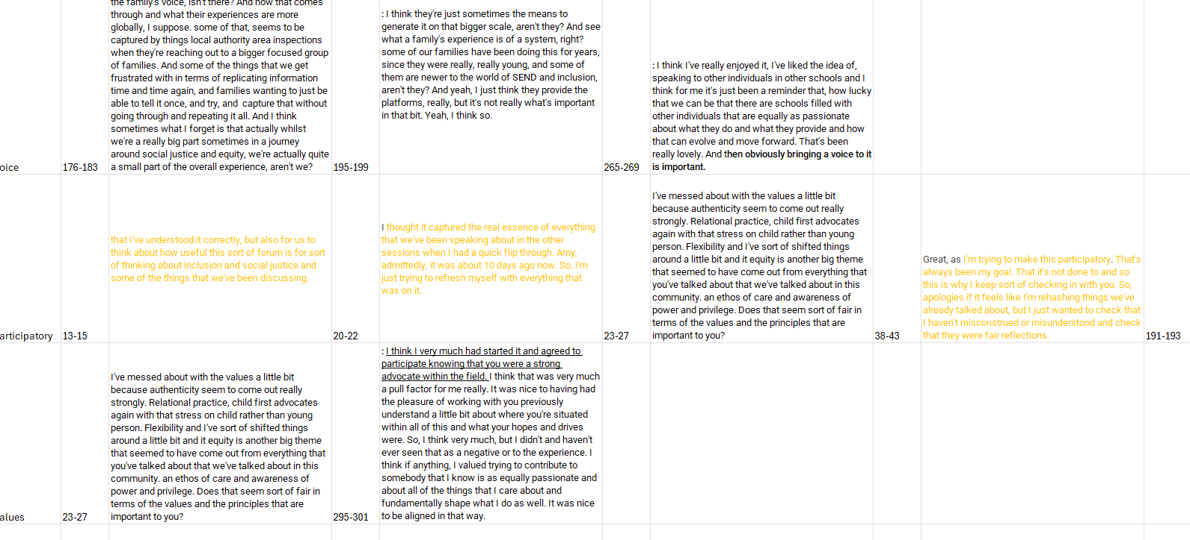

Example Code Book
Code | Frequency | Theme | Sub-theme
Rights-based approach | 12 | Understanding of inclusion and SJ | Rights and values-based approach that is applied in practice
Social responsibility | 4 | Understanding of inclusion and SJ | Commitment to equity and advocacy
Champion/advocacy | 10 | Understanding of inclusion and SJ | Commitment to equity and advocacy
Tension theory/academia and practice | 7 | Barriers to inclusion and SJ | Tension theory v practice
Meaning of SJ | 20 | Understanding of inclusion and SJ | Commitment to equity and advocacy
Equity | 6 | Understanding of inclusion and SJ | Commitment to equity and advocacy
Barriers to enacting SJ | 20 | Barriers to inclusion and SJ
Protected characteristics | 6 | Maintaining factors | Understands personal power and privilege
Cultural capital | 8 | Maintaining factors | Resistance and use of social and cultural capital
Social capital | 9 | Maintaining factors | Resistance and use of social and cultural capital
Deficit views | 6 | Barriers to inclusion and SJ | Increased demand and financial pressure  Teacher capacity
Diluting provision | 6 | Barriers to inclusion and SJ | Increased demand and financial pressure  Teacher capacity
Broken system | 18 | Barriers to inclusion and SJ | Systemic and competing demands
Importance of community | 7 | Understanding of inclusion and SJ | Rights and values-based approach that is applied in practice
Relational practice | 29 | Maintaining factors | Relationally supportive pedagogical approaches
Works against inclusion | 30 | Barriers to inclusion and SJ | Systemic and competing demands
Supportive measures | 27 | Understanding of inclusion and SJ  Maintaining factors
Power | 26 | Understanding of inclusion and SJ  Maintaining factors  Barriers to inclusion and SJ | Understands personal power and privilege  Resistance and use of social and cultural capital  Systemic and competing demands
Benefit of CoP | 7 | Collective coping
Safe space | 5 | Collective coping | Renewed commitment
Shared values | 9 | Collective coping/ Understanding of inclusion and SJ | Shared values and goals
Identity shapes positioning | 13 | Understanding of inclusion and SJ  Barriers to enacting inclusion and SJ  Collective coping | Renewed commitment  Understands personal power and privilege  Teacher capacity
Voice | 8 | Maintaining factors | Resistance and use of social capital
Authenticity | 4 | Understanding of inclusion and SJ  Maintaining factors | Understands personal power and privilege  Relationally supportive pedagogical approaches  Shared values and goals
Awareness of privilege | 4 | Understanding of inclusion and SJ  Maintaining factors | Understands personal power and privilege  Resistance and use of social and cultural capital
Participatory | 8 | Collective coping
MAT | 8 | Maintaining factors | Allies

Appendices References
Ashurst, F. (2014). Inequality, poverty, education: A political economy of school exclusion. Springer.
Bourke, B. (2014). Positionality: Reflecting on the Research Process. The qualitative report : an online journal dedicated to qualitative research since 1990., 19(33), 1. https://doi.org/10.46743/2160-3715/2014.1026
Brown, J. S., & Duguid, P. (1991). Organizational Learning and Communities-of-Practice: Toward a Unified View of Working, Learning, and Innovation. Organization science : a journal of the Institute of Management Sciences., 2(1), 40-57. https://doi.org/10.1287/orsc.2.1.40
Burr, V. (2015). Social constructionism.
Fox, M. (2009). Working with systems and thinking systemically - disentangling the crossed wires. Educational psychology in practice, 25(3), 247-258. https://doi.org/10.1080/02667360903151817
Graybill, E., Baker, C. N., Cloth, A. H., Fisher, S., & Nastasi, B. K. (2018). An analysis of social justice research in school psychology. International journal of school & educational psychology., 6(2), 77-89. https://doi.org/10.1080/21683603.2017.1302850
Howell, K. E. (2016). An introduction to the philosophy of methodology.
Markova, M., Pit-Ten Cate, I., Krolak-Schwerdt, S., & Glock, S. (2016). Preservice Teachers' Attitudes Toward Inclusion and Toward Students with Special Educational Needs from Different Ethnic Backgrounds. The Journal of experimental education, 84(3), 554-578. https://doi.org/10.1080/00220973.2015.1055317
Mertens, D. M. (2008). Transformative research and evaluation. Guilford press.
Polkinghorne, D. (1988). Narrative knowing and the human sciences. Suny Press.
Riessman, C. K. (2008). Narrative methods for the human sciences. Sage.
Wenger, E. (2011). Communities of practice: A brief introduction.
Williams, A. (2013). Critical Educational Psychology: Fostering Emancipatory Potential within the Therapeutic Project. Power and Education, 5(3), 304-317. https://doi.org/10.2304/power.2013.5.3.304
Williams, A. R. (2020). The Whiteness of Educational Psychology: Colonialism, Post-Colonialism and Racialisation in the Theory, Training and Practice of Educational Psychology. Educational Psychology Research and Practice, 6(1), 1-8.
Willig, C. (2017). The Sage handbook of qualitative research in psychology (Second edition. ed.). SAGE Inc.

