University of Sheffield

Department of Civil and Structural Engineering


Uncertainty and risk-based decision-making tools for water quality regulation compliance in the urban drainage sector.
[Yellow Sticker]

Philippa Caroline Mohan

Thesis submitted in fulfilment of the requirements for the degree of Doctor of Philosophy

June 2025
Declaration
I, PHILIPPA CAROLINE MOHAN, certify that all the material contained within this thesis titled “Uncertainty and risk-based decision-making tools for water quality regulation compliance in the urban drainage sector” is my own work except where it is clearly referenced to others, and confirm that this work was done wholly while in candidature for a research degree at The University of Sheffield.

Acknowledgements
I would like to offer my deepest gratitude to my supervisors Dr Alma Schellart, Professor Simon Tait and Professor Chris Digman, for all the guidance and support they have offered me throughout my PhD. This work would not be possible without the irreplaceable advice and direction you have offered me. I am particularly grateful for your patience you have shown me throughout this process, especially in regard to my written communication and story building around my PhD topic.
I would also like to thank the technical advice from Richard Norreys, Elliot Gill, Celina Wong, Mark Russell, Adam Smart and Will Hunt. I am very grateful for all the guidance you have provided throughout this process.
This PhD would not be possible without the WIRE Industrial Doctorate Centre and my industrial sponsor Stantec. I would like to acknowledge from the Engineering and Physical Sciences Research Council (EPSRC) through their funding of the WIRe Centre for Doctoral Training (ref.: EP/S023666/1) and from Stantec for their financial and technical support throughout the project.
This PhD would also not be possible without the data contributions of Yorkshire Water and United Utilities. I thank both companies for the use of their data in this project.
Finally, as always, I would like to thank my family, in particular my mother and father, for always supporting me in my academic career and life. I am very blessed to have you in my life.
Abstract
Ecological thresholds are often used in environmental protection regulations, particularly in the context of pollution control to prevent ecosystem damage. One example of threshold-based regulation is the Fundamental Intermittent Standards used in the UK to define if environmental harm has been caused by intermittent sewer overflow discharges. The thesis explores the impact of predictive uncertainty and risk appetite plays in understand weather and the extent of environmental harm has occurred. This thesis concludes that as both data and parameter uncertainty, as well as risk appetite, can alter the final dissolved oxygen and unionised ammonia Fundamental Intermittent Standards exceedance count and therefore can alter one's understanding of whether environmental harm has occurred. It also concluded that sensitivity to uncertainty and risk is location dependent. A new term was created called Parameter Threshold Ratio (PTR) to investigate the extent to which measured water quality concentration interacted with the regulatory threshold at different locations, which can be used to engage with stakeholders around the abstract concepts of uncertainty and risk. Interviews were conducted with practitioners in the UK to understand the role uncertainty and risk plays in the decision process when assessing for and building solutions to counteract environmental harm caused by storm overflows. It was concluded that industry is risk-averse, favouring to over-design solutions, and that it is currently operating opaque manner where this risk-aversion is not discussed with regulators or documented. The impact of uncertainty and risk appetite is believed to be important because not only does it have consequences for regulating sector, but also economic implications such as sensor selection, maintenance regimes and the size and choice of solutions. The largest economic impact of uncertainty and risk is around the decision whether environmental harm has occurred, and therefore whether a solution is required to be designed and implemented.

Table of Contents
 |  |  |  |  | Page Number
 | List of Abbreviations |  |  |  | 8
 | List of Figures |  |  |  | 10
 | List of Tables |  |  |  | 13
 | Chapter 1: Introduction |  |  |  | 14
 | Chapter 2: Literature Review |  |  |  | 18
2.1 |  | Water Quality |  |  | 18
2.2 |  | Sewage Systems |  |  | 18
2.3 |  | Uncertainty |  |  | 19
2.3.1 |  |  | Modelling |  | 19
2.3.2 |  |  | Sensor |  | 20
2.4 |  | Risk |  |  | 21
2.5 |  | Decision Theory |  |  | 23
2.6 |  | Regulation |  |  | 24
2.6.1 |  |  | Pre-Privatisation/ Pre- European Union Era |  | 28
2.6.2 |  |  | Privatisation/ European Union Era |  | 29
2.6.2.1 |  |  |  | Privatisation and the regulators | 29
2.6.2.2 |  |  |  | European Union and European Directives | 30
2.6.2.3 |  |  |  | Urban Pollution Management Manual | 31
2.6.3 |  |  | Privatisation/ Post-European Union Era |  | 33
2.6.3.1 |  |  |  | Environment Act Section 81 | 34
2.6.3.2 |  |  |  | Environment Act Section 82 | 34
2.6.3.3 |  |  |  | Environment Act Section 83 | 35
2.6.3.4 |  |  |  | Environment Act Section 84 | 35
2.6.3.5 |  |  |  | EA approach to Storm Overflows | 36
2.6.3.6 |  |  |  | OFWAT approach to Storm Overflows | 36
3.1 | Chapter 3. 1: Uncertainty in determining Fundamental Intermittent Standards Exceedance Counts for Intermittent Discharges |  |  |  | 37
3.1.1 |  | Abstract |  |  | 37
3.1.2 |  | Introduction |  |  | 37
3.1.3 |  | Methodology |  |  | 39
3.1.3.1 |  |  | Water Quality Data Used in the Study |  | 39
3.1.3.2 |  |  | Monitoring Data Uncertainty |  | 39
3.1.3.3 |  |  | Sensitivity Analysis |  | 40
3.1.3.4 |  |  | FIS Analysis |  | 40
3.1.4 |  | Results |  |  | 41
3.1.4.1 |  |  | Sensitivity Analysis |  | 41
3.1.4.2 |  |  | Impact of Data and Parameter Uncertainty in DO and UA on the FIS Exceedance Count |  | 44
3.1.4.2.1 |  |  |  | Effect of Data Uncertainty in the DO Measurements on the DO FIS Exceedance Count | 44
3.1.4.2.2 |  |  |  | Effect of Data Uncertainty in the UA on the UA FIS Exceedance Count | 44
3.1.4.2.3 |  |  |  | Effect of Parameter Uncertainty A on the UA FIS Exceedance Count | 45
3.1.5 |  | Discussion |  |  | 46
3.1.5.1 |  |  | Data Uncertainty |  | 46
3.1.5.2 |  |  | Parameter Uncertainty |  | 47
3.1.5.3 |  |  | Regulating the Sector |  | 48
3.1.6 |  | Conclusion |  |  | 48
3.2 | Chapter 3. 2: Risk, Thresholds and Seasonal Differences |  |  |  | 49
3.2.1 |  | Introduction |  |  | 49
3.2.1.1 |  |  | Consideration as to Whether Probability of Not Causing Harm is Reasonable |  | 49
3.2.1.2 |  |  | Consideration of Uncertainty Associated with the Threshold |  | 50
3.2.1.3 |  |  | Consideration of Seasonal Impact on a Locations Sensitivity to Uncertainty |  | 51
3.2.2 |  | Results |  |  | 51
3.2.2.1 |  |  | Impact of the Uncertainty and Risk on the Threshold |  | 51
3.2.2.2 |  |  | Impact of Risk Profile on FIS Exceedance Count |  | 52
3.2.2.3 |  |  | Impact of Uncertainty Associated with the Threshold on FIS Exceedance Count |  | 55
3.2.2.4 |  |  | Impact of Seasonal Variability on a Locations Sensitivity to Uncertainty and Risk Profile |  | 56
3.2.3 |  | Discussion |  |  | 56
3.2.3.1 |  |  | Risk Appetite |  | 56
3.2.3.2 |  |  | Uncertainty Associated with Thresholds |  | 58
3.2.3.3 |  |  | Seasonal Variation |  | 58
3.2.4 |  | Conclusion |  |  | 58
4. | Chapter 4: Understanding Water Quality Monitoring Uncertainty for Intermittent Spill Compliance (Introduction of Parameter Threshold Ratio) |  |  |  | 60
4.1 |  | Abstract |  |  | 60
4.2 |  | Introduction |  |  | 60
4.3 |  | Methodology |  |  | 63
4.3.1 |  |  | Water Quality Sampling |  | 63
4.3.2 |  |  | Threshold Determination |  | 63
4.3.3 |  |  | Monitoring Uncertainty |  | 63
4.3.4 |  |  | Implications of Monitoring Uncertainty combined with Risk Profiles on determining compliance. |  | 65
4.3.5 |  |  | Parameter Threshold Ratio Concept |  | 66
4.3.6 |  |  | Parameter Threshold Ratio Analysis on the Case Study Data |  | 68
4.4 |  | Results |  |  | 68
4.4.1 |  |  | Compliance Uncertainty – Dissolved Oxygen |  | 68
4.4.2 |  |  | Compliance Uncertainty – Unionsed Ammonia |  | 70
4.4.3 |  |  | Compliance Incorporating Risk |  | 73
4.4.4 |  |  | Validation |  | 75
4.5 |  | Discussion |  |  | 75
4.5.1 |  |  | Uncertainty |  | 75
4.5.2 |  |  | PTR Concept and Daily Likelihood of Exceeding – PTR Diagram |  | 75
4.5.3 |  |  | Likelihood PTR Diagram Implications for Sensor Selection |  | 76
4.5.4 |  |  | Implications of Risk |  | 77
4.6 |  | Conclusion |  |  | 78
5. | Chapter 5: Understanding the Extent of Incorporation of the Concepts of Uncertainty and Risk in Industry |  |  |  | 79
5.1 |  | Introduction |  |  | 79
5.2 |  | Methodology |  |  | 83
5.3 |  | Results and Discussion |  |  | 84
5.3.1 |  |  | Uncertainty |  | 84
5.3.2 |  |  | Risk Appetite |  | 85
5.3.3 |  |  | Preparedness to Regulation Change |  | 86
5.3.4 |  |  | Implications of Change in Regulation |  | 87
5.3.5 |  |  | The Role of the Regulators |  | 89
5.4 |  | Conclusion |  |  | 91
6. | Chapter 6: Discussion |  |  |  | 93
6.1 |  | Defining the Term ‘Excessive’ Under the Environment Act 2021 |  |  | 93
6.1.1 |  |  | Sensor Choice |  | 94
6.1.2 |  |  | Maintenance of Sensors |  | 96
6.1.3 |  |  | Solution Design and Risk Appetite |  | 98
6.2 |  | Transparency |  |  | 100
6.3 |  | Uncertainty and Risk Appetite in other Contexts |  |  | 101
6.3.1 |  |  | China |  | 101
6.3.2 |  |  | Myanmar |  | 102
6.3.3 |  |  | Air Quality |  | 102
7. | Chapter 7: Conclusion |  |  |  | 104
 | References |  |  |  | 106
 | Appendix |  |  |  | 118

List of Abbreviations
Abbreviations
Ammonium | NH₄
Asset Management Plan | AMP
Best available technology | BAT
Best technical knowledge | BTK
Best technical knowledge not exceeding excessive cost | BTKNEEC
Combined Sewer Overflow | CSO
Continuous Water Quality Monitoring Program Interim Technical Standards Report | CWQMP ITSR
Department of Environment Food and Rual Affairs | DEFRA
Dissolved Oxygen | DO
Dry Weather Flow | DWF
Environment Agency | EA
European Economic Community | EEC
European Union | EU
Event Duration Monitoring | EDM
Fundamental Intermittent Standards | FIS
Nongovernmental Organisations | NGOs
Parameter Threshold Ratio | PTR
Price Review 2024 | PR24
Probability Distribution Function | PDF
Sanitary Sewer Overflow | SSO
Storm Overflow | SO
Storm Overflow Assessment Framework | SOAF
Storm Overflow Discharge Reduction Plan | SODRP
Sustainable Urban Drainage systems | SUDs
Total Ammonia | TA
Unionised Ammonia | UA
Urban Pollution Management | UPM
Urban Wastewater Treatment Directive | UWWTD
Urban Wastewater Treatment Regulation | UWWTR
Wastewater Treatment Plant | WWTP
Water Framework Directive | WFD
Water Industry National Environment Program | WINEP
Water Investment Strategic Environmental Requirements | WISER
Water Quality | WQ
Water Quality Monitoring | WQM
Water Services Regulation Authority | OFWAT
1h1m | Duration of 1 hour and a return period 1 month
1h3m | Duration of 1 hour and a return period 3 months
1h12m | Duration of 1 hour and a return period 12 months
6h1m | Duration of 6 hours and a return period 1 month
6h3m | Duration of 6 hours and a return period 3 months
6h12m | Duration of 6 hours and a return period 12 months
24h1m | Duration of 24 hours and a return period 1 month
24h3m | Duration of 24 hours and a return period 3 months
24h12m | Duration of 24 hours and a return period 12 months

List of Figures
 |  | Page Number
Figure 1a: | Diagram of key the thinking (blue), regulation and legislation (red; currently enforceable, dark orange; either replead or significantly altered) and methodology procedure (purple) for Storm Overflows in the Pre-Privatisation/ Pre European Union Era. Black lines indicated where the author see linkages. | 25
Figure 1b: | Diagram of key the thinking (blue), regulation and legislation (red; currently enforceable, dark orange; either replead or significantly altered) and methodology procedure (purple) for Storm Overflows in the Privatisation/ European Union Era. Black lines indicated where the author see linkages. | 26
Figure 1c: | Diagram of key the thinking (blue), regulation and legislation (red; currently enforceable, dark orange; either replead or significantly altered) and methodology procedure (purple) for Storm Overflows in the Privatisation/ Post-European Union Era. Black lines indicated where the author see linkages. | 27
Figure 2a: | The average change in UA values compared to UA values without data uncertainty data for all 41 locations, plotted against percentage change in the data value due to data uncertainty for UA. | 42
Figure 2b: | The average change in UA values caused by the parameter uncertainty compared to UA values without uncertainty in all 41 locations, plotted against percentage change in parameter A and B due to parameter uncertainty in Equation 1. | 43
Figure 3: | Illustration of application of two different risk appetites (20% or 0.2 and 5% or 0.05), when considering compliance analysis based on uncertain data (where uncertainty is expressed as a normal probability distribution, with recorded parameter as mean, and the manufacturer’s accuracy specification bandwidth being two standard deviations from the mean). | 50
Figure 4: | UA threshold (top panel) and DO threshold (bottom panel), when calculated for either 0.6 (blue) or the 0.4 (orange) risk profiles are taken to represent uncertainty in DO, TA, pH and temperature. | 52
Figure 5: | The impact of uncertainty on the measured parameter of DO and DO threshold for nine different combinations of FIS duration and return periods for four different risk profiles (0.2 and 0.4 risk averse shaded purple, and 0.6 and 0.8 risk-taking, shaded light blue). In the Bar chat an addition of more than four exceedances is purple, an addition of between 1 to 4 exceedances is light blue, no change in exceedance count is green, a removal of between 1 to 4 exceedances is orange and a reduction of more than four exceedances is dark blue. | 53
Figure 6: | The impact of uncertainty on the calculated parameter of UA and UA threshold for nine different combinations of FIS duration and return periods for four different risk profiles (0.2 and 0.4 risk averse shaded purple, and 0.6 and 0.8 risk-taking, shaded light blue). In the Bar chat an addition of more than four exceedances is purple, an addition of between 1 to 4 exceedances is light blue, no change in exceedance count is green, a removal of between 1 to 4 exceedances is orange and a reduction of more than four exceedances is dark blue. | 54
Figure 7: | The impact of uncertainty on the measured parameter of DO (1), the impact of uncertainty on the DO threshold (2), the impact of the uncertainty on the measured parameter DO and uncertainty on the DO threshold (3), the impact of uncertainty on the calculated parameter of UA (4), the impact of uncertainty on the UA threshold (5) and the impact of uncertainty on the calculated parameter of UA and the UA threshold (6) for FIS exceedance count of 1 hour duration and 1 month return period for four different risk profiles (0.2 and 0.4 risk averse shaded purple, and 0.6 and 0.8 risk-taking, shaded light blue). In the Bar chat an addition of more than four exceedances is purple, an addition of between 1 to 4 exceedances is light blue, no change in exceedance count is green, a removal of between 1 to 4 exceedances is orange and a reduction of more than four exceedances is dark blue. | 55
Figure 8: | The impact of uncertainty on the measured parameter of DO and the calculated parameter UA for the return period of 1 hour 1 moth for the seasons of Winter and Summer for four different risk profiles (0.2 and 0.4 risk averse shaded purple, and 0.6 and 0.8 risk-taking, shaded light blue). In the Bar chat an addition of more than four exceedances is purple, an addition of between 1 to 4 exceedances is light blue, no change in exceedance count is green, a removal of between 1 to 4 exceedances is orange and a reduction of more than four exceedances is dark blue. | 56
Figure 9: | A visualisation of the probability distribution of DO values at a single time instance in the collected DO time series, the arrows point to the 2.5 percentile, the mean and the 97.5 percentile respectively. | 64
Figure 10: | Bar chart illustrating probability at each timestep of exceeding the DO regulatory threshold for an event at location 3. | 66
Figure 11: | An illustration of the averaged measured parameter and averaged regulatory threshold needed to calculate the PTR. The PTR value is thus a measure of how far away from the threshold the measured data in a location tends to be (as indicated by the arrow). | 67
Figure 12: | Likelihood of the daily threshold exceedance for DO against Parameter Threshold Ratio at 19 locations | 69
Figure 13: | Schematic of conceptual pattern of likelihood of daily threshold exceedance for DO against PTR at a single location | 69
Figure 14: | Daily likelihood of exceedance versus PTR curves from zone 2 calculated for a single location (18) for six DO sensor uncertainty bands of ±0.13 mg/L (dark blue), ±0.20 mg/L (red), ±0.40 mg/L (dark green) ±1.33 mg/L (yellow), ±2.00 mg/L (blue) and ±4.00 mg/L (light green). | 70
Figure 15: | Likelihood of the daily UA exceedance against Parameter Threshold Ratio (PTR) for 17 out of the 19 locations | 71
Figure 16: | Schematic of conceptual pattern of likelihood of daily FIS exceedance for UA against PTR at a single location | 71
Figure 17: | The daily likelihood of exceedance versus PTR curves for UA, from Zone 2, calculated for the six sensor Ammonium uncertainty bands considered ±0.13 (dark blue), ±0.20 (red), ±0.40 (dark green) ±1.33 (yellow), ±2.00 (blue) and ±4.00 (light green). | 72
Figure 18: | Daily likelihood of exceedance versus PTR curves for DO, from PTR zone 2 calculated for a single location (14) for four risk appetites (0.8, 0.6, 0.4 and 0.2). | 73
Figure 19: | Daily likelihood of exceedance versus PTR curves, from PTR zone 2 calculated for a single location (14) for four risk appetites (0.8, 0.6, 0.4 and 0.2). | 74
Figure 20: | Flow diagram of assessment of environmental harm under the UPM manual procedure | 81
Figure 21: | Imagined flow diagram of assessment of environmental harm under the Environment Act 2021 | 82
Figure 22: | A diagram of a thought experiment illustrating the impact of risk where the ‘expert’ does not believe that the most likely value corresponds to the recorded value due to sensor drift and creates a skewed distribution. | 97
Figure 1A | The average change in UA values compared to UA values without data uncertainty data for all 41 locations, plotted against percentage change in the data value due to pH data uncertainty for UA | 118
Figure 2A | The average change in UA values compared to UA values without data uncertainty data for all 41 locations, plotted against percentage change in the data value due to temperature data uncertainty for UA | 119
Figure 3A | The average change in UA values caused by the parameter uncertainty compared to UA values without uncertainty in all 41 locations, plotted against percentage change in parameter B due to parameter uncertainty in Equation 1 (chapter 3.1). | 120

List of Tables
 |  | Page Number
Table 1: | Manufacturer’s accuracy specification for the sensors used in the data collection (YSI Incorporated, 2012). | 40
Table 2: | When considering data uncertainty in DO measurements, a comparison of the proportion of the locations showing: no change in FIS exceedance count, a difference between 1 to 4 FIS exceedance counts, and a difference of more than 4 exceedance counts respectively. | 44
Table 3: | When considering data uncertainty in the measurements needed to calculate UA, a comparison of the proportion of locations showing: no change in FIS exceedance count, a difference between 1 to 4 FIS exceedance counts, and a difference of more than 4 exceedance counts respectively. | 45
Table 4: | When considering parameter uncertainty associated with parameter A in equation 1, a comparison between the proportion of locations showing: no change in FIS exceedance count, a difference between 1 to 4 FIS exceedance counts, and a difference of more than 4 exceedance counts respectively. | 46
Table 5: | The hypothetical sensor accuracy and associated standard deviation investigated for both Dissolved Oxygen and Ammonium (mg/L) | 65
Table 6: | The likelihood reported at the six DO sensor uncertainty bands for region A and B shown in Figure 14 | 70
Table 7: | The likelihood reported at the six Ammonium sensor uncertainty bands for region A and B shown in Figure 17. | 72
Table 8: | The likelihood reported at the four risk appetites (0.8, 0.6, 0.4 and 0.2) for region A and B shown in Figure 18. | 73
Table 9: | The likelihood reported at the four risk appetites (0.8, 0.6, 0.4 and 0.2) for region A and B shown in Figure 19. | 74
Table 1A: | Questionnaire sent to participants to complete before interview | 120
Table 2A | Table illustrating format of the interviews with pre-prepared questions | 122

Chapter 1: Introduction
Water quality is a holistic term, which encompasses the physical, chemical and biological state of waterbodies in relation to their designated use (Giri, 2021). The use of waterbodies can be varied, for instance from providing biodiversity, ecosystem services, providing recreational facilities, as a drinking water source and a pollutant receptor. When the physical, chemical or biological status of the water does not match with the level required for its designated use it is described as impaired and should be deemed of need to restore its quality status (Giri, 2021). This follows the thinking associated with the Water Framework Directive (WFD) (EU, 2000), an EU directive implemented in the year 2000. The aim of the WFD was to reverse the damage of pollution from the late 19th and 20th century on the ecology of waterbodies and maintain that improvement across Europe. It promoted the thinking that the minimum standard of water quality of rivers should be equitable to pre-anthropogenic conditions in the river. It established the classifications of ‘good chemical and ecological’ status, dividing all waterbodies into two categories; those that achieved ‘good chemical and ecological’ status’ and those that do not.
Ecological thresholds are defined as the system condition at which a relatively small disturbance from external pressures causes rapid change in an ecosystem (Groffman et al., 2006). They represent the situation in which a non-linearity of response is experienced by the ecosystem. Sometimes, once a threshold is surpassed the ecosystem may no longer be able to return to its original state; for example, when organisms are killed or lose the ability to reproduce. Therefore, ecological thresholds are often used in standards set in environmental protection regulations, particularly in the context of pollution control with the aim to limit or prevent ecosystem damage.
As of 2025, 14% of rivers in the UK achieve ‘good ecological status’ (DEFRA, 2025a), a figure which has remained stagnant since 2009. There are many reasons why rivers fail to achieve ‘good ecological status’ including well established concepts like agricultural and industrial runoff, as well as emerging pollutants such as microplastics, PFAS and road runoff (EU, 2025). From the water industry perspective, it is the intermittent discharge of non-treated sewage into receiving waterbodies from storm overflows which is the major contributing factor, under their control, for the loss of ecological status. In the UK, similar to many other countries across Europe, North America and Asia, has a centralised sewer network with a combination of combined and separated urban drainage network, which carry wastewater from residential and commercial buildings with stormwater runoff in the same pipe to the wastewater treatment plant (WWTP) (Milieu, 2016). Storm overflows are designated points in the system, where if the system is unable to cope with volume water its transporting, it discharges water into the local river to prevent flooding in more undesirable locations such as residential or commercial areas. They are passive systems, often designed using a weir or bypass conduit (Milieu, 2016). It should be noted that in both EU and UK legislation a ‘storm overflow’ (SO) particularly denotes the structure from which a combined sewer system discharges into surface water, this is also commonly known as a ‘combined sewer overflow’ structure. It is not to be confused with the outfalls from storm drainage systems (from separated systems).
Due to their passive nature, up until recently the extent of storm overflow discharges occurring, and their subsequent impact on the receiving water was unknowable. It relied on witnessing the event or consequences of the event such a dead fish, and inspections on the overflow pipe which may show signs of recent flows (Ministry of Housing and Local Government, 1970). Towards the end of the 20th century, this was improved upon by two major factors: firstly, with an increased academic understanding of the impacts of sewage on waterbodies’ ecological health and secondly with the use of progressively more complex sewer and river modelling, which could predict the likeliness of an event occurring under known, or predicted, conditions. The increased understanding of at what point harm occurs, allows standards to be created which relate back to the WFD understanding of water quality; defining the point at which external anthropogenic inputs (in this case the discharge of a storm overflow) alters the condition of the river. Modelling allowed those standards to be checked against.
The issue in implementing this improvement was scale. There was not the computing power or financial capacity, in the 1990s and early 2000s to run these models informing on over 14,000 overflows and preform all the necessary improvements. Therefore, a very small proportion of overflows, thought to be possibly causing the most damage to the environment, had very expensive schemes implemented, and the majority of locations still relied on witnessing the event to understand their impact.
This, however, is changing for England and Wales. It has become technologically feasible to produce an annual representation of water quality in a river solely from multi-location “continuous” water quality measurements. The cost of sensors, as well as transferring and storing the data, has over the last couple of decades significantly decreased in price. Nevertheless, the scale of monitoring needed, and installation and maintenance costs are often still prohibitive. However, because of a shift in legislation in England and Wales, it will be mandatory to monitor the receiving water quality in the watercourse receiving storm overflow discharges both up and down stream of all of virtually all storm overflows and treatment work outfalls by 2035. This changes the focus from assessing the impact at few locations to all locations.
In adopting a new data-based approach to regulatory compliance, consideration must be made to data uncertainties. The sensors installed to measure water quality parameter concentration have uncertainty levels. There are differing sensor capabilities, with differing uncertainty levels. This can sometimes be reported as sensor accuracy which can be defined as the deviation from the measured sensor value to the true parameter value (ISO, 2009). It is impossible to eliminate all uncertainty, which must be considered when using collected water quality data, especially when assessing regulatory compliance. The Interim Technical Standard on the Continuous Water Quality Programme (DEFRA, 2024) sets out guidance on minimum sensor accuracy requirements, however, it does not provide justification to why these sensor accuracy requirements have been chosen. Currently implications of uncertainty on regulatory compliance are not know.
It should be noted that modelling still has a vital role in achieving storm overflows compliance, especially during the design of solution to ensure the capability of protection against predicted future flows. For many countries modelling is still the primary way of assessing environmental regulation compliance (Milieu, 2016). The work in this thesis primarily focuses on the adoption of sensors for considering compliance, but much of it can also be applied to the use of models.
Inherent to regulatory compliance is the fact that there must be a determination on whether or not the regulation has been adhered to. Usually there is one individual or organisation performing an action, and another ensuring compliance with the regulation. In the case of water quality regulation compliance of storm overflows, the water company who owns the asset is responsible for action of an intermittent discharge and it’s the role of the Environment Agency (EA) in England and Wales to determine the lawfulness of the discharge. However, there are other key actors that contribute to conversation around determining harm from storm overflows. These include the Department of Environment, Food and Rural Affairs (DEFRA) who sets the policies and guidance around storm overflows, and OFWAT the water sector’s financial regulatory authority who determine level of investment water companies can devote on mitigating storm overflows. Additionally, the public in the UK recently has had an increased interest in the matter, with several national news organisations disseminating the public’s disapproval of the occurrence of intermittent discharge from storm overflows.
Whereas none of these three groups, DEFRA, OFWAT or the public, have the authority of the EA to classify particular assets, and by result the water company which owns the asset, as non-compliant, all can influence the risk appetite of both the water companies and the EA to allow assets to non-comply. Risk is a key influential component in the decision-making process (Haines, 2011) and thus in the strategic and operational management of water utilities (Pollard et al., 2008).
Overall aim of PhD |  | To build a risk-based framework and supporting tools that account for predictive uncertainty in the decision process associated with water quality compliance in the urban drainage sector.
Objective 1 |  | To assess whether uncertainty associated with monitored data can alter the assessment of environmental harm
 | Novelty | The impacts of data and parameter uncertainty on FIS are currently unknown.
 | Research question | - The thesis aims to systematically quantify FIS compliance under data and parameter uncertainty and investigate whether or not conducting uncertainty analysis is necessary when assessing compliance with FIS.
 | Location in Thesis | Chapter 3.1- Paper title: Uncertainty in determining Fundamental Intermittent Standards exceedance counts for intermittent discharges  First Author: Philippa Mohan (candidate). Co-authors: supervisory team
Objective 2 |  | To assess the degree to which different risk appetite profiles, uncertainty associated with thresholds and seasonal variation associated with monitored data can alter the assessment of environmental harm
 | Novelty | The impacts of risk profile uncertainty on FIS are currently unknown. The impact of uncertainty associated with the FIS threshold is currently unknown. How seasonal variation interacts with sensitivity to uncertainty is currently unknown.
 | Research questions | - Can risk appetite alter the final FIS exceedance count?  - Can uncertainty which associated with the threshold impact the final FIS exceedance count?  - Can seasonal difference impact a locations sensitivity to uncertainty and risk appetite?
 | Location in Thesis | Chapter 3.2
Objective 3 |  | To develop a methodology to explore the relationship between the monitored or calculated parameter, thresholds, uncertainty and risk.
 | Novelty | A new term called Parameter Threshold Ratio (PTR) was created.
 | Research questions | - Do different locations in a receiving water body show different sensitivity to monitoring uncertainty when considering the same regulatory thresholds?  - To what extent does an individual’s or organisation’s approach to risk influence the observed uncertainty effects evidenced in the question above?  - Can a more rational approach to monitoring uncertainty and deciding upon compliance risk lead to more robust environmental protection of receiving water bodies?
 | Location in Thesis | Chapter 4 - Paper titled: Understanding Water Quality Monitoring Uncertainty for Intermittent Spill Compliance  First Author: Philippa Mohan (candidate). Co-authors: supervisory team
Objective 4 |  | To consider how the understanding of uncertainty and risk appetite gained in objective 1, 2 and 3 impacts the decision process in industry.
 | Novelty | There is one thesis that links predictive uncertainty to personal risk aversion in the water sector. That paper talked about risk profiles of a small number of individuals in Belgium, therefore the context of the UK in both the regulation and cultural context is novel. Any individual risk profiles set in the literature in the UK context is ascribed to the drinking water regulation not to UPM or SODRP studies.
 | Research questions | - To what extent does the urban drainage sector currently consider uncertainty and risk in water quality assessment and solution design?  - How prepared is the water industry for the recent regulatory changes?  - To what extent will the change in water quality regulation brought in by the Environment Act 2021, more specifically regarding the continuous open monitoring data, alter the urban drainage sector’s relationship with uncertainty and risk in water quality assessment and solution design?  - To what extent does the role the regulators play influence the urban drainage sector’s approach to uncertainty and risk in water quality assessment and solution design?
 | Location in Thesis | Chapter 5

Chapter 2: Literature Review
2.1 Water Quality
The quality of water in natural watercourses gets impaired through the introduction of contaminants into the watercourses from both natural and anthropogenic sources. There are a considerable number of substances which could be considered as pollutants, including microbial, inorganic and organic compounds (Ahamed et al.,2020). However, the decision on whether the body of water is considered to be of a suitable quality is based on a relatively small number of substances, most notably Dissolved Oxygen (DO), Total Ammonia (TA) and Unionised Ammonia (UA). Due to the number of pollutants identified, there is much discussion in the literature about how to classify pollutants (see Herrero et al., 2015; Pham et al., 2011; Verhaar et al., 2000). More broadly the literature tends to clarify pollutant sources by point and non-point pollution. Point and non-point pollution describes the source and pathway of pollutants entering the watercourse (Fashchevskaya et al., 2018). Point pollution is when a pollutant source enters the waterbodies from a clearly identifiable and discrete location, such as a pipe or ditch (Ahn & Lyu, 2020). It can be intentional and generally consented such as a storm overflow discharge, or unintentional and unconsented such as runoff after a blast from a chemical factory. Whereas non-point pollution enters the waterbody through interaction with the catchment, such as land runoff or atmospheric deposition (Ahn & Lyu, 2020). It cannot be ascribed to a single point in space but has a continuous negative effect on the waterbody (Pan et al., 2021). Whereas the academic literature has shifted recently towards understanding non-point pollution, in practical terms point pollution is more readily monitored and therefore is more regulated due to its more tangible nature. Multiple papers cite better monitoring of nonpoint pollution as areas of future research (see Pan et al., 2021; Zhang, 2020; Djuwita et al., 2021).
Runoff is a major transport vector of pollutants in the urban environment and therefore a significant contribution to the deterioration of receiving water quality (Burant et al., 2018). There are multiple sources within urban areas, such as anthropogenic activities, atmospheric deposition and from the material used in the built environment (see Almakki et al., 2019; Shajib et al., 2019; Yoo et al., 2021: Müller et al., 2020), which contribute to the pollution in runoff in the urban environment. In the built environment this runoff is often transported into the sewer network and transported to either a treatment plant or it enters the environment intermittently via a storm overflows. Operation of storm overflows can lead to diminished water quality standards in the receiving waterbody, through the sporadic and repeated discharge of high concentrations of organics, nutrients and other pollutant sources (Viviano et al., 2017; Marín et al., 2018). There is the potential for this effect to be exacerbated if current water use is maintained by the combined effects of more extreme weather events, as a result of climate change, and a potential increase in-sewage base flow occupies the sewer network, as a result of population increase (Mahaut & Andrieu, 2019).
  - Sewage systems
The United Nations has the target of the availability and sustainable management of water and sanitation for all which incorporates the safe disposal of sewage and reduction of water pollution in its Sustainable Development Goal 6: Clean Water and Safe Sanitation (United Nations, 2025). Target 6.2 of Sustainable Development Goals specifically targets access to adequate and equitable sanitation and hygiene for all including the use of safely managed sanitation services. Target 6.3 of Sustainable Development Goals focuses on improving water quality by reducing pollution and halving the proportion of untreated wastewater.
Access to sewage collection services and systems still varies dramatically around the world (UN-Habitat, 2023). Many countries globally have centralised sewage systems. A centralised sewage system collects sewage at point of production, such as residential and commercial properties, and transports it via a pipe network to a Wastewater Treatment Plant (WWTP) for safe disposal. The basis of the pipe network can either be a combined or separated system. Combined systems convey sewage and surface water in the same pipe, whereas a separate system coney them in two different pipe networks. Globally combined system is more prevalent in older systems, with places like Hong Kong having primarily separated systems (Hong Kong’s Drainage Services Department, 2015). Separated systems are generally believed to have a lower risk of discharging untreated sewage into receiving waterways however De Toffol et al. (2007) concluded that separate sewer systems can discharge considerable pollutant loads.
Part of a centralised approach to the sewage collection and transportation using a pipe network, is understanding the correct size of pipe required. Oversized sewer pipes can produce reduced or non-optimal flow velocity, which can cause solids to settle and create blockages (Camp, 1946). The issue lies in combined sewer system, the volume of flow is not consistent, as it depends on rainfall patterns. Therefore, the size of the pipe needs to ensure in dry weather conditions there is sufficient velocity to prevent settling, and that the system capacity is not exceeded in wet weather conditions. If the system capacity is exceeded, the contents of the pipe will discharge out the lowest available point, which may be into a residential or commercial building. Due to the health implications of stagnant sewage this is usually considered unacceptable. If this is deemed unacceptable, a structure, usually a weir can be placed in the pipe network redirecting excess flow into a receiving watercourse. This structure is usually in the UK called a storm overflow (SO) but sometimes referred to a combined sewer overflow (CSO) or in American English, sanitary sewer overflow (SSO). For the purpose of this thesis, it will be referred to a storm overflow.
2.3 Uncertainty
2.3.1 Modelling
Intrinsic to the modelling process is the concept of uncertainty (Moreno-Rodenas et al., 2019). Literature describes many sources of uncertainty in environmental modelling, many of which are non-linear and some of which cannot be accurately quantified leading to it often being ignored (Tscheikner-Gratl et al., 2019). Most of the uncertainties considered are inherent to the modelling process itself, by the choices and assumption used. Nevertheless there are also uncertainties surrounding how well we know the system. Known knowns are concepts that collectively as a society we are aware of and understand (Loxdale et al., 2016). In in the context of water quality modelling, a SOs is more likely to spill after a rainfall event, we can see this happen and we understand why this happens due to the base level of the system being higher. Unknown unknowns are things that we are not aware of, nor do we understand (Loxdale et al., 2016). Known unknowns are things we are aware of, but do not understand. For instance, we are aware climate change, population increase, and water saving techniques are all likely to affect spatial and temporal base level in the sewer network. However, we do not know how in ten years’ time the effect all three aspects will affect the number of SO spills. Many of these known unknown uncertainties are active areas of research (see Urich et al., 2013).
The application of water quality models generally has been adopted without the thought as to the level of expected predictive uncertainty (Schellart et al., 2010). Thus, model uncertainty cannot be considered in investment decisions as it has not been quantified, and this may influence the outcome. Lempert et al. (2006) concluded that that the predictive probability distributions of an outcome of interest can be significantly wider than what the policy allows for, undermining the regulation procedure itself. ICMs include all types of uncertainty, both within models of sub-systems as well as in linking the models of subsystems together (Tscheikner-Gratl et al., 2019). Predictive uncertainty can become excessively large when combining hydraulic and water quality models with different spatial and temporal scales with insufficient attention to balance model complexity or objective (Moreno-Rodenas et al., 2017). There is little literature on the propagation of uncertainties between sub-models when considering water quality prediction at a catchment scale. There is some consensus in the literature that sources of uncertainty can be generally categorised into three categories: model parameter and input data; calibration process; and the model structure (see Tscheikner-Gratl et al., 2019). However, it can sometimes be slightly categorised differently depending on the focus of the paper.
2.3.2 Sensor
Before recent technological advances and the “internet of things” allowing the fast transfer of data over large spatial scales, water quality data collection relied on infrequent site visits to collect discrete river water samples and bring these to an accredited laboratory for analysis. This meant that any data driven environmental harm assessment process was slow, expensive and reactive. Often coarse temporal time steps meant that the sampled data failed to reflect the environmental impact from intermittent polluting discharge events (Cristiano et al., 2017). It is now technologically feasible to produce an annual representation of water quality in a river solely from multi-location “continuous” water quality measurements.
Uncertainty associated with in river water quality data is primarily associated with manufacture actuary bandwidth and its acceptable range. Manufactured accuracy bandwidth refers to how close a sensor's output is to the true value, while acceptable range indicates the range of frequencies a sensor can accurately measure. Usually, these specifications are found in the documentation provided with acquisition of the sensor. How a particular sensor introduces uncertainty is dependent on methodology it used to detect the parameters. Below is summary of current methodology used to detect dissolved oxygen and ammonia.
For the parameter of dissolved oxygen (DO), the general categories for sensor are optical and electrochemical (Wei et al., 2019). Optical sensors measure the interaction between oxygen and a luminescent dye. When exposed to blue light, electrons in the dye emit light, but if DO is present then the emitted light wavelength is altered. The concentration of DO is measured by its partial pressure, which is inversely proportional to luminescent lifetime of the dye (shown by the Sterm-Volmer equation) (Fondriest Environmental, 2014). This can be an example of the uncertainty associated with the sensor as this equation actually only applies to low DO concentrations. At high concentrations the measurement would be non-linear. Some sensors will counteract this uncertainty by also emitting red light for verification purposes, but not all sensors. Electrochemical DO sensors can be categorised further by polarographic, pulsed polo-graphic and galvanic (Wei et al., 2019). Nevertheless, they use two polarised electrodes in an electrolyte solution, separated from a sample by semi-permeable membrane. The DO diffuses at a rate proportional to the pressure of the oxygen in the membrane, which then allows the DO to be reduced and consumed by the cathode producing an electrical current directly related to the oxygen concentration. An uncertainty associated with electrochemical sensor is that the measurement is affected by hydrogen, sulphide and other gasses present in the sample.
An example of a methodology used in ammonia sensor is the ammonium ion selective electrode (Li et al., 2020). The ammonia electrode uses hydrophobic gas-permeable membrane to separate the sample and solution from the electrode filling solution. Dissolved ammonia diffuses through the membrane until partial pressure of ammonia reaches an equilibrium state, which will be proportional to ammonia concentration. An example of uncertainty associated with the methodology include if the sample contains surfactants, such as in sewage, which wets the membrane, or the solution is nonaqueous the diffusion of ammonia may be prohibited so an equilibrium state is never achieved. Sensor drift due to mechanical wear is also prevalent in ammonia sensors.
2.4 Risk
Risk is normally understood to be the possibility of different outcomes due to attached uncertainty within a decision (Asadi et al., 2021). The deviation in effect can be positive or negative and take the form of multiple aspects of someone’s life, such as financial, health, professional or environmental (see Inekwe et al, 2018; Kriger, 2021; Garmashov et al., 2019; Li et al., 2021). It can also be applied at many different scales, such as strategic, organisational and individual. Within the commercial setting, risk is monitored and control though the implantation of management techniques to mitigate risk (Pym & Matsushita, 2018). For instance they may strictly follow regulation and standard of good practice, in order to avoid financial penalties or reputational damage. However, when risk management is carried out correctly it should also identify opportunities, where the business can act in itself and customers best interest. But the idea of risk is more than there simply being the possibility of multiple outcomes, it is the emotional attachment, either positive or negative, to certain outcomes (Asadi et al., 2021). It is the consequence or change in circumstance of the outcomes to yourself or others, which is normally vital to determining this emotional attachment. As the emotional attachment is personal, different people view risk differently. Those who are more accepting of risk are risk-seeking, but those who prefer to view risk negatively, are risk averse (Chan et al., 2020). This is dependent of their risk appetite and tolerance level. It is believed that the water sector, due to strict regulation and financial penalties would be risk averse. However, most of the research is when the risk with associating changing quality of water affecting drinking water standards (see Pollard et al., 2008) not natural environment standards. Posing a question if the water industry is more excepting of risk in different settings.
In England the water utilities have a privatised funding model, which gives them access to capital through shareholders, access to capital markets and charging customers (Rachwal, 2007).
Privatisation theory (Boycko & Shleifer, 1996) proposes that private sector work is enhanced by the introduction of competition. However, Cubbin & Stern (2004), emphasized that in utilities such as water where geographical monopolies exist it is problematic to establish true competition due to the physical network infrastructure required. That in such sectors it is the accountability from regulation which substitutes competition (Parker, 1999). Overall in the literature most of the evidence to support or refute the idea of privatisation of water companies is unambiguous and hence no real consensus to usefulness of privatisation has been established. However, the context of privatisation does alter the responsibility and accountability for the risk profiles in water companies (Allan et al., 2013). Public and private companies will have different dominant business cultures and leadership styles which will affect how the company will meet or exceed objections set by regulation. The decision makers must balance risk, efficacy and regulatory compliance in an uncertain operating environment.
As risk is omnipresent in all areas of life, they are managed both consciously, as the technique of hedging (Bodnar et al., 2019), and instinctively. Where it is true, one may personally utilise risk management techniques in their personal life, it is normally more formally expressed within organisation, where there are strategies in place to achieve objectives and make formal, informed decisions. These strategies must be scientifically rigorous, cost-effective and account for social, ethical, cultural, legal and political constrains. The first step in any risk management stagey is the risk assessment, where risks are recognised, characterised and evaluated (Jing et al., 2015). Risk assessment techniques can be: qualitative, which relies on expect judgment to evaluate significance (see Kelly et al., 2018); semi-quantitative, which uses numerical scores to group consequences and probabilities, normally expressed as high, medium and low (see Hermansyah et al., 2019); and quantitative to evaluate using a numerical risk criteria matrix (see Baybutt, 2015). The point of them is to ascribe a value to risk to comprehend possible consequences of the action. Regardless of the risk assessment technique used, normally it relies on data and information from previous events to gauge the probabilities and consequences. In the event where there is no previous experience of a particular risk, for instance in the invention of a new technology or procedure, theoretical and logical models such as Monte Carlo and Bayesian networks can be used gauge the risk (see Suhobokov, 2007; Ahmadi et al., 2015). Normally in an event where there is no previous experience, it is left to the expert judgment of individual who is implanting the risk, and this ‘expert judgment’ may be skewed by cognitive bias (Jung & Treibich, 2015).
A usual assumption in risk assessment is that outcome probabilities follow a normal or lognormal distribution (Schulz & Griffin, 1999). Hence that extreme events have a lower probability of occurring than ordinary events. Mandelbrot (1997) differentiated the concept of mild and wild risk and argued that risk assessment must be different for different type of risk. Mild risk adheres to normal or near normal distribution and hence the rule for large number. Therefore, it easily predicted using tools such as the Monte Carlo. However wild risk follows closer to ‘fat-tailed’ distributions, or power-law distributions and hence do not follow the rule for large numbers, causing them to be harder to predict. Mandelbrot (1997) argued that conventional risk assessment and evaluation techniques underestimate the wildness of risk. Bodnar et al. (2019) showed that executives who were risk averse in nature or followed risk-averse company policies preferred to perceive risk as fat-tailed distributions as it gave more possibility to extreme event, of which they wanted to avoid. However, this is less to do with expressing the likelihood an event may occur more, as Mandelbrot argued, but more about rationalising the precautionary measures and their cost for these extreme unlikely events.
This evaluation of risk allows a business to implement actions to reduce risk. Whereas risk can be reduced though the implementation of control or treatment options, it is important to note that further actions to reduce risk will increase cost and inconveniences and it is rarely possible to reduce risk altogether without eliminating the original activity. Therefore, there must be thresholds of acceptable levels of risk and acceptable costs to reduce risk. In the commercial context criteria should be set on this to ensure standardisation between individual beliefs are accounted for. In an ideal context, the criteria should firstly unambiguously define the level of risk acceptable or desired risk appetite, determine when further actions are required through cost-benefit analysis and provide guidance of preference between different risk management options. The extent a company does this will be highly dependent on which sector they are in. Some sectors, such as finance, are comfortable taking about risk and risk appetite as it is already in their vernacular, while others, possibly including the water sector, will first need to just gauge risk appetite, and then become comfortable expressing it before setting up risk procedures.
2.5 Decision Theory
In creating criteria to evaluate risk, decisions at some point need to be made. Decision theory is the study of an agent’s choice (French et al., 2009), and it can broadly be divided into two main areas; normative decision theory and descriptive decision theory (see Rapoport, 1994). Normative decision theory aims to determine optimal decisions given constrains or assumptions (Drugowitsch et al., 2019). An ‘optimal’ decision has been described to be able to be calculated with perfect accuracy and be fully rational (Drugowitsch et al., 2019). Outside of the world of mathematics, this version of optimal is practically impossible, hence most of the research focuses on how decision-making ought to be conducted and proving tools, methodology and software to support the decision process to help provide final decisions closer to this idealistic optimal state. Descriptive decision theory conversely focuses on describing observed behaviours of decisions under assumptions (Weiss et al., 2010). It examines the idea that there are inherent or culturally imposed constant rules one follows to make decisions. A sub-section of descriptive decision theory is behavioural decision theory which evaluate the idea of what a useful decision process requires. The debate between the theoretical optimal decisions compared to the practical useful decisions is active debate in the area of decision theory. But at the idea of uncertainty underpinning a choice is at the core of both.
One of the main arguments in descriptive decision theory, is that expected utility theory have be shown multiple times to be ineffective in psychology studies (see Frisch & Clemen, 1994; Zhao et al., 2021). The expected utility hypotheses is a concept in pure economics that serves as a reference for uncertain decisions (Moscati, 2017). The theory recommends which options should be chosen in complex situations depending on risk appetite. It states that an agency should chose the outcomes by comparing the risky projected utility (a hypothetical unit for measure of satisfaction) and the expected utility (Moscati, 2017).
Whereas prospect theory by Kahneman and Tversky (1979) describes the way people make decisions when the outcome carry risk. Prospect theory highlight two main drives in human decision making, which expected utility theory does not account for. Firstly, that gains and losses are not perceived equally because losses have a greater emotional impact. Secondly that an individual will focus more on a change, negative or positive, in satisfaction than absolute satisfaction score. The idea that your satisfaction may decrease 1 utility is more important to an individual than understanding that your satisfaction would be 2 utility if the non-risky option is chosen. This relates to the concept of bounded rationality (Sent, 2018). As humans are limited in resources, both in terms of time and intelligence, therefore without the use of technology there is a limit to the understanding of the outcomes and their likeness, but the current state is known and becomes the reference for the decision.
These physiological impacts become more apparent when the decision involves the emotional engagement of someone else, either by them being impacted by the decision or that they will pass judgment on the decision. This is an emerging topic in socio-cognitive engineering, but primarily it relates to the importance one puts on the social context; that our interdependencies of our surroundings support systems are linked to a fear of social exclusion and can impact cognitive behaviour (Jung & Treibich, 2015) and make come to an illogical conclusion. Also a decision which could impact another individual is more complicated as there are more possible outcomes, causing bounded rationality to play a more important role. This role of human behaviour, both in the individual and in the social context is a growing area in phycology for understanding risk management decision making. With an agreement with prospect theory that negative emotions, such as fear and regret, are more influential than positive one where you are rewarded for risky behaviour. Limited studies have been made on decision theory in relation to integrated catchment management, and how both uncertainty in models and data, as well as risk perception, influences decision making in the water industry.
2.6 Regulation
The history of the English water industry history has been split into three major eras as shown in Figure 1(a, b and c); Pre-Privatisation/ Pre-European Union Era, Privatisation/ European Union Era and Privatisation/ Post -European Union Era. All three eras have an influential impact on understanding how the English interpret the problem of the environmental harm caused by SO today.

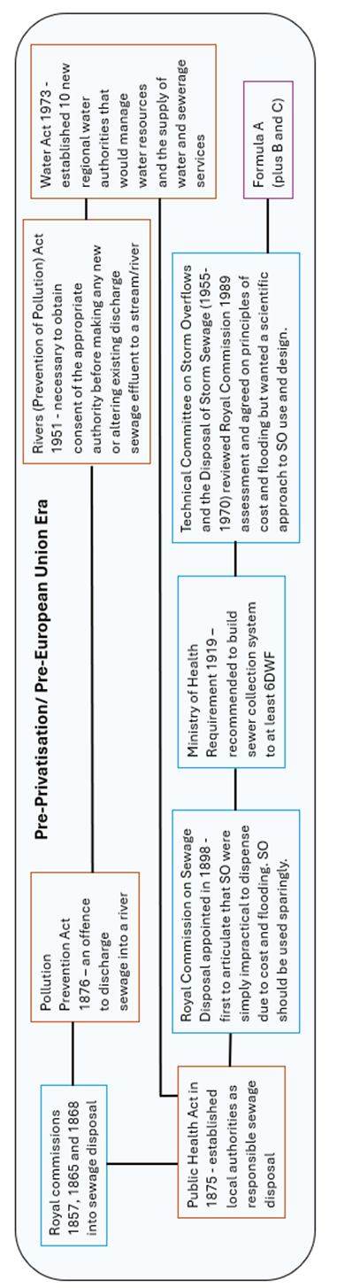
Figure 1 a: Diagram of key the thinking (blue), regulation and legislation (red; currently enforceable, dark orange; either replead or significantly altered) and methodology procedure (purple) for Storm Overflows in the Pre-Privatisation/ Pre European Union Era. Black lines indicated where the author see linkages.
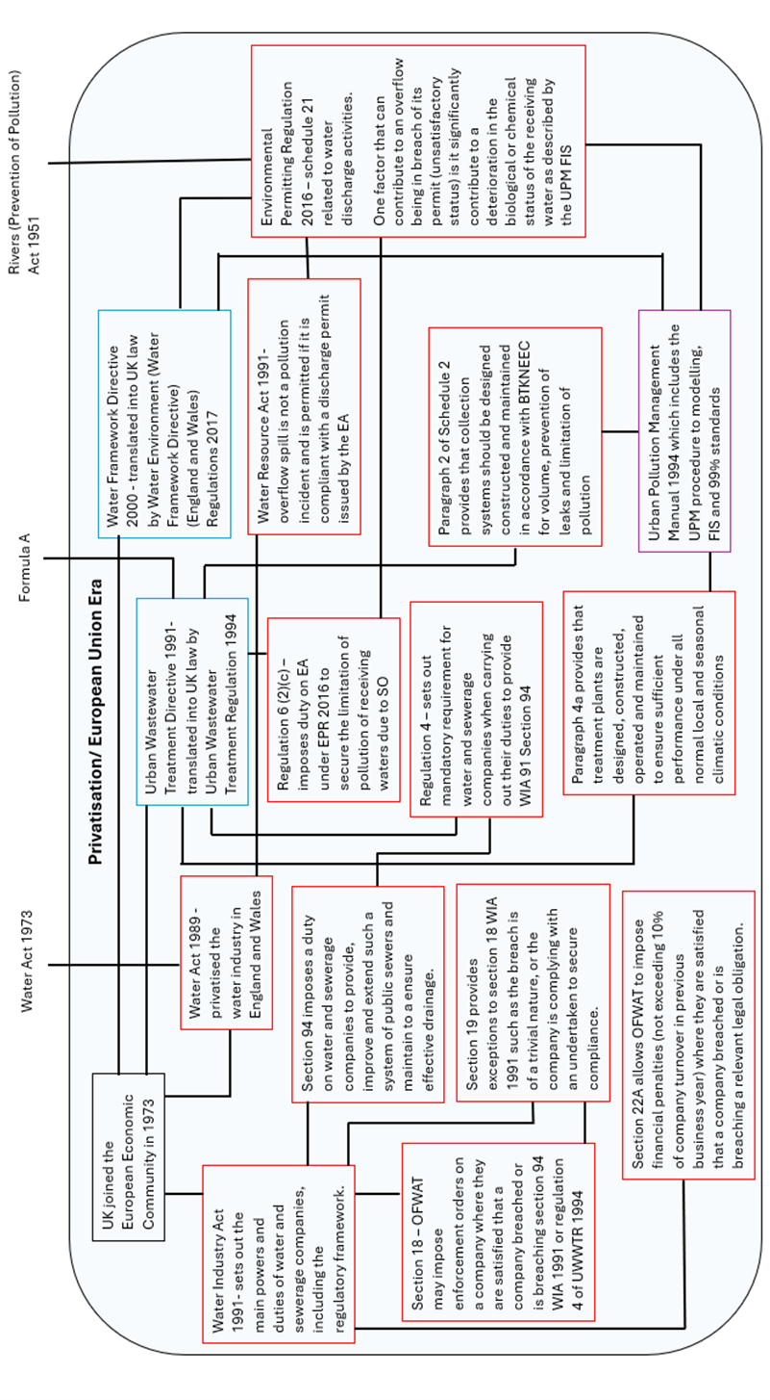
Figure 1 b: Diagram of key the thinking (blue), regulation and legislation (red; currently enforceable, dark orange; either replead or significantly altered) and methodology procedure (purple) for Storm Overflows in the Privatisation/ European Union Era. Black lines indicated where the author see linkages.
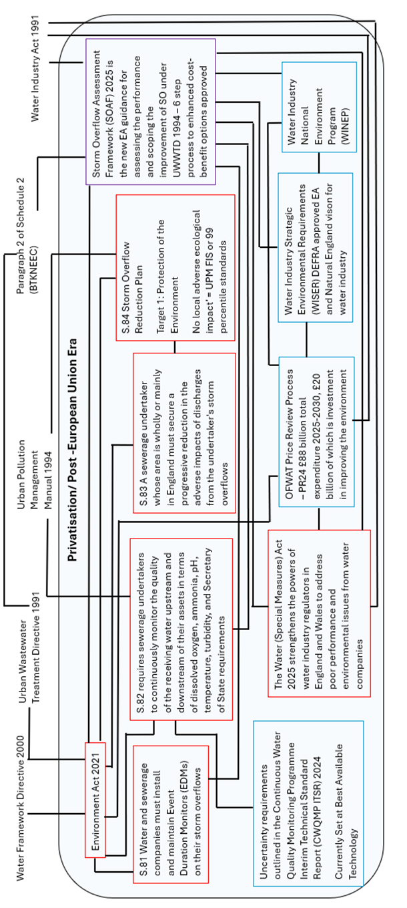
Figure 1 c: Diagram of key the thinking (blue), regulation and legislation (red; currently enforceable, dark orange; either replead or significantly altered) and methodology procedure (purple) for Storm Overflows in the Privatisation/ Post-European Union Era. Black lines indicated where the author see linkages.

Figure 1 b: Diagram of key the thinking (blue), regulation and legislation (red; currently enforceable, dark orange; either replead or significantly altered) and methodology procedure (purple) for Storm Overflows in the Privatisation/ European Union Era. Black lines indicated where the author see linkages.
2.6.1 Pre-Privatisation/ Pre-European Union Era
Often documents that explain role of SO (see Institute Civil Engineering, 2023) will start with the sentiment that SO are a Victorian invention. Much of the UK sewer system was expanded on in the early to mid-20th century, so it important to note that the actual age of many SOs is not Victorian. It is the beginning of the thinking around SO that is Victorian. Much of that thinking took places as royal commissions into sewage treatment and disposal. The first few (in 1857,1865 and 1868) identified numerous problems with the collection, transportation and disposal of sewage (Ministry of Housing and Local Government, 1970). It was around this time sewage was begging to linked to health problems such as the breakout of cholera in London in 1857 discovered by Sir John Snow (McLeod, 2000). The publication of the reports from these various commissions was followed by the passing of the Public Health Act (1875) and the River Pollution Prevention Act (1876). Both which are fundamental starting points for understanding today’s relationship between sanitation, the environment and public health.
The Public Health Act of 1875, regarding sanitation, established local authorities as responsible for providing clean water, sewage disposal and connecting homes to the main sewerage system. This firstly established the practice that the public should have the right to such services of sanitation and if deemed unsatisfactory or inadequate, an organisational body of whom they can ask to be accountable (Ramunno & Gardner, 2022).
The Rivers Pollution Prevention Act 1876 was the first national legislation in the UK to address river pollution, including prohibiting the discharge of sewage into streams and rivers. Often regarded as ineffective due to a lack of clear definitions resulted in an inability to enforce the Act (Lu et al., 2023). Nevertheless, its existence and intent, disproves a notion that environmental concerns of the water industry is a late 20th century or early 21st century phenomenon. It also the start of a trend in UK ambition for environmental protection from water industry surpassing its technical ability, in this case agreed definitions, to achieve said ambition. The Rivers Pollution Prevention Act 1876 was succeeded by Rivers (Prevention of Pollution) Act (1951) where it became necessary to obtain consent of the appropriate authority before making any new or altering existing discharge sewage effluent to a stream. Therefore, relaxing of the rule, from no discharges to agreed permitted discharges, which legitimises the uses of SO. But possibly more consequentially it indicates a shift in approach towards the problem. Where the Act in 1876 protected rivers by a blanket rule, it may cause harm, so it is prohibited; the act in 1951 protected rivers by acquiring knowledge of events happening and used acquired knowledge to prohibit excessive use of the rivers. Additionally in granting consent the boards were empowered to impose conditions. This is essentially the precursors to the Environment Agency (EA) role of setting conditions for environmental permits of SO in today’s regulatory landscape.
Regarding the use of SO, it was the final royal commission of 1898, which is most consequential for it was these reports that SO were specifically discussed. This commission reports were the first to articulate the now long holding view that SO were simply impractical to dispense of altogether (The Royal Commission on Sewage Disposal, 1915). The primal reasoning behind this conclusion was quoted as the combining factors of cost and flooding. It was believed, even then, that the cost of building the necessary sewers to convey all flows to the final point of disposal would have been prohibitive and therefore if one accepts the possibility of excess flows, one must insure there are mechanisms in place to ensure that these flows do not cause flooding in undesirable places. This underlines firstly the importance economic decision making has always played in the role of SO in sewage collection and treatment, as well as the fundamental belief that the primitive role of SO is the protection of public health. This thinking was re-examined by the Technical Committee on Storm Overflows between 1950 and 1971, but they came to the same conclusion (Ministry of Housing and Local Government, 1970).
The royal commission 1898 went on to express that SO should be used sparingly and should not come into operation until the flow was several times the maximum normal flow (The Royal Commission on Sewage Disposal, 1915). The report went on to state that no general rule could be given but the general principle should be to prevent such an amount of unpurified sewage from passing over the overflow as it would cause a nuisance (The Royal Commission on Sewage Disposal, 1915). Whereas this is a good sentiment the inability to provide a rule undermines its usefulness in practice. Again, the ambition of environmental protection is undermined by the technical understanding to execute it. By 1971 Formula A was proposed as a more environmental focused approach to SO than simply using dry-weather flow to identify the appropriate level discharges (Ministry of Housing and Local Government, 1970). What is important to note is that it took over 70 years for a formula bases on scientific understanding to be created, and in that time the sewer system in the UK was rapidly expanded.
2.6.2 Privatisation/ European Union Era
2.6.2.1 Privatization and regulators
When the UK joined the European Economic Community in 1973, they were the subject to adhere to regulatory directives set by the block. For instance, the European Commission (EC 1976) (76/464/EEC) set limit values for member states which must not be exceeded for the various dangerous substances discharged into the aquatic environment. Each member state is obliged to enact the requirements of the directive through appropriate local legislation. These external directives highlighted numerous aspects of the UK water industry which required improving to meet EEC directives. Poor environmental standards and the cost to align with EU directives is often quoted as one of the reasons why the UK privatised water companies in England under the Water Act 1989 (Owen, 2024) There was an expectation that private water companies would be invest private capital to improve water quality.
In privatising the water industry Water Industry Act (1991) sets out the main powers and duties of water and sewerage companies, including that of the regulatory framework in which they were to work within. That regulatory framework is there would be two bodies who regulate: an environmental regulator, originally the National Rivers Authority, later the Environment Agency (EA) whom would be concerned with water quality and resources; and a financial regulator, originally the Director General of Water Services, later Office for Water Services (OFWAT) concerned for consumer protection and competition. Section 94 of the Act imposes a duty on water and sewerage companies to provide, improve and extend such a system of public sewers and maintain to a ensure effective drainage. Section 18 of the Act then allows OFWAT to impose enforcement orders on a company where they are satisfied that a company breached or is breaching section 94 WIA 1991 or regulation 4 of Urban Wastewater Treatment Regulation (1994) (see below). Additional, Section 22A of the Act allows OFWAT also to impose financial penalties (not exceeding 10% of company turnover in previous business year) where they are satisfied that a company breached or is breaching a relevant legal obligation. Section 18 and section 22A together provide quite substantial financial deterrent for water companies to aspire to comply with section 94.
For the environmental regulator the Water Resources Act (1991) which provide the main framework in which to regulate the water industry. The Water Resources Act (1991) ruled that an overflow spill is not a pollution incident and is permitted if it is compliant with a discharge permit issued by EA. The most current regulation to environmental permitting is the Environmental Permitting Regulation (2016) in which schedule 21 related to water discharge activities. When issuing such permits the EA applies water quality design standards for all new, improved or altered storm overflows. As part of the permit, it is required for water companies to classify each SO as satisfactory, substandard or unsatisfactory. Satisfactory overflows meet both the environmental and modern engineering standards for SO structures and have sufficient capacity. Substandard overflows satisfactory in terms of environmental impact currently, nonetheless, do not meet modern standards of engineering and aesthetic control. Whereas unsatisfactory operate in dry weather flow or contribute to the failure of environmental standards. If an overflow becomes unsatisfactory the EA can review the SO’s permit or take enforcement action against the water company. The prevention of SO becoming unsatisfactory outlines the extent of work required on the environmental front that will be assessed by the EA sufficient in the water company meeting its demands for environmental protection.
2.6.2.2. European Union and EU Directives
In this period environmental regulations were determined via European Directives. This means that the discerning around priorities and objectives set around the European aims of direction, but it was for each individual country to interpret EU directive and transcribe these into legislation, regulation, and standards to be measured against. Hence each country, including the England and Wales, could decide its level of lenience it wished to apply in its approach to achieving adherence to the directive.
A major EEC directive relating to SO, and river pollution was the Urban Wastewater Directive (UWWTD) (91/271/EEC), put into UK regulation by Urban Wastewater Treatment Regulation (UUWTR) (1994). The UWWTD aimed "to protect the environment from the adverse effects of urban wastewater discharges and discharges from certain industrial sectors" by mandating wastewater collection and treatment in urban populations of over 2000 according to best technical knowledge not exceeding excessive costs (BTKNEEC). The UWWTR supplement the Water Industry Act (1991) section 94. BTKNEEC continues the notion set out by the royal commission 1898, that cost of sewage collection, distribution and treatment should not be prohibitive in nature, but now it includes the idea of ‘best technical knowledge’ (BTK). Its should be noted that BTK is not the same as best available technology (BAT). BTK may include the use of BAT, but it is broader concept that encapsulates the implications of using certain technologies in approaching the problem, in this case environmental harm. However, where that understanding of using different technologies is absent, BAT is often used as a substitute for BTK.
Another key directive for SO is Water Framework Directive (WFD) (EU, 2000). The primal aspiration behind the WFD implementation in 2000 was to reverse the damage of pollution on the ecology of waterbodies and maintain that improvement across Europe (Hampson et al., 2017). The WFD has been argued to be one of the most ambitious pieces of EU environmental protection legislation, particularly in the field of water management (Fritsch et al., 2017). WFD has a number of key objectives fundamental to its underlying principle to improve the ecological status of water bodies within a catchment. The first objective being to unite and streamline current legislation and make it more cohesive across Europe (Phillips, 2014). The second objective was that it expanded the scope of water protection to all waterbodies, including groundwater, within the catchment (Hannigan et al., 2016). This aim relates to the theory of connectivity within hydrological systems (see Bracken et al., 2013). Polluted water can be propagated throughout the hydrological system and not all areas have the same sensitivity to pollution disturbances (Orlikowski et al., 2011).
The WFD established the classifications of ‘good chemical and ecological’ status, dividing all waterbodies into two categories; those that achieved ‘good chemical and ecological’ status’ and those that do not. Good ecological status is determined by assessing the overall ecosystems health, expressed by firstly biological quality elements (such as fish, fauna, phytoplankton, other living organicism), but also assessments of hydro-morphology (such as the physical structure of the water course, the water level, the eroding power, rate of sediment transfer), and the physicochemical parameters, (such as nutrients, oxygen condition, temperature, transparency, salinity). In many ways the hydro-morphological and physicochemical are seen as supporting indications of the biological quality elements of the ability to support life. The WFD is clear in in assessment to assess the overall health, a range of parameter should be considered. One of the reasons why is the fact that ecosystems are complex systems which operates on multiple scales both spatially and temporally where features are interconnected with other parameters. Another reason for multiple the consideration of multiple parameters there are difference sources, such as agricultural, industrial and urban runoff, which can impact river health. The classification system of the WFD works on a one-out, all out system, where if one quality element fails to meet a satisfactory level, the overall waterbody loses it good ecological status. Good chemical status, referred to the quality of the water in terms of chemical composition of water and is assessed against standards for priority substances listed.
There are a few other key EU Directive which are considered important in relation the management of SO. These include the Habitats Directive, Flooding Directive and the Bathing Water Directive. The Habitat directive overall aim it to ensure that species and habitat types are maintained, or restored, to a favourable conservation status. The flooding Directive aims to reduce and manage the risks of flooding in four main areas: human health, the environment, cultural heritage, and economic activity. The Bathing Water Directive is the directive to monitor and assess bathing water. This was the directive which is most associated with public health from public recreational activities such as wild swimming. EU bathing water legislation specifies that designated bathing water quality can be classified as 'excellent', 'good', 'sufficient' or 'poor', depending on the levels of faecal bacteria detected. Where none these directives are directly linked to environmental concerns of SO, they do contribute to the narrative around SO.
2.6.2.3 Urban Pollution Management Manual
At the time the UK released a Guidance Note to accompany the UUWTD regulation, which for intermittent discharges related back to the AMP2 Guidelines entitled Framework for the Consenting Intermittent Discharges (FWR, 1994). The AMP2 Guidelines recognised a number of planning procedures for consenting intermittent discharges to freshwater, the most prominent of which was approach based upon intermittent river quality standards, which was taken forward by the Urban Pollution Management (UPM) Manual (FWR, 1994). Regarding the issue intermittent discharges effect on environment raised by the UWWTD the UK approach was combination of using Formula A to determine Pass Forward Flow and UPM procedure to understand discharge impacts.
The primary purpose of the UPM Manual is to assist practitioners in the UK to develop cost -effective strategies to urban pollution management problems through the assistance of new tools and procedures (FWR, 1994). The importance of the concept of cost-effectiveness should not be underestimated when considering the UPM, as it produced in tangent to the UWWTD. Some of these tool and procedures were developed the UPM Research program and hence became the current best technical knowledge on the subject. The UPM claimed that using its tools and procedures should result in overall cost savings, as the tools allows a better understanding of the ‘true’ cause and extent of pollution, resulting in more focused solutions adopted with confidence (FWR, 1994). It also claims that as they procedure is founded on a single set of environmental standards which can be applied to simple or complex modelling, there will be greater consistency in UPM strategies both regionally and nationally.
The environmental standards outlined by UPM manual are Fundamental Intermittent Standards (FIS), and 99 percentile standards (FWR, 1994). FIS is a concentration-duration-frequency based criteria, with the duration periods of 1 hour, 6 hours and 24 hours and the return periods of 1 month, 3 months and 12 months. It was based on ecotoxicological research was carried out between 1987 and 1992, reported in a National Rivers Authority Report (Milne et al. 1992). This work investigated the relative importance of concentration, duration and frequency of low dissolved oxygen and elevated unionised ammonia has on the ability for fish to reproduce, which is prevented when either the fish has died or there has been considerable damaged its reproductive organisms. FIS takes the point of inability to reproduce as representative of the point as which there has been a consequence to the discharge. As it works found that the point at which damage occurs to the fish is dependent on the other conditions of the system FIS has dynamic threshold outlined in Appendix A of the UPM manual (FWR, 2018).
FIS works on the basis that low dissolved oxygen and elevated unionised ammonia is toxic for fish. Fish sensitivity to low dissolved oxygen varies by species, life stage (egg, larve, adult), life process and current activity. Fish can escape hypoxia (low dissolved oxygen) by actively searching for well oxygenated area, however most freshwater fish will have drastically diminished swimming ability and skill when exposed to hypoxic conditions due to high metabolic cost of aerobically propelled swimming (Jones, 1971; Herbet & Steffensen, 2005). The concentration can impact the metabolic rate and nutrient absorption rate in fish, impacting growth rate (Boeck et al., 2013). Stress of hypoxia can damage the immune system, make fish more susceptible to disease (Wang et al., 2018). During hypoxia fish usually maintain oxygen intake by increasing gill ventilation, but this can increase blood pressure leading to the possibility of heart-stoke (Stecyk et al., 2004). Reduced DO can affect growth and development in eggs and by modifying the embryo incubation duration it can affect the survival rates (Agbehadzi et al., 2024). Hypoxia can modify courtship behaviours and mate choice, as well as inhibiting testicular and ovarian development reducing fertilisation rate (Hoo et al., 2016).
Ammonia is a by-product of the protein metabolism and is primarily excreted across the gill membrane with a small proportion excreted by urine (Weihrauch et al., 2009). Therefore, any ambient unionised ammonia in the ambient water can cross due to pressure diffusion into the fish though the gill membrane and once inside converts to ionised form which causes cellular damage (Xu et al., 2021). Ammonia may be acutely toxic to fish through it effect on the central nervous system (Randall & Tsui, 2002). Acute toxicity susceptibility to ammonia varies by life stage, decreasing from sac to juvenile and increasing again with age after juvenile stage (Zimmer et al., 2017). If exposed in sac stage, there may be delayed development of the ability to swim. Successive exposure to ammonia, particularly in the recovery period which last the length of time for excrete excess ammonia from the body, could cause additional stress on the fish (FWR, 1994).
As the UPM Manual (FWR, 1994), and hence FIS, was created in the mid-90s and therefore it predates WFD which was implemented in the year 2000. Thus, it was simply assumed to begin with, partly because of its scientific origins, that FIS was sufficient in defining good ecological status under WFD. This was dependent on the results of a pending review to scrutinise this assumption in more detail. That review was published in 2012, titled; Review of urban pollution management standards against WFD requirements (Environment Agency, 2012). It concluded that UPM FIS are “fit for purpose” and no modifications were required with respect to the WFD. Firstly, the standards were demonstrated to provide protection to all life-stages of all aquatic life (plants, invertebrates and fish) associated with the specified ecosystem type. Secondly, for most concentrations, durations and frequency combinations, the standards provide a margin of safety between 5-463% (Environment Agency, 2012). The boxes that are yellow are standards where there is less than a 5% margin of safety, and the boxes that are green provided more than 5% margin of safety. The largest margin of safety applied is 463%. Therefore, meeting FIS, should result in no long-term behavioural or physiological effects and no short-term fish and macroinvertebrate mortality. This therefore satisfies WFD requirements to ensure that the existing good quality status of a water body is not compromised by intermittent discharges from the wastewater systems network.
2.6.3 Privatisation/ Post -European Union Era
With the UK leaving the EU in 2020, the idea that direction of sewer collection, distribution and treatment is dictated by EU Directives for the UK is no longer applicable. Hence new legislation in the form of the Environment Act 2021 (UK Government, 2021) was introduced. Nevertheless, the old directive that had been transcribed into the law are still in place and the system is still privatised, so the regulatory set has remained the same. Statutory obligations arise from legislation requirements and need to comply with obligations imposed directly by the statue or by the permits/licences granted by the secretary of state, the EA or other body of jurisdiction. Statutory obligations must be applied to regardless of the cost-benefit analysis. The Environment Act 2021 therefore is statutory obligation.
Statutory plus obligations are categorised as legal requirements where evidence form part of the decision-making process and in cases where actions are considered disproportionately expensive compared to the environmental benefits, alternative objectives or timeline may be considered. An example of this would be UWWTR, where not exceeding excessive costs is part of the legal obligation. Non-Statutory requirements are expectations that are not driven by statutory requirements. This may be a customer desire that is not underpin by a specific Act. In case of the Water Companies, to pursue such a scheme they must show customer support and that such an investment will provide best value for customers over the long time. However, there is an expectation that water companies will pursue a range of non-statutory agendas alongside any statuary or statutory plus obligations (DEFRA, 2022).
In the Environment Act 2021 government introduced a requirement for sewage undertakers to monitor sewage assets (s.81; Event-duration monitoring) and the impact on their local environment (s.82; Water Quality monitoring). It is expected that both the Event-duration monitoring (EDM) and Water Quality monitoring (WQM) will be published to the data within 1-hour of the operation. It is noted that these stipulations are to ‘place a renewed focus on monitoring’ and ‘increase public transparency of those impacts’ (DEFRA, 2023b)).
2.6.3.1 Environment Act Section 81
EDM measures the start and end of an operation of SO. Before to 2013 EDM, was targeted at shellfish and bathing waters. Since 2013, water companies were instructed to cover comprehensively across the network. As of 2023 there 100% coverage at all actable sites (DEFRA, 2023c). There are three types of sensors that can be used for EDM; Ultrasonic, Pressure and Float. Misting and condensation can be an issue of ultrasonic devices, whereas float systems need to be located away from areas where fouling could occur (CIWEM, 2016). EDM data can either record changes in state from not spilling to spilling or produces trended datasets such as recording level at set frequency timescale.
2.6.3.2 Environment Act Section 82
In section 82 of the Environment Act 2021 there is a duty to monitor the water quality impacts of the discharges on receiving watercourses. It is required to measure the parameters of:
- Levels of Dissolved Oxygen
- Temperature
- pH values
- Levels of Ammonia
- Anything else specified in regulation made by the Secretary of State
In the technical guidance produced by DEFRA (2023b) there are four objectives for section 82:
- To quantify the water quality impacts of a discharge
- To increase the stakeholder and public understanding of the impacts of a discharge
- To inform the sewage undertakers improvement programmes to meet SODRP
- To inform regulatory action
In order to meet these the first objective, the monitoring firstly must be linked to regulatory standards. The regulatory standards chosen to inform on continuous monitoring program is the UPM FIS. UPM FIS was preferred over other less focused alternatives such as WFD due the fact that they were designed with the specific desire to measure impact at SO. Next the data must be attributed to a targeted asset. This is why the majority of assets are expected to have a monitoring site both upstream and downstream of a particular asset. It is recognised that in certain environments such as urban area there may be assets discharging at relatively close proximity. This may cause issue for monitoring programmes, as the data from the downstream location may be impacted by other assets. Thus, clustering of location may need to occur, where the downstream data shows cumulative impact. Though this approach is looked unfavourably on, and where possible each asset should have its own monitoring program. Any watercourse with a year-round permanent depth of below 4 cm throughout the permissible distance to the optimum measuring point does not need to be monitored as the technology will not produce reliable results in such conditions DEFRA (2023b).
For the monitoring to be considered continuous requires the monitor to measure at regulatory intervals. For the water quality measurements, it is proposed at 1-hour intervals, expect at high-risk periods where 15 minutes intervals have been proposed DEFRA (2023b). High risk has been described as either duration the operation of a SO (refer to the EDM data) and during anything that would affect the water quality of the final discharge. Once either of these conditions are met, the 15-minute intervals frequency is to remain in place for 24 hours. If rainfall is considered as a trigger for the high-risk 15-minuite intervals frequency (as it would affects the water quality of the final discharge), it is possible that some locations in England in the winter months may never leave the condition of being high-risk. The reason why the condition of high risk, is primarily to allow a more detailed understanding of time where is likely that UPM FIS exceedance may occur, but in other time to reduce instrument wear and maintenance programs.
2.6.3.3 Environment Act Section 83
Section 83 of the Environment Act 2021 aims to progressively reduce the negative effects of their SO discharges, specifically on both the environment and public health. The section emphasizes a progressive and ongoing reduction in these adverse impacts, rather than a one-time fix. This approach currently contradicts the funding set up water industry in which OFWAT promotes funding to only be allocated to each asset once. In terms of the environments, one way proposed to show this reduction in harm is to show reduced number of UPM FIS exceedance counts. However, there is a theoretical limit to which exceedance counts can be reduced, as negative exceedance counts are impossible. As it is stated in section 83 that this is enforceable by the Secretary of State or an Authority with the consent Secretary of State, it is believed that once the conditions are meet in section 84 of the act (a report written by Secretary of State) no more progressive reduction in harm will be required. But that is not stated in section 83.
2.6.3.4 Environment Act Section 84
Section 84 of the Environment Act 2021 requires the Secretary of State to prepare a report actions to be taken to eliminate SO discharges and the costs and benefits of those actions. This report was produced in 2023 as the Storm Overflow Discharge Reduction Plan (SODRP) (DEFRA 2023a). The government have set the deadline of 2027 to review the repot. In the SODRP it states by 2035, water companies will have improved all SO discharging near bathing waters and 75% of SO discharging by high priority sites. By 2050 no SO will be authorised to operate outsides of unusually heavy rainfall or cause ecological harm. The SODPR sets out three official targets:
- Protecting the environment.
Water companies will only be permitted to discharge SO where they can demonstrate no local ecological impact. In the appendix of the report it states that no ecological impact is equivalent to achieving UPM FIS or 99 percentile standards for DO and Ammonia at the downstream location. These standards apply to inland waters.
- Protecting public health in designated bathing waters
Water companies must significantly reduce harmful pathogens by applying disinfection or reducing the frequency of discharges.
- Ensuring SO operate only in unusually heavy rainfall events
SO are only permitted to discharge in a maximum of 10 rainfall events per year by 2050. This target is meant to act as backstop to the other two targets.
There is forth acknowledgement in the report that water companies are required to ensure all SO have screening controls. This is however not an official target in the report.
2.6.3.5 EA approach to SO
There are five main pills at the moment where the EA is concern with the use of SO. The firs one is still (as stated in the previous section) the use of Environmental permit, with conditions on the extent of their use. The next one is collecting from the water companies the EDM data , which is on condition of the environmental permits.
The next is the Storm Overflow Assessment Framework (SOAF) (Environment Agency, 2025) , which is the EA guidance for assessing the performance and required improvements of SO under UWWTR. Therefore, it promotes the idea of BTKNEEC while using the new available data under the Environment Act 2021. It applies to water companies in England. Currently, SOAF follows a 5-step program from data to solution, detailed below:
- Spill frequency triggers investigation
- Level of environmental impact quantified
- Improvement options Assessed, including a cost-benefit analysis.
- Decision made using cost-benefit analysis.
- Delivery of BTKNEEC solution, subject to funding, to reduced environmental harm and spill frequency.
The SOAF investigation process is expected to be conducted outside of WINEP, but there is an acceptance that future investigations may be included under Water Industry National Environment Program (WINEP).
The primary role of WINEP is to provide information to water companies on the actions they need to take to meet the environmental legislation requirements that apply to water companies in England (Environment Agency, 2022a). The WINEP program between 2020 and 2025 delt with £5.2 billon of asset improvements, investigations, monitoring and catchment interventions Environment Agency, 2022a). It is expected of the EA to prove that WINEP provides benefit to environment for every pound invested by the water companies. However, the water sectors environmental expenditure is greater than the WINEP outcomes, due to expenditure on maintenance.
The last Water Investment Strategic Environmental Requirements (WISER) are organised around EA and Natural England vison for water Industry (Environment Agency, 2022b):
- A thriving natural environment which will increase environmental value, healthy rivers and sustainable functioning eco-systems.
- Performance and compliance, resulting in acts in the long-term interest of society and excellent day-to-day service for customers
- Resilience for the environment and customers to ensure safe and affordable water and wastewater services for today and future generations.
2.6.3.6 OFWAT approach to SO
Every five years Ofwat requires each water company in England and Wales to produce a business plan explaining it proposes plans. Current Price Review 24 (PR24) has allowed £88 billion in total expenditure for the period 2025-2030, £20 billion of which has to set specifically for £20 billion (OFWAT, 2025). OFWAT will support more than 2500 project related to reducing spills from SO. Simultaneously Ofwat in PR24 to claimed to have removed £16 billion for inefficiencies of proposed spending from companies (OFWAT, 2025). It also claims that it bills are expected raise by £19 per year before inflation which is £44 lower than proposed (OFWAT, 2025).
Chapter 3.1: Uncertainty in determining Fundamental Intermittent Standards exceedance counts for intermittent discharges
This chapter is based on a paper submitted and under review to CIWEM Water and Environment Journal. The first author is Philippa Mohan (candidate). The co-authors include Dr Alma Schellart, Professor Simon Tait and Professor Chris Digman.
    - Abstract
The Storm Overflow Discharge Reduction Plan definition of ‘no local adverse ecological impact’ caused by intermittent discharges from storm sewer overflows are described in the Urban Pollution Management Manual in the form of the Fundamental Intermittent Standards. The aim of the S.82 Environment Act of 2021 monitoring program is to allow sewerage undertakers to assess the impact of intermittent discharges on the receiving watercourse using monitored data. Data from any monitor contains uncertainty. The aim of this work is to consider the impact of both data uncertainty associated with the monitoring and parameter uncertainty associated with the data processing on determining Fundamental Intermittent Standards exceedance counts. This work finds that both data uncertainty for Dissolved Oxygen (DO) and Total Ammonia (TA) as well as parameter uncertainty associated with Unionised Ammonia (UA) can, at certain locations, affect exceedance counts considerably. This has significant consequences in determining environmental harm caused by the spills from SOs.
    - Introduction
The Storm Overflow Discharge Reduction Plan definition of ‘no local adverse ecological impact’ in relation to intermittent discharges from Storm Overflows (SOs) are described in the Urban Pollution Management (UPM) Manual (FWR, 2018) in the form of the Fundamental Intermittent Standards (FIS) and 99 percentiles standards. This study will look into the uncertainty of determining FIS exceedances and compliance failures when using continuous water quality data obtained using instrumentation commonly used by UK water companies in receiving waters to measure particular water parameters determined by regulation.
FIS works on a binary basis; pass or fail once the frequency of the exceedance count for a particular return period is surpassed. These standards have been accepted by the Environment Agency in England as providing evidence that a river is not of ‘good ecological status’ as defined under the EU Water Framework Directive (EA, 2012).
In the UK, investigations regarding receiving water quality in UPM studies have been carried out through modelling approaches, with data collection only supporting the verification of the modelling tools. Recently, however, the attention is shifting from utilising modelling tools to collection of data that is to be directly used to test compliance. This logic follows the current practice of reporting SO spill frequency performance using collected Event Duration Monitoring (EDM) data rather than using predictions from simulations.
The most recent legislation concerning the discharge of sewage into receiving watercourses in England and Wales is the Environment Act of 2021 (UK Government, 2021). Section 82 of the Environment Act of 2021 requires the continuous monitoring of the specified water quality parameters in the receiving water upstream and downstream of an overflow. This in combination with section 81, which stipulates storm overflow discharges in England must be reported in the form of Event Duration Monitoring, is an enormous digitalisation of both the sewer and river networks in England. England and Wales are not the only countries to call for this digitalisation; the new Urban Wastewater Treatment Directive (EU, 2024) also calls for EU member states to monitor nutrients of treated and untreated discharges, though not continuously as in England and Wales.
The aim of the S.82 Environment Act of 2021 monitoring program is to allow sewerage undertakers to assess the impact of intermittent discharges on the receiving watercourse, with the FIS being used to determine “environmental harm”. Hence the Act requires the monitoring of pH, temperature, turbidity, dissolved oxygen (DO) and total ammonia (TA) at a sampling timestep of 15 minutes at high-risk times or otherwise a timestep of 1 hour is permissible. There will be few exemptions for technical reasons but the vast majority of SOs are obliged to have an in-situ continuous, receiving water quality monitoring program. It is expected that total rollout should be completed by 2035 with up to 40% completed by the end of AMP8 in 2030.
Data from any monitor contains uncertainty. Sensors installed to measure concentration of various parameters have uncertainty levels. This can sometimes be reported as sensor accuracy which can be defined as the deviation from the measured sensor value to the true parameter value (ISO, 2009). In this paper, this will be referred to as ‘data uncertainty’. Uncertainties in the measured input data are generally caused by systematic and/or random errors and depending on the sensing methodology used in the sensor, the sensor will have different capabilities and introduce uncertainty in different ways (Delectic et al., 2012). While uncertainty can be reduced, it cannot be eliminated. Uncertainty can also be introduced if measured data is converted into other forms using empirical relationships, for example when converting TA measurements to Unionised Ammonia (UA) concentration values. Here the level of uncertainty is related to how well these relationships describe the physical processes, or how well parameters were originally fitted in the regression equations. This is another type of uncertainty, called ‘parameter uncertainty’ in this paper.
The impacts of data and parameter uncertainty are currently ignored. DEFRA’s Interim Technical Standard on the Continuous Water Quality Programme (DEFRA, 2024) sets out guidance on minimum sensor accuracy requirements, and also provides some guidance on verification of errors or gaps in the dataset. A maximum acceptable uncertainty range is provided, which appears to be current best available technology (BET), but the guidance does not specifically state any reasons as to why this range is selected. The Interim Technical Standard furthermore acknowledges sensors will have different error bounds, and states that “When comparing the calculated [unionised] ammonia concentrations and the measured dissolved oxygen concentrations to the UPM FIS and 99 percentile standards, the error bounds in both values should be considered” (DEFRA, 2024, pp.14). However, no guidance is provided as to how these error bounds should be considered. There is also no information or guidance on what the FIS implications of these error bounds, or the minimum sensor requirements, can be when determining compliance with FIS and investigating the overall impact on defining environmental harm associated with an intermittent SO discharge.
This paper therefore looks at how considering data and parameter uncertainty would alter the determination of environmental harm at numerous sites for which continuous water quality data is available. The impact of both data uncertainty and parameter uncertainty will be explored. The paper aims to systematically quantify FIS compliance under data and parameter uncertainty and investigate whether or not conducting uncertainty analysis is necessary when assessing compliance with FIS.

3.1.3 Methodology
3.1.3.1 Water Quality Data Used in this Study
At 41 locations, within two geographical areas in the North of England, sets of continuous water quality data were obtained from two English water companies. In one of the areas, data was available from 19 locations in four rivers, collected between September 2019 and September 2020. In the other geographical area, data was available from 22 locations in three rivers, between April 2023 to September 2023. Both urban and rural locations were sampled. For each location, the water quality parameters measured were DO, ammonia (TA), pH and temperature. The measurements were made using multi-parameter sensors, sampling was continuous at a measurement interval of five minutes. On the rare instance when any sensor had failed to record a value, the data was linearly interpolated. All locations did have some missing data, but no location was found to have more than 0.05% data loss in the timeframe of the data collection.
For the FIS assessment, UA concentration values are calculated using the calibration relation described in Equation 1, based on an earlier Emerson et al. (1975) study into determining the relationship between ionised ammonia, pH and temperature:
UA (mg/L) = NH₄₊ (mg/L)/ (1+10 (10.055-(0.0324*Temperature(˚C))-pH)) Equation 1
This relationship is in widespread use in England and Wales and is outlined to be used while converting TA to UA in UPM schemes by the first addition of the UPM Appendix C (FWR, 1994)
3.1.3.2 Monitoring Data Uncertainty
Data uncertainty can be defined by considering the upper and lower sensor error bounds for DO, TA, pH and temperature as provided by the sensor manufacturer. It is assumed that the distribution of the data uncertainty can be described by a normal distribution. For this analysis, it was assumed that the mean of the distribution is the parameter value as recorded by the sensor, and the upper and lower sensor error bounds are as provided by the sensor manufacturer and are the equivalent of two standard deviations from the mean. Therefore, 95% of the ‘true’ values would fall within the sensor error bounds. This is in line with established literature on how to handle data uncertainty (see ISO, 2009; Delectic et al., 2012).
The upper and lower sensor error bounds for DO, TA, pH and temperature in the paper has been taken from the manufacturer’s accuracy specification for the sensors installed at the above locations (YSI Incorporated, 2012) and are reported in Table 1. It is believed that at time of installation (2018) these sensors were considered BAT. Whereas the manufacture uncertainties quoted in Table 1 are currently technically not considered BAT anymore, with sensors that are minorly better currently on the market (such as ±0.1 for DO in mg/L and temperature in degree Celsius), the uncertainties in Table 1 can still be seen as a good approximation of capabilities of in-situ sensors for the different water quality parameters. The uncertainties quoted in Table 1 were calculated in from lab conditions, however a supposably representative of field locations when sensor is placed in ideal conditions. In order to be used in the UK industry, the method for this uncertainty analysis must comply with standard to be fair representative of the capabilities in the field. Therefore, it can be assumed that some usual field conditions have been tested. Overall, the uncertainties in Table 1 must be taken as representative of sensors deployed, though most probably an underestimation of the ‘true’ uncertainty associated with the field in-situ data due to being developed in lab conditions.

Table 1: Manufacturer’s accuracy specification for the sensors used in the data collection (YSI Incorporated, 2012).
Sensor Specification | Accuracy
Dissolved Oxygen (DO) | ± 0.2 mg/L
Ammonium (TA) | ± 2.0 mg/L
pH | ±0.2
Temperature | ±0.15°C

As DO is measured directly the overall uncertainty for the FIS analysis can be taken from Table 1. UA has to be calculated from TA, pH and Temperature using the empirical equation (Equation 1) along with the manufacturer’s accuracy specification which is found in Table 1. By using the ± 2.0 mg/L uncertainty band for TA on the typically reported range of 0-4 mg/L, a value less than 2 mg/L would provide a negative value for TA. Negative values are physically impossible, and hence in this study the lower limit of the uncertainty bandwidth was considered to be 0 mg/L.
Parameter uncertainty can be defined as the uncertainty in the empirically fitted parameters in Equation 1.
3.1.3.3 Sensitivity Analysis
For the sensitivity analysis of the calculated UA, firstly the UA was calculated without considering any data or parameter uncertainty. This provides the benchmark to which other values including uncertainty could be compared against. This was done at each timestep for all 41 locations. Then for the data uncertainty, the manufacturer’s error bounds were split into 20 increments and then new datasets were calculated by either adding or subtracting the increment value to each timestep.
The values of 10.055 and 0.0324 in Equation 1, have been noted as Parameter A and Parameter B, respectively and these will be considered for parameter uncertainty analysis. For Parameter A and B, a range of ±15% of 10.055 and 0.0324 has been considered in the sensitivity analysis. For parameter uncertainty, the ±15% on Parameter A and B was split into 1% increments and then added or subtracted to the parameter in Equation 1. The UA was calculated at each timestep and for each increment, considering data uncertainty or parameter uncertainty.
3.1.3.4 FIS analysis
For the consideration of the data uncertainty, a Monte Carlo simulation of 500 runs was created, by picking random values from the normal distributions described in section 3.2 for DO, TA, pH and temperature at each timestep. Parameter uncertainty was set at 5% (after considering the sensitivity analysis; range of 9.55-10.55, explained in section 4.1).
The FIS analysis has been carried out using the methodology for sustainable salmonid fishery for both DO and UA as outlined in Urban Pollution Manual (FWR, 2018). The UPM calls for a 6-hour gap between exceedance counts, believed to be linked to the EA definition of separating rainfall events. However, as no rainfall data has been collected or considered during this work, this condition has been removed from the UPM-FIS procedure.
For data analysis the FIS procedure was first carried out on the dataset without considering uncertainty, and then data uncertainty was considered carrying out the FIS procedure on all 500 Monte Carlo runs for the DO and TA data uncertainty. Parameter uncertainty was considered by analysing FIS for parameter A -5%. The mode FIS exceedance count was found by identifying out of the 500 different exceedance counts produced which exceedance count values repeated the greatest number of times. This value was taken to be compared to the FIS exceedance count that did not consider uncertainty.
3.1.4. Results
3.1.4.1 Sensitivity Analysis
As DO is directly measured no sensitivity analysis has been carried out, the uncertainty band has been taken directly from the uncertainty reported by the manufacturer and then its impact on FIS exceedance count is reported in Section 4.2.1.
As UA is calculated based on other measurements, data and parameter uncertainty has to be considered individually to investigate their effect on the calculation of UA. The impact of both types of uncertainty on the impact on FIS exceedance count is reported in Section 4.2.2 and Section 4.2.3.
In Figure 2a the UA values have been plotted against percentage change in the data value as total ammonia, pH and temperature all have different units. Total ammonia percentage change is large, ranging between 300% to just over 700%. This is because the manufacturer’s error bounds can be large. The manufacturer’s error bounds in measured pH and temperature both relate to a percentage change in UA value of less than ±2%, so are difficult to observe given the vertical scale used in Figure 2a. The horizontal axis is unsymmetrical as it is impossible to remove more than 100% of the ammonia, but it is possible to add more than 100% of the ammonia.

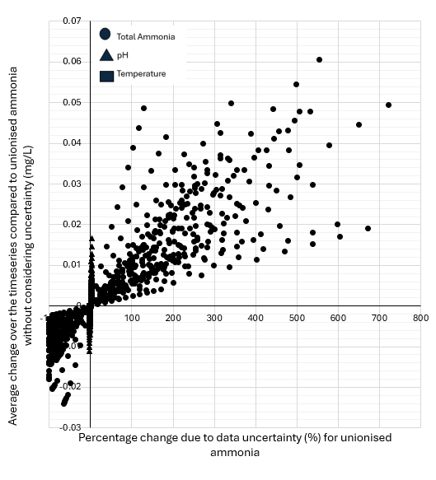

Figure 2a: The average change in UA values compared to UA values without data uncertainty data for all 41 locations, plotted against percentage change in the data value due to data uncertainty for UA.
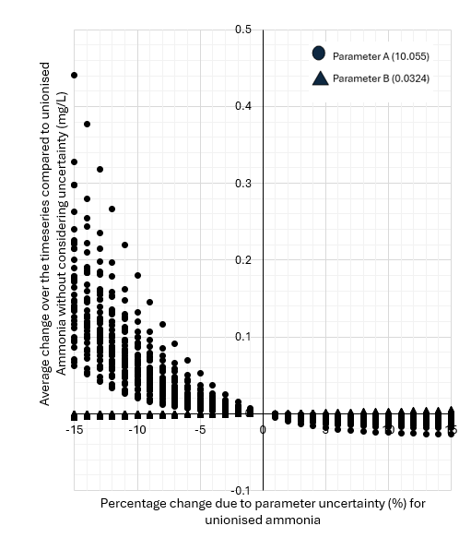
Figure 2b: The average change in UA values caused by the parameter uncertainty compared to UA values without uncertainty in all 41 locations, plotted against percentage change in parameter A and B due to parameter uncertainty in Equation 1.
In Figure 2b, the calculated UA values have been plotted against percentage change in the values of the Equation 1 calibration parameters A and B. Figure 2b shows that the UA values are much more sensitive to uncertainty in parameter A, however more prominently in the negative direction. It also shows that there is geographical difference in the effect of uncertainty parameter A on the UA value. Each curve, with different gradients, corresponds to a different location. There is no geographical pattern for uncertainty in parameter B. Uncertainty in parameter B always has a very limited effect on the calculated UA value.
Overall, the UA values are more sensitive to parameter uncertainty than data uncertainty and specifically to uncertainty in parameter A.

3.1.4.2 Impact of data and parameter uncertainty in DO and UA on the FIS exceedance count
3.1.4.2.1 Effect of Data uncertainty in the DO measurements on the DO FIS exceedance count
Table 2 shows that by considering data uncertainty, the mode DO FIS exceedance count shows a difference of between 1 to 4 exceedances at around 20-30% of locations for the 1 hour and 6 hours duration criteria. For a longer duration component of FIS, a decrease in the proportion of locations that are affected by the data uncertainty is seen. Hence the small frequent discharges intended to be reviewed by DO 1h1m exceedance count are most susceptible to data uncertainty in the DO measurements. However, even at the 1h1m FIS exceedance count, nearly 70% of locations FIS exceedance counts were not affected by considering data uncertainty. It should be noted that nearly all 100% of locations that originally reported a zero FIS exceedance count were in the no change category across the different durations and return periods, except for one location for the duration of 24 hours and the return periods of 3 and 12 months.
Table 2: When considering data uncertainty in DO measurements, a comparison of the proportion of the locations showing: no change in FIS exceedance count, a difference between 1 to 4 FIS exceedance counts, and a difference of more than 4 exceedance counts respectively.
Change in FIS Exceedance count | No change | A difference of 1 to 4 exceedances | A difference of greater than 4 exceedances
1h1m | 0.68 | 0.29 | 0.02
6h1m | 0.66 | 0.22 | 0.12
24h1m | 0.73 | 0.22 | 0.05
1h3m | 0.76 | 0.22 | 0.02
6h3m | 0.71 | 0.24 | 0.05
24h3m | 0.85 | 0.14 | 0.00
1h12m | 0.66 | 0.27 | 0.07
6h12m | 0.78 | 0.22 | 0.00
24h12m | 0.93 | 0.07 | 0.00

3.1.4.2.2 Effect of data uncertainty in the UA on UA FIS exceedance count
Table 3 shows that by considering data uncertainty in the measurements needed to calculate UA, only 15-30% of locations will see no change in reported FIS exceedance count. The majority of the locations that show no change in exceedance count, originally also reported an exceedance count of zero. Of the 30 locations that reported at least 1 exceedance count without considering uncertainty for the 6-hour duration, only 6 locations reported at least 1 exceedance count when considering uncertainty. Of the 24 locations that reported at least 1 exceedance count without considering uncertainty for the 24-hour duration, none reported at least 1 exceedance count when considering uncertainty. The inability to capture even the worst performing locations under a UPM study, means that the uncertainty bandwidth is too large to distinguish FIS count exceedances for the 6 hour and 24-hour duration thresholds.
Table 3: When considering data uncertainty in the measurements needed to calculate UA, a comparison of the proportion of locations showing: no change in FIS exceedance count, a difference between 1 to 4 FIS exceedance counts, and a difference of more than 4 exceedance counts respectively.
Change in FIS Exceedance count | No change | A difference of 1 to 4 exceedances | A difference of greater than 4 exceedances
1h1m | 0.17 | 0.29 | 0.54
6h1m | 0.27 | 0.27 | 0.46
24h1m | 0.44 | 0.22 | 0.34
1h3m | 0.17 | 0.29 | 0.54
6h3m | 0.29 | 0.24 | 0.44
24h3m | 0.51 | 0.22 | 0.27
1h12m | 0.15 | 0.26 | 0.58
6h12m | 0.29 | 0.27 | 0.44
24h12m | 0.56 | 0.26 | 0.20

3.1.4.2.3 Effect of parameter uncertainty A on UA FIS exceedance count
In this section, only the impact of parameter uncertainty related to parameter A for UA has been shown, as the impact of parameter B, was shown to be minimal, see Figure 2.
A 5% change in parameter A was considered pragmatic given the results of the sensitivity study reported in Fig 1b. Even at this estimation, there is considerable impact on FIS compliance estimations. With longer return periods the number of locations impacted decreases, whereas the number of locations impacted increases with longer duration (Table 4). The largest impact is on the largest return period and shortest duration (24h1m) discharges where almost 80% of locations had a FIS exceedances increase by over 4. Alternatively, it is the small infrequent (1h12m) discharges that are least impacted, where just over 80% of locations show no change. One of the largest differences, however, between the effect of data uncertainty and parameter uncertainty is the effect on locations that without considering uncertainty report a zero FIS exceedance count. Whereas data uncertainty does not affect these locations particularly, parameter uncertainty does. Just 17% of locations which reported a zero FIS exceedance count for the 1h1m return period retain zero exceedances when considering uncertainty. However, as the return period increases so does the percentage of locations which retain zero exceedances when considering uncertainty.

Table 4; When considering parameter uncertainty associated with parameter A in equation 1, a comparison between the proportion of locations showing: no change in FIS exceedance count, a difference between 1 to 4 FIS exceedance counts, and a difference of more than 4 exceedance counts respectively.
Change in FIS Exceedance count | No change | A difference of 1 to 4 exceedances | A difference of greater than 4 exceedances
1h1m | 0.61 | 0.27 | 0.10
6h1m | 0.41 | 0.17 | 0.41
24h1m | 0.12 | 0.10 | 0.78
1h3m | 0.76 | 0.12 | 0.10
6h3m | 0.66 | 0.20 | 0.15
24h3m | 0.53 | 0.07 | 0.41
1h12m | 0.83 | 0.05 | 0.05
6h12m | 0.70 | 0.20 | 0.10
24h12m | 0.56 | 0.12 | 0.32

3.1.5 Discussion
The results of the FIS analysis shows that both data uncertainty and parameter uncertainty can alter the final FIS exceedance count and, in many locations, considerably. Therefore, the implications of data uncertainty and parameter uncertainty should not be ignored, and guidelines should be updated to include the implications of such uncertainty, not just simply an acknowledgement of the existence of uncertainty. This paper also demonstrates that for current BAT there are locations where the effect of both data and parameter uncertainty is of a magnitude where a reasonable argument can be made that obligatory requirement to assess ‘no local adverse ecological impact’ by achieving the FIS (DEFRA, 2024, pp. 34) is often not reasonably possible. The argument follows that if there is a large variation in possible FIS exceedances then one cannot be confident in assessing what the “true” number of FIS exceedances experienced in the receiving water.
3.1.5.1 Data Uncertainty
The data related uncertainty in both DO and TA considerably impacts on FIS exceedance counts. The no change column in Tables 4 and 5 represents the percentage of locations where the assessment of harm would not change if the industry began to start considering uncertainty. Hence where the current requirements of BET as proposed by the Interim Technical Standard on the Continuous Water Quality Programme is suitable. For DO this is around 70-80% of locations, and for TA this is only around 20-30 % of locations.
The impact of data uncertainty in TA uncertainty on the UA FIS exceedances count is more substantial than the impact of DO data uncertainty on the DO FIS exceedance count. This is as expected given the magnitude of difference in capabilities between the two sensors (Table 1). It should be noted that the 41 locations in this study come from UPM studies, therefore there is a bias in the dataset as these locations have a perceived problem and may not be representative of all overflows that will need to be monitored to comply with S82 of the Environment Act (2021). For the proportion of locations with between ± 1 to 4 exceedances in Tables 4 and 5 it would mean a change in the binary decision around harm for the return period of 3 and 12 months. For the 1 month return period then up to one third of allowed exceedances may be accounted for uncertainty.
For the proportion of locations showing a difference of more than 4 exceedances, it is deemed that uncertainty means it is not reasonably possible to determine environmental harm from the dataset for any duration or frequency of return period. For the TA sensor roughly 45-55% of locations fall into this category, emphasising the fact that current BET is not suitable for UA FIS analysis and further work is required in improving the accuracy of the TA sensor.
Understanding the difference shown between locations is important as it implies that if the industry intends to enforce uniform rules regarding uncertainty, such as accepted ± ranges as set out in DEFRA’s Technical standards (DEFRA, 2024), the accepted uncertainty needs to be applicable needs to be determined by the behaviour of the most sensitive location. Alternatively, the industry needs to move away from uniform rules and create a more in-depth approach to uncertainty where there are multiple levels of accepted uncertainty ascribed to different locations, based on expected impact on FIS and not based on current BAT uncertainty ranges. This approach still does require some investment for the improvement of BAT particularly for the TA sensor, but current technology should allow the assessment of environmental harm in locations less sensitive to uncertainty in the short-term.
This work also illustrates that data uncertainty affects FIS duration and return period differently. For both DO and TA, shorter duration exceedances (1 hour) and shorter return period (1 month) are more susceptible to uncertainty. This has implications when considering the effects of uncertainty in the long term. Currently environmental harm occurs most commonly from short-frequent events, which is most susceptible to uncertainty. However, in the future if more intense rainfall increases the likelihood of events currently deemed ‘infrequent’ (see Met Office, 2020), these storm events are less susceptible to uncertainty in the water quality data in the determination of environmental harm.
3.1.5.2 Parameter Uncertainty
The Interim Technical Standard on the Continuous Water Quality Programme assessment of uncertainty only focuses on data uncertainty not parameter uncertainty. This work shows that parameter uncertainty in equation 1 can considerably alter the UA values and change the FIS exceedances count. Therefore, it should be considered alongside the impact of data uncertainty.
The number of locations that can be identified as ‘complying with FIS’ has an important implication for the locations that do not. This is in part as sewerage undertakers’ capacity is limited but as the number of individuals with appropriate technical capabilities are limited, so any locations that do not need further attention in designing, constructing or maintaining solutions allows more resources to be allocated to locations that do. Whereas data uncertainty did not significantly alter the number of the locations that reported no exceedance, parameter uncertainty (specifically parameter A) in the Emerson equation did (Equation 1). The Emerson equation therefore should be used with caution in the form presented in Equation 1. In locations, which is around 20% of locations used in this paper (Table 4), where it is shown that parameter A may increase FIS exceedance count, parameter A should be re-calibrated, so a location specific equation is used. Having a calibrated parameter A, reduces the predicted uncertainty bandwidth, thus allowing an understanding on whether it is reasonable to assume an exceedance possibly occurred at this location. This allows confidence that locations that show zero exceedance did not cause harm.
It is anticipated within the industry that as more investment is allocated to the management of storm overflows for target 1 (the water quality requirement) and target 3 (the frequency requirement) of the Environment Act (2021), the percentage of locations falling into this category of ‘passing FIS’ is only expected to increase. Thus, long term, it makes the importance of parameter uncertainty more important than data uncertainty. One way to deal with this, as previously stated, is to have a calibrated version of equation 1 for certain locations. This approach would need a careful explanation to all stakeholders, including the public, as to why the same sensors have different equations to convert TA to UA. An alternative solution is to develop direct UA sensors. This would eradicate any consideration being given to parameter uncertainty as equation 1 would not be needed to complete a FIS analysis.
3.1.5.3 Regulating the sector
Understanding the effect of uncertainty on the determination of environmental harm has implications for regulating the sector. The Water (Special measures) Act 2025 allows the EA to impose automatic and severe fines for causing environmental harm (DEFRA, 2025b). It aims to achieve this through first lowering the standard of proof from ‘beyond reasonable doubt’ (the criminal standard of proof) to ‘on the balance of probabilities’ (the civil standard of proof). By not considering uncertainty effect on FIS exceedance counts at all such as in DEFRA’s Technical standards (DEFRA, 2024), there could be an argument that even the lower civil standard of proof has not been met. The UK legal framework should always allow the null hypothesis (in this case the idea that environmental harm has not occurred) to be considered even if quickly refuted. But secondly the Water (Special measures) Act 2025 calls for the automating of the process resulting in fixed monetary penalties for certain offences. The current monitoring technology and FIS methodology means that two locations which have the same impact on the environment will return different FIS compliance results due to sensitivity of the sensor and data processing.
3.1.6 Conclusion
This paper concludes that as both data and parameter uncertainty can alter the final DO and UA FIS exceedance count, this uncertainty can alter one's understanding of whether environmental harm has occurred or not. This paper also demonstrates that for current BAT there are locations where the effect of uncertainty is of such a magnitude, that an argument can be made that obligatory requirement to assess ‘no local adverse ecological impact’ by achieving the FIS is not reasonably possible. This is observed for both the DO and UA FIS exceedance counts. For the continuation of the conversion of TA, pH and temperature into UA, equation 1 needs to be re-calibrated at sites that are highly sensitive to uncertainty. However, long term the development of a direct measurement of unionised ammonia may be deemed more beneficial.

Chapter 3.2 Risk, Thresholds and Season Variability
3.2.1 Introduction
Section 3.1 is based on a paper aimed at the water industry, with the main purpose to demonstrate that both data and parameter uncertainty can alter the final DO and UA FIS exceedance count, and that this can alter one's understanding of whether environmental harm has occurred or not. For the sake of sticking to a short and clear message, the paper did not consider uncertainty associated with, risk appetite, the FIS thresholds themselves or seasonal differences. These considerations will be explored in this section, which aims to answer three questions:
- Can risk appetite alter the final FIS exceedance count?
- Can uncertainty which associated with the threshold impact the final FIS exceedance count?
- Can seasonal difference impact a locations sensitivity to uncertainty and risk appetite?
3.2.1.1 Consideration as to whether probability of not causing harm is ‘reasonable’
As a result of the methodology outlined in section 3.1.3, threshold exceedances are only counted when the entire manufacturer’s accuracy specification bandwidth exceeds the threshold for the set duration. This means that the location can be at or around the point of defined harm for over the set duration, but if there is still some chance, however low, that the threshold was not exceeded before the set length of duration, then no exceedance is counted. This makes exceedances from the long duration (6 and 24 hours) FIS standards essentially non-existent even at locations where one would conclude significant levels of harm occurred if observing the data without considering uncertainty. Whereas this by itself is not a criticism of the methodology, as the chance that harm did not occur plays an important role in regulating the sector; but the inability for the user of the data to consider whether that chance of not causing harm is ‘reasonable’ is a criticism of the methodology. Therefore, it is proposed that one should not consider uncertainty without also considering risk.
Risk is expressed as the possibility of different outcomes due to uncertainty within a decision (Asadi et al., 2021). The overarching decision is the binary one of whether environmental harm has occurred. The possible outcome is the belief that harm has, or has not, occurred. Even if one is under the impression that environmental harm ‘may’ have occurred, it will still need to be treated as either causing harm or not. The UPM FIS procedure is quite clear in distinguishing these two outcomes. The difference between locations that have and have not caused environmental harm is the surpassing of the frequency allowance of FIS exceedances in the defined period of one year. Thus, it is the impact of uncertainty on assessing whether individual exceedances are counted or not is what has the influence of resulting in a different outcome.
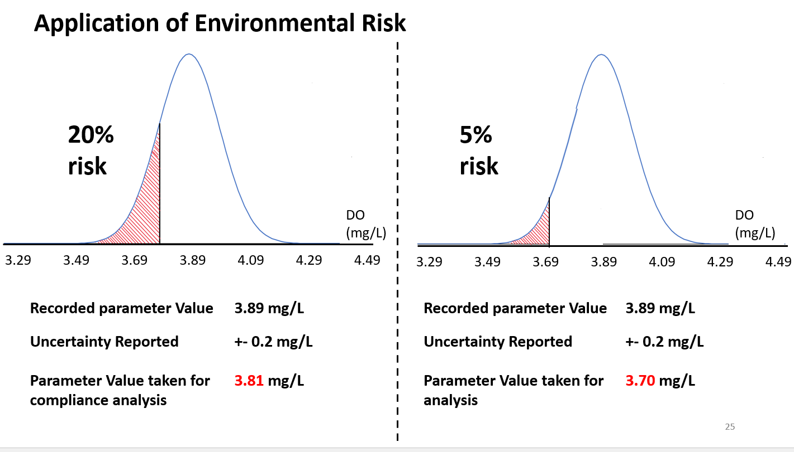
Figure 3. Illustration of application of two different risk appetites (20% or 0.2 and 5% or 0.05), when considering compliance analysis based on uncertain data (where uncertainty is expressed as a normal probability distribution, with recorded parameter as mean, and the manufacturer’s accuracy specification bandwidth being two standard deviations from the mean).
Instead of the randomly choosing points on the normal distribution, as described by the methodology outlined in the paper, risk appetite has been conceived as the user of the data choosing where on the distribution they wish to consider. In Figure 3 the recorded value is 3.89 mg/L for DO. If the normal distribution is applied in the same way as presented in section 3.1.3, the upper and lower accuracy bandwidth (± 0.2 mg/L at 3.69 mg/L and 4.09 mg/L respectively), would be two standard deviations away from the mean (the recorded value) and account for 95% of the data within that manufacturer’s accuracy specification bandwidth. The proportion of the graph before the point chosen is the percentage chance the user is willing to accept that harm might have occurred. Risk averse individuals or organisations would wish to consider the possibility of lower DO and more elevated UA, as this increases the likelihood of an exceedance whereas risk taking individuals wish to consider the opposite. Hence using the method described in this section, the concept of risk appetite could be applied to the parameter uncertainty, thereby allowing the user to make an explicit consideration as to whether a certain probability of not causing harm is ‘reasonable’.
The risk appetite of an individual is evident of which side of the recorded value the individual choses. The values closer to the threshold (in the case of DO, a lower value than the recorded value) is risk averse. The values further away from threshold are risk taking. The risk profile is the point of the graph the individual choses. For example, 0.2 or 0.05, both of which would be characterised as risk averse.
3.2.1.2 Consideration of Uncertainty associated with thresholds
One simplification in the methodology outlined in section 3.1 is that it takes the thresholds calculated as not being impacted by uncertainty. This is not the case. As described in the UPM procedure (see FWR, 2018) the data collected is needed to calculate the FIS thresholds, which are therefore impacted by uncertainty associated with the data. The DO threshold is calculated using the measured UA values and the UA threshold is calculated using measured DO, pH and temperature values. According to the UPM procedure the threshold will either be in the base condition for the set duration and return period, or in an altered position. The DO threshold may increase, but only by a maximum of 2 mg/L and the UA threshold may decrease. To consider uncertainty associated with threshold, the methodology developed to incorporate risk will be applied firstly on just the measured dataset, then just on the threshold and lately on both the measured dataset and the threshold.
3.2.1.3 Consideration of seasonal impact on locations sensitivity analysis
Section 3.1 used different lengths of the datasets, with some being over 12 months and other being over 6 months and did not consider whether this had any effect on deciding if locations are sensitive to uncertainty. This is firstly important for determining in the future, how long a monitor needs to be in site before uncertainty analysis is carried out, but also if you want to consider how sensitivity to uncertainty may be applied in the future under changing seasonal patterns. This work will separate datasets into two categories: winter (between the months of September to February) and Summer (between the months of March to August). The methodology explained in sections 3.2.1.1 and 3.2.2.1 will then be applied to the seasonal datasets.
    - Results
3.2.2.1 Impact of uncertainty and risk on the threshold calculation
The uncertainty associated with UA parameter is much larger than that of the DO, pH and temperature, so the effect of UA on the DO threshold is more than the effect of DO on the UA threshold. Figure 3 demonstrates this, by showing the DO and UA threshold calculated for location 11 if 0.6 (blue) and the 0.4 (orange) risk profiles are taken to account for data uncertainty in DO, TA, pH and temperature. The impact of selecting the different risk profiles is visibly different for the DO threshold, but not the UA threshold. However, due to the way the threshold calculation is set up (see UPM; FWR, 2018), the DO threshold is bounded to plus 2 mg/L of the base value, so there is a limit to the impact that UA data uncertainty has on the DO threshold. Alternatively, if a larger uncertainty was associated with DO, pH or temperature, the effect on the UA threshold could be more significant. This because when the threshold is in the ‘altered position’ from the base value it decreases to almost half of the base value or practically zero mg/L (Figure 4).

Figure 4: UA threshold (left) and DO threshold (right), when calculated for either 0.6 (blue) or the 0.4 (orange) risk profiles are taken to represent uncertainty in DO, TA, pH and temperature.
3.2.2.2 Impact of risk appetite on FIS exceedance counts
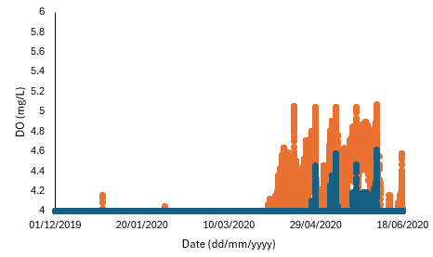
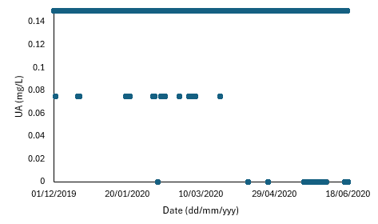
Figure 5 shows the impact that different risk bands have when uncertainty is considered both on the measured parameter of DO and on the DO threshold, for the nine different combinations of duration and return period. Figure 5 show the proportion of locations where there is an addition of more than four exceedances (purple), an addition of between 1 to 4 exceedances (light blue), no change in exceedance count (green), a removal of between 1 to 4 exceedances (orange) and a reduction of more than four exceedances (dark blue). The first thing Figure 5 shows is that the shorter the duration and return period the more sensitive FIS exceedance count is to uncertainty, with the green bar (the proportion of locations that observe no change in exceedance count from considering uncertainty) being the smallest in 1h1m and the largest in 24h12m. This has been indicated by the direction of the arrows.
The next thing of note is that it shows that risk adverse profiles (0.2 and 0.4, shaded background light purple) are more likely to add exceedance (dark purple and light blue bars) whereas the risk-taking profiles (0.6 and 0.8, shaded light blue) are more likely to reduces exceedances (orange and dark blue bars). Sometimes a risk-taking profile will add exceedance, and a risk-adverse profile may reduce exceedance, as seen in 1h12m. This is because both the threshold and measured point have moved, meaning that when and for how long the threshold was exceeded may change. This can result in what was previously two exceedances merging to become one exceedance or vice versa.
Finally, Figure 5 shows that the relationship between risk profiles and difference in exceedance counts is non-linear. If you take the 1h1m, the difference between the proportion of locations where uncertainty does not affect exceedance count decreases from around 0.68 to 0.63 for the risk-taking profiles of 0.6 and 0.8 respectively. When considering the proportion of locations in the green zone, increasing the risk profile by 0.2 in the risk-taking direction only affects 5% more locations, whereas increasing the risk profile by 0.2 in the risk-adverse direction affects 28% more locations.

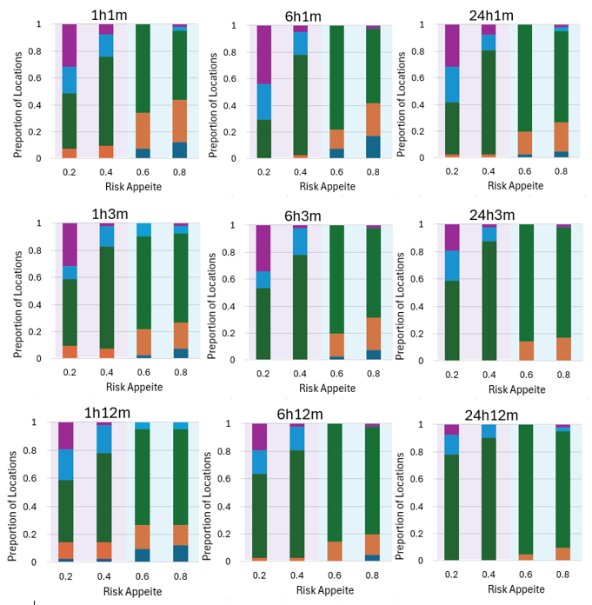
Figure 5: The impact of uncertainty on the measured parameter of DO and DO threshold for nine different combinations of FIS duration and return periods for four different risk profiles (0.2 and 0.4 risk averse shaded purple, and 0.6 and 0.8 risk-taking, shaded light blue). In the Bar chat an addition of more than four exceedances is purple, an addition of between 1 to 4 exceedances is light blue, no change in exceedance count is green, a removal of between 1 to 4 exceedances is orange and a reduction of more than four exceedances is dark blue.
Figure 6 shows the impact that different risk bands have when uncertainty is considered both on the calculated parameter of UA and the UA threshold, for the nine different combinations of FIS duration and return period. When compared to DO (Figure 5), UA (Figure 6) is more impacted by uncertainty. By considering the size of the green bar (the proportion of locations that observe no change in exceedance count from considering uncertainty), it shows shorter duration and return period is most sensitive to uncertainty. However, if one just considers the 1 month return period (the top row), for the risk-adverse profiles (0.2 and 0.4, shaded by light purple), it appears that the longer duration is more impacted that the shorter durations, shown by increase in the dark purple bar (addition of more than 4 exceedance counts).
Figure 6 shows that the risk averse profiles are highly non-linear. If you take the 24h1m, the difference between proportion of locations that uncertainty does not affect exceedance count decreases from around 0.42 to 0.40 for the risk-taking profiles of 0.6 and 0.8 respectively. When considering the green zone, increasing the risk profile by 0.2 in the risk-taking direction, only affects 2% more locations, whereas increasing the risk profile by 0.2 in the risk-adverse direction affects 42% more locations.
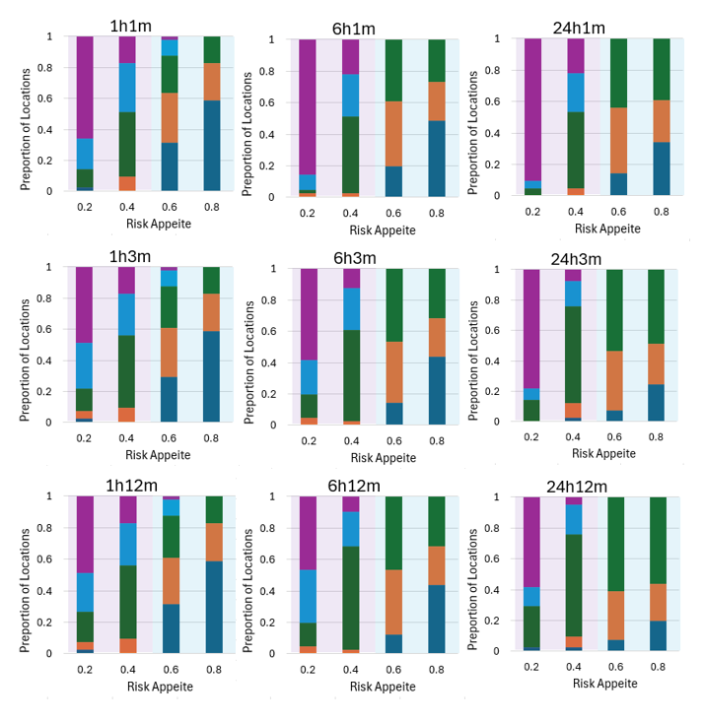
Figure 6: The impact of uncertainty on the calculated parameter of UA and UA threshold for nine different combinations of FIS duration and return periods for four different risk profiles (0.2 and 0.4 risk averse shaded purple, and 0.6 and 0.8 risk-taking, shaded light blue). In the Bar chat an addition of more than four exceedances is purple, an addition of between 1 to 4 exceedances is light blue, no change in exceedance count is green, a removal of between 1 to 4 exceedances is orange and a reduction of more than four exceedances is dark blue.

3.2.2.3 Impact of data uncertainty on Threshold, and implications for FIS exceedance count
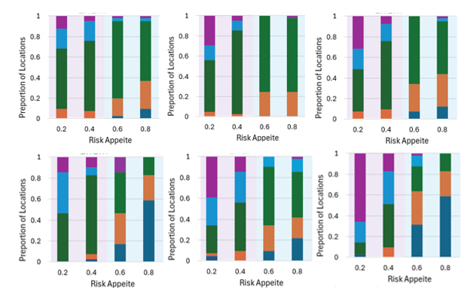
6
5
4
3
1
2
Figure 7 The impact of uncertainty on the measured parameter of DO (1), the impact of DO and uncertainty on the DO threshold (3), the impact of uncertainty on the calculated parameter of UA (4), the impact of uncertainty on the UA threshold (5) and the impact of uncertainty on the calculated parameter of UA and the UA threshold (6) for FIS exceedance count of 1 hour duration and 1 month return period for four different risk profiles (0.2 and 0.4 risk averse shaded purple, and 0.6 and 0.8 risk-taking, shaded light blue). In the Bar chat an addition of more than four exceedances is purple, an addition of between 1 to 4 exceedances is light blue, no change in exceedance count is green, a removal of between 1 to 4 exceedances is orange and a reduction of more than four exceedances is dark blue.
Figure 7 shows the impact of data uncertainty on the threshold, as well as the impact of data uncertainty itself, both in combination with different levels of risk profiles have on the 1h1m FIS exceedance counts. In the risk adverse side (0.2 and 0.4, shaded background light purple), the proportion of locations affected by uncertainty increases significantly when considering the uncertainty associated with the threshold (2 and 5) when compared to considering uncertainty on the measured and calculated parameter (1 and 4) for both DO and UA. Nevertheless, on the risk-taking side (0.6 and 0.8, shaded background light blue) there is minimal difference for DO and for UA the measured value decreases exceedances more drastically than considering uncertainty on the UA threshold. For both DO and UA, the largest difference in exceedance counts is observed when you consider both uncertainty on the measured value and the threshold (3 and 6).

3.2.2.4 Impacts on seasonal variability on locations sensitivity to data uncertainty and risk
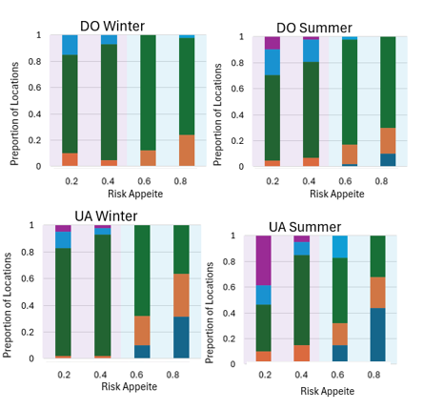
Figure 8: The impact of uncertainty on the measured parameter of DO and the calculated parameter UA for the return period of 1 hour 1 moth for the seasons of Winter and Summer for four different risk profiles (0.2 and 0.4 risk averse shaded purple, and 0.6 and 0.8 risk-taking, shaded light blue). In the Bar chat an addition of more than four exceedances is purple, an addition of between 1 to 4 exceedances is light blue, no change in exceedance count is green, a removal of between 1 to 4 exceedances is orange and a reduction of more than four exceedances is dark blue.
The analysis showed that for both DO and UA (see Figure 8), exceedances that happened in the summer months (March to August) were more sensitive to uncertainty. But were pattens observed in relation to impact of uncertainty in the threshold and uncertainty in the data, on the FIS exceedance counts for different return period and duration.
3.2.3 Discussion
3.2.3.1 Risk
If risk is taken to be the possibility of a negative consequence (Asadi et al., 2021), then the UPM manual is vital to understand the UK approach to risk for SO discharges, even if risk is not specially stated in there. The UPM manual, took the negative consequence of SO as environmental harm and produced a ‘scientific’ procedure to determine harm in FIS. Thus, any discharges that did not meet the criteria of harm, was deemed acceptable. Then the roll out of UPM studies in practice were financially prohibitive due to the detail described in the UPM procedure, so were done in small numbers. Thus, an argument can be made that risk of harm at sites not studied was accepted. But in terms of sites that did perform FIS, the biggest indicator of whether following the UPM manual was risk averse or risk taking, is EA (2012) review of FIS to see whether it suitable for use indicator of losing good ecological status under Water Framework Directive. The fact that safety factors were applied to the thresholds in UPM FIS, to prohibit situations closes to the realisation of the environmental harm, implies it is risk-averse in nature.
There may be an argument therefore that the Storm Overflow Discharge Reduction Plan (SODRP) takes a broader appreciated to harm. That it is no longer simply acceptable to not cause environmental harm, but that negative consequences of SO discharges should also include the public perception of exceeding acceptable levels of pollution. It can also be argued that the area of most risk-accepting behaviour occurred, at sites not studied, is no longer allowed to exist with the Environment Act 2021 requiring monitoring at virtually all assets. Therefore, implying that UK may be moving into a more risk-averse environment in regard to SO discharges. If this is true, then particularly for UA, the extent to which companies choose to be risk adverse could drastically alter a location’s FIS exceedance count (see the difference between the purple area of the graph between risk appetite 0.2 and 0.4 in Figure 6). Therefore, this choice to the extent of the move towards risk-aversion has financial but also reputational implications for the water companies.
Considering risk appetite can also limit the number of locations that are deemed not suitable under the current BAT technology, to be held against FIS in order to determine environmental harm. Section 3.1, using a random number of the normal distribution, found that between 70% to 80% of locations, the current BAT to monitor UA were non-suitable. This work also shows that if you take a modest level of risk aversion (0.4), that the number of locations where BAT to monitor UA is unsuitable reduces to between 40% to 60% of locations, and that is with the additional impact of considering the uncertainty associated with the threshold. Nevertheless, the underlying message of section 3.2 is that FIS exceedance count can be altered drastically by the levels of uncertainty associated with current BAT, and that this is not eradicated when explicitly accounting for different levels of risk appetite. Even modest risk appreciation levels (0.4 and 0.6), there are location where the exceedance count is affected by uncertainty for DO and UA on both the measured or calculated parameter and the associated uncertainty with the threshold.
As the same risk appetite on DO and UA produces different sensitivity profiles to uncertainty it may be deemed acceptable for water companies to choose difference risk appetite for different parameters. The difference in the sensitivity profiles observed between Figure 5 and 6 is attributed to the difference in sensing capabilities between the DO and TA sensors.
The risk appetite per location may also be influenced by other priorities of the water companies. For instance, locations of recognised national beauty, or locations upstream of bathing water sites, or areas where there is increased public scrutiny may be attributed to a more risk-adverse profile. Where sites that are deemed of low significance, whether due to being locations where discharges are unlikely to cause harm or sites out of view from the public, may be attributed a comparably more risk-taking profile. A more risk-taking profile may not necessarily be on the risk-taking side (shaded blue in Figures 5, 6, 7 and 8), though it may be. Alternatively, a water company may wish to adopt the public stance that all their overflows are treated equally and hence adopt a universal risk approach, irrespective of a location’s sensitivity to risk or public opinion. It is expected that the different water companies will develop their own risk approach depending on company priorities. There is also the possibility that the environmental regulator, the EA, may impose guidelines of appropriate an inappropriate level of environmental risk which water companies must stay within.
3.2.3.2 Threshold
The fact that considering only the impact of data uncertainty on the threshold is larger than considering the uncertainty associated with the measured data on its own, implies that the threshold needs to be considered in uncertainty analysis. Interestingly the impact of the DO uncertainty (± 0.2 mg/L) has just as a significant an impact on the UA FIS count as the TA uncertainty (± 2 mg/L) on the DO FIS count, even though being an order of magnitude different. This is believed to be due to the way the DO and UA thresholds are set up in the UPM FIS methodology. The DO threshold has a condition that the maximum difference it can be from the base value (found in the look up table in the UPM manual) is plus 2 mg/L. Whereas the UA threshold jumps from the base value to a middle value point and then to almost practically zero mg/l (see Figure 4). Consequently, a small difference in DO, can create a large difference in the threshold and that difference in threshold can then have impact on the final FIS exceedance count.
3.2.3.3 Seasonal
The fact that summer months were deemed more sensitive to uncertainty was surprising. It was supposed that the winter months would be most sensitive to uncertainty, which was found to be incorrect. This hypothesis was based on higher water level in the river being common in winter, attributed to winter rainfall (Met, 2020). With higher water levels, the concentrations of pollutants being discharged into the river would have higher dilution rates and hence it was thought these concentrations are more likely to be closer to the threshold. Being close to the point of harm because of dilution, it was thought that uncertainty would have a larger impact as it could move the parameter from just exceeding the threshold to not exceeding the threshold or vice versa depending on the risk appetite. Therefore, impacting the final FIS exceedance count. This was not observed in the sensitivity analysis.
Alternatively, it is proposed that it is the length of discharge not the dilution that is responsible for seasonal differences. That in winter, if the length of the exceedance is longer, due to snow melt and raised water tables providing longer periods of excess water into the sewer network, then even if uncertainty altered the start and end time of the exceedance, it does not change the condition of if 1 hour, 6 hours or 24 hours have been meet. Therefore 1 FIS exceedance is still counted. Whereas if in summer, the exceedance counts are closer to the duration condition of FIS, the uncertainty could change whether the FIS exceedance is counted or not. Further work therefore is suggested seeing if there is a link between uncertainty and the length of duration based on the EDM data. If this is true as an explanation to why there is this seasonal difference, then changing rainfall patterns in the UK, with rainfall predicted to fall over shorter periods of time in the summer (Met, 2020) could exacerbate the differences observed between winter and summer in the future.
    - Conclusion
Allowing the user the ability to decide whether the chance of not causing harm is ‘reasonable’ should be an essential element of the FIS exceedance analysis. It is proposed that the user of the data states their accepted level of chance that harm might have occurred, by relating this to the position on the normal distribution curve. It is believed that the UPM-FIS procedure is risk-averse by nature, but generally in the UK there is a current trend towards a more risk averse stance. If this is true, this work shows that particularly for UA, the extent to which water companies choose to be risk averse could drastically alter a location’s FIS exceedance count. Both the uncertainty associated with threshold and with the season in which it was collected can affect final FIS exceedance count. Therefore, both should be considered when considering a location’s sensitivity to uncertainty. For both DO and UA, the impact of data uncertainty on the threshold can be as significant as simply considering data uncertainty on its own. The summer months were found to be more sensitive to uncertainty, which opposite of the expected result. It was proposed that it may be due to length of exceedance for this difference in exceedance counts, however this would need to be confirmed in further research.

Chapter 4: Understanding Water Quality Monitoring Uncertainty for Intermittent Spill Compliance
This chapter is based on a paper submitted and under review to Water Research Journal. The first author is Philippa Mohan (candidate). The co-authors include Dr Alma Schellart, Professor Simon Tait and Professor Chris Digman.
4.1 Abstract
Ecological thresholds are often used in environmental protection regulations, particularly in the context of pollution control to prevent ecosystem damage. Threshold based environmental regulation regarding water quality standards for rivers are in use all over the world. One example of threshold-based regulation is the concentration-duration-frequency standards used in the UK to define if harm has been caused by intermittent sewer overflow discharges. The work presented here investigates the influence that uncertainty in data from water quality sensors, as well as individual risk profiles of water utilities and regulators can have on assessing compliance with water quality concentration-duration-frequency based standards. A new term was created called Parameter Threshold Ratio (PTR) to investigate the extent to which measured water quality concentration interacted with the regulatory threshold at different locations. The work investigates two different water quality parameters, dissolved oxygen and unionised ammonia. It is concluded that both uncertainty and risk appetite does influence the binary decision around the assessment of a location meeting regulatory compliance. It is demonstrated that a location's sensitivity to uncertainty and risk, as shown by using the new term PTR, has economic implications on both sensor selection and operation to perform regulatory assessment and size and type of mitigating solution required to prevent regulatory failure.
4.2 Introduction
The UN report (2019) on Environmental Rule of Law recognised that if the global intent was to stay within the constraints of critical ecological thresholds, it is vital that environmental laws are understood, respected and enforced. However, it also acknowledged that complying with environmental laws often depends on decisions being made under significant uncertainty. Ecological thresholds are defined as the system condition at which a relatively small disturbance from external pressures causes rapid change in an ecosystem (Groffman et al., 2006). They represent the situation in which a non-linearity of response is experienced by the ecosystem. Sometimes, once a threshold is surpassed the ecosystem may no longer be able to return to its original state; for example, when organisms are killed or lose the ability to reproduce. Therefore, ecological thresholds are often used in standards set in environmental protection regulations, particularly in the context of pollution control with the aim to limit or prevent ecosystem damage. Understanding how measurement uncertainty may impact threshold based environmental regulation is hence important to help make better informed decisions on whether ecological thresholds have been exceeded and ensure the effective enforcement of environmental laws.
Threshold based environmental regulation regarding water quality (WQ) standards for rivers can be seen all over the world. Threshold-based regulation within Europe is used for both the Urban Wastewater Treatment Directive (2024) (2024/345/EC), which set limiting the pollution from storm water overflows to no more than 2% of the annual collected urban wastewater load and in the Environmental Quality Standards Directive (2008) (2008/105/EC), setting priority substance standards relevant for assessments of the Water Framework Directive. These are examples of two different ways for setting thresholds in environmental regulation, the first being focused on the operating capacity of the system and the other being based on the impact of pollutants upon receiving waters. In the United States of America effluent limitations, typically expressed as mass loadings or concentrations, are set under Title III: Standards and Enforcement of the Clean Water Act (EPA, 1977). These standards are based on the performance of treatment and control technologies. In Canada, The Wastewater Systems Effluent Regulations (2012) (SOR/2012-139) under the Fisheries Act aims to reduce the threats to fish, fish habitat and human health and therefore are impact based. Threshold based regulation is also prominent in Asian countries, such as the Surface Water Environmental Standards (2002) (GB3838-2002) in China and the Environmental Quality Standards (1993) for the conservation of the living environment established under section 3 The Basic Environmental Law (1993) in Japan.
In the UK, threshold-based approaches (Fundamental Intermittent Standards, FIS) are also used (FWR, 2019). FIS defines the critical thresholds for pollution control of intermittent discharge from urban drainage systems and consists of a series of concentration-duration-frequency criteria for Dissolved Oxygen (DO) and Un-ionised Ammonia (UA). These criteria are directly related to pollution levels which can cause unacceptable stress in receiving water ecosystems. The values of critical concentration-duration thresholds are based on a laboratory program which investigated the relative importance of concentration levels, duration of exposure, and frequency of occurrence during periods of short-term exposure to salmonid and cyprinid fish, reported by Milne et al. in 1992 (FWR, 2019). The FIS approach is deemed appropriate by England’s environmental regulator (EA, 2012), to ensure no environmental harm occurs in receiving water bodies. This WQ regulation thus considers environmental harm as a binary problem; either the water course has passed or failed. FIS is just one example of a threshold-based environment regulation that links the standards to be measured against the scientific understanding of when irreversible environmental harm will occur in an ecosystem.
The potential for environmental harm from urban drainage systems could be exacerbated due to climate change, with extreme rainfall resulting in a longer duration or a higher frequency of intermittent discharges (Bizer & Kirchhoff, 2022). Long periods of dry weather could furthermore reduce river discharge and thus increase concentrations of the pollutant load. Potential increases in sewage base flow, as a result of population increase (Mahaut & Andrieu, 2019) will also increase the potential for environmental harm related to intermittent discharges. Intermittent discharges are just one of several sources contributing to poor surface WQ, most notably agricultural runoff (see He et al., 2023).
Considerable investments are made, globally, to maintain and upgrade urban drainage assets to reduce the total load of pollutants entering and causing environmental harm on receiving waters. Before recent technological advances and the “internet of things” allowing the fast transfer of data over large spatial scales, WQ data collection relied on infrequent site visits to collect discrete river water samples and bring these to an accredited laboratory for analysis. This meant that any data driven environmental harm assessment process was slow, expensive and reactive. Often coarse temporal time steps meant that the sampled data failed to reflect the environmental impact from intermittent polluting discharge events (Cristiano et al., 2017).
It is now technologically feasible to produce an annual representation of WQ in a river solely from multi-location “continuous” WQ measurements. The cost of sensors and transferring and storing the data has over the last couple of decades significantly decreased in price, although the scale of monitoring needed, and installation and maintenance costs are often still prohibitive. However, in the UK the assessment processes for identifying when intermittent discharges from urban drainage systems have caused environmental harm is currently changing due to a shift in legislation. Large-scale WQ monitoring schemes are now mandatory in order to provide a data based regulatory approach. This can be seen in UK’s Environment Act (2021), Article 82 which requires event duration monitoring and “continuous” WQ monitoring both up and downstream of virtually all storm overflows (SOs) and treatment work outfalls by 2035.
In adopting a new data-based approach to regulatory compliance, consideration must be made to data uncertainties. The sensors installed to measure WQ parameter concentration have uncertainty levels. There are differing sensor capabilities, with differing uncertainty levels. For instance, the parameter of dissolved oxygen can be measured either by electrochemical or optical sensors, if considering in-situ measurements (Wei et al., 2019). These alternative sensor types fundamentally assess dissolved oxygen using different methodologies; therefore, introducing uncertainty in separate ways. Nevertheless, some uncertainty related to the manufacturer’s specified level of sensor accuracy is impossible to eliminate and therefore must be considered when using collected WQ data, especially when assessing regulatory compliance.
Uncertainty and risk are intrinsically linked and to evaluate the implications of uncertainty, risk must also be considered (Toma et al., 2012). Risk is normally understood to be the possibility of different outcomes due to inherent uncertainty within a decision (Asadi et al., 2021). The ISO guidelines for risk management (2018) specify the amount and type of risk that an organisation may allow, it should be explicitly written down and communicated relative to desired objectives. In the context of the water sector, one desired objective is regulatory compliance.
It is believed that the water sector in the UK, due to its working culture of strict regulation and regulatory financial penalties would be risk averse. However, most of the research on the risk attitudes in the water sector is associated with drinking water standards (Pollard et al., 2008) not managing events that may cause environmental harm. In the context of environmental harm from intermittent discharges polluting receiving surface waters, this risk is that the represented value of the DO or UA from either monitored or modelled data, is presented as a value that causes less ecological harm to the river ecosystem than the ‘true’ value of the parameter in the river. This poses environmental risk for the river system, but also the risk of ineffective solution design, regulatory financial penalties and reputational damage to the water utility.
The drive to more monitoring to assess ecological harm caused by intermittent discharges, will require the widespread installation of in-situ sensors to monitor specified WQ parameters. If the full benefit of widespread monitoring is to be realised, there is a need for better understanding and tools to assess uncertainty and risk. This study chose to use the UK specific FIS regulation as an example of an environmental threshold-based regulation, however, the methodologies developed here can be used to consider other threshold-based standards. This work aims to investigate the influence that uncertainty in multi-parameter WQ sensors and the risk profile of water utilities can have on the assessment of whether water bodies meet WQ concentration-duration-frequency based regulatory standards. To achieve this aim, the following three questions will be answered:
- Do different locations in a receiving water body show different sensitivity to monitoring uncertainty when considering the same regulatory thresholds?
- To what extent does an individual’s or organisation’s approach to risk influence the observed uncertainty effects evidenced in the question above?
- Can a more rational approach to monitoring uncertainty and deciding upon compliance risk lead to more robust environmental protection of receiving water bodies?
4.3 Methodology
4.3.1 Water quality sampling
This study used a WQ data set collected for a number of Water Framework Directive (WFD) studies in the UK, from 41 locations across seven rivers and two water utilities in the North of England between September 2019 and September 2023. The sampling locations were in both urban and rural areas. Thirty-eight of the locations had a known SO located upstream which discharged multiple times during the sampling period. For each location, dissolved oxygen concentration (DO), total ammonia (TA) concentration, pH and temperature were measured using multi-parameter sensors. Sampling was continuous at a measurement frequency of five minutes, and 12-month duration at each location. The data sets were numbered 1 to 41, the first 19 were used to develop the concept, which was then applied to the other 22 locations. Most locations did have some missing data, but no location was found to have more than 0.05% of the timeframe missing, in which case the data was linearly interpolated. For the FIS assessment, unionised ammonia (UA) concentration values are calculated using Equation 1 based on the Emerson et al. (1975) study into relationships between unionised ammonia (UA), ammonium, pH and temperature:

UA (mg/L) = NH₄ (mg/L)/ (1+10 (10.055^{-(0.0324*Temperature(˚C))-pH)})) Equation 1

4.3.2 Threshold Determination
The Fundamental Intermittent Standards (FIS) use pollutant concentration, duration of exposure, and frequency of emission, to assess ecological harm in a receiving river as a result of intermittent discharges from an overflow (FWR, 2019). The concentration thresholds are dynamic and divided into two parts, FWR (2019). The first is a base value, which is the point at which the WQ parameter exceeding the threshold will cause harm to the ecosystem regardless of the state of other WQ parameters within the system. However, the toxicity of DO and UA may change depending on the values of other WQ parameters (FWR, 2019). Secondly, FIS calls for modification factors to be applied once certain conditions are met to better define harm (Appendix A.1 of FWR, 2019). Another component is duration. An exceedance of FIS is counted when the concentration of DO or UA breaches its allowable threshold for a set duration. The final component is frequency, where the exceedances of the threshold (concentration combined with duration) are summed over a 12-month period.
4.3.3. Monitoring Uncertainty.
In this study sensor accuracy is defined as the absolute deviation from the measured WQ parameter value to the true parameter value. The accuracy for DO can be directly taken from Table 1 section 3.1, which shows the manufacturers accuracy specification for the sensors used in this study. It is assumed that the distribution of the sensor accuracy can be described by a normal distribution. This is in line with established literature on how to handle data uncertainty (see Delectic et al., 2012). It was assumed that the mean is recorded by the DO sensor, and the upper and lower bands of the manufacturer’s accuracy range are the equivalent of two standard deviations. Therefore, 95% of the ‘true’ values would fall within the accuracy band quoted by the manufacturer (see ISO, 2009). Figure 9 illustrates a visualisation of this normal distribution for a single instance in the “continuous” time series, in relation to the regulatory threshold. A similar approach was taken for the other three measured WQ parameters Ammonium, pH and Temperature.

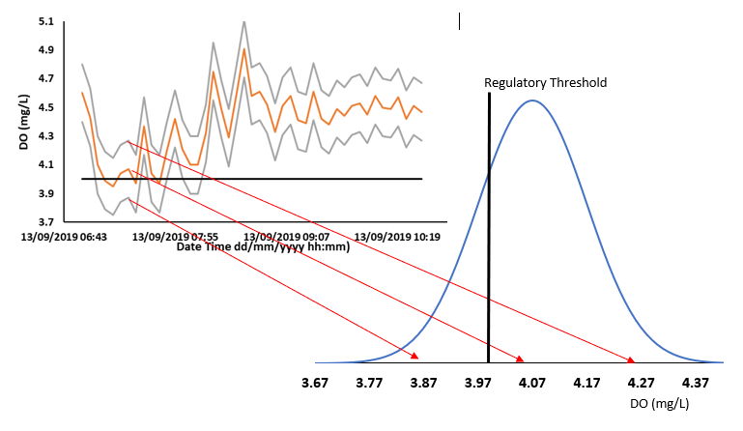
Figure 9: A visualisation of the probability distribution of DO values at a single time instance in the collected DO time series, the arrows point to the 2.5 percentile, the mean and the 97.5 percentile respectively.
UA is calculated from Ammonium, pH and Temperature (Equation 1). The largest accuracy bandwidth reported in Table 1 (section 3.1) is the Ammonium sensor, with an accuracy range of ± 2.00 mg/L. As the datasets typically reported Ammonium in the range of 0-4 mg/L, a value less than 2 mg/L would provide a negative value for Ammonium when taking the uncertainty due to sensor accuracy into account. Negative values are physically impossible, and hence the normal distribution was truncated at 0 mg/L.
This work wants to test the impact of the uncertainty due to different sensor quality; hence other hypothetical sensor accuracy bandwidths have also been investigated (Table 5).

Table 5: The hypothetical sensor accuracy and associated standard deviation investigated for both Dissolved Oxygen and Ammonium (mg/L)
Hypothetical Sensor Accuracy for Dissolved Oxygen and Ammonium (3sf) | Associated standard deviation (3sf)
± 0.13 mg/L | 0.056 mg/L
± 0.20 mg/L | 0.100 mg/L
± 0.40 mg/L | 0.200 mg/L
± 0.33 mg/L | 0.165 mg/L
± 0.50 mg/L | 0.250 mg/L
± 1.00 mg/L | 0.500 mg/L
± 1.33 mg/L | 0.665 mg/L
± 2.00 mg/L | 1.000 mg/L
± 4.00 mg/L | 2.000 mg/L

4.3.4 Implications of Monitoring Uncertainty combined with Risk Profiles on determining compliance.
Monte Carlo simulations have been carried out to investigate the potential impact of sensor uncertainty combined with water utility risk profiles for analysing compliance with FIS. From the normal distributions created at every timestep for DO and Ammonium, with the recorded value assumed to be the mean, and the associated standard deviations from Table 5, 10,000 values were randomly selected. Each of these 10,000 values are then ascribed as being either above or below the regulatory threshold, and the values ascribed as below the threshold are then counted and divided by 10,000 to create a probability of exceeding the threshold at that time. For example, if 2400 values were recorded as exceeding the regulatory limit it would be considered to have a 24% chance of exceeding the regulatory limit. This process is repeated for each time point in the time series.
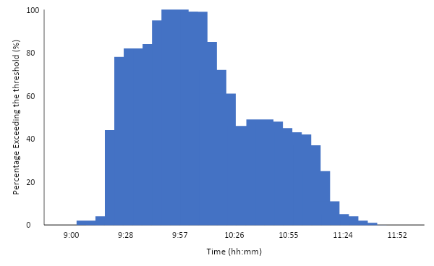
Figure 10; Bar chart illustrating probability at each timestep of exceeding the DO regulatory threshold for an event at location 3.
The risk profile, in this context, is defined as the probability of a WQ parameter exceeding the threshold. In Figure 10 taking a risk appetite of 0.5, leads to the threshold being exceeded between 9:30 and 10:20. As this is less than 1 hour duration, no FIS exceedance would be counted. Conversely, taking a risk appetite of 0.2 would result in a FIS exceedance being counted between 09:25 to 11:10, so a regulatory failure would have been deemed to have occurred. For the purpose of this work a risk appetite has been set at 0.2. As information on the risk appetite of UK water companies is currently unknown, a risk appetite of 0.2 is assumed as a starting point.
4.3.5 Parameter Threshold Ratio (PTR) concept
An “FIS exceedance” is only counted when the measured parameter breaches the regulatory threshold for a defined period. Therefore, the relative size of deviation required of the parameters from their ‘ambient state’ to interact with a threshold is important to consider. In order to do so, a ‘Parameter Threshold Ratio’ (PTR) concept has been introduced.
There are several reasons for looking at multiple hypothetical base thresholds. Firstly, the actual threshold is calculated using the same measured dataset it is put against. Therefore, any uncertainty associated with the manufacturer’s accuracy bandwidth of any sensor installed will also impact the threshold. Secondly the definition of harm is partly decided by the public and political appetite for strict or pragmatic environmental regulations. In the future, for example, there may be calls for harm to be defined at a higher DO and/or lower UA values, in order to reduce the likelihood of fish mortality. Or the thresholds might instead be relaxed after a cost-benefit analysis of interventions needed to limit fish mortality rates.
Equation 2 introduces the ‘Parameter Threshold Ratio’ (PTR), which may be used to gain an understanding of the likelihood of different locations interacting with the regulatory threshold. To gauge an estimate of the ambient DO level at a location, an average of the recorded DO values for a whole year was taken. The FIS thresholds are dynamic (see section 3.2), hence the FIS threshold itself was also averaged. The PTR is then defined as the ratio of the averaged measured values vs the averaged regulatory threshold (Equation 2). Figure 11 illustrates the averaged measured values and averaged regulatory threshold, required to calculate PTR (Equ. 2).
$$PTR \left(no units\right)= \frac{Averaged Parameter Measured Values (mg / L)}{Averaged Parameter Regulatory Threshold (mg / L)}$$
Equation 2
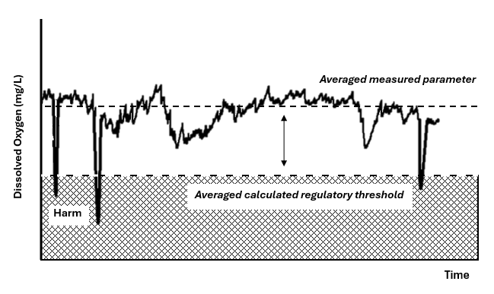
Figure 11: An illustration of the averaged measured parameter and averaged regulatory threshold needed to calculate the PTR. The PTR value is thus a measure of how far away from the threshold the measured data in a location tends to be (as indicated by the arrow).
It is important to note that equation 2, does not mean that anything is averaged in the FIS analysis. The FIS analysis was carried out as instructed by UPM version 1 (1994). This included the creation of variable threshold that are dependent on the state of other parameters. This variable threshold was then averaged in equation 2 to create the PTR value. This means that for each timestep in the timeseries there is a value associated with the FIS threshold. To average the threshold the sum of these values was taken and divided by the number of the points in the timeseries. In the FIS analysis, the variable threshold, not the average of the variable threshold, was used in line with UPM procedure. As in at each timepoint in the timeseries a binary decision was made as to if parameter exceeded the threshold at that timepoint. The purpose of Figure 11 is to demonstrate the parameters to be used in equation 2, not the parameters to be used in the FIS analysis and therefore it does not demonstrate the variable threshold associated with FIS analysis. To understand the variable threshold associated with FIS analysis please see UPM Appendix A (1994).
The analysis shown in this chapter was repeated for all return period and durations as outlined in UPM (1994). However, for demonstration purposes FIS analysis in this chapter is referring to the 1-hour duration. This is because firstly the methodology in this section calls for multiple different base thresholds to be used. The difference between different return periods in UPM FIS is that they have different thresholds and therefore can be found on the same PTR diagram at different PTR values. Out of the three different durations in UPM FIS (1-hour, 6-hour and 24-hour) the 1-hour duration was chosen to demonstrate the concept as section 3.2 showed it to be the most sensitive to uncertainty. When the analysis was carried out on other duration, the same PTR diagrams for DO and UA as presented below for the 1-hour duration FIS, with minor difference in gradients. No additional conclusions are made with the inclusion of these FIS durations.
4.3.6 Parameter Threshold Ratio analysis of the case study data
For the 41 data sets, an analysis is carried out of the PTR versus the daily likelihood of an event exceeding the threshold. The likelihood of an event exceeding the threshold on any given day was calculated by totalling the number of such events in the time series dividing this by the total number of days. To investigate a wide range of potential perceptions of when ecological harm may be occurring, the analysis is completed on a range of different hypothetical base threshold values, ranging from 0.8 mg/L to 13.5 mg/L DO in increments of 0.1 mg/L for DO. The UA base values were set between 0.001 mg/L. and 0.125 mg/L increasing in increments of 0.001 mg/L. Therefore, creating 128 base threshold values for DO and 125 base threshold values of UA. A PTR value (Equation 2) was then calculated for these ranges of thresholds, created with 19 datasets and with the risk appetite set at 0.2.
  - Results
The results section has been split into four parts; Compliance Uncertainty (DO), Compliance Uncertainty (UA); Compliance Determination Incorporating Risk; and Validation utilising the remaining 22 of the 41 available data sets.
4.4.1 Compliance Uncertainty - Dissolved Oxygen
Figure 12 illustrates the daily likelihood of a DO threshold exceedance occurring within a single day against PTR values, the risk appetite is set at 0.2 and the sensor accuracy bandwidth set according to the manufacturer's specification (Table 1, section 3.1) which is considered to be two standard deviations from the mean (see Section 3.3).
The likelihood versus PTR plots in Figure 12 are found to be location specific and appear to split into 2 groupings. One group shows a rapid decay of threshold exceedance likelihood, until a PTR value of approximately 1.5 when the likelihood of threshold exceedance is effectively zero. A second group showed a more gradual decay of threshold exceedance likelihood versus PTR, with PTR values up to 2 to 3. Finally, there is one location in which the decay of threshold exceedance is significantly slower.
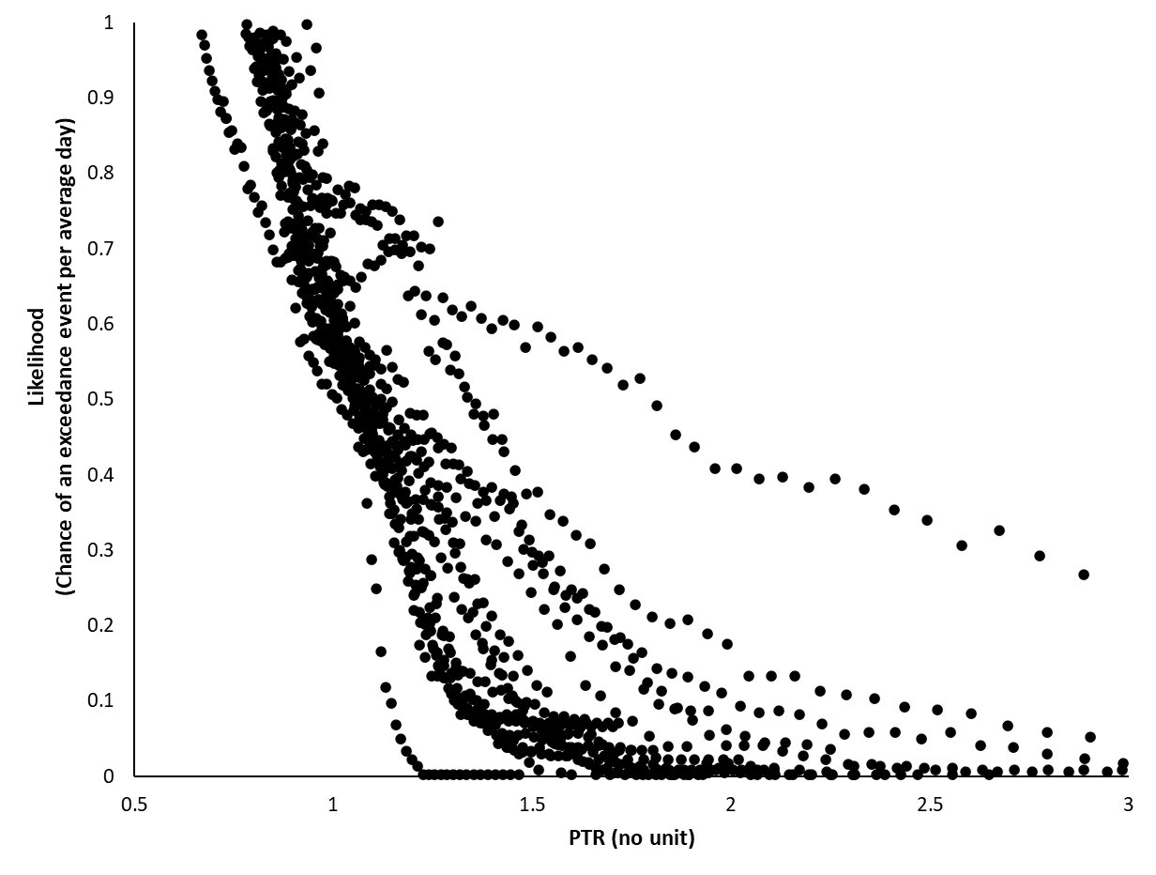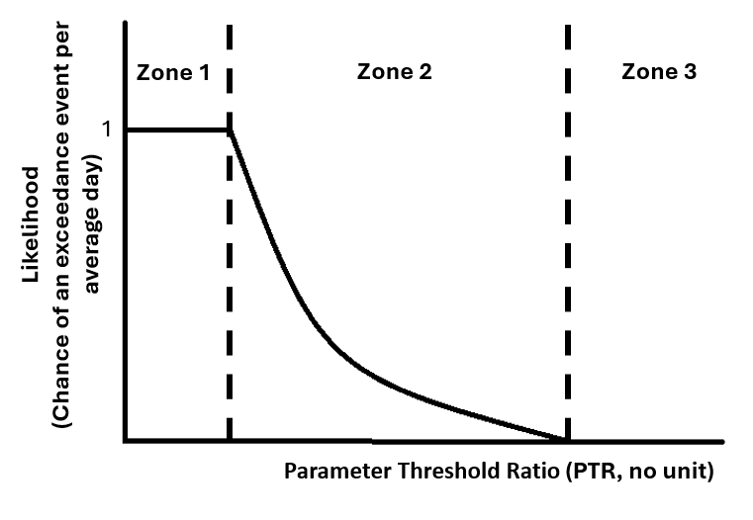

Figure 12: Likelihood of the daily threshold exceedance for DO against Parameter Threshold Ratio at 19 locations | Figure 13: Schematic of conceptual pattern of likelihood of daily threshold exceedance for DO against PTR at a single location
On observing the data, a conceptual 3-zone pattern of the daily likelihood of threshold exceedance against PTR was proposed, illustrated in Figure 13. Zone 1 is where the DO of the receiving water is always exceeding the regulatory threshold and accordingly is failing compliance and deemed to be continuously in a state of ecological harm. Zone 3 reflects conditions when a PTR is so large, that when a reduction in measured DO values occurs the exceedance threshold is still not breached, and no regulatory compliance failures are recorded. No possible ecological harm occurs at this location in a typical year. Zone 2 indicates a location where normally the receiving water is in a state where ecological harm is not occurring, however, possible ecological harm might occur to external inputs into the system. The locations studied were found to be in Zone 2 (11/19) or in Zone 3 (8/19). Zone 2 can be represented as an exponential decay curve where the pattern of likelihood of threshold exceedance is dependent on a PTR value and two constants (a, b). Exponential decay curves were fitted to the data, and all showed a r² correlation greater than 0.9.
The impact of sensor uncertainty on the prediction of the likelihood of DO threshold exceedance was examined. Figure 14 shows the result of this examination at location 18 by incorporating information on DO sensor uncertainty in the PTR analysis.
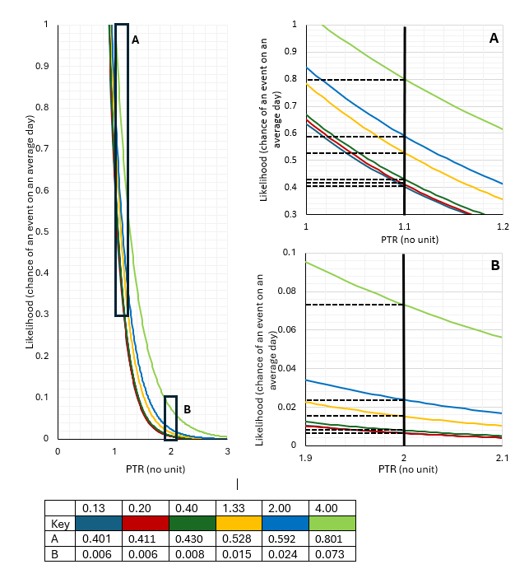
Figure 14: Daily likelihood of exceedance versus PTR curves from zone 2 calculated for a single location (18) for six DO sensor uncertainty bands of ±0.13 mg/L (dark blue), ±0.20 mg/L (red), ±0.40 mg/L (dark green) ±1.33 mg/L (yellow), ±2.00 mg/L (blue) and ±4.00 mg/L (light green).
Table 6: The likelihood reported at the six DO sensor uncertainty bands for region A and B shown in Figure 14.
Uncertainty Bandwidth | 0.13 | 0.20 | 0.40 | 1.33 | 2.00 | 4.00
Region A, PTR 1.1 | 0.401 | 0.411 | 0.430 | 0.528 | 0.592 | 0.801
Region B, PTR 2.0 | 0.006 | 0.006 | 0.008 | 0.015 | 0.024 | 0.073

Figure 14 (left panel) shows the exponential decay curves from zone 2 calculated for all the six sensor uncertainty bands. Reducing the sensor uncertainty and keeping the same risk appetite (0.2), at any value of PTR will reduce the likelihood of a DO exceedance. This shows that the zone 2 gradient can be influenced by DO sensor uncertainty as well as location. Figure 14 (right panels) zooms in on two different regions of PTR values. Where the gradient of the curve is steepest (Figure 14, top right panel, Region A, PTR 1.1) there is large variation within the likelihood of a DO exceedance being reported, from 0.401 to 0.801 (Table 6) for the DO sensor accuracy band from ±0.13 mg/L to ±4.0 mg/L respectively. This indicates that the determination of an exceedance count in this PTR region is very sensitive to the uncertainty of the DO sensor used. Conversely, when the gradient of the curve is shallower (Fig.14, bottom right panel, Region B, PTR 2.0), the range in the likelihood of a DO exceedance being reported is much smaller for the same DO sensor accuracy bandwidth ranges.
4.4.2 Compliance Uncertainty - Unionised Ammonia
Figure 15 illustrates daily likelihood of an UA exceedance versus PTR for the 19 locations. The plot increases sharply in all locations as the PTR approaches 1, the gradient varies, and this variation appears to be strongly location specific. There does not appear to be the groupings that were seen in Fig. 12 for the DO data. The likelihood behaviour for UA can also be split into three schematic PTR zones (Fig. 16).
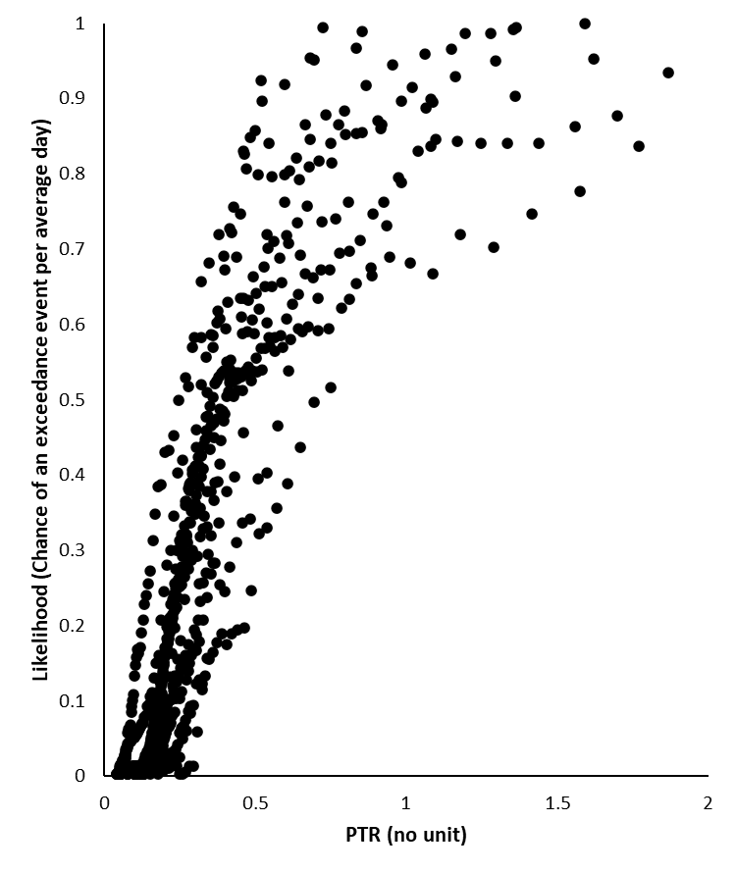 | 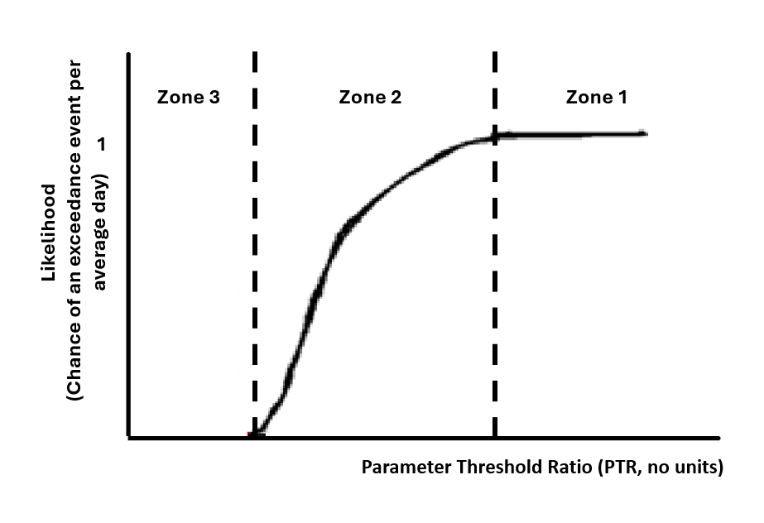
Figure 15: Likelihood of the daily UA exceedance against Parameter Threshold Ratio (PTR) for 17 out of the 19 locations | Figure 16: Schematic of conceptual pattern of likelihood of daily FIS exceedance for UA against PTR at a single location

The classification of zone 1-3 corresponds to the 3-zone pattern described in section 4.2 for DO. Unlike the DO PTR-Likelihood diagram (Figure 13), zone 3 does not automatically mean a likelihood of an exceedance is zero. This is because the UA threshold depends on the prevailing DO, pH and temperature levels in the receiving water. Therefore, even if the ambient UA is further away from the averaged threshold it may still exceed the lowest possible state of threshold, reducing the capacity of PTR to predict likelihood of an UA exceedance. In order to focus the analysis on the sensitivity of measured UA to threshold exceedance uncertainty, two locations were removed from this analysis because the UA values were unusually impacted by low DO values in zone 1 and are not shown in Figure 16.
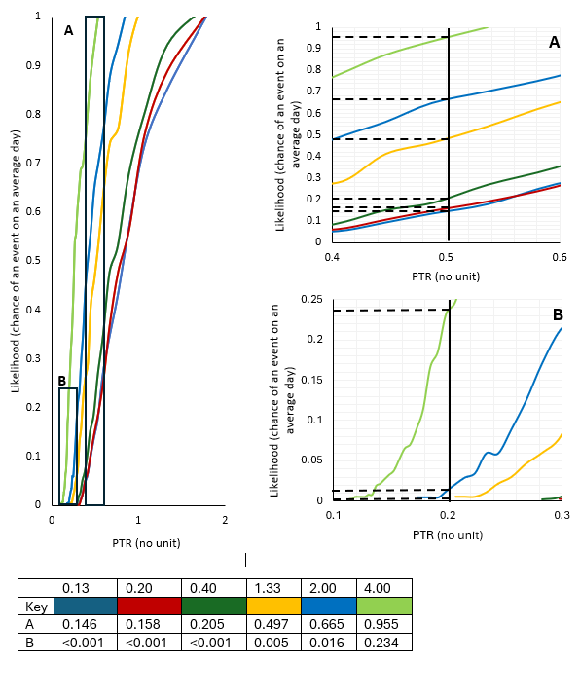

Figure 17: The daily likelihood of exceedance versus PTR curves for UA, from Zone 2, calculated for the six sensor Ammonium uncertainty bands considered ±0.13 (dark blue), ±0.20 (red), ±0.40 (dark green) ±1.33 (yellow), ±2.00 (blue) and ±4.00 (light green).
Table 7: The likelihood reported at the six Ammonium sensor uncertainty bands for region A and B shown in Figure 17.
Uncertainty Bandwidth | 0.13 | 0.20 | 0.40 | 1.33 | 2.00 | 4.00
Region A, PTR 1.1 | 0.146 | 0.158 | 0.205 | 0.497 | 0.665 | 0.955
Region B, PTR 2.0 | <0.001 | <0.001 | <0.001 | 0.005 | 0.016 | 0.234

Figure 17 shows the exponential decay curves from zone 2 for the six considered Ammonium sensor accuracy bands for location 18. In a similar pattern to the earlier DO sensor analysis (Figure 14), where the gradient of the plot is steepest (Figure 17 region A, PTR 0.5) there is large variation within the likelihood of UA threshold exceedances being reported, from 0.146 to 0.955 (Table 7). However, all the different Ammonium sensor uncertainty bandwidths would have the same conclusion that the location ‘fails’ compliance with the FIS regulations. Conversely, when the function is in the initial uplift (Figure 17 Region B, PTR 0.2), the range in the likelihood of an UA threshold exceedance being reported is much smaller, from <0.001 to 0.234 (Table 7). Nevertheless, in the case of Region B, not all sensor uncertainty bandwidths would have the same conclusion that the location ‘fails’ compliance with the FIS regulations. This clearly demonstrates that determining compliance failure is dependent on the uncertainty of the sensor.
4.4.3 Compliance Incorporating Risk
The impact of risk appetite is dependent on which section of the PTR-likelihood diagram (Figure 13 and 16) is being examined. If the location of interest is sufficiently in zone 1 or 3 then the risk appetite will not alter the likelihood of an exceedance occurring on an average day, as it will not alter the extent of interaction with the threshold. Therefore, the conclusion of whether harm had occurred from the decision maker would be consistent. At the upper and lower boundaries of zone 2, however, the risk appetite can alter whether the PTR falls within zone 2 or not. Within Zone 2, the extent of the decrease in likelihood is dependent on the steepness of the exponential decay curve, here risk appetite may alter the binary decision whether harm has occurred or not, as illustrated in Figures 18 & 19.

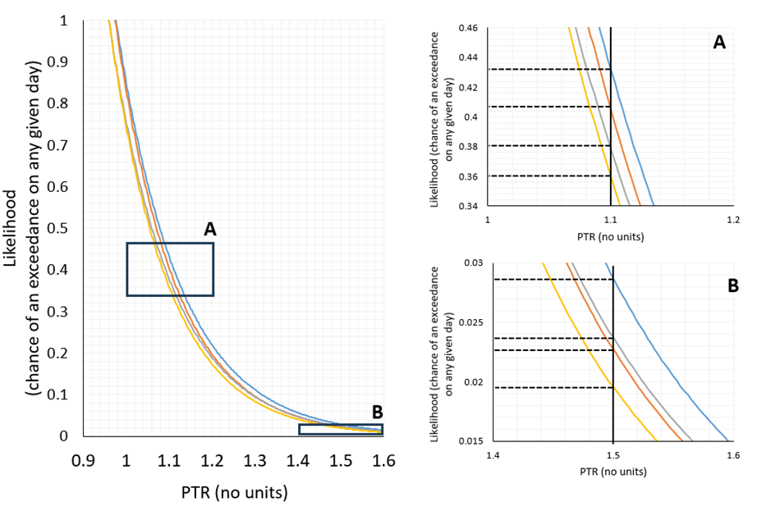
Figure 18: Daily likelihood of exceedance versus PTR curves for DO, from PTR zone 2 calculated for a single location (14) for four risk appetites (0.8, 0.6, 0.4 and 0.2).
Table 8: The likelihood reported at the four risk appetites (0.8, 0.6, 0.4 and 0.2) for region A and B shown in Figure 18.
Risk | 0.8 | 0.6 | 0.4 | 0.2
Region A, PTR 1.1 | 0.364 | 0.382 | 0.409 | 0.431
Region B, PTR 1.5 | 0.019 | 0.022 | 0.023 | 0.028
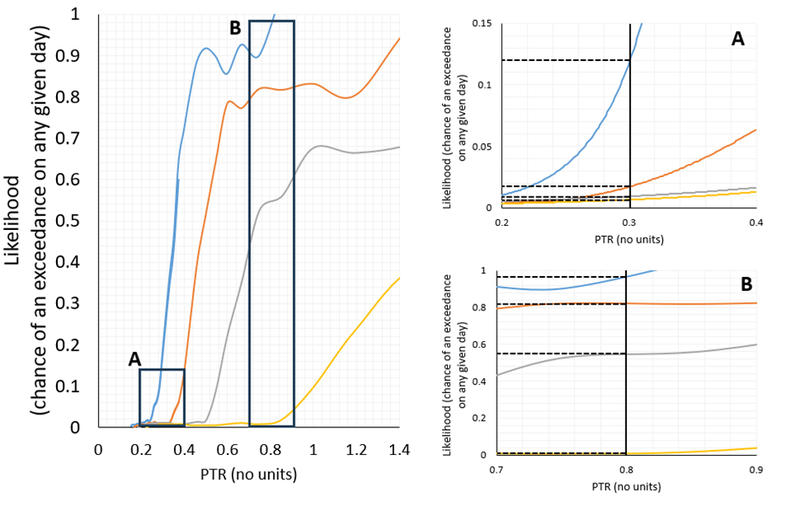
Figure 19: Daily likelihood of exceedance versus PTR curves, from PTR zone 2 calculated for a single location (14) for four risk appetites (0.8, 0.6, 0.4 and 0.2).
Table 9: The likelihood reported at the four risk appetites (0.8, 0.6, 0.4 and 0.2) for region A and B shown in Figure 19.
Risk | 0.8 | 0.6 | 0.4 | 0.2
Region A, PTR 0.3 | 0.009 | 0.011 | 0.018 | 0.121
Region B, PTR 0.8 | 0.009 | 0.550 | 0.802 | 0.961

Figures 18 and 19 and tables 8 and 9 show the zone 2 from both DO and UA Likelihood of exceedance versus PTR diagrams calculated for a single example location and four different risk appetites (0.8, 0.6, 0.4 and 0.2). The uncertainty for each parameter is from table 1 (± 0.2 mg/L for DO and ±2.0 for UA, section 3.1). Becoming more risk averse for both parameters at any value of PTR will usually increase the likelihood of a threshold exceedance. This shows that the gradient of the likelihood of exceedance versus PTR curves is altered by risk appetite as well as location. Nevertheless, with the larger uncertainty band of the total ammonia sensor the difference between the risk appetite bands is much greater. In Figure 19 and table 9, region B, at a PTR of 0.8, the difference between 0.2 or 0.8 risk appetite leading to a daily likelihood of exceedance on any given day being 1 or nearly 0 respectively. In areas where the gradient of the daily likelihood of exceedance versus PTR function is shallower, the difference in likelihood following different risk appetites is smaller, as can be seen for both DO and UA in Figures 18 & 19.

4.4.4 Validation
The methodology (section 4.3) was applied to another dataset of 22 locations from a different geographical location in the UK, this time with a 6 months’ worth of data. DoE/NWP (1983) shows these locations have some variations in climate, some of the locations in the validation dataset have somewhat higher annual rainfall amounts, but lower rainfall intensities. The validation datasets show similar patterns of the effect of PTR on the likelihood of a DO and UA threshold exceedance occurring within an average day. When varying the sensor uncertainty band and risk profiles, similar effects were seen on the daily likelihood of DO and UA exceedance. In the validation dataset, steeper functions characterising zone 2 in the plots of daily threshold exceedance probability versus PTR also were more sensitive to uncertainty band and risk profile. Both geographical locations showed a range of different gradients for zone 2. The validation dataset also showed that some locations that were deemed to have very different gradients in the plots of daily threshold exceedance probability versus PTR, were located in the same catchment several kilometres apart from each other.
4.5 Discussion
4.5.1 Uncertainty
It is acknowledged that sensor uncertainty bandwidth is not the only type of uncertainty associated with the measured data, and likely an underestimation of the overall uncertainty associated with the data. However, the aim of this work is about understanding the interaction between uncertainty in measured data and the regulatory framework. The methodology of characterisation of uncertainty by assigning a probability function consisting of a normal distribution, while common in the hydrologic modelling field (see Deletic et al., 2012), does have its limitations. It is also acknowledged that when more types of uncertainty are considered the application of a normal distribution may become less representative. Systematic approaches to distribution assignment complying multiple uncertainty sources are a gap in the literature, although there are approaches such as Mishra (2002) to complete such analysis. With better understanding of distributions from multiple uncertainty sources, this could be applied to the methodology presented in the paper. The methodology could also be used to examine uncertainty associated with modelled data as well as monitored data.

4.5.2 PTR concept and daily likelihood of exceedance-PTR diagram
This work aims to consider the interaction between data uncertainty and a threshold-based regulatory framework to define ecological harm. It proposes a new term, Parameter Threshold Ratio (PTR), to indicate a location's proximity to entering a state of possible ecological harm. The PTR concept can be applied to other environmental or public health concentration-based threshold regulations which use measured parameters, for example nitrates. It is hypothesised that other parameters will follow a similar three-zone daily exceedance likelihood-PTR diagram (Figure 13 & 16). However, the function to characterise zone 2 is expected to be parameter specific, relating to its own characteristics in fluctuations and relationship with its thresholds, as illustrated by the difference shown between the parameters of DO and UA.
The PTR concept is specifically about a parameter at a certain location likelihood of interacting with a threshold. For a location to sit naturally close to a threshold, it would take a smaller deviation in a parameter to interact with a threshold, compared to if a location sat further away. This does not imply that in any given day or year, that deviation will occur. On the diagram, the y-axis is labelled as likelihood of an exceedance and should not be taken as the likelihood of any given discharge or of the extent deviation observed in the parameter from any given discharge. It is possible for two locations, for one to sit close to a threshold and never interact with it, and for another to sit further away from the threshold but significantly interact with it. This is because there are external factors, such as the capacity vs current use of the sewer network, the likelihood of blockages in the network and the total or intensity of rainfall in the surrounding catchments, that can all increase the likelihood of discharge from the sewer network. The likelihood that the sewer will discharge are not considered in a locations PTR value or the likelihood of an exceedance. The PTR value is to describe, once that discharge has occurred, the likelihood that deviation caused by the discharge has of interacting with the threshold and hence is considered in the assessment of environmental harm. The PTR values and PTR diagram are designed to help articulate a locations sensitivity to uncertainty, to help engage decision makers and regulators with how uncertainty and risk appetite may influence the assessment of environmental harm, or if a threshold-based approach to assess environmental harm if a location is very sensitive to uncertainty. It is not to be used as proof that environmental harm has occurred.
The daily exceedance likelihood-PTR diagram is a visual way of representing a location's sensitivity to uncertainty and risk appetite, which may be used to support engagement with end-users with these abstract concepts. Comparison between definition of harm from intermittent discharges as described in regulatory frameworks from different countries are usually qualitatively and not quantitatively discussed (see Botturi et al., 2021; Wang et al., 2023). The methods described in this study would allow more quantitative comparisons. Regulatory frameworks that at a given PTR, have a lower likelihood on any given day of an exceedance occurring being deemed lenient in their definition of harm.
In the Likelihood-PTR diagram, zone 1 means the location is a continuous state of ecological harm. Regardless of the reasons, you would expect a location concluded as severely failing the regulatory framework to require urgent attention. This conclusion is unlikely to be influenced strongly by uncertainty of the instrument. Thus, consideration around data quality and accuracy should in this case focus on the future use of the data, such as its suitability for calibration of models for solution design. Whereas for a location in zone 3 the question of accuracy of the sensor is entirely around its use for regulatory assessment. Instrument uncertainty in this instance will alter the PTR value where the likelihood of an exceedance is less than one a year (the start of zone 3). Hence instrument quality may be selected based on the criteria to move a location into zone 3 from zone 2, which would increase initial cost, due to needing a sensor with lower uncertainty, but may then also result in no need for further analysis or solution design. It is Zone 2 where not all uncertainty bandwidths or risk profiles would have the same conclusion that a location ‘fails’ the regulation and by extension can also alter the perception to the extent to which a location has failed a regulatory threshold.
4.5.3 Likelihood-PTR Diagram Implication for Sensors Selection
Several authors (e.g. Montserrat et al., 2013; Zhu et al., 2023) have indicated that high spatial and temporal resolution data, requiring the implementation of low-cost sensors, is the way forward in a data-driven understanding of urban drainage problems. One anticipated hindrance to this approach is the installation cost, although the sensor is low cost, the cost of employing people to install, maintain and replace sensors is likely to remain high. When implementing a monitoring network of high spatial and temporal resolution, a variety of sensors should be considered and with such comes a variety of uncertainty bandwidths. Additionally, Höllermann & Evers (2017), concluded not only that uncertainty does matter to practitioners but also that rigid regulation is a defining feature which limits the implementation of new management techniques. Therefore, implying that a hindrance to progression toward the high-resolution data driven approach, is the level of sensor uncertainty which is deemed acceptable for regulatory use. The concept that different locations have different gradients in zone 2 of the exceedance likelihood-PTR curve contradicts the notion that uncertainty should always be minimised where possible when the data is being used for regulatory assessment to gauge the ecological health of the system. Instead, it encourages the idea that in some locations increasing the bandwidth of uncertainty will not alter the binary decisions as to whether harm has occurred, or the extent to which harm has occurred. This then encourages the idea that practitioners responsible for monitoring environmental harm would need to categorise the locations instead of applying blanket rules towards suitable sensor uncertainty at all locations. This has implications for choice of sensor quality, and likely also the cost of monitoring scheme, by justifying the implementation of lower-cost more uncertain sensors in appropriate locations.

4.5.4 Implications of Risk
Studies which acknowledge uncertainties in urban drainage decisions, often refer to risk as the financial consequence of the system being in non-compliance (e.g. Sriwastava et al., 2021; Salletti et al., 2023) or the non-optimal operation of the system relating to a relative performance (van der Werf et al., 2023). The methodology in the current study particularly considered risk as environmental risk, in terms of the possible negative impact on the environment. The reason why this is specified is that this type of risk, in relation to the threshold and regulatory compliance, should be considered in the context of other risks such as financial risk. To be able to do that one needs to quantify the type of risk.
It was shown that the level of risk acceptance or averseness, especially for larger sensor uncertainty bands, was able to alter the daily likelihood of an exceedance occurring. Different parameters were shown to exhibit different gradients in the Likelihood-PTR curve and hence exhibit a different sensitivity to risk appetite. This means that different parameters might be assigned different risk appetites, in accordance with both their capabilities to be monitored or modelled, as well as the shape of their PTR-Likelihood curve.
Explicitly describing the risk appetite level as well as the probability function representing monitoring uncertainty in a parameter, allows decision makers to reevaluate whether a location has breached its threshold in a more transparent manner. For instance, initial assessment may be done under a risk appetite band which the organisation would ‘ideally’ like to work towards. However, when financial constraints are placed upon the project, the organisation can reevaluate locations using different risk bands and accept more risk to reduce the size and possibly even the type of the solution. By accepting more environmental risk, the predicted volume of the storage required to resolve the issues reduces and possibly allows more consideration of Sustainable Drainage Systems or nature-based solutions. This revaluation would be seen not only in potential impact of possible environmental harm, but also in the cost to adapt in the future if needed.
Sriwastava et al. (2021) emphasises the need for implicit corporate risk appetite preference to ensure consistent investment decisions across operations and Selletti et al., (2023) recognised that in Sweden no such framework exists and does not emphasise other countries’ practices for a contrast. Sriwastava et al. (2021) goes on to suggest initially that successful management of sewer systems involves investment and operational decisions which are often perceived to be risk-averse in character, however, concludes that decision makers are actually flexible with their risk averseness. This is because it is believed that urban drainage decision makers would be risk averse, partly by the fact that the fundamental operational approach of the sewer network (pipes taking effluent to treatment plant with the use of SOs) has stayed consistent for several decades in a multiple of countries as well as a slower uptake of digitalisation in water infrastructure management globally compared to other (commercial) enterprises. Conservatism may also be a reflection of the financial regulatory environment that a water utility operates under, with limited opportunities to intervene may result in “safer” solutions being adopted. Both indicated a reluctance to change which is in alignment with a perception of a risk-averse profile. However, there are questions related to the extent in which financial constraints would encourage riskier behaviour. Then there are questions related to the extent in which the current passive nature of many urban drainage networks plays into this risk-aversion. Real time control has been an active area of study in recent years (e.g. van der Werf et al., 2023), would more automation of the sewer network alter the accepted risk level of design or offer multiple opportunities for intervention? Future work is needed in this space to understand (corporate) environmental risk appetite preferences of practitioners and water utilities.
4.6 Conclusion
This work aimed to investigate the influence that sensor uncertainty in multi-parameter WQ sensors can have on the assessment of whether water bodies meet WQ regulatory standards. A new term was created, called Parameter Threshold Ratio (PTR), which may be used to gain an understanding of the likelihood of different locations interacting with the regulatory threshold. The example used to demonstrate the application of this concept were concentration-duration WQ thresholds. The results indicate that both uncertainty and risk appetite influence the binary decision around the assessment of a location meeting concentration-duration-frequency based regulatory standards. The concept was first applied to long-term continuously collected WQ data collected at 19 locations. The approach was then validated for an independent long-term data set collected at another 22 locations. For the DO and UA data investigated at the 41 locations, daily exceedance likelihood versus PTR functions were developed. It was shown that the shape of the daily exceedance likelihood versus PTR functions may be used to better understand a location's sensitivity to sensor uncertainty and risk appetite. Understanding a location's sensitivity to sensor uncertainty and risk appetite has many economic implications from choice of sensor and sensor maintenance regime, and to the size and/or type of solution considered to mitigate potential WQ regulatory failures. Making visible the consequences of sensor uncertainty and risk, can help utilities, with the permission of their regulators to adopt more flexible approaches to sensor selection and risk that would allow actions that are more appropriate to individual locations whilst still providing an acceptably high level of regulatory compliance.

Chapter 5: Understanding the extent of incorporation of the concepts of uncertainty and risk in industry
5.1 Introduction
The previous chapters examine the implication of uncertainty and a risk profile on the FIS exceedance count or likelihood of an FIS exceedance count. This chapter looks at examining how the UK urban drainage sector currently approaches uncertainty and risk and how that may change under a new regulatory landscape.
Before the Environment Act water companies were subject to the 1991 version of the Urban Wastewater Treatment Directive (UWWTD) (EU, 1991) and the Water Framework Directive (WFD) (EU, 2000). The UWWTD had the aim that the sewage network is designed and maintained to a standard which does not cause environmental harm, and the WFD requires possible polluters to show their actions are not the reason why a waterbody has lost or would lose ‘good ecological status’. Sewage collectors can cause harm through discharge of raw sewage from SOs. Both directives work on a premise that the action of the water company, which either has occurred or will occur in the future, can cause the environment to enter a state of harm from a state of non-harm.
The methodology agreed upon by the UK water industry to illustrate this understanding of whether harm has occurred, or would occur, is described in the Urban Pollution Management (UPM) manual (FWR, 2018). The basic structure of which was to collect a limited amount of data to calibrate and validate sewer and river models and to use the model to first determine if it was believed that environmental harm would occur and then design a solution which would eradicate that harm. There are two major concepts that characterise this era of understanding harm: firstly, the importance on modelling and secondly that the methodology worked on prioritising sites. Very few sites were selected for a UPM study to be conducted. Figure 20 visualises how the sector would operate since the adoption of UPM manual in 1990s.
With the new legal requirements of section 82 and section 84 of the Environment Act (2021) the way in which in industry evaluates environmental harm has changed. Figure 21 visualises how the sector is expected to operate under the Environment Act. The major difference between the old and the new procedures to understand environmental harm is firstly the new importance of monitored data located in-situ at each asset, and secondly the fact all sites are monitored simultaneously, removing the step of prioritising sites.
The regulatory set up in England has not changed since the EA took over the responsibility of the National Rivers Authority to act as the environmental regulator and OFWAT was established to act as the financial regulator when privatisation occurred. However, recently their regulatory power has been strengthened under the Water Special Measures Act 2025.
This chapter looks to answer four research questions:
- To what extent does the urban drainage sector currently consider uncertainty and risk in water quality assessment and solution design?
- How prepared is the water industry for the recent regulatory changes?
- To what extent will the change in water quality regulation brought in by the Environment Act 2021, more specifically regarding the continuous open monitoring data, alter the urban drainage sector’s relationship with uncertainty and risk in water quality assessment and solution design?
- To what extent does the role the regulators play influence the urban drainage sector’s approach to uncertainty and risk in water quality assessment and solution design?
To answer these questions a series of semi-structured interviews were conducted with people working in the water industry.
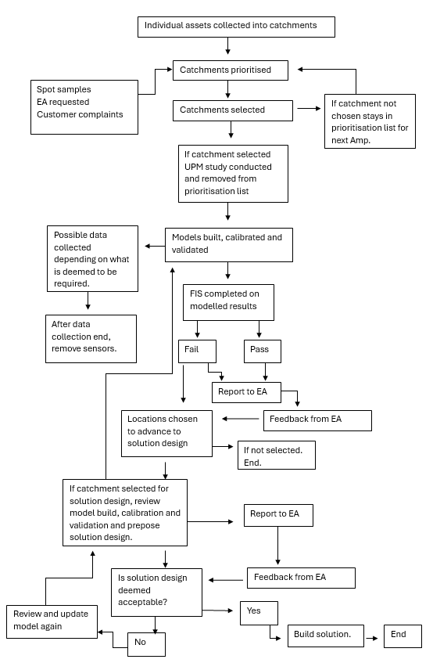
Figure 20: Flow diagram of assessment of environmental harm under the UPM manual procedure
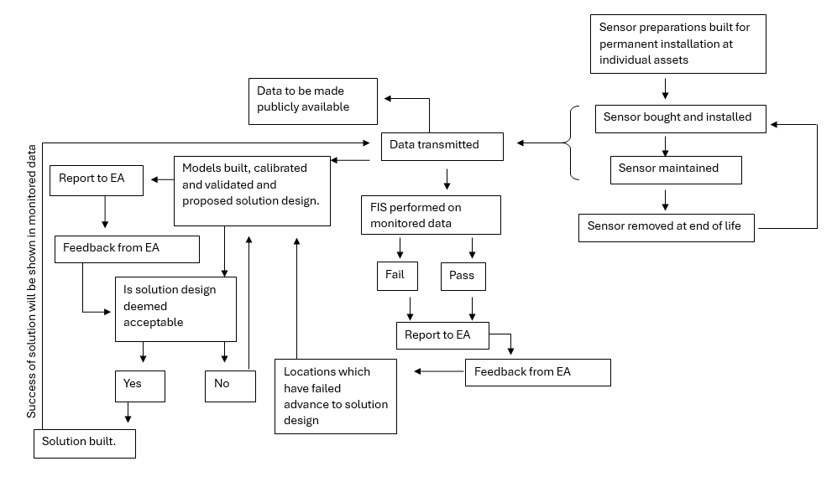
Figure 21: Imagined flow diagram of assessment of environmental harm under the Environment Act 2021
  - Methodology
In total 7 individuals were interviewed: two from a consultancy and five from three different English water companies. The interviews primarily focused on work done in England and Scotland. The remit of the Environment Act 2021 only applies to England, and Scotland has different financial and environmental regulators. However, Scotland is also changing its regulation to include more monitoring and previous work on SO has been conducted in Scotland. Any mention to Scotland specific regulators has not been included in the study. The interview tried to capture a range of stages of careers, however, due to limiting to people with understanding of the topic, there was a bias towards people in later stages in their careers. More were invited to interview but declined on grounds that they either did not believe they had sufficient knowledge in the area or believed that the topic with its current media attention was too controversial to discuss.
The reason why such a small number of participants was selected to participate in the interview was the two-fold. Firstly, was the subject matter. The UPM procedure, though developed in the 1990s, has not been widely adopted by industry until very recently. This was in part because the subject matter of environmental impact of CSO, until recently, was not a priority for the industry as a whole and in part the substantial cost of running a UPM study. In order to achieve the aims of the interviews, it was important to interview the correct individual, who held the relevant technical knowledge. This limited the potential number of participants significantly as many water quality specialists in the field do not have a deep understanding on the UPM procedure, or have not completed a UPM study since AMP 3.
The second factor was the decision to not include participants who currently worked in regulator space. The intersection between uncertainty and risk, is the emotional attachment to the possible consequences of the action. Therefore, to understand how the industry views uncertainty and risk, an understanding must be attained around the anticipation of the reaction of regulators around uncertainty in compliance to statutory and non-statutory obligations. As this reaction would determine the consequence. It is possible that this conversation with those in currently in the regulator space could occur; to compare and contrast how the two parties (the regulator and the regulated) anticipate how a conversation around uncertainty would go. However, that assumes the conversation would occur. In reality, many of the decision around uncertainty and risk are made in order to not have to have a conversation with the regulator, and if they did to already have arguments made to justify their action or plan of actions. Including the regulators perspective also the possibility of skew in the interpretation of the results. That upon reading this work, more consideration would be given to the regulator’s perspective as a ‘truth’ of what should happen. This combined with the fact including regulators would result in regulators being question around the role of regulators, it was decided to focus on the water companies and their consultant’s perspective on risk and uncertainty.
Before the interview, participants were asked to fill out a short questionnaire, providing information such as what sort of organisations they currently and formally work for, what type of individuals they interact with in their day-to-day activity (for instance do they communicate with the regulators) and what parts of the UPM procedure they had experience with. The questionnaire can be found in the appendix (Table 1A).
The semi-structured interviews followed the same outline structure of 10 minutes discussing uncertainty, 10 minutes discussing risk, 20 minutes on how they believed the Environment Act may change assessment and solution design, and 10 minutes on the implications of open data. Table 2A in the appendix shows the outline structure, with some example questions given to each section. The interview was designed to last around 1 hour, so the last 10 minutes was allocated to any theme which the interviewee wished to discuss in more detail. The interviews were transcribed using a transcribing service. Then a thematic analysis was conducted to find similarities and differences on four major themes: uncertainty, risk, regulatory change, and the role of the regulators. It became apparent in the analysis that the theme of regulatory change could be split into two major concepts; firstly, whether the sector was prepared for the change in regulatory landscape and secondly what implications there could be because of the change in regulatory landscape.
Thematic analysis follows 5 steps; familiarisation of the data, generating codes, searching for themes, reviewing themes and finally defining themes. These five-step process was followed the conclusion of the semi-structured interviews. The familiarisation stage requires immersive reading of the transcripts of the semi-structured interviews (Hole, 2024). In this stage initial impressions and recurring patterns are noted down. As familiarisation is not a linear process, each transcript is read several times (see Christou, 2022), returning to previous transcripts reviewed so earlier transcripts can be read with the knowledge of later transcripts. The second step of thematic analysis, generating initial codes, marks transcripts into segments of data by breaking up and combining different sections of transcripts (Braun & Clark, 2006). The purpose of this section is to break the complexity of the interviews into meaningful units of text (see Byrne, 2022). These units of text are then examined for recurring and meaning patterns which align with the research questions (Braun & Clark, 2006). This is the searching for themes stage. An important aspect of this part of the process is that themes must be determined by the data not pre-existing assumptions. Both the significance and relationship to the research area must also be considering. If a potential theme does not have high significance or relevance to the research area, it is removed in the fourth step; reviewing the themes (see Christou, 2022). The last stage is a deeper analysis of the remining themes, to understand how they interact with each other to answer the research questions (see Christou, 2022).
  - Results and Discussion
    - Uncertainty
Universally, uncertainty in data and models could be acknowledged. All participants could recall conversations with colleges discussing some sort of uncertainty. Documentation of these conversations are common practice, though some participants also referred to conversations which were not documented, depending on the extent of the conversation. This documentation could be provided as evidence if anyone questioned the approach to uncertainty, but the extent to which these documents were passed on within organisations was unclear. Having a key individual in the conversation, or signing off the conversation, may be more influential in the organisation than the actual documentation of the conversation. Participants recognised that the impact of uncertainty was not always understood and often uncertainty was not considered in a constant manner. Multiple participants also referred to the fact that some uncertainty, such as impact on rainfall from climate change, population growth rate or the physical location of the monitor was much more prevalent that other types of uncertainty such as the manufacturer’s accuracy bandwidth of monitoring equipment, or uncertainty due to the equations used in a model. There seemed to be a distinction between uncertainty that is built into the methodology, compared to uncertainty associated with processes and concepts.
Multiple participants referred to suitable data or models, and that the ‘best available had to be sufficient’. It is wondered whether this mentality has grown from the fact that the UPM methodology was designed and implemented in the 1990s, where the technology available to understand environmental impact was of a much lower grade. Thus, forcing decisions to be made on poor data or information and if this was sufficient then, now with better data or information it must be suitable too. One participant, however, called this thinking a ‘trap’, reflecting whether the implications of uncertainty had ever really been rigorously challenged by the industry. The UPM procedure was referred to by a couple of participants as to why considerations to uncertainty or risk currently do not occur and may not be relevant in the future. That, according to their understanding, the procedure lends itself to conservativeness, hence they conclude that the impact of uncertainty is likely to be encapsulated within.
Sensitivity analysis, its extent and repetition, appears to be where participants seemed to have most confidence when talking about uncertainty. Most participants believed that sufficient sensitivity analysis was conducted in the UPM procedure. One participant particularly emphasised the role sensitivity analysis has from a cost perspective. That doing more sensitivity analysis can have long-term economic savings, if it results in a more suitable solution being proposed. A different participant talked around how questions around the extent of sensitivity analysis conducted, and any related uncertainty, often occurred while the cost of schemes was discussed. That sometimes extra consideration could be given, if costs were deemed too high. A third participant questioned whether sensitivity analysis was uniformly applied, or if there was a bias to using the tools to explain discrepancies in expert ‘expected’ results and the actual results on a model. That there was not the same appetite in seeing if the expert ‘expected’ results always occurred, if it original results confirmed what they expected to observe.
5.3.2 Risk Appetite
Participants did not acknowledge risk in the same manner in which they acknowledged uncertainty. However, when asked to consider risk, the first question a couple of them started asking themselves was ‘who holds the risk?’. Thinking through the current regulatory setup their conclusion was ‘most likely the water company, as they are responsible for their assets’. One participant took that a step further by talking how ‘protecting the company’s interest’ most likely leads down the route of conservatism. The question whether other organisations in the industry could hold the risk was proposed, but in talking though the answer the participant concluded that it was unlikely, as the regulators may be seen not to be ‘tough enough’ on the water companies in the eyes of the public if they jointly held risk.
The topics ‘gut feeling’ and confidence that a solution could be deemed ‘sensible’ were brought up a few times when discussing risk. That whereas it was not quantified or documented, an experienced modeller can ‘sense’ when a result is appropriate to pass-forward to a colleague or regulator. One term, ‘fit for purpose’, came up a few times when discussing the concept of risk in solution design, particularly in relation to a possible defence to the regulators if at late stages of construction question appeared around suitability. A few participants went on to talk around how engineers like designing to specifications, so if a dispute happens later, they can argue they are not at fault as they did what was expected of them. One participant talked about work done while at a consultancy and explained that the clients’ requirements outweighed their view on the work. Some participants did also talk about the idea of not personally feeling confident in designing to averages. They explained that there may be reservations as to whether solution that produced a result of 9.9 was superior to one which produced a result of 10.1. They described that following the uniform procedure as outlined by UPM and other industry guidelines was common practice, and outweighed personal reservations. One participant wanted to emphasise that conservatism was built into the methodology of the UPM and hence they were confident that solution using this methodology would not have the risk of non-compliance. This all may suggest that personal risk appetite may not be as important as risk practices embedded into procedure.
However, it was also recognised that this ability of a ‘gut feeling’ and recognising what a ‘sensible’ design is, comes with experience. One participant talked about the importance of work culture in developing such a ‘gut feel’ to the work. That where you sat in the organisation, with whom you interacted with and what contractual obligations one has or is working towards could all influence your personal gut feeling. Other participants talked about how they expected that the idea of ‘what is sensible’ was most likely somewhat uniform currently in the industry, as the number of individuals who worked in the area was limited. Hence the same opinions and criticisms were circulated and adopted as practice. Both ideas suggest that personal risk appetite, in terms of the individual’s approach to their work, but also key individual’s risk appetite influencing others in the industry has been influential in the adoption of the UPM procedure.
There were a few other risks which were indirectly related to solution design which participants mentioned. The first was the risk of increasing carbon emissions and energy use due to the Environment Act, with a note that part of the risk is that the industry does not appreciate the full environmental impact of the Environment Act but also part of the risk is posed by nongovernmental organisations (NGOs) not fully understanding the environmental implications of what they are advocating for. The next risk mentioned was the implication of the size of work called for under the Environment Act. That inevitably the work done in the future would be done by a less well experienced workforce, who may not appreciate the complexity of water quality issues in urban drainage. It was thought that this skills gap could increase the role uncertainty plays in the future. The last risk posed was the issue around if a model which would be used for solution design did not replicate the dataset to that is produced by the monitored dataset, how could a solution be designed to observe no harm in the monitored dataset. It was thought that this may lead to more risk adverse decision making where the aim becomes one or no spills, so FIS compliance cannot be exceeded. These risks have been included in this section as participants all identified these as part of the discussion around risk.
5.3.3 Preparedness to regulation change
One question that was asked of the participants was whether they believed the industry understood the implications of the change in regulation. The answers were leaning towards that the industry as a whole had not appreciated the implications of the Environment Act, but that key individuals were prepared. However, interestingly some of the individuals named were also participants in the study, and when they were asked the same question, they answered with doubt that enough individuals understood the area fully for the industry understand the implications of the Environment Act.
There was a general agreement that inclusion of FIS from UPM into the Environment Act was a positive, with FIS being based on scientific principle and its focus on understanding fish populations being noted as its strengths. It was noted that its simplicity around either passing or failing was also a strength. Though around half of the participants commented that insufficient consideration had been applied to the application of FIS for monitored data. That the UPM FIS had been designed with the understanding that it would be applied to modelled data and thus had modelling assumptions, such as clustering and ten-year averaging, in the methodology. Some individuals talked around how limited the discussion around the applicability of FIS had been before it was included in the SODRP. Even so, there was no appetite identified for regulation to move away from a scientific approach to a more pragmatic approach. In fact, multiple individuals talked negatively around how, in their opinion, the Environment Act (usually in reference to target 3 of the SODRP) had a weaker scientific background than the UPM procedure and how they wished water companies had the ability to follow a more scientifically lead approach to reduction of environmental harm under the Environment Act than was currently permitted.
Two individuals from different water companies went on their own accord to describe three different categories of water companies’ preparedness for the Environment Act, based on how they had previously interacted with the UPM. The first category of water companies had performed somewhat recently a UPM style study and had the staff in house with the technical ability to fully engage with such a project. The second was water companies who either had not completed a full UPM study since the early 2000s or who have had to rely heavily on consultants for their technical understanding. The last category consisted of water companies who had not properly engaged with the topic since AMP3 (2000-2005). They named the same water companies for each category, with two water companies in the top category, two water companies in the second category and the rest of water companies in the last category. There was also the ability to name consultancies in these 3 categories, with certain consultancies being named more often than others as having a technical ability to perform a UPM study. One participant of the study was from a water company which fell into the third category, it should be noted that in the discussion there was a noticeable difference in clarity of answer from this individual. Their answers often strayed into discissions around nutrients and impacts on ground water supply, which are important environmental concerns for water companies, but are not covered by either the UPM procedure or sections 82 and 84 of the Environment Act, both of which have a focus on the parameters of DO and UA.
When asked if there was an issue with there being imbalance in the geographical spread of technical understanding, it was answered that there was an unequal spread of technical knowledge, but with advances in technology and the rise of remote working this was not as much as a concern as it would have been previously. This was quite a positive response and one that implies that there is to some degree a sense of community in this area of work. That technical knowledge could and would be transferred between water companies and consultancies if needed in the future. There was even the proposition that this learning in the long term may produce more uniform practices, which was deemed vital for water companies to be assessed against each other. Currently it was identified that the number of individuals who understood the work was limited and that there was a skills gap in the industry. The issue identified was not that they were attributed to a small number of the organisations and that other organisations would suffer, but that these individuals would simply become overloaded. This skill gap and the possible issue around the amount of work required to effectively train up individuals is one that a few participants identified as a risk of the industry, but no solution was proposed alongside it. One participant remembered the amount of time, training and support they received from experienced professionals and compared it to the amount of time they can currently spare for training others and concluded that the pressure and timescale of regulation put on the industry today is a significantly important aspect of this.
5.3.4 Implications of change in regulation
One concept proposed as a consequence of the change in regulatory setup, is the fact that with continuous monitoring, solutions would gain post-construction data around their performance. No participant could recall any previous project that had post construction data collection for understanding the success of the project. One participant went on to explain that such a scheme previously would be negatively regarded by the regulators, particularly from OFWAT. That from the standpoint of the financial regular, the concept that a water company could have spent money on a scheme which did not achieve the desired outcomes that had been outlined in the proposal for the allocation of funds was so inconceivable that there was no reason to check. It was also explained that from a water company perspective there was not a reason to check either, as when a solution was found to be ineffective and environmental harm was occurring there was nothing the water company could do other than submit that evidence to the environmental regulator and get fined. OFWAT would not allow additional expenditure on a site that already had a solution implemented.
When pressed on what this could mean for the industry going forward, a few participants talked about the concept of ‘regret’ and how it was not really an option. That whereas they had not really considered what working to build solutions with continuous monitoring would look like, that given the current regulatory set up demanding continuous monitoring, combined with the current pressure from the public viewing that data, they would most likely prefer over-design. Some admitted that currently they simply did not know if under-design occurred, but others assumed that it did not occur due to the conservatism built into UPM procedure. Thus, if practices in solution design would become more conservative in the short term, before this data provided evidence on whether this assumption was correct is unclear. Whereas some participants talked negatively around the UK approach to ‘measure twice cut once’, others really appreciated that about the UK approach to solution design currently. One participant advocated that UK should promote even more careful consideration to understand the problem, through more modelling or data collection before committing to construction.
This then opens up discussion around what would be different if the financial obligation of only allowing one attempt at a solution was not in place; that one could revisit sites where under-design had occurred. There was a mix of opinions expressed on this topic. Some believed that due to the size of the work under the Environment Act combined with uncertainty due to climate change, the industry does need to engage with solution design practices and part of that is an agreed procedure if under-design occurs. One participant talked around how adaptive pathways planning was already promoted in the industry, such as in DWMPs, and is now being considered for work done around the Environment Act. But this was more due to the practical restrains of achieving the goals of SODRP in time using SuDS, not in case of under-design. They then went on the explain, that even though adaptive pathways planning was promoted as an idea, it often relied on what uncertainty you were using it for, that the ‘pot of money’ for climate change and population growth is different and the company could not ‘misuse’ designated funds. Other individuals quoted additional issues with a site being under-designed, mainly that the construction of solutions disrupts customers and a repetition of that disruption being ‘unacceptable’. A few referred to the cost of ‘knocking down’ solutions which were insufficient as being a waste of money, time and resources (carbon). One participant split their answer by the role in the water industry and their role as a customer of the water industry; stating that from a technical mindset, additional financial resources would be beneficial but from a customer perspective they would want to know if the water company was at fault, and whether this was unavoidable and if it was avoidable an explanation to why customers should pay again.
Three participants recognised that this data could provide a leaning opportunity for the industry, but only if the industry chose to utilise it. There is a reality that the data is required through legal obligation, is collected, reported and made available for the public, but currently not used as a learning opportunity. It was proposed that taking the time to review schemes may provide a better understanding catchments, that currently there may be unknown unknowns. One issue around learning from the data is whether both positive and negative lessons are permitted to be discussed. With the current mindset in the industry that under-design is so intolerable, there would be a fear that water companies could not admit to such activity and hence collectively the lessons learnt from unsuccessful schemes may not be learnt and applied elsewhere. Interestingly one participant also really emphasised the importance that if space and resources were given to learn lessons, there was a need to ensure positive lessons are learnt and discussed too. Otherwise, it could just be used as another tool to criticise the industry. It is believed that some stakeholders, including NGOs and the public, may wish to use this data to criticise the industry, so having a list of case studies available with evidence of positive impacts may be beneficial for water companies. Reviewing schemes to determine their success is additional workload for the industry. There was a conversion around who should undertake such work and impartial organisation such as Water UK to do the work and CIWEM UDG to disseminate the work were suggested, to give other stakeholders (NGOs/ the public) confidence in the assessment. Another proposal was that a working group between different water companies was setup, however, convincing water companies to participate and freely discuss matters of regulatory compliance would be a challenge to be considered. It was noted that the ‘politics’ would need to be removed for useful lessons to be learnt.
The fact that this data will be open may influence how water companies will operate in the future. It was clear from the responses that the openness of the data was real concern for the participants. Multiple participants wanted to emphasise that water companies are ‘not evil’, that SO do not operate when a water company ‘press a button’. They believed that just as with the EDM data, the water quality data will be misinterpreted and misrepresented by the British media. Whether the media or NGOs will be able to distinguish the difference between impact and harm was asked by multiple participants. Others talked around how to show the scale of improvement asked for under SODRP, as it may take decades of data collection, and would the public be able to wait that long. There was a clear agreement that, unlike with the EDM data, there needs to be a narrative explaining the water quality data. One participant emphasised that it was the responsibility of all aspects of the water industry who work with the data to contribute to the overall message. Another participant mentioned that organisations with technical ability, but public credibility, such as Water UK, must engage in promoting objective narratives around the data, when water companies will not be listened to by the public.
5.3.5 The role of the regulators
The most common comment around the regulators was the idea of ‘fairness’. When questioned around what ‘fairness’ was, it was often described as the ability to compare water companies directly. However, some referred to unified approach such as FIS, and other referred to a unified goal such as the ability to not cause harm. But most appreciated that there needs to be some sort of consistency when regulating the sector. One participant stressed that consistency may need to come from the consultancies as they operate across water companies. When asked if it was ‘fair’ for geographical considerations to be considered when comparing water companies, the answer was either unsure or no. One participant talked around how the water company should understand its own constraints and plan accordingly so it could be competitive. There does appear that in answering the question ‘what is considered as a geographical constraint’, poor planning was deemed less acceptable than a physical constrain such as topography. But reference to a particular water company’s economic situation was a common answer as to why considering a company’s situation would not be acceptable from the public and hence could not be used to regulate the sector. One participant started the answer as no, then began talking though the implications that this may have on some customer bills and began to question the difference between fairness for companies and fairness for customers.
It was generally agreed that the regulatory setup in England was a positive, having an environmental regulator (EA) focused on the environment and a financial regulator (OFWAT) focused on the economics. Many participants wanted to emphasise the importance for the sector of a constant working relationship between the EA, OFWAT and DEFRA. However, in terms of uncertainty and risk associated with work done under the Environment Act, they emphasised that the EA needed to lead the discussion. A couple of participants indicated that for work to be conducted on uncertainty and risk, the EA needed to set acceptable risk levels. One participant talked about setting a national risk level, which would be acceptable across the country, in order to be ‘fair’. It was recognised that this would probably lead different water companies to act differently. A different participant talked how conversations with the EA need to occur at the local level, so that individual assets can be discussed and understood. This particular individual also talked about a fear that the EA as an organisation was becoming more risk averse as it has become more centralised as an organisation and thus counteracting for loosing local knowledge. Nevertheless, it was recognised that part of this recent shift could also be due to fear of judicial review and current negative media attention around regulating the sector. They went on to talk about that there had been an increase of conversations being led by what is written in the guidelines, and not to deviate from the guidelines. There was a general acceptance that the EA does appreciate the financial implications of environmental schemes. But one participant did suggest that this may differ depending on who you talk to in the organisation. That occasionally younger individuals may not appreciate the scale of economics, or that once financial side had been agreed upon, one cannot simply keep adding to schemes.
It was pretty well agreed that OFWAT’s drive for inefficacies was not really based on informed decision around nuances of locations but by comparison between companies in monetary terms. One participant talked around how this mindset had currently not caused a problem for industry, as funding had always come through, but went on to question what would happen to the industry as water companies ask for considerably more money than before with new regulatory and climate pressures. They were unsure what the implication for the industry were if sufficient money did not materialise for environment improvement. There was quite a consensus that OFWAT will only focus on economic perspective. Nevertheless, it was generally well agreed among participants that there would be benefits to improve OFWAT’s understanding of the implications of environmental decision making in more detail than is currently discussed; Although not to the level detail of individual standards such as FIS. However, multiple participants also questioned if such information was written on a ‘one or two-pager’, whether it would be read by OFWAT. They just could not see the appetite from OFWAT’s side to engage meaningfully with the environmental side of the decision, simply the economic side. One participant questioned if OFWAT would require more than just information, and whether some sort of structure reorganisation was required. They proposed the idea that OFWAT could separate out environmental enhancement to the operational part, so there would be an expert to engage with in the environmental decisions section of the draft determination of all the water companies. That part of their particular role would be to understand how investing in ‘right places’ provided overall improvements; thus, a more nuanced understanding than currently held from OFWAT. They went on to explain that OFWAT does have a commitment to protect customer interests, which is ‘not just bills’ but could also include environmental protection.
  - Conclusion
It must be noted that seven individuals is a rather limited number of participants to make conclusion on the whole sector. However, due to the current limited number of individuals with experience and understanding of the topic, it is believed that views presented in the interview are representative of the sector.
To answer the first research questions, uncertainty and risk did play a role in the approach taken by the UK urban drainage sector to understand environment harm caused by SO under the UPM procedure. When considering the UPM style of programs, uncertainty associated with data and models could be acknowledged and qualitatively described, but their implications could not. However, uncertainty could be used to shape programs, particularly though the extent sensitivity analysis was performed or not performed. It was also clear that whereas some uncertainty was considered, such a where one placed a sensor, other uncertainty such as uncertainty embedded into models, was ignored. Risk and risk mitigation on the other hand could not be described to the same extent uncertainty was, but it was clearly present in the UPM procedure. Due to the repetition of the word ‘conservatism’ when discussing the UPM procedure and the clear favour of the practitioners to over-design compared to under-design the UK urban drainage sector can be labelled as risk averse. That is not to discount some clearly obvious risk-taking behaviours exhibited by the industry, such a disregard to review schemes once constructed and allowing certain water companies to dis-engage with the topic for the last two decades, resulting in limited number of individuals with technical understanding of the topic.
To answer the second and third research questions, it is unclear that the change in regulation will alter how the urban drainage sector will interact with uncertainty and risk in water quality assessment and solution design. The answers were leaning towards that the industry as a whole had not appreciated the implications of the Environment Act, particularly due to the extent of individuals with technical understanding of the area. The fact that continuous monitoring will force the industry into having post-construction data collection should suggest that the industry would become more risk averse, as under-design was simply described as not an option, not only from a regulatory perspective but also a customer opinion perspective. But there was a confidence in some individuals that under-design does not occur currently, so that would suggest that the behaviour would not change as one would expect the data to show the current methodology as sufficient.
It is proposed from the findings of this work that there are two defining characteristics on whether the urban drainage sector will interact with uncertainty and risk differently in the future. Firstly, if the scale of workload vs skill gap does present a problem, the industry may need to become more risk averse as it loses it confidence in the expertise of its workforce. Secondly, whether the industry choses to learn lessons from having data after construction, will alter its approach to uncertainty and risk. Without learning lessons, the sector cannot reevaluate its current behaviours.
Finally, to answer the last research question, it was clear that the regulators do play an important and influential role in how the sector does and will engage with the topic of uncertainty and risk. It was clear the sector would prefer to follow the lead of the EA. That if the sector was to give more consideration to uncertainty and risk than currently performed, the EA would need to provide some sort of guidance. It was also clear that the sector expects the EA would be in favour of a risk-averse stance. However, currently it is OFWAT that is influencing the practices of the sector the most in terms of its risk appetite. OFWATs ‘one attempt’ financial policy drives the sector to act in risk-averse manner, and it is one of the major reasons why the sector prefers over-design.

Chapter 6: Discussion
6.1 Defining the term ‘excessive’ under the Environment Act 2021
One of the current contradictions the UK water industry faces under the new era of legislation is that they are still subject to pre-Brexit legislation alongside the new Environment Act (2021) (see Figure 1b and 1c). Whereas there is certainly a degree of continuity from previous legislation like the UWWTR and the Environment Act, there are also contradictions. The most obvious continuity is that you can see the WFD, Bathing water directive and UWWTD in the three targets of the SODRP. In target 1 of the SODRP it states that ‘no water body in England should fail to achieve good ecological status due to storm overflow discharges’ (DEFRA, 2023b). Good ecological status is a direct link to the WFD and therefore Environment Act follows the WFD understanding that protecting the environment should be equivalent to no anthropogenic actions altering the natural state of the environment. This provides the evidence that as FIS was deemed suitable for WFD, it should also be deemed appropriate for Environment Act.
Target 3 in the SODRP is the target aimed at SO only operating in unusually heavy rainfall events. Though not a direct link like in target 1 back to an EU directive, this target can be linked to UWWTD. The UWWTD set out the EU position on the collection, transport and treatment of urban wastewater, with a simplistic interpretation of the directive being that EU member states should have satisfactory systems to collect and treat the majority of urban wastewater; with a satisfactory system being one that protects the environment the majority of the time. One could argue that SODRP target 3 is England’s updated interpretation of that directive. Under SODRP target 3 a satisfactory system that protects the environment the majority of the time is equivalent to a system that only discharges into the environment untreated wastewater 10 times a year.
But it actually one of the biggest contradictions in terms of SO for the water industry in England, it how to achieve UWWTR (1994) and the Environment Act (2021) simultaneously. An absolutely key component of the UWWTR (1994) is that in paragraph 2 of schedule 2 where it states that collection systems should be designed constructed and maintained in accordance with BTKNEEC including that of limiting pollution. But the Environment Act (2021) does not have BTKNEEC as a clause, with its focus is on whether its goal, most notably using monitoring to assess number of discharges and no ecological impact from SO, is achieved or not. The cost of such a program is somewhat irrelevant as it is required by law to have such a program in place. Essentially what this means is that limiting environmental pollution from SO is simultaneously both a statutory and statutory plus requirement. That the SORDP targets must happen regardless of cost, while any investments to designing, constructing or maintaining sewage collection assets, referred to in the SODRP targets, must be financially considered and not regarded as excessive.
There could be the argument that this contradiction is not a new predicament. That adequate environmental protection, regardless of the cost, was stipulated under the EU directive of WFD and the water companies in England were required to demonstrate that they did not prevent a location from achieving good ecological status. The difference is that WFD did not focus wholly on the water industry and SO discharges. Whereas section 81 to 84 of Environment Act is very specifically directed at urban wastewater collection systems and crucially how to manage them with associated costs, which previously would have been much more under the authority of UWWTD to determine acceptable cost.
The simple way to achieve both the UWWTR (1994) and Environment Act (2021), is to examine the definition of excessive cost. Usually under the condition of BTKNEEC, excessive cost is the point where additional benefits become disproportionally small in relation to the additional cost required. This means that there has also been a degree of fluidity in its definition of excessive as different stakeholders may attribute different value to the additional benefits and so may argue on the point in which its benefit become disproportionally small. However, under the statutory requirements of the Environment Act, any cost associated with achieving the Act cannot be seen as excessive, regardless of the benefits is brings as it is the legal requirement. For example, whereas before monitoring an asset which had been determined not to cause harm, may previously been seen as excessive uses of resources, (as the cost of monitoring was disproportionally compared to the understanding gained about levels of harm occurring), however now it would no longer be seen as excessive as it is required by the Act. But what this does not mean that any action taken to comply to the Act cannot be seen as excessive. Removing all SO by constructing a completely separate system, so no SO would need to be monitored or assessed for environmental harm under the Act as they did not exist, may be seen an example of an excessive approach to the comply with regulation. This example was considered in the Storm Overflow Evidence Project (Stantec, 2021) and it was estimated to cost up to £600 billion or just under an increase of £1000 to water bills. Thus, one could characterise this as an ‘excessive’ cost to meet the goal of the Environment Act.
It is not that the two regulations cannot exist simultaneously, it is that precedent definition of excessive under UWWTR (1994) of which many in the industry has worked towards contradicts the new legal obligations in the UK. Therefore, opening up questions to what the new definition of excess will look like in designing, constructing or maintaining sewage collection assets including the new assets of monitoring equipment. This is a current and urgent debate in the UK and one in which the UK has not found a consensus on. However, it is also one that can be seen occurring in other countries. For countries still in Europe, they are subject to the new requirements of the recast of the UWWTD (EU, 2024) but the UWWTD has not lost its requirement for not exceeding excessive costs. Therefore, discussion around accepted understanding of excessive costs is also occurring in Europe.
This next section considers how uncertainty and risk appetite may interact with a possible new definition of excessive in investigation level of pollution levels from SO. Neither uncertainty nor risk appetite has been a prominent component in prioritising funds to understand environmental harm before, thus either of their inclusion would be rather a new approach to understanding BTKNEEC under UWWTD, as well as understanding the potential costs involved in implementing the Environment Act (2021).
6.1.1 Sensor Choice
The initial cost for English water companies is to acquire the sensors. As it stands there are currently 14,285 SO in England (DEFRA, 2025c), which under section 82 would need a continuous water quality monitoring both upstream and downstream of the asset. Therefore, excluding the odd sites where clustering would be permitted, that is approximately 28,000 monitors that need to be acquired and installed. It is true that over the last few decades there has been technological advances over the last few decades which allows a program like this to be feasible. This both technical advances in sensing capabilities but also advances in data transmission capabilities.
The change in scale at which the Environment Act calls for digitisation of the river network is significant. To put it into comparison with AMP7, this thesis used sensor data collected from two water companies in Amp 7 which totalled data from 41 locations, whereas the Environment Act calls for sensor data from 28,000 locations. It is expected that total rollout should be completed by 2035 with up to 25%, equivalent to around 7000 units, completed by the end of AMP8 in 2030. In PR24 (OFWAT, 2024) OFWAT has permitted £651 million for continuous water quality monitors which, though a small component of the total expenditure allocated this price review for regulating and improving SO, is substantial.
The cost of current price range of the instruments is believed to be subject to the quantity of units a water company would order. There are two possible external factors that will contribute to the price; that is cost of the raw material in the sensor which is related to the monitoring method, and the demand compared to the supply of sensors. Using a different monitoring method of the parameter of interest, will use different raw materials and could have different sensor maintenance needs, and hence have a different total cost. Raw materials themselves are also subject to fluctuating costs due to worldwide supply and demand. The other contribution factor to cost is supply and demand, with a higher demand likely creating economies of scale.
The current acceptable variety of sensors the UK water companies may use is limited by the requirements outlined in the Continuous Water Quality Monitoring Programme Interim Technical Standard Report (CWQMP ITSR) (DEFRA, 2024). These requirements align closely to BAT currently available on the market for DO, pH and Temperature sensors (see YSI, 2012), limiting the variety of sensors to one that comply with these manufacture bandwidths. It then goes on to state that sensors outside these accepted levels would be ‘deemed non-compliant’ (DEFRA, 2024). So, water companies would not be resilient to any complications with the supply of these sensors. For ammonia, BAT would be the order of ± 2mg/L which could be up to x10⁴% of reading, whereas the CWQMP ITSR allows up to x10⁶% of the reading, so there could be the argument that variety of sensors may already be deemed acceptable for Ammonia. However, the work in chapter 3.1 showed that considering the smaller uncertainty bandwidth of ± 2mg/L, without considering risk (the current methodology), is not sufficient in the majority of locations to understand environmental harm using the FIS. Hence a larger uncertainty bandwidth also likely to be insufficient at the majority of the locations.
As this work shows that different locations are sensitive to uncertainty bandwidths (see chapters 3.1 and 4) this would indicate that an alternative approach to determining acceptable level of uncertainty may be more suitable. Instead of focusing on the capabilities of the sensor currently on the market, which may change over time, the guidance should focus on the impact uncertainty has on determining environmental harm. For instance, a better rule in the UK regulatory landscape could be that sensors must be able to report exceedance counts within a range of ± 3 exceedance for the return period of 1 month, ±1 exceedance counts for the return period of 3 months and 12 months, in order for the sensor to be compliant. Different return period should have different impact on exceedance count by using the same sensor as they have different threshold, they will have different PTR values (see DIAGRAM/ chapter 4).
Locations that are deemed most sensitive to uncertainty would be required to have the most accurate sensors, whereas locations less sensitive to uncertainty may at the water companies’ discretion use other less accurate sensors. As these sensors are not top of the market they may have lower price, though this is not guaranteed. But more importantly, in terms of price, it provides water companies more room for negotiation when communicating with manufactures on price of the sensors. With the current methodology, the manufacturer knows at the start of the negotiations exactly the specification all the water companies want, and therefore vendors who have that specification can dictate the price. Permitting a larger variety of sensors specifications, does not only reduce the likelihood of one sensor specification price being exponentially increasing purely due to demand, but also may allow alternative vendors into the market increasing competition and hence reduce prices.
Additionally, if an issue in the supply chain arises and there is a six-months or longer delay for instance on the luminescent dye used in DO optical sensors, then a DO electrochemical sensor may be bought and used. This means that water companies would not be penalised for six months loss of data in that location. Currently if water companies do not wish to be penalised for loss of data, would need to stockpile sensors for resilience against shocks to the supply chain, which would only increase the demand more for particular appropriate sensors.
The regulators should investigate if paying inflated prices for sensors, due to structure of guidance currently in place, should be considered as excessive or acceptable expenditure under UWWTR 1994 requirement of BTKNEEC.
6.1.2 Maintenance of sensors
The next expected expenditure of the Environment Act is that of maintenance of the sensors. It should be noted that this is an expenditure that is excluded from environmental funding programs such as WINEP and is expected to be accounted for day-to-day working cost of the water companies.
Following the ‘best technical knowledge’ principle of BTKNEEC regarding maintenance would be to follow a two-week maintenance program in accordance with the manufacture guidelines to prevent sensor drift particularly in the ammonia sensor (YSI, 2012). Therefore, taking the premise of 28,000 sensors for the Environment Act, across England there would need to be 728,000 site visits every year. If assume that 3 site visit could be done on average in a day (to allow travel between sites), and then that an individual would work 252 day a year (which is only removing weekend and UK public holidays, no additional paid leave), and that lone working is likely not permitted in accordance with health and safety regulations, then it would require 1926 individuals working full time. If all 1926 individuals were paid an annual salary of £21,000 then the annual budget spent on salaries alone to maintain the sensors would be over £40 million across the nine England sewage operators.
Currently there is no ‘best technical knowledge’ which would provide water companies with a reason to deviate from the manufactures’ guidelines. However, if 60% of sites could follow a 4-week maintenance program, the number of total site visits annually would fall to 492,800 leading to a reduction of 68% of the required number of individuals working to 1304, or a reduction to the salary budget over £13 million for England or £1.4 million per water company. Disregarding any saving in cost of fuel to travel to the sites and the possible reduction this may have on carbon emission if transportation was not fully electric.
There are many causes for in which a sensor can drift. However, there is very little research done for in-situ ammonia sensor in rivers. It is recommended future research done to understand the probability distribution function of poorly maintained sensor in rivers. Figure 22 shows a thought example whereby the error distribution of the sensor has become skewed, though the general idea could also be applied if the normal distribution is simply shifted. If one accepts the concept proposed in chapter 3.2 that the user of the data, for instance water companies, can accept risk by where on the probability distribution curve of uncertainty one choses to consider, then that concept of risk can be applied to data from a sensor which has drifted. If the user of the data wished to use a 0.2 risk profile, then ignoring any considerations to sensor drift they would use a value 1.1 mg/L. If the user of the data wished to use a 0.2 risk profile on the new probability distribution function it would come to 0.8 mg/L. The value of 0.8 mg/L can be found on the normal probability distribution curved where 0.6 mg/L (the recorded value) is mean value. For the example above, it is around the 0.4 risk profile. Thus, these difference in risk profiles, between 0.2 and 0.4, is the accepted risk the user takes on by using data where sensor drift has occurred. Thus, sensor drift may not need to be eradicated though a strict maintenance program but can be accounted for by risk.

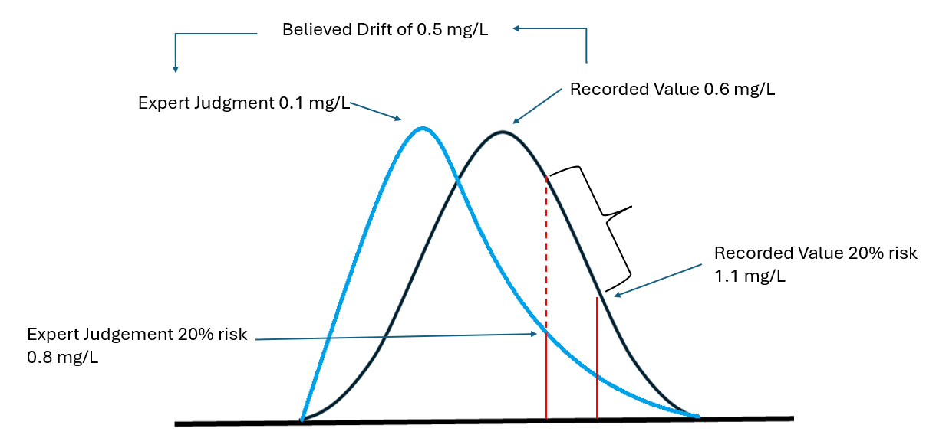
Figure 22: A diagram of a thought experiment illustrating the impact of risk where the ‘expert’ does not believe that the most likely value corresponds to the recorded value due to sensor drift and creates a skewed distribution.
As this work shows that different locations have different sensitivity to risk profile, accepting more risk in terms of altered/skewed probability distribution will result in differences in exceedance counts. Just as the buying of sensor, it is proposed that the guidelines around maintenance are linked to impact on the ability to identify environmental harm, and not on simply on the manufacture’s specification. For example, guidance on maintenance regimes must be designed to a standard where the quality of the data does not interfere with the intended purpose of the data, in this case the count number of FIS exceedance occurred in any given year.
As sensors are a requirement of the Environment Act, the cost to maintain the sensors must not be observed as an excessive expenditure. However, if excess maintenance was occurring, for instance visiting sites daily, that could be seen under UWWTR as excessive expenditure. Guidelines do not currently exits specially stating the regulators view on accepted level of maintenance.

6.1.3 Solution Design and risk aversion
The transition to monitoring under the Environment Act from modelling under the UPM manual is altering the process used to identify locations that require solutions. The landscape in England is transitioning from a system where a very small number of locations are selected for the UPM procedure to one where all locations are simultaneously considered under SOAF and SODRP (see Figure 1b and 1c).
A key finding of the interviews (section 5) was that one of the driving forces behind the risk-aversion level at the English water companies is the current financial setup to which they have to create their plans to. Under the old set up (figure 20) it is a linear function, where locations are prioritised at the start and removed from the prioritisation once agreed to start an investigation. There is no mechanism to review locations which have already received funding. This means that once funding has been allocated, solutions must be built with the mindset that this location will not receive any more funding and hence built to a size that can manage with the current and potential future issues. Thus, an aversion to risk is expected as there are no resources available to handle risk in future, so it is deemed best practice to deal with potential risk in the present. The crucial aspect is that to some degree the risks in the future are hypothetical and unknown risk cannot be accounted for other than simply adding in safety factors. With locations being removed from this prioritisation list once the solution was built, the reality of whether the solution did endure any unaccounted risk which rendered the location to become unsatisfactory again remains unknowable for the vast number of locations. There was no process for reviewing whether being risk averse provided any benefit, or whether it needlessly increased the cost and the use of carbon.
Under the new set up (figure 21) one would expect this to at least continue, if not become more risk averse. This is because there has been no indication that the financial set up will change; under the current OFWAT financial review process still it is expected that allocating funding to a location twice would be seen as inefficient resource management. The change in the new set up, is that there is continued monitoring, providing data on whether the solution continues to be satisfactory and penalised with monitory fines if the SO does become unsatisfactory again. Therefore, the legacy of accounting for potential risk in the present remains. However, the consequence of not accounting for a potential risk has become more substantial. This is expected to result in conditions more susceptible to aversion of risk. There is also the possibility of positive reinforcement when it comes to risk. That if it is shown that accepting a certain level of risk allowed a particular location to not become unsatisfactory under stated conditions, such as unusually large rainfall event, then the conclusion may be that current practices will provide acceptable results everywhere. This works shows that this is likely to be incorrect as different locations have different susceptibility to uncertainty and risk. Thus, uniform practices are unlikely to produce uniform results.
Nevertheless, the change to continuous monitoring is one that could be an opportunity to engage with the regulators around what is ‘excessive expenditure’ when it comes to solution design. At the moment there is no discussion around possibility for ‘extra’ funding opportunities for locations after solutions have been built. Whereas this would be a radical change to the setup of the water industry. Let’s consider a situation where this changed. The current way of thinking is that if the water company choses the smaller cheaper solutions, that just a financial saving to the water company. However, imagine if this money was agreed with OFWAT to be put in a hypothetical pot. This hypothetical pot may be an agreement, where ‘risk’ is absorbed in this AMP in order to protect customers from sudden increases in prices, only under the condition that in a future AMP, OFWAT has theoretically already agreed to that spending, in case the data shows the risk of a smaller solution was deemed unsatisfactory. It could be imagined as a pass-forward credit. Then as part of asset management plans, the success rate of solutions is quantified and reported to the regulators. Where solutions are deemed satisfactory, no remedial action is required, even if the solution is smaller than originally designed. Where solutions are not deemed satisfactory, money is taken from the pot for additional solution/s to be designed.
This type of thinking may be seen a radical change to the water industry set-up is because OFWAT currently heavily focuses on inefficiencies, and doing two solutions would currently be seen as highly ineffective. However, an argument could be made that this financial structure offered by OFWAT actually promotes inefficiency and higher bills for customers. That the promotion of one-attempt structure incentivises water companies to construct larger solutions and requires customers to pay for it all over one AMP cycle. OFWAT’s argument for the one-attempt structure being that customers should not have to pay twice for the same objective. But what if it was not seen as paying twice, but just in two stages. That the actual issue of inefficacies lies with customers paying more money that necessary without any additional benefit observed. Previously that assessment could not be made as there was no post-construction data collected to understand wasted resources. But this proposed two-stage approach, which takes advantages of the continuous monitoring program, could reduce cost overall as extra capacity is only being added where needed, removing over-constructing in locations that never use the safety factors added in.
Adaptive planning is a flexible approach which aims to consider uncertainty in the planning process (Rangwala, 2024). It usually focusses on the impact of climate change (Haasnoot et al., 2024), though has been considered in the context of circular economy and population growth. According to the Schoemaker (2022) is it can balance the known and unknown as well as bridging the gap between different approach favoured by different stakeholders. The tools created in this thesis can help with the adoption of adaptive planning, though the consideration of uncertainty and risk.
One clear message from the interviews, is that building in the same site twice, would disrupt the lives of customers twice, and that this is unacceptable. Hence, another part of the decision to build smaller, must be an understanding of where else in the system or catchment a later solution could be built, whether this be another storage tank or a blue green (SUDs) infrastructure. Some locations may already have future plans for schemes such as SUDs for other objects in the catchment such as flooding proposed in DWMPs (OFWAT, 2025) and this could be taken into consideration when deeming locations appropriate for taking on risk.
The possible reputational damage of a solution not being compliant may be as substantial as any financial saving from smaller solutions, rendering this whole concept of accepting risk and then reviewing the risk not possible. Thus, a part of this process may have to include an agreement with the EA; that sites which have solution under review are either exempt or capped in regard to monetary fines for non-compliance. This may be part of the agreement water companies ask for when the risk is agreed by EA and OFWAT originally before the solution is built and tested. For both the reputation of EA and water companies, it important that locations that are non-compliant are flagged and reprimanded. But for this to work, there would have to be some level of acceptance, by all parties, that not all locations may produce satisfactory level of protection with smaller solutions, which is why there is the monetary structure in place to allow additional resources where needed. There is precedent through the EA procedures, to understand whether there is planned work in the area while assessing the appropriate level of reprimand, which one could argue that this would be an extension of. That possibly there should be a distinction between a location that is non-compliant, and the water company has done nothing about and a location that is non-compliant and the water company has not done enough about. That distinction may be hard to communicate to the public, so there may need to be someway of flagging or classifying locations in process of solution design/construction and not removing that until the full review process has occurred. It is also recommended for industry to consider whether it would be deemed appropriate for water companies to pay fine out of the pot of potential savings from smaller solutions, or whether that pot should have restrictions put upon it to only be used in solutions to protect the environment.
6.2 Transparency
Regarding transparency, there are two areas which need consideration when it comes to uncertainty and risk. The first is transparency around the current technical capabilities in understanding environmental harm and the second is transparency around the decisions made in the process of identifying locations and moving them through to construction of a solution to prevent environment harm.
The SODRP claims that ‘These new duties on monitoring will increase transparency and provide the government, regulators and the public with the information to take action and hold the industry to account’ (DEFRA, 2023b, pp. 38). But that transparency can only occur once the viewer is confident that the data can inform on whether environmental harm has occurred. This work showed that in certain locations, particularly for UA, current BAT does not provide the required level of confidence. Thus, as discussed chapter 3.1, this has implications on regulating the industry as currently two water companies can have different consequences for comparable environmental harm due to different levels of a location’s sensitivity to uncertainty. A key finding from the interview is that idea of ‘fairness’, that all water companies should be held to comparable standard. Therefore, it is recommended that the industry firstly recognises this inequality and secondly communicates it to all stakeholders which have access to the open data. Hence this includes the public. It may be that locations are flagged where FIS is deemed to be an inappropriate methodology of determining environmental harm due to sensitivity to uncertainty. Regardless of how the industry choses to communicate the message around uncertainty, without clear messaging to the public, the SODRP claim around transparency level desired from section 82 of Environment Act will be hard to achieve.
In terms of the process to solution design, the major issue around transparency is that risk and uncertainty is not explicitly documented in the process. An example of where this could change is in the process of draft determinations. In the first round of OFWAT draft determinations, a water company could outline their plans, specifying for each location a preferred risk appetite band. Whereas this could be uniform across all locations, a water company, may also wish identify locations where for particular reasons they are willing to accept less risk. This could for example be for locations close to a bathing water site, being in a recognised site of natural beauty, or close to vocal local community groups or any other key priorities. It is believed from the results on the interviews that their preferred risk appetite would be risk adverse. Thus, most probably originally asking OFWAT for larger amount of money. At this stage they may wish to consider locations’ sensitivity to risk and uncertainty and create a list of locations where financial saving can occur through accepting higher uncertainty or risk levels. This may be sensor choice, or maintenance regimes as outlined in section 6.1.1 and section 6.1.2, but it could also be smaller solution designs. Therefore, when or if OFWAT rebuts the initial draft determination proposal, the next draft can have detailed explanations about the risk and possible implications of these risks the water company is willing to (with both OFWAT and the EA approval) accept in order to meet or move closer to OFWAT’s financial expectations. This offers a level of transparency at least to the regulators around the decision process between steps taken to achieve the desired and actual level of protection for the environment.
  - Uncertainty and risk appetite in other contexts
Primarily this work has had a UK focus, with the use of FIS and interviewing UK practitioners, however the environmental impact of non-treated sewage, as well as the concepts of uncertainty and risk are universal. Therefore, the work presented in thesis will be considered in the context of two different countries (China and Malaysia) as well as a different environment problem (air quality).
6.6.1 China
From a western perspective, one has to acknowledge limitations in understanding the relative importance environmental harm caused by SO currently in China. One has to accept the report China translates for western consumption. In reviewing reports on the state of ecology and environment in China, there is very limited acknowledgement to the identification of SO as a cause of water pollution, in contrast to the extensive impacts of other environmental concerns such as acid rain. In the 2023 report it was noted that across the country 250,000 sewage outlets had investigations, of which 1/3 had complete recertification (Ministry of Ecology and Environment, People's Republic of China, 2023). It is unclear, possibly due to translation error and the limited explanation, whether recertification means that 1/3 passed the investigation and its permit was re-instated or whether 1/3 investigations failed and had their permit review and altered in line to the reality of their use. Either way this implies that the scale of untreated sewage exiting SO in China is extensive as even best-case scenario with a 1/3 failing investigations would be over 83,000 SO identified as non-compliant 2023.
China’s political structure is hierarchical and designed so loyalty is directed to the party not the individual. Therefore, one may suspect that risk appetite described in China policy would not be dependent on the individual but regulated by party. However, it is proposed that in reality may be the opposite and it heavily influenced by key individuals personal risk appetite. China operates on a 5-year cycle, both at the national and local level. At the national level, every five years individuals are elected to the Central Committee oversee the long-term social and economic policies and at the local level lower-level members of the party are moved around to different geographical regions to oversee the implementation of these policies. From the Central Committee side, difference in priorities can be observed from different five-year cycles. For instance, in the 13th Five-Year-Plan (2016-2020) (Central Committee of the Communist Party of China, 2016) there was an emphasis on the environmental policy to see a decrease the discharge of major pollutants into receiving waters. Whereas in 14th Five-Year-Plan (2021-2025) ) (Central Committee of the Communist Party of China, 2021) the major environmental policy focused on a clean and secure low carbon energy supply. It is speculated that focus on the committee focus may relate to the personal experience and opinions of the individual elected. If they do not prioritise water quality improvement, the risk-taking actions may be adopted at the local level with reallocation of funds to environmental policies which are prioritised by the Central Committee. It is also suggested that risk appetite may also be dependent on the individual elected to oversee that particular region. There is a general acceptance they are permitted to adjust policies and strategies to the specific reginal requirements, but also to be promoted to higher positions in the party, their regions should show exceptional progress. Therefore, it is speculated that depending on the individual drive to progress in the party, a region may exhibit more risk averse or taking approach to SO depending on the speed at which the individual in charge of the region wishes to see improvements and the regard the individual places on the fact that a different person will review how they leave the region in 5-years’ time. It is not known who will follow or what their current or future influence in party will be.
6.3.2 Myanmar
Myanmar is an example of a country that does not have a well-established sewage infrastructure. Currently only 10% of its sewage is collected and treated and only in major cities (Japan International Cooperation Agency, 2019). It also has no national ambient water quality standards (Japan International Cooperation Agency, 2019). This limits the applicability of the approach set out in this thesis, that one can understand acceptable levels of uncertainty in relation to its effect on regulatory compliance and the risk profile of the decision-maker in relation to non-compliance. If there is no compliance procedure, one cannot non-comply. Currently therefore it is probably assumed that the risk profile of the nation is risk-taking, as much of the sewage is not treated and there being no consequence for environmental impact.
If one takes the assumption that Myanmar may imposes standards in the future, they produced guidelines in 2012 (Japan International Cooperation Agency, 2019) as a route to regulatory setup and already has a regulatory body, the Sewerage Services Department, how applicable in the future could the work in this thesis be. Primarily this work focused on an environmental impact and economics implications of retrofitting an already established centralised system with SO assets. With such limited already existing infrastructure, Myanmar may wish to adopt a decentralised approach particularly for its rural areas, which focuses on treating wastewater close its source, such as in the local community, or even at the household level (Muzioreva et al., 2022). It is recognised in academic literature that such approaches cost be more cost-efficient, as it removes capital as well as some maintenance cost which can be beneficial for low lower-middle income countries (Muzioreva et al., 2022). Such an approach requires a high level of engagement with the public, which could have two consequences for the risk profile adopted by the Sewerage Services Department. Firstly, it may encourage risk-adverse stance due to fears of public health risks, from the public’s direct contact with such systems. Secondly, a decentralised system may lessen the combativeness nature between the water companies, regulators and public which observed in the UK. This combativeness for the UK is a strong driving force in the overall risk-averse profile, but if the public are more involved and more educated in the process of collecting and treating sewage, there may a higher influence of the individual’s risk profile and how they wish to engage with the system.
6.6.3 Air Quality
Outside the use in the water industry, concept developed in this work could be used in other environmental practices. This work focused on the sections on the Environment Act (2021), 81-84 on the water quality, but in previous sections (Part 4 sections 72-77) focuses air quality. Just like the call for digitalisation of the water network, there is also a call for local authorities to uses sensors to understand air quality, particularly that of particular matter 2.5 and 10. Both of which in the UK has a concentration threshold-based regulation, the difference is that wate quality follows the scientific approach of concentration-duration-frequency whereas the air quality regulation follows a more pragmatic approach of concentration aggregation so data collection can occur at a courser timestep. Uncertainty affects both data, currently air quality must fall with 25% band for the total year (UK AIR, 2025). Furthermore, just like with the water data, the purpose for this air quality data is to be the justification of the billions of pounds of investment however for air quality the angle is much more focused on improving the health of the UK public. Therefore, one would assume that the risk appetite would be much more averse, as public health is usually viewed more consequential than environmental health. The existence of SO is evident to that; that stagnant sewage enters to rivers, so it does not enter residential or commercial properties. That is a decision between environmental and public health. But the decision to make the regulation pragmatic and not scientific may imply that the air quality sector is more risk-taking as it reduces the consequence of becoming non-compliant. Practitioners cannot be confident that at the instance of non-compliance there is direct consequence. But compliance implies good ambient air quality and that usually results in better public health.

Chapter 7: Conclusion
The first conclusion of this thesis is that the work demonstrates that both uncertainty and risk appetite can alter one’s understanding of whether environmental harm has occurred from SO and thus both should be considered in regulatory compliance assessments. The work in chapter 3.1 illustrates that at certain locations the sensitivity to uncertainty is of a magnitude which makes the assessment of environmental harm using FIS and BAT not reasonably possible. For UA at a considerable number of locations the change in the number of FIS exceedance counts due to uncertainty was larger than the number of permitted FIS exceedances (Table 3, section 3.1). It was also shown that different locations have different levels of sensitivity to uncertainty. This has consequences when regulating the sector, as currently two water companies can have a comparable impact on the environment, yet as a result of a location’s sensitivity to uncertainty, they could have different consequences such as either receiving a monetary fine or not receiving one. One of the results of the interviews presented in chapter 5, indicated that the concept of regulations being ‘fair’ to water companies is very important to practitioners in the sector.
Academic literature suggests that uncertainty should be considered with the concept of risk, which currently it is not. From the interviews it is evident that the UK water sector does operate in a risk averse manner, however, risk is currently considered in an opaque manner without any documentation or agreed procedure. It is therefore recommended that the sector agree a methodology of quantifying risk, such as the methodology proposed in this thesis in chapter 3.2. Here the risk profile corresponds to a point selected on the probability distribution function that describes uncertainty related to the accuracy specification of a sensor. Risk was also demonstrated to be able to influence final FIS exceedance counts, hence the sector should engage with and be transparent about its risk appetite.
Considering uncertainty in the FIS thresholds was identified in chapter 3.2 to be as influential in determining the final FIS exceedance counts as considering the uncertainty related to the accuracy of the monitoring equipment and considering risk profiles associated only with the monitored dataset. As the FIS methodology uses the monitored data to calculate the FIS thresholds, the FIS thresholds are also susceptible to the uncertainty associated with the monitored dataset. Following this a new term was created called Parameter-Threshold Ration (PTR) which can be used to gain an understanding of the likelihood of a location interacting with the regulatory threshold. A three-stage diagram was developed where a location is either always exceeding the threshold or sometimes exceeding the threshold or never exceeding the threshold. The shape of the function in the 2nd stage of the PTR diagram was shown to be first parameter specific, with DO and UA having two distinct different functions, and then secondly location specific. Thus, the concept of PTR can be used to demonstrate a location’s sensitivity to sensor uncertainty and risk appetite. The benefit of PTR diagrams is that it allows the abstract concepts of uncertainty and risk to be visualised when engaging with stakeholders. The concept of PTR, though developed and validated on 41 water quality dataset using FIS, is believed to be applicable in other scenarios as long as there is a threshold and parameter which may exceed it.
The fact that different locations have different sensitivity to uncertainty and risk also has economic implications. Currently the UK is undergoing regulatory change, where the concept of ‘excessive expenditure’ is currently being recalibrated. Whereas uncertainty and risk have never been used to understand ‘excessive expenditure’ is it is proposed that it could be in the future. One example given for this was using how the tools created in the thesis could be used to advise on a maintenance regime for the continuous water quality sensors. It is proposed that when checking compliance with FIS, while using data where it is accepted that the sensor has drifted is a form of accepting a risk, and that this may be permissible if it does not alter the final FIS exceedance count. Though future work is needed to understand the probability distribution function describing uncertainty related to using a water quality sensor that has been less regularly maintained would be required to understand the extent of risk one is accepting. The largest economic impact of uncertainty and risk is around the decision whether environmental harm has occurred, and therefore whether a solution is required to be designed and implemented.
Whereas this thesis has primarily focused on how uncertainty and risk effects the assessment of environmental harm from SO from an English perspective, using FIS standards and interviewing British practitioners, it has consequences countries as well as other environmental contexts. It is recommended that the topic of uncertainty and risk presented in this thesis is also studied from a social science perspective. This thesis presents a methodology of how the sector may engage with uncertainty and risk, however, as the data from the continuous water quality monitoring program will be made public there needs to be an approach to how the public can also engage in uncertainty and risk.

- References
Agbehadzi R.K., Meteyake H.T., Adjei-Mensah B., Sasu P., Koranteng A.A., Dassidi N., Hamidu J.A., Tona K. (2024), Effects of layer breeder age and reduced incubator oxygen concentrations on embryo development, hatching events, chick quality, embryonic mortality and hatchability of fertile eggs, Heliyon, 10 (22), e40468 https://doi.org/10.1016/j.heliyon.2024.e40468
Ahamed A., Madhav S., Singh A.K., Kumar A., Singh P. (2020), Types of Water Pollutants: Conventional and Emerging, in Pooja D., Kumar P., Singh P., Patil S. Sensors in Water Pollution Monitoring: Role of Material, Advance Functional Material and Sensors, pp. 21-41.
Ahmadi A., Moridi A., Han D. (2015), Uncertainty Assessment in Environmental Risk through Bayesian Networks, Journal of Environmental Informatics, 25 (1), pp. 46-59.
Ahn J.M., Lyu S. (2020), Selection of Priority Tributaries for Point and Non-Point Pollution Management, KSCE Journal of Civil Engineering, 24 (4), pp. 1060-1069.
Allan R., Jeffrey P., Clarke M., Pollard S. (2013), The Impact of Regulation, Ownership and Business Culture on Managing Corporate Risk within the Water Industry, Water Policy, 15 (3), pp. 458-478.
Almakki A., Jumas-Bilak E., Marchandin H., Licznar-Fajardo P. (2019), Antibiotic Resistance in Urban Runoff, Science of the Total Environment, 667, pp. 64-76
Asadi H., Shoham R., Pollak Y. (2021), Intertwined Associations Among Attachment Styles, Emotional Dysregulation and ADHD: Examining Unique Associations with General Risk-Taking Behaviour, Journal of Neural Transmission, 128 (7), pp. 957-968, DOI: 10.1007/s00702-021-02320-4
Baybutt P. (2015), Calibration of Risk Matrices for Process Safety, Journal of Loss Prevention in the Process Industries, 38, pp. 163-168.
Bizer M., Kirchhoff C.J. (2022), Regression Modelling of Combined Sewer Overflows to Assess System Performance, Water Science and Technology, 86 (11), pp. 2848-2860
Bocek G.D. Wood C.M., Iftikar F.I., Matey V., Scott G., Sloman K.A., da Silva M.N.P., Almeida-Val V.M.F., Val A.L (2013), Interactions between hypoxia tolerance and food deprivation in Amazonian oscars, Astronotus ocellatus, The Journal of Experimental Biology, 216 (24), 4590-600 DOI: 10.1242/jeb.082891
Bodnar G. M., Giambona E., Graham J. R., Harvey C. R. (2019), A View Inside Corporate Risk Management, Management Science, 65 (11), pp. 5001-5026.
Botturi A., Ozbayram E.G., Tondera K., Gilbert N.I., Rouault P., Caradot N., Gutierrez O., Daneshgar S., Frison N., Akyol Ç., Foglia A., Eusebi A.L., Fatone F., (2021), Combined Sewer Overflows: A Critical Review on Best Practice and Innovative Solutions to Mitigate Impacts on Environment and Human Health, Critical Reviews in Environmental Science and Technology, 51(15), PP.1585-1618, https://doi.org/10.1080/10643389.2020.1757957
Boycko M., Shleifer A. (1996), A Theory of Privatisation, Economic Journal, 106 (435), pp. 309-319.
Bracken L. J., Wainwright J., Ali G. A., Tetzlaff D., Smith M. W., Reaney S. M., Roy A. G. (2013), Concepts of Hydrological Connectivity: Research Approaches, Pathways and Future Agendas, Earth Science Reviews, 199, pp. 17-34.
Braun V., Clarke V. (2006), Using Thematic Analysis in Psychology, Qualitative Research in Psychology, 3(2), pp.77-101
Byrne D. (2022), A Worked Example of Braun and Clark’s Approach to Reflexive Thematic Analysis, Quality and Quantity, 56 (3), pp. 1391-1412
Burant A., Selbig W., Furlong E.T., Higgins C.P. (2018), Trace Organics Contaminants in Urban Runoff: Associations with Urban Land-Use, Environmental Pollution, 242, pp. 2068-2077.
Camp T.R. (1946), Design of Sewers of Facilitate Flow, Sewage Works Journal, 18 (1) , pp.3-16, Available https://www.jstor.org/stable/25030187?searchText=&searchUri=&ab_segments=&searchKey=&refreqid=fastly-default%3Af4b9ba0b361da810df33b2e2293470cf&initiator=recommender&seq=14
Central Committee of the Communist Party of China (2016), The 13th Five-Year Plan For Economic and Social Development of The People’s Republic of China (2016–2020), Available: https://en.ndrc.gov.cn/policies/202105/P020210527785800103339.pdf, Accessed: 24/05/2025
Central Committee of the Communist Party of China (2021), Outline of the People's Republic of China 14th Five-Year Plan for National Economic and Social Development and Long-Range Objectives for 2035, Available: https://cset.georgetown.edu/wp-content/uploads/t0284_14th_Five_Year_Plan_EN.pdf, Accessed: 24/05/2025
Chan R.H., Clark E., Guo X., Wong W.K. (2020), New Development on the Third-Order Stochastic Dominance for Risk-Averse and Risk-Seeking Investors with Application in Risk Management, Risk Management – An International Journal, 22 (2), pp. 108-132, DOI: 10.1057/s41283-019-00057-9
Christou P.A. (2022), How to Use Thematic Analysis in Qualitative Research, Journal of Qualitative Research in Tourism, 3 (2), pp. 79-95
CIWEM (2016), Event Duration Monitoring Good Practice Guide, Version 2.2 Available: https://www.ciwem.org/assets/pdf/Special%20Interest%20Groups/Urban%20Drainage%20Group/EDM-Good-Practice-Guide.pdf Accessed: 24/06/2025
Cristiano E., ten Veldhuis M-C., van de Giesen N., (2017), Spatial and Temporal Variability of Rainfall and Their Effects on Hydrological Response in Urban Areas - A Review, Hydrology and Earth System Science, 21, pp. 3859-3878, https://doi.org/10.5194/hess-21-3859-2017
Cubbin J., Stern J. (2004), Role of UK Competition Agencies in the Regulation and Deregulation of Utilities Service Industries, Utilities Policy, 12 (2), pp. 53-55.
De Toffol. S., Engelhard C., Rauch W., (2007) Combined Sewer System Versus Separate System – A Comparison of Ecological and Economical Performance Indicators, Water Science and Technology, 55(4), pp. 255-264 https://iwaponline.com/wst/article/55/4/255/12023/Combined-sewer-system-versus-separate-system-a
DEFRA (2022), Water industry strategic environmental requirements (WISER), Available: https://www.gov.uk/government/publications/developing-the-environmental-resilience-and-flood-risk-actions-for-the-price-review-2024/water-industry-strategic-environmental-requirements-wiser Accessed: 24/06/2025
DEFRA (2023a), Storm Overflows Discharge Reduction plan, https://assets.publishing.service.gov.uk/media/6537e1c55e47a50014989910/Expanded_Storm_Overflows_Discharge_Reduction_Plan.pdf, Accessed:24th January 2025
DEFRA (2023b), Continuous Water Quality Monitoring Program: Provisional Technical Guidance for Sewage undertakers of implementing s.82 of the Environment Act 2021, Version 1, Available: https://assets.publishing.service.gov.uk/media/6436dc0dcc9980000cb89426/CWQM_programme_provisional_technical_guidance_for_sewerage_undertakers_April_2023.1.pdf Accessed 26/02/2024
DEFRA (2023c), Storm overflows monitoring hits 100% target, Available: https://www.gov.uk/government/news/storm-overflows-monitoring-hits-100-target, Accessed: 24/06/2025
DEFRA (2024), Continuous Water Quality Monitoring Programme, Interim Technical Standard. August 2024, Version: 1.0
DEFRA (2025a), State of the water environment indicator B3: supporting evidence, https://www.gov.uk/government/publications/state-of-the-water-environment-indicator-b3-supporting-evidence/state-of-the-water-environment-indicator-b3-supporting-evidence Accessed: 24/05/2025
DEFRA (2025b), Water (Special Measures) Act: policy statement, https://www.gov.uk/government/publications/water-special-measures-bill-policy-statement/water-special-measures-bill-policy-statement, Accessed: 27th March 2025
DEFRA (2025c), Event Duration Monitoring - Storm Overflows - Annual Returns, Available: https://environment.data.gov.uk/dataset/21e15f12-0df8-4bfc-b763-45226c16a8ac, Accessed: 24/06/2025
Deletic A., Dotto C.B.S., McCarthy D.T., Kleidorfer M., Fremi G., Mannina G., Uhl M., Henrichs M., Fletcher T.D., Rauch W., Bertrand-Krajewski J.L., Tait S. (2012), Assessing Uncertainties in Urban Drainage Models, Physics and Chemistry of the Earth Parts A/B/C, 42-44, pp.3-10 https://doi.org/10.1016/j.pce.2011.04.007
Djuwita M.R., Hartono D.M., Mursidik S.S., Soesilo T.E.B. (2021), Pollution Load Allocation on Water Pollution Control in the Citarum River, Journal of Engineering and Technological Sciences, 53 (1), DOI: 10.5614/j.eng.technol.sci.2021.53.1.12.
Drugowitsch J., Mendonca A. G., Mainen Z. F., Pouget A. (2019), Learning Optimal Decisions with Confidence, Proceedings of the National Academy of Science of the United States of America, 116 (49), pp. 24872-24880.
EC (1976) Council Directive 76/464/EEC of 4 May 1976 on pollution caused by certain dangerous substances discharged into the aquatic environment of the Community, Available: https://eur-lex.europa.eu/eli/dir/1976/464/oj/eng Accessed: 24/06/2025
Emerson K.R.C., Russo R.C., Thurston R.V. (1975), Aqueous Ammonia Equilibrium Calculations: Effect of pH and Temperature, Journal of Fisheries Research Board of Canada, 32, pp. 2379-2383
Environment Agency (2012), Review of Urban Pollution Management Standards against WFD Requirements, Bristol, Available: https://assets.publishing.service.gov.uk/media/5a7c56d840f0b62dffde1747/LIT_7373_b2855a.pdf, Accessed: 14th August 2024
Environment Agency (2022a), Water industry national environment programme (WINEP) methodology, Available: https://www.gov.uk/government/publications/developing-the-environmental-resilience-and-flood-risk-actions-for-the-price-review-2024/water-industry-national-environment-programme-winep-methodology, Accessed: 24/04/2025
Environment Agency (2022b), Water industry strategic environmental requirements (WISER), Available: https://www.gov.uk/government/publications/developing-the-environmental-resilience-and-flood-risk-actions-for-the-price-review-2024/water-industry-strategic-environmental-requirements-wiser, Accessed: 24/04/2025
Environment Agency (2025), Storm overflow assessment framework 2025, Available: https://www.gov.uk/government/publications/storm-overflow-assessment-framework-2025/storm-overflow-assessment-framework-2025, Accessed: 24/04/2025
Environmental Permitting Regulation (2016) Available: https://www.legislation.gov.uk/uksi/2016/1154/contents Accessed: 24/06/2025
Environmental Protection Agency (1977), Clean Water Act of 1977: Title III: Standards and Enforcement, Available: https://www3.epa.gov/npdes/pubs/cwatxt.txt, Accessed: 14/08/2024
Environmental Quality Standards (1993), Ministry of the Environment Government of Japan, Available:https://www.env.go.jp/content/900454947.pdf , Accessed: 14/08/2024
EU (2025), European Water Resilience Strategy, Brussels, Available: file:///C:/Users/cip20pcm/Downloads/European%20Water%20Resilience%20Strategy.pdf, Accessed: 24/06/2025
EU (2024), Urban Wastewater Treatment Directive, Available: https://data.consilium.europa.eu/doc/document/ST-7108-2024-INIT/en/pdf, Accessed: 14/08/2024
EU (2008), Environmental Quality Standards Directive, Available: https://eur-lex.europa.eu/eli/dir/2008/105/oj , Accessed: 14/08/2024
EU (2000), Directive 2000/60/EC of the European Parliament and of the Council of 23 October 2000 establishing a framework for Community action in the field of water policy, Available; https://eur-lex.europa.eu/eli/dir/2000/60/oj/eng Accessed: 24/06/2025
Fashchevskaya T.B., Polianin V.O., Fedosova L.A. (2018), Strucutral Alalysis of Water Quality Formation in an Urban Watercourse: Point, Non-Point, Transit and Natural Components, Water Resources, 45 , S67-S78.
Fondriest Environmental (2014), “Measuring Dissolved Oxygen.” Fundamentals of Environmental Measurements., Available: https://www.fondriest.com/environmental-measurements/measurements/measuring-water-quality/dissolved-oxygen-sensors-and-methods/, Accessed: 24/06/2025
Foundation for Water Research (FWR), (2018), Urban Pollution Management Manual, version 3. http://www.fwr.org/UPM3/Section2.pdf Accessed: 3rd July 2024
Foundation for Water Research (FWR), (1994). Urban Pollution Management Manual, version 1, Marlow, pp 299-301
French S., Maule J., Papamichail N. (2009), Decision Behaviour, Analysis and Support, Cambridge University Press, Cambridge
Frisch D., Clemen R. T. (1994), Beyond Expected Utility – Rethinking Behavioural Decision Research, Psychological Bulletin, 116 (1), pp. 46-54.
Fritsch O., Adelle C., Benson D. (2017), The EU Water Initiative at 15: Origins, Processes and Assessment, Water International, 42 (4), pp. 425-442.
Garmashov A. S., Akinin N. I., Melnikov N. O. (2019), Assessing Professional Risk, Coke And Chemistry, 62 (10), pp. 489-492.
Giri S. (2021), Water Quality Prospective in Twenty First Century: Status of Water Quality in Major Rivers Basins, Contemporary Strategies and Impediments: A Review, Environmental Pollution, 271, AN: 116362.
Groffman P.M., Baron J.S., Blett T., Gold A.J., Goodman I., Gunderson L.H., Levinson B.M., Palmer M.A., Paerl H.W., Peterson G.D., LeRoy Poff N., Rejeski D.W., Reynolds J.F., Turner M.G., Weathers K.C., Wiens J. (2006), Ecological Thresholds: The Key to Successful Environmental Management or Important Concept with No Practical Application, Ecosystems, 9 (1), pp. 1-13, DOI: 10.1007/s10021-003-0142-z https://link.springer.com/article/10.1007/s10021-003-0142-z
Haasnoot M., Fant V.D., Kwakkel J., Lawrence J. (2024), Lessons from a decade of adaptive pathways studies for climate adaptation, Global Environment Change, 88, 102907, https://doi.org/10.1016/j.gloenvcha.2024.102907
Haines F. (2011), Addressing the Risk, Reading the Landscape: The Role of Agency in Regulation, Regulation and Governance, 5 (1), pp. 118-144.
Hampson D. I., Ferrini S., Rigby D., Bateman I. J. (2017), River Water Quality: Who Cares, How Much and Why?, Water, 9 (8), AN: 621.
Hannigan E., Feeley H. B., Kelly-Quinn M. (2016), Should Rare or Distinctive Rivers Types be Given Special Consideration under the Water Framework Directive? A Synthesis of Available Information, Biology and Environmental-Proceedings of the Royal Irish Academy, 116B (3), pp. 167-177.
He W., Zhang K., Kong Y., Yuan L., Peng Q., Degefu D.M., Ramsey T.S., Meng X. (2023), Reduction Pathways Identification of Agricultural Water Pollution inNakamura Hubei Province, China, Ecological Indicators, 153, 110464, https://www.sciencedirect.com/science/article/pii/S1470160X23006064?via%3Dihub
Herbet N.A., Steffensen J.F. (2005), The response of Atlantic cod, Gadus morhua, to progressive hypoxia: fish swimming speed and physiological stress, Marine Biology, 147, pp. 1403-1412
Hermansyah H., Kumaranigrum A. R., Sommeng A. N., Wijanarko A., Sahlan M., Shariff A. M. (2019), Semi-quantitative Risk Assessment on the Impact of Port Development to Wellhead Platform, Process Safety Progress, 39, UNSP e12117.
Herrero J.L., Lonzano J., Santos J. P. (2015), A REstfull Approach for Classifying Pollutants in Water Using Neural Networks, in Rocha A., Correia A.M., Costanzo S., Reis L.P. New Contributions in Information System and Technologies, Advances in Intelligent System and Computing, 353, pp. 371380.
Hole L. (2024), Handle with Care; Considerations of Braun and Clarke’s Approach to Thematic Analysis, Qualitative Research Journal, 24 (4), pp. 371-383
Höllermann B., Evers M. (2017), Perception and Handling of Uncertainties in Water Management: A Study of Practitioners' and Scientists' Perspectives on Uncertainty in Their Daily Decision-Making, Environmental Science & Policy, 71, pp.9-19, DOI: 10.1016/j.envsci.2017.02.003, https://www.sciencedirect.com/science/article/pii/S1462901116305986?via%3Dihub
Hong Kong’s Drainage Services Department (2015), Sustainability Report 2014-15: A Century of Drainage Development, Available; https://www.dsd.gov.hk/Documents/SustainabilityReports/1415/en/text/our_core_responsibilities.html , Accessed: 24/05/2025
Hoo J.Y., Kumari Y., Shaikh M.F., Hue S.M., Goh B.H. (2016), Zebrafish: A Versatile Animal Model for Fertility Research, BioMed Research International, 2016 (1), 9932780,
https://doi.org/10.1155/2016/9732780
Inekwe J.N., Jin Y., Valenzuela M. R. (2018), Global Financial Network and Liquidity Risk, Australian Journal of Management, 43 (4), pp. 593-613.
Institute Civil Engineering (2023), Civil Engineering Insights into Combined Sewer Overflows (CSOs), Available: https://www.ice.org.uk/media/ecuhx2dc/cso-insights-paper-july-2023-final-11.pdf Accessed 24/06/2025
ISO (2018), Risk management — Guidelines, February 2018, Geneva, Switzerland, https://shahrdevelopment.ir/wp-content/uploads/2020/03/ISO-31000.pdf
ISO (2009), Uncertainty of measurement — Part 1: Introduction to the expression of uncertainty in measurement, September 2009, Geneva, Switzerland, https://www.bsigroup.com/contentassets/fb7f1499fa6f43c6b9084be8c2378bc9/iso_iec_guide_98-1_2009e---uncertainty-of-measurement----part-1-introduction-to-the-expression-of-uncertainty-in-measurement.pdf
Japan International Cooperation Agency (2019), The Republic of The Union of Myanmar Data Collection Survey for Sewerage System Development in Yangon City, Available; https://openjicareport.jica.go.jp/pdf/1000039705_01.pdf , Accessed: 24/06/2025
Jing Y. M., Ahn G.J., Zhao Z. M., Hu H.X. (2015), Towards Automated Risk Assessment and Mitigation of Mobile Applications, IEEE Transactions on Dependable and Secure Computing, 12 (5), pp. 571-584.
Jones D.R. (1971), The Effect of Hypoxia and Anaemia on Swimming Performance of Rainbow Trout (Salmo Gairdneri), The Journal of Experimental Biology, 55(2), pp.541-551
Jung S., Treibich C. (2015), Is Self-Reported Risk Aversion Time Variant?, Revue D Economie Politique, 125 (4), pp. 547-570.
Kahneman D., Tversky A. (1979), Prospect Theory: An Analysis of Decision under Risk, Econometrica, 47 (2), pp. 263-292.
Kelly L., Kosmider R., Gale P., Snary E. L. (2018), Qualitative Import Risk Assessment: A Proposed Method for Estimating the Aggregated Probability of Entry of Infection, Microbial Risk Analysis, 9, pp. 33-37.
Kriger D. (2021), What is Risk? Four Approaches to the Embodiment of Health Risk in Public Health, Health Risk and Society, 23 (3-4), pp. 143-161.
Lempert R. J., Groves D. G., Popper S. W., Bankes S. C. (2006), A General, Analytic Method for Generating Robust Stategies and Narrative Scenarios, Management Science, 52 (4), pp. 514-528
Li H. H., Xu J.H., Wiener J.B. (2021), Comparing Environmental Risk Regulation in China and the United States, Risk Analysis, DOI: 10.1111/risa.13797.
Li D., Xu X., Li Z., Wang T., Wang C. (2020), Detection Method of Ammonia Nitrogen in Water: A Review, TrAC Trends in Analytical Chemistry, 127, 115890, https://www.sciencedirect.com/science/article/abs/pii/S0165993620301199
Loxdale H. D., Davis B.J., Davis R.A. (2016), Known Knowns and Unknowns in Biology, Biological Journal of the Linnean Society, 117 (2), pp. 386-398.
Lu H., Yinshuan R., Zhufeng Z. (2023), Britain's harnessing of Thames River from the perspective of peace studies and its enlightenment—research based on the background of great stink in London, National Library of Medicine, 9 (6), e17491 doi: 10.1016/j.heliyon.2023.e17491
Mahaut V., Andrieu. (2019), Relative Influence of Urban-Development Strategies and Water Management on Mixed (Separated and Combine) Sewer Overflows in the Context of Climate Change and Population Growth: A Case Study in Nantes, Sustainable Cities and Society, 44, pp. 171-182, DOI: 10.1016/j.scs.2018.09.012
Mandelbrot B. B. (1997), Fractals and Scaling, In Finance: Discontinuity, Concentration, Risk, Springer Science Press, New York.
Marín A. M., Rivière N., Kouyi G. L. (2018), DSM-Flux: A New Technology for Reliable Combined Sewer Overflow Discharge Monitoring with Low Uncertainties, Journal of Environmental Management, 215 (1), pp. 273-282.
McLeod K.S. (2000), Our Sense of Snow: The Myth of John Snow in Medical Geography, Social Science and Medicine, 50 (7-8), pp. 923-935 https://www.sciencedirect.com/science/article/pii/S0277953699003457
Met Office (2020), UK Climate Projections: Headline Findings, version 4, https://www.metoffice.gov.uk/binaries/content/assets/metofficegovuk/pdf/research/ukcp/ukcp18_headline_findings_v4_aug22.pdf, Accessed: 23rd April 2025
Milieu (2016), Assessment of impact of storm water overflows from combined waste water collecting systems on water bodies (including the marine environment) in the 28 EU Member States, Brussels, https://circabc.europa.eu/sd/a/f3c0cbde-3f4a-4b6f-8953-0eaec6a6ffd0/Task%203%20Occurrence%20of%20storm%20water%20over%20flows%20in%20the%20EU.pdf Accessed: 24th June 2025
Milne I., Mallett M.J., Clarke S.J., Flower T.G., Holmes D., Chambers R.G (1992), Intermittent Pollution Combined Sewer Overflows, ecotoxicology and Water Quality Standards, WRC, Bristol
Ministry of Ecology and Environment, People's Republic of China (2023), 2023 Report on the State of the Ecology and Environment in China, Beijing Available: https://english.mee.gov.cn/Resources/Reports/soe/SOEE2019/202408/P020240828593686591369.pdf , Accessed: 23/06/2025
Ministry of Housing and Local Government (1970), Technical Committee on Storm Overflows and the Disposal of Storm Sewage, London, Available https://iiif.wellcomecollection.org/pdf/b32170592 , Accessed: 24/06/2025
Montserrat A., Gutierrez O., Poch M., Corominas (2013), Field Validation of a New Low-Cost Method for Determining Occurrence and Duration of Combined Sewer Overflows, Science of Total Environment, 463-464, pp.904-912 https://doi.org/10.1016/j.scitotenv.2013.06.010
Moreno-Rodenas A. M., Tscheikner-Gratl F., Langeveld J. G., Clemens F. H. L. R. (2019), Uncertainty Analysis in a Large Scale Water Quality Integrated Catchment Modelling Study, Water Research, 158, pp. 46-60.
Moscati I. (2017), Expected Utility Theory and Experimental Utility Measurements, 1950-1985. From Confidence to Scepticism, The European Journal of the History of Economic Thought, 24 (6), pp. 1318-1354.
Müller A., Österlund H., Marsalek J., Viklander M. (2020), The Pollution Conveyed by Urban Runoff: A Review of Sources, Science of the Total Environment, 709, AN: 136125.
Muzioreva H., Gumbo T., Kavishe N., Moyo T., Musonda I. (2022), Decentralized wastewater system practices in developing countries: A systematic review, Utilities Policy, 79, 101442, https://doi.org/10.1016/j.jup.2022.101442
OFWAT (2025), Our final determinations for the 2024 price review: Sector summary, Birmingham, Available; https://www.ofwat.gov.uk/wp-content/uploads/2025/04/PR24-FD-sector-summary-revised.pdf, Accessed: 24/06/2025
Orlikowski D., Bugey A., Perillon C., Julich S., Guegain C., Soyeux E., Matzinger A. (2011), Development of a GIS Method to Localize Critical Source Area of Diffuse Nitrate Pollution, Water Science and Technology, 64 (4), pp. 892-898.
Owen D.A.L (2024), Water privatization in England & Wales: past reasons, present problems & future prospects, International Journal of Water Resources Development, 40 (60), pp.1078-1093, https://doi.org/10.1080/07900627.2024.2393833
Pan Y., Guo J.X., Yang L., Yuan Q.Q., Ren Z.H., Wang L.C. (2021), Numerical Simulation of Non-Point Source Pollution in a Small Urban Catchment: Identification of Pollution Risk Areas and Effectiveness of Source-Control Measures, Water, 13 (1), 96
Parker D. (1999), Regulation of Privatised Public Utilities in the UK: Performance and Governance, International Journal of Public Sector Management, 12 (2-3), pp.213-235.
Pham T.M.H., Sthiannopkao S., Ba D.T., Kim K.W. (2011), Development of Water Quality Indexes to Identify Pollutants in Vietnam’s Surface Water, Journal of Environmental Engineering – ASCE, 137 (4), pp. 273-283.
Phillips G. (2014), Progress Towards the Implementation of the European Water Framework Directive (2000-2012), Aquatic Ecosystems Health and Management, 17 (4), pp. 424-436 .
Pollard S.J.T., Bradshaw R., Tranfield D., Charrois J.W.A., Cromar N., Jalba D., Hrudey S.E., Abell P., Lloyd R. (2008), Developing a Risk Management Culture: Mindfulness in the International Water Utility Sector, American Water Works Research Foundation, Denver, Colorado
Public Health Act (1875) Available: https://www.legislation.gov.uk/ukpga/Vict/38-39/55/contents Accessed 24/06/2025
Pym A., Matsushita K. (2018), Risk Mitigation in Translators Decisions, Across Languages and Cultures, 19 (1), pp.1-18.
Rachwal T. (2007), 30 Years of Technical and Organisational Development in the UK Water Sector: Thames Water’s experiences of Moving from Public to Private Sector, Journal of Water Supply Research and Technology – AQUA, 56 (6-7), pp. 419-423.
Ramunno J., Gardner G. (2022), The Public Health Act in England in Industrial Revo (1800’S to 1940s), Clemson University, Available; https://opentextbooks.clemson.edu/sciencetechnologyandsociety/chapter/the-public-heath-act/ Accessed 24/06/2025
Randall D.J., Tsui T.K.N. (2002), Ammonia toxicity in fish, Marine Pollution Bulletin, 45 (1-12), pp. 17-23, https://doi.org/10.1016/S0025-326X(02)00227-8
Rangwala T. (2024), Literature Review: Adaptive Planning Practices, Water, 16 (12), 1657, https://doi.org/10.3390/w16121657
Rapoport A. (1994), Problems of Normative and Descriptive Decision Theories, Mathematical Social Sciences, 27 (1), pp. 31-47.
Rivers (Prevention of Pollution) Act (1951) Available: https://www.legislation.gov.uk/ukpga/Geo6/14-15/64 Accessed: 24/06/2025
River Pollution Prevention Act (1876) Available: https://www.legislation.gov.uk/ukpga/Vict/39-40/75/enacted Accessed: 24/06/2025
Schellart A. N. A., Tait S. T., Ashley R. M. (2010), Towards Quantification of Uncertainty in Predicting Water Quality Failures in Integrated Catchment Model Studies, Water Research, 44 (13), pp. 38933904.
Schoemaker P.J.H. (2022), Advanced Introduction to Scenario Planning; Edward Elgar Publishing Limited: Cheltenham, UK
Schulz T. W., Griffin S. (1999), Estimating Risk Assessment Exposure Point Concentrations When the Data are not Normal or Lognormal, Risk Analysis, 19 (4), pp. 577-584.
Shajib M.T.I., Hansen H.C.B., Liang T., Holm P.E. (2019), Metals in Surface Specific Urban Runoff in Beijing, Environmental Pollution, 248, pp. 584-598.
Sriwastava A.J., Torres-Matallana J.A., Schellart A., Leopold U., Tait S. (2021), Implications of Model Uncertainty for Investment Decisions to Manage Intermittent Sewer Overflows, Water Research, 194, 116885, https://www.sciencedirect.com/science/article/pii/S004313542100083X?via%3Dihub
Stantec (2021), Storm Overflow Evidence Project, Available: https://assets.publishing.service.gov.uk/media/6182bad4e90e07197867ecd4/storm-overflows-evidence-project.pdf , Accessed: 24/06/2025
Stecyk J.A., Stenslokken K.O., Farrell A.P., Milsson G.E. (2004), Maintained Cardiac Pumping in Anoxic Crucian Carp, Science, 306, 5693, DOI: 10.1126/science.1100763
Suhobokov A. (2007), Application of Monte Carlo Simulation Methods in Risk Management, Journal of Business Economics and Management, 8 (3), pp. 165-168.
Surface Water Environmental Standards (2002) (GB3838-2002), Ministry of Ecology and Environment, The People’s Republic of China, Available: https://english.mee.gov.cn/Resources/standards/water_environment/quality_standard/200710/W020061027509896672057.pdf , Accessed: 14/08/2024

The Basic Environmental Law (1993), Ministry of the Environment Government of Japan, Available: https://faolex.fao.org/docs/pdf/jap4747.pdf , Accessed: 14/08/2024
The Royal Commission on Sewage Disposal (1915), Treating and Disposing of Sewage (Including any Liquid from any Factory or Manufacturing Process), London, Available https://archive.org/details/cu31924003641929/page/n1/mode/2up?view=theater Accessed: 24/06/2025
Toma S.V., Chitita M., Sarpe D. (2012), Risk and Uncertainty, Procedia Economics and Finance, 3, pp. 975-980, DOI: 10.1016/S2212-5671(12)00260-2.
Tscheikner-Gratl F., Bellos V., Schellart A., Moreno-Rodenas A., Muthusamy M., Langeveld J., Clemens F., Benedetti L., Rico-Ramirez M. A., de Carvalho R.F., Breuer L., Shucksmith J., Heuvelink G. B. M., Tait S. (2019), Recent Insights on Uncertainties Present in Intergraded Catchment Water Quality Modelling, Water Research, 150 (1), pp. 368-379.
UK AIR (2025), Particulate Matter (PM_{2.5} targets) in the Environment Act: Monitoring Assessment Methods, Available: https://uk-air.defra.gov.uk/networks/monitoring-methods?view=PM-Environment-Act-MonitoringMethods, Accessed: 24/06/2025
UK Government (2021). Environment Act (2021) https://www.legislation.gov.uk/ukpga/2021/30/contents/enacted, Accessed:14th October 2021
UNEP (2019), Environmental Rule of Law: First Global Report, United Nations Environment Programme, Nairobi
UN-Habitat (2023), Global Report on Sanitation and Wastewater Management in Cities and Human Settlements, Nairobi, Available: https://unhabitat.org/sites/default/files/2023/06/water_report_web.pdf, Accessed: 24/06/2025
United Nations (2025), The Global Goals: Ensure Availability and Sustainable Management of Water and Sanitation for all, Available: https://globalgoals.org/goals/6-clean-water-and-sanitation/, Accessed: 25/06/2025
Urban Wastewater Directive (2022) C9-6363 Amendment 34, European Union, Available: https://www.europarl.europa.eu/doceo/document/TA-9-2023-0355_EN.html Accessed: 15/11/2023
Urban Wastewater Treatment Regulation (1994) Available: https://www.legislation.gov.uk/uksi/1994/2841/contents Accessed: 24/06/2025
Urich C., Bach P., Sitzenfrei R., Kleidorfer M., McCarthy D. T., Deletic A., Rauch W. (2013), Modelling Cities and Water Infrastructure Dynamics, Engineering Sustainability, ES5, pp. 301-308.
van der Werf J.A., Kapelan Z., Langeceld J., (2023), Real-time Control of Combined Sewer Systems: Risk Associated with Uncertainties, Journal of Hydrology, 617, 128900 https://doi.org/10.1016/j.jhydrol.2022.128900
Verhaar H.J.M., Solbe J., Speksnijder J., van Leeuwen C.J., Hermens J.L.M. (2000), Classifying Environmental Pollutants: Part 3. External Validation of the Classification System, Chemosphere, 40 (8), pp. 875-883.
Viviano G., Valsecchi S., Polesello S., Capodaglio A., Tartari G., Salerno F. (2017), Combined Use of Caffeine and Turbidity to Evaluate the Impact of CSOs on River Water Quality, Water, Air and Soil Pollution, 228 (9), pp. 330
Wang T., Zhang Y., Li H., Xu Z., Jin W., (2023), Policies on Combined Sewer Overflows Pollution Control: A Global Perspective to Inspire China and Less Developed Countries, Critical Reviews in Environmental Science and Technology, https://doi.org/10.1080/10643389.2023.2286956
Wang J., Lu D.Q., Jiang B., Luo H.L., Lu G.L., Li A.X. (2018), The effect of intermittent hypoxia under different temperature on the immunomodulation in Streptococcus agalactiae vaccinated Nile tilapia (Oreochromis niloticus), Fish & Shellfish Immunology, 79, pp. 181-192 https://doi.org/10.1016/j.fsi.2018.04.040
Water Industry Act (1991) Available https://www.legislation.gov.uk/ukpga/1991/56/contents Accessed: 24/06/2025
Wastewater Systems Effluent Regulations (SOR/2012-139) (2012), Fisheries Act, Canada, Available: https://laws-lois.justice.gc.ca/eng/regulations/SOR-2012-139/FullText.html Accessed: 14/08/2024
Wei Y., Jiao Y., An D., Li D., Li W., Wei Q. (2019), Review of Dissolved Oxygen Detection Technology: From Laboratory Analysis to Online Intelligent Detection, Sensors, 19 (18), 3995, DOI: 10.3390/s19183995
Weihrauch D., Wilkie M.P., Walsh P.J. (2009), Ammonia and urea transporters in gills of fish and aquatic crustaceans, Experimental Biology, 212 (11), pp. 1716-1730 https://doi.org/10.1242/jeb.024851
Weiss J.W., Weiss D.J., Edwards W. (2010), A Descriptive Multi-Attribute Utility Model for Everyday Decisions, Theory and Decision, 68 (1-2), pp. 101-114.
Xu Z., Cao J., Qin X., Qiu W., Mei J., Xie J. (2021), Toxic Effects on Bioaccumulation, Hematological Parameters, Oxidative Stress, Immune Responses and Tissue Structure in Fish Exposed to Ammonia Nitrogen: A Review, Animals, 11 (11), 3304, https://doi.org/10.3390/ani11113304
Yoo C., Cho E., Na W., Kang M., Lee M. (2021), Changes of Rainfall-Runoff Processes in Urban Areas Due to High-Rise Buildings, Journal of Hydrology, 597, 126155.
YSI Incorporated (2012); 6-Series Multiparameter Water Quality Sondes User Manual, Ohio, available: https://www.ysi.com/File%20Library/Documents/Manuals/069300-YSI-6-Series-Manual-RevJ.pdf, Accessed: 12th September 2021
Zhang J.F (2020), Discussion on Non-Point Source Pollution and Control in Water Source Areas, in Zhang J. Study of Ecological Engineering of Human Settlements, pp. 197-221.
Zhao L., Ye J. H., Yang L. Q., Li Z. Z., Zhang W. X., Hu F. P. (2021), Myopic Loss Aversion or Equate-To Differentiate Heuristic? A Heuristic Decision Making Model for both Single and Aggregated Plays, Journal of General Psychology, DOI: 10.1080/00221309.2021.1955239 .
Zhu Q., Cherqui F., Bertand-Krajewski J-L., (2023), End-user Perspective of Low-Cost Sensors for Urban Stormwater Monitoring: A Review, Water Science & Technology, 87(11), pp.2648-2684, https://doi.org/10.2166/wst.2023.142
Zimmer A.M., Wright P.A., Wood C.M. (2017), Ammonia and urea handling by early life stages of fishes, Journal of Experimental Biology, 220(21), pp.3843-3855 https://doi.org/10.1242/jeb.140210
Appendix

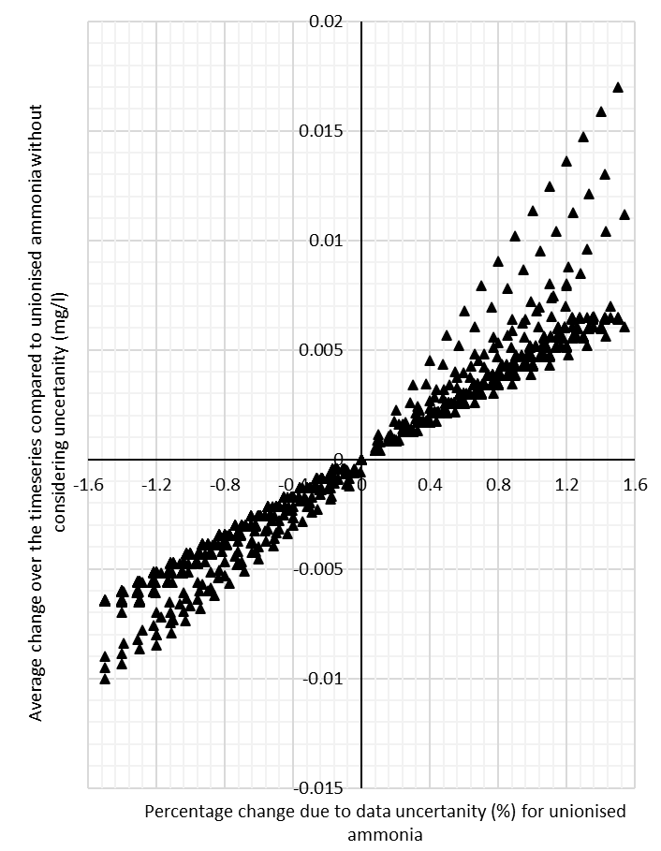
Figure A1: The average change in UA values compared to UA values without data uncertainty data for all 41 locations, plotted against percentage change in the data value due to pH data uncertainty for UA
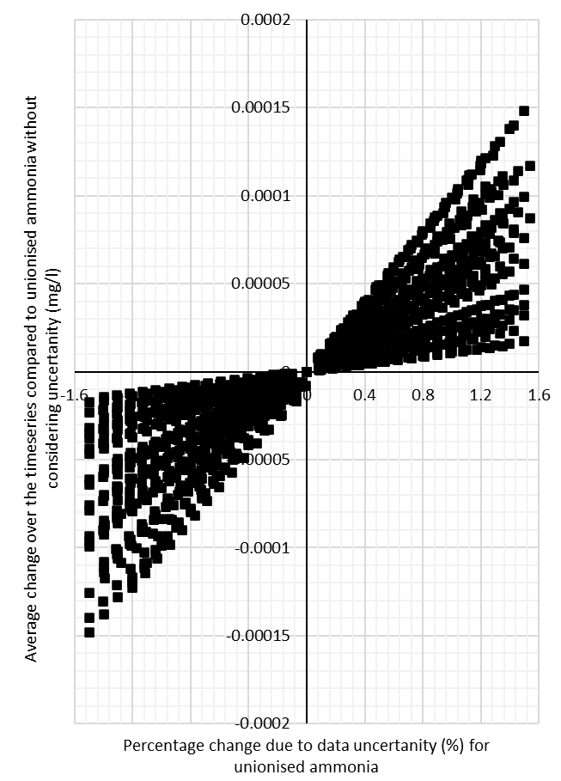
Figure A2: The average change in UA values compared to UA values without data uncertainty data for all 41 locations, plotted against percentage change in the data value due to temperature data uncertainty for UA

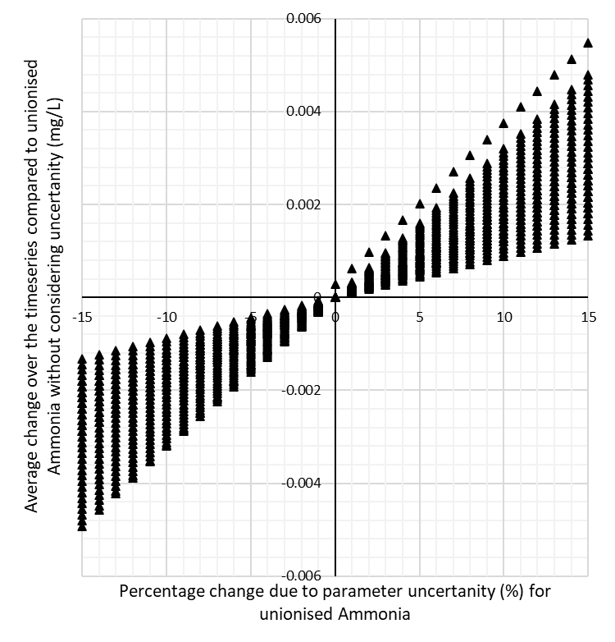
Figure A3: The average change in UA values caused by the parameter uncertainty compared to UA values without uncertainty in all 41 locations, plotted against percentage change in parameter B due to parameter uncertainty in Equation 1 (chapter 3.1).

Table A1: Questionnaire sent to participants to complete before interview
1. | Which best represents the organisation which currently employs you?
1. | Water Utility |  |  |  |  |  | Consultancy |  |  | Other (please specify)
2. | State current job title and briefly describe the current role.
3. | Please state number of years working in the urban drainage sector.
3. | 0-3 years |  | 4-9 years |  |  |  |  |  |  | 10-15 years |  |  |  | 16-24 years |  |  |  | 25+ years
4. | Who would you interact with in your current day-to-day job activities? Select all that apply.
4. | Internal (own team within organisation) |  | Internal (other teams within organisation) |  |  |  |  |  |  | Environmental Regulator (EA) |  |  |  | Financial Regulator (OWFAT) |  |  |  | Governmental Body (DEFRA)
4. | Client (water utility) |  | Client (consultancy) |  |  |  |  |  |  | Local Council |  |  |  | Other (please specify)
5. | In your career, have you stayed in current organisation or moved between organisations? If the latter, please specify relevant organisations you have worked at.
5. | Yes |  |  |  | No
6. | Please select all the statements that apply to you.
6. | I have chosen a location for the assessment stage of intermittent discharges water quality schemes.
6. | I have worked on the assessment stage of intermittent discharges water quality schemes.
6. | I have completed work which required a working understanding of Fundamental Intermittent Standards (FIS).
6. | I feel comfortable with my understand of what FIS analysis means for the receiving rivers water quality.
6. | I have recommended a location to progress on to solution design stage to comply with regulation.
6. | I have chosen which locations that are funded for solution design stage process.
6. | I have worked on the solution design stage of water intermittent discharges water quality schemes.
6. | I have been involved in the decision for which solutions are to be funded for implementation.
6. | I have overseen the implementation of a solution.
6. | My day to day activates is usually focused on the environmental aspect of the schemes.
6. | My day to day activates is usually focused on the financial aspect of the schemes.
6. | My day to day activates is usually focused on both the environmental and financial aspects of the schemes.
6. | Thinking about previous water quality work, I could identify sources of uncertainty.
6. | I have some understanding of the links between uncertainty and risk in a water quality study.
6. | I have previously completed risk analysis on water quality schemes.
6. | I understand the differences between financial and environmental risk and could communicate this to others.
6. | I understand the relationship between financial and environmental risk and could communicate this to others.
6. | I have not completed any work on intermittent discharges water quality schemes.
7. | In your day-to-day workload do you primarily work with monitor data, modelled results, or processed information?
7. | Primarily monitored data |  | Primarily modelled results |  |  |  |  | Both modelled and monitored results |  |  |  | Primarily processed information |  | All three; monitored, modelled, and processed information |  |  |  |  |  | Other (please specify)
8. | In 3 or less sentence, what do you believed is meant by the phrase ‘observed data’ ?
9. | Please write your understanding of the term ‘environmental risk’ in relation to the urban drainage sector. If you do not feel comfortable defining this term, please write;  Unable to define term.
10. | Can you briefly outline your current understanding of water quality regulation of intermittent spills in England prior the Environment Act?
11. | Regulation around water quality of intermittent spills regulation is changing, can you tell me bit about your understanding of how it may change because of Environment Act?
12. | How influential on a scale of 1-10 do you believe the change in regulation caused by the Environment Act to be in changing your day-to-day activity? With 1 being not influential at all, that you foreseeable no change to your workload or pattern in the future as the result of the change in regulation and 10 being very influential, that you feel it may alter my day-to-day actives or overall workload considerably.
12. | 1 | 2 |  |  |  | 3 |  |  | 4 |  | 5 |  | 6 |  | 7 |  | 8 |  | 9 |  | 10
13. | Would you prefer modelled or monitored data to drive decisions in the urban drainage sector? If you have a strong opinion why please specific, otherwise leave the comment section blank.
13. | Modelled |  |  | Monitored |  |  |  |  |  | Either |  |  |  | A combination of both |  |  |  | No preference
13. | Comment
14. | Any final comments you would like to share at the time?

Table A2: Table illustrating format of the interviews with pre-prepared questions.
5 minutes | Opening remarks, thanking them for giving time up, rearming rights to withdraw, checking consent verbally, checking and recapping information provided by questionnaire.
Question 1  RQ_1a  10 minutes | Main Question: | In the questionnaire it was noted that you worked on the assessment and solutions stage can you talk me through the work that you have completed? What was your contribution? Do you remember any discussion you had around uncertainty?
Question 1  RQ_1a  10 minutes | Sub Questions to considered depending on what is said: | What kind of implications do you think considering uncertainty has in your projects you have worked on?  Do you feel the industry acknowledge uncertainty in its decisions process?  How important do you believe considering uncertainty to be in your current role?
Question 2  RQ_1b  10 minutes | Main Question | So you talked about [include overview of Q2] thinking about that same body of work what consideration to risk was there? In the conversations about uncertainty was risk mentions? To what extent or why not?
Question 2  RQ_1b  10 minutes | Sub Questions to considered depending on what is said: | What kind of implications do you think considering risk has in your projects you have worked on?  Do you feel the industry acknowledge risk in its decisions process?  How influential do you believe your is risk appetite to in your current role description?
Question 3  RQ_2 and RQ _3a  10 minutes | Main Question: | The Environment Act 2021 calls for continuous monitoring data in England. Do you feel that the type of data (if it comes from modelling or monitoring) would change processes you have described previously to uncertainty and risk considered?
Question 3  RQ_2 and RQ _3a  10 minutes | Sub Questions to considered depending on what is said: | Do you feel the urban drainage sector understands how it will assess water quality impacts in river from the result of intermittent discharge in the future?  How do you see the type of data or information that a person of your level in water sector will receive to complete their job in the future changing?  Do you foresee any impacts from losing the stage where locations are screen before studied for ecological harm for the organisation of workload in the sector generally and more specifically do you foresee your job level role day to day activities changing?
Question 4  RQ_3a  10 minutes | Main Question: | Can you describe the process you can foresee for designing solutions in the future may look like with increased number of locations assessed for ecological harm due to continuous monitoring being implemented due to the Environment Act?
Question 4  RQ_3a  10 minutes | Sub Questions to considered depending on what is said: | How do you think locations may be chosen in the future to be passed on to solution design? What are the criteria you will see as important of a location to receive financial backing for solution design? How influential do you believe are external pressures will be to this choice?  Which do you believe will be a priority for the urban drainage sector in the future; to tackle the few ‘extremely bad’ locations (historic approach), or a focus on a larger number of ‘just failing’ locations?  How important do you feel integrated modelling schemes to be in future compared to monitored schemes which are required by the Environment Act?
Question 5  RQ_3b  10 minutes | Main Question | What do you believe the implications may be of open data for water quality impacts in river from the result of intermittent discharge assessment and solution design?
Question 5  RQ_3b  10 minutes | Sub Questions to considered depending on what is said: | Do you foresee any impacts from losing the stage where locations are screen before studied for ecological harm for the organisation of workload in the sector generally and more specifically do you foresee your job level role day to day activities changing?  Can you foresee any other consequences of continuous open data for the practices of the water sector?  How much risk to insufficient design do you think will be accepted in the sector in the future?  Do you believe that a reiterative approach to solution design (the idea that a solution can be assessed after it is implemented and adjusted if needed) is something the urban drainage sector should consider? If so, how important do you believe the regulators (financial and environmental) to be in implementing such a change in practice? What kind of timeframe would you say is appropriate for such a scheme?
5 minutes | Bring to close. Thank again and reminder of rights.

