Errata Sheet – Xinzi Hou
Location: p 78, Table 2.2.4

Current text: (Checkmarks missing)
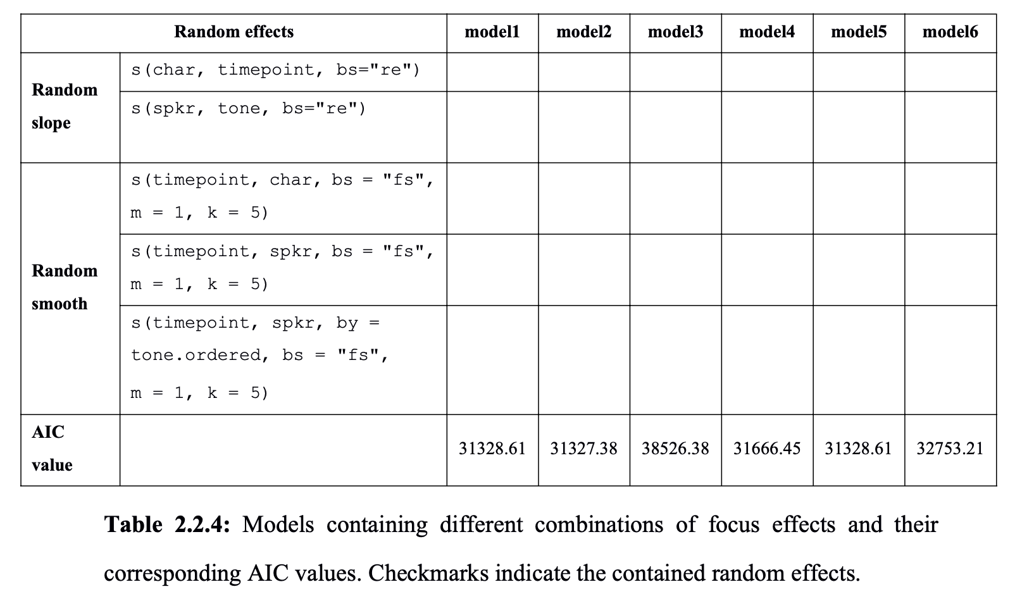
Corrected text: (Checkmarks presented)
