

The Relationship Between Bipolar Disorder and Schizophrenia: Psychopathological Mechanisms Underlying the Blurred Boundary

Wen Shao

A thesis submitted in partial fulfilment of the requirements for the degree of
Doctor of Philosophy

The University of Sheffield
Faculty of Science
School of Psychology

January 2026

Abstract
This thesis comprises six chapters, including four empirical studies (Chapters 2-5), aimed at deepening the understanding of a long-standing clinical dilemma: whether schizophrenia and bipolar spectrum disorders (BSD) represent distinct disease entities or a single disorder with differing manifestations.
The thesis utilises various empirical approaches to examine psychopathological patterns, including dimensional and structural explorations of symptoms and at-risk states for mood and psychosis. Methodologically, this includes a systematic review of the prevalence of psychosis in BSD, alongside network analyses and dimensional comparisons. These studies utilised existing questionnaires and structured interviews across diverse cohorts: patients with psychotic disorders, the general population, and young people assessed for newly developed at-risk states.
Findings from the systematic review (covering 285 articles) indicate that psychosis is highly prevalent in BSD and identified a close relationship between Bipolar I disorder and psychosis. Consequently, network analysis revealed a robust link between mania and psychosis. This relationship remained consistent across patient and healthy populations and demonstrated longitudinal validity. Furthermore, network modelling uncovered distinctive patterns: mania and positive psychosis were linked by behavioural activation and thought disorganisation, whereas depression and negative psychosis were bridged by reduced emotional expression and social coldness. Additionally, the network of at-risk states revealed that identity confusion and suspiciousness were significant symptoms potentially driving the network.
In conclusion, this thesis highlights that BSD and schizophrenia are connected not only by shared risk factors but also at the symptom level. They likely share a latent psychopathological process that manifests differently, offering strong support for a transdiagnostic approach to psychiatric practice. Future research should adopt extensive longitudinal designs capable of inferring robust causal relationships to further improve the understanding of these mental disorders.
Keywords: bipolar disorder, schizophrenia, psychosis, mania, depression, psychopathology, network analysis, transdiagnostic, clinical high risk.

Acknowledgement
First and foremost, my deepest gratefulness goes to my parents, Xiuzhen Si and Guangming Shao, and my sister, Kangning Shao. You have been integral to my life and the spark behind this doctoral journey. To my parents, thank you for your unconditional love and support. To my sister, thank you for your companionship and emotional support, and for always being there when I needed to be heard. This thesis is as much yours as it is mine.
I also express my sincere gratitude to my supervisors, Professor Richard P. Bentall and Dr Melanie Simmonds-Buckley. Your expertise and patience were truly appreciated throughout this journey. Your guidance was invaluable in navigating these complicated tasks, and I am deeply thankful that you treated me not only as a student but also as a friend. I believe your supervision will have a long-lasting impact, benefiting me not only now as a student but also as I establish myself as an independent researcher in the near future.
Special thanks must go to Dr Fenghua Li, Dr Jayne Pickering, Dr Jie Luo, and Professor Paul Overton for the stimulating discussions and insightful feedback that made the challenging days easier.
Finally, I acknowledge the research teams behind the secondary datasets (B-SNIP and C19PRC) utilised in Chapters 3 and 4 for facilitating data access. I am equally grateful to the participants of these studies, and especially to the young people recruited for Chapter 5, who generously shared their personal experiences. Their contribution is the foundation of this thesis, and I hope this work contributes meaningfully to the understanding of their lives.
Content
Abstract 2
Acknowledgement 4
List of Tables (Main body) 7
List of Tables (Appendix A) 7
List of Tables (Appendix B) 7
List of Tables (Appendix C) 8
List of Tables (Appendix D) 8
List of Tables (Appendix E) 8
List of Figures (Main body) 9
List of Figures (Appendix B) 9
List of Figures (Appendix C) 10
List of Figures (Appendix D) 11
List of Figures (Appendix E) 11
Declaration and Inclusion of Published Work 12
Chapter 1 The psychiatric taxonomy of bipolar disorder and schizophrenia: an ordered chaos
A short introduction to bipolar disorder and schizophrenia 13
History of psychiatric classification 15
The Unclear Boundary 28
Overlap in Biological, Genetic, and Neurocognitive Features 58
Psychosocial factors 66
Theoretical Models 80
Research Gaps and current investigation 88
Structure of the Thesis 89
References 90
Chapter 2 Comorbid schizophrenia and psychotic symptoms in patients with bipolar disorders: A meta-analysis of the global literature
Introduction 120
Materials and methods 124
Results 131
Discussion 143
Conclusion 149
References 150
Chapter 3 The common structure of the major psychoses: More similarities than differences in the network structures of schizophrenia, schizoaffective disorder and psychotic bipolar disorder
Introduction 159
Method 162
Results 168
Discussion 177
Conclusion 182
References 183
Chapter 4 The Interplay Between Mood Symptoms and Psychosis Over Two Years: Longitudinal and Structural Relationships Between Manic, Depressive, and Psychotic-Like Experience
Introduction 188
Methods 194
Results 205
Discussion 214
Conclusion 219
References 220
Chapter 5 Tracing Early Anomalies of Mania and Psychosis: Developing a Pluripotential Assessment Tool and Mapping Its Network Dynamics
Introduction 231
Methods 240
Results 253
Discussion 272
Conclusion 286
References 287
Chapter 6 General Discussion and Conclusion
Introduction 303
Synthesis of Findings 305
Concluding remark 318
References 319
Appendixes
Appendix A: Supplementary Files for Chapter 1 323
Appendix B: Supplementary Files for Chapter 2 339
Appendix C: Supplementary Files for Chapter 3 421
Appendix D: Supplementary Files for Chapter 4 449
Appendix E: Supplementary Files for Chapter 5 460

List of Tables (Main body)
Table 1.1 Development of the nosology in well-established DSM and ICD systems 25
Table 2.1 Demographic and clinical information for question one 126
Table 2.2 Demographic and clinical information of studies of specific psychotic symptoms 127
Table 2.3 Pooled results of comorbid schizophrenia and psychosis in bipolar patients 131
Table 2.4 The information of predictors contributed to the heterogeneity 132
Table 2.5 Pooled results of cooccurring delusions, hallucinations and thought disorders in bipolar patients 139
Table 2.6 The predictors contributed to the heterogeneity in analyses of specific psychotic symptoms 140
Table 3.1 Demographic and clinical information of full sample 162
Table 3.2 The weights of three varied edges and the statistics across networks 176
Table 4.1 Descriptive statistics of primary and secondary measures 195
Table 4.2 Top three edge statistics across two waves 208
Table 4.3 Count and continuous models regressing on Mood and PLEs aacross waves 209
Table 5.1 Basic information about the included participants 240
Table 5.2 Full item pool prior to psychometric evaluation 253
Table 5.3 Factor loadings of the CFA 257
Table 5.4 Factor loadings of the bi-factor model 258
Table 5.5 Descriptive statistics of the interested variables among subgroups 264

List of Tables (Appendix A)
Table A 1 The evolvement of diagnostic criteria for schizophrenia since DSM III 323
Table A 2 The evolvement of diagnostic criteria for bipolar disorder since DSM III 327
Table A 3 BAR (Bipolar at risk) criteria 335
Table A 4 CHARMS criteria (bipolar) 336
Table A 5 CHARMS criteria (attenuated symptoms) 337

List of Tables (Appendix B)
Table B 1 Search strategies for synthesis of comorbid schizophrenia and psychosis 340
Table B 2 Search strategies for synthesis of comorbid delusions 341
Table B 3 Search strategies for synthesis of comorbid hallucinations 342
Table B 4 Search strategies for synthesis of comorbid thought disorders 343
Table B 5 The coding method for included variables 344
Table B 6 The Abbreviated Terms and Full Names 347
Table B 7 Lifetime psychosis in bipolar patients with mixed episode 348
Table B 8 Include studies in the synthesis of comorbid schizophrenia 349
Table B 9 Include studies in the synthesis of comorbid psychosis 353
Table B 10 Include studies in the synthesis of cooccurring delusions 378
Table B 11 Include studies in the synthesis of cooccurring hallucinations 388
Table B 12 Include studies in the synthesis of cooccurring thought disorders 397

List of Tables (Appendix C)
Table C 1 Item selection: reason and action 421
Table C 2 Sensitivity check through UVA analysis excluding general psychiatric problems 423
Table C 3 The comparison statistics of the selected items in subgroups 424
Table C 4 The ordered edge statistics of the edges with non-zero weight in network of all patients 426
Table C 5 The ordered edge statistics of the edges with non-zero weight in network of PBD patients 430
Table C 6 The ordered edge statistics of the edges with non-zero weight in network of SCA patients 433
Table C 7 The ordered edge statistics of the edges with non-zero weight in network of SCZ patients 436
Table C 8 The structural consistencies and item replicabilities from EGA 439

List of Tables (Appendix D)
Table D 1 The UVA analysis result 449
Table D 2 Bootstrapped statistics for edges with non-zero weights in the Mood and PLE network at wave 5 450
Table D 3 Bootstrapped statistics for edges with non-zero weights in the Mood and PLE network at wave 9 453
Table D 4 Binary models regressing on Mood and PLEs across waves 456

List of Tables (Appendix E)
Table E 1 Questionnaires and criteria of at-risk features or clinical states examined in this study 460
Table E 2 Edge with non-zero weight in the network of at risk states among all sample 485
Table E 3 Confidence in edge presence and direction in the Bayesian network model 489
Table E 4 Edges with non-zero weights in the network of at risk states among adolescents 491
Table E 5 Edges with non-zero weights in the network of at risk states among adults aged 18-24 493
Table E 6 Edges with non-zero weights in the network of at risk states among adults aged 25-29 496
Table E 7 Edges with non-zero weights in the network of at risk states among adults aged 30–36 498
Table E 8 Edges with non-zero weights in the network of at risk states among females 501
Table E 9 Edges with non-zero weights in the network of at risk states among males 504

List of Figures (Main body)
Figure 2.1 Flow diagram of the systematic review and meta-analyses 125
Figure 3.1 Network structure of selected variables in general and psychotic patients 169
Figure 3.2 Node centralities of the estimated network models 171
Figure 3.3 The empirical network communities of affective and psychotic syndromes in all patients and subgroups 174
Figure 4.1 Diagram of the regression models 203
Figure 4.2 Networks of Mood and PLEs across waves 206
Figure 4.3 A summary plot of the significant predictors for primary symptoms 213
Figure 5.1 Workflow of content-driven item selection and psychometric validation of the TRACE scale 243
Figure 5.2 The empirical structure obtained from EGA for the remaining TRACE items 256
Figure 5.3 Response patterns by risk groups 260
Figure 5.4 The Ising Model (IM) network structure of prodromal symptoms 265
Figure 5.5 Node centralities in the IM network structure 266
Figure 5.6 The Bayesian Network (BN) structure of at-risk symptoms 268
Figure 6.1 The hypothesised psychopathological models following network modelling and findings from this thesis 312
Figure 6.2 A hierarchical model integrating transdiagnostic and categorical approaches 314

List of Figures (Appendix B)
Figure B 1 Pooled prevalence of comorbid schizophrenia in bipolar patients 348
Figure B 2 Funnel plots for the comorbid schizophrenia 349
Figure B 3 Pooled prevalence of mood incongruent psychosis 350
Figure B 4 Funnel plots for mood incongruent psychosis 351
Figure B 5 Pooled rate of lifetime psychosis in bipolar patients 352
Figure B 6 Funnel plots for the lifetime psychosis 353
Figure B 7 The rate of lifetime psychosis in patients with bipolar I 354
Figure B 8 Funnel plots for the lifetime psychosis in patients with bipolar I 355
Figure B 9 The rate of lifetime psychosis in patients with bipolar II 356
Figure B 10 Funnel plots for lifetime psychosis in patients with bipolar II 357
Figure B 11 Pooled rate of lifetime psychosis in bipolar patients with manic episode 358
Figure B 12 Funnel plots for lifetime psychosis in bipolar patients with manic episode 359
Figure B 13 Pooled rate of lifetime psychosis in bipolar patients with depressive episode 360
Figure B 14 Funnel plots for lifetime psychosis in bipolar patients with depressive episode 361
Figure B 15 Pooled rate of current psychosis in bipolar patients 362
Figure B 16 Funnel plots for current psychosis in bipolar patients 363
Figure B 17 Pooled rate of current psychosis in bipolar I patients 364
Figure B 18 Funnel plots for current psychosis in bipolar I patients 365
Figure B 19 Pooled rate of current psychosis in bipolar II patients 366
Figure B 20 Funnel plots for current psychosis in bipolar II patients 367
Figure B 21 Pooled rate of current psychosis in bipolar patients with manic episode 368
Figure B 22 Funnel plots for current psychosis in bipolar patients with manic episode 369
Figure B 23 Pooled rate of current psychosis in bipolar patients with depressive episode 370
Figure B 24 Funnel plots for current psychosis in bipolar patients with depressive episode 371
Figure B 25 Funnel plots for current psychosis in bipolar patients with depressive episode 372
Figure B 26 Funnel plots for current psychosis in bipolar patients with mixed episode 373
Figure B 27 Pooled rate of first episode psychosis in bipolar patients 374
Figure B 28 Funnel plots for first episode psychosis in bipolar patients 375
Figure B 29 Pooled rate of lifetime delusions in bipolar patients 376
Figure B 30 Funnel plots for lifetime delusions in bipolar patients 377
Figure B 31 Pooled rate of current delusions in bipolar patients 378
Figure B 32 Funnel plots for current delusions in bipolar patients 379
Figure B 33 Pooled rate of lifetime hallucinations in bipolar patients 380
Figure B 34 Funnel plots for lifetime hallucinations in bipolar patients 381
Figure B 35 Pooled rate of current hallucinations in bipolar patients 382
Figure B 36 Funnel plots for current hallucinations in bipolar patients 383
Figure B 37 Pooled rate of lifetime thought disorders in bipolar patients 384
Figure B 38 Funnel plots for lifetime thought disorders in bipolar patients 385
Figure B 39 Pooled rate of current thought disorders in bipolar patients 386
Figure B 40 Funnel plots for current thought disorders in bipolar patients 387

List of Figures (Appendix C)
Figure C 1 The bootstrapped edge weight CIs of the network of affective and psychotic syndromes 444
Figure C 2 The bootstrapped node strengths in network of general psychotic population 445
Figure C 3 The differed edge among patients with different psychoses 446
Figure C 4 The network density among patients with different psychoses 447
Figure C 5 The edge variability network among networks in different diagnostic groups 448

List of Figures (Appendix D)
Figure D 1 The distributions of ethnicity, income, and contury of residence among the sample 457
Figure D 2 Empirical network communities of Mood and PLEs across waves 458
Figure D 3 Node statistics across networks of mood and PLEs at waves 5 and 9 459

List of Figures (Appendix E)
Figure E 1 The full procedure of item selection for TRACE 507
Figure E 2 The item prevalence of distress levels among all sample by different age groups 509
Figure E 3 The Ising Model (IM) network structures of at-risk symptoms by age groups 510
Figure E 4 Node and bridge strength across age group networks 511
Figure E 5 The Ising Model (IM) network structures of at risk symptoms by genders 512
Figure E 6 Node and bridge strength across gender group networks 513

Declaration and Inclusion of Published Work
I, Wen Shao, confirm that the Thesis is my own work. I am aware of the University’s Guidance on Academic Integrity. This work has not previously been presented for an award at this, or any other, university.
This thesis is written in a publication format, the publication status of the work included in this thesis is presented below, listed sequentially from Chapter 2 to Chapter 5:
Chapter 2 Shao, W., Shao, K., & Bentall, R. P. (Submitted). Comorbid schizophrenia and psychotic symptoms in patients with bipolar disorders: A meta-analysis of the global literature. Journal of Bipolar Disorders.
Chapter 3 Shao, W., Simmonds-Buckley, M., Zavlis, O., & Bentall, R. P. (2025). The common structure of the major psychoses: More similarities than differences in the network structures of schizophrenia, schizoaffective disorder, and psychotic bipolar disorder. Schizophrenia Bulletin, 51(4), 1042–1053. https://doi.org/10.1093/schbul/sbae154
Chapter 4 Shao, W., Pickering, J., Simmonds-Buckley, M., Mason, L., & Bentall, R. P. (Submitted). The interplay between mood symptoms and psychosis over two years: longitudinal and structural relationships between manic, depressive, and psychotic-like experiences. Psychological Medicine.
Part of Chapter 5 Pickering, J.*, Shao, W.*, Weich, S., Dalton, C. F., Jones, M., Taylor, C. D. J., Reuber, M., Kingston, J., Gibbs, C., & Bentall, R. P. (2025). Developing TRACE: A transdiagnostic screening tool for early detection of a pluripotent at-risk mental state. International Journal of Methods in Psychiatric Research, 34(4), e70046. https://doi.org/10.1002/mpr.70046 (*Joint first author).

The psychiatric taxonomy of bipolar disorder and schizophrenia: an ordered chaos

A short introduction to bipolar disorder and schizophrenia
Bipolar spectrum disorders (BSD) are a series of mental disorder characterised by mood dysregulations. According to the latest DSM (Diagnostic and Statistical Manual of Mental Disorders) manual, patients with BSD are characterised by the presence of both manic and depressive syndromes (American Psychiatric Association, 2022). Specifically, the manic syndrome includes symptoms such as mood elevation, irritability, increased energy and motor activity, and flight of thoughts while the depressive syndrome is typically comprised symptoms of depressed mood, fatigue, diminished interests, and suicidal thoughts. Another syndrome that is commonly observed in the BSD population is hypomania. Symptom manifestations of hypomania are similar to mania, but the daily functioning of the patients is nearly intact. The presence of manic versus hypomanic features is the criterion used to distinguish whether patients are suffering from BSD type I (i.e., presence of mania) or BSD type II (i.e., presence of hypomania). Regardless of the type of BSD, episodic mood disturbances and accompanying behavioural or cognitive anomalies are the defining features of the disorder.
BSD is not only harmful to patients but also creates a burden for caregivers and public health services. The global number of individuals affected by the disorder was estimated to be approximately 40 million in 2019 (WHO, 2022); BSD patients, even if successfully treated, have a high risk of relapse, and are at increased suicidal risk (Treuer & Tohen, 2010). In addition, patients with bipolar disorder are likely to be unemployed and many have comorbid substance abuse (Fajutrao et al., 2009). Meanwhile, the caregivers of BSD patient often report stress related to the daily care of patients, who may exhibit aggressiveness, and because of the financial consequences of the disorder (Beentjes et al., 2012); a heightened risk of developing psychiatric symptoms and increased use of mental health care services has also been observed in the caregivers of BSD patients (Steele et al., 2010). These findings suggest that BSD is a difficult-to-treat chronic mental health condition and burden to the family members of the patients as well as public health care system.
Schizophrenia, by definition, is a mental disorder different from BSD. Patients with schizophrenia may present with cognitive anomalies resulting in abnormal sensation and thinking (American Psychiatric Association, 2022). Several hallmark symptoms include hallucinations (i.e., patients perceive non-present visual or auditory stimuli), delusions (i.e., fixed false beliefs), and thought disorder (i.e., disorganised speech or thinking process). These symptoms are also known as psychotic symptoms/ syndrome. Schizophrenia is associated with a low remission rate and the loss of autonomy (Huber, 1997; Huber et al., 1975), and it is often considered to be one of the most severe mental condition recognised by modern psychiatrists.
Although BSD is usually considered to be a separate disorder from schizophrenia and mainly characterised by abnormal mood, BSD patients on occasion present with symptoms which are typical of schizophrenia patients. For instance, psychotic symptoms are very common in this population (Chakrabarti & Singh, 2022). In addition, a comorbid psychiatric diagnosis for BSD patients is not uncommon. A recent meta-analysis revealed a combined rate of 38.91% for BSD patients suffering from at least one psychiatric comorbidity (Leda-Rego et al., 2024). Further, the diagnostic stability of BSD is low, with a recent longitudinal large-scale study finding that the diagnosis was associated with frequent diagnostic shift (Cegla-Schvartzman et al., 2021). These findings reflect the poorly defined boundaries between different diagnoses and the limited understandings of underlying pathological processes, resulting in the limited evidence currently seen for the validity of the existing categorical diagnostic system. To broaden our understanding of the relationship between BSD and schizophrenia, it will be beneficial to evaluate the history of the modern psychiatric classifications and how the classificatory boundary between BSD and schizophrenia have evolved over time. Reviewing evidence of the similarities between the disorders and the theories explaining these overlaps is also helpful in delineating this boundary and potential research gaps.

History of psychiatric classification
Psychiatric classification in ancient times was largely shaped by philosophical worldviews. During this period, mental illness, commonly referred to as madness, lacked clear definitions for several reasons. Madness was often attributed to supernatural causes, such as demonic possession, and systematic approaches to analysing abnormal behaviour were limited by the absence of appropriate conceptual frameworks and methodological tools (e.g., replicable research methods), as well as by competing societal priorities such as poverty and war. Systematic psychiatric classification did not become feasible until the mid-nineteenth century, after which the field of psychiatry underwent substantial advances in the development of clinical models of mental illness. Remarkably, this period saw the establishment of the categorical approaches to mental disorders and the conceptualisation of bipolar disorder and schizophrenia as distinct diagnostic entities. These taxonomic developments have been foundational to one of the most widely used diagnostic systems (DSM) in psychiatry.
In 1854, French psychiatrists Jules Baillarger (1809-1890) and Jean-Pierre Falret (1794-1870) independently proposed folie à double forme (dual-form insanity) or folie circulaire (circular insanity), the very nearest known disease entity mirroring the modern bipolar diagnosis. The rationales for proposing this disease name were many (Cousin, 1999; Garrabé, 1999). Baillarger and Falret questioned the validity of monomania as a disease featuring predominantly one symptom such as delusions or fixations without considering other accompanying traits, which created ambiguities in differentiating disordered and healthy minds. Instead, they argued that the disordered process should be identified via a holistic view on the symptom cluster and dynamic changes. They noted a cyclical pattern of mood disturbances that was distinctive from other mental disorders, which gave birth to this disease entity. Although the conceptualisation was very primitive with only mania and melancholia phases observed, it is the foundation for the development of the concept of manic-depressive insanity (Emil Kraepelin) and bipolar disorder (Karl Leonhard).

Emil Kraepelin (1856-1926)
Emil Kraepelin was a German physician sometimes described as ‘the father’ of modern psychiatry. Kraepelin’s approach to mental illness was biologically driven, which focused on the etiological factors, longitudinal observation as well as symptom pattern in psychiatric classification (Kraepelin & Diefendorf, 1912). The symptom pattern or syndrome refers to a cluster of symptoms that frequently occur together. Kraepelin proposed that diagnoses should be based on the collective presence of these symptom patterns and their variations over the course of mental illnesses, rather than relying on a single symptom. The rationale for focusing on syndromes instead of individual symptoms as indicators of illness lies in the fact that symptoms can manifest in patients with different diagnoses. Kraepelin referred to such symptoms as general symptoms that include delusions, hallucinations, disturbances in thought (e.g., flight of ideas), cognition (e.g., amnesia), affect (e.g., mania, depression), and behaviour (e.g., restlessness).
Kraepelin emphasised the necessity of longitudinal observation for psychiatric classification, as the pattern of progression and outcome can reveal critical distinctions between various mental illnesses. Additionally, understanding the causes of mental illnesses can further inform classification, as psychiatric conditions can have heritable components. Environmental factors, alongside genetic and biological influences, also play a role in the development of these illnesses. For instance, Kraepelin distinguished different types of psychoses based on their causes, such as psychoses resulting from infections (e.g., infectious delirium) or intoxications (e.g., acute alcoholic intoxication).
Accordingly, Kraepelin classified numerous psychiatric conditions, but the conceptualisations of manic-depressive insanity and dementia praecox (early onset dementia) are particularly central to this thesis. Manic-depressive insanity was defined as a chronic condition characterised by episodic mood syndromes, with various sub-syndromes corresponding to different mood phases. This concept encompassed not only what we now term bipolar disorder but also major depression. In the manic phase, individuals exhibit psychomotor excitement, agitation, racing thoughts, distractibility, and euphoria, often accompanied by mood lability. In the depressive phase, symptoms include psychomotor retardation, lack of spontaneity, dearth of ideas, and depressed mood. Patients in the mixed phase display a combination of symptoms from the manic and depressive phases. Dementia praecox, on the other hand, was characterised as a deteriorating condition that could be categorised into different forms based on its predominant symptoms: Hebephrenic (e.g., emotional withdrawal, delusions, hallucinations); Catatonic (e.g., inactivity, impulsivity, repetitive behaviours, negativism); Paranoid (e.g., persistent delusions, hallucinations without significant cognitive impairments).
Kraepelin strongly advocated for the distinction between manic-depressive insanity and dementia praecox as separate disease entities. He argued that dementia praecox is an incurable condition marked by progressive mental deterioration, a feature absent in manic-depressive insanity. This distinction was supported by differences in symptomatology across functional domains such as perception, memory, thought, emotions, and consciousness. As dementia praecox progressed, features unique to the condition emerged, including the absence of mood reactivity, impaired memory for recent events, somatic convulsions, and stereotyped behaviours.
However, Kraepelin acknowledged that significant overlaps between the conditions posed challenges for making decisive diagnoses without prolonged observation. For example, both conditions exhibited high heritability (i.e., increased prevalence among individuals with affected relatives), early onset (approximately age 25), and frequent relapses. Furthermore, similarities in psychopathologies, such as disturbances in judgment (e.g., delusions), thought (e.g., unconnected ideas), and emotions (e.g., depression), further complicated differentiation.
Nonetheless, Kraepelin maintained that these two conditions are separate diagnoses, which should be made by considering the overall clinical course rather than isolated symptoms. He identified subtle distinctions, such as differences in emotional responsiveness during depressive episodes. For instance, depressive patients with manic-depressive insanity demonstrated more active emotional responses compared to those with dementia praecox. However, symptoms like psychomotor retardation were challenging to differentiate between the two conditions. Similarly, differentiating between manic stupor and catatonic stupor was complex. Patients with manic stupor exhibited distractibility that affected their speech, whereas catatonic patients were indifferent to their surroundings. These subtle distinctions required detailed clinical observation. Additionally, the central argument distinguishing dementia praecox as a deteriorating condition was undermined by cases of manic-depressive patients who also showed cognitive deterioration. While Kraepelin shared a similar view with Esquirol regarding the treatability of mania, Esquirol's observation of the conversion from mania to dementia posed a challenge to Kraepelin’s dichotomy.
Despite these challenges, Kraepelin’s contributions to psychiatric classification remain foundational, inspiring modern approaches to diagnosing mental illnesses based on symptom clusters, aetiology, and prognosis. However, his dichotomy is subject to diagnostic difficulties stemming from overlaps in aetiology, symptom patterns, and episodic relapses. The heterogeneity and overlap across these conditions remain difficult to quantify and have been a source of ongoing controversy in psychiatry.

Eugen Bleuler (1857-1939)
Swiss psychiatrist Eugen Bleuler questioned Karaeplein’s characterisation of the disease entity of dementia praecox. In 1911, Bleuler published his book Dementia Praecox or the Group of Schizophrenias, in which he argued that dementia praecox is an inappropriate name for the disease entity by reason that the early onset of the disease as well as the inevitable cognitive declinations are not universal. Dementia praecox or the group of schizophrenias is an extremely heterogeneous condition in terms of its manifestations and course. Individuals varied significantly on those aspects including duration of acute onset as well as the different outcomes such remission or deterioration.
Schizophrenia was defined by Bleuler as a condition of splitting of psychic function or disintegration of the unity of personality. This conceptualisation incorporated psychological and psychoanalytical concepts such as dissociation and repression. Building on Paul Janet’s (1823–1899) association theory, which suggested automatic interactions between behaviours, sensations, and thoughts, Pierre Janet (1859–1947) had developed the theory of dissociation (LeBlanc, 2001), defining it as an unconscious state capable of initiating motor or psychological functions without involving the primary consciousness, which he also described as double consciousness. This splitting of consciousness had been observed in states such as hysteria (e.g., convulsions, attention seeking, dissociation) and hypnosis. For instance, a hypnotized individual can perform independent mental tasks, such as counting, under a subconscious state, demonstrating the capacity for parallel mental functioning. Drawing from Pierre Janet’s concept of dissociation, Sigmund Freud (1856–1939), the founder of the psychoanalytic school, proposed the idea of repression, a defence mechanism by which distressing thoughts and memories are actively repressed into the unconscious to protect the individual from psychological pain, possibly resulting in the loss of traumatic memory. Bleuler integrated these conceptions to explain the disconnected mental functions (e.g., thought disorder) as well as distorted beliefs (e.g., delusions) in schizophrenia.
The structure of schizophrenia as outlined by Bleuler was based on Kraepelin’s classifications, with additional refinements that resulted in five subtypes: paranoid, catatonic, hebephrenic, and simple schizophrenia (i.e., gradual cognitive decline without psychotic symptoms). Furthermore, Bleuler's categorisation of primary and secondary symptoms complemented this classification by reflecting higher-order mental processes. Primary symptoms were described as the result of interactions between simple functions (e.g., perception, sensation) and compound functions (e.g., the ability to maintain coherence in thought). These symptoms were encapsulated in the "four A's": association (e.g., disordered thinking), affect (e.g., blunted affect), ambivalence (e.g., erratic behaviour, difficulties in decision-making), and autism (e.g., withdrawal). In contrast, secondary symptoms, including hallucinations, delusions, and catatonic behaviour (e.g., stupor, excitement), were understood as derivatives or adaptations arising from the joint presence of primary symptoms and external factors (e.g., traumatic experiences) or internal factors (e.g., unresolved emotional states).
The epidemiology and aetiology of schizophrenia were similarly explored by Blueler. Schizophrenia accounted for 29% to 75% of hospital admissions in various institutions, with a disproportional gender ratio favouring female patients. The typical onset of schizophrenia occurred between late adolescence and early adulthood (i.e., ages 15–35 years). Regarding its aetiology, Bleuler rejected psychological trauma or stress as a predisposition for schizophrenia, as signs of the disease often predated such events. Conversely, he accepted hereditary influences as a potential cause. Notably, Bleuler introduced the concept of subclinical schizophrenia, which he termed latent schizophrenia (i.e., mild schizophrenia symptoms). According to Bleuler, latent schizophrenia was common in the general population, and progression to the full-blown condition was not inevitable. However, the risk of progression remained uncertain due to the absence of studies examining this feature at the time.
Diagnosing schizophrenia historically posed significant challenges due to its inherent complexities. Latent symptoms, such as trait-like anomalies, social withdrawal, and stubbornness, were often regarded as early indicators but offered limited diagnostic value. True schizophrenia was not defined by a single symptom but rather by profound alterations in normal psychological processes. The diagnostic threshold for this condition was exceptionally high, further complicated by the overlapping nature of individual symptoms, which required careful evaluation of their context and intensity. This challenge became particularly acute when another mental disorder coexisted, raising the critical question of whether hallucinations or delusions stemmed from broader psychoses or schizophrenia itself. Consequently, a comprehensive, holistic approach was indispensable for achieving accurate and reliable diagnoses.
Bleuler acknowledged the overlap between schizophrenia and manic-depressive psychosis, noting similarities that blurred the distinction between the two conditions. Part of his argument regarding their differences aligned with Kraepelin's perspective. For instance, manic-depressive psychosis typically exhibited a consistency between thought and mood, purposeful activity, a logical flight of ideas, and its characteristic alternating nature—features that were believed to be absent in schizophrenia. However, these distinctions were not absolute, as schizophrenia patients sometimes displayed alternating psychosis as well. For example, some individuals with schizophrenia exhibited recurrent cycles resembling manic-depressive psychosis, typically brief in duration, and the psychotic symptoms eventually becoming dominant. The extreme heterogeneity within schizophrenia led Bleuler to hypothesize that it might not represent a single disease entity but rather a spectrum of related disorders sharing core characteristics. To account for this variability, he proposed additional subtypes of schizophrenia, classified by disorder patterns, age of onset, aetiology, and symptom intensity.
The term "schizophrenia" has remained a cornerstone of the psychiatric system since its inception. Bleuler’s framework for schizophrenia integrated psychological theories, biological functions, and other contributing factors. His methodological approach significantly influenced psychiatric research. However, this framework also faced several limitations. Notably, the diagnostic criteria for schizophrenia showed limited improvement compared to Kraepelin’s earlier contributions. Diagnosing schizophrenia, particularly in patients with complex symptoms, often proved time-consuming and challenging. Additionally, Bleuler’s reliance on differences in etiological factors to distinguish schizophrenia from other major psychoses limited the generalizability of his findings due to the specificity of his research settings and populations. His dismissal of psychological trauma as a potential predisposing factor also appeared premature and lacked supporting evidence. For instance, Bleuler’s team failed to systematically investigate trauma as a risk factor for schizophrenia or to explore how the interplay between latent schizophrenia and trauma could predict the onset of the disorder. This oversight revealed a gap in the application of the comprehensive approach that Bleuler himself advocated.

Karl Leonhard (1904-1988)
Karl Leonhard, a German psychiatrist, is credited with developing the concept of bipolar disorder. Leonhard criticised the Kraepelinian dichotomy for being overly inclusive and heterogeneous. He argued that not all severe psychiatric conditions could be categorised as either manic-depressive insanity or dementia praecox. Instead, he introduced the distinction between bipolar and unipolar mood psychoses, based on the polarity patterns of these conditions (Leonhard, 1999). He examined hospital records and argued that patients with the bipolar form of manic-depressive insanity not only fluctuated between the poles of mania and depression but also exhibited diverse manifestations within each phase. In contrast, patients with unipolar mood psychosis experienced recurrent episodes with the same psychopathology, maintaining a consistent clinical presentation.
This nosology was detailed in Karl Leonhard’s book Classification of Endogenous Psychoses and their Differentiated Etiology, first published in 1957 in Germany as Aufteilung der endogenen Psychosen und ihre differenzierte Ätiologie (Leonhard, 1957). Karl Leonhard divided the mental illness into three broad categorisations: phasic psychoses (i.e., mood psychosis), cycloid psychoses (i.e., rapid mood fluctuation, benign prognosis), and unsystematic (i.e., episodic, bipolar in nature) as well as systematic schizophrenia (i.e., gradual onset and progressive course). Phasic Psychoses, were classified into manic-depressive illness, unipolar mania, melancholia, and unipolar depression or euphoria. The manic-depressive illness, nowadays bipolar disorder, was characterized by variations and combinations of the typical features of mania (i.e., euphoria, elevated self-esteem, flight of ideas, pressured speech, and overactivity) and melancholia (i.e., depressive mood, feelings of inadequacy, thought blockages, psychomotor retardation, indecisiveness, and depressive rumination). More atypical forms of manic-depressive illness such as mixed states resemble pure euphoria and depression; other types such as confused mania—marked by thought disorders without disturbance of consciousness—mirrored cycloid psychosis.
In addition, Leonhard observed a clear family trend in cases of manic-depressive illness. Mild forms of typical manic-depressive symptoms were reported among family members of these cases. This observation was later confirmed by independent familial studies conducted by Jules Angst and Carlo Perris. Due to the accessibility of the study, Perris’ work in English was summarised here. Perris (2008) examined various factors in bipolar patients and found that bipolar depression was significantly more likely to occur in individuals with relatives diagnosed with bipolar depression than in those with relatives diagnosed with unipolar depression. Although other findings from this study, such as personality profiles, suggested that bipolar and unipolar depression might represent different manifestations of the same disease, the genetic evidence strongly supported the classification of bipolar mood psychosis as a distinct condition from unipolar mood psychosis, and the name was finally documented on the DSM III published in 1980.
Leonhard maintained that the various psychoses, despite overlapping symptoms, represent discrete disease entities that can be distinguished through detailed clinical observation and longitudinal studies. Drawing on his neuropsychiatry background, Leonhard concluded that the biological underpinnings of manic-depressive illness and schizophrenia were fundamentally different. He proposed that mood psychosis primarily involves the vegetative nervous system, whereas schizophrenia is associated with disorders of higher-order processes, such as thought and willpower.
Leonhard offered limited commentary on the psychopathological overlap between bipolar disorder and schizophrenia, likely dismissing these similarities in favour of the 'salient differences' he distinguished between vegetative and higher-order cortical processes. However, exceptions included conditions such as hypochondriacal depression and euphoria (e.g., peculiar misperceptions of bodily sensations) and suspicious depression. These conditions could be distinguished from schizophrenia by the fact that mood psychosis does not progress, and depressive episodes are typically brief in schizophrenia. A similar distinction was made between confused mania and incoherent paraphrenia (e.g., disturbed thought). Leonhard emphasised that patients with confused mania retained the ability to "fill the gaps" between thoughts, distinguishing this condition from incoherent paraphrenia.
In terms of prognosis, Leonhard’s perspective closely aligned with earlier figures such as Kraepelin and Bleuler, suggesting that bipolar disorder is generally associated with a more favourable outcome. Additionally, he noted that the genetic heritability of bipolar disorder is more pronounced compared to schizophrenia. Demographic distinctions were also evident; bipolar disorder demonstrated a notable predominance of female patients, whereas gender ratios in schizophrenia varied by subtype. Although age distributions were too heterogeneous to allow direct comparisons, schizophrenia subtypes typically exhibited an earlier onset than bipolar disorder.

Schizophrenia and bipolar disorders in modern psychiatric systems
Following Kraepelinian dichotomy, various manuals for psychiatric diagnoses have been published in the past several decades. Their initial purpose was to aid the patient management in psychiatric institutions and quantify patient data statistically. Along with the clinical practice and research, the system became increasingly diverse and comprehensive.
The Statistical manual for the use of institutions for the insane (SMII) was the first manual of this system used in the United States (American Psychiatric Association & National Committee for Mental Hygiene, 1918). The SMII included statistical cards for patients records from first admission to death, and the classification of mental diseases. This manual adopted Kraepelin’s dichotomy and categorised dementia praecox and manic-depressive psychoses as separate disorders. Manic-depressive psychoses feature emotional disturbance and a high chance of relapse, and various psychotic symptoms (e.g., delusions, hallucinations, and delirium). It could be classified into five subtypes: manic (e.g., euphoria/ irritability, overactivity, flight of ideas), depressive (e.g., low self-esteem, sad/hopeless mood), stuporous (e.g., psychomotor retardation, suicidal ideation), mixed, and circular reactions (e.g., episodic cycling without remission).
Unlike manic and depressive psychoses, dementia praecox was not well defined in this manual due to its heterogenous manifestations. According to the manual, patients with this disorder typically present with abnormal personality, discrepancy between mood/ behaviour and thought, blunt affect, impaired judgement, paranoia, and delusions. Subtypes of paranoid (e.g., delusions), catatonic (e.g., negativistic reactions or peculiar conduct), hebephrenic (e.g., silliness), and simple dementia praecox (e.g., apathy without delusions or hallucinations) were diagnosed by the prominence of the symptoms
Similar to the SMII, the world health organisation has attempted to document the cause of death statistically. In 1949, they issued the international list of causes of death (ICD), 6th revision (so called because it was evolved from five previous editions of a classificatory manual develop ed by the French government); this is the first version that included mental disorders. It was further elaborated in a revised ICD-6 ten years later. However, detailed descriptions and criteria for the diagnoses were absent. From names of the diagnoses, three main features are different between ICD-6 and SMII. Firstly, the ICD-6 used the name schizophrenia and praecox jointly instead of dementia praecox. Secondly, the comorbidity of dementia praecox and manic-depressive psychoses is considered in ICD-6 but not SMII. Finally, some sub diagnoses are not fully consistent between the two systems. For example, the manic-depressive illness in ICD 6 six has a subtype termed perplex, which is absent in SMII.
The first version of the well-known DSM I was issued in 1952; this version is largely similar to the SMII, with some changes observed in nosology. Most mental disorders were titled reactions due to the heavy influence of psychoanalytic theory that assumes mental sufferings are reactions to life events. For example, the manic-depressive psychosis was placed under the affective reactions while the schizophrenic reactions replaced dementia praecox. In addition, manic depressive reaction in this version included three subtypes: manic, depressive, and other; the later merged the manic mixed, stupor and circular types. The schizophrenic reactions had more subtypes than SMII, which including undifferentiated (acute or chronic), schizo-affective, childhood, and residual types.

Table 1.1
Development of the nosology in well-established DSM and ICD systems
Manuals | Bipolar disorder | Schizophrenia | Note
SMII (1918) | Manic depressive illness | Dementia praecox | Kraepelinian dichotomy
ICD 6 (1949) | Manic depressive;  Manic; | Praecox (schizophrenia) | The first ICD version that includes mental disorders.
DSM I (1952) | Affective reactions | Schizophrenic reactions
ICD 7 (1955) | Manic depressive reaction | Schizophrenic disorders (dementia praecox)
DSM II (1968) | Manic depressive illness | Schizophrenia
ICD 8 (1967) | Manic depressive psychosis | …
ICD 9 (1975) | Manic depressive psychosis | Schizophrenic psychoses | Criteria for various mental disorder are included in this manual
DSM III (1980) | Bipolar disorder | Schizophrenia | The first time that bipolar disorder has been used in the manual
DSM III R (1987) | Bipolar disorders | …
ICD 10 (1992) | Bipolar affective disorder | …
DSM IV (1994) | Bipolar disorders | …
DSM IV TR (2000) | … | …
DSM V (2013) | Bipolar and related disorders | … | The two systems are much more similar than the prior versions
ICD 11 (2019) | Bipolar or related disorders | …
DSM V TR (2022) | Bipolar and related disorders | …
Note. DSM: Diagnostic and Statistical Manual of Mental Disorders, ICD: International Classification of Diseases, SMII: Statistical manual for the use of institutions for the insane; R: Revised, TR: Text Revision.

The system experienced small change in the following two decades, see Table 1.1. For the ICD system, detailed criteria of mental disorder diagnosis were firstly presented in ICD 9; in this, the diagnosis of schizophrenia could be made when at least two of significant disruptions in thought, perception, mood, conduct, or personality presented in the illness course, and the subtypes could be considered based on the predominant feature. The affective psychoses were distinguished by the significant mood disturbance (e.g., depression, anxiety, mood elevation) and accompanied by delusions, perplexity, disturbed attitude to self or disorder of perception. This is the last time that manic depressive psychosis appeared in the diagnostic manual.
In 1980, the name bipolar disorder replaced manic-depressive illness in DSM III, in which the criteria had been refined and improved with advancements in statistics and epidemiology. For example, patients suffering from a manic episode could experience one or more distinctive manic episodes (e.g., mood elevation), with most of the relevant symptoms (e.g., racing thoughts, restless) lasting longer than a week; the exclusion criteria (e.g., substance induced manic symptoms) were also listed, see Tables A 1-2 in appendix A. Another major change in this version is that the DSM III attempted to separate bipolar disorder and schizophrenia by adding comorbid psychotic features to the former, which were further delineated as mood incongruent (e.g., persecutory delusions) or congruent (e.g., grandiose delusion). Meanwhile, schizophrenia patients (i.e., younger than 45) could exhibit one or more psychotic symptoms, with lasting course (i.e., more than 6 months) and deteriorated functioning. The diagnosis of schizoaffective disorder could be made when the clinician was facing difficulties in diagnosing patients with schizophrenia or bipolar disorder.
The revised version of the DSM-III introduced minimal changes to the diagnostic criteria. However, a few updates were made to bipolar disorder, including the addition of severity levels (e.g., mild, moderate, severe) and subtypes. Bipolar disorder with psychotic features was classified at the severe level. The criteria for schizophrenia remained largely unchanged, with coding based on its course (e.g., sub-chronic, chronic, acute exacerbation, or remission). The ICD-10 adopted a similar severity-based system, categorising all mood episodes and psychotic comorbidities by the severity of bipolar affective disorder. However, the schizophrenia criteria in the ICD-10 diverged significantly from those in the DSM-III-R. The ICD-10 established two sets of criteria for schizophrenia: the presence of more than one Schneiderian symptom or more than two psychotic symptoms, including hallucinations, thought disorganisation, catatonia, or negative symptoms. Additionally, the ICD-10 expanded its definition of schizophrenia’s course to include episodic patterns alongside continuous and remissive courses. In their latest iterations, the DSM and ICD systems have largely converged, with only minor disparities in their criteria. For schizophrenia, the DSM emphasises hallucinations, delusions, and disorganised speech, requiring at least one of these symptoms to be present for one month to establish a diagnosis. In contrast, the ICD specifies that at least two psychotic symptoms are necessary for the diagnosis. Regarding bipolar disorder, no significant changes have been made since the DSM-IV, and the criteria now align closely with those in the ICD-11 (see Table A 2 for details).
As psychiatric diagnostic systems are categorical in nature, each version of these manuals has introduced distinctive criteria to minimise the risk of misdiagnosing disorders, particularly since the publication of the DSM-III and ICD-10. DSM-III pioneered the idea that the co-occurrence of psychosis and mood symptoms can be thematically defined without compromising diagnostic boundaries. Additionally, the chronological sequence of mood and psychotic episodes, as well as the predominance of each episode, can be utilised to further differentiate disorders. However, the possibility of misdiagnosis cannot be entirely eliminated, and diagnostic stability remains a significant challenge. To better evaluate these limitations, evidence concerning diagnostic stability and overlaps across various areas will be discussed in the following sections.

The Unclear Boundary
The diagnostic stabilities of bipolar disorder and schizophrenia are generally poor, largely due to the unclear boundary between the two conditions. Diagnostic variability and misdiagnoses were not uncommon in early psychiatric studies. Patients with mental disorders often presented initially with symptoms resembling dementia praecox, such as hallucinations, stereotypies, and thought transference. Over time, however, their condition could evolve to display typical manifestations of manic-depressive insanity. Notably, these phenomena could occur reciprocally, further complicating diagnostic clarity (Hoch, 1922). The ambiguity subsequently led to the issue of misdiagnosing one as another. Hoch and Rachlin (1941) reviewed clinical records of 5,799 cases with schizophrenia in the US, and the corrected diagnosis of schizophrenia was made for 7.16% of the patients who have been originally diagnosed as having manic depressive insanity five years previously. Another study conducted in the UK followed patients up after ten years, and found the rate of misdiagnosis was 8.70% (Baudiš et al., 1977), whereas the incidence of misdiagnosing schizophrenia as manic-depressive insanity was stunningly high at 45.45%, which could possibly be attributed to the small sample size (n = 11).
Surprisingly, this problem was not resolved with the constant refinements observed in criteria for diagnosing bipolar disorder and schizophrenia in later manuals. Ruggero et al. (2010) examined diagnostic stability over a ten-year interval, revealing that the diagnostic consistency for bipolar disorder patients was approximately 75%. Among the 97 patients with inconsistent diagnostic patterns—whose initial and final diagnoses were not bipolar disorder but were diagnosed with bipolar disorder at some points during the course—schizophrenia spectrum disorders, particularly schizoaffective disorder, were the most common alternative diagnoses. These disorders exhibited the highest conversion rates among all diagnostic categories. In addition, four types of diagnostic trajectory were identified: consistent bipolar at baseline and endline (50%), bipolar at baseline but switched to another diagnosis at endline (16%), non-bipolar diagnosis at baseline and bipolar diagnosis at endline (17%), and random pattern (16%).
The instability of psychiatric diagnoses appears to be universal across cultures and populations. In a psychiatric centre in Ethiopia, the incidence for a patient with schizophrenia being diagnosed as bipolar disorder was up to 56.25% (Ayano et al., 2021). In a Spain psychiatric institute, 31% of the bipolar patients were diagnosed as schizophrenia spectrum disorders at their disorder onset (Gonzalez-Pinto et al., 1998); a similar figure was found in China as well (Shen et al., 2018). Similarly, youth patients with bipolar disorder can be easily misdiagnosed as having schizophrenia and vice versa (McClellan et al., 1993; Werry et al., 1994).
Several factors may contribute to the low diagnostic stabilities of bipolar disorder and schizophrenia. For instance, early age of onset has been identified as a potential factor associated with the misdiagnosis of schizophrenia (Joyce, 1984). However, the degree of similarity between psychopathologies across different psychoses poses a fundamental diagnostic challenge for psychiatrists. For example, patients with a lifetime diagnosis of bipolar disorder who exhibit inconsistent diagnoses over time tend to report more severe negative symptoms, childhood psychopathology, general psychopathology, and lower daily functioning (Ruggero et al., 2010), Similar findings have been reported in other studies (Shen et al., 2018).

Psychopathological overlap

Literature between 1911 and 1979
Indeed, the psychopathological overlap between bipolar disorder and schizophrenia has been noted since their conceptualisation. Early findings provided mixed support for distinguishing between the two disorders. Page et al. (1934) conducted a comparison study among patients with schizophrenia (n = 125), bipolar disorder (n = 100), and healthy controls (n = 240). The median occurrences of 50 selected psychotic traits across these groups were 16.83, 13.57, and 17.47, respectively. These figures remained largely unchanged after excluding participants who reported unclear occurrences. Certain traits were more frequent in schizophrenia patients compared to those with bipolar disorder, including paranoia or persecutory delusions, derealisation, auditory hallucinations, social withdrawal, low socioeconomic status, and delusional thinking. However, drawing definitive conclusions from these findings is challenging, as psychotic traits were observed to be common in both clinical and non-clinical populations. Notably, the unexpectedly high occurrence of these traits in the healthy control group suggests that they may not serve as reliable indicators of psychotic conditions.
A more detailed study was conducted by Zigler and Phillips (1961), Symptomatology was examined in patients with manic-depressive insanity (n = 75) and schizophrenia (n = 287). Diagnoses were made based on the Standard Classified Nomenclature of Disease (1945–1952) and the Diagnostic and Statistical Manual of Mental Disorders (1953–1957), with symptoms rated through psychiatrist observations. In the schizophrenia group, the most frequently observed symptoms were suspiciousness (65%), anxiety (36%), hallucinations (35%), depression (28%), and withdrawal (25%). In contrast, the manic-depressive group was primarily characterised by depression (64%), anxiety (37%), suicidal ideation (29%), suspiciousness (25%), and suicide attempts (24%). These findings indicate significant symptom overlap between the two diagnoses but also highlight notable divergences.
Another study involved a transdiagnostic examination of psychopathology in 88 patients with major psychoses (Verma, 1974), using the Symptom-Sign Inventory. Of the total sample, 57.92% were female. A correlation analysis was carried out to explore the relationships between different diagnoses and various syndromes, as assessed by the Inpatient Multidimensional Psychiatric Scale. Two subtypes of schizophrenia were examined: non-paranoid and paranoid schizophrenia, both of which exhibited distinct patterns when compared to the mania group. For instance, excitation, grandiose expansiveness, and conceptual disorganization were more pronounced in the non-paranoid schizophrenia group, whereas the mania group displayed more paranoid projection. Additionally, the mania group showed more anxious introversion, punitiveness, retardation, and apathy compared to the paranoid schizophrenia group, although other symptoms were not distinguishable between the two groups. However, the lack of reported sample sizes for the specific subgroups may limit the interpretation of these findings, as relationships within small sample groups may not be accurately represented.
In contrast, Pope and Lipinski (1978) conducted an extensive review examining the phenomenological similarities between manic-depressive insanity and schizophrenia. Their findings indicated that schizophrenia-like traits were highly prevalent among patients with manic-depressive insanity. Despite some heterogeneity across studies, the prevalence of at least one schizophrenia-like trait in studies with sample sizes exceeding 30 ranged from 20% to 100%. For instance, the prevalence of auditory hallucinations ranged from 6% to 48%, with one study identifying a clear correlation between manic episodes and hallucinations. Similarly, the incidence of ideas of reference was reported in 5% to 77% of patients with manic-depressive insanity. These findings highlight the significant overlap in symptomatology between the two conditions, suggesting shared psychopathological features.
In addition to the studies mentioned, the symptom overlap between manic-depressive insanity and schizophrenia has also been examined across different stages of manic-depressive illness (Carlson & Goodwin, 1973). The researchers identified three distinct stages among 20 patients. Notably, schizophrenia-like traits were observed at all stages, ranging from mild pressured speech and grandiosity in the initial stage, to hopelessness, panic, and definite loosening of associations - one of Bleuler’s four “A’s” that conceptualized schizophrenia - at the final stage. While not all patients with manic-depressive insanity reached this final stage, 70% of the sample did exhibit these symptoms. Similarly, Taylor and Abrams (1977) investigated acutely ill patients with manic-depressive illness, finding that a significant proportion of their 119 participants showed schizophrenia-like symptoms. These included thought disorder (84%), persecutory delusions (65.55%), and auditory hallucinations (47.06%). These findings align to some extent with the staging model proposed by Carlson and Goodwin, providing further evidence of symptom overlap between these two conditions. This overlap raises important questions about the boundaries between manic-depressive insanity and schizophrenia, suggesting that both disorders might share common psychopathological features, especially during acute phases.
It is thus natural to ponder what exactly constitutes a diagnosis of schizophrenia and mania, given the heterogeneous manifestations reported in these case studies. In 1939, Kurt Schneider proposed a series of symptoms that can uniquely distinguishing schizophrenia from other functional psychoses (Kendler & Mishara, 2019). These features were termed as first-rank symptoms (FRS), including self-disturbance (e.g., thought broadcasting, insertion, withdrawal, and derealisation), delusional perception (e.g., delusions of reference), and hallucinations (e.g., voices providing commentary). However, empirical evidence has revealed a more complex narrative regarding their feasibility in diagnosing schizophrenia. Carpenter and Strauss (1974) conducted a systematic examination of first-rank symptoms (FRS) among 1,202 patients recruited from multiple countries. The prevalence of FRS was highly heterogeneous across psychiatric centres and schizophrenia subtypes, with rates among schizophrenia patients (n = 811) ranging from 31% to 76%. While schizophrenia patients exhibited the highest raw prevalence of FRS (57%), its presence in other populations, particularly those with manic-depressive insanity (n = 66), was not negligible (23%). Despite its high discriminating ability, the specificity of FRS is not ideal for diagnosing schizophrenia. Instead, FRS may serve as an indicator of disease severity rather than a pathological marker of schizophrenia, as it has been found to correlate with longer illness duration and poorer prognosis in patients with major psychoses (Conus et al., 2004).
Overall, early attempts to distinguish between bipolar disorder and schizophrenia were not entirely successful within the domain of psychopathology. Investigations into their similarities and differences were highly heterogeneous, and no definitive conclusions could be drawn from the findings. Although the course of manic-depressive insanity was studied, its progression and subtypes in relation to schizophrenia features remain poorly understood. For instance, only one study has examined the distribution of schizophrenia features in patients with manic-depressive insanity across different mood episodes. Furthermore, demographic factors such as gender and age were not systematically explored, largely due to small sample sizes and limited statistical methodologies. Finally, the phenomenological differences within schizophrenic features themselves were rarely investigated, leaving significant gaps in understanding.

Evaluation of the two disorders after 1980
As noted in prior sections, bipolar disorder was formally introduced in the DSM-III. Schizophrenia-like traits or psychotic symptoms were explicitly associated with bipolar disorder in this manual, reflecting their frequent occurrence in bipolar patients as reported in earlier studies. Psychotic symptoms were further categorised into positive and negative symptoms. Positive symptoms involve a distortion of normal functions, such as delusions or hallucinations, whereas negative symptoms represent a reduction or absence of behaviours related to interest or engagement, such as anhedonia. The presence of positive symptoms is defined by the occurrence of either delusions or hallucinations. Chakrabarti and Singh (2022) systematically reviewed existing evidence and reported that the median prevalence of lifetime and point psychotic features in bipolar patients was approximately 50%. Specifically, the median lifetime and point prevalence of psychotic features were around 60% in patients with bipolar I disorder but decreased significantly to approximately 20% in bipolar II patients. A similar trend was observed across mood episodes, with patients experiencing manic episodes showing a higher median prevalence than those in depressive episodes. Mixed episodes displayed a pattern similar to manic episodes. However, these trends are considered unstable due to the wide confidence intervals reported across all figures, making it challenging to derive precise conclusions from narrative reviews. Another systematic review quantitatively examined this feature to address these limitations, with findings that were somewhat consistent with those of the narrative review (Aminoff et al., 2022). However, most of the syntheses were characterised by extremely high levels of heterogeneity, posing significant challenges to their generalisability to a broader population. Although heterogeneous, these findings suggest that, similar to pre-1980 research, psychotic features are common in patients with bipolar disorder, with varying prevalence across different subtypes and mood episodes. This variability makes it difficult to establish a clear boundary between bipolar disorder and schizophrenia.
To further delineate the boundary between bipolar disorder and schizophrenia, mood-incongruent psychosis (MIP) has been proposed as a distinguishing feature. Individuals with bipolar disorder typically present with hallucinations or delusions aligned with the prevailing mood (e.g., grandiose delusions during a manic episode). In contrast, MIPs are considered uncommon and, when present, are transient in nature. These features are independent of mood themes and may include manifestations such as persecutory delusions, thought insertion, thought broadcasting, and delusions of being controlled. Catatonic features, such as negativism and stupor, were also classified as mood-incongruent psychotic features in the DSM-III. However, in the DSM-IV and subsequent editions, these features became independent of mood-incongruent classifications. Empirical evidence, however, challenges the appropriateness of MIPs as a unique pathological indicator of schizophrenia.
As reported by Chakrabarti and Singh (2022), the median prevalence of MIPs was around 40% of the bipolar patients regardless the timeframe. MIP appeared to be more likely happened in patients with manic and mixed episodes, with the prevalence up to 74% and 72% respectively. However, this distribution is limited in generalisability considering its study size and nature. For instance, no studies had explored the prevalence of the MIP in patients with bipolar ii disorder or lifetime depressive episode.
The relationship between MIPs and clinical as well as other factors remains complex in this population. Goes et al. (2007) conducted a group-to-group comparison between bipolar patients with MIPs (n = 291) and those with mood-congruent psychosis (n = 866). The MIP group exhibited a higher frequency of all modalities of hallucinations. Interestingly, Toni et al. (2001) found similar findings in different mood incongruent delusions, which higher frequency was observed in bipolar patients with MIPs. Similar finding was reported elsewhere (Elowe et al., 2022). However, findings regarding effects of some demographic or clinical factors remains inconsistent. For example, the effects of female gender, manic episode or symptoms, age of onset were inconsistent across studies (Carlson et al., 2012; Fennig et al., 1996; Gaudiano et al., 2007; Goes et al., 2007; Gonzalez-Pinto et al., 1998). Along with evidence supporting its poor prognosis (Carlson et al., 2012), MIP is therefore, similar to FRS, an indicator of severity for bipolar disorder. The mechanisms of mania, illness course, and female gender as well as corresponding MIPs remain unclear, which warrant further investigations.
Unlike studies conducted prior to 1980, nearly all aspects of psychotic features can now be examined comprehensively using advanced statistical techniques and research methodologies. Given the substantial overlap between bipolar disorder and schizophrenia, it is essential to evaluate this overlap in detail across specific symptoms. Features such as delusions, hallucinations, disorganised thought, and negative symptoms as well as mood symptoms have been systematically examined in patients with these psychoses. However, findings from studies over the past two decades comparing these features - whether mood-congruent or not - continue to show significant inconsistencies.

Dimensional comparisons
Tamminga et al. (2013) examined the dimensional differences in psychotic and mood symptoms among clinically stable patients with bipolar disorder (n = 312), schizoaffective disorder (n = 224), and schizophrenia (n = 397) using the Positive and Negative Syndrome Scale (PANSS), the Young Mania Rating Scale (YMRS), and the Montgomery-Åsberg Depression Rating Scale (MADRS). The PANSS results indicated that patients with schizophrenia experienced more severe psychotic symptoms and general psychopathology compared to those with bipolar disorder. In contrast, the YMRS and MADRS scores suggested no significant differences in the severity of mood symptoms between the two disorders. However, these findings have not been consistently replicated across studies. For example, Yu et al. (2023) reported more severe mood symptoms in bipolar disorder compared to schizophrenia, while Simonsen et al. (2010) observed greater severity of manic symptoms in patients with schizophrenia. Similarly, Melcher et al. (2014) found that PANSS-rated negative symptoms were comparable between the two disorders. Despite some heterogeneity in these findings, the positive symptoms are generally more severe in patients with schizophrenia than bipolar disorder.

Delusions
Delusions might be the most prominent positive symptoms in bipolar patients. Indeed, the median lifetime prevalence was 71% in bipolar patients, and the median point prevalence was 49% (Chakrabarti & Singh, 2022). Bipolar patients with manic episode exhibited highest median lifetime (77%) and point prevalence (62%), while the depressive episode was much lower, reflected by prevalence of 16% and 22%. Given its high prevalence in bipolar patients, several studies have compared the psychopathology of delusions in bipolar disorder with that of schizophrenia. Turgut and Yenilmez (2013) examined the frequency of various types of delusions in patients with schizophrenia (n = 105) and acute mania (n = 72). Their findings indicated that persecutory delusions were the most common in both groups, occurring in 85.7% of schizophrenia patients and 63.9% of bipolar patients, with no significant difference in distribution between the groups. However, significant between-group differences were observed for reference and grandiose delusions: schizophrenia patients (n = 40) were more likely to exhibit delusions of reference (55.2%), while bipolar patients (n = 40) more commonly presented with grandiose delusions (38.9%). In addition, Azzam et al. (2020) found that delusions in bipolar patients were more monothematic (e.g., single theme, logically consistent, stable) and align with mood, while schizophrenia patients feature the delusions that are non-systematic (e.g., disorganised, bizarre, and less stable) and mood incongruent. However, this pattern is less consistent across studies. For example, the Australian national psychosis study applied Operational Criteria for Psychosis (OPCRIT) and found that schizophrenia patients exhibited higher frequency of most delusions, except for nihilistic and poverty delusions, than bipolar patients (Toh et al., 2016); Pini et al. (2004) examined overall psychopathology in 46 patients with schizophrenia and individuals experiencing mania or mixed mania episodes with MIPs. Assessed using the Structured Clinical Interview for DSM-IV (SCID), grandiosity was the only delusion that differed significantly between the groups, being more prevalent in patients with mania or mixed mania episodes. Other delusions, such as bizarre delusions and thought broadcasting, were comparable between the groups. Similarly, no significant differences were found between the groups in an Italian study using the Peters et al Delusions Inventory (PDI) (Preti et al., 2007), which measures the frequency of delusional ideation in the general population. Another study using the PDI and found inconsistent finding (Chiu et al., 2024), which the bipolar patients (n = 32) exhibited higher PDI scores than individuals suffered from schizophrenia (n = 43).
Regarding the course of delusions, findings indicate that delusions in 67 schizophrenia patients were more consistent across three time points over an eight-year period, with the prevalence of full delusions at all three time points being higher than in 46 bipolar or unipolar psychotic patients (Harrow et al., 1995), though this difference may contribute by the inclusion of unipolar psychotic disorder. Similarly, persistent delusions were more frequently presented in patients with schizophrenia(n = 71) than bipolar disorder (n = 44) (Song et al., 2015).
The significant overlap in delusions, despite heterogenous, between disorders could be explained by several factors. Mood may play a critical role in the development of delusions, as indicated by the generally higher incidence of delusions in bipolar patients during manic episodes (Chakrabarti & Singh, 2022). Furthermore, mood themes appear to influence the types of delusions experienced. For instance, grandiose delusions are more prevalent during mania, whereas delusions of guilt are more commonly associated with depression (Picardi et al., 2018). Manic symptoms might be similarly important in explaining MIPs in bipolar patients, as evidenced by their high incidence in individuals experiencing mania or mixed episodes; but this speculation is complicated by the findings that the history of bizarre delusions, after accounting for different diagnoses, is correlated with lower mania severity, the presence of other delusions, and hallucinations (Yuksel et al., 2018). Finally, psychotic symptoms such as delusions are aetiologically complex. Various factors may contribute to the observed heterogeneities. For example, the presence of delusions has been linked to depression severity in schizophrenia patients but not in those with mood disorders (Grunebaum et al., 2001), which may imply complex mechanisms between different contributing factors (Smith et al., 2017).

Hallucinations
Hallucinations are also prevalent among bipolar patients. The median lifetime prevalence of any hallucinations is 32% (range: 13%-100%), and the median point prevalence wis 19% (range: 10%-58%) according to (Chakrabarti & Singh, 2022). The distribution of hallucinations in bipolar patients closely resembled that of delusions. Hallucinations were most prevalent in patients experiencing manic episodes, with a median lifetime prevalence of 83% (range: 55%-100%) and a median point prevalence of 41% (range: 10%-55%). Patients with mixed episodes exhibited similar prevalence figures compared to those with manic episodes. In contrast, hallucinations were much less common during depressive episodes, with a median lifetime prevalence of 25% (range: 4%-73%) and a median point prevalence of 9% (range: 7%-73%). Empirical data on hallucination prevalence in patients with bipolar II disorder remains limited, and the most prevalent form of hallucinations was auditory hallucination.
Comparative studies on hallucinations have been conducted among patients with bipolar disorder and schizophrenia, with findings, as expected, remaining mixed. Song et al. (2015) compared 44 psychotic bipolar patients with 71 schizophrenia patients and found that schizophrenia patients exhibited higher severity scores for hallucinations. This result is understandable, considering that not all psychotic bipolar patients experience hallucinations. However, the findings become more complex when comparing hallucinating patients with bipolar disorder and schizophrenia. Baethge et al. (2005) reported that the severity of general hallucinations was higher in patients with schizophrenia (n = 130) compared to hallucinating bipolar patients (n = 65), whereas Smith et al. (2024) examined the phenomenology of auditory hallucinations and found no significant differences between hallucinating bipolar and schizophrenia patients in terms of frequency, distress, severity, or subjective beliefs (e.g., malevolence, omnipotence). The only notable difference was in how patients attributed the hallucinations. This phenomenon is further complicated by the distribution of various hallucination modalities. Hallucinations are generally more frequent in schizophrenia patients than in bipolar patients, both overall and for specific types (Benabarre et al., 2001; Lewandowski et al., 2009). For comparison with psychotic bipolar disorder, many studies report that schizophrenia patients exhibit higher frequencies of hallucinations across most modalities (Baethge et al., 2005; Chouinard et al., 2019; Rossell et al., 2019; Song et al., 2015), with the exception of comparisons involving bipolar patients with MIPs (Pini et al., 2004), where the distribution shows some inconsistencies.
Several studies have also explored the potential factors contributing to hallucinations. Baethge et al. (2005) conducted correlational analysis in patients with major psychoses and found that the presence of hallucinations was associated with higher score on delusions, and days of hospital stay in patients with psychotic bipolar disorder and schizophrenia, which suggest the close relationship between delusions and hallucinations as well as the latter being an indicator of disease severity. The relationship between hallucination and delusions has been tentatively examined by pairwise correlation analysis, with auditory hallucinations mostly predicted by mood incongruent delusions such as delusions of reference and persecutory delusions (Rosen et al., 2016), but the variance between different kinds of delusions was not properly controlled which may lead to biased conclusions. Another study constructed a logistic regression model predicting visual hallucinations, and the most prominent predictors, adjusting for different diagnoses, were auditory and somatic hallucinations, followed by catatonic behavioural, and delusions regardless of the mood congruency (Chouinard et al., 2019). In addition to mood incongruent delusions, the number of depressive episode and relatives with mood disorder, as well as early age of onset predicted somatic hallucinations (Lewandowski et al., 2009).
Hallucinations, regardless of the modality, appear to be closely connected with delusions, especially mood incongruent delusions. Although there was evidence suggested that manic patients show a higher prevalence of hallucinations, the prevalence was heterogenous indicated by an extremely wide range across studies. The evidence on how severity of mood predicts hallucinations remains limited. It might be particularly interesting to examine how different delusions mediate the relationship between mood and various hallucinations.

Thought and speech problems
Thought disorder refers to dysregulations in thought processes and speech, and it can be manifest in various ways. It is typically categorised into positive (e.g., incoherent speech) and negative (e.g., poverty of speech) thought disorders. Positive thought disorder has long been considered a hallmark of schizophrenia, but it is also a common criterion A psychotic symptom in bipolar disorder. The prevalence of thought disorder in bipolar disorder is heterogeneous. Perlman et al. (2016) examined thought disorder in major psychoses using OPCRIT items and found that 13.2% of bipolar patients (n = 2084) had ever experienced positive thought disorder. In patients with bipolar I disorder (n = 1342), the prevalence rose to 59.7% (van Bergen et al., 2019). However, another study reported a lower prevalence of 9% in bipolar I (n = 238) (Keck et al., 2003). A similar trend was observed for point prevalence, with rates ranging from 0% to 74% (Marengo & Harrow, 1985; Reininghaus et al., 2016).
The question of whether thought disorder is unique to bipolar disorder or schizophrenia remains a topic of ongoing debate. Yalincetin et al. (2017) systematically reviewed the existing literature using assessment tools such as the Thought Disorder Index (TDI) and the Thought, Language, and Communication Disorders (TLC) scale. Their review showed that the standardized mean difference in symptom severity between schizophrenia and bipolar disorder was not significant, as confidence intervals (CIs) from most studies crossed zero. No effect of assessment tools was observed, but differences became detectable when patients from both groups were stable. Similar findings have been reported in more recent studies (Morgan et al., 2017; Mutlu et al., 2022). More specifically, Morgan et al. (2017) found that outpatients with schizophrenia (n = 242) exhibited higher TDI scores than those with bipolar I disorder with psychotic features (n = 79). Sixty-three percent of the schizophrenia patients were categorized into the severe group, while only 36.7% of the bipolar patients were classified similarly. Less consistent finding was reported in a study by De Pieri et al. (2024), in which the difference in the dimension of disorganisation (i.e., bizarre behaviour and positive formal thought disorder) was not significant.
In addition, inconsistencies have also been found when comparing the subdimensions of disorganised thinking. Morgan et al. (2017) found that schizophrenia patients were more likely to endorse deviant verbalization (e.g., absurd responses), while no significant difference was found in the tendency toward combinatory thinking (e.g., incongruent thinking) between the two groups. Another study, however, found that the manic patients exhibited more severe combinatory thinking than schizophrenia patients (Solovay et al., 1987). Mutlu et al. (2022) found similar variations in the subdimensions of the Thought and Language Disorder Scale (TALD-TR) in Turkish patients. They reported that manic patients (n = 20) exhibited more severe subjective positive thought problems (e.g., rushing thoughts) than patients with schizophrenia (n = 34), while most objective positive thought problems (e.g., derailment, dissociative thinking) were comparable between the groups.
Empirical findings suggest that bipolar disorder and schizophrenia broadly share psychopathological features of positive thought disorder. This overlap can make it particularly challenging to distinguish between bipolar disorder and schizophrenia during acute episodes, especially when examining the positive features of thought disturbance. The distribution of subdimensions of thought disorder further complicates this distinction, as the manifestation of thought disorder varies across both disorders. Positive thought disorder, much like MIPs and FRS, may serve as an indicator of illness severity. This is supported by the high correlations observed between many subdimensions of the TALD-TR and illness duration in bipolar patients (Mutlu et al., 2022); the severity of positive thought disorder correlated strongly with manic symptoms, which suggests that mania plays a key factor in the development of thought disturbance in bipolar disorder. Moreover, attention deficits may contribute to the severity and varied manifestations of positive thought disorder (Morgan et al., 2017), further shaping its presentation in both bipolar and schizophrenia patients. Meanwhile, biological factors such as white matter density and cognitive factors such as memory capacity may also contribute to the heterogeneities. For a more detailed discussion on the potential causal mechanisms underlying thought disorder by different diagnoses, please refer to the section on neurocognitive overlap.

Negative symptoms
The negative symptoms are the defining features of schizophrenia. The prevalence is particularly high (e.g., up to 60%) and often correlates with long term disability and poor prognosis in schizophrenia patients (Correll & Schooler, 2020). However, negative symptoms may not be uniquely associated with schizophrenia as they have been observed in other populations as well. Bipolar disorder, for example, has been found to be associated with reductions in motivation-related behaviours. The lifetime prevalence of negative symptoms by any forms among patients with bipolar disorder ranges between 16.4% and 56% (Kulkarni & Himakar, 2022; Perlman et al., 2016). Evidence is limited regarding the point prevalence of this condition, with one study reported a prevalence of 8.97% in bipolar patients with MIPs (Pini et al., 2004).
A few studies have compared the prevalence between patients with major psychoses; regardless of the bipolar type, timeframe, and clinical status, schizophrenia commonly exhibited higher prevalence of symptoms with no exceptions (McClellan & McCurry, 1999; Pini et al., 2004). Most studies applied a dimensional approach to examine the profiles of negative symptoms in bipolar disorder and schizophrenia, and the results generally replicated the findings from the comparison on prevalence, irrespective of the assessment tools used (Besnier et al., 2011; De Pieri et al., 2024; Tamminga et al., 2014). An inconsistent finding was reported by Melcher et al. (2014), where the schizophrenia and bipolar patients exhibited similar level of negative symptoms. In addition, the negative symptoms appeared to be fairly stable in different populations across a 12-month interval (Tabares-Seisdedos et al., 2008), suggesting that the negative symptoms might be trait like to both patients.
More recently, Strauss et al. (2019) employed a network model to compare the structure of negative symptoms between bipolar disorder and schizophrenia patients. The network model conceptualises mental disorders as networks composed of interacting symptoms. In this framework, symptom relationships are represented as edge weights, which are the weighted partial correlation coefficients between symptoms. Local network properties, such as node centralities, are used to assess whether network structures remain consistent across diagnostic groups. For instance, node strength, which reflects the degree of connectedness between a given node and other nodes in the network, serves as a key indicator of node importance. This analysis utilized negative symptoms assessed through items from the Brief Negative Symptom Scale (BNSS) and compared the corresponding network structures among patients with schizophrenia, bipolar disorder, and healthy controls. The results indicated differences in network structure between bipolar and schizophrenia patients. Specifically, alogia emerged as the most central node in the schizophrenia network, while anhedonia was the most central symptom in the networks of bipolar and healthy controls.
Negative symptoms are generally more prominent in schizophrenia than bipolar patients. However, some studies have found that specific negative symptoms, such as anhedonia and avolition, are indistinguishable between bipolar disorder and schizophrenia, suggesting that certain negative features may be transdiagnostic. Additionally, prior research has emphasised the relationship between mood and negative symptoms. For example, the exclusive presence of negative symptoms in patients with mixed episodes, but not in those with manic episodes, in bipolar disorder with MIPs, alongside a statistically significant correlation between depression and the severity of negative symptoms (De Pieri et al., 2024; Pini et al., 2004). Network studies provide preliminary evidence that the structure of negative symptoms differs between schizophrenia, bipolar disorder, and healthy controls. While there are dimensional overlaps in symptomatology, the underlying mechanisms or interactions between symptoms may vary between these populations.

Affective symptoms
Affective symptoms, or dysregulated mood patterns, hold important diagnostic value for mood disorders such as bipolar disorder. Manic episodes, which are required for a diagnosis of bipolar I, are primarily characterised by prolonged irritability, elevated mood, increased energy, and heightened motor activity. Conversely, depressive episodes are marked by sustained low mood and a loss of interest or pleasure. However, the detailed phenomenology of individual mood symptoms is rarely examined in schizophrenia patients. Most studies report mood symptoms in schizophrenia through overall severity scores for depressive or manic symptoms, with only a few studies assessing their prevalence using cutoff scores on assessment tools or clinical interviews.
Mood psychopathology is not uncommon in schizophrenia, though the severity of mood symptoms and comparisons with bipolar disorder yield mixed findings. Smith et al. (2024) used cutoff scores on the Beck Depression Inventory (BDI) and the YMRS to compare schizophrenia and psychotic bipolar patients. Their results indicated comparable raw prevalence rates of depression between the two groups (77.6% in schizophrenia and 75% in bipolar disorder). However, the prevalence of mania or hypomania was higher in bipolar disorder patients (20.8%) compared to schizophrenia patients (6.1%). Nonetheless, the distribution of depression severity differed between groups, with a higher percentage of severely depressed patients in the bipolar group (31.3%) compared to the schizophrenia group (14.3%). More broadly, a study using ecological momentary assessment found that sadness was experienced more frequently in bipolar patients (95.77% of 71 bipolar patients) than in schizophrenia patients (81.37% of 101 schizophrenia patients). Consistent findings regarding the severity of symptoms were reported by prior studies of patients with acute paranoia schizophrenia and manic bipolar disorder (Besnier et al., 2011), hallucinating schizophrenia and bipolar disorder (Rossell et al., 2019), first episode schizophrenia and bipolar disorder (Yu et al., 2023), schizophrenia and bipolar I (De Pieri et al., 2024), as well as general bipolar disorder and schizophrenia patients (Song et al., 2015; Toh et al., 2016; Zhu et al., 2019). Nonetheless, there are also evidence suggesting the symptom severity was comparable between groups (Pagel et al., 2013; Stein et al., 2022; Tamminga et al., 2014), or possibly even more severe in schizophrenia patients (Haug et al., 2012; Simonsen et al., 2010; Tabares-Seisdedos et al., 2008).
As demonstrated by the majority of studies, mood symptoms are cardinal features of bipolar disorder. However, their predominant presence in schizophrenia patients can pose significant diagnostic challenges for clinicians. Furthermore, the relationship between mood and psychotic features is particularly relevant to this thesis. While prior research has suggested a close connection between these two syndromes and potential pathways linking mood disturbances with various forms of psychosis, many details remain unexplored - particularly regarding their phenomenological relationship. For example, most studies have examined the relationship between mood and various forms of psychosis using dimensional sum scores, while few have explored the unique relationships between individual symptoms.

The prodromal stage
Given these complexities, it is valuable to explore the prodromal features or early signs of mental disorders through a transdiagnostic lens. This approach would emphasise how the severity and interplay of different symptoms contribute to the emergence of specific diagnostic outcomes, offering a more nuanced understanding of the boundary between mood and psychotic disorders.
A necessary preliminary question before delving deeper into this area is what constitutes the prodromal stage of major psychoses. The term prodrome, or prodromal features, originates from the Greek word prodromos, meaning "forerunner" or "precursor" of an event. In medical science, the concept of a prodromal stage is well established, particularly in the context of infectious diseases. In psychiatry, the prodromal phase is defined as the interval between the emergence of the first symptom and the point at which the illness reaches its maximum severity (Fava & Kellner, 1991). However, despite increasing research interest, the prodromal phase remains a complex and somewhat elusive concept in psychiatry due to the heterogeneous trajectories of mental disorders. Defining this stage within the constraints of categorical diagnostic systems continues to be a matter of debate.
Before formal criteria for defining the prodrome of psychosis were established, considerable interest had already emerged in identifying early signs or predictors of bipolar disorder and schizophrenia. It is widely accepted that prodromal features can occur prior to the onset of full illness.
Research interest in strange experiences prior onset dates back more than a century, to the period when Kraepelin first proposed the dichotomy between mood and psychotic disorders. He documented a range of psychological and behavioural anomalies - including social withdrawal, emotional reactivity, and eccentric behaviours - that preceded the onset of psychosis. However, he primarily interpreted these features as constitutional vulnerability or degenerative predisposition, rather than as a clearly defined prodromal phase (Kraepelin, 1899). Similarly, Bleuler observed traits that might precede schizophrenia, such as isolation, withdrawal, and irritability - features that substantially overlap with Kraepelin’s descriptions. Meanwhile, Jaspers (1963) emphasised that early anomalies in subjective psychic experience - particularly those that were non-understandable and alien to the self - could represent fundamental disturbances in the development of schizophrenia. These phenomena were later formalised as "basic symptoms" in the phenomenological tradition. Unfortunately, attempts to identify early symptoms of schizophrenia during that period were constrained by pervasive stigma and limited theoretical frameworks. The formalised criteria of these experiences within prodromal phase would not emerge until many decades later.
During the following years, the term ‘early detection’ was commonly used in research trying to identifying the important features at the prodromal stage of psychosis. Cameron (1938) adopted a systematic approach to examining these features in 100 first-admission patients with schizophrenia. He conceptualised early symptomatology in terms of non-specific and specific features. Non-specific anomalies were categorised by activity level: hyperactive symptoms (e.g., sleeplessness, moodiness, anxiety) and hypoactive symptoms (e.g., depression, social withdrawal, fatigue). Specific prodromal features included delusional and persecutory ideation, perceptual disturbances and derealisation symptoms, as well as disorganised behaviour and catatonic features. These early anomalies varied considerably in duration, lasting from days to months or even years, indicating a highly heterogeneous prodromal course. Varsamis and Adamson (1971), using a smaller sample (n = 33) and a quantitative approach, classified prodromal features based on their nature, including affective symptoms, motivational impairments, thought disturbances, and changes in environmental responsiveness. The most frequently reported symptoms across categories were anxiety (67%), reduced drive (79%), decreased occupational or academic performance (64%), and sleep disturbances (33%). Notably, they identified a ‘complex state’ - a mixture of disorganisation, thought disorder, affective and perceptual disturbances, and emerging delusional beliefs - which they interpreted as the onset point of schizophrenia. They also observed a gradual transition from the prodromal to the psychotic phase. However, the duration of the prodrome in their study was typically brief (i.e., a few days), which is not fully consistent with Cameron’s findings. Given its smaller sample and retrospective design, the external validity of their findings is limited.
Basic symptoms have been studied extensively prior to the 21st century. They were conceptualised by Gerd Huber, a prominent student of Kurt Schneider. Huber extended Bleuler’s idea of core symptoms in schizophrenia and integrated it with the phenomenological approach endorsed by Jaspers - focusing on subtle, subjective experiences that may represent the earliest detectable signs of schizophrenia. He proposed a three-stage model of symptom development, progressing from non-specific to characteristic basic symptoms, and eventually to overt psychosis.
The Bonn Scale for the Assessment of Basic Symptoms (BSABS) classifies these experiences into five domains: direct dynamic deficiencies (e.g., energy-related complaints such as fatigue), indirect dynamic deficiencies (e.g., stress-related symptoms like irritability or sleep disturbance), cognitive disturbances (e.g., thought blocking or concentration problems), and coenesthesia (e.g., vague or unusual bodily sensations) (Gross, 1989). Empirical studies using the BSABS have shown that the severity of basic symptoms is distributed along a continuum, from healthy individuals (n = 79) to patients with various psychiatric diagnoses (n = 243). Stress sensitivity symptoms were found to be the most prevalent across all groups (Klosterkötter et al., 1996). Other findings suggest that some basic symptoms may precede or contribute to the development of psychotic features; for instance, thought pressure has been observed to precede auditory hallucinations (Parnas, 1999). In a longitudinal study of 502 patients, the average time from the onset of basic symptoms to the emergence of psychosis was 3.3 years, with a range from two months to 35 years (Gross, 1989). Importantly, basic symptoms are not confined to the early or prodromal stages of illness; they can appear throughout the course of schizophrenia with varying intensity and clinical significance (Gross & Huber, 2010). Therefore, defining certain basic anomalies as “prodromal features” solely based on their timing may be problematic, since these same features can occur at other phases of the disorder as well.
Although the prodromal stage of schizophrenia was acknowledged in formal diagnostic manuals as early as the 1980s, operationalised criteria were not introduced until 1996. The features characterising the prodromal phase, as described in the DSM-III, closely align with previously mentioned early warning signs and basic symptoms, including social withdrawal, impaired functioning, unusual perceptual experiences, and disturbances in communication. Individuals were considered to have subclinical (prodromal or residual) schizophrenia if they exhibited two or more of these features for at least six months. Yung et al. (1996) adapted several items from the DSM-III-R to propose a preliminary version of the at-risk mental state (ARMS) criteria. These were organised into three groups: (1) trait plus state risk factors, defined as having a family history of psychosis or a diagnosis of schizotypal personality disorder combined with DSM-III-R prodromal features; (2) attenuated positive symptoms (APS), such as unusual perceptual experiences; and (3) brief limited intermittent psychotic symptoms (BLIPS), referring to transient psychotic episodes that resolved without treatment. These three groups represented distinct clinical pathways to psychosis: genetic vulnerability, emergent subthreshold psychotic phenomena, and short-lived psychotic experiences. As part of its early implementation, the PACE (Personal Assistance and Crisis Evaluation) clinic assessed 71 individuals, of whom 52 met at least one inclusion criterion. The majority (75%) presented with APS or BLIPS. Among those who remained in the research sample (n = 33), symptom duration ranged from one day to nine years, and 21% transitioned to psychosis within a 20-month follow-up period.
Yung et al. (2003) subsequently refined the ARMS criteria and renamed them as the ultra-high risk (UHR) criteria. Specifically, for the trait plus state group, a significant functional decline (defined as a ≥ 30-point reduction on the Global Assessment of Functioning [GAF] scale) was added as a requirement. For the APS and BLIPS groups, symptom thresholds, frequency, and duration were operationalised using validated clinical instruments such as the Brief Psychiatric Rating Scale (BPRS) and the Comprehensive Assessment of Symptoms and History (CASH). These refinements preserved the original group structure, with APS and BLIPS continuing to represent the majority. The specificity of the refined UHR criteria improved substantially, with 20 out of 49 individuals transitioning to psychosis within 12 months.
Several years later, the same research team developed the Comprehensive Assessment of At-Risk Mental States (CAARMS), a semi-structured interview designed to assess subthreshold psychotic-like experiences and basic symptoms that may indicate a risk for psychotic disorder (Yung et al., 2005). The CAARMS consists of eight subscales: thought content (e.g., overvalued ideas and delusions), perceptual abnormalities (e.g., hallucinations), conceptual disorganisation (e.g., difficulties in forming thoughts), motor changes (e.g., catatonic features), concentration and attention, emotion and affect (e.g., blunted affect), impaired energy, and impaired tolerance to ordinary stress. Each item is rated on a scale from 0 to 6. Compared to the refined UHR criteria, CAARMS applied more stringent thresholds by using its own internal ratings of intensity, frequency, duration, and symptom trajectory across each subscale. Risk of transition to psychosis was defined by combinations of high symptom intensity (CAARMS rating > 5), frequency (> 3), and duration (at least 1 week). Of those meeting the CAARMS criteria for psychosis, 19 out of 45 individuals transitioned within 12 months - a rate comparable to that identified using BPRS/CASH measures. Nonetheless, the false positive rate remained high.
In parallel, German psychiatrists continued to develop psychosis-risk criteria grounded in Huber’s model of basic symptoms. Klosterkötter et al. (2001) investigated the structure and predictive validity of these symptoms using the BSABS in a sample of 695 help-seeking individuals. Of these, 310 were excluded due to meeting DSM-based criteria for various psychiatric disorders. Participants were followed up after a mean interval of 9.6 years, although 58.44% of the sample were lost to follow-up with no systematic pattern to the attrition. At baseline, the prevalence of any basic symptom was 68.75%. When applying a 15% threshold for symptom presence, only the cluster comprising disturbances in perception, thought, language, and motor function demonstrated moderate predictive validity. The prodromal phase, as identified by basic symptoms, had an average duration of 5.6 years.
Schultze-Lutter, Addington, et al. (2007) developed the Schizophrenia proneness instrument, adult version (SPI-A) to increase the diagnostic predictability by add severity ratings of basic symptoms. There are 34 items grouped into 6 subscales: affective dynamic disturbance (e.g., impaired stress tolerance), cognitive-attentional impediments (e.g., attention and memory deficits), cognitive disturbance (e.g., thought blockage), disturbance in experience of self and surroundings (e.g., idea of reference), body perception disturbance (e.g., unusual perceptive experiences), and perception disturbance (e.g., hyper sensitivity to auditory or visual stimuli). The preliminary finding suggest that the transition rate was 34% for those who presented with at least one basic symptom, and the mean duration was 11 months, with a moderate accuracy of 73%.
A more refined set of criteria was proposed, namely the COPER (Cognitive-Perceptive Basic Symptoms) and COGDIS (Cognitive Disturbances) criteria, both of which have been empirically tested. The COPER criterion is defined as the presence of at least one cognitive-perceptive basic symptom that first occurred over a year ago, with current severity or frequency rated > 2 (moderate severity, occurring several times a month or weekly). In contrast, the COGDIS criterion requires the presence of at least two cognitive disturbance symptoms within the same severity and frequency range. Schultze-Lutter, Klosterkötter, et al. (2007) reported similar transition rates to psychosis among individuals meeting COPER (n = 22; 36.36%) and COGDIS (n = 124; 34.68%) criteria, which appeared somewhat lower than those associated with the UHR criteria. A later systematic review by Schultze-Lutter et al. (2015), encompassing 45 studies, examined transition rates associated with various prodromal definitions over time. Among individuals classified as UHR, the pooled risk of transition to psychosis increased, steadily rising to approximately 10% after one year and tripling by year four. A similar trajectory was observed for the COGDIS group: around 20% of participants transitioned to psychosis within the first year, and over half transitioned after four or more years, though the available data were limited. High heterogeneity across the included studies suggested considerable variability in transition rates, regardless of the prodromal criteria or timeframe applied.
Although the transition risk for psychosis associated with these criteria has been replicated in subsequent studies, it remains uncertain whether these criteria specifically indicate a heightened risk for psychosis or a broader vulnerability to different mental disorders. Most studies reported transition rates comparable to those identified in earlier systematic reviews (Ambarini et al., 2021; Pelizza et al., 2018; Poletti et al., 2019; Raballo et al., 2022), and an increased risk has been observed in individuals meeting both UHR/Clinical High Risk (CHR) and basic symptom criteria (Haining et al., 2024). The Prodromal Questionnaire has been introduced as a rapid self-report screening tool for psychosis risk, with moderate predictive accuracy (Savill et al., 2018). However, most studies have been conducted in help-seeking populations, raising concerns about the generalisability of findings. Additionally, the specificity of the at-risk criteria remains limited, calling into question their diagnostic precision. Consequently, some scholars have proposed an alternative hypothesis - that at-risk features may reflect a pluripotential vulnerability to various psychiatric disorders rather than psychosis alone. This hypothesis has received mixed support: while some studies report increased risk for a range of mental health conditions, others suggest specific associations with schizophrenia-spectrum disorders, such as schizotypal personality disorder (Martin et al., 2024). In contrast, Schultze-Lutter et al. (2022) found comparable severities of at-risk features and CHR-positive rates across community samples and other clinical groups including autism spectrum disorder, ADHD, OCD, and eating disorders, suggesting these features may not be transdiagnostic. In general, the CHR and COPER/COGDIS criteria have demonstrated some predictive validity for psychosis; however, the diagnostic specificity and consistency of symptom manifestations remain limited across different populations. Future research employing longitudinal designs is warranted to delineate predictive pathways more precisely.
The search for early signs of bipolar disorder came much later. Malhi et al. (2014) reviewed the evidence across different study designs and populations. Retrospective studies involving diagnosed patients commonly identified irritability, aggression, sleep disturbance, anxiety, mood swings, and cognitive impairments as early signs of illness. Prospective studies in high-risk and community-based samples replicated several of these findings, with additional observations such as anxiety, mood lability, subthreshold manic symptoms, and a developmental trajectory progressing from non-specific symptoms to depression and, eventually, (hypo)mania in at-risk individuals.
In a complementary approach, Van Meter et al. (2016) used a phenomenological lens to systematically synthesise early symptoms of bipolar disorder in adult populations. They reported that the most prevalent prodromal features included elevated energy (68%), cognitive disturbances such as diminished ability to think (63%), mood dysregulation (e.g., elevated mood, 58%), and functional impairments such as insomnia (56%). The interval between the prodromal phase and illness onset averaged over two years, ranging from four months to ten years. Importantly, more than half of the individuals experienced a depressive episode as their first mood episode, despite the presence of subclinical manic features. A recent review with similar findings was published elsewhere (Faedda et al., 2019). It should be noted that most of these studies focused on individuals with bipolar I disorder. While some evidence suggests there may be no significant differences in early manifestations between bipolar I and bipolar II disorder (Benti et al., 2014), the current findings are insufficient to support a definitive conclusion. Moreover, the absence of a gold-standard, comprehensive set of criteria for identifying the bipolar prodrome limits the generalisability of existing evidence. As a result, although some prodromal features appear to be common, their predictive utility remains limited - particularly across the spectrum of bipolar subtypes.
The need for formalised criteria to identify the bipolar prodrome has gained increasing attention in recent years. In response, several criteria have been proposed, but the Bipolar At-Risk (BAR) criteria are the most extensively studied ones. Bechdolf et al. (2010) proposed the BAR criteria, which comprise three distinct subgroups: (1) individuals exhibiting subthreshold manic symptoms; (2) those with depressive episodes accompanied by cyclothymic features (i.e., mild manic symptoms combined with recurrent depression); and (3) individuals experiencing depression and functional impairment in the context of a first-degree relative diagnosed with bipolar disorder, see Tables A 3-5 for details of the existing criteria.
These criteria were preliminarily tested in this study spanning 265 days and involving 173 help-seeking participants. Of these, 12.7% (n = 22) met one or more BAR criteria, and 22% (n = 5) of this subgroup transitioned to a bipolar diagnosis - defined by either hospital admission or the initiation of bipolar-specific treatment. Most transitions occurred among individuals classified under Group III. The median time to conversion was 78 days (range: 35-290), and BAR-positive individuals were, on average, younger and transitioned more rapidly than their BAR-negative counterparts. The study also reported promising diagnostic accuracy, with sensitivity and specificity estimated at 83% and 90%, respectively.
Bechdolf et al. (2014) subsequently examined 559 help-seeking youth and identified a similar proportion of individuals meeting the BAR criteria as in their earlier study. Most transitions occurred in participants presenting with subthreshold mania, and most transition diagnoses were bipolar II disorder. These participants were later followed up for approximately ten years. Ratheesh et al. (2023) reported that three additional BAR individuals developed bipolar disorder during this period, with the diagnostic patterns and group distribution of converters remaining consistent. However, the small number of conversions and the heterogeneous nature of diagnostic outcomes - spanning various bipolar subtypes - make it difficult to draw definitive conclusions. These findings underscore the complexity of transition pathways and highlight the need for further research to clarify the clinical utility and predictive consistency of the BAR criteria.
Alongside other emerging frameworks, the existing criteria were evaluated in a systematic review by Salazar de Pablo et al. (2023). The authors reported considerable variability in transition rates across different criteria, largely due to inconsistencies in follow-up timeframes across studies. The Semi-structured Interview for Bipolar At-Risk States (SIBARS) demonstrated the highest observed transition rate, with 23.4% of individuals progressing to bipolar disorder over a two-year follow-up period, which is expected given the application of more stringent conditions relative to the original BAR criteria - such as the inclusion of mixed features and cyclothymic traits in the second and third groups, respectively. Several predictors of transition were identified, including female gender, white ethnicity, a family history of (hypo)mania, early symptom onset, psychiatric admissions, impulsivity, and deficits in behavioural inhibition. However, the review offered limited insight into the epidemiology of at-risk populations, as the approach was not fully quantitative. Future studies should employ more robust quantitative methods to estimate more precise transition rates and identify sources of heterogeneity.
It is perhaps unsurprising that individuals identified as at risk for bipolar disorder - much like those meeting criteria for CHR-P (clinical high risk for psychosis) - also exhibit other forms of psychopathology and may develop psychiatric conditions beyond bipolar disorder. For example, a systematic review has examined the psychiatric outcomes among individuals who met the third BAR criterion (Lau et al., 2018), namely being the first degree relatives of bipolar patients. The study found that 24.2% of these individuals received non-bipolar psychiatric diagnoses, with anxiety disorders being the most common outcome. Other studies found elevated prevalence of mood regulation and APS symptoms in CHR-P and BAR populations respectively (Iyer et al., 2008; Miller et al., 2003; Morón-Nozaleda et al., 2017). Similarly, nearly 30% of individuals who transitioned from the UHR state developed affective psychoses (Fusar-Poli et al., 2013), which may again suggest that distinct at-risk statuses share common underlying psychopathological processes, potentially leading to pluripotent outcomes. However, Woods et al. (2018) challenged the pluripotential hypothesis, reporting that the distribution of non-psychotic diagnoses in UHR individuals was comparable to that observed in help-seeking controls. Nevertheless, this counterargument warrants caution. Help-seeking individuals cannot be considered equivalent to healthy controls, as they already exhibit psychological distress or impairment. As such, comparisons between UHR and help-seeking groups may underestimate the unique risk profile of UHR individuals, thereby limiting the strength of claims against the pluripotential model.
These findings may suggest that the populations at-risk for psychosis and bipolar disorder - although defined by ostensibly distinct criteria - could share overlapping psychopathological features and functional impairments, even during the prodromal stage. Despite no comprehensive and feasible tools assessing both at risk features, there have been some studies examined the differences in at risk symptoms between these two populations, mostly within the youth population with affected first degree relatives. Sanchez-Gistau et al. (2015) compared the subthreshold affective symptoms between patients with bipolar disorder and schizophrenia, and they found that the severity of symptoms was comparable in acute phase but more frequent in bipolar patients at the prodromal stage. Another study examined the difference in APS and functioning in CHR population who transitioned to schizophrenia (n = 24) and bipolar disorder (n = 8), and a similar degree of positive symptoms, as well as functioning, were observed between the groups (Olvet et al., 2010). Nonetheless, this finding maybe biased as the sample size was unequal and limited in number, and the CHR status is not clear which made the interpretation of these findings quite challenging. Verdolini et al. (2022) used a semi-structured interviewing tool termed bipolar prodrome symptoms scale-retrospective (BPSS-R) to study the distribution difference among first episode psychosis (FEP) and mania (FEM) patients. They found a Schizo-bipolar pattern in those symptoms, with some manic indices (e.g., elevated mood, increased energy, physical agitation) more prevalent in FEM patients and some indices more prevalent in FEP patients (e.g., depressive mood, social isolation, suspiciousness); most of the frequencies of BPSS-R items remained indistinguishable between the two groups, but the duration of all items appeared to be longer in FEP patients, which implying a continuous possibilities between bipolar and schizophrenia. A similar finding utilised a different scale was reported elsewhere (Baeza et al., 2024), and inconsistent findings in UHR and BAR as well (De la Serna et al., 2021), suggesting variances in both population and research method.
Other studies adopting dimensional or transdiagnostic approaches have also reported notable links between the at risk symptoms of schizophrenia and bipolar disorder. Arribas et al. (2024) , using natural language processing to analyse clinical records of individuals with severe mental illness, found that most at risk symptoms were non-specific. Nonetheless, positive symptoms - such as paranoia and hallucinations - demonstrated moderate discriminability between schizophrenia and bipolar disorder, and the duration of the prodrome was comparable across both diagnostic groups. Similarly, Fonseca-Pedrero et al. (2020) examined the network structure of risk symptoms and functional impairment in a community sample of 1,506 adolescents. They observed that manic risk symptoms, assessed via the Mood Disorder Questionnaire and the Prodromal Questionnaire (PQ), exhibited stronger symptom connectivity than other nodes, particularly those linked to prodromal severity and frequency. Notably, the PQ-defined severity scores showed the highest strength within the network, suggesting that symptom severity and frequency may exert significant influence over broader risk states and functional decline. Furthermore, a study using a clinical staging model provided additional evidence for transdiagnostic vulnerability. It compared psychopathology across stage 1a (non-specific distress) and stage 1b (attenuated psychotic symptoms), finding that individuals in stage 1b exhibited greater severity across nearly all domains of psychopathology, including SOP dimensions (Addington et al., 2019). Individuals in this stage were at heightened risk for a range of internalising and personality disorders, though not for neurodevelopmental conditions. These findings collectively support the utility of transdiagnostic frameworks for understanding emerging psychopathology, particularly in early or subthreshold clinical stages.
In general, the accumulating evidence provides limited support for a discrete at-risk classification. Although the CHR and BAR criteria demonstrate some validity in predicting the onset of schizophrenia and bipolar disorder, their overall specificity remains low - particularly in the case of CHR-P. Furthermore, most studies examining the prodromal stages of mental illness have focused on help-seeking youth, raising concerns about the generalisability of findings to broader or non-clinical populations. Another limitation lies in the relative absence of validated self-report instruments for assessing at-risk symptoms, which restricts the feasibility and scalability of these criteria in routine clinical practice.
Notably, the frequent use of the term prodromal symptoms in the literature may be misleading. Unlike in infectious disease models, where the prodrome denotes a distinct and time-limited pre-onset phase, the early presenting symptoms associated with psychosis and bipolar risk may persist across multiple stages of the illness trajectory. Therefore, alternative terminology - such as at-risk symptoms or trait-like features - may better reflect the enduring nature of these experiences.
Finally, the distinction between the prodromal phases of bipolar disorder and schizophrenia remains unclear. Current evidence has not conclusively supported a diagnostic boundary based on at-risk symptom profiles, suggesting that these conditions may share overlapping transdiagnostic features during early stages of illness progression.

Overlap in Biological, Genetic, and Neurocognitive Features
The biological roots of major psychoses have been extensively investigated. Although this thesis does not empirically address biological features in relation to the psychopathology, it is worthwhile to briefly mentioning relevant studies for a deeper understanding of the relationship between bipolar and schizophrenia. Schizophrenia has been assumed to be a brain disorder since its earliest clinical conceptualisation. The original construct of dementia praecox was based on the observation that the illness typically emerged in youth and involved progressive cognitive deterioration, presumed to reflect underlying brain pathology. Influenced by the medical model of the time, early researchers - including figures such as Kraepelin and Alzheimer - sought physical lesions in the brain that might explain the disorder, much like those found in other neuropsychiatric conditions (e.g. general paresis). Although these early neuropathological investigations were largely inconclusive, they laid the foundation for understanding schizophrenia as a biologically based condition. With the advent of neuroimaging and other technological advances, it has become possible to investigate the brain and related physiological processes in vivo with greater precision.

Brain structure
The loss of grey matter volume (GMV), for example, is a key indicator of how brain function is disrupted in both patients and individuals at risk for these disorders. Qi et al. (2022) conducted a meta-analysis examining functional and structural brain alterations in individuals with major psychoses (schizophrenia and bipolar disorder) compared to healthy controls. Two key neuroimaging indicators were employed: regional homogeneity (ReHo), reflecting the synchronicity of local neural activity, and GMV, indexing structural integrity and potential developmental deficits that may impair the brain’s capacity for information processing. Their findings revealed that both clinical groups exhibited increased ReHo in the bilateral medial prefrontal cortex (mPFC), a region implicated in self-referential processing, mood regulation, decision-making, and social cognition. Decreased ReHo was observed in the left insula (associated with emotional and cognitive integration), the superior temporal gyrus (STG) (involved in auditory processing, language comprehension, and social perception), as well as the right STG and inferior temporal gyrus (ITG) (linked to visual object recognition and semantic memory). In terms of structure, both patient groups demonstrated reduced GMV in the bilateral mPFC, anterior cingulate cortex (ACC) (emotion regulation, cognitive control, and motivational processes), midcingulate cortex, inferior frontal gyrus (IFG) (language production, impulse control, and social cognition), insula, and STG. Nonetheless, schizophrenia was associated with more widespread structural and functional alterations, suggesting a broader pattern of neurobiological disruption in this population.
The long-term variations in the brain relating to schizophrenia and bipolar disorder has also been studied in these populations. Gallardo-Ruiz et al. (2019) reviewed longitudinal studies on schizophrenia patients with follow-up periods longer than one year and reported a consistent pattern of GMV reduction in patients with first-episode psychosis. These reductions were primarily observed in the frontal and temporal lobes and typically continued over a period of two to three years. However, findings regarding GMV loss in specific regions were inconsistent across studies, likely due to methodological variations, differences in antipsychotic treatment exposure, and the use of diverse neuroimaging techniques. Cahn et al. (2021) reviewed studies examining GMV in patients following a first episode of mania, finding that most studies reported no baseline GMV differences between patients and healthy controls. Only four studies identified GMV reductions in various brain regions. Notably, longitudinal studies revealed GMV loss in the anterior cingulate cortex (ACC), a region implicated in emotional regulation and cognitive control. However, given the narrative synthesis and methodological heterogeneity, these findings should be interpreted cautiously.
The association between psychopathology and GMV has also been investigated from a transdiagnostic perspective. Evidence suggests that different symptom dimensions - regardless of diagnostic category - are associated with distinct regional GMV changes. For instance, positive symptoms such as hallucinations are linked to reduced GMV and cortical thickness in the frontal and temporal lobes (Padmanabhan et al., 2015), while negative symptoms have been associated with reduced surface area in frontal regions, implicating deficits in motivation and cognitive control. Similarly, Stein et al. (2021) found that reductions in GMV within the middle frontal gyrus, thalamus, and hippocampus were associated with thought disorder, hallucinations, and blunted affect, highlighting the potential of symptom dimensions to map onto distinct neurobiological substrates.
These symptom-related brain changes are also observed in at-risk populations. Sugranyes et al. (2021) examined the brain developmental trajectories of individuals at CHR for psychosis, including offspring of patients with schizophrenia or bipolar disorder. CHR individuals who later developed psychotic symptoms exhibited accelerated cortical thinning - primarily in the occipital cortex - and progressive reductions in surface area and total GMV. These findings suggest that early structural brain changes are more closely associated with the emergence of psychotic symptoms than with familial risk for specific diagnostic categories.
In summary, schizophrenia and bipolar disorder demonstrate overlapping brain structural abnormalities, particularly in GMV loss, and psychotic symptoms appear to be particularly linked to these changes. These changes remain mostly consistent across different clinical stages. However, it is yet unclear whether these brain alterations are disorder-specific early in the illness course or converge over time. The variability in GMV changes across studies is likely influenced by symptom severity, clinical subtypes, and pharmacological treatment. The consistent lack of structural differences at baseline supports the hypothesis that schizophrenia and bipolar disorder may involve progressive brain changes, aligning with Kraepelin’s original conceptualisation of dementia praecox as a disorder of cognitive decline. Given the heterogeneity of existing findings, further research is warranted to elucidate the dynamic interplay between psychopathology and structural brain changes throughout illness development.

Neurocognitive overlap
As the brain is the central organ for cognitive functioning, structural alterations in specific brain regions are likely to contribute to the neurocognitive impairments observed in schizophrenia and bipolar disorder. Kuswanto et al. (2016) systematically reviewed evidence of neurocognitive impairments in patients with schizophrenia and bipolar disorder. Individuals with schizophrenia demonstrated poorer performance across all cognitive domains, with the largest effect sizes observed in verbal memory, processing speed, and executive function, while motor speed and language showed smaller effect sizes. The severity of neurocognitive impairment appeared to increase in patients with bipolar disorder with psychotic features or those diagnosed with schizoaffective disorder. Moreover, these impairments may be partially explained by environmental factors (e.g., educational level) and clinical variables (e.g., severity of negative symptoms). Given the diversity of cognitive assessments synthesised, the findings offer preliminary support for the hypothesis that neurocognitive deficits exist along a continuum across the psychosis spectrum.
Two longitudinal studies have examined the neurocognitive trajectories of individuals with schizophrenia and bipolar disorder, consistently reporting that patients with schizophrenia exhibit more severe impairments across cognitive domains (Burdick et al., 2006; Jiménez-López et al., 2019). However, findings remain inconsistent regarding whether these neurocognitive profiles remain stable across diagnostic groups over time. Moreover, evidence is mixed as to whether the presence of psychotic symptoms is associated with more pronounced cognitive deficits (Jiménez-López et al., 2019; Simonsen et al., 2011). For instance, Ceylan et al. (2020) conducted a comprehensive study examining the interaction between symptomatology and neurocognitive function. They found that symptomatic states were linked to poorer cognitive performance in both schizophrenia and bipolar disorder. Nevertheless, this effect varied by cognitive domain. Specifically, processing speed was impaired during active phases of schizophrenia but not during manic episodes with psychotic features in bipolar disorder, suggesting that certain cognitive domains, such as verbal fluency, may represent trait-like features relatively unaffected by symptom fluctuations.
It is worth pondering at which stage in the illness neurocognitive impairments become evident. It has been suggested that these changes can happen as early as the onset of first episode illnesses (Barrett et al., 2009). However, research on the youth at risk population revealed a different story. Olvet et al. (2010) investigated neurocognitive performance in young CHR-P participants, who were later categorised into pre-bipolar disorder (n = 8) and pre-schizophrenia (n = 24) groups based on confirmed diagnoses at follow-up. Both groups demonstrated greater severity of attenuated psychotic symptoms (APS) compared to non-converters, as well as significantly lower overall neurocognitive performance. These findings suggest that neurocognitive impairments may emerge early in childhood among individuals at risk for psychosis. However, interpretation is limited by the small sample size, particularly in the CHR-bipolar group, and the absence of a healthy or population-based control group for comparison. Further research is needed to validate and extend these preliminary findings.
Knudsen et al. (2022) investigated neurocognitive development in children aged 7 to 11 years with familial high risk (FHR) for schizophrenia or bipolar disorder using a longitudinal design. Children at FHR for schizophrenia demonstrated significantly lower performance on approximately 20% to 30% of neurocognitive measures, compared to both population-based controls and children at FHR for bipolar disorder. These impairments - affecting sustained attention, processing speed, memory, and verbal fluency - were already apparent at age 7 and remained stable over the four-year follow-up. The absence of a significant group × time interaction indicated that while all groups showed age-appropriate cognitive gains, the developmental trajectories were parallel. These findings suggest that the neurocognitive deficits associated with familial risk for schizophrenia are trait-like and likely originate early in neurodevelopment, potentially arising from genetically embedded vulnerabilities that manifest before school age.
Neurocognitive findings consistently indicate that individuals with schizophrenia exhibit more widespread and severe impairments across cognitive domains compared to those with bipolar disorder. These differences appear to be quantitative rather than qualitative in nature. However, the longitudinal trajectories of neurocognitive functioning across these diagnostic groups remain poorly understood, owing to limited longitudinal evidence. Moreover, the interaction between clinical symptoms and specific cognitive impairments is not yet fully elucidated. Research on individuals at familial high risk suggests that neurocognitive deficits may emerge as early as childhood, with developmental trajectories remaining relatively stable over time. Future studies are warranted to investigate the interplay between genetic liability and neurocognitive dysfunction, particularly in at-risk populations. In addition, a more granular exploration of how distinct symptom dimensions relate to specific cognitive domains is needed.

Genetic risk
Familial risk has been extensively studied in the offspring of individuals with major psychoses. Evidence indicates that these offspring are at elevated risk for a range of psychiatric disorders. Rasic et al. (2014) reported that children of parents with schizophrenia or bipolar disorder are at increased risk of developing either condition, whereas such cross-disorder risk was not observed in the offspring of individuals with major depressive disorder. Specifically, 10% of offspring of individuals with schizophrenia developed schizophrenia, and 3% developed bipolar disorder. Among the offspring of individuals with bipolar disorder, 6% developed bipolar disorder, and 4% developed schizophrenia. In addition to diagnostic outcomes, youth at familial risk also exhibit a variety of subclinical features, including basic symptoms, psychotic-like experiences, and difficulties in temperament regulation. Some of these features appear to represent transdiagnostic vulnerabilities, while others may reflect disorder-specific pathways (Sandstrom et al., 2019). These findings support the contribution of familial (and likely genetic) risk to the emergence of psychopathology, particularly highlighting the overlapping genetic architecture of schizophrenia and bipolar disorder.
The genetic overlap between schizophrenia and bipolar disorder is further supported by findings from twin studies. Early twin studies consistently demonstrated that both conditions are highly heritable, with concordance rates of approximately 50% in monozygotic twins (100% shared genes) and substantially lower rates (typically < 10%) in dizygotic twins (50 % shared genes) (Cardno & Owen, 2014). Later, the non-hierarchical diagnostic approaches have revealed a substantial genetic correlation - estimated at around 60% - between schizophrenia and bipolar disorder. This correlation was not solely driven by individuals with comorbid diagnoses, but rather reflected shared genetic liability across both disorders, further supporting the overlapped genetic architecture.
With advances in genomic methods, researchers have identified various risk genes for schizophrenia and bipolar disorder. Risk genes are genetic loci that increase an individual's vulnerability to mental illness. Common variants, found through genome-wide association studies (GWAS), are frequent and confer small effects, while rare variants, including protein-truncating mutations, are less common but often carry larger risks. Copy number variants (CNVs) - structural changes like deletions or duplications - can disrupt coding regions and significantly impact gene function. A meta-analysis of 22 GWAS studies identified the following genes - AMBRA1, ANK3, ARNT, CDH13, EFHD, PLXNA2, and UGT1A1 - that were consistently implicated in both schizophrenia and bipolar disorder (Prata et al., 2019). These genes contribute to biological processes central to psychiatric illness, including neuronal structure and signalling, brain development, mitochondrial function, immune response, and circadian regulation. The genetic overlap between the two disorders is further supported by findings that some of these genes were initially linked more strongly to one condition; for example, ANK3 was previously identified as a prominent risk gene for bipolar disorder. However, CNVs, such as 22q11.2 deletions, and rare coding variants (e.g., de novo protein-truncating mutations) appear to play a more prominent role in schizophrenia than in bipolar disorder (Owen et al., 2025), suggesting a partially shared but distinct genetic architecture between the two conditions.
More recently, a genic metric known as the polygenic risk score (PRS) has been developed to improve the quantification of genetic liability to psychiatric conditions. PRS estimates an individual’s genetic risk by integrating the cumulative effect of numerous single nucleotide polymorphisms (SNPs), derived from genome-wide association studies (GWAS), using advanced statistical methods. Grigoroiu-Serbanescu et al. (2024) investigated the predictive utility of the schizophrenia-based polygenic risk score (PRS-SZ) in individuals with bipolar I disorder and healthy controls. Their findings indicated that PRS-SZ significantly predicted both the onset of bipolar disorder and the presence of psychotic symptoms. However, the score alone demonstrated limited predictive power for bipolar I disorder in the absence of additional clinical features, highlighting modest clinical applicability in characterising bipolar phenotypes. Similarly, Markota et al. (2018) reported elevated PRS-SZ in individuals with bipolar disorder presenting with psychotic mania or depression. Interestingly, PRS-SZ also showed limited but statistically significant predictive value for bipolar I and II disorder in individuals without psychotic features. Further supporting this transdiagnostic model, Rodriguez et al. (2023) evaluated the discriminative validity of multiple PRS. They found that PRS-SZ was significantly higher in individuals with schizophrenia compared to those with affective psychosis, whereas the bipolar-based PRS (PRS-BD) was modestly elevated in individuals with affective psychosis. However, the effect sizes were small, and the ability of PRS to distinguish between affective and non-affective psychoses was limited, with an area under the curve (AUC) of only 0.63. While some findings have been consistent across studies, there remains substantial variability in the diagnostic predictive value of different PRS subtypes. For example, some studies reported inconsistent results regarding the predictive validity of PRS-BD, and in certain cases, PRS-SZ has been found to predict outcomes even in healthy populations (Markota et al., 2018). Such inconsistencies may reflect methodological limitations of GWAS, which primarily capture common variants of small effect and are highly sensitive to factors such as correct ancestry matching and GWAS quality. Moreover, genetic contributions alone do not fully account for the observed phenotypic variance in major psychoses, suggesting that environmental factors such as psychosocial characteristics may also play a significant role in disease development.

Psychosocial factors
It is well established that social and psychological factors contribute meaningfully to psychiatric vulnerability. A growing body of research has identified a range of psychosocial risk factors, spanning from early childhood to adulthood, that may predispose individuals to major psychotic disorders such as schizophrenia and bipolar disorder. For clarity of presentation, these factors are grouped into two broad domains: environmental influences (e.g., family environment, social adversity) and psychological characteristics (e.g., personality traits, cognitive styles). These are discussed in the subsections below.

Environmental influences

Childhood adversity
Childhood adversity (CA), including traumatic events (CT), has been recognised as a risk factor for psychosis since the late 19th century. CA refers to experiences such as neglect, abuse, and exposure to violence that occur during childhood and disrupt normative development. A substantial body of empirical work shows that CA may serve as a major cause of diverse mental-health problems (Zarse et al., 2019). One proximal outcome is post-traumatic stress disorder (PTSD), characterised by symptoms such as dissociation, avoidance; these symptoms could in turn precipitate psychotic experiences and other psychiatric conditions (Powers et al., 2016). Consequently, histories of CA are frequently documented among individuals with severe mental illnesses.
Indeed, CA is frequently reported by individuals with bipolar disorder and schizophrenia. Meta-analytic evidence indicates that individual experienced CA carried elevated risk for schizophrenia and bipolar disorders (Palmier-Claus et al., 2016; Varese et al., 2012; Zhou et al., 2025). How these experiences are distributed across the two diagnoses, however, remains controversial. Hjelseng et al. (2022) observed a slightly higher prevalence of CA - regardless of severity - among people with schizophrenia than among those with bipolar disorder, and they linked more severe CA to poorer social functioning. Other studies have detected no diagnostic differences in overall CA prevalence (Hjelseng et al., 2022; Robinson et al., 2024), while earlier work has produced mixed findings (Aas et al., 2011; Begemann et al., 2023). Inconsistency persists when specific trauma types are examined. Devi et al. (2019) found that mood-disorder patients endorsed every trauma type more frequently than those with schizophrenia - except physical neglect - whereas Bruni et al. (2018) reported higher rates of psychological and physical abuse in schizophrenia. Another study found that physical neglect was the most common form of CA in both groups (Xie et al., 2018); Begemann et al. (2023) reported that the most common form of CA for bipolar I was emotional neglect and emotional abuse for schizophrenia. Quantitative findings on trauma severity are likewise mixed: most studies report comparable levels across nearly all CA dimensions in schizophrenia and bipolar disorder (Cho et al., 2021; Poletti et al., 2015); Other work, however, documents inconsistencies among trauma sub-dimensions - particularly emotional and physical neglect, with some studies observing higher frequencies of these forms of neglect in bipolar disorder, whereas others note the opposite pattern for physical neglect (Quidé et al., 2019; Xie et al., 2018).
Its associations with psychopathology and functional outcomes have also been investigated in various populations. Alameda et al. (2021) synthesised existing literature about its affinity with psychopathology in psychiatric patients and found strong correlations between general CA and positive as well as depressive symptoms, with the latter exhibited the most consistent effect; The most influential trauma type on symptoms were as follows: positive and depressive symptoms (emotional abuse), negative symptoms (physical/emotional neglect), disorganisation (general CA), and manic symptoms (sexual abuse). Another review regarding the trauma and functioning in patients found consistent associations between decreased general functioning and history of CAs such as emotional abuse/neglect and physical neglect among psychiatric patients; for relationship between specific functioning (general, social) and CA, the results remained less explored and largely heterogenous (Christy et al., 2023); CA likely contributes to the variance observed in neurocognitive impairments as well as morphological change in the brain among patients with major psychoses (Begemann et al., 2023; Vargas et al., 2019), though more studies are needed to confirm this.
Recent work has turned from global links between CA and psychosis to the finer question of developmental pathways from traumatic events to different types of psychotic symptoms. Robust evidence connects CA to psychotic phenomena in general, yet symptom-level patterns are emerging. Bentall et al. (2014) reported that physical abuse elevated the risk of both hallucinations and paranoia, whereas sexual abuse and institutional care predicted auditory hallucinations and paranoia, respectively, with a clear dose-response across multiple adversities. In a bipolar sample, Upthegrove et al. (2015) found that abuse - especially sexual or physical - was uniquely related to grandiose delusions and any hallucination, while composite psychosis scores were not predicted by CA. Among youth at familial risk for bipolar disorder or schizophrenia, CA predicted delusions but not hallucinations, and no dose-effect emerged (Brandt et al., 2023). Gene-environment research echoes this heterogeneity: childhood trauma intensified positive symptoms in those with a high bipolar PRS but dampened them in individuals with a high schizophrenia PRS (Alameda et al., 2024), suggesting that people who have experienced trauma and carry substantial schizophrenia genetic risk may actually be less vulnerable to trauma-related positive symptoms.
In summary, CA is a common risk factor for bipolar disorder and schizophrenia as well as other psychiatric conditions. The distribution of the CAs in different diagnoses is still debatable. Similarly, the relationships between specific CA and specific psychopathologies in these populations remain largely inconsistent, especially for mania symptoms. Moreover, the physical neglect emerges as a strong predictor of specific psychosis such as delusions in patients with schizophrenia and bipolar disorder; however, this pattern has not been replicated in youth at risk for severe mental illnesses, and the inconsistencies in the interaction between gene and CAs suggest the pathways between CAs and symptoms or diagnoses are extremely intricate, which warrants further research to reveal the underlying mechanisms.

Family related constructs
Parenting methods serve as an important facilitator in the path of human development. Negative parenting may affect the children’s psychosocial developmental and predispose individuals to psychiatric conditions. Early research categorised parenting styles based on levels of care and protection, resulting in four distinct patterns: high or low care crossed with high or low protection (Favaretto & Torresani, 1997); findings suggested that a parenting style characterised by high control and low care - termed affectionless control - was commonly associated with increased risk for various psychiatric disorders. While this style was prevalent among individuals with schizophrenia and affective disorders, it was not consistently observed in bipolar disorder. This inconsistency may reflect individual differences in the perception of parental bonding or suggest heterogeneity within bipolar populations. Studies focused on at-risk populations and healthy individuals using this scale have also found a consistent pattern linking overprotection to psychopathology and poorer functioning. For example, affectionless control was associated with subclinical anxiety and schizophrenia symptoms (Giakoumaki et al., 2013). Similarly, overprotection - particularly maternal low care and high protection - was more frequently observed in UHR populations and was associated with more severe symptoms and reduced functioning (Peh et al., 2020). Another study identified a similar pattern of perceived parenting, with both schizophrenia and bipolar patients often reporting their upbringing as flawless and their families as resilient and flexible in coping with challenges (Rabei, 2018). However, this idealised perception stood in contrast to reports of poor communication and cold, controlling parent-child relationships, which were prevalent among psychiatric patients. These findings underscore individual differences in the perception of parenting styles, even when they appear inconsistent with observable relational dynamics. Nonetheless, the generalisability of these results is limited due to the small sample size, cultural differences and the absence of a healthy control group. Abbaspour et al. (2021) directly compared parenting styles in patients with schizophrenia and bipolar disorder. They found that paternal parenting styles were similar across the two diagnostic groups; however, maternal styles differed markedly. Schizophrenia patients more frequently reported maternal affectionless control, whereas bipolar patients more often reported maternal neglect. Notably, the most reported overall parenting style in both groups was high care and low control, suggesting that the relationship between perceived parenting and psychiatric outcomes may involve more complex and heterogeneous mechanisms than previously assumed. However, Gomes et al. (2015) reported inconsistencies in the literature, noting that bipolar patients, in general, perceived higher levels of overprotection and lower levels of care compared to both schizophrenia patients and healthy controls.

Urbanicity
The urbanisation is a double edge sword that has its pros and cons. In a way, it offers more opportunity for various populations in terms of good life quality and diversity. On the other hand, it has long been assumed to be a risk factor for psychosis (Faris & Dunham, 1939). The rationale for this hypothesis is that the competitive urban environments and related fluctuations in stress may cause mental distress and thereafter psychiatric disorders. As observed by the renowned American psychiatrist Adolf Meyer in the middle years of the twentieth century, urbanisation is affecting the human potentials such as adaptability and constructive activity, instigating changes that may lead to mental problems (Mandell, 1995).
Urbanicity has been linked to an elevated risk for psychosis, even after adjusting for confounding factors such as parental psychosis, in a representative Danish sample (Shevlin et al., 2016). Castillejos et al. (2018) further support this, consistently finding higher psychosis prevalence in urban areas, with most incidence rate ratios reaching statistical significance. However, whether being raised in or living in an urban area also increases the risk of bipolar disorder remains controversial, with findings varying across studies. Gyllenberg et al. (2022) observed that the incidence of both schizophrenia and bipolar disorder differed by urban-rural classification in broadly similar patterns, though the magnitude of association varied. Logeswaran et al. (2023) found that growing up in densely populated (urban) areas increases the risk of psychotic disorders, but this effect was much weaker for nonpsychotic bipolar disorder; moreover, people with psychotic disorders tend to remain in urban areas, and moving from urban to rural environments in childhood was also associated with higher psychosis risk, but not for nonpsychotic bipolar disorder. Similarly, Kaymaz et al. (2006) reported that rates of mania with psychosis and psychotic disorders increased with population density, whereas this relationship was not observed in bipolar patients without psychosis. By contrast, Lasalvia et al. (2014) reported no effect of urbanicity on the incidence of psychosis or bipolar disorder in an Italian sample; similar finding has been reported in UK as well (Hardoon et al., 2013).
These apparent inconsistencies may be reconciled by several theoretical models about how the urban environment affects mental health, including social stress, social deprivation, and selective drift. However, the empirical support for these models varies. Evidence suggests that social deprivation is a significant risk factor for both bipolar disorder and schizophrenia and may mediate the association between urbanicity and major psychoses (Lee et al., 2023). Other studies indicate that selective drift - the hypothesis that individuals with major psychoses move into more deprived or urban areas - is not strongly supported, as rates of upward or downward migration do not substantially change after diagnosis (Logeswaran et al., 2023). Nonetheless, these models do not fully account for the observed differences across studies. Recently, Quattrone et al. (2019), by using a dimensional approach, found that urbanicity was modestly associated with the general psychopathology factor, and only weakly or not at all with negative and disorganized syndromes. This suggests that urbanicity may shape liability to mental illness in general rather than specific symptom domains. However, their regression models did not adjust for other bifactor dimensions as covariates, which may limit the robustness of their findings - since general and specific factors can be correlated in bifactor analysis, the observed associations might reflect overlapping variance rather than unique effects.
In summary, urbanicity may influence liability to mental illness through complex and interacting factors. The heterogeneity in current findings may reflect distinct developmental pathways for bipolar disorder and schizophrenia. However, the mechanisms underlying these associations remain unclear. For example, although some studies have examined the relationship between urbanicity and general or specific psychopathology, they often do not control for the influence of other symptom dimensions, and the longitudinal interplay between these variables is not well understood. Further research is warranted to clarify these mechanisms and pathways.

Psychological characteristics

Attachment style
Attachment is a foundational process in human socioemotional development, emerging during early parent-child interactions and continuing to shape relationships throughout childhood and adolescence. Attachment theory was first introduced by John Bowlby in his seminal work Attachment and Loss (Bowlby, 1969). Bowlby proposed that infants have an innate tendency to seek proximity to their caregivers to establish a sense of safety and security. As a core element of the theory, he introduced the concept of the internal working model, which refers to the mental representations of self and others that are shaped through early interactions with caregivers. These models influence individuals’ expectations of relationships and guide their future emotional and interpersonal behaviour. He further suggested that early attachment experiences may influence vulnerability to mental illness; for example, his early findings indicated that inconsistent caregiving or maternal separation was associated with an elevated risk for psychiatric disorders. Building on this, Ainsworth et al. (1978) identified three patterns of attachment to caregivers among infants based on their responses to reunion in the Strange Situation: secure (e.g., actively seeking proximity and comfort), insecure-avoidant (e.g., avoiding eye contact and physical closeness), and insecure-ambivalent (e.g., simultaneously seeking and resisting contact). Main and Solomon (1990) proposed a fourth classification - disorganised attachment - for infants who display contradictory or disoriented behaviours that do not fit the original three categories, implicating potential issues in caregiving that has been commonly observed in caregivers with mental illnesses.
The four categories have been extensively examined in empirical studies among youth population. Krantz et al. (2024) found no significant differences in attachment patterns between children at FHR for schizophrenia or bipolar disorder and population-based controls. Longitudinal regression analyses revealed stability in attachment patterns over time, with secure attachment at baseline predicting secure attachment seven years later across all groups. Notably, disorganised attachment was the only pattern associated with an elevated risk of later psychopathology, and similar finding has been reported elsewhere (Obsuth et al., 2014). Another study examined attachment and early psychopathology in children at familial risk for bipolar disorder and schizophrenia. Attachment problems during toddlerhood (9-24 months) were more frequently reported in the offspring of individuals with schizophrenia (25%) compared to those with bipolar disorder and healthy controls (both 16%), with the difference reaching marginal significance (Bundgaard et al., 2022). They also observed that insecure attachment was associated with increased risk of mental illness and poorer functioning across all groups (Gregersen et al., 2023). Another meta-analysis found that attachment accounted for 16.8% of the variance in psychosis transition among individuals at UHR for psychosis (Barbeito et al., 2024). An inconsistent finding was observed in UHR for psychosis population, where the schizotypal paranoia was the only variable correlated with insecure attachment, yet, in healthy control, insecure attachment was correlated with various subclinical symptoms including depression and anxiety (Russo et al., 2018).
Child-parent attachment theory has been extended to adult populations to examine romantic relationships and other close bonds. This extension has enabled researchers to explore the pathways between adult attachment styles and vulnerability to psychosis across different populations. Building on earlier conceptualisations of attachment theory, Hazan and Shaver (1990) proposed two primary adult attachment dimensions: attachment anxiety - characterised by fear of abandonment and a heightened need for closeness - and attachment avoidance - marked by discomfort with intimacy and dependence. In addition, based on individuals’ internal working models of the self and others (i.e., positive or negative), Bartholomew and Horowitz (1991) proposed two additional adult attachment styles: preoccupied (negative view of self, positive view of others) and dismissive (positive view of self, negative view of others).These styles are applicable not only to romantic relationships but also to close friendships, offering insight into how patterns of interpersonal relationships and dynamics may shape individuals’ mental well-being.
A narrative review by Korver-Nieberg et al. (2014) summarised evidence on the association between adult attachment and psychosis. Insecure attachment - whether anxious, avoidant, or both - was found to be more prevalent among individuals with schizophrenia. Interaction effects between insecure attachment and childhood adversity were also observed, potentially contributing to the development of psychotic symptoms such as paranoia (Bentall et al., 2014; Wickham et al., 2015). Prior literature further indicated that insecure attachment is associated with positive symptoms and affective dysregulation. More specifically, anxious attachment has been linked to delusional thinking, while avoidant attachment is more closely associated with negative symptoms such as social withdrawal. Secure attachment, on the other hand, has been proposed as protector that correlates with social functioning (de With et al., 2023). Later studies have replicated the high prevalence of insecure attachment in schizophrenia (França et al., 2020). Inconsistent findings, however, have been reported elsewhere, with evidence for the relationship between negative symptoms and attachment styles found primarily in non-clinical samples (Carr et al., 2018).
In studies focusing on bipolar disorder, both shared and distinct pathways of attachment-related vulnerability have been observed. Elevated levels of insecure attachment are commonly reported among bipolar patients, though heterogeneity exists regarding its association with symptom severity (Picardi et al., 2019; Wagner-Skacel et al., 2020). Preoccupied attachment has been linked to both manic and depressive episodes, while dismissive attachment is more often associated with remission and manic phases (Morriss et al., 2009), suggesting that attachment styles may not be stable in bipolar patients. Gender differences have also been noted, with females more frequently endorsing preoccupied styles. Across bipolar subtypes, individuals with bipolar I disorder exhibited the highest rates of fearful/disorganised attachment, whereas those with cyclothymic disorder more often reported dismissive attachment (Harnic et al., 2014). At a dispositional level, secure attachment is positively associated with hyperthymic temperament, while depressive temperaments show positive associations with insecure styles and a negative association with secure attachment (Kartal & Fahri Aydın, 2023). Further, a lower score of avoidant attachment has been observed in bipolar patients, and may share variance with maladaptive coping (Karaş et al., 2021); Hurd (2024) reported partially consistent findings, showing that anxious attachment was associated with greater baseline manic and depressive symptoms, whereas avoidant attachment was linked only to depressive symptoms. Notably, avoidant attachment was also associated with greater variability in manic symptoms, suggesting a potential role in mood instability.
In summary, attachment patterns in both children and adults are associated with various psychiatric symptoms and outcomes. However, it remains unclear whether insecure attachment constitutes a common risk factor across disorders or contributes to disorder-specific pathways. Although attachment style appears relatively stable over time, findings on group differences between schizophrenia and bipolar disorder in at-risk populations remain inconsistent. In both conditions, insecure attachment has shown predictive value for diagnosis and symptom expression, but direct comparisons of attachment style distribution between the disorders are limited. Additionally, inconsistencies in the conceptualisation and assessment of attachment may contribute to divergent findings across studies. Given that attachment interacts with multiple other risk factors - such as childhood adversity, temperament, personality, genetic predisposition, and parenting - future research should aim to clarify its transdiagnostic and disorder-specific roles across developmental stages and symptom dimensions.

Personality
Personality can be conceptualised as a dynamic process through which an individual’s psychophysical system adapts its responses to changes in the external environment (Allport, 1937). Contemporary theorists typically distinguish three core facets of this construct: enduring personal traits, characteristic behavioural styles, and habitual patterns of adjustment. The most widely supported structural model is the Big Five, encompassing Openness to experience (e.g., imagination, curiosity), Conscientiousness (e.g., self-discipline, dependability), Extraversion (e.g., sociability, assertiveness), Agreeableness (e.g., cooperativeness, warmth), and Neuroticism (e.g., anxiety, irritability, self-consciousness). An extensive body of evidence indicates that personality plays a significant role in the aetiology, expression, and course of psychopathology. For example, high neuroticism combined with low extraversion consistently predict elevated vulnerability to a broad range of mental-health difficulties, and that these traits interact dynamically with both psychopathology and wider psychosocial contexts (Andersen & and Bienvenu, 2011; Tackett, 2006).
Previous studies have identified broadly similar personality patterns in patients with schizophrenia and bipolar disorder, although important differences do emerge. Across investigations, neuroticism - assessed with a variety of instruments - has been consistently elevated in both diagnostic groups relative to healthy controls (Heerlein et al., 1996; Lönnqvist et al., 2009; Yang et al., 2021). In addition, the bipolar patients exhibited heightened level of extraversion compared to schizophrenia patients, and neuroticism was comparable between these groups. Jang et al. (2025) examined the personality structure of individuals with major psychoses and healthy controls and reported partially convergent findings. Patients scored lower on every personality dimension except neuroticism, which showed the largest elevation relative to controls; within the patient sample, those with bipolar disorder scored higher than those with schizophrenia on all traits except conscientiousness. Another study examined the group difference in personality by facets (Bagby et al., 1997); bipolar patients reported higher levels of extraversion, openness, and agreeableness than schizophrenia patients, with half of the openness facets (feeling, action, and value), and one extraversion facets (positive emotion) accounting for these differences. Finally, canonical correlation analysis revealed a distinct association between elevated neuroticism and positive psychotic symptoms. This finding was partially replicated in a study that examined the dimensional links between personality and psychiatric symptoms in schizophrenia and bipolar disorder (Wilson & Sponheim, 2014). Using the Multidimensional Personality Questionnaire, patients and their first-degree relatives showed comparable levels on four personality dimensions - negative emotionality (e.g., stress reactivity), positive emotionality (e.g., well-being, social closeness), Absorption (e.g., dissociative experience), and constraint (e.g., cautiousness, harm avoidance). Zero-order analyses indicated that positive and negative symptom scores correlated positively with both negative emotionality and absorption across patients and relatives; however, these associations disappeared once the shared variance among the personality dimensions was statistically controlled in the regression models.
In addition to trait-based personality, clinical personality inventories were developed to bridge the gap between those traits and vulnerability to psychiatric symptoms, yet existing findings show minor difference between bipolar disorder and schizophrenia patients. Using the Minnesota Multiphasic Personality Inventory-2 (MMPI-2), Bagby et al. (2005) found that, during depressive episodes, patients with bipolar disorder scored higher than those with schizophrenia on the Clinical Scales Depression, Hysteria and Psychopathic Deviation, as well as on the Content Scales Depression and Anxiety. These elevations are consistent with a personality liability that combines strong internal distress with the capacity for impulsive or rule-breaking behaviour when depressed. Risk-focused personality measures have also been explored. In a case-control study, Miettunen et al. (2011) administered the Hypomanic Personality Scale (HPS) - originally designed to assess bipolar vulnerability - to patients with schizophrenia and to healthy controls; the schizophrenia group scored significantly higher than both controls and participants with other psychiatric diagnoses (including bipolar patients). In contrast, Rowland et al. (2013) found the reverse pattern, reporting significantly higher HPS scores in patients with bipolar disorder than in those with schizophrenia. Interestingly, the HPS has been found to correlate with mild psychotic experiences such as hallucinations and irrational beliefs in general and at risk populations (Badcock et al., 2015; Cowan & Mittal, 2021; Tiba et al., 2023). Meanwhile, when the Schizotypal Personality Questionnaire (SPQ), a screener for schizophrenia-spectrum risk, was given to first-degree relatives of patients with bipolar disorder and schizophrenia, the two at-risk groups showed no differences on any SPQ dimension; only the presence of psychotic features, irrespective of familial diagnosis, accounted for additional variance in the Disorganised dimension (Schurhoff et al., 2005). Moreover, although the SPQ and HPS are conceptualised as risk measures for distinct disorders (schizophrenia and BSD, respectively), they have demonstrated significant correlations in the general population (Berson et al., 2021; Kemp et al., 2018; Miettunen et al., 2010).
Neuroticism appears to be the one Big-Five trait consistently elevated across both bipolar disorder and schizophrenia, although this likely reflects a complex interplay of neurobiological, psychological and environmental factors. Findings for the other four Big-Five domains are mixed, a variability that probably stems from differences in sampling frames, clinical states and assessment methods. Beyond normal‐range traits, pathological-trait measures align closely with clinical symptoms and high-risk states; their similarity in the two disorders underscores the tight nosological links between them. Clarifying how personality liabilities translate into distinct diagnostic outcomes will require future studies that trace the mechanistic pathways - biological, cognitive and environmental - from trait to disorder.

Intolerance of uncertainty
Intolerance of uncertainty (IoU) is a dispositional tendency to react negatively - emotionally, cognitively, and behaviourally - to uncertain or ambiguous situations. Individuals high in IU perceive uncertainty as unacceptable or threatening, which may give rise to cognitive biases (e.g., jumping to conclusions), emotional distress (e.g., anxiety, worry), and maladaptive behaviours (e.g., avoidance, impulsive actions). IoU is proposed as a core mechanism underlying worry and is implicated in a range of mental difficulties (Freeston et al., 1994). Its association with mental distress - including anxiety, depression, functional impairments (such as sleep disturbance), and suicidal ideation - has been well-documented in adolescent populations (Ye et al., 2025). In addition, Rosser (2019) identified a robust relationship between IoU and anxiety disorders, and inconsistent evidence linking IoU to obsessive-compulsive disorder, eating disorders, and psychosis. These findings underscore its potential as a transdiagnostic marker of vulnerability to a range of severe mental health problems.
However, the overlap between schizophrenia and bipolar disorder on this matter is quite limited. There is a fair number of studies examined the relationship between psychosis and IoU. Morriss et al. (2025) reviewed the evidence regarding the relationship between psychosis and IoU in clinical and non-clinical populations. They found that, although effect sizes were generally moderate, IoU consistently predicted negative symptoms and paranoia, see also Lei et al. (2025). However, evidence regarding its association with general psychotic symptoms - as well as specific features such as delusions and hallucinations - remained mixed. Subscale of IoU such as inhibition has been shown to predict the diagnosis of schizophrenia (Yang et al., 2025). In addition, IoU has been found to correlate with at-risk symptoms across both healthy controls and patients with schizophrenia and anxiety disorders, even after adjusting for negative affectivity (Morriss & Ellett, 2025). Similar associations have been observed between IoU - as well as its subscales - and schizotypal personality traits and psychotic experiences, but not hypomanic traits (Kumar et al., 2025; Pujji & Dinzeo, 2024). Evidence for the role of IoU in bipolar disorder, apart from its relation to hypomanic traits, remains limited. For example, Şen and Yıldızhan (2020) primarily investigated the association between IoU and suicidal ideation or attempt in individuals with bipolar disorder. Although the relationship between IoU and specific symptom severity was not examined, their findings indicated that IoU - particularly the inhibitory subscale - was associated with duration of illness and number of mood episodes, with small to moderate effect sizes.
In summary, IoU - proposed as a key mechanism underlying worry - emerges as a transdiagnostic marker of vulnerability to a variety of psychiatric conditions. However, many issues remain unexplored, particularly given the lack of evidence addressing the boundaries between different psychiatric disorders and the complex mechanisms underlying specific symptoms. For example, the finding that inhibitory IoU significantly predicts both clinical constructs of schizophrenia and bipolar disorder highlights the possibility of shared aetiological or cognitive pathways across distinct psychiatric diagnoses, which requires more studies to explore.

Theoretical Models
Despite multiple hypothesis have been proposed in the field of psychiatry explaining the aetiology of mental illnesses, there are a few theories explaining the overlap between different mental disorders, and most of them are focused on the symptoms. Beyond symptom-level models, broader theoretical frameworks seek to explain the emergence of severe mental illness and the convergence of symptoms or diagnoses. These models do not operate within the disease entity itself but instead propose underlying causes or developmental mechanisms. While a range of frameworks - such as genetic (e.g., polygenic models), biological (e.g., biotype models), and cognitive (e.g., attribution biases) - offer valuable insights, they fall beyond the scope of this thesis. Several theoretical models relevant to this thesis are discussed below.

Models behind the psychopathology

The unitary psychosis model
The concept of psychosis was originally synonymous with “madness” and, over time, became restricted to severe mental illnesses thought to have a physical aetiology. As described in early sections, prior to the Kraepelinian dichotomy, psychiatric classification was rudimentary: individuals were either considered mentally intact or suffering from “alienation.” Reflecting this view, the doctrine of unitary psychosis posited that all severe mental disorders represent different manifestations or stages of a single disease (Aragona, 2024). For example, William Cullen (1710-1790) argued for a common cause underlying various mental illnesses, due to their tendency to intermingle. Joseph Guislain and Ernest von Zeller conceptualised psychoses as progressing from mild states such as melancholy to severe dementia. Wilhelm Griesinger later applied this perspective to symptomatology, suggesting that major psychoses are brain diseases with a progressive course from affective disturbance to dementia. This unitary progression is echoed in contemporary models, such as the proneness-persistence-impairment framework described in recent meta-analyses (van Os et al., 2009). However, as the evidence accumulated, it became clear that neither pure unitary nor strictly categorical models could fully account for the diversity and dynamics of mental illness. This historical debate continues to inform modern discussions about psychiatric classification and the validity of spectrum or dimensional approaches.

Schizo-bipolar model
To account for the overlap between schizophrenia and bipolar disorder, schizoaffective disorder was introduced in DSM-II as an intermediate diagnosis. However, its high heterogeneity and low diagnostic validity have been questioned ever since. Keshavan et al. (2011) instead proposed a schizo-bipolar model, suggesting that schizophrenia and bipolar disorder represent opposite ends of a single continuum, with schizoaffective disorder falling in between. This model was preliminarily validated in clinical populations using the Schizo-Bipolar Scale, which revealed a hybrid distribution: many patients with schizophrenia or bipolar disorder clustered at opposite ends of the continuum, while a substantial number - particularly those diagnosed with schizoaffective disorder - occupied intermediate positions. This pattern suggests that schizoaffective disorder does not represent a discrete intermediate category but rather reflects a range of clinical presentations along the spectrum between schizophrenia and bipolar disorder.

‘p’ factor and bi-factor models
Mirroring the unitary psychosis theory, Caspi et al. (2014) hypothesised the existence of a general psychopathology factor - termed the ‘p’ factor - underlying diverse psychiatric conditions, given the high correlations among the major spectra: internalising, externalising, and thought disorder. In their study, the hierarchical structure was empirically supported: a general ‘p’ factor, alongside three specific factors for each spectrum, provided a better fit than a correlated factors model. Higher ‘p’ factor scores were associated with poorer prognosis and lower functioning, underscoring its prognostic value. Notably, Caspi et al. similarly tested the bifactor model, originally proposed in 1937, which allows each symptom to load directly onto both a general factor and a specific group factor. This approach is distinct from higher-order confirmatory factor analysis (CFA), in which group factors themselves load onto a general factor. The bifactor model, as a form of CFA, thus quantifies both the shared variance across all symptoms and the unique variance contributed by each symptom domain. Such transdiagnostic or dimensional models offer valuable frameworks for understanding comorbidity in clinical populations and the complex interrelationships among psychiatric symptoms.

Network model
Network science, an interdisciplinary field grounded in graph theory, emerged in the 1990s and has since been applied to a range of domains, including airline route optimization, urban transportation systems, and social network analysis. Its theoretical relevance to psychology was articulated by Borsboom and Cramer (2013), who proposed the network model as an alternative framework for conceptualising mental disorders. In contrast to traditional latent variable models, which assume that mental disorders are unobservable constructs that manifest through symptoms, the network model conceptualizes symptoms as causally interacting elements within a dynamic system. For example, in depression, sleep disturbances may contribute to fatigue, which in turn may impair concentration, thereby creating a reinforcing feedback loop.
In recent years, network models have gained substantial traction in psychological research. Initially, these models focused on estimating cross-sectional associations among symptoms and uncovering the underlying dimensional structure of symptom networks, an approach conceptually similar to exploratory factor analysis (EFA), see Christensen and Golino (2021). More recent advances have extended these frameworks to model temporal symptom dynamics using intensive longitudinal data, while adjusting for individual-level variability. As such, the network approach offers a powerful means to elucidate symptom dynamics, characterise symptom roles within the network structure (e.g., how well a racing thoughts is connected to the network of mood and psychotic symptoms), and deepen our understanding of the mechanisms underlying the emergence, persistence, and progression of severe mental disorders.

Summary of the structure of psychosis
The structure of schizophrenia’s manifestations has long been a subject of interest and debate. Prior to the millennium, discussions centred on whether schizophrenia should be conceptualised as a disorder defined by positive and negative syndromes, or as comprising three core dimensions: positive, negative, and disorganisation (Lenzenweger et al., 1991). Although the latter structure accounted for the majority of the variance and was consistently observed in patients with psychosis, meta-analytic findings suggest that neither the two- nor three-factor models are statistically robust (Grube et al., 1998; Smith et al., 1998). Additionally, evidence from certain studies points to the existence of up to eleven underlying dimensions (Stuart et al., 1999). Moreover, heterogeneity in schizophrenia symptoms poses an additional challenge; for example, Picardi et al. (2012) identified three distinct subgroups within a sample of individuals with schizophrenia, each characterised by different factor solutions on the BPRS; Cichocki et al. (2012) identified a four-factor solution over a twenty-year cohort study, but found that only the negative syndrome exhibited strong longitudinal stability. Collectively, these findings highlight that the symptomatology of schizophrenia is likely more multifaceted and heterogeneous than earlier models have captured.
Advances in statistical modelling and the refinement of symptom rating scales have further crystallised the underlying structure of schizophrenia; paradoxically, however, these structures are not unique to schizophrenia but are often shared with other major psychotic conditions. The two most extensively studied clinical tools are BPRS and PANSS. Daneluzzo et al. (2002) identified a three-factor solution for both schizophrenia and bipolar patients during acute episodes: positive and negative syndromes were stable components in both groups, while the third factor comprised depression and excitement in bipolar disorder and mainly depression in schizophrenia. Notably, lack of insight was the only item distinguishing schizophrenia from bipolar disorder, as it shifted cognitive symptoms into the negative syndrome in schizophrenia but remained with positive syndrome in bipolar patients. Anderson et al. (2017) analysed both 18- and 30-item versions of the PANSS and identified a five-factor structure - positive, disorganised, negative, excited, and anxiety/depression - in both sets. The latter three factors were similar across diagnostic groups. The five-factor solution derived from the 18-item version generalised better to all diagnostic groups than that from the 30-item version, and the factor structure was more similar between bipolar disorder and schizophrenia than between schizophrenia and schizoaffective disorder. The robustness of the five-factor structure has subsequently been supported by meta-analytic findings, which also indicate cross-disorder validity, albeit with some variation in item loadings (Shafer & Dazzi, 2019). Similar findings have been reported for the BPRS, with four factors - depression/anxiety, psychosis, mania/excitement, and negative symptoms - commonly observed among patients with major psychoses (Velligan et al., 2005; Ventura et al., 2000). Incorporating both PANSS and BPRS items, Van Dorn et al. (2016) identified a four-factor solution - affective, positive, negative, and disorganised cognitive processing - that generalised well to both bipolar disorder and schizophrenia; similar findings have also been reported in studies employing more comprehensive symptom assessments, which encompass a wider range of psychopathological domains (Stein et al., 2019). In addition, studies focusing on specific symptoms or syndromes of psychosis have demonstrated consistency in the underlying symptom structure across diagnoses. For instance, individuals with bipolar disorder exhibit a similar pattern of negative symptoms to those observed in schizophrenia (Ihler et al., 2023). These findings suggest that schizophrenia and bipolar disorder as well as other mental illnesses may share a common latent structure of psychopathology.
In recent years, increased attention has been paid to transdiagnostic approach to psychopathology in various populations. Hierarchical and bifactor analysis, and exploratory graph analysis are very popular statistical solutions in this filed. The hierarchical model of psychopathology, exemplified by the HiTOP framework, posits that psychiatric symptoms are organised in a hierarchy comprising general psychopathology at the apex, followed by broad psychopathological dimensions (spectra), and, finally, individual symptoms. HiTOP proposes three major spectra beneath general psychopathology: internalising, externalising, and psychosis (Kotov et al., 2017). This model has recently been tested in CHR-P individuals. Contrary to expectations that bipolar disorder would load somewhere between the psychosis and internalising spectra, it was found to load predominantly onto the psychosis dimension (Williams et al., 2024), suggesting that bipolar manifestations are phenotypically closer to the psychosis spectrum. However, given the characteristics of CHR-P individuals, this finding may reflect unique developmental pathways specific to this group. Further studies are warranted to test the generalisability of this model in patients with severe mental illnesses. Alternatively, two recent studies employed bifactor method to examine symptom structure as assessed by the OPCRIT and PANSS instruments (Reininghaus et al., 2019; Reininghaus et al., 2016). Although the optimal structure varied across studies, the bifactor solution consistently demonstrated superior model fit, suggesting that a shared structure of mood and psychosis symptoms underlies the diagnoses of severe mental illnesses such as schizophrenia and bipolar disorder. Consistent findings have been found in general population as well, with high correlations observed among specific factors such as mania and psychosis (Shevlin et al., 2017). As another statistical solution, two studies used network model-based clustering to examine the structural differences in psychopathology across patients with schizophrenia and bipolar disorder. Peralta et al. (2020) identified seven communities among patients with psychotic disorders using EGA based on 68 symptoms assessed by the Comprehensive Assessment of Symptoms and History (CASH). The median proportion of valid connections between communities was 14.3%. Excluding catatonia - which comprised only three symptoms - the proportion of connections between mania and other psychotic dimensions ranged from 11.2% (disorganisation) to 19% (reality distortion). These findings suggest potential dynamic relationships between mania and psychotic symptoms.
In summary, current evidence indicates that a shared underlying structure of psychosis spans both bipolar disorder and schizophrenia, as well as the local relationships among symptoms within these conditions. Although the structure of symptomatology can be influenced by factors such as the choice of estimator, data type, assessment instruments, and item composition, the existing literature suggests that the structure of psychosis is generalisable beyond schizophrenia to a broader population, and the underlying correlation between mania and psychosis. This shift in perspective has fuelled the transition from categorical to dimensional or transdiagnostic approaches in psychiatric research. Nevertheless, considerable gaps remain in our understanding of the psychometrics of latent structures and the dynamic interplay of symptoms in severe mental illnesses, highlighting the need for further research to elucidate these underlying mechanisms.

Models beyond the psychopathology

Diathesis–stress model
Diathesis is derived from the Greek term originally referring to an imbalance in bodily humours, signifying a predisposition to madness that deviates from the normative range of variation. Over time, the concept of diathesis has expanded beyond this biologically rooted definition to encompass a broader array of predispositional factors that confer risk for mental disorders. These include not only biological traits, such as genetic vulnerability, but also psychosocial characteristics, such as personality traits and attachment styles, as discussed in prior sections.
Importantly, predisposition alone is insufficient to cause a mental disorder. The emergence of psychopathology typically requires the co-occurrence of external stressors such as traumatic life events. In the diathesis-stress model, mental illness results from an interaction between an individual’s underlying vulnerability and environmental stressors. Stress refers to the psychological response to adverse or challenging events, ranging from everyday hassles to acute trauma. The nature and severity of stress reactions are influenced by an individual’s sensitivity to stress, the intensity of the events, and how the events are interpreted and managed.
This model proposes that psychopathology emerges from the combined effect of diathesis and stress. Several scholars have attempted to test the pathways to schizophrenia within this framework. For instance, one hypothesis posits that the interaction between genetic risk for schizophrenia and maladaptive parenting styles (e.g., maternal rejection or ambivalence) may contribute to illness onset, where genes serve as a necessary predisposition and parenting acts as a catalysing stressor. Another formulation, such as the SHAITU (submissive, hypohedonic, anxietous, introverted, traumatized, unlucky) model, suggests that schizophrenia may result from specific personality traits in combination with trauma and additional stochastic factors.
Nonetheless, relatively few studies have directly tested the interaction effect between diathesis and stress on the onset of major mental illnesses. Much of the empirical support for the diathesis-stress model has focused on genetic vulnerability, and the overall volume of evidence remains limited. An illustration to this is the adoption study by Tienari et al. (2004) , which demonstrated that adoptees with a FHR for schizophrenia were significantly more likely to develop the disorder if raised in dysfunctional adoptive families characterised by conflict, criticism, or other maladaptive dynamics. Similar findings have been reported by Aas et al. (2023). Furthermore, Myin-Germeys et al. (2001) found that individuals with a family history of psychosis exhibited heightened mood reactivity to stress, supporting an interaction between familial diathesis and daily-life stress exposure. A similar pattern has been observed in the offspring of bipolar patients as well. For example, Oquendo et al. (2013) reported that childhood trauma, such as sexual abuse, was associated with a sixfold increase in the risk of developing bipolar disorder compared to those without such trauma. In a more recent study, Xi et al. (2025) employed a transdiagnostic approach to examine diathesis constructs beyond genetic traits. They found that individuals with high neuroticism and a history of childhood trauma had an 8.9-fold increase in the odds of reporting psychotic-like experiences.
In summary, the diathesis-stress model has been most extensively applied to research on biological predispositions and trauma, particularly in relation to psychotic disorders. Current evidence supports a significant interaction effect between vulnerability and stress in increasing the risk of psychopathology. However, few studies have examined this model in relation to the diagnostic boundary between schizophrenia and bipolar disorder. Nor has sufficient research explored non-biological diatheses in either clinical or general populations. For instance, it remains unclear whether particular diathesis constructs lead preferentially to schizophrenia over bipolar disorder, or whether the differences are merely quantitative in terms of risk magnitude. Future research should aim to address these gaps using diverse populations and transdiagnostic frameworks.

Research Gaps and current investigation
Significant gaps remain in delineating the boundaries between schizophrenia and bipolar disorder.
First, the prevalence of comorbid schizophrenia or psychotic symptoms among individuals with bipolar disorder remains unclear, as do the key factors contributing to such comorbidity. Second, at the micro-level, there is limited understanding of how mood and psychotic symptoms interact, and how these local interactions contribute to variations in symptom structures across diagnostic categories. Third, it is unclear how symptom structures evolve over time and what the longitudinal relationships between mood symptoms and psychosis entail. Fourth, although it is important to understand the network structure of at-risk symptoms in the general population, there remains a lack of comprehensive tools for assessing how such symptoms interact dynamically.
To address these gaps and to enhance understanding of the relationship between bipolar disorder and schizophrenia from both psychopathological and psychosocial perspectives, the present thesis pursues the following four primary aims:
- To quantitatively examine the prevalence of comorbid schizophrenia and psychotic symptoms in individuals with bipolar disorder.
- To estimate the network structure of mood and psychotic symptoms and assess its characteristics across different diagnostic groups and time points.
- To investigate the longitudinal relationships between mood and psychosis, including the potential moderating or mediating effects of psychosocial variables.
- To develop a comprehensive self-report questionnaire assessing at-risk symptoms and evaluate its psychometric properties and network structure.

Structure of the Thesis
This thesis comprises six chapters and, following this general introductory review, is organized as follows:
- Chapter 2 (Study 1) presents a meta-analysis of epidemiological studies examining the prevalence of comorbid schizophrenia or psychotic symptoms in bipolar disorder.
- Chapter 3 (Study 2) involves a network analysis investigating the symptom structure of mood and psychosis across schizophrenia, schizoaffective, and psychotic bipolar disorder.
- Chapter 4 (Study 3) combines network modelling and regression approaches to explore the longitudinal dynamics and structural stability of mood and psychosis symptoms.
- Chapter 5 (Study 4) reports on the development and psychometric evaluation of a newly constructed questionnaire measuring at-risk symptoms, along with a network analysis of its item-level structure.
- Chapter 6 offers a general discussion of the findings, addresses their implications, limitations, and provides directions for future research.

References
Aas, M., Alameda, L., Di Forti, M., Quattrone, D., Dazzan, P., Trotta, A., Ferraro, L., Rodriguez, V., Vassos, E., Sham, P., Tripoli, G., Cascia, C. L., Barbera, D. L., Tarricone, I., Muratori, R., Berardi, D., Lasalvia, A., Tosato, S., Szöke, A.,…Morgan, C. (2023). Synergistic effects of childhood adversity and polygenic risk in first-episode psychosis: the EU-GEI study. Psychological Medicine, 53(5), 1970–1978. https://doi.org/10.1017/S0033291721003664
Aas, M., Dazzan, P., Fisher, H. L., Morgan, C., Morgan, K., Reichenberg, A., Zanelli, J., Fearon, P., Jones, P. B., Murray, R. M., & Pariante, C. M. (2011). Childhood trauma and cognitive function in first-episode affective and non-affective psychosis. Schizophr Res, 129(1), 12–19. https://doi.org/10.1016/j.schres.2011.03.017
Abbaspour, A., Bahreini, M., Akaberian, S., & Mirzaei, K. (2021). Parental bonding styles in schizophrenia, depressive and bipolar patients: a comparative study. BMC Psychiatry, 21(1), 169. https://doi.org/10.1186/s12888-021-03177-3
Addington, J., Liu, L., Goldstein, B. I., Wang, J., Kennedy, S. H., Bray, S., Lebel, C., Stowkowy, J., & MacQueen, G. (2019). Clinical staging for youth at-risk for serious mental illness. Early Interv Psychiatry, 13(6), 1416–1423. https://doi.org/10.1111/eip.12786
Ainsworth, M. D. S., Blehar, M. C., Waters, E., & Wall, S. (1978). Patterns of attachment: A psychological study of the strange situation. Lawrence Erlbaum.
Alameda, L., Christy, A., Rodriguez, V., Salazar de Pablo, G., Thrush, M., Shen, Y., Alameda, B., Spinazzola, E., Iacoponi, E., Trotta, G., Carr, E., Ruiz Veguilla, M., Aas, M., Morgan, C., & Murray, R. M. (2021). Association Between Specific Childhood Adversities and Symptom Dimensions in People With Psychosis: Systematic Review and Meta-Analysis. Schizophr Bull, 47(4), 975–985. https://doi.org/10.1093/schbul/sbaa199
Alameda, L., Rodriguez, V., Di Forti, M., Spinazzola, E., Trotta, G., Arango, C., Arrojo, M., Bernardo, M., Bobes, J., de Haan, L., Del-Ben, C. M., Gayer-Anderson, C., Sideli, L., Jones, P. B., Kirkbride, J. B., La Cascia, C., Tripoli, G., Ferraro, L., La Barbera, D.,…Aas, M. (2024). The effect of polygenic risk score and childhood adversity on transdiagnostic symptom dimensions at first-episode psychosis: evidence for an affective pathway to psychosis. Translational Psychiatry, 14(1), 454. https://doi.org/10.1038/s41398-024-03149-7
Allport, G. W. (1937). Personality: A psychological interpretation.
Ambarini, t. k., Surjaningrum, E., & Chusairi, A. (2021). BASIC SYMPTOM AND THE PREDICTION OF CLINICAL HIGH RISK ON PSYCHOSIS. JOURNAL OF HEALTHCARE IN DEVELOPING COUNTRIES, 1, 19–23. https://doi.org/10.26480/jhcdc.02.2021.19.23
American Psychiatric Association, & National Committee for Mental Hygiene, B. o. S. (1918). Statistical manual for the use of institutions for the insane. National Committee for Mental Hygiene.
American Psychiatric Association, i. b. (2022). Diagnostic and statistical manual of mental disorders : DSM-5-TR (5th edition, text revision. ed.). Washington, DC : American Psychiatric Association Publishing, 2022.
Aminoff, S. R., Onyeka, I. N., Odegaard, M., Simonsen, C., Lagerberg, T. V., Andreassen, O. A., Romm, K. L., & Melle, I. (2022). Lifetime and point prevalence of psychotic symptoms in adults with bipolar disorders: a systematic review and meta-analysis. Psychol Med, 52(13), 2413–2425. https://doi.org/10.1017/S003329172200201X
Andersen, A. M., & and Bienvenu, O. J. (2011). Personality and psychopathology. International review of psychiatry, 23(3), 234–247. https://doi.org/10.3109/09540261.2011.588692
Anderson, A. E., Mansolf, M., Reise, S. P., Savitz, A., Salvadore, G., Li, Q., & Bilder, R. M. (2017). Measuring pathology using the PANSS across diagnoses: Inconsistency of the positive symptom domain across schizophrenia, schizoaffective, and bipolar disorder. Psychiatry Res, 258, 207–216. https://doi.org/10.1016/j.psychres.2017.08.009
Aragona, M. (2024). Unitary psychosis (Einheitspsychose): A conceptual history. Journal of affective disorders, 359, 86–91.
Arribas, M., Oliver, D., Patel, R., Kornblum, D., Shetty, H., Damiani, S., Krakowski, K., Provenzani, U., Stahl, D., Koutsouleris, N., McGuire, P., & Fusar-Poli, P. (2024). A transdiagnostic prodrome for severe mental disorders: an electronic health record study. Molecular Psychiatry, 29(11), 3305–3315. https://doi.org/10.1038/s41380-024-02533-5
Ayano, G., Demelash, S., Yohannes, Z., Haile, K., Tulu, M., Assefa, D., Tesfaye, A., Haile, K., Solomon, M., Chaka, A., & Tsegay, L. (2021). Misdiagnosis, detection rate, and associated factors of severe psychiatric disorders in specialized psychiatry centers in Ethiopia. Ann Gen Psychiatry, 20(1), 10. https://doi.org/10.1186/s12991-021-00333-7
Azzam, H., Hamed, M., Elhawary, Y., & Mohammed, A. (2020). Delusions in a Sample of Patients with Schizophrenia and Bipolar Disorder: The same or different? QJM: An International Journal of Medicine, 113.
Badcock, J. C., Mahfouda, S., & Maybery, M. T. (2015). Hallucinations and inhibitory functioning in healthy young adults with high and low levels of hypomanic personality traits. Cognitive Neuropsychiatry, 20(3), 254–269.
Baethge, C., Baldessarini, R. J., Freudenthal, K., Streeruwitz, A., Bauer, M., & Bschor, T. (2005). Hallucinations in bipolar disorder: characteristics and comparison to unipolar depression and schizophrenia. Bipolar Disord, 7(2), 136–145. https://doi.org/10.1111/j.1399-5618.2004.00175.x
Baeza, I., de la Serna, E., Mezquida, G., Cuesta, M. J., Vieta, E., Amoretti, S., Lobo, A., González-Pinto, A., Díaz-Caneja, C. M., Corripio, I., Valli, I., Puig, O., Mané, A., Bioque, M., Ayora, M., Bernardo, M., Castro-Fornieles, J., García-Rizo, C., González-Díaz, J.,…the, P. g. (2024). Prodromal symptoms and the duration of untreated psychosis in first episode of psychosis patients: what differences are there between early vs. adult onset and between schizophrenia vs. bipolar disorder? European Child & Adolescent Psychiatry, 33(3), 799–810. https://doi.org/10.1007/s00787-023-02196-7
Bagby, R. M., Bindseil, K. D., Schuller, D. R., Rector, N. A., Young, L. T., Cooke, R. G., Seeman, M. V., McCay, E. A., & Joffe, R. T. (1997). Relationship between the five-factor model of personality and unipolar, bipolar and schizophrenic patients. Psychiatry Res, 70(2), 83–94. https://doi.org/10.1016/s0165-1781(97)03096-5
Bagby, R. M., Marshall, M. B., Basso, M. R., Nicholson, R. A., Bacchiochi, J., & Miller, L. S. (2005). Distinguishing bipolar depression, major depression, and schizophrenia with the MMPI-2 clinical and content scales. J Pers Assess, 84(1), 89–95. https://doi.org/10.1207/s15327752jpa8401_15
Barbeito, S., Gómez-Juncal, R., Vega, P., Antonio Becerra, J., Petkari, E., González-Pinto, A., & Sánchez-Gutiérrez, T. (2024). Attachment styles and associated psychosocial factors in patients at ultra-high risk for psychosis: A systematic review. International Journal of Social Psychiatry, 70(5), 850–860. https://doi.org/10.1177/00207640231224661
Barrett, S. L., Mulholland, C. C., Cooper, S. J., & Rushe, T. M. (2009). Patterns of neurocognitive impairment in first-episode bipolar disorder and schizophrenia. Br J Psychiatry, 195(1), 67–72. https://doi.org/10.1192/bjp.bp.108.054874
Bartholomew, K., & Horowitz, L. M. (1991). Attachment styles among young adults: a test of a four-category model. Journal of Personality and social Psychology, 61(2), 226.
Baudiš, P., Matesová, A., Škoda, C., Kabešová, L., & Skodová, M. (1977). A comparison of first admissions of Mania in Prague, Aarhus and London. Social psychiatry, 12(4), 185–193. https://doi.org/10.1007/bf00578138
Bechdolf, A., Nelson, B., Cotton, S. M., Chanen, A., Thompson, A., Kettle, J., Conus, P., Amminger, G. P., Yung, A. R., Berk, M., & McGorry, P. D. (2010). A preliminary evaluation of the validity of at-risk criteria for bipolar disorders in help-seeking adolescents and young adults. J Affect Disord, 127(1-3), 316–320. https://doi.org/10.1016/j.jad.2010.06.016
Bechdolf, A., Ratheesh, A., Cotton, S. M., Nelson, B., Chanen, A. M., Betts, J., Bingmann, T., Yung, A. R., Berk, M., & McGorry, P. D. (2014). The predictive validity of bipolar at-risk (prodromal) criteria in help-seeking adolescents and young adults: a prospective study. Bipolar Disorders, 16(5), 493–504. https://doi.org/https://doi.org/10.1111/bdi.12205
Beentjes, T. A., Goossens, P. J., & Poslawsky, I. E. (2012). Caregiver burden in bipolar hypomania and mania: a systematic review. Perspect Psychiatr Care, 48(4), 187–197. https://doi.org/10.1111/j.1744-6163.2012.00328.x
Begemann, M. J. H., Schutte, M. J. L., van Dellen, E., Abramovic, L., Boks, M. P., van Haren, N. E. M., Mandl, R. C. W., Vinkers, C. H., Bohlken, M. M., & Sommer, I. E. C. (2023). Childhood trauma is associated with reduced frontal gray matter volume: a large transdiagnostic structural MRI study. Psychol Med, 53(3), 741–749. https://doi.org/10.1017/s0033291721002087
Benabarre, A., Vieta, E., Colom, F., Martinez-Aran, A., Reinares, M., & Gasto, C. (2001). Bipolar disorder, schizoaffective disorder and schizophrenia: epidemiologic, clinical and prognostic differences. Eur Psychiatry, 16(3), 167–172. https://doi.org/10.1016/s0924-9338(01)00559-4
Bentall, R. P., de Sousa, P., Varese, F., Wickham, S., Sitko, K., Haarmans, M., & Read, J. (2014). From adversity to psychosis: pathways and mechanisms from specific adversities to specific symptoms. Soc Psychiatry Psychiatr Epidemiol, 49(7), 1011–1022. https://doi.org/10.1007/s00127-014-0914-0
Benti, L., Manicavasagar, V., Proudfoot, J., & Parker, G. (2014). Identifying Early Indicators in Bipolar Disorder: A Qualitative Study. Psychiatric Quarterly, 85(2), 143–153. https://doi.org/10.1007/s11126-013-9279-x
Berson, T. R., Kemp, K. C., Bathery, A. J., Barrantes-Vidal, N., & Kwapil, T. R. (2021). The association of bipolar spectrum psychopathology with psychotic-like and schizotypic symptoms. Journal of Psychopathology and Behavioral Assessment, 43(2), 303–313. https://doi.org/10.1007/s10862-020-09805-8
Besnier, N., Kaladjian, A., Mazzola-Pomietto, P., Adida, M., Fakra, E., Jeanningros, R., & Azorin, J. M. (2011). Differential responses to emotional interference in paranoid schizophrenia and bipolar mania. Psychopathology, 44(1), 1–11. https://doi.org/10.1159/000322097
Borsboom, D., & Cramer, A. O. J. (2013). Network Analysis: An Integrative Approach to the Structure of Psychopathology. Annual review of clinical psychology, 9(Volume 9, 2013), 91–121. https://doi.org/https://doi.org/10.1146/annurev-clinpsy-050212-185608
Bowlby, J. (1969). Attachment and loss. Random House.
Brandt, J. M., Gregersen, M., Søndergaard, A., Krantz, M. F., Knudsen, C. B., Andreassen, A. K., Veddum, L., Ohland, J., Hjorthøj, C., Wilms, M., Rohd, S. B., Greve, A., Burton, B. K., Bliksted, V., Mors, O., Nordentoft, M., Thorup, A. A. E., & Hemager, N. (2023). Associations between exposure to early childhood adversities and middle childhood psychotic experiences in children at familial high risk of schizophrenia, bipolar disorder, and population-based controls: The Danish high risk and resilience study – VIA 7 and VIA 11. Psychological Medicine, 53(14), 6635–6645. https://doi.org/10.1017/S0033291722004020
Bruni, A., Carbone, E. A., Pugliese, V., Aloi, M., Calabrò, G., Cerminara, G., Segura-García, C., & De Fazio, P. (2018). Childhood adversities are different in schizophrenic spectrum disorders, bipolar disorder and major depressive disorder. BMC Psychiatry, 18, 1–7.
Bundgaard, A. F., Hemager, N., Gantriis, D. L., Steffensen, N. L., Burton, B. K., Ellersgaard, D., Christiani, C. J., Spang, K. S., Carlsen, A. H., Bliksted, V., Plessen, K. J., Jepsen, J. R. M., Nordentoft, M., Mors, O., Thorup, A. A. E., & Greve, A. N. (2022). Association Between Early Risk Factors and Level of Functioning at Age Seven in Children at Familial Risk for Schizophrenia Or Bipolar Disorder - the Danish High Risk and Resilience Study VIA 7. Scand J Child Adolesc Psychiatr Psychol, 10(1), 12–23. https://doi.org/10.2478/sjcapp-2022-0001
Burdick, K. E., Goldberg, J. F., Harrow, M., Faull, R. N., & Malhotra, A. K. (2006). Neurocognition as a stable endophenotype in bipolar disorder and schizophrenia. J Nerv Ment Dis, 194(4), 255–260. https://doi.org/10.1097/01.nmd.0000207360.70337.7e
Cahn, A. J., Keramatian, K., Frysch, C., Yatham, L. N., & Chakrabarty, T. (2021). Longitudinal grey matter changes following first episode mania in bipolar I disorder: A systematic review. J Affect Disord, 291, 198–208. https://doi.org/10.1016/j.jad.2021.04.051
Cameron, D. E. (1938). EARLY SCHIZOPHRENIA. American Journal of Psychiatry, 95(3), 567–582. https://doi.org/10.1176/ajp.95.3.567
Cardno, A. G., & Owen, M. J. (2014). Genetic relationships between schizophrenia, bipolar disorder, and schizoaffective disorder. Schizophr Bull, 40(3), 504–515. https://doi.org/10.1093/schbul/sbu016
Carlson, G. A., & Goodwin, F. K. (1973). The stages of mania. A longitudinal analysis of the manic episode. Arch Gen Psychiatry, 28(2), 221–228. https://doi.org/10.1001/archpsyc.1973.01750320053009
Carlson, G. A., Kotov, R., Chang, S. W., Ruggero, C., & Bromet, E. J. (2012). Early determinants of four-year clinical outcomes in bipolar disorder with psychosis. Bipolar Disord, 14(1), 19–30. https://doi.org/10.1111/j.1399-5618.2012.00982.x
Carpenter, W. T., Jr., & Strauss, J. S. (1974). Cross-cultural evaluation of Schneider's first-rank symptoms of schizophrenia: a report from the International Pilot Study of Schizophrenia. Am J Psychiatry, 131(6), 682–687. https://doi.org/10.1176/ajp.131.6.682
Carr, S. C., Hardy, A., & Fornells-Ambrojo, M. (2018). Relationship between attachment style and symptom severity across the psychosis spectrum: A meta-analysis. Clinical Psychology Review, 59, 145–158. https://doi.org/https://doi.org/10.1016/j.cpr.2017.12.001
Caspi, A., Houts, R. M., Belsky, D. W., Goldman-Mellor, S. J., Harrington, H., Israel, S., Meier, M. H., Ramrakha, S., Shalev, I., Poulton, R., & Moffitt, T. E. (2014). The p Factor: One General Psychopathology Factor in the Structure of Psychiatric Disorders? Clin Psychol Sci, 2(2), 119–137. https://doi.org/10.1177/2167702613497473
Castillejos, M. C., Martín-Pérez, C., & Moreno-Küstner, B. (2018). A systematic review and meta-analysis of the incidence of psychotic disorders: the distribution of rates and the influence of gender, urbanicity, immigration and socio-economic level. Psychological Medicine, 48(13), 2101–2115. https://doi.org/10.1017/S0033291718000235
Cegla-Schvartzman, F., Ovejero, S., Lopez-Castroma, J., Palomar-Ciria, N., Migoya-Borja, M., Bello, H., Martinez-Ales, G., & Baca-Garcia, E. (2021). Diagnostic Stability in Bipolar Disorder: A Follow-up Study in 130,000 Patient-Years. J Clin Psychiatry, 82(6), 36681. https://doi.org/10.4088/JCP.20m13764
Ceylan, D., Akdede, B. B., Bora, E., Aktener, A. Y., Hıdıroğlu Ongun, C., Tunca, Z., Alptekin, K., & Özerdem, A. (2020). Neurocognitive functioning during symptomatic states and remission in bipolar disorder and schizophrenia: A comparative study. Psychiatry Res, 292, 113292. https://doi.org/10.1016/j.psychres.2020.113292
Chakrabarti, S., & Singh, N. (2022). Psychotic symptoms in bipolar disorder and their impact on the illness: A systematic review. World J Psychiatry, 12(9), 1204–1232. https://doi.org/10.5498/wjp.v12.i9.1204
Chiu, C. D., Li, D. J., Hsieh, Y. C., Chou, L. S., Au, J. S., Chen, Y. L., & Lin, C. H. (2024). Linking childhood trauma and dissociation to psychotic symptoms in major depressive disorder, bipolar disorders, and schizophrenia: A transdiagnostic examination using patient and clinician ratings. Psychol Trauma, 16(Suppl 1), S242–S249. https://doi.org/10.1037/tra0001584
Cho, Y., Daeho, K., & and Kim, S.-H. (2021). Prevalence and clinical correlates of childhood trauma among inpatients diagnosed with bipolar disorder: a matched comparison with schizophrenia. Psychosis, 13(1), 13–23. https://doi.org/10.1080/17522439.2020.1801818
Chouinard, V. A., Shinn, A. K., Valeri, L., Chouinard, P. A., Gardner, M. E., Asan, A. E., Cohen, B. M., & Ongur, D. (2019). Visual hallucinations associated with multimodal hallucinations, suicide attempts and morbidity of illness in psychotic disorders. Schizophr Res, 208, 196–201. https://doi.org/10.1016/j.schres.2019.02.022
Christensen, A. P., & Golino, H. (2021). Estimating the Stability of Psychological Dimensions via Bootstrap Exploratory Graph Analysis: A Monte Carlo Simulation and Tutorial. Psych, 3(3), 479–500.
Christy, A., Cavero, D., Navajeeva, S., Murray-O'Shea, R., Rodriguez, V., Aas, M., Trotta, G., Moudiab, S., Garrido, N., Zamora, B., Sideli, L., Wrobel, A. L., Salazar de Pablo, G., & Alameda, L. (2023). Association Between Childhood Adversity and Functional Outcomes in People With Psychosis: A Meta-analysis. Schizophr Bull, 49(2), 285–296. https://doi.org/10.1093/schbul/sbac105
Cichocki, Ł., Cechnicki, A., & Polczyk, R. (2012). Consistency of symptomatic dimensions of schizophrenia over 20 years. Psychiatry Research, 200(2-3), 115–119.
Conus, P., Abdel-Baki, A., Harrigan, S., Lambert, M., & McGorry, P. D. (2004). Schneiderian first rank symptoms predict poor outcome within first episode manic psychosis. J Affect Disord, 81(3), 259–268. https://doi.org/10.1016/j.jad.2003.09.003
Correll, C. U., & Schooler, N. R. (2020). Negative Symptoms in Schizophrenia: A Review and Clinical Guide for Recognition, Assessment, and Treatment. Neuropsychiatr Dis Treat, 16, 519–534. https://doi.org/10.2147/NDT.S225643
Cousin, F. R. (1999). Jules Baillarger (1809–1890). In WPA Anthology of French Language Psychiatric Texts (pp. 181–198). https://doi.org/10.1002/9780470986738.ch11
Cowan, H. R., & Mittal, V. A. (2021). Transdiagnostic Dimensions of Psychiatric Comorbidity in Individuals at Clinical High Risk for Psychosis: A Preliminary Study Informed by HiTOP [Brief Research Report]. Frontiers in Psychiatry, Volume 11 - 2020. https://doi.org/10.3389/fpsyt.2020.614710
Daneluzzo, E., Arduini, L., Rinaldi, O., Di Domenico, M., Petruzzi, C., Kalyvoka, A., & Rossi, A. (2002). PANSS factors and scores in schizophrenic and bipolar disorders during an index acute episode: a further analysis of the cognitive component. Schizophr Res, 56(1-2), 129–136. https://doi.org/10.1016/s0920-9964(01)00277-8
De la Serna, E., Ilzarbe, D., Sugranyes, G., Baeza, I., Moreno, D., Rodríguez-Toscano, E., Espliego, A., Ayora, M., Romero, S., Sánchez-Gistau, V., & Castro-Fornieles, J. (2021). Lifetime psychopathology in child and adolescent offspring of parents diagnosed with schizophrenia or bipolar disorder: a 2-year follow-up study. Eur Child Adolesc Psychiatry, 30(1), 117–129. https://doi.org/10.1007/s00787-020-01500-z
De Pieri, M., Berg, X., Georgiadis, F., Brakowski, J., Burrer, A., Sabe, M., Kaliuzhna, M., Vetter, S., Seifritz, E., Homan, P., Kaiser, S., & Kirschner, M. (2024). Negative Symptoms and Their Associations With Other Clinical Variables and Working Memory Across the Schizophrenia Spectrum and Bipolar Disorder. Schizophr Bull Open, 5(1), sgae024. https://doi.org/10.1093/schizbullopen/sgae024
de With, J., Korver-Nieberg, N., de Haan, L., & Schirmbeck, F. (2023). The association between attachment style and social functioning in patients with non-affective psychotic disorders, unaffected siblings and healthy controls. Schizophrenia Research, 252, 96–102. https://doi.org/https://doi.org/10.1016/j.schres.2022.12.038
Devi, F., Shahwan, S., Teh, W. L., Sambasivam, R., Zhang, Y. J., Lau, Y. W., Ong, S. H., Fung, D., Gupta, B., & Chong, S. A. (2019). The prevalence of childhood trauma in psychiatric outpatients. Annals of General Psychiatry, 18, 1–8.
Elowe, J., Vallat, J., Castelao, E., Strippoli, M. F., Gholam, M., Ranjbar, S., Glaus, J., Merikangas, K., Lavigne, B., Marquet, P., Preisig, M., & Vandeleur, C. L. (2022). Psychotic features, particularly mood incongruence, as a hallmark of severity of bipolar I disorder. Int J Bipolar Disord, 10(1), 31. https://doi.org/10.1186/s40345-022-00280-6
Faedda, G. L., Baldessarini, R. J., Marangoni, C., Bechdolf, A., Berk, M., Birmaher, B., Conus, P., DelBello, M. P., Duffy, A. C., Hillegers, M. H. J., Pfennig, A., Post, R. M., Preisig, M., Ratheesh, A., Salvatore, P., Tohen, M., Vázquez, G. H., Vieta, E., Yatham, L. N.,…Correll, C. U. (2019). An International Society of Bipolar Disorders task force report: Precursors and prodromes of bipolar disorder. Bipolar Disorders, 21(8), 720–740. https://doi.org/https://doi.org/10.1111/bdi.12831
Fajutrao, L., Locklear, J., Priaulx, J., & Heyes, A. (2009). A systematic review of the evidence of the burden of bipolar disorder in Europe. Clin Pract Epidemiol Ment Health, 5, 3. https://doi.org/10.1186/1745-0179-5-3
Faris, R. E. L., & Dunham, H. W. (1939). Mental disorders in urban areas: an ecological study of schizophrenia and other psychoses. Univ. Chicago Press.
Fava, G. A., & Kellner, R. (1991). Prodromal symptoms in affective disorders. Am J Psychiatry, 148(7), 823–830. https://doi.org/10.1176/ajp.148.7.823
Favaretto, E., & Torresani, S. (1997). The parental bonding as predictive factor for the development of adult psychiatric disorders. Epidemiologia e Psichiatria Sociale, 6(2), 124–138. https://doi.org/10.1017/S1121189X00004929
Fennig, S., Bromet, E. J., Karant, M. T., Ram, R., & Jandorf, L. (1996). Mood-congruent versus mood-incongruent psychotic symptoms in first-admission patients with affective disorder. J Affect Disord, 37(1), 23–29. https://doi.org/10.1016/0165-0327(95)00073-9
Fonseca-Pedrero, E., Ortuño-Sierra, J., Inchausti, F., Rodríguez-Testal, J. F., & Debbané, M. (2020). Beyond Clinical High-Risk State for Psychosis: The Network Structure of Multidimensional Psychosis Liability in Adolescents [Original Research]. Frontiers in Psychiatry, 10. https://doi.org/10.3389/fpsyt.2019.00967
França, G., Laranjeira, E., Silva, F., Monteiro, L., Moreira, A. M., & Carvalho, S. (2020). Attachment Style and Insight in Schizophrenia: a Cross-Sectional Study. Psychiatric Quarterly, 91(1), 31–43. https://doi.org/10.1007/s11126-019-09675-8
Freeston, M. H., Rhéaume, J., Letarte, H., Dugas, M. J., & Ladouceur, R. (1994). Why do people worry? Personality and Individual differences, 17(6), 791–802. https://doi.org/https://doi.org/10.1016/0191-8869(94)90048-5
Fusar-Poli, P., Bechdolf, A., Taylor, M. J., Bonoldi, I., Carpenter, W. T., Yung, A. R., & McGuire, P. (2013). At risk for schizophrenic or affective psychoses? A meta-analysis of DSM/ICD diagnostic outcomes in individuals at high clinical risk. Schizophr Bull, 39(4), 923–932. https://doi.org/10.1093/schbul/sbs060
Gallardo-Ruiz, R., Crespo-Facorro, B., Setién-Suero, E., & Tordesillas-Gutierrez, D. (2019). Long-term grey matter changes in first episode psychosis: a systematic review. Psychiatry investigation, 16(5), 336.
Garrabé, J. (1999). Jean‐Pierre Falret (1794–1870). In WPA Anthology of French Language Psychiatric Texts (pp. 105–126). https://doi.org/10.1002/9780470986738.ch6
Gaudiano, B. A., Uebelacker, L. A., & Miller, I. W. (2007). Course of illness in psychotic mania: is mood incongruence important? J Nerv Ment Dis, 195(3), 226–232. https://doi.org/10.1097/01.nmd.0000243763.81487.4d
Giakoumaki, S. G., Roussos, P., Zouraraki, C., Spanoudakis, E., Mavrikaki, M., Tsapakis, E. M., & Bitsios, P. (2013). Sub-optimal parenting is associated with schizotypic and anxiety personality traits in adulthood. European Psychiatry, 28(4), 254–260. https://doi.org/10.1016/j.eurpsy.2012.07.002
Goes, F. S., Zandi, P. P., Miao, K., McMahon, F. J., Steele, J., Willour, V. L., Mackinnon, D. F., Mondimore, F. M., Schweizer, B., Nurnberger, J. I., Jr., Rice, J. P., Scheftner, W., Coryell, W., Berrettini, W. H., Kelsoe, J. R., Byerley, W., Murphy, D. L., Gershon, E. S., Bipolar Disorder Phenome, G.,…Potash, J. B. (2007). Mood-incongruent psychotic features in bipolar disorder: familial aggregation and suggestive linkage to 2p11-q14 and 13q21-33. Am J Psychiatry, 164(2), 236–247. https://doi.org/10.1176/ajp.2007.164.2.236
Gomes, F. G., Passos, I. C., Krolow, A. C., Reckziegel, R., Vasconcelos-Moreno, M. P., Spanemberg, L., Belmonte-de-Abreu, P., Kapczinski, F., & Kauer-Sant’Anna, M. (2015). Differences in parental bonding between schizophrenia and bipolar disorder: Evidence of prodromal symptoms? Schizophrenia Research, 165(2), 134–137. https://doi.org/https://doi.org/10.1016/j.schres.2015.03.032
Gonzalez-Pinto, A., Gutierrez, M., Mosquera, F., Ballesteros, J., Lopez, P., Ezcurra, J., Figuerido, J. L., & de Leon, J. (1998). First episode in bipolar disorder: misdiagnosis and psychotic symptoms. J Affect Disord, 50(1), 41–44. https://doi.org/10.1016/s0165-0327(98)00032-9
Gregersen, M., Ellersgaard, D., Søndergaard, A., Christiani, C., Hemager, N., Spang, K. S., Burton, B. K., Uddin, M. J., Ohland, J., Gantriis, D., Greve, A., Hjorthøj, C., Mors, O., Plessen, K. J., Nordentoft, M., Clemmensen, L., Jepsen, J. R. M., & Thorup, A. A. E. (2023). Attachment representations in 7-year-old children at familial high risk of schizophrenia or bipolar disorder: Associations with mental disorders and daily functioning. Scandinavian Journal of Psychology, 64(6), 776–783. https://doi.org/https://doi.org/10.1111/sjop.12941
Grigoroiu-Serbanescu, M., van der Veen, T., Bigdeli, T., Herms, S., Diaconu, C. C., Neagu, A. I., Bass, N., Thygesen, J., Forstner, A. J., Nöthen, M. M., & McQuillin, A. (2024). Schizophrenia polygenic risk scores, clinical variables and genetic pathways as predictors of phenotypic traits of bipolar I disorder. Journal of affective disorders, 356, 507–518. https://doi.org/https://doi.org/10.1016/j.jad.2024.04.066
Gross, G. (1989). The 'basic' symptoms of schizophrenia. Br J Psychiatry Suppl(7), 21–25; discussion 37–40.
Gross, G., & Huber, G. (2010). Psychopathology of Basic Stages of Schizophrenia in View of Formal Thought Disturbances. Psychopathology, 18(2-3), 115–125. https://doi.org/10.1159/000284224
Grube, B. S., Bilder, R. M., & Goldman, R. S. (1998). Meta-analysis of symptom factors in schizophrenia. Schizophrenia Research, 31(2-3), 113–120.
Grunebaum, M. F., Oquendo, M. A., Harkavy-Friedman, J. M., Ellis, S. P., Li, S., Haas, G. L., Malone, K. M., & Mann, J. J. (2001). Delusions and suicidality. Am J Psychiatry, 158(5), 742–747. https://doi.org/10.1176/appi.ajp.158.5.742
Gyllenberg, D., Ristikari, T., Kelleher, I., Kääriälä, A., & Gissler, M. (2022). School performance and later diagnoses of nonaffective psychoses, bipolar disorder, and depression. Acta Psychiatr Scand, 146(5), 420–429. https://doi.org/10.1111/acps.13481
Haining, K., Gajwani, R., Gross, J., Gumley, A. I., Lawrie, S. M., Schultze-Lutter, F., Schwannauer, M., & Uhlhaas, P. J. (2024). Clinical and Functional Outcomes of Community-Recruited Individuals at Clinical High-Risk for Psychosis: Results From the Youth Mental Health Risk and Resilience Study (YouR-Study). Schizophrenia Bulletin Open, 5(1). https://doi.org/10.1093/schizbullopen/sgae029
Hardoon, S., Hayes, J. F., Blackburn, R., Petersen, I., Walters, K., Nazareth, I., & Osborn, D. P. (2013). Recording of severe mental illness in United Kingdom primary care, 2000-2010. PLOS ONE, 8(12), e82365. https://doi.org/10.1371/journal.pone.0082365
Harnic, D., Pompili, M., Innamorati, M., Erbuto, D., Lamis, D. A., Bria, P., Girardi, P., & Janiri, L. (2014). Affective temperament and attachment in adulthood in patients with Bipolar Disorder and Cyclothymia. Comprehensive Psychiatry, 55(4), 999–1006. https://doi.org/https://doi.org/10.1016/j.comppsych.2013.12.006
Harrow, M., MacDonald, A. W., 3rd, Sands, J. R., & Silverstein, M. L. (1995). Vulnerability to delusions over time in schizophrenia and affective disorders. Schizophr Bull, 21(1), 95–109. https://doi.org/10.1093/schbul/21.1.95
Haug, E., Lien, L., Raballo, A., Bratlien, U., Oie, M., Andreassen, O. A., Melle, I., & Moller, P. (2012). Selective aggregation of self-disorders in first-treatment DSM-IV schizophrenia spectrum disorders. J Nerv Ment Dis, 200(7), 632–636. https://doi.org/10.1097/NMD.0b013e31825bfd6f
Hazan, C., & Shaver, P. R. (1990). Love and work: An attachment-theoretical perspective. Journal of Personality and social Psychology, 59(2), 270.
Heerlein, A., Santander, J., & Richter, P. (1996). Premorbid personality aspects in mood and schizophrenic disorders. Compr Psychiatry, 37(6), 430–434. https://doi.org/10.1016/s0010-440x(96)90026-7
Hjelseng, I. V., Vaskinn, A., Ueland, T., Lunding, S. H., Reponen, E. J., Steen, N. E., Andreassen, O. A., & Aas, M. (2022). Childhood trauma is associated with poorer social functioning in severe mental disorders both during an active illness phase and in remission. Schizophr Res, 243, 241–246. https://doi.org/10.1016/j.schres.2020.03.015
Hoch, P., & Rachlin, H. L. (1941). An Evaluation of Manic-Depressive Psychosis in the Light of Follow-up Studies. American Journal of Psychiatry, 97(4), 831–843. https://doi.org/10.1176/ajp.97.4.831
Hoch, T. A. (1922). Acute Psychoses with Symptoms Resembling Dementia PrÆcox. American Journal of Psychiatry, 78(3), 365–372. https://doi.org/10.1176/ajp.78.3.365
Huber, G. (1997). The heterogeneous course of schizophrenia. Schizophr Res, 28(2-3), 177–185. https://doi.org/10.1016/s0920-9964(97)00113-8
Huber, G., Gross, G., & Schuttler, R. (1975). A long-term follow-up study of schizophrenia: psychiatric course of illness and prognosis. Acta Psychiatr Scand, 52(1), 49–57. https://doi.org/10.1111/j.1600-0447.1975.tb00022.x
Hurd, Z. O. (2024). Adult Attachment Status and Longitudinal Symptom Patterns in Bipolar Affective Disorder
Ihler, H. M., Lyngstad, S. H., Mørch-Johnsen, L. E., Lagerberg, T. V., Melle, I., & Romm, K. L. (2023). A transdiagnostic approach to negative symptoms: exploring factor structure and negative symptoms in bipolar disorders [Original Research]. Frontiers in Psychiatry, Volume 14 - 2023. https://doi.org/10.3389/fpsyt.2023.1136097
Iyer, S. N., Boekestyn, L., Cassidy, C. M., King, S., Joober, R., & Malla, A. K. (2008). Signs and symptoms in the pre-psychotic phase: description and implications for diagnostic trajectories. Psychol Med, 38(8), 1147–1156. https://doi.org/10.1017/s0033291708003152
Jang, Y. J., Yassin, W., Mesholam-Gately, R., Gershon, E. S., Keedy, S., Pearlson, G. G., Tamminga, C. A., McDowell, J., Parker, D. A., & Sauer, K. (2025). Characterizing the relationship between personality dimensions and psychosis-specific clinical characteristics. Schizophrenia Research, 276, 88–96.
Jaspers, K. (1963). General psychopathology: Karl Jaspers. Manchester University Press.
Jiménez-López, E., Sánchez-Morla, E. M., López-Villarreal, A., Aparicio, A. I., Martínez-Vizcaíno, V., Vieta, E., Rodriguez-Jimenez, R., & Santos, J. L. (2019). Neurocognition and functional outcome in patients with psychotic, non-psychotic bipolar I disorder, and schizophrenia. A five-year follow-up. Eur Psychiatry, 56, 60–68. https://doi.org/10.1016/j.eurpsy.2018.11.008
Joyce, P. R. (1984). Age of onset in bipolar affective disorder and misdiagnosis as schizophrenia. Psychol Med, 14(1), 145–149. https://doi.org/10.1017/s0033291700003147
Karaş, H., Çarpar, E., Küçükgöncü, S., & Kaşer, M. (2021). Associations of Attachment and Coping Styles With Social Functioning in Patients With Bipolar Disorder I. The Journal of Nervous and Mental Disease, 209(8).
Kartal, C., & Fahri Aydın, E. (2023). Functional Impairment, Attachment, and Affective Temperaments in Euthymic Patients with Bipolar Disorder. Psychiatry Clin Psychopharmacol, 33(4), 299–308. https://doi.org/10.5152/pcp.2023.22597
Kaymaz, N., Krabbendam, L., de Graaf, R., Nolen, W., Ten Have, M., & van Os, J. (2006). Evidence that the urban environment specifically impacts on the psychotic but not the affective dimension of bipolar disorder. Soc Psychiatry Psychiatr Epidemiol, 41(9), 679–685. https://doi.org/10.1007/s00127-006-0086-7
Keck, P. E., Jr., McElroy, S. L., Havens, J. R., Altshuler, L. L., Nolen, W. A., Frye, M. A., Suppes, T., Denicoff, K. D., Kupka, R., Leverich, G. S., Rush, A. J., & Post, R. M. (2003). Psychosis in bipolar disorder: phenomenology and impact on morbidity and course of illness. Compr Psychiatry, 44(4), 263–269. https://doi.org/10.1016/S0010-440X(03)00089-0
Kemp, K. C., Gross, G. M., Barrantes-Vidal, N., & Kwapil, T. R. (2018). Association of positive, negative, and disorganized schizotypy dimensions with affective symptoms and experiences. Psychiatry Res, 270, 1143–1149. https://doi.org/10.1016/j.psychres.2018.10.031
Kendler, K. S., & Mishara, A. (2019). The Prehistory of Schneider's First-Rank Symptoms: Texts From 1810 to 1932. Schizophr Bull, 45(5), 971–990. https://doi.org/10.1093/schbul/sbz047
Keshavan, M. S., Morris, D. W., Sweeney, J. A., Pearlson, G., Thaker, G., Seidman, L. J., Eack, S. M., & Tamminga, C. (2011). A dimensional approach to the psychosis spectrum between bipolar disorder and schizophrenia: the Schizo-Bipolar Scale. Schizophr Res, 133(1-3), 250–254. https://doi.org/10.1016/j.schres.2011.09.005
Klosterkötter, J., Ebel, H., Schultze-Lutter, F., & Steinmeyer, E. M. (1996). Diagnostic validity of basic symptoms. European Archives of Psychiatry and Clinical Neuroscience, 246(3), 147–154. https://doi.org/10.1007/BF02189116
Klosterkötter, J., Hellmich, M., Steinmeyer, E. M., & Schultze-Lutter, F. (2001). Diagnosing Schizophrenia in the Initial Prodromal Phase. Archives of General Psychiatry, 58(2), 158–164. https://doi.org/10.1001/archpsyc.58.2.158
Knudsen, C. B., Hemager, N., Greve, A. N., Lambek, R., Andreassen, A. K., Veddum, L., Brandt, J. M., Gregersen, M., Krantz, M. F., Søndergaard, A., Steffensen, N. L., Birk, M., Stadsgaard, H. B., Ohland, J., Burton, B. K., Jepsen, J. R. M., Thorup, A. A. E., Nordentoft, M., Mors, O., & Bliksted, V. F. (2022). Neurocognitive Development in Children at Familial High Risk of Schizophrenia or Bipolar Disorder. JAMA Psychiatry, 79(6), 589–599. https://doi.org/10.1001/jamapsychiatry.2022.0465
Korver-Nieberg, N., Berry, K., Meijer, C. J., & de Haan, L. (2014). Adult attachment and psychotic phenomenology in clinical and non-clinical samples: A systematic review. Psychology and Psychotherapy: Theory, Research and Practice, 87(2), 127–154. https://doi.org/https://doi.org/10.1111/papt.12010
Kotov, R., Krueger, R. F., Watson, D., Achenbach, T. M., Althoff, R. R., Bagby, R. M., Brown, T. A., Carpenter, W. T., Caspi, A., Clark, L. A., Eaton, N. R., Forbes, M. K., Forbush, K. T., Goldberg, D., Hasin, D., Hyman, S. E., Ivanova, M. Y., Lynam, D. R., Markon, K.,…Zimmerman, M. (2017). The Hierarchical Taxonomy of Psychopathology (HiTOP): A dimensional alternative to traditional nosologies. J Abnorm Psychol, 126(4), 454–477. https://doi.org/10.1037/abn0000258
Kraepelin, E. (1899). Psychiatry: A textbook for students and physicians. (Vol. Volume 1 ). Watson Publishing International.
Kraepelin, E., & Diefendorf, A. R. (1912). Clinical psychiatry : a text-book for students and physicians. Norwood Press.
Krantz, M. F., Gregersen, M., Veddum, L., Hjorthøj, C., Prøsch, Å. K., Ohland, J., Brandt, J. M., Rohd, S. B., Knudsen, C. B., Andreasen, A. K., Hemager, N., Greve, A., Mors, O., Nordentoft, M., Psouni, E., & Thorup, A. A. E. (2024). Attachment representations in pre-adolescents at familial high risk of schizophrenia or bipolar disorder and population-based controls—Characteristics of attachment from middle childhood to pre-adolescence, and its relation to parental functioning and child mental disorder. JCPP Advances, n/a(n/a), e12274. https://doi.org/https://doi.org/10.1002/jcv2.12274
Kulkarni, N., & Himakar, P. (2022). A Comparative analysis of Negative symptoms in Remission phase of Schizophrenia and Bipolar Affective Disorder. Indian Journal of Psychiatry, 64, S581 – S581.
Kumar, S., Davidson, C. A., Saini, R., & Jain, R. (2025). The Role of Intolerance of Uncertainty and Religiousness in Schizotypal Personality and Life Satisfaction: A Cross-Sectional Study. J Psychol, 159(2), 92–110. https://doi.org/10.1080/00223980.2024.2372578
Kuswanto, C., Chin, R., Sum, M. Y., Sengupta, S., Fagiolini, A., McIntyre, R. S., Vieta, E., & Sim, K. (2016). Shared and divergent neurocognitive impairments in adult patients with schizophrenia and bipolar disorder: Whither the evidence? Neurosci Biobehav Rev, 61, 66–89. https://doi.org/10.1016/j.neubiorev.2015.12.002
Lasalvia, A., Bonetto, C., Tosato, S., Zanatta, G., Cristofalo, D., Salazzari, D., Lazzarotto, L., Bertani, M., Bissoli, S., De Santi, K., Cremonese, C., De Rossi, M., Gardellin, F., Ramon, L., Zucchetto, M., Amaddeo, F., Tansella, M., & Ruggeri, M. (2014). First-contact incidence of psychosis in north-eastern Italy: influence of age, gender, immigration and socioeconomic deprivation. Br J Psychiatry, 205(2), 127–134. https://doi.org/10.1192/bjp.bp.113.134445
Lau, P., Hawes, D. J., Hunt, C., Frankland, A., Roberts, G., & Mitchell, P. B. (2018). Prevalence of psychopathology in bipolar high-risk offspring and siblings: a meta-analysis. European Child & Adolescent Psychiatry, 27(7), 823–837. https://doi.org/10.1007/s00787-017-1050-7
LeBlanc, A. (2001). The Origins of the Concept of Dissociation: Paul Janet, His Nephew Pierre, and the Problem of Post-Hypnotic Suggestion. History of Science, 39(1), 57–69. https://doi.org/10.1177/007327530103900103
Leda-Rego, G., Studart-Botto, P., Abbade, P., Rabelo-Da-Ponte, F. D., Casqueiro, J. S., Sarmento, S., Dallalana, C., Troesch, M., Prates, S., & Miranda-Scippa, A. (2024). Lifetime prevalence of psychiatric comorbidities in patients with bipolar disorder: A systematic review and meta-analysis. Psychiatry Res, 337, 115953. https://doi.org/10.1016/j.psychres.2024.115953
Lee, S. C., DelPozo-Banos, M., Lloyd, K., Jones, I., Walters, J. T. R., & John, A. (2023). Trends in socioeconomic inequalities in incidence of severe mental illness - A population-based linkage study using primary and secondary care routinely collected data between 2000 and 2017. Schizophr Res, 260, 113–122. https://doi.org/10.1016/j.schres.2023.08.014
Lei, Y., Martinez, A., Huddy, V., Morriss, J., Ellett, L., & Bentall, R. (2025). Intolerance of uncertainty predicts paranoia over time: Evidence from a UK sample. Journal of Behavior Therapy and Experimental Psychiatry, 89, 102050. https://doi.org/https://doi.org/10.1016/j.jbtep.2025.102050
Lenzenweger, M. F., Dworkin, R. H., & Wethington, E. (1991). Examining the underlying structure of schizophrenic phenomenology: Evidence for a three-process model. Schizophrenia Bulletin, 17(3), 515–524.
Leonhard, K. (1957). Aufteilung der endogenen Psychosen und ihre differenzierte Ätiologie. 1995. In: Thieme, Stuttgart.
Leonhard, K. (1999). Classification of Endogenous Psychoses and their Differentiated Etiology (C. H. Cahn, Trans.). Springer-Verlag Wien.
Lewandowski, K. E., DePaola, J., Camsari, G. B., Cohen, B. M., & Ongur, D. (2009). Tactile, olfactory, and gustatory hallucinations in psychotic disorders: a descriptive study. Ann Acad Med Singap, 38(5), 383–385.
Logeswaran, Y., Dykxhoorn, J., Dalman, C., & Kirkbride, J. B. (2023). Social Deprivation and Population Density Trajectories Before and After Psychotic Disorder Diagnosis. JAMA Psychiatry, 80(12), 1258–1268. https://doi.org/10.1001/jamapsychiatry.2023.3220
Lönnqvist, J. E., Verkasalo, M., Haukka, J., Nyman, K., Tiihonen, J., Laaksonen, I., Leskinen, J., Lönnqvist, J., & Henriksson, M. (2009). Premorbid personality factors in schizophrenia and bipolar disorder: results from a large cohort study of male conscripts. J Abnorm Psychol, 118(2), 418–423. https://doi.org/10.1037/a0015127
Main, M., & Solomon, J. (1990). Procedures for identifying infants as disorganized/disoriented during the Ainsworth Strange Situation. In Attachment in the preschool years: Theory, research, and intervention. (pp. 121–160). The University of Chicago Press.
Malhi, G. S., Bargh, D. M., Coulston, C. M., Das, P., & Berk, M. (2014). Predicting bipolar disorder on the basis of phenomenology: implications for prevention and early intervention. Bipolar Disorders, 16(5), 455–470. https://doi.org/https://doi.org/10.1111/bdi.12133
Mandell, W. (1995). The Realization of an Idea. Johns Hopkins University.
Marengo, J., & Harrow, M. (1985). Thought disorder. A function of schizophrenia, mania, or psychosis? J Nerv Ment Dis, 173(1), 35–41.
Markota, M., Coombes, B. J., Larrabee, B. R., McElroy, S. L., Bond, D. J., Veldic, M., Colby, C. L., Chauhan, M., Cuellar-Barboza, A. B., Fuentes, M., Kung, S., Prieto, M. L., Rummans, T. A., Bobo, W. V., Frye, M. A., & Biernacka, J. M. (2018). Association of schizophrenia polygenic risk score with manic and depressive psychosis in bipolar disorder. Transl Psychiatry, 8(1), 188. https://doi.org/10.1038/s41398-018-0242-3
Martin, J. C., Clark, S. R., Hartmann, S., & Schubert, K. O. (2024). A Tale of Three Spectra: Basic Symptoms in Clinical-High-Risk of Psychosis Vary Across Autism Spectrum Disorder, Schizotypal Personality Disorder, and Borderline Personality Disorder. Schizophrenia Bulletin Open, 5(1), sgae017. https://doi.org/10.1093/schizbullopen/sgae017
McClellan, J., & McCurry, C. (1999). Early onset psychotic disorders: diagnostic stability and clinical characteristics. Eur Child Adolesc Psychiatry, 8 Suppl 1, I13–19. https://doi.org/10.1007/pl00010686
McClellan, J. M., Werry, J. S., & Ham, M. (1993). A follow-up study of early onset psychosis: comparison between outcome diagnoses of schizophrenia, mood disorders, and personality disorders. J Autism Dev Disord, 23(2), 243–262. https://doi.org/10.1007/BF01046218
Melcher, T., Wolter, S., Falck, S., Wild, E., Wild, F., Gruber, E., Falkai, P., & Gruber, O. (2014). Common and disease-specific dysfunctions of brain systems underlying attentional and executive control in schizophrenia and bipolar disorder. Eur Arch Psychiatry Clin Neurosci, 264(6), 517–532. https://doi.org/10.1007/s00406-013-0445-9
Miettunen, J., Veijola, J., Freimer, N., Lichtermann, D., Peltonen, L., Paunio, T., Isohanni, M., Joukamaa, M., & Ekelund, J. (2010). Data on schizotypy and affective scales are gender and education dependent—study in the Northern Finland 1966 Birth Cohort. Psychiatry Research, 178(2), 408–413.
Miettunen, J., Veijola, J., Isohanni, M., Paunio, T., Freimer, N., Jääskeläinen, E., Taanila, A., Ekelund, J., Järvelin, M.-R., & Peltonen, L. (2011). Identifying schizophrenia and other psychoses with psychological scales in the general population. The Journal of Nervous and Mental Disease, 199(4), 230–238.
Miller, T. J., Zipursky, R. B., Perkins, D., Addington, J., Woods, S. W., Hawkins, K. A., Hoffman, R., Preda, A., Epstein, I., Addington, D., Lindborg, S., Marquez, E., Tohen, M., Breier, A., & McGlashan, T. H. (2003). The PRIME North America randomized double-blind clinical trial of olanzapine versus placebo in patients at risk of being prodromally symptomatic for psychosis. II. Baseline characteristics of the "prodromal" sample. Schizophr Res, 61(1), 19–30. https://doi.org/10.1016/s0920-9964(02)00440-1
Morgan, C. J., Coleman, M. J., Ulgen, A., Boling, L., Cole, J. O., Johnson, F. V., Lerbinger, J., Bodkin, J. A., Holzman, P. S., & Levy, D. L. (2017). Thought Disorder in Schizophrenia and Bipolar Disorder Probands, Their Relatives, and Nonpsychiatric Controls. Schizophr Bull, 43(3), 523–535. https://doi.org/10.1093/schbul/sbx016
Morón-Nozaleda, M. G., Díaz-Caneja, C. M., Rodríguez-Toscano, E., Arango, C., Castro-Fornieles, J., de la Serna, E., Espliego, A., Sanchez-Gistau, V., Romero, S., Baeza, I., Sugranyes, G., Moreno, C., & Moreno, D. (2017). A developmental approach to dimensional expression of psychopathology in child and adolescent offspring of parents with bipolar disorder. Eur Child Adolesc Psychiatry, 26(10), 1165–1175. https://doi.org/10.1007/s00787-017-0965-3
Morriss, J., Butler, D., & Ellett, L. (2025). Intolerance of uncertainty and psychosis: A systematic review. British Journal of Clinical Psychology, n/a(n/a). https://doi.org/https://doi.org/10.1111/bjc.12509
Morriss, J., & Ellett, L. (2025). Intolerance of uncertainty, paranoia, and prodromal symptoms: Comparisons between a schizophrenia spectrum disorder, anxiety disorder and non‐clinical sample. Psychology and Psychotherapy: Theory, Research and Practice.
Morriss, R. K., van der Gucht, E., Lancaster, G., & Bentall, R. P. (2009). Adult attachment in bipolar 1 disorder. Psychology and Psychotherapy: Theory, Research and Practice, 82(3), 267–277. https://doi.org/https://doi.org/10.1348/147608309X415309
Mutlu, E., Gurkan, S., Goka, E., & Yagcioglu, A. E. A. (2022). Comparison of Formal Thought Disorder in the Acute Episode of Schizophrenia and Manic Episode of Bipolar Affective Disorder. Turk Psikiyatri Derg, 33(4), 223–232. https://doi.org/10.5080/u25886 (Sizofreni ve Ikiuclu Duygudurum Bozuklugunun Akut Hastalik Doneminde Dusunce Sureci Bozukluklarinin Karsilastirilmasi.)
Myin-Germeys, I., van Os, J., Schwartz, J. E., Stone, A. A., & Delespaul, P. A. (2001). Emotional reactivity to daily life stress in psychosis. Archives of General Psychiatry, 58(12), 1137–1144.
Obsuth, I., Hennighausen, K., Brumariu, L. E., & Lyons-Ruth, K. (2014). Disorganized Behavior in Adolescent–Parent Interaction: Relations to Attachment State of Mind, Partner Abuse, and Psychopathology. Child Development, 85(1), 370–387. https://doi.org/https://doi.org/10.1111/cdev.12113
Olvet, D. M., Stearns, W. H., McLaughlin, D., Auther, A. M., Correll, C. U., & Cornblatt, B. A. (2010). Comparing clinical and neurocognitive features of the schizophrenia prodrome to the bipolar prodrome. Schizophr Res, 123(1), 59–63. https://doi.org/10.1016/j.schres.2010.07.005
Oquendo, M. A., Ellis, S. P., Chesin, M. S., Birmaher, B., Zelazny, J., Tin, A., Melhem, N., Burke, A. K., Kolko, D., Greenhill, L., Stanley, B., Brodsky, B. S., Mann, J. J., & Brent, D. A. (2013). Familial transmission of parental mood disorders: unipolar and bipolar disorders in offspring. Bipolar Disorders, 15(7), 764–773. https://doi.org/https://doi.org/10.1111/bdi.12107
Owen, M. J., Bray, N. J., Walters, J. T. R., & O’Donovan, M. C. (2025). Genomics of schizophrenia, bipolar disorder and major depressive disorder. Nature Reviews Genetics. https://doi.org/10.1038/s41576-025-00843-0
Padmanabhan, J. L., Tandon, N., Haller, C. S., Mathew, I. T., Eack, S. M., Clementz, B. A., Pearlson, G. D., Sweeney, J. A., Tamminga, C. A., & Keshavan, M. S. (2015). Correlations between brain structure and symptom dimensions of psychosis in schizophrenia, schizoaffective, and psychotic bipolar I disorders. Schizophr Bull, 41(1), 154–162. https://doi.org/10.1093/schbul/sbu075
Page, J., Landis, C., & Katz, S. E. (1934). Schizophrenic Traits in the Functional Psychoses and in Normal Individuals. American Journal of Psychiatry, 90(6), 1213–1225. https://doi.org/10.1176/ajp.90.6.1213
Pagel, T., Baldessarini, R. J., Franklin, J., & Baethge, C. (2013). Heterogeneity of schizoaffective disorder compared with schizophrenia and bipolar disorder. Acta Psychiatr Scand, 128(4), 238–250. https://doi.org/10.1111/acps.12109
Palmier-Claus, J. E., Berry, K., Bucci, S., Mansell, W., & Varese, F. (2016). Relationship between childhood adversity and bipolar affective disorder: systematic review and meta-analysis. Br J Psychiatry, 209(6), 454–459. https://doi.org/10.1192/bjp.bp.115.179655
Parnas, J. (1999). From predisposition to psychosis: progression of symptoms in schizophrenia. Acta Psychiatrica Scandinavica, 99(s395), 20–29. https://doi.org/https://doi.org/10.1111/j.1600-0447.1999.tb05979.x
Peh, O. H., Rapisarda, A., & Lee, J. (2020). Quality of parental bonding is associated with symptom severity and functioning among individuals at ultra-high risk for psychosis. Schizophrenia Research, 215, 204–210. https://doi.org/https://doi.org/10.1016/j.schres.2019.10.029
Pelizza, L., Azzali, S., Garlassi, S., Paterlini, F., Scazza, I., Chiri, L. R., Pupo, S., & Raballo, A. (2018). Adolescents at ultra-high risk of psychosis in Italian neuropsychiatry services: prevalence, psychopathology and transition rate. Eur Child Adolesc Psychiatry, 27(6), 725–737. https://doi.org/10.1007/s00787-017-1070-3
Peralta, V., Gil-Berrozpe, G. J., Sanchez-Torres, A., & Cuesta, M. J. (2020). The network and dimensionality structure of affective psychoses: an exploratory graph analysis approach. J Affect Disord, 277, 182–191. https://doi.org/10.1016/j.jad.2020.08.008
Perlman, G., Kotov, R., Fu, J., Bromet, E. J., Fochtmann, L. J., Medeiros, H., Genomic Psychiatry Cohort, C., Pato, M. T., & Pato, C. N. (2016). Symptoms of psychosis in schizophrenia, schizoaffective disorder, and bipolar disorder: A comparison of African Americans and Caucasians in the Genomic Psychiatry Cohort. Am J Med Genet B Neuropsychiatr Genet, 171(4), 546–555. https://doi.org/10.1002/ajmg.b.32409
Perris, C. (2008). Introduction. Acta Psychiatrica Scandinavica, 41(s194), 9–14. https://doi.org/10.1111/j.1600-0447.1966.tb11009.x
Picardi, A., Fonzi, L., Pallagrosi, M., Gigantesco, A., & Biondi, M. (2018). Delusional Themes Across Affective and Non-Affective Psychoses. Front Psychiatry, 9, 132. https://doi.org/10.3389/fpsyt.2018.00132
Picardi, A., Pallagrosi, M., Fonzi, L., Martinotti, G., Caroppo, E., Meldolesi, G. N., Di Gennaro, G., De Risi, M., & Biondi, M. (2019). Attachment in Patients with Bipolar and Unipolar Depression: A Comparison with Clinical and Non-clinical Controls. Clin Pract Epidemiol Ment Health, 15, 143–152. https://doi.org/10.2174/1745017901915010143
Picardi, A., Viroli, C., Tarsitani, L., Miglio, R., de Girolamo, G., Dell'Acqua, G., & Biondi, M. (2012). Heterogeneity and symptom structure of schizophrenia. Psychiatry Research, 198(3), 386–394.
Pini, S., de Queiroz, V., Dell'Osso, L., Abelli, M., Mastrocinque, C., Saettoni, M., Catena, M., & Cassano, G. B. (2004). Cross-sectional similarities and differences between schizophrenia, schizoaffective disorder and mania or mixed mania with mood-incongruent psychotic features. Eur Psychiatry, 19(1), 8–14. https://doi.org/10.1016/j.eurpsy.2003.07.007
Poletti, M., Pelizza, L., Azzali, S., Paterlini, F., Garlassi, S., Scazza, I., Chiri, L. R., Gebhardt, E., Pupo, S., & Andrea, R. (2019). Clinical high risk for psychosis in childhood and adolescence: findings from the 2-year follow-up of the ReARMS project. Eur Child Adolesc Psychiatry, 28(7), 957–971. https://doi.org/10.1007/s00787-018-1262-5
Poletti, S., Bollettini, I., Mazza, E., Locatelli, C., Radaelli, D., Vai, B., Smeraldi, E., Colombo, C., & Benedetti, F. (2015). Cognitive performances associate with measures of white matter integrity in bipolar disorder. J Affect Disord, 174, 342–352. https://doi.org/10.1016/j.jad.2014.12.030
Pope, H. G., Jr., & Lipinski, J. F., Jr. (1978). Diagnosis in schizophrenia and manic-depressive illness: a reassessment of the specificity of 'schizophrenic' symptoms in the light of current research. Arch Gen Psychiatry, 35(7), 811–828. https://doi.org/10.1001/archpsyc.1978.01770310017001
Powers, A., Fani, N., Cross, D., Ressler, K. J., & Bradley, B. (2016). Childhood trauma, PTSD, and psychosis: Findings from a highly traumatized, minority sample. Child Abuse & Neglect, 58, 111–118. https://doi.org/https://doi.org/10.1016/j.chiabu.2016.06.015
Prata, D. P., Costa-Neves, B., Cosme, G., & Vassos, E. (2019). Unravelling the genetic basis of schizophrenia and bipolar disorder with GWAS: A systematic review. J Psychiatr Res, 114, 178–207. https://doi.org/10.1016/j.jpsychires.2019.04.007
Preti, A., Rocchi, M. B., Sisti, D., Mura, T., Manca, S., Siddi, S., Petretto, D. R., & Masala, C. (2007). The psychometric discriminative properties of the Peters et al Delusions Inventory: a receiver operating characteristic curve analysis. Compr Psychiatry, 48(1), 62–69. https://doi.org/10.1016/j.comppsych.2006.05.003
Pujji, S. D., & Dinzeo, T. J. (2024). Transdiagnostic connections of the intolerance of uncertainty across schizotypy, mood, obsessive beliefs, and physical health in a college student sample [doi:10.1037/tps0000427]. 10, 449–471. https://doi.org/10.1037/tps0000427
Qi, Z., Wang, J., Gong, J., Su, T., Fu, S., Huang, L., & Wang, Y. (2022). Common and specific patterns of functional and structural brain alterations in schizophrenia and bipolar disorder: a multimodal voxel-based meta-analysis. J Psychiatry Neurosci, 47(1), E32–e47. https://doi.org/10.1503/jpn.210111
Quattrone, D., Di Forti, M., Gayer-Anderson, C., Ferraro, L., Jongsma, H. E., Tripoli, G., La Cascia, C., La Barbera, D., Tarricone, I., Berardi, D., Szoke, A., Arango, C., Lasalvia, A., Tortelli, A., Llorca, P. M., de Haan, L., Velthorst, E., Bobes, J., Bernardo, M.,…Reininghaus, U. (2019). Transdiagnostic dimensions of psychopathology at first episode psychosis: findings from the multinational EU-GEI study. Psychol Med, 49(8), 1378–1391. https://doi.org/10.1017/S0033291718002131
Quidé, Y., Bortolasci, C. C., Spolding, B., Kidnapillai, S., Watkeys, O. J., Cohen-Woods, S., Berk, M., Carr, V. J., Walder, K., & Green, M. J. (2019). Association between childhood trauma exposure and pro-inflammatory cytokines in schizophrenia and bipolar-I disorder. Psychol Med, 49(16), 2736–2744. https://doi.org/10.1017/s0033291718003690
Raballo, A., Poletti, M., Preti, A., & McGorry, P. (2022). Clinical high risk for psychosis in children and adolescents: A meta-analysis of transition prevalences. Schizophrenia Research, 243, 254–261. https://doi.org/https://doi.org/10.1016/j.schres.2020.03.063
Rabei, S. H. (2018). Family assessment among patients with various mental disorders. Middle East Current Psychiatry, 25(2).
Rasic, D., Hajek, T., Alda, M., & Uher, R. (2014). Risk of mental illness in offspring of parents with schizophrenia, bipolar disorder, and major depressive disorder: a meta-analysis of family high-risk studies. Schizophr Bull, 40(1), 28–38. https://doi.org/10.1093/schbul/sbt114
Ratheesh, A., Hammond, D., Watson, M., Betts, J., Siegel, E., McGorry, P., Berk, M., Cotton, S., Chanen, A., Nelson, B., & Bechdolf, A. (2023). Bipolar At-Risk Criteria and Risk of Bipolar Disorder Over 10 or More Years. JAMA Netw Open, 6(9), e2334078. https://doi.org/10.1001/jamanetworkopen.2023.34078
Reininghaus, U., Bohnke, J. R., Chavez-Baldini, U., Gibbons, R., Ivleva, E., Clementz, B. A., Pearlson, G. D., Keshavan, M. S., Sweeney, J. A., & Tamminga, C. A. (2019). Transdiagnostic dimensions of psychosis in the Bipolar-Schizophrenia Network on Intermediate Phenotypes (B-SNIP). World Psychiatry, 18(1), 67–76. https://doi.org/10.1002/wps.20607
Reininghaus, U., Bohnke, J. R., Hosang, G., Farmer, A., Burns, T., McGuffin, P., & Bentall, R. P. (2016). Evaluation of the validity and utility of a transdiagnostic psychosis dimension encompassing schizophrenia and bipolar disorder. Br J Psychiatry, 209(2), 107–113. https://doi.org/10.1192/bjp.bp.115.167882
Robinson, N., Ploner, A., Leone, M., Lichtenstein, P., Kendler, K. S., & Bergen, S. E. (2024). Environmental risk factors for schizophrenia and bipolar disorder from childhood to diagnosis: a Swedish nested case-control study. Psychol Med, 54(9), 2162–2171. https://doi.org/10.1017/s0033291724000266
Rodriguez, V., Alameda, L., Quattrone, D., Tripoli, G., Gayer-Anderson, C., Spinazzola, E., Trotta, G., Jongsma, H. E., Stilo, S., La Cascia, C., Ferraro, L., La Barbera, D., Lasalvia, A., Tosato, S., Tarricone, I., Bonora, E., Jamain, S., Selten, J.-P., Velthorst, E.,…Vassos, E. (2023). Use of multiple polygenic risk scores for distinguishing schizophrenia-spectrum disorder and affective psychosis categories in a first-episode sample; the EU-GEI study. Psychological Medicine, 53(8), 3396–3405. https://doi.org/10.1017/S0033291721005456
Rosen, C., Jones, N., Chase, K. A., Gin, H., Grossman, L. S., & Sharma, R. P. (2016). The intrasubjectivity of self, voices and delusions: A phenomenological analysis. Psychosis, 8(4), 357–368. https://doi.org/10.1080/17522439.2016.1162839
Rossell, S. L., Schutte, M. J. L., Toh, W. L., Thomas, N., Strauss, C., Linszen, M. M. J., van Dellen, E., Heringa, S. M., Teunisse, R., Slotema, C. W., & Sommer, I. E. C. (2019). The Questionnaire for Psychotic Experiences: An Examination of the Validity and Reliability. Schizophr Bull, 45(45 Suppl 1), S78–S87. https://doi.org/10.1093/schbul/sby148
Rosser, B. A. (2019). Intolerance of Uncertainty as a Transdiagnostic Mechanism of Psychological Difficulties: A Systematic Review of Evidence Pertaining to Causality and Temporal Precedence. Cognitive therapy and research, 43(2), 438–463. https://doi.org/10.1007/s10608-018-9964-z
Rowland, J. E., Hamilton, M. K., Lino, B. J., Ly, P., Denny, K., Hwang, E.-J., Mitchell, P. B., Carr, V. J., & Green, M. J. (2013). Cognitive regulation of negative affect in schizophrenia and bipolar disorder. Psychiatry Research, 208(1), 21–28.
Ruggero, C. J., Carlson, G. A., Kotov, R., & Bromet, E. J. (2010). Ten-year diagnostic consistency of bipolar disorder in a first-admission sample. Bipolar Disord, 12(1), 21–31. https://doi.org/10.1111/j.1399-5618.2009.00777.x
Russo, D. A., Stochl, J., Hodgekins, J., Iglesias-González, M., Chipps, P., Painter, M., Jones, P. B., & Perez, J. (2018). Attachment styles and clinical correlates in people at ultra high risk for psychosis. British Journal of Psychology, 109(1), 45–62. https://doi.org/https://doi.org/10.1111/bjop.12249
Salazar de Pablo, G., Cabras, A., Pereira, J., Castro Santos, H., de Diego, H., Catalan, A., González-Pinto, A., Birmaher, B., Correll, C. U., & Fusar-Poli, P. (2023). Predicting bipolar disorder I/II in individuals at clinical high-risk: Results from a systematic review. Journal of affective disorders, 325, 778–786. https://doi.org/https://doi.org/10.1016/j.jad.2023.01.045
Sanchez-Gistau, V., Baeza, I., Arango, C., González-Pinto, A., de la Serna, E., Parellada, M., Graell, M., Paya, B., Llorente, C., & Castro-Fornieles, J. (2015). The affective dimension of early-onset psychosis and its relationship with suicide. J Child Psychol Psychiatry, 56(7), 747–755. https://doi.org/10.1111/jcpp.12332
Sandstrom, A., Sahiti, Q., Pavlova, B., & Uher, R. (2019). Offspring of parents with schizophrenia, bipolar disorder, and depression: a review of familial high-risk and molecular genetics studies. Psychiatric Genetics, 29(5).
Savill, M., D'Ambrosio, J., Cannon, T. D., & Loewy, R. L. (2018). Psychosis risk screening in different populations using the Prodromal Questionnaire: A systematic review. Early Interv Psychiatry, 12(1), 3–14. https://doi.org/10.1111/eip.12446
Schultze-Lutter, F., Addington, J., Ruhrmann, S., & Klosterkötter, J. (2007). Schizophrenia proneness instrument, adult version (SPI-A). Rome: Giovanni Fioriti.
Schultze-Lutter, F., Klosterkötter, J., Picker, H., Steinmeyer, E.-M., & Ruhrmann, S. (2007). Predicting first-episode psychosis by basic symptom criteria. Clin Neuropsychiatry, 4(1), 11–22.
Schultze-Lutter, F., Walger, P., Franscini, M., Traber-Walker, N., Osman, N., Walger, H., Schimmelmann, B. G., Flückiger, R., & Michel, C. (2022). Clinical high-risk criteria of psychosis in 8-17-year-old community subjects and inpatients not suspected of developing psychosis. World J Psychiatry, 12(3), 425–449. https://doi.org/10.5498/wjp.v12.i3.425
Schurhoff, F., Laguerre, A., Szoke, A., Meary, A., & Leboyer, M. (2005). Schizotypal dimensions: continuity between schizophrenia and bipolar disorders. Schizophr Res, 80(2-3), 235–242. https://doi.org/10.1016/j.schres.2005.07.009
Şen, Ö., & Yıldızhan, E. (2020). Relationship of Intolerance of Uncertainty and Attachment Styles with the Clinical Features of Bipolar Disorder in Remission. Turk Psikiyatri Derg, 31(3), 174–184. https://doi.org/10.5080/u25107 (Remisyonda Bipolar Bozuklukta Belirsizliğe Tahammülsüzlük, Bağlanma Biçimleri ve Klinik Özelliklerin İlişkisi.)
Shafer, A., & Dazzi, F. (2019). Meta-analysis of the positive and Negative Syndrome Scale (PANSS) factor structure. J Psychiatr Res, 115, 113–120. https://doi.org/10.1016/j.jpsychires.2019.05.008
Shen, H., Zhang, L., Xu, C., Zhu, J., Chen, M., & Fang, Y. (2018). Analysis of Misdiagnosis of Bipolar Disorder in An Outpatient Setting. Shanghai Arch Psychiatry, 30(2), 93–101. https://doi.org/10.11919/j.issn.1002-0829.217080
Shevlin, M., McElroy, E., Bentall, R. P., Reininghaus, U., & Murphy, J. (2017). The Psychosis Continuum: Testing a Bifactor Model of Psychosis in a General Population Sample. Schizophr Bull, 43(1), 133–141. https://doi.org/10.1093/schbul/sbw067
Shevlin, M., McElroy, E., Christoffersen, M. N., Elklit, A., Hyland, P., & Murphy, J. (2016). Social, familial and psychological risk factors for psychosis: A birth cohort study using the Danish Registry System. Psychosis, 8(2), 95–105. https://doi.org/10.1080/17522439.2015.1113306
Simonsen, C., Sundet, K., Vaskinn, A., Birkenaes, A. B., Engh, J. A., Færden, A., Jónsdóttir, H., Ringen, P. A., Opjordsmoen, S., Melle, I., Friis, S., & Andreassen, O. A. (2011). Neurocognitive Dysfunction in Bipolar and Schizophrenia Spectrum Disorders Depends on History of Psychosis Rather Than Diagnostic Group. Schizophrenia Bulletin, 37(1), 73–83. https://doi.org/10.1093/schbul/sbp034
Simonsen, C., Sundet, K., Vaskinn, A., Ueland, T., Romm, K. L., Hellvin, T., Melle, I., Friis, S., & Andreassen, O. A. (2010). Psychosocial function in schizophrenia and bipolar disorder: Relationship to neurocognition and clinical symptoms. J Int Neuropsychol Soc, 16(5), 771–783. https://doi.org/10.1017/S1355617710000573
Smith, D. A., Mar, C. M., & Turoff, B. K. (1998). The structure of schizophrenic symptoms: a meta-analytic confirmatory factor analysis. Schizophrenia Research, 31(1), 57–70. https://doi.org/https://doi.org/10.1016/S0920-9964(98)00009-7
Smith, L., Rossell, S. L., Thomas, N., & Toh, W. L. (2024). Intersections of phenomenology, voice beliefs and distress in bipolar disorder: a comparison with schizophrenia. Behav Cogn Psychother, 52(1), 78–92. https://doi.org/10.1017/S1352465823000395
Smith, L. M., Johns, L. C., & Mitchell, R. (2017). Characterizing the experience of auditory verbal hallucinations and accompanying delusions in individuals with a diagnosis of bipolar disorder: A systematic review. Bipolar Disord, 19(6), 417–433. https://doi.org/10.1111/bdi.12520
Solovay, M. R., Shenton, M. E., & Holzman, P. S. (1987). Comparative studies of thought disorders. I. Mania and schizophrenia. Arch Gen Psychiatry, 44(1), 13–20. https://doi.org/10.1001/archpsyc.1987.01800130015003
Song, J., Han, D. H., Kim, S. M., Hong, J. S., Min, K. J., Cheong, J. H., & Kim, B. N. (2015). Differences in gray matter volume corresponding to delusion and hallucination in patients with schizophrenia compared with patients who have bipolar disorder. Neuropsychiatr Dis Treat, 11, 1211–1219. https://doi.org/10.2147/NDT.S80438
Steele, A., Maruyama, N., & Galynker, I. (2010). Psychiatric symptoms in caregivers of patients with bipolar disorder: a review. J Affect Disord, 121(1-2), 10–21. https://doi.org/10.1016/j.jad.2009.04.020
Stein, F., Buckenmayer, E., Brosch, K., Meller, T., Schmitt, S., Ringwald, K. G., Pfarr, J. K., Steinstrater, O., Enneking, V., Grotegerd, D., Heindel, W., Meinert, S., Leehr, E. J., Lemke, H., Thiel, K., Waltemate, L., Winter, A., Hahn, T., Dannlowski, U.,…Kircher, T. (2022). Dimensions of Formal Thought Disorder and Their Relation to Gray- and White Matter Brain Structure in Affective and Psychotic Disorders. Schizophr Bull, 48(4), 902–911. https://doi.org/10.1093/schbul/sbac002
Stein, F., Lemmer, G., Kraus, C., Schmitt, S., Brosch, K., Meller, T., Nagels, A., Nenadic, I., Dannlowski, U., Kircher, T., & Krug, A. (2019). Factor analyses of several psychopathological scales in a transdiagnostic cohort: Results from the DFG FOR2107 (Vol. 52). https://doi.org/10.1055/s-0039-1679182
Stein, F., Meller, T., Brosch, K., Schmitt, S., Ringwald, K., Pfarr, J. K., Meinert, S., Thiel, K., Lemke, H., Waltemate, L., Grotegerd, D., Opel, N., Jansen, A., Nenadić, I., Dannlowski, U., Krug, A., & Kircher, T. (2021). Psychopathological Syndromes Across Affective and Psychotic Disorders Correlate With Gray Matter Volumes. Schizophr Bull, 47(6), 1740–1750. https://doi.org/10.1093/schbul/sbab037
Strauss, G. P., Esfahlani, F. Z., Kirkpatrick, B., Allen, D. N., Gold, J. M., Visser, K. F., & Sayama, H. (2019). Network Analysis Reveals Which Negative Symptom Domains Are Most Central in Schizophrenia vs Bipolar Disorder. Schizophr Bull, 45(6), 1319–1330. https://doi.org/10.1093/schbul/sby168
Stuart, G., Pantelis, C., Klimidis, S., & Minas, I. (1999). The three-syndrome model of schizophrenia: Meta-analysis of an artefact. Schizophrenia Research, 39(3), 233–242.
Sugranyes, G., de la Serna, E., Ilzarbe, D., Pariente, J. C., Borras, R., Romero, S., Rosa, M., Baeza, I., Moreno, M. D., Bernardo, M., Vieta, E., & Castro-Fornieles, J. (2021). Brain structural trajectories in youth at familial risk for schizophrenia or bipolar disorder according to development of psychosis spectrum symptoms. Journal of Child Psychology and Psychiatry, 62(6), 780–789. https://doi.org/https://doi.org/10.1111/jcpp.13321
Tabares-Seisdedos, R., Balanza-Martinez, V., Sanchez-Moreno, J., Martinez-Aran, A., Salazar-Fraile, J., Selva-Vera, G., Rubio, C., Mata, I., Gomez-Beneyto, M., & Vieta, E. (2008). Neurocognitive and clinical predictors of functional outcome in patients with schizophrenia and bipolar I disorder at one-year follow-up. J Affect Disord, 109(3), 286–299. https://doi.org/10.1016/j.jad.2007.12.234
Tackett, J. L. (2006). Evaluating models of the personality-psychopathology relationship in children and adolescents. Clin Psychol Rev, 26(5), 584–599.
Tamminga, C. A., Ivleva, E. I., Keshavan, M. S., Pearlson, G. D., Clementz, B. A., Witte, B., Morris, D. W., Bishop, J., Thaker, G. K., & Sweeney, J. A. (2013). Clinical phenotypes of psychosis in the Bipolar-Schizophrenia Network on Intermediate Phenotypes (B-SNIP). Am J Psychiatry, 170(11), 1263–1274. https://doi.org/10.1176/appi.ajp.2013.12101339
Tamminga, C. A., Pearlson, G., Keshavan, M., Sweeney, J., Clementz, B., & Thaker, G. (2014). Bipolar and schizophrenia network for intermediate phenotypes: outcomes across the psychosis continuum. Schizophr Bull, 40 Suppl 2(Suppl 2), S131–137. https://doi.org/10.1093/schbul/sbt179
Taylor, M. A., & Abrams, R. (1977). Catatonia. Prevalence and importance in the manic phase of manic-depressive illness. Arch Gen Psychiatry, 34(10), 1223–1225. https://doi.org/10.1001/archpsyc.1977.01770220105012
Tiba, A. I., Trip, S., Bora, C. H., Drugas, M., Borz, F., Miclăuş, D. C., Voss, L., Iova, S. C., & Pop, S. (2023). Positive irrational beliefs are associated with hypomanic personality. Frontiers in Psychology, 14, 1053486.
Tienari, P., Wynne, L. C., Sorri, A., Lahti, I., Läksy, K., Moring, J., Naarala, M., Nieminen, P., & Wahlberg, K.-E. (2004). Genotype–environment interaction in schizophrenia-spectrum disorder: long-term follow-up study of Finnish adoptees. The British Journal of Psychiatry, 184(3), 216–222.
Toh, W. L., Castle, D. J., Thomas, N., Badcock, J. C., & Rossell, S. L. (2016). Auditory verbal hallucinations (AVHs) and related psychotic phenomena in mood disorders: analysis of the 2010 Survey of High Impact Psychosis (SHIP) data. Psychiatry Res, 243, 238–245. https://doi.org/10.1016/j.psychres.2016.06.035
Toni, C., Perugi, G., Mata, B., Madaro, D., Maremmani, I., & Akiskal, H. S. (2001). Is mood-incongruent manic psychosis a distinct subtype? Eur Arch Psychiatry Clin Neurosci, 251(1), 12–17. https://doi.org/10.1007/s004060170061
Treuer, T., & Tohen, M. (2010). Predicting the course and outcome of bipolar disorder: a review. Eur Psychiatry, 25(6), 328–333. https://doi.org/10.1016/j.eurpsy.2009.11.012
Turgut, H., & Yenilmez, C. (2013). Relationship among the types of delusions and sociodemographic and clinical characteristics of patients with schizophrenia and acute manic with psychotic features. Anatolian Journal of Psychiatry, 14(4), 291–301. https://doi.org/10.5455/apd.43671
Upthegrove, R., Chard, C., Jones, L., Gordon-Smith, K., Forty, L., Jones, I., & Craddock, N. (2015). Adverse childhood events and psychosis in bipolar affective disorder. Br J Psychiatry, 206(3), 191–197. https://doi.org/10.1192/bjp.bp.114.152611
van Bergen, A. H., Verkooijen, S., Vreeker, A., Abramovic, L., Hillegers, M. H., Spijker, A. T., Hoencamp, E., Regeer, E. J., Knapen, S. E., Riemersma-van der Lek, R. F., Schoevers, R., Stevens, A. W., Schulte, P. F. J., Vonk, R., Hoekstra, R., van Beveren, N. J., Kupka, R. W., Sommer, I. E. C., Ophoff, R. A.,…Boks, M. P. M. (2019). The characteristics of psychotic features in bipolar disorder. Psychol Med, 49(12), 2036–2048. https://doi.org/10.1017/S0033291718002854
Van Dorn, R. A., Desmarais, S. L., Grimm, K. J., Tueller, S. J., Johnson, K. L., Sellers, B. G., & Swartz, M. S. (2016). The latent structure of psychiatric symptoms across mental disorders as measured with the PANSS and BPRS-18. Psychiatry Res, 245, 83–90. https://doi.org/10.1016/j.psychres.2016.08.029
Van Meter, A. R., Burke, C., Youngstrom, E. A., Faedda, G. L., & Correll, C. U. (2016). The Bipolar Prodrome: Meta-Analysis of Symptom Prevalence Prior to Initial or Recurrent Mood Episodes. J Am Acad Child Adolesc Psychiatry, 55(7), 543–555. https://doi.org/10.1016/j.jaac.2016.04.017
van Os, J., Linscott, R. J., Myin-Germeys, I., Delespaul, P., & Krabbendam, L. (2009). A systematic review and meta-analysis of the psychosis continuum: evidence for a psychosis proneness-persistence-impairment model of psychotic disorder. Psychol Med, 39(2), 179–195. https://doi.org/10.1017/S0033291708003814
Varese, F., Smeets, F., Drukker, M., Lieverse, R., Lataster, T., Viechtbauer, W., Read, J., van Os, J., & Bentall, R. P. (2012). Childhood adversities increase the risk of psychosis: a meta-analysis of patient-control, prospective- and cross-sectional cohort studies. Schizophr Bull, 38(4), 661–671. https://doi.org/10.1093/schbul/sbs050
Vargas, T., Lam, P. H., Azis, M., Osborne, K. J., Lieberman, A., & Mittal, V. A. (2019). Childhood Trauma and Neurocognition in Adults With Psychotic Disorders: A Systematic Review and Meta-analysis. Schizophr Bull, 45(6), 1195–1208. https://doi.org/10.1093/schbul/sby150
Varsamis, J., & Adamson, J. D. (1971). Early schizophrenia. Can Psychiatr Assoc J, 16(6), 487–497. https://doi.org/10.1177/070674377101600604
Velligan, D., Prihoda, T., Dennehy, E., Biggs, M., Shores-Wilson, K., Crismon, M. L., Rush, A. J., Miller, A., Suppes, T., Trivedi, M., Kashner, T. M., Witte, B., Toprac, M., Carmody, T., Chiles, J., & Shon, S. (2005). Brief Psychiatric Rating Scale Expanded Version: How do new items affect factor structure? Psychiatry Research, 135(3), 217–228. https://doi.org/https://doi.org/10.1016/j.psychres.2005.05.001
Ventura, J., Nuechterlein, K. H., Subotnik, K. L., Gutkind, D., & Gilbert, E. A. (2000). Symptom dimensions in recent-onset schizophrenia and mania: a principal components analysis of the 24-item Brief Psychiatric Rating Scale. Psychiatry Research, 97(2), 129–135. https://doi.org/https://doi.org/10.1016/S0165-1781(00)00228-6
Verdolini, N., Borràs, R., Sparacino, G., Garriga, M., Sagué-Vilavella, M., Madero, S., Palacios-Garrán, R., Serra, M., Forte, M. F., Salagre, E., Aedo, A., Salgado-Pineda, P., Salvatierra, I. M., Sánchez Gistau, V., Pomarol-Clotet, E., Ramos-Quiroga, J. A., Carvalho, A. F., Garcia-Rizo, C., Undurraga, J.,…Amoretti, S. (2022). Prodromal phase: Differences in prodromal symptoms, risk factors and markers of vulnerability in first episode mania versus first episode psychosis with onset in late adolescence or adulthood. Acta Psychiatr Scand, 146(1), 36–50. https://doi.org/10.1111/acps.13415
Verma, R. M. (1974). A study of diagnostic differences of some functional psychoses by means of self-report technique and behaviour rating with an examination of punitiveness as a variable in the psychotic disorders. Acta Psychiatr Scand, 50(6), 569–576. https://doi.org/10.1111/j.1600-0447.1974.tb07520.x
Wagner-Skacel, J., Bengesser, S., Dalkner, N., Morkl, S., Painold, A., Hamm, C., Pilz, R., Rieger, A., Kapfhammer, H. P., Hiebler-Ragger, M., Jauk, E., Butler, M. I., & Reininghaus, E. Z. (2020). Personality Structure and Attachment in Bipolar Disorder [Original Research]. Front Psychiatry, 11, 410. https://doi.org/10.3389/fpsyt.2020.00410
Werry, J. S., McClellan, J. M., Andrews, L. K., & Ham, M. (1994). Clinical features and outcome of child and adolescent schizophrenia. Schizophr Bull, 20(4), 619–630. https://doi.org/10.1093/schbul/20.4.619
WHO. (2022). Mental disorders. United Nations. https://www.who.int/news-room/fact-sheets/detail/mental-disorders
Wickham, S., Sitko, K., & Bentall, R. P. (2015). Insecure attachment is associated with paranoia but not hallucinations in psychotic patients: the mediating role of negative self-esteem. Psychological Medicine, 45(7), 1495–1507. https://doi.org/10.1017/S0033291714002633
Williams, T. F., Williams, A. L., Cowan, H. R., Walker, E. F., Cannon, T. D., Bearden, C. E., Keshavan, M., Cornblatt, B. A., Addington, J., Woods, S. W., Perkins, D. O., Mathalon, D. H., Cadenhead, K. S., Stone, W. S., & Mittal, V. A. (2024). The hierarchical taxonomy of psychopathology in clinical high risk for psychosis: Validation and extension. J Psychopathol Clin Sci, 133(3), 235–244. https://doi.org/10.1037/abn0000893
Wilson, S., & Sponheim, S. R. (2014). Dimensions underlying psychotic and manic symptomatology: Extending normal-range personality traits to schizophrenia and bipolar spectra. Compr Psychiatry, 55(8), 1809–1819. https://doi.org/10.1016/j.comppsych.2014.07.008
Woods, S. W., Powers, A. R., 3rd, Taylor, J. H., Davidson, C. A., Johannesen, J. K., Addington, J., Perkins, D. O., Bearden, C. E., Cadenhead, K. S., Cannon, T. D., Cornblatt, B. A., Seidman, L. J., Tsuang, M. T., Walker, E. F., & McGlashan, T. H. (2018). Lack of Diagnostic Pluripotentiality in Patients at Clinical High Risk for Psychosis: Specificity of Comorbidity Persistence and Search for Pluripotential Subgroups. Schizophr Bull, 44(2), 254–263. https://doi.org/10.1093/schbul/sbx138
Xi, C., Xu, X., & Wang, S. (2025). Predicting psychotic-like experiences among adolescents: the interplay of childhood trauma, cognitive biases, neuroticism, and depression. Child and Adolescent Psychiatry and Mental Health, 19(1), 20. https://doi.org/10.1186/s13034-025-00878-5
Xie, P., Wu, K., Zheng, Y., Guo, Y., Yang, Y., He, J., Ding, Y., & Peng, H. (2018). Prevalence of childhood trauma and correlations between childhood trauma, suicidal ideation, and social support in patients with depression, bipolar disorder, and schizophrenia in southern China. J Affect Disord, 228, 41–48. https://doi.org/10.1016/j.jad.2017.11.011
Yalincetin, B., Bora, E., Binbay, T., Ulas, H., Akdede, B. B., & Alptekin, K. (2017). Formal thought disorder in schizophrenia and bipolar disorder: A systematic review and meta-analysis. Schizophr Res, 185, 2–8. https://doi.org/10.1016/j.schres.2016.12.015
Yang, F., Hong, X., Tao, J., Chen, Y., Zhang, Y., & Xiao, H. (2021). Hair cortisol, social support, personality traits, and clinical course: differences in schizophrenia and bipolar disorder. Brain Behav, 11(12), e2412. https://doi.org/10.1002/brb3.2412
Yang, Y. H., Hallford, D. J., Villanueva-Romero, C. M., Hernández-Viadel, J. V., & Ricarte, J. J. (2025). An Examination of Intolerance of Uncertainty in Schizophrenia. Clin Psychol Psychother, 32(3), e70074. https://doi.org/10.1002/cpp.70074
Ye, H., Chen, C., Chen, S., Jiang, N., Cai, Z., Liu, Y., Li, Y., Huang, Y., Yu, W., You, R., Liao, H., & Fan, F. (2025). Profiles of Intolerance of Uncertainty Among 108,540 Adolescents: Associations with Sociodemographic Variables and Mental Health. Child Psychiatry & Human Development, 56(3), 715–727. https://doi.org/10.1007/s10578-023-01603-z
Yu, H., Ni, P., Zhao, L., Tian, Y., Li, M., Li, X., Wei, W., Wei, J., Deng, W., Du, X., Wang, Q., Guo, W., Ma, X., Coid, J., & Li, T. (2023). Decreased plasma neuropeptides in first-episode schizophrenia, bipolar disorder, major depressive disorder: associations with clinical symptoms and cognitive function [Original Research]. Front Psychiatry, 14, 1180720. https://doi.org/10.3389/fpsyt.2023.1180720
Yuksel, C., Yilmaz, S., Nesbit, A., Carkaxhiu, G., Ravichandran, C., Salvatore, P., Pingali, S., Cohen, B., & Ongur, D. (2018). Demographic and clinical characteristics associated with a history of bizarre delusions in a cross-diagnostic sample of individuals with psychotic disorders. Asian J Psychiatr, 31, 82–85. https://doi.org/10.1016/j.ajp.2018.02.011
Yung, A. R., McGorry, P. D., McFarlane, C. A., Jackson, H. J., Patton, G. C., & Rakkar, A. (1996). Monitoring and care of young people at incipient risk of psychosis. Schizophr Bull, 22(2), 283–303. https://doi.org/10.1093/schbul/22.2.283
Yung, A. R., Phillips, L. J., Yuen, H. P., Francey, S. M., McFarlane, C. A., Hallgren, M., & McGorry, P. D. (2003). Psychosis prediction: 12-month follow up of a high-risk ("prodromal") group. Schizophr Res, 60(1), 21–32. https://doi.org/10.1016/s0920-9964(02)00167-6
Yung, A. R., Yung, A. R., Pan Yuen, H., McGorry, P. D., Phillips, L. J., Kelly, D., Dell'olio, M., Francey, S. M., Cosgrave, E. M., Killackey, E., Stanford, C., Godfrey, K., & Buckby, J. (2005). Mapping the Onset of Psychosis: The Comprehensive Assessment of At-Risk Mental States. Australian & New Zealand Journal of Psychiatry, 39(11-12), 964–971. https://doi.org/10.1080/j.1440-1614.2005.01714.x
Zarse, E. M., R., N. M., Rachel, Y., Leslie, H., E., C. J., & and Chambers, R. A. (2019). The adverse childhood experiences questionnaire: Two decades of research on childhood trauma as a primary cause of adult mental illness, addiction, and medical diseases. Cogent Medicine, 6(1), 1581447. https://doi.org/10.1080/2331205X.2019.1581447
Zhou, L., Sommer, I. E. C., Yang, P., Sikirin, L., Os, J. v., Bentall, R. P., Varese, F., & Begemann, M. J. H. (2025). What Do Four Decades of Research Tell Us About the Association Between Childhood Adversity and Psychosis: An Updated and Extended Multi-Level Meta-Analysis. American Journal of Psychiatry, 182(4), 360–372. https://doi.org/10.1176/appi.ajp.20240456
Zhu, Y., Womer, F. Y., Leng, H., Chang, M., Yin, Z., Wei, Y.-g., Zhou, Q., Fu, S., Deng, X., Lv, J., Song, Y., Ma, Y., Sun, X., Bao, J., Wei, S., Jiang, X., Tan, S., Tang, Y., & Wang, F. (2019). The Relationship Between Cognitive Dysfunction and Symptom Dimensions Across Schizophrenia, Bipolar Disorder, and Major Depressive Disorder. Frontiers in Psychiatry, 10.
Zigler, E., & Phillips, L. (1961). Psychiatric diagnosis and symptomatology. The Journal of Abnormal and Social Psychology, 63(1), 69–75. https://doi.org/10.1037/h0040375

Comorbid schizophrenia and psychotic symptoms in patients with bipolar disorders: A meta-analysis of the global literature

Introduction
Following Kraepelin (1899) proposal of a distinction between manic-depressive illness and dementia praecox, the boundaries between the two conditions have been extensively debated. In contemporary diagnostic manuals, which have been developed from Kraepelin’s model, bipolar spectrum disorder (BSD) is characterised by episodes of manic (e.g., euphoria, impulsivity, increased energy) and depressive symptoms (e.g., depressed mood, hopeless, fatigue), whereas schizophrenia is described in terms of altered thought processes and perceptions, especially delusions (i.e., fixed false beliefs), hallucinations (i.e., illusory perceptions) and negative symptoms such as avolition (American Psychiatric Association, 2022; WHO, 2022). Although this distinction has been described as one of the cornerstones of modern psychiatry (Kendell, 1991), it has been persistently contested by those who have proposed alternative models, or who have doubted the value of diagnostic classifications altogether (Bentall, 2004). For example, some authors have proposed a unitary psychosis model, in which BSD and schizophrenia are considered variants of the same disease (Berrios & Beer, 1994), some have proposed a third type of schizoaffective psychosis characterised by symptoms of both conditions (Kasanin, 1994), and some have suggested that there is a boundaryless continuum between BSD and schizophrenia (Keshavan et al., 2011).
Similarities between BSD and schizophrenia are evident at many levels of analysis. For example, although empirical research has found a high level of global cognitive impairments in patients across the psychosis spectrum, some studies have attempted to identify specific profiles of neurocognitive dysfunction in the two groups. However, there is evidence that these are more predicted by developmental difficulties than diagnosis (Bora et al., 2023). A recent meta-analysis examined executive functions indexed by reasoning capacities and semantic inhibition, and found that bipolar and schizophrenia patients were similarly impaired (Wang et al., 2013). Similar impairments have also been reported for capacities relevant to executive function such as attention, abstract thinking, and working memory (Ancin et al., 2013). Other neurocognitive studies have suggested that patients with schizophrenia are more severely impaired than bipolar patients on specific working memory tasks and that poorer motor speed and memory retrieval are reported in schizophrenia patients in the majority of the reviewed studies (Kuswanto et al., 2016). Despite these general similarities and differences, cognitive impairments are heterogeneous across both populations, perhaps reflecting heterogeneity in both psychopathologies and research methods.
Recent research has also highlighted similarities between the two conditions at the genetic level. Although high heritability estimates have been calculated for both BSD (Barnett & Smoller, 2009) and schizophrenia (Sullivan et al., 2003), family studies have shown that they are inter-heritable, so that there are elevated rates of schizophrenia in the close relatives of BSD patients and vice-versa (Lichtenstein et al., 2009; Rasic et al., 2014; Van Snellenberg & de Candia, 2009). Overlap between the two diagnostic groups has also been observed at the molecular level (Cardno & Owen, 2014; Schulze et al., 2014). For example, a recent large-scale study identified 114 shared genome wide association (GWA) loci between schizophrenia and bipolar patients(Bipolar et al., 2018), and similar findings have been reported elsewhere (Bigdeli et al., 2021). Studies using polygenic risk scores support these conclusions. For example, individual with the highest schizophrenia PRS also have heightened bipolar PRS (Ohi et al., 2023).
Finally, the two conditions may also be similar in respect to social determinants. For example, in recent years there has been considerable research demonstrating that adversity and, in particular, interpersonal trauma in childhood, is a risk factor for psychosis (Varese et al., 2012). Although fewer studies have been conducted on childhood trauma in BSD patients, those that are available have reported a similar association (Palmier-Claus et al., 2016).
It is perhaps not surprising, therefore, that there have been reports of overlapping symptomology in the two conditions. Patients with a primary diagnosis of schizophrenia have been reported to experience manic and depressive symptoms, with varied prevalence across studies (Mancuso et al., 2015; Mulholland & Cooper, 2000). Similarly, the symptoms typically attributed to schizophrenia have been reported in BSD patients. For example, Black and Nasrallah (2010) reported a prevalence of current delusions of 36.15% in a large sample of bipolar patients, and even higher estimates have been reported when grandiose delusions are specifically considered. In a recent study, Shao et al. (2024) also identified highly similar symptom structures of mood and psychosis among patients diagnosed with schizophrenia, schizoaffective disorder, and psychotic BSD. Although existing diagnostic criteria emphasize the chronic nature of psychosis in schizophrenia, some studies have also found persistent psychosis and corresponding deficits in patients with BSD (Dunayevich & Keck, 2000; Song et al., 2015).
Given these considerable overlaps and complexities in their illness trajectories, comorbidity between BSD and schizophrenia over the course of illness has been increasingly documented. It is important to note that, when we use the term ‘comorbidity’ in this context, we are doing so in a theoretically neutral way, simply to indicate the extent to which individuals who meet the criteria for one disorder also meet the criteria for another, without prejudice as to whether the two conditions are one, or whether it is possible to suffer from two separate psychiatric disorders at the same time. Hence, this phenomenon is observed in various forms, including: (1) dual diagnoses of comorbid BSD and schizophrenia, where patients meet the diagnostic criteria for both conditions (Abu Nazel et al., 2017; Hsu et al., 2015); (2) lifetime comorbidity, in which a patient diagnosed with BSD had a history of schizophrenia, or vice versa(Goodwin et al., 2002); and (3) diagnostic conversion, where a diagnosis of BSD may precede a diagnosis of schizophrenia(Jorgensen et al., 2018); in a broader sense, it can also be observed (4) when features once considered distinctive to schizophrenia—such as first-rank symptoms and mood-incongruent psychotic features—are also prevalent in BSD (Chakrabarti & Singh, 2022).
In order to further clarify the relationship between the two conditions, a starting point will be to quantify the extent of this phenomenon. In this study, we synthesise existing studies on the prevalence of comorbid schizophrenia and related symptoms in patients with Bipolar I and Bipolar II diagnoses. A previous synthesis by Chakrabarti and Singh (2022) summarised studies of this kind in a narrative systematic review but did not carry out a quantitative synthesis or address heterogeneity between their included studies; they reported various outcomes including general psychosis, first rank symptoms, and different kind of delusions and hallucinations. Although the range was wide, the median and mean values were quite high for conditions such as general psychosis and delusions. Another recent review article did report an empirical synthesis of data on psychotic symptoms in bipolar patients, but only considered lifetime and point-prevalence rates of hallucinations and delusions in various bipolar populations(Aminoff et al., 2022); they found the psychotic symptoms were prevalent in bipolar populations especially for patients suffering from bipolar I disorder.
In this study we meta-analyse lifetime and point prevalence rates for schizophrenia in bipolar patients, and also lifetime and point prevalence rates for delusions, hallucinations, and thought disorder. We quantify the heterogeneity in the studies, considering whether different clinical variables (e.g., BDI or BDII, euthymic or acute onset) or demographic variables (e.g., age, gender) contributed to the variance observed in this population. We aim to answer the following questions: 1) How prevalent is comorbid schizophrenia is in bipolar patients? 2) How prevalent is general psychosis/ psychotic symptoms are in this population? 3) How prevalent are specific psychotic symptoms such as delusions, hallucinations and thought disorder in this population?

Materials and methods

Protocol and registration
The current study was preregistered on the PROSPERO (https://www.crd.york.ac.uk/PROSPERO/), an international database of prospectively registered systematic reviews in health and other fields (registration number: CRD42022309219. All analyses and procedures reported in this study were conducted in full accordance with the original pre-registration, with no deviations from the study protocol.

Eligibility criteria
Studies were included if they fulfilled the following criteria: 1) the study population had a valid current or lifetime diagnosis of bipolar disorder; 2) the recruited participants were aged 16 years old or older; 3) the prevalence or number of patients with comorbid schizophrenia spectrum disorder, co-occurring psychosis/ psychotic features or symptoms, hallucination, delusion, or thought disorder were reported; 4) the study was published after 1980 (the release date of DSM III); 5) the article was peer-reviewed; and 6) was published in English. Studies were not considered for this data synthesis if the following criteria were met: 1) participants were genetically related (in which case, comorbidity rates might be inflated); 3) participants were diagnosed with psychiatric conditions as a consequence of medical illnesses (e.g., head trauma, pregnancy); 4) they were case reports; 5) the sample size was less than 30; 6) duplicated analyses from the same sample.
To avoid duplication of the included data, the following criteria were applied during the full-text screening. If two or more studies shared 1) the same sponsor or affiliation, 2) identical name of research program or group, and 3) overlapped sampling time, they were considered at high risk of duplication. In these circumstances, only the study reporting the most comprehensive features of the sample were retained in the database. An inquiry email was sent to the authors if information relevant to these criteria was not included in the articles.

Data source
The literature search was conducted on three databases: Medline, Psych Info, and Web of Science. Forward and backward citation searches of included studies were conducted Google Scholar and Medline. Additional literature was requested from authors if their articles had missing information. The search was started on Jan 10th, 2022, and ended on Nov 30th, 2023.

Searching strategies
Keywords (e.g., schizophrenia, bipolar disorder) as well as their variants (e.g., psychosis, manic-depressive illness) were used to screen the titles and abstracts of the literature (see Tables B 1-4 in Appendix B for details).

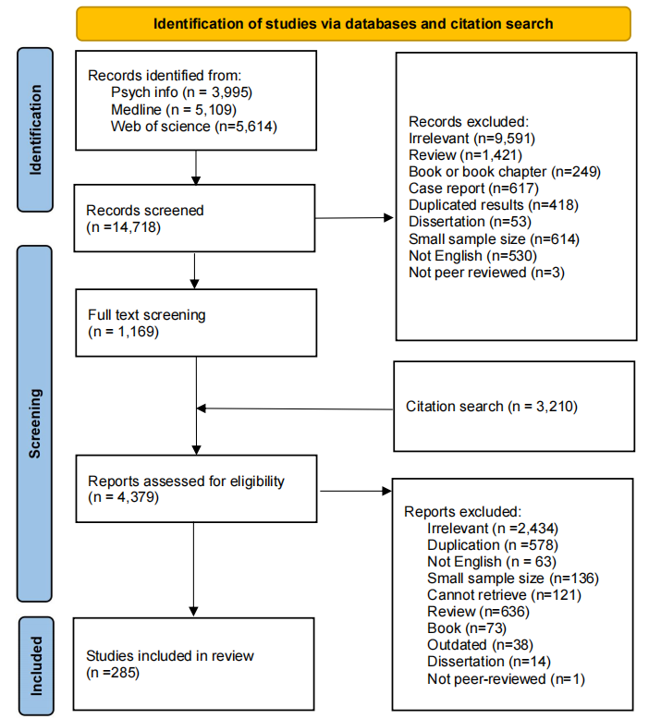
Figure 2.1
Flow diagram of the systematic review and meta-analyses

Screening procedure
The three databases were searched by two independent reviewers and the flow diagram for the search is shown in Figure 2.1. First, title and abstract screening were conducted. There were 14,718 records identified. 13,549 records did not meet the inclusion criteria and thus were excluded, leaving 1,169 records for full text screening. Based on the included studies, backward and forward citation search returned an additional 3,210 results. Additionally, 95 enquiries were sent for studies with incomplete data specified in the eligibility criteria, and eight authors replied with data summaries. A total of 285 records were included in the current review (see Tables 2.1 and 2.2). References for these studies are listed in Appendix B.

Table 2.1
Demographic and clinical information for question one
 | Schizophrenia | Psychosis
N | 206,750 | 337,993
K | 27 | 208
Sub synthesis (k) | Not applicable | Lifetime (110); Current (108); Bipolar I lifetime (40) and current (52); Bipolar II lifetime (13) and current (6); manic episode lifetime (9) and current (44); depressive episode lifetime (7) and current (22); mixed episode lifetime (4) and current (8); first episode (15); mood incongruent (21).
Age, M(SD) ª | 41.21 (10.30) | 40.70 (6.85)
Female, n (%) ^{b} | 127,201 (61.52) | 120,062 (35.52)
Diagnostic standards (k)^{c} | DSM (17), ICD (8), MDQ, RDC, and mixed | DSM (167), ICD (25), mixed (6), RDC (5), unclear (3), DCR10 and DCUPR
Assessment tools (k) ^{c} | Unclear (14), SCID (7), BPRS, DIS, MDQ, OPCRIT, PSE, SAPS, SCAN | SCID (91), unclear (48), MINI (18), mixed (9), DIGS (8), SCAN (7), SADS (6), CIDI (3), AMDP (2), CGI (2), OPCRIT (2), PANSS (2), SID (2), BISS, CORE, DI-PAD, DIS, ORSM, PDI, SAPS, YMRS.
Study location (k) ^{d} | USA (9), AU (2), CN (2), EGY (2), IN (2), TR (2), UK (2), CA, CH, DK, ES, GL, QA, SE | USA (61), IT (20), TR (12), UK (11), FR (10), CN (8), IN (7), KR (7), BR (6), NO (6), CA (5), CH (5), DE (5), ES (5), EU (4), GL (4), AU (3), NL (3), PL (3), SE (3), DK (2), EGY (2), ET (2), AT, CL, FI, GR, HU, IE, IR, JP, LB, ME, MY, SG, TN, UG.
Patient type (k) | Inpatient (6), Mixed (17), Outpatient (5) | Inpatient (34), Mixed (46), Outpatient (57), Unknown (51)
Bipolar type (k) | Psychotic Bipolar (4), Bipolar I (9) and BSD (15) | Psychotic Bipolar, Bipolar I (68), BSD (136) and Bipolar II (3)
Type of psychosis (k) | First rank symptoms (10), Schizophrenia (8), Psychotic disorders (7)^{e}, Schizoaffective disorder (3) | Not applicable
Note. The study number (k) is one for those without brackets.
ª Data was missing in 22 studies for psychosis, and 7 studies for schizophrenia;
^{b} Data was missing in 11 studies.
^{c} The full name of the diagnostic standards and assessment tools can be retrieved from supplementary materials.
^{d} The study location used 2 or 3 letters country code. The GL indicated that the study was conducted in multiple countries.
^{e} The psychotic disorders include one study focused on schizophrenia spectrum disorder.

Table 2.2
Demographic and clinical information of studies of specific psychotic symptoms
 | Delusions | Hallucinations | Thought disorders
N | 43,507 | 44,865 | 5,952
Age, M (SD) ª | 43.02 (7.42) | 43.08 (7.50) | 44.66 (7.84)
Female, n (%) ^{b} | 26,051 (59.88) | 26,608 (59.31) | 2,851 (47.90)
K | 76 | 71 | 15
Sub synthesis (k) | Lifetime (34), Current (47) | Lifetime (35), Current (42) | Lifetime (8), Current (10)
Diagnostic standards (k)^{c} | DSM (54), ICD (8), unclear (6), RDC (4), mixed (4), DCR10, DCUPR | DSM (52), ICD (7), unclear (5), RDC (4) mixed (2), DCR10, DCUPR | DSM (9), RDC (3), DCUPR, ICD, mixed, unclear
Assessment tools (k) ^{c} | SCID (16), unclear (16), DIGS (6), mixed (6), SADS (4), OPCRIT (3), SAPS (3), AMDP (2), BPRS (2), DIP (2), MINI (2), PDI (2), PSE (2), SCAN (2), BISS, CAPE, CGI, CIDI, DI-PAD, DIS, WGSQ, MDS | SCID (19), unclear (11), DIGS (6), mixed (5), OPCRIT (4), MINI (3), SADS (3), AMDP (2), DIP (2), SAPS (2), SCAN (2), BISS, BPRS, CGI, CIDI, CORE, DI-PAD, DIS, EMA, HoNOS, MDS, PDI, PSE | SCID (3), mixed (2), OPCRIT (2), SADS (2) unclear (2), CMBT, DIGS, DIP, DI-PAD, SAPS
Study location (k) ^{d} | USA (23), IT (10), DE (7), IN (6), UK (6), AU (4), CH (3), FR (3), KR (3), TR (2), CN, EGY, ET, EU, FI, GL, NL, PL, SE, UG | USA (27), UK (8), IT (7), DE (6), AU (4), IN (4), CH (3), KR (3), FR (2), NO, CN, EGY, ET, NL, SE, TR, UG | USA (11), UK (2), DE (2), AU
Patient type (k) | Inpatient (25), mixed (16), Outpatient (9), unclear (27) | Inpatient (21), mixed (21), Outpatient (11), unclear (19) | Inpatient (5), mixed (6), Outpatient (2), unclear (3)
Bipolar type (k) | Psychotic (13), Type I (27), BSD (37) | Psychotic (14), Type I (24), BSD (34) | Psychotic (2), Type I (9), BSD (5)
Type of conditions (k) | Any (47), Grandiosity (11), Persecutory (7), Paranoia (4), Reference (4) Suspiciousness (3), Perception | Any (46), Auditory (25), Visual | Any (6), formal thought disorder (3), positive formal thought disorder (3), disorganised speech (2), disorganised thoughts and behaviour  behaviors
Note. The study number (k) is one for those without brackets; BSD includes subtypes of bipolar I, II and not otherwise specified.
ªMissing values: delusions (k = 13), hallucinations (k = 15), and thought disorders (k = 1);
^{b}Missing values: delusions (k = 8), hallucinations (k = 7)
^{c}The full name of the diagnostic standards and assessment tools can be retrieved from supplementary materials.
^{d}The study location used 2 or 3 letters country code. The GL indicated that the study was conducted in multiple countries.

Coding
The coding for data extraction was conducted by two independent reviewers. An interrater reliability analysis was conducted with 25% of the papers randomly selected from all included studies. The overall kappa value for proposed variables in those studies was .89, which indicated excellent reliability. Any disagreements were resolved after discussion.

Variables
Independent variables such as demographic (e.g., gender), clinical (e.g., bipolar type), and methodological factors (e.g., publication date, study quality) were used to explore the potential source of heterogeneities. The dependent variables were the prevalence of comorbid schizophrenia, psychosis (i.e., presence of hallucinations or delusions), and concurrent delusions, hallucinations or thought disorders, please see Table B 5 in appendix for details. Information of diagnostic standards, assessment tools and locations were also collected and summarised in Tables 2.1-2.2.

Risk assessment
The Joanna Briggs Institute (JBI) Critical Appraisal Checklist for prevalence studies was used to evaluate qualities of studies (see: https://jbi.global/critical-appraisal-tools). This checklist includes 9 items that covers study sampling, reporting, analysis, measurement, procedure and outcome. For each item, reviewers rated the study using four categories: Yes (rated as 1), No (0), Unclear (0), and Not applicable. The procedure for the evaluation of the interrater reliability was identical to the coding schema; initial kappa was 0.62 and, in the light of this, all discrepant ratings were examined, discussed and final ratings were agreed by consensus.

Statistical analysis
All data was extracted manually except information contained in images, which was extracted by GetData Graph Digitizer software (see http://www.getdata-graph-digitizer.com/). Results of descriptive statistics will be presented to give a general account of the included studies, including demographic factors (e.g., age, gender, country) as well as clinical factors (e.g., subtype of BSD, duration of illness). We used single proportion meta-analysis. To stabilise the variance between studies that were too high (i.e.,70%-100%) or low (i.e., 0%-30%), the double arcsine or Freeman-Turkey transformation was performed (Miller, 1978). Funnel plot and egger’s regression test for the asymmetry were conducted to detect publication bias (Egger et al., 1997). A random effects model was used in the light of expected heterogeneity, estimated by the I statistic. Studentised residuals test were applied to find outliers in the dataset. Subgroup analysis via meta regression were performed to see if any of the factors (e.g., research design, year of publication, or demographic factors) could explain the variance between studies, and to identify meaningful associations between these factors and the primary outcomes. Meta analysis and regression were applied via the packages meta (version 6.5-0) and metafor (version 4.4-0); permutation test with 3,000 iterations was carried out for regression models using the dmetar package (version 0.0.9000). R studio (version 1.4.1717) was used for all analyses.

Results

Comorbid Schizophrenia
The basic information was summarised in Table 2.1, and the abbreviations as well as the full name of the diagnostic tools are listed in Table B 6. The pooled prevalence of comorbid schizophrenia was 9.54% (95% CI [5.68%, 14.23%], k = 27). An outlier (t = 6.00) was detected, significantly influencing the pooled result (Conus et al., 2004). The rate after the exclusion of the outlier was 8.04% (95% CI [5.53%, 10.96%], k = 26). Publication bias was not evident (z = 1.81, p = .07), and no significant effect of sample size was observed. Heterogeneity in this synthesis was very high (I² = 99.73%), suggesting the variance between studies is not negligible. Neither the time frame of the diagnosis (lifetime or current) nor the type of psychotic comorbidity affected the findings. Age and gender explained 23.01% of the between study variance, and the residual variance was reduced to 99.46%, implying that most of the heterogeneity is introduced by unknown variables. Being male (estimate = -.004, se = 001, p = .02) in the bipolar population was associated with risk of receiving comorbid schizophrenia diagnosis, see Tables 2.3-2.4 and Figures B 1-2 for details.

Table 2.3
Pooled results of comorbid schizophrenia and psychosis in bipolar patients
Analyses of Comorbid  Conditions | Sub-analyses | Pooled Rate (95% CI) | Tau² (95% CI) | I² (95% CI)
Schizophrenia |  | 8.04  [5.53, 10.96] | .01 [.01, .03] | 99.7  [99.5, 99.9]
Mood-incongruent psychosis |  | 47.43  [38.55, 56.40] | .04 [.02, .09] | 95.9  [94.7, 96.8]
Psychosis (lifetime) |  | 53.08 [49.72, 56.43] | .03 [.02, .04] | 97.6  [97.3, 97.8]
 | Bipolar I | 62.81  [59.24, 66.31] | .01 [.01, .02] | 87.9  [84.4, 90.6]
 | Bipolar II | 16.97  [11.75, 22.88] | .02 [.01, .05] | 88.4  [82, 92.5]
 | Manic episode | 69.58  [57.15, 80.75] | .03 [.01, .14] | 91.1  [84.8, 94.8]
 | Depressive episode | 43.47  [29.72, 57.74] | .03 [.01, .19] | 95.3  [92.1, 97.2]
 | Mixed episode | 52.70  [22, 67.71] ª
Psychosis (current) † |  | 41.46  [36.88, 46.11] | .05 [.05, .08] | 99.77  [99.70, 99.82]
 | Bipolar I | 48.41  [41.82, 55.03] | .06 [.04, .09] | 98.5  [98.4, 98.7]
 | Bipolar II | 7.43  [5.73, 9.33] | <.0001 [0, .08] | 47.6  [0, 80.8]
 | Manic episode† | 51.5  [44.26, 58.72] | .06 [.04, .09] | 98.6  [98.4, 98.8]
 | Depressive episode† | 18.15  [12.46, 24.63 | .03 [.02, .07] | 97.2  [96.6, 97.8]
 | Mixed episode | 50.29  [23.09, 77.40] | .16 [.07, .68] | 98.8  [98.4, 99.1]
 | First episode† | 56.95  [44.31, 69.15] | .06 [.03, .15] | 97.4  [96.6, 98]
Note. the pooled rate and the I statistics presented in proportion; all pooled rate was based on random effects model due to high heterogeneity.
ª the sample size for lifetime psychosis in patients with mixed episode was too low (k = 4) and thus the values reported were median and the range.
† marks the presence of possible publication bias.

Table 2.4
The information of predictors contributed to the heterogeneity
Syntheses | Predictors | estimate (se) | Q | R² | Tau² | I²
Schizophrenia | Gender | -0.004 (0.001) * | 6.82* | .23 | .01 [.01, .03] | 99.46  [98.94, 99.79]
Schizophrenia | age | -0.002 (0.003)
Mood-incongruent psychosis | Publication date | -0.01 (0.004) ** | 12.94** | .46 | .02 [.01, .04] | 95.14  [90.65, 98.02]
Mood-incongruent psychosis | Age | 0.01(0.005) **
Lifetime psychosis | Gender | -0.003(0.001) * | 21.45*** | .15 | .02 [.02, .03] | 96.97  [96.05, 97.80]
Lifetime psychosis | Bipolar type | 0.14 (0.04) ***
LP-Bipolar I | Psychosis type | 0.13 (0.06) * | 15.32* | .32 | .01 [.003, .01] | 80.54  [66.88, 89.90]
LP-Bipolar I | First level evidence | 0.09 (0.04) *
LP-Bipolar II | Age | 0.01 (0.004) ** | 16.32** | .64 | .01 [.002, .02] | 79.09  [52.37, 93.14]
LP-Bipolar II | Gender | -0.01 (0.004) *
LP-Depressive | Bipolar type | 0.32 (0.07) · | 21.58 · | .85 | .005 [.001, .04] | 72.96  [28.78, 96.16]
Current psychosis | Bipolar type | 0.13 (0.05) ** | 31.14*** | .24 | .05 [.04, .07] | 99.24  [98.99, 99.45]
Current psychosis | Age | -0.01 (0.003) **
Current psychosis | Patient type | 0.07 (0.03) *
CP-Bipolar I | Rate of mania | 0.004 (0.001) *** | 24.68 *** | .36 | .04 [.02, .06] | 97.55  [96.34, 98.56]
CP-Bipolar I | Multicentre study | -0.17 (0.07) *
CP-Bipolar I | Clinical status | 0.09 (0.07)
CP-Manic | Rate of mania | 0.003 (0.002) * | 5.48 | .07 | .05 [.03, .10] | 98.95  [98.37, 99.41]
CP-Manic | Gender | -0.001 (0.007)
CP-Manic | Age | 0.005 (0.005)
CP-Depressive | Gender | -0.01 (0.007) | 11.73 ** | .40 | .02 [.01, .06] | 97.63  [95.45, 99.09]
CP-Depressive | Age | -0.01 (0.006) *
CP-Mixed | Patient type | 0.49 (0.30) | 2.68 | .19 | .13 [.05, .65] | 98.59  [96.55, 99.71]
CP-First episode | Rate of mania | 0.006 (0.002) ** | 16.38 ** | .56 | .03 [.01, .08] | 96.48  [92.91, 98.76]
Note. LP: lifetime psychosis; CP: Current psychosis. No meaningful predictors were found for lifetime psychosis in patients with manic episode or current psychosis in bipolar ii patients. For regression on psychosis in mania, patients with mixed episode have been included since not all patients were suffering from unique manic episode.
·p > .05 and p < .1; * p < .05; **p<.01, ***p < .001.

Comorbid Psychosis

Mood incongruent psychosis (MIP)
The pooled prevalence of MIP in psychotic bipolar patients was 47.43% (95% CI [38.55, 56.40], k = 21), with very high heterogeneity (I² = 95.9%). Publication bias was not evident (z = -0.50, p = .61). No significant outliers were identified, and subgroup analysis on the timeframe of the prevalence as well as the type of bipolar disorder did not yield significant findings. Meta-regression found that age and publication date explained 45.67% of the between-study variance, and the heterogeneity still remained high (I² = 95.15%). Being older (estimate = 0.01, SE = 0.005, p = .01) predicted higher prevalence of MIP; a similar trend was found for earlier date of publication (estimate = -0.01, SE = 0.004, p < .01).

Lifetime psychosis
The combined prevalence of lifetime psychosis in bipolar patients was 53.08% (95% CI [49.72, 56.43]). Publication bias was not evident (z = 0.33, p = .74). Significant outliers were not detected. The between-study variance estimated by I² is 97.74%, reflecting a high level of heterogeneity between studies. Subgroup analysis was conducted for this reason. Despite the evident difference between different BSD types, the overall heterogeneity was not significantly reduced. Findings from meta-regression revealed that BSD type and gender (k_{missing} = 6) explained 16.45% of the total variance, and a minor decrease was observed in heterogeneity (I² = 96.97%). Patients with bipolar I (estimate = 0.14, SE = 0.04, p < .001) and being male (estimate = -0.003, SE = 0.001, p < .05) were at increased risk of lifetime psychosis (see Tables 2.3–2.4 and Figures B 3–6 for details).
Subsequent syntheses were conducted for lifetime psychosis in patients with bipolar I (k = 40) or bipolar II disorder (k = 13). The pooled lifetime prevalence of psychosis in patients with bipolar I disorder was 64.19% (95% CI [59.64, 68.62]), and I² was 94.69%. Studentised residuals as well as sensitivity analysis suggested that a potential outlier (t = 5.16) caused a significant increase in the heterogeneity (Parker et al., 2013); the heterogeneity decreased to 90.86% after dropping this study. The pooled prevalence after the removal was 62.81% (95% CI [59.24, 66.31]). Publication bias was not evident (z = -1.05, p = .30). Subgroup analysis on clinical status and patient source did not yield significant decreases in heterogeneity. Findings from meta-regression suggested that age of onset (k_{missing} = 7), first-level evidence, duration of illness, gender, age (k_{missing} = 3), patient type, and publication date explained 32.16% of the variance; the residual I² was 80.55%. Prevalence of lifetime psychosis was higher in studies using consecutive sampling (estimate = 0.09, SE = 0.04, p < .05) and lower for studies reporting first-episode psychosis (estimate = 0.13, SE = 0.06, p < .02).
The synthesized rate of lifetime psychosis in bipolar II disorder was 16.97% (95% CI [11.75, 22.88]), with high heterogeneity (I² = 88.4%) between studies. No significant outliers were identified. Subgroup analysis on clinical status as well as patient type did not produce significant findings. Meta-regression revealed that age (k_{missing} = 1) and gender explained 63.72% of the variance, and a change in heterogeneity was observed (I² = 79.10%). Bipolar II patients who were older (estimate = 0.01, SE = 0.004, p < .005) or male (estimate = -0.01, SE = 0.005, p < .02) were at risk of lifetime psychosis.
The pooled rate of lifetime psychosis in BSD patients with a manic episode was 75.28% (95% CI [59.67, 88.18], k = 9), with very high heterogeneity (I² = 95.58%). An outlier (t = 2.84) contributed significantly to the heterogeneity. The heterogeneity decreased to 91.20% after the removal of this study, and the pooled rate decreased to 69.58% (95% CI [57.15, 80.75]; k = 8). Publication bias was not evident (z = 0.29, p = .77). Subgroup analysis on the nature of the mood episode did not explain any variance. No predictors were found in meta-regression.
The pooled rate of lifetime psychosis for depression was 37.03% (95% CI [21.14, 54.50], k = 7), and the heterogeneity was very high (I² = 97.66%). An outlier (t = -2.39) significantly contributed to the heterogeneity; the heterogeneity after removal was 94.65% and the rate was 43.47% (95% CI [29.72, 57.74]). Publication bias was not evident (z = 0.65, p = .51). Subgroup analysis by BSD type explained 84.69% of the variance, and the remaining heterogeneity was high (I² = 72.96%). The nature of the mood episode did not reveal any difference between studies. After permutation, bipolar I was correlated with a higher prevalence of psychosis at a marginally significant level (estimate = 0.32, SE = 0.07, p = .07) (see Tables 2.3-2.4 and Figures B 7-14 for details).
Only four studies reported lifetime psychosis in patients with mixed episodes; thus, we report a narrative review. The median prevalence was 52.70%, with a range between 22.00% and 67.71%. The mood episode in all of the studies was defined according to the DSM system. Three studies recruited patients from outpatient units and one recruited from an inpatient unit, but no distinctive pattern was observed. The lowest prevalence was observed in BSD patients (22%), and bipolar I patients had generally higher prevalences; in addition, the prevalence was lower in more recently published studies. However, caution should be exercised when interpreting these findings due to the small number of studies (see Table B 7 for details).

Current or recent psychosis
The pooled rate of current or recent psychosis was 41.46% (95% CI [36.88, 46.11]). Publication bias was significant (z = 3.57, p < .001). Heterogeneity was very high (I² = 99.50%). No significant outlier was detected. Subgroup analysis revealed that both bipolar type and patient type explained the between-group variance. However, the remaining heterogeneity was still high (I² = 99.71% and 99.70%, respectively). Meta-regression found that patient type, bipolar type, and age explained 22.85% of the variance; a minor change in heterogeneity was observed (I² = 98.96%). A higher prevalence of psychosis was identified in bipolar patients who were recruited from inpatient units (estimate = 0.07, SE = 0.03, p < .05) and diagnosed with bipolar I disorder (estimate = 0.14, SE = 0.05, p < .005), as well as in younger patients (estimate = -0.01, SE = 0.003, p < .01).
The rate in bipolar I patients was 48.41% (95% CI [41.82, 55.03], k = 52), with a very high level of heterogeneity (I² = 98.50%). Publication bias was not evident (z = 1.65, p = .10). No outlier affecting the pooled prevalence was detected. Subgroup analysis did not find any variance contributed by patient type or clinical status. Meta-regression found that rate of mania, multicentre study status, and clinical status explained 35.82% of the variance. However, this did not lead to a significant reduction in heterogeneity (I² = 97.56%). Bipolar I patients who were experiencing manic episodes were at higher risk of recent psychosis (estimate = 0.004, SE = 0.0009, p < .001); studies with samples recruited from multicentre sites (estimate = -0.17, SE = 0.07, p < .02) reported a lower prevalence of psychosis.
The prevalence in patients with bipolar II disorder was 9.20% (95% CI [3.33, 17.39], k = 6), with high heterogeneity (I² = 92.94%). A significant outlier (t = 7.08) was detected (Xiang et al., 2013). The rate of current psychosis in bipolar II after removal was 7.43% (95% CI [5.73, 9.33], k = 5), and the heterogeneity decreased to a moderate level (I² = 47.6%). Publication bias was not evident in this synthesis (z = -1.59, p = .11). No significant predictors were found in meta-regression.
The combined rate of current psychosis for mania was 51.50% (95% CI [44.26, 58.72], k = 44), with very high heterogeneity (I² = 99.10%). Publication bias was evident (z = 2.00, p = .05). No significant outlier was found. Subgroup analysis did not find any variance contributed by the nature of the mood episode or whether mixed or manic patients were involved. The rate of mania (k_{missing} = 2), gender (k_{missing} = 3), and age (k_{missing} = 4) explained 7.29% of the between-study variance; however, the remaining heterogeneity was still significant (I² = 98.95%), and a higher rate of mania predicted a higher prevalence of psychosis (estimate = 0.003, SE = 0.002, p < .05).
The rate of recent psychosis in patients with a depressive episode was 20.26% (95% CI [13.36, 28.16], k = 22). The heterogeneity was very high (I² = 99.30%). An outlier (t = 3.18) was identified (Nisha et al., 2015). The prevalence after the removal decreased to 18.15% (95% CI [12.16, 24.63], k = 21), and a minor change in heterogeneity was observed (I² = 99.05%). Publication bias was evident (z = 2.46, p < .01). The nature of the mood episode explained 9.19% of the between-study variance, and the remaining heterogeneity was 98.98%; no significant predictors were found after permutation. Gender and age explained 39.55% of the variance, and the remaining heterogeneity was 97.63%. Younger depressive patients were at greater risk of current psychosis (estimate = -0.01, SE = 0.006, p < .05).
The rate of current psychosis in patients with mixed episodes was 50.29% (95% CI [23.09, 77.40], k = 8), and the heterogeneity was very high (I² = 98.8%). Publication bias was not significant (z = 1.48, p = .14). No significant outlier was detected. Subgroup analysis of BSD type did not reveal any significant variance; patient type contributed to 18.80% of the between-group variance; however, the prediction effect was not significant.
The combined rate of first-episode psychosis was 56.95% (95% CI [44.31, 69.15], k = 15); the heterogeneity was very high (I² = 97.40%). Significant publication bias was detected (z = 2.26, p < .02). No outliers significantly contributed to the heterogeneity. Subgroup analysis on the type of bipolar disorder did not reveal significant findings. The rate of mania (k_{missing} = 1) explained 56.30% of the between-group variance; the remaining heterogeneity decreased to 96.48%. Bipolar patients with a manic episode were at higher risk of experiencing psychosis in the first mood episode (estimate = 0.006, SE = 0.002, p < .002) (see Tables 2.3–2.4 and Figures B 15–28 for further reference).

Distributions of specific psychotic symptoms in bipolar populations

Cooccurring Delusions
The combined prevalence of lifetime delusions in bipolar patients was 55.11% (95% CI [45.70, 64.34], k = 34), with very high heterogeneity (I² = 99.13%). Publication bias was not evident in the included studies (z = 1.06, p = .29), and no significant outliers were identified. Subgroup analysis revealed that the bipolar type explained 46.52% of the variance. Patients with more severe BSD (bipolar I or psychotic bipolar) were at risk of lifetime delusions (estimate = 0.27, SE = 0.05, p < .001).
The prevalence of current delusions in this population was 47.19% (95% CI [38.53, 56.94], k = 47), with very high heterogeneity (I² = 99.06%). Significant publication bias was detected by Egger’s test (z = 2.72, p = .01). No significant outliers were detected. Subgroup analysis indicated that different bipolar types explained 23.71% of the variance, and the overall variance decreased to 98.58%. Meta-regression revealed that first-level evidence and bipolar type explained 37.04% of the variance. The remaining heterogeneity was still high (I² = 98.23%). Studies recruiting consecutive patients (estimate = 0.26, SE = 0.08, p < .01) or patients with more severe bipolar disorder (estimate = 0.15, SE = 0.05, p < .001) tended to report higher current delusions (see Tables 2.2, 2.5, and 2.6 as well as Figures B 29-32).

Table 2.5
Pooled results of cooccurring delusions, hallucinations and thought disorders in bipolar patients
Analyses of Comorbid  Conditions | Sub-analyses | Pooled Rate [95% CI] | Tau² [95% CI] | I² [95% CI]
Delusions | Lifetime | 55.11  [45.70, 64.34] | .08 [.05, .13] | 99.1  [98.7, 99.5]
 | Current † | 47.19  [38.53, 55.94] | .09 [.06, .14] | 99.1  [98.6, 99.4]
Hallucinations | Lifetime | 31.26  [26.01, 36.76] | .03 [.02, .05] | 97.5  [96.0, 98.6]
 | Current | 19.62  [14.37, 25.43] | .05 [.03, .08] | 98.7  [98.0, 99.2]
Thought disorders | Lifetime | 29.94  [15.08, 47.34] | .07[.03, .28] | 99.2  [98.2, 99.8]
 | Current | 23.61  [9.00, 42.31] | .08 [.04, .34] | 98.2  [95.9, 99.5]
Note. the pooled rate and the I statistics were presented in proportions; all pooled rate was based on random effects model due to high heterogeneity.
ª the sample size for lifetime psychosis in patients with mixed episode was too low (k=4) and thus the values reported were median and the range.
† denotes the presence of possible publication bias.

Table 2.6
The predictors contributed to the heterogeneity in analyses of specific psychotic symptoms
Syntheses | Predictors | estimate (se) | Q | R² | Tau² | I²
DelusionsL | Bipolar type | 0.27 (0.05) *** | 28.32 *** | .47 | .04 [.03, .07] | 98.33  [97.40, 99.07]
DelusionsC | Bipolar type | 0.15 (0.05) *** | 27.65 *** | .37 | .06[.04, .09] | 98.23  [97.37, 98.91]
DelusionsC | First level evidence | 0.26 (0.08) **
HallucinationsL | Sampling method | 0.30 (0.08) *** | 15.94 ** | .34 | .02 [.01, .03] | 96.24  [94.05, 97.95]
HallucinationsC | Bipolar type | 0.10 (0.04) ** | 6.72 ** | .14 | .04 [.03, .07] | 98.41  [97.58, 9]
Thought disordersL | / | / | / | / | / | /
Thought disordersC | Age | -0.03 (0.01) *** | 13.68 *** | .72 | .03 [.009, .26] | 93.82  [81.98, 99.25]
Thought disordersC | Gender | -0.008 (0.004) *
Note. L = lifetime; C = current.
· p > .05 and p < .10; *p < .05; **p < .01; ***p < .001.

Cooccurring Hallucinations
The combined lifetime prevalence of hallucinations in bipolar patients was 32.59% (95% CI [25.79, 39.77], k = 35), with very high heterogeneity (I² = 98.53%). One outlier had a significant influence (t = 5.97) on the pooled result (Dell'Osso et al., 2002). The new prevalence after excluding the outlier was 31.26% (95% CI [26.01, 36.76], k = 34), and the heterogeneity dropped to 97.48%. Publication bias was not significant (z = 0.92, p = .36). Neither the type of hallucination nor the type of bipolar disorder explained significant between-group variance. Sampling method explained 33.86% of the variance. The remaining heterogeneity decreased to I² = 96.24%. Studies applying probabilistic sampling (estimate = 0.30, SE = 0.08, p < .001) were associated with higher lifetime hallucinations.
The pooled rate of current hallucinations was 19.62% (95% CI [14.37, 25.43], k = 42), with very high heterogeneity (I² = 98.71%). A significant outlier (t = 3.09) was detected; however, it had no significant impact on the pooled prevalence and heterogeneity, and thus the analysis continued without excluding the outlier (Rosen et al., 2016). Publication bias was again not significant across studies (z = 1.47, p = .14). Subgroup analysis revealed that the bipolar type contributed 13.50% of the total variance, and the remaining heterogeneity was still substantial (I² = 98.41%). Patients with more severe bipolar disorder (estimate = .10, SE = .04, p < .01) were at risk of current hallucinations; see Tables 2.5–2.6 and Figures B 33–36 for details.

Cooccurring Thought Disorder (TD)
The synthesised prevalence of lifetime TD in bipolar patients was 29.94% (95% CI [15.08, 47.34], k = 8), with high heterogeneity (I² = 99.22%). No publication bias was detected (z = -0.73, p = .46). No significant outlier was found. The subgroup analysis on different bipolar types did not contribute to the difference between studies. No significant predictors were observed in this analysis. The rate of current TD was 31.25% (95% CI [11.50, 55.31], k = 10), with very high between-study variance (I² = 98.81%). An outlier (t = 2.62) was identified (Harrow et al., 1982), and the rate fell to 23.61% after its removal (95% CI [9.00, 42.31]); the heterogeneity reduced to I² = 98.18%. Publication bias was not evident (z = 1.43, p = .15). Neither types of TD nor BSD explained the between-group variance. In meta-regression, age and gender explained 71.65% of the variance; the remaining heterogeneity was still high (I² = 95.31%). Male patients (estimate = -0.007, SE = 0.004, p < .05) and younger patients (estimate = -0.03, SE = 0.009, p < .001) were at the greatest risk of current thought disorder (see Tables 2.5-2.6 and Figures B 37-40 for details)

Overall study quality
Study quality, as assessed by the JBI checklist, ranged from 3 to 9 across all included studies. The scores followed an approximately normal distribution, with most studies rated at 5 or 6, see details in summary Tables B 8-12. When incorporated as a moderator in all meta-regression models, study quality did not significantly contribute to the observed heterogeneity (p > .05).

Discussion
In the current study we have synthesized findings on the prevalence in bipolar patients of comorbid schizophrenia, psychosis and the specific symptoms of delusions, hallucinations, and thought disorder. Our findings are summarised in Table 2.3 and Table 2.5, and here we draw readers’ attention to the main observations. In summary, the low rate of comorbid schizophrenia in bipolar population increased when a broader definition was applied (mood incongruent psychosis). Lifetime psychosis was higher than current or recent psychosis, and this was true for all the analyses. Patients with bipolar I or manic episode had a much higher rate of comorbid psychosis than those with bipolar II or with depressive episodes. Delusions were more prevalent than thought disorder or hallucinations in bipolar patients. For context, the estimated prevalence of comorbid schizophrenia is considerably higher than its estimated prevalence (i.e., 0.4-2%) in the general population (Moreno-Küstner et al., 2018), or even the prevalence of broadly defined psychosis (about 3%)(Perala et al., 2007). In addition to the previous attempts to synthesize these data by Aminoff et al. (2022), our approach includes more studies on psychosis and added the analyses of comorbid schizophrenia diagnosis as well as specific psychotic symptoms. The merits of our study compared to that of Chakrabarti and Singh (2022) were the quantitative synthesis and heterogeneity analyses, as well as the synthesis on thought disorder in bipolar patients. Furthermore, our meta-analytic findings are relatively stable across our analyses and not affected by poor study design. In all analyses, however, a high level of heterogeneity was observed. In general, although some meaningful factors were identified in meta-regression, this remained high in these further analyses, and we comment further about this in the research limitations.
In one sense, the findings are unsurprising. The high prevalence of psychosis in this population has been noted in numerous previous studies and, indeed, was the motivation for many of the studies included in this meta-analysis. Our estimate that lifetime psychosis is present in approximately three out of five bipolar I patients and nearly a fifth of bipolar II patients is slightly lower than the values reported by two systematic reviews(Aminoff et al., 2022; Chakrabarti & Singh, 2022), and this seems to be mainly accounted for by the lower rate we observed in bipolar II patients. This difference could be explained by different search and inclusion strategies. We applied a relatively conservative approach to identifying papers and yet our estimate of the lifetime prevalence in bipolar patients was computed from a larger dataset (k = 110) than those in prior reviews. The prevalence of recent or current psychosis was also relatively lower than reported previously, with about two out of five patients affected.
The higher rate of psychosis in bipolar I versus bipolar II was expected and can be in part explained by the fact that the former is the more severe condition, but also by the fact that bipolar I criteria require a history of manic episodes whereas those for bipolar II do not. Hence, this finding is consistent with our observation that psychotic symptoms are more evident in mania than depression. This observation was further supported by subgroup analyses of bipolar I and bipolar II samples, where the estimated confidence intervals did not overlap. This finding is consistent with a prior review(Aminoff et al., 2022), and a network analysis, which showed stronger connections between positive and manic symptom clusters(Shao et al., 2024). Findings from meta regressions on the small groups were less consistent. The proportion of bipolar patients with a manic episode predicted current psychosis in the entire dataset and in some sub-analyses, although the effect sizes were relatively small. For lifetime psychosis, the best model did not contain this variable due to missing values.
Male patients were more likely to be diagnosed with comorbid schizophrenia compared with female patients, which is consistent with a greater prevalence of schizophrenia in men, especially in early adulthood (Abel et al., 2010; Nicole et al., 1992); similar findings were identified in the meta regressions of lifetime psychosis in general bipolar and bipolar ii patients, and the same effect was observed for current thought disorder. Moreover, previous research has suggested that male patients with bipolar disorder are more likely to have manic symptoms than the female patients(Fogarty et al., 1994). Hence, the gender differences observed are consistent with an overlap between bipolar disorder and schizophrenia conditions, or possibly common processes involved in bipolar I disorder with manic symptoms and schizophrenia.
As expected, and consistent with previous literature (Craddock, 2018), we found that delusions are common in bipolar patients, with an estimated prevalence similar to that for lifetime psychosis, and with no evident difference between the prevalence of lifetime and current delusions. Our estimate of combined prevalence is lower than the mean or median prevalence of lifetime or current delusions reported earlier (Chakrabarti & Singh, 2022). In meta regression, bipolar type predicted the prevalence of lifetime and current delusions, with bipolar I or psychotic bipolar patients especially likely to report a history of delusions. This likely reflects the facts that delusions, especially of grandiosity, are a common feature of the manic syndrome (Azzam et al., 2020; Dunayevich & Keck, 2000). We found that hallucinations are less prevalent in bipolar patients; overall about three in ten had a history of hallucinations and one fifth had current hallucinations, figures that are also comparable to those reported by Chakrabarti and Singh (2022). Finally, the approximate prevalence of thought disorder was similar across the different time frames, with around one fourth of bipolar patients suffering from lifetime thought disorder and one fifth suffering from current thought disorder. Although once thought pathognomonic for schizophrenia (Bleuler, 1950), it has been known for some time that this symptom is common in bipolar patients(Docherty et al., 1996) and our observations are comparable to those in meta-analyses focused on quantitative comparison between patients with schizophrenia and bipolar disorder (Dunayevich & Keck, 2000; Yalincetin et al., 2017).

Limitations
The main limitation of this review is the high heterogeneity observed within the main and sub-analyses, although some of the heterogeneities have been explained by factors such as bipolar type or the presence of mania. The remaining heterogeneities were generally high in all of the analyses. Some of this heterogeneity could be introduced by the use of different diagnostic and assessment tools. However, our study size lacks power to detect such variance without risk of overfitting. It is also plausible that the variance was introduced by different sampling techniques, research designs or other unknown factors. Another limitation is that study numbers for some subgroup analyses (e.g., psychosis in different mood episodes, thought disorder) were low. For example, only four studies have reported lifetime psychosis in bipolar patients with mixed episodes; therefore, a narrative review was conducted. Caution should be exercised when interpreting the findings from these analyses.
Additionally, current finding did not quantitatively examine other clinical characteristics such as the prognosis and treatment responses that may differ or be similar between BSD and schizophrenia. This study has focused on the psychopathological manifestations of schizophrenia in BSD, and other features such as course, outcome and treatment response were beyond its scope. For prognosis, there has been evidence that the major psychoses can be divided into several subgroups according to the illness trajectories(Dwyer et al., 2020). In contrast to the pessimistic outlook of Kraepelin, however, schizophrenia is not always associated with poor prognosis, highlighting the necessity of transdiagnostic approach to psychiatric classification. Meanwhile, pharmaceutical treatments are primarily neurotransmitter-oriented, and responses to them can be influenced by various factors(Citrome et al., 2009; Iftimovici et al., 2024) and even within a single diagnostic group, treatment response can vary markedly(Lipkovich et al., 2008). Consequently, determining the specificity of treatment effects based solely on categorical diagnoses is challenging, particularly when patients follow treatment plans that combine antipsychotics and mood stabilisers. In the only placebo-controlled study we are aware of which patients with severe mental illness were randomly assigned to either mood stabilisers, antipsychotics or both, treatment response was predicted by symptoms but not diagnoses(Johnstone et al., 1988). These challenges underscore the need for treatments targeting common deficits across these disorders, such as biological markers or cognitive dysfunctions(Dacquino et al., 2015; Yamada et al., 2020). For example, the Research Domain Criteria (RDoC) represent a significant shift in research approach, emphasising transdiagnostic psychological and neurobiological processes.

Implications
The present findings have implications for understanding the relationship between bipolar disorder and schizophrenia, the causal processes relating to both diagnoses, as well as the mechanisms involved in specific psychotic symptoms experienced by bipolar patients. The Kraepelinian distinction between bipolar disorder and schizophrenia was a cornerstone of psychiatry throughout the 20th century (Berrios & Beer, 1995) but continues to be a source of controversy today. In an attempt to resolve this issue Kasanin (1933) proposed the concept of schizoaffective psychosis, which was originally conceived as a separate condition combining symptoms of the other two conditions. The idea of a schizo-bipolar spectrum was raised by later researchers (Kendell & Brockington, 1980) and has recently received support from analyses of large samples combining patients from across the psychosis spectrum (Tamminga et al., 2014). However, some investigators have proposed more complex models, most notably hierarchical and bifactor models that assume a common psychosis disease process together with separate factors that explain the preponderance of mood vs psychotic symptoms (Reininghaus et al., 2019; Reininghaus et al., 2016; Reininghaus et al., 2013). These debates have led to an ongoing and concerted effort to create a new, more scientifically valid classification of psychiatric disorders (Krueger et al., 2018). Clearly the present findings point to the importance of this development and, yet, as a caveat, it should be pointed out that recent philosophical treatments of natural classification systems have argued that we may have to abandon the idea that one system can be devised that will be fit for all purposes (in the case of psychiatric conditions, these main purposes are epidemiology and public health surveillance, disease mechanism discovery, and clinical prediction) (Dupré, 2001); the alternative is to adopt a ‘promiscuous realism’ which recognises that any system is likely to have limitations and may be better suited to some purposes rather than others.
Attempts to resolve issues of psychiatric taxonomy can, to some extent, be addressed by focusing on causal factors. In the introduction, we highlighted that a considerable literature exists pointing to common aetiological and disease mechanisms in psychosis and bipolar disorder, including shared genetic architecture (Bigdeli et al., 2021), psychosocial risk factors such as childhood trauma (Palmier-Claus et al., 2016; Varese et al., 2012), and neurobiological processes (Chen et al., 2021). Research in psychosis suggests that there may be some specificity for different kinds of social risk factors and specific symptoms (Bentall et al., 2014) and it is possible that a similar kind of specificity will be found for some biological factors. This observation highlights the potential value of investigating mechanisms involved in the psychotic symptoms experienced by bipolar patients. Psychological research on delusions has placed considerable emphasis on emotional processes (Freeman & Garety, 2003) but this work has mostly focused on paranoia, and grandiosity has been relatively neglected (Knowles et al., 2011). A few studies focusing on grandiosity in schizophrenia patients have emphasized the role of motivation to find purpose in life (Isham et al., 2022) and, in future studies, it might be fruitful to explore how this relates to reward sensitivity (Alloy et al., 2015) and the high goal motivation (Johnson, 2005) observed in bipolar patients. Very little is known about hallucinations in bipolar patients but, in patients diagnosed with schizophrenia, it is thought that they are the consequence of a failure of source monitoring mechanisms which allow individuals to distinguish between their own mental events and external stimuli (Brookwell et al., 2013). Thought disorder is probably the only psychotic symptom in which detailed comparisons have been made between schizophrenia and bipolar patients. In both the former (Haddock et al., 1995) and the latter (Tai et al., 2004) it has been shown that thought disorder is a speech production abnormality that is activated when high levels of emotion disrupt cognitive processing (de Sousa et al., 2016).

Conclusion
In conclusion, our findings point to considerable overlap between bipolar disorder and schizophrenia, both in terms of phenomenology and psychopathology. However, questioning the established diagnostic boundaries between these two conditions requires caution. Validating such distinctions requires evidence from other dimensions of the illness, rather than relying solely on phenomenological and psychopathological findings. Future research should explore comparisons between patients with the two diagnoses who experience the same symptoms and common symptom-causing processes, as well as their variations in longitudinal course.

References
Abel, K. M., Drake, R., & Goldstein, J. M. (2010). Sex differences in schizophrenia. Int Rev Psychiatry, 22(5), 417–428. https://doi.org/10.3109/09540261.2010.515205
Abu Nazel, M., Elkady, H., Abd Allah, S., & Ibrahim, R. (2017). Pattern and correlates of tobacco smoking among mentally ill male patients in El-Mamoura Psychiatric Hospital, Alexandria, Egypt. Journal of Egyptian Public Health Association, 92(3), 167–176. https://doi.org/10.21608/epx.2017.16397
Alloy, L. B., Nusslock, R., & Boland, E. M. (2015). The development and course of bipolar spectrum disorders: an integrated reward and circadian rhythm dysregulation model. Annu Rev Clin Psychol, 11, 213–250. https://doi.org/10.1146/annurev-clinpsy-032814-112902
American Psychiatric Association, i. b. (2022). Diagnostic and statistical manual of mental disorders : DSM-5-TR (5th edition, text revision. ed.). Washington, DC : American Psychiatric Association Publishing, 2022.
Aminoff, S. R., Onyeka, I. N., Odegaard, M., Simonsen, C., Lagerberg, T. V., Andreassen, O. A., Romm, K. L., & Melle, I. (2022). Lifetime and point prevalence of psychotic symptoms in adults with bipolar disorders: a systematic review and meta-analysis. Psychol Med, 52(13), 2413–2425. https://doi.org/10.1017/S003329172200201X
Ancin, I., Cabranes, J. A., Santos, J. L., Sanchez-Morla, E., & Barabash, A. (2013). Executive deficits: a continuum schizophrenia-bipolar disorder or specific to schizophrenia? J Psychiatr Res, 47(11), 1564–1571. https://doi.org/10.1016/j.jpsychires.2013.07.008
Azzam, H., Hamed, M., Elhawary, Y., & Mohammed, A. (2020). Delusions in a Sample of Patients with Schizophrenia and Bipolar Disorder: The same or different? QJM: An International Journal of Medicine, 113.
Barnett, J. H., & Smoller, J. W. (2009). The genetics of bipolar disorder. Neuroscience, 164(1), 331–343. https://doi.org/10.1016/j.neuroscience.2009.03.080
Bentall, R. P. (2004). Madness explained [electronic resource] : psychosis and human nature. London : Penguin, 2004.
Bentall, R. P., de Sousa, P., Varese, F., Wickham, S., Sitko, K., Haarmans, M., & Read, J. (2014). From adversity to psychosis: pathways and mechanisms from specific adversities to specific symptoms. Soc Psychiatry Psychiatr Epidemiol, 49(7), 1011–1022. https://doi.org/10.1007/s00127-014-0914-0
Berrios, G. E., & Beer, D. (1994). The notion of a unitary psychosis: a conceptual history. Hist Psychiatry, 5(17 Pt 1), 13–36. https://doi.org/10.1177/0957154X9400501702
Berrios, G. E., & Beer, D. (1995). Unitary psychosis concept. A history of clinical psychiatry. London: Athlone, 313–335.
Bigdeli, T. B., Fanous, A. H., Li, Y., Rajeevan, N., Sayward, F., Genovese, G., Gupta, R., Radhakrishnan, K., Malhotra, A. K., Sun, N., Lu, Q., Hu, Y., Li, B., Chen, Q., Mane, S., Miller, P., Cheung, K. H., Gur, R. E., Greenwood, T. A.,…Harvey, P. D. (2021). Genome-Wide Association Studies of Schizophrenia and Bipolar Disorder in a Diverse Cohort of US Veterans. Schizophr Bull, 47(2), 517–529. https://doi.org/10.1093/schbul/sbaa133
Bipolar, D., Schizophrenia Working Group of the Psychiatric Genomics Consortium. Electronic address, d. r. v. e., Bipolar, D., & Schizophrenia Working Group of the Psychiatric Genomics, C. (2018). Genomic Dissection of Bipolar Disorder and Schizophrenia, Including 28 Subphenotypes. Cell, 173(7), 1705–1715 e1716. https://doi.org/10.1016/j.cell.2018.05.046
Black, D. W., & Nasrallah, A. (2010). Hallucinations and Delusions in 1,715 Patients with Unipolar and Bipolar Affective Disorders. Psychopathology, 22(1), 28–34. https://doi.org/10.1159/000284576
Bleuler, E. (1950). Dementia praecox or the group of schizophrenias.
Bora, E., Verim, B., Akgul, O., Ildiz, A., Ceylan, D., Alptekin, K., Ozerdem, A., & Akdede, B. B. (2023). Clinical and developmental characteristics of cognitive subgroups in a transdiagnostic sample of schizophrenia spectrum disorders and bipolar disorder. Eur Neuropsychopharmacol, 68, 47–56. https://doi.org/10.1016/j.euroneuro.2022.12.005
Brookwell, M. L., Bentall, R. P., & Varese, F. (2013). Externalizing biases and hallucinations in source-monitoring, self-monitoring and signal detection studies: a meta-analytic review. Psychol Med, 43(12), 2465–2475. https://doi.org/10.1017/S0033291712002760
Cardno, A. G., & Owen, M. J. (2014). Genetic Relationships Between Schizophrenia, Bipolar Disorder, and Schizoaffective Disorder. Schizophrenia Bulletin, 40(3), 504–515. https://doi.org/10.1093/schbul/sbu016
Chakrabarti, S., & Singh, N. (2022). Psychotic symptoms in bipolar disorder and their impact on the illness: A systematic review. World J Psychiatry, 12(9), 1204–1232. https://doi.org/10.5498/wjp.v12.i9.1204
Chen, Y. L., Tu, P. C., Huang, T. H., Bai, Y. M., Su, T. P., Chen, M. H., & Wu, Y. T. (2021). Identifying subtypes of bipolar disorder based on clinical and neurobiological characteristics. Sci Rep, 11(1), 17082. https://doi.org/10.1038/s41598-021-96645-5
Citrome, L., Reist, C., Palmer, L., Montejano, L., Lenhart, G., Cuffel, B., Harnett, J., & Sanders, K. N. (2009). Dose trends for second-generation antipsychotic treatment of schizophrenia and bipolar disorder. Schizophr Res, 108(1-3), 238–244. https://doi.org/10.1016/j.schres.2008.11.017
Conus, P., Abdel-Baki, A., Harrigan, S., Lambert, M., & McGorry, P. D. (2004). Schneiderian first rank symptoms predict poor outcome within first episode manic psychosis. J Affect Disord, 81(3), 259–268. https://doi.org/10.1016/j.jad.2003.09.003
Craddock, N. (2018). The Spectrum of Psychotic Disorders: Neurobiology, Etiology and
Pathogenesis Edited By Daryl Fujii and Iqbal Ahmed. Cambridge University Press.
2007. 588pp. $80.00 (hb). ISBN
9780521850568. British Journal of Psychiatry, 192(6), 478–478. https://doi.org/10.1192/bjp.bp.107.039578
Dacquino, C., De Rossi, P., & Spalletta, G. (2015). Schizophrenia and bipolar disorder: The road from similarities and clinical heterogeneity to neurobiological types. Clin Chim Acta, 449, 49–59. https://doi.org/10.1016/j.cca.2015.02.029
de Sousa, P., Sellwood, W., Spray, A., & Bentall, R. P. (2016). The affective reactivity of psychotic speech: The role of internal source monitoring in explaining increased thought disorder under emotional challenge. Schizophr Res, 172(1-3), 189–194. https://doi.org/10.1016/j.schres.2016.01.049
Dell'Osso, L., Pini, S., Cassano, G. B., Mastrocinque, C., Seckinger, R. A., Saettoni, M., Papasogli, A., Yale, S. A., & Amador, X. F. (2002). Insight into illness in patients with mania, mixed mania, bipolar depression and major depression with psychotic features. Bipolar Disord, 4(5), 315–322. https://doi.org/10.1034/j.1399-5618.2002.01192.x
Docherty, N. M., Hawkins, K. A., Hoffman, R. E., Quinlan, D. M., Rakfeldt, J., & Sledge, W. H. (1996). Working memory, attention, and communication disturbances in schizophrenia. J Abnorm Psychol, 105(2), 212–219. https://doi.org/10.1037//0021-843x.105.2.212
Dunayevich, E., & Keck, P. E., Jr. (2000). Prevalence and description of psychotic features in bipolar mania. Curr Psychiatry Rep, 2(4), 286–290. https://doi.org/10.1007/s11920-000-0069-4
Dupré, J. (2001). In defence of classification. Studies in History and Philosophy of Science Part C: Studies in History and Philosophy of Biological and Biomedical Sciences, 32(2), 203–219.
Dwyer, D. B., Kalman, J. L., Budde, M., Kambeitz, J., Ruef, A., Antonucci, L. A., Kambeitz-Ilankovic, L., Hasan, A., Kondofersky, I., Anderson-Schmidt, H., Gade, K., Reich-Erkelenz, D., Adorjan, K., Senner, F., Schaupp, S., Andlauer, T. F. M., Comes, A. L., Schulte, E. C., Klohn-Saghatolislam, F.,…Koutsouleris, N. (2020). An Investigation of Psychosis Subgroups With Prognostic Validation and Exploration of Genetic Underpinnings: The PsyCourse Study. JAMA Psychiatry, 77(5), 523–533. https://doi.org/10.1001/jamapsychiatry.2019.4910
Egger, M., Davey Smith, G., Schneider, M., & Minder, C. (1997). Bias in meta-analysis detected by a simple, graphical test. bmj, 315(7109), 629–634. https://doi.org/10.1136/bmj.315.7109.629
Fogarty, F., Russell, J. M., Newman, S. C., & Bland, R. C. (1994). Epidemiology of psychiatric disorders in Edmonton. Mania. Acta Psychiatr Scand Suppl, 376(s376), 16–23. https://doi.org/https://doi.org/10.1111/j.1600-0447.1994.tb05787.x
Freeman, D., & Garety, P. A. (2003). Connecting neurosis and psychosis: the direct influence of emotion on delusions and hallucinations. Behav Res Ther, 41(8), 923–947. https://doi.org/10.1016/s0005-7967(02)00104-3
Goodwin, R. D., Stayner, D. A., Chinman, M. J., Wu, P., Tebes, J. K., & Davidson, L. (2002). The relationship between anxiety and substance use disorders among individuals with severe affective disorders. Compr Psychiatry, 43(4), 245–252. https://doi.org/10.1053/comp.2002.33500
Haddock, G., Wolfenden, M., Lowens, I., Tarrier, N., & Bentall, R. P. (1995). Effect of emotional salience on thought disorder in patients with schizophrenia. Br J Psychiatry, 167(5), 618–620. https://doi.org/10.1192/bjp.167.5.618
Harrow, M., Grossman, L. S., Silverstein, M. L., & Meltzer, H. Y. (1982). Thought pathology in manic and schizophrenic patients. Its occurrence at hospital admission and seven weeks later. Arch Gen Psychiatry, 39(6), 665–671. https://doi.org/10.1001/archpsyc.1982.04290060027006
Hsu, Y. C., Hsu, C. C., Chang, K. H., Lee, C. Y., Chong, L. W., Wang, Y. C., & Kao, C. H. (2015). Increased Subsequent Risk of Peptic Ulcer Diseases in Patients With Bipolar Disorders. Medicine (Baltimore), 94(29), e1203. https://doi.org/10.1097/MD.0000000000001203
Iftimovici, A., Krebs, E., Dalfin, W., Legrand, A., Scoriels, L., Martinez, G., Bendjemaa, N., Duchesnay, E., Chaumette, B., & Krebs, M. O. (2024). Neurodevelopmental predictors of treatment response in schizophrenia and bipolar disorder. Psychol Med, 54(13), 1–12. https://doi.org/10.1017/S0033291724001776
Isham, L., Sheng Loe, B., Hicks, A., Wilson, N., Bird, J. C., Bentall, R. P., & Freeman, D. (2022). The meaning in grandiose delusions: measure development and cohort studies in clinical psychosis and non-clinical general population groups in the UK and Ireland. Lancet Psychiatry, 9(10), 792–803. https://doi.org/10.1016/S2215-0366(22)00236-X
Johnson, S. L. (2005). Mania and dysregulation in goal pursuit: a review. Clin Psychol Rev, 25(2), 241–262. https://doi.org/10.1016/j.cpr.2004.11.002
Johnstone, E. C., Crow, T. J., Frith, C. D., & Owens, D. G. (1988). The Northwick Park "functional" psychosis study: diagnosis and treatment response. Lancet, 2(8603), 119–125. https://doi.org/10.1016/s0140-6736(88)90682-4
Jorgensen, K. B., Nordentoft, M., & Hjorthoj, C. (2018). Association between alcohol and substance use disorders and psychiatric service use in patients with severe mental illness: a nationwide Danish register-based cohort study. Psychol Med, 48(15), 2592–2600. https://doi.org/10.1017/S0033291718000223
Kasanin, J. (1933). The acute schizoaffective psychoses. American Journal of Psychiatry, 90(1), 97–126.
Kasanin, J. (1994). The acute schizoaffective psychoses. 1933. Am J Psychiatry, 151(6 Suppl), 144–154. https://doi.org/10.1176/ajp.151.6.144
Kendell, R. E. (1991). The major functional psychoses: Are they independent entities or part of a continuum? Philosophical and conceptual issues underlying the debate. In Concepts of mental disorder: A continuing debate. (pp. 1–16). Gaskell/Royal College of Psychiatrists.
Kendell, R. E., & Brockington, I. F. (1980). The identification of disease entities and the relationship between schizophrenic and affective psychoses. The British Journal of Psychiatry, 137(4), 324–331.
Keshavan, M. S., Morris, D. W., Sweeney, J. A., Pearlson, G., Thaker, G., Seidman, L. J., Eack, S. M., & Tamminga, C. (2011). A dimensional approach to the psychosis spectrum between bipolar disorder and schizophrenia: the Schizo-Bipolar Scale. Schizophr Res, 133(1-3), 250–254. https://doi.org/10.1016/j.schres.2011.09.005
Knowles, R., McCarthy-Jones, S., & Rowse, G. (2011). Grandiose delusions: a review and theoretical integration of cognitive and affective perspectives. Clin Psychol Rev, 31(4), 684–696. https://doi.org/10.1016/j.cpr.2011.02.009
Kraepelin, E. (1899). Psychiatry: A textbook for students and physicians. (Vol. Volume 1 ). Watson Publishing International.
Krueger, R. F., Kotov, R., Watson, D., Forbes, M. K., Eaton, N. R., Ruggero, C. J., Simms, L. J., Widiger, T. A., Achenbach, T. M., Bach, B., Bagby, R. M., Bornovalova, M. A., Carpenter, W. T., Chmielewski, M., Cicero, D. C., Clark, L. A., Conway, C., DeClercq, B., DeYoung, C. G.,…Zimmermann, J. (2018). Progress in achieving quantitative classification of psychopathology. World Psychiatry, 17(3), 282–293. https://doi.org/10.1002/wps.20566
Kuswanto, C., Chin, R., Sum, M. Y., Sengupta, S., Fagiolini, A., McIntyre, R. S., Vieta, E., & Sim, K. (2016). Shared and divergent neurocognitive impairments in adult patients with schizophrenia and bipolar disorder: Whither the evidence? Neurosci Biobehav Rev, 61, 66–89. https://doi.org/10.1016/j.neubiorev.2015.12.002
Lichtenstein, P., Yip, B. H., Bjork, C., Pawitan, Y., Cannon, T. D., Sullivan, P. F., & Hultman, C. M. (2009). Common genetic determinants of schizophrenia and bipolar disorder in Swedish families: a population-based study. Lancet, 373(9659), 234–239. https://doi.org/10.1016/S0140-6736(09)60072-6
Lipkovich, I. A., Houston, J. P., & Ahl, J. (2008). Identifying patterns in treatment response profiles in acute bipolar mania: a cluster analysis approach. BMC Psychiatry, 8, 65. https://doi.org/10.1186/1471-244X-8-65
Mancuso, S. G., Morgan, V. A., Mitchell, P. B., Berk, M., Young, A., & Castle, D. J. (2015). A comparison of schizophrenia, schizoaffective disorder, and bipolar disorder: Results from the Second Australian national psychosis survey. J Affect Disord, 172, 30–37. https://doi.org/10.1016/j.jad.2014.09.035
Miller, J. J. (1978). The Inverse of the Freeman – Tukey Double Arcsine Transformation. The American Statistician, 32(4), 138–138. https://doi.org/10.1080/00031305.1978.10479283
Moreno-Küstner, B., Martín, C., & Pastor, L. (2018). Prevalence of psychotic disorders and its association with methodological issues. A systematic review and meta-analyses. PLoS One, 13(4), e0195687. https://doi.org/10.1371/journal.pone.0195687
Mulholland, C., & Cooper, S. (2000). The symptom of depression in schizophrenia and its management. Advances in Psychiatric Treatment, 6(3), 169–177.
Nicole, L., Lesage, A., & Lalonde, P. (1992). Lower incidence and increased male:female ratio in schizophrenia. Br J Psychiatry, 161(4), 556–557. https://doi.org/10.1192/bjp.161.4.556
Nisha, A., Sathesh, V., Punnoose, V. P., & Varghese, P. J. (2015). A comparative study on psycho-socio-demographic and clinical profile of patients with bipolar versus unipolar depression. Indian J Psychiatry, 57(4), 392–396. https://doi.org/10.4103/0019-5545.171842
Ohi, K., Nishizawa, D., Sugiyama, S., Takai, K., Fujikane, D., Kuramitsu, A., Hasegawa, J., Soda, M., Kitaichi, K., Hashimoto, R., Ikeda, K., & Shioiri, T. (2023). Cognitive performances across individuals at high genetic risk for schizophrenia, high genetic risk for bipolar disorder, and low genetic risks: a combined polygenic risk score approach. Psychol Med, 53(10), 4454–4463. https://doi.org/10.1017/S0033291722001271
Palmier-Claus, J. E., Berry, K., Bucci, S., Mansell, W., & Varese, F. (2016). Relationship between childhood adversity and bipolar affective disorder: systematic review and meta-analysis. Br J Psychiatry, 209(6), 454–459. https://doi.org/10.1192/bjp.bp.115.179655
Parker, G., Graham, R., Hadzi-Pavlovic, D., McCraw, S., Hong, M., & Friend, P. (2013). Differentiation of bipolar I and II disorders by examining for differences in severity of manic/hypomanic symptoms and the presence or absence of psychosis during that phase. J Affect Disord, 150(3), 941–947. https://doi.org/10.1016/j.jad.2013.05.018
Perala, J., Suvisaari, J., Saarni, S. I., Kuoppasalmi, K., Isometsa, E., Pirkola, S., Partonen, T., Tuulio-Henriksson, A., Hintikka, J., Kieseppa, T., Harkanen, T., Koskinen, S., & Lonnqvist, J. (2007). Lifetime prevalence of psychotic and bipolar I disorders in a general population. Arch Gen Psychiatry, 64(1), 19–28. https://doi.org/10.1001/archpsyc.64.1.19
Rasic, D., Hajek, T., Alda, M., & Uher, R. (2014). Risk of mental illness in offspring of parents with schizophrenia, bipolar disorder, and major depressive disorder: a meta-analysis of family high-risk studies. Schizophr Bull, 40(1), 28–38. https://doi.org/10.1093/schbul/sbt114
Reininghaus, U., Bohnke, J. R., Chavez-Baldini, U., Gibbons, R., Ivleva, E., Clementz, B. A., Pearlson, G. D., Keshavan, M. S., Sweeney, J. A., & Tamminga, C. A. (2019). Transdiagnostic dimensions of psychosis in the Bipolar-Schizophrenia Network on Intermediate Phenotypes (B-SNIP). World Psychiatry, 18(1), 67–76. https://doi.org/10.1002/wps.20607
Reininghaus, U., Bohnke, J. R., Hosang, G., Farmer, A., Burns, T., McGuffin, P., & Bentall, R. P. (2016). Evaluation of the validity and utility of a transdiagnostic psychosis dimension encompassing schizophrenia and bipolar disorder. Br J Psychiatry, 209(2), 107–113. https://doi.org/10.1192/bjp.bp.115.167882
Reininghaus, U., Priebe, S., & Bentall, R. P. (2013). Testing the psychopathology of psychosis: evidence for a general psychosis dimension. Schizophr Bull, 39(4), 884–895. https://doi.org/10.1093/schbul/sbr182
Rosen, C., Jones, N., Chase, K. A., Gin, H., Grossman, L. S., & Sharma, R. P. (2016). The intrasubjectivity of self, voices and delusions: A phenomenological analysis. Psychosis, 8(4), 357–368. https://doi.org/10.1080/17522439.2016.1162839
Schulze, T. G., Akula, N., Breuer, R., Steele, J., Nalls, M. A., Singleton, A. B., Degenhardt, F. A., Nothen, M. M., Cichon, S., Rietschel, M., Bipolar Genome, S., & McMahon, F. J. (2014). Molecular genetic overlap in bipolar disorder, schizophrenia, and major depressive disorder. World J Biol Psychiatry, 15(3), 200–208. https://doi.org/10.3109/15622975.2012.662282
Shao, W., Simmonds-Buckley, M., Zavlis, O., & Bentall, R. P. (2024). The Common Structure of the Major Psychoses: More Similarities Than Differences in the Network Structures of Schizophrenia, Schizoaffective Disorder, and Psychotic Bipolar Disorder. Schizophr Bull, sbae154. https://doi.org/10.1093/schbul/sbae154
Song, J., Han, D. H., Kim, S. M., Hong, J. S., Min, K. J., Cheong, J. H., & Kim, B. N. (2015). Differences in gray matter volume corresponding to delusion and hallucination in patients with schizophrenia compared with patients who have bipolar disorder. Neuropsychiatr Dis Treat, 11, 1211–1219. https://doi.org/10.2147/NDT.S80438
Sullivan, P. F., Kendler, K. S., & Neale, M. C. (2003). Schizophrenia as a complex trait: evidence from a meta-analysis of twin studies. Arch Gen Psychiatry, 60(12), 1187–1192. https://doi.org/10.1001/archpsyc.60.12.1187
Tai, S., Haddock, G., & Bentall, R. (2004). The effects of emotional salience on thought disorder in patients with bipolar affective disorder. Psychol Med, 34(5), 803–809. https://doi.org/10.1017/s003329170300117x
Tamminga, C. A., Pearlson, G., Keshavan, M., Sweeney, J., Clementz, B., & Thaker, G. (2014). Bipolar and schizophrenia network for intermediate phenotypes: outcomes across the psychosis continuum. Schizophr Bull, 40 Suppl 2(Suppl 2), S131–137. https://doi.org/10.1093/schbul/sbt179
Van Snellenberg, J. X., & de Candia, T. (2009). Meta-analytic evidence for familial coaggregation of schizophrenia and bipolar disorder. Arch Gen Psychiatry, 66(7), 748–755. https://doi.org/10.1001/archgenpsychiatry.2009.64
Varese, F., Smeets, F., Drukker, M., Lieverse, R., Lataster, T., Viechtbauer, W., Read, J., van Os, J., & Bentall, R. P. (2012). Childhood adversities increase the risk of psychosis: a meta-analysis of patient-control, prospective- and cross-sectional cohort studies. Schizophr Bull, 38(4), 661–671. https://doi.org/10.1093/schbul/sbs050
Wang, K., Song, L. L., Cheung, E. F., Lui, S. S., Shum, D. H., & Chan, R. C. (2013). Bipolar disorder and schizophrenia share a similar deficit in semantic inhibition: a meta-analysis based on Hayling Sentence Completion Test performance. Prog Neuropsychopharmacol Biol Psychiatry, 46, 153–160. https://doi.org/10.1016/j.pnpbp.2013.07.012
WHO. (2022). ICD-11 for Mortality and Morbidity Statistics. https://icd.who.int/browse11/l-m/en#/http://id.who.int/icd/entity/613065957
Xiang, Y. T., Zhang, L., Wang, G., Hu, C., Ungvari, G. S., Dickerson, F. B., Kilbourne, A. M., Si, T. M., Fang, Y. R., Lu, Z., Yang, H. C., Lai, K. Y., Lee, E. H., Hu, J., Chen, Z. Y., Huang, Y., Sun, J., Wang, X. P., Li, H. C.,…Chiu, H. F. (2013). Sociodemographic and clinical features of bipolar disorder patients misdiagnosed with major depressive disorder in China. Bipolar Disord, 15(2), 199–205. https://doi.org/10.1111/bdi.12052
Yalincetin, B., Bora, E., Binbay, T., Ulas, H., Akdede, B. B., & Alptekin, K. (2017). Formal thought disorder in schizophrenia and bipolar disorder: A systematic review and meta-analysis. Schizophr Res, 185, 2–8. https://doi.org/10.1016/j.schres.2016.12.015
Yamada, Y., Matsumoto, M., Iijima, K., & Sumiyoshi, T. (2020). Specificity and Continuity of Schizophrenia and Bipolar Disorder: Relation to Biomarkers. Curr Pharm Des, 26(2), 191–200. https://doi.org/10.2174/1381612825666191216153508

The common structure of the major psychoses: More similarities than differences in the network structures of schizophrenia, schizoaffective disorder and psychotic bipolar disorder

Introduction
The bipolar and schizophrenia spectrum disorders often lead to lasting disabilities. The former are characterized by severe mood dysregulations, while psychotic symptoms (e.g., delusions) are prominent in schizophrenia (American Psychiatric Association, 2022). Although these diagnostic constructs have been employed since the late 19th century (Kraepelin, 1899), it has long been debated whether the major psychoses are different disorders, one entity with different manifestations (Berrios & Beer, 1995; Kotov et al., 2011; Tamminga et al., 2020), or whether there is a schizophrenia-bipolar spectrum with schizoaffective disorder as an intermediate phenotype(Kasanin, 1933; Tamminga et al., 2014).
There are many similarities between the two diagnoses. Bipolar patients on occasion receive a comorbid diagnosis of schizophrenia and often experience positive symptoms (Shao et al., in press); the affective symptoms are similarly common in schizophrenia patients (Mulholland & Cooper, 2000). Genetic and familial commonality such as shared genome loci have been identified in the two disorders (Bipolar et al., 2018), which are mutually heritable(Van Snellenberg & de Candia, 2009). The disorders also share environmental risk factors such as stress and trauma (Palmier-Claus et al., 2016).
In the last two decades, new approaches have emerged to understand the complexities of psychiatric disorders. Dimensional approaches, based on latent variable statistical principles, consider mental disorders as complex entities composed of different psychopathological dimensions with varying severities (Baruch et al., 1992) and, compared to categorical classifications, have the advantage of not losing clinical information (Fernandez, 2019). Dimensional approaches have been extended to higher-order and bifactor models that can accommodate multiple levels of classification. For example, it has been argued that models with both a general psychosis factor and separate factors corresponding to symptom dimensions are a better description of the empirical data on symptom covariation than models that include symptom dimensions alone (Reininghaus et al., 2019; Reininghaus et al., 2016; Reininghaus et al., 2013). This kind of approach finds its ultimate expression in the Hierarchical Taxonomy of Psychopathology under development by researchers in the US (Kotov et al., 2021).
An alternative network approach to understanding the structure of psychopathology does not assume the covariation between symptoms necessarily reflects underlying latent disease entities. Instead, psychiatric disorders are conceptualized as complex systems determined by causal relationships between symptom (Epskamp et al., 2018). Communities of highly interconnected symptoms can be determined, and symptoms that are most central in terms of their connectivity to other symptoms can be identified and may have particular significance as targets for treatment (Zavlis et al., 2023). From a taxometric perspective, the evidence of the continuum across different mental disorders can be obtained by observing the correlation patterns among a set of symptoms (Schmidt et al., 2004). Network analysis is capable of comparing these patterns among different diagnostic groups, offering new insight into the heterogeneity of severe mental illness (Bringmann & Eronen, 2018). If different diagnoses within the psychosis spectrum reflect different disease entities, we would not expect their network structures to be the same but if they are different expressions of the same underlying disease processes, the network structure should be very similar even though symptom expression is different. Hence, in this paper we test the hypothesis that bipolar disorder, schizoaffective disorder and schizophrenia are different manifestations of the same underlying psychopathology by comparing their network structures.
Only two studies have previously reported comparisons of this kind., Peralta et al ( Peralta et al., 2020; Peralta et al., 2020) evaluated the network structure of symptoms assessed using the Comprehensive Assessment of Symptoms and History comparing patients with major psychoses (SCZ, n=908) and affective psychoses (n = 590) (Peralta et al., 2020) on 73 symptoms, and then schizoaffective disorder (SCA, n = 124) and psychotic bipolar disorder (PBD, n = 345) (Peralta et al., 2020) on 28 symptoms, finding diagnostic groups differed in network structure in each comparison. However, neither directly compared schizophrenia and bipolar patients; and a check for conceptual similarities among nodes (items) was not employed. which is an important limitation since the robustness of network findings can be undermined by redundant items. Consequently, the comparability of schizophrenia and bipolar disorder network structures has yet to be established.
The current study therefore aimed to use network analysis to test the hypothesis that diagnoses across the psychosis spectrum have similar structures consistent with them being different manifestations of the same psychopathological processes. We constructed symptom networks for a broad sample of patients with psychosis, and then for the three different groupings, SCZ, PBD and SCA, comparing their network structures, the composition of communities and the connectivities between specific symptoms.

Method

Sample selection
The current study used secondary data extracted from three studies: Bipolar & Schizophrenia Consortium for Parsing Intermediate Phenotypes (B-SNIP 1), B-SNIP 2, and Psychosis and Affective Research Domains and Intermediate Phenotypes (PARDIP) (Hamm et al., 2013; Ivleva et al., 2008; Liu et al., 2009). These studies used the same instruments and methodology to examine the manifestations of psychosis comprehensively in populations diagnosed with bipolar disorder, schizoaffective disorder, and schizophrenia. The datasets were obtained from the US National Institute of Health archive (https://nda.nih.gov/).
The combined dataset included assessments of 1,882 patients that were clinically stable and not in acute symptomatic states. The mean age was 37.76 years (SD = 12.30 years). 927 patients were male and 955 patients were female. 559 had a diagnosis of psychotic bipolar disorder (PBD) or bipolar disorder with psychotic features (i.e., delusions or hallucinations). 542 had a diagnosis of schizoaffective disorder (SCA), and 687 had a diagnosis of schizophrenia (SCZ). All diagnoses were made by trained clinicians who used the Structured Clinical Interview for DSM-IV Axis I Disorders, SCID-I (First et al., 2007). Patients were assessed by clinicians using assessment tools described below. Table 3.1 details demographic and clinical information for the patients.

Table 3.1
Demographic and clinical information of full sample
 | Sample
Sources
B-SNIP1, n (%) | 834 (43.12)
B-SNIP2, n (%) | 922 (47.67)
PARDIP, n (%) | 178 (9.20)
Total N (%) | 1934 (100)
Valid N (%)ª | 1,882 (97.31)
Age, M (SD) | 37.76 (12.30)
Gender
Female, n (%) | 955 (50.74)
Male, n (%) | 927 (49.26)
Race^{b}, n (%)
American Indian/Alaska Native | 4 (0.37)
Asian | 25 (2.33)
Black or African American | 426 (39.63)
White | 565 (52.56)
More than one race | 55 (5.12)
Marital status^{c}, n (%)
Divorced/separated | 190 (17.12)
Never married/ single | 719 (64.77)
Presently Married or in sustained conjugal relationship | 183 (16.49)
Widowed | 18 (1.62%)
Diagnoses^{d} | PBD | SCA | SCZ
n (%) | 559 (29.70) | 542 (28.80) | 687 (36.50)
PANSS, M (SD) | 54.41 (17.39) | 66.90 (18.55) | 65.18 (18.71)
Positive, M (SD) | 13.06 (5.12) | 17.77 (6.11) | 16.82 (6.10)
Negative, M (SD) | 12.27 (5.19) | 15.40 (5.93) | 16.70 (6.26)
General, M (SD) | 29.08 (9.25) | 33.74 (9.24) | 31.66 (9.50)
YMRS, M (SD) | 6.99 (7.73) | 9.67 (7.82) | 7.45 (6.71)
MADRS, M (SD) | 11.82 (10.59) | 14.31 (10.40) | 8.67 (8.57)
In receipt of medications, Y/N (%)^{e} | 233/15 (93.95/6.05) | 218/9 (96.04/3.96) | 246/9 (96.47/3.53)
Age of first hospitalisation, M(SD)^{f} | 25.43 (9.86) | 22.70 (9.14) | 22.74 (7.46)
Number of hospitalisations, M(SD)^{g} | 5.30 (6.20) | 6.91 (7.33) | 5.91 (6.72)
Age of first psychotic episode, M(SD)^{h} | 22.27 (9.59) | 18.76 (8.99) | 20.85 (7.80)
Note. PBD: Psychotic Bipolar Disorder; SCA: Schizoaffective Disorder; SCZ: Schizophrenia; PANSS: Positive and Negative Syndrome Scale; YMRS: Young Mania Rating Scale; MADRS: Montgomery-Asberg Depression Rating Scale.
ª Forty-six participants were excluded due to incomplete assessment on interested variables. Additionally, six participants were relatives of the probands and thus excluded from further analysis.
^{b} the information was incomplete or missing in n=807 participants.
^{c} the information was incomplete or missing in n=772 participants.
^{d} Incomplete responses to relevant variables were distributed as followings: PBD (n=13), SCA (n=9), and SCZ (n=24).
^{e} the information was incomplete or missing in 311 PBD, 315 SCA, and 432 SCZ patients.
^{f} the information was incomplete or missing in 329 PBD, 344 SCA, and 456 SCZ patients.
^{g} the information was incomplete or missing in 339 PBD, 358 SCA, and 478 SCZ patients.
^{h} the information was incomplete or missing in 315 PBD, 325 SCA, and 440 SCZ patients.

Assessment tools and variable selection
The Structured Clinical Interview for the Positive and Negative Syndrome Scale (PANSS) was used to assess positive and negative psychotic symptoms as well as symptoms of general psychopathology (Kay et al., 1987). It contains 30 items and the rating score for each item ranges between 1 (i.e., absent) and 7 (i.e., extreme). This tool is considered a gold standard for psychiatric evaluations (Liechti et al., 2017). Manic symptoms were evaluated with the Young Mania Rating scales (YMRS), which are widely applied in clinical settings (Lukasiewicz et al., 2013). This measure contains 11 items and the rating score for each ranges either from 0 to 4 or 0 to 8. For example, Elevated Mood is rated from 0 (i.e., absent) to 4 (i.e., euphoria); and Disruptive - Aggressive Behaviour is rated from 0 (i.e., absent) to 8 (i.e., assaultive). Depressive symptoms were assessed using the Montgomery-Asberg Depression Rating Scale (MADRS), and its validity and sensitivity were supported by prior studies(Davidson et al., 1986; Khan et al., 2002). The MADRS contains 10 items, with rating scores ranging from 0 to 6, with the higher score reflecting a more severe condition.
Pilot work indicated that item redundancy (for example between almost identical items P7 in the PANSS and Y9 in YMRS) created considerable distortions in the network structures. Variable selection was therefore conducted in two stages. First, the face validity of all variables was evaluated by the research team and items P1 (i.e., delusion), P7 (i.e., hostility), and general psychiatric symptoms from PANSS as well as M1 (i.e., apparent sadness) from MADRS were excluded due to obvious duplication with other items. The conceptual similarities between the remaining items were determined by the weighted topological overlap (wTO) score; pairs of variables were considered conceptually similar if the score was higher than 0.25 and variables were merged by addition if they met this criterion38. Twenty-six symptom variables were selected for the current analysis. The detailed variable selection procedure and the rationale for specific decisions can be found in Table C 1. As a sensitivity test, we repeated all analyses using item selection guided solely by wTO scores (that is, without first reducing items that, on face-validity, seemed to overlap), see Table C 2. This made no substantial difference to the results. For example, the correlations between edge weights calculated with our reported method of item selection with those calculated using item scores entirely determined by the wTO scores were, in all case, > .85.

Statistical Analyses
All computations were conducted using R studio (version 2023.06.0) with R language (version 4.3.1) as backend. The Kruskal-Wallis rank sum test was used to compare the symptom ratings across multiple groups, and the pair-wise Wilcoxon test was subsequently used to show the results of group to group level comparisons with the p value adjusted by the BH method (Benjamini & Hochberg, 1995). The Wilcoxon effect size (r) was reported, with a range between (.10-.29) indicating a small effect size, (.30-.49) representing a moderate effect size, and values higher than .50 considered as a large effect size. The Package bootnet (version 1.5.6) was utilised to estimate networks and evaluate the network stabilities. The qgraph package (version 1.9.5) was used to compute the centralities and draw relevant graphs. The igraph package (version 1.5.1) was used to compute the network statistics (e.g., density). The network communities and the stabilities were computed using the package EGAnet (version 2.02); the wTO scores were computed using this package via the function UVA (Unique Variable Analysis) (Christensen et al., 2023). The NetworkComparisonTest (version 2.2.2) was used to compare networks.

Network estimation
The network structures for the total patient population as well as subgroups with different diagnoses were estimated by graphic lasso based on extended BIC criterium (EBICglasso), with a default hyperparameter value (γ = 0.5) for regularised networks (Friedman et al., 2011). No skip structure was involved during the assessment. Spearman correlation/ rank transformations were taken as inputs owing to the skewed distributions of the ratings (Isvoranu & Epskamp, 2023). Three node centralities were calculated: strength (i.e., how strongly a node is connected to other nodes), closeness (i.e., the degree a node is indirectly connected to other nodes), and betweenness (i.e., the degree to which a node acts a mediator connecting two other nodes in the network). Network stability was assessed by nonparametric bootstrapping with 3000 iterations (Epskamp et al., 2018). The stability of node statistics was reflected by the Correlation Stability (CS) coefficient, with a range between 0 and .75. For example, a CS coefficient value of .75 indicates that a correlation value of .70 in at least 95% of the sample can be attained with 75% of the sample dropped. A fairly robust node statistic is indicated by a CS coefficient value larger than .50. The stability of edges can be evaluated by visual inspection of the confidence interval (CI) plot, such that a wider CI suggests less stable edge statistics.
The network communities were computed via Exploratory Graphic Analysis (EGA), which is a network method comparable to exploratory factor analysis(Christensen & Golino, 2021). As for the network estimations, spearman correlations were used as inputs in the EGA. The walkstrap algorithm was used to find densely connected subgroups among all variables (Pons & Latapy, 2005). The empirical structures for all patients and subgroups were plotted. The Total Entropy Fit Index (TEFI) reflects the accuracy of the structure, with lower values indicating better structural fit. The structural consistency and item stability were evaluated by 1,000 nonparametric iterations; the structural consistency represents the proportion of replicated item compositions in bootstrapped samples, while item stability reflects the proportion of times a node was placed in a specific dimension.

Network comparison
The Network Comparison Test (NCT) was used to examine group differences (van Borkulo et al., 2023). Specifically, the invariance of global strength and invariance of network structure (i.e., omnibus test) tests were conducted to compare the global connectedness and the differences in edges by groups with different diagnoses. For illustration, the density (i.e., number of edges with non-zero weights/ the total number of edges) and the MAEW (mean absolute edge weights) of the network were also reported. A post hoc test with BH adjustment was run when the omnibus test was significant. The NCT was computed based on 2000 iterations.

Results

Comparisons of symptoms between diagnostic groups
Significant differences were observed in all symptoms across groups except for Y10 (Appearance; YMRS). The PBD patients had lowest severity for all psychotic symptoms, except for P4 (Excitement; PANSS). In addition, the SCA patients reported generally higher severity of positive psychotic symptoms, while the SCZ patients had generally higher severity of negative psychotic symptoms. The SCA and PBD patients had comparable severity on most manic symptoms and their symptom scores were both higher than for SCZ patients. However, the pattern was different for Y7 (Thought disorder; YMRS) and Y11 (Insight; YMRS). The SCA patients reported the most severe thought disorders compared to both SCZ and PBD patients, while the SCZ patients exhibited the poorest insight, followed by SCA and PBD patients. Severities of the most depressive symptoms were ranked in subgroups as following: SCA>PBD>SCZ. Nonetheless, the serveries of M5 (Reduced appetite; MADRS), M6 (Concentration difficulty; MADRS), and SP (Sleep problems; YMRS and MADRS) did not follow this order. Most of the comparisons exhibited small effect sizes, although some psychotic symptoms, such as hallucinations, showed moderate effect sizes, see Table C 3 for details.

Network structure for the total psychotic population
The network structure in the full sample was very stable; see Figure 3.1. All node centralities (i.e., strength, closeness, betweenness) exhibited high robustness (CS coefficient = .75), and the edge weights CIs were fairly narrow, see Figure C 1a for details.
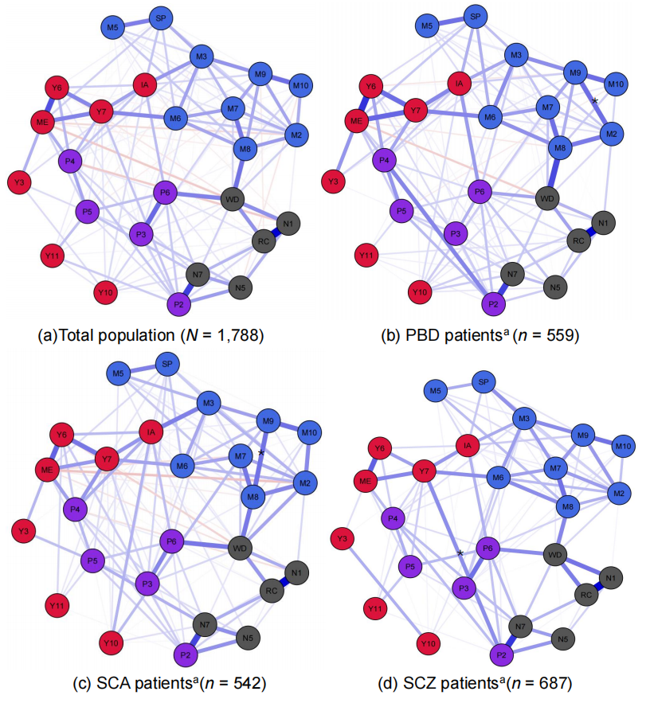
Figure 3.1
Network structure of selected variables in general and psychotic patients
Note. The node colours were determined by the questionnaire scales. Blue edges represent positive correlations between nodes, and red edges represent negative correlations.
Positive symptoms: P2 = conceptual disorganisation, P3 = hallucinations, P4 = excitement, P5 = grandiosity, P6 = paranoia/suspiciousness; Negative symptoms: N1 = blunted affect, RC = poor rapport and rigid conversation, WD = withdrawal, N5 = difficulty in abstract thinking, N7 = stereotyped thinking; Manic symptoms: ME = mood/energy elevation, IA = irritability/aggressive-disruptive behaviour, Y3 = sexual interests, Y6 = speed and amount of speech, Y7 = language thought disorder, Y10 = appearance, Y11 = insight; Depressive symptoms: M2 = reported sadness, M3 = inner tension, M5 = reduced appetite, M6 = concentration difficulty, M7 = retardation, M8 = inability to feel, M9 = pessimistic thoughts, M10 = suicidal thoughts, SP = sleep problems.
ª The overall centrality (S₀) and maximum edge difference (M) across compared subgroups were: PBD and SCZ (S₀ = 2.20***, M = 0.13), SCA and SCZ (S₀ = 2.07*, M = 0.17), PBD and SCA (S₀ = .18, M = 0.13).
Asterisks denote theoretically interesting edge differences: P2-Y7 (SCZ > PBD*/SCA**), M8-M9 (SCA > SCZ**), M2-M9 (PBD > SCA**).
*p < .05, **p < .01, ***p < .001.

The density of the network was .51 and the absolute average mean weight was .036. WD (Withdrawal; PANSS) was a bridge symptom linking depressive (e.g., M8, Inability to feel; MADRS) to positive symptoms (e.g., P6, Suspiciousness; PANSS). Perhaps not surprisingly, P4 (Excitement; PANSS) was the node that linked most clearly to manic symptoms such as ME (Elevated mood; YMRS) and to other positive symptoms (e.g., P5: Grandiosity). Manic symptoms were more connected to positive psychotic symptoms while depressive symptoms were more linked to negative psychotic symptoms. The edge with highest weight was N1(Blunt affect: PANSS)-RC (Poor rapport and rigid conversation; PANSS) (w = 0.41, 95% BCI [0.37, 0.46]), whereas the lowest weight was observed on edge N7 (Stereotyped thinking; PANSS)-IA (Irritability/disruptive and aggressive behaviour; YMRS) (w = 0.001, 95% BCI [-0.02, 0.02]). Full list of all non-zero edges and their statistics can be found in Table C 4. The node with highest strength in this network was M3 (Inner tension; MADRS), and Y11 (Insight; YMRS) was the node with lowest strength; the nodes with highest level of betweenness and closeness were M8 (Inability to feel; MADRS) and WD (Withdrawal; PANSS), see Figure 3.2 and Figure C 2 for details.

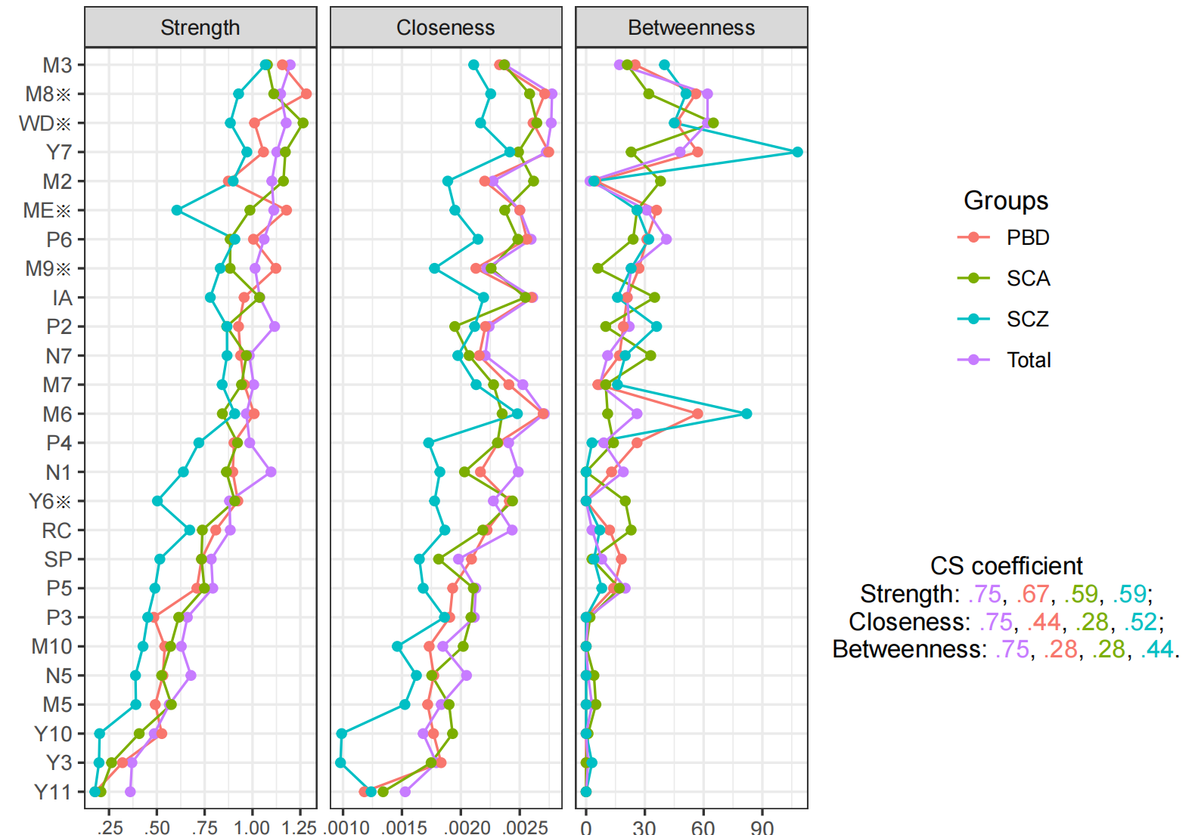
Figure 3.2
Node centralities of the estimated network models
Note. Positive symptoms: P2 (Conceptual disorganisation), P3 (Hallucinations), P4 (Excitement), P5 (Grandiosity), P6 (Paranoia/suspiciousness); Negative symptoms: N1 (blunt affect), RC (poor rapport and rigid conversation), WD (withdrawal), N5 (difficulty in abstract thinking), N7 (stereotyped thinking); Manic symptoms: ME (Mood/energy elevation), IA (Irritability/aggressive-disruptive behaviour), Y3 (Sexual interests), Y6 (Speed and amount of speech), Y7 (Language thought disorder), Y10 (Appearance), Y11 (Insight); Depressive symptoms: M2 (Reported sadness), M3 (Inner tension), M5 (Reduced appetite), M6 (Concentration difficulty), M7 (Retardation), M8 (Inability to feel), M9 (Pessimistic thoughts), M10 (Suicidal thoughts), SP (Sleep problems).
The scale used in this graph was the raw values of coefficients.
※Node strength statistics with adjusted p values: PBD>SCZ (ME**, Y6**, M8**, M9*), SCA>SCZ (WD**, Y6*).
*p < .05, **p < .01.

Network structures in specific diagnostic groups

PBD Network
The edge statistics of the PBD network were fairly stable, see Figure C 1b for detail. The node statistics were stable for strength (CS coefficient = .67), but less stable for closeness (CS coefficient = .44), and betweenness (CS coefficient = .28), meaning that these statistics should be interpreted with caution.
A visualisation of the PBD network can be seen on Figure 3.1. Positive psychotic symptoms (e.g., P4: Excitement, P6: Suspiciousness/ persecution; PANSS) were mostly linked with manic symptoms (e.g., Y6: Speed and amount of speech, IA: Irritability/disruptive and aggressive behaviour; YMRS), while negative psychotic symptoms (e.g., WD: Withdrawal; PANSS) were mostly connected with depressive symptoms (e.g., M8: Inability to feel; MADRS). The strongest edge in this network was to the same as that of general population but with lower weights (w = 0.38, 95% BCI [0.31, 0.47]), while the edge with lowest weights was P6 (Suspiciousness/ persecution; PANSS) - M6 (Concentration difficulties; MADRS) (w = 0.001, 95% BCI [-0.03, 0.04]). The complete list can be found in Table C 5. The node with highest degree of strength in this network was M8 (Inability to feel; MADRS), while the node with lowest strength in the network was Y11(Insight; YMRS), see Figure 3.2.

SCA Network
The Network of SCA patients, shown in Figure 3.1, was stable in terms of node strength (CS coefficient = 0.59) and edge weights (see Figure C 1c), but the stabilities of closeness and betweenness were low (CS coefficient = 0.28). The pattern of connections was similar to that seen in the PBD patients. The strongest edge in the network was N1(Blunt affect; PANSS) - RC (Poor rapport and rigid conversation; PANSS) (w = 0.39, 95% BCI [0.29, 0.44]), while the smallest edge was P6 (Suspiciousness/ persecution; PANSS) - M5 (Reduced appetite; MADRS) (w = 0.001, 95% BCI [-0.03, 0.04]), see full list of the edge statistics in Table C 6. The node with highest strength within this network was WD (Withdrawal; PANSS), while the node with lowest degree of strength was Y11(Insight; YMRS), see details in Figure 3.2.

SCZ Network
The network of SCZ exhibited good stabilities for node strength (CS coefficient = 0.59) and node closeness (CS coefficient = 0.52), and moderate stability for betweenness (CS coefficient = 0.44). The edges were fairly stable, see Figure C 1d.
The network pattern in SCZ patients is generally similar to the other networks. Nonetheless, a significant difference was observed in the relationship between Y7 (Thought disorder; YMRS) and P2 (Conceptual disorganisation; PANSS), see Figure 3.2. N1(Blunt affect; PANSS) - RC (Poor rapport and rigid conversation; PANSS) (w = 0.36, 95% BCI [0.29, 0.42]) was the edge with highest weight in this network, and the edge with the lowest weight was M5 (Reduced appetite; MADRS) - M9 (Pessimistic thoughts; MADRS) (w = 0.001, 95% BCI [-0.04, 0.05]); see Table C 7 for the full edge list. In this network, the node with highest strength was M3 (Inner tension; MADRS), while the node with lowest strength was Y11 (Insight; YMRS); the node with highest level of betweenness was Y7 (Thought disorder), see Figure 3.2.

Network communities
The number of communities ranged between three for the general sample and PBD group to six for the SCZ group. This variation reflected some symptoms which were not stably attributed to communities in some analyses. Most notably, P3 (Hallucinations, PANSS) and P6 (Suspiciousness, PANSS) appear with other psychotic symptoms in the general and PBD samples but are not consistently attributed to a community in the SCA and SCZ samples. Across the bootstrapped analyses, the most replicable community consisted of all of the depressive symptoms; for most of the groups, the structural consistency was higher than 75% and the node replicability was higher than 95%, indicating that the composition of this community was very stable. The communities with lowest stabilities comprised of psychotic symptoms and manic symptoms; interestingly the most stable nodes in the psychosis community were negative symptoms and conceptual disorganisation, see Figure 3.3 and Table C 8 for further details.

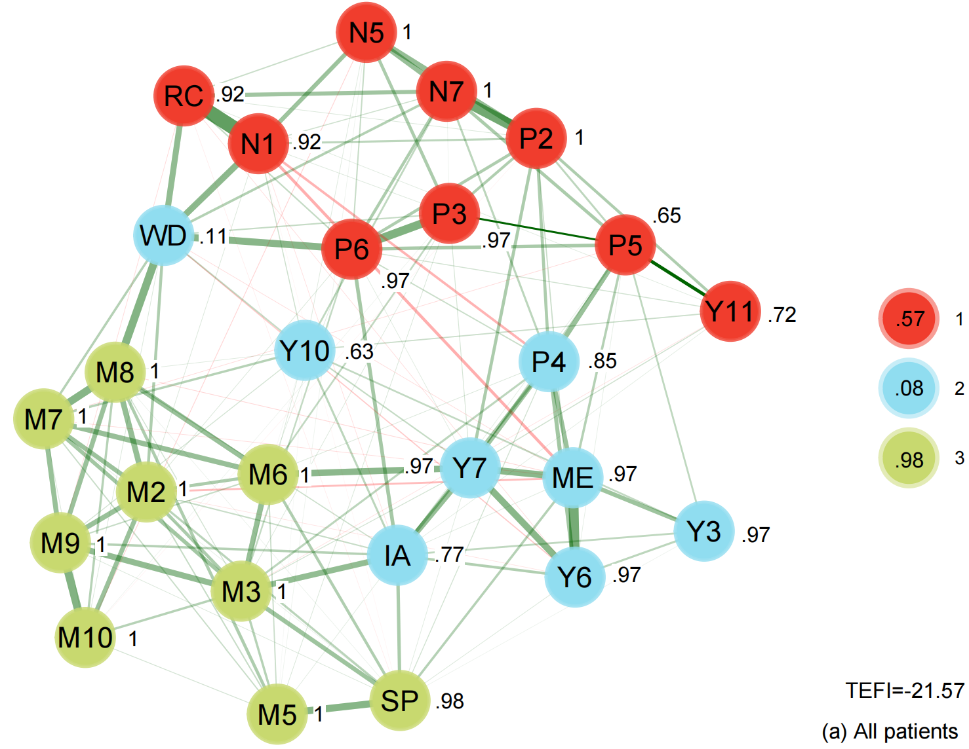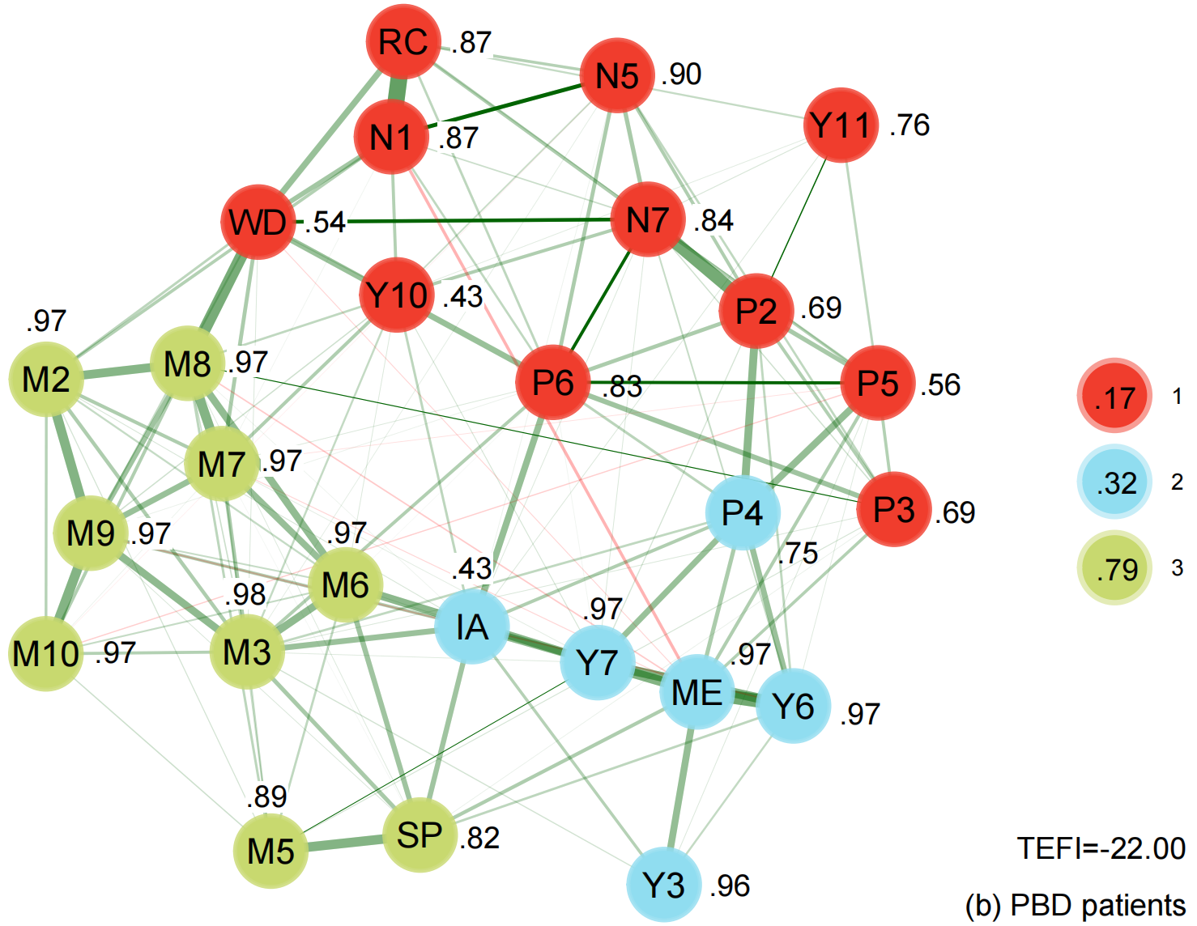
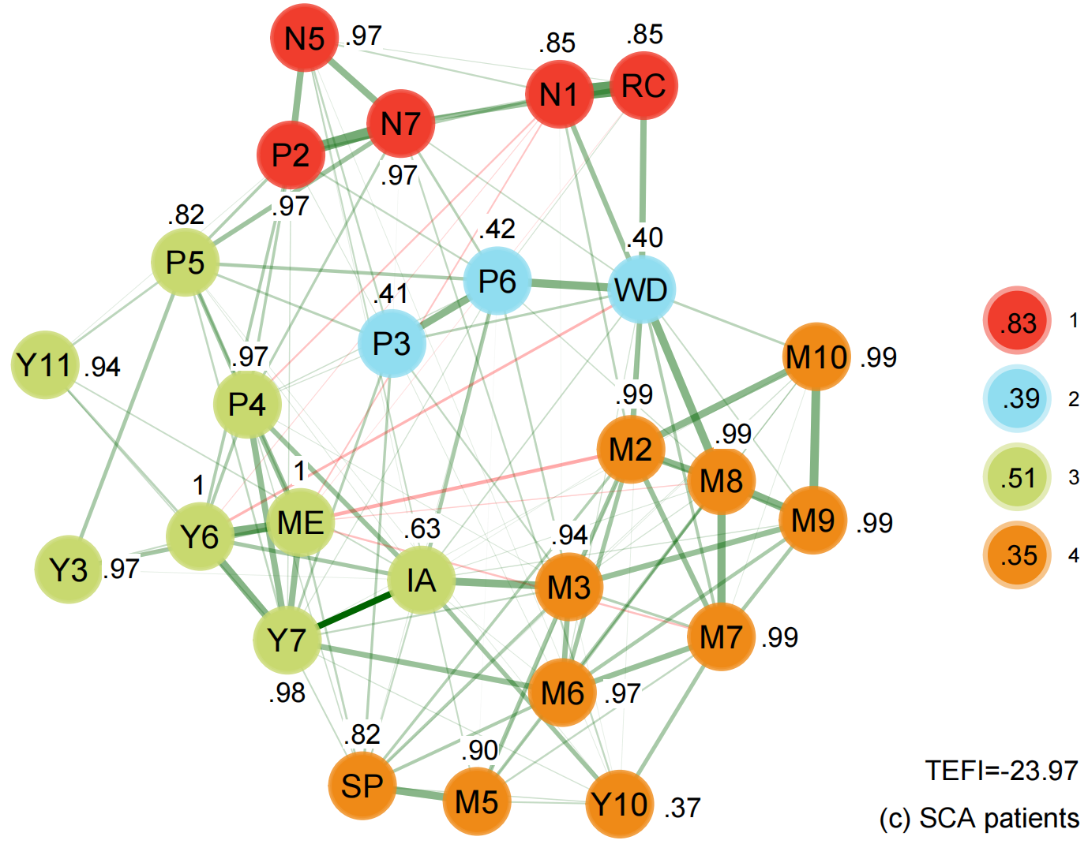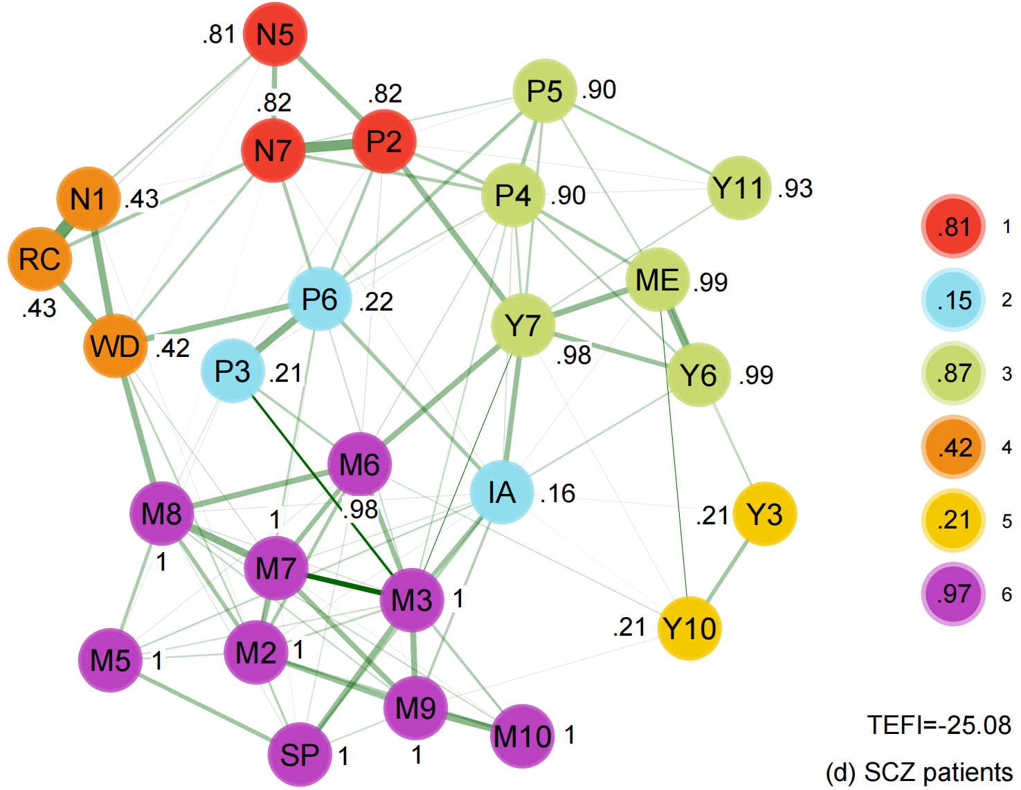
Figure 3.3
The empirical network communities of affective and psychotic syndromes in all patients and subgroups
Note. Psychotic symptoms: P2 (Conceptual disorganisation), P3 (Hallucinations), P4 (Excitement), P5 (Grandiosity), P6 (Paranoia/suspiciousness), N1 (blunt affect), RC (poor rapport and rigid conversation), WD (withdrawal), N5 (difficulty in abstract thinking), N7 (stereotyped thinking); Manic symptoms: ME (Mood/energy elevation), IA (Irritability/aggressive-disruptive behaviour), Y3 (Sexual interests), Y6 (Speed and amount of speech), Y7 (Language thought disorder), Y10 (Appearance), Y11 (Insight); Depressive symptoms: M2 (Reported sadness), M3 (Inner tension), M5 (Reduced appetite), M6 (Concentration difficulty), M7 (Retardation), M8 (Inability to feel), M9 (Pessimistic thoughts), M10 (Suicidal thoughts), SP (Sleep problems);The colouring of the nodes and dimensions was determined empirically. Each node is accompanied by a number indicating its stability to the corresponding dimension. The colour and number representing each dimension are displayed on the right side of the graph of communities; the number within each node indicates the structural consistency of the dimension. The Total Entropy Fit Index (TFEI) is presented in the right bottom of each graph of communities, with lower values suggesting a more accurate structure.

Network Comparisons by Diagnostic Groups
Densities of the networks of PBD, SCA, and SCZ were .43, .42, and .35 respectively; the MAEWs (mean absolute edge weights) were .033, .033, and .022, see Figure C 3 for the distribution of the weighted network densities. The networks for PBD (S₀ = 2.20, p < .001) and SCA (S₀ = 2.07, p = .02) patients had a higher global connectivity than that for SCZ patients, but the difference between SCA and PBD patients was not significant (S₀ = 0.12, p = .81). Omnibus test revealed non-significant differences between network structures of PBD and SCZ (M = 0.13, p = .47), SCA and SCZ (M = 0.17, p = .06), and between those for PBD and SCA (M = 0.18, p = .07). Similarly, the weight matrixes of the edges were highly correlated across all compared networks: PBD and SCA (r = .85), PBD and SCZ (r = .85), as well as SCA and SCZ (r = .83).
Regardless of the nonsignificant findings yielded by omnibus tests, an exploratory inspection of the edge variability network plotted in Figure C 4 suggested that the edges P2 (Conceptual disorganisation; PANSS) - Y7 (Thought disorder; YMRS), M2 (Reported sadness; MADRS) - M9 (Pessimistic thoughts; MADRS), and M8 (Inability to feel; MADRS) - M9 (Pessimistic thoughts; MADRS) exhibited high variabilities in weights across different networks; these edges are theoretically interesting for reasons detailed in the discussion. Therefore, post hoc analyses were conducted to compare the three edges across networks. The permutation test showed that edge weights of P2 - Y7 were higher in SCZ patients than that of SCA (E = 0.13, p_{adjusted} < .01) and PBD (E = 0.13, p_{adjusted} = .02) patients. The weights of M2 - M9 were lower in the SCA network than the PBD network (E = 0.18, p_{adjusted} <.01), and the weights of M8 - M9 were lower in the SCZ network than SCA network (E = 0.17, p_{adjusted} < .01). The weights of the two edges between depressive symptoms were not statistically different between networks of SCZ and PBD patients, see Table 3.2 and Figure C 5 for details.

Table 3.2
The weights of three varied edges and the statistics across networks
Networks | PBD | SCA | SCZ | direction
P2-Y7 | 0.03 | 0.03 | 0.16 | SCZ>SCA**; SCZ>PBD*
M2-M9 | 0.22 | 0.04 | 0.14 | PBD>SCA**
M8-M9 | 0.12 | 0.21 | 0.05 | SCA>SCZ**
Note. PBD: Psychotic Bipolar Disorder; SCA: Schizoaffective Disorder; SCZ: Schizophrenia. The results were based on 2000 iterations; the p value was adjusted by BH method.
*: p<.05, **: p<.01.

Discussion
The current analysis examined the network structures of affective and psychotic syndromes in patients diagnosed with schizophrenia, schizoaffective disorder or psychotic bipolar disorder. The data was drawn from three high-quality studies with large, representative samples using gold-standard psychiatric assessments conducted by trained clinicians. We used a principled approach to item selection which eliminated redundancy that might otherwise have distorted the findings. Our findings are consistent with the work of Peralta and colleagues (Victor Peralta et al., 2020; V. Peralta et al., 2020) in the relationship between affective and psychotic syndromes. Specifically, the manic symptoms were more linked with positive symptoms while depressive symptoms were more linked with negative symptoms. However, our findings are distinct from the previous work in the following aspects.
The first and most striking finding, which is in contrast to the studies by Peralta and colleagues, is that, although symptom ratings differed very considerably between the three diagnostic groups, the network structures were near identical. Based on the definition of statistical dimensions (Hopwood et al., 2023; Schmidt et al., 2004), this similarity would not have been expected if the three diagnoses were reflections of distinct psychopathological processes. Therefore, the findings are consistent with the hypothesis that the same underlying psychopathological processes lead to the varying symptom expressions which, according to the exact symptoms experienced, are then classified during the assessment process (and presumably by clinicians in general psychiatric practice) into the three diagnostic groups. This interpretation is consistent with recent attempts to create new taxonomic models that emphasize the hierarchical nature of disorders (with conventional diagnoses contained within higher-order classifications) such as the three spectra (internalizing, externalizing, reality-impairing) model (Wright et al., 2013) and the HiTOP approach (Kotov et al., 2021).
Examination of the individual symptom differences helps clarify this picture. As would be expected, the PBD patients had lowest severity for all psychotic symptoms, except for excitement. However, unexpectedly perhaps, SCA patients reported the most severe positive psychotic symptoms while, expectedly, the SCZ patients had more severe negative symptoms. The SCA and PBD patients were comparable in the severity of most manic symptoms which were more severe than those observed in SCZ patients.
Examination of the community structures provides further insights that help us to interpret these findings. Although there was inconsistency between the groups, in both the analysis of the sample as a whole and across the diagnoses, depressive and negative symptoms showed the greatest replicability. Positive and manic symptoms, by contrast, were unstable and fluctuated in their placement across communities. In as much as core psychopathological symptoms are likely to lead to stable communities, these findings could suggest that depressive and negative symptom processes are primary drivers of severe mental illness, with positive and manic symptoms possibly being a reaction to them. The node centralities revealed a similar story, as the nodes with highest strength were either depressive (e.g., Inability to feel) or negative symptoms (e.g., Withdrawal) across the subgroups. This interpretation would be consistent with some foundational accounts of severe mental illness. For example, in contrast to the post DSM-III focus on positive symptoms, Kraepelin (Kraepelin, 1899) highlighted negative symptoms as the primary feature of dementia praecox/schizophrenia, and Bleuler argued that the positive symptoms are reactions to fundamental disturbances that included disordered associations, affect, ambivalence, together with autism (conceived of as a flight into a preferred reality), a view taken by more recent phenomenological researchers (Parnas & Henriksen, 2014). Similarly, Karl Abraham argued that manic symptoms are a reaction to underlying depressive processes and this hypothesis has some support from more recent psychopathological investigations (Johnson, 2005; Lyon et al., 1999; Thomas et al., 2007; Zavlis et al., 2023). A possible objection to this interpretation is that it seems inconsistent with the observation that positive symptoms cause great distress and often provoke greatest clinical concern. However, there is evidence that distress in psychosis is more associated with depression and low self-esteem than either positive or negative symptoms (Vracotas et al., 2007) and, in any case, there is no reason to assume that the most distressing symptoms are those that are most central to the disease process (by analogy, in many medical conditions pain is the main source of distress but is not the central pathological process). An implication of our admittedly speculative interpretation of our data is that advances in the treatment of psychosis might be achieved by researchers developing treatments that are more focused on negative emotion and negative symptoms.
Our exploratory analyses of differences in specific edge weights should be interpreted with caution given the results of omnibus tests and the lack of a priori hypotheses but are nonetheless of potential theoretical interest. The role of cognitive versus affective processes in thought disorder has long been debated. The Bleulerian view that loosening of association was a driving process in schizophrenia has been supported by empirical research (Spitzer et al., 1993) suggesting that this process is specifically associated with thought disorder but, at the same time, there is evidence that affective reactivity plays a role in disordered speech in both schizophrenia and bipolar disorder (de Sousa et al., 2016; Tai et al., 2004). The network structure observed here suggests that both processes may be important but the high variability in the edge between thought disorder and conceptual disorganisation suggests that this latter process is more important in schizophrenia patients.
Pessimistic thought (M9) plays a role in both of the highly variable edge comparisons in depressive symptoms, in relation to both Reported sadness (M2: MADRS) and M9 and Inability to feel (M8: MADRS). Learned hopelessness theory suggests that a pessimistic attributional (explanatory) style plays a central role in depressed mood (Abramson et al., 1978) and this relationship seems reflected in the network model of PBD patients but less so in that of SCA patients. However, it is possible that this is because the SCA patients had both higher pessimism and higher depressed mood than the PBD patients (see Table 3.2). Meanwhile, the relationship between pessimistic thought and inability to feel (a bridge symptom between depressive and negative symptoms) is more evident in SCA patients than SCZ patients, which is partially in line with a prior report that the relationship was stronger in depressed adolescents than those with subthreshold depression (Gutkovich et al., 2011). Speculating, it is possible that pessimistic thinking plays a role in both low mood and flat affect but that the former relationship is more evident in PBD patients whereas the latter is more evident is SCA patients. A further speculation is that the attribution style is less significant in the path toward inability to feel and negative symptoms in schizophrenia patients than that in schizoaffective patients. Further research about the relationship between attribution style and both symptoms seems merited.

Limitations
The current study utilised a large sample that was representative of the broad population of patients with psychosis; the data is high quality and a principled approach was taken to item inclusion. However, our research has the following limitations: 1) Network models assume causal relationships between nodes in the network, but the data is correlational. The link between nodes denotes the probability of joint presence, and this presence is based on cross sectional data, so that the direction of the relationship cannot be determined. Further research is required to establish the direction of influence (e.g., between conceptual disorganisation and thought disorder), for example by longitudinal/ dynamic network analysis. 2) Although the general psychotic population network comprised a large sample size and was very stable, the node centralities (e.g., closeness and betweenness), replicabilities and structural consistencies were quite unstable for some subgroups and symptoms. This could be ameliorated by recruiting even larger samples to more accurately assess and understand networks in diagnostic subgroups. 3) The clinical scales used (e.g., PANSS, YMRS, MADRS) capture symptoms over several days. While assessing clinically stable patients demonstrates that phenomenological overlap persists outside of acute episodes, this cross-sectional snapshot cannot account for the differing longitudinal courses of these illnesses. This is taxonomically critical, as DSM criteria require substantially different symptom durations for a schizophrenia diagnosis (e.g., at least 6 months) compared to bipolar episodes. Therefore, our findings highlight short-term phenomenological similarity among stable patients, but do not inherently establish diagnostic equivalence or a unitary underlying disorder.4) Our analyses did not examine the influence of external factors on psychopathology (for example, life trauma, which may have effects on specific symptoms). Future work including these factors in network analyses may be informative about the role of the environment in the course of mental illness. 5) A final caveat is that there is no known way of comparing network models with the longer established latent variable models, which have recently suggested a transdiagnostic psychosis latent variable (Reininghaus et al., 2016; Reininghaus et al., 2013). Indeed, one analysis (Reininghaus et al., 2019) supporting a general psychosis dimension has used a subset (B-SNIP1) of the data used in the present analyses. Our findings of similar network structures across psychotic populations are in line with the bifactor model assumption that a general psychosis psychopathology factor is important in all diagnostic groups. However, our findings revealed 3 - 6 network communities within different populations, which contrasts to the factors found in abovementioned studies using latent variable approaches. It seems plausible that both underlying latent factors and symptom-to-symptom influences are important in driving psychopathology, with exogenous factors also influencing symptom expression at both levels. However, further methodological advances are required before it will be possible to test models of such complexity.

Conclusion
Bipolar disorder, schizoaffective disorder, and schizophrenia exhibit marked similarities in their cross-sectional network topology and the interplay between affective and psychotic syndromes. These results underscore a significant transdiagnostic phenomenological overlap across the psychotic spectrum. However, observed divergences in network communities and specific edge weights suggest that the underlying mechanisms driving symptomatic expression may be distinct across diagnostic groups. Furthermore, while these structural commonalities persist among clinically stable patients, the taxonomic equivalence remains to be established; future investigation is warranted to elucidate whether longitudinal course and symptom dynamics across the affective-psychotic spectrum are truly convergent or remain fundamentally distinct.

References
Abramson, L. Y., Seligman, M. E., & Teasdale, J. D. (1978). Learned helplessness in humans: critique and reformulation. J Abnorm Psychol, 87(1), 49–74. https://doi.org/10.1037/0021-843X.87.1.49
American Psychiatric Association, i. b. (2022). Diagnostic and statistical manual of mental disorders : DSM-5-TR (5th edition, text revision. ed.). Washington, DC : American Psychiatric Association Publishing, 2022.
Baruch, P., Filteau, M. J., Bouchard, R. H., Pourcher, E., Vincent, P., & Jouvent, R. (1992). The dimensional approach to clinical psychopharmacology: a polysemous concept. J Psychiatry Neurosci, 17(2), 55–60.
Benjamini, Y., & Hochberg, Y. (1995). Controlling the False Discovery Rate: A Practical and Powerful Approach to Multiple Testing. Journal of the Royal Statistical Society Series B: Statistical Methodology, 57(1), 289–300. https://doi.org/10.1111/j.2517-6161.1995.tb02031.x
Berrios, G. E., & Beer, D. (1995). Unitary psychosis concept. A history of clinical psychiatry. London: Athlone, 313–335.
Bipolar, D., Schizophrenia Working Group of the Psychiatric Genomics Consortium. Electronic address, d. r. v. e., Bipolar, D., & Schizophrenia Working Group of the Psychiatric Genomics, C. (2018). Genomic Dissection of Bipolar Disorder and Schizophrenia, Including 28 Subphenotypes. Cell, 173(7), 1705–1715 e1716. https://doi.org/10.1016/j.cell.2018.05.046
Bringmann, L. F., & Eronen, M. I. (2018). Don't blame the model: Reconsidering the network approach to psychopathology. Psychol Rev, 125(4), 606–615. https://doi.org/10.1037/rev0000108
Christensen, A. P., Garrido, L. E., & Golino, H. (2023). Unique Variable Analysis: A Network Psychometrics Method to Detect Local Dependence. Multivariate Behav Res, 58(6), 1165–1182. https://doi.org/10.1080/00273171.2023.2194606
Christensen, A. P., & Golino, H. (2021). Estimating the Stability of Psychological Dimensions via Bootstrap Exploratory Graph Analysis: A Monte Carlo Simulation and Tutorial. Psych, 3(3), 479–500.
Davidson, J., Turnbull, C. D., Strickland, R., Miller, R., & Graves, K. (1986). The Montgomery-Asberg Depression Scale: reliability and validity. Acta Psychiatr Scand, 73(5), 544–548. https://doi.org/10.1111/j.1600-0447.1986.tb02723.x
de Sousa, P., Sellwood, W., Spray, A., & Bentall, R. P. (2016). The affective reactivity of psychotic speech: The role of internal source monitoring in explaining increased thought disorder under emotional challenge. Schizophr Res, 172(1-3), 189–194. https://doi.org/10.1016/j.schres.2016.01.049
Epskamp, S., Borsboom, D., & Fried, E. I. (2018). Estimating psychological networks and their accuracy: A tutorial paper. Behavior Research Methods, 50(1), 195–212. https://doi.org/10.3758/s13428-017-0862-1
Fernandez, A. V. (2019). Phenomenology and dimensional approaches to psychiatric research and classification. Philosophy, Psychiatry, & Psychology, 26(1), 65–75.
First, M. B., Spitzer, R. L., Gibbon, M., & Williams, J. B. (2007). SCID-I. Structured Clinical Interview for DSM-IV-TR Axis I Disorders, Research Version.
Friedman, J., Hastie, T., & Tibshirani, R. (2011). glasso: Graphical lasso-estimation of Gaussian graphical models. http://CRAN.R-project.org/package=glasso
Gutkovich, Z., Morrissey, R. F., Espaillat, R. K., & Dicker, R. (2011). Anhedonia and pessimism in hospitalized depressed adolescents. Depress Res Treat, 2011, 795173. https://doi.org/10.1155/2011/795173
Hamm, J. P., Ethridge, L. E., Shapiro, J. R., Pearlson, G. D., Tamminga, C. A., Sweeney, J. A., Keshavan, M. S., Thaker, G. K., & Clementz, B. A. (2013). Family history of psychosis moderates early auditory cortical response abnormalities in non-psychotic bipolar disorder. Bipolar Disord, 15(7), 774–786. https://doi.org/10.1111/bdi.12110
Hopwood, C. J., Morey, L. C., & Markon, K. E. (2023). What is a psychopathology dimension? Clinical Psychology Review, 106, 102356.
Isvoranu, A. M., & Epskamp, S. (2023). Which estimation method to choose in network psychometrics? Deriving guidelines for applied researchers. Psychol Methods, 28(4), 925–946. https://doi.org/10.1037/met0000439
Ivleva, E., Thaker, G., & Tamminga, C. A. (2008). Comparing genes and phenomenology in the major psychoses: schizophrenia and bipolar 1 disorder. Schizophr Bull, 34(4), 734–742. https://doi.org/10.1093/schbul/sbn051
Johnson, S. L. (2005). Mania and dysregulation in goal pursuit: a review. Clin Psychol Rev, 25(2), 241–262. https://doi.org/10.1016/j.cpr.2004.11.002
Kasanin, J. (1933). The acute schizoaffective psychoses. American Journal of Psychiatry, 90(1), 97–126.
Kay, S. R., Fiszbein, A., & Opler, L. A. (1987). The positive and negative syndrome scale (PANSS) for schizophrenia. Schizophr Bull, 13(2), 261–276. https://doi.org/10.1093/schbul/13.2.261
Khan, A., Khan, S. R., Shankles, E. B., & Polissar, N. L. (2002). Relative sensitivity of the Montgomery-Asberg Depression Rating Scale, the Hamilton Depression rating scale and the Clinical Global Impressions rating scale in antidepressant clinical trials. Int Clin Psychopharmacol, 17(6), 281–285. https://doi.org/10.1097/00004850-200211000-00003
Kotov, R., Chang, S. W., Fochtmann, L. J., Mojtabai, R., Carlson, G. A., Sedler, M. J., & Bromet, E. J. (2011). Schizophrenia in the internalizing-externalizing framework: a third dimension? Schizophr Bull, 37(6), 1168–1178. https://doi.org/10.1093/schbul/sbq024
Kotov, R., Krueger, R. F., Watson, D., Cicero, D. C., Conway, C. C., DeYoung, C. G., Eaton, N. R., Forbes, M. K., Hallquist, M. N., Latzman, R. D., Mullins-Sweatt, S. N., Ruggero, C. J., Simms, L. J., Waldman, I. D., Waszczuk, M. A., & Wright, A. G. C. (2021). The Hierarchical Taxonomy of Psychopathology (HiTOP): A Quantitative Nosology Based on Consensus of Evidence. Annu Rev Clin Psychol, 17, 83–108. https://doi.org/10.1146/annurev-clinpsy-081219-093304
Kraepelin, E. (1899). Psychiatry: A textbook for students and physicians. (Vol. Volume 1 ). Watson Publishing International.
Liechti, S., Capodilupo, G., Opler, D. J., Opler, M., & Yang, L. H. (2017). A Developmental History of the Positive and Negative Syndrome Scale (PANSS). Innov Clin Neurosci, 14(11-12), 12–17.
Liu, J., Kiehl, K. A., Pearlson, G., Perrone-Bizzozero, N. I., Eichele, T., & Calhoun, V. D. (2009). Genetic determinants of target and novelty-related event-related potentials in the auditory oddball response. Neuroimage, 46(3), 809–816. https://doi.org/10.1016/j.neuroimage.2009.02.045
Lukasiewicz, M., Gerard, S., Besnard, A., Falissard, B., Perrin, E., Sapin, H., Tohen, M., Reed, C., Azorin, J. M., & Group, E. S. (2013). Young Mania Rating Scale: how to interpret the numbers? Determination of a severity threshold and of the minimal clinically significant difference in the EMBLEM cohort. International journal of methods in psychiatric research, 22(1), 46–58.
Lyon, H. M., Startup, M., & Bentall, R. P. (1999). Social cognition and the manic defense: attributions, selective attention, and self-schema in bipolar affective disorder. J Abnorm Psychol, 108(2), 273–282. https://doi.org/10.1037//0021-843x.108.2.273
Mulholland, C., & Cooper, S. (2000). The symptom of depression in schizophrenia and its management. Advances in Psychiatric Treatment, 6(3), 169–177.
Palmier-Claus, J. E., Berry, K., Bucci, S., Mansell, W., & Varese, F. (2016). Relationship between childhood adversity and bipolar affective disorder: systematic review and meta-analysis. Br J Psychiatry, 209(6), 454–459. https://doi.org/10.1192/bjp.bp.115.179655
Parnas, J., & Henriksen, M. G. (2014). Disordered self in the schizophrenia spectrum: a clinical and research perspective. Harv Rev Psychiatry, 22(5), 251–265. https://doi.org/10.1097/HRP.0000000000000040
Peralta, V., Gil-Berrozpe, G. J., Librero, J., Sánchez-Torres, A., & Cuesta, M. J. (2020). The Symptom and Domain Structure of Psychotic Disorders: A Network Analysis Approach. Schizophrenia Bulletin Open, 1(1), sgaa008. https://doi.org/10.1093/schizbullopen/sgaa008
Peralta, V., Gil-Berrozpe, G. J., Sanchez-Torres, A., & Cuesta, M. J. (2020). The network and dimensionality structure of affective psychoses: an exploratory graph analysis approach. J Affect Disord, 277, 182–191. https://doi.org/10.1016/j.jad.2020.08.008
Pons, P., & Latapy, M. (2005, 2005//). Computing Communities in Large Networks Using Random Walks. Computer and Information Sciences - ISCIS 2005, Berlin, Heidelberg.
Reininghaus, U., Bohnke, J. R., Chavez-Baldini, U., Gibbons, R., Ivleva, E., Clementz, B. A., Pearlson, G. D., Keshavan, M. S., Sweeney, J. A., & Tamminga, C. A. (2019). Transdiagnostic dimensions of psychosis in the Bipolar-Schizophrenia Network on Intermediate Phenotypes (B-SNIP). World Psychiatry, 18(1), 67–76. https://doi.org/10.1002/wps.20607
Reininghaus, U., Bohnke, J. R., Hosang, G., Farmer, A., Burns, T., McGuffin, P., & Bentall, R. P. (2016). Evaluation of the validity and utility of a transdiagnostic psychosis dimension encompassing schizophrenia and bipolar disorder. Br J Psychiatry, 209(2), 107–113. https://doi.org/10.1192/bjp.bp.115.167882
Reininghaus, U., Priebe, S., & Bentall, R. P. (2013). Testing the psychopathology of psychosis: evidence for a general psychosis dimension. Schizophr Bull, 39(4), 884–895. https://doi.org/10.1093/schbul/sbr182
Schmidt, N. B., Kotov, R., & Joiner, T. E. (2004). Taxometrics: Toward a new diagnostic scheme for psychopathology [doi:10.1037/10810-000]. American Psychological Association. https://doi.org/10.1037/10810-000
Shao, W., Shao, K., & Bentall, R. P. (in press). Comorbid schizophrenia and psychotic symptoms in patients with bipolar disorder: A meta-analysis of the global literature. In.
Spitzer, M., Braun, U., Hermle, L., & Maier, S. (1993). Associative semantic network dysfunction in thought-disordered schizophrenic patients: direct evidence from indirect semantic priming. Biol Psychiatry, 34(12), 864–877. https://doi.org/10.1016/0006-3223(93)90054-h
Tai, S., Haddock, G., & Bentall, R. (2004). The effects of emotional salience on thought disorder in patients with bipolar affective disorder. Psychol Med, 34(5), 803–809. https://doi.org/10.1017/s003329170300117x
Tamminga, C. A., Jim van Os, M., & Elena Ivleva, M. (2020). Psychotic disorders: Comprehensive conceptualization and treatments. Oxford University Press.
Tamminga, C. A., Pearlson, G., Keshavan, M., Sweeney, J., Clementz, B., & Thaker, G. (2014). Bipolar and schizophrenia network for intermediate phenotypes: outcomes across the psychosis continuum. Schizophr Bull, 40 Suppl 2(Suppl 2), S131–137. https://doi.org/10.1093/schbul/sbt179
Thomas, J., Knowles, R., Tai, S., & Bentall, R. P. (2007). Response styles to depressed mood in bipolar affective disorder. J Affect Disord, 100(1-3), 249–252. https://doi.org/10.1016/j.jad.2006.10.017
van Borkulo, C. D., van Bork, R., Boschloo, L., Kossakowski, J. J., Tio, P., Schoevers, R. A., Borsboom, D., & Waldorp, L. J. (2023). Comparing network structures on three aspects: A permutation test. Psychol Methods, 28(6), 1273–1285. https://doi.org/10.1037/met0000476
Van Snellenberg, J. X., & de Candia, T. (2009). Meta-analytic evidence for familial coaggregation of schizophrenia and bipolar disorder. Arch Gen Psychiatry, 66(7), 748–755. https://doi.org/10.1001/archgenpsychiatry.2009.64
Vracotas, N., Schmitz, N., Joober, R., & Malla, A. (2007). Subjective distress in first‐episode psychosis: role of symptoms and self‐esteem. Early Intervention in Psychiatry, 1(3), 251–258. https://doi.org/10.1111/j.1751-7893.2007.00034.x
Wright, A. G., Krueger, R. F., Hobbs, M. J., Markon, K. E., Eaton, N. R., & Slade, T. (2013). The structure of psychopathology: toward an expanded quantitative empirical model. J Abnorm Psychol, 122(1), 281–294. https://doi.org/10.1037/a0030133
Zavlis, O., Matheou, A., & Bentall, R. (2023). Identifying the bridge between depression and mania: A machine learning and network approach to bipolar disorder. Bipolar Disord, 25(7), 571–582. https://doi.org/10.1111/bdi.13316

The Interplay Between Mood Symptoms and Psychosis Over Two Years: Longitudinal and Structural Relationships Between Manic, Depressive, and Psychotic-Like Experiences

Introduction
The boundaries between psychiatric disorders have been contested since Kraepelin (1899) and others devised the categorical approach to diagnosis towards the end of the nineteenth century (Bentall, 2004). Modern psychiatric classifications define disorders as discrete entities derived from observable symptoms. The Diagnostic and Statistical Manual of Mental Disorders (DSM) exemplifies this approach, but has become increasingly complex, creating diagnoses with overlapping features that often blur boundaries (Blashfield et al., 2014). The distinction between schizophrenia spectrum disorder (SSD) and bipolar spectrum disorder (BSD) has been particularly debated. According to the latest diagnostic manuals, BSD is characterized by mood dysregulation (e.g., irritability, mood elevation, depression, and suicidal thoughts), whereas SSD is primarily defined by cognitive and perceptual disturbances (e.g., hallucinations, disorganized speech) and altered beliefs (e.g., delusions) (American Psychiatric Association, 2022; WHO, 2022).
However, whether schizophrenia SSD and BSD are distinct disease entities or variants of a broader underlying illness process remains contested, given significant overlap across multiple domains: brain morphology, genetics and familial heredity, neurocognition, and external psychosocial factors (Birur et al., 2017; Hill et al., 2008; Lichtenstein et al., 2009; Van Snellenberg & de Candia, 2009; Zhou et al., 2025). Psychopathology shows the strongest overlap between these conditions, as psychotic features are commonly observed in patients diagnosed with BSD, and mood symptoms are also common in patients diagnosed with schizophrenia (Shao et al., in press). Moreover, studies have reported high lifetime comorbidity (18.2%) and, importantly, between BSD and SSD (Goodwin et al., 2002; Jorgensen et al., 2018), reflecting the instability of these categorical boundaries.
Beyond symptomatology, overlaps have been identified in aetiological and risk factors such as heritability (Van Snellenberg & de Candia, 2009), risk genes (Ruderfer et al., 2018) , brain morphology (Birur et al., 2017) and cognitive functioning (Wang et al., 2013). Dopamine dysregulation has also been implicated in both bipolar disorder and schizophrenia, with dopamine synthesis capacity positively correlated with mania and positive symptoms (Jauhar et al., 2017). Experiences of social adversity are also common to both diagnostic groups, including childhood trauma (Palmier-Claus et al., 2016; Varese et al., 2012; Zhou et al., 2025) and exposure to urban environments (urbanicity) (Gyllenberg et al., 2022; Hardoon et al., 2013; Shevlin et al., 2016).
A variety of psychological variables have also been associated with both conditions. For example, insecure attachment is common in both patients with schizophrenia spectrum disorders (Berry et al., 2007) and bipolar disorder (Morriss et al., 2009) and has been specifically associated with paranoia (Wickham et al., 2015), depression (Russo et al., 2018) and stress liability (Morriss et al., 2025; Pujji, 2023). Specific pathways have been identified between different insecure attachment styles - such as the avoidant and anxious styles - and both psychotic and bipolar symptoms (Korver-Nieberg et al., 2014). Intolerance of uncertainty (IoU), has also been found to be associated with negative symptoms, paranoia (Lei et al., 2025; Morriss & Ellett, 2025), psychotic traits and poor prognosis in BSD patients (Şen & Yıldızhan, 2020), although not with the severity of hypomania (Pujji & Dinzeo, 2024). High levels of neuroticism, a trait within the well-known Big Five personality model (Roccas et al., 2002), have been consistently observed in patients with both disorders and in their unaffected relatives (Heerlein et al., 1996; Yang et al., 2021). Similarly, other traits from the Big Five have also been implicated, with evidence supporting associations between higher openness and both mood symptoms and psychotic-like experiences, as well as higher extraversion in patients with BDS (Bagby et al., 1997; Jang et al., 2025). In contrast, evidence for an association between lower extraversion and depression has been inconsistent (Barnett et al., 2011; Koorevaar et al., 2013).

Theoretical models
Various models have been proposed to explain the relationship between schizophrenia and BSD. For example, the overlap between the two diagnoses has been interpreted by some scholars as consistent with a unitary psychosis model, which argues that BSD and schizophrenia are different expressions of the same disease process (Berrios & Beer, 1994), whereas others have interpreted it as consistent with a schizo-bipolar spectrum model (Keshavan et al., 2011), which argues that there is a continuum between BSD and schizophrenia, with schizoaffective disorder representing the centre portion of this dimension.
One way of testing these theories is by using bifactor modelling that decomposes psychopathology into shared (general) and unique (specific) sources of variance. The assumption of this approach is that the factors that are discovered correspond to underlying disease process that are either common to all psychotic disorders (the general factor) or which are related to specific symptom expressions (the specific factors). Studies using this method to analyse symptom covariation in psychotic patients (Reininghaus et al., 2019; Reininghaus et al., 2013) and also in the general population (Shevlin et al., 2017) have found evidence for both a general psychosis dimension and specific symptom dimensions corresponding to positive symptoms, negative symptoms, cognitive dysfunction, depression and mania. A further extension of this idea is the ‘p factor’ model, which proposes a general factor underlying all mental disorders (Caspi et al., 2014).
A more radical challenge to categorical diagnoses is provided by network models which propose that covariations between symptoms can be explained by their dynamic interactions within complex, interrelated systems (Bringmann & Eronen, 2018). These models assume that observed patterns of relationships between symptoms emerge as a consequence of the way that symptoms influence each other, rather than because they have common underlying psychopathological causes (Borsboom & Cramer, 2013). For example, using data from a large sample of US psychiatric patients, we have recently shown that symptoms have a common structure in patients diagnosed with schizophrenia, psychotic bipolar disorder and schizoaffective disorder, and that the relationships between psychotic symptoms and mania are stronger than the relationships between psychotic symptoms and depression (Shao et al. 2024).

Relationship between mood and PLEs in the general population
Dimensional approaches argue that mental disorders exist along continua, with varying degrees of symptom severity across populations (Claridge, 1985). For instance, psychotic symptoms may manifest as trait-like features (e.g., schizotypal personality) in the general population (Johns & van Os, 2001) and the same has been claimed for bipolar symptoms (Angst & Cassano, 2005). Consistent with this approach, psychotic-like experiences (PLEs) are more common in the general population than episodes meeting the criteria for a diagnosis of severe mental illness (Bolhuis et al., 2018; van Os et al., 2009), are considered part of an extended continuum of psychosis (Kaymaz & van Os, 2010) and have been associated with an elevated risk of developing psychotic disorders (Lindgren et al., 2022).
The same questions that have been asked about the relationship between psychotic and BDS symptoms in clinical populations can therefore asked about general population samples. Indeed, correlations between PLEs and hypomanic (subclinical manic) symptoms have been reported in non-clinical populations, as have associations between PLEs and depressive symptoms (Ballesio et al., 2022; Scott et al., 2021) and, as already noted, bifactor modelling has been used to garner evidence that a common psychosis factor underlies the expression of bipolar and psychotic-like experiences in a general population sample (Shevlin et al., 2017).

Research gaps and hypotheses
Important gaps remain in our understanding of the relationship between schizophrenia and BDS symptoms. Network analysis of symptoms has been restricted to patient samples and their replicability in general population samples is unknown. Moreover, much of the research reviewed above has been cross-sectional, limiting the possibility of whether the relationships between schizophrenia and BDS remain constant over time, or the extent to which mood and psychotic symptoms influence each other longitudinally. Moreover, although environmental stressors and psychological variables are known to influence symptom fluctuation, few studies have assessed their evolving interactions with mood and psychotic symptoms over extended periods.
In the current analyses, we address these gaps by using data from a multi-wave mental health survey conducted with a large, representative sample of the UK population which began during the COVID-19 pandemic (McBride et al., 2020). This survey measured psychotic-like experiences and bipolar symptoms at its 5th and 9th waves, which were approximately two years apart. Our objectives were threefold: (i) to characterise and compare the network structure linking depressive symptoms, manic symptoms, and psychotic-like experiences (PLEs) across the two time points; (ii) to test cross-sectional and longitudinal associations among these symptom domains; and (iii) to examine whether these relationships were associated with psychosocial factors, including childhood adversity, attachment style, intolerance of uncertainty, personality traits, and urbanicity.
Our pre-registered hypotheses were as follows:
(i) We expected the relationship between mood symptoms and psychosis symptoms would be stronger between mania and PLEs than between depression and PLEs at each time point (replicating Shao et al. (2024) clinical findings);
(ii) We expected that the network structure of mood and PLEs would remain stable over time;
(iii) We expected that the relationships identified in the regression models between mania, depression, and PLEs would be reciprocal. This hypothesis can be divided into cross-sectional and longitudinal predictions: (a) Cross-sectionally, in survey wave 5 - the first point at which mood symptoms and PLEs were comprehensively assessed - we hypothesised a positive relationship between mania and PLEs, as well as between depression and PLEs, and vice versa; (b) Longitudinally, because clinical studies show that bipolar diagnoses were often preceded by depressive episodes (Benazzi, 2006), we hypothesised that depression at wave 1 of the survey would positively predict mania at wave 5, and that depression at wave 5 would predict mania at wave 9 after adjusting for mania at wave 5. Mania and depression at wave 5 were expected to positively predict PLEs at wave 9 after adjusting for PLEs at wave 5. Furthermore, PLEs at wave 5 were expected to positively predict both depression and mania at Wave 9 after adjusting for mood psychopathology at wave 5;
(iv) Based on past psychological research, we expect that insecure attachment styles would positively predict all psychopathologies at wave 9. With respect to personality, we expect that, at waves 5 and 9, neuroticism and openness to experience would predict both mood symptoms and PLEs, whereas extraversion would be positively associated with mania but negatively associated with depression. Intolerance of uncertainty was hypothesised to be positively associated with depression and PLEs but negatively associated with mania at both waves as IoU reflects a ‘fear of the unknown’ and promotes cautious, avoidant responding (Carleton, 2016), whereas manic states involve elevated impulsivity, novelty-seeking and risk-taking (American Psychiatric Association, 2022). Finally, with respect to social determinants, adverse childhood experiences and urbanicity were expected to be positively associated with all psychopathologies at both waves.

Methods

Transparency and Openness
The study hypotheses were preregistered on the Open Science Framework (OSF; https://osf.io/kb5eh). The data are publicly available upon reasonable request (https://osf.io/v2zur/overview). Code for the completion of all analyses is available on this site (https://osf.io/wy2z9/overview). This study was conducted in accordance with the ethical standards of the University of Sheffield Research Ethics Committee and the 1964 Helsinki Declaration and its later amendments. All participants provided informed consent prior to participation, following procedures previously described in (McBride et al., 2021). The research protocol was approved by the University of Sheffield Ethics Committee (Reference Number 033759), and participant confidentiality and data security were maintained throughout the study.

Participants
The analyses were based on data obtained by the COVID-19 Psychological Research Consortium (C19PRC), a longitudinal panel study conducted between 2020 and 2023 (McBride et al., 2021). The study comprised nine waves of assessments, with the first wave recruiting 2,025 participants beginning on the first day of the UK lockdown on March 23rd 2020. In subsequent waves, all participants from previous waves were invited to take part and, from wave 3 onwards, additional participants were recruited to replace dropouts in order to meet the required sample. Qualtrics recruited the participants, aiming for a quota sample stratified by age, sex, and household income to reflect the UK population at each wave. In this study, our measures of PLEs and bipolar symptoms were available only at waves 5 (March-April 2021) and 9 (March-August 2023), but we also used data on trait-like and environmental variables from wave 1 (intolerance of uncertainty, personality, and urbanicity, collected March 2020) and from wave 6 (attachment styles, August-September 2021).
In total, the wave 5 dataset comprised 2,377 participants, with a mean age of 51.72 years (SD = 14.98). The gender distribution was approximately balanced, with females accounting for 49.62% of the sample. Of these participants, 1,285 also completed the survey at wave 9. Detailed demographic data are shown in Table 4.1. The distribution of the ethnicity among the participants is detailed in Figure D 1.

Table 4.1
Descriptive statistics of primary and secondary measures
Variables (DVs/IVs/COs) | Wave 5 | Wave 9
N | 2377 | 1285
Age, M(SD) | 51.72 (14.98) | 53.98 (14.21)
Female, n (%)ª | 1176 (49.62) | 628 (48.95)
MDQ
Total, M(SD) | 2.24 (3.03) | 1.58 (2.46)
Sub clinical, n (%) | 137 (5.76) | 40 (3.11)
PHQ-9
Total, M(SD) | 5.47 (6.27) | 5.30 (6.33)
Sub clinical, n (%) | 516 (21.70) | 259 (20.16)
PSQ
Total, M(SD) | 0.51 (0.89) | 0.31 (0.69)
Sub clinical, n (%) | 742 (31.75) | 262 (20.39)
GAD, M(SD) | 4.31 (5.50) | 4.66 (5.74)
SSR, M(SD)^{b} | 5.69 (1.80) | 5.61 (1.80)
IVs from different waves^{c}
Urbanicity, n (%)^{d} | 209 (19.81)
BFI-10, M(SD)^{d}
Openness | 6.52 (1.70)
Conscientious | 7.58 (1.75)
Extraversion | 5.75 (1.97)
Agreeableness | 6.89 (1.63)
Neuroticism | 5.52 (2.10)
IoU, M(SD)^{d}
Total | 34.27 (8.97)
Inhibitory | 12.42 (5.00)
Prospective | 21.86 (5.06)
Attachment, M(SD)^{e}
Anxiety | 19.27 (8.88)
Avoid | 22.99 (7.26)
ACE, M(SD)^{f} | 0.80 (1.31)
Note. CO: Covariate, DV: Dependent Variable, IV: Independent Variable. ACE: Adverse childhood events, BFI: Big five personality inventory, GAD: Generalised Anxiety Disorder Questionnaire, IoU: Intolerance of uncertainty, MDQ: Mood disorder questionnaire, PHQ-9: Patient Health Questionnaire-9, PSQ: Psychosis screening questionnaire; SSR: Subjective Social Ranking.
ª Missing value: wave 5 (n = 7), wave 9 (n = 136).
^{b} Missing value: wave 9 (n = 143).
^{c} Baseline (wave1): BFI-10, IoU, Urbanicity; wave 5: ACE, wave 6: Attachment (assessed by Experiences in Close Relationships-12).
^{d} Missing value: n = 1358.
^{e} Missing value: n = 1097.
^{f} Missing value: n = 504.

Materials

Primary symptom measures

Patient Health Questionnaire-9 (PHQ-9)
The PHQ-9 is a widely used, brief self-report instrument for assessing depression (Kroenke et al., 2001). It consists of 9 items reflecting key depressive symptoms (e.g., feeling down, depressed, or hopeless), with demonstrated validity and reliability. Each item is rated on a 4-point scale from 0 (not at all) to 3 (nearly every day), with higher scores indicating greater severity; scores above 10 suggest clinical risk for depression (Manea et al., 2015). The PHQ-9 data from waves 1, 5, and 9 were used in regression models, incorporating both total scores and a dichotomized risk status (0: not at risk, 1: at risk). Individual items were included in network models for waves 5 and 9. Cronbach’s alphas for the PHQ-9 at waves 1, 5, and 9 were .91, .93, and .93, respectively, indicating excellent internal consistency across time. We included PHQ-9 severity at wave 5 as a baseline covariate in longitudinal regression models predicting PHQ-9 scores at wave 9.

Psychosis Screening Questionnaire (PSQ)
The PSQ screens for psychotic-like experiences to assess potential psychosis risk (Bebbington & Nayani, 1995), and has been designed for use in epidemiological studies such as the Adult Psychiatric Morbidity Survey (NHS, 2024). It comprises five sections that ask about symptoms of paranoia (e.g., “Over the past year, have there been times when you felt that people were against you?”), hallucinations, unusual thought content (e.g., thought insertion, strange experiences) and hypomania. Each section begins with a primary screening question followed by follow-up questions. Only the primary screening questions were used, excluding the hypomania probe (due to overlap with MDQ items). Each response is rated as 0 (No), 1 (Unclear), or 2 (Yes), with higher scores indicating elevated psychosis risk. Individuals who responded “Yes” to one or more primary questions were classified as being at psychosis risk, with this classification demonstrating high sensitivity and specificity, both > .94 (Bebbington & Nayani, 1995). The PSQ data from waves 5 and 9 were used in regression models, with both total scores and dichotomised risk classifications. Individual items were included in network models for these waves. We included PSQ severity at wave 5 as a baseline covariate in longitudinal regression models predicting PSQ scores at wave 9.

Mood Disorder Questionnaire (MDQ)
The MDQ includes 13 items that assess manic or hypomanic symptoms (Hirschfeld et al., 2000), such as increased energy or engaging in risky activities. It has been validated within general population samples with high specificity and good reliability (Hirschfeld et al., 2003). Each item is binary (Yes = 1, No = 0), indicating whether the symptom has ever been present. Higher scores suggest a greater likelihood of bipolar spectrum disorders, with scores above 9 indicating possible bipolar disorder (Twiss et al., 2008). The MDQ employed different time frames in the two waves (wave 5: past year as in the published questionnaire; wave 9: past month to harmonise with the PSQ); both the total score and a dichotomized risk status were used in regression models, and individual items for network models. Cronbach’s alphas for the MDQ in the current study were .87 and .85 for waves 5 and 9, respectively. We included MDQ severity at wave 5 as a baseline covariate in longitudinal regression models predicting MDQ scores at wave 9.

Demographic and psychosocial measures

Demographic Variables
We recorded age, gender, urbanicity (residence in a rural or urban area; binary), and Subjective Social Ranking (SSR), often referred to as the MacArthur Social Ladder (Adler et al., 2000), which assesses an individual’s perceived position within the social hierarchy using a ten-point scale. Urbanicity at wave 1 was included in all models. Age, gender, and SSR were included as covariates, and the waves of data were selected to match the wave of the outcome variable. For example, for Wave 9 PLEs, age, gender, and SSR at Wave 9 were included as covariates.

Adverse Childhood Experiences (ACEs)
The ACE questionnaire assesses childhood adversity (Felitti et al., 1998), with binary responses (0 = No, 1 = Yes). Because of our survey company’s concerns about using the more severe items, the C19PRC project used a shortened version that included 7 forms of adversity: Verbal abuse (e.g., “Did a parent or other adult in the household often or very often… Swear at you, insult you, put you down, or humiliate you? Or Act in a way that made you afraid that you might be physically hurt?”), Emotional neglect, Physical neglect, Parental loss, Alcohol abuse, family history of mental illness, and Parental incarceration. Scores were summed so that higher scores indicate greater childhood adversity. The ACE was administered at wave 5 and was included in all regression models.

Intolerance of Uncertainty Scale (IoU)
The IoU Scale assesses intolerance of uncertainty, which plays a key role in the development and maintenance of worry (Birrell et al., 2011). The short version of the original IoU scale includes 12 items rated on a 5-point scale (1 = not at all characteristic of me to 5 = entirely characteristic of me) and has shown good internal reliability and construct validity with the original scale (Buhr & Dugas, 2002; Carleton et al., 2007); the Cronbach’s alpha in the current study was .90. Previous research has indicated that IoU is a stable trait (Shams et al., 2023). Therefore, we included the two subscales (IoU-I: inhibitory; IoU-P: prospective) measured at wave 1 in all regression models and treated as invariant covariates.

Big-Five Inventory (BFI-10)
The BFI-10 measures five personality traits: openness, conscientiousness, extraversion, agreeableness, and neuroticism. Each trait is assessed using two items. For example, “I see myself as someone who is reserved”, is a reversely scored item of extraversion. This short personality questionnaire demonstrates high test-retest reliability and validity when compared to longer scales (Rammstedt & John, 2007). BFI-10 data from wave 1 were used in regression models and treated as invariant covariates.

Generalized Anxiety Disorder Scale (GAD-7)
The GAD-7 assesses generalized anxiety using a 4-point scale (1 = not at all to 4 = nearly every day) across seven symptoms in the past week (e.g., trouble relaxing). With a cut-off score of 10 indicating clinical risk. It has demonstrated strong reliability and validity (Spitzer et al., 2006). The data of GAD-7 from waves 5 and 9 was included as a covariate across all regression models, as it has been shown to correlate with multiple psychiatric outcomes (Young et al., 2012). The Cronbach’s alphas for the two waves in the current study were .95 and .96, indicating excellent internal consistency.

Experiences in Close Relationships-12 (ECR-12)
Attachment was assessed using the ECR-12 (Lafontaine et al., 2016). Six items measure attachment anxiety (e.g., “I worry that people won’t care about me as much as I care about them”) and six measuring attachment avoidance (e.g., “I don’t feel comfortable opening up to others”). Participants indicated their agreement with each item on a 7-point Likert scale, ranging from 1 (strongly disagree) to 7 (strongly agree). After reverse-coding negatively worded items, scores were summed to create two subscales: attachment anxiety and attachment avoidance. The original ECR-12 study demonstrated good reliability and validity, and these findings have been replicated in other populations (Imran et al., 2020; Tasca et al., 2018). The Cronbach’s alpha in the current study was .84. The ECR-12 was administered at Wave 6, and its two subscales (anxiety and avoidance) were incorporated into the longitudinal regression model predicting Wave 9 psychopathology.

Statistical plan

Network models
For the transdiagnostic analysis, our network model utilized all items from the PHQ-9, MDQ, and PSQ (excluding hypomanic probe) at waves 5 and 9. The mixed graphical model (MGM) was applied as it is capable of estimating a network with variables of mixed types (e.g., binary, categorical, and continuous) (Haslbeck & Waldorp, 2020).
To avoid issues of conceptual overlap among items and their potential influence on network structure, a two-stage selection method was used. First, the Unique Variable Analysis (UVA) was applied, which identifies significant redundancy among pairs of items (high redundancy: weighted topological score > .25); for consistency, only pairs demonstrating high redundancy across both waves were considered. Further, two lab members evaluated whether item pairs with high redundancy exhibited conceptual overlap and decided either to merge them into a new variable by summing their scores or to retain them for conceptual distinctiveness. MDQ items M8 (i.e., elevated energy) and M9 (i.e., increased goal directed activities) both captured behavioural activation (Meyer et al., 1999) and so were merged into the single variable EI (i.e., M8+M9). The high redundancy between PSQ items P3 (i.e., paranoia probe) and P4 (i.e., strange experiences) was thought to reflect the latter item capturing delusional mood (Conrad, 1958; Mishara, 2010) and so these were merged into PS (i.e., P3+P4), see Table D 1 for detail. For each network model, the stability of the network and the global (e.g., global density) as well as local network statistics (e.g., node strength) were reported.
Edge presence was validated using the AND rule, which retains an edge only when both directional estimates are nonzero. The tunning parameter for regularising the network was determined by 10-folds cross validation. Three network centralities were estimated: strength (i.e., nodes with high strength are considered highly influential or central nodes), betweenness (i.e., how well a node serves as a mediator to two other nodes), and closeness (i.e., the mean distance between each node and the others). The stabilities of the edge and node statistics were examined through the bootstrapping technique (n_{Boot}=2000), and were statistically evaluated using the Correlation Stability (CS) coefficient (0-.75); a value of .50 or higher in CS coefficient is considered an acceptable level of stability (Epskamp et al., 2018).
The structural variance of the selected symptoms between the two time points can be explored by two additional analyses: Exploratory graphic analysis (EGA) and Network comparison tests (NCT). EGA was employed to detect groups of closely related items by first estimating a polychoric correlation matrix and subsequently applying the EBICglasso procedure for network estimation. In EGA, the EBICglasso approach is optimised for community detection, facilitating the identification of the latent dimensional structure. The stability of the structures was assessed by generating 2,000 bootstrapped samples from the original dataset. For each EGA model, we report node stability, defined as the proportion of times a node was assigned to the same community across all bootstrapped samples, and structural consistency, defined as the proportion of times a community was replicated across all bootstrapped samples. In addition, the Total Entropy Fit Index (TEFI) is reported as a measure of community structure quality, with lower values indicating that the estimated structure more closely represented the information contained in the original network. The stability across the two waves was also evaluated qualitatively by comparing the compositions of the communities identified in each wave.
The permutated NCT is an alternative approach to test the similarity between the networks. Two types of comparison statistics can be computed by NCT: (i) the invariant global strength test, which examines whether the overall connectivity of the network, defined as the sum of the absolute edge weights, differs between the two networks; and (ii) the invariant edge strength test, which examines whether specific edge weights differ between the two networks. These comparisons were computed through 2000 iterated samples. If the test reveals significant differences between the models, a post hoc analysis using the Benjamini-Hochberg (BH) method was conducted. The following NCT statistics were reported: S₀, representing the difference in global strength between the networks, and M, representing the maximum difference in edge weights, along with their corresponding statistical significance (p values).

Regression models
Generalised linear models were used to examine the cross-sectional as well as longitudinal relationships between variables. PHQ-9, MDQ, and PSQ were treated as outcome variables across waves 5 and 9. Raw severity/frequency scores were analysed to assess continuous associations among variables. As a supplementary analysis, dichotomised risk status was used to examine potential risk factors for possible clinical risk conditions (e.g., bipolar disorder and schizophrenia). Only a summary of these supplementary analyses is reported in the main text, with full details provided in the appendix D. Two types of regression models were estimated: semi-cross-sectional models, which used outcome and predictor variables from waves 1 and 5, and longitudinal models, which used measures from waves 1, 5, 6, and 9. Detailed design of these models can be found in Figure 4.1 below. For the regression models, the estimates, standard errors, and p-values (two-sided alpha = .05) were reported.

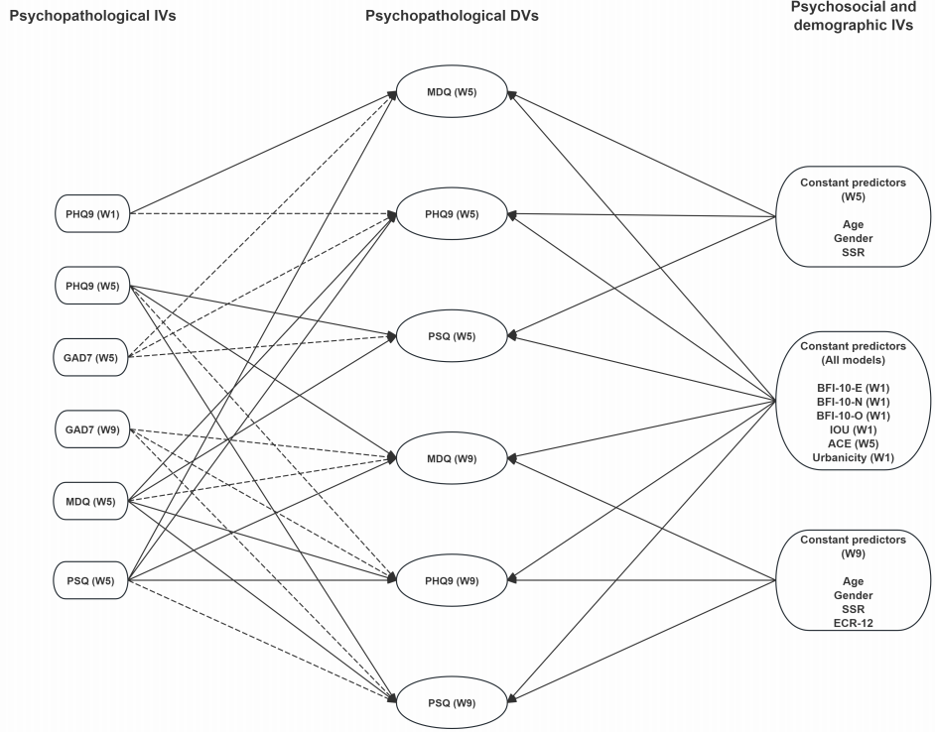
Figure 4.1
Diagram of the regression models
Note. Path diagram illustrating the hypothesised regression relationships among psychopathological and psychosocial/demographic independent variables (IVs) and psychopathological dependent variables (DVs) across Waves 1, 5, and 9. Solid lines indicate main predictors, while dashed lines indicate covariates included to control for confounding. W = assessment wave (e.g., W1 = Wave 1). PHQ-9 = Patient Health Questionnaire-9; PSQ = Psychosis Screening Questionnaire; MDQ = Mood Disorder Questionnaire; GAD-7 = Generalised Anxiety Disorder-7; SSR = Subjective Social Ranking; IOU = Intolerance of Uncertainty; ACE = Adverse Childhood Experience; ECR-12 = Experiences in Close Relationships-12; BFI-10 = Big Five Inventory-10 (E = Extraversion, N = Neuroticism, O = Openness).

No evidence of multicollinearity was observed, with all Variance Inflation Factor (VIF) values below 5. There were missing values observed for variables assessed at wave 1 (e.g., personality, depression, n = 1,385), wave 6 (e.g., attachment, n = 1,097), and wave 5 (e.g., adverse childhood events, n = 504). Consequently, the sample size for regression models involving these variables decreased significantly, especially the wave 9 regression models (n = 499). However, a post-hoc power analysis indicated that the wave 9 models had approximately 80% power to detect an overall small-to-moderate effect (R² = .04). In addition, a Wilcoxon rank‑sum test showed no significant age difference between participants who remained (Mdn = 54) and those who dropped out (Mdn = 52), W = 483 448, p = .15. Similarly, a chi‑square test indicated no significant association between gender and attrition, χ²(1, N = 2 520) = 1.72, p = .19. These results suggest that attrition was not systematically related to age or gender, reducing concerns about selection bias related to these variables, and that statistical power remained adequate to detect effects of the magnitude reported.
Given that the PSQ and MDQ sum scores are count data with skewed distributions, we applied regression models using a Poisson family with a log link function. To account for potential overdispersion (where variance exceeds the mean), we assessed statistical significance using bootstrapped confidence intervals (2,000 resamples). This approach provides robust standard errors and confidence intervals without relying on strict distributional assumptions about variance. To facilitate model interpretation, McFadden’s R² was used as a goodness-of-fit measure across all models.
All computations were conducted using R (version 4.4.0). The network model utilised packages such as bootnet (version 1.6.0), qgraph (version 1.9.8), EGAnet (version 2.1.0), and NetworkComparisonTest (version 2.2.2), while the regression models were conducted using lme4 (version 1.1-35.5), car (version 3.1-3), and psych (version 2.4.12).

Results
We first present analyses of the network structures of PLEs and mood symptoms at waves 5 and 9 and test for differences between them.

Stabilities of the network statistics
For consistency, the 1,285 participants who completed both waves 5 and 9 assessments were considered a valid sample for network estimations of psychopathological symptoms at each wave. Network stability estimates were generally high for both waves 5 and 9 networks. The CS coefficients were as followings: wave 5 (edge weight: .67; node strength: .75; node closeness: .67; node betweenness: .28) and wave 9 (edge weight: .52; node strength: .60; node closeness: .60; node betweenness: .05), suggesting the edge and node statistics were generally stable, except for betweenness, which needs to be interpreted with caution.

Network composition, structure and connectivity
The EGA revealed a network structure (Figure D 2) with three communities at waves 5 and 9. These corresponded with depression (e.g., D2: depressed mood or feelings of hopelessness; D4: fatigue), PLEs (e.g., PS: paranoia or strange experience; P5: hallucinations) and mania (e.g., M1: elevated mood, M5: pressured speech or talkativeness,). Most of the statistics were consistent with little variation between waves. Depression was the most stable community (structural consistency = 1) across both waves. For PLEs, structural consistency was adequate at both waves (.60 at wave 5 and .61 at wave 9).
Although the structural consistency of the mania community was high at wave 5 (.92) at wave 9 it was .32, which is below the threshold for stability (> .60). Although most items in this community exhibited high item stability (> .80), its composition should be interpreted with caution. This instability appears to be driven by M2 (irritability), M6 (racing thoughts), and M7 (easily distracted), which showed unstable placement - being part of the PLEs community at wave 5 but the mania community at wave 9 - suggesting a complex relationship between subclinical symptoms of mania and psychosis.
The network densities were .41 at wave 5 and .38 at wave 9. The weighted network densities (average absolute edge weight) were both .09. The NCT revealed that neither the global connectivity (S₀ = 0.20, p = .90) nor the network structure (M = 0.54, p = .70) were statistically different across the waves.

Edge and node statistics across waves
Visual representations of the networks, which are presented in Figure 4.2, and some differences are apparent from visual inspection. The node with the highest strength in the wave 5 network was M7 (i.e., easily distracted), whereas M6 (i.e., racing thoughts) was the node with the highest strength in the wave 9 network; these two symptoms were also the nodes exhibiting highest closeness. In both networks, the node with lowest strength was D5 (i.e., feeling of worthlessness), see Figure D 3 for details.

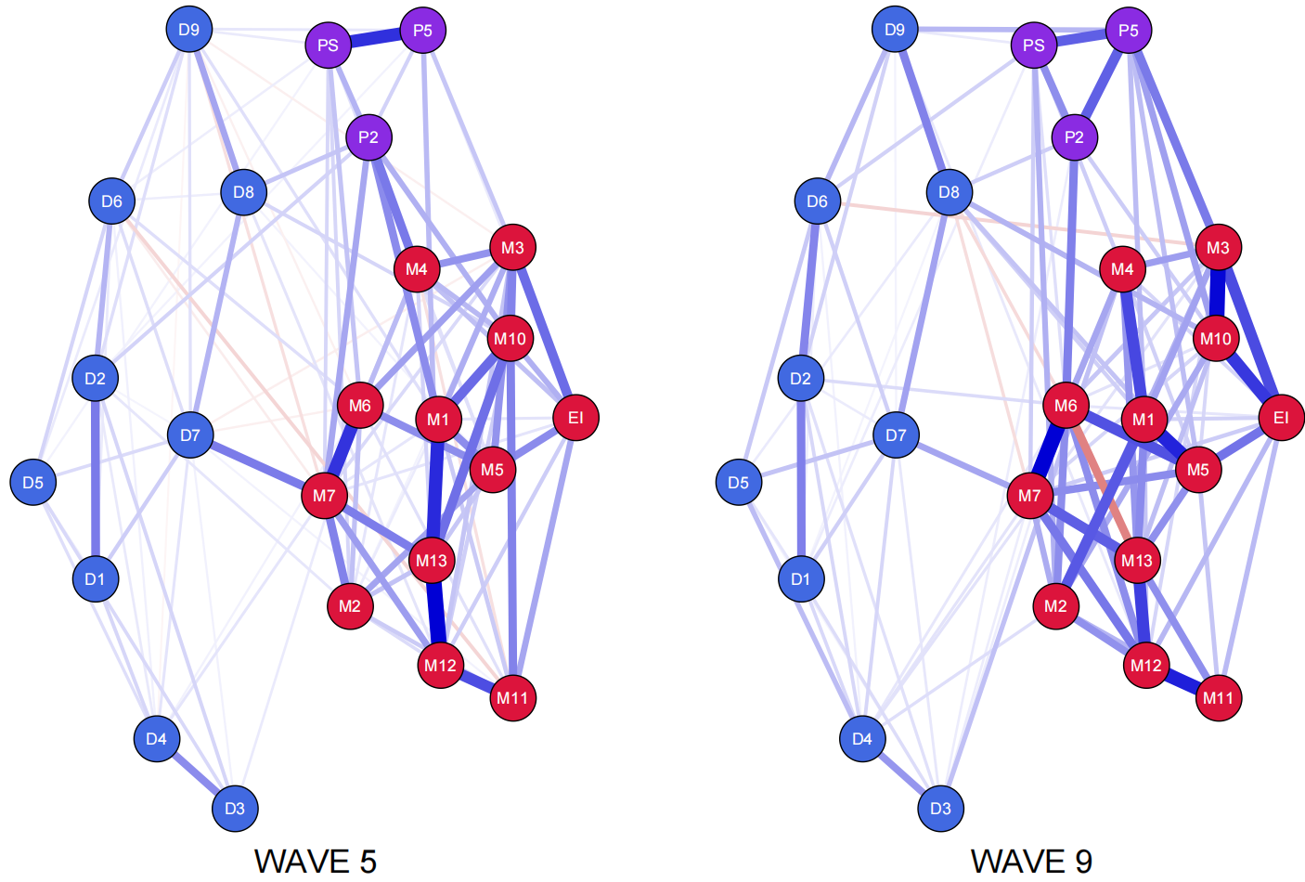
Figure 4.2
Networks of Mood and PLEs across waves
Note. Blue edge denotes positive correlation, while red edge denotes negative correlation. Depression (PHQ) nodes are represented by blue, Mania (MDQ) nodes by red, and PLEs (PSQ) nodes by purple. No threshold is applied to the graphs. D1: Decreased interest, D2: Depressed mood or feelings of hopelessness, D3: Sleep problems, D4: Fatigue, D5: Poor appetite or overeating, D6: Feelings of worthlessness, D7: Concentration problems, D8: Psychomotor retardation or agitation, D9: Self-harm or suicidal thoughts, EI: Elevated energy or increased goal-directed activity, M1: Elevated mood, M2: Irritability, M3: Elevated self-confidence, M4: Reduced need for sleep, M5: Pressured speech or talkativeness, M6: Racing thoughts, M7: Easily distracted, M10: Increased social activity, M11: Increased sexual interest, M12: Involvement in risky behaviour, M13: Spending money carelessly, P2: Thought insertion, PS: Paranoia or strange experiences, P5: Hallucinations.

Regarding edge statistics, the two networks displayed slightly different patterns. In the wave 5 network, the edge with the highest weight was M12 (involvement in risky behaviour)-M13 (spending money carelessly) (W = 0.90, 95% BCI [0.50, 1.30]), whereas at wave 9, the strongest edge was M6 (racing thoughts)-M7 (easily distracted) (W = 0.75, 95% BCI [0.54, 0.95]). The edges with the lowest weights were D4 (fatigue)-D9 (self-harm or suicidal thoughts) at Wave 5 (W = -0.03, 95% BCI [-0.10, 0.04]) and D1 (decreased interest)-D8 (psychomotor retardation or agitation) at Wave 9 (W = 0.04, 95% BCI [-0.04, 0.11]); see Tables D 2-3 for details.
Although the ranking of edge weights was not identical across waves for the mood-PLE pairs, the pattern of the highest-ranked mood-PLE associations was generally consistent, with higher edge weights linking PLEs to mania symptoms compared to depressive symptoms at both waves, consistent with the findings of Shao et al. (2024) with clinical samples. The edge with the highest weight was M4 (reduced need for sleep)-P2 (thought insertion) at wave 5 (W = 0.48, 95% BCI [0.10, 0.85]) and M3 (elevated self-confidence)-P5 (hallucinations) at wave 9 (W = 0.39, 95% BCI [-0.17, 0.95]). The edge D9 (suicidal thoughts or self-harm)-P5 (hallucinations) was consistent across wave 5 (W = 0.09, 95% BCI [-0.10, 0.28]) and wave 9 (W = 0.21, 95% BCI [-0.11, 0.53]); see Table 4.2 for details.

Table 4.2
Top three edge statistics across two waves
Edges | Weights | 95% BCI
Wave 5 Mania-PLEs
M4-P2 | 0.48 | [0.10, 0.85]
M12-P5 | 0.25 | [-0.12, 0.61]
M6-PS | 0.21 | [0.09, 0.33]
Wave 5 Depression-PLEs
D8-P2 | 0.20 | [-0.09, 0.50]
D9-P5 | 0.09 | [-0.10, 0.28]
D9-PS | 0.08 | [-0.02, 0.17]
Wave 9 Mania-PLEs
M3-P5 | 0.39 | [-0.17, 0.95]
M6-P2 | 0.37 | [-0.14, 0.88]
M2-PS | 0.23 | [0.10, 0.36]
Wave 9 Depression-PLEs
D9-P5 | 0.21 | [-0.11, 0.53]
D8-P2 | 0.14 | [-0.11, 0.39]
D6-PS | 0.13 | [0.05, 0.22]
Note. D6: Feeling of self-worthlessness, D8: Psychomotor retardation or agitation, D9: Self-harm or suicidal thoughts, M2: Irritability, M3, Elevated self-confidence, M4: Reduced need for sleep, M6: Racing thoughts, M12: Involvement in risky behaviour, P2: Thought insertion, PS: Paranoia or Strange experience, P5: Hallucinations. BCI: Bootstrapped Confidence Interval; it was derived from 2,000 bootstrapped samples, which is reported for reference. the strongest edge that bridges the mood and the three PLEs is presented on the first column by waves.

Regression models
We now consider regression models examining the interplay between PLEs and mood symptoms at each wave and between waves, and the role of environmental and psychological factors in each type of psychopathology.

PLEs
The model regressing PLE at wave 5 counts on the predictors accounted for 22% of the total variance. PLEs at wave 5 were more frequently observed in participants with higher ACE frequency (b = 0.12, SE = 0.04, p < .001, 95% BCI [0.06, 0.19]), more severe mania (b = 0.12, SE = 0.01, p < .001, 95% BCI [0.09, 0.15]), higher anxiety levels (b = 0.05, SE = 0.01, p < .001, 95% BCI [0.02, 0.08]), and lower SSR (b = -0.07, SE = 0.03, p < .05, 95% BCI [-0.12, -0.01]); see Table 4.3 for details.

Table 4.3
Count and continuous models regressing on Mood and PLEs aacross waves
Variable | Estimate |  |  | se | z/t value |  | 95% BCI
Wave 5 PLEs (Count): McFadden’s R² = .22
(Intercept) | -1.81 |  |  | 0.47 | -3.89
ACEs (W5) | 0.12*** |  |  | 0.04 | 4.00 |  | [0.06, 0.19]
Anxiety (W5) | 0.05*** |  |  | 0.01 | 3.65 |  | [0.02, 0.08]
Mania (W5) | 0.12*** |  |  | 0.01 | 8.55 |  | [0.09, 0.15]
SSR (W5) | -0.07* |  |  | 0.03 | -2.47 |  | [-0.12, -0.01]
Wave 9 PLEs (Count): McFadden’s R² = .32
(Intercept) | -1.68 |  |  | 0.82 | -2.05
ACEs (W5) | 0.14** |  |  | 0.05 | 2.62 |  | [-0.02, 0.25]
Anxiety (W9) | 0.06*** |  |  | 0.02 | 3.44 |  | [0.02, 0.10]
PLEs (W5) | 0.31*** |  |  | 0.08 | 3.70 |  | [0.11, 0.52]
Mania (W5) | 0.07** |  |  | 0.03 | 2.87 |  | [0.03, 0.14]
Wave 5 Depression (Sum): McFadden’s R² = .55
(Intercept) | 0.02 |  |  | 0.32 | 0.06
ACEs (W5) | 0.08** |  |  | 0.03 | 2.84 |  | [0.03, 0.13]
Anxiety (W5) | 0.12*** |  |  | 0.01 | 13.17 |  | [0.11, 0.14]
Depression (W1) | 0.04*** |  |  | 0.01 | 5.02 |  | [0.03, 0.06]
Mania (W5) | 0.04** |  |  | 0.01 | 3.18 |  | [0.02, 0.07]
Wave 9 Depression (Sum): McFadden’s R² = .47
(Intercept) | -0.17 |  |  | 0.46 | 0.911
ACEs (W5) | 0.11** |  |  | 0.04 | 2.66 |  | [0.03, 0.19]
Depression (W5) | 0.06*** |  |  | 0.01 | 5.30 |  | [0.04, 0.08]
Anxiety (W9) | 0.13*** |  |  | 0.03 | 10.90 |  | [0.11, 0.15]
IoU-P (W1) | 0.02* |  |  | 0.01 | 2.13 |  | [0.003, 0.05]
Attachment: Anxiety (W6) | 0.01* |  |  | 0.005 | 2.23 |  | [0.002, 0.03]
PLEs (W5) | -0.14* |  |  | 0.06 | -2.28 |  | [-0.27, -0.02]
Wave 5 Mania (Sum): McFadden’s R² = .18
(Intercept) | -0.57 |  |  | 0.22 | -2.61
Age (W5) | -0.005*** |  |  | 0.002 | -3.32 |  | [-0.01, 0.0002]
Gender (W5) | -0.13** |  |  | 0.04 | -3.03 |  | [-0.39, 0.01]
ACEs (W5) | 0.08*** |  |  | 0.02 | 5.05 |  | [0.03, 0.14]
Neuroticism (W1) | 0.05*** |  |  | 0.01 | 3.50 |  | [0.003, 0.10]
Openness (W1) | 0.03* |  |  | 0.01 | 2.40 |  | [-0.01, 0.08]
Extraversion (W1) | 0.07*** |  |  | 0.01 | 4.95 |  | [0.02, 0.12]
Urbanicity (W1) | 0.20*** |  |  | 0.05 | 3.60 |  | [-0.01, 0.39]
SSR (W5) | 0.04** |  |  | 0.01 | 2.70 |  | [-0.01, 0.08]
Anxiety (W5) | 0.04*** |  |  | 0.005 | 6.91 |  | [0.02, 0.05]
Depression (W1) | 0.01** |  |  | 0.005 | 2.68 |  | [-0.01, 0.03]
PLEs (W5) | 0.31*** |  |  | 0.02 | 13.25 |  | [0.23, 0.40]
Wave 9 Mania (Sum): McFadden’s R² = .29
(Intercept) |  | -0.26 | 0.38 |  |  | -0.67
ACEs (W5) |  | 0.10*** | 0.03 |  |  | 3.73 | [0.01, 0.19]
Anxiety (W9) |  | 0.05*** | 0.008 |  |  | 5.65 | [0.02, 0.08]
Depression (W5) |  | 0.02** | 0.007 |  |  | 2.92 | [0.02, 0.05]
PLEs (W5) |  | 0.17*** | 0.04 |  |  | 4.20 | [-0.003, 0.30]
Mania (W5) |  | 0.11*** | 0.01 |  |  | 9.47 | [0.07, 0.16]
IoU-I (W1) |  | -0.04*** | 0.01 |  |  | -3.87 | [-0.09, -0.01]
Note. BCI = bootstrapped confidence interval; W = assessment wave (e.g., W1 = Wave 1). ACEs = adverse childhood experiences; IoU = intolerance of uncertainty (I = inhibitory, P = prospective); PLEs = psychotic-like experiences; SSR = subjective social rank, SSR.
*p < .05, **p <.01, ***p < .001.

The number of PLEs at Wave 9, after adjusting for PLEs at wave 5, was similarly predicted by anxiety at wave 9 (b = 0.06, SE = 0.02, p < .001, 95% BCI [0.02, 0.10]); mania at wave 5 (b = 0.07, SE = 0.03, p < .01, 95% BCI [0.03, 0.14]); and ACEs (b = 0.14, SE = 0.05, p < .01, 95% BCI [-0.02, 0.25]). The model explained 32% of the total variance.
The binary models of PLEs were largely consistent with the continuous models, except for the following variations. The wave 5 binary model of PLEs did not find a significant effect of SSR, while IoU-P exhibited a positive association (b = 0.05, SE = 0.02, p < .05, 95% BCI [0.01, 0.10]). In the wave 9 binary model, no significant effect of ACEs was detected; see Table D 4 for details.

Depression
The model predicting the severity of wave 5 depression explained 55% of the total variance. Baseline depression severity (b = 0.04, SE = 0.01, p < .001, 95% BCI [0.03, 0.06]), ACEs (b = 0.08, SE = 0.03, p < .01, 95% BCI [0.03, 0.13]) and anxiety (b = 0.12, SE = 0.01, p < .001, 95% BCI [0.11, 0.14]) as well as mania severity at wave 5 (b = 0.04, SE = 0.01, p < .01, 95% BCI [0.02, 0.07]) were statistically significant predictors.
The model of wave 9 depression severity explained 47% of the total variance. ACEs (b = 0.11, SE = 0.04, p < .01, 95% BCI [0.03, 0.19]), wave 9 anxiety (b = 0.13, SE = 0.03, p < .001, 95% BCI [0.11, 0.15]), and wave 5 depression severity (b = 0.15, SE = 0.04, p < .001, 95% BCI [0.07, 0.37]) remained significant predictors of this outcome. In addition, IoU-P (b = 0.02, SE = 0.01, p < .05, 95% BCI [0.003, 0.05]), anxious attachment style (b = 0.01, SE = 0.005, p < .05, 95% BCI [0.002, 0.03]), and the number of experienced PLEs at Wave 5 (b = -0.14, SE = 0.06, p < .05, 95% BCI [-0.27, -0.02]) predicted depression severity at Wave 9.
Compared to the continuous models, binary models of depression across waves displayed some variations. In the wave 5 model, age was a positive predictor (b = 0.02, SE = 0.01, p < .05, 95% BCI [-0.0002, 0.05]), whereas in the wave 9 model, ACEs, attachment style, and experienced PLEs were non-significant; see Table D 4 for details.

Mania
Mania severity at Wave 5 was predicted by ACEs (b = 0.08, SE = 0.02, p < .001, 95% BCI [0.03, 0.14]); anxiety (b = 0.04, SE = 0.005, p < .001, 95% BCI [0.02, 0.05]); PLEs (b = 0.31, SE = 0.02, p < .001, 95% BCI [0.23, 0.40]); and baseline depression severity (b = 0.01, SE = 0.005, p < .01, 95% BCI [-0.01, 0.03]). Demographic factors such as age (b = -0.005, SE = 0.002, p < .001, 95% BCI [-0.01, 0.0002]); gender (b = -0.13, SE = 0.04, t = -3.03, 95% BCI [-0.39, 0.01]); SSR (b = 0.04, SE = 0.01, p < .01, 95% BCI [-0.01, 0.08]); and baseline urbanicity (b = 0.20, SE = 0.05, p < .001, 95% BCI [-0.01, 0.39]) also predicted mania severity. Personality traits including neuroticism (b = 0.05, SE = 0.01, p < .001, 95% BCI [0.003, 0.10]); openness to experience (b = 0.03, SE = 0.01, p < .05, 95% BCI [-0.01, 0.08]); and extraversion (b = 0.07, SE = 0.01, p < .001, 95% BCI [0.02, 0.12]) were also significant predictors of mania severity. The model explained 18% of the total variance.
Mania severity at wave 9 was predicted by IoU-I (b = -0.04, SE = 0.01, p < .001, 95% BCI [-0.09, -0.01]). Additionally, wave 9 anxiety (b = 0.05, SE = 0.008, p < .01, 95% BCI [0.02, 0.08]); Wave 5 ACEs (b = 0.10, SE = 0.03, p < .001, 95% BCI [0.01, 0.19]); depression severity (b = 0.02, SE = 0.007, p < .01, 95% BCI [0.02, 0.05]); and the number of experienced PLEs (b = 0.17, SE = 0.04, p < .001, 95% BCI [-0.003, 0.30]) were significant predictors of this outcome. The model explained 29% of the total variance.
The binary models of mania were less consistent with the count models. Among all significant predictors across waves, only younger age and PLEs in the Wave 5 mania model, and mania severity at Wave 5 and IoU-I in the Wave 9 mania model, remained significant predictors; see Table D 4 for details. For ease of interpretation, significant predictors from count and continuous models across waves were summarised in Figure 4.3.

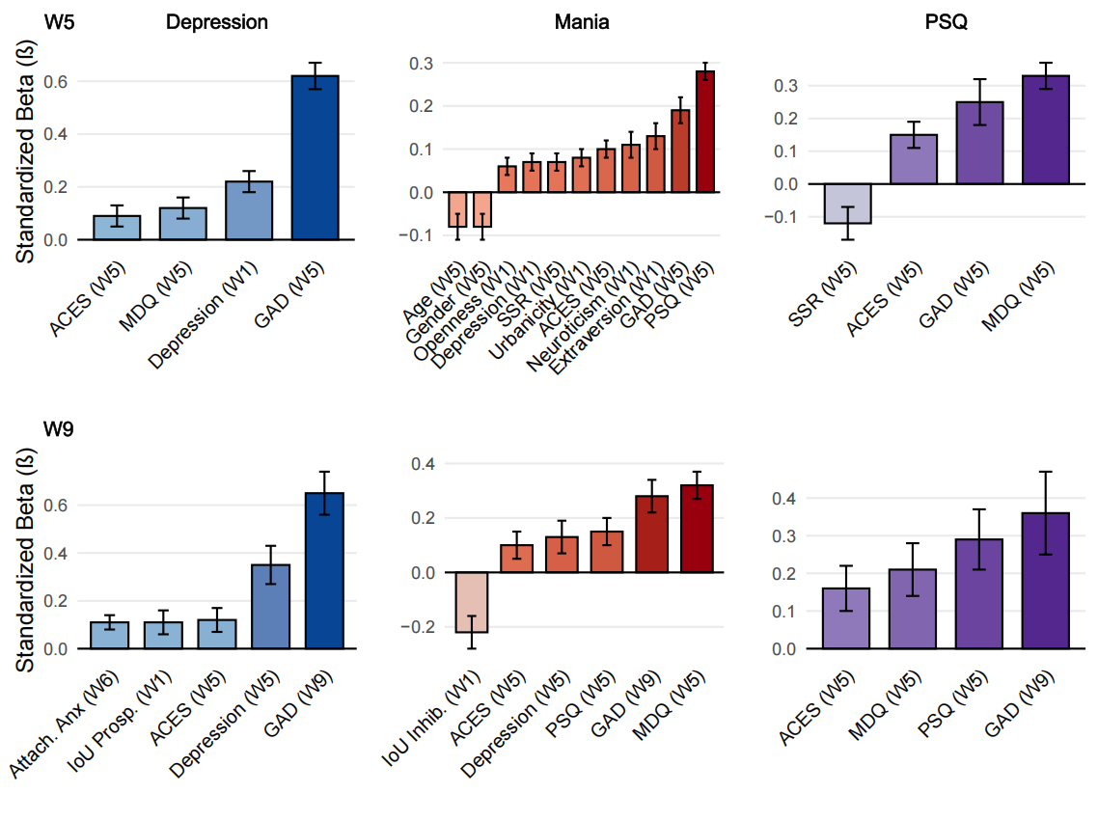
Figure 4.3
A summary plot of the significant predictors for primary symptoms
Note. W = assessment wave (e.g., W5 = Wave 5). ACEs = adverse childhood experiences; GAD = generalised anxiety disorder; IoU = intolerance of uncertainty Inhibitory and Prospective); MDQ = mood disorder questionnaire (Self-reported mania); PLEs = psychotic-like experiences; PSQ= psychosis screening questionnaire (PLEs); SSR = subjective social rank.

Discussion
The current study utilised longitudinal panel data to clarify how psychotic-like experiences (PLEs) relate to depressive and manic symptoms over time. Four key findings emerged. First, network analyses revealed that PLEs were more strongly related to subclinical manic than to depressive symptoms. Second, these symptom structures were largely stable across a two-year interval. Third, the longitudinal relationship between mood symptoms and psychotic experiences was partially reciprocal, with the clearest bidirectional links occurring between manic symptoms and PLEs. Finally, childhood adversity functioned as a broad risk factor, predicting all symptom domains.
Consistent with our first hypothesis and previous research (Shao et al. 2024), the association between manic symptoms and PLEs was stronger than that between depressive symptoms and PLEs, and this pattern remained stable across all networks. This finding suggests that the PLEs (e.g., altered beliefs and perceptions) may co-occur with manic symptoms (e.g., racing thoughts) in the general population. This strong interplay between (hypo)manic and psychotic experiences revealed here, and in our work with psychiatric populations (Shao et al. 2024) may help to explain the longstanding difficulties in drawing boundaries between schizophrenia and bipolar disorders as reviewed in our introduction and, with some caution, can be interpreted as consistent with findings from other approaches, for example latent trait models, which suggest either a close relationship between the disorders (Keshavan, et al., 2011) or that they may be products of common underlying psychopathological processes (Reininghaus et al., 2019; Reininghaus et al., 2013). However, it should be noted that network models make very different assumptions to the models used in these previous studies. In particular, whereas latent trait models start from the assumption that covariation between symptoms reflects underlying factors, network models posit that the same covariation can be accounted for by symptoms mutually influencing each other.
The stable structure of the mood and psychosis networks across the two-year interval is consistent with our second hypothesis and, to some extent, previous psychopathological studies using the network approach with healthy populations (Funkhouser et al., 2021; van der Tuin et al., 2023). The persistence of mood-psychosis network structures over time may reflect enduring cognitive-affective dispositions, consistent with models suggesting that stable patterns of cognitive and emotional responses shape individual differences in psychopathology (Mischel & Shoda, 1995). However, within a network framework, it could reflect relatively stable and enduring influences of different symptoms on each other. The network model proposes two general symptom-network states: a resilient state with relatively sparse connections and a vulnerable state with denser connectivity (Borsboom, 2017). Deviations from the stable mood-psychosis structure-such as increases in overall connectivity or strengthening specific edges-potentially triggered by stressful life events or developmental challenges, may signal a shift toward a more vulnerable state. Such shifts could precede worsening mood or psychotic symptoms and serve as early markers of heightened risk, though this remains speculative. Variations in mood-psychosis networks across clinical, at-risk, and non-clinical groups, together with the possible influence of external triggers, warrant further investigation.
Findings from our regression analyses were partially consistent with the third hypothesis. Specifically, we found evidence of some reciprocity between mood psychopathologies and PLEs. After adjusting for baseline severity and other contributing factors, subclinical mania predicted PLEs after two years, and the reverse was also observed. This finding aligns with the reciprocal relationship between bipolar psychotic symptoms observed in our network models and, to some extent, with the occurrence of diagnostic conversion between bipolar disorder and schizophrenia (Jorgensen et al., 2018; McGrath et al., 2016). However, the close connection between clusters of subclinical mania and PLEs as well as their longitudinal reciprocity may also arise from shared pathological mechanisms, which would be consistent with latent trait models.
Unexpectedly, depression did not predict PLEs, either in total frequency or dichotomised status, and more frequent PLEs at wave 5 predicted less severe depression at wave 9. This finding, to some extent, suggests that the relationship between PLEs and depressive symptoms may be more complex than a straightforward transdiagnostic liability (McGrath et al., 2016). One possible explanation is that individuals with more frequent PLEs may have been more likely to seek help, as suggested by prior work (Misiak & Frydecka, 2024), and such help-seeking could have contributed to reduced depressive symptoms over time. Another explanation could be that PLEs mask depressive symptoms, perhaps through suppressing self-reflection, which has been observed in clinical participants (Palmer et al., 2015). Finally, the effect could be statistical: the negative association may reflect a suppression effect, as adjusting for baseline depression and psychosocial covariates may have accounted for shared variance, leaving PLEs with a residual inverse relationship to subsequent depression. Certainly, in the present data there is no evidence of depression preceding PLEs.
Moreover, a one-way relationship from subclinical depression to mania was observed in the longitudinal regression model, and this pattern was replicated across the two assessment points. This finding aligns with previous study that most bipolar patients report depression as their first mood episode (Perugi et al., 2000). Longitudinally, the onset of mania is predicted by an increase in depression (Johnson et al., 2011) and mania in the absence of a history of depression is extremely rare (Stokes et al., 2020). A previous network analysis found that depression and mania may be connected by bridge symptoms such as anhedonia and impulsivity (Zavlis et al., 2023). These findings highlight the possibility that depression is part of the bipolar trajectory and support the long-held assumption that depression serves as a prodromal stage of mania (Frank et al., 2015). The absence of the reverse pattern in this study suggests that the transition from mania to depression in clinical bipolar disorder may follow a distinct pathway, highlighting the need for further investigation into the mechanisms underlying bipolar trajectories before and after the onset of illness. Taken with the previous findings of no longitudinal association between depression and PLEs, the picture that emerges is of a complex interplay between mood and psychotic symptoms in which mania is influenced by both preexisting negative mood and a vulnerability to psychosis.
Regarding variables hypothesized to predict symptoms, most of our assumptions were not supported by the findings. The major exception was that childhood adversity consistently predicted nearly all subclinical psychopathologies across the two major assessment waves, aligning with well-established evidence that childhood adversity is a risk factor for psychosis as well as other severe mental disorders (Agnew-Blais & Danese, 2016; Mandelli et al., 2015; Zhou et al., 2025). Hence, our findings support the notion that childhood trauma serves as a transdiagnostic risk factor for a variety of psychiatric conditions.
Our regression analyses of other psychological variables yielded inconsistent findings. However, it is worth noting that, at wave 9 (although not at wave 5), subclinical depression and mania exhibited distinct associations with prospective and inhibitory intolerance of uncertainty even after adjusting for confounders such as anxiety severity. Specifically, higher subclinical mania was correlated with lower inhibitory IoU, while higher subclinical depression was correlated with higher prospective IoU. The positive association between depression and prospective IoU is consistent with prior literature (Gentes & Ruscio, 2011). There has been very little research examining the relationship between mania and subdimensions of IoU but the hypomania subdimension of irritability/impulsivity has been found to be positively associated with general IoU (Pujji, 2023). Our findings extend these observations by suggesting that mania and depression may be associated with distinct cognitive-affective profiles. These findings align with theorising about the behavioural activation and inhibition systems (BAS/BIS) governing motivation (Gray, 1987). In this framework, depression is hypothesized to be associated with an overactive BIS, leading to heightened sensitivity to uncertainty and a tendency toward excessive caution and avoidance (Pinto-Meza et al., 2006). In contrast, mania is hypothesised to be associated with an overactive BAS, which promotes impulsivity and risk-taking in uncertain situations (Dempsey et al., 2017; Depue & Iacono, 1989). Nonetheless, the evidence linking IoU to mood psychopathologies and PLEs was not consistent across waves, suggesting that these relationships may be time-sensitive or influenced by other unassessed factors. Future research should address these inconsistencies to better understand the role of IoU in the development and maintenance of psychopathology.

Limitations
The current study utilised secondary data with a longitudinal design. However, the generalisability of our findings may be affected by the following limitations: (1) The network analysis did not capture intra-individual variability because the data format was not suitable for a cross-lagged network model. Future research should examine these features using longitudinal panel data with more than three time points; (2) The variations observed in logistic regression and network models may have been influenced by insensitive cutoff values and inconsistencies in the timeframes used in assessment tools. Although the cutoff values have been validated in empirical studies, certain measures, such as the PSQ, may be less sensitive as predictors or outcomes, potentially inflating the observed effects. Future studies could replicate these findings by incorporating diagnostic status defined by gold-standard criteria (e.g., DSM) and ensuring consistency in assessment timeframes; (3) This study was informed by a continuum model that assumes a degree of shared psychopathological liability between non-clinical (non-diagnosed) and clinical (diagnosed) populations. Although the present findings provide preliminary support for this perspective, this assumption has important limitations. Specifically, the continuum model may overstate the generalisability of findings from non-clinical populations to clinical populations, despite meaningful differences in neurobiology, symptom severity, functional impairment, and illness course. Moreover, psychopathological processes may be non-linear rather than continuous across the full spectrum. Accordingly, these findings should be interpreted with caution and require further validation using diverse methods, clinical samples, and cross-cultural comparisons. (4) Data for Wave 5 were collected during the final phase of COVID-19 lockdown in the UK, whereas Wave 9 was conducted well after the lifting of all legal restrictions. Although the stability of symptom networks and longitudinal associations across these two periods suggests that the observed relationships are unlikely to be driven solely by pandemic-related effects, the influence of the broader COVID-19 context cannot be fully ruled out. (5) The high attrition rate in this study raises the possibility of attrition bias. Although no significant differences were observed in age or gender between participants who remained in the study and those who dropped out, this alone does not provide sufficient reassurance that the missing data were unbiased. In particular, the data may not have been missing completely at random, and attrition may have been related to unobserved factors such as illness characteristics, symptom severity, or other clinical variables. This introduces inferential uncertainty and the findings should be interpreted with caution. Future research should consider more robust approaches to handling missing data, such as multiple imputation, inverse probability weighting, model-based methods, and sensitivity analyses, in order to better estimate and reduce the potential impact of attrition bias on the findings.

Conclusion
This study examined the relationship between mood psychopathologies and PLEs using both network and regression analyses. Our findings indicated a stable network structure, showing that mood symptoms and PLEs - particularly mania and PLEs - remained closely interconnected over a two-year period. Additionally, the longitudinal reciprocity between mania and PLEs identified in the regression models provides further evidence of their close relationship and may suggest shared psychopathological process between mood and psychosis. While this study benefits from a longitudinal design and multiple analytic approaches, its generalisability to longitudinal symptom variation and clinical settings remains to be demonstrated. Future research should incorporate more rigorous longitudinal designs (e.g., EMA: Ecological Momentary Assessment), gold-standard diagnostic criteria, and relevant environmental or psychosocial variables to further explore the interplay between schizophrenia and bipolar symptoms over time.

References
Adler, N. E., Epel, E. S., Castellazzo, G., & Ickovics, J. R. (2000). Relationship of subjective and objective social status with psychological and physiological functioning: Preliminary data in healthy, White women. Health psychology, 19(6), 586.
Agnew-Blais, J., & Danese, A. (2016). Childhood maltreatment and unfavourable clinical outcomes in bipolar disorder: a systematic review and meta-analysis. The Lancet Psychiatry, 3(4), 342–349. https://doi.org/10.1016/S2215-0366(15)00544-1
American Psychiatric Association, i. b. (2022). Diagnostic and statistical manual of mental disorders : DSM-5-TR (5th edition, text revision. ed.). Washington, DC : American Psychiatric Association Publishing, 2022.
Angst, J., & Cassano, G. (2005). The mood spectrum: improving the diagnosis of bipolar disorder. Bipolar Disorders, 7(s4), 4–12. https://doi.org/https://doi.org/10.1111/j.1399-5618.2005.00210.x
Bagby, R. M., Bindseil, K. D., Schuller, D. R., Rector, N. A., Young, L. T., Cooke, R. G., Seeman, M. V., McCay, E. A., & Joffe, R. T. (1997). Relationship between the five-factor model of personality and unipolar, bipolar and schizophrenic patients. Psychiatry Res, 70(2), 83–94. https://doi.org/10.1016/s0165-1781(97)03096-5
Ballesio, A., Musetti, A., Zagaria, A., Manari, T., Filosa, M., & Franceschini, C. (2022). Depression and mania symptoms mediate the relationship between insomnia and psychotic-like experiences in the general population. Sleep Epidemiology, 2, 100019. https://doi.org/https://doi.org/10.1016/j.sleepe.2021.100019
Barnett, J. H., Huang, J., Perlis, R. H., Young, M. M., Rosenbaum, J. F., Nierenberg, A. A., Sachs, G., Nimgaonkar, V. L., Miklowitz, D. J., & Smoller, J. W. (2011). Personality and bipolar disorder: dissecting state and trait associations between mood and personality. Psychological Medicine, 41(8), 1593–1604. https://doi.org/10.1017/S0033291710002333
Bebbington, P., & Nayani, T. (1995). The psychosis screening questionnaire. International journal of methods in psychiatric research.
Bentall, R. P. (2004). Madness explained [electronic resource] : psychosis and human nature. London : Penguin, 2004.
Berrios, G. E., & Beer, D. (1994). The notion of a unitary psychosis: a conceptual history. Hist Psychiatry, 5(17 Pt 1), 13–36. https://doi.org/10.1177/0957154X9400501702
Berry, K., Barrowclough, C., & Wearden, A. (2007). A review of the role of adult attachment style in psychosis: Unexplored issues and questions for further research. Clinical Psychology Review, 27(4), 458–475. https://doi.org/https://doi.org/10.1016/j.cpr.2006.09.006
Birrell, J., Meares, K., Wilkinson, A., & Freeston, M. (2011). Toward a definition of intolerance of uncertainty: a review of factor analytical studies of the Intolerance of Uncertainty Scale. Clin Psychol Rev, 31(7), 1198–1208. https://doi.org/10.1016/j.cpr.2011.07.009
Birur, B., Kraguljac, N. V., Shelton, R. C., & Lahti, A. C. (2017). Brain structure, function, and neurochemistry in schizophrenia and bipolar disorder-a systematic review of the magnetic resonance neuroimaging literature. NPJ Schizophr, 3(1), 15. https://doi.org/10.1038/s41537-017-0013-9
Blashfield, R. K., Keeley, J. W., Flanagan, E. H., & Miles, S. R. (2014). The Cycle of Classification: DSM-I Through DSM-5. Annual review of clinical psychology, 10(Volume 10, 2014), 25–51. https://doi.org/https://doi.org/10.1146/annurev-clinpsy-032813-153639
Bolhuis, K., Koopman-Verhoeff, M. E., Blanken, L. M. E., Cibrev, D., Jaddoe, V. W. V., Verhulst, F. C., Hillegers, M. H. J., Kushner, S. A., & Tiemeier, H. (2018). Psychotic-like experiences in pre-adolescence: what precedes the antecedent symptoms of severe mental illness? Acta Psychiatrica Scandinavica, 138(1), 15–25. https://doi.org/https://doi.org/10.1111/acps.12891
Borsboom, D. (2017). A network theory of mental disorders. World Psychiatry, 16(1), 5–13. https://doi.org/https://doi.org/10.1002/wps.20375
Borsboom, D., & Cramer, A. O. J. (2013). Network Analysis: An Integrative Approach to the Structure of Psychopathology. Annual review of clinical psychology, 9(Volume 9, 2013), 91–121. https://doi.org/https://doi.org/10.1146/annurev-clinpsy-050212-185608
Bringmann, L. F., & Eronen, M. I. (2018). Don't blame the model: Reconsidering the network approach to psychopathology. Psychol Rev, 125(4), 606–615. https://doi.org/10.1037/rev0000108
Buhr, K., & Dugas, M. J. (2002). The intolerance of uncertainty scale: psychometric properties of the English version. Behaviour research and therapy, 40(8), 931–945. https://doi.org/https://doi.org/10.1016/S0005-7967(01)00092-4
Carleton, R. N. (2016). Fear of the unknown: One fear to rule them all? Journal of Anxiety Disorders, 41, 5–21. https://doi.org/https://doi.org/10.1016/j.janxdis.2016.03.011
Carleton, R. N., Norton, M. A. P. J., & Asmundson, G. J. G. (2007). Fearing the unknown: A short version of the Intolerance of Uncertainty Scale. Journal of Anxiety Disorders, 21(1), 105–117. https://doi.org/https://doi.org/10.1016/j.janxdis.2006.03.014
Caspi, A., Houts, R. M., Belsky, D. W., Goldman-Mellor, S. J., Harrington, H., Israel, S., Meier, M. H., Ramrakha, S., Shalev, I., Poulton, R., & Moffitt, T. E. (2014). The p Factor: One General Psychopathology Factor in the Structure of Psychiatric Disorders? Clin Psychol Sci, 2(2), 119–137. https://doi.org/10.1177/2167702613497473
Conrad, K. (1958). Beginning schizophrenia: attempt for a Gestalt-analysis of delusion. Selected excerpts taken from, 176–193.
Dempsey, R. C., Gooding, P. A., & Jones, S. H. (2017). A prospective study of bipolar disorder vulnerability in relation to behavioural activation, behavioural inhibition and dysregulation of the Behavioural Activation System. European Psychiatry, 44, 24–29. https://doi.org/10.1016/j.eurpsy.2017.03.005
Depue, R. A., & Iacono, W. G. (1989). Neurobehavioral Aspects of Affective Disorders. Annual Review of Psychology, 40(Volume 40, 1989), 457–492. https://doi.org/https://doi.org/10.1146/annurev.ps.40.020189.002325
Epskamp, S., Borsboom, D., & Fried, E. I. (2018). Estimating psychological networks and their accuracy: A tutorial paper. Behavior Research Methods, 50(1), 195–212. https://doi.org/10.3758/s13428-017-0862-1
Felitti, V., Anda, R., Nordenberg, D., & Williamson, D. (1998). Adverse childhood experiences and health outcomes in adults: The Ace study. Journal of Family and Consumer Sciences, 90(3), 31.
Frank, E., Nimgaonkar, V. L., Phillips, M. L., & Kupfer, D. J. (2015). All the world's a (clinical) stage: rethinking bipolar disorder from a longitudinal perspective. Mol Psychiatry, 20(1), 23–31. https://doi.org/10.1038/mp.2014.71
Funkhouser, C. J., Chacko, A. A., Correa, K. A., Kaiser, A. J. E., & Shankman, S. A. (2021). Unique longitudinal relationships between symptoms of psychopathology in youth: A cross-lagged panel network analysis in the ABCD study. Journal of Child Psychology and Psychiatry, 62(2), 184–194. https://doi.org/https://doi.org/10.1111/jcpp.13256
Gentes, E. L., & Ruscio, A. M. (2011). A meta-analysis of the relation of intolerance of uncertainty to symptoms of generalized anxiety disorder, major depressive disorder, and obsessive–compulsive disorder. Clinical Psychology Review, 31(6), 923–933. https://doi.org/https://doi.org/10.1016/j.cpr.2011.05.001
Goodwin, R. D., Stayner, D. A., Chinman, M. J., Wu, P., Tebes, J. K., & Davidson, L. (2002). The relationship between anxiety and substance use disorders among individuals with severe affective disorders. Compr Psychiatry, 43(4), 245–252. https://doi.org/10.1053/comp.2002.33500
Gray, J. A. (1987). The neuropsychology of emotion and personality. In Cognitive neurochemistry. (pp. 171–190). Oxford University Press.
Gyllenberg, D., Ristikari, T., Kelleher, I., Kääriälä, A., & Gissler, M. (2022). School performance and later diagnoses of nonaffective psychoses, bipolar disorder, and depression. Acta Psychiatr Scand, 146(5), 420–429. https://doi.org/10.1111/acps.13481
Hardoon, S., Hayes, J. F., Blackburn, R., Petersen, I., Walters, K., Nazareth, I., & Osborn, D. P. (2013). Recording of severe mental illness in United Kingdom primary care, 2000-2010. PLOS ONE, 8(12), e82365. https://doi.org/10.1371/journal.pone.0082365
Haslbeck, J. M. B., & Waldorp, L. J. (2020). mgm: Estimating Time-Varying Mixed Graphical Models in High-Dimensional Data. Journal of Statistical Software, 93(8), 1 – 46. https://doi.org/10.18637/jss.v093.i08
Heerlein, A., Santander, J., & Richter, P. (1996). Premorbid personality aspects in mood and schizophrenic disorders. Compr Psychiatry, 37(6), 430–434. https://doi.org/10.1016/s0010-440x(96)90026-7
Hill, S. K., Harris, M. S. H., Herbener, E. S., Pavuluri, M., & Sweeney, J. A. (2008). Neurocognitive Allied Phenotypes for Schizophrenia and Bipolar Disorder. Schizophrenia Bulletin, 34(4), 743–759. https://doi.org/10.1093/schbul/sbn027
Hirschfeld, R. M., Holzer, C., Calabrese, J. R., Weissman, M., Reed, M., Davies, M., Frye, M. A., Keck, P., McElroy, S., & Lewis, L. (2003). Validity of the mood disorder questionnaire: a general population study. American Journal of Psychiatry, 160(1), 178–180.
Hirschfeld, R. M., Williams, J. B., Spitzer, R. L., Calabrese, J. R., Flynn, L., Keck, P. E., Jr., Lewis, L., McElroy, S. L., Post, R. M., Rapport, D. J., Russell, J. M., Sachs, G. S., & Zajecka, J. (2000). Development and validation of a screening instrument for bipolar spectrum disorder: the Mood Disorder Questionnaire. Am J Psychiatry, 157(11), 1873–1875. https://doi.org/10.1176/appi.ajp.157.11.1873
Imran, S., MacBeth, A., Quayle, E., & Chan, S. (2020). Psychometric Properties of the Experiences in Close Relationship Scale (Short Form). Journal of Psychology and Psychotherapy, 10(5).
Jang, Y. J., Yassin, W., Mesholam-Gately, R., Gershon, E. S., Keedy, S., Pearlson, G. G., Tamminga, C. A., McDowell, J., Parker, D. A., & Sauer, K. (2025). Characterizing the relationship between personality dimensions and psychosis-specific clinical characteristics. Schizophrenia Research, 276, 88–96.
Jauhar, S., Nour, M. M., Veronese, M., Rogdaki, M., Bonoldi, I., Azis, M., Turkheimer, F., McGuire, P., Young, A. H., & Howes, O. D. (2017). A Test of the Transdiagnostic Dopamine Hypothesis of Psychosis Using Positron Emission Tomographic Imaging in Bipolar Affective Disorder and Schizophrenia. JAMA Psychiatry, 74(12), 1206–1213. https://doi.org/10.1001/jamapsychiatry.2017.2943
Johns, L. C., & van Os, J. (2001). The continuity of psychotic experiences in the general population. Clin Psychol Rev, 21(8), 1125–1141. https://doi.org/10.1016/s0272-7358(01)00103-9
Johnson, S. L., Morriss, R., Scott, J., Paykel, E., Kinderman, P., Kolamunnage-Dona, R., & Bentall, R. P. (2011). Depressive and manic symptoms are not opposite poles in bipolar disorder. Acta Psychiatr Scand, 123(3), 206–210. https://doi.org/10.1111/j.1600-0447.2010.01602.x
Jorgensen, K. B., Nordentoft, M., & Hjorthoj, C. (2018). Association between alcohol and substance use disorders and psychiatric service use in patients with severe mental illness: a nationwide Danish register-based cohort study. Psychol Med, 48(15), 2592–2600. https://doi.org/10.1017/S0033291718000223
Kaymaz, N., & van Os, J. (2010). Extended psychosis phenotype – yes: single continuum – unlikely: A commentary on ‘Why we need more debate on whether psychotic symptoms lie on a continuum with normality’ by David (2010). Psychological Medicine, 40(12), 1963–1966. https://doi.org/10.1017/S0033291710000358
Keshavan, M. S., Morris, D. W., Sweeney, J. A., Pearlson, G., Thaker, G., Seidman, L. J., Eack, S. M., & Tamminga, C. (2011). A dimensional approach to the psychosis spectrum between bipolar disorder and schizophrenia: the Schizo-Bipolar Scale. Schizophr Res, 133(1-3), 250–254. https://doi.org/10.1016/j.schres.2011.09.005
Koorevaar, A. M. L., Comijs, H. C., Dhondt, A. D. F., van Marwijk, H. W. J., van der Mast, R. C., Naarding, P., Oude Voshaar, R. C., & Stek, M. L. (2013). Big Five personality and depression diagnosis, severity and age of onset in older adults. Journal of affective disorders, 151(1), 178–185. https://doi.org/https://doi.org/10.1016/j.jad.2013.05.075
Korver-Nieberg, N., Berry, K., Meijer, C. J., & de Haan, L. (2014). Adult attachment and psychotic phenomenology in clinical and non-clinical samples: A systematic review. Psychology and Psychotherapy: Theory, Research and Practice, 87(2), 127–154. https://doi.org/https://doi.org/10.1111/papt.12010
Kraepelin, E. (1899). Psychiatry: A textbook for students and physicians. (Vol. Volume 1 ). Watson Publishing International.
Kroenke, K., Spitzer, R. L., & Williams, J. B. (2001). The PHQ-9: validity of a brief depression severity measure. J Gen Intern Med, 16(9), 606–613. https://doi.org/10.1046/j.1525-1497.2001.016009606.x
Lafontaine, M.-F., Brassard, A., Lussier, Y., Valois, P., Shaver, P. R., & Johnson, S. M. (2016). Selecting the Best Items for a Short-Form of the Experiences in Close Relationships Questionnaire. European Journal of Psychological Assessment. https://doi.org/10.1037/t51913-000
Lei, Y., Martinez, A., Huddy, V., Morriss, J., Ellett, L., & Bentall, R. (2025). Intolerance of uncertainty predicts paranoia over time: Evidence from a UK sample. Journal of Behavior Therapy and Experimental Psychiatry, 89, 102050. https://doi.org/https://doi.org/10.1016/j.jbtep.2025.102050
Lichtenstein, P., Yip, B. H., Bjork, C., Pawitan, Y., Cannon, T. D., Sullivan, P. F., & Hultman, C. M. (2009). Common genetic determinants of schizophrenia and bipolar disorder in Swedish families: a population-based study. Lancet, 373(9659), 234–239. https://doi.org/10.1016/S0140-6736(09)60072-6
Lindgren, M., Numminen, L., Holm, M., Therman, S., & Tuulio-Henriksson, A. (2022). Psychotic-like experiences of young adults in the general population predict mental disorders. Psychiatry Res, 312, 114543. https://doi.org/10.1016/j.psychres.2022.114543
Mandelli, L., Petrelli, C., & Serretti, A. (2015). The role of specific early trauma in adult depression: A meta-analysis of published literature. Childhood trauma and adult depression. European Psychiatry, 30(6), 665–680. https://doi.org/10.1016/j.eurpsy.2015.04.007
Manea, L., Gilbody, S., & McMillan, D. (2015). A diagnostic meta-analysis of the Patient Health Questionnaire-9 (PHQ-9) algorithm scoring method as a screen for depression. General hospital psychiatry, 37(1), 67–75. https://doi.org/10.1016/j.genhosppsych.2014.09.009
McBride, O., Murphy, J., Shevlin, M., Gibson-Miller, J., Hartman, T. K., Hyland, P., Levita, L., Mason, L., Martinez, A. P., McKay, R., Stocks, T. V. A., Bennett, K. M., Vallières, F., Karatzias, T., Valiente, C., Vazquez, C., & Bentall, R. P. (2021). Monitoring the psychological, social, and economic impact of the COVID-19 pandemic in the population: Context, design and conduct of the longitudinal COVID-19 psychological research consortium (C19PRC) study. International journal of methods in psychiatric research, 30(1), e1861. https://doi.org/https://doi.org/10.1002/mpr.1861
McGrath, J. J., Saha, S., Al-Hamzawi, A., Andrade, L., Benjet, C., Bromet, E. J., Browne, M. O., Almeida, J. M. C. d., Chiu, W. T., Demyttenaere, K., Fayyad, J., Florescu, S., Girolamo, G. d., Gureje, O., Haro, J. M., Have, M. t., Hu, C., Kovess-Masfety, V., Lim, C. C. W.,…Kessler, R. C. (2016). The Bidirectional Associations Between Psychotic Experiences and DSM-IV Mental Disorders. American Journal of Psychiatry, 173(10), 997–1006. https://doi.org/10.1176/appi.ajp.2016.15101293
Meyer, B., Johnson, S. L., & Carver, C. S. (1999). Exploring Behavioral Activation and Inhibition Sensitivities Among College Students at Risk for Bipolar Spectrum Symptomatology. Journal of Psychopathology and Behavioral Assessment, 21(4), 275–292. https://doi.org/10.1023/A:1022119414440
Mischel, W., & Shoda, Y. (1995). A cognitive-affective system theory of personality: reconceptualizing situations, dispositions, dynamics, and invariance in personality structure. Psychol Rev, 102(2), 246–268. https://doi.org/10.1037/0033-295x.102.2.246
Mishara, A. L. (2010). Klaus Conrad (1905–1961): Delusional mood, psychosis, and beginning schizophrenia. Schizophrenia Bulletin, 36(1), 9–13.
Misiak, B., & Frydecka, D. (2024). Psychotic-like experiences predict the perceived intent to seek treatment: A network perspective. Schizophrenia Research, 266, 100–106. https://doi.org/https://doi.org/10.1016/j.schres.2024.02.033
Morriss, J., Butler, D., & Ellett, L. (2025). Intolerance of uncertainty and psychosis: A systematic review. British Journal of Clinical Psychology, n/a(n/a). https://doi.org/https://doi.org/10.1111/bjc.12509
Morriss, J., & Ellett, L. (2025). Intolerance of uncertainty, paranoia, and prodromal symptoms: Comparisons between a schizophrenia spectrum disorder, anxiety disorder and non‐clinical sample. Psychology and Psychotherapy: Theory, Research and Practice.
Morriss, R. K., van der Gucht, E., Lancaster, G., & Bentall, R. P. (2009). Adult attachment in bipolar 1 disorder. Psychology and Psychotherapy: Theory, Research and Practice, 82(3), 267–277. https://doi.org/https://doi.org/10.1348/147608309X415309
NHS. (2024). Adult Psychiatric Morbidity Survey. https://digital.nhs.uk/data-and-information/publications/statistical/adult-psychiatric-morbidity-survey
Palmer, E. C., Gilleen, J., & David, A. S. (2015). The relationship between cognitive insight and depression in psychosis and schizophrenia: A review and meta-analysis. Schizophrenia Research, 166(1), 261–268. https://doi.org/https://doi.org/10.1016/j.schres.2015.05.032
Palmier-Claus, J. E., Berry, K., Bucci, S., Mansell, W., & Varese, F. (2016). Relationship between childhood adversity and bipolar affective disorder: systematic review and meta-analysis. Br J Psychiatry, 209(6), 454–459. https://doi.org/10.1192/bjp.bp.115.179655
Perugi, G., Micheli, C., Akiskal, H. S., Madaro, D., Socci, C., Quilici, C., & Musetti, L. (2000). Polarity of the first episode, clinical characteristics, and course of manic depressive illness: A systematic retrospective investigation of 320 bipolar I patients. Comprehensive Psychiatry, 41(1), 13–18. https://doi.org/https://doi.org/10.1016/S0010-440X(00)90125-1
Pinto-Meza, A., Caseras, X., Soler, J., Puigdemont, D., Pérez, V., & Torrubia, R. (2006). Behavioural Inhibition and Behavioural Activation Systems in current and recovered major depression participants. Personality and Individual differences, 40(2), 215–226. https://doi.org/https://doi.org/10.1016/j.paid.2005.06.021
Pujji, S. D. (2023). The Intolerance of Uncertainty: Transdiagnostic Connections Across Schizophrenia and Mood Spectrums, Obsessive Beliefs, and Physical Health (Publication Number 30491765) [Ph.D., Rowan University]. ProQuest Dissertations & Theses Global. United States -- New Jersey. https://www.proquest.com/dissertations-theses/intolerance-uncertainty-transdiagnostic/docview/2818564552/se-2?accountid=13828
https://libkey.io/libraries/399/openurl?ctx_ver=Z39.88-2004&ctx_enc=info:ofi/enc:UTF-8&rfr_id=info:sid/ProQuest&rft_val_fmt=dissertation&rft.genre=dissertations&rft.jtitle=&rft.atitle=&rft.au=Pujji%2C+Sharanjit+D..&rft.aulast=Pujji&rft.aufirst=Sharanjit&rft.date=2023-01-01&rft.volume=&rft.issue=&rft.spage=&rft.isbn=9798379556457&rft.btitle=&rft.title=&rft.issn=&rft_id=info:doi/
Pujji, S. D., & Dinzeo, T. J. (2024). Transdiagnostic connections of the intolerance of uncertainty across schizotypy, mood, obsessive beliefs, and physical health in a college student sample [doi:10.1037/tps0000427]. 10, 449–471. https://doi.org/10.1037/tps0000427
Rammstedt, B., & John, O. P. (2007). Measuring personality in one minute or less: A 10-item short version of the Big Five Inventory in English and German. Journal of Research in Personality, 41(1), 203–212. https://doi.org/10.1016/j.jrp.2006.02.001
Reininghaus, U., Bohnke, J. R., Chavez-Baldini, U., Gibbons, R., Ivleva, E., Clementz, B. A., Pearlson, G. D., Keshavan, M. S., Sweeney, J. A., & Tamminga, C. A. (2019). Transdiagnostic dimensions of psychosis in the Bipolar-Schizophrenia Network on Intermediate Phenotypes (B-SNIP). World Psychiatry, 18(1), 67–76. https://doi.org/10.1002/wps.20607
Reininghaus, U., Priebe, S., & Bentall, R. P. (2013). Testing the psychopathology of psychosis: evidence for a general psychosis dimension. Schizophr Bull, 39(4), 884–895. https://doi.org/10.1093/schbul/sbr182
Roccas, S., Sagiv, L., Schwartz, S. H., & Knafo, A. (2002). The Big Five Personality Factors and Personal Values. Personality and Social Psychology Bulletin, 28(6), 789–801. https://doi.org/10.1177/0146167202289008
Ruderfer, D. M., Ripke, S., McQuillin, A., Boocock, J., Stahl, E. A., Pavlides, J. M. W., Mullins, N., Charney, A. W., Ori, A. P. S., Loohuis, L. M. O., Domenici, E., Di Florio, A., Papiol, S., Kalman, J. L., Trubetskoy, V., Adolfsson, R., Agartz, I., Agerbo, E., Akil, H.,…Kendler, K. S. (2018). Genomic Dissection of Bipolar Disorder and Schizophrenia, Including 28 Subphenotypes. Cell, 173(7), 1705–1715.e1716. https://doi.org/10.1016/j.cell.2018.05.046
Russo, D. A., Stochl, J., Hodgekins, J., Iglesias-González, M., Chipps, P., Painter, M., Jones, P. B., & Perez, J. (2018). Attachment styles and clinical correlates in people at ultra high risk for psychosis. British Journal of Psychology, 109(1), 45–62. https://doi.org/https://doi.org/10.1111/bjop.12249
Scott, J., Martin, N. G., Parker, R., Couvy-Duchesne, B., Medland, S. E., & Hickie, I. (2021). Prevalence of self-reported subthreshold phenotypes of major mental disorders and their association with functional impairment, treatment and full-threshold syndromes in a community-residing cohort of young adults. Early Intervention in Psychiatry, 15(2), 306–313. https://doi.org/https://doi.org/10.1111/eip.12942
Şen, Ö., & Yıldızhan, E. (2020). Relationship of Intolerance of Uncertainty and Attachment Styles with the Clinical Features of Bipolar Disorder in Remission. Turk Psikiyatri Derg, 31(3), 174–184. https://doi.org/10.5080/u25107 (Remisyonda Bipolar Bozuklukta Belirsizliğe Tahammülsüzlük, Bağlanma Biçimleri ve Klinik Özelliklerin İlişkisi.)
Shams, M., Pardini, S., Del Bianco, P., Calabrese, C., De Salvo, G. L., & Novara, C. (2023). The predictive role of intolerance of uncertainty and trait of worry in breast cancer patients: A prospective, observational, single-center clinical study [Original Research]. Frontiers in Psychology, Volume 14 - 2023. https://doi.org/10.3389/fpsyg.2023.1092060
Shao, W., Shao, K., & Bentall, R. P. (in press). Comorbid schizophrenia and psychotic symptoms in patients with bipolar disorder: A meta-analysis of the global literature. In.
Shao, W., Simmonds-Buckley, M., Zavlis, O., & Bentall, R. P. (2024). The Common Structure of the Major Psychoses: More Similarities Than Differences in the Network Structures of Schizophrenia, Schizoaffective Disorder, and Psychotic Bipolar Disorder. Schizophr Bull, sbae154. https://doi.org/10.1093/schbul/sbae154
Shevlin, M., McElroy, E., Christoffersen, M. N., Elklit, A., Hyland, P., & Murphy, J. (2016). Social, familial and psychological risk factors for psychosis: A birth cohort study using the Danish Registry System. Psychosis, 8(2), 95–105. https://doi.org/10.1080/17522439.2015.1113306
Spitzer, R. L., Kroenke, K., Williams, J. B., & Lowe, B. (2006). A brief measure for assessing generalized anxiety disorder: the GAD-7. Arch Intern Med, 166(10), 1092–1097. https://doi.org/10.1001/archinte.166.10.1092
Stokes, P. R. A., Yalin, N., Mantingh, T., Colasanti, A., Patel, R., Bellivier, F., Leboyer, M., Henry, C., Kahn, J.-P., Etain, B., & Young, A. H. (2020). Unipolar mania: Identification and characterisation of cases in France and the United Kingdom. Journal of affective disorders, 263, 228–235. https://doi.org/https://doi.org/10.1016/j.jad.2019.11.024
Tasca, G. A., Brugnera, A., Baldwin, D., Carlucci, S., Compare, A., Balfour, L., Proulx, G., Gick, M., & Lafontaine, M.-F. (2018). Reliability and validity of the Experiences in Close Relationships Scale-12: Attachment dimensions in a clinical sample with eating disorders. International Journal of Eating Disorders, 51(1), 18–27. https://doi.org/https://doi.org/10.1002/eat.22807
Twiss, J., Jones, S., & Anderson, I. (2008). Validation of the Mood Disorder Questionnaire for screening for bipolar disorder in a UK sample. J Affect Disord, 110(1-2), 180–184. https://doi.org/10.1016/j.jad.2007.12.235
van der Tuin, S., Hoekstra, R. H. A., Booij, S. H., Oldehinkel, A. J., Wardenaar, K. J., van den Berg, D., Borsboom, D., & Wigman, J. T. W. (2023). Relating stability of individual dynamical networks to change in psychopathology. PLOS ONE, 18(11), e0293200. https://doi.org/10.1371/journal.pone.0293200
van Os, J., Linscott, R. J., Myin-Germeys, I., Delespaul, P., & Krabbendam, L. (2009). A systematic review and meta-analysis of the psychosis continuum: evidence for a psychosis proneness-persistence-impairment model of psychotic disorder. Psychol Med, 39(2), 179–195. https://doi.org/10.1017/S0033291708003814
Van Snellenberg, J. X., & de Candia, T. (2009). Meta-analytic evidence for familial coaggregation of schizophrenia and bipolar disorder. Arch Gen Psychiatry, 66(7), 748–755. https://doi.org/10.1001/archgenpsychiatry.2009.64
Varese, F., Smeets, F., Drukker, M., Lieverse, R., Lataster, T., Viechtbauer, W., Read, J., van Os, J., & Bentall, R. P. (2012). Childhood adversities increase the risk of psychosis: a meta-analysis of patient-control, prospective- and cross-sectional cohort studies. Schizophr Bull, 38(4), 661–671. https://doi.org/10.1093/schbul/sbs050
Wang, K., Song, L. L., Cheung, E. F., Lui, S. S., Shum, D. H., & Chan, R. C. (2013). Bipolar disorder and schizophrenia share a similar deficit in semantic inhibition: a meta-analysis based on Hayling Sentence Completion Test performance. Prog Neuropsychopharmacol Biol Psychiatry, 46, 153–160. https://doi.org/10.1016/j.pnpbp.2013.07.012
WHO. (2022). ICD-11 for Mortality and Morbidity Statistics. https://icd.who.int/browse11/l-m/en#/http://id.who.int/icd/entity/613065957
Wickham, S., Sitko, K., & Bentall, R. P. (2015). Insecure attachment is associated with paranoia but not hallucinations in psychotic patients: the mediating role of negative self-esteem. Psychological Medicine, 45(7), 1495–1507. https://doi.org/10.1017/S0033291714002633
Yang, F., Hong, X., Tao, J., Chen, Y., Zhang, Y., & Xiao, H. (2021). Hair cortisol, social support, personality traits, and clinical course: differences in schizophrenia and bipolar disorder. Brain Behav, 11(12), e2412. https://doi.org/10.1002/brb3.2412
Young, S., Pfaff, D., Lewandowski, K. E., Ravichandran, C., Cohen, B. M., & Öngür, D. (2012). Anxiety Disorder Comorbidity in Bipolar Disorder, Schizophrenia and Schizoaffective Disorder. Psychopathology, 46(3), 176–185. https://doi.org/10.1159/000339556
Zavlis, O., Matheou, A., & Bentall, R. (2023). Identifying the bridge between depression and mania: A machine learning and network approach to bipolar disorder. Bipolar Disord, 25(7), 571–582. https://doi.org/10.1111/bdi.13316
Zhou, L., Sommer, I. E. C., Yang, P., Sikirin, L., Os, J. v., Bentall, R. P., Varese, F., & Begemann, M. J. H. (2025). What Do Four Decades of Research Tell Us About the Association Between Childhood Adversity and Psychosis: An Updated and Extended Multi-Level Meta-Analysis. American Journal of Psychiatry, 182(4), 360–372. https://doi.org/10.1176/appi.ajp.20240456

Tracing Early Anomalies of Mania and Psychosis: Developing a Pluripotential Assessment Tool and Mapping Its Network Dynamics

Introduction
Mental disorders pose a significant public health concern, affecting up to ten million individuals. Severe mental illnesses (SMIs), such as schizophrenia and bipolar spectrum disorder (BSD), are particularly debilitating, with estimated global prevalence of 2.5% and 4.1%, respectively (WHO, 2022). Schizophrenia is characterised by persistent psychotic symptoms, including delusions and hallucinations, often resulting in severe mental distress and long-term functional impairments (American Psychiatric Association, 2022). BSD manifests as mood dysregulation, irritability, and episodic shifts between manic and depressive states, with an increased risk of suicidality. Although various treatment options, such as medications and psychotherapies, have been proposed, managing major psychoses remains a complex challenge. Multiple factors influence treatment outcomes in both the short and long term. For instance, early age of onset and prolonged duration of untreated psychosis have been identified as key contributors to poor prognosis in individuals with psychotic disorders (Díaz-Caneja et al., 2015). These findings stress the importance of early identification and intervention, not only to improve long-term outcomes for patients with major psychoses but also to prevent the progression to full threshold SMIs among general population.

Early signs of psychiatric conditions
Over the past several decades, identifying symptoms, or clusters of symptoms, that precede SMIs has been a central focus of psychiatric research. These features are often described as early indicators of SMIs, by analogy with the well-established prodromal signs that precede physical illnesses such as infections. Building on this analogy, the notion of a prodromal stage has been adapted within psychiatric clinical staging models to denote the period before the emergence of full-threshold mental illness, during which individuals experience subclinical symptoms (Power, 2015). These symptoms have been most investigated in populations at risk for psychiatric disorders - for example, those with first-degree relatives diagnosed with schizophrenia or bipolar disorder - and are sometimes referred to as prodromal symptoms. They have been commonly observed in adolescents, affecting more than 50% of individuals at familial risk (Sanches & Soares, 2020). Some of these symptoms such as mood lability, sleep disturbances, and anxiety are nonspecific and overlap with other psychiatric conditions (Hafeman et al., 2016; Iyer et al., 2008). Beyond experiencing subclinical symptoms, youth at high risk also face an increased likelihood of developing SMIs (Birmaher et al., 2018; Caballero et al., 2023). The trajectory of at-risk symptoms is highly heterogeneous (Conroy et al., 2018), and conversion to formal psychiatric diagnoses does not always follow the diagnosis of affected relatives (Fusar-Poli et al., 2013).
The growing interest in this field has given rise to the development of various criteria for at risk states of SMIs. An early and well-known framework is the clinical ultra-high risk (UHR) criteria (Yung, 2003). The criteria specifically targeted the at-risk symptoms of psychosis and were defined in terms of individuals experiencing subthreshold symptoms (e.g., attenuated or transient psychotic symptoms), loss of social functioning and having a first degree relative diagnosed with schizophrenia. A meta-analysis of 130 prospective studies using these criteria has found that about a quarter of people meeting these ultra-high-risk criteria transition to psychosis within two-and-a-half years (Salazar de Pablo et al., 2021). Similarly, researchers have proposed parallel criteria for a high-risk state for bipolar disorder (BAR) (Bechdolf et al., 2010); a BAR state is indicated if individuals have experienced either subclinical mania, depression with cyclothymic features (recurrent subclinical mania or depression that does not meet the criteria), or depression with familial risk in the past year. Empirical findings regarding the transition rate vary. A study on BAR revealed a transition rate to BSD of 14.3% within a year (Bechdolf et al., 2014), whereas a systematic review on similar criteria (such as clinical high risk for bipolar disorder [CHR-BD]) reported that this figure increased to 23.4% after two years (Salazar de Pablo et al., 2023). Furthermore, Hartmann et al. (2019) have proposed at-risk criteria for borderline personality disorder (BPD), defining a risk state by the presence of at least two subclinical BPD features (e.g., frantic efforts to avoid abandonment, unstable interpersonal relationships) in the past six months. However, a preliminary study suggested that individuals as at risk for BPD were all transitioned to severe depression during a 12-month follow-up (Destrée et al., 2024).
These findings highlight an important caveat in the field: individuals who meet high-risk criteria for SMIs may not follow a predefined diagnostic trajectory yet may nonetheless go on to develop other forms of psychopathology. For instance, Beck et al. (2019) reviewed existing studies and found that individuals who met criteria for clinical high risk for psychosis (CHR-P) later transitioned to other psychiatric diagnoses, including mood disorders (1.3 -14.5%) and personality disorders (3-13%). The same might be true for the high-risk state for bipolar disorder, as one study found that 4 out of 28 BAR individuals developed psychotic symptoms or disorders, compared with 2 out of 32 non-BAR individuals over a 10-year follow-up (Ratheesh et al., 2023). These observations could be interpreted as evidence of a lack of precision in the high-risk criteria, as individuals can simultaneously meet criteria for different at-risk states (Fusar-Poli et al., 2018; Lo Buglio et al., 2024). They also clearly align with the findings in previous chapters, for example that there is substantial symptom overlap between SMIs (see Chapter 2); that the symptom structure of different psychotic disorders may be the same even when symptom expression is different (Shao et al., 2024; see Chapter 3); and that, in the general population, mood disorder symptoms may influence psychotic symptoms and vice-versa (see Chapter 4). Indeed, many of the pathological processes underlying these disorders may be shared between them. For example, empirical findings suggest that they have similar genetic architecture, familial risk factors, brain morphology, cognitive dysfunction and social determinants (Ancin et al., 2013; Benabarre et al., 2001; Bora et al., 2023; Mancuso et al., 2015; Van Snellenberg & de Candia, 2009; Wang et al., 2013) (for a review, see Chapter 1).
These observations led researchers at the University of Melbourne to propose the extended Clinical High At-Risk Mental State (CHARMS) criteria (Hartmann et al., 2019), which suggest that the risk state can be better explained as pluripotential. The non-specific nature of at-risk symptoms may predispose individuals to multiple clinical outcomes, following the continuum of the clinical staging model: from Stage 0 (increased risk for SMIs but no symptoms) and Stage 1 (distress or subclinical symptoms of SMIs with functional change) to Stage 2 and subsequent stages (clinical-level severity). The CHARMS criteria proposed three broad categories of transdiagnostic risk states: the trait vulnerability group (psychosis: functional impairments and familial risk; bipolar: depression and/or cyclothymic features as well as familial risk), the attenuated symptoms group (psychotic [abbreviated as APS]; [hypo]mania; depression; borderline personality), and the brief limited intermittent psychotic symptoms (BLIPS) group (similar to APS but, as the name implies, transient), for review see Hartmann et al. (2019). Empirical evidence preliminarily supports the pluripotential idea of at-risk states. Hartmann et al. (2021) found that nearly half of the CHARMS individuals meeting multiple criteria for at-risk state, similar finding has been reported in Italy population (Monego et al., 2022). Furthermore, Destrée et al. (2024) evaluated CHARMS longitudinally and found that the transition rates of CHARMS individuals (n = 23) at 6 and 12 months were 17.1% and 27.6%, respectively. Surprisingly, depression was the most frequent initial diagnosis; 9% and 4% of these individuals later developed psychosis and BPD, respectively.
Despite the enormous progress made in defining at-risk criteria, reliable and accessible assessment tools remain limited. Comprehensive clinical assessments exist for the prodromal stages of schizophrenia (e.g., SIPS: Structured Interview for Psychosis-Risk Syndromes) and bipolar disorder (e.g., BPSISP: Bipolar Prodrome Symptom Interview & Scale-Prospective), as well as for transdiagnostic applications (e.g., CAARMS: Comprehensive Assessment of At-Risk Mental States) (Correll et al., 2014; Miller et al., 2003; Yung et al., 2005). However, their complexity and resource demands limit their applicability in broader clinical and community settings.
An alternative approach to assessing at-risk status involves the use of self-report measures, yet the available tools are largely confined to psychosis - such as the Prodromal Questionnaire (PQ) (Ising et al., 2012) and Youth Psychosis At-Risk Questionnaire (Fonseca-Pedrero et al., 2017). The original version of PQ, for example, includes 82 items, and the shortest version reduced the number to 16 (Loewy et al., 2005). The scale demonstrated good diagnostic accuracy across various populations (Savill et al., 2018). A comprehensive self-report instrument that captures a broad range of at-risk symptoms across multiple conditions is still lacking. This gap in assessment hinders large-scale screening for the pluripotential nature of at-risk symptoms across different mental health conditions from a transdiagnostic perspective, thereby reducing feasibility in non-clinical and community-based contexts. The development of efficient and scalable screening methods is therefore urgently needed.

Symptom dynamics of the mental illness at-risk states
Advances in understanding the nature of at-risk mental states could be achieved by determining their structure. Researchers previously have attempted to develop at-risk criteria for specific disorders such as schizophrenia and bipolar disorder (Bechdolf et al., 2010; Yung et al., 2003), implicitly assuming that these were disorder-specific, whereas the approach took by Hartmann et al. (2019) seems to assume a single at-risk state comparable to the idea of a unitary psychosis (Berrios and Beer, 1995). Recent developments in statistical modelling have inspired many seminal theoretical frameworks and provided valuable tools for exploring symptom dynamics which could be applied to studying at-risk states in much the same way that they have been used to study symptom covariation in SMIs. The p-factor model posits a single latent factor underlying multiple forms of psychopathology, while bifactor models suggest that symptom expression can be explained by both general and domain-specific factors (Caspi et al., 2014; DeMars, 2013). These models have received support from several empirical studies examining the symptom structure of SMIs (Reininghaus et al., 2019; Reininghaus et al., 2016; Reininghaus et al., 2013; Shevlin et al., 2017). Furthermore, the network model offers an alternative lens by conceptualising symptoms as interacting elements within a dynamic system, rather than expressions of latent constructs (Epskamp et al., 2018). Empirical support for these transdiagnostic mechanisms comes from network analyses demonstrating structural overlap across symptom domains (Shao et al., 2024). Collectively, these theoretical and empirical perspectives challenge traditional categorical classifications and support the view of a fluid boundary between symptom dimensions and diagnostic categories.
To date, few studies have examined the network structure of at-risk features using empirically validated at-risk assessment. Fonseca-Pedrero et al. (2020) investigated the network structure of schizotypal traits, APS (assessed by PQ), bipolar-like experiences, and other psychosocial factors in a sample of 1,881 college students. Their findings suggested that bipolar-like experiences were linked to both APS-related distress and schizotypal traits, while APS played a central role in shaping the overall network structure. However, the nodes modelled in the network were scale or subscale scores, so the study did not explore the network at the full symptom level. Consequently, micro-network relationships among APS and bipolar-like experiences remain unexamined. Additionally, conceptual overlap between schizotypal traits and at-risk features was not accounted for before analysis (Pfarr et al., 2023), potentially influencing the network structure. Furthermore, the use of the graphical lasso model, while effective for estimating conditional dependencies, provided limited insight into potential causal relationships among symptoms or syndromes. Utilising a Bayesian network approach, which can identify putative causal relations between symptoms even in cross-sectional data (Scutari, 2010) may offer a more nuanced understanding of at-risk states and their underlying dynamics.

Research aim, purposes, and hypotheses
To address these research gaps, the first aim of the present study was to develop the Transdiagnostic Risk Assessment and Clinical Evaluation (TRACE) - a self-report instrument designed to assess a wide spectrum of at-risk symptoms indicative of multiple potential clinical outcomes. The secondary aim was to explore the structure of at-risk states and the potential network mechanisms underlying the TRACE items.
The specific objectives of each aim were as follows:
- TRACE Development
  - Select appropriate items from existing questionnaires assessing at-risk or subclinical features or symptoms.
  - Validate the structure of the selected items using multiple psychometric methods.
  - Test internal reliability and convergent validity with other psychological measures.
  - Conduct exploratory analyses of TRACE items across subgroups.
- Network dynamics of the TRACE
  - Estimate the network structure of TRACE using the Ising model (IM).
  - Compare the connections between different pairs of at-risk dimensions.
  - Estimate potential causal relationships among TRACE dimensions using a Bayesian network model (BNM).
  - Compare network statistics across different subgroups.
Although the current study was primarily exploratory, we hypothesised the following based on existing literature:
- TRACE Development
- We expected that four dimensions would be identified, as the items were selected to reflect manifestations of risk states associated with bipolar disorder (cyclothymia, hypomania), schizophrenia (APS), and borderline personality disorder (unstable self-image and interpersonal relationships).
- The TRACE total score and relevant subscale scores will show high convergent validity with existing validated risk-assessment instruments (e.g., the Prodromal Questionnaire), as evidenced by moderate-to-strong correlations (r ≥ .50).
- At a broad level, items indexing manic-like tendencies and psychotic-like experiences will exhibit stronger cross-domain associations, reflected in higher inter-factor correlations (e.g., r > .30-.40).
- Since gender differences have been observed in the frequency of mood episodes, mood dysregulation and psychosis (Baldassano et al., 2005; Barajas et al., 2015; Bender et al., 2012), a gender pattern is anticipated: males are expected to score higher on manic-like and psychotic-like dimensions, whereas females are expected to score higher on depression- and emotion-dysregulation-like dimensions.
- Participants classified as high risk, based on the TRACE scale cut-off scores, will report significantly higher levels of psychological distress than participants classified as low risk.
- Network dynamics of TRACE scale
- Reflecting the inter-factor correlations, the symptoms of the mania and psychotic like dimensions will exhibit greater interconnectivity than other dimension pairs. In particular, (a) the prevalence of non-zero edges between symptoms in these two dimensions will be higher; and (b) the mean absolute edge weight of these connections will exceed that of other inter-domain connections. (These predictions follow from the findings in Chapters 3 (Shao et al., 2025) and 4 (C19PRC study)
- As the risk for psychosis and other mental illnesses peaks during adolescence (Solmi et al., 2022), we expect younger participants to show greater vulnerability than their adult counterparts. Specifically, (1) the symptom network among younger participants will be more dynamic and susceptible to change, reflected by higher overall connectivity; and (2) node centrality values will be generally higher in younger participants than in older participants.
- Gender differences in at-risk symptoms will be limited. Specifically, the overall network structure of at-risk symptoms will be comparable across genders.

The TRACE scale contributes to the field by integrating clinical insight and empirical rigor within a trait-based conceptual framework, thereby enhancing both its theoretical foundation and clinical utility. Network analysis of TRACE items can elucidate underlying mechanisms by examining relationships between symptoms and variations across subgroups. The resulting findings may offer valuable insights for therapeutic development and inform psychoeducational initiatives aimed at preventing early psychological distress among youth populations.

Methods

Participants
The current analysis recruited participants through the online sampling platform, Qualtrics (https://www.qualtrics.com/). Qualtrics administered quota sampling to a large UK cohort (target N ≈ 2,000), with the following enforced constraints: age (14-17 years: 17.33%; 18-24 years: 27.88%; 25-29 years: 24.14%; 30-36 years: 30.65%), gender (female: 50.52%), and region (North East: 3.99%; North West: 10.95%; Yorkshire and The Humber: 8.23%; East Midlands: 7.22%; West Midlands: 8.86%; East of England: 9.36%; London: 13.48%; South East: 13.77%; South West: 8.43%; Wales: 4.71%; Scotland: 8.18%; Northern Ireland: 2.81%), designed to approximate the target research population and corresponding national distributions. A total of 2,043 participants were invited to complete an online survey lasting approximately 15 minutes. The survey included the transdiagnostic questionnaire we developed, along with a series of psychiatric and psychological assessments (described in detail below), and incorporated attention-check questions (e.g., “Select the animal from the list below,” with response options: sleep, food, friends, cat, chocolate). Six participants failed these checks, resulting in 2,037 valid records for analysis. The final sample had a mean age of 25.32 years (SD = 6.43). The gender distribution was approximately equal, with females comprising 50.86% of the sample; 13 participants did not disclose their gender identity. See Table 5.1 for more details.

Table 5.1
Basic information about the included participants
Variables | M (SD) or n (%)
N | 2037 (100)
Age | 25.32 (6.43)
Gender (Female) | 1036 (51.19)
Ethnicity
White | 1349 (66.22)
Black | 315 (15.46)
Asian | 265 (13.01)
Other | 108 (5.30)
Education
Primary | 517 (25.38)
Secondary or intermediate | 561 (27.54)
Higher | 943 (46.29)
Other | 16 (0.79)
Employment
Student | 496 (24.35)
Employment | 1288 (63.23)
Unemployment | 222 (10.90)
Disabled | 30 (1.47)
Retired | 1 (0.05)
Family history of mental illnesses
YES | 739 (36.28)
NO/UNCLEAR | 1298 (63.74)
Note. For clarity, ethnicity was categorized into the following groups: White (White British/Irish: n = 1,245; White non-British/Irish: n = 10), Black (Afro-Caribbean: n = 35; African: n = 280), Asian (Chinese: n = 36; Indian: n = 65; Pakistani: n = 102; Bangladeshi: n = 25; Other Asian: n = 37; total = 265), and Other (Arab: n = 15; Other: n = 93). The employment category included full-time (n = 1,003) and part-time (n = 285) positions, whereas the unemployment category included those looking for a job (n = 145) and those not seeking employment (n = 77).

Assessment tools

Transdiagnostic Risk Assessment and Clinical Evaluation (TRACE)
TRACE is a transdiagnostic questionnaire designed to assess a range of prodromal features that may predispose youth for various psychiatric conditions: BPD, BSD, schizophrenia. Features of BPD were included due to their strong association with help-seeking behaviour and high prevalence among young people (Hartmann et al., 2019). We selected 212 items from a thematic synthesis of existing questionnaires assessing early psychosis-related anomalies (e.g., PQ-16: Prodromal Questionnaire-16) and other psychiatric or clinical traits (e.g., General Behaviour Inventory, Hypomania Personality Scale), see Table E 1 in appendix E. These items were mapped to risk states defined by established clinical criteria, including BAR (Bipolar At-Risk criteria), CHARMS (Clinical High At-Risk Mental States), and SCID-5 (Structured Clinical Interview for DSM-5 Disorders). Item selection was an iterative process that involved evaluating each item for readability and conceptual appropriateness, as rated by Public and Patient Involvement (PPI) representatives and clinical psychologists. The research panel first assigned an ordinal rating to each item (keep [2], unclear [1], or remove [0]) based on face validity and linguistic quality. Each item was independently rated by three panel members, and items with a total score greater than 3 were retained. The retained items were then reviewed by clinicians and PPI representatives, whose feedback informed the final round of item selection. Any disagreements were resolved through discussion prior to confirming the final item set. The full procedure of item development is available in Figure E 1. The TRACE scale utilised a scale adapted from the PQ-16, featuring a binary response to symptom presence, followed by an additional ordinal rating (0-3) to assess perceived distress. To ensure consistency between statements, these items were framed in the first-person narrative (e.g., "I have been..."). The full procedure for the questionnaire development and following psychometric validation are presented in Figure 5.1. The convergent validity of TRACE can be examined using the psychiatric and psychological measures described below. Further details about the items retained for the psychometric analysis are given in the results section.
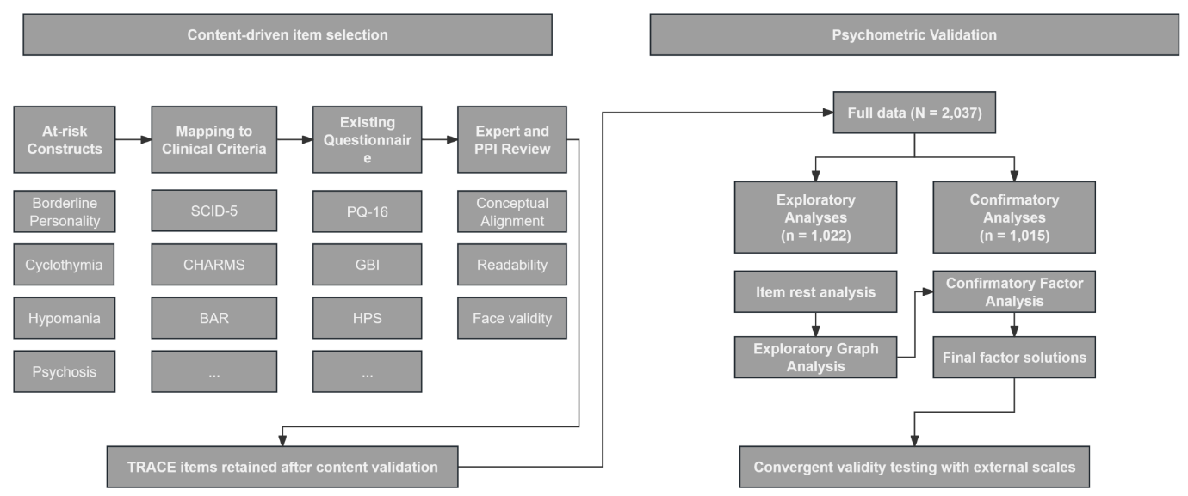
Figure 5.1
Workflow of content-driven item selection and psychometric validation of the TRACE scale
Note. Ellipses (…) indicate that there were additional diagnostic criteria/ questionnaires adopted but not displayed for simplicity, see Table E 1. SCID-5 = Structured Clinical Interview for DSM-5 Disorders; CHARMS = Clinical High At-Risk Mental States; BAR = Bipolar At-Risk Criteria; PQ-16 = Prodromal Questionnaire, 16-item version; GBI = General Behaviour Inventory; HPS = Hypomanic Personality Scale; PPI = Public and Patient Involvement.

Prodromal questionnaire 16 (PQ-16)
PQ-16 is a shortened version of the well-known Prodromal Questionnaire (Ising et al., 2012; Loewy et al., 2005), which adapted items from the Schizotypal Personality Scale and the Structured Interview for Prodromal Syndromes. It comprises 16 items assessing perceptual anomalies, unusual thought content, cognitive disorganisation, and negative symptoms. A sample item is, “I have heard things other people cannot hear, such as voices of people whispering or talking.” Each item is rated for presence (true or false) and, if endorsed, for the degree of distress on a 4-point scale (0 = no distress to 3 = severe distress). The PQ-16 has demonstrated acceptable diagnostic accuracy (cutoff ≥ 6), with approximately 87% sensitivity and specificity for identifying individuals at UHR or with psychosis. In the current study, PQ-16 showed excellent internal reliability, with a Cronbach’s alpha of .90.

General Anxiety Disorder-7 (GAD7)
The GAD-7 is a seven-item self-report questionnaire designed to assess symptoms that may indicate a risk of generalised anxiety disorder over the past two weeks (Spitzer et al., 2006). It evaluates symptoms such as anxious feelings, excessive worrying, and heightened psychomotor and emotional agitation. For instance, how often have you been bothered by feeling nervous, anxious or on edge. These symptoms are rated on a four-point ordinal scale ranging from not at all (0) to nearly every day (3). A possible total score of GAD-7 ranges between 0 and 21, with higher score indicated more severe GAD like syndromes. Existing evidence suggests a good diagnostic accuracy (cutoff ≥ 8; sensitivity and specificity > 0.80) for GAD-7 in predicting GAD (Plummer et al., 2016) and good convergent validity with other psychological and functional constructs. The internal reliability of GAD-7 was excellent in this study sample (Cronbach alpha = .92).

Patient heath questionnaire-8 (PHQ8)
The PHQ-8 is a shortened version of the PHQ-9 used to assess depressive symptoms in general and clinical populations (Kroenke et al., 2001; Kroenke et al., 2009). It evaluates depression risk based on symptom frequency over the past two weeks, including items such as feelings of worthlessness, diminished interest or pleasure, psychomotor retardation, and physical complaints (e.g., changes in concentration or appetite). For example, one item asks: “How often have you been bothered by little interest or pleasure in doing things?” The questionnaire uses a four-point ordinal scale ranging from not at all (0) to nearly every day (3). The PHQ-8 has demonstrated good diagnostic accuracy (cutoff ≥ 10) comparable to the PHQ-9 (Shin et al., 2019; Wu et al., 2020). In the current sample, internal reliability was very good (Cronbach’s α = .89).

Warwick-Edinburgh Mental Wellbeing Scales (WEMWS)
The WEMWBS is a self-report questionnaire designed to evaluate subjective and psychological wellbeing in the general population over the past two weeks (Tennant et al., 2007). It consists of 14 items relating to positive affect, psychological functioning, and social functioning. A sample item is: “I’ve been feeling useful over the last two weeks.” Responses are rated on a five-point ordinal scale ranging from none of the time (0) to all of the time (4), yielding a total score between 0 and 56, with higher scores indicating greater wellbeing. Internal reliability was excellent in the current study sample (Cronbach’s α = .94).

Sleep Condition Indicator Scale (SCIS)
The SCIS is a self-report scale designed to assess insomnia disorder and sleep-related problems in clinical settings (Espie et al., 2018; Espie et al., 2014). It consists of eight items assessing insomnia over the past month, grouped into three sections: (a) sleep difficulties during a typical night (e.g., time taken to fall asleep and frequency of awakenings), (b) the impact of poor sleep on daily functioning (e.g., mood, attention, and general wellbeing), and (c) the duration of the sleep problem. Each item is rated on a five-point reverse ordinal scale (4-0). Although the response options vary slightly across items, higher scores generally indicate less disturbed sleep or fewer negative effects of insomnia. For example, a shorter time taken to fall asleep is scored higher (4), whereas taking more than one hour is scored lower (0). The total score ranges from 0 to 32, with higher scores reflecting better sleep functioning. Initial validation studies demonstrated good convergent validity with the Pittsburgh Sleep Quality Index and the Insomnia Severity Index, and internal reliability was very good in the current study (Cronbach’s α = .87).

Everson two-item hopelessness scale (ETIHS)
The ETIHS is a self-report questionnaire designed to assess negative expectations about the future in the general population (Everson et al., 1996). It comprises two items: “I feel that it is impossible to reach the goals I would like to strive for” and “The future seems to me to be hopeless, and I can't believe that things are changing for the better.” Responses are rated on a five-point Likert scale (0 = absolutely agree; 1 = somewhat agree; 2 = cannot say; 3 = somewhat disagree; 4 = absolutely disagree). Item scores are reversed, such that higher total scores (ranging from 0 to 8) indicate more positive expectations regarding one’s ability to achieve personal goals in the future.

Analytic plans
For the psychometric analyses, the data were randomly divided into two smaller subsets. One subset was used for factor exploration (the exploratory dataset; n = 1,022), and the other was used for factor confirmation analysis (n = 1,015). The network analyses were conducted on the full dataset as well as on subgroups defined by the four age divisions and gender.

Psychometric analyses
Item-rest analysis was performed to evaluate the correlation between each item and the total score with that item excluded. This assesses each item’s association with the underlying latent construct independent of its own contribution. A cutoff correlation of r = .30 was applied; items with correlations below this threshold were excluded from further analysis.

Exploratory Graph Analysis (EGA)
EGA was used to examine the structure of these symptoms. EGA is a network theory-based method (see the “Network Analyses” section for a detailed introduction) that evaluates the psychometric structure of items based on the pattern of relationships among them. It has demonstrated performance comparable to traditional psychometric approaches (Christensen & Golino, 2021). In this study, EGA was conducted using a polychoric correlation matrix as input, and the Walktrap algorithm was applied to identify communities of items, which are interpreted as latent dimensions. The robustness of the identified structure was assessed via bootstrap resampling (1,000 iterations), yielding two indices: item stability and structural consistency. Item stability reflects the probability that a given item is consistently assigned to the same community across bootstrap samples, whereas structural consistency indicates the extent to which the overall item composition of each community is replicated across resamples. Both indices range from 0 to 1, with values above .60 generally considered stable.

Confirmatory factor analysis (CFA)
Following the EGA, CFAs were conducted using the confirmatory data to evaluate two models: a standard factor model based on the EGA-derived community structure and a bifactor model comprising a general factor alongside specific factors corresponding to the EGA dimensions. In the standard model, each latent factor was specified to load on its respective set of items. In the bifactor model, all items loaded on a general factor in addition to the specific factors revealed by the EGA, with the general and specific factors constrained to be orthogonal. To aid interpretation, factor variances were fixed at 1, allowing item loadings to be freely estimated.
Given the ordinal and non-normal distribution of the data, the Weighted Least Squares Mean and Variance adjusted (WLSMV) estimator was employed for both models, consistent with best practice for CFA with ordinal indicators. Model fit and fit indices were reported following established statistical recommendations. For the standard CFA model, internal consistency and convergent validity were assessed using composite reliability (CR) and average variance extracted (AVE), with CR values of ≥ .70 and AVE values of ≥ .50 considered acceptable. For the bifactor model, analyses focused primarily on the influence of the general factor and the reliability of the multidimensional structure. The Explained Common Variance (ECV) was estimated to quantify the proportion of common variance attributed to the general factor, while the Percent of Uncontaminated Correlations (PUC) indicated the extent to which item correlations were explained by the general dimension. Overall reliability was assessed with omega total (ω), and omega hierarchical (ωₕ) reflected the proportion of variance in total scores attributable to the general factor. Construct replicability (H) was calculated to evaluate the likelihood that the latent constructs could be reproduced across independent samples, and factor determinacy (FD) represented the correlation between estimated and true factor scores. Recommended thresholds of ECV ≥ .70, ωₕ ≥ .80, H ≥ .70, and FD ≥ .90 were used to infer strong saturation of the general factor, supporting essential unidimensionality.
Model fit was evaluated using commonly recommended indices. The chi-square test was reported for descriptive purposes, while acknowledging its sensitivity to large sample sizes. Values of the Comparative Fit Index (CFI) and Tucker-Lewis Index (TLI) of ≥ .90 were interpreted as indicating acceptable fit. Root Mean Square Error of Approximation (RMSEA) and Standardised Root Mean Square Residual (SRMR) values below .08 were also considered indicative of acceptable fit. Given the ordinal and non-normal characteristics of the data, scaled CFI and TLI, alongside robust RMSEA and SRMR estimates, were reported for comparative purposes.

Cutoff scores
The current study employed statistical approaches to estimate cutoff scores, using two methods. First, a distribution-based statistical cutoff was applied, whereby participants were classified as high-risk if their scores exceeded the 90th percentile; to account for the right-skewed distribution, the 90th percentile was calculated using linear interpolation with median-unbiased estimation. Second, latent class analysis (LCA) was conducted, a clustering method that assumes individuals belong to unobserved classes, which are reflected in systematic differences in their questionnaire responses. We identified two classes (high risk and low risk), as this solution offered greater clinical utility and demonstrated excellent entropy (.90), indicating strong discrimination between classes. The ROC (Receiver Operating Characteristic curve) was then computed using LCA-derived class membership as the reference to determine the cut-off score that best discriminates the two classes.

External validity
Criterion-related validity was examined was assessed using Cohen’s κ, with the following interpretation: poor (<0), slight (0-.20), fair (.21-.40), moderate (.41-.60), substantial (.61-.80), and almost perfect (.81-1.00), by examining the agreement between the cutoff-derived risk status and risk classifications defined by established thresholds on the PQ-16, PHQ-8, and GAD-7 (Landis & Koch, 1977). The proportion of observed agreement (Po; the probability that both raters agree) and the proportion of expected agreement (Pe; the probability of agreement by chance) were also reported since kappa value could be misleading when categories are unbalanced.
Convergent and divergent validity were assessed using Spearman correlations with conceptually related psychopathology measures (PHQ-8, GAD-7, PQ-16) and with negative, healthy-functioning validators (wellbeing and sleep quality). Positive correlations were expected with related measures and negative correlations with well-being, consistent with theoretical assumptions. A permutation ANCOVA (Freedman-Lane, np = 10,000) was conducted comparing LCA cutoff-defined groups while adjusting for Age and Gender groups; it was hypothesised that the high-risk group would score higher on related constructs and lower on negative validators. For interpretation we report adjusted means (M_{adjusted} ± SE), 95% confidence intervals, permutation F, SS, and p values, and Cliff’s delta (δ) as a robust effect size.

Network analyses
Network model can be categorised into undirected and directed models. An undirected network model comprises multiple nodes connected by edges: nodes represent symptoms and edges represent the statistical relationships between them. In conventional network models, these relationships are typically conditional dependencies, meaning that the association between any two symptoms reflects their unique statistical relationship after controlling for all other variables in the network. A positive edge indicates that the presence (or greater severity) of one symptom is associated with an increased likelihood (or greater severity) of the other, whereas a negative edge indicates the opposite. The connectivity or density of the nodes within the network, commonly defined as the proportion of non-zero edges, is frequently used as an indicator of macro network characteristics: a densely connected network is considered more vulnerable to change because symptoms can activate one another more readily, whereas a sparsely connected network is thought to be more resistant to change and less responsive to intervention.
The directed network model shares some features of the undirected one except that the links between nodes have specified directions that determined by complicated algorithms. The Bayesian network model, as a representative method of this kind, can estimate causal relationships between symptoms using several algorithms. The Inductive Causation algorithm, for example, follows a stepwise procedure: (1) it first identifies the overall structure of the system by constructing a skeleton - a network of connections between symptoms without yet assigning directions or causality; (2) it then detects v-structures, which are small configurations in which two symptoms (parents) jointly influence a common outcome (child); (3) these v-structures enable the algorithm to assign causal directions from parent symptoms to their shared outcome; and (4) the algorithm subsequently determines the directions of the remaining connections through logical deduction, ensuring that no new v-structures are introduced and that no cyclic (looping) relationships are formed. In this study, both network models were utilised to explore the structure of at-risk symptoms. The Ising Model (IM) was employed to estimate the undirected network structure, whereas the Bayesian Network Model (BNM) was applied as a supplementary method to identify the statistical representation of causal relationships. The specific procedures for these methods are detailed below.

Ising Model (IM)
The IM was estimated using the eLasso method, which combines L1-regularised logistic regression with model selection based on the Extended Bayesian Information Criterion (van Borkulo et al., 2014). This criterion serves as a goodness-of-fit measure while penalising model complexity to identify the most meaningful relationships between variables. We reported several network statistics: edge weights (reflecting the strength of conditional dependencies between symptoms) and centrality indices (e.g., node strength, defined as the sum of absolute edge weights connecting a given symptom to others) - were reported. Network stability was assessed via non-parametric bootstrapping (boot N = 2,000), and the stability of centrality measures was evaluated using the correlation stability (CS) coefficient, where values above .50 are considered acceptable. For each network, whether derived from the full sample or subgroup analyses, the stability of edge weights and centrality metrics (node strength, closeness, and betweenness) was reported for reference.

Bayesian Network Model (BNM)
The BNM is a Directed Acyclic Graph (DAG) that represents probabilistic dependencies between variables through directed edges, allowing for causal structure analysis (Scutari, 2010). Unlike IM, which capture undirected conditional dependencies, BNM explicitly encodes parent-child relationships, offering a more mechanistically informed representation of the at-risk mental status. The algorithms for BNM estimation and evaluation were selected based on model fit indices, including the Akaike Information Criterion (AIC) and Bayesian Information Criterion (BIC), to determine the optimal method. The Custom Hybrid Structure Learning Approach, detailed below, integrated both Constraint-Based Learning (CBL) and Score-Based Learning (SBL), and demonstrated the strongest model fit (AIC = -32960.1, BIC = -33176.44). CBL: The PC-stable algorithm, using Mutual Information (MI) as the conditional independence test, was employed to identify direct dependencies. This method was particularly suited for the binary nature of the data, as it efficiently captures nonlinear associations in discrete datasets. SBL: The Hill-Climbing (HC) algorithm was applied to refine the structure, optimizing the BIC score to ensure the best trade-off between model complexity and data likelihood (Scutari, 2017). To ensure the robustness of the estimated BN structure, we applied a bootstrapping procedure (N = 2,000 resamples), validating the stability of detected edges. The final reported network retained only edges present in at least 70% of bootstrap samples, while directionality was considered stable if observed in ≥ 60% of cases. Edges with directionality between 40-59% were interpreted as bidirectional, accounting for possible reciprocal influences in symptom relationships. This approach ensured that the final BNM represents stable probabilistic dependencies, reducing the influence of sample-specific variations. Thus, only the bootstrapped structure is reported, as it provides an empirically justified and interpretable dynamics of at-risk states (Friedman et al., 1999).

Network comparisons test (NCT)
NCTs were performed to compare age and gender subgroups, with the hyperparameter gamma set to 0.25 to account for binary data (van Borkulo et al., 2023). Global strength (S₀) and maximum edge difference (E) were assessed using 2,000 permutations. When either test yielded significant results, post hoc analyses with BH were conducted to examine specific edge differences and variations in node strength across subgroups.

Statistics and software
Descriptive statistics were reported for demographic variables and the TRACE questionnaire. Age, education level, and TRACE distress scores were summarised as means and standard deviations (M ± SD), while gender, ethnicity, and family history of mental illness were presented as proportions. Differences in TRACE distress scores between groups were assessed using the Wilcoxon rank-sum test, with p-values adjusted using the Benjamini-Hochberg method. All analyses were conducted in R. The psych and lavaan packages were used for psychometric analyses; bnlearn, bootnet, and qgraph were used for network estimation and visualisation; and the NetworkComparisonTest package was used to perform the NCT.

Results
Based on the criteria for different at-risk mental states, we selected up to three questions to correspond to each symptom domain. 212 candidate items were identified from 28 questionnaires. 71 items passed the face-validity and linguistic-quality checks and were rephrased in the first person and past tense to align with the style of the well-established PQ-16. These items were then reviewed by clinicians, young people, and individuals with lived experience of mental health difficulties to assess readability and clinical appropriateness. Following this review, 37 items were retained for initial psychometric testing, which are detailed in Table 5.2.

Table 5.2
Full item pool prior to psychometric evaluation
Item | Content
TR1 | I have had motivation to do things.
TR2 | There have been times when I was so restless that it was impossible for me to sit still.
TR3 | I have behaved impulsively and later regretted it.
TR4 | I have had been interested in getting to know other people
TR5 | I have often found that my thoughts were racing.
TR6 | I have heard sounds that were not there.
TR7 | During the last month, my mood became extremely low for a period of a few days.
TR8 | Somebody who I thought was going to be very special quickly turned out to be a huge disappointment.
TR9 | I have felt suddenly distracted by distant sounds that I am not normally aware of.
TR10 | I have been concerned that my closest friends or co-workers were not really loyal or trustworthy.
TR11 | There have often been times when I had such an excess of energy that I felt little need to sleep at night.
TR12 | I have found it easy to organise my thoughts or to find the right words.
TR13 | I often got into excited moods where it was almost impossible for me to stop talking.
TR14 | I often had moods where I felt so energetic and optimistic that I felt I could outperform almost anyone at anything.
TR15 | I have often felt empty.
TR16 | I have had periods of extreme happiness and high energy lasting several days or more.
TR17 | I have confused whether something I experienced was real or imaginary.
TR18 | My familiar surroundings have occasionally appeared to be changed, unreal, or strange.
TR19 | I have had periods lasting several days or more when I felt depressed or irritable, and then other periods of several days or more when I felt extremely high, elated, and overflowing with energy.
TR20 | I did most of my work during brief periods of intense inspiration.
TR21 | There have been times when, although I was feeling unusually happy and intensely energetic, almost everything got on my nerves and made me irritable or angry (other than related to the menstrual cycle).
TR22 | I have thought that I am very important or have abilities that are out of the ordinary.
TR23 | When something bad happened, my mood changed very quickly and it took me a long time to calm down.
TR24 | I have sometimes had too many thoughts going through my head without any connection between them.
TR25 | I have felt that everyday things had a special meaning just for me.
TR26 | I have often felt that I have no idea of who I am or that I have no identity.
TR27 | I have had nothing to say or very little to say.
TR28 | I have got so angry, I have felt like I might lose control. If TRUE: "Anger Control Problems
TR29 | I have mistaken shadows for people or noises for voices.
TR30 | I have often had a feeling that something strange and unusual is happening around me.
TR31 | I have made desperate efforts to avoid feeling abandoned or being abandoned (e.g., repeatedly called someone to reassure myself that he or she still cared, begged them not to leave me, clung to them physically).
TR32 | In the last month, I have engaged in very pleasurable but reckless and risky activities.
TR33 | I have mistaken shadows for people or noises for voices.
TR34 | I have felt emotionally numb.
TR35 | I have been preoccupied with unusual, magical, or supernatural things or ideas.
TR36 | I have had thoughts that other people would think are strange.
TR37 | My thinking has felt confused, muddled, or disturbed in some way.

EGA
Item-rest analysis indicated that TR1 and TR4 showed weak correlations with the latent structure (r < .30) once their own influence was removed; therefore, both items were excluded from subsequent analyses. EGA initially identified a three-dimensional structure across the 35 items; however, nine items demonstrated insufficient item stability (< .60): TR2 (Restlessness), TR8 (Interpersonal Instability), TR10 (Paranoia), TR11 (Increased Energy), TR28 (Difficulties in Anger Control), TR31 (Fear of Abandonment), TR32 (Reckless Behaviour), TR35 (Magical Thinking), and TR36 (Odd Thoughts). After removing these unstable items, the three-dimensional structure remained, comprising affective-cognitive dysregulation, reality distortion, and hypomania. All three dimensions demonstrated very high structural consistency (> .85). Among the remaining 26 items, item stability was excellent (> .90) for all except TR33, which was also high but slightly below this threshold. The empirical structure of the final 26-item solution is shown in Figure 5.2.

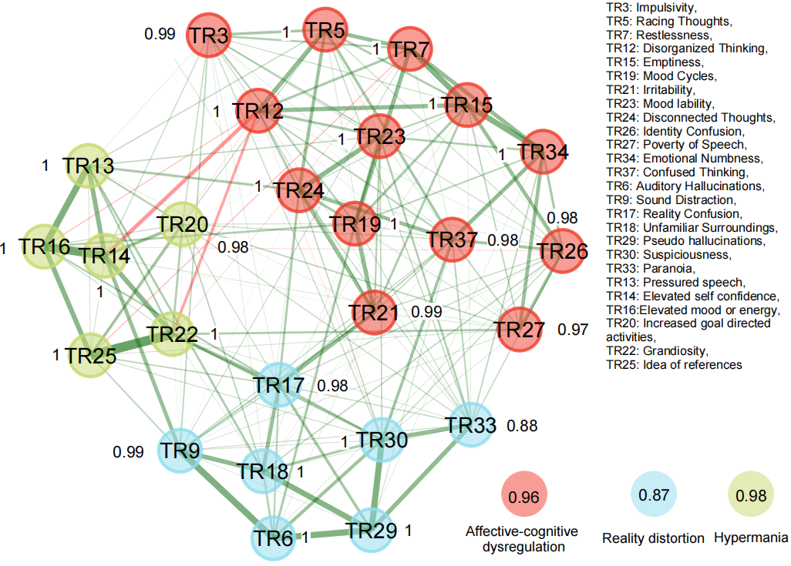
Figure 5.2
The empirical structure obtained from EGA for the remaining TRACE items
Note. Colours indicate the community (dimension) membership of each node. Values displayed next to the nodes represent item stability, estimated from 1,000 bootstrapped resamples. Structural consistency values for each community are shown in the community nodes at the bottom right.

CFA
CFA was conducted on the refined 26-item measure to evaluate the fit of the previously identified three-factor structure. The model was successfully replicated and demonstrated acceptable fit, with a scaled CFI of 0.93 and TLI of 0.92. The robust RMSEA was .073 and the SRMR was .065, both within the acceptable-to-good range. Factor correlations were moderate to high: r = .51 (affective-cognitive dysregulation and hypomania), r =.72 (reality distortion and hypomania), and r =.79 (affective-cognitive dysregulation and reality distortion), indicating that the factors were distinct yet strongly related. The model also demonstrated acceptable internal consistency and convergent validity. Composite reliability (CR) estimates were high across factors, ranging from .84 to .88. Average variance extracted (AVE) values ranged from .43 to .57, indicating acceptable convergent validity for most factors. Although the AVE for Factor 1 fell slightly below the commonly recommended threshold of .50, its high CR value suggests that the construct retains adequate reliability. Factor loadings and validity statistics are presented in Table 5.3.

Table 5.3
Factor loadings of the CFA
Items | Short names | Factor 1 | Factor 2 | Factor 3 | R²
TR3 | Impulsivity | .60 | - | - | .36
TR5 | Racing thoughts | .59 | - | - | .35
TR7 | Low mood | .66 | - | - | .44
TR12 | Disorganized thinking | .32 | - | - | .10
TR15 | Emptiness | .67 | - | - | .45
TR19 | Mood cycle | .71 | - | - | .50
TR21 | Irritability | .71 | - | - | .50
TR23 | Mood lability | .68 | - | - | .48
TR24 | Disconnected thoughts | .74 | - | - | .55
TR26 | Identity confusion | .70 | - | - | .49
TR27 | Poverty of speech | .61 | - | - | .37
TR34 | Emotional numbness | .72 | - | - | .52
TR37 | Confused thinking | .75 | - | - | .56
TR6 | Auditory hallucinations | - | .71 | - | .50
TR9 | Sound distraction | - | .74 | - | .55
TR17 | Reality confusion | - | .79 | - | .62
TR18 | Precepted oddity in familiar surroundings | - | .75 | - | .56
TR29 | Pseudo hallucinations | - | .74 | - | .74
TR30 | Suspiciousness | - | .80 | - | .64
TR33 | Paranoia | - | .67 | - | .45
TR13 | Pressured speech/ talkative | - |  | .73 | .53
TR14 | Elevated self-confidence | - |  | .79 | .62
TR16 | Elevated mood or energy | - |  | .77 | .59
TR20 | Increased goal directed activities | - |  | .72 | .52
TR22 | Grandiosity | - |  | .81 | .65
TR25 | Idea of reference | - |  | .72 | .52
 |  | Factor 1 | Factor 2 | Factor 3
Alpha |  | .91 | .89 | .88
Omega |  | .88 | .84 | .84
AVE |  | .43 | .55 | .57
Note. Factor loadings represent standardized estimates from the CFA. R² indicates the variance explained by each factor. Alpha = ordinal Cronbach’s alpha; Omega = ordinal McDonald's omega; AVE = average variance extracted. Given the ordinal and skewed nature of the data, Omega and AVE were prioritised for evaluating reliability and validity, while Alpha was reported for reference. Items with loadings below .60 are bolded.

To further evaluate the factor structure, a bifactor model was tested. This model specified one general factor capturing shared variance across all items, alongside three orthogonal specific factors. The bifactor model demonstrated improved fit relative to the three-factor model (CFI = .96, TLI = .95, RMSEA = .064, 90% CI [.058, .070], SRMR = .049). The model is best characterised as an incomplete bifactor structure, whereby some items (with the exception of auditory hallucinations, those measuring reality distortion) load solely on the general factor and not on any specific factor. Table 5.4 presents the factor loadings of the model.

Table 5.4
Factor loadings of the bi-factor model
Items | Short names | GF | F1 | F2 | F3 | R² (GF/SF)
TR3 | Impulsivity | .48 | .35 |  |  | .23/ .13
TR5 | Racing thoughts | .38 | .53 |  |  | .14/ .28
TR7 | Low mood | .43 | .57 |  |  | .19/ .33
TR12 | Disorganized thinking | .04 | .65 |  |  | .002/ .42
TR15 | Emptiness | .44 | .59 |  |  | .19/ .35
TR19 | Mood cycle | .60 | .33 |  |  | .36/ .11
TR21 | Irritability | .62 | .30 |  |  | .38/ .09
TR23 | Mood lability | .50 | .48 |  |  | .25/ .23
TR24 | Disconnected thoughts | .60 | .42 |  |  | .36/ .18
TR26 | Identity confusion | .54 | .44 |  |  | .29/ .19
TR27 | Poverty of speech | .51 | .30 |  |  | .26/ .09
TR34 | Emotional numbness | .55 | .46 |  |  | .30/ .21
TR37 | Confused thinking | .65 | .32 |  |  | .42/ .10
TR6 | Auditory hallucinations | .68 |  | .68 |  | .46/ .46
TR9 | Sound distraction | .73 |  | .19 |  | .53/ .03
TR17 | Reality confusion | .80 |  | .04 |  | .63/ .002
TR18 | Precepted oddity in familiar surroundings | .76 |  | .04 |  | .57/ .002
TR29 | Pseudo hallucinations | .72 |  | .20 |  | .52/ .04
TR30 | Suspiciousness | .81 |  | -.01 |  | .66/ .0001
TR33 | Paranoia | .68 |  | -.11 |  | .46/ .01
TR13 | Pressured speech/ talkative | .52 |  |  | .49 | .27/ .24
TR14 | Elevated self-confidence | .53 |  |  | .64 | .28/ .41
TR16 | Elevated mood or energy | .53 |  |  | .58 | .28/ .34
TR20 | Increased goal directed activities | .54 |  |  | .40 | .29/ .16
TR22 | Grandiosity | .57 |  |  | .57 | .32/ .32
TR25 | Idea of reference | .50 |  |  | .54 | .25/ .29
Note. GF = General factor; F1-F3 = Factor 1-Factor 3; GF/SF = proportion of variance explained by general or specific factors.

The bifactor structure showed strong saturation of the general factor, with an Explained Common Variance (ECV) of 64% and a Percent of Uncontaminated Correlations (PUC) of 65%. Omega total (ω) was .93, and omega hierarchical (ωₕ) was .75, indicating good overall reliability. At the factor level, construct replicability was acceptable for specific Factor 1 (affective and cognitive dysregulation; H = .79) and specific Factor 3 (hypomania; H = .72), whereas specific Factor 2 (reality distortion) showed weaker replicability (H = .49). This suggests that Factor 2 may not represent a distinct or reliably measured construct within this model; therefore, interpretations involving this factor should be approached with caution.

External validity

Cutoff scores
The estimated cut-off at the 90th percentile was 66, with n = 102 participants exceeding this score and thereby classified as a high-risk group, accounting for 10.05% of the confirmatory sample. Meanwhile, the response patterns of the LCA-identified high- and low-risk groups are presented in Figure 5.3. ROC analysis indicated that a cut-off score of 46 provided the best discrimination between the high- and low-risk groups, yielding an AUC of .99, with both specificity and sensitivity of .96. Based on the LCA-derived cut-off, 461 participants were classified as high-risk individuals.

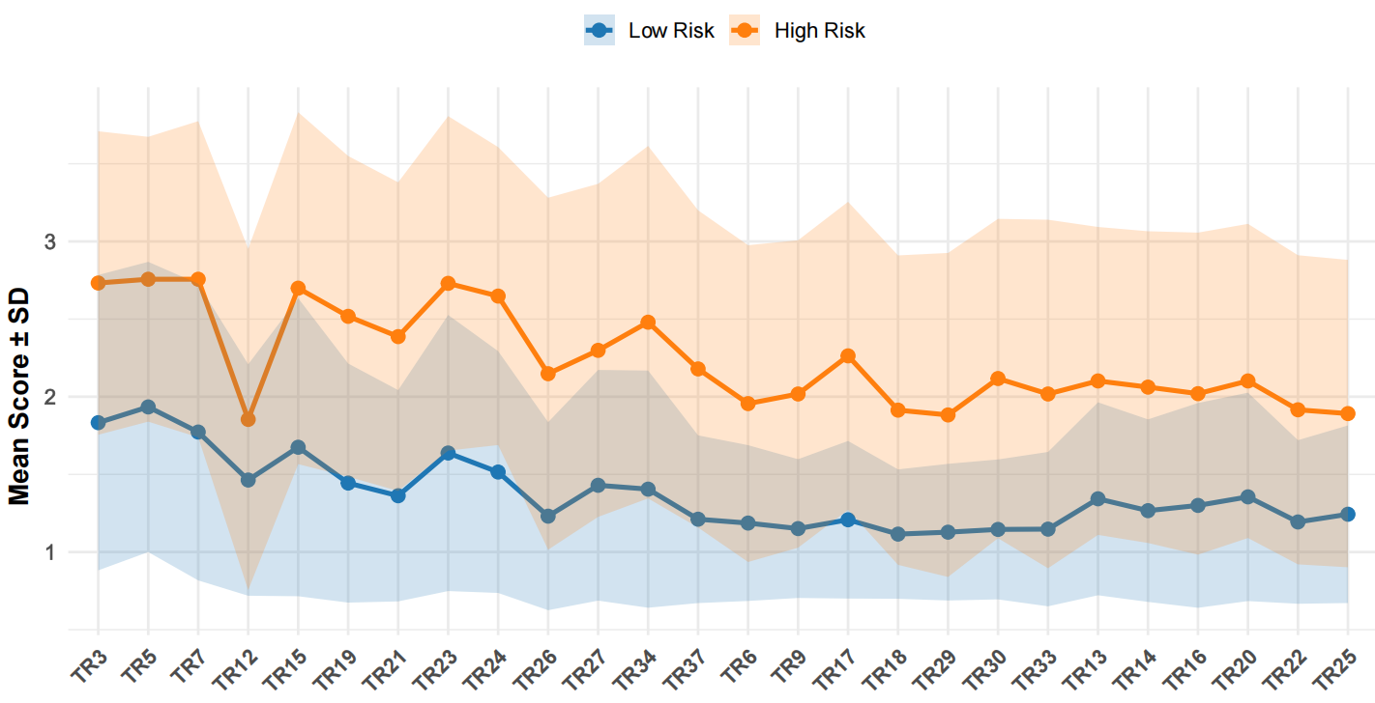

Figure 5.3
Response patterns by risk groups
Note. Statistics are based on the confirmatory dataset (n = 1,015). Item codes correspond to the following constructs: TR3 = Impulsivity, TR5 = Racing thoughts, TR7 = Low mood, TR12 = Disorganized thinking, TR15 = Emptiness, TR19 = Mood cycle, TR21 = Irritability, TR23 = Mood lability, TR24 = Disconnected thoughts, TR26 = Identity confusion, TR27 = Poverty of speech, TR34 = Emotional numbness, TR37 = Confused thinking, TR6 = Auditory hallucinations, TR9 = Sound distraction, TR17 = Reality confusion, TR18 = Percepted oddity in familiar surroundings, TR29 = Pseudo hallucinations, TR30 = Suspiciousness, TR33 = Paranoia, TR13 = Pressured speech/talkative, TR14 = Elevated self-confidence, TR16 = Elevated mood or energy, TR20 = Increased goal-directed activities, TR22 = Grandiosity, TR25 = Idea of reference.

Criterion-related validity
The agreement between the percentile cut-off and the PQ-16 cut-off was very low (Cohen’s κ = .19, 95% CI [.16, .23]; Po = 59%, Pe = 49%). Agreements were similarly low for the PHQ-8 cut-off (Cohen’s κ = .15, 95% CI [.11, .19]; Po = 61%, Pe = 54%), the GAD-7 cut-off (Cohen’s κ = .15, 95% CI [.11, .19]; Po = 60%, Pe = 53%), and self-reported FHR status (Cohen’s κ = .13, 95% CI [.08, .18]; Po = 66%, Pe = 61%). In contrast, agreement between the LCA cut-off and the PQ-16 was substantial (Cohen’s κ = .65, 95% CI [.60, .70]; Po = 82%, Pe = 49%). Agreement between the LCA cut-off and the PHQ-8 (Cohen’s κ = .40, 95% CI [.34, .45]; Po = 70%, Pe = 50%) and FHR status (Cohen’s κ = .22, 95% CI [.16, .28]; Po = 62%, Pe = 51%) was fair, while agreement with the GAD-7 cut-off was moderate (Cohen’s κ = .45, 95% CI [.39, .50]; Po = 73%, Pe = 50%).

Convergent and divergent validity
The TRACE total score was positively associated with the sum scores of the PQ-16 (r = .83, p < .001), PHQ-8 (r = .59, p < .001), GAD-7 (r = .62, p < .001), and hopelessness (r = .30, p < .001), and negatively associated with sleep quality (r = -.41, p < .001) and wellbeing (r = -.23, p < .001). Correlations between the TRACE subdimensions and the external questionnaires were broadly consistent with those observed for the total score. Specifically, (a) affective-cognitive dysregulation showed positive associations with the PQ-16 (r = .72, p < .001), PHQ-8 (r = .64, p < .001), GAD-7 (r = .68, p < .001), and hopelessness (r = .36, p < .001), and negative associations with sleep quality (r = -.47, p < .001) and wellbeing (r = -.40, p < .001); (b) reality distortion was positively associated with the PQ-16 (r = .78, p < .001), PHQ-8 (r = .47, p < .001), GAD-7 (r = .68, p < .001), and hopelessness (r = .22, p < .001), and negatively associated with sleep quality (r = -.32, p < .001) and wellbeing (r = -.10, p < .001); and (c) hypomania was positively associated with the PQ-16 (r = .56, p < .001), PHQ-8 (r = .19, p < .001), GAD-7 (r = .21, p < .001), hopelessness (r = .07, p < .05), and wellbeing (r = .19, p < .001), and negatively associated with sleep quality (r = -.08, p < .05).

Adjusted Group Differences on External Measures
After adjusting for the variance contributed by age and gender groups, the difference on the PQ-16 between the high-risk (M_{adjusted} = 14.21, SE = 0.30, 95% CI [13.62, 14.79]) and low-risk group (M_{adjusted} = 3.38, SE = 0.27, 95% CI [2.84, 3.91]) was statistically significant, F (1, 1009) = 734.54, SS = 29279.49, permutation p < .001, with a large effect size, δ = -.815 (95% CI [-.857, -.762]), indicating that scores in the high-risk group are generally higher than in the low-risk group. The high-risk group (M_{adjusted} = 12.43, SE = 0.24, 95% CI [11.90, 12.90]) exhibited higher PHQ severity than the low-risk group (M_{adjusted} = 6.44, SE = 0.22, 95% CI [6.0, 6.87]). This difference was statistically significant, F (1, 1009) = 337.11, SS = 8960.20, permutation p < .001, with a larger effect size, δ = -.58 (95% CI [-.63, -.52]). Individuals from high-risk group (M_{adjusted} = 11.17, SE = 0.23, 95% CI [10.72, 11.63]) reported higher GAD severity than those of low-risk group(M_{adjusted} = 5.14, SE = 0.21, 95% CI [4.72, 5.56]), and the difference was statistically significant, F (1, 1009) = 371.06, SS = 9089.10, permutation p < .001, with a larger effect size, δ = -.61 (95% CI [-.66, -.55]). The difference in hopelessness between the high-risk (M_{adjusted} = 4.61, SE = 0.11, 95% CI [4.40, 4.82]) and low-risk groups (M_{adjusted} = 3.52, SE = 0.10, 95% CI [3.32, 3.71]) was statistically significant, F (1, 1009) = 50.09, SS = 297.38, permutation p < .001, with a small effect size, δ = -.27 (95% CI [-.33, -.20]), indicating that high-risk individuals generally report higher levels of hopelessness than the low-risk group.
For the opposing constructs, the pattern observed in the related constructs was reversed. The difference in sleep quality between the low-risk (M_{adjusted} = 21.30, SE = 0.31, 95% CI [20.60, 21.90]) and high-risk groups (M_{adjusted} = 15.90, SE = 0.34, 95% CI [15.30, 16.60]) was statistically significant, F(1, 1009) = 133.26, SS = 7,049, permutation p < .001, with a medium effect size, δ = .38 (95% CI [.32, .44]). This indicates that individuals in the low-risk group reported substantially higher sleep quality than those in the high-risk group. Similarly, individuals in the low-risk group (M_{adjusted} = 45.70, SE = 0.47, 95% CI [44.80, 46.60]) reported higher wellbeing than those in the high-risk group (M_{adjusted} = 41.20, SE = 0.52, 95% CI [40.20, 42.20]). This difference was statistically significant, F (1, 1009) = 42.10, SS = 5,052, permutation p < .001, with a small effect size, δ = .23 (95% CI [.16, .30]), indicating that low-risk individuals tend to report a higher degree of wellbeing than high-risk individuals.

Descriptive statistics of the TRACE scale
The most frequently endorsed TRACE item was TR5 (Racing thoughts), reported by 75.45% of the sample. In contrast, the least commonly endorsed item was TR18 (Perceived oddity in familiar surroundings), experienced by 29.36% of participants. In terms of distress ratings, TR15 (Emptiness) was perceived as the most distressing, with 16.94% of the sample assigning it the highest distress rating. Conversely, TR5 (Racing thoughts) was most frequently rated as the least distressing experience, with 26.22% of participants selecting this rating. See Figure E 2 for detailed item-level distributions.
Dimensional comparisons of TRACE total and subscale scores were conducted across gender and age subgroups. No significant differences were found in total distress levels between gender or age groups (p > .05). However, differences emerged across specific dimensions: female participants reported significantly higher distress on the affective-cognitive dysregulation dimension compared to males (p < .001, r = .08), while males reported greater distress on the reality distortion (p < .001, r = .13) and hypomania (p < .001, r = .10); adolescents reported the lowest distress levels for hypomania when compared to all adult subgroups (p < .001, r range = .11-.21). Similarly, younger adults (aged 18-24) reported lower distress for hypomania than participants aged 25-29 (p < .001, r = .10) and those aged 30-36 (p < .05, r = .07). see Table 5.5 for details.

Table 5.5
Descriptive statistics of the interested variables among subgroups
Variables | Females | Males | Age 14-17 | Age 18-24 | Age 25-29 | Age 30-36
n | 1036 | 988 | 353 | 570 | 485 | 629
Age | 24.9 (6.56) | 25.8 (6.24) | 16 (0.94) | 21.3(2.19) | 27 (1.40) | 32.9 (1.95)
Females | 100% | 0% | 64.66% | 54.24% | 50.21% | 50.64
White British | 60.3% | 62% | 50.7% | 60.9% | 60.2% | 67.9%
Education level (college level and above) | 41.3% | 51.7% | 0% | 34.2% | 64.9% | 68.7%
Family history of mental illness (Yes) | 37.4% | 35.2% | 26.6% | 36.5% | 42.5% | 36.7%
TRACE total | 19.8 (13.9) | 20.4 (14.6) | 19.6 (13.7) | 19.4 (13.3) | 21.4 (14.4) | 20.0 (15.2)
Affective-cognitive dysregulation | 13.2 (8.85) *** | 11.8 (8.32) | 13.2 (8.93) | 12.4 (8.34) | 13.1 (8.64) | 12.0 (8.72)
Reality distortion | 3.46 (4.24) | 4.20 (4.54) *** | 3.86 (4.38) | 3.67 (4.11) | 4.05 (4.48) | 3.79 (4.62)
Hypomania | 3.12 (3.43) | 4.34 (4.26) *** | 2.56 (3.06) ª | 3.32 (3.42) ^{b} | 4.28 (4.12) | 4.24 (4.36)
Note. The number of participants who did not disclose their gender identity was distributed as follows: Age 14-17 (n = 5), Age 18-24 (n = 4), Age 25-29 (n = 3), and Age 30-36 (n = 1). ª Age 18-24/ Age 25-29/ Age 30-36 > Age 14-17***. ^{b} Age 25-29***/ Age 30-36* > Age 18-24. *p < .05, **p < .01, ***p < .001.

Network statistics

IM in all sample

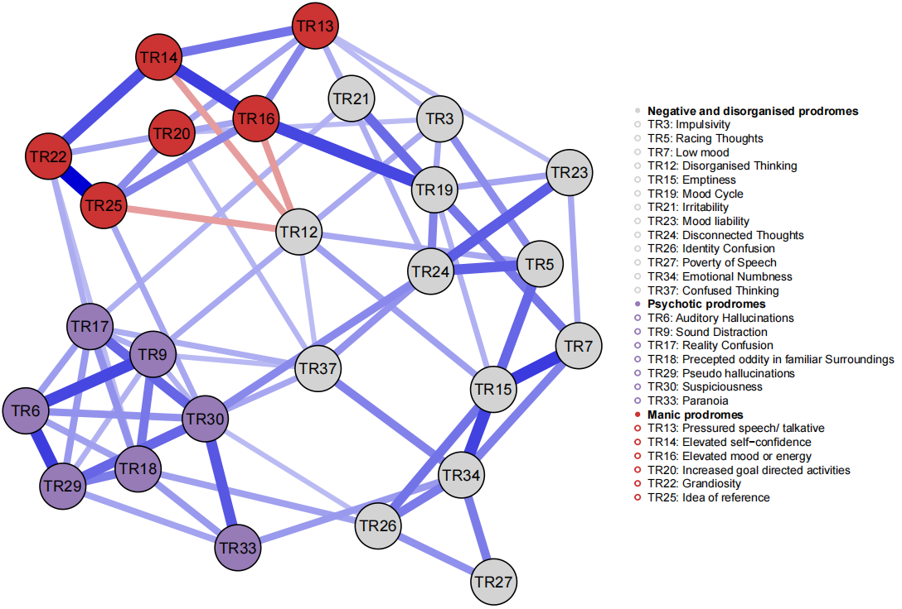
Figure 5.4
The Ising Model (IM) network structure of prodromal symptoms
Note. Blue edges indicate positive relationships, while red edges reflect negative correlations. The threshold for edge weights was set at 0.2 to improve readability.

The Ising model structure is presented in Figure 5.4. The node and edge statistics was fairly stable, with all CS coefficient value pass .50. Among all nodes, TR30 (Suspiciousness) exhibited the highest strength centrality, indicating a high level of interconnectedness with other prodromal symptoms. In contrast, TR27 (Poverty of Speech) showed the lowest strength centrality, suggesting a more peripheral position within the network. Regarding bridge centrality, TR26 (Identity Confusion) demonstrated the highest bridge strength, highlighting its role as a key connector between different symptom domains. Conversely, TR13 (Pressured speech/ talkative) had the lowest bridge strength, implying that its associations were largely confined within its own symptom cluster, see Figure 5.5 for details.

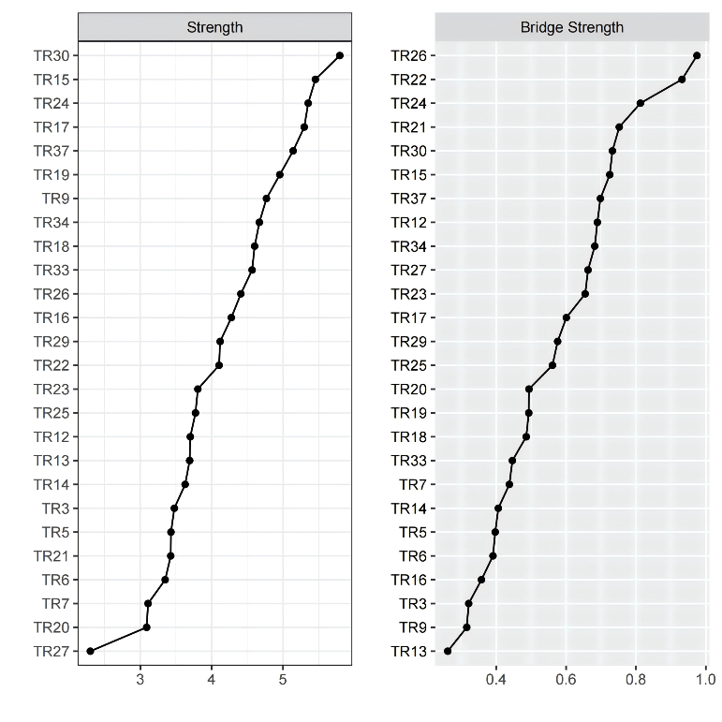
Figure 5.5
Node centralities in the IM network structure
Note. Centrality values are presented as raw coefficients for both node strength and bridge strength. TR3: Impulsivity, TR5: Racing Thoughts, TR7: Low mood, TR12: Disorganised Thinking, TR15: Emptiness, TR19: Mood Cycle, TR21: Irritability, TR23: Mood lability, TR24: Disconnected Thoughts, TR26: Identity Confusion, TR27 Poverty of Speech, TR34 Emotional Numbness, TR37 Confused Thinking,TR6: Auditory Hallucinations, TR9: Sound Distraction, TR17: Reality Confusion, TR18: Precepted oddity in familiar Surroundings, TR29: Pseudo hallucinations, TR30: Suspiciousness, TR33: Paranoia, TR13: Pressured speech/ talkative, TR14: Elevated self-confidence, TR16: Elevated mood or energy, TR20: Increased goal directed activities, TR22: Grandiosity, TR25: Idea of reference.

The Ising Model network revealed that the strongest edge was observed within the manic prodrome cluster, specifically between TR22 (Idea of reference) and TR25 (Grandiosity), w = 1.14, 95% bootstrap confidence interval (CI) [0.91, 1.37]. In contrast, the weakest edge was found between TR12 (Disorganised thinking) and TR34 (Emotional numbness), both from the affective-cognitive dysregulation domains, w = 0.03, 95% CI [-0.12, 0.18]. The strongest cross-domain connections included: (a) TR16 (Elevated mood or energy) and TR19 (Mood cycle), linking the affective-cognitive dysregulation and hypomania, w = 0.83, 95% CI [0.59, 1.06]; (b) TR24 (Disconnected thoughts) and TR30 (Suspiciousness), linking the affective-cognitive dysregulation and reality distortion, w = 0.53, 95% CI [0.26, 0.80]; and (c) TR25 (Grandiosity) and TR30 (Suspiciousness), linking the hypomania and reality distortion, w = 0.39, 95% CI [0.13, 0.65], see Table E 2 for reference.
The connectivity (number of edges with non-zero weight/ total number of edges) between dimensions was ranged as followings: hypomania and reality distortion (23/42, 54.76%), reality distortion and affective-cognitive dysregulation (42/91, 46.15%), and hypomania and affective-cognitive dysregulation (17/78, 21.79%). No significant differences in average absolute edge weights were found between any pair of at-risk domains. All bootstrapped confidence intervals for between-domain comparisons crossed zero across 2,000 samples, indicating a lack of robust differentiation in overall connectivity strength between domains.

BNM in all sample

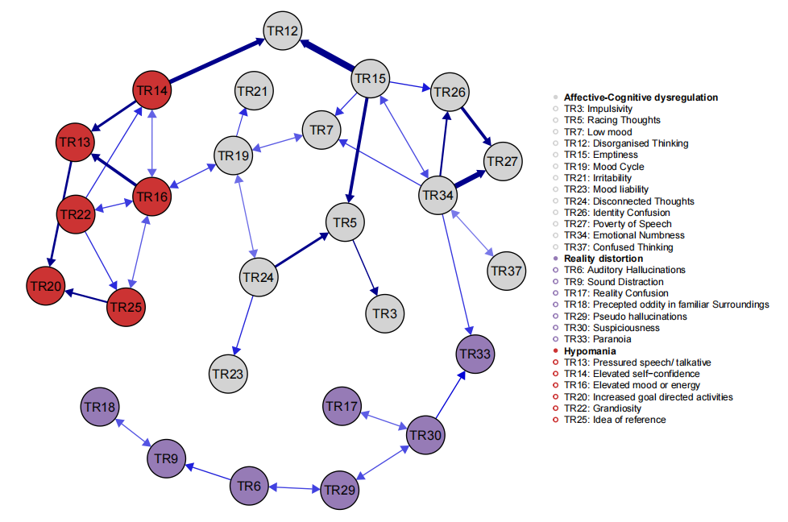
Figure 5.6
The Bayesian Network (BN) structure of at-risk symptoms
Note. Edges indicate the most probable direction of causal influence, estimated from bootstrapped Bayesian Network structures. A directionality threshold of .40 was applied, such that bidirectional arrows are displayed when both directional probabilities exceed .40, reflecting uncertainty or mutual dependence in the causal ordering of nodes.

The BNM (Figure 5.6) revealed meaningful causal links both within and between the three clusters of at-risk mental states. The confidence in direction and edge presence is available in Table E 3. Most directional relationships were identified within clusters rather than across them. In the affective-cognitive dysregulation domain, the directed link from TR15 (Emptiness) to TR12 (Disorganised thinking) emerged as the most confident arc in the entire network. In addition, TR15 was also found to exert probabilistic influences on TR5 (Racing thoughts) and TR26 (Identity confusion), with decreasing confidence approaching the threshold for directionality. Beyond the influence of TR15, TR5 also appeared to be affected by TR25 (Disconnected thoughts). These findings suggest that emotional emptiness may act as a central driver of identity confusion and thought disorganisation. Another notable directed connection within this domain was observed from TR34 (Emotional numbness), also the most connected symptom within this domain, to TR27 (Poverty of speech), with further probabilistic influences from TR34 to TR7 (Low mood) and TR26. These results suggest that emotional numbness may contribute to reduced affective expression and diminished cognitive engagement, potentially linking affective blunting with thought and speech impoverishment. Collectively, these findings indicate that emotional emptiness and emotional numbness may play pivotal roles in shaping affective and cognitive symptoms within this cluster.
In the hypomanic domain, TR13 (Pressured speech/Talkativeness) emerged as a child node of TR14 (Elevated self-confidence) and TR16 (Elevated mood or energy), suggesting that elevations in mood and self-image may give rise to cognitive anomalies, such as impairments in executive functioning. TR16 was among the most connected nodes within this domain, although the causal direction of several links remained uncertain. Directed links from TR22 (Grandiosity) to TR14 and TR25 (Ideas of reference) indicate that grandiosity may serve as a common antecedent of alterations in self-identity and related perceptual experiences. Collectively, these findings suggest that elevated mood and energy - and, to a lesser extent, grandiosity - may drive many of the symptoms within the hypomanic cluster.
The causal links within the reality distortion domain were less complex and generally less confident. TR30 (Suspiciousness) appeared to be influenced by TR33 (Paranoia) and to have possible bidirectional relationships with TR17 (Reality confusion) and TR29 (Pseudo-hallucinations). Another meaningful directed link was observed from TR6 (Auditory hallucinations) to TR9 (Sound distraction), suggesting that auditory hallucinations may contribute to increased distractibility by ‘external’ sounds.
Only three directed edges were identified across the three domains. Two of these connected the hypomanic and affective-cognitive clusters. The most confident of these was from TR14 (Elevated self-confidence) to TR12 (Disorganised thinking), while a bidirectional association was observed between TR16 (Elevated mood or energy) and TR19 (Mood cycle), highlighting the potential interplay between mood elevation and cognitive dysfunction. The remaining cross-domain link was from TR34 (Emotional numbness) to TR33 (Paranoia), indicating a close connection between negative and psychotic-like traits.

Network comparison among subgroups
The stabilities of node centralities and edge statistics were low to moderate (i.e., CS coefficient: 0-.44) for most of the subgroups, with the exception of edge weights observed in the oldest age group (30-36 years) and gender subgroups. The low stability is likely due to smaller subgroup sample sizes. Therefore, findings from the NCT, particularly those involving age group comparisons, should be interpreted with caution.

IMs in participants of different age groups
The networks for different age groups are visualised in Figure E 3. A general pattern was observed in node strength, which tended to increase with age. Visual inspection revealed that the adolescent group (14-17 years old) exhibited lower node strength across most items compared to older participants. For example, nodes such as TR3 (Impulsivity), TR13 (Pressured Speech/Talkative), TR17 (Reality Confusion), TR25 (Idea of Reference), and TR37 (Confused Thinking) showed reduced centrality in adolescents. In contrast, node strength appeared higher among adults, particularly those aged 30-36 years. Notable examples include TR16 (Elevated Mood or Energy), TR20 (Increased Goal-Directed Activity), and TR24 (Disconnected Thoughts).
With regard to bridge centrality, TR33 (Paranoia) emerged as the node with the highest bridge strength in both the youngest (14-17 years) and oldest (30-36 years) groups. In contrast, TR30 (Suspiciousness) was the most central bridging node among the two middle age groups (18-29 years). The node with the lowest bridge strength varied across subgroups; however, most such nodes were observed in the youngest group and exhibited a nearly flat line on the graph, indicating minimal cross-domain influence (see Figure E 4 for details).
Edge weights also varied across age groups. For instance, the strongest edge in the youngest group was between TR6 (Auditory Hallucinations) and TR29 (Pseudo-Hallucinations), whereas in the oldest group, it was between TR14 (Elevated Self-Confidence) and TR16 (Elevated Mood or Energy). Notably, only participants aged 18-25 years exhibited an edge structure similar to that of the full sample, which may be attributable to sample size differences across groups. The weakest edge weights also differed across age groups (see Tables E 4-7 for full edge statistics).
At a broader level, the average absolute edge weights (i.e., weighted network density) increased with age and were reported as follows: .07 (14-17 years), .12 (18-24 years), .12 (25-29 years), and .15 (30-36 years). The proportion of non-zero edges was also age-dependent, with the adolescent network exhibiting the lowest density (18%) and the oldest group the highest (41%). While no significant differences in network connectivity or structure were observed between the two middle age groups, the Network Comparison Test (NCT) revealed statistically significant differences in global connectivity between the youngest and oldest groups (S₀ = 27.02, p < .001), as well as between the 18-24 and 30-36 age groups (S₀ = 12.69, p < .01). A significant difference in overall network structure was also found between the youngest and oldest groups (E = 1.15, p < .05), prompting a post hoc test. However, the post hoc analysis did not reveal any significant difference between edges, which may reflect limited power or the presence of many small distributed changes rather than any single large effect.

IMs in Female and Male
The IM structures for gender subgroups are presented in Figure E 5. Although the networks appeared visually similar between males and females, node-level statistics indicated notable qualitative differences. In the male network, the node with the highest strength was TR17 (Reality Confusion), while in the female network, the nodes with highest strength were TR24 (Disconnected Thoughts) and TR30 (Suspiciousness). The node with the lowest strength was consistent across gender subgroups: TR27 (Poverty of Speech).
In terms of bridge strength, TR30 (Suspiciousness) had the highest value in the female network, whereas TR17 (Reality Confusion) held this position in the male network. The nodes with the lowest bridge strength were TR27 and TR7 (Low Mood) for females, and TR15 (Emptiness) for males (see Figure E 6 for node statistics). The edge with the highest weight was consistent with that of the full sample network; however, the weakest edge varied between subgroups (see Tables E 8-9 for details).
At the macro level, the proportion of non-zero edges in the networks of female (42%) and male (45%) were similar, and the weighted global densities were .14 and .15 for female and male networks, respectively. NCT revealed no statistically significant differences in overall network connectivity (S₀ = 0.49, p = 0.89) or structure (E = 0.58, p = 0.78) between gender groups.

Discussion
The present study developed a scale to assess a possible pluripotential at-risk state and examined the structure of at-risk experiences use this scale among young people in the United Kingdom through a range of psychometric and network-analytic approaches.

Psychometric and exploratory findings
Our main psychometric and exploratory findings were as follows: (1) A three-factor structure emerged, reflecting affective-cognitive dysregulation, hypomania, and reality distortion. (2) The three factors were strongly inter-correlated (r > .50), and a general factor accounted for a substantial proportion of shared variance. (3) The TRACE demonstrated robust convergent and divergent validity, showing strong associations with related psychopathology measures and expected negative associations with healthy-functioning indicators; however, the hypomania dimension contributed comparatively little unique variance. (4) Gender differences were observed, with females scoring higher on affective-cognitive dysregulation and males scoring higher on hypomania and reality distortion. (5) Age differences among groups were not significant for most dimensions except for hypomania.
Unexpectedly, only three dimensions were identified. The affective-cognitive dysregulation dimension captured affective instabilities (e.g., mood cycles, mood lability) and cognitive disturbances (e.g., racing thoughts, disconnected thinking). The hypomania and reality-distortion dimensions comprised classic symptoms that aligned closely with theoretical constructs of at-risk states for mania and psychosis. These findings are partially consistent with the HiTOP model (Kotov et al., 2017; Williams et al., 2024), which proposed three super-spectra (e.g., internalising, externalising and thought disorder), but with several deviations observed. Affective-cognitive dysregulation and reality distortion broadly map onto the spectra of internalising and thought disorder, respectively. Hypomania emerged as a distinct dimension, even though its severer version shows conceptual proximity to multiple spectral domains within the HiTOP framework (Forbes et al., 2021; Ruggero et al., 2025). This finding differs from a patient study conducted by Ruggero et al. (2025), which placed current manic symptoms on the thought disorder dimension. This inconsistency may come from differences in sampling or item wording, as, even though hypomania and mania items are similar, patients and healthy individuals may interpret them differently. Together with the high inter-factor correlation, these findings indicate that hypomania, while separable from internalising and thought-disorder dimensions, also shares considerable covariance with them. This aligns with our bifactor findings showing that a general psychopathological factor accounted for substantial shared variance, consistent with prior studies (Carragher et al., 2016; Caspi & Moffitt, 2018; Williams et al., 2024). Nonetheless, the precise positioning of (hypo)mania within the HiTOP spectrum remains uncertain and warrants additional research using varied timeframes and populations.
Furthermore, the affective-cognitive dysregulation factor contained symptoms that mirror featuring risk states for several diagnostic pathways. It is thus difficult to interpret the overall structure solely through either a categorical or dimensional lens, given the heterogeneous nature of the items and their empirical clustering. Symptoms such as disorganised thinking and poverty of speech are clustered with turbulences in cognition and emotion, challenging its conceptual closer relationship to the spectra of thought disorder (Williams et al., 2024). Moreover, classic borderline personality features (e.g., identity confusion) showed perfect item stability in EGA and high factor loading onto this dimension. This finding is partly consistent with a psychometric study of individuals at clinical high risk, which showed that borderline personality disorder loaded on both mood dysfunction and externalising problems (Wright et al., 2013). Similar results have also been reported in other populations (Watson et al., 2022). These findings suggest a complex relationship between symptoms that goes beyond their latent entities, inspiring future research on the dynamics within and across clusters.
The TRACE demonstrated strong convergent and divergent validity with external validators. Individuals with higher TRACE scores tended to report greater psychological distress, including attenuated psychotic symptoms, depression, anxiety and hopelessness, as well as poorer sleep quality and wellbeing. This finding is consistent with existing evidence on the association between at-risk mental states, daily functioning and emotional distress. For instance, the PQ, a comparable measure of risk states, has been associated with poor sleep quality, depression and anxiety in both general and clinical populations (Clarke et al., 2021; Mullen et al., 2026). Furthermore, the LCA-defined risk groups showed higher agreement with risk status indicated by external validators (e.g., PHQ-8, GAD-7, PQ-16)—ranging from fair to substantial agreement—than the classes defined using the 90th-percentile approach; the differences between mental distress and daily functioning were statistically significant, even after adjusting for variance of age and gender. Although no external gold-standard validator currently exists, LCA identifies groups based on shared symptom-response patterns, offering a more data-driven and potentially clinically meaningful distinction between risk profiles. Consistent with this, our results demonstrate stronger criterion-based validity for the LCA-derived groups than for those identified purely on the basis of statistical distribution. These findings collectively highlight the scales’ potential as a transdiagnostic, pluripotential risk-screening tool for mental illness. Nevertheless, their predictive utility requires further validation in both at-risk and healthy populations.
Exploratory analyses revealed noteworthy patterns in TRACE dimensions across age and gender. Contrary to our hypothesis, only the hypomania dimension showed an age-related trend, with older participants reporting more severe distress on this dimension. This finding is partly consistent with established trajectories of mental health difficulties from early adolescence into young adulthood, as documented in several large-scale epidemiological studies across diverse cultural contexts (Jones, 2013; Kleintjes et al., 2006; Newman et al., 1996; Wittchen et al., 1998). However, other studies have not identified consistent age-related trends across different mental disorders during adolescence (Benjet et al., 2016; Collishaw et al., 2004), suggesting that the relationship between age and mental health in this developmental period may be nonlinear. Such complexity may be attributable to developmental or environmental factors (Xie et al., 2021; Zlotnick et al., 2008). Further research is needed to clarify the developmental trajectory of mental illness and to better understand the dynamics underlying these patterns, as well as the factors that may moderate these relationships.
As expected, gender differences were not evident in overall TRACE distress but emerged within specific dimensions. Our findings suggest that female participants may experience greater distress related to emotional and cognitive difficulties, whereas male participants may report higher levels of hypomania and perceptual anomalies. This pattern supports the TRACE’s sensitivity to gender-related variations in symptom presentation. These findings are broadly consistent with previous empirical research on clinical symptoms and psychiatric conditions such as depression and psychosis in different populations (Barajas et al., 2015; Bender et al., 2012; Carter et al., 2022; Hyde & Mezulis, 2020; Ochoa et al., 2012), with the exception of bipolar disorders. Although substantial evidence indicates that the incidence of bipolar disorder is similar in males and females, gender-related differences in symptom presentation have been frequently observed. For example, some studies have reported that females are more likely to experience depressive episodes, whereas males are more likely to experience manic episodes (Baldassano et al., 2005; Nivoli et al., 2011), a pattern that aligns with our findings regarding hypomania and affective-cognitive dysregulation. The gender pattern in different at-risk cluster may be driven by distinct psychosocial and neurobiological mechanisms. The higher distress of affective-cognitive dysregulation observed in females may reflect a tendency to engage in emotion-focused coping, particularly rumination, as well as heightened sensitivity of the hypothalamic-pituitary-adrenal axis to stress (Johnson & Whisman, 2013; Kudielka & Kirschbaum, 2005). Conversely, the prominence of hypomania and reality distortion among males may reflect neurodevelopmental vulnerabilities, including heightened dopaminergic activity and androgen-mediated modulation of neural circuits implicated in impulsivity, salience processing, and behavioural disinhibition (Hermans et al., 2008; Howes & Kapur, 2009; Ma-Kellams & Wu, 2020). These patterns suggest sex-linked pathways in the development of at-risk psychopathology and highlight the need for gender-informed approaches in early identification and intervention.
However, other studies have identified gender differences in psychiatric comorbidities, with females reporting higher rates of binge eating and males reporting more frequent substance misuse (Kessing, 2004; Suominen et al., 2009). Furthermore, Douglas and Scott (2014) review of childhood mood disorders found a reversed pattern, with boys more likely than girls to be diagnosed with depression. The mechanisms underlying these gender differences are therefore likely to be multifaceted and complex. Taken together with the age-related patterns observed in our study, these findings suggest a potential interaction between age and gender that warrants further investigation.

Network findings
To further examine the underlying dynamics of the TRACE, we conducted a series of network analyses and obtained the following main findings. In terms of structural mechanisms, the Ising Model indicated that suspiciousness (TR30) was the most strongly connected symptom within the network, whereas identity confusion (TR26) functioned as a pivotal symptom linking affective-cognitive dysregulation with other symptom domains. Hypomania and reality distortion were more densely interconnected than other domain pairs (e.g., hypomania and affective-cognitive dysregulation). The Bayesian Network Model suggested that most causal relationships occurred within each at-risk state cluster, with relatively few relationships observed across clusters. The cognitive-affective cluster served as a bridge connecting hypomania and reality distortion. With respect to structural comparisons, the overall network structures were comparable across male and female participants. A tentative developmental trend also emerged, indicating that adolescents exhibited sparser network connectivity than the older participant groups.

Ising model
In the IM, suspiciousness (TR30) emerged as the symptom with the highest node strength, along with its high bridge strength supporting its importance in the network structure of the at-risk states assessed by TRACE. The finding can be interpreted through several theoretical models of delusional thinking. Theory of mind, as proposed by Frith and Frith (2005), provides a plausible explanation. In this study, disconnected thoughts (TR24), ideas of reference (TR25), confused thinking (TR37), and paranoia (TR33) - though from different domains of at-risk states - were all linked to suspiciousness. This convergence suggests a shared cognitive vulnerability in social reasoning, particularly in the capacity to reason about others’ beliefs, intentions, and behaviours. Such impairments may limit the ability to accurately interpret social cues, increasing the likelihood of misattributions and suspicious ideation. Additional evidence supporting this interpretation has been reported elsewhere (Daniel & Bao Sheng, 2023). On the other hand, according to defence and metacognitive accounts of delusions, suspiciousness may serve as a coping strategy for managing psychological conflict; individuals with delusional beliefs may externalise negative experiences, thereby alleviating internal distress by attributing perceived hostility to others (Kaney & Bentall, 1989; Kinderman & Bentall, 1996; Morrison et al., 2011). The observed associations between identity confusion (TR26) and suspiciousness, and between suspiciousness and paranoia (TR33), is consistent with these interpretations.
The disturbance in self-identity also warrants attention given its strong associations with at risk symptoms across multiple dimensions. This aligns with previous research in adolescents showing that identity confusion is linked to heightened psychological distress and personality dysfunction (Kaynak Demir et al., 2009; Raemen et al., 2022). Grounded in the model proposed by Erikson (1959), these findings suggest that difficulties in identity formation during adolescence may serve as a transdiagnostic risk factor, contributing to a range of mental health challenges.
The proportion of edge present between manic and psychotic prodromes was the highest among all symptom dimension pairs, suggesting that features within these two domains are more frequently interconnected. This pattern aligns with findings from prior network analyses of mood and psychotic symptoms in individuals with major psychoses, which have reported stronger and more frequent connections between manic and psychotic dimensions than between depressive and psychotic dimensions (Shao et al., 2024). Such results challenge traditional categorical distinctions within major psychoses and instead support the conceptualisation of a fluid boundary between manic and psychotic symptomatology in the prodromal phase. Nevertheless, the comparable weighted densities across symptom pairs suggest that connection strength and connection count may reflect distinct properties of symptom interactions. Future research should further explore these interrelationships, particularly by identifying high-weight edges and elucidating potential shared mechanisms underlying the convergence between mania and psychosis.

Bayesian network model
The probabilistic relationships identified by the BNM provided additional information beyond the IM. Specifically, emotional numbness and feelings of emptiness emerged as key initiating nodes and were bidirectionally related. This finding aligns with a recent systematic review (Miller et al., 2020), and a thematic analysis identifying numbness as a subtheme of chronic emptiness (Miller et al., 2021), indicating a potential conceptual overlap - or even a causal interdependence - between the two constructs that warrants further investigation. In addition, these two symptoms align well with psychoanalytic conceptions of the self. Within self-psychology (Kohut & Wolf, 1978), disruptions in the cohesion of self-representations are understood to produce identity diffusion and a correspondingly fragmented affective life. Our findings extend these classical formulations by suggesting a mutually reinforcing process between a weakened sense of self and the subjective experience of voidness or detachment from affect. This interpretation is supported by both the IM and, more concretely, by the BNM structure, which positioned identity confusion as a downstream (child) node of emotional numbness and emptiness. These findings are partially consistent with recent network analyses of borderline personality disorder features (Jiménez et al., 2025; Snoek et al., 2024).
Beyond disturbances of self-representation, these states also contributed to a cascade of emotional distress and cognitive dysfunction. Both symptoms were associated with low mood; moreover, emotional numbness was linked to poverty of speech whereas emptiness was associated with thought disturbance. From a cognitive perspective, individuals exhibiting emotional blunting may experience impairments in retrieving emotionally salient content from memory, leading to reduced lexical diversity and contributing to the poverty of speech. This account is partially supported by evidence indicating that psychotic patients with blunt affect show deficits in recognising vocal (Hoekert et al., 2007) and facial affect (Kohler et al., 2000). Future research could employ targeted cognitive paradigms to systematically investigate the mechanisms underlying memory retrieval under conditions of blunt affect. Thought disorganisation could represent an active cognitive attempt to cope with emotional emptiness, whereby individuals engage in ruminative searching for meaning (Miller et al., 2021). This process, while compensatory, may paradoxically intensify cognitive fragmentation and contribute to disorganised thought patterns (Palaniyappan et al., 2025). Taken together with prior correlational evidence (D’Agostino et al., 2020), these findings suggest that both symptoms may represent transdiagnostic liabilities spanning multiple psychiatric conditions. Consequently, early-stage therapeutic interventions and psychoeducation aimed at restoring self-object functions may mitigate progression to more pervasive affective and cognitive impairment.
Another noteworthy finding is that the most influential symptoms within hypomania was elevated mood or energy, which is consistent with the IM and several other network models (Briganti et al., 2021; Shao et al., 2024). Grandiosity also demonstrated high influence over the hypomania states; it contributed to ideas of reference is consistent with their co-occurrence in schizophrenia and bipolar disorder (Carlson & Goodwin, 1973; Tibbo et al., 2000); individuals with grandiose priors may selectively seek and interpret ambiguous cues as self-relevant, using ideas of reference as experiential “evidence” that reinforces their biased beliefs, a process likely amplified by reasoning deficits such as a confirmation and jumping-to-conclusions bias (Knowles et al., 2011). Grandiosity can be double-edged: while it may contribute to psychological distress, it can also foster motivation for goal-directed activity. This observation aligns with recent large-cohort evidence suggesting that grandiose ideas can provide individuals with a sense of purpose and make life feel more worthwhile (Isham et al., 2022), and similar finding has been reported in other populations (Lee et al., 2025). Collectively, these findings suggest that the hypomania state may drive by the interaction between delusion and mood elevation, which is partially in line with a theoretical model of grandiose delusions (Knowles et al., 2011).
Most causal links were found within each at-risk cluster. This finding provides strong support for topological modularity (clear communities within the network of symptoms), challenging the traditional assumption that local symptom clusters are solely caused by a shared latent entity (Kendler et al., 2011). Instead, this implies that psychiatric syndromes are characterized by distinct internal structural dependencies, a pattern consistent with network-based models of psychopathology (Borsboom & Cramer, 2013). Although no direct causal relationship was identified between hypomania and reality distortion, the affective-cognitive dimension may serve as a bridge linking these two symptom clusters. Mood dysregulation as a precursor to thought disorder has been documented in case studies for nearly a century (Kasanin, 1933). Consistent with these early case events, our findings revealed a pathway from mood elevation (TR16) to racing thoughts (TR5), mediated by mood cycling (TR19) and disconnected thoughts (TR24). The IM similarly identified denser connections among these symptoms. Together, these results challenge the long-standing view that thought disorder is a defining hallmark of schizophrenia (Bleuler, 1950; Carpenter et al., 1973), which holds that disorganised thinking primarily arises from psychotic processes. Instead, our data suggest that cognitive disorganisation may be equally—or even more—strongly shaped by manic processes than by psychotic ones, lending empirical support to prior discussions that conceptualise thought disorganization as a potential anomaly of severe mood disturbance (Raymond Lake, 2008). This interpretation is in line with empirical findings demonstrating that individuals with bipolar disorder exhibit levels of positive thought disorder comparable to those seen in schizophrenia (Yalincetin et al., 2017), and that mood-salient material exacerbates disorganised speech in cognitive experiments among patients with SMIs (de Sousa et al., 2016; Haddock et al., 1995; Tai et al., 2004).
Furthermore, the emergence of reality distortion as a downstream outcome - albeit marked by only a single directed edge - from affective cognitive dysregulation is not entirely unexpected. This observation partially aligns with Bleuler’s seminal account of schizophrenia, wherein ‘primary’ symptoms such as disturbances in affect, association, and cognition, are thought to give rise to ‘secondary’ manifestations, including hallucinations and delusions (Bleuler, 1950). Within this framework, psychotic features are conceptualised as consequences of cognitive and emotional disruptions. However, in our model, only paranoia appears to be influenced by these primary drives, in spite only emotional numbness, suggesting an affective pathway to delusional ideation. This finding warrants further investigation, particularly given the apparent absence of strong links between cognitive disorganisation and psychotic symptoms, despite longstanding theoretical assumptions about their close associations.
It is worth noting that some findings from the BNM diverged from those yielded by the IM. In particular, the BNM showed no statistically robust causal relationships between hypomania and reality distortion, and identified only a single directed edge between reality distortion and affective-cognitive dysregulation. This contrasts with the close interactions between hypomania and reality distortion observed in IM results. Such discrepancies may suggest that the IM captures a shared latent liability underlying the co-occurrence of symptoms across at-risk domains, an interpretation consistent with longstanding evidence of overlap across the SMIs. For instance, bipolar disorder and schizophrenia have been shown to share genetic vulnerability, patterns of familial aggregation, and similar neurobiological alterations (Bigdeli et al., 2021; Van Snellenberg & de Candia, 2009; Yamada et al., 2020). Similarly, schizophrenia has traditionally been characterised by the manifestations of both negative and positive psychotic symptoms. These findings lend support to transdiagnostic frameworks, such as the general psychopathology (‘p’) factor and bifactor models, proposing that a substantial proportion of variance in symptom expression is attributable to a latent general factor (Caspi et al., 2014; Reininghaus et al., 2016). An alternative interpretation is that the BNM, based on DAGs, is incapable of detecting loop back influences, mutual influences that are more readily detected through the undirected structure of the IM. Future research should examine how genetic, neurobiological, and cognitive mechanisms interact to produce distinct clinical profiles, and consider applying alternative modelling approaches (e.g., temporal, or dynamic network models) to better capture the complex, and potentially bidirectional, nature of symptom interactions across diagnostic boundaries.

Age differences in the psychopathological manifestations
Partially consistent with the dimensional finding, a developmental pattern emerged in the broader symptom network structure. Specifically, older participants reported greater distress in both domains and, at a macro level, exhibited higher network connectivity and more differentiated structural patterns. These findings are consistent with previous research indicating that older age and longer illness duration are associated with more severe manifestations of SMIs (Altamura et al., 2015; Chakrabarti & Singh, 2022; Penttilä et al., 2014). Such patterns lend partial support to the conceptualisation of psychopathology as a developmental process. Older individuals, being more cognitively and emotionally mature, may experience more complex and interactive symptom dynamics. This interpretation is echoed by neurodevelopmental studies demonstrating increased neural integration and connectivity with age from adolescence to mid-life (Edde et al., 2021). Similarly, the lower bridge and node strength of all at-risk features observed among younger participants may reflect a less consolidated symptom structure. Nevertheless, evidence supporting this idea has been mixed (Contractor et al., 2013; Hybels et al., 2012; Lahey et al., 2008; Peters et al., 2023; Rouquette et al., 2018; Schlechter et al., 2023), with some reporting structural invariance in symptom networks between different age groups, particularly within defined diagnostic populations. Furthermore, the present findings, specifically those concerning the adolescent subgroup, should be interpreted cautiously due to the relatively smaller sample size in this group, which may affect the stability and generalisability of the estimated networks (see Limitations for further discussion). Future research should more rigorously examine structural invariance across developmental stages to better understand the dynamic nature of psychopathology.

Gender differences in the psychopathological manifestations
Consistent with similar level of general TRACE distress across genders and our expectation, males and females exhibited similar symptom interrelations, which suggests that the underlying pattern of symptom interrelationships is broadly comparable between males and females. This reflects findings from Shao et al. (2024), who reported structural invariance among patients with major psychoses. The similar symptom structure aligns with transdiagnostic models of psychopathology, such as the aforementioned ‘p’ factor model, which posits a shared underlying liability across individuals, irrespective of specific symptom presentations.

Implications
The TRACE scale demonstrated strong internal reliability and promising external validity. Although it currently lacks a gold-standard external validator, the cutoff value identified through LCA provides a useful preliminary screener for detecting a potential pluripotential risk state. Its clinical utility, however, requires further empirical support. Several implications emerging from the present findings warrant careful consideration.
Although overall distress and the global TRACE network structure were similar across genders, the subdimension profiles revealed meaningful differences: females showed higher affective-cognitive dysregulation, while males exhibited higher hypomania and reality distortion. These gender-linked patterns suggest that therapeutic considerations will be most useful when targeted at specific symptom dimensions rather than global distress (e.g., focusing on emotion-regulation strategies for affective-cognitive dysregulation or behavioural/activation approaches for hypomanic features).
An age-related pattern emerged in the hypomania dimension and, more tentatively, in aspects of the network structure. The network analyses suggested that older participants may display a more interconnected and differentiated configuration of at-risk features. According to network theory, highly connected networks are thought to be more susceptible to the activation and maintenance of psychological distress, whereas loosely connected networks may be relatively more resilient (Borsboom, 2017). Following this, younger participants might be more amenable to low-intensity, preventive approaches such as psychoeducation and early stress-management strategies. In contrast, older participants may require more structured or targeted psychological interventions, or where appropriate, pharmacological support. These implications should, however, be considered provisional and viewed as hypotheses for future longitudinal work rather than definitive clinical recommendations.
The identified symptom interactions may inform early intervention strategies for young people with subclinical mental distress by highlighting potential targets for support. Early cognitive and psychosocial anomalies (e.g., suspiciousness and identity confusion) may serve as key indicators for managing prodromal difficulties. Although suspiciousness is relatively common in the general population, its escalation, particularly when accompanied by maladaptive coping strategies, can increase the likelihood of paranoid distress (Freeman et al., 2005). Similarly, identity confusion, identified in this study as a central bridge symptom, may disrupt self-coherence and broader psychological functioning, potentially instigating a range of mental health difficulties (Klimstra & Denissen, 2017) . Targeted interventions, including cognitive-behavioural therapy (CBT) and psychoeducation, could reduce risk by addressing these high-centrality symptoms. Furthermore, strengthening cognitive mechanisms such as theory of mind (ToM) may offer additional protection against the development of psychosis, as supported by prior evidence (Bora et al., 2009; Murphy et al., 2018; So et al., 2016; Tiernan et al., 2014). Still, these implications should be drawn carefully, as the network approach has methodological constraints and the observed associations do not imply causation.

Limitations
The TRACE demonstrated good validity and reliability, benefiting from a nationally representative sample and robust statistical analyses. Moreover, the network structure was explored in an innovative manner, with consistent findings observed across models and populations. However, the generalisability of these findings to external populations or contexts may be limited for the following reasons.
Psychometric findings should be interpreted considering several limitations. First, the present study was conducted using an online survey. Although multiple quality-control procedures were implemented to enhance data robustness, the results may still have been influenced by response biases, such as inattentive or satisficing responding, as well as variations in the contexts in which participants completed the survey. Future research should seek to replicate these findings using study designs that allow for more rigorous control over testing procedure (e.g., standardised testing environments). Second, the current design of the TRACE may be limited by the still incomplete understanding of at-risk states. Only features from a subset of conditions were included, while others were omitted. For example, somatic symptoms have been shown to predict the onset of mental illness longitudinally. Future research should aim to develop more comprehensive assessments as the understanding of at-risk states advances. Third and most importantly, although advanced statistical methods were used to identify latent classes from the empirical data, it remains unclear how well the high-risk status corresponds with other clinical assessments, as well as its validity within at-risk populations. Further research is warranted to examine this issue using established clinical tools and in well-defined at-risk groups.
Similarly, the network findings may be subject to several limitations. First, the self-report nature of the questionnaire, combined with online data collection, may have introduced reporting biases. Future studies should aim to replicate these findings using structured clinical interviews (e.g., SIPS, BPSS-P). Secondly, Bayesian network models derived from cross-sectional data provide limited evidence regarding causality. Furthermore, standard BN algorithms are constrained to DAGs and cannot explicitly model cyclic relationships. Consequently, edges with unstable directionality (confidence index 40%59%) were interpreted as potential bidirectional relationships. This interpretation aligns with theoretical expectations of symptom reciprocity, effectively representing statistical equivalence in a cross-sectional model. Therefore, longitudinal designs are required to definitively map temporal feedback loops. Third, the limited sample size in the adolescent subgroup may have reduced the stability and generalisability of age-related network comparisons, as indicated by lower correlation stability coefficients. Future research should replicate these analyses with larger developmental subsamples to improve statistical power and robustness.

Conclusion
To summarise, the present study developed the TRACE and evaluated its structure in a large UK cohort of young people. The TRACE comprised three highly correlated dimensions (e.g., affective-cognitive dysregulation, reality distortion and hypomania) which demonstrated excellent structural validity and reliability. Latent class-derived cut-offs also showed strong convergent and divergent validity with external psychopathology measures, supporting the utility of the TRACE as a rapid screening tool for a potential pluripotential at-risk state. Through the application of Ising and Bayesian network models, we also provided novel insights into the structure of at-risk symptoms in young people. Findings highlighted the central roles of suspiciousness and identity confusion within symptom networks and suggested that cognitive-affective dysregulation may precede the emergence of psychiatric disorders. Although age- and gender-related differences in symptom severity were observed, the broader structural organisation of symptoms remained largely stable, aligning with transdiagnostic frameworks such as the general “p” factor. These results further offer preliminary support for developmental and gender-specific pathways in the expression of at-risk psychopathology. Importantly, the findings identify potential intervention targets—such as suspiciousness, identity confusion and affective dysregulation—for early identification and prevention of progression toward severe mental illnesses. Future research should aim to replicate or refine the TRACE in diverse populations, evaluate its validity using structured clinical interviews, and investigate the longitudinal development of these symptom structures. In addition, applying modelling approaches capable of inferring temporal and causal relationships will be essential for tracing pathways from at-risk symptoms to the onset of psychiatric conditions.

References
Altamura, A. C., Marta, S., & and Buoli, M. (2015). Is duration of illness really influencing outcome in major psychoses? Nordic Journal of Psychiatry, 69(6), 1685-1699. https://doi.org/10.3109/08039488.2014.990919
American Psychiatric Association, i. b. (2022). Diagnostic and statistical manual of mental disorders : DSM-5-TR (5th edition, text revision. ed.). Washington, DC : American Psychiatric Association Publishing, 2022.
Ancin, I., Cabranes, J. A., Santos, J. L., Sanchez-Morla, E., & Barabash, A. (2013). Executive deficits: a continuum schizophrenia-bipolar disorder or specific to schizophrenia? J Psychiatr Res, 47(11), 1564-1571. https://doi.org/10.1016/j.jpsychires.2013.07.008
Baldassano, C. F., Marangell, L. B., Gyulai, L., Nassir Ghaemi, S., Joffe, H., Kim, D. R., Sagduyu, K., Truman, C. J., Wisniewski, S. R., Sachs, G. S., & Cohen, L. S. (2005). Gender differences in bipolar disorder: retrospective data from the first 500 STEP-BD participants. Bipolar Disorders, 7(5), 465-470. https://doi.org/https://doi.org/10.1111/j.1399-5618.2005.00237.x
Barajas, A., Ochoa, S., Obiols, J. E., & Lalucat-Jo, L. (2015). Gender Differences in Individuals at High-Risk of Psychosis: A Comprehensive Literature Review. The Scientific World Journal, 2015(1), 430735. https://doi.org/https://doi.org/10.1155/2015/430735
Bechdolf, A., Nelson, B., Cotton, S. M., Chanen, A., Thompson, A., Kettle, J., Conus, P., Amminger, G. P., Yung, A. R., Berk, M., & McGorry, P. D. (2010). A preliminary evaluation of the validity of at-risk criteria for bipolar disorders in help-seeking adolescents and young adults. J Affect Disord, 127(1-3), 316-320. https://doi.org/10.1016/j.jad.2010.06.016
Bechdolf, A., Ratheesh, A., Cotton, S. M., Nelson, B., Chanen, A. M., Betts, J., Bingmann, T., Yung, A. R., Berk, M., & McGorry, P. D. (2014). The predictive validity of bipolar at-risk (prodromal) criteria in help-seeking adolescents and young adults: a prospective study. Bipolar Disorders, 16(5), 493-504. https://doi.org/https://doi.org/10.1111/bdi.12205
Beck, K., Andreou, C., Studerus, E., Heitz, U., Ittig, S., Leanza, L., & Riecher-Rössler, A. (2019). Clinical and functional long-term outcome of patients at clinical high risk (CHR) for psychosis without transition to psychosis: A systematic review. Schizophrenia Research, 210, 39-47. https://doi.org/https://doi.org/10.1016/j.schres.2018.12.047
Benabarre, A., Vieta, E., Colom, F., Martinez-Aran, A., Reinares, M., & Gasto, C. (2001). Bipolar disorder, schizoaffective disorder and schizophrenia: epidemiologic, clinical and prognostic differences. Eur Psychiatry, 16(3), 167-172. https://doi.org/10.1016/s0924-9338(01)00559-4
Bender, P. K., Reinholdt-Dunne, M. L., Esbjørn, B. H., & Pons, F. (2012). Emotion dysregulation and anxiety in children and adolescents: Gender differences. Personality and Individual differences, 53(3), 284-288. https://doi.org/https://doi.org/10.1016/j.paid.2012.03.027
Benjet, C., Borges, G., Méndez, E., Albor, Y., Casanova, L., Orozco, R., Curiel, T., Fleiz, C., & Medina-Mora, M. E. (2016). Eight-year incidence of psychiatric disorders and service use from adolescence to early adulthood: longitudinal follow-up of the Mexican Adolescent Mental Health Survey. European Child & Adolescent Psychiatry, 25(2), 163-173. https://doi.org/10.1007/s00787-015-0721-5
Bigdeli, T. B., Fanous, A. H., Li, Y., Rajeevan, N., Sayward, F., Genovese, G., Gupta, R., Radhakrishnan, K., Malhotra, A. K., Sun, N., Lu, Q., Hu, Y., Li, B., Chen, Q., Mane, S., Miller, P., Cheung, K. H., Gur, R. E., Greenwood, T. A.,…Harvey, P. D. (2021). Genome-Wide Association Studies of Schizophrenia and Bipolar Disorder in a Diverse Cohort of US Veterans. Schizophr Bull, 47(2), 517-529. https://doi.org/10.1093/schbul/sbaa133
Birmaher, B., Merranko, J. A., Goldstein, T. R., Gill, M. K., Goldstein, B. I., Hower, H., Yen, S., Hafeman, D., Strober, M., Diler, R. S., Axelson, D., Ryan, N. D., & Keller, M. B. (2018). A Risk Calculator to Predict the Individual Risk of Conversion From Subthreshold Bipolar Symptoms to Bipolar Disorder I or II in Youth. Journal of the American Academy of Child & Adolescent Psychiatry, 57(10), 755-763.e754. https://doi.org/10.1016/j.jaac.2018.05.023
Bleuler, E. (1950). Dementia praecox or the group of schizophrenias.
Bora, E., Verim, B., Akgul, O., Ildiz, A., Ceylan, D., Alptekin, K., Ozerdem, A., & Akdede, B. B. (2023). Clinical and developmental characteristics of cognitive subgroups in a transdiagnostic sample of schizophrenia spectrum disorders and bipolar disorder. Eur Neuropsychopharmacol, 68, 47-56. https://doi.org/10.1016/j.euroneuro.2022.12.005
Bora, E., Yücel, M., & Pantelis, C. (2009). Theory of mind impairment: a distinct trait‐marker for schizophrenia spectrum disorders and bipolar disorder? Acta Psychiatrica Scandinavica, 120(4), 253-264.
Borsboom, D. (2017). A network theory of mental disorders. World Psychiatry, 16(1), 5-13. https://doi.org/https://doi.org/10.1002/wps.20375
Borsboom, D., & Cramer, A. O. J. (2013). Network Analysis: An Integrative Approach to the Structure of Psychopathology. Annual review of clinical psychology, 9(Volume 9, 2013), 91-121. https://doi.org/https://doi.org/10.1146/annurev-clinpsy-050212-185608
Briganti, G., Kornreich, C., & Linkowski, P. (2021). A network structure of manic symptoms. Brain and Behavior, 11(3), e02010. https://doi.org/https://doi.org/10.1002/brb3.2010
Caballero, N., Machiraju, S., Diomino, A., Kennedy, L., Kadivar, A., & Cadenhead, K. S. (2023). Recent updates on predicting conversion in youth at clinical high risk for psychosis. Current psychiatry reports, 25(11), 683-698.
Carlson, G. A., & Goodwin, F. K. (1973). The Stages of Mania: A Longitudinal Analysis of the Manic Episode. Archives of General Psychiatry, 28(2), 221-228. https://doi.org/10.1001/archpsyc.1973.01750320053009
Carpenter, W. T., Jr., Strauss, J. S., & Muleh, S. (1973). Are there pathognomonic symptoms in schizophrenia? An empiric investigation of Schneider's first-rank symptoms. Arch Gen Psychiatry, 28(6), 847-852. https://doi.org/10.1001/archpsyc.1973.01750360069010
Carragher, N., Teesson, M., Sunderland, M., Newton, N. C., Krueger, R. F., Conrod, P. J., Barrett, E. L., Champion, K. E., Nair, N. K., & Slade, T. (2016). The structure of adolescent psychopathology: a symptom-level analysis. Psychological Medicine, 46(5), 981-994. https://doi.org/10.1017/S0033291715002470
Carter, B., Wootten, J., Archie, S., Terry, A. L., & Anderson, K. K. (2022). Sex and gender differences in symptoms of early psychosis: a systematic review and meta-analysis. Archives of Women's Mental Health, 25(4), 679-691. https://doi.org/10.1007/s00737-022-01247-3
Caspi, A., Houts, R. M., Belsky, D. W., Goldman-Mellor, S. J., Harrington, H., Israel, S., Meier, M. H., Ramrakha, S., Shalev, I., Poulton, R., & Moffitt, T. E. (2014). The p Factor: One General Psychopathology Factor in the Structure of Psychiatric Disorders? Clin Psychol Sci, 2(2), 119-137. https://doi.org/10.1177/2167702613497473
Caspi, A., & Moffitt, T. E. (2018). All for One and One for All: Mental Disorders in One Dimension. American Journal of Psychiatry, 175(9), 831-844. https://doi.org/10.1176/appi.ajp.2018.17121383 %M 29621902
Chakrabarti, S., & Singh, N. (2022). Psychotic symptoms in bipolar disorder and their impact on the illness: A systematic review. World J Psychiatry, 12(9), 1204-1232. https://doi.org/10.5498/wjp.v12.i9.1204
Christensen, A. P., & Golino, H. (2021). Estimating the Stability of Psychological Dimensions via Bootstrap Exploratory Graph Analysis: A Monte Carlo Simulation and Tutorial. Psych, 3(3), 479-500.
Clarke, S., Hanna, D., Davidson, S., Shannon, C., & Mulholland, C. (2021). The association between sleep quality and attenuated psychotic symptoms. Early Intervention in Psychiatry, 15(4), 837-848. https://doi.org/https://doi.org/10.1111/eip.13020
Collishaw, S., Maughan, B., Goodman, R., & Pickles, A. (2004). Time trends in adolescent mental health. Journal of Child Psychology and Psychiatry, 45(8), 1350-1362. https://doi.org/https://doi.org/10.1111/j.1469-7610.2004.00335.x
Conroy, S. K., Francis, M. M., & Hulvershorn, L. A. (2018). Identifying and Treating the Prodromal Phases of Bipolar Disorder and Schizophrenia. Current Treatment Options in Psychiatry, 5(1), 113-128. https://doi.org/10.1007/s40501-018-0138-0
Contractor, A. A., Layne, C. M., Steinberg, A. M., Ostrowski, S. A., Ford, J. D., & Elhai, J. D. (2013). Do gender and age moderate the symptom structure of PTSD? Findings from a national clinical sample of children and adolescents. Psychiatry Research, 210(3), 1056-1064. https://doi.org/https://doi.org/10.1016/j.psychres.2013.09.012
Correll, C. U., Olvet, D. M., Auther, A. M., Hauser, M., Kishimoto, T., Carrión, R. E., Snyder, S., & Cornblatt, B. A. (2014). The Bipolar Prodrome Symptom Interview and Scale-Prospective (BPSS-P): description and validation in a psychiatric sample and healthy controls. Bipolar Disord, 16(5), 505-522. https://doi.org/10.1111/bdi.12209
D’Agostino, A., Pepi, R., Rossi Monti, M., & Starcevic, V. (2020). The Feeling of Emptiness: A Review of a Complex Subjective Experience. Harvard Review of Psychiatry, 28(5).
de Sousa, P., Sellwood, W., Spray, A., & Bentall, R. P. (2016). The affective reactivity of psychotic speech: The role of internal source monitoring in explaining increased thought disorder under emotional challenge. Schizophr Res, 172(1-3), 189-194. https://doi.org/10.1016/j.schres.2016.01.049
DeMars, C. E. (2013). A Tutorial on Interpreting Bifactor Model Scores. International Journal of Testing, 13(4), 354-378. https://doi.org/10.1080/15305058.2013.799067
Destrée, L., McGorry, P., Chanen, A., Ratheesh, A., Davey, C., Polari, A., Amminger, P., Yuen, H. P., Hartmann, J., Dwyer, D., Spooner, R., & Nelson, B. (2024). Transdiagnostic risk identification: A validation study of the Clinical High At Risk Mental State (CHARMS) criteria. Psychiatry Research, 333, 115745. https://doi.org/https://doi.org/10.1016/j.psychres.2024.115745
Díaz-Caneja, C. M., Pina-Camacho, L., Rodríguez-Quiroga, A., Fraguas, D., Parellada, M., & Arango, C. (2015). Predictors of outcome in early-onset psychosis: a systematic review. NPJ schizophrenia, 1(1), 14005. https://doi.org/10.1038/npjschz.2014.5
Douglas, J., & Scott, J. (2014). A systematic review of gender-specific rates of unipolar and bipolar disorders in community studies of pre-pubertal children. Bipolar Disorders, 16(1), 5-15. https://doi.org/https://doi.org/10.1111/bdi.12155
Edde, M., Leroux, G., Altena, E., & Chanraud, S. (2021). Functional brain connectivity changes across the human life span: From fetal development to old age. Journal of Neuroscience Research, 99(1), 236-262. https://doi.org/https://doi.org/10.1002/jnr.24669
Epskamp, S., Borsboom, D., & Fried, E. I. (2018). Estimating psychological networks and their accuracy: A tutorial paper. Behav Res Methods, 50(1), 195-212. https://doi.org/10.3758/s13428-017-0862-1
Erikson, E. (1959). Theory of identity development. E. Erikson, Identity and the life cycle. Nueva York: International Universities Press. Obtenido de http://childdevpsychology. yolasite. com/resources/theory% 20of% 20ident ity% 20erikson. pdf.
Espie, C. A., Farias Machado, P., Carl, J. R., Kyle, S. D., Cape, J., Siriwardena, A. N., & Luik, A. I. (2018). The Sleep Condition Indicator: reference values derived from a sample of 200 000 adults. Journal of Sleep Research, 27(3), e12643. https://doi.org/https://doi.org/10.1111/jsr.12643
Espie, C. A., Kyle, S. D., Hames, P., Gardani, M., Fleming, L., & Cape, J. (2014). The Sleep Condition Indicator: a clinical screening tool to evaluate insomnia disorder. BMJ Open, 4(3), e004183. https://doi.org/10.1136/bmjopen-2013-004183
Everson, S. A., Goldberg, D. E., Kaplan, G. A., Cohen, R. D., Pukkala, E., Tuomilehto, J., & Salonen, J. T. (1996). Hopelessness and Risk of Mortality and Incidence of Myocardial Infarction and Cancer. Biopsychosocial Science and Medicine, 58(2).
Fonseca-Pedrero, E., Ortuño-Sierra, J., Chocarro, E., Inchausti, F., Debbané, M., & Bobes, J. (2017). Psychosis risk screening: Validation of the youth psychosis at-risk questionnaire - brief in a community-derived sample of adolescents. International journal of methods in psychiatric research, 26(4), e1543. https://doi.org/https://doi.org/10.1002/mpr.1543
Fonseca-Pedrero, E., Ortuño-Sierra, J., Inchausti, F., Rodríguez-Testal, J. F., & Debbané, M. (2020). Beyond Clinical High-Risk State for Psychosis: The Network Structure of Multidimensional Psychosis Liability in Adolescents [Original Research]. Frontiers in Psychiatry, 10. https://doi.org/10.3389/fpsyt.2019.00967
Forbes, M. K., Sunderland, M., Rapee, R. M., Batterham, P. J., Calear, A. L., Carragher, N., Ruggero, C., Zimmerman, M., Baillie, A. J., Lynch, S. J., Mewton, L., Slade, T., & Krueger, R. F. (2021). A Detailed Hierarchical Model of Psychopathology: From Individual Symptoms up to the General Factor of Psychopathology. Clinical Psychological Science, 9(2), 139-168. https://doi.org/10.1177/2167702620954799
Freeman, D., Garety, P. A., Bebbington, P. E., Smith, B., Rollinson, R., Fowler, D., Kuipers, E., Ray, K., & Dunn, G. (2005). Psychological investigation of the structure of paranoia in a non-clinical population. Br J Psychiatry, 186, 427-435. https://doi.org/10.1192/bjp.186.5.427
Friedman, N., Goldszmidt, M., & Wyner, A. (1999). Data analysis with bayesian networks: a bootstrap approach Proceedings of the Fifteenth conference on Uncertainty in artificial intelligence, Stockholm, Sweden.
Fusar-Poli, P., Bechdolf, A., Taylor, M. J., Bonoldi, I., Carpenter, W. T., Yung, A. R., & McGuire, P. (2013). At risk for schizophrenic or affective psychoses? A meta-analysis of DSM/ICD diagnostic outcomes in individuals at high clinical risk. Schizophr Bull, 39(4), 923-932. https://doi.org/10.1093/schbul/sbs060
Fusar-Poli, P., De Micheli, A., Rocchetti, M., Cappucciati, M., Ramella-Cravaro, V., Rutigliano, G., Bonoldi, I., McGuire, P., & Falkenberg, I. (2018). Semistructured Interview for Bipolar At Risk States (SIBARS). Psychiatry Research, 264, 302-309. https://doi.org/https://doi.org/10.1016/j.psychres.2018.03.074
Haddock, G., Wolfenden, M., Lowens, I., Tarrier, N., & Bentall, R. P. (1995). Effect of emotional salience on thought disorder in patients with schizophrenia. Br J Psychiatry, 167(5), 618-620. https://doi.org/10.1192/bjp.167.5.618
Hafeman, D. M., Merranko, J., Axelson, D., Goldstein, B. I., Goldstein, T., Monk, K., Hickey, M. B., Sakolsky, D., Diler, R., Iyengar, S., Brent, D., Kupfer, D., & Birmaher, B. (2016). Toward the Definition of a Bipolar Prodrome: Dimensional Predictors of Bipolar Spectrum Disorders in At-Risk Youths. Am J Psychiatry, 173(7), 695-704. https://doi.org/10.1176/appi.ajp.2015.15040414
Hartmann, J. A., McGorry, P. D., Destree, L., Amminger, G. P., Chanen, A. M., Davey, C. G., Ghieh, R., Polari, A., Ratheesh, A., Yuen, H. P., & Nelson, B. (2021). Pluripotential Risk and Clinical Staging: Theoretical Considerations and Preliminary Data From a Transdiagnostic Risk Identification Approach [Hypothesis and Theory]. Frontiers in Psychiatry, Volume 11 - 2020. https://doi.org/10.3389/fpsyt.2020.553578
Hartmann, J. A., Nelson, B., Spooner, R., Paul Amminger, G., Chanen, A., Davey, C. G., McHugh, M., Ratheesh, A., Treen, D., Yuen, H. P., & McGorry, P. D. (2019). Broad clinical high-risk mental state (CHARMS): Methodology of a cohort study validating criteria for pluripotent risk. Early Interv Psychiatry, 13(3), 379-386. https://doi.org/10.1111/eip.12483
Hermans, E. J., Ramsey, N. F., & van Honk, J. (2008). Exogenous Testosterone Enhances Responsiveness to Social Threat in the Neural Circuitry of Social Aggression in Humans. Biological Psychiatry, 63(3), 263-270. https://doi.org/10.1016/j.biopsych.2007.05.013
Hoekert, M., Kahn, R. S., Pijnenborg, M., & Aleman, A. (2007). Impaired recognition and expression of emotional prosody in schizophrenia: Review and meta-analysis. Schizophrenia Research, 96(1), 135-145. https://doi.org/https://doi.org/10.1016/j.schres.2007.07.023
Howes, O. D., & Kapur, S. (2009). The Dopamine Hypothesis of Schizophrenia: Version III—The Final Common Pathway. Schizophrenia Bulletin, 35(3), 549-562. https://doi.org/10.1093/schbul/sbp006
Hybels, C. F., Landerman, L. R., & Blazer, D. G. (2012). Age differences in symptom expression in patients with major depression. International Journal of Geriatric Psychiatry, 27(6), 601-611. https://doi.org/https://doi.org/10.1002/gps.2759
Hyde, J. S., & Mezulis, A. H. (2020). Gender Differences in Depression: Biological, Affective, Cognitive, and Sociocultural Factors. Harvard Review of Psychiatry, 28(1).
Isham, L., Sheng Loe, B., Hicks, A., Wilson, N., Bird, J. C., Bentall, R. P., & Freeman, D. (2022). The meaning in grandiose delusions: measure development and cohort studies in clinical psychosis and non-clinical general population groups in the UK and Ireland. Lancet Psychiatry, 9(10), 792-803. https://doi.org/10.1016/S2215-0366(22)00236-X
Ising, H. K., Veling, W., Loewy, R. L., Rietveld, M. W., Rietdijk, J., Dragt, S., Klaassen, R. M., Nieman, D. H., Wunderink, L., Linszen, D. H., & van der Gaag, M. (2012). The validity of the 16-item version of the Prodromal Questionnaire (PQ-16) to screen for ultra high risk of developing psychosis in the general help-seeking population. Schizophr Bull, 38(6), 1288-1296. https://doi.org/10.1093/schbul/sbs068
Iyer, S. N., Boekestyn, L., Cassidy, C. M., King, S., Joober, R., & Malla, A. K. (2008). Signs and symptoms in the pre-psychotic phase: description and implications for diagnostic trajectories. Psychol Med, 38(8), 1147-1156. https://doi.org/10.1017/s0033291708003152
Jiménez, S., Arango de Montis, I., & Garza-Villarreal, E. A. (2025). Longitudinal dynamics between the central nodes in the symptoms network of borderline personality disorder: An intraindividual network analysis. Journal of affective disorders, 372, 431-439. https://doi.org/https://doi.org/10.1016/j.jad.2024.12.005
Johnson, D. P., & Whisman, M. A. (2013). Gender differences in rumination: A meta-analysis. Personality and Individual differences, 55(4), 367-374. https://doi.org/https://doi.org/10.1016/j.paid.2013.03.019
Jones, P. B. (2013). Adult mental health disorders and their age at onset. British Journal of Psychiatry, 202(s54), s5-s10. https://doi.org/10.1192/bjp.bp.112.119164
Kaney, S., & Bentall, R. P. (1989). Persecutory delusions and attributional style. Br J Med Psychol, 62(2), 191-198. https://doi.org/10.1111/j.2044-8341.1989.tb02826.x
Kasanin, J. (1933). The acute schizoaffective psychoses. American Journal of Psychiatry, 90(1), 97-126.
Kaynak Demir, H., Dereboy, F., & Dereboy, C. (2009). [Identity confusion and psychopathology in late adolescence]. Turk Psikiyatri Derg, 20(3), 227-235. (Gençlerde Kimlik Bocalamasi ve Psikopatoloji.)
Kendler, K. S., Zachar, P., & Craver, C. (2011). What kinds of things are psychiatric disorders? Psychological Medicine, 41(6), 1143-1150. https://doi.org/10.1017/S0033291710001844
Kessing, L. V. (2004). Gender differences in the phenomenology of bipolar disorder. Bipolar Disord, 6(5), 421-425. https://doi.org/10.1111/j.1399-5618.2004.00135.x
Kinderman, P., & Bentall, R. P. (1996). Self-discrepancies and persecutory delusions: evidence for a model of paranoid ideation. J Abnorm Psychol, 105(1), 106-113. https://doi.org/10.1037//0021-843x.105.1.106
Kleintjes, S., Flisher, A. J., Fick, M., Railoun, A., Lund, C., Molteno, C., & Robertson, B. A. (2006). The prevalence of mental disorders among children, adolescents and adults in the Western Cape, South Africa. African Journal of Psychiatry, 9, 157-160. https://doi.org/10.4314/ajpsy.v9i3.30217
Klimstra, T. A., & Denissen, J. J. A. (2017). A theoretical framework for the associations between identity and psychopathology. Dev Psychol, 53(11), 2052-2065. https://doi.org/10.1037/dev0000356
Knowles, R., McCarthy-Jones, S., & Rowse, G. (2011). Grandiose delusions: a review and theoretical integration of cognitive and affective perspectives. Clin Psychol Rev, 31(4), 684-696. https://doi.org/10.1016/j.cpr.2011.02.009
Kohler, C. G., Bilker, W., Hagendoorn, M., Gur, R. E., & Gur, R. C. (2000). Emotion recognition deficit in schizophrenia: association with symptomatology and cognition. Biological Psychiatry, 48(2), 127-136. https://doi.org/https://doi.org/10.1016/S0006-3223(00)00847-7
Kohut, H., & Wolf, E. S. (1978). The disorders of the self and their treatment: An outline. International journal of Psychoanalysis, 59(4), 413-425.
Kotov, R., Krueger, R. F., Watson, D., Achenbach, T. M., Althoff, R. R., Bagby, R. M., Brown, T. A., Carpenter, W. T., Caspi, A., Clark, L. A., Eaton, N. R., Forbes, M. K., Forbush, K. T., Goldberg, D., Hasin, D., Hyman, S. E., Ivanova, M. Y., Lynam, D. R., Markon, K.,…Zimmerman, M. (2017). The Hierarchical Taxonomy of Psychopathology (HiTOP): A dimensional alternative to traditional nosologies. J Abnorm Psychol, 126(4), 454-477. https://doi.org/10.1037/abn0000258
Kroenke, K., Spitzer, R. L., & Williams, J. B. (2001). The PHQ-9: validity of a brief depression severity measure. J Gen Intern Med, 16(9), 606-613. https://doi.org/10.1046/j.1525-1497.2001.016009606.x
Kroenke, K., Strine, T. W., Spitzer, R. L., Williams, J. B. W., Berry, J. T., & Mokdad, A. H. (2009). The PHQ-8 as a measure of current depression in the general population. Journal of affective disorders, 114(1), 163-173. https://doi.org/https://doi.org/10.1016/j.jad.2008.06.026
Kudielka, B. M., & Kirschbaum, C. (2005). Sex differences in HPA axis responses to stress: a review. Biological Psychology, 69(1), 113-132. https://doi.org/https://doi.org/10.1016/j.biopsycho.2004.11.009
Lahey, B. B., Rathouz, P. J., Van Hulle, C., Urbano, R. C., Krueger, R. F., Applegate, B., Garriock, H. A., Chapman, D. A., & Waldman, I. D. (2008). Testing structural models of DSM-IV symptoms of common forms of child and adolescent psychopathology. J Abnorm Child Psychol, 36(2), 187-206. https://doi.org/10.1007/s10802-007-9169-5
Landis, J. R., & Koch, G. G. (1977). The Measurement of Observer Agreement for Categorical Data. Biometrics, 33(1), 159-174. https://doi.org/10.2307/2529310
Lee, T., Liu, C.-H., Gan, B., & Yang, C.-K. (2025). The double-edged sword of narcissism: influences of university students’ grandiose and vulnerable narcissism on entrepreneurial intention. Asia Pacific Journal of Management, 42(1), 333-369. https://doi.org/10.1007/s10490-023-09934-0
Lo Buglio, G., Boldrini, T., Polari, A., Fiorentino, F., Nelson, B., Solmi, M., Lingiardi, V., & Tanzilli, A. (2024). Harmonizing early intervention strategies: scoping review of clinical high risk for psychosis and borderline personality disorder [Systematic Review]. Front Psychol, 15, 1381864. https://doi.org/10.3389/fpsyg.2024.1381864
Loewy, R. L., Bearden, C. E., Johnson, J. K., Raine, A., & Cannon, T. D. (2005). The prodromal questionnaire (PQ): Preliminary validation of a self-report screening measure for prodromal and psychotic syndromes. Schizophrenia Research, 79(1), 117-125. https://doi.org/https://doi.org/10.1016/j.schres.2005.03.007
Ma-Kellams, C., & Wu, M. S. (2020). Gender, behavioral inhibition/activation, and emotional reactions to negative natural and social events. Personality and Individual differences, 157, 109809. https://doi.org/https://doi.org/10.1016/j.paid.2019.109809
Mancuso, S. G., Morgan, V. A., Mitchell, P. B., Berk, M., Young, A., & Castle, D. J. (2015). A comparison of schizophrenia, schizoaffective disorder, and bipolar disorder: Results from the Second Australian national psychosis survey. J Affect Disord, 172, 30-37. https://doi.org/10.1016/j.jad.2014.09.035
Miller, C. E., Townsend, M. L., Day, N. J. S., & Grenyer, B. F. S. (2020). Measuring the shadows: A systematic review of chronic emptiness in borderline personality disorder. PLOS ONE, 15(7). https://doi.org/https://doi.org/10.1371/journal.pone.0233970
Miller, C. E., Townsend, M. L., & Grenyer, B. F. S. (2021). Understanding chronic feelings of emptiness in borderline personality disorder: a qualitative study. Borderline personality disorder and emotion dysregulation, 8(1), 24. https://doi.org/10.1186/s40479-021-00164-8
Miller, T. J., Mcglashan, T. H., Rosen, J. L., Cadenhead, K., Ventura, J., Mcfarlane, W., Perkins, D. O., Pearlson, G. D., & Woods, S. W. (2003). Prodromal assessment with the structured interview for prodromal syndromes and the scale of prodromal symptoms: predictive validity, interrater reliability, and training to reliability. Schizophrenia Bulletin, 29(4), 703-715.
Monego, E., Cremonese, C., Gentili, F., Fusar-Poli, P., Shah, J. L., & Solmi, M. (2022). Clinical high at-risk mental state in young subjects accessing a mental disorder prevention service in Italy. Psychiatry Research, 316, 114710. https://doi.org/https://doi.org/10.1016/j.psychres.2022.114710
Morrison, A. P., Gumley, A. I., Ashcroft, K., Manousos, I. R., White, R., Gillan, K., Wells, A., & Kingdon, D. (2011). Metacognition and persecutory delusions: tests of a metacognitive model in a clinical population and comparisons with non-patients. Br J Clin Psychol, 50(3), 223-233. https://doi.org/10.1348/014466510x511141
Mullen, T. M. D., Shaw, A. M., Bernier, E., Weiss, D. M., Fanburg, J. T., Hagler, D. Q., Herlihy, K. A., Hyman, P. L., & Woodberry, K. A. (2026). Examining the predictive value of anxiety, depression, and suicidal ideation screening in determining psychosis risk. Journal of Psychiatric Research, 192, 196-201. https://doi.org/https://doi.org/10.1016/j.jpsychires.2025.10.022
Murphy, P., Bentall, R. P., Freeman, D., O'Rourke, S., & Hutton, P. (2018). The paranoia as defence model of persecutory delusions: a systematic review and meta-analysis. The Lancet Psychiatry, 5(11), 913-929. https://doi.org/10.1016/S2215-0366(18)30339-0
Newman, D. L., Moffitt, T. E., Caspi, A., Magdol, L., Silva, P. A., & Stanton, W. R. (1996). Psychiatric disorder in a birth cohort of young adults: Prevalence, comorbidity, clinical significance, and new case incidence from ages 11 to 21. Journal of Consulting and Clinical Psychology, 64(3), 552-562. https://doi.org/10.1037/0022-006X.64.3.552
Nivoli, A. M. A., Pacchiarotti, I., Rosa, A. R., Popovic, D., Murru, A., Valenti, M., Bonnin, C. M., Grande, I., Sanchez-Moreno, J., Vieta, E., & Colom, F. (2011). Gender differences in a cohort study of 604 bipolar patients: The role of predominant polarity. Journal of affective disorders, 133(3), 443-449. https://doi.org/https://doi.org/10.1016/j.jad.2011.04.055
Ochoa, S., Usall, J., Cobo, J., Labad, X., & Kulkarni, J. (2012). Gender Differences in Schizophrenia and First-Episode Psychosis: A Comprehensive Literature Review. Schizophrenia Research and Treatment, 2012(1), 916198. https://doi.org/https://doi.org/10.1155/2012/916198
Palaniyappan, L., Wang, Y. L., & Meister, F. (2025). Disorganisation and depression: a re-examination of how we think and speak when depressed. European Archives of Psychiatry and Clinical Neuroscience. https://doi.org/10.1007/s00406-025-01994-1
Penttilä, M., Jääskeläinen, E., Hirvonen, N., Isohanni, M., & Miettunen, J. (2014). Duration of untreated psychosis as predictor of long-term outcome in schizophrenia: systematic review and meta-analysis. British Journal of Psychiatry, 205(2), 88-94. https://doi.org/10.1192/bjp.bp.113.127753
Peters, J. R., Crowe, M. L., Morgan, T., Zimmerman, M., Sharp, C., Grilo, C. M., Sanislow, C. A., Shea, M. T., Zanarini, M. C., McGlashan, T. H., Morey, L. C., Skodol, A. E., & Yen, S. (2023). Borderline personality disorder symptom networks across adolescent and adult clinical samples: examining symptom centrality and replicability. Psychological Medicine, 53(7), 2946-2953. https://doi.org/10.1017/S0033291721004931
Pfarr, J.-K., Meller, T., Evermann, U., Sahakyan, L., Kwapil, T. R., & Nenadić, I. (2023). Trait schizotypy and the psychosis prodrome: Current standard assessment of extended psychosis spectrum phenotypes. Schizophrenia Research, 254, 208-217. https://doi.org/https://doi.org/10.1016/j.schres.2023.03.004
Plummer, F., Manea, L., Trepel, D., & McMillan, D. (2016). Screening for anxiety disorders with the GAD-7 and GAD-2: a systematic review and diagnostic metaanalysis. General hospital psychiatry, 39, 24-31. https://doi.org/https://doi.org/10.1016/j.genhosppsych.2015.11.005
Power, P. (2015). Intervening early in bipolar disorder in young people: a review of the clinical staging model. Ir J Psychol Med, 32(1), 31-43. https://doi.org/10.1017/ipm.2014.72
Raemen, L., Claes, L., Palmeroni, N., Buelens, T., Vankerckhoven, L., & Luyckx, K. (2022). Identity formation and psychopathological symptoms in adolescence: Examining developmental trajectories and co-development. Journal of Applied Developmental Psychology, 83, 101473. https://doi.org/https://doi.org/10.1016/j.appdev.2022.101473
Ratheesh, A., Hammond, D., Watson, M., Betts, J., Siegel, E., McGorry, P., Berk, M., Cotton, S., Chanen, A., Nelson, B., & Bechdolf, A. (2023). Bipolar At-Risk Criteria and Risk of Bipolar Disorder Over 10 or More Years. JAMA Network Open, 6(9), e2334078-e2334078. https://doi.org/10.1001/jamanetworkopen.2023.34078
Raymond Lake, C. (2008). Disorders of Thought Are Severe Mood Disorders: the Selective Attention Defect in Mania Challenges the Kraepelinian Dichotomy—A Review. Schizophrenia Bulletin, 34(1), 109-117. https://doi.org/10.1093/schbul/sbm035
Reininghaus, U., Bohnke, J. R., Chavez-Baldini, U., Gibbons, R., Ivleva, E., Clementz, B. A., Pearlson, G. D., Keshavan, M. S., Sweeney, J. A., & Tamminga, C. A. (2019). Transdiagnostic dimensions of psychosis in the Bipolar-Schizophrenia Network on Intermediate Phenotypes (B-SNIP). World Psychiatry, 18(1), 67-76. https://doi.org/10.1002/wps.20607
Reininghaus, U., Bohnke, J. R., Hosang, G., Farmer, A., Burns, T., McGuffin, P., & Bentall, R. P. (2016). Evaluation of the validity and utility of a transdiagnostic psychosis dimension encompassing schizophrenia and bipolar disorder. Br J Psychiatry, 209(2), 107-113. https://doi.org/10.1192/bjp.bp.115.167882
Reininghaus, U., Priebe, S., & Bentall, R. P. (2013). Testing the psychopathology of psychosis: evidence for a general psychosis dimension. Schizophr Bull, 39(4), 884-895. https://doi.org/10.1093/schbul/sbr182
Rouquette, A., Pingault, J.-B., Fried, E. I., Orri, M., Falissard, B., Kossakowski, J. J., Vitaro, F., Tremblay, R., Cote, S. M., & Borsboom, D. (2018). Emotional and Behavioral Symptom Network Structure in Elementary School Girls and Association With Anxiety Disorders and Depression in Adolescence and Early Adulthood: A Network Analysis. JAMA Psychiatry, 75(11), 1173-1181. https://doi.org/10.1001/jamapsychiatry.2018.2119
Ruggero, C. J., Jonas, K. G., Busso, C., Lian, W., Docherty, A. R., Shabalin, A. A., Carlson, G. A., Bromet, E. J., & Kotov, R. (2025). Where is mania in the meta-structure of psychopathology? Psychological Medicine, 55, e342, Article e342. https://doi.org/10.1017/S0033291725101712
Salazar de Pablo, G., Cabras, A., Pereira, J., Castro Santos, H., de Diego, H., Catalan, A., González-Pinto, A., Birmaher, B., Correll, C. U., & Fusar-Poli, P. (2023). Predicting bipolar disorder I/II in individuals at clinical high-risk: Results from a systematic review. Journal of affective disorders, 325, 778-786. https://doi.org/https://doi.org/10.1016/j.jad.2023.01.045
Salazar de Pablo, G., Radua, J., Pereira, J., Bonoldi, I., Arienti, V., Besana, F., Soardo, L., Cabras, A., Fortea, L., Catalan, A., Vaquerizo-Serrano, J., Coronelli, F., Kaur, S., Da Silva, J., Shin, J. I., Solmi, M., Brondino, N., Politi, P., McGuire, P., & Fusar-Poli, P. (2021). Probability of Transition to Psychosis in Individuals at Clinical High Risk: An Updated Meta-analysis. JAMA Psychiatry, 78(9), 970-978. https://doi.org/10.1001/jamapsychiatry.2021.0830
Sanches, M., & Soares, J. C. (2020). Prevention of Bipolar Disorder: Are We Almost There? Current Behavioral Neuroscience Reports, 7(2), 62-67. https://doi.org/10.1007/s40473-020-00203-8
Savill, M., D'Ambrosio, J., Cannon, T. D., & Loewy, R. L. (2018). Psychosis risk screening in different populations using the Prodromal Questionnaire: A systematic review. Early Interv Psychiatry, 12(1), 3-14. https://doi.org/10.1111/eip.12446
Schlechter, P., Ford, T. J., & Neufeld, S. A. S. (2023). The development of depressive symptoms in older adults from a network perspective in the English Longitudinal Study of Ageing. Translational Psychiatry, 13(1), 363. https://doi.org/10.1038/s41398-023-02659-0
Scutari, M. (2010). Learning Bayesian Networks with the bnlearn R Package. Journal of Statistical Software, 35(3), 1 - 22. https://doi.org/10.18637/jss.v035.i03
Scutari, M. (2017). Bayesian network constraint-based structure learning algorithms: Parallel and optimized implementations in the bnlearn R package. Journal of Statistical Software, 77, 1-20.
Shao, W., Simmonds-Buckley, M., Zavlis, O., & Bentall, R. P. (2024). The Common Structure of the Major Psychoses: More Similarities Than Differences in the Network Structures of Schizophrenia, Schizoaffective Disorder, and Psychotic Bipolar Disorder. Schizophr Bull, sbae154. https://doi.org/10.1093/schbul/sbae154
Shevlin, M., McElroy, E., Bentall, R. P., Reininghaus, U., & Murphy, J. (2017). The Psychosis Continuum: Testing a Bifactor Model of Psychosis in a General Population Sample. Schizophr Bull, 43(1), 133-141. https://doi.org/10.1093/schbul/sbw067
Shin, C., Lee, S.-H., Han, K.-M., Yoon, H.-K., & Han, C. (2019). Comparison of the Usefulness of the PHQ-8 and PHQ-9 for Screening for Major Depressive Disorder: Analysis of Psychiatric Outpatient Data. Psychiatry Investig, 16(4), 300-305. https://doi.org/10.30773/pi.2019.02.01
Snoek, A., Edens, R., van Ballegooijen, W., Dekker, J., Beekman, A. T. F., & Thomaes, K. (2024). A network perspective on posttraumatic stress disorder and comorbid borderline personality disorder symptoms. European journal of psychotraumatology, 15(1), 2367815. https://doi.org/10.1080/20008066.2024.2367815
So, S. H.-w., Siu, N. Y.-f., Wong, H.-l., Chan, W., & Garety, P. A. (2016). ‘Jumping to conclusions’ data-gathering bias in psychosis and other psychiatric disorders—Two meta-analyses of comparisons between patients and healthy individuals. Clinical Psychology Review, 46, 151-167.
Solmi, M., Radua, J., Olivola, M., Croce, E., Soardo, L., Salazar de Pablo, G., Il Shin, J., Kirkbride, J. B., Jones, P., Kim, J. H., Kim, J. Y., Carvalho, A. F., Seeman, M. V., Correll, C. U., & Fusar-Poli, P. (2022). Age at onset of mental disorders worldwide: large-scale meta-analysis of 192 epidemiological studies. Molecular Psychiatry, 27(1), 281-295. https://doi.org/10.1038/s41380-021-01161-7
Spitzer, R. L., Kroenke, K., Williams, J. B., & Lowe, B. (2006). A brief measure for assessing generalized anxiety disorder: the GAD-7. Arch Intern Med, 166(10), 1092-1097. https://doi.org/10.1001/archinte.166.10.1092
Suominen, K., Mantere, O., Valtonen, H., Arvilommi, P., Leppämäki, S., & Isometsä, E. (2009). Gender differences in bipolar disorder type I and II. Acta Psychiatrica Scandinavica, 120(6), 464-473. https://doi.org/https://doi.org/10.1111/j.1600-0447.2009.01407.x
Tai, S., Haddock, G., & Bentall, R. (2004). The effects of emotional salience on thought disorder in patients with bipolar affective disorder. Psychol Med, 34(5), 803-809. https://doi.org/10.1017/s003329170300117x
Tennant, R., Hiller, L., Fishwick, R., Platt, S., Joseph, S., Weich, S., Parkinson, J., Secker, J., & Stewart-Brown, S. (2007). The Warwick-Edinburgh Mental Well-being Scale (WEMWBS): development and UK validation. Health and Quality of Life Outcomes, 5(1), 63. https://doi.org/10.1186/1477-7525-5-63
Tibbo, P., Kroetsch, M., Chue, P., & Warneke, L. (2000). Obsessive-compulsive disorder in schizophrenia. Journal of Psychiatric Research, 34(2), 139-146. https://doi.org/https://doi.org/10.1016/S0022-3956(99)00048-5
Tiernan, B., Tracey, R., & Shannon, C. (2014). Paranoia and self-concepts in psychosis: A systematic review of the literature. Psychiatry Research, 216(3), 303-313. https://doi.org/https://doi.org/10.1016/j.psychres.2014.02.003
van Borkulo, C. D., Borsboom, D., Epskamp, S., Blanken, T. F., Boschloo, L., Schoevers, R. A., & Waldorp, L. J. (2014). A new method for constructing networks from binary data. Scientific Reports, 4(1), 5918. https://doi.org/10.1038/srep05918
van Borkulo, C. D., van Bork, R., Boschloo, L., Kossakowski, J. J., Tio, P., Schoevers, R. A., Borsboom, D., & Waldorp, L. J. (2023). Comparing network structures on three aspects: A permutation test. Psychol Methods, 28(6), 1273-1285. https://doi.org/10.1037/met0000476
Van Snellenberg, J. X., & de Candia, T. (2009). Meta-analytic evidence for familial coaggregation of schizophrenia and bipolar disorder. Arch Gen Psychiatry, 66(7), 748-755. https://doi.org/10.1001/archgenpsychiatry.2009.64
Wang, K., Song, L. L., Cheung, E. F., Lui, S. S., Shum, D. H., & Chan, R. C. (2013). Bipolar disorder and schizophrenia share a similar deficit in semantic inhibition: a meta-analysis based on Hayling Sentence Completion Test performance. Prog Neuropsychopharmacol Biol Psychiatry, 46, 153-160. https://doi.org/10.1016/j.pnpbp.2013.07.012
Watson, D., Levin-Aspenson, H. F., Waszczuk, M. A., Conway, C. C., Dalgleish, T., Dretsch, M. N., Eaton, N. R., Forbes, M. K., Forbush, K. T., Hobbs, K. A., Michelini, G., Nelson, B. D., Sellbom, M., Slade, T., South, S. C., Sunderland, M., Waldman, I., Witthöft, M., Wright, A. G. C.,…Workgroup, H. U. (2022). Validity and utility of Hierarchical Taxonomy of Psychopathology (HiTOP): III. Emotional dysfunction superspectrum. World Psychiatry, 21(1), 26-54. https://doi.org/https://doi.org/10.1002/wps.20943
WHO. (2022). World mental health report: Transforming mental health for all. World Health Organization.
Williams, T. F., Williams, A. L., Cowan, H. R., Walker, E. F., Cannon, T. D., Bearden, C. E., Keshavan, M., Cornblatt, B. A., Addington, J., Woods, S. W., Perkins, D. O., Mathalon, D. H., Cadenhead, K. S., Stone, W. S., & Mittal, V. A. (2024). The hierarchical taxonomy of psychopathology in clinical high risk for psychosis: Validation and extension. J Psychopathol Clin Sci, 133(3), 235-244. https://doi.org/10.1037/abn0000893
Wittchen, H. U., Nelson, C. B., & Lachner, G. (1998). Prevalence of mental disorders and psychosocial impairments in adolescents and young adults. Psychological Medicine, 28(1), 109-126. https://doi.org/10.1017/S0033291797005928
Wright, A. G., Krueger, R. F., Hobbs, M. J., Markon, K. E., Eaton, N. R., & Slade, T. (2013). The structure of psychopathology: toward an expanded quantitative empirical model. J Abnorm Psychol, 122(1), 281-294. https://doi.org/10.1037/a0030133
Wu, Y., Levis, B., Riehm, K. E., Saadat, N., Levis, A. W., Azar, M., Rice, D. B., Boruff, J., Cuijpers, P., Gilbody, S., Ioannidis, J. P. A., Kloda, L. A., McMillan, D., Patten, S. B., Shrier, I., Ziegelstein, R. C., Akena, D. H., Arroll, B., Ayalon, L.,…Thombs, B. D. (2020). Equivalency of the diagnostic accuracy of the PHQ-8 and PHQ-9: a systematic review and individual participant data meta-analysis. Psychological Medicine, 50(8), 1368-1380. https://doi.org/10.1017/S0033291719001314
Xie, S., Zhang, X., Cheng, W., & Yang, Z. (2021). Adolescent anxiety disorders and the developing brain: comparing neuroimaging findings in adolescents and adults. General Psychiatry, 34(4), e100411. https://doi.org/10.1136/gpsych-2020-100411
Yalincetin, B., Bora, E., Binbay, T., Ulas, H., Akdede, B. B., & Alptekin, K. (2017). Formal thought disorder in schizophrenia and bipolar disorder: A systematic review and meta-analysis. Schizophr Res, 185, 2-8. https://doi.org/10.1016/j.schres.2016.12.015
Yamada, Y., Matsumoto, M., Iijima, K., & Sumiyoshi, T. (2020). Specificity and Continuity of Schizophrenia and Bipolar Disorder: Relation to Biomarkers. Curr Pharm Des, 26(2), 191-200. https://doi.org/10.2174/1381612825666191216153508
Yung, A. R. (2003). Commentary: The Schizophrenia Prodrome: A High-Risk Concept. Schizophrenia Bulletin, 29(4), 859-865. https://doi.org/10.1093/oxfordjournals.schbul.a007052
Yung, A. R., Phillips, L. J., Yuen, H. P., Francey, S. M., McFarlane, C. A., Hallgren, M., & McGorry, P. D. (2003). Psychosis prediction: 12-month follow up of a high-risk ("prodromal") group. Schizophr Res, 60(1), 21-32. https://doi.org/10.1016/s0920-9964(02)00167-6
Yung, A. R., Yung, A. R., Pan Yuen, H., McGorry, P. D., Phillips, L. J., Kelly, D., Dell'olio, M., Francey, S. M., Cosgrave, E. M., Killackey, E., Stanford, C., Godfrey, K., & Buckby, J. (2005). Mapping the Onset of Psychosis: The Comprehensive Assessment of At-Risk Mental States. Australian & New Zealand Journal of Psychiatry, 39(11-12), 964-971. https://doi.org/10.1080/j.1440-1614.2005.01714.x
Zlotnick, C., Johnson, J., Kohn, R., Vicente, B., Rioseco, P., & Saldivia, S. (2008). Childhood trauma, trauma in adulthood, and psychiatric diagnoses: results from a community sample. Comprehensive Psychiatry, 49(2), 163-169. https://doi.org/https://doi.org/10.1016/j.comppsych.2007.08.007

General Discussion and Conclusion

Introduction
Since Kraepelin first proposed the dichotomy separating schizophrenia from bipolar spectrum disorders (BSD), the question of whether these conditions represent distinct diagnostic categories or variations of a single disease process has persisted for more than a century. Empirical evidence indicates that schizophrenia and BSD share many biological, psychological, and environmental determinants. Meanwhile, important differences exist—differences that appear to be largely quantitative rather than qualitative. Much of the existing evidence adopts a dimensional perspective, yet many underlying mechanisms behind their psychopathological overlap remain poorly understood. For instance, the factors contributing to the shared symptomatology across schizophrenia and BSD are still unclear. Recent advances in statistical modelling and theoretical frameworks have introduced new methodological tools that enable more fine-grained investigations of symptom patterns and dimensions. These approaches offer an opportunity to examine schizophrenia and BSD not only dimensionally but also at the symptom level. The primary aim of this thesis was to utilise these state-of-the-art methodological approaches to investigate the mechanisms underlying the psychopathologies of schizophrenia and BSD, thereby contributing to a more nuanced understanding of the mechanisms behind the blurred boundary.
This thesis comprises six chapters that collectively examine the mechanisms underlying the psychopathological overlap between BSD and schizophrenia. It aimed to address three primary questions: (1) to what extent BSD overlaps with schizophrenia, (2) what psychopathological mechanisms underpin this overlap, and (3) how generalisable these mechanisms are across different populations, time and stages of illness. Chapter 1 provides a general introduction and establishes the theoretical background for the empirical studies. Chapter 2 presents a systematic review investigating the point and lifetime prevalence of schizophrenia and psychosis (including diagnostic conversion) among individuals with BSD. Chapter 3 explores symptom dynamics in schizophrenia and BSD using patient data and network analytic methods. Chapter 4 evaluates the long-term stability of these symptom dynamics and their generalisability in a non-clinical population, and it further examines the longitudinal relationships between BSD and schizophrenia using progression models. Chapter 5 develops a transdiagnostic screening tool for pluripotential at-risk symptoms and investigates its underlying network structure to determine whether early-stage patterns of BSD and schizophrenia resemble those observed in (sub)clinical psychosis and mood symptoms. Finally, this chapter serves as a chain that links these findings across studies, discusses the theoretical, clinical, and methodological implications, and presents the overall conclusions of the thesis.

Synthesis of Findings

To what extent did these two conditions overlap
Findings from Chapter 2 revealed that psychosis is common in patients with BSD, occurring either in its narrow diagnostic forms (e.g., lifetime diagnosis, conversion to schizophrenia, or first-rank symptoms) or broader symptomatic forms (e.g., general psychotic symptoms). These phenomena were particularly evident in patients with Bipolar I Disorder. The meta-regression findings, alongside the current conceptualisation of Bipolar I Disorder in the diagnostic manual, indicated a robust and close relationship between mania and psychosis. These findings suggest that the symptom overlap is not, at least in patients with BSD, a result of assessment errors, but mostly an integral part of the disease trajectory. This strong empirical association served as the foundation for the subsequent chapters to investigate the underlying symptomatic mechanisms using novel approaches.

Symptom dynamics underlying the close relationship
A general pattern that emerged in the network analyses of symptoms of mood and psychosis in most populations or assessments was that the connections were denser between symptoms of psychosis (or attenuated psychotic symptoms) and (hypo)mania, which means that the mania and psychosis tend to cooccur more often. These findings are consistent with the meta-analytic findings. However, findings regarding the local characteristics of the networks, such as node and edge statistics, as well as broad features (i.e., network cluster) varied across studies, possibly due to the methodological variations (e.g., sample size, different populations, assessment tools).

Nodes/ symptoms
In Chapter 3, the top three symptoms with the highest strength (i.e., those most strongly connected with other symptoms) within the patient networks were broadly consistent across diagnostic groups. Across all patients, inner tension, inability to feel, and withdrawal showed the greatest strength. This pattern was reflected within specific diagnoses: for psychotic bipolar disorder (PBD: inability to feel, inner tension, mood/energy elevation), schizophrenia (SCZ: inner tension, inability to feel, thought disorder), and schizoaffective disorder (SCA: withdrawal, sadness, thought disorder). Although the specific rankings varied slightly, these consistently high-strength symptoms may point to shared underlying affective and interpersonal processes, such as heightened psychological anxiety and reduced emotional engagement, across these patient groups. Consistent with this, highly prevalent comorbid anxiety disorders have been reported in psychotic patients (Simon, 2009). Similar findings regarding anhedonia, a superordinate construct of withdrawal or reduced emotional engagement, have been reported in both network analyses and dimensional comparisons of patients with various psychiatric conditions (Guineau et al., 2023; Trøstheim et al., 2020). In these studies, anhedonia was found to be more severe in patients than in healthy controls and exhibited the highest strength as a node in a network of anxiety, depression, attention deficits, and autism.
The pattern found in general population (Chapter 4) was different from the patients. Analyses of the C19PRC dataset indicate the symptoms with the highest strength are best characterised as subclinical manic-like features, including elevated self-confidence, distractibility, risk-taking (wave 5), and racing thoughts (wave 9). This activation-oriented profile may contrast with the anxiety and withdrawal pattern seen in clinical patients. This finding is consistent with empirical evidence that (hypo)mania lies on the continuum of bipolar spectrum (Gamma et al., 2008) cess that correlates with many other psychopathological features, such as affect instability, distress, hallucinatory experiences, and conduct problems (Bentall et al., 2011; Kwapil et al., 2011; Sperry & Kwapil, 2017, 2022; Walsh et al., 2012). This contrast suggests that there may be a tipping point between different states (Scheffer et al., 2009), in which the network dynamics of healthy individuals are driven by behavioural activation and reward pursuit (Depue & Collins, 1999), while pathological states are maintained by behaviour inhibition and experiential avoidance (Hayes et al., 1996). However, this variation could be also introduced by the measurement differences since the measures used in the C19PRC study did not include negative symptoms (or experiences) as well as some psychotic features.
Interpreting the at-risk symptoms (Chapter 5) in a comparative manner with the above discussed populations is challenging because the measure used, the TRACE, was specifically designed to assess multiple at-risk domains (e.g., affective–cognitive dysregulation, reality distortion, hypomania), rather than mapping directly onto the symptom dimensions used in the general-population (C19PRC) or patient samples. In TRACE, the strongest symptoms reflected attenuated psychotic features (e.g., suspiciousness) and affective–cognitive dysregulation (e.g., disconnected thoughts, feelings of emptiness). These appear to function as common psychological starting points within the at-risk phenotype, consistent with theories emphasising early disruptions in salience attribution and affective–cognitive control (Fusar-Poli et al., 2013). However, this pattern differs from the hyperactivation, or inhibition profiles identified in the C19PRC data and in clinical patient networks. Such inconsistencies are likely introduced by differences in measurement and conceptualisation between at risk states and (sub)clinical symptoms of mood and psychosis.

Edge/ relationship between symptoms
Edge statistics in Chapter 3 revealed that the edge with the highest strength was between blunted affect and poor rapport/ rigid conversation. This finding is consistent across different patient groups, suggesting that reduced emotional experience and expression, as well as concurrent social coldness, are generalisable to all psychotic patients. In Chapter 4, however, the edges with the highest strength were not consistent across two time points: an impulsivity-featured edge (spending money carelessly and involvement in risky behaviours) was strongest at Wave 5, whereas a cognitive dysregulation-featured edge (racing thoughts and being easily distracted) was strongest at Wave 9. This variance can be attributed to the different time frames used at the two points (lifetime at Wave 5 and past month at Wave 9); thus, hypomania-induced cognitive dysregulation is more likely the normative connection in common populations than impulsivity. Similarly, in the at-risk network (Chapter 5), the edge with the highest strength was between grandiosity and ideas of reference, which belongs to the hypomania cluster. This difference between patients and the healthy population might reflect variance in symptom dynamics between these populations, which warrants further investigation.
Although the number of connections between mood and psychotic symptoms appear to be denser between manic and positive symptoms, there were variations among the top ranked edges between these symptoms in networks of healthy and patient populations that may implicate different mechanisms in symptoms. In patient networks, the connections between mood and positive symptoms were dominated by manic symptoms, the top three being mood or energy elevation, pressured speech, and thought disorder, which all connected to excitement. The first connection emerged between depression and positive symptoms was a loose connection (concentration difficulties and hallucinations, edge weight < 0.05) whereas the strongest connections between depression and psychotic symptoms were found between depression and negative symptoms (e.g., inability to feel and withdrawal, edge weights = 0.23). Although the study in Chapter 4 was conducted in a healthy population and used different measures, there were consistencies in the connection between mood and psychosis, in which the pattern between mania and positive symptoms was retained. Interestingly, denser connections were found among at-risk symptoms, particularly between hypomania and reality distortion (attenuated psychosis). However, more robust comparisons on the absolute edge weights of different cluster pairs (e.g., the affective-cognitive dysregulation and reality distortion pair versus the hypomania and reality distortion pair) did not yield significant findings. Nevertheless, taking the findings from the network and regression models (Chapter 4) together, the coupling between mania and psychosis, either in terms of valid connections or predictive effects, appears to be consistent across populations. These findings provide strong support for a transdiagnostic approach to psychiatry over the traditional categorical taxonomy.
Although Chapters 3 and 4 utilised similar symptom measures (assessing depression, mania, and psychosis or psychotic-like experiences), Chapter 5 employed distinct dimensional constructs (affective-cognitive dysregulation, hypomania, and reality distortion). Despite the variations in assessment tools, there are consistencies between Chapters 4 and 5, as well as between Chapters 3 and 5, at the micro-level (symptom-to-symptom interactions). The populations in Chapters 4 and 5 were fundamentally similar (mostly healthy individuals), except that the participants in Chapter 5 were significantly younger. However, all three networks (including the two from Chapter 4 estimated at different time points) featured a strongest edge connecting symptoms within the (hypo)mania cluster: specifically, subclinical mania-induced reckless behaviours and cognitive dysfunction in the Chapter 4 networks, and delusional thinking (grandiosity and ideas of reference) in the Chapter 5 network. These findings, along with the node strength discussed in the previous section, suggest that symptom patterns may differ between healthy participants and stable patients in terms of local network statistics.
Conversely, between Chapter 3 and 5, there were significant differences in the study populations (clinical versus non-clinical) and assessments (structured clinical interview on clinical symptoms versus self-reported risk states). Nevertheless, there were similarities between the two networks. For example, a similar dominating edge between reduced emotional salience and social coldness observed in the patient sample was identified in individuals assessed by at-risk measures, where emotional numbness was connected to poverty of speech. This finding implies that symptom-symptom interactions are robust across different populations but may vary in connection strength or symptom severity, in line with both network and dimensional models.

Network communities/ Item placement
The macro profile of the network of mood and psychosis appears to be stable across patients and healthy individuals at different time points. There were several common facts that remained valid across different datasets. To begin with, the depression community was the most stable among patients as well as healthy individuals, with most nodes achieving very high item stability (> 85%) within this community; this indicates that most depressive symptoms are structurally stable and share mutual relationships with their surrounding symptoms. This finding is partially consistent with existing findings in which depression or depressive traits form a stable community (Belvederi Murri et al., 2020; Ribeiro Santiago et al., 2022). Contrary findings are only observed in studies exploring highly comorbid conditions, such as depression and anxiety (Huang et al., 2025), or in studies with limited sample sizes that may lack sufficient power to identify stable symptom clustering (Peralta et al., 2020). However, this does not contradict our findings, as a network model is an interactive system composed of symptoms; the structure can be altered by the inclusion of different symptom sets, particularly those of highly comorbid conditions, which are expected to cluster together due to their similarities and high likelihood of co-occurrence. Though psychometrically stable as a unique community, this finding does not support the view that depression is fully independent of mania and psychosis since they are connected in network local statistics, which is in line with existing network models (Granö et al., 2023; Zavlis et al., 2023). These findings suggest that classic depression symptoms, without external interference, are more likely to function as a self-sustaining system - consistent with a prior study on the network dynamics of depression (Cramer et al., 2016).
Manic and positive symptoms tend to ‘cross-load’, with some items exhibiting low item stability within their conceptual communities, especially across different patient groups. As a result, these communities are highly unstable. For example, in Chapter 4, manic symptoms such as irritability, racing thoughts, and distractibility were placed within the mania cluster at Wave 9 but clustered together with PLEs at Wave 5. Similar findings were observed in Chapter 3 across patients with SMIs. This finding is in line with the denser connection and longitudinal interplay between mania and psychosis observed in the regression models in Chapters 3 and 4. There are several explanations for this concurrence. First, the two syndromes might be induced by similar external situations. This is supported by the findings from Chapter 4 identifying childhood adversity as a common predictor for all psychopathologies both cross-sectionally and longitudinally, as well as by a recent systematic review highlighting childhood trauma as a universal risk factor for SMIs (Hogg et al., 2023). Another possible reason is that the manifestations of mania and psychosis are caused by a similar latent entity; this aligns with the dimensional framework of the ‘p’ factor and bifactor models, in which a common factor explains much of the variance across different factors, consistent with the psychometric findings in Chapter 5 and existing findings on psychosis (Reininghaus et al., 2019). Finally, this psychopathological overlap may also arise from shared psychological mechanisms. For example, impaired Theory of Mind is implicated in both BSD and schizophrenia patients (Bora et al., 2009), which may contribute to the observed psychopathological overlap in these populations (Bora et al., 2016; Park, 2018; Wang et al., 2018).

Implications
The findings from the current thesis may make people pondering what constitutes a mental disorder. Traditionally, mental conditions have been conceptualised according to the common cause (or latent factor) model, in which a latent disease entity causes observable symptoms. This view aligns with the human predisposition for categorisation (e.g., cognitive economy) and the Kraepelinian tradition (Kraepelin, 1899; Rosch & Lloyd, 1975), which has inspired the long-standing search for discrete physical causes of mental illness (e.g., brain diseases). However, accumulating evidence suggests this is unlikely, as the latent entity is a statistical construct, and a clear biological locus for mental disorders remains elusive, with attempts to identify such loci having thus far been of limited success (Andreassen et al., 2023).
Alternatively, the network model assumes that a disorder arises directly from the causal interactions among its symptoms (Borsboom & Cramer, 2013). From this perspective, a mental disorder is defined as a stable pattern of relationships between observable behavioural and mental anomalies. This view is partially supported by the findings of this thesis: the symptom patterns observed were generally similar in symptom interrelationship but differ in the symptom centralities between clinical and non-clinical populations. Less direct evidence can be found in the network structure and connectivity between patients with SMIs in Chapter 3, and in network studies of treatment efficacy in patients with anxiety and eating disorders (Ding et al., 2024; Smith et al., 2019), in which the network statistics were broadly similar. The dimensional model of psychiatry suggests that individuals exhibit quantitatively different degrees of symptom severity depending on their clinical status (healthy or ill). However, network theory and findings from this thesis suggest a complementary perspective: The centrality pattern of the symptom network might differ between healthy individuals and people with SMIs, as illustrated in the hypothetical networks in Figure 6.1.

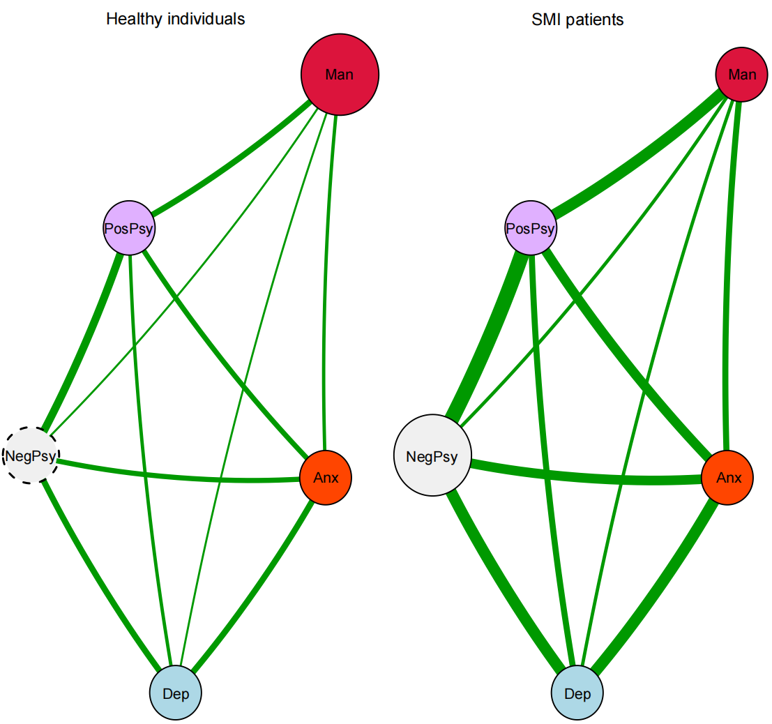
Figure 6.1
The hypothesised psychopathological models following network modelling and findings from this thesis
Note. The network structure is a simulated figure used to illustrate hypothesised psychopathological patterns across populations. A wider edge indicates a stronger relationship within the network, and node centrality is illustrated using different node sizes, with healthy individuals featuring mania symptoms and patients with SMIs featuring negative psychosis. NegPsy is illustrated as a dashed node as it was not included in the network analysis in Chapter 4. Anx = anxiety; Dep = depression; Man = (hypo)mania; PosPsy = positive psychosis; NegPsy = negative psychosis.

These findings may have clinical utility by informing mental illness screening and structured diagnostic interviews, in which symptom patterns could serve as a reference for determining the need for mental health care. For example, symptom severity may function as an important indicator of clinical intervention; however, symptom pattern may also provide significant insight relevant to diagnosis and treatment planning. Nevertheless, this interpretation remains largely speculative, as no direct quantitative comparisons were conducted between clinical and healthy populations in the present study. Moreover, item selection was not fully consistent, as negative symptoms or experiences were not assessed in healthy individuals. Future research should examine symptom network dynamics using longitudinal designs to evaluate whether models of mental illness remain consistent across both clinical and non-clinical populations.
Furthermore, this thesis identified psychopathological mechanisms linking mood and positive psychotic symptoms that appear largely invariant across time and populations. These findings challenge the rigid dichotomy between schizophrenia and BSD by delineating two distinct bridging pathways: the manic–psychotic bridge, mediated by dysfunctions in behavioural activation and thought disturbance, and the depressive–psychotic bridge, mediated by negative self-evaluation and suppressed emotional expression. Theoretically, these pathways align with multi-level biopsychosocial models. Biological models posit shared dopaminergic dysregulation, characterised by hyper- or hypo-activation (Berk et al., 2007; Howes & Kapur, 2009); psychological models conceptualise delusions as ego-defence mechanisms against negative self-stigma (Kaney & Bentall, 1992); and behavioural models emphasise dysfunctions in the Behavioural Activation and Behavioural Inhibition Systems (Meyer et al., 1999).

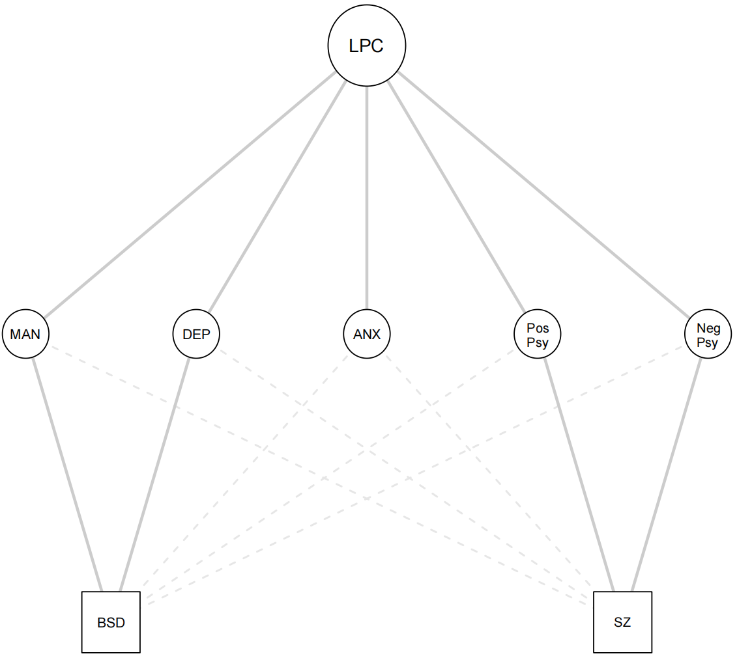
Figure 6.2
A hierarchical model integrating transdiagnostic and categorical approaches
Note. The diagram demonstrates how specific symptom dimensions (Middle Tier) bridge the gap between a shared latent liability (LPC) and distinct clinical diagnoses (BSD and SZ). Solid lines indicate primary symptom clusters; dashed lines represent shared or secondary features; MAN = mania; DEP = depression; ANX = anxiety; PosPsy = positive psychosis; NegPsy = negative psychosis.

Although Schizophrenia (SZ) and Bipolar Spectrum Disorders (BSD) appear distinct in current diagnostic systems like the DSM-5, they may share an underlying vulnerability. Figure 6.2 illustrates a hybrid model: it maps how a shared Latent Psychopathological Construct (LPC) manifests through specific symptom dimensions, which are then grouped into our traditional clinical diagnoses. As observed in Chapter 3, conceptual disorganisation was uniquely central to the schizophrenia network, whereas it was negligible in the schizoaffective and bipolar networks. This distinction does not contradict the main claim; rather, it suggests that while the latent psychopathological processes are shared, the phenotypic manifestation varies depending on the strength of specific disorder-specific nodes (e.g., thought disorder and conceptual disorganisation in schizophrenia). In addition, while the current 'symptom map' offers a detailed topography of the mood–psychosis interface, it does not fully elucidate the causal mechanisms underlying diagnostic conversion or stability. Several potential moderating constructs (e.g., external events, Theory of Mind, subjective phenomenological experiences, coping strategies, attributional biases) were absent from the current models. Future studies should, therefore, explore how these specific cognitive and environmental factors modulate the identified psychopathological processes to determine why individuals follow different diagnostic trajectories within the SMI spectrum. Moreover, the Chapter 5 carried add on values to abovementioned findings in the field of early intervention. Highly influential symptoms (e.g., symptom with highest strength) should be considered as potential risk marker in young people present at mental health services. These findings lend a strong support for a transdiagnostic approach. Treatment management and strategies should target these specific symptom dynamics (e.g., symptom with high strength, driving nodes of TRACEs) rather than treating specific psychiatric diagnosis, which aligns with recent guidelines for SMIs (Keramatian et al., 2023; McCutcheon et al., 2025).

General limitations and future directions
The current study employed multiple methodological approaches and samples to examine the psychopathological mechanisms linking mood and psychosis; however, the generalisability of the main findings may be limited for several reasons.
First, the use of a strict longitudinal design was limited. Consequently, most network mechanisms were derived from cross-sectional data, which constrains causal inference and may limit the external validity of the identified psychopathological pathways. Longitudinal network approaches, including panel designs or ecological momentary assessment (EMA), are warranted to evaluate the temporal stability and external validity of these findings.
Second, the network analyses did not employ covariate-adjusted symptom networks. Adjusting for external variables can substantially alter network structure and reduce cross-study comparability, particularly when different sets of confounders are included. Psychosocial variables (e.g., personality traits, attachment styles, or trauma exposure) are highly heterogeneous, theory-dependent, and inconsistently measured across studies. Adjusting for such factors may therefore yield networks that reflect study-specific modelling decisions rather than shared symptom-level relationships. To facilitate comparability and synthesis across studies, the present work focused on unadjusted networks. Future research should systematically assess the robustness of network structures across populations and clinically relevant subgroups as well as mood episodes, and explicitly test how different adjustment strategies influence network topology and replicability.
Third, although several psychosocial factors have been associated with mood and psychotic symptoms in regression-based analyses, the present thesis did not model their influence within a network framework. As a result, how distinct psychosocial factors interact with symptom dynamics to shape the psychopathological processes underlying mood and psychosis remains unclear. Future studies could incorporate psychosocial variables directly into network models to clarify their mechanistic roles in symptom interrelations.
Fourth, the clinical samples were restricted to individuals with bipolar I disorder with psychotic features. It therefore remains unclear to what extent the identified mechanisms generalise to other bipolar subtypes. Symptom dynamics in bipolar II disorder and non-psychotic bipolar presentations remain less well understood, and future studies should examine differences in mood–psychosis network structures across bipolar subtypes.
Finally, negative symptoms or negative psychotic- like experiences were not included in the network analyses of healthy individuals, limiting the comparability of network structures between clinical and non-clinical samples. Future research should employ more comprehensive assessments of psychotic experiences in non-clinical populations to enhance comparability.

Concluding remark
This thesis examined the long-debated psychopathological distinction between schizophrenia and bipolar spectrum disorders (BSD) from a network perspective. The symptom structures of mood and psychosis were investigated using multiple assessment tools, including structured interviews and self-report measures of mood- and psychosis-related experiences, as well as risk states, across diverse populations (clinical, non-clinical, and younger samples).
Across methodological approaches and population groups, mania and psychosis were closely interconnected. Behavioural activation (e.g., elevated mood and energy, impulsivity, irritability), thought disturbance (e.g., thought disorder and racing thoughts), negative self-evaluation, and reduced emotional expression emerged as key symptoms linking these domains. Regression analyses further revealed longitudinal interplay between mood and psychotic symptoms at a dimensional level.
However, the Kraepelinian account of mental illness remains central, particularly his emphasis that diagnostic distinctions should be grounded in longitudinal course rather than isolated symptom presentations. In this context, the observed overlap between BSD and schizophrenia in the present study is better understood as reflecting phenomenological similarity, shared features at the level of symptoms or experiences, rather than taxonomic equivalence. Accordingly, while these findings support a transdiagnostic perspective suggesting partially shared underlying psychopathological processes across mood and psychotic disorders, they do not conclusively challenge the validity of maintaining BSD and schizophrenia as distinct diagnostic entities. As Kraepelin highlighted, diagnostic validity depends on multiple converging validators beyond symptom similarity, including clinical, biological, social and psychometric factors. Therefore, the current cross-sectional findings should be interpreted cautiously: they indicate potential shared processes within a broader psychopathological spectrum, but do not, on their own, provide sufficient evidence to collapse established diagnostic boundaries. A full reconsideration of the Kraepelinian dichotomy would require longitudinal and multidisciplinary evidence, which remains an ongoing area of investigation.
The generalisability of these findings is limited by the predominantly cross-sectional design and certain methodological inconsistencies, such as variation in item selection across samples. Future studies should examine the robustness of mood - psychosis interactions across different clinical populations and methodological designs, particularly using longitudinal approaches, to allow stronger inferences regarding causal relationships.

References
Andreassen, O. A., Hindley, G. F. L., Frei, O., & Smeland, O. B. (2023). New insights from the last decade of research in psychiatric genetics: discoveries, challenges and clinical implications. World Psychiatry, 22(1), 4–24. https://doi.org/https://doi.org/10.1002/wps.21034
Belvederi Murri, M., Caruso, R., Ounalli, H., Zerbinati, L., Berretti, E., Costa, S., Recla, E., Folesani, F., Kissane, D., Nanni, M. G., & Grassi, L. (2020). The relationship between demoralization and depressive symptoms among patients from the general hospital: network and exploratory graph analysis. Journal of affective disorders, 276, 137–146. https://doi.org/https://doi.org/10.1016/j.jad.2020.06.074
Bentall, R. P., Myin-Germeys, I., Smith, A., Knowles, R., Jones, S. H., Smith, T., & Tai, S. J. (2011). Hypomanic Personality, Stability of Self-Esteem and Response Styles to Negative Mood. Clinical Psychology & Psychotherapy, 18(5), 397–410. https://doi.org/https://doi.org/10.1002/cpp.780
Berk, M., Dodd, S., Kauer-Sant’Anna, M., Malhi, G. S., Bourin, M., Kapczinski, F., & Norman, T. (2007). Dopamine dysregulation syndrome: implications for a dopamine hypothesis of bipolar disorder. Acta Psychiatrica Scandinavica, 116(s434), 41–49. https://doi.org/https://doi.org/10.1111/j.1600-0447.2007.01058.x
Bora, E., Bartholomeusz, C., & Pantelis, C. (2016). Meta-analysis of Theory of Mind (ToM) impairment in bipolar disorder. Psychological Medicine, 46(2), 253–264.
Bora, E., Yücel, M., & Pantelis, C. (2009). Theory of mind impairment: a distinct trait‐marker for schizophrenia spectrum disorders and bipolar disorder? Acta Psychiatrica Scandinavica, 120(4), 253–264.
Borsboom, D., & Cramer, A. O. J. (2013). Network Analysis: An Integrative Approach to the Structure of Psychopathology. Annual review of clinical psychology, 9(Volume 9, 2013), 91–121. https://doi.org/https://doi.org/10.1146/annurev-clinpsy-050212-185608
Cramer, A. O. J., van Borkulo, C. D., Giltay, E. J., van der Maas, H. L. J., Kendler, K. S., Scheffer, M., & Borsboom, D. (2016). Major Depression as a Complex Dynamic System. PLOS ONE, 11(12), e0167490. https://doi.org/10.1371/journal.pone.0167490
Depue, R. A., & Collins, P. F. (1999). Neurobiology of the structure of personality: Dopamine, facilitation of incentive motivation, and extraversion. Behavioral and Brain Sciences, 22(3), 491–517. https://doi.org/10.1017/S0140525X99002046
Ding, F., Li, N., Zhang, S., Li, J., Jing, Z., & Zhao, Y. (2024). Network comparison analysis of comorbid depression and anxiety disorder in a large clinical sample before and after treatment. Current Psychology, 43(15), 13267–13278. https://doi.org/10.1007/s12144-023-05308-3
Fusar-Poli, P., Borgwardt, S., Bechdolf, A., Addington, J., Riecher-Rössler, A., Schultze-Lutter, F., Keshavan, M., Wood, S., Ruhrmann, S., Seidman, L. J., Valmaggia, L., Cannon, T., Velthorst, E., De Haan, L., Cornblatt, B., Bonoldi, I., Birchwood, M., McGlashan, T., Carpenter, W.,…Yung, A. (2013). The Psychosis High-Risk State: A Comprehensive State-of-the-Art Review. JAMA Psychiatry, 70(1), 107–120. https://doi.org/10.1001/jamapsychiatry.2013.269
Gamma, A., Angst, J., Ajdacic-Gross, V., & Rössler, W. (2008). Are hypomanics the happier normals? Journal of affective disorders, 111(2), 235–243. https://doi.org/https://doi.org/10.1016/j.jad.2008.02.020
Granö, N., Lintula, S., Therman, S., Marttunen, M., Lång, U., & Ranta, K. (2023). Factor and network analysis of psychosis-like experiences and depressive symptoms in a sample of Finnish adolescents entering psychiatric services. Early Intervention in Psychiatry, 17(12), 1199–1206. https://doi.org/https://doi.org/10.1111/eip.13417
Guineau, M. G., Ikani, N., Rinck, M., Collard, R. M., van Eijndhoven, P., Tendolkar, I., Schene, A. H., Becker, E. S., & Vrijsen, J. N. (2023). Anhedonia as a transdiagnostic symptom across psychological disorders: a network approach. Psychological Medicine, 53(9), 3908–3919. https://doi.org/10.1017/S0033291722000575
Hayes, S. C., Wilson, K. G., Gifford, E. V., Follette, V. M., & Strosahl, K. (1996). Experimental avoidance and behavioral disorders: a functional dimensional approach to diagnosis and treatment. J Consult Clin Psychol, 64(6), 1152–1168. https://doi.org/10.1037//0022-006x.64.6.1152
Hogg, B., Gardoki-Souto, I., Valiente-Gómez, A., Rosa, A. R., Fortea, L., Radua, J., Amann, B. L., & Moreno-Alcázar, A. (2023). Psychological trauma as a transdiagnostic risk factor for mental disorder: an umbrella meta-analysis. European Archives of Psychiatry and Clinical Neuroscience, 273(2), 397–410. https://doi.org/10.1007/s00406-022-01495-5
Howes, O. D., & Kapur, S. (2009). The Dopamine Hypothesis of Schizophrenia: Version III—The Final Common Pathway. Schizophrenia Bulletin, 35(3), 549–562. https://doi.org/10.1093/schbul/sbp006
Huang, J., Tang, A., Li, Q., Chen, F., Ye, S., Song, L., & Qiu, P. (2025). Network analysis of sleep disorders, depression and anxiety symptoms among community older adults. BMC Geriatrics, 25(1), 694. https://doi.org/10.1186/s12877-025-06381-y
Kaney, S., & Bentall, R. P. (1992). Persecutory delusions and the self-serving bias. Evidence from a contingency judgment task. J Nerv Ment Dis, 180(12), 773–780. https://doi.org/10.1097/00005053-199212000-00006
Keramatian, K., Chithra, N. K., & Yatham, L. N. (2023). The CANMAT and ISBD Guidelines for the Treatment of Bipolar Disorder: Summary and a 2023 Update of Evidence. Focus, 21(4), 344–353. https://doi.org/10.1176/appi.focus.20230009
Kraepelin, E. (1899). Psychiatry: A textbook for students and physicians. (Vol. Volume 1 ). Watson Publishing International.
Kwapil, T. R., Barrantes-Vidal, N., Armistead, M. S., Hope, G. A., Brown, L. H., Silvia, P. J., & Myin-Germeys, I. (2011). The expression of bipolar spectrum psychopathology in daily life. Journal of affective disorders, 130(1), 166–170. https://doi.org/https://doi.org/10.1016/j.jad.2010.10.025
McCutcheon, R. A., Pillinger, T., Varvari, I., Halstead, S., Ayinde, O. O., Crossley, N. A., Correll, C. U., Hahn, M., Howes, O. D., Kane, J. M., Kabir, T., Konradsson-Geuken, Å., Lennox, B., Hui, C. L. M., Rossell, S. L., Solmi, M., Sommer, I. E., Taipale, H., Uchida, H.,…Siskind, D. (2025). INTEGRATE: international guidelines for the algorithmic treatment of schizophrenia. The Lancet Psychiatry, 12(5), 384–394. https://doi.org/10.1016/S2215-0366(25)00031-8
Meyer, B., Johnson, S. L., & Carver, C. S. (1999). Exploring Behavioral Activation and Inhibition Sensitivities Among College Students at Risk for Bipolar Spectrum Symptomatology. Journal of Psychopathology and Behavioral Assessment, 21(4), 275–292. https://doi.org/10.1023/A:1022119414440
Park, S. (2018). A Study on the Theory of Mind Deficits and Delusions in Schizophrenic Patients. Issues in Mental Health Nursing, 39(3), 269–274. https://doi.org/10.1080/01612840.2017.1378782
Peralta, V., Gil-Berrozpe, G. J., Sanchez-Torres, A., & Cuesta, M. J. (2020). The network and dimensionality structure of affective psychoses: an exploratory graph analysis approach. J Affect Disord, 277, 182–191. https://doi.org/10.1016/j.jad.2020.08.008
Reininghaus, U., Bohnke, J. R., Chavez-Baldini, U., Gibbons, R., Ivleva, E., Clementz, B. A., Pearlson, G. D., Keshavan, M. S., Sweeney, J. A., & Tamminga, C. A. (2019). Transdiagnostic dimensions of psychosis in the Bipolar-Schizophrenia Network on Intermediate Phenotypes (B-SNIP). World Psychiatry, 18(1), 67–76. https://doi.org/10.1002/wps.20607
Ribeiro Santiago, P. H., Manzini, D., Haag, D., Roberts, R., Smithers, L. G., & Jamieson, L. (2022). Exploratory Graph Analysis of the Strengths and Difficulties Questionnaire in the Longitudinal Study of Australian Children. Assessment, 29(8), 1622–1640. https://doi.org/10.1177/10731911211024338
Rosch, E. E., & Lloyd, B. B. E. (1975). Cognition and Categorization. American Journal of Psychology, 92(3).
Scheffer, M., Bascompte, J., Brock, W. A., Brovkin, V., Carpenter, S. R., Dakos, V., Held, H., van Nes, E. H., Rietkerk, M., & Sugihara, G. (2009). Early-warning signals for critical transitions. Nature, 461(7260), 53–59. https://doi.org/10.1038/nature08227
Simon, N. M. (2009). Generalized anxiety disorder and psychiatric comorbidities such as depression, bipolar disorder, and substance abuse. J Clin Psychiatry, 70 Suppl 2, 10–14. https://doi.org/10.4088/jcp.s.7002.02
Smith, K. E., Mason, T. B., Crosby, R. D., Cao, L., Leonard, R. C., Wetterneck, C. T., Smith, B. E. R., Farrell, N. R., Riemann, B. C., Wonderlich, S. A., & Moessner, M. (2019). A comparative network analysis of eating disorder psychopathology and co-occurring depression and anxiety symptoms before and after treatment. Psychological Medicine, 49(2), 314–324. https://doi.org/10.1017/S0033291718000867
Sperry, S. H., & Kwapil, T. R. (2017). What can daily life assessment tell us about the bipolar spectrum? Psychiatry Research, 252, 51–56. https://doi.org/https://doi.org/10.1016/j.psychres.2017.02.045
Sperry, S. H., & Kwapil, T. R. (2022). Bipolar spectrum psychopathology is associated with altered emotion dynamics across multiple timescales. Emotion, 22(4), 627–640. https://doi.org/10.1037/emo0000759
Trøstheim, M., Eikemo, M., Meir, R., Hansen, I., Paul, E., Kroll, S. L., Garland, E. L., & Leknes, S. (2020). Assessment of Anhedonia in Adults With and Without Mental Illness: A Systematic Review and Meta-analysis. JAMA Network Open, 3(8), e2013233–e2013233. https://doi.org/10.1001/jamanetworkopen.2020.13233
Walsh, M. A., Royal, A., Brown, L. H., Barrantes-Vidal, N., & Kwapil, T. R. (2012). Looking for bipolar spectrum psychopathology: identification and expression in daily life. Comprehensive Psychiatry, 53(5), 409–421. https://doi.org/https://doi.org/10.1016/j.comppsych.2011.06.006
Wang, Y.-y., Wang, Y., Zou, Y.-m., Ni, K., Tian, X., Sun, H.-w., Lui, S. S. Y., Cheung, E. F. C., Suckling, J., & Chan, R. C. K. (2018). Theory of mind impairment and its clinical correlates in patients with schizophrenia, major depressive disorder and bipolar disorder. Schizophrenia Research, 197, 349–356. https://doi.org/https://doi.org/10.1016/j.schres.2017.11.003
Zavlis, O., Matheou, A., & Bentall, R. (2023). Identifying the bridge between depression and mania: A machine learning and network approach to bipolar disorder. Bipolar Disord, 25(7), 571–582. https://doi.org/10.1111/bdi.13316

Appendixes

Appendix A: Supplementary Files for Chapter 1
Table A 1
The evolvement of diagnostic criteria for schizophrenia since DSM III
 | Criteria | Functioning | Course | Types | Boundary issue
DSM III | At least one of the followings: (1) Delusions (bizarre, persecution or jealous with hallucinations, others) with hallucinations; (2) auditory hallucinations (commentary, conversation, mood incongruent), (3) thought speech disorder accompanied by psychotic symptoms, catatonia or disorganised behaviour | Deterioration from previous level of capacities for Social, work, self-care activities. | Continuous signs of illness for at least six months in lifetime, include an active phase of the characteristics with or without prodromal or residual features. The age of onset (prodromal or active stage) is before 45. | Disorganised (incoherence, absence of systematic delusions, blunted affect); Catatonic; Paranoia; Undifferentiated; Residual | Schizophrenia is made when affective syndromes presented after active phase and the duration are relatively short to course of psychosis;
DSM III R | At least one of the followings lasted longer than 1 week:  - two of the followings: delusions, prominent hallucinations, loose associations, catatonic behaviour, flat affect;  - bizarre delusions;  - prominent hallucinations (voice commentary, conversation) | …markedly below the highest level of functioning in abovementioned areas. | …  Classification of the course: sub chronic, chronic, sub chronic with acute exacerbation, chronic with acute exacerbation, in remission, unspecified. | … | …
ICD 10 | At least one of the followings:  a) thought echo, insertion, withdrawal, or broadcasting;  b) delusions of control, influence, or passivity;  c) hallucinations (voice commentary, conversation);  d) persistent delusions (culturally inappropriate and completely impossible).  Or at least two of the followings:  a) persistent hallucinations;  b) thought disorder;  c) catatonia  d) negative symptoms | Not applicable | Course is based on observation for at least one year.  Classification:  Continuous;  Episodic with progressive deficit;  Episodic with stable deficit;  Episodic remittent;  Incomplete remission;  Complete remission;  Other;  Course uncertain, period of observation too short. | Paranoid, hebephrenic, catatonic, and undifferentiated schizophrenia | The criteria must meet before the onset any mood episode
DSM IV | At least two of the followings frequently presented during a month period:  - delusions  - hallucinations  - disorganised speech  - grossly disorganised or catatonic behaviour  - negative symptoms | Markedly lower level Social/ occupation functioning than the time before illness onset. | … during premorbid or residual periods, the signs may manifest as only negative symptoms or two or more attenuated psychotic symptoms.  Classifications: episodic with interepisode residual symptoms;  Episodic with no interepisode residual symptoms; continuous; single episode in partial remission; single episode in full remission; other or unspecified pattern | … | Exclusion of schizoaffective and affective disorders: a) non concurrent occurrence of psychotic and affective syndrome, b) if cooccur, the affective duration is brief relative to the active phase of schizophrenia
DSM IV TR | … | … | … | … | …
DSM V | At least two of the followings frequently presented during a month period; at least one of these must be 1), 2), or 3):  - delusions  - hallucinations  - disorganised speech  - grossly disorganised or catatonic behaviour  - negative symptoms | … | …  Classification:  First episode, currently in acute episode;  …, currently in partial remission;  …, currently in full remission;  Multiple episodes, …;  ….  Continuous;  Unspecified. | … | …
ICD 11 | At least two of the followings must be present most of the time for a period of 1 months or more:  a) persistent delusions;  b) persistent hallucinations;  c) disorganised thinking;  d) experiences of influence, passivity or control;  e) negative symptoms;  f) disorganised behaviour;  g) psychomotor disturbance | Not applicable | First episode (symptomatic, remission, unspecified);  Multiple episodes (…);  Continuous (…); other specified episodes; episode unspecified. | Not applicable | Psychotic symptoms in mood disorder are mood congruent. If the criteria of mood disorder and schizophrenia disorder are met concurrently, then diagnosis of schizoaffective disorder is appropriate to make.
DSM V TR | … | … | … | … | …
Note. the … means that the content in this block is the same as the previous.

Table A 2
The evolvement of diagnostic criteria for bipolar disorder since DSM III
 | Criteria | Functioning | Course | Types | Boundary issue
DSM III | The essential feature of bipolar disorder is whether there has been a manic episode:  - At least one distinctive period with elevated, expansive, or irritable mood that is predominant or persistent during the course, lasted for more than a week;  - During the course, at least three, or four if the mood is only irritable, of the followings have persisted and been presented to a significant degree:  - Increased activity or physical restlessness  - More talkative  - Racing thoughts  - Inflated self-esteem (grandiosity, which maybe delusional)  - Decreased need for sleep  - Distractibility  - Excessive involvement in activities that are potentially having painful consequences  Depressive episode:  - Dysphoric mood (e.g., sad, hopeless, irritable) or loss of interest. The mood disturbance is prominent and persistent. The mood is not necessarily dominant and does not swich from one to another;  - At least four of the followings has each been presented nearly every day in at least two weeks.  - Poor appetite;  - Insomnia and hyposomnia;  - Psychomotor agitation or retardation;  - Loss of interest or pleasure;  - Fatigue;  - Diminished ability to think or concentrate;  - Recurrent suicidal ideation or attempt. | Not applicable | Classification: in remission, with psychotic features (mood incongruent or congruent), without psychotic features, unspecified. | Mixed (manic and depressive episodes are intermixed or rapidly alternating every few days; depressive symptoms are prominent and last at least a full day)  Manic (currently in this episode)  Depressed (has had one or more manic episode in lifetime, and currently in depressive episode) | The mood incongruent delusions or hallucinations does not prevail when mood syndrome is absent;  Not superimposed by psychotic disorders
DSM III R | A manic syndrome includes symptoms and functioning impairments, while hypomanic syndrome only includes symptoms:  - A distinctive period of abnormally and persistently elevated, expansive, or irritable mood.  - During this period, three or four (only irritable mood) of the followings …:  - Inflated self-esteem or grandiosity;  …the rest is the same as DSM III  A depressive syndrome includes five of the followings during the course (14 days, nearly every day), and at least one of the symptoms is either depressed mood or decreased interests:  - Depressed mood;  … (7 symptoms are same as DSM III)  (9) Feeling of worthlessness or inappropriate guilt. | Marked impairment in occupational or social functioning, potentially harmful to self or others. | Mild, moderate, severe with or without psychotic features (mood congruent or incongruent), in partial or full remission, unspecified. | … | No hallucinations or delusions lasted for more than two weeks when prominent mood syndrome is absent;  …
ICD 10 | Episodes are featured by a switch to an episode of opposite or mixed polarity or by a remission.  Mania:  - Predominantly elevated, expansive, or irritable mood. The abnormalities must be prominent and last for more than a week.  - at least three or four (same as DSM III) of the followings:  … (seven of the symptoms is identical to DSM III-R)  - loss of normal social inhibitions (inappropriate behaviour in certain situations)  - marked sexual energy or indiscretions.  Hypomania:  - at least 4 days of elevated or irritable mood;  - at least three of the followings:  - increased activity or physical restlessness;  - increased talkativeness;  - distractibility;  - decreased need for sleep;  - increased sexual energy;  - reckless or irresponsible behaviour;  - increased sociability or over-familiarity  Depressive episode:  The episode should last for at least 14 days, with no (hypo)manic symptoms sufficient to meet (hypo)manic episodes. at least four of the followings should present in the course to meet the somatic syndrome:  - marked loss of interest or pleasure;  - lack of emotion reactions;  - Early waking (2 hours early than usual);  - Depression worse in morning;  - Psychomotor retardation or agitation;  - Marked loss of appetite;  - Significant weight loss (5% or more);  - Marked loss of libido. | The manic and hypomanic episode have severe and some interruptions with personal functioning in daily life, respectively. | Bipolar affective disorder, current episode hypomanic/ manic with or without psychotic symptoms/ moderate or mild depression/ severe depression with or without psychotic symptoms/ mixed/ in remission. Other bipolar affective disorder, bipolar affective disorders, unspecified. | Manic, hypomanic, mixed (a mixture or rapid alternation of manic, hypomanic, depressive, symptoms), depressive episodes. | Non-Schneider symptoms can present in patients (e.g., grandiose, persecutory delusions) with bipolar affective disorders.
DSM IV | Manic episode same as DSM III-R; hypomanic episode is milder than manic episode in that the mood abnormalities lasted for at least four days, and the rest are the same as mania.  Depressive episode same as DSM III-R. | The hypomania induced mood disturbance and functional impairment are not severe but observable by others. | Same as DSM III R | Bipolar I (one or more manic episode accompanied with depressive episodes), II (one or more depressive episodes with at least one hypomanic episode), and NOS disorder (none other specified); Cyclothymic disorder. | Not mentioned.
DSM IV TR | No change | No change | No change | No change | Not mentioned.
DSM V | No change | No change | No change | Bipolar I (meet criteria of manic episode; the episode may have been preceded or followed by hypomanic or depressive episodes);  Bipolar II (meet current or past criteria for hypomanic and depressive episodes). | Bipolar I is not mentioned. Bipolar II must be differentiated with psychotic disorders, which featured by psychotic symptoms occurred in the absence of prominent mood symptoms. the course can also be differentiated by accompanying symptoms, previous course and family history.
ICD 11 | Depressive episode:  In at least 14 days, more than five of the followings’ symptoms presented for most of the day nearly every day:  - Affective cluster (depressed mood, diminished interest or pleasure);  - Cognitive behaviour cluster (reduced ability to concentrate, low self-worth, excessive or inappropriate guilt, hopeless, recurrent suicidal thoughts or attempts);  - Neurovegetative cluster (disturbed sleep, significant change in appetite or weight, psychomotor retardation or agitation, fatigue)  Manic episode:  Both of the following features occurring concurrently and persisting for most of the day, nearly every day for at least 7 days:  - Euphoria, irritable, expansive mood;  - Increased activity or energy;  - Increased talkativeness or pressured speech;  - Racing thoughts;  - Increased self-esteem or grandiosity;  - Decreased need for sleep;  - Distractibility;  - Impulsive reckless behaviour;  - Increased goal directed activities;  Hypomania the symptoms lasted several days, and are generally the same as mania.  Mixed episode: The presence of several prominent manic and several prominent depressive symptoms consistent with those observed in Manic Episodes and Depressive Episodes, which either occur simultaneously or alternate very rapidly (from day to day or within the same day). Symptoms must include an altered mood state consistent with a Manic and/or Depressive Episode (i.e., depressed, dysphoric, euphoric or expansive mood), and be present most of the day, nearly every day, during a period of at least 2 weeks, unless shortened by a treatment intervention. | The mood disturbance results in significant impairment in personal, family, social, educational, occupational, or other important areas of functioning. If functioning is maintained, it is only through significant additional effort. | Bipolar type +episode name+ severity (with or without psychotic features, only applicable to severe mood episode) | Bipolar type I disorder is an episodic mood disorder defined by the occurrence of one or more manic or mixed episodes. Bipolar type II disorder is an episodic mood disorder defined by the occurrence of one or more hypomanic episodes and at least one depressive episode. | Delusions related to experiences of influence, passivity or control (e.g., the experience that thoughts or actions are not generated by the person, are being placed in one’s mind or withdrawn from one’s mind by others, or that thoughts are being broadcast to others) can also occur, but less commonly than in Schizophrenia and Schizoaffective Disorder.
DSM V TR | No change | No change | No change | No change | Bipolar I with psychotic features (BDP) should be differentiated with schizoaffective disorder (SCA) in that SCA features concurrent manic and depressive episode with active schizophrenia which delusions or hallucinations occur for at least two weeks in the absence of manic or depressive episodes. The psychotic symptoms in bipolar I occurred exclusively during manic or depressive episodes.  Bipolar II should be differentiated with schizophrenia and schizoaffective disorder in that the psychotic features have occurred exclusively during major depressive episodes. while the schizophrenia (depressive episode is relatively brief compared to schizophrenia course) or schizoaffective (same as bipolar I) disorder are different.
Note. the … means that the content in this block is the same as the previous.

Table A 3
BAR (Bipolar at risk) criteria
Conditions | Mania | Depression | Cyclothymia
Abnormal or persistent | Elevated, expansive, or irritated mood (at least two consecutive days| less than four days) | Depressed mood, loss of interest or pleasure (at least one week) | Numerous episodes of mania or depressive symptoms (four cumulative days in lifetime| not meeting the criteria for mania)
Mania: two or more symptoms, three if irritated mood.  Depression: two or more symptoms | Inflated self-esteem or grandiosity | Significant weight loss
 | Decreased need for sleep | Insomnia or hypersomnia nearly every day
 | More talkative than usual or pressure to keep talking | Psychomotor retardation or agitation
 | Flight of ideas | Fatigue or loss of energy
 | Distractibility | Feeling of worthlessness, or excessive or inappropriate guilt
 | Increased goal-directed activity or psychomotor agitation | Diminished ability to think or concentrate
 |  | Recurrent thoughts of death, recurrent suicidal ideation
Note. BAR = Bipolar At Risk. This table outlines the diagnostic thresholds for identifying individuals at risk of bipolar disorder across three categories: Mania, Depression, and Cyclothymia. The first row defines the necessary entry criteria, specifying the required mood state and duration (e.g., manic symptoms must last between 2 and 4 days). The subsequent rows list specific symptoms; the "Conditions" column specifies the cutoff for these, requiring at least two symptoms for mania (or three if the mood is only irritable) and at least two symptoms for depression. Cyclothymia is defined by the cumulative history of these sub-threshold episodes rather than a single acute event.

Table A 4
CHARMS criteria (bipolar)
Bipolar trait vulnerability
(depression + cyclothymic features + genetic risk)
AND | Depression | Cyclothymic features
 | Depressed mood, or loss of interest or pleasure (at least 1 week| two of the symptoms below) | High or low mood (at least 6 cumulative months| less than 2 consecutive months without symptoms| three of the symptoms below)
 | Significant weight loss | Decreased need for sleep
 | Insomnia or hypersomnia nearly every day | Increased energy
 | Psychomotor retardation or agitation | Inflated self-esteem or grandiosity
 | Fatigue or loss of energy | Increased goal directed activity
 | Feeling of worthlessness, or excessive or inappropriate guilt | Restlessness
 | Diminished ability to think or concentrate | More talkative than usual or pressure to keep talking
 | Recurrent thoughts of death, recurrent suicidal ideation | Unusual ideas, clear thinking
 |  | Troublesome behaviour
 |  | Inappropriate sense of humour
NOT | 1) episode caused by direct physiological effects of a substance or condition; 2) cause a clinically significant drop in functioning.
OR | first degree relative with bipolar disorder
Note. This table details the criteria for identifying Bipolar Trait Vulnerability, defined by a combination of depressive and cyclothymic features alongside genetic risk. The "AND" section establishes the core inclusion criteria: individuals must exhibit Depression (requiring a duration of at least one week and the presence of > 1 listed symptoms) in conjunction with Cyclothymic features (requiring > 5 cumulative months of mood instability and > 2 listed symptoms). The "NOT" row specifies exclusion criteria, ruling out episodes induced by substances or those causing clinically significant functional impairment. The "OR" row accounts for genetic liability, indicating the relevance of having a first-degree relative with bipolar disorder.

Table A 5
CHARMS criteria (attenuated symptoms)
 | Psychotic (CAARMS)
 | Unusual thought content, non-bizarre ideas (3-5, intensity)
 | Perceptual abnormality (3-4, intensity)
 | And/ or disorganised speech (4-5, intensity)
AND | Unusual thought content, non-bizarre ideas, perceptual abnormalities, and /or disorganised speech (3-6, frequency)
OR | Perceptual abnormalities (5-6 intensity), unusual thought content, non-bizarre ideas, and/ or disorganised speech (6, intensity)
AND | Unusual thought content, non-bizarre ideas, perceptual abnormalities, and /or disorganised speech (3, frequency)
Time | Symptoms presented for less than 1 week in the last year
 | Brief limited intermittent psychotic symptoms (CAARMS)
 | Perceptual abnormalities (5-6 intensity), unusual thought content, non-bizarre ideas, and/ or disorganised speech (6, intensity)
AND | Unusual thought content, non-bizarre ideas, perceptual abnormalities, and /or disorganised speech (4-6, frequency)
Time | Symptoms presented for less than 1 week in the last year
 | (Hypo)manic (SCID-5)
A | Abnormally and persistently elevated, expansive or irritable mood
B | Inflated self-esteem or grandiosity
 | Decreased need for sleep
 | More talkative than usual or pressure to keep talking
 | Flight of ideas
 | Distractibility
 | Increased goal directed activity/ psychomotor agitation
 | Excessive involvement in pleasurable activities which have a high potential for painful consequences
Criteria | A and two symptoms of B (3 if irritability) for at least two days
 | Moderate depression (SCID-5)
A | Depressed mood, or loss of interest or pleasure (at least 1 week| two of the symptoms below)
B | Significant weight loss
 | Insomnia or hypersomnia nearly every day
 | Psychomotor retardation or agitation
 | Fatigue or loss of energy
 | Feeling of worthlessness, or excessive or inappropriate guilt
 | Diminished ability to think or concentrate
 | Recurrent thoughts of death, recurrent suicidal ideation
C | The MDE is not due to direct physiological effects of a substance, or causes clinically significant drop in functioning, and not be better accounted for by bereavement.
Criteria | A+B (at least 5 symptoms) +C, at least two weeks
 | Borderline personality (SCID-5-PD)
List | Frantic efforts to avoid real or imagined abandonment
 | A pattern of unstable and intense interpersonal relationships characterised by alternating between extremes of idealisation and devaluation
 | Identity disturbance: markedly and persistently unstable self-image or sense of self.
 | Impulsivity in at least 2 areas that are potentially self-damaging (e.g., spending, sex, substance abuse, reckless driving and binge eating). This does not include suicidal or self-harming behaviour.
 | Recurrent suicidal behaviour, gestures, or threats, or self-mutilating behaviour
 | Affective instability due to a marked reactivity of mood-intense feelings that can last from a few hours to a few days
 | Chronic feelings of emptiness
 | Inappropriate intense anger or difficult controlling anger
 | Transient, stress-related paranoia ideas or severe dissociative symptoms
Criteria | 2-4 symptoms from the list and lasted for at least 6 months
Note. This table outlines the criteria for Attenuated Symptoms across five domains. The Psychotic (CAARMS) section requires sub-threshold positive symptoms (rated by intensity and frequency) or brief episodes of higher intensity that resolved spontaneously within one week. Similarly, Brief Limited Intermittent Psychotic Symptoms (BLIPS) are defined by higher intensity symptoms lasting less than one week. The (Hypo)manic criteria require elevated or irritable mood (Criterion A) plus > 2 associated symptoms (Criterion B; or 3 if mood is only irritable) lasting at least two days. Moderate Depression is defined by the presence of core mood symptoms (Criterion A) plus > 4 total symptoms from Criteria A and B combined, lasting at least two weeks, without functional impairment (Criterion C). finally, Borderline Personality features are assessed via the SCID-5-PD, requiring 2–4 characteristic symptoms (e.g., frantic efforts to avoid abandonment, identity disturbance) persisting for at least 6 months.

Appendix B: Supplementary Files for Chapter 2

Tables and figures
Table B 1
Search strategies for synthesis of comorbid schizophrenia and psychosis
Database | Boolean formula
Psych INFO | ((schizophrenia or psychosis or psychotic) and (bipolar or manic-depressive or mania) and (prevalence or proportion or rate or comorbid*)).ab. or ((schizophrenia or psychosis or psychotic) and (bipolar or manic-depressive or mania) and (prevalence or proportion or rate or comorbid*)).ti.
Web of Science | (AB=(schizophrenia) OR AB=(psychosis) OR AB=(psychotic)) AND (AB=(bipolar) OR AB=(mania) OR AB=(manic-depressive)) AND (AB=(prevalence) OR AB=(proportion) OR AB=(rate) OR AB=(comorbid*))
MEDLINE | ((schizophrenia [Title/Abstract]) OR (psychosis [Title/Abstract]) OR (psychotic [Title/Abstract])) AND ((bipolar [Title/Abstract]) OR (manic- depressive [Title/Abstract]) OR (mania [Title/Abstract])) AND ((prevalence [Title/Abstract]) OR (proportion [Title/Abstract]) OR (rate [Title/Abstract]))

Table B 2
Search strategies for synthesis of comorbid delusions
Database | Boolean formula
Psych INFO | ((schizophrenia or psychosis or psychotic) and (bipolar or manic-depressive or mania) and delu*).ab. or ((schizophrenia or psychosis or psychotic) and (bipolar or manic-depressive or mania) and delu*).ti.
Web of Science | (AB=(schizophrenia) OR AB=(psychosis) OR AB=(psychotic)) AND (AB=(bipolar) OR AB=(mania) OR AB=(manic-depressive)) AND AB=(delu*)
MEDLINE | ((schizophrenia [Title/Abstract]) OR (psychosis [Title/Abstract]) OR (psychotic [Title/Abstract])) AND ((bipolar [Title/Abstract]) OR (manic- depressive [Title/Abstract]) OR (mania [Title/Abstract])) AND (delu* [Title/Abstract])

Table B 3
Search strategies for synthesis of comorbid hallucinations
Database | Boolean formula
Psych INFO | ((schizophrenia or psychosis or psychotic) and (bipolar or manic-depressive or mania) and hallucinat*).ab. or ((schizophrenia or psychosis or psychotic) and (bipolar or manic-depressive or mania) and hallucinat*).ti.
Web of Science | (AB=(schizophrenia) OR AB=(psychosis) OR AB=(psychotic)) AND (AB=(bipolar) OR AB=(mania) OR AB=(manic-depressive)) AND AB=(hallucinat*)
MEDLINE | ((schizophrenia [Title/Abstract]) OR (psychosis [Title/Abstract]) OR (psychotic [Title/Abstract])) AND ((bipolar [Title/Abstract]) OR (manic- depressive [Title/Abstract]) OR (mania [Title/Abstract])) AND (hallucinat* [Title/Abstract])

Table B 4
Search strategies for synthesis of comorbid thought disorders
Database | Boolean formula
Psych INFO | ((schizophrenia or psychosis or psychotic) and (bipolar or manic-depressive or mania) and (thought disorder or disorganized)).ab. or ((schizophrenia or psychosis or psychotic) and (bipolar or manic-depressive or mania) and (thought disorder or disorganized)).ti.
Web of Science | (AB=(schizophrenia) OR AB=(psychosis) OR AB=(psychotic)) AND (AB=(bipolar) OR AB=(mania) OR AB=(manic-depressive)) AND(AB=(thought disorder) OR AB=(disorganized))
MEDLINE | ((schizophrenia [Title/Abstract]) OR (psychosis [Title/Abstract]) OR (psychotic [Title/Abstract])) AND ((bipolar [Title/Abstract]) OR (manic- depressive [Title/Abstract]) OR (mania [Title/Abstract])) AND ((thought disorder [Title/Abstract]) OR (disorganized [Title/Abstract]))

Table B 5
The coding method for included variables
Variable name | Description | Type | Coding
Gender | Sex identity of the participants | Categorical | 0=male,  1=female.
Age | Age at assessment | Numeric (mean or median value) | Default
Study IDs | In order to manage the dataset numbers were assigned to each study sequentially, from 1 to n. | Numeric | Default
Publication year | The year that the article has been published | Numeric | Default
Sampling method | The way participants have been sampled | Nominal | 0=convenient,  1=probabilistic.
Multicentre study | Whether the participants have been recruited via multi centre | Nominal | 0=single,  1=multicentre.
Study quality | Overall quality of the study, rated via the JBI checklist | Numeric | Default
First level evidence | Whether the patient was consecutively recruited | Nominal | 0=non-consecutive,  1=consecutive.
Patient type | Sampling source | Nominal | 1=outpatient, 2=mixed,  3=inpatient.
Clinical status | Whether patient was in an active state of the disorder | Nominal | 0= euthymic,  1= mixed,  2= acute/active.
Age of onset | the number of years after the first diagnosis or first episode onset of the disorder | Numeric (mean or median value) | Default
Bipolar Type | the type of the bipolar diagnosis | Nominal | Bipolar II Disorder=0,  Bipolar Spectrum Disorder=1.  Bipolar I Disorder=2, Psychotic Bipolar Disorder=3.
Manic | The rate of patient with current/ predominant manic episode | Numeric | Default
Depression | The rate of patient with current/ predominant depressive episode | Numeric | Default
Episode type | Whether the polarity is predominant? (for sub analysis of psychosis in different mood episode) | Binary | 0=recent  1=predominant
Mixed | The rate of patient with current/ predominant mixed episode | Numeric | Default
Type of delusions | whether the delusion was general or specific | Nominal | 0=specific,  1=general.
Type of hallucinations | whether the hallucination was general or specific | Nominal | 0=specific,  1=general.
Type of thought disorder | whether the thought disorder was general or specific | Nominal | 0=specific,  1=general.
Outcome variables
Rate of comorbid schizophrenia | Whether bipolar patients had/have schizophrenia diagnosis (current/ lifetime) | Numeric | Default
Rate of comorbid psychosis | Whether bipolar patients had/have comorbid psychosis (current/ lifetime) | Numeric | Default
Rate of comorbid delusions | Whether bipolar patients had/have concurrent delusions (lifetime/ current) | Numeric | Default
Rate of comorbid hallucinations | Whether bipolar patients had/have concurrent hallucinations (lifetime/ current) | Numeric | Default
Rate of comorbid thought disorder | Whether bipolar patients had/have concurrent thought disorder (lifetime/ current) | Numeric | Default
Variables not involved in the analysis
Diagnostic standard | The criteria used for diagnosis | Nominal | DSM, ICD, RDC etc.
Assessment tools | The tools used for assessment, specifically the psychiatric symptoms | Nominal | PANSS, YMRS etc.
Location | The place where the study was conducted | Nominal | AL ,CN, DZ etc.
Note. the lifetime or current psychosis was mainly decided by semantic descriptions. For instance, patient diagnosed by structured clinical interview for DSM IV as having psychotic features are considered to be suffering from a current or recent condition unless otherwise specified; the highest rate of a specific type of the psychotic condition was recorded in case the prevalence of general hallucinations, delusions, and thought disorder was not reported,

Table B 6
The abbreviated terms and full names
Short name | Full name
AMDP | Association for Methodology and Documentation in Psychiatry
BISS | Bipolar Inventory of Symptoms Scale
BPRS | Brief Psychiatric Rating Scale
CAPE | Community Assessment of Psychic Experiences
CGI | Clinical Global Impression
CIDI | Composite International Diagnostic Interview
CMBT | Comprehensive measure of bizarre-idiosyncratic thinking
CORE | Core system (see Parker et al., 2000)
DCR10 | Diagnostic criteria for research-10 (DCR10) criteria
DCUPR | Diagnostic Criteria for Use in Psychiatric Research
DI-PAD | Diagnostic Interview for Psychosis and Affective Disorders
DIGS | Diagnostic Interview for Genetic Studies
DIP | Diagnostic Interview for Psychosis
DIS | National Institute of Mental Health Diagnostic Interview Schedule
DSM | Diagnostic and Statistical Manual of Mental Disorders
EMA | Ecological Momentary Assessments
HoNOS | Health of the Nations Outcome Scale
ICD | International Classification of Diseases
MDQ | Mood Disorder Questionnaire
MDS | Minimum Data Set (MDS) 2.0 admission assessment
MINI | Mini-International Neuropsychiatric Interview
OPCRIT | Operational Criteria Checklist for Psychotic Illness
ORSM | Observer-Rated Scale for Mania
PANSS | Positive and Negative Syndrome Scale
PDI | Peters et al Delusions Inventory
PSE | Present State Examination
RDC | Research Diagnostic Criteria
RPMIP | Royal Park Multidiagnostic Instrument for Psychosis
SADS | Schedule for Affective Disorder and Schizophrenia
SAPS | Scale for the Assessment of Positive Symptoms
SID | Semi structured Interview for Depression
SCID | Structured Clinical Interview for DSM
SCAN | Schedule for Clinical Assessment in Neuropsychiatry
WGSQ | Wirthlin group survey questionnaire (claimed to be comparable to SCID)
YMRS | Young Mania Rating Scale

Table B 7
Lifetime psychosis in bipolar patients with mixed episode
Study | Study location | Patient type | Patient number | Diagnosis | Lifetime psychosis
Keck et al. (2003) | USA | Outpatient | 223 Bipolar I patients | DSM4 | 67.71% (n=151)
Andrade-Nascimento et al. (2011) | Brazil | Outpatient | 282 Bipolar I patients | DSM4 | 47.52% (n=134)
Ferentinos et al. (2017) | Greece | Outpatient | 50 BSD patients | DSM | 22% (n=11)
Pacchiarotti et al. (2011) | Italy | Inpatient | 88 Bipolar I patients | DSM4TR | 57.95% (n=51)

Table B 8
Include studies in the synthesis of comorbid schizophrenia
Study | JBI score | Age | Criteria | Assessment | N | Pop | BD | TF | Cotype | Co (n)
Zolezzi et al. (2017) | 4 | 41.2 | DSM | unclear | 63 | 1 | 1 | 0 | psychotic | 2
Hsieh et al. (2016) | 5 | 25.1 | DSM4 | SCID | 35 | 2 | 1 | 0 | scz | 0
Hsu et al. (2015) | 7 | 40.2 | ICD9 | unclear | 21060 | 2 | 1 | 0 | scz | 1116
Jorgensen et al. (2018) | 7 | NA | ICD | unclear | 10560 | 1 | 1 | 1 | scz | 681
Patterson-Lomba et al. (2019) | 6 | 39.6 | ICD | unclear | 69736 | 2 | 1 | 0 | psychotic | 3013
Almeida and Fenner (2002) | 6 | 34.4 | ICD9 | unclear | 6182 | 2 | 1 | 0 | psychotic | 91
Palzes et al. (2020) | 5 | 46 | ICD | unclear | 21150 | 2 | 1 | 0 | scz | 371
Abu Nazel et al. (2017) | 5 | 37.9 | DSM4 | unclear | 49 | 1 | 1 | 0 | ssd | 11
Kamat et al. (2008) | 5 | NA | MDQ | MDQ | 94 | 2 | 1 | 1 | psychotic | 9
(Goodwin et al., 2002) | 5 | NA | DSM3 | SCID | 33 | 1 | 1 | 0 | scz | 6
Morgan et al. (2012) | 5 | NA | DSM4 | SCID-P | 231 | 2 | 3 | 0 | sca | 8
Lev-Ran et al. (2013) | 7 | NA | DSM4 | unclear | 1905 | 1 | 1 | 0 | psychotic | 63
Allardyce et al. (2018); | 6 | 46 | RDC | SCAN | 4339 | 2 | 1 | 0 | sca | 356
Kupfer et al. (2005); Niitsu et al. (2015) | 6 | 40.78 | DSM4 | SCID | 2718 | 2 | 1 | 0 | sca | 248
Okasha et al. (2023) | 8 | 34.4 | DSM4 | SCID | 300 | 2 | 2 | 1 | scz | 22
Ng et al. (2021) | 5 | NA | ICD9 | unclear | 53434 | 2 | 1 | 0 | scz | 7844
Almeida et al. (2019); | 5 | 72.5 | ICD | unclear | 302 | 2 | 1 | 1 | psychotic | 51
Kendler et al. (2023) | 7 | 36.4 | ICD10 | unclear | 13530 | 3 | 2 | 0 | scz | 325
Bora et al. (2007) | 5 | 37.97 | DSM4 | SCID | 65 | 2 | 2 | 1 | frs | 2
Tohen et al. (1992) | 6 | 30 | DSM3 | DIS | 54 | 3 | 3 | 0 | frs | 11
Das and Khanna (1993) | 5 | 31.93 | DSM3R | unclear | 60 | 3 | 2 | 0 | frs | 2
Sethi and Khanna (1993) | 6 | 27.7 | DSM3R | PSE | 100 | 2 | 2 | 0 | frs | 15
Gorgulu et al. (2021) | 5 | 41.94 | DSM5 | unclear | 80 | 2 | 2 | 0 | frs | 7
Gonzalez-Pinto et al. (2003) | 5 | 36.9 | DSM4 | SAPS | 103 | 3 | 2 | 0 | frs | 23
Yan et al. (1982) | 6 | 31.51 | mixed | unclear | 108 | 3 | 2 | 0 | frs | 4
Carlson et al. (2012) | 6 | 29.3 | DSM3R | SCID | 126 | 3 | 3 | 0 | frs | 35
Kennedy et al. (2004) | 4 | NA | DSM4 | OPCRIT | 246 | 2 | 2 | 0 | frs | 30
Note. The JBI score refers to the study quality score rated by the JBI checklist (range = 0-9). Pop denotes the patient population (1 = outpatient, 2 = mixed, 3 = inpatient). Criteria specify the diagnostic criteria used, while Assessment refers to the interview tools employed (See Table S6 for details). BD represents the bipolar diagnosis subtype (0 = BD II, 1 = BSD, 2 = BD I, 3 = Psychotic BD). TF indicates the timeframe (0 = current, 1 = lifetime). Cotype refers to the comorbidity type (psychotic = psychotic disorders, scz = schizophrenia, sca = schizoaffective disorders, frs = first rank symptoms). Co (n): number of patients with this condition.

Reference:
Abu Nazel, M., Elkady, H., Abd Allah, S., & Ibrahim, R. (2017). Pattern and correlates of tobacco smoking among mentally ill male patients in El-Mamoura Psychiatric Hospital, Alexandria, Egypt. Journal of Egyptian Public Health Association, 92(3), 167–176. https://doi.org/10.21608/epx.2017.16397
Almeida, O. P., & Fenner, S. (2002). Bipolar disorder: similarities and differences between patients with illness onset before and after 65 years of age. Int Psychogeriatr, 14(3), 311–322. https://doi.org/10.1017/s1041610202008517
Bora, E., Vahip, S., Akdeniz, F., Gonul, A. S., Eryavuz, A., Ogut, M., & Alkan, M. (2007). The effect of previous psychotic mood episodes on cognitive impairment in euthymic bipolar patients. Bipolar Disord, 9(5), 468–477. https://doi.org/10.1111/j.1399-5618.2007.00469.x
Carlson, G. A., Kotov, R., Chang, S. W., Ruggero, C., & Bromet, E. J. (2012). Early determinants of four-year clinical outcomes in bipolar disorder with psychosis. Bipolar Disord, 14(1), 19–30. https://doi.org/10.1111/j.1399-5618.2012.00982.x
Das, A., & Khanna, R. (1993). Organic manic syndrome: causative factors, phenomenology and immediate outcome. J Affect Disord, 27(3), 147–153. https://doi.org/10.1016/0165-0327(93)90002-2
Gonzalez-Pinto, A., van Os, J., Perez de Heredia, J. L., Mosquera, F., Aldama, A., Lalaguna, B., Gutierrez, M., & Mico, J. A. (2003). Age-dependence of Schneiderian psychotic symptoms in bipolar patients. Schizophr Res, 61(2-3), 157–162. https://doi.org/10.1016/s0920-9964(02)00320-1
Goodwin, R. D., Stayner, D. A., Chinman, M. J., Wu, P., Tebes, J. K., & Davidson, L. (2002). The relationship between anxiety and substance use disorders among individuals with severe affective disorders. Compr Psychiatry, 43(4), 245–252. https://doi.org/10.1053/comp.2002.33500
Gorgulu, Y., Uluturk, M. K., & Palabiyik, O. (2021). Comparison of serum BDNF, IL-1beta, IL-6, TNF-alpha, CRP and leucocyte levels in unipolar mania and bipolar disorder. Acta Neuropsychiatr, 33(6), 317–322. https://doi.org/10.1017/neu.2021.25
Hsieh, C. J., Godwin, D., & Mamah, D. (2016). Utility of Washington Early Recognition Center Self-Report Screening Questionnaires in the Assessment of Patients with Schizophrenia and Bipolar Disorder. Front Psychiatry, 7, 149. https://doi.org/10.3389/fpsyt.2016.00149
Hsu, Y. C., Hsu, C. C., Chang, K. H., Lee, C. Y., Chong, L. W., Wang, Y. C., & Kao, C. H. (2015). Increased Subsequent Risk of Peptic Ulcer Diseases in Patients With Bipolar Disorders. Medicine (Baltimore), 94(29), e1203. https://doi.org/10.1097/MD.0000000000001203
Jorgensen, K. B., Nordentoft, M., & Hjorthoj, C. (2018). Association between alcohol and substance use disorders and psychiatric service use in patients with severe mental illness: a nationwide Danish register-based cohort study. Psychol Med, 48(15), 2592–2600. https://doi.org/10.1017/S0033291718000223
Kamat, S. A., Rajagopalan, K., Pethick, N., Willey, V., Bullano, M., & Hassan, M. (2008). Prevalence and humanistic impact of potential misdiagnosis of bipolar disorder among patients with major depressive disorder in a commercially insured population. J Manag Care Pharm, 14(7), 631–642.
Kendler, K. S., Ohlsson, H., Sundquist, J., & Sundquist, K. (2023). Selecting cases of major psychiatric and substance use disorders in Swedish national registries on the basis of clinical features to maximize the strength or specificity of the genetic risk. Mol Psychiatry, 28(12), 5195–5205. https://doi.org/10.1038/s41380-023-02156-2
Kennedy, N., Boydell, J., van Os, J., & Murray, R. M. (2004). Ethnic differences in first clinical presentation of bipolar disorder: results from an epidemiological study. J Affect Disord, 83(2-3), 161–168. https://doi.org/10.1016/j.jad.2004.06.006
Kupfer, D. J., Frank, E., Grochocinski, V. J., Houck, P. R., & Brown, C. (2005). African-American participants in a bipolar disorder registry: clinical and treatment characteristics. Bipolar Disord, 7(1), 82–88. https://doi.org/10.1111/j.1399-5618.2004.00163.x
Morgan, V. A., Waterreus, A., Jablensky, A., Mackinnon, A., McGrath, J. J., Carr, V., Bush, R., Castle, D., Cohen, M., Harvey, C., Galletly, C., Stain, H. J., Neil, A. L., McGorry, P., Hocking, B., Shah, S., & Saw, S. (2012). People living with psychotic illness in 2010: the second Australian national survey of psychosis. Aust N Z J Psychiatry, 46(8), 735–752. https://doi.org/10.1177/0004867412449877
Ng, V. W. S., Man, K. K. C., Gao, L., Chan, E. W., Lee, E. H. M., Hayes, J. F., & Wong, I. C. K. (2021). Bipolar disorder prevalence and psychotropic medication utilisation in Hong Kong and the United Kingdom [https://doi.org/10.1002/pds.5318]. Pharmacoepidemiol Drug Saf, 30(11), 1588–1600. https://doi.org/10.1002/pds.5318
Niitsu, T., Fabbri, C., & Serretti, A. (2015). Predictors of switch from depression to mania in bipolar disorder. J Psychiatr Res, 66-67, 45–53. https://doi.org/10.1016/j.jpsychires.2015.04.014
Okasha, T. A., Abdel Maksoud, M., Moneum, D. M. A., & Hegazy Ali, D. (2023). Management challenges and choices in patients with bipolar disorder: An Egyptian observational study. Int J Soc Psychiatry, 69(2), 370–377. https://doi.org/10.1177/00207640221092707
Palzes, V. A., Parthasarathy, S., Chi, F. W., Kline-Simon, A. H., Lu, Y., Weisner, C., Ross, T. B., Elson, J., & Sterling, S. A. (2020). Associations Between Psychiatric Disorders and Alcohol Consumption Levels in an Adult Primary Care Population. Alcohol Clin Exp Res, 44(12), 2536–2544. https://doi.org/10.1111/acer.14477
Patterson-Lomba, O., Ayyagari, R., & Carroll, B. (2019). Risk assessment and prediction of TD incidence in psychiatric patients taking concomitant antipsychotics: a retrospective data analysis. BMC Neurol, 19(1), 174. https://doi.org/10.1186/s12883-019-1385-4
Sethi, S., & Khanna, R. (1993). Phenomenology of mania in eastern India. Psychopathology, 26(5-6), 274–278. https://doi.org/10.1159/000284833
Shan-Ming, Y., Deyi, C., Zhen, C. Y., Jingsu, J., & Taylor, M. A. (1982). Prevalence and characteristics of mania in Chinese inpatients: a prospective study. Am J Psychiatry, 139(9), 1150–1153. https://doi.org/10.1176/ajp.139.9.1150
Tohen, M., Tsuang, M. T., & Goodwin, D. C. (1992). Prediction of outcome in mania by mood-congruent or mood-incongruent psychotic features. Am J Psychiatry, 149(11), 1580–1584. https://doi.org/10.1176/ajp.149.11.1580
Zolezzi, M., Abdulrhim, S., Isleem, N., Zahrah, F., & Eltorki, Y. (2017). Medical comorbidities in patients with serious mental illness: a retrospective study of mental health patients attending an outpatient clinic in Qatar. Neuropsychiatr Dis Treat, 13, 2411–2418. https://doi.org/10.2147/NDT.S141448

Table B 9
Include studies in the synthesis of comorbid psychosis
Study | JBI score | Age | Criteria | Assessment | N | Pop | BD | TF | Co (n) | Co MC (n) | Co MIC (n)
Asaad et al. (2014) | 7 | 34.65 | DSM4 | SCID | 350 | unclear | 1 | 0 | 192 | 149 | 43
Keck et al. (2003) | 7 | 41.32 | DSM4 | SCID-P | 352 | 1 | 2 | 2 | 238 | 136 | 102
Chan et al. (2019) | 6 | 46.95 | DSM5 | SCID | 104 | 1 | 1 | 2 | 56 | NA | NA
Ospina et al. (2016) | 5 | 47.22 | DSM4 | SCID | 105 | unclear | 1 | 2 | 43 | NA | NA
Braga et al. (2012) | 7 | 36.7 | DSM4 | SCID | 200 | unclear | 2 | 2 | 143 | NA | NA
Andrade-Nascimento et al. (2011) | 7 | 41.6 | DSM4 | SCID | 298 | 1 | 2 | 2 | 144 | NA | NA
Kauer-Sant'Anna et al. (2009) | 6 | 22.19 | DSM4 | MINI | 53 | 1 | 2 | 0 | 8 | NA | NA
van Os et al. (2007) | 7 | 44.6 | mixed | CGI | 3459 | 2 | 2 | 0 | 1849 | NA | NA
Kilbourne et al. (2005) | 5 | 46.6 | DSM4 | SCID | 330 | 3 | 1 | 0 | 112 | NA | NA
Kessing (2004) | 6 | NA | ICD10 | unclear | 1719 | 2 | 1 | 0 | 908 | NA | NA
(Frangou, 2002) | 5 | 42 | DSM4 | SCID | 63 | unclear | 2 | 2 | 39 | NA | NA
Ballester et al. (2014) | 5 | 38.99 | DSM4 | SCID | 227 | 2 | 1 | 0 | 24 | NA | NA
Cardoso et al. (2008) | 6 | 42.8 | DSM4 | SCID | 178 | 1 | 1 | 2 | 83 | NA | NA
Dalkner et al. (2021) | 6 | 42.41 | DSM4 | SCID | 148 | 1 | 1 | 2 | 85 | NA | NA
Janicak et al. (1998) | 5 | 36.2 | DSM3R | unclear | 32 | 3 | 2 | 0 | 23 | NA | NA
Medici et al. (2020) | 4 | 41.24 | ICD10 | unclear | 46 | 3 | 2 | 0 | 21 | NA | NA
Frye et al. (2015) | 6 | 42.6 | DSM4 | SCID | 1363 | 2 | 1 | 2 | 563 | NA | NA
Levy et al. (2011) | 6 | 38.8 | DSM4 | SCID | 82 | 3 | 2 | 0 | 39 | NA | NA
Yildiz and Sachs (2003) | 5 | NA | DSM4 | SCID | 328 | 1 | 1 | 2 | 138 | NA | NA
Finseth et al. (2012) | 7 | 42.2 | DSM4 | SCID | 206 | 3 | 1 | 2 | 96 | NA | NA
Ernst and Goldberg (2004) | 5 | 40.8 | DSM4 | SCID | 43 | unclear | 1 | 2 | 38 | NA | NA
Nery et al. (2014) | 8 | 40.6 | DSM4 | SCID | 483 | 1 | 1 | 2 | 352 | NA | NA
Costa et al. (2020) | 6 | NA | DSM4 | SCID | 4032 | 1 | 1 | 2 | 1536 | NA | NA
Treuer et al. (2007) | 5 | 34.45 | DSM4TR | unclear | 894 | 2 | 1 | 0 | 552 | NA | NA
Sachs et al. (2002) | 4 | NA | DSM4 | CGI | 156 | 3 | 2 | 0 | 61 | NA | NA
Fridberg et al. (2009) | 5 | 42.77 | DSM4 | SCID | 68 | 2 | 2 | 2 | 26 | NA | NA
Nehme et al. (2018) | 5 | 38.98 | DSM5 | SCID | 40 | 2 | 2 | 0 | 18 | NA | NA
Serretti et al. (2002) | 7 | 44.36 | DSM | OPCRIT | 576 | 2 | 1 | 2 | 362 | NA | NA
Swann et al. (1997) | 4 | 39 | DSM3 | SADS | 178 | 3 | 2 | 0 | 30 | NA | NA
Gao et al. (2008) | 6 | 36.09 | DSM4 | SCID-P | 144 | 2 | 1 | 2 | 59 | NA | NA
Nivoli et al. (2013) | 6 | 43.58 | DSM4TR | SCID | 604 | 1 | 1 | 2 | 314 | NA | NA
Heron et al. (2003) | 6 | 45 | DSM4 | SCAN | 92 | unclear | 1 | 2 | 60 | NA | NA
Chen et al. (2021) | 5 | 38.32 | DSM4 | SCID | 94 | 2 | 1 | 2 | 54 | NA | NA
Salem et al. (2019) | 6 | 33.04 | DSM4TR | SCID | 507 | 3 | 1 | 0 | 396 | NA | NA
Burton et al. (2018) | 6 | 40.9 | DSM4 | DIGS | 381 | unclear | 1 | 2 | 213 | NA | NA
Cremaschi et al. (2017) | 6 | 48.6 | DSM4TR | SCID | 362 | 2 | 1 | 2 | 208 | NA | NA
Raymont et al. (2003) | 5 | 42 | DSM4 | SCID | 63 | unclear | 2 | 2 | 39 | NA | NA
Black and Nasrallah (1989) | 5 | NA | DSM3 | unclear | 628 | 3 | 1 | 0 | 249 | NA | NA
Upthegrove et al. (2015) | 6 | 47 | DSM4 | SCAN | 2019 | unclear | 2 | 2 | 1408 | NA | NA
Garcia-Gonzalez et al. (2020) | 5 | NA | ICD10 | CIDI | 781 | unclear | 1 | 2 | 358 | NA | NA
Tost et al. (2010) | 6 | 42.4 | DSM4 | SCID | 42 | 3 | 2 | 2 | 30 | NA | NA
Braunig et al. (2009) | 6 | 41.27 | DSM4 | AMDP | 246 | unclear | 2 | 0 | 155 | NA | NA
Abrams and Taylor (1981) | 6 | 40.32 | feighner | unclear | 111 | 3 | 2 | 0 | 69 | NA | NA
Schulze et al. (2005) | 7 | 44.58 | DSM4 | mixed | 540 | unclear | 1 | 2 | 294 | NA | NA
Perlman et al. (2016) | 5 | 44.35 | DSM4 | DI-PAD | 2084 | unclear | 1 | 2 | 1414 | NA | NA
Nisha et al. (2015) | 6 | 39.1 | DCR10 | unclear | 30 | 3 | 1 | 0 | 24 | NA | NA
Schurhoff et al. (2003) | 6 | 41.14 | DSM4 | PDI | 61 | 3 | 1 | 0 | 31 | NA | NA
Song et al. (2012) | 6 | 32.2 | DSM4 | DIGS | 212 | unclear | 1 | 0 | 27 | NA | NA
Ekman et al. (2017) | 7 | 38.47 | DSM4TR | mixed | 167 | 1 | 1 | 2 | 85 | NA | NA
Zenisek et al. (2015) | 4 | 35.89 | DSM4 | SCID | 58 | 1 | 1 | 2 | 30 | NA | NA
De Pradier et al. (2010) | 4 | 49.65 | DSM4 | DIGS | 137 | 1 | 1 | 2 | 74 | NA | NA
Ferentinos et al. (2017) | 5 | 48.17 | DSM | MINI | 123 | 1 | 1 | 2 | 62 | NA | NA
Mallet et al. (2022) | 7 | 40.39 | DSM4TR | SCID | 2174 | 1 | 1 | 2 | 723 | NA | NA
Church et al. (2017) | 6 | 30.4 | DSM4 | SCID | 159 | 2 | 2 | 2 | 110 | NA | NA
Ortiz et al. (2021) | 5 | 44.7 | DSM5 | SADS | 53 | 1 | 1 | 2 | 17 | NA | NA
Azorin et al. (2013) | 6 | 43 | DSM4 | SCID | 1090 | 3 | 2 | 0 | 521 | 364 | 180
Dilsaver et al. (1997) | 6 | 33.33 | DSM | SADS | 129 | 3 | 1 | 0 | 97 | NA | NA
Cakir et al. (2016) | 5 | 40.6 | DSM4 | SCID | 135 | 1 | 2 | 0 | 105 | NA | NA
Azorin et al. (2015) | 6 | 45.54 | DSM4 | SCID-P | 228 | unclear | 1 | 0 | 62 | NA | NA
Caldieraro et al. (2017) | 5 | 39.45 | DSM4TR | BISS | 303 | 1 | 1 | 0 | 32 | NA | NA
Karakus and Tamam (2011) | 7 | 33.87 | DSM4 | SCID | 124 | 1 | 2 | 0 | 82 | NA | NA
Severance et al. (2014) | 5 | 36.21 | DSM4 | SCID | 264 | 2 | 1 | 1 | 38; 208 | NA | NA
Weinstock et al. (2016) | 5 | 42.2 | DSM4TR | SCID | 230 | 2 | 2 | 0 | 105 | NA | NA
Shashidhara et al. (2015) | 8 | 31.63 | DSM4TR | SCID | 396 | 3 | 2 | 1 | 205; 235 | NA | NA
Belete et al. (2016) | 7 | 32 | DSM4 | unclear | 411 | 1 | 1 | 0 | 188 | NA | NA
Belteczki et al. (2018) | 5 | NA | ICD10 | unclear | 365 | 3 | 1 | 1 | 89; 285 | NA | NA
van Bergen et al. (2019) | 7 | 49.5 | DSM4 | SCID | 1342 | 2 | 2 | 2 | 990 | NA | 404
Fekadu et al. (2004) | 6 | 27 | ICD10 | SCAN | 31 | 1 | 1 | 0 | 7 | NA | NA
Kennedy et al. (2004) | 4 | NA | DSM4 | OPCRIT | 246 | 2 | 2 | 0 | 165 | NA | 73
Benazzi (2003) | 7 | 41.7 | DSM4 | SCID-C | 260 | 1 | 0 | 0 | 22 | NA | NA
Neves et al. (2009) | 7 | 42.69 | DSM4 | MINI | 168 | 2 | 1 | 2 | 32 | NA | NA
Moon et al. (2012) | 5 | 39.4 | DSM4 | unclear | 275 | 1 | 1 | 2 | 73 | NA | NA
Keramatian et al. (2022) | 5 | 42 | DSM4 | MINI | 319 | 2 | 1 | 2 | 143 | NA | NA
Ozyildirim et al. (2010) | 5 | NA | DSM4 | unclear | 281 | 2 | 2 | 1 | 43; 215 | NA | NA
Baek et al. (2011) | 5 | 37.59 | DSM4TR | mixed | 307 | unclear | 1 | 2 | 149 | NA | NA
Dilsaver et al. (2008) | 6 | 34.9 | DSM4 | SCID-C | 69 | 1 | 1 | 2 | 47 | NA | NA
Pacchiarotti et al. (2011) | 7 | 38.77 | DSM4TR | SCID | 134 | 3 | 2 | 2 | 80 | NA | NA
Musetti et al. (2018) | 7 | 38.6 | DSM4 | unclear | 234 | 1 | 1 | 2 | 99 | NA | NA
Mantere et al. (2004) | 7 | 37.7 | DSM4 | SCID | 199 | 2 | 1 | 1 | 31, 95 | NA | NA
McGrady et al. (2017) | 6 | 42.8 | DSM4TR | unclear | 121 | 1 | 1 | 2 | 59 | NA | NA
Samellas et al. (2004) | 6 | 40 | DSM4 | unclear | 74 | 3 | 2 | 0 | 47 | NA | NA
Dilsaver et al. (1994) | 5 | 34.12 | RDC | SADS | 75 | 3 | 2 | 0 | 65 | NA | NA
Rybakowski et al. (2007) | 7 | NA | DSM4 | unclear | 539 | 1 | 1 | 0 | 119 | NA | NA
Kaymaz et al. (2006) | 6 | 41.2 | DSM3R | CIDI | 132 | unclear | 1 | 2 | 15 | NA | NA
Akiskal and Benazzi (2005) | 7 | 41.3 | DSM4 | SCID-C | 374 | 1 | 0 | 0 | 29 | NA | NA
Pavlova et al. (2018) | 6 | 41.79 | DSM4TR | MINI | 174 | unclear | 1 | 0 | 37 | NA | NA
Dell'Osso et al. (2015) | 6 | 35.6 | DSM4 | SCID | 503 | 1 | 1 | 2 | 193 | NA | NA
Sato et al. (2005) | 6 | 48.64 | ICD10 | AMDP | 95 | 3 | 1 | 0 | 17 | NA | NA
Perugi et al. (2000) | 7 | 38.4 | DSM3R | SID | 320 | 3 | 2 | 0 | 195 | 118 | 77
Cho et al. (2020) | 6 | 36.7 | DSM4 | SCID-C | 71 | 3 | 1 | 0 | 35 | NA | NA
Miller et al. (2014) | 6 | 50.3 | ICD9 | unclear | 170173 | 2 | 1 | 0 | 22119 | NA | NA
Altindag et al. (2006) | 5 | 43.54 | DSM4 | SCID | 70 | 1 | 2 | 0 | 44 | NA | NA
Barata et al. (2020) | 4 | 43 | ICD10 | unclear | 218 | 3 | 1 | 0 | 95 | NA | NA
Corvin et al. (2001) | 5 | 44 | ICD10 | SCAN | 92 | unclear | 1 | 2 | 64 | NA | NA
Aedo et al. (2018) | 6 | 37.6 | DSM4TR | SCID | 235 | 1 | 1 | 0 | 90 | NA | NA
Buoli et al. (2017) | 5 | 51.65 | DSM5 | unclear | 238 | unclear | 1 | 2 | 171 | NA | NA
Ragazan et al. (2019) | 7 | 44.2 | ICD10 | unclear | 16271 | 3 | 1 | 0 | 1692 | NA | NA
Huang et al. (2015) | 8 | 31 | ICD10 | MINI | 2613 | 2 | 1 | 0 | 628 | NA | NA
Tohen, Goldberg, et al. (2003) | 6 | 40 | DSM4 | SCID-P | 453 | 2 | 2 | 0 | 260 | NA | NA
Lee et al. (2015) | 6 | 22.8 | DSM4TR | SCID | 61 | unclear | 1 | 0 | 16 | NA | NA
Keck et al. (2009) | 5 | 39.67 | DSM4TR | MINI | 480 | 3 | 2 | 0 | 111 | NA | NA
Zhang et al. (2013) | 6 | 36 | ICD10 | unclear | 175 | 2 | 1 | 0 | 73 | NA | NA
Choi et al. (2010) | 6 | 33.7 | DSM4 | SCID | 103 | 3 | 2 | 0 | 78 | NA | NA
Shan et al. (2016) | 5 | 41.98 | unclear | unclear | 47 | unclear | 1 | 0 | 19 | NA | NA
Basterreche et al. (2008) | 5 | 44 | DSM4 | SCID | 160 | 3 | 2 | 0 | 134 | 23 | 111
Xiang et al. (2013) | 6 | 35.5 | DSM4 | MINI | 309 | 2 | 1 | 0 | 100 | NA | NA
Bulbul et al. (2020) | 5 | 38 | DSM5 | unclear | 101 | 1 | 1 | 0 | 54 | NA | NA
Mazaheri-Tehrani et al. (2014) | 4 | 36.2 | DSM4 | unclear | 64 | unclear | 1 | 0 | 31 | NA | NA
Yildiz et al. (2008) | 5 | NA | DSM4 | SCID | 66 | 3 | 2 | 0 | 44 | NA | NA
Mrad et al. (2016) | 6 | 35.2 | DSM4TR | unclear | 92 | 1 | 2 | 0 | 42 | NA | NA
Scott et al. (2017) | 6 | 46.7 | DSM4 | DIGS | 298 | unclear | 1 | 2 | 154 | NA | NA
Menculini et al. (2022) | 7 | 45.39 | DSM5 | SCID-C | 161 | 2 | 1 | 2 | 71 | NA | NA
Hirschfeld et al. (2004) | 4 | 38.78 | DSM4 | SCID | 259 | 3 | 2 | 0 | 110 | NA | NA
Khanna et al. (2005) | 4 | 35.1 | DSM4 | unclear | 290 | 3 | 2 | 0 | 118 | NA | NA
van der Werf-Eldering et al. (2011) | 5 | 45.5 | DSM4 | PANSS | 85 | unclear | 1 | 2 | 36 | NA | NA
Berkol et al. (2016) | 5 | 40.8 | DSM4 | SCID | 200 | 1 | 1 | 0 | 154 | NA | NA
Yazici et al. (2002) | 5 | 39.29 | DSM4 | unclear | 272 | unclear | 2 | 0 | 200 | 105 | 95
Wang et al. (2021) | 8 | 37.33 | ICD10 | MINI | 742 | 3 | 1 | 0 | 312 | NA | NA
Yen et al. (2008) | 7 | 40.23 | DSM4 | SCID | 59 | 1 | 1 | 0 | 17 | NA | NA
Kruger et al. (2010) | 4 | 37.4 | DSM4 | ORSM | 31 | 3 | 2 | 0 | 12 | NA | NA
Serretti et al. (2011) | 5 | 36.35 | DSN4 | MINI | 132 | 3 | 1 | 0 | 57 | NA | NA
Lim et al. (2001) | 5 | 57 | ICD9 | unclear | 1471 | 3 | 2 | 0 | 227 | NA | NA
Lipkovich et al. (2008) | 5 | 40.55 | DSM4 | SCID-P | 251 | 3 | 2 | 0 | 114 | NA | NA
Parker et al. (2013) | 6 | 35.73 | DSM4 | mixed | 632 | unclear | 1 | 2 | 136 | NA | NA
Chaudhary et al. (2021) | 4 | NA | DSM4TR | SCID | 188 | 3 | 1 | 0 | 92 | 86 | 6
Kato et al. (2020) | 7 | 50.53 | ICD10 | unclear | 2609 | 1 | 1 | 0 | 147 | NA | NA
Maj et al. (1998) | 4 | 41.12 | RDC | SADS | 247 | unclear | 2 | 0 | 59 | NA | NA
Zutshi et al. (2006) | 6 | 30.06 | DSM4 | SCID-C | 80 | unclear | 1 | 2 | 66 | NA | NA
Samalin et al. (2014) | 6 | 47.8 | DSM4 | unclear | 525 | 1 | 1 | 0 | 141 | NA | NA
Schurhoff et al. (2000) | 3 | 44.29 | mixed | DIGS | 97 | unclear | 1 | 0 | 37 | NA | NA
Perugi et al. (1997) | 7 | 38.2 | DSM3R | SID | 261 | 3 | 1 | 0 | 180 | 114 | 137
Chrobak et al. (2021) | 5 | 42 | DSM5 | unclear | 33 | unclear | 1 | 2 | 10 | NA | NA
Larsen et al. (2019) | 4 | 38.3 | DSM5 | SCID | 62 | unclear | 1 | 2 | 31 | NA | NA
Carugno et al. (2021) | 5 | 45.5 | DSM | SCID | 414 | 3 | 2 | 0 | 226 | NA | NA
Tohen, Zarate, et al. (2003) | 7 | 32.5 | DSM3R | SCID-P | 166 | 3 | 2 | 0 | 147 | 72 | 74
Parker et al. (2000) | 4 | 46.3 | DSM | CORE | 83 | 2 | 1 | 0 | 16 | NA | NA
Soeiro-de-Souza et al. (2013) | 4 | 26.8 | DSM4TR | SCID | 50 | 2 | 2 | 2 | 25 | NA | NA
Garcia-Jimenez et al. (2020) | 6 | 48.17 | DSM4 | SCID | 108 | 1 | 1 | 2 | 40 | NA | NA
Simonsen et al. (2010) | 7 | 36.51 | DSM4 | SCID | 120 | 2 | 1 | 2 | 64 | NA | NA
Serafini et al. (2018) | 6 | 52.1 | DSM | MINI | 255 | 1 | 1 | 2 | 133 | NA | NA
Suppes et al. (2008) | 6 | 39.59 | DSM3R | PANSS | 516 | 3 | 2 | 0 | 99 | NA | NA
Peh and Tay (2008) | 5 | NA | DSM4TR | unclear | 121 | 1 | 1 | 0 | 30 | NA | NA
Tohen et al. (2014) | 6 | 39.32 | DSM | unclear | 1214 | 3 | 2 | 0 | 117 | NA | NA
Kesebir et al. (2012) | 6 | 39.2 | DSM3R | SCID | 100 | 1 | 1 | 0 | 31 | NA | NA
Murru et al. (2015) | 5 | 52.73 | DSM4TR | unclear | 119 | 1 | 1 | 2 | 27 | NA | NA
Musetti et al. (2018) | 7 | 39.3 | DSM4 | SCID-P | 407 | 1 | 1 | 0 | 104 | NA | NA
Wylie et al. (1999) | 6 | 71.7 | DSM3R | unclear | 62 | 3 | 1 | 0 | 36 | NA | NA
McGrath et al. (2016) | 7 | NA | DSM4 | CIDI | 1212 | unclear | 1 | 2 | 196 | NA | NA
McElroy et al. (1997) | 7 | 28 | DSM3R | SCID-P | 88 | 3 | 1 | 0 | 80 | NA | NA
Mathieu et al. (2014) | 5 | 42.37 | DSM4 | DIGS | 310 | 1 | 1 | 2 | 71 | NA | NA
Dautzenberg et al. (2016) | 5 | 68.5 | DSM4TR | MINI | 78 | unclear | 1 | 0 | 9 | NA | NA
Newport et al. (2012) | 6 | 32 | DSM4 | SCID | 141 | unclear | 1 | 2 | 60 | NA | NA
Navarro et al. (2016) | 7 | 49.2 | ICD10 | unclear | 76 | 1 | 1 | 2 | 52 | NA | NA
Gopal et al. (2007) | 5 | 35.22 | DSM4 | unclear | 291 | 3 | 2 | 0 | 170 | NA | NA
Kim et al. (2020) | 5 | NA | ICD10 | unclear | 12376 | unclear | 1 | 0 | 1255 | NA | NA
Benard et al. (2020) | 5 | NA | ICD10 | MINI | 148 | unclear | 2 | 2 | 101 | NA | NA
Grover et al. (2021) | 6 | 45.66 | DSM4 | MINI | 773 | 1 | 1 | 2 | 326 | NA | NA
Lavagnino et al. (2015) | 5 | 39 | DSM4TR | SCID | 41 | 1 | 2 | 2 | 16 | NA | NA
Wang et al. (2022) | 7 | 39.64 | ICD10 | unclear | 1393 | unclear | 1 | 0 | 621 | NA | NA
Szmulewicz et al. (2020) | 5 | 44.1 | DSM4 | SCID | 212 | unclear | 1 | 2 | 87 | NA | NA
Lloyd et al. (2005) | 4 | NA | ICD10 | SCAN | 75 | 2 | 1 | 2 | 47 | NA | NA
Anyayo et al. (2021) | 5 | 37.2 | unclear | unclear | 169 | 1 | 1 | 2 | 89 | NA | NA
Strakowski et al. (2000) | 7 | 27 | DSM4 | SCID-P | 50 | 3 | 2 | 2 | 43 | 18 | 25
Bauer et al. (1997) | 5 | 50 | DSM | unclear | 103 | 2 | 1 | 2 | 66 | NA | NA
Calkin et al. (2009) | 5 | 44 | DSM4 | unclear | 276 | unclear | 1 | 2 | 146 | NA | NA
Bora et al. (2016) | 6 | 36.2 | DSM4 | SCID | 556 | 1 | 1 | 2 | 444 | NA | NA
Bond et al. (2017) | 5 | 22.8 | unclear | MINI | 80 | 2 | 1 | 2 | 57 | NA | NA
Schoeyen et al. (2011) | 7 | 42 | DSM4 | SCID | 257 | 2 | 1 | 2 | 151 | NA | NA
Bauer et al. (1994) | 5 | 38.55 | mixed | unclear | 239 | 2 | 1 | 0 | 105 | NA | NA
De Dios et al. (2012) | 7 | 48.6 | DSM4TR | MINI | 225 | 1 | 1 | 2 | 127 | NA | NA
Olincy and Martin (2005) | 4 | 45.12 | DSM4 | SCID | 42 | 1 | 2 | 2 | 29 | NA | NA
Ancin et al. (2013) | 4 | 42.9 | DSM4 | SCID-P | 148 | unclear | 1 | 2 | 93 | NA | NA
Angst et al. (2004) | 5 | 65.27 | mixed | unclear | 220 | 2 | 1 | 2 | 152 | 23 | 129
Anticevic et al. (2013) | 6 | 31.93 | DSM4 | SCID | 68 | 1 | 2 | 2 | 34 | NA | NA
Allardyce et al. (2018) | 6 | 46 | RDC | SCAN | 4023 | unclear | 1 | 2 | 1945 | 1315 | 981
Millischer et al. (2020) | 6 | 46.6 | DSM4 | SCAN | 753 | 2 | 1 | 2 | 509 | 526 | 210
de Sousa et al. (2012) | 6 | 28.53 | DSM4TR | SCID | 141 | 3 | 2 | 0 | 64 | NA | NA
Icick et al. (2022) | 7 | 36 | DSM4TR | mixed | 670 | unclear | 1 | 2 | 394 | NA | NA
Chang et al. (2023) | 6 | 38.23 | DSM4TR | mixed | 9358 | 2 | 1 | 0 | 4218 | NA | NA
Wingo et al. (2010) | 6 | 40.1 | DSM4 | SCID | 65 | 1 | 1 | 2 | 29 | NA | NA
Sarrazin et al. (2018) | 6 | 40.46 | mixed | mixed | 211 | unclear | 2 | 2 | 129 | NA | NA
Drachman et al. (2022) | 4 | 35.7 | DSM4 | SCID | 38 | unclear | 1 | 2 | 15 | NA | NA
Thomas et al. (2008) | 5 | 43.54 | DSM4TR | YMRS | 120 | 3 | 2 | 0 | 87 | NA | NA
Suppes et al. (2013) | 5 | 38.3 | DSM4TR | SCID | 55 | 3 | 0 | 2 | 4 | NA | NA
Ng et al. (2021) | 5 | NA | ICD9 | unclear | 53434 | unclear | 1 | 0 | 9367 | NA | NA
Gotra et al. (2020) | 4 | 37.69 | DSM4 | SCID | 259 | unclear | 1 | 2 | 192 | NA | NA
Wagner-Skacel et al. (2020) | 5 | 47.4 | DSM4 | SCID | 46 | 1 | 1 | 2 | 6 | NA | NA
Lee et al. (2017) | 6 | 43.94 | DSM4 | SCID | 68 | unclear | 1 | 2 | 22 | NA | NA
Tohen et al. (1992) | 6 | 30 | DSM3 | DIS | 54 | 3 | 3 | 0 | 54 | 24 | 30
Bora et al. (2007) | 5 | 37.97 | DSM4 | SCID | 65 | unclear | 2 | 2 | 40 | NA | 18
Winokur et al. (1985) | 5 | NA | ICD8 | mixed | 30 | unclear | 1 | 0 | 13 | 12 | 3
Toni et al. (2001) | 7 | 37.9 | DSM3R | SAPS | 155 | 3 | 2 | 0 | 107 | 38 | 69
Benabarre et al. (2001) | 4 | NA | RDC | SADS | 67 | 1 | 2 | 1 | 28; 58 | NA | NA
Allen et al. (2010) | 5 | 34.27 | DSM4 | SCID | 46 | unclear | 1 | 2 | 24 | NA | NA
Harrow et al. (1982) | 3 | NA | RDC | mixed | 34 | 3 | 2 | 0 | 21 | NA | NA
Gaudiano et al. (2007) | 6 | 39 | DSM | SCID | 74 | 3 | 2 | 1 | 59; 64 | 40 | 24
Parker et al. (2013) | 6 | 41.49 | DSM4 | DIGS | 41 | 2 | 2 | 2 | 25 | NA | NA
Simonetti et al. (2023) | 7 | 46.23 | DSM5 | SCID | 360 | 1 | 1 | 2 | 164 | NA | NA
Hett et al. (2023) | 8 | 54.26 | ICD10 | unclear | 2649 | 2 | 1 | 0 | 252 | NA | NA
Menculini et al. (2023) | 7 | 44.76 | DSM5 | SCID | 178 | 2 | 1 | 2 | 82 | NA | NA
Elowe et al. (2022) | 8 | 41.39 | DSM4 | DIGS | 162 | 2 | 2 | 2 | 96 | NA | 43
Bora et al. (2023) | 5 | NA | DSM4 | SCID | 90 | 1 | 1 | 2 | 56 | NA | NA
Hassan et al. (2023) | 8 | 35.84 | DSM5 | SCID | 83 | 2 | 2 | 0 | 25 | NA | NA
Chrobak et al. (2023) | 7 | 39.31 | mixed | unclear | 116 | 2 | 1 | 2 | 31 | NA | NA
Dhiman et al. (2022) | 7 | 42.31 | DSM4 | MINIPLUS | 200 | 2 | 2 | 2 | 97 | NA | NA
Fredriksen et al. (2022) | 8 | 43.7 | ICD10 | unclear | 226 | 3 | 1 | 0 | 45 | NA | NA
Buoli et al. (2022) | 9 | 48.62 | DSM4TR | MINI | 1673 | 2 | 1 | 1 | 407; 780 | NA | NA
Cote-Allard et al. (2022) | 7 | 43.48 | ICD10 | unclear | 58 | 2 | 1 | 0 | 17 | NA | NA
Note: The JBI score denotes study quality based on the JBI checklist (range = 0–9). Pop indicates patient population (1 = outpatient, 2 = mixed, 3 = inpatient). Criteria specify the diagnostic criteria used; Assessment refers to the interview tools employed (see Table S6). BD represents bipolar disorder subtype (0 = BD II, 1 = BSD, 2 = BD I, 3 = psychotic BD). TF indicates timeframe (0 = current, 1 = both, 2 = lifetime). Co (n) denotes the number of patients with the specified condition. Co MC (n) and Co MIC (n) denote the numbers of patients with mood-congruent and mood-incongruent psychosis, respectively. NA or “Unclear” within cells indicates that the value was not reported.

Reference:
Abrams, R., & Taylor, M. A. (1981). Importance of schizophrenic symptoms in the diagnosis of mania. Am J Psychiatry, 138(5), 658–661. https://doi.org/10.1176/ajp.138.5.658
Aedo, A., Murru, A., Sanchez, R., Grande, I., Vieta, E., & Undurraga, J. (2018). Clinical characterization of rapid cycling bipolar disorder: Association with attention deficit hyperactivity disorder. J Affect Disord, 240, 187–192. https://doi.org/10.1016/j.jad.2018.07.051
Akiskal, H. S., & Benazzi, F. (2005). Psychopathologic correlates of suicidal ideation in major depressive outpatients: is it all due to unrecognized (bipolar) depressive mixed states? Psychopathology, 38(5), 273–280. https://doi.org/10.1159/000088445
Allardyce, J., Leonenko, G., Hamshere, M., Pardinas, A. F., Forty, L., Knott, S., Gordon-Smith, K., Porteous, D. J., Haywood, C., Di Florio, A., Jones, L., McIntosh, A. M., Owen, M. J., Holmans, P., Walters, J. T. R., Craddock, N., Jones, I., O'Donovan, M. C., & Escott-Price, V. (2018). Association Between Schizophrenia-Related Polygenic Liability and the Occurrence and Level of Mood-Incongruent Psychotic Symptoms in Bipolar Disorder. JAMA Psychiatry, 75(1), 28–35. https://doi.org/10.1001/jamapsychiatry.2017.3485
Allen, D. N., Randall, C., Bello, D., Armstrong, C., Frantom, L., Cross, C., & Kinney, J. (2010). Are working memory deficits in bipolar disorder markers for psychosis? Neuropsychology, 24(2), 244–254. https://doi.org/10.1037/a0018159
Altindag, A., Yanik, M., & Nebioglu, M. (2006). The comorbidity of anxiety disorders in bipolar I patients: prevalence and clinical correlates. Isr J Psychiatry Relat Sci, 43(1), 10–15.
Ancin, I., Cabranes, J. A., Santos, J. L., Sanchez-Morla, E., & Barabash, A. (2013). Executive deficits: a continuum schizophrenia-bipolar disorder or specific to schizophrenia? J Psychiatr Res, 47(11), 1564–1571. https://doi.org/10.1016/j.jpsychires.2013.07.008
Andrade-Nascimento, M., Miranda-Scippa, A., Nery-Fernandes, F., Kapczinski, F., & Quarantini, L. C. (2011). The identification of unipolar mania subtype based on anxiety comorbidity. J Affect Disord, 132(3), 356–359. https://doi.org/10.1016/j.jad.2011.03.005
Angst, J., Gerber-Werder, R., Zuberbuhler, H. U., & Gamma, A. (2004). Is bipolar I disorder heterogeneous? Eur Arch Psychiatry Clin Neurosci, 254(2), 82–91. https://doi.org/10.1007/s00406-004-0501-6
Anticevic, A., Brumbaugh, M. S., Winkler, A. M., Lombardo, L. E., Barrett, J., Corlett, P. R., Kober, H., Gruber, J., Repovs, G., Cole, M. W., Krystal, J. H., Pearlson, G. D., & Glahn, D. C. (2013). Global prefrontal and fronto-amygdala dysconnectivity in bipolar I disorder with psychosis history. Biol Psychiatry, 73(6), 565–573. https://doi.org/10.1016/j.biopsych.2012.07.031
Anyayo, L., Ashaba, S., Kaggwa, M. M., Maling, S., & Nakimuli-Mpungu, E. (2021). Health-related quality of life among patients with bipolar disorder in rural southwestern Uganda: a hospital based cross sectional study. Health Qual Life Outcomes, 19(1), 84. https://doi.org/10.1186/s12955-021-01729-5
Asaad, T., Okasha, T., Ramy, H., Fekry, M., Zaki, N., Azzam, H., Rabie, M. A., Elghoneimy, S., Sultan, M., Hamed, H., Refaat, O., Shorab, I., Elhabiby, M., Elgweily, T., ElShinnawy, H., Nasr, M., Fathy, H., Meguid, M. A., Nader, D.,…Ahmed, S. (2014). Correlates of psychiatric co-morbidity in a sample of Egyptian patients with bipolar disorder. J Affect Disord, 166, 347–352. https://doi.org/10.1016/j.jad.2014.04.050
Azorin, J. M., Adida, M., & Belzeaux, R. (2015). Predominant polarity in bipolar disorders: Further evidence for the role of affective temperaments. J Affect Disord, 182, 57–63. https://doi.org/10.1016/j.jad.2015.04.037
Azorin, J. M., Belzeaux, R., Kaladjian, A., Adida, M., Hantouche, E., Lancrenon, S., & Fakra, E. (2013). Risks associated with gender differences in bipolar I disorder. J Affect Disord, 151(3), 1033–1040. https://doi.org/10.1016/j.jad.2013.08.031
Baek, J. H., Park, D. Y., Choi, J., Kim, J. S., Choi, J. S., Ha, K., Kwon, J. S., Lee, D., & Hong, K. S. (2011). Differences between bipolar I and bipolar II disorders in clinical features, comorbidity, and family history. J Affect Disord, 131(1-3), 59–67. https://doi.org/10.1016/j.jad.2010.11.020
Ballester, J., Goldstein, B., Goldstein, T. R., Yu, H., Axelson, D., Monk, K., Hickey, M. B., Diler, R. S., Sakolsky, D. J., Sparks, G., Iyengar, S., Kupfer, D. J., Brent, D. A., & Birmaher, B. (2014). Prospective longitudinal course of aggression among adults with bipolar disorder. Bipolar Disord, 16(3), 262–269. https://doi.org/10.1111/bdi.12168
Barata, P. C., Godinho, F., Guedes, R., Silva, L., Oliveira, P., Serrano, R., Oliveira, C. F., Pereira, M. E., Martins, B., Araujo, R., Borja-Santos, J. N., & Maia, T. (2020). Bipolar disorder diagnostic stability: a Portuguese multicentric study. Psychiatry Res, 291, 113255. https://doi.org/10.1016/j.psychres.2020.113255
Basterreche, N., Davila, R., Zumarraga, M., Arrue, A., Gonzalez-Torres, M. A., Zamalloa, M. I., Anguiano, J. B., & Guimon, J. (2008). Biological correlates of the congruence and incongruence of psychotic symptoms in patients with type 1 bipolar disorder. Neuropsychobiology, 58(3-4), 111–117. https://doi.org/10.1159/000170391
Bauer, M. S., Calabrese, J., Dunner, D. L., Post, R., Whybrow, P. C., Gyulai, L., Tay, L. K., Younkin, S. R., Bynum, D., Lavori, P., & et al. (1994). Multisite data reanalysis of the validity of rapid cycling as a course modifier for bipolar disorder in DSM-IV. Am J Psychiatry, 151(4), 506–515. https://doi.org/10.1176/ajp.151.4.506
Bauer, M. S., Shea, N., McBride, L., & Gavin, C. (1997). Predictors of service utilization in veterans with bipolar disorder: a prospective study. J Affect Disord, 44(2-3), 159–168. https://doi.org/10.1016/s0165-0327(97)00046-3
Belete, H., Mulat, H., Fanta, T., Yimer, S., Shimelash, T., Ali, T., & Tewabe, T. (2016). Magnitude and associated factors of aggressive behaviour among patients with bipolar disorder at Amanual Mental Specialized Hospital, outpatient department, Addis Ababa, Ethiopia: cross-sectional study. BMC Psychiatry, 16(1), 443. https://doi.org/10.1186/s12888-016-1151-8
Belteczki, Z., Rihmer, Z., Ujvari, J., Lamis, D. A., & Dome, P. (2018). Differences in clinical characteristics between bipolar patients with current psychotic symptoms and those who have never been psychotic. Psychiatr Danub, 30(2), 183–188. https://doi.org/10.24869/psyd.2018.183
Benabarre, A., Vieta, E., Colom, F., Martinez-Aran, A., Reinares, M., & Gasto, C. (2001). Bipolar disorder, schizoaffective disorder and schizophrenia: epidemiologic, clinical and prognostic differences. Eur Psychiatry, 16(3), 167–172. https://doi.org/10.1016/s0924-9338(01)00559-4
Benard, V., Pignon, B., Geoffroy, P. A., Benradia, I., Roelandt, J. L., Rolland, B., Fovet, T., D'Hondt, F., Thomas, P., Vaiva, G., & Amad, A. (2020). Depression with and without a history of psychotic symptoms in the general population: sociodemographic and clinical characteristics. J Affect Disord, 273, 247–251. https://doi.org/10.1016/j.jad.2020.04.048
Benazzi, F. (2003). The role of gender in depressive mixed state. Psychopathology, 36(4), 213–217. https://doi.org/10.1159/000072792
Berkol, T. D., Kirli, E., Islam, S., Pinarbasi, R., & Ozyildirim, I. (2016). Comparison of clinical and sociodemographic features of bipolar disorder patients with those of social anxiety disorder patients comorbid with bipolar disorder in Turkey. Saudi Med J, 37(3), 309–314. https://doi.org/10.15537/smj.2016.3.13108
Black, D. W., & Nasrallah, A. (1989). Hallucinations and delusions in 1,715 patients with unipolar and bipolar affective disorders. Psychopathology, 22(1), 28–34. https://doi.org/10.1159/000284576
Bond, D. J., Torres, I. J., Lee, S. S., Kozicky, J. M., Silveira, L. E., Dhanoa, T., Lam, R. W., & Yatham, L. N. (2017). Lower cognitive functioning as a predictor of weight gain in bipolar disorder: a 12-month study. Acta Psychiatr Scand, 135(3), 239–249. https://doi.org/10.1111/acps.12674
Bora, E., Hidiroglu, C., Ozerdem, A., Kacar, O. F., Sarisoy, G., Civil Arslan, F., Aydemir, O., Cubukcuoglu Tas, Z., Vahip, S., Atalay, A., Atasoy, N., Atesci, F., & Tumkaya, S. (2016). Executive dysfunction and cognitive subgroups in a large sample of euthymic patients with bipolar disorder. Eur Neuropsychopharmacol, 26(8), 1338–1347. https://doi.org/10.1016/j.euroneuro.2016.04.002
Bora, E., Vahip, S., Akdeniz, F., Gonul, A. S., Eryavuz, A., Ogut, M., & Alkan, M. (2007). The effect of previous psychotic mood episodes on cognitive impairment in euthymic bipolar patients. Bipolar Disord, 9(5), 468–477. https://doi.org/10.1111/j.1399-5618.2007.00469.x
Bora, E., Verim, B., Akgul, O., Ildiz, A., Ceylan, D., Alptekin, K., Ozerdem, A., & Akdede, B. B. (2023). Clinical and developmental characteristics of cognitive subgroups in a transdiagnostic sample of schizophrenia spectrum disorders and bipolar disorder. Eur Neuropsychopharmacol, 68, 47–56. https://doi.org/10.1016/j.euroneuro.2022.12.005
Braga, R. J., Burdick, K. E., Derosse, P., & Malhotra, A. K. (2012). Cognitive and clinical outcomes associated with cannabis use in patients with bipolar I disorder. Psychiatry Res, 200(2-3), 242–245. https://doi.org/10.1016/j.psychres.2012.05.025
Braunig, P., Sarkar, R., Effenberger, S., Schoofs, N., & Kruger, S. (2009). Gender differences in psychotic bipolar mania. Gend Med, 6(2), 356–361. https://doi.org/10.1016/j.genm.2009.07.004
Bulbul, F., Koca, I., Tamam, L., Demirkol, M. E., Cakmak, S., & Ersahinoglu, E. (2020). The Prevalence of Sarcopenia in Bipolar Disorder. Neuropsychiatr Dis Treat, 16, 915–921. https://doi.org/10.2147/NDT.S245721
Buoli, M., Cesana, B. M., Bolognesi, S., Fagiolini, A., Albert, U., Di Salvo, G., Maina, G., de Bartolomeis, A., Pompili, M., Palumbo, C., Bondi, E., Steardo, L., Jr., De Fazio, P., Amore, M., Altamura, M., Bellomo, A., Bertolino, A., Di Nicola, M., Di Sciascio, G.,…Group, I. I. C. E. (2022). Factors associated with lifetime suicide attempts in bipolar disorder: results from an Italian nationwide study. Eur Arch Psychiatry Clin Neurosci, 272(3), 359–370. https://doi.org/10.1007/s00406-021-01343-y
Buoli, M., Dell'Osso, B., Caldiroli, A., Carnevali, G. S., Serati, M., Suppes, T., Ketter, T. A., & Altamura, A. C. (2017). Obesity and obstetric complications are associated with rapid-cycling in Italian patients with bipolar disorder. J Affect Disord, 208, 278–283. https://doi.org/10.1016/j.jad.2016.10.010
Burton, C. Z., Ryan, K. A., Kamali, M., Marshall, D. F., Harrington, G., McInnis, M. G., & Tso, I. F. (2018). Psychosis in bipolar disorder: Does it represent a more "severe" illness? Bipolar Disord, 20(1), 18–26. https://doi.org/10.1111/bdi.12527
Cakir, S., Tasdelen Durak, R., Ozyildirim, I., Ince, E., & Sar, V. (2016). Childhood trauma and treatment outcome in bipolar disorder. J Trauma Dissociation, 17(4), 397–409. https://doi.org/10.1080/15299732.2015.1132489
Caldieraro, M. A., Sylvia, L. G., Dufour, S., Walsh, S., Janos, J., Rabideau, D. J., Kamali, M., McInnis, M. G., Bobo, W. V., Friedman, E. S., Gao, K., Tohen, M., Reilly-Harrington, N. A., Ketter, T. A., Calabrese, J. R., McElroy, S. L., Thase, M. E., Shelton, R. C., Bowden, C. L.,…Nierenberg, A. A. (2017). Clinical correlates of acute bipolar depressive episode with psychosis. J Affect Disord, 217, 29–33. https://doi.org/10.1016/j.jad.2017.03.059
Calkin, C., van de Velde, C., Ruzickova, M., Slaney, C., Garnham, J., Hajek, T., O'Donovan, C., & Alda, M. (2009). Can body mass index help predict outcome in patients with bipolar disorder? Bipolar Disord, 11(6), 650–656. https://doi.org/10.1111/j.1399-5618.2009.00730.x
Cardoso, B. M., Kauer Sant'Anna, M., Dias, V. V., Andreazza, A. C., Cereser, K. M., & Kapczinski, F. (2008). The impact of co-morbid alcohol use disorder in bipolar patients. Alcohol, 42(6), 451–457. https://doi.org/10.1016/j.alcohol.2008.05.003
Carugno, M., Palpella, D., Ceresa, A., Pesatori, A. C., & Buoli, M. (2021). Short-term air pollution exposure is associated with lower severity and mixed features of manic episodes in hospitalized bipolar patients: A cross-sectional study in Milan, Italy. Environ Res, 196, 110943. https://doi.org/10.1016/j.envres.2021.110943
Chan, C. C., Shanahan, M., Ospina, L. H., Larsen, E. M., & Burdick, K. E. (2019). Premorbid adjustment trajectories in schizophrenia and bipolar disorder: A transdiagnostic cluster analysis. Psychiatry Res, 272, 655–662. https://doi.org/10.1016/j.psychres.2018.12.169
Chang, C. E., Wang, J., Lin, Y. T., Chiu, C. C., Hsieh, M. H., Huang, M. C., Lu, M. L., Chen, H. C., Chen, W. J., & Kuo, P. H. (2023). Characterization of clinical features and comorbidities between bipolar affective disorder with and without depressive episodes. Psychol Med, 53(9), 4103–4113. https://doi.org/10.1017/S0033291722000782
Chaudhary, P., Parikh, N., & Sharma, P. (2021). Characteristics of mood-congruent and mood-incongruent psychotic features in bipolar disorder [journal article]. Neuropsychiatria i Neuropsychologia, 16(1-2), 66–75. https://doi.org/10.5114/nan.2021.108035
Chen, Y. L., Tu, P. C., Huang, T. H., Bai, Y. M., Su, T. P., Chen, M. H., & Wu, Y. T. (2021). Identifying subtypes of bipolar disorder based on clinical and neurobiological characteristics. Sci Rep, 11(1), 17082. https://doi.org/10.1038/s41598-021-96645-5
Cho, Y., Kim, D., & Kim, S.-H. (2020). Prevalence and clinical correlates of childhood trauma among inpatients diagnosed with bipolar disorder: a matched comparison with schizophrenia. Psychosis, 13(1), 13–23. https://doi.org/10.1080/17522439.2020.1801818
Choi, K. Y., Yoon, H. K., & Kim, Y. K. (2010). Association between Serotonin-Related Polymorphisms in 5HT2A, TPH1, TPH2 Genes and Bipolar Disorder in Korean Population. Psychiatry Investig, 7(1), 60–67. https://doi.org/10.4306/pi.2010.7.1.60
Chrobak, A. A., Siuda-Krzywicka, K., Soltys, Z., Siwek, G. P., Bohaterewicz, B., Sobczak, A. M., Ceglarek, A., Tereszko, A., Starowicz-Filip, A., Fafrowicz, M., Marek, T., Siwek, M., & Dudek, D. (2021). Relationship between neurological and cerebellar soft signs, and implicit motor learning in schizophrenia and bipolar disorder. Prog Neuropsychopharmacol Biol Psychiatry, 111, 110137. https://doi.org/10.1016/j.pnpbp.2020.110137
Chrobak, A. A., Soltys, Z., Dudek, D., & Siwek, M. (2023). Neurological and cerebellar soft signs in bipolar disorder: The role of staging, type and history of psychotic symptoms. Prog Neuropsychopharmacol Biol Psychiatry, 121, 110673. https://doi.org/10.1016/j.pnpbp.2022.110673
Church, C., Andreassen, O. A., Lorentzen, S., Melle, I., & Aas, M. (2017). Childhood Trauma and Minimization/Denial in People with and without a Severe Mental Disorder [Original Research]. Front Psychol, 8, 1276. https://doi.org/10.3389/fpsyg.2017.01276
Corvin, A., O'Mahony, E., O'Regan, M., Comerford, C., O'Connell, R., Craddock, N., & Gill, M. (2001). Cigarette smoking and psychotic symptoms in bipolar affective disorder. Br J Psychiatry, 179(1), 35–38. https://doi.org/10.1192/bjp.179.1.35
Costa, M. H., Kunz, M., Nierenberg, A. A., Deckersbach, T., Berk, M., & Magalhaes, P. V. S. (2020). Clozapine and the Course of Bipolar Disorder in the Systematic Treatment Enhancement Program for Bipolar Disorder (STEP-BD). Can J Psychiatry, 65(4), 245–252. https://doi.org/10.1177/0706743719900460 (Clozapine and the Course of Bipolar Disorder in the Systematic Treatment Enhancement Program for Bipolar Disorder (STEP-BD).)
Cote-Allard, U., Jakobsen, P., Stautland, A., Nordgreen, T., Fasmer, O. B., Oedegaard, K. J., & Torresen, J. (2022). Long–Short Ensemble Network for Bipolar Manic-Euthymic State Recognition Based on Wrist-Worn Sensors. IEEE Pervasive Computing, 21(2), 20–31. https://doi.org/10.1109/mprv.2022.3155728
Cremaschi, L., Dell'Osso, B., Vismara, M., Dobrea, C., Buoli, M., Ketter, T. A., & Altamura, A. C. (2017). Onset polarity in bipolar disorder: A strong association between first depressive episode and suicide attempts. J Affect Disord, 209, 182–187. https://doi.org/10.1016/j.jad.2016.11.043
Dalkner, N., Bengesser, S. A., Birner, A., Fellendorf, F. T., Fleischmann, E., Grossschadl, K., Lenger, M., Maget, A., Platzer, M., Queissner, R., Schonthaler, E., Tmava-Berisha, A., & Reininghaus, E. Z. (2021). Metabolic Syndrome Impairs Executive Function in Bipolar Disorder [Original Research]. Front Neurosci, 15, 717824. https://doi.org/10.3389/fnins.2021.717824
Dautzenberg, G., Lans, L., Meesters, P. D., Kupka, R., Beekman, A., Stek, M. L., & Dols, A. (2016). The care needs of older patients with bipolar disorder. Aging Ment Health, 20(9), 899–907. https://doi.org/10.1080/13607863.2015.1047321
De Dios, C., Ezquiaga, E., Agud, J. L., Vieta, E., Soler, B., & Garcia-Lopez, A. (2012). Subthreshold symptoms and time to relapse/recurrence in a community cohort of bipolar disorder outpatients. J Affect Disord, 143(1-3), 160–165. https://doi.org/10.1016/j.jad.2012.05.047
De Pradier, M., Gorwood, P., Beaufils, B., Ades, J., & Dubertret, C. (2010). Influence of the serotonin transporter gene polymorphism, cannabis and childhood sexual abuse on phenotype of bipolar disorder: a preliminary study. Eur Psychiatry, 25(6), 323–327. https://doi.org/10.1016/j.eurpsy.2009.10.002
de Sousa, R. T., Busnello, J. V., Forlenza, O. V., Zanetti, M. V., Soeiro-de-Souza, M. G., van de Bilt, M. T., Moreno, R. A., Zarate, C. A., Jr., Gattaz, W. F., & Machado-Vieira, R. (2012). Early improvement of psychotic symptoms with lithium monotherapy as a predictor of later response in mania. J Psychiatr Res, 46(12), 1564–1568. https://doi.org/10.1016/j.jpsychires.2012.08.011
Dell'Osso, B., Holtzman, J. N., Goffin, K. C., Portillo, N., Hooshmand, F., Miller, S., Dore, J., Wang, P. W., Hill, S. J., & Ketter, T. A. (2015). American tertiary clinic-referred bipolar II disorder compared to bipolar I disorder: More severe in multiple ways, but less severe in a few other ways. J Affect Disord, 188, 257–262. https://doi.org/10.1016/j.jad.2015.09.001
Dhiman, S., Subodh, B. N., & Chakrabarti, S. (2022). Course and outcome of bipolar I disorder among Indian patients: A retrospective life-chart study. Indian J Psychiatry, 64(5), 510–517. https://doi.org/10.4103/indianjpsychiatry.indianjpsychiatry_129_21
Dilsaver, S. C., Benazzi, F., Akiskal, K. K., & Akiskal, H. S. (2008). Differential patterns of lifetime multiple anxiety disorder comorbidity between Latino adults with bipolar I and major depressive disorders. Bull Menninger Clin, 72(2), 130–148. https://doi.org/10.1521/bumc.2008.72.2.130
Dilsaver, S. C., Chen, Y. W., Swann, A. C., Shoaib, A. M., & Krajewski, K. J. (1994). Suicidality in patients with pure and depressive mania. Am J Psychiatry, 151(9), 1312–1315. https://doi.org/10.1176/ajp.151.9.1312
Dilsaver, S. C., Chen, Y. W., Swann, A. C., Shoaib, A. M., Tsai-Dilsaver, Y., & Krajewski, K. J. (1997). Suicidality, panic disorder and psychosis in bipolar depression, depressive-mania and pure-mania. Psychiatry Res, 73(1-2), 47–56. https://doi.org/10.1016/s0165-1781(97)00109-1
Drachman, R., Colic, L., Sankar, A., Spencer, L., Goldman, D. A., Villa, L. M., Kim, J. A., Oquendo, M. A., Pittman, B., & Blumberg, H. P. (2022). Rethinking "aggression" and impulsivity in bipolar disorder: Risk, clinical and brain circuitry features. J Affect Disord, 303, 331–339. https://doi.org/10.1016/j.jad.2022.02.047
Ekman, C. J., Petrovic, P., Johansson, A. G., Sellgren, C., Ingvar, M., & Landen, M. (2017). A History of Psychosis in Bipolar Disorder is Associated With Gray Matter Volume Reduction. Schizophr Bull, 43(1), 99–107. https://doi.org/10.1093/schbul/sbw080
Elowe, J., Vallat, J., Castelao, E., Strippoli, M. F., Gholam, M., Ranjbar, S., Glaus, J., Merikangas, K., Lavigne, B., Marquet, P., Preisig, M., & Vandeleur, C. L. (2022). Psychotic features, particularly mood incongruence, as a hallmark of severity of bipolar I disorder. Int J Bipolar Disord, 10(1), 31. https://doi.org/10.1186/s40345-022-00280-6
Ernst, C. L., & Goldberg, J. F. (2004). Clinical features related to age at onset in bipolar disorder. J Affect Disord, 82(1), 21–27. https://doi.org/10.1016/j.jad.2003.10.002
Fekadu, A., Shibre, T., Alem, A., Kebede, D., Kebreab, S., Negash, A., & Owen, M. J. (2004). Bipolar disorder among an isolated island community in Ethiopia. J Affect Disord, 80(1), 1–10. https://doi.org/10.1016/S0165-0327(02)00345-2
Ferentinos, P., Fountoulakis, K. N., Lewis, C. M., Porichi, E., Dikeos, D., Papageorgiou, C., & Douzenis, A. (2017). Validating a two-dimensional bipolar spectrum model integrating DSM-5's mixed features specifier for Major Depressive Disorder. Compr Psychiatry, 77, 89–99. https://doi.org/10.1016/j.comppsych.2017.06.007
Finseth, P. I., Morken, G., Andreassen, O. A., Malt, U. F., & Vaaler, A. E. (2012). Risk factors related to lifetime suicide attempts in acutely admitted bipolar disorder inpatients. Bipolar Disord, 14(7), 727–734. https://doi.org/10.1111/bdi.12004
Frangou, S. (2002). Predictors of outcome in a representative population of bipolar disorder. Bipolar Disord, 4 Suppl 1, 41–42. https://doi.org/10.1034/j.1399-5618.4.s1.13.x
Fredriksen, K. J., Gjestad, R., Walby, F. A., Anda, L. G., Oedegaard, K. J., & Schoeyen, H. K. (2022). High Scores on the Montgomery-Asberg Depression Rating Scale and Psychotic Symptoms Predict Suicide: A Prospective Cohort Study of Psychiatric Acute Ward Patients. J Clin Psychiatry, 83(5). https://doi.org/10.4088/JCP.21m14018
Fridberg, D. J., Hetrick, W. P., Brenner, C. A., Shekhar, A., Steffen, A. N., Malloy, F. W., & O'Donnell, B. F. (2009). Relationships between auditory event-related potentials and mood state, medication, and comorbid psychiatric illness in patients with bipolar disorder [https://doi.org/10.1111/j.1399-5618.2009.00758.x]. Bipolar Disord, 11(8), 857–866. https://doi.org/10.1111/j.1399-5618.2009.00758.x
Frye, M. A., McElroy, S. L., Fuentes, M., Sutor, B., Schak, K. M., Galardy, C. W., Palmer, B. A., Prieto, M. L., Kung, S., Sola, C. L., Ryu, E., Veldic, M., Geske, J., Cuellar-Barboza, A., Seymour, L. R., Mori, N., Crowe, S., Rummans, T. A., & Biernacka, J. M. (2015). Development of a bipolar disorder biobank: differential phenotyping for subsequent biomarker analyses. Int J Bipolar Disord, 3(1), 30. https://doi.org/10.1186/s40345-015-0030-4
Gao, K., Kemp, D. E., Ganocy, S. J., Muzina, D. J., Xia, G., Findling, R. L., & Calabrese, J. R. (2008). Treatment-emergent mania/hypomania during antidepressant monotherapy in patients with rapid cycling bipolar disorder. Bipolar Disord, 10(8), 907–915. https://doi.org/10.1111/j.1399-5618.2008.00637.x
Garcia-Gonzalez, J., Ramirez, J., Howard, D. M., Brennan, C. H., Munroe, P. B., & Keers, R. (2020). The effects of polygenic risk for psychiatric disorders and smoking behaviour on psychotic experiences in UK Biobank. Transl Psychiatry, 10(1), 330. https://doi.org/10.1038/s41398-020-01009-8
Garcia-Jimenez, J., Gutierrez-Rojas, L., Jimenez-Fernandez, S., Gonzalez-Domenech, P. J., Carretero, M. D., & Gurpegui, M. (2020). Features Associated With Depressive Predominant Polarity and Early Illness Onset in Patients With Bipolar Disorder. Front Psychiatry, 11, 584501. https://doi.org/10.3389/fpsyt.2020.584501
Gaudiano, B. A., Uebelacker, L. A., & Miller, I. W. (2007). Course of illness in psychotic mania: is mood incongruence important? J Nerv Ment Dis, 195(3), 226–232. https://doi.org/10.1097/01.nmd.0000243763.81487.4d
Gopal, S., Beyer, J. L., Steffens, D. C., & Kramer, M. L. (2007). Symptomatic Remission in Patients with Bipolar Mania: Results from a Double-Blind, Placebo-Controlled Trial of Risperidone Monotherapy. Progress in Neurotherapeutics and Neuropsychopharmacology, 2(1), 213–224. https://doi.org/10.1017/s1748232106000152
Gotra, M. Y., Hill, S. K., Gershon, E. S., Tamminga, C. A., Ivleva, E. I., Pearlson, G. D., Keshavan, M. S., Clementz, B. A., McDowell, J. E., Buckley, P. F., Sweeney, J. A., & Keedy, S. K. (2020). Distinguishing patterns of impairment on inhibitory control and general cognitive ability among bipolar with and without psychosis, schizophrenia, and schizoaffective disorder. Schizophr Res, 223, 148–157. https://doi.org/10.1016/j.schres.2020.06.033
Grover, S., Avasthi, A., Chakravarty, R., Dan, A., Chakraborty, K., Neogi, R., Desouza, A., Nayak, O., Praharaj, S., Menon, V., Ramandeep, Bathla, M., Subramanyam, A. A., Nebhinani, N., Ghosh, P., Lakdawala, B., & Bhattacharya, R. (2021). Predominant polarity in bipolar disorder: Findings from the bipolar disorder course and outcome study from India (BiD-CoIN study). Compr Psychiatry, 109, 152249. https://doi.org/10.1016/j.comppsych.2021.152249
Harrow, M., Grossman, L. S., Silverstein, M. L., & Meltzer, H. Y. (1982). Thought pathology in manic and schizophrenic patients. Its occurrence at hospital admission and seven weeks later. Arch Gen Psychiatry, 39(6), 665–671. https://doi.org/10.1001/archpsyc.1982.04290060027006
Hassan, M., Elzehery, R., Mosaad, Y. M., Mostafa, M., Elkalla, I. H. R., & Elwasify, M. (2023). Clinical characteristics of bipolar 1 disorder in relation to interleukin-6: a cross-sectional study among Egyptian patients. Middle East Current Psychiatry, 30(1), 21. https://doi.org/10.1186/s43045-023-00297-2
Heron, J., Jones, I., Williams, J., Owen, M. J., Craddock, N., & Jones, L. A. (2003). Self-reported schizotypy and bipolar disorder: demonstration of a lack of specificity of the Kings Schizotypy Questionnaire. Schizophr Res, 65(2-3), 153–158. https://doi.org/10.1016/s0920-9964(03)00004-5
Hett, D., Morales-Munoz, I., Durdurak, B. B., Carlish, M., & Marwaha, S. (2023). Rates and associations of relapse over 5 years of 2649 people with bipolar disorder: a retrospective UK cohort study. Int J Bipolar Disord, 11(1), 23. https://doi.org/10.1186/s40345-023-00302-x
Hirschfeld, R. M., Keck, P. E., Jr., Kramer, M., Karcher, K., Canuso, C., Eerdekens, M., & Grossman, F. (2004). Rapid antimanic effect of risperidone monotherapy: a 3-week multicenter, double-blind, placebo-controlled trial. Am J Psychiatry, 161(6), 1057–1065. https://doi.org/10.1176/appi.ajp.161.6.1057
Huang, Y. Q., Hong, W., Qiu, M. H., Zhi-Guo, W. U., Gao, C. Y., Peng, D. H., & Fang, Y. R. (2015). A cross-sectional study of risk factors of various subtypes of current manic episode. Chinese Mental Health Journal.
Icick, R., Melle, I., Etain, B., Hoegh, M. C., Gard, S., Aminoff, S. R., Leboyer, M., Andreassen, O. A., Belzeaux, R., Henry, C., Bjella, T. D., Kahn, J. P., Steen, N. E., Bellivier, F., & Lagerberg, T. V. (2022). Preventive Medication Patterns in Bipolar Disorder and Their Relationship With Comorbid Substance Use Disorders in a Cross-National Observational Study [Original Research]. Front Psychiatry, 13, 813256. https://doi.org/10.3389/fpsyt.2022.813256
Janicak, P. G., Sharma, R. P., Pandey, G., & Davis, J. M. (1998). Verapamil for the treatment of acute mania: a double-blind, placebo-controlled trial. Am J Psychiatry, 155(7), 972–973. https://doi.org/10.1176/ajp.155.7.972
Karakus, G., & Tamam, L. (2011). Impulse control disorder comorbidity among patients with bipolar I disorder. Compr Psychiatry, 52(4), 378–385. https://doi.org/10.1016/j.comppsych.2010.08.004
Kato, M., Adachi, N., Kubota, Y., Azekawa, T., Ueda, H., Edagawa, K., Katsumoto, E., Goto, E., Hongo, S., Tsuboi, T., Yasui-Furukori, N., Yoshimura, R., Nakagawa, A., Kikuchi, T., Kinoshita, T., Watanabe, Y., Miki, K., & Watanabe, K. (2020). Clinical features related to rapid cycling and one-year euthymia in bipolar disorder patients: A multicenter treatment survey for bipolar disorder in psychiatric clinics (MUSUBI). J Psychiatr Res, 131, 228–234. https://doi.org/10.1016/j.jpsychires.2020.09.030
Kauer-Sant'Anna, M., Bond, D. J., Lam, R. W., & Yatham, L. N. (2009). Functional outcomes in first-episode patients with bipolar disorder: a prospective study from the Systematic Treatment Optimization Program for Early Mania project. Compr Psychiatry, 50(1), 1–8. https://doi.org/10.1016/j.comppsych.2008.05.013
Kaymaz, N., Krabbendam, L., de Graaf, R., Nolen, W., Ten Have, M., & van Os, J. (2006). Evidence that the urban environment specifically impacts on the psychotic but not the affective dimension of bipolar disorder. Soc Psychiatry Psychiatr Epidemiol, 41(9), 679–685. https://doi.org/10.1007/s00127-006-0086-7
Keck, P. E., Jr., McElroy, S. L., Havens, J. R., Altshuler, L. L., Nolen, W. A., Frye, M. A., Suppes, T., Denicoff, K. D., Kupka, R., Leverich, G. S., Rush, A. J., & Post, R. M. (2003). Psychosis in bipolar disorder: phenomenology and impact on morbidity and course of illness. Compr Psychiatry, 44(4), 263–269. https://doi.org/10.1016/S0010-440X(03)00089-0
Keck, P. E., Orsulak, P. J., Cutler, A. J., Sanchez, R., Torbeyns, A., Marcus, R. N., McQuade, R. D., Carson, W. H., & Group, C. N. S. (2009). Aripiprazole monotherapy in the treatment of acute bipolar I mania: a randomized, double-blind, placebo- and lithium-controlled study. J Affect Disord, 112(1-3), 36–49. https://doi.org/10.1016/j.jad.2008.05.014
Kennedy, N., Boydell, J., van Os, J., & Murray, R. M. (2004). Ethnic differences in first clinical presentation of bipolar disorder: results from an epidemiological study. J Affect Disord, 83(2-3), 161–168. https://doi.org/10.1016/j.jad.2004.06.006
Keramatian, K., Pinto, J. V., Schaffer, A., Sharma, V., Beaulieu, S., Parikh, S. V., & Yatham, L. N. (2022). Clinical and demographic factors associated with delayed diagnosis of bipolar disorder: Data from Health Outcomes and Patient Evaluations in Bipolar Disorder (HOPE-BD) study. J Affect Disord, 296, 506–513. https://doi.org/10.1016/j.jad.2021.09.094
Kesebir, S., Isitmez, S., & Gundogar, D. (2012). Compulsive buying in bipolar disorder: is it a comorbidity or a complication? J Affect Disord, 136(3), 797–802. https://doi.org/10.1016/j.jad.2011.09.037
Kessing, L. V. (2004). Gender differences in the phenomenology of bipolar disorder. Bipolar Disord, 6(5), 421–425. https://doi.org/10.1111/j.1399-5618.2004.00135.x
Khanna, S., Vieta, E., Lyons, B., Grossman, F., Eerdekens, M., & Kramer, M. (2005). Risperidone in the treatment of acute mania: double-blind, placebo-controlled study. Br J Psychiatry, 187, 229–234. https://doi.org/10.1192/bjp.187.3.229
Kilbourne, A. M., Bauer, M. S., Pincus, H., Williford, W. O., Kirk, G. F., Beresford, T., & Veterans Administration Cooperative Study, T. (2005). Clinical, psychosocial, and treatment differences in minority patients with bipolar disorder. Bipolar Disord, 7(1), 89–97. https://doi.org/10.1111/j.1399-5618.2004.00161.x
Kim, H., Kim, Y., Baek, J. H., Fava, M., Mischoulon, D., Nierenberg, A. A., Choi, K. W., Na, E. J., Shin, M. H., & Jeon, H. J. (2020). Predictive factors of diagnostic conversion from major depressive disorder to bipolar disorder in young adults ages 19-34: A nationwide population study in South Korea. J Affect Disord, 265, 52–58. https://doi.org/10.1016/j.jad.2020.01.009
Kruger, S., Quilty, L., Bagby, M., Lippold, T., Bermpohl, F., & Braunig, P. (2010). The Observer-Rated Scale for Mania (ORSM): development, psychometric properties and utility. J Affect Disord, 122(1-2), 179–183. https://doi.org/10.1016/j.jad.2009.07.022
Larsen, E. M., Ospina, L. H., Cuesta-Diaz, A., Vian-Lains, A., Nitzburg, G. C., Mulaimovic, S., Latifoglu, A., Clari, R., & Burdick, K. E. (2019). Effects of childhood trauma on adult moral decision-making: Clinical correlates and insights from bipolar disorder. J Affect Disord, 244, 180–186. https://doi.org/10.1016/j.jad.2018.10.002
Lavagnino, L., Cao, B., Mwangi, B., Wu, M. J., Sanches, M., Zunta-Soares, G. B., Kapczinski, F., & Soares, J. (2015). Changes in the corpus callosum in women with late-stage bipolar disorder [https://doi.org/10.1111/acps.12397]. Acta Psychiatr Scand, 131(6), 458–464. https://doi.org/10.1111/acps.12397
Lee, J., Rizzo, S., Altshuler, L., Glahn, D. C., Miklowitz, D. J., Sugar, C. A., Wynn, J. K., & Green, M. F. (2017). Deconstructing Bipolar Disorder and Schizophrenia: A cross-diagnostic cluster analysis of cognitive phenotypes. J Affect Disord, 209, 71–79. https://doi.org/10.1016/j.jad.2016.11.030
Lee, R. S., Hermens, D. F., Naismith, S. L., Lagopoulos, J., Jones, A., Scott, J., Chitty, K. M., White, D., Robillard, R., Scott, E. M., & Hickie, I. B. (2015). Neuropsychological and functional outcomes in recent-onset major depression, bipolar disorder and schizophrenia-spectrum disorders: a longitudinal cohort study. Transl Psychiatry, 5(4), e555. https://doi.org/10.1038/tp.2015.50
Levy, B., Medina, A. M., Manove, E., & Weiss, R. D. (2011). The characteristics of a discrete mood episode, neuro-cognitive impairment and re-hospitalization in bipolar disorder. J Psychiatr Res, 45(8), 1048–1054. https://doi.org/10.1016/j.jpsychires.2011.01.005
Lim, P. Z., Tunis, S. L., Edell, W. S., Jensik, S. E., & Tohen, M. (2001). Medication prescribing patterns for patients with bipolar I disorder in hospital settings: adherence to published practice guidelines. Bipolar Disord, 3(4), 165–173.
Lipkovich, I. A., Houston, J. P., & Ahl, J. (2008). Identifying patterns in treatment response profiles in acute bipolar mania: a cluster analysis approach. BMC Psychiatry, 8, 65. https://doi.org/10.1186/1471-244X-8-65
Lloyd, T., Kennedy, N., Fearon, P., Kirkbride, J., Mallett, R., Leff, J., Holloway, J., Harrison, G., Dazzan, P., Morgan, K., Murray, R. M., Jones, P. B., & team, A. s. (2005). Incidence of bipolar affective disorder in three UK cities: results from the AESOP study. Br J Psychiatry, 186, 126–131. https://doi.org/10.1192/bjp.186.2.126
Maj, M., Pirozzi, R., Magliano, L., & Bartoli, L. (1998). Long-term outcome of lithium prophylaxis in bipolar disorder: a 5-year prospective study of 402 patients at a lithium clinic. Am J Psychiatry, 155(1), 30–35. https://doi.org/10.1176/ajp.155.1.30
Mallet, J., Godin, O., Mazer, N., Le Strat, Y., Bellivier, F., Belzeaux, R., Etain, B., Fond, G., Gard, S., Henry, C., Leboyer, M., Llorca, P. M., Loftus, J., Olie, E., Passerieux, C., Polosan, M., Schwan, R., Roux, P., Dubertret, C., & Group, F.-B. (2022). Handedness in bipolar disorders is associated with specific neurodevelopmental features: results of the BD-FACE cohort. Eur Arch Psychiatry Clin Neurosci, 272(5), 827–838. https://doi.org/10.1007/s00406-021-01314-3
Mantere, O., Suominen, K., Leppamaki, S., Valtonen, H., Arvilommi, P., & Isometsa, E. (2004). The clinical characteristics of DSM-IV bipolar I and II disorders: baseline findings from the Jorvi Bipolar Study (JoBS). Bipolar Disord, 6(5), 395–405. https://doi.org/10.1111/j.1399-5618.2004.00140.x
Mathieu, F., Etain, B., Daban, C., Raymond, R., Raust, A., Cochet, B., Gard, S., M'Bailara, K., Desage, A., Kahn, J. P., Wajsbrot-Elgrabli, O., Cohen, R. F., Azorin, J. M., Leboyer, M., Bellivier, F., Scott, J., & Henry, C. (2014). Affect intensity measure in bipolar disorders: a multidimensional approach. J Affect Disord, 157, 8–13. https://doi.org/10.1016/j.jad.2013.12.039
Mazaheri-Tehrani, E., Maghsoudi, N., Shams, J., Soori, H., Atashi, H., Motamedi, F., Bode, L., & Ludwig, H. (2014). Borna disease virus (BDV) infection in psychiatric patients and healthy controls in Iran. Virol J, 11, 161. https://doi.org/10.1186/1743-422X-11-161
McElroy, S. L., Strakowski, S. M., West, S. A., Keck, P. E., Jr., & McConville, B. J. (1997). Phenomenology of adolescent and adult mania in hospitalized patients with bipolar disorder. Am J Psychiatry, 154(1), 44–49. https://doi.org/10.1176/ajp.154.1.44
McGrady, A., Lynch, D., & Rapport, D. (2017). Psychosocial Factors and Comorbidity Associated with Suicide Attempts: Findings in Patients with Bipolar Disorder. Psychopathology, 50(2), 171–174. https://doi.org/10.1159/000453272
McGrath, J. J., Saha, S., Al-Hamzawi, A., Andrade, L., Benjet, C., Bromet, E. J., Browne, M. O., Almeida, J. M. C. d., Chiu, W. T., Demyttenaere, K., Fayyad, J., Florescu, S., Girolamo, G. d., Gureje, O., Haro, J. M., Have, M. t., Hu, C., Kovess-Masfety, V., Lim, C. C. W.,…Kessler, R. C. (2016). The Bidirectional Associations Between Psychotic Experiences and DSM-IV Mental Disorders. American Journal of Psychiatry, 173(10), 997–1006. https://doi.org/10.1176/appi.ajp.2016.15101293
Medici, C. R., Kai, L. M., Kristensen, S. B., Kirkedal, C., Munk-Jorgensen, P., & Straszek, S. (2020). Typical Versus Atypical Antipsychotics for Acute Mania. Am J Ther, 27(3), e243–e248. https://doi.org/10.1097/MJT.0000000000000871
Menculini, G., Steardo, L., Jr., Verdolini, N., Cirimbilli, F., Moretti, P., & Tortorella, A. (2022). Substance use disorders in bipolar disorders: Clinical correlates and treatment response to mood stabilizers. J Affect Disord, 300, 326–333. https://doi.org/10.1016/j.jad.2022.01.001
Menculini, G., Steardo, L. J., Verdolini, N., D'Angelo, M., Chipi, E., Cirimbilli, F., Orsolini, L., Volpe, U., De Fazio, P., & Tortorella, A. (2023). Chronotype is associated with affective temperaments, clinical severity and worse treatment outcomes in bipolar disorders: results from a two-center, cross-sectional study. Int J Psychiatry Clin Pract, 27(3), 248–256. https://doi.org/10.1080/13651501.2022.2160763
Miller, C. J., Li, M., Penfold, R. B., Lee, A. F., Smith, E. G., Osser, D. N., Bajor, L., & Bauer, M. S. (2014). Patterns of initiation of second generation antipsychotics for bipolar disorder: a month-by-month analysis of provider behavior. BMC Psychiatry, 14, 339. https://doi.org/10.1186/s12888-014-0339-z
Millischer, V., Matheson, G. J., Martinsson, L., Romer Ek, I., Schalling, M., Lavebratt, C., & Backlund, L. (2020). AKT1 and genetic vulnerability to bipolar disorder. Psychiatry Res, 284, 112677. https://doi.org/10.1016/j.psychres.2019.112677
Moon, E., Chang, J. S., Kim, M. Y., Seo, M. H., Cha, B., Ha, T. H., Choi, S., Cho, H. S., Park, T., & Ha, K. (2012). Dropout rate and associated factors in patients with bipolar disorders. J Affect Disord, 141(1), 47–54. https://doi.org/10.1016/j.jad.2012.02.025
Mrad, A., Wassim Krir, M., Ajmi, I., Gaha, L., & Mechri, A. (2016). Neurological soft signs in euthymic bipolar I patients: A comparative study with healthy siblings and controls. Psychiatry Res, 236, 173–178. https://doi.org/10.1016/j.psychres.2015.11.047
Murru, A., Primavera, D., Oliva, M., Meloni, M. L., Vieta, E., & Carpiniello, B. (2015). The role of comorbidities in duration of untreated illness for bipolar spectrum disorders. J Affect Disord, 188, 319–323. https://doi.org/10.1016/j.jad.2015.09.009
Musetti, L., Tundo, A., Benedetti, A., Massimetti, G., Cambiali, E., Pergentini, I., Del Grande, C., & Dell'Osso, L. (2018). Lithium, valproate, and carbamazepine prescribing patterns for long-term treatment of bipolar I and II disorders: A prospective study. Hum Psychopharmacol, 33(6), e2676. https://doi.org/10.1002/hup.2676
Navarro, S., Rodriguez, F., Acosta, F. J., & Garcia-Bello, M. (2016). Variables associated with nonadherence in clinically stable patients with bipolar disorder. Actas Esp Psiquiatr, 44(5), 157–165.
Nehme, E., Obeid, S., Hallit, S., Haddad, C., Salame, W., & Tahan, F. (2018). Impact of psychosis in bipolar disorder during manic episodes(). Int J Neurosci, 128(12), 1128–1134. https://doi.org/10.1080/00207454.2018.1486833
Nery, F. G., Miranda-Scippa, A., Nery-Fernandes, F., Kapczinski, F., & Lafer, B. (2014). Prevalence and clinical correlates of alcohol use disorders among bipolar disorder patients: results from the Brazilian Bipolar Research Network. Compr Psychiatry, 55(5), 1116–1121. https://doi.org/10.1016/j.comppsych.2014.02.006
Neves, F. S., Malloy-Diniz, L. F., Barbosa, I. G., Brasil, P. M., & Correa, H. (2009). Bipolar disorder first episode and suicidal behavior: are there differences according to type of suicide attempt? Braz J Psychiatry, 31(2), 114–118. https://doi.org/10.1590/s1516-44462009000200006
Newport, D. J., Baldessarini, R. J., Knight, B. T., Fernandez, S. V., Morris, N. J., Viguera, A. C., & Stowe, Z. N. (2012). Comparison of women with confirmed versus presumably misdiagnosed bipolar disorder. J Clin Psychiatry, 73(2), 242–246. https://doi.org/10.4088/JCP.11m06936
Ng, V. W. S., Man, K. K. C., Gao, L., Chan, E. W., Lee, E. H. M., Hayes, J. F., & Wong, I. C. K. (2021). Bipolar disorder prevalence and psychotropic medication utilisation in Hong Kong and the United Kingdom [https://doi.org/10.1002/pds.5318]. Pharmacoepidemiol Drug Saf, 30(11), 1588–1600. https://doi.org/10.1002/pds.5318
Nisha, A., Sathesh, V., Punnoose, V. P., & Varghese, P. J. (2015). A comparative study on psycho-socio-demographic and clinical profile of patients with bipolar versus unipolar depression. Indian J Psychiatry, 57(4), 392–396. https://doi.org/10.4103/0019-5545.171842
Nivoli, A. M., Colom, F., Pacchiarotti, I., Murru, A., Scott, J., Valenti, M., Mazzarini, L., Del Mar Bonnin, C., Sanchez-Moreno, J., Serretti, A., & Vieta, E. (2013). Treatment strategies according to clinical features in a naturalistic cohort study of bipolar patients: a principal component analysis of lifetime pharmacological and biophysic treatment options. Eur Neuropsychopharmacol, 23(4), 263–275. https://doi.org/10.1016/j.euroneuro.2012.07.015
Olincy, A., & Martin, L. (2005). Diminished suppression of the P50 auditory evoked potential in bipolar disorder subjects with a history of psychosis. Am J Psychiatry, 162(1), 43–49. https://doi.org/10.1176/appi.ajp.162.1.43
Ortiz, A., Bradler, K., Moorti, P., MacLean, S., Husain, M. I., Sanches, M., Goldstein, B. I., Alda, M., & Mulsant, B. H. (2021). Reduced heart rate variability is associated with higher illness burden in bipolar disorder. J Psychosom Res, 145, 110478. https://doi.org/10.1016/j.jpsychores.2021.110478
Ospina, L. H., Russo, M., Nitzburg, G. M., Cuesta-Diaz, A., Shanahan, M., Perez-Rodriguez, M. M., McGrath, M., Levine, H., Mulaimovic, S., & Burdick, K. E. (2016). The effects of cigarette smoking behavior and psychosis history on general and social cognition in bipolar disorder [https://doi.org/10.1111/bdi.12420]. Bipolar Disord, 18(6), 528–538. https://doi.org/10.1111/bdi.12420
Ozyildirim, I., Cakir, S., & Yazici, O. (2010). Impact of psychotic features on morbidity and course of illness in patients with bipolar disorder. Eur Psychiatry, 25(1), 47–51. https://doi.org/10.1016/j.eurpsy.2009.08.004
Pacchiarotti, I., Mazzarini, L., Kotzalidis, G. D., Valenti, M., Nivoli, A. M., Sani, G., Torrent, C., Murru, A., Sanchez-Moreno, J., Patrizi, B., Girardi, P., Vieta, E., & Colom, F. (2011). Mania and depression. Mixed, not stirred. J Affect Disord, 133(1-2), 105–113. https://doi.org/10.1016/j.jad.2011.03.037
Parker, G., Graham, R., Hadzi-Pavlovic, D., McCraw, S., Hong, M., & Friend, P. (2013). Differentiation of bipolar I and II disorders by examining for differences in severity of manic/hypomanic symptoms and the presence or absence of psychosis during that phase. J Affect Disord, 150(3), 941–947. https://doi.org/10.1016/j.jad.2013.05.018
Parker, G., Roy, K., Wilhelm, K., Mitchell, P., & Hadzi-Pavlovic, D. (2000). The nature of bipolar depression: implications for the definition of melancholia. J Affect Disord, 59(3), 217–224. https://doi.org/10.1016/s0165-0327(99)00144-5
Pavlova, B., Perroud, N., Cordera, P., Uher, R., Alda, M., Dayer, A., & Aubry, J. M. (2018). Anxiety disorders and childhood maltreatment as predictors of outcome in bipolar disorder. J Affect Disord, 225, 337–341. https://doi.org/10.1016/j.jad.2017.08.048
Peh, A. L., & Tay, L. K. (2008). Demographical profile and clinical features of patients with bipolar disorder in an outpatient setting in Singapore. Singapore Med J, 49(5), 380–383.
Perlman, G., Kotov, R., Fu, J., Bromet, E. J., Fochtmann, L. J., Medeiros, H., Genomic Psychiatry Cohort, C., Pato, M. T., & Pato, C. N. (2016). Symptoms of psychosis in schizophrenia, schizoaffective disorder, and bipolar disorder: A comparison of African Americans and Caucasians in the Genomic Psychiatry Cohort. Am J Med Genet B Neuropsychiatr Genet, 171(4), 546–555. https://doi.org/10.1002/ajmg.b.32409
Perugi, G., Akiskal, H. S., Micheli, C., Musetti, L., Paiano, A., Quilici, C., Rossi, L., & Cassano, G. B. (1997). Clinical subtypes of bipolar mixed states: validating a broader European definition in 143 cases. J Affect Disord, 43(3), 169–180. https://doi.org/10.1016/s0165-0327(97)01446-8
Perugi, G., Micheli, C., Akiskal, H. S., Madaro, D., Socci, C., Quilici, C., & Musetti, L. (2000). Polarity of the first episode, clinical characteristics, and course of manic depressive illness: A systematic retrospective investigation of 320 bipolar I patients. Comprehensive Psychiatry, 41(1), 13–18. https://doi.org/https://doi.org/10.1016/S0010-440X(00)90125-1
Ragazan, D. C., Eberhard, J., Osby, U., & Berge, J. (2019). Gender influence on the bipolar disorder inpatient length of stay in Sweden, 2005-2014: A register-based study. J Affect Disord, 256, 183–191. https://doi.org/10.1016/j.jad.2019.05.052
Raymont, V., Bettany, D., & Frangou, S. (2003). The Maudsley bipolar disorder project. Clinical characteristics of bipolar disorder I in a Catchment area treatment sample. Eur Psychiatry, 18(1), 13–17. https://doi.org/10.1016/s0924-9338(02)00009-3
Rybakowski, J. K., Suwalska, A., Lojko, D., Rymaszewska, J., & Kiejna, A. (2007). Types of depression more frequent in bipolar than in unipolar affective illness: results of the Polish DEP-BI study. Psychopathology, 40(3), 153–158. https://doi.org/10.1159/000100004
Sachs, G. S., Grossman, F., Ghaemi, S. N., Okamoto, A., & Bowden, C. L. (2002). Combination of a mood stabilizer with risperidone or haloperidol for treatment of acute mania: a double-blind, placebo-controlled comparison of efficacy and safety. Am J Psychiatry, 159(7), 1146–1154. https://doi.org/10.1176/appi.ajp.159.7.1146
Salem, H., Ruiz, A., Hernandez, S., Wahid, K., Cao, F., Karnes, B., Beasley, S., Sanches, M., Ashtari, E., & Pigott, T. (2019). Borderline Personality Features in Inpatients with Bipolar Disorder: Impact on Course and Machine Learning Model Use to Predict Rapid Readmission. J Psychiatr Pract, 25(4), 279–289. https://doi.org/10.1097/PRA.0000000000000392
Samalin, L., Llorca, P. M., Giordana, B., Milhiet, V., Yon, L., El-Hage, W., Courtet, P., Hacques, E., Bedira, N., Filipovics, A., Arnaud, R., Dillenschneider, A., & Bellivier, F. (2014). Residual symptoms and functional performance in a large sample of euthymic bipolar patients in France (the OPTHYMUM study). J Affect Disord, 159, 94–102. https://doi.org/10.1016/j.jad.2014.02.023
Samellas, D., Read, P., & Cookson, J. C. (2004). Antipsychotic drugs in mania: factors predicting use of antipsychotic medication following inpatient treatment of mania. Int Clin Psychopharmacol, 19(5), 291–297. https://doi.org/10.1097/01.yic.0000132775.98340.b1
Sarrazin, S., Cachia, A., Hozer, F., McDonald, C., Emsell, L., Cannon, D. M., Wessa, M., Linke, J., Versace, A., Hamdani, N., D'Albis, M. A., Delavest, M., Phillips, M. L., Brambilla, P., Bellani, M., Polosan, M., Favre, P., Leboyer, M., Mangin, J. F., & Houenou, J. (2018). Neurodevelopmental subtypes of bipolar disorder are related to cortical folding patterns: An international multicenter study. Bipolar Disord, 20(8), 721–732. https://doi.org/10.1111/bdi.12664
Sato, T., Bottlender, R., Kleindienst, N., & Moller, H. J. (2005). Irritable psychomotor elation in depressed inpatients: a factor validation of mixed depression. J Affect Disord, 84(2-3), 187–196. https://doi.org/10.1016/S0165-0327(02)00172-6
Schoeyen, H. K., Birkenaes, A. B., Vaaler, A. E., Auestad, B. H., Malt, U. F., Andreassen, O. A., & Morken, G. (2011). Bipolar disorder patients have similar levels of education but lower socio-economic status than the general population. J Affect Disord, 129(1-3), 68–74. https://doi.org/10.1016/j.jad.2010.08.012
Schulze, T. G., Ohlraun, S., Czerski, P. M., Schumacher, J., Kassem, L., Deschner, M., Gross, M., Tullius, M., Heidmann, V., Kovalenko, S., Jamra, R. A., Becker, T., Leszczynska-Rodziewicz, A., Hauser, J., Illig, T., Klopp, N., Wellek, S., Cichon, S., Henn, F. A.,…Rietschel, M. (2005). Genotype-phenotype studies in bipolar disorder showing association between the DAOA/G30 locus and persecutory delusions: a first step toward a molecular genetic classification of psychiatric phenotypes. Am J Psychiatry, 162(11), 2101–2108. https://doi.org/10.1176/appi.ajp.162.11.2101
Schurhoff, F., Bellivier, F., Jouvent, R., Mouren-Simeoni, M. C., Bouvard, M., Allilaire, J. F., & Leboyer, M. (2000). Early and late onset bipolar disorders: two different forms of manic-depressive illness? J Affect Disord, 58(3), 215–221. https://doi.org/10.1016/s0165-0327(99)00111-1
Schurhoff, F., Szoke, A., Meary, A., Bellivier, F., Rouillon, F., Pauls, D., & Leboyer, M. (2003). Familial aggregation of delusional proneness in schizophrenia and bipolar pedigrees. Am J Psychiatry, 160(7), 1313–1319. https://doi.org/10.1176/appi.ajp.160.7.1313
Scott, J., Geoffroy, P. A., Sportiche, S., Brichant-Petit-Jean, C., Gard, S., Kahn, J. P., Azorin, J. M., Henry, C., Etain, B., & Bellivier, F. (2017). Cross-validation of clinical characteristics and treatment patterns associated with phenotypes for lithium response defined by the Alda scale. J Affect Disord, 208, 62–67. https://doi.org/10.1016/j.jad.2016.08.069
Serafini, G., Vazquez, G. H., Gonda, X., Pompili, M., Rihmer, Z., & Amore, M. (2018). Depressive residual symptoms are associated with illness course characteristics in a sample of outpatients with bipolar disorder. Eur Arch Psychiatry Clin Neurosci, 268(8), 757–768. https://doi.org/10.1007/s00406-018-0875-5
Serretti, A., Chiesa, A., Porcelli, S., Han, C., Patkar, A. A., Lee, S. J., Park, M. H., & Pae, C. U. (2011). Influence of TPH2 variants on diagnosis and response to treatment in patients with major depression, bipolar disorder and schizophrenia. Psychiatry Res, 189(1), 26–32. https://doi.org/10.1016/j.psychres.2011.02.001
Serretti, A., Mandelli, L., Lattuada, E., & Smeraldi, E. (2002). Rapid cycling mood disorder: clinical and demographic features. Compr Psychiatry, 43(5), 336–343. https://doi.org/10.1053/comp.2002.34630
Severance, E. G., Gressitt, K. L., Yang, S., Stallings, C. R., Origoni, A. E., Vaughan, C., Khushalani, S., Alaedini, A., Dickerson, F. B., & Yolken, R. H. (2014). Seroreactive marker for inflammatory bowel disease and associations with antibodies to dietary proteins in bipolar disorder. Bipolar Disord, 16(3), 230–240. https://doi.org/10.1111/bdi.12159
Shan, G. W., Makmor-Bakry, M., & Omar, M. S. (2016). Long term use of lithium and factors associated with treatment response among patients with bipolar disorder. Psychiatr Danub, 28(2), 146–153.
Shashidhara, M., Sushma, B. R., Viswanath, B., Math, S. B., & Janardhan Reddy, Y. C. (2015). Comorbid obsessive compulsive disorder in patients with bipolar-I disorder. J Affect Disord, 174, 367–371. https://doi.org/10.1016/j.jad.2014.12.019
Simonetti, A., Luciano, M., Sampogna, G., Rocca, B. D., Mancuso, E., De Fazio, P., Di Nicola, M., Di Lorenzo, G., Pepe, M., Sambataro, F., Signorelli, M. S., Koukopoulos, A. E., Chiaie, R. D., Fiorillo, A., & Sani, G. (2023). Effect of affective temperament on illness characteristics of subjects with bipolar disorder and major depressive disorder. J Affect Disord, 334, 227–237. https://doi.org/10.1016/j.jad.2023.04.130
Simonsen, C., Sundet, K., Vaskinn, A., Ueland, T., Romm, K. L., Hellvin, T., Melle, I., Friis, S., & Andreassen, O. A. (2010). Psychosocial function in schizophrenia and bipolar disorder: Relationship to neurocognition and clinical symptoms. J Int Neuropsychol Soc, 16(5), 771–783. https://doi.org/10.1017/S1355617710000573
Soeiro-de-Souza, M. G., Andreazza, A. C., Carvalho, A. F., Machado-Vieira, R., Young, L. T., & Moreno, R. A. (2013). Number of manic episodes is associated with elevated DNA oxidation in bipolar I disorder. Int J Neuropsychopharmacol, 16(7), 1505–1512. https://doi.org/10.1017/S1461145713000047
Song, J. Y., Yu, H. Y., Kim, S. H., Hwang, S. S., Cho, H. S., Kim, Y. S., Ha, K., & Ahn, Y. M. (2012). Assessment of risk factors related to suicide attempts in patients with bipolar disorder. J Nerv Ment Dis, 200(11), 978–984. https://doi.org/10.1097/NMD.0b013e3182718a07
Strakowski, S. M., Williams, J. R., Sax, K. W., Fleck, D. E., DelBello, M. P., & Bourne, M. L. (2000). Is impaired outcome following a first manic episode due to mood-incongruent psychosis? J Affect Disord, 61(1-2), 87–94. https://doi.org/10.1016/s0165-0327(99)00192-5
Suppes, T., Eudicone, J., McQuade, R., Pikalov, A., 3rd, & Carlson, B. (2008). Efficacy and safety of aripiprazole in subpopulations with acute manic or mixed episodes of bipolar I disorder. J Affect Disord, 107(1-3), 145–154. https://doi.org/10.1016/j.jad.2007.08.015
Suppes, T., Ketter, T. A., Gwizdowski, I. S., Dennehy, E. B., Hill, S. J., Fischer, E. G., Snow, D. E., Gonzalez, R., Sureddi, S., Shivakumar, G., & Cosgrove, V. E. (2013). First controlled treatment trial of bipolar II hypomania with mixed symptoms: quetiapine versus placebo. J Affect Disord, 150(1), 37–43. https://doi.org/10.1016/j.jad.2013.02.031
Swann, A. C., Bowden, C. L., Morris, D., Calabrese, J. R., Petty, F., Small, J., Dilsaver, S. C., & Davis, J. M. (1997). Depression during mania. Treatment response to lithium or divalproex. Arch Gen Psychiatry, 54(1), 37–42. https://doi.org/10.1001/archpsyc.1997.01830130041008
Szmulewicz, A., Millett, C. E., Shanahan, M., Gunning, F. M., & Burdick, K. E. (2020). Emotional processing subtypes in bipolar disorder: A cluster analysis. J Affect Disord, 266, 194–200. https://doi.org/10.1016/j.jad.2020.01.082
Thomas, P., Vieta, E., & group, S. s. (2008). Amisulpride plus valproate vs haloperidol plus valproate in the treatment of acute mania of bipolar I patients: a multicenter, open-label, randomized, comparative trial. Neuropsychiatr Dis Treat, 4(3), 675–686. https://doi.org/10.2147/ndt.s3135
Tohen, M., Goldberg, J. F., Gonzalez-Pinto Arrillaga, A. M., Azorin, J. M., Vieta, E., Hardy-Bayle, M. C., Lawson, W. B., Emsley, R. A., Zhang, F., Baker, R. W., Risser, R. C., Namjoshi, M. A., Evans, A. R., & Breier, A. (2003). A 12-week, double-blind comparison of olanzapine vs haloperidol in the treatment of acute mania. Arch Gen Psychiatry, 60(12), 1218–1226. https://doi.org/10.1001/archpsyc.60.12.1218
Tohen, M., Kanba, S., McIntyre, R. S., Fujikoshi, S., & Katagiri, H. (2014). Efficacy of olanzapine monotherapy in the treatment of bipolar depression with mixed features. J Affect Disord, 164, 57–62. https://doi.org/10.1016/j.jad.2014.04.003
Tohen, M., Tsuang, M. T., & Goodwin, D. C. (1992). Prediction of outcome in mania by mood-congruent or mood-incongruent psychotic features. Am J Psychiatry, 149(11), 1580–1584. https://doi.org/10.1176/ajp.149.11.1580
Tohen, M., Zarate, C. A., Jr., Hennen, J., Khalsa, H. M., Strakowski, S. M., Gebre-Medhin, P., Salvatore, P., & Baldessarini, R. J. (2003). The McLean-Harvard First-Episode Mania Study: prediction of recovery and first recurrence. Am J Psychiatry, 160(12), 2099–2107. https://doi.org/10.1176/appi.ajp.160.12.2099
Toni, C., Perugi, G., Mata, B., Madaro, D., Maremmani, I., & Akiskal, H. S. (2001). Is mood-incongruent manic psychosis a distinct subtype? Eur Arch Psychiatry Clin Neurosci, 251(1), 12–17. https://doi.org/10.1007/s004060170061
Tost, H., Ruf, M., Schmal, C., Schulze, T. G., Knorr, C., Vollmert, C., Bosshenz, K., Ende, G., Meyer-Lindenberg, A., Henn, F. A., & Rietschel, M. (2010). Prefrontal-temporal gray matter deficits in bipolar disorder patients with persecutory delusions. J Affect Disord, 120(1-3), 54–61. https://doi.org/10.1016/j.jad.2009.04.009
Treuer, T., Oruc, L., Loza, N., El Saidi, M. A., Kovacs, Z., Akkaya, C., Gulseren, S., Saylan, M., Colman, S. A., & Harrison, G. A. (2007). Acute phase results from STORM, a multicountry observational study of bipolar disorder treatment and outcomes. Psychiatr Danub, 19(4), 282–295.
Upthegrove, R., Chard, C., Jones, L., Gordon-Smith, K., Forty, L., Jones, I., & Craddock, N. (2015). Adverse childhood events and psychosis in bipolar affective disorder. Br J Psychiatry, 206(3), 191–197. https://doi.org/10.1192/bjp.bp.114.152611
van Bergen, A. H., Verkooijen, S., Vreeker, A., Abramovic, L., Hillegers, M. H., Spijker, A. T., Hoencamp, E., Regeer, E. J., Knapen, S. E., Riemersma-van der Lek, R. F., Schoevers, R., Stevens, A. W., Schulte, P. F. J., Vonk, R., Hoekstra, R., van Beveren, N. J., Kupka, R. W., Sommer, I. E. C., Ophoff, R. A.,…Boks, M. P. M. (2019). The characteristics of psychotic features in bipolar disorder. Psychol Med, 49(12), 2036–2048. https://doi.org/10.1017/S0033291718002854
van der Werf-Eldering, M. J., van der Meer, L., Burger, H., Holthausen, E. A., Nolen, W. A., & Aleman, A. (2011). Insight in bipolar disorder: associations with cognitive and emotional processing and illness characteristics. Bipolar Disord, 13(4), 343–354. https://doi.org/10.1111/j.1399-5618.2011.00934.x
van Os, J., van Rossum, I., Boomsma, M., Vieta, E., Goetz, I., Reed, C., Haro, J. M., & Board, E. A. (2007). The social, psychopathological and consumer context of rate of symptom improvement in acute mania. Soc Psychiatry Psychiatr Epidemiol, 42(8), 631–638. https://doi.org/10.1007/s00127-007-0215-y
Wagner-Skacel, J., Bengesser, S., Dalkner, N., Mörkl, S., Painold, A., Hamm, C., Pilz, R., Rieger, A., Kapfhammer, H.-P., Hiebler-Ragger, M., Jauk, E., Butler, M. I., & Reininghaus, E. Z. (2020). Personality Structure and Attachment in Bipolar Disorder [Original Research]. Frontiers in Psychiatry, Volume 11 - 2020. https://doi.org/10.3389/fpsyt.2020.00410
Wang, Z., Cao, Y., Zhu, Y., Li, K., Jiang, X., Zhuo, C., Triplett, P., & Li, J. (2021). Differences in Demographic and Clinical Characteristics of Patients With Depressive vs. Manic First Episode of Bipolar Disorder [Original Research]. Front Psychiatry, 12, 616415. https://doi.org/10.3389/fpsyt.2021.616415
Wang, Z., Li, T., Li, S., Li, K., Jiang, X., Wei, C., Yang, L., Cao, H., Li, S., & Li, J. (2022). The prevalence and clinical correlates of medical disorders comorbidities in patients with bipolar disorder. BMC Psychiatry, 22(1), 176. https://doi.org/10.1186/s12888-022-03819-0
Weinstock, L. M., Gaudiano, B. A., Wenze, S. J., Epstein-Lubow, G., & Miller, I. W. (2016). Demographic and clinical characteristics associated with comorbid cannabis use disorders (CUDs) in hospitalized patients with bipolar I disorder. Compr Psychiatry, 65, 57–62. https://doi.org/10.1016/j.comppsych.2015.10.003
Wingo, A. P., Baldessarini, R. J., Holtzheimer, P. E., & Harvey, P. D. (2010). Factors associated with functional recovery in bipolar disorder patients. Bipolar Disord, 12(3), 319–326. https://doi.org/10.1111/j.1399-5618.2010.00808.x
Winokur, G., Scharfetter, C., & Angst, J. (1985). The diagnostic value in assessing mood congruence in delusions and hallucinations and their relationship to the affective state. Eur Arch Psychiatry Neurol Sci, 234(5), 299–302. https://doi.org/10.1007/BF00381040
Wylie, M. E., Mulsant, B. H., Pollock, B. G., Sweet, R. A., Zubenko, G. S., Begley, A. E., Gregor, M., Frank, E., Reynolds, C. F., 3rd, & Kupfer, D. J. (1999). Age at onset in geriatric bipolar disorder. Effects on clinical presentation and treatment outcomes in an inpatient sample. Am J Geriatr Psychiatry, 7(1), 77–83.
Xiang, Y. T., Zhang, L., Wang, G., Hu, C., Ungvari, G. S., Dickerson, F. B., Kilbourne, A. M., Si, T. M., Fang, Y. R., Lu, Z., Yang, H. C., Lai, K. Y., Lee, E. H., Hu, J., Chen, Z. Y., Huang, Y., Sun, J., Wang, X. P., Li, H. C.,…Chiu, H. F. (2013). Sociodemographic and clinical features of bipolar disorder patients misdiagnosed with major depressive disorder in China. Bipolar Disord, 15(2), 199–205. https://doi.org/10.1111/bdi.12052
Yazici, O., Kora, K., Ucok, A., Saylan, M., Ozdemir, O., Kiziltan, E., & Ozpulat, T. (2002). Unipolar mania: a distinct disorder? J Affect Disord, 71(1-3), 97–103. https://doi.org/10.1016/s0165-0327(01)00416-5
Yen, C. F., Chen, C. C., Cheng, C. P., Yen, C. N., Lin, H. C., Ko, C. H., Yen, J. Y., & Chen, C. S. (2008). Comparisons of insight in schizophrenia, bipolar I disorder, and depressive disorders with and without comorbid alcohol use disorder. Psychiatry Clin Neurosci, 62(6), 685–690. https://doi.org/10.1111/j.1440-1819.2008.01870.x
Yildiz, A., Guleryuz, S., Ankerst, D. P., Ongur, D., & Renshaw, P. F. (2008). Protein kinase C inhibition in the treatment of mania: a double-blind, placebo-controlled trial of tamoxifen. Arch Gen Psychiatry, 65(3), 255–263. https://doi.org/10.1001/archgenpsychiatry.2007.43
Yildiz, A., & Sachs, G. S. (2003). Age onset of psychotic versus non-psychotic bipolar illness in men and in women. J Affect Disord, 74(2), 197–201. https://doi.org/10.1016/s0165-0327(02)00003-4
Zenisek, R., Thaler, N. S., Sutton, G. P., Ringdahl, E. N., Snyder, J. S., & Allen, D. N. (2015). Auditory processing deficits in bipolar disorder with and without a history of psychotic features. Bipolar Disord, 17(7), 769–780. https://doi.org/10.1111/bdi.12333
Zhang, L., Wang, G., Luo, J., Zhang, Q. E., Zhao, Q., Deng, Q. Y., & Ma, X. (2013). Retrospective analysis of factors associated with quetiapine dosage in the acute and subsequent six-month maintenance treatment of bipolar disorders. Neuropsychiatr Dis Treat, 9, 575–580. https://doi.org/10.2147/NDT.S42473
Zutshi, A., Reddy, Y. C., Thennarasu, K., & Chandrashekhar, C. R. (2006). Comorbidity of anxiety disorders in patients with remitted bipolar disorder. Eur Arch Psychiatry Clin Neurosci, 256(7), 428–436. https://doi.org/10.1007/s00406-006-0658-2

Table B 10
Include studies in the synthesis of cooccurring delusions
Study | JBI score | Age | Criteria | Assessment | N | Pop | BD | TF | CoTyp | Co (n)
Asaad et al. (2014) | 7 | 34.65 | DSM4 | SCID | 350 | unclear | 1 | 0 | grandiosity | 156
Swann et al. (1997) | 4 | 39 | DSM3 | SADS | 178 | 3 | 2 | 0 | any | 42
Black and Nasrallah (1989) | 5 | NA | DSM3 | unclear | 628 | 3 | 1 | 0 | any | 227
Mancuso et al. (2015) | 7 | 40.75 | ICD10 | DIP | 319 | unclear | 3 | 0 | any | 317
Benazzi (1999) | 7 | 48 | DSM4 | SCID-C | 30 | 1 | 3 | 0 | any | 29
Baethge et al. (2005) | 7 | NA | ICD | AMDP | 549 | 3 | 1 | 0 | any | 144
Verdoux and Bourgeois (1993) | 5 | 35.17 | DSM3R | unclear | 36 | 3 | 3 | 0 | grandiosity | 29
Robinson (1988) | 4 | NA | ICD9 | unclear | 35 | 3 | 2 | 0 | any | 18
Breslau and Meltzer (1988) | 5 | 32.9 | RDC | SADS-C | 38 | 3 | 1 | 0 | persecutory | 20
Song et al. (2015) | 3 | 34.8 | DSM4 | SCID | 44 | 2 | 3 | 0 | any | 28
Das and Khanna (1993) | 5 | 31.93 | DSM3R | unclear | 60 | 3 | 2 | 0 | grandiosity | 26
Braunig et al. (2009) | 6 | 41.27 | DSM4 | AMDP | 246 | unclear | 2 | 0 | any | 118
Abrams and Taylor (1981) | 6 | 40.32 | feighner | unclear | 111 | 3 | 2 | 0 | persecutory | 37
Prakash et al. (2009) | 5 | 68.5 | ICD10 | unclear | 30 | 1 | 2 | 0 | any | 8
Nisha et al. (2015) | 6 | 39.1 | DCR10 | unclear | 30 | 3 | 1 | 0 | any | 23
Sethi and Khanna (1993) | 6 | 27.7 | DSM3R | PSE | 100 | unclear | 2 | 0 | grandiosity | 93
Canuso et al. (2008) | 4 | 36.84 | DSM4 | unclear | 515 | unclear | 2 | 0 | grandiosity | 319
Winokur (1984) | 4 | NA | unclear | unclear | 122 | 3 | 1 | 0 | any | 66
Stein et al. (2020) | 6 | 41.72 | DSM4 | SAPS | 151 | 2 | 1 | 0 | any | 22
Grunebaum et al. (2001) | 5 | 35.8 | DSM4 | SAPS | 56 | unclear | 1 | 0 | any | 23
Brancati et al. (2021) | 5 | 48.4 | DSM5 | CGI | 670 | 3 | 1 | 0 | suspiciousness | 54
Schurhoff et al. (2003) | 6 | 41.14 | DSM4 | PDI | 61 | 3 | 1 | 0 | suspiciousness | 39
Gorgulu et al. (2021) | 5 | 41.94 | DSM5 | unclear | 80 | 2 | 2 | 0 | any | 44
Nakimuli-Mpungu et al. (2006) | 6 | 25.2 | DSM4 | unclear | 64 | 3 | 2 | 0 | paranoia | 51
Reininghaus et al. (2016) | 7 | 48 | RDC | OPCRIT | 477 | 2 | 1 | 0 | grandiosity | 266
Picardi et al. (2018) | 5 | 39.7 | mixed | BPRS | 217 | 3 | 3 | 0 | any | 61
Jester et al. (2018) | 4 | NA | unclear | MDS | 23130 | unclear | 1 | 0 | any | 1234
Rosen et al. (2016) | 4 | NA | DSM4TR | SCID | 33 | unclear | 3 | 0 | any | 31
Toomey et al. (1998) | 6 | 47.7 | unclear | SADS | 58 | 2 | 3 | 0 | any | 12
Gosek et al. (2019) | 4 | 48.91 | ICD10 | goesk et al | 70 | 3 | 1 | 0 | any | 9
Morgan et al. (2005) | 7 | 42.47 | ICD10 | DIP | 112 | 2 | 1 | 0 | any | 23
Caldieraro et al. (2017) | 5 | 39.45 | DSM4TR | BISS | 303 | 1 | 1 | 0 | any | 21
Fekadu et al. (2004) | 6 | 27 | ICD10 | SCAN | 31 | 1 | 1 | 0 | grandiosity | 24
Kennedy et al. (2004) | 4 | NA | DSM4 | OPCRIT | 246 | 2 | 2 | 0 | grandiosity | 136
Chaudhary et al. (2021) | 4 | NA | DSM4TR | SCID | 188 | 3 | 1 | 0 | any | 69
Parker et al. (2000) | 4 | 46.3 | DSM | CORE | 83 | 2 | 1 | 0 | any | 15
Yan et al. (1982) | 6 | 31.51 | mixed | unclear | 108 | 3 | 2 | 0 | grandiosity | 80
Carlson et al. (2012) | 6 | 29.3 | DSM3R | SCID | 126 | 3 | 3 | 0 | paranoia | 59
Tohen et al. (1992) | 6 | 30 | DSM3 | DIS | 54 | 3 | 3 | 0 | paranoia | 35
Lish et al. (1994) | 5 | NA | unclear | DMDA | 494 | unclear | 1 | 0 | paranoia | 46
Bora et al. (2007) | 5 | 37.97 | DSM4 | SCID | 65 | unclear | 2 | 0 | any | 40
Winokur et al. (1985) | 5 | NA | ICD8 | mixed | 30 | unclear | 1 | 0 | any | 13
Conus et al. (2004) | 4 | 22.2 | DSM3R | BPRS | 87 | unclear | 3 | 0 | grandiosity | 77
Toni et al. (2001) | 7 | 37.9 | DSM3R | SAPS | 155 | 3 | 2 | 0 | reference | 64
Brockington et al. (1982) | 4 | NA | RDC | PSE | 32 | unclear | 1 | 0 | reference | 5
Gaudiano et al. (2007) | 6 | 39 | DSM | SCID | 74 | 3 | 2 | 0 | grandiosity | 40
Morgan et al. (2012) | 5 | NA | ICD10 | DIP | 319 | NA | 3 | 0 | any | 85
Keck et al. (2003) | 7 | 41.32 | DSM4 | SCID-P | 352 | 1 | 2 | 1 | reference | 148
Cassano et al. (2004) | 4 | 43.7 | mixed | MINI | 106 | 2 | 2 | 1 | persecutory | 59
Serretti et al. (2002) | 7 | 44.36 | DSM | OPCRIT | 576 | 2 | 1 | 1 | any | 360
Burton et al. (2018) | 6 | 40.9 | DSM4 | DIGS | 381 | unclear | 1 | 1 | any | 142
Mancuso et al. (2015) | 7 | 40.75 | ICD10 | DIP | 319 | unclear | 3 | 1 | any | 318
Upthegrove et al. (2015) | 6 | 47 | DSM4 | SCAN | 2019 | unclear | 2 | 1 | any | 1308
Garcia-Gonzalez et al. (2020) | 5 | 55.93 | unclear | CIDI | 781 | unclear | 1 | 1 | any | 255
Schulze et al. (2002) | 5 | 43.02 | DSM4 | mixed | 90 | 3 | 1 | 1 | any | 39
Tost et al. (2010) | 6 | 42.4 | DSM4 | SCID | 42 | 3 | 2 | 1 | persecutory | 15
Akinhanmi et al. (2020) | 5 | 41.81 | unclear | DIGS | 843 | unclear | 2 | 1 | any | 419
Skowronek et al. (2006) | 4 | 42.4 | DSM4 | unclear | 306 | unclear | 1 | 1 | persecutory | 107
Schulze et al. (2002) | 7 | 44.58 | DSM4 | mixed | 594 | unclear | 1 | 1 | persecutory | 145
Perlman et al. (2016) | 5 | 44.35 | DSM4 | DI-PAD | 2084 | unclear | 1 | 1 | persecutory and jealous | 285
Poletti et al. (2015) | 5 | 47.62 | DSM4 | SCID | 78 | unclear | 2 | 1 | any | 28
Stein et al. (2020) | 6 | 41.72 | DSM4 | SAPS | 151 | 2 | 1 | 1 | any | 36
Song et al. (2012) | 6 | 32.2 | DSM4 | DIGS | 212 | unclear | 1 | 1 | any | 97
Ekman et al. (2017) | 7 | 38.47 | DSM4TR | mixed | 167 | 1 | 1 | 1 | any | 77
Schutte et al. (2022) | 5 | 48.31 | DSM4 | CASH | 113 | unclear | 1 | 1 | any | 63
Morgan et al. (2005) | 7 | 42.47 | ICD10 | DIP | 112 | 2 | 1 | 1 | any | 96
van Bergen et al. (2019) | 7 | 49.5 | DSM4 | SCID | 1342 | 2 | 2 | 1 | any | 925
Kennedy et al. (2004) | 4 | NA | DSM4 | OPCRIT | 246 | 2 | 2 | 1 | any | 143
Musetti et al. (2018) | 7 | 38.6 | DSM4 | unclear | 234 | 1 | 1 | 1 | any | 99
Ongur et al. (2009) | 7 | 36.4 | DSM4TR | SCID | 92 | 2 | 3 | 1 | any | 89
Baryshnikov et al. (2018) | 4 | 43.7 | mixed | CAPE-42 | 99 | 2 | 1 | 1 | grandiosity | 77
Parker et al. (2013) | 6 | 35.73 | DSM4 | mixed | 632 | unclear | 1 | 1 | any | 93
Dell'Osso et al. (2002) | 7 | 36.48 | DSM3R | SCID-P | 147 | 3 | 3 | 1 | any | 146
Benabarre et al. (2001) | 4 | NA | RDC | SADS | 67 | 1 | 2 | 1 | any | 55
Baek et al. (2011) | 6 | 34.14 | DSM4 | DIGS | 105 | 2 | 1 | 1 | any | 24
Pfohl et al. (1982) | 5 | 35.25 | DSM3 | unclear | 247 | 3 | 2 | 1 | any | 150
Rajkumar (2016) | 6 | 31.64 | DSM4 | MINI | 66 | unclear | 2 | 1 | any | 42
Park et al. (2014) | 6 | 41.49 | DSM4 | DIGS | 41 | 2 | 2 | 1 | any | 19
Etain et al. (2017) | 5 | 43 | DSM4 | PDI | 270 | unclear | 1 | 1 | suspiciousness | 168
Elowe et al. (2022) | 8 | 41.39 | DSM4 | DIGS | 162 | 2 | 2 | 1 | any | 87
Morgan et al. (2012) | 5 | NA | ICD10 | DIP | 319 | NA | 3 | 1 | any | 265
Note. The JBI score refers to the study quality score rated by the JBI checklist (range = 0-9). Pop denotes the patient population (1 = outpatient, 2 = mixed, 3 = inpatient). Criteria specify the diagnostic criteria used, while Assessment refers to the interview tools employed (See Table S6 for details). BD represents the bipolar diagnosis subtype (0 = BD II, 1 = BSD, 2 = BD I, 3 = Psychotic BD). TF indicates the timeframe (0 = current, 1 = lifetime). Cotyp refers to the type of cooccurring delusions (e.g., any delusions, or specific delusion such as grandiosity and idea of reference etc.). Co (n): number of patients with this condition.

Reference:
Abrams, R., & Taylor, M. A. (1981). Importance of schizophrenic symptoms in the diagnosis of mania. Am J Psychiatry, 138(5), 658–661. https://doi.org/10.1176/ajp.138.5.658
Akinhanmi, M., El-Amin, S., Balls-Berry, J. E., Vallender, E. J., Ladner, M., Geske, J., Coombes, B., Biernacka, J., Kelsoe, J., Bipolar Genome, S., & Frye, M. A. (2020). Decreased core symptoms of mania and utilization of lithium/mood stabilizing anticonvulsants in U.S. bipolar I patients of African vs European ancestry. J Affect Disord, 260, 361–365. https://doi.org/10.1016/j.jad.2019.09.022
Asaad, T., Okasha, T., Ramy, H., Fekry, M., Zaki, N., Azzam, H., Rabie, M. A., Elghoneimy, S., Sultan, M., Hamed, H., Refaat, O., Shorab, I., Elhabiby, M., Elgweily, T., ElShinnawy, H., Nasr, M., Fathy, H., Meguid, M. A., Nader, D.,…Ahmed, S. (2014). Correlates of psychiatric co-morbidity in a sample of Egyptian patients with bipolar disorder. J Affect Disord, 166, 347–352. https://doi.org/10.1016/j.jad.2014.04.050
Baek, J. H., Park, D. Y., Choi, J., Kim, J. S., Choi, J. S., Ha, K., Kwon, J. S., Lee, D., & Hong, K. S. (2011). Differences between bipolar I and bipolar II disorders in clinical features, comorbidity, and family history. J Affect Disord, 131(1-3), 59–67. https://doi.org/10.1016/j.jad.2010.11.020
Baethge, C., Baldessarini, R. J., Freudenthal, K., Streeruwitz, A., Bauer, M., & Bschor, T. (2005). Hallucinations in bipolar disorder: characteristics and comparison to unipolar depression and schizophrenia. Bipolar Disord, 7(2), 136–145. https://doi.org/10.1111/j.1399-5618.2004.00175.x
Baryshnikov, I., Suvisaari, J., Aaltonen, K., Koivisto, M., Melartin, T., Naatanen, P., Suominen, K., Karpov, B., Heikkinen, M., Oksanen, J., Paunio, T., Joffe, G., & Isometsa, E. (2018). Self-reported psychosis-like experiences in patients with mood disorders. Eur Psychiatry, 51, 90–97. https://doi.org/10.1016/j.eurpsy.2016.07.005
Benabarre, A., Vieta, E., Colom, F., Martinez-Aran, A., Reinares, M., & Gasto, C. (2001). Bipolar disorder, schizoaffective disorder and schizophrenia: epidemiologic, clinical and prognostic differences. Eur Psychiatry, 16(3), 167–172. https://doi.org/10.1016/s0924-9338(01)00559-4
Benazzi, F. (1999). Bipolar versus unipolar psychotic outpatient depression. J Affect Disord, 55(1), 63–66. https://doi.org/10.1016/s0165-0327(98)00217-1
Black, D. W., & Nasrallah, A. (1989). Hallucinations and delusions in 1,715 patients with unipolar and bipolar affective disorders. Psychopathology, 22(1), 28–34. https://doi.org/10.1159/000284576
Bora, E., Vahip, S., Akdeniz, F., Gonul, A. S., Eryavuz, A., Ogut, M., & Alkan, M. (2007). The effect of previous psychotic mood episodes on cognitive impairment in euthymic bipolar patients. Bipolar Disord, 9(5), 468–477. https://doi.org/10.1111/j.1399-5618.2007.00469.x
Brancati, G. E., Tripodi, B., Novi, M., Barbuti, M., Medda, P., & Perugi, G. (2021). Association of treatment facets, severity of manic symptoms, psychomotor disturbances and psychotic features with response to electroconvulsive therapy in bipolar depression. World J Biol Psychiatry, 22(3), 194–202. https://doi.org/10.1080/15622975.2020.1770860
Braunig, P., Sarkar, R., Effenberger, S., Schoofs, N., & Kruger, S. (2009). Gender differences in psychotic bipolar mania. Gend Med, 6(2), 356–361. https://doi.org/10.1016/j.genm.2009.07.004
Breslau, N., & Meltzer, H. Y. (1988). Validity of subtyping psychotic depression: examination of phenomenology and demographic characteristics. Am J Psychiatry, 145(1), 35–40. https://doi.org/10.1176/ajp.145.1.35
Brockington, I. F., Altman, E., Hillier, V., Meltzer, H. Y., & Nand, S. (1982). The clinical picture of bipolar affective disorder in its depressed phase. A report from London and Chicago. Br J Psychiatry, 141, 558–562. https://doi.org/10.1192/bjp.141.6.558
Burton, C. Z., Ryan, K. A., Kamali, M., Marshall, D. F., Harrington, G., McInnis, M. G., & Tso, I. F. (2018). Psychosis in bipolar disorder: Does it represent a more "severe" illness? Bipolar Disord, 20(1), 18–26. https://doi.org/10.1111/bdi.12527
Caldieraro, M. A., Sylvia, L. G., Dufour, S., Walsh, S., Janos, J., Rabideau, D. J., Kamali, M., McInnis, M. G., Bobo, W. V., Friedman, E. S., Gao, K., Tohen, M., Reilly-Harrington, N. A., Ketter, T. A., Calabrese, J. R., McElroy, S. L., Thase, M. E., Shelton, R. C., Bowden, C. L.,…Nierenberg, A. A. (2017). Clinical correlates of acute bipolar depressive episode with psychosis. J Affect Disord, 217, 29–33. https://doi.org/10.1016/j.jad.2017.03.059
Canuso, C. M., Bossie, C. A., Zhu, Y., Youssef, E., & Dunner, D. L. (2008). Psychotic symptoms in patients with bipolar mania. J Affect Disord, 111(2-3), 164–169. https://doi.org/10.1016/j.jad.2008.02.014
Carlson, G. A., Kotov, R., Chang, S. W., Ruggero, C., & Bromet, E. J. (2012). Early determinants of four-year clinical outcomes in bipolar disorder with psychosis. Bipolar Disord, 14(1), 19–30. https://doi.org/10.1111/j.1399-5618.2012.00982.x
Cassano, G. B., Rucci, P., Frank, E., Fagiolini, A., Dell'Osso, L., Shear, M. K., & Kupfer, D. J. (2004). The mood spectrum in unipolar and bipolar disorder: arguments for a unitary approach. Am J Psychiatry, 161(7), 1264–1269. https://doi.org/10.1176/appi.ajp.161.7.1264
Chaudhary, P., Parikh, N., & Sharma, P. (2021). Characteristics of mood-congruent and mood-incongruent psychotic features in bipolar disorder [journal article]. Neuropsychiatria i Neuropsychologia, 16(1-2), 66–75. https://doi.org/10.5114/nan.2021.108035
Conus, P., Abdel-Baki, A., Harrigan, S., Lambert, M., & McGorry, P. D. (2004). Schneiderian first rank symptoms predict poor outcome within first episode manic psychosis. J Affect Disord, 81(3), 259–268. https://doi.org/10.1016/j.jad.2003.09.003
Das, A., & Khanna, R. (1993). Organic manic syndrome: causative factors, phenomenology and immediate outcome. J Affect Disord, 27(3), 147–153. https://doi.org/10.1016/0165-0327(93)90002-2
Dell'Osso, L., Pini, S., Cassano, G. B., Mastrocinque, C., Seckinger, R. A., Saettoni, M., Papasogli, A., Yale, S. A., & Amador, X. F. (2002). Insight into illness in patients with mania, mixed mania, bipolar depression and major depression with psychotic features. Bipolar Disord, 4(5), 315–322. https://doi.org/10.1034/j.1399-5618.2002.01192.x
Ekman, C. J., Petrovic, P., Johansson, A. G., Sellgren, C., Ingvar, M., & Landen, M. (2017). A History of Psychosis in Bipolar Disorder is Associated With Gray Matter Volume Reduction. Schizophr Bull, 43(1), 99–107. https://doi.org/10.1093/schbul/sbw080
Elowe, J., Vallat, J., Castelao, E., Strippoli, M. F., Gholam, M., Ranjbar, S., Glaus, J., Merikangas, K., Lavigne, B., Marquet, P., Preisig, M., & Vandeleur, C. L. (2022). Psychotic features, particularly mood incongruence, as a hallmark of severity of bipolar I disorder. Int J Bipolar Disord, 10(1), 31. https://doi.org/10.1186/s40345-022-00280-6
Etain, B., Lajnef, M., Bellivier, F., Henry, C., M'Bailara, K., Kahn, J. P., Leboyer, M., & Fisher, H. L. (2017). Revisiting the association between childhood trauma and psychosis in bipolar disorder: A quasi-dimensional path-analysis. J Psychiatr Res, 84, 73–79. https://doi.org/10.1016/j.jpsychires.2016.09.022
Fekadu, A., Shibre, T., Alem, A., Kebede, D., Kebreab, S., Negash, A., & Owen, M. J. (2004). Bipolar disorder among an isolated island community in Ethiopia. J Affect Disord, 80(1), 1–10. https://doi.org/10.1016/S0165-0327(02)00345-2
Garcia-Gonzalez, J., Ramirez, J., Howard, D. M., Brennan, C. H., Munroe, P. B., & Keers, R. (2020). The effects of polygenic risk for psychiatric disorders and smoking behaviour on psychotic experiences in UK Biobank. Transl Psychiatry, 10(1), 330. https://doi.org/10.1038/s41398-020-01009-8
Gaudiano, B. A., Uebelacker, L. A., & Miller, I. W. (2007). Course of illness in psychotic mania: is mood incongruence important? J Nerv Ment Dis, 195(3), 226–232. https://doi.org/10.1097/01.nmd.0000243763.81487.4d
Gorgulu, Y., Uluturk, M. K., & Palabiyik, O. (2021). Comparison of serum BDNF, IL-1beta, IL-6, TNF-alpha, CRP and leucocyte levels in unipolar mania and bipolar disorder. Acta Neuropsychiatr, 33(6), 317–322. https://doi.org/10.1017/neu.2021.25
Gosek, P., Heitzman, J., Stefanowski, B., Antosik-Wojcinska, A. Z., & Parnowski, T. (2019). Symptomatic differences and symptoms stability in unipolar and bipolar depression. Medical charts review in 99 inpatients. Psychiatr Pol, 53(3), 655–672. https://doi.org/10.12740/PP/102656 (Obraz psychopatologiczny i powtarzalnosc wystepowania objawow w chorobie afektywnej jednobiegunowej i chorobie afektywnej dwubiegunowej. Analiza dokumentacji 99 pacjentow.)
Grunebaum, M. F., Oquendo, M. A., Harkavy-Friedman, J. M., Ellis, S. P., Li, S., Haas, G. L., Malone, K. M., & Mann, J. J. (2001). Delusions and suicidality. Am J Psychiatry, 158(5), 742–747. https://doi.org/10.1176/appi.ajp.158.5.742
Jester, D. J., Hyer, K., Molinari, V., Andel, R., & Rozek, E. (2018). Age-dependent determinants of antipsychotic use among newly admitted residents of skilled nursing facilities: A population-based study. Int J Geriatr Psychiatry, 33(10), 1370–1382. https://doi.org/10.1002/gps.4934
Keck, P. E., Jr., McElroy, S. L., Havens, J. R., Altshuler, L. L., Nolen, W. A., Frye, M. A., Suppes, T., Denicoff, K. D., Kupka, R., Leverich, G. S., Rush, A. J., & Post, R. M. (2003). Psychosis in bipolar disorder: phenomenology and impact on morbidity and course of illness. Compr Psychiatry, 44(4), 263–269. https://doi.org/10.1016/S0010-440X(03)00089-0
Kennedy, N., Boydell, J., van Os, J., & Murray, R. M. (2004). Ethnic differences in first clinical presentation of bipolar disorder: results from an epidemiological study. J Affect Disord, 83(2-3), 161–168. https://doi.org/10.1016/j.jad.2004.06.006
Lish, J. D., Dime-Meenan, S., Whybrow, P. C., Price, R. A., & Hirschfeld, R. M. (1994). The National Depressive and Manic-depressive Association (DMDA) survey of bipolar members. J Affect Disord, 31(4), 281–294. https://doi.org/10.1016/0165-0327(94)90104-x
Mancuso, S. G., Morgan, V. A., Mitchell, P. B., Berk, M., Young, A., & Castle, D. J. (2015). A comparison of schizophrenia, schizoaffective disorder, and bipolar disorder: Results from the Second Australian national psychosis survey. J Affect Disord, 172, 30–37. https://doi.org/10.1016/j.jad.2014.09.035
Morgan, V. A., Mitchell, P. B., & Jablensky, A. V. (2005). The epidemiology of bipolar disorder: sociodemographic, disability and service utilization data from the Australian National Study of Low Prevalence (Psychotic) Disorders. Bipolar Disord, 7(4), 326–337. https://doi.org/10.1111/j.1399-5618.2005.00229.x
Morgan, V. A., Waterreus, A., Jablensky, A., Mackinnon, A., McGrath, J. J., Carr, V., Bush, R., Castle, D., Cohen, M., Harvey, C., Galletly, C., Stain, H. J., Neil, A. L., McGorry, P., Hocking, B., Shah, S., & Saw, S. (2012). People living with psychotic illness in 2010: the second Australian national survey of psychosis. Aust N Z J Psychiatry, 46(8), 735–752. https://doi.org/10.1177/0004867412449877
Musetti, L., Tundo, A., Benedetti, A., Massimetti, G., Cambiali, E., Pergentini, I., Del Grande, C., & Dell'Osso, L. (2018). Lithium, valproate, and carbamazepine prescribing patterns for long-term treatment of bipolar I and II disorders: A prospective study. Hum Psychopharmacol, 33(6), e2676. https://doi.org/10.1002/hup.2676
Nakimuli-Mpungu, E., Musisi, S., Mpungu, S. K., & Katabira, E. (2006). Primary mania versus HIV-related secondary mania in Uganda. Am J Psychiatry, 163(8), 1349–1354; quiz 1480. https://doi.org/10.1176/ajp.2006.163.8.1349
Nisha, A., Sathesh, V., Punnoose, V. P., & Varghese, P. J. (2015). A comparative study on psycho-socio-demographic and clinical profile of patients with bipolar versus unipolar depression. Indian J Psychiatry, 57(4), 392–396. https://doi.org/10.4103/0019-5545.171842
Ongur, D., Lin, L., & Cohen, B. M. (2009). Clinical characteristics influencing age at onset in psychotic disorders. Compr Psychiatry, 50(1), 13–19. https://doi.org/10.1016/j.comppsych.2008.06.002
Park, J., Ayduk, O., O'Donnell, L., Chun, J., Gruber, J., Kamali, M., McInnis, M., Deldin, P., & Kross, E. (2014). Regulating the High: Cognitive and Neural Processes Underlying Positive Emotion Regulation in Bipolar I Disorder. Clin Psychol Sci, 2(6), 661–674. https://doi.org/10.1177/2167702614527580
Parker, G., Graham, R., Hadzi-Pavlovic, D., McCraw, S., Hong, M., & Friend, P. (2013). Differentiation of bipolar I and II disorders by examining for differences in severity of manic/hypomanic symptoms and the presence or absence of psychosis during that phase. J Affect Disord, 150(3), 941–947. https://doi.org/10.1016/j.jad.2013.05.018
Parker, G., Roy, K., Wilhelm, K., Mitchell, P., & Hadzi-Pavlovic, D. (2000). The nature of bipolar depression: implications for the definition of melancholia. J Affect Disord, 59(3), 217–224. https://doi.org/10.1016/s0165-0327(99)00144-5
Perlman, G., Kotov, R., Fu, J., Bromet, E. J., Fochtmann, L. J., Medeiros, H., Genomic Psychiatry Cohort, C., Pato, M. T., & Pato, C. N. (2016). Symptoms of psychosis in schizophrenia, schizoaffective disorder, and bipolar disorder: A comparison of African Americans and Caucasians in the Genomic Psychiatry Cohort. Am J Med Genet B Neuropsychiatr Genet, 171(4), 546–555. https://doi.org/10.1002/ajmg.b.32409
Pfohl, B., Vasquez, N., & Nasrallah, H. (1982). Unipolar vs. bipolar mania: a review of 247 patients. Br J Psychiatry, 141, 453–458. https://doi.org/10.1192/bjp.141.5.453
Picardi, A., Fonzi, L., Pallagrosi, M., Gigantesco, A., & Biondi, M. (2018). Delusional Themes Across Affective and Non-Affective Psychoses. Front Psychiatry, 9, 132. https://doi.org/10.3389/fpsyt.2018.00132
Poletti, S., Bollettini, I., Mazza, E., Locatelli, C., Radaelli, D., Vai, B., Smeraldi, E., Colombo, C., & Benedetti, F. (2015). Cognitive performances associate with measures of white matter integrity in bipolar disorder. J Affect Disord, 174, 342–352. https://doi.org/10.1016/j.jad.2014.12.030
Prakash, O., Kumar, C. N., Shivakumar, P. T., Bharath, S., & Varghese, M. (2009). Clinical presentation of mania compared with depression: data from a geriatric clinic in India. Int Psychogeriatr, 21(4), 764–767. https://doi.org/10.1017/S1041610209009466
Rajkumar, R. P. (2016). Recurrent unipolar mania: A comparative, cross-sectional study. Compr Psychiatry, 65, 136–140. https://doi.org/10.1016/j.comppsych.2015.11.008
Reininghaus, U., Bohnke, J. R., Hosang, G., Farmer, A., Burns, T., McGuffin, P., & Bentall, R. P. (2016). Evaluation of the validity and utility of a transdiagnostic psychosis dimension encompassing schizophrenia and bipolar disorder. Br J Psychiatry, 209(2), 107–113. https://doi.org/10.1192/bjp.bp.115.167882
Robinson, A. D. (1988). A century of delusions in south west Scotland. Br J Psychiatry, 153, 163–167. https://doi.org/10.1192/bjp.153.2.163
Rosen, C., Jones, N., Chase, K. A., Gin, H., Grossman, L. S., & Sharma, R. P. (2016). The intrasubjectivity of self, voices and delusions: A phenomenological analysis. Psychosis, 8(4), 357–368. https://doi.org/10.1080/17522439.2016.1162839
Schulze, T. G., Muller, D. J., Krauss, H., Gross, M., Fangerau-Lefevre, H., Illes, F., Ohlraun, S., Cichon, S., Held, T., Propping, P., Nothen, M. M., Maier, W., & Rietschel, M. (2002). Further evidence for age of onset being an indicator for severity in bipolar disorder. J Affect Disord, 68(2-3), 343–345. https://doi.org/10.1016/s0165-0327(01)00306-8
Schurhoff, F., Szoke, A., Meary, A., Bellivier, F., Rouillon, F., Pauls, D., & Leboyer, M. (2003). Familial aggregation of delusional proneness in schizophrenia and bipolar pedigrees. Am J Psychiatry, 160(7), 1313–1319. https://doi.org/10.1176/appi.ajp.160.7.1313
Schutte, M. J. L., Voppel, A., Collin, G., Abramovic, L., Boks, M. P. M., Cahn, W., van Haren, N. E. M., Hugdahl, K., Koops, S., Mandl, R. C. W., & Sommer, I. E. C. (2022). Modular-Level Functional Connectome Alterations in Individuals With Hallucinations Across the Psychosis Continuum. Schizophr Bull, 48(3), 684–694. https://doi.org/10.1093/schbul/sbac007
Serretti, A., Mandelli, L., Lattuada, E., & Smeraldi, E. (2002). Rapid cycling mood disorder: clinical and demographic features. Compr Psychiatry, 43(5), 336–343. https://doi.org/10.1053/comp.2002.34630
Sethi, S., & Khanna, R. (1993). Phenomenology of mania in eastern India. Psychopathology, 26(5-6), 274–278. https://doi.org/10.1159/000284833
Skowronek, M. H., Georgi, A., Jamra, R. A., Schumacher, J., Becker, T., Schmael, C., Paul, T., Deschner, M., Hofels, S., Wulff, M., Schwarz, M., Klopp, N., Illig, T., Propping, P., Cichon, S., Nothen, M. M., Schulze, T. G., & Rietschel, M. (2006). No association between genetic variants at the ASCT1 gene and schizophrenia or bipolar disorder in a German sample. Psychiatr Genet, 16(6), 233–234. https://doi.org/10.1097/01.ypg.0000218621.58009.d1
Song, J., Han, D. H., Kim, S. M., Hong, J. S., Min, K. J., Cheong, J. H., & Kim, B. N. (2015). Differences in gray matter volume corresponding to delusion and hallucination in patients with schizophrenia compared with patients who have bipolar disorder. Neuropsychiatr Dis Treat, 11, 1211–1219. https://doi.org/10.2147/NDT.S80438
Song, J. Y., Yu, H. Y., Kim, S. H., Hwang, S. S., Cho, H. S., Kim, Y. S., Ha, K., & Ahn, Y. M. (2012). Assessment of risk factors related to suicide attempts in patients with bipolar disorder. J Nerv Ment Dis, 200(11), 978–984. https://doi.org/10.1097/NMD.0b013e3182718a07
Stein, F., Lemmer, G., Schmitt, S., Brosch, K., Meller, T., Fischer, E., Kraus, C., Lenhard, L., Kohnlein, B., Murata, H., Backer, A., Muller, M., Franz, M., Forster, K., Meinert, S., Enneking, V., Koch, K., Grotegerd, D., Nagels, A.,…Krug, A. (2020). Factor analyses of multidimensional symptoms in a large group of patients with major depressive disorder, bipolar disorder, schizoaffective disorder and schizophrenia. Schizophr Res, 218, 38–47. https://doi.org/10.1016/j.schres.2020.03.011
Swann, A. C., Bowden, C. L., Morris, D., Calabrese, J. R., Petty, F., Small, J., Dilsaver, S. C., & Davis, J. M. (1997). Depression during mania. Treatment response to lithium or divalproex. Arch Gen Psychiatry, 54(1), 37–42. https://doi.org/10.1001/archpsyc.1997.01830130041008
Tohen, M., Tsuang, M. T., & Goodwin, D. C. (1992). Prediction of outcome in mania by mood-congruent or mood-incongruent psychotic features. Am J Psychiatry, 149(11), 1580–1584. https://doi.org/10.1176/ajp.149.11.1580
Toni, C., Perugi, G., Mata, B., Madaro, D., Maremmani, I., & Akiskal, H. S. (2001). Is mood-incongruent manic psychosis a distinct subtype? Eur Arch Psychiatry Clin Neurosci, 251(1), 12–17. https://doi.org/10.1007/s004060170061
Toomey, R., Faraone, S. V., Simpson, J. C., & Tsuang, M. T. (1998). Negative, positive, and disorganized symptom dimensions in schizophrenia, major depression, and bipolar disorder. J Nerv Ment Dis, 186(8), 470–476. https://doi.org/10.1097/00005053-199808000-00004
Tost, H., Ruf, M., Schmal, C., Schulze, T. G., Knorr, C., Vollmert, C., Bosshenz, K., Ende, G., Meyer-Lindenberg, A., Henn, F. A., & Rietschel, M. (2010). Prefrontal-temporal gray matter deficits in bipolar disorder patients with persecutory delusions. J Affect Disord, 120(1-3), 54–61. https://doi.org/10.1016/j.jad.2009.04.009
Upthegrove, R., Chard, C., Jones, L., Gordon-Smith, K., Forty, L., Jones, I., & Craddock, N. (2015). Adverse childhood events and psychosis in bipolar affective disorder. Br J Psychiatry, 206(3), 191–197. https://doi.org/10.1192/bjp.bp.114.152611
van Bergen, A. H., Verkooijen, S., Vreeker, A., Abramovic, L., Hillegers, M. H., Spijker, A. T., Hoencamp, E., Regeer, E. J., Knapen, S. E., Riemersma-van der Lek, R. F., Schoevers, R., Stevens, A. W., Schulte, P. F. J., Vonk, R., Hoekstra, R., van Beveren, N. J., Kupka, R. W., Sommer, I. E. C., Ophoff, R. A.,…Boks, M. P. M. (2019). The characteristics of psychotic features in bipolar disorder. Psychol Med, 49(12), 2036–2048. https://doi.org/10.1017/S0033291718002854
Verdoux, H., & Bourgeois, M. (1993). Delusional mania: what is a mood-incongruent psychotic feature? J Nerv Ment Dis, 181(8), 517–518. https://doi.org/10.1097/00005053-199308000-00008
Winokur, G. (1984). Psychosis in bipolar and unipolar affective illness with special reference to schizo-affective disorder. Br J Psychiatry, 145, 236–242. https://doi.org/10.1192/bjp.145.3.236
Winokur, G., Scharfetter, C., & Angst, J. (1985). The diagnostic value in assessing mood congruence in delusions and hallucinations and their relationship to the affective state. Eur Arch Psychiatry Neurol Sci, 234(5), 299–302. https://doi.org/10.1007/BF00381040
Yan, S., Chen, D., Chao, Y. Z., Ji, J., & Taylor, M. A. (1982). Prevalence and characteristics of mania in Chinese inpatients: a prospective study. American Journal of Psychiatry, 139, 1150–1153. https://doi.org/10.1176/ajp.139.9.1150

Table B 11
Include studies in the synthesis of cooccurring hallucinations
Study | JBI score | Age | Criteria | Assessment | N | Pop | BD | TF | CoTyp | Co (n)
Asaad et al. (2014) | 7 | 34.65 | DSM4 | SCID | 350 | unclear | 1 | 0 | auditory | 113
Swann et al. (1997) | 4 | 39 | DSM3 | SADS | 178 | 3 | 2 | 0 | any | 37
Black and Nasrallah (1989) | 5 | NA | DSM3 | unclear | 628 | 3 | 1 | 0 | any | 80
Mancuso et al. (2015) | 7 | 40.75 | ICD10 | DIP | 319 | unclear | 3 | 0 | any | 61
Benazzi (1999) | 7 | 48 | DSM4 | SCID-C | 30 | 1 | 3 | 0 | any | 5
Baethge et al. (2005) | 7 | NA | ICD | AMDP | 549 | 3 | 1 | 0 | any | 65
Verdoux and Bourgeois (1993) | 5 | 35.17 | DSM3R | unclear | 36 | 3 | 3 | 0 | any | 11
Breslau and Meltzer (1988) | 5 | 32.9 | RDC | SADS-C | 38 | 3 | 1 | 0 | auditory | 7
Song et al. (2015) | 3 | 34.8 | DSM4 | SCID | 44 | 2 | 3 | 0 | any | 19
Das and Khanna (1993) | 5 | 31.93 | DSM3R | unclear | 60 | 3 | 2 | 0 | mc | 1
Olfson et al. (2005) | 6 | NA | DSM4 | MINI | 53 | 1 | 1 | 0 | any | 19
Braunig et al. (2009) | 6 | 41.27 | DSM4 | AMDP | 246 | unclear | 2 | 0 | any | 113
Abrams and Taylor (1981) | 6 | 40.32 | feighner | unclear | 111 | 3 | 2 | 0 | auditory | 22
Prakash et al. (2009) | 5 | 68.5 | ICD10 | unclear | 30 | 1 | 2 | 0 | any | 3
Nisha et al. (2015) | 6 | 39.1 | DCR10 | unclear | 30 | 3 | 1 | 0 | any | 15
Winokur et al. (1985) | 4 | NA | unclear | unclear | 122 | 3 | 1 | 0 | auditory | 17
Stein et al. (2020) | 6 | 41.72 | DSM4 | SAPS | 151 | 2 | 1 | 0 | any | 11
Morgan et al. (2012) | 5 | NA | ICD10 | DIP | 319 | NA | 3 | 0 | any | 217
Brancati et al. (2021) | 5 | 48.4 | DSM5 | CGI | 670 | 3 | 1 | 0 | any | 157
Schurhoff et al. (2003) | 6 | 41.14 | DSM4 | PDI | 61 | 3 | 1 | 0 | auditory | 7
Mirza et al. (2021) | 5 | NA | ICD10 | HoNOS | 3379 | 2 | 1 | 0 | any | 1063
Morch-Johnsen et al. (2018) | 6 | 34.5 | DSM4 | SCID | 157 | 1 | 1 | 0 | auditory | 22
Gorgulu et al. (2021) | 5 | 41.94 | DSM5 | unclear | 80 | 2 | 2 | 0 | any | 16
Nakimuli-Mpungu et al. (2006) | 6 | 25.2 | DSM4 | unclear | 64 | 3 | 2 | 0 | auditory | 10
Reininghaus et al. (2016) | 7 | 48 | RDC | OPCRIT | 477 | 2 | 1 | 0 | any | 0
Jester et al. (2018) | 4 | NA | unclear | MDS | 23130 | unclear | 1 | 0 | any | 745
Rosen et al. (2016) | 4 | NA | DSM4TR | SCID | 33 | unclear | 3 | 0 | auditory | 26
Toomey et al. (1998) | 6 | 47.7 | unclear | SADS | 58 | 2 | 3 | 0 | any | 0
Morgan et al. (2005) | 7 | 42.47 | ICD10 | DIP | 112 | 2 | 3 | 0 | any | 4
Caldieraro et al. (2017) | 5 | 39.45 | DSM4TR | BISS | 303 | 1 | 1 | 0 | any | 22
Fekadu et al. (2004) | 6 | 27 | ICD10 | SCAN | 31 | 1 | 1 | 0 | any | 3
Kennedy et al. (2004) | 4 | NA | DSM4 | OPCRIT | 246 | 2 | 2 | 0 | auditory | 41
Parker et al. (2000) | 4 | 46.3 | DSM | CORE | 83 | 2 | 1 | 0 | any | 7
Yan et al. (1982) | 6 | 31.51 | mixed | unclear | 108 | 3 | 2 | 0 | auditory | 14
Carlson et al. (2012) | 6 | 29.3 | DSM3R | SCID | 126 | 3 | 3 | 0 | any | 64
Tohen et al. (1992) | 6 | 30 | DSM3 | DIS | 54 | 3 | 3 | 0 | auditory | 16
Winokur et al. (1985) | 5 | NA | ICD8 | mixed | 30 | unclear | 1 | 0 | any | 8
Conus et al. (2004) | 4 | 22.2 | DSM3R | BPRS | 87 | unclear | 3 | 0 | any | 48
Toni et al. (2001) | 7 | 37.9 | DSM3R | SAPS | 155 | 3 | 2 | 0 | auditory | 18
Brockington et al. (1982) | 4 | NA | RDC | PSE | 32 | unclear | 1 | 0 | auditory | 3
Gaudiano et al. (2007) | 6 | 39 | DSM | SCID | 74 | 3 | 2 | 0 | auditory | 25
Morgan et al. (2022) | 6 | 38.45 | DSM5 | EMA rating | 114 | 2 | 1 | 0 | auditory | 9
Keck et al. (2003) | 7 | 41.32 | DSM4 | SCID-P | 2 | 1 | 2 | 1 | auditory | 88
Cassano et al. (2004) | 4 | 43.7 | mixed | MINI | 2 | 2 | 2 | 1 | auditory | 22
Serretti et al. (2002) | 7 | 44.36 | DSM | OPCRIT | 1 | 2 | 1 | 1 | any | 168
Burton et al. (2018) | 6 | 40.9 | DSM4 | DIGS | 1 | unclear | 1 | 1 | any | 88
Mancuso et al. (2015) | 7 | 40.75 | ICD10 | DIP | 3 | unclear | 3 | 1 | any | 217
Upthegrove et al. (2015) | 6 | 47 | DSM4 | SCAN | 2 | unclear | 2 | 1 | auditory | 469
Garcia-Gonzalez et al. (2020) | 5 | 55.93 | unclear | CIDI | 1 | unclear | 1 | 1 | any | 268
Schulze et al. (2002) | 5 | 43.02 | DSM4 | mixed | 1 | 3 | 1 | 1 | any | 20
Tost et al. (2010) | 6 | 42.4 | DSM4 | SCID | 2 | 3 | 2 | 1 | any | 8
Olfson et al. (2005) | 6 | NA | DSM4 | MINI | 1 | 1 | 1 | 1 | any | 38
Akinhanmi et al. (2020) | 5 | 41.81 | unclear | DIGS | 2 | unclear | 2 | 1 | any | 212
Perlman et al. (2016) | 5 | 44.35 | DSM4 | DI-PAD | 1 | unclear | 1 | 1 | any | 514
Stein et al. (2020) | 6 | 41.72 | DSM4 | SAPS | 1 | 2 | 1 | 1 | any | 15
Hwang et al. (2021) | 4 | NA | DSM4TR | SCID | 1 | 2 | 1 | 1 | auditory | 22
Chouinard et al. (2019) | 4 | 36.5 | DSM4TR | SCID | 3 | 2 | 3 | 1 | visual | 66
Song et al. (2012) | 6 | 32.2 | DSM4 | DIGS | 1 | unclear | 1 | 1 | auditory | 65
Ekman et al. (2017) | 7 | 38.47 | DSM4TR | mixed | 1 | 1 | 1 | 1 | any | 40
Lewandowski et al. (2009) | 6 | NA | DSM4TR | SCID | 2 | 2 | 2 | 1 | any | 77
Morch-Johnsen et al. (2018) | 6 | 34.5 | DSM4 | SCID | 1 | 1 | 1 | 1 | auditory | 49
Hammersley et al. (2003) | 5 | 40.5 | DSM4 | SCID | 1 | unclear | 1 | 1 | any | 45
Zenisek et al. (2015) | 4 | 35.89 | DSM4 | SCID | 1 | 1 | 1 | 1 | auditory | 17
Schutte et al. (2022) | 5 | 48.31 | DSM4 | CASH | 1 | unclear | 1 | 1 | any | 73
Morgan et al. (2005) | 7 | 42.47 | ICD10 | DIP | 3 | 2 | 3 | 1 | any | 23
van Bergen et al. (2019) | 7 | 49.5 | DSM4 | SCID | 2 | 2 | 2 | 1 | any | 573
Kennedy et al. (2004) | 4 | NA | DSM4 | OPCRIT | 2 | 2 | 2 | 1 | auditory | 42
Ongur et al. (2009) | 7 | 36.4 | DSM4TR | SCID | 3 | 2 | 3 | 1 | any | 44
Parker et al. (2013) | 6 | 35.73 | DSM4 | mixed | 1 | unclear | 1 | 1 | any | 92
Benabarre et al. (2001) | 4 | NA | RDC | SADS | 2 | 1 | 2 | 1 | any | 23
Baek et al. (2011) | 6 | 34.14 | DSM4 | DIGS | 1 | 2 | 1 | 1 | any | 13
Pfohl et al. (1982) | 5 | 35.25 | DSM3 | unclear | 2 | 3 | 2 | 1 | any | 75
Rajkumar (2016) | 6 | 31.64 | DSM4 | MINI | 2 | unclear | 2 | 1 | any | 12
Park et al. (2014) | 6 | 41.49 | DSM4 | DIGS | 2 | 2 | 2 | 1 | any | 14
Elowe et al. (2022) | 8 | 41.39 | DSM4 | DIGS | 2 | 2 | 2 | 1 | any | 50
Morgan et al. (2012) | 5 | NA | ICD10 | DIP | 3 | NA | 3 | 1 | any | 217
Note. The JBI score refers to the study quality score rated by the JBI checklist (range = 0-9). Pop denotes the patient population (1 = outpatient, 2 = mixed, 3 = inpatient). Criteria specify the diagnostic criteria used, while Assessment refers to the interview tools employed (See Table S6 for details). BD represents the bipolar diagnosis subtype (0 = BD II, 1 = BSD, 2 = BD I, 3 = Psychotic BD). TF indicates the timeframe (0 = current, 1 = lifetime). Cotyp refers to the type of cooccurring hallucinations (e.g., any hallucinations, mc: mood congruent hallucinations, or auditory hallucinations). Co (n): number of patients with this condition.

Reference:
Abrams, R., & Taylor, M. A. (1981). Importance of schizophrenic symptoms in the diagnosis of mania. Am J Psychiatry, 138(5), 658–661. https://doi.org/10.1176/ajp.138.5.658
Akinhanmi, M., El-Amin, S., Balls-Berry, J. E., Vallender, E. J., Ladner, M., Geske, J., Coombes, B., Biernacka, J., Kelsoe, J., Bipolar Genome, S., & Frye, M. A. (2020). Decreased core symptoms of mania and utilization of lithium/mood stabilizing anticonvulsants in U.S. bipolar I patients of African vs European ancestry. J Affect Disord, 260, 361–365. https://doi.org/10.1016/j.jad.2019.09.022
Asaad, T., Okasha, T., Ramy, H., Fekry, M., Zaki, N., Azzam, H., Rabie, M. A., Elghoneimy, S., Sultan, M., Hamed, H., Refaat, O., Shorab, I., Elhabiby, M., Elgweily, T., ElShinnawy, H., Nasr, M., Fathy, H., Meguid, M. A., Nader, D.,…Ahmed, S. (2014). Correlates of psychiatric co-morbidity in a sample of Egyptian patients with bipolar disorder. J Affect Disord, 166, 347–352. https://doi.org/10.1016/j.jad.2014.04.050
Baek, J. H., Park, D. Y., Choi, J., Kim, J. S., Choi, J. S., Ha, K., Kwon, J. S., Lee, D., & Hong, K. S. (2011). Differences between bipolar I and bipolar II disorders in clinical features, comorbidity, and family history. J Affect Disord, 131(1-3), 59–67. https://doi.org/10.1016/j.jad.2010.11.020
Baethge, C., Baldessarini, R. J., Freudenthal, K., Streeruwitz, A., Bauer, M., & Bschor, T. (2005). Hallucinations in bipolar disorder: characteristics and comparison to unipolar depression and schizophrenia. Bipolar Disord, 7(2), 136–145. https://doi.org/10.1111/j.1399-5618.2004.00175.x
Benabarre, A., Vieta, E., Colom, F., Martinez-Aran, A., Reinares, M., & Gasto, C. (2001). Bipolar disorder, schizoaffective disorder and schizophrenia: epidemiologic, clinical and prognostic differences. Eur Psychiatry, 16(3), 167–172. https://doi.org/10.1016/s0924-9338(01)00559-4
Benazzi, F. (1999). Bipolar versus unipolar psychotic outpatient depression. J Affect Disord, 55(1), 63–66. https://doi.org/10.1016/s0165-0327(98)00217-1
Black, D. W., & Nasrallah, A. (1989). Hallucinations and delusions in 1,715 patients with unipolar and bipolar affective disorders. Psychopathology, 22(1), 28–34. https://doi.org/10.1159/000284576
Brancati, G. E., Tripodi, B., Novi, M., Barbuti, M., Medda, P., & Perugi, G. (2021). Association of treatment facets, severity of manic symptoms, psychomotor disturbances and psychotic features with response to electroconvulsive therapy in bipolar depression. World J Biol Psychiatry, 22(3), 194–202. https://doi.org/10.1080/15622975.2020.1770860
Braunig, P., Sarkar, R., Effenberger, S., Schoofs, N., & Kruger, S. (2009). Gender differences in psychotic bipolar mania. Gend Med, 6(2), 356–361. https://doi.org/10.1016/j.genm.2009.07.004
Breslau, N., & Meltzer, H. Y. (1988). Validity of subtyping psychotic depression: examination of phenomenology and demographic characteristics. Am J Psychiatry, 145(1), 35–40. https://doi.org/10.1176/ajp.145.1.35
Brockington, I. F., Altman, E., Hillier, V., Meltzer, H. Y., & Nand, S. (1982). The clinical picture of bipolar affective disorder in its depressed phase. A report from London and Chicago. Br J Psychiatry, 141, 558–562. https://doi.org/10.1192/bjp.141.6.558
Burton, C. Z., Ryan, K. A., Kamali, M., Marshall, D. F., Harrington, G., McInnis, M. G., & Tso, I. F. (2018). Psychosis in bipolar disorder: Does it represent a more "severe" illness? Bipolar Disord, 20(1), 18–26. https://doi.org/10.1111/bdi.12527
Caldieraro, M. A., Sylvia, L. G., Dufour, S., Walsh, S., Janos, J., Rabideau, D. J., Kamali, M., McInnis, M. G., Bobo, W. V., Friedman, E. S., Gao, K., Tohen, M., Reilly-Harrington, N. A., Ketter, T. A., Calabrese, J. R., McElroy, S. L., Thase, M. E., Shelton, R. C., Bowden, C. L.,…Nierenberg, A. A. (2017). Clinical correlates of acute bipolar depressive episode with psychosis. J Affect Disord, 217, 29–33. https://doi.org/10.1016/j.jad.2017.03.059
Carlson, G. A., Kotov, R., Chang, S. W., Ruggero, C., & Bromet, E. J. (2012). Early determinants of four-year clinical outcomes in bipolar disorder with psychosis. Bipolar Disord, 14(1), 19–30. https://doi.org/10.1111/j.1399-5618.2012.00982.x
Cassano, G. B., Rucci, P., Frank, E., Fagiolini, A., Dell'Osso, L., Shear, M. K., & Kupfer, D. J. (2004). The mood spectrum in unipolar and bipolar disorder: arguments for a unitary approach. Am J Psychiatry, 161(7), 1264–1269. https://doi.org/10.1176/appi.ajp.161.7.1264
Chouinard, V. A., Shinn, A. K., Valeri, L., Chouinard, P. A., Gardner, M. E., Asan, A. E., Cohen, B. M., & Ongur, D. (2019). Visual hallucinations associated with multimodal hallucinations, suicide attempts and morbidity of illness in psychotic disorders. Schizophr Res, 208, 196–201. https://doi.org/10.1016/j.schres.2019.02.022
Conus, P., Abdel-Baki, A., Harrigan, S., Lambert, M., & McGorry, P. D. (2004). Schneiderian first rank symptoms predict poor outcome within first episode manic psychosis. J Affect Disord, 81(3), 259–268. https://doi.org/10.1016/j.jad.2003.09.003
Das, A., & Khanna, R. (1993). Organic manic syndrome: causative factors, phenomenology and immediate outcome. J Affect Disord, 27(3), 147–153. https://doi.org/10.1016/0165-0327(93)90002-2
Ekman, C. J., Petrovic, P., Johansson, A. G., Sellgren, C., Ingvar, M., & Landen, M. (2017). A History of Psychosis in Bipolar Disorder is Associated With Gray Matter Volume Reduction. Schizophr Bull, 43(1), 99–107. https://doi.org/10.1093/schbul/sbw080
Elowe, J., Vallat, J., Castelao, E., Strippoli, M. F., Gholam, M., Ranjbar, S., Glaus, J., Merikangas, K., Lavigne, B., Marquet, P., Preisig, M., & Vandeleur, C. L. (2022). Psychotic features, particularly mood incongruence, as a hallmark of severity of bipolar I disorder. Int J Bipolar Disord, 10(1), 31. https://doi.org/10.1186/s40345-022-00280-6
Fekadu, A., Shibre, T., Alem, A., Kebede, D., Kebreab, S., Negash, A., & Owen, M. J. (2004). Bipolar disorder among an isolated island community in Ethiopia. J Affect Disord, 80(1), 1–10. https://doi.org/10.1016/S0165-0327(02)00345-2
Garcia-Gonzalez, J., Ramirez, J., Howard, D. M., Brennan, C. H., Munroe, P. B., & Keers, R. (2020). The effects of polygenic risk for psychiatric disorders and smoking behaviour on psychotic experiences in UK Biobank. Transl Psychiatry, 10(1), 330. https://doi.org/10.1038/s41398-020-01009-8
Gaudiano, B. A., Uebelacker, L. A., & Miller, I. W. (2007). Course of illness in psychotic mania: is mood incongruence important? J Nerv Ment Dis, 195(3), 226–232. https://doi.org/10.1097/01.nmd.0000243763.81487.4d
Gorgulu, Y., Uluturk, M. K., & Palabiyik, O. (2021). Comparison of serum BDNF, IL-1beta, IL-6, TNF-alpha, CRP and leucocyte levels in unipolar mania and bipolar disorder. Acta Neuropsychiatr, 33(6), 317–322. https://doi.org/10.1017/neu.2021.25
Hammersley, P., Dias, A., Todd, G., Bowen-Jones, K., Reilly, B., & Bentall, R. P. (2003). Childhood trauma and hallucinations in bipolar affective disorder: preliminary investigation. Br J Psychiatry, 182, 543–547. https://doi.org/10.1192/bjp.182.6.543
Hwang, M., Roh, Y. S., Talero, J., Cohen, B. M., Baker, J. T., Brady, R. O., Ongur, D., & Shinn, A. K. (2021). Auditory hallucinations across the psychosis spectrum: Evidence of dysconnectivity involving cerebellar and temporal lobe regions. Neuroimage Clin, 32, 102893. https://doi.org/10.1016/j.nicl.2021.102893
Jester, D. J., Hyer, K., Molinari, V., Andel, R., & Rozek, E. (2018). Age-dependent determinants of antipsychotic use among newly admitted residents of skilled nursing facilities: A population-based study. Int J Geriatr Psychiatry, 33(10), 1370–1382. https://doi.org/10.1002/gps.4934
Keck, P. E., Jr., McElroy, S. L., Havens, J. R., Altshuler, L. L., Nolen, W. A., Frye, M. A., Suppes, T., Denicoff, K. D., Kupka, R., Leverich, G. S., Rush, A. J., & Post, R. M. (2003). Psychosis in bipolar disorder: phenomenology and impact on morbidity and course of illness. Compr Psychiatry, 44(4), 263–269. https://doi.org/10.1016/S0010-440X(03)00089-0
Kennedy, N., Boydell, J., van Os, J., & Murray, R. M. (2004). Ethnic differences in first clinical presentation of bipolar disorder: results from an epidemiological study. J Affect Disord, 83(2-3), 161–168. https://doi.org/10.1016/j.jad.2004.06.006
Lewandowski, K. E., DePaola, J., Camsari, G. B., Cohen, B. M., & Ongur, D. (2009). Tactile, olfactory, and gustatory hallucinations in psychotic disorders: a descriptive study. Ann Acad Med Singap, 38(5), 383–385.
Mancuso, S. G., Morgan, V. A., Mitchell, P. B., Berk, M., Young, A., & Castle, D. J. (2015). A comparison of schizophrenia, schizoaffective disorder, and bipolar disorder: Results from the Second Australian national psychosis survey. J Affect Disord, 172, 30–37. https://doi.org/10.1016/j.jad.2014.09.035
Mirza, L., Das-Munshi, J., Chaturvedi, J., Wu, H., Kraljevic, Z., Searle, T., Shaari, S., Mascio, A., Skiada, N., Roberts, A., Bean, D., Stewart, R., Dobson, R., & Bendayan, R. (2021). Investigating the association between physical health comorbidities and disability in individuals with severe mental illness. Eur Psychiatry, 64(1), e77. https://doi.org/10.1192/j.eurpsy.2021.2255
Morch-Johnsen, L., Nerland, S., Jorgensen, K. N., Osnes, K., Hartberg, C. B., Andreassen, O. A., Melle, I., Nesvag, R., & Agartz, I. (2018). Cortical thickness abnormalities in bipolar disorder patients with a lifetime history of auditory hallucinations. Bipolar Disord, 20(7), 647–657. https://doi.org/10.1111/bdi.12627
Morgan, O., Strassnig, M. T., Moore, R. C., Depp, C. A., Ackerman, R. A., Pinkham, A. E., & Harvey, P. D. (2022). Accuracy of immediate self-assessment of neurocognitive test performance: Associations with psychiatric diagnosis and longitudinal psychotic symptoms. J Psychiatr Res, 156, 594–601. https://doi.org/10.1016/j.jpsychires.2022.10.069
Morgan, V. A., Mitchell, P. B., & Jablensky, A. V. (2005). The epidemiology of bipolar disorder: sociodemographic, disability and service utilization data from the Australian National Study of Low Prevalence (Psychotic) Disorders. Bipolar Disord, 7(4), 326–337. https://doi.org/10.1111/j.1399-5618.2005.00229.x
Morgan, V. A., Waterreus, A., Jablensky, A., Mackinnon, A., McGrath, J. J., Carr, V., Bush, R., Castle, D., Cohen, M., Harvey, C., Galletly, C., Stain, H. J., Neil, A. L., McGorry, P., Hocking, B., Shah, S., & Saw, S. (2012). People living with psychotic illness in 2010: the second Australian national survey of psychosis. Aust N Z J Psychiatry, 46(8), 735–752. https://doi.org/10.1177/0004867412449877
Nakimuli-Mpungu, E., Musisi, S., Mpungu, S. K., & Katabira, E. (2006). Primary mania versus HIV-related secondary mania in Uganda. Am J Psychiatry, 163(8), 1349–1354; quiz 1480. https://doi.org/10.1176/ajp.2006.163.8.1349
Nisha, A., Sathesh, V., Punnoose, V. P., & Varghese, P. J. (2015). A comparative study on psycho-socio-demographic and clinical profile of patients with bipolar versus unipolar depression. Indian J Psychiatry, 57(4), 392–396. https://doi.org/10.4103/0019-5545.171842
Olfson, M., Das, A. K., Gameroff, M. J., Pilowsky, D., Feder, A., Gross, R., Lantigua, R., Shea, S., & Weissman, M. M. (2005). Bipolar depression in a low-income primary care clinic. Am J Psychiatry, 162(11), 2146–2151. https://doi.org/10.1176/appi.ajp.162.11.2146
Ongur, D., Lin, L., & Cohen, B. M. (2009). Clinical characteristics influencing age at onset in psychotic disorders. Compr Psychiatry, 50(1), 13–19. https://doi.org/10.1016/j.comppsych.2008.06.002
Park, J., Ayduk, O., O'Donnell, L., Chun, J., Gruber, J., Kamali, M., McInnis, M., Deldin, P., & Kross, E. (2014). Regulating the High: Cognitive and Neural Processes Underlying Positive Emotion Regulation in Bipolar I Disorder. Clin Psychol Sci, 2(6), 661–674. https://doi.org/10.1177/2167702614527580
Parker, G., Graham, R., Hadzi-Pavlovic, D., McCraw, S., Hong, M., & Friend, P. (2013). Differentiation of bipolar I and II disorders by examining for differences in severity of manic/hypomanic symptoms and the presence or absence of psychosis during that phase. J Affect Disord, 150(3), 941–947. https://doi.org/10.1016/j.jad.2013.05.018
Parker, G., Roy, K., Wilhelm, K., Mitchell, P., & Hadzi-Pavlovic, D. (2000). The nature of bipolar depression: implications for the definition of melancholia. J Affect Disord, 59(3), 217–224. https://doi.org/10.1016/s0165-0327(99)00144-5
Perlman, G., Kotov, R., Fu, J., Bromet, E. J., Fochtmann, L. J., Medeiros, H., Genomic Psychiatry Cohort, C., Pato, M. T., & Pato, C. N. (2016). Symptoms of psychosis in schizophrenia, schizoaffective disorder, and bipolar disorder: A comparison of African Americans and Caucasians in the Genomic Psychiatry Cohort. Am J Med Genet B Neuropsychiatr Genet, 171(4), 546–555. https://doi.org/10.1002/ajmg.b.32409
Pfohl, B., Vasquez, N., & Nasrallah, H. (1982). Unipolar vs. bipolar mania: a review of 247 patients. Br J Psychiatry, 141, 453–458. https://doi.org/10.1192/bjp.141.5.453
Prakash, O., Kumar, C. N., Shivakumar, P. T., Bharath, S., & Varghese, M. (2009). Clinical presentation of mania compared with depression: data from a geriatric clinic in India. Int Psychogeriatr, 21(4), 764–767. https://doi.org/10.1017/S1041610209009466
Rajkumar, R. P. (2016). Recurrent unipolar mania: A comparative, cross-sectional study. Compr Psychiatry, 65, 136–140. https://doi.org/10.1016/j.comppsych.2015.11.008
Reininghaus, U., Bohnke, J. R., Hosang, G., Farmer, A., Burns, T., McGuffin, P., & Bentall, R. P. (2016). Evaluation of the validity and utility of a transdiagnostic psychosis dimension encompassing schizophrenia and bipolar disorder. Br J Psychiatry, 209(2), 107–113. https://doi.org/10.1192/bjp.bp.115.167882
Rosen, C., Jones, N., Chase, K. A., Gin, H., Grossman, L. S., & Sharma, R. P. (2016). The intrasubjectivity of self, voices and delusions: A phenomenological analysis. Psychosis, 8(4), 357–368. https://doi.org/10.1080/17522439.2016.1162839
Schulze, T. G., Muller, D. J., Krauss, H., Gross, M., Fangerau-Lefevre, H., Illes, F., Ohlraun, S., Cichon, S., Held, T., Propping, P., Nothen, M. M., Maier, W., & Rietschel, M. (2002). Further evidence for age of onset being an indicator for severity in bipolar disorder. J Affect Disord, 68(2-3), 343–345. https://doi.org/10.1016/s0165-0327(01)00306-8
Schurhoff, F., Szoke, A., Meary, A., Bellivier, F., Rouillon, F., Pauls, D., & Leboyer, M. (2003). Familial aggregation of delusional proneness in schizophrenia and bipolar pedigrees. Am J Psychiatry, 160(7), 1313–1319. https://doi.org/10.1176/appi.ajp.160.7.1313
Schutte, M. J. L., Voppel, A., Collin, G., Abramovic, L., Boks, M. P. M., Cahn, W., van Haren, N. E. M., Hugdahl, K., Koops, S., Mandl, R. C. W., & Sommer, I. E. C. (2022). Modular-Level Functional Connectome Alterations in Individuals With Hallucinations Across the Psychosis Continuum. Schizophr Bull, 48(3), 684–694. https://doi.org/10.1093/schbul/sbac007
Serretti, A., Mandelli, L., Lattuada, E., & Smeraldi, E. (2002). Rapid cycling mood disorder: clinical and demographic features. Compr Psychiatry, 43(5), 336–343. https://doi.org/10.1053/comp.2002.34630
Song, J., Han, D. H., Kim, S. M., Hong, J. S., Min, K. J., Cheong, J. H., & Kim, B. N. (2015). Differences in gray matter volume corresponding to delusion and hallucination in patients with schizophrenia compared with patients who have bipolar disorder. Neuropsychiatr Dis Treat, 11, 1211–1219. https://doi.org/10.2147/NDT.S80438
Song, J. Y., Yu, H. Y., Kim, S. H., Hwang, S. S., Cho, H. S., Kim, Y. S., Ha, K., & Ahn, Y. M. (2012). Assessment of risk factors related to suicide attempts in patients with bipolar disorder. J Nerv Ment Dis, 200(11), 978–984. https://doi.org/10.1097/NMD.0b013e3182718a07
Stein, F., Lemmer, G., Schmitt, S., Brosch, K., Meller, T., Fischer, E., Kraus, C., Lenhard, L., Kohnlein, B., Murata, H., Backer, A., Muller, M., Franz, M., Forster, K., Meinert, S., Enneking, V., Koch, K., Grotegerd, D., Nagels, A.,…Krug, A. (2020). Factor analyses of multidimensional symptoms in a large group of patients with major depressive disorder, bipolar disorder, schizoaffective disorder and schizophrenia. Schizophr Res, 218, 38–47. https://doi.org/10.1016/j.schres.2020.03.011
Swann, A. C., Bowden, C. L., Morris, D., Calabrese, J. R., Petty, F., Small, J., Dilsaver, S. C., & Davis, J. M. (1997). Depression during mania. Treatment response to lithium or divalproex. Arch Gen Psychiatry, 54(1), 37–42. https://doi.org/10.1001/archpsyc.1997.01830130041008
Tohen, M., Tsuang, M. T., & Goodwin, D. C. (1992). Prediction of outcome in mania by mood-congruent or mood-incongruent psychotic features. Am J Psychiatry, 149(11), 1580–1584. https://doi.org/10.1176/ajp.149.11.1580
Toni, C., Perugi, G., Mata, B., Madaro, D., Maremmani, I., & Akiskal, H. S. (2001). Is mood-incongruent manic psychosis a distinct subtype? Eur Arch Psychiatry Clin Neurosci, 251(1), 12–17. https://doi.org/10.1007/s004060170061
Toomey, R., Faraone, S. V., Simpson, J. C., & Tsuang, M. T. (1998). Negative, positive, and disorganized symptom dimensions in schizophrenia, major depression, and bipolar disorder. J Nerv Ment Dis, 186(8), 470–476. https://doi.org/10.1097/00005053-199808000-00004
Tost, H., Ruf, M., Schmal, C., Schulze, T. G., Knorr, C., Vollmert, C., Bosshenz, K., Ende, G., Meyer-Lindenberg, A., Henn, F. A., & Rietschel, M. (2010). Prefrontal-temporal gray matter deficits in bipolar disorder patients with persecutory delusions. J Affect Disord, 120(1-3), 54–61. https://doi.org/10.1016/j.jad.2009.04.009
Upthegrove, R., Chard, C., Jones, L., Gordon-Smith, K., Forty, L., Jones, I., & Craddock, N. (2015). Adverse childhood events and psychosis in bipolar affective disorder. Br J Psychiatry, 206(3), 191–197. https://doi.org/10.1192/bjp.bp.114.152611
van Bergen, A. H., Verkooijen, S., Vreeker, A., Abramovic, L., Hillegers, M. H., Spijker, A. T., Hoencamp, E., Regeer, E. J., Knapen, S. E., Riemersma-van der Lek, R. F., Schoevers, R., Stevens, A. W., Schulte, P. F. J., Vonk, R., Hoekstra, R., van Beveren, N. J., Kupka, R. W., Sommer, I. E. C., Ophoff, R. A.,…Boks, M. P. M. (2019). The characteristics of psychotic features in bipolar disorder. Psychol Med, 49(12), 2036–2048. https://doi.org/10.1017/S0033291718002854
Verdoux, H., & Bourgeois, M. (1993). Delusional mania: what is a mood-incongruent psychotic feature? J Nerv Ment Dis, 181(8), 517–518. https://doi.org/10.1097/00005053-199308000-00008
Winokur, G., Scharfetter, C., & Angst, J. (1985). The diagnostic value in assessing mood congruence in delusions and hallucinations and their relationship to the affective state. Eur Arch Psychiatry Neurol Sci, 234(5), 299–302. https://doi.org/10.1007/BF00381040
Yan, S., Chen, D., Chao, Y. Z., Ji, J., & Taylor, M. A. (1982). Prevalence and characteristics of mania in Chinese inpatients: a prospective study. American Journal of Psychiatry, 139, 1150–1153. https://doi.org/10.1176/ajp.139.9.1150
Zenisek, R., Thaler, N. S., Sutton, G. P., Ringdahl, E. N., Snyder, J. S., & Allen, D. N. (2015). Auditory processing deficits in bipolar disorder with and without a history of psychotic features. Bipolar Disord, 17(7), 769–780. https://doi.org/10.1111/bdi.12333

Table B 12
Include studies in the synthesis of cooccurring thought disorders
Study | JBI score | Age | Criteria | Assessment | N | Pop | BD | TF | CoTyp | Co (n)
Mancuso et al. (2015) | 7 | 40.75 | ICD10 | DIP | 319 | unclear | 3 | 0 | any | 36
Breslau and Meltzer (1988) | 5 | 32.9 | RDC | SADS-C | 38 | 3 | 1 | 0 | any | 16
Marengo and Harrow (1985) | 4 | 23 | mixed | CMBT | 38 | 3 | 2 | 0 | any | 28
Abrams and Taylor (1981) | 6 | 40.32 | feighner | unclear | 111 | 3 | 2 | 0 | ftd | 9
Stein et al. (2020) | 6 | 41.72 | DSM4 | SAPS | 151 | 2 | 1 | 0 | pftd | 62
Reininghaus et al. (2016) | 7 | 48 | RDC | OPCRIT | 477 | 2 | 1 | 0 | pftd | 0
Taylor et al. (1994) | 5 | 55.27 | DSM3 | mixed | 62 | unclear | 2 | 0 | ftd | 4
Toomey et al. (1998) | 6 | 47.7 | unclear | SADS | 58 | 2 | 3 | 0 | any | 20
Keck et al. (2003) | 7 | 41.32 | DSM4 | SCID-P | 352 | 1 | 2 | 1 | ds | 21
Mancuso et al. (2015) | 7 | 40.75 | ICD10 | DIP | 319 | unclear | 3 | 1 | any | 105
Perlman et al. (2016) | 5 | 44.35 | DSM4 | DI-PAD | 2084 | unclear | 1 | 1 | pftd | 275
Stein et al. (2020) | 6 | 41.72 | DSM4 | SAPS | 151 | 2 | 1 | 1 | pftd | 70
van Bergen et al. (2019) | 7 | 49.5 | DSM4 | SCID | 1342 | 2 | 2 | 1 | any | 801
Kennedy et al. (2004) | 4 | NA | DSM4 | OPCRIT | 246 | 2 | 2 | 1 | any | 89
Pfohl et al. (1982) | 5 | 35.25 | DSM3 | unclear | 247 | 3 | 2 | 1 | ftd | 143
Park et al. (2014) | 6 | 41.49 | DSM4 | DIGS | 41 | 2 | 2 | 1 | dtb | 2
Note. The JBI score refers to the study quality score rated by the JBI checklist (range = 0-9). Pop denotes the patient population (1 = outpatient, 2 = mixed, 3 = inpatient). Criteria specify the diagnostic criteria used, while Assessment refers to the interview tools employed (See Table S6 for details). BD represents the bipolar diagnosis subtype (0 = BD II, 1 = BSD, 2 = BD I, 3 = Psychotic BD). TF indicates the timeframe (0 = current, 1 = lifetime). Cotyp refers to the type of cooccurring thought disorders (e.g., ftd= formal thought disorder, ds = disturbed speech, dtb = disorganised thoughts and behaviours, pftd = positive formal thought disorder). Co (n): number of patients with this condition.

Reference:
Abrams, R., & Taylor, M. A. (1981). Importance of schizophrenic symptoms in the diagnosis of mania. Am J Psychiatry, 138(5), 658–661. https://doi.org/10.1176/ajp.138.5.658
Breslau, N., & Meltzer, H. Y. (1988). Validity of subtyping psychotic depression: examination of phenomenology and demographic characteristics. Am J Psychiatry, 145(1), 35–40. https://doi.org/10.1176/ajp.145.1.35
Keck, P. E., Jr., McElroy, S. L., Havens, J. R., Altshuler, L. L., Nolen, W. A., Frye, M. A., Suppes, T., Denicoff, K. D., Kupka, R., Leverich, G. S., Rush, A. J., & Post, R. M. (2003). Psychosis in bipolar disorder: phenomenology and impact on morbidity and course of illness. Compr Psychiatry, 44(4), 263–269. https://doi.org/10.1016/S0010-440X(03)00089-0
Kennedy, N., Boydell, J., van Os, J., & Murray, R. M. (2004). Ethnic differences in first clinical presentation of bipolar disorder: results from an epidemiological study. J Affect Disord, 83(2-3), 161–168. https://doi.org/10.1016/j.jad.2004.06.006
Mancuso, S. G., Morgan, V. A., Mitchell, P. B., Berk, M., Young, A., & Castle, D. J. (2015). A comparison of schizophrenia, schizoaffective disorder, and bipolar disorder: Results from the Second Australian national psychosis survey. J Affect Disord, 172, 30–37. https://doi.org/10.1016/j.jad.2014.09.035
Marengo, J., & Harrow, M. (1985). Thought disorder. A function of schizophrenia, mania, or psychosis? J Nerv Ment Dis, 173(1), 35–41.
Park, J., Ayduk, O., O'Donnell, L., Chun, J., Gruber, J., Kamali, M., McInnis, M., Deldin, P., & Kross, E. (2014). Regulating the High: Cognitive and Neural Processes Underlying Positive Emotion Regulation in Bipolar I Disorder. Clin Psychol Sci, 2(6), 661–674. https://doi.org/10.1177/2167702614527580
Perlman, G., Kotov, R., Fu, J., Bromet, E. J., Fochtmann, L. J., Medeiros, H., Genomic Psychiatry Cohort, C., Pato, M. T., & Pato, C. N. (2016). Symptoms of psychosis in schizophrenia, schizoaffective disorder, and bipolar disorder: A comparison of African Americans and Caucasians in the Genomic Psychiatry Cohort. Am J Med Genet B Neuropsychiatr Genet, 171(4), 546–555. https://doi.org/10.1002/ajmg.b.32409
Pfohl, B., Vasquez, N., & Nasrallah, H. (1982). Unipolar vs. bipolar mania: a review of 247 patients. Br J Psychiatry, 141, 453–458. https://doi.org/10.1192/bjp.141.5.453
Reininghaus, U., Bohnke, J. R., Hosang, G., Farmer, A., Burns, T., McGuffin, P., & Bentall, R. P. (2016). Evaluation of the validity and utility of a transdiagnostic psychosis dimension encompassing schizophrenia and bipolar disorder. Br J Psychiatry, 209(2), 107–113. https://doi.org/10.1192/bjp.bp.115.167882
Stein, F., Lemmer, G., Schmitt, S., Brosch, K., Meller, T., Fischer, E., Kraus, C., Lenhard, L., Kohnlein, B., Murata, H., Backer, A., Muller, M., Franz, M., Forster, K., Meinert, S., Enneking, V., Koch, K., Grotegerd, D., Nagels, A.,…Krug, A. (2020). Factor analyses of multidimensional symptoms in a large group of patients with major depressive disorder, bipolar disorder, schizoaffective disorder and schizophrenia. Schizophr Res, 218, 38–47. https://doi.org/10.1016/j.schres.2020.03.011
Taylor, M. A., Reed, R., & Berenbaum, S. (1994). Patterns of speech disorders in schizophrenia and mania. J Nerv Ment Dis, 182(6), 319–326. https://doi.org/10.1097/00005053-199406000-00002
Toomey, R., Faraone, S. V., Simpson, J. C., & Tsuang, M. T. (1998). Negative, positive, and disorganized symptom dimensions in schizophrenia, major depression, and bipolar disorder. J Nerv Ment Dis, 186(8), 470–476. https://doi.org/10.1097/00005053-199808000-00004
van Bergen, A. H., Verkooijen, S., Vreeker, A., Abramovic, L., Hillegers, M. H., Spijker, A. T., Hoencamp, E., Regeer, E. J., Knapen, S. E., Riemersma-van der Lek, R. F., Schoevers, R., Stevens, A. W., Schulte, P. F. J., Vonk, R., Hoekstra, R., van Beveren, N. J., Kupka, R. W., Sommer, I. E. C., Ophoff, R. A.,…Boks, M. P. M. (2019). The characteristics of psychotic features in bipolar disorder. Psychol Med, 49(12), 2036–2048. https://doi.org/10.1017/S0033291718002854

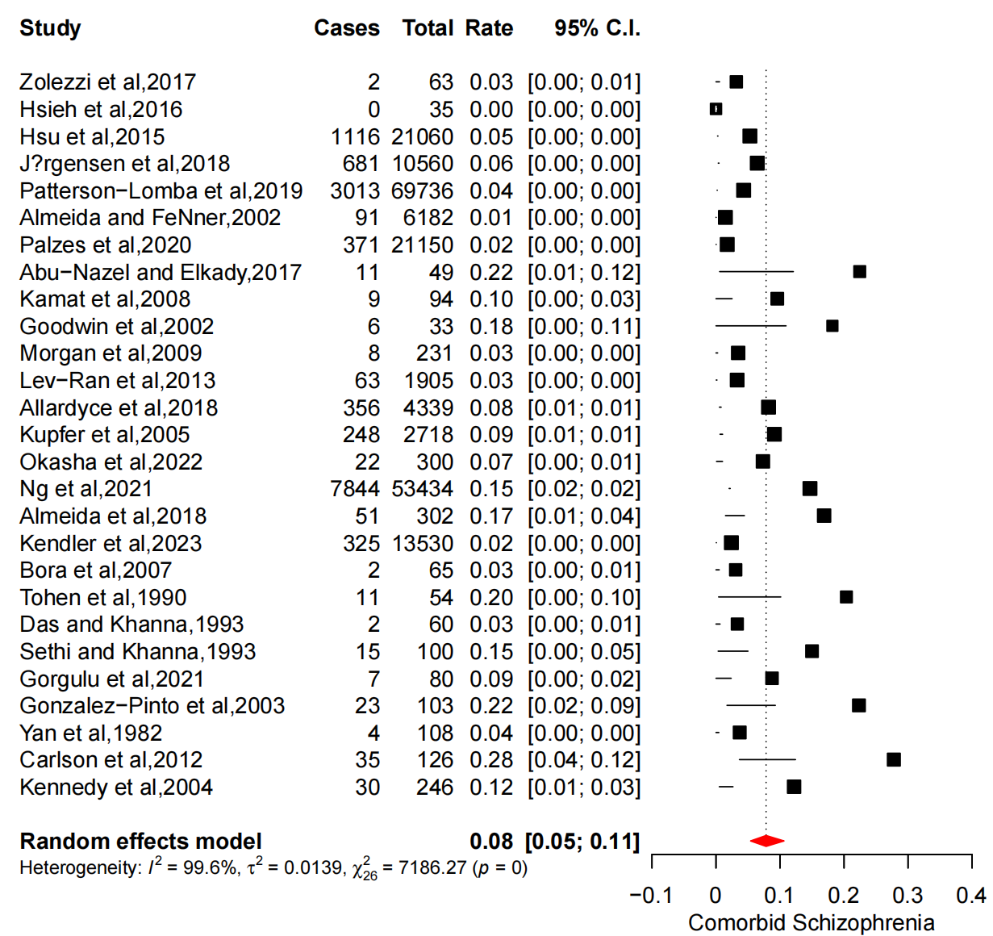
Figure B 1
Pooled prevalence of comorbid schizophrenia in bipolar patients

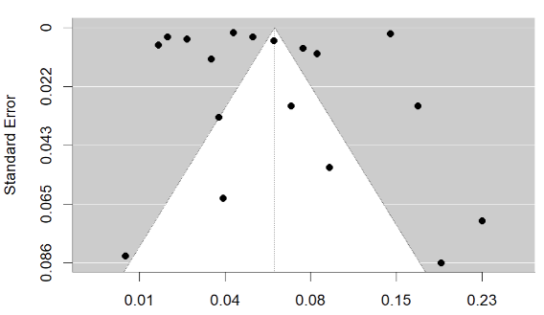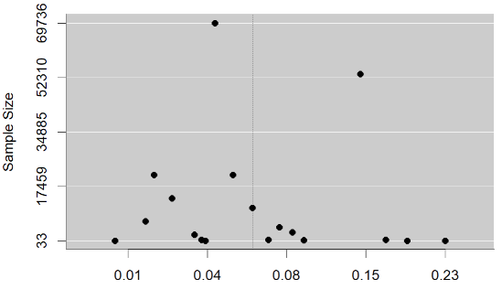
(a) original funnel (b) plot by sample size
Figure B 2
Funnel plots for the comorbid schizophrenia

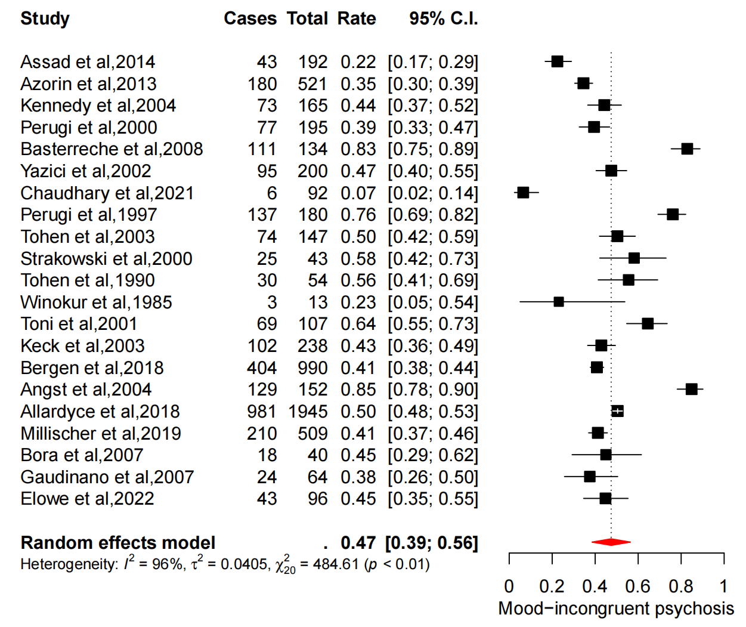
Figure B 3
Pooled prevalence of mood incongruent psychosis

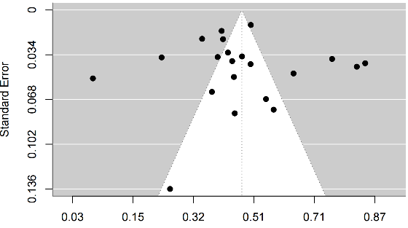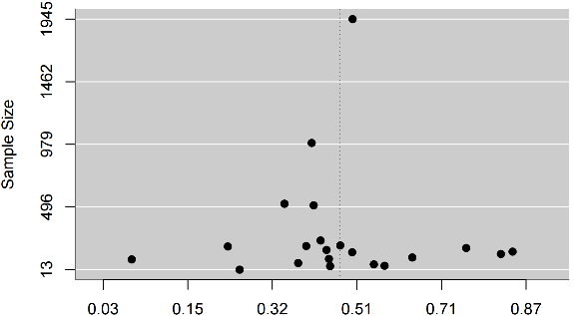
(a) original funnel (b) plot by sample size
Figure B 4
Funnel plots for mood incongruent psychosis
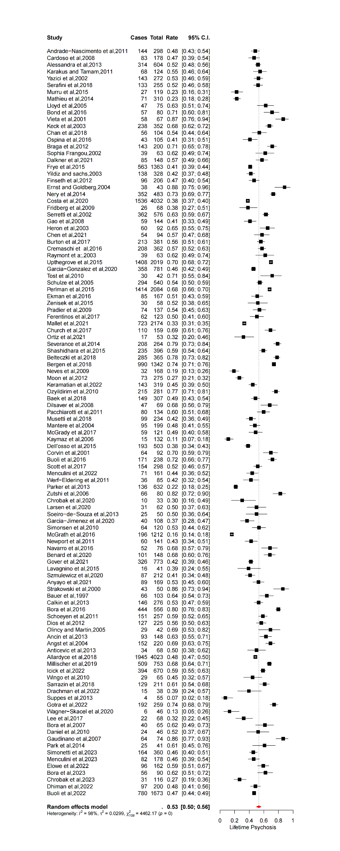
Figure B 5
Pooled rate of lifetime psychosis in bipolar patients
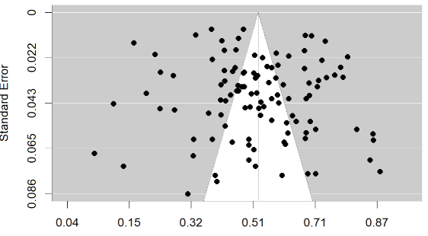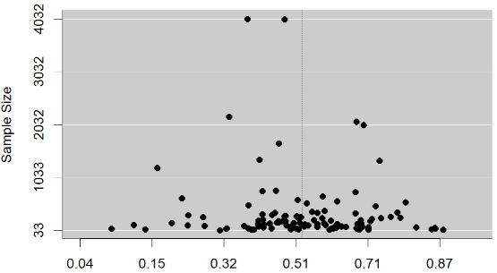
(a) original funnel (b) plot by sample size
Figure B 6
Funnel plots for the lifetime psychosis

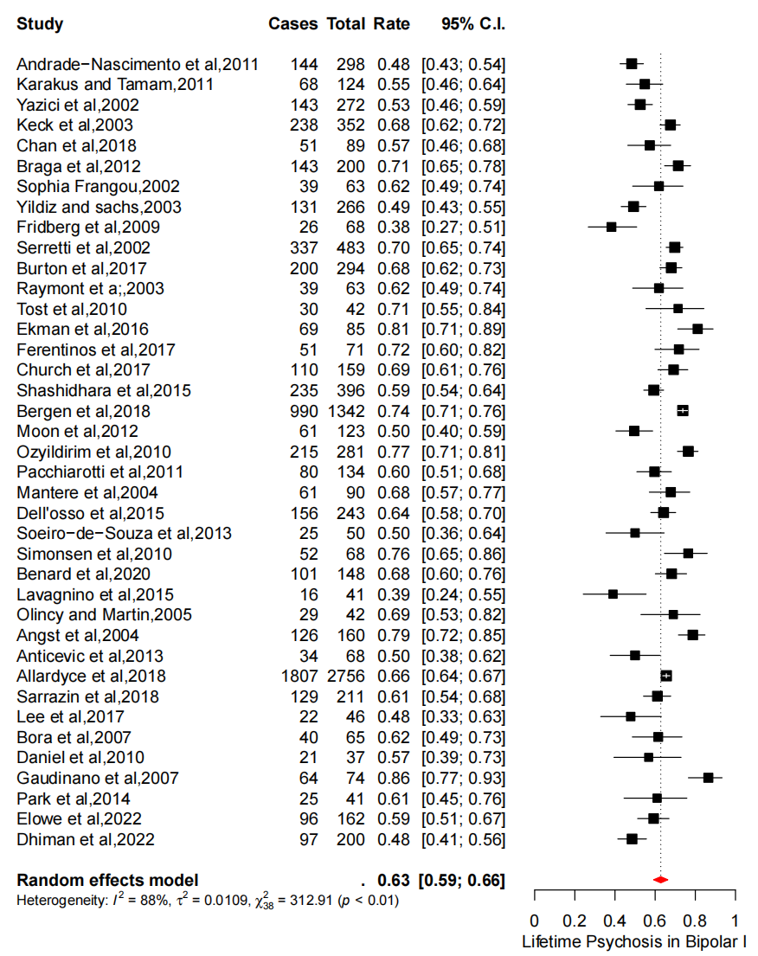
Figure B 7
The rate of lifetime psychosis in patients with bipolar I

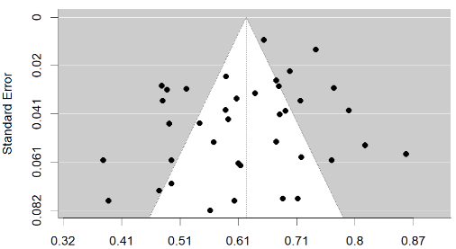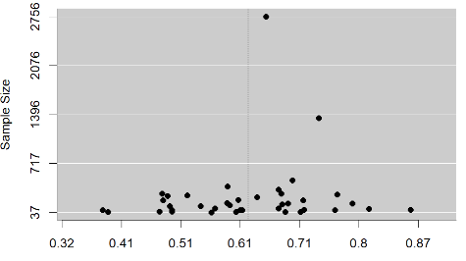
(a) original funnel (b) plot by sample size
Figure B 8
Funnel plots for the lifetime psychosis in patients with bipolar I

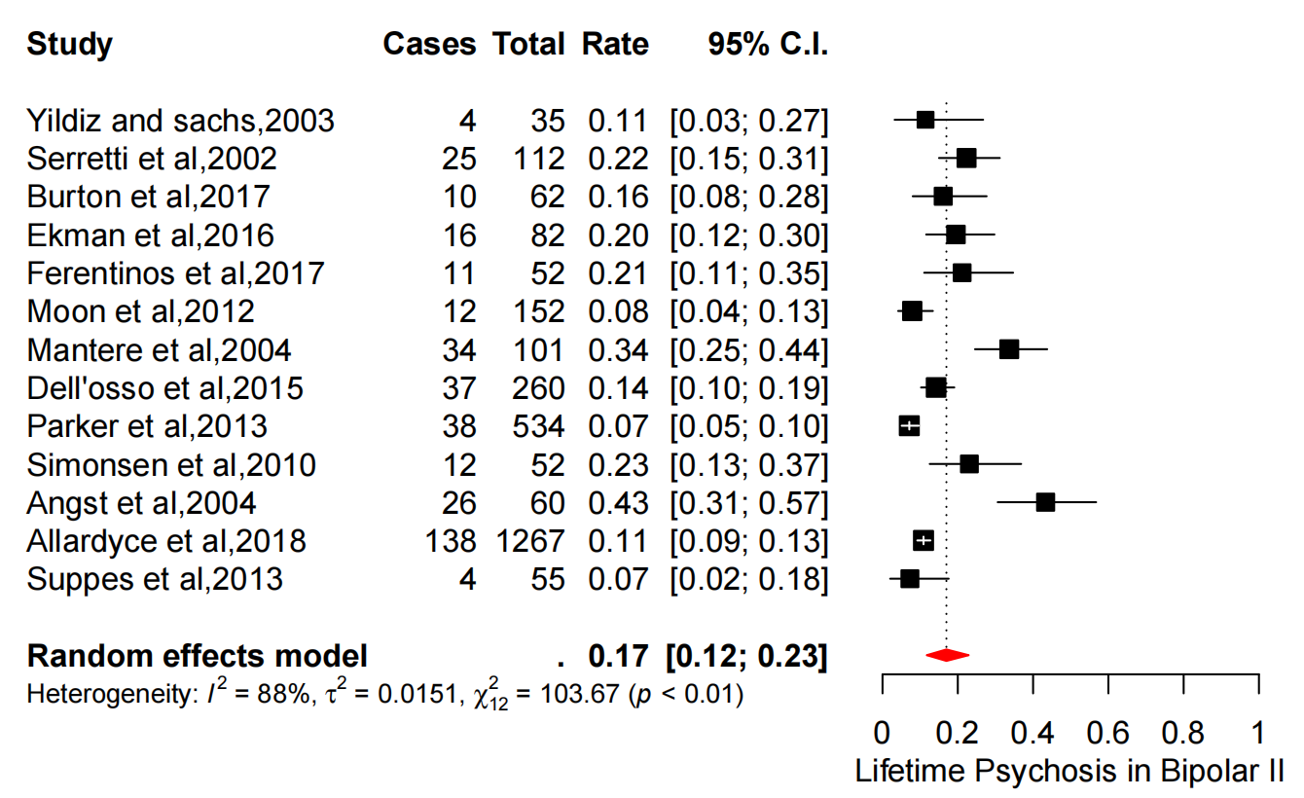
Figure B 9
The rate of lifetime psychosis in patients with bipolar II

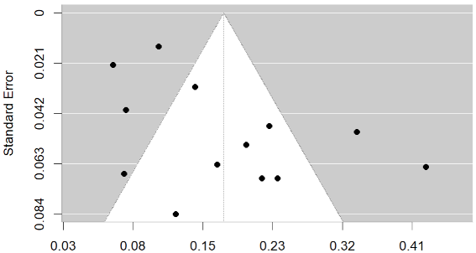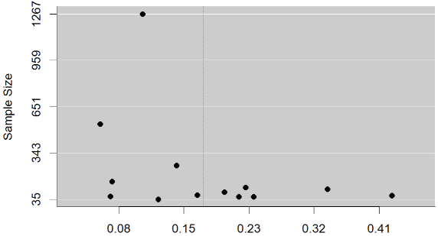
(a) original funnel (b) plot by sample size

Figure B 10
Funnel plots for lifetime psychosis in patients with bipolar II

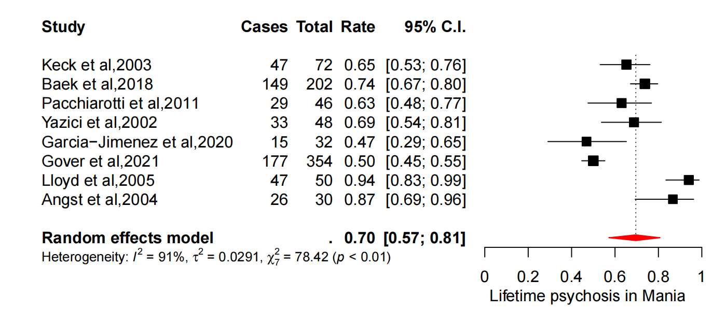
Figure B 11
Pooled rate of lifetime psychosis in bipolar patients with manic episode

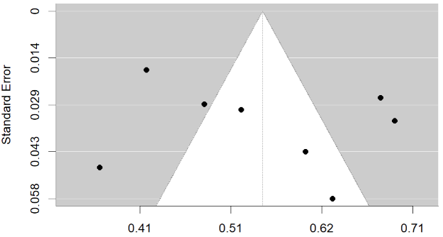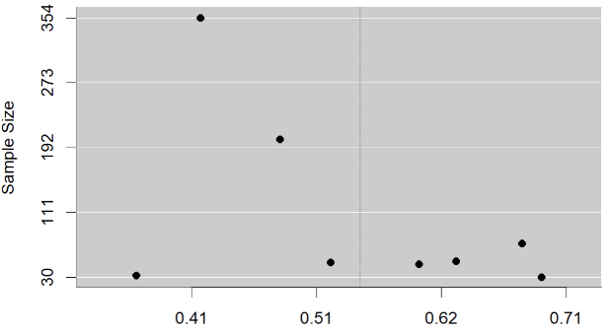
(a) original funnel (b) plot by sample size
Figure B 12
Funnel plots for lifetime psychosis in bipolar patients with manic episode

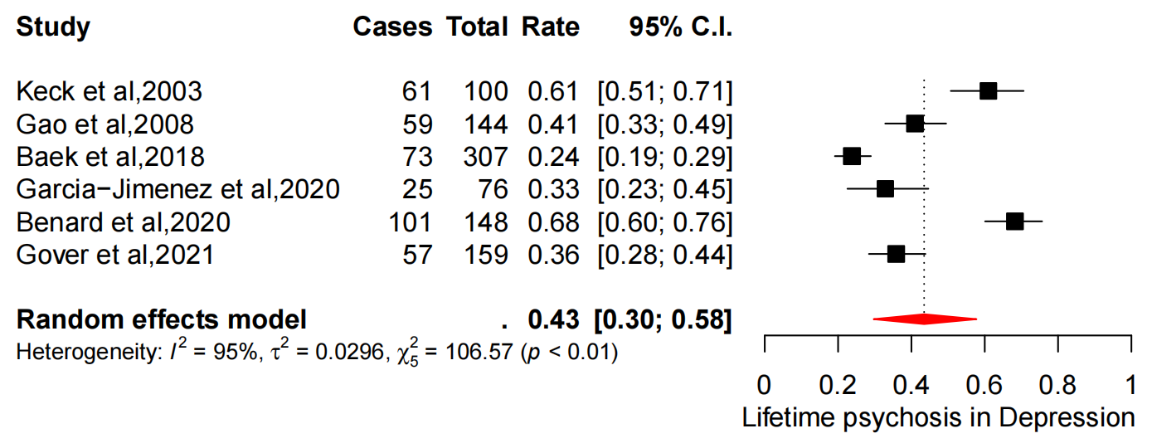
Figure B 13
Pooled rate of lifetime psychosis in bipolar patients with depressive episode

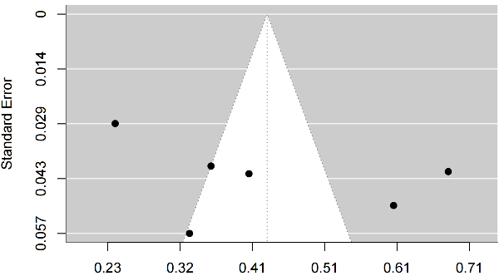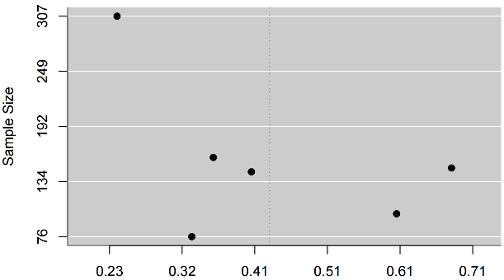
(a) original funnel (b) plot by sample size
Figure B 14
Funnel plots for lifetime psychosis in bipolar patients with depressive episode

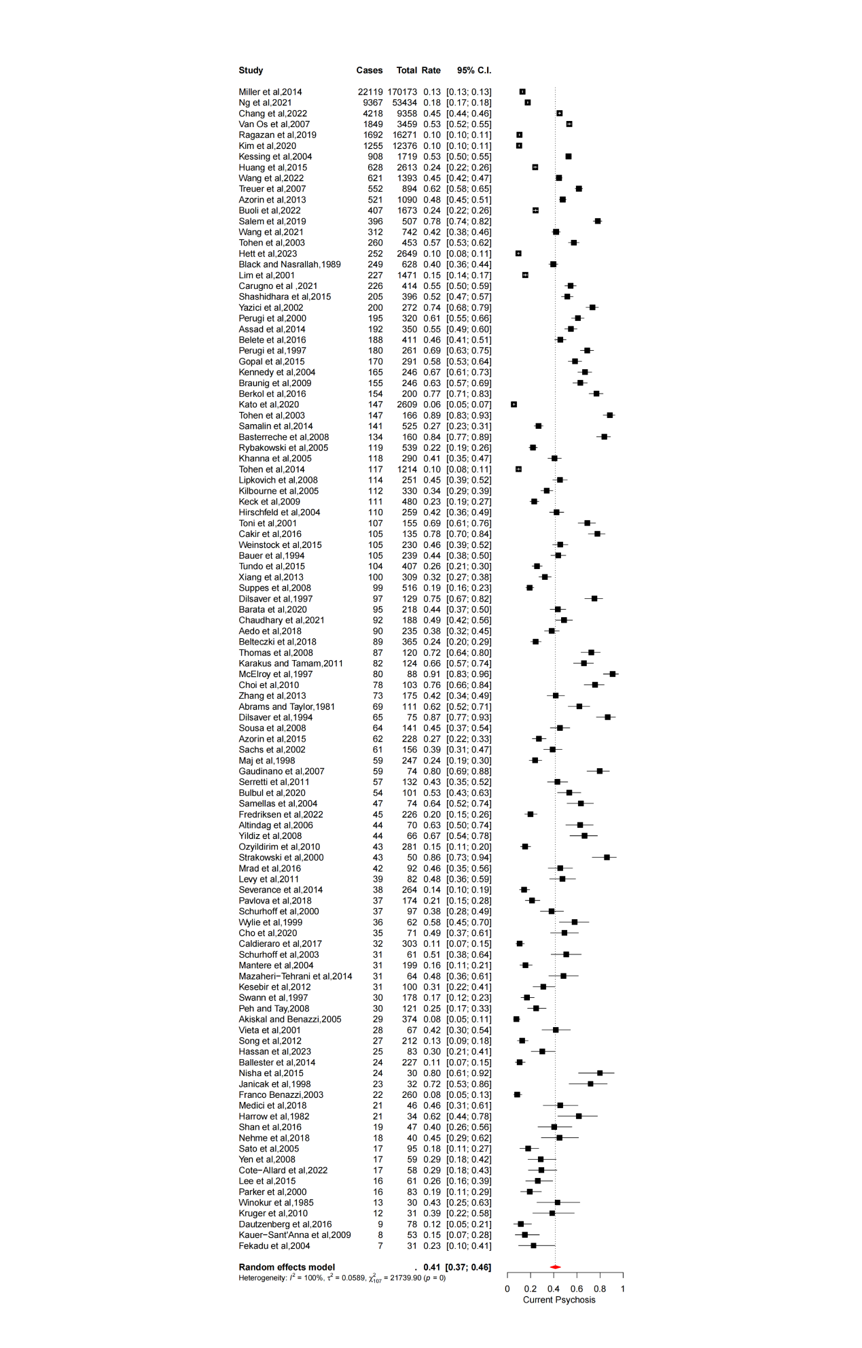
Figure B 15
Pooled rate of current psychosis in bipolar patients
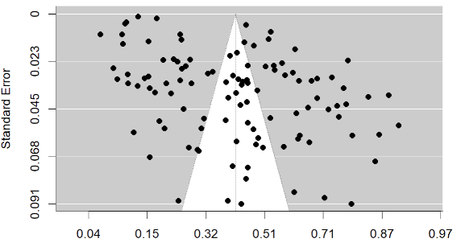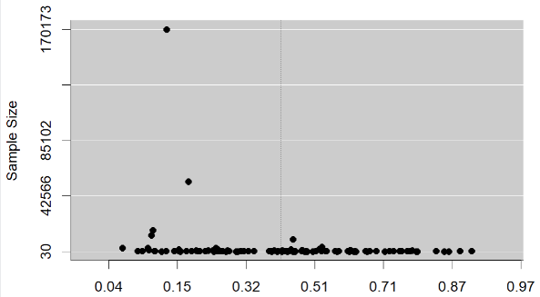
(a) original funnel (b) plot by sample size
Figure B 16
Funnel plots for current psychosis in bipolar patients

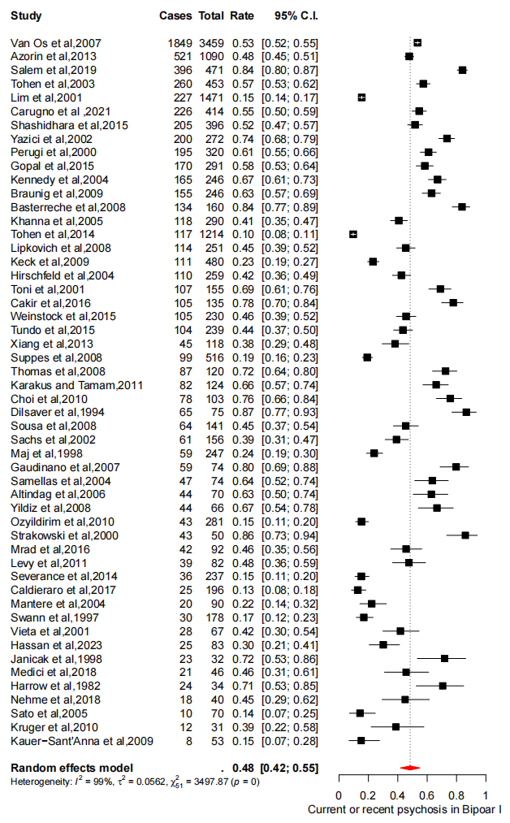
Figure B 17
Pooled rate of current psychosis in bipolar I patients

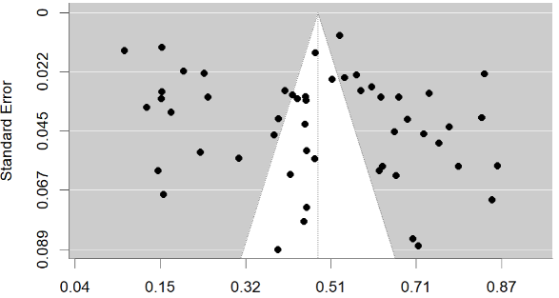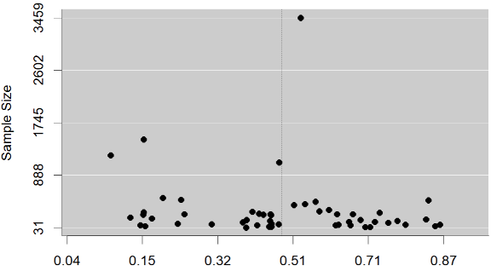
(a) original funnel (b) plot by sample size
Figure B 18
Funnel plots for current psychosis in bipolar I patients

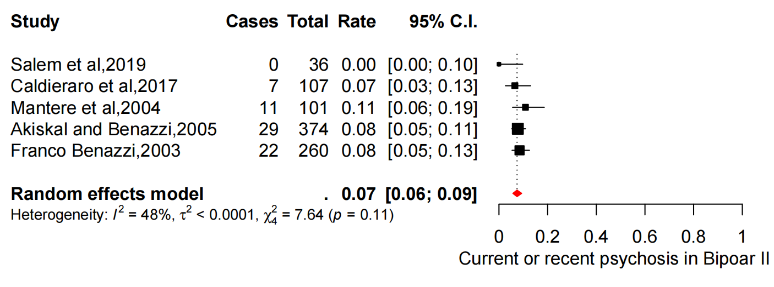
Figure B 19
Pooled rate of current psychosis in bipolar II patients

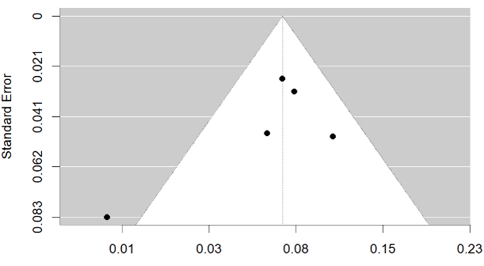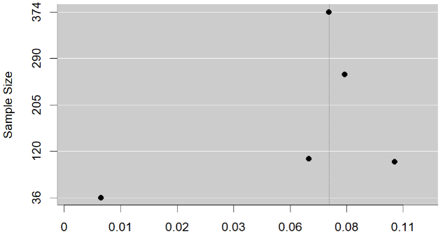
(a) original funnel (b) plot by sample size
Figure B 20
Funnel plots for current psychosis in bipolar II patients

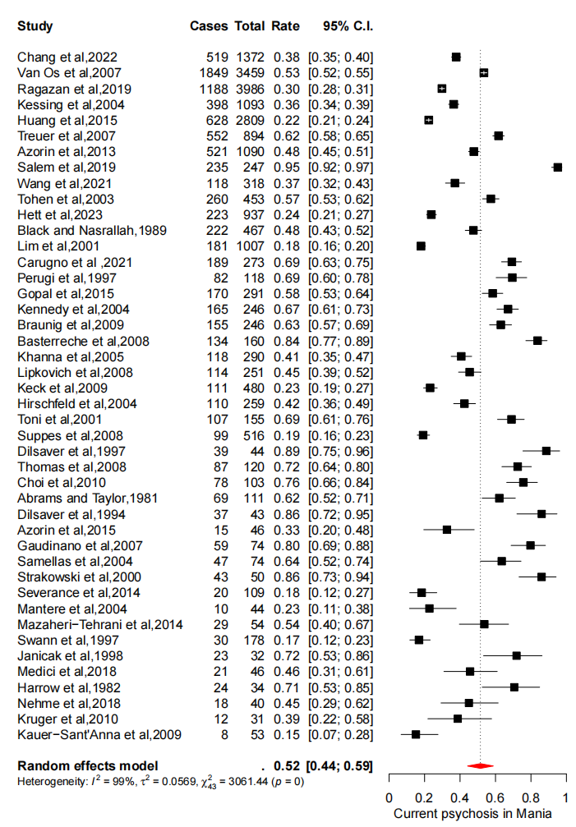
Figure B 21
Pooled rate of current psychosis in bipolar patients with manic episode

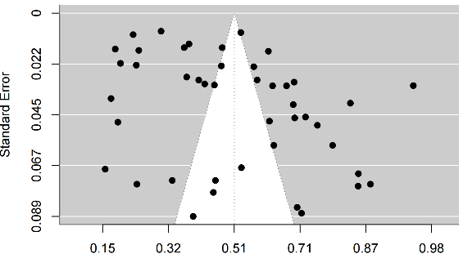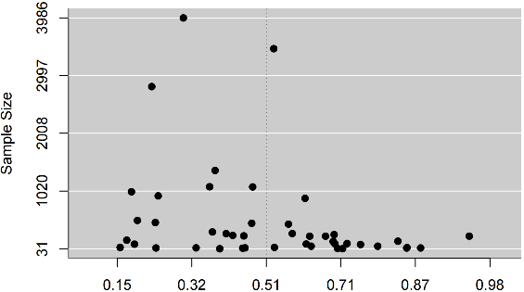
(a) original funnel (b) plot by sample size
Figure B 22
Funnel plots for current psychosis in bipolar patients with manic episode

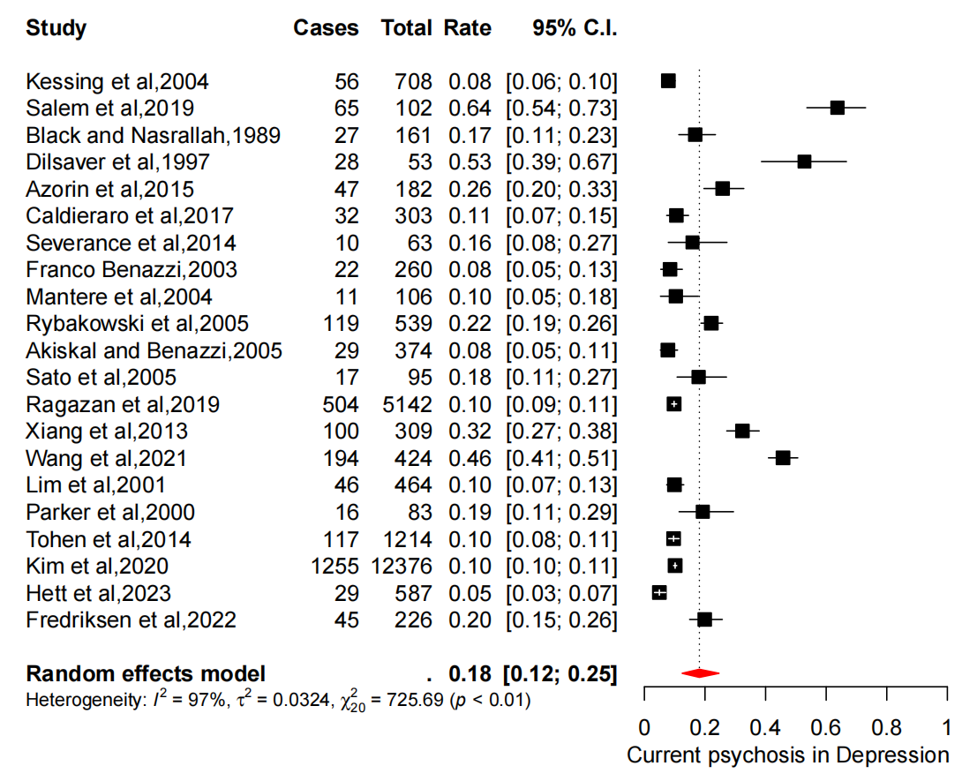
Figure B 23
Pooled rate of current psychosis in bipolar patients with depressive episode

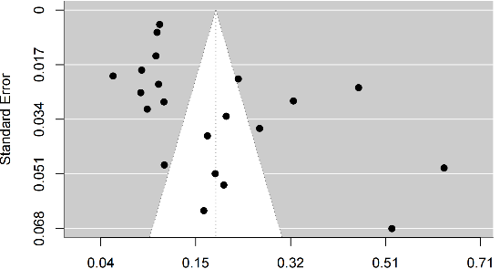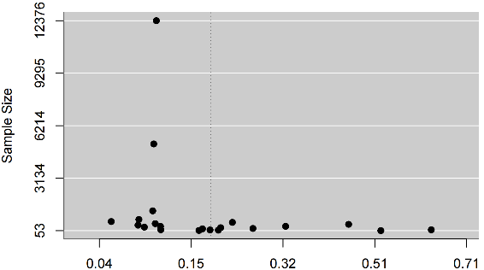
(a) original funnel (b) plot by sample size
Figure B 24
Funnel plots for current psychosis in bipolar patients with depressive episode

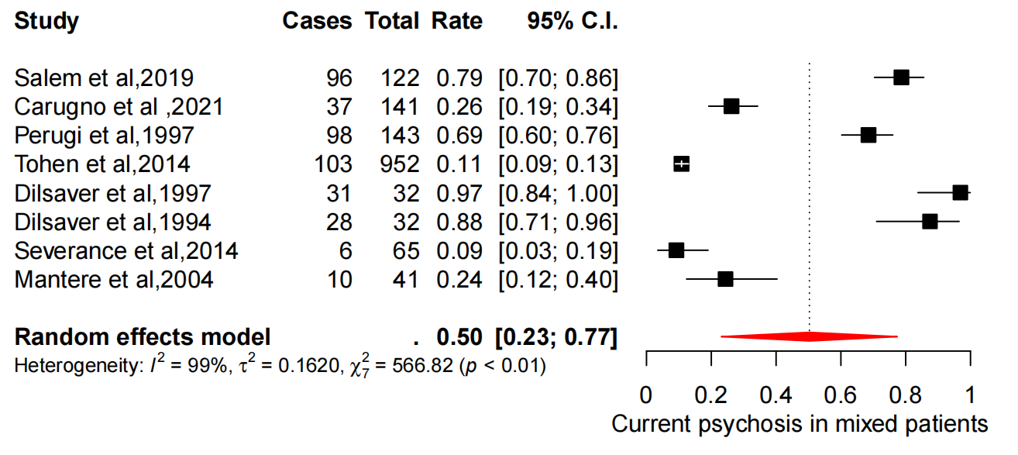
Figure B 25
Pooled rate of current psychosis in bipolar patients with mixed episode

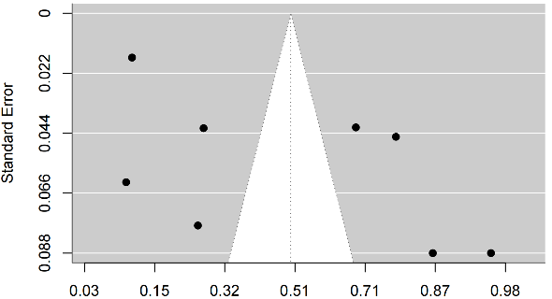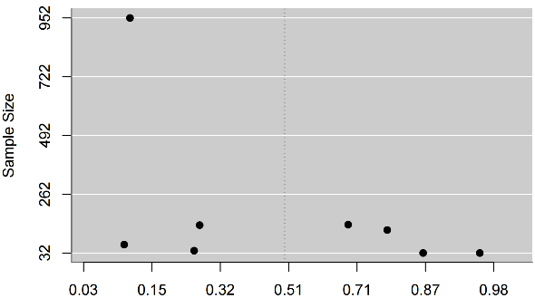
(a) original funnel (b) plot by sample size
Figure B 26
Funnel plots for current psychosis in bipolar patients with mixed episode

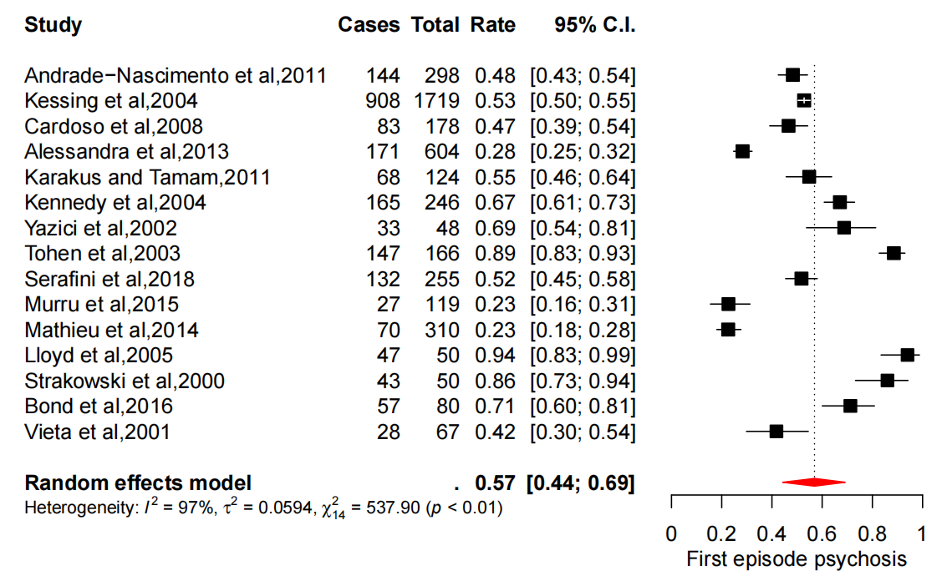
Figure B 27
Pooled rate of first episode psychosis in bipolar patients

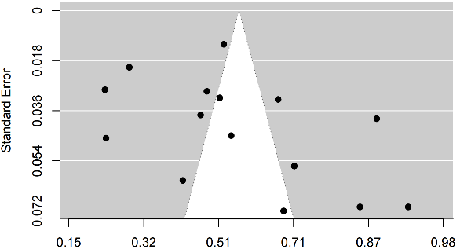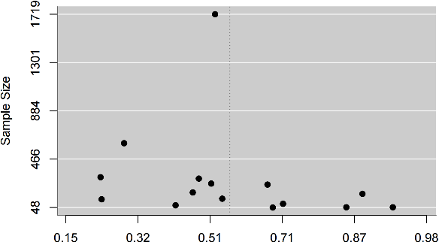
(a) original funnel (b) plot by sample size
Figure B 28
Funnel plots for first episode psychosis in bipolar patients

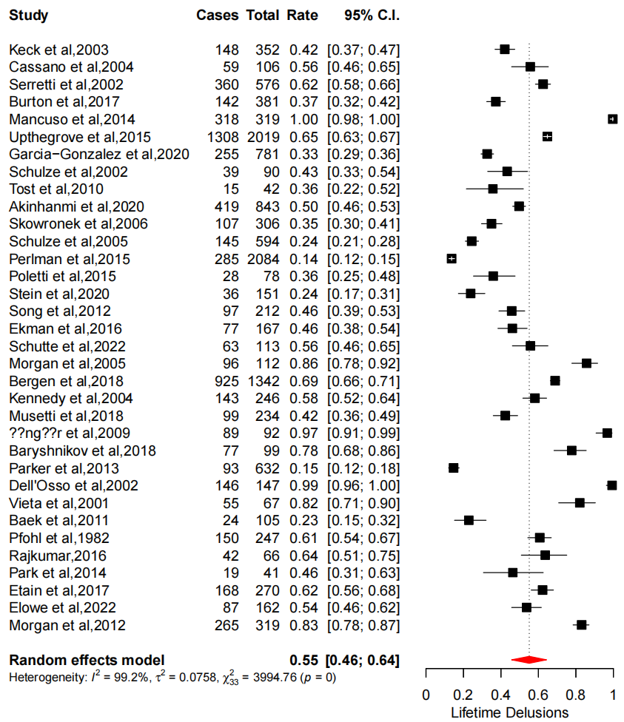
Figure B 29
Pooled rate of lifetime delusions in bipolar patients

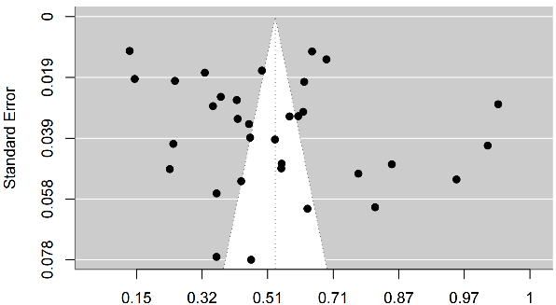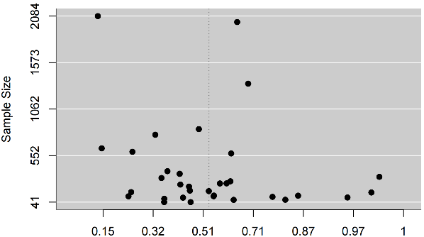
(a) original funnel (b) plot by sample size
Figure B 30
Funnel plots for lifetime delusions in bipolar patients
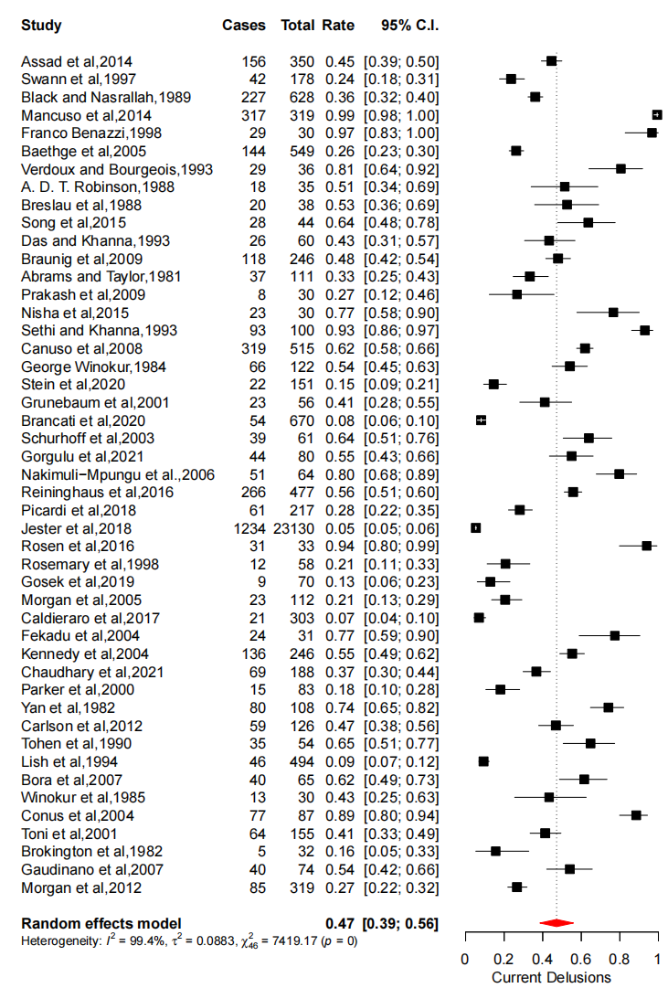
Figure B 31
Pooled rate of current delusions in bipolar patients

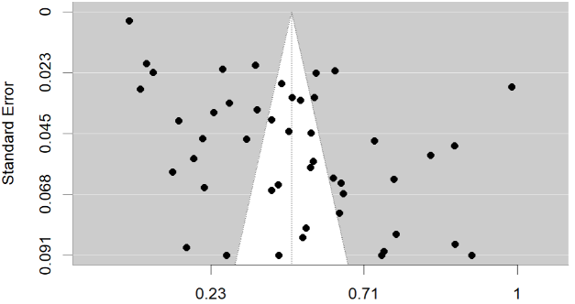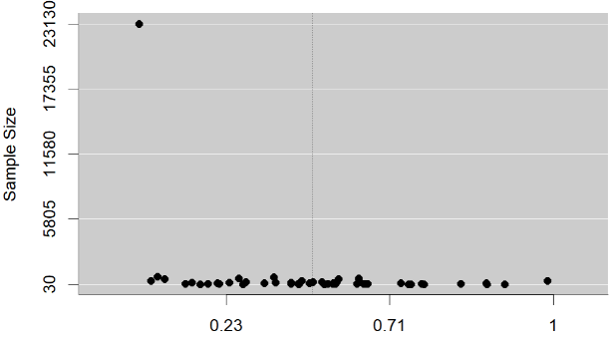
(a) original funnel (b) plot by sample size
Figure B 32
Funnel plots for current delusions in bipolar patients

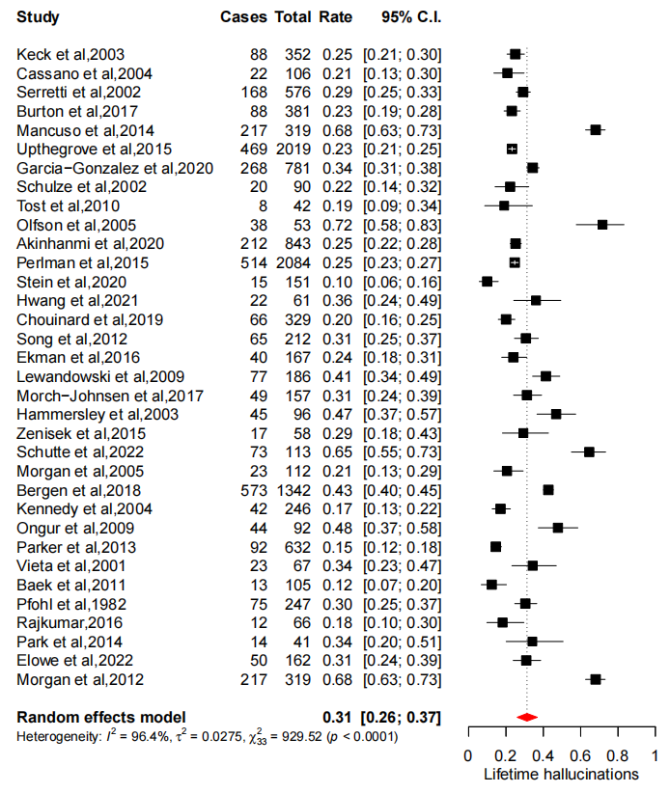
Figure B 33
Pooled rate of lifetime hallucinations in bipolar patients

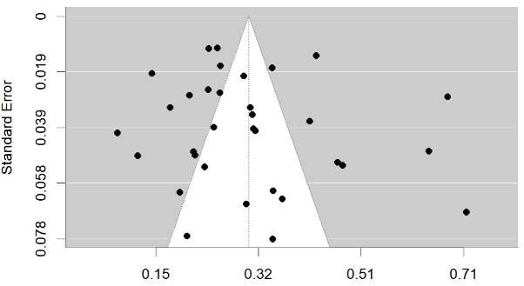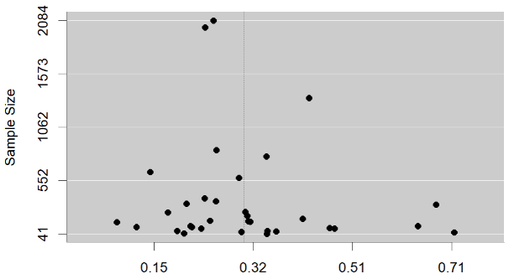
(a) original funnel (b) plot by sample size
Figure B 34
Funnel plots for lifetime hallucinations in bipolar patients

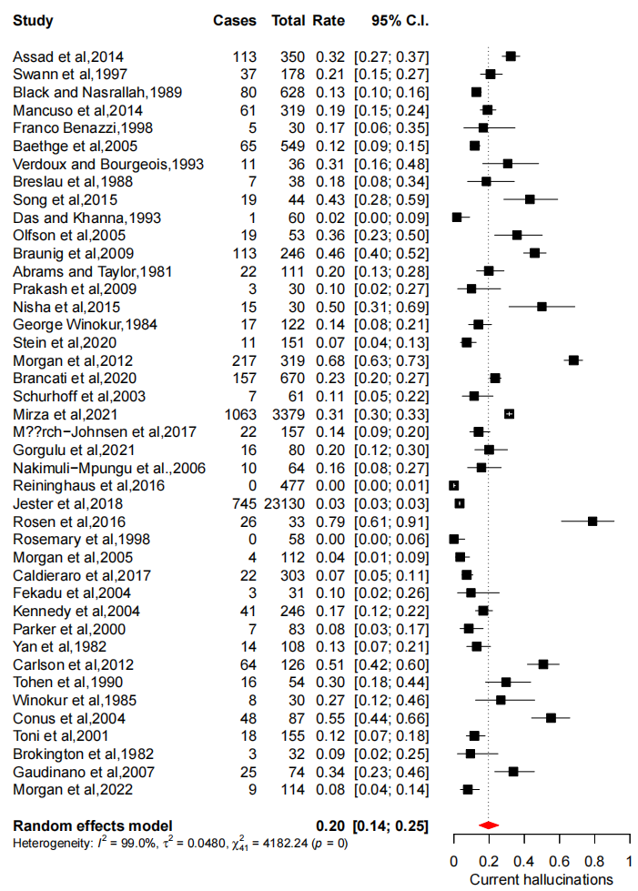
Figure B 35
Pooled rate of current hallucinations in bipolar patients

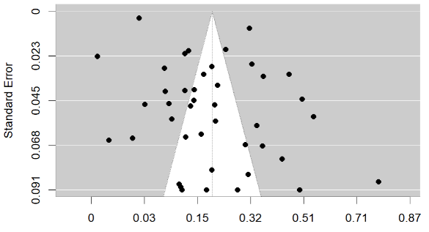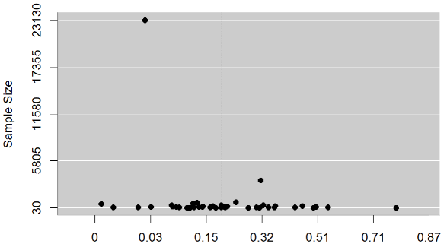
(a) original funnel (b) plot by sample size
Figure B 36
Funnel plots for current hallucinations in bipolar patients

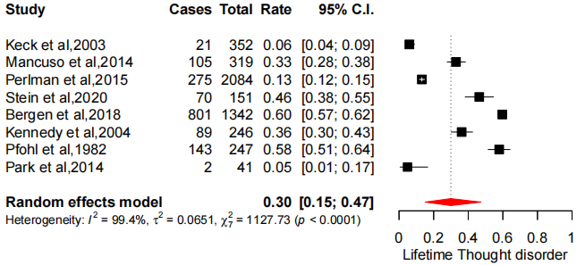
Figure B 37
Pooled rate of lifetime thought disorders in bipolar patients

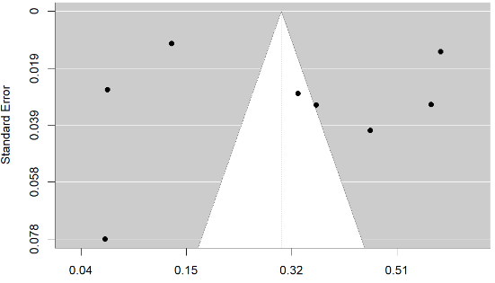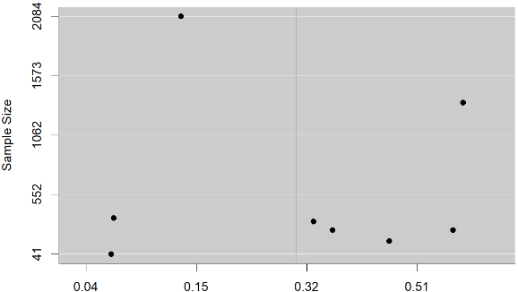
(a) original funnel (b) plot by sample size
Figure B 38
Funnel plots for lifetime thought disorders in bipolar patients

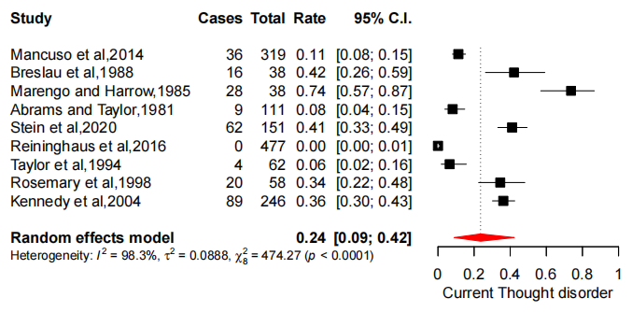
Figure B 39
Pooled rate of current thought disorders in bipolar patients

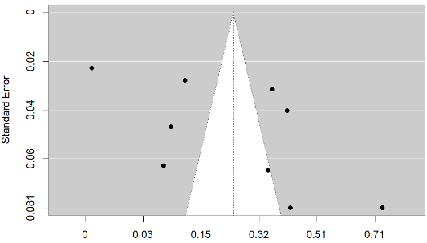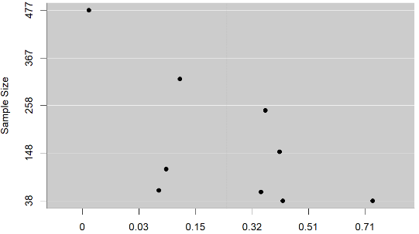
(a) original funnel (b) funnel plot by sample size
Figure B 40
Funnel plots for current thought disorders in bipolar patients

Appendix C: Supplementary Files for Chapter 3
Table C 1
Item selection: reason and action
Item | Description | Action | Note
Positive Syndrome (PANSS)
P1 | Delusions | exclusion | Similar to P5 and P6
P2 | Conceptual disorganization | Inclusion
P3 | Hallucinations | Inclusion
P4 | Excitement | Inclusion
P5 | Grandiosity | Inclusion
P6 | Suspiciousness/persecution | Inclusion
P7 | Hostility | exclusion | Similar to Y9
Negative Syndrome (PANSS)
N1 | Blunted affect | Inclusion
N2 | Emotional withdrawal | Merge | Merged with N4 (new item: WD)
N3 | Poor rapport | Merge | Merged with N6 (new item: RC)
N4 | Passive/apathetic social withdrawal | Merge | Merged with N2 (new item: WD)
N5 | Difficulty in abstract thinking | Inclusion
N6 | Lack of spontaneity and flow of conversation | Merge | Merged with N3 (new item: RC)
N7 | Stereotyped thinking | Inclusion
General psychiatric symptoms |  | Exclusion | These symptoms are not specific to schizophrenia. Considering the computational cost and network stability, these items were excluded.
Manic syndrome (YMRS)
Y1 | Elevated Mood | Merge | The new item was ME
Y2 | Increased Motor Activity-Energy | Merge | The new item was ME
Y3 | Sexual Interest | Inclusion
Y4 | Decreased Sleep | Merge | Merged with M4 (new item: SP)
Y5 | Irritability | Merge | Merged with Y9 (new item: IA)
Y6 | Speed and amount of Speech | Inclusion
Y7 | Language Thought disorder | Inclusion
Y8 | Content | Exclusion | Categorical and similar to P6 and P5
Y9 | Disruptive-Aggressive Behaviour | Merge | Merged with Y5 (new item: IA)
Y10 | Appearance | Inclusion
Y11 | Insight | Inclusion
M1 | Apparent Sadness | Exclusion | Similar to M2. This item is rated by observer, which is excluded to maintain the consistency of the measurement.
M2 | Reported Sadness | Inclusion
M3 | Inner tension | Inclusion
M4 | Reduced Sleep | Merge | Merged with Y4 (new item: SP)
M5 | Reduced appetite | Inclusion
M6 | Concentration difficulty | Inclusion
M7 | Lassitude (Retardation) | Inclusion
M8 | Inability to feel (Reduced Interests) | Inclusion
M9 | Pessimistic thoughts | Inclusion
M10 | Suicidal thoughts | Inclusion
Note. Item exclusions of P1, P7, General Psychiatric Symptoms and M1 were based on face validity, judged by an expert of this area. The rest items underwent a statistical checking (i.e., wTO score), and the pair of variables with score higher than 0.25 should be merged by addition.

Table C 2
Sensitivity check through UVA analysis excluding general psychiatric problems
Node 1 | Node2 | wTO
Y4 (Reduced need for sleep) | M4 (Reduced time for sleep) | .705
N3 (Poor rapport) | N6 (Lack of spontaneity and flow of conversation) | .355
P7 (Hostility) | Y9 (Aggressive and disruptive behaviour) | .333
N2 (Emotional withdrawal) | N4 (Passive/apathetic social withdrawal) | .324
Y1 (Mood elevation) | Y2 (Increased motor activity/energy) | .291
P7 (Hostility) | Y5 (Irritability) | .291
M2 (Reported sadness) | M1 (Apparent sadness) | .266
P1 (Delusions) | P3 (Hallucinations) | .257
P2 (Conceptual disorganisation) | N7 (Stereotyped thinking) | .247
P1 (Delusions) | P6 (Paranoia/ Suspiciousness) | .244
N1 (Blunt affect) | N6 (Lack of spontaneity and flow of conversation) | .238
Y5 (Irritability) | Y9 (Aggressive and disruptive behaviour) | .233
M9 (Pessimistic thoughts) | M10 (Suicidal thoughts) | 0.231
Note. This straight UVA solution differed from the two-stage solution in that it did not exclude P1 and M1 and did not merge Y5 and Y9. For conceptual distinctiveness, P1 and P3 were added into the model without merging, and the rest were merged by addition if they exhibited a wTO score higher than 0.25. The colouring denotes that the pair of nodes was merged by addition before the estimation of the network model.

Table C 3
The comparison statistics of the selected items in subgroups
Items | PBD | SCA | SCZ | Chi square (unadjusted) | Direction (adjusted)
P2 Conceptual disorganisation | 1.64 (0.96) | 2.18 (1.19) | 2.41 (1.34) | 126.43*** | SCZ>SCA**†; SCZ>PBD***††; SCA>PBD***†;
P3 Hallucinations | 1.53 (1.03) | 3.01 (1.65) | 2.81 (1.70) | 280.85*** | SCA>SCZ*†; SCZ>PBD***††; SCA>PBD***††.
P4 Excitements | 2.02 (1.08) | 2.06 (1.10) | 1.74 (1.10) | 34.89*** | SCA>SCZ***†; PBD>SCZ***†.
P5 Grandiosity | 1.86 (1.06) | 2.15 (1.27) | 2.05 (1.27) | 11.78** | SCA>PBD**†.
P6 Paranoia/ Suspiciousness | 2.35 (1.27) | 3.28 (1.42) | 3.12 (1.45) | 136.15*** | SCZ >PBD***†; SCA> PBD***††.
N1 Blunt affect | 1.69 (1.09) | 2.24 (1.33) | 2.70 (1.47) | 177.81*** | SCZ>SCA***†; SCZ>PBD***††; SCA>PBD***†.
RC Poor rapport and rigid conversation | 2.90 (1.60) | 3.51 (2.01) | 3.97 (2.25) | 95.00*** | SCZ>SCA***†; SCZ>PBD***†; SCA>PBD***†.
WD Withdrawal | 3.97 (2.28) | 4.97 (2.56) | 4.99 (2.45) | 69.05*** | SCZ>PBD***†; SCA> PBD***†.
N5 Difficulty in abstract thinking | 2.30 (1.38) | 3.01 (1.44) | 3.23 (1.50) | 137.71*** | SCZ>SCA*; SCZ>PBD***††; SCZ>PBD***†.
N7 Stereotyped thinking | 1.40 (0.82) | 1.69 (1.04) | 1.81 (1.08) | 62.60*** | SCZ>SCA*†; SCZ>PBD***†; SCA>PBD***†.
ME Mood/energy elevation | 1.11 (1.70) | 0.86 (1.35) | 0.49 (.97) | 46.81*** | SCA>SCZ***†; PBD>SCZ***†.
Y3 Sexual interest | 0.25 (0.65) | 0.24 (0.62) | 0.16 (0.51) | 7.46* | SCA>SCZ*†; PBD>SCZ*†.
IA Irritability/ aggressive-disruptive behaviour | 1.95 (2.44) | 2.10 (2.50) | 1.26 (2.00) | 50.62*** | SCA>SCZ***†; PBD>SCZ***†.
Y6 Speed and amount of speech | 0.89 (1.64) | 0.70 (1.36) | 0.46 (1.09) | 21.17*** | SCA>SCZ***†; PBD>SCZ***†.
Y7 Language thought disorder | 0.55 (0.85) | 0.75 (0.91) | 0.50 (0.81) | 29.35*** | SCA>PBD***†; SCA>SCZ***†.
Y10 Appearance | 0.30 (0.63) | 0.35 (0.70) | 0.38 (0.71) | 3.95 | -
Y11 Insight | 0.24 (0.61) | 0.52 (0.85) | 0.76 (1.15) | 90.73*** | SCZ >SCA***†; SCZ>PBD***†; SCA>PBD***†.
M2 Reported sadness | 1.32 (1.49) | 1.54 (1.55) | 0.91 (1.29) | 60.01*** | SCA>PBD*†; SCA>SCZ***†; PBD>SCZ***†.
M3 Inner tension | 1.71 (1.50) | 1.99 (1.47) | 1.25 (1.42) | 79.72*** | SCA>PBD**†; SCA>SCZ***†; PBD>SCZ***†.
M5 Reduced appetite | 0.56 (1.21) | 0.69 (1.30) | 0.34 (0.90) | 27.00*** | SCA>SCZ***†; PBD>SCZ***†.
M6 Concentration difficulty | 1.34 (1.61) | 1.80 (1.66) | 1.19 (1.55) | 48.86*** | SCA>PBD***†; SCA>SCZ***†.
M7 Retardation | 1.46 (1.60) | 1.72 (1.62) | 1.12 (1.42) | 44.53*** | SCA>PBD**†; SCA>SCZ***†; PBD>SCZ***†.
M8 Inability to feel | 1.13 (1.59) | 1.32 (1.56) | 0.86 (1.38) | 31.57*** | SCA>PBD**†; PBD>SCZ**†; SCA>SCZ***†
M9 Pessimistic thoughts | 1.21 (1.44) | 1.43 (1.55) | 0.86 (1.28) | 50.41*** | SCA>PBD**†; SCA>SCZ***†; PBD>SCZ***†.
M10 Suicidal thoughts | 0.42 (0.99) | 0.62 (1.17) | 0.26 (0.77) | 42.88*** | SCA>PBD***†; SCA>SCZ***†; PBD>SCZ**†.
SP Sleep problems | 1.88 (2.58) | 2.13 (2.62) | 1.21 (2.08) | 47.11*** | SCA>SCZ***†; PBD>SCZ***†.
Note. The chi square value was derived from Kruskal-Wallis test. The p value for paired comparison was adjusted by BH (Benjamini & Hochberg) method. The group difference was not significant if it was not reported in the direction column. For the ease of interpretation, the M(SD) was reported instead of median (range).
*: p < .05; **: p < .01; ***: p < .001.
† small effect size (r = .10-.29), ††moderate effect size (r = .30-.49).

Table C 4
The ordered edge statistics of the edges with non-zero weight in network of all patients
Edge | Weight | BCI (lower) | BCI (upper) | P0
N1--RC | 0.41 | 0.37 | 0.46 | 0.00
P2--N7 | 0.31 | 0.27 | 0.35 | 0.00
ME--Y6 | 0.28 | 0.23 | 0.33 | 0.00
P3--P6 | 0.24 | 0.19 | 0.28 | 0.00
M9--M10 | 0.23 | 0.19 | 0.28 | 0.00
WD--M8 | 0.23 | 0.19 | 0.26 | 0.00
M7--M8 | 0.22 | 0.17 | 0.26 | 0.00
M5--SP | 0.21 | 0.16 | 0.26 | 0.00
P6--WD | 0.20 | 0.16 | 0.24 | 0.00
ME--Y7 | 0.20 | 0.15 | 0.24 | 0.00
Y6--Y7 | 0.19 | 0.15 | 0.24 | 0.00
Y7--M6 | 0.19 | 0.15 | 0.23 | 0.00
N1--WD | 0.18 | 0.14 | 0.22 | 0.00
RC--WD | 0.17 | 0.13 | 0.22 | 0.00
M3--M9 | 0.17 | 0.13 | 0.22 | 0.00
IA--M3 | 0.17 | 0.12 | 0.21 | 0.00
M2--M8 | 0.16 | 0.11 | 0.21 | 0.00
P2--N5 | 0.16 | 0.11 | 0.20 | 0.00
IA--Y7 | 0.15 | 0.11 | 0.20 | 0.00
M6--M7 | 0.15 | 0.10 | 0.20 | 0.00
M3--M6 | 0.15 | 0.10 | 0.20 | 0.00
N5--N7 | 0.15 | 0.11 | 0.20 | 0.00
M6--M8 | 0.15 | 0.10 | 0.19 | 0.00
M2--M9 | 0.14 | 0.09 | 0.19 | 0.00
P4--P5 | 0.14 | 0.10 | 0.19 | 0.00
M7--M9 | 0.14 | 0.09 | 0.19 | 0.00
M8--M9 | 0.14 | 0.09 | 0.18 | 0.00
M2--M10 | 0.13 | 0.09 | 0.18 | 0.00
P4--ME | 0.13 | 0.09 | 0.18 | 0.00
M2--M7 | 0.13 | 0.08 | 0.18 | 0.00
ME--Y3 | 0.13 | 0.08 | 0.18 | 0.00
M3--SP | 0.13 | 0.08 | 0.17 | 0.00
N1--N5 | 0.12 | 0.08 | 0.17 | 0.00
RC--N7 | 0.12 | 0.07 | 0.16 | 0.00
P4--Y6 | 0.11 | 0.07 | 0.16 | 0.00
M3--M7 | 0.11 | 0.07 | 0.16 | 0.00
P4--Y7 | 0.11 | 0.06 | 0.16 | 0.00
P6--IA | 0.11 | 0.07 | 0.15 | 0.00
P5--P6 | 0.10 | 0.06 | 0.15 | 0.00
P5--Y11 | 0.10 | 0.05 | 0.15 | 0.00
P5--N7 | 0.10 | 0.05 | 0.14 | 0.00
IA--SP | 0.09 | 0.05 | 0.14 | 0.00
P3--N5 | 0.09 | 0.05 | 0.14 | 0.00
P2--Y7 | 0.09 | 0.06 | 0.13 | 0.00
P2--P4 | 0.09 | 0.05 | 0.14 | 0.00
M2--M6 | 0.09 | 0.04 | 0.14 | 0.00
P4--IA | 0.09 | 0.05 | 0.13 | 0.00
M2--M3 | 0.09 | 0.05 | 0.14 | 0.00
M5--M8 | 0.09 | 0.04 | 0.14 | 0.00
P2--P6 | 0.09 | 0.04 | 0.13 | 0.00
P2--Y11 | 0.08 | 0.04 | 0.12 | 0.00
P6--N7 | 0.08 | 0.04 | 0.12 | 0.00
IA--Y6 | 0.08 | 0.03 | 0.13 | 0.00
M6--SP | 0.08 | 0.04 | 0.12 | 0.00
P2--P3 | 0.08 | 0.03 | 0.12 | 0.00
WD--M2 | 0.08 | 0.03 | 0.12 | 0.00
ME--SP | 0.08 | 0.03 | 0.12 | 0.00
WD--N7 | 0.07 | 0.03 | 0.11 | 0.00
P5--ME | 0.07 | 0.03 | 0.11 | 0.00
Y10--M7 | 0.07 | 0.02 | 0.11 | 0.00
WD--M7 | 0.07 | 0.03 | 0.11 | 0.00
IA--M9 | 0.07 | 0.03 | 0.11 | 0.00
M3--M10 | 0.07 | 0.02 | 0.11 | 0.00
M2--SP | 0.07 | 0.03 | 0.11 | 0.00
M3--M5 | 0.07 | 0.02 | 0.11 | 0.00
P2--N1 | 0.07 | 0.02 | 0.11 | 0.00
P4--M3 | 0.07 | 0.02 | 0.11 | 0.00
P4--N7 | 0.06 | 0.02 | 0.10 | 0.00
M8--M10 | 0.06 | 0.02 | 0.11 | 0.01
Y3--Y6 | 0.06 | 0.01 | 0.11 | 0.01
P3--P5 | 0.06 | 0.02 | 0.11 | 0.00
IA--Y10 | 0.06 | 0.02 | 0.10 | 0.01
Y3--Y10 | 0.06 | 0.01 | 0.11 | 0.02
P5--Y3 | 0.06 | 0.01 | 0.10 | 0.01
P2--P5 | 0.06 | 0.01 | 0.10 | 0.01
Y3--IA | 0.05 | 0.01 | 0.10 | 0.01
N7--Y10 | 0.05 | 0.01 | 0.10 | 0.01
P3--M6 | 0.05 | 0.01 | 0.09 | 0.02
P6--M3 | 0.05 | 0.01 | 0.09 | 0.01
P6--RC | 0.05 | 0.01 | 0.09 | 0.01
IA--M2 | 0.04 | 0.00 | 0.09 | 0.03
Y7--Y10 | 0.04 | 0.00 | 0.09 | 0.04
Y10--Y11 | 0.04 | -0.00 | 0.09 | 0.04
WD--Y10 | 0.04 | 0.00 | 0.08 | 0.04
P2--Y6 | 0.04 | 0.00 | 0.08 | 0.03
P3--WD | 0.04 | -0.00 | 0.08 | 0.05
P6--N5 | 0.04 | -0.00 | 0.08 | 0.05
M2--M5 | 0.04 | -0.00 | 0.08 | 0.04
P5--Y7 | 0.04 | -0.00 | 0.08 | 0.05
M6--M9 | 0.04 | -0.00 | 0.08 | 0.06
P4--P6 | 0.04 | -0.00 | 0.08 | 0.04
M5--M7 | 0.04 | -0.01 | 0.08 | 0.07
RC--N5 | 0.04 | -0.01 | 0.08 | 0.07
N1--Y10 | 0.04 | -0.00 | 0.07 | 0.07
IA--M8 | 0.03 | -0.01 | 0.08 | 0.08
M5--M6 | 0.03 | -0.01 | 0.08 | 0.07
Y7--Y11 | 0.03 | -0.01 | 0.07 | 0.07
P6--Y11 | 0.03 | -0.01 | 0.07 | 0.11
N1--N7 | 0.03 | -0.01 | 0.07 | 0.09
N1--M2 | 0.03 | -0.01 | 0.07 | 0.07
Y7--M3 | 0.03 | -0.01 | 0.07 | 0.09
Y10--M9 | 0.03 | -0.01 | 0.07 | 0.13
P4--SP | 0.03 | -0.01 | 0.07 | 0.11
M5--M10 | 0.03 | -0.02 | 0.07 | 0.17
M3--M8 | 0.03 | -0.01 | 0.06 | 0.13
P3--Y7 | 0.02 | -0.01 | 0.06 | 0.17
Y6--SP | 0.02 | -0.02 | 0.06 | 0.19
P3--M5 | 0.02 | -0.02 | 0.06 | 0.24
P4--M6 | 0.02 | -0.02 | 0.06 | 0.14
WD--M10 | 0.02 | -0.01 | 0.06 | 0.15
IA--Y11 | 0.02 | -0.02 | 0.06 | 0.25
M7--M10 | 0.02 | -0.02 | 0.06 | 0.24
RC--Y11 | 0.02 | -0.02 | 0.05 | 0.30
Y10--M3 | 0.02 | -0.02 | 0.05 | 0.26
P3--N1 | 0.02 | -0.02 | 0.05 | 0.20
P2--RC | 0.02 | -0.02 | 0.05 | 0.20
P6--M2 | 0.02 | -0.01 | 0.05 | 0.22
M9--SP | 0.02 | -0.02 | 0.05 | 0.30
ME--IA | 0.02 | -0.02 | 0.05 | 0.25
N5--Y10 | 0.02 | -0.02 | 0.05 | 0.27
N5--M5 | 0.02 | -0.02 | 0.05 | 0.26
P3--M3 | 0.02 | -0.02 | 0.05 | 0.26
P5--IA | 0.01 | -0.02 | 0.05 | 0.28
P3--M10 | 0.01 | -0.02 | 0.04 | 0.35
Y10--M8 | 0.01 | -0.02 | 0.04 | 0.33
IA--M5 | 0.01 | -0.02 | 0.04 | 0.36
P6--Y7 | 0.01 | -0.02 | 0.04 | 0.29
Y7--SP | 0.01 | -0.02 | 0.04 | 0.35
P6--M6 | 0.01 | -0.02 | 0.04 | 0.43
M7--SP | 0.01 | -0.02 | 0.04 | 0.39
Y3--SP | 0.01 | -0.02 | 0.04 | 0.43
M8--SP | 0.01 | -0.02 | 0.04 | 0.40
P5--Y6 | 0.01 | -0.02 | 0.04 | 0.40
Y10--M5 | 0.01 | -0.02 | 0.04 | 0.50
WD--M9 | 0.01 | -0.02 | 0.03 | 0.49
P3--SP | 0.01 | -0.02 | 0.03 | 0.49
WD--N5 | 0.00 | -0.03 | 0.03 | 0.39
P3--N7 | 0.00 | -0.03 | 0.03 | 0.49
IA--M7 | 0.00 | -0.02 | 0.03 | 0.47
Y10--M6 | 0.00 | -0.02 | 0.03 | 0.53
Y3--M3 | 0.00 | -0.02 | 0.03 | 0.52
M6--M10 | 0.00 | -0.02 | 0.03 | 0.51
N7--IA | 0.00 | -0.02 | 0.02 | 0.55
N1--M5 | -0.00 | -0.03 | 0.02 | 0.51
P5--M8 | -0.00 | -0.02 | 0.02 | 0.57
Y11--M7 | -0.00 | -0.03 | 0.02 | 0.45
P5--WD | -0.01 | -0.03 | 0.02 | 0.55
N1--SP | -0.01 | -0.03 | 0.02 | 0.47
P5--M5 | -0.01 | -0.04 | 0.02 | 0.39
RC--SP | -0.01 | -0.04 | 0.02 | 0.42
P2--SP | -0.01 | -0.04 | 0.02 | 0.36
P2--M3 | -0.01 | -0.04 | 0.02 | 0.39
P2--M10 | -0.01 | -0.04 | 0.02 | 0.34
WD--ME | -0.02 | -0.05 | 0.01 | 0.20
RC--Y6 | -0.02 | -0.05 | 0.01 | 0.27
Y6--M2 | -0.02 | -0.05 | 0.01 | 0.26
ME--M7 | -0.02 | -0.06 | 0.01 | 0.14
N1--IA | -0.02 | -0.06 | 0.01 | 0.15
ME--M8 | -0.03 | -0.06 | 0.01 | 0.09
P5--M7 | -0.03 | -0.06 | 0.01 | 0.16
Y11--M3 | -0.03 | -0.07 | 0.01 | 0.17
RC--M9 | -0.03 | -0.07 | 0.00 | 0.07
N5--M10 | -0.04 | -0.08 | 0.00 | 0.07
WD--Y6 | -0.04 | -0.08 | -0.00 | 0.03
ME--M2 | -0.06 | -0.10 | -0.02 | 0.00
P4--N1 | -0.08 | -0.12 | -0.05 | 0.00
N1--ME | -0.08 | -0.12 | -0.05 | 0.00
Note. The value represents the edge weight of the network in all participants of the group, and the BCI (lower-upper) indicates the confidence intervals of the edge in the bootstrapped networks. The P0 represents the estimated rate at which the edge weight is zero in the bootstrapped sample. Edges with a non-zero weight in more than 70% of the bootstrapped networks were selected to be presented in this table.

Table C 5
The ordered edge statistics of the edges with non-zero weight in network of PBD patients
Edge | Weight | BCI (lower) | BCI (upper) | P0
N1--RC | 0.39 | 0.31 | 0.47 | 0.00
ME--Y6 | 0.31 | 0.23 | 0.39 | 0.00
P2--N7 | 0.29 | 0.21 | 0.36 | 0.00
WD--M8 | 0.28 | 0.21 | 0.34 | 0.00
ME--Y7 | 0.23 | 0.15 | 0.31 | 0.00
M9--M10 | 0.22 | 0.15 | 0.30 | 0.00
M7--M8 | 0.22 | 0.14 | 0.30 | 0.00
Y6--Y7 | 0.22 | 0.14 | 0.30 | 0.00
M2--M9 | 0.22 | 0.14 | 0.30 | 0.00
M5--SP | 0.22 | 0.13 | 0.30 | 0.00
M2--M8 | 0.20 | 0.12 | 0.28 | 0.00
Y7--M6 | 0.19 | 0.12 | 0.25 | 0.00
P2--P4 | 0.18 | 0.11 | 0.26 | 0.00
IA--Y7 | 0.18 | 0.11 | 0.25 | 0.00
M3--M6 | 0.17 | 0.10 | 0.25 | 0.00
M3--M9 | 0.17 | 0.10 | 0.25 | 0.00
M6--M8 | 0.17 | 0.09 | 0.25 | 0.00
P4--P5 | 0.16 | 0.08 | 0.24 | 0.00
ME--Y3 | 0.16 | 0.08 | 0.24 | 0.00
P6--IA | 0.15 | 0.08 | 0.22 | 0.00
M6--M7 | 0.15 | 0.07 | 0.23 | 0.00
RC--WD | 0.14 | 0.07 | 0.21 | 0.00
P4--Y7 | 0.14 | 0.07 | 0.21 | 0.00
M7--M9 | 0.14 | 0.06 | 0.22 | 0.00
P6--WD | 0.14 | 0.07 | 0.20 | 0.00
P4--Y6 | 0.13 | 0.07 | 0.20 | 0.00
IA--M3 | 0.13 | 0.06 | 0.21 | 0.00
M8--M9 | 0.12 | 0.05 | 0.20 | 0.00
M6--SP | 0.12 | 0.05 | 0.19 | 0.00
IA--SP | 0.12 | 0.05 | 0.19 | 0.00
P3--P6 | 0.12 | 0.04 | 0.19 | 0.00
N1--WD | 0.11 | 0.04 | 0.18 | 0.00
P2--P5 | 0.10 | 0.02 | 0.18 | 0.01
N5--N7 | 0.10 | 0.02 | 0.18 | 0.01
M3--SP | 0.10 | 0.03 | 0.17 | 0.01
P4--ME | 0.10 | 0.02 | 0.17 | 0.01
N1--N5 | 0.09 | 0.01 | 0.17 | 0.02
M3--M7 | 0.09 | 0.01 | 0.17 | 0.02
P2--P6 | 0.09 | 0.02 | 0.16 | 0.01
WD--M7 | 0.09 | 0.02 | 0.16 | 0.01
P6--N5 | 0.09 | 0.02 | 0.16 | 0.01
M2--M3 | 0.09 | 0.01 | 0.16 | 0.02
WD--N7 | 0.08 | 0.02 | 0.15 | 0.01
RC--N7 | 0.08 | 0.00 | 0.16 | 0.04
ME--SP | 0.08 | 0.01 | 0.15 | 0.03
M2--M7 | 0.08 | 0.01 | 0.16 | 0.02
Y10--M7 | 0.08 | 0.00 | 0.16 | 0.04
P5--ME | 0.08 | 0.01 | 0.15 | 0.02
P4--IA | 0.08 | 0.01 | 0.15 | 0.03
P2--N5 | 0.08 | 0.01 | 0.15 | 0.03
N7--Y10 | 0.08 | 0.00 | 0.15 | 0.05
P6--M3 | 0.08 | 0.00 | 0.15 | 0.04
M8--M10 | 0.08 | 0.00 | 0.15 | 0.03
P2--P3 | 0.08 | -0.00 | 0.16 | 0.05
IA--M9 | 0.07 | 0.01 | 0.14 | 0.03
P5--N7 | 0.07 | -0.00 | 0.15 | 0.04
P6--N7 | 0.07 | 0.00 | 0.14 | 0.03
N1--M2 | 0.07 | 0.01 | 0.14 | 0.03
N1--Y10 | 0.07 | -0.00 | 0.15 | 0.05
P5--P6 | 0.07 | -0.00 | 0.15 | 0.05
M3--M10 | 0.07 | 0.00 | 0.14 | 0.03
P3--P5 | 0.07 | -0.01 | 0.15 | 0.08
P3--ME | 0.07 | 0.00 | 0.14 | 0.05
Y3--IA | 0.07 | 0.00 | 0.14 | 0.05
RC--N5 | 0.07 | -0.01 | 0.14 | 0.06
M2--M10 | 0.06 | -0.01 | 0.14 | 0.06
P4--P6 | 0.06 | -0.01 | 0.13 | 0.05
WD--M2 | 0.06 | -0.01 | 0.13 | 0.08
M5--M8 | 0.06 | -0.01 | 0.12 | 0.12
IA--Y10 | 0.06 | -0.01 | 0.12 | 0.10
P6--RC | 0.06 | -0.02 | 0.13 | 0.06
P5--Y11 | 0.06 | -0.02 | 0.13 | 0.16
Y6--SP | 0.06 | -0.01 | 0.12 | 0.09
P2--Y6 | 0.05 | -0.01 | 0.12 | 0.10
P4--M3 | 0.05 | -0.01 | 0.12 | 0.08
M5--M6 | 0.05 | -0.02 | 0.12 | 0.11
Y10--M8 | 0.05 | -0.01 | 0.12 | 0.11
P6--N1 | 0.05 | -0.01 | 0.12 | 0.09
P3--N5 | 0.05 | -0.02 | 0.12 | 0.14
Y3--Y6 | 0.05 | -0.02 | 0.12 | 0.17
Y10--M3 | 0.05 | -0.02 | 0.11 | 0.13
M2--M6 | 0.05 | -0.03 | 0.12 | 0.13
RC--Y11 | 0.04 | -0.02 | 0.11 | 0.29
WD--M9 | 0.04 | -0.02 | 0.10 | 0.12
M6--M10 | 0.04 | -0.02 | 0.10 | 0.18
N7--Y6 | 0.04 | -0.02 | 0.10 | 0.21
M6--M9 | 0.04 | -0.03 | 0.10 | 0.15
M3--M5 | 0.04 | -0.02 | 0.09 | 0.22
N5--Y10 | 0.04 | -0.02 | 0.10 | 0.28
M5--M7 | 0.04 | -0.02 | 0.10 | 0.24
N1--N7 | 0.03 | -0.03 | 0.10 | 0.23
M3--M8 | 0.03 | -0.03 | 0.09 | 0.19
M5--M10 | 0.03 | -0.04 | 0.10 | 0.31
Y10--M9 | 0.03 | -0.03 | 0.09 | 0.24
P3--N7 | 0.03 | -0.04 | 0.09 | 0.29
P2--Y11 | 0.03 | -0.03 | 0.09 | 0.35
WD--Y10 | 0.03 | -0.03 | 0.09 | 0.23
Y3--M3 | 0.03 | -0.03 | 0.08 | 0.28
P5--RC | 0.03 | -0.03 | 0.08 | 0.31
P2--Y7 | 0.03 | -0.03 | 0.08 | 0.32
M2--M5 | 0.02 | -0.03 | 0.08 | 0.35
P3--M5 | 0.02 | -0.03 | 0.08 | 0.48
Y7--Y10 | 0.02 | -0.03 | 0.08 | 0.36
P3--M8 | 0.02 | -0.02 | 0.06 | 0.51
N7--Y11 | 0.02 | -0.03 | 0.08 | 0.41
IA--M2 | 0.02 | -0.03 | 0.07 | 0.36
P3--M3 | 0.02 | -0.02 | 0.06 | 0.45
M9--SP | 0.02 | -0.03 | 0.06 | 0.41
WD--M3 | 0.02 | -0.03 | 0.07 | 0.31
N7--Y7 | 0.02 | -0.03 | 0.06 | 0.40
IA--M6 | 0.02 | -0.03 | 0.07 | 0.35
N7--IA | 0.02 | -0.03 | 0.07 | 0.42
IA--Y11 | 0.02 | -0.04 | 0.07 | 0.45
P5--Y3 | 0.02 | -0.04 | 0.07 | 0.43
P6--M7 | 0.02 | -0.03 | 0.06 | 0.47
Y10--M6 | 0.02 | -0.04 | 0.07 | 0.37
M8--SP | 0.01 | -0.03 | 0.05 | 0.52
P5--Y6 | 0.01 | -0.04 | 0.07 | 0.38
Y7--M5 | 0.01 | -0.03 | 0.06 | 0.46
IA--Y6 | 0.01 | -0.04 | 0.06 | 0.44
Y7--M3 | 0.01 | -0.03 | 0.06 | 0.38
Y10--Y11 | 0.01 | -0.05 | 0.07 | 0.51
Y7--M7 | 0.01 | -0.03 | 0.05 | 0.54
N5--M3 | 0.01 | -0.03 | 0.04 | 0.59
P6--M9 | 0.01 | -0.03 | 0.04 | 0.57
P3--SP | 0.01 | -0.04 | 0.05 | 0.57
N5--IA | 0.01 | -0.03 | 0.04 | 0.56
M7--M10 | 0.00 | -0.04 | 0.05 | 0.49
IA--M8 | 0.00 | -0.03 | 0.04 | 0.55
N1--M7 | 0.00 | -0.03 | 0.04 | 0.49
P6--Y7 | 0.00 | -0.03 | 0.04 | 0.49
M7--SP | 0.00 | -0.04 | 0.04 | 0.55
P6--M6 | 0.00 | -0.03 | 0.04 | 0.60
N5--M10 | -0.00 | -0.05 | 0.04 | 0.58
P5--M7 | -0.01 | -0.05 | 0.03 | 0.54
WD--ME | -0.02 | -0.07 | 0.02 | 0.39
ME--M7 | -0.02 | -0.07 | 0.02 | 0.39
P5--M10 | -0.03 | -0.08 | 0.03 | 0.35
ME--M8 | -0.03 | -0.08 | 0.01 | 0.28
Y6--M9 | -0.04 | -0.08 | 0.01 | 0.36
N1--ME | -0.07 | -0.13 | -0.01 | 0.06
Note. The value represents the edge weight of the network in all participants of the group, and the BCI (lower-upper) indicates the confidence intervals of the edge in the bootstrapped networks. The P0 represents the estimated rate at which the edge weight is zero in the bootstrapped sample. Edges with a non-zero weight in more than 70% of the bootstrapped networks were selected to be presented in this table.

Table C 6
The ordered edge statistics of the edges with non-zero weight in network of SCA patients
Edge | Weight | BCI (lower) | BCI (upper) | P0
N1--RC | 0.39 | 0.32 | 0.47 | 0.00
P2--N7 | 0.29 | 0.21 | 0.36 | 0.00
ME--Y6 | 0.24 | 0.16 | 0.32 | 0.00
M9--M10 | 0.22 | 0.14 | 0.30 | 0.00
M8--M9 | 0.21 | 0.14 | 0.29 | 0.00
Y6--Y7 | 0.21 | 0.13 | 0.29 | 0.00
P6--WD | 0.21 | 0.14 | 0.28 | 0.00
M7--M8 | 0.21 | 0.13 | 0.29 | 0.00
WD--M8 | 0.21 | 0.14 | 0.27 | 0.00
M5--SP | 0.20 | 0.11 | 0.28 | 0.00
IA--M3 | 0.19 | 0.12 | 0.27 | 0.00
P3--P6 | 0.19 | 0.11 | 0.26 | 0.00
M2--M8 | 0.19 | 0.11 | 0.26 | 0.00
M2--M10 | 0.18 | 0.11 | 0.25 | 0.00
N5--N7 | 0.17 | 0.10 | 0.24 | 0.00
P2--N5 | 0.17 | 0.09 | 0.25 | 0.00
IA--Y7 | 0.16 | 0.09 | 0.23 | 0.00
RC--WD | 0.16 | 0.09 | 0.23 | 0.00
P4--Y7 | 0.16 | 0.09 | 0.23 | 0.00
ME--Y7 | 0.16 | 0.08 | 0.24 | 0.00
P4--ME | 0.15 | 0.07 | 0.23 | 0.00
M3--M9 | 0.15 | 0.07 | 0.22 | 0.00
Y7--M6 | 0.14 | 0.07 | 0.21 | 0.00
M6--M7 | 0.14 | 0.06 | 0.22 | 0.00
WD--M2 | 0.14 | 0.07 | 0.21 | 0.00
M3--M6 | 0.13 | 0.06 | 0.21 | 0.00
M2--M7 | 0.13 | 0.06 | 0.21 | 0.00
N1--WD | 0.13 | 0.06 | 0.20 | 0.00
RC--N7 | 0.13 | 0.05 | 0.20 | 0.00
P4--IA | 0.12 | 0.05 | 0.20 | 0.00
P5--N7 | 0.12 | 0.05 | 0.20 | 0.00
M2--M3 | 0.12 | 0.05 | 0.18 | 0.00
IA--Y10 | 0.11 | 0.04 | 0.19 | 0.00
M3--M5 | 0.11 | 0.04 | 0.19 | 0.00
ME--Y3 | 0.11 | 0.03 | 0.20 | 0.02
M2--M6 | 0.11 | 0.03 | 0.19 | 0.00
P4--P5 | 0.11 | 0.03 | 0.19 | 0.01
IA--Y6 | 0.10 | 0.03 | 0.18 | 0.01
Y10--M7 | 0.10 | 0.03 | 0.18 | 0.01
P6--IA | 0.10 | 0.03 | 0.17 | 0.01
P5--Y3 | 0.10 | 0.02 | 0.18 | 0.03
M7--M9 | 0.10 | 0.02 | 0.18 | 0.01
M6--M9 | 0.09 | 0.01 | 0.17 | 0.01
P5--P6 | 0.09 | 0.01 | 0.16 | 0.03
M5--M8 | 0.09 | 0.02 | 0.16 | 0.02
M6--SP | 0.08 | 0.01 | 0.16 | 0.03
P4--Y6 | 0.08 | 0.00 | 0.16 | 0.02
M3--SP | 0.08 | 0.01 | 0.15 | 0.02
WD--M7 | 0.08 | 0.01 | 0.15 | 0.02
P2--Y6 | 0.08 | 0.01 | 0.15 | 0.04
P2--P5 | 0.07 | 0.00 | 0.15 | 0.04
P2--P4 | 0.07 | 0.00 | 0.14 | 0.04
P2--N1 | 0.07 | 0.00 | 0.14 | 0.06
M2--SP | 0.07 | 0.01 | 0.14 | 0.05
M3--M7 | 0.07 | -0.00 | 0.14 | 0.03
P3--Y7 | 0.07 | -0.00 | 0.14 | 0.06
M6--M8 | 0.07 | -0.00 | 0.14 | 0.04
P3--SP | 0.07 | -0.01 | 0.14 | 0.10
P4--N7 | 0.07 | -0.00 | 0.13 | 0.06
P6--N7 | 0.06 | -0.00 | 0.13 | 0.05
P3--WD | 0.06 | -0.00 | 0.13 | 0.07
WD--M10 | 0.06 | -0.00 | 0.13 | 0.06
Y6--Y11 | 0.06 | -0.01 | 0.14 | 0.13
P3--P5 | 0.06 | -0.01 | 0.14 | 0.09
N1--M2 | 0.06 | -0.00 | 0.12 | 0.05
P5--Y11 | 0.06 | -0.01 | 0.13 | 0.17
ME--SP | 0.06 | -0.01 | 0.13 | 0.20
P6--M3 | 0.06 | -0.01 | 0.12 | 0.11
P5--Y7 | 0.05 | -0.01 | 0.12 | 0.10
P3--N5 | 0.05 | -0.01 | 0.11 | 0.23
M5--M7 | 0.05 | -0.02 | 0.12 | 0.12
P2--P6 | 0.05 | -0.02 | 0.12 | 0.11
Y7--M3 | 0.05 | -0.01 | 0.11 | 0.08
P5--ME | 0.05 | -0.02 | 0.12 | 0.13
N7--Y10 | 0.05 | -0.01 | 0.11 | 0.21
P3--M3 | 0.05 | -0.02 | 0.11 | 0.16
N1--N5 | 0.05 | -0.02 | 0.11 | 0.15
IA--SP | 0.05 | -0.02 | 0.11 | 0.15
N1--N7 | 0.05 | -0.02 | 0.11 | 0.15
M2--M9 | 0.04 | -0.02 | 0.11 | 0.10
Y3--Y6 | 0.04 | -0.03 | 0.12 | 0.27
Y10--M5 | 0.04 | -0.03 | 0.11 | 0.26
N5--M5 | 0.04 | -0.02 | 0.10 | 0.26
Y7--SP | 0.04 | -0.03 | 0.11 | 0.16
WD--M9 | 0.04 | -0.02 | 0.10 | 0.13
IA--Y11 | 0.04 | -0.02 | 0.10 | 0.25
WD--N7 | 0.04 | -0.02 | 0.10 | 0.15
WD--IA | 0.04 | -0.02 | 0.09 | 0.25
Y7--Y11 | 0.04 | -0.03 | 0.10 | 0.28
M8--M10 | 0.03 | -0.03 | 0.10 | 0.19
P4--SP | 0.03 | -0.03 | 0.09 | 0.23
P6--M8 | 0.03 | -0.02 | 0.08 | 0.24
Y10--SP | 0.03 | -0.03 | 0.09 | 0.33
P4--P6 | 0.03 | -0.02 | 0.09 | 0.27
P2--Y7 | 0.03 | -0.03 | 0.08 | 0.22
IA--M9 | 0.03 | -0.02 | 0.08 | 0.29
P3--P4 | 0.03 | -0.03 | 0.09 | 0.31
Y7--Y10 | 0.03 | -0.03 | 0.08 | 0.35
P6--Y7 | 0.03 | -0.02 | 0.08 | 0.23
WD--M6 | 0.03 | -0.03 | 0.08 | 0.29
M3--M8 | 0.03 | -0.03 | 0.09 | 0.23
P6--RC | 0.02 | -0.03 | 0.08 | 0.29
RC--N5 | 0.02 | -0.03 | 0.08 | 0.34
IA--M8 | 0.02 | -0.03 | 0.07 | 0.34
P2--P3 | 0.02 | -0.03 | 0.08 | 0.37
M2--M5 | 0.02 | -0.03 | 0.07 | 0.32
P4--M3 | 0.02 | -0.03 | 0.07 | 0.38
M5--M10 | 0.02 | -0.04 | 0.08 | 0.43
P5--IA | 0.02 | -0.03 | 0.07 | 0.35
M3--M10 | 0.02 | -0.03 | 0.07 | 0.35
P3--M6 | 0.02 | -0.03 | 0.07 | 0.40
IA--M6 | 0.02 | -0.03 | 0.07 | 0.36
P6--SP | 0.02 | -0.03 | 0.07 | 0.39
P5--Y10 | 0.01 | -0.03 | 0.06 | 0.50
M7--M10 | 0.01 | -0.04 | 0.06 | 0.42
P2--Y11 | 0.01 | -0.03 | 0.06 | 0.51
Y7--M10 | 0.01 | -0.03 | 0.05 | 0.54
M10--SP | 0.01 | -0.04 | 0.06 | 0.51
N5--Y10 | 0.01 | -0.03 | 0.05 | 0.53
N5--IA | 0.01 | -0.03 | 0.05 | 0.56
IA--M2 | 0.01 | -0.03 | 0.05 | 0.48
WD--Y10 | 0.01 | -0.03 | 0.05 | 0.52
Y3--IA | 0.01 | -0.03 | 0.04 | 0.60
Y10--M3 | 0.01 | -0.04 | 0.05 | 0.55
M5--M6 | 0.00 | -0.04 | 0.05 | 0.50
N1--M6 | 0.00 | -0.04 | 0.04 | 0.56
P3--N7 | 0.00 | -0.04 | 0.05 | 0.54
P6--M5 | 0.00 | -0.03 | 0.04 | 0.59
Y3--M2 | -0.00 | -0.04 | 0.03 | 0.62
RC--ME | -0.01 | -0.06 | 0.03 | 0.50
N1--Y6 | -0.02 | -0.07 | 0.02 | 0.39
ME--M8 | -0.03 | -0.08 | 0.02 | 0.25
N1--ME | -0.04 | -0.10 | 0.01 | 0.16
P4--N1 | -0.05 | -0.11 | 0.01 | 0.27
ME--M7 | -0.05 | -0.11 | 0.01 | 0.13
WD--Y6 | -0.07 | -0.13 | -0.00 | 0.10
ME--M2 | -0.09 | -0.15 | -0.03 | 0.01
Note. The value represents the edge weight of the network in all participants of the group, and the BCI (lower-upper) indicates the confidence intervals of the edge in the bootstrapped networks. The P0 represents the estimated rate at which the edge weight is zero in the bootstrapped sample. Edges with a non-zero weight in more than 70% of the bootstrapped networks were selected to be presented in this table.

Table C 7
The ordered edge statistics of the edges with non-zero weight in network of SCZ patients
Edge | Weight | BCI (lower) | BCI (upper) | P0
N1--RC | 0.36 | 0.29 | 0.42 | 0.00
P2--N7 | 0.28 | 0.22 | 0.35 | 0.00
ME--Y6 | 0.22 | 0.14 | 0.30 | 0.00
P3--P6 | 0.20 | 0.13 | 0.27 | 0.00
M7--M8 | 0.20 | 0.13 | 0.27 | 0.00
M9--M10 | 0.20 | 0.12 | 0.27 | 0.00
N1--WD | 0.19 | 0.13 | 0.26 | 0.00
RC--WD | 0.18 | 0.11 | 0.24 | 0.00
WD--M8 | 0.17 | 0.11 | 0.23 | 0.00
ME--Y7 | 0.17 | 0.09 | 0.24 | 0.00
P6--WD | 0.16 | 0.10 | 0.22 | 0.00
M3--M9 | 0.16 | 0.09 | 0.23 | 0.00
M6--M8 | 0.16 | 0.09 | 0.23 | 0.00
P2--Y7 | 0.16 | 0.10 | 0.22 | 0.00
Y7--M6 | 0.16 | 0.09 | 0.22 | 0.00
M3--SP | 0.15 | 0.08 | 0.22 | 0.00
P2--N5 | 0.15 | 0.08 | 0.21 | 0.00
IA--Y7 | 0.14 | 0.08 | 0.21 | 0.00
M2--M9 | 0.14 | 0.07 | 0.22 | 0.00
M7--M9 | 0.14 | 0.07 | 0.22 | 0.00
M3--M7 | 0.14 | 0.07 | 0.21 | 0.00
N5--N7 | 0.14 | 0.07 | 0.21 | 0.00
M2--M7 | 0.14 | 0.07 | 0.21 | 0.00
M3--M6 | 0.14 | 0.07 | 0.20 | 0.00
Y6--Y7 | 0.13 | 0.05 | 0.21 | 0.00
M6--M7 | 0.13 | 0.06 | 0.20 | 0.00
IA--M3 | 0.12 | 0.05 | 0.19 | 0.00
M5--SP | 0.12 | 0.03 | 0.20 | 0.00
P4--P5 | 0.11 | 0.04 | 0.19 | 0.00
Y3--Y10 | 0.11 | 0.03 | 0.20 | 0.00
M2--M8 | 0.11 | 0.04 | 0.18 | 0.00
P6--IA | 0.11 | 0.04 | 0.17 | 0.00
RC--N7 | 0.10 | 0.04 | 0.17 | 0.00
P5--P6 | 0.10 | 0.03 | 0.17 | 0.00
P6--N7 | 0.10 | 0.03 | 0.16 | 0.01
M2--M6 | 0.10 | 0.02 | 0.17 | 0.00
P4--ME | 0.10 | 0.02 | 0.17 | 0.00
P2--P4 | 0.10 | 0.03 | 0.16 | 0.00
M5--M8 | 0.09 | 0.02 | 0.17 | 0.01
P4--N7 | 0.09 | 0.03 | 0.16 | 0.00
M2--M10 | 0.09 | 0.02 | 0.15 | 0.01
P2--P6 | 0.08 | 0.02 | 0.15 | 0.01
P5--Y11 | 0.08 | 0.01 | 0.16 | 0.01
WD--N7 | 0.08 | 0.02 | 0.14 | 0.01
IA--SP | 0.08 | 0.01 | 0.15 | 0.02
IA--M9 | 0.07 | 0.01 | 0.14 | 0.02
P3--M6 | 0.07 | 0.01 | 0.14 | 0.02
P5--Y7 | 0.07 | 0.00 | 0.14 | 0.02
M3--M10 | 0.07 | 0.00 | 0.13 | 0.01
M2--SP | 0.07 | -0.00 | 0.14 | 0.03
P3--M3 | 0.07 | 0.00 | 0.13 | 0.04
P4--Y6 | 0.06 | -0.01 | 0.14 | 0.04
N1--N5 | 0.06 | -0.00 | 0.13 | 0.02
P6--M2 | 0.06 | 0.00 | 0.12 | 0.03
P4--Y7 | 0.06 | -0.01 | 0.13 | 0.06
M2--M3 | 0.06 | -0.01 | 0.13 | 0.05
WD--M2 | 0.06 | -0.00 | 0.12 | 0.06
P5--ME | 0.06 | -0.01 | 0.12 | 0.04
IA--Y6 | 0.05 | -0.02 | 0.12 | 0.06
IA--M5 | 0.05 | -0.01 | 0.12 | 0.07
Y7--Y11 | 0.05 | -0.02 | 0.12 | 0.07
M2--M5 | 0.05 | -0.02 | 0.12 | 0.10
P4--P6 | 0.05 | -0.02 | 0.11 | 0.06
M8--M9 | 0.05 | -0.02 | 0.11 | 0.13
P4--M3 | 0.05 | -0.01 | 0.11 | 0.08
P5--N7 | 0.05 | -0.02 | 0.11 | 0.08
ME--Y3 | 0.04 | -0.03 | 0.12 | 0.11
M9--SP | 0.04 | -0.02 | 0.11 | 0.13
M8--M10 | 0.04 | -0.03 | 0.11 | 0.11
M3--M5 | 0.04 | -0.02 | 0.10 | 0.19
P6--M3 | 0.04 | -0.02 | 0.09 | 0.14
Y10--M6 | 0.03 | -0.02 | 0.09 | 0.21
P4--M6 | 0.03 | -0.03 | 0.10 | 0.14
Y3--Y6 | 0.03 | -0.04 | 0.11 | 0.16
RC--N5 | 0.03 | -0.02 | 0.09 | 0.15
WD--M7 | 0.03 | -0.02 | 0.08 | 0.13
P4--IA | 0.03 | -0.03 | 0.09 | 0.21
M3--M8 | 0.03 | -0.03 | 0.09 | 0.23
M6--SP | 0.03 | -0.03 | 0.08 | 0.23
IA--M7 | 0.03 | -0.03 | 0.08 | 0.22
P2--M6 | 0.03 | -0.02 | 0.08 | 0.23
M8--SP | 0.03 | -0.03 | 0.08 | 0.25
P3--M8 | 0.03 | -0.02 | 0.07 | 0.28
P3--M10 | 0.02 | -0.04 | 0.08 | 0.19
IA--M8 | 0.02 | -0.03 | 0.08 | 0.27
M5--M6 | 0.02 | -0.03 | 0.08 | 0.25
P4--Y11 | 0.02 | -0.04 | 0.08 | 0.21
P2--P3 | 0.02 | -0.03 | 0.07 | 0.29
Y10--M9 | 0.02 | -0.03 | 0.07 | 0.35
N7--IA | 0.02 | -0.03 | 0.07 | 0.30
P2--Y11 | 0.02 | -0.04 | 0.08 | 0.22
IA--M2 | 0.02 | -0.04 | 0.07 | 0.24
P3--M5 | 0.02 | -0.04 | 0.07 | 0.23
Y7--Y10 | 0.02 | -0.03 | 0.06 | 0.41
Y7--M3 | 0.02 | -0.03 | 0.06 | 0.41
P3--P4 | 0.01 | -0.04 | 0.07 | 0.33
ME--IA | 0.01 | -0.04 | 0.07 | 0.28
P2--N1 | 0.01 | -0.04 | 0.06 | 0.26
P2--P5 | 0.01 | -0.04 | 0.07 | 0.32
N1--M2 | 0.01 | -0.04 | 0.07 | 0.18
M7--M10 | 0.01 | -0.04 | 0.06 | 0.33
P6--M7 | 0.01 | -0.03 | 0.05 | 0.42
Y3--IA | 0.01 | -0.04 | 0.06 | 0.40
P3--P5 | 0.01 | -0.04 | 0.06 | 0.31
M7--SP | 0.01 | -0.04 | 0.05 | 0.43
ME--Y10 | 0.01 | -0.05 | 0.06 | 0.32
WD--N5 | 0.01 | -0.04 | 0.05 | 0.42
IA--Y10 | 0.01 | -0.04 | 0.05 | 0.48
M6--M9 | 0.01 | -0.03 | 0.05 | 0.51
N7--M8 | 0.00 | -0.03 | 0.04 | 0.47
P3--WD | 0.00 | -0.04 | 0.05 | 0.45
P2--RC | 0.00 | -0.04 | 0.04 | 0.47
P2--Y10 | 0.00 | -0.04 | 0.04 | 0.49
WD--Y10 | 0.00 | -0.04 | 0.04 | 0.45
M5--M9 | 0.00 | -0.04 | 0.05 | 0.50
Note. The value represents the edge weight of the network in all participants of the group, and the BCI (lower-upper) indicates the confidence intervals of the edge in the bootstrapped networks. The P0 represents the estimated rate at which the edge weight is zero in the bootstrapped sample. Edges with a non-zero weight in more than 70% of the bootstrapped networks were selected to be presented in this table.

Table C 8
The structural consistencies and item replicabilities from EGA
 | General |  |  | PBD |  |  | SCA |  |  |  | SCZ
SC | .57 | .08 | .98 | .17 | .32 | .79 | .83 | .39 | .52 | .35 | .81 | .15 | .87 | .42 | .21 | .97
P2 | 1 | 0 | 0 | .69 | .15 | 0 | .97 | 0 | .02 | 0 | .82 | .01 | .16 | 0 | 0 | 0
P3 | .97 | .01 | 0 | .69 | .15 | 0 | .14 | .42 | .32 | .08 | .23 | .21 | .21 | .01 | 0 | .32
P4 | .11 | .85 | 0 | .12 | .75 | 0 | .02 | .01 | .97 | 0 | .08 | .01 | .90 | 0 | 0 | 0
P5 | .65 | .31 | 0 | .56 | .29 | 0 | .13 | .03 | .82 | 0 | .07 | .01 | .90 | 0 | 0 | 0
P6 | .97 | .01 | 0 | .83 | .03 | 0 | .14 | .42 | .32 | .07 | .34 | .22 | .27 | .01 | 0 | .15
N1 | .92 | 0 | 0 | .87 | 0 | 0 | .85 | .01 | 0 | 0 | .57 | 0 | 0 | .43 | 0 | 0
RC | .92 | 0 | 0 | .87 | 0 | 0 | .85 | .01 | 0 | 0 | .57 | 0 | 0 | .43 | 0 | 0
WD | .76 | .11 | .01 | .54 | 0 | .36 | .12 | .40 | .11 | .33 | .57 | .01 | 0 | .42 | 0 | 0
N5 | 1 | 0 | 0 | .90 | 0 | 0 | .97 | 0 | .02 | 0 | .81 | 0 | .08 | .10 | 0 | 0
N7 | 1 | 0 | 0 | .84 | .01 | 0 | .98 | 0 | .02 | 0 | .82 | .01 | .10 | .07 | 0 | 0
ME | 0 | .97 | 0 | 0 | .97 | 0 | 0 | 0 | 1 | 0 | 0 | 0 | .99 | 0 | 0 | 0
Y3 | 0 | .97 | 0 | 0 | .96 | .01 | .01 | .01 | .97 | 0 | 0 | .02 | .71 | 0 | .21 | .05
IA | .02 | .77 | .17 | .05 | .43 | .42 | .01 | .18 | .63 | .09 | .04 | .16 | .31 | 0 | .01 | .47
Y6 | 0 | .97 | 0 | 0 | .97 | 0 | 0 | 0 | 1 | 0 | 0 | 0 | .99 | 0 | 0 | 0
Y7 | 0 | .97 | 0 | 0 | .97 | 0 | 0 | .01 | .98 | 0 | 0 | 0 | .98 | 0 | 0 | 0
Y10 | .22 | .63 | .09 | .43 | .02 | .45 | .02 | .20 | .31 | .37 | .02 | .04 | .64 | 0 | .21 | .09
Y11 | .72 | .24 | 0 | .76 | .08 | .01 | .03 | .01 | .94 | 0 | .05 | .01 | .93 | 0 | 0 | 0
M2 | 0 | 0 | 1 | 0 | 0 | .97 | 0 | 0 | 0 | .99 | 0 | 0 | 0 | 0 | 0 | 1
M3 | 0 | 0 | 1 | 0 | .01 | .98 | 0 | .01 | .01 | .94 | 0 | 0 | 0 | 0 | 0 | 1
M5 | 0 | 0 | 1 | 0 | .05 | .89 | 0 | .02 | 0 | .90 | 0 | 0 | 0 | 0 | 0 | 1
M6 | 0 | 0 | 1 | 0 | .01 | .97 | 0 | 0 | 0 | .97 | 0 | .01 | .01 | 0 | 0 | .98
M7 | 0 | 0 | 1 | 0 | 0 | .97 | 0 | 0 | 0 | .99 | 0 | 0 | 0 | 0 | 0 | 1
M8 | 0 | 0 | 1 | 0 | 0 | .97 | 0 | 0 | 0 | .99 | 0 | 0 | 0 | 0 | 0 | 1
M9 | 0 | 0 | 1 | 0 | 0 | .97 | 0 | 0 | 0 | .99 | 0 | 0 | 0 | 0 | 0 | 1
M10 | 0 | 0 | 1 | 0 | 0 | .97 | 0 | 0 | 0 | .99 | 0 | 0 | 0 | 0 | 0 | 1
SP | 0 | .02 | .98 | 0 | .11 | .82 | 0 | .05 | .04 | .82 | 0 | 0 | 0 | 0 | 0 | 1
Note. SC: structural consistency, and the bold value in each column represents the stability of the community. Values of the variables (other than SC) in each column were bolded if the variable belongs to this community.

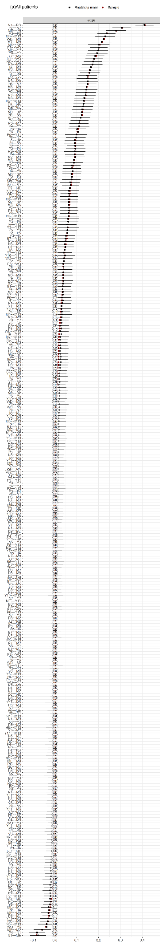
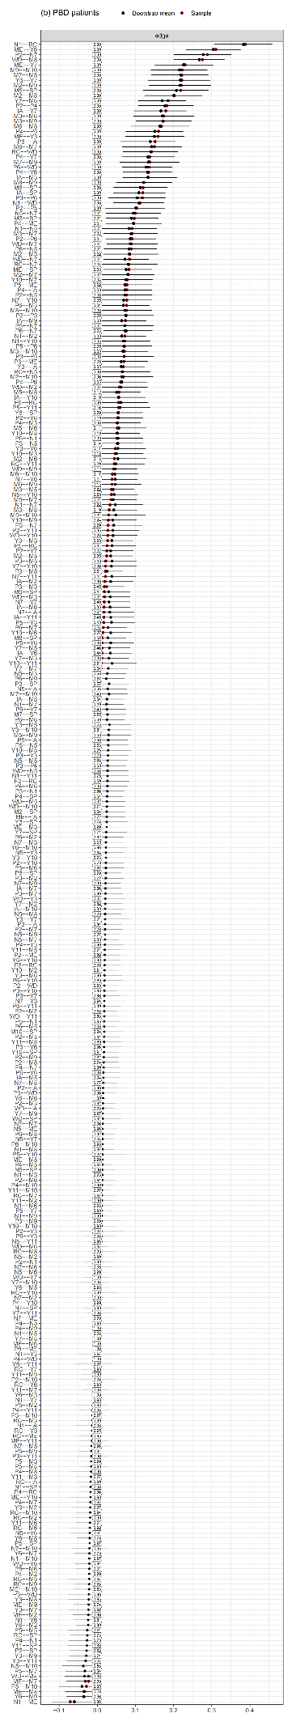
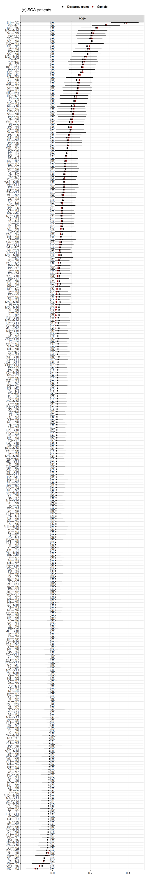
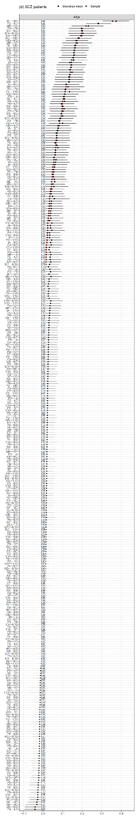
Figure C 1
The bootstrapped edge weight CIs of the network of affective and psychotic syndromes
Note. The red dot represents the sample weight of the edges. The black dot and lines indicate the mean weight and 95% confidence intervals (CIs) of the edge in the bootstrapped samples (N = 3,000). The values in the small boxes upon the zero on the x-axis reflect the proportion of times that the edge weight was estimated to be 0 in the bootstrapped samples.

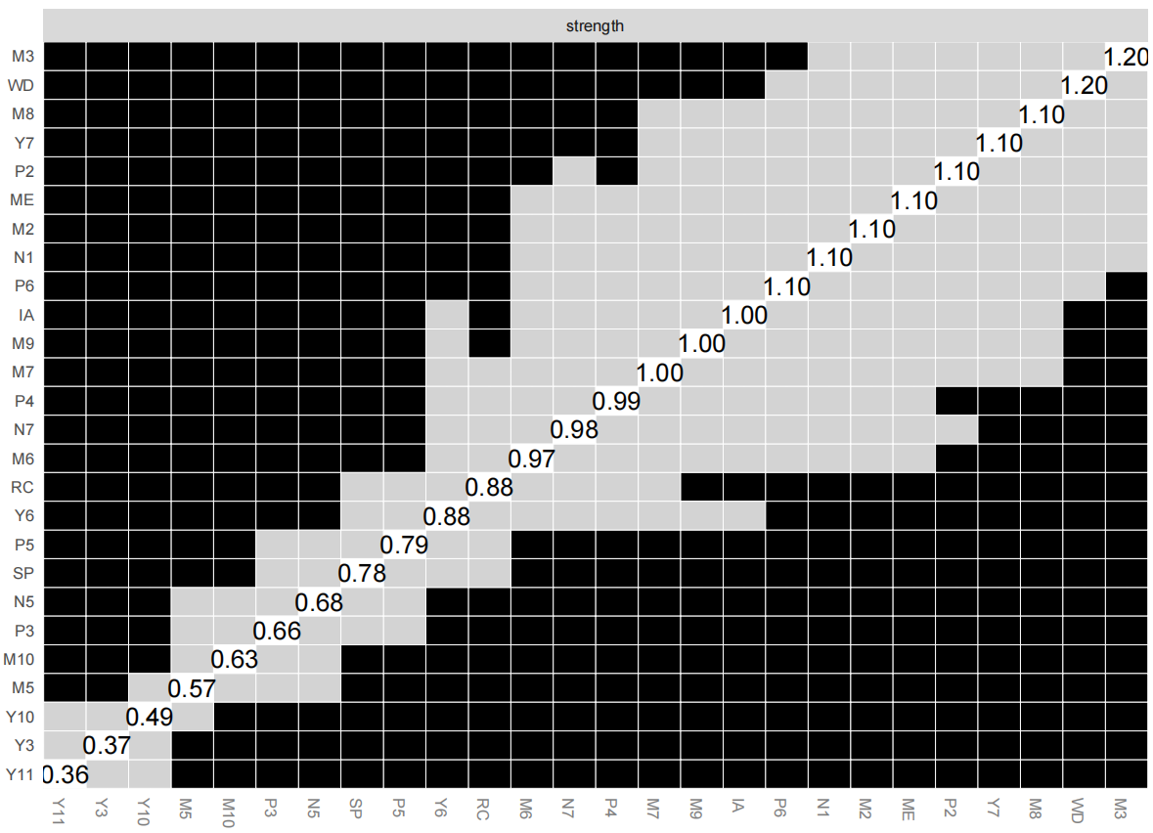
Figure C 2
The bootstrapped node strengths in network of general psychotic population
Note. The figure shows the node strength as well as the comparison results of the bootstrapped samples (N=3000). The black blocks indicate the difference between the node strengths was statistically different while the grey blocks mean the difference was non-significant. However, the results should be interpreted with caution as they were based on bootstrapped samples.

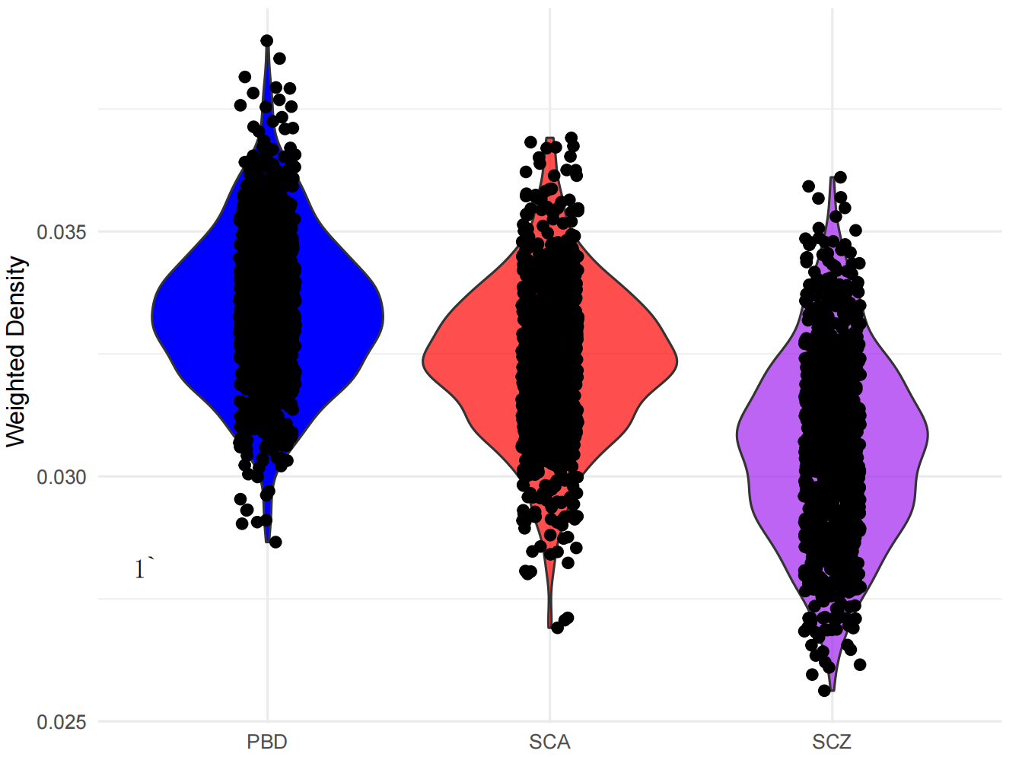
Figure C 3
The network density among patients with different psychoses
Note. The densities and the confidential intervals were computed based on the bootstrapped networks, which offers additional support to the NCT findings.

Figure C 4
The differed edge among patients with different psychoses
Note. M2 (Reported sadness), M9 (Pessimistic thoughts), M10(Suicidal thoughts), P2 (Conceptual disorganisation), P4 (Excitement), Y7 (Language thought disorder), ME (Mood/energy elevation), Y3 (Sexual interest), Y10 (Appearance), M8 (Inability to feel), WD (Withdrawal), IA (Irritability/aggressive-disruptive behaviour), Y10 (Appearance), M7(Retardation). Edge weights with maximum edge difference (E) larger than .1 were included. The bootstrapped CIs were added to show the degree of difference among different groups in addition to the NCT findings.

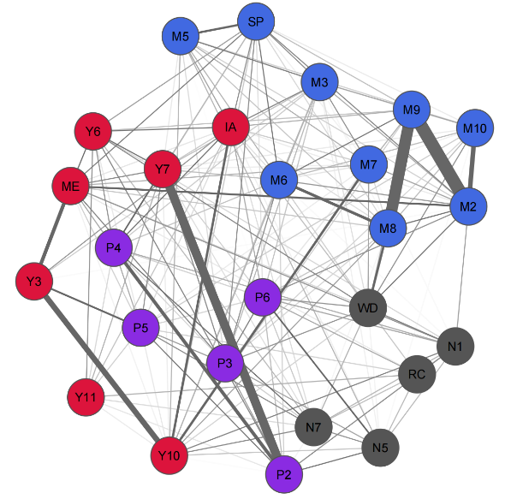
Figure C 5
The edge variability network among networks in different diagnostic groups
Note. The grey edge in the network represents the edge variability across networks of the subpopulation, indicated by standard deviation of edge weights.

Appendix D: Supplementary Files for Chapter 4
Table D 1
The UVA analysis result
Wave 5 |  |  | Wave 9
Item 1 | Item 2 | wTO | Item 1 | Item 2 | wTO
"Elevated energy" | "Increased goal-directed activity", | 0.37 | "Elevated energy" | "Increased goal-directed activity", | 0.31
Strange experience | Hallucinations | 0.36 | Paranoia probe | Strange experience | 0.25
Paranoia probe | Strange experience | 0.27
Depressive mood or hopeless | Sleep problems | 0.29
Fatigue | Poor appetite or overeating | 0.29
Note. wTO: weighted topological overlap score.

Table D 2
Bootstrapped statistics for edges with non-zero weights in the Mood and PLE network at wave 5
Edge | Weight | 95% BCI lower | 95% BCI upper | P0
M12--M13 | 0.90 | 0.50 | 1.30 | 0.00
M1--M13 | 0.76 | 0.35 | 1.16 | 0.00
PS--P5 | 0.73 | 0.54 | 0.93 | 0.00
M6--M7 | 0.72 | 0.52 | 0.93 | 0.00
M11--M12 | 0.63 | 0.35 | 0.91 | 0.00
M1--M10 | 0.53 | 0.18 | 0.87 | 0.01
EI--M3 | 0.52 | 0.38 | 0.66 | 0.00
M10--M13 | 0.51 | 0.05 | 0.97 | 0.03
M4--P2 | 0.48 | 0.10 | 0.85 | 0.01
D1--D2 | 0.47 | 0.40 | 0.54 | 0.00
D7--M7 | 0.47 | 0.33 | 0.61 | 0.00
M7--M13 | 0.46 | -0.01 | 0.93 | 0.04
M2--M7 | 0.44 | 0.25 | 0.64 | 0.00
M10--M11 | 0.44 | 0.13 | 0.75 | 0.01
M3--M10 | 0.44 | 0.09 | 0.79 | 0.02
M1--P2 | 0.41 | -0.02 | 0.84 | 0.05
EI--M5 | 0.41 | 0.25 | 0.57 | 0.00
D3--D4 | 0.41 | 0.34 | 0.48 | 0.00
M1--M5 | 0.41 | 0.11 | 0.70 | 0.02
M5--M6 | 0.40 | 0.15 | 0.66 | 0.01
M3--M5 | 0.38 | 0.12 | 0.65 | 0.01
M3--M4 | 0.38 | 0.15 | 0.61 | 0.00
M7--M12 | 0.35 | -0.03 | 0.72 | 0.11
M3--M6 | 0.34 | 0.12 | 0.56 | 0.02
M2--M5 | 0.32 | 0.08 | 0.56 | 0.02
D8--D9 | 0.32 | 0.23 | 0.41 | 0.00
M7--P2 | 0.32 | -0.10 | 0.73 | 0.11
EI--M11 | 0.31 | 0.18 | 0.45 | 0.00
M1--M3 | 0.29 | -0.05 | 0.64 | 0.12
M10--P2 | 0.28 | -0.17 | 0.73 | 0.20
EI--M10 | 0.28 | 0.07 | 0.49 | 0.03
D7--D8 | 0.27 | 0.19 | 0.35 | 0.00
PS--P2 | 0.27 | 0.02 | 0.52 | 0.05
D2--D6 | 0.27 | 0.18 | 0.35 | 0.00
M4--M10 | 0.25 | -0.06 | 0.56 | 0.15
M4--M7 | 0.25 | 0.02 | 0.47 | 0.06
M12--P5 | 0.25 | -0.12 | 0.61 | 0.28
EI--M4 | 0.23 | 0.10 | 0.35 | 0.00
M2--M6 | 0.22 | 0.03 | 0.42 | 0.05
M2--M13 | 0.22 | -0.14 | 0.58 | 0.19
PS--M6 | 0.21 | 0.09 | 0.33 | 0.01
M3--M12 | 0.21 | -0.13 | 0.55 | 0.27
D8--P2 | 0.20 | -0.09 | 0.50 | 0.28
M3--P5 | 0.20 | -0.13 | 0.53 | 0.35
M5--M13 | 0.20 | -0.19 | 0.59 | 0.37
M1--M11 | 0.19 | -0.11 | 0.48 | 0.26
M2--M11 | 0.18 | -0.04 | 0.40 | 0.15
D6--D9 | 0.18 | 0.09 | 0.27 | 0.00
D1--D7 | 0.18 | 0.10 | 0.25 | 0.00
EI--M12 | 0.18 | -0.05 | 0.40 | 0.20
M10--M12 | 0.17 | -0.21 | 0.55 | 0.33
M4--M13 | 0.16 | -0.19 | 0.51 | 0.30
P2--P5 | 0.16 | -0.23 | 0.55 | 0.41
M4--M6 | 0.16 | -0.06 | 0.37 | 0.18
D2--P2 | 0.16 | -0.07 | 0.38 | 0.16
D5--D6 | 0.15 | 0.07 | 0.24 | 0.00
D2--D3 | 0.15 | 0.08 | 0.22 | 0.00
D8--M10 | 0.15 | -0.05 | 0.35 | 0.17
PS--M2 | 0.15 | 0.03 | 0.27 | 0.05
M1--M12 | 0.15 | -0.17 | 0.46 | 0.40
D1--D4 | 0.15 | 0.07 | 0.22 | 0.00
PS--M7 | 0.14 | -0.02 | 0.31 | 0.21
D3--D5 | 0.14 | 0.06 | 0.21 | 0.00
M3--M7 | 0.13 | -0.10 | 0.36 | 0.37
D5--D7 | 0.13 | 0.05 | 0.21 | 0.02
M2--M12 | 0.13 | -0.14 | 0.40 | 0.35
D6--D7 | 0.12 | 0.04 | 0.20 | 0.02
D6--M6 | 0.12 | -0.01 | 0.24 | 0.11
D2--D9 | 0.12 | 0.03 | 0.21 | 0.05
D4--D5 | 0.12 | 0.04 | 0.19 | 0.02
D9--M1 | 0.11 | -0.09 | 0.31 | 0.52
M4--M5 | 0.11 | -0.11 | 0.34 | 0.38
D7--D9 | 0.11 | 0.02 | 0.20 | 0.04
M6--M11 | 0.11 | -0.11 | 0.33 | 0.40
PS--M5 | 0.11 | -0.05 | 0.27 | 0.30
M3--M11 | 0.10 | -0.14 | 0.34 | 0.41
EI--M1 | 0.10 | -0.08 | 0.28 | 0.40
D8--M12 | 0.10 | -0.09 | 0.29 | 0.44
EI--M7 | 0.10 | -0.05 | 0.24 | 0.41
D4--D7 | 0.09 | 0.02 | 0.17 | 0.06
D4--M7 | 0.09 | -0.05 | 0.24 | 0.42
M2--M4 | 0.09 | -0.10 | 0.29 | 0.35
D9--P5 | 0.09 | -0.10 | 0.28 | 0.48
D2--M2 | 0.09 | -0.03 | 0.21 | 0.28
M1--M7 | 0.09 | -0.19 | 0.36 | 0.53
D2--D4 | 0.08 | 0.00 | 0.16 | 0.16
D9--PS | 0.08 | -0.02 | 0.17 | 0.23
D1--D6 | 0.08 | -0.02 | 0.17 | 0.18
EI--P5 | 0.07 | -0.09 | 0.24 | 0.52
D3--M6 | 0.07 | -0.04 | 0.19 | 0.24
D5--D9 | 0.07 | -0.02 | 0.17 | 0.20
M1--M2 | 0.07 | -0.17 | 0.31 | 0.52
D6--PS | 0.06 | -0.02 | 0.15 | 0.24
D6--D8 | 0.06 | -0.03 | 0.15 | 0.27
D1--D5 | 0.06 | -0.03 | 0.15 | 0.30
D4--D6 | 0.05 | -0.03 | 0.13 | 0.24
D3--D7 | 0.05 | -0.03 | 0.13 | 0.25
D4--M6 | 0.05 | -0.05 | 0.15 | 0.50
D8--M5 | 0.05 | -0.11 | 0.20 | 0.51
D5--PS | 0.05 | -0.04 | 0.13 | 0.49
M2--M3 | 0.05 | -0.13 | 0.22 | 0.56
D2--P5 | 0.05 | -0.13 | 0.23 | 0.60
D7--M11 | 0.04 | -0.08 | 0.17 | 0.56
D2--D7 | 0.04 | -0.04 | 0.12 | 0.49
D4--D9 | -0.03 | -0.10 | 0.04 | 0.52
D9--M6 | -0.05 | -0.16 | 0.06 | 0.53
D9--M3 | -0.06 | -0.17 | 0.06 | 0.57
D7--M6 | -0.06 | -0.18 | 0.07 | 0.44
D7--M3 | -0.06 | -0.18 | 0.06 | 0.47
D6--M7 | -0.07 | -0.21 | 0.08 | 0.44
M4--M11 | -0.11 | -0.37 | 0.15 | 0.45
D9--M7 | -0.11 | -0.26 | 0.04 | 0.23
D6--M11 | -0.15 | -0.31 | 0.01 | 0.12
Note. Edges are arranged from top to bottom according to their numeric weights, from highest positive to lowest negative values. The BCI (lower–upper) indicates the confidence intervals of each edge in the bootstrapped networks, based on 2,000 bootstrap samples. P0 represents the proportion of bootstrap samples in which the edge weight was zero. Only edges with non-zero weights are presented in this table.

Table D 3
Bootstrapped statistics for edges with non-zero weights in the Mood and PLE network at wave 9
Edge | Weight | 95% BCI lower | 95% BCI upper | P0
M6--M7 | 0.75 | 0.54 | 0.95 | 0.00
M3--M10 | 0.73 | 0.21 | 1.25 | 0.01
M11--M12 | 0.66 | 0.31 | 1.01 | 0.00
M1--M5 | 0.65 | 0.31 | 0.98 | 0.00
EI--M10 | 0.59 | 0.28 | 0.90 | 0.01
M12--M13 | 0.57 | 0.04 | 1.10 | 0.04
M1--M4 | 0.54 | 0.26 | 0.82 | 0.00
EI--M3 | 0.53 | 0.33 | 0.73 | 0.00
M5--M6 | 0.51 | 0.15 | 0.87 | 0.01
M1--M2 | 0.49 | 0.20 | 0.78 | 0.00
M7--M13 | 0.47 | -0.03 | 0.98 | 0.09
PS--P5 | 0.47 | 0.16 | 0.78 | 0.01
P2--P5 | 0.47 | -0.08 | 1.01 | 0.10
EI--M5 | 0.41 | 0.16 | 0.66 | 0.03
M7--M12 | 0.40 | 0.01 | 0.79 | 0.05
M3--P5 | 0.39 | -0.17 | 0.95 | 0.18
D1--D2 | 0.38 | 0.30 | 0.45 | 0.00
M6--P2 | 0.37 | -0.14 | 0.88 | 0.14
D8--D9 | 0.37 | 0.27 | 0.46 | 0.00
D2--D6 | 0.36 | 0.28 | 0.44 | 0.00
M1--M13 | 0.34 | -0.08 | 0.77 | 0.16
M5--M7 | 0.34 | -0.02 | 0.70 | 0.07
M2--M6 | 0.33 | 0.13 | 0.54 | 0.01
M6--M12 | 0.33 | -0.03 | 0.70 | 0.11
PS--P2 | 0.33 | 0.05 | 0.61 | 0.05
M11--M13 | 0.33 | -0.12 | 0.77 | 0.12
M5--M13 | 0.33 | -0.15 | 0.80 | 0.20
M2--M12 | 0.32 | -0.02 | 0.67 | 0.11
M4--M13 | 0.31 | -0.09 | 0.71 | 0.16
D3--D4 | 0.31 | 0.24 | 0.37 | 0.00
M3--M4 | 0.29 | 0.00 | 0.58 | 0.09
M10--P5 | 0.28 | -0.32 | 0.89 | 0.29
D7--D8 | 0.27 | 0.18 | 0.36 | 0.00
M1--M3 | 0.27 | -0.04 | 0.58 | 0.12
D7--M7 | 0.27 | 0.13 | 0.40 | 0.00
M4--M6 | 0.26 | 0.01 | 0.51 | 0.08
M2--M10 | 0.25 | -0.19 | 0.70 | 0.23
M2--M7 | 0.24 | 0.01 | 0.48 | 0.10
PS--M2 | 0.23 | 0.10 | 0.36 | 0.01
M2--M3 | 0.23 | -0.07 | 0.52 | 0.14
D8--M10 | 0.22 | -0.13 | 0.57 | 0.30
M2--M11 | 0.22 | -0.05 | 0.49 | 0.09
D6--D9 | 0.21 | 0.13 | 0.30 | 0.00
EI--M12 | 0.21 | -0.08 | 0.50 | 0.36
D9--P5 | 0.21 | -0.11 | 0.53 | 0.17
EI--M11 | 0.20 | 0.02 | 0.39 | 0.05
D4--D5 | 0.20 | 0.12 | 0.27 | 0.00
M1--P5 | 0.20 | -0.38 | 0.77 | 0.33
M5--P5 | 0.19 | -0.32 | 0.71 | 0.39
M10--M13 | 0.19 | -0.25 | 0.63 | 0.45
M4--M7 | 0.19 | -0.07 | 0.45 | 0.21
D3--M4 | 0.18 | 0.06 | 0.31 | 0.01
D8--M5 | 0.18 | -0.06 | 0.41 | 0.24
D5--D7 | 0.18 | 0.09 | 0.26 | 0.00
M1--M12 | 0.17 | -0.20 | 0.54 | 0.33
M5--M11 | 0.17 | -0.20 | 0.54 | 0.32
M3--M6 | 0.17 | -0.11 | 0.45 | 0.32
D5--D6 | 0.16 | 0.07 | 0.25 | 0.00
EI--M7 | 0.15 | 0.00 | 0.30 | 0.13
M10--P2 | 0.15 | -0.40 | 0.70 | 0.51
PS--M7 | 0.15 | -0.02 | 0.32 | 0.23
PS--M4 | 0.15 | -0.03 | 0.32 | 0.16
D8--P2 | 0.14 | -0.11 | 0.39 | 0.41
D8--M1 | 0.14 | -0.05 | 0.33 | 0.30
D6--D7 | 0.14 | 0.06 | 0.22 | 0.00
D1--D7 | 0.14 | 0.06 | 0.22 | 0.00
M4--M5 | 0.14 | -0.17 | 0.45 | 0.32
D6--PS | 0.13 | 0.05 | 0.22 | 0.02
D2--D9 | 0.13 | 0.06 | 0.21 | 0.01
EI--M1 | 0.13 | -0.07 | 0.34 | 0.39
M3--M12 | 0.12 | -0.19 | 0.44 | 0.46
EI--M4 | 0.12 | -0.05 | 0.29 | 0.27
M7--M10 | 0.12 | -0.29 | 0.53 | 0.52
D4--D7 | 0.12 | 0.04 | 0.20 | 0.01
M3--M5 | 0.12 | -0.21 | 0.45 | 0.42
D2--D4 | 0.12 | 0.04 | 0.19 | 0.02
D1--D4 | 0.11 | 0.04 | 0.18 | 0.01
D2--M6 | 0.11 | -0.03 | 0.24 | 0.18
D1--D3 | 0.10 | 0.02 | 0.18 | 0.04
D4--M2 | 0.10 | -0.03 | 0.22 | 0.27
PS--M6 | 0.10 | -0.06 | 0.25 | 0.60
D2--D3 | 0.09 | 0.02 | 0.17 | 0.09
M6--M10 | 0.09 | -0.33 | 0.51 | 0.57
D4--M3 | 0.08 | -0.07 | 0.24 | 0.45
D4--M7 | 0.08 | -0.05 | 0.21 | 0.39
EI--M6 | 0.08 | -0.07 | 0.23 | 0.48
D1--D5 | 0.08 | 0.00 | 0.15 | 0.12
D4--M6 | 0.07 | -0.05 | 0.20 | 0.39
D3--D7 | 0.07 | -0.01 | 0.15 | 0.20
D9--M12 | 0.07 | -0.16 | 0.29 | 0.49
D9--PS | 0.06 | -0.04 | 0.17 | 0.32
D5--D8 | 0.06 | -0.03 | 0.15 | 0.35
D2--D7 | 0.06 | -0.03 | 0.14 | 0.27
D1--PS | 0.06 | -0.03 | 0.14 | 0.40
D3--P2 | 0.06 | -0.11 | 0.22 | 0.52
D3--M7 | 0.06 | -0.06 | 0.17 | 0.50
D3--M6 | 0.05 | -0.07 | 0.17 | 0.56
D1--D6 | 0.05 | -0.03 | 0.13 | 0.33
D4--D6 | 0.04 | -0.03 | 0.11 | 0.44
D7--D9 | 0.04 | -0.05 | 0.13 | 0.36
D3--D5 | 0.04 | -0.04 | 0.11 | 0.41
D1--D8 | 0.04 | -0.04 | 0.11 | 0.48
D8--M7 | -0.10 | -0.25 | 0.05 | 0.35
D8--M6 | -0.11 | -0.26 | 0.05 | 0.35
D6--M3 | -0.13 | -0.31 | 0.05 | 0.24
M6--M13 | -0.37 | -0.95 | 0.21 | 0.29
Note. Edges are arranged from top to bottom according to their numeric weights, from highest positive to lowest negative values. The BCI (lower–upper) indicates the confidence intervals of each edge in the bootstrapped networks, based on 2,000 bootstrap samples. P0 represents the proportion of bootstrap samples in which the edge weight was zero. Only edges with non-zero weights are presented in this table.

Table D 4
Binary models regressing on Mood and PLEs across waves
Variable | Estimate | SE | z/t value | 95% BCI
Wave 5 PLEs (presence of at least one PLE)
McFadden’s R²=0.27
(Intercept) | -2.84 | 0.84 | -3.39
ACEs (W5) | 0.28*** | 0.07 | 3.96 | [0.14, 0.43]
Anxiety (W5) | 0.10*** | 0.03 | 3.55 | [0.04, 0.16]
Mania (W5) | 0.19*** | 0.03 | 6.02 | [0.13, 0.26]
Depression (W5) | 0.07** | 0.02 | 2.70 | [0.01, 0.12]
IOU-P (W1) | 0.05* | 0.02 | 2.44 | [0.01, 0.10]
Wave 9 PLEs (presence of at least one PLE)
McFadden’s R²=0.37
(Intercept) | -1.63 | 1.49 | -1.09
Anxiety (W9) | 0.11*** | 0.03 | 3.31 | [0.05, 0.20]
PLEs (W5) | 0.51** | 0.17 | 3.07 | [0.13, 0.94]
Mania (W5) | 0.14** | 0.05 | 2.87 | [0.05, 0.25]
Wave 5 Depression (PHQ9>10)
McFadden’s R²=0.54
(Intercept) | -4.05 | 1.29 | -3.13
ACEs (W5) | 0.22* | 0.09 | 2.42 | [0.02, 0.42]
Anxiety (W5) | 0.35*** | 0.03 | 10.18 | [0.29, 0.45]
Depression (W1) | 0.18*** | 0.03 | 5.48 | [0.09, 0.22]
Age (W5) | 0.02* | 0.01 | 2.05 | [–0.0002, 0.05]
Wave 9 Depression (PHQ9>10)
McFadden’s R²=0.65
(Intercept) | -6.21 | 2.18 | -2.85
Depression (W5) | 0.15*** | 0.04 | 3.49 | [0.07, 0.31]
Anxiety (W9) | 0.39*** | 0.06 | 6.85 | [0.31, 0.67]
IOU-P (W1) | 0.13* | 0.06 | 2.29 | [0.03, 0.29]
Wave 5 Mania (MDQ>8)
McFadden’s R²=0.20
(Intercept) | -5.10 | -1.54 | -3.31
Age (W5) | -0.03* | 0.01 | -2.01 | [–0.05, –0.001]
PLEs (W5) | 0.77*** | 0.16 | 4.99 | [0.46, 1.18]
Wave 9 Mania (MDQ>8)
McFadden’s R²=0.45
(Intercept) | -4.69 | 3.42 | -1.37
Mania (W5) | 0.34*** | 0.10 | 3.54 | [0.23, 27.99]
IOU-I (W1) | -0.19* | 0.10 | 1.78 | [–7.18, 0.15]
Note. BCI = bootstrapped confidence interval; W = assessment wave (e.g., W1 = Wave 1). ACEs = adverse childhood experiences; IOU = intolerance of uncertainty (I = inhibitory, P = prospective); PLEs = psychotic-like experiences; SSR = subjective social rank. The predictors shaded in grey indicate that their bootstrapped coefficient confidence intervals include zero; these results should therefore be interpreted with caution.
*p < .05, **p <.01, ***p < .001.

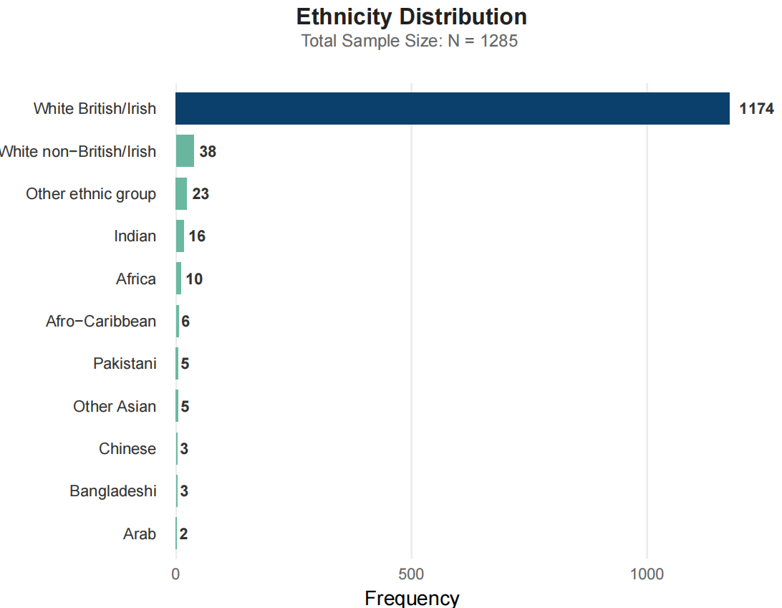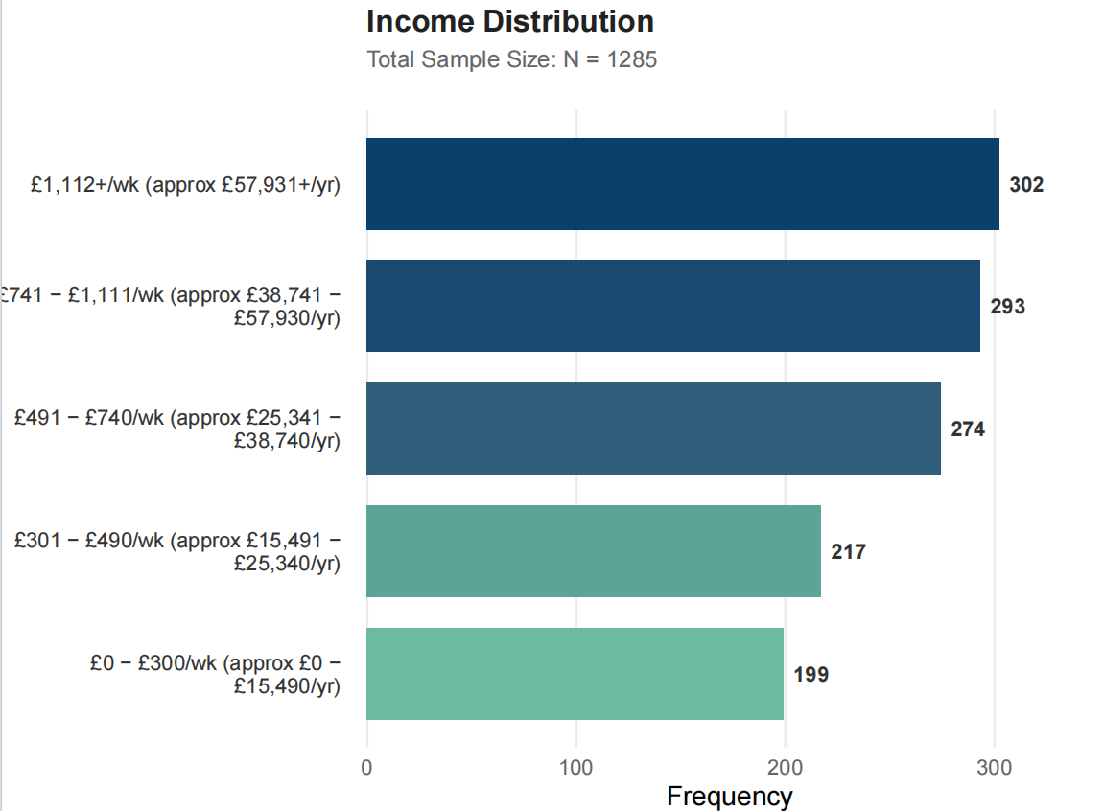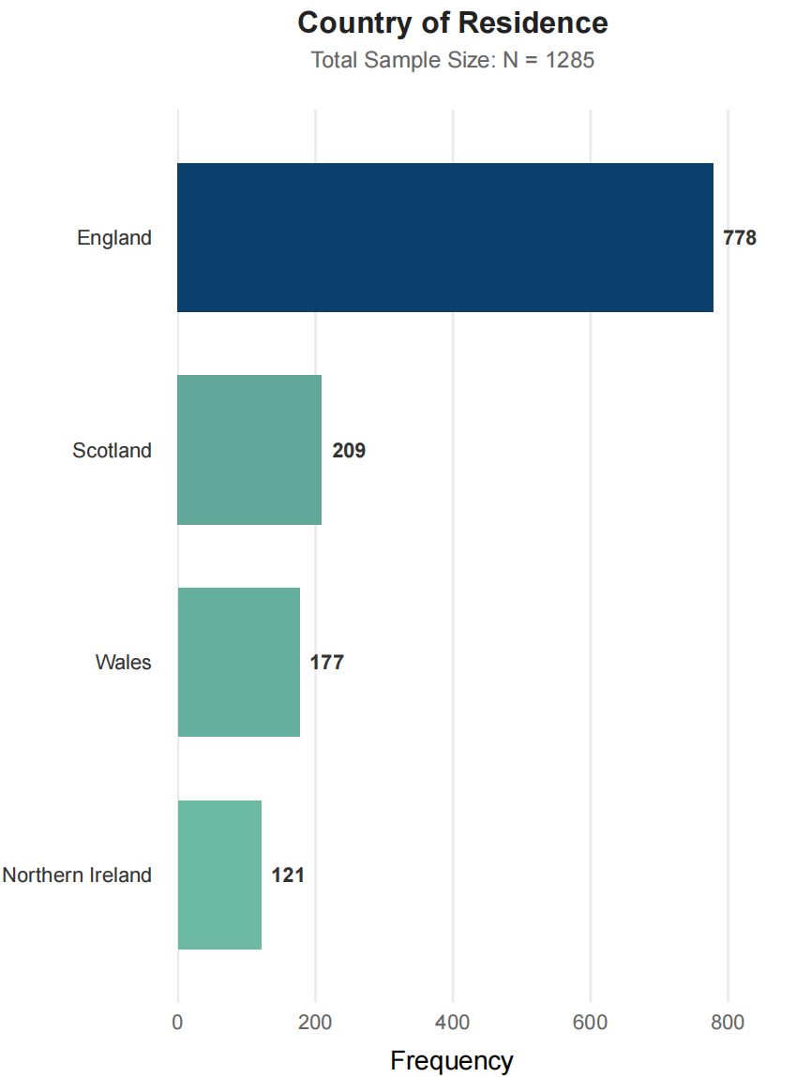
Figure D 1
The distributions of ethnicity, income, and contury of residence among the sample
Note. The figure shows the distribution of participants included in both Wave 5 and Wave 9.

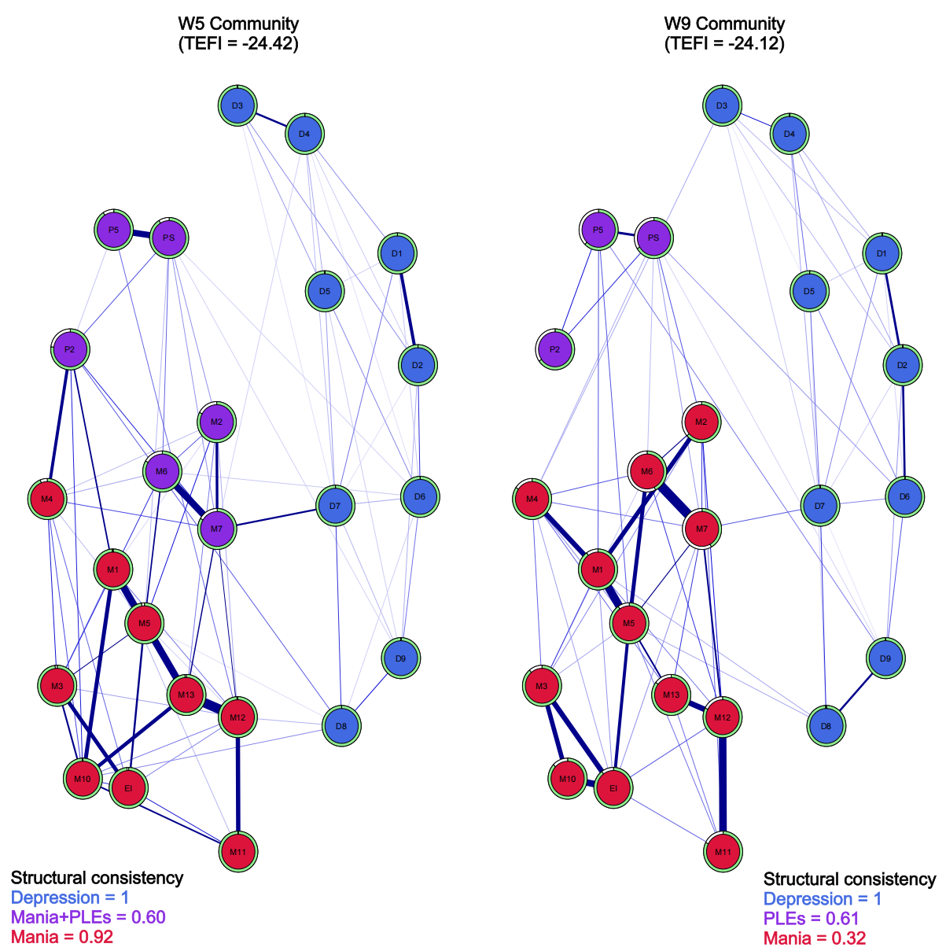
Figure D 2
Empirical network communities of Mood and PLEs across waves
Note. The colouring of the nodes in the network denotes their empirical community placement. The ring outside the node with light green colour indicates their item stability. A perfect item stability (= 1) is reflected by the full ring. The bottom left and right reflect the communities' structural consistency, defined by how many times this composition has been captured in the bootstrapped sample (N = 2000). W = assessment wave (e.g., W5 = Wave 5). D1 = Decreased interest; D2 = Depressed mood or feelings of hopelessness; D3 = Sleep problems; D4 = Fatigue; D5 = Poor appetite or overeating; D6 = Feelings of worthlessness; D7 = Concentration problems; D8 = Psychomotor retardation or agitation; D9 = Self-harm or suicidal thoughts; EI = Elevated energy or increased goal-directed activity; M1 = Elevated mood; M2 = Irritability; M3 = Elevated self-confidence; M4 = Reduced need for sleep; M5 = Pressured speech or talkativeness; M6 = Racing thoughts; M7 = Easily distracted; M10 = Increased social activity; M11 = Increased sexual interest; M12 = Involvement in risky behaviour; M13 = Spending money carelessly; P2 = Thought insertion; PS = Paranoia or strange experiences; P5 = Hallucinations. TEFI = the total entropy fit index.
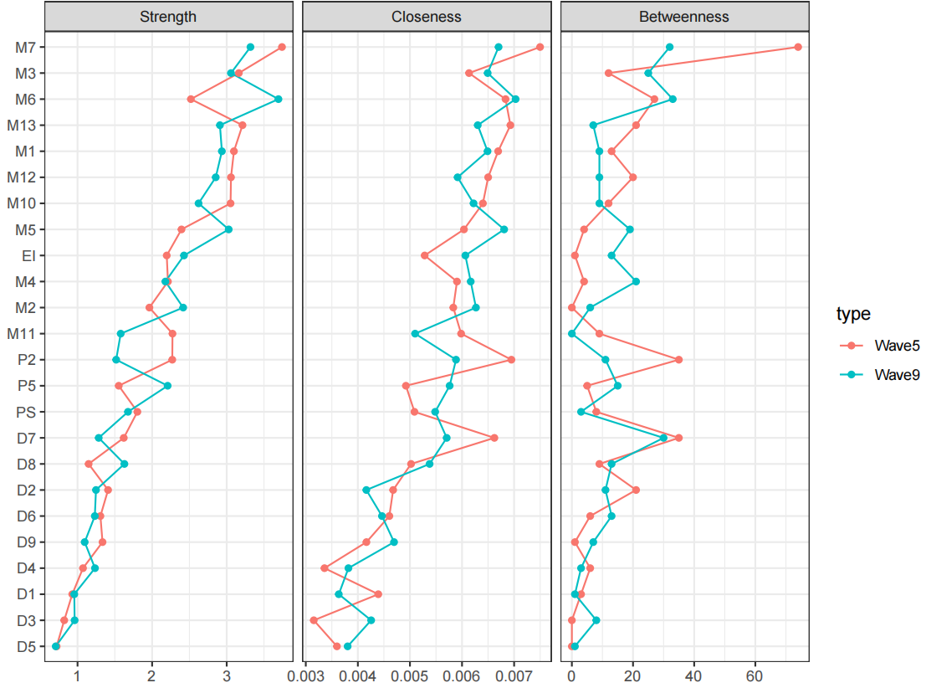
Figure D 3
Node statistics across networks of mood and PLEs at waves 5 and 9
Note. Node strength was plotted using the raw coefficient scale, with nodes ordered in descending strength. D1: Decreased interest, D2: Depressed mood or feelings of hopelessness, D3: Sleep problems, D4: Fatigue, D5: Poor appetite or overeating, D6: Feelings of worthlessness, D7: Concentration problems, D8: Psychomotor retardation or agitation, D9: Self-harm or suicidal thoughts, EI: Elevated energy or increased goal-directed activity, M1: Elevated mood, M2: Irritability, M3: Elevated self-confidence, M4: Reduced need for sleep, M5: Pressured speech or talkativeness, M6: Racing thoughts, M7: Easily distracted, M10: Increased social activity, M11: Increased sexual interest, M12: Involvement in risky behaviour, M13: Spending money carelessly, P2: Thought insertion, PS: Paranoia or strange experiences, P5: Hallucinations.

Appendix E: Supplementary Files for Chapter 5
Table E 1
Questionnaires and criteria of at-risk features or clinical states examined in this study
Model | Sub-dimension | Symptom/trait | Questions | No. | Questionnaire
Negative | Emotional  expression | Poor rapport | I am poor at returning social courtesies and gestures | 1 | BSQSP and CPRQ
Negative | Emotional  expression | Poor rapport | Increased problems with relationships (partner, family, work) | 2 | Self-screen Prodrome
Negative | Emotional  expression | Poor rapport | I tend to keep my feelings to myself | 3 | BSQSP, PS-R, and CPRQ
Negative | Emotional  expression | Poor rapport | Is it hard to establish a connection or do you feel at a distance when you are talking with others? | 4 | YPARQ-B
Negative | Emotional  expression | Emotions less recognisable and appropriate | I do not have an expressive and lively way of speaking | 5 | BSQSP and CPRQ
Negative | Emotional  expression | Inappropriate affect | People have said that I seemed "spacey" or "out of it" | 6 | PQ
Negative | Emotional  expression | Inappropriate affect | People have found me to be aloof and distant | 7 | PQ
Negative | Emotional  expression | Diminished emotional responsiveness | Do you ever feel that you are not a very animated person? | 8 | CAPE
Negative | Emotional  expression | Diminished emotional responsiveness | I have had difficulty expressing my feelings as well as I used to | 9 | PQ
Negative | Emotional  expression | Lack of spontaneity and flow of conversation | Do you ever feel that you are lacking in spontaneity? | 10 | CAPE
Negative | Emotional  expression | Lack of spontaneity and flow of conversation | I have had nothing to say or very little to say | 11 | PQ
Negative | Emotional  expression | Lack of spontaneity and flow of conversation | Do you ever feel that you are not much of a talker when you are conversing with other people? | 12 | CAPE
Negative | Social  anhedonia | Does not initiate contact | Do you tend to avoid social activities with others? | 13 | YPARQ-B
Negative | Social  anhedonia | Does not initiate contact | I have had little interest in getting to know other people | 14 | PQ (Prodromal Questionnaire)
Negative | Social  anhedonia | Does not initiate contact | I have avoided social activities with other people | 15 | PQ (Prodromal Questionnaire)
Negative | Social  anhedonia | Tends to recede into the background | I am mostly quiet when with others | 16 | BSQSP and CPRQ
Negative | Social  anhedonia | Lack of close friends | I feel I cannot get close to people | 17 | BSQSP and CPRQ
Negative | Avolition | Impairment in goal directed activities | Do you ever feel that you can never get things done? | 18 | CAPE
Negative | Avolition | Impairment in goal directed activities | I have been less able to do usual activities or tasks | 19 | PQ
Negative | Avolition | Impairment in goal directed activities | Difficulties in carrying out ordinary routine activities for the last 1 week | 20 | PROD-screen
Negative | Avolition | Low drive, energy, or productivity | Have you felt like your thinking, speaking or movements have been slowing down noticeably? Has your empathy with others changed? | 21 | ERIraros
Negative | Avolition | Low drive, energy, or productivity | I have felt unable to carry out everyday tasks because of fatigue or lack of motivation | 22 | PQ
Negative | Avolition | Low drive, energy, or productivity | I have been less interested in school or work | 23 | PQ
Negative | Avolition | Low drive, energy, or productivity | Do you ever feel that you are lacking in motivation to do things? | 24 | CAPE
Negative | Avolition | Low drive, energy, or productivity | Do you ever feel that you are lacking in energy? | 25 | CAPE
Negative | Avolition | Low drive, energy, or productivity | Do you ever feel that you are spending all your days doing nothing? | 26 | CAPE
Negative | Avolition | Low drive, energy, or productivity | Lack of energy, drive, initiative or interest | 27 | Self-screen Prodrome and EDPCC
Negative | Experience of  emotions and  self | Emotions disappearing | Do you ever feel that your emotions are blunted? | 28 | CAPE
Negative | Experience of  emotions and  self | Emotions disappearing | Do you ever feel that your feelings are lacking in intensity? | 29 | CAPE
Negative | Experience of  emotions and  self | Feeling depersonalised at a distance from self | I have felt like I was looking at myself as in a movie, or that I was a spectator in my own life | 30 | PQ
Negative | Experience of  emotions and  self | Feeling depersonalised at a distance from self | Have you felt at a distance from yourself, as if you were outside your own body? | 31 | YPARQ-B
Negative | Experience of  emotions and  self | Feeling profoundly changed unreal or strange | When I looked at a person, or myself in a mirror, I have seen the face change right before my eyes. | 32 | PQ
Negative | Experience of  emotions and  self | Feeling profoundly changed unreal or strange | Have your familiar surroundings occasionally appeared to be changed, unreal or strange? Or have you ever had the feeling that you were not yourself or that you were unreal or strange to yourself, e.g. When looking in the mirror? | 33 | ERIraros
Negative | Experience of  emotions and  self | Loss of sense of self | Do you ever feel that your mind is empty? | 34 | CAPE
Negative | Experience of  emotions and  self | Sense of having no feelings | Do you ever feel that you experience few or no emotions at important events? | 35 | CAPE
Negative | Ideational  richness | Unable to make sense of familiar phrases | Do you sometimes feel that you cannot immediately understand spoken or written words, even though these are familiar to you? | 36 | PCA
Negative | Ideational  richness | Unable to make sense of familiar phrases | Do you sometimes catch bits and pieces of conversation that you are then unable to link intelligibly? | 37 | PCA
Negative | Ideational  richness | Unable to make sense of familiar phrases | I often have to reflect over the meaning of very common words. | 38 | YSR and ESI
Negative | Ideational  richness | Unable to make sense of familiar phrases | If someone speaks with long sentences, I have difficulties to grasp the meaning correctly. | 39 | ESI and EDPCC
Negative | Ideational  richness | Unable to make sense of familiar phrases | If someone speaks to me, I often have trouble grasping the meaning of the words correctly. | 40 | ESI
Negative | Ideational  richness | Unable to make sense of familiar phrases | Common words sometimes seem to have a peculiar strange meaning. | 41 | ESI
Negative | Ideational  richness | Difficulty performing role functions | I have been in danger of failing out of school, or of being fired from my job | 42 | PQ
Negative | Ideational  richness | Difficulty performing role functions | Marked decline in performance, possibly with difficulties at work or school | 43 | Self-screen Prodrome
Negative | Ideational  richness | Difficulty performing role functions | Have you become significantly less persistent, motivated or productive at work, school, in your studies, occupational training, search for work? Has your performance deteriorated? | 44 | ERIraros
Negative | Ideational  richness | Difficulty in productive relationships at work or school | I have not gotten along well with people at school or at work | 45 | PQ
Disorganisation | Impairment  in personal hygiene | Self neglect | I have noticed that I am less interested than I used to be in keeping clean or dressing well | 46 | PQ
Disorganisation | Impairment  in personal hygiene | Self neglect | Do you ever feel that you are neglecting your appearance or personal hygiene? | 47 | CAPE
Disorganisation | Bizarre thinking | Strange, fantastic or bizarre ideas | Feelings, thoughts or behaviours that could be considered weird or peculiar | 48 | PROD-screen
Disorganisation | Bizarre thinking | Strange, fantastic or bizarre ideas | People have said that my ideas were strange or illogical | 49 | PQ
Disorganisation | Bizarre thinking | Strange, fantastic or bizarre ideas | My thinking has felt confused, muddled, or disturbed in some way* | 50 | PQ
Disorganisation | Bizarre thinking | Strange, fantastic or bizarre ideas | Do you sometimes have too many thoughts going through your head without any connection between them? | 51 | PCA
Disorganisation | Bizarre thinking | Strange, fantastic or bizarre ideas | I have thoughts that other people would think are strange | 52 | YSR
Disorganisation | Trouble with  focus  and  attention | Trouble with short term memory | I have had trouble remembering things | 53 | PQ
Disorganisation | Trouble with  focus  and  attention | Difficulty in focusing to new stimuli | When I watch television, it is difficult for me to follow the pictures and words and to catch the story simultaneously | 54 | ESI
Disorganisation | Trouble with  focus  and  attention | Difficulty concentrating | I cannot focus on a task and need to take frequent breaks while working (studying). | 55 | BSQSP and CPRQ
Disorganisation | Trouble with  focus  and  attention | Difficulty concentrating | I feel mentally insufficient and easily fatigued while thinking or reading | 56 | BSQSP and CPRQ
Disorganisation | Trouble with  focus  and  attention | Difficulty concentrating | I have had difficulty concentrating, listening or reading | 57 | PQ
Disorganisation | Trouble with  focus  and  attention | Failure in focused alertness | I have had trouble focusing on one thought at a time | 58 | PQ
Disorganisation | Trouble with  focus  and  attention | Failure in focused alertness | I have felt suddenly distracted by distant sounds that I am not normally aware of | 59 | PQ
Disorganisation | Trouble with  focus  and  attention | Failure in focused alertness | I have been distracted by noises or other people talking | 60 | PQ
Disorganisation | Trouble with  focus  and  attention | Failure in focused alertness | Do you find yourself constantly thinking about experiences or conversations that are, in fact, irrelevant, when you would rather be focusing on other matters? | 61 | PCA
Disorganisation | Odd behaviour  and  appearance | Odd behaviour | Plays with own sex parts in public | 62 | CBCL
Disorganisation | Odd behaviour  and  appearance | Odd behaviour | I do things other people think are strange | 63 | YSR
Disorganisation | Odd behaviour  and  appearance | Odd behaviour | Have you pursued interests or behaviours that other people regarded as odd? | 64 | ERIraros
Disorganisation | Odd behaviour  and  appearance | Odd behaviour | Repeats certain acts over and over; compulsions | 65 | EDPCC
Disorganisation | Odd behaviour  and  appearance | Odd behaviour | I have engaged in some eccentric (odd) habits | 66 | PQ
Disorganisation | Odd behaviour  and  appearance | Odd behaviour | People have commented on my unusual mannerisms and habits | 67 | PQ
Disorganisation | Odd behaviour  and  appearance | Odd behaviour | I have thought that I am an odd, unusual person | 68 | PQ
Disorganisation | Odd behaviour  and  appearance | Preoccupied with and/or interactive with own thoughts | I have been talking to myself | 69 | PQ
Disorganisation | Odd behaviour  and  appearance | Preoccupied with and/or interactive with own thoughts | Changes in behaviour (e.g. Loud soliloquy in public) | 70 | Self-screen Prodrome
Disorganisation | Odd behaviour  and  appearance | Preoccupied with and/or interactive with own thoughts | Experience of thoughts running wild or difficulty in controlling the speed of thoughts | 71 | PROD-screen
General | Dysphoric mood | Anxiety, panic, multiple fears and phobias | I feel nervous when giving a speech in front of a large group of people | 72 | BSQSP and CPRQ
General | Dysphoric mood | Anxiety, panic, multiple fears and phobias | I cannot deal with the pressures associated with crowds | 73 | BSQSP and CPRQ
General | Dysphoric mood | Anxiety, panic, multiple fears and phobias | I can’t get my mind [away from] certain thoughts | 74 | YSR
General | Dysphoric mood | Diminished interest in pleasurable activities | Do you ever feel that you have only few hobbies or interests? | 75 | CAPE
General | Dysphoric mood | Diminished interest in pleasurable activities | I have felt unable to enjoy things that I used to enjoy | 76 | PQ
General | Dysphoric mood | Diminished interest in pleasurable activities | I have felt uninterested in the things I used to enjoy | 77 | PQ
General | Dysphoric mood | Feelings of loss of energy | I feel lethargic whatever I do | 78 | BSQSP and CPRQ
General | Dysphoric mood | Feelings of worthlessness and/or guilt | I always mess up whatever I do | 79 | BSQSP and CPRQ
General | Dysphoric mood | Feelings of worthlessness and/or guilt | I have felt very guilty | 80 | PQ
General | Dysphoric mood | Feelings of worthlessness and/or guilt | I have felt worthless | 81 | PQ
General | Dysphoric mood | Feelings of worthlessness and/or guilt | Do you ever feel like a failure? | 82 | CAPE
General | Dysphoric mood | Irritability, hostility, rage | I have felt angry, easily irritated or offended | 83 | PQ
General | Dysphoric mood | Irritability, hostility, rage | Over-sensitivity, more easily hurt or upset | 84 | Self-screen Prodrome and YSR
General | Dysphoric mood | Poor or increased appetite | Poor appetite | 85 | EDPCC
General | Dysphoric mood | Restless, agitation, tension | I have felt more nervous or anxious, and have found it hard to relax | 86 | PQ
General | Dysphoric mood | Restless, agitation, tension | Nervousness, feeling tense | 87 | Self-screen Prodrome
General | Dysphoric mood | Restless, agitation, tension | Have you often felt nervous, tense or restless? Has this led to arguments with others even about minor issues? Have you been more active than usual? Maybe so active that others might have thought that there was something wrong with you? | 88 | ERIraros
General | Dysphoric mood | Suicidal thoughts | Do you ever feel as if you do not want to live anymore? | 89 | CAPE
General | Dysphoric mood | Suicidal thoughts | Deliberately harms self or attempts suicide | 90 | CBCL
General | Dysphoric mood | Suicidal thoughts | I deliberately try to hurt or kill myself | 91 | YSR
General | Dysphoric mood | Unstable mood | My moods have been highly changeable and unstable | 92 | PQ
General | Dysphoric mood | Unstable mood | I have felt unhappy or depressed | 93 | PQ
General | Dysphoric mood | Unstable mood | Do you ever feel pessimistic about everything? | 94 | CAPE
General | Dysphoric mood | Unstable mood | Do you ever feel as if there is no future for you? | 95 | CAPE
General | Dysphoric mood | Unstable mood | Do you ever cry about nothing? | 96 | CAPE
General | Dysphoric mood | Unstable mood | Has your mood been depressed, sad, melancholic, subdued or desperate over weeks? | 97 | ERIraros
General | Motor disturbance | New movement: stereotypes, echopraxia | Nervous movements or twitching | 98 | CBCL
General | Motor disturbance | Loss of automatic skills | I simply forgot many of my habits. | 99 | YSR
General | Motor disturbance | Compulsive motor rituals | I repeat certain acts over and over | 100 | YSR
General | Motor disturbance | Compulsive motor rituals | I pick my skin or other parts of my body | 101 | YSR
General | Motor disturbance | Dyskinetic movements of head, face, extremities | Parts of my body twitch or make nervous movements | 102 | PQ
General | Sleep disturbance | Sleep disturbance | I have trouble sleeping | 103 | PQ
General | Sleep disturbance | Sleep disturbance | I have not been sleeping well | 104 | PQ
General | Sleep disturbance | Sleep disturbance | Sleep less than most kids | 105 | CBCL
General | Sleep disturbance | Sleep disturbance | Have you had any sleep problems (difficulties falling asleep, sleeping through the night, early wakening)? Has your appetite or sexual interest deteriorated? | 106 | ERIraros
General | Impaired tolerance  to  normal stress | Exhausted by stressful situations | Everyday things have been more stressful than before, like school or work, social situations, deadlines or changes in a schedule | 107 | PQ
General | Impaired tolerance  to  normal stress | Exhausted by stressful situations | Lower level of resilience | 108 | Self-screen Prodrome
General | Impaired tolerance  to  normal stress | Exhausted by stressful situations | Increased sensitivity, more easily moved | 109 | Self-screen Prodrome
General | Impaired tolerance  to  normal stress | Exhausted by stressful situations | Everyday things have affected me more than they used to | 110 | PQ
Positive symptoms | Perceptual abnormalities/ hallucinations | Pseudo hallucinations | My thoughts have been so strong that I could almost hear them | 111 | PQ
Positive symptoms | Perceptual abnormalities/ hallucinations | Pseudo hallucinations | I have noticed strange feelings on or just beneath my skin, like bugs crawling | 112 | PQ
Positive symptoms | Perceptual abnormalities/ hallucinations | Pseudo hallucinations | I have mistaken shadows for people or noises for voices | 113 | PQ
Positive symptoms | Perceptual abnormalities/ hallucinations | Unusual perceptual experience | I have seen unusual things like flashes, flames, blinding light, or geometric figures | 114 | PQ
Positive symptoms | Perceptual abnormalities/ hallucinations | Unusual perceptual experience | Changes in perception (e.g., hearing, seeing, smelling or tasting unusual things) | 115 | Self-screen prodrome
Positive symptoms | Perceptual abnormalities/ hallucinations | Unusual perceptual experience | Do things sometimes seem fragmented to you, like a photograph that has been torn into pieces and then glued back together? | 116 | PCA
Positive symptoms | Perceptual abnormalities/ hallucinations | Frank hallucinations | Do you see things that others can't or don't see? | 117 | YPARQ-B
Positive symptoms | Perceptual abnormalities/ hallucinations | Frank hallucinations | Do you ever hear sounds that are not there? | 118 | YPARQ-B
Positive symptoms | Perceptual abnormalities/ hallucinations | Frank hallucinations | Do you ever see objects, people or animals that other people cannot see? | 119 | CAPE
Positive symptoms | Suspiciousness/ persecutory ideas | Suspiciousness or paranoid thinking | I have been concerned that my closest friends and co-workers were not really loyal or trustworthy | 120 | PQ
Positive symptoms | Suspiciousness/ persecutory ideas | Suspiciousness or paranoid thinking | Feeling people are watching you or giving you a hard time for no reason | 121 | EDPCC
Positive symptoms | Suspiciousness/ persecutory ideas | Suspiciousness or paranoid thinking | Do you ever feel people are plotting against you or planning to harm you? | 122 | YPARQ-B
Positive symptoms | Suspiciousness/ persecutory ideas | Persecutory ideas of reference | I have felt that other people were watching me or talking about me | 123 | PQ
Positive symptoms | Suspiciousness/ persecutory ideas | Persecutory ideas of reference | Do you ever feel as if there is a conspiracy against you? | 124 | CAPE
Positive symptoms | Suspiciousness/ persecutory ideas | Persecutory ideas of reference | "I have thought that other people had it in for me | 125 | PQ
Positive symptoms | Suspiciousness/ persecutory ideas | Delusional conviction | I sometimes become concerned about the loyalty and trustworthiness of friends or coworkers (duplicated) | 126 | BSQSP
Positive symptoms | Disorganised communication | Confused, muddled, racing, or slowed down speech | I have had difficulty organizing my thoughts or finding the right words | 127 | PQ
Positive symptoms | Disorganised communication | Confused, muddled, racing, or slowed down speech | People have found it hard to understand what I say | 128 | PQ
Positive symptoms | Disorganised communication | Confused, muddled, racing, or slowed down speech | My thinking has felt confused, muddled, or disturbed in some way* | 129 | PQ
Positive symptoms | Disorganised communication | Loosening or paralysis of associations | Other people have mentioned changes in the way I speak (e.g., my speech has become difficult to understand) | 130 | Self-screen Prodrome & PQ
Positive symptoms | Disorganised communication | Odd speech | I have used words in unusual ways | 131 | PQ
Positive symptoms | Disorganised communication | Circumstantial tangential or paralogical speech | I have wondered off the topic or rambled on too much when I was speaking | 132 | YSR
Positive symptoms | Grandiose ideas | Exaggerated self-opinion | Do you ever feel that you are a very special or unusual person? | 133 | CAPE
Positive symptoms | Grandiose ideas | Exaggerated self-opinion | I have thought that I am very important or have abilities that are out of the ordinary | 134 | PS-R
Positive symptoms | Grandiose ideas | Exaggerated self-opinion | Feeling euphoric or especially competent and important. | 135 | PROD-screen
Positive symptoms | Grandiose ideas | Clear-cut grandiose delusions | I believe that I have special natural or supernatural gifts beyond my talents and natural strengths | 136 | PS-R
Positive symptoms | Grandiose ideas | Clear-cut grandiose delusions | Do you feel you have unusual healing abilities or powers? | 137 | YPARQ-B
Positive symptoms | Grandiose ideas | Unusual ideas | I have felt that I didn't exist, the world didn't exist, or that I was dead | 138 | PQ
Positive symptoms | Grandiose ideas | Unusual ideas | For moments I got the feeling that my body is deformed. | 139 | ESI
Positive symptoms | Grandiose ideas | Unusual ideas | Have you been repeatedly pondering on certain things (violent or sexual in content or concerning changes in your body)? | 140 | ERIraros
Positive symptoms | Grandiose ideas | Overvalued beliefs | Have you been preoccupied with unusual, secretive or supernatural things or ideas (e.g. Religious or esoteric in type)? | 141 | ERIraros
Positive symptoms | Grandiose ideas | Overvalued beliefs | Do you hold beliefs that others would find unusual or different or bizarre? | 142 | YPARQ-B
Positive symptoms | Grandiose ideas | Overvalued beliefs | Do you believe in the power of witchcraft, voodoo or the occult? | 143 | CAPE
Positive symptoms | Grandiose ideas | Non-persecutory ideas of reference | People have dropped hints about me or said things with a double meaning | 144 | PQ
Positive symptoms | Grandiose ideas | Non-persecutory ideas of reference | Feeling that every day things have a special meaning just for you | 145 | EDPCC
Positive symptoms | Grandiose ideas | Non-persecutory ideas of reference | Feeling that events in the environment or other people’s behaviour specifically concerns oneself | 146 | Self-screen Prodrome
Positive symptoms | Grandiose ideas | Perplexity and delusional mood | I have confused whether something I experienced was real or imaginary | 147 | PQ
Positive symptoms | Grandiose ideas | Perplexity and delusional mood | Do familial surroundings sometimes seem unreal to you? | 148 | YPARQ-B
Positive symptoms | Grandiose ideas | Perplexity and delusional mood | Often I have a feeling that something strange and unusual is happening around me. | 149 | ESI
Positive symptoms | Grandiose ideas | First rank phenomenology | Do you ever feel as if the thoughts in your head are not your own? | 150 | CAPE
Positive symptoms | Grandiose ideas | First rank phenomenology | Have your thoughts ever been so vivid that you were worried other people would hear them? | 151 | CAPE
Positive symptoms | Grandiose ideas | First rank phenomenology | I have felt that I was not in control of my own ideas or thoughts | 152 | PQ
Cyclothymia | CHARMS | High or low mood | I seem to be a person whose mood goes up and down easily. | 153 | HPS
Cyclothymia | CHARMS | High or low mood | Have you had periods lasting several days or more when you felt depressed or irritable, and then other periods of several days or more when you felt extremely high, elated, and overflowing with energy? | 154 | GBI
Cyclothymia | CHARMS | High or low mood | The mood often changes for no reason | 155 | TEMPS-A
Cyclothymia | CHARMS | Decreased need for sleep | There have often been times when I had such an excess of energy that I felt little need to sleep at night. | 156 | HPS
Cyclothymia | CHARMS | Decreased need for sleep | I have often been so excited about an involving project that I didn’t care about eating or sleeping. | 157 | HPS
Cyclothymia | CHARMS | Decreased need for sleep | Have there been times of several days or more when you did not feel the need for sleep and were able to stay awake and alert for much longer than usual because you were full of energy | 158 | GBI
Cyclothymia | CHARMS | Increased energy | I am considered to be a kind of ‘Hyper’ person. | 159 | HPS
Cyclothymia | CHARMS | Increased energy | You had more energy than usual | 160 | MDQ
Cyclothymia | CHARMS | Increased energy | I often have moods where I feel so energetic and optimistic that I feel I could outperform almost anyone at anything* | 161 | HPS
Cyclothymia | CHARMS | Inflated self-esteem or grandiosity | I seem to have an uncommon ability to persuade and inspire others. | 162 | HPS
Cyclothymia | CHARMS | Inflated self-esteem or grandiosity | A hundred years after I'm dead, my achievements will probably have been forgotten. | 163 | HPS
Cyclothymia | CHARMS | Inflated self-esteem or grandiosity | I often get into moods where I feel like many of the rules of life don’t apply to me. | 164 | HPS
Cyclothymia | CHARMS | Increased goal directed activity | I do most of my work during brief periods of intense inspiration. | 165 | HPS
Cyclothymia | CHARMS | Increased goal directed activity | I plan more activities or projects | 166 | HCL-32
Cyclothymia | CHARMS | Increased goal directed activity | You were more active or did many more things than usual | 167 | MDQ
Cyclothymia | CHARMS | Restlessness | There are times when l am so restless that it is impossible for me to sit still. | 168 | HPS
Cyclothymia | CHARMS | Restlessness | Have you experienced periods of several days or more when you were feeling down and depressed, and you also were physically restless, unable to sit still, and had to keep moving or jumping from one activity to another? | 169 | GBI
Cyclothymia | CHARMS | Restlessness | Have you experienced periods of several days or more when, although you were feeling unusually happy and intensely energetic (clearly more than your usual self), you were also physically restless, unable to sit still, and have to keep moving or jumping from one activity to another? | 170 | GBI
Cyclothymia | CHARMS | More talkative than usual or pressure to keep talking | In unfamiliar surroundings I am often so assertive and sociable that I surprise myself. | 171 | HPS
Cyclothymia | CHARMS | More talkative than usual or pressure to keep talking | I often get into excited moods where it’s almost impossible for me to stop talking. | 172 | HPS
Cyclothymia | CHARMS | More talkative than usual or pressure to keep talking | I talk more | 173 | HCL-32
Cyclothymia | CHARMS | Unusual ideas, clear thinking | I frequently write down the thoughts and insights that come to me when I am thinking especially creatively. | 174 | HPS
Cyclothymia | CHARMS | Unusual ideas, clear thinking | Have you had periods of extreme happiness and high energy lasting several days or more when what you saw, heard, smelled, tasted, or touched seemed vivid or intense? | 175 | GBI
Cyclothymia | CHARMS | Unusual ideas, clear thinking | Have you found yourself at times feeling fearful or suspicious of your environment or people around you? | 176 | GBI
Cyclothymia | CHARMS | Troublesome behaviour | Spending money or get you or your family in trouble | 177 | MDQ
Cyclothymia | CHARMS | Troublesome behaviour | I take more risks in my daily life, work, or other activities* | 178 | HCL-32
Cyclothymia | CHARMS | Troublesome behaviour | Have there been times when you have done things – like perhaps driving recklessly, taking a trip on the spur of the moment, creating a public disturbance, being more sexually active than usual, getting into fights, destroying property, or getting into trouble with the law – which you later thought showed poor judgment? | 179 | GBI
Hypomania | SCID-5 (Attenuated symptoms) | Elevated, expansive or irritable mood | I often feel excited and happy for no apparent reason. | 180 | HPS
Hypomania | SCID-5 (Attenuated symptoms) | Elevated, expansive or irritable mood | I often have moods where I feel so energetic and optimistic that I feel I could outperform almost anyone at anything* | 181 | HPS
Hypomania | SCID-5 (Attenuated symptoms) | Elevated, expansive or irritable mood | Have there been periods when, although you were feeling unusually happy and intensely energetic, almost everything got on your nerves and made you irritable or angry (other than related to the menstrual cycle?) | 182 | GBI
Hypomania | SCID-5 (Attenuated symptoms) | Flight of ideas | I frequently find that my thoughts are racing. | 183 | HPS
Hypomania | SCID-5 (Attenuated symptoms) | Flight of ideas | Thoughts raced through your head or you could not slow your mind down? | 184 | MDQ
Hypomania | SCID-5 (Attenuated symptoms) | Flight of ideas | Some ideas and insights come to me so fast I cannot express them all. | 185 | HPS
Hypomania | SCID-5 (Attenuated symptoms) | Distractibility | I am frequently in such high spirts that I can't concentrate on any one thing for too long. | 186 | HPS
Hypomania | SCID-5 (Attenuated symptoms) | Distractibility | You were so easily distracted by things around you that you had trouble concentrating or staying on track | 187 | MDQ
Hypomania | SCID-5 (Attenuated symptoms) | Distractibility | Has there been a period of several days or more when you could not keep your attention on any one thing for more than a few seconds, and you mind jumped rapidly from one thought to another or to things around you. | 188 | GBI
Borderline personality | SCID-5 (Attenuated symptoms) | Real effort to avoid abandonment (real or imagination) | I am helpless when I'm left on my own. | 189 | PBQ
Borderline personality | SCID-5 (Attenuated symptoms) | Real effort to avoid abandonment (real or imagination) | Did you in the last three months ever become desperate when you thought that someone you care about was going to abandon you ? | 190 | BPDSI
Borderline personality | SCID-5 (Attenuated symptoms) | Real effort to avoid abandonment (real or imagination) | Have you made desperate efforts to avoid feeling abandoned or being abandoned (e.g., repeatedly called someone to reassure yourself that he or she still cared, begged them not to leave you, clung to them physically)? | 191 | MSI-BPD
Borderline personality | SCID-5 (Attenuated symptoms) | Unstable/ intense interpersonal relationship (idealisation or devaluation) | I can really like someone a lot, and then completely lose interest in them. | 192 | TEMPS-A
Borderline personality | SCID-5 (Attenuated symptoms) | Unstable/ intense interpersonal relationship (idealisation or devaluation) | Were there moments in the last three months at which you thought that your partner was everything you wanted and other moments at which you thought he/she was awful? | 193 | BPDSI
Borderline personality | SCID-5 (Attenuated symptoms) | Identity disturbance (unstable self-image or sense of self) | Were you in the last three months in diverse situations or with various people so different that you didn’t always behave as the same person and that you didn’t know anymore who you truly were? | 194 | BPDSI
Borderline personality | SCID-5 (Attenuated symptoms) | Identity disturbance (unstable self-image or sense of self) | On one day I might have one opinion of myself and on another day I might have a different opinion. | 195 | SCS
Borderline personality | SCID-5 (Attenuated symptoms) | Identity disturbance (unstable self-image or sense of self) | Have you often felt that you had no idea of who you are or that you have no identity? | 196 | MSI-BPD
Borderline personality | SCID-5 (Attenuated symptoms) | Impulsivity in at least 2 areas that are potentially self-damaging (not include self harm or suicidal behaviour) | I take more risks in my daily life, work, or other activities* | 197 | HCL-32
Borderline personality | SCID-5 (Attenuated symptoms) | Impulsivity in at least 2 areas that are potentially self-damaging (not include self harm or suicidal behaviour) | Have you had at least two other problems with impulsivity (e.g. Eating binges and spending sprees, drinking too much and verbal outbursts)? | 198 | MSI-BPD
Borderline personality | SCID-5 (Attenuated symptoms) | Impulsivity in at least 2 areas that are potentially self-damaging (not include self harm or suicidal behaviour) | How often in the last three months did you irresponsibly spend money and/or spend more money than you actually can spend? (e.g. Gambling, impulsive buying, making many and long phone calls) | 199 | BPDSI
Borderline personality | SCID-5 (Attenuated symptoms) | Recurrent suicidal behaviour, gestures, or threats, or self-mutilating behaviour | Have you ever thought about or attempted to kill yourself? | 200 | SBQ-R
Borderline personality | SCID-5 (Attenuated symptoms) | Recurrent suicidal behaviour, gestures, or threats, or self-mutilating behaviour | I thought of hurting myself/ I want to punish myself | 201 | BSL-23
Borderline personality | SCID-5 (Attenuated symptoms) | Recurrent suicidal behaviour, gestures, or threats, or self-mutilating behaviour | Have you deliberately hurt yourself physically (e.g. Punched yourself, cut yourself, burned yourself)? How about made a suicide attempt? | 202 | MSI-BPD
Borderline personality | SCID-5 (Attenuated symptoms) | Affective instability due to a marked reactivity of mood-intense feelings that can last from a few hours to a few days | My mood rapidly cycled in terms of anxiety, anger, and depression | 203 | BSL-23
Borderline personality | SCID-5 (Attenuated symptoms) | Affective instability due to a marked reactivity of mood-intense feelings that can last from a few hours to a few days | When something bad happens, my mood changes very quickly. People tell me I have a very short fuse. | 204 | ERS
Borderline personality | SCID-5 (Attenuated symptoms) | Affective instability due to a marked reactivity of mood-intense feelings that can last from a few hours to a few days | Unpleasant feelings will escalate and get out of control. | 205 | PBQ
Borderline personality | SCID-5 (Attenuated symptoms) | Chronic feelings of emptiness | How often in the last three months did you feel bored or empty inside | 206 | BPDSI
Borderline personality | SCID-5 (Attenuated symptoms) | Chronic feelings of emptiness | Everything seemed senseless to me | 207 | BSL-23
Borderline personality | SCID-5 (Attenuated symptoms) | Chronic feelings of emptiness | Have you chronically felt empty? | 208 | MSI-BPD
Borderline personality | SCID-5 (Attenuated symptoms) | Inappropriate intense anger or difficult controlling anger | I get so angry, I feel like I might lose control | 209 | MAI
Borderline personality | SCID-5 (Attenuated symptoms) | Inappropriate intense anger or difficult controlling anger | I have trouble controlling my temper. | 210 | BPAQ
Borderline personality | SCID-5 (Attenuated symptoms) | Inappropriate intense anger or difficult controlling anger | How often in the last three months did you swear, scream and/or slam doors | 211 | BPDSI
Borderline personality | SCID-5 (Attenuated symptoms) | Transient, stress-related paranoia ideas or severe dissociative symptoms | I have to be on guard at all times. | 212 | PBQ
Borderline personality | SCID-5 (Attenuated symptoms) | Transient, stress-related paranoia ideas or severe dissociative symptoms | Have you often been distrustful of other people? | 213 | MSI-BPD
Borderline personality | SCID-5 (Attenuated symptoms) | Transient, stress-related paranoia ideas or severe dissociative symptoms | Have you frequently felt unreal or as if things around you were unreal? | 214 | MSI-BPD
Note. This table was adapted from Jayne et al., 2025. BPAQ = Buss Perry Aggression Questionnaire (Buss & Perry, 1992); BPDSI = Borderline Personality Disorder Severity Index (Arntz et al., 2003); BSL-23 = Borderline Symptom List (Bohus et al., 2007); BSQSP = Brief Self-Report Questionnaire for Screening Putative Pre-Psychotic States (Liu et al., 2013); CAPE = Community Assessment of Psychic Experiences (Stefanis et al., 2002); CBCL = Child Behavior Checklist (Achenbach & Rescorla, 2001); CPRQ = Composite Psychosis Risk Questionnaire (Loewy et al., 2005); EDPCC = Early Detection Primary Care Checklist (Fusar-Poli et al., 2015); ERIraos = Early Recognition Inventory (Rausch et al., 2013); ERS = Emotion Reactivity Scale (Nock et al., 2008); ESI = Eppendorf Schizophrenia Inventory (Niessen et al., 2010); GBI = General Behavior Inventory (Depue et al., 1981); HCL-32 = Hypomania Checklist-32 (Angst et al., 2005); HPS = Hypomanic Personality Scale (Eckblad & Chapman, 1986); MAI = Multidimensional Anger Inventory (Siegel, 1986); MDQ = Mood Disorder Questionnaire (Hirschfeld et al., 2000); MSI-BPD = McLean Screening Instrument for Borderline Personality Disorder (Zanarini et al., 2003); PCA = Perceptual and Cognitive Aberrations Scale (Chapman & Chapman., 1978); PS-R = PRIME Screen – Revised (Miller et al., 2003); PQ = Prodromal Questionnaire (Loewy et al., 2005); SBQ = Suicidal Behavior Questionnaire Revised (Osman et al., 2001); SCS = Self-Concept Clarity Scale (Campbell et al., 1996); TEMPS-A = Temperament Evaluation of Memphis, Pisa, Paris and San Diego – Autoquestionnaire (Akiskal et al., 2005); YPARQ-B = Abbreviated Youth Psychosis At-Risk Questionnaire (Ord et al., 2004); YSR = Youth Self-Report (Achenbach & Rescorla, 2001).

Reference:
Achenbach, T. M., & Rescorla, L. A. (2001). Manual for the ASEBA school-age forms & profiles. University of Vermont, Research Center for Children, Youth, & Families.
Akiskal, H. S., Akiskal, K. K., Haykal, R. F., Manning, J. S., & Connor, P. D. (2005). TEMPS-A: Progress towards validation of a self-rated clinical version of the Temperament Evaluation of the Memphis, Pisa, Paris, and San Diego Autoquestionnaire. Journal of Affective Disorders, 85(1–2), 3–16.
Angst, J., Adolfsson, R., Benazzi, F., Gamma, A., Hantouche, E., Meyer, T. D., … Young, A. H. (2005). The HCL-32: Towards a self-assessment tool for hypomanic symptoms in outpatients. Journal of Affective Disorders, 88(2), 217–233.
Arntz, A., van den Hoorn, M., Cornelis, J., Verheul, R., van den Bosch, W. M., & de Bie, A. J. (2003). Reliability and validity of the Borderline Personality Disorder Severity Index. Journal of Personality Disorders, 17(1), 45–59.
Bohus, M., Kleindienst, N., Limberger, M. F., Stieglitz, R. D., Domsalla, M., Chapman, A. L., … Wolf, M. (2007). The short version of the Borderline Symptom List (BSL-23): Development and initial data on psychometric properties. Psychopathology, 42(1), 32–39.
Buss, A. H., & Perry, M. (1992). The Aggression Questionnaire. Journal of Personality and Social Psychology, 63(3), 452–459.
Campbell, J. D., Trapnell, P. D., Heine, S. J., Katz, I. M., Lavallee, L. F., & Lehman, D. R. (1996). Self-concept clarity: Measurement, personality correlates, and cultural boundaries. Journal of Personality and Social Psychology, 70(1), 141–156.
Chapman, L. J., Chapman, J. P., & Raulin, M. L. (1978). Body-image aberration in schizophrenia. Journal of Abnormal Psychology, 87(4), 399–407.
Christensen, A. P., & Golino, H. (2021). Estimating the stability of psychological dimensions via bootstrap exploratory graph analysis. Psych, 3(3), 479–500.
Depue, R. A., Krauss, S., Spoont, M. R., & Arbisi, P. (1981). General behavior inventory identification of unipolar and bipolar affective conditions in a nonclinical university population. Journal of Abnormal Psychology, 98(2), 117–126.
Eckblad, M., & Chapman, L. J. (1986). Development and validation of a scale for hypomanic personality. Journal of Abnormal Psychology, 95(3), 214–222.
Fusar-Poli, P., Raballo, A., & Parnas, J. (2015). What is an attenuated psychotic symptom? On the importance of the context. Schizophrenia Bulletin, 43(4), 687–692.
Hirschfeld, R. M. A., Williams, J. B. W., Spitzer, R. L., Calabrese, J. R., Flynn, L., Keck, P. E., … Zajecka, J. (2000). Development and validation of the Mood Disorder Questionnaire. American Journal of Psychiatry, 157(11), 1873–1875.
Liu, C. C., Tien, Y. J., Chen, C. H., Chiu, Y. N., Chien, Y. L., Hsieh, M. H., … Hwu, H. G. (2013). Development of a brief self-report questionnaire for screening putative pre-psychotic states. Schizophrenia Research, 143(1), 32–37.
Loewy, R. L., Bearden, C. E., Johnson, J. K., Raine, A., & Cannon, T. D. (2005). The Prodromal Questionnaire (PQ): Preliminary validation of a self-report screening measure for prodromal and psychotic syndromes. Schizophrenia Research, 79(1), 117–125.
Miller, T. J., McGlashan, T. H., Rosen, J. L., Cadenhead, K., Ventura, J., McFarlane, W., … Woods, S. W. (2003). Prodromal assessment with the structured interview for prodromal syndromes and the scale of prodromal symptoms. Schizophrenia Bulletin, 29(4), 703–715.
Niessen, M. A., Dingemans, P. M., van de Fliert, R., Becker, H. E., Nieman, D. H., & Linszen, D. (2010). Diagnostic validity of the Eppendorf Schizophrenia Inventory (ESI). Psychological Assessment, 22(4), 935–944.
Nock, M. K., Wedig, M. M., Holmberg, E. B., & Hooley, J. M. (2008). The Emotion Reactivity Scale: Development, evaluation, and relation to self-injurious thoughts and behaviors. Behavior Therapy, 39(2), 107–116.
Ord, L. M., Myles-Worsley, M., Blailes, F., & Ngiralmau, H. (2004). Screening for prodromal adolescents in an isolated high-risk population. Schizophrenia Research, 71(2–3), 507–508.
Osman, A., Bagge, C. L., Gutierrez, P. M., Konick, L. C., Kopper, B. A., & Barrios, F. X. (2001). The Suicidal Behaviors Questionnaire-Revised (SBQ-R): Validation with clinical and nonclinical samples. Assessment, 8(4), 443–454.
Pickering, J., Shao, W., Weich, S., Dalton, C. F., Jones, M., Taylor, C. D. J., Reuber, M., Kingston, J., Gibbs, C., & Bentall, R. P. (2025). Developing Trace: A transdiagnostic screening tool for early detection of a pluripotent at-risk mental state. International Journal of Methods in Psychiatric Research, 34(4), Article e70046. https://doi.org/10.1002/mpr.70046
Rausch, F., Eifler, S., Esser, G., & Schultze-Lutter, F. (2013). The Early Recognition Inventory ERIraos: Preliminary evaluation of an instrument for early recognition of psychosis. European Psychiatry, 28(1), 22–29.
Rodriguez, A., Reise, S. P., & Haviland, M. G. (2016). Evaluating bifactor models: Calculating and interpreting statistical indices. Psychological Methods, 21(2), 137–150.
Siegel, J. M. (1986). The Multidimensional Anger Inventory. Journal of Personality and Social Psychology, 51(1), 191–200.
Stefanis, C. N., Hanssen, M., Smirnis, N. K., Avramopoulos, D. A., Evdokimidis, I. K., Stefanis, C. B., … van Os, J. (2002). Evidence that three dimensions of psychosis have a distribution in the general population. Psychological Medicine, 32(2), 347–358.
Zanarini, M. C., Vujanovic, A. A., Parachini, E. A., Boulanger, J. L., Frankenburg, F. R., & Hennen, J. (2003). A screening measure for BPD: The McLean Screening Instrument for Borderline Personality Disorder (MSI-BPD). Journal of Personality Disorders, 17(6), 568–573.

Table E 2
Edge with non-zero weight in the network of at risk states among all sample
Edge | Weight | 95% BCI lower | 95% BCI upper | P0
TR22--TR25 | 1.14 | 0.91 | 1.37 | 0.00
TR7--TR15 | 0.88 | 0.64 | 1.12 | 0.00
TR14--TR16 | 0.87 | 0.65 | 1.08 | 0.00
TR6--TR29 | 0.86 | 0.60 | 1.13 | 0.00
TR15--TR34 | 0.84 | 0.61 | 1.08 | 0.00
TR19--TR16 | 0.83 | 0.59 | 1.06 | 0.00
TR6--TR9 | 0.82 | 0.58 | 1.07 | 0.00
TR14--TR22 | 0.79 | 0.56 | 1.02 | 0.00
TR30--TR33 | 0.75 | 0.49 | 1.00 | 0.00
TR23--TR24 | 0.73 | 0.50 | 0.95 | 0.00
TR5--TR24 | 0.71 | 0.45 | 0.97 | 0.00
TR17--TR30 | 0.69 | 0.42 | 0.95 | 0.00
TR29--TR30 | 0.68 | 0.42 | 0.95 | 0.00
TR5--TR15 | 0.68 | 0.41 | 0.95 | 0.00
TR19--TR21 | 0.66 | 0.42 | 0.91 | 0.00
TR15--TR26 | 0.62 | 0.37 | 0.87 | 0.00
TR13--TR14 | 0.62 | 0.40 | 0.84 | 0.00
TR9--TR18 | 0.61 | 0.35 | 0.86 | 0.00
TR7--TR19 | 0.60 | 0.36 | 0.85 | 0.00
TR26--TR34 | 0.59 | 0.35 | 0.82 | 0.00
TR27--TR34 | 0.59 | 0.36 | 0.81 | 0.00
TR18--TR29 | 0.58 | 0.31 | 0.86 | 0.00
TR7--TR34 | 0.56 | 0.32 | 0.81 | 0.00
TR16--TR25 | 0.56 | 0.32 | 0.79 | 0.00
TR34--TR37 | 0.56 | 0.31 | 0.80 | 0.00
TR19--TR24 | 0.56 | 0.31 | 0.80 | 0.00
TR13--TR16 | 0.53 | 0.32 | 0.75 | 0.00
TR24--TR30 | 0.53 | 0.26 | 0.80 | 0.00
TR20--TR25 | 0.52 | 0.30 | 0.75 | 0.00
TR3--TR5 | 0.51 | 0.26 | 0.76 | 0.00
TR26--TR27 | 0.49 | 0.26 | 0.73 | 0.00
TR17--TR18 | 0.49 | 0.20 | 0.77 | 0.00
TR6--TR30 | 0.48 | 0.22 | 0.75 | 0.00
TR24--TR37 | 0.48 | 0.22 | 0.74 | 0.00
TR17--TR29 | 0.46 | 0.18 | 0.74 | 0.00
TR34--TR33 | 0.46 | 0.19 | 0.72 | 0.00
TR18--TR33 | 0.45 | 0.18 | 0.73 | 0.00
TR6--TR17 | 0.44 | 0.18 | 0.70 | 0.00
TR12--TR15 | 0.43 | 0.20 | 0.66 | 0.00
TR26--TR18 | 0.42 | 0.17 | 0.68 | 0.00
TR6--TR18 | 0.42 | 0.16 | 0.69 | 0.00
TR13--TR20 | 0.42 | 0.20 | 0.63 | 0.00
TR29--TR33 | 0.41 | 0.16 | 0.67 | 0.00
TR19--TR23 | 0.41 | 0.17 | 0.64 | 0.00
TR16--TR22 | 0.41 | 0.17 | 0.64 | 0.00
TR37--TR30 | 0.39 | 0.13 | 0.65 | 0.00
TR30--TR25 | 0.39 | 0.13 | 0.65 | 0.01
TR5--TR12 | 0.39 | 0.11 | 0.66 | 0.03
TR7--TR23 | 0.39 | 0.15 | 0.62 | 0.00
TR3--TR19 | 0.38 | 0.15 | 0.62 | 0.01
TR3--TR9 | 0.38 | 0.11 | 0.65 | 0.02
TR17--TR22 | 0.37 | 0.13 | 0.62 | 0.01
TR37--TR17 | 0.37 | 0.12 | 0.61 | 0.01
TR24--TR13 | 0.36 | 0.13 | 0.60 | 0.00
TR9--TR17 | 0.36 | 0.10 | 0.62 | 0.00
TR15--TR19 | 0.35 | 0.08 | 0.62 | 0.01
TR21--TR17 | 0.35 | 0.11 | 0.60 | 0.01
TR9--TR29 | 0.35 | 0.08 | 0.62 | 0.01
TR9--TR30 | 0.34 | 0.08 | 0.60 | 0.01
TR37--TR20 | 0.33 | 0.09 | 0.57 | 0.01
TR21--TR13 | 0.32 | 0.10 | 0.54 | 0.00
TR37--TR9 | 0.31 | 0.07 | 0.56 | 0.02
TR3--TR13 | 0.31 | 0.08 | 0.54 | 0.02
TR26--TR30 | 0.30 | 0.04 | 0.57 | 0.03
TR23--TR13 | 0.30 | 0.06 | 0.54 | 0.04
TR18--TR22 | 0.30 | 0.04 | 0.56 | 0.03
TR3--TR20 | 0.30 | 0.08 | 0.52 | 0.02
TR12--TR37 | 0.30 | 0.04 | 0.56 | 0.06
TR15--TR21 | 0.29 | 0.06 | 0.53 | 0.01
TR20--TR22 | 0.28 | 0.05 | 0.51 | 0.03
TR18--TR30 | 0.28 | 0.02 | 0.55 | 0.03
TR19--TR37 | 0.28 | 0.03 | 0.53 | 0.04
TR14--TR25 | 0.28 | 0.03 | 0.53 | 0.01
TR21--TR37 | 0.27 | 0.03 | 0.52 | 0.01
TR26--TR33 | 0.27 | 0.03 | 0.52 | 0.03
TR27--TR37 | 0.27 | 0.04 | 0.50 | 0.03
TR15--TR24 | 0.27 | 0.01 | 0.52 | 0.03
TR5--TR13 | 0.27 | 0.02 | 0.52 | 0.06
TR12--TR24 | 0.27 | -0.01 | 0.54 | 0.16
TR34--TR29 | 0.27 | -0.00 | 0.53 | 0.06
TR37--TR29 | 0.27 | 0.00 | 0.53 | 0.05
TR3--TR33 | 0.26 | -0.01 | 0.53 | 0.10
TR23--TR33 | 0.26 | 0.01 | 0.52 | 0.07
TR30--TR22 | 0.25 | -0.01 | 0.51 | 0.06
TR23--TR37 | 0.25 | 0.01 | 0.48 | 0.04
TR12--TR26 | 0.24 | 0.00 | 0.48 | 0.09
TR3--TR17 | 0.24 | -0.01 | 0.49 | 0.05
TR21--TR26 | 0.24 | 0.01 | 0.47 | 0.03
TR21--TR24 | 0.24 | -0.01 | 0.48 | 0.05
TR21--TR9 | 0.23 | -0.01 | 0.48 | 0.05
TR33--TR22 | 0.23 | -0.03 | 0.49 | 0.11
TR23--TR26 | 0.23 | -0.01 | 0.47 | 0.06
TR15--TR23 | 0.23 | -0.01 | 0.47 | 0.06
TR34--TR17 | 0.23 | -0.02 | 0.47 | 0.11
TR5--TR9 | 0.23 | -0.06 | 0.51 | 0.22
TR15--TR33 | 0.23 | -0.06 | 0.51 | 0.15
TR18--TR20 | 0.22 | -0.03 | 0.48 | 0.10
TR37--TR33 | 0.22 | -0.04 | 0.47 | 0.07
TR5--TR26 | 0.21 | -0.08 | 0.50 | 0.18
TR12--TR23 | 0.21 | -0.04 | 0.46 | 0.22
TR17--TR20 | 0.21 | -0.02 | 0.43 | 0.07
TR17--TR16 | 0.20 | -0.04 | 0.45 | 0.14
TR9--TR14 | 0.20 | -0.04 | 0.45 | 0.09
TR17--TR33 | 0.20 | -0.04 | 0.45 | 0.10
TR21--TR23 | 0.20 | -0.04 | 0.43 | 0.05
TR27--TR30 | 0.20 | -0.04 | 0.43 | 0.13
TR3--TR12 | 0.19 | -0.05 | 0.44 | 0.32
TR24--TR17 | 0.19 | -0.04 | 0.43 | 0.13
TR33--TR13 | 0.19 | -0.06 | 0.43 | 0.18
TR24--TR27 | 0.18 | -0.04 | 0.41 | 0.20
TR3--TR30 | 0.18 | -0.09 | 0.46 | 0.23
TR9--TR16 | 0.18 | -0.05 | 0.42 | 0.20
TR27--TR20 | 0.18 | -0.04 | 0.40 | 0.19
TR33--TR20 | 0.18 | -0.05 | 0.42 | 0.17
TR26--TR37 | 0.18 | -0.06 | 0.42 | 0.11
TR15--TR37 | 0.18 | -0.07 | 0.42 | 0.15
TR19--TR18 | 0.18 | -0.08 | 0.43 | 0.19
TR19--TR29 | 0.17 | -0.08 | 0.43 | 0.27
TR3--TR15 | 0.17 | -0.07 | 0.41 | 0.17
TR24--TR26 | 0.17 | -0.07 | 0.41 | 0.18
TR21--TR18 | 0.17 | -0.08 | 0.42 | 0.15
TR7--TR12 | 0.16 | -0.09 | 0.41 | 0.15
TR21--TR20 | 0.16 | -0.06 | 0.38 | 0.07
TR21--TR33 | 0.16 | -0.08 | 0.39 | 0.12
TR24--TR34 | 0.15 | -0.07 | 0.37 | 0.20
TR5--TR37 | 0.15 | -0.10 | 0.41 | 0.29
TR18--TR25 | 0.15 | -0.09 | 0.39 | 0.27
TR23--TR9 | 0.15 | -0.07 | 0.37 | 0.31
TR30--TR14 | 0.15 | -0.08 | 0.38 | 0.21
TR23--TR34 | 0.15 | -0.07 | 0.37 | 0.20
TR24--TR20 | 0.15 | -0.05 | 0.34 | 0.24
TR17--TR14 | 0.14 | -0.09 | 0.37 | 0.18
TR14--TR20 | 0.14 | -0.07 | 0.35 | 0.16
TR23--TR18 | 0.14 | -0.11 | 0.38 | 0.31
TR19--TR34 | 0.14 | -0.09 | 0.36 | 0.23
TR7--TR24 | 0.13 | -0.09 | 0.35 | 0.23
TR5--TR7 | 0.13 | -0.11 | 0.37 | 0.21
TR19--TR6 | 0.13 | -0.09 | 0.35 | 0.24
TR37--TR18 | 0.12 | -0.10 | 0.35 | 0.32
TR3--TR27 | 0.12 | -0.09 | 0.34 | 0.44
TR17--TR25 | 0.12 | -0.10 | 0.34 | 0.27
TR26--TR9 | 0.12 | -0.09 | 0.33 | 0.32
TR7--TR37 | 0.12 | -0.10 | 0.34 | 0.27
TR3--TR34 | 0.12 | -0.09 | 0.33 | 0.33
TR24--TR9 | 0.11 | -0.10 | 0.32 | 0.38
TR15--TR27 | 0.11 | -0.10 | 0.32 | 0.26
TR9--TR13 | 0.11 | -0.10 | 0.32 | 0.30
TR9--TR22 | 0.11 | -0.10 | 0.31 | 0.32
TR9--TR25 | 0.10 | -0.09 | 0.30 | 0.42
TR3--TR37 | 0.10 | -0.11 | 0.32 | 0.33
TR3--TR24 | 0.10 | -0.10 | 0.30 | 0.28
TR3--TR26 | 0.10 | -0.11 | 0.31 | 0.39
TR26--TR6 | 0.10 | -0.13 | 0.32 | 0.38
TR6--TR33 | 0.09 | -0.12 | 0.31 | 0.36
TR5--TR23 | 0.09 | -0.11 | 0.30 | 0.36
TR23--TR27 | 0.09 | -0.09 | 0.27 | 0.45
TR7--TR21 | 0.08 | -0.15 | 0.31 | 0.20
TR19--TR30 | 0.08 | -0.11 | 0.28 | 0.41
TR13--TR25 | 0.07 | -0.10 | 0.25 | 0.50
TR19--TR13 | 0.07 | -0.11 | 0.26 | 0.39
TR29--TR22 | 0.07 | -0.13 | 0.27 | 0.47
TR17--TR13 | 0.07 | -0.11 | 0.25 | 0.39
TR19--TR33 | 0.07 | -0.12 | 0.25 | 0.44
TR26--TR17 | 0.07 | -0.13 | 0.26 | 0.41
TR27--TR17 | 0.07 | -0.12 | 0.25 | 0.42
TR18--TR16 | 0.06 | -0.14 | 0.27 | 0.55
TR5--TR33 | 0.06 | -0.16 | 0.28 | 0.60
TR7--TR26 | 0.05 | -0.14 | 0.25 | 0.47
TR21--TR30 | 0.05 | -0.13 | 0.23 | 0.48
TR30--TR13 | 0.05 | -0.13 | 0.22 | 0.55
TR9--TR33 | 0.04 | -0.13 | 0.22 | 0.47
TR19--TR17 | 0.04 | -0.12 | 0.20 | 0.49
TR24--TR33 | 0.03 | -0.14 | 0.21 | 0.59
TR12--TR34 | 0.03 | -0.12 | 0.18 | 0.59
TR12--TR22 | -0.15 | -0.42 | 0.11 | 0.30
TR15--TR16 | -0.18 | -0.49 | 0.14 | 0.33
TR12--TR25 | -0.44 | -0.66 | -0.21 | 0.01
TR12--TR14 | -0.44 | -0.67 | -0.20 | 0.00
TR12--TR16 | -0.45 | -0.68 | -0.23 | 0.00
Note. Bootstrapped edge statistics were based on 2,000 resampled datasets. P0 indicates the proportion of times an edge was present across the bootstrap samples.

Table E 3
Confidence in edge presence and direction in the Bayesian network model
From | To | Presence | Direction
TR7 | TR5 | 1.00 | 0.41
TR34 | TR37 | 1.00 | 0.43
TR15 | TR34 | 1.00 | 0.45
TR19 | TR7 | 1.00 | 0.48
TR7 | TR19 | 1.00 | 0.52
TR34 | TR15 | 1.00 | 0.55
TR37 | TR34 | 1.00 | 0.57
TR5 | TR7 | 1.00 | 0.59
TR19 | TR21 | 1.00 | 0.63
TR29 | TR6 | 1.00 | 0.63
TR15 | TR7 | 1.00 | 0.63
TR24 | TR23 | 1.00 | 0.68
TR24 | TR5 | 1.00 | 0.68
TR30 | TR29 | 1.00 | 0.69
TR14 | TR13 | 1.00 | 0.69
TR22 | TR14 | 1.00 | 0.69
TR22 | TR25 | 1.00 | 0.72
TR16 | TR14 | 1.00 | 0.72
TR6 | TR9 | 1.00 | 0.75
TR30 | TR33 | 1.00 | 0.80
TR16 | TR13 | 1.00 | 0.81
TR5 | TR12 | 1.00 | 0.92
TR22 | TR20 | 1.00 | 0.93
TR25 | TR20 | 1.00 | 0.73
TR26 | TR27 | 1.00 | 0.84
TR34 | TR7 | 1.00 | 0.62
TR16 | TR25 | 1.00 | 0.66
TR17 | TR18 | 1.00 | 0.83
TR37 | TR24 | 1.00 | 0.44
TR24 | TR37 | 1.00 | 0.56
TR30 | TR17 | 1.00 | 0.63
TR15 | TR26 | 1.00 | 0.82
TR15 | TR12 | 0.99 | 0.87
TR5 | TR3 | 0.99 | 0.79
TR29 | TR18 | 0.99 | 0.73
TR17 | TR16 | 0.99 | 0.66
TR19 | TR23 | 0.99 | 0.45
TR23 | TR19 | 0.99 | 0.55
TR29 | TR33 | 0.99 | 0.65
TR24 | TR19 | 0.99 | 0.71
TR19 | TR16 | 0.98 | 0.40
TR16 | TR19 | 0.98 | 0.60
TR5 | TR15 | 0.98 | 0.44
TR15 | TR5 | 0.98 | 0.56
TR16 | TR22 | 0.98 | 0.45
TR22 | TR16 | 0.98 | 0.55
TR30 | TR37 | 0.98 | 0.49
TR37 | TR30 | 0.98 | 0.51
TR17 | TR6 | 0.98 | 0.66
TR9 | TR18 | 0.97 | 0.44
TR18 | TR9 | 0.97 | 0.56
TR13 | TR20 | 0.97 | 0.76
TR34 | TR26 | 0.97 | 0.79
TR7 | TR3 | 0.96 | 0.80
TR30 | TR6 | 0.95 | 0.75
TR19 | TR34 | 0.94 | 0.41
TR34 | TR19 | 0.94 | 0.59
TR15 | TR27 | 0.94 | 0.92
TR14 | TR20 | 0.93 | 0.84
TR17 | TR21 | 0.92 | 0.64
TR25 | TR14 | 0.92 | 0.48
TR14 | TR25 | 0.92 | 0.52
TR23 | TR21 | 0.92 | 0.64
TR37 | TR26 | 0.91 | 0.86
TR23 | TR3 | 0.91 | 0.74
TR23 | TR12 | 0.89 | 0.82
TR24 | TR21 | 0.88 | 0.78
TR6 | TR18 | 0.88 | 0.63
TR17 | TR22 | 0.87 | 0.68
TR5 | TR37 | 0.86 | 0.42
TR37 | TR5 | 0.86 | 0.58
TR19 | TR3 | 0.85 | 0.74
TR34 | TR23 | 0.85 | 0.49
TR23 | TR34 | 0.85 | 0.51
TR7 | TR12 | 0.85 | 0.68
Note. Confidence indices (range: 0.01–1.00) represent the stability of edge presence and directionality across 2,000 bootstrapped samples. An edge with high presence but split directionality (e.g., TR7/TR5) indicates robust connection strength but statistically undetermined direction.

Table E 4
Edges with non-zero weights in the network of at risk states among adolescents
Edge | Weight | 95% BCI lower | 95% BCI upper | P0
TR6--TR29 | 1.32 | 0.75 | 1.88 | 0.00
TR15--TR34 | 1.08 | 0.50 | 1.66 | 0.00
TR7--TR19 | 0.89 | 0.31 | 1.46 | 0.00
TR22--TR25 | 0.85 | 0.29 | 1.40 | 0.02
TR7--TR15 | 0.73 | 0.19 | 1.27 | 0.01
TR18--TR30 | 0.69 | 0.07 | 1.31 | 0.04
TR18--TR33 | 0.65 | 0.05 | 1.24 | 0.06
TR24--TR37 | 0.60 | 0.06 | 1.14 | 0.01
TR30--TR33 | 0.59 | 0.03 | 1.16 | 0.07
TR5--TR24 | 0.59 | -0.04 | 1.21 | 0.07
TR26--TR34 | 0.58 | 0.04 | 1.11 | 0.07
TR15--TR33 | 0.57 | -0.07 | 1.21 | 0.10
TR7--TR23 | 0.55 | -0.01 | 1.11 | 0.10
TR13--TR14 | 0.49 | -0.10 | 1.09 | 0.09
TR17--TR30 | 0.49 | -0.02 | 1.00 | 0.07
TR17--TR18 | 0.47 | -0.14 | 1.08 | 0.09
TR9--TR18 | 0.47 | -0.14 | 1.08 | 0.13
TR19--TR16 | 0.46 | -0.25 | 1.16 | 0.32
TR18--TR29 | 0.45 | -0.12 | 1.03 | 0.19
TR19--TR23 | 0.45 | -0.08 | 0.98 | 0.13
TR12--TR15 | 0.44 | -0.12 | 1.00 | 0.16
TR17--TR29 | 0.44 | -0.13 | 1.00 | 0.17
TR23--TR24 | 0.42 | -0.09 | 0.94 | 0.16
TR7--TR21 | 0.42 | -0.16 | 1.01 | 0.14
TR21--TR17 | 0.41 | -0.14 | 0.96 | 0.11
TR24--TR34 | 0.38 | -0.14 | 0.90 | 0.22
TR21--TR24 | 0.36 | -0.14 | 0.85 | 0.24
TR6--TR30 | 0.35 | -0.16 | 0.86 | 0.26
TR26--TR30 | 0.33 | -0.17 | 0.84 | 0.27
TR12--TR23 | 0.33 | -0.18 | 0.84 | 0.37
TR34--TR33 | 0.30 | -0.22 | 0.82 | 0.34
TR19--TR18 | 0.30 | -0.25 | 0.85 | 0.34
TR14--TR22 | 0.29 | -0.26 | 0.84 | 0.31
TR15--TR21 | 0.28 | -0.23 | 0.79 | 0.21
TR26--TR27 | 0.28 | -0.30 | 0.86 | 0.45
TR16--TR22 | 0.28 | -0.23 | 0.79 | 0.43
TR29--TR30 | 0.27 | -0.22 | 0.77 | 0.38
TR23--TR29 | 0.27 | -0.19 | 0.72 | 0.64
TR24--TR29 | 0.26 | -0.23 | 0.75 | 0.58
TR21--TR33 | 0.26 | -0.23 | 0.74 | 0.33
TR9--TR29 | 0.25 | -0.27 | 0.78 | 0.41
TR6--TR9 | 0.24 | -0.33 | 0.81 | 0.32
TR15--TR26 | 0.23 | -0.29 | 0.75 | 0.38
TR14--TR16 | 0.23 | -0.23 | 0.69 | 0.54
TR19--TR6 | 0.22 | -0.30 | 0.74 | 0.37
TR19--TR24 | 0.22 | -0.22 | 0.65 | 0.38
TR19--TR21 | 0.21 | -0.22 | 0.65 | 0.36
TR21--TR23 | 0.21 | -0.24 | 0.65 | 0.39
TR26--TR18 | 0.20 | -0.31 | 0.71 | 0.44
TR26--TR33 | 0.20 | -0.25 | 0.65 | 0.37
TR23--TR34 | 0.19 | -0.26 | 0.65 | 0.51
TR19--TR33 | 0.18 | -0.23 | 0.60 | 0.48
TR21--TR34 | 0.17 | -0.27 | 0.62 | 0.40
TR24--TR30 | 0.17 | -0.23 | 0.58 | 0.56
TR21--TR30 | 0.16 | -0.29 | 0.62 | 0.46
TR15--TR24 | 0.15 | -0.27 | 0.58 | 0.45
TR26--TR17 | 0.14 | -0.29 | 0.57 | 0.39
TR24--TR33 | 0.13 | -0.32 | 0.58 | 0.54
TR7--TR18 | 0.10 | -0.47 | 0.67 | 0.60
TR12--TR26 | 0.06 | -0.35 | 0.46 | 0.64
Note. Bootstrapped edge statistics were based on 2,000 resampled datasets. P0 indicates the proportion of times an edge was present across the bootstrap samples.

Table E 5
Edges with non-zero weights in the network of at risk states among adults aged 18-24
Edge | Weight | 95% BCI lower | 95% BCI upper | P0
TR22--TR25 | 1.12 | 0.70 | 1.53 | 0.00
TR15--TR34 | 1.06 | 0.59 | 1.52 | 0.00
TR7--TR15 | 0.90 | 0.46 | 1.35 | 0.00
TR17--TR18 | 0.88 | 0.40 | 1.37 | 0.00
TR5--TR15 | 0.82 | 0.33 | 1.31 | 0.01
TR26--TR34 | 0.77 | 0.35 | 1.19 | 0.00
TR6--TR29 | 0.76 | 0.30 | 1.22 | 0.00
TR9--TR18 | 0.70 | 0.22 | 1.18 | 0.00
TR6--TR30 | 0.69 | 0.23 | 1.16 | 0.01
TR19--TR23 | 0.68 | 0.26 | 1.10 | 0.00
TR19--TR30 | 0.66 | 0.20 | 1.12 | 0.01
TR14--TR22 | 0.65 | 0.24 | 1.06 | 0.00
TR19--TR16 | 0.63 | 0.21 | 1.06 | 0.01
TR29--TR30 | 0.62 | 0.12 | 1.12 | 0.01
TR7--TR19 | 0.60 | 0.13 | 1.08 | 0.02
TR14--TR16 | 0.59 | 0.19 | 0.99 | 0.01
TR3--TR9 | 0.59 | 0.09 | 1.08 | 0.07
TR19--TR21 | 0.55 | 0.12 | 0.98 | 0.02
TR13--TR14 | 0.55 | 0.13 | 0.96 | 0.04
TR30--TR33 | 0.53 | 0.05 | 1.00 | 0.04
TR17--TR29 | 0.51 | 0.03 | 1.00 | 0.04
TR15--TR26 | 0.51 | 0.03 | 0.99 | 0.09
TR33--TR22 | 0.51 | 0.05 | 0.96 | 0.10
TR23--TR24 | 0.50 | 0.06 | 0.93 | 0.04
TR7--TR34 | 0.50 | 0.05 | 0.95 | 0.03
TR21--TR37 | 0.48 | 0.04 | 0.91 | 0.08
TR3--TR30 | 0.45 | -0.08 | 0.97 | 0.20
TR13--TR16 | 0.44 | 0.02 | 0.86 | 0.09
TR19--TR24 | 0.43 | 0.00 | 0.86 | 0.05
TR9--TR30 | 0.43 | -0.02 | 0.88 | 0.07
TR21--TR26 | 0.42 | -0.00 | 0.85 | 0.10
TR26--TR27 | 0.42 | -0.01 | 0.85 | 0.18
TR37--TR17 | 0.42 | 0.01 | 0.83 | 0.10
TR33--TR13 | 0.42 | -0.04 | 0.87 | 0.21
TR37--TR30 | 0.42 | -0.01 | 0.84 | 0.10
TR21--TR23 | 0.41 | -0.02 | 0.85 | 0.07
TR6--TR9 | 0.41 | -0.06 | 0.87 | 0.08
TR9--TR17 | 0.37 | -0.05 | 0.80 | 0.12
TR23--TR34 | 0.37 | -0.04 | 0.78 | 0.13
TR21--TR9 | 0.35 | -0.03 | 0.74 | 0.16
TR15--TR19 | 0.35 | -0.09 | 0.78 | 0.14
TR18--TR29 | 0.34 | -0.13 | 0.82 | 0.12
TR15--TR24 | 0.34 | -0.08 | 0.76 | 0.15
TR3--TR5 | 0.34 | -0.16 | 0.83 | 0.26
TR9--TR33 | 0.34 | -0.10 | 0.77 | 0.16
TR3--TR13 | 0.33 | -0.06 | 0.73 | 0.29
TR26--TR17 | 0.33 | -0.06 | 0.72 | 0.26
TR27--TR34 | 0.33 | -0.10 | 0.76 | 0.27
TR17--TR30 | 0.31 | -0.13 | 0.74 | 0.18
TR19--TR34 | 0.30 | -0.13 | 0.74 | 0.20
TR34--TR37 | 0.30 | -0.11 | 0.71 | 0.23
TR16--TR25 | 0.30 | -0.10 | 0.70 | 0.29
TR12--TR15 | 0.30 | -0.16 | 0.75 | 0.38
TR26--TR30 | 0.29 | -0.12 | 0.71 | 0.26
TR29--TR33 | 0.29 | -0.15 | 0.74 | 0.19
TR34--TR29 | 0.29 | -0.19 | 0.78 | 0.26
TR24--TR37 | 0.29 | -0.09 | 0.66 | 0.19
TR5--TR24 | 0.29 | -0.19 | 0.76 | 0.18
TR17--TR14 | 0.28 | -0.12 | 0.68 | 0.33
TR24--TR13 | 0.28 | -0.16 | 0.72 | 0.25
TR12--TR37 | 0.28 | -0.14 | 0.69 | 0.50
TR19--TR6 | 0.27 | -0.16 | 0.71 | 0.29
TR16--TR22 | 0.27 | -0.10 | 0.65 | 0.27
TR15--TR21 | 0.26 | -0.12 | 0.64 | 0.31
TR9--TR29 | 0.26 | -0.19 | 0.71 | 0.19
TR17--TR22 | 0.26 | -0.12 | 0.63 | 0.42
TR18--TR33 | 0.25 | -0.18 | 0.68 | 0.24
TR3--TR37 | 0.25 | -0.13 | 0.63 | 0.47
TR18--TR25 | 0.24 | -0.19 | 0.68 | 0.26
TR27--TR30 | 0.24 | -0.16 | 0.65 | 0.44
TR23--TR9 | 0.24 | -0.16 | 0.65 | 0.36
TR23--TR26 | 0.24 | -0.14 | 0.62 | 0.31
TR17--TR16 | 0.23 | -0.13 | 0.60 | 0.45
TR23--TR33 | 0.21 | -0.17 | 0.59 | 0.49
TR6--TR17 | 0.21 | -0.16 | 0.57 | 0.35
TR21--TR13 | 0.20 | -0.14 | 0.55 | 0.38
TR30--TR22 | 0.20 | -0.16 | 0.55 | 0.44
TR3--TR34 | 0.20 | -0.17 | 0.56 | 0.52
TR18--TR22 | 0.19 | -0.22 | 0.61 | 0.29
TR6--TR33 | 0.19 | -0.21 | 0.59 | 0.40
TR21--TR24 | 0.18 | -0.18 | 0.53 | 0.35
TR21--TR14 | 0.17 | -0.17 | 0.52 | 0.50
TR19--TR37 | 0.16 | -0.18 | 0.50 | 0.39
TR9--TR14 | 0.16 | -0.19 | 0.51 | 0.47
TR3--TR17 | 0.16 | -0.15 | 0.46 | 0.60
TR30--TR25 | 0.14 | -0.18 | 0.47 | 0.54
TR18--TR30 | 0.14 | -0.22 | 0.50 | 0.42
TR26--TR9 | 0.14 | -0.21 | 0.48 | 0.49
TR23--TR13 | 0.13 | -0.19 | 0.45 | 0.55
TR6--TR18 | 0.13 | -0.25 | 0.50 | 0.40
TR14--TR25 | 0.13 | -0.18 | 0.43 | 0.52
TR26--TR33 | 0.13 | -0.20 | 0.45 | 0.56
TR23--TR37 | 0.12 | -0.20 | 0.43 | 0.52
TR17--TR13 | 0.11 | -0.18 | 0.40 | 0.56
TR24--TR26 | 0.11 | -0.21 | 0.42 | 0.56
TR15--TR37 | 0.10 | -0.22 | 0.43 | 0.55
TR12--TR34 | 0.09 | -0.20 | 0.38 | 0.65
TR3--TR25 | 0.09 | -0.15 | 0.32 | 0.82
TR24--TR34 | 0.08 | -0.22 | 0.39 | 0.53
TR27--TR22 | 0.08 | -0.18 | 0.35 | 0.77
TR21--TR33 | 0.07 | -0.20 | 0.34 | 0.66
TR24--TR17 | 0.05 | -0.18 | 0.28 | 0.68
TR12--TR22 | -0.17 | -0.46 | 0.12 | 0.69
TR12--TR16 | -0.28 | -0.73 | 0.18 | 0.33
TR12--TR14 | -0.51 | -0.95 | -0.06 | 0.11
Note. Bootstrapped edge statistics were based on 2,000 resampled datasets. P0 indicates the proportion of times an edge was present across the bootstrap samples.

Table E 6
Edges with non-zero weights in the network of at risk states among adults aged 25-29
Edge | Weight | 95% BCI lower | 95% BCI upper | P0
TR6--TR9 | 0.99 | 0.50 | 1.48 | 0.00
TR27--TR34 | 0.95 | 0.50 | 1.40 | 0.00
TR19--TR21 | 0.89 | 0.42 | 1.35 | 0.00
TR24--TR30 | 0.83 | 0.31 | 1.35 | 0.01
TR14--TR16 | 0.82 | 0.37 | 1.26 | 0.00
TR29--TR33 | 0.81 | 0.29 | 1.33 | 0.00
TR17--TR33 | 0.81 | 0.29 | 1.32 | 0.00
TR5--TR15 | 0.80 | 0.27 | 1.34 | 0.01
TR14--TR22 | 0.75 | 0.28 | 1.21 | 0.01
TR17--TR30 | 0.73 | 0.20 | 1.26 | 0.01
TR22--TR25 | 0.71 | 0.28 | 1.15 | 0.00
TR7--TR15 | 0.71 | 0.22 | 1.20 | 0.00
TR6--TR29 | 0.66 | 0.17 | 1.15 | 0.01
TR20--TR25 | 0.64 | 0.21 | 1.08 | 0.01
TR16--TR25 | 0.64 | 0.19 | 1.09 | 0.00
TR23--TR24 | 0.63 | 0.12 | 1.13 | 0.02
TR18--TR29 | 0.61 | 0.09 | 1.14 | 0.03
TR29--TR30 | 0.59 | 0.05 | 1.13 | 0.04
TR7--TR34 | 0.58 | 0.10 | 1.05 | 0.03
TR26--TR18 | 0.57 | 0.04 | 1.10 | 0.07
TR37--TR33 | 0.57 | 0.03 | 1.11 | 0.05
TR30--TR25 | 0.56 | 0.03 | 1.09 | 0.06
TR17--TR22 | 0.56 | 0.10 | 1.02 | 0.03
TR13--TR16 | 0.56 | 0.12 | 1.00 | 0.05
TR19--TR24 | 0.54 | 0.03 | 1.05 | 0.05
TR15--TR26 | 0.54 | 0.07 | 1.00 | 0.04
TR15--TR34 | 0.53 | 0.07 | 0.98 | 0.05
TR21--TR37 | 0.52 | 0.03 | 1.01 | 0.04
TR6--TR17 | 0.52 | 0.01 | 1.03 | 0.04
TR15--TR33 | 0.51 | -0.04 | 1.07 | 0.14
TR3--TR19 | 0.50 | -0.00 | 1.00 | 0.04
TR37--TR30 | 0.46 | -0.04 | 0.97 | 0.12
TR26--TR27 | 0.46 | -0.02 | 0.94 | 0.07
TR34--TR17 | 0.43 | -0.06 | 0.92 | 0.13
TR26--TR34 | 0.40 | -0.03 | 0.84 | 0.11
TR30--TR33 | 0.40 | -0.09 | 0.89 | 0.11
TR13--TR20 | 0.39 | -0.06 | 0.84 | 0.16
TR5--TR24 | 0.39 | -0.15 | 0.93 | 0.21
TR6--TR30 | 0.38 | -0.10 | 0.86 | 0.12
TR9--TR18 | 0.37 | -0.10 | 0.85 | 0.12
TR7--TR24 | 0.37 | -0.09 | 0.82 | 0.12
TR34--TR30 | 0.36 | -0.14 | 0.86 | 0.23
TR15--TR23 | 0.35 | -0.10 | 0.80 | 0.15
TR27--TR37 | 0.34 | -0.12 | 0.80 | 0.19
TR13--TR22 | 0.34 | -0.07 | 0.75 | 0.31
TR18--TR20 | 0.33 | -0.16 | 0.83 | 0.22
TR5--TR13 | 0.32 | -0.17 | 0.80 | 0.48
TR24--TR17 | 0.31 | -0.17 | 0.79 | 0.24
TR18--TR22 | 0.31 | -0.12 | 0.74 | 0.29
TR19--TR17 | 0.31 | -0.16 | 0.78 | 0.24
TR19--TR37 | 0.30 | -0.13 | 0.73 | 0.22
TR15--TR37 | 0.29 | -0.16 | 0.75 | 0.28
TR34--TR37 | 0.29 | -0.15 | 0.74 | 0.20
TR37--TR29 | 0.29 | -0.19 | 0.77 | 0.30
TR9--TR17 | 0.29 | -0.18 | 0.75 | 0.20
TR21--TR24 | 0.28 | -0.14 | 0.70 | 0.25
TR5--TR23 | 0.28 | -0.23 | 0.78 | 0.30
TR19--TR23 | 0.27 | -0.17 | 0.71 | 0.23
TR6--TR18 | 0.27 | -0.20 | 0.73 | 0.24
TR17--TR29 | 0.27 | -0.20 | 0.74 | 0.26
TR18--TR33 | 0.26 | -0.20 | 0.73 | 0.30
TR14--TR25 | 0.26 | -0.16 | 0.69 | 0.16
TR7--TR23 | 0.26 | -0.20 | 0.71 | 0.21
TR7--TR19 | 0.25 | -0.20 | 0.70 | 0.26
TR7--TR26 | 0.24 | -0.22 | 0.71 | 0.30
TR3--TR15 | 0.24 | -0.21 | 0.69 | 0.28
TR21--TR18 | 0.23 | -0.20 | 0.67 | 0.38
TR12--TR15 | 0.23 | -0.18 | 0.63 | 0.45
TR15--TR21 | 0.22 | -0.23 | 0.67 | 0.37
TR26--TR33 | 0.22 | -0.21 | 0.65 | 0.37
TR30--TR22 | 0.21 | -0.19 | 0.61 | 0.43
TR37--TR17 | 0.21 | -0.19 | 0.61 | 0.35
TR23--TR33 | 0.20 | -0.20 | 0.60 | 0.49
TR9--TR30 | 0.20 | -0.22 | 0.62 | 0.35
TR19--TR34 | 0.20 | -0.18 | 0.58 | 0.38
TR17--TR16 | 0.20 | -0.20 | 0.59 | 0.40
TR26--TR30 | 0.19 | -0.21 | 0.59 | 0.43
TR24--TR27 | 0.19 | -0.21 | 0.58 | 0.37
TR7--TR37 | 0.19 | -0.23 | 0.60 | 0.41
TR21--TR20 | 0.17 | -0.23 | 0.56 | 0.39
TR24--TR13 | 0.15 | -0.20 | 0.49 | 0.47
TR21--TR33 | 0.14 | -0.24 | 0.52 | 0.56
TR23--TR37 | 0.14 | -0.21 | 0.48 | 0.48
TR9--TR33 | 0.14 | -0.26 | 0.53 | 0.44
TR3--TR24 | 0.13 | -0.29 | 0.55 | 0.39
TR30--TR14 | 0.13 | -0.26 | 0.51 | 0.52
TR15--TR24 | 0.12 | -0.25 | 0.49 | 0.48
TR18--TR30 | 0.12 | -0.26 | 0.49 | 0.50
TR19--TR16 | 0.12 | -0.33 | 0.56 | 0.44
TR14--TR20 | 0.11 | -0.29 | 0.52 | 0.39
TR26--TR37 | 0.11 | -0.24 | 0.46 | 0.48
TR17--TR18 | 0.11 | -0.26 | 0.47 | 0.55
TR24--TR37 | 0.10 | -0.24 | 0.45 | 0.51
TR34--TR33 | 0.09 | -0.23 | 0.41 | 0.61
TR37--TR20 | 0.09 | -0.20 | 0.37 | 0.62
TR17--TR25 | 0.08 | -0.28 | 0.45 | 0.59
TR19--TR20 | 0.08 | -0.24 | 0.41 | 0.59
TR12--TR25 | -0.74 | -1.22 | -0.26 | 0.01

Note. Bootstrapped edge statistics were based on 2,000 resampled datasets. P0 indicates the proportion of times an edge was present across the bootstrap samples.

Table E 7
Edges with non-zero weights in the network of at risk states among adults aged 30–36
Edge | Weight | 95% BCI lower | 95% BCI upper | P0
TR14--TR16 | 1.39 | 0.97 | 1.80 | 0.00
TR22--TR25 | 1.30 | 0.85 | 1.76 | 0.00
TR6--TR18 | 1.00 | 0.53 | 1.47 | 0.00
TR34--TR37 | 0.98 | 0.55 | 1.41 | 0.00
TR30--TR33 | 0.97 | 0.50 | 1.45 | 0.00
TR6--TR9 | 0.95 | 0.47 | 1.44 | 0.00
TR14--TR22 | 0.93 | 0.46 | 1.40 | 0.00
TR17--TR30 | 0.93 | 0.42 | 1.44 | 0.00
TR29--TR30 | 0.91 | 0.37 | 1.45 | 0.00
TR7--TR15 | 0.91 | 0.50 | 1.31 | 0.00
TR23--TR24 | 0.89 | 0.48 | 1.29 | 0.00
TR19--TR16 | 0.86 | 0.43 | 1.29 | 0.00
TR34--TR33 | 0.83 | 0.35 | 1.32 | 0.01
TR5--TR24 | 0.73 | 0.31 | 1.15 | 0.00
TR15--TR19 | 0.72 | 0.27 | 1.17 | 0.01
TR19--TR24 | 0.70 | 0.28 | 1.13 | 0.00
TR18--TR29 | 0.70 | 0.23 | 1.18 | 0.01
TR13--TR14 | 0.69 | 0.27 | 1.11 | 0.00
TR15--TR26 | 0.67 | 0.21 | 1.12 | 0.01
TR16--TR25 | 0.67 | 0.22 | 1.11 | 0.01
TR15--TR34 | 0.63 | 0.22 | 1.04 | 0.00
TR24--TR30 | 0.61 | 0.09 | 1.12 | 0.06
TR19--TR21 | 0.59 | 0.18 | 1.00 | 0.00
TR9--TR29 | 0.58 | 0.06 | 1.10 | 0.02
TR7--TR34 | 0.58 | 0.17 | 0.99 | 0.03
TR9--TR17 | 0.57 | 0.06 | 1.08 | 0.02
TR27--TR34 | 0.57 | 0.16 | 0.97 | 0.01
TR37--TR9 | 0.54 | 0.06 | 1.01 | 0.03
TR17--TR20 | 0.53 | 0.07 | 0.99 | 0.03
TR20--TR25 | 0.52 | 0.09 | 0.95 | 0.02
TR17--TR22 | 0.52 | 0.04 | 1.00 | 0.04
TR6--TR17 | 0.50 | 0.01 | 0.99 | 0.05
TR3--TR5 | 0.49 | 0.06 | 0.93 | 0.01
TR18--TR33 | 0.49 | 0.02 | 0.96 | 0.08
TR24--TR37 | 0.49 | 0.02 | 0.96 | 0.06
TR21--TR17 | 0.48 | 0.03 | 0.94 | 0.05
TR29--TR22 | 0.47 | -0.02 | 0.97 | 0.11
TR5--TR15 | 0.47 | 0.02 | 0.92 | 0.04
TR26--TR37 | 0.46 | 0.00 | 0.92 | 0.05
TR34--TR29 | 0.46 | -0.02 | 0.95 | 0.12
TR37--TR20 | 0.46 | 0.03 | 0.89 | 0.10
TR13--TR16 | 0.45 | 0.01 | 0.89 | 0.08
TR21--TR13 | 0.44 | 0.01 | 0.88 | 0.05
TR24--TR13 | 0.44 | 0.00 | 0.88 | 0.07
TR12--TR26 | 0.42 | -0.10 | 0.94 | 0.30
TR16--TR22 | 0.42 | -0.04 | 0.88 | 0.09
TR13--TR20 | 0.41 | 0.00 | 0.83 | 0.06
TR37--TR33 | 0.41 | -0.06 | 0.89 | 0.12
TR37--TR17 | 0.41 | -0.05 | 0.87 | 0.10
TR6--TR29 | 0.37 | -0.10 | 0.85 | 0.13
TR21--TR18 | 0.37 | -0.07 | 0.82 | 0.13
TR3--TR33 | 0.37 | -0.16 | 0.91 | 0.25
TR12--TR37 | 0.36 | -0.23 | 0.96 | 0.30
TR15--TR37 | 0.36 | -0.09 | 0.81 | 0.15
TR20--TR22 | 0.36 | -0.08 | 0.80 | 0.11
TR23--TR18 | 0.36 | -0.14 | 0.85 | 0.21
TR9--TR30 | 0.35 | -0.13 | 0.84 | 0.17
TR33--TR20 | 0.35 | -0.08 | 0.78 | 0.24
TR26--TR33 | 0.35 | -0.08 | 0.77 | 0.24
TR29--TR33 | 0.33 | -0.13 | 0.80 | 0.19
TR12--TR24 | 0.33 | -0.24 | 0.90 | 0.31
TR23--TR26 | 0.30 | -0.14 | 0.75 | 0.22
TR21--TR22 | 0.30 | -0.14 | 0.74 | 0.18
TR9--TR22 | 0.29 | -0.14 | 0.73 | 0.20
TR27--TR37 | 0.29 | -0.11 | 0.69 | 0.24
TR18--TR30 | 0.29 | -0.17 | 0.74 | 0.24
TR19--TR37 | 0.28 | -0.14 | 0.70 | 0.31
TR26--TR18 | 0.27 | -0.16 | 0.70 | 0.32
TR30--TR22 | 0.27 | -0.17 | 0.70 | 0.28
TR30--TR13 | 0.26 | -0.12 | 0.65 | 0.29
TR21--TR6 | 0.26 | -0.16 | 0.69 | 0.30
TR3--TR19 | 0.26 | -0.15 | 0.67 | 0.18
TR26--TR27 | 0.26 | -0.15 | 0.66 | 0.44
TR7--TR21 | 0.25 | -0.15 | 0.64 | 0.31
TR15--TR23 | 0.24 | -0.16 | 0.65 | 0.21
TR26--TR34 | 0.24 | -0.14 | 0.63 | 0.29
TR37--TR30 | 0.24 | -0.19 | 0.67 | 0.34
TR14--TR20 | 0.24 | -0.18 | 0.66 | 0.24
TR24--TR26 | 0.24 | -0.19 | 0.67 | 0.31
TR21--TR26 | 0.23 | -0.14 | 0.60 | 0.34
TR30--TR25 | 0.23 | -0.16 | 0.62 | 0.43
TR12--TR15 | 0.23 | -0.14 | 0.59 | 0.32
TR9--TR18 | 0.23 | -0.19 | 0.65 | 0.29
TR24--TR9 | 0.23 | -0.17 | 0.63 | 0.36
TR6--TR16 | 0.22 | -0.26 | 0.70 | 0.46
TR7--TR19 | 0.22 | -0.17 | 0.61 | 0.37
TR37--TR6 | 0.21 | -0.19 | 0.61 | 0.37
TR15--TR24 | 0.21 | -0.17 | 0.59 | 0.32
TR15--TR27 | 0.20 | -0.14 | 0.55 | 0.31
TR18--TR25 | 0.20 | -0.18 | 0.58 | 0.55
TR19--TR22 | 0.20 | -0.16 | 0.56 | 0.38
TR17--TR29 | 0.20 | -0.23 | 0.62 | 0.38
TR7--TR24 | 0.19 | -0.17 | 0.56 | 0.38
TR26--TR30 | 0.19 | -0.18 | 0.56 | 0.55
TR13--TR25 | 0.18 | -0.16 | 0.51 | 0.40
TR3--TR24 | 0.17 | -0.17 | 0.52 | 0.38
TR14--TR25 | 0.17 | -0.20 | 0.53 | 0.34
TR3--TR30 | 0.17 | -0.25 | 0.58 | 0.53
TR37--TR18 | 0.16 | -0.21 | 0.54 | 0.46
TR7--TR23 | 0.16 | -0.21 | 0.54 | 0.32
TR24--TR33 | 0.16 | -0.21 | 0.53 | 0.58
TR19--TR13 | 0.15 | -0.18 | 0.49 | 0.40
TR27--TR29 | 0.15 | -0.24 | 0.55 | 0.54
TR3--TR20 | 0.15 | -0.22 | 0.52 | 0.29
TR5--TR7 | 0.15 | -0.24 | 0.54 | 0.38
TR7--TR26 | 0.15 | -0.18 | 0.47 | 0.63
TR15--TR18 | 0.15 | -0.21 | 0.50 | 0.63
TR23--TR33 | 0.14 | -0.25 | 0.53 | 0.54
TR17--TR16 | 0.14 | -0.23 | 0.50 | 0.54
TR37--TR29 | 0.13 | -0.21 | 0.48 | 0.44
TR17--TR14 | 0.13 | -0.20 | 0.47 | 0.46
TR17--TR18 | 0.13 | -0.24 | 0.51 | 0.44
TR24--TR17 | 0.13 | -0.22 | 0.48 | 0.49
TR18--TR20 | 0.13 | -0.24 | 0.49 | 0.53
TR9--TR25 | 0.13 | -0.25 | 0.50 | 0.48
TR33--TR13 | 0.12 | -0.20 | 0.45 | 0.55
TR3--TR17 | 0.12 | -0.26 | 0.51 | 0.48
TR6--TR30 | 0.12 | -0.25 | 0.49 | 0.47
TR7--TR12 | 0.11 | -0.22 | 0.44 | 0.61
TR19--TR17 | 0.11 | -0.20 | 0.42 | 0.56
TR9--TR14 | 0.11 | -0.22 | 0.44 | 0.50
TR15--TR21 | 0.10 | -0.21 | 0.42 | 0.60
TR21--TR20 | 0.09 | -0.25 | 0.44 | 0.46
TR23--TR37 | 0.09 | -0.22 | 0.40 | 0.52
TR21--TR37 | 0.09 | -0.20 | 0.37 | 0.52
TR30--TR14 | 0.08 | -0.22 | 0.39 | 0.60
TR21--TR24 | 0.08 | -0.19 | 0.36 | 0.54
TR3--TR9 | 0.08 | -0.31 | 0.46 | 0.50
TR19--TR33 | 0.07 | -0.20 | 0.35 | 0.65
TR3--TR27 | 0.04 | -0.31 | 0.40 | 0.47
TR12--TR16 | -0.14 | -0.53 | 0.25 | 0.52
TR12--TR14 | -0.29 | -0.79 | 0.21 | 0.32
TR15--TR16 | -0.40 | -0.98 | 0.17 | 0.44
TR12--TR25 | -0.54 | -1.03 | -0.05 | 0.09
Note. Bootstrapped edge statistics were based on 2,000 resampled datasets. P0 indicates the proportion of times an edge was present across the bootstrap samples.

Table E 8
Edges with non-zero weights in the network of at risk states among females
Edge | Weight | 95% BCI lower | 95% BCI upper | P0
TR22--TR25 | 1.02 | 0.69 | 1.35 | 0.00
TR6--TR29 | 1.01 | 0.64 | 1.37 | 0.00
TR19--TR16 | 0.98 | 0.66 | 1.30 | 0.00
TR15--TR34 | 0.95 | 0.61 | 1.29 | 0.00
TR7--TR15 | 0.91 | 0.59 | 1.23 | 0.00
TR30--TR33 | 0.89 | 0.53 | 1.26 | 0.00
TR14--TR16 | 0.84 | 0.53 | 1.16 | 0.00
TR19--TR21 | 0.77 | 0.45 | 1.09 | 0.00
TR6--TR9 | 0.75 | 0.39 | 1.11 | 0.00
TR9--TR18 | 0.73 | 0.36 | 1.10 | 0.00
TR26--TR34 | 0.72 | 0.41 | 1.04 | 0.00
TR7--TR19 | 0.67 | 0.32 | 1.02 | 0.00
TR17--TR29 | 0.66 | 0.28 | 1.05 | 0.00
TR5--TR15 | 0.66 | 0.30 | 1.02 | 0.00
TR3--TR5 | 0.64 | 0.30 | 0.99 | 0.00
TR13--TR14 | 0.64 | 0.34 | 0.94 | 0.00
TR15--TR26 | 0.64 | 0.29 | 0.98 | 0.00
TR14--TR22 | 0.64 | 0.30 | 0.98 | 0.00
TR23--TR24 | 0.60 | 0.26 | 0.94 | 0.00
TR17--TR30 | 0.58 | 0.19 | 0.97 | 0.00
TR24--TR37 | 0.54 | 0.16 | 0.92 | 0.00
TR20--TR25 | 0.54 | 0.22 | 0.86 | 0.02
TR7--TR34 | 0.51 | 0.20 | 0.82 | 0.00
TR6--TR17 | 0.50 | 0.15 | 0.86 | 0.01
TR3--TR19 | 0.49 | 0.17 | 0.82 | 0.01
TR5--TR24 | 0.49 | 0.11 | 0.87 | 0.02
TR24--TR13 | 0.49 | 0.14 | 0.83 | 0.01
TR3--TR9 | 0.46 | 0.09 | 0.84 | 0.03
TR18--TR33 | 0.45 | 0.07 | 0.82 | 0.01
TR34--TR37 | 0.45 | 0.11 | 0.78 | 0.02
TR5--TR12 | 0.44 | 0.02 | 0.85 | 0.15
TR37--TR30 | 0.43 | 0.07 | 0.79 | 0.02
TR13--TR16 | 0.43 | 0.12 | 0.74 | 0.02
TR27--TR34 | 0.42 | 0.11 | 0.74 | 0.01
TR29--TR30 | 0.42 | 0.05 | 0.80 | 0.02
TR26--TR30 | 0.42 | 0.05 | 0.78 | 0.02
TR24--TR30 | 0.41 | 0.01 | 0.80 | 0.04
TR18--TR30 | 0.40 | 0.02 | 0.79 | 0.02
TR30--TR25 | 0.40 | 0.03 | 0.78 | 0.04
TR17--TR18 | 0.39 | -0.00 | 0.79 | 0.02
TR16--TR25 | 0.39 | 0.07 | 0.71 | 0.04
TR23--TR34 | 0.39 | 0.06 | 0.72 | 0.01
TR6--TR18 | 0.39 | 0.02 | 0.76 | 0.02
TR19--TR24 | 0.39 | 0.06 | 0.72 | 0.03
TR13--TR20 | 0.38 | 0.08 | 0.68 | 0.02
TR9--TR30 | 0.37 | 0.02 | 0.73 | 0.03
TR27--TR37 | 0.36 | 0.04 | 0.69 | 0.04
TR30--TR22 | 0.36 | -0.02 | 0.75 | 0.04
TR9--TR29 | 0.36 | -0.00 | 0.73 | 0.05
TR14--TR25 | 0.36 | 0.04 | 0.68 | 0.08
TR26--TR27 | 0.35 | 0.03 | 0.66 | 0.01
TR26--TR17 | 0.34 | -0.02 | 0.71 | 0.04
TR37--TR9 | 0.34 | -0.00 | 0.68 | 0.08
TR37--TR17 | 0.34 | -0.01 | 0.68 | 0.05
TR21--TR13 | 0.34 | 0.01 | 0.66 | 0.07
TR16--TR22 | 0.33 | 0.00 | 0.66 | 0.04
TR12--TR15 | 0.33 | 0.01 | 0.64 | 0.06
TR12--TR24 | 0.32 | -0.04 | 0.68 | 0.14
TR29--TR33 | 0.31 | -0.04 | 0.67 | 0.09
TR26--TR18 | 0.31 | -0.06 | 0.68 | 0.06
TR18--TR29 | 0.30 | -0.10 | 0.70 | 0.09
TR15--TR24 | 0.29 | -0.04 | 0.63 | 0.09
TR3--TR20 | 0.29 | -0.02 | 0.60 | 0.08
TR5--TR37 | 0.29 | -0.09 | 0.67 | 0.33
TR17--TR22 | 0.28 | -0.07 | 0.63 | 0.07
TR23--TR37 | 0.28 | -0.08 | 0.63 | 0.11
TR19--TR23 | 0.27 | -0.06 | 0.61 | 0.08
TR18--TR22 | 0.27 | -0.10 | 0.64 | 0.10
TR37--TR29 | 0.27 | -0.08 | 0.61 | 0.18
TR15--TR19 | 0.27 | -0.09 | 0.63 | 0.12
TR29--TR22 | 0.27 | -0.10 | 0.63 | 0.17
TR15--TR33 | 0.26 | -0.15 | 0.68 | 0.17
TR21--TR9 | 0.26 | -0.06 | 0.58 | 0.15
TR15--TR21 | 0.26 | -0.06 | 0.58 | 0.14
TR37--TR20 | 0.26 | -0.04 | 0.55 | 0.19
TR7--TR24 | 0.25 | -0.09 | 0.59 | 0.18
TR21--TR17 | 0.25 | -0.08 | 0.58 | 0.11
TR3--TR17 | 0.25 | -0.10 | 0.59 | 0.13
TR19--TR34 | 0.24 | -0.09 | 0.58 | 0.15
TR17--TR14 | 0.24 | -0.07 | 0.55 | 0.12
TR21--TR37 | 0.24 | -0.07 | 0.55 | 0.14
TR21--TR33 | 0.24 | -0.08 | 0.55 | 0.21
TR9--TR17 | 0.24 | -0.09 | 0.56 | 0.12
TR7--TR37 | 0.23 | -0.13 | 0.60 | 0.29
TR19--TR6 | 0.23 | -0.09 | 0.55 | 0.23
TR24--TR34 | 0.23 | -0.09 | 0.55 | 0.20
TR5--TR9 | 0.23 | -0.15 | 0.60 | 0.46
TR24--TR20 | 0.22 | -0.08 | 0.51 | 0.20
TR21--TR20 | 0.22 | -0.06 | 0.50 | 0.25
TR37--TR18 | 0.21 | -0.12 | 0.55 | 0.21
TR21--TR23 | 0.21 | -0.09 | 0.51 | 0.19
TR17--TR20 | 0.21 | -0.09 | 0.51 | 0.13
TR15--TR6 | 0.20 | -0.14 | 0.55 | 0.31
TR9--TR16 | 0.20 | -0.11 | 0.51 | 0.29
TR21--TR24 | 0.20 | -0.11 | 0.50 | 0.16
TR23--TR13 | 0.20 | -0.14 | 0.54 | 0.07
TR3--TR13 | 0.20 | -0.11 | 0.50 | 0.15
TR12--TR37 | 0.20 | -0.11 | 0.50 | 0.39
TR19--TR30 | 0.19 | -0.14 | 0.53 | 0.22
TR24--TR26 | 0.19 | -0.12 | 0.50 | 0.23
TR24--TR9 | 0.19 | -0.14 | 0.51 | 0.32
TR34--TR29 | 0.18 | -0.16 | 0.53 | 0.36
TR21--TR14 | 0.18 | -0.09 | 0.45 | 0.43
TR17--TR33 | 0.18 | -0.15 | 0.50 | 0.23
TR5--TR13 | 0.17 | -0.15 | 0.50 | 0.37
TR19--TR33 | 0.16 | -0.15 | 0.48 | 0.27
TR34--TR33 | 0.16 | -0.17 | 0.49 | 0.36
TR3--TR34 | 0.16 | -0.13 | 0.44 | 0.41
TR26--TR37 | 0.15 | -0.12 | 0.42 | 0.29
TR3--TR14 | 0.14 | -0.15 | 0.44 | 0.45
TR24--TR14 | 0.14 | -0.14 | 0.43 | 0.56
TR21--TR29 | 0.13 | -0.18 | 0.45 | 0.49
TR21--TR30 | 0.12 | -0.18 | 0.42 | 0.37
TR37--TR33 | 0.12 | -0.16 | 0.39 | 0.36
TR17--TR16 | 0.12 | -0.17 | 0.40 | 0.34
TR21--TR16 | 0.11 | -0.14 | 0.37 | 0.53
TR9--TR13 | 0.11 | -0.16 | 0.38 | 0.50
TR19--TR17 | 0.11 | -0.16 | 0.37 | 0.38
TR19--TR37 | 0.11 | -0.17 | 0.38 | 0.44
TR9--TR14 | 0.10 | -0.14 | 0.34 | 0.49
TR3--TR33 | 0.10 | -0.22 | 0.42 | 0.43
TR3--TR24 | 0.10 | -0.15 | 0.34 | 0.44
TR5--TR21 | 0.09 | -0.14 | 0.32 | 0.61
TR6--TR30 | 0.09 | -0.19 | 0.38 | 0.39
TR6--TR33 | 0.09 | -0.19 | 0.36 | 0.45
TR3--TR12 | 0.08 | -0.21 | 0.38 | 0.50
TR24--TR29 | 0.08 | -0.21 | 0.37 | 0.58
TR3--TR21 | 0.08 | -0.15 | 0.30 | 0.52
TR5--TR34 | 0.08 | -0.16 | 0.31 | 0.61
TR9--TR22 | 0.07 | -0.18 | 0.33 | 0.49
TR26--TR9 | 0.07 | -0.20 | 0.34 | 0.56
TR9--TR33 | 0.06 | -0.20 | 0.32 | 0.52
TR19--TR13 | 0.05 | -0.18 | 0.28 | 0.52
TR26--TR33 | 0.03 | -0.20 | 0.26 | 0.53
TR12--TR14 | -0.27 | -0.63 | 0.10 | 0.36
TR12--TR25 | -0.46 | -0.79 | -0.13 | 0.06
TR12--TR16 | -0.48 | -0.79 | -0.18 | 0.01
Note. Bootstrapped edge statistics were based on 2,000 resampled datasets. P0 indicates the proportion of times an edge was present across the bootstrap samples.

Table E 9
Edges with non-zero weights in the network of at risk states among males
Edge | Weight | 95% BCI lower | 95% BCI upper | P0
TR22--TR25 | 1.09 | 0.78 | 1.40 | 0.00
TR29--TR30 | 0.87 | 0.49 | 1.25 | 0.00
TR14--TR16 | 0.84 | 0.51 | 1.17 | 0.00
TR18--TR29 | 0.81 | 0.45 | 1.17 | 0.00
TR6--TR9 | 0.79 | 0.46 | 1.13 | 0.00
TR5--TR24 | 0.76 | 0.41 | 1.12 | 0.00
TR23--TR24 | 0.74 | 0.41 | 1.08 | 0.00
TR14--TR22 | 0.74 | 0.40 | 1.08 | 0.00
TR17--TR30 | 0.72 | 0.37 | 1.07 | 0.00
TR13--TR14 | 0.71 | 0.38 | 1.04 | 0.00
TR6--TR29 | 0.70 | 0.32 | 1.07 | 0.00
TR7--TR15 | 0.68 | 0.36 | 1.01 | 0.00
TR15--TR34 | 0.68 | 0.33 | 1.02 | 0.00
TR6--TR30 | 0.67 | 0.28 | 1.05 | 0.00
TR34--TR37 | 0.66 | 0.33 | 0.98 | 0.00
TR16--TR25 | 0.65 | 0.32 | 0.97 | 0.00
TR34--TR33 | 0.62 | 0.26 | 0.98 | 0.00
TR5--TR15 | 0.62 | 0.26 | 0.98 | 0.00
TR19--TR24 | 0.60 | 0.26 | 0.95 | 0.00
TR27--TR34 | 0.58 | 0.27 | 0.90 | 0.00
TR17--TR18 | 0.54 | 0.17 | 0.92 | 0.00
TR13--TR16 | 0.54 | 0.21 | 0.87 | 0.01
TR29--TR33 | 0.52 | 0.15 | 0.89 | 0.01
TR7--TR34 | 0.49 | 0.17 | 0.80 | 0.01
TR7--TR19 | 0.48 | 0.14 | 0.81 | 0.00
TR19--TR21 | 0.47 | 0.14 | 0.81 | 0.01
TR7--TR23 | 0.46 | 0.14 | 0.79 | 0.00
TR15--TR26 | 0.46 | 0.09 | 0.82 | 0.02
TR21--TR17 | 0.44 | 0.11 | 0.77 | 0.01
TR24--TR30 | 0.44 | 0.08 | 0.80 | 0.02
TR19--TR37 | 0.44 | 0.09 | 0.78 | 0.01
TR6--TR18 | 0.44 | 0.07 | 0.80 | 0.02
TR12--TR15 | 0.43 | 0.09 | 0.77 | 0.02
TR26--TR27 | 0.43 | 0.09 | 0.77 | 0.03
TR30--TR33 | 0.43 | 0.06 | 0.80 | 0.02
TR5--TR26 | 0.43 | 0.01 | 0.85 | 0.13
TR20--TR25 | 0.43 | 0.09 | 0.76 | 0.03
TR26--TR33 | 0.42 | 0.08 | 0.76 | 0.02
TR18--TR13 | 0.42 | 0.05 | 0.79 | 0.04
TR19--TR16 | 0.41 | 0.05 | 0.77 | 0.03
TR19--TR23 | 0.41 | 0.08 | 0.74 | 0.01
TR9--TR17 | 0.40 | 0.05 | 0.75 | 0.03
TR9--TR18 | 0.40 | 0.04 | 0.75 | 0.02
TR24--TR37 | 0.37 | 0.01 | 0.73 | 0.05
TR21--TR26 | 0.35 | 0.00 | 0.70 | 0.05
TR3--TR15 | 0.35 | 0.00 | 0.70 | 0.05
TR3--TR13 | 0.34 | 0.02 | 0.67 | 0.11
TR18--TR33 | 0.34 | -0.02 | 0.70 | 0.07
TR26--TR18 | 0.34 | -0.01 | 0.69 | 0.10
TR34--TR17 | 0.34 | 0.01 | 0.67 | 0.06
TR21--TR37 | 0.34 | 0.01 | 0.66 | 0.04
TR17--TR22 | 0.34 | 0.01 | 0.66 | 0.07
TR37--TR17 | 0.34 | -0.02 | 0.69 | 0.05
TR20--TR22 | 0.33 | -0.00 | 0.67 | 0.06
TR15--TR23 | 0.33 | -0.03 | 0.69 | 0.03
TR26--TR34 | 0.33 | -0.01 | 0.66 | 0.06
TR15--TR21 | 0.32 | -0.02 | 0.66 | 0.06
TR23--TR26 | 0.30 | -0.06 | 0.65 | 0.10
TR37--TR20 | 0.30 | -0.04 | 0.63 | 0.12
TR9--TR29 | 0.30 | -0.06 | 0.65 | 0.13
TR16--TR22 | 0.29 | -0.03 | 0.62 | 0.06
TR21--TR13 | 0.29 | -0.04 | 0.62 | 0.10
TR17--TR13 | 0.29 | -0.03 | 0.62 | 0.10
TR13--TR20 | 0.29 | -0.03 | 0.60 | 0.10
TR15--TR19 | 0.28 | -0.08 | 0.64 | 0.07
TR5--TR7 | 0.28 | -0.09 | 0.65 | 0.16
TR23--TR33 | 0.28 | -0.07 | 0.63 | 0.14
TR6--TR17 | 0.27 | -0.09 | 0.63 | 0.13
TR34--TR29 | 0.27 | -0.07 | 0.60 | 0.20
TR24--TR17 | 0.26 | -0.06 | 0.57 | 0.14
TR37--TR33 | 0.25 | -0.07 | 0.58 | 0.12
TR37--TR30 | 0.25 | -0.08 | 0.58 | 0.12
TR27--TR17 | 0.25 | -0.07 | 0.58 | 0.14
TR21--TR24 | 0.25 | -0.07 | 0.56 | 0.14
TR3--TR5 | 0.25 | -0.10 | 0.59 | 0.25
TR9--TR30 | 0.24 | -0.09 | 0.56 | 0.14
TR15--TR37 | 0.23 | -0.10 | 0.57 | 0.15
TR5--TR13 | 0.23 | -0.11 | 0.58 | 0.29
TR9--TR14 | 0.23 | -0.14 | 0.60 | 0.16
TR33--TR20 | 0.23 | -0.12 | 0.58 | 0.22
TR21--TR20 | 0.23 | -0.08 | 0.54 | 0.15
TR14--TR20 | 0.23 | -0.07 | 0.53 | 0.17
TR33--TR13 | 0.23 | -0.09 | 0.54 | 0.24
TR12--TR37 | 0.22 | -0.16 | 0.61 | 0.22
TR33--TR22 | 0.22 | -0.10 | 0.55 | 0.21
TR37--TR29 | 0.22 | -0.11 | 0.54 | 0.28
TR13--TR25 | 0.21 | -0.10 | 0.53 | 0.22
TR19--TR26 | 0.21 | -0.12 | 0.54 | 0.25
TR3--TR27 | 0.21 | -0.13 | 0.54 | 0.22
TR3--TR33 | 0.21 | -0.16 | 0.58 | 0.37
TR19--TR18 | 0.21 | -0.12 | 0.53 | 0.23
TR19--TR29 | 0.21 | -0.11 | 0.52 | 0.34
TR26--TR6 | 0.20 | -0.14 | 0.54 | 0.35
TR37--TR9 | 0.20 | -0.10 | 0.50 | 0.19
TR18--TR22 | 0.20 | -0.12 | 0.52 | 0.24
TR7--TR18 | 0.20 | -0.16 | 0.56 | 0.34
TR21--TR18 | 0.20 | -0.13 | 0.52 | 0.21
TR21--TR9 | 0.20 | -0.12 | 0.51 | 0.22
TR23--TR9 | 0.19 | -0.12 | 0.51 | 0.22
TR17--TR33 | 0.19 | -0.13 | 0.50 | 0.23
TR24--TR22 | 0.18 | -0.13 | 0.50 | 0.28
TR26--TR37 | 0.18 | -0.13 | 0.48 | 0.22
TR17--TR16 | 0.17 | -0.13 | 0.48 | 0.41
TR12--TR26 | 0.17 | -0.15 | 0.49 | 0.46
TR3--TR37 | 0.17 | -0.15 | 0.49 | 0.34
TR18--TR20 | 0.17 | -0.13 | 0.47 | 0.39
TR30--TR25 | 0.16 | -0.15 | 0.47 | 0.20
TR3--TR7 | 0.16 | -0.14 | 0.46 | 0.35
TR21--TR6 | 0.15 | -0.15 | 0.46 | 0.30
TR15--TR24 | 0.15 | -0.15 | 0.46 | 0.29
TR18--TR25 | 0.15 | -0.14 | 0.45 | 0.43
TR3--TR20 | 0.15 | -0.11 | 0.41 | 0.45
TR34--TR20 | 0.15 | -0.14 | 0.43 | 0.46
TR17--TR29 | 0.15 | -0.16 | 0.45 | 0.40
TR14--TR25 | 0.14 | -0.14 | 0.43 | 0.26
TR23--TR37 | 0.14 | -0.16 | 0.43 | 0.28
TR24--TR13 | 0.13 | -0.14 | 0.40 | 0.42
TR19--TR14 | 0.13 | -0.17 | 0.43 | 0.37
TR23--TR18 | 0.13 | -0.18 | 0.44 | 0.38
TR9--TR25 | 0.13 | -0.17 | 0.42 | 0.39
TR3--TR26 | 0.13 | -0.15 | 0.40 | 0.50
TR24--TR27 | 0.11 | -0.16 | 0.39 | 0.37
TR17--TR20 | 0.11 | -0.14 | 0.37 | 0.38
TR3--TR17 | 0.11 | -0.16 | 0.39 | 0.48
TR3--TR19 | 0.10 | -0.16 | 0.36 | 0.38
TR23--TR6 | 0.10 | -0.19 | 0.39 | 0.42
TR7--TR21 | 0.09 | -0.17 | 0.36 | 0.38
TR7--TR26 | 0.09 | -0.16 | 0.34 | 0.47
TR21--TR23 | 0.09 | -0.16 | 0.33 | 0.36
TR18--TR30 | 0.09 | -0.20 | 0.37 | 0.41
TR18--TR14 | 0.09 | -0.18 | 0.35 | 0.55
TR3--TR24 | 0.08 | -0.18 | 0.35 | 0.51
TR5--TR33 | 0.08 | -0.21 | 0.37 | 0.61
TR21--TR22 | 0.08 | -0.17 | 0.32 | 0.47
TR21--TR33 | 0.07 | -0.17 | 0.31 | 0.46
TR26--TR9 | 0.07 | -0.19 | 0.32 | 0.54
TR34--TR30 | 0.07 | -0.20 | 0.33 | 0.41
TR24--TR25 | 0.06 | -0.17 | 0.30 | 0.61
TR26--TR29 | 0.06 | -0.15 | 0.27 | 0.66
TR21--TR34 | 0.06 | -0.17 | 0.29 | 0.52
TR13--TR22 | 0.06 | -0.18 | 0.29 | 0.47
TR17--TR25 | 0.05 | -0.17 | 0.27 | 0.55
TR9--TR22 | 0.05 | -0.20 | 0.29 | 0.50
TR19--TR25 | 0.02 | -0.20 | 0.23 | 0.63
TR12--TR16 | -0.12 | -0.43 | 0.19 | 0.38
TR12--TR25 | -0.24 | -0.61 | 0.13 | 0.25
TR12--TR14 | -0.52 | -0.86 | -0.17 | 0.01
Note. Bootstrapped edge statistics were based on 2,000 resampled datasets. P0 indicates the proportion of times an edge was present across the bootstrap samples.

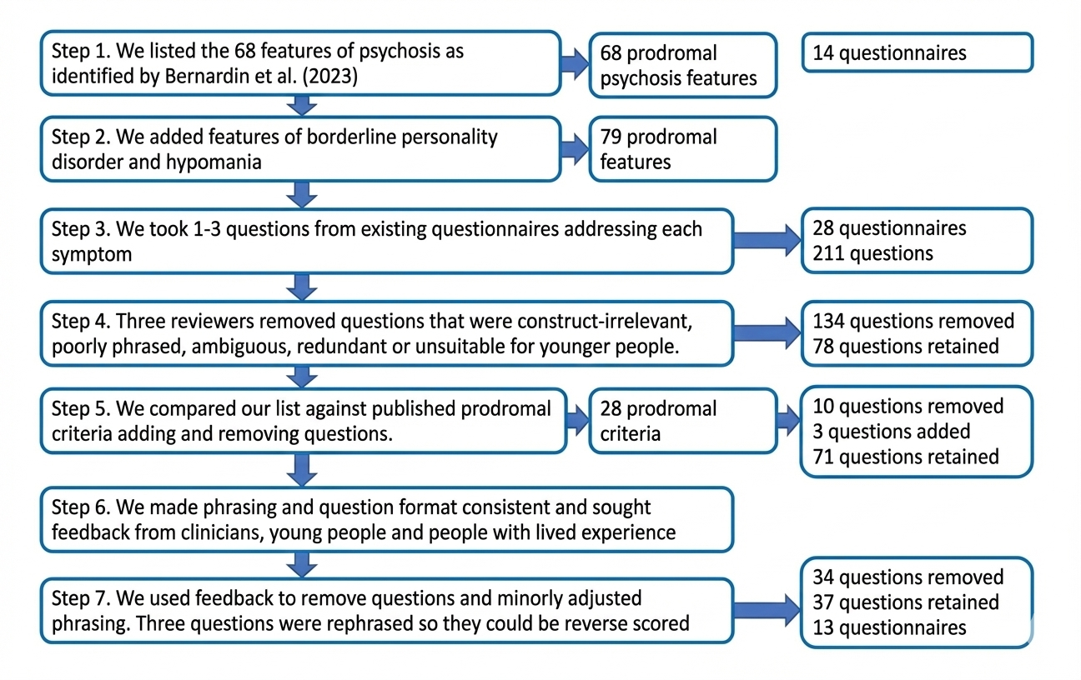
Figure E 1
The full procedure of item selection for TRACE
Note. From Jayne et al. (2025).

Reference:
Pickering, J., Shao, W., Weich, S., Dalton, C. F., Jones, M., Taylor, C. D. J., Reuber, M., Kingston, J., Gibbs, C., & Bentall, R. P. (2025). Developing Trace: A transdiagnostic screening tool for early detection of a pluripotent at-risk mental state. International Journal of Methods in Psychiatric Research, 34(4), Article e70046. https://doi.org/10.1002/mpr.70046

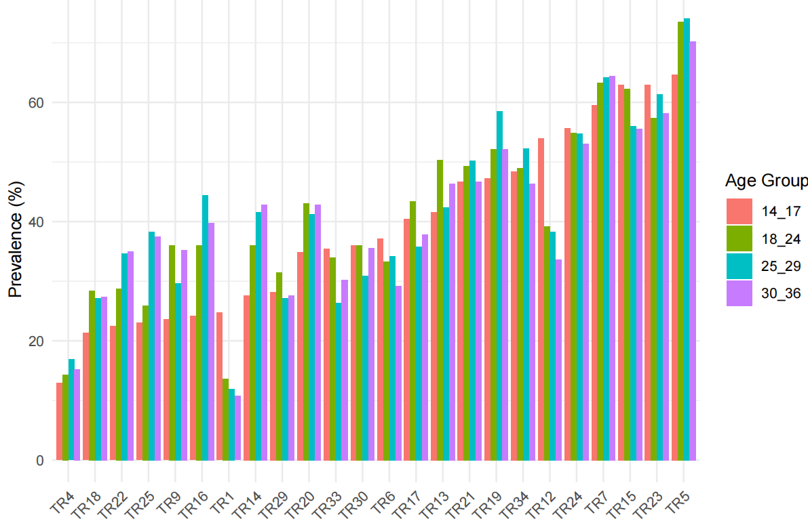

(a) mild distress
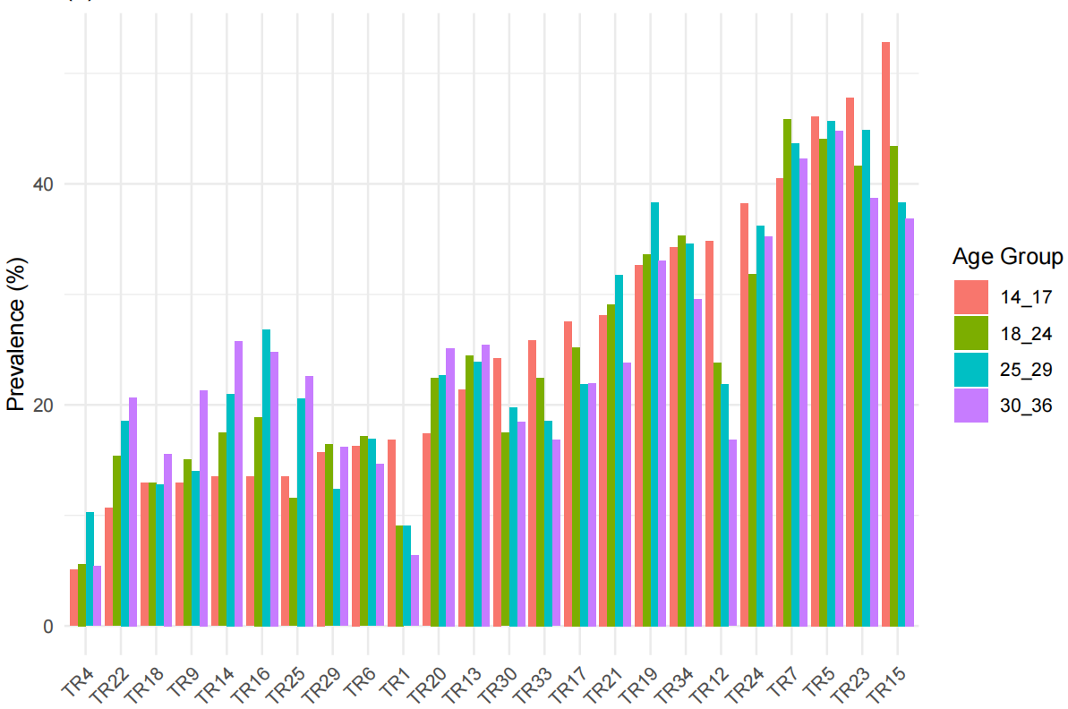
(b) moderate distress
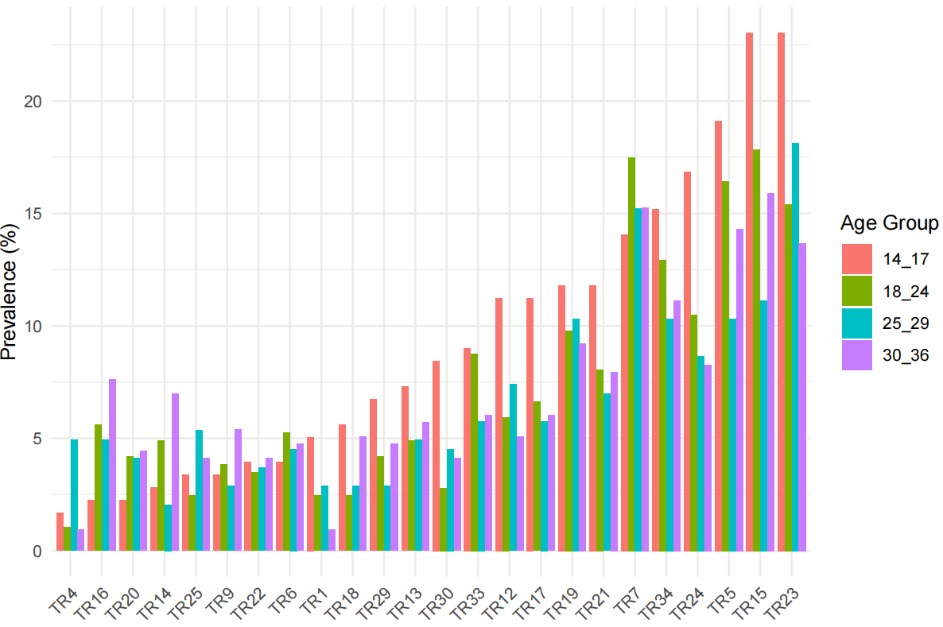
(c) severe distress

Figure E 2
The item prevalence of distress levels among all sample by different age groups
Note. TR3: Impulsivity, TR5: Racing Thoughts, TR7: Low mood, TR12: Disorganized Thinking, TR15: Emptiness, TR19: Mood Cycle, TR21: Irritability, TR23: Mood lability, TR24: Disconnected Thoughts, TR26: Identity Confusion, TR27 Poverty of Speech, TR34 Emotional Numbness, TR37 Confused Thinking;
TR6: Auditory Hallucinations, TR9: Sound Distraction, TR17: Reality Confusion, TR18: Precepted oddity in familiar Surroundings, TR29: Pseudo hallucinations, TR30: Suspiciousness, TR33: Paranoia;
TR13: Pressured speech/ talkative, TR14: Elevated self-confidence, TR16: Elevated mood or energy, TR20: Increased goal directed activities, TR22: Grandiosity, TR25: Idea of reference.

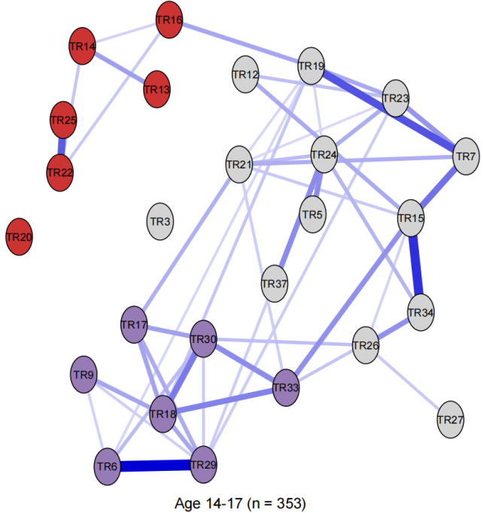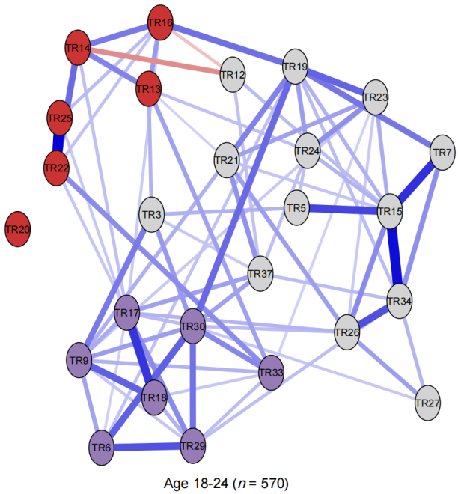
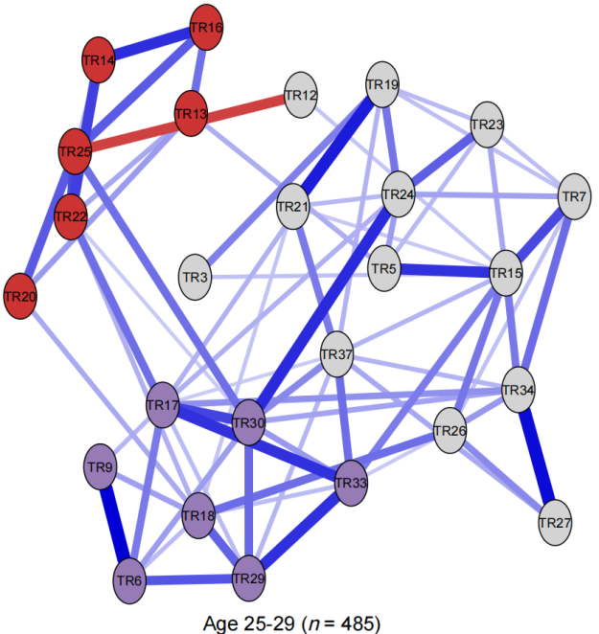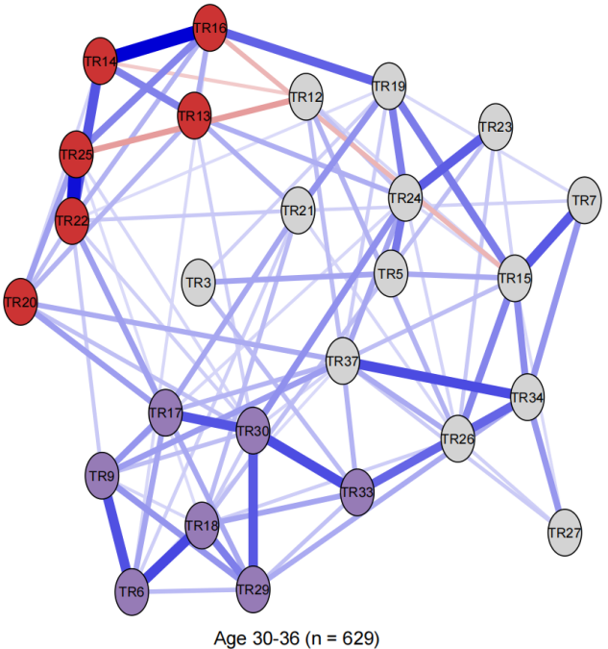
Figure E 3
The Ising Model (IM) network structures of at-risk symptoms by age groups
Note. Blue edges indicate positive relationships, while red edges reflect negative correlations. The threshold for edge weights was set at 0.2 to improve readability.
TR3: Impulsivity, TR5: Racing Thoughts, TR7: Low mood, TR12: Disorganized Thinking, TR15: Emptiness, TR19: Mood Cycle, TR21: Irritability, TR23: Mood lability, TR24: Disconnected Thoughts, TR26: Identity Confusion, TR27 Poverty of Speech, TR34 Emotional Numbness, TR37 Confused Thinking;
TR6: Auditory Hallucinations, TR9: Sound Distraction, TR17: Reality Confusion, TR18: Precepted oddity in familiar Surroundings, TR29: Pseudo hallucinations, TR30: Suspiciousness, TR33: Paranoia;
TR13: Pressured speech/ talkative, TR14: Elevated self-confidence, TR16: Elevated mood or energy, TR20: Increased goal directed activities, TR22: Grandiosity, TR25: Idea of reference.

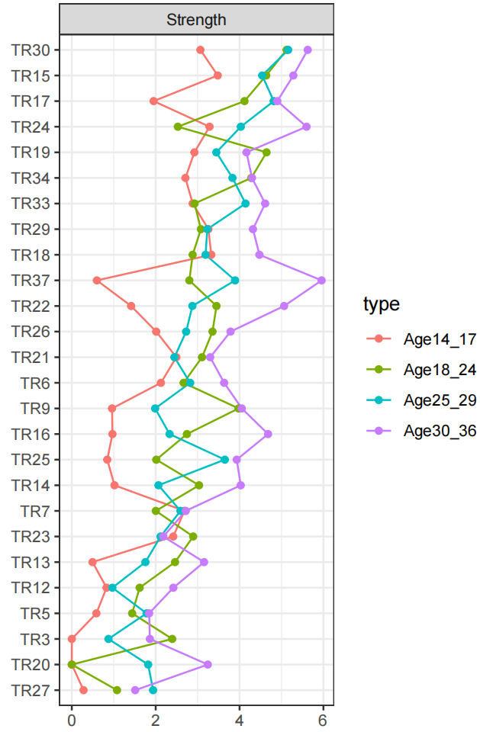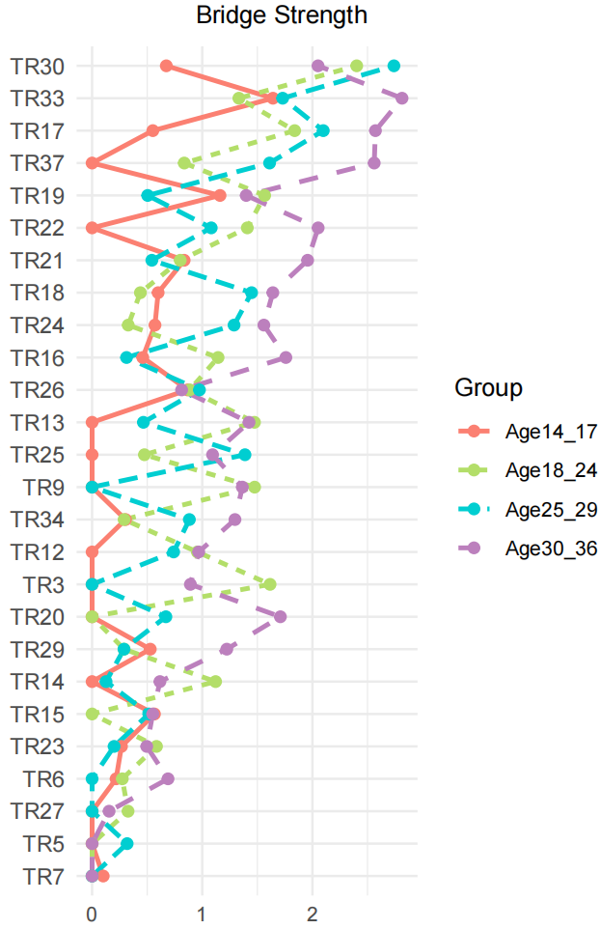
Figure E 4
Node and bridge strength across age group networks
Note. Raw coefficients were used for node strength and bridge strength scales.
TR3: Impulsivity, TR5: Racing Thoughts, TR7: Low mood, TR12: Disorganized Thinking, TR15: Emptiness, TR19: Mood Cycle, TR21: Irritability, TR23: Mood lability, TR24: Disconnected Thoughts, TR26: Identity Confusion, TR27 Poverty of Speech, TR34 Emotional Numbness, TR37 Confused Thinking;
TR6: Auditory Hallucinations, TR9: Sound Distraction, TR17: Reality Confusion, TR18: Precepted oddity in familiar Surroundings, TR29: Pseudo hallucinations, TR30: Suspiciousness, TR33: Paranoia;
TR13: Pressured speech/ talkative, TR14: Elevated self-confidence, TR16: Elevated mood or energy, TR20: Increased goal directed activities, TR22: Grandiosity, TR25: Idea of reference.

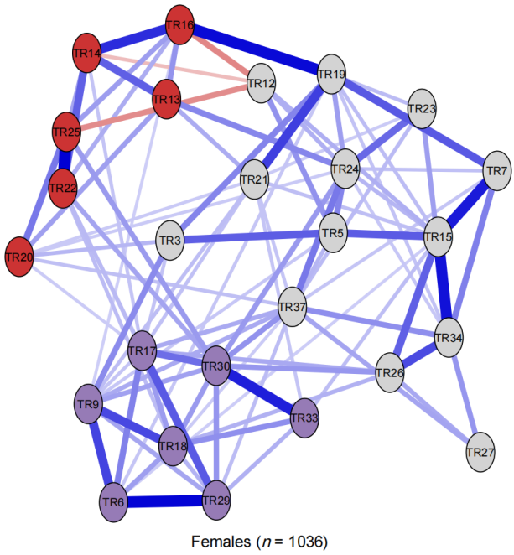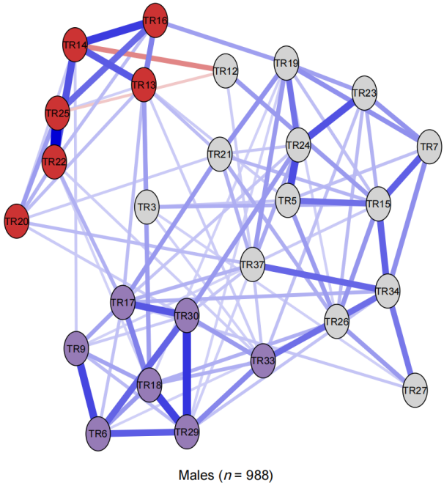
Figure E 5
The Ising Model (IM) network structures of at risk symptoms by genders
Note. Blue edges indicate positive relationships, while red edges reflect negative correlations. The threshold for edge weights was set at 0.2 to improve readability.
TR3: Impulsivity, TR5: Racing Thoughts, TR7: Low mood, TR12: Disorganized Thinking, TR15: Emptiness, TR19: Mood Cycle, TR21: Irritability, TR23: Mood lability, TR24: Disconnected Thoughts, TR26: Identity Confusion, TR27 Poverty of Speech, TR34 Emotional Numbness, TR37 Confused Thinking;
TR6: Auditory Hallucinations, TR9: Sound Distraction, TR17: Reality Confusion, TR18: Precepted oddity in familiar Surroundings, TR29: Pseudo hallucinations, TR30: Suspiciousness, TR33: Paranoia;
TR13: Pressured speech/ talkative, TR14: Elevated self-confidence, TR16: Elevated mood or energy, TR20: Increased goal directed activities, TR22: Grandiosity, TR25: Idea of reference.

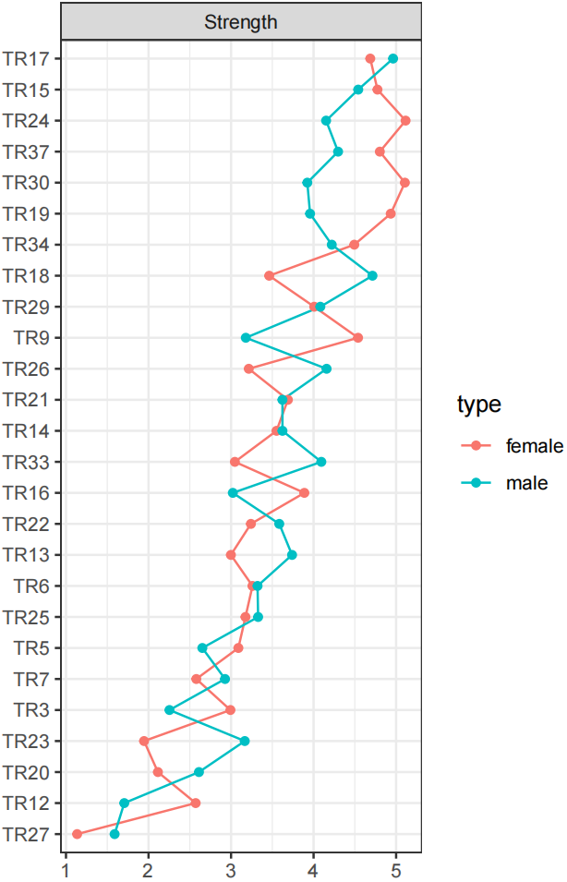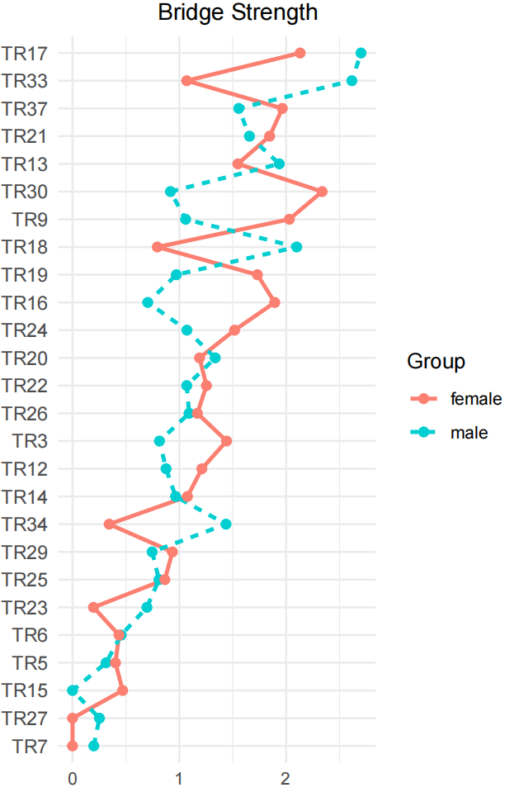
Figure E 6
Node and bridge strength across gender group networks
Note. Raw coefficients were used for node strength and bridge strength scales;
TR3: Impulsivity, TR5: Racing Thoughts, TR7: Low mood, TR12: Disorganized Thinking, TR15: Emptiness, TR19: Mood Cycle, TR21: Irritability, TR23: Mood lability, TR24: Disconnected Thoughts, TR26: Identity Confusion, TR27 Poverty of Speech, TR34 Emotional Numbness, TR37 Confused Thinking;
TR6: Auditory Hallucinations, TR9: Sound Distraction, TR17: Reality Confusion, TR18: Precepted oddity in familiar Surroundings, TR29: Pseudo hallucinations, TR30: Suspiciousness, TR33: Paranoia;
TR13: Pressured speech/ talkative, TR14: Elevated self-confidence, TR16: Elevated mood or energy, TR20: Increased goal directed activities, TR22: Grandiosity, TR25: Idea of reference.

This chapter was submitted to the Journal of Bipolar Disorders for consideration for publication in January 2024 and is currently undergoing a second round of review. It represents original work conducted, analysed, and drafted by the PhD candidate, supervised by Professor Richard P. Bentall.
The PhD candidate was responsible for research design, obtaining data access, data analysis, and manuscript drafting of this chapter. The chapter was supervised by Dr. Melanie Simmonds-Buckley and Professor Richard P. Bentall, and published as: Shao, W., Simmonds-Buckley, M., Zavlis, O., & Bentall, R. P. (2025). The common structure of the major psychoses: More similarities than differences in the network structures of schizophrenia, schizoaffective disorder, and psychotic bipolar disorder. Schizophrenia Bulletin, 51(4), 1042–1053. https://doi.org/10.1093/schbul/sbae154
The study presented in this chapter was designed, analysed, and drafted by the PhD candidate, supervised by Dr Melanie Simmonds-Buckley and Professor Richard P. Bentall. This manuscript is being prepared for submission.
All analyses in this chapter were conducted by the PhD candidate, who also contributed to the study design and item selection and refinement of the TRACE instrument. The EGA and confirmatory factor analyses were published in Pickering, J., Shao, W., Weich, S., Dalton, C. F., Jones, M., Taylor, C. D. J., Reuber, M., Kingston, J., Gibbs, C., & Bentall, R. P. (2025). Developing TRACE: A transdiagnostic screening tool for early detection of a pluripotent at-risk mental state. International Journal of Methods in Psychiatric Research, 34(4), e70046. https://doi.org/https://doi.org/10.1002/mpr.70046 (Pickering and Shao were considered joint first authors of this article).

