Computational Evaluation, Characterization and Screening of Materials and Molecules for Sustainable Applications

Chenhao Li

Supervisor: Dr. James McGregor
Dr. Sergio Vernuccio
Dr. Peyman Z. Moghadam

School of Chemical, Materials and Biological Engineering
The University of Sheffield

Abstract

Computational simulation is wildly used for materials evaluation, characterization and property prediction, playing a critical role in advancing material science. In this thesis, we focus on three sustainable applications: suppression of lignin repolymerization, CO₂ adsorption, and photocatalytic CO₂ conversion, approached from a computational aspect. Density Functional Theory (DFT) was used to evaluate and characterize an initial set of candidate molecules and materials. We developed and applied a systematic computational framework that integrates chemical model construction, target property evaluation, reaction pathway analysis, performance differentiation, and high-throughput screening. This multiscale approach enabled the identification of promising cation scavengers for biomass pretreatment, functional molecules and MOFs with enhanced CO₂ binding affinities, and photocatalysts with suitable band structures and reaction energetics for solar-driven CO₂ conversion.
Our results not only provide insight into the underlying structure-property relationships but also offer valuable guidance for experimental validation and future material design aimed at sustainable development and carbon mitigation.

Contents
1 Introduction 5
1.1 Structural Principles of Metal-Organic Frameworks 6
1.2 Chemical Bonding Between Metal Nodes and Organic Linkers 7
1.3 Physical Properties of MOFs 7
1.4 Functionalization and Tunability of MOFs 8
1.5 Rigid, Flexible and Functionalized Framework MOFs 8
1.6 Zirconium-Based MOFs 10
1.7 Computational Simulations of MOFs for Adsorption and Photocatslysis 11
2 Methodology 13
2.1 Density Functional Theory 13
2.1.1 Ideals and Realities of Quantum Mechanics 15
2.1.2 Hohenberg-Kohn theorem 16
2.1.3 Exchange-correlation Functional 17
2.2 Basis Sets 20
2.3 Density Functional Theory and Post-Hartree-Fock Methods 20
2.4 Basis Set Superposition Error (BSSE) 21
2.5 Thermodynamic Properties and Enthalpy Calculations 22
2.6 Reactivity Descriptors: Fukui Functions and Interaction Region Indicator 22
2.7 Solvation Model 22
2.8 Transition State Searches and Intrinsic Reaction Coordinate (IRC) Analysis 23
3 In silico evaluation of naphthoic acids as scavengers for suppressing Lignin Repolymerisation 24
3.1 Introduction 25
3.2 Computational Details 29
3.3 Results 30
3.3.1 Model construction of VG and cation scavengers 30
3.3.2 Mechanism of VG dehydration and electrophilic aromatic subsititution 34
3.3.3 Lignin interactions with different scavengers 39
3.4. Conclusion 45
4 Computational Screening of Amino-Functionalized Molecules for Direct Air Capture of CO₂ 47
4.1 Introduction 48
4.1.1 Direct Air Capture: Scientific and Materials Challenges 48
4.1.2 Advantage of MOFs for CO₂ Capture at Ultra-Low Partial Pressure 49
4.1.3 Functionalized MOFs for CO₂ Adsorption 50
4.1.4 Moisture Stability and the Role of Robust Frameworks 51
4.1.5 Balancing CO₂ Affinity and Regeneration Energy 51
4.1.6 Role of Computational Modelling in MOF-Based DAC 52
4.2 Computational details 53
4.3 Result and Discussions 54
4.3.1 CO₂ and water interactions with amino-functionalized molecules 55
4.3.2 Applications of functionalized molecules to CO₂ capture 68
4.4 Conclusion 77
5 High-throughput Computational Screening of MOFs for Photocatalytic Water Splitting & Carbon Dioxide Conversion 79
5.1 Introduction 79
5.1.1 Photocatalytic CO₂ Reduction 81
5.1.2 Advantages and disadvantages of MOFs in Photocatalysis 83
5.1.3 MOFs for photocatalytic carbon dioxide reduction 86
5.2 Computational Details 93
5.3 Result 94
5.3.1 Photocatalytic process of UiO-66 94
5.3.2 Computational screening of potentially conductive MOFs 101
5.3.3 Screening of MOFs for photocatalytic water splitting and CO₂ reduction 104
5.4 Conclusion 108
6 Conclusion and Future Developments 109
6.1 In silico evaluation of naphthoic acids as scavengers for suppressing Lignin Repolymerisation 110
6.2 Computational Screening of Amino-Functionalized Molecules for Direct Air Capture of CO₂ 111
6.2 High-throughput Computational Screening of MOFs for Photocatalytic Water Splitting & Carbon Dioxide Conversion 112
References 114

1 Introduction
In the contemporary landscape of materials science, the rapid development of computational simulation is profoundly transforming the process of material design, discovery, optimization, and manufacturing.¹⁻³ By integrating principles from computer science, physics, and chemistry, computational simulation plays a key role in materials research and development.^{4, 5} These simulations enable the prediction of material properties prior to experimental synthesis, thereby accelerating the discovery and optimization of new materials and reducing the cost and time associated with traditional trial-and-error approaches.⁶ By using computational simulations to study the impact of different atomic and molecular structures, it is possible to identify ideal molecules and materials with tailored properties for targeted applications such as gas adsorption⁷, photocatalysis⁸, thermal catalysis⁹, electrocatalysis¹⁰, separation¹¹, hydrogen storage¹² and more. Moreover, simulations allow for the optimization of material properties by systematically modifying structural features, chemical composition, and process conditions. Through these approaches, computational methods provide valuable insights into electronic structure¹³, thermodynamic properties¹⁴, and physical properties¹⁵ of materials. Such insight complements experimental research, while guiding the rational design of advances materials and improve their practical engineering applications. Although challenges remain, such as data scarcity, high computing costs and limitations in algorithm accuracy, computational simulations continues opening up new frontiers in materials science. With the development of technologies, material science is predicted to enter a new era of greater precision and intelligence in novel material design, performance optimization, and automated manufacturing, promoting continuous innovation and progress.
In this thesis, we focus on the computational evaluation, characterization, and screening of molecules and materials for various sustainable applications.
The third chapter of this thesis focus on evaluating the repolymerisation suppression behaviour of three different naphthoic acid isomers. This work was carried out in partnership with Zurich University of Applied Sciences (ZHAW) which led the experimental efforts to validate and test the performance of the lignin cation scavengers. In our study we applied cluster model optimization and Fukui function calculation, to construct reaction pathways and evaluate performance differences among the selected candidate molecules.
In the fourth chapter, the initial pool of candidate molecules was expanded to include fifteen different amino functionalized molecules, which were screened to evaluate their adsorption behaviour. High-precision binding energy calculations, based on carefully constructed cluster models, were employed to identify the most promising amino groups to functionalize metal-organic frameworks for direct air capture. Besides the single-molecule calculations, we developed a multi-molecule model to better approximate real-world conditions and enhance the predictive relevance of the simulations. This chapter has been published on The Journal of Physical Chemistry A. (https://doi.org/10.1021/acs.jpca.5c03392)
In the fifth chapter, the scope of targeted materials was further expanded. An automated algorithm was developed to perform high-throughput screen the CSD MOF subset, to identify structures with key properties for photocatalytic applications, such as band gap, band alignment, and largest cavity diameter. This work aimed at identifying metal-organic frameworks with potential photocatalytic properties, was supported by the European Space Agency (ESA).

1.1 Structural Principles of Metal-Organic Frameworks

Metal–organic frameworks (MOFs) are crystalline porous materials constructed from metal ions or oxo-metallic clusters, known as secondary building units (SBUs), interconnected by multitopic organic linkers through coordination bonds. Unlike traditional porous solids, the long-range order and modular assembly of MOFs enable precise control over framework topology, pore architecture, and chemical environment.¹⁶⁻¹⁸ The connectivity and geometry of the metal SBUs play a decisive role in defining the resulting framework structure. Common inorganic nodes include tetrahedral Zn₄O clusters, paddlewheel-type Cu₂ units, and highly connected Zr₆ oxo-clusters.¹⁹ These nodes are typically linked by carboxylate-based ligands, such as terephthalate or trimesate, forming extended three-dimensional networks with well-defined pore sizes ranging from microporous to mesoporous regimes. The coordination modes of the linkers and the metal oxidation state strongly influence framework rigidity, stability, and defect tolerance.¹⁹⁻²¹

1.2 Chemical Bonding Between Metal Nodes and Organic Linkers

The chemical bonding between metal nodes and organic linkers is central to the structural robustness and physicochemical properties of MOFs. In carboxylate-based MOFs, strong metal–oxygen coordination bonds dominate framework formation, while nitrogen-donor ligands (e.g. imidazolates) generate metal–nitrogen bonding motifs with distinct chemical behaviour.^{22, 23} High-valent metal centres, such as Zr⁴⁺ or Al³⁺, form stronger metal–ligand bonds compared to divalent metals, resulting in enhanced resistance to thermal decomposition, moisture, and acidic or basic environments.²⁴ The nature of the metal–linker interaction also governs electronic properties, framework flexibility, and the availability of coordinatively unsaturated sites. These factors are particularly important for catalytic applications, where open metal sites and linker-based functional groups can act as active centres or modulate reactant adsorption.

1.3 Physical Properties of MOFs

One of the most distinctive features of MOFs is their exceptionally high internal surface area and porosity. In many cases, up to 90% of the framework volume consists of accessible void space. Reported Brunauer–Emmett–Teller (BET) surface areas can exceed 7,000 m² g⁻¹, placing MOFs among the most porous materials known. Such high porosity underpins their outstanding performance in gas storage and separation, particularly for small molecules such as hydrogen and carbon dioxide.²⁵⁻²⁹ Beyond surface area, other physical properties—including pore size distribution, thermal stability, solvent tolerance, hydrophobic/hydrophilic character, and electronic structure—are equally critical for determining MOF performance in practical applications.^{30, 31} Thermal stability can range from below 300 °C for less robust frameworks to above 450 °C for highly connected structures.³¹ Similarly, framework polarity and solvent compatibility can be tuned through linker chemistry, enabling selective adsorption and stability under a wide range of operating conditions.

1.4 Functionalization and Tunability of MOFs

A major advantage of MOFs lies in their chemical tunability. Functionalization can be achieved through modification of organic linkers, incorporation of functional groups, or substitution of metal ions within the inorganic nodes.³² Common functional groups such as amines, hydroxyls, and sulfonic acids have been shown to significantly alter framework polarity, adsorption affinity, and catalytic activity.^{33, 34} For example, amine-functionalised MOFs exhibit enhanced CO₂ adsorption and selectivity due to favourable acid–base interactions and hydrogen bonding.³⁵ These strategies provide powerful tools for tailoring MOFs toward specific applications.

1.5 Rigid, Flexible and Functionalized Framework MOFs

MOFs can be classified into the following groups according to their structural properties:
(i) Rigid Framework MOFs
MOFs in this group usually have a stable and robust topology with very high porosity. In addition, these MOFs can maintain their pore structure when there is an interaction with the adsorbate molecule.
Examples of MOFs in this category include: MOF-5 [Zn₄O (terephthalate)₃] with its cubic structure which has surface area of 3800 m²/g.³⁶ Other examples of MOFs of this type that have high porosity with BET surface area of 4746 and 6260 m²/g are MOF-177 [Zn₄O (btb)₂] and MOF-200 [Zn₄O (bbc)₂], respectively.^{37, 38} The use of chromium metal to replace the ZnO metal cluster on this type of MOF will produce MIL-101 [Cr₃F (H₂O)O(bdc)₃] having BET surface area of 4100 m²/g.³⁹
(ii) Flexible framework MOFs
In contrast to rigid framework MOFs, flexible MOFs often exhibit dynamic structural behaviour and may not retain their initial pore structure and topology under varying conditions. The pore structure can be significantly affected by external pressure and temperature.
Several MOFs in this category experience severe changes in their unit cell parameters during the adsorption process due to the “breathing” effect. Examples of MOFs in this category include aluminium-based MOFs (MIL-53) and ZIF-8.⁴⁰
(iii) Functionalized MOFs
MOFs can be modified by crafting specific functional groups on their organic linker or metal nodes. The addition of such functional groups can enhance the adsorption capacity of MOFs for certain gases. For example, the addition of an arylamine group, hydroxyl or alkylamine can increase the affinity of MOFs to CO₂ leading to an increase in adsorption capacity and selectivity.⁴¹

1.6 Zirconium-Based MOFs

Among the various MOF families, zirconium-based frameworks have attracted particular attention due to their exceptional stability. UiO-66 is a prototypical example, constructed from highly connected Zr₆O₄(OH)₄ clusters coordinated by twelve terephthalate linkers, resulting in a face-centred cubic topology. (Figure 1.1)¹⁹ The strong Zr–O coordination bonds and high connectivity endow UiO-66 with remarkable thermal stability, with decomposition temperatures typically exceeding 450 °C, as well as excellent resistance to water, acids, and organic solvents.³⁵ UiO-66 exhibits a moderate BET surface area (typically 1,100–1,500 m² g⁻¹) combined with narrow micropores, making it particularly suitable for applications requiring structural robustness rather than maximum porosity.⁴² Importantly, the UiO-66 framework tolerates a high density of defects and linker functionalisation without loss of crystallinity. Functionalised derivatives such as UiO-66-NH₂ and UiO-66-NO₂ have been widely investigated to tailor adsorption behaviour, electronic structure, and catalytic activity. Furthermore, metal substitution and post-synthetic modification strategies have been employed to introduce active sites and tune hydrophobic/hydrophilic characteristics, highlighting UiO-66 as a versatile platform for both fundamental studies and practical applications.^{43, 44}
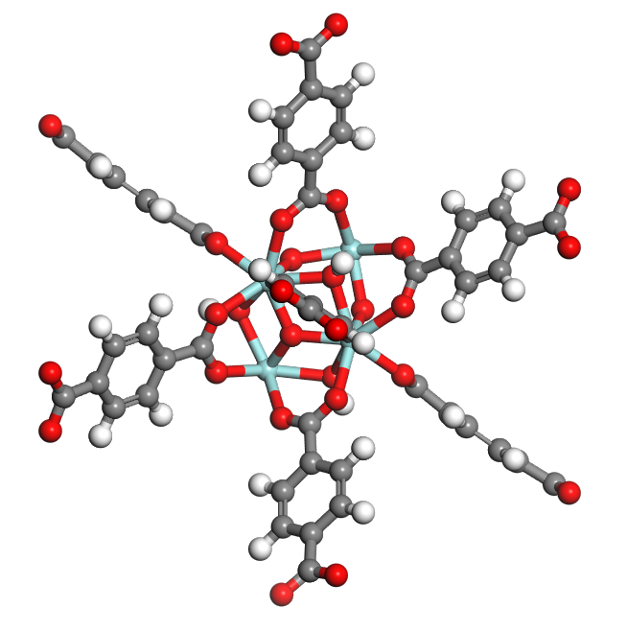
Figure 1.1. UiO-66 framework. Color scheme: O, red; C, grey; H, white; Zr, light blue.

1.7 Computational Simulations of MOFs for Adsorption and Photocatslysis

In recent years, computational simulations have become an indispensable tool for advancing the understanding of MOFs, particularly in the context of adsorption and photocatalytic applications. Simulations provide atomistic and electronic-level insight that is often inaccessible experimentally, enabling rational interpretation of adsorption behaviour, framework stability, and photoinduced processes.
Accurate structural models are a prerequisite for understanding MOF performance. Atomistic simulations and geometry optimisations are widely employed to investigate framework stability, pore accessibility, and the influence of defects or linker functionalisation on local coordination environments. Such studies allow evaluation of how metal nodes, linker chemistry, and pore topology collectively determine adsorption sites and interaction strengths. In adsorption-related applications, simulation has proven particularly valuable for analysing the distribution of guest molecules within pores and identifying preferential binding regions associated with functional groups or open metal sites, thereby complementing experimental adsorption measurements and spectroscopic data. Recent simulation studies have demonstrated that framework chemistry, rather than surface area alone, often governs adsorption selectivity and capacity. Computational investigations of functionalised MOFs have shown that polar functional groups can significantly enhance CO₂ affinity by strengthening electrostatic and hydrogen-bonding interactions, even in frameworks with moderate porosity. Such findings provide a mechanistic basis for experimental observations reported in adsorption and separation studies.⁴⁵ Besides predicting adsorption isotherms, simulations are also used to interpret adsorption mechanisms and trends observed experimentally. Molecular-level modelling enables the decomposition of adsorption energetics into framework–guest and guest–guest interactions, clarifying the role of pore confinement, framework flexibility, and functionalization. In chemically complex systems, simulation helps distinguish whether adsorption enhancement arises from increased binding strength, improved pore accessibility, or cooperative effects between adsorbed species. Such mechanistic insights are particularly valuable when comparing families of MOFs with similar topologies but different chemical compositions. Computational studies reported in chemical engineering and separation literature highlight how subtle variations in linker substitution or metal coordination can produce measurable changes in adsorption selectivity and working capacity, thereby guiding experimental material optimisation.⁴⁶
For photocatalytic applications, electronic structure calculations play a central role in elucidating light–matter interactions within MOFs. These simulations provide access to key properties such as band gaps, density of states, charge carrier localisation, and redox potentials, which are critical for assessing photocatalytic viability. By correlating framework composition with electronic structure, simulations enable prediction of how linker functionalisation or metal substitution alters light absorption and charge separation behaviour.
Several studies have demonstrated that linker-derived orbitals often dominate the valence band, while metal nodes or metal–oxo clusters contribute to the conduction band, highlighting the importance of metal–linker synergy in determining photocatalytic activity. Computational investigations reported in environmental and chemical engineering contexts have shown how such electronic features correlate with experimentally observed photocatalytic degradation efficiencies and reaction rates.⁴⁷
More broadly, simulation has emerged as a powerful tool for rational MOF design, allowing researchers to screen hypothetical structures, assess stability under operating conditions, and identify promising modification strategies prior to synthesis. By linking structural descriptors—such as coordination environment, pore polarity, and electronic structure—to functional performance, modelling studies help establish general structure–property relationships applicable across MOF families. Recent reviews emphasise that the integration of atomistic modelling, electronic structure calculations, and experimental validation is particularly effective for multifunctional MOFs, where adsorption and photocatalytic processes are closely coupled. Such combined approaches are increasingly used to design MOFs with balanced porosity, stability, and photoactivity, enabling more efficient and targeted application development.⁴⁸
Overall, computational simulation provides a complementary perspective to experimental studies, offering mechanistic understanding and predictive capability that strengthen interpretation of experimental results. Incorporating simulation-based insights into MOF research therefore enables a more comprehensive evaluation of adsorption and photocatalytic behaviour and provides a robust framework for contextualising the results presented in this work.

2 Methodology

2.1 Density Functional Theory

Density Functional Theory (DFT) is the most popular first principles method in quantum chemistry and computational chemistry. DFT is typically considered to have a lower computational complexity compared to other quantum chemical methods. For this reason, DFT is widely used in the field of computational simulation. DFT itself is based on the fundamental equations of quantum mechanics - the Schrödinger equation. In most quantum mechanics textbooks, the Schrödinger equation is presented as a single-electron equation. However, in practical applications such as catalysis and reaction engineering, the systems of interest – molecules and bulk materials – often contain hundreds to tens of thousands of electrons. This complexity transforms the Schrödinger equation into a many-body problem that cannot be solved exactly or systematically. To address the challenge of many-body problems, quantum chemistry as developed two main approaches, ab initio methods, and Density Functional Theory.⁴⁹
Ab initio methods treat each electron as precisely as possible, aiming to obtain a many-body wave function that describes all electrons; density functional theory, does not describe the wave function of each electron, but only accurately deals with the total electron density. In density functional theory, density refers to the number of electrons per unit volume in a given state. The term “functional” (function of another function) indicates that the energy is a function of the electron density, and the electron density is a function of the space coordinates. DFT study multi-electron systems through electron density, the electron-electron interactions in multi-electron systems are simplified.
Although density functional theory solves the density of electrons and obtains a series of wave functions of electrons, it should be noted that this wave function is actually the wave function of a virtual, non-interacting electron system, not the electrons in the actual system. The only connection between the two systems is that they have the same density. However, approximating the eigenvalues (energy levels) and eigenstates (wave functions) of such free electrons to the energy levels and wave functions of real electrons is a widely accepted practice. In terms of energy level, only the highest occupied molecular orbitals (HOMO) and lowest unoccupied molecular orbitals (LUMO) correspond to the actual electron dissociation energy and affinity, and other energy levels have no actual physical meaning. Therefore, the error of density functional calculation of high energy level and low energy level can be very large (the farther away from the energy level of HOMO and LUMO, the greater the error⁵⁰)

2.1.1 Ideals and Realities of Quantum Mechanics

The concept of a wave function in quantum mechanics is enticing: a simple wave function ψ(r, t) can theoretically contain all the information about a certain system in a given state. This suggests that, in principle, it should be possible to simulate any quantum system. However, the gap between this ideal and practical reality is the immense computational power required..
For a multi-electron atomic system, the Schrödinger equation can be written in the following form:
$\hat{H}ψ=\left[\hat{T}+\hat{V}+\hat{U}\right]ψ=[\sum_{i}^{N}{\left(-\frac{h^{2}}{2m_{i}}∇_{i}^{2}\right)}+\sum_{i}^{N}{V\left(r_{i}\right)+\sum_{i<j}^{N}{U\left(r_{i},r_{j}\right)}}]ψ$ (1)
where $\hat{H}$ is the Hamiltonian, $\hat{T}$ is the kinetic energy operator, $\hat{V}$ is the Potential energy operator for the external electric field (nuclear electric field), $\hat{U}$ is the Electron-electron interaction operator, $h$ is the Planck constant, $m$ is the electron mass, $∇^{2}$is the Laplacian, $r_{i},r_{j}$ are the particle positions of electrons.
Since each electron in an N-electron system has three spatial coordinates, then the Schrödinger equation contains 3N variables. For special systems, such as hydrogen-like particles (H, He⁺, Li²⁺, etc.), we can obtain the analytical solution of the Schrödinger equation by converting Cartesian coordinates into spherical coordinates. Through a series of mathematical operations, the spherical coordinate representation of Schrödinger equation for hydrogen-like particles can be decomposed into three sub-equations containing only one spherical coordinate variable. As a result, the principal quantum number, the angular quantum number and the magnetic quantum number can be estimated. However, this simplification is possible because hydrogen-like particles have no interaction terms. For a multi-electron system, as $r_{ij}$ (the distance between particle i and j) can be expressed as:
$\overset{→}{|r_{ij}|}=\sqrt{{(x_{i}-x_{j})}^{2}+{(y_{i}-y_{j})}^{2}+{(z_{i}-z_{j})}^{2}}$ (2)
Schrödinger equation cannot be treated in the same way and cannot be solved analytically. The few solvable Schrödinger equations, such as hydrogen-like and harmonic oscillators, are highly symmetric.⁴⁹
In order to find numerical solutions, Perturbation Theory⁵¹ and Configuration Interaction Method were proposed.⁵² The problem is that it is too computationally intensive to simulate thousands of atoms in a certain chemistry system.

2.1.2 Hohenberg-Kohn theorem

The first Hohenberg-Kohn (H-K) theorem states that the energy of an atomic system, as well as all other observables, is unambiguously determined by the electronic density of the system, n(r). Thus, the 3N variables of the multi-electron system above is reduced to 3.
The second H-K theorem states that the electron density at which the lowest energy can be obtained is the ground state electron density.
Although H-K theorem simplified the Schrödinger equation, it does not provide any information on the specific expressions of the electron density function, kinetic energy functional and exchange correlation functional are not given.
Kohn and L Sham established the Kohn-Sham equation, which provided the specific description for all the functions mentioned above. “For the kinetic energy functional, they proposed to use the particle kinetic energy functional without mutual influence as an approximate replacement, and incorporate the difference between the two into the unknown term of the exchange correlation functional.”⁵³ This work greatly simplified the calculation process and transfers the key of the problem to the solution of exchange correlation functional.

2.1.3 Exchange-correlation Functional

Local Density Approximation (LDA)
LDA is the most concise and the first proposed exchange-correlation functional. In LDA theory, the $E_{XC}$ (exchange-correlation functional) is assumed to be only affected by the local electron density. The general expression of the exchange correlation functional for LDA is:
$E_{XC}^{LDA}\left(n\right)=\int{\left. f(n(r)\right) dr}$ (3)
$E_{XC}^{LDA}\left(n\right)=\int{E_{X}^{LDA}}((n\left(r\right))+E_{C}^{LDA}$ $(n\left(r\right))) dr$ (4)
where $E_{X}$ is exchange functional, and $E_{C}$ is correlation functional. $n(r)$ is the electron density and $f(n)$ is the exchange-correlation energy density.
Homogeneous/Uniform Electron Gas, (HEG/UEG), Carpley-Alder (CA), Vosko-Wilk-Nusair (VWN), Perdew-Zunger (PZ), Perdew-Wang (PW) are all widely used LDA functional.⁵⁴
LDA can provide good estimates of structural and elastic properties but often results in an overestimation of the binding energy, an underestimation of the reaction activation energy, an excessive tendency to high spin structures, and a poor estimation of phase stability.⁵⁴
Generalized Gradient Approximation (GGA)
In general, LDA does not perform well in systems where the electron density changes rapidly. For these cases, the easiest way to improve the performance of the exchange-correlation functional is to include the first order of n(r) into the exchange-correlation functional, which is GGA. The general expression of the exchange correlation functional for GGA is:
$E_{XC}^{GGA}\left(n\right)=\int{dr f(n, ∇n)}$ (5)
The vast majority of GGA functional are modifications based on LDA functional, and the introduced first-order gradient can be interpreted as the "speed" of the electron cloud evolution (or the speed of electron movement). Becke, Lee-Yang-Parr (BLYP), Perdew-Berke-Ernzerhof (PBE) are widely used GGA functionals.⁵⁵
Compared with LDA, GGA has several advantages including more accurate atomic and molecular energies, corrected overbinding, and more accurate reaction activation energies (although usually still too low). However, GGA usually gives lower bond energies and higher lattice parameters.⁵⁶
Generalized Gradient Approximation with Kinetic Energy Density (meta-GGA)
Based on GGA, meta- GGA introduces the second order gradient.⁵⁶ The general expression of meta-GGA exchange correlation functional is:
$E_{XC}^{MGGA}\left(n\right)=\int{dr f(n, ∇n, ∇^{2}n)}$ (6)
Hybrid Functional
Since different functionals can respectively overestimate or underestimate the energy, combining two functional together can often improve the accuracy of the results. This is the idea of hybrid functionals. In practical applications, a small fraction of the Hartree-Fock energy ($E_{XC}^{HF}$) is usually included.
The general expression for a hybrid functional is:
$E_{XC}^{Hybrid}=αE_{X}^{HF}+(1-α{)E}_{X}^{DFT}+E_{C}^{DFT}$ (7)
where $α$ is the proportion of HF in the hybrid functional.
The research on hybrid functional has been highly active in recent years, and several new functionals are proposed every year. The following is an example of the most widely used Becke's 3 parameters hybrid functional with the Lee-Yang-Parr correlation functional (B3LYP).
$E_{XC}^{B3LYP}=E_{X}^{LDA}+α\left(E_{X}^{HF}-E_{X}^{LDA}\right)+{b(E}_{X}^{GGA}-E_{X}^{LDA})+E_{C}^{LDA}+c(E_{C}^{GGA}-E_{C}^{LDA})$ (8)
Where the values of the parameters are: $α$=0.20, b=0.21, c=0.81. This indicates that 59% of LDA, 20% of HF and 21% of GGA are used in B3LYP exchange potential, 81% of GGA and 19% of LDA are used in correlation potential.^{57, 58}
In Chapter 5, the PBE0 hybrid functional was used. PBE0 is constructed by mixing 25% exact Hartree-Fock exchange with 75% exchange from the Perdew-Burke-Ernzerhof (PBE), while retaining 100% of the PBE correlation energy. The functional form can be expressed as:
$E_{XC}^{PBE0}=0.25E_{X}^{LDA}$ $+$ 0.75$E_{X}^{PBE}+E_{C}^{PBE}$ (9)
Importantly, the mixing coefficient (25%) is not empirically fitted to molecular data but derived from theoretical considerations based on the adiabatic connection formalism. As a result, PBE0 is often described as a parameter-free hybrid functional.⁵⁹
Figure 2.1 illustrates the relationship between different approximation methods. The complexity of the methods increases from the bottom to the top of the Jacob’sladder, accompanied by improved performance. Although in some problems, lower-level functional may outperform some higher-level functional, selecting the appropriate higher-order functional for a given problem, generally ensures greater accuracy.

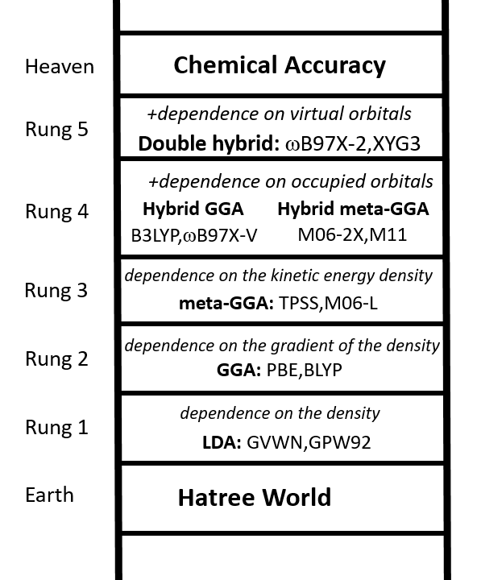
Figure 2.1. “Jacob’s Ladder” illustrating the relationship between the various XC functional.⁶⁰

2.2 Basis Sets

In molecular orbital (MO) theory, molecular orbitals are constructed as linear combinations of atomic orbitals (LCAO). Each atomic orbital is in turn expanded using a finite set of predefined mathematical functions known as basis functions. In Gaussian-based quantum chemistry, Gaussian-type orbitals (GTOs) are widely employed due to their computational efficiency in evaluating multi-center integrals, despite being less physically accurate near the nucleus than Slater-type orbitals.⁶¹ To achieve sufficient flexibility in representing electron density, multiple basis functions are typically assigned to the same atomic orbital, particularly for valence electrons. This allows radial flexibility and improves the description of bonding and polarization effects. In this work, split-valence basis sets were used extensively, where valence orbitals are represented by more than one radial function. Polarisation functions (denoted by d, p) introduce higher angular momentum functions that allow the electron density to distort from spherical symmetry, which is essential for accurately describing chemical bonding, molecular geometries, and transition states. Diffuse functions (denoted by “+”) extend the basis set with functions having small exponents, enabling a better description of weakly bound electrons, anions, and long-range interactions such as hydrogen bonding and dispersion. Accordingly, the 6-311+G(d,p) basis set was employed in Chapters 3 and 4, providing a triple-ξ valence description with both polarisation and diffuse functions, making it suitable for reaction energetics, noncovalent interactions, and charged intermediates. In Chapter 5, the 6-31G(d,p) basis set was used in combination with the PBE0 functional to balance computational cost and accuracy for larger systems, on the other hand, the selection of basis set is consistent with the periodic simulation in the previous work.

2.3 Density Functional Theory and Post-Hartree-Fock Methods

Most calculations in this thesis were performed using DFT, which provides an efficient compromise between accuracy and computational cost by describing electron correlation through exchange–correlation functionals.⁶² In Chapter 3, geometry optimizations and energetics were performed using both the B3LYP and M06-2X functionals with the 6-311+G(d,p) basis set. B3LYP is a widely used hybrid functional that performs reliably for equilibrium structures and reaction energies which is good for pre-optimization, while M06-2X is a meta-hybrid functional with a high percentage of Hartree–Fock exchange, offering improved performance for thermochemistry, noncovalent interactions, and barrier heights.^{58, 63} Chapter 4 employed B3LYP/6-311+G(d,p) to pre-optimize the geometrics of constructed molecules in order to make it easier to converge in the later process. In Chapter 5, the PBE0 functional was combined with the 6-31G(d,p) basis set. PBE0 is a parameter-free hybrid functional known for its robust performance in electronic structure and band gap predictions, particularly relevant for photocatalytic and electronic property analysis.⁵⁹ In addition to DFT, second-order Møller–Plesset perturbation theory (MP2) optimizations were carried out in Chapter 3 for selected systems to provide a higher-level comparison. MP2 explicitly accounts for electron correlation beyond the mean-field approximation and is often used as a benchmark for DFT results in small to medium-sized molecular systems, particularly for describing weak interactions.⁶⁴

2.4 Basis Set Superposition Error (BSSE)

For systems involving weak interactions, such as adsorption complexes, basis set superposition error (BSSE) can artificially stabilise interacting fragments due to basis function sharing. To correct for this effect, BSSE was accounted for using the counterpoise correction method proposed by Boys and Bernardi⁶⁵, in which the energy of each fragment is calculated in the presence of ghost orbitals from the other fragment. This correction was applied consistently in reported interaction energies where applicable.

2.5 Thermodynamic Properties and Enthalpy Calculations

Thermodynamic quantities, including enthalpy changes, were derived from frequency calculations performed at the same level of theory as geometry optimizations. Harmonic vibrational frequencies provide zero-point energy (ZPE) corrections and thermal contributions to internal energy and enthalpy within the rigid rotor–harmonic oscillator approximation.⁶⁶ The detailed expressions are showing in the computational detail below.

2.6 Reactivity Descriptors: Fukui Functions and Interaction Region Indicator

In Chapter 3, local reactivity was analysed using Fukui functions, derived from conceptual DFT. Fukui functions describe changes in electron density with respect to electron number and provide insight into nucleophilic, electrophilic, and radical attack sites.⁶⁷ They are computed from differences in electron density between neutral, anionic, and cationic species obtained from wavefunction calculations. The Interaction Region Indicator (IRI) was employed in Chapter 3 and Chapter 4 to visualise bonding and noncovalent interactions by combining electron density and its gradients, offering a unified representation of covalent bonds, hydrogen bonding, and dispersion interactions.⁶⁸

2.7 Solvation Model

Implicit solvation effects were included using the SMD (Solvation Model based on Density) continuum solvation model in Chapter 3. SMD incorporates both electrostatic and nonelectrostatic contributions to solvation free energy and is parameterised for a wide range of solvents, making it suitable for modelling solution-phase reaction energetics.⁶⁹

2.8 Transition State Searches and Intrinsic Reaction Coordinate (IRC) Analysis

Transition states were located using standard Gaussian optimisation algorithms, starting from chemically informed guesses based on bond distances and reaction coordinates. Optimised transition states were confirmed by frequency calculations, which exhibit exactly one imaginary frequency corresponding to the reaction coordinate. To ensure correct connectivity between reactants and products, Intrinsic Reaction Coordinate (IRC) calculations are performed, tracing the minimum energy path on the potential energy surface in both forward and reverse directions.⁷⁰

3 In silico evaluation of naphthoic acids as scavengers for suppressing Lignin Repolymerisation
Lignocellulose, as a renewable biomass resource, hold significant potential for industrial applications due to its vas availability and low cost. However, due to its complex and chemically stable structure, the efficient utilization of lignocellulose remains one of the major challenges. Pretreatment such as acid hydrolysis is widely used to enhance the efficiency of lignocellulose conversion process to valuable chemicals. On the one hand, the acidic environment facilitates the cleavage of lignocellulose into smaller lignin fragments, thereby enhancing its utilization efficiency. On the other hand, the repolymerisation between smaller lignin fragments and the lignin-derived carbocations can hinder the whole conversion process.
The use of chemical scavengers to cap reactive sites formed during the pretreatment process has been proved to be an effective method for mitigating these issues. Therefore, the discovery and evaluation of effective cation scavenger has become a prominent research focus in lignocellulose ultilization. In this chapter, we tested the performance of three different naphthoic acids, 3-hydroxy-2-naphthoic acid, 6-hydroxy-1-naphthoic acid and 6-hydroxy-2-naphthoic acid as potential scavengers for suppressing lignin repolymerization. Fukui function calculation were employed to determine the most favourable active site of the investigated scavengers, the acid-catalysed dehydration and cation scavenging process were simulated and evaluated using an appropriate lignin cluster model. Our results demonstrate that the binding between scavengers and lignin-derived carbocations at favorable active sites plays a key role in suppressing repolymerization. Among the naphthoic acid tested, 3-hydroxy-2-naphthoic acid exhibited the most significant advantage.

3.1 Introduction

The shortage of resources and the escalation of environmental pollution have significantly constrained the sustainable development of the global economy and society, emerging as critical challenges that demand urgent solutions. Using renewable biomass resources, especially lignocellulose materials, to produce liquid fuels and essential bulk chemicals offers a promising and effective approach to address these issues.⁷¹ This strategy provides a sustainable alternative to the diminishing reserves of non-renewable fossil resources, such as petroleum, thereby supporting long-term societal and economic progress.^{57, 71-74} Lignocellulose has a complex chemical composition, primarily consisting of three major components: cellulose, hemicellulose and lignin.⁷⁵ These constituents coexist within the plant cell wall in various configurations, where they are closely intertwined and connected. Structurally, cellulose forms a rigid framework that is embedded with hemicellulose and lignin complexes, resulting in a heterogeneous architecture. From a chemical composition standpoint, cellulose, hemicellulose, and lignin within the plant cell wall exhibit complex structural characteristics and diverse physicochemical properties. These components are interconnected through a variety of chemical bonds, which contribute to the inherent recalcitrance of lignocellulose.^{76, 77} As a result, the efficiency of direct bioconversion of lignocellulose is typically low, necessitating pretreatment to enhance the conversion process.^{77, 78} Among various pretreatment strategies, autohydrolysis and acid hydrolysis, lignin-removing organosolv processes have been proven to be effective and cost-efficient methods to solubilize and remove hemicellulose, thereby facilitating subsequent enzymatic or microbial processing.⁷⁹ Organosolv pretreatment involves the use of organic solvents, frequently mixed with water and optionally with acid catalysts, to selectively solubilize lignin and partially hydrolyse hemicellulose. The organic solvent facilitates lignin depolymerisation and extraction by cleaving ether linkages such as β–O–4 bonds, while allowing recovery of relatively pure lignin fractions after solvent removal. The addition of acid catalysts or the in-situ release of acids from hemicellulose during the pretreatment facilitates the depolymerisation of lignocellulosic biomass and promotes the formation of lignin-derived carbocations (denoted as ${lignin}^{+}$)⁸⁰ (Scheme 3.1, route a). Subsequent depolymerisation cleaves the β-arylether linkages of ${lignin}^{+}$ resulting in the formation of smaller lignin fragments⁸¹ (Scheme 3.1, route b). However, the formed carbocationic intermediates are highly reactive and can undergo electrophilic attack by the nucleophilic sites on hemi-lignin fragments generated in route b. This interaction leads to undesired repolymerization, forming high-molecular weight lignin structures stabilized by robust C-C bonds⁸² (Scheme 2.1, route c). Such repolymerization significantly hinders the efficiency of the pretreatment by reducing lignin solubility and limiting downstream processing.
Scavengers can be used for capping the defective carbon atom and suppress the undesired lignin repolymerisation (Scheme 3.1, route d). The carbocation intermediate (${lignin}^{+}$) binds with different scavenger via the primary nucleophilic carbon atom. The formation of benzylic or aromatic cationic intermediates is common under acidic. These cations are also highly reactive and readily undergo electrophilic aromatic substitution or condensation reactions with lignin fragments, leading to repolymerization and char formation.⁸³ The role of the cation scavenger is not to eliminate the formation of the cationic intermediate itself, but to intercept it selectively before it participates in intermolecular condensation reactions. The scavenger provides a fast and competing stabilization pathway which reduces the lifetime and effective concentration of free cations in solution. This suppresses lignin-lignin coupling reactions while allowing the desired depolymerization steps to proceed through alternative, lower-recombination pathways.⁸³
Wayman et al. were among the first to report that the use of specific aromatic compounds as cation scavengers can effectively inhibit lignin repolymerisation, thereby enhancing the yield of lignin that is potentially extractable by organic solvents.⁸² Among these, 2-naphthol has emerged as one of the most wildly used and effective cation scavenger. Its ability to stabilize reactive carbocations significantly reduces the molecular weight of residual lignin, improving the overall pretreatment performance.^{82, 84} Pielhop et al.⁸⁵ reported that dimethylphloroglucinol demonstrates superior performance in suppressing lignin repolymerisation during the autohydrolysis process compared to 2-naphthol, resulting in over a 40% increase in glucose yield. Rui et al.⁸⁶ and Chenhuan et al.⁸⁷ have shown that various aromatic compounds such as 4-hydroxybenzoic acid, vanillic acid (4-hydroxy-3-methoxybenzoic acid), syringic acid (4-hydroxy-3,5-dimethoxybenzoic acid), and 2-naphthol-7sulfonate also act affectively as cation scavengers, improving hydrolysis and enhancing glucose recovery from lignocellulosic biomass. Previous research reveals that an effective cation scavenger should preferentially provide selective nucleophilic active sites to prevent crosslinking between lignin fragments. Among these potential candidates, naphthol derivatives have shown significant potential due to the high electron density associated with their two aromatic rings, which enhances their ability to stabilize lignin-derived carbocations.^{88, 89}
Naphthoic acid, as derivatives of naphthol, has been proved that show great performance in repolymerisation suppression.⁹⁰ Yequan et al. reported that 3-hydroxy-2-naphthoic acid shows a improved performance with a 53.2％ efficiency than 2-naphthol.⁹⁰ However, although some experimental studies has been done on naphthoic acid, their behaviour has not been fully understood. Our work will shed light on their potential.
In this work we computationally analysed three naphthoic acid isomers to assess their potential use as cation scavengers for suppressing lignin repolymerisation. Our finding identify key molecular properties that govern the effectiveness of these scavenger, offering valuable insights to inform the rational design of novel and more efficient lignin repolymerisation inhibitors.
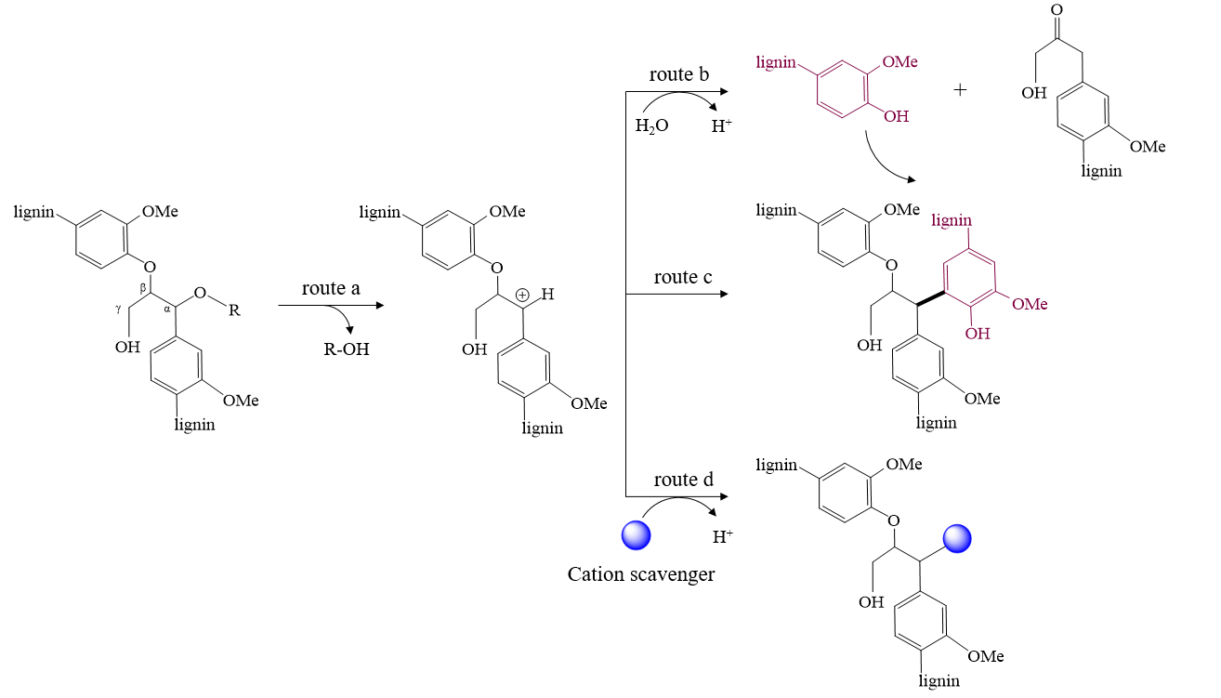
Scheme 3.1. Reaction of lignin in acidic media: (a) acid catalysed depolymerisation and formation of carbocation (b) cleavage of β-O-4’ bond and depolymerisation (c) lignin repolymerisation reaction (d) scavenging of carbocation.⁸³
Lignin is a highly complex, amorphous, and heterogeneous biopolymer composed primarily of phenylpropanoid units derived from p-coumaryl, coniferyl, and sinapyl alcohols.⁹¹ These monolignols give rise to the p-hydroxyphenyl (H), guaiacyl (G), and syringyl (S) units that are interconnected through a variety of ether and carbon–carbon linkages.⁹² Among these, the β-O-4’ bond aryl ether linkage is the most abundant, accounting for approximately 45–60% of all interunit connections in native lignin, followed by β–β, β–5, and 5–5 linkages.⁹³ Due to the intrinsic structural complexity and lack of long-range order in lignin, periodic models are often impractical for detailed quantum chemical investigations. Instead, cluster models representing key structural motifs are widely adopted to capture the local chemical environment relevant to bond cleavage and functional group transformations. In this work, a lignin cluster model was constructed to represent the most chemically significant features of lignin, with particular emphasis on the β-O-4’ linkage, aromatic ring substitution patterns, and aliphatic side chains commonly observed in guaiacyl-type units. (Figure 3.1) In this cluster model we cut the C-C bond connecting lignin molecules and cap with H atoms. Although the cluster model does not reproduce the full polymeric nature of lignin, it retains the essential local bonding environment, electronic structure. Such an approach has been shown to provide reliable mechanistic insight while maintaining computational feasibility and has been widely employed in previous theoretical studies of lignin depolymerisation and valorisation.⁹⁴
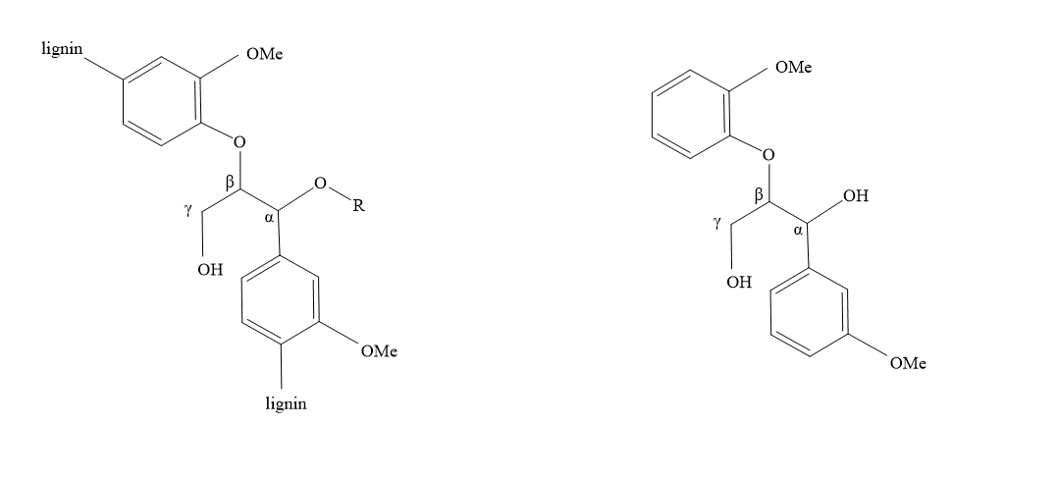
Figure 3.1. Schematic comparison between the general structure of lignin (left) and the cluster model employed in this work (right).

3.2 Computational Details

All density functional theory (DFT) calculations presented in this chapter were conducted using Gaussian 16 software package.⁹⁵ A cluster model of veratrylglycerol-β-guaiacyl ether (VG) was employed to represent lignin, constructed by substituting the adjacent lignin molecules with a H atom and a methyl capping group.⁹⁴ Geometry optimizations were conducted using the M06-2X level⁶³ of theory with the 6-311+G (d,p) basis set. Frequency calculations were conducted at the same functional level at 298K to determine correct transition states. Intrinsic reaction coordinate (IRC) calculations were used to confirm that the identified transition states smoothly connect to the corresponding reactants and products. In order to investigate the solvent effects, the solvation model based on density (SMD) method was applied for all mentioned calculation by employing water as an implicit solvent. All atoms were allowed to relax during the optimization to identify the configurations with minimum energy. Interaction region indicator (IRI) calculations and orbital weighted (OW) Fukui function calculations were conducted at the B3LYP functional level⁹⁶ with the 6-311+G (d,p) basis set, using Multiwfn software and visualized with VMD packages.⁹⁷

3.3 Results

3.3.1 Model construction of VG and cation scavengers

In order to identify the most stable configuration of VG, we optimized four different possible geometries. Figure 3.2 shows the optimized molecular structures, including the dihedral angle ($C$-$C_{α}$-$C_{β}$-$O$) and the corresponding electronic energy ($E_{relative}$). Among the four configurations, VG (a) exhibits the lowest electronic energy, making it the most energetically favourable structure by a margin of 5.9-37.3 kJ/mol. As shown in Figure 3.2, strong H-bonds are present in all optimized structures, either between two hydroxyl groups or between a hydroxyl group and an O atom. Both types of H-bonds can be observed in VG (a) and VG (b), contributing to their enhanced stability compared to the other two structures. The shorter hydrogen bond distance (1.93Å and 1.99 Å) make VG (a) the most stable configuration; therefore VG (a) was selected for subsequent studies.
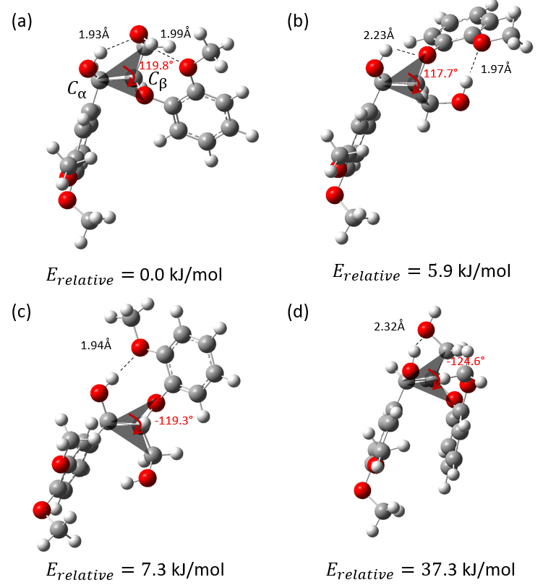
Figure 3.2. Different optimized configurations of VG. (M06-2X 6-311+G (d,p)) Grey, white and red atoms correspond to C, H and O, respectively. The red numbers represent the dihedral angles $C$-$C_{α}$-$C_{β}$-$O$ in degrees (°). The dashed lines represent the distance between pairs of atoms identified as the primary interaction sites in angstroms (Å). The numbers below each configuration represent the relative electronic energy ($E_{relative}$).

The representative cation scavengers investigated in the present study include 3-hydroxy-2-naphthoic acid, 6-hydroxy-1-naphthoic acid and 6-hydroxy-2-naphthoic acid. Various cluster models were considered for each scavenger, based on the orientation and spatial arrangement of their hydroxyl and carboxyl functional groups. For instance, Figure 3.3 shows three optimized structures of 3-hydroxy-2-naphthoic acid, chosen as an exemplary scavenger, and the corresponding calculated $E_{relative}$. Theoretically, the accumulation of positive charge on H(OH) and the negative charge concentrated on O(COOH), facilitates the formation of a hydrogen bond between these two atoms, resulting in a more stable, minimum energy configuration.
Figure 3.4 shows the constructed cluster models of the selected cation scavengers. In order to identify the binding site of each scavenger with the lignin framework, we employed the orbital-weighted (OW) Fukui functions and performed dual descriptor calculations for all candidate molecules. These approaches, established within the framework of DFT, are widely used for predictive reactive sites and assessing local reactivity in molecular systems.⁹⁸ The orbital-weighted Fukui functions $f_{ow}^{+}$ and $f_{ow}^{-}$ represent the electron density contributions from the LUMO and HOMO, respectively. The dual descriptor ${(∆f}_{ow})$, defined as the difference between $f_{ow}^{+}$ and $f_{ow}^{-}$ (i.e., ${{∆f}_{ow}=f}_{ow}^{+}-f_{ow}^{-}$), provides insights into local reactivity. In particular, a site with a more positive $f_{ow}^{-}$ and more negative ${∆f}_{ow}$ is more susceptible to electrophilic attack. Figure 3.5 shows the most positive calculated Fukui function $f_{ow}^{-}$ and the corresponding most negative dual descriptors. The numerical labels correspond to the highest integrated values of the respective orbital-weighted functions within the Hirshfeld space of each specific atom. It is worth noting that the identified carbon active sites exhibit $∆f$ values significantly more negative (35％ to 40％) compared to the second nucleophilic carbon.
Blue isosurfaces represent regions with negative values of ${∆f}_{ow}$, while green isosurfaces indicate positive values. Among all atoms analysed, the C4 carbon active site atom in 3-hydroxy-2-naphthoic acid exhibits a ${∆f}_{ow}$, of -0.142, as shown in Figure 3.5, which is significantly more negative compared to corresponding values for 6-hydroxy-1-naphthoic acid (-0.058) and 6-hydroxy-2-naphthoic acid (-0.052). This indicates a higher nucleophilicity, suggesting that this carbon site in 3-hydroxy-2-naphthoic acid is more reactive toward electrophilic species such as ${lignin}^{+}$, thereby facilitating the formation of the C–C bond between lignin and scavenger.
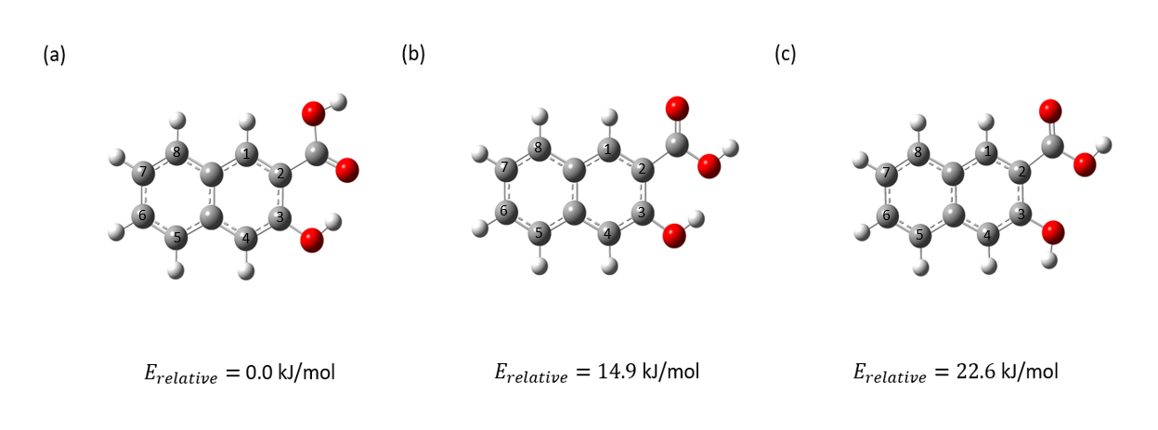
Figure 3.3. Different optimized configurations of the exemplary 3-hydroxy-2-naphthoic acid scavenger. (M06-2X 6-311+G (d,p)) Grey, white and red atoms correspond to C, H and O, respectively. The numbers below each configuration represent the relative electronic energy ($E_{relative}$).

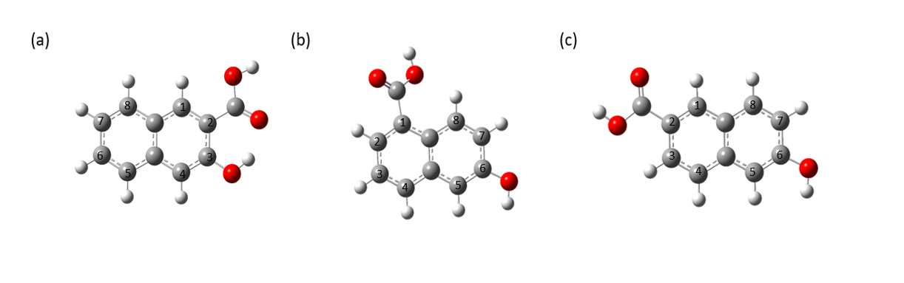
Figure 3.4. Constructed cluster models of selected cation scavengers (a) 3-hydroxy-2-naphthoic acid, (b) 6-hydroxy-1-naphthoic acid, and (c) 6-hydroxy-2-naphthoic acid. (M06-2X 6-311+G (d,p)) Grey, white and red atoms correspond to C, H and O, respectively.
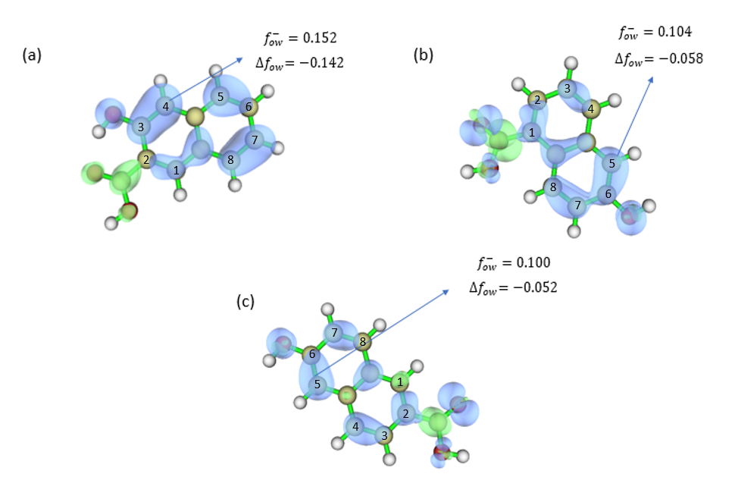
Figure 3.5. Calculated condensed orbital weighted Fukui function ${(f}_{ow}^{-})$ and dual descriptor ${(∆f}_{ow})$ for selected cation scavengers (a) 3-hydroxy-2-naphthoic acid (b) 6-hydroxy-1-naphthoic acid (c) 6-hydroxy-2-naphthoic acid. Light yellow, white and red atoms correspond to C, H and O, respectively. The blue isosurfaces represent the positive ${∆f}_{ow}$, the green isosurfaces represent the negative ${∆f}_{ow}$.

3.3.2 Mechanism of VG dehydration and electrophilic aromatic subsititution

To compare the effectiveness of the different scavengers in suppressing lignin repolymerization, this and the subsequent sections present simulations of the acid-catalyzed lignin dehydration and the electrophilic aromatic substitution for the selected hydroxynaphthoic acids.
Figure 3.6 shows the calculated Gibbs free energy profile for the acid-catalysed dehydration of VG. The first elementary step of the reaction pathway is the coordination of a hydronium ion (${H_{3}O}^{+}$) to the VG molecule via formation of a strong H-bond (1.05 Å) between ${{H(H}_{3}O}^{+})$ and $O(VG)$, which results in the formation of the reaction intermediate Int1. The following dehydration step leads to the formation of a benzylic carbocation intermediate (Int2) via a transition state (TS1-2) with an energy barrier of 74.0 kJ/mol. This step is similar across all selected scavengers and does not significantly affect the relative performance of the different scavenger candidates. Following its formation, the carbocation intermediate (${lignin}^{+}$) binds with the scavenger via the primary nucleophilic carbon atom (identified in the previous section). Subsequently, a water molecule is introduced into the system, leading to the formation of intermediate Int 3. This species undergoes deprotonation facilitated by the adsorbed water molecule via the transition state TS3-4, with an associated energy barrier ranging from 9.4 to 17.7 kJ/mol. This elementary step results in the formation of Int4. The thermal enthalpy profile of the reaction pathway and calculated thermal enthalpy ($ΔH$) described above is illustrated in Figure 3.7 and Table 3.1. According to Figure 3.6, Figure 3.7 and Table 3.1, the binding of the scavenger and water is enthalpically favorable. However, the binding step is dominated by an entropic penalty which results in a positive $∆G$. When comparing the cluster models of Int3, TS3-4 and Int4, the dihedral angle between the aromatic rings of the scavengers and ${lignin}^{+}$ changes significantly from 28° to 90° over the course of the reaction. Despite this structural variation, the Gibbs free energy differences between Int3 and TS3-4 range from 9.4 to 17.7 kJ/mol, indicating a low-energy barrier associated with the formation of a strong C-C bond (Figure 3.7). We therefore concluded that the deprotonation of the lignin-scavenger complex proceeds with a minimal activation barrier and that the performance differences among the scavengers are primarily governed by the binding interaction between the lignin carbocation, scavenger, and water.
The binding energy (BE) of scavengers and water for all possible configurations was calculated using Equation (1), where E indicates the electronic energy.
$$BE= E_{{lignin}^{+}+adsorbate}-E_{{lignin}^{+}}-E_{adsorbate}+E_{BSSE}$$ | (1)
Specifically, $E_{{lignin}^{+}+adsorbate}$ is the total energy of ${lignin}^{+}$ interacting with the adsorbate, $E_{{lignin}^{+}}$ is the energy of the carbocation intermediate, $E_{adsorbate}$ is the energy of the adsorbate (scavengers or water), and $E_{BSSE}$ is the BSSE correction. The binding thermal enthalpy ($∆H$) was calculated by adding the zero-point (${∆E}_{ZPE}$), rotational (${∆E}_{rot}$), translational (${∆E}_{trans}$), vibrational (${∆E}_{vib}$) contributions, and the pressure volume work $∆(PV)$ to the previously calculated electronic BE, as shown in Equation 2:
$$∆H= BE+{∆E}_{ZPE}+{∆E}_{rot}+{∆E}_{trans}+{∆E}_{vib}+∆(PV)$$ | (2)
The Gibbs free energy ($∆G$) was calculated following Equation 3:
$∆G=∆H-T∆S$ (3)
Specifically, $T$ is the temperature and $∆S$ is the entropy change associated to binding step.
All simulations in this study were performed using an implicit solvation model to simulate the presence of water. To rule out potential artefacts from the solvation approach when analysing scavenger-water binding, binding energy calculations for all selected scavengers were additionally carried out in the gas phase. The results indicate stronger binding between the scavengers and ${lignin}^{+}$ for 3-hydroxy-2-naphthoic acid (-41.8 kJ/mol), 6-hydroxy-1-naphthoic acid (-25.0 kJ/mol) and 6-hydroxy-2-naphthoic acid (-16.3 kJ/mol). However, the overall binding trend remains consistent.
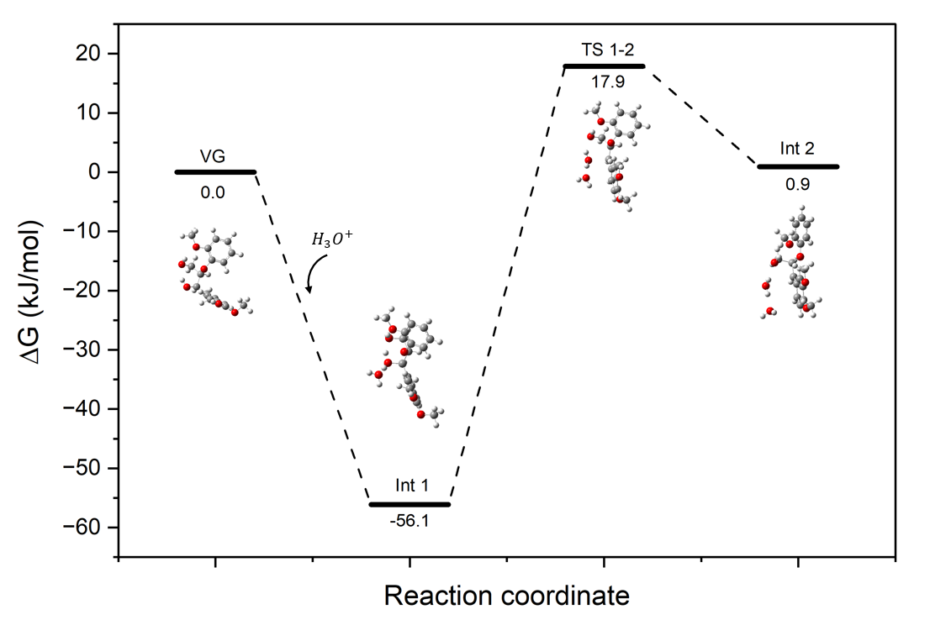
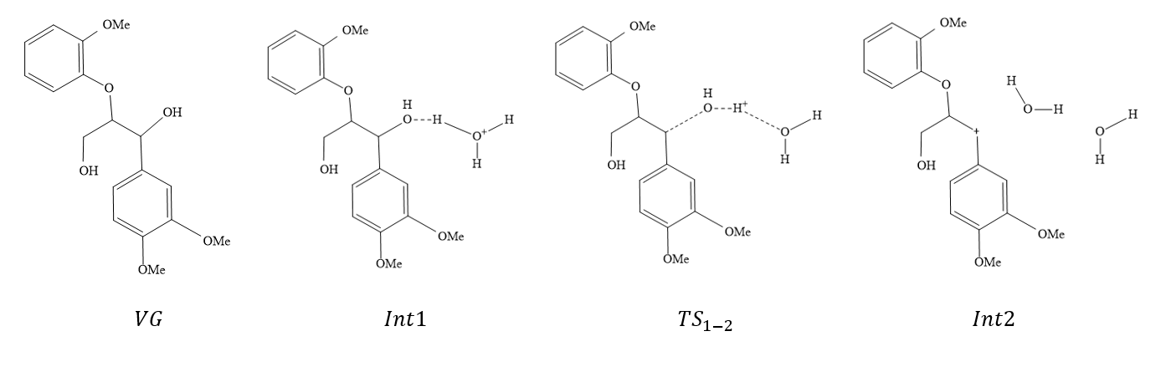
Figure 3.6. Reaction coordinate diagram showing the Gibbs free energy profile with schematic structures for the acid-catalysed dehydration of VG. (M06-2X 6-311+G (d,p))
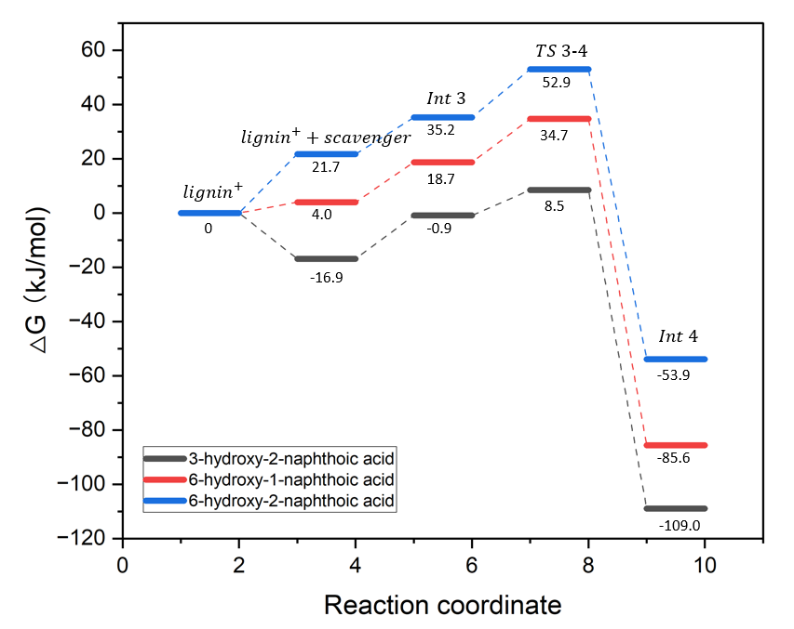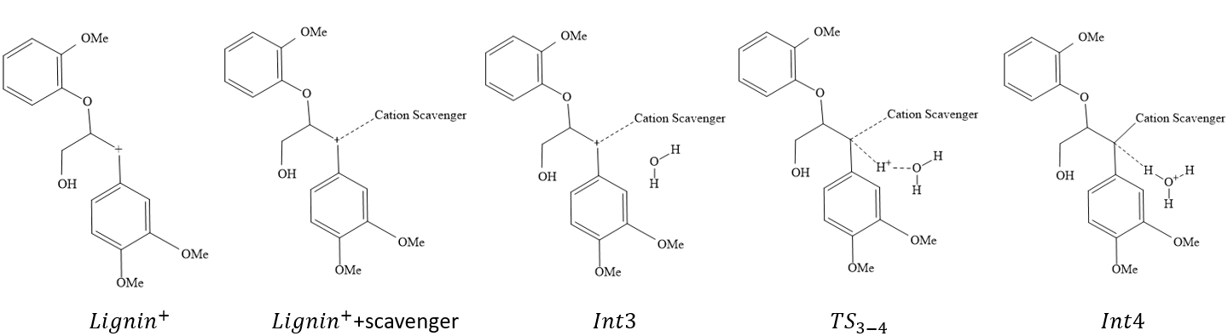
Figure 3.7. Reaction coordinate diagram showing the Gibbs free energy profile for 3-hydroxy-2-naphthoic acid (black), 6-hydroxy-1-naphthoic acid (red), 6-hydroxy-2-naphthoic acid (blue) with schematic structures for the cation scavenging and corresponding deprotonation of the lignin-scavenger complex. (M06-2X 6-311+G (d,p))
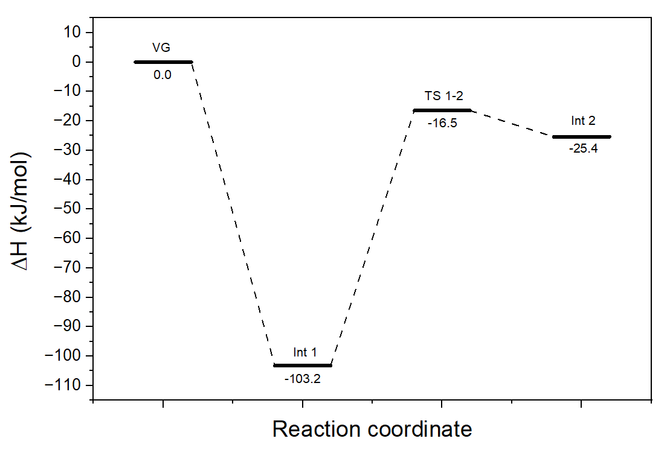
Figure 3.8. Reaction coordinate diagram showing the thermal enthalpy profiles for the acid-catalysed dehydration of VG. (M06-2X 6-311+G (d,p))

Table 3.1. Calculated thermal enthalpy ($ΔH$) for the binding interaction of ${lignin}^{+}$, various scavengers, and water.
Scavengers | Binding thermal enthalpy between ${lignin}^{+}$ and scavengers (kJ/mol) | Binding thermal enthalpy between ${lignin}^{+}$ and water (kJ/mol)
6-hydroxy-2-naphthoic acid | -21.7 | -13.7
6-hydroxy-1-naphthoic acid | -59.3 | -13.4
3-hydroxy-2-naphthoic acid | -89.6 | -13.4

3.3.3 Lignin interactions with different scavengers
To elucidate the lignin-scavenger binding interaction, interaction region indicator (IRI) calculations were applied to the optimized configurations (Figure 3.9). The isosurfaces reveal the repulsive or attractive forces, including van der Waals (vdW) interactions and hydrogen bonds that exist both between different molecules and among functional groups within the same molecule. The vdW interactions including π-π stacking between aromatic rings, weak hydrogen bonding between H($scavenger$) and O($scavenger$) and weak hydrogen bonding between H($scavenger$) and O(${lignin}^{+}$) etc. are indicated by green isosurfaces. The repulsion interactions, such as those occurring in the centre of aromatic rings are represented by red isosurfaces. In addition, relatively strong interactions, primarily hydrogen bonds, are depicted as blue isosurfaces in the IRI map. The scattered map depicted in Figure 3.10 quantifies the intensity of the isosurfaces. The points at the base of each peak in Figure 3.10 correspond to IRI minima, representing the interaction regions between atoms, as illustrated in Figure 3.9. As demonstrated in both Figures 3.9 and 3.10, in addition to the weak interaction between ${lignin}^{+}$ and the scavengers – which are the primary focus of this study – strong bonds and weak intramolecular interaction within the individual molecules are also observed.
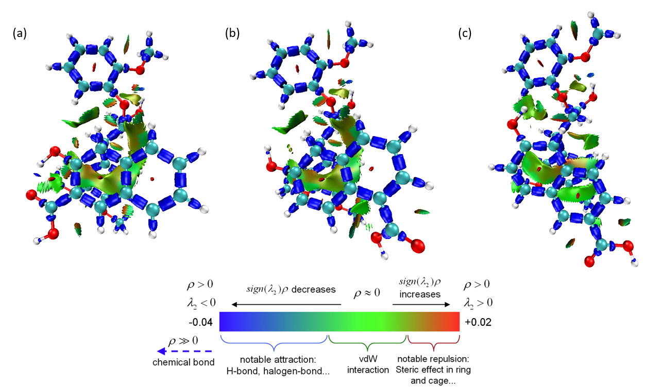
Figure 3.9. IRI calculations for ${lignin}^{+}$ binding (a) 3-hydroxy-2-naphthoic acid, (b) 6-hydroxy-1-naphthoic acid and (c) 6-hydroxy-2-naphthoic acid at IRI = 1.0. (B3LYP 6-311+G (d,p)) Red, turquoise, white atoms correspond to O, C and H, respectively. ρ indicates the electron density, $sign\left(λ_{2}\right)$denotes the sign of the second largest eigenvalue of Hessian of ρ.⁶⁸
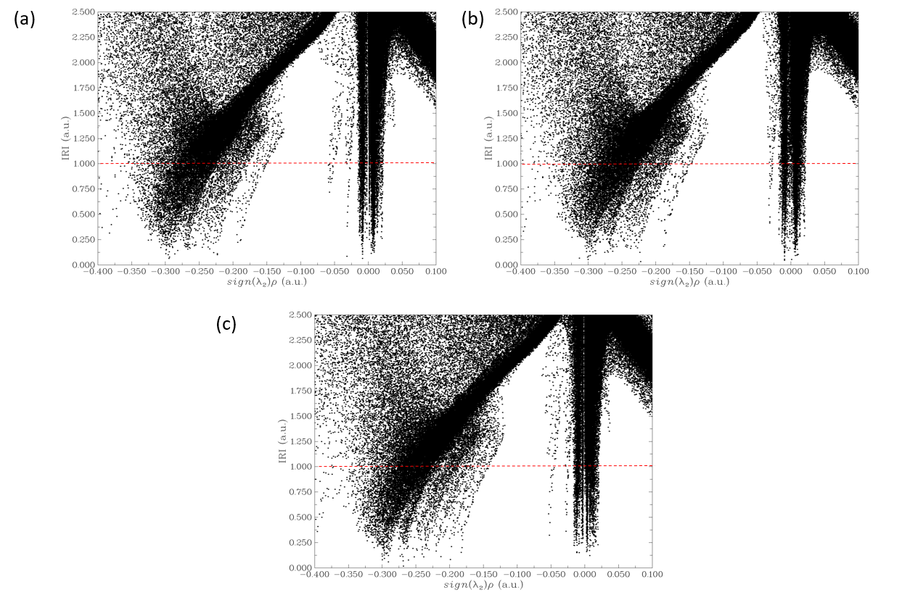
Figure 3.10. Scatter map of IRI vs sign$(λ_{2})ρ$ (-0.4 to 0.1) of designed system with (a) 3-hydroxy-2-naphthoic acid, (b) 6-hydroxy-1-naphthoic acid and (c) 6-hydroxy-2-naphthoic acid. The points intersecting with the red dashed line (IRI = 1.0) correspond to the grid points constituting the isosurfaces shown in Figure 3.9.

Figure 3.11 shows the scatter map resulting from the IRI calculations. ($sign\left(λ_{2}\right)ρ$ from -0.05 to 0.05). ρ indicates the electron density, $sign\left(λ_{2}\right)$denotes the sign of the second largest eigenvalue of Hessian of ρ. Peaks appearing on the negative x-axis, where $sign\left(λ_{2}\right)ρ$ < 0, indicate strong attractive interactions, which correspond to blue isosurfaces in the IRI analysis. In contrast, peaks on the positive x-axis ($sign\left(λ_{2}\right)ρ$ > 0 indicate atomic repulsion and are visualized as red isosurfaces. Figure 3.11 a, 3.11 b, and 3.11 c show the scatter maps corresponding to the complex ${lignin}^{+}$ with 3-hydroxy-2-naphthoic acid, and the individual components, namely ${lignin}^{+}$ and 3-hydroxy-2-naphthoic acid, respectively.
The peak with most negative value of $sign\left(λ_{2}\right)ρ$, highlighted in the blue dashed box, corresponds to the strongest interaction in the system, specifically, the hydrogen bond between H(${lignin}^{+}$) and O(${lignin}^{+}$) within the ${lignin}^{+}$ cation. Conversely, the peak with the most positive value of $sign\left(λ_{2}\right)ρ$, indicated in the red dashed box represents the repulsive steric interaction in the aromatic rings – an effect consistently observed consistently across all designed systems. In Figure 3.11, many overlapping peaks with identical values can be observed in both the individual components (${lignin}^{+}$ or scavengers) and the complex. These peaks correspond primarily to vdW interaction and atomic repulsion. By isolating these overlapping regions, we determined that the weak interactions are predominantly distributed within the range of -0.02 to 0.02. The peaks in the scatter map that describe the binding interaction between the scavenger and the lignin carbocation contribute are highlighted with the green and red background.
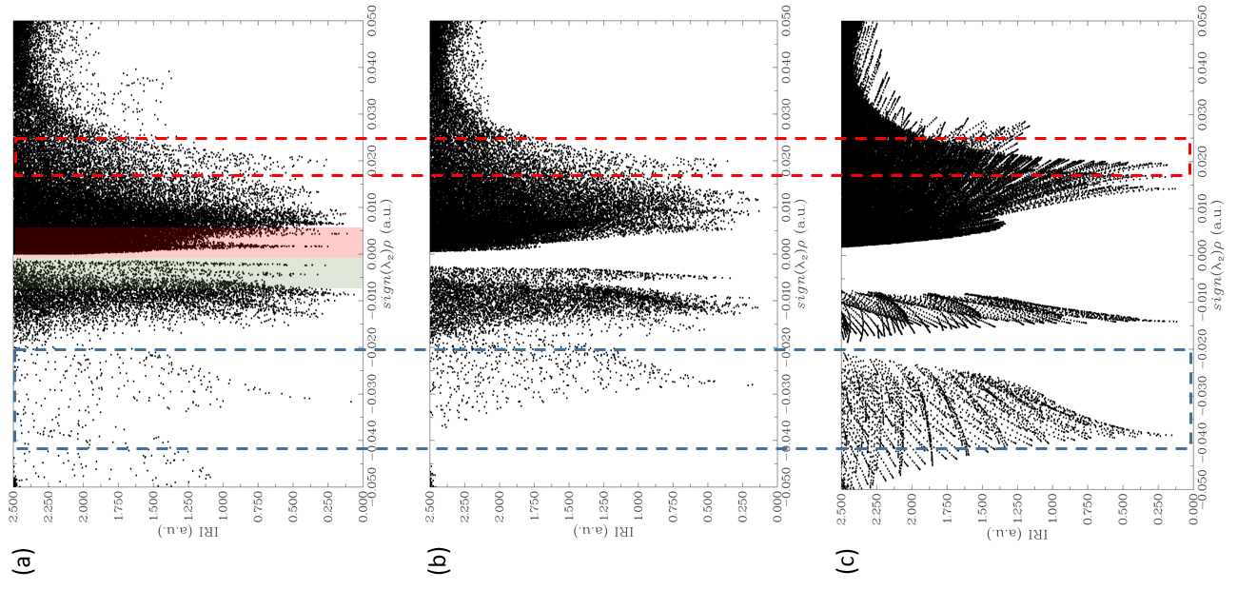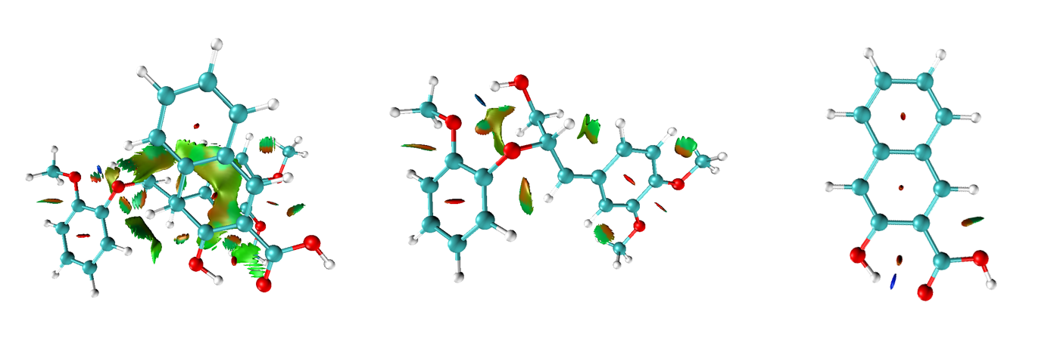
Figure 3.11. Scatter map of IRI vs sign$(λ_{2})ρ$ (-0.05 to 0.05) of (a)${lignin}^{+}$ + 3-hydroxy-2-naphthoic acid (b) ${lignin}^{+}$ (c) 3-hydroxy-2-naphthoic acid (left) and corresponded IRI figure (right). (B3LYP 6-311+G (d,p)) The blue dash box indicate peaks correspond to hydrogen bond and the red dash box indicate peaks correspond to the repulsion between atoms.

Figure 3.12 shows the scatter maps describing the interaction of the lignin carbocations with different scavengers. The binding interactions between 3-hydroxy-2-naphthoic acid and ${lignin}^{+}$ are described by a highly intense peak concentrated in a restricted interval around sign$(λ_{2})ρ$ = -0.01. On the other hand, the attractive interactions between lignin, 6-hydroxy-1-naphthoic acid and 6-hydroxy-2-naphthoic acid are described by multiple and relatively dispersed peaks. This analysis explains the stronger binding between 3-hydroxy-2-naphthoic acid and ${lignin}^{+}$ compared to the other investigated isomers, presented in Figure 3.7.
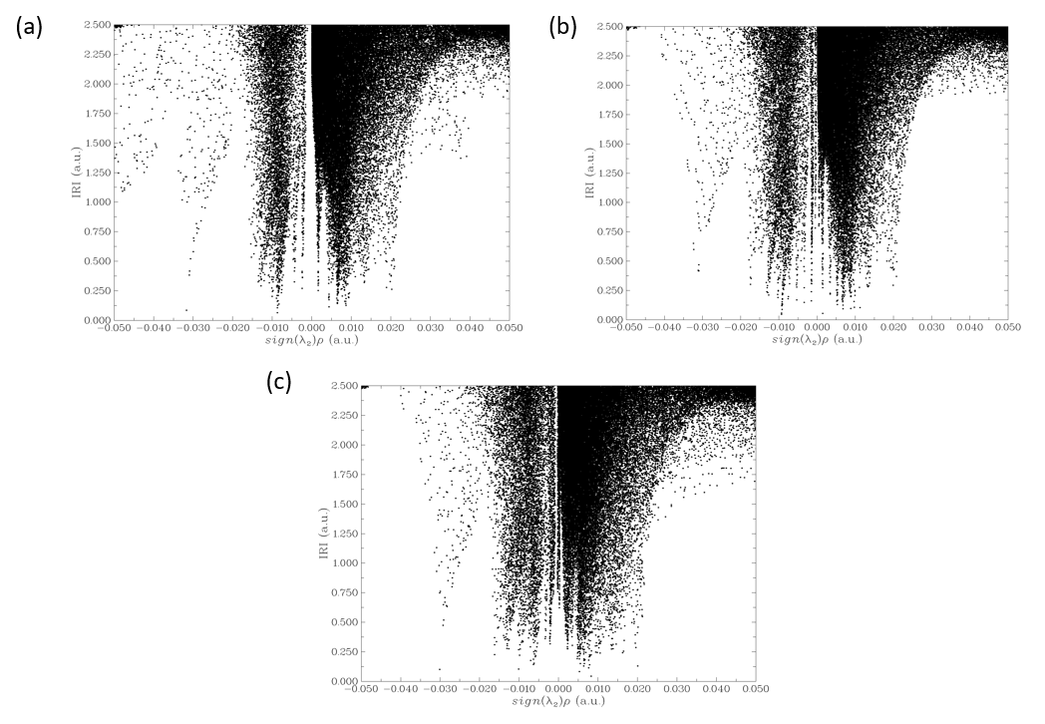
Figure 3.12. Scatter map of IRI vs sign$(λ_{2})ρ$ (-0.05 to 0.05) with (a) 3-hydroxy-2-naphthoic acid (b) 6-hydroxy-1-naphthoic acid (c) 6-hydroxy-2-naphthoic acid.

Yequan etc. investigated the lignin repolymerization efficiency using 2-hydroxy-1-naphthoic acid, 3-hydroxy-2-naphthoic acid, 6-hydroxy-1-naphthoic acid and 6-hydroxy-2-naphthoic acid as cation scavenger comparing with traditional 2-naphthol. ⁹⁰ 3-hydroxy-2-naphthoic acid shows a significantly improved performance with a 53.2％ efficiency. These experimental results align well with our simulation findings, providing strong validation for our study. Building on this foundation, future work will focus on extending the approach to a broader range of scavengers, further enhancing the predictive power and practical applicability of our methodology.

3.4. Conclusion

This computational work provides a comprehensive analysis of three naphthoic acid isomers to assess their potential use as scavengers for lignin repolymerisation suppression. We characterised and simulated the cation scavenging process with the goal of identifying the most characteristic descriptors to design promising scavenger candidates for lignin repolymerisation suppression. According to the OW Fukui function calculation, all selected candidates offer a dominant nucleophilic site. Among all scavengers, 3-hydroxy-2-naphthoic acid has the most nucleophilic active site exhibiting a dual descriptor ${∆f}_{ow}=-0.142$. Our results show that the binding of scavenger and water are enthalpically unfavourable. In case of positive binding Gibbs free energies, the entropy change dominate the whole process. The deprotonation following the binding step exhibits a minimal energy barrier. As a result, the binding energy difference is likely to determine the performance of the scavenger. As demonstrated by the Fukui function analysis, 3-hydroxy-2-naphthoic acid exhibits the strongest binding energy with ${lignin}^{+}$ of -16.8 kJ/mol. The calculated binding energy is determined by the strength of the hydrogen bond, vdW forces and repulsion forces existing between ${lignin}^{+}$ and the different scavengers. IRI calculation results show that the C-C bond generated between the electrophilic carbon of ${lignin}^{+}$ and the carbon active site of the scavenger have similar strength. The differences in binding energy are primarily driven by the balance between van der Waals interactions and repulsive forces. As a result, 3-hydroxy-2-naphthoic acid exhibits stronger binding with ${lignin}^{+}$ and is therefore an effective scavenger for the investigated process. The findings from this work provide valuable insights for the design of promising cation scavengers aimed at inhibiting lignin repolymerization.

4 Computational Screening of Amino-Functionalized Molecules for Direct Air Capture of CO₂

Direct air capture (DAC) of CO₂ is a promising strategy for mitigating global carbon emissions by removing CO₂ from the atmosphere. A critical factor in enhancing the efficiency of DAC is the design of functionalized materials with strong CO₂ binding capabilities. This study screens a variety of amino-functionalized molecules, utilizing MP2 and density functional theory calculations to identify promising candidates for CO₂ capture under dry and humid conditions. The analysis determined the most stable configurations of CO₂ and water with 15 amino-functionalized molecules. Amino acids such as Arginine, 7-Azaindole, 1, 5, 7-triazabicyclo-[4.4.0] dec-5-ene, and Melamine demonstrated the strongest CO₂ binding energies, ranging from −17 to −19 kJ/mol. This is the result of both Lewis acid-base interactions between the electron deficient carbon of CO₂ and a N atom, and hydrogen bonding. Generally, all the amino-groups exhibited a stronger binding affinity with water, attributed to the formation of stable hydrogen bonds between an electron-rich N atom and the hydrogen atoms of water. To guide the design of porous host structures incorporating these molecules as functional groups, the study was extended to hypothetical systems where multiple functional groups can essentially “sandwich” CO₂ promoting simultaneous binding. In these scenarios, the repulsion between functional molecules emerged as a critical factor increasing the overall CO₂ binding energy to ca. −30-40 kJ/mol. This analysis enabled the identification of optimal pore sizes for designing functionalized frameworks to maximize CO₂ capture efficiency.

4.1 Introduction

4.1.1 Direct Air Capture: Scientific and Materials Challenges

Global warming, driven by the rise in the level of atmospheric carbon dioxide (CO₂) has emerged as a global critical concern. In 2022, CO₂ emissions related to the energy sector has reached a new record high of over 36.8 Gigatonnes (Gt), marking a significant increase compared to previous years.⁹⁹ To meet the Intergovernmental Panel on Climate Change (IPCC) target of limiting the temperature rise to 2°C, established during the 2015 COP21 conference in Paris, CO₂ capture rates must improve significantly, reaching 10 Gt per year by 2050 and 25 Gt per year by the end of the century.¹⁰⁰ In this context, CO₂ capture, utilization, and storage have become one of the most critical and pressing challenges in today's society.¹⁰¹ Direct air capture (DAC) technologies offer a promising solution for capturing CO₂ directly from the atmosphere. These systems operate by using either liquid solvents or solid sorbents to bind with CO₂ molecules, effectively separating them from ambient air.¹⁰² Compared to point-source CO₂ capture, DAC benefits from processing cleaner ambient air, free from the impurities present in flue gas. This simplifies the capture process, potentially lowering associated costs, and provides greater flexibility in deployment locations. However, unlike post-combustion capture, where CO₂ concentrations typically exceed 10 vol%, DAC must operate at atmospheric CO₂ levels of approximately 420 ppm, placing stringent demands on sorbent performance.¹⁰³ In addition to low CO₂ partial pressure, DAC sorbents must function under ambient conditions where oxygen, nitrogen, and especially water vapour are present in large excess. These operating constraints imply that effective DAC materials must simultaneously exhibit (i) high CO₂ affinity at very low partial pressures, (ii) strong selectivity over N₂, O₂, and H₂O, (iii) fast adsorption and desorption kinetics, and (iv) low regeneration energy to ensure process viability.¹⁰⁴ Many DAC absorbents, including liquid amines and aqueous hydroxides, achieve high CO₂ capture performances through chemisorption but require high temperatures (>120 °C) for regeneration.^{105, 106} Solid adsorbent materials offer CO₂ uptakes ranging from 0.1 to over 3 mmol/g and normally require milder regeneration conditions (ca. 100 °C).¹⁰⁷ However, these materials may suffer from competitive adsorption of water in humid conditions.

4.1.2 Advantage of MOFs for CO₂ Capture at Ultra-Low Partial Pressure
Currently, a wide range of sorbent families including polymers, carbons, zeolites, silicas, metal oxides and metal-organic frameworks (MOFs) are heavily researched, in their unfunctionalized and functionalized forms, as viable solutions for DAC. Readers are encouraged to refer to important review papers for more details on DAC materials and technologies.^{102, 107-110} Clearly, investing in new materials and DAC technologies is important as we urgently seek to mitigate climate change and transit to a low-carbon economy. In this context, MOFs have emerged as a promising class of adsorbents for DAC applications.¹¹¹⁻¹¹³ MOFs are crystalline materials composed of inorganic nodes – either single metal atoms or metal clusters – connected by organic linkers, to form open networks with potential void spaces¹¹⁴. Compared to traditional porous materials, MOFs offer tunability in characteristics such as surface area, pore size/shape, and surface chemistry. Additionally, they can be tailored to exhibit selective sorption properties through ligand and post-synthesis functionalization.¹¹⁵⁻¹¹⁷ Early studies demonstrated that many MOFs exhibit high CO₂ uptake at moderate pressures due to their large surface areas and quadrupole–dipole interactions between CO₂ and the framework.³³ However, subsequent work revealed that high surface area alone is insufficient for DAC, as adsorption under ultra-dilute conditions is dominated by the strength and specificity of local binding sites rather than total pore volume.¹⁰⁴ This insight has shifted the focus of MOF research for DAC toward frameworks that provide strong, directional CO₂ binding sites.

4.1.3 Functionalized MOFs for CO₂ Adsorption
Unmodified MOFs generally exhibit low affinity and capacity for separating CO₂ from air. To address this, various functionalized MOFs have been developed for selective CO₂ capture, with N containing molecules among the most commonly used groups.¹¹⁸⁻¹²¹ Functionalization with amino molecules is an effective strategy to increase the affinity of MOFs towards CO₂, benefiting both adsorption strength and separation selectivity.¹²²⁻¹²⁷ For example, Chen et al.¹²⁸ functionalized MOF-808 using a group of amino acid anion (AA) and polyamine-substituted anion (PA). Their experimental results demonstrated that the functionalized MOFs showed enhanced performance in DAC of CO₂, particularly under humid conditions. Two MOFs, namely MOF-808-Lysine (Lys) and MOF-808-tris(3-aminopropyl)amine (TAPA) exhibited the highest CO₂ uptakes at 400 ppm in dry conditions, reaching 0.6 and 0.5 mmol/g, respectively. These CO₂ uptake values were increased to 1.2 and 0.9 mmol/g, when 50% relative humidity was introduced. Saptasree et al.¹²⁹ tested N,N’-dimenthylethylenediamine (mmen) appended Mg₂(dobpdc) (dobpdc = 4,4'-dioxido-3,3'-biphenyldicarboxylate) MOF for DAC, and obtained CO₂ uptake of 1.7 mmol/g under 50% relative humidity. Many metal nodes in MOF adsorbents are susceptible to hydrolysis by water, which can cleave metal–ligand bonds and chemically degrade the framework. Water inside MOF pores can both hinder the desired adsorption—through competitive binding, pore blocking, or hydrolysis—and, in some MOFs, enhance CO₂ uptake.^{130, 131} In this context, several reports show that CO₂ uptake increases under humid conditions for some MOFs, particularly amine-functionalized frameworks. In these cases, water creates new adsorption sites or alters pore polarity to favor CO₂ binding.^{128, 132-134} Subsequent studies demonstrated that subtle changes in amine structure, metal identity, and framework geometry can dramatically alter adsorption thermodynamics and kinetics.¹³⁵ These findings highlight the importance of local electronic structure and binding motifs, rather than global framework properties, in determining DAC performance. While chemisorptive MOFs offer exceptional low-pressure uptake, challenges remain regarding oxidative stability, moisture tolerance, and long-term cycling performance.¹⁰²

4.1.4 Moisture Stability and the Role of Robust Frameworks
Water stability is a critical requirement for DAC, as atmospheric air typically contains 30–70% relative humidity. Many early MOFs suffer from hydrolysis of metal–ligand bonds under humid conditions, leading to structural degradation. In this context, frameworks based on high-valent metal clusters, particularly Zr₆O₄(OH)₄ nodes, have emerged as exceptionally robust materials (Cavka et al., 2008).¹⁹ UiO-type MOFs, such as UiO-66, exhibit outstanding thermal and hydrothermal stability due to strong Zr–O bonds and high framework connectivity. These properties make them attractive platforms for DAC, either as physisorptive sorbents or as scaffolds for further functionalisation.²⁴ However, pristine UiO-66 typically shows limited CO₂ uptake at atmospheric pressure, motivating extensive efforts to introduce functional groups or open metal sites to enhance CO₂ affinity while preserving moisture resistance.

4.1.5 Balancing CO₂ Affinity and Regeneration Energy
A recurring theme in the DAC literature is the trade-off between CO₂ binding strength and regeneration energy. Strong chemisorption improves low-pressure capture but increases the energetic cost of CO₂ release, whereas weak physisorption enables easy regeneration but suffers from poor DAC performance.¹⁰⁴ MOFs provide a unique opportunity to fine-tune this balance by controlling linker functionality, metal identity, and framework flexibility. Computational and experimental studies have shown that intermediate binding energies—stronger than van der Waals interactions but weaker than irreversible chemical bonds—are optimal for DAC.^{33, 104} Understanding how specific functional groups and coordination environments influence these interactions at the molecular level is therefore essential for rational sorbent design.

4.1.6 Role of Computational Modelling in MOF-Based DAC
Molecular simulation and electronic structure calculations have become indispensable tools for elucidating CO₂ adsorption mechanisms in MOFs. Computational studies allow direct examination of local binding geometries, charge redistribution, and energetics that are difficult to access experimentally, particularly under DAC-relevant conditions.¹³⁶ DFT calculations have been widely used to characterise CO₂–framework interactions, identify preferential adsorption sites, and rationalise the effects of functionalisation and metal substitution. Such studies provide mechanistic insight into how local chemical environments govern macroscopic adsorption behaviour, thereby complementing experimental screening efforts.^{104, 136}Computational studies have been carried out to investigate the interactions between CO₂ and amino-functionalized molecules.^{137, 138} For instance, Vogiatzis et al.¹³⁹ reported a comprehensive computational analysis of CO₂ interactions with N-containing organic heterocycles. They compared different DFT levels of theory, finding that Lewis acid-Lewis base interactions between the carbon of CO₂ and the N of the heterocycle, and hydrogen bonds play a significant role in the stabilized geometry of the molecules. Cai et al.⁵⁰ calculated CO₂ binding energy of −9.7 kJ/mol with the -NH₂ group of IRMOF-3. Zhu et al.¹⁴⁰ developed a diamine-appended MOF called pip2–Mg₂(dobpdc) (pip2 = 1-(2-aminoethyl)piperidine), and used DFT to calculate the CO₂ binding energy of −48.6 kJ/mol when the structure was loaded with 1.5 CO₂ molecules per diamine. The predicted binding energy was within 5 kJ/mol compared to the corresponding experimental heat of adsorption value of −53 kJ/mol.
Given the growing importance of designing functionalized MOFs for CO₂ capture, it is imperative to develop a systematic computational approach to analyze the interactions between CO₂ and the amino-functionalized molecules which have shown a lot of promise for efficient carbon capture technologies. In this work, we computationally screened 15 amino-functionalized groups, which could potentially be incorporated into MOFs, and studied their binding energies with CO₂ and water to evaluate their potential for DAC application in dry and humid conditions. More importantly, we developed hypothetical pore models to account for pore confinement effects, where CO₂ molecules interact with multiple functional groups in the MOF. Our findings reveal several functionalized molecules with strong CO₂-interaction energies, which could be employed in the design of novel porous materials for DAC.

4.2 Computational details

All density functional theory (DFT) calculations were conducted using the Gaussian 16 software package.⁹⁵ Cluster models were employed to simulate and analyze the interactions of CO₂ and water with various amino-functionalized molecules. The cluster models were constructed from appropriate functionalized materials, including MOFs, by replacing the metal nodes with hydroxyl capping groups.¹⁴¹ As an example, Figure 4.1 shows the construction of Glycine from MOF-808-Gly. Geometry optimizations to describe the interaction of CO₂ and water with a single functional molecule were conducted using the MP2 level of theory with the 6-311+G (d,p) basis set⁶⁴. MP2 explicitly includes electron correlation effects and therefore provides a more physically grounded description of dispersion-dominated non-covalent interactions. For this reason, MP2 has been widely employed as a benchmark or refinement method for calculating binding energies in weakly bound molecular complexes, π–π stacking systems, and van der Waals interactions.¹⁴² Comprehensive assessments of non-covalent interactions have shown that MP2 generally offers improved accuracy over standard DFT methods for such interactions, particularly when basis set superposition error is properly corrected.¹⁴³ All atoms were allowed to relax during the optimization to identify the configurations with minimum energy. Electronic density calculations were performed using the same level of theory and basis set. Interaction region indicator (IRI) calculations were conducted at the B3LYP functional level, using the same basis set, using Multiwfn software and visualized with VMD⁹⁷.
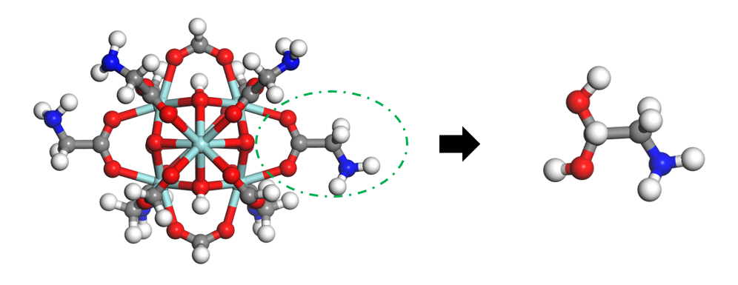
Figure 4.1. Construction of an exemplary functional molecule cluster model (Gly) from MOF-808-Gly. Grey, white, red, turquoise and blue atoms correspond to C, H, O, Zr and N.

CO₂ and water interactions with multiple functional groups were investigated to guide the design of porous frameworks for CO₂ capture. To avoid unrealistic lateral interactions between the functionalized molecules, the hydroxyl capping groups were frozen during the optimization process, while all other atoms were allowed to fully relax. M06-L exchange-correlation functional with 6-311+G (d,p) basis set was used for all calculations involving multiple functional groups. Basis set superposition error (BSSE) correction was applied to all the aforementioned calculations to remove the overlap of basis set between different molecules. The BSSE calculation made energy differences from 6.0 to 10.8 kJ/mol. Frequency calculations were performed at the same level of theory as the geometry optimizations to estimate the adsorption enthalpies.

4.3 Result and Discussions

4.3.1 CO₂ and water interactions with amino-functionalized molecules

The adsorption behavior of CO₂ and water in a microporous material is governed by both the chemical characteristics of the material and by its textural properties, such as pore size and surface area. We first began our study by calculating the binding energies of CO₂ and water with 15 different amino-functionalized molecules. To account for the presence of different adsorption sites, we evaluated several initial configurations of the adsorbate for each functionalized molecule. These initial configurations were selected based on possible hydrogen bonding and electrostatic interactions with the functional molecules. Figure 4.2 illustrates three possible binding configurations of CO₂ and tris(2-aminoethyl)amine (TAEA), as an exemplary functionalized molecule, with the estimated binding energies and characteristic interatomic distances for each configuration.
The binding energy (BE) of CO₂ and water for all possible configurations was calculated using Equation (1), where E indicates the electronic energy.
$$BE= E_{FM+adsorbate}-E_{FM}-E_{adsorbate}+E_{BSSE}$$ | (1)
Specifically, $E_{FM+adsorbate}$ is the total energy of the functionalized molecule interacting with the adsorbate, $E_{FM}$ is the energy of the functionalized molecule, $E_{adsorbate}$ is the energy of the adsorbate (CO₂ or water), and $E_{BSSE}$ is the BSSE correction. Configurations with the most negative binding energy indicate the strongest interactions between the functionalized molecules and the adsorbate. The configurations in Figure 4.2 describe the interactions of CO₂ with the primary (a), secondary (b), and tertiary (c) amino functional groups of TAEA. A significant contribution to the binding energy arises from the Lewis acid–base electrostatic interaction between the N of the amino group and the O of CO₂. This is evidenced by the N-O(CO₂) interatomic distances which are observed to range between 2.9 and 3.1 Å. Although the tertiary amino functional group is the strongest Lewis base of the molecule, the interaction of CO₂ with the secondary (b) and primary (a) amino groups result in higher CO₂ binding energies. This is due to the additional interaction between an electron rich O atom of CO₂ and a H atom of the functionalized molecule. Specifically, the configuration in Figure 4.2b exhibits a H-O(CO₂) distance of 2.7 Å, resulting in a binding energy of −13.9 kJ/mol.
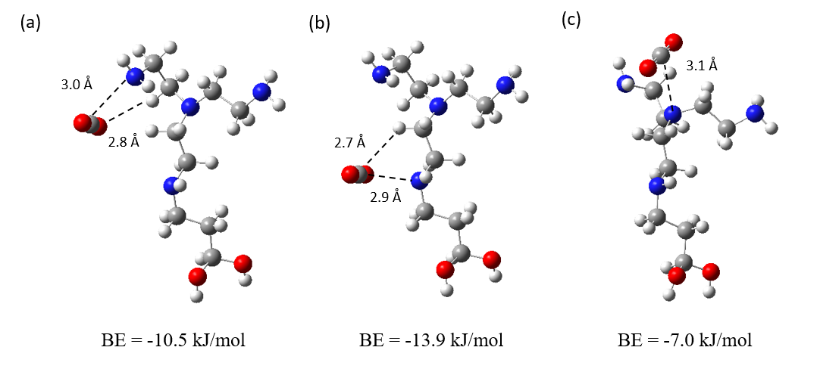Figure 4.2. Different optimized configurations of CO₂ interacting with a primary (a), secondary (b), and tertiary (c) amino functional group of an exemplary functionalized molecule (TAEA). (MP2 6-311+G (d,p)) Gray, white, red and blue atoms correspond to C, H, O and N, respectively. The dashed lines represent the distances in angstroms (Å) between pairs of atoms identified as the primary interaction sites. The numbers below each configuration represent the CO₂ binding energy (BE).

Figure 4.3 presents the most stable MP2-calculated binding energies and configurations of CO₂ for the 15 N-containing groups considered in this study. Amino acids such as Arginine (Arg), 7-Azaindole, 1,5,7-triazabicyclo-[4.4.0]dec-5-ene (TBD), and Melamine exhibit pronounced amphoteric properties, resulting in both (i) Lewis acid-base interactions between the electron deficient carbon of CO₂ and a N atom, and (ii) hydrogen bonding interactions. It can be observed that the groups which form two O(CO₂)-H bonds (Melamine, TBD etc.) show stronger binding with CO₂ compared to those that primarily rely on vdW interactions (Gly, Lys etc.) or those that generate single O(CO₂)-H bonds (TAEA, TAPA etc.). These dual interactions result in the strongest CO₂ binding for Arg (−17.0 kJ/mol), 7-Azaindole, (−18.4 kJ/mol), TBD, (−17.5 kJ/mol), and melamine, (−19.0 kJ/mol) among all the functional groups studied. DFT calculations based on M06-L functional result in CO₂ binding energies ranging from −13 to −23 kJ/mol for the amino functional groups studied (Table 4.1).
Given the importance of competitive adsorption of CO₂ and water in the design of adsorbent materials, we also computed the binding energies between water and the 15 functional molecules. Figure 4.4 presents the most stable configurations of a water molecule interacting with the functional molecules. The primary interaction between the functionalized molecules and water involves the formation of a hydrogen bond between an electron-rich N and the H(H₂O) atom. A secondary interaction involves the vdW forces between the O atom and the NH or NH₂ groups. The observed hydrogen bonding distances range from 1.9 to 2.9 Å while the angles of O-H-C(N) and N-H-O angles span from 88° to 173°. These values are generally consistent with the established criteria for hydrogen bonding.¹⁴⁴ The estimated electronic binding energies of CO₂ and water with the investigated groups, along with their corresponding differences are presented in Table 4.2. The negative value of $BE_{(H_{2}O)}$$-BE_{({CO}_{2})}$in Table 4.2 shows stronger binding affinity with water compared to CO₂ for all the functionalized molecules. Among all the molecules studied, Arg exhibits the least negative value for $BE_{(H_{2}O)}{-BE}_{({CO}_{2})}$(-5.6 kJ/mol), indicating its potential for CO₂ capture under humid condition. To mimic wet conditions and to provide some insight on the competitive binding of CO₂ in the presence of H₂O, we considered a scenario where we added a CO₂ molecule to an optimized cluster of a pre-adsorbed water binding with an amino-functionalized molecule. Figure 4.5 shows the most stable configurations of CO₂ binding with selected functional molecules; Melamine, Arg, TBD, 7-Azaindole, in the presence of water. The results indicate that, in the presence of water, the binding of CO₂ with the amino-functionalized groups is weakened due to the competitive adsorption. Under wet conditions, the CO₂ binding energy for melamine, Arg, TBD and 7-Azaindole is −15.0, −10.6, −14.4 and −12.2 kJ/mol, respectively, which are weaker than the corresponding binding energies in the absence of water (−19.0, −17.0, −17.5 and −18.4 kJ/mol). In dry conditions, CO₂ primarily interacts with the amino groups, however when water is present, H₂O has higher preferential interactions with the amino moieties compared to CO₂ which binds simultaneously with water and the amino group. We note that in practice, CO₂ capture in wet conditions will involve clustering of multiple water molecules around the primary adsorption sites (e.g. N-containing groups), together with confinement effects within the micropores, which are not fully captured by our quantum-chemical cluster approach.
Table 4.1. Binding energies in kJ/mol calculated for CO₂ (${BE}_{({CO}_{2})}$) and water (${BE}_{(H_{2}O)}$) with different amino-functionalized molecules with M06-L level.
Functional groups | $${-BE}_{({CO}_{2})}$$ | $${-BE}_{(H_{2}O)}$$ | $${BE}_{(H_{2}O)}{-BE}_{({CO}_{2})}$$
Melamine | 18.6 | 41.3 | -22.7
7-Azaindole | 21.2 | 46.3 | -25.1
TBD | 22.7 | 46.4 | -23.7
Arg | 22.3 | 49.9 | -27.6
ο-Phenylenediamine | 16.8 | 32.2 | -15.4
TAEA | 16.5 | 48.1 | -31.6
TAPA | 18.0 | 35.0 | -17
DAP | 19.0 | 37.2 | -18.2
1-(2-Aminoethyl)piperidine | 20.1 | 33.7 | -13.6
Pro | 17.3 | 31.6 | -14.3
Pyridine | 15.7 | 27.1 | -11.4
Lys | 15.5 | 31.5 | -16.0
Aniline | 13.7 | 22.0 | -8.3
His | 16.1 | 31.5 | -15.4
Gly | 13.4 | 29.3 | -15.9

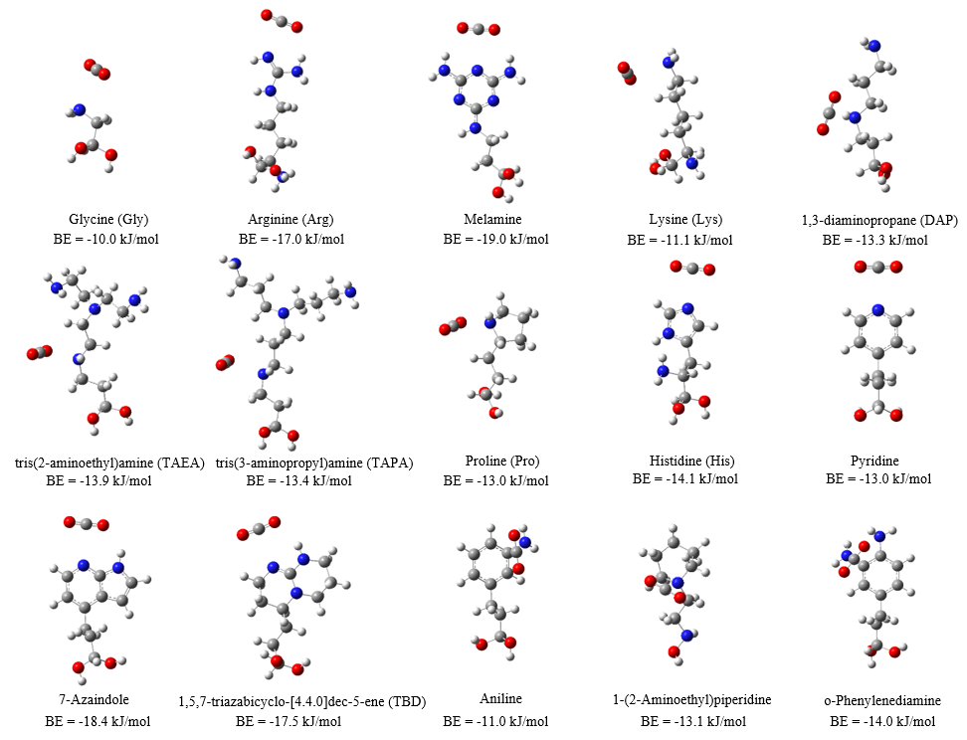
Figure 4.3. Most stable configurations of a CO₂ molecule binding with amino functionalized molecules. (MP2 6-311+G (d,p)) The numbers below each configuration represent the CO₂ binding energy (BE). Grey, white, red and blue atoms correspond to C, H, O and N, respectively.
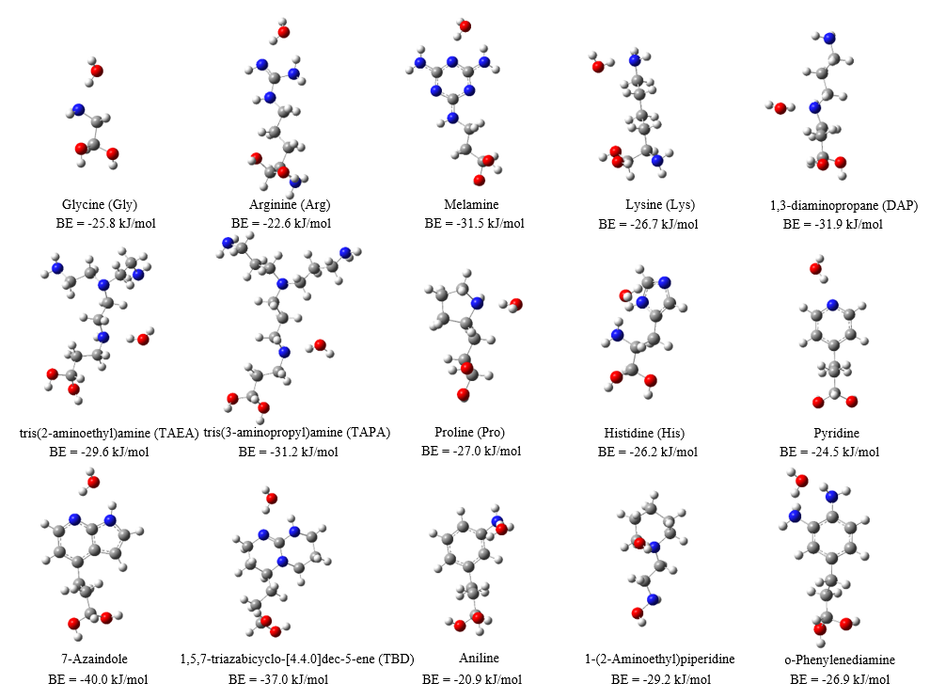
Figure 4.4. Most stable configurations of a water molecule binding with amino functionalized molecules. (MP2 6-311+G (d,p)) The numbers below each configuration represent the H₂O binding energy (BE). Grey, white, red and blue atoms correspond to C, H, O and N, respectively.

Table 4.2. Binding energies in kJ/mol calculated for CO₂ (${BE}_{({CO}_{2})}$) and water (${BE}_{(H_{2}O)}$) with different amino-functionalized molecules with MP2. The last column represents the difference between the calculated binding energies of water and CO₂. Negative values mean stronger binding interaction with water.

Functionalized molecules | $${-BE}_{({CO}_{2})}$$ | $${-BE}_{(H_{2}O)}$$ | $$BE_{(H_{2}O)}{-BE}_{({CO}_{2})}$$
Melamine | 19.0 | 31.5 | −12.5
7-Azaindole | 18.4 | 40.0 | −21.6
TBD | 17.5 | 37.0 | −19.5
Arg | 17.0 | 22.6 | −5.6
His | 14.1 | 26.2 | −15.6
ο-Phenylenediamine | 14.0 | 26.9 | −12.9
TAEA | 13.9 | 29.6 | −15.7
TAPA | 13.4 | 31.2 | −17.8
DAP | 13.3 | 31.9 | −18.6
1-(2-Aminoethyl)piperidine | 13.1 | 29.2 | −16.1
Pro | 13.0 | 27.0 | −14.0
Pyridine | 13.0 | 24.5 | −11.5
Lys | 11.1 | 26.7 | −15.6
Aniline | 11.0 | 20.9 | −9.9
Gly | 10.0 | 25.8 | −15.8

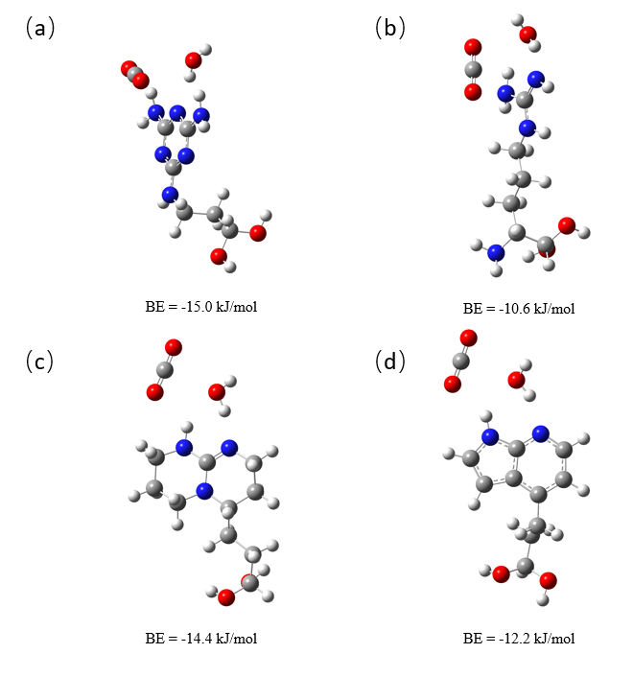
Figure 4.5. Most stable configuration of a CO₂ molecule binding with water molecules and (a) Melamine, (b) Arg, (c) TBD, (d) 7-Azaindole. (MP2 6-311+G (d,p)) Grey, white, red and blue atoms correspond to C, H, O and N, respectively. The number below each configuration represent the calculated CO₂ binding energy in the presence of water.

To study and visualize the nature of the interactions between the adsorbates and the functionalized molecules, interaction region indicator (IRI) calculations were additionally performed. The IRI is a real-space, wavefunction-based descriptor that enables simultaneous visualisation of both strong covalent bonds and weak non-covalent interactions, including hydrogen bonding, van der Waals interactions, and steric repulsion. The IRI is constructed from the electron density and its gradient, allowing interaction regions to be identified without prior definition of bond paths or critical points. In contrast to traditional topological approaches, such as atoms-in-molecules (AIM) analysis, the IRI provides an intuitive graphical representation of interaction regions that is particularly useful for complex systems involving multiple weak interactions. In this work, IRI isosurfaces (IRI maps) are visualised and coloured according to the sign of the second eigenvalue of the Hessian matrix of the electron density, multiplied by the electron density ($sign\left(λ_{2}\right)ρ)$.⁶⁸ Figure 4.6 shows the results obtained for three exemplary molecules: Arg, Lys, and Gly. The isosurface maps display the van der Waals interactions between CO₂, water and the amino-functionalized molecules and show that hydrogen bonds predominantly influence the binding energy. The vdW interactions between the electron-rich O-H₂O atom and the electron-deficient H atom (Figures 4.6a, b, c) are indicated by aquamarine surfaces as in the case of the interactions between the electron-deficient C and the electron-rich N (Figures 4.6d, e, f). In addition to three-dimensional IRI maps, IRI scatter plots are employed to provide a complementary quantitative representation of interaction regions. These plots display IRI values as a function of $sign\left(λ_{2}\right)ρ$, enabling different types of interactions to be distinguished based on their characteristic ranges. In the scatter plots, points located at negative values of $sign\left(λ_{2}\right)ρ$ correspond to attractive interactions, such as hydrogen bonding or electrostatic attraction, whereas points near zero values are associated with weak dispersive interactions. Positive values of $sign\left(λ_{2}\right)ρ$ indicate steric repulsion. Peaks or clusters of points in specific regions of the scatter plot can therefore be directly correlated with the interaction features observed in the corresponding IRI isosurfaces. The scattered map depicted in Figure 4.7 for Gly binding CO₂ and water shows that both these interactions correspond to similar values of the $sign\left(λ_{2}\right)ρ$ function (approximately -0.014). The point at the bottom of each peak in Figure 4.7 a and b corresponds to an IRI minimum, representing the interaction isosurface between the atoms shown in Figure 4.7 c and d. A peak located on the negative x-axis ($sign\left(λ_{2}\right)ρ$< 0) indicates strong binding and corresponds to a blue isosurfaces in the IRI analysis. Conversely, peaks located on the positive x-axis ($sign\left(λ_{2}\right)ρ$ > 0) represent the repulsion between atoms and are displayed as red isosurfaces. The peaks located close to the origin indicate weak vdW interactions and are represented as green isosurfaces. On the other hand, the hydrogen bonds between water and the amino functional groups are significantly stronger than those formed with CO₂, resulting in a more negative binding energy between water and Arg, Lys and Gly, as shown in Table 4.2.
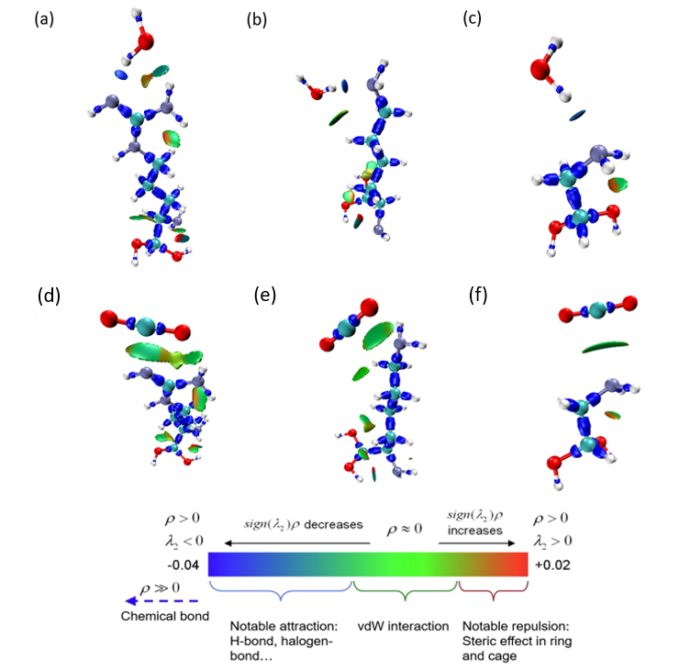
Figure 4.6. Interaction region indicator (IRI) calculations⁶⁸ for water and CO₂ binding Arg (a,d). Lys (b,e), and Gly (c,f) at IRI = 1.0. (B3LYP 6-311+G (d,p)) Red, turquoise, purple, white atoms correspond to O, C, N and H, respectively. ρ indicates the electron density, $sign\left(λ_{2}\right)$denotes the sign of the second largest eigenvalue of Hessian of ρ.

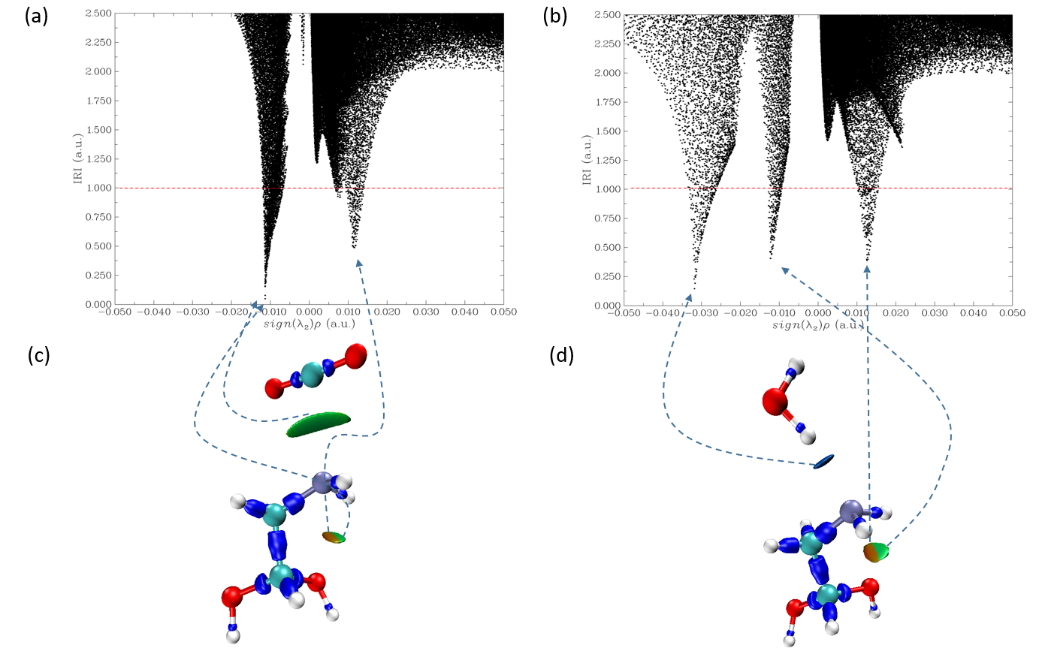
Figure 4.7. Interaction region indicator (IRI) analysis of Gly. Scatter map of IRI vs sign$(λ_{2})ρ$ for CO₂ (a) and water (b) binding with Gly. Isosurface map at IRI = 1.0 for CO₂ (c) and water (d) binding. (B3LYP) 6-311+G (d,p)) Red, turquoise, purple, white atoms correspond to O, C, N and H, respectively. The arrows show the correspondence between IRI isosurfaces and the observed IRI minima.

The enthalpy contribution is generally the primary driving force of the binding process which is often accompanied by an entropy loss. Large and negative adsorption enthalpies reflect the intermolecular interactions between the adsorbent and the target adsorbate, including vdW forces and hydrogen bonds. The adsorption enthalpy ($∆H$) was calculated by adding the zero-point (${∆E}_{ZPE}$), rotational (${∆E}_{rot}$), translational (${∆E}_{trans}$), vibrational (${∆E}_{vib}$) contributions, and the pressure volume work $∆(PV)$ to the previously calculated electronic BE, as shown in Equation 2:
$$∆H= BE+{∆E}_{ZPE}+{∆E}_{rot}+{∆E}_{trans}+{∆E}_{vib}+∆(PV)$$ | (2)
All the terms in equation 2 were obtained from the electronic and frequency calculations previously described. It is worth noting that the calculated vibrational frequencies were positive for all the cluster models, indicating stability of the species. The calculated $∆H$ values of water and CO₂ binding with the amino functionalized molecules are presented in Figure 4.8, where they are compared with the corresponding binding energies. These values are also tabulated in Table 4.3 for ease of reference. We note that the adsorption enthalpies for TAEA and TAPA are not included, as we were unable to achieve convergence in the frequency calculations due to computational limitations.
Figure 4.8a and b show the comparison between the calculated electronic binding energy and the adsorption enthalpy. In all cases, the calculated $∆H$ values are less negative than the corresponding binding energy. However the observed ranking of binding strength between the functional molecules and CO₂ or water is generally maintained. Figure 4.8c shows the comparison between the differences of binding energies ($BE_{(H_{2}O)}{-BE}_{({CO}_{2})}$) and adsorption enthalpies (${∆H}_{(H_{2}O)}{-∆H}_{({CO}_{2})}$) for water and CO₂. These calculations indicate that Melamine, Arg, 7-Azaindole, and TBD exhibit the highest affinity for CO₂ capture, with adsorption enthalpies ranging from −12.8 to −14.6 kJ/mol. None of the selected functionalized molecules preferentially adsorb CO₂ over water when single molecule interactions are considered. This analysis demonstrates that a screening based solely on the evaluation of the binding energies is generally sufficient to characterize functional groups’ affinity with CO₂ and water, eliminating the need for additional and computationally intensive frequency calculations.
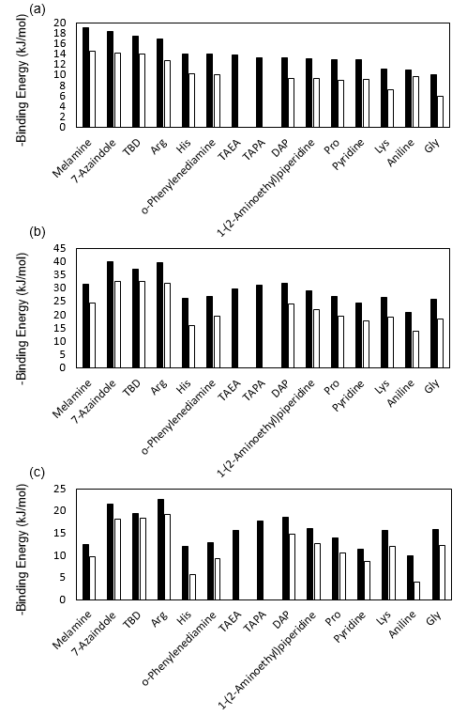
Figure 4.8. Comparison between calculated binding energies (black) and adsorption enthalpies at 298 K (white) for CO₂ (a) and water (b). (c) Comparison between $BE_{(H_{2}O)}{-BE}_{({CO}_{2})}$ (black) and ${∆H}_{(H_{2}O)}{-∆H}_{({CO}_{2})}$ (white). (MP2 6-311+G (d,p))

Table 4.3. Calculated adsorption enthalpies (in kJ/mol) at 298 K for CO₂ (${∆H}_{({CO}_{2})}$) and water (${∆H}_{(H_{2}O)}$) for different amino-functionalized molecules. The last column represents the difference between the calculated binding energies of water and CO₂. Negative values indicate that the binding of water is enthalpically more favourable than CO₂.

Functional groups | $${-∆H}_{({CO}_{2})}$$ | $${-∆H}_{(H_{2}O)}$$ | $${∆H}_{(H_{2}O)}{-∆H}_{({CO}_{2})}$$
Melamine | 14.6 | 24.3 | -9.7
7-Azaindole | 14.2 | 32.5 | -18.3
TBD | 14.1 | 32.6 | -18.5
Arg | 12.8 | 32.0 | -19.2
ο-Phenylenediamine | 10.1 | 19.4 | -9.3
TAEA
TAPA
DAP | 9.3 | 24.2 | -14.9
1-(2-Aminoethyl)piperidine | 9.3 | 21.9 | -12.6
Pro | 9.0 | 19.5 | -10.5
Pyridine | 9.2 | 17.9 | -8.7
Lys | 7.2 | 19.3 | -12.1
Aniline | 9.7 | 13.7 | -4.0
His | 10.2 | 15.9 | -5.7
Gly | 6.0 | 18.3 | -12.3

4.3.2 Applications of functionalized molecules to CO₂ capture

The identified top-performing functionalized molecules exhibit promising potential for CO₂ capture, as evidenced by the strong CO₂ binding energies predicted by DFT calculations. However, effective CO₂ capture depends not only on the binding affinity but also on the pore environment, where CO₂ molecules can simultaneously interact with multiple functional groups. To account for these multiple interactions, we extended the CO₂ binding energy calculations to multi-functional-molecule systems, to inform the design of functionalized MOFs, that could incorporate these molecules as terminal groups. To do this, different DFT geometry optimization calculations were performed by varying the distance between the α-carbon of the diol group of two functional molecules with a single CO₂ molecule sandwiched between the two. It is worth noting that the terminal -OH groups were frozen during the simulations to minimize the lateral interactions between the molecules and simulate the adsorption performance of a rigid structure. Figure 4.9 illustrates the results obtained for a 2-Arg system with the distance between the α-carbon atoms ranging between 19.0 Å and 33.0 Å. The red horizontal line represents the binding energy of CO₂ with a single Arg molecule. Distances shorter than 20.6 Å result in a non-planar structure, with the CO₂ molecule moving out of the plane of the multi-Arg system, as shown in the inset for point I in Figure 4.9. The most negative binding energy (ca. −36 kJ/mol) was observed at a distance of 20.6 Å where CO₂ is equidistant from the binding sites of the two Arg molecules (point II). At longer distances up to 23 Å (see points III and IV), the binding energy is significantly influenced by both functional molecules, as indicated by the progressive reduction in its value to ca. −21 kJ/mol. At greater distances, the binding energy of the multi-molecule system converges towards the value observed for a single molecule (at the M06-L level of theory), indicating that CO₂ interacts predominantly with one of the Arg molecules, while the influence of the second molecule becomes negligible (see point VI in Figure 4.9). Based on this analysis, a small meso-pore size of approximately 20.0 Å is optimal when functionalizing rigid frameworks with Arg terminal groups to enhance CO₂ capture efficiency.

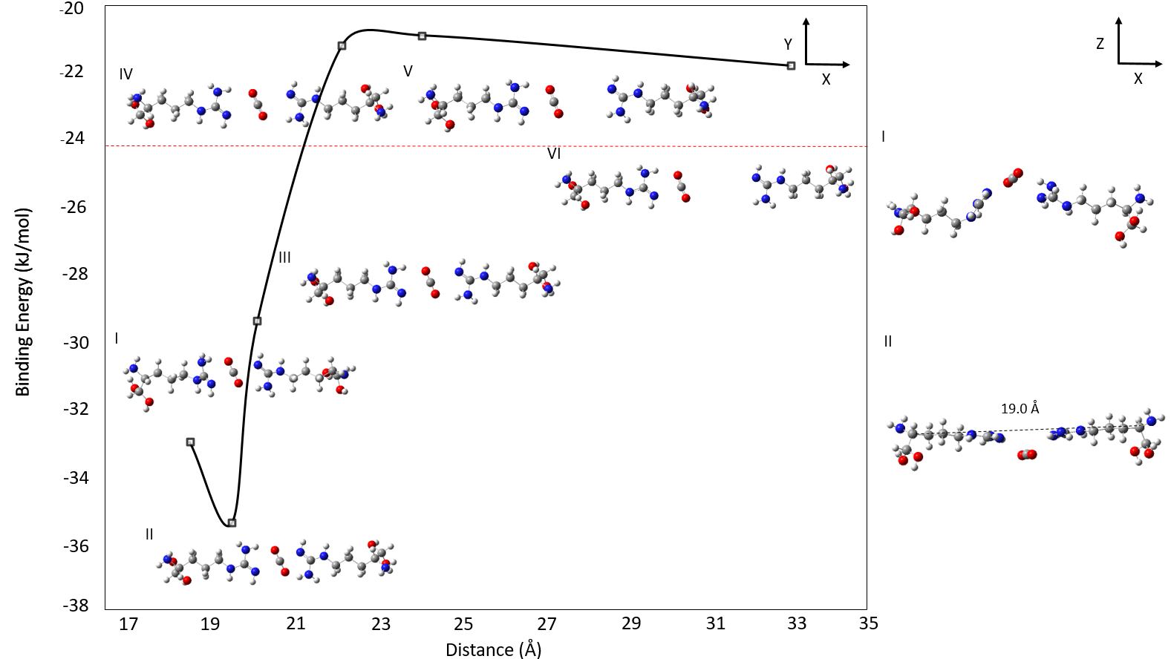
Figure 4.9. Binding energy between CO₂ and two Arg molecules calculated at the M06-L level of theory with the 6-311+G (d,p) basis set. The -OH terminal groups in Arg are kept frozen during geometry optimization calculations. The x-axis indicates the distance between the two α-carbon of the diol groups. The horizontal red line represents the binding energy of CO₂ and a single Arg molecule.

A similar approach was used to determine the optimal distance between the other functionalized molecules, resulting in the strongest CO₂ binding interactions (Figure 4.9-4.11). Figure 4.12 shows the two-molecule systems namely, 7-Azaindole, Arg, Melamine, and TBD interacting with CO₂. These molecules were identified as the top performing groups from our previous CO₂ binding energy analysis on the single molecule systems. The binding energy values shown in Figure 4.12 correspond to the DFT-relaxed structures obtained through the procedure depicted in Figure 4.9. All binding energy values exceed −30 kJ/mol, which is particularly advantageous for DAC application where strong binding affinities are required. In particular, the 7-Azaindole 2-molecule system results in the strongest CO₂ binding energy (−38.5 kJ/mol), followed by Arg and TBD, each with binding energies of approximately −35 kJ/mol. In contrast to the trend observed in single-molecule simulations, the two-Melamine system exhibits the longest N-C(CO₂) and H-O(CO₂) interatomic distances compared to other candidates, and exhibits relatively lower two-way binding energy of −32.7 kJ/mol. Among the other candidates, the two-TBD system shows the shortest N-C(CO₂) distance, while the two-Arg system displays the shortest H-O(CO₂) distance. However, the binding energy for these molecules remains lower than that of the two-7-Azaindole conformation. This suggests that the interaction strength cannot be solely attributed to variations in the interatomic distances.

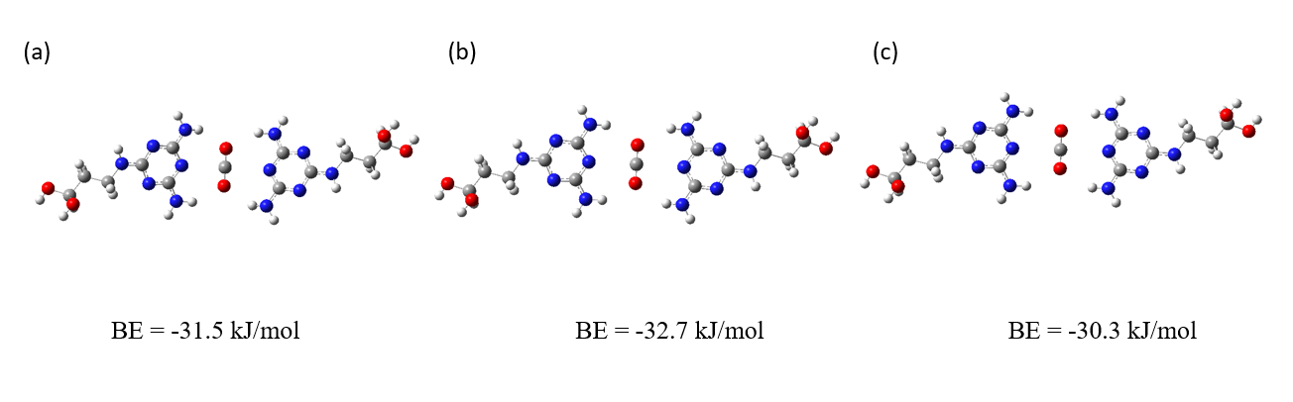
Figure 4.10. Binding energy of CO₂ and two Melamine molecules calculated at the M06L level of theory with the 6-311+G (d,p) basis set by freezing the -OH terminal groups. The distance between two dial alpha carbons from both Melamine molecules is (a) 19.8 Å (b) 20.5 Å (c) 20.8 Å. Grey, white, red and blue atoms correspond to C, H, O and N.
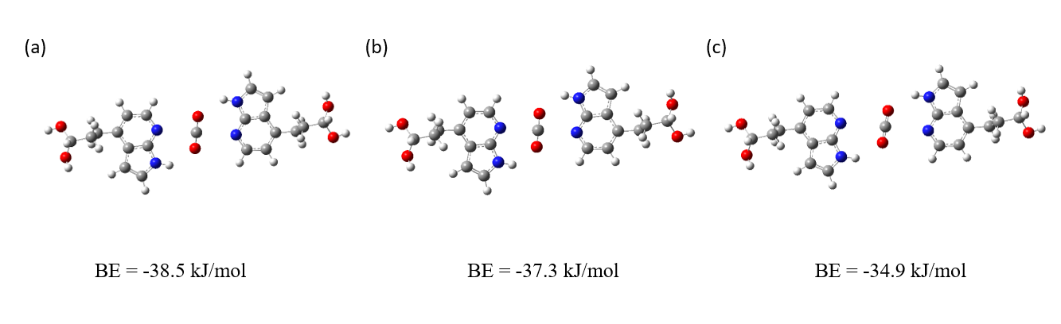
Figure 4.11. Binding energy of CO₂ and two 7-Azaindole molecules calculated at the M06L level of theory with the 6-311+G (d,p) basis set by freezing the -OH terminal groups. The distance between two dial alpha carbon from both Melamine molecules is (a) 18.4 Å (b) 17.6 Å (c) 19.1 Å. Grey, white, red and blue atoms correspond to C, H, O and N.
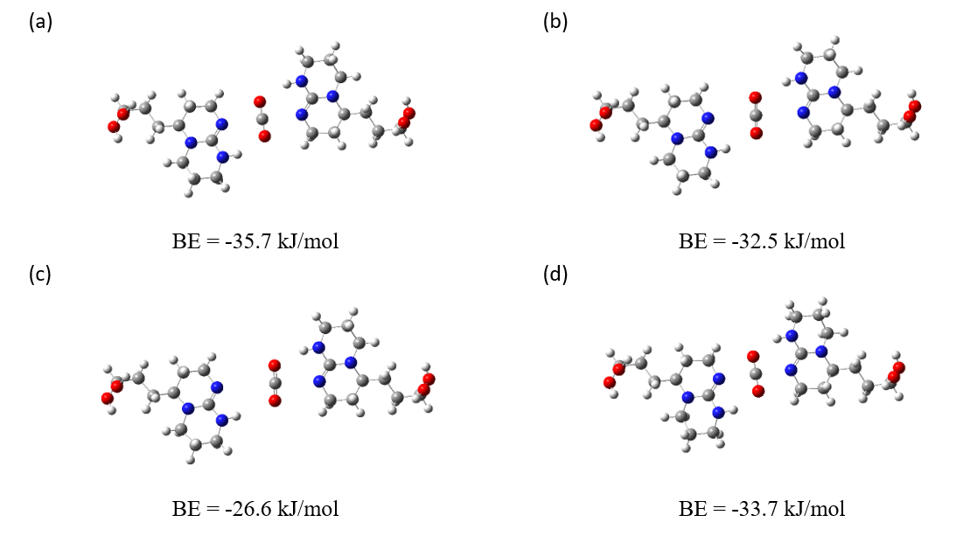
Figure 4.12. Binding energy of CO₂ and two TBD molecules calculated at the M06L level of theory with the 6-311+G (d,p) basis set by freezing the -OH terminal groups. The distance between two dial alpha carbon from both Melamine molecules is (a) 18.6 Å (b) 19.5 Å (c) 20.0 Å (d) 18.0 Å. Grey, white, red and blue atoms correspond to C, H, O and N.

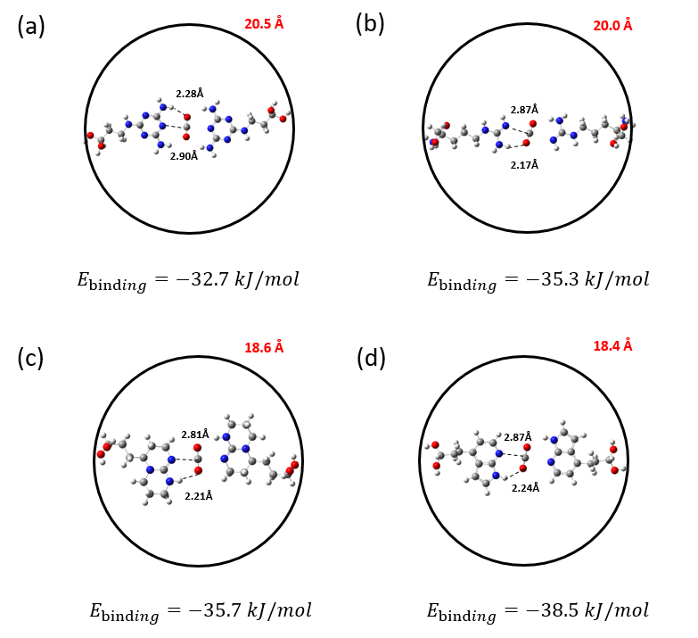
Figure 4.13. Most stable configurations of the hypothetical pore systems with two (a) Melamine (b) Arg (c) TBD (d) 7-Azaindole functionalized molecules for CO₂ capture. (M06-L 6-311+G (d,p)) Grey, white, red and blue atoms correspond to C, H, O and N, respectively. The terminal -OH groups were frozen during the simulations. The red numbers represent the distances in angstroms (Å) between the two diol α-carbon atoms of the functionalized molecules. The dashed lines represent the distances between the interacting atoms. The number below each configuration indicate the calculated CO₂ binding energy.

To further investigate these interactions, we performed the IRI analysis (Figure 4.14) and generated a scatter map for all the designed multi-molecule systems for CO₂ capture. Figure 4.15 reveals that while vdW interactions between C(CO₂) and the N atom in amino-functionalized molecules remain consistent across systems ($sign\left(λ_{2}\right)ρ≈0.005$), the hydrogen bond between O(CO₂) and H in the two-Melamine system is relatively weaker ($sign\left(λ_{2}\right)ρ≈-0.011$), which is consistent with our previous findings. Additionally, Figure 4.15 shows that Melamine, Arg, and TBD all exhibit a clear peak at $sign\left(λ_{2}\right)ρ$ slightly greater than 0.012, indicating the repulsion between O(CO₂) and N atom in amino-functionalized molecules. The combination of relatively strong H-bonding and weaker repulsion makes the two-7-Azaindole system the most promising candidate for designing amino-functionalized rigid structures for CO₂ capture.
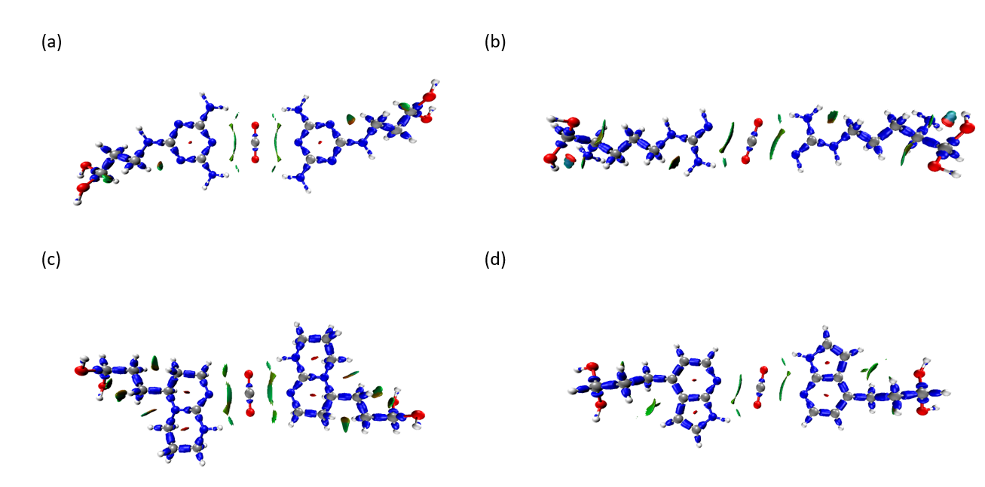
Figure 4.14. Interaction region indicator (IRI) calculations for CO₂ binding on two- (a) Melamine (b) Arg (c) TBD (d) 7-Azaindole at IRI = 1.0. (B3LYP 6-311+G (d,p)) Red, turquoise, purple, white atoms correspond to O, C, N and H.
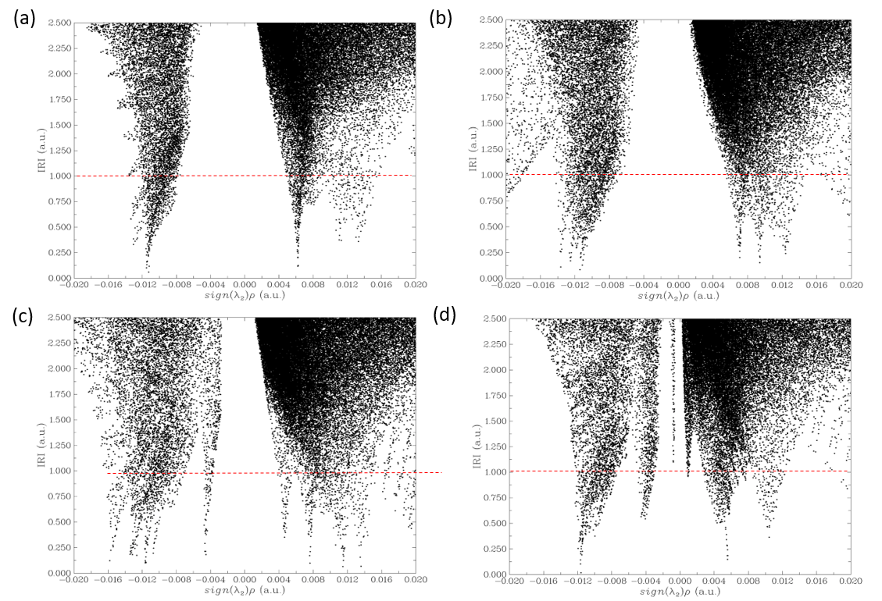
Figure 4.15. Scatter map of IRI vs sign$(λ_{2})ρ$ of designed system with two (a) Melamine (b) Arg (c) TBD (d) 7-Azaindole for CO₂ capture. The points intersecting with the red dashed line (IRI = 1.0) correspond to the grid points constituting the isosurfaces shown in Figure 4.13.

An analogous study was conducted to investigate water binding with the two-molecule systems mentioned above (Melamine, Arg, TBD and 7-Azaindole), as illustrated in Figure 4.16. In this case, the distance between the two diol α-carbon atoms was fixed to the value identified through the previous analysis in Figure 4.13 to assess the performance of a porous structure – specifically optimized for CO₂ adsorption – in the presence of water. In all cases, water exhibits a more negative binding energy compared to CO₂, indicating a preference of the investigated systems for water adsorption. During the geometry optimization calculations, the water molecules twisted to enable the hydrogen atoms of the amino groups to interact with O(H₂O). This rearrangement of the functionalized molecules to accommodate water was not observed in the simulations involving CO₂, where the molecules remained planar with the adsorbate.
While all selected functionalized molecules exhibit strong interactions with water, melamine results in the weakest binding energy of −64.6 kJ/mol. This was attributed to the formation of relatively weak hydrogen bonds with distances of 2.05 Å and 2.13 Å for H(H₂O) and O(H₂O), respectively (Figure 4.16a).

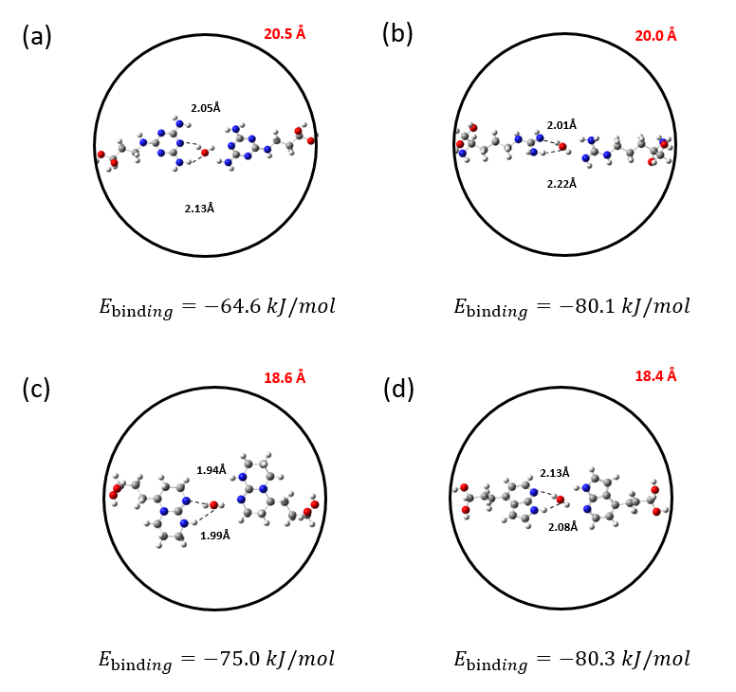
Figure 4.16. Most stable configurations of the hypothetical pore systems with two (a) Melamine, (b) Arg, (c) TBD, (d) 7-Azaindole functionalized molecules for water capture. Grey, white, red and blue atoms correspond to C, H, O and N, respectively. The terminal -OH groups were frozen during the simulations. The red numbers represent the distances in angstroms (Å) between the two diol α-carbon atoms of the functionalized molecules. The dashed lines represent the distances between the interacting atoms. The number below each configuration represent the calculated H₂O binding energy. (M06-L 6-311+G (d,p))

4.4 Conclusion

In this study, we computationally screened different amino-functionalized molecules that can be incorporated into host materials such as MOFs for DAC of CO₂. Using MP2 and DFT calculations, we evaluated the binding energies and thermal enthalpies of adsorption for water and CO₂ with 15 amino-functionalized molecules with the goal of identifying promising candidates for DAC under both dry and humid conditions. Our results show that 7-Azaindole, TBD, melamine and Arg interact strongly with CO₂ with binding energy values ranging from −17.0 kJ/mol to −19.0 kJ/mol. Such relatively large binding energies are predominately influenced by the number and strength of hydrogen bonds formed between O(CO₂) and H atoms from the functional molecules. These groups demonstrate greater potential for CO₂ DAC compared to those that primarily rely on vdW interactions e.g. Gly and Lys. To inform the design of rigid porous structures that incorporate amino-functionalized molecules as terminal groups, we generated hypothetical pore structures that enabled simultaneous CO₂ binding with two functional groups. We found that the two-way interactions with CO₂ result in significantly stronger binding energies of ca. −33 kJ/mol to −39 kJ/mol. In particular, CO₂ strongly coordinates with the two molecules of 7-Azaindole resulting in a binding energy of -38.5 kJ/mol. Overall, the binding energy in a two-molecule system is influenced not only by the strength of the hydrogen bonds but also by the repulsive interactions between the functional molecules, which play a critical role in determining the overall binding energy. This means that multi amino-functionalized molecules such as 7-Azaindole, TBD, melamine and Arg, could serve as multiple binding sites when CO₂ is “sandwiched” between these groups inside a pore. The findings from this study offer valuable insights for the development of promising amino-functionalized materials for efficient DAC of CO₂.

5 High-throughput Computational Screening of MOFs for Photocatalytic Water Splitting & Carbon Dioxide Conversion

As the most abundant greenhouse gas emitted by human activities, carbon dioxide (CO₂) significantly contributes to global warming and ocean acidification. Using catalysts to efficiently and selectively convert CO₂ into valuable chemicals under mild conditions is of great significance to mitigating the negative impact of CO₂ on climate change and reducing the dependence on fossil energy. As an emerging class of porous crystalline materials, metal-organic frameworks (MOFs) have both the excellent properties of heterogeneous and homogeneous catalysts including separability, reusability, high selectivity and activity. In this work, we aim to identify novel MOF catalysts that harness solar energy for the conversion of CO₂ into value-added fuels. UiO-66 (University of Oslo) was selected as a model MOF to investigate and elucidate the CO₂ phototcatalytic reduction mechanism. An automated algorithm was developed to screen the Cambridge Structural Database (CSD) MOF subset and perform high-throughput density functional theory (DFT) calculations with the aim of identifying promising MOF frameworks for photocatalytic CO₂ reduction and water splitting. TONBII, UZAVOH, XIQPIW, FUQJOS, UJAYIN and GIDCEB were identified as potentially effective photocatalysts for CO₂ reduction and water splitting.

5.1 Introduction

Global warming has triggered a series of natural disasters which have been attributed to the increase in the level of carbon dioxide (CO₂). Atmospheric CO₂ levels have increased by 43% since 1750 and are still increasing at a rate of 2·10⁻⁴ % by year.¹⁴⁵ Statistics show that carbon dioxide levels in the atmosphere have risen from 280 ppm before the industrial revolution to 416 ppm in 2020. Therefore, carbon capture, utilization and storage represent one of the most important challenges in today's society. As one of the key technologies to achieve large-scale global emission reduction in the future, chemical utilization not only reduces the amount of carbon dioxide in the atmosphere, but also converts it into valuable fuels or chemicals through chemical transformation.¹⁰¹ Due to the stable molecular structure of carbon dioxide, sufficient energy and stable catalysts are indispensable in the chemical conversion process to efficiently convert CO₂ into usable fuel such as CO and methane .¹⁴⁶ Solar energy, as a popular clean energy, can provide sufficient energy for this process. For instance, photosynthesis is the most common natural photocatalytic carbon dioxide reduction process. That pioneering work confirmed the feasibility of photocatalytic conversion and utilization of CO₂.
In recent years, novel solid catalysts such as metal-organic frameworks (MOFs) have demonstrated great potential in energy conversion systems. MOFs are an important class of crystalline materials which consist of inorganic nodes (single metal atoms or metal clusters) connected to organic linkers to form open networks that contain potential voids.¹¹⁴ Due to the availability of a large variety of inorganic nodes and organic linkers, more than 100,000 different structures of MOFs have already been synthesized.^{147, 148} As the total number of MOFs discovered increased every day, there continues to exist the opportunity to discover new structures for many diverse applications.¹⁴⁹ Compared with traditional porous metals, MOFs possess unique characteristics such as large surface area, adjustable pore size and channel structure, rich and diverse metal and organic ligands, and easy functionalization.^{115-117, 150} Because of these unique advantages, MOFs have become the focus of many research activities in chemical engineering including separations, energy storage, drug delivery, and catalysis.^{30, 151-154} Among the many applications of MOFs, photocatalysis is one of the most promising to address the reduction of carbon dioxide emissions. In a photocatalytic reaction mechanism, the catalyst generates photogenerated electrons and holes in the presence of light irradiation, electrons transfer from highest occupied molecular orbital (HOMO) to lowest unoccupied molecular orbital (LUMO) where a large number of MOFs have excellent performance.¹⁵⁵

5.1.1 Photocatalytic CO₂ Reduction

CO₂ is a non-polar linear molecule in which carbon is in its highest valence state. Due to its thermodynamic stability, the conversion of CO₂ requires the presence of a catalyst. Designing catalytic systems to maximize CO₂ conversion efficiency has become a challenging scientific frontier work.
The photocatalytic or electrocatalytic reduction reaction mechanism in the presence of water is shown in Table 5.1. The single-electron reaction that kinetically converts CO₂ to CO₂·⁻ has the highest reduction potential from the equation. Relatively speaking, the reduction potential required for the multi-electron conversion process is lower, the reaction kinetics are easier to achieve. Different products such as formic acid, formaldehyde, methanol, methane, etc. can be obtained by multi-electron reduction of CO₂.¹⁵⁶

Table 5.1. Reduction of CO₂ in the presence of a proton source (aqueous solution, pH =7, vs Normal Hydrogen Electrode (NHE)).¹⁵⁶ $E°$ is the standard electrode potential of the reaction in volts.
CO₂ reduction reactions | $$E°/V$$
$${CO}_{2}+e^{-}= {CO}_{2}^{·-}$$ | -1.90
$${CO}_{2}+{2H}^{+}+{2e}^{-}=CO+H_{2}O$$ | -0.53
$${CO}_{2}+{2H}^{+}+{2e}^{-}={HCO}_{2}H$$ | -0.61
$${CO}_{2}+{4H}^{+}+{4e}^{-}=HCHO+H_{2}O$$ | -0.48
$${CO}_{2}+{6H}^{+}+{6e}^{-}={CH}_{3}OH+H_{2}O$$ | -0.38
$${CO}_{2}+{8H}^{+}+{8e}^{-}={CH}_{4}+{2H}_{2}O$$ | -0.24

The photocatalytic reduction of carbon dioxide consists of the reduction of CO₂ into other products through the action of a photocatalyst under light-induced conditions. In the first step electron-hole pairs are generated upon light irradiation of the photocatalyst. CO₂ is adsorbed on the surface of the catalyst and then reduced to different products in the presence of a hydrogen source such as water or a sacrificial agent as a result of the interaction with the photogenerated electrons. It can be seen from Table 1 that the specific product generated by the reduction process depends on the number of photoelectrons participating in the reaction.
Under illumination conditions, when the photon energy is greater than the band gap of the catalyst, the catalytic material can generate photogenerated electrons and holes. The electrons will be excited to the lowest unoccupied molecular orbital (LUMO) and the holes remain on the highest occupied molecular orbital (HOMO), resulting in electron-hole separation. Then the electrons and holes will continue to migrate to the surface of the photocatalyst for photocatalytic reduction and oxidation reactions (the process of separation and reuse of photogenerated electrons and holes). Therefore, improving the generation amount, separation efficiency and carrier utilization efficiency of electron-hole pairs is the important way to enhance photocatalytic activity.¹⁵⁶
TiO₂ is a semiconductor photocatalyst with excellent performance, it is the earliest and most widely used material as a photocatalyst. TiO₂ currently has two shortcomings. First, the band gap is 3.2 eV, which can only absorb 4% of solar ultraviolet light. The utilization rate of solar energy is relatively low. Second, the photogenerated electrons and holes are easy to recombine, which reduces the utilization rate of photogenerated electrons.¹⁵⁷
Ternary metal oxides can also be used for the reduction of carbon dioxide, and the basic catalytic mechanism is similar to titanium dioxide. These materials can effectively control the band gap within the range of visible light and improve the reaction efficiency and product selectivity of photocatalytic carbon dioxide reduction. But the binding force between carbon dioxide molecules and the material is weak, which decrease the reduction efficiency. Therefore, there is currently no perfect photocatalyst for carbon dioxide reduction, it is necessary to research and discover new photocatalytic materials. As a material currently widely used in various fields, the advantages of MOFs can effectively solve the problems of current photocatalytic materials.

5.1.2 Advantages and disadvantages of MOFs in Photocatalysis

In recent years, the application of MOFs in the field of catalysis has become more and more extensive¹⁵⁸. Due to their unique properties, a large number of closely arranged catalytic active sites in the MOFs structures is beneficial to accelerate the catalytic reaction. MOF exceptional porous structure facilitates the interaction between each catalytic active site and the reactants. One the other hand, MOFs have been widely considered to be potential materials for carbon dioxide (CO₂) capture due to their porous structure and high CO₂ capacity. While porosity is an important factor in facilitating reactant diffusion, adsorption, and accessibility of active sites, it should be emphasised that charge carrier generation and separation during photocatalysis are governed primarily by the electronic structure of the material rather than by porosity itself. In photocatalytic MOFs, the spatial distribution and energetic alignment of the frontier molecular orbitals play a decisive role in determining charge separation and recombination behaviour. In many Zr-based MOFs such as UiO-66, the valence band is predominantly derived from ligand-centred orbitals, while the conduction band shows only limited contribution from the Zr(IV) centres due to their d⁰ electronic configuration. As a result, photoexcitation in these materials is largely ligand-centred, which can limit efficient spatial separation of photogenerated electron–hole pairs.¹⁵⁹ A widely adopted strategy to enhance charge carrier separation in MOFs therefore involves engineering ligand-to-metal charge transfer (LMCT) pathways by introducing metal nodes with accessible low-energy acceptor orbitals. Substitution or incorporation of redox-active metals such as Fe(III), Ti(IV), or Ce(IV) into MOF nodes has been shown to lower the effective conduction band edge and facilitate electron transfer from photoexcited ligands to the metal centres. This LMCT process spatially separates electrons and holes, suppresses recombination, and leads to enhanced photocatalytic performance.¹⁶⁰ Fe-substituted UiO-type MOFs have been reported to exhibit significantly improved photocatalytic activity due to efficient ligand-to-Fe(III) charge transfer, where the metal centres act as electron acceptors and charge traps.¹⁶¹ These studies demonstrate that the electronic structure of the metal node and its coupling with the organic linker is the dominant factor controlling charge carrier separation in photocatalytic MOFs and it is worth to develop novel MOFs for photocatalytic use.
For these reasons, employing MOFs as catalysts for CO₂ reduction has emerged as a significant research focus.¹⁶² Metal unsaturated sites, which are abundant in defective MOFs, along with various active organic functional groups, serve as the active sites for CO₂ reduction. Compared with traditional photocatalysts, MOFs mainly have the following key advantages:
1. By introducing long-wavelength absorbing functional groups into the structure of MOFs as organic ligands (such as NH₂ groups), the MOF light absorption capacity can be enhanced and extended into the visible light range, thereby increasing the number of photogenerated electrons and holes generated under visible light conditions.
2. The porous structure of MOFs allows for the interaction of CO₂ with multiple active sites.
3. The presence of this large number of pores, as transport channels for reactants and products, can effectively reduce the number of photogenerated electrons and holes recombined and improve efficiency.
4. The rich porous structure of the inner surface greatly shortens the transmission distance of photogenerated electrons and holes, avoids the recombination during the photocatalytic process, thereby improving the separation and utilization efficiency of photogenerated electrons and holes, and greatly improving the photocatalytic performance.
5. MOFs can be easily combined with other compounds, such as photosensitizers, co-catalysts, etc. to enhance their photocatalytic efficiency.
6. The clear and tailorable structural features of MOFs make them an ideal model for studying the structure-activity relationship in photocatalysis.¹⁶³
However, MOFs also have some disadvantages in photocatalysis.
1. Most photocatalytic MOFs have not yet been synthesized via high-throughput methods, and currently, large scale production of MOF materials remains a significant challenge.
2. Most of the photoactive ligands or coated nanoparticles used in MOFs usually contain precious metals, such as Ru, Pd, Pt, Au, etc. This feature increases the difficulty and cost of MOF synthesis.
3. The efficiency of MOFs in photocatalytic water splitting and hydrogen production reactions is limited. In most cases, the catalytic reaction still requires the presence of a sacrificial agent.
4. The use of MOFs for photocatalysis has similar problems to traditional organic chemical reaction catalysis, and there are still challenges in research to improve universality and efficiency.
Therefore, improving MOF synthesis methods, identifying non-precious metals for functionalization, and reducing overall costs have become key priorities for future research.

5.1.3 MOFs for photocatalytic carbon dioxide reduction

In photocatalytic systems, the concept of an active site extends beyond a static adsorption or reaction centre and should instead be understood as a redox-active couple capable of accepting and donating electrons during the catalytic cycle. Effective photocatalysis therefore requires not only light absorption but also the presence of energetically accessible oxidation and reduction states that enable sequential charge transfer steps without irreversible degradation of the catalyst. In MOF-based photocatalysts, such redox couples may be associated with metal nodes, metal–ligand charge transfer states, or redox-active linker units. Defining the active site in terms of a redox couple provides a more physically meaningful framework for understanding photocatalytic turnover, as it explicitly links electronic structure to catalytic function and charge carrier dynamics.¹⁶⁰
Table 5.2 shows the catalytic performance of a number of reported functional MOFs for photocatalytic CO₂ reduction. It should be noted that the photocatalytic yields reported in Table 4.2 are extracted from different literature sources under varying experimental conditions, including differences in CO₂ concentration (e.g., pure CO₂ atmosphere vs CO₂-saturated solutions), catalyst loading, solvent volume, and light intensity. As a result, the absolute yield values cannot be directly compared without normalization to parameters such as catalyst mass, reaction time, or photon flux. In many cases, turnover frequency (TOF), apparent quantum efficiency (AQE), or yield normalized per gram of catalyst provide more meaningful performance indicators. However, such data are not consistently reported across the literature. Therefore, Table 5.2 is intended to provide an overview of representative systems rather than a strict quantitative ranking of catalyst performance.

Table 5.2. Catalytic performance of some reported functional MOFs in photocatalytic CO₂ reduction.
MOF | Catalyst active site | Catalyst amount | Irradiation time (h) | Sacrificial agent | Product | Yield | Ref.
NH2-MIL-125(Ti) | ${Ti}^{4+}$-${Ti}^{3+}$ | 50 mg | 10 | TEOA | HCOOH | 8.1 μL | ¹⁶²
MIL-53(Fe) | ${Fe}^{3+}$-${Fe}^{2+}$ | 50 mg | 8 | TEOA | HCOOH | 29.7 μmol | ¹⁶⁴
MIL-88B(Fe) | ${Fe}^{3+}$-${Fe}^{2+}$ | 50 mg | 8 | TEOA | HCOOH | 9.0 μmol | ¹⁶⁴
MIL-101(Fe) | ${Fe}^{3+}$-${Fe}^{2+}$ | 50 mg | 8 | TEOA | HCOOH | 59.0 μmol | ¹⁶⁴
NH2-MIL-53(Fe) | ${Fe}^{3+}$-${Fe}^{2+}$ | 50 mg | 8 | TEOA | HCOOH | 46.5 μmol | ¹⁶⁴
NH2-MIL-88B(Fe) | ${Fe}^{3+}$-${Fe}^{2+}$ | 50 mg | 8 | TEOA | HCOOH | 30.0 μmol | ¹⁶⁴
NH2-MIL-101(Fe) | ${Fe}^{3+}$-${Fe}^{2+}$ | 50 mg | 8 | TEOA | HCOOH | 178.0 μmol | ¹⁶⁵
Ru-MOF | Ru-polypyridine |  | 8 | TEOA | HCOOH | 24.7 μmol | ¹⁶⁶
UiO-66-CrCAT | ${Cr}^{3+}$-${Cr}^{2+}$ |  | 6 | TEOA | HCOOH | 51.7 μmol | ¹⁶⁶
UiO-66-GaCAT | ${Ga}^{3+}$-${Ga}^{2+}$ |  | 6 | TEOA | HCOOH | 28.8 μmol | ¹⁶⁶
PCN-222 | ${Zr}^{4+}$-${Zr}^{3+}$ | 50 mg | 10 | TEOA | HCOOH | 2.4 nmol | ¹⁶⁷
Co-MOF-525 | ${Co}^{2+}$-${Co}^{+}$ |  | 6 | TEOA | CO, CH4 | CO:2.4 μmol  CH₄:0.4 μmol | ¹⁶⁸

In one of the first reports on the use of pure MOFs as photocatalysts for CO₂ reduction, Li et al.¹⁶² studied the CO₂ reduction under visible light irradiation, catalyzed by pure NH₂-MIL (Materials of Institut Lavoisier)-125(Ti). For the NH₂-MIL-125(Ti) material synthesized from formic acid (BDC-NH₂), the light absorption edge relative to MIL-125(Ti) can extend from 350 to 500 nm. In this structure, the photo-generated electron transfer follows the ligand-to-metal charge-transfer (LMCT) process, and the replacement of terephthalic acid (H₂BDC) with BDC-NH₂ affects the LMCT process, which is responsible for the change in the light absorption capacity of the MOF. The lowest unoccupied metal orbital, primarily associated with Ti, remains unchanged between the two structures above. However, the introduction of the –NH₂ group raises the energy level of the lowest unoccupied linker orbital, resulting in a reduced charge transfer energy. On the other hand, NH₂-MIL-125(Ti) exhibits a better adsorption capacity for CO₂. Chapter 4 has proved that, functionalizing MOFs with amino functional groups and molecules such as –NH₂ can enhance the interaction between the MOF framework and CO₂. The authors investigated the photocatalytic reduction of CO₂ by using NH₂-MIL-125(Ti) in the presence of acetonitrile as a solvent and TEOA (triethanolamine) as a sacrificial agent. The presence of a sacrificial agent as an electron donor/hole scavenger is needed to reduce the recombination tendency of electrons and holes and accelerates the rate of hydrogen generation. From a stoichiometric perspective, the consumption of the sacrificial agent must be directly related to the number of electrons transferred during product formation. In the simplest case of a single-electron transfer process, a 1:1 relationship between sacrificial agent oxidation and product formation would be expected. However, many photocatalytic reactions involve multi-electron processes, leading to stoichiometries such as 2:1 or higher ratios, depending on the number of electrons required to form the target product.¹⁶⁹ Replacing H₂BDC with ligand BDC-NH₂ can broaden the absorption range of MOFs. Li et al.¹⁷⁰ reported the photocatalytic properties of NH₂-UiO-66(Zr) for CO₂ reduction and compared them to those of UiO-66(Zr). It was shown that, similar to the case of NH₂-MIL-125(Ti), the functionalization of UiO-66(Zr) also significantly improved the visible light photocatalytic activity. The partial replacement of Zr in NH₂-UiO-66(Zr) with Ti through a post-synthetic exchange strategy, yields NH₂-UiO-66(Zr/Ti), a bimetallic MOF that has been shown to exhibit enhanced photocatalytic CO₂ reduction performance.
Original UiO-66 has limited capacity to catalyze CO₂ reduction or water splitting.¹⁷¹ The Zr₆ secondary building units (SBUs) cannot accept electrons from the bdc linker (terephthalic acid) because of the relatively high redox potential energy level of the Zr cluster. Embedding Ti ions into the Zr₆ SBUs can significantly improve this situation due to the lower redox potential energy of Zr/Ti cluster.^{170, 171} Li et al.¹⁶⁴ also studied the photocatalytic CO₂ reduction activity of iron-based MOFs: NH₂-MIL-101(Fe), NH₂-MIL-53(Fe), NH₂-MIL-88B(Fe) and suggested the existence of a dual excitation pathway during the photoreaction. In addition to the direct excitation of Fe–O clusters, the aminoterephthalic acid ligand can also be photo-excited and transfer the photo-generated electrons to the Fe center. The two excitation pathways work synergistically to enhance the photocatalytic activity of the framework. Introducing porphyrins into the structures of MOFs can also broaden the visible light absorption range. Zhang and Jiang et al.¹⁶⁷ studied porphyrin-based MOF (PCN-222), which has a selective adsorption function for CO₂ and efficient reduction ability. They found that deep electrons appeared in the structure when transitioning from the organic ligand tetracarboxyphenylporphyrin (H₂TCPP) to PCN-222. The captured state, which acts as an electron trap, can capture long-lived photo-generated electrons and interact with the adsorbed CO₂ to catalyze CO₂ reduction; the existence of the captured state greatly reduces the photo-generated electron-hole recombination probability resulting in a better photocatalytic efficiency. The porphyrin center can be embedded with a variety of metal ions, such as Fe, Cu, Co, etc. Among them, Cu ions easily interact with the π orbital of CO₂ to promote its dissociation. For this reason, the Cu-porphyrin MOFs are considered ideal materials for the photocatalytic reduction of CO₂. Huang et al.¹⁶⁷ synthesized a copper porphyrin-based MOF, denoted as S_{Cu}. As a control, they also synthesized a MOF with a similar structure but no copper in the porphyrin center, denoted as S_{p}. The results showed that compared with S_{p}, S_{Cu} exhibits better CO₂ capture capability and photocatalytic performance for CO₂ to CH₃OH conversion. The existence of a single metal atom active site in the catalyst can provide the maximum atom utilization efficiency, which provides the most ideal strategy for fabricating efficient photocatalysts and provides a basis for understanding heterogeneous catalysis at the molecular level. Ye et al.¹⁶⁸ introduced a Co single active site into the center of the porphyrin ring of MOF-525, which greatly improved the electron-hole separation efficiency of MOF. Specifically, under visible light irradiation, the photo-generated electrons migrate from the porphyrin ring to the single-site Co active center, accelerating the rate of electron transfer and obtaining a long-lived electron supply for the reduction of CO₂ small molecules adsorbed on Co. The photocatalytic CO₂ reduction efficiency of MOF-525-Co to CO (experimental result) is three times higher than that of pure MOF, and the efficiency of CH₄ generation increases sixfold. Grau-Crespo et al.¹⁷² used density functional theory to optimize the metal ions in the porphyrin center. Their results demonstrate that the structural composition of the porphyrin MOF with the best photocatalytic activity was a partially Fe-substituted Al-based porphyrin MOF, keeping the porphyrin center as Zn atom. In addition to metal ions and organic ligands, the photocatalytic activity of MOFs also depends on the reaction system. In most cases, photocatalytic CO₂ reduction is carried out in acetonitrile with triethanolamine as the sacrificial agent, which is a potential chemical pollutant. Zhang et al. found that immobilizing MOF at the CO₂/H₂O phase interface results in enhanced photocatalytic activity. Additionally, the reaction can be controlled by adjusting CO₂ pressure and H₂O content.¹⁷³ The reaction system does not involve organic solvents and is environmentally friendly.
The modular nature of MOFs allows them to be tailored to achieve specific properties: for example, both different combinations of metal nodes and organic ligands can be selected to improve the photocatalytic properties of MOFs. The design space for MOFs is enormous and too complex to be efficiently explored by trial and error. In 2017, the Cambridge Crystallographic Data Centre (CCDC), identified and characterized more than 100,000 already synthesized MOF structures. These were included in the Cambridge Structural Database (CSD) (Figure 5.1). This huge number of structures turns out to be a blessing and a curse. It is a blessing because their chemical and physical diversity creates tremendous opportunities for various applications. It is a curse because it creates the grand challenge of identifying the top-performing materials for CO₂ conversion on reasonable time scales. This work directly tackles this pressing challenge by high-throughput simulation approaches to efficiently develop novel MOFs for the two key regenerative energy areas: Simultaneous photocatalytic water splitting and carbon dioxide reduction.
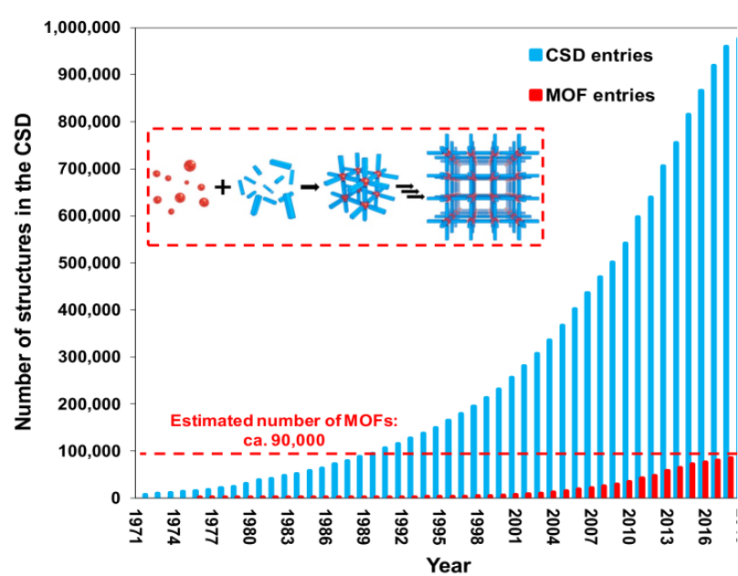
Figure 5.1. Evolution of the number of MOFs and other crystal structures in the CSD in the last 48 years. The inset shows the MOF self-assembly process from building blocks: metals (red spheres) and organic ligands (blue struts).^{147, 148}

To date, no study has systematically explored simultaneous water and carbon dioxide catalytic reactions using MOFs as photocatalysts. We harness the chemistry rich CSD structures to their full potential using accurate atomistic modelling to discover new catalytically active MOFs which enable breakthroughs for the discovery of the next-generation of photocatalysts that are unattainable using current approaches on any time scale.

5.2 Computational Details

The cluster DFT calculations were performed using the Gaussian 16 software package.⁹⁵ We used the PBE0¹⁷⁴ exchange-correlation functional with the 6-31G(d,p) basis set¹⁷⁵ for C, H, O and the Stuttgart-Dresden-Dunning (SDD, MWB28)¹⁷⁶ basis set and effective core potential for Zr.
The periodic geometry optimization was performed by the CAmbridge Serial Total Energy Package (CASTEP)¹⁷⁷ software package with default Broyden-Fletcher-Goldfarb-Shanno (BFGS) algorithm which use the lowest time consuming to find the structure with minimum energy.
The low-level density of state (DoS) calculations and geometry optimization were calculated using local-density approximation (LDA) XC functional.¹⁷⁸ A criterion of 10⁻⁸ eV/atom was chosen for electronic convergence tolerance, 10⁻⁵ eV/atom for the geometry energy tolerance, a cut-off energy of 400 eV, and the k-point spacing is set at 0.03. The cell was not optimized, only the atomic coordination was allowed to relax. The results of the DoS calculation were post processed with OptaDOS¹⁷⁹, to obtain the band gap values and the DoS at Fermi energy values. The Vienna Ab initio Simulation Package (VASP)¹⁸⁰ software package was used to perform the high-level DoS calculation. The kinetic energy cutoff was set up to 500 eV and the Hellman-Feynman force criterion was set to 0.02 eV/Å on each relaxed ion. The 3x3x3 Monkhorst-Pack grid were used for k-point. The convergence criterion was set as 10⁻⁵ eV.

5.3 Result

5.3.1 Photocatalytic process of UiO-66

Before applying high-throughput screening, a specific MOF was selected to gain a deeper understanding of the photocatalytic process. UiO-66 has been extensively investigated due to its exceptional chemical, mechanical, and thermal stability. Its widespread recognition and the availability of experimental data enable direct comparison with our simulation results. For example, Donald and his group conducted computational studies on the UiO-66 family MOFs, exploring various metal nodes and functionalized organic ligands.¹⁸¹ We therefore decided to model CO₂ photoreduction over both UiO-66-Zr to analyze the performance.
In order to reduce the computational cost, we used the primitive cell during the periodic calculations (Figure. 5.2). Table 5.2 shows that the periodic optimization are consistent with previously reported computational and experimental data. The minor discrepancies are within an acceptable range and likely arise from structural differences in the optimized structures.
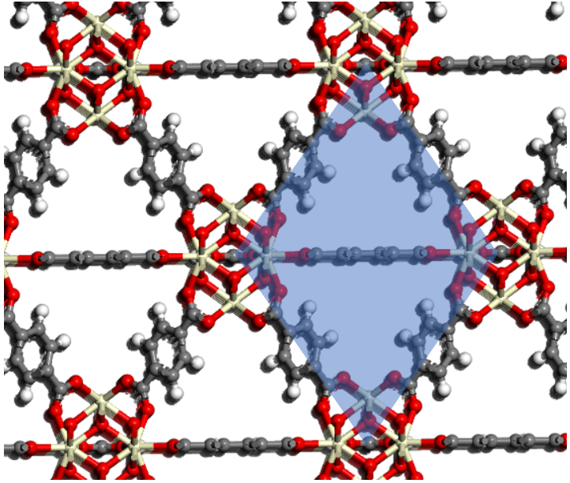
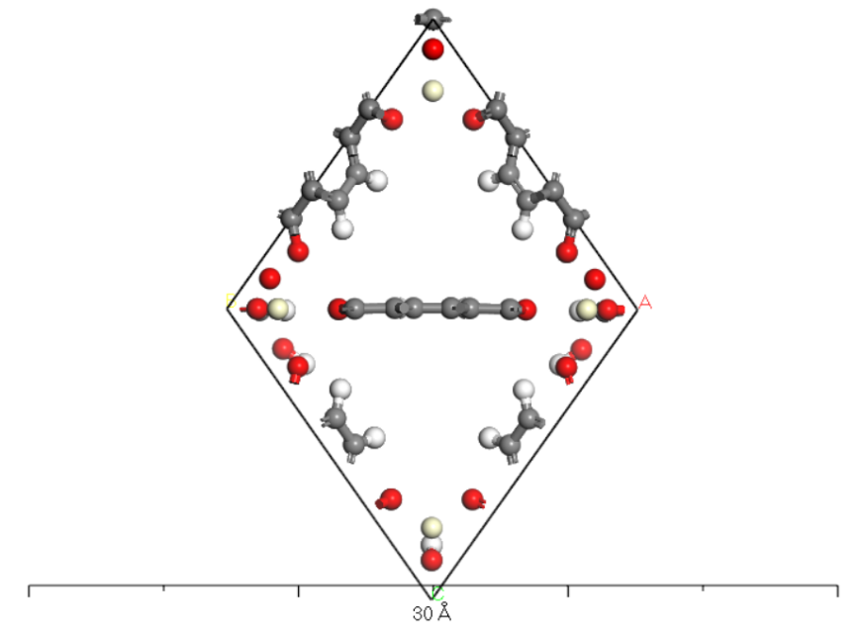
Figure 5.2. Top: Framework structure of UiO-66 with the primitive cell indicated by a blue background. Bottom: The fully optimized structure of the selected primitive cell from UiO-66. Color scheme: Zr, light yellow; O, red; C, grey; H, white. (BFGS)

Table 5.3. Calculated lattice (unit cell) parameters for UiO-66, data published and available experimental data
 |  | This work | Reference¹⁸¹ | Experimental
UiO-66 | a (Å) | 20.76 | 20.80 | 20.70¹⁸²
UiO-66 | α (°) | 90 | 90 | 90

The cluster model was obtained from the periodic model, with the unsaturated sites capped with H atoms. The Zr atoms in the original UiO-66 framework with 12 linkers are all saturated, which leads to a weaker interaction between CO₂ and Zr as depicted in Figure 5.3 (left).¹⁸³ In addition, a relatively computationally expensive functional level and basis set were used in cluster calculations. Thus, a simplified defective cluster model was constructed based on the full structure. In Figure 5.3 (right) one full bdc linker (highlighted with the red square) was removed, compared with the full cluster model, and seven benzene rings (highlighted with red circles) were replaced by H atoms. In order to keep the simplified defective cluster model neutral, one H atom connected to the O atom from Zr-O metal cluster was removed as well. This strategy to construct defective UiO-66 structure has been wildly used in previous works.¹⁸³

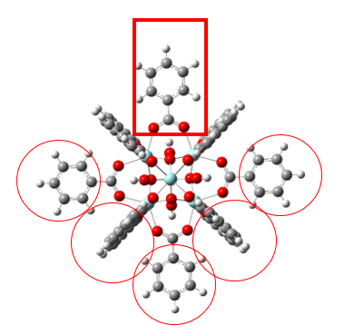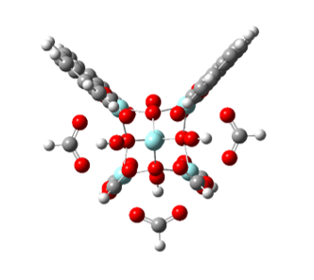
Figure 5.3. Full cluster models of UiO-66 (left) and simplified defective model of UiO-66 (right). (PBE0 6-31G(d,p) and SDD) Color scheme: O, red; C, grey; H, white; Zr, light blue.

DFT calculations were applied to estimate the adsorption enthalpy of CO₂ on the MOF metal node and verify the accuracy of the cluster model. (${∆H}_{ads}= {∆H}_{MOF+{CO}_{2}}-{∆H}_{MOF}-{∆H}_{{CO}_{2}}$) Compared with the previously published computational result (-57 kJ/mol Figure 5.4 b)¹⁸³, the adsorption enthalpy of CO₂ on the simplified cluster model showed a much stronger interaction (-139 kJ/mol Figure 5.4 a) which is also inconsistent with adsorption enthalpies found in other MOF systems that contain undercoordinated metal sites. (MOF-74¹⁸⁴, MIL-101¹⁸⁵, M-BTT¹⁸⁶) This significant difference cannot be explained by different functionals and basis set used in the calculations. On the other hand, the adsorption enthalpy of CO₂ with the fully defective UiO-66 model (obtained by restoring the replaced benzene rings, and removing the linker on the top to make it defective) showed excellent agreement with the published results. For this reason, the defective model was considered to be an appropriate cluster model to conduct the calculations.
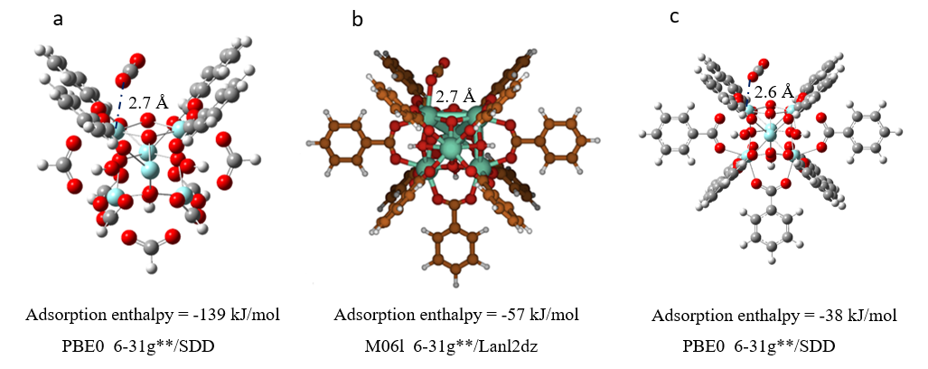
Figure 5.4. Comparing the influence of different cluster models on the interaction with molecular carbon dioxide. (a) simplified defective UiO-66 model. (b) cluster model from literature¹⁸³ (c) full defective UiO-66 model. The dash lines represent the distance between CO₂ and UiO-66.

The binding energy calculations were applied by equation (1):
${∆E}_{binding}={∆E}_{MOF+Molecular} -{∆E}_{MOF}-{∆E}_{Molecular}$ (1)
Molecule indicates the molecule adsorbed on the MOF. Frequency calculations were also applied after binding energy calculations in order to estimate the thermal correction value. Thermal enthalpies were calculated by equation (2):
$H=E+thermal correction$ (2)
Gibbs free energy differences $(∆G$) were calculated by equation (3):
$∆G=∆H-T∆S$ (3)
Figure 5.5 shows the reaction mechanism proposed to describe CO₂ photoreduction over the investigated MOF. As UiO-66 has been reported to be unsuitable for water splitting, we simulated the reduction process of CO₂ using molecular hydrogen, following an approach previously reported in literature.¹⁸⁷ The first step of the mechanism is the CO₂ adsorption. When a photon with an energy greater than the band gap of the photocatalytic material hits the photocatalyst surface, an electron-hole couple is photogenerated on the linker. The photogenerated electron migrates from the linker to the metal node of the MOF, as a result of the conductive properties of the material. Then, the CO₂ radical adsorbed on the MOF metal node is hydrogenated to form CO and water adsorbed on the surface of the MOF. The resulting CO can finally desorb and be further converted to other valuable products such as CH₄ and C₂H₄.
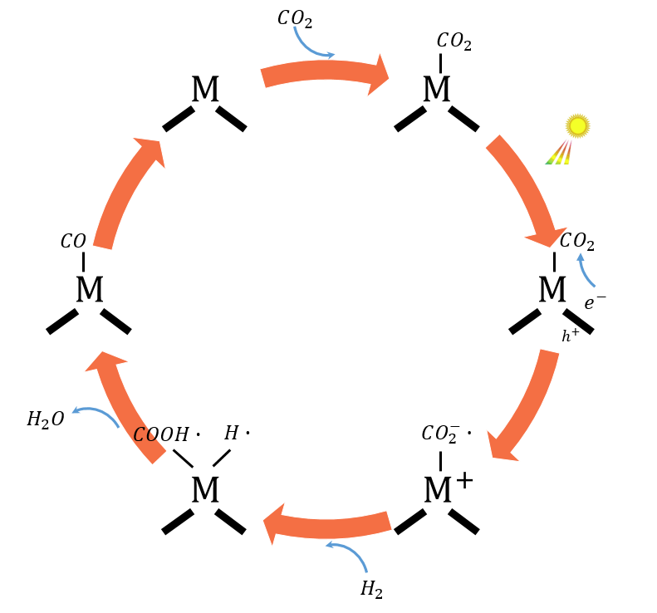
Figure 5.5. Reaction mechanisms proposed to describe CO₂ photoreduction over MOFs

Figure 5.6 shows the calculated reaction coordinate diagram for CO₂ photoreduction over UiO-66. The relative thermal enthalpies for each elementary step in the whole reaction network are shown. It is shown in Figure 5.6 that a band gap of 94.5 kcal/mol (4.1eV) estimated in this work becomes one of the most important barriers that hinder the photocatalytic process. The band gap value is an indication of the energy required for the electrons to be excited, and it has to fall into a semi-conductivity range, between 1 and 3 eV, which corresponds to the visible light range of wavelengths.
In previous works, the energy change related to the transfer of the photo-generated electron form the photoexcited linker orbital to the lowest unoccupied metal orbital (transfer energy) has been identified as another key photocatalyst descriptors.¹⁸² The combination of low-lying unoccupied metal orbitals and high-lying lowest unoccupied linker orbitals endows photocatalytic MOFs with significant potential for enhanced performance.¹⁸¹ Figure 5.6 shows that the LMCT energy of UiO-66-Zr is about 46.2 kcal/mol (2eV). On the other hand, Xing-ping et al.¹⁸¹ reported that by replacing the metal nodes of UiO-66 (Zr) to Ce, a negative transfer energy can be observed which resulting in the absence of an energy barrier for this process and benefit the photocatalytic performance. Therefore, UiO-66-Zr does not usually exhibit remarkable photocatalytic properties. Jianhao et al. reported that by functionalizing Zr-MOFs with Au/UiO-66-NH₂ and Au/UiO-66, significantly enhances their photocatalytic oxidation performance.¹⁸⁸ In this work, to avoid the use of expensive noble metals for MOF functionalization, we employ a high-throughput computational screening approach with the aim of systematically evaluating a large library of conductive MOFs with lower transfer energy and identify the most promising structures for photocatalytic applications.
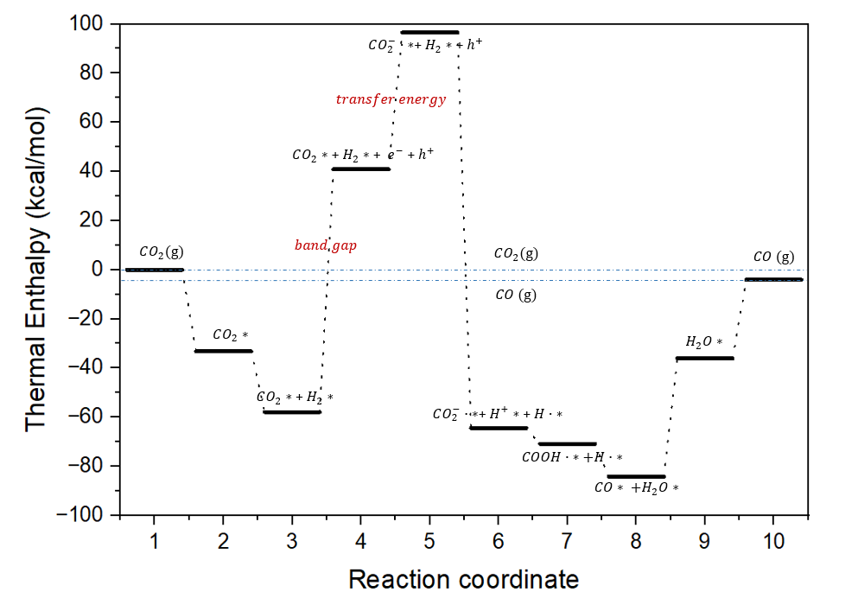
Figure 5.6. Reaction coordinate diagram showing the reaction thermal enthalpies at 298K. (PBE0 6-31G(d,p) and SDD) Black dashed lines show the main reaction pathway, blue dash lines show the thermal enthalpy level of CO₂ and CO in gas phase. $*$ represents the species are adsorbed on the MOFs.

5.3.2 Computational screening of potentially conductive MOFs

This section is a collaborative effort, incorporating selected results from my colleagues to provide a more comprehensive description of the high-throughput screening process.
To efficiently identify the electrically conductive MOFs from the CSD MOF subset, high throughput structural screening was first conducted using ConQuest¹⁸⁹ and CSD Python API¹⁹⁰. In targeting the conductive MOFs, one must first consider the set of most essential features that would guarantee electrical conductivity in the framework. As for any conductive material, a MOF must contain a valid charge transfer (CT) pathway that extends throughout its structure for electrical conductivity to be observed and used for e.g. photocatalytic CO₂ conversion. As such, structural features of MOFs that can comprise the pathways for long-range CT were prioritized over any other identifiers. The first level of screening was designed to search for through-bond CT pathways in the MOFs, and the through-space mode was later considered in the second level of screening. Two distinct structural features were used in constructing the structural descriptors that can warrant through-bond CT: contiguous metal clusters and π-d conjugation. (Figure 5.7) Contiguous metal clusters refer to the metal-linker coordination schemes where the metals do not exist in isolated clusters, but rather in a continuous chain or sheet that extends within the crystal. Such bonding schemes guarantee much closer contact between the metal centers, which therefore secure highly effective CT pathways with larger electron densities. In the absence of the contiguous metal clusters, charge must be carried over an alternative route that traverses through the linker. This is possible for the cases where significant π-d conjugation exists between the metals and linkers, which usually requires the linkers to be composed of conjugated moieties with high degree of electron delocalization. Hence, π-d conjugation was selected as the second structural descriptor.
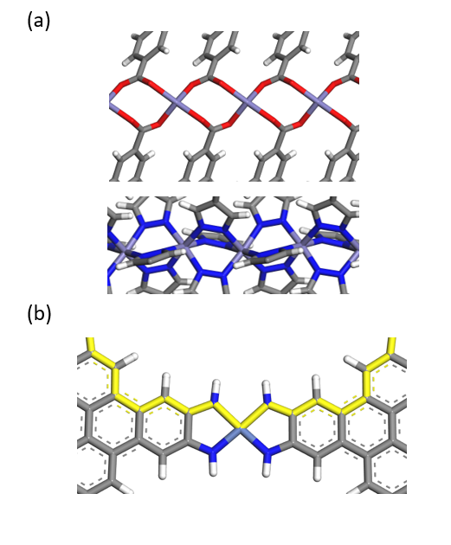
Figure 5.7. Example of (a) contiguous metal clusters and (b) conjugated linkers. Charge-transfer pathways are shown in (a) TONBII (top), Fe₂(bdp)₃ (bdp²⁻ = benzene-1,4-dipyrazolate)¹⁹¹ (bottom), and (b) Ni₃(HITP)₂ (HITP = 2, 3, 6, 7, 10, 11-hexaiminotriphenylene)¹⁹². The atoms involved in charge transport are coloured (purple: Fe, blue: N, grey: C, white: H, red: O, light blue: Ni)

MOFs that satisfy structural screening criteria in the first level were interpreted to potentially contain CT pathways for electrical conductivity. They were then carried over to the second level of screening, which searches for the presence of additional structural features which can further boost the resulting conductivity.
In the second level of screening, various experimental strategies for conductivity enhancement in MOFs were adopted as structural screening criteria (Figure 5.8). Four strategies were considered: softer linkers (“soft” refers to donor atoms with higher polarizability and lower charge density, for example metal-S or metal-N bonds) (Figure 5.8 a)¹⁹³, mixed-valence metals (Figure 5.8 b)¹⁹³, redox-active linkers (Figure 5.8 c)¹⁹⁴, and π-π stacking (Figure 5.8 d) for through-space CT. First, MOFs composed of linkers that bond with S or N as opposed to O are expected to benefit from the improved covalency of metal-ligand bonds, which in turn better promotes CT. In the second case, MOFs that contain Fe, Cr, Ru, Co, or Ni as metal ions are considered, which are metal types that are known to exhibit mixed-valence in a coordination environment.¹⁹³ Upon successful charge doping in MOF systems with these metals, electrical conductivity can be dramatically improved. Next case looks for MOFs built from redox-active linkers, which can improve conductivity by accessing several different resonant forms for efficient CT between metal sites. Lastly, MOFs exhibiting π-π stacking between conjugated, electron-rich moieties of linkers were considered. These MOFs are able to facilitate through-space CT in addition to through-bond CT, which can further supplement the resulting electrical conductivity.
In addition to the four new descriptors introduced, fulfilment of both criteria for through-bond CT in the first level was additionally regarded as a separate second level criterion. In the end, candidate MOFs that pass more than one structural screening criteria from the second level were considered to be final candidate MOFs for further computational analysis.
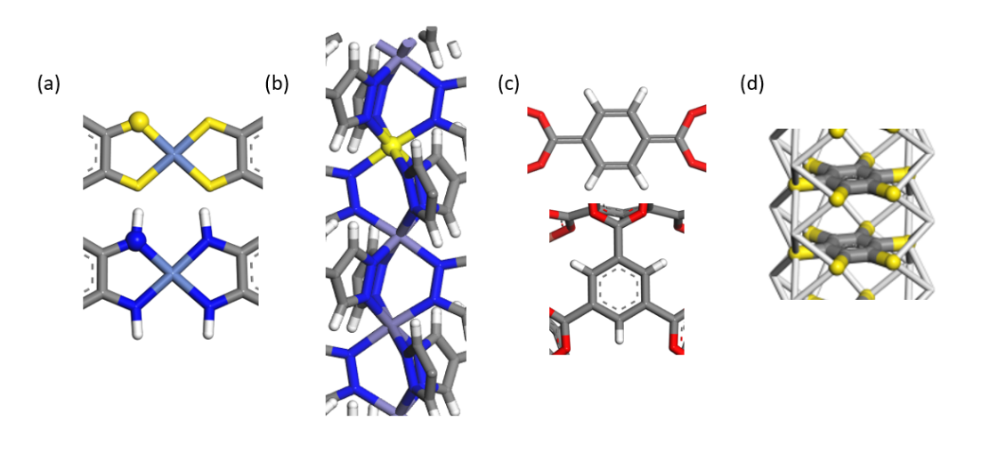
Figure 5.8. Exemplary second screening criteria. The important atoms are highlighted. (a) binding moieties containing S or N, (b) metals with potential for mixed-valence and charge doping, (c) redox-active linkers, and (d) π-π stacking.

Low level band gap calculations (LDA) were applied for the candidates selected from the first level screening, however LDA functional always underestimates the band gap of MOFs. Therefore, higher level band gap calculations (HSE06) are needed to better estimate the performance. In order to proceed to the hybrid functional calculations, it is necessary to establish a conductivity threshold to shorten the candidates list, which can reduce the time consuming of high-throughput DFT calculations. Previous work of the co-worker of this chapter¹⁹⁵ reported that, the DoS at Fermi energy value can provide more information about the material conductivity. A high value of DoS at Fermi energy indicates the availability of free electrons that can be used as charge carriers and could be related to high conductivity. The MOFs with band gap lower than 0.2 eV (LDA) show high DoS at Fermi energy (10 to 100 eln/cell) and the numbers of electrons decrease significantly after 0.2 eV. We therefore consider 0.2 eV (LDA) as the threshold, high level HSE06¹⁹⁶ calculations were applied for those selected MOFs for further analysis.

5.3.3 Screening of MOFs for photocatalytic water splitting and CO₂ reduction

The screening of MOFs for photocatalytic water splitting and CO₂ reduction in this section are based on the previous selected conductive MOFs. Band gap is selected as the first criteria; in order to meet the visible light range, the band gap of the MOF has to fall in the range of 1-3 eV. Due to the intrinsic error associated with DFT calculations, we set up a threshold of 0.5-3.5 eV. The porosity of MOFs is the second criteria. In order to adsorb CO₂ and water, MOFs with pore size larger than 2 Å is desirable. The porosity was indicated by the largest cavity diameter (LCD). LCD calculations were applied under the same level of band gap calculations.
For the CO₂ reduction to take place, the free energy change per electron of the reaction has to match the energy of the excited electron, i.e. the minimum of the conduction band.¹⁹⁷ In this work, the energy levels for CO₂ reduction and water splitting, the band gaps and conduction band edge needed to be compared. However, the DOS calculations were conducted using DFT methods resulting in insignificant and incomparable band gap values. In order to be efficiently compared, these values, have to be put into the same scale of reference, through a process of band alignment. The ionisation potential of an atom represents the energy required to remove an electron and bring it to a condition of vacuum which can be regarded as the energy difference between the HOCO of the MOF and the vacuum level (the maximum of the valence band). For a system with thousands of atoms (such as MOFs), there is no specific method for ionisation potential calculations. Butler et al. developed a method which aims to find the vacuum level for a MOF to be used as a reference to align the bands, exploiting the presence of the pores in the framework.¹⁹⁷ They considered that in periodic MOF systems, the internal pore space provides regions sufficiently far from the atomic cores where the electrostatic potential becomes spatially uniform. The electrostatic potential at the centre of the pore can be used as a reliable approximation to the vacuum reference level for porous MOFs. Following this approach, the planar-averaged electrostatic potential was calculated across the unit cell, and the vacuum level was defined as the plateau value observed in the low-density region within the pore. The valence band maximum (VBM) and conduction band minimum (CBM) were subsequently aligned relative to this reference potential. This results in an aligned band that can be directly compared to the other energies mentioned above. Therefore, band alignment calculations were applied to the selected MOFs.
Figure 5.9 illustrates the third criterion used in our screening process, with six typical MOFs presented as an example. To be considered for CO₂ reduction in this work, the MOFs must have a conduction band edge higher than the reduction potential of CO₂ (indicated by the yellow bar), which varies depending on the specific reduction product. For water splitting, both the HER (hydrogen evolution reaction) and OER (oxygen evolution reaction) potentials must lie within the band gap.¹⁹⁸ As shown in Figure 5.9, all the MOFs presented meet these requirements, demonstrating potential for CO₂ reduction, as well as favourable band alignment (TONBII) for both CO₂ reduction and water splitting.
Table 5.4 presents the final results of our screening for promising MOFs suitable for CO₂ reduction and water splitting. Among them, PAHWAX, PEVZAT, FUVYUR, BURHAZ, CISMIC, QOSYED and UJAYOT exhibit potential for CO₂ reduction. In contrast, TONBII, UZAVOH, XIQPIW, FUQJOS, UJAYIN and GIDCEB meet the criteria for both CO₂ reduction and water splitting, making them particularly promising for dual-function photocatalysis.
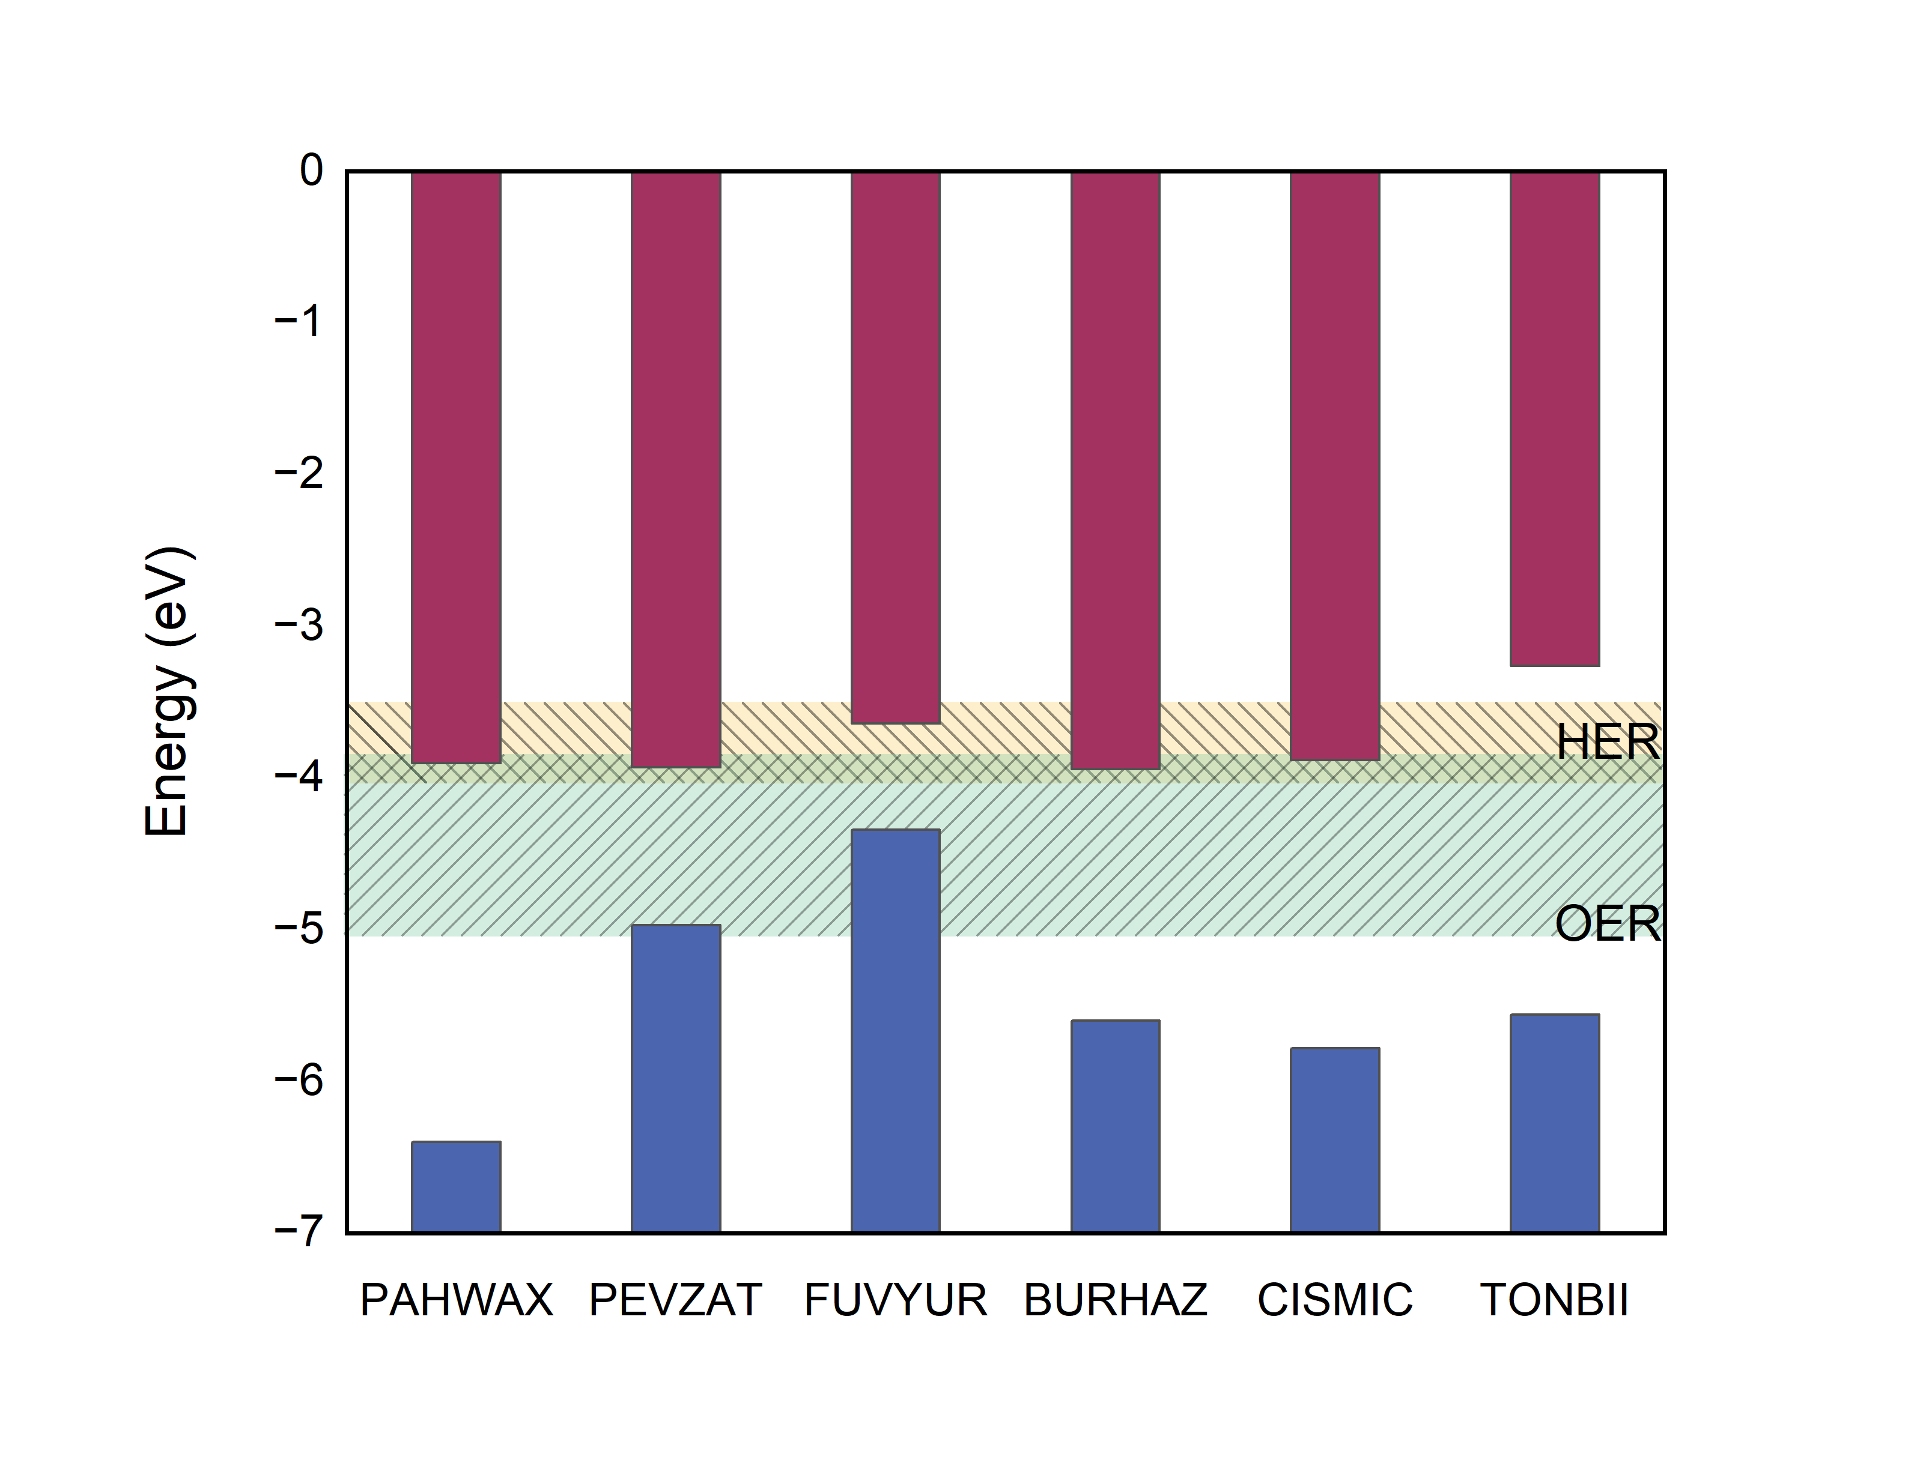
Figure 5.9. Selection criteria based on VBM (valence band maximum) and CBM (conduction band minimum). Red bar: conduction bands, Blue bar: valence band. The HOCO and LUCO are for the whole structure. The top and bottom lines of green region represent energy levels corresponding to redox potentials for water splitting, and the yellow region covers the energy levels of different CO₂ reduction. (CO, CH₄, CH₃OH, HCHO, HCOOH, C₂H4, C₂H₅OH¹⁹⁹)

Table 5.4. Screened promising MOFs for CO₂ reduction and water splitting with calculated parameters
MOF (refcode) | Band gap (eV) | Aligned CBM (LUMO) (eV) | Aligned VBM (HOMO) (eV) | LCD (Å) | CO₂ Reduction | Water Splitting
TONBII | 2.33 | -3.26 | -5.59 | 4.87 | √ | √
UZAVOH | 3.01 | -3.54 | -6.56 | 2.53 | √ | √
XIQPIW | 2.18 | -2.97 | -5.15 | 3.84 | √ | √
FUQJOS | 2.69 | -3.13 | -5.82 | 3.85 | √ | √
UJAYIN | 2.92 | -2.42 | -5.34 | 3.83 | √ | √
GIDCEB | 3.15 | -2.30 | -5.45 | 3.66 | √ | √
PAHWAX | 2.56 | -3.90 | -6.47 | 2.13 | √ | ×
PEVZAT | 1.04 | -3.93 | -4.96 | 3.95 | √ | ×
FUVYUR | 0.71 | -3.64 | -4.35 | 3.51 | √ | ×
BURHAZ | 1.66 | -3.94 | -5.61 | 4.20 | √ | ×
CISMIC | 1.99 | -3.88 | -5.87 | 3.36 | √ | ×
QOSYED | 3.44 | -2.04 | -5.47 | 5.63 | √ | ×
UJAYOT | 2.81 | -2.22 | -5.03 | 3.89 | √ | ×

5.4 Conclusion

In this work, we simulated the photocatalytic process of UiO-66 as an exemplary MOF. We found that UiO-66 is not suitable to be used as photocatalysts because of the large band gap and transfer energy. A desirable photocatalyst MOF need to have a band gap between 1 to 3 eV with low transfer energy. Conductive MOFs are a series MOFs with valid charge transfer pathway which can result in lower transfer energy during photocatalytic process. Therefore we created an automated algorithms which dive into the CSD MOF subset to quickly identify promising MOFs. TONBII, UZAVOH, XIQPIW, FUQJOS, UJAYIN and GIDCEB have great potential to be used as photocatalysts for CO₂ reduction and water splitting.

6 Conclusion and Future Developments

In this thesis, we implemented a systematic computational approach for evaluating, characterizing, and screening molecules and materials for different sustainable applications. The construction of chemical models (cluster or periodic) to characterize the investigated system is the first step of the approach proposed in this work. The analysis of the possible configurations of the systems is critical in order to identify the most stable model with minimum energy during optimization. After the model construction, it is essential to design and implement appropriate computational methods to evaluate the target properties of the investigated molecules or materials. In Chapter 4, we investigated the potential use of amino-functionalized molecules to engineer the adsorption performance of porous materials. Specifically, we calculated and compared the binding energy of these molecules with respect to CO₂ under humid and dry conditions. In Chapter 3, we simulated the reaction path of the acid-catalysed dehydration of VG and cation scavenging process by combining geometry optimization, binding energy and transition state calculations. In Chapter 5, we simulated the photocatalytic CO₂ hydrogenation reaction by combing adsorption, optimisation, band gap, band alignment and desorption calculations. After comparing the desired properties, further detailed analysis is need for explaining the performance difference. (IRI etc.) The summary and analysis of how the best performing candidates benefit to the desired properties can be further used for materials design and prediction. Then, the computational result can be compared with experimental results (Chapter 3) as a validation. Finally, the determined properties lead to better performance for specific aim can be used for further functionalization or high-throughput screening.
The following section breaks down the conclusion for each chapter and future directions.

6.1 In silico evaluation of naphthoic acids as scavengers for suppressing Lignin Repolymerisation

In Chapter 3, we provide a comprehensive analysis of potential scavengers for lignin repolymerisation suppression. We characterised and simulated the cation scavenging process of different naphthoic acid isomers with the goal of identifying the most promising candidates for lignin repolymerisation suppression. OW Fukui function calculation shows that 3-hydroxy-2-naphthoic acid exhibits the most nucleophilic carbon active site among all selected scavengers. The reaction coordinate diagrams show that the deprotonation reaction of the lignin-scavenger carbocation complex is characterized by a minimal energy barrier. Therefore the binding energy difference between lignin and scavenger is the critical descriptor to assess the performance of the scavenger. Consistent with the trend of Fukui function result, 3-hydroxy-2-naphthoic acid exhibits the strongest binding energy with ${lignin}^{+}$ (-16.8 kJ/mol), indicating its potential as an effective cation scavenger for suppressing lignin repolymerisation.
In future work, we plan to extend this approach to a broader range of naphthol derivatives with selective nucleophilic active sites. The candidates exhibiting the strongest binding with ${lignin}^{+}$ will be recommended to our colleagues from Zurich University of Applied Sciences for further experimental validation. In addition to binding energy and selective nucleophilic active sites, our current study also suggests that the interaction angle between the scavengers and ${lignin}^{+}$ may influence performance. To further investigate this trend, we aim to evaluate a representative set of molecules exhibiting different interacting angles.

6.2 Computational Screening of Amino-Functionalized Molecules for Direct Air Capture of CO₂

In Chapter 4, we computationally screened different amino-functionalized molecules that can be incorporated into host materials such as MOFs for DAC of CO₂. We evaluated the binding energies and thermal enthalpies of adsorption for water and CO₂ with 15 amino-functionalized molecules with the goal of identifying promising candidates for DAC under both dry and humid conditions. Our results show that 7-Azaindole, TBD, melamine and Arg could be used for DAC materials functionalization.
In future work, we plan to functionalize MOFs (MOF-808 etc.) with the promising identified functional molecules including 7-Azaindole, TBD, melamine and Arg. Those functional molecules will be introduced in the MOF either by functionalizing the organic linkers or by coordinating with the metal cluster of existing MOFs, aiming to achieve pore environment with dimensions closely aligned to our target distances. Following functionalization, periodic DFT calculations will be performed on the constructed MOFs. Binding energy with CO₂ and water within the periodic framework will provide a more realistic assessment of the material adsorption performance. In addition, partial charges distributions will be computed using both repeat and DDEC methods. These data will be then be used to inform Grand Canonical Monte Carlo (GCMC) simulations to further predict and evaluate gas adsorption behaviour.

6.2 High-throughput Computational Screening of MOFs for Photocatalytic Water Splitting & Carbon Dioxide Conversion

In Chapter 5, we investigated the photocatalytic reduction of CO₂ over a model MOF (defective UiO-66), and identified band gap and charge transfer energy as key properties influencing photocatalytic performance. Building on these insights, we developed an automated algorithm to screen the CSD MOF subset based on band gap, band alignment, and largest cavity diameter parameters. As a result, MOF such as PAHWAX, PEVZAT, FUVYUR, BURHAZ, CISMIC, QOSYED and UJAYOT were identified as promising candidates for CO₂ reduction. Additionally, TONBII, UZAVOH, XIQPIW, FUQJOS, UJAYIN and GIDCEB exhibited characteristics that suggest potential for application as CO₂ reduction and water splitting photocatalysts.
In future work, we plan to conduct DFT calculations to predict the electronic properties of the most promising MOFs identified in the screening process. DFT calculations will be used to estimate the activation barrier for CO₂ and H₂O dissociation over the MOF active sites, as well as to determine the adsorption energies of key intermediates and transition states. Based on these insights, a general microkinetic model will be developed to describe the kinetics of the photocatalytic assisted CO₂ and water conversion to fuel-range hydrocarbons. The estimation of the kinetic parameters governing the process will be supported by first-principles studies. Transition state scaling relations will be introduced to calculate the reaction rates of the elementary steps included in the network based on a limited number of kinetic parameters that can be theoretically computed via DFT. Once validated against experimental data, the kinetic model will be extended to evaluate the full set of screened MOFs.

References
(1) Curtarolo, S.; Hart, G. L.; Nardelli, M. B.; Mingo, N.; Sanvito, S.; Levy, O. The high-throughput highway to computational materials design. Nature materials 2013, 12 (3), 191-201.
(2) Sharma, V.; Wang, C.; Lorenzini, R. G.; Ma, R.; Zhu, Q.; Sinkovits, D. W.; Pilania, G.; Oganov, A. R.; Kumar, S.; Sotzing, G. A. Rational design of all organic polymer dielectrics. Nature communications 2014, 5 (1), 4845.
(3) Ceder, G.; Hautier, G.; Jain, A.; Ong, S. P. Recharging lithium battery research with first-principles methods. Mrs Bulletin 2011, 36, 185-191.
(4) Schleder, G. R.; Padilha, A. C.; Acosta, C. M.; Costa, M.; Fazzio, A. From DFT to machine learning: recent approaches to materials science–a review. Journal of Physics: Materials 2019, 2 (3), 032001.
(5) Deringer, V. L.; Caro, M. A.; Csányi, G. Machine learning interatomic potentials as emerging tools for materials science. Advanced Materials 2019, 31 (46), 1902765.
(6) Cheng, X.-Y.; Chen, X.-Q.; Li, D.-Z.; Li, Y.-Y. Computational materials discovery: the case of the W–B system. Crystal Structure Communications 2014, 70 (2), 85-103.
(7) Watanabe, T.; Sholl, D. S. Accelerating applications of metal–organic frameworks for gas adsorption and separation by computational screening of materials. Langmuir 2012, 28 (40), 14114-14128.
(8) Meng, X.; Yun, N.; Zhang, Z. Recent advances in computational photocatalysis: A review. The Canadian Journal of Chemical Engineering 2019, 97 (7), 1982-1998.
(9) Li, Q.; Yang, X.; Dong, W.; Du, Y. Kinetic Monte Carlo modeling of heterogeneous catalysis on silica thermal protective materials based on reactive molecular dynamics simulation. International Journal of Heat and Mass Transfer 2025, 236, 126378.
(10) Li, Q.; Ouyang, Y.; Lu, S.; Bai, X.; Zhang, Y.; Shi, L.; Ling, C.; Wang, J. Perspective on theoretical methods and modeling relating to electro-catalysis processes. Chemical Communications 2020, 56 (69), 9937-9949.
(11) Slater, G. W.; Holm, C.; Chubynsky, M. V.; de Haan, H. W.; Dubé, A.; Grass, K.; Hickey, O. A.; Kingsburry, C.; Sean, D.; Shendruk, T. N. Modeling the separation of macromolecules: A review of current computer simulation methods. Electrophoresis 2009, 30 (5), 792-818.
(12) Basdogan, Y.; Keskin, S. Simulation and modelling of MOFs for hydrogen storage. CrystEngComm 2015, 17 (2), 261-275.
(13) Wang, L.-W. Novel computational methods for nanostructure electronic structure calculations. Annual review of physical chemistry 2010, 61 (1), 19-39.
(14) Van Speybroeck, V.; Gani, R.; Meier, R. J. The calculation of thermodynamic properties of molecules. Chemical Society Reviews 2010, 39 (5), 1764-1779.
(15) Sizochenko, N.; Syzochenko, M.; Gajewicz, A.; Leszczynski, J.; Puzyn, T. Predicting physical properties of nanofluids by computational modeling. The Journal of Physical Chemistry C 2017, 121 (3), 1910-1917.
(16) Li, B.; Dong, X.; Wang, H.; Ma, D.; Tan, K.; Jensen, S.; Deibert, B. J.; Butler, J.; Cure, J.; Shi, Z. Capture of organic iodides from nuclear waste by metal-organic framework-based molecular traps. Nature communications 2017, 8 (1), 485.
(17) Yuan, S.; Feng, L.; Wang, K.; Pang, J.; Bosch, M.; Lollar, C.; Sun, Y.; Qin, J.; Yang, X.; Zhang, P. Stable Metal–Organic Frameworks: Stable Metal–Organic Frameworks: Design, Synthesis, and Applications (Adv. Mater. 37/2018). Advanced Materials 2018, 30 (37), 1870277.
(18) Xu, H.; Cai, J.; Xiang, S.; Zhang, Z.; Wu, C.; Rao, X.; Cui, Y.; Yang, Y.; Krishna, R.; Chen, B. A cationic microporous metal–organic framework for highly selective separation of small hydrocarbons at room temperature. Journal of Materials Chemistry A 2013, 1 (34), 9916-9921.
(19) Cavka, J. H.; Jakobsen, S.; Olsbye, U.; Guillou, N.; Lamberti, C.; Bordiga, S.; Lillerud, K. P. A new zirconium inorganic building brick forming metal organic frameworks with exceptional stability. Journal of the American Chemical Society 2008, 130 (42), 13850-13851.
(20) Li, H.; Eddaoudi, M.; O'Keeffe, M.; Yaghi, O. M. Design and synthesis of an exceptionally stable and highly porous metal-organic framework. nature 1999, 402 (6759), 276-279.
(21) Chui, S. S.-Y.; Lo, S. M.-F.; Charmant, J. P.; Orpen, A. G.; Williams, I. D. A chemically functionalizable nanoporous material [Cu3 (TMA) 2 (H2O) 3] n. Science 1999, 283 (5405), 1148-1150.
(22) Park, K. S.; Ni, Z.; Côté, A. P.; Choi, J. Y.; Huang, R.; Uribe-Romo, F. J.; Chae, H. K.; O’Keeffe, M.; Yaghi, O. M. Exceptional chemical and thermal stability of zeolitic imidazolate frameworks. Proceedings of the National Academy of Sciences 2006, 103 (27), 10186-10191.
(23) Phan, A.; Doonan, C. J.; Uribe-Romo, F. J.; Knobler, C. B.; O’keeffe, M.; Yaghi, O. M. Synthesis, structure, and carbon dioxide capture properties of zeolitic imidazolate frameworks. Accounts of chemical research 2009, 43 (1).
(24) Burtch, N. C.; Jasuja, H.; Walton, K. S. Water stability and adsorption in metal–organic frameworks. Chemical reviews 2014, 114 (20), 10575-10612.
(25) Seidi, F.; Jenjob, R.; Crespy, D. Designing smart polymer conjugates for controlled release of payloads. Chemical reviews 2018, 118 (7), 3965-4036.
(26) Adil, K.; Belmabkhout, Y.; Pillai, R. S.; Cadiau, A.; Bhatt, P. M.; Assen, A. H.; Maurin, G.; Eddaoudi, M. Gas/vapour separation using ultra-microporous metal–organic frameworks: insights into the structure/separation relationship. Chemical Society Reviews 2017, 46 (11), 3402-3430.
(27) Cui, Y.; Li, B.; He, H.; Zhou, W.; Chen, B.; Qian, G. Metal–organic frameworks as platforms for functional materials. Accounts of chemical research 2016, 49 (3), 483-493.
(28) Wang, P.; Chen, K.; Liu, Q.; Wang, H.-W.; Azam, M.; Al-Resayes, S. I.; Lu, Y.; Sun, W.-Y. Fine tuning of catalytic and sorption properties of metal–organic frameworks via in situ ligand exchange. Dalton Transactions 2017, 46 (34), 11425-11430.
(29) Dong, J.; Zhao, D.; Lu, Y.; Sun, W.-Y. Photoluminescent metal–organic frameworks and their application for sensing biomolecules. Journal of materials chemistry A 2019, 7 (40), 22744-22767.
(30) Kreno, L. E.; Leong, K.; Farha, O. K.; Allendorf, M.; Van Duyne, R. P.; Hupp, J. T. Metal–organic framework materials as chemical sensors. Chemical reviews 2012, 112 (2), 1105-1125.
(31) Schneemann, A.; Bon, V.; Schwedler, I.; Senkovska, I.; Kaskel, S.; Fischer, R. A. Flexible metal–organic frameworks. Chemical Society Reviews 2014, 43 (16), 6062-6096.
(32) Cohen, S. M. Postsynthetic methods for the functionalization of metal–organic frameworks. Chemical reviews 2012, 112 (2), 970-1000.
(33) Sumida, K.; Rogow, D. L.; Mason, J. A.; McDonald, T. M.; Bloch, E. D.; Herm, Z. R.; Bae, T.-H.; Long, J. R. Carbon dioxide capture in metal–organic frameworks. Chemical reviews 2012, 112 (2), 724-781.
(34) Wang, C.; Liu, D.; Lin, W. Metal–organic frameworks as a tunable platform for designing functional molecular materials. Journal of the American Chemical Society 2013, 135 (36), 13222-13234.
(35) Deria, P.; Mondloch, J. E.; Karagiaridi, O.; Bury, W.; Hupp, J. T.; Farha, O. K. Beyond post-synthesis modification: evolution of metal–organic frameworks via building block replacement. Chemical Society Reviews 2014, 43 (16), 5896-5912.
(36) Kaye, S. S.; Dailly, A.; Yaghi, O. M.; Long, J. R. Impact of preparation and handling on the hydrogen storage properties of Zn4O (1, 4-benzenedicarboxylate) 3 (MOF-5). Journal of the American Chemical Society 2007, 129 (46), 14176-14177.
(37) Chae, H. K.; Siberio-Pérez, D. Y.; Kim, J.; Go, Y.; Eddaoudi, M.; Matzger, A. J.; O'keeffe, M.; Yaghi, O. M.; Design, M.; Group, D. A route to high surface area, porosity and inclusion of large molecules in crystals. Nature 2004, 427 (6974), 523-527.
(38) Furukawa, H.; Ko, N.; Go, Y. B.; Aratani, N.; Choi, S. B.; Choi, E.; Yazaydin, A. Ö.; Snurr, R. Q.; O’Keeffe, M.; Kim, J. Ultrahigh porosity in metal-organic frameworks. Science 2010, 329 (5990), 424-428.
(39) Hong, D. Y.; Hwang, Y. K.; Serre, C.; Férey, G.; Chang, J. S. Porous chromium terephthalate MIL‐101 with coordinatively unsaturated sites: surface functionalization, encapsulation, sorption and catalysis. Advanced Functional Materials 2009, 19 (10), 1537-1552.
(40) Horcajada, P.; Serre, C.; Maurin, G.; Ramsahye, N. A.; Balas, F.; Vallet-Regí, M.; Sebban, M.; Taulelle, F.; Férey, G. Flexible porous metal-organic frameworks for a controlled drug delivery. Journal of the American Chemical Society 2008, 130 (21), 6774-6780.
(41) Lee, G.; Jhung, S. H. CO2 capture using functionalized MIL-101 (Cr) metal–organic frameworks: Functionality nanoarchitectonics of nanospace for CO2 adsorption. Separation and Purification Technology 2025, 354, 129514.
(42) Valenzano, L.; Civalleri, B.; Chavan, S.; Bordiga, S.; Nilsen, M. H.; Jakobsen, S.; Lillerud, K. P.; Lamberti, C. Disclosing the complex structure of UiO-66 metal organic framework: a synergic combination of experiment and theory. Chemistry of Materials 2011, 23 (7), 1700-1718.
(43) Shearer, G. C.; Chavan, S.; Bordiga, S.; Svelle, S.; Olsbye, U.; Lillerud, K. P. Defect engineering: tuning the porosity and composition of the metal–organic framework UiO-66 via modulated synthesis. Chemistry of Materials 2016, 28 (11), 3749-3761.
(44) Fonseca, J.; Gong, T.; Jiao, L.; Jiang, H.-L. Metal–organic frameworks (MOFs) beyond crystallinity: amorphous MOFs, MOF liquids and MOF glasses. Journal of Materials Chemistry A 2021, 9 (17), 10562-10611.
(45) Mesgarian, R.; Heydarinasab, A.; Rashidi, A.; Zamani, Y. Adsorption and growth of water clusters on UiO-66 based nanoadsorbents: A systematic and comparative study on dehydration of natural gas. Separation and Purification Technology 2020, 239, 116512.
(46) Sun, W.; Li, H.; Li, H.; Li, S.; Cao, X. Adsorption mechanisms of ibuprofen and naproxen to UiO-66 and UiO-66-NH2: Batch experiment and DFT calculation. Chemical Engineering Journal 2019, 360, 645-653.
(47) Wang, Y.; Zhang, S.; Zhao, Y.; Bedia, J.; Rodriguez, J.; Belver, C. UiO-66-based metal organic frameworks for the photodegradation of acetaminophen under simulated solar irradiation. Journal of Environmental Chemical Engineering 2021, 9 (5), 106087.
(48) Torbina, V. V.; Salaev, M. A.; Paukshtis, E. A.; Liotta, L. F.; Vodyankina, O. V. Effect of linker substituent nature on performance of active sites in UiO-66: Combined FT-IR and DFT study. International Journal of Molecular Sciences 2023, 24 (19), 14893.
(49) Obot, I.; Macdonald, D.; Gasem, Z. Density functional theory (DFT) as a powerful tool for designing new organic corrosion inhibitors. Part 1: an overview. Corrosion Science 2015, 99, 1-30.
(50) Cai, S.; Yu, L.; Huo, E.; Ren, Y.; Liu, X.; Chen, Y. Adsorption and Diffusion Properties of Functionalized MOFs for CO(2) Capture: A Combination of Molecular Dynamics Simulation and Density Functional Theory Calculation. Langmuir 2024, 40 (13), 6869-6877. DOI: 10.1021/acs.langmuir.3c03782 From NLM PubMed-not-MEDLINE.
(51) Gaeta, G. Perturbation theory. Encyclopedia of Complexity and Systems Science 2009, 6625-6639.
(52) Hoggan, P. E. Novel electronic structure theory: general innovations and strongly correlated systems; Academic Press, 2018.
(53) Nagy, Á. Density functional. Theory and application to atoms and molecules. Physics Reports 1998, 298 (1), 1-79.
(54) Giese, T. J.; York, D. M. Density-functional expansion methods: Evaluation of LDA, GGA, and meta-GGA functionals and different integral approximations. The Journal of chemical physics 2010, 133 (24).
(55) Lee, C.; Yang, W.; Parr, R. G. Development of the Colle-Salvetti correlation-energy formula into a functional of the electron density. Physical review B 1988, 37 (2), 785.
(56) Kurth, S.; Perdew, J. P.; Blaha, P. Molecular and solid‐state tests of density functional approximations: LSD, GGAs, and meta‐GGAs. International journal of quantum chemistry 1999, 75 (4‐5), 889-909.
(57) Chen, J.; Fan, X.; Zhang, L.; Chen, X.; Sun, S.; Sun, R. C. Research Progress in Lignin-Based Slow/Controlled Release Fertilizer. ChemSusChem 2020, 13 (17), 4356-4366. DOI: 10.1002/cssc.202000455 From NLM PubMed-not-MEDLINE.
(58) Becke, A. D. Density‐functional thermochemistry. III. The role of exact exchange. The Journal of chemical physics 1993, 98 (7), 5648-5652.
(59) Adamo, C.; Barone, V. Toward reliable density functional methods without adjustable parameters: The PBE0 model. The Journal of chemical physics 1999, 110 (13), 6158-6170.
(60) Mardirossian, N.; Head-Gordon, M. ωB97X-V: A 10-parameter, range-separated hybrid, generalized gradient approximation density functional with nonlocal correlation, designed by a survival-of-the-fittest strategy. Physical Chemistry Chemical Physics 2014, 16 (21), 9904-9924.
(61) Helgaker, T.; Jorgensen, P.; Olsen, J. Molecular electronic-structure theory; John Wiley & Sons, 2013.
(62) Parr, R. G. Density functional theory of atoms and molecules. In Horizons of Quantum Chemistry: Proceedings of the Third International Congress of Quantum Chemistry Held at Kyoto, Japan, October 29-November 3, 1979, 1989; Springer: pp 5-15.
(63) Zhao, Y.; Truhlar, D. G. The M06 suite of density functionals for main group thermochemistry, thermochemical kinetics, noncovalent interactions, excited states, and transition elements: two new functionals and systematic testing of four M06-class functionals and 12 other functionals. Theoretical Chemistry Accounts 2007, 120 (1-3), 215-241. DOI: 10.1007/s00214-007-0310-x.
(64) Utkov, H. E.; Price, A. M.; Cafiero, M. MP2, density functional theory, and semi-empirical calculations of the interaction energies between a series of statin-drug-like molecules and the HMG-CoA reductase active site. Computational and Theoretical Chemistry 2011, 967 (1), 171-178. DOI: 10.1016/j.comptc.2011.04.013.
(65) Boys, S. F.; Bernardi, F. The calculation of small molecular interactions by the differences of separate total energies. Some procedures with reduced errors. Molecular physics 1970, 19 (4), 553-566.
(66) Poland, D. Statistical Mechanics (McQuarrie, Donald A.). ACS Publications: 1977.
(67) Ayers, P. W.; Parr, R. G. Variational principles for describing chemical reactions: the Fukui function and chemical hardness revisited. Journal of the American Chemical Society 2000, 122 (9), 2010-2018.
(68) Lu, T.; Chen, Q. Interaction region indicator: a simple real space function clearly revealing both chemical bonds and weak interactions. Chemistry‐Methods 2021, 1 (5), 231-239.
(69) Marenich, A. V.; Cramer, C. J.; Truhlar, D. G. Universal solvation model based on solute electron density and on a continuum model of the solvent defined by the bulk dielectric constant and atomic surface tensions. The Journal of Physical Chemistry B 2009, 113 (18), 6378-6396.
(70) Fukui, K. The path of chemical reactions-the IRC approach. Accounts of chemical research 1981, 14 (12), 363-368.
(71) Wu, Y.; Ge, S.; Xia, C.; Mei, C.; Kim, K.-H.; Cai, L.; Smith, L. M.; Lee, J.; Shi, S. Q. Application of intermittent ball milling to enzymatic hydrolysis for efficient conversion of lignocellulosic biomass into glucose. Renewable and Sustainable Energy Reviews 2021, 136. DOI: 10.1016/j.rser.2020.110442.
(72) Ge, S.; Foong, S. Y.; Ma, N. L.; Liew, R. K.; Wan Mahari, W. A.; Xia, C.; Yek, P. N. Y.; Peng, W.; Nam, W. L.; Lim, X. Y.; et al. Vacuum pyrolysis incorporating microwave heating and base mixture modification: An integrated approach to transform biowaste into eco-friendly bioenergy products. Renewable and Sustainable Energy Reviews 2020, 127. DOI: 10.1016/j.rser.2020.109871.
(73) Yang, R.; Cao, Q.; Liang, Y.; Hong, S.; Xia, C.; Wu, Y.; Li, J.; Cai, L.; Sonne, C.; Le, Q. V.; et al. High capacity oil absorbent wood prepared through eco-friendly deep eutectic solvent delignification. Chemical Engineering Journal 2020, 401. DOI: 10.1016/j.cej.2020.126150.
(74) Li, H.; Liang, Y.; Li, P.; He, C. Conversion of biomass lignin to high-value polyurethane: A review. Journal of Bioresources and Bioproducts 2020, 5 (3), 163-179. DOI: 10.1016/j.jobab.2020.07.002.
(75) Tian, S.-Q.; Zhao, R.-Y.; Chen, Z.-C. Review of the pretreatment and bioconversion of lignocellulosic biomass from wheat straw materials. Renewable and Sustainable Energy Reviews 2018, 91, 483-489.
(76) Broda, M.; Yelle, D. J.; Serwanska, K. Bioethanol Production from Lignocellulosic Biomass-Challenges and Solutions. Molecules 2022, 27 (24). DOI: 10.3390/molecules27248717 From NLM Medline.
(77) Brethauer, S.; Studer, M. H. Biochemical Conversion Processes of Lignocellulosic Biomass to Fuels and Chemicals - A Review. Chimia (Aarau) 2015, 69 (10), 572-581. DOI: 10.2533/chimia.2015.572 From NLM Medline.
(78) Yuan, Y.; Jiang, B.; Chen, H.; Wu, W.; Wu, S.; Jin, Y.; Xiao, H. Recent advances in understanding the effects of lignin structural characteristics on enzymatic hydrolysis. Biotechnol Biofuels 2021, 14 (1), 205. DOI: 10.1186/s13068-021-02054-1 From NLM PubMed-not-MEDLINE.
(79) Solarte-Toro, J. C.; Romero-García, J. M.; Martínez-Patiño, J. C.; Ruiz-Ramos, E.; Castro-Galiano, E.; Cardona-Alzate, C. A. Acid pretreatment of lignocellulosic biomass for energy vectors production: A review focused on operational conditions and techno-economic assessment for bioethanol production. Renewable and Sustainable Energy Reviews 2019, 107, 587-601. DOI: 10.1016/j.rser.2019.02.024.
(80) Lundquist, K.; Lundgren, R.; Danielsen, J.; Haaland, A.; Svensson, S. Acid degradation of lignin. Acta Chem Scand 1972, 26, 2005-2023.
(81) Sarkanen, K. V.; Ludwig, C. H. Lignins: occurrence, formation, structure and reactions. 1971.
(82) Lora, J. H.; Wayman, M. Delignification of hardwoods by autohydrolysis and extraction. Tappi;(United States) 1978, 61 (6).
(83) Pielhop, T. Suppression of Lignin Repolymerisation to Enhance Cellulose Bioconversion and Lignin Valorisation - A Review. Chimia (Aarau) 2023, 77 (6), 403-416. DOI: 10.2533/chimia.2023.403 From NLM PubMed-not-MEDLINE.
(84) Li, J.; Gellerstedt, G. Improved lignin properties and reactivity by modifications in the autohydrolysis process of aspen wood. Industrial Crops and Products 2008, 27 (2), 175-181.
(85) Pielhop, T.; Larrazábal, G. O.; Rudolf von Rohr, P. Autohydrolysis pretreatment of softwood – enhancement by phenolic additives and the effects of other compounds. Green Chemistry 2016, 18 (19), 5239-5247. DOI: 10.1039/c6gc01447j.
(86) Zhai, R.; Hu, J.; Saddler, J. N. Minimizing cellulase inhibition of whole slurry biomass hydrolysis through the addition of carbocation scavengers during acid-catalyzed pretreatment. Bioresource Technology 2018, 258, 12-17.
(87) Lai, C.; Yang, B.; He, J.; Huang, C.; Li, X.; Song, X.; Yong, Q. Enhanced enzymatic digestibility of mixed wood sawdust by lignin modification with naphthol derivatives during dilute acid pretreatment. Bioresource technology 2018, 269, 18-24.
(88) Wayman, M.; Lora, J. H. Simulated autohydrolysis of aspen milled wood lignin in the presence of aromatic additives: Structural modifications. Journal of Applied Polymer Science 1980, 25 (10), 2187-2194.
(89) Pielhop, T.; Larrazábal, G. O.; Studer, M. H.; Brethauer, S.; Seidel, C.-M.; Rudolf von Rohr, P. Lignin repolymerisation in spruce autohydrolysis pretreatment increases cellulase deactivation. Green Chemistry 2015, 17 (6), 3521-3532. DOI: 10.1039/c4gc02381a.
(90) Sheng, Y.; Liu, M.; Xia, C.; Song, J.; Ge, S.; Cai, L.; Lam, S. S.; Sonne, C. Using nucleophilic naphthol derivatives to suppress biomass lignin repolymerization in fermentable sugar production. Chemical Engineering Journal 2021, 420. DOI: 10.1016/j.cej.2021.130258.
(91) Boerjan, W.; Ralph, J.; Baucher, M. Lignin biosynthesis. Annual review of plant biology 2003, 54 (1), 519-546.
(92) Ralph, J.; Lapierre, C.; Boerjan, W. Lignin structure and its engineering. Current opinion in biotechnology 2019, 56, 240-249.
(93) Li, C.; Zhao, X.; Wang, A.; Huber, G. W.; Zhang, T. Catalytic transformation of lignin for the production of chemicals and fuels. Chemical reviews 2015, 115 (21), 11559-11624.
(94) Mu, X.; Han, Z.; Liu, C.; Zhang, D. Mechanistic Insights into Formaldehyde-Blocked Lignin Condensation: A DFT Study. The Journal of Physical Chemistry C 2019, 123 (14), 8640-8648. DOI: 10.1021/acs.jpcc.9b00247.
(95) Gaussian 16 Rev. C.01; Wallingford, CT, 2016. (accessed.
(96) Tirado-Rives, J.; Jorgensen, W. L. Performance of B3LYP density functional methods for a large set of organic molecules. Journal of chemical theory and computation 2008, 4 (2), 297-306.
(97) <Performance of B3LYP Density Functional Methods for aLarge Set of Organic Molecules.pdf>.
(98) Pino-Rios, R.; Inostroza, D.; Cardenas-Jiron, G.; Tiznado, W. Orbital-Weighted Dual Descriptor for the Study of Local Reactivity of Systems with (Quasi-) Degenerate States. J Phys Chem A 2019, 123 (49), 10556-10562. DOI: 10.1021/acs.jpca.9b07516 From NLM PubMed-not-MEDLINE.
(99) IEA. CO2 Emissions in 2022. 2023. (accessed 2025.
(100) Carbon capture and storage (CCS): the way forward.
(101) Tan, Y.; Nookuea, W.; Li, H.; Thorin, E.; Yan, J. Cryogenic technology for biogas upgrading combined with carbon capture-a review of systems and property impacts. Energy Procedia 2017, 142, 3741-3746.
(102) Sanz-Perez, E. S.; Murdock, C. R.; Didas, S. A.; Jones, C. W. Direct Capture of CO(2) from Ambient Air. Chem Rev 2016, 116 (19), 11840-11876. DOI: 10.1021/acs.chemrev.6b00173 From NLM Medline.
(103) Realff, M. J.; Eisenberger, P. Flawed analysis of the possibility of air capture. Proc Natl Acad Sci U S A 2012, 109 (25), E1589; author reply E1590. DOI: 10.1073/pnas.1203618109 From NLM Medline.
(104) Siegelman, R. L.; Milner, P. J.; Kim, E. J.; Weston, S. C.; Long, J. R. Challenges and opportunities for adsorption-based CO 2 capture from natural gas combined cycle emissions. Energy & environmental science 2019, 12 (7), 2161-2173.
(105) Keith, D. W.; Holmes, G.; St. Angelo, D.; Heidel, K. A Process for Capturing CO2 from the Atmosphere. Joule 2018, 2 (8), 1573-1594. DOI: 10.1016/j.joule.2018.05.006.
(106) Barzagli, F.; Giorgi, C.; Mani, F.; Peruzzini, M. Screening Study of Different Amine-Based Solutions as Sorbents for Direct CO2 Capture from Air. ACS Sustainable Chemistry & Engineering 2020, 8 (37), 14013-14021. DOI: 10.1021/acssuschemeng.0c03800.
(107) Low, M.-Y.; Barton, L. V.; Pini, R.; Petit, C. Analytical review of the current state of knowledge of adsorption materials and processes for direct air capture. Chemical Engineering Research and Design 2023, 189, 745-767. DOI: 10.1016/j.cherd.2022.11.040.
(108) Erans, M.; Sanz-Pérez, E. S.; Hanak, D. P.; Clulow, Z.; Reiner, D. M.; Mutch, G. A. Direct air capture: process technology, techno-economic and socio-political challenges. Energy & Environmental Science 2022, 15 (4), 1360-1405. DOI: 10.1039/d1ee03523a.
(109) Kong, F.; Rim, G.; Song, M.; Rosu, C.; Priyadarshini, P.; Lively, R. P.; Realff, M. J.; Jones, C. W. Research needs targeting direct air capture of carbon dioxide: Material & process performance characteristics under realistic environmental conditions. Korean Journal of Chemical Engineering 2022, 39 (1), 1-19. DOI: 10.1007/s11814-021-0976-0.
(110) Tiainen, T.; Mannisto, J. K.; Tenhu, H.; Hietala, S. CO(2) Capture and Low-Temperature Release by Poly(aminoethyl methacrylate) and Derivatives. Langmuir 2022, 38 (17), 5197-5208. DOI: 10.1021/acs.langmuir.1c02321 From NLM PubMed-not-MEDLINE.
(111) Bhatt, P. M.; Belmabkhout, Y.; Cadiau, A.; Adil, K.; Shekhah, O.; Shkurenko, A.; Barbour, L. J.; Eddaoudi, M. A Fine-Tuned Fluorinated MOF Addresses the Needs for Trace CO2 Removal and Air Capture Using Physisorption. J Am Chem Soc 2016, 138 (29), 9301-9307. DOI: 10.1021/jacs.6b05345 From NLM PubMed-not-MEDLINE.
(112) Kumar, A.; Hua, C.; Madden, D. G.; O'Nolan, D.; Chen, K. J.; Keane, L. J.; Perry, J. J.; Zaworotko, M. J. Hybrid ultramicroporous materials (HUMs) with enhanced stability and trace carbon capture performance. Chem Commun (Camb) 2017, 53 (44), 5946-5949. DOI: 10.1039/c7cc02289a From NLM PubMed-not-MEDLINE.
(113) Kumar, A.; Madden, D. G.; Lusi, M.; Chen, K. J.; Daniels, E. A.; Curtin, T.; Perry, J. J. t.; Zaworotko, M. J. Direct Air Capture of CO2 by Physisorbent Materials. Angew Chem Int Ed Engl 2015, 54 (48), 14372-14377. DOI: 10.1002/anie.201506952 From NLM PubMed-not-MEDLINE.
(114) Batten, S. R.; Champness, N. R.; Chen, X.-M.; Garcia-Martinez, J.; Kitagawa, S.; Öhrström, L.; O'Keeffe, M.; Suh, M. P.; Reedijk, J. Coordination polymers, metal–organic frameworks and the need for terminology guidelines. CrystEngComm 2012, 14 (9). DOI: 10.1039/c2ce06488j.
(115) Wang, W.; Xu, X.; Zhou, W.; Shao, Z. Recent Progress in Metal-Organic Frameworks for Applications in Electrocatalytic and Photocatalytic Water Splitting. Adv Sci (Weinh) 2017, 4 (4), 1600371. DOI: 10.1002/advs.201600371 From NLM PubMed-not-MEDLINE.
(116) Bo, Y.; Gao, C.; Xiong, Y. Recent advances in engineering active sites for photocatalytic CO(2) reduction. Nanoscale 2020, 12 (23), 12196-12209. DOI: 10.1039/d0nr02596h From NLM PubMed-not-MEDLINE.
(117) Diercks, C. S.; Liu, Y.; Cordova, K. E.; Yaghi, O. M. The role of reticular chemistry in the design of CO(2) reduction catalysts. Nat Mater 2018, 17 (4), 301-307. DOI: 10.1038/s41563-018-0033-5 From NLM PubMed-not-MEDLINE.
(118) Sinha, A.; Darunte, L. A.; Jones, C. W.; Realff, M. J.; Kawajiri, Y. Systems Design and Economic Analysis of Direct Air Capture of CO2 through Temperature Vacuum Swing Adsorption Using MIL-101(Cr)-PEI-800 and mmen-Mg2(dobpdc) MOF Adsorbents. Industrial & Engineering Chemistry Research 2017, 56 (3), 750-764. DOI: 10.1021/acs.iecr.6b03887.
(119) McDonald, T. M.; Lee, W. R.; Mason, J. A.; Wiers, B. M.; Hong, C. S.; Long, J. R. Capture of carbon dioxide from air and flue gas in the alkylamine-appended metal-organic framework mmen-Mg2(dobpdc). J Am Chem Soc 2012, 134 (16), 7056-7065. DOI: 10.1021/ja300034j From NLM PubMed-not-MEDLINE.
(120) Liao, P. Q.; Chen, X. W.; Liu, S. Y.; Li, X. Y.; Xu, Y. T.; Tang, M.; Rui, Z.; Ji, H.; Zhang, J. P.; Chen, X. M. Putting an ultrahigh concentration of amine groups into a metal-organic framework for CO(2) capture at low pressures. Chem Sci 2016, 7 (10), 6528-6533. DOI: 10.1039/c6sc00836d From NLM PubMed-not-MEDLINE.
(121) Darunte, L. A.; Sen, T.; Bhawanani, C.; Walton, K. S.; Sholl, D. S.; Realff, M. J.; Jones, C. W. Moving Beyond Adsorption Capacity in Design of Adsorbents for CO2 Capture from Ultradilute Feeds: Kinetics of CO2 Adsorption in Materials with Stepped Isotherms. Industrial & Engineering Chemistry Research 2018, 58 (1), 366-377. DOI: 10.1021/acs.iecr.8b05042.
(122) Couck, S.; Denayer, J. F.; Baron, G. V.; Rémy, T.; Gascon, J.; Kapteijn, F. An amine-functionalized MIL-53 metal− organic framework with large separation power for CO2 and CH4. Journal of the American Chemical Society 2009, 131 (18), 6326-6327.
(123) Arstad, B.; Fjellvåg, H.; Kongshaug, K. O.; Swang, O.; Blom, R. Amine functionalised metal organic frameworks (MOFs) as adsorbents for carbon dioxide. Adsorption 2008, 14 (6), 755-762. DOI: 10.1007/s10450-008-9137-6.
(124) Kandiah, M.; Nilsen, M. H.; Usseglio, S.; Jakobsen, S.; Olsbye, U.; Tilset, M.; Larabi, C.; Quadrelli, E. A.; Bonino, F.; Lillerud, K. P. Synthesis and Stability of Tagged UiO-66 Zr-MOFs. Chemistry of Materials 2010, 22 (24), 6632-6640. DOI: 10.1021/cm102601v.
(125) Ingleson, M. J.; Barrio, J. P.; Guilbaud, J. B.; Khimyak, Y. Z.; Rosseinsky, M. J. Framework functionalisation triggers metal complex binding. Chem Commun (Camb) 2008, (23), 2680-2682. DOI: 10.1039/b718367d From NLM PubMed-not-MEDLINE.
(126) Rowsell, J. L.; Yaghi, O. M. Effects of functionalization, catenation, and variation of the metal oxide and organic linking units on the low-pressure hydrogen adsorption properties of metal− organic frameworks. Journal of the American Chemical Society 2006, 128 (4), 1304-1315.
(127) Stavitski, E.; Pidko, E. A.; Couck, S.; Remy, T.; Hensen, E. J.; Weckhuysen, B. M.; Denayer, J.; Gascon, J.; Kapteijn, F. Complexity behind CO2 capture on NH2-MIL-53(Al). Langmuir 2011, 27 (7), 3970-3976. DOI: 10.1021/la1045207 From NLM PubMed-not-MEDLINE.
(128) Chen, O. I.; Liu, C. H.; Wang, K.; Borrego-Marin, E.; Li, H.; Alawadhi, A. H.; Navarro, J. A. R.; Yaghi, O. M. Water-Enhanced Direct Air Capture of Carbon Dioxide in Metal-Organic Frameworks. J Am Chem Soc 2024, 146 (4), 2835-2844. DOI: 10.1021/jacs.3c14125 From NLM PubMed-not-MEDLINE.
(129) Bose, S.; Sengupta, D.; Malliakas, C. D.; Idrees, K. B.; Xie, H.; Wang, X.; Barsoum, M. L.; Barker, N. M.; Dravid, V. P.; Islamoglu, T. Suitability of a diamine functionalized metal–organic framework for direct air capture. Chemical Science 2023, 14 (35), 9380-9388.
(130) Jiang, L.; Xie, R.; Shi, W.; Wu, E.; Li, B.; Zhang, X. Water effect on adsorption carbon capture in metal-organic framework: A molecular simulation. Carbon Capture Science & Technology 2022, 4, 100061.
(131) Canivet, J.; Fateeva, A.; Guo, Y.; Coasne, B.; Farrusseng, D. Water adsorption in MOFs: fundamentals and applications. Chemical Society Reviews 2014, 43 (16), 5594-5617.
(132) Mahajan, S.; Lahtinen, M. Recent progress in metal-organic frameworks (MOFs) for CO2 capture at different pressures. Journal of Environmental Chemical Engineering 2022, 10 (6), 108930.
(133) Cammarere, C.; Cortés, J.; Glover, T. G.; Snurr, R. Q.; Hupp, J. T.; Liu, J. Water-Enhanced CO2 Capture in Metal-Organic Frameworks. Frontiers in Chemistry 2025, 13, 1634637.
(134) Yazaydın, A. O.; Benin, A. I.; Faheem, S. A.; Jakubczak, P.; Low, J. J.; Willis, R. R.; Snurr, R. Q. Enhanced CO2 adsorption in metal-organic frameworks via occupation of open-metal sites by coordinated water molecules. Chemistry of Materials 2009, 21 (8), 1425-1430.
(135) Siegelman, R. L.; McDonald, T. M.; Gonzalez, M. I.; Martell, J. D.; Milner, P. J.; Mason, J. A.; Berger, A. H.; Bhown, A. S.; Long, J. R. Controlling cooperative CO2 adsorption in diamine-appended Mg2 (dobpdc) metal–organic frameworks. Journal of the American Chemical Society 2017, 139 (30), 10526-10538.
(136) Lin, L.-C.; Berger, A. H.; Martin, R. L.; Kim, J.; Swisher, J. A.; Jariwala, K.; Rycroft, C. H.; Bhown, A. S.; Deem, M. W.; Haranczyk, M. In silico screening of carbon-capture materials. Nature materials 2012, 11 (7), 633-641.
(137) de Lange, K. M.; Lane, J. R. Quantifying cooperative intermolecular interactions for improved carbon dioxide capture materials. J Chem Phys 2011, 135 (6), 064304. DOI: 10.1063/1.3624363 From NLM PubMed-not-MEDLINE.
(138) Chen, L.; Cao, F.; Sun, H. Ab initio study of the π–π interactions between CO2 and benzene, pyridine, and pyrrole. International Journal of Quantum Chemistry 2013, 113 (20), 2261-2266.
(139) Vogiatzis, K. D.; Mavrandonakis, A.; Klopper, W.; Froudakis, G. E. Ab initio study of the interactions between CO(2) and N-containing organic heterocycles. Chemphyschem 2009, 10 (2), 374-383. DOI: 10.1002/cphc.200800583 From NLM PubMed-not-MEDLINE.
(140) Zhu, Z.; Tsai, H.; Parker, S. T.; Lee, J. H.; Yabuuchi, Y.; Jiang, H. Z. H.; Wang, Y.; Xiong, S.; Forse, A. C.; Dinakar, B.; et al. High-Capacity, Cooperative CO(2) Capture in a Diamine-Appended Metal-Organic Framework through a Combined Chemisorptive and Physisorptive Mechanism. J Am Chem Soc 2024, 146 (9), 6072-6083. DOI: 10.1021/jacs.3c13381 From NLM PubMed-not-MEDLINE.
(141) Yang, B.; Wheeler, J. I.; Sorensen, B.; Steagall, R.; Nielson, T.; Yao, J.; Mendez-Arroyo, J.; Ess, D. H. Computational determination of coordination structure impact on adsorption and acidity of pristine and sulfated MOF-808. Materials Advances 2021, 2 (13), 4246-4254. DOI: 10.1039/d1ma00330e.
(142) Hobza, P.; Šponer, J. Toward true DNA base-stacking energies: MP2, CCSD (T), and complete basis set calculations. Journal of the American Chemical Society 2002, 124 (39), 11802-11808.
(143) Rezac, J.; Hobza, P. Benchmark calculations of interaction energies in noncovalent complexes and their applications. Chemical reviews 2016, 116 (9), 5038-5071.
(144) Desiraju, G. R.; Steiner, T. The weak hydrogen bond: in structural chemistry and biology; International Union of Crystal, 2001.
(145) Royer, D. L.; Berner, R. A.; Montañez, I. P.; Tabor, N. J.; Beerling, D. J. CO2 as a primary driver of Phanerozoic climate. GSA Today 2004, 14 (3). DOI: 10.1130/1052-5173(2004)014<4:Caapdo>2.0.Co;2.
(146) Neatu, S.; Macia-Agullo, J. A.; Garcia, H. Solar light photocatalytic CO2 reduction: general considerations and selected bench-mark photocatalysts. Int J Mol Sci 2014, 15 (4), 5246-5262. DOI: 10.3390/ijms15045246 From NLM Medline.
(147) Moghadam, P. Z.; Li, A.; Liu, X.-W.; Bueno-Perez, R.; Wang, S.-D.; Wiggin, S. B.; Wood, P. A.; Fairen-Jimenez, D. Targeted classification of metal–organic frameworks in the Cambridge structural database (CSD). Chemical science 2020, 11 (32), 8373-8387.
(148) Moghadam, P. Z.; Li, A.; Wiggin, S. B.; Tao, A.; Maloney, A. G.; Wood, P. A.; Ward, S. C.; Fairen-Jimenez, D. Development of a Cambridge Structural Database subset: a collection of metal–organic frameworks for past, present, and future. Chemistry of materials 2017, 29 (7), 2618-2625.
(149) Chung, Y. G.; Haldoupis, E.; Bucior, B. J.; Haranczyk, M.; Lee, S.; Zhang, H.; Vogiatzis, K. D.; Milisavljevic, M.; Ling, S.; Camp, J. S. Advances, updates, and analytics for the computation-ready, experimental metal–organic framework database: CoRE MOF 2019. Journal of Chemical & Engineering Data 2019, 64 (12), 5985-5998.
(150) Nam, D.-H.; De Luna, P.; Rosas-Hernández, A.; Thevenon, A.; Li, F.; Agapie, T.; Peters, J. C.; Shekhah, O.; Eddaoudi, M.; Sargent, E. H. Molecular enhancement of heterogeneous CO2 reduction. Nature materials 2020, 19 (3), 266-276.
(151) Li, J.-R.; Sculley, J.; Zhou, H.-C. Metal–organic frameworks for separations. Chemical reviews 2012, 112 (2), 869-932.
(152) Wang, L.; Han, Y.; Feng, X.; Zhou, J.; Qi, P.; Wang, B. Metal–organic frameworks for energy storage: Batteries and supercapacitors. Coordination Chemistry Reviews 2016, 307, 361-381.
(153) Wang, L.; Zheng, M.; Xie, Z. Nanoscale metal–organic frameworks for drug delivery: a conventional platform with new promise. Journal of Materials Chemistry B 2018, 6 (5), 707-717.
(154) Wang, Q.; Astruc, D. State of the art and prospects in metal–organic framework (MOF)-based and MOF-derived nanocatalysis. Chemical reviews 2019, 120 (2), 1438-1511.
(155) Alvaro, M.; Carbonell, E.; Ferrer, B.; Llabrés i Xamena, F. X.; Garcia, H. Semiconductor behavior of a metal‐organic framework (MOF). Chemistry–A European Journal 2007, 13 (18), 5106-5112.
(156) Finn, C.; Schnittger, S.; Yellowlees, L. J.; Love, J. B. Molecular approaches to the electrochemical reduction of carbon dioxide. Chemical Communications 2012, 48 (10), 1392-1399.
(157) Fujishima, A.; Honda, K. Electrochemical photolysis of water at a semiconductor electrode. nature 1972, 238 (5358), 37-38.
(158) Guo, F.; Guo, J.-H.; Wang, P.; Kang, Y.-S.; Liu, Y.; Zhao, J.; Sun, W.-Y. Facet-dependent photocatalytic hydrogen production of metal–organic framework NH 2-MIL-125 (Ti). Chemical science 2019, 10 (18), 4834-4838.
(159) Nasalevich, M. A.; Becker, R.; Ramos-Fernandez, E. V.; Castellanos, S.; Veber, S. L.; Fedin, M. V.; Kapteijn, F.; Reek, J. N.; Van Der Vlugt, J.; Gascon, J. Co@ NH 2-MIL-125 (Ti): cobaloxime-derived metal–organic framework-based composite for light-driven H 2 production. Energy & Environmental Science 2015, 8 (1), 364-375.
(160) Wang, X.; Sun, G.; Routh, P.; Kim, D.-H.; Huang, W.; Chen, P. Heteroatom-doped graphene materials: syntheses, properties and applications. Chemical Society Reviews 2014, 43 (20), 7067-7098.
(161) Hendrickx, K.; Vanpoucke, D. E.; Leus, K.; Lejaeghere, K.; Van Yperen-De Deyne, A.; Van Speybroeck, V.; Van Der Voort, P.; Hemelsoet, K. Understanding intrinsic light absorption properties of UiO-66 frameworks: a combined theoretical and experimental study. Inorganic chemistry 2015, 54 (22), 10701-10710.
(162) Fu, Y.; Sun, D.; Chen, Y.; Huang, R.; Ding, Z.; Fu, X.; Li, Z. An amine-functionalized titanium metal-organic framework photocatalyst with visible-light-induced activity for CO2 reduction. Angewandte Chemie (International ed. in English) 2012, 51 (14), 3364-3367.
(163) Suib, S. L.; Přech, J.; Čejka, J.; Kuwahara, Y.; Mori, K.; Yamashita, H. Some novel porous materials for selective catalytic oxidations. Materials Today 2020, 32, 244-259.
(164) Wang, D.; Huang, R.; Liu, W.; Sun, D.; Li, Z. Fe-based MOFs for photocatalytic CO2 reduction: role of coordination unsaturated sites and dual excitation pathways. Acs Catalysis 2014, 4 (12), 4254-4260.
(165) Zhang, S.; Li, L.; Zhao, S.; Sun, Z.; Hong, M.; Luo, J. Hierarchical metal–organic framework nanoflowers for effective CO2 transformation driven by visible light. Journal of Materials Chemistry A 2015, 3 (30), 15764-15768.
(166) Lee, Y.; Kim, S.; Fei, H.; Kang, J. K.; Cohen, S. M. Photocatalytic CO 2 reduction using visible light by metal-monocatecholato species in a metal–organic framework. Chemical Communications 2015, 51 (92), 16549-16552.
(167) Xu, H.-Q.; Hu, J.; Wang, D.; Li, Z.; Zhang, Q.; Luo, Y.; Yu, S.-H.; Jiang, H.-L. Visible-light photoreduction of CO2 in a metal–organic framework: boosting electron–hole separation via electron trap states. Journal of the American Chemical Society 2015, 137 (42), 13440-13443.
(168) Zhang, H.; Wei, J.; Dong, J.; Liu, G.; Shi, L.; An, P.; Zhao, G.; Kong, J.; Wang, X.; Meng, X. Efficient visible‐light‐driven carbon dioxide reduction by a single‐atom implanted metal–organic framework. Angewandte Chemie 2016, 128 (46), 14522-14526.
(169) Li, K.; Peng, B.; Peng, T. Recent advances in heterogeneous photocatalytic CO2 conversion to solar fuels. Acs Catalysis 2016, 6 (11), 7485-7527.
(170) Sun, D.; Fu, Y.; Liu, W.; Ye, L.; Wang, D.; Yang, L.; Fu, X.; Li, Z. Studies on photocatalytic CO2 reduction over NH2‐Uio‐66 (Zr) and its derivatives: towards a better understanding of photocatalysis on metal–organic frameworks. Chemistry–A European Journal 2013, 19 (42), 14279-14285.
(171) Lee, Y.; Kim, S.; Kang, J. K.; Cohen, S. M. Photocatalytic CO 2 reduction by a mixed metal (Zr/Ti), mixed ligand metal–organic framework under visible light irradiation. Chemical Communications 2015, 51 (26), 5735-5738.
(172) Aziz, A.; Ruiz-Salvador, A. R.; Hernández, N. C.; Calero, S.; Hamad, S.; Grau-Crespo, R. Porphyrin-based metal-organic frameworks for solar fuel synthesis photocatalysis: band gap tuning via iron substitutions. Journal of Materials Chemistry A 2017, 5 (23), 11894-11904.
(173) Li, X.-X.; Liu, J.; Zhang, L.; Dong, L.-Z.; Xin, Z.-F.; Li, S.-L.; Huang-Fu, X.-Q.; Huang, K.; Lan, Y.-Q. Hydrophobic polyoxometalate-based metal-organic framework for efficient CO2 photoconversion. ACS Applied Materials & Interfaces 2019, 11 (29), 25790-25795.
(174) Krukau, A. V.; Vydrov, O. A.; Izmaylov, A. F.; Scuseria, G. E. Influence of the exchange screening parameter on the performance of screened hybrid functionals. The Journal of chemical physics 2006, 125 (22).
(175) Hehre, W. J. Ab initio molecular orbital theory. Accounts of Chemical Research 1976, 9 (11), 399-406.
(176) Dolg, M.; Stoll, H.; Preuss, H. Energy‐adjusted ab initio pseudopotentials for the rare earth elements. The Journal of chemical physics 1989, 90 (3), 1730-1734.
(177) Clark, S. J.; Segall, M. D.; Pickard, C. J.; Hasnip, P. J.; Probert, M. I.; Refson, K.; Payne, M. C. First principles methods using CASTEP. Zeitschrift für kristallographie-crystalline materials 2005, 220 (5-6), 567-570.
(178) Lewin, M.; Lieb, E. H.; Seiringer, R. The local density approximation in density functional theory. Pure and Applied Analysis 2019, 2 (1), 35-73.
(179) Morris, A. J.; Nicholls, R. J.; Pickard, C. J.; Yates, J. R. OptaDOS: A tool for obtaining density of states, core-level and optical spectra from electronic structure codes. Computer Physics Communications 2014, 185 (5), 1477-1485.
(180) Kresse, G.; Furthmüller, J. Efficient iterative schemes for ab initio total-energy calculations using a plane-wave basis set. Physical review B 1996, 54 (16), 11169.
(181) Wu, X.-P.; Gagliardi, L.; Truhlar, D. G. Cerium metal–organic framework for photocatalysis. Journal of the American Chemical Society 2018, 140 (25), 7904-7912.
(182) De Vos, A.; Hendrickx, K.; Van Der Voort, P.; Van Speybroeck, V.; Lejaeghere, K. Missing linkers: an alternative pathway to UiO-66 electronic structure engineering. Chemistry of Materials 2017, 29 (7), 3006-3019.
(183) Grissom, T. G.; Driscoll, D. M.; Troya, D.; Sapienza, N. S.; Usov, P. M.; Morris, A. J.; Morris, J. R. Molecular-level insight into CO2 adsorption on the zirconium-based metal–organic framework, UiO-66: a combined spectroscopic and computational approach. The Journal of Physical Chemistry C 2019, 123 (22), 13731-13738.
(184) Caskey, S. R.; Wong-Foy, A. G.; Matzger, A. J. Dramatic tuning of carbon dioxide uptake via metal substitution in a coordination polymer with cylindrical pores. Journal of the American Chemical Society 2008, 130 (33), 10870-10871.
(185) Llewellyn, P. L.; Bourrelly, S.; Serre, C.; Vimont, A.; Daturi, M.; Hamon, L.; De Weireld, G.; Chang, J.-S.; Hong, D.-Y.; Kyu Hwang, Y. High Uptakes of CO2 and CH4 in Mesoporous Metal Organic Frameworks MIL-100 and MIL-101. Langmuir 2008, 24 (14), 7245-7250.
(186) Poloni, R.; Lee, K.; Berger, R. F.; Smit, B.; Neaton, J. B. Understanding trends in CO2 adsorption in metal–organic frameworks with open-metal sites. The journal of physical chemistry letters 2014, 5 (5), 861-865.
(187) Ghoshal, S.; Roy, P.; Pramanik, A.; Sarkar, P. Ru/Rh catalyzed selective hydrogenation of CO 2 to formic acid: a first principles microkinetics analysis. Catalysis Science & Technology 2022, 12 (23), 7219-7232.
(188) Qiu, J.; Zhang, X.; Xie, K.; Zhang, X.-F.; Feng, Y.; Jia, M.; Yao, J. Noble metal nanoparticle-functionalized Zr-metal organic frameworks with excellent photocatalytic performance. Journal of colloid and interface science 2019, 538, 569-577.
(189) Bruno, I. J.; Cole, J. C.; Edgington, P. R.; Kessler, M.; Macrae, C. F.; McCabe, P.; Pearson, J.; Taylor, R. New software for searching the Cambridge Structural Database and visualizing crystal structures. Structural Science 2002, 58 (3), 389-397.
(190) Sykes, R. A.; Johnson, N. T.; Kingsbury, C. J.; Harter, J.; Maloney, A. G.; Sugden, I. J.; Ward, S. C.; Bruno, I. J.; Adcock, S. A.; Wood, P. A. What has scripting ever done for us? The CSD Python application programming interface (API). Applied Crystallography 2024, 57 (4), 1235-1250.
(191) Biggins, N.; Ziebel, M. E.; Gonzalez, M. I.; Long, J. R. Crystallographic characterization of the metal–organic framework Fe 2 (bdp) 3 upon reductive cation insertion. Chemical science 2020, 11 (34), 9173-9180.
(192) Campbell, M. G.; Sheberla, D.; Liu, S. F.; Swager, T. M.; Dincă, M. Cu3 (hexaiminotriphenylene) 2: an electrically conductive 2D metal–organic framework for chemiresistive sensing. Angewandte Chemie International Edition 2015, 54 (14), 4349-4352.
(193) Takaishi, S.; Hosoda, M.; Kajiwara, T.; Miyasaka, H.; Yamashita, M.; Nakanishi, Y.; Kitagawa, Y.; Yamaguchi, K.; Kobayashi, A.; Kitagawa, H. Electroconductive porous coordination polymer Cu [Cu (pdt) 2] composed of donor and acceptor building units. Inorganic chemistry 2009, 48 (19), 9048-9050.
(194) Sun, L.; Hendon, C. H.; Park, S. S.; Tulchinsky, Y.; Wan, R.; Wang, F.; Walsh, A.; Dincă, M. Is iron unique in promoting electrical conductivity in MOFs? Chemical science 2017, 8 (6), 4450-4457.
(195) Zanca, F. High-throughput Computational Design and Discovery of Conductive Materials in the Cambridge Structural Database. the universitsy of sheffield, 2023.
(196) Khalid, S.; Sharan, A.; Janotti, A. Hybrid functional calculations of electronic structure and carrier densities in rare-earth monopnictides. Physical Review B 2020, 101 (12), 125105.
(197) Butler, K. T.; Hendon, C. H.; Walsh, A. Electronic chemical potentials of porous metal–organic frameworks. Journal of the American Chemical Society 2014, 136 (7), 2703-2706.
(198) Hamad, S.; Hernandez, N. C.; Aziz, A.; Ruiz-Salvador, A. R.; Calero, S.; Grau-Crespo, R. Electronic structure of porphyrin-based metal–organic frameworks and their suitability for solar fuel production photocatalysis. Journal of Materials Chemistry A 2015, 3 (46), 23458-23465.
(199) Qiao, J.; Liu, Y.; Hong, F.; Zhang, J. A review of catalysts for the electroreduction of carbon dioxide to produce low-carbon fuels. Chemical Society Reviews 2014, 43 (2), 631-675.

