

Bone anabolic agents mitigate bone loss in a model of breast cancer bone metastasis

A thesis submitted in partial fulfilment of the requirements for
the degree of
Doctor of Philosophy by
Wong Yue Chun Jacky

Supervised by
Prof. Ingunn Holen and Dr. Michelle Lawson

The University of Sheffield
Faculty of health, School of Medicine and Population Health
Division of Clinical Medicine

Submitted by September 2024

Acknowledgements

I would express my deepest gratitude to my supervisors, Prof. Ingunn Holen and Dr. Michelle Lawson for providing me the opportunity to work on this project. Your consistent guidance and selfless dedication throughout my research have been greatly invaluable and a very previous experience. I am truly grateful to have known you and be your student.

I would like to acknowledge my post-Doc Lubaid Saleh, though there was no technician to support me throughout my research, you were there to guide my initial experiments and was always patient. I would like to acknowledge Holly Evans and Alexandria Sprules for your technical support and being very faithful friends. I would also like to acknowledge Jane Cardwell, Andrea Hurrell, Rachel Sandy, and the rest of BSU staff for taking care of my mice and being so supportive. Additionally, I would like to acknowledge Matt fisher for training me for intravenous injections and supervising me in conducting them. I would like to acknowledge Prof. Penelope Ottewell for helping me to conduct intracardiac injections for my last study. I would essentially want to acknowledge and thank all the mice that has contributed to my research project. I would also like to acknowledge Dr. Ning Wang for providing me with sample to test out methods of μCT.

I would like to thank my beloved partner, Anqi Wang. The past three years have been full of ups and downs, and I am incredibly grateful for your unwavering support. Thankyou for always being there for me and help point our areas where I could improve. A special acknowledgement goes to my cats whom have always been so lovely and obedient. Especially Duoduo.

Lastly, I would like to thank my parents for always being there for me. You were always supportive, your love and encouragement not only guided me since I was a child, but also morally support me to finish my research project and I believe further on.

Declaration

I hereby declare that this thesis is my original research work under the guidance of my supervisors Prof. Ingunn Holen and Dr. Michelle Lawson. All experimental work was performed by myself and any contribution by other are indicated in the corresponding methodology section.

Table of Contents
Acknowledgements 2
Declaration 3
Table of Contents 4
Summary 11
Abbreviation List 12
List of Figures 15
List of Tables 18

Chapter 1-Introduction 19
  - Breast Cancer 20
    - Breast cancer stages and subtypes 20
1.2 Breast cancer bone metastasis 22
1.2.1 Tumour cells in the circulation system 23
1.2.2 Formation of the pre-metastatic niche 23
1.2.3 Tumour cell colonisation of bone 25
1.2.4 The Vicious cycle in breast cancer bone metastases 26
1.2.5 The lack of bone repair treatments for breast cancer bone metastasis 28
1.3 Bone 30
1.3.1 The Bone Microenvironment 30
1.3.2 Bone Remodelling 32
1.3.2.1 Osteoblasts in bone homeostasis 33
1.3.4 The RANKL/RANK/OPG signalling pathway 34
1.4 Role of osteoblasts in lytic lesions 36
1.4.1 Osteoblast in bone metastases 36
1.4.2 Osteoblast changes in cancer-induced bone disease - evidence from in vivo models 37
1.4.2.1 Expansion of osteoblasts niche by PTH 38
1.4.2.2 Effect of anti-resorptive agents on osteoblasts 39
1.5 The role of TGF-β in in bone homeostasis and metastasis 43
1.5.1 The TGF-β signalling pathway 44
1.5.2.1 TGF-β and tumour proliferation and differentiation into invasive phenotype 45
1.5.2.2 TGF-β in suppressing immune response 46
1.5.2.3 TGF-β in tumour angiogenesis 46
1.5.2.4 TGF-β in normal bone homeostasis and anti-tumour effects 47
1.6 TGF-β in bone metastases 48
1.7 Hypothesis and Aims 50
Chapter 2-Materials and methods 51
Materials 52
Methods 56
2.1. Cell Culture 56
2.1.1 Cell line characteristics 56
2.1.2 Cell sub-culture 57
2.1.3 Cell Passaging 57
2.1.4 Counting Cells 58
2.1.5 Freezing Cells 58
2.1.6 Thawing Cells 58
2.2. In vitro studies 58
2.2.1 Preparation of drugs for in vitro studies 59
2.2.1.1 TGF-β inhibitors 59
2.2.1.2 Anti-cancer agents 59
2.2.2 Cell viability analysis (MTT Assay) 60
2.2.3 Alkaline phosphatase (ALP) production and analysis (ALP assay) 61
2.2.3.1 DNA standardisation (Pico green assay) 61
2.2.3.2 ALP activity Calculation 63
2.2.4 Mineralisation Analysis (Alizarin red assay) 64
2.3 In vivo studies 65
2.3.1 Tumour-free in vivo studies 66
2.3.1.1 Immune deficient mice treated with TGF-β inhibitors 66
2.3.1.2 Immune competent mice treated with TGF-β inhibitors 66
2.3.2 Tumour in vivo studies using a model of breast cancer-induced bone disease 67
2.3.3 Establishment of an in vivo breast cancer tumour model 67
2.3.4 Effect of doxorubicin on breast cancer tumour growth in bone 67
2.3.5 Effect of losartan on breast cancer-induced bone lesions 68
2.3.6 Effect of SD-208/ Palbociclib on breast cancer-induced bone lesions 68
2.4 Animals 69
2.5 Preparation of drugs for in vivo studies 69
2.6 Bioluminescent imaging over time 71
2.7 In vivo µCT analysis 72
2.8 Intracardiac injection 74
2.9 Dissection and sample processing 74
2.10 Ex vivo µCT analysis 74
2.11 Image J analysis of bone lesion area 75
2.12 Bone histology 76
2.12.1 Preparation of tibia embedded paraffin sections 76
2.12.2 Haematoxylin and eosin (H&E) staining 77
2.12.3 Tartrate acid resistant phosphate (TRAP) staining 77
2.12.4 Ploton silver nitrate staining 77
2.12.5 Bone histomorphometry 78
2.13 ELISA assay 80
2.14 Gene expression analysis 82
2.14.1 RNA purification from bone 82
2.14.2 cDNA conversion 82
2.14.3 Quantitative Polymerase Chain Reaction (qPCR) 83
Statistical analysis 83
Chapter-3 Establishing bone anabolic effects of SD-208/ losartan in vitro and in vivo 86
3.1 Summary 87
3.2 Introduction 87
3.2.1. TGF-B inhibition in models of breast cancer bone metastasis 87
3.2.2. TGF-βR1 inhibitor SD-208 88
3.2.2.1. Effect of TGF-βR1 inhibition in immunocompetent tumour-free mice 88
3.2.2.2. Therapeutic and preventative TGF-βR1 inhibition in immunocompromised model of melanoma bone metastasis 88
3.2.2.3. TGF-βR1 inhibition and chemotherapy combinational treatment in immunocompromised model of multiple myeloma bone metastasis 89
3.2.3. Angiotensin type 1 receptor inhibitor Losartan 92
3.2.3.1 Effect of losartan treatment in tumour-free rodents 93
3.2.3.2 Effect of losartan treatment in pre-clinical model 94
3.3 Hypothesis and aims 95
3.4 Material and methods 95
3.4.1 In vitro studies 95
3.4.2 In vivo studies 96
3.5 Results 96
3.5.1.1 Effects of bone anabolic agents on osteoblast-like cells 96
3.5.1.2 Administration of losartan and SD-208 promoted alkaline phosphatase (ALP) production in differentiated SAOS-2 cells 96
3.5.1.3 Losartan and SD-208 promoted mineralisation in osteoblast-like cells 99
3.5.2 Effect of bone anabolic agents on bone integrity and structure of tumour-free immunocompromised mice 101
3.5.2.1 Administration of losartan demonstrated anabolic effects in BALB/c nude mice 101
3.5.2.1.1 Administration of losartan increased osteoblast number in BALB/c nude mice 103
3.5.2.2 Administration of SD-208 demonstrated bone anabolic effects in BALB/c nude mice 105
3.5.2.2.1 Administration of SD-208 had effect increased osteoblasts in the trabecular of BALB/c nude mice 108
3.5.2.3 Effect of bone anabolic agents on bone integrity and structure of tumour-free mice immunocompetent mice 110
3.5.2.4 Administration of losartan demonstrated bone anabolic effects in C57BL/6 mice 111
3.5.2.5 Administration of SD-208 demonstrated bone anabolic effects in C57BL/6 mice 112
3.6. Discussion 113
Chapter4-Establishing methods for analysis of tumour growth in bone using an immunocompromised model of breast cancer-induced bone disease 117
4.1 Summary 118
4.2 Introduction 118
4.2.1 Murine models of breast cancer bone metastases 119
4.2.1.1. Immunocompromised rodent model 119
4.2.1.2. Immunocompetent rodent model 120
4.2.1.3. Injection routes 121
4.2.2 Assessing bone effects in murine models of breast cancer bone metastases 123
4.3 Hypothesis and Aims 123
4.4 Material and methods 125
4.4.1 In vivo studies 125
4.4.2 Osteolytica analysis of bone lesion area 126
4.5 Results 126
4.5.1 Establishing a murine model of breast cancer bone metastasis 126
4.5.1.1 Tumour development overtime 127
4.5.1.2 Development of lytic bone lesions 128
4.5.1.3 Bone lesions at endpoint 133
4.5.1.4 Breast cancer bone metastases decreased osteoblasts and increased osteoclasts in BALB/c nude mice 134
4.5.2 Establishing murine model of breast cancer bone metastasis imaging both proximal tibia and distal femora 135
4.5.2.1 Tumour growth overtime 137
4.5.2.2 Development of lytic bone lesions 138
4.5.2.3 Bone lesions at endpoint 141
4.6 Discussion 142
Chapter 5-Evaluating doxorubicin for tumour suppression in breast cancer bone metastasis 145
5.1 Summary 146
5.2 Introduction 146
5.2.1. Current treatments for breast cancer induced-bone disease 146
5.2.2 Chemotherapy doxorubicin 147
5.2.3 Effect of doxorubicin treatment in tumour-free immunocompetent mice 148
5.2.4 Effect of doxorubicin treatment in model of breast cancer bone metastases 148
5.3 Hypothesis and Aims 149
5.4 Material and methods 150
5.4.1 In vitro studies 150
5.4.2 In vivo studies 150
5.5 Results 150
5.5.1 Doxorubicin inhibits growth of breast cancer cells in vitro 150
5.5.2 Doxorubicin increased bone loss in murine model of breast cancer bone metastasis 151
5.5.3 Tumour development overtime 152
5.5.4 Development of lytic bone lesions 153
5.6 Discussion 163
Chapter 6-Bone anabolic agents mitigates bone loss in breast cancer bone metastases 167
Abstract 169
1. Introduction 169
2. Materials and methods 171
2.1 Cell lines 171
2.2 Therapeutic agents 172
2.3 Cell viability assay 172
2.4 In vivo studies 172
2.4.1 In vivo studies using tumour-free immune deficient mice 172
2.4.2 In vivo studies using a model of breast cancer-induced bone disease 173
2.4.3 Treatment with agents 173
2.5 µCT analyses 173
2.6 Bone histomorphometry 174
2.7 Bone turnover markers 174
2.8 Gene expression analysis 174
2.9 Statistical analysis 175
3.Results 175
3.1 Bone anabolic effects were confirmed in tumour free mice 175
3.1.1 SD-208 and losartan treatment increases osteoblast number in tumour free mice 178
3.2 Administration of losartan limits BC induced bone disease 180
3.3 Administration of SD-208/Palbociclib limits BC induced-bone disease 182
4.Discussion 190
Chapter 7-Final Discussion 200
  - Challenges in using traditional bone anabolic treatment in breast cancer bone metastasis 200
  - Monitoring bone lesions and using anti-cancer agents in breast cancer bone metastasis 202
7.3 Confirming of bone anabolic effects in vitro and in tumour-free mice 204
  - TGF-β inhibitors treatment in the model of breast cancer bone metastases 206
7.5 Limitation and benefits of project 207
7.6 Conclusion 211
7.7 Future Work 212

Reference 215
Appendix 230

Summary

Background
Bone metastasis remains an issue in advanced breast cancer patients due to the lack of treatments to repair the bone. Transforming growth factor-β (TGF-β) plays a key role in producing osteolytic factors that stimulate bone resorption. Losartan, an FDA approved anti-hypertensive drug, has been shown to inhibit TGF-β and increase bone mass in immunocompetent mice. SD-208, a TGF-βR1 kinase inhibitor has been shown to have bone anabolic effects in immunocompetent mice. However, the effects of losartan and SD-208 on bone in the breast cancer bone metastasis remain undetermined.

Aim
The aim of this study was to assess whether losartan or SD-208 can limit/repair lytic bone lesions in models of breast cancer bone metastasis.

Methods
Two cell types were ultilised: human osteosarcoma cells (SAOS-2) and human triple negative breast cancer (MDA-MB-231 LU2+GFP+). To assess bone anabolic effects of losartan and SD-208, an alkaline phosphatase assay or alizarin red assay were conducted using SAOS-2 cells. A model of breast cancer bone metastasis was established to monitor the development of lytic bone lesions and tumour growth, following intracardiac injection of breast cancer cells (MDA-MB-231 LU2+GFP+) into immunocompromised BALB/c nude mice. The model was then used to assess the effect of losartan and SD-208 on bone with matastatic breast cancer.

Results
Losartan and SD-208 were able to increase alkaline phosphatase activity and mineralisation in vitro. In tumour-free mice, losartan and SD-208 increased trabecular bone volume and number compared to vehicle. In the model of breast cancer bone metastasis, losartan and SD-208 reduced tumour induced bone loss compared to vehicle.

Conclusion
Losartan and SD-208 were able to mitigate bone loss induced by breast cancer bone metastasis, but not able to completely repair bone lesions. Finally, losartan and SD-208 have the potential to be used in combination with bisphosphonates and chemotherapies in the treatment of breast cancer bone metastasis and other bone-related diseases.

Abbreviation List
ACP5 Acid phosphate 5
ALP Alkaline phosphatase
AT1R Angiotensin II Type-1 Receptor
ATP Adenosine Triphosphate
BC Breast cancer
BMDC Bone Marrow-Derived Cell
BMP Bone Morphogenic Protein
BMU Bone Multicellular Unit
BRC Bone Remodelling Compartment
BTZ Bortezomib
CD28 Cluster of Differentiation 28
Cq Cycle quantification
CTGF Connective Tissue Growth Factor
CTSK Cathepsin K
CXCL12 C-X-C Motif Chemokine Ligand 12
CXCR4 Chemokine Receptor Type 4
DC-STAMP Dendritic cell–specific transmembrane protein
DKK1 Dickkpof WNT signalling pathway inhibitor 1
DLX5 Distal-Less Homeobox 5
DMP1 Dentin matrix protein 1
DMSO Dimethyl Sulfoxide
DNA Deoxyribonucleic acid
DOX Doxorubicin
EDTA Ethylenediamine Tetra Acetic Acid
EGF Epidermal Growth Factor
ELISA Enzyme-linked immunosorbent assay
EMT Epithelial to Mesenchymal Transition
EPHB4 Ephrin Type-B Receptor 4
ER Estrogen Receptor
FasL Factor Associated Suicide Ligand
FAK Focal adhesion kinase
FCS Fetal calf serum
FDA Food and Drug Administration
FGF Fibroblast Growth Factor
GAPDH Galyceraldehyde-3-phosphate dehydrogenase
GFP Green Fluorescent Protein
GTP Guanosine-5’- Triphosphate
GOI Gene of interest
GM-CSF Granulocyte macrophage colony stimulating factor
H&E Haematoxylin and Eosin
HER2 Human Epidermal Growth Factor 2
HGF Hepatocyte Growth Factor
HIF Hypoxia Inducible Factor
HSC Haematopoietic stem cell niche
IGF Insulin-Like Growth Factor
IL Interleukin
IL-1B Interleukin-1 beta
IL-2 Interleukin-2
IL-6 Interleukin-6
IL-10 Interleukin-10
IL-11 Interleukin-11
Intracardiac i.c.
Intraperitoneal i.p.
Intravenous i.v.
Len Lenalidomide
LPA Lysophosphatidic Acid
M-CSF Macrophage Colony-Stimulating Factor
MDSCs Myeloid derived suppressor cells
MCP-1 Monocyte Chemotactic Protein-1
MET Mesenchymal to Epithelial Transition
MIP-2 Macrophage Inflammatory Protein 2
MMP-1 Matrix Metalloproteinase-1
mTOR Mammalian Target of Rapamycin
NK Natural killer
NSG NOD SCID gamma
OPG Osteoprotegerin
P/S Penicillin and streptomycin
P1NP Procollagen 1 Intact N-terminal Propeptide
PBS Phosphate Buffered Saline
PCR Polymerase chain reaction
PDGF Platelet-Derived Growth Factor
PFA Paraformaldehyde
PGE2 Prostaglandin E2
PLR Peri-lacunar remodelling
PNPP p-Nitrophenyl Phosphate
PR Progesterone Receptor
PTHrP Parathyroid Hormone Related Proteins
RANK Receptor Activator of Nuclear Kappa-B
RANKL Receptor Activator of Nuclear Kappa-b Ligand
RFC Relative focal change
RNA Ribonucleic acid
RUNX2 Runt-related Transcription Factor 2
SEMA3A Semaphorin-3A
SMAD2 Mothers against decapentaplegic homolog 2
SMAD3 Mothers against decapentaplegic homolog 3
SMAD4 Mothers against decapentaplegic homolog 4
SOST Sclerostin
STAT3 Signal transducer and activator of transcription 3
STR Short tandem repeats
SRC Sacroma family kinases
TDSF Tumour-Derived Secreted Factor
TGF-β Transforming Growth Factor Beta
TNBC Triple negative breast cancer
TNF Tumour Necrosis Factor
TRAF6 TNF-Associated Factor 6
TRAP Tatrate-resistant acid phosphatase
UV Ultraviolet
VEGF Vascular Endothelial Growth Factor
Wnt Wingless-Related Integration Sites
ZOL Zoledronic Acid
µCT Micro Computed Tomography

List of Figures
Figure 1.1 The vicious cycle of breast cancer-induced bone metastases 27
Figure 1.2 The RANK/RANKL/OPG signalling pathway 35
Figure 1.3 TGF-β signalling pathway (Smad and Non-Smad pathways) 45
Figure 2.1 Pico Green Assay Standard Curve 62
Figure 2.2 Alizarin red assay standard curve 65
Figure 2.3 IVIS bioluminescent imaging of mice 72
Figure 2.4 In vivo µCT of the hindlimb of mouse 73
Figure 2.5 Cross sectional ex vivo µCT image 75
Figure 2.6 2D-image of tibia for bone lesion area analysis 76
Figure 2.7 Predefined area of lateral/medial side and trabecular bone of tibia cross Section 78
Figure 2.8 Measurements of osteoblasts and osteoclasts number and surface 79
Figure 2.9 Distinction of the osteocytes lacunae and network 80
Figure 2.10 ELISA (P1NP) assay standard curve 81
Figure 2.11 ELISA (TRAP5b) assay standard curve 81
Figure 2.12 Run of qPCR 84
Figure 3.1 SD-208 inhibition of the TGF-β signalling pathway 89
Figure 3.2 Losartan competitive inhibition of Angiotensin 1 receptor supresses TGF-β signalling pathway 93
Figure 3.3 ALP production by SD-208/Losartan treated SAOS-2 cells 97
Figure 3.4 Effect of losartan/SD-208 treatment on the ALP production of differentiated SAOS-2 at different timepoints 98
Figure 3.5 Different concentrations of Losartan/SD-208 treatment at different timepoints to calcium production by SAOS-2 cells 100
Figure 3.6 Effects of losartan on tumour-free immunocompromised mice 101
Figure 3.7 Effects of losartan on bone integrity and structure measured by in vivo µCT 102
Figure 3.8 Ex vivo µCT analysis of losartan treated mice compared to vehicle treated mice 103
Figure 3.9 Osteomeasure analysis of osteoblasts and osteoclasts in losartan treated mice tibias compared to vehicle treated mice 104
Figure 3.10 Osteomeasure analysis of medial and lateral endocortical bone comparing losartan treated mice to vehicle treated mice 104
Figure 3.11 Osteomeasure analysis of trabecular bone comparing losartan treated mice compared to vehicle treated mice 105
Figure 3.12 Effects of SD-208 tumour-free immunocompromised mice 106
Figure 3.13 In vivo µCT analysis of SD-208 treated mice compared to vehicle treated mice 107
Figure 3.14 Ex vivo µCT analysis of SD-208 treated mice compared to vehicle treated mice 108
Figure 3.15. Osteomeasure analysis of SD-208 treated mice compared to vehicle treated mice 109
Figure 3.16 Osteomeasure analysis of SD-208 treated mice compared to vehicle treated mice (medial+ lateral side) 109
Figure 3.17 Osteomeasure analysis of SD-208 treated mice compared to vehicle treated mice (Trabecular bone) 110
Figure 3.18. Effects of losartan on tumour-free immunocompetent mice 111
Figure 3.19 In vivo µCT analysis of losartan treated mice compared to vehicle treated mice 111
Figure 3.20 Effects of SD-208 on tumour-free immunocompetent mice 112
Figure 3.21 Ex vivo µCT analysis of SD-208 treated mice compared to vehicle treated mice 112
Figure 4.1 Measuring timepoint at which bone lesions form in left tibia in model of breast cancer-induced bone disease 127
Figure 4.2 Development of tumour in the hindlimb of mice 128
Figure 4.3 Effect of breast cancer bone metastases on bone integrity and structure measured by In vivo µCT 129
Figure 4.4 In vivo µCT, CTVOX and IVIS imaging analysis on left tibia of representative tumour bearing mice 130
Figure 4.5 Osteolytica software was unable to analyse bone lesions in model of breast cancer-induced bone disease 131
Figure 4.6 Image J 2-D analysis of bone lesions in model of breast cancer-induced bone disease 132
Figure 4.7 Comparison of osteolytica to image J analysis of bone lesions in model of breast cancer-induced bone disease 132
Figure 4.8 Ex vivo µCT analysis of tumour bearing mice and mice with no tumour detected 126
Figure 4.9 Osteomeasure analysis of of vehicle (tumour-free) and tumour bearing mice 133
Figure 4.10 Setting of in vivo µCT in scanning proximal tibia and distal femora 134
Figure 4.11 Comparing 3/4 block set reference of in vivo µCT scanning proximal tibia+ distal femora reconstructed 3-D images 135
Figure 4.12 Measuring timepoint at which bone lesions form in left proximal tibia/ distal femur in model of breast cancer-induced bone disease 136
Figure 4.13 Development of tumour in the hindlimb of mice 137
Figure 4.14 Effect of breast cancer bone metastases on bone integrity and structure measured by In vivo µCT 138
Figure 4.15 In vivo µCT, CTVOX and IVIS imaging analysis on proximal tibia/ distal femora of representative tumour bearing mice 139
Figure 4.16 Ex vivo µCT data comparison to In vivo µCT data on proximal tibia/ distal femora of tumour bearing mice 140
Figure 5.1 Dose response assay of DOX 151
Figure 5.2 Measuring effect of 4mg/kg DOX on breast cancer tumour growth in bone 152
Figure 5.3 Tumour development monitored by IVIS in vivo imaging 153
Figure 5.4 In vivo µCT analysis of DOX treated mice compared to vehicle treated mice 155
Figure 5.5 In vivo µCT, CTVOX and IVIS imaging analysis on proximal tibia and distal femur of tumour bearing mice 156
Figure 5.6 Ex vivo µCT data comparison to In vivo µCT data on proximal tibia/ distal femora of tumour bearing mice 157
Figure 1. SD-208 and losartan have bone anabolic effects in BALB/c nude mice 175
Figure 2. Histomorphometric analysis of SD-208 or losartan treated BALB/c nude mice 177
Figure 3. Gene expression of SD-208 or losartan treated BALB/c nude mice 177
Figure 4. Losartan mitigates bone loss in breast cancer-induced bone disease in vivo 179
Figure 5. SD-208 mitigates bone loss in BC-induced bone disease in vivo 181
Figure 6. Potential effects of losartan/ SD-208 on osteocytes 186

Appendix Figure 1. Short tandem repeats (STR) profiling of MDA-MB-231 PX462 (Luc2+GFP+) 230
Appendix Figure 2. Short tandem repeats (STR) profiling of SAOS-2 cells 232
Appendix Figure 3. Example of ALP calculation 233
List of Tables
Table 1.1 Subtypes of breast cancer and treatments available 22
Table 1.2. Essential bone-derived tumour growth factors released during breast cancer-induced osteolysis 27
Table 1.3 Tumour derived factors that stimulate bone resorption 28
Table 1.4 Osteoblast-derived factors that regulates osteoclasts 33
Table 1.5 Bone targeted agents reported to target osteoblasts in cancer induced bone disease 41
Table 1.6 TGF-β target genes that express anti-tumour effects 48
Table 2.1 List of equipment 52
Table 2.2 List of software 52
Table 2.3 List of reagents 53
Table 2.4. List of cell lines 57
Table 2.5. RT sample calculation 82
Table 4.1 Overview of tumour development monitored by IVIS in vivo imaging 128
Table 4.2 IVIS summary of tumour bearing mice 138
Table 5.1 Overview of tumour development monitored by IVIS in vivo imaging 153

Chapter 1
Introduction

1.1 Breast cancer
1.1.1 Epidemiology of breast cancer

Breast cancer is the most diagnosed cancer in women in the UK, with an annual incidence rate of 55,500. It has an approximate mortality rate of 11,500 annually, being the fourth most common cause of cancer death (Breast Cancer Now, 2023). A high mortality rate is demonstrated to be related to late-diagnosis, where breast cancer has progressed to late-stage when diagnosed (Li et al, 2019). Although the 5-year survival rate is 98% for early-stage breast cancer patients, it is only 26% for patients at metastatic stage (Cancer Research UK, 2023), with around 30% of breast cancer patients being first diagnosed with metastatic disease. Between 20-30% of early-stage breast cancer patients progress to the metastatic stage within 15 years of follow up (Cancer Research UK, 2023).
The development of new drugs such as abemaciclib or capivasertib for early-stage breast cancer patients has increased survival. As a result, the number of patients developing late-stage breast cancer has increased (Johnston et al, 2020) (Andrikopoulou et al, 2022) (Li et al, 2019). Treatment options have improved in the metastatic settings, showing prolonged survival, but metastatic breast cancer remains incurable (Welt et al, 2020) (Schreiber et al, 2021).

1.1.2 Breast cancer stages and sub-types

Breast carcinomas typically present as a discrete lump or swelling, where primary tumours usually appear on the upper outer quadrant of the breast, arising from the ductal or glandular epithelium (Koo et al, 2017). Breast carcinomas do not progress rapidly, and its progression does not correlate with the severity of cell morphological changes. Moreover, breast carcinomas develop from the morphological change of cells in lobules and ducts including hyperplasia, atypical hyperplasia, ductal carcinoma in situ and invasive carcinoma (Sgroi, 2010).

Breast cancer is divided into 4 stages based on severity. Stage 0, the tumour is limited to in situ, stages 1-4 are invasive disease. In Stage 1, the cancer is at an early stage, spreading only within breast tissues; Stage 2 tumours spread to the margins of breast tissues and may spread to lymph nodes close to the breast. Stage 3 is locally advanced, spreading to the chest wall and the skin of the breast, or to lymph nodes near the sternum or axillary node in the armpit. Stage 4 is metastatic, when the tumour spreads to other organs, including the lungs, liver, brain, and bones.
Breast cancer is divided into subtypes based on the molecular profile of the tumour (Table 1.1). This includes the main subtypes of luminal-A, luminal-B, human epidermal growth factor 2(HER2) positive, Triple negative (basal-like) and normal breast-like breast cancer (Eroles et al, 2012) (Ishihara et al, 2009). Moreover, molecular profiling has demonstrated that there are further subgroups with distinct gene expression profiles (Sørlie et al, 2001). Breast cancer is commonly diagnosed through mammographic X-ray screening. When an abnormality is detected, a tumour biopsy is taken from breast cancer patient by surgical excision. After fixation and paraffin embedding of the tissue into slide, immunohistochemistry is carried out where specific antibodies bind to estrogen (ER), progesterone (PR), or HER2 proteins results in a colour reaction. Pathologist examines the stain slide to determine the intensity and percentage of positive cells and the subtype of breast cancer (Wolff et al, 2018). Classification of breast cancer stages and subtypes allows tailoring of the treatment most likely to be effective to patients, through assessing clinical parameters and response to therapy (Yersal and Barutca, 2014) (Wang and Minden, 2022). These therapies include hormone therapies (selective estrogen receptor modulator and Aromatase inhibitor), CDK4/6 inhibitors, HER2 targeted agents, immunotherapy or chemotherapy (Burstein et al, 2019; Finn et al, 2016; Giordan et al, 2018; Schmid et al, 2018; Prat and Perou, 2011; Inwald et al, 2013). The 5-year survival rate is high for most breast cancer subtypes, luminal A 95.1%, luminal B 91.5%, HER2 85.7%. Triple negative has a lower survival rate of 78% compared to other subtypes due to poor prognosis and relapse (National Cancer Institute, 2020). The skeleton is the most common site of breast cancer metastasis, with up to 70% of metastatic breast cancer patients having cancer spread to bone (Sharma et al, 2010). Bone metastasis is most common in luminal A subtype breast cancer and least frequent in triple-negative breast cancer (Diessner et al, 2016).

Table 1.1 Subtypes of breast cancer and treatments available (Eroles et al, 2012; Ishihara et al, 2009; Yersal and Barutca, 2014; Wang and Minden, 2022; Burstein et al, 2019; Finn et al, 2016; Giordan et al, 2018; Schmid et al, 2018; Prat and Perou, 2011; Inwald et al,2013)
Breast cancer sub-type | Hormone Receptors | HER2 | Ki-67 | Type of treatments
Luminal A | ER⁺ / PR⁺ or PR⁻ | - | Low | Hormone therapy-  Tamoxifen (Selective estrogen receptor modulator)  Letrozole, Anastrozole, Exemestane (Aromatase inhibitor)
Luminal B | ER⁺ / PR⁺ or PR⁻ | +/- | High | Hormone therapy  CDK4/6 inhibitors-Palbociclib, Ribociclib, Abemaciclib  Chemotherapy-docetaxel
HER2-Positive | ER⁻/ PR⁻ | + | Any | HER2-targeted agents- Trastuzumab (Herceptin), Pertuzumab, T-DM1, Neratinib  Chemotherapy-Paclitaxel, Carboplatin
Triple-negative  (Basal like) | ER⁻/ PR⁻ | - | Any | Chemotherapy-Doxorubicin, Cyclophosphamide, Paclitaxel  Immunotherapy -Atezolizumab, Pembrolizumab
Normal-like | ER⁺ / PR⁺ or PR⁻ | - | Low | Hormone therapy  Chemotherapy
The molecular profile of normal breast-like breast cancer is similar to Luminal A. ER is oestrogen receptor and PR is progesterone receptor. Ki-67 is a marker for cell proliferation. The type of therapy administered to breast cancer patients in based on the subtype of breast cancer.

1.2 Breast cancer bone metastasis

Breast cancer bone metastasis is associated with the development of osteolytic lesions, which can lead to skeletal-related events (SREs), including pathological fractures, debilitating bone pain, and a reduced quality of life (QoL) (So et al, 2012).
Bone is the preferred site for breast cancer metastases because it provides a more favorable environment for cancer cell colonization compared to other organs (Coleman et al, 2020). The best quote to explain this is the “seed and soil” hypothesis- “When a plant goes to seed, its seed is carried in all directions, but they can only live and grow if they fall on congenial soil” (Paget, 1889). Furthermore, the bone is an abundant source of cytokines, growth factors, and chemokines, forming the “congenial soil” for breast cancer cells to survive and grow. Bone resorption releases growth factors that promote cancer growth and gradual blood flow in vascular bone marrow, which enables tumour cells to attach to the endosteal bone surface (Tulotta et al, 2021). Most importantly, interactions within the bone microenvironment, between the stroma, bone marrow-derived cells, and tumour cells, are significant in creating a favourable environment supporting tumour growth and progression (Coleman et al, 2020).

There are four significant hallmarks of tumour cells associated with forming metastatic tumour in bone: invasion, plasticity, colonisation, and modulation of microenvironment (Welch and Hurst, 2019).
A study has demonstrated that a hypoxic microenvironment and pro-metastatic genes regulated by hypoxia inducible factor (HIF) might promote cells to disseminate from the primary tumour site (Petrova et al,2018). Tumour-derived secreted factors (TDSF) like transforming growth factor beta (TGF-β), vascular endothelial growth factor (VEGF), tumour necrosis factor-alpha (TNF-α) and lysyl oxide (LOX) expressed by the tumour cells, promote mobilisation and recruit bone marrow-derived stem cell (BMDC)s in the primary site. BMDCs interact with local stroma and extracellular matrix to colonise nearby tissues and organs (Sceneay, Smyth and Moller, 2013).

    - Tumour cells in the circulation system

Breast cancer cells migrate from the primary site into the circulatory system, a process called intravasation, becoming circulating tumour cells (Zavyalova et al,2019). It is demonstrated that intravasation is carried out through entosis, where tumour cells pass through endothelial linings (Overholtzer et al, 2007) and passive invasive mechanisms where tumour cells are pushed into the circulatory system by tumour cell division (Erdogan et al, 2017). Moreover, tumour cell plasticity allows them to shift to a mesenchymal state through epithelial to mesenchymal transition (EMT) (Tulotta et al, 2019). Through loss of polarity and cell-to-cell adhesion features, tumour cells gain migratory and invasive properties. This allows tumour cells to survive stress factors, including immune cells and matrix detachment, while in the blood vessel lumen (Kalluri and Weinberg, 2009). In addition, the formation of the tumour vasculature is induced by tumour cell derived-vascular endothelial growth factors that facilitate intravasation into the circulatory system (Schaaf et al, 2018).

    - Formation of the pre-metastatic niche

The pre-metastatic niche is a favourable microenvironment supporting tumour cell survival and proliferation that facilitates metastasis. The recruitment of inflammatory cells and angiogenesis induces the establishment of pre-metastatic niches in the primary tumour (Sceneay, Smyth and Moller, 2013). Most tumour cells migrated from the breast will be eliminated by the immune system or fail to locate a favourable niche and undergo apoptosis; however, some tumour cells arrive in the bone and other distant organs. Tumour cells in the bone modify the extracellular matrix to promote tumour cell migration and attachment (Haider et al, 2020). Lysyl oxidase, secreted by tumour cells to activate osteoclasts, promotes tumour cell colonisation of bone (Reynaud et al, 2017). Furthermore, tumour cell-derived chemokines facilitate tumour cell seeding by suppressing the immune response through recruiting tumour-associated macrophages and myeloid derived suppressor cells (Doglioni et al, 2019).
Tumour cells home to areas of bone that contain the endosteal, haematopoietic stem cell (HSC) and vascular niches that facilitate their metastases to bone through supporting colonisation, survival, and proliferation. The endosteal niche sustains tumour cells to be quiescent while the HSC niche in conjunction with the vascular niche stimulates proliferation of breast cancer cells for metastases (Ottewell, 2016).

    - Tumour cell colonisation of bone

When reaching the bone, circulating tumour cells undergo extravasation. During this process, tumour cells revert their phenotype, undergoing mesenchymal to epithelial transition (MET) to adhere to stromal cells and colonise a new site, including bone (Yao, Dai and Peng, 2011). Extravasation of circulating tumour cells out of the circulation system might be accelerated by the pre-metastatic niche attracting tumour cells to colonise bone (Cominetti et al, 2019).
As previously mentioned, most circulating tumour cells are eliminated through immunosurveillance in the bone marrow, with the surviving tumour cells now termed disseminated tumour cells (Schneider et al, 2011). Breast cancer cells overexpress Integrin αvβ3, which mediates adhesion to the HSC niche by binding to extracellular matrix proteins (Macedo et al, 2017).

In bone, tumor cells produce integrin αvβ3, which helps them attach to bone matrix proteins such as vitronectin and osteopontin. This integrin-driven adhesion plays a critical role in allowing circulating tumor cells to initially settle and anchor within the bone (Weilbaecher et al, 2011). These interactions also trigger downstream signaling pathways, including focal adhesion kinase (FAK) and the sarcoma (SRC) kinases, which support tumor cell movement, survival, and invasiveness. These pathways help tumor cells adapt to the bone environment and promote the spread of metastatic disease (Desgrosellier and Cheresh, 2010).
Moreover, tumor cells that spread to bone often produce high amounts of matrix metalloproteinase-1 (MMP-1), an enzyme that breaks down the extracellular matrix—especially type I collagen, the main structural component of bone. By degrading these structural proteins, MMP-1 enables tumor cells to invade through the endosteal surface and penetrate deeper into mineralized bone. This activity not only allows the cells to infiltrate local tissue but also weakens bone structure, clearing space for additional tumor growth and progression (Kang et al, 2003; Lu et al, 2009). Additionally, disseminated tumor cells evade immune detection by entering a dormant state, which is facilitated by the interaction between CXCR4 and CXCL12 (Wang et al, 2014).
Tumour cells can exploit the plasticity of immune cells and evade immune detection within bone through automimicry (Owen and Parker, 2018). Natural killer (NK) cells can acquire the phenotype of myeloid-derived suppressor cells (MDSCs) in the presence of MDSC-stimulating factors such as granulocyte-macrophage colony-stimulating factor (GM-CSF). This conversion is suppressed by IL-2, during which NK cells lose their antitumor activity and instead begin to suppress immune responses and promote tumor growth (Sawant et al, 2013). In addition, tumour cells can use immune precursors to mimic and manipulate bone remodelling mechanisms. MDSCs derived from bone-metastatic lesions can differentiate into osteoclasts, directly contributing to bone degradation both in vitro and in vivo (Edgington-Mitchell et al, 2015; Sawant et al, 2013).

    - The Vicious cycle in breast cancer bone metastases

Breast cancer-induced bone metastases are most commonly osteolytic, though mixed osteosclerotic/lytic metastases also occur, both resulting in the weakening of bone (Kozlow and Guise, 2005). Osteolytic lesions describe the accelerated breakdown of bone tissue by osteoclasts stimulated by breast cancer cells. The overproduction of new bone by osteoblasts stimulated by breast cancer cells, which results in dense, deformed bone, are osteosclerotic lesions (Chin and Kim, 2015).

Components of the metastatic niche can reactivate dormant tumour cells under suitable conditions. In addition, bone-derived growth factors, including transforming growth factor-beta 1 (TGFB-1) can reactivate dormant disseminated tumour cells, stimulating metastatic outgrowth (Prunier et al 2019, Ghajar et al, 2013). Tumour cells dysregulate the receptor activator of nuclear factor Kappa-B ligand (RANKL)/ receptor activator of nuclear factor Kappa-B(RANK)/ osteoprotegerin (OPG) signalling pathway by releasing osteoclastogenic factors, parathyroid hormone related proteins (PTHrP). PTHrP causes nearby osteoblasts to increase RANKL, and decrease OPG. Decreased OPG decreases competition to RANK and increases RANKL matures osteoclast precursors causing osteolysis and bone demineralisation, exposing extracellular matrix within bone. As shown in Table 1.2, growth factors and calcium are released from bone matrix that promote cancer cell growth and tumour progression in bone (Rieunier et al, 2019: Buijs et al, 2012: Tulotta et al, 2019: Kwabi-Addo. Ozen and Ittman, 2004: Brahmkhatri, 2015). Bone-derived tumour growth factors promote activity and recruitment of osteoclasts (Table 1.3) (Riquelme, Cardenas, and Jiang, 2020). A vicious cycle of positive feedback loop continuously drives osteolytic lesions and restructures bone tissues to a favourable environment for tumour cells (Figure. 1.1) (Moos and Haynes, 2013).
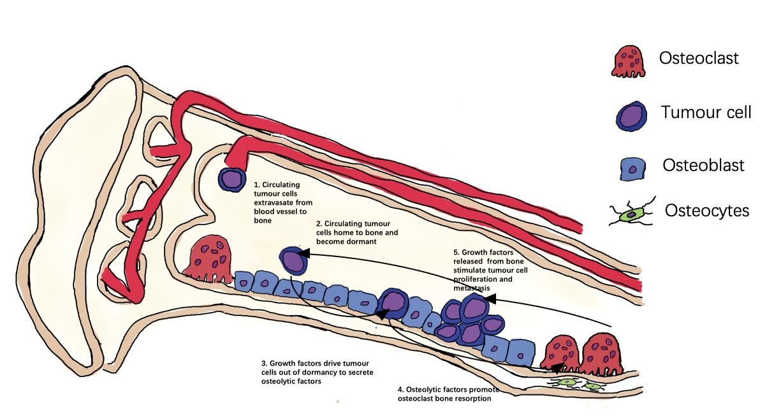
Figure 1.1 The vicious cycle of breast cancer-induced bone metastases (Coleman, et al, 2012)
Shows the molecular interactions in bone metastatic sites of breast cancer-induced bone metastases and the formation of the vicious cycle. 1) Circulating tumour cells exit the blood vessel into bone through extravasation 2) Circulating tumour cells colonise distant sites, becoming disseminated tumour cells and enter dormant state to protect themselves from the immune system 3) Disseminated tumour cells are reactivated under appropriate conditions, stimulating them to release osteolytic factors 4) Osteolytic factors promote osteoclast bone resorption, continuingly releasing growth factors from bone 5) Growth factors released from bone promote tumour cell metastasis and growth, further promoting osteoclast bone resorption, forming a positive feedback loop- the vicious cycle. Physical properties are created in bone metastatic sites which promote bone metastases including: low pH (stimulates osteoclast activity), high levels of calcium (upregulates PTHrP by calcium-sensing receptor) and hypoxia (HIF-1 promotes osteolytic bone metastases) in the bone metastatic sites also promote breast cancer induced bone metastasis.

Table 1.2. Essential bone-derived tumour growth factors released during breast cancer-induced osteolysis
*Function | Growth Factor | Reference
Tumour metastases, growth factor production | TGF-β | Buijs et al, 2012
Promote cancer progression | Fibroblast Growth Factor (FGF)s | Kwabbi-Addo, Ozen and Ittman, 2004
Promote cell tumour proliferation, EMT | Platelet-Derived Growth Factor (PDGF)s | Tulotta et al, 2019
Promote cell tumour proliferation, EMT | Bone Morphogenic Protein (BMP) | Tulotta et al, 2019
Promote tumour cell survival, angiogenesis, and survival | CXCL12 | Ottewell, 2016
Promote cancer growth, progression and anti-apoptotic effect | Insulin-like growth factors (IGF)s | Brahmkhatri, 2015
*Bone metastases. Bone-derived tumour growth factors released from the bone matrix by osteoclast resorption during vicious cycle, promotes various aspects of breast cancer-induced bone disease

Table 1.3 Tumour derived factors that stimulate bone resorption
Classification | Osteoclastogenic factors | *Function | Reference
Promotes Breast cancer induced-bone metastases | Interlekuin-1 beta (IL-1B) | Promotes EMT, angiogenesis and intravasation of tumour cells,  Expanding the bone metastatic niche by stimulating activity of osteoblast, haematopoetic stem cells and perivascular endothelial cells,  Increases colonisation and metastatic outgrowth in bone | Zhou and Ottewell, 2024
Promotes Breast cancer induced-bone metastases | Macrophage colony-stimulating factor (M-CSF) | Chemoattractant secreted by tumour cells, essential factor for osteoclast differentiation | Yoshimura et al, 2016
Inhibits Osteoblast Bone formation | MMP-1 | Promotes bone metastases by activating EGFR-dependent paracrine signalling cascade Suppress OPG secretion by osteoblast | Liu et al, 2017
Inhibits Osteoblast Bone formation | Tumour Necrosis Factor (TNF) | Inhibits osteoblastic growth and differentiation | Gilbert et al, 2000
Promotes Osteoclast  Bone resorption | Interlekuin-11(IL-11) | Increase expression of RANKL, promoting osteoclast differentiation and maturation | Ara and Declerck, 2010
Promotes Osteoclast  Bone resorption | Prostaglandin E2 (PGE2) | Increase expression of RANKL, promoting osteoclast differentiation and maturation | Liu et al, 2017
Promotes Osteoclast  Bone resorption | Interlekuin-6(IL-6) | Increase expression of RANKL, promoting osteoclast differentiation and maturation.  Induce expression of bone resorption proteins | Ara and Declerck, 2010
Promotes Osteoclast  Bone resorption | PDGF | Decrease osteoclast apoptosis. Promote expression of IL-6 for osteoclast differentiation | Canalis and Rydziel, 2002
*Tumour derived factors secreted by breast cancer cells during bone matrix vicious cycle promote osteoclast bone resorption and inhibit osteoblast bone formation, releasing growth factors from bone matrix that in turn promote breast cancer-induced bone metastases

1.2.5 The lack of bone repair treatments for breast cancer bone metastasis

Common treatments available for breast cancer bone metastasis are chemotherapy and radiation to target the tumour cells. Bone-targeted agents like the antiresorptive bisphosphonate (Zoledronic acid) (Steinman et al, 2012) and the RANKL inhibitor denosumab (Steger and Bartsch, 2011) are used to treat the bone disease to prevent the progression of excess bone resorption, reduce pain, and lower the risk of fractures. However, patients may continue to experience skeletal-related events as bone quality remains low and bone formation is not stimulated through anti-resorptive therapy (Zhou et al, 2011; Kim et al, 2017). Consequently, there is an urgent clinical need to determine whether bone anabolic agents can be used to repair bone lesions and increase bone quality, improving the QoL in these patients.
Bone is the main target of breast cancer metastatic malignancy, with a microenvironment that consists of a complex structural and mechanical system. Growth factors and numerous cell types reside in the bone matrix that are essential for bone-tumour interaction (Zheng et al, 2012).

1.3 Bone
1.3.1 The Bone Microenvironment
The bone matrix contains various cell types that perform different functions in the bone microenvironment. The main cell types that regulate bone formation and bone resorption are osteoblasts and osteoclasts, respectively. Elongated bone lining cells are present in layers, lining the surfaces of bone and protecting the surface of bone from osteoclastic resorption (Mohammed, 2008). Osteocytes are embedded within the bone, communicating with osteoblasts on the bone surface, and having canaliculi that spread from them, allowing the diffusion of substances. Osteocytes also secrete paracrine factors like IGF upon detection of mechanical stress (Mohammed, 2008). Bone marrow stromal cells differentiate into myeloid stroma and other lineages (including macrophages, osteocytes, and fibroblasts) (Barbash et al, 2003).
Osteoprogenitor cells are developed from mesenchymal stem cells contained in the inner cellular layer of the bone marrow. Furthermore, osteoprogenitor cells differentiate into pre-osteoblasts and mature into osteoblasts through actions of transcription factors runt-related transcription factor 2(RUNX2) and osterix (Karsentry, Kronenberg and Settembre, 2009). Osteoblasts primarily function in bone formation on bone surfaces, they become cuboidal in shape when active. Osteoblasts are in close contact through gap junctions and adherens. This characteristic enables intracellular adherence and communication (Jiang, Siller-Jackson, and Burra, 2007). Moreover, osteoblasts synthesise extracellular matrix components, one being type-I collagen that composes 90% of the organic matrix; collagen matrix osteoid that has enzymatic alkaline phosphatase and adenosine triphosphatase activity. This promotes mineralisation through accumulation of calcium and phosphate, which act as sites for hydroxyapatite formation (Bosetti et al, 2003). After bone formation, 65% of osteoblasts undergo apoptosis, 30% becomes osteocyte. Osteocytes are the most abudent cell type in the bone, serving as strain and stress sensors that facilitate in maintaining bone structure. Osteocytes are involved in shaping the lacunae to resorb and deposit bone (Franz et al, 2006).
Osteoclasts are differentiated from the monocyte-macrophage lineage, fused together by mononucleated precursor cells, regulated by cytokines M-CSF and RANKL (Kubatzky, Uhle and Eigenbrod, 2018). Osteoclasts migrate from bone marrow to bone surfaces, where they primarily function in bone resorption. Osteoclasts consists of four domains including sealed zone, basal membrane, plasma membrane and ruffled border. During bone resorption, bone components are endocytosed in ruffled border, transcytoses in vesicles and released via the plasma membrane. Osteoclast also maintain blood calcium homeostasis by expressing calcitonin receptors which bind to calcitonin (released by parafollicular cells and suppresses osteoclasts to reduce blood calcium levels) (Udagawa, 2003).
1.3.2 Bone Remodelling

Bone remodelling is a continuous process that maintains skeletal function and structure throughout life. This is a coupled, balanced process of bone resorption and bone formation (Hadjidakis and Androilakis, 2006). Bone is normally in a quiescent stage; however, to replace fractured or old brittle bone, bone remodelling is activated, preparing the replacement of defective bone with new tissue by the formation of bone remodelling compartments (BRC) (Owen and Reilly, 2018). Trabecular bone lining cells form BRCs that facilitate the formation and function of bone multicellular units (BMU), consisting of osteoblasts and osteoclasts. BRCs cover over half of the formative surfaces, which are virtually all resorptive surfaces, tightly regulating the coupling of osteoblasts and osteoclasts (Owen and Reilly, 2018). Bone remodelling commences with bone resorption. Osteoclast precursors are activated by osteoblast-secreted RANKL and endothelial cells-secreted M-CSF, anchoring themselves on the bone surface and creating a sealed zone underneath the cell. An acidic environment is created through the secretion of lysosomal enzymes, including collagenase and hydrochloric acid, that dissolve the hydroxyapatite bone mineral content. This results in pits of lacunae, releasing of calcium and phosphate into the circulation system (Hadjidakis and Androilakis, 2006). Osteoclasts undergo apoptosis after bone resorption, and macrophages clear away debris from the bone resorption area (Owen and Reilly, 2018).
In the next stage, bone formation occurs, where osteoblasts move into the resorption sites, depositing organic matrix osteoid. The osteoid forms a scaffold that crystalizes calcium and phosphate, filling in the lacunae. Osteoblasts secrete matrix vesicles, which support mineralisation by increasing calcium and phosphate ions, Type-I collagen binds to osteonectin and nucleates hydroxyapatite (Riquel, Cardenas, and Jiang, 2020). Once bone formation is complete, osteoblasts can either undergo apoptosis or become bone lining cells, or differentiate into chondroid depositing cells or osteocytes embedded within bone matrix (Hadjidakis and Androilakis, 2006).
In addition, osteocytes produce RANKL and OPG that regulate bone remodelling. Osteocytes secrete sclerostin and the Wnt signalling pathway inhibitor DKK1, both of which regulate osteoblast activity by inhibiting bone formation and reducing osteoblast differentiation during bone demineralisation (Robling et al, 2008).

1.3.2.1 Osteoblasts in bone homeostasis

Osteoblasts primarily contribute to bone formation during skeletal development and bone homeostasis. Osteoblasts form BMUs that surround surfaces of bone and secrete TGF-β, osteocalcin, alkaline phosphatase, collagenase, and type-1 collagen that aid mineralisation (Karsenty, Kronenberg, and Settembre, 2009). After subsequent bone formation, most osteoblasts get trapped within lacunae during mineralisation and differentiate into osteocytes, while remaining osteoblasts become bone lining cells on bone surfaces or undergo apoptosis (Riquel, Cardenas, and Jiang, 2020).
Moreover, osteoblasts interact with osteoclasts by forming gap junctions that enable molecules to pass between the cells. Osteoblasts secret factors that regulate osteoclast formation and osteoclastic bone resorption (Table 1.4.) (Chen et al, 2018).

Table 1.4 Factors secreted by osteoblasts that regulates osteoclasts
Factors secreted by osteoblasts | Function | Reference
MSC-F | Essential for osteoclast differentiation, survival, cell migration, activity.  Promote differentiation of osteoclast precursors and upregulate RANK. | Kim and Kim, 2016
Semaphorin 3A (Sema 3A) | Inhibits osteoclast differentiation by binding to neuropilin-1 | Hayashi et al, 2012
Lysophosphatidic acid (LPA) | Blocks osteoclast apoptosis and promotes morphological change of osteoclasts | Hosogaya et al, 2008
Factor associated suicide ligand (FasL) | Induce osteoclast apoptosis through its signalling pathway | Nakamura et al, 2007
Ephrin type-B receptor 4(EPHB4) | Inhibit osteoclast formation and bone resorption | Zhao et al, 2006
*Osteoblasts and osteoclasts are coupled in bone remodelling, osteoblasts secrete factors that promote or supress osteoclasts based on the stage of bone remodelling

1.3.4 The RANKL/RANK/OPG signalling pathway

The RANKL/RANK/OPG signalling pathway is responsible for regulating bone remodelling and the process of bone formation (Krzeszinski and Wan, 2015). RANKL is expressed as membrane bound homotrimeric protein by osteoblasts. RANKL has a pivotal role in osteoclast formation, function, and survival (Krzeszinski and Wan, 2015). RANK is located on osteoclast precursor monocytes and the cell membranes of mature osteoclasts. PTHrP is released by mesenchymal stem cells and binds to osteoblasts, releasing RANKL which binds to RANK on monocytes (Figure 1.2). Monocytes/ macrophages fuse together and differentiate into mature, multinucleated osteoclasts. RANKL then binds to RANK on mature osteoclasts, activating TNF-associated factor 6 (TRAF6), which leads to a series of signalling cascades (Baud’huin, 2007). Osteoclasts are activated and commence bone resorption as part of the bone remodelling process.
OPG is mainly expressed by osteoblast to protect bone from excessive osteoclastic resorption. OPG has a higher affinity than RANK where it binds to and inhibits RANKL, RANKL is not able to activate RANK on osteoclasts which prevents bone loss (Udagawa et al, 2000). 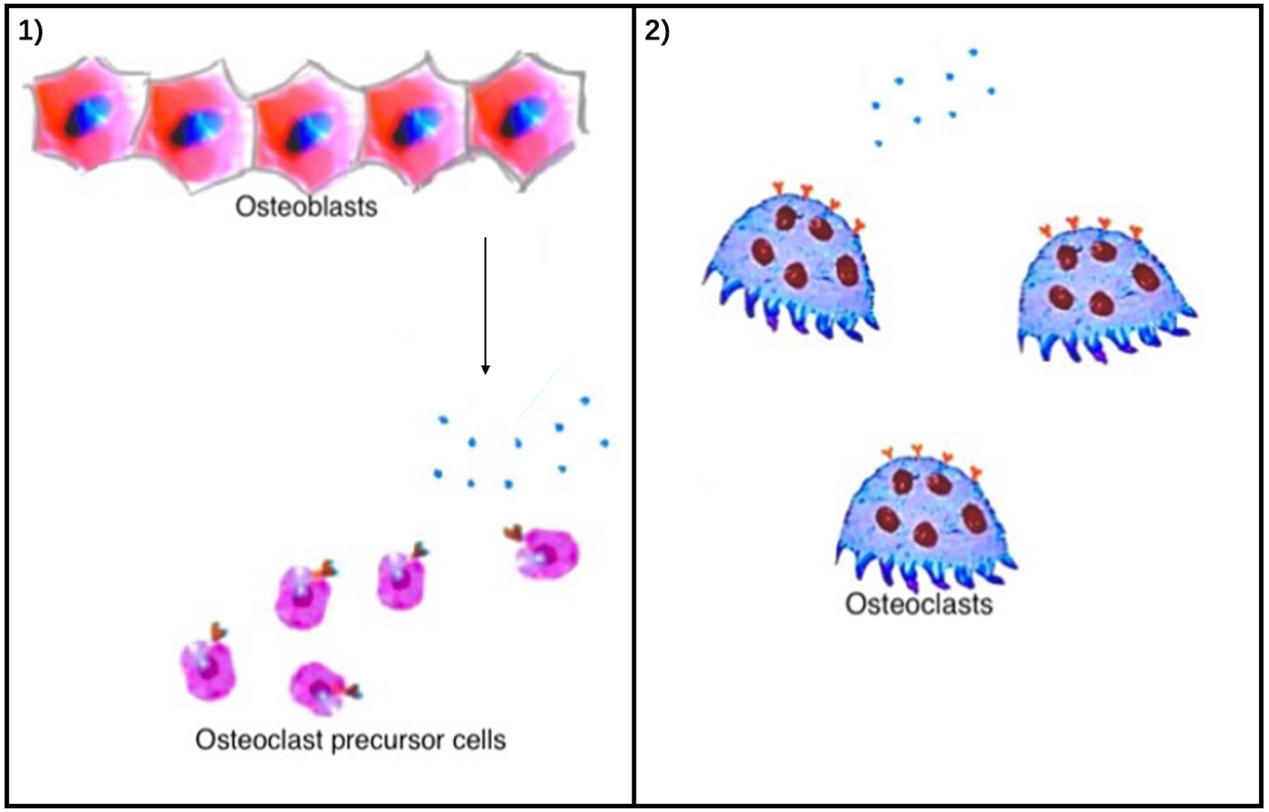
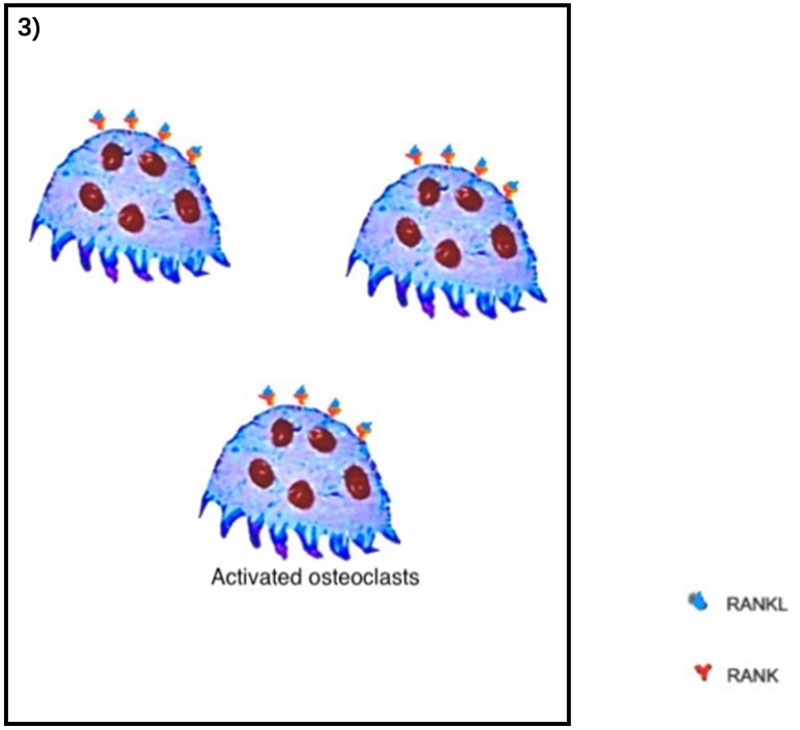
Figure 1.2 The RANK/RANKL/OPG signalling pathway (Infante et al, 2019)
1) Osteoblast release RANKL, binding to RANK on osteoclast precursors, forming osteoclasts. 2) RANKL released by osteoblasts bind to RANK on osteoclasts causing their activation.

1.4 Role of osteoblasts in lytic lesions

1.4.1 Osteoblast in bone metastases

The role of osteoblasts in the early stages of metastasis (tumour cell homing, survival and, colonisation of bone) is different from that of the progression of established tumour colonies and cancer-induced bone lesions (Shiosawa et al, 2011). The endosteal niche is composed mainly of osteoblasts. In mouse models of breast and prostate cancer, osteoblasts express CXCL12 while cancer cells express its receptor CXCR4, the CXCL12-CXCR4 interaction between endosteal niche and tumour cells sustains tumour cells in a quiescent state before metastases (Wang et al, 2014).

Osteoblasts are also proposed to be highly relevant to cancer cell dormancy and growth (Riquel et al,2020). Adherent junctions are required between breast cancer cells and osteoblasts for early-stage bone colonization (Wang et al, 2015). During osteoblast activity, expression of hepatocyte growth factor (HGF) and secretion of connective tissue growth factor (CTGF) and TGF-β promotes tumour growth by stimulating extracellular matrix deposition (Riquel et al,2020).

Osteoblasts are involved in both osteolytic and osteoblastic bone metastases. Increased osteoclast differentiation and activity stimulated by breast cancer cells in turn inhibits osteoblast activity and differentiation (Krzeszinski and Wan, 2015). This includes osteoblast-modifying factors like sclerostin, dickkopf-1 (both inhibit osteoblast differentiation through inhibition of Wnt signalling), noggin (BMP antagonist, impairs osteoblast formation and function) and activin A (inhibits osteoblast bone mineralisation by inhibiting extracellular matrix maturation) (Alves et al, 2013) secreted by tumour cells (Alves et al, 2013, Devlin et al, 2003)(Terpos and Christoulas, 2013). Osteolytic lesions are formed when osteoclastic bone resorption exceeds osteoblastic bone formation (Krzeszinski and Wan, 2015). Osteoblast differentiation and bone formation are further inhibited by growth factors released from resorption of the bone matrix, one being TGF-β. In addition, osteoblasts contribute to the initiation of bone resorption as their precursors express RANKL (Fournier et al, 2015).
Mixed sclerotic-lytic lesions can occasionally occur in breast cancer. Breast cancer cells promote osteoblast differentiation and bone formation, having osteoblastic bone formation greater than osteoclastic bone resorption. Sclerotic lesions are formed by excess bone formation, weakening the skeletal structure and decreasing bone quality (Gdowski, Ranjan and, Vishwanatha, 2017). The vicious cycle of cancer-induced bone disease is present in both osteoblastic and osteolytic bone metastases. Tumour cells secrete PDGF, epidermal growth factor (EGF) and BMP that promote osteoblast differentiation, activity and survival (Brown et al, 2012). In turn, tumour-activated osteoblasts secrete macrophage inflammatory protein 2 (MIP-2), monocyte chemotactic protein-1 (MCP-1), IL-6 and VEGF that promote breast cancer cell proliferation and colonisation (Ottewell, 2016). Tumour cells can stimulate or inhibit osteoblast function to create the favourable environment for metastases in bone (Ottewell, 2016)

The bone microenvironment changes with increasing age. Accumulation of senescent osteoblasts and bone lining cells occurs, due to by-products of cellular respiration and environmental toxins that induce genetic mutations (Campisi and Fagana, 2007). In addition, senescent osteoblasts and oxidative stress promotes osteoclastogenesis, driven by IL-6 in vivo. In a mouse model of breast cancer bone metastases, Luo et al, 2016 created senescence osteoblasts by inducing the expression of ${p27}^{Kip1}$. Senescence osteoblasts do not mineralise bone matrix, and increased osteoclastogensis, the surface area of osteoclasts covered bone was increased and may have promoted tumour cell seeding. Cancer cells that reside in bone and home to senescent cells accumulate overtime. This might be a possible mechanism of relapses in cancer patients, triggering re-awakening of dormant disseminated tumour cells in bone (Riquelme et al, 2020). The contributing roles of the osteoblasts in bone metastases make it a potential target for treating bone metastases.

1.4.2 Osteoblast changes in cancer-induced bone disease - evidence from in vivo models

Hormone therapy, osteoclast inhibitors, and bone anabolic agents have demonstrated their effects on osteoblasts and bone formation in in vivo models of cancer-induced bone disease (Brown et al,2018; Haider et al, 2014; Mohammad et al, 2009). However, there is limited literature on these topics and few clinical studies in cancer have included studies of bone formation. The following sections describe the effect of agents on osteoblasts in in vivo models of cancer-induced bone metastases.

1.4.2.1 Expansion of osteoblasts niche

Parathyroid hormone (PTH) is secreted by the parathyroid gland into the systemic circulation system and increases resorption of calcium in bone. Moreover, it has been reported that 5 days of treatment with PTH in BALB/c nude mice exerts an anabolic effect through delaying osteoblast apoptosis, increasing the number and activity of osteoblasts, which leads to expanded osteoblast compartments (Jilka, 2007). Intermittent treatment also increases expression of osteoblast-related genes including osteocalcin, ColA1 and, Sclerostin (SOST) (Jilka et al,2009). PTH 1-34/1-84 is currently approved for the treatment of severe osteoporosis, but not for cancer-induced bone disease (Compston, 2007).
Brown and colleagues carried out a study aimed at determining the effect of expanding osteoblast niches with PTH in a model of breast cancer bone metastasis. In 12-week-old BALBc/nude mice, PTH treatment (40 or 80µg/kg) for five consecutive days induced alterations in the bone microenvironment. Comparing PTH-treated animals, the number of osteoblasts was significantly increased, and number of osteoclasts was not significantly decreased. However, the PTH-induced increase in the osteoblastic component did not result in changes in bone volume nor bone structure in the tibiae, demonstrating that this short-term PTH treatment was osteoblast-specific (Brown et al,2018).
In the treatment group, MDA-MB-231 breast cancer cells were injected at the end of the PTH treatment. The PTH pre-treatment induced increases in the osteoblastic component and resulted in increased numbers of skeletal tumours in a range of skeletal sites not normally colonised by tumour cells in this model (e.g., rib, hip, tail), and not in hind limbs where tumours colonise. This demonstrates PTH induces alterations of the osteoblast compartment, potentially opening alternative sites for breast cancer colonisation (Brown et al, 2018). This model is essential as it demonstrates that altering the bone microenvironment by expanding osteoblast niches not only has no bone anabolic effects, but also increases tumour growth in vivo. Clinically, the increase of osteoblastic niches may be a concern of increased risk of patients developing osteosarcoma (Subbiah et al, 2021)

The analog of PTH, teriparatide (PTH 1-34), has shown promising results in preclinical trials using murine models of breast cancer bone metastases. Twelve-week-old BALB/c nude female mice were treated with 40 µg/kg or 80 µg/kg teriparatide once daily for five consecutive days via subcutaneous injection. Following the 5-day treatment, the mice were injected with MDA-MB-231-luc2 cells via intracardiac injection. Teriparatide treatment initially increased osteoblast numbers and caused no change in osteoclast numbers compared to the vehicle group. After 7 days, osteoblast numbers began to decrease, which corresponded with the timing of tumor cell inoculation. Bioluminescent imaging of bone showed a significant reduction in tumor growth in the bone marrow compared to the vehicle, suggesting that teriparatide reduces metastatic breast cancer cell seeding to bone by disrupting osteoblasts and may be a useful therapeutic option (Swami et al, 2017). Nevertheless, PTH is not approved as a treatment for breast cancer bone metastasis. Although PTH has been tested in humans (Tong and Rubenfeld, 2012), clinical trials are still needed to assess its safety and effectiveness in patients with breast cancer bone involvement.
Denosumab is a RANKL inhibitor approved by the FDA for the prevention of skeletal-related events (SREs) in patients with breast cancer bone metastases. In a Phase III randomised trial, 2046 patients with advanced breast cancer and bone metastases received 120 mg subcutaneous denosumab every 4 weeks or zoledronic acid (ZOL) 4 mg intravenously every 4 weeks, along with daily calcium and vitamin D supplementation. Patients receiving denosumab had 18% reduction in the risk of developing a first SRE, and a significant delay in the onset of subsequent SREs, compared to patients that received ZOL. No difference was observed in overall survival. Denosumab may be an alternative to ZOL, offering a lower risk of renal toxicity and acute-phase reactions (Stopeck et al, 2010).

1.4.2.2 Effect of anti-resorptive agents on osteoblasts

Since bone resorption is tightly coupled with bone formation during bone remodelling, a decrease in bone resorption will decrease bone formation along with decreased osteoblast activity (Lerner et al, 2019). The anti-resorptive drug ZOL is a potent bisphosphonate that reduces the rate of bone loss, resulting in decreased bone pain and fracture risk in patients with bone disease. ZOL causes osteoclast apoptosis by impairing post-translational modification of small signalling guanosine triphosphatases (GTP) binding proteins and inhibits bone resorption (Luckman et al, 1998). There is limited literature on how ZOL affects osteoblasts and their function in vivo. ZOL is approved by the Food and Drug Administration (FDA) for the treatment of hypercalcaemia of malignancy, multiple myeloma, and bone metastases from solid tumours, i.e, breast and prostate cancer (U.S. Food and Drug Administration, 2015).
In vivo studies have aimed to elucidate the effects of ZOL on osteoblasts and osteoclasts in a model of breast cancer bone metastasis. 6-week-old BALB/cAnNCrl ${Foxn1}^{nu/nu}$immunocompromised female mice (n=2-7/ group) received a single dose of ZOL (100µg/kg), 5 days later, were injected with MDA-MB-231 breast cancer cells intracardially, resulting in a significant increase in trabecular number and bone volume compared to control. Moreover, significant decreases in the number of osteoclasts, osteoblasts, and their corresponding serum bone marker levels were demonstrated (Haider et al, 2014). The increase in trabecular volume may have resulted from inhibition of osteoclasts, osteoblasts, and increased endochondral ossification by ZOL. Pre-treatment with ZOL (100µg/kg) resulted in homing of tumour cells to osteoblast-rich areas without change in the number of tumour cells detected in bone by flow cytometry using ex vivo culture cell suspension (Haider et al, 2014). However, a study by Sudhoff et al, 2003 showed that mineralisation was not affected in a ZOL-treated murine model of keratin-induced osteolysis, suggesting that ZOL does not negatively affect osteoblast activity in a non-tumour model.
These studies demonstrate that tumours tendency to locate in osteoblast-rich areas of the bone microenvironment demonstrates that osteoblasts are pivotal to bone metastases.

In addition to ZOL, other agents have also been demonstrated to change the bone microenvironment through exerting effects on osteoblasts and bone formation (Table 1.5). There is no current treatment to repair bone lesions induced by breast cancer bone metastasis but, TGF-β is known to have pro-tumour effects, so this makes it an ideal target for bone anabolic agents.

Table 1.5 Bone targeted agents reported to target osteoblasts in cancer induced bone disease
Agent | Target | Function | Status (FDA) | Reference
Bortezomib (btz) | Proteasome inhibitor, leading to accumulation of proteins in tumour cells | Tumour cell apoptosis, anabolic effects and anti-resorptive effects.  Increases osteoblast activity without expanding osteoblast niche or osteoblast progenitors, through increasing RUNX2/Cbfa1 expression. | Approved for treatment of multiple myeloma | Giuliani et al, 2007
Lenalidomide (len) | Binds to cereblon, lead to substrate ubiquitination and proteasomal degradation of transcription factors in tumour cells | T-cell activation, inhibit tumour proliferation and angiogenesis.  Inhibit osteoblast differentiation and activity. | Approved for treatment of multiple myeloma | Kotla et al, 2009  Bolomsky et al, 2014
Losartan | Inhibits binding of angiotensin II to angiotensin II type-1 receptor (AT1R) on osteoblast. Inhibits TGF-β and promotes BMP signalling | Normalizes transcription and osteoblastic bone formation in vivo | Approved for hypertension treatment.  Not approved for cancer-induced bone disease. | Chen et al, 2015
Romosozumab | Anti-sclerostin antibody | Prevents multiple myeloma suppression on osteoblast formation and osteoblastic bone formation in vivo | Approved for osteoporosis in postmenopausal women | McDonald et al,2017
BHQ880 | Anti-DKK1 antibody, (DKK1 inhibits Wnt signalling and osteoblast formation) |  | Not approved for cancer-induced bone disease. | Heath et al, 2009
RAP-011 | Activin A inhibitor (Activin A Inhibits osteoblast differentiation by downregulating distal-less homeobox 5(DLX5) expression downstream to mothers against decapentaplegic homolog (SMAD)-2) | Enhances osteoblast formation (does not normalise to normal level), indirect inhibition of multiple myeloma in multiple myeloma model in vivo | Not approved for cancer-induced bone disease. | Vallet et al, 2010
Fresolimumab (GC1008) | All isoforms of TGF-β | Increase osteoblast activity. | Phase 1 clinical trial in patients with malignant melanoma and renal cell carcinoma  Phase 2 clinical trial in primary glomerulosclerosis. | Marulanda et al, 2021  Morris et al, 2014
The table summarises various agents that have been demonstrated by previous literature to have an effect on osteoblast formation or activity. Btz, losartan, RAP-011, Fresolimumab promotes osteoblast, len, Romosozumab BHQ880 suppresses osteoblasts.

1.5 The role of TGF-β in in bone homeostasis and metastasis

TGF-β is an abundant growth factor secreted by osteoblasts and remains embedded in the bone matrix. TGF-β functions in the immune system to initiate inflammatory responses by regulating the differentiation and function of key immune cells such as T-cells, NK cells, macrophages, and granulocytes (Sanjabi et al, 2017). Additionally, TGF-β maintains bone homeostasis by regulating the differentiation and function of osteoblasts/ osteoclasts (Yasui et al, 2011).
Nevertheless, TGF-β is a major growth factor in promoting breast cancer bone metastasis. TGF-β is released from the bone matrix by proteolytic cleavage and pH changes in the local environment during osteoclastic bone resorption. TGF-β initiates the release of pre-osteolytic and osteolytic factors such as interleukin (IL)-11 and MMP-1 that stimulate bone resorption (Trivedi et al, 2021). In samples of patients with breast cancer bone metastases, there was an accumulation of phosphorylated SMAD2 in the nucleus of tumour cells, indicating elevated TGF-β signalling (Kang et al, 2005).

1.5.1 The TGF-β signalling pathway

TGF-β is multi-functional, regulating various aspects of cellular functions, including proliferation, differentiation, and apoptosis in human tissues (Poniatowski et al, 2015). Furthermore, TGF-β consists of a group of three isoforms (TGF-β1, 2, 3), each of which is formed by dimeric polypeptide chains. The mammalian genome encodes 33 TGF-β-related cytokines, including growth and differentiation factors, BMPs, activin, inhibin, nodal, and anti-Müllerian hormone, which are involved in tissue development and physiological processes (Morikawa, 2019).

TGF-β is rendered by latency-associated protein (LAP) and remains inactive. When LAP is cleaved, TGF-β functions through two pathways, the Smad and non-Smad pathways. To initialise these pathways, TGF-β binds and brings two TGF-β type 2 transmembrane monomers in proximity. The dimerised TGF-β type 2 transmembrane receptor recruits TGF-β type 1 receptor and phosphorylates them, forming an activated tetrameric complex which initiates the Smad or the non-Smad pathway (Song, Estrada and Lyons, 2009; Crane and Cao, 2014).
In the Smad pathway, the phosphorylated receptors phosphorylate and activate R-Smads (Smad 2 and 3), which bind to Smad 4, translocating into the nucleus and regulating TGF-β target genes through transcription (Song, Estrada and Lyons, 2009).
In the non-Smad pathway, the phosphorylated TGF-β receptors initiate the downstream cascades of Rho, PI3K, JNK/p38, NF-kβ, and ERK, which translocate to the nucleus to regulate transcription of TGF-β target genes (Fig. 1.3). Furthermore, ERK is responsible for the disassembly of cell-cell matrix and increases cell motility; p38 works in conjunction with the Smad pathway in EMT through maintaining E-cadherin through TAK1. Akt promotes EMT through transcription factors Zinc finger E-box binding homeobox 1 (ZEB1) and Zinc finger protein SNAI1 (Snail) (Zhang, 2017).
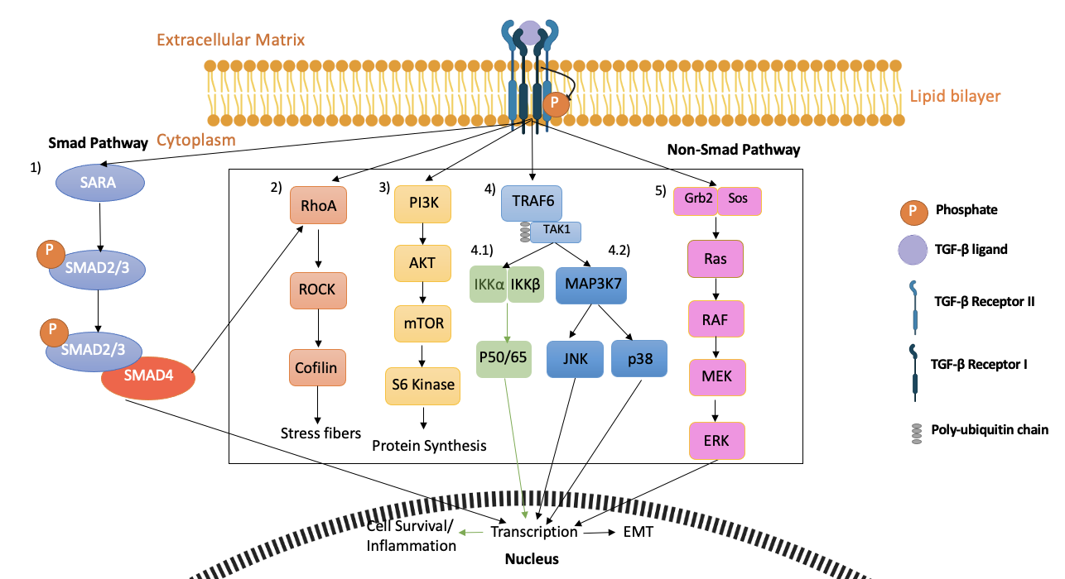
Figure 1.3 TGF-β signalling pathway (Smad and Non-Smad pathways)
TGF-β signalling has two pathways: 1) Smad (Canonical) pathway and 2) non-Smad (Non-canonical) pathway. There are four downstream pathways in the non-Smad (Non-canonical) pathway (2,) in Rho-like GTPases pathway, 3) in PI3K pathway, 4) in NF-kβ pathway and 5) In Erk pathway.

Adapted from Zhang, 2009

1.5.2.1 TGF-β and tumour proliferation and differentiation into invasive phenotype

TGF-β is ultlised by tumour cells in promoting tumour progression in various ways. To metastasise into distant areas from the primary tumour, cancer cells need to acquire mesenchymal properties and lose cell polarity. TGF-β promotes EMT of cancer cells through downregulation of occludins and claudins, which degrade junctions between tumour cells. RhoA stabilises cell junctions and E-cadherin prevents the dissociation of cancer cells from the primary tumour. TGF-β degrades RhoA through inducing the phosphorylation of PAR6 and down-regulates E-cadherin by HMGA2, Snail, and ZEB1 (Xu et al, 2009). In addition, the tumour suppressor p53 is destabilised by TGF- β1-induced TGF-β1 Mdm2, which enables EMT of cancer cells. High expression of Mdm2 is often detected in late-stage metastatic breast cancer (Araki et al, 2010).
1.5.2.2 TGF-β in suppressing immune response

TGF-β represses the anti-tumour effects of the immune system, enabling tumour cell proliferation and progression by affecting various immune cell types. To maintain homeostasis, Treg cells downregulate the function of effector T cells in healthy tissues. TGF-β promotes T cell differentiation into the Treg stage (suppresses immune response) by inducing transcription factor FOXP3 and inhibits T cell function (Batle and Massagué, 2019). Antigen-presenting function of dendritic cells is inhibited by TGF-β suppression of MHC-II genes. Immunosuppressing molecule indoleamine 2,3-dioxygenase is upregulated in dendritic cells by the TGF-β signalling pathway. This promotes immune evasion and Treg cell infiltration. Cancer cell-induced dendritic cells also promote T cell differentiation into Treg stage by secreting TGF-β (Hanks et al, 2013). Furthermore, NK cell function is also affected by TGF- β. Suppression of the Th1 inflammatory response is achieved by silencing NK cell expression of IFN-γ and T-bet. TGF-β downregulates NK activity by impairing the downstream stimulatory cytokines of mTOR. Immune evasion of NK cells is accomplished by transdifferentiating them into innate lymphoid cells, facilitated by TGF-β SMAD4 signalling (Cortez et al,2017).

1.5.2.3 TGF-β in tumour angiogenesis

The formation of blood vessels is vital for tumours to obtain nutrients and oxygen for proliferation, invasion, and metastases. TGF-β promotes angiogenesis through inducing angiogenic factors, including VEGF and connective tissue growth factors (Kang et al, 2003). In addition, TGF-β downregulates tissue inhibitor metalloproteinase through the secretion of matrix metalloproteinases (MMP)-2 and MMP-9 (Zhao et al, 2016). High levels of TGF-β are corelated with breast cancer prognosis and angiogenesis. Patients with a high plasma level of TGF-β1 have an increased risk of disease progression (Buijs et al, 2011). In a study of 23 breast cancer patients with bone metastases, over half of the patients had elevated TGF- β1 levels, along with TGF-β related markers of PTHrP and IL-10 (Baselga et al, 2008).

There is no current treatment to repair bone lesions induced by breast cancer bone metastasis. TGF-β’s pro-tumour effects make it an ideal target for bone anabolic agents.

1.5.2.4 TGF-β in normal bone homeostasis and anti-tumour effects

In bone, TGF-β maintains bone homeostasis through the regulation of coupled bone resorption and bone formation. TGF-β inhibits bone resorption in the developing marrow cavity and stimulates bone resorption in older bone where new bone matrix is established (Wu et al, 2016). Osteoclasts express TGF-β type I and II receptors. In bone resorption, TGF-β regulates osteoclasts in a dose-dependent manner. Low concentrations of TGF-β promote osteoclast differentiation by regulating the RANKL/OPG ratio, inducing the migration of macrophages and stromal cells (expressing RANKL) to bone resorption sites mediated by the Smad pathway. Latent TGF-β is proteolytically cleaved by osteoclast-secreted cathepsins during bone resorption, inducing osteoblasts to release RANKL. High concentration of TGF-β inhibits the migration of osteoclast precursors and osteoclast differentiation (Yasui et al, 2011). During bone formation, activated TGF-β recruits osteoblast progenitors (mesenchymal stem cells), stimulating their early differentiation and bone matrix production (Wu et al., 2020). TGF-β blocks late-stage differentiation of osteoblasts mediated by SMAD3. TGF-β activated by membrane type1 metalloproteinase (MT1-MMP) and blocks apoptosis of osteoblast leading to their trans-differentiation into osteocytes (Nguyen et al,2016). In addition, TGF-β regulates the formation of extracellular proteins in bone matrix synthesis, such as alkaline phosphatase, osteocalcin, and osteopontin (Guerrero et al, 2014).

In normal cells, TGF-β maintains homeostasis and suppresses tumour proliferation through cell autonomous responses (apoptosis and cytostasis) and indirect effects on stromal cells (inhibiting inflammation and stromal-derived mitogens) (Zarzynska, 2014). TGF-β expresses cytostatic effect by inducing the expression of eukaryotic translation initiation factor 4E binding protein 1 (4E-BP1) and Cyclin dependent kinase (CDK) inhibitors (p15, p21, p57). 4E-BP1 binds to translation initiation factor 4E and preventing cancer cell protein translation, while CDK inhibitors bind to CDK complexes and prevents G1/ S phase transition that is important for their gene replication and repair (Amorim et al., 2018). TGF-β also represses the expression of CDC25A, negative regulating cancer progression and cell cycle (Amorim et al., 2018). Genes regulated by Smad expressing phospholipid phosphatase mediates apoptosis, TGF-inducible early response gene 1, death associated-protein kinase mediates TGF-induced apoptosis. Moreover, the levels of Mad3 and Akt determines whether cell will undergo apoptosis in response to TGF-β (Howe et al, 2001). In addition, other TGF-β targeted genes initiated by Smad and non-Smad pathways also express anti-tumour effects (Table 1.6).

Table 1.6 TGF-β target genes that express anti-tumour effects.
Anti-Tumour Effects | TGF-β Target Genes | Reference
Inhibit cell proliferation | 4EBP1, E2F-1, c-Myc | Pourdehnad et al, 2013 and Sheldon et al, 2017
Cell Apoptosis | BIM, Fas, Bcl-xl/2 | Antignani et al,2017 and Hagimoto et al, 2002
Autophagy | ATG5/7, Beclin, DAPK | Suzuki et al, 2010
Inhibit angiogenesis | Thrombospondin | Lawler and Lawler, 2012
Suppress inflammation | Fox3P3, GATA-3, T-bet | Díaz et al, 2010
The various anti-tumour effects of TGF-β target genes, activated by TGF-β Smad and non-Smad pathway through transcription in the nucleus.

1.6 TGF-β in bone metastases

Bone is the most preferred site of metastasis by breast cancer as it contains abundant growth factors, including TGF-β, that can promote tumour growth and progression. Breast cancer cells can circumvent the tumour-suppressing effects of TGF-β through inactivating TGF-β core components (TGF-β receptors) or through downstream alterations by somatic mutations in the TGF-β signalling pathway. The latter allows breast cancer to utilise TGF-β for tumour metastases (Massague, 2012). Negative regulators of TGF-β signalling SKI and SnoN are overexpressed in breast cancer, disrupting the TGF-β receptor tetra-meric complex through the interaction with Smads and inhibiting TGF-β response genes (Deheuninck and Luo, 2009). Therefore, high levels of TGF-β are observed in solid tumours, particularly after TGF-β suppressive effects are lost. TGF-β levels become increasingly higher in advanced stages of breast cancer (Travers et al, 1988).
Stored TGF-β is released from bone matrix by tumour cell-activated osteoclasts. Within the bone microenvironment, TGF-β stimulates tumour cells to express osteolytic factors such as MMP1 and PTHrP via both Smad-dependent and Smad-independent (p38 MAPK) signalling pathways, along with the upregulation of Gil family zinc finger protein 2 (Gil2). PTHrP induced by TGF-β stimulates the production of RANKL and downregulate OPG, leading to the differentiation and activation of osteoclasts. (Kakonen et al, 2002, Johnson et al, 2011). In a study that studied the effect of TGF-β on PTHrP. Confluent MDA-MB-231 cells were treated with 5ng/ml TGF-β1, 40ng/ml fibroblast growth factor (FGF)-1, 40ng/ml platelet-derived growth factor (PDGF), 40ng/ml insulin-like growth factor (IGF)-2 for 48 hours, after which the expression of PTHrP were measured. 5ng/ml TGF-β1 significantly increased PTHrP secretion by triple negative breast cancer (TNBC) cells compared to FGF-1, PDGF, and IGF-2 treated TNBC cells. A subsequent study was conducted to assess the effect of TGF-β on bone in a model of breast cancer bone metastasis. MDA-MB-231 clonal cells TβRII∆− cyt + TβRI(T204D) or TβRII∆cyt + pcDNA3.1zeo control cells were intracardially injected in 4-week-old female nude mice. After 4 weeks of i.c.,mice inoculated with TβRII∆− cyt + TβRI TNBC cells developed significantly larger lytic bone lesions compared to control. Additionally, bone histomorphometry demonstrated that trabecular and cortical bone were heavily destroyed in mice inoculated with TβRII∆− cyt + TβRI TNBC cells compared to control (Yin et al, 1999). Additionally, TGF-β regulates CTGF and IL-11 by the canonical pathway. IL-11 stimulates osteoclast differentiation, while CTGF mediates angiogenesis and invasion. Both contribute to promoting breast cancer bone metastasis (Trivedi et al, 2021). The role of TGF-β in tumorigenesis and bone metastases in breast cancer makes it a potential therapeutic target.

1.7 Hypothesis and Aims

The overall aim of this project is to use SD-208 and losartan to inhibit TGF-β in an in vivo model of breast cancer-induced bone metastasis, to limit or repair osteolytic lesions, and to improve bone structure and integrity.
Hypothesis:
Bone anabolic agents can stimulate bone formation in mouse models of breast cancer bone metastases, limiting the development and/or progression of cancer-induced lytic lesions.

The hypothesis will be tested by the following project objectives:

1) To determine the effects of the bone anabolic agents SD-208 and losartan on osteoblast-like cells and breast cancer cells in vitro.

2) To determine the effects of SD-208 and losartan on bone structure and integrity of tumour-free mice in vivo and determine if in vivo µCT can be used to track bone changes.

3) To track tumour development in bone, using bioluminescent imaging to determine the timepoint of established tumour growth and bone lesions in the hind limbs

4) To determine the efficacy of SD-208 and losartan on the bone structure and integrity in an in vivo breast cancer bone metastasis mouse model.

Chapter 2
Materials &Methods

Materials

Lists of equipment, software and reagents used throughout this thesis are listed in Tables 2.1, 2.2 and 2.3 below.

Table 2.1 List of equipment
Equipment | Supplier
3510 pH meter | JENWAY
AE2000 Invert Microscope | Motic
ABI Prism 7900HT | Applied biosystem (USA)
Beadmill shaker | Fisherbrand
BX53 Binocular Microscope | Olympus
FRESCO17 Microcentrifuge | Thermo Scientific
Haemocytometer | Hawksley
IVIS Spectrum machine | Xenogen
Magnetic stirrer | STAR Lab
Microfuge | Fisher Scientific
Microtome machine | Leica
Nanodrop 2000 | Thermo Scientific
NeoScan N80 | Neoscan
Non-mercury thermometer | Fisher Scinetific
Orbital plate rotor | Stuart Scientific
SkyScan1272 µCT scanner | Bruker
SpectraMax 5Me multi-plate reader | Molecular Devices
Ultrasonic bath XB2 | Grant
VivaCT80 µCT scanner | SCANCO Medical AG (Switzerland)
Vortex mixer | Havard Apparatus

Table 2.2 List of software
Software | Supplier
CTAN | Bruker
CTVox | Bruker
Dataviewer | Bruker
Dragonfly software | ZEISS
Drishiti | ANU Vizlab
GraphPad Prism 9 | GraphPad
G* Power software | Heinrich-Heine-Universität
Image J | Wayne Wesband
MicroCT FTP | Scando Medical
NRecon | Bruker
Osteomeasure software | OsteoMetrics
PuTTY | Chiark
R software | Posit PBC
Skyscan 1272 software | Bruker
SoftMax Pro 5.4.6. | Molecular Devices
SDS 2.1 software | Applied biosystems (USA)
VivaCT80 software | SCANCO Medical AG (Switzerland)
X Ming | Source Forge

Table 2.3 List of reagents
Reagent | Supplier | Catalogue number
1% aqueous Eosin Y | Sigma Aldrich | HT110280
3-4,5-Dimethylthiazol-2-yl-2,5-Diphenyltetrazolium Bromide (MTT) | Sigma Aldrich | M2003
Absolute Ethanol (99.8%) | Fisher Scientific | 64-17-5
Alizarin Red S | BDH | 130053L
Chloroform | Sigma Aldrich | 67-66-3
Diethanolamine substrate buffer | Thermo Scientific | 34064
Dimethyl Sulfoxide (DMSO) | Fisher Scientific | 67-68-5
Doxorubicin | Sigma Aldrich | 25316-40-9
Dibutylphthalate polystyrene  xylene (PDX) | VWR | 1.00579.0500
Ethylenediaminetetraacetic  acid, disodium salt dihydrate (EDTA) | Fisher Scientific | S25687
Enzyme-linked immunoassay (ELISA), human procollagen 1 N-terminal propeptide (P1NP) kit | Elabscience | E-EL-H0185
Enzyme-linked immunoassay (ELISA), tartrate-resistant acid phosphate (TRAP5b) kit | IDS | SB-TR201A
Fetal Calf Serum (FCS) | Thermo Fisher | 16270106
Gill’s haematoxylin | VWR | 1.051575.0500
Hexadecyl pyridinium chloride monohydrate (HCM) | Sigma Aldrich | 6004-24-6
Hydrochloric acid (HCL) | Fisher Scientific | 7647-01-0
Industrialised methylated spirits (IMS) | SafeChem | 110302
Isoflurane | Henry Schein | 988-3245
L-Ascorbic Acid | SIGMA | 50-81-7
Lactic acid | Sigma Alrich | 79-33-4
Losartan | APExBIO | 114798-26-4
Luciferin | Sigma Alrdich | 219-981-3
Methyl cellulose | Sigma Aldrich | 9004-67-5
Minimal Essential Medium (MEM) alpha ++ (+Ribonucleosides, +Deoxyribonucleosides) | Gibco | 32571-028
Nuclease free water | Qiagen | 129117
PBS tablet | OXOID | BR0014G
Paraformaldehyde | Sigma-Aldrich | 3025-89-4
Palbociclib | MedchemExpress | PD 0332991
Penicillin/ streptomycin (P/S) | Gibco | 15140122
Phosphate buffered saline (PBS) | Gibco | 10010-015
Pico Green Kit | Invitrogen Life Technologies | P7589
PNPP | Thermo Scientific | 34047
Propanol | Fisher Scientific | 71-23-8
Rosewell Park Memorial Institute (RPMI) medium | Gibco | 61870-010
RNAse ZAP | Sigma Aldrich | R2020
RNA-cDNA kit | Thermofisher Scientific | 4387406
SD-208 | Selleckchem | S7624
Sodium hydroxide (NAOH) | Fisher Scientific | 1310-73-2
TE buffer | Invitrogen Life Technologies | P7589
Tri reagent | Qiagen | 44503618
TriotinX100 | Fisher Scientific | 9002-93-1
Trypan blue | SIGMA | T8154cs
Trypsin | SIGMA | 9002-07-7
TaqMan fast advanced master mix for qPCR | Thermofisher Scientific | 4444963
Wax | Leica | 380860E
β glycerol phosphate | SIGMA | 13408-09-8

Methods

2.1. Cell Culture

Cell culture procedures were performed in Class II biosafety cabinets under sterile conditions, with the consistent use of lab coats and gloves. The cabinet was cleaned by 70% IMS cabinet thoroughly. Equipment and flasks were cleaned with 70% IMS before bringing them into the cabinet and were only opened in the cabinet to prevent contamination. Flasks were sprayed with 70% IMS before returning to the incubator after cell culture to prevent contamination during transportation outside the cabinet.

2.1.1 Cell line characteristics

The human epithelial SASO-2 cells (Passage 23) were obtained from ATCC, UK, kindly provided by group technician Mr. Lath. The SAOS-2 cell line used in the experiments was originally isolated from the bone of an osteosarcoma patient. SAOS-2 cells were used in mineralisation assays as they have similar characteristics to osteoblasts, depositing type I and type V collagen in the extracellular matrix (Fernandes et al, 2007). In addition, these cells have been used in our group in previous literature (Paton-Hough et al, 2019, and Andrews et al, 2011).

A bone homed variant of the human MDA-MB-231 LUC2+ GFP+ cells (MDA-IV cells) were kindly provided by Dr. Lubaid Saleh. The parental MDA-MB-231 cells were from European Collective of Cell Cultures, Salisbury, Wiltshire, UK (Ottewell et al. 2008). The bone homing clone used in this project was developed by Nutter et al, 2014.

For initial experiments (Chapter 4,5) MDA-MB-231 cells of passage 44 were used. In later experiments, MDA-MB-231 cells of passage 31 were used to improve the outcome of tumour intake (Chapter 6,7).
The MDA-MB -231 cell line used in the experiments was isolated from a ductal carcinoma patient by pleural effusion (Amaro et al, 2016). The MDA-MB-231 cells were ER, PR, HER negative and tumourgenic in vivo (Table 2.4). These cells were transfected with luciferin and green fluorescent protein which allows tracking of the tumour cells in bone and in soft organs through bioluminescent imaging.

Table 2.4. List of cell lines
Cell line | Cell type | Original source | Stock cell passage | Origin of cells
MDA-MB-231 LUC2+ GFP+ | ER, PR, HER negative breast cancer cells | Gibco, Invitrogen, Paisly, UK | 33-41 | Pleural effusion of 51-year-old Caucasian female with mammary adenocarcinoma
SAOS-2 | Human primary osteogenic sarcoma cells (osteoblast-like) |  | 22-26 | Established from primary osteogenic sarcoma of 11-year-old Caucasian girl

2.1.2 Cell sub-culture

MDA-MB-231 LUC2+ GFP+ cells were maintained in RPMI medium (10% FCS). SAOS-2 were maintained in MEM alpha++ (10% fetal calf serum (FCS), 1% penicillin (P)/ Streptomycin (S)) in T75 flasks. For osteogenic differentiation, SAOS-2 cells were grown in osteogenic medium (1% FCS, 1% P/S, 50µg/ml Ascorbic Acid, 10mM β-glycerol phosphate in RPMI medium). Flasks containing cells were stored in a cell incubator (37°C, 5% CO₂).
Cells were monitored daily through an inverted microscope, and cells were passaged when they reached up to ~80% confluency. Media in flasks were replaced every three days if cells were not confluent.

2.1.3 Cell Passaging

Media and trypsin were warmed in a 37°C water bath before cell passaging. Old media was aspirated and discarded. Cells were washed with 10ml PBS to remove dead cells, and trypsin was used to detach cells, followed by 2-minute incubation in a cell incubator. Flask was tapped gently; cells were monitored under inverted microscope (10X) to ensure all cells were detached. 3ml of medium was used to resuspend cells in the flask, the cell suspension was transferred to a 50ml tube, and centrifuged for 5 minutes at 112xg. Supernatant was aspirated to remove trypsin, leaving cell pellet. Cell pellet was resuspended with 10ml media, 5ml cell suspension was added to two new flasks, and 15ml media was added to each flask.

2.1.4 Counting Cells

After the cell pellet was resuspended in media (Section 2.1.1), 10µl of cells were mixed with 10µl of trypan blue, and 2µl of cell solution was pipetted onto a haemocytometer. Using an inverted microscope (10X), cells in all four quadrats of the haemocytometer were counted and cell number calculated. An example of full calculation-: 458 (Total number of cells counted)/ 4 (number of quadrats counted) X 10 000= 1.145 X${10}^{6}$cells per mL

2.1.5 Freezing Cells
After cells were counted (Section 2.1.2), cell suspension containing a minimum of 1 million cells/ml are resuspended in freezing medium (90% FCS and 10% Dimethyl sulfoxide (DMSO), DMSO stops cells from lysing and stops growth). 1ml of cells in freezing media were pipetted into cryovials and transferred into Mr. Frosty and stored at -80℃ for 24 hours, after which cryovials were transferred to a freezing box for continued storage at -80℃.
2.1.6 Thawing Cells

Cryovials containing cells were warmed in a 37℃-water bath by whirling until virtually defrosted. Cells are pipetted into a 25mL universal tube, 12ml media was pipetted drop by drop into the tube to allow recovery of cells. Cell suspension (cells in media) is pipetted into a T175 flask, and mixed with 8ml media by tilting the flask, so cells space out in the flask and do not form clumps.

2.2. In vitro studies

2.2.1 Preparation of drugs for in vitro studies

A range of concentrations was used to assess whether SD-208 and losartan had an anabolic effect on SAOS-2 cells. A range of doxorubicin and palbociclib doses was used to assess whether the drug purchased to validate the tumour inhibition effect of purchased compounds and calculate IC50 of these drugs.

2.2.1.1 TGF-β inhibitors
To form a stock solution of losartan at 100mM, 0.1g of losartan was dissolved in 2.36ml of DMSO to form a 100mM stock. This was then aliquoted to 50µl or 100µl in bijou tubes.
To form a stock solution of SD-208 at 1mM, 0.005g of SD-208 was dissolved in 14.17ml DMSO to form a 1mM stock. This was then aliquoted in 50µl or 100µl in 0.5ml Eppendorf tubes.

Losartan and SD-208 aliquots were stored at -80℃ according to the supplier’s instructions. Before use, both drugs were incubated at room temperature until virtually defrosted. Drugs were diluted in media for in vitro assays; losartan concentrations 50-175µM were used; SD-208 concentrations 0.5-1.75 µM were used.

2.2.1.2 Anti-cancer agents
To form a stock solution of doxorubicin at 1mM, 5.5mg of doxorubicin was dissolved in 10ml of phosphate buffer saline (PBS). The stock solution of doxorubicin was stored at -20℃ according to the supplier’s instructions.

To form a stock solution of Palbociclib at 10mM, 4.4mg of Palbociclib was dissolved in 10ml of 0.05N lactate buffer (pH 4) to form a 10mM stock. To prepare for a 0.05M lactate buffer (pH 4), 5.15ml of 86% lactic acid was added to 400ml of distilled water. pH was adjusted to 4 with 5N NaOH.

Both doxorubicin stock solution and Palbociclib stock solution were stored at -20℃ according to the supplier’s instructions. Doxorubicin concentrations ${10}^{-1}$-${10}^{-8}$μM were used; Palbociclib concentrations 1– ${10}^{-5}$μM were used.
2.2.2 Cell viability analysis (MTT Assay)

MTT assay measures cell metabolic activity, where yellow MTT is reduced by metabolically active cells to insoluble purple formazan crystals (absorbance near 570nm) catalysed by mitochondrial succinate dehydrogenase, which can be detected by a plate reader (Lim et al, 2015).

To prepare the stock solution, MTT powder (Sigma-Aldrich) was first dissolved in PBS and then sterilised by filtration, yielding a final concentration of 5 mg/mL. This was wrapped in aluminium foil to avoid exposure to light (MTT is sensitive to light) and stored at -20℃. Prior to use, the MTT stock solution was thawed in a 37°C water bath. MTT solution was briefly mixed by inverting, ensuring all precipitated solids were re-dissolved before diluting 1:5 (v/v) in RPMI medium to a final working concentration of 1mg/ml (w/v).

MDA-MB-231 cells were seeded in 96-well plates at a density of 2.5~3x${10}^{3}$cells per well and incubated overnight. After incubation, cells were treated with TGF-β inhibitors 100mM losartan or 1mM SD-208 for 3 or 6 days. For anti-cancer treatments, cells were treated with a ${10}^{-5}$-${10}^{-12}$ M doxorubicin or ${10}^{-2}$ -${10}^{-8}$ mM Palbociclib for 3 days.
After the desired period of exposure to the drug, the media was removed by carefully inverting onto sterilized tissue paper. 100µl of MTT working solution was added to all wells. Plates were wrapped in aluminium foil and incubated for 3-4hours at 37°C. Following incubation, the MTT solution was removed by carefully inverting the plate onto sterilised tissue paper. Cells were lysed with 100µl DMSO, plates were re-wrapped in aluminium foil and agitated on plate rotor at 3xg for at least 15 minutes to ensure the MTT contained within the wells completely dissolved. Plates were then read by a SpectraMax multi-plate reader at a wavelength of 570nm, absorbance is equivalent to metabolic activity in living cells, measured in OD (Buranaamnuay K, 2021).

2.2.3 Alkaline phosphatase (ALP) production and analysis (ALP assay)

Osteogenic differentiated SAOS-2 cells (Section 2.1) were seeded in 96-well plates at a density of 2x${10}^{3}$ cells per well and incubated for 3 days. Cells were then treated with different concentrations of TGF-β inhibitors, 50,75,100,125,150,175µM of losartan or 0.5, 0.75, 1, 1.25, 1.5, 1.75µM of SD-208 for 3, 7, or 10 days.

The alkaline phosphatase (ALP) assay measures ALP production, which is an early indicator of osteoblast differentiation. ALP catalyses the hydrolysis of the colourless organic phosphatase ester substrate, PNPP, to the yellow-coloured product p-Nitrophenol and phosphate (Sabokbar et al, 1994) that can be detected by a multi-plate reader. ALP assay is a longitudinal assay that can measure ALP production up to 90minutes.

After the desired period of drug treatment, the media was removed, and the cells were washed twice in 200µl of PBS. Cells were lysed by 20µl of 0.1 % Triton and agitated on a plate rotor at 3g for 20 minutes. Whilst plates were on the plate rotor, two PNPP tablets were warmed at room temperature and dissolved in 10ml diethanolamine substrate buffer and vortexed thoroughly to form the PNPP working solution. A SpectraMax multi-plate reader was pre-warmed to 37⁰C. 100µl of PNPP was added to lysed cells and immediately read (PNPP immediately reacts with cells) on SpectraMax multi-plate reader at 405nm every 5 minutes for 90 minutes at 37℃. Absorbance is equivalent to ALP production, measured in OD.

2.2.3.1 DNA standardisation (Pico green assay)

The pico green assay measures double-strand DNA concentration of cells, removing different cell densities of biological replicates when standardised to ALP production (Section 2.2.3), so results of replicates can be unified. The fluorescence probe pico green binds to double-strand DNA of cells and forms a luminescent complex (Singer et al, 1997) that can be detected by a multi-plate reader.

After performing the ALP assay, the SpectraMax multi-plate reader was left to cool to room temperature. DNA standards from the pico green kit were diluted in TE buffer to have DNA concentrations of 0, 50, 100, 200, 400, 600, 800 and 1000 ng/ml in separate volumes of 100 µl; DNA standards were plated on a new 96-well plate in duplicates. 50µl of samples from the plate of the ALP assay were transferred to the plate with DNA standards, and 50µl of TE buffer was added to each sample. 27.5µl of pico green reagent from the pico green kit was thawed at room temperature and diluted in 11ml of TE buffer to form a pico green working solution. 100µl of pico green solution was added to wells containing the samples and DNA standards. The plate was covered in foil (to avoid bleaching) and agitated on the plate rotor for 5 minutes at 3g. The plate was read on the SpectraMax multi-plate reader at 525nm. Absorbance is equivalent to the amount of DNA in the sample, measured in OD.

A Standard curve (Figure 2.1) was produced by the readings of the DNA standards, using SoftMax Pro 5.4.6. software (Figure 2.1). The software used the standard curve to calculate the unknown DNA amounts in the ALP samples.
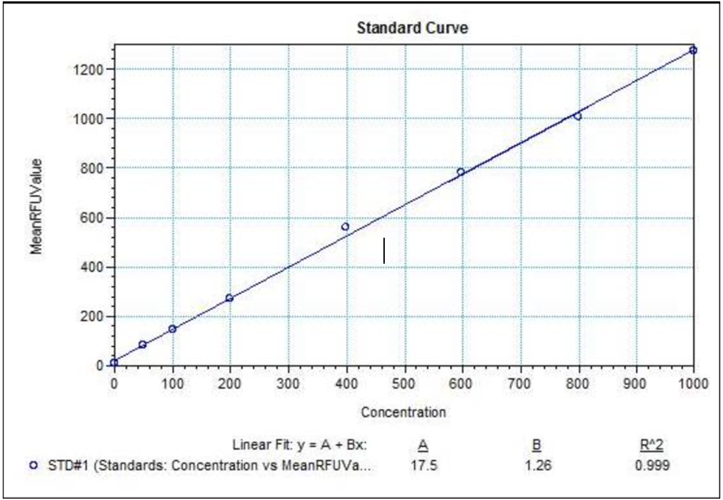
Figure 2.1 Pico Green Assay Standard Curve
Wells were loaded with of duplicate 100µl of DNA standards containing concentrations of 100, 200, 400, 600, 800, 1000 ng/ml to produce standard curve. The formula of linear fit is y=A+Bx, where y is OD, A is the intercept, B is the slope of line and x is unknown DNA concentration. SoftMax Pro 5.4.6. software automatically calculates unknown DNA concentrations of samples using standard curve.

2.2.3.2 ALP activity Calculation

The calculation standardises ALP production per cell to ensure accurate results.
Beer-Lambert’s Law states the relationship between absorption (A), molar absorption coefficient (ɛ), molar concentration (C), and optical path length (l). The equation is as shown below.

A= ɛCl

Beer-Lambert’s Law was used to calculate ALP activity of cells. The equation is rearranged and includes reaction time to demonstrate longitudinal ALP assay over 15 minutes.
$\frac{A}{ɛl}$= C

- B= (${OD}_{end}$- ${OD}_{start}$)x V

- ${OD}_{end}$: Absorbance where the reaction on different days of treatment has a linear difference (at 15 minutes (min))
- ${OD}_{start}$: Absorbance at start of reaction (at 0 minutes)
- V: Volume (100µl of PNPP assay solution+ 20 µl of sample, 120 µl total volume)
2. C =T x ɛ x l
- C= PNPP absorbance over reaction period (${cm}^{-1}$/min)
- T: Reaction Time (5 min)
- ɛ: PNPP Molar absorption coefficient (${18.5M}^{-1}$centimeter (${cm)}^{-1}$)
- l: Light path length (0.63 cm)
3. B/C= U (nmol/min)

- U= ALP production (U/mL)

The amount of DNA in ALP sample was multiplied by a dilution factor of 6 (120µl total volume /20µl of sample= 6). ALP production was then standardised by dividing the DNA amount in the ALP sample, resulting in amount of DNA (U/ng). The amount of DNA was then presented in U/ µg. An example of full calculation is demonstrated in Appendix (Figure 3.).

2.2.4 Mineralisation Analysis (Alizarin red assay)

The alizarin red assay measures calcium deposits by cells. The alizarin red stain reacts with calcium by its sulfonic acid or OH groups, producing red coloured crystals (Puchtler et al, 1997) that can be detected using a plate reader.

After SAOS-2 cells were seeded and incubated (Sections 2.2.3), cells were treated with 50,75,100,125,150,175µM of losartan or 0.5, 0.75, 1, 1.25, 1.5, 1.75µM of SD-208 for 14 or 21 days.
After the desired period of exposure to the drug, the media was removed, and the cells were washed three times with 100µl PBS and fixed with 100µl of 70% Ethanol. After 30 minutes of fixation, cells were washed three times with 100µl of deionised water. Cells were stained with 200µl of 0.5% alizarin red stain and agitated on a plate rotor for 30 minutes at 1g. Cells were washed three times with 100µl of deionised water, followed by a wash with 100µl of PBS. PBS was removed and the plate was left to dry.
Dried alizarin red was eluted by adding 200µl of HCM to each well and agitating for 2 hours at 37⁰C. Alizarin red was diluted in PBS to form standard concentrations of 0, 6.25, 12.5, 25, 50, 100, 200, 400 µM in separate volumes of 200µl. Alizarin red standards were plated on a new 96-well plate in duplicates. 200µl of alizarin eluate from each sample was transferred to a new plate, which was read on a SpectraMax multi-plate reader with excitation at 562nm. Absorbance is equivalent to the amount of calcium deposited by cells, measured in OD.

A standard curve (Figure2.2) was produced by readings of alizarin red standards. To calculate the unknown value of calcium deposits in dried alizarin red eluate samples, ODs of dried alizarin red eluate samples were plotted on a standard curve using SoftMax Pro 5.4.6. software.

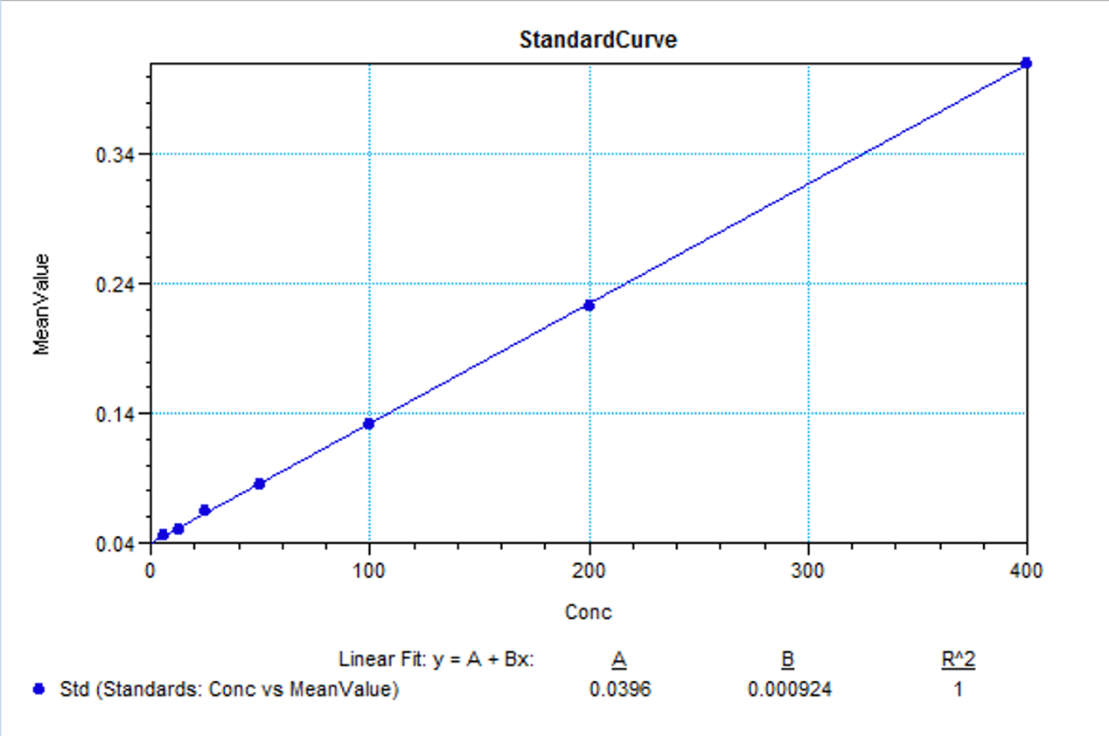

Figure 2.2 Alizarin red assay standard curve
Wells were loaded with of duplicate 200µl of alizarin red standards containing concentrations of 6.25, 12.5, 25, 50, 100, 200, 400uM to produce standard curve. The formula of linear fit is y=A+Bx, where y is OD, A is the intercept, B is the slope of line and x is unknown DNA concentration. SoftMax Pro 5.4.6. software automatically calculates unknown calcium concentrations of samples using standard curve.

2.3 In vivo studies

In vivo studies were used to allow a dynamic assessment of bone parameters using TGF-β inhibitors (SD-208 and losartan) in the presence or absence of breast cancer. Furthermore, the mechanism of TGF-β inhibitors in the tumour and bone microenvironment could be investigated by assessment of gene expression.

Ethics statement: All animal experiments were conducted at the University of Sheffield and approved by the UK Home Office (PPL 3267943, PPL holder: Dr. Michelle Lawson, PIL: I71985715, PIL holder: Jacky Wong) in strict accordance with the Animal (Scientific Procedures) Act 1986.

Dr. Lubaid Saleh trained and assisted me with the initial oral gavage of TGF-β inhibitors and the intracardiac injection (i.c.) of breast cancer cells to mice. Prof. Penny Ottewell assisted me with the i.c. injections of breast cancer cells into mice. Mr. Matt Fisher trained me with the intravenous (i.v) injections of doxorubicin into mice and bioluminescent imaging using in vivo imaging system (IVIS). Individual study design schematics will be described as follows.

2.3.1 Tumour-free in vivo studies

2.3.1.1 Immune deficient mice treated with TGF-β inhibitors

SD-208 and losartan were used for in vivo experiments based on the in vitro results (Chapter 3). Two pilot studies were performed in BALB/c immunodeficient tumour-free mice, as these mice will be used in subsequent tumour studies and injected with human MDA-MB-231 breast cancer cells. In the first study, BALB/c nude mice were treated with 150µl of SD-208 (60mg/kg) (n=4) or vehicle (150µl of 1% methyl cellulose) (n=3) by oral gavage using a gastric applicator syringe 5 days per week for 3 weeks. In the second study, BALB/c nude mice (n=4/ group) were treated with 150µl of losartan (100mg/ml) or vehicle (150µl of PBS) by oral gavage using a gastric applicator syringe 5 days per week for 3 weeks.
Animals were scanned weekly by a VivaCT80 µCT scanner (Section 2.3.3). All mice were euthanised after 3 weeks of treatment. Samples of mice processed ex vivo are carried out as (Section 2.3.10) (Chapter 3) SD-208 and losartan were prepared as described in Section 2.5.

2.3.1.2 Immune competent mice treated with TGF-β inhibitors
To assess whether losartan or SD-208 had a bone anabolic effect in the presence of an immune system, two additional tumour-free studies were performed in immunocompetent C57BL/6 mice. In the first study, C57BL/6 mice were treated with 100µl of Losartan (100mg/ml),100µl of Losartan (150mg/ml), or Vehicle (100µl of PBS) (Treated groups n=10/ group, vehicle group n=5) by oral gavage using a gastric applicator syringe 5 days per week for 3 weeks; In the second study, C57BL/6 mice were treated with 100µl of SD-208 (60mg/kg) or 100µl of SD-208 (100mg/kg) or vehicle (100µl of 1% methyl cellulose) (Treated groups n=7/ group, vehicle group n=5) by oral gavage using a gastric applicator syringe 5 days per week for 3 weeks.
In the losartan studies, animals were scanned by a VivaCT80 µCT scanner after 2.5 weeks of treatment (Section 2.3.3), and euthanised after 3 weeks of treatment. The SD-208 study was terminated at 2.5 weeks due to treatment potential toxicity. The rest of the mice were euthanised at 2.5 weeks and samples of mice processed ex vivo are carried out as (Section 2.3.10) (Chapter 3).

2.3.2 Tumour in vivo studies using a model of breast cancer-induced bone disease

Stock MDA-MB-231 Luc2+ GFP2+ cells (passage 44) were cultured (see section 2.1.) until confluent for the initial in vivo experiment.
Each confluent T75 flask contained approximately 10 million cells, which was enough to inject 20 mice for 50,000 cells per injection.
2.3.3 Establishment of an in vivo breast cancer tumour model
A breast cancer bone metastasis model was established that allowed the monitoring of the development of tumour growth by IVIS and associated lytic bone lesions using in vivo µCT. 6-week-old female BALB/c nude mice (n=10) (Charles River Laboratories, UK) were injected intracardially with 5 x ${10}^{4}$ MDA-MB-231-GFP-LUC2 cells (Section 2.3.5.1). Mice were scanned by IVIS Spectrum to monitor tumour burden (Section 2.3.5.2) twice weekly. Prior to cell tumour injection, mice were scanned by the VivaCT80 µCT scanner in vivo (Section 2.3.3) and once weekly after the tumour had spread to the hind limbs confirmed by IVIS imaging. All mice were euthanised depending on tumour growth; animals were culled 4-6 weeks after tumour cell injection. Only the long bones of the hindlimbs were collected, and the left tibia was analysed. Ex vivo µCT (Section 2.3.10) was used to scan the left tibia of mice after culling to confirm the accuracy of the endpoint results of in vivo µCT (Chapter 4).
2.3.4 Effect of doxorubicin on breast cancer tumour growth in bone
Doxorubicin’s effect on breast cancer tumour growth was assessed, determining whether it is suitable for combinational studies using TGF-β inhibitors in limiting bone disease. 6-week-old female BALB/c nude mice (n=10/ group) were injected intracardially with 5 x ${10}^{4}$ MDA-MB-231 cells as described before (Section 2.3.5.1). Mice were treated with 100µl of 4mg/kg doxorubicin or 100µl of PBS (vehicle) weekly for 3 weeks by i.v. injection. Mice were scanned by IVIS Spectrum to monitor tumour burden (Section 2.3.5.2) twice weekly. Prior to tumour cell injection, mice were scanned by the in vivo VivaCT80 µCT scanner (Section 2.3.3) and once weekly after the tumour had spread to the hind limbs confirmed by IVIS imaging. All mice were euthanised depending on tumour growth; animals were culled 4-6 weeks after tumour cell injection. Long bones of hindlimbs were collected and the left tibia was analysed by ex vivo µCT (Section 2.3.10) (Chapter 5).
2.3.5 Effect of losartan on breast cancer-induced bone lesions
The effect of losartan in limiting/repairing bone lesions in the model of breast cancer-induced bone disease was assessed. 6-week-old female BALB/c nude mice were injected i.c with MDA-MB-231 cells (Section 2.3.5.1). Mice were treated with 100µl of 100mg/kg losartan (n=11), the rest of the tumour-bearing mice (n=6), who had no tumour detected, were treated with 100µl of PBS. Mice were scanned by IVIS Spectrum to monitor tumour burden (Section 2.3.5.2) twice weekly. Before tumour injection, mice were scanned by the in vivo VivaCT80 µCT scanner (Section 2.3.3) and once weekly after the tumour had spread to the hind limbs, confirmed by IVIS imaging. All mice were euthanised 7 weeks after tumour cell injection (Chapter 6).

2.3.6 Effect of SD-208/ Palbociclib on breast cancer-induced bone lesions
The effect of SD-208 and palbociclib in limiting/repairing bone lesions in the model of breast-cancer induced bone disease was assessed. 6-week-old female BALB/c nude mice were injected i.c with MDA-MB-231 cells (Section 2.3.5.1). Mice were treated with 100µl of 60mg/kg SD-208 (n=6) or 100mg/kg Palbociclib (n=6) or 100ul of 60mg/kg SD-208 in combination with 100mg/kg palbociclib (n=3), the rest of the tumour bearing mice (n=9) who had no tumour detected were treated with 100µl of 1% methylcellulose. Mice were scanned by IVIS Spectrum to monitor tumour burden (Section 2.3.5.2) twice weekly. Prior to tumour injection, mice were scanned by the in vivo VivaCT80 µCT scanner (Section 2.3.3) and once weekly after the tumour had spread to the hind limbs, confirmed by IVIS imaging. All mice were euthanised 7 weeks after tumour cell injection (Chapter 6).

2.4 Animals

Female C57BL/6 mice and BALB/c nude mice were delivered at the age of 6-7 weeks old from Charles River. The animals were allowed 1 week to be accustomed to the housing facility (University of Sheffield, Biological services) before any experimental procedures started. Mice were housed at n=4 or n=5 mice/cage and exposed to 12:12 hour light-dark cycle in a humidity and temperature-controlled environment. The number of animals in each group was calculated by G* Power software. Mice were randomised into groups based on weights. In vivo and ex vivo analyses were blinded.

Both immunocompetent C57BL/6 mice and immunocompromised BALB/c nude mice were used to assess the effects of SD-208 and losartan on bone. BALB/c nude mice were also used in the xenograft model of breast cancer induced-bone disease, which allowed the growth of human breast cancer cells.

2.5 Preparation of drugs for in vivo studies

Both SD-208 and losartan were crushed inside bead mill tubes using a bead mill machine to make them more soluble in solution. Working solution of drugs were prepared fresh twice every week in separate 7ml bijou tubes, to avoid repeated sonication and denaturation of the drug.

To form a working solution of SD-208 at a concentration of 60mg/kg, 18mg of SD-208 was dissolved in 3ml of 1% methyl cellulose (for 3-day treatment), or 12mg of SD-208 dissolved in 2ml of 1% methyl cellulose (for 2-day treatment).
To form a working solution of SD-208 at a concentration of 100mg/kg, 30mg of SD-208 was dissolved in 3ml of 1% methyl cellulose (for 3-day treatment), or 20mg of SD-208 was dissolved in 2ml of 1% methyl cellulose (for 2-day treatment).
When dissolving SD-208, working solutions were agitated in an ultrasonic bath and the temperature was measured with a non-mercury thermometer to avoid the temperature rising over 50°C (SD-208 will denature at over 50°C). SD-208 working solutions were made fresh every three days.
60mg/kg SD-208 was chosen based on a published paper which demonstrated an anabolic effect in bone in a tumour-free model, where 20mg/kg had less bone anabolic effect (Mohammed et al, 2009); 60mg/kg SD-208 was able to reduce destruction in bone in other cancer models (Mohamad et al, 2011; Green et al, 2019).

Based on personal communication with Penelope Ottewell’s group, 4 days of 60mg/kg SD-208 or 100mg/kg losartan treatment did not have a bone anabolic effect on C57BL/6 tumour-free mice (unpublished data). An increased dose of 100mg/kg SD-208 and 150 mg/kg losartan was used in addition to the 60mg/kg and 100mg/kg losartan was chosen for the immunocompetent tumour-free mice studies, in case smaller standard doses do not have an effect.

To prepare 1% methyl cellulose for control treatment, 2g of methyl cellulose was dissolved in 200mL purified water at 70$℃$. Methyl cellulose solution was put on a magnetic stirrer with a stirring pea for 90 minutes at 700rpm until fully dissolved, with no particulates present.

To form a working solution of losartan at a concentration of 100mg/kg, 30mg of losartan was dissolved in 1.8ml of PBS (for 3-day treatment), or 20mg of losartan dissolved in 1.1ml of PBS (for 2-day treatment).

Losartan has not yet been assessed in models of breast cancer bone metastasis, and its ideal dosing in this setting is still unclear. Previous studies demonstrating losartan’s bone anabolic effects generally involved treatment periods longer than eight weeks (Chen et al, 2015; Mulinari-Santos et al, 2019). Unpublished data, shared via personal communication with Mr. Darren Lah, indicated that lower doses of losartan did not trigger a bone anabolic response in either in vitro or in vivo settings. Regarding toxicity, Spence et al, 1995 found that administering doses of 200 mg/kg or more led to significant weight loss in mice. Based on these findings, a high-dose regimen of 100 mg/kg was selected for the pilot study. This dose was continued after initial results indicated a bone anabolic effect.

To form a working solution of losartan at a concentration of 150mg/kg, 45mg of losartan was dissolved in 1.8ml of PBS (for 3-day treatment), or 30mg of losartan dissolved in 1.1ml of PBS (for 2-day treatment). Losartan working solutions were agitated in an ultrasonic bath before every treatment to avoid precipitation.

To form a working solution of doxorubicin at 4mg/kg, 216µl of 5mg/ml doxorubicin was added to 1284µl of PBS to form a working solution and mixed using a vortex mixer.
A dose of 4 mg/kg doxorubicin was chosen based on findings from a study by Ottewell et al, 2008 in the Journal of the National Cancer Institute, which demonstrated that a lower dose of 2 mg/kg did not reduce tumour growth in a breast cancer bone metastasis model. This led to the assumption that the higher dose of 4mg/kg would yield greater efficacy. However, this was later identified as a misinterpretation. A subsequent study by the same authors, published in Clinical Cancer Research in 2008, revealed that a 2 mg/kg dose of doxorubicin was effective in reducing tumour growth in a breast cancer bone metastasis model.

To form a working solution of palbociclib at 100mg/kg, 72mg of palbociclib was dissolved in 6.4ml of 1% methyl cellulose (for 3-day treatment), or 24 mg of palbociclib dissolved in 4.4ml of 1% methyl cellulose (for 2-day treatment).
100mg/kg palbociclib was chosen based on studies carried out within my group, where this concentration was able to inhibit tumour growth (Saleh et al, 2023)

2.6 Bioluminescent imaging over time

The IVIS spectrum is an in vivo non-invasive imaging system that measures tumour burden/disease progression. Mice were anaesthetised with 2% isoflurane and injected subcutaneously with 100µl of 3.5mM luciferin and imaged by the IVIS spectrum machine (Figure 2.3). The front and back of the mice were imaged 8 minutes after injection. In tumour-bearing mice, MDA-MB-231 cells expressing luciferase oxidised luciferin in the presence of oxygen, ATP, and Mg²⁺, emitting bioluminescent light detectable at 560 nm (Lim et al., 2011).

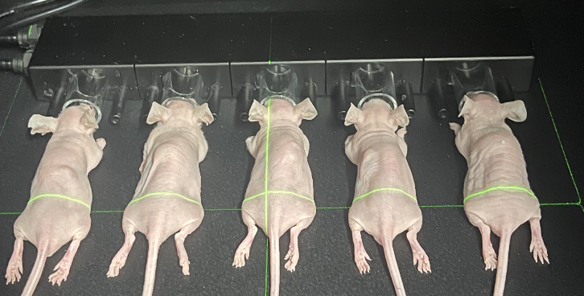
Figure 2.3 IVIS bioluminescent imaging of mice
The mice were anaesthetised in the induction box and then moved to the platform of the IVIS machine. The nose of each mouse was placed in the plastic ring of the platform to maintain the mice under anaesthesia while they underwent the procedure. Field of D was used to scan 5 mice; field of C was used to scan 3 mice in one scan.

2.7 In vivo µCT analysis

Proximal tibias and distal femurs of mice were scanned using an in vivo VivaCT80 µCT scanner (Figure 2.3) at baseline (before the injection of tumour cells or treatment) and once weekly for 3-4 weeks, depending on the study, then bone integrity/structure was analysed (Figure 2.4). Mice were anesthetised by isoflurane inhalation at 4% and maintained at 1.5-2%. The hindlimbs were scanned at 10.4μm isotropic voxel size, 55kV, 145μA, 200ms integration time for a 360-degree scan with a 0.24-degree rotation step. PuTTY and XMing were used to connect to the VivaCT80 scanner system, and tomography projection images were reconstructed using VivaCT80 software. Reconstructed images were downloaded from the scanner by MicroCT FTP software and analysed by CTAN software (version 1.18). Results were then quantified by Prism software (version 9.0).
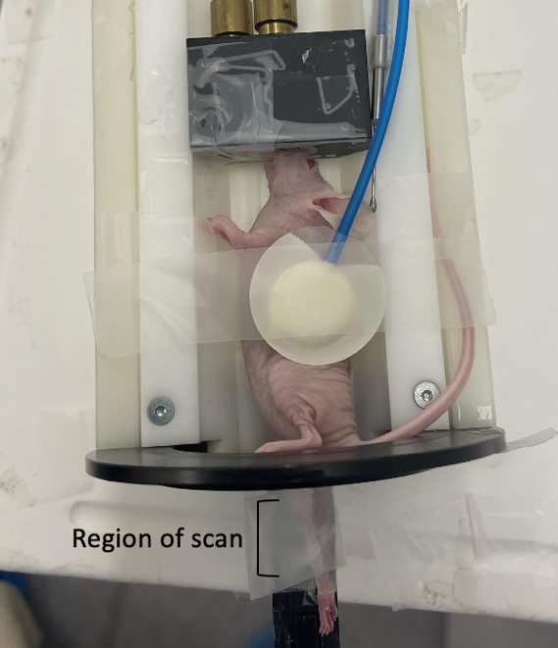
Figure 2.3 In vivo µCT of the hindlimb of mouse
Representative image of an anaesthetised mouse whilst it undergoes in vivo µCT. As the mouse was alive, the hindlimb of the mouse was taped to the stage to avoid movement that would cause artifacts to the scan. The scanner was set to scan only the proximal tibia and the distal femur part of the hindlimb. A child’s heart pulse detector was taped to the mouse to monitor heart rate. 6-7 weeks old mice used had a small head that did not fit into inhaler completely, tape attached to hole of inhaler was used to maintain position of mice and prevent excess isoflourane into working environment.
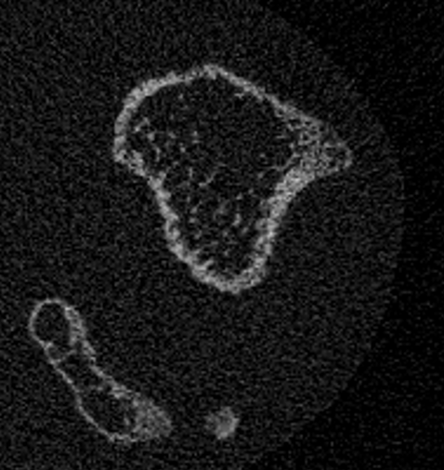
Figure 2.4 Cross sectional in vivo µCT image
Representative reconstructed cross-sectional image of a mouse tibia that was used to measure bone parameters after in vivo µCT scanning.

2.8 Intracardiac injection

After MDA-MB-231 cells were confluent, they were trypsinised and counted. The required number of cells was calculated based on the desired number of tumour-bearing mice in study. Calculated number of cells was resuspended with PBS and stored on ice. Cells were pipetted through a cell strainer twice, once after resuspending in PBS and once before intracardiac injection (i.c.). 10 female, 6-week-old BALB/c nude mice (Charles River Laboratories, UK) were injected intracardially (left ventricle) with 5 x ${10}^{4}$ MDA-MB-231-GFP-LUC2 cells in 100µl of PBS.

2.9 Dissection and sample processing

At the end of all in vivo experiments, mice were anesthetised by isoflurane inhalation and cardiac bleed into 1.5ml labelled transparent Eppendorf tubes before cull. Blood was left clotting for 30 minutes and spun at 1000g for 10 minutes at 4°C. Serum was then aliquoted in 50μl and transferred to 0.5ml labelled Eppendorf tubes and stored at -80°C. Serum was used for subsequent analyses, including measurement of serum bone turnover markers for bone formation, osteoblast marker procollagen 1 N-terminal propeptide (P1NP), and osteoclast marker tartrate resistant acid phosphatase (TRAP5b) (see section 2.13).
The right femur was flushed to extract RNA for conversion to cDNA for gene expression analysis (see section 2.14), the left tibia was used for ex vivo µCT analysis (see section 2.10) and for measurement of osteoblast and osteoclast numbers and area (using bone histomorphometry) (see section 2.12), the left femur and right tibia were kept as backup bones. The left tibia, left femur, and right tibia were fixed in 4% PFA for 48 hours and then stored in 70% ethanol at -20 °C.

2.10 Ex vivo µCT analysis

After culling, the left tibias of mice were scanned using an ex vivo SkyScan1272 µCT scanner at medium camera (2016X1344), 0.5mm aluminium filter, 4.18μm pixel size, 50kV, 200μA for a 180-degree scan with a 0.7-degree rotation step. Images were reconstructed by NRecon (version 2.0) (Figure 2.5) and analysed by CTAN software as previously described (Bouxsein et al, 2010). Results were then quantified by Prism software. Images reconstructed were analysed on CTVOX software. The back of tibias was excluded by CTVOX software to produce representative 3D-images of tibias.

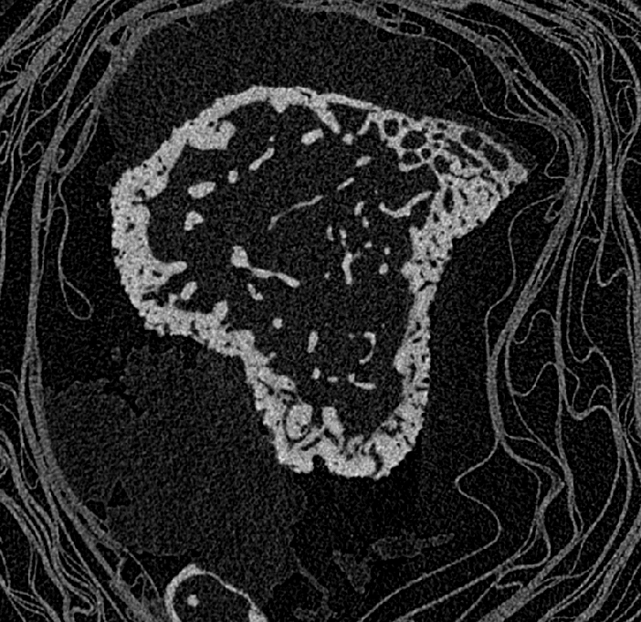
Figure 2.5 Cross sectional ex vivo µCT image
Representative cross-section image of the tibia that was used to measure bone parameters

2.11 Image J analysis of bone lesion area

Image J can perform automated 2-D analysis on bone and determine the % lesion area to the bone (Figure 2.6). Tibia and femur cross-sectional images from in vivo and ex vivo µCT scanning were processed as described above (Section 2.7, 2.10). Processed images were analysed on CTVOX software to produce 3D-surface images of the tibia (all three surfaces of tibia- medial, lateral, posterior). The 3D-surface images of the tibia were then analysed on ImageJ to measure surface lesion area. The surface lesion area of all three surfaces was added together to produce the lesion area.
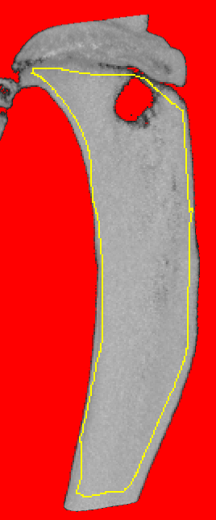
Figure 2.6 2D-image of tibia for bone lesion area analysis
Bone lesion area was measured as percentage of total bone surface area included in yellow line, everything outside of the yellow line is not include in measurement.

2.12 Bone histology

2.12.1 Preparation of tibia embedded paraffin sections

To decalcify the tibias, 0.4M EDTA was used, which softened the bones allowing sections to be cut from paraffin embedded bones. EDTA solution was prepared as follows: 11 PBS tablets were dissolved in 700mL distilled water. 10g of NAOH was added to the solution and 186.6g EDTA was added in several stages. A maximum of 10g of NAOH was added to the solution until the EDTA was completely dissolved. The pH of EDTA solution was measured to avoid the pH going over 7.8 and below 7, the appropriate pH for bone decalcification. NAOH was added to the solution if the pH was too low, and HCL was added to the solution if the pH was too high. Bones were placed in individual 1.5ml Eppendorf tubes containing 1 ml of EDTA which was changed every two days for two weeks. Tibias were then processed by embedding in paraffin blocks. 3µm bone sections were cut from paraffin-embedded tibias using a microtome machine (3 longitudinal Sections were cut, each with a difference in depth of 10μm) (Dempster et al, 2013).
2.12.2 Haematoxylin and eosin (H&E) staining

Haematoxylin stains acidic cell structures (nuclei) a purplish-blue colour, and eosin stains basic cell structures (cytoplasm) a pink colour (Fischer et al,2008). Furthermore, Haematoxylin and Eosin (H&E) staining was used to identify osteoblasts and bone structures. Bone sections were dewaxed by incubating in xylene twice for five minutes, followed by a series of IMS washes (99%, 99%, 95%, 70%) for 5 minutes each to remove xylene. The bone sections were rinsed with running water for 1 minute, incubated in Gill’s haematoxylin for 90 seconds, and “blued” in running water for 3 minutes to give the bone sections better contrast. The bone sections were incubated in 1% aqueous eosin for 5 minutes, rinsed with running water for 30 seconds, followed by a series of IMS washes (70%, 95%, 99%, 99%) for 10 seconds each, twice in xylene for 1 minute and 3 minutes. The bone sections were mounted with a coverslip using DPX and left to dry overnight.

2.12.3 Tartrate acid resistant phosphate (TRAP) staining

TRAP is associated with osteoclast differentiation and activity. In staining, TRAP is a histochemical marker for osteoclasts, which stains them red (Galvao et al, 2011). The bone sections were dewaxed as described before (see section 2.12.2) and incubated in acetate tartrate buffer in a pre-warmed coplin jar for 30 minutes at 37°C. The bone sections were incubated in sodium nitrate buffer for 15 minutes at 37°C and rinsed in running tap water twice for 1 minute each. The bone sections were counterstained with Gil’s haematoxylin for 20 seconds and “blued” in running tap water for 3 minutes. The bone sections were dehydrated and mounted with a coverslip using DPX as described before (see section 2.12.2).

2.12.4 Ploton silver nitrate staining

Silver nitrate stains for osteocyte lacunae and their network (Gaudin-Audrain et al, 2008). Silver
nitrate buffer was prepared by dissolving 15g of silver in 30mls of distilled water. The bone sections
were dewaxed as described before (see section 2.12.2) and incubated in silver nitrate buffer in coplin jar for 55 minutes at room temperature in the dark. The bone sections were then washed in distilled water three times for 5 minutes each, followed by incubation in sodium thiosulfate buffer in a plastic coplin jar for 10 minutes. The bone sections were washed again with distilled water for three times for 5 minutes each and counterstained with Gil’s haematoxylin and “blued” as described before. The bone sections were dehydrated and mounted with a coverslip using DPX as described before (see section 2.12.2).

2.12.5 Bone histomorphometry

The number of osteoblasts and osteoclasts was determined by bone histomorphometric analysis using osteomeasure software. Both the trabecular and the medial side of the endocortical region of the left tibia Sections were analysed (Dempster et al ,2013) using an Olympus binocular microscope and OsteoMeasure software. Under the 10x objective, the bone on the section was found. An Offset of 250µm is used from the growth plate. Under the 40x objective, 6 predefined 1.5mm² squares were drawn from the (i) lateral and medial side (ii) of the endocortical surface, 9 predefined squares were drawn from the (iii) trabecular bone (Figure 2.7), with osteoblast/osteoclast/osteocyte number, osteoblast/osteoclast/osteocyte surface area and endocortical perimeter scored (Figure 2.8, 2.9). The number of dendrites and dendrite length on the osteocytes were also scored. An average of the squares was calculated and used for analysis to compare each bone.
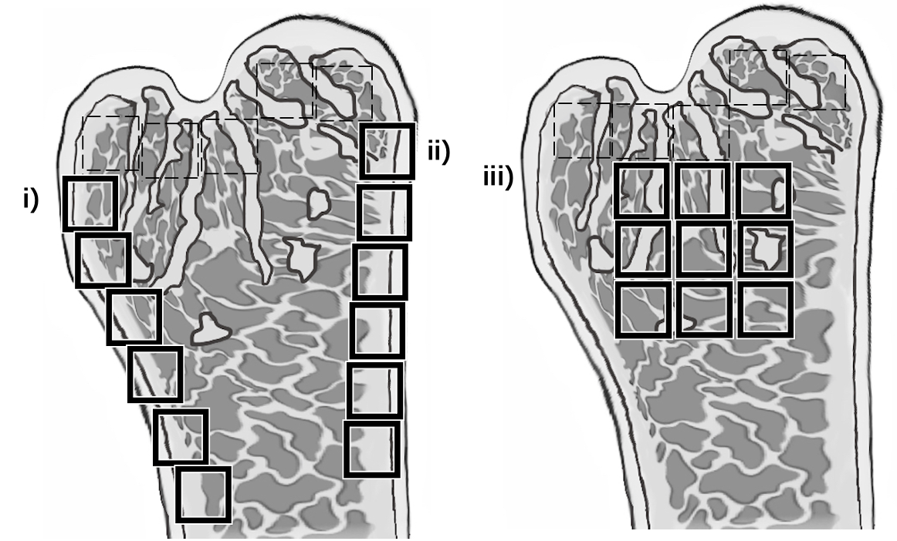
Figure 2.7 Predefined area of lateral/medial side and trabecular bone of tibia cross Section
Cross Section schematic of tibia and measured area: i) lateral side ii) medial side iii) trabecular bone. Predefined area is 250µM away (dotted squares) from growth plate and each square is250µMX250µM.

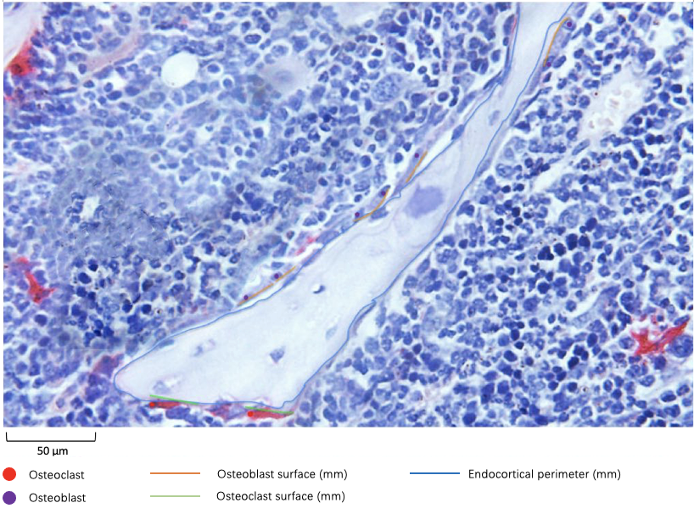
Figure 2.8 Measurements of osteoblasts and osteoclasts number and surface
Histological image of the trabecular in the tibia of 10-week-old tumour-free mice stained by TRAP and H&E. Osteoblasts and osteoclasts are in contact with the bone surface. Osteoblasts have a cuboidal morphology and a distinct nucleus, osteoclasts are red (stained by TRAP) and multi-nucleated. Osteoblasts are indicated by purple dots and diameter of osteoblast surface in green. Osteoclasts are indicated by red dot and diameter of surface in orange. The whole endocortical perimeter of the bone included in the measurement is indicated in blue.
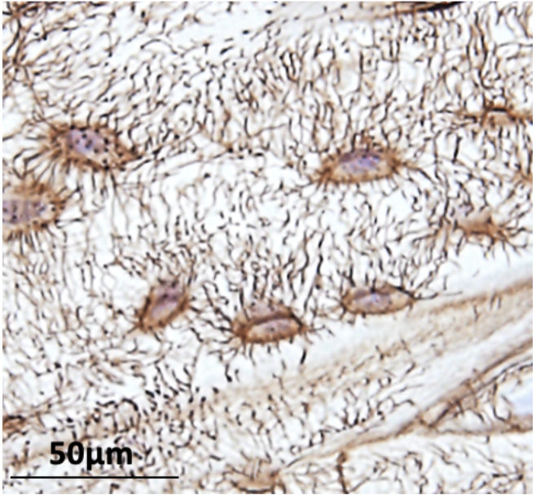
Figure 2.9 Distinction of the osteocytes lacunae and network
Histological image of cortical bone in the tibia of 10-week-old tumour-free BALB/c nude mice stained by ploton silver stain. Osteocytes (in brown colour) have a single nucleus and multiple protruding dendrites.

2.13 ELISA assay

The ELISA assay was used in serologic testing to measure the proteins procollagen 1 Intact N-terminal propeptide (P1NP) and TRAP5b. In the blood stream, P1NP is released by osteoblasts during collagen maturation; TRAP5b is released during bone resorption (Shetty et al, 2016). The ELISA kit came with a 96-well plate, where wells were plated with the antigen of interest. 10µl of serum was pipetted into wells and incubated for 90 minutes at 37°C. All liquid in the wells were aspirated, 100µl of biotinylated detection Ab were pipetted to each well, and antigen-specific antibodies in the serum bind to the antigen in the well. The liquid in the well were aspirated, the wells were washed with 100µl of PBS three times to remove any unbound antibodies. 100µl of HRP conjugate (secondary antibody that binds to the biotinylated ab) were pipetted in the wells and incubated for 30 minutes at 37°C. The liquid in the wells was aspirated and washed with PBS as described before five times. 90µl of substrate reagent was added to the wells and incubated for 15 minutes at 37°C. The substrate interacts with the enzyme to give a visible colour, which is quantified by the plate reader at 450nm.
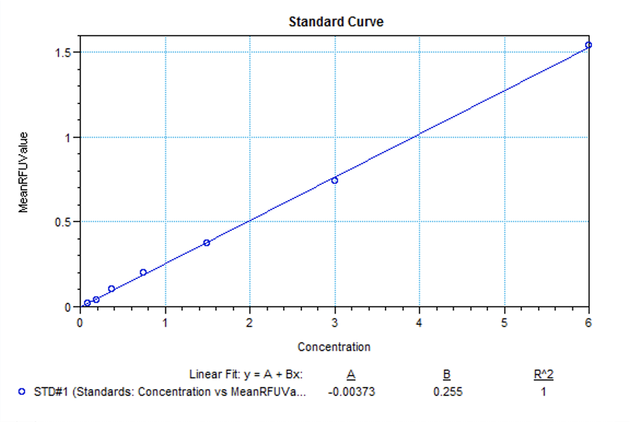
Figure 2.10 ELISA (P1NP) assay standard curve

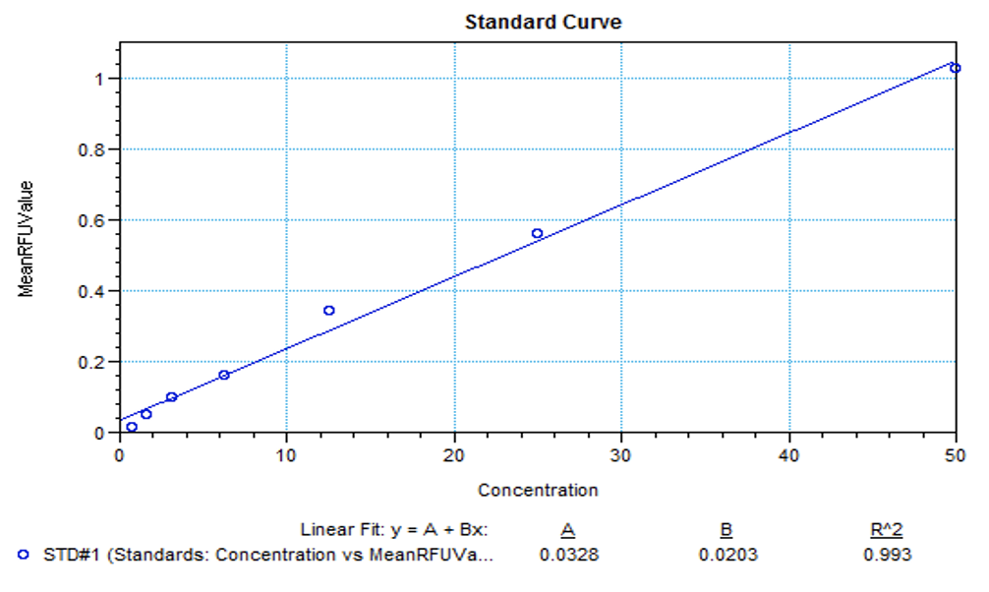
Figure 2.11 ELISA (TRAP5b) assay standard curve
2.14 Gene expression analysis

The work area was sprayed with RNAse ZAP, and pipettes and racks were put in an ultraviolet (UV) hood prior to any experiments taking place. This is to prevent any RNAase contamination – enzymes that can degrade RNA.
2.14.1 RNA purification from bone
Femurs were flushed to separate the bone marrow from the femur bone. The bone marrow was used to assess the expression of osteoblast/ osteoclast specific genes (Chapter 6), while the femur bone was used to assess the expression of osteocyte-specific genes (Chapter 7). Femur bone was chopped into small pieces with scalpel blades prior RNA isolation. Bone fragments or bone marrow were lysed with 1ml of tri-reagent in bead mill tubes. Bones were crushed by bead mill shaker until no bone material could be visually observed. 200µl of chloroform was mixed with bone solution by inverting tubes, which separated RNA and DNA. Tubes were spun by centrifuge at 15G for 20 minutes. The supernatant (RNA phase layer) was aspirated and mixed with 500µl of propanol to precipitate RNA. The cell suspension was centrifuged at 15G for 15 minutes and the liquid was removed to leave a cell pellet. 1.25ml of 70% ethanol (30% nuclease-free water) was used to resuspend the cell pellet before centrifugation at 7.5G for 5 minutes. Then the liquid phase was removed and 30µl of nuclease-free water was used to resuspend the cell pellet. 1µl of cell suspension was measured on a nano-drop machine to measure the 260/280 value (over 1.8, no contamination) and RNA concentration (ng/µl). RNA was purified and stored at -80°C.
2.14.2 cDNA conversion
Table 2.5. RT sample calculation
RNA measured | Volume of RNA to use | Water
123.1 | 8.1ul (100/123.1) | 0.9ul (9-8.1)

RNA-to-cDNA kit was put on ice 30 minutes prior to the experiment according to the manufacturer’s instructions. Samples with reverse transcriptase (RT+) and samples without reverse transcriptase (RT-) were prepared. Reverse transcriptase creates a copy of the complementary strand of DNA based on the RNA sequence of the sample (Hu and Hugh, 2012). RT- samples do not contain reverse transcriptase and are unable to produce cDNA from the sample, contamination is present if detection occurs during the polymerase chain reaction in RT- samples. RT Samples were prepared based on the volume of RNA measured in section 2.14.1. An example of full calculation (Table 2.5), for RT+ samples, 1µl of reverse transcriptase was added to sample, for RT- samples, 1µl of nuclease-free water was added instead. Samples were pulse-spined to bring all samples down and heated using the G-Storm GS1 thermal cycler for automatic cDNA synthesis. Heated to 112°C for 10 minutes for annealing of primers, 37°C for 1 hour for elongation of cDNA, and 95°C for 5 minutes for enzyme deactivation. cDNA was stored at -80°C.
2.14.3 Quantitative Polymerase Chain Reaction (qPCR)
cDNA samples, master mix, and primers were put on ice 30 minutes prior to the experiment according to the manufacturer’s instructions. Complete mixes were made based on the number of samples, one sample required 5µl master mix (Taq man), 1µl Primer, 3µl water per well/ gene. 9µl of master mix was pipetted into a 384-well plate, followed by 1µl of cDNA. The plate was covered with a slip to avoid evaporation and pulse spun. qPCR was performed on ABI Prism 7900HT and SDS 2.1 software (Figure 2.12). TaqMan primers used for quantifying expression of genes, for osteoblast/osteoclast-specific genes:
TGF-β, SMAD3, EFNB2, Runt-related transcription factor 2 RUNX2, osteocalcin, Cathepsin K (CTSK), Dendritic cell–specific transmembrane protein (DC-STAMP) relative to the expression of 18s. For osteocyte-specific genes, dentin matrix protein 1 (DMP1), SOST, acid phosphate 5 (ACP5), MMP13, and MMP2 relative to the expression of galyceraldehyde-3-phosphate dehydrogenase (GAPDH) expression.

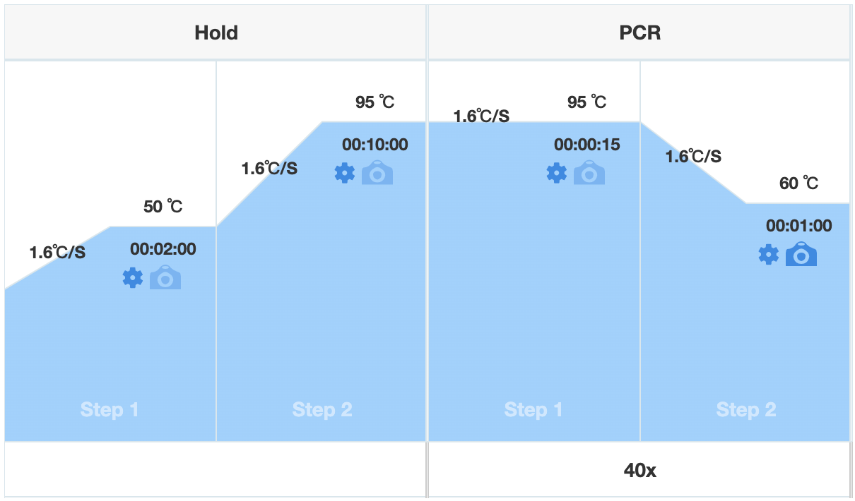
Figure 2.12 Run of qPCR
After the 384 well plate was inserted into ABI Prism 7900HT machine, it was prewarmed to 50 °C for 2 minutes. Following by heat up to 95 °C for 10 minutes which denatures double-strand DNA to produce single-strand DNA templates. The temperature was then cooled down to 60°C, allowing primers to anneal to the target sequence in the single-strand template. Temperature was raised to 95 °C again, during which DNA polymerase in the mastermix incorporate complementary nucleotides into DNA template and form double-stranded DNA. This process is repeated for 40 cycles. During each cycle, SYBR green in the master mix binds to synthesised double-strand DNA and fluoresced. The intensity of fluorescence above the background level was measured and recorded as cycle quantification (Cq) value.

2.14.4 Gene expression calculation
Gene expression is calculated using the relative fold change method, where values are calculated relative to a control (Livak and Schmittgen, 2001). CT value is the number of PCR cycles required for the fluorescent signal to exceed the background fluorescence and is related to the amount of target nucleic acid in the sample.

Delta ($∆$) CT for each sample is calculated by normalising the CT gene of interest (GOI) to the CT of the housekeeping gene (Reference).
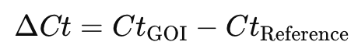
Delta delta ($∆∆$) CT for each sample is calculated compared to the CT of the control.
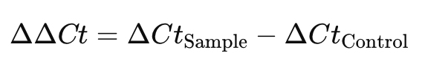
Fold Change indicates how much gene expression had changed and is calculated in log2 of $∆∆$ CT.
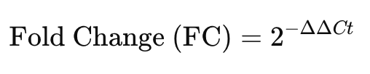
Relative fold change (RFC) is the normalised expression value, calculated where FC values of samples are relative to the normalised FC of the control.

Statistical analysis
When group sizes were equal, parametric tests were performed using GraphPad Prism v9.4 (La Jolla, CA, USA), including unpaired t-tests, one-way ANOVA with Dunnett’s multiple comparison test, or two-way ANOVA with Sidak’s multiple comparisons test. For non-parametric analyses, data were analysed in GraphPad Prism using the unpaired t-test with Mann-Whiteny’s test, one-way ANOVA with Kruskal-Walliss’s test. For two-factor non-parametric designs, data were analysed using the Aligned Rank Transform (ART) method followed by two-way ANOVA, implemented in R software (Vienna, Austria) using the ARTool, dplyr, and emmeans packages.
All data were presented as mean ±SD, and P≤0.05 was considered significant. Significance ns= not significant (P>0.05), * (P≤0.05), ** (P≤0.01), *** (P≤0.001), and **** (P≤0.0001). Power calculations were analysed using G* power software (Düsseldorf, Germany) : Two-tailed t-test, α (Significance level): 0.05, Power (1−β): 0.8.

Chapter 3
Establishing bone anabolic effects of SD-208/ Losartan in vitro and in vivo

3.1 Summary

Background: TGF-β has pro-tumour effects in breast cancer bone metastasis, which makes it a target for new therapies. Inhibition of TGF-β in vivo has demonstrated improved outcomes on bone structure in mice with breast cancer bone metastasis. TGF-β type-1 receptor (TGFβR1) kinase inhibitor SD-208 and an angiotensin type 1 receptor inhibitor losartan are potential therapeutic agents for breast cancer bone metastasis, as both agents have previously been shown to inhibit TGF-β and have demonstrated bone anabolic effects in mice.

Results: Alkaline phosphatase and alizarin assays conducted in vitro demonstrated that SD-208 and losartan increased alkaline phosphatase production and mineralization in differentiated SAOS-2 cells. In vivo µCT data demonstrated that 3 weeks of losartan treatment significantly increased trabecular BV/TV and number. Similarly, 3 weeks of SD-208 treatment significantly increased trabecular BV/TV, number. Bone histomorphometry data demonstrated that losartan increased osteoblast number in the trabecular bone and endocortical bone.

3.2 Introduction

The various pro-tumour effects of TGF-β make it a potential therapeutic target for inhibiting bone resorption and breast cancer bone metastasis.

3.2.1. TGF-B inhibition in models of breast cancer bone metastasis

The inhibition of TGF-β has been demonstrated to have bone anabolic effects and reduce the development of bone lesions induced by breast cancer-induced bone metastases (Buenrostro et al, 2018; Wright et al, 2013).
Curcuminoid-enriched product (76.9% curcumin, 17.6% desmethoxycurcumin, 5.5%bis-demoethoxyfurcumin) was shown to inhibit the osteolytic factor PTHrP through the Smad pathway of TGF-β signalling using an immunocompromised model of breast cancer bone metastasis. Four-week-old female athymic nude mice (n=11/ group) were injected intracardially with MDA-MB-231 cells. After tumour injection, mice were treated with 25 or 50mg/ kg curcuminoid or PBS (vehicle) every other day for 3 weeks by intraperitoneal (i.p) injection. Bone lesions were reduced by 51% in curcuminoid-treated mice compared to vehicle-treated mice. Curcuminoid had no anti-tumour effect, and there was no change in tumour burden. Osteoclast numbers were decreased, and this was likely the result of reduced PTHrP secretion by tumour cells through TGF-β inhibition (Wright et al, 2013).

In another study, the effect of early TGF-β inhibition was tested in an immunocompromised model of breast cancer bone metastases using TGF-β neutralising antibody 1D11.Four/five-week-old female athymic nude mice and BALB/c nude mice (n=12/ group) were injected with 10mg/kg 1D11 (a TGF-β neutralising antibody) or 13C4 (1D11 isotype, vehicle) daily for 7 days before tumour inoculation. After seven days of treatment, athymic mice received human MDA-MB-231-GFP cells by i.c., while BALB/c nude mice received 4T1 cells by i.c. Both athymic mice and BALB/c nude mice received 3 times 1D11 treatment or 13C4 per week by i.p. injection. Athymic mice were culled at 10, 14, and 32 days, while BABL/c nude mice were culled at 7, 10, 14 days post-tumour inoculation. Both athymic and BALB/c nude 1D11-treated mice had greater % bone volume/ tissue volume (%BV/TV) over the course of tumour-induced bone disease compared to vehicle-treated mice. In addition, 1D11-treated athymic mice had a significant reduction in osteoclasts and resorption pits. Tumour burden was decreased in both types of 1D11-treated mice (Buenrostro et al, 2018).

3.2.2. TGF-βR1 inhibitor SD-208

SD-208 (2-(4-Choloro-2-fluorophenyl)-4[4-pyridlamino] pteridine) is a bone anabolic agent that inhibits TGFβR1 kinase, specifically SMAD3 phosphorylation and downstream SMAD3/4 transcription (Figure 3.1) (Haque and Morris, 2017, and Mohammad et al,2010). Furthermore, transcription of TGF-β target genes (including PTHrP, IL-11, RUNX2, and CTGF) that promote bone metastasisis inhibited by SD-208 in vitro (Mohammed et al, 2011).
SD-208 is currently at the pre-clinical developmental stage, used as an anti-cancer therapy in models of breast cancer (Biswas et al, 2011) and prostate cancer (Fournier et al,2015). It is not used as a bone anabolic agent and is not approved for treatment of cancer-induced bone disease (Kim et al, 2021).

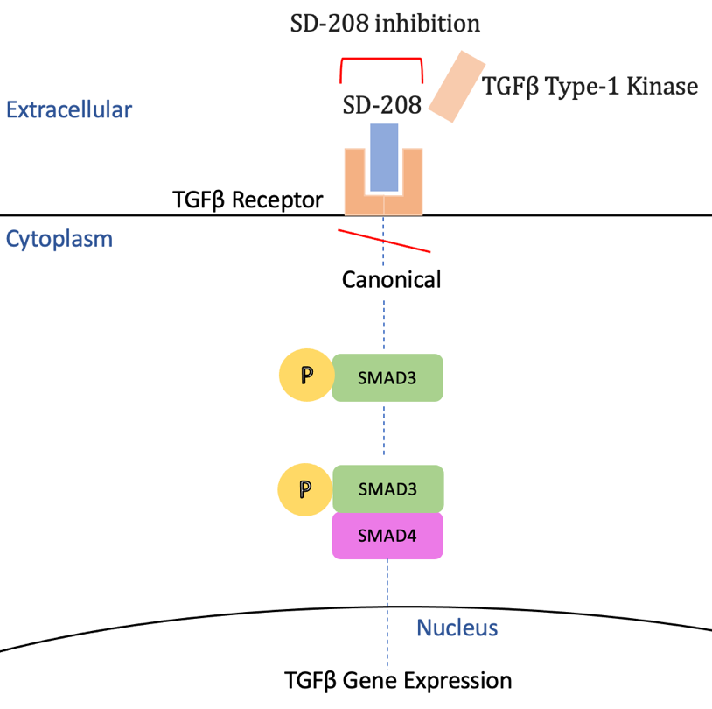
Figure 3.1 SD-208 inhibition of the TGF-β signalling pathway
SD-208 competitively inhibits TGF-β type 1 receptor (not allowing TGF-β type-1 kinase to bind), this inhibits TGF-β induced SMAD3 and further SMAD3/4 transcription of TGF-β target genes. Adapted from Mohammed et al, 2010

3.2.2.1. Effect of TGF-βR1 inhibition in immunocompetent tumour-free mice

SD-208 has been demonstrated to have bone anabolic effects in tumour-free immunocompetent mice. 4-week-old male and female C57BL/6 mice (n=15/ group) were treated with either 20mg/kg SD-208 daily or 60mg/kg SD-208 twice daily by oral gavage for 6 weeks. 60mg/kg and 20mg/kg SD-208 treatment both significantly increased %BV/TV, trabecular number, and separation. Furthermore, both treatments significantly increased osteoblast number in both female and male mice; only male mice had decreased osteoclast numbers. 60mg/kg SD-208 treatment achieved maximal response by significantly increasing bone mineral density (BMD) in tibia, femur, and spine in male and female mice; 20mg/kg SD-208 treatment had no significant effect. In vitro, this study demonstrated potential regulating pathways through the inhibition. Mouse primary calvaria osteoblasts treated with 10μM SB4313542 (another TGFβR1-inhibitor) for 48 hours decreased expression of RANKL mRNA that promotes osteoclast differentiation and increased expression of ephrin B2 that inhibits osteoclast differentiation, B4 expression that promotes osteoblast differentiation (Mohammad et al, 2009).
Collectively, these studies show that the inhibition of the TGF-β signalling pathway through TGFβR1 inhibition has a bone anabolic effect in tumour-free immunocompetent models. However, both long-term treatment and high-dose SD-208 are required. In the immunocompetent model of mouse mammary breast cancer bone metastasis, such as 4T1, the treatment window is only for around 2 weeks due to the rapid progression of lung and other soft tissue metastasis (Ottewell et al, 2021). Therefore, 2 weeks of treatment might not have a bone anabolic effect in the model of mouse mammary breast cancer bone metastasis.

3.2.2.2. Therapeutic and preventative TGF-βR1 inhibition in an immunocompromised model of melanoma bone metastasis

Effects of SD-208 on cancer-induced bone lesions from solid tumours are lacking. However, SD-208 has been studied in a model of melanoma. SD-208 (20, 60mg/kg) was administered to 4-week-old immunocompromised athymic female nude mice (n=12/group) with melanoma (1205Lu cells by i.c. injection) by oral gavage daily for four weeks (therapeutic treatment). Only 60mg/kg SD-208 treatment significantly reduced osteolytic lesion area (mm²) compared to tumour-bearing vehicle mice, which may have been the result of slower tumour growth. Moreover, there was no difference in the number of mice that developed tumour in the bone between SD-208 and vehicle-treated mice (Mohammad et al,2011).
Another study group received 60mg/kg SD-208 2 days before tumour cell injection in athymic nude mice (n=12/group), and continued to be treated daily for 4 weeks, assessing SD-208 as a preventative treatment. Preventative SD-208 treatment demonstrated anti-tumour effect by reducing tumour take of mice-38.4%, whilst tumour take of vehicle mice was 72.7% and therapeutic SD-208 treatment mice was 83.3.%.
In tumour-bearing mice, preventative SD-208 treatment significantly reduced osteolytic lesions and osteoclast number, where its effect was greater than SD-208 therapeutic treatment. In addition, tumour burden of mice was also significantly reduced in SD-208 preventative treatment compared to therapeutic treatment (Mohammad et al,2011).
These data show that SD-208 monotherapy at 60mg/kg with both therapeutic and preventative approaches was able to reduce the development of melanoma-induced bone lesions. Having preventative SD-208 treatment with anti-tumour effects.

3.2.2.3. TGF-βR1 inhibition and chemotherapy combinational treatment in an immunocompromised model of multiple myeloma bone metastasis

The effect of SD-208 has also been explored in models of multiple myeloma. 8-week-old NOD SCID gamma (NSG) female mice (n=8/group) with myeloma (following intravenous (i.v.) injection of JJN3 cells), received either 5 days of SD-208 (60mg/kg) treatment or 20mg/kg 1D11 every week for two weeks. Both SD-208 and 1D11 treatment led to significantly greater trabecular number and volume compared to that found in tumour-bearing vehicle mice, but had no effect on the numbers of osteoclasts and osteoblasts in the endocortical bone regions. Furthermore, both treatment doses demonstrated a significant reduction in total lesion area in the proximal tibia, with SD-208 having the lowest lesion area (1.4%) compared to 1D11 (4.3%) treated and vehicle mice (6.3%) (Green et al, 2019).

In a second model, 17-week-old NSG mice (n=7/group) (8 weeks post tumour inoculation of U266 myeloma cells), SD-208 was administered in the tumour plateau phase after the second week of chemotherapy treatment (len and btz). The plateau phase is where the tumour burden is low following chemotherapy and may be the optimal time to allow repair of cancer-induced bone disease. After 2 weeks of SD-208 treatment, combinational therapy had a 57% reduction in lesion area (% change), while chemotherapy alone had a 52% reduction in lesion area, demonstrating that half of the lesions formed were completely repaired. Furthermore, bones formed after 1 week of SD-208 treatment were less dense; these were replaced by more dense bone after 2 weeks of SD-208 treatment. The bending strength of the femur was significantly improved in SD-208 combinational treatment (withstanding 14N) but not in chemotherapy alone (withstanding 12N). Moreover, expression of osteoclast activity serum marker TRAP5b decreased while there was no change in expression of bone formation marker P1NP (Green et al, 2019).
These data show that monotherapy of SD-208 in the JJN3 murine model of myeloma demonstrates greater bone anabolic effects than 1D11 treatment by reducing lesion area in proximal tibia, despite both drugs increasing trabecular volume and number significantly. With the presence of chemotherapy, SD-208 treatment was also able to completely repair lesions developed in the tibia, demonstrating SD-208 to be a strong bone anabolic to repair myeloma-induced bone disease.

3.2.3. Angiotensin type 1 receptor inhibitor Losartan

Losartan (2-butyl-4-chloro-1-[p-(o-1H-tetrazol-5-ylphenyl) benzyl] imidazole-5-methanol monopotassium salt) is an angiotensin receptor antagonist approved by the FDA for the treatment of hypertension. It is administered either orally alone or with other antihypertensives (Ripley and Hirsh, 2010). It was recently reported that losartan might have a broader therapeutic potential, particularly in bone, as the blockage of angiotensin increases bone mass in osteoporosis models (Ma et al, 2010) (Shimizu et al, 2008). Since the TGF-β receptors (TGF-βR1, 2, 3), angiotensin receptors (angiotensin 1, 2) and BMP receptors (BMPR1, 2) are all found on the extracellular matrix where their downstream pathways are cross-linked (Ouhoud et al, 2020, Wang et al, 2021), it is proposed that losartan may exhibit its bone anabolic effects through the inhibition of angiotensin type 1 receptor, resulting in its downstream inhibition of the TGF-β signalling pathway and the promotion of the BMP pathway (Figure 3.2).

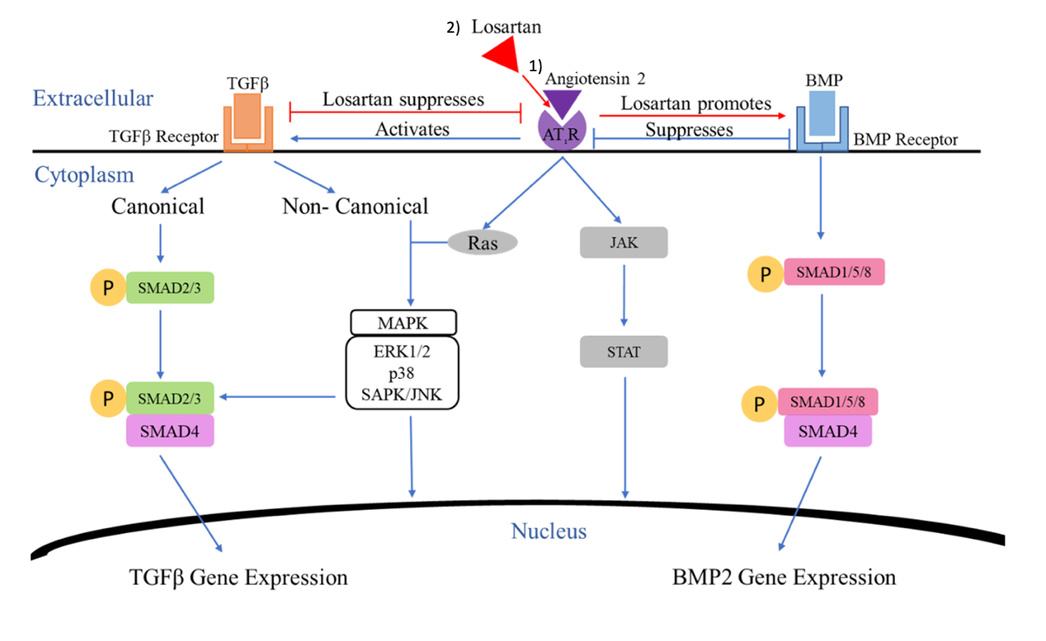
Figure 3.2 Losartan competitive inhibition of Angiotensin 1 receptor supresses TGF-β signalling pathway
1) Angiotensin 2 binds to angiotensin receptor and activates TGF-β signalling pathway to promote tumour cells and suppresses BMP signalling pathway that inhibit normal bone formation. 2) Losartan competitively binds to angiotensin receptor (not allowing angiotensin 2 to bind), suppressing TGF-β signalling pathway and promotes BMP signalling pathway that enable normal bone formation.

Adapted from Chen et al, 2015

In addition, activation of angiotensin type 2 receptor has been shown to be associated with the attenuation of both canonical and non-canonical pathways by dephosphorylating phosphotyrosine phosphatase and protein phosphatase 2A, which has survival-promoting that oppose Angiotensin 1 (Murphy et al, 2015). In breast cancer, angiotensin 2 is utilised by tumour cells to promote metastasis via adhesion to endothelial cells, trans-endothelial migration, and migration across extracellular matrix. This accelerates the formation of metastatic foci at secondary sites (Rodrigues-Ferrerira et al, 2012). Moreover, losartan suppresses osteoclasts through the inhibition of MAPK signaling during osteoclastogenesis and increases hypertrophy of chondrocytes (Walcott, 2014, and Chen et al, 2015). Moreover, losartan might be more effective than traditional TGF-β targeted bone anabolic agents due to its indirect effects. It is hypothesised that the administration of losartan will not promote osteoclasts by the RANKL-expressing osteoblasts. This is important for the treatment of breast cancer-induced bone metastases as osteoblasts secreting RANKL are major mediators of osteoclastogenesis (Chen et al, 2010).

3.2.3.1 Effect of losartan treatment in tumour-free rodents

The effects of losartan as a bone anabolic agent have been demonstrated in in vivo studies. 0.6g/L of losartan was administered to immunocompetent tumour-free C57BL/6 mothers orally dissolved in drinking water until weaning. Their pups (n=8) continued to receive 0.6g/L of losartan dissolved in drinking water for 6 weeks, and had increased trabecular %BV/TV, cortical thickness (9% increase) and decreased osteoclast number compared to vehicle mice (n=7) (administered only water) (Chen et al, 2015).
In another study, 30mg/kg of losartan was administered to 16-week-old male immunocompetent Wistar rats (n=16/group) by oral gavage daily for 67 days, resulting in increased alveolar bone volume compared to vehicle rats (Mulinari-Santos et al, 2019).

Despite the bone anabolic effects of losartan in the studies described above, administration of losartan (100mg/kg) to 10-day-old C57BL/6 mice with reduced bone density (osteopenia) daily for 8 weeks by oral gavage did not resolve bone loss (Nistala et al, 2010). The difference in results might be due to the difference in the length of treatment and the animal model used.

These data show that losartan requires a long treatment time to have a bone anabolic effect; this effect is also subject to the disease type. Furthermore, no recent studies have reported the bone anabolic effects of losartan in any cancer type.

3.2.3.2 Effect of losartan treatment in pre-clinical model

In preclinical studies, the effect of losartan on bone graft healing was assessed. Adult immunocompetent Wistar rats and spontaneously hypertensive rats (SHR) with moderate immune dysfunction (n=24/ group) received 30mg/kg losartan diluted in 50ml of water 7 days prior to the surgical procedure, followed by 4 weeks of continued treatment. Both treated groups demonstrated improved bone graft healing in bone histology, but no significant statistical difference was observed. Furthermore, all rats were weighed every week, and no toxic effects were reported in this study (Gealh et al, 2014).
These data show that losartan has a bone anabolic effect, although the underlying mechanisms remain to be discovered. This is similar to the clinical data of Yamamoto et al, 2015, where an angiotensin 2 receptor blocker (ARB) was administered to patients with secondary hyperparathyroidism (n=3276) and monitored for 2.7 years. Patients who received treatment had a lower fracture incidence rate (1.48%) compared to untreated patients (2.33%).

3.3 Hypothesis and aims

The main aim of this chapter was to determine the bone anabolic effects of losartan and SD-208 in vitro in bone cells and in vivo in tumour-free mice.

Hypothesis: Losartan and SD-208 will have bone anabolic effects in vitro and in vivo models.
This hypothesis will be tested by the following objectives:
- To determine the potential bone anabolic effects of losartan and SD-208 on osteoblast-like cells (SAOS2) in vitro using ALP and alizarin red assays.

- To determine the bone anabolic effects of losartan and SD-208 on bone structure and integrity in tumour-free immunocompromised mice (BALB/C nude) and determine the time point at which bone formation is increased using in vivo μCT.

- To determine the bone anabolic effects of losartan and SD-208 on bone structure and integrity in tumour-free immunocompetent mice (C57BL/6) using μCT.

3.4 Materials and methods

3.4.1 In vitro studies

SAOS-2cells were cultured and maintained as described in Section 2.1. Preparation of SD-208 and losartan were for in vitro and in vivo experiments as described in Section 2.2.1.1, Section 2.5. ALP and mineralisation assays were carried out on SD-208/ losartan treated SAOS-2 cells as described in Section 2.2.3 and Section 2.2.4.
3.4.2 In vivo studies

Tumour-free immunocompromised studies and immunocompetent studies were conducted as described in Section 2.3.1, where in vivo µCT was used to scan the tibia of mice (Section 2.7). At endpoint, the tibia of mice was scanned by ex vivo µCT (Section 2.10), where tibia sections were cut, TRAP-stained (Section 2.12.3), and analysed (Section 2.12.5).

3.5 Results

3.5.1.1 Effects of bone anabolic agents on osteoblast-like cells

Experiments were carried out to evaluate whether losartan and SD-208 had an anabolic effect in osteoblast-like cells in vitro. Alkaline phosphatase assay was used to measure ALP production, and alizarin red assay was used to measure mineralisation with losartan and SD-208 on differentiated osteoblast-like SAOS-2 cells. ALP is an indicator of osteoblast activity as its levels are reflective of osteoblast activity. ALP also assists mineralisation by increasing the rate of inorganic phosphate (Vimalraj, 2020). It was expected that losartan and SD-208 would increase osteoblast activity (ALP production and mineralisation) in differentiated SAOS-2 cells.

3.5.1.2 Administration of losartan and SD-208 promoted alkaline phosphatase (ALP) production in differentiated SAOS-2 cells

Osteoblast-like differentiated SAOS-2 cells were treated with either losartan (50–175 µM) or SD-208 (0.5–1.75 µM) for 3, 6, and 10 days, followed by an ALP assay to assess ALP production. These concentrations were chosen through personal communication with Mr. Darren Lath. Moreover, losartan was administered at a range of higher concentrations to assess whether it had a bone anabolic effect, and SD-208 at a range of higher concentrations to assess whether it would have a greater bone anabolic effect than the range (1-100µM).
In the ALP assay, the absorbance measured is equivalent to ALP production. This is normally calculated by subtracting the absorbance at 90 minutes (assay end) from the absorbance at 0 minutes (from the start at which PNPP solution was added to lysed cells treated by losartan or SD-208) (Sabokbar et al, 1994).
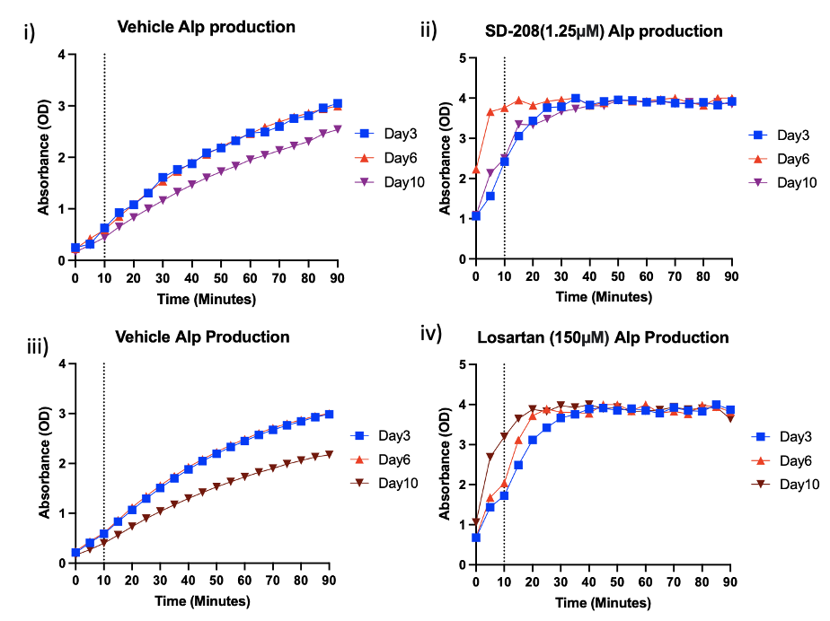
Figure 3.3 ALP production by SD-208/Losartan treated SAOS-2 cells
As ALP production of SD-208/ losartan treated SAOS-2 reached maximal absorbance (~4OD), unstandardised ALP values of cells treated by both drugs that achieved maximal response but had not exceed 4OD were selected. (ii) 1.25uM SD-208 and (iv) 150uM Losartan were chosen to produce this graph amongst the concentrations as these were the concentrations that had maximal ALP production. (i) represent no treatment control of SD-208 and (ii) represent no treatment control of losartan.
ALP read reached plateau at different rates for Day3, 6 and 10 minutes (dotted line indicated) where there was greatest linear difference between Day3, 6 and 10 was chosen to produce the ALP assay results. The amount of ALP produced was measured in absorbance (OD). These graphs are used to generate figure 3.4.

The absorbance of losartan or SD-208-treated SAOS-2 cells started to reach a plateau at approximately 30 minutes, meaning that ALP production was too high for a 90-minute assay to be meaningful (Figure 3.3). Any ALP value detected to be above 4OD will not be valid as it would be over the range of detection (Farely et al,1989). To determine a point at which ALP production amongst days 3, 7, 10 could be measured, the longitudinal absorbance of days 3, 7, 10 was compared. The 10-minute time point was selected, as this was when the linear difference between all three days was most significant in both losartan and SD-208-treated SAOS-2 cells (Figure 3.3).
The pico green standardised alkaline phosphatase (ALP) per cell, results demonstrated that 150 µM or 175µM losartan significantly increased ALP production of differentiated SAOS-2 cells after 6- and 10-days (Figure 3.4 i). 1.5 µM, 1.75µM SD-208 significantly increased ALP production of differentiated SAOS-2 cells after 6- days treatment. ALP production of differentiated SAOS-2 treated by SD-208 decreased comparing to 6-day to 10-day treatment (Figure 3.4 ii). The ALP production in vehicle-treated cells decreased over time from 3 to 10 days.

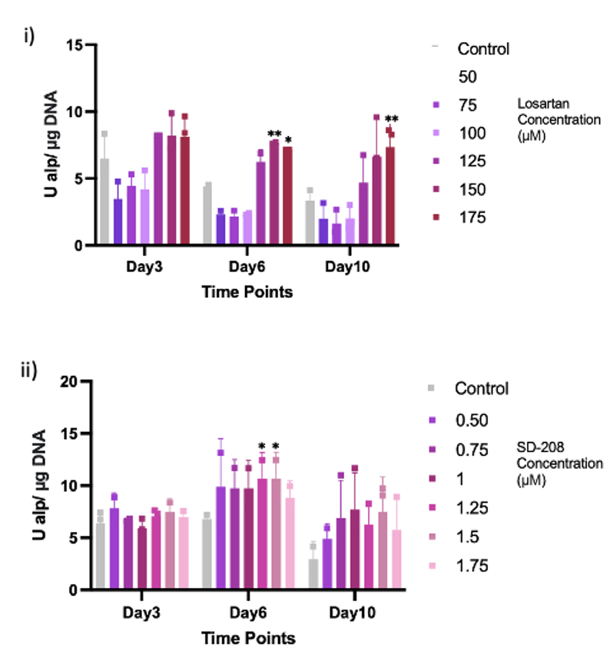

Figure 3.4 Effect of losartan/SD-208 treatment on the ALP production of differentiated SAOS-2 at different timepoints
SAOS-2 cells were grown in osteogenic media and exposed to a range of losartan concentrations (i) or SD-208 concentrations (ii) for up to 10 days. On days 3, 6 and 10, cells were lysed, and ALP assays were performed. Three biological replicates were performed (n=3), each with four replicates of each concentration. Data are mean ±SD, Significance of Losartan/SD-208 treated SASO-2 cells were compared to control (DMSO treated SAOS-2 cells) by two-way ANOVA analysis on prism software and corrected by Dunnett's multiple comparison test, standard deviation on Microsoft excel. Significance ns (P>0.05), * (P≤0.05), ** (P≤0.01).

3.5.1.3 Losartan and SD-208 promoted mineralisation in osteoblast-like cells

The alizarin red assay is used to measure calcium deposits by osteoblast-like SAOS-2 cells. Losartan and SD-208 both have significantly increased calcium deposits of differentiated SAOS-2 cells from 14 to 21 days. 50, 75, 100, 175µM losartan significantly increased the calcium deposit of differentiated SAOS-2 cells. 125-150µM had the most significant increase in calcium deposit (Figure 3.5i). 0.5, 0.75, 1.5, 1.75µM SD-208 significantly increased calcium deposit of differentiated SAOS-2 cells, after 21-day treatment. 1.25µM had the most significant increase in calcium deposit (Figure 3.5ii).
The anabolic effect between losartan and SD-208 could not be directly compared, as cells were not grown/treated on the same plate.

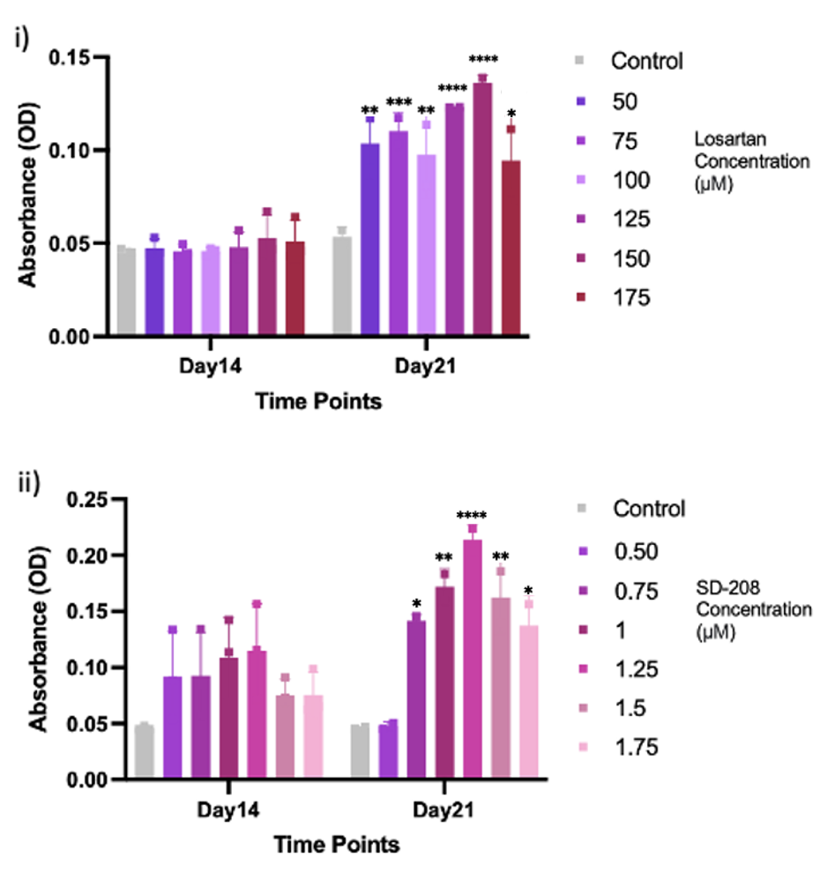
Figure 3.5 Different concentrations of Losartan/SD-208 treatment at different timepoints to calcium production by SAOS-2 cells
SAOS-2 cells were grown in osteogenic media and exposed to a range of losartan (i) or SD-208 concentrations (ii) for up to 21 days. On days 14 and 21, cells were lysed, and alizarin red assays were performed. Three biological replicates were performed(n=3), each with four replicates of each concentration. Amount of mineralization was read in absorbance (OD). Data are mean ±SD, Significance of Losartan/SD-208 treated SASO-2 cells were compared to control (DMSO treated SAOS-2 cells) by one-way ANOVA analysis on prism software and corrected by Dunnett's multiple comparison test, standard deviation on Microsoft excel. Significance ns (P>0.05), * (P≤0.05), ** (P≤0.01), *** (P≤0.001) and **** (P≤0.0001).

Taken together, the in vitro studies demonstrate that the bone anabolic effects of losartan/SD-208 were confirmed on osteoblast-like cells.

3.5.2 Effect of bone anabolic agents on bone integrity and structure of tumour-free immunocompromised mice

The in vivo effects of losartan and SD-208 in tumour-free immunocompromised BALB/c nude mice were next assessed to establish whether the agents have bone anabolic effects in vivo. BALB/c nude mice were used here as subsequent tumour studies used this strain (Chapters 4,5,6). Both studies conducted here were pilot studies to initially assess whether losartan and /or SD-208 had bone anabolic effects in mice, so group numbers were low and not powered.

3.5.2.1 Administration of losartan demonstrated anabolic effects in BALB/c nude mice

Administration of 200 and 300mg/kg of losartan by oral gavage daily for 12 days was reported to cause toxicity in female rats, resulting in treatment-related weight loss (Spence et al, 1995). Therefore, 100mg/kg of losartan was used for this pilot in vivo study (Figure 3.6), as the dose must be sufficient to potentially have a bone anabolic effect, but with no indicated toxicity.

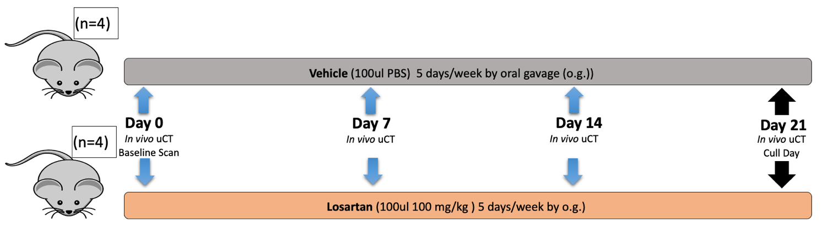
Figure 3.6 Effects of losartan on tumour-free immunocompromised mice
6-week-old female BALB/c nude mice were treated with 100µl of losartan (100mg/kg) or 100µl of PBS (vehicle) by oral gavage 5 days per week for 3 weeks. The left tibia (Losartan n=4, Vehicle n=4) were scanned by in vivo µCT once weekly for 4 weeks and ex vivo after cull, with bone integrity and structure analysed

The treatment of losartan in mice did not have any toxic effects; there were no signs of illness throughout the treatment period, and no significant change in weight in losartan-treated mice (results not shown).

In vivo µCT demonstrated that the tibia of losartan-treated mice had increased trabecular %BV/TV and trabecular number by 2 weeks of treatment and continued to increase significantly by 3 weeks of treatment compared to vehicle (Figure 3.7 i, ii). Losartan had no effect on trabecular thickness (Figure 3.7 iii) and trabecular separation (Figure 3.7 iv) by 3 weeks of treatment.
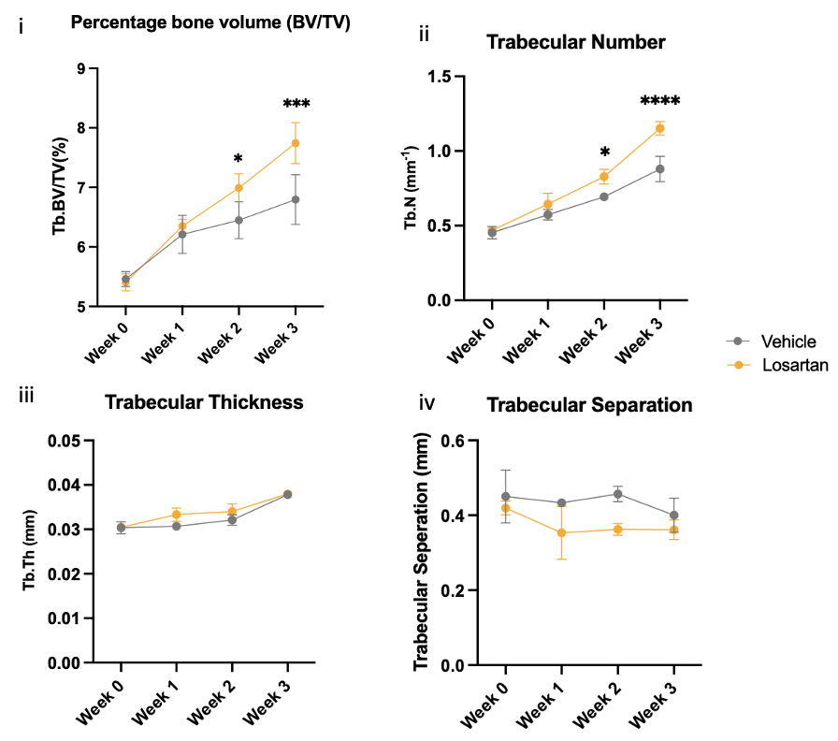
Figure 3.7 Effects of losartan on bone integrity and structure measured by In vivo µCT
Figure shows %BV/TV (i), trabecular number (ii), trabecular thickness (iii) and trabecular separation (iv) of Losartan treated mice (n=4) and vehicle treated mice (n=4) over 3 weeks treatment. All data were presented as mean ± SD, 2-way ANOVA and Šidák’s test, analysed using PRISM software. Significance ns (P>0.05), * (P≤0.05), *** (P≤0.001), **** (P≤0.0001).

Ex vivo µCT carried at endpoint demonstrated that 3 weeks of losartan treatment increased trabecular BV/TV and trabecular number (Figure 3.8 ii, iv), but had no effect in cortical bone volume, trabecular thickness trabecular separation or trabecular pattern factor compared to untreated mice (Figure 3.8 i, iii, v). In vivo and ex vivo data agreed at endpoint (week 3) (Figure 3.7, 3.8).

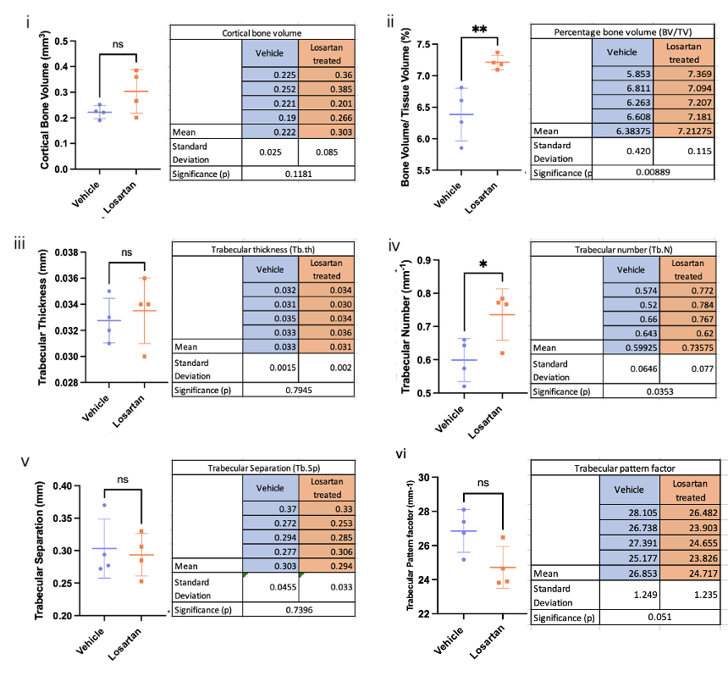
Figure 3.8 Ex vivo µCT analysis of losartan treated mice compared to vehicle treated mice
Graphs show cortical bone volume (i), BV/TV (ii), trabecular thickness (iii), trabecular number (iv) trabecular separation (v) and trabecular pattern factor of Losartan treated mice (n=4) and vehicle treated mice (n=4) after 3 weeks treatment. All data are presented as mean ± SD, student’s t test, analysed on prism software. Significance ns (P>0.05), * (P≤0.05), ** (P≤0.01).

3.5.2.1.1 Administration of losartan increased osteoblast number in BALB/c nude mice

Bone histomorphometry (Figure 3.9) demonstrated that 3 weeks of losartan treatment significantly increased the number of osteoblasts in the lateral and medial endocortical bone (Figure 3.10 i) and the trabecular bone region (Figure 3.11 i). There was no significant effect on number of osteoclasts, osteoblast surface area, osteoclast surface area in the lateral and medial endocortical bone (Figure 3.10 ii-iv) or in the trabecular bone region (Figure 3.11 ii-iv) when compared to longitude tibial sections from losartan and vehicle treated mice.

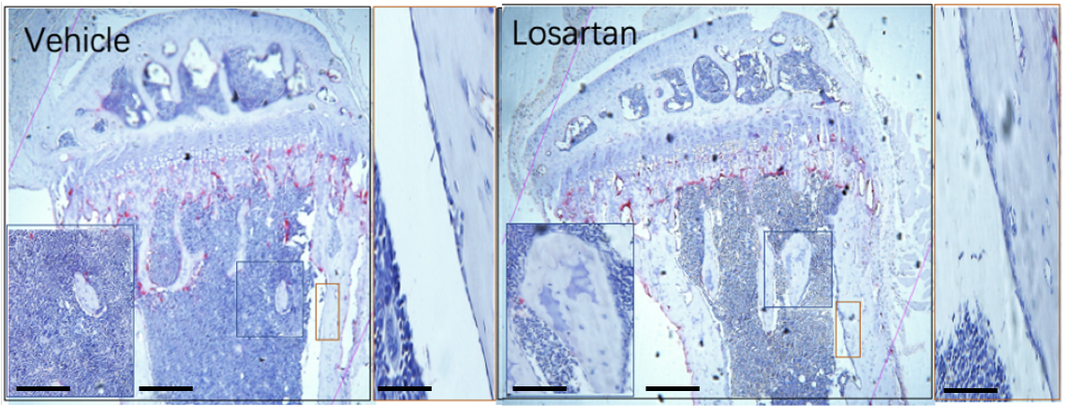
Figure 3.9 Osteomeasure analysis of osteoblasts and osteoclasts in losartan treated mice tibias compared to vehicle treated mice
Graphs show histological image of vehicle treated mice and losartan treated mice. The blue box in the trabecular region of the bone corresponds to its enlarged image (on the bottom left), the orange box in the medial region of the bone corresponds to its enlarged image (on the right). Scale bars, tibia= 400µm, inset= 50µm.

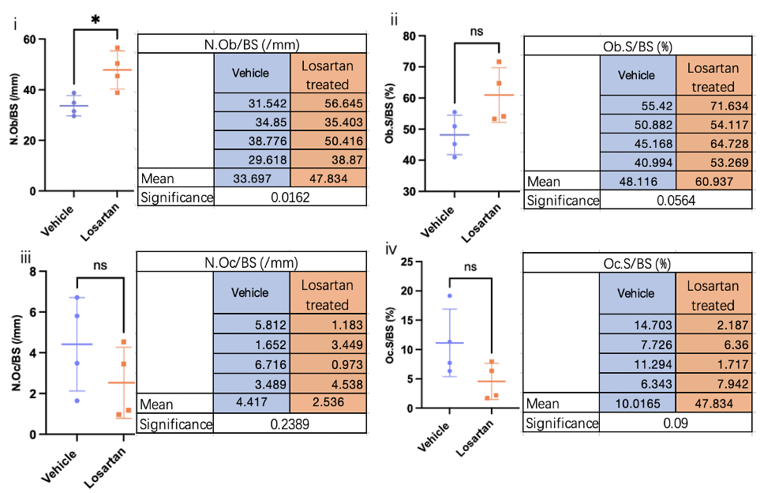
Figure 3.10 Osteomeasure analysis of medial and lateral endocortical bone comparing losartan treated mice to vehicle treated mice
Graphs show the measurement of number of osteoblasts over bone surface (i), percentage osteoblast surface over bone surface (ii), number of osteoclasts over bone surface (iii), percentage osteoclast surface over bone surface (iv) in medial+ lateral side of longitude tibia sections of Losartan treated mice (n=4) and vehicle treated mice (n=4) after 3 weeks treatment. All data are presented as mean ± SD, student’s t test, analysed on prism software. Significance ns (P>0.05), * (P≤0.05)
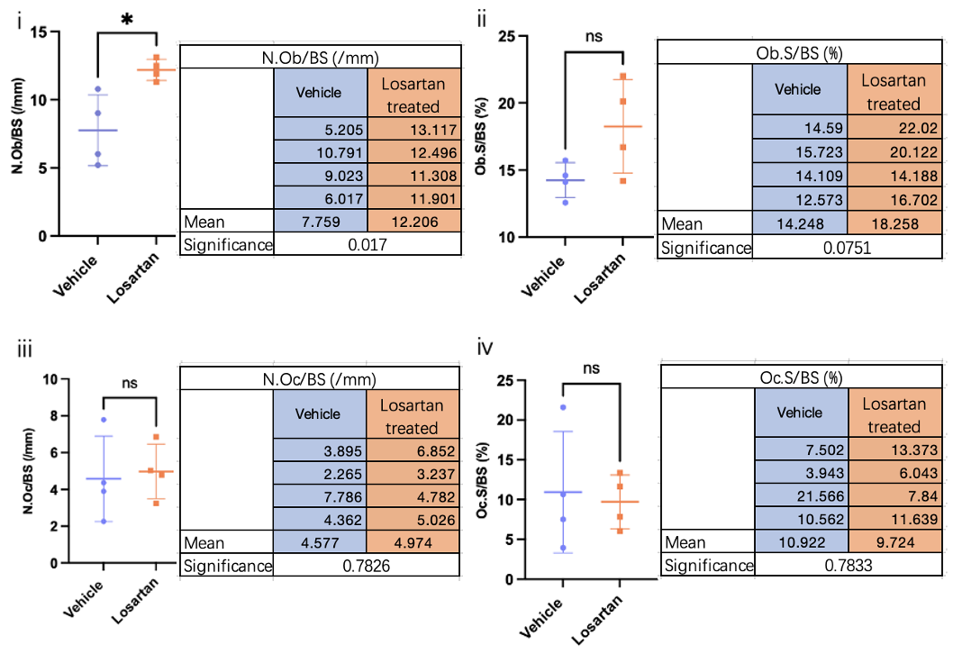
Figure 3.11 Osteomeasure analysis of trabecular bone comparing losartan treated mice compared to vehicle treated mice
Graphs show the measurement of number of osteoblasts over bone surface (i), percentage osteoblast surface over bone surface (ii), number of osteoclasts over bone surface (iii), percentage osteoclast surface over bone surface (iv) in trabecular bone of longitude tibia sections of Losartan treated mice (n=4) and vehicle treated mice (n=4) after 3 weeks treatment. All data are presented as mean ± SD, student’s t test, analysed on prism software. Significance ns (P>0.05), * (P≤0.05).

3.5.2.2 Administration of SD-208 demonstrated bone anabolic effects in BALB/c nude mice

Studies by Green et al, 2019 have shown that 60mg/kg of SD-208 for 2 weeks by oral gavage increased trabecular bone volume and number significantly in the immunocompromised JJN3 myeloma-bearing NOD scid gamma mice compared to vehicle-treated mice. Therefore, the same 60mg/kg of SD-208 dose was used in this study to determine whether SD-208 has a bone anabolic effect on BALB/c nude mice (Figure 3.12). Analyses were carried out as for the losartan study described in section 3.1. It was expected that SD-208 would have a bone anabolic effect on BALB/c nude mice, increasing trabecular bone and number of osteoblasts.

6-week-old female BALB/c nude mice were treated with 150µl of SD-208 (60mg/ml) or 150µl of methyl cellulose (vehicle) by oral gavage 5 days per week for 3 weeks. Left tibiae of mice (SD-208 n=4, Vehicle n=3) were scanned by in vivo µCT once weekly for 4 weeks (Figure 3.13) and subsequently scanned ex vivo after cull (Figure 3.14), with bone integrity and structure analysed. A vehicle-treated mouse (M7) was culled after week 1 of treatment due to poor health, and so it was not included in the analyses.

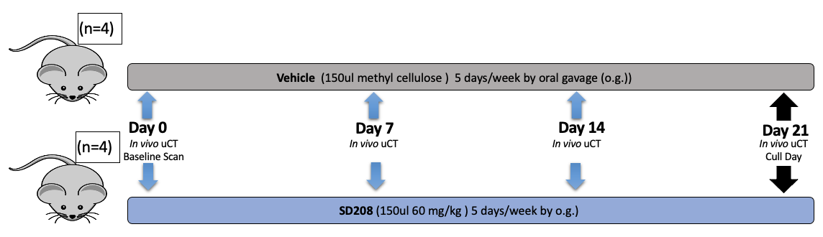
Figure 3.12 Effects of SD-208 tumour-free immunocompromised mice
6-week-old female BALB/c nude mice were treated with 150µl of SD-208 (60mg/kg) or 100µl of methylcellulose (vehicle) by oral gavage 5 days per week for 3 weeks. The left tibia (SD-208 n=4, Vehicle n=4) were scanned by in vivo µCT once weekly for 4 weeks and ex vivo after cull, with bone integrity and structure analysed

Like losartan treatment, SD-208 treatment in mice did not have any toxic effects; there were no signs of illness throughout the treatment period, and no significant changes in weights were observed (results not shown).

In vivo µCT demonstrated that SD-208-treated mice have increased BV/TV, trabecular number, by 3 weeks of treatment, compared to untreated mice. (Figure 3.13 i-iii). There was no difference in trabecular thickness and trabecular separation comparing SD-208 treated-mice to vehicle-treated mice (Figure 3.13 iv).

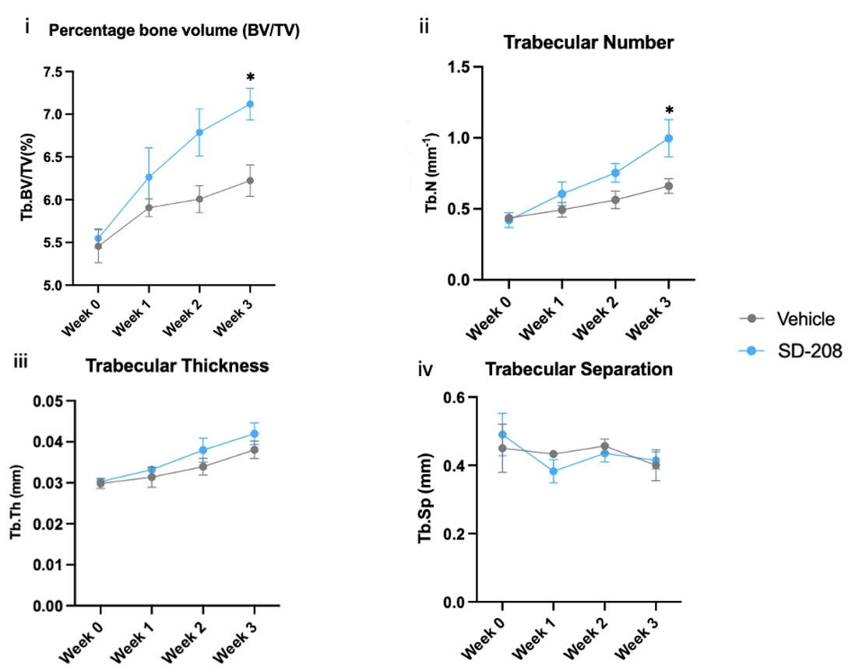
Figure 3.13 In vivo µCT analysis of SD-208 treated mice compared to vehicle treated mice
Graphs show BV/TV (i), trabecular number (ii), trabecular thickness (iii) and trabecular separation (iv) of SD-208 treated mice (n=4) and vehicle treated mice (n=3) over 3 weeks treatment. All data were presented as mean ± SD, Aligned Rank transfer and 2-way ANOVA test, analysed on R software. Significance ns (P>0.05), * (P≤0.05).

Ex vivo µCT demonstrated that 3 weeks of SD-208 treatment had no effect on cortical bone volume, %BV/TV, trabecular number, and trabecular thickness trabecular separation (Figure 3.14 i-v).
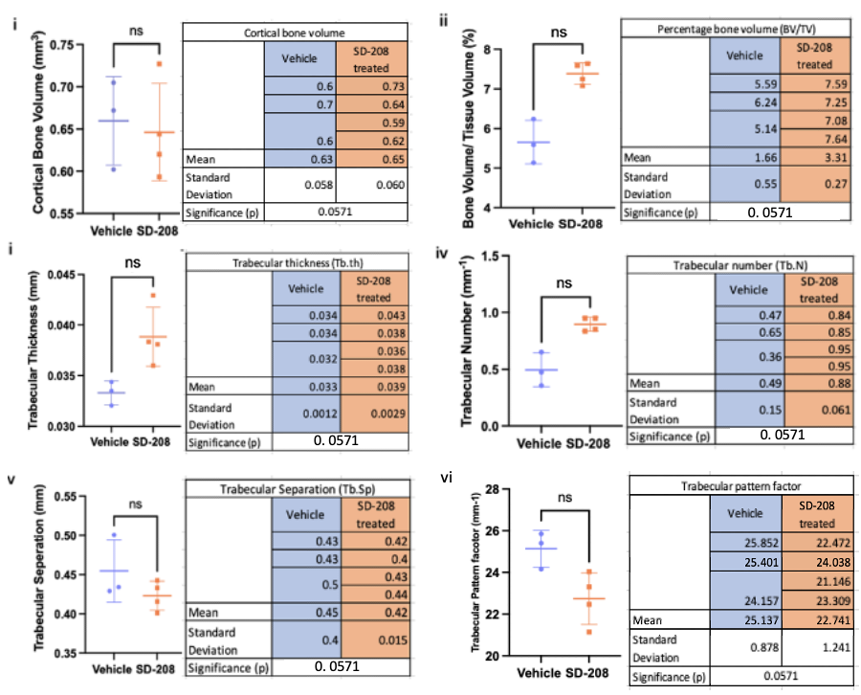
Figure 3.14 Ex vivo µCT analysis of SD-208 treated mice compared to vehicle treated mice
Graphs show cortical bone volume (i), BV/TV (ii), trabecular thickness (iii), trabecular number (iv) and trabecular separation (v) trabecular pattern factor (vi.) of SD-208 treated mice (n=4) and vehicle treated mice (n=3) over 3 weeks treatment. All data were presented as mean ± SD, unpaired nonparametric t test and Mann-Whiteny’s test, analysed on PRISM software. Significance ns (P>0.05).

3.5.2.2.1 Administration of SD-208 increased osteoblasts in the trabecular of BALB/c nude mice

Bone histomorphometry (Figure 3.15) demonstrated that 3 weeks of SD-208 treatment had no effect in the number of osteoblast and osteoclasts (Figure 3.16 i, iii), osteoblast surface area and osteoclast surface area in lateral and medial side of the endocortical bone (Figure 3.16 ii, iv) when comparing longitude tibia section of SD-208 treated mice and vehicle mice. In the trabecular bone, 3 weeks of SD-208 treatment had no effect on the number of osteoblast and osteoclasts (Figure 3.17 i, iii), the osteoblast surface area and the osteoclast surface area in lateral and medial sides of the endocortical bone (Figure 3.17 ii, iv).

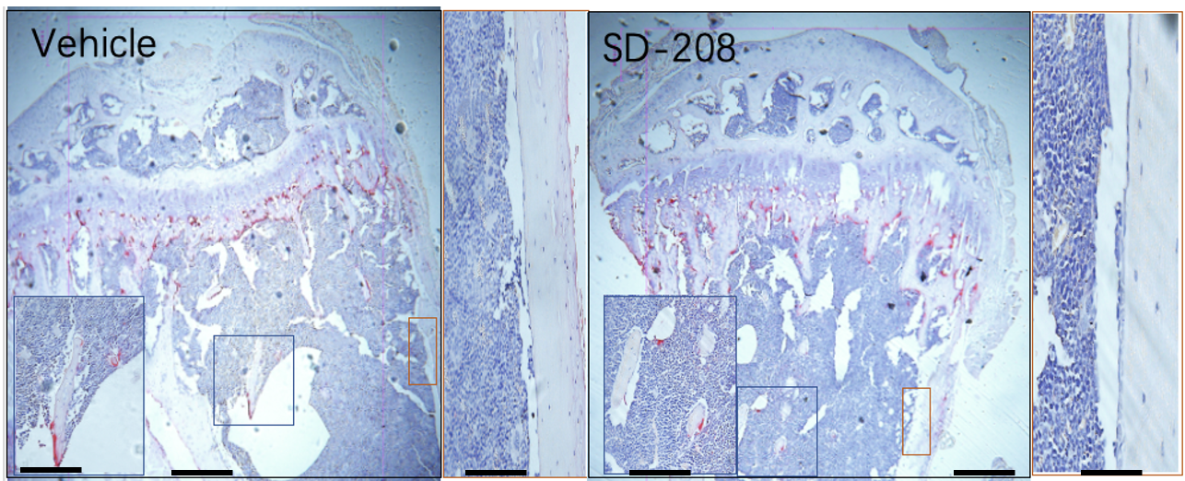
Figure 3.15. Osteomeasure analysis of SD-208 treated mice compared to vehicle treated mice
Graphs show histological image of vehicle treated mice and SD-208 treated mice. The blue box in the trabecular region of the bone corresponds to its enlarged image (on the bottom left), the orange box in the medial region of the bone corresponds to its enlarged image (on the right). Scale bars, tibia= 400µm, inset= 50µm.

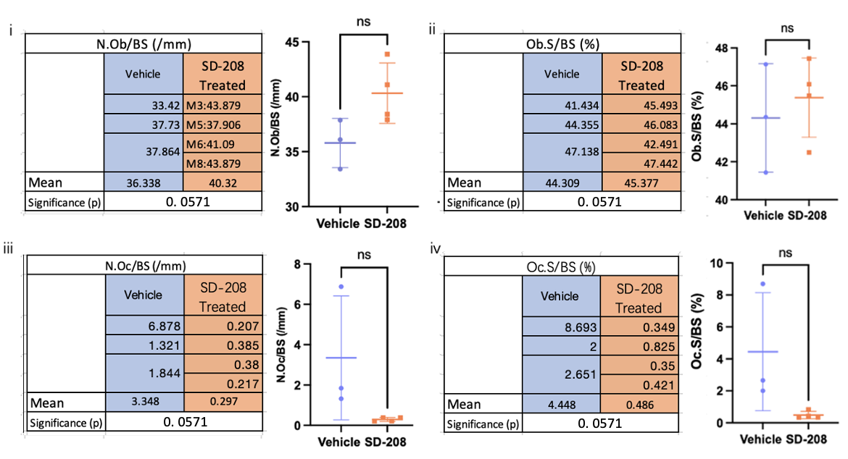
Figure 3.16 Osteomeasure analysis of SD-208 treated mice compared to vehicle treated mice (medial+ lateral side)
Graphs show the measurement of number of osteoblasts over bone surface (i), percentage osteoblast surface over bone surface (ii), number of osteoclasts over bone surface (iii), percentage osteoclast surface over bone surface (iv) in medial+ lateral side of longitude tibia sections of SD-208 treated mice (n=4) and vehicle treated mice (n=4) after 3 weeks treatment. All data are presented as mean ± SD, unpaired t test and Mann-Whitney’s test, analysed on PRISM software. Significance ns (P>0.05).

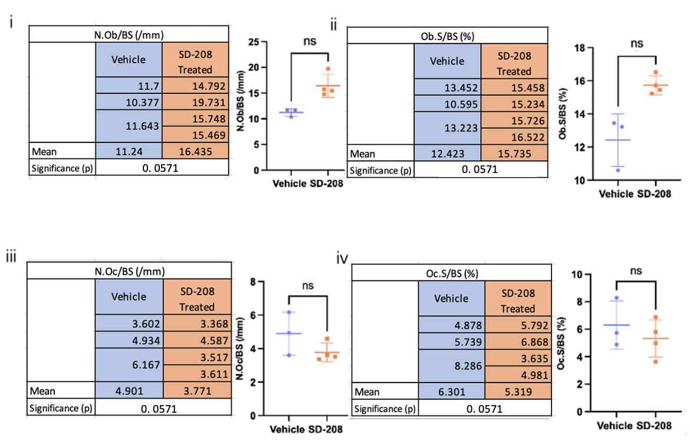
Figure 3.17 Osteomeasure analysis of SD-208 treated mice compared to vehicle treated mice (Trabecular bone)
Graphs show the measurement of number of osteoblasts over bone surface (i), percentage osteoblast surface over bone surface (ii), number of osteoclasts over bone surface (iii), percentage osteoclast surface over bone surface (iv) in trabecular bone of longitude tibia sections of SD-208 treated mice (n=4) and vehicle treated mice (n=4) after 3 weeks treatment. All data are presented as mean ± SD, unpaired t-test with Mann-Whitney’s test, analysed on PRISM software. Significance ns (P>0.05).

3.5.2.3 Effect of bone anabolic agents on bone integrity and structure of tumour-free mice immunocompetent mice

The effects of losartan and SD-208 in tumour-free immunocompetent BALB/c nude mice on bone were next assessed to establish whether the agents have bone anabolic effects in murine models with an immune system. Trabecular bone was measured using µCT after 2.5 weeks of treatment to mimic the treatment window available in the BC mouse mammary E0771 model, which has a treatment window of 2 to 2.5 weeks. The aim was to assess whether 2.5 weeks of treatment could stimulate bone formation. An alternative higher dose of losartan and SD-208 has been included in the experiment to determine whether a higher dose can result in a greater improvement in bone integrity and quality compared to the standard dose in the immunocompromised model.

3.5.2.4 Administration of losartan demonstrated bone anabolic effects in C57BL/6 mice

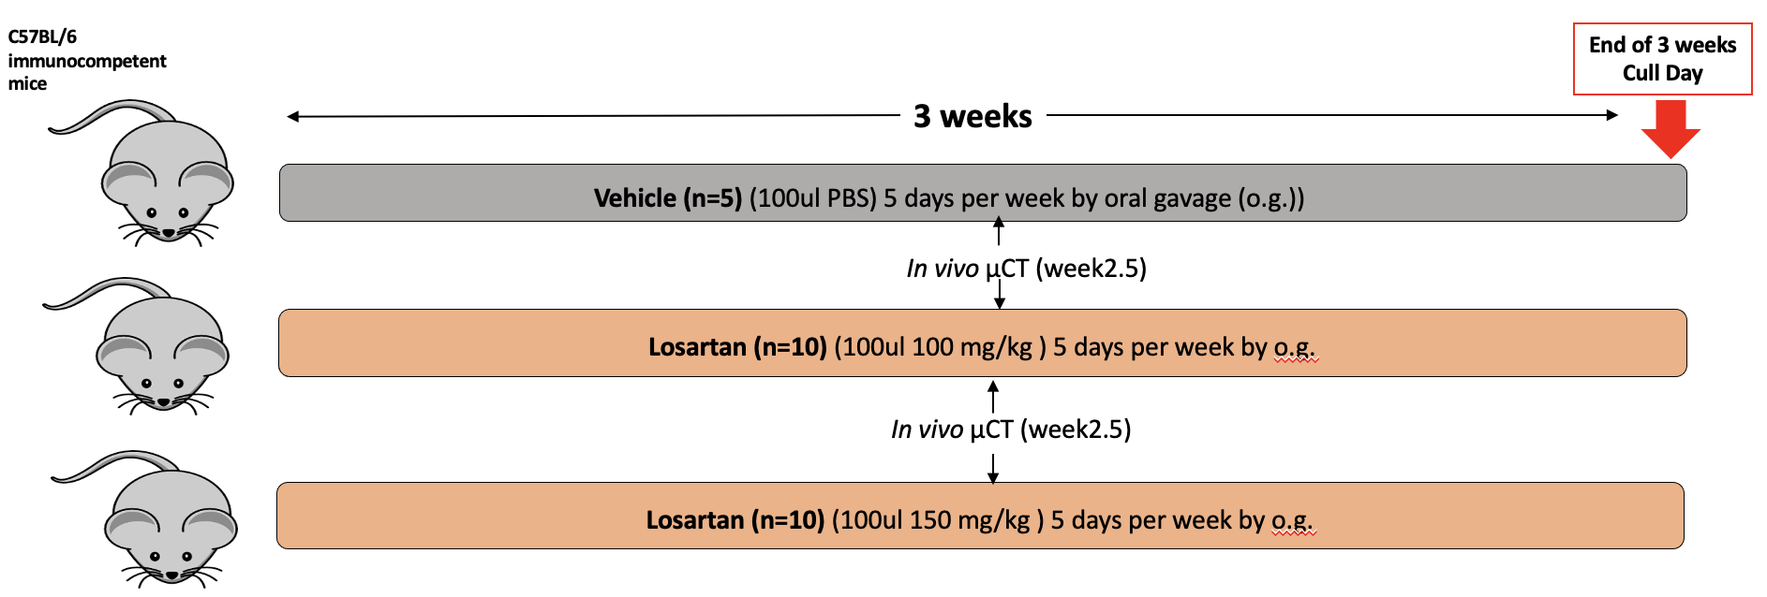
Figure 3.18. Effects of losartan on tumour-free immunocompetent mice
6-week-old female BALB/c nude mice were treated with 100µl of losartan (100mg/kg) or 100µl of losartan (150mg/kg) or 100µl of PBS (vehicle) by oral gavage 5 days per week for 3 weeks. The left tibia (Losartan (100mg/kg) n=10, Losartan (150mg/kg) n=10, Vehicle n=5) were scanned by in vivo µCT 2.5 weeks post treatment, with bone integrity and structure analysed.

In vivo µCT demonstrated that the tibia of 150mg/kg losartan-treated mice had significantly increased trabecular %BV/TV and trabecular thickness with 2.5 weeks of treatment compared to vehicle-treated mice (Figure 3.19 i,iii). 100mg/kg losartan-treated mice also had significantly increased trabecular pattern factor, but it had no effect on trabecular % BV/TV, trabecular number, and trabecular thickness. Both doses of losartan had no effect on trabecular number compared to vehicle-treated mice (Figure 3.19 ii).
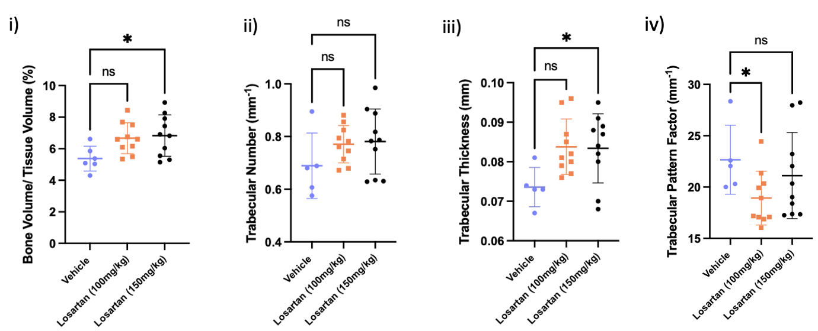
Figure 3.19 In vivo µCT analysis of losartan treated mice compared to vehicle treated mice
Graphs show BV/TV (i), trabecular number (ii) and trabecular thickness (iii) of losartan treated mice (n=10) and vehicle treated mice (n=3) 2.5 weeks post treatment. All data were presented as mean ± SD, 1-way ANOVA and Kruskal-Wallis’s test, analysed on PRISM software. Significance ns (P>0.05), * (P≤0.05).

3.5.2.5 Administration of SD-208 demonstrated bone anabolic effects in C57BL/6 mice
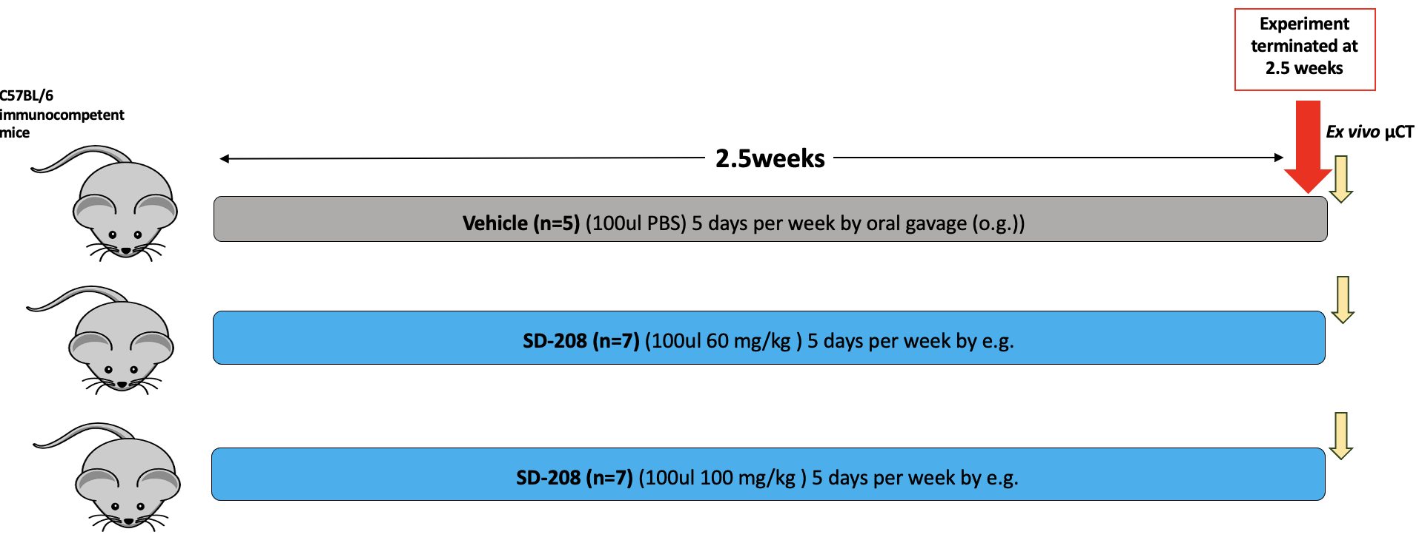
Figure 3.20 Effects of SD-208 on tumour-free immunocompetent mice
6-week-old female C57BL/6 mice were treated with 100µl of SD-208 (60mg/kg) or 100µl of SD-208 (100mg/kg) or 100µl of PBS (vehicle) by oral gavage 5 days per week for 2.5 weeks. Experiment was terminated at 2.5 weeks and all mice sacrificed. The left tibia of mice (SD-208(60mg/kg) n=7, SD-208 (100mg/kg) n=7, Vehicle n=5) were scanned by ex vivo µCT, with bone integrity and structure analysed.

This study was terminated at 2.5 weeks due to constant appearance of ill mice. Despite conducting biopsies, the cause of illness was undetermined. Ex vivo µCT demonstrated that the tibia of 100mg/kg SD-208 treated mice had significantly increased trabecular %BV/TV and trabecular number with 2.5 weeks of treatment compared to vehicle treated mice (Figure 3.21 i,iii). Both doses of SD-208 had no effect on trabecular thickness and trabecular pattern factor compared to vehicle treated mice (Figure 3.21 ii).

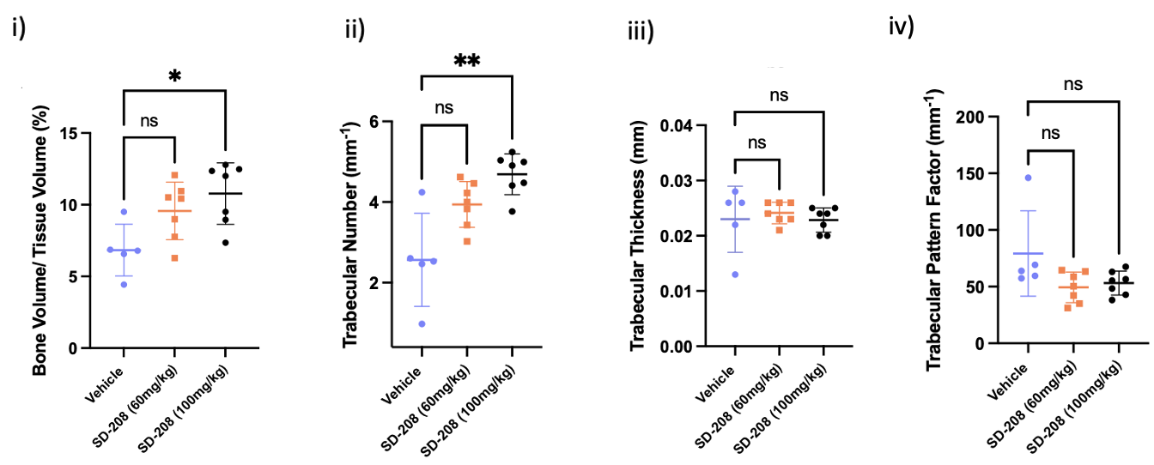
Figure 3.21 Ex vivo µCT analysis of SD-208 treated mice compared to vehicle treated mice
Graphs show BV/TV (i), trabecular number (ii), trabecular thickness (iii), trabecular pattern factor (iv) of 60mg/kg or 100mg/kg SD-208 treated mice (n=7/ group) and vehicle treated mice (n=5) 2.5 weeks post treatment. All data were presented as mean ± SD, 1-way ANOVA and Kruskal-Wallis’s test, analysed on PRISM software. Significance ns (P>0.05), * (P≤0.05), ** (P≤0.005).

Taken together, both losartan and SD-208 demonstrated significant bone anabolic effects of improving bone structure in tumour-free immunocompromised and immunocompetent mice.

3.6. Discussion

This chapter set out to determine the bone anabolic effects of losartan and SD-208 in vitro in osteoblast-like cells and in vivo in tumour-free mice.
I initially assessed whether losartan and SD-208 had bone anabolic effects in vitro, as predicted in bone cells. Our data showed that osteoblast-like SAOS-2 cells treated by losartan/ SD-208 for 3-10 days increased ALP levels, and 21 days of losartan/ SD-208 treatment increased mineralisation. Our findings were like those by Green et al, 2019, who have shown that SD-208 has bone anabolic effects in vitro. They demonstrated ALP assays using normal donor bone marrow stem cells (BMSCs) and myeloma patient BMSCs treated by SD-208 for 3-6 days (concentration not mentioned), had significantly higher ALP levels (osteoblast activity) than untreated control normal donor BMSCs and myeloma patient BMSCs. In addition, matrix mineralisation regulator osteocalcin expressed by mature osteoblasts was only detected in BMSCs treated by SD-208. There is no published study investigating the bone anabolic effect of losartan in vitro. However, an ongoing phase 4 clinical study shows that ALP levels (a marker of osteoblast activity) in blood are found to be increased in patients who have been taking losartan for less than 1 month. It was worth noting that patients who take losartan experience side effects (eHealthMe, 2022).
The bone anabolic effects of SD-208 were analysed in vivo. Our data show that administration of 60mg/kg SD-208 for 5 days per week for 3 weeks increased BV/TV and trabecular number, in the left tibia of 6-week-old tumour-free female BALB/c nude mice compared to vehicle-treated controls. This agrees with a study showing that administration of 20mg/kg and 60mg/kg of SD-208 for 6 weeks increased BV/TV and fracture resistance in tibias, increased osteoblast number and decreased osteoclast number in 4-week-old C57BL/6 mice (Mohammad et al, 2009). Moreover, expression of osteoblast differentiation-promoting genes RUNX2 and EPHB4 was increased, expression of EPHB2, which inhibits osteoclast differentiation, was also increased (Mohammad et al, 2009). Ex vivo and bone histomorphometry analysis demonstrate no significant differences in BV/TV, trabecular number, or osteoblast number, when comparing SD-208–treated to vehicle-treated mice. These findings may be attributed to the unequal and small sample sizes, with only 3 mice in the vehicle group and 4 in the SD-208–treated group. An estimated of 6 mice per group are required to observe a statistically significant effect on bone volume, based on data of Mohammad et al, 2009 (Appendix Fig. 4 Calculation 1).

Our data also identified bone anabolic effects of losartan in vivo. Administration of 100mg/kg losartan for 5 days per week for 3 weeks increased BV/TV and trabecular number in left tibia of 6-week-old tumour-free female BALB/c nude mice compared to untreated vehicle. Furthermore, this is may suggest an increased osteoblast activity as the number of osteoblasts is increased comparing the longitudinal tibia section of 6-week-old losartan-treated tumour-free female BALB/c nude mice compared to untreated vehicle. As this was identified in both the medial and lateral sides and trabecular bone, if the time of losartan treatment is increased, it may also increase the cortical bone volume in the tibia.
Similarly, a study showed that tumour free C57BL/6 pups that received lactation from mothers (administered 0.6g/L losartan in drinking water) and 0.6g/L of losartan dissolved in drinking water for 6 weeks had increased trabecular volume and cortical thickness (9% increase) compared to vehicle-treated mice (administered only water). Furthermore, osteoblast number and chondrocyte hypertrophy were also increased (Chen et al, 2015).

Notably, the number of osteoclasts remained unchanged in the immunocompromised, tumor-free models, even though earlier research has shown that TGF-β targeted treatments can decrease both osteoclast number and activity (Mohammad et al, 2009; Morita et al, 2024). This might be attributed to the study having small group sizes (n$≤$4). Based on power calculations (Appendix Fig 4. Calculation 2), about eight mice per group would be necessary in the losartan study to observe a statistically significant impact on osteoclasts, whereas the SD-208 study would need roughly 5 mice per group to ensure sufficient statistical power (Appendix Fig. 4 Calculation 3).

There was a lot of variability in the bone data measured from in vivo µCT in the first two immunocompromised tumour-free studies using SD-208/ losartan. This could be attributed to mice delivered by Charles River mice at a younger age than requested or batch discrepancies, where some mice might be younger or older. Growth rate in bone slows as mice age, the wall thickness of cancellous bone declines, indicating that bone made by osteoblasts becomes less (Jika, 2013). It is speculated that younger mice might have had higher baseline ALP activity, which may cause a different rate of bone growth in response to SD-208/ losartan treatment. A smaller than expected mouse was observed in the vehicle group, and later excluded from the study due to its small size and looked physically unhealthy. At 6-weeks-old, this mouse weighed 7.2g, lower than the average weight of 10.5g observed among mice from the same Charles River shipment. A veterinary assessment confirmed it was unfit for the procedures.

Although BALB/c nude mice lack a thymus and cannot develop mature T cells, this does not preclude the production of TGF-β, which is secreted by multiple cell types including stromal and bone cells (Salasznyk et al, 2009). It was reasonable to expect that TGF-β signalling is still active in these immunocompromised mice, which helps explain the bone anabolic effects seen in the losartan and SD-208 studies. It was speculated that TGF-β was released by normal osteoclast resorption of the bone and that the TGF-β signalling pathway was present. Furthermore, both Mohammad et al, 2011 and Leni et al, 2019 demonstrated bone anabolic effects through the inhibition of the TGF-β signalling pathway in immunocompromised mice.

Having confirmed the bone anabolic effects of losartan and SD-208 in tumour-free immunocompromised mice, we next evaluated their effects in immunocompetent mice. This was conducted to assess whether the observed bone anabolic effects would persist in mice with a functioning immune system. Both losartan (150mg/kg) and SD-208 (100mg/kg) significantly increased BV/TV compared to vehicle-treated mice. Interestingly, the doses of losartan (100mg/kg) and SD-208 (60mg/kg) that showed bone anabolic effect in immunocompromised mice did not exhibit the same effect in immunocompetent mice. This might be due to shorter treatment time (3 weeks of treatment in immunocompromised mice compared to 2.5 weeks of treatment in immunocompetent mice) and the difference in models. Moreover, this study demonstrated that a higher dose is needed to significantly stimulate bone formation in immunocompetent mice compared to immunocompromised mice. The occurrence of in immunocompetent mice treated by SD-208 might be attributed to a poor mouse batch, as biopsies conducted by staff demonstrate that there was no cause of death.

As our data show that bone is increased significantly with 3 weeks of treatment, we will use this treatment model in a murine model of breast cancer bone metastases to assess the effect of repairing bone lesions using losartan or SD-208. Furthermore, the anabolic effect of SD-208 shown in our data was likely mediated through the blockade of TGF-β receptor, which promotes osteoblast differentiation (Matsumoto and Abe, 2011).

In summary, this chapter has demonstrated that losartan and SD-208 both have bone anabolic effects in differentiated SAOS-2 cells and in tumour-free mice. Therefore, the next step would be to establish a model of breast cancer bone metastasis to assess the effects of losartan and SD-208 on bone lesions.

Chapter 4
Establishing methods for analysis of tumour growth in bone using an immunocompromised model of breast cancer-induced bone disease

4.1 Summary

Background: There is no single mouse model that can represent all phenotypic and genetic changes of human breast cancer bone metastases, as spontaneous metastasis of mammary tumour to bone is rare in mice. The human xenograft model of triple-negative MDA-MB-231 cells is the most common model to study breast cancer bone metastasis. MDA-MB-231 cells are injected via the left cardiac ventricle into BABLB/c nude mice, with 90% of metastasis to bone. Here, the development of tumour burden and bone disease in this xenograft model was characterized to determine the optimum treatment time for subsequent studies assessing the effects of bone anabolic agents SD-208 and losartan in this model.

Results: Image J software was able to measure the lesion area as a percentage of bone, whilst osteolytica software was not successful in analysing lesions that extended into the growth plate. In vivo µCT data demonstrated that hind limb lytic bone lesions can be detected 1 week after i.c. injection of MDA-MB-231 cells. In some mice, a tumour was present in the hindlimb without bone lesions detected in the tibia. In the second study, hind limb tumours and lesions are formed in the proximal tibia after 1 week of i.c. of MDA-MB-231 cells and in the distal femur 3 weeks post i.c.. In addition, the development of tumour growth about associated lytic bone lesions can be monitored in vivo. This study demonstrates that when tumour is present and no bone lesion is detected in the proximal tibia, there is a possibility that lytic lesions will develop in the distal femur. The development of tumour growth in relation to associated lytic bone lesions can be monitored in vivo using IVIS bioluminescent imaging and in vivo µCT. The MDA-MB-231 xenograft model using in vivo µCT can be used for assessing the effects of bone anabolic agents in subsequent studies.

4.2 Introduction
In chapter 3, losartan and SD-208 were confirmed to have bone anabolic effects both in vitro and in tumour-free mice. Therefore, the next logical step would be to assess these agents in a breast cancer model of bone metastasis. However, before these studies can be done, it is important to understand the development of cancer-induced bone disease in the chosen breast cancer mouse model. For example, mapping tumour development with bioluminescent imaging and bone lesion development with in vivo µCT scanning. This will then allow an optimum treatment time to be established in the chosen model; therefore, this will be the focus of Chapter 4.

4.2.1 Murine models of breast cancer bone metastases
Breast cancer bone metastases is a complex process involving multiple signaling pathways and cell types; this disease varies with the different subtypes of the primary breast cancer. There is currently no single model that can represent all phenotypic and genetic changes of human breast cancer bone metastases (Ottewell et al, 2021). Therefore, numerous in vivo murine models have been developed to represent these different subtypes, allowing researchers to select the most appropriate model and study the different mechanisms involved. Young breed mice (4-8 weeks old) are usually used for models of breast cancer bone metastases, which increases the incidence of bone metastases as they have a high bone turnover where their bones are developing (Ottewell et al, 2021). Both immunocompetent and immunocompromised models of breast cancer bone metastases have been established to facilitate the study of the role of human/ rodent tumour cells and the immune system in metastasis (Tulotta et al, 2019).

4.2.1.1. Immunocompromised rodent model

In immunocompromised models, most human breast cancer cells that are trophic to the bone environment form overt tumours after direct injection into the bone (Wright et al, 2016). Nude (nu/nu) and severe combined immunodeficient (SCID) mice lack cortex and medulla structure, impairing the development of mature T lymphocytes and preventing the initiatation of adaptive immune responses, including graft rejection to human tumour cells (Morton and Houghton, 2007). NOD SCID mice are severely immunocompromised and have defective T and B lymphocytes development along with reduced number and functionality of macrophages, granulocytes, and NK cells. A subline NOD SCID Υ (NSG) mouse strain has additional deficiency in multiple cytokine pathways (Okada et al, 2019). Despite the ability of these models to facilitate the growth of human breast cancer cells in the bone of mice, a disadvantage of this is the lack of immunological response to tumorigenesis and the activity of anti-cancer agents from the host. Hence, data from these models must be analysed carefully (Tulotta et al, 2019).
Patient-derived xenograft (PDX) models are another type of immunocompromised model. Tumour tissues that have been removed from patients and cultured in immunocompromised whole-body systems. Unlike conventional human breast cancer cell lines that have been cultured for around 40 years, PDX models are considered more clinically relevant as they retain heterogeneity and molecular subtypes, as they have only been cultured for a minimal number of passages. The limitation of immunocompromised models is that they do not entirely replicate natural immune response in the human body (Abdolahi et al, 2022).
Immortalised human breast cancer cell lines are established to form breast cancer bone metastases in immunocompromised mice. Human breast cancer cells can proliferate indefinitely and be cultured for long periods of time. This includes triple negative cell lines MDA-MB-231, MDA-MB-436, SUM 1315, and ER+ cell lines MCF-7, T47D, and ZR-75-1. ER+ breast cancer cell lines have an estrogen receptor, where cancer cells grow in response to the supplementation of estradiol. Triple negative breast cancer cell lines do not overexpress HER2 protein and have no estrogen/ progesterone receptor (Ottewell et al, 2021). Using different cell lines can allow studying models that represent different subtypes of breast cancer, with different survival durations of rodents based on the aggressiveness of the cell line.

4.2.1.2. Immunocompetent rodent model

Immunocompetent (syngeneic) models allow researchers to investigate how the immune system interacts with breast cancer during the different stages of the metastatic process, and its interaction with anti-cancer agents. This model does not permit the use of human breast cancer cells or PDX, as the etiology of human and mouse mammary cancer metastasis differs fundamentally (Céspedes et al, 2006). Human breast cancer metastases to the bone, while mouse mammary cancer metastasis mostly occurs in the lung and very rarely occurs in the bone; the usefulness of this model to study breast cancer bone metastases is minimal (Derksen et al, 2011). To increase the rate of bone metastases, researchers have developed bone trophic cells sublines of mouse mammary breast cancer cells by repeated passaging through the long bone of mice in vivo (Wright et al, 2016). The mouse mammary cells will be bone-homing due to repeated in vivo passaging through bone. 4T1, PyMTMMTV, E0771 Py8119, and KEP cell lines are established to form breast cancer bone metastases in immunocompetent mice (Tulotta et al, 2019). In addition, different injection routes for tumour cells are chosen based on the research objective.

4.2.1.3. Injection routes

Various injection routes of tumour cells can lead to differing progression patterns of breast cancer bone metastases. This is useful to studies as injection routes can be chosen based on the desired components of breast cancer bone metastasis aimed to studied. Orthotopic inoculation of tumour cells includes the injection into the mammary fat pad, intra-nipple, and subcutaneous implantation of a human bone disc. These are useful for modelling tumour cell growth at the primary site and spontaneous metastasis to bone.
Injection into the bloodstream includes injection of tumour cells into the left cardiac ventricle, carotid artery, and tail artery. They are useful for investigating tumour cell homing, colonisation, metastasis, interaction with bone microenvironment, and dormancy. Intra-osseous injection is useful for modelling interaction between bone microenvironment and tumour cells (Tulotta et al, 2019). A murine mammary cancer-derived 4T1 cell line has a 20~30% incidence of developing tumour in the bone by orthotopic inoculation in the fat pad. The study mentions that intracardiac injection has an advantage over implantation of tumour cells into bone, where tumour cells home to the bone compartment (Johnson et al, 2011).
Orthotopic and intracardiac injection both result in bone metastases, with the latter having a higher incidence rate- 70-90% osteolytic bone metastases rate with 4T1-2, E0771, or Py8119 cells into the left cardiac ventricle (Pulaski and Ostrand-Roseberg, 2001, Bujis et al, 2015). Intratibial injection is best for studying the interaction between tumour cells and bone microenvironment at end-stage breast cancer; a disadvantage of this route is that it will cause inflammation at injection sites (Campbell et al, 2012). Tumour developed in the hindlimb after 1 week of intratibial injection and 2 weeks after intracardiac injection. Nevertheless, spontaneous metastases to soft tissues occur even by the route of intracardiac injection; the only way to avoid this is by direct injection of tumour cells into the hindlimbs, that would allow the investigation of tumour-bone cell interaction. (Céspedes et al, 2006).
Bone-homing human sub-cell lines (e.g., MDA-MB-231-B02, MDA-MB-231-B) have been generated through repeated in vivo passaging through mouse bones. These have a 90% incidence rate of forming in bone through caudal artery injection (Yoneda et al, 2021). The MDA-MB-231 cell line is widely used as a model for bone metastasis, as it reliably forms tumours in mouse long bones following injection into the left cardiac ventricle (Nutter et al, 2014). Although both sub-cell lines exhibit bone-homing potential, lateral vein injection is regarded as a more physiologically relevant model for studying bone metastasis, as tumour cells must first traverse the systemic circulation before colonising the bone microenvironment (Allocca et al, 2019). MCF-7 cells that had been passaged in vivo through this mechanism form osteolytic lesions after 10-12 weeks by caudal artery injection. Moreover, the intracardiac and intravenous injections of MDB-MB-231 bone homing cells are useful for studying the early dissemination into bone, as tumour cells disseminate into the same endosteal and perivascular metastatic niches (Allocca et al, 2019). Intravenous injection of breast cancer cells usually metastasised to the lung, where mice died before developing bone metastases. Therefore, intravenous injection is not suitable for murine models of breast cancer bone metastases (Oyajobi et al, 2002).

While intra-osseous injection into the tibia or femur can simulate the growth of tumour cells within bone, it bypasses the early stages of metastasis, including the interactions between tumour cells and the metastatic niche, as well as the process of homing to the bone microenvironment. A high efficacy has been shown using ER-negative and ER-positive cell lines with estradiol supplementation. This model has a high tumour take rate, which is useful for studying the environment between host and tumour cells, but the bone cortex is damaged with bone marrow cells replaced, resulting in increased release of cytokines and bone turnover (Ottewell et al, 2021).

Breast cancer cells create a metastatic niche in the bone metastatic site, which facilitates metastases to this site (Yang et al, 2020). Models of ER+ and ER- models represent this by spontaneous breast cancer metastasis to the bone. The incidence rate of bone metastasis in this model is significantly lower than that observed with caudal artery injections. Specifically, injection of MCF-7 and T47D cells into the fourth mammary fat pad results in bone metastases in only approximately 50% of animals, typically occurring after 20–25 weeks. With the supplementation of estradiol, a high occurrence of spontaneous metastasis to bone results from the injection of ER+ PR+HER2- PDXs (BB3RC32 and BB2RC08) into the fourth mammary fat pad and intracardiac injection. In this model, metastasis to soft tissue is also high and may affect the survival of mice (Lefley et al, 2019). The presence of an immune system, cell line, and injection route can result in different breast cancer bone metastases models. These should be considered based on the research objective of the project. Bone effects associated with breast cancer bone metastases can be studied using a range of experimental approaches. The left intracardiac injection of MDA-MB-231 cells has been shown to reliably generate overt hindlimb metastases, making it a suitable model for assessing drug effects on both tumour cells and the bone microenvironment.

4.2.2 Assessing bone effects in murine models of breast cancer bone metastases

The most used model of breast cancer bone metastasis is the human xenograft model of triple negative MDA-MB-231 cells, left cardiac ventricle injection into BABLB/c nude mice, with 90% of animals developing osteolytic tumours and osteolytic bone lesions that are detectable after 2-4 weeks. BALB/c nude mice can facilitate the growth of human breast cancer cells in the bone, where 90% of animals develop tumour readily in the skeleton due to the inability to initiate the majority of adaptive immune responses. They lack a thymus and cannot produce mature T cells (Tulotta et al, 2019) (Asghar et al, 2015). This model has been commonly used to investigate tumour cell homing, colonisation, metastatic outgrowth, as well as the interactions between the tumour and the bone microenvironment, and the effects of administered therapeutics (Tulotta et al, 2019; Wang et al, 2015; Saleh et al, 2023; Ottewell et al, 2014).

In this model, circulating tumour cells that are injected into the bloodstream extravasate and home to bone. Growth factors, including TGF-B stimulate tumour cells that have disseminated into the haemopoietic stem cell niche out of dormancy and secrete osteolytic factors including, PTHrP. PTHRP in turn increases RANKL and decreases OPG, leading to osteoclast bone resorption, releasing bone-derived tumour growth factors that facilitate tumour cell adhesion, migration, and invasion (Wu et al, 2018; Yang et al, 2020; Nutter et al, 2014). Osteolytic bone lesions result from continuous bone resorption and are usually detectable after 2-4 weeks of intracardiac injection (Campbell et al, 2012).
In addition to the bone parameters measured in the tumour-free model that assesses the bone integrity and structure of tibiae bone (Chapter 3, Section 3.4.7), % area of bone lesions to the whole bone can also be measured as an indicator of the severity of osteolytic bone lesions. Bone histology can assess the growth of tumour cells in the bone marrow. Specifically, how tumour cells interact with osteoblasts and osteoclasts. From the murine blood serum, bone formation marker P1NP that reflects osteoblast activity and bone resorption marker TRAP5b that reflects osteoclast activity can be measured. Based on the above, the MDA-MB-231 xenograft is the model chosen for this project.

Several other murine models of breast cancer bone metastases have been established besides the MDA-MB-231 xenograft model, for studying the effectiveness of new agents. For example, Campbell et al, 2012 established methods for monitoring the development of tumour burden and bone lesions of breast cancer bone metastases in vivo. In this study, different techniques were used to monitor development of tumour burden. 4-6 week old female Foxn nu-/- : Harlan mice were injected with GFP-tagged MDA-MB-231 cells by intracardiac or intratibial injection. Hindlimbs of mice were scanned weekly by X-ray and fluorescence/ green fluorescent protein (GFP) imaging. All mice were culled after 4 weeks of tumour inoculation. X-ray analysis show that bone lesions develop in hindlimb after 3 weeks of tumour inoculation (Campbell et al, 2012). There is no difference between the two imaging techniques in the early detection of tumour in bone (Campbell et al, 2012). The main limitation of histology and X-ray analysis on osteolytic lesions is that images are a 2-D approximation of 3-D tumours. Therefore, this forged the development of ex vivo and in vivo µCT that produces 3-D images of osteolytic lesions in bone. Nevertheless, the frequent use of µCT could result in cumulative radiation, which enhances cancer metastasis (Cowey et al, 2007). Based on the above, µCT is the chosen method for this project as it produces 3-D images that could capture all surfaces of the tibia for analysing whether surface osteolytic lesions are limited/ repaired by bone anabolic agents

Having established bone anabolic effects of losartan and SD-208 were significant following 3 weeks of treatment in tumour-free BALB/c nude mice (chapter 3), I next aimed to establish a breast cancer induced bone metastasis model by injecting MDA-MB-231 breast cancer cells through intracardiac (i.c.) route which would result in hind limb tumours (Brown et al, 2012, Campbell et al, 2012 and Scepansky et al, 2011). This model will later allow the assessment of whether the treatment of losartan and SD-208 could repair cancer-induced bone lesions in hindlimb.

4.3 Hypothesis and Aims
The main aim of this chapter was to establish and characterise a model of that is suitable to determine effects of bone anabolic agents on breast cancer-induced bone disease using in vivo µCT.

Hypothesis: The establishment of a breast cancer-related bone disease model in immunocompromised mice using in vivo µCT will provide a valuable platform for the accurate assessment of bone anabolic agents. In vivo µCT and biolumenscent imaging will be able to track the development of lytic bone lesions and tumour in hind limb of MDA-MB-231 xenograft model.
This hypothesis will be tested by the following objectives:

- To determine the time for development of tumours, their distribution and the associated lytic bone lesions immunocompromised mice

- Evaluate whether in vivo µCT can track progression of bone lesions in the hind limbs within a limited (3-4 week) treatment window, and determine if this can be linked to lesion volume

- Evaluate whether novel automated software osteolytica can quantify the size of lytic bone lesions

4.4 Material and methods
4.4.1 In vivo studies

MDA-MB-231 cells were cultured and maintained as described in Section 2.1, and injected into mice intracardially as described in Section 2.8. The study were conducted as described in Section 2.3.3. Image J analysis and bone histomorphometry was conducted as described in Sections 2.11 and 2.12.

4.4.2 Osteolytica analysis of bone lesion area

Osteolytica software was used to determine the % lesion area compared to the whole bone. Osteolytica is a fast, automated software that has been shown to precisely identify and measure all the distinct lesions in the selected area of bone. In addition, it offers greater speed and accuracy compared to traditional X-ray imaging or two-dimensional ImageJ analysis (Evans et al., 2016). Osteolytica has previously been used to measure bone lesions in a study of myeloma (Green et al, 2019). In this study, it was quantified whether the lesion area induced by breast cancer bone metastasis can be measured by osteolytica.
Scans from in vivo µCT were processed on CTAN software, having the femur connecting the growth plate and lower part of the tibia excluded. The size of the file was converted to X3 resize (13-pixel size) to avoid an overload of graphics card. The resized file was then run in the osteolytica using a minimum lesion size of 750µM, which will be able to cover the bottom of the tibia (the bottom part of the tibia was not measured by µCT which will cause a hollow hole), and the largest lesion present.

4.5 Results

4.5.1 Establishing a murine model of breast cancer bone metastasis

This experiment sought to use a breast cancer bone metastasis model that allows monitoring of the development of tumour growth in relation to the associated lytic bone lesions using in vivo µCT (Wright et al, 2016). This experiment will determine the time for lesions to develop in the left tibia. Until recently, most studies have investigated the effects of breast cancer-induced bone disease at end stage (Campbell et al, 2012; Guise, 2000; and Scepansky et al, 2011). In addition, Brown et al, 2011 have investigated the effects of breast cancer-induced bone disease 33 days post intracardiac breast cancer cell injection, ex vivo µCT was used to measure parameters of trabecular bone in tibias from different groups of animals culled at different time points after tumour injection. In our study, the left tibias from the same animals were monitored over time using in vivo µCT after tumour injection and ex vivo µCT after animals are culled (Figure 4.1).
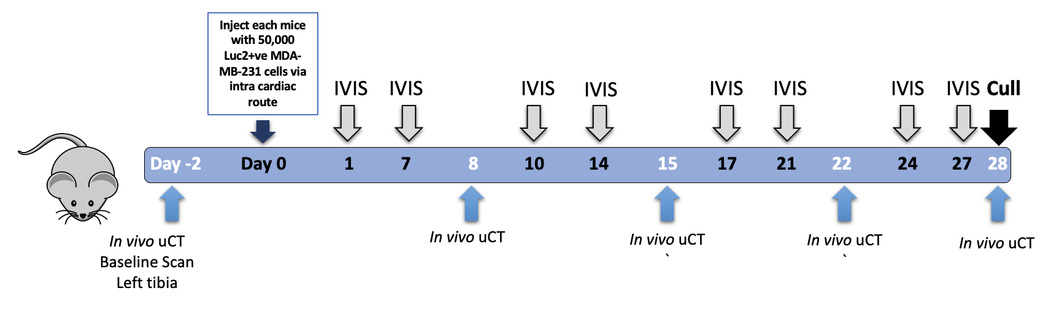
Figure 4.1 Measuring timepoint at which bone lesions form in left tibia in model of breast cancer-induced bone disease
6-week-old female BALB/c nude mice (n=10) were injected i.c. with 5 X ${10}^{5}$ Luc2+ve MDA-MB-231 cells. Mice were injected subcutaneously with 100µl of luciferin and bioluminescence imaged using IVIS Spectrum machine to monitor tumour twice weekly for four weeks, and tumour burden analysed. Prior to tumour injection, left tibias of mice were scanned by VivaCT80 µCT scanner in vivo (baseline scan) and once weekly after tumour has spread to hind limbs confirmed by IVIS imaging, with bone integrity and structure analyzed. All mice were euthanised after 4 weeks of tumour injection. At the end of the experiment, long bones of hindlimbs were collected and left tibia analysed by ex vivo µCT. Bone histomorphometry was carried out using longitudinal left tibia sections, scoring number of osteoblasts and osteoclasts by osteomeasure software

4.5.1.1 Tumour development overtime

IVIS Imaging Analysis demonstrated that 5/10 mice developed tumour growth in the hind limbs (=100% of tumour-bearing mice). Mice that first displayed a signal in the H (Skull) (3/10) the day after tumour injection developed tumour growth in bone. Mice with no signal detected (3/10) and signal in the C (Chest) (2/10), did not develop tumours at any site (Table 4.1). All animals that developed hind limb tumours had a visible bioluminescent signal in the bone at day 10. Tumour burden in the hindlimb continued to increase over 4 weeks after tumour injection (Figure 4.2).

Table 4.1 Overview of tumour development monitored by IVIS in vivo imaging
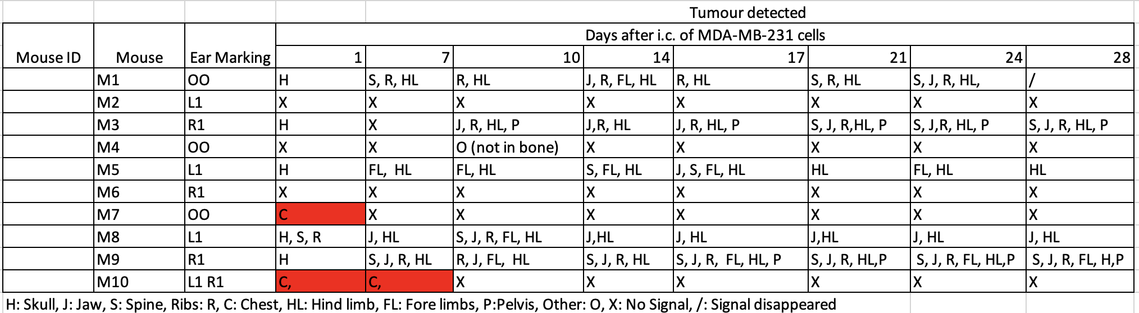
Mice were scanned by bioluminescence imaging using a IVIS Spectrum machine twice weekly for four weeks, and tumour burden analysed. Table showed the different positions of tumour developed in bone overtime.

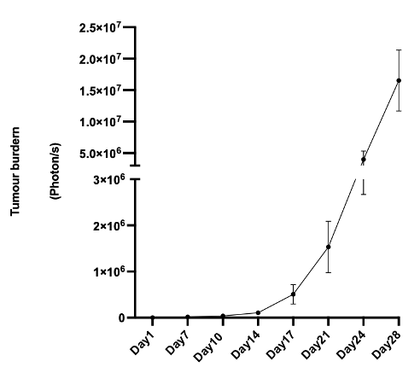
Figure 4.2 Development of tumour in the hindlimb of mice
Mice were scanned by bioluminescence imaging using a IVIS Spectrum machine twice weekly for four weeks, and tumour burden analysed. Figure shows the development of tumour burdern overtime from 1- to 28 days post tumour inoculation in the hindlimb where tumour is present. Mice were scanned by bioluminescence imaging using a IVIS Spectrum machine twice weekly for four weeks, and tumour burden analysed. Figure shows the development of tumour burdern overtime from 1- to 28 days post tumour inoculation in the hindlimb where tumour is present.

4.5.1.2 Development of lytic bone lesions

In vivo µCT analysis demonstrated that BV/TV, trabecular number, and trabecular thickness increased from week 0 to week 1 for all mice that had a detectable tumour in the tibia. This is likely due to bone growth as demonstrated by fuzzy bone (bone growth occurring) in the 3D- reconstructed image by CTVOX. The earliest time point at which bone loss is detected is 2 weeks after tumour injection. BV/TV and trabecular number decreased from week 2 to week 4 in tumour-bearing mice (Figure 4.3). As tumour burden in bone increased, BV/TV and trabecular number decreased over 4 weeks after tumour injection. Bone lesions were visible at 1 week, but there was no trabecular bone loss at this timepoint. % Bone lesion area increase was detected 2 weeks after tumour injection and increased over 4 weeks (Figure 4.4). In vivo µCT optical bone volume was not analysed due to the need to repeat the study.

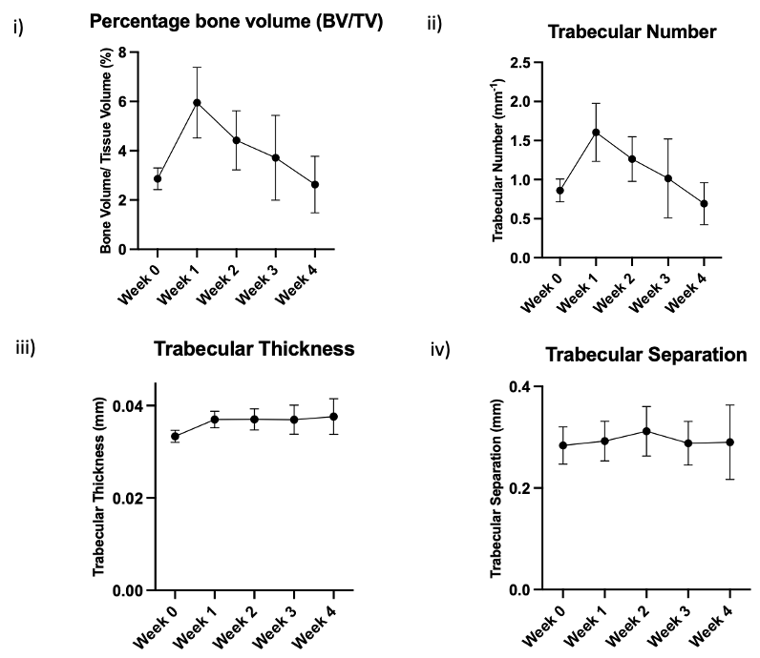
Figure 4.3 Effect of breast cancer bone metastases on bone integrity and structure measured by In vivo µCT
Graphs show %BV/TV (i), trabecular number (ii), trabecular thickness (iii) and trabecular separation (iv) of tumour bearing mice (n=5) from week 0 to week4.
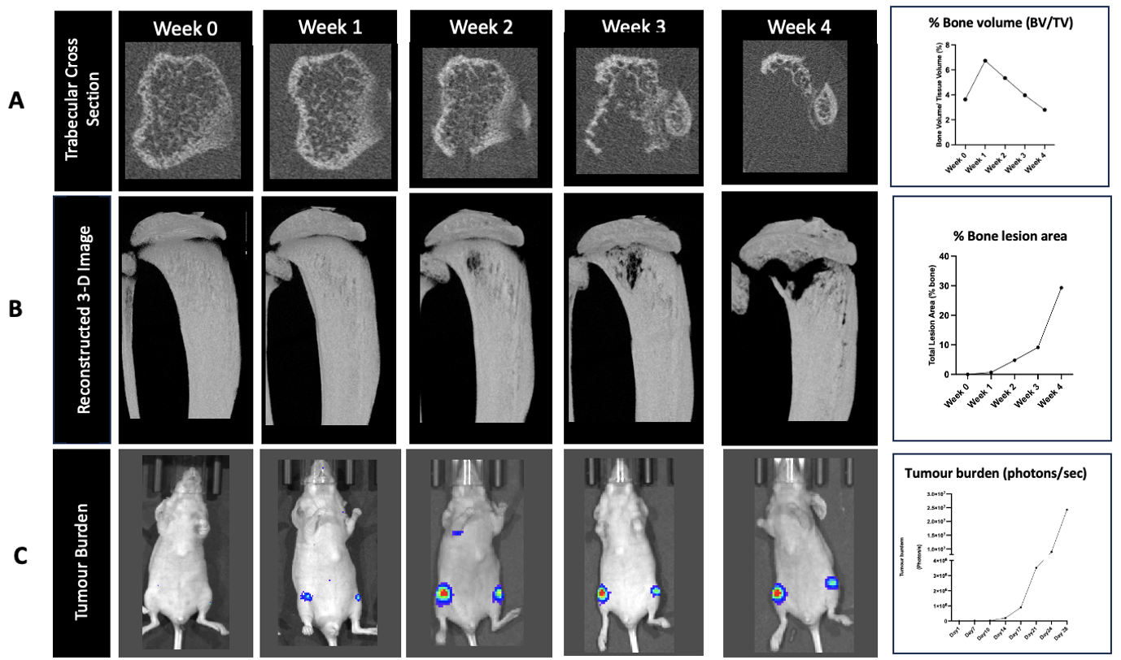
Figure 4.4 In vivo µCT, CTVOX and IVIS imaging analysis on left tibia of representative tumour bearing mice Figure show the (A) cross-section image of trabecular, reconstructed 3D image by CTVOX of left tibia of representative mice and it’s IVIS images over 5 weeks. (B) Percentage lesion area was measured by ImageJ software and (C) tumour burden measured by IVIS living image software. The bone parameters were analysed by CTAN software. All data were analysed on prism software.

The lesion area as a percentage of bone in the tibia of mice was next investigated using osteolytica software. The bone lesions in the model of breast cancer-induced bone disease were often large and localised, which bled into the growth plate. Osteolytica is a software and can have defects in recognising concave surfaces of bone as lesions (Figure 4.5 iii), this error was able to be avoided by manually deselecting the concave surface. Nevertheless, osteolytica was not able to distinguish between the growth plate and the bone lesion; they were recognised as one large lesion by the software. (Figure 4.5 i) show (in red) all grooves that are recognised by osteolytica as bone lesions. (Figure 4.5 ii) Shows the error of osteolytica recognising the lesion that bled into the growth plate with the growth plate as one large lesion. (Figure 4.5 iii) Shows osteolytica recognising the concave surfaces as bone lesions. This error cannot be manually corrected. Another method for bone lesion analysis was used, as osteolytica was unfit for bone lesion analysis in the model of breast cancer-induced-bone disease.

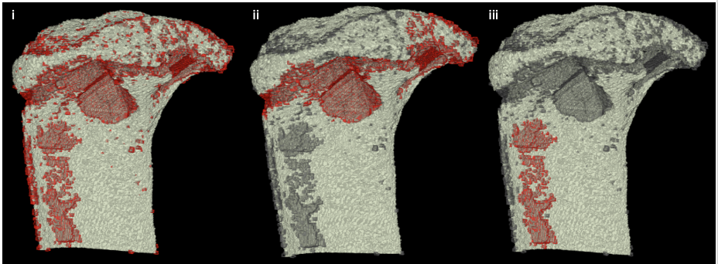
Figure 4.5 Osteolytica software was unable to analyse bone lesions in model of breast cancer-induced bone disease
BALB/c nude mice 4 weeks after injected with 50, 000 MDA-MB-231 cells after was scanned by in vivo µCT and scans analysed by osteolytica, grooves highlighted in red are recongnised by osteolytica software as bone lesions

Image J was able to separate bone lesions from bone and accurately measure the %area of the lesion to bone. A technical disadvantage of Image J is that measuring of bone lesions is not fully automated and requires manual selection of region of interest (Figure 4.6). Reconstructed 3D-image (CTVOX) and ImageJ Analysis demonstrated that visible lesions appear in mice with a tumour in bone 1 week after tumour injection, and the lesions size continued to increase over the following 3 weeks. Mouse M8 had largest lesion size- 23.9% of bone 4 weeks after tumour injection, where the lesion bled into the growth plate and through the back of the bone.

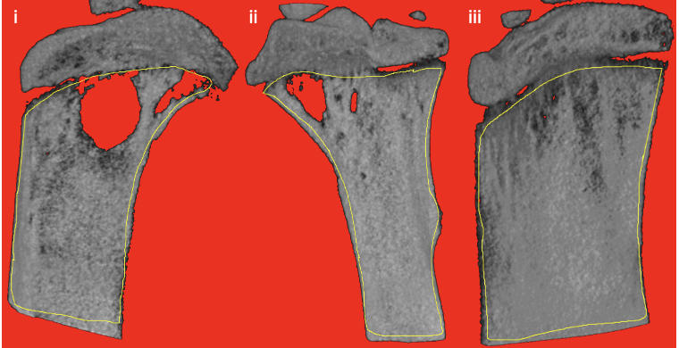
Figure 4.6 Image J 2-D analysis of bone lesions in model of breast cancer-induced bone disease
The tibia of BALB/c nude mice 4 weeks post injection with 50, 000 MDA-MB-231 cells was scanned by in vivo µCT and scans analysed by Image J software. Lesions in all three surfaces of the tibia i medial , ii lateral ,iii posterior were measured. The region of interest (region within yellow line) was manually drawn, excluding the growth plate and top of the tibia as no bone lesion was present in these regions. Image J automatically measures the % bone lesion to the tibia bone

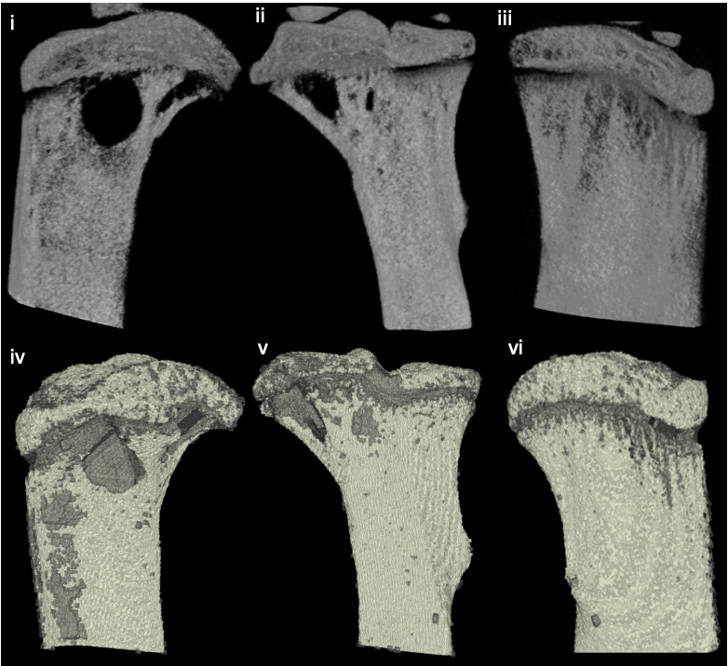
Figure 4.7 Comparison of osteolytica to image J analysis of bone lesions in model of breast cancer-induced bone disease
BALB/c nude mice 4 weeks after injected with 50, 000 MDA-MB-231 cells after was scanned by in vivo µCT and scans analysed by ImageJ software (i,ii,iii) and osteolytica software (iv, v, vi).
4.5.1.3 Bone lesions at endpoint

Ex vivo µCT comparing mice with no tumour detected and tumour-bearing mice demonstrated that BV/TV and trabecular number decreased significantly; trabecular pattern factor increased significantly; trabecular thickness decreased (Figure 4.8 ii, iii, iv). No significant difference in cortical bone volume and trabecular separation comparing mice with tumours in bone compared to mice with no tumour in the bone (Figure 4.8 i, v).

Taken together, the earliest in vivo µCT can detect bone loss in all tumour-bearing mice is in week 2, but reconstructed 3D-images show visible development of lesions after 1 week of tumour injection, which is in line with IVIS imaging, where all mice had a visible IVIS signal in the bone at day 10. Although bone lesions are visible at 1 week, there appears to be no bone loss.
In vivo µCT data were in agreement with ex vivo µCT data that BV/TV and trabecular number decreased, but did not demonstrate that trabecular thickness decreased; this may be due to the resolution difference.
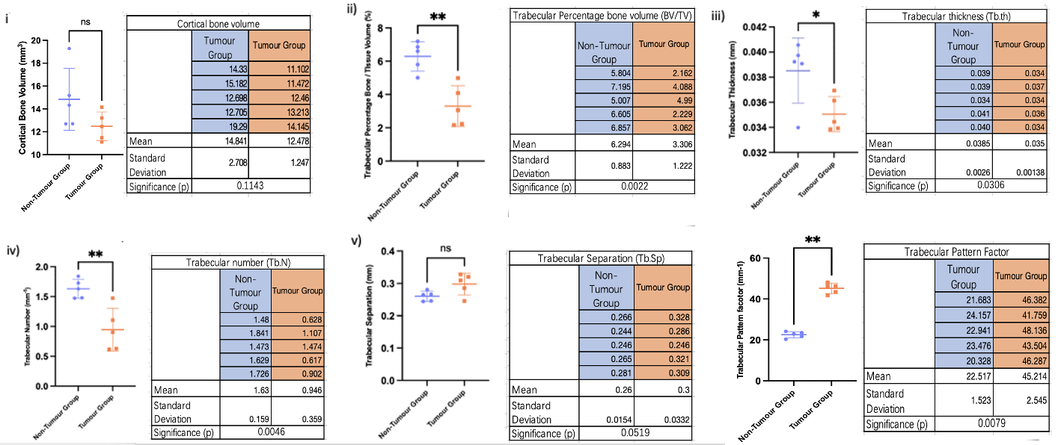
Figure 4.8 Ex vivo µCT analysis of tumour bearing mice and mice with no tumour detected
Graphs show cortical bone volume (i), BV/TV (ii), trabecular number(iii), trabecular thickness (iv), trabecular separation (v) and trabecular pattern factor of tumour bearing mice (Tumour Group) (n=5) and mice with no tumour detected (No-Tumour Group) (n=5) after 4 weeks of tumour injection. All data were presented as mean ± SD, student’s t test. Significance ns (P>0.05), * (P≤0.05), ** (P≤0.01).

4.5.1.4 Breast cancer bone metastases decreased osteoblasts and increased osteoclasts in BALB/c nude mice

Bone histomorphometry demonstrated that breast cancer bone metastases in mice significantly decreased the number of osteoblasts, osteoblast surface area, and significantly increased osteoclasts and osteoclast surface area in the lateral and medial sides of endocortical bone (Figure 4.9) when comparing longitudinal tibia sections of tumour-bearing mice and vehicle mice. The trabeculae in most tumour-bearing mice were destroyed by breast cancer bone metastases and could not be measured.
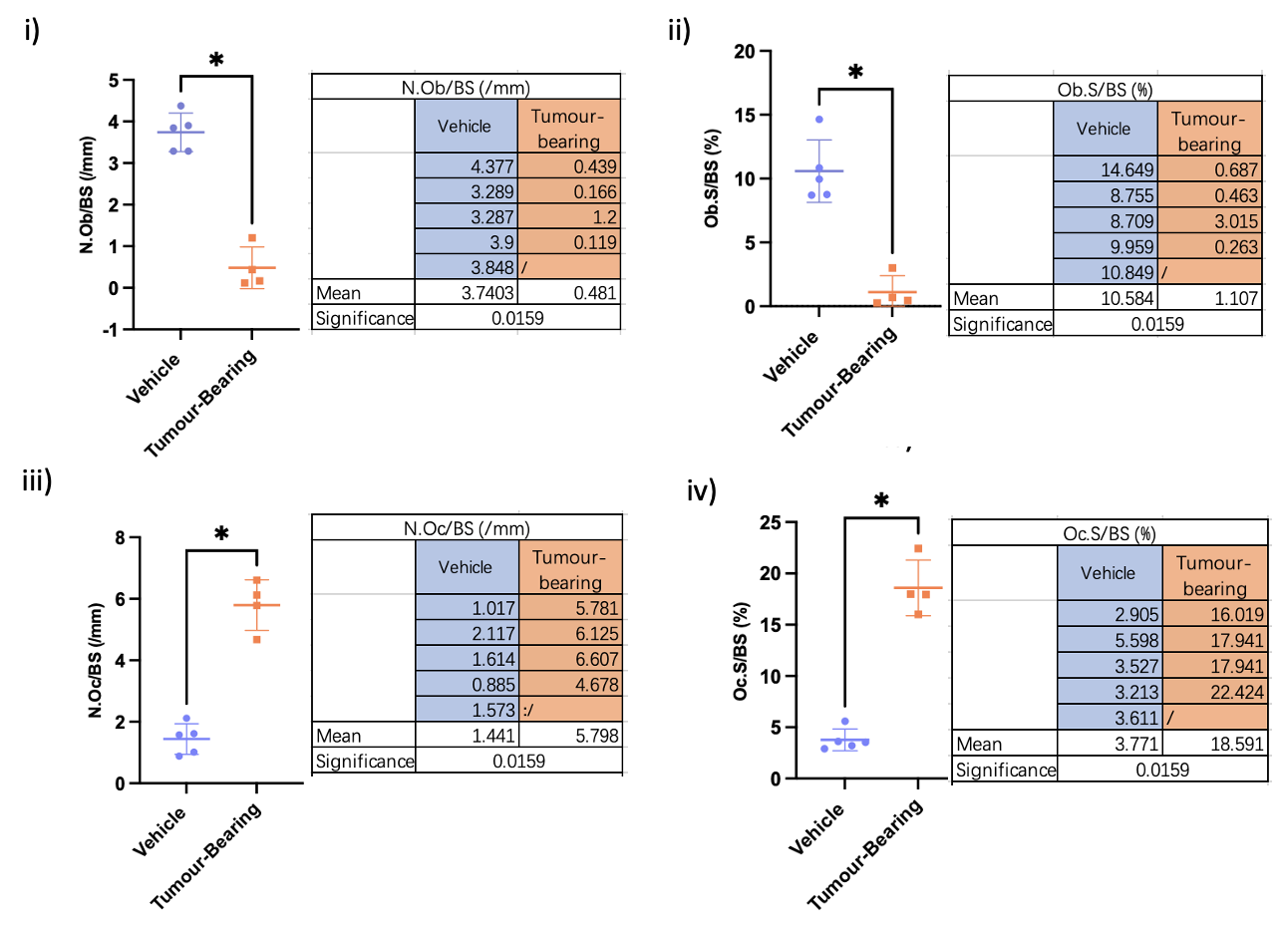
Figure 4.9 Osteomeasure analysis of of vehicle (tumour-free) and tumour bearing mice
Figure show the measurement of number of osteoblasts over bone surface (i), percentage osteoblast surface over bone surface (ii), number of osteoclasts over bone surface (iii), percentage osteoclast surface over bone surface (iv) in medial+ lateral side of longitude tibia sections of SD-208 treated mice (n=4) and vehicle treated mice (n=4) after 3 weeks treatment. All data were presented as mean ± SD, unpaired t test with Mann-Whiteny’s test, analysed on PRISM software. Significance * (P≤0.05).
This tumour study showed that hind limb tumours and lytic bone lesions can be detected 1 week after i.c. injection of MDA-MB-231 cells. In addition, the development of tumour growth about associated lytic bone lesions can be monitored in vivo using IVIS bioluminescent imaging and in vivo µCT.
This experiment had to be repeated due to a low number of mice developing tumour in the hindlimb (5/10), only 3 mice developed bone lesions in the tibia. Tumour signals were detected in the femurs by IVIS bioluminescence imaging in some cases, suggesting the potential development of tumour and bone lesions.
4.5.2 Establishing murine model of breast cancer bone metastasis imaging both proximal tibia and distal femora

Due to the low tumour take in the experiment described above, the study was repeated; every procedure was carried out as described in Section 4.5.1, except that both the proximal tibia and the distal femora were scanned by in vivo µCT to assess whether a bone lesion had formed in the tibia or femur or both (Fig. 4.5.2.1).
Before the experiment, the efficacy of scanning both the proximal tibia and distal femora by in vivo µCT was assessed using a culled prostate cancer-bearing mouse kindly provided by Dr. Ning Wang. A reference line was set to 4 blocks and 3 blocks; both reference lines were able to measure the tibia/femur trabecular and cortical measurements (Fig. 4.10). The more the block references, the more bone is scanned, but also a longer scanning time and cost. There was no difference in the scans when the 3-D images were reconstrcuted by CTVOX, with all bone parameters being able to be measured (Fig. 4.11). Hence, the 3 blocks set reference was more feasible for the study.
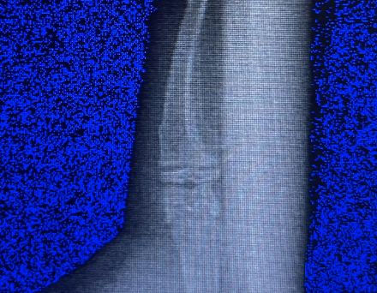
Figure 4.10 Setting of in vivo µCT in scanning proximal tibia and distal femora
Scanning region of proximal tibia and distal femora

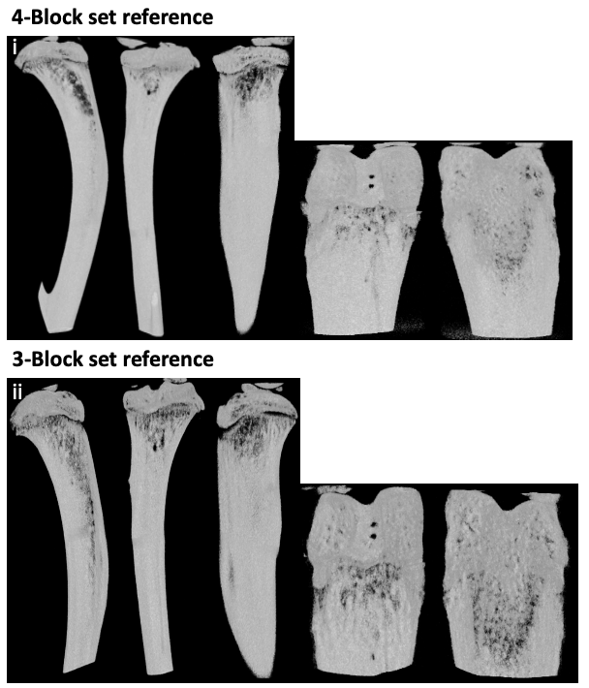
Figure 4.11 Comparing 3/4 block set reference of in vivo µCT scanning proximal tibia+ distal femora reconstructed 3-D images
The tibia of 12-week-old BALB/c nude mice with prostate cancer-induced bone disease was scanned by in vivo µCT after cull at different set reference- (i) 4 block set reference /(ii) 3 block set reference.

This experiment sought to determine the time for tumour and bone lesions to be established in the proximal tibia and distal femur of the left hindlimb and assessed whether in vivo µCT can be used to track the progression of bone lesions (Figure 4.12).

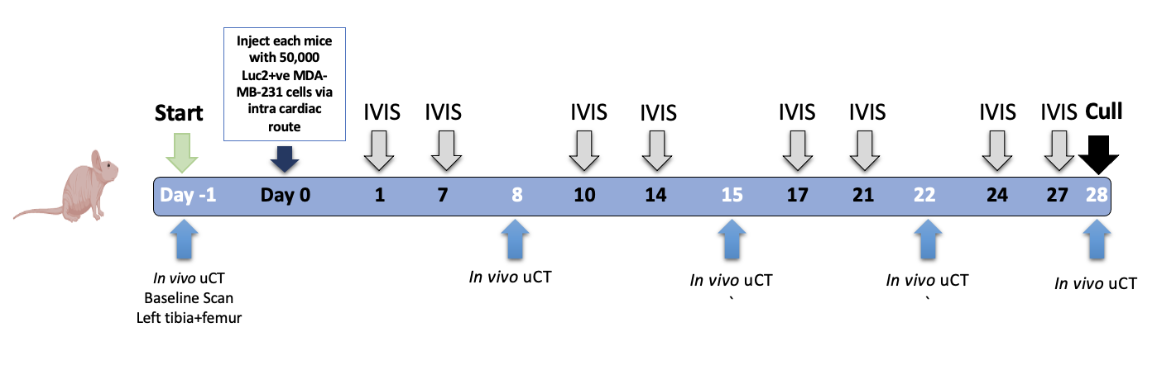
Figure 4.12 Measuring timepoint at which bone lesions form in left proximal tibia/ distal femur in model of breast cancer-induced bone disease
6-week-old female BALB/c nude mice (n=10) were injected i.c. with 5 X ${10}^{5}$ Luc2+ve MDA-MB-231 cells. The left proximal tibia/ distal femur of mice were scanned by in vivo µCT weekly for 5 weeks to track the formation and development of bone lesions. IVIS bioluminescent imaging was carried out twice weekly for 4 weeks after i.c. injection to track the formation and development of tumour in the skeleton of mice. All mice were culled after the 4th week.

4.5.2.1 Tumour growth overtime
IVIS Imaging Analysis demonstrated that 10/10 mice developed tumour growth in the hind limbs (=100% of tumour-bearing mice). Mice that first displayed a signal in the H (Skull) (10/10) the day after tumour injection developed tumour growth in bone (Table 4.2). All animals that developed hind limb tumours had a visible IVIS signal in the bone at day 14. Tumour burden in bone continued to increase over 4 weeks after tumour injection (Figure 4.13).
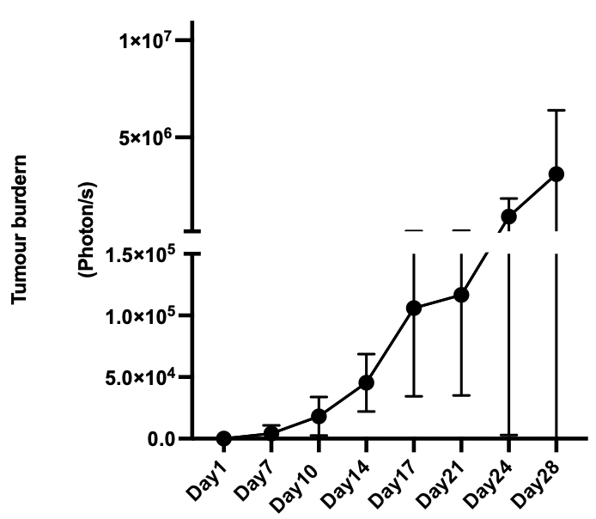
Figure 4.13 Development of tumour in the hindlimb of mice
Mice were scanned by bioluminescence imaging using a IVIS Spectrum machine twice weekly for four weeks, and tumour burden analysed. Figure shows the development of tumour burdern overtime from day 1- to 28 days post tumour inoculation in the hindlimb where tumour is present.

Table 4.2 IVIS summary of tumour bearing mice
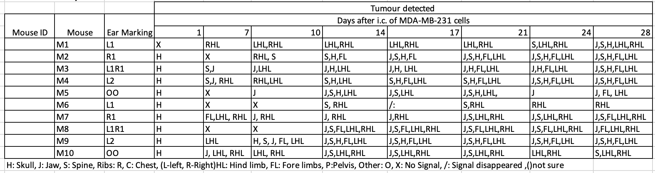
Mice were scanned by bioluminescence imaging using a IVIS Spectrum machine twice weekly for four weeks, and tumour burden analysed. The table shows the different positions of tumours detected in bone at the different time points after tumour cell injection. All mice (10/10) developed tumour in either of the hindlimb.

4.5.2.2 Development of lytic bone lesions

In vivo µCT analysis demonstrated that BV/TV, trabecular number, trabecular thickness, and cortical BV decreased from week 0 (baseline) to week 4 in tumour-bearing mice. This decrease was most significant from week 3 to week 4 (Figure 4.14).

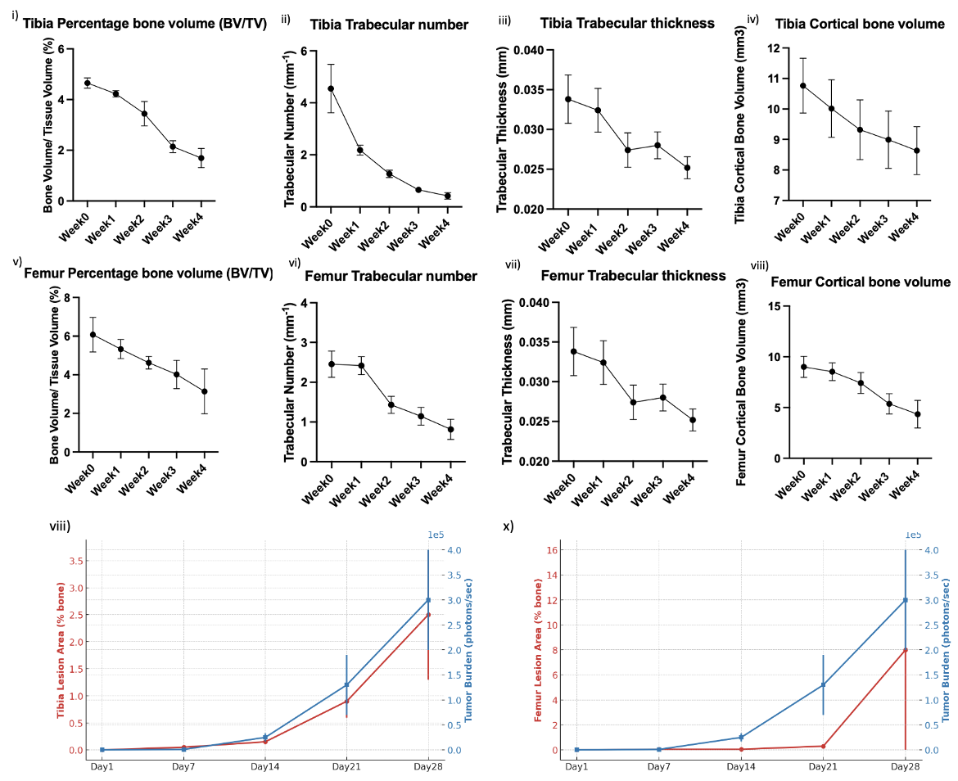
Figure 4.14 Effect of breast cancer bone metastases on bone integrity and structure measured by In vivo µCT
Graphs show %BV/TV (i), trabecular number (ii), trabecular thickness (iii) and trabecular separation (iv) in the tibia and %BV/TV (i), trabecular number (ii), trabecular thickness (iii) and trabecular separation (iv) in the femur of tumour bearing mice (n=5) from week 0 to week4. %Bone lesion volume is compared to tumour volume in the (vii) tibia and (x) femur.

Reconstructed 3D-image (CTVOX) and ImageJ Analysis demonstrated that visible lesions appear in mice with a tumour in the tibia 1 week after tumour injection, lesions size continued to increase over the 3 weeks. Visible lesions appear in the femur after 3 weeks of tumour injection, and the lesion size continued to increase from week3-4 (Figure 4.15). In each mouse, bone lesions were present in either the tibia or femur or both. Some femurs were lacking the 3-D reconstructing images due to not whole image of distal femora was captured by in vivo µCT, this included both human error of not been experienced enough to pull enough femur for scanning, and week 0 some hindlimbs of mice were not long enough to stretch to be scanned to include the whole distal femora, bone parameter measurements were not affected.

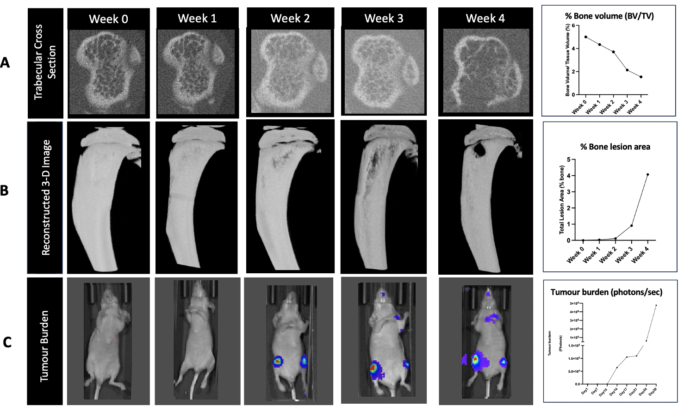
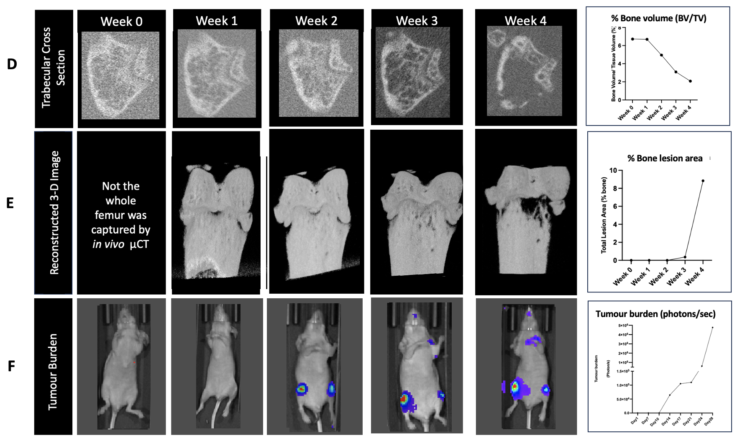
Figure 4.15 In vivo µCT, CTVOX and IVIS imaging analysis on proximal tibia/ distal femora of representative tumour bearing mice
Figure show the proximal tibia (A) cross-section image of trabecular, reconstructed 3D image by CTVOX of representative mice and it’s IVIS images over 5 weeks. (B) Percentage lesion area was measured by ImageJ software and (C) tumour burden measured by IVIS living image software; distal femur (D) cross-section image of trabecular (The whole distal femur was not captured by µCT), reconstructed 3D image by CTVOX of proximal tibia of representative mice and it’s IVIS images over 5 weeks. (B) Percentage lesion area was measured by ImageJ software and (C) tumour burden measured by IVIS living image software. The bone parameters were analysed by CTAN software. All data were analysed on prism software.
4.5.2.3 Bone lesions at endpoint
Ex vivo µCT data agreed with in vivo µCT data (Figure 4.16); in vivo µCT can be used to track the progression of bone lesions. As all mice were tumour-bearing, there was no vehicle to compare with at endpoint.

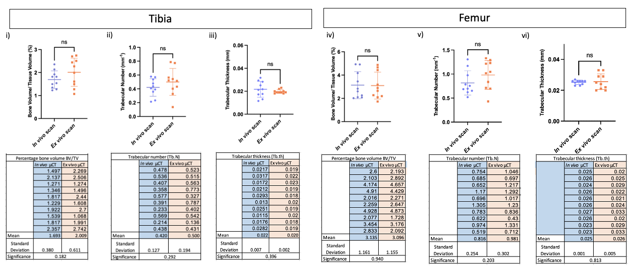Figure 4.16 Ex vivo µCT data comparison to In vivo µCT data on proximal tibia/ distal femora of tumour bearing mice
No significance difference between ex vivo µCT data mice after cull and in vivo µCT data of mice after 4 week of tumour injection (Tibia, %BV/TV ns 0.1817, Tb.n ns 0.2920, Tb.th ns 0.3960; Femur, %BV/TV ns 0.9339, Tb.n ns 0.2027, Tb.th ns 0.813; ). All data were presented as mean ± SD, student’s t test, analysed on prism software. Significance ns (P>0.05)
Taken together, this tumour study showed that hind limb tumours and lesions are formed in the proximal tibia after 1 week i.c. of MDA-MB-231 cells and in the femur 3 weeks post i.c. In addition, the development of tumour growth about associated lytic bone lesions can be monitored in vivo. The MDA-MB-231 xenograft model using in vivo µCT can be used for assessing the effects of bone anabolic agents in subsequent studies.

4.6 Discussion

This chapter set out to establish and characterise a model of breast cancer bone metastases that is suitable to determine the effects of bone anabolic agents on breast cancer-induced bone disease.
I initially aimed to establish the murine model of breast cancer bone metastases, where we inoculated Luc2+ve MDA-MB-231 cells (50,000 cells per mouse) in 6-week-old female BALB/c nude mice via the i.c. route. We were able to monitor the development of tumour burden and bone lesions using bioluminescent imaging and in vivo µCT, respectively. In addition, end-stage disease was assessed by ex vivo µCT. Our data showed that tumour developed in mice 10 days post tumour injection, tumour burden in bone continued to increase over 4 weeks after tumour injection. BV/TV and trabecular number decreased from week 2 to week 4 in tumour-bearing mice. Bone lesions developed in the left tibia after 1 week of tumour injection, and the size of the lesion increased over 4 weeks after tumour injection. The second study was done due to low tumour take and tumour detected but no lesion was present in tibia. In this study, both the proximal tibia and distal femur were scanned to assess whether the tumour detected was in the distal femur. All animals that developed hind limb tumours had a visible IVIS signal in the bone after 1 week. Similar to the first study, tumour burden in bone and % bone lesion continued to increase over 4 weeks after tumour injection. BV/TV, trabecular number, trabecular thickness, and cortical BV decreased from week 0 (baseline) to week 4 in tumour-bearing mice. This model is well established and has been used in a series of publications (Brown et al, 2012, Brown et al ,2012, Brown et al, 2018, and Ottewell et al, 2015). Moreover, Brown et al, 2012 show that tumours in bone need to reach a certain size before they initiate lytic lesions, which can be detected by µCT. This study also shows how osteoblasts and osteoclasts are changed as tumours develop.
Studies of breast cancer bone metastases have shown that bone lesions develop in the tibia at two weeks in 4-week old BALB/c nude mice and three weeks in 4-6 week old female Foxn nu-/-: Harlan mice after tumour injection (Campbell et al, 2012 and Peyruchaud et al, 2001), hence the bone lesions developed left tibia in our study are considerably fast. This may be attributed to the differences in the MDA-MB-231 cell strain used in this study. The MDA-MB-231 cells used in this study are fully homed variant of MDA-MB-231 cells (Chapter 2. Section 2.1.1), which might have rapidly developed tumour in mice in this study following intracardial injection.
In the first study, all animals that developed hind limb tumours had a visible IVIS signal in the bone at day 10. This means that for this model, IVIS imaging can be used to detect tumour growth in bone on day 10 at the earliest. Reconstructed 3D-images (from the same scan of in vivo µCT) show visible development of lesions after 1 week of tumour injection, which is in line with IVIS imaging, where all mice had a visible IVIS signal in the bone at day 10. This showed that bone is lost after 1 week of tumour injection. However, in vivo µCT can only detect bone loss in all tumour-bearing mice in week 2. This likely explanation is that the growth of bone in tumour-bearing mice is greater than the bone loss 1 week after tumour injection.
Most bone lesions formed in the tibia of the hind limb are small (especially mouse M5 and M9), and it was suspected that bone lesions might have formed in the femur part of the hind limb. In addition, the femur is the most common long bone where breast cancer bone metastasis metastasises to in patients (Samsani et al, 2004). The breast cancer tumour model needs to be revised to also monitor the development of tumour growth about the associated lytic bone lesions in the tibia as well as the femur in vivo. Monitoring the femur and the tibia at the same time will be challenging, as it may be hard for the legs of young mice to be positioned in the x-ray beam, so femurs can be scanned by in vivo µCT. Furthermore, repeating the experiment could provide more data on when bone lesions are formed in the left tibia of mice as well as having a larger group size (as our data show early formation of bone lesions in the left tibia compared to other studies). In addition, stock MDA-MB-231 cells may have undergone wild-type outgrowth and lost their fluorescence, leading to bone metastases that lack fluorescence. Stock MDA-MB-231 will be checked for fluorescence before injection in the subsequent studies.

By improving the methods of in vivo µCT and repeating the study, a more intact model of breast cancer-induced bone disease was developed. Bone loss occurred in all tumour-bearing mice, which was like the results of the previous study. Furthermore, bone lesions were always present in either the proximal tibia or the distal femur in this study. This finding addresses the issue raised in a previous study, where tumour presence was detected in the hind limbs, but no bone lesions were observed in the tibia, indicating that bone lesions likely developed in the femur. The accuracy and efficacy of in vivo µCT was also reconfirmed with ex vivo µCT by demonstrating that the data at endpoint were similar. Bone histomorphometry data from these studies were not presentable due to extensive bone destruction following disease progression. This may be attributed to excessive tumour burden, leading to extensive localised lesions in bone. In the first study, only the medial and the lateral sides of tibia were measured, as the trabecular region was severely compromised to be evaluated. Notably, the number of osteoclasts was significantly higher compared to animals that did not develop a tumour Fig. 4.9. This might indicate that high levels of bone resorption causes this.

To assess bone formation, calcine incorporation can be used and considered for future studies. Calcein is typically injected into mice on two separate days before the endpoint. Calcein binds to calcium ions and incorporates into sites where new bone is forming, specifically into the hydroxyapatite crystals in the mineralising front of bone. Calein labelled areas emit green bands at a wavelength of 510-520 nm in bone tissue and can be quantified using a fluorescence microscope (Dempster et al, 2013). Nevertheless, conducting weekly in vivo µCT and bioluminescent imaging may constitute an excessive procedural burden for the mice. Veterinary assessment is required to determine whether the frequency and combination of these procedures are ethically and physiologically acceptable.

In conclusion, this chapter has demonstrated a breast cancer-induced bone disease model using in vivo µCT and bioluminescent imaging was able to track the formation and development of bone lesions and change in bone parameters, which would allow the monitoring of the effect of a drug to the bone in vivo. Therefore, the next step would be to assess the effect of chemotherapy agent doxorubicin on bone lesions in a murine model of breast cancer bone metastasis. This is to have a chemotherapy to limit the development of lytic bone lesions so bone anabolic agents losartan and SD-208 can limit/ repair lytic bone lesions.

Chapter 5
Evaluating doxorubicin for tumour suppression in breast cancer bone metastasis

5.1 Summary

Background:
Doxorubicin (DOX) is one of the most common anthracycline drugs used in the treatment of breast cancer. Despite its potent anti-tumour effects, DOX has side effects, including bone loss, reported in breast cancer patients and mouse models. For my studies, I investigated the potential of using a low dose of DOX to inhibit tumour growth and slow progression of tumour-induced bone destruction, allowing time for bone anabolic agents to limit/ repair bone lesions. Work in this chapter explores whether a low dose of DOX might be able to inhibit tumour growth without causing damage to bone.

Results:
MTT conducted in vitro demonstrated that DOX inhibits the growth of triple-negative breast cancer cells in vitro. In vivo µCT data demonstrated that 3 weeks of DOX treatment significantly decreases cortical bone volume, trabecular BV/TV in the tibia, and increases % bone lesion area (in the presence of a tumour) compared to vehicle. In the femur, the trabecular number significantly decreased. Bioluminescent imaging demonstrated that tumour growth was significantly reduced at day 35 of DOX treatment compared to vehicle. Collectively, these findings demonstrate that 4mg/kg DOX does not induce a low-tumour phase in the MDA-MB-231 xenograft model of cancer-induced bone disease.

5.2 Introduction

5.2.1. Current treatments for breast cancer-induced bone disease
Bone metastasis is a prevalent occurrence in breast cancer patients, with approximately 70% of patients with advanced breast cancer spreading to bone (Sharma et al, 2010). This often leads to complications known as skeletal-related events (SRE), including bone pain, immobility, hypercalcemia, spinal cord compression, and increased fracture risk, significantly impacting the quality of life of patients (Shao and Varamini et al, 2022). The primary objective of treating breast cancer bone metastasis is to preserve bone function, alleviate pain, and mitigate SREs. Treatment decisions by doctors are typically recommended based on the severity of SREs and the progression of metastasis (Wong et al, 2014).
Treatment modalities are categorised as systemic or local. Systemic approaches, such as immunotherapy, chemotherapy, and hormonal therapy, target cancer cells throughout the body (Palumno et al, 2013); whilst local treatments, including surgery and radiation, focus on specific bone sites (Debela et al, 2021). Bone-strengthening medications, including the monoclonal antibody denosumab and bisphosphonates like zoledronic acid, are often administered along with these treatments to minimise bone damage. Moreover, anthracycline and taxane chemotherapies are currently the standard of care to control tumour growth (Choulli et al, 2024). Other drugs are used in breast cancer treatment, including DOX. but side effects in some patients have hindered their use as discussed below (Section 5.2.2).

5.2.2 Doxorubicin

Doxorubicin (DOX) (brand name Adriamycin) is a first-line anthracycline drug that has potent anti-cancer effects in breast cancer, often administered alone or in combination with other chemotherapies. DOX is originally isolated from the fungus Streptomyces peucetius (Jang et al, 2023). Whilst the mechanism of action of DOX is not fully understood, it is shown to inhibit topoisomerase II, ubiquitous enzymes that are important for DNA synthesis and replication; intercalate with DNA and generate oxygen species to induce cell death (Zhao et al, 2018). The epimer of DOX, epirubicin, is also used for the treatment of early and late-stage breast cancer (Khasraw et al, 2012).

Despite the clinical effectiveness of DOX, it induces toxicity that negatively affects patients. In a prospective study, patients receiving DOX treatment from 1995 to 2014 developed cardiotoxicity in 9% of breast cancer patients (Cardinale et al, 2018), and children receiving multiple doses of DOX totalling 228 to 550 mg developed ventricular abnormalities in afterload or contractility (Lipshultz et al, 1991). Most importantly, DOX treatment is linked with an increased risk of bone damage in patients. Female breast cancer patients treated with 6 cycles of DOX have low bone mineral density (BMD) (Hadji et al, 2009). Similar results have been seen in several mouse studies.

5.2.3 Effect of DOX treatment in tumour-free immunocompetent mice

Bone effects of DOX have been explored in tumour-free mice. DOX was used at a high concentration in a study to investigate DOX enhancement of autophagy. Ten-week-old C57BL/6 female mice were treated intraperitoneally with 5mg/kg DOX or PBS daily for 4 weeks. Femurs were scanned ex vivo, demonstrating that DOX induced significant bone loss with decreased BMD, trabecular bone volume/ tissue volume, trabecular thickness, and increased trabecular separation, compared to vehicle control. In addition, TRAP staining of the femur demonstrated that DOX increased osteoclast surface area. Western blot analysis suggested that this might be due to increased autophagy mediated through mitochondrial reactive oxygen species (mROS)/ type IV mucolipidosis-associated protein (TRPML1)/ transcription factor EB (TFEB) axis (Park et al, 2022).

5.2.4 Effect of DOX treatment in model of breast cancer bone metastases
The bone effects of DOX have also been explored in a dose-response study, where a lower range dose of DOX was used. 6-week-old female MF1 nu/nu mice were inoculated subcutaneously in the right flanks with MDA-G8 cells. This model targets local tissue for tumour growth and does not metastasise efficiently to the bone (Ottewell et al, 2006). This may not be a good representation of a bone metastatic model. Mice were administered 2, 4 or 8mg/kg DOX (n=8/ group) or 100μl of saline (vehicle control) once per week for 6 weeks. Both 4mg/kg and 8mg/kg DOX significantly inhibited tumour growth, whilst there was no effect with 2mg/kg. Histological sections of bones ex vivo demonstrated that 6 weeks of weekly treatment with 2mg/kg DOX had no significant effect on osteoclasts on cortical bone surface compared with saline control; μCT demonstrated that there was no tumour-induced bone loss (Ottewell et al, 2008). 4mg/kg DOX was able to inhibit tumour growth; however, the effect of this dosage on bone is still undetermined.
In another subsequent study, the anticancer effect of clinically relevant doses of DOX and ZOL were investigated in a more relevant bone metastatic model (Ottewell et al, 2008). 4-week-old BALB/c nu/nu mice (n=5/ group) were inoculated by B02 cells via tail vein. In this model, tumour cells frequently metastasise to the bone, especially the hindlimbs, spine and jaw (Le Gall et al, 2007). Once mice were detected with osteolytic lesions by day 18, mice received 2mg/kg DOX or 100μl of saline (vehicle control). Mice received a second administration of DOX on day 25. Immunohistochemical analysis of bone sections combined with μCT imaging revealed that treatment with DOX alone led to a reduction in intraosseous tumor growth and osteolytic lesion area in the hindlimb when compared to the vehicle-treated control group. This suggests that a low dose of DOX (2 mg/kg) may be effective in affecting tumour or bone.

Having established a breast cancer induced bone metastasis model by injecting MDA-MB-231 breast cancer cells through intracardiac (i.c.) route, resulting in hind limb tumours (chapter 4), I next aimed to assess the effect of 4mg/kg DOX in mice with breast cancer-induced bone disease, building on previous finding that 4mg/kg DOX successfully inhibited tumour growth in another immunocompromised model (MF1 nu/nu mice) (Ottewell et al, 2008). A dose of 4 mg/kg DOX was selected due to a misinterpretation of the data and failure to reference Ottewell et al. (2008, Clinical Cancer Research), which demonstrated that a lower dose of 2 mg/kg was sufficient to significantly reduce tumour growth and bone lesion area in a murine model of breast cancer bone metastasis. 4mg/kg DOX has the possibility of inducing a low-tumour phase which will later allow the assessment of the ability of losartan or SD-208 to limit/ repair cancer-induced bone lesions.

5.3 Hypothesis and Aims

The main aim of this chapter was to determine a suitable therapy for reducing tumour growth in bone that will allow time for bone anabolic agents in subsequent studies to limit/ repair bone lesions. Furthermore, assess whether 4m/kg DOX treatment can induce a low-tumour phase in bone where tumour growth is minimal and further bone destruction is prevented.

Hypothesis: DOX will be able to limit bone disease in the model of breast cancer bone metastases and induce a low-tumour phase.

This hypothesis will be tested by the following objectives:

- To determine the tumour inhibition effect of 4mg/kg DOX in bone

- To determine the effects of 4mg/kg DOX on bone structure and integrity in the MDA-MB-231 murine model of breast cancer-induced bone disease.

5.4 Materials and methods

5.4.1 In vitro study

MDA-MB-231 LUC2+ GFP+ cells were cultured and maintained as described in Section 2.1. MDA-MB-231 cells were treated with increasing concentrations of DOX (10⁵-10¹²M) for 72 hours. MTT assay was conducted as described in Section 2.2.2.

5.4.2 In vivo study

MDA-MB-231 were injected into mice i.c. as described in Section 2.8. The study was conducted as described in Section 2.3.3. Image J analysis and bone histomorphometry were conducted as described in Sections 2.11 and 2.12.

5.5 Results

5.5.1 DOX inhibits growth of breast cancer cells in vitro
To confirm the inhibitory effect of the DOX stock on the growth of MDA-MB-231 breast cancer cells in vitro, a dose-dependent decrease in cell number was demonstrated using an MTT assay, with an IC50 of 0.026 µM (Figure 5.1). These results showed that the cell line used to induce tumour growth in bone (see next section) was sensitive to DOX.

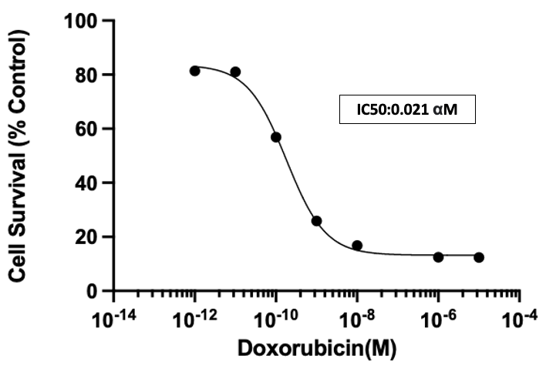
Figure 5.1 Dose response assay of DOX
Triple negative MDA-MB-231 Luc2+ GFP+ human breast cancer cells were treated with increasing concentrations of DOX (10⁵-10¹²M) for 72 hours followed by MTT assay to access cell viability

5.5.2 DOX increased bone loss in murine model of breast cancer bone metastasis

This in vivo study (Figure 5.2) sought to determine whether a low dose of DOX (4mg/kg) can inhibit both tumour growth and bone destruction following the formation of bone lesions in the hindlimb. 4mg/kg DOX was chosen as it has previously been shown to inhibit subcutaneous breast tumour growth, whereas the lower dose of 2mg/kg had no effect on tumour or bone in a mouse model of breast cancer-induced bone disease (Ottewell et al, 2008).

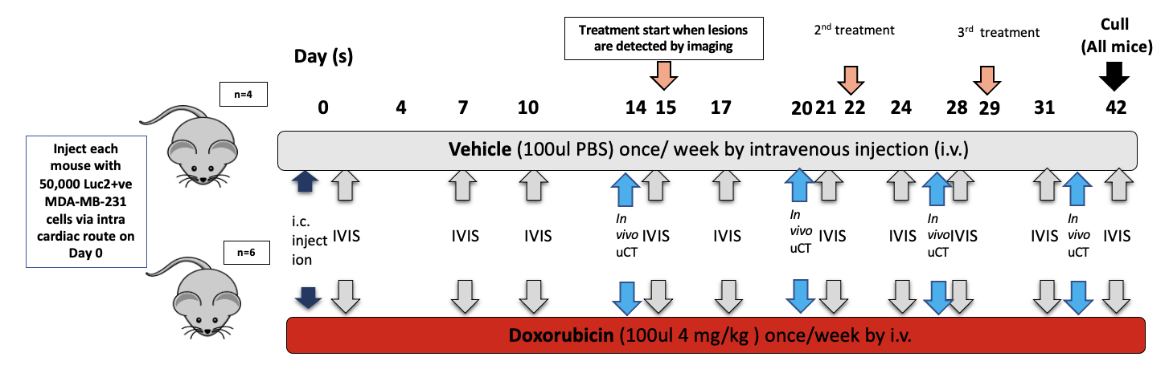
Figure 5.2 Measuring effect of 4mg/kg DOX on breast cancer tumour growth in bone
6-week-old female BALB/c nude mice (n=20) were injected i.c. with 5 X ${10}^{5}$ Luc2+ve MDA-MB-231 cells. 10 mice developed tumour in the hindlimb. Mice were injected subcutaneously with 100µl of luciferin and bioluminescence imaging using IVIS Spectrum machine to monitor tumour twice weekly for five weeks (grey arrows), and tumour burden analysed. After two weeks, the hindlimb of mice which developed skeletal tumour was scanned by in vivo µCT to determine whether a tumour-induced bone lesion had formed. Once the formation of bone lesion was confirmed by in vivo µCT, treatment starts (orange arrows), mice were treated with 4mg/kg DOX or 100µl of PBS (vehicle) by intravenous injection once per week for 3 weeks (DOX n=6, Vehicle n=4). The tibia and femurs of mice with a confirmed tumour was scanned by in vivo µCT once weekly for 3 weeks (blue arrows) and ex vivo after cull, with bone integrity and structure analysed.

5.5.3 Tumour development over time

Bioluminescence image analysis demonstrated that 10/20 mice (50%) developed tumour growth in the hind limbs, in both the proximal tibia and the distal femur (Table 5.1). The expected tumour take was 80-90%, so it was unclear what caused this low percentage. Mice that did not develop tumours were excluded from this study. 4mg/kg DOX did not slow down or inhibit tumour growth compared to vehicle treatment after 2 weeks of treatment. Tumour growth in DOX-treated mice was significantly reduced at day 35 compared to vehicle-treated mice (Figure 5.3).

Table 5.1 Overview of tumour development monitored by IVIS in vivo imaging
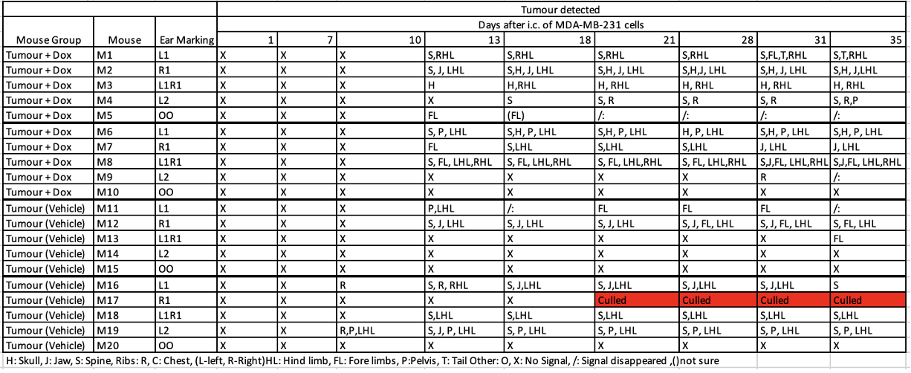
Mice were scanned by bioluminescence imaging using a IVIS Spectrum machine twice weekly for four weeks, and tumour burden analysed. Table showed the different positions of tumour developed in bone overtime.

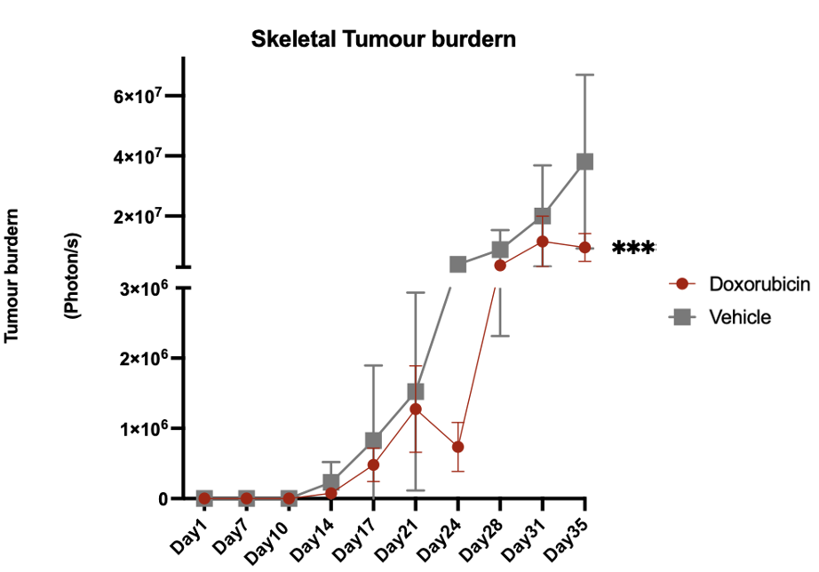
Figure 5.3 Tumour development monitored by IVIS in vivo imaging
Mice were scanned by bioluminescence imaging using a IVIS Spectrum machine twice weekly for five weeks, and tumour burden analysed. Figure shows tumour developed in bone from day 1 day 35 of vehicle treated mice (n=4) compared to 4mg/kg DOX treated mice (n=6), data are displayed as photons/sec. All data are presented as mean ± SD, Aligned Rank transfer and 2-way ANOVA test, analysed on R software. Significance (P≤0.001).

5.5.4 Development of lytic bone lesions
In vivo µCT analysis demonstrated that trabecular bone volume (%BV/TV), trabecular number and trabecular thickness in the proximal tibia decreased from 2 weeks to 5 weeks after tumour injection in both vehicle-treated, and DOX-treated mice (Figure 5.4 i-iv). There was a significant decrease in %BV/TV at 5 weeks comparing vehicle-treated to DOX-treated mice (Figure 5.4i).

Image J analysis demonstrated that visible lesions appeared in the tibia of mice 2 weeks after tumor cell injection (Figure 5.5 i, ii), and in the femur 3 weeks after tumor cell injection (Figure 5.5 ii), in both DOX and vehicle-treated mice. The size of the bone lesions continued to increase from 2 weeks to 5 weeks in both groups. At week 5, DOX-treated mice had a greater %bone lesion area compared to vehicle-treated mice, demonstrating that 4mg/kg DOX treatment not only failed to prevent the increase in size of the tumour-induced bone lesion, but also appeared to exacerbate this effect (Figure 5.5 i, ii). Five weeks after tumour cell injection, there was no difference in % bone lesion area in the proximal tibia and distal femur comparing the DOX-treated group to the vehicle-treated group (Figure 5.6 1i, 2i). Ex vivo µCT analysis confirmed that the DOX treated group (tumour bearing) had significantly reduced trabecular % BV/TV (Figure 5.6.1iii) and increased trabecular pattern factor (Figure 5.6.1vii) compared to vehicle treated group in the tibia, whereas there was no difference in trabecular number, trabecular thickness, trabecular separation and trabecular pattern factor (Figure 5.6.1 iv-vii). A similar trend was seen in the femur (Figure 5.6.2 i-vi), but this was not statistically significant.

No further analysis has been carried out on this study as these results demonstrate that the DOX schedule applied was not suitable to be used in the combinational therapy with bone anabolic agents, based on the damage caused to bone in the mouse model of breast cancer-induced bone disease.
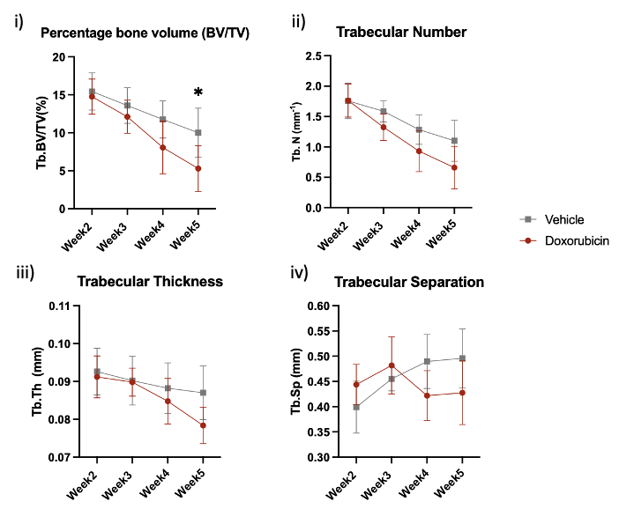
Figure 5.4 In vivo µCT analysis of DOX treated mice compared to vehicle treated mice
Graphs show BV/TV (i), trabecular number (ii), trabecular thickness (iii) and trabecular separation (iv) of DOX treated mice (n=6) and vehicle treated mice (n=4) over the course of 3 weeks treatment. All data were presented as mean ± SD, 2-way ANOVA and Šídák’s test, analysed on PRISM software. Significance ns (P>0.05), * (P≤0.05).

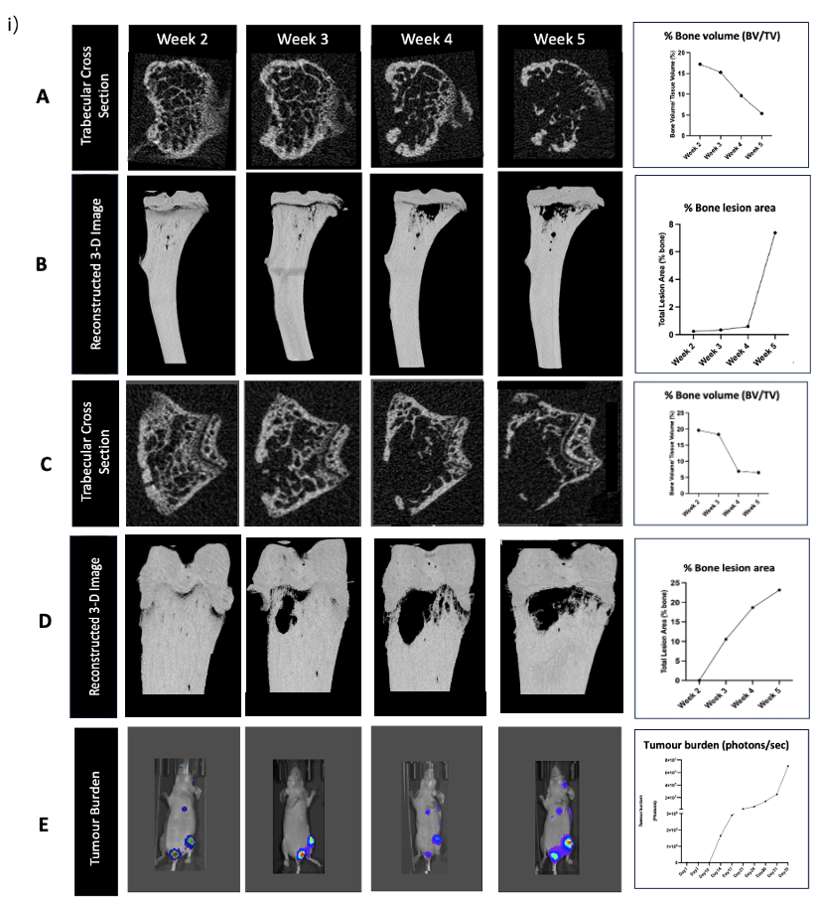
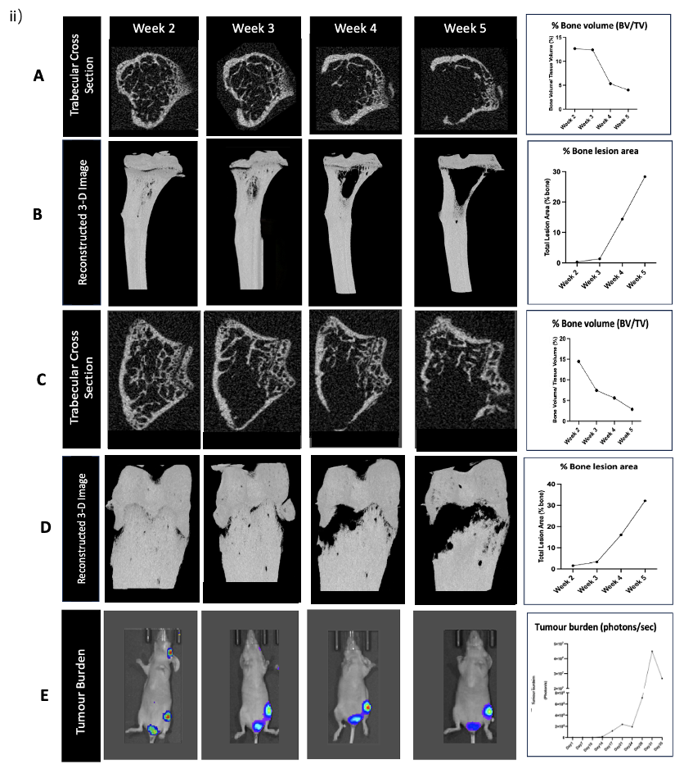=

Figure 5.5 In vivo µCT, CTVOX and IVIS imaging analysis on proximal tibia and distal femur of tumour bearing mice
Figure shows the proximal tibia and distal femur of representative DOX (4mg/kg) treated mice (i) compared to vehicle (PBS) (ii), where (A) cross-section image of trabecular bone of proximal tibia (B) reconstructed 3D image of proximal tibia (C) cross-section image of trabecular bone of distal femur (D) reconstructed 3D image of distal femur by CTVOX(E) IVIS images of representative mice. The bone parameters were analysed by CTAN software. Percentage lesion area was measured by ImageJ software and tumour burden measured by IVIS living image software.
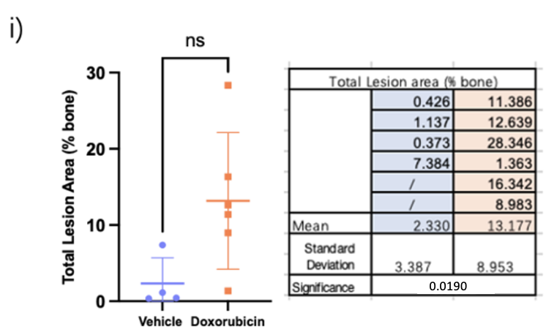
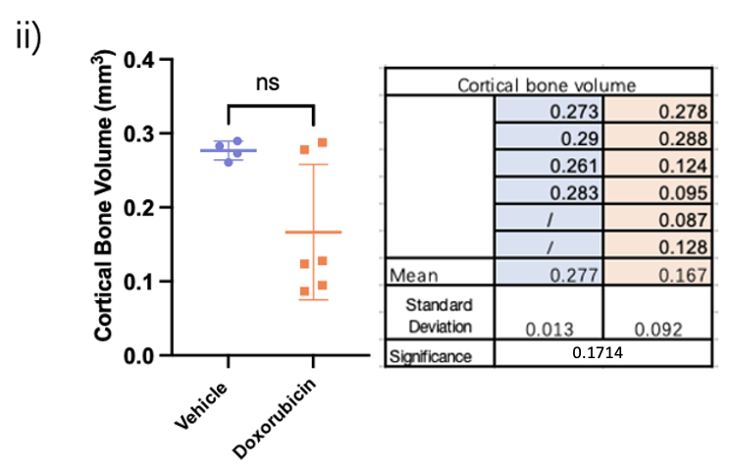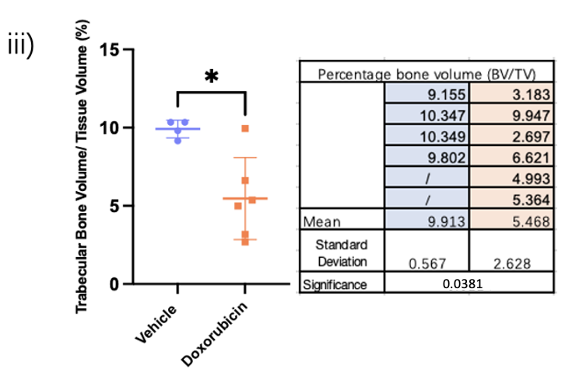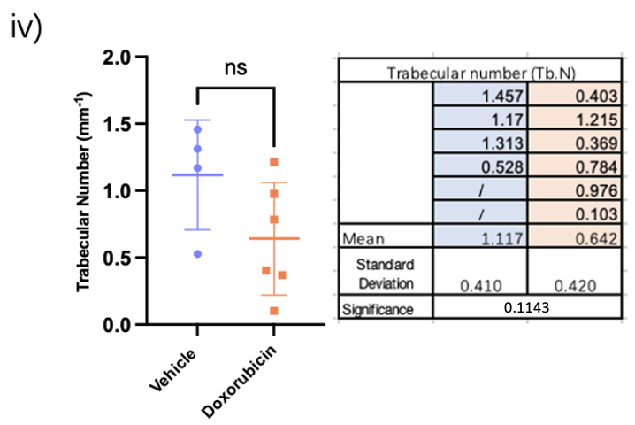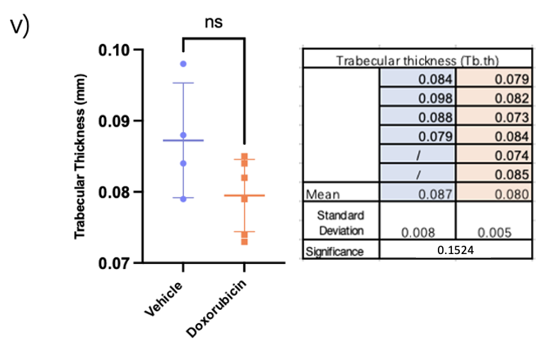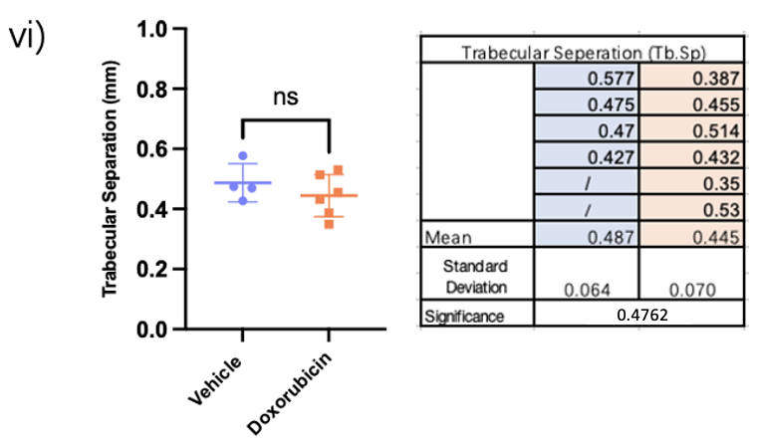
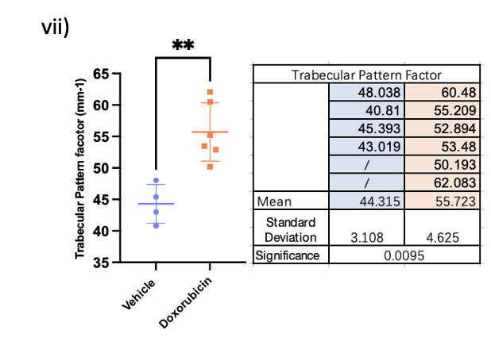

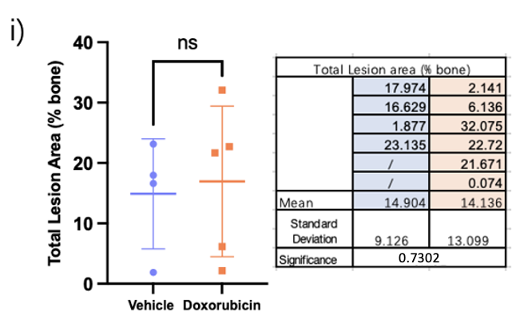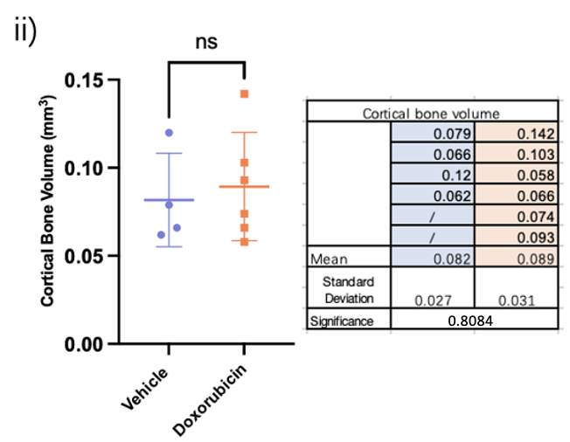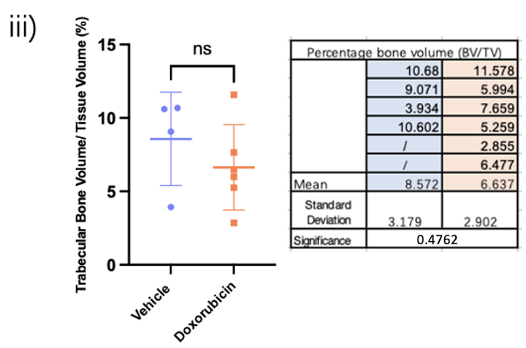
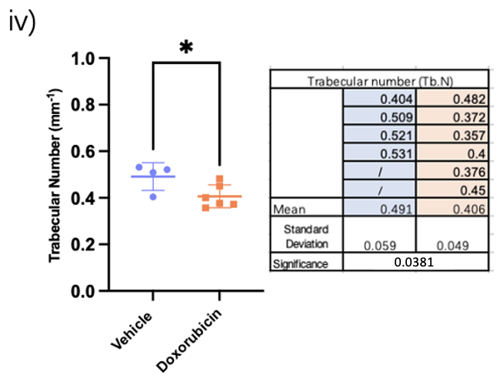
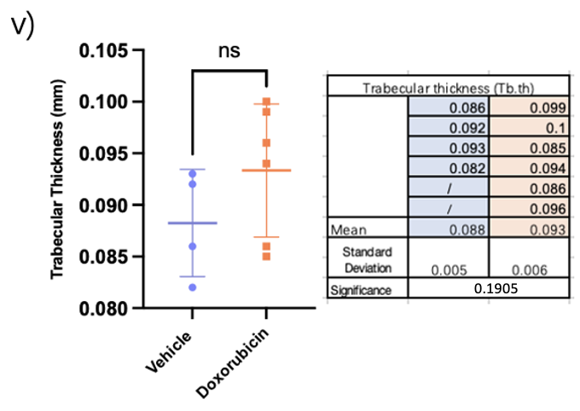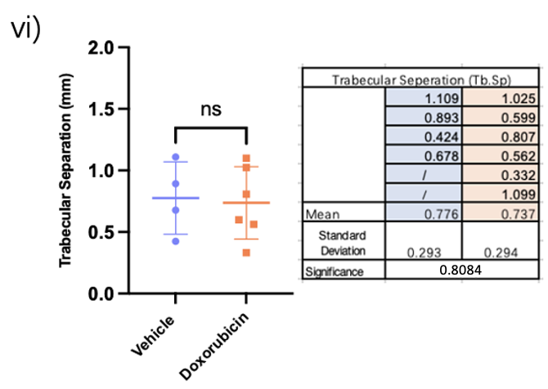
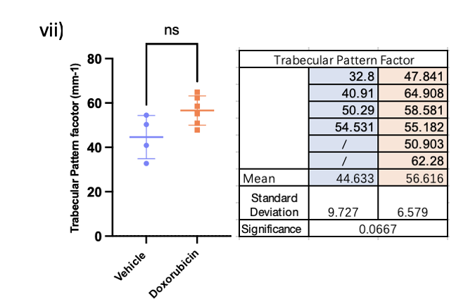
Figure 5.6 Ex vivo µCT data comparison to In vivo µCT data on proximal tibia/ distal femora of tumour bearing mice
Figure shows ex vivo µCT data of mice with skeletal tumour in proximal tibia 1i % bone lesion area, 1ii cortical bone volume, 1iii % BV/TV, 1iv trabecular number, 1v trabecular thickness, 1vi trabecular separation, 1vii trabecular pattern factor; distql femur 2i % bone lesion area, 2ii cortical bone volume, 2iii % BV/TV, 2iv trabecular number, 2v trabecular thickness, 2vi trabecular separation, 2vii trabecular pattern factor. All data were presented as mean ± SD, unpaired t test with Mann-Whiteny‘s test, analysed on PRISM software. Significance ns (P>0.05), * (P≤0.05),

Taken together, this study showed that 4mg/kg DOX slowed down tumour growth but did not induce a stable low-tumour phase. The administration of 4mg/kg DOX did have a detrimental effect to bone integrity and structure in the tibia, supporting that one of the side effects of this agent is modification of the bone microenvironment.

5.6 Discussion

This chapter aimed to determine the effects of DOX treatment on bone in a model of breast cancer bone metastases. This is to establish a chemotherapy schedule to be used with bone anabolic agents that targets both suppressing tumour growth in bone and limiting bone destruction, enabling bone anabolic agents to repair lesions in the model of breast cancer-induced bone disease.

Having confirmed that DOX inhibited growth of MDA-MB-231 breast cancer cells in vitro as predicted, I next investigated whether 4mg/kg DOX administered once/week for 3 weeks could inhibit tumour growth in bone. The effect of low tumour take rate could be attributed to the outgrowth of wild-type MDA-MB-231 cells that have lost LUC2+ expression by high passage (44) MDA-MB-231 cells. Bioluminescent imaging showed that there were no mis-injections, as there was detection in the chest, which would indicate tumour growth in the lungs (Table 5.1). A new batch of MDA-MB-231 cells with a lower passage number will be used in the subsequent studies (Chapter 6). The effects of DOX on tumour growth in bone were analysed in vivo, showing that DOX significantly inhibited tumour growth at day 35. Nevertheless, in vivo µCT analysis demonstrated that trabecular %BV/TV, trabecular thickness, and trabecular number were decreased, and % bone lesion area increased from 2 weeks to 5 weeks after tumour injection, comparing DOX-treated mice to vehicle. The significant increase in % BV/TV observed at 5 weeks in DOX-treated mice compared to vehicle may potentially be attribute to both the decrease in trabecular number and trabecular thickness, as there was no significant difference observed in either of these parameters at 5 weeks. The significant difference in trabecular pattern factor in DOX-treated mice compared to vehicle suggest reduction in bone quality in DOX-treated mice.

DOX was used at 4mg/kg in this study, where DOX exhibited tumour inhibition effects in the MF1 nu/nu mice model with subcutaneous injection of MDA-G8 cells in the right flanks (Ottewell et al, 2008). In this study, 4mg/kg DOX-treated mice had greater bone loss compared to vehicle tumour-bearing mice, with significantly less cortical bone volume and % trabecular BV/TV, and significantly greater % bone lesion area. There was no significant difference in % bone lesion area due to having an outlier mouse M7, which only developed small lesions in the tibia. There was a variable tumour burden in bone, which made it difficult to assess bone loss. Histology may have revealed more on how DOX treated mice had greater bone loss compared to vehicle mice. However, it was decided not to carry out bone histomorphometry on the samples from this study in the interest of time, since the DOX schedule in this study was detrimental to bone. Administering DOX at a lower concentration 2mg/kg might have been able to reduce tumour growth and % bone lesion area in this study as demonstrated in Ottewell et al, 2008. DOX alone did not demonstrate a detrimental effect to bone but was able to reduce tumour growth and % lesion area with 2 weeks of DOX treatment at 2mg/kg. While the treatment effect of 3-week DOX regimen at 2mg/kg in this model remain to be established, the results should be similar as Ottewell et al, 2008. Both the model used in this study and that of Ottewell et al, 2008 targets the bone. Furthermore, the concentration of DOX in this study should be referenced to a study using a bone metastasis-relevant model.

The effect of DOX in worsening bone quality observed in this study may be due to the increased autophagy in osteoclasts, which in turn increases osteoclast area and bone resorption activity via the mROS/TRPML1/ TFEB axis (Park et al, 2022) (Abdullah et al, 2019). DOX is also associated with oxidative stress in bone marrow stromal cells (Zhou et al, 2001) and the systemic increase in TGF-β levels (Biswas et al, 2007). DOX treatment has been shown to damage bone in tumour-free rats. 12-week-old female Sprague-Dawley rats received either i) sterile water or ii) 20mg/kg cyclophosphamide and 2mg/kg DOX treatment for 4 weeks. Cyclophosphamide and DOX treatment significantly reduced trabecular %BV/TV and trabecular number (Fan et al, 2017). Moreover, mesenchymal stem cells (MSC) retrieved from bone marrow of DOX-treated Wistar rats were shown to have lower alkaline phosphatase production compared to MSC retrieved from saline-treated rats, which suggests DOX treatment decreases osteoblast activity (Oliveria et al, 2014). The induction of bone loss of DOX might also be associated with osteoclasts.

The epimer of DOX, epirubicin has also been reported to cause bone loss (Rayner et al, 2022). In a clinical study which investigated the effect of chemotherapies on bone mineral density (BMD), patients (n=148) with non-metastatic breast cancer received three cycles of epirubicin, cyclophosphamide, or 5-fluorouracil weekly for 3 weeks, followed by dexamethasone; any patient with prior bone diseases was excluded from this study. After receiving chemotherapy treatments, all patient BMD was decreased compared to baseline BMD at the lumbar spine, femoral neck, and total hip (Nisha et al, 2023). Moreover, this study demonstrated that the worsening of bone quality was strongly associated with the use of chemotherapies, including epirubicin. Breast cancer patients receiving long-term radiotherapy were associated with toxicities including osteoporosis, osteopenia, and increased risk or fracture (Pierce et al,1992). Bone loss due to cancer treatments is commonly observed and remains a problem to be dealt with.
Bone-targeted agents, such as bisphosphonates and denosumab, are often used to reduce skeletal complications caused by bone metastases. These agents help to mitigate the effect of bone destruction by inhibiting bone resorption, managing bone health during cancer treatment (Coleman, 2022).

The adverse effect of DOX on bone might potentially be compensated with TGF-β inhibitors, as increased TGF-β levels with the treatment of DOX have been associated with increased circulating tumour cells in a transgenic model of metastatic breast cancer (Biswas et al, 2007). As indicated by a study by Rana et al, 2013. 4- to 5-week-old female athymic nu/nu mice were inoculated with MDA-MB-231 cells intracardially. 3 days after tumour inoculation, mice were treated with i) control antibody 3 days per week for three weeks; ii) 5mg/kg DOX once weekly for three weeks; iii) 10mg/kg of anti-TGFβ antibody 1D11 or iv) 5mg/kg DOX and 10mg/kg of 1D11 3 days per week for three weeks. Mice treated with DOX had a significant decrease in trabecular %BV/TV compared to vehicle control. Mice receiving DOX and 1D11 treatment had greater trabecular %BV/TV and increased trabecular thickness, demonstrating that treatment with 1D11 was able to rescue the bone loss induced by DOX. In addition, DOX increases osteoclast (from adult C57BL/6 mice) formation in vitro using mononuclear bone marrow cells; 1D11 was able to reverse the increase of osteoclasts (Rana et al, 2013). Moreover, DOX treatment has detrimental effects on bone, regardless of its ability to be mitigated by TGF-β antibody, and might not be ideal for combinational treatment in the aim of limiting the induction low-tumour phase.

In conclusion, in the MDA-MB-231 breast cancer mouse model, 4mg/kg of DOX treatment exacerbated breast cancer-induced bone lesions and is therefore not suitable for limiting bone disease induced by breast cancer. DOX should be administered at a lower dose (2 mg/kg) to prevent bone damage or used in combination with TGF-β inhibitors (SD-208/ losartan) to compensate for the damage of DOX. In subsequent studies, the effects of the cytostatic agent palbociclib were therefore explored (see Chapter 6).

Chapter 6
Bone anabolic agents mitigate bone loss in a model of breast cancer bone metastasis

Manuscript formatted for submission to Journal of Bone and Mineral Research

I present data exploring the inhibition of TGF-β using angiotensin II receptor inhibitor losartan and TGF-β type I kinase inhibitor SD-208 as a bone anabolic treatment to limit lytic bone lesions induced by breast cancer bone metastasis.

In this manuscript, I present three studies. The first study explores the use of losartan and SD-208 in tumour-free mice. This work hoped to explore whether losartan or SD-208 treatment can induce trabecular bone formation and the underlying mechanisms responsible for these effects. The second study explores the use of losartan in a xenograft model of triple-negative breast cancer bone metastasis. This work hopes to explore whether losartan treatment can limit/ repair lytic bone lesions in breast cancer bone metastasis. The third study explores the use of SD-208 and the anti-cancer agent palbociclib in tumour-free mice. This work hoped to explore whether SD-208 treatment alone or combined with palbociclib can limit/ repair lytic bone lesions in breast cancer bone metastasis.

Manuscript Title:
Bone anabolic agents mitigate bone loss in a model of breast cancer bone metastasis

Publication status:
Draft only, not yet submitted for peer-review

Published in:
N/A

Date:
N/A
Link to the publication:
N/A
Authors:
Jacky Wong 1,† , Lubaid Saleh1, Holly Evans1, Enrico Dall'Ara1,2 Alexandria Sprules1 ,Michelle Lawson1, Ingunn Holen1
Affiliations:
¹Division of Clinical Medicine, School of Medicine and Population Health, Faculty of Health, University of Sheffield, Sheffield, S10 2RX, UK.
²INSIGNEO Institute for in silico Medicine, The Pam Liversidge Building, University of Sheffield, Sheffield, S13 JD, UK

Keywords: Bone anabolic agents, TGF-β, Breast cancer bone metastasis

Abstract
Breast cancer (BC) spreads to bone, forming osteolytic bone lesions, which lead to skeletal-related events. Current treatments prevent further bone destruction, but do not repair bone, so new treatments are needed to stimulate bone formation to improve BC patient outcomes. Transforming growth factor (TGF-β) plays a key role in maintaining bone homeostasis by regulating the differentiation and function of osteoblasts and osteoclasts. In BC bone metastases, TGF-β promotes osteoclast-driven bone resorption whilst suppressing bone formation by osteoblasts. Pharmacological inhibition of TGF-β may be a therapeutic option to limit the progression of osteolytic lesions. Therefore, we evaluated the effects of losartan and SD-208 on bone in non-tumour and BC mouse models. In tumour-free mice using in vivo µCT, we established that both the (TGF-β inhibitor) agent losartan and the (TGF-βR1 kinase inhibitor) agent SD-208 increase %BV/TV in the tibia. The effects of losartan and SD-208 were then evaluated in a triple-negative (TN) model of breast cancer-induced bone disease. Animals treated with either losartan or SD-208 demonstrated a slower tumour-induced reduction in trabecular bone and decreased percentage bone lesion area in the tibia compared to vehicle. These results demonstrate that losartan and SD-208 are effective in limiting breast cancer-induced bone disease.

- Introduction

Breast cancer (BC) is the most common cancer worldwide, affecting over 2.3 million women each year (Lei et al, 2021). The skeleton is the most common site for breast cancer metastasis, as over 70% of patients with advanced BC have cancer spread to bone (Pulido et al, 2017). Patients develop destructive bone disease due to interrupted bone remodelling, leading to excessive bone degradation. Through the development of osteolytic bone lesions, patients experience skeletal-related events (SREs) such as bone pain, pathological fractures, and hypercalcemia that reduce long-term survival and quality of life (Haley et al, 2018).
BC bone metastasis is incurable, where current treatments are considered palliative. Bisphosphonates and the RANK-L antibody Denosumab are effective in reducing the formation of bone lesions by inhibiting osteoclast-mediated resorption; chemotherapies are effective in limiting tumour growth and progression (Clemon et al, 2012). Nevertheless, there is no available treatment to repair bone lesions, so patients continue to suffer from bone pain and fragility (Bongiovanni et al, 2021). Moreover, various cancer treatments have a strong association with increased fracture risk (Melton et al, 2012). Therefore, there is a clear need for new treatments that can repair and improve bone quality to potentially reduce SREs.

Transforming growth factor (TGF-β) is a major growth factor released from bone; its pro-osteolytic effects in BC bone metastasis make it a potential therapeutic target for inhibiting BC-induced bone resorption. TGF-β induces the production of pro-osteolytic factors, including interleukin (IL-11) and parathyroid-related proteins that cause the destruction of bone (Batlle and Massagué, 2019). TGF-β is expressed at high levels in both human and murine BC bone metastases (Abnaof et al, 2014). In a study where samples of patient BC bone metastasis biopsies were stained by immunohistochemistry, 75% of samples were positive for phosphorylated-SMAD2, demonstrating active TGF-β signalling that contributes to BC bone metastasis (Chiechi et al, 2013).

Losartan is a FDA-approved hypertensive drug, that primarily inhibits angiotensin II. It has also been demonstrated to inhibit the downstream TGF-β pathway and decrease TGF-β1 plasma levels in allograft nephropathy patients (Zhao et al, 2022; Campistol et al, 1999). It was recently reported that losartan might have a broader therapeutic potential, particularly in bone, as the blockage of angiotensin increases bone mass in osteoporosis models (Shimizu et al, 2008). SD-208 is at the preclinical development stage and has been used as an anti-cancer therapy in models of BC (Biswas et al, 2011) and prostate cancer (Fournier et al, 2015). SD-208 blocks adenosine triphosphate (ATP) binding to TGF-β type I receptor and inhibits its activity (Uhl et al, 2004). Long-term daily SD-208 treatment (6 weeks) has been demonstrated to have bone anabolic effects in tumour-free immunocompetent mice, increasing bone volume and bone quality by promoting osteoblast differentiation (Mohammad et al, 2009). Administration of SD-208 has also been demonstrated to prevent the development of melanoma bone disease (Mohammad et al, 2011), repair bone lesions, and increase fracture resistance in myeloma bone disease in mice (Green et al, 2019).
The inhibition of TGF-β has been reported to have bone anabolic effects in a model of BC bone metastases. Athymic mice injected with MDA-MB-231 LUC2+GFP+ cells intracardially were treated with 25 or 50mg/ kg curcuminoid or PBS (control) every other day for 3 weeks by intraperitoneal (i.p) injection. Curcuminoid treatment inhibits parathyroid hormone-related proteins (PTHrP) production through suppressor of mothers against decapentaplegic (SMAD) pathway of TGF-β, reducing % bone lesion area and osteoclast number compared to control (Wright et al, 2013). In another study, athymic nude mice and BALB/c nude mice were injected with 10mg/kg 1D11 (TGF-β neutralising antibody) or 13C4 (1D11 isotype, control) daily for 7 days prior to tumour inoculation. After seven days of treatment, athymic mice received human MDA-MB-231 LUC2+GFP+-GFP cells by intracardiac (i.c.) injection, while BALB/c nude mice received murine 4T1 cells by i.c. injection. Both athymic mice and BALB/c nude mice received 1D11 treatment or 13C4 3 times per week by i.p. injection. In both types of mice, 1D11 treatment increased trabecular % bone volume and reduces % bone lesion area compared to control (Buerostro et al, 2018). Despite these encouraging results, the effects of inhibiting TGF-β, using losartan on BC-induced bone disease over time remains to be determined.

Here, we used a triple-negative BC model by introducing cancer cells intracardially to form metastatic outgrowth in the skeleton to demonstrate that inhibiting TGF-β can limit the development of osteolytic bone lesions in vivo.

2. Materials and Methods

2.1 Cell lines
The human triple-negative breast cancer MDA-MB-231 LUC2+GFP+ cell line (Gibco, Invitrogen, Paisley, UK) was transfected with luciferase (LUC2) and green fluorescent protein (GFP) and maintained in RPMI media with 10% foetal calf serum (FCS). Cells were cultured in T75 flasks in a humidified incubator (37°C, 5% CO₂).

2.2 Therapeutic agents
SD-208 (S7624, Selleckchem) and losartan (114798-26-4, APExBIO) were dissolved in dimethyl sulfoxide (DMSO) for in vitro studies and 1% methyl cellulose for in vivo studies. Palbociclib (PD 0332991 Medchemexpress) was dissolved in sodium lactate solution for in vitro studies and 0.5% methyl cellulose for in vivo studies. SD-208 and losartan were administered by oral gavage, and palbociclib via peanut butter feeding.

2.3 Cell viability assay
MDA-MB-231 LUC2+GFP+ LUC2+GFP+ were seeded in 96-well plates at a density of 3x${10}^{3}$cells per well with TGF-β-B1 recombinant (2.5ng/ml) and incubated for 24 hours. Cells were treated with 10µM SD-208, 100µM losartan, or 10µM Palbociclib for 72 hours. After the desired exposure to the drug, MTT assays were conducted to measure cell numbers. Plates were read by a FlexStation3 Benchtop Multi-Mode Microplate reader (Molecular Devices, San Jose, USA) at an absorbance of 570nm.

2.4 In vivo studies
All animal experiments were conducted at the University of Sheffield and approved by the UK Home Office (PPL 3267943) in strict accordance with the Animal (Scientific Procedures) Act 1986. Female C57BL/6 mice and BALB/c nude mice were delivered at the age of 6-7 weeks old from Charles River. The animals were allowed 1 week to be accustomed to the housing facility prior to any experimental procedures and exposed to 12:12-hour light-dark cycle in a humidity and temperature-controlled environment, with food and water provided.

2.4.1 In vivo studies using tumour-free immune deficient mice
The effects of agents on the trabecular bone were first assessed on tumour-free BALB/c nude mice as described in section 2.4.3. The tibias of mice were scanned by in vivo µCT once weekly. All mice were euthanised after 3 weeks of treatment. Mice were initially randomised into groups based on body weight and assigned to cages to their designated treatment. In the combination study involving SD-208 and palbociclib, group sizes varied considerably due to differences in the number of mice that developed tumours within each cage.

2.4.2 In vivo studies using a model of breast cancer-induced bone disease
The effects of agents on the trabecular bone were assessed on the model of breast cancer-induced bone disease as described in section 2.4.3. 6-week-old female BALB/c nude mice were injected i.c. with 5x10⁵ MDA-MB-231 LUC2+GFP+ LUC2+GFP+ cells. This model is frequently used to study therapeutic approaches for BC bone metastases (Ottewell, 2021), with around 90% of animals developing skeletal tumours (Asghar et al, 2015). Tumour growth was monitored by bioluminescence imaging using an IVIS spectrum machine (Xenogen, Alameda, USA) twice weekly, and the tibia was scanned by in vivo µCT once weekly, as described in Section 2.5. Treatment commences once tumour and lytic bone lesions were detected by imaging. All mice were euthanised after 3 weeks of treatment and tibias scanned by ex vivo µCT as described in Section 2.5.

2.4.3 Treatment with agents
In a tumour-free study, mice were treated with 60mg/kg SD-208 or 100mg/kg losartan, or control (1% methyl cellulose) by oral gavage 5 days per week for 3 weeks (n=4/group).
In the model of breast cancer-induced bone disease, mice were treated with 100mg/kg losartan (n=11) or controls (PBS)(n=9) by oral gavage 5 days per week for 3 weeks. To assess the effect of agent combined with anti-cancer agent on trabecular bone, mice were treated with 60mg/kg SD-208 (n=6) by oral gavage or 100mg/kg palbociclib (n=6) by peanut butter feeding or SD-208 combined with palbociclib (n=3) or controls (1% methyl cellulose) (n=9) by oral gavage 5 days per week for 3 weeks.

2.5 µCT analyses
Tumour-bearing tibiae of mice were scanned in vivo using a VivaCT80 µCT scanner (Scanco Medical AG, Wangen-Brüttisellen, Switzerland) once weekly for 3-4 weeks, depending on the study and bone integrity/structure analysed. Mice were anesthetised by isoflurane inhalation and their hindlimb were scanned at 10.4μm isotropic voxel size, 55kV, 145μA, 200ms integration time for a 360-degree scan with a 0.24-degree rotation step. Images were reconstructed by µCT evaluation software (Scanco). At the end of the experiment, tibiae were scanned ex vivo by SkyScan1272 µCT scanner (Bruker, Massachusetts, USA) at medium camera (2016X1344), 0.5mm aluminium filter, 4.18μm pixel size, 50kV, 200μA for a 180-degree scan with a 0.7-degree rotation step. Images were reconstructed by NRecon (version 2.0) (Figure 2.6) and analysed by CTAN software (Bruker) (Bouxsein et al, 2010). Images were reconstructed by NRecon software and analysed on CTAN software. A 1mm region of tibia trabecular bone was measured with a 0.2mm offset from the growth plate. Tibia cortical bone was measured with a 1mm offset from the growth plate. 3-D models were created using CTVOX software (Bruker). Surface lesion area in cortical bone was measured by ImageJ software (Wayne Wesband).

2.6 Bone histomorphometry
Tibiae were fixed in 4% PFA for 48 hours and then stored in 70% ethanol, decalcified for 3 weeks by 20% ethylenediaminetetraacetic acid (EDTA), processed, and embedded in paraffin blocks. 2µm bone sections were cut and tartrate-resistant acid phosphatase (TRAP) stained, then counterstained by haematoxylin and eosin (H&E). The number of osteoblasts and osteoclasts were determined by histomorphometry analysis using a binocular microscope (Olympus, Tokyo, Japan) with Osteomeasure software (OsteoMetrics).

2.7 Bone turnover markers
Mice were anesthetised by isoflurane inhalation and cardiac blood was collected into 1.5ml labelled transparent Eppendorf tubes before culling. Blood was left to clot for 30 minutes and centrifuged at 1000xg for 10 minutes at 4°C to separate serum. Mice sera were then assessed by procollagen 1N-terminal propeptide (P1NP) enzyme-linked immunoassay (ELISA) (Elabscience, Texas, USA) and TRAP5b ELISA (Biorbyt, Cambridge, UK) according to the manufacturer’s guide.
2.8 Gene expression analysis
Bone marrow of the femur was flushed with RNA protect. RNA was isolated by phenol-chloroform and subsequently quantified by NanoDropTM 2000 spectrophotometer (Thermo Scientific, Wilmington, USA). Quantitative PCR (qPCR) was conducted on an ABI Prism 7900HT using SDS 2.1 software (Applied Biosystems, CA, USA). TaqMan primers were employed to quantify the expression levels of the TGF-β, SMAD3, EphrinB4 (EPHB4), Runt-related transcription factor 2 (RUNX2), Osteocalcin, CTSK (cathepsin K), and DC-STAMP (dendritic cell-specific transmembrane protein) genes, using 18S as a reference gene for normalization.

2.9 Statistical analysis
All data were analysed by Graphpad Prism v9.4 software (La Jolla, CA, USA), using unpaired t-test with Mann-Whitney’s test, one-way ANOVA with Dunnett’s multiple comparison test or 2-way ANOVA with Šidák’s test. All data were presented as mean ±SD and P≤0.05 was considered significant.

3. Results

3.1 Bone anabolic effects were confirmed in tumour free mice
SD-208 has been demonstrated to exhibit bone anabolic effects in immunocompetent tumour-free C57BL/6 mice (Mohammad et al, 2009), while the effect of losartan on bone in mice remains to be determined. In the xenograft model of BC bone metastasis using MDA-MB-231 LUC2+GFP+ cells, immunocompromised BALB/c nude mice are utilised as hosts for the TNBC cells. Therefore, we first confirmed whether SD-208 and losartan had bone-anabolic effects over time in tumour-free BALBC immunocompromised mice.

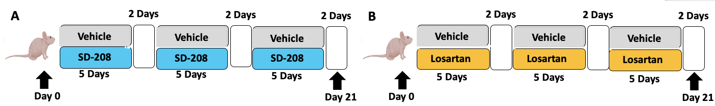
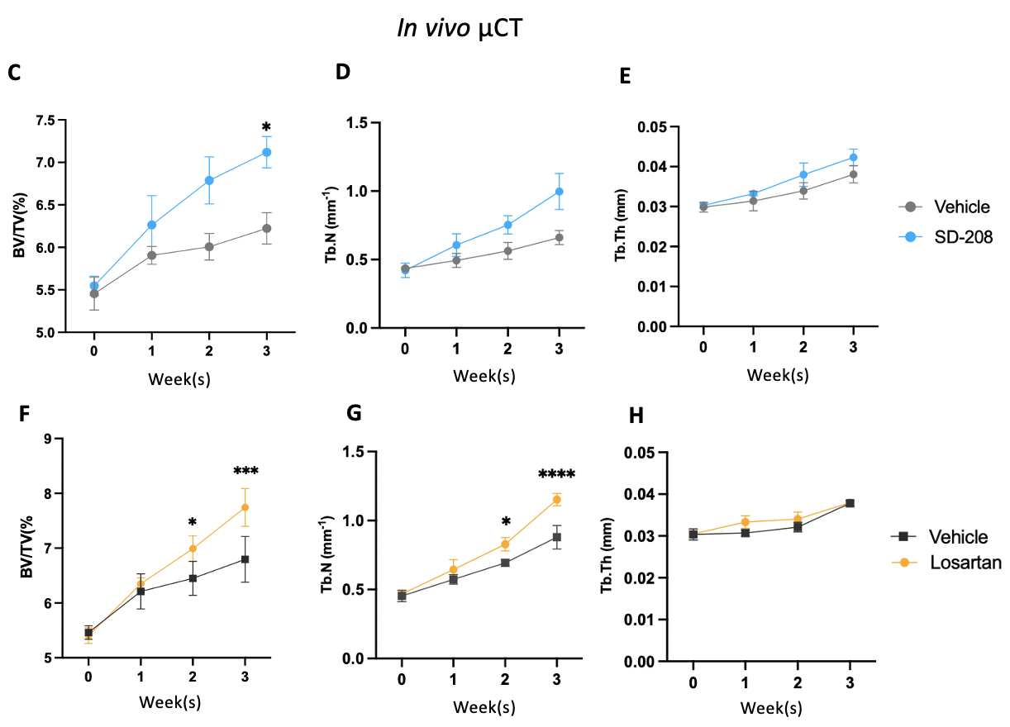
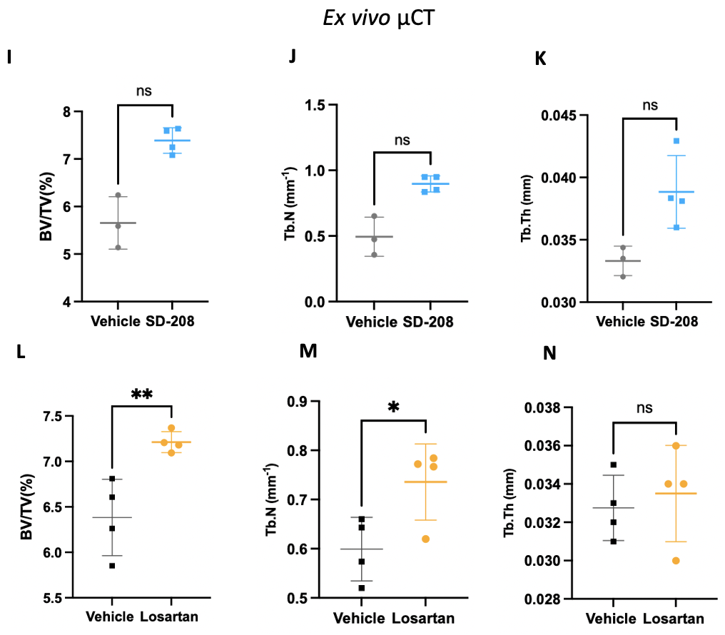
Figure 1. SD-208 and losartan have bone anabolic effects in BALB/c nude mice Schematic outline of in vivo treatment. (A) BALB/c nude mice were treated with 60mg/kg SD-208 (n=4), or control (n=3) 5 days/week for 3 weeks. (B)In a subsequent study, BALB/c nude mice were treated with 100mg/kg losartan (n=4), or control (n=4) 5 days/week for 3 weeks. The tibiae of mice were scanned by in vivo µCT once weekly. Mice were then sacrificed for analysis of bone integrity and structure by ex vivo µCT. In vivo µCT (C) BV/TV, (D) Tb.N, and (E)Tb. th of SD-208 and vehicle mice, (F) BV/TV, (G) Tb. N, and (H) Tb. Th of losartan and vehicle mice. Ex vivo µCT
(I) BV/TV, (J) Tb. N, and (K)Tb. th of SD-208 and vehicle mice, (L) BV/TV, (M) Tb. N, and (N) Tb. Th of losartan and vehicle mice. Data are presented as mean +/- SD, one-way ANOVA with Kruskal-wallis test, two-tail student’s t-test with Mann-Whitney’s test, analysed on Prism software. Significance ns= (P>0.05), * (P≤0.05), ** (P≤0.01), *** (P≤0.001), **** (P≤0.0001).
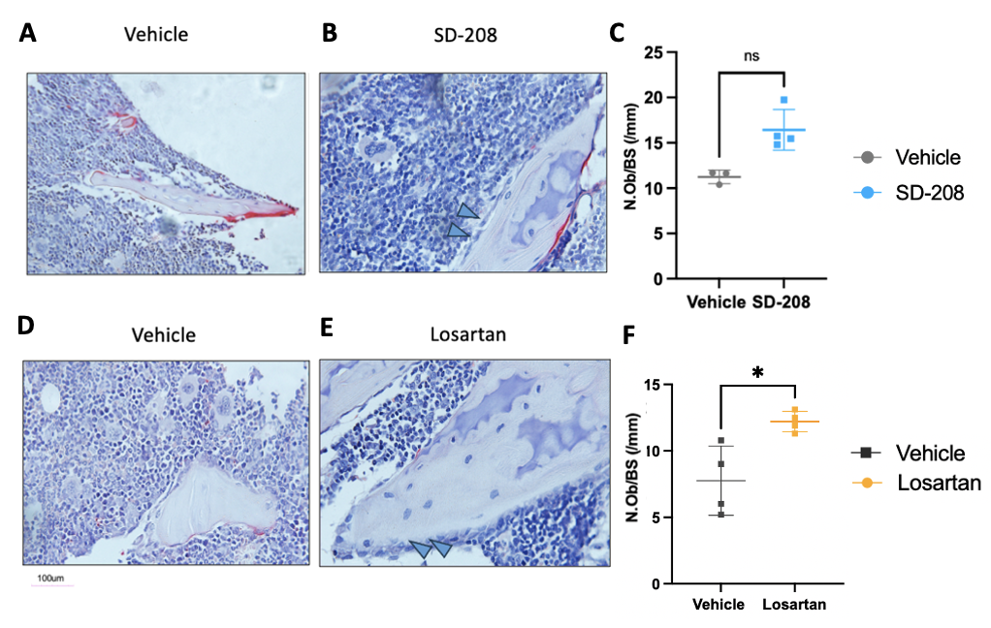
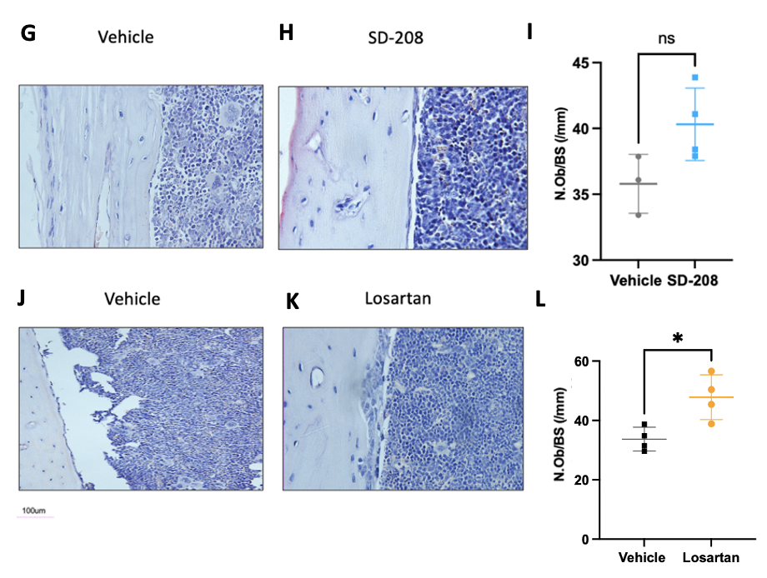
Figure 2. Histophometric analysis of SD-208 and losartan treated BALB/c nude mice 2µm Paraffin-embedded tibiae sections were cut and TRAP stained. Representative images of trabecular bone in mice treated with (A) vehicle, (B) SD-208, or (D) vehicle and (E) losartan. Histomorphometric analysis of number of osteoblasts/ mm in trabecular bone of (C) vehicle and SD-208 and (F) vehicle and losartan. Representative images of number of osteoblasts/ mm in medial+ lateral endocortical surface in mice treated with (G) vehicle (H) SD-208, or (J) vehicle (K) losartan. Histomorphometric analysis of number of osteoblasts/ mm in medial+ lateral endocortical surface of (I) vehicle SD-208 and (L) vehicle losartan. Data are presented as mean +/- SD, two-tail student’s t-test with Mann-Whitney’s test, analysed on Prism software. Significance ns= (P>0.05), * (P≤0.05).
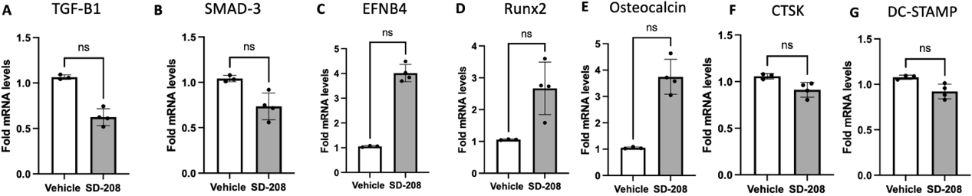
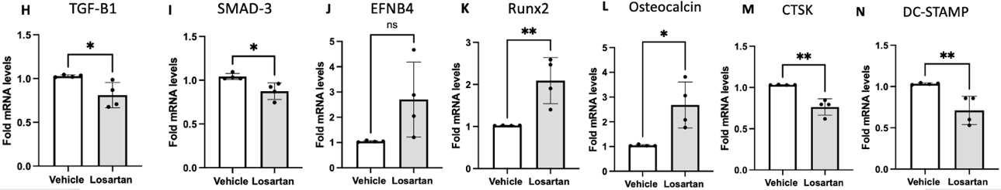
Figure 3. Gene expression in SD-208 and losartan treated BALB/c nude mice
qPCR analysis of osteoblast/osteoclast specific genes in bone marrow of mice treated with vehicle, SD-208 (A)TGF-β1, (B) SMAD-3, (C) EFNB4, (D) RUNX2, (E) Osteocalcin, (F) CTSK, (G) DC-STAMP or vehicle, losartan (H) TGF-β1, (I) SMAD-3, (J) EFNB4, (K) RUNX2, (L) Osteocalcin, (M) CTSK, (N) DC-STAMP relative to 18S expression.Data are presented as two-tail student’s t-test and Mann-Whitney’s test, analysed on Prism software. Significance ns= (P>0.05), * (P≤0.05), ** (P≤0.01).

Female BALB/c nude mice aged 6 weeks were treated with SD-208 (n=4) or control (n=3) 5 days per week for 3 weeks, with in vivo µCT of the left hind limb carried out once/week throughout the study (Fig. 1A). In a subsequent experiment, losartan was administered following the same dosing schedule and treatment duration (n=4 per group). In vivo µCT demonstrated that after 3 weeks of treatment, percentage trabecular bone volume/tissue volume (%BV/TV) was significantly increased in SD-208 and losartan-treated mice compared to control (Fig. 1C, F). There was also a significant increase in trabecular number in the losartan group compared to control (Fig. 1H). There was no change in trabecular thickness (Fig. 1E, H) and trabecular separation (data no shown) in both SD-208 group and losartan group when compared to their control. Ex vivo µCT was carried out at study endpoint (Fig. 1E-G) confirmed the increase in %BV/TV and trabecular number detected by end-stage (week 3) in vivo µCT in the losartan treatment groups (Fig. 1L, M); There was no significant difference in %BV/TV, trabecular number or trabecular thickness comparing SD-208 treated mice compared to control (Fig. 1I-K).

3.1.1 SD-208 and losartan treatment increases osteoblast numbers in tumour free mice
Next, bone histomorphometry of the tibiae was performed to determine whether SD-208 and losartan caused a change in the number of osteoblasts and/or osteoclasts. 3 weeks of losartan treatment significantly increased osteoblast number in the trabecular bone of the metaphysis, compared to the tibia of mice receiving vehicle control (Fig. 2D-F). Losartan also significantly increased osteoblast number in the medial/lateral endocortical surfaces (Fig. 1J-L). SD-208 treatment did not result in any significant changes in osteoblast number within the trabecular bone of the metaphysis (Fig. 2A-C) or along the medial/lateral endocortical surfaces (Fig. 2G-I), compared to the tibia of mice receiving vehicle control. There was no effect by either drug on the number of osteoclasts in either the trabecular bone or the medial and lateral endocortical surfaces (data not shown). To determine the effect of SD-208 and losartan on osteoblast/ osteoclast-specific genes, qPCR was performed on flushed bone marrow. Losartan significantly reduced expression of TGF-β1 and SMAD3 (Fig. 3H, I), while significantly increasing the expression of EFNB4, RUNX2, and osteocalcin (Fig. 3J-L) compared to vehicle, suggesting a potential shift toward pro-osteogenic signaling pathways. Additionally, losartan significantly reduced the expression of CTSK and DC-STAMP compared to vehicle, suggesting a potential modulatory influence on osteoclastogenic processes (Fig. 3M, N). Treatment with SD-208 did not alter the expression levels of the analysed genes relative to controls (Fig. 2A-G).

Collectively, these data established a dose and treatment schedule of SD-208 and losartan that had significant bone anabolic effects in vivo.

3.2 Administration of losartan limits BC induced bone disease
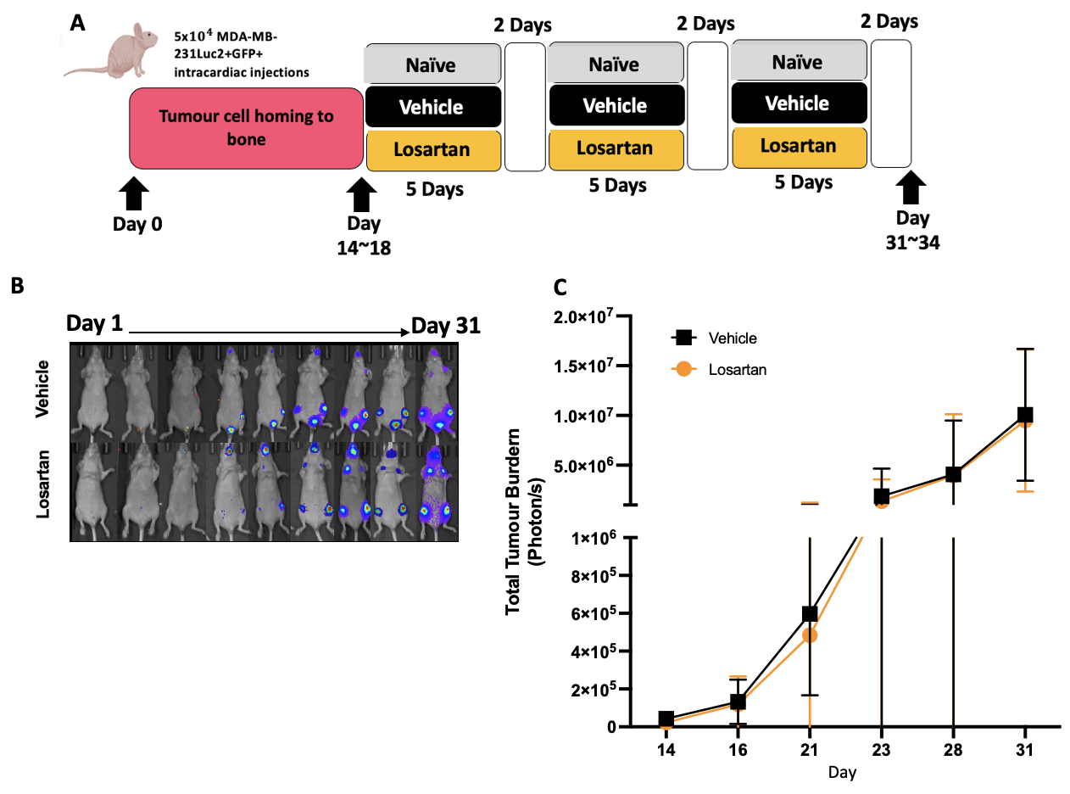

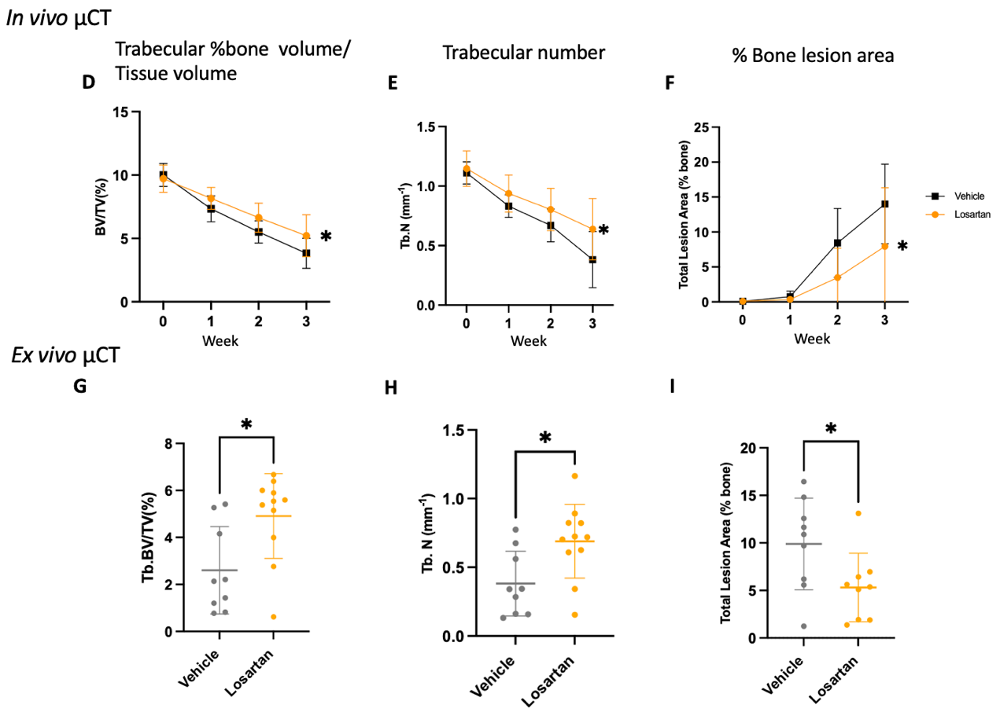
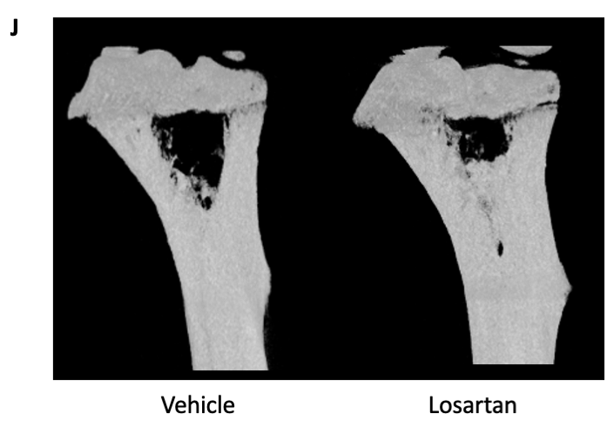
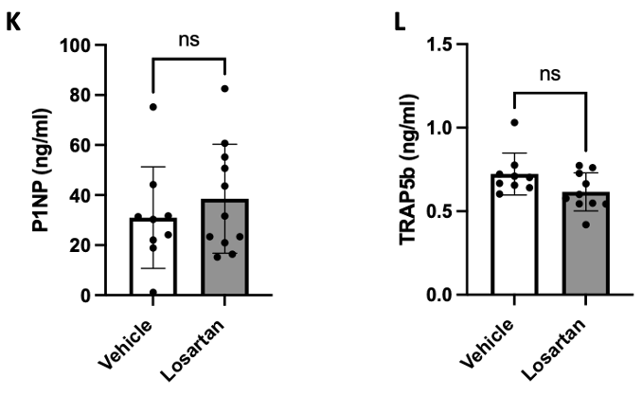
Figure 4. Losartan mitigates bone loss in breast cancer-induced bone disease in vivo (A) Schematic outline the experimental outline. BALB/c nude mice were injected i.c. with 5X${10}^{4}$ Luc2+MDA-MB-231 LUC2+GFP+ cells. Tumour progression was monitored twice weekly by IVIS bioluminescent imaging and tibiae scanned by in vivo µCT once weekly. Once tumour and bone lesions were detected by imaging (14 to 18 days), mice were randomised to receive 100mg/kg losartan (n=11) or control (PBS) (n=9) 5x per week for 3 weeks. (B) Example of skeletal tumour progression in losartan and PBS control. (C) Progression of skeletal tumour growth as tumour burden (photon/s). In vivo µCT (D) BV/TV, (E) Tb.N (F) lesion area % bone. Ex vivo µCT (G) BV/TV (H) Tb.N, (I) % bone lesion area. (J) Example of 3-D reconstructed image of bone lesion development in the tibia in losartan and PBS control. (K) P1NP and (L) TRAP5b were measured in sera by ELISA. Data are presented as mean +/- SD, Aligned Rank transfer and 2-way ANOVA test, analysed on R software ; unpaired two-tail student’s t-test with Mann-Whitney’s test analysed on Prism software. Significance ns (P>0.05), * (P≤0.05).

Following confirmation of bone anabolic effects with SD-208 and losartan as monotherapies in tumour-free animals, we investigated the effects of each agent in an established in vivo model of TNBC bone metastases, starting with losartan. As shown in Fig. 2A, 5$×{10}^{4}$ MDA-MB-231 LUC2+GFP+ cells were injected intracardially into female BALB/c nude mice aged 6 weeks, and 20 animals had confirmed tumour growth. After tumour and bone lesions were detected by imaging, mice were treated with losartan (n=11) or control (n=9) for 5 days per week for 3 weeks, with bioluminescent imaging carried out twice/ week and in vivo µCT on the hind limb with tumour once/week throughout.
Tumour growth in the hind limbs was detected on day 10 (Fig. 4B), resulting in lytic lesions detectable by in vivo µCT (Fig. 4G). IVIS imaging demonstrated that 3 weeks of losartan treatment had no effect on tumour growth (Fig. 4C). In vivo µCT demonstrated a significant tumour-induced reduction in %BV/TV and trabecular number compared to control (Fig. 4D, E). Ex vivo µCT was carried out at the study endpoint (Fig. 4G, H) confirmed that losartan treatment increased %BV/TV and trabecular number compared to vehicle, consistent with in vivo CT results at 3 weeks. As shown in panel Fig. 4G, the progression of tumour-induced bone lesions observed in losartan-treated mice were reduced compared to control mice 3 weeks post-treatment.

Although complete repair of bone lesions was not achieved, the percentage of bone lesion area in the tibia significantly decreased after 3 weeks of losartan treatment compared to control (Fig. 4F). There was no change in trabecular separation and trabecular pattern factor (data not shown). Serum P1NP and TRAP5b were unchanged (Fig. 4K, L). Collectively, these data demonstrate that losartan mitigated bone loss in the model of BC bone metastases, but the exact mechanism remains unclear.
3.3 Administration of SD-208/Palbociclib limits BC induced-bone disease
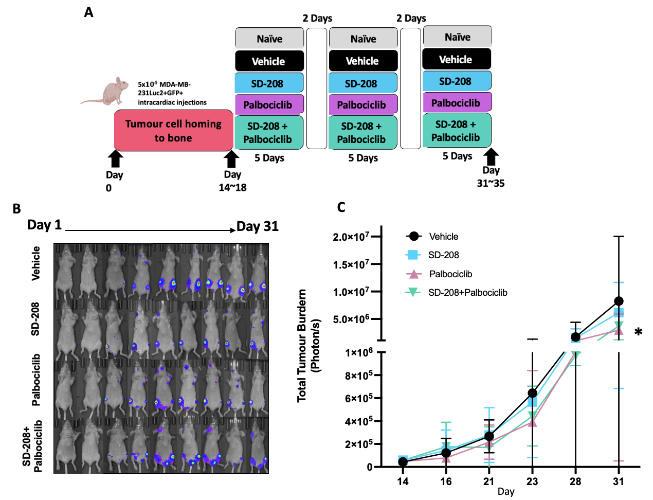
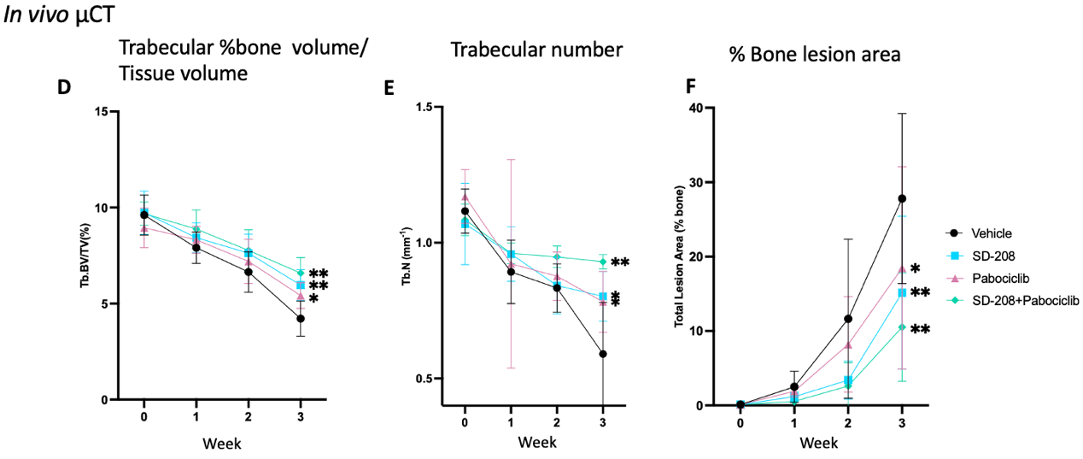
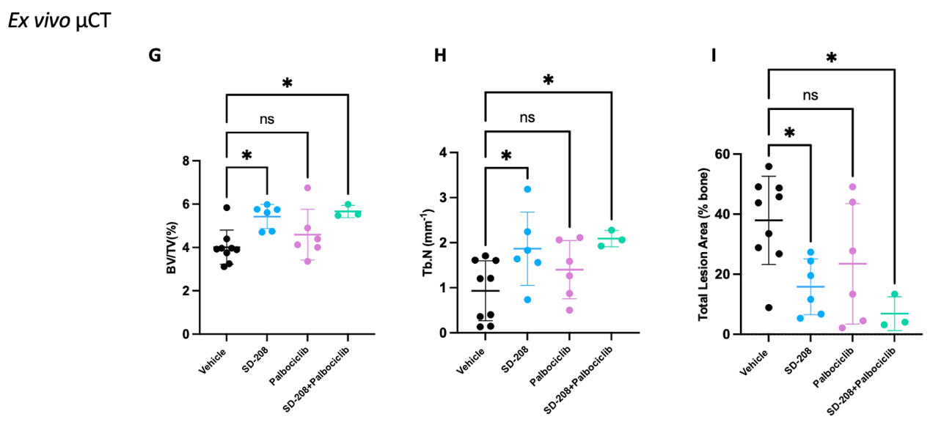
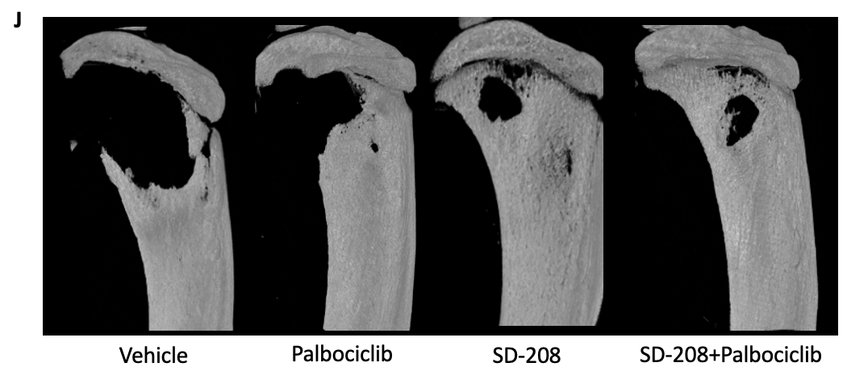
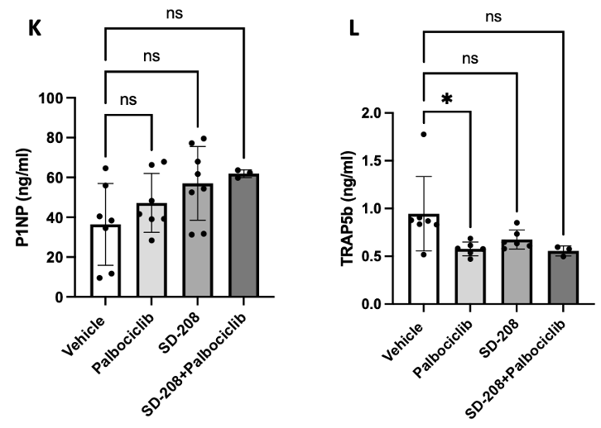
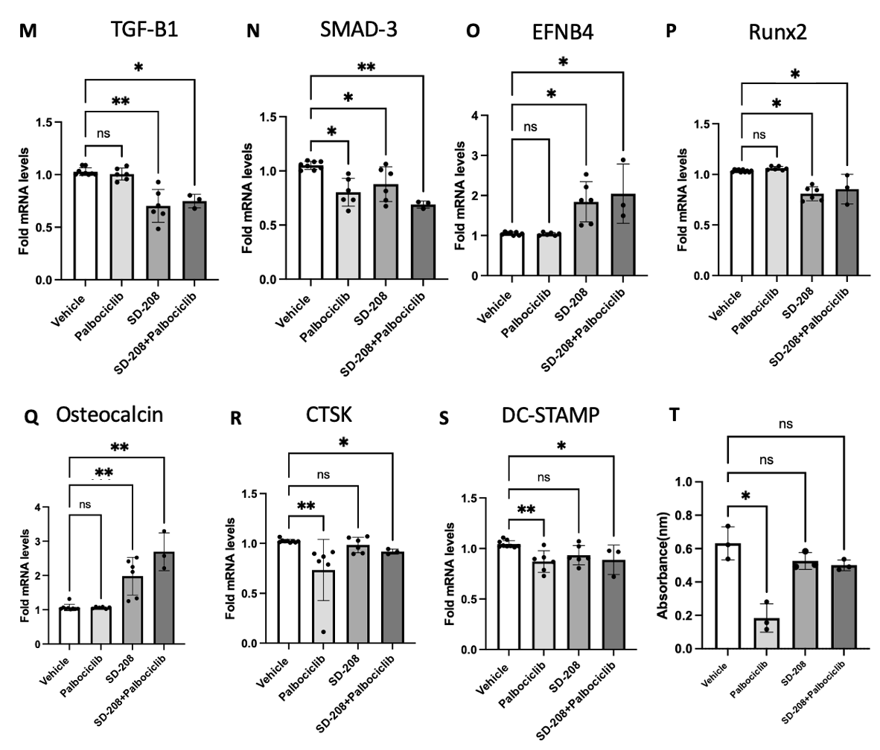
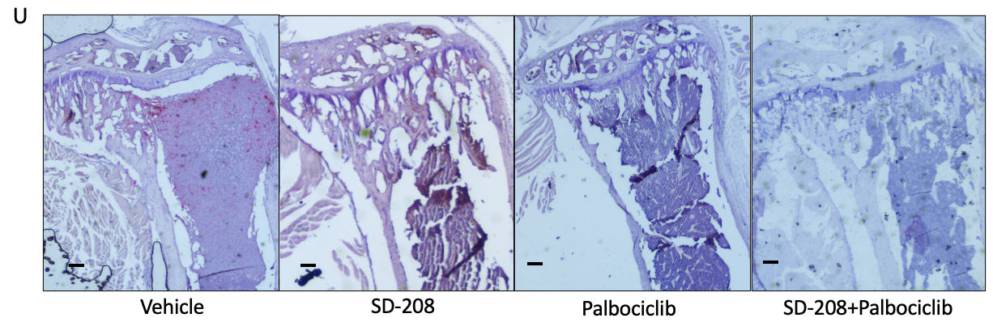
Figure 5. SD-208 mitigates bone loss in BC-induced bone disease in vivo (A) Schematic outline of the in vivo experimental schedule. BALB/c nude mice were injected intracardially with 5X${10}^{4}$ Luc2+MDA-MB-231 LUC2+GFP+ cells. Tumour progression was monitored twice weekly by IVIS bioluminescent imaging, the tibiae of mice scanned by in vivo µCT once weekly. Once tumour and bone lesion were detected by imaging (14 to 18 days), mice were randomised and received either 60mg/kg SD-208 (n=6), 100mg/kg Palbociclib (n=6), 60mg/kg SD-208 in combination with 100mg/kg Palbociclib (n=3), or methylcellulose control (n=9) 5x per week for 3 weeks. After 3 weeks of treatment mice were culled by cardiac bleed. (B) Example of skeletal tumour progression in the different treatment groups. (C) Progression of skeletal tumour growth as tumour burden (photon/s). In vivo µCT (D) BV/TV (E) Tb.N (F) lesion area % bone. Ex vivo µCT (G) BV/TV (H) Tb.N (I) lesion area % bone. (J) Example of 3-D reconstructed image of bone lesion development in the tibia in SD-208 and palbociclib, SD-208 in combination with palbociclib treated mice. (K)P1NP and (L) TRAP5b serum levels measured by ELISA. qPCR analysis of osteoblast/osteoclast specific genes, (M) TGF-β1, (N) SMAD-3, (O) EFNB4, (P) RUNX2, (Q) Osteocalcin, (R) CTSK, (S) DC-STAMP relative to 18S expression. (T) Cell viability of MDA-MB-231 LUC2+GFP+ cells (cultured with TGF-β-B1 recombinant (2.5ng/ml)) treated with 10µM SD-208 or 100µM losartan or 10µM Palbociclib for 72 hours. (U) Representative histological image vehicle, SD-208, palbociclib, SD-208 in combination palbociclib treated mice. Scale bars= 10µm. Data are presented as mean +/- SD, Aligned Rank transfer and 2-way ANOVA test, analysed on R software ; 1-way ANOVA and Kruskal-Wallis’s test, unpaired two-tail student’s t-test with Mann-Whitney’s test, analysed on Prism software. Significance ns (P>0.05), * (P≤0.05), ** (P≤0.01).

Since losartan treatment was not sufficient to fully repair bone lesions, we next assessed whether adding a cytostatic agent to SD-208 treatment would inhibit the growth of skeletal tumours and further reduce the development of lytic bone lesions. This approach was aimed at slowing down tumour progression, allowing time for the bone anabolic agent to facilitate bone repair. Palbociclib is a CDK4/6 inhibitor shown to inhibit bone metastasis in the MDA-MB-231 LUC2+GFP+ xenograft BC model (Saleh et al, 2023). As shown in Fig. 3A, 5$×{10}^{4}$ Luc2+MDA-MB-231 LUC2+GFP+ cells were injected intracardially into female BALB/c nude mice aged 6 weeks, and 24 animals had confirmed tumour growth. After tumour and bone lesions were detected by imaging, mice were treated with SD-208 (n=6) or palbociclib (n=6) or SD-208 in combination with palbociclib (n=3) for 5 days per week for 3 weeks. Tumour growth was monitored by bioluminescent imaging carried out twice/week and in vivo µCT on the tumour-bearing hind limb once/week throughout the study. Tumour growth in the hindlimbs was detected on day 10 (Fig. 5B), resulting in lytic lesions (Fig. 5J). IVIS imaging demonstrated that 3 weeks of SD-208 treatment had no effect on tumour growth (Fig. 5C), whereas palbociclib significantly inhibited tumour growth on day 31 (Fig. 5C). In vivo µCT demonstrated a significant tumour-induced reduction in %BV/TV and trabecular number comparing SD-208, palbociclib and SD-208 in combination with palbociclib to control (Fig. 5D, E, F). Ex vivo µCT was carried out at the study endpoint, and as shown in Fig. 3G, it confirmed the higher levels in %BV/TV and trabecular number by SD-208 and SD-208 palbociclib combined treatments at the end stage. However, higher levels of %BV/TV and trabecular number in palbociclib-treated mice compared to vehicle by in vivo µCT, did not agree with Ex vivo µCT.
Complete repair of bone lesions was not achieved with SD-208, either alone or in combination with palbociclib. The percentage of bone lesion area in the tibia significantly decreased after 3 weeks of SD-208 alone / SD-208 in combination with palbociclib, compared to the methylcellulose control. Palbociclib alone did not significantly decrease the percentage bone lesion area compared to control. Despite the changes in bone volume, there was no significant corresponding change in serum P1NP at endpoint (Fig. 5K, L). Palbociclib alone significantly decreased serum TRAP5b levels compared to control. qPCR was performed on flushed bone marrow to investigate the effect on osteoblast and osteoclast specific genes. SD-208 and SD-208 combined with palbociclib significantly decreased TGF-β and SMAD3 expression compared to vehicle (Fig. 3M, N). Surprisingly, palbociclib did not alter TGF-β expression but significantly decreased SMAD3 expression compared to vehicle (Fig. 5M, N), suggesting that palbociclib acted directly on SMAD3 expression. SD-208 and SD-208 combined with palbociclib significantly increased expression of EPHB4 and osteocalcin, while significantly decreasing RUNX2 expression. These transcriptional changes may suggest a phenotypic shift toward osteoblastic maturation and extracellular matrix mineral deposition. These treatments did not alter the expression of osteoclast-specific genes CTSK and DC-STAMP (Fig. 5O-T). Palbociclib significantly decreased the expression of CTSK and DC-STAMP, suggesting disrupted osteoclastic differentiation and a potential reduction in bone-resorptive activity (Fig. 5O-T).
We next evaluated whether the effect of losartan or SD-208 reducing the loss of trabecular bone in the model of BC induced bone disease was attributed to tumour inhibition. TNBC MDA-MB-231 LUC2+GFP+ cells were treated with losartan, SD-208, and palbociclib for 72 hours. Losartan and SD-208 had no effect on the TNBC cells, while palbociclib significantly inhibited cell growth compared to vehicle (Fig. 5T). This suggests the effect on trabecular bone by losartan and SD-208 in vivo was not mediated by tumour inhibition.
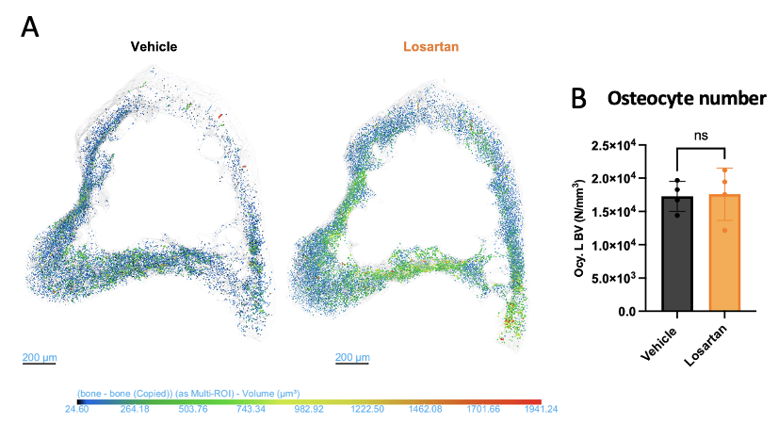
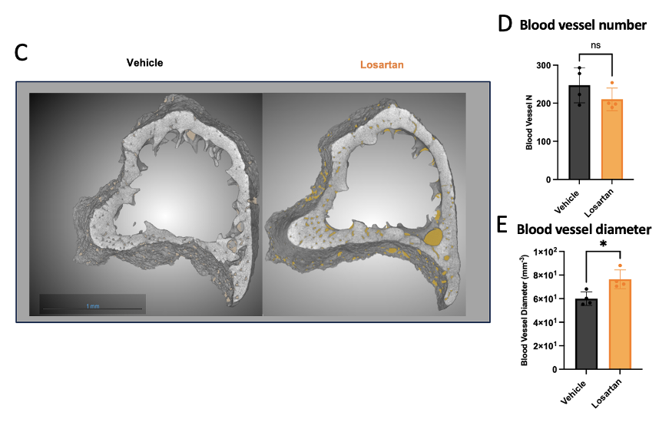
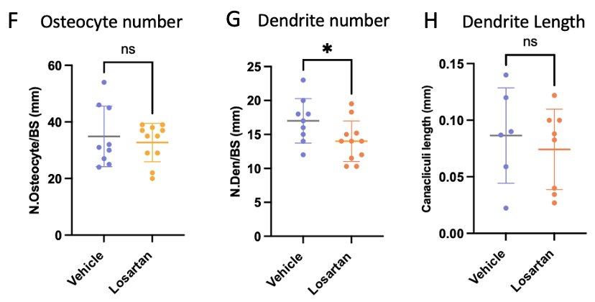
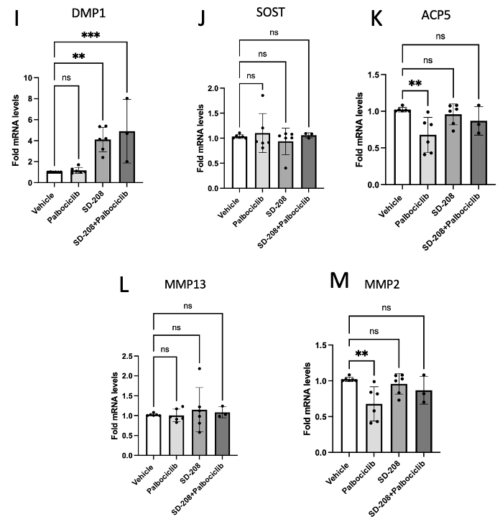
Figure 6. Potential effects of losartan/ SD-208 on osteocytes
The tibiae of losartan mice (n=4/ group) were fixed in 10% PFA and scanned by high resolution ex vivo µCT scanner at a resolution of 1.2 using neo-scanner, with (A) 3-D model of osteocytes in cortical cross section (colour brightness represents number of osteocytes in cortical bone), (B) osteocyte number and (C) 3-D model of cortical cross section (blood vessels are in yellow), (D) blood vessel number, (E) blood vessel diameter analysed. Tibiae were then decalcified with 20% EDTA, cut in 2µM sections and ploton silver stained and analysed, (F) osteocyte number, (G) Dendrite number, (H) dendrite length. In the combination study, bone marrow was flushed from femur. The remaining femur bone was crushed to extract cDNA for qPCR analysis for osteocyte specific genes (Vehicle/ palbociclib, SD-208 n=6/group, SD-208+palbociclib n=3). - (I)DMP1, (J)SOST, and PLR genes (K) ACP5, (L) MMP13, and (M)MMP2 relative to GAPDH expression. Data are presented as mean +/- SD, one-way ANOVA with Kruskal-wallis test; unpaired two-tail student’s t-test with Mann-Whitney’s test analysed on Prism software. Significance ns= not significant, **p = 0.001 **p = 0.01, and ***p = 0.001.

Lastly, we analysed the effect of bone anabolic agents to osteocytes. Given that little is currently known about their role in breast cancer bone metastases and their potential contribution to bone resorption in this setting. Osteocytes regulate osteoblast and osteoclast differentiation by production of IL-6 via signal transducer activator 3(STAT3) and ERK signalling pathways. Osteocytes also resorb extracellular matrix and replace with them with type I collagen to surround themselves by peri-lacunar remodelling (PLR) (Hao et al, 2017; Yee et al, 2019). Ploton silver stain was performed to analyse bone microstructures, including osteocyte lacunae and their network (Evans et al, 2024, Gaudin-Audrain et al, 2008).
Silver staining demonstrated that losartan did not have effect on osteocyte number and dendrite length, but significantly reduced dendrite number (Fig. 6F-H), suggesting losartan have an altered osteocyte connectivity, further investigation on mechanistic structure is needed. High resolution ex vivo µCT confirmed that losartan treatment does not alter osteocyte number (Fig. 6B). Additionally, losartan treatment did not alter blood vessel number, but increased blood vessel diameter, indicated increased blood perfusion (Fig. 6 D, E).
qPCR on osteocyte specific genes was conducted on the femur bone from SD-208 treated tumour bearing mice. SD-208 and SD-208 combined with palbociclib significantly increased DMP1 expression compared to vehicle (Fig. 6I), this may suggest increased osteocyte formation. Further experiments, including histological quantification, in situ hybridization are necessary to confirm changes in osteocyte number or maturation. Interestingly this increase was not accompanied change in SOST expression (Fig. 6J), which encodes sclerostin, a protein produced by osteocytes that inhibits bone formation (van Bezoojjen et al, 2005). SD-208 alone and SD-208 combined with palbociclib did not alter the expression of ACP5 and MMP2, whilst palbociclib significantly decreased ACP5 and MMP2 expression compared to vehicle (Fig. 6 K, L), suggesting that palbociclib disrupts osteocytes PLR resorption in bone. SD-208, palbociclib and SD-208 combined with palbociclib did not alter the expression MMP13 compared to vehicle (Fig. 6M). Additional experiments including silver staining and high-resolution ex vivo µCT need to be conducted to further confirm effects of palbociclib and SD-208 on osteocytes.
Collectively, these data demonstrate that losartan and SD-208 as monotherapies mitigated bone loss in the model of BC bone metastases.
4. Discussion
Despite the improved survival in metastatic breast cancer (Welt et al, 2020), there is a lack of treatment that can improve bone quality and repair bone lesions in patients with BC bone metastases. Patients continue to suffer from SREs, including bone pain and fractures due to poor-quality bone, with standard-of-care anti-resorptive treatments not facilitating repair of lesions (Kates and Acket-Bicknell et al, 2016). We initially evaluated the effects of TGF-β inhibitors losartan and SD-208 in tumour-free mice. Hind-limb analysis demonstrated that losartan and SD-208 significantly increased trabecular bone mass, confirming the bone anabolic effects of TGF-β inhibitors in tumour-free immunocompromised mice. qPCR demonstrated that losartan significantly increased the expression of EFNB4 and RUNX2 compared to vehicle. This is findings are consistent with published data by Mohammed et al, 2009, using SD-208 in tumour-free immunocompetent mice. qPCR using calvaria explants of Smad binding element (SBE)-Luc mice (treated with TGF-β1 10µg/kg and 3 days 60mg/kg SD-208) demonstrated increased expression of RUNX2 and osteocalcin. Primary calvaria osteoblasts treated with 10µM of TGF-βR1 inhibitor SB431542 for 48 hours and assessed by qPCR demonstrated increased expression of EPHB4. Losartan antagonises osteoclast differentiation by significantly reducing the expression of CTSK and DC-STAMP compared to vehicle, whilst SD-208 did not alter the expression of CTSK and DC-STAMP. Losartan treatment was demonstrated to reduce osteoclast differentiation and number by Chen et al 2015. 0.6g/L of losartan or drinking water (vehicle) was administered to immunocompetent tumour-free C57BL/6 mothers orally dissolved in drinking water until weaning. Their pups (n=8) continued to receive 0.6g/L of losartan dissolved in drinking water or drinking water (vehicle) for 6 weeks. Histology demonstrated reduced osteoclast numbers when comparing the losartan treated mice and vehicle-treated mice. These effects might possibly attribute to the reduction in TGF-β1 and SMAD3 expression by losartan treatment. Ex vivo µCT, bone histomorphometry analysis demonstrate no significant differences in BV/TV, trabecular number, or osteoblast number, when comparing SD-208–treated to vehicle-treated mice. These findings may be attributed to the unequal and small sample sizes, with only 3 mice in the vehicle group and 4 in the SD-208–treated group. An estimated of 6 mice per group are required to observe a statistically significant effect on bone volume, based on data of Mohammad et al, 2009 (Supplementary material, Calculation 1).

We next investigated the effect of the TGF-β inhibitors in a commonly used model of TNBC bone metastases, where lytic bone lesions arise following i.c. injection of MDA-MB-231 LUC2+GFP+231- human BC cells (Ottewell and Lawson, 2021). A major limitation of these studies is the short duration of the model, which typically runs for only 3–4 weeks, thereby restricting the time available for bone-targeted therapies to exert measurable effects. In addition, continued tumour growth is associated with extensive trabecular bone loss, leaving reduced bone surfaces where new bone formation can take place.

We first investigated the effects of losartan in this BC model, to determine if the bone anabolic effects we had observed in tumour-free animals were powerful enough to limit bone loss associated with BC bone metastases. Losartan significantly limited BC-induced bone disease but did not cause complete repair of bone lesions. We therefore hypothesised that introducing an anti-cancer agent to slow down tumour growth would enhance the ability of a bone anabolic agent to repair bone lesions. For these studies, we chose to use the cytostatic agent palbociclib, previously used by us to inhibit tumour progression in bone in this BC model (Saleh et al, 2023). The study aimed to maintain a stable tumour burden during the period when the bone anabolic agent was administered. Using this schedule, we found that SD-208 in combination with palbociclib significantly limited BC-induced bone disease but did not cause complete repair of bone lesions. Importantly, SD-208 alone did not reduce tumour growth, meaning that we were able to assess the effects of SD-208 specifically on bone. However, precise progression monitoring of individual lytic lesions using in vivo µCT is technically challenging.

Studies on the effects of losartan in the context of BC-induced bone disease are lacking; however, losartan was shown to inhibit cancer progression and improve the therapeutic effects of chemotherapy in a xenograft model of colorectal cancer. 6-8 weeks old BALB/c nude mice implanted with CT-26 cells (by subcutaneous injection into hindlimb) were treated with 5mg/kg 5-fluorouracil (5-FU), 90mg/kg losartan, 5-FU combined with losartan, or control by intraperitoneal injection (i.p) daily for 14 days. Losartan alone significantly reduced tumour size compared to control. When combined with 5-FU, losartan further reduced tumour weight. The effect of losartan is possibly attributed to the upregulation of pro-inflammatory cytokines and chemokines that lead to tumour necrosis (Hashemzehi et al, 2021). It has been reported that losartan increased tumour response to metronomic cyclophosphamide (Cy) in triple-negative adenocarcinoma in mice. BALB/c nude mice implanted with M-234p tumour fragments in the mammary fat pad were treated with 200mg/kg losartan in drinking water, 25mg/kg Cy, losartan combined with Cy, or control. Mice were euthanised when the tumour reached maximal size. Losartan combined with Cy significantly increased survival of mice compared to either treatment alone and control, while decreasing the proliferation marker Ki67 (Mainetti et al, 2020). The bone anabolic effects of losartan may be improved when used in combination with an anti-resorptive agent. Moreover, the effects of losartan on bone lesions in combination with an anti-cancer agent and/or a bisphosphonate remain to be determined. The effect of losartan on osteoblast and osteoclast specific genes assessed by qPCR will be explored in future studies.

In the combination study, variability in the number of animals that developed tumors in each treatment-assigned cage led to unequal group sizes. To ensure statistically meaningful results, a minimum of 9 mice per group is required, based on power calculations (Supplementary material, Calculation 2) derived from Dunn et al. (2009), which demonstrated that SD-208 treatment significantly reduced lesion area in a breast cancer bone metastasis model. Palbociclib treatment was not able to completely inhibit tumour growth and induce a low-tumour phase for SD-208 to potentially repair bone lesions. Palbociclib-treated mice had decreased tumour growth at day 23 (not statistically different) and significantly decreased tumour growth at day 31 compared to vehicle-treated mice. However, tumour growth was never completely inhibited. A similar trend was observed in mice treated with SD-208 combined with palbociclib. In the same model of TNBC bone metastasis using the same palbociclib schedule, relapse of tumour cells was also observed (Saleh et al, 2023). 6-week-old BALB/c nude mice were injected with MDA-MB-231 LUC2+GFP+ cells by i.c. After 7 days, mice were treated with 100mg/kg palbociclib or sodium lactate vehicle (n=8/ group) for 5 days per week for 4 weeks. Tumour growth in palbociclib mice emerged after a 2-day break in treatment, suggesting growth of palbociclib-resistant TNBC cells. Palbociclib reduced BC-induced bone loss compared to control from 1 week to 3 weeks of treatment. This was possibility driven by reduced osteoclast activity, indicated by a significant reduction in serum TRAP5b, and is consistent with significant decreases in CTSK and DC-STAMP expression, which suggests a disruption of osteoclast-associated molecular programs and bone catabolic processes. There was significant reduction in SMAD3 expression and this may have potentially contributed to inhibition of tumour growth inhibition. As others have shown, the knockdown of SMAD3 in MDA-MB-231 LUC2+GFP+ cells lead to a prolonged lag phase of tumour growth (Petersen et al, 2010). Additionally, loss of SMAD3 function suppresses tumour growth (Chen et al, 2024). However, palbociclib did not reduce the tumour-induced decrease in %BV/TV and trabecular number at endpoint, possibly due to progressive tumour growth and relapse of tumour growth. Most importantly, traditional chemotherapies for the treatment of BC, including doxorubicin, induce damage to bone and reduce bone mass (Rana et al, 2013). This may possibly be attributed to palbociclib not negatively affecting the survival and differentiation of osteoblasts. Moreover, our study shows that palbociclib may be a suitable anti-cancer agent for the treatment of BC bone metastases, as we did not observe any detrimental effects on bone in treated mice.

Both SD-208 and palbociclib slowed down the tumour-induced reduction in %BV/TV. Notably, SD-208 treatment and SD-208 combined with palbociclib demonstrated greater reduction in lesion development compared to palbociclib alone, as analysed by both in vivo µCT (3 weeks treatment) and ex vivo µCT at endpoint. The number of animals in this study is a main limitation, especially in the SD-208 combined with the palbociclib group (n=3). This may potentially contribute to additional effects of SD-208 acting on osteoblasts and palbociclib acting on osteoclasts. SD-208 significantly increased expression of EPHB4 and osteocalcin and decreased RUNX2 expression, suggesting progression along the osteogenic lineage and activation of mineral deposition pathways. SD-208 treatment had no effect on osteoclast specific-genes CTSK and DC-STAMP, suggesting that osteoclast differentiation remained unaltered in this model of TNBC bone metastases. This was demonstrated differently in a model of melanoma with a different SD-208 schedule (Mohammed et al, 2011). 4-week-old athymic female nude mice were injected with 1205Lu melanoma cells (n=12). After 12 days, mice were treated with 20mg/kg or 60mg/kg SD-208 or vehicle. SD-208-treated mice significantly reduced osteoclast numbers compared to vehicle mice. In addition, the results from the in vitro MTT assay and in vivo bioluminescent imaging suggested that the bone anabolic effects of SD-208 and losartan in limiting breast cancer bone metastases were not driven by tumour inhibition, but by the stimulation of a bone anabolic effect. In a model of multiple myeloma, SD-208 combined with chemotherapy was able to repair bone lesions, improve bone quality, and fracture resistance (Green et al, 2019). NSG mice were injected i.v.. With U266 myeloma cells, 8 weeks later mice were treated with 1mg/kg of bortezomib (btz) twice per week combined with 50mg/kg lenalidomide (len) 4 days per week or 0.75 btz and 50mg/kg len twice per week combined with 60mg/kg SD-208 for 5 days per week or control for 9 weeks. Low tumour-phase, where tumour burden is low, was induced using chemotherapies. SD-208 combined with chemotherapies repaired 50% of lesions, and 60% of lesions were reduced in size. In our study, SD-208 combined with palbociclib reduced the bone loss in BC bone metastases, but lesion repair was not observed. The lack of lesion repair could be attributed to palbociclib’s inability to induce a low-tumour phase where tumour growth is halted, and its inability to facilitate SD-208 to effectively repair bone. Moreover, our study used a BC bone metastasis model, where osteolytic lesions were large and localised, so may be more difficult to repair compared to smaller multiple lesions in the model of multiple myeloma. Treatment duration was also much longer in the myeloma model.

In summary, we have demonstrated that losartan and SD-208 have bone anabolic effects in the BALB/c tumour-free model and limit BC-induced trabecular bone loss. SD-208 and losartan have the potential to be used in combination with bisphosphonates and bone-targeted agents to limit breast cancer bone metastasis and bone-related diseases.

Acknowledgements
We acknowledge Biological Services of the University of Sheffield for delivering and taking care of mice. We thank Prof. Penelope Ottewell for her technical support.

Author contribution
Jacky Wong (Investigation, Methodology, Formal Analysis, Writing-Original Draft, Review & Editing), Lubaid Saleh (Investigation, Methodology, Formal Analysis, Writing- Review & Editing), Holly Evans (Formal Analysis, Writing- Review & Editing), Enrico Dall'Ara (Formal Analysis, Writing- Review & Editing), Alexandria Sprules, Michelle Lawson (Conceptualisation, Investigation, Supervision, Writing- Review & Editing), Ingunn Holen (Conceptualisation, Investigation, Supervision, Writing-Review & Editing)

Supplementary Material

Calculation 1. Based on on Mohammad et al, 2009 study in SD-208 treatment having bone anabolic effect on tumour free mice

Using Cohen’s d to calculate effect size, vehicle 11.6, SD 0.116. SD-208 20, SD 0.2.

Effect size: $\frac{0.2-0.116}{3.55}≈$ 10.46
Using G* software, where Effect size (d): 10.46, required number of mice per group$≈$ 6.

Calculation 2. Based on Dunn et al, 2009 study in SD-208 treatment significantly reduced lesion area in a breast cancer bone metastasis model.
Using Cohen’s d to calculate effect size, vehicle 22, SD 2.5. SD-208 8, SD 2.5.
Effect size: $\frac{22-8}{2.5}≈$ 5.6
Using G* software, where effect size 5.6, required number of mice per group$≈$ 9

Funding
This work was self-funded

Conflicts of interest
The authors have no conflicts of interest
Data Availability
The data that support the findings of this study are available within the article.

References
Abnaof, K., Mallela, N., Walenda, G., Meurer, S. K., Seré, K., Lin, Q., Smeets, B., Hoffmann, K., Wagner, W., Zenke, M., Weiskirchen, R., & Fröhlich, H. (2014). TGF-β stimulation in human and murine cells reveals commonly affected biological processes and pathways at transcription level. BMC systems biology, 8, 55.

Batlle, E., & Massagué, J. (2019). Transforming Growth Factor-β Signaling in Immunity and Cancer. Immunity, 50(4), 924–940.

Biswas, S., Nyman, J. S., Alvarez, J., Chakrabarti, A., Ayres, A., Sterling, J., Edwards, J., Rana, T., Johnson, R., Perrien, D. S., Lonning, S., Shyr, Y., Matrisian, L. M., & Mundy, G. R. (2011). Anti-transforming growth factor ß antibody treatment rescues bone loss and prevents breast cancer metastasis to bone. PloS one, 6(11), e27090.

Bongiovanni, T., Lancaster, E., Ledesma, Y., Whitaker, E., Steinman, M. A., Allen, I. E., Auerbach, A., & Wick, E. (2021). Systematic Review and Meta-Analysis of the Association Between Non-Steroidal Anti-Inflammatory Drugs and Operative Bleeding in the Perioperative Period. Journal of the American College of Surgeons, 232(5), 765–790
Buenrostro, D., Kwakwa, K. A., Putnam, N. E., Merkel, A. R., Johnson, J. R., Cassat, J. E., & Sterling, J. A. (2018). Early TGF-β inhibition in mice reduces the incidence of breast cancer induced bone disease in a myeloid dependent manner. Bone, 113, 77–88.

Campistol, J. M., Iñigo, P., Jimenez, W., Lario, S., Clesca, P. H., Oppenheimer, F., & Rivera, F. (1999). Losartan decreases plasma levels of TGF-beta1 in transplant patients with chronic allograft nephropathy. Kidney international, 56(2), 714–719

Chen, Z., Wang, Y., Lu, X., Chen, H., Kong, Y., Rong, L., & Wang, G. (2024). The immune regulation and therapeutic potential of the SMAD gene family in breast cancer. Scientific reports, 14(1), 6769.

Chiechi, A., Waning, D. L., Stayrook, K. R., Buijs, J. T., Guise, T. A., & Mohammad, K. S. (2013). Role of TGF-β in breast cancer bone metastases. Advances in bioscience and biotechnology (Print), 4(10C), 15–30.

Clemons, M., Gelmon, K. A., Pritchard, K. I., & Paterson, A. H. (2012). Bone-targeted agents and skeletal-related events in breast cancer patients with bone metastases: the state of the art. Current oncology (Toronto, Ont.), 19(5), 259–268.

Fournier, P. G., Juárez, P., Jiang, G., Clines, G. A., Niewolna, M., Kim, H. S., Walton, H. W., Peng, X. H., Liu, Y., Mohammad, K. S., Wells, C. D., Chirgwin, J. M., & Guise, T. A. (2015). The TGF-β Signaling Regulator PMEPA1 Suppresses Prostate Cancer Metastases to Bone. Cancer cell, 27(6), 809–821.

Gaudin-Audrain C, Gallois Y, Pascaretti-Grizon F, Hubert L, Massin P, Baslé MF, Chappard D. (2008). Osteopontin is histochemically detected by the AgNOR acid-silver staining. Histol Histopathol. 23(4):469-78.

Green, A. C., Lath, D., Hudson, K., Walkley, B., Down, J. M., Owen, R., Evans, H. R., Paton-Hough, J., Reilly, G. C., Lawson, M. A., & Chantry, A. D. (2019). TGFβ Inhibition Stimulates Collagen Maturation to Enhance Bone Repair and Fracture Resistance in a Murine Myeloma Model. Journal of bone and mineral research : the official journal of the American Society for Bone and Mineral Research, 34(12), 2311–2326.

Haley, H. R., Shen, N., Qyli, T., Buschhaus, J. M., Pirone, M., Luker, K. E., & Luker, G. D. (2018). Enhanced Bone Metastases in Skeletally Immature Mice. Tomography (Ann Arbor, Mich.), 4(2), 84–93. Clemons, M., Gelmon, K. A., Pritchard, K. I., & Paterson, A. H. (2012). Bone-targeted agents and skeletal-related events in breast cancer patients with bone metastases: the state of the art. Current oncology (Toronto, Ont.), 19(5), 259–268.

Hashemzehi, M., Rahmani, F., Khoshakhlagh, M., Avan, A., Asgharzadeh, F., Barneh, F., Moradi-Marjaneh, R., Soleimani, A., Fiuji, H., Ferns, G. A., Ryzhikov, M., Jafari, M., Khazaei, M., & Hassanian, S. M. (2021). Angiotensin receptor blocker Losartan inhibits tumor growth of colorectal cancer. EXCLI journal, 20, 506–521.

Hao, Y., Zhou, L., Zhang, H., Zeng, J., Wang, J., Liu, L., & Li, Y. (2017).
The role of osteocyte regulation in bone remodeling: A novel therapeutic target for osteoporosis treatment. RSC Advances, 7(71), 43046–43055.

Kates, S. L., & Ackert-Bicknell, C. L. (2016). How do bisphosphonates affect fracture healing?. Injury, 47 Suppl 1(0 1), S65–S68.

Lei, S., Zheng, R., Zhang, S., Wang, S., Chen, R., Sun, K., Zeng, H., Zhou, J., & Wei, W. (2021). Global patterns of breast cancer incidence and mortality: A population-based cancer registry data analysis from 2000 to 2020. Cancer communications (London, England), 41(11), 1183–1194.

Mainetti, L. E., Rico, M. J., Kaufman, C. D., Grillo, M. C., Guercetti, J., Baglioni, M. V., Del Giúdice, A., Capitani, M. C., Fusini, M., Rozados, V. R., & Scharovsky, O. G. (2020). Losartan improves the therapeutic effect of metronomic cyclophosphamide in triple negative mammary cancer models. Oncotarget, 11(32), 3048–3060.

Melton, L. J., 3rd, Hartmann, L. C., Achenbach, S. J., Atkinson, E. J., Therneau, T. M., & Khosla, S. (2012). Fracture risk in women with breast cancer: a population-based study. Journal of bone and mineral research : the official journal of the American Society for Bone and Mineral Research, 27(5), 1196–1205.

Mohammad, K. S., Chen, C. G., Balooch, G., Stebbins, E., McKenna, C. R., Davis, H., Niewolna, M., Peng, X. H., Nguyen, D. H., Ionova-Martin, S. S., Bracey, J. W., Hogue, W. R., Wong, D. H., Ritchie, R. O., Suva, L. J., Derynck, R., Guise, T. A., & Alliston, T. (2009). Pharmacologic inhibition of the TGF-beta type I receptor kinase has anabolic and anti-catabolic effects on bone. PloS one, 4(4), e5275.

Mohammad, K. S., Javelaud, D., Fournier, P. G., Niewolna, M., McKenna, C. R., Peng, X. H., Duong, V., Dunn, L. K., Mauviel, A., & Guise, T. A. (2011). TGF-beta-RI kinase inhibitor SD-208 reduces the development and progression of melanoma bone metastases. Cancer research, 71(1), 175–184.

Ottewell, P.D. and Lawson, M.A. (2021). Advances in murine models of breast cancer bone disease Journal of Cancer Metastasis and Treatment, 7. 11. ISSN 2394-4722

Petersen, M., Pardali, E., van der Horst, G., Cheung, H., van den Hoogen, C., van der Pluijm, G., & Ten Dijke, P. (2010). SMAD2 and SMAD3 have opposing roles in breast cancer bone metastasis by differentially affecting tumor angiogenesis. Oncogene, 29(9), 1351–1361.

Pulido, C., Vendrell, I., Ferreira, A. R., Casimiro, S., Mansinho, A., Alho, I., & Costa, L. (2017). Bone metastasis risk factors in breast cancer. Ecancermedicalscience, 11, 715.

Rana, T., Chakrabarti, A., Freeman, M., & Biswas, S. (2013). Doxorubicin-mediated bone loss in breast cancer bone metastases is driven by an interplay between oxidative stress and induction of TGFβ. PloS one, 8(10), e78043.

Saleh, L., Ottewell, P. D., Brown, J. E., Wood, S. L., Brown, N. J., Wilson, C., Park, C., Ali, S., & Holen, I. (2023). The CDK4/6 Inhibitor Palbociclib Inhibits Estrogen-Positive and Triple Negative Breast Cancer Bone Metastasis In Vivo. Cancers, 15(8), 2211.

Shimizu, H., Nakagami, H., Osako, M. K., Hanayama, R., Kunugiza, Y., Kizawa, T., Tomita, T., Yoshikawa, H., Ogihara, T., & Morishita, R. (2008). Angiotensin II accelerates osteoporosis by activating osteoclasts. FASEB journal : official publication of the Federation of American Societies for Experimental Biology, 22(7), 2465–2475.

Uhl, M., Aulwurm, S., Wischhusen, J., Weiler, M., Ma, J. Y., Almirez, R., Mangadu, R., Liu, Y. W., Platten, M., Herrlinger, U., Murphy, A., Wong, D. H., Wick, W., Higgins, L. S., & Weller, M. (2004). SD-208, a novel transforming growth factor beta receptor I kinase inhibitor, inhibits growth and invasiveness and enhances immunogenicity of murine and human glioma cells in vitro and in vivo. Cancer research, 64(21), 7954–7961.

van Bezooijen, R. L., ten Dijke, P., Papapoulos, S. E., & Löwik, C. W. (2005). SOST/sclerostin, an osteocyte-derived negative regulator of bone formation. Cytokine & growth factor reviews, 16(3), 319–327.

Welt, A., Bogner, S., Arendt, M., Kossow, J., Huffziger, A., Pohlkamp, C., Steiniger, H., Becker, U., Alashkar, F., Kohl, M., Wiesweg, M., Richly, H., Hense, J., Scheulen, M. E., Schuler, M., Seeber, S., & Tewes, M. (2020). Improved survival in metastatic breast cancer: results from a 20-year study involving 1033 women treated at a single comprehensive cancer center. Journal of cancer research and clinical oncology, 146(6), 1559–1566.

Wright, L. E., Frye, J. B., Gorti, B., Timmermann, B. N., & Funk, J. L. (2013). Bioactivity of turmeric-derived curcuminoids and related metabolites in breast cancer. Current pharmaceutical design, 19(34), 6218–6225.

Zhao, W. Y., Zhang, L. Y., Wang, Z. C., Fang, Q. Q., Wang, X. F., Du, Y. Z., Shi, B. H., Lou, D., Xuan, G. D., & Tan, W. Q. (2022). The compound losartan cream inhibits scar formation via TGF-β/Smad pathway. Scientific reports, 12(1), 14327.

Yee, C. S., Schurman, C. A., White, C. R., Alliston, T., & Ritchie, R. O. (2020).
Investigating osteocytic perilacunar/canalicular remodeling. Current Osteoporosis Reports, 18(5), 429–440.

Chapter 7
Final discussion, conclusion and future work

7. Final Discussion

Advanced breast cancer preferentially colonises the bone, disrupting bone homeostasis by altering the balance between osteoblast bone formation and osteoclast bone resorption. This ultimately leads to excessive bone degradation, forming osteolytic bone lesions that significantly decreases bone quality (Chen et al, 2010). Affected patients will experience SREs, including severe pain, tumour-induced fractures, and ultimately reduced survival (So et al, 2012). The need for repeated consultation, hospitalisation, and ongoing medical care leads to increased health care expenditures, creating a significant economic burden (DiCaprio et al, 2022). Anti-resorptive bisphosphonates and bone-targeted agents are currently the standard of care, reducing the formation of bone lesions by inhibiting osteoclast-mediated resorption, combined with chemotherapies to limit tumour growth and progression (Clemon et al, 2012). The current challenge in treating breast cancer-induced bone disease is the lack of treatment that can effectively repair bone. Patients continue to suffer from SREs due to low-quality bone (Bongiovanni et al, 2021). The ideal combination therapy for breast cancer-induced bone disease would be to incorporate a bisphosphonate, chemotherapy, and a bone anabolic agent, which could stimulate bone formation to increase bone strength and quality. Lytic bone lesions are present in various types of advanced cancer; however, my studies focus on breast cancer, given the availability of well-established models such as the PDX model, the human breast cancer MDA-MB-231 xenograft model, and the mouse mammary 4T1 syngeneic model (Tulotta et al, 2019).
Work presented in this thesis has utilised in vivo models and methodologies to investigate: (i) bone anabolic effects in agents in vitro and in vivo; (ii) establish a model of triple negative breast cancer bone metastasis; (iii) identify an anti-cancer agent to be used in combination with bone anabolic agents; (iv) assess bone effects of bone anabolic agents in a model of triple negative breast cancer bone metastasis.

  - Challenges in using traditional bone anabolic treatment in breast cancer bone metastasis

Bone anabolic agents are effective in the treatment of osteoporosis to restore the loss of bone. However, bone anabolic agents are not used in breast cancer due to the insufficient clinical evidence supporting their safety and efficacy in this setting. The recombinant PTH is a FDA-approved agent for the treatment of osteoporosis (Ponnapakkam et al, 2014). However, PTH treatment is reported to be associated with the development of osteosarcoma. 6–8-week-old Fischer rats received daily treatment of PTH (5, 30, 75 μg/kg based on animal weight) or control (n=60/group) for 2 years by subcutaneous injection. Bone mass was significantly increased in PTH-treated mice compared to control. Nevertheless, proliferative osteosarcoma bone lesions occurred in various sites of the skeleton of PTH (75μg/kg) treated rats (Vahle et al, 2002). PTH treatment has also been explored in a model of breast cancer bone metastasis. 12-week-old female BALB/c nude mice were treated with 40 or 80μg/ kg PTH or PBS control for 5 days before to intracardiac injection of MDA-MB-231 cells, to ensure that tumour cells were not exposed to PTH, allowing the evaluation of PTH’s effect on the bone microenvironment. At endpoint (day 35), mice treated with PTH had developed significantly greater number of skeletal tumours compared to control (Brown et al, 2018). Taken together, these studies suggest that the bone anabolic treatment with PTH that is used for osteoporosis treatment could potentially lead to the development of bone tumours in cancer patients and may pose safety risks, making these therapies unsuitable for cancer treatment.
New treatments that inhibit TGF-β are emerging, including the anti-TGF-β antibody 1D11 (neutralises all three TGF-β isoforms). The repair of lytic bone lesions in other cancer types is feasible and has been demonstrated in a model of multiple myeloma using TGF-β inhibitors combined with either bisphosphonate or chemotherapy. 5 weeks after NSG mice were intravenously injected with U266 cells, mice received either two 125μg/kg ZOL subcutaneous injection (3 days apart) (n=8) or 20mg/kg 1D11 every 3 days by i.p. combined with ZOL (n=8) or 20mg/kg isotype control (n=6) every 3 days for 3 weeks. In vivo μCT demonstrated that ZOL combined with 1D11 significantly reduced %lesion area, with no progressive bone disease compared to ZOL and control. Bone lesions in mice that received combined treatment were significantly repaired by week 3. Mice treated with ZOL alone had lesion repair compared to control. In addition, trabecular bone volume and cortical thickness were significantly increased in both treatments compared to the control (Paton-Hough et al, 2019). A separate study used chemotherapy in combination with a TGF-β inhibitor (SD-208). 9-week-old NSG mice were intravenously injected with U266 cells. After 8 weeks, mice were treated with either 1mg/kg of bortezomib (btz) twice per week combined with 50mg/kg lenalidomide (Len) 4 days per week or 0.75 btz and 50mg/kg len twice per week 60mg/kg combined with 60mg/kg SD-208 5 days per week or control. In vivo μCT demonstrated that mice receiving 2 weeks of SD-208 chemotherapy combination treatment had a lesion area reduced by 76% compared to the control, with half of all lesions completely repaired. Chemotherapy alone reduced lesions by 52% by week 2 and partial bone repair compared to the vehicle. Mice treated with SD-208 and the chemotherapy combination treatment had significantly increased %BV/TV and increased trabecular number compared to mice treated with chemotherapy or control (Green et al, 2019). Both studies used either a bisphosphonate to inhibit bone resorption or chemotherapy to limit tumour growth, so the TGF-β inhibitor could stimulate bone repair. Moreover, Btz promotes osteoblast differentiation and inhibits osteoclastogenesis (Wang et al, 2020). Taken together, lesions could be repaired by TGF-β inhibitors combined with either a bisphosphonate or chemotherapy in a model of myeloma, with chemotherapy combined treatment demonstrating the largest extent of bone lesion repair.
Lesions formed in breast cancer differ from those associated with haematological malignancies like multiple myeloma. In breast cancer bone metastases, large, localised lesions are formed that are more difficult to repair compared to multiple small lesions that are formed in myeloma (Fujion, 2018). Breast cancer cells release cytokines that mediate osteoclast activation and cause rapid bone destruction (Trivedi et al, 2021, Tulotta and Ottewell, 2018). Parathyroid-related proteins (PTHrP) produced by breast cancer cells upregulate RANKL expression by osteoblasts, which promotes osteoclastogenesis and bone resorption. Notably, PTHrP is expressed at higher levels in the bone microenvironment compared to the breast and other soft tissues, which contributes to the aggressive nature of bone metastasis in breast cancer (Pang et al, 2022). Therefore, it is important to preserve bone to allow studies of bone repair in breast cancer bone metastasis models, as bone is rapidly destroyed by tumour-induced osteoclast activity. In fast-progressing models of breast cancer bone metastasis, mice can get very ill due to the rapid growth of the tumour and bone destruction, making the treatment window very limited. In the 4T1 metastasis model in immunocompetent mice, the treatment window is approximately 2 weeks. For the MDA-MB-231 bone metastases model in immunocompromised mice, the treatment window is approximately 3 weeks.
  - Monitoring bone lesions and using anti-cancer agents in breast cancer bone metastasis

Another challenge in the model of breast cancer bone metastases is the accurate monitoring of bone formation. An appropriate method for studying bone changes must balance accuracy, animal welfare, and time efficiency. In this project, I wanted to determine whether in vivo μCT (resolution 10.4 μm) could be used to capture treatment-induced changes in bone volume/structure in the tibia of mice, within the 3-week window needed for the subsequent tumour studies. In vivo µCT successfully captured the development of bone lesions, which correlated with the initial detection of tumour establishment in bone by bioluminescence imaging, as well as with the subsequent progression of lesions over time in the breast cancer bone metastasis model. (Chapter 4. Fig. 4.3). In this project, the proximal tibia and distal femur of mice were scanned by in vivo μCT and ex vivo μCT at endpoint, and the data analysed from in vivo μCT agreed with data analysed using well-established ex vivo μCT (resolution of 4.18 μm). In recent literature, in vivo μCT has been used in various models to measure bone changes, including an OVX model (Roberts et al, 2024) and an osteoarthritis model (Oliviero et al, 2023) to measure changes in trabecular and cortical bone volume. Additionally, in studies of myeloma induced bone disease, Paton-Hough et al, 2019 and Green et al, 2019 effectively captured the development of bone lesions and monitored their progression overtime using in vivo μCT. Importantly, the levels of radiation in in vivo μCT are not high enough to alter tumour growth when capturing the development of bone lesions (Johnson et al, 2011). The challenge in quantifying bone lesions data is the inability to use automated software such as Osteolytica (Evans et al, 2016). The automated software was unable to distinguish between the growth plates (that extend into the bone) and lytic bone lesions (Chapter 4. Fig 4.4). Therefore, the measurement of bone lesions required manually drawing regions of bone lesions for analysis using software such as ImageJ.

Difficulties were also identified in monitoring tumour burden in bone. In a small number of mice, bone lesions were absent in the tibia, even though the tumour was detectable in the hindlimb. It was later discovered that lesions can also develop in the femur, correlating with tumours detected in the hindlimb. In advanced breast cancer, patients receive anti-cancer agents to slow down tumour progression. Anthracycline-based chemotherapies, including DOX, are the standard of care (Choulli et al, 2024). I initially aimed to use DOX to slow down tumour growth, allowing bone anabolic agents to promote bone formation in the TNBC bone metastasis xenograft model. DOX treatment (4mg/kg, once per week for 3 weeks by i.v.) commenced when bone lesions were detected by imaging, mimicking the initial destruction of bone by breast cancer when bone lesions first develop. However, DOX (4mg/kg) treated mice exhibited greater bone loss compared to tumour-bearing vehicle mice (Chapter 5. Fig. 5.4). This supports that 4mg/kg DOX has negative effects on bone as reported by Hadji et al, 2009.
Notably, 4mg/kg DOX led to bone loss in the tibiae but not the femur. There was a significant difference in the decrease in trabecular number, but there was no change in % trabecular bone volume or cortical bone volume. Only the distal femur was measured and not the whole femur. This result may not be significant as it does not represent the whole femur bone. The duration of treatment (3 weeks) might also be too short to significantly impact bone volume.
To prevent damage to bone, DOX should have been administered at 2mg/kg, where this concentration was shown to reduce tumour growth and %bone lesion area in a breast cancer bone metastatic model (Ottewell et al, 2008). Moreover, TGF-β inhibitors used in this study (SD-208/ losartan) might have compensated for bone loss associated with DOX treatment, as demonstrated by Rana et al, 2013, where TGF-β inhibitor 1D11 was employed in combination therapy. This approach may offer the benefit of curbing tumor progression without compromising bone integrity. Ultimately, the most effective treatment would be one that inhibits tumor growth without causing bone damage. In the next study, palbociclib was used in combination therapy. This CDK4/6 inhibitor has previously been demonstrated by our group to reduce tumour burden in bone in the MDA-MB-231 model (Saleh et al, 2023). Palbociclib treatment (100mg/kg 5 days per week for 3 weeks) was initiated when bone lesions were detected by imaging. Palbociclib was not able to completely inhibit tumour growth due to constant 2-day breaks (in 3 weeks) (Chapter 6. Fig. 3C), potentially causing growth of palbociclib-resistant TNBC cells.

The main limitation of the project was the lack of time to repeat the combination therapy of SD-208 with palbociclib in the TNBC bone metastasis model. Additionally, the sample size in SD-208, the palbociclib treatment group was small (n=6/ group) and SD-208 combined with palbociclib (n=3), meaning these results can only be considered as a pilot study.

  - Confirming of bone anabolic effects in vitro and in tumour-free mice

In this study, losartan and SD-208 have been demonstrated to have bone anabolic effects in differentiated SAOS-2 cells (Chapter 3. Fig. 5, 6) and both immunocompromised and immunocompetent tumour-free mouse models (Chapter 3. Fig. 9, 14, 19, 20). Although not directly comparable, the effect in increasing trabecular bone was more pronounced in the immunocompromised model (3 weeks treatment) (Chapter 3. Fig. 9, 14) compared to the immunocompetent model (2.5 weeks treatment) (Chapter 3. Fig. 19,20). In this study, an increase in bone volume was achieved in immunocompetent mice with a reduced treatment schedule—2.5 weeks of SD-208 at 60 mg/kg, administered five times per week, compared to the longer 6-week daily regimen used by Mohammed et al, 2009.. This suggests that the therapeutic effect can be attained in a more condensed dosing schedule. With TGF-β’s main role in regulating the immune system, this bone anabolic difference might be attributed to the presence of an immune response or inflammation, where there are more components and signalling pathways involved, which suggests that manipulation of bone mass by TGF-β inhibition might be more difficult in the immunocompetent model. Moreover, trabecular bone was significantly increased in both immunocompromised and immunocompetent models (Chapter 3. Fig. 9, 14, 19, 20). For the MDA-MB-231 bone metastases model in immunocompromised mice, the treatment window is 3 weeks, which provides enough treatment time to have a bone anabolic effect. However, the E0771 bone metastases model in immunocompetent mice has a treatment window of approximately 2 weeks. Additional treatments such as immunotherapy might be required to extend the treatment window for losartan and SD-208 to have bone anabolic effects. Based on the results showing that losartan increased the volume of cortical bone (not statistically different) (Chapter 3. Fig. 9) and significantly increased osteoblast number observed in the endocortical surfaces (Chapter 3. Fig. 11) in immunocompromised tumour-free mice, increasing treatment time might be able to increase the cortical bone volume. This might be due to the angiotensin II inhibitor losartan having a broader downstream inhibition pathway whereas SD-208 only inhibits the TGF-β1 kinase receptor. Losartan treatment has been demonstrated to significantly increase cortical thickness (Chen et al, 2015). 0.6g/L of losartan was administered (dissolved in drinking water) to immunocompetent C57BL/6 mothers until weaning. Their pups continued to receive 0.6g/L of losartan dissolved in drinking water or drinking water (vehicle) for 6 weeks. Ex vivo µCT demonstrated that losartan-treated mouse pups had significantly increased cortical thickness, trabecular %BV/TV, trabecular number, and trabecular thickness, which may be attributed to decreased RANKL activation. In this study, the bone anabolic effect of SD-208 in immunocompromised mice is attributed to increased osteoblast differentiation and bone formation by increasing the expression of RUNX2, EPHB2, and osteocalcin. On the other hand, losartan not only increased osteoblast differentiation and bone formation by increasing the expression of RUNX2, EPHB2, osteocalcin, but also decreased osteoclast differentiation and bone resorption by reducing the expression of CTSK and DC-STAMP (Chapter 6. Fig. 1 P-V), aligned with the findings of Chen et al 2015 who showed losartan treatment decreases osteoclast number. However, this reduction in osteoclasts was not observed in the histology of my study. In conclusion, losartan and SD-208 both have bone anabolic effects in tumour-free models and can be considered for treatment in tumour-free bone diseases such as osteoporosis, increasing trabecular bone mass to compensate for bone loss.

  - TGF-β inhibitors treatment in the model of breast cancer bone metastases

I found that losartan alone, SD-208 alone, or combined with palbociclib, was not able to completely repair lesions induced by breast cancer bone disease. However, all agents administered were able to decrease the tumour-induced reduction of trabecular bone, demonstrating significant anabolic effects (Chapter 6, Fig. 3). We studied gene expression to investigate the mechanisms of bone anabolic effect (Chapter 6, Fig. 1 P-V, Fig. 3 M-O). Runx2 is (Komori, 2017). RUNX2 regulates osteoblast differentiation by expression of osterix. However, it has differing roles in BC bone metastasis, promoting BC bone metastases by promoting autophagy, a process that allows BC cells to recover nutrients (Si et al, 2023). In this study, SD-208 was associated with significantly reduced RUNX2 expression (Chapter 6. Fig. 3P), even though it did not demonstrate any tumour inhibition effect in vivo or in vitro in this study. Similarly, SD-208 treatment has been observed to decrease RUNX2 expression in models of melanoma and multiple myeloma (Mohammed et al, 2011; Green et al, 2018). To further validate whether SD-208 had a tumour inhibition effect in this model. Gene expression of SMAD2 should be assessed. SMAD2 and SMAD3 interact to form a complex with SMAD4, which subsequently activates genes involved in tumour progression.

Osteocalcin is expressed in high levels in BC patients with bone metastases (Pietschmann et al, 1989) and can potentially be used as a prognostic marker (Martiniakova et al, 2023). SD-208 significantly increased the expression of osteocalcin (Chapter 6. Fig. 3Q), suggesting possible recovery of osteoblast differentiation from suppression of breast cancer bone disease. Further validation is required to confirm mineralisation, and this can be achieved using von Kossa staining, which allows visualisation of mineralised bone matrix in tissue sections. In this method, non-mineralised tissue appears colourless or pink, whereas mineralised tissue is stained black or dark brown (Rungby et al, 1993).
Bioluminescent imaging and MTT assay demonstrate that the effect of losartan and SD-208 was not mediated by tumour inhibition (Chapter 6, Fig. 3C, T), unlike in melanoma models (Mohammed et al, 2011). ELISA serum results did not show a significant effect in P1NP by SD-208 or losartan treatment, despite demonstrating a bone anabolic effect (Chapter 6. Fig. 3K, L). It was suspected that the serum collected at the endpoint did not coincide with the peak of osteoblast activity, where changes might have occurred earlier in the experiment, which was not captured. Moreover, palbociclib significantly reduced the expression of osteoclast-associated genes, DC-STAMP and CTSK (Chapter 6. Fig. 3R,S), suggesting potential inhibition of osteoclastogenesis, which might have contributed to reduced tumour-induced bone loss observed in my study. Further gene expression analysis on matrix metalloproteinases involved in osteoclast differentiation and organic matrix degradation, including c-Fos, MMP9, and MMP14 can be conducted to confirm effect on osteoclasts.
Palbociclib treated osteoclasts were shown to express significantly lower levels of CTSK and ACP5 compared to vehicle (Luliani et al, 2022).
However, tumour growth increased after 2-day break in palbociclib treatment, which indicated tumour growth was not inhibited completely (Fig. 3C). The schedule of palbociclib treatment can be increased from 5 days per week to daily treatment for 3 weeks to potentially avoid the outgrowth of palbociclib-resistant TNBC cells. In summary, losartan, SD-208 alone or combined with palbociclib, was able to limit breast cancer-induced bone disease and should be considered in combination with treatments such as bisphosphonates to further limit/ repair lesions induced by breast cancer bone metastases.

  - Limitations and benefits of project

This study could be improved by using more appropriate control groups. An ideal naïve control for studies involving mice with breast cancer bone metastasis would be mice that have not received intracardiac injections of tumor cells. However, because these mice do not develop tumors, many of them are instead used as controls. Although no tumour in the bone was detected by bioluminescent imaging and no bone damage was observed via µCT, the actual physiological effects on these mice are unknown. Therefore, they are not ideal naïve controls.
For qPCR gene expression analysis, genes that are functionally related, including SMAD2 and SMAD3, should be selected, so that we can accurately determine whether the drugs inhibit the TGF-β signaling pathway. Additionally, reference genes should be consistent. 18S should have been used instead of GAPDH throughout qPCR experiments, as, through personal communication with Penny’s group, drugs targeting TGF-β are known to affect the accuracy of GAPDH as a reference gene.

This project had both limitations and benefits. One limitation was improper sample preservation. In the study where losartan was used to treat breast cancer bone metastasis (Chapter 6), bone marrow from the femurs of losartan-treated, tumor-bearing mice was not flushed immediately at the endpoint. Multiple cell types leached into bone marrow; these samples could not be used for qPCR analysis of osteocyte-specific genes.
Time constraints were also a limitation. In the study where SD-208 and palbociclib were used in combination (Chapter 6), the experiment could not be repeated to increase the sample size, which would have better demonstrated the effects of the drugs on bone. Unlike the losartan study, we did not have sufficient time to assess the effects of SD-208 and palbociclib on osteocytes using Ploton silver staining. Ideally, the study should have included groups such as tumor-free mice, vehicle-treated tumor-bearing mice, SD-208 alone, losartan alone, palbociclib alone, the SD-208/palbociclib combination, and the losartan/palbociclib combination. This would have enabled direct comparisons between SD-208 and losartan, as well as between the different combination treatments.
Another limitation was the number of mice that could be used in the study. Tumor take was initially low due to limited experience with intracardiac injection, resulting in fewer mice developing skeletal tumors. Additionally, in vivo µCT was a core experimental method for assessing bone structure and integrity, but each scan took approximately 30 minutes. This limited the number of mice that could be scanned weekly, thereby reducing the overall group size.
Variability in the number of mice in treatment groups was another limitation. Mice were initially randomised into groups based on body weight and assigned to cages according to their designated treatment. Group sizes varied considerably due to differences in the number of mice that developed tumours within each cage
The number of intensive procedures was also a limitation. Mice with breast cancer-induced bone disease underwent bioluminescent imaging twice and in vivo µCT weekly, all of which required anesthesia. This constrained the number of procedures that could be ethically performed. Additionally, calcein incorporation, which could have been used to assess bone formation, was not included due to procedural overload.
The intracardiac model of breast cancer bone metastasis only represents the stage where tumor cells have already spread to the bone. The effects of the drugs used in this study at earlier stages of the metastatic process remain unknown.
Lastly, the study did not identify a drug or treatment schedule that could fully inhibit tumor growth. Tumor progression was never fully halted, making it difficult to assess the reparative effects of the bone-anabolic drug in the absence of ongoing tumor-induced bone damage. Palbociclib should have been administered daily to achieve more effective tumor suppression, and doxorubicin (DOX) should have been dosed at 2 mg/kg instead of 4 mg/kg to reduce damage to bone while maintaining efficacy.

Despite these limitations, the study had several benefits. The use of in vivo µCT allowed for the same mice to be monitored over time, enabling the detection of changes in bone structure and the development of lesions with higher accuracy. This longitudinal approach reduced the number of mice required, unlike ex vivo µCT, which would have necessitated separate cohorts being euthanised at different time points.
Another key finding was that palbociclib, when administered to BALB/c nude mice with breast cancer-induced bone disease, did not negatively impact bone. This is a significant advantage over traditional chemotherapies in this model. This suggests that palbociclib could potentially be used in other cancer models where preserving bone health is essential.
Importantly, this was also the first study to demonstrate that losartan can limit breast cancer-induced bone disease. This finding indicates that losartan may have potential applications in other bone disease models. While this project was ongoing, Morita et al, 2024 published a study supporting the use of losartan in experimental models of bone disease, further validating its relevance.

7.6 Conclusion

This thesis describes a series of studies investigating the potential of bone anabolic agents in limiting lytic bone lesions in an in vivo model of breast cancer bone metastasis.

In my initial experiments, I established that both losartan and SD-208 had anabolic effects on bone cells in vitro, stimulating ALP production and promoting mineralisation, paving the way for subsequent in vivo studies. Treating tumour-free mice with losartan or SD-208, I next demonstrated that 3 weeks of losartan or SD-208 treatment significantly increased trabecular %BV/TV, trabecular number, and osteoblast number by promoting osteoblast differentiation. I established that in vivo μCT could be utilised to monitor changes in bone volume, where in vivo μCT data at the endpoint agreed with ex vivo μCT. Cancer-induced lytic lesions were studied using the established in vivo MDA-MB-231 triple-negative breast cancer (TNBC) bone metastasis xenograft model. In tumour-bearing mice, there was variability in tumour growth and lesion size, despite animals being inoculated with 50,000 TNBC cells and being genetically identical. I aimed to reduce tumour progression in bone to allow bone anabolic agents to induce bone formation to limit/ repair lytic bone lesions by introducing anti-cancer agents. DOX was not successful in inhibiting tumour growth and resulted in increased bone loss in tumour-bearing mice, and was unsuitable to be used in subsequent studies. I next used the cytostatic agent palbociclib, although still unsuccessful in inhibiting tumour growth, palbociclib reduced tumour-induced bone loss over 3 weeks of treatment by delaying tumour growth in bone and reducing osteoclast differentiation. Losartan and SD-208 both mitigated tumour-induced bone loss. SD-208 achieved this by increasing osteoblast differentiation and bone formation.

Future work should focus on repeating the study involving combinational therapy of SD-208 combined with palbociclib, as well as performing histology analysis to investigate the role of bone cells in this study. Additionally, bone strength and bone quality tests will be conducted on fixed and snap-frozen samples. The work presented here suggests that losartan and SD-208 can mitigate bone loss in the TNBC bone metastasis model. The incorporation of bisphosphonates should be considered to further improve treatment outcomes and potential aid in repairing lytic bone lesions.

7.7 Future Work

Further research can be carried out using samples collected from this study or through additional studies that can be set up based on this project.

Bone histology on cut tibia embedded paraffin sections from studies of losartan and SD-208 treatment in the model of breast cancer bone metastases can be done to analyse bone morphology and whether TGF-β inhibition in breast cancer bone metastases affects osteoblasts and osteoclasts using TRAP/ H&E and ploton silver nitrate stain (Evans et al, 2024).

In addition, mass spectroscopy can be performed to investigate the actual absorbance of TGF-β inhibitors in bone using snap-freeze femurs from tumour-free immunocompetent studies where two different concentrations of TGF-β inhibitors were used. This is important as the amount of drug detected in the samples can suggest whether the concentration used for the study is too high or too low. Samples will be crushed and ionised, where mass spectroscopy measures the mass-to-charge ratio of the drug present in the sample. The intensity of the sample demonstrated by the peak will indicate the relative abundance of the drug in the sample (Olshina and Sharon, 2016).

Most importantly, bone strength and bone quality can be assessed using fixed vertebrae and tibia that have not been used for bone histology from all relevant tumour-free and tumour studies. 3-point bending strength tests using a fixed femur and compression tests using fixed vertebrae can assess the maximum load to break the bones. These results are important as they will demonstrate the bone strength of treated mice compared to vehicle (Metzener et al, 2022). Using snap-freeze tibias that were not utilised for histology, Raman spectroscopy can be performed to understand material composition as described in Green et al, 2019. The Raman spectrum provides information, including bone mineral crystallinity that is related to bone strength, matrix collagen components including carbonate to phosphate ratio on matrix maturity, and cross linkages that are formed when bone matures (Mandir and Morris, 2015).

The data from this project suggests that there are additional studies that can be designed or continued.
Firstly, the study of SD-208 and Palbociclib can be repeated with alteration. Results weren’t significant enough as the sample size was too low due to tumour-take. Daily palbociclib treatment might be able to inhibit tumour growth and prevent BC cells from being insensitive to Palbociclib. Daily treatment could potentially induce a low-tumour phase where tumour growth is halted, which would allow repair of the bone by SD-208 compared to 5-day treatment, where tumour growth is only slowed down.
In addition, the effect of losartan in combination with palbociclib in breast cancer bone metastases remains to be determined. There is a possibility that losartan might cause a synergistic effect in limiting lytic lesions as losartan has been demonstrated to increase the efficacy of chemotherapies (Zhao et al, 2019). Moreover, losartan can be used in combination with SD-208 and Palbociclib, as it inhibits a broader pathway than SD-208. However, the limitation is that mice may receive excess amount of orally, an alternative administration route might have to be identified.

Since SD-208 combined with palbociclib did not demonstrate complete repair of the tibiae, the optimal treatment might to have the addition of bisphosphonate zoledronic acid (ZOL). ZOL is effective in inhibiting osteoclast activity by perturbing post-translational modification of small signaling Guanosine-5'-triphosphate (GTP), which are essential for osteoclast cell function. This slows down the rate of loss of bone density (Drake, Clarke, and Khosla, 2008). In the model of myeloma bone metastases, ZOL in combination with anti-TGF-β antibody (1D11) was able to repair osteolytic bone lesions and increase trabecular % BV/TV. 1D11 in combination with ZOL was more effective in repairing bone lesions than ZOL alone, suggesting that ZOL might be more effective when used in combination (Patoun-hough et al, 2019). In the model of breast cancer bone metastases, each drug will be responsible for individual pathways which would potentially optimise in limiting or repairing lesions induced in the combination treatment- Palbociclib inhibits tumour growth, ZOL inhibits osteoclast bone resorption, TGF-β inhibitors promote osteoblast bone formation. In addition, ZOL is injected intravenously, a different administration to TGF-β inhibitors and palbociclib, and can avoid excess oral dosing in mice.

To conclude, the data from this project suggest that TGF-β plays a significant role in post-natal skeleton and breast cancer bone metastases. Inhibiting TGF-β increased bone formation in tumour-free model and slowed down tumour-induced bone loss in the models of breast cancer bone metastases following treatment with losartan or SD-208. Moreover, this study demonstrates that breast cancer-induced bone disease can be mitigated using bone anabolic agents that inhibit TGF-β.

Reference
Abdolahi, S., Ghazvinian, Z., Muhammadnejad, S., Saleh, M., Asadzadeh Aghdaei, H., & Baghaei, K. (2022). Patient-derived xenograft (PDX) models, applications and challenges in cancer research. Journal of translational medicine, 20(1), 206

Abdullah, C. S., Alam, S., Aishwarya, R., Miriyala, S., Bhuiyan, M. A. N., Panchatcharam, M., Pattillo, C. B., Orr, A. W., Sadoshima, J., Hill, J. A., & Bhuiyan, M. S. (2019). Doxorubicin-induced cardiomyopathy associated with inhibition of autophagic degradation process and defects in mitochondrial respiration. Scientific reports, 9(1), 2002.

Abnaof, K., Mallela, N., Walenda, G., Meurer, S. K., Seré, K., Lin, Q., Smeets, B., Hoffmann, K., Wagner, W., Zenke, M., Weiskirchen, R., & Fröhlich, H. (2014). TGF-β stimulation in human and murine cells reveals commonly affected biological processes and pathways at transcription level. BMC systems biology, 8, 55.

Ahmad, M., McCarthy, M. B., & Gronowicz, G. (1999). An in vitro model for mineralization of human osteoblast-like cells on implant materials. Biomaterials, 20(3), 211–220.
Allocca, G., Hughes, R., Wang, N., Brown, H. K., Ottewell, P. D., Brown, N. J., & Holen, I. (2019). The bone metastasis niche in breast cancer-potential overlap with the haematopoietic stem cell niche in vivo. Journal of bone oncology, 17, 100244.
Amaro, A., Angelini, G., Mirisola, V., Esposito, A. I., Reverberi, D., Matis, S., Maffei, M., Giaretti, W., Viale, M., Gangemi, R., Emionite, L., Astigiano, S., Cilli, M., Bachmeier, B. E., Killian, P. H., Albini, A., & Pfeffer, U. (2016). A highly invasive subpopulation of MDA-MB-231 breast cancer cells shows accelerated growth, differential chemoresistance, features of apocrine tumors and reduced tumorigenicity in vivo. Oncotarget, 7(42), 68803–68820.

Andrews, R. E., Shah, K. M., Wilkinson, J. M., & Gartland, A. (2011). Effects of cobalt and chromium ions at clinically equivalent concentrations after metal-on-metal hip replacement on human osteoblasts and osteoclasts: implications for skeletal health. Bone, 49(4), 717–723.
Andrikopoulou, A., Chatzinikolaou, S., Panourgias, E., Kaparelou, M., Liontos, M., Dimopoulos, M. A., & Zagouri, F. (2022). "The emerging role of capivasertib in breast cancer". Breast (Edinburgh, Scotland), 63, 157–167.

Araki, S., Eitel, J. A., Batuello, C. N., Bijangi-Vishehsaraei, K., Xie, X. J., Danielpour, D., Pollok, K. E., Boothman, D. A., & Mayo, L. D. (2010). TGF-beta1-induced expression of human Mdm2 correlates with late-stage metastatic breast cancer. The Journal of clinical investigation, 120(1), 290–302

Batlle, E., & Massagué, J. (2019). Transforming Growth Factor-β Signaling in Immunity and Cancer. Immunity, 50(4), 924–940.

Biswas, S., Guix, M., Rinehart, C., Dugger, T. C., Chytil, A., Moses, H. L., Freeman, M. L., & Arteaga, C. L. (2007). Inhibition of TGF-beta with neutralizing antibodies prevents radiation-induced acceleration of metastatic cancer progression. The Journal of clinical investigation, 117(5), 1305–1313.

Biswas, S., Guix, M., Rinehart, C., Dugger, T. C., Chytil, A., Moses, H. L., Freeman, M. L., & Arteaga, C. L. (2007). Inhibition of TGF-beta with neutralizing antibodies prevents radiation-induced acceleration of metastatic cancer progression. The Journal of clinical investigation, 117(5), 1305–1313.

Biswas, S., Nyman, J. S., Alvarez, J., Chakrabarti, A., Ayres, A., Sterling, J., Edwards, J., Rana, T., Johnson, R., Perrien, D. S., Lonning, S., Shyr, Y., Matrisian, L. M., & Mundy, G. R. (2011). Anti-transforming growth factor ß antibody treatment rescues bone loss and prevents breast cancer metastasis to bone. PloS one, 6(11), e27090.

Bongiovanni, A., Foca, F., Fantini, M., Forcignanò, M. R., Artioli, F., Berardi, R., Campadelli, E., Procopio, G., Silvestris, F., Riva, N., Gurrieri, L., Debonis, S. A., Di Menna, G., Fausti, V., Recine, F., Vespignani, R., & Ibrahim, T. (2021). First prospective data on breast cancer patients from the multicentre italian bone metastasis database. Scientific reports, 11(1), 4329.

Bongiovanni, T., Lancaster, E., Ledesma, Y., Whitaker, E., Steinman, M. A., Allen, I. E., Auerbach, A., & Wick, E. (2021). Systematic Review and Meta-Analysis of the Association Between Non-Steroidal Anti-Inflammatory Drugs and Operative Bleeding in the Perioperative Period. Journal of the American College of Surgeons, 232(5), 765–790
Breast Cancer Now. (2021). Latest breast cancer facts and statistics. [Online] https://breastcancernow.org/about-us/media/facts-statistics
Brown, H. K., Allocca, G., Ottewell, P. D., Wang, N., Brown, N. J., Croucher, P. I., Eaton, C. L., & Holen, I. (2018). Parathyroid Hormone (PTH) Increases Skeletal Tumour Growth and Alters Tumour Distribution in an In Vivo Model of Breast Cancer. International journal of molecular sciences, 19(10), 2920.

Brown, H. K., Ottewell, P. D., Evans, C. A., & Holen, I. (2012). Location matters: osteoblast and osteoclast distribution is modified by the presence and proximity to breast cancer cells in vivo. Clinical & experimental metastasis, 29(8), 927–938.

Buenrostro, D., Kwakwa, K. A., Putnam, N. E., Merkel, A. R., Johnson, J. R., Cassat, J. E., & Sterling, J. A. (2018). Early TGF-β inhibition in mice reduces the incidence of breast cancer induced bone disease

Buijs, J. T., Matula, K. M., Cheung, H., Kruithof-de Julio, M., van der Mark, M. H., Snoeks, T. J., Cohen, R., Corver, W. E., Mohammad, K. S., Jonkers, J., Guise, T. A., & van der Pluijm, G. (2015). Spontaneous bone metastases in a preclinical orthotopic model of invasive lobular carcinoma; the effect of pharmacological targeting TGFβ receptor I kinase. The Journal of pathology, 235(5), 745–759.

Cancer Research UK Breast. (2023). Breast cancer statistics. [Online] Available at: https://www.cancerresearchuk.org/health-professional/cancer-statistics/statistics-by-cancer- type/breast-cancer#heading-Three

Cardinale, D., Colombo, A., Bacchiani, G., Tedeschi, I., Meroni, C. A., Veglia, F., Civelli, M., Lamantia, G., Colombo, N., Curigliano, G., Fiorentini, C., & Cipolla, C. M. (2015). Early detection of anthracycline cardiotoxicity and improvement with heart failure therapy. Circulation, 131(22), 1981–1988.

Céspedes, M. V., Casanova, I., Parreño, M., & Mangues, R. (2006). Mouse models in oncogenesis and cancer therapy. Clinical & translational oncology : official publication of the Federation of Spanish Oncology Societies and of the National Cancer Institute of Mexico, 8(5), 318–329.

Chen S, Grover M, Sibai T, Black J, Rianon N, Rajagopal A, Munivez E, Bertin T, Dawson B, Chen Y, Jiang MM, Lee B, Yang T, Bae Y. Losartan increases bone mass and accelerates chondrocyte hypertrophy in developing skeleton. Mol Genet Metab. 2015 May;115(1):53-60.

Chen, Y. C., Sosnoski, D. M., & Mastro, A. M. (2010). Breast cancer metastasis to the bone: mechanisms of bone loss. Breast cancer research : BCR, 12(6), 215.

Chen, Z., Wang, Y., Lu, X., Chen, H., Kong, Y., Rong, L., & Wang, G. (2024). The immune regulation and therapeutic potential of the SMAD gene family in breast cancer. Scientific reports, 14(1), 6769.

Chiechi, A., Waning, D. L., Stayrook, K. R., Buijs, J. T., Guise, T. A., & Mohammad, K. S. (2013). Role of TGF-β in breast cancer bone metastases. Advances in bioscience and biotechnology (Print), 4(10C), 15–30.

Chin, O, A., J., Fleshner, N., & Saad, F. (2012). Management of skeletal-related events in patients with advanced prostate cancer and bone metastases: Incorporating new agents into clinical practice. Canadian Urological Association journal = Journal de l'Association des urologues du Canada, 6(6), 465–470.

Choulli, F., Tafenzi, H. A., Hattimy, F. E., Choulli, M. K., & Belbaraka, R. (2024). Chemotherapy-related adverse effects with anthracycline and taxane-containing regimens in patients with localized Breast cancer: a descriptive study : Mohammed VI University Hospital, Medical Oncology Department, Marrakech, Morocco. BMC cancer, 24(1), 17.

Christowitz, C., Davis, T., Isaacs, A. (2019). Mechanisms of doxorubicin-induced drug resistance and drug resistant tumour growth in a murine breast tumour model. BMC Cancer 19, 757
Clemons, M., Gelmon, K. A., Pritchard, K. I., & Paterson, A. H. (2012). Bone-targeted agents and skeletal-related events in breast cancer patients with bone metastases: the state of the art. Current oncology (Toronto, Ont.), 19(5), 259–268.

Coleman R. (2022). Bone-Targeted Agents and Metastasis Prevention. Cancers, 14(15), 3640.
Cominetti, M. R., Altei, W. F., & Selistre-de-Araujo, H. S. (2019). Metastasis inhibition in breast cancer by targeting cancer cell extravasation. Breast cancer (Dove Medical Press), 11, 165–178.

Dai, X., Zhang, J., Arfuso, F., Chinnathambi, A., Zayed, M. E., Alharbi, S. A., Kumar, A. P., Ahn, K. S., & Sethi, G. (2015). Targeting TNF-related apoptosis-inducing ligand (TRAIL) receptor by natural products as a potential therapeutic approach for cancer therapy. Experimental biology and medicine (Maywood, N.J.), 240(6), 760–773.

Debela, D. T., Muzazu, S. G., Heraro, K. D., Ndalama, M. T., Mesele, B. W., Haile, D. C., Kitui, S. K., & Manyazewal, T. (2021). New approaches and procedures for cancer treatment: Current perspectives. SAGE open medicine, 9, 20503121211034366.

Dempster, D.W., Compston, J.E., Drezner, M.K., et al. (2013). Standardized nomenclature, symbols, and units for bone histomorphometry: a 2012 update of the report of the ASBMR Histomorphometry Nomenclature Committee. Journal of Bone and Mineral Research, 28(1), 2–17.
Derksen, P. W., Braumuller, T. M., van der Burg, E., Hornsveld, M., Mesman, E., Wesseling, J., Krimpenfort, P., & Jonkers, J. (2011). Mammary-specific inactivation of E-cadherin and p53 impairs functional gland development and leads to pleomorphic invasive lobular carcinoma in mice. Disease models & mechanisms, 4(3), 347–358.
Desgrosellier, J. S., & Cheresh, D. A. (2010). Integrins in cancer: biological implications and therapeutic opportunities. Nature Reviews Cancer, 10(1), 9–22.
DiCaprio, M. R., Murtaza, H., Palmer, B., & Evangelist, M. (2022). Narrative review of the epidemiology, economic burden, and societal impact of metastatic bone disease. Annals of joint, 7, 28.

Diessner, J., et al. (2016). Evaluation of clinical parameters influencing the development of bone metastasis in breast cancer. BMC Cancer, 16, 307.

Doglioni, G., Parik, S., & Fendt, S. M. (2019). Interactions in the (Pre)metastatic Niche Support Metastasis Formation. Frontiers in oncology, 9, 219

Donmez, B. O., Ozdemir, S., Sarikanat, M., Yaras, N., Koc, P., Demir, N., Karayalcin, B., & Oguz, N. (2012). Effect of angiotensin II type 1 receptor blocker on osteoporotic rat femurs. Pharmacological reports : PR, 64(4), 878–888.

Donmez, B.O., et al., Effect of angiotensin II type 1 receptor blocker on osteoporotic rat femurs. Pharmacol Rep, 2012. 64(4): p. 878-88.
Edgington-Mitchell, L. E., Rautela, J., Duivenvoorden, H. M., Jayatilleke, K. M., van der Linden, W. A., Verdoes, M., Bogyo, M., & Parker, B. S. (2015). Cysteine cathepsin activity suppresses osteoclastogenesis of myeloid-derived suppressor cells in breast cancer. Oncotarget, 6(28), 27008–27023.

Evans, H. R., Karmakharm, T., Lawson, M. A., Walker, R. E., Harris, W., Fellows, C., Huggins, I. D., Richmond, P., & Chantry, A. D. (2016). Osteolytica: An automated image analysis software package that rapidly measures cancer-induced osteolytic lesions in in vivo models with greater reproducibility compared to other commonly used methods. Bone, 83, 9–16.

Evans, H., Andrews, R., Abedi, F. A., Sprules, A., Trend, J., Lovric, G., Green, A., Chantry, A., Clarkin, C., Brown, J., & Lawson, M. (2024). Evidence for peri-lacunar remodeling and altered osteocyte lacuno-canalicular network in mouse models of myeloma-induced bone disease. JBMR plus, 8(9), ziae093.

Eyre, R., Alférez, D. G., Santiago-Gómez, A., Spence, K., McConnell, J. C., Hart, C., Simões, B. M., Lefley, D., Tulotta, C., Storer, J., Gurney, A., Clarke, N., Brown, M., Howell, S. J., Sims, A. H., Farnie, G., Ottewell, P. D., & Clarke, R. B. (2019). Microenvironmental IL1β promotes breast cancer metastatic colonisation in the bone via activation of Wnt signalling. Nature communications, 10(1), 5016.

Fan, C., Georgiou, K. R., Morris, H. A., McKinnon, R. A., Keefe, D. M. K., Howe, P. R., & Xian, C. J. (2017). Combination breast cancer chemotherapy with doxorubicin and cyclophosphamide da Patients continue to suffer from SREs, including bone pain and fractures due to poor-quality bone, with standard of care anti-resorptive treatments not facilitating repair of lesions ges bone and bone marrow in a female rat model. Breast cancer research and treatment, 165(1), 41–51.

Farley, J. R., Kyeyune-Nyombi, E., Tarbaux, N. M., Hall, S. L., & Strong, D. D. (1989). Alkaline phosphatase activity from human osteosarcoma cell line SaOS-2: an isoenzyme standard for quantifying skeletal alkaline phosphatase activity in serum. Clinical chemistry, 35(2), 223–229.
Fernandes, R. J., Harkey, M. A., Weis, M., Askew, J. W., & Eyre, D. R. (2007). The post-translational phenotype of collagen synthesized by SAOS-2 osteosarcoma cells. Bone, 40(5), 1343–1351

Fischer, A. H., Jacobson, K. A., Rose, J., & Zeller, R. (2008). Hematoxylin and eosin staining of tissue and cell sections. CSH protocols

Franz-Odendaal, T. A., Hall, B. K., & Witten, P. E. (2006). Buried alive: how osteoblasts become osteocytes. Developmental dynamics : an official publication of the American Association of Anatomists, 235(1), 176–190.

Fujino M. (2018). The histopathology of myeloma in the bone marrow. Journal of clinical and experimental hematopathology : JCEH, 58(2), 61–67.

Galvão, M. J., Santos, A., Ribeiro, M. D., Ferreira, A., & Nolasco, F. (2011). Optimization of the tartrate-resistant acid phosphatase detection by histochemical method. European journal of histochemistry : EJH, 55(1), e1

Gealh, W. C., Pereira, C. C., Luvizuto, E. R., Garcia-Júnior, I. R., Antoniali, C., & Okamoto, R. (2014). Healing process of autogenous bone graft in spontaneously hypertensive rats treated with losartan: an immunohistochemical and histomorphometric study. Journal of oral and maxillofacial surgery : official journal of the American Association of Oral and Maxillofacial Surgeons, 72(12), 2569–2581.

Ghajar, C. M., Peinado, H., Mori, H., Matei, I. R., Evason, K. J., Brazier, H., Almeida, D., Koller, A., Hajjar, K. A., Stainier, D. Y., Chen, E. I., Lyden, D., & Bissell, M. J. (2013). The perivascular niche regulates breast tumour dormancy. Nature cell biology, 15(7), 807–817.

Gnant M. (2011). Zoledronic acid in breast cancer: latest findings and interpretations. Therapeutic advances in medical oncology, 3(6), 293–301

Green, A. C., Lath, D., Hudson, K., Walkley, B., Down, J. M., Owen, R., Evans, H. R., Paton-Hough, J., Reilly, G. C., Lawson, M. A., & Chantry, A. D. (2019). TGFβ Inhibition Stimulates Collagen Maturation to Enhance Bone Repair and Fracture Resistance in a Murine Myeloma Model. Journal of bone and mineral research : the official journal of the American Society for Bone and Mineral Research, 34(12), 2311–2326.

Hadji, P., Ziller, M., Maskow, C., Albert, U., & Kalder, M. (2009). The influence of chemotherapy on bone mineral density, quantitative ultrasonometry and bone turnover in pre-menopausal women with breast cancer. European journal of cancer (Oxford, England : 1990), 45(18), 3205–3212.

Haider, M. T., Smit, D. J., & Taipaleenmäki, H. (2020). The Endosteal Niche in Breast Cancer Bone Metastasis. Frontiers in oncology, 10, 335.

Haley, H. R., Shen, N., Qyli, T., Buschhaus, J. M., Pirone, M., Luker, K. E., & Luker, G. D. (2018). Enhanced Bone Metastases in Skeletally Immature Mice. Tomography (Ann Arbor, Mich.), 4(2), 84–93.

Haque, S., & Morris, J. C. (2017). Transforming growth factor-β: A therapeutic target for cancer. Human vaccines & immunotherapeutics, 13(8), 1741–1750.

Hu, W. S., & Hughes, S. H. (2012). HIV-1 reverse transcription. Cold Spring Harbor perspectives in medicine, 2(10), a006882

Jang, J. Y., Kim, D., & Kim, N. D. (2023). Recent Developments in Combination Chemotherapy for Colorectal and Breast Cancers with Topoisomerase Inhibitors. International journal of molecular sciences, 24(9), 8457.

Jilka, R. L. (2013). The relevance of mouse models for investigating age-related bone loss in humans. The Journals of Gerontology: Series A, Biological Sciences and Medical Sciences, 68(10), 1209–1217.
Johnson, L. C., Johnson, R. W., Munoz, S. A., Mundy, G. R., Peterson, T. E., & Sterling, J. A. (2011). Longitudinal live animal micro-CT allows for quantitative analysis of tumor-induced bone destruction. Bone, 48(1), 141–151.

Johnston, S. R. D., Harbeck, N., Hegg, R., Toi, M., Martin, M., Shao, Z. M., Zhang, Q. Y., Martinez Rodriguez, J. L., Campone, M., Hamilton, E., Sohn, J., Guarneri, V., Okada, M., Boyle, F., Neven, P., Cortés, J., Huober, J., Wardley, A., Tolaney, S. M., Cicin, I., monarchE Committee Members and Investigators (2020). Abemaciclib Combined With Endocrine Therapy for the Adjuvant Treatment of HR+, HER2-, Node-Positive, High-Risk, Early Breast Cancer (monarchE). Journal of clinical oncology : official journal of the American Society of Clinical Oncology, 38(34), 3987–3998.

Kang, Y., He, W., Tulley, S., Gupta, G. P., Serganova, I., Chen, C. R., Manova-Todorova, K., Blasberg, R., Gerald, W. L., & Massagué, J. (2005). Breast cancer bone metastasis mediated by the Smad tumor suppressor pathway. Proceedings of the National Academy of Sciences of the United States of America, 102(39), 13909–13914.
Kang, Y., Siegel, P. M., Shu, W., Drobnjak, M., Kakonen, S. M., Cordón-Cardo, C., Guise, T. A., & Massagué, J. (2003). A multigenic program mediating breast cancer metastasis to bone. Cancer cell, 3(6), 537–549.
Kang, Y., Siegel, P. M., Shu, W., Drobnjak, M., Kakonen, S. M., Cordon-Cardo, C., ... & Massagué, J. (2003). A multigenic program mediating breast cancer metastasis to bone. Cancer Cell, 3(6), 537–549. https://doi.org/10.1016/S1535-6108(03)00132-6
Kates, S. L., & Ackert-Bicknell, C. L. (2016). How do bisphosphonates affect fracture healing?. Injury, 47 Suppl 1(0 1), S65–S68.

Khasraw, M., Bell, R., & Dang, C. (2012). Epirubicin: is it like doxorubicin in breast cancer? A clinical review. Breast (Edinburgh, Scotland), 21(2), 142–149.

Kim, BG., Malek, E., Choi, S.H. Ignatz-hoover J.J., & Driscoll, J. J. (2021). Novel therapies emerging in oncology to target the TGF-β pathway. J Hematol Oncol 14, 55
Komori T. (2017). Roles of Runx2 in Skeletal Development. Advances in experimental medicine and biology, 962, 83–93.

Koo, M. M., von Wagner, C., Abel, G. A., McPhail, S., Rubin, G. P., & Lyratzopoulos, G. (2017). Typical and atypical presenting symptoms of breast cancer and their associations with diagnostic intervals: Evidence from a national audit of cancer diagnosis. Cancer epidemiology, 48, 140–146.

Le Gall, C., Bonnelye, E., & Clézardin, P. (2007). Cathepsin K inhibitors prevent breast cancer–induced osteolysis through inhibition of bone resorption and tumor cell invasion of bone.
American Journal of Pathology, 170(4), 1334–1343.
Lefley, D., Howard, F., Arshad, F. (2019). Development of clinically relevant in vivo metastasis models using human bone discs and breast cancer patient-derived xenografts. Breast Cancer Res 21, 130.
Lei, S., Zheng, R., Zhang, S., Wang, S., Chen, R., Sun, K., Zeng, H., Zhou, J., & Wei, W. (2021). Global patterns of breast cancer incidence and mortality: A population-based cancer registry data analysis from 2000 to 2020. Cancer communications (London, England), 41(11), 1183–1194.

Li, B. T., Wong, M. H., & Pavlakis, N. (2014). Treatment and Prevention of Bone Metastases from Breast Cancer: A Comprehensive Review of Evidence for Clinical Practice. Journal of clinical medicine, 3(1), 1–24.

Lim, E., Modi, K., Christensen, A., Meganck, J., Oldfield, S., & Zhang, N. (2011). Monitoring tumor metastases and osteolytic lesions with bioluminescence and micro CT imaging. Journal of visualized experiments : JoVE, (50), 2775.

Lim, S. W., Loh, H. S., Ting, K. N., Bradshaw, T. D., & Allaudin, Z. N. (2015). Reduction of MTT to Purple Formazan by Vitamin E Isomers in the Absence of Cells. Tropical life sciences research, 26(1), 111–120.

Lipshultz, S. E., Colan, S. D., Gelber, R. D., Perez-Atayde, A. R., Sallan, S. E., & Sanders, S. P. (1991). Late cardiac effects of doxorubicin therapy for acute lymphoblastic leukemia in childhood. The New England journal of medicine, 324(12), 808–815.

Livak, K. J., & Schmittgen, T. D. (2001). Analysis of relative gene expression data using real-time quantitative PCR and the 2^–ΔΔCT method. Methods, 25(4), 402–408.

Lu, X., Wang, Q., Hu, G., Van Poznak, C., Fleisher, M., Reiss, M., & Massagué, J. (2009). VCAM-1 promotes osteolytic expansion of indolent bone micrometastasis of breast cancer by engaging α4β1-positive osteoclast progenitors. Cancer Cell, 16(1), 80–93.
Maccauro, G., Spinelli, M. S., Mauro, S., Perisano, C., Graci, C., & Rosa, M. A. (2011). Physiopathology of spine metastasis. International journal of surgical oncology, 2011, 107969
Macedo, F., Ladeira, K., Pinho, F., Saraiva, N., Bonito, N., Pinto, L., & Goncalves, F. (2017). Bone Metastases: An Overview. Oncology reviews, 11(1), 321
Martiniakova, M., Mondockova, V., Biro, R., Kovacova, V., Babikova, M., Zemanova, N., Ciernikova, S., & Omelka, R. (2023). The link between bone-derived factors osteocalcin, fibroblast growth factor 23, sclerostin, lipocalin 2 and tumor bone metastasis. Frontiers in endocrinology, 14, 1113547.

Massagué J. (2012). TGFβ signalling in context. Nature reviews. Molecular cell biology, 13(10), 616–630.

Melton, L. J., 3rd, Hartmann, L. C., Achenbach, S. J., Atkinson, E. J., Therneau, T. M., & Khosla, S. (2012). Fracture risk in women with breast cancer: a population-based study. Journal of bone and mineral research : the official journal of the American Society for Bone and Mineral Research, 27(5), 1196–1205.

Mohammad, K. S., Chen, C. G., Balooch, G., Stebbins, E., McKenna, C. R., Davis, H., Niewolna, M., Peng, X. H., Nguyen, D. H., Ionova-Martin, S. S., Bracey, J. W., Hogue, W. R., Wong, D. H., Ritchie, R. O., Suva, L. J., Derynck, R., Guise, T. A., & Alliston, T. (2009). Pharmacologic inhibition of the TGF-beta type I receptor kinase has anabolic and anti-catabolic effects on bone. PloS one, 4(4), e5275.

Mohammad, K. S., Javelaud, D., Fournier, P. G., Niewolna, M., McKenna, C. R., Peng, X. H., Duong, V., Dunn, L. K., Mauviel, A., & Guise, T. A. (2011). TGF-beta-RI kinase inhibitor SD-208 reduces the development and progression of melanoma bone metastases. Cancer research, 71(1), 175–184.

Morton, C. L., & Houghton, P. J. (2007). Establishment of human tumor xenografts in immunodeficient mice. Nature Protocols, 2(2), 247–250

Mulinari-Santos, G., Santos, J., Palin, L. P., Silva, A., Antoniali, C., Faverani, L. P., & Okamoto, R. (2019). Losartan improves alveolar bone dynamics in normotensive rats but not in hypertensive rats. Journal of applied oral science : revista FOB, 27

Murphy, A. M., Wong, A. L., & Bezuhly, M. (2015). Modulation of angiotensin II signaling in the prevention of fibrosis. Fibrogenesis & tissue repair, 8, 7.

National Cancer Institute (NIH). [Internet]. National Cancer Institute (NIH); c2019-2022. Cancer Stat Facts: Female Breast Cancer Subtypes. https://seer​.cancer.gov​/statfacts/html/breast-subtypes.html [Accessed on 20 Nov 2023]

Nisha, Y., Dubashi, B., Bobby, Z., Sahoo, J. P., Kayal, S., Ananthakrishnan, R., & Ganesan, P. (2023). Cytotoxic chemotherapy is associated with decreased bone mineral density in postmenopausal women with early and locally advanced breast cancer. Archives of osteoporosis, 18(1), 41.
Nutter, F., Holen, I., Brown, H. K., Cross, S. S., Evans, C. A., Walker, M., Coleman, R. E., Westbrook, J. A., Selby, P. J., Brown, J. E., & Ottewell, P. D. (2014). Different molecular profiles are associated with breast cancer cell homing compared with colonisation of bone: evidence using a novel bone-seeking cell line. Endocrine-related cancer, 21(2), 327–341.
Nutter, F., Holen, I., Brown, H. K., Cross, S. S., Evans, C. A., Walker, M., Coleman, R. E., Westbrook, J. A., Selby, P. J., Brown, J. E., & Ottewell, P. D. (2014). Different molecular profiles are associated with breast cancer cell homing compared with colonisation of bone: Evidence using a novel bone-seeking cell line. Endocrine-Related Cancer, 21(2), 327–341.
Okada, S., Vaeteewoottacharn, K., & Kariya, R. (2019). Application of Highly Immunocompromised Mice for the Establishment of Patient-Derived Xenograft (PDX) Models. Cells, 8(8), 889.
Oliviero, S., Millard, E., Chen, Z., Rayson, A., Roberts, B. C., Ismail, H. M. S., Bellantuono, I., & Dall'Ara, E. (2023). Accuracy of in vivo microCT imaging in assessing the microstructural properties of the mouse tibia subchondral bone. Frontiers in endocrinology, 13, 1016321.
Ottewell PD, Lawson MA (2021). Advances in murine models of breast cancer bone disease. J Cancer Metastasis Treat 7:11.
Ottewell, P. D., Lefley, D. V., Coleman, R. E., & Holen, I. (2008). Differential effect of doxorubicin and zoledronic acid on intraosseous versus extraosseous breast tumor growth in a murine model. Clinical Cancer Research, 14(14), 4658–4666
Ottewell, P. D., Mian, S., Coleman, R. E., & Holen, I. (2006).
Tumour cell detection in the blood of mice with orthotopic and subcutaneous tumours of human breast cancer cells. Clinical Cancer Research, 12(22), 6406–6412.

Ottewell, P. D., Wang, N., Brown, H. K., Reeves, K. J., Fowles, C. A., Croucher, P. I., Eaton, C. L., & Holen, I. (2014). Zoledronic acid has differential antitumor activity in the pre- and postmenopausal bone microenvironment in vivo. Clinical cancer research : an official journal of the American Association for Cancer Research, 20(11), 2922–2932.

Ottewell, P. D., Wang, N., Brown, H. K., Reeves, K. J., Fowles, C. A., Croucher, P. I., Eaton, C. L., & Holen, I. (2014). Zoledronic acid has differential antitumor activity in the pre- and postmenopausal bone microenvironment in vivo. Clinical cancer research : an official journal of the American Association for Cancer Research, 20(11), 2922–2932.

Ouahoud, S., Hardwick, J. C. H., & Hawinkels, L. J. A. C. (2020). Extracellular BMP Antagonists, Multifaceted Orchestrators in the Tumor and Its Microenvironment. International journal of molecular sciences, 21(11), 3888.

Owen, K. L., & Parker, B. S. (2018). Beyond the vicious cycle: The role of innate osteoimmunity, automimicry and tumor-inherent changes in dictating bone metastasis. Molecular Immunology, 110, 83–96.

Palumbo, M. O., Kavan, P., Miller, W. H., Jr, Panasci, L., Assouline, S., Johnson, N., Cohen, V., Patenaude, F., Pollak, M., Jagoe, R. T., & Batist, G. (2013). Systemic cancer therapy: achievements and challenges that lie ahead. Frontiers in pharmacology, 4, 57.
Pang, L., Gan, C., Xu, J., Jia, Y., Chai, J., Huang, R., Li, A., Ge, H., Yu, S., & Cheng, H. (2022). Bone Metastasis of Breast Cancer: Molecular Mechanisms and Therapeutic Strategies. Cancers, 14(23), 5727.

Park, H. J., Yoon, S. Y., Park, J. N., Suh, J. H., & Choi, H. S. (2022). Doxorubicin Induces Bone Loss by Increasing Autophagy through a Mitochondrial ROS/TRPML1/TFEB Axis in Osteoclasts. Antioxidants (Basel, Switzerland), 11(8), 1476.

Park, H. J., Yoon, S. Y., Park, J. N., Suh, J. H., & Choi, H. S. (2022). Doxorubicin Induces Bone Loss by Increasing Autophagy through a Mitochondrial ROS/TRPML1/TFEB Axis in Osteoclasts. Antioxidants (Basel, Switzerland), 11(8), 1476.

Paton-Hough, J., Tazzyman, S., Evans, H., Lath, D., Down, J. M., Green, A. C., Snowden, J. A., Chantry, A. D., & Lawson, M. A. (2019). Preventing and Repairing Myeloma Bone Disease by Combining Conventional Antiresorptive Treatment With a Bone Anabolic Agent in Murine Models. Journal of bone and mineral research : the official journal of the American Society for Bone and Mineral Research, 34(5), 783–796.

Petersen, M., Pardali, E., van der Horst, G., Cheung, H., van den Hoogen, C., van der Pluijm, G., & Ten Dijke, P. (2010). Smad2 and SMAD3 have opposing roles in breast cancer bone metastasis by differentially affecting tumor angiogenesis. Oncogene, 29(9), 1351–1361.

Pierce, S. M., Recht, A., Lingos, T. I., Abner, A., Vicini, F., Silver, B., Herzog, A., & Harris, J. R. (1992). Long-term radiation complications following conservative surgery (CS) and radiation therapy (RT) in patients with early stage breast cancer. International journal of radiation oncology, biology, physics, 23(5), 915–923.

Pietschmann, P., Zielinski, C., & Woloszczuk, W. (1989). Serum osteocalcin levels in breast cancer patients. Journal of cancer research and clinical oncology, 115(5), 456–458.

Ponnapakkam, T., Katikaneni, R., Sakon, J., Stratford, R., & Gensure, R. C. (2014). Treating osteoporosis by targeting parathyroid hormone to bone. Drug discovery today, 19(3), 204–208.

Prunier C, Baker D, Ten Dijke P, Ritsma L. TGF-β Family Signaling Pathways in Cellular Dormancy. Trends Cancer. 2019 Jan;5(1):66-78.

Puchtler, H., Meloan, S. N., & Terry, M. S. (1969). On the history and mechanism of alizarin and alizarin red S stains for calcium. The journal of histochemistry and cytochemistry : official journal of the Histochemistry Society, 17(2), 110–124.
Pulaski, B. A., & Ostrand-Rosenberg, S. (2001). Mouse 4T1 breast tumor model. Current protocols in immunology, Chapter 20,
Rana, T., Chakrabarti, A., Freeman, M., & Biswas, S. (2013). Doxorubicin-mediated bone loss in breast cancer bone metastases is driven by an interplay between oxidative stress and induction of TGFβ. PloS one, 8(10), e78043.

Rayner-Myers SD, Hunter K, Pituskin E. Direct and Indirect Mechanisms of Chemotherapy-Induced Bone Loss in Adjuvant Breast Cancer: An Integrative Review. Semin Oncol Nurs. 2022 Apr;38(2):151280.
Reynaud C, Ferreras L, Di Mauro P, Kan C, Croset M, Bonnelye E, Pez F, Thomas C, Aimond G, Karnoub AE, Brevet M, Clézardin P. Lysyl Oxidase Is a Strong Determinant of Tumor Cell Colonization in Bone. Cancer Res. 2017 Jan 15;77(2):268-278

Roberts, B. C., Cheong, V. S., Oliviero, S., Arredondo Carrera, H. M., Wang, N., Gartland, A., & Dall'Ara, E. (2024). Combining PTH(1-34) and mechanical loading has increased benefit to tibia bone mechanics in ovariectomised mice. Journal of orthopaedic research : official publication of the Orthopaedic Research Society, 42(6), 1254–1266

Rodrigues-Ferreira, S., Abdelkarim, M., Dillenburg-Pilla, P., Luissint, A. C., di-Tommaso, A., Deshayes, F., Pontes, C. L., Molina, A., Cagnard, N., Letourneur, F., Morel, M., Reis, R. I., Casarini, D. E., Terris, B., Couraud, P. O., Costa-Neto, C. M., Di Benedetto, M., & Nahmias, C. (2012). Angiotensin II facilitates breast cancer cell migration and metastasis. PloS one, 7(4)

Rungby J, Kassem M, Eriksen EF, Danscher G. The von Kossa reaction for calcium deposits: silver lactate staining increases sensitivity and reduces background. Histochem J. 1993 Jun;25(6):446-51.

Salasznyk, R. M., Klees, R. F., Williams, W. A., Boskey, A., & Plopper, G. E. (2009). Focal adhesion kinase signaling pathways regulate the osteogenic differentiation of human mesenchymal stem cells. Cellular and Molecular Biology Letters, 47(5), 360–375

Sabokbar, A., Millett, P. J., Myer, B., & Rushton, N. (1994). A rapid, quantitative assay for measuring alkaline phosphatase activity in osteoblastic cells in vitro. Bone and mineral, 27(1), 57–67.

Saleh, L., Ottewell, P. D., Brown, J. E., Wood, S. L., Brown, N. J., Wilson, C., Park, C., Ali, S., & Holen, I. (2023). The CDK4/6 Inhibitor Palbociclib Inhibits Estrogen-Positive and Triple Negative Breast Cancer Bone Metastasis In Vivo. Cancers, 15(8), 2211.
Sanjabi, S., Oh, S. A., & Li, M. O. (2017). Regulation of the Immune Response by TGF-β: From Conception to Autoimmunity and Infection. Cold Spring Harbor perspectives in biology, 9(6), a022236.

Sawant, A., Deshane, J., Jules, J., Lee, C. M., Harris, B. A., Feng, X., & Ponnazhagan, S. (2013). Myeloid-derived suppressor cells function as novel osteoclast progenitors enhancing bone loss in breast cancer. Cancer Research, 73(2), 672–682.

Schaaf, M. B., Garg, A. D., & Agostinis, P. (2018). Defining the role of the tumor vasculature in antitumor immunity and immunotherapy. Cell death & disease, 9(2), 115.

Schneider, J. G., Amend, S. R., & Weilbaecher, K. N. (2011). Integrins and bone metastasis: integrating tumor cell and stromal cell interactions. Bone, 48(1), 54–65.

Schreiber, A. R., Kagihara, J. A., Weiss, J. A., Nicklawsky, A., Gao, D., Borges, V. F., Kabos, P., & Diamond, J. R. (2021). Clinical Outcomes for Patients With Metastatic Breast Cancer Treated With Immunotherapy Agents in Phase I Clinical Trials. Frontiers in oncology, 11, 640690
Serra, F., Lapidari, P., Quaquarini, E., Tagliaferri, B., Sottotetti, F., & Palumbo, R. (2019). Palbociclib in metastatic breast cancer: current evidence and real-life data. Drugs in context, 8, 212579

Sgroi D. C. (2010). Preinvasive breast cancer. Annual review of pathology, 5, 193–221.
Shao, H., & Varamini, P. (2022). Breast Cancer Bone Metastasis: A Narrative Review of Emerging Targeted Drug Delivery Systems. Cells, 11(3), 388.

Shetty, S., Kapoor, N., Bondu, J. D., Thomas, N., & Paul, T. V. (2016). Bone turnover markers: Emerging tool in the management of osteoporosis. Indian journal of endocrinology and metabolism, 20(6), 846–852.

Si, W., Kan, C., Zhang, L., & Li, F. (2023). Role of RUNX2 in breast cancer development and drug resistance (Review). Oncology letters, 25(5), 176.

Singer, V. L., Jones, L. J., Yue, S. T., & Haugland, R. P. (1997). Characterization of PicoGreen reagent and development of a fluorescence-based solution assay for double-stranded DNA quantitation. Analytical biochemistry, 249(2), 228–238.

Stopeck, A. T., Lipton, A., Body, J. J., Steger, G. G., Tonkin, K., de Boer, R. H., Lichinitser, M., Fujiwara, Y., Yardley, D. A., Viniegra, M., Fan, M., Jiang, Q., Dansey, R. D., & Jun, S. (2010). Denosumab compared with zoledronic acid for the treatment of bone metastases in patients with advanced breast cancer: A randomized, double-blind study. Journal of Clinical Oncology, 28(35), 5132–5139.

Swami, S., Johnson, J., Bettinson, L. A., Kimura, T., Zhu, H., Albertelli, M. A., Johnson, R. W., & Wu, J. Y. (2017). Prevention of breast cancer skeletal metastases with parathyroid hormone. JCI Insight, 2(17), e90874.

Thorn, C. F., Oshiro, C., Marsh, S., Hernandez-Boussard, T., McLeod, H., Klein, T. E., & Altman, R. B. (2011). Doxorubicin pathways: pharmacodynamics and adverse effects. Pharmacogenetics and genomics, 21(7), 440–446.

Trivedi, T., Pagnotti, G. M., Guise, T. A., & Mohammad, K. S. (2021). The Role of TGF-β in Bone Metastases. Biomolecules, 11(11), 1643

Tong, E. C. K., & Rubenfeld, S. (1967). The treatment of bone metastases with parathormone followed by radiophosphorus. American Journal of Roentgenology, Radium Therapy, and Nuclear Medicine, 99(2), 422–434.

Tulotta, C., & Ottewell, P. (2018). The role of IL-1B in breast cancer bonemetastasis. Endocrine-related cancer, 25(7), R421–R434.
Tulotta, C., Groenewoud, A., Snaar-Jagalska, B. E., & Ottewell, P. (2019). Animal Models of Breast Cancer Bone Metastasis. Methods in molecular biology (Clifton, N.J.), 1914, 309–330.

Tulotta, C., Lefley, D. V., Freeman, K., Gregory, W. M., Hanby, A. M., Heath, P. R., Nutter, F., Wilkinson, J. M., Spicer-Hadlington, A. R., Liu, X., Bradbury, S. M. J., Hambley, L., Cookson, V., Allocca, G., Kruithof de Julio, M., Coleman, R. E., Brown, J. E., Holen, I., & Ottewell, P. D. (2019). Endogenous Production of IL1B by Breast Cancer Cells Drives Metastasis and Colonization of the Bone Microenvironment. Clinical cancer research : an official journal of the American Association for Cancer Research, 25(9), 2769–2782.
Vahle, J. L., Sato, M., Long, G. G., Young, J. K., Francis, P. C., Engelhardt, J. A., Westmore, M. S., Linda, Y., & Nold, J. B. (2002). Skeletal changes in rats given daily subcutaneous injections of recombinant human parathyroid hormone (1-34) for 2 years and relevance to human safety. Toxicologic pathology, 30(3), 312–321.
van Bezooijen, R. L., ten Dijke, P., Papapoulos, S. E., & Löwik, C. W. (2005). SOST/sclerostin, an osteocyte-derived negative regulator of bone formation. Cytokine & growth factor reviews, 16(3), 319–327.

Walcott BP. BMP signaling modulation attenuates cerebral arteriovenous malformation formation in a vertebrate model. J Cereb Blood Flow Metab. 2014 Oct;34(10):1688-94.
Wang, H., Zhang, H., Srinivasan, V., Tao, J., Sun, W., Lin, X., Wu, T., Boyce, B. F., Ebetino, F. H., Boeckman, R. K., Jr, & Xing, L. (2020). Targeting Bortezomib to Bone Increases Its Bone Anabolic Activity and Reduces Systemic Adverse Effects in Mice. Journal of bone and mineral research : the official journal of the American Society for Bone and Mineral Research, 35(2), 343–356.

Wang, L., Wang, H. L., Liu, T. T., & Lan, H. Y. (2021). TGF-Beta as a Master Regulator of Diabetic Nephropathy. International journal of molecular sciences, 22(15), 7881.

Wang, N., Reeves, K. J., Brown, H. K., Fowles, A. C., Docherty, F. E., Ottewell, P. D., Croucher, P. I., Holen, I., & Eaton, C. L. (2015). The frequency of osteolytic bone metastasis is determined by conditions of the soil, not the number of seeds; evidence from in vivo models of breast and prostate cancer. Journal of experimental & clinical cancer research : CR, 34, 124.

Wang, T. H., Hsia, S. M., & Shieh, T. M. (2016). Lysyl Oxidase and the Tumor Microenvironment. International journal of molecular sciences, 18(1), 62

Wang, Y., & Minden, A. (2022). Current Molecular Combination Therapies Used for the Treatment of Breast Cancer. International journal of molecular sciences, 23(19), 11046.
Weilbaecher, K. N., Guise, T. A., & McCauley, L. K. (2011). Cancer to bone: a fatal attraction. Nature Reviews Cancer, 11(6), 411–425.
Welt, A., Bogner, S., Arendt, M., Kossow, J., Huffziger, A., Pohlkamp, C., Steiniger, H., Becker, U., Alashkar, F., Kohl, M., Wiesweg, M., Richly, H., Hense, J., Scheulen, M. E., Schuler, M., Seeber, S., & Tewes, M. (2020). Improved survival in metastatic breast cancer: results from a 20-year study involving 1033 women treated at a single comprehensive cancer center. Journal of cancer research and clinical oncology, 146(6), 1559–1566

Wolff, A. C., Hammond, M. E. H., Allison, K. H., et al. (2018). Human Epidermal Growth Factor Receptor 2 Testing in Breast Cancer: ASCO/CAP Clinical Practice Guideline Focused Update. Journal of Clinical Oncology, 36(20), 2105–2122.

Wright, L. E., Frye, J. B., Lukefahr, A. L., Timmermann, B. N., Mohammad, K. S., Guise, T. A., & Funk, J. L. (2013). Curcuminoids block TGF-β signaling in human breast cancer cells and limit osteolysis in a murine model of breast cancer bone metastasis. Journal of natural products, 76(3), 316–321.

Wright, L. E., Ottewell, P. D., Rucci, N., Peyruchaud, O., Pagnotti, G. M., Chiechi, A., Buijs, J. T., & Sterling, J. A. (2016). Murine models of breast cancer bone metastasis. BoneKEy reports, 5, 804.
Wu, T. C., Xu, K., Martinek, J., Young, R. R., Banchereau, R., George, J., Turner, J., Kim, K. I., Zurawski, S., Wang, X., Blankenship, D., Brookes, H. M., Marches, F., Obermoser, G., Lavecchio, E., Levin, M. K., Bae, S., Chung, C. H., Smith, J. L., Cepika, A. M., … Palucka, A. K. (2018). IL1 Receptor Antagonist Controls Transcriptional Signature of Inflammation in Patients with Metastatic Breast Cancer. Cancer research, 78(18), 5243–5258.

Yang, Z., Yue, Z., Ma, X., & Xu, Z. (2020). Calcium Homeostasis: A Potential Vicious Cycle of Bone Metastasis in Breast Cancers. Frontiers in oncology

Yersal, O., & Barutca, S. (2014). Biological subtypes of breast cancer: Prognostic and therapeutic implications. World journal of clinical oncology, 5(3), 412–424.

Yin, J. J., Selander, K., Chirgwin, J. M., Dallas, M., Grubbs, B. G., Wieser, R., Massagué, J., Mundy, G. R., & Guise, T. A. (1999). TGF-beta signaling blockade inhibits PTHrP secretion by breast cancer cells and bone metastases development. The Journal of clinical investigation, 103(2), 197–206.

Yoneda, T., Williams, P. J., Hiraga, T., Niewolna, M., & Nishimura, R. (2001). A bone-seeking clone exhibits different biological properties from the MDA-MB-231 parental human breast cancer cells and a brain-seeking clone in vivo and in vitro. Journal of bone and mineral research : the official journal of the American Society for Bone and Mineral Research, 16(8), 1486–1495.
Zhang, X., & Lewis, M. T. (2013). Establishment of Patient-Derived Xenograft (PDX) Models of Human Breast Cancer. Current protocols in mouse biology, 3(1), 21–29.
Zhao, N., Woodle, M. C., & Mixson, A. J. (2018). Advances in delivery systems for doxorubicin. Journal of nanomedicine & nanotechnology, 9(5), 519.

Zhou J, Ottewell, P. D. The role of IL-1B in breast cancer bone metastatsis. Journal of bone oncology. 2024 Jun. V46

Zhou, S., Palmeira, C. M., & Wallace, K. B. (2001). Doxorubicin-induced persistent oxidative stress to cardiac myocytes. Toxicology letters, 121(3), 151

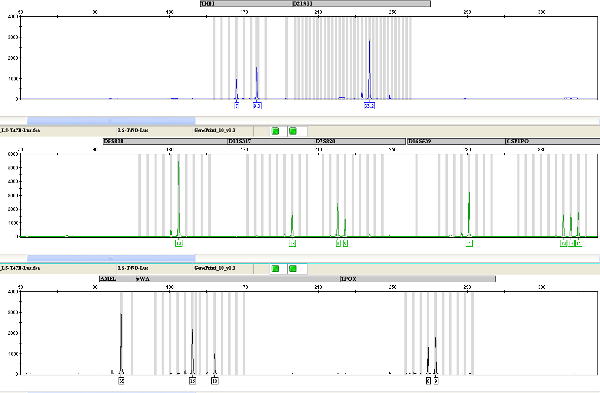
Appendix
Appendix Figure 1. Short tandem repeats (STR) profiling of MDA-MB-231 PX462 (Luc2+GFP+)

1 |  | THO1 | D21S11 | D5S818 | D13S317 | D7S820 | D16S539 | CSFIPO | AMEL | vWA | TPOX
 |  | 7,9.3 | 33.2 | 12 | 13 | 8,9 | 12 | 12,13,14 | X | 15,18 | 8,9
Cell line | Match
HTB-26 | 100% | 7,9.3 |  | 12 | 13 | 8,9 | 12 | 12,13 | X | 15,18 | 8,9
MDA-MB-231 | 100% | 7,9.3 |  | 12 | 13 | 8,9 | 12 | 12,13 | X | 15,18 | 8,9

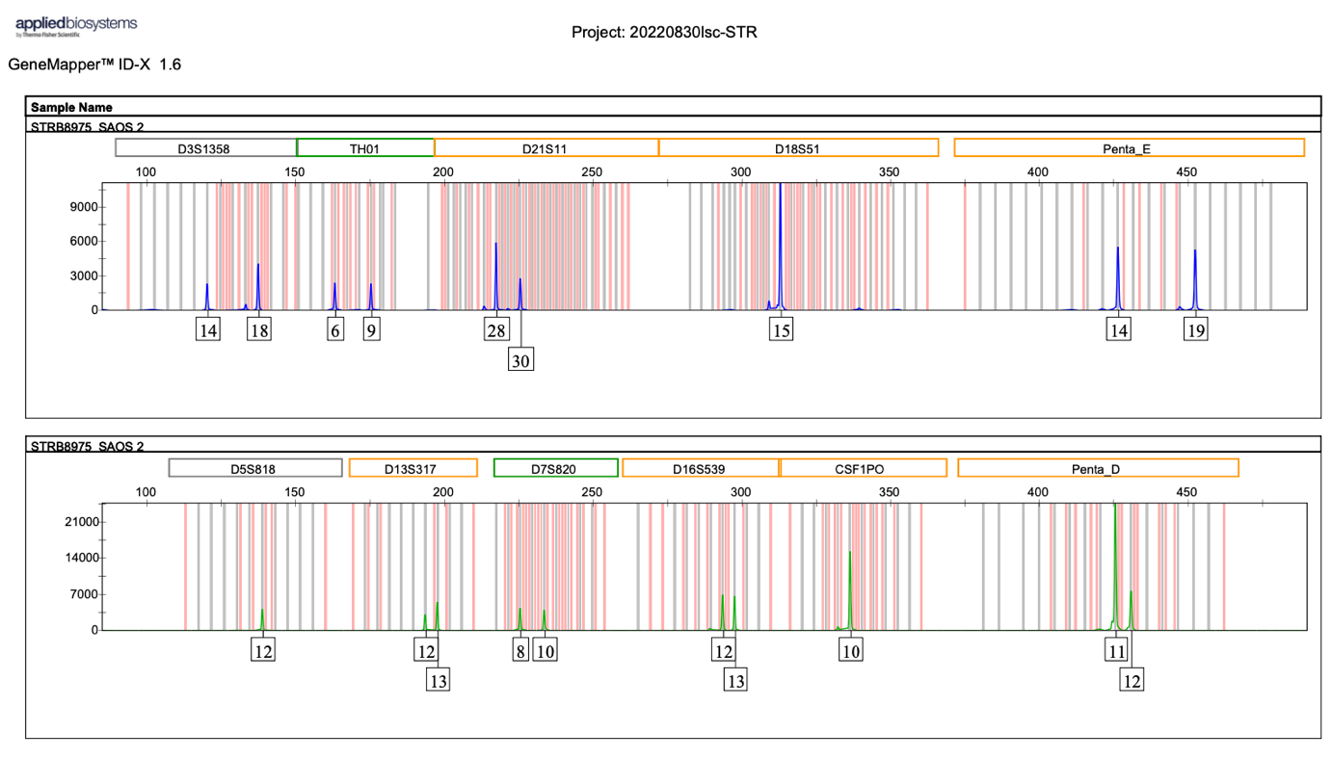
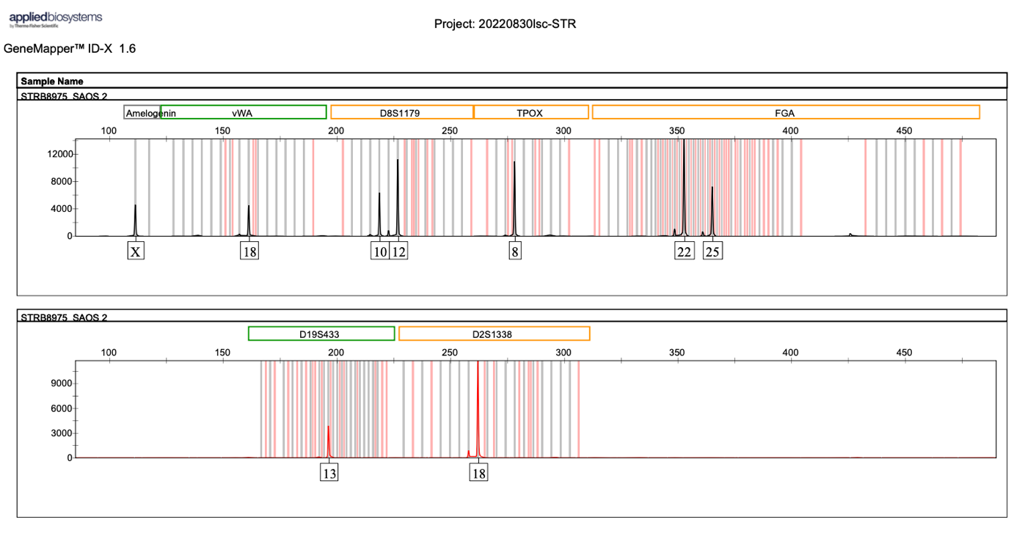


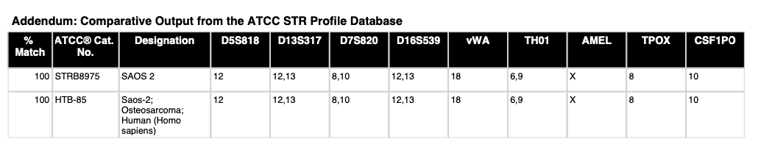
Appendix Figure 2. Short tandem repeats (STR) profiling of SAOS-2 cells

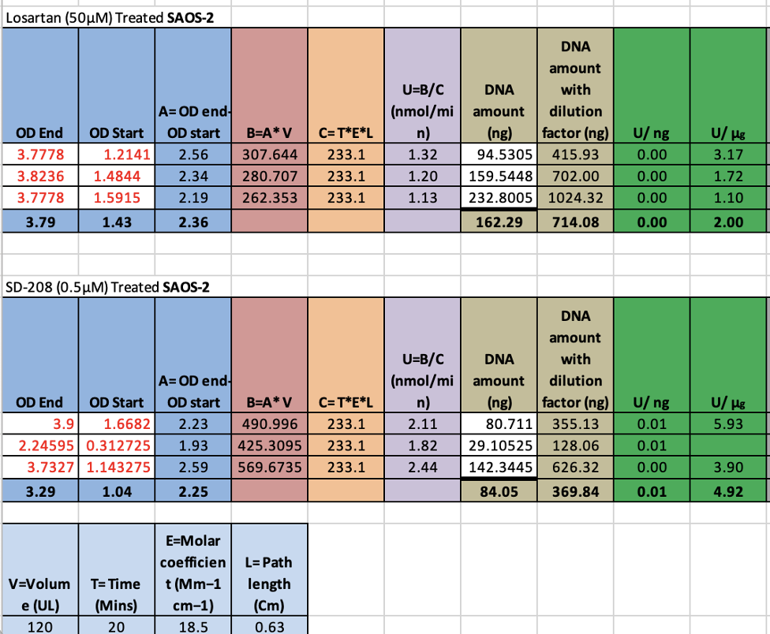
Appendix Figure 3. Example of ALP calculation

Appendix Figure 4. Power calculation
Calculation 1. Based on on Mohammad et al, 2009 study in SD-208 treatment having bone anabolic effect on tumour free mice

Using Cohen’s d to calculate effect size, vehicle 11.6, SD 0.116. SD-208 20, SD 0.2.

Effect size: $\frac{0.2-0.116}{3.55}≈$ 10.46
Using G* software, where Effect size (d): 10.46, required number of mice per group$≈$ 6.

Calculation 2. Based on Morita et al, 2024 study in losartan treatment affecting osteoclasts in bone.
Using Cohen’s d to calculate effect size, vehicle 19.7, SD 4.1. losartan 14.2, SD 2.9.
SD= $\frac{√{4.1}^{2}-{2.9}^{2}}{2}≈$ 3.55

Effect size: $\frac{19.7-14.2}{3.55}≈$ 1.55
Using G* software, where Effect size (d): 1.55, required number of mice per group$≈$ 8.

Calculation 3. Based on Mohammad et al, 2009 study in SD-208 treatment affecting osteoclasts in bone.
Using Cohen’s d to calculate effect size, vehicle 21.6, SD 3.5. SD-208 13.6, SD 3.5.
Effect size: $\frac{21.6-3.5}{3.5}≈$ 2.29
Using G* software, where effect size 2.29, required number of mice per group$≈$ 5

