

The lived experiences of young British female Muslims in a secondary school: Exploring faith membership, religious practices and identities

By: Sabiha Khan
Supervised by: Dr Sean Octagon and Professor Rebecca Lawthom
Student number: 220110378
The University of Sheffield
Research thesis submitted in part of the requirement for the Doctor of Educational and Child Psychology
School of Education
Submission date: June 2025

Abstract
While existing literature acknowledges the importance of religious and cultural identity in adolescence, there remains a gap in understanding how these processes unfold for Muslim students in mainstream secondary schools in the UK. This research explores the lived experiences of five young British female Muslims in Years 8 to 10 (ages 12-15) attending an all-girls mainstream secular secondary school, with a particular focus on their experiences of faith membership, religious practice, and identity development. To address this, the study employed semi-structured interviews and adopted an Interpretative Phenomenological Analysis (IPA) approach. All participants identified as Muslim females and were part of the same school community, offering insight into how religious identity is navigated within a secular educational environment.

Following the Larkin et al. (2021) model, the IPA methodology is grounded in a phenomenological epistemology and ontology, centring the participants’ subjective experiences. The analysis generated five Group Experiential Themes (GETs). The first, A General Shift in Muslim Family Dynamics, explores evolving generational perspectives on faith and identity. The second, Community Bonds, highlights the significance of peer and local networks in shaping religious belonging. The third, Relational Belonging and Identity Integration, examines how students reconcile their Muslim identity with broader school and societal expectations. The fourth, Individuality in a Conformist World, reflects the tension between personal expression and perceived cultural or institutional norms. Finally, Balancing Freedom and Responsibility captures the participants’ negotiation of autonomy within religious and familial frameworks.

This study explores how young British female Muslims navigate faith, belonging, and identity within secular school contexts. By amplifying their voices, it reveals faith as a source of resilience and underscores the need for inclusive educational environments that support intentional identity development and affirm complex, culturally rooted identities.

Acknowledgements
This thesis marks the culmination of a deeply personal and transformative journey, one that would not have been possible without the unwavering support, guidance, and love of those around me.

First and foremost, I would like to express my sincere gratitude to my research supervisors. Your expertise, patience, and thoughtful guidance have been instrumental in shaping this work. Thank you for challenging me to think critically, for encouraging my growth, and for believing in my potential even when I doubted myself.

To my family, thank you for being my foundation. Your constant encouragement, understanding, and sacrifices have carried me through the most demanding moments of this journey. I am especially grateful to my children, whose laughter, resilience, and love have been my greatest source of hope and inspiration. You remind me every day why this work matters.

This thesis is dedicated to the memory of my late father. Though you are no longer here to see this milestone, your values, strength, and quiet wisdom continue to guide me. I carry your spirit with me in every step I take.

إِنَّ مَعَ الْعُسْرِ يُسْرًا
"Indeed, with hardship comes ease."
— Surah Ash-Sharh (94:6)

Abbreviations
EP | Educational Psychologist
TEP | Trainee Educational Psychologist
ES | Experiential Statements
GETs | Group Experiential Themes
IPA | Interpretive Phenomenological Analysis
PETs | Personal Experiential Themes
RQ1 | Research Question 1
RQ2 | Research Question 2
RQ3 | Research Question 3
SENDCO | Special Educational Needs Co-Ordinator
SDT | Self-Determination Theory

Contents
The lived experiences of young British female Muslims in a secondary school: Exploring faith membership, religious practices and identities 1
Abstract 2
Acknowledgements 3
Abbreviations 4
Contents 5
Chapter 1: Introduction 9
Overview of Thesis 9
From Culture To Faith: A Journey Of Bravery And Reorientation 9
Research interests 10
The current context 14
Identifying need in the educational system 15
Research questions 16
Primary Research Question (RQ) 16
Secondary research question (RQ) 17
Definitions 17
Introduction Summary 18
Chapter 2: Literature Review 19
Introduction 19
Part 1: 22
Faith Membership in the school context 22
Integrating Faith in the Curriculum: Psychological and Pedagogical Perspective 24
Islamic Psychology: Theoretical Frameworks Informing the Study 26
Religious Practice and Psychological Needs 29
Identity Formation and the Islamic Self 31
Part 2: Research into the lived experiences of young British Muslim 33
Part 3: Research Justification 37
Literature review conclusion 39
Chapter 3: Methodology 41
Part 1: Introduction 41
Ontological and epistemological positioning 41
Interpretative Phenomenological Analysis (IPA) 45
Phenomenology 45
Idiography 46
Hermeneutics 48
Ensuring Quality and Rigour in Qualitative Research 52
Researcher Reflexivity and Ensuring Quality in IPA 53
Ethical Considerations 56
Part 2: Procedure and Design 58
Participant Selection and Recruitment 58
Sampling, Recruitment, and Limitations 58
Methods and Data Collection 62
Pilot Study 62
Semi-Structured Interviews 63
Transcription 64
Analysis 64
Methodology Summary 68
Chapter 4: Analytical Findings 70
GET 1: A General Shift in Muslim Family Dynamics 71
GET 2: Community Bonds 74
GET 3: Relational Belonging and Identity Integration 80
GET 4: Individuality in a Conformist World 87
GET 5: Balancing Freedom and Responsibility 93
Findings Summary 96
Chapter 5: Discussion 98
GET 1: General Shift in Muslim Family Dynamics 99
GET 2: Community Bonds 106
GET 3: Relational Belonging and Identity Integration 111
GET 4: Individuality in a Conformist World 115
GET 5: Balancing Freedom and Responsibility 121
Discussion Summary 127
Chapter 6: Key Findings, Strengths, Limitations, Implications and Future Research 129
Key Findings 129
Strengths 132
Limitations 133
Implications for Educational Psychology Practice 134
Recommendations for Future Research 136
Key Findings, Strengths, Limitations, Implications and Future Research Summary 138
References 140
Appendix 158
Appendix 1 – Researcher Reflections: Sample Log Entries 158
Appendix 2 – Prompts for Researcher Reflexivity and Reflection 165
Appendix 3 – Ethics Submission and Supporting Documents 167
Appendix 4 – Confirmation of Ethical Clearance 175
Appendix 5 – Protocol for Managing Participant Distress 176
Appendix 6 – Correspondence with Participating School 177
Appendix 7 – Information Sheet for Parents and Carers 178
Appendix 8 – Information Sheet for Student Participants 180
Appendix 9 – Consent Form for Parents/Guardians 181
181
Appendix 10 – Consent Form for Student Participants 182
Appendix 11 – Participant Profile Summary 183
Appendix 12 – Sample Interview Transcript 187
Appendix 13 – Sample Analysis: Stage 2 of IPA Process 188
Appendix 14 – Sample Analysis: Stage 3 of IPA Process 189
Appendix 15 – Sample Analysis of Personal Experiential Themes (PETs) 190
Appendix 16 – Sample Analysis of Group Experiential Themes (GETS) 191

Chapter 1: Introduction

Overview of Thesis
In recent years, the experiences of young British Muslims in secondary schools have come under increasing academic and public scrutiny, particularly in relation to identity, inclusion, and belonging. As a growing and diverse demographic, British Muslim youth navigate complex intersections of faith, culture, and national identity within educational environments that are often shaped by secular norms and limited cultural responsiveness. These dynamics raise important questions about how faith membership and religious practice are experienced and expressed in school settings, and how these experiences influence identity development.

From Culture To Faith: A Journey Of Bravery And Reorientation
At the start of my research journey, I found myself caught in an internal conflict. I knew I wanted to explore the identity of young people, but I was torn between two deeply personal and meaningful lenses: faith, specifically Islam, and culture, particularly South Asian heritage. Faith felt like the more compelling direction, one that resonated with my own experiences and the lived realities of many young people. Yet, despite this pull, I hesitated.

The political and social climate surrounding Islam felt heavy and fraught with tension. I worried that choosing faith as my focus might expose me to scrutiny or misinterpretation. I feared being asked to defend not just my research, but my own identity. These concerns made me question whether I was brave enough to take that path. And so, I chose culture. It felt safer, more familiar, and still rich with complexity, offering insights into language, tradition, migration, and intergenerational dynamics.

As I began writing my literature review, however, something shifted. Immersing myself in the existing research, I became increasingly aware of the gaps, particularly around faith and how it intersects with identity. I saw how Islam was often overlooked or flattened in academic discourse, and how young people’s spiritual lives were rarely given the space they deserved. The more I read, the more I felt a growing sense of responsibility. I realised that avoiding faith out of fear was not only limiting my research - it was silencing an essential part of the conversation.

It was at this point that I decided to be braver. I returned to my original instinct and shifted my focus to faith. This decision was not easy, but it felt necessary. It was an act of courage, not because the risks had disappeared, but because I had come to understand that meaningful research sometimes requires stepping into uncomfortable spaces. It requires listening deeply, representing responsibly, and being willing to challenge dominant narratives.

Changing my focus from culture to faith was a turning point in my journey. It reflected not only a shift in topic, but a shift in me - as a researcher, as a thinker, and as someone committed to amplifying the voices of young people navigating complex identities. It taught me that bravery in research is not about fearlessness, but about choosing to move forward despite fear, guided by purpose and integrity.

Research interests
The motivation for this research stems from a deeply personal and scholarly interest in understanding how young British female Muslims experience and interpret their faith, values, and practices, elements often associated with what may be described as ‘Islamic culture’ (McKenna and Francis, 2019). This study focuses specifically on how these young individuals construct and express their religious identities within the context of secondary school, while also acknowledging the influence of broader community and cultural dynamics. By centring the school environment, the research aims to explore how faith membership, religious practice, and identity development unfolds in educational settings that may not always reflect or support their spiritual and cultural needs.

At the heart of this inquiry is the recognition that, for many Muslims, the presence and influence of God (Allah) is not merely a theological abstraction but a guiding force that informs daily decision-making, moral reasoning, and long-term aspirations. While the degree of religious observance may vary among individuals, the aspiration to live in accordance with Islamic principles remains a significant dimension of identity for many. This research seeks to understand how such aspirations are negotiated in environments that may or may not affirm religious expression.

Additionally, I found that it was essential to draw upon theories that are grounded in the framework of Islamic Psychology, which examines human development and identity formation through the lens of faith, spirituality, and the inner dimensions of the self. Islamic psychology provides a valuable perspective on how faith membership shapes cognitive, emotional, and behavioural processes, offering insights into how young British female Muslims engage in meaning-making, seek coherence in their identities, and navigate the complexities of living in a pluralistic society. By meaningfully aiming to integrate Western psychological frameworks with the rich spiritual and philosophical traditions of Islamic Psychology, this exploration considers not only the external influences on identity but also the internal spiritual and psychological mechanisms that drive self-conception and moral development. This dual lens allows for a more nuanced and culturally grounded interpretation of the lived experiences shared by the participants. Without this depth of integration, any attempt to infer meaning from the data risks being reductionist and failing to capture the complex interplay between faith, identity, and psychological well-being that shapes their inner worlds.

As a British Muslim woman, my motivation for this research is not only personal and academic but also shaped by my unique positionality. I am working specifically with young Muslim women, and I acknowledge that my access to and understanding of their experiences is shaped by shared aspects of gender, faith, and cultural background. This insider perspective allows me to engage with participants in a way that is both empathetic and contextually informed. I do not claim to speak for all Muslim youth, nor do I assume a universal experience of faith. However, I recognize that my own identity affords me a particular closeness to the experiences of young Muslim girls, experiences that may differ significantly from those of their male peers.
This gendered lens is not incidental; it is central to the research. The voices of young Muslim women are often underrepresented in both educational and psychological research, and this study seeks to foreground their perspectives. My own journey of negotiating faith, identity, and belonging as a Muslim woman informs my sensitivity to the nuances of their narratives. At the same time, I remain critically reflexive about the boundaries of my perspective, striving to approach each participant’s story with openness and academic rigor (refer to the Methodology chapter for Researcher Positionality).

By focusing on young females in secondary school contexts, this research aims to illuminate how gender, faith, and identity intersect in the lives of Muslim girls navigating both affirming and challenging environments. It is through this lens, shaped by both shared experience and scholarly inquiry, that I seek to contribute to a more inclusive and nuanced understanding of Muslim youth identity in contemporary Britain.

Chapter One introduces the study, The lived experiences of young British female Muslims in a secondary school: Exploring faith membership, religious practices and identities. It begins by defining key terms and outlining the central research questions. The chapter sets the context by exploring the current realities faced by young British Muslims in secondary schools, where faith, identity, and belonging intersect in complex ways. It highlights the significance of understanding how these students experience religious practice and navigate identity formation within educational environments that may not always reflect or support their cultural and spiritual needs.

Chapter Two, the literature review, is structured in three parts. The first draws on Islamic and Western psychology to explore faith in school settings, the role of religious practice in meeting psychological needs, and the formation of the Islamic self. The second reviews research on the lived experiences of young British Muslims specifically focusing on how they navigate, faith membership in secular or pluralistic school environments, religious practice and its expression in public and educational spaces and identity development, including how they reconcile religious, cultural, and national affiliations. The third offers a rationale for the study, highlighting its relevance and contribution.

Chapter Three outlines the study’s methodological approach. It begins with the philosophical foundations, including ontological and epistemological positioning, and introduces Interpretative Phenomenological Analysis (IPA) as the guiding framework. The chapter also addresses quality, reflexivity, and ethics. The second part details the research design, including participant recruitment, data collection through semi-structured interviews, transcription, and analysis.

Chapter Four presents the study’s findings through five Group Experiential Themes (GETs): shifting Muslim family dynamics, community bonds, relational belonging and identity integration, individuality within conformity, and balancing freedom with responsibility. Each theme offers insight into how young British female Muslims navigate identity, belonging, and autonomy.

Chapter Five interprets these themes in relation to existing literature and theory. It explores how participants’ experiences reflect broader cultural and psychological dynamics, offering a deeper understanding of identity negotiation, community influence, and personal agency within faith-based contexts.

Chapter Six concludes the thesis by synthesizing the key findings and explicitly relating them back to the research questions. It reflects on the study’s strengths and limitations, and discusses the broader implications for Educational Psychology, particularly in relation to identity, inclusion, and faith-sensitive practice. The chapter also offers recommendations for future research and educational policy, emphasizing the evolving nature of identity and belonging among young British Muslims in contemporary school contexts.

The current context
Recent qualitative research by Kapinga et al. (2023) offers valuable insights into the evolving nature of religious identity among young Muslims in the UK. Their findings indicate that during mid-adolescence, young people begin to engage in a more autonomous exploration of their faith, gradually differentiating their personal beliefs and practices from those of their parents. This period of individuation is marked by a shift away from inherited cultural-religious frameworks, often tied to parental countries of origin, toward more localized and personally meaningful expressions of Islamic identity.

Notably, the study reveals that sacred geographies, such as Mecca, gain symbolic prominence in the participants’ spiritual consciousness, while traditional associations with ancestral homelands become less central. This suggests that young Muslims are not merely inheriting religious identities but are actively reconstructing them in ways that are embedded in their everyday British contexts. Such findings challenge essentialist and stereotypical portrayals of Muslim youth as rigidly bound to transnational or culturally static notions of Islam.

Kapinga et al.’s (2022) work also contributes to a growing body of literature that critiques the secularisation thesis, which posits a decline in the relevance of religion in modern societies (Maliepaard and Phalet, 2012). Contrary to this paradigm, there is increasing evidence that religion remains a salient, and in many cases, intensifying dimension of identity for young Muslims in Western contexts (Anjum, et al., 2023; Voas & Fleischmann, 2012). Rather than being passively inherited, religious identity is increasingly experienced as a conscious, agentic, and chosen aspect of selfhood (Alba, 2005; Peek, 2005). For many young British Muslims, faith membership is not just a belief system but a central component of identity. It informs their values, moral reasoning, and social affiliations. However, the extent to which this identity is supported or challenged in school environments varies widely. In some schools, particularly those with inclusive or faith-sensitive policies, students feel affirmed. In others, they may experience marginalization, stereotyping, or pressure to assimilate, which can lead to internal conflict or identity suppression (Gilani, 2023).

Moreover, Kapinga et al.’s (2022) study highlights a process of “re-culturalisation” of religious identity, wherein being Muslim is increasingly associated with British cultural references and social realities. This counters the notion that religious identity is de-culturalised or detached from local contexts. Instead, young Muslims appear to be constructing hybrid identities that are both rooted in Islamic values and responsive to the socio-cultural dynamics of contemporary Britain.

Gilani (2023) highlights how Muslim students in British schools often encounter unconscious bias, which can undermine their sense of belonging and discourage open expressions of faith. Writing from a policy and advocacy perspective, Gilani (2023) emphasizes the importance of recognizing faith as a source of motivation, inspiration, and resilience for Muslim children and young people. Building on these insights, my research seeks to explore in greater depth how young British female Muslims navigate their faith, values, and practices within both school and community contexts. By focusing on the lived experiences of Muslim female adolescents in secondary schools, this study aims to contribute to a more nuanced understanding of how religious identity is shaped, negotiated, and expressed and how these processes inform broader aspects of identity development and decision-making.

Identifying need in the educational system
Despite increasing attention to diversity and inclusion in British education, the specific experiences of young British Muslims in secondary schools remain underexplored in Educational Psychology. Existing research often treats Muslim identity as monolithic or focuses narrowly on issues of extremism and integration, overlooking the everyday realities of faith practice, belonging, and identity negotiation. There is a critical need to understand how school environments, through policies, peer interactions, and teacher attitudes, affect Muslim students’ ability to maintain their religious identity, engage in faith practices, and develop a positive sense of self. Without this understanding, educational institutions risk perpetuating environments that hinder rather than support the holistic development of Muslim adolescents.
Recent research emphasizes the importance of understanding Muslim students on their own terms, rather than through deficit-based or securitized lenses (Malik & Wykes, 2018). This includes recognizing the diversity within Muslim communities and the varied ways in which young people relate to their faith. Faith membership is not monolithic; it is shaped by personal conviction, family influence, and social context.

Research questions
The formulation of my research questions is grounded in my epistemological stance, which prioritizes the exploration of participants lived experiences of faith membership, practice and identity development within a secondary school setting. These questions are intentionally open-ended and exploratory in nature, designed to elicit rich, interpretive insights into the meanings participants ascribe to their experiences.

Primary Research Question (RQ)
The primary research question provides a criterion for evaluating the study’s success in meeting its objectives.

RQ1: How do young British female Muslims perceive and experience faith membership within the context of secondary school environments and in their communities?

RQ2: How do young British female Muslims, in secondary schools and in their communities, process identity development in relation to their religious, cultural, and national affiliations?

Secondary research question (RQ)
As articulated by Smith (2004), secondary research questions are frequently shaped by theoretical considerations and are typically examined within an interpretive paradigm. Within the framework of Interpretive Phenomenological Analysis (IPA), such inquiries are instrumental in advancing theoretical understanding, rather than being primarily oriented toward the testing of hypotheses.

RQ3: What can educationalists learn from the lived experiences of young British female Muslims in secondary schools and in their communities, to foster inclusive, faith-sensitive educational environments?

Definitions
Young British Muslims are individuals aged approximately 11 to 25 who identify as Muslim and have grown up in the UK. This group navigates faith, identity, and belonging within both British society and their cultural or religious communities.

Faith Membership refers to an individual’s sense of belonging to a religious tradition or community, encompassing both personal identification with a set of beliefs and participation in associated practices and social networks. For young Muslims, this may involve religious upbringing, engagement in communal worship, adherence to Islamic values, and the internalisation of a Muslim identity within both private and public spheres.

Religious Practice refers to the observable expressions of faith, including rituals, worship, moral conduct, and daily behaviours guided by religious teachings. For young Muslims, this may involve practices such as prayer (ṣalāh), fasting during Ramadan, attending mosque, wearing religious attire, and adhering to Islamic ethical principles in everyday life.

Identity Development refers to the ongoing process through which individuals form a coherent sense of self, shaped by personal experiences, social interactions, and cultural or religious influences. For young Muslims, this process often involves negotiating multiple identities, religious, cultural, and national, while navigating the expectations of both their faith communities and wider British society.

Introduction Summary
This chapter outlines the contextual and personal motivations underpinning this study, which explores the lived experiences of young British female Muslims in a secondary school setting, particularly in relation to faith membership, identity development, and religious practice. My professional and personal journey has shaped a reflective and critical engagement with how identity and belonging are negotiated within educational environments.

The chapter situates the research within broader discourses on inclusion, identity, and faith in education, challenging dominant paradigms that often marginalise or overlook the spiritual and cultural dimensions of student experience. It critically examines how institutional frameworks, including secularism in education and intersectionality (Crenshaw, 1989) may obscure or inadequately address the complex realities of students whose identities are shaped by both religious and cultural affiliations.

In articulating the research questions and key definitions, this chapter affirms a commitment to understanding how young British female Muslims make sense of their identities within the pluralistic and, at times, contested space of the secondary school. It sets the foundation for subsequent chapters, which delve into the relational, spiritual, and sociocultural dynamics that inform participants’ experiences, highlighting the interconnectedness of faith, identity, and educational practice.

Chapter 2: Literature Review

Introduction
The objective of this literature review is to explore the experiences of young British Muslims in secondary schools, with a particular focus on faith membership, religious practice, and identity development. To achieve this, a narrative review approach was adopted. This method was chosen for its flexibility in synthesizing diverse sources and for its suitability in capturing the complexity and contextual richness of identity-related experiences across educational and community settings.

The review integrates insights from a wide range of sources, including peer-reviewed journal articles, academic books, policy reports, and relevant grey literature. The search strategy involved a combination of systematic keyword searches and snowball sampling. Databases such as StarPlus (University Library Discovery), PsycINFO, Scopus, Taylor and Francis, Google Scholar and IAIP (International Association of Islamic Psychology) were used to identify relevant literature. Key search terms included: “British Muslim students,” “faith and education,” “Islamic identity development,” “religious practice in schools,” “Muslim youth in the UK,” and “intersectionality and religion.” To explore the psychological and spiritual dimensions of identity, additional terms from Islamic psychology were incorporated, such as “Islamic psychology,” “nafs,” “qalb,” “ruh,” “fitrah,” “tazkiyah al-nafs,” “Islamic self,” and “spiritual development in Islam.” These terms helped identify literature that bridges classical Islamic thought with contemporary psychological frameworks, particularly in relation to self-understanding, moral agency, and identity formation. Boolean operators (e.g., AND, OR) were used to refine results, and filters were applied to prioritize literature published within the last 15 years, while also including seminal works where relevant.

In addition to database searches, reference lists of key articles were reviewed to identify further relevant studies. Literature was selected based on its relevance to the research questions, theoretical contribution, and methodological rigor. The review process was iterative and reflexive, allowing for the inclusion of emerging themes and perspectives that aligned with the study’s conceptual framework.

This narrative synthesis not only maps the existing knowledge base but also identifies gaps in the literature, particularly around the intersection of faith, gender, and identity in school contexts. These insights inform the rationale for the current study and help position it within the broader field of educational and psychological research.

Part One of the literature review explores faith membership, religious practice, and identity formation among young British Muslims within the school context. This section draws on both Islamic and Western psychological perspectives to deepen understanding of these themes. Islamic psychology offers a spiritually grounded and holistic framework, integrating classical Islamic thought with contemporary psychological insights to examine how Muslim adolescents internalize and express their faith in modern settings. Key Western theoretical lenses, Self-Determination Theory (SDT), Social Identity Theory, and Faith Development Theory, were self-selected based on their conceptual relevance to the study’s focus on belief, practice, and identity among young British Muslims. These frameworks were chosen through a reflective and iterative review of the literature, guided by the research questions and the thematic concerns emerging from both Islamic and educational psychology. Together, they offer a comprehensive basis for analysing the interplay between internal motivation, group belonging, and spiritual development, while allowing for meaningful integration with Islamic psychological concepts.
Choosing to include Islamic psychology was not just an academic decision, it was a personal one. It reflected my desire to honour the richness of Islamic thought and to acknowledge the ways in which faith can be central to identity formation. However, as I engaged more deeply with the literature, I became aware of the tensions and limitations within the field. I recognised that Islamic psychology, like any framework, is not without its complexities and areas that invite critique.

Yet I made a conscious decision not to critique it within the scope of my literature review. This was not due to a lack of critical insight, but rather a recognition of the emotional and political weight that such critique carries. Islamic psychology is still emerging as a formal discipline, often developed in response to the marginalisation of Muslim voices in mainstream psychology. To critique it prematurely, without sufficient space to explore its theological and epistemological foundations, felt not only unfair but potentially harmful.

There was also a personal dimension to this choice. As a Muslim researcher, I felt a responsibility to approach Islamic psychology with care and respect. I was aware of the risk that critique could be misinterpreted, not as constructive engagement, but as rejection or internalised doubt. I wanted to create space for Islamic psychology to be seen as valid and valuable, especially for young people whose identities are shaped by faith in ways that are often misunderstood or ignored in psychological discourse.
In choosing not to critique Islamic psychology, I was not avoiding complexity - I was acknowledging it. I was recognising the need for more nuanced, culturally sensitive, and spiritually informed research. My literature review became a space to introduce Islamic psychology as a meaningful framework, while leaving room for future scholarship to engage with its limitations in ways that are thoughtful, respectful, and grounded in lived experience.

Young British Muslims in secondary schools navigate the complex intersection of religious, cultural, and national identities. Their experiences are shaped by school settings, peer relationships, and wider societal narratives surrounding Islam and multiculturalism. Part Two synthesizes empirical studies and theoretical insights to examine how Muslim adolescents, both girls and boys, engage with faith membership, religious practice, and identity development. It draws on a diverse body of literature to reflect the varied experiences across gender, while also identifying key gaps in current research, particularly in relation to gendered expressions of faith and identity. The chapter concludes by underscoring the significance of addressing these gaps and positioning this study as a necessary contribution to the field of Educational Psychology.

Part 1:

Faith Membership in the school context
This study is informed by a constellation of theoretical frameworks that collectively provide a robust foundation for exploring the lived experiences of young British Muslims in secondary schools. Specifically, it draws upon Self-Determination Theory (SDT), Social Identity Theory, Faith Development Theory, Intersectionality, and critical perspectives on Secularism in Education. These frameworks offer complementary insights into the ways in which faith membership, identity development, and religious practice are negotiated within educational contexts.

Self-Determination Theory (SDT)
SDT (Deci & Ryan, 1985; 2000) posits that human motivation and psychological well-being are contingent upon the fulfilment of three basic psychological needs: autonomy, competence, and relatedness. In the context of this study, SDT provides a valuable lens for understanding how young British Muslims experience school environments that either support or constrain their ability to express their religious identities. When students are afforded the autonomy to observe religious practices, feel competent in navigating their dual identities, and experience a sense of relatedness with peers and educators, they are more likely to thrive. Conversely, environments that marginalise or suppress faith expression may hinder students’ motivation, engagement, and overall well-being.

Social Identity Theory
Social Identity Theory (Tajfel & Turner, 1979) offers a framework for examining how individuals derive a sense of self from their membership in social groups. This theory is particularly relevant for understanding how young Muslims navigate their religious, cultural, and national identities within the pluralistic and, at times, secular landscape of British secondary schools. The theory highlights the psychological processes of in-group identification and out-group differentiation, which can influence students’ experiences of belonging, exclusion, and identity negotiation. For many participants, being Muslim is not only a personal belief system but also a salient social identity that shapes their interactions and perceptions within the school environment.

Faith Development Theory
Faith Development Theory (Fowler, 1981) provides a developmental perspective on how individuals engage with and internalise their faith over time. Fowler’s model outlines a progression through stages of faith, with adolescence typically marked by a transition from synthetic-conventional to individuative-reflective faith. This stage is characterised by increased self-reflection, critical examination of inherited beliefs, and the search for personal meaning. For young British Muslims, this developmental process is often situated within a broader context of cultural hybridity and institutional secularism, making the negotiation of faith particularly complex. Faith Development Theory thus offers a nuanced understanding of how religious identity evolves in response to both internal maturation and external influences.

Intersectionality
The concept of intersectionality, introduced by Crenshaw (1989), is essential for understanding how multiple, overlapping social identities, such as religion, ethnicity, gender, class and dis/ability, interact to shape individual experiences. Intersectionality challenges reductionist approaches by recognising that young British Muslims may face compounded forms of marginalisation. For instance, a Muslim girl who wears a hijab may simultaneously encounter Islamophobia, racial stereotyping, and gendered expectations. This framework underscores the importance of attending to the complexity of students’ lived realities and the ways in which structural inequalities manifest within educational settings.

Secularism in Education
Critical perspectives on secularism in education further illuminate the institutional context in which young Muslims navigate their identities (Sali, 2023; Sahin, 2018; 2015). While secularism is often framed as a neutral stance, it can function as a normative framework that marginalises religious expression, particularly for minority faiths. In many UK secondary schools, secular policies may inadvertently suppress visible expressions of Islamic faith, such as prayer, fasting, or religious dress, under the guise of neutrality or uniformity. This creates a hidden curriculum in which students may internalise the message that their faith is incompatible with academic or social success. By interrogating the role of secularism, this study seeks to uncover how institutional norms shape the visibility, legitimacy, and accommodation of religious identities in school spaces.

Together, these theoretical frameworks provide a multidimensional lens through which to examine the lived experiences of young British Muslims. SDT foregrounds the emotional and motivational aspects of faith expression; Social Identity Theory situates identity within broader social dynamics; Faith Development Theory captures the internal evolution of belief; Intersectionality reveals the compounded nature of marginalisation; and critiques of secularism expose the institutional forces that shape religious visibility and belonging. This integrative approach enables a deeper understanding of the complex interplay between faith, identity, and educational experience, and informs the study’s commitment to promoting inclusive, faith-sensitive educational practices.

Integrating Faith in the Curriculum: Psychological and Pedagogical Perspective
In UK secondary education, the inclusion of faith within the curriculum is both a statutory requirement and a vital component of inclusive educational practice. Religious Education (RE) is mandated in all state-funded schools in England, though it is not part of the National Curriculum. Instead, it is shaped by locally agreed syllabi or, in the case of academies and free schools, by their funding agreements (Department for Education, 2010). This flexibility allows schools to tailor RE to reflect local demographics and values, but it also introduces variability in how faith is represented and taught. From an Educational Psychology perspective, this variability has significant implications for adolescent development. Erikson’s (1968) theory of psychosocial development identifies adolescence as a critical period for identity formation, during which young people explore and consolidate their beliefs and values. Schools that provide inclusive, dialogic spaces for students to engage with diverse religious and non-religious worldviews can support this identity work and foster a sense of belonging.

Bronfenbrenner’s (1979) ecological systems theory further highlights the role of schools as microsystems that interact with broader cultural and institutional forces. Inclusive practices, such as offering multi-faith RE syllabi, facilitating respectful interfaith dialogue, and accommodating religious observances, help students feel seen and respected within the school environment. The Research Review Series: Religious Education by Ofsted (2021) emphasizes that high-quality RE should be intellectually challenging, personally enriching, and inclusive of both religious and non-religious perspectives. This aligns with Vygotsky’s (1978) sociocultural theory, which posits that learning is mediated through social interaction and cultural tools. When students are encouraged to engage in discussions about belief systems and ethical dilemmas, they develop not only cognitive and moral reasoning but also empathy and intercultural understanding.

Case studies from local authorities and schools illustrate how these inclusive practices are implemented. For example, Croydon’s Standing Advisory Council on Religious Education (SACRE) provides detailed guidance for schools on how to accommodate pupils of faith, including allowing time off for religious festivals, providing prayer spaces, and ensuring that school events are inclusive of all cultural and religious backgrounds (Croydon SACRE, 2025). The guidance emphasizes the importance of fostering an environment where diversity is celebrated and all students feel safe to express their beliefs. Similarly, the Birmingham Agreed Syllabus for Religious Education promotes a multi-faith approach that includes Christianity, Islam, Hinduism, Sikhism, Buddhism, Judaism, and Humanism, encouraging students to explore both shared values and distinct beliefs.

These practices are further supported by institutional frameworks such as Queen Mary University of London’s Inclusive Curriculum and Educational Practice Guide, which advocates for inclusive pedagogies that recognize and validate multiple forms of knowledge and identity (Queen Mary University of London, 2022). These examples demonstrate how inclusive RE can serve as a vehicle for promoting social cohesion, reducing prejudice, and supporting the psychological well-being of all students, regardless of their faith background.

Islamic Psychology: Theoretical Frameworks Informing the Study
Rothman and Coyle’s (2018) work, “Toward a Framework for Islamic Psychology and Psychotherapy: An Islamic Model of the Soul”, presents a foundational attempt to articulate an Islamic psychology that is rooted in the cosmology of the Islamic tradition. Their framework moves beyond Western psychological models, arguing that an authentically Islamic approach must begin with an understanding of the human soul as conceptualized within Islamic thought.

At the heart of their model is the tripartite structure of the soul, “nafs” (the lower self), “qalb” (the heart), and “ruh” (the spirit), which interact dynamically in shaping human behaviour and psychological well-being. This conceptualization aligns with classical Islamic scholarship, particularly the works of Al-Ghazali and Ibn Qayyim (Arroisi and Rahmadi, 2022), who emphasized the purification of the soul as central to personal development and spiritual fulfilment. Rothman and Coyle’s framework suggests that psychological distress often arises from an imbalance within these components, where the “nafs” dominates, leading to inner conflict and disconnection from divine purpose.

For young British Muslims navigating secondary school, this model offers a compelling lens through which to examine faith membership, religious practice, and identity formation. Adolescence is a critical period for self-definition, and the tensions between cultural expectations, peer influences, and religious commitments can create psychological struggles. The Islamic psychology framework posits that fostering a strong connection to “qalb” and “ruh”, through spiritual practices such as prayer, reflection, and community engagement, can help mitigate these challenges and support a more cohesive identity.

This perspective is reinforced by other Islamic psychology theories, such as Malik Badri’s critique of Western psychological paradigms and his call for an Islamic approach that integrates spirituality with mental health. Badri’s work highlights the importance of “tazkiyah” (purification of the soul) as a means of achieving psychological resilience, a concept that resonates with Rothman and Coyle’s emphasis on the development of the soul. Similarly, Haque et al. (2016) argue that Islamic psychology must be grounded in an understanding of human nature that prioritizes spiritual well-being alongside emotional and cognitive health.

In the context of young British Muslims, these theories suggest that identity formation is not merely a social or psychological process but a deeply spiritual one. The struggle to balance religious practice with contemporary societal norms can be understood as an internal negotiation between the “nafs” and “qalb”, where external pressures may amplify the dominance of the lower self. However, Islamic psychology offers a pathway toward integration, advocating for practices that strengthen the heart’s connection to divine guidance and foster a sense of belonging within both faith and society.

By situating Rothman and Coyle’s (2018) framework within broader Islamic psychology discourse, this literature review underscores the relevance of an Islamic model of the soul in understanding the lived experiences of young British Muslims. Their journey through secondary school is not just about academic achievement or social adaptation - it is a profound process of self-discovery, where faith, identity, and psychological well-being are intricately intertwined.

In Islamic psychology, faith (īmān) is not merely a belief system but a dynamic, evolving relationship with God (Allah) that encompasses the heart (qalb), intellect (‘aql), and actions (‘amal). Adolescents are seen as entering a stage of moral and spiritual accountability (taklīf), where they begin to take personal ownership of their faith. SDT, when integrated with Islamic principles, emphasizes the importance of autonomy, competence, and relatedness in fostering sincere religious commitment. A study by Saafir and Umarji (2024) at the Yaqeen Institute shows that adolescents are more likely to internalize Islamic values when they feel supported in making faith-based decisions autonomously, rather than through coercion- a finding that gains particular significance in Muslim-minority contexts such as the UK or the US. In these environments, where Muslim youth often navigate competing cultural expectations and may experience marginalization or identity conflict, autonomy-supportive parenting and educational practices are essential for fostering a secure and meaningful connection to faith. This aligns not only with SDT, which emphasizes the psychological need for autonomy, competence, and relatedness, but also with principles from Islamic psychology (Ilm al-Nafs), which view the human being (insān) as a spiritual, moral, and rational agent endowed with fitrah, the innate disposition toward truth and goodness.

Islamic psychology emphasizes the importance of nurturing the fitrah through tarbiyah (holistic development), which includes cultivating moral reasoning, spiritual awareness, and self-regulation. When adolescents are given the space to explore their faith through reflection, dialogue, and personal choice, rather than through fear or authoritarian control, they are more likely to develop a sincere and enduring commitment to Islamic values. This is especially critical in minority contexts, where external validation of religious identity may be limited, and where the school and family environments must work together to provide a sense of belonging and spiritual grounding. Bronfenbrenner’s ecological systems theory further supports this view by highlighting how macrosystemic factors, such as societal attitudes toward Islam, interact with microsystems like family and school to shape adolescent development. In contrast, in Muslim-majority contexts, where Islamic norms are more culturally embedded, the challenge may lie in moving beyond ritual compliance toward internalized conviction, again underscoring the universal importance of autonomy and intentionality in religious development.

Islamic scholars such as Ibn al-Jawzī and Ibn Qayyim describe adolescence as a spiritually volatile period, marked by internal struggles (jihād al-nafs) and the need for guidance. Faith membership during this stage is not static but is actively negotiated through reflection, questioning, and spiritual striving.

Faith membership involves a sense of belonging to a religious tradition and community. For Muslim adolescents, this includes adherence to Islamic beliefs, participation in rituals, and identification with the global ummah. However, in secular or pluralistic school settings, this membership can be challenged or marginalized.
Ipgrave (2010) distinguishes between permissive (tolerant but passive) and affirmative (actively inclusive) approaches to religious diversity. Her findings suggest that permissive environments often fail to support Muslim students’ religious identities, leading to feelings of exclusion. Similarly, Panjwani and Moulin-Stożek (2017) critique the 'religification' of Muslim identity in schools, where students are reduced to their religious affiliation without recognition of their broader identities.
Fowler’s Faith Development Theory posits that adolescents typically move from a conformist to an individuated-reflective stage of faith. Moulin (2012) applies this theory to the UK context, arguing that unsupportive school environments can hinder this developmental progression, leading to internal conflict or compartmentalization of faith and academic life (refer to Integrating Faith in the Curriculum: Psychological and Pedagogical Perspective above).

Religious Practice and Psychological Needs
Research indicates a positive correlation between religious participation and reduced anxiety among adolescents, particularly in contexts where religion plays a significant societal role (Jung, 2015; Peterman et al., 2014). Religious involvement has also been identified as a protective factor against the use of psychoactive substances and substance abuse in young people (Sheppard et al., 2014; Desrosiers et al., 2011; Rostosky et al., 2008) and is associated with positive behavioural changes over time. Increased religiosity has been linked to sociocultural influences on pathological behaviours, such as eating disorders, and religious coping strategies have been shown to enhance psychological adjustment, reduce anxiety, and improve quality of life for individuals with chronic illnesses or interpersonal trauma (Pirutinsky et al., 2012; Carpenter et al., 2012).

While religious and spiritual struggles, characterised by doubt, conflict, and internal or external tensions, can affect coping mechanisms and meaning-making processes (Exline, 2013; Exline et al., 2011, 2014), the broader literature generally supports the view that faith and religion contribute positively to adolescent development. This includes benefits to physical and mental health, as well as resilience in the face of challenges (Torralba et al., 2021). My research seeks to contribute to this discourse by offering a more nuanced understanding of how religion supports identity development in adolescents.

Studies exploring young people's motivations for engaging with their faith highlight several key themes: belief, purpose, personal growth, social connection, and opportunities for leadership (Betts et al., 2022). Scholars have also emphasised the need for educational institutions to engage more openly with discussions around faith, religion, and spirituality, rather than avoiding them (Barton, Cadge, & van Stee, 2020; Braskamp, 2007; Burchell, Lee, & Olson, 2010). In response, this study invites young people to share their experiences of faith and religious practice and examines how these experiences shape their identity development.

Islamic psychology recognizes that religious practice (ʿibādah) is both a spiritual discipline and a means of psychological regulation. Practices such as prayer (ṣalāh), fasting (ṣawm), and remembrance (dhikr) are seen as tools for cultivating emotional resilience, self-discipline, and spiritual awareness. Adolescents who are given the tools and encouragement to practice Islam meaningfully, rather than through fear or shame, are more likely to develop a positive religious identity. This aligns with SDT’s emphasis on competence and relatedness: youth need to feel capable of practicing their faith and connected to a community that supports them.

Communities and schools that foster faith-sensitive environments, by affirming religious practices and providing space for spiritual expression, can significantly enhance adolescents’ sense of belonging and self-worth. Muslim students often face institutional barriers to religious practice, such as lack of prayer facilities, inflexible uniform policies, and limited halal food options. These challenges are documented in studies like the British Muslims and Education report (JSTOR) (Open Society Institute, 2005), which highlights how such exclusions can lead to disengagement and identity suppression.
SDT emphasizes the psychological needs of autonomy, competence, and relatedness. When schools restrict religious expression, they undermine students’ autonomy and relatedness to their faith community. This can lead to either disengagement or resistance. For example, some students may assert their religious identity more strongly in response to perceived marginalization, while others may suppress it to conform.
Shah (2006) explores how Muslim students in multi-ethnic schools navigate these tensions. Her findings suggest that culturally responsive leadership can mitigate the negative effects of exclusion by fostering environments where religious practices are respected and accommodated.

Identity Formation and the Islamic Self
Islamic psychology views identity as rooted in the fitrah, the innate disposition toward belief in God and moral awareness. Adolescence is a critical period for reconnecting with the fitrah, especially as youth navigate competing cultural, social, and ideological influences. Harneker (2024) emphasizes that Islamic identity formation involves answering existential questions such as “Who am I?” and “What do I value?” through the lens of divine purpose and accountability.

The Positive Islamic Identity (PII) model (Pasha-Zaidi and Odeh, 2019) integrates Islamic teachings with developmental psychology to propose a framework where identity is formed through spiritual growth, moral reasoning, and community engagement. Contrary to secular theories that predict a decline in religiosity, Islamic psychology, and supporting empirical research, suggests that religion remains central or even becomes more salient in identity formation among Muslim youth in the West. This is often a conscious, agentic process, where being Muslim is a chosen and meaningful identity, not merely an inherited label (Yucel and Whyte, 2023).

Young British Muslims often construct hybrid identities, integrating elements of Britishness, Islam, and ethnic heritage. Finlay and Green (2017) and the Young British Muslims: Voice in Britain study (SpringerLink, 2024) show that these adolescents actively negotiate their identities in response to both school culture and societal narratives. Tajfel & Turner's (1979) social identity theory discusses that an individual’s sense of self is part dependent on their membership of social groups. According to Tajfel (2010), group memberships gives us a sense of identity and belonging and is a natural part of human experience (Brewer & Brown,1998) with individuals classifying themselves into groups at the micro (e.g., family, friends) and macro level (e.g., nationality, religion, ethnicity, political stance) (Brewer & Brown,1998). Individuals may also categorise others into groups which serve different purposes such as making overly simplistic assumptions about the behaviours and beliefs of others (stereotyping), which can preserve cognitive resources (Wigboldus, Sherman, Franzese, & Knippenberg, 2004). However, stereotyping a group of people can have negative effects such as fostering pre-conceived, oversimplified, and negative attitudes about certain groups (prejudice) (Mackie & Hamilton, 2014).

When Muslim students experience identity threat, for example, through Islamophobic incidents or curriculum exclusion, they may respond with in-group solidarity or identity concealment. Panjwani (2013) warns against the overemphasis on religious identity in policy and media, which can pressure students into defensive identity postures. Students often engage in identity negotiation, balancing religious values with peer expectations and institutional norms. This process is influenced by teacher attitudes, curriculum content, and peer dynamics. Affirmative school environments that validate multiple aspects of identity can support more integrated and resilient self-concepts.

Islamic psychology provides a spiritually congruent and developmentally sensitive framework for understanding how Muslim adolescents experience faith membership, engage in religious practice, and form their identities. It emphasizes the importance of nurturing environments, both familial and institutional, that support autonomy, competence, and belonging. As young British Muslims navigate complex social landscapes, Islamic psychology offers both theoretical insight and practical guidance for fostering resilient, faith-cantered identities.

Part 2: Research into the lived experiences of young British Muslim
The lived experiences of young British Muslims are shaped by complex intersections of faith membership, religious practice, and identity development within a sociocultural landscape marked by both opportunities and challenges. As a demographic group, young British Muslims navigate multifaceted identities influenced by generational shifts, globalization, and societal perceptions of Islam (Spiegler, et al., 2021). This research focuses on understanding how these young British Muslims, in particular females, negotiate their religious identities, practices, and affiliations in the context of contemporary Britain, addressing critical gaps in the literature surrounding the interplay between faith, identity and belonging. Belonging is an integral aspect of identity. It refers to the sense of being part of a group or community, which significantly shapes how individuals see themselves and their place in the world. For these young women, their sense of belonging within their religious and cultural communities is deeply intertwined with their personal identities. This sense of belonging provides them with a sense of purpose and connection, reinforcing their self-concept and overall identity (Tajfel, 1981; Baumeister & Leary, 1995).

In essence, belonging is not just about being part of a group; it is about how these group affiliations contribute to one's self-concept and overall identity. The feeling of belonging helps individuals understand who they are and how they fit into the broader social context (Tajfel, 1981). This study delves into these dynamics, exploring how young British female Muslims negotiate their place within both their religious communities and the wider society, and how these experiences shape their identities.

The broader context of young British Muslims' lived experiences reveals significant sociological and cultural dynamics. For instance, studies highlight the increasing prominence of religion in their identity formation, often surpassing other markers such as ethnicity or nationality (Basit, 2009). This prioritization of religious identity is not static but evolves as individuals engage with diverse influences, including familial traditions, peer networks, and societal expectations (Franceschelli, 2013). However, the literature also underscores the challenges faced by young British Muslims, such as Islamophobia and societal exclusion, which complicate their sense of belonging (Githens-Mazer, 2010).

Despite the growing body of research on young British Muslims, significant gaps remain in understanding the nuanced ways they experience and express their faith. While previous studies have explored religious identity development as a linear process, this approach often overlooks the fluid and contested nature of identity in response to shifting sociopolitical contexts (Peek, 2005). Furthermore, much of the existing literature tends to focus on static descriptions of identity, neglecting the dynamic interplay between religious practice and broader societal engagement (Franceschelli, 2013). Additionally, studies often fail to account for the diversity within the British Muslim population, including variations by gender, socioeconomic status, and regional contexts (Ali, 2013).

This study seeks to address existing gaps by exploring the following research questions: (1) How do young British Muslims, particularly young females, negotiate their faith membership and religious practices in contemporary Britain? (2) In what ways does identity development shape their lived experiences and interactions with broader society? (3) How do external influences, such as societal perceptions, generational differences, and gendered expectations, impact their religious and social identities? By adopting a qualitative methodology rooted in interpretative phenomenological analysis (IPA), this research will provide an in-depth exploration of the lived experiences of young British female Muslims, capturing the complexity and diversity of their narratives (Murphy, 2023).

The significance of this research lies in its theoretical and practical contributions. Theoretically, it aims to advance understanding of religious identity as a dynamic and context-dependent construct, challenging reductive frameworks that fail to capture the lived realities of young British Muslims. Practically, the findings have implications for policymakers, educators, and community leaders seeking to foster inclusivity and support for young Muslims in Britain. By highlighting the ways in which these individuals navigate their identities amidst societal pressures, this study can inform strategies to address discrimination, promote interfaith dialogue, and enhance social cohesion (Warden, 2017).

Ethical considerations are integral to this research, particularly given the sensitivity of exploring religious identity and lived experiences. Ensuring participant anonymity, obtaining informed consent, and adopting reflexivity in the research process are essential to maintaining the integrity of the study (Kapinga, 2021). Moreover, the study acknowledges the potential for its findings to challenge stereotypes and foster a more nuanced understanding of young British female Muslims, contributing to broader efforts to combat Islamophobia and promote social justice (Dadabhoy, 2018).

Religion and identity function as crucial intersecting axes in how young British Muslims navigate their lived experiences within the sociocultural fabric of contemporary Britain. The Muslim population in the UK, comprising approximately 6.5% of the national demographic, remains one of the most ethnically and socioeconomically diverse communities (Ali, 2013). For many young Muslims, religion acts as an organizing framework of meaning through which they interpret family, society, and opportunities for self-expression. However, the negotiation of faith and identity is not without challenges, particularly given the proliferation of Islamophobic narratives that have intensified over the past two decades, restricting opportunities for integration and recognition (Githens-Mazer, 2010). Policies ostensibly aimed at fostering social cohesion often overlook the heterogeneity of Muslim identities, focusing on monolithic assumptions that fail to address individuals' nuanced religious experiences (Warden, 2017).

The scholarship on young British Muslims highlights substantial variability in their conceptualization of faith membership and its day-to-day expression. Early works, such as Franceschelli’s (2013) sociological analysis, elucidated identity as socially constructed within intersecting systems of race, religion, and culture (Franceschelli, 2013). More recent studies have adjusted this lens to emphasize the dynamic interplay between external perceptions and internal self-concept (Kapinga, 2021). Yet, tensions persist in reconciling faith-based values with the demands of a predominantly secular society (Moulin-Stožeck, 2013). Some scholars argue that an overemphasis on structural factors, such as racism and discrimination, risks obscuring the ways young Muslims proactively reinterpret and redefine religious practices in innovative and empowering ways (Rosowsky, 2017). Others critique linear models of religious identity development for their inability to adequately capture the recursive and iterative negotiations that youth undertake (Peek, 2005).
One conspicuous deficit in existing research is the insufficient attention to gendered experiences of religious identity. While studies such as Ali (2013) suggest that women’s faith practices often intersect with cultural expectations to produce experiences of double marginalization, granular empirical evidence that closely examines these intersections remains sparse (Ali, 2013). Additionally, the analytical focus of many data-driven studies is often confined to either isolated snapshots of belief or overgeneralized accounts of marginalization. This focus inadvertently misses the pluralistic and contextual understandings young Muslim women derive from their engagement with both Islamic teachings and Western norms (Dadabhoy, 2018). Researchers have also noted the absence of longitudinal studies connecting adolescent religious experiences to longer-term trajectories in adult identity and integration, which are intricately tied to broader societal challenges (Murphy, 2023).
Emerging challenges, such as increased globalization and rising xenophobia, further complicate the contexts in which young British Muslims’ identities are shaped. For instance, generational shifts in the interpretation of Islamic teachings frequently spark within-family tensions between adherence to tradition and the desire for individual self-expression, exposing conflicts on issues of religious observance and sociopolitical activism (Maqbool, 2022). Simultaneously, digital spaces are increasingly shaping how young Muslims perform and negotiate religious identities, offering both opportunities for solidarity and risks of further alienation (Alkouatli, 2019). The risk, however, is that without an expanded focus on lived experience, including the psychological, spatial, and intergenerational dimensions, these emerging phenomena may remain underexplored.

By addressing gaps in gendered contexts, identity fluidity, and the consequences of generational divides, this research aims to provide an in-depth analysis of young female British Muslims’ navigation of faith membership and practice. Specifically, it interrogates how such navigation intersects with identity and belonging, focusing on the interplay between their religious commitments, sociocultural pressures, and personal agency. In doing so, this study not only contributes to the contemporary scholarly discourse but also offers practical insights for improving institutional support systems and community outreach initiatives critical to fostering inclusive societies in the UK.

Part 3: Research Justification
In contemporary multicultural societies, schools are not only sites of academic instruction but also critical arenas for identity formation, social integration, and personal development. For young British Muslims, secondary school represents a pivotal context in which they negotiate their religious beliefs, cultural heritage, and national identity. As adolescents, they are at a developmental stage characterized by increasing autonomy, self-reflection, and the search for belonging, processes that are deeply influenced by their lived experiences within educational institutions.

In the UK, Religious Education (RE) is a statutory subject in all state-funded schools, though it occupies a unique position: it is part of the basic curriculum but not the National Curriculum, and parents retain the right to withdraw their children from RE classes (Francis and McKenna, 2017). Faith-based schools, such as Islamic or Christian schools, often embed religious instruction and practices into daily routines, while non-faith-based schools typically offer a broader, more comparative RE curriculum. However, the depth and quality of RE teaching can vary significantly, and concerns have been raised about the adequacy of teacher training and the representation of minority faiths (Francis and McKenna, 2017).

For Muslim adolescents, the process of "becoming" a Muslim is not merely a private or spiritual journey but one shaped by communal practices, family expectations, and religious education, both formal and informal. This includes learning to recite and understand the Qur’an, performing daily prayers (salah), observing Ramadan, and attending mosque-based classes or youth groups. These practices are often gendered, with distinct expectations for boys and girls. For instance, girls may be more closely monitored in terms of modest dress and behaviour, while boys may be encouraged to take on leadership roles in religious settings (Long, et al., 2019).

These gendered dynamics intersect with school experiences, where young Muslims may encounter conflicting messages about identity, belonging, and religious expression. Understanding how these adolescents navigate such tensions is essential for appreciating the complexity of their identity development. It also underscores the need for more inclusive and nuanced approaches to RE in schools, approaches that reflect the lived realities of religious minorities and support young people in making sense of their faith in a pluralistic society (Department for Education, 2021).
The intersection of religion, ethnicity, and adolescence presents unique challenges and opportunities for Muslim students in the UK. While the British education system promotes values of inclusion and diversity, research suggests that Muslim students often encounter environments that are either passively tolerant or insufficiently responsive to their religious needs. These experiences can significantly impact their sense of faith membership, the ability to practice their religion freely, and the development of a coherent and resilient identity.
From an Educational Psychology perspective, understanding how these students internalize or resist the messages they receive about their faith and identity is essential. Theories such as SDT, Social Identity Theory, and Faith Development Theory offer valuable frameworks for examining how autonomy, belonging, and belief systems are shaped in school contexts. However, there remains a gap in the literature that centres the voices of Muslim adolescents themselves in exploring how they make meaning of their experiences and how these experiences influence their psychological and spiritual development.
Despite increasing attention to diversity and inclusion in British education, the specific experiences of young British Muslims, both males and females, in secondary schools remain underexplored in educational psychology. Existing research often treats Muslim identity as monolithic or focuses narrowly on issues of extremism and integration, overlooking the everyday realities of faith practice, belonging, and identity negotiation. There is a critical need to understand how school environments, through policies, peer interactions, and teacher attitudes, affect Muslim students’ ability to maintain their religious identity, engage in faith practices, and develop a positive sense of self. Without this understanding, educational institutions risk perpetuating environments that hinder rather than support the holistic development of Muslim adolescents.
This study aims to address this gap by exploring the lived experiences of young British female Muslims in secondary schools, with a focus on how they experience and express their faith, navigate institutional structures, and construct their identities in the face of both support and marginalization.

Literature review conclusion
This literature review explores the intersection of faith, identity, and educational experience among young British Muslims in secondary schools. Part One examined how religious identity is formed and expressed within school contexts, drawing on both Islamic and Western psychological frameworks. Islamic psychology offers a spiritually integrated perspective, while Western theories, such as SDT, Social Identity Theory, and Faith Development Theory, provide complementary insights into the dynamics of belief, practice, and identity development.

Part Two synthesizes empirical research to highlight how young Muslims navigate the complexities of religious, cultural, and national identities amid peer influences and societal narratives. This section draws attention to the nuanced ways in which identity is shaped by both internal convictions and external pressures, including school environments, media portrayals, and intergenerational dynamics. The review identified significant gaps in current scholarship, particularly around the lived experiences of Muslim adolescents in educational settings, and suggests directions for future research that centre their voices and contextual realities.

To address these gaps, the study is guided by three central research questions:
- How do young British female Muslims perceive and experience faith membership within the context of secondary school environments?
- How do young British female Muslims in secondary schools and their wider communities navigate identity development in relation to their religious, cultural, and national affiliations?
- What can educationalists learn from the lived experiences of young British female Muslims in secondary schools, to foster inclusive, faith-sensitive educational environments?

Chapter 3: Methodology

Part 1: Introduction
This chapter outlines the methodological framework underpinning the study and explains how the research objectives informed the selection of Interpretative Phenomenological Analysis (IPA) as the most appropriate approach. It begins by establishing the ontological and epistemological foundations of the research, situating the study within an interpretative phenomenological approach that values subjective meaning-making and lived experience. Appendix 1, Reflective Log Example 3 and 4, outlines my rationale for selecting this approach, including a comparison with alternative approaches I considered during the research design process.

Key concepts central to IPA are introduced and discussed, highlighting their relevance to the study’s aims. The chapter then explores the three philosophical pillars that ground IPA, phenomenology, hermeneutics, and idiography, demonstrating how each contributes to the interpretative and experiential focus of the analysis.

Attention is also given to issues of research quality, including rigour, credibility, and trustworthiness, to ensure the study meets established qualitative standards. The chapter concludes with a detailed overview of the research design, including my own positionality and reflexivity, participant sampling, recruitment strategies, and data collection procedures. This is followed by a description of the transcription process and a step-by-step account of the IPA analytical method employed in the study.

Ontological and epistemological positioning
Ontology in research is often conceptualised as a continuum spanning two foundational philosophical paradigms (Robson, 2002). At one end lies the realist or positivist perspective, which posits the existence of universal laws governing human behaviour. This paradigm assumes that reality exists independently of human perception and can be objectively observed and measured. Kornuta and Germaine (2019) liken this to the physical sciences, suggesting that just as natural laws govern the physical world, human behaviour can be systematically studied through empirical methods. Realist ontology, therefore, asserts the presence of an objective, external reality that can be accessed and understood through rigorous scientific inquiry (McEvoy & Richards, 2003).

In contrast, relativist ontologies, positioned at the opposite end of the spectrum, argue that reality is not fixed but is instead constructed through individual consciousness and experience. In its most radical form, relativism suggests that reality is entirely subjective and inaccessible to anyone other than the individual perceiving it (Robson, 2002). As Levers (2013) articulates, this view holds that there are “as many different realities as there are people,” highlighting the deeply personal and interpretative nature of human experience.

These ontological positions align with different methodological approaches. Quantitative research, often grounded in naive realism, assumes that researchers can objectively measure and analyse human behaviour, drawing generalisable conclusions. However, Kornuta and Germaine (2019) challenge this assumption, arguing that all human experience is inherently subjective and shaped by contextual understanding. This epistemological stance aligns more closely with qualitative methodologies, which seek to explore meaning, interpretation, and lived experience rather than to uncover absolute truths (Willig, 2013).

Phenomenological approaches, particularly those employed in qualitative research, are situated between these two extremes. Willig (2013) describes interpretative phenomenological research as an exploration of how individuals make sense of their experiences within specific social, cultural, and psychological contexts. This approach acknowledges both the reality of the experience for the individual and the interpretative processes through which meaning is constructed.

This research is grounded in an interpretative phenomenological epistemology, which recognises that knowledge is not discovered in an objective sense, but is instead co-constructed through the lived, subjective experiences of individuals. Drawing on Willig (2008), epistemology, the study of how we come to know what we know, shapes the methodological choices of this study by positioning participants as meaning-makers whose experiences are valid, complex, and worthy of deep exploration. Within this framework, lived experience is not only central to the research focus but also to the way knowledge is generated and interpreted.
Interpretative phenomenology assumes that individuals actively interpret their experiences, and that these interpretations are shaped by their personal histories, cultural contexts, and social environments. As such, this study does not seek to uncover a singular, objective truth, but rather to understand how young British Muslims make sense of their identities and everyday realities within a dynamic and often challenging sociopolitical landscape. The interpretivist tradition values the sharing of narratives and personal stories (Schwandt, 2003; Smith, 2003), which serve as windows into how individuals construct meaning, negotiate identity, and locate themselves within their social worlds.

This research adopts a ‘dynamic lived religion’ approach, which is particularly suited to exploring how religious identity is experienced, embodied, and expressed in everyday life. It allows for an examination of how young British Muslims engage with their faith in ways that are fluid, contextual, and deeply personal. Through this lens, identity is understood as a socially constructed and evolving phenomenon, shaped through interaction, reflection, and the navigation of multiple cultural and religious influences (Soja, 1996; Liberatore, 2017).

My ontological stance aligns with a phenomenological view of reality - one that sees the social world as experienced and interpreted, rather than objectively existing outside of human consciousness. While informed by interpretivist thinking, my focus remains on the individual’s meaning-making processes, rather than on abstract structures alone (Young & Collin, 2004). This ontological position acknowledges that reality is constituted through lived experience and that these experiences are always situated within broader social and cultural contexts.
As a British Muslim myself, I recognise that my positionality is not separate from the research process. Instead, it forms part of the interpretative lens through which meaning is co-constructed. This reflexive engagement allows for a deeper, more empathetic understanding of participants’ narratives and acknowledges the intersubjective nature of the research encounter. In line with Schwandt (2003), I understand that interpretation is shaped not only by the participant’s worldview but also by the researcher’s own experiences, assumptions, and social positioning.
The interpretivist paradigm emphasises the relational and negotiated nature of meaning, where the researcher and participant are engaged in a dialogic process of understanding. Denzin and Lincoln (2005) note that interpretivist research is “guided by the researcher’s set of beliefs and feelings about the world and how it should be understood and studied” (p. 22). This study is therefore shaped by my own lived experience and commitment to amplifying the voices of young British female Muslims.

As a British-born, female Muslim, my personal and professional journey has significantly shaped the lens through which I approach this research. I attended a secular primary school with a majority Muslim population, where my religious identity was largely affirmed and unchallenged. Alongside school, I also attended mosque classes in the evenings, which provided a strong foundation in Islamic teachings and community belonging. However, this sense of ease and affirmation shifted when I transitioned to a non-faith, secular secondary school in a predominantly white, middle-class area. It was during these years that I began to question and more consciously negotiate my identity, as I encountered environments where my faith and cultural background were less visible and often misunderstood.

My early career as a secondary school teacher in Bradford, where I taught in secular schools with predominantly Pakistani Muslim student populations, further shaped my understanding of how faith and identity are expressed in educational contexts. Now, as a Trainee Educational Psychologist working in the same city, I continue to engage with these communities professionally and personally. Living and working in Bradford, a city known for its rich multicultural landscape, has allowed me to remain closely connected to the communities I serve. This continuity between my personal history, teaching background, and current role as a TEP provides a unique vantage point from which to explore the lived experiences of young British female Muslim in secondary schools. It also reinforces my commitment to research that is both academically rigorous and grounded in the realities of the communities it seeks to represent.

Following Harding (2004), I hold that individuals from marginalised or minority backgrounds are uniquely positioned to speak about their own realities, as their experiences of exclusion and negotiation offer critical insights into the workings of identity, power, and belonging. In this way, the research is not only an exploration of others’ experiences but also a reflexive engagement with my own, creating a space where shared understanding and new knowledge can emerge through the interpretative phenomenological process.

Interpretative Phenomenological Analysis (IPA)
Smith et al. (2021) offer a comprehensive account of several key figures who have shaped the development of phenomenology. In this section, I critically engage with the contributions of three of these philosophers, focusing on their perspectives related to phenomenology, idiography, and hermeneutics.

Phenomenology
Phenomenology views subjective lived experiences as central to understanding one’s choices and decisions and this focus on subjectivity in relation to faith membership, practice, and identity development is important. The subjective interpretation of a transaction via cognitive appraisal, represents one’s perceptions which are influenced by beliefs, expectations, and the meaning and significance of the transaction for the individual’s well-being (Lazarus & Folkman, 1984). The subjective, experiential and the process-oriented aspects of human functioning is considered through the phenomenological approach (Fuster, 2019). By focusing on the lived experience and personal world of the individual via phenomenological methods, this study will deepen understanding of faith membership, practice, and identity development in young British female Muslims. By employing a phenological method, I assume that experiences are a version of truth for the individual telling their story, but that this is also subjective to interpretation and reinterpretation by the individual experiencing it and by other people. Therefore, knowledge is subjective and is situated inside the reality that is created of one's own experiences (Ponterotto, 2005). By sharing unique and individual stories and experiences, the participants in this study would be involved in a continuous process of meaning making of their stories and experiences from a subjective positioning.

I will be using a hermeneutic approach to phenomenology whereby my ontological assumption is that the lived experiences are interpreted by individuals in their lifeworld, and my epistemological stance being that the observer is part of the world and not bias free. Heidegger, a key figure in phenomenology, underscored the centrality of interpretation, asserting that understanding is inherently linked to interpretative processes (Langdridge, 2007). Heidegger maintained that the self is intrinsically embedded within the universe and cannot be separated from it (Horrigan-Kelly et al., 2016). The notions of 'inter-relationship and interconnectedness' are often regarded as central to the human experience (Tuffour, 2017, p. 3). I seek to understand phenomena by interpretive means. I will be reflecting on essential themes of the participants experience of the phenomena whilst reflecting on my own experiences.

Idiography
Idiography represents a central philosophical and methodological commitment within Interpretative Phenomenological Analysis (IPA). Unlike nomothetic approaches, which seek to identify general laws or universal truths across large populations, idiography is concerned with the detailed, in-depth exploration of individual lived experiences. It prioritises the particular over the general, aiming to understand how specific individuals make sense of their personal and contextual realities.

Smith et al. (2009) define idiography as the study of the particular, emphasising the importance of examining each case in its own right before considering any cross-case analysis. This approach is grounded in the belief that each person’s experience is unique, shaped by their personal history, cultural background, and situational context. In IPA, participants are not treated as representatives of a broader category, but as individuals whose narratives offer rich, meaningful insights into the phenomenon under investigation.

Smith et al. (2021) reinforce this view by highlighting that IPA researchers are encouraged to engage deeply with each participant’s account, attending to the nuances of their language, emotions, and meaning-making processes. This involves a case-by-case analysis, where the researcher immerses themselves in the data, seeking to understand the participant’s perspective from within their own experiential world.

However, idiography in IPA does not preclude the identification of shared themes across participants. Rather, it involves a double commitment: first, to the detailed examination of individual cases, and second, to the careful development of patterns of convergence and divergence across those cases. This dual focus allows researchers to explore how different individuals experience a similar phenomenon, while still honouring the distinctiveness of each account.

This approach aligns with Warnock’s (1975) assertion, cited in Smith (2004), that “going deeper into the particular also takes us closer to the universal.” In other words, by thoroughly understanding the specific, we can begin to illuminate broader human experiences, not through generalisation, but through resonance and depth.
In the context of this study, idiography was essential for exploring students’ experiences of faith membership, practice and identity development within secondary education. Adopting a comprehensive, in-depth, and holistic approach to students’ experiences can foster deeper understanding and enhance discourse on the role of lived religion and identity formation in secondary education. Idiography enables the exploration of individual experiences within their specific contexts (Smith et al., 2021), while acknowledging that similar events may be interpreted differently by different individuals (Miller et al., 2018). By embracing idiography, this research not only captures the complexity of individual meaning-making but also contributes to a more nuanced and human-centred discourse on the role of relationships in secondary schooling.

This idiographic commitment also informed the analytical process. Each transcript was analysed individually, with attention to the participant’s language, tone, and emotional expression. Only after this detailed engagement were patterns across cases explored, allowing for the emergence of Group Experiential Themes (GETs) that reflected both shared and divergent experiences.

Moreover, this study acknowledges that no two individuals interpret the same event in exactly the same way. As Miller et al. (2018) suggest, even when participants encounter similar circumstances, their interpretations are filtered through their unique lenses of meaning. Idiography, therefore, provided the methodological space to honour these differences, while still constructing a coherent and insightful account of the phenomenon.

Hermeneutics
The third foundational pillar of Interpretative Phenomenological Analysis (IPA) is hermeneutics, the theory and practice of interpretation. Central to IPA is the belief that understanding human experience is inherently interpretative; it involves making sense of how individuals themselves make sense of their lived realities. This interpretative process is not merely a methodological step but a philosophical stance that acknowledges the complexity and depth of human meaning-making.

Hermeneutic phenomenology explores the nuanced and multi layered human experience that lies beneath the surface awareness and how their lifeworld influences their experiences (Bynum and Varpio, 2017) and this is done through the study of the individual’s narratives. The term ‘lifeworld’ refers to the concept that realities are influenced by the world which we live in (Lopez and Willis, 2004) and therefore individuals are understood as already having an understanding of themselves in their world, even if it not explicitly understood (Staiti, 2012). This approach also considers that consciousness is formed by historically lived experiences and the culture in which they are raised in (Lopez and Willis, 2004) and therefore individuals experience a phenomenon in reference to their background understandings.

IPA draws heavily on the work of key hermeneutic philosophers such as Martin Heidegger (1962), Hans-Georg Gadamer (1991), and Paul Ricoeur (1981). Heidegger, a student of Husserl and a pivotal figure in existential phenomenology, argued that interpretation is not an optional layer added to understanding; it is the very condition of understanding itself. For Heidegger, human beings are always already embedded in the world, and our understanding of phenomena is shaped by our historical, cultural, and existential contexts (Langdridge, 2007). As Horrigan-Kelly et al. (2016) explain, Heidegger viewed the self as fundamentally interconnected with the world, making interpretation an inseparable part of human experience.
This notion of interconnectedness, what Tuffour (2017, p. 3) refers to as “inter-relationship and interconnectedness”, is central to the hermeneutic dimension of IPA. It compels the researcher to engage with participants’ narratives not as detached observers, but as co-constructors of meaning. In this study, hermeneutics provided the philosophical grounding for exploring how participants made sense of their experiences, and how I, as the researcher, interpreted those interpretations.
A key methodological feature of IPA is the double hermeneutic, a process in which the researcher is engaged in trying to make sense of the participant, who is themselves engaged in making sense of their own experience (Smith et al., 2009). This layered interpretative process acknowledges that meaning is not simply extracted from data but is co-created through a dynamic and reflective engagement with the text. As Finlay (2011) notes, this approach moves beyond surface-level description to uncover deeper, more nuanced understandings. Data analysis required a double hermeneutic approach, which I embraced as a researcher. The hermeneutic circle, both reflective and dynamic, facilitates understanding of participants’ meaning-making processes (Smith, 2011). IPA posits that comprehending the whole depends on understanding the parts, and vice versa, underscoring its non-linear interpretative cycle. Accordingly, I adopted an iterative analytic process throughout the study (Larkin et al., 2021). Employing IPA involved interpreting how participants made sense of their experiences, highlighting the relevance of the double hermeneutic. Each response reflected unique interpretations shaped by individual life contexts, a dimension I remained attentive to during the research.

Smith (2011) describes this interpretative engagement as a hermeneutic circle, a non-linear, iterative process in which the researcher moves back and forth between the parts of the text and the whole, refining their understanding through repeated engagement. This circularity reflects the idea that one cannot fully understand the whole without understanding the parts, and vice versa. In this study, I adopted an iterative analytic approach, revisiting transcripts multiple times to deepen my interpretations and remain attuned to emerging meanings (Larkin et al., 2021).
Before conducting cross-case analysis, I undertook a detailed, case-by-case examination of each transcript. This involved constructing interpretative tables that traced the development of meaning from initial exploratory notes to more abstract experiential statements, supported by direct quotations. These tables served as a transparent record of the interpretative journey and ensured that my analysis remained grounded in the participants’ own words.

Throughout the analytic process, I engaged in reflexive practices to acknowledge and manage my own preconceptions and assumptions. As Hood (2016) suggests, reflexivity is essential in hermeneutic research, as it allows the researcher to critically examine how their own positionality shapes the interpretative process. I maintained a reflexive journal and sought regular supervision to explore how my background, beliefs, and experiences influenced my engagement with the data. My educational journey began in a secular primary school with a majority Muslim population, where my religious identity was normalized and rarely questioned. I also attended mosque classes in the evenings, which deepened my connection to Islamic teachings and community life. However, this sense of coherence was disrupted during my secondary school years, where I attended a predominantly white, middle-class, non-faith school. It was in this setting that I began to critically reflect on my identity, navigating the tensions between visibility, belonging, and self-expression.
These formative experiences, combined with my professional background as a teacher and now as a Trainee Educational Psychologist in Bradford, have shaped the interpretative lens through which I approached this research. My access to particular Muslim spaces, teachings, and educational environments has inevitably filtered my sense-making. I acknowledge that my interpretations are not neutral but are informed by my lived experiences, cultural knowledge, and the relational dynamics I share with participants. This reflexive stance aligns with the view of Flowers and Larkin (1997, p. 189), who argue that researchers must be willing to “unpack the meanings within” while remaining aware of their own interpretative lens.

Importantly, hermeneutic philosophers such as Heidegger and Gadamer challenge the notion of bracketing, the idea that researchers can fully set aside their own experiences and biases. Instead, they propose that researchers bring their “fore-meanings” to the interpretative process, which can either obscure or illuminate understanding (Gadamer, 1991). In this study, I did not attempt to eliminate my preconceptions but rather approached the data with openness and humility, allowing the participants’ narratives to “assert their own truth” against my prior assumptions (Gadamer, 1991, p. 269).

Hermeneutics in IPA is not about achieving objective truth, but about engaging in a dialogue with the data, a process of interpretation that is both rigorous and compassionate. By embracing the double hermeneutic and the hermeneutic circle, this study sought to uncover the layered meanings embedded in participants’ accounts, offering insights into how they made sense of their experiences within the relational and educational contexts of their lives. It also allows me to consider my role as a researcher and instead of bracketing off my subjective perspective, this approach recognizes that I cannot be free of my lifeworld. My past experiences and knowledge are considered as valuable guides to inquiry, and therefore I cannot take a completely unbiased approach to the data. I was reflexive and considered my subjectivity as part of the analysis process throughout and I captured my reflections in a reflexive diary (See Appendix 1, Reflective Log Entry 1 and 2), creating ‘continuous, iterative cycles to develop increasingly robust and nuanced analyses’ (Neubauer, 2019). I also considered the hermeneutic circle, ‘deliberately considering how the data (the parts) contributed to the evolving understanding of the phenomena (the whole) and how each enhanced the meaning of the other’ (Bynum and Varpio, 2017).

Ensuring Quality and Rigour in Qualitative Research
Qualitative research is inherently interpretative, requiring the researcher to engage deeply with participants’ narratives and the meanings they construct. This interpretative approach inherently introduces subjectivity into the research process. As Willig (2012) notes, findings from interpretative studies must be treated with caution, particularly due to the typically small sample sizes and the contextual nature of meaning-making in qualitative research. Therefore, it is important to avoid making claims of generalisability or representation, and instead focus on the depth, richness, and contextual relevance of the findings.
To ensure the quality and credibility of this study, I will adopt the evaluative framework proposed by Elliott et al. (1999), which is grounded in the phenomenological-hermeneutic tradition and aligns closely with the principles of Interpretative Phenomenological Analysis (Willig, 2001). This framework offers a set of flexible yet rigorous criteria for assessing the trustworthiness of qualitative research.

The following strategies will be employed to uphold the integrity and transparency of the research process:
- Contextual Transparency: Detailed descriptive information about the participants will be provided to situate their experiences within their specific social and cultural contexts. Additionally, my own positionality as a researcher will be explicitly acknowledged, including reflections on how my perspectives may have influenced the research process.
- Methodological Clarity: The research design, data collection procedures, and analytical steps will be described comprehensively to allow for transparency and potential replication. This includes a clear account of how Interpretative Phenomenological Analysis was applied at each stage.
- Grounding in Data: The presentation of findings will be supported by direct quotations from participants, illustrating how each theme emerged from the data. These excerpts will be embedded within a coherent narrative that reflects both the participants’ voices and the interpretative lens of the researcher.
- Peer Review and Validation: To enhance the credibility of the analysis, a research colleague will independently review a sample of the data and the corresponding interpretations. This process will serve as a form of peer validation, helping to ensure that the findings are grounded and not solely shaped by the researcher’s perspective.
- Reflexivity: A reflexive journal will be maintained throughout the research process, as recommended by Lincoln and Guba (1985). This journal will document key decision points, emerging insights, and reflections on the researcher’s assumptions and biases. Engaging in this ongoing reflexive practice will support a more faithful and nuanced interpretation of the data, while also helping to mitigate the risk of misrepresentation.

By integrating these strategies, the study aims to produce a rich, credible, and ethically sound account of participants’ lived experiences, while remaining mindful of the interpretative nature of qualitative inquiry.

Researcher Reflexivity and Ensuring Quality in IPA
IPA acknowledges that data analysis is inherently interpretative and shaped by the researcher’s own perspectives, experiences, and assumptions. As Golsworthy and Coyle (2001) note, the process of interpretation in IPA is not neutral; it is influenced by the researcher’s positionality, which inevitably introduces a degree of subjectivity. Rather than attempting to eliminate this influence, IPA encourages transparency and reflexivity, recognising that the researcher plays an active role in co-constructing meaning with participants.

In line with best practices in IPA, I have made a conscious effort to articulate my own positionality and the ways in which it may have shaped the research process and interpretation of findings (Elliott et al., 1999). My interpretative lens has been informed by several key aspects of my identity and professional experience:
- My lived experience as a Pakistani, British female Muslim;
- My role as an educator working with British Muslim students;
- My current training and practice as a Trainee Educational Psychologist (TEP) in a city with a significant British Muslim population.

These experiences have provided me with cultural insight and contextual understanding that have supported rapport-building with participants and enriched the interpretative depth of the analysis. At the same time, I have remained critically aware of the potential for bias and have actively engaged in reflexive practices to monitor and manage my assumptions throughout the research process.

This study is grounded in the epistemological belief that individuals construct meaning through their lived experiences, and that these meanings are shaped by their social, cultural, and historical contexts. In evaluating the quality and rigour of this qualitative research, I have drawn upon the evaluative framework proposed by Yardley (2015), which outlines four key principles for assessing qualitative research: sensitivity to context, commitment and rigour, transparency and coherence, and impact and importance.

Sensitivity to Context
This principle involves demonstrating awareness of the relevant literature, theoretical frameworks, and socio-cultural factors that may influence both participant responses and the researcher’s interpretations. Throughout the research process, I engaged with existing studies on lived religion, identity, and educational experiences of British Muslims. I also remained attuned to the broader socio-political context in which participants’ narratives were situated. Reflexivity was maintained through regular supervision and the use of open-ended reflective prompts (see Appendix 2), which encouraged critical engagement with my own assumptions and interpretative decisions.

Commitment and Rigour
Rigour was demonstrated through a thorough engagement with the research topic, careful data collection, and a systematic approach to analysis. I undertook extensive reading on phenomenological and hermeneutic traditions, as well as on IPA methodology, prior to data collection. The analysis was conducted with attention to both psychological insight and contextual nuance, drawing on my academic training and professional experience to interpret the data meaningfully and responsibly.

Transparency and Coherence
To ensure transparency, I have provided a detailed account of the research design, data collection procedures, and analytic process. Each stage of the study is clearly documented, and the rationale for methodological choices is explicitly stated. Coherence was achieved by aligning the research questions, theoretical framework, and analytic approach, ensuring that the study remained methodologically and philosophically consistent. The presentation of findings includes illustrative quotes that are closely linked to the themes, allowing readers to trace the interpretative process.

Impact and Importance
This research aims to contribute meaningful insights to both academic and professional communities. By exploring the lived experiences of young British female Muslims in educational settings, the study offers implications for the practice of Educational Psychologists (EPs) and educators working in diverse school environments. The findings highlight the importance of culturally responsive practice and the need to understand students’ experiences within their broader identity frameworks.

In addition to Yardley’s criteria, I also adopted strategies recommended by Elliott et al. (1999) to enhance the credibility of the research. These included:
- Providing rich, contextualised descriptions of participants;
- Including verbatim extracts to support each theme;
- Engaging a research colleague to review and validate the findings;
- Maintaining a reflexive journal (Lincoln & Guba, 1985) to document key decisions, reflections, and potential biases throughout the research journey.

By integrating these strategies, I aimed to conduct a study that is both methodologically sound and ethically grounded, offering a nuanced and respectful account of participants lived experiences.

Ethical Considerations
This research was conducted in accordance with the ethical principles outlined in the British Psychological Society’s Code of Human Research Ethics (BPS, 2021). Ethical approval was granted by the University of Sheffield’s ethics committee in October 2024 (See Appendix 3 and 4). Throughout the research process, I adhered to the BPS’s (2018) core ethical principles of respect, competence, responsibility, and integrity (p. 5), ensuring that all procedures were designed to protect the rights, dignity, and well-being of participants.

Following Tracy’s (2010) guidance, the research was grounded in principles of respect and trust, with particular attention given to informed consent, confidentiality, and the minimisation of harm. Ethical practice was further informed by Willig’s (2013) five key considerations for qualitative research:
- Informed Consent: Participants and their parents/carers were provided with comprehensive information sheets outlining the purpose, procedures, and potential implications of the study (See Appendix 7-10). Written consent from the parents and the participants was obtained prior to participation.
- Transparency: The research aims, methods, and intended use of data were clearly communicated. Participants were informed of their right to withdraw at any stage without consequence.
- Participant Autonomy: Participants were reminded of their right to discontinue the interview at any point. Following data collection, they were debriefed and invited to provide feedback on the findings, which informed the final presentation of results.
- Data Protection: All personal data were anonymised and securely stored. Identifying details, including names of individuals and schools, were removed from transcripts. Pseudonyms were used throughout to protect participant identity.
- Ethical Reflexivity: In line with Kvale and Brinkmann’s (2009, p. 263) assertion that “human interaction in qualitative inquiries affects researchers and participants,” I remained mindful of the ethical complexities inherent in conducting research with young people in educational settings. A reflexive stance was maintained throughout, supported by supervision and reflective journaling.

Given the sensitive nature of the research topic, additional measures were taken to safeguard participants’ emotional well-being. Prior to each interview, participants were informed of the school’s safeguarding procedures, including designated points of contact. A trusted staff member was identified to provide emotional support if needed. During interviews, I closely monitored participants’ verbal and non-verbal cues, offering reassurance and the option to pause or stop the interview at any time. The semi-structured format allowed participants to retain a sense of control over the conversation.

To further ensure participant safety, I implemented a distress protocol (Appendix 5) based on the Four-Step Triage Pathway (Whitney & Evered, 2022). This protocol provided a structured response in the event that a participant displayed signs of distress. Any concerns would be referred to the appropriate school staff, including the Head of Year, Safeguarding Lead, or SENDCO.

In addition, I took steps to ensure my own safety during data collection. I shared my interview schedule, including start and end times, with my partner, who was best placed to monitor my whereabouts due to our shared residence and regular communication. All distress events that occur during the interviews would also be discussed with the research safeguarding lead (Professor Rebecca Lawthom). This is so that concerns can be discussed and further strategies to address these concerns can be implemented.

By embedding ethical considerations into every stage of the research process, this study sought to uphold the highest standards of integrity, transparency, and care, particularly when working with young people in a school setting.

Part 2: Procedure and Design
Part 2 outlines the procedures employed for sampling, participant recruitment, and data collection. It concludes with a detailed account of the transcription process and the analytical approach adopted for the study.

Participant Selection and Recruitment
The research aimed to investigate the diversity within the category of "practicing young Muslims" and to understand how religious practice and belief are experienced and interpreted by individuals within this group. Rather than treating British Muslims as a homogenous population, this study sought to highlight the nuanced and varied ways in which young people engage with their faith and how this engagement shapes their developing identities.

Sampling, Recruitment, and Limitations
Maqbool (2022), in her work with mixed-ethnic Muslim women, observed a strong desire among young Muslims to articulate their lived experiences and reflect on their religious identities. Her findings suggest that many young British Muslims are motivated to contribute to academic and societal understandings of Islam, particularly in response to the historical marginalisation and homogenisation of Muslim identities in public discourse (Gupta & Ferguson, 1992; Puwar, 2004). This desire is further intensified by the increasing hostility toward ethnic and religious minorities in the UK (Mulvey & Davidson, 2018; Telford & Wistow, 2019), which underscores the importance of creating spaces for young Muslims to voice their perspectives.

Originally, the study was designed to explore the lived experiences of young British Muslims more broadly, with the intention of including both male and female participants. However, the school that agreed to participate was a secular, all-girls secondary school with a majority Muslim student population. This context necessitated a revision of the inclusion criteria to focus specifically on:
- young British female Muslims (from young British Muslims) and who
- Self-identify as practicing their faith.

Consequently, the study’s title was updated to reflect this refined focus, shifting from a general exploration of young British Muslims to a more specific investigation into the experiences of young British female Muslims in secondary school settings.

Purposive sampling was chosen to ensure that participants had direct, relevant experience with the phenomenon under investigation namely, the lived experience of practicing Islam during adolescence in a British context. This approach allowed for the intentional selection of individuals who could offer rich, meaningful insights into the research questions. The term "practicing" was deliberately used in the recruitment materials to attract individuals who actively engage with their faith, as opposed to those who may identify culturally with Islam but do not observe religious practices. Care was taken to avoid ambiguous phrases such as “a connection to Islam,” which could have led to the inclusion of participants outside the intended scope of the study.

The concept of being a "practicing Muslim" was understood in this research as an individual who acknowledges the Five Pillars of Islam as core obligations, while recognising that the degree of observance may vary. This flexible understanding reflects the reality that religious practice exists on a continuum and is shaped by personal, familial, and social contexts. Drawing from my own lived experience, I approached this concept with the understanding that faith is not a binary state but a dynamic and evolving journey.

Recruitment was conducted through a secular all girls secondary school located in Bradford, with ethnically and culturally diverse student population, including a significant number of Muslim students. The school’s demographic profile provided a suitable context for exploring the diversity of religious expression among young British female Muslims. In my capacity as a Trainee Educational Psychologist (TEP), I initially approached several schools with whom I have established professional relationships through traded services, to discuss the proposed study and explore potential collaboration. After outlining the aims and ethical considerations of the research, one school expressed a clear interest in participating. This school was a secular, all-girls secondary school located in Bradford, with a majority Muslim student population. Their agreement to take part in the study shaped the direction of participant recruitment and led to a refinement of the inclusion criteria, focusing specifically on young British female Muslims. I held an informal conversation with the Special Educational Needs and Disabilities Coordinator (SENDCO), who expressed interest in the research and indicated she would consult with the headteacher before confirming participation. Following this, I received written confirmation of the school’s interest. I then proceeded to send a follow-up email containing detailed information about the study, including participant requirements, ethical considerations, and next steps (See Appendix 6). Parents also received consent forms and information letters alongside the participants (See Appendix 7-10). The SENDCO later informed me that 17 students had expressed interest in participating and she proposed to self-select a sample of students from Years 8 to 10, aiming to ensure a degree of representativeness across year groups and backgrounds. Once I had received completed consent forms from both parents and participants, I worked collaboratively with the SENDCO to coordinate the next steps. Together, we arranged appropriate times for me to visit the school and conduct the interviews in a manner that was minimally disruptive to the students’ learning. The SENDCO also supported in identifying a quiet and private space within the school where participants could feel comfortable and safe to share their experiences. This collaborative approach helped to facilitate a smooth and ethically sound data collection process.

The decision to recruit participants from Bradford was both a practical and intentional one. As a long-term resident of the city, I was motivated by a strong desire to contribute to the development of inclusive and culturally responsive educational practices within my own local community. Bradford’s rich multicultural fabric, shaped by its diverse ethnic and religious populations, offered a particularly meaningful context for this study. The city’s demographic profile, especially its significant British Muslim population, provided a relevant and dynamic backdrop for exploring how young Muslim females navigate the intersections of faith, identity, and belonging in their everyday school experiences. Conducting the research in a familiar setting also allowed me to draw on existing professional relationships and local knowledge, which facilitated access and helped ensure that the study remained grounded in the lived realities of the participants.

In total, five participants were recruited for the study. This sample size aligns with Clarke’s (2010) recommendation that IPA studies typically involve between four and ten participants. A smaller sample allows for the in-depth, idiographic analysis that IPA demands, enabling a detailed exploration of each participant’s unique perspective. As Sandelowski (1995, p. 183) notes, such an approach facilitates the development of “a new and richly textured understanding of experience.”
In keeping with IPA’s idiographic commitment, the study does not seek to generalise findings to a wider population. As Smith (2011) emphasises, each individual’s experience is shaped by their specific cultural, social, and temporal context, and thus cannot be assumed to reflect broader trends. Instead, the aim is to offer a nuanced and contextually grounded understanding of how young British Muslims experience and interpret their faith.

The study involved female students between the ages of 12 and 15, all enrolled at a secular, all-girls secondary school. While this setting offered valuable insight into the experiences of young Muslim girls, it also introduced a notable limitation: the absence of male perspectives. As such, the findings cannot claim to represent the full spectrum of gendered experiences within the broader Muslim youth population. Other limitations include the geographic concentration in one city, and the relatively small sample size all constrain the generalisability of the findings. Nevertheless, the depth of insight gained through this focused, idiographic approach contributes meaningfully to the broader discourse on religious identity, youth, and education in contemporary Britain.

Methods and Data Collection
This section outlines the data collection methods employed in the study, with a particular focus on the use of semi-structured interviews. All interviews were conducted in person within the school setting, providing a familiar and comfortable environment for participants. The interviews were carried out over the course of a single day, audio recorded with consent and subsequently transcribed by the researcher. A total of five participants were interviewed, with each session lasting between 45 and 60 minutes.

Pilot Study
Initially, a pilot study was considered to refine the research questions and methodology. The plan was to conduct a preliminary interview with one student to identify potential issues and ensure the questions were well-suited to elicit rich, meaningful data. However, during this initial interaction, the student's responses proved to be exceptionally insightful and comprehensive. Each answer provided a depth of understanding that captured the essence of the experiences I aimed to explore.

Given the richness of these responses, I made a strategic decision to incorporate these findings directly into the main study rather than treating this interaction as a separate pilot phase. This approach allowed for immediate refinement of the research design, ensuring that the questions were tailored to better suit the participants and enhance the quality of the data collected.

While this decision had several advantages, it also presented certain limitations. By foregoing a separate pilot study, the opportunity to identify potential issues that might arise in a larger sample was missed. The insights from one student, although valuable, may not be representative of the broader population, introducing a degree of bias into the study. Additionally, the lack of a pilot phase meant that the findings from this initial participant might not be generalizable to the entire study population.
Despite these limitations, the implications of this decision were significant. The immediate integration of these preliminary insights enhanced the overall research design, providing a solid foundation for subsequent data collection and analysis. This approach saved time and resources, allowing for a more focused and efficient main study. Moreover, the depth and quality of the student's responses enriched the study, offering a nuanced understanding that might have been missed in a more traditional pilot phase.

Ultimately, this decision underscored the importance of flexibility and responsiveness in qualitative research. It highlighted the value of being open to unexpected insights and adapting the research design to better capture the complexities of participants' experiences. This approach not only strengthened the study but also ensured that the findings were both robust and relevant.

Semi-Structured Interviews
Semi-structured interviews were selected as the primary method of data collection due to their flexibility and suitability for exploring lived experiences in depth. Each interview was guided by an interview schedule inspired by Smith’s (2011) recommendations for effective IPA questioning. The schedule served as a framework to ensure consistency across interviews, while still allowing for the natural flow of conversation and the emergence of unanticipated but relevant topics.
Sample questions included:
- What does being a Muslim mean to you?
- How does it feel to be Muslim in Bradford in 2024?
- How does it feel to move between home and school as a Muslim?
- How do you experience being a Muslim in school?
- How do you explore your individuality as part of Muslim community?
- How do you experience navigating different communities as a Muslim?
- What does the international Muslim community mean to you?
- How has your experience of your Muslim identity changed over time?

These open-ended questions were designed to encourage participants to reflect deeply and speak freely about their experiences. The semi-structured format allowed for a collaborative process of meaning-making, where both the participant and I, as the researcher, contributed to the co-construction of the data (Larkin et al., 2021). I aimed to speak minimally, allowing participants to lead the conversation, while remaining attentive and responsive to their cues. When participants introduced themes that were particularly relevant to the research aims, I followed up with additional probing questions to explore these areas further.

To support reflexivity, I took detailed notes immediately after each interview. These notes captured my initial impressions, emotional responses, and any contextual observations that might inform later stages of analysis (See Appendix 1, Reflective log entry 1 and 2). This practice helped maintain a reflective stance throughout the research process and supported the interpretative depth of the analysis.

Transcription
All interviews were transcribed verbatim by the researcher to ensure close engagement with the data and to facilitate immersion in each participant’s narrative. Following the guidance of Larkin et al. (2021), I validated the accuracy of each transcript by listening to the audio recordings while reviewing the written text. This process allowed me to capture not only the content of what was said but also the tone, pauses, and emphases that contributed to the meaning of participants’ responses.

An example of a transcribed interview is provided in Appendix 12 to illustrate the level of detail and fidelity maintained during this stage of the research.

Analysis
Larkin et al. (2021) contend that Interpretative Phenomenological Analysis (IPA) does not mandate a fixed or prescriptive analytical framework. Rather, it promotes a flexible, interpretative stance that invites researchers to engage creatively with their data. As a newcomer to IPA, I initially sought a structured approach to guide my analytical process. I adopted a method consistent with Larkin et al. (2021) interpretative ethos, as illustrated. This section outlines and critically reflects on the analytical procedures I employed, supported by examples from each stage of analysis across the five interviews (see appendices for details).
Stage 1: Data Immersion
The first stage involved deep engagement with the interview transcripts through repeated readings. This immersion was essential for fostering a meaningful connection with the data, a practice emphasised by Larkin et al. (2021). I began by transcribing each interview, carefully cross-checking the transcripts against the audio recordings. This process enabled me to become intimately familiar with the participants' narratives, allowing their voices to resonate beyond the written word. I paid close attention to tone, pauses, and other paralinguistic features, which enriched my understanding of the social and emotional context of the interviews. A sample transcript is provided in Appendix 12. At this stage, I experienced a sense of being overwhelmed by the volume of data and found transcription to be a particularly time-intensive task.
Stage 2: Exploratory Noting
At this point, I engaged more deeply with Larkin et al. (2021) guidance, who describe this phase as akin to “free textual analysis” (p. 79). I refrained from immediate interpretation, instead focusing on documenting participants’ descriptions, experiences, and references. To manage the extensive data, I created a structured table in Microsoft Excel, where I recorded exploratory comments. These included descriptive summaries, conceptual insights, and linguistic observations. This approach helped me remain grounded in the participants’ lived experiences while beginning to explore deeper meanings. An example of this table is included in Appendix 13. This stage fostered a strong sense of connection with the participants’ narratives and enabled me to identify emerging patterns across the data.
Stage 3: Constructing Experiential Statements (ES)
In this stage, I began to distil the data by generating Experiential Statements (ES), which served to synthesise the transcript content and exploratory notes. I added a new column to my table for these statements, aiming to interpret the participants’ experiences while remaining close to their original expressions. At times, I found myself reverting to descriptive summaries, prompting me to seek guidance from my research supervisor. This led to a more conscious engagement with the interpretative dimension of IPA, acknowledging my role within the hermeneutic circle (Larkin et al., 2021). I regularly cross-referenced the transcripts, exploratory notes, and ES to ensure coherence and evidential grounding. A sample table from this stage is presented in Appendix 14.
Stage 4: Identifying Connections
This phase involved identifying patterns and relationships among the ES. I physically manipulated printed ES by cutting and arranging them on a surface, following Larkin et al.’s (2021) recommendation to disrupt linearity. This manual process was complemented by a digital table that included the ES, original transcript excerpts, and notes from previous stages. While not all ES were retained, I was careful to preserve those that were particularly meaningful to the participants. My aim was to balance fidelity to individual experiences with the thematic focus of my research questions. I refined and consolidated ES where appropriate, reducing redundancy and enhancing clarity. This stage required critical judgement and iterative decision-making, including re-clustering and re-labelling statements. Once grouped, I assigned interpretative titles to each cluster, capturing the essence of the participants’ shared experiences.
Stage 5: Developing Personal Experiential Themes (PETs)
Following the identification and clustering of experiential statements, I progressed to the development of Personal Experiential Themes (PETs). This stage involved synthesising the clustered ES into broader thematic constructs that encapsulated the essence of each participants’ lived experience. I revisited the original transcripts and earlier notes to ensure that the emerging themes remained grounded in the participants’ narratives. This iterative process required careful interpretative work, balancing abstraction with fidelity to the data.
To support this, I created a new table that included the PETs (Appendix 15) alongside supporting quotes and references to the relevant ES. This helped maintain transparency and traceability in the analytical process. I also engaged in reflective journaling during this phase, noting my evolving interpretations and the rationale behind thematic decisions. This reflexive engagement was crucial in maintaining awareness of my own influence on the interpretative process, consistent with the double hermeneutic nature of IPA (Larkin et al., 2021).
Stage 6: Cross-Case Analysis and Thematic Integration
The final stage involved a cross-case analysis, where I examined the PETs across all six participants to identify patterns of convergence and divergence. This process aimed to develop higher-order themes that captured shared aspects of experience while respecting the individuality of each participant’s account. I employed a comparative approach, systematically reviewing each case to trace thematic overlaps and unique contributions.
To facilitate this, I constructed a master table that mapped PETs across cases, highlighting areas of thematic resonance and distinction. This allowed for the emergence of superordinate themes that reflected the collective meaning-making of the participants. Throughout this stage, I remained attentive to the contextual and relational nuances of each account, ensuring that the final thematic structure honoured the complexity and richness of the data.
This integrative phase was both intellectually demanding and rewarding, as it required synthesising detailed individual analyses into a coherent narrative that addressed the research questions. The final thematic framework is presented in the findings chapter, with illustrative extracts and interpretative commentary.
During the analytical process, five Group Experiential Themes (GETs) were identified, each comprising a set of associated sub-themes. In accordance with the guidance provided by Larkin et al. (2021), I created a separate Word document for each GET, systematically organising the sub-themes and linking them with illustrative participant quotations. An example of this structure is presented in Appendix 16.

Methodology Summary
Chapter 3 presents a comprehensive account of the research methodology underpinning this study, which explores the lived experiences of young British Muslims in mainstream secondary education, particularly in relation to their faith membership, religious practice, and identity development. The chapter justifies the adoption of IPA as the most appropriate methodological approach, grounded in a phenomenological tradition that prioritises the exploration of individual meaning-making.
The chapter begins by outlining the ontological and epistemological foundations of the research. It adopts a phenomenological ontology, which assumes that reality is experienced subjectively and is best understood through the lens of those who live it. This is paired with an interpretivist epistemology, which recognises that knowledge is co-constructed through the interaction between researcher and participant. These philosophical commitments align with the core principles of IPA, which seeks to understand how individuals make sense of their personal and social worlds.
Three key philosophical underpinnings of IPA are explored in depth: phenomenology, hermeneutics, and idiography. Phenomenology provides the foundation for exploring lived experience, while hermeneutics introduces the interpretative dimension of the research, including the concept of the double hermeneutic, where the researcher interprets the participant’s own interpretation of their experience. Idiography, meanwhile, ensures a detailed, case-by-case analysis that honours the uniqueness of each participant’s narrative.
The chapter also addresses issues of quality, rigour, and trustworthiness in qualitative research. Drawing on Yardley’s (2015) evaluative criteria, sensitivity to context, commitment and rigour, transparency and coherence, and impact and importance, the study demonstrates how these principles were embedded throughout the research process to ensure methodological integrity.
Ethical considerations are discussed in accordance with the British Psychological Society’s Code of Human Research Ethics (BPS, 2021). Particular attention is given to informed consent, confidentiality, participant well-being, and the mitigation of potential harm, especially given the sensitive nature of the topic and the age of the participants.
In addition to establishing the philosophical and ethical foundations of the study, this chapter outlines the research design, including the sampling strategy, recruitment procedures, and data collection methods. A purposive sampling approach was used to recruit participants who self-identified as practicing British Muslims aged 11–16, attending a mainstream secondary school. Data were collected through semi-structured interviews, which allowed for in-depth exploration of participants’ experiences while maintaining flexibility to follow emergent themes.
Finally, the chapter details the transcription and analytical procedures used to interpret the data, following the iterative and interpretative steps of IPA. This methodological framework sets the stage for the subsequent analysis and discussion of findings, providing a robust foundation for understanding the complex and nuanced experiences of young British female Muslims navigating faith and identity in contemporary educational settings.

Chapter 4: Analytical Findings
This chapter presents the findings derived from the Interpretative Phenomenological Analysis (IPA) of the lived experiences of young British female Muslims in relation to faith membership, religious practice, and identity development. The analysis (refer to pg. 53) uncovered a number of salient themes that illuminate the nuanced and multifaceted nature of faith and identity within this group. As summarised in the table below, five Group Experiential Themes (GETs) were constructed from a total of fourteen sub-themes that emerged during the interpretative process.
Group Experiential themes (GETs) | Subtheme
General shift in Muslim family dynamics – empowerment, dialogue and evolving perspectives | Parental upbringing/ influence
 | Strengthening Familial Bonds Through Shared Faith Practices
Community Bonds | Inclusivity and Acceptance
Community Bonds | Visibility and Representation
Community Bonds | Unity in Diversity
Relational Belonging and Identity Integration | Genuine Connections
Relational Belonging and Identity Integration | Safe Spaces
Relational Belonging and Identity Integration | Shared Faith/ Spiritual Companionship
Individuality in a Conformist World | Personal Truth
Individuality in a Conformist World | Self-Acceptance
Individuality in a Conformist World | Authenticity
Balancing Freedom and Responsibility | Perceived Restrictions vs. True Freedom:
Balancing Freedom and Responsibility | Protective Boundaries
Balancing Freedom and Responsibility | Faith and Trust
Table 1: Group Experiential Themes (GETs) and Associated Subthemes
This chapter presents each Group Experiential Themes (GET) and its corresponding subthemes in turn, offering a detailed account of the participants lived experiences. The findings are interwoven with relevant literature throughout, allowing for a contextualized and nuanced interpretation of the data. This integrated approach ensures that the participants’ voices remain central while also situating their experiences within broader academic discussions. Chapter 5 will build upon this foundation by offering a deeper analysis and critical reflection on the findings.
The analysis of the interview data revealed five GETs:
- A General Shift in Muslim Family Dynamics,
- Community Bonds,
- Relational Belonging and Identity Integration
- Individuality in a Conformist World, and
- Balancing Freedom and Responsibility.

GET 1: A General Shift in Muslim Family Dynamics
General shift in Muslim family dynamics – empowerment, dialogue and evolving perspectives | Parental upbringing/ influence
 | Strengthening Familial Bonds Through Shared Faith Practices

This GET explores the evolving nature of family relationships within contemporary Muslim households, highlighting both the challenges and opportunities that arise as generational values and practices shift. Participants reflected on how traditional parental influences continue to shape their identities, while also emphasizing the growing importance of shared faith practices in fostering deeper familial connections. Together, these subthemes illustrate a dynamic interplay between inherited values and intentional efforts to strengthen family bonds through spirituality.

The subtheme, parental upbringing and influence, revealed a dynamic interplay between inherited religious values and the assertion of personal agency, illustrating how religious identity is actively shaped rather than passively received. For instance, Ayesha, in Y10, described her decision to wear the niqab, despite her mother not doing so: “For me, I wear a niqab but my mum doesn’t. I picked it up after going on Umrah twice. The second time, I did a lot of research on it.” This account reflects a moment of spiritual and intellectual autonomy. Ayesha’s choice was not rooted in familial expectation but emerged from a deeply personal journey, catalysed by her pilgrimage experiences. Her engagement with religious texts and independent research suggests that her identity was being constructed through critical reflection and lived experience, rather than inherited tradition alone.

This theme of critical engagement extended into participants’ interactions with parental authority. Ayesha noted: “Even when my mum tells me something she’s read it, I’ll ask her for the sources.” Here, Ayesha’s approach to religious knowledge is marked by a desire for verification and understanding. Rather than accepting information at face value, she seeks evidence, indicating a shift from passive reception to active inquiry. This behaviour reflects a broader epistemological stance among participants, one that values authenticity and intellectual integrity in the pursuit of religious understanding. Ayesha echoed this sentiment in a moment of gentle questioning: “Mum said to me once, ‘This is haram.’ And I asked, ‘How is it haram, mum?’” This interaction, while respectful, illustrates a subtle resistance to unexamined authority. Ayesha’s question is not confrontational but inquisitive, signalling a desire to understand the reasoning behind religious rulings. Such moments highlight a shift in the nature of religious engagement, from compliance to comprehension, where faith is not simply followed but thoughtfully interrogated.
The transition to secondary school emerged as a significant turning point in participants’ identity development. Sara, also in Y10, reflected: “But when you come to secondary school, it's a lot more serious. It's a lot more people talk about their home lives, people, children, they meet after school, and then when you see that how they carry out their lives, and it contradicts to how you've been trained to carry out your life.” This reflection captures the dissonance experienced when home-based values are brought into contact with broader societal norms. Sara’s use of the word “trained” suggests a structured moral upbringing, which is then challenged by exposure to alternative lifestyles and belief systems. The phrase “it’s a lot more serious” marks a developmental shift, an awakening to the complexities of social life and identity negotiation in a pluralistic environment.

These accounts collectively illustrate the nuanced ways in which young British female Muslims navigate their religious and cultural identities. Rather than experiencing identity as fixed or inherited, participants described a process of ongoing negotiation, shaped by personal experiences, critical reflection, and social context. Their narratives reveal a form of religious engagement that is both thoughtful and adaptive, grounded in a desire to reconcile tradition with personal meaning in a multicultural society.

The subtheme, strengthening familial bonds through shared faith practices, reveal a parallel thread of emotional and spiritual intimacy with their parents, cultivated through shared religious practices, despite participants’ critical reflections on inherited religious beliefs. These moments of connection often transcend doctrinal adherence, becoming deeply embedded in the fabric of familial relationships.
Sara, reflecting on her spiritual journey, shared a simple yet powerful memory: “I’ve prayed all my prayers with my dad.” This statement encapsulates more than a routine act of worship, it speaks to a profound sense of companionship and unity. The ritual of praying together emerges as a formative experience, one that not only reinforces religious identity but also strengthens the emotional bond between parent and child. In this context, prayer becomes a relational act, a shared rhythm that nurtures both faith and familial closeness.

Sara recounted a moment of personal grief, recalling her father’s comforting words: “I was upset for a bit, and my dad told me, ‘Allah has taken her out of your way for a reason.’” Here, the father’s invocation of divine purpose offers more than theological explanation, it provides emotional scaffolding. This moment illustrates how religious belief is mobilized to make sense of loss, with the parent serving as both a spiritual guide and an emotional anchor. The narrative underscores the role of faith in fostering resilience, particularly when mediated through the parental voice.
Ayesha evoked a tender childhood memory: “I remember praying with my mum when I was seven. I have good memories of it.” The warmth and nostalgia embedded in this recollection highlight the enduring emotional resonance of early religious experiences. Even when participants later question or distance themselves from religious doctrine, these memories remain as touchstones of comfort and connection. They suggest that the emotional landscape of religious upbringing is often shaped as much by the presence of loved ones as by the content of belief.
Together, these narratives reveal the complex interplay between belief, emotion, and relationality in religious socialization. While participants may challenge the ideologies they inherited, the emotional and spiritual bonds formed through shared practices with parents continue to hold significant meaning in their lives.

GET 2: Community Bonds
Community Bonds | Inclusivity and Acceptance
Community Bonds | Visibility and Representation
Community Bonds | Unity in Diversity
This GET captures the evolving experiences of belonging, identity, and solidarity within Muslim communities. Participants reflected on the significance of feeling seen, valued, and connected in communal spaces, particularly in contexts where diversity within the ummah is both a strength and a challenge. The subthemes explore how inclusivity, visibility, and unity contribute to a sense of collective identity and emotional safety.

The subtheme, Inclusivity and Acceptance, developed as a powerful thread in participants’ reflections on their educational and social environments. Across their narratives, it became clear that spaces where their identities were acknowledged, rather than merely tolerated, played a crucial role in fostering emotional safety and a sense of belonging. These environments were not just backdrops to their academic journeys; they were active contributors to their confidence, motivation, and ability to engage meaningfully with peers and learning. Ayesha captured this sentiment poignantly, saying, “In Bradford, it's just really easy to be a Muslim because it just feels like home.” Her words evoke more than comfort - they speak to a deep psychological alignment between self and setting, where cultural familiarity and religious visibility are normalized rather than questioned. In such spaces, identity affirmation becomes a foundation for thriving, both socially and academically.

Yet, the sense of belonging described by some participants was not universally experienced. For others, even environments that might appear culturally familiar on the surface could evoke feelings of disconnection. Ayesha reflected on her time in Turkey, saying, “I felt really out of place in Turkey because I was wearing the hijab and not many people around me were.” Her words reveal a subtle but significant tension: despite being in a Muslim-majority country, her visible expression of faith marked her as different. This moment underscores the complexity of identity, where cultural, national, and religious affiliations do not always align neatly. It also illustrates how belonging is not guaranteed by shared heritage alone - it is shaped by the interplay between personal practice and social norms. For students, such dissonance can lead to internal conflict, affecting their confidence and sense of integration within educational and social spaces.

In contrast, Asma in Y8, described a classroom environment that embraced religious diversity with quiet respect. She noted, “In my classes, only one girl is actually a Christian. Nobody judges her for that.” The tone of this observation conveyed admiration and perhaps a sense of aspiration - a recognition that inclusivity is not about sameness, but about mutual respect. In this setting, difference was not erased or sidelined; it was acknowledged without stigma. Such environments, where students feel safe to express their beliefs without fear of judgment, emerged as powerful enablers of psychological safety and positive peer relationships.

Together, these narratives illustrate that inclusivity is not a passive condition but an active process; one that requires recognition, respect, and responsiveness to the diverse ways students inhabit their identities. When educational spaces succeed in creating this kind of acceptance, they do more than accommodate difference; they cultivate the emotional and social conditions necessary for students to thrive.

The subtheme, Visibility and Representation, emerged as a central thread in participants’ reflections on identity and belonging. For many, the ability to see themselves - culturally, religiously, and racially - reflected in their surroundings was not just comforting, but essential to feeling at ease in their environments. Visibility was not about being noticed, but about being normalized. It was about walking through a space and knowing, instinctively, that one’s presence did not need to be justified.

Bradford, in particular, surfaced repeatedly as a place where this kind of affirmation was possible. Amina, also in Y8, explained simply, “Because you see other people in Bradford wearing hijab.” Though brief, this statement carries weight. The hijab, often a visible marker of religious identity, becomes less of a personal risk and more of a shared norm in Bradford. The presence of others who dress similarly offers a quiet validation, reducing the psychological burden of standing out. In this context, the hijab is not a symbol of difference, but of belonging, a thread that weaves the individual into the fabric of the community.

Hanna, in Y9, elaborated on this sense of ease: “In Bradford, there's a bigger Asian community, so I feel like it's more easier to fit in, whereas, if you go somewhere where there's, like, not a lot of people that are your religion, like, the same as you it's a bit more different…” Her words highlight how demographic familiarity fosters a sense of safety and authenticity. In Bradford, she feels seen, not just as a Muslim, but as someone whose cultural and religious identity is mirrored in those around her. The contrast she draws with less diverse areas underscores the relational nature of identity: it is shaped not only by internal beliefs but also by the external gaze and the presence, or absence, of shared experience.

However, visibility is not always straightforward. Hanna reflected, “…but obviously, like, obviously, like, I've not got brown skin colour either. So I find it more easy to fit in, whereas I find it that you find it more easy to fit in where, like, if there's like, people, for example, who are like, white or Christian.” This reflection introduces a nuanced layer of intersectionality. While she identifies with the Muslim community, her lighter skin tone allows her to navigate predominantly white or Christian spaces with relative ease. Her experience reveals a dual positionality, being both insider and outsider depending on the context. This fluidity, shaped by the intersection of race, religion, and geography, complicates simplistic notions of belonging and highlights the privileges and challenges that come with different forms of visibility.

The idea of Bradford as a sanctuary was echoed again in Ayesha’s words: “Dominated by Muslims who I never really feel out of place in Bradford. Yeah, obviously you go out to like Ilkley, Skipton, you see that is not dominated by Muslims, and you feel a little bit out of place, but for me to know that in Bradford, it's just really easy to be a Muslim because it just feels like home.” Here, Bradford is not just a city, it is a space of emotional and spiritual safety. The contrast with nearby towns, where the absence of a visible Muslim presence leads to discomfort, reinforces the importance of representation in shaping one’s sense of place and identity. “Home,” in this context, is not defined by geography alone, but by the presence of shared values, practices, and people.

Interestingly, even in a Muslim-majority country like Turkey, visibility did not guarantee belonging. Ayesha shared, “I felt really out of place in Turkey because I was wearing the hijab and not many people around me were.” Her experience disrupts the assumption that religious affiliation alone ensures cultural familiarity. The hijab, while a shared symbol of faith, became a marker of difference in a context where it was less commonly worn. This moment reveals the complexity of diasporic Muslim identity, where expectations of solidarity may not align with lived experience. Belonging, it seems, is not only about shared religion but also about local norms and visible practices.

Finally, Asma reflected on the contrast between global and local religious visibility: “I do see a lot more Christians online around the world. But when it comes to and then when it comes to our, like, local community, I do see more Muslims, yeah.” This observation captures the layered nature of religious identity in a digital age. Online, she is exposed to a broader Christian presence, while her immediate environment remains predominantly Muslim. This dual exposure shapes her understanding of faith as both locally grounded and globally contextualized - fluid, dynamic, and deeply influenced by the spaces she inhabits.

The subtheme, Unity in Diversity, captures the participants’ reflections on the richness and complexity of belonging to a global Muslim community. Despite differences in cultural background, religious practice, and personal expression, participants consistently expressed a sense of shared identity that transcended national and ethnic boundaries. This unity was not rooted in uniformity, but in a collective spiritual framework that allowed for variation, growth, and mutual respect.
Ayesha remarked, “I've seen Muslims from all over the world, and the way we practice faith is so different.” Her words reflect a mature and open-minded engagement with religious diversity. Rather than perceiving these differences as threatening or divisive, she embraced them as opportunities for connection and learning. This perspective suggests a form of cognitive flexibility and intercultural competence, qualities that are increasingly vital in multicultural educational settings. It also reflects a global consciousness, where faith becomes a bridge rather than a barrier, fostering a sense of global citizenship rooted in shared values rather than identical practices.

Hanna noted, “In Bradford, there's a bigger Asian community, so I feel like it's easier to fit in.” While this comment initially appears to emphasize ethnic familiarity, it also speaks to the coexistence of unity and diversity. The participant finds comfort in shared heritage, but this does not negate the broader theme of inclusion. Instead, it reinforces the idea that representation and diversity are not mutually exclusive. In fact, they can be mutually reinforcing, creating spaces where individuals feel both culturally grounded and spiritually connected.

A particularly insightful reflection came from Asma, in Y8, who shared, “So I can honestly say in primary school, I wasn't that self-aware of my religion… The school was, again, filled with lots of Muslims, but I didn't really pay attention that much. So when I’ve come to high school and actually been much more self-aware of our religion, yeah, and that definitely… that’s a good thing.” This narrative captures a developmental shift in religious identity. In early childhood, faith was ambient, present but unexamined, normalized by a culturally homogeneous environment. The transition to high school, however, marked a turning point. With increased exposure to diversity and the cognitive maturity to reflect on identity, the participant began to engage more consciously with what it meant to be Muslim. This evolution reflects the broader psychological process of individuation, where adolescents begin to differentiate their beliefs from those of their family or community, often leading to a more personal and internalized faith.

Asma offered a nuanced perspective on cultural assimilation: “When it comes to other people in my school… we’re all Muslims, but obviously we live in more of a, like, I’d call a Christian country… So I think most Muslim girls, they actually act more like Christians. But I don’t really think it’s that bad.” Her observation challenges dominant narratives that frame hybridity as a threat to religious authenticity. Instead, she adopts a pragmatic and tolerant stance, recognizing that cultural blending is a natural part of living in a multicultural society. The phrase “I don’t really think it’s that bad” signals an adaptive worldview, one that prioritizes the essence of faith over rigid conformity. This reflects an emerging “third space” of identity (Bhaba, 1994), where young Muslims are not fully assimilated nor entirely separate, but instead navigate a hybrid existence that allows for both religious continuity and cultural flexibility. This hybridity is not a compromise, but a creative negotiation of belonging, one that enables individuals to remain rooted in their faith while engaging meaningfully with the broader society.

Together, these reflections illustrate that unity within the Muslim community does not require sameness. Instead, it thrives on the recognition of difference as a source of strength. Participants’ experiences reveal a dynamic and evolving understanding of faith, one that is shaped by age, environment, and social interaction, and that embraces diversity as an integral part of spiritual and communal life.

GET 3: Relational Belonging and Identity Integration
Relational Belonging and Identity Integration | Genuine Connections
Relational Belonging and Identity Integration | Safe Spaces
Relational Belonging and Identity Integration | Shared Faith and Spiritual Companionship

This GET captures how young Muslims navigate their social worlds by forming meaningful relationships, seeking culturally affirming environments, and cultivating spiritually grounded companionships. Whether through inclusive friendships, safe spaces, or shared religious practices, participants emphasized the importance of being able to express their identities authentically and without fear of judgment. These relational experiences not only support emotional well-being and resilience but also foster a coherent sense of self, where faith, culture, and personal values are harmoniously integrated into everyday life. This GET highlights the central role of relationships in shaping identity and belonging, particularly within the context of pluralistic and sometimes challenging social environments.

The subtheme, Genuine Connections, captures the nuanced ways in which young Muslims navigate friendships across religious and cultural lines. Participants consistently emphasized the value of forming authentic relationships grounded not in shared faith alone, but in mutual respect, curiosity, and compatibility. These reflections reveal a relational maturity that prioritizes emotional resonance and shared experience over rigid identity boundaries.

Asma reflected, “I have had loads of different friends… but the friends I am with right now, they are all Muslims, yeah, but I didn't select my friends off of faith though.” This statement illustrates a key aspect of identity development: the desire for authenticity in social relationships. While Asma’s current circle aligns with her religious identity, the process of choosing friends was not faith-driven. Instead, it was shaped by organic connection and personal compatibility. This reflects a non-essentialist view of identity, where religion is one part of the self, but not the sole determinant of relational bonds. It also aligns with Islamic psychological principles of ikhlas (sincerity) and muwaddah (affection), which emphasize the importance of genuine, heartfelt relationships.

Asma also shared, “My friend from primary school, she's actually a Hindu… we don't talk about our religion, but we do ask each other occasionally, because it's good to be curious and interested.” This quote highlights the role of interfaith curiosity and mutual respect in sustaining meaningful relationships. Rather than avoiding difference, the participant embraces it as an opportunity for learning. This openness fosters intercultural competence and social-emotional learning, both of which are essential in diverse educational settings. It also reflects the Islamic value of ta’aruf - the idea that human beings were created in diverse nations and tribes so that they may come to know one another (Qur’an 49:13).

Confidence in one’s religious identity was also seen as a foundation for openness. Sara, in Y10, noted, “I probably would class myself as the more practicing… but that doesn’t mean I’m afraid to like, mix with others.” Her words suggest a resilient and dialogical self-concept, where faith is not a barrier to connection but a grounding from which to engage with others meaningfully. This reflects SDT (Deci & Ryan, 2000), particularly the principle of autonomy, where individuals who feel secure in their identity are more capable of forming open, respectful relationships across difference.

Sara offered a pragmatic perspective: “I think that's why, not all the time you should focus on, like the faith over the relationship.” Here, Sara challenges the notion that religious identity should dominate interpersonal dynamics. Instead, she advocates for a holistic view of relationships, where faith is one of many factors to consider. This reflects emotional intelligence and a lived understanding that genuine connection requires flexibility, empathy, and the ability to see the person beyond their religious label.

Shared interests also emerged as a key bridge across difference. Sara remarked, “She might like reading books. I love reading books. We could probably talk about reading books, and that's okay.” The simplicity of this statement underscores a profound truth: that common ground often lies in the everyday. Shared activities become neutral spaces where individuals can relate without the pressure of ideological alignment. The phrase “and that’s okay” signals a gentle affirmation that meaningful relationships can be built on mutual enjoyment, even in the absence of deeper cultural or religious similarities.

Sara echoed this sentiment, stating, “What is always to be friends with someone, you have to be compatible. There has to be something. You have to share an interest.” This view reflects a relational philosophy grounded in mutual engagement rather than identity-based selection. It suggests that genuine connection is experiential, emerging from shared values, goals, or passions. The emphasis on “something” highlights the importance of relational substance and that friendships must be anchored in real, lived commonalities.

Finally, Ayesha emphasized the role of shared morality in reinforcing trust and solidarity: “I also know that their morals, because all of our morals, they come from Islam… they do, stem from Islam.” Even when other differences exist, a shared ethical framework provides a deep sense of alignment. This reflects the Islamic concept of akhlaq (moral character), which serves as a unifying force within relationships. For Ayesha, morality is not just a personal compass but a relational anchor, offering a foundation for trust, respect, and genuine connection.

Together, these narratives reveal that for many young Muslims, genuine relationships are built not on sameness, but on sincerity, shared values, and mutual curiosity. Whether grounded in faith, interest, or moral alignment, these connections reflect a dynamic and inclusive approach to friendship, one that is both spiritually rooted and socially expansive.

The subtheme, Safe Spaces, emerged as a vital dimension in participants’ experiences of identity expression and social integration. Across the interviews, young Muslims described the importance of environments where they could be themselves and where their faith, culture, and values were not only accepted but understood. These spaces, often shaped by the presence of a shared religious or cultural community, provided the psychological safety necessary for authentic self-expression.

Hanna, in Y9, reflected on the shift in her social experience after moving to a more Muslim-populated area: “I feel like there was more of a Christian community there. And then I came here, and there's more like Muslims. So it's easy to get along with people and make friends.” Her words highlight how cultural familiarity can ease social integration and foster a sense of belonging. The presence of others who share visible and invisible aspects of identity reduces the need for self-censorship and allows for more natural relationship-building. This aligns with Maslow’s hierarchy of needs, where belonging and safety are foundational to personal growth, and with Islamic psychology’s emphasis on aman (safety and peace) as a prerequisite for spiritual and emotional well-being.

However, safe spaces were not always uniformly experienced. Ayesha, in Y10, described a more compartmentalized approach to identity: “For me, school is just academics and friends. And obviously I'm not going to bring faith into academics. So faith comes in when it's friends.” This statement reveals a strategic navigation of identity, where expressions of faith are selectively shared depending on the context. It reflects a form of code-switching, a psychological adaptation often used by minority individuals to manage different social expectations. While this strategy can be protective, it also underscores the limitations of environments that do not fully accommodate the whole self.

This selective expression of identity suggests that while some educational spaces may be tolerant, they are not always inclusive in a way that allows for full integration of faith and learning. Ayesha’s experience points to the need for psychologically safe environments, spaces where students feel free to express all dimensions of their identity without fear of judgment or marginalization. In Islamic terms, this resonates with the concept of adl (justice), which includes the fair treatment of individuals in all aspects of life, including education.

Together, these reflections illustrate that safe spaces are not just about physical presence or demographic representation - they are about emotional and psychological conditions that allow individuals to feel seen, respected, and whole. For young Muslims, such spaces are essential not only for social comfort but for the development of a coherent and confident sense of self. When schools and communities foster this kind of safety, they do more than support academic success - they nurture the spiritual and emotional well-being of their students.

The subtheme, Shared Faith and Spiritual Companionship, highlights the deep emotional and spiritual bonds that participants formed through shared religious practices and dialogue. These relationships were described not only as sources of comfort and connection but also as spaces for mutual growth, trust, and identity affirmation. For many, faith was not a private or isolated experience, it was something lived and nurtured in the presence of others.

Amina, in Y8, simply stated, “I read with one of my friends,” referring to the act of engaging in prayer together. Though understated, this moment reflects the profound intimacy of shared devotional practice. Within Islamic psychology, such acts are seen as expressions of ukhuwah (spiritual brotherhood/sisterhood), where companionship is rooted in a shared pursuit of nearness to God. These sacred relational spaces foster not only spiritual growth but also emotional safety, reinforcing the idea that faith is both a personal and collective journey.

Ayesha, in Y10, elaborated, “We go to prayer together. We talk about faith, we recommend books to each other… I never second guess it. I never think twice. ‘Okay, can I send this video to her?’” This quote reveals a profound level of psychological safety and spiritual intimacy. The absence of hesitation, “I never second guess it”, signals a relationship where faith is seamlessly integrated into everyday interaction. This aligns with Narvaez and Lapsley’s (2009) work on moral development, which emphasizes the role of trusted relationships in fostering ethical reasoning and emotional resilience. In this context, spiritual companionship becomes a space where identity is affirmed, and moral and emotional growth is nurtured.

The importance of spiritual alignment in deepening relational bonds was further reflected in the words of Sara: “It doesn't hurt, to be friends with other people. But I would be closer with someone who’s more practicing.” Here, Sara acknowledges the value of diverse friendships while also expressing a preference for deeper connections with those who share a similar level of religious commitment. This reflects a nuanced understanding of relational closeness, where spiritual resonance enhances trust and emotional depth. It also aligns with the Islamic concept of suhbah saliha, righteous companionship, as a means of mutual support and accountability in faith.

Sara offered a more foundational view: “Because, if, if you don't have faith in the relationship, then how is it going to last?” This statement positions faith as a stabilizing force in relationships, suggesting that shared spiritual grounding provides the moral and emotional framework necessary for enduring connection. This perspective reflects a deeply integrated view of faith and interpersonal life, where religion is not compartmentalized but central to relational meaning and longevity.
The role of shared faith in easing social integration was also evident in reflections on environmental shifts. Hanna, in Y9, noted, “I feel like there was more of a Christian community there. And then I came here, and there's more like Muslim. So it's easy to get along with people and make friends.” The transition from a predominantly Christian to a Muslim-majority context facilitated smoother social interactions, not simply because of religious similarity, but because of shared norms, language, and values. This highlights how cultural familiarity and spiritual commonality can reduce the social friction of everyday interactions, creating a more welcoming and affirming environment.

Importantly, participants also acknowledged the diversity within the Muslim community itself. Ayesha shared, “So I have Muslim friends that’s easy to talk about Islam with, then I have Muslim friends that it’s not easy to talk with, but at the same time, I know that their values do align with mine.” This quote reveals a mature and inclusive understanding of spiritual companionship. Ayesha recognizes that while not all Muslim peers engage in overt religious dialogue, shared ethical foundations still foster meaningful connection. This reflects a value-based model of friendship, where moral alignment can be as significant as shared practice in sustaining relational depth.

Together, these reflections illustrate that for many young Muslims, spiritual companionship is a vital part of their social and emotional lives. Whether through shared rituals, open dialogue, or aligned values, these relationships offer a sense of belonging, trust, and mutual growth. They reflect a lived theology where faith is not only practiced individually but cultivated collectively through friendships that nourish both the soul and the self.

GET 4: Individuality in a Conformist World
Individuality in a Conformist World | Personal Truth
Individuality in a Conformist World | Self-Acceptance
Individuality in a Conformist World | Authenticity
This GET explores the inner journey of participants as they strive to maintain a sense of self in environments that often reward conformity over authenticity. In a world shaped by social expectations, cultural norms, and digital influence, participants reflected on the importance of discovering who they are, accepting their differences, and living in alignment with their values. Their narratives reveal a deep commitment to self-exploration and spiritual grounding as tools for navigating external pressures.

The subtheme, Personal Truth, explores how young Muslims engage in a deeply reflective and intentional process of belief formation. Rather than accepting religious teachings passively, participants described a strong desire to understand their faith on their own terms through inquiry, evidence, and personal conviction. This pursuit of truth was not merely intellectual; it was existential, rooted in a need for coherence between belief and identity.

Ayesha expressed this clearly: “I feel like you have to research it for yourself. You can't just take what someone else has said. You've got to find the sources of it.” Her words reflect a commitment to epistemic autonomy, the psychological need to form one’s own understanding of the world (Kawall, 2024). This approach aligns with the Islamic tradition of tadabbur (deep reflection), which encourages believers to engage critically and thoughtfully with religious texts and teachings. Ayesha’s insistence on finding sources suggests a methodological approach to faith, treating it not only as a matter of the heart but also of the intellect. In this way, belief becomes something earned through effort and sincerity, not simply inherited through tradition.

Sara offered a more nuanced reflection: “Yeah, you should already know. Okay, all this evidence has already been given to me. I have to put trust in that.” This statement reveals a tension between rational inquiry and spiritual trust. While Sara acknowledges the role of evidence, she also highlights the necessity of iman (faith), a trust that transcends empirical proof. This moment of epistemic surrender illustrates how belief often involves a movement from analysis to conviction, where knowledge and faith are not opposites but partners in the search for truth.
Sara introduced a philosophical awareness of the human condition: “Everybody thinks that they're on the right track. Nobody ever thinks that, you know I'm in the wrong.” This observation reflects a moment of critical self-awareness, acknowledging the subjectivity of belief and the limitations of perspective. Yet, rather than undermining conviction, this humility reinforces sincerity. It suggests that while certainty may be elusive, the pursuit of truth is still meaningful when grounded in honest intention, a concept echoed in Islamic teachings on niyyah (intention) and sincerity in belief.

The theme of ownership and conviction was perhaps most clearly articulated by Sara who stated: “This is my belief of it. And I absolutely believe this.” The repetition of “believe” underscores the emotional and cognitive investment in her faith. This is not a borrowed belief, but a self-authored one - an expression of individuation, where the participant claims her religious identity as personally meaningful and internally validated. This reflects a process of identity integration, where belief is not compartmentalized but woven into the fabric of the self.

Together, these reflections illustrate that for many young Muslims, faith is not static or inherited uncritically. It is a dynamic, evolving process of inquiry, trust, and self-definition. The pursuit of personal truth is both a spiritual and psychological journey and one that requires courage, humility, and a deep commitment to authenticity. In this way, belief becomes not just a set of doctrines, but a lived and chosen truth that anchors identity and guides action.

The subtheme, Self-Acceptance, explores how young Muslims cultivate a sense of inner peace and confidence in the face of societal expectations and pressures to conform. Participants described moments of clarity and empowerment, where they chose to embrace their individuality rather than internalize external judgments. This process of self-acceptance reflects both psychological resilience and spiritual grounding, allowing participants to maintain a coherent sense of self in diverse and often challenging social environments.

Ayesha, in Y10, expressed this sense of freedom succinctly: “I don’t go out and think about, oh my god, what are these people thinking of me.” Her words reflect a liberating detachment from external validation, suggesting a strong internal locus of control (Fish & Karabenick, 1971). Rather than allowing others’ perceptions to dictate her self-worth, Ayesha prioritizes her own values and sense of identity. This moment illustrates a form of psychological autonomy, where the self is protected from the destabilizing effects of social comparison. In Islamic terms, this aligns with the concept of izzah - a sense of dignity and self-respect rooted in one’s relationship with God rather than the approval of others.

Asma, in Y8, offered a joyful affirmation of individuality: “You are just yourself, and there's nothing wrong with that, because I actually am a really weird person… but I'm really happy to be like that.” Here, Asma reclaims the label “weird” as a badge of authenticity, transforming what might be seen as a social liability into a source of pride. This reflects a high degree of self-awareness and emotional maturity, where difference is not only accepted but celebrated. Asma’s ability to laugh with friends about her uniqueness suggests that self-acceptance can coexist with social connection, reinforcing the idea that authenticity does not preclude belonging.

This theme of self-definition was echoed by Sara, in Y10, who stated: “Because by looking I think, I don't want to be like that. I like how I am.” Her words reflect a moment of self-affirmation, where she consciously chooses not to emulate others, despite being aware of alternative models of identity. This decision is not framed as resistance but as clarity - a confident embrace of her own way of being. The phrase “I like how I am” is both declarative and empowering, suggesting that self-acceptance is not passive but actively chosen in the face of comparison.

A particularly reflective moment came from Sara who shared: “But just seeing them, people that, instead of like thinking, Oh, I’m not like them. Why can’t I be like them? Why is my life so hard? You think how lucky I am to be the way.” This quote captures a transformative shift in perspective, where Sara moves from self-doubt to gratitude. Initially acknowledging the temptation to compare, she ultimately reframes her experience as a recognition of personal uniqueness and strength. This moment reflects a form of existential reorientation, where meaning is found not in sameness but in difference. It also aligns with Islamic teachings on shukr (gratitude), which encourage believers to appreciate their unique circumstances as part of divine wisdom.

These reflections illustrate that self-acceptance among young Muslims is not merely about resisting external pressures; it is about cultivating a deep, internalized sense of worth that is both psychologically and spiritually grounded. Whether through rejecting social comparison, embracing individuality, or reframing challenges as blessings, participants demonstrated a resilient and affirming relationship with the self. This self-acceptance becomes a foundation for identity coherence, emotional well-being, and the ability to navigate a pluralistic world with confidence and grace.

The subtheme, Authenticity, explores how young Muslims strive to live in alignment with their true selves, particularly in the context of religious practice and identity. For participants, authenticity was not simply about self-expression - it was about intentionality, self-awareness, and spiritual integrity. This aligns with SDT (Deci & Ryan, 2020), which emphasizes intrinsic motivation and the importance of acting in accordance with one’s values. In Islamic psychology, this pursuit resonates with the concept of nafs al-lawwama, the self-reproaching soul that seeks moral and spiritual refinement through conscious reflection and discipline.
Sara illustrated this depth of engagement through her reflection on tahajjud, the voluntary night prayer: “But if you think I’ve woken up for tahajjud because Allah is calling me to pray and talking to Allah, like, that's different, because you're understanding him more.” This quote reveals a profound shift from ritual to relationship. The act of prayer becomes meaningful not because it is expected, but because it is experienced as a personal dialogue with the Divine. Here, authenticity is not just about being true to oneself, but about being true in one’s relationship with God. This reflects a spiritually grounded form of authenticity, where actions are driven by internal conviction rather than external obligation.

However, participants also acknowledged the challenges of maintaining authenticity in a world saturated with digital influence. Ayesha, in Y10, noted, “In a way, because our life is full of tech, it's hard to be individual. There’s way more influences and societal pressures than there were 100 years ago.” This observation captures the tension between selfhood and social conformity in the digital age. Ayesha perceives a historical contrast, suggesting that individuality was more attainable in the past. The constant influx of curated images, opinions, and expectations through social media makes it difficult to remain grounded in one’s own values.

This concern was echoed by Sara who remarked, “There aren't many people that are really practicing… because it's generation TikTok and Instagram?” Her words reflect a sense of isolation and concern about the performative nature of contemporary culture. The reference to “generation TikTok” suggests a shift toward superficiality, where depth and sincerity are often overshadowed by trends and appearances. This highlights the psychological strain of maintaining authenticity in environments that reward conformity and spectacle.

Sara addressed this directly: “But a lot of people, they just follow the rest of society the way they think.” This quote critiques the loss of independent thought, suggesting that even internal beliefs are shaped by collective norms. Sara’s concern reflects a desire for cognitive autonomy, the ability to think and act independently, a key aspect of both psychological maturity and spiritual responsibility.

Intentionality was a recurring theme. Sara stated, “To me, it's about actually understanding why you're doing that,” emphasizing that authenticity involves knowing the purpose behind one’s actions. This reflects a phenomenological insight: meaning is not found in the action alone, but in the subjective understanding of it. In Islamic terms, this aligns with niyyah (intention), which is central to the spiritual value of any deed.

Ayesha, in Y10, summarized the essence of authenticity with clarity: “To know who you are, to be grounded with who you are, is so important.” This statement underscores the importance of self-knowledge and inner stability. Being “grounded” suggests resilience and rootedness, qualities that protect against the pull of external influences and allow for consistent, values-based living.

Ayesha also critiqued Western notions of individuality: “Individuality shouldn't be that this idea that the Western world pushes. That you should do what you want to do, and what your heart desires.” Instead, she offered a spiritually disciplined view, where free will is a divine gift to be exercised with responsibility. This perspective reframes authenticity not as unrestrained self-expression, but as moral alignment - a life lived in accordance with divine guidance and ethical self-discipline.

She concluded with a powerful articulation of this inner struggle: “I have my soul and my nafs, and that’s me, and I have to constantly be bettering that… You have to have control over yourself. Otherwise it’s very, very easy to get lost in this world.” This quote encapsulates the existential challenge of authenticity. Ayesha defines individuality through the lens of the soul and the nafs (self/ego), emphasizing the need for continuous self-improvement. The repetition of “very easy” underscores the vulnerability of the self in a world full of distractions. Authenticity, then, is not a static trait but a lifelong effort to remain spiritually and morally centred.

These reflections reveal that for young Muslims, authenticity is a deeply spiritual and psychological pursuit. It involves resisting superficiality, questioning societal norms, and aligning one’s actions with inner convictions and divine purpose. In a world that often encourages performance over presence, their commitment to living authentically reflects both resilience and profound self-awareness.

GET 5: Balancing Freedom and Responsibility
Balancing Freedom and Responsibility | Perceived Restrictions vs. True Freedom:
Balancing Freedom and Responsibility | Protective Boundaries
Balancing Freedom and Responsibility | Faith and Trust
This GET explores how participants navigate the tension between personal autonomy and the responsibilities that come with faith, family, and community. Rather than viewing religious or cultural expectations as limiting, many participants described a more nuanced understanding of freedom; one that is shaped by purpose, boundaries, and trust in a higher plan. Their reflections reveal a shift from seeing faith as restrictive to recognizing it as a framework that supports growth, safety, and meaningful choice.

The subtheme Perceived Restrictions vs. True Freedom reveals how participants redefined the meaning of religious boundaries in their lives. Rather than viewing Islamic principles as limiting, they described a process of internal realignment, where boundaries became sources of clarity and empowerment. Ayesha, in Y10, reflected, “For some people, the boundaries that Islam has, they're restrictive, but when you understand that they're not restrictive, they're there for you and your protection, then that's when it becomes easy to stay a strong Muslim.” This insight reflects a shift from external compliance to internal conviction, a movement from rule-following to value-driven living.

Participants often contrasted this sense of grounded freedom with the pressures of modern digital life. Social media was described as a space where the illusion of choice often masked deeper forms of conformity. Ayesha noted, “People are so like especially this day and age, so attached to social media, and they, they follow the trends and stuff.” This observation highlights the psychological tension between the desire for belonging and the erosion of authentic selfhood. In resisting these pressures, Ayesha expressed a quiet confidence: “For me, it's easy to imagine a life without social media. For me, it's easy to not succumb to societal pressures, and it's also easy to were those societal pressures on me. I would be able to stand strong. In case of it.”

This sense of strength was not rooted in isolation but in a deep alignment with personal and spiritual values. Participants described a kind of freedom that emerged not from doing whatever one wants, but from knowing what one stands for. Their narratives reflect a form of psychological integration, where faith-based boundaries support a coherent identity and a sense of agency in navigating complex social environments.

The subtheme, Protective Boundaries, explores how participants experienced Islamic practices as safeguards that nurtured emotional and spiritual well-being. These boundaries whether expressed through modest dress, structured prayer, or gendered norms, were not seen as imposed limitations, but as chosen commitments that fostered self-respect and inner peace. Hanna, in Y9, explained, “When it comes to clothing, I'll make sure I'm still covered, for example, like, wear hoodie or something, something that will keep you, like, more covered, because girls nowadays they go out, like, wearing short tops and stuff like that. I don't agree with that, to be honest. I don't really like it. Yeah.” The hoodie, in this context, becomes more than a garment - it is a symbol of personal integrity and emotional safety.
Participants often traced these values back to their upbringing, where parental guidance played a formative role. Sara shared, “Because upbringing is kind of important when we talk about this kind of stuff, because if I look at it, another reason why I’m the way I am is because of my upbringing because my parents, they took away social media, they make sure I pray.” These early experiences were not remembered as restrictive, but as nurturing. The consistency of these boundaries helped participants develop a sense of stability and purpose, especially in a world where external influences can be overwhelming.

There was also a strong awareness of the social function of boundaries. Hanna expressed discomfort when these were challenged: “If people try proving opinions that are not needed, then this would be more uncomfortable and awkward.” This sensitivity reflects a desire for respectful interaction and emotional safety in social spaces. Similarly, Hanna reflected on changing religious norms with concern: “Like, some people, like, when you do Umrah, you have to have a Mehram, yeah. People, a lot of people go without one now. A lot of it's changed, and people don't really follow it.” These reflections suggest that boundaries are not only personal but communal - they help maintain a sense of order, belonging, and shared values.

The subtheme, Faith and Trust, was the most emotionally resonant, revealing how participants experienced their relationship with Allah as a source of deep emotional support and existential grounding. Faith was not abstract or distant; it was lived, felt, and relied upon in moments of vulnerability. Sara shared, “Allah has always chosen me. He's always just been there for me whenever I've had no one.” This sense of divine companionship offered a profound sense of security, especially when human relationships felt uncertain or absent.

Participants described how this trust extended into their interpretation of life’s challenges. Hardship was not seen as random, but as meaningful. Sara explained, “That's why I think about faith so much about why you should always trust Allah. Whatever happens, you should like think it happens for a reason.” Another echoed this sentiment, describing a moment of clarity: “When I realized that all that happened, instead of being upset, I realized, okay, Allah is here for me. Allah's with me.” These reflections show how faith provided a framework for resilience, allowing participants to reframe suffering as part of a purposeful journey.

Faith was also described as a conscious choice, a decision to align with a source of unwavering support. Sara stated, “That's the person, that's who I chose to go with. I chose to go with Allah, because Allah will always be there.” Even in everyday moments, this trust served as a calming force. As Sara put it, “If you think of it, who's been there when everyone's not, when you're like, at school, when you're at school, who's there with you? Mainly, it was Allah wasn’t it. That's what I think keeps me connected. Because even in like, you know, embarrassing moments, you think, oh my god, it's so embarrassing. And I think why am I worried, Allah is with me. It’s fine and it’s what relaxes me.”

Perhaps the most profound expression of this trust came from Hanna, in Y9, who said, “To me, it's about trusting Allah without being able to see him, because I don't need to see Allah to have trust.” This statement reflects a deep internalization of spiritual conviction, one that does not rely on physical proof but on a felt sense of presence and guidance. For these participants, faith was not only a belief system but a psychological anchor, offering stability, meaning, and peace in a world of uncertainty.

Findings Summary
The findings of this study revealed five interconnected Group Experiential Themes (GETs), each offering a window into the complex identity development and lived experiences of young Muslims navigating faith, culture, and belonging in contemporary society. The first GET, General Shift in Muslim Family Dynamics, highlighted how participants were shaped by their parental upbringing while also actively working to strengthen familial bonds through shared religious practices, reflecting a dynamic interplay between tradition and intentional connection. The second GET, Community Bonds, explored the significance of inclusivity, visibility, and unity within diverse Muslim communities. Participants emphasized the importance of being accepted as they are, seeing themselves represented, and finding strength in the diversity of the ummah. The third GET, Relational Belonging and Identity Integration, focused on the deep need for genuine, meaningful connections. Participants described the value of safe spaces where they could express their full identities without fear of judgment, and the powerful role of shared faith and spiritual companionship in fostering a sense of belonging. The fourth GET, Individuality in a Conformist World, captured the internal journey of discovering personal truth, embracing self-acceptance, and striving for authenticity amidst societal and digital pressures. Participants demonstrated a strong desire to live in alignment with their values, even when doing so meant resisting dominant norms.
Finally, the fifth GET, Balancing Freedom and Responsibility, revealed a nuanced understanding of autonomy. Participants reflected on the tension between perceived restrictions and true freedom, ultimately reframing religious boundaries as protective and empowering. Trust in divine wisdom emerged as a source of peace and confidence, enabling them to navigate life’s responsibilities with clarity and purpose.
Together, these themes offer a rich, multidimensional understanding of how young Muslims construct identity, seek belonging, and cultivate resilience.

Chapter 5 will now explore these findings in greater depth, drawing on both Islamic and Western psychological frameworks to critically interpret and contextualize the data.

Chapter 5: Discussion
This chapter critically examines the findings of this study through the lens of both Islamic and Western psychological frameworks, offering a deeper understanding of how young British female Muslims navigate faith, identity, and belonging within secondary school environments. The study was guided by three research questions:
- RQ1: How do young British female Muslims perceive and experience faith membership within the context of secondary school environments and in their communities?
- RQ2: How do young British female Muslims, in secondary schools and in their communities, process identity development in relation to their religious, cultural, and national affiliations?
- RQ3: What can educationalists learn from the lived experiences of young British female Muslims in secondary schools and in their communities, to foster inclusive, faith-sensitive educational environments?

The findings revealed five Group Experiential Themes (GETs), each reflecting a distinct yet interconnected dimension of the participants’ lived experiences. These included:
- General Shift in Muslim Family Dynamics, which explored the evolving role of parental influence and the strengthening of familial bonds through shared religious practices.
- Community Bonds, which highlighted the importance of inclusivity, visibility, and unity within diverse Muslim communities.
- Relational Belonging and Identity Integration, which emphasized the need for genuine connections, safe spaces, and spiritual companionship.
- Individuality in a Conformist World, which captured the pursuit of personal truth, self-acceptance, and authenticity amidst societal pressures.
- Balancing Freedom and Responsibility, which revealed how participants reframed religious boundaries as empowering and rooted in trust in divine wisdom.

These themes are now interpreted through a range of theoretical perspectives that were discussed previously in Chapter 2 – Literature Review. SDT provides insight into how autonomy, competence, and relatedness are expressed through faith-based identity development. Social Identity Theory helps explain the role of group belonging and intergroup dynamics in shaping participants’ experiences of inclusion and exclusion. Faith Development Theory offers a developmental lens on how participants move from inherited to internalized belief systems, while intersectionality highlights how overlapping identities, such as religious, cultural, race, nationality and dis/ability, interact to shape lived experiences in nuanced ways.

In addition, this chapter draws on Islamic psychology, particularly concepts such as nafs (self), fitrah (innate disposition), tawakkul (trust in God), and ihsan (spiritual excellence), to contextualize participants’ spiritual and emotional development. Finally, the discussion engages with critical perspectives on secularism in education, questioning how dominant secular norms may marginalize religious expression and limit the visibility of Muslim identities in school settings.

The chapter is structured around each of the five GETs, with the aim to offer a holistic and critically engaged interpretation of the findings, grounded in both faith-informed and psychological understandings of identity and development.

GET 1: General Shift in Muslim Family Dynamics
The first GET explores how evolving family roles and intergenerational relationships shape the faith and identity development of young British female Muslims. Participants reflected on the enduring influence of parental guidance, particularly in shaping early moral awareness and religious commitment. In the subtheme Parental Upbringing and Influence, participants described how their parents’ values and practices laid the foundation for their own spiritual journeys, often serving as both a source of inspiration and a point of reflection. The second subtheme, Strengthening Familial Bonds Through Shared Faith Practices, highlighted how collective acts of worship, such as praying together or observing Ramadan, fostered emotional closeness and reinforced a shared sense of purpose within the family unit. These findings suggest that family remains a central site of identity formation, where faith is both inherited and actively nurtured.

The subtheme, parental upbringing and influence, offers a rich, textured understanding of how young British female Muslims navigate faith, identity, and belonging within the context of secondary school environments. Their reflections reveal a dynamic interplay between personal agency, religious commitment, and social negotiation, an interplay that can be meaningfully interpreted through both Islamic and Western psychological frameworks.

The participants’ narratives reveal a consistent pattern of critical engagement with religious knowledge, an approach that reflects a broader shift in how young British female Muslims relate to faith. Rather than accepting religious teachings solely through familial transmission, participants described a process of inquiry, verification, and personal reflection. This aligns with Zine’s (2008) and Roy’s (2004) observations that Muslim youth are increasingly approaching Islam through individualised, evidence-based frameworks. This is not indicative of secularisation, but rather a transformation in the locus of religious authority, from communal and parental sources to personal and intellectual autonomy.

Ayesha’s, in Y10, question, “How is it haram, mum?”, captures this shift with clarity. Her tone, as conveyed in the interview, was not confrontational but curious, signalling a desire to understand rather than simply comply. This moment exemplifies what Peek (2005) describes as the “reaffirmation” stage of faith development, where young people re-engage with religion on their own terms. It is a reconfiguration, not a rejection, of religious identity, one that privileges comprehension and conviction over inherited compliance.

From the perspective of Islamic psychology, this process can be understood through the concept of fitrah, the innate human disposition toward truth, morality, and connection with the Divine. The participants’ desire to question, research, and understand reflects a return to this natural state of seeking alignment between belief and practice. Rather than being passive recipients of tradition, they are actively engaging in tazkiyah al-nafs (purification of the self), a process that involves self-reflection, critical thinking, and spiritual growth. This aligns with the Islamic psychological view that true religiosity is not blind adherence but conscious, intentional submission rooted in knowledge and sincerity.

This process of identity construction is further illuminated by Altıntaş (2023), who describes how Muslim youth navigate a world shaped by both sacred and secular influences. His concept of identity as bricolage, a creative assembly of tradition, modernity, and personal experience, is vividly reflected in the account of Ayesha who said: “For me, I wear a niqab but my mum doesn’t. I picked it up after going on Umrah twice. The second time, I did a lot of research on it.” Here, the Ayesha’s decision to adopt the niqab was not based on familial expectation but emerged from a convergence of spiritual experience and intellectual inquiry. Her identity is not a replication of her mother’s, but a unique synthesis of religious conviction and personal agency, an embodiment of bricolage in practice. From an Islamic psychological lens, this also reflects muraqabah (spiritual mindfulness), where the individual becomes increasingly aware of their relationship with Allah and seeks to align their actions with divine guidance through personal conviction. Ayesha’s decision to wear the niqab, despite her mother choosing not to, offers a compelling example of how religious expression can be both deeply personal and profoundly agentic. Her choice was not the result of familial pressure or cultural conformity, but rather emerged from a process of spiritual reflection and intellectual engagement. This narrative resonates with Saba Mahmood’s (2005) argument that piety can itself be a form of agency, one that does not conform to liberal Western ideals of autonomy, but instead redefines agency through embodied religious commitment. In this context, the niqab becomes more than a garment; it is a symbol of intentionality, conviction, and spiritual aspiration.

Ayesha’s story challenges dominant Western discourses that often frame religious dress, particularly Islamic veiling, as inherently oppressive (La Fornara, 2018). Instead, her experience illustrates how religious practices, when chosen freely and meaningfully, can serve as expressions of empowerment within a specific moral and theological framework. This act of choosing the niqab, especially in contrast to her mother’s different practice, also highlights the gendered dimensions of religious agency. It reflects a nuanced negotiation of identity, where Ayesha asserts her own understanding of modesty and devotion, even within the intimate space of family. Rather than fitting neatly into binaries of oppression versus liberation, her narrative invites a more complex reading, one that centres the woman’s voice, her spiritual journey, and her right to define what empowerment means on her own terms.

Ayesha shared: “Even when my mum tells me something she’s read it, I’ll ask her for the sources.” This statement reflects what can be termed epistemic agency, the capacity to question, verify, and construct knowledge independently. Zine (2008) highlights how Muslim youth increasingly use digital tools, peer networks, and scholarly resources to engage with religious texts, often supplementing or challenging familial interpretations. This form of engagement reflects a broader cultural shift toward dialogical rather than deferential relationships with religious authority.

Harneker (2024) similarly emphasizes the importance of autonomy in faith development, arguing that healthy religious identities are fostered when young people are empowered to make faith-driven decisions independently. Ayesha, who chose to wear the niqab after personal research and spiritual reflection, exemplifies this autonomy. Her decision reflects not external pressure but internal conviction.
This aligns closely with SDT (Deci & Ryan, 1985), which posits that motivation exists along a continuum, from external regulation (e.g., compliance due to fear or reward) to integrated regulation, where actions are fully aligned with one’s sense of self. In the context of religious practice, Nelson et al. (2022) extend SDT to suggest that adolescents may engage in faith for various reasons: to avoid punishment (external), out of guilt (introjected), because they personally value it (identified), or because it is fully internalised (integrated). The participants’ narratives, particularly those involving independent research, questioning, and spiritual reflection, suggest a movement toward identified and integrated regulation. These forms of motivation are associated with greater psychological wellbeing, resilience, and pro-social behaviour.

From an Islamic psychological perspective, this internalisation of faith aligns with the concept of ikhlas (sincerity), where actions are performed not for social approval or fear of punishment, but out of genuine devotion and alignment with one’s spiritual purpose. When young Muslims are supported in developing this sincere, autonomous relationship with their faith, they are more likely to experience sakinah (inner peace) and thabat (steadfastness) in the face of external pressures.

Taken together, these findings challenge simplistic narratives of religious identity as either inherited or rejected. Instead, they reveal a more nuanced process of critical engagement, where young British female Muslims actively construct their faith identities through a combination of tradition, inquiry, and lived experience. This process is not only intellectually rigorous but spiritually meaningful, offering a powerful counter-narrative to deficit-based assumptions about Muslim youth in secular educational contexts.

The subtheme, strengthening familial bonds through shared faith practices, also revealed that religion functions as a deeply relational and emotional practice. Rather than being confined to doctrine or ritual, faith was experienced through the textures of everyday life through shared prayers, comforting words, and childhood memories. This aligns with Ammerman’s (2013) concept of everyday religion, where faith is lived through relationships, routines, and emotional exchanges.

Sara’s reflection, “I’ve prayed all my prayers with my dad”, illustrates how religious rituals serve as a medium for emotional closeness. From the perspective of Islamic psychology, this reflects the principle of tawheed al-nafs (unity of the self), where spiritual, emotional, and relational dimensions are integrated. Simultaneously, SDT (Deci & Ryan, 2000) helps explain how such shared practices fulfill the basic psychological need for relatedness, fostering a sense of belonging and emotional security within the family unit.

Sara recalled: “I was upset for a bit, and my dad told me, ‘Allah has taken her out of your way for a reason.’” This moment exemplifies religious coping (Pargament, 1997), where faith is used to make sense of emotional pain. It also resonates with Islamic concepts of sabr (patience) and tawakkul (trust in God), which offer theological frameworks for resilience. From a Western psychological lens, this aligns with Faith Development Theory (Fowler, 1981), which posits that individuals draw on religious narratives to construct meaning during times of crisis, particularly when guided by trusted figures like parents.

Early memories of prayer, such as “I remember praying with my mum when I was seven. I have good memories of it,” highlight the emotional imprint of early religious experiences. These moments are not only spiritually formative but also emotionally nurturing. In Islamic psychology, this reflects the nurturing of fitrah, the innate disposition toward faith. From a developmental psychology perspective, these experiences contribute to the formation of secure attachments and early identity development.

Participants also described moments of epistemic curiosity, questioning religious claims, asking for sources, and challenging declarations like “this is haram.” This shift toward analytical engagement reflects the development of epistemic agency and autonomous motivation, key components of SDT, where individuals seek to internalize values through critical reflection rather than passive acceptance. Importantly, this process did not necessarily weaken familial bonds. Instead, many participants described how open dialogue with parents enhanced mutual respect and spiritual intimacy.

These dynamics also intersect with Social Identity Theory (Tajfel & Turner, 1979), as participants navigated their identities as Muslims within broader social contexts that may not always affirm or understand their beliefs. The negotiation of religious identity, especially when it involves questioning or reinterpretation, can be seen as a process of balancing personal authenticity with group belonging. This is particularly salient in secular educational settings, where religious expression may be marginalized or misunderstood.

From a critical perspective on secularism in education, these findings challenge the assumption that religious belief is inherently private or irrational. Participants’ experiences demonstrate that faith is often a source of emotional resilience, moral reasoning, and relational depth. The secular framing of education, which often excludes or devalues religious perspectives, risks overlooking the holistic development of students whose identities are shaped by faith. This is especially relevant when considering intersectionality (Crenshaw, 1989), as participants’ experiences were shaped not only by religion but also by ethnicity, gender, and generational dynamics. Their narratives reflect the complexity of navigating multiple, and sometimes conflicting, identity positions within both familial and institutional contexts.

To summarise, the participants’ stories reveal that religious identity is not a static inheritance but a dynamic, relational, and meaning-making process. Through the combined lenses of Islamic and Western psychology, we see how faith can foster emotional security, cognitive autonomy, and intergenerational cohesion. These findings call for a more nuanced understanding of religious development, one that honours both the emotional depth and intellectual agency of young people as they navigate their spiritual journeys.

This GET strongly aligns with RQ1 and RQ2. Participants described the pivotal role of parental upbringing, not solely as a source of religious socialisation but as a dynamic space where faith and identity were increasingly negotiated through dialogue. Shared faith practices, such as praying together, became moments of familial cohesion that both reaffirmed religious identity and enabled intergenerational empathy. The narratives reflected a subtle, yet profound, shift in family culture, from instruction to understanding, creating a nurturing context for the development of religious and cultural identity.

GET 2: Community Bonds
The GET highlights the importance of inclusivity, representation, and unity within Muslim communities. Participants emphasized the value of being seen, accepted, and supported in diverse communal spaces. In the subtheme Inclusivity and Acceptance, they described the emotional safety that comes from being welcomed without judgment, regardless of background or level of religiosity. Visibility and Representation emerged as another key subtheme, with participants expressing how seeing Muslims, especially those who reflect their own identities, in leadership or public roles affirmed their sense of belonging. Finally, the subtheme Unity in Diversity captured participants’ appreciation for the richness of the ummah, where cultural and theological differences were not seen as divisions but as expressions of a shared spiritual foundation. Together, these subthemes illustrate how community bonds serve as both a refuge and a resource for identity affirmation.
The subtheme, Inclusivity and Acceptance, emerged as a foundational element in participants’ experiences of identity and belonging. Across their narratives, young Muslims emphasized the importance of being in environments where their faith, culture, and presence were not only acknowledged but embraced. This echoes Belongingness Theory (Baumeister & Leary, 1995), which posits that the need to belong is a fundamental human motivation. When this need is met, particularly in educational and social settings, individuals are more likely to thrive emotionally, socially, and academically (Osterman, 2000).
For many participants, cities like Bradford offered this sense of belonging in abundance. Ayesha shared, “In Bradford, it’s just really easy to be a Muslim because it just feels like home.” This feeling of ease was not incidental, it was rooted in the visibility of shared religious practices, the normalization of Islamic identity, and the emotional safety that comes from being surrounded by others who understand and reflect one’s values. From the perspective of Islamic psychology, this aligns with the concept of fitrah, the innate disposition toward faith and goodness. When the external environment supports this internal orientation, individuals experience a sense of harmony and psychological well-being.
However, this sense of comfort was not universal. Participants also described moments of dissonance when they stepped outside these familiar environments. Ayesha noted, “You go out to like Ilkley, Skipton, you see that it is not dominated by Muslims, and you feel a little bit out of place.” Another reflected on feeling watched while wearing the hijab in Turkey, despite the country’s Muslim-majority status. These experiences highlight the complexity of intersectional identity (Crenshaw, 1991), where religion, race, gender, and geography intersect in ways that shape how individuals are perceived and how they perceive themselves. The hijab, as a visible marker of faith, can either affirm belonging or amplify difference, depending on the context.
This dynamic also resonates with Social Identity Theory (Tajfel & Turner, 1986), which suggests that individuals derive part of their self-concept from group membership. When that group is visibly present and positively regarded, identity is reinforced. But when it is marginalized or misunderstood, individuals may experience alienation or self-doubt. In Bradford, the presence of a strong Muslim community allowed participants to feel seen and supported. In contrast, in less diverse areas, the absence of that community could lead to feelings of hyper-visibility and discomfort.
Still, participants also described inclusive experiences in more mixed or secular environments. One student reflected, “It just makes you feel like, yeah, you could be a Muslim here. The school welcomes it, and I know the students do too.” This sense of acceptance, rooted in both institutional support and peer respect, created a space where faith could be practiced openly and confidently. Such environments reflect the principles of culturally responsive education (Gay, 2010), where diversity is not merely tolerated but actively valued.
Inclusivity was also seen as a value to be nurtured for future generations. Hanna, in Y9, remarked, “I think it’s good for the next generation coming up because they’ll be more comfortable being around people that are not the same as them.” This forward-looking perspective reflects a deep understanding of rahma (compassion) and ukhuwwah (brotherhood/sisterhood) in Islamic psychology values that emphasize empathy, mutual respect, and the importance of community. It also aligns with Western developmental theories that highlight the role of inclusive environments in fostering intercultural competence and social-emotional learning.
Ultimately, the narratives shared by participants reveal that inclusivity is not just about being present, it’s about being welcomed, respected, and understood. Whether in Muslim-majority spaces or diverse educational settings, the presence of acceptance allows young Muslims to develop a secure sense of self, grounded in both faith and community. This sense of belonging becomes a wellspring of resilience, enabling them to navigate the complexities of identity with confidence and grace.
The subtheme, Visibility and Representation, emerged as a powerful influence on how young Muslims experience identity and belonging in their everyday environments. For many participants, the presence of a visibly Muslim community through shared dress, language, or cultural practices, offered a sense of reassurance and solidarity. This aligns with Social Identity Theory (Tajfel & Turner, 1979), which emphasizes the importance of group membership in shaping self-concept. When individuals see themselves reflected in their surroundings, they are more likely to feel validated, supported, and psychologically safe.
Amina, in Y8, captured this sentiment simply: “You see other people in Bradford wearing hijab.” This brief observation speaks volumes. The hijab, as a visible symbol of faith, becomes more than a personal expression - it becomes a shared cultural marker that signals belonging. In cities like Bradford, where Muslim identity is both visible and normalized, participants described feeling more confident and less burdened by the need to explain or defend their faith. This sense of visibility fosters what Islamic psychology might describe as nafs al-mutma’innah, a tranquil self, at peace with its surroundings and secure in its identity.
However, visibility is not always experienced as empowering. In some contexts, it can become a source of discomfort or even alienation. Ayesha reflected on her experience in Turkey: “I felt really out of place… because I was wearing the hijab and not many people around me were.” Despite being in a Muslim-majority country, her visible expression of faith marked her as different. This paradox highlights the complexity of visibility, it can affirm identity in one setting and isolate in another. As Aronson (2019) notes, being visibly different from the norm can lead to heightened self-consciousness and social dissonance, especially in environments where that difference is not understood or accepted.
Hanna, in Y9, explained, “In Bradford, there's a bigger Asian community, so I feel like it's more easier to fit in, whereas, if you go somewhere where there's not a lot of people that are your religion, it’s a bit more different.” Her words underscore the relational nature of identity: it is not formed in isolation but shaped through interaction with the social environment. When cultural or religious familiarity is absent, everyday interactions can become more complex, and the psychological burden of being “the only one” can weigh heavily. This supports findings from Phinney et al. (2001), who argue that identity affirmation, especially for ethnic and religious minorities, is critical for emotional resilience and academic persistence.
Yet, participants also described moments of inclusion in more diverse or secular settings. Asma, in Y8, shared, “In my classes, only one girl who’s actually a Christian, like nobody judges her for that.” This reflection reveals the potential for mutual respect and acceptance, even in environments where religious identity is not the majority norm. It suggests that visibility, when met with openness, can foster not only tolerance but genuine inclusion. This aligns with Islamic values of adl (justice) and rahma (compassion), which emphasize the importance of respecting difference and upholding the dignity of all individuals.
Ultimately, the narratives reveal that visibility is a double-edged experience capable of affirming identity or exposing vulnerability, depending on the context. For young Muslims, the ability to see themselves reflected in their communities, whether through peers, public figures, or institutional practices, plays a crucial role in shaping how they understand and express their faith. When visibility is met with acceptance, it becomes a source of strength. When it is met with suspicion or silence, it can lead to withdrawal or self-censorship. These findings underscore the need for educational and social environments that not only recognize diversity but actively create space for it to flourish.

The subtheme, Unity in Diversity, captures the participants’ reflections on the richness and cohesion of the global Muslim community. Despite differences in cultural background, language, and religious practice, participants consistently expressed a strong sense of shared identity rooted in faith. This unity was not about sameness, but about a collective spiritual bond that transcended borders and traditions. It reflects a flexible and inclusive understanding of identity, one that embraces diversity as a source of connection rather than conflict.
Ayesha shared, “I’ve been there, and I’ve seen Muslims from all over the world, and the way we practice faith is so, so different.” Her words reflect a deep appreciation for the plurality within Islam. Rather than viewing these differences as divisions, she saw them as enriching, evidence of a living, adaptable faith. This openness aligns with the goals of multicultural education (Banks, 2008), which emphasizes intercultural understanding, tolerance, and global citizenship. It also reflects a high level of cognitive and cultural flexibility (Nieto, 2010), traits associated with positive identity development and critical thinking.
From the perspective of Islamic psychology, this appreciation for diversity within the Ummah (global Muslim community) reflects the principle of rahma (compassion) and tawheed (oneness), not in uniformity, but in shared purpose and values. Ayesha described, “I know how it’s practiced in say, when you go to Madinah/Makkah, you see a lot of people from Malaysia, Indonesia… even we’re all wearing the same clothes, right? But it’s a different way of wearing them.” This observation highlights how cultural expression and religious practice can vary while still being rooted in the same spiritual tradition. The shared rituals of prayer, pilgrimage and fasting become unifying acts, even when performed differently.
This recognition of difference within unity also supports Social Identity Theory (Tajfel & Turner, 1979), which suggests that strong in-group identity can coexist with openness to diversity, especially when the group is defined by shared values rather than rigid norms. Participants’ reflections suggest that their sense of belonging to the Muslim community was not diminished by cultural variation but it was deepened by it. As Sleijpen et al. (2020) note, accepting diversity within a faith tradition can foster resilience, empathy, and a more nuanced understanding of identity.
Sara, in Y10, expressed this balance clearly: “Like, I probably would class myself as the more practicing, but that doesn’t mean I’m afraid to like, mix with others, because to get around this world, you have to be able to mix with others.” Her words reflect a pragmatic and spiritually grounded worldview. She recognizes that religious observance and social openness are not mutually exclusive. Instead, they are complementary allowing her to remain rooted in her faith while engaging meaningfully with others. This reflects the development of what some scholars describe as a “third space” identity (Bhaba, 1994): one that is neither fully assimilated nor entirely separate, but dynamically negotiated across cultural and religious lines.
Ultimately, the participants’ reflections on unity in diversity reveal a mature and inclusive approach to faith. They show that young Muslims are not only aware of the global dimensions of their religious identity but are also equipped to navigate its complexities with grace and confidence. Their experiences suggest that when faith is lived as a shared, evolving journey, rather than a fixed set of rules, it becomes a powerful source of connection, resilience, and spiritual growth.
This GET directly addresses RQ1 and RQ3. Girls expressed a strong emotional pull toward inclusive and accepting community spaces, whether mosques, the Reflection Room, or friendship circles, where their identities were understood rather than explained. Subthemes of visibility and representation captured both the pride and pressure of being seen as ‘the Muslim girl,’ highlighting the importance of authentic representation in educational spaces. Unity in diversity emerged as a quiet rebellion against essentialist narratives where participants voiced a desire for solidarity across differences and a recognition of intra-Muslim and interfaith complexities. These insights hold important implications for schools seeking to develop nuanced, faith-sensitive practices.

GET 3: Relational Belonging and Identity Integration
This GET examines how young Muslims form meaningful relationships that support identity coherence and emotional well-being. In the subtheme Genuine Connections, participants described friendships rooted in mutual respect and shared values, often extending across faith lines. These relationships were seen as emotionally enriching and essential for navigating pluralistic environments. Safe Spaces emerged as another critical subtheme, where culturally familiar environments, such as Muslim-majority schools or communities, allowed participants to express their faith without fear of judgment. These spaces provided a buffer against marginalization and supported the integration of social and spiritual selves. The final subtheme, Shared Faith and Spiritual Companionship, explored the depth of relationships grounded in mutual religious practice. These connections offered not only emotional support but also spiritual alignment, reinforcing identity coherence and moral development. Collectively, these subthemes reveal how relational belonging is central to the construction of a stable and integrated Muslim identity.

This subtheme, genuine connections, highlights how young British female Muslims prioritize relational authenticity and mutual respect over religious homogeneity in their friendships. Participants described forming meaningful relationships based on shared values, emotional safety, and mutual curiosity, often extending across faith lines. This reflects a broader trend among Muslim youth who prioritize relational authenticity over homogeneity, seeking connections that allow for curiosity, empathy, and trust. These relationships, often extending across faith lines, support the development of intercultural competence and emotional maturity, essential traits in pluralistic educational settings.

From the perspective of SDT, these connections fulfil the psychological need for relatedness, the desire to feel understood and accepted by others. Participants described friendships grounded in shared moral outlooks or common interests, such as reading or creative expression, rather than doctrinal alignment. This openness to difference, while maintaining a strong sense of self, reflects cognitive flexibility and identity integration.

Islamic psychology also supports this orientation through the concept of ukhuwwah (brotherhood/sisterhood), which emphasizes sincerity, compassion, and mutual support in relationships. While shared faith often deepened emotional intimacy, it was not a prerequisite for meaningful connection. Participants demonstrated that spiritual companionship and interfaith respect can coexist, offering a model of inclusive belonging that affirms both individuality and community.

The subtheme of Safe Spaces underscores the importance of culturally familiar and affirming environments in supporting identity expression and psychological safety. Participants described how such spaces, whether physical, social, or institutional, allowed them to express their faith without fear of judgment. This aligns with the Culturally Engaging Campus Environments (CECE) Model (Museus, 2014), which posits that students thrive when their cultural identities are reflected and respected in their surroundings.

However, participants also described the need for strategic identity navigation, where expressions of faith were selectively managed depending on context. This reflects findings from intersectionality research (Hailu et al., 2019), which show that Muslim youth often engage in identity management to maintain psychological safety in environments where Islam is misunderstood or stigmatized. The ability to compartmentalize or adapt religious expression is both a coping mechanism and a reflection of the need for more inclusive institutional cultures.

Islamic psychology emphasizes the importance of niyyah (intention) and hikmah (wisdom) in navigating complex social realities. Participants’ ability to discern when and how to express their faith reflects a spiritually grounded form of emotional intelligence. In Muslim-majority spaces, such as certain schools or communities, participants described feeling “at home”, able to integrate their social and spiritual selves without compromise. These environments provided a psychological buffer against the alienation often experienced in more secular or monocultural settings.

The subtheme of Shared Faith and Spiritual Companionship explores the depth of relationships grounded in mutual religious practice. These connections offered not only emotional support but also spiritual companionship, reinforcing a sense of identity coherence and moral alignment. Participants spoke of the ease with which they could pray together, exchange religious content, or discuss matters of faith without fear of judgment - experiences that fostered trust, intimacy, and spiritual growth.

This aligns with Faith Development Theory, which highlights the importance of peer relationships in the internalization of belief systems. Shared faith provided a common language of ethics and spirituality, allowing participants to explore and affirm their beliefs in safe, supportive contexts. These “safe spiritual spaces” are especially vital in environments where public expressions of Islam may be met with scrutiny or hostility.

From an Islamic psychological lens, such companionship reflects the prophetic model of suhbah sāliḥah, righteous companionship as a means of spiritual elevation and moral development. These relationships not only reinforced participants’ religious identity but also offered a sense of belonging within the ummah, transcending cultural and denominational differences.

Together, these subthemes illustrate how young Muslims construct relational belonging through a balance of authenticity, adaptability, and spiritual depth. Whether through interfaith friendships, culturally affirming environments, or spiritually grounded companionships, participants demonstrated a remarkable capacity to form connections that support both personal growth and faithful living. In doing so, they challenge reductive narratives of isolation or identity conflict, offering instead a vision of Muslim youth who are emotionally intelligent, socially engaged, and spiritually anchored.

This GET provides a bridge across all three research questions. The presence of genuine connections, safe spaces, and spiritual companionship offered young women a sense of belonging that transcended rigid identity categories. Participants spoke of relationships where they could share their faith without explanation or defence. These interactions were vital in affirming both their Muslim identity and broader sense of self, suggesting that inclusive educational environments must go beyond curriculum reform to include relational and emotional safety.

GET 4: Individuality in a Conformist World
This GET captures the internal journey of young Muslims striving to remain authentic amidst societal and digital pressures. In the subtheme Personal Truth, participants described a reflective process of belief formation, moving from inherited religiosity to intentional, self-affirmed faith. Self-Acceptance emerged as a powerful theme, with participants embracing their uniqueness and rejecting the need for external validation. They reframed perceived differences as strengths, demonstrating emotional maturity and resilience. The subtheme Authenticity explored the challenge of living in alignment with one’s values in a world that often rewards performance over sincerity. Participants emphasized the importance of intention (niyyah), spiritual grounding, and self-discipline in maintaining a coherent sense of self. These narratives reflect a deep commitment to living faithfully and authentically, even when doing so requires resisting dominant cultural norms.

The subtheme of Personal Truth captures the intentional, reflective, and often courageous journey through which young British female Muslims come to understand and affirm their faith. Rather than passively inheriting religious beliefs, participants described a process marked by questioning, critical engagement, and personal meaning-making. This journey reflects what SDT identifies as the psychological need for autonomy, the ability to make choices aligned with one’s values and beliefs. Participants demonstrated a strong sense of identity agency, the capacity to actively shape their worldview through inquiry and conviction.
Ayesha, in Y10, expressed this clearly: “I feel like you have to research it for yourself. You can't just take what someone else has said. You've got to find the sources of it.” Her words reflect a commitment to epistemic autonomy, a concept that resonates with the Islamic principle of tadabbur, deep contemplation of religious texts and teachings. In Islamic psychology, this reflective process is not only encouraged but seen as essential to developing iman (faith) that is sincere, conscious, and rooted in understanding rather than imitation.
This pursuit of personal truth also aligns with Faith Development Theory, particularly the transition from conventional to individuative-reflective stages of faith, where individuals begin to internalize beliefs through personal exploration rather than external authority. Participants’ narratives challenge deficit-based discourses that frame Muslim youth as experiencing an “identity crisis.” As Ali (2018) critiques, such narratives often pathologize the natural developmental process of integrating multiple identity dimensions, religious, cultural, and national, into a coherent self. In contrast, the participants in this study demonstrated clarity, purpose, and resilience in their spiritual journeys.
Sara, also in Y10, reflected on the balance between rational inquiry and spiritual trust: “Yeah, you should already know. Okay, all this evidence has already been given to me. I have to put trust in that.” This moment of epistemic surrender illustrates a shift from analysis to conviction, where belief is not blind but grounded in both reason and revelation. In Islamic psychology, this reflects a mature form of iman, where faith is not static but dynamic, an evolving relationship between the heart, intellect, and divine guidance.
From a Social Identity Theory perspective, this process of belief formation also serves as a means of affirming group membership while maintaining personal authenticity. Participants were not simply conforming to communal expectations; they were actively negotiating their place within the ummah through informed and intentional belief. This negotiation is further complicated by intersectional pressures, as young Muslims navigate overlapping identities in environments where religious expression is often marginalized.
Indeed, critical perspectives on secularism in education highlight how dominant norms in schools can render religious identity invisible or problematic. In this context, the act of forming and affirming one’s faith becomes not only a personal journey but a subtle form of resistance, an assertion of selfhood in spaces that may not fully accommodate it.
Ultimately, the reflections shared by participants reveal that for many young Muslims, belief is not inherited - it is earned. It is not imposed - it is chosen. Their commitment to discovering and standing by their personal truth reflects both spiritual maturity and psychological resilience, offering a powerful counter-narrative to assumptions of passivity or confusion. In a world where religious identity is often contested, this agency in belief formation becomes a profound act of self-definition, one that affirms both faith and individuality.
The subtheme of Self-Acceptance reflects how young British female Muslims navigate societal expectations by affirming their individuality and cultivating a sense of self-worth rooted in both faith and personal conviction. Rather than conforming to dominant cultural norms or seeking external validation, participants described a growing pride in their uniqueness, demonstrating what SDT identifies as autonomy and authenticity, key components of psychological well-being.
Ayesha expressed this mindset with striking clarity: “I don’t go out and think about, oh my god, what are these people thinking of me.” Her words reflect a liberating detachment from the external gaze, suggesting a strong internal locus of control and a refusal to internalize societal scrutiny. This aligns with the Islamic concept of ‘izzah, a dignified self-respect that stems not from public approval, but from one’s relationship with God. In Islamic psychology, ‘izzah is a spiritual strength that allows individuals to remain grounded in their values, even when those values diverge from mainstream expectations.
Participants also expressed joy in their individuality. Asma, in Y8, shared “I actually am a really weird person… but I’m really happy to be like that.” Rather than viewing her uniqueness as a liability, she embraced it as a defining and joyful part of her identity. This reflects positive identity negotiation (Jonason, 2019), where individuals reinterpret perceived differences as strengths. Her ability to laugh with friends about being “weird” suggests that self-acceptance and social connection are not mutually exclusive - in fact, authenticity can deepen relationships and foster a sense of belonging.
Sara described her conscious resistance to comparison: “Because by looking I think, I don’t want to be like that. I like how I am.” This moment of self-affirmation illustrates a powerful act of self-definition. Rather than aspiring to fit into externally imposed ideals, she chose to value her own way of being. This reflects a form of cultural resistance, where self-worth is asserted in the face of normative pressures. It also aligns with the Islamic concept of fitrah - the innate, God-given disposition toward truth and goodness. In both Islamic and psychological terms, remaining true to one’s fitrah is a path to inner peace and resilience.
Sara described a shift in perspective: “Instead of like thinking, ‘Oh, I’m not like them. Why can’t I be like them?’… you think, ‘How lucky I am to be the way [I am].’” This quote captures a moment of cognitive reframing, where self-doubt is transformed into gratitude. This mirrors the Islamic value of shukr (gratitude), which encourages believers to appreciate their unique qualities as part of divine wisdom. It also reflects emotional maturity, where self-acceptance becomes a source of strength rather than struggle.
These reflections are especially significant when viewed through the lens of intersectionality. Many participants occupy multiple, overlapping identities: Muslim, British, ethnic minority, female, and must navigate environments where these identities are not always affirmed. In such contexts, self-acceptance becomes a radical act of self-preservation. As Social Identity Theory suggests, belonging to a stigmatized group can impact self-esteem unless individuals find ways to positively affirm their group membership and personal identity.
Moreover, critical perspectives on secularism in education highlight how school environments often privilege neutrality or sameness, subtly discouraging visible expressions of faith or cultural difference. In this context, participants’ ability to affirm their self-worth and embrace their distinctiveness becomes a form of resistance to assimilationist pressures. Their narratives challenge the notion that integration requires conformity, offering instead a vision of inclusion that honours difference.
These findings echo research from the Yaqeen Institute (Awad & Sultan, 2024), which emphasizes the importance of self-esteem and self-trust in building resilient Muslim identities. In spaces where young Muslims may feel “not Muslim enough” at home or “not Western enough” in public (Fleischmann & Verkuyten, 2022), the ability to affirm one’s identity becomes essential for psychological and spiritual well-being. By embracing their differences and rejecting internalized stigma, participants demonstrated a confident and coherent sense of self—one that is both spiritually grounded and psychologically robust.
The subtheme of Authenticity captures the ongoing tension young British female Muslims experience between remaining true to their values and navigating the distractions, expectations, and contradictions of modern life. Participants consistently expressed a desire to live with sincerity and depth, resisting superficial expressions of religiosity and striving instead for a faith that is intentional, reflective, and personally meaningful. This pursuit reflects the core of SDT, particularly the principle of intrinsic motivation, where actions are driven by internal values rather than external pressures.

Sara illustrated this with a powerful reflection on prayer: “But if you think I’ve woken up for tahajjud because Allah is calling me to pray and talking to Allah, like, that's different, because you're understanding Him more.” This moment reveals a deeply spiritual conception of authenticity, rooted not in outward performance but in inward connection. In Islamic psychology, this aligns with the concept of ihsan, worshipping God as though one sees Him, emphasizing sincerity, mindfulness, and presence in every act of devotion.

Yet, participants also acknowledged the difficulty of maintaining this authenticity in a world saturated with digital influence. Ayesha observed, “In a way, because our life is full of tech, it's hard to be individual. There’s way more influences and societal pressures than there were 100 years ago.” Her reflection echoes concerns in the literature on identity fragmentation (Pérez-Torres, 2024), which suggests that the hyper-connected nature of modern life can erode self-coherence and make it difficult to sustain a stable sense of identity. The constant exposure to curated personas and performative culture challenges the ability to remain grounded in one’s values.
Sara critiqued this performative culture directly: “There aren’t many people that are really practicing… because it’s generation TikTok and Instagram?” Her comment reflects a longing for sincerity and a sense of disconnection from a culture that often rewards visibility over depth. This tension between authenticity and performance is particularly acute for young Muslims navigating environments where religious expression may be commodified or misunderstood.

This struggle was further articulated by Ayesha who remarked, “But a lot of people, they just follow the rest of society the way they think.” Her words point to a loss of cognitive autonomy, a key aspect of both psychological maturity and spiritual integrity. In Islamic terms, this reflects the challenge of refining the nafs (ego), which must be disciplined through self-awareness and spiritual practice to align with divine guidance.

Intentionality emerged as a central theme. Sara stated, “To me, it’s about actually understanding why you’re doing that,” emphasizing that authenticity involves knowing the purpose behind one’s actions. This reflects the Islamic concept of niyyah (intention), which determines the spiritual value of any deed. From a phenomenological perspective, meaning is not found in the action itself, but in the subjective understanding and intentionality behind it.

Ayesha offered a foundational insight: “To know who you are, to be grounded with who you are, is so important.” Her emphasis on being “grounded” suggests a sense of inner stability and resilience, qualities that protect against the pull of external influences and allow for consistent, values-based living. This grounding is essential in navigating the intersectional pressures of being visibly Muslim in a society that often marginalizes religious expression.

Ayesha also challenged Western notions of individuality: “Individuality shouldn’t be that this idea that the Western world pushes. That you should do what you want to do, and what your heart desires.” Instead, she proposed a spiritually disciplined view, where free will is a divine trust to be exercised with responsibility. This reframing of authenticity as moral alignment rather than self-indulgence reflects a traditional Islamic understanding of the self, where the nafs is not to be followed blindly but refined through tazkiyah (spiritual purification).

She concluded with a powerful articulation of this inner struggle: “I have my soul and my nafs, and that’s me, and I have to constantly be bettering that… You have to have control over yourself. Otherwise it’s very, very easy to get lost in this world.” Her words encapsulate the existential challenge of authenticity in a hyper-connected world. She defines individuality through the lens of the soul and the self, emphasizing the need for continuous self-improvement and spiritual vigilance.

These reflections reveal that for young Muslims, authenticity is not a fixed trait but a continuous, intentional effort. It involves resisting superficiality, questioning societal norms, and aligning one’s actions with inner convictions and divine purpose. In a world that often encourages performance over presence, their commitment to living faithfully reflects both resilience and profound self-awareness. Their narratives challenge secular educational spaces to recognize that authenticity, for many, is not about self-expression alone but about spiritual coherence, ethical living, and the pursuit of meaning beyond the material.

This GET is especially salient for RQ2, as it explores the interior journeys of participants striving to live their personal truth amidst institutional and societal expectations. The search for authenticity and self-acceptance was shaped not only by faith but by a broader desire to be whole - to be seen as more than stereotypes, more than assumptions. For many, this was an act of resistance, of reclaiming narrative agency.

GET 5: Balancing Freedom and Responsibility
This GET explores how participants redefined autonomy through the lens of faith. In the subtheme Perceived Restrictions vs. True Freedom, participants challenged the assumption that Islamic boundaries are inherently limiting. Instead, they described these boundaries as empowering frameworks that support intentional living and moral clarity. Protective Boundaries were seen as safeguards that nurture dignity, emotional safety, and spiritual discipline - internalized not as rules, but as chosen commitments. The final subtheme, Faith and Trust, revealed the emotional depth of participants’ relationship with Allah. Trust in divine wisdom provided a source of resilience, helping them make sense of hardship and maintain hope. Together, these subthemes illustrate a mature understanding of freedom, not as the absence of structure, but as the ability to live in alignment with one’s values and divine purpose.

The subtheme Perceived Restrictions vs. True Freedom offers a compelling counter-narrative to the often-assumed dichotomy between Islamic values and personal autonomy. Rather than viewing Islamic principles as restrictive, participants described a process of reinterpretation in which religious boundaries were internalized as sources of clarity, protection, and empowerment. This reframing reflects a deeper level of spiritual and psychological maturity, where boundaries are not externally imposed but embraced as intentional, self-endorsed commitments.
This perspective aligns with SDT, which emphasizes that true autonomy is not the absence of structure, but the presence of self-concordant goals - values and practices that are freely chosen and personally meaningful. Participants’ narratives revealed that Islamic teachings provided a moral compass that helped them navigate the complexities of modern life, particularly in environments where societal norms often conflicted with their values.
One participant described how resisting social media trends and performative culture was not an act of repression, but a form of liberation. This echoes the Islamic psychological concept of nafs al-lawwāmah, the self-reproaching soul, which represents the inner struggle toward moral refinement and self-awareness. In this view, freedom is not defined by indulgence, but by the ability to act in accordance with one’s higher self and divine purpose.
This internalized understanding of freedom also challenges the “identity crisis” narrative critiqued by Ali (2018), which pathologizes Muslim youth as being torn between incompatible cultural worlds. Instead, participants in this study demonstrated that they are actively constructing integrated identities; identities that harmonize faith, culture, and modernity. Their reflections suggest that Islamic boundaries are not barriers to self-expression, but frameworks that support intentional living and moral clarity.
Social media emerged as a particularly salient site of tension. Participants described it as a space where external validation, trend-following, and curated personas often undermine authentic self-expression. Yet, those who resisted these pressures did not frame their resistance as withdrawal. Instead, they spoke of a deeper sense of freedom through discipline, where self-restraint became a form of empowerment. This aligns with Faith Development Theory, which recognizes the shift from externally imposed belief to internally integrated faith as a key developmental milestone.
From an intersectional perspective, these experiences are shaped by the layered identities participants inhabit: Muslim, British, racialized, and often visibly religious. In secular educational settings, where religious expression may be subtly discouraged or misunderstood, their commitment to Islamic boundaries becomes a quiet act of resistance and self-preservation. These boundaries offer a sense of coherence and stability in environments that often promote relativism or moral ambiguity.
Critical perspectives on secularism in education further illuminate this dynamic. Secular frameworks often frame religious commitments as private or irrational, marginalizing students whose identities are deeply shaped by faith. Yet, participants’ experiences suggest that Islamic boundaries are not obstacles to development but they are resources for resilience. When respected and understood, these boundaries can support students in cultivating a strong, values-based identity that is both spiritually grounded and socially aware.
Ultimately, what may appear externally as restriction is internally experienced as liberation, a freedom not from rules, but through them. Participants’ reflections reveal that autonomy, in its truest form, is found not in rejecting structure, but in choosing it with intention and conviction. Their ability to reinterpret religious boundaries as empowering demonstrates a profound integration of faith and selfhood, one that challenges dominant assumptions and offers a richer, more nuanced understanding of what it means to be free.
The subtheme of Protective Boundaries explores how young British female Muslims experience Islamic guidelines, such as modest dress, structured prayer, and gendered norms around social interaction and travel, not as limitations, but as intentional frameworks that nurture dignity, emotional safety, and spiritual clarity. Rather than viewing these practices as externally imposed, participants described them as meaningful expressions of faith that had been internalized through early familial influence and consistent spiritual routines. This aligns with Faith Development Theory, which emphasizes the role of early moral scaffolding in shaping a coherent and resilient belief system.
Participants’ reflections also resonate with SDT, particularly the need for relatedness and competence. These boundaries were not experienced as arbitrary rules, but as tools that helped participants feel spiritually anchored and socially secure. One participant described how these practices, introduced with care by parents, became part of her moral compass supporting her ability to navigate complex social environments with confidence and clarity.
From an Islamic psychological perspective, these boundaries can be understood through the concept of ḥifẓ (preservation), one of the core objectives of the maqāṣid al-sharīʿah (higher aims of Islamic law). The emphasis on preserving dignity (‘ird), intellect (‘aql), and faith (dīn) reflects a holistic approach to human well-being. Participants’ narratives suggest that these boundaries are not restrictive, but protective and designed to cultivate self-respect, emotional regulation, and spiritual discipline. In this sense, boundaries are not barriers to freedom, but pathways to moral autonomy and inner peace.
Participants also expressed discomfort when these boundaries were challenged or dismissed by others, particularly in secular school environments. This discomfort highlights the social function of boundaries as not only as personal commitments but as shared norms that reduce interpersonal tension and foster mutual respect. This aligns with Social Identity Theory, which posits that moral boundaries help individuals define their place within a group, offering a stable reference point for social interaction and belonging.
Moreover, these experiences must be understood through the lens of intersectionality. As visibly Muslim youth, often navigating racial, religious, and gendered identities simultaneously, participants described how protective boundaries helped them manage the pressures of being hyper-visible in public spaces. In contexts where secular norms dominate, such as schools that prioritize neutrality over religious expression, these boundaries become acts of cultural and spiritual resistance. They offer a way to assert identity and maintain coherence in environments that may otherwise marginalize or misunderstand their values.
This tension is further illuminated by critical perspectives on secularism in education, which critique how secular frameworks often render religious practices invisible or incompatible with institutional norms. Participants’ experiences suggest that when schools fail to recognize the meaning and function of religious boundaries, they risk undermining students’ psychological safety and sense of belonging. In contrast, when these boundaries are respected and accommodated, they can serve as powerful sources of resilience, self-regulation, and spiritual empowerment.
Ultimately, the reflections shared by participants reveal that Islamic boundaries, when internalized through intentional guidance and spiritual understanding, are not constraints but they are anchors. They provide structure in a world of shifting norms, clarity in moments of confusion, and dignity in the face of external judgment. For these young Muslims, protective boundaries are not about restriction, but about living with purpose, integrity, and divine alignment.

The subtheme of Faith and Trust emerged as one of the most emotionally resonant dimensions of participants’ narratives, revealing a deeply personal and sustaining relationship with Allah. For these young Muslims, faith was not a distant or abstract belief system, it was intimate, embodied, and emotionally grounding. Allah was described as the one constant in a world of flux: the presence that remained when others left, the understanding that endured when no one else could. This reflects a theology of divine companionship central to Islamic spirituality, where tawakkul (reliance on God) and yaqīn (certainty in faith) are not passive states, but active, resilient orientations of the soul.

Participants frequently interpreted life’s uncertainties through the lens of divine wisdom. Trials were not seen as random misfortunes, but as purposeful tests designed to cultivate ṣabr (patience), deepen trust, and refine character. Sara, in Y10, referenced the Qur’anic verse, “Allah does not burden a soul beyond its capacity” (Qur’an 2:286), illustrating a profound internalization of Islamic teachings on divine justice and mercy. This worldview provided a framework for meaning-making, allowing participants to navigate adversity with hope and coherence. From a psychological perspective, this mirrors Viktor Frankl’s existential theory, which posits that individuals can endure suffering when it is situated within a broader, purposeful narrative.

This spiritual orientation also aligns with Faith Development Theory, particularly the movement toward a reflective, individuated faith that is internalized and emotionally integrated. Participants’ trust in Allah was not blind submission, but a conscious, cultivated relationship that offered emotional safety and existential security. Their reflections challenge deficit-based narratives that portray Muslim youth as fragmented or in crisis. Instead, they demonstrated agency, resilience, and reflective capacity, using faith as a stabilizing force in the face of personal and societal challenges.

From the lens of Islamic psychology, this trust reflects the concept of rūḥ (soul) being anchored in divine connection, and the nafs (self) being disciplined through spiritual practice. Trust in Allah becomes a form of emotional regulation, offering clarity in confusion and calm in chaos. It is a spiritual coping mechanism that supports psychological well-being, particularly in environments where young Muslims may feel misunderstood or marginalized.

These experiences are also shaped by intersectional realities. As visibly Muslim youth navigating racial, religious, and cultural identities, participants often encountered environments, particularly in secular educational settings, where expressions of faith were either sidelined or subtly discouraged. In such contexts, their trust in Allah became a quiet form of resistance and self-preservation, allowing them to maintain a coherent identity in the face of external pressures.
Critical perspectives on secularism in education further illuminate this tension. Secular frameworks often prioritize rationalism and neutrality, leaving little room for spiritual worldviews. Yet, participants’ narratives reveal that faith is not a barrier to development, it is a vital resource. When educational spaces fail to acknowledge this, they risk overlooking a key dimension of students’ identity and resilience.

Conversely, when schools create space for spiritual exploration and expression, they empower students to develop a more integrated and grounded sense of self.
Ultimately, the reflections shared in this subtheme reveal that for many young Muslims, faith is not merely a belief, it is a relationship, a refuge, and a source of strength. Through the pursuit of personal truth, the embrace of protective boundaries, and the cultivation of trust in Allah, participants constructed identities that were both rooted in tradition and responsive to contemporary challenges. Their spiritual anchoring enabled them to navigate uncertainty with grace, offering a powerful model of resilience that is both psychologically robust and spiritually profound.

This final GET intersects with RQ2 and RQ3, as participants reflected critically on what it means to be free. The subthemes of perceived restriction versus true freedom, protective boundaries, and faith and trust revealed a reframing of autonomy, not as the absence of limits, but as the ability to choose meaningfully within one’s faith and moral compass. Participants challenged secular conceptions of ‘liberation,’ offering alternative epistemologies grounded in Islamic thought. These reflections offer educators a powerful invitation: to reconsider how school discourses around freedom, voice, and empowerment might unwittingly exclude faith-based worldviews.

Discussion Summary
The findings discussed in this chapter reveal the rich, multidimensional ways in which young British female Muslims navigate faith, identity, and belonging within contemporary educational and social contexts. Across the five Group Expierential Themes, General Shift in Muslim Family Dynamics, Community Bonds, Relational Belonging and Identity Integration, Individuality in a Conformist World, and Balancing Freedom and Responsibility, participants demonstrated a remarkable capacity for reflection, resilience, and spiritual depth. Whether through the influence of family, the search for inclusive communities, the cultivation of authentic relationships, or the reframing of religious boundaries as empowering, these young people articulated a coherent and grounded sense of self. Their narratives challenge deficit-based assumptions and highlight the importance of faith-informed frameworks in understanding identity development. Together, the subthemes illustrate how Islamic values and psychological needs intersect to support emotional well-being, moral clarity, and social integration.

Chapter 6 will now build on these insights by summarizing the key findings, evaluating the study’s strengths and limitations, and offering implications for educational psychology practice, along with recommendations for future research.

Chapter 6: Key Findings, Strengths, Limitations, Implications and Future Research

Key Findings
While each Group Experiential Theme (GET) provides a unique perspective on the lived experiences of young British Muslim girls, this section synthesizes the key findings in alignment with the study’s three research questions. These findings illuminate the complex interplay between faith, identity, and belonging, and highlight the psychological, spiritual, and social processes that shape participants’ development. The synthesis below is organized thematically to directly address each research question.

RQ1: How do young British female Muslims perceive and experience faith membership within the context of secondary school environments and in their communities?

Faith as a Framework for Meaning and Resilience
Participants consistently described their faith not as a static label but as a dynamic and evolving framework that shaped their understanding of self and the world. Islamic teachings were deeply integrated into daily life, offering existential grounding and emotional regulation. In school contexts, this spiritual anchoring provided a source of strength, particularly in moments of adversity. Concepts such as tawakkul (trust in Allah) and belief in divine wisdom were invoked to navigate academic pressures, social dynamics, and personal challenges. Faith was not compartmentalized but lived holistically, influencing decision-making and interpersonal relationships.

Belonging as Both Relational and Spatial
The experience of faith membership was closely tied to the sense of belonging within school environments. Participants emphasized the importance of emotionally safe relationships and culturally affirming spaces. Muslim-majority schools, inclusive classrooms, and access to prayer facilities were cited as enabling authentic self-expression. Where such spaces were absent, participants engaged in strategic identity navigation, adapting their religious expressions to avoid marginalization. These findings underscore the need for educational settings to foster both relational and spatial inclusion, recognizing the role of faith in students’ psychological and social well-being.

RQ2: How do young British female Muslims, in secondary schools and in their communities, process identity development in relation to their religious, cultural, and national affiliations?

Identity Integration Through Intentionality
Participants demonstrated a high level of intentionality in constructing their identities. Rather than passively absorbing inherited beliefs or conforming to societal expectations, they engaged in critical reflection and personal meaning-making. This involved reinterpreting religious boundaries, negotiating cultural norms, and aligning personal values with Islamic principles. Identity was experienced as fluid and integrative, shaped by both internal convictions and external realities. This developmental trajectory aligns with Faith Development Theory and SDT, highlighting the cultivation of autonomy, competence, and relatedness.

Resistance to Conformity Through Faith-Informed Agency
A recurring theme was the participants’ principled resistance to conformist pressures, including secular norms, digital culture, and peer expectations. This resistance was grounded in a faith-informed sense of self, where authenticity was defined by alignment with divine purpose rather than societal validation. Participants reframed religious boundaries as protective rather than restrictive, and expressed agency through moral clarity and spiritual discipline. This challenges dominant narratives that equate freedom with the absence of structure, and reflects a sophisticated understanding of autonomy that bridges Islamic and Western psychological paradigms.

The Role of Context in Shaping Expression
Identity expression was highly context-dependent. Participants adapted their religious and cultural expressions based on the perceived openness or hostility of their environments. This highlights the importance of intersectionality in understanding how race, religion, gender, and cultural background intersect to influence identity development. It also points to the need for educational institutions to move beyond superficial inclusion and toward the creation of genuinely faith-sensitive spaces that affirm the whole student.

These themes reveal a portrait of young British female Muslims as reflective, resilient, and relationally grounded individuals who are actively shaping their identities in complex and often challenging environments. Their experiences call for a more nuanced understanding of faith, autonomy, and belonging, one that recognizes the interplay between personal conviction and social context.

RQ3: What can educationalists learn from the lived experiences of young British female Muslims in secondary schools and in their communities, to foster inclusive, faith-sensitive educational environments?

Recognizing Faith as a Resource
Faith should be understood as a source of resilience, moral clarity, and psychological well-being. Educators can support students by acknowledging and valuing the role of spirituality in their lives.

Supporting Intentional Identity Development
Schools should provide opportunities for students to explore and express their identities intentionally and safely. This includes fostering critical reflection, dialogue, and culturally responsive pedagogy.

Creating Relational and Spatial Belonging
Inclusive environments must support both interpersonal relationships and physical spaces that affirm students’ identities. Prayer spaces, diverse curricula, and culturally competent staff are essential components.

Embracing Intersectionality and Contextual Sensitivity
Educational practices must account for the intersecting influences of race, religion, gender, dis/ability and socio-political context. Moving beyond superficial inclusion requires a commitment to equity and faith-sensitive engagement.

Strengths
One of the key strengths of this study lies in its qualitative, narrative-based approach, which allowed for a rich, in-depth exploration of the lived experiences of young British female Muslims. By centring participants’ voices, the research captured the complexity and nuance of identity development, faith expression, and belonging in ways that quantitative methods may not have fully revealed.

The study also benefited from a diverse participant sample in terms of levels of religiosity, and cultural backgrounds, which enriched the data and allowed for a broader understanding of how Islamic identity is negotiated across different contexts. The use of Islamic psychology alongside Western psychological theories, such as SDT, Faith Development Theory, and Social Identity Theory, provided a unique, integrative framework that honoured both spiritual and psychological dimensions of development.

Additionally, the study’s focus on educational settings offers timely and practical insights for educators, educational psychologists, and policymakers seeking to create more inclusive, faith-sensitive environments. The findings contribute to a growing body of literature that challenges deficit-based narratives and highlights the agency, resilience, and reflective capacity of Muslim youth.

Limitations
In this section, I will discuss the limitations of my study through the lens of Yardley's (2015) principles for assessing qualitative research (refer to Chapter 3 – Methodology). These principles provide a comprehensive framework for critically evaluating the strengths and weaknesses of qualitative research, ensuring that the findings are both robust and meaningful.

Sensitivity to Context
While I engaged with relevant literature and socio-political contexts, the sample size limits the generalizability of the findings. The rich experiences shared may not fully represent the diversity of young British female Muslims across different regions, school types, or socio-economic backgrounds. Additionally, the self-selecting nature of the sample may have introduced bias, as participants who chose to engage in the study may already have a strong sense of identity or be more comfortable discussing their faith. This could mean that the voices of those who are more conflicted, disengaged, or marginalized may be underrepresented.

Commitment and Rigour
Although I demonstrated rigour thorough engagement with the research topic and systematic analysis, the study did not fully disaggregate findings by factors such as ethnicity, gender, or sectarian affiliation. These dimensions may shape identity development in important ways and warrant further exploration in future research. The reliance on specific methodological frameworks, such as IPA, might also limit the exploration of alternative perspectives or methodologies that could offer additional insights.

Transparency and Coherence
While I provided a detailed account of my research process, my positionality, including shared faith background and gender, may have influenced both data collection and interpretation. This may have fostered trust and openness, but it also necessitated ongoing reflexivity to ensure that participants’ voices remain central and were not shaped by my assumptions. The complexity of qualitative data analysis means that some interpretative decisions might not be entirely transparent, potentially affecting the perceived coherence of the study.

Impact and Importance
The impact of my research is significant, but its generalizability might be limited due to the specific focus on young British female Muslims. While the findings offer valuable insights, they may not be applicable to other contexts or groups. Additionally, the practical implications for Educational Psychologists and educators might require further validation through additional studies or practical applications.

Implications for Educational Psychology Practice
The findings of this study offer several important implications for educational psychologists (EPs) working within increasingly diverse and pluralistic school environments. Young British female Muslims in this study demonstrated a strong capacity for reflection, resilience, and identity integration, yet their ability to thrive was often shaped by the inclusivity and cultural responsiveness of their educational settings. Educational psychologists are uniquely positioned to support schools in creating environments where Muslim students can flourish both academically and personally. The HCPC standards emphasize the importance of cultural competence, ethical practice, and the ability to work effectively within diverse communities.

Cultural Competence: Recognizing faith as a protective factor and supporting identity integration aligns with the HCPC's emphasis on understanding and respecting cultural and religious diversity. Training programs should incorporate modules on religious literacy and culturally sensitive therapeutic approaches to equip EPs with the skills needed to support students from diverse backgrounds.
Example:
An EP working with a secondary school notices that a Muslim student is withdrawing during Ramadan. Rather than interpreting this as disengagement, the EP recognises the spiritual significance of fasting and advocates for flexible scheduling and quiet spaces. This culturally responsive approach supports the student’s autonomy and wellbeing, aligning with Self-Determination Theory and the HCPC’s standards.
Training Implication:
EP training programs should incorporate modules on religious literacy and culturally sensitive therapeutic approaches, including case studies like the one above, to equip EPs with the skills needed to support students from diverse backgrounds.

Ethical Practice: Promoting inclusive and faith-sensitive school cultures and challenging deficit narratives are crucial for ethical practice. EPs must advocate for environments that respect and affirm students' identities, which is consistent with the HCPC's standards for promoting equality and preventing discrimination.
Example:
During a consultation, a teacher expresses concern that a Muslim student’s religious identity is “holding her back socially.” The EP challenges this deficit narrative by sharing insights from Faith Development Theory and Islamic psychology, reframing the student’s faith as a source of resilience and moral reasoning. This promotes ethical practice by affirming the student’s identity and preventing discriminatory assumptions.
Training Implication:
Workshops on unconscious bias and faith-sensitive language can help EPs uphold ethical standards and advocate for inclusive school cultures.

Collaborative Partnerships: The importance of collaborating with families and communities is also reflected in HCPC standards, which stress the need for effective communication and partnership working. Training programs should emphasize strategies for building trust and engaging with community leaders to ensure interventions are culturally congruent.
Example:
An EP is supporting a Muslim student experiencing anxiety related to identity conflict. Instead of relying solely on individual interventions, the EP engages with the student’s family and local mosque to co-develop a support plan that integrates faith-based coping strategies. This builds trust and ensures the intervention is culturally congruent.
Training Implication:
EPs should be equipped with tools for community engagement, including how to work respectfully with religious leaders and families to co-create solutions that reflect shared values.

By integrating these findings into educational psychology training and practice, EPs can better support the diverse needs of students and contribute to more inclusive and empowering educational environments. These implications call for a shift toward more faith-literate, culturally responsive, and relationally attuned educational psychology practice. By recognising the centrality of faith in many students’ lives and creating environments that affirm rather than marginalise this dimension, EPs can play a critical role in fostering inclusive, empowering educational experiences.

Recommendations for Future Research
While this study offers valuable insights into the lived experiences of young British female Muslims in secondary schools, it also opens up several avenues for further exploration. Future research can build on these findings to deepen understanding, broaden representation, and inform more inclusive educational practices.

1. Broaden Participant Diversity
Future studies should aim to include a wider range of participants across different regions, school types (e.g., faith-based, independent, and alternative provision), and socio-economic backgrounds. Including voices from underrepresented groups, such as reverts, students with disabilities, or those from smaller Muslim communities, would offer a more comprehensive picture of the diversity within British Muslim youth experiences.

2. Explore Intersectional Identities in Greater Depth
While this study acknowledged intersectionality, future research could more explicitly examine how overlapping identities, such as ethnicity, dis/ability, gender (male perspectives), sectarian affiliation, and immigration status, shape the experiences of Muslim students. This would allow for a more nuanced understanding of how identity is navigated in different contexts and how multiple forms of marginalisation or privilege intersect.

3. Longitudinal and Developmental Studies
Longitudinal research could track how Muslim students’ identities evolve over time, particularly through key educational transitions (e.g., from primary to secondary school, or into further education). Such studies would provide insight into the developmental processes of faith, belonging, and self-concept across adolescence and early adulthood.

4. Comparative and Interfaith Studies
Comparative studies involving students from different religious or cultural backgrounds could help identify shared challenges and unique experiences in navigating identity within secular educational systems. Interfaith research could also explore how young people build bridges across religious lines and what factors support or hinder interfaith understanding and cooperation.

5. Faith-Sensitive Educational Interventions
There is a need for research that evaluates the impact of faith-sensitive interventions, such as inclusive curriculum design, staff training on religious literacy, or the provision of prayer spaces, on student well-being, engagement, and academic outcomes. Such studies could provide evidence-based guidance for schools and educational psychologists seeking to implement inclusive practices.

6. Voices of Educators and Families
Future research could also include the perspectives of teachers, school leaders, and parents to better understand the systemic and relational dynamics that influence Muslim students’ experiences. Exploring how educators perceive and respond to religious identity in the classroom could inform more effective training and policy development.

By expanding the scope and depth of inquiry, future research can continue to challenge deficit narratives, promote inclusive educational practices, and support the holistic development of Muslim youth in schools. These efforts are essential for building educational environments where all students feel seen, valued, and empowered to thrive.

Key Findings, Strengths, Limitations, Implications and Future Research Summary
This study aimed to explore the lived experiences of young British female Muslims in secondary schools, focusing on three key research questions:

  - RQ1: How do young British female Muslims perceive and experience faith membership within the context of secondary school environments and in their communities?
  - RQ2: How do young British female Muslims, in secondary schools and in their communities, process identity development in relation to their religious, cultural, and national affiliations?
  - RQ3: What can educationalists learn from the lived experiences of young British female Muslims in secondary schools and in their communities, to foster inclusive, faith-sensitive educational environments?

Through rich, narrative accounts, participants revealed the complexity, intentionality, and resilience that characterize their journeys. Far from being in crisis, these young people demonstrated a deep capacity for reflection, moral reasoning, and spiritual grounding, providing valuable insights into their experiences and identity development.

The five Group Experiential Themes, ranging from family dynamics and community belonging to individuality, relational integration, and the balance between freedom and responsibility, highlighted the multifaceted ways in which faith intersects with personal and social development. Participants actively constructed integrated identities, drawing strength from their religious values while engaging critically with the world around them. Their experiences challenge reductive narratives and call for a more nuanced, faith-literate understanding of Muslim youth in educational contexts.

This research contributes to the growing body of literature that centres the voices of Muslim students and affirms the importance of culturally and spiritually responsive educational psychology. It underscores the need for schools and practitioners to move beyond tokenistic inclusion and toward environments that genuinely affirm students’ whole identities, intellectual, emotional, cultural, and spiritual.

As educational psychologists, educators, and researchers, we are called to listen more deeply, respond more thoughtfully, and design systems that honour the diverse ways in which young people make meaning of their lives. In doing so, we not only support their development but also enrich the educational landscape for all.

References
Alba, R. (2005). Bright vs. blurred boundaries: Second-generation assimilation and exclusion in France, Germany, and the United States. Ethnic and Racial Studies, 28(1), 20–49. https://doi.org/10.1080/0141987042000280003
Albrithen, A. (2023). The Islamic basis of social work in the modern world. International Journal of Social Work Values and Ethics, 20(1), 171–193. https://doi.org/10.55521/10-020-113
Alchin, C. E., Machin, T. M., Martin, N., & Burton, L. J. (2024). Authenticity and inauthenticity in adolescents: A scoping review. Adolescent Research Review, 9(2), 279–315. https://doi.org/10.1007/s40894-023-00218-8
Alcock, J. E. (2018). Belief: What it means to believe and why our convictions are so compelling. Prometheus Books.
Ali, I. (2013). Experiences of life in Britain: Young British Muslim women negotiating their identities (Master’s thesis, University of Huddersfield). https://eprints.hud.ac.uk/id/eprint/20886/
Ali, M. (2018). Young Muslim America: Faith, community, and belonging. Oxford University Press
Ali, T. M. (2023). The mosque as a site of inclusivity. The Maydan. Retrieved from https://themaydan.com/2023/07/imtf-the-mosque-as-a-site-of-inclusivity/
Alkouatli, C. (2019). Digital faith: How social media shapes the religious identity of Muslim youth. INSIS Journal, Universitas Muhammadiyah Sumatera Utara. https://jurnal.umsu.ac.id/index.php/insis/article/download/23736/pdf
Allen, C., Lambert, R., & Githens-Mazer, J. (2010). Islamophobia and anti-Muslim hate crime in the West Midlands. In Islamophobia and Anti-Muslim Hate Crime: UK Case Studies. University of Birmingham. https://research.birmingham.ac.uk/en/publications/islamophobia-and-anti-muslim-hate-crime-in-the-west-midlands
Altıntaş, M. C. (2023). Change of identities and religiosities of Muslim young people across time and space: Resilient youth. Şırnak Üniversitesi İlahiyat Fakültesi Dergisi, 22–46.
Ammerman, N. T. (2014). Sacred stories, spiritual tribes: Finding religion in everyday life. Oxford University Press.
Anjum, G., Obaidi, M., Sohail, S., & Madni, R. (2023). Threatening or marginalized: Muslim identity and perceived inequality among minority Muslim populations. In A. W. Blume, J. L. Chin, & Y. E. Garcia (Eds.), The psychology of inequity: Global issues and perspectives (pp. 1–24). Praeger/ABC-CLIO. https://doi.org/10.5040/9798216186885[1](https://psycnet.apa.org/record/2023-07863-001)
Aronson, E. (2019). Dissonance, hypocrisy, and the self-concept. In E. Harmon-Jones (Ed.), Cognitive dissonance: Reexamining a pivotal theory in psychology (2nd ed., pp. 141–157). American Psychological Association. https://doi.org/10.1037/0000135-007
Arroisi, J., & Rahmadi, M. A. (2022). Theory of mind on Ghazali and Ibn Qayyim al-Jauziyyah’s perspective: An analysis model on Islamic psychology. International Journal of Islamic Psychology, 5(1). Retrieved from http://journal.iamphome.org/index.php/ijip/article/view/33
Awad, N., & Sultan, S. (2024). Raising Resilient Muslim Youth: Strategies for Building a Strong Muslim Identity in Children. Yaqeen Institute for Islamic Research. Retrieved from Yaqeen Institute
Banks, J. A. (2008). An introduction to multicultural education (4th ed.). Pearson Education.
Barton, R., Cadge, W., & van Stee, E. G. (2020). Caring for the whole student: How do chaplains contribute to campus life? Journal of College and Character, 21(2), 67–85. https://doi.org/10.1080/2194587X.2020.1741392
Basit, T. N. (2009). White British; dual heritage; British Muslim: Young Britons’ conceptualisation of identity and citizenship. British Educational Research Journal, 35(5), 723–743. https://www.jstor.org/stable/40375633
Baumeister, R. F., & Leary, M. R. (1995). The need to belong: Desire for interpersonal attachments as a fundamental human motivation. Psychological Bulletin, 117(3), 497–529. https://doi.org/10.1037/0033-2909.117.3.497
Bem, D. J. (1972). Self-perception theory. In L. Berkowitz (Ed.), Advances in experimental social psychology (Vol. 6, pp. 1–62). Academic Press
Betts, J., Hart, A., & Thomas, H. (2022). Young people’s motivations for faith engagement: Exploring belief, purpose, and leadership. Journal of Youth Studies, 25(4), 512–528. https://doi.org/10.1080/13676261.2022.2031234
Bhabha, H. K. (1994). The Location of Culture. Routledge.
Braskamp, L. A. (2007). Fostering religious and spiritual development of students during college. Chicago, IL: Ankor Publishing
Brewer, M. B., & Brown, R. J. (1998). Intergroup relations. In D. T. Gilbert, S. T. Fiske, & G. Lindzey (Eds.), The handbook of social psychology (4th ed., pp. 554–594). McGraw-Hill
British Psychological Society. (2018). Code of ethics and conduct. https://www.bps.org.uk/news-and-policy/bps-code-ethics-and-conduct
British Psychological Society. (2021). Code of human research ethics (4th ed.). https://www.bps.org.uk/guideline/bps-code-human-research-ethics[1](https://www.bps.org.uk/guideline/bps-code-human-research-ethics)
Bronfenbrenner, U. (1979). The ecology of human development: Experiments by nature and design. Harvard University Press
Brown, G. D. A., Lewandowsky, S., & Huang, Z. (2022). Social sampling and expressed attitudes: Authenticity preference and social extremeness aversion lead to social norm effects and polarization. Psychological Review, 129(1), 18–48. https://doi.org/10.1037/rev0000342
Burchell, J. A., Lee, J. J., & Olson, S. M. (2010). University student affairs staff and their spiritual discussions with students. In J. M. Dirkx (Ed.), Sacred and secular tensions in higher education (pp. 123–138). Routledge. https://doi.org/10.4324/9780203833834-10
Bynum, W., & Varpio, L. (2018). When I say … hermeneutic phenomenology. Medical Education, 52(3), 252–253. https://doi.org/10.1111/medu.13414
Carpenter, T. P., Laney, E. K., Mezulis, A. H., & Hyde, J. S. (2012). Religious coping, stress, and depressive symptoms among adolescents: A prospective study. Psychology of Religion and Spirituality, 4(1), 19–30. https://doi.org/10.1037/a0023155[1](https://psycnet.apa.org/record/2011-28192-010)
Carr, C. T., Kim, Y., Valov, J. J., Rosenbaum, J. E., Johnson, B. K., Hancock, J. T., & Gonzales, A. L. (2021). An explication of identity shift theory: Getting our shift together. Journal of Media Psychology: Theories, Methods, and Applications, 33(4), 202–214. https://doi.org/10.1027/1864-1105/a000314
Carr-Chellman, D. J., & Kroth, M. (2017). The spiritual disciplines as practices of transformation. University of Idaho. Retrieved from ResearchGate
Cherniak, A. D., Mikulincer, M., Shaver, P. R., & Granqvist, P. (2020). Attachment theory and religion. Current Opinion in Psychology. https://doi.org/10.1016/j.copsyc.2020.08.020
Clarke, V. (2010). Review of the book Interpretative phenomenological analysis: Theory, method and research, by J. A. Smith, P. Flowers, & M. Larkin. Psychology Learning & Teaching, 9(1), 57–59. https://doi.org/10.2304/plat.2010.9.1.57
Crenshaw, K. (1989). Demarginalizing the intersection of race and sex: A Black feminist critique of antidiscrimination doctrine, feminist theory and antiracist politics. University of Chicago Legal Forum, 1989(1), 139–167
Crenshaw, K. (1991). Mapping the margins: Intersectionality, identity politics, and violence against women of color. Stanford Law Review, 43(6), 1241–1299. https://doi.org/10.2307/1229039
Croydon SACRE. (2025). Guidance for inclusive religious education in Croydon schools. [Local authority publication; URL not publicly available]
Dadabhoy, H. (2018). Islamophobia: Psychological correlates and impact on young Muslim identity development (Doctoral dissertation, University College London). https://discovery.ucl.ac.uk/id/eprint/10057163/[1](https://discovery.ucl.ac.uk/10057163/8/Dadabhoy_10057163_thesis_sig_removed.pdf)
Dalal, F. (2009). The paradox of belonging. Psychoanalysis, Culture & Society, 14(1), 74–81. https://link.springer.com/article/10.1057/pcs.2008.47
Deci, E. L., & Ryan, R. M. (1985). Intrinsic motivation and self-determination in human behavior. Plenum.
Dee, T. (2004). Teachers, race and student achievement in a randomized experiment. The Review of Economics and Statistics, 86(1), 195–210. https://doi.org/10.1162/003465304323023750
Denzin, N. K., & Lincoln, Y. S. (Eds.). (2005). The Sage handbook of qualitative research (3rd ed.). Sage Publications
Department for Education. (2010). Religious education in English schools: Non-statutory guidance 2010. https://www.gov.uk/government/publications/religious-education-guidance-in-english-schools-non-statutory-guidance-2010
Department for Education. (2021). Research review series: Religious education. GOV.UK. https://www.gov.uk/government/publications/research-review-series-religious-education/research-review-series-religious-education
Desmond, S. A., Soper, S. E., & Kraus, R. (2011). Religiosity, peers, and delinquency: Does religiosity reduce the effect of peers on delinquency? Sociological Spectrum, 31(6), 665–694. https://doi.org/10.1080/02732173.2011.606725
Elliott, R., Fischer, C. T., & Rennie, D. L. (1999). Evolving guidelines for publication of qualitative research studies in psychology and related fields. British Journal of Clinical Psychology, 38(3), 215–229. https://doi.org/10.1348/014466599162782
Erikson, E. H. (1968). Identity: Youth and crisis. W. W. Norton & Company.
Exline, J. J., & Rose, E. D. (2013). Religious and spiritual struggles. In R. F. Paloutzian & C. L. Park (Eds.), Handbook of the psychology of religion and spirituality (2nd ed., pp. 380–398). The Guilford Press
Exline, J. J., Pargament, K. I., Grubbs, J. B., & Yali, A. M. (2014). The Religious and Spiritual Struggles Scale: Development and initial validation. Psychology of Religion and Spirituality, 6(3), 208–222. https://doi.org/10.1037/a0036465
Exline, J. J., Yali, A. M., & Sanderson, W. C. (2000). Guilt, discord, and alienation: The role of religious strain in depression and suicidality. Journal of Clinical Psychology, 56(12), 1481–1496. https://doi.org/10.1002/1097-4679(200012)56:12<1481::AID-JCLP4>3.0.CO;2-A
Finlay, L. (2011). Phenomenology for therapists: Researching the lived world. Wiley-Blackwell.
Fish, B., & Karabenick, S. A. (1971). Relationship between self-esteem and locus of control. Psychological Reports, 29(3), 784. https://doi.org/10.2466/pr0.1971.29.3.784
Fleischmann, F., & Verkuyten, M. (2022). Being a Muslim in the Western World: A Social Identity Perspective. In Identity in a Changing World (pp. 163–179). Springer. https://link.springer.com/chapter/10.1007/978-3-030-77242-0_10
Fowler, J. W. (1981). Stages of faith: The psychology of human development and the quest for meaning. San Francisco, CA: Harper & Row
Franceschelli, M. (2013). South Asian young British Muslims: Identity, habitus and the family field (Doctoral dissertation, University of East Anglia). https://ueaeprints.uea.ac.uk/id/eprint/47884/
Francis, L. J., & McKenna, U. (2017). The religious and social correlates of Muslim identity: An empirical enquiry into religification among male adolescents in the UK. Oxford Review of Education, 43(5), 550–565. https://doi.org/10.1080/03054985.2017.1352351
Fuster, D. E. (2019). Qualitative research: Hermeneutical phenomenological method. Propósitos y Representaciones, 7(1), 201–229. https://doi.org/10.20511/pyr2019.v7n1.267
Gadamer, H.-G. (1991). Truth and method (2nd ed., J. Weinsheimer & D. G. Marshall, Trans.). Crossroad. (Original work published 1960)
Gay, G. (2010). Culturally responsive teaching: Theory, research, and practice (2nd ed.). Teachers College Press.
Gilani, S. (2023, March 3). The ‘Muslim problem’ is actually an opportunity for schools. Schools Week. https://schoolsweek.co.uk/the-muslim-problem-is-actually-an-opportunity-for-schools/
Golsworthy, R., & Coyle, A. (2001). Practitioners' accounts of religious and spiritual dimensions in bereavement therapy. Counselling Psychology Quarterly, 14(3), 183–202. https://doi.org/10.1080/09515070110037993
Green, F. (2017). British values and identity among young British Muslims in Tower Hamlets: Understandings and connections. Journal of Children's Services, 12(4), 239–256. https://doi.org/10.1108/JCS-01-2017-0001
Gregg, G. S. (2007). Culture and identity in a Muslim society. Oxford University Press
Gupta, A., & Ferguson, J. (1992). Beyond “culture”: Space, identity, and the politics of difference. Cultural Anthropology, 7(1), 6–23. https://doi.org/10.1525/can.1992.7.1.02a00020
Hailu, M. F., Curtis, J. W., & Santos, J. L. (2019). Culturally engaging campus environments and sense of belonging: A mixed-methods study of first-year students of color at a predominantly White institution. Journal of Diversity in Higher Education, 12(4), 378–392. https://doi.org/10.1037/dhe0000093
Hall, S. (Ed.). (1997). Representation: Cultural representations and signifying practices. Sage Publications.
Hamed Shaw, S. (2024). Young British Muslims: Voice in Britain. In Britishness, Identity and Belonging in Education (pp. 89–126). Springer. https://doi.org/10.1007/978-3-031-63969-2_3
Haque, A., Khan, F., Keshavarzi, H., & Rothman, A. E. (2016). Integrating Islamic traditions in modern psychology: Research trends in the last ten years. Journal of Muslim Mental Health, 10(1), 75–100. https://doi.org/10.3998/jmmh.10381607.0010.107[1](https://psycnet.apa.org/record/2016-54749-007)
Harding, S. (Ed.). (2004). The feminist standpoint theory reader: Intellectual and political controversies. Routledge
Hardy, S. A., Nelson, J. M., Frandsen, S. B., Cazzell, A. R., & Goodman, M. A. (2022). Adolescent religious motivation: A self-determination theory approach. The International Journal for the Psychology of Religion, 32(1), 16–30. https://doi.org/10.1080/10508619.2020.1844968
Harneker, M. Z. (2024, November 25). Youth, identity, and Islam: Fostering healthy religious identities. SeekersGuidance. https://seekersguidance.org/articles/community-building/youth-identity-and-islam-fostering-healthy-religious-identities-by-moulana-zakariyya-harneker/
Haslam, S. A., Jetten, J., Postmes, T., & Haslam, C. (2009). Social identity, health and well-being: An emerging agenda for applied psychology. Applied Psychology: An International Review, 58(1), 1–23. https://doi.org/10.1111/j.1464-0597.2008.00379.x
Hassan, R. (2006). Globalisation's challenge to the Islamic 'Ummah'. Asian Journal of Social Science, 34(2), 311–323. https://www.jstor.org/stable/23654422
Heidegger, M. (1962). Being and time (J. Macquarrie & E. Robinson, Trans.). Harper & Row. (Original work published 1927)
Hitlin, S., & Elder, G. H. Jr. (2007). Time, self, and the curiously abstract concept of agency. Sociological Theory, 25(2), 170–191. https://www.jstor.org/stable/20453074
Hood, J. C. (2016). Researching reflexivity: A critical examination of the role of the researcher in qualitative inquiry. Unpublished manuscript, University of South Florida.
Horrigan-Kelly, M., Millar, M., & Dowling, M. (2016). Understanding the key tenets of Heidegger’s philosophy for interpretive phenomenological research. International Journal of Qualitative Methods, 15(1), 1–8. https://doi.org/10.1177/1609406916680634
Hu, J., & Cheung, C. K. J. (2024). Social identity and social integration: A meta-analysis exploring the relationship between social identity and social integration. Frontiers in Psychology, 15, Article 1361163. https://doi.org/10.3389/fpsyg.2024.1361163
Ipgrave, J. (2010). Including the religious viewpoints and experiences of Muslim students in an environment that is both plural and secular. Journal of International Migration and Integration, 11(1), 5–22. https://doi.org/10.1007/s12134-009-0128-6
Johnson, M., Hacker, A., Hill, M., & Patel, E. (2023). Where religious identity fits into your DEI strategy. Harvard Business Review
Jonason, A. (2019). Defining, aligning, and negotiating futures: New forms of identity work in an urban farming project. Sociological Perspectives, 62(5), 691–708. https://www.jstor.org/stable/26967950
Kapinga, L., van Hoven, B., Bock, B. B., & Hopkins, P. (2023). Young Muslims’ religious identities in relation to places beyond the UK: A qualitative map-making technique in Newcastle upon Tyne. Children’s Geographies, 21(4), 609–623. https://doi.org/10.1080/14733285.2022.2100691
Kawall, J. (2024). Epistemic Autonomy and the Shaping of Our Epistemic Lives. Social Epistemology, 38(3), 374–391. https://doi.org/10.1080/02691728.2024.2326840
Kornuta, H. M., & Germaine, R. W. (2019). A concise guide to writing a thesis or dissertation: Educational research and beyond (2nd ed.). Routledge. https://doi.org/10.4324/9780429056888
Kvale, S., & Brinkmann, S. (2009). InterViews: Learning the craft of qualitative research interviewing (2nd ed.). Sage Publications
La Fornara, L. M. (2018). Islam’s (In)compatibility with the West?: Dress code restrictions in the age of feminism. Indiana Journal of Global Legal Studies, 25(1), 463–490. https://www.jstor.org/stable/10.2979/indjglolegstu.25.1.0463
Langdridge, D. (2007). Phenomenological psychology: Theory, research and method. Pearson Prentice Hall
Larkin, M., Shaw, R., & Flowers, P. (2021). Multiperspectival designs and processes in interpretative phenomenological analysis research. Qualitative Research in Psychology, 18(2), 214–236. https://doi.org/10.1080/14780887.2018.1540655
Lazarus, R. S., & Folkman, S. (1984). Stress, appraisal, and coping. Springer Publishing Company
Levers, M.-J. D. (2013). Philosophical paradigms, grounded theory, and perspectives on emergence. SAGE Open, 3(4), 1–6. https://doi.org/10.1177/2158244013517243
Liberatore, G. (2017). Somali, Muslim, British: Striving in securitized Britain. Bloomsbury Publishing.
Lincoln, Y. S., & Guba, E. G. (1985). Naturalistic inquiry. Sage Publications
Long, R., Loft, P., & Danechi, S. (2019). Religious education in schools (England) (House of Commons Library Briefing Paper No. 07167). UK Parliament. https://researchbriefings.files.parliament.uk/documents/CBP-7167/CBP-7167.pdf
Lopez, K. A., & Willis, D. G. (2004). Descriptive versus interpretive phenomenology: Their contributions to nursing knowledge. Qualitative Health Research, 14(5), 726–735. https://doi.org/10.1177/1049732304263638
Mackie, D. M., & Hamilton, D. L. (2014). Affect, cognition, and stereotyping: Interactive processes in group perception. Academic Press
Mahmood, S. (2005). Politics of piety: The Islamic revival and the feminist subject. Princeton University Press.
Maliepaard, M., & Phalet, K. (2012). Social integration and religious identity expression among Dutch Muslims: The role of minority and majority group contact. Social Psychology Quarterly, 75(2), 131–148. https://doi.org/10.1177/0190272511436353
Malik, A., & Wykes, M. (2018). Islamophobia in higher education: A barrier to Muslim students. Written evidence submitted to the APPG on British Muslims (HCL0055). Retrieved from https://committees.parliament.uk/writtenevidence/103676/html/[1](https://committees.parliament.uk/writtenevidence/103676/html/)
Maqbool, H. (2022). Generational shifts: Unraveling the dynamics of family structure in contemporary Pakistan through an Islamic lens. International Journal of Humanities and Social Sciences, 3(3), 280–292. https://www.researchgate.net/publication/376585901
Marcia, J. E. (1980). Identity in adolescence. In J. Adelson (Ed.), Handbook of adolescent psychology (pp. 159–187). Wiley.
McEvoy, P., & Richards, D. (2006). A critical realist rationale for using a combination of quantitative and qualitative methods. Journal of Research in Nursing, 11(1), 66–78. https://doi.org/10.1177/1744987106060192
McKenna, U., & Francis, L. J. (2019). Growing up female and Muslim in the UK: An empirical enquiry into the distinctive religious and social values of young Muslims. British Journal of Religious Education, 41(4), 388–401. https://doi.org/10.1080/01416200.2018.1437393
Miller, R. M., Chan, C. D., & Farmer, L. B. (2018). Interpretative phenomenological analysis: A contemporary qualitative approach. Counselor Education and Supervision, 57(4), 240–254. https://doi.org/10.1002/ceas.12114
Moulin, D. (2012). Giving voice to ‘the silent minority’: The experience of religious students in secondary school religious education lessons. British Journal of Religious Education, 33(3), 313–326. https://doi.org/10.1080/01416200.2011.649343
Moulin-Stožeck, D., & Panjwani, F. (2017). Muslims, schooling and the limits of religious identity. Oxford Review of Education, 43(5), 519–523. https://www.jstor.org/stable/26801150
Mulvey, G., & Davidson, N. (2018). Islamophobia in Scotland. Edinburgh: Runnymede Trust. https://www.runnymedetrust.org/publications/islamophobia-in-scotland
Murphy, J., Jones, F. W., & Nigbur, D. (2023). Allah has told us everything: An interpretative phenomenological analysis exploring the lived experiences of British Muslims. Archive for the Psychology of Religion, 45(2), 133–151. https://doi.org/10.1177/00846724231158415
Museus, S. D. (2014). The Culturally Engaging Campus Environments (CECE) Model: A new theory of success among racially diverse college student populations. In M. B. Paulsen (Ed.), Higher education: Handbook of theory and research (Vol. 29, pp. 189–227). Springer.
Narvaez, D., & Lapsley, D. K. (2009). Moral identity, moral functioning, and the development of moral character. In D. Narvaez & D. K. Lapsley (Eds.), Personality, identity, and character: Explorations in moral psychology (pp. 140–165). Cambridge University Press
National Association of Teachers of Religious Education (NATRE). (2017). State of the Nation: A report on Religious Education provision in secondary schools in England. https://www.natre.org.uk/uploads/Free%20Resources/SOTN%20RE%202017%20Report%20web%20v4.pdf
Neubauer, B. E., Witkop, C. T., & Varpio, L. (2019). How phenomenology can help us learn from the experiences of others. Perspectives on Medical Education, 8(2), 90–97. https://doi.org/10.1007/s40037-019-0509-2
Nieto, S. (2010). The light in their eyes: Creating multicultural learning communities (10th anniversary ed.). Teachers College Press
Ofsted. (2021). Research review series: Religious education. https://www.gov.uk/government/publications/research-review-series-religious-education/research-review-series-religious-education
Osterman, K. F. (2000). Students' need for belonging in the school community. Review of Educational Research, 70(3), 323–367. https://doi.org/10.3102/00346543070003323
Oyserman, D., Elmore, K., & Smith, G. (2012). Self, self-concept, and identity. In M. R. Leary & J. P. Tangney (Eds.), Handbook of self and identity (2nd ed., pp. 69–104). The Guilford Press
Paine, D. R., Jankowski, P. J., & Sandage, S. J. (2016). Humility as a predictor of intercultural competence: Mediator effects for differentiation-of-self. The Family Journal, 24(1), 15–22. https://doi.org/10.1177/1066480715615667
Panjwani, A. A. (2020). Perspectives on inclusive education: Need for Muslim children’s literature. Religions, 11(9), 450. https://doi.org/10.3390/rel11090450
Panjwani, F., & Moulin-Stożek, D. (2017). Muslims, schooling and the limits of religious identity. Oxford Review of Education, 43(5), 519–523. https://doi.org/10.1080/03054985.2017.1354585
Pargament, K. I. (1997). The psychology of religion and coping: Theory, research, practice. Guilford Press.
Pasha-Zaidi, N., & Odeh, M. (2019). The life of PII: Developing a Positive Islamic Identity. In N. Pasha-Zaidi (Ed.), Positive Psychology in the Middle East/North Africa (pp. 257–284). Springer. https://link.springer.com/chapter/10.1007/978-3-030-13921-6_12
Patel, E. (2007). Acts of faith: The story of an American Muslim, the struggle for the soul of a generation. Beacon Press.
Peek, L. (2005). Becoming Muslim: The development of a religious identity. Sociology of Religion, 66(3), 215–242. https://doi.org/10.2307/4153097
Peek, L. (2005). The identity of crisis: Muslim Americans after September 11 (Doctoral dissertation, University of Colorado at Boulder). https://hazards.colorado.edu/news/dissertations/the-identity-of-crisis-muslim-americans-after-september-11
Pérez-Torres, V. (2024). Social media: A digital social mirror for identity development during adolescence. Current Psychology, 43, 22170–22180. https://link.springer.com/article/10.1007/s12144-024-05980-z
Peterman, J. S., LaBelle, D. R., & Steinberg, L. (2014). Devoutly anxious: The relationship between anxiety and religiosity in adolescence. Psychology of Religion and Spirituality, 6(2), 113–122. https://doi.org/10.1037/a0035447[1](https://psycnet.apa.org/getdoi.cfm?doi=10.1037/a0035447)
Phinney, J. S., Horenczyk, G., Liebkind, K., & Vedder, P. (2001). Ethnic identity, immigration, and well-being: An interactional perspective. Journal of Social Issues, 57(3), 493–510. https://doi.org/10.1111/0022-4537.00225
Piaget, J. (1952). The origins of intelligence in children (M. Cook, Trans.). W. W. Norton & Company.
Pirutinsky, S., Rosmarin, D. H., & Pargament, K. I. (2011). Religious coping moderates the relationship between emotional functioning and spiritual struggles among religious Jews. Journal of Clinical Psychology, 67(12), 1185–1194. https://doi.org/10.1002/jclp.20838
Ponterotto, J. G. (2005). Qualitative research in counseling psychology: A primer on research paradigms and philosophy of science. Journal of Counseling Psychology, 52(2), 126–136. https://doi.org/10.1037/0022-0167.52.2.126
Powell, C., Nettelbeck, T., & Burns, N. R. (2016). Deconstructing intellectual curiosity. Personality and Individual Differences, 95, 147–151. https://doi.org/10.1016/j.paid.2016.02.037
Puwar, N. (2004). Space invaders: Race, gender and bodies out of place. Berg Publishers.
Queen Mary University of London. (2022). Inclusive curriculum and educational practice guide. https://www.qmul.ac.uk/queenmaryacademy/educational-development/inclusive-curriculum/
Ramiah, A. A., Hewstone, M., & Schmid, K. (2011). Social identity and intergroup conflict. Psychological Studies, 56(1), 44–52. https://link.springer.com/article/10.1007/s12646-011-0075-0
Ricoeur, P. (1981). Hermeneutics and the human sciences (J. B. Thompson, Ed. & Trans.). Cambridge University Press.
Robson, C. (2002). Real world research: A resource for social scientists and practitioner-researchers (2nd ed.). Oxford: Blackwell Publishers Ltd
Rosowsky, A. (2017). Challenging the discursive positioning of young British Muslims through the multilingual performance of devotional song and poetry. International Journal of Multilingualism. https://doi.org/10.1080/14790718.2017.1329309Rothman, A., & Coyle, A. (2018). Toward a framework for Islamic psychology and psychotherapy: An Islamic model of the soul. Journal of Religion and Health, 57(5), 1731–1744. https://doi.org/10.1007/s10943-018-0651-x[1](https://psycnet.apa.org/record/2018-29597-001)
Rostosky, S. S., Wilcox, B. L., Wright, M. L. C., & Randall, B. A. (2004). The impact of religiosity on adolescent sexual behavior: A review of the evidence. Journal of Adolescent Research, 19(6), 677–697. https://doi.org/10.1177/0743558403260019
Roy, O. (2004). Globalized Islam: The search for a new Ummah. Columbia University Press.
Ruan, Q.-N., Shen, G.-H., Yang, J.-S., & Yan, W.-J. (2023). The interplay of self-acceptance, social comparison and attributional style in adolescent mental health: Cross-sectional study. BJPsych Open, 9(6), e202. https://doi.org/10.1192/bjo.2023.594
Ryan, R. M., & Deci, E. L. (2000). Self-determination theory and the facilitation of intrinsic motivation, social development, and well-being. American Psychologist, 55(1), 68–78. https://doi.org/10.1037/0003-066X.55.1.68
Ryan, R. M., & Deci, E. L. (2020). Intrinsic and extrinsic motivation from a self-determination theory perspective: Definitions, theory, practices, and future directions. Contemporary Educational Psychology, 61, Article 101860. https://doi.org/10.1016/j.cedpsych.2020.101860
Ryan, W. S., & Ryan, R. M. (2018). Toward a social psychology of authenticity: Exploring within-person variation in autonomy, congruence, and genuineness using Self-Determination Theory. Review of General Psychology. https://doi.org/10.1037/gpr0000162
S. (1978). Mind in society: The development of higher psychological processes (M. Cole, V. John-Steiner, S. Scribner, & E. Souberman, Eds.; A. R. Luria, M. Lopez-Morillas, & M. Cole, Trans.). Harvard University Press.
Sahin, A. (2015). New directions in Islamic education: Pedagogy and identity formation. Retrieved from https://www.academia.edu/50155091/New_Directions_in_Islamic_Education_pedagogy_and_identity_formation
Sahin, A. (2018). Critical issues in Islamic education studies: Rethinking Islamic and Western liberal secular values of education. Religions, 9(11), 335. https://doi.org/10.3390/rel9110335
Sali, A. H. A. (2023). Sociological understanding of Muslim education in multicultural Philippines. DINAMIKA ILMU, 23(1), 105-122. https://doi.org/10.21093/di.v23i1.6255
Sandelowski, M. (1995). Sample size in qualitative research. Research in Nursing & Health, 18(2), 179–183. https://doi.org/10.1002/nur.4770180211
Schwandt, T. A. (2003). Three epistemological stances for qualitative inquiry: Interpretivism, hermeneutics, and social constructionism. In N. K. Denzin & Y. S. Lincoln (Eds.), The landscape of qualitative research (2nd ed., pp. 292–331). Thousand Oaks, CA: Sage
Shah, S. (2006). Educational leadership: An Islamic perspective. British Educational Research Journal, 32(3), 363–385. https://doi.org/10.1080/01411920600635403
Shepperd, J. A., Miller, W. A., Smith, C. T., & Algina, J. (2014). Does religion offer worldviews that dissuade adolescent substance use? Psychology of Religion and Spirituality, 6(4), 292–301. https://doi.org/10.1037/a0037052
Sleijpen, S., Verkuyten, M., & Adelman, L. (2020). Accepting Muslim minority practices: A case of discriminatory or normative intolerance? Journal of Community & Applied Social Psychology, 30(4), 405–418. https://doi.org/10.1002/casp.2450
Smith, J. A. (2004). Reflecting on the development of interpretative phenomenological analysis and its contribution to qualitative research in psychology. Qualitative Research in Psychology, 1(1), 39–54. https://doi.org/10.1191/1478088704qp004oa
Smith, J. A. (2011). Evaluating the contribution of interpretative phenomenological analysis. Health Psychology Review, 5(1), 9–27. https://doi.org/10.1080/17437199.2010.510659
Smith, J. A., & Osborn, M. (2003). Interpretative phenomenological analysis. In J. A. Smith (Ed.), Qualitative psychology: A practical guide to research methods (pp. 51–80). Sage Publications
Smith, J. A., Flowers, P., & Larkin, M. (2009). Interpretative phenomenological analysis: Theory, method and research. Sage Publications
Smith, J. A., Flowers, P., & Larkin, M. (2021). Interpretative phenomenological analysis: Theory, method and research (2nd ed.). SAGE Publications.
Soja, E. W. (1996). Thirdspace: Journeys to Los Angeles and other real-and-imagined places. Oxford: Blackwell Publishers Ltd.
Spiegler, O., Schmid, K., Saleem, M., Hewstone, M., & Benet-Martínez, V. (2021). Dual identity, bicultural identity integration and social identity complexity among Muslim minority adolescents. Self and Identity, 21(3), 257–277. https://doi.org/10.1080/15298868.2021.1912819
Spiegler, O., Wölfer, R., & Hewstone, M. (2019). Dual identity development and adjustment in Muslim minority adolescents. Journal of Youth and Adolescence, 48(10), 1924–1937. https://doi.org/10.1007/s10964-019-01117-9
Staiti, A. (2012). Husserl’s transcendental phenomenology: Nature, spirit, and life-world. New Yearbook for Phenomenology and Phenomenological Philosophy, 12, 1–26.
Stets, J. E., & Carter, M. J. (2011). The moral self: Applying identity theory. In S. J. Schwartz, K. Luyckx, & V. L. Vignoles (Eds.), Handbook of Identity Theory and Research (pp. 619–636). Springer. https://link.springer.com/chapter/10.1007/978-1-4419-7988-9_20
Suleiman, Y. (2017). Being Muslim: A Cultural History of Women of Color in American Islam. Harvard University Press.
Tajfel, H. (1981). Human groups and social categories: Studies in social psychology. Cambridge University Press.
Tajfel, H. (2010). Social identity and intergroup behaviour. In T. Postmes & N. R. Branscombe (Eds.), Rediscovering social identity (pp. 77–96). Psychology Press
Tajfel, H., & Turner, J. C. (1986). The social identity theory of intergroup behavior. In S. Worchel & W. G. Austin (Eds.), Psychology of intergroup relations (pp. 7–24). Chicago: Nelson-Hall
Tang, M. J., & Chan, E. T. (2020). Social Media: Influences and Impacts on Culture. In Intelligent Computing (pp. 491–501). Springer. https://link.springer.com/chapter/10.1007/978-3-030-52249-0_33
Telford, L., & Wistow, J. (2019). The intensification of Islamophobia in the UK: The role of the media and policy. Social Policy and Society, 18(4), 615–630. https://doi.org/10.1017/S1474746419000064
Torralba, J., Oviedo, L., & Canteras, M. (2021). Religious coping in adolescents: New evidence and relevance. Humanities and Social Sciences Communications, 8, Article 297. https://doi.org/10.1057/s41599-021-00797-8
Tracy, S. J. (2010). Qualitative quality: Eight “big-tent” criteria for excellent qualitative research. Qualitative Inquiry, 16(10), 837–851. https://doi.org/10.1177/1077800410383121
Tuffour, I. (2017). A critical overview of interpretative phenomenological analysis: A contemporary qualitative research approach. Journal of Healthcare Communications, 2(4), 52. https://doi.org/10.4172/2472-1654.100093[1](https://journals.sagepub.com/doi/pdf/10.1177/1609406916680634)
Ungar, M. (2013). Resilience, trauma, context, and culture. Trauma, Violence, & Abuse, 14(3), 255–266. https://www.jstor.org/stable/26638317
Verkuyten, M. (2005). Ethnic group identification and group evaluation among minority and majority groups: Testing the multiculturalism hypothesis. Journal of Personality and Social Psychology, 88(1), 121–138. https://doi.org/10.1037/0022-3514.88.1.121
Voas, D., & Fleischmann, F. (2012). Islam moves west: Religious change in the first and second generations. Annual Review of Sociology, 38, 525–545. https://doi.org/10.1146/annurev-soc-071811-145455
Vygotsky, L. S. (1978). Mind in society: The development of higher psychological processes (M. Cole, V. John-Steiner, S. Scribner, & E. Souberman, Eds. & Trans.). Cambridge, MA: Harvard University Press. (Original work published ca. 1930–1934)
Warden, R. (2017). British Muslims and their discourses. In L. de Rooij (Ed.), British Muslims and Their Discourses (pp. 1–22). Springer. https://link.springer.com/book/10.1007/978-3-031-45013-6
Whitney, C., & Evered, J. A. (2022). The Qualitative Research Distress Protocol: A participant-centered tool for navigating distress during data collection. International Journal of Qualitative Methods, 21, 1–9. https://doi.org/10.1177/16094069221110317
Wigboldus, D. H. J., Sherman, J. W., Franzese, H. L., & van Knippenberg, A. (2004). Capacity and comprehension: Spontaneous stereotyping under cognitive load. Social Cognition, 22(3), 292–309. https://doi.org/10.1521/soco.22.3.292.35967
Willig, C. (2013). Introducing qualitative research in psychology (3rd ed.). Open University Press
Wittberg, P. (2021). Generational Change in Religion and Religious Practice: A Review Essay. Review of Religious Research, 63, 461–482. https://link.springer.com/article/10.1007/s13644-021-00455-0
Yardley, L. (2017). Demonstrating the validity of qualitative research. The Journal of Positive Psychology, 12(3), 295–296.
Young, R. A., & Collin, A. (2004). Introduction: Constructivism and social constructionism in the career field. Journal of Vocational Behavior, 64(3), 373–388. https://doi.org/10.1016/j.jvb.2003.12.005
Yucel, S., & Whyte, S. (2023). Muslim Identity Formation in Contemporary Societies. Religions, 14(10), 1296. https://www.mdpi.com/2077-1444/14/10/1296
Zine, J. (2008). Canadian Islamic schools: Unravelling the politics of faith, gender, knowledge, and identity. University of Toronto Press.

Appendix

Appendix 1 – Researcher Reflections: Sample Log Entries
Reflective Log entry (example 1): Today’s interview with Ayesha left a lasting impression on me. I went into the conversation with a set of assumptions, perhaps unconsciously held, that teenagers might struggle with their Muslim identity, especially in a Western context. But Ayesha’s reflections completely challenged that narrative.
What struck me most was the depth and authenticity of her understanding of her faith. Her decision to wear the niqab wasn’t influenced by family pressure (her mother doesn’t wear one) but was instead a deeply personal choice. She spoke about her experience during Umrah and how it sparked a journey of self-discovery and research into the soul and identity. Her words were not only articulate but also grounded in a sense of spiritual maturity that I hadn’t expected from someone her age.
Listening to her made me reflect on my own journey. I grew up in a home with a strong Muslim foundation, and in Year 6, I felt confident in who I was. But that confidence began to erode when I entered a predominantly white, middle-class secondary school. Suddenly, I was a visible minority, and my identity felt like something I had to hide or downplay to fit in. I remember longing to blend in, to not stand out so much. It was a time of internal conflict, trying to reconcile my home life with the world outside.
Ayesha’s clarity and confidence made me think about the importance of representation. I wish I had encountered someone like her when I was younger, someone who could model what it looks like to embrace your faith and individuality with pride. Her example reminded me that identity doesn’t have to be a battleground; it can be a source of strength when nurtured with understanding and intention.
This experience has not only challenged my assumptions but also inspired me to think more deeply about how we support young people in navigating their identities. Ayesha’s story is a powerful reminder that with the right tools and support, young Muslims can thrive in their faith and individuality.
Reflective Log entry (example 2): Amina’s story struck a chord with me and stayed with me after the interview ended. She recounted a moment from a few weeks ago when she attempted to pray namaz at school with a group of her peers. It was a brave and sincere effort; she was trying to connect with her faith in a public space, something that takes courage at any age, let alone as a young girl. But instead of being met with encouragement or even quiet acceptance, she was ridiculed.
She had worn her hijab incorrectly, perhaps a little loose, or not styled in the way others expected, and this became the focus of mockery from older students. They laughed, made comments, and turned what should have been a moment of spiritual connection into one of shame and embarrassment. Amina described how that experience made her retreat inward, questioning not just her appearance but her place within the Muslim community itself.
Hearing this filled me with a deep sadness. It was painful to imagine a young girl, full of intention and curiosity about her faith, being shut down so harshly by those who should have been her allies. It reminded me that bullying doesn’t always come from outside the community and sometimes, the harshest judgments come from within. And that kind of internal policing, especially when directed at someone who is just beginning to explore their identity, can be incredibly damaging.
Amina’s story made me reflect on how fragile faith can feel when it’s still forming. It’s a time when support, kindness, and gentle guidance are crucial. Instead, she was met with ridicule, and that moment could have easily turned her away from her faith altogether. It made me think about how many others might have had similar experiences, how many young people have been discouraged from expressing their spirituality because they didn’t “get it right” the first time.
It also stirred something personal in me. I remembered moments in my own life when I felt like I had to perform my identity a certain way to be accepted - when I feared judgment not just from the outside world, but from within my own community. Amina’s story was a painful reminder of how important it is to create spaces of compassion and understanding, especially for those who are just beginning to find their way.

Reflective Log entry (example 3): As I progressed through my research journey, I found myself deeply engaged in reflecting on the philosophical foundations that would shape the direction and integrity of my study. Understanding the ontological (nature of reality) and epistemological (nature of knowledge) assumptions underpinning my work became not just an academic exercise, but a necessary step in ensuring that my methodological choices were coherent and meaningful.
In this process, I explored several philosophical paradigms, particularly critical realism and social constructivism, both of which offered compelling perspectives. Critical realism posits that there is a reality independent of our perceptions, but our understanding of it is always mediated through social, cultural, and linguistic constructs. It acknowledges the existence of objective structures and mechanisms, even if they are not directly observable, and emphasizes the importance of uncovering these deeper layers of reality through research. This approach appealed to me for its balance between acknowledging an external reality and recognizing the limitations of human knowledge.
On the other hand, social constructivism takes a more relativist stance, suggesting that reality is not objective or fixed, but rather constructed through social interactions and shared meanings. Knowledge, in this view, is co-created through dialogue, experience, and cultural context. This perspective resonated with the idea that individuals’ experiences are shaped by the social worlds they inhabit, and that meaning is fluid and negotiated.
While both paradigms offered valuable insights, I ultimately found that neither fully captured the essence of what I aimed to explore in my research. My focus is on the lived experiences of individuals - their internal worlds, perceptions, and meaning-making processes. For this reason, I chose to adopt an interpretive phenomenological approach as the guiding ontological and epistemological framework for my study.
Interpretive phenomenology is grounded in the belief that reality is experienced subjectively and that understanding emerges through the interpretation of those experiences. It acknowledges that individuals are meaning-makers and that their experiences are shaped by their histories, contexts, and relationships. This approach allows me to delve deeply into how participants make sense of their identities, emotions, and social realities, without needing to claim an objective truth or universal explanation.
What distinguishes interpretive phenomenology from critical realism is its emphasis on subjective experience over objective mechanisms. Unlike social constructivism, it does not focus solely on the co-construction of knowledge through social interaction, but rather on the individual’s internal process of meaning-making, often in response to complex and deeply personal phenomena.
In choosing this approach, I am committing to a research paradigm that values depth over generalisability, and interpretation over explanation. It aligns with my aim to explore nuanced, personal narratives and to honour the voices of participants as they articulate their lived realities.

Reflective Log entry (example 4): As I moved deeper into the design of my research, I found myself at a crossroads when it came to selecting the most appropriate method of data analysis. I was drawn to several qualitative approaches, each offering unique strengths, but ultimately, I chose Interpretative Phenomenological Analysis (IPA). This decision was not made lightly - it emerged from a process of critical reflection on the nature of my research questions, the type of data I was collecting, and the kind of insights I hoped to generate.
Initially, I considered Thematic Analysis, a widely used and flexible method for identifying, analysing, and reporting patterns (themes) within data. Its accessibility and adaptability made it an attractive option, especially for a researcher seeking to explore broad patterns across a dataset. Thematic Analysis allows for both inductive and deductive coding, and it can be applied across a range of theoretical frameworks. However, as I began to engage more deeply with my participants’ narratives, I realized that my interest was not just in identifying common themes, but in understanding the depth and nuance of individual lived experiences.
This is where IPA stood out. Rooted in phenomenology, hermeneutics, and idiography, IPA is designed to explore how individuals make sense of their personal and social worlds. It emphasises the subjective meaning of experiences and the interpretative role of the researcher. Unlike Thematic Analysis, which often seeks to generalise across participants, IPA is committed to a detailed, case-by-case exploration, allowing for a richer, more textured understanding of each participant’s perspective.
What resonated with me most about IPA was its alignment with my ontological and epistemological stance. I view reality as something that is experienced and interpreted, rather than objectively observed. IPA acknowledges that the researcher plays an active role in making sense of participants’ accounts, engaging in a double hermeneutic, interpreting the participant’s interpretation of their experience. This felt like a more honest and transparent approach to the kind of meaning-making I was engaging in.
Moreover, IPA’s focus on idiographic depth over nomothetic breadth allowed me to stay close to the voices of my participants. I wasn’t just interested in what was said, but in how it was said, what it meant to the individual, and how it connected to their broader sense of identity and experience. This level of depth would have been difficult to achieve through Thematic Analysis, which, while powerful, often abstracts data into broader categories that can sometimes lose the richness of individual narratives.
In choosing IPA, I am committing to a method that honours the complexity, individuality, and emotional texture of human experience. It allows me to explore not just what participants think or feel, but how they come to understand and articulate those thoughts and feelings within their unique contexts.
This decision has shaped not only my analytical process but also my ethical and relational approach to research. It has reminded me that behind every transcript is a person with a story that deserves to be heard in its full depth and humanity.

Reflective log entry (example 5):
The development of my integrated framework was not a linear process, it emerged through reflection, discomfort, and a growing sense of responsibility to the voices of my participants. At the outset, I was drawn to Islamic psychology. In early discussions with my research supervisor, we explored its potential to offer a spiritually grounded lens through which to understand identity, faith, and belonging. It felt aligned with the lived realities of the young British Muslim girls I hoped to centre in my research.
However, as I began to shape my methodological approach, I encountered a tension. I had committed to an interpretative phenomenological stance, one that prioritises the meaning-making of participants and foregrounds their subjective experiences. Yet, I found myself increasingly confused about how to position myself within Islamic psychology, which is often rooted in theological assumptions and prescriptive understandings of human nature. I began to question whether I could maintain the openness and interpretative flexibility that IPA demands while working within a framework that carries its own ontological and epistemological commitments.
In response to this uncertainty, I made the decision to temporarily set aside Islamic psychology and focus on Western psychological theories. I engaged deeply with Self-Determination Theory, Social Identity Theory, and Faith Development Theory - each offering valuable insights into autonomy, belonging, and spiritual growth. These frameworks helped me build a strong foundation for understanding adolescent identity within secular school contexts.
But after conducting the interviews, everything shifted. Listening to the girls speak about their faith, not just as a belief system, but as a source of strength, struggle, and meaning, I realised that something was missing. Their words carried a spiritual depth that Western theories alone could not fully capture. I felt a growing discomfort that, by relying solely on Western psychology, I risked reducing their experiences, flattening the richness of their faith into abstract constructs that didn’t quite fit.
It was then that I returned to Islamic psychology, not as a replacement, but as a complement. I realised that I wasn’t abandoning my interpretative stance; I was expanding it. I wasn’t choosing between frameworks, I was creating a hybrid. This integrated approach allowed me to interpret participants’ experiences in a way that honoured both their spiritual worldview and their psychological development. It became clear that my positionality was not compromised by this integration, it was clarified. I was not imposing a theological lens, but rather using it to enrich my understanding and ensure that the girls’ voices were heard in full.
This multi-framework approach, drawing from Self-Determination Theory, Social Identity Theory, Faith Development Theory, and Islamic psychology, reflects the hybrid identities of the young people at the heart of my research. It allows for a culturally sensitive and contextually rich exploration of how faith, gender, and belonging intersect in adolescence. More importantly, it reflects my commitment to interpret their experiences with integrity, depth, and respect.

Appendix 2 – Prompts for Researcher Reflexivity and Reflection
- What lies at the heart of the participants’ experiences?
  - What do participants identify as the most defining or central aspect of what they’ve gone through?
  - Which elements appear to carry the greatest emotional or personal weight for them?
- How are these experiences lived and narrated by participants?
  - In what ways do participants articulate their experiences using their own language and expressions?
  - What personal, social, or cultural contexts frame these experiences?
- How do participants interpret and assign meaning to what they’ve experienced?
  - What personal insights, interpretations, or understandings do they draw from their experiences?
  - What values, beliefs, or worldviews seem to shape their sense-making processes?
- What emotional landscapes emerge from their stories?
  - How are feelings and emotional responses conveyed through their narratives?
  - In what ways do these emotions influence how they perceive and respond to their experiences?
- What recurring ideas or patterns can be identified across the data?
  - Which concepts, metaphors, or experiences appear repeatedly across different accounts?
  - Are there shared threads or notable divergences in how participants describe similar phenomena?
- How do individual stories stand apart in their uniqueness?
  - What makes each participant’s experience distinct from the others?
  - Are there specific circumstances, identities, or perspectives that shape these differences?
- Where do tensions, contradictions, or uncertainties arise?
  - Are there moments in the data where participants express confusion, conflict, or ambiguity?
  - How do they grapple with or attempt to resolve these internal or external tensions?
- What external influences shape the participants’ experiences?
  - What broader social, cultural, institutional, or environmental factors do participants reference?
  - How do these external forces intersect with their personal narratives?
- What broader understandings or implications can be drawn from these insights?
  - What do these individual accounts reveal about the wider phenomenon under study?
  - How might these findings inform future research, practice, or policy?

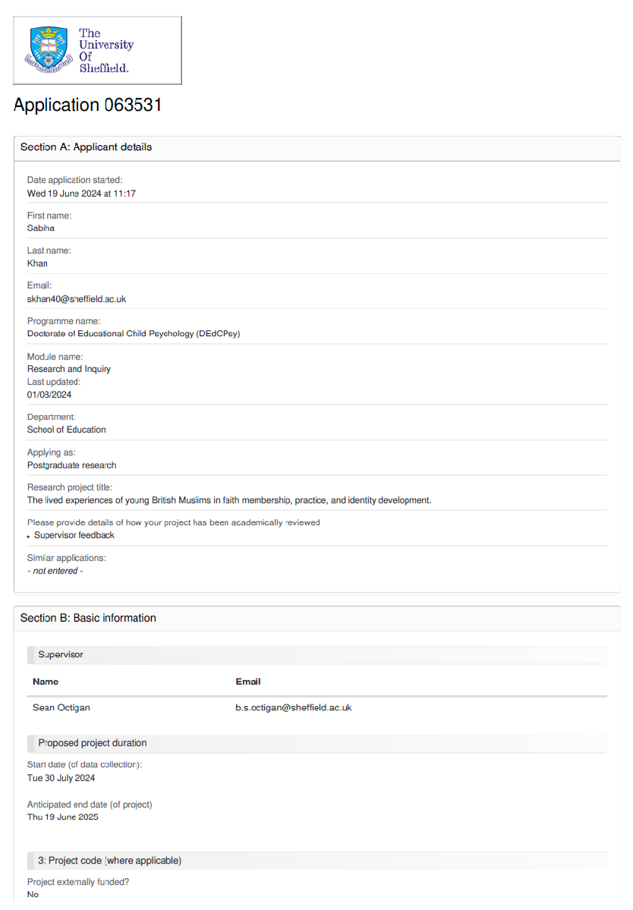
Appendix 3 – Ethics Submission and Supporting Documents

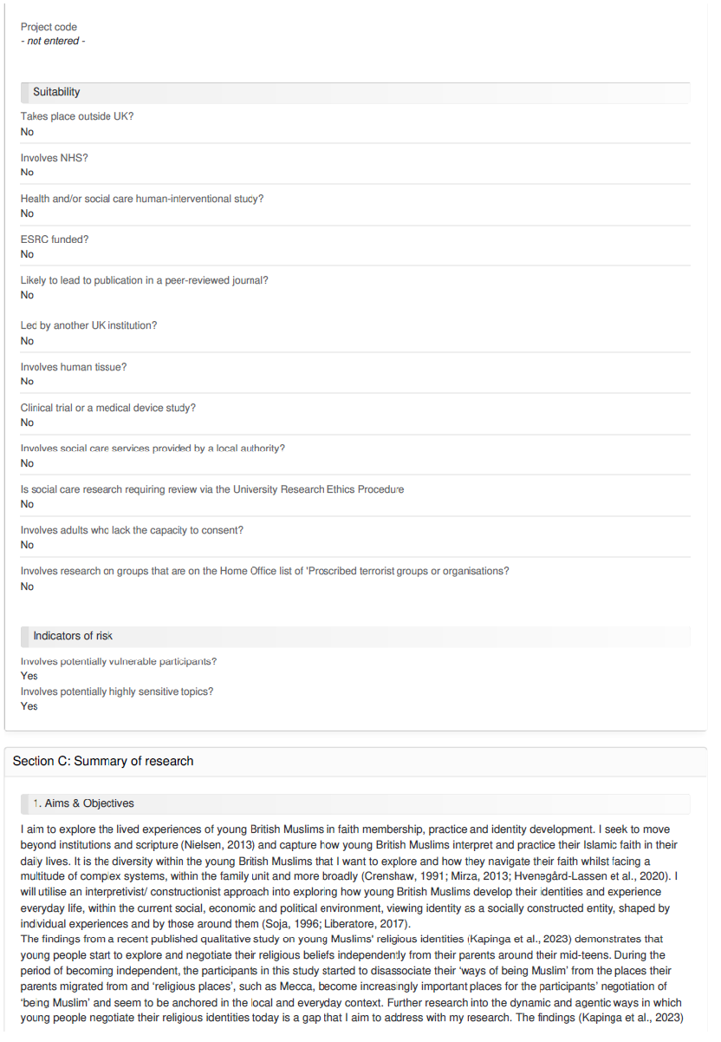
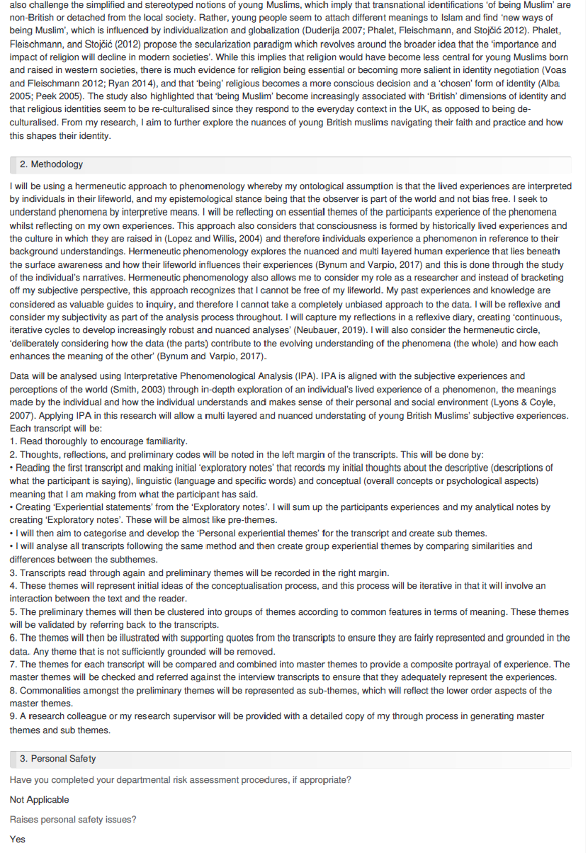
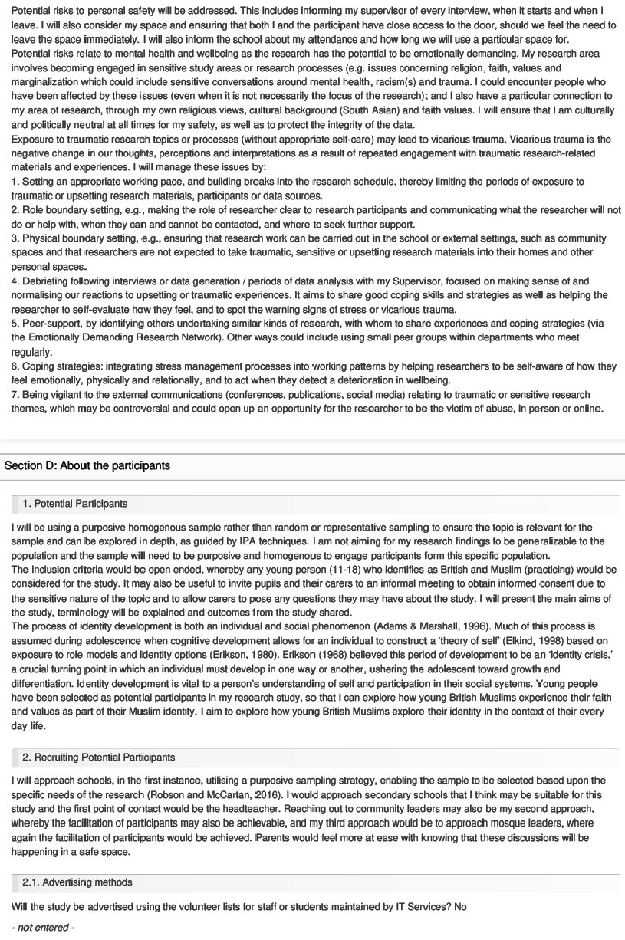
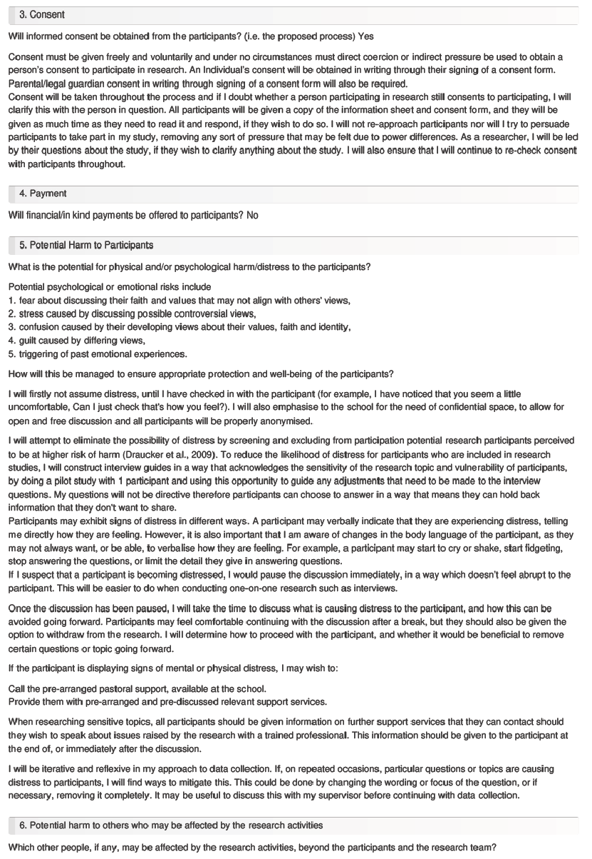
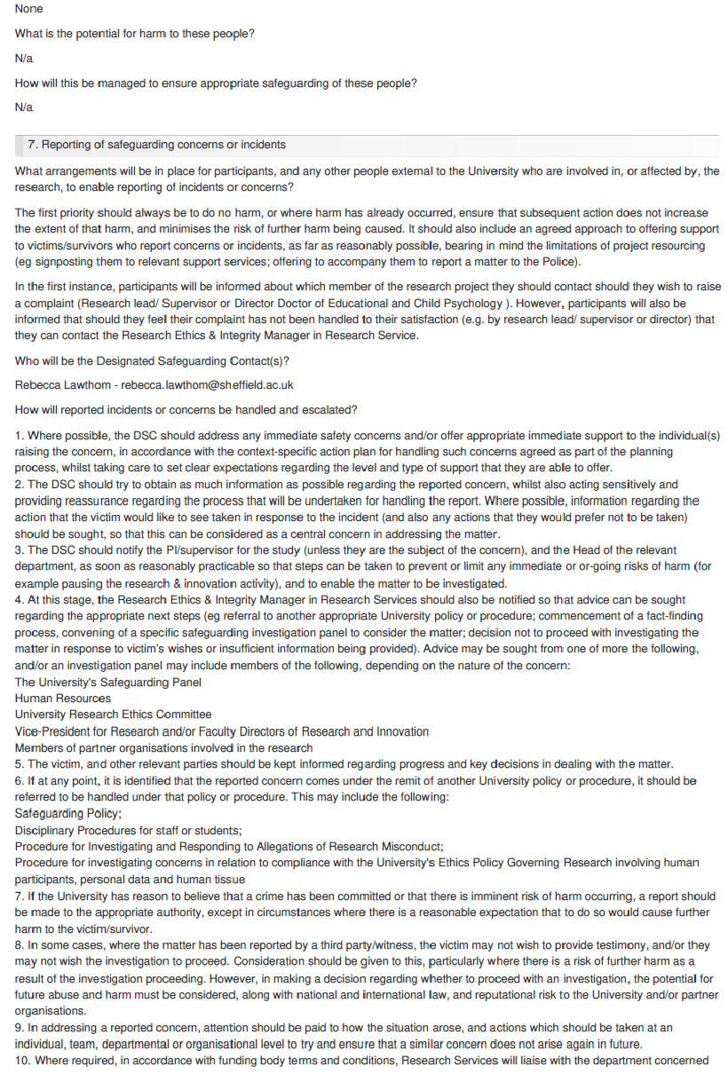
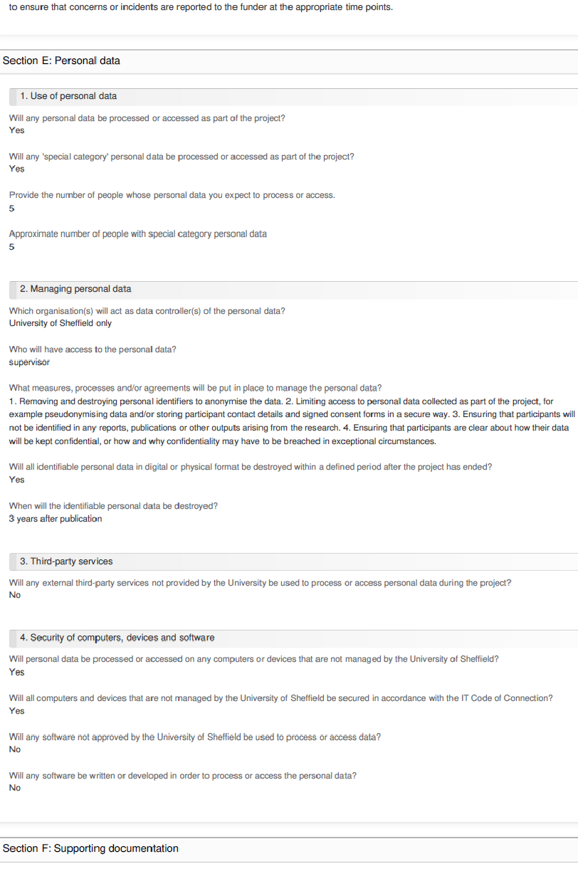
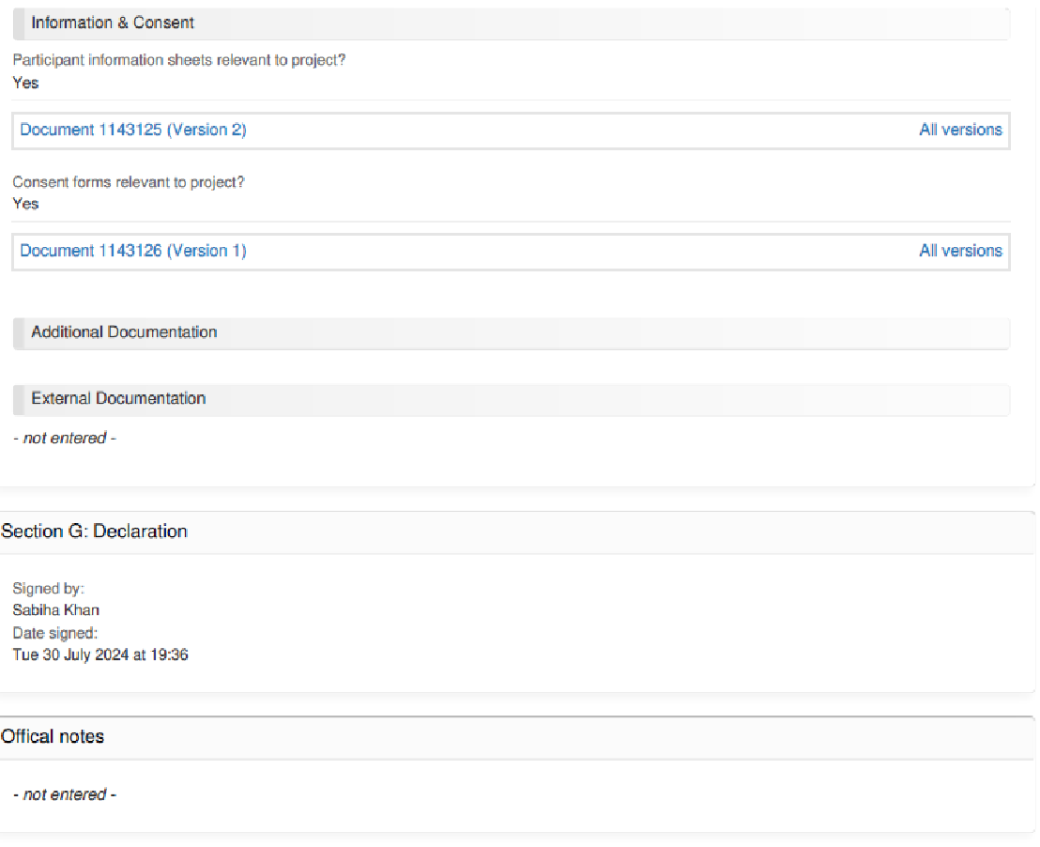

Appendix 4 – Confirmation of Ethical Clearance
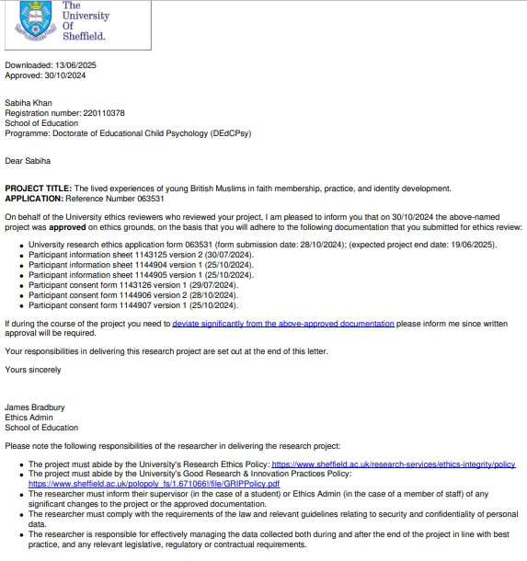

Appendix 5 – Protocol for Managing Participant Distress
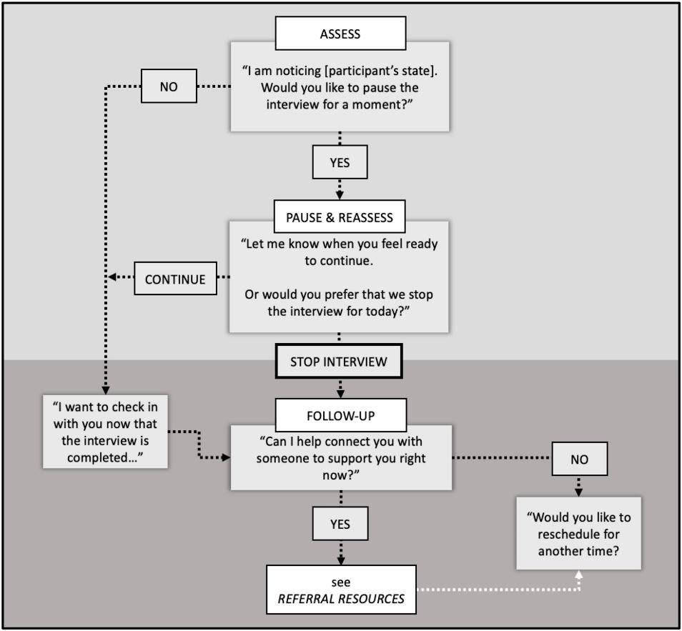

Appendix 6 – Correspondence with Participating School
Hi XXX
I hope you’re well 😊 I will be detailing some of the key points of my study and have attached relevant information/consent forms, for your reference. All personal information will be kept confidential, including any references to the school.
I have passed the ethics stage, and I can provide a certificate that documents this, if required.
Title: The lived experiences of young British Muslims in faith membership, practice, and identity development.
Aim: This thesis aims to present a psychological investigation of the formation of young British Muslims (aged 11-16) experiences of Islam in their every day life, including their school life, in the hopes that I can produce guidance that will allow schools to offer more inclusive practice.
Data gathering: semi structured interviews (up to 60 minutes), audio recorded and transcribed at a later date. My questions will have no reference to any ongoing political issues.
Potential participants criteria: up to 5 participants
- British Muslims
- Aged between 11-16
- Practicing (young people who accept the 5 pillars as obligatory – they do not need to be punctual with their obligations to be considered as a participant)
I would need a room where I can carry out these interviews. 2 separate envelopes titled “parent/carer” and “young person” will be handed to the young person containing consent forms/information sheets (which I will provide) and it is then up to the young person to decide if they would like to participate.
I would be delighted if we could work together on this 😊 If you require any further information, please do not hesitate to contact me.
Kindest regards
Sabiha
Sabiha Khan
Trainee Educational Psychologist
Educational Psychology Team

Appendix 7 – Information Sheet for Parents and Carers
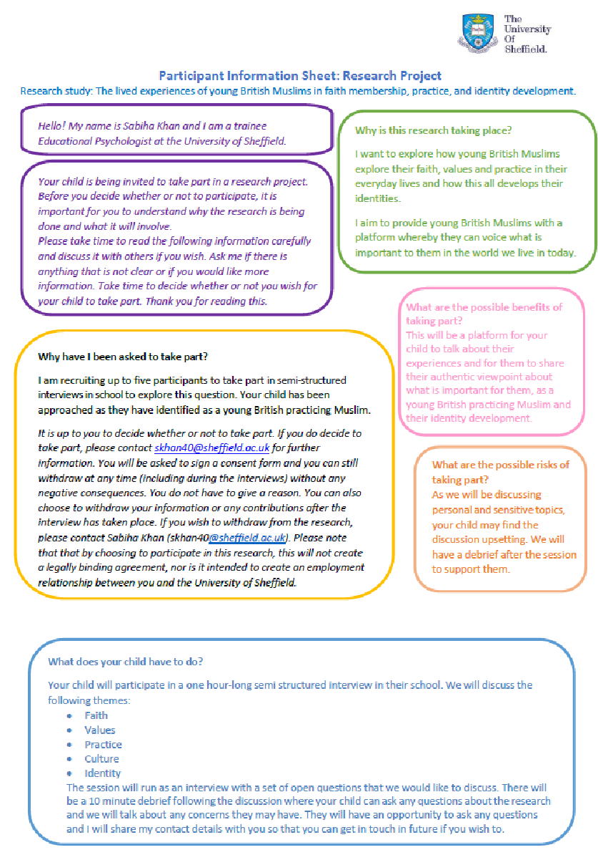

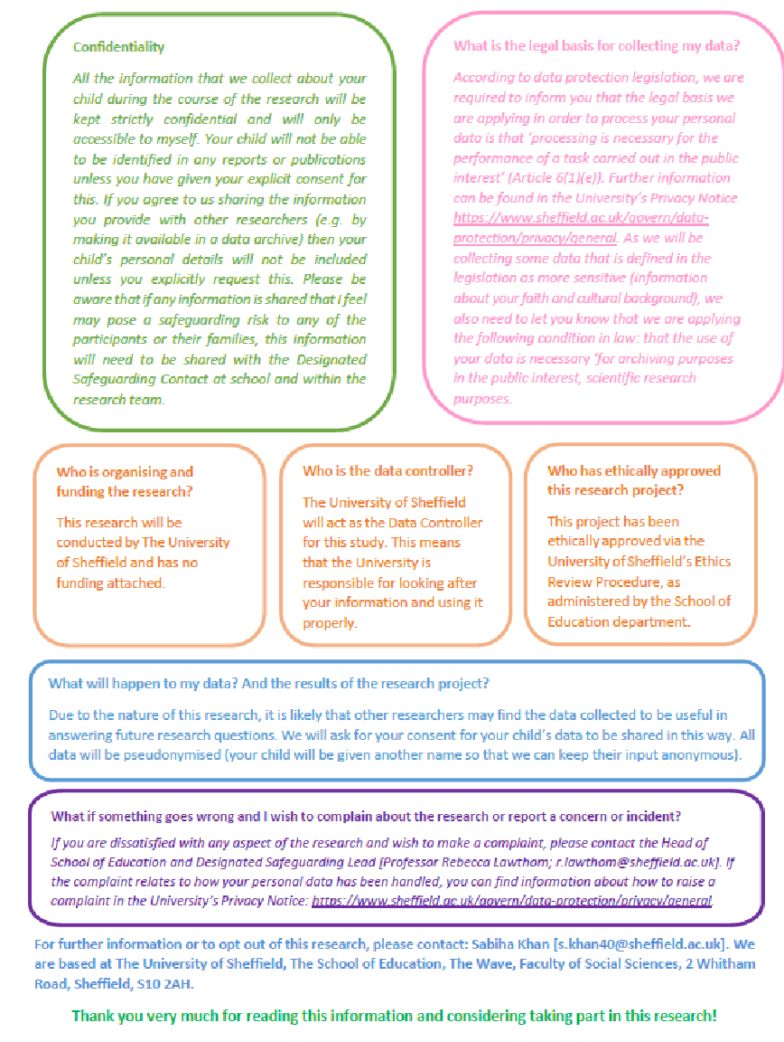

Appendix 8 – Information Sheet for Student Participants
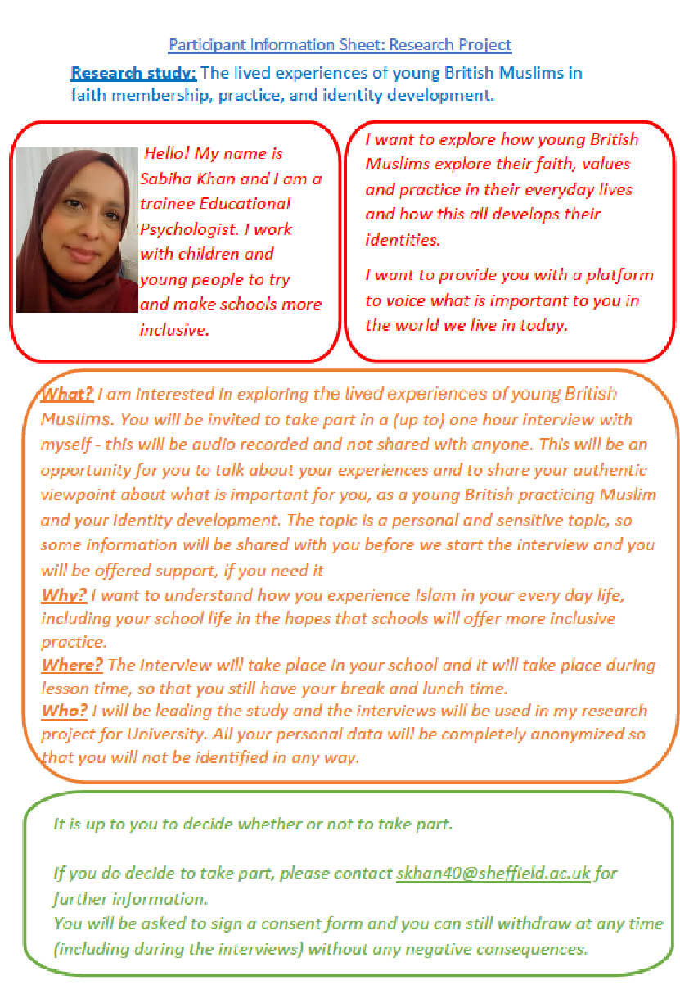

Appendix 9 – Consent Form for Parents/Guardians
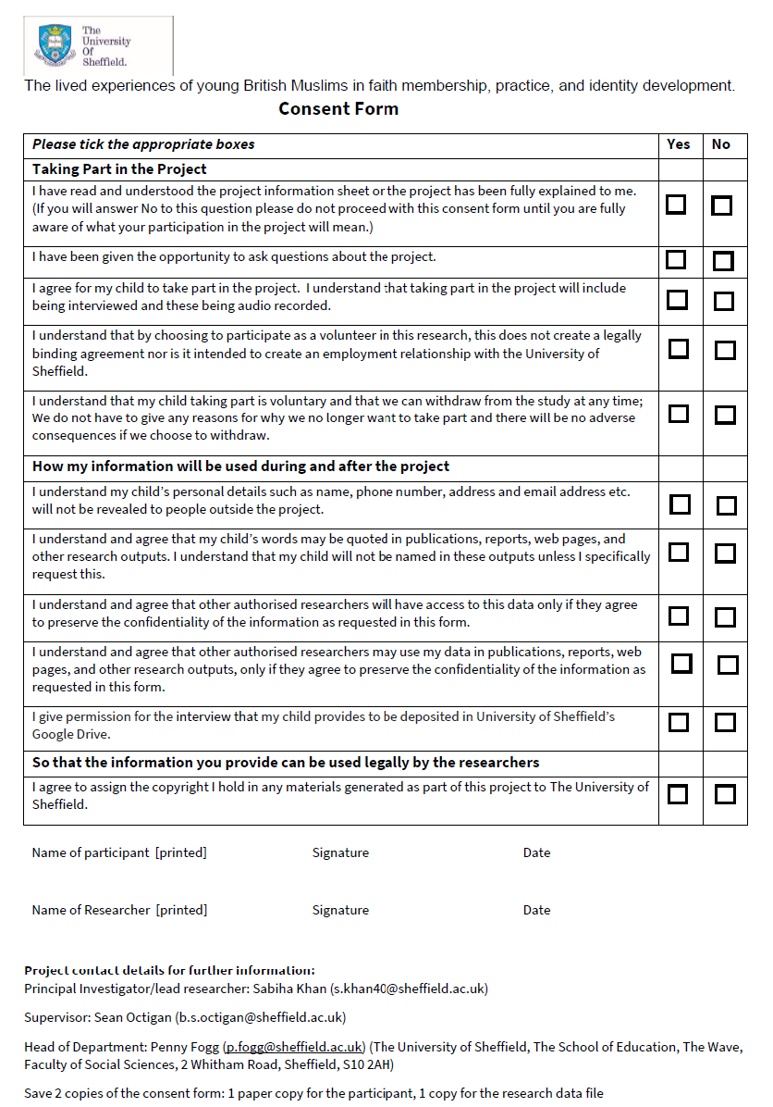

Appendix 10 – Consent Form for Student Participants

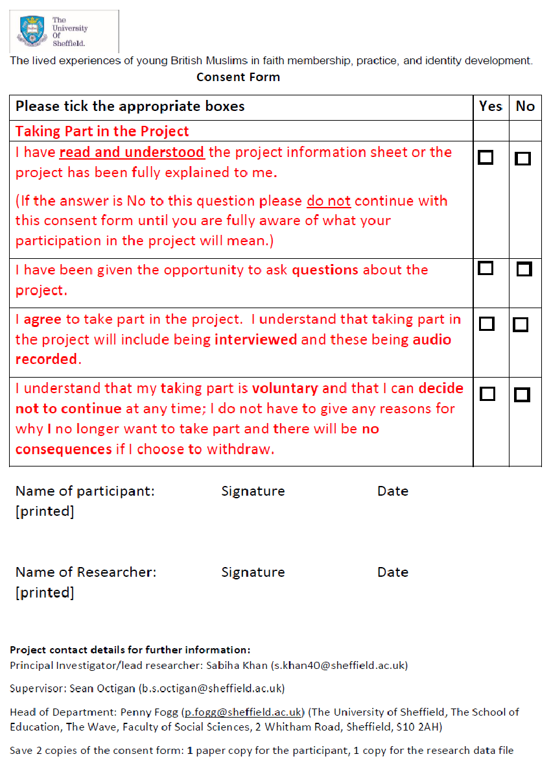

Appendix 11 – Participant Profile Summary
Pseudonym | Year group | Gender | Reflections following interview
Ayesha | 10 | Female | Ayesha’s philosophical depth is striking, She doesn’t just practice faith, she interrogates, understands, and refines it. She speaks with warmth and confidence, effortlessly recalling childhood memories and grounding her identity in them.  Her face lights up when discussing the soul and individuality, concepts that clearly fascinate her beyond religious obligation. She carries certainty without arrogance, shaped by years of deep reflection.  Yet, in her presence, I feel an unexpected self-reflection, her devotion makes me keenly aware of my own faith and how differently I embody it. Dressed in a jilbab and niqab, she embodies a quiet, steadfast strength that challenges without judging.  Ayesha isn’t just an interviewee, she is a thinker, a believer, and a seeker, effortlessly compelling me to reflect on my own journey!
Sara | 10 | Female | Sara is a breath of fresh air, effortlessly articulate about her journey with faith. She speaks with clarity and warmth, recalling memories of praying with her father, moments that have shaped her relationship with spirituality.  Her journey with the hijab and prayer is deeply personal, yet she conveys it with confidence and openness, showing how faith has become an intrinsic part of her identity. She discusses friendships without hesitation, reflecting on how they coexist with her beliefs.  Books and intellectual curiosity fuel her perspective, making her engaging and thoughtful. Despite her certainty in her relationship with Allah, she never judges those who may not share her level of insight, her presence is welcoming, not imposing.  Sara carries her faith with grace and assurance, embodying a balance of devotion and openness that leaves a lasting impression.
Hanna | 9 | Female | Hanna embodies a fusion of Islam and the Western world, crafting a faith practice that aligns with her personal values. Her modesty is expressed through Western clothing, demonstrating that adherence to Islamic principles can be integrated into contemporary fashion.  What stands out most is her independence - she makes faith-based decisions entirely on her own terms. Choosing to wear a hijab, despite her mother and sister opting not to, mirrors Ayesha’s conviction in wearing a niqab independently of her family’s choices.  Hanna is authentic and self-assured, confidently embracing her Muslim identity without hesitation. She does not shrink away from decisions that define her faith, nor does she seek validation - her approach is deliberate, personal, and unwavering.
Amina | 8 | Female | Amina's understanding of Islam seems rooted in its physical aspects, modesty and the act of prayer. Her engagement with faith is more structured than exploratory, which sometimes made it feel like she hadn't fully thought through or articulated the deeper meanings behind her practice.  At moments, I found myself feeling frustrated, perhaps because her interpretations seemed limited, not due to a lack of belief but possibly due to a lack of vocabulary or exposure to certain discussions. It wasn’t clear if she had ever contemplated faith beyond its surface-level rituals.  However, a shift occurred when I shared my own experience with identity, this opened the space for her to reveal something personal. She recalled a moment when she was laughed at for trying to pray, an experience that may have shaped her perception of faith in a school setting. It made me wonder, perhaps early vulnerability impacts how young Muslim girls express and interpret their faith.  Reflecting on this, I realise I may need to offer my own reflections at the beginning of each interview, clearly explaining what I aim to explore. Inviting openness from the start might help interviewees process and articulate their own experiences more freely.
Asma | 8 | Female | Asma presents a balanced, thoughtful outlook, one not entirely driven by religion but deeply rooted in “kindness, acceptance, and non-violence”. She embodies a genuine sincerity, carrying herself with warmth and openness.  Her journey of self-discovery stands out - she is exploring what faith means to her, but she does so without being confined by labels. While her relationship with Islam is evolving, she remains confident in her identity beyond religious categorization.  There is something refreshing and honest about Asma. She is not searching for definitive answers, rather, she embraces uncertainty with grace, allowing herself space to grow, question, and redefine what belief means in her life.

Appendix 12 – Sample Interview Transcript
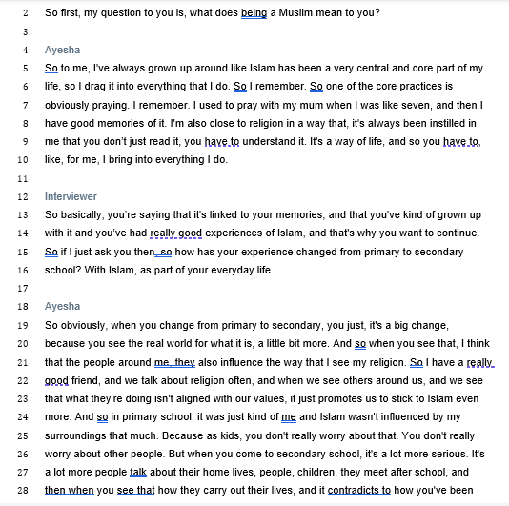

Appendix 13 – Sample Analysis: Stage 2 of IPA Process
Key:
descriptive comments
conceptual and first-level interpretations
Linguistic

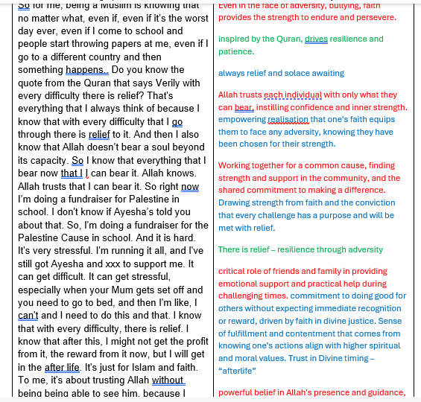

Appendix 14 – Sample Analysis: Stage 3 of IPA Process
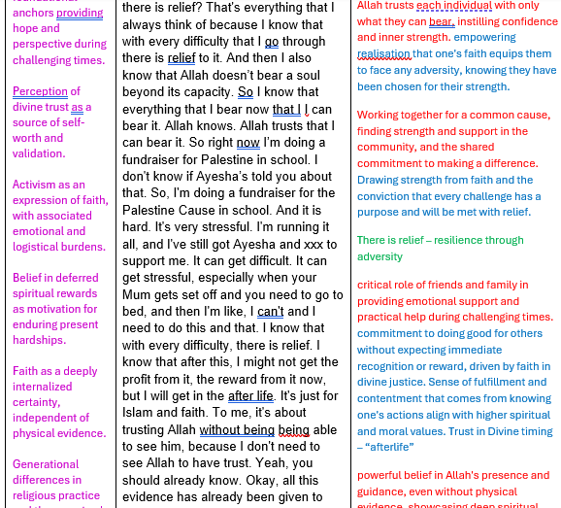

Appendix 15 – Sample Analysis of Personal Experiential Themes (PETs)
Example of developing PETs:



Appendix 16 – Sample Analysis of Group Experiential Themes (GETS)



Mecca holds profound spiritual significance in Islam as the birthplace of the Prophet Muhammad and the site of the Kaaba, the holiest sanctuary toward which Muslims direct their prayers. It is the destination of the Hajj pilgrimage, one of the five pillars of Islam, and symbolizes a universal point of spiritual orientation and unity for Muslims worldwide.
A veil worn by some Muslim women that covers the face, leaving only the eyes visible. It is typically worn in public or in the presence of non-mahram men, as an interpretation of modesty within Islamic practice
Haram refers to anything that is explicitly forbidden or prohibited in Islam. It encompasses actions, behaviours, or substances that are considered sinful or morally impermissible according to Islamic law (Sharia). Engaging in something haram is believed to incur spiritual consequences, while abstaining from it, especially out of reverence for divine guidance, is seen as virtuous.
A headscarf worn by many Muslim women that covers the hair, neck, and sometimes shoulders, while leaving the face visible. It is commonly understood as an expression of modesty and religious commitment, though interpretations and practices vary across cultural and individual contexts.
Mehram (also spelled mahram) refers to a person with whom marriage is permanently forbidden under Islamic law due to close blood relations, breastfeeding (in infancy), or marital ties. A mehram typically serves as a guardian or chaperone in contexts where gender interaction is religiously regulated. Examples of mehram relationships for a woman include: her father and grandfather, her brothers (full, half, or through breastfeeding), her sons and grandsons, her paternal and maternal uncles, her nephews (sons of her siblings), her father-in-law and son-in-law (Al-Islam.org, n.d.-a; Al-Islam.org, n.d.-b)

