

The best of both worlds? Experiences of flexischooling through the personal narratives of families who are undertaking it.

Isobel Pryor-Nitsch
220110426
Supervised by Dr Penny Fogg

Research Thesis Submitted in Part Requirement for the Doctor of Educational and Child Psychology
The University of Sheffield, School of Education
May 2025

Acknowledgements

I would like to thank everybody who has participated in this research. Thank you to the mothers’ who gave up their time to be interviewed by me, and to the flexischooling community volunteers and advocates who took the time to help me post my recruitment adverts, advised and helped me along the way. It has been interesting to spend time in the flexischooling world and I have learnt so much.

I would like to take this opportunity to thank my university lecturers and my placement supervisors and colleagues, who have equipped me with the knowledge and skills to become a better Educational Psychologist and heartened me to take the time needed to write this piece of work. A special thank you goes out to Penny Fogg who was my pastoral and thesis supervisor and has guided me through this process with thoughtfulness, care and encouragement.

Thank you to my friends and family who have endured almost three years of my relative absence and let me keep my head down and work hard, always reinforcing their faith and regard for what I have been working towards.

Huge love and gratitude goes to Dominik, who has patiently waited for me to complete this qualification, all the while painting walls, putting up shelves, planting the garden and making our home a cosier place ready for me to emerge. Thank you for being my constant, encouraging me and keeping me sane. And last but not least, a little thank you to Luna for enthusiastically demanding walks in Tatton Park, which gratefully removed me from my laptop at least once a day and exposed me to some much needed vitamin D.

Abstract

Poor mental health and declining school attendance among children and young people (CYP) are areas of increasing focus and concern among educational professionals. At the same time flexischooling, characterised by part time home education (HE) and part time school attendance, has gained enormous popularity across the UK since the first COVID lockdown in 2020. Although research around the topic is currently limited, some studies suggest flexischooling can support the mental health and wellbeing of CYP who struggle with the demands of full-time school attendance. The present research adopts a small scale, qualitative approach to explore experiences of flexischooling, as represented through the personal narratives of families engaged in a flexischooling arrangement. All three participants’ children were attending a UK mainstream school, and each child had a diagnosed special educational need or disability (SEND). Although the conclusion of this research cannot be generalised, all participants reported that they perceived a reduction in school-based days resulted in improvement in the mental health and wellbeing of their children, and in two cases better overall school attendance. Other experiences revealed important insights into the significant and positive impact of adopting relational and collaborative approaches in schools, and uncovered themes that challenge the inflexibility of the current system and constructs around schooling.

Table of Contents

Acknowledgements ii
Abstract iii
Table of Contents 4
Table of Abbreviations 15
Table of figures 17
Chapter 1: Overview 18
Choice of Topic 19
Aims of Research and Relevance to the Field of Educational Psychology 20
Structure of Thesis 23
Contextual and Theoretical Background of the Research 24
Design and Analysis of the Research 24
Presentation of Findings, Discussion and Conclusions 25
Chapter 2 25
Literature Review: Part 1 25
Origins of Flexischooling in the UK 25
The Constructs of Education and Schooling 27
So why School? 29
So why not School? 31
A Focus on Special Educational Needs (SEN) 32
Emotionally Based School Non-attendance (EBSNA) 33
A Matter of Inclusion? 34
Last Resort Home Educators 34
A Call for Flexibility 36
Flexischooling: Who Does it Serve? 38
Meighan’s Concept of Flexischooling in Contemporary UK 40
Literature Review: Part 2 42
Flexischooling Literature 42
Part 1: A Whole School Approach 44
Part 2: A Distinct Item on the Menu 46
A Closer Look at Scotland: Language Matters 48
Focus on Autism 51
Summary of Literature Review 55
Chapter 3: Methodology 55
Introduction 55
Qualitative Research 56
Reflexivity 57
Epistemological Assumptions and Research Philosophy 58
Ontology 58
Epistemology 59
Narrative Psychology and Educational Psychology Practice 62
Narrative Inquiry in Research 63
Why choose Narrative? 65
Chapter 4: Design and Procedure 65
Quality Appraisal of the Data 66
Ethical Considerations 68
Participants 69
Pilot Study 71
Data Collection: Semi-structured Interviews. 72
Where did the Interviews take Place? 72
Questions and Prompts 73
Data Analysis: Narrative Thematic Analysis (NTA) 74
Small Sample Size and NTA 76
The Process of NTA 76
Phase 1: Organisation and Preparation of the Data 77
Phase 2: Obtaining a general sense of the Information 77
Phase 3: The Coding Process 78
Phase 4: Categories or Themes 81
Phase 5: Interpretation of the Data 83
Methodological Limitations 84
Chapter 5: Analysis and Finding 86
Findings 86
Jenny and Robert 88
Thematic Map for Jenny’s Interview 89
Theme 1 - Flexischooling as a Responsive Journey: “...it’s taken years.” 90
Sub-Theme - What Robert Needs: “...he is what I’m calling flexiflexi.” 91
Sub-Theme - Negotiation: “Should we put a visual timetable on his desk?” 92
Theme 2 - A Mother’s Evolving Role in Flexischooling: “We’ve worked out at home what he needs.” 94
Sub-Theme - The Advocate: “No one suggests - why don't you try this? And would this work for you or this work for you?” 94
Theme 3 - Finding his Own Way: “I try and have him in meetings now.” 96
Sub-Theme - Ownership: “I’m just gonna have some quiet time”. 96
Sub-Theme - Self-Determination: “What do you want to do with your life?” 97
Theme 4 - The relational Web of Flexischooling: “I don’t put pressure on Robert.” 98
Sub-Theme – Security: “I’ll be journeying with a bunch of other people.” 98
Sub-Theme - The Importance of Professional Partnerships: “I found that useful just to keep them in the loop.” 99
Helen and Tyler 100
Thematic Map for Helen’s Interview 100
Theme 1 – A Bridge is Strongest when Built from Both Sides: “We're in partnership for the benefit of Tyler’s education.” 102
Sub-Theme – Openness: “She was putting her arms out in a way that she was almost, hugging.” 102
Sub-Theme – Solid Foundations: “I was very keen on school.” 105
Theme 2 – Redefining Roles and Identities: “I never thought of myself as a home educator.” 109
Sub-Theme – Advocacy: “This is Tyler.” 109
Sub-Theme – Sacrifice: “It’s not going to happen unless I’m there.” 110
Sub-Theme – Self-Discovery: “We’ve come to the conclusion that my husband himself is neurodiverse.” 111
Theme 3 – Finding the Right Fit: “There are days’ when you say, come on, you have to.” 113
Sub-Theme – Not all Offers are Equal: “We did appeal for him to get in.” 113
Sub-Theme – Learning Beyond the Classroom: “He needs his down time to cope with being at school.” 116
Theme 4 – Navigating Tyler’s Strengths and Needs: “He needs to get 100% in everything.” 117
Sub-Theme – “Perfectionism” and Emotional Impact: “It is a struggle”. 118
Sub-Theme – Recognising Patterns and Adapting: “So, he needs to work from home. And it got me thinking…” 119
Carey and Sam 120
Carey and Sam’s Thematic Map 121
Theme 1 – Navigating Exclusion and Inclusion: “He was just sat in the corner doing theme sticker books I’d sent in.” 122
Sub-Theme – Exclusion: “Nobody had read his EHCP…” 123
Sub-Theme – Inclusion: “...everybody pulled together…” 125
Theme 2 – Disruption Unlocks New Pathways for Change “...and so it got very convoluted...” 126
Sub-Theme – Quiet Concessions “I read between the lines…” 127
Sub-Theme – Power: “I was very well read up before Sam even hit school.” 128
Sub-Theme – Reimagination of Self: “…the relief was massive.” 130
Theme 3 – Clear Rewards: “Sam made massive progress at home. Massive” 131
Chapter 6: Discussion 133
Introduction 133
Key Findings from my Thematic Analysis 134
A Note on Mothers Featuring as Key Participants 134
Organisation of Discussion Through an Experiential Lens 135
1.Experiencing Identity Shifts 135
Home Educators 135
Advocates 137
2. Flexischooling as an Inherently Relational Experience 139
Communication Challenges 139
Professional Partnerships 140
Collaboration 141
Relationships 142
3 .Systemic Limitations and Normalised Constructs of Schooling can Inhibit Experiences of Inclusion 144
Attendance 147
4. Traditional Constructs of Schooling and Education may be Limiting 148
Emotional Development and Family Connectivity 149
Academic Potential and Motivation to Learn 151
Social Development 152
Implications 153
1.Increasing Transparency and Access to Information about Flexischooling 153
2.Strengthening Parent-School Relationships 154
3.Rethinking Learning and Inclusion Beyond the Construct of School 156
4.Recognising Flexischoolers as Distinct from Home Educators 157
Future Research 158
Policy Takeaways 159
Strengths and Limitations 160
Strengths 160
Limitations 160
Conclusion 161
References 162
Appendices 191
Appendix A: Reflections 191
Appendix B: Ethics Approval Letter 203
Appendix C: Information Sheet 205
Appendix D: Consent form 210
Appendix E: Recruitment Advert 212
Appendix F: Questions and Prompts 214
Appendix G: Interview Transcripts 216
Appendix H: Code Book example 252

Table of Abbreviations

CYP | Children and Young People
DFE | Department for Education
EBSA/EBSNA | Emotionally Based School Avoidance/Emotionally based School Non-Attendance
EHE | Elective Home Education
EP | Educational Psychologist
EP/s | Educational Psychologist/s
HE | Home Education
NTA | Narrative Thematic Analysis
SDT | Self Determination Theory
SEMH | Social, Emotional and Mental Health
SEN | Special Educational Needs
SENCO | Special Educational Needs Coordinator
SEND | Special Educational Needs and Disability
TA | Thematic Analysis
TQF | Total Quality Framework
YP | Young People

Table of figures
Figure 1 | Bronfenbrenner’s Ecological Systems diagram |  |  | Page 21
Figure 2 | Data from a Schools Week commissioned survey of over 7,200 teachers in the UK |  |  | Page 39
Figure 3 | Procedural diagram of research design |  |  | Page 57
Figure 4 | Extract from my coding table |  |  | Page 70
Figure 5 | Screenshot of my Miro board showing three post it notes from the coding phase |  |  | Page 71
Figure 6 | Screenshot from Jenny and Robert’s Miro board, showing codes that had been organised into the theme ‘Flexischooling as a responsive journey: “it’s taken years…” |  |  | Page 73
Figure 7 | Screenshot of a section of the Miro boards’ large thematic map, which incorporate themes from each interview |  | Page 74
Figure 8 | Full Thematic Map of all interviews (screenshot of the Miro board: a visual representation of all of the mothers experiences, as represented by my analysis process) |  | Page 87
Figure 9 | Thematic Map of Jenny’s interview (screenshot of the Miro board: a visual representation of Jenny’s experiences, as represented by my analysis process) |  | Page 90
Figure 10 | Thematic Map of Helen’s interview (screenshot of the Miro board: a visual representation of Helen’s experiences, as represented by my analysis process) |  | Page 101
Figure 11 | Thematic Map of Carey’s interview (screenshot of the Miro board: a visual representation of Carey’s experiences, as represented by my analysis process) | Page 122

Chapter 1: Overview

“The rise of flexischooling. With supersized primary schools, large class sizes and the squeeze on primary school places, some parents are choosing to educate their children at home for part of the week” (The Guardian, 2011)

“‘Flexible learning will stop pupils being left behind’: Education should embrace the opportunity to share learning between home and school” (TES, 2020)

“Forget flexi working, flexi schooling is the future” (FE news, 2021)

"Schools allowing children to attend part time in flexi learn-from-home deals, Ofsted chief warns" (The Telegraph, 2024)

“The middle-class mums 'flexischooling' their children: They go to extraordinary lengths to teach their children from home part-time... despite some teachers' fears that pupils will miss out on key lessons” (The Daily Mail, 2024)

The range of media headlines shown above summarise some of the interest, concern, assumptions and questions raised around flexischooling in the UK. Recent headlines indicate a surge in coverage of flexischooling, likely influenced by an incremental cultural shift following on from the COVID-19 pandemic, which has seen a rise in child and adolescent challenges with mental health, and a decline in school attendance. For some parents and education professionals, the appetite for flexischooling has brought about a welcome change but for many there is significant worry about the complexity it might invite, as well uprooting concerns around safeguarding, and the impact on attendance records and assessment results.

There are currently very few studies relating to the nature and practice of flexischooling in the UK, although a notable contribution to the literature and understanding of flexischooling was made in 2022 through a comprehensive review exploring flexischooling of children diagnosed with special educational needs and disabilities (SEND) (Paxman, 2022). Other small-scale studies have begun to consider and evaluate different dimensions of flexischooling, including the quality of education the children are receiving, the outcomes with regards to improved wellbeing or academic achievement, and the motivations of parents (e.g. Griffin et al., 2024, Baker et al., 2019; Lawrence, 2017) The present study contributes to the field by capturing and exploring the experiences of parents who have navigated this approach to education, in a time where it is not highly accessible or available within the school structure.

Choice of Topic
My interest in alternative and flexible schooling originates from my personal experience with home education (HE). Having undergone an unconventional educational path, I believe this positions me to approach the subject of part-time school attendance with an open perspective, while acknowledging the potential for personal bias regarding the perceived benefits and drawbacks of alternatives to full-time schooling. In my professional career within the education sector, I have held various roles, including teacher, researcher, and member of the SEND team within a LA. These experiences have provided me with opportunities to critically engage with and reflect on the education system. They have also prompted me to question how effectively the current schooling model meets the needs of children and young people (CYP). Consequently, I often find myself reimagining an education system that better acknowledges individual differences and fosters the inclusion of a broader range of practices and priorities, many of which are often overlooked in the present structure. As a Trainee Educational Psychologist (TEP), I have observed a growing demand for alternative provisions, particularly for CYP who face mental health challenges or struggle to attend school due to special educational needs (SEN).

Aims of Research and Relevance to the Field of Educational Psychology
I consider that flexischooling is a pertinent issue to explore, primarily because it is already being implemented in numerous schools across the UK. Despite this, many educational professionals, including educational psychologists (EPs) remain unfamiliar with flexischooling due to the lack of research and the relative novelty of the approach in mainstream schooling. At the time of writing this thesis, there was no existing literature that directly linked flexischooling with educational psychology (EP) practice. Nonetheless, several key themes in relation to parental choices, issues of inclusion, mental health and wellbeing, and the lack of flexibility within the current school system emerge from the existing literature on flexischooling (e.g., Paxman, 2022; Griffin et al., 2024; Sudea, 2023; Lawrence, 2017; Baker et al., 2019). These themes are of considerable relevance to EPs, LAs, and the academic research community.

If EPs are unfamiliar with flexischooling, it may discourage schools, families, and other professionals from seeking support from EP Services when considering this option. Flexischooling agreements allow CYP to maintain the same funding and access to Local Authority (LA) services as their peers (Paxman, 2022). Given that many flexischooling children have SEND (Baker et al., 2019; Griffin et al., 2024), EPs are likely to become involved with these children at some time or another. Further research will help EPs better understand and assist those navigating flexischooling.

Currently, schools offering flexischooling do so at the discretion of their respective headteachers. Although the Department for Education (DFE) recognises it as a legal practice, flexischooling remains unregulated and not statutorily monitored. This leaves families and schools without clear guidance on what constitutes effective flexischooling, and little is known about its implementation across schools. Additional research could provide valuable insights and foster improved practices in flexischooling. Some learning opportunities that can occur outside of structured school settings, like self-directed learning (SDL), have been described as “qualitatively different from the processes taking place in school” (Arora, 2003, p. 111). Further investigation into flexischooling may enhance understanding of how CYP are engaged in learning outside of the traditional school system.

This thesis is concerned with exploring the views of parents with regards to their experiences with flexischooling. Both home educators, and previously non-home educators seem to be accessing flexischooling arrangements (Facebook Practitioners UK, 2023) and it is relevant to consider that families may hold quite different values, views and motivations, depending on the point of entry into a flexischooling arrangement. I am particularly interested in examining the perspectives of families whose children were in school full time before transitioning to flexischooling. While existing research has explored elective home education (EHE) (e.g., Wolfe, 2015; de Carvalho & Skipper, 2018; Medlin, 2000) and insights of home educators would undoubtedly contribute to the flexischooling literature, my focus is on those families who did not begin their flexischooling journey in this way. My primary interest lies in the unidirectional experiences of families who have navigated this transition, and I hope this will make a unique contribution to the literature on flexischooling. Within this group, I would like to explore how families perceive the impact on their CYP, particularly those who have struggled with full-time school attendance due to special educational needs (SEN), as outlined in the SEN Code of Practice (Department for Education and Health, 2015).

The terms Special Educational Needs (SEN) and Special Educational Needs and Disabilities (SEND) are used interchangeably in this thesis. In the UK education system, these terms describe children who require additional support to access education. The Children and Families Act (2014) defines a child as having SEN if they have a difficulty or disability which requires special educational provision beyond what is normally available to others of the same age. The SEND Code of Practice (DfE, 2015) outlines four areas of need:
- Communication and interaction
- Cognition and learning
- Social, emotional and mental health
- Sensory and/or physical needs.
In this study, I have chosen to focus on families whose children have SEN, as I felt this would bring the most benefit to the EP community and be the most relevant to the children and families that EPs serve. The term SEN was used deliberately in participant recruitment because it does not necessarily imply a medical diagnosis, but captures the range of recognised areas of need that parents are likely to be familiar with, while also distinguishing these families from those who may have chosen flexischooling primarily for philosophical or lifestyle reasons.

Participants in this study were drawn from an online flexischooling Facebook group for parents. The methods used to capture experiences were qualitative and narrative based (semi structured online interviews).

This thesis is framed around one central research question and three sub questions:
- What are the experiences of families who have engaged in a flexischooling agreement, whose children have previously experienced full time school attendance?

Sub questions:

- Were any interventions carried out in school before flexischooling was agreed?
- What are the parents’ thoughts or reflections on the idea of ‘inclusion’ since flexischooling has been implemented?
- What has been the impact on family and child wellbeing?

Structure of Thesis
This thesis is organised into three main sections:
- Contextual and theoretical background of flexischooling as part of an extended literature review.
- Design and analysis of the research.
- Presentation of findings, discussion and conclusions.

Contextual and Theoretical Background of the Research
The literature review is made up of two complementary parts. Part one considers the origins of flexischooling, exploring where it came from, why it might have emerged and what it looks like today in terms of its legal framework and position within education. Although distinctive fields on their own right, EHE and flexischooling are theoretically aligned. This provides the opportunity to review situations, conditions and ideas around EHE within this work as a way of further contextualising some of the discussion and debate around education that does not rely on traditional schooling. Part two of the literature review examines the existing research around flexischooling in more detail, dividing it into two main sections. Firstly, exploring what is known about the possibility of flexischooling as a whole school approach, followed by an analysis of the research around flexischooling as a discrete option, which identifies experiences of families who educated their children at home as well as continued to engage with a regular mainstream school on selected days each week.

Design and Analysis of the Research
This chapter considers the relevance of qualitative and narrative research, along with their potential contribution, strengths and limitations in relation to the field of flexischooling research. I outline my philosophical position, including reflections throughout that define epistemological and ontological choices within the research. The design and procedure used within this research are presented, along with the methods used to collect the relevant data and the ethical considerations involved with this process. In addition, techniques used to analyse results are explained and examples given to further illustrate the use within this study.

Presentation of Findings, Discussion and Conclusions
This section of the thesis presents the findings from the research. As is usual with narrative analysis, attempts to respect participants' stories by preserving the structure, meaning and coherence of personal experiences have been made. As such, findings from each interview are presented one by one, as a way of avoiding too much fragmentation and in order to keep narratives intact. A discussion section which draws together the findings of the research by examining overarching themes from the participants' experiences and reviewing themes in relation to wider literature is followed by a final chapter discussing implications of the study, along with its strengths and limitations.

Chapter 2

Literature Review: Part 1

Origins of Flexischooling in the UK
The term "flexischooling" emerged in the 1980s, pioneered by Roland Meighan, an academic and outspoken critic of traditional schooling (Meighan, 1988). A professor at Birmingham University, Meighan viewed schooling as outdated in a post-industrial society, and instead preferred to explore what he called ‘future learning systems’. He claimed to have coined the term flexischooling in conversation with American educator John Holt, soon describing it in his book; Flexischooling, Education for Today, Starting Tomorrow (1988). Meighan defined flexischooling as a part-time arrangement where school and family share educational responsibility in a formal partnership (Meighan, 1988). Meighan’s ideas were influenced by his admiration of HE, which he supported through advocacy and research throughout his career. Although when Meighan was initially involved with HE it was not a yet a parental right, it is now a legal option and England has one of the highest HE populations globally, second only to the USA (Neuman & Guterman, 2020). Through his work, Meighan often highlighted the benefits of HE, particularly its flexible, person-centred approach, which is also a central tenant of flexischooling (Meighan, 1995).

Meighan was not alone in his denunciation of the school system and other critics of traditional schooling often reason it can serve as a rout to societal control rather than a rounded education. Freire (1970), for example, argued that schooling is a means of influencing society, led by educational policies and governments that define what knowledge is valuable, while Illich (1971) viewed schools as institutionalised mechanisms for supervision, stratification, and socialisation rather than education. Others, however, such as Pitt (1980), defended schools for their role in structured learning and social cohesion, and Becker (1993) emphasised their economic benefits. Hirsch (1987) contended that the shared cultural knowledge gained in school is vital for societal success.

Despite the various arguments for and against traditional and formal schooling, it has remained largely unchanged, and Meighan (1988) found that many parents turned to EHE out of desperation due to the system’s inflexibility, particularly for children with additional needs. He wrote, “…they became so desperate that they clutched at the last possible straw of trying to educate their children at home” (1988, p.2).

While schools are widely regarded as an essential rout from which to achieve success and wellbeing, research also highlights benefits of education outside of school (e.g. Webb, 1999; Rothermel, 2011). This thesis will now examine key arguments surrounding traditional schooling and HE, as these two areas represent the overlapping contexts within which the concept of flexischooling is situated.

The Constructs of Education and Schooling
Before delving into the literature around the perceived benefits and limitations of school and HE, it is important to make a distinction between the construct of school and the construct of education, which differ. American philosopher John Dewy (1916) describes education as a lifelong process that involves the acquisition of knowledge and skills, as well as the development of values and attitudes. Another definition sees education as involving processes, including voluntary and personal endeavours centred on the acquisition of shared moral, cultural, and aesthetic values that contribute to social capital (Illich, 1971).

Dewey (1916) defined learning as either formal or informal. Formal learning refers to an intentional and structured type of learning that takes place in settings such as schools, leading to qualifications and following set rules and procedures (Livingstone, 2001). McGregor et al.,(2018) agrees that schools serve as places where credentials are gathered, and children are prepared for the workforce but adds that socialisation is also a key function of a school. Informal learning is thought of as learning that takes place outside of structured education environments like schools and that is not formally assessed, such as visiting a museum or a zoo (Eraut, 2000).

Traditional mass schooling in the UK emerged alongside the industrial revolution and is prevalent since the late 19th century. Before that period, any schooling for the general population had been largely funded and influenced by the church. Around the industrial revolution it became a state funded mainstay in response to concerns about child labour and a need for a more literate workforce (Carl, 2009). Since the inception of this system and in response to cultural and economic shifts over the decades, there have been debates about the usefulness of traditional schooling. Marsico and Dazzani (2022) point out that often these debates are situated around socioeconomic issues to do with inequality and access, and the curriculum orientation towards standardisation and assessment. Mohamed (2020) summarises:

…the traditional system of teaching may have worked well for many students over the last 100 years; however, research shows that the industrial epoch’s “factory-based” approach to education is failing to serve the needs of 21st century students, let alone special education students (p.43).

For some educationalists, including Meighan (1988), alternatives to traditional mass schooling are necessary. Examples are Maria Montessori (1912) who devised an alternative school model focussing on student led principles, and Rudolf Steiner (1995), who created schools that involve greater engagement of parents and value creativity and holistic child development above fostering economic value. Alternative school models have however been critiqued as lacking important ‘content knowledge’, being impractical and idealistic and lacking the necessary structure that children need to compete in a modern economy (e.g. Hirsch, 1987; Willingham, 2009).

Thoughts from the arena of the cultural psychology of education promote the idea that education is a continuously developing human activity and there are no ready-made or perpetual solutions to the delivery and structure of it (Marsico and Dazzani, 2022).

So why School?
Regardless of the origins and differing perspectives around formal and informal learning, schools are known to provide more than just academic instruction and a means to obtaining qualifications. Bronfenbrenner’s (1979) ecological systems theory acknowledges that children's development is impacted by different environments that interact with each other throughout their life.

Figure 1
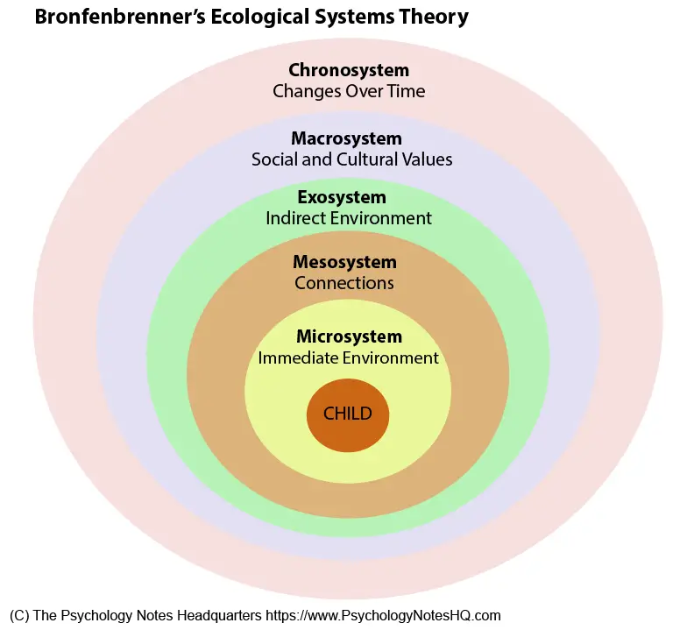
Bronfenbrenner’s Ecological Systems Theory

According to the system's perspective, school is not a separate, isolated experience but rather it is interwoven into different areas of a child’s life. School typically fits within Bronfenbrenner’s mesosystem (see Figure 1), impacting on the connections between a child's home life (Microsystem) and wider environment (Exosystem) (Tudge & Hogan, 2005).

Most recently, the COVID 19 pandemic taught us a lot about the protective factors of school and served as a stark reminder that schools serve a purpose beyond the delivery of formal and structured education. School lockdowns had a range of adverse consequences for CYP, which was reported as disrupted learning, food insecurity, lack of social interactions and increased exposure to violence and exploitation at home for many (Roe, Blikstad-Balas, & Dalland, 2021). Those children from economically poorer families were affected the most and are likely to feel long term effects of school closures including negative effects on physical and mental health (Rajmil et al., 2021), limited speech and communication skills (Charney, Camarata, & Chern, 2022), a widened gap in maths and literacy attainment and skills (Education Endowment Foundation, n.d.), and an increase in emotional and behavioural difficulties (Blanden et al., 2021). With regards to the COVID literature around the impact of school closures, research does also highlight that the pandemic had a broader economic and social impact that affected almost all support systems. The pandemic contributed to higher levels of financial hardship, parental stress and reduced social interactions for all, and so it is difficult to isolate negative impacts of school closures on children, and attribute all poor outcomes for CYP to the lack formal schooling (Van Lanker and Parolin, 2020; Christi et al., 2022)

Wider research suggests that schools can provide a plethora of other important functions, such as being a significant means of social development. Erikson's stage theory (1950) suggests that early adolescents develop crucial social skills, including the ability to initiate interactions by being around groups of similar aged peers, which are linked to the quality of their friendships as they progress through life (Chow, Ruhl & Buhrmester,. 2013). Studies have shown that schools have a role in both directly and indirectly influencing and protecting children’s mental health and wellbeing – directly by providing a means by which to deliver social and emotional learning (Montero-Marin, Allwood & Ball, 2022) and indirectly by generating a sense of school connectedness and a positive school climate (Kuyken et al., 2022) through providing trusted adults and safe spaces. Furthermore, schools can provide a means of social mobility via academic achievement and qualifications, which can lead to more choice and better jobs (Social mobility commission, 2014). When exploring improving population health, Alper, Thompson & Baciu (2015) report that better educational attainment can lead to many “downstream” benefits including higher income, improved health and happiness, and resources to live in healthier areas.

So why not School?
Despite the compelling evidence that schools provide a safe, inclusive and productive space for many pupils, there is a breadth of literature addressing the limiting factors of schools and citing the reasons why they can be difficult environments for some CYP to manage. Several well-documented factors can contribute to school-related stress and mental health challenges, including academic pressure and performance anxiety (Flett, 2018), bullying and negative peer interactions (Arsenault et al., 2010), social exclusion and peer rejection (Parker & Asher, 1993), discrimination and marginalisation (Benner & Graham, 2011). These factors can negatively impact self-esteem, academic achievement, and overall mental health.

A Focus on Special Educational Needs (SEN)
Recent research offers further insight as to why some issues may be particularly pertinent for children who are recognised as having SEN. Crane et al., (2020) looked at the qualitative experiences of young people (YP) with a diagnosis of autism, who were attending UK secondary schools. They found that discriminatory practices, social exclusion and limited support for their specific needs were all common challenges faced by those interviewed. For children with a diagnosis of autism, Billington (2020) further discusses the complication of the often chaotic and overwhelming sensory aspects of school, which contributes to everyday struggles experienced by many of these CYP. Furthermore, it has been reported by the charities ‘Ambitious About Autism’ and ‘The National Autistic Society’ (2017), that autistic children are often the victims of unofficial exclusions, including actions such as being sent home to ‘cool off’, being removed from school trips and accessing part time timetables (Billington, 2019).

In the broader SEN population, Jones and Murray (2019) found similar effects in their study of the experience of children with dyslexia in primary schools, citing stigma, discrimination and inadequate support as common experiences faced by these children. Parsons and Abbott (2018) examined the impact of bullying on the educational experiences and outcomes of disabled children, including those with SEN, finding that bullying played a large role in negatively affecting psychological wellbeing, self-esteem and academic performance in school for these CYP.

Emotionally Based School Non-attendance (EBSNA)
Emotionally Based School Non-Attendance (EBSNA), previously termed school refusal or phobia, was once seen as a ‘within-child’ issue, but evolving perspectives emphasise broader contributing factors (Sawyer, 2022). For example, EBSNA is known to be influenced by various issues including but not limited to, individual factors (anxiety, neurodiversity, unmet learning needs), school factors (transitions, peer and teacher relationships), and family factors (stress, bereavement, sibling history of EBSNA) (EdPsyched, n.d). Recent research highlights that many families withdraw children from school due to its negative impact on CYPs mental health and wellbeing (Paulauskaite et al.,2022), suggesting that children categorised as having EBSNA challenges are likely to be seeking alternative routes through education.

School absenteeism, which includes children missing school due to EBSNA, has gained public and government attention since COVID-19. A study on EBSNA during lockdowns found 25% of parents reported school closures reduced their children's anxiety due to lower pressures (Sawyer, 2022). In April 2023, the DFE reported Spring term absence was 50% higher than pre-pandemic levels. In response to falling attendance rates, Children’s Commissioner Dame Rachel de Souza prioritised improvements, advocating for 100% school attendance (Attendance is Everyone’s Business, 2022). However, a 2021 Edge Foundation survey of over 10,000 students found nearly 50% of secondary school respondents saw education as something to "get through" rather than an enjoyable or meaningful experience (Laczik & Newton, 2023). This data paints a complex and layered picture, that highlights a fragmentation of priorities among parents, CYP and government officials.

A Matter of Inclusion?
As moral and political arguments have evolved over time, so have narratives around special educational needs and disability (SEND). A part of this evolution of thinking included the assertion that positive attitudes are developed when children with disabilities and their typically developing peers interact at school (McDonald and Lopes, 2014). Since this shift, discussion around inclusion has often tended to be thought of as integrating all CYP into the formal schooling system, but there is evidence that this does not always satisfy the needs of families and children with SEN, or those who struggle to access a school because of social, emotional and mental health challenges, who can end up excluded or marginalised. Inclusion is not easy to define. Despite many educational reforms and as some of the above research demonstrates, the most vulnerable CYP in the UK are typically not thriving in the school system (Kerr & Ainscow, 2023). Despite a national commitment to increasing inclusive practice in schools and an evolving understanding of neurodiversity, data from the British Educational Research Association (BERA) shows a mixed and complex picture of increasing school exclusions. The data also shows that the curriculum is becoming narrower and special schools are expanding, perhaps indicating that more and more children identified with SEND are finding it increasingly difficult to fit into the mainstream school system (e.g. Lynch, 2022; DFE, 2023; Kerr and Ainscow, 2023).

Last Resort Home Educators
Understanding HE motivations provides insight into flexischooling. UK flexischooling guidance falls under Elective Home Education (EHE) regulations, with the DFE stating: “Although children being home-educated are not normally registered at any school, parents sometimes choose for a child to receive part of their education at a school… Such arrangements are sometimes known as ‘flexischooling’” (DFE, 2019, p.6). This positioning suggests the DFE assumes home educators as key drivers of flexischooling requests, though this remains largely underexplored. In 2023 the Welsh Government released new and additional guidance on improving learner engagement and attendance, in a document titled Belonging, Engaging and Participating. This document includes information and guidance for flexischooling and is intended for a wider audience including "leaders, teachers and other practitioners in maintained schools, pupil referral units (PRUs) and education otherwise than at school (EOTAS) settings"(Welsh Government, 2023, p.6). This guidance seems to take a more holistic perspective of school attendance challenges, referencing that flexischooling may be particularly beneficial for children who are suffering with medical illness or school anxiety, those who are autistic, or those transitioning into school.

HE is often framed as a social movement (Collom, 2005) or value-based choice (Kunzman & Gaither, 2020). However, Meighan (1988) observed that many families turned to HE as a ‘last resort,’ particularly for those who had children with SEN. The Badman Report (2009) which was a government-commissioned review of HE echoed this, finding that many SEN families withdrew children due to unmet needs: “Many parents… withdrew their child often in despair that their needs were not being adequately met in school” (Badman, 2009). Similarly, Neuman & Guterman (2017) identified two categories of home educators—those making an informed, philosophical choice and those making an ‘arbitrary change’ due to school-related distress. Over half of their participants fell into the latter category. Other studies confirm that HE is often a reluctant decision, following failed attempts to make school work (Morton, 2008; Kendall & Taylor, 2010).

In the US, Ray (2004) found ‘last resort’ HE often stemmed from unmet needs, bullying, or school misunderstandings. Kendall & Taylor (2016) reported similar findings in the UK, with SEN families feeling forced into HE. Rothermel (2011) noted that many HE decisions were triggered by specific school events, though it was unclear whether families had been inclined towards HE in the first place.

Despite its sometimes unplanned nature, HE often becomes a positive choice over time. Meighan (1988) found most families, regardless of initial motivation, were satisfied with their decision. Kunzman & Gaither (2020) similarly concluded that dissatisfaction driven HE often evolves into a pedagogically and ideologically motivated choice: “…the original decision to homeschool introduces families to a new subculture of which they had not previously been aware” (p.262).

Determining how many families engage in HE as a true ‘last resort’ is challenging due to the diversity within the HE community (Mazama, 2016; Kunzman & Gaither, 2013). However, available literature suggests that SEN families and those with school-anxious children are the most likely to turn to HE reluctantly, highlighting a clear need for more flexible education option.

A Call for Flexibility
Morpeth and Creed (2012) highlight the need to rethink education, advocating for more flexible, diversified systems: “Governments must continue to reform, improve and expand the public system, but also consider reconceptualising their role… towards encouraging a more diversified and equitable educational system.” (p.201)

This theme has also arisen from the literature around HE and parent’s desire for more flexibility in the school system as an alternative to HE, which includes a wish to remain supported by schools. Collom (2005) found home educators often share educational responsibilities with an HE community, but studies also report the financial and emotional strain of HE from families who have made considerable sacrifices to undertake it alone (Parsons & Lewis, 2010; Reilly, 2007). Families facing such pressures may welcome flexischooling as a way to balance their child’s needs without assuming full responsibility for the education. A report completed in 2011 that explored a whole school approach to flexischooling, offers an interesting insight that suggests the flexible approach to schooling attracted both registered and previously unregistered home educators to participate in the school (Morpeth and Creed, 2011). This implies that working in partnerships rather than alone could be perceived as a benefit.

Some research suggests there are many who feel forced into HE might prefer a flexible school arrangement. Kendall and Taylor (2016) found that while parents of SEN children desired flexischooling, they often faced barriers: “Parents said that they would welcome flexischooling with part-time attendance at school, but they identified the difficulties… due to flexischooling being at the discretion of a head teacher.” (p.303). The Badman Report (2009) also noted that most SEN home educators wanted continued contact with schools and recommended expanding flexischooling (p.41). Parsons and Lewis (2010) found parents would prefer school if needs were met and learning was individualised, adding: “Provision needed to be sufficiently flexible to accommodate children’s changing needs over time.” (p.46) Maxwell et al. (2020) found that some Welsh families wanted flexischooling but were denied due to policy restrictions. Similarly, the National Household Education Survey (2016) found over half of US home-educated children maintained “some involvement in school-based activity” (Kunzman & Gaither, 2020, p.279).

Supporting parents’ mental health is also crucial. O’Hagan (2021) noted that flexischooling warrants further exploration as a way to reduce stress for families home educating autistic children. Kidd & Kaczmarek (2010) also found that all mothers in their study felt impacted by their child's stress.

Although the above-mentioned studies provide some evidence on the desirability of flexischooling, most research offers only preliminary insights into how small groups of parents feel about the option, rather than robust evaluations and outcomes over time from parents who have been given the opportunity to try it out. Flexible schooling is not widely promoted in the UK, and Lawrence (2017) points out that because many parents feel they have no choice but to home educate, it is not clear how many would have preferred to maintain some support from school. However, the same research does tentatively indicate that if families had access to a more flexible school arrangement, it might prevent many of them from feeling like they must make a last resort bid for EHE.

Flexischooling: Who Does it Serve?
Shafer and Khan (2016) explored motivation for different groups of parents in the US, including those that are flexischooling and those that are homeschooling, using a large quantitative data set from the National Household Education Survey. As well as collecting information around motivation, this study also offers insight into the demographics of these families, by providing cross group comparisons between the family contexts of students enrolled in school full time, and those who were either home or flexischooled. This quantitative study broadly implies that flexischooling may meet needs of children with disabilities and that “more economically and racially diverse families see flexischooling as a viable option” (p.542). Overall, it seemed that more advantaged families choose HE, and economically diverse families tended to choose flexischooling. The authors of the study don’t provide detailed qualitative responses from parents, but there are some insights into themes relating to equality and socio-economic status that are also relevant to a UK context.

It is helpful to consider school attendance as one end of a spectrum of educational choice, and HE the other, with flexischooling somewhere in between the two options, perhaps presenting the best of both worlds for some families. In the UK, it has been suggested that HE is often a middle-class pursuit, with research revealing higher rates of income and university level qualifications among home educating families (Badman, 2009; Parsons and Lewis, 2010). Additionally, it was found that demographic trends within the HE community showed mostly white and Christian backgrounds (Badman, 2009; Parsons and Lewis, 2010), and Thomas (2016) discovered that many EHE support groups served primarily English-speaking families and cultures. Other research finds that parents generally undertake HE of their children with SEN with limited funding, and the mother often becomes the main teacher (Parsons and Lewis 2010; Reilly 2007), potentially reducing her financial independence and ability to access a range of resources to teach the child, making it a less viable or attractive option. It is important to reinforce that it is very difficult to gain accurate statistics and knowledge of HE families, due to the fact that there is not a mandatory need for registration and inconsistent data is collected by LAs, meaning that it is often through voluntary survey based or qualitative data that insight is gained (Danechi & Long, 2023).

In comparison to full time EHE, in a flexischooling arrangement the school remain involved and responsible for funding pupils; “their age weighted pupil formula funding is identical to their full-time attending peers in the setting” (Humphries, 2018, p. 93). This means that CYP can gain access to computers, books and other school resources on the days they are in school, potentially reducing pressure on parents who feel the need to provide an equivalent resource base at home.

In summary, Shafer and Kahn’s (2016) research was around a large sample in the US offers a transferable conclusion to the UK, indicating that flexischooling might play an important role in the diversification of the HE movement (Macbeth 2000), from which flexischooling derives. Issues of the equitability of alternative schooling have long been the topic of interest, and it is an important area to continue to explore in relation to flexischooling.

Meighan’s Concept of Flexischooling in Contemporary UK
Meighan’s (1988) vision of flexischooling was one that took inspiration from home educating families and interweaved a variety of ideas that were recognised at the time of writing and remain present in contemporary psychological and education theory, including the benefits of child centred practices (e.g. Rogers, 1972, Piaget, 1964, Vygotsky, 1978), parent school partnerships (e.g. Bronfenbrenner, 1979) inquiry and collaborative based learning (Vygotsky, 1978) and more individualised approaches (e.g. Gardner, 1989, Dweck, 1988 ). HE arguably remains a contentious and debated issue, although it has been explored more thoroughly in the literature. With the Education Act (1996), a legal framework for education was established and HE was recognised as an acceptable form of education, which it was not at the time of Meighan’s initial exploration in the 1980’s. Additionally, the Children Act (2004) actively promotes partnerships between schools and parents, and Every Child Matters (2003) agenda highlighted the importance of parent, child and school partnerships, something that Meighan placed as a central importance within flexischooling practice.

Currently, there is no statutory guidance or legislation written specifically for flexischooling in the UK and it remains a decision made at the discretion of the respective headteacher. However, as previously mentioned, it is referenced by the DFE as a recognised option. The Department for Children, Schools and Families (DCSF) issued the following description for flexischooling: “Flexischooling or "flexible school attendance" is an arrangement between the parent and the school where the child is registered at school and attends the school only part of the time; the rest of the time the child is home-educated.” (DCSF, 2022)

Dialogue surrounding SEND, inclusion and attendance could understandably create tension among school professionals who want to avoid exclusionary practices and who have a responsibility to ensure all children have access to a full-time education. Nonetheless the current school system has been described as one which struggles to cope with children who do not adhere to traditional social norms and expectations around mass education, or who do not respond to a predetermined curriculum and the traditional five day a week structure of schooling (Runswick-Cole et al., 2024). A recent article about flexischooling published by independent online publication Schools Week reported: “…it seems schools are using flexischooling as a tool to help children with special needs, school refusers, or those at risk of emotionally based school non-attendance (EBSNA) from dropping out of the classroom.” (Chantler-Hicks, 2025)

In the same Schools Week publication, national director of education at Aspirations Academies Trust Dr Jeffrey Quaye was reported to comment, “We need to return to the normal, which is pupils being in school in front of an expert to deliver the curriculum,” (Chantler-Hicks, 2025). There has been a recent surge in coverage of flexischooling in the wake of dropping attendance figures and increased issues with poor mental health among CYP being reported. Ofsted has expressed concerns about children receiving a hybrid education, including flexischooling, noting in their annual report that “a very significant number [of children] are experiencing unorthodox patterns of education” (Ofsted, 2024). Meanwhile, EP Jericah Holder has developed a comprehensive and widely accessed training resource for schools and families to address ongoing concerns about EBSNA (EBSA Horizons, 2024), suggesting flexischooling as a form of proactive and preventative intervention for children unable to attend full-time school. The examples briefly explored here represent a paradox, illustrating the tension between top-down policies prioritising standardisation and control over a normative education, and the growing support among educationalists for more individualised, child-led approaches to inclusion, which can include approaches like flexischooling.

Literature Review: Part 2

Flexischooling Literature
The research and literature base for flexischooling is currently limited and studies that do exist explore different elements of flexischooling, making it challenging to compare, contrast and generalise findings. Nonetheless, flexischooling is happening more and more in the UK and is prominent in the US, where it is actually thought to be more popular than full-time HE (Shafer and Kahn, 2013). There are some ‘how to’ guides available from the UK (Humphries 2018; Lawrence 2012), and Finding the Flex is an active organisation that supports families, schools and LAs to enable access to flexischooling. There are several websites and social media platforms that promote alternative approaches to education including flexischooling, and these enable families and professionals to connect (e.g. Progressive Education online and Flexischooling Families Facebook group). A recent comprehensive review of the flexischooling landscape, commissioned by the charities 20/20 Health and The Relationships Foundation, provides an up to date and inclusive overview of flexischooling children with SEN in the UK. This review draws upon both quantitative and qualitative data, reviewing the available research and endeavouring to construct recommendations based on findings. Recommendation from this review are as follows:
- DFE to issue comprehensive guidelines on flexischooling arrangements in its national guidance for schools.
- DFE to introduce a new attendance code for flexischooling.
- Government, UKRI and other institutional funders to support academic study of flexi- schooling children with SEND.
- Multi-agency consortium to produce national guidelines on flexischooling children with SEND.
(Paxman, 2022, p.40)

There is an ongoing need to understand how flexischooling can be best implemented for today’s educational terrain. Meighan’s (1988) concept of flexischooling proposed a bilateral arrangement between parents and schools, whereby learners have the flexibility to break away from the classroom to pursue alternative interests in a more self-directed way at home, but classrooms also became less authoritarian, and more freedom and autonomy was afforded to all participating within the school structure. Therefore, at its truest, Meighan’s concept signifies not just a practical arrangement around part time schooling, but a cultural and relational shift where parent and school partnerships are central. Humphries (2018) suggests that flexischooling is in fact sitting on a continuum, “…at its simplest most basic it is a flexitime arrangement where school based and home-based learning are discrete and continue as ‘normal’ (p.109). Richter et al., (2025) suggest that flexischooling can be understood as an ‘educational third way’.

Part 1: A Whole School Approach
The literature on flexischooling in the UK reveals some examples of schools adopting flexible models to stay viable or support families in need of alternative education. Poultney and Anderson (2019) explore a rural school that implemented flexischooling to remain open after facing closure. This case highlights the power dynamics between national policymakers pushing for standardisation and local school leaders advocating for flexibility, which continues to impact the implementation of such models. The school in this case used an open systems approach to facilitate the transition the flexischooling, consulting with teachers and parents to create a collaborative approach. Thoughts from the field of cultural educational psychology propose that education as a construct is an open system that should constantly be consulting with partners and reforming, asking ‘what next?’ (Marsico and Dazzani, 2022).

The shared philosophy of school and families in this case was to ensure that children enjoyed their learning, a goal that was achieved through the introduction of flexischooling. Parents were pleased to return to work after home educating, and children were engaged, often expressing that their school was “the best in the world” (Poultney & Anderson, 2019). However, the study's limitation is that it focused on a small primary school with few teachers, meaning the findings may not be representative of larger schools considering such a shift. Additionally, many of the children were from families already home educating, which may have made the transition easier due to their pre-existing shift in educational ideology (Kunzman & Gaither, 2020).

Similar examples of schools that adopted flexischooling include Dame Catherine Harpur’s School in Tiknall and Hollinsclough Primary in Buxton, both small rural schools that turned to flexischooling to remain viable. Hollinsclough, for instance, has been recognised for its integrated flexischooling policy, which supports both full-time mainstream and part-time flexischooling students. Mountford-Lees, the Headteacher of Hollinsclough, emphasised that the model made the school “more viable” (BBC News, 2011) and attracted significant interest from across the country, even internationally (TheHeadteacher.com, 2022). These cases demonstrate how small schools, facing local challenges, have adapted flexischooling models to meet the needs of their communities, with schools like these using research to shape their approaches (Gutherson & Mountford-Lees, 2011).

Research by McDonald and Lopes (2014) on Australian Schools of Isolated and Distance Education (SIDE) further supports the notion that flexible attendance models can meet the needs of students who struggle to attend mainstream schools’ full time. The SIDE program is particularly suited for students with special educational needs, as it allows them to gradually become more independent in a supportive, mainstream environment. This model highlights the potential benefits of a blended approach to education, where students with different needs can thrive in a flexible system.

Something that the research highlights, is that the schools looking to make a whole school shift towards a flexible curriculum engaged in research around alternative education models. In Poultney and Anderson’s (2019) study this included exploring Meighan’s original concept and embracing a more collaborative model of education that remains within a legal framework but that is also, by its very nature, less preoccupied by centralised initiatives. Gutherson and Mountford-Lees (2011) note that key principles of Hollinsclough school are mutual support, enhanced social development and dynamic teaching and learning, which is described as “opportunities for mutual enrichment and exchange of ideas through a learning community of children, staff and parents in which there is ongoing dialogue” (p.5). Poultney and Anderson’s (2019) study makes a valuable contribution to understanding the barriers and strengths of a school leadership system, and implies that the outcome has been successful, although it does not attempt to gain any in depth perspectives of the families and children participating. Other freely available information published by Ofsted, indicates that some schools are doing a good job of supporting their flexischooled children. Although examples are somewhat scarce due to the small numbers of schools offering a whole school approach, Erpingham CE Primary School in Norwich has a 2014 Ofsted report which comments: “…the flexi-school timetable, used to allow individual pupils to be partly home educated, works very well” (Ofsted, 2014).

More research needs to be undertaken to explore the mechanisms that are enabling the system to be successful. In McDonald and Lopes (2014) research, only two families’ perspectives were sought. It does report that the flexible approach offered a better fit; “…the study revealed that home schooling with the support of SIDE substantially increased the educational ‘fit’ experienced by the child with an ASD” (p.11), but more examples need to be pursued and examined in order to illustrate the pros and cons of whole school flexible attendance.

Part 2: A Distinct Item on the Menu
Most of the literature looks at flexischooling as an arrangement whereby the parent has requested that their CYP spends time at home (or elsewhere) each week, to receive part of their education, alongside attendance at a regular school that has adjusted the curriculum to suit the arrangement for that CYP. A recent paper from Griffin et al., (2024) explored data from a survey completed by 31 parents who were flexischooling their CYP, all of which were considered to have a SEN. Data from this survey suggested that a typical flexischooling arrangement involved up to two HE days a week and that the perceived benefits from this arrangement were increased wellbeing, and educational needs being met more effectively. This survey revealed that for some of the parents who responded, who’s children were out of school for longer (half a week or more), a drawback was the impact on quality of friendships (Griffin et al., 2024).

Although there is no accurate data on the number of flexischooled pupils in the UK, information available from the Facebook group Flexi Schooling Families UK suggests that there are around 568 known schools altogether offering some form of arrangement which does not necessarily mean a whole school approach, with the majority primary schools and only 27 secondary schools. However, according to a survey capturing 5078 teacher responses commissioned by Schools Week (Chantler-Hicks, 2025) around 660 secondary teachers report teaching a flexischooled young person. This data does seem to suggest that there are more children taking part in flexischooling arrangements at secondary school than may be being reported elsewhere (see figure 2):

Figure 2
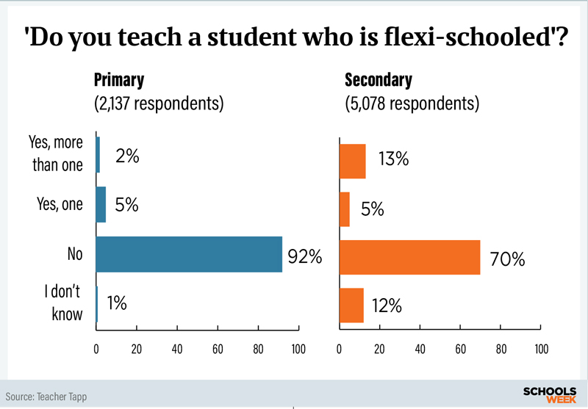
Data from a Schools Week commissioned survey of over 7,200 teachers in the UK (Chantler-Hicks, 2025)

Extracting themes from the existing research around some of the more qualitative elements and experiences of people who have entered this arrangement, two main papers emerge from the literature, both with very small sample sizes.

A Closer Look at Scotland: Language Matters
Between 2017 and 2018, an informal parent group who named themselves Dumfries and Galloway Parenting Science Group (DGPSG), obtained Welcome Trust funding, and researched three strands of flexischooling: the status, management and processes around flexischooling in Scotland (strand one), and parents (strand two) and teachers’ (stand three) views. This study was small scale and does provide useful insights into the flexischooling landscape of Scotland at that time, although the topic was not explored in great detail and sample sizes for the qualitative part of the research are small. The review highlighted that although flexischoolers seemed relatively small in numbers compared to children attending school full time, there were a lot of LAs with flexischooling policies in place. Most significantly, Fife council reported actively using flexible education arrangements (FEA), of which flexischooling was one, and had a 57-page policy to explain the process (Baker et al,. 2019). Furthermore, Fife had recorded a significant increase in flexischooling requests in the three years leading up to the 2019 review and therefore before the COVID 19 pandemic, and it is interesting that in Paxman’s (2022) more recent review of flexischooling, Fife reported a further 150% increase in pupils actively being flexischooled.

Much like the schools discussed in previously who moved to a whole school flexischooling approach, strand one of the DGPSG research revealed that factors around policy and transparency could play a part in prevalence of flexischooling in an area, revealing that councils with visible policies received more requests and had more uptake of the flexischooling offer.

The qualitative information gathered from the DGPSG report paints a largely positive picture. From the parents’ surveys, some clear and mostly encouraging themes emerged around parents’ perceptions of the consequences of flexischooling, which were based around finding a balance between family and school life, and a balance between home schooling and mainstream schooling (Baker et al., 2019). Reduced stress for the child, better attitude to school and positive effect on social confidence were all recorded by parents as benefits. These outcomes are comparable to Griffin et al.’s (2024) more recent research where parents reported similar benefits, with one parent commenting; “Being in school less hours is a massive help for my son’s behaviour as he is less overwhelmed” (p. 10). In contrast, in the DGPSG study there was also some concern that their children may be missing out on some learning and that school found it difficult to accommodate the flexischooling (Baker et al., 2019). Although the sample size was small (24 parents), this is an important initial insight to the impact of flexischooling on the lives of families and CYP who have chosen a flexi arrangement within a mainstream school.

Interestingly, The Poverty Alliance (2020) also published a small-scale research report that aimed to explore the qualitative experiences of families, CYP and professionals engaged in FEA’s in Fife. It was reported that some CYP on FEA’s were receiving no educational provision outside of school, that parents lacked understanding around the provisions put in place and that arrangements could negatively impact educational attainment (Robertson and McHardy, 2020). In fact, the report findings were largely negative. One parent's response emphasises their lack of agency in the FEA.

He was put on a part time timetable to try and get him to go to school because he wasn’t going…Soon as he got to fourth year subjects dropped like flies cause he’s not going there to do it…if they’d been giving me that work he’d be getting some sort of education from me. He wasn’t getting anything at this point. (Robertson and McHardy, 2020, p.14)

Overall, there are contrasting experiences reported from the DGPSG review (2019) and the Poverty Alliance report (2020), which both looked at parent experiences of part time schooling in areas of Scotland defined as having transparent policies that support flexible arrangements.

It is likely that language used to describe and define the agreement is significant. Parents who participated in the DGPSG (2019) research were from a group who self-identified as ‘flexischoolers’, they had embraced the role of partnership with their child’s school and reported a sense of control within that arrangement. Parents interviewed for the Poverty Alliance (2020) report are described as participating in FEA’s, but qualitative citing’s from parents and CYP indicate that the arrangement had not been a transparent process, and there had been a lack of guidance and support available from school. There is also an indication that these parents did not feel equipped or were perhaps not in position to take on some of the educational responsibilities that came with having their children at home part time, and so these young people were simply missing out on school, and this is indicative of a wider issue. In a Schools Week article reporting on school exclusions, this problem was highlighted as a concern for Ofsted; “part-time timetables are being used “too often” to manage pupils’ behaviour, sometimes as an alternative to exclusion.” (Towler, 2023).

Although the Poverty Allegiance report is not strictly an insight into flexischooling, it offers an understanding of how important the mutual relationships is between parent and school, and perhaps provides a warning as to how the CYP can be negatively affected if this is not ensured through secure policies and processes. A strong theme from teacher reports in the DGPSG also highlighted that parent partnerships were key to the success of a flexischooling arrangement, and this was also reported in Poultney and Anderson’s (2019) study, where the leadership team described key factor in making the model work, was recognising the philosophical stances of the home educators, and using this to inform the model. The DGPSG conclude:

[A] lack of consistency about what is considered as flexischooling, even what term is used to describe part time schooling, whether ASL [additional learning needs] pupils are counted in their flexischooling numbers, what policies local authorities have relating to it, and who has responsibility for flexischooling within each local authority. (Baker et al., 2019, p.30)

Focus on Autism
A resent systematic review on flexischooling of autistic students was undertaken by Richter et al., (2025). The review includes eight studies and finds that this research recognises flexischooling as a way to provide autistic CYP with an individualised education that seems to be successful, often due to its ability to be responsive to changing needs. Lawrence (2017) made a significant contribution to the flexischooling literature by utilising an interpretative phenomenological analysis to capture the lived experiences of five mothers who share their autistic child's education with school. A key difference in this work is that the term “shared education” is used in place of flexischooling and is defined by Lawrence (2017) as an arrangement that “may occur at the request of the either parents or the school” (p.2). The term is explained as one that reflects a wider concept of education involving the roles of parents, schools, and learners, as opposed to Meighan’s (1988) flexischooling concept which implies a more philosophical stance on parental involvement with a child’s education (Lawrence, 2017). This choice of terminology seems to indicate that families in the study felt that a more arbitrary choice (according to language chosen by Neuman and Gutterman's 2017 study) had been made to address educational and wellbeing needs presented by having an autistic child that struggles to cope with the inflexibility of a school environment. Lawrence writes: “the parents in this study seem also to be less secure in what they are doing”, and continues, “perhaps because of this, are less ready to report that they are experiencing pressure or to describe their involvement in their child’s education as being a major undertaking.’ (p.206) It is possible that a more value-based choice might imply more confidence to associate with a flexischooling identity, although this is not something that has been explored in the literature so far.

Lawrences’ (2017) research addresses the perceived positives and negatives of full-time school, finding ultimately that mothers in her study felt they could supplement what school provided and at the same time, mitigate many of the stressors their child faced: “they see it as a time of self-repair needed by their children due to the anxiety engendered by the pace and pressures of school” (Lawrence, 2017, p. 230). There has been a large effort undertaken to carry out research on the benefits and drawbacks of HE for autistic children. Most recently, O’Hagan, Bond & Hebron (2021) carried out a systematic review of the HE and autism literature and it is apparent that the lack of flexibility featured as an important priority for protecting the wellbeing of both families and children, highlighting that this community have long felt the need for more flexibility in the school system. Richter et al., (2025) in a more recent systematic review of flexischooling and autism reported benefits of flexible schooling that impacted the family and students’ wellbeing . One existing issue is the unlawful practice of informal exclusion of many autistic children, which is reported by The National Autistic Society (NAS) Great Expectation report, as happening frequently; “…exclusions often happen because a child’s needs are not well understood and therefore, not being met appropriately” (Reid, 2011, pg. 8). O’Hagan et al., (2021) rest on the following summary: “HE and flexischooling were identified as ways to provide the personalised curriculum and social opportunities that autistic children need as well as respite for parents. Such models encourage the acceptance and accommodation of different cognitive and behavioural profiles.” (p.12)

Lawrence’s (2017) study offers interesting insight into the possibility for educational diversity within flexischooling arrangements and considers whether it can benefit the children, looking at how different families take on varying percentages of the educational role. Some of the perceived benefits that arose from the shared education arrangements included that the shift to part time homeschooling addressed issues around sensory processing differences, it allowed families to provide a specialised curriculum tailored to their child's needs and created opportunities that improved interaction with their child. From Richter et al.’s(2025) review of the wider literature (which includes Lawrences’ study), these themes seem to be repeated, making a compelling case for flexischooling as a potential intervention for some autistic children who struggle with the school environment.

An important observation from Lawrence’s (2017) study is the acknowledgment that parents of autistic children are at an increased risk of psychological difficulties, and that the parents' perceived locus of control can be a significant factor influencing their adjustment to the stress of raising an autistic child. Similarly, an Australian study by Kidd and Kaczmarek (2010), also looked at the experiences of mothers’ home educating their children with autism and found that incorporating flexibility was important for the wellbeing of the child and parent: “…with respect to flexibility and well-being, taking time out (solitary time) throughout the day or week was regarded as important” (p.267). This study did not specifically mention flexischooling but did find that nine out of the 10 mothers interviewed, the impact of school on their children was mainly anxiety and stress, and the experience of coming home to be educated, offered increased wellbeing for all involved.

Another interesting theme highlighted the idea of flexischooling allowing the child to be more ‘themselves’: “Shared education is respectful of the autistic difference in the child and does not support a 'normalisation' process (rejection of the child as 'is') which may occur in school”. (Lawrence, 2017, p.137). Similarly, a paper by Goodley and Runswick-Cole (2012) comments on "normalisation" in the context of autism and explores how it has been a topic of debate for some time. It is argued that there is scope for acceptance and accommodation of autistic individuals as they are rather than attempting to make them "normal" according to societal standards. It is interesting to reflect on flexischooling as an option that could provide a respite from normalisation for a whole array of CYP, who find that the school environment impacts them in a negative way and causes them to want to avoid school, or even experience EBSA.

Summary of Literature Review

The first section of this literature review explored the origins of flexischooling, examining its historical development, potential reasons for its emergence, and its current legal status within the education system. Given the close relationship between HE and flexischooling, this section also considered the broader context of HE, highlighting key debates and conditions that influence educational approaches beyond traditional schooling, including discussion and inclusion. The second part of the review focused on existing research on flexischooling, dividing the discussion into two key areas. The first explored the potential for flexischooling to be implemented as a whole-school approach, while the second examined research on flexischooling as an individual choice, particularly the experiences of families who combine HE with part-time attendance at mainstream schools, with an additional focus on children diagnosed with autism.

Chapter 3: Methodology

Introduction
This chapter discusses and outlines the methodology of the following research. The goal of this research is to understand the experiences of families with children who have SEN, as outlined by the SEN code of practice (2015), who have undertaken a flexischooling arrangement following engagement with full time schooling. Experiences will be represented through participants’ personal narratives. The first part of this methodology chapter will outline my philosophical position as a researcher and how this relates to my research question and the decision to use a narrative methodology. This chapter will also define ‘narrative’ in terms of analytical methodology and discuss the use of narrative within EP practice and research. The second part of this chapter will discuss the design and procedure used to carry out the research.

Qualitative Research
Qualitative research methods are used to provide an in-depth description of a particular practice or setting (Mertons, 1998), whereas quantitative research can enhance understanding and enable hypothesis testing using standardised measurement tools (Patton, 2000). I did briefly consider the use of employing a mixed methods design, using survey based quantitative methods to explore experiences of flexischoolers, taking into consideration that studies employing statistical methods can provide insights that can be applied to broader populations (Howell 2013). Although I do see the value of this approach, I acknowledge that of the small pool of research currently available for flexischooling, most have taken a quantitative approach as a means to understand elements of the movement (e.g. Griffin et al.,2024; Baker et.al 2019), and there is a gap in qualitative insights of those undertaking a flexischooling arrangement. Therefore, using a qualitative approach could result in new insights into flexischooling.

Denzin and Lincoln (1994) describe qualitative research the following way: “…the studied use and collection of a variety of empirical materials [...] that describe routine and problematic moments and meanings in individuals’ lives” (p.2). Within this research project, I did not set out to understand the underlying mechanisms that make flexischooling successful, or to measure or compare flexischooling experiences against other school experiences, and I was not aiming to uncover a particular ‘truth’ about flexischooling. My research is qualitative and exploratory, and this category of methodology was chosen based on my view of the world, as well as the nature of the research question, which was to explore experiences rather than necessarily measure or categorise them. The use of qualitative methods has a strong and recent history within the Social Sciences (Esin, Fathi and Squire, 2013) and reflects the journey that the field of psychology has undergone since the 20th century. Once aligning itself with a positivist stance of facts and measurements, as Willig (2013) writes, research has now moved “towards a psychology that acknowledged the importance of language and ‘lived’ subjective experience” (p.143), as well as the impact and reflexivity of the researcher (Billington, Williams, Goodley and Corcoran 2017).

Reflexivity
Willig (2013) writes about the importance of researcher reflexivity and encourages those undertaking qualitative methodologies to pay particular attention to this throughout the research process. In qualitative research, the subjectivity of the researcher and participant are seen as central to the process (Ponterotto, 2005). Additionally, a narrative researcher should begin from a curious, unknowing position (Anderson & Gehart, 2007). To support me to be reflexive, I kept a research journal throughout the process of constructing this thesis, in which I noted my epistemological journey and ideas, my personal reflections and questions that felt important to keep in mind. Finlay and Gough (2003) write that there are multiple dimensions of reflexivity and describe the process as a ‘critical self-awareness’ that researchers must hold in mind throughout the research process. Personal reflexivity is one dimension, which leads the researcher to reflect on personal beliefs that have influenced or shaped the research (which includes, personal interests, political positioning and social identity). Epistemological reflexivity is also important, as it holds the researcher responsible for acknowledging how the design of the study defines or limits what can be found out, how the data and findings are constructed, and how it could have been investigated differently (Willig, 2013). In order to support transparency within this report, I have included reflection boxes that will enable the reader to gain some insight into my reflexive process. Personal reflections are noted in yellow boxes and epistemological reflections are noted in green boxes throughout, all are titled and can be found in Appendix A.

Epistemological Assumptions and Research Philosophy

To orient the reader, I am mindful to define the terms by which I position myself as a researcher with relation to my ontology and epistemology, which underpin and help organise my overall research philosophy. It is hoped that by outlining my ontology and epistemology, I will make clear the objectives of my research, which will in turn justify why I have chosen a particular set of methods with which to go about answering my question.

Ontology
Ontology is a word used to describe the way we think of the world, which has an impact on what we think can be known about it, and the way we assume we can investigate it (Fleetwood, 2004). Crotty (1998) states; “Ontology is the study of being” (pg.10). Blaikie (1993) offers further explanation, outlining ontology as, “the claims or assumptions that a particular approach to social enquiry makes about the nature of social reality” (pg. 6). My theoretical perspective as a researcher is aligned with a relativist ontology. This means that I understand knowledge and truth as it relates to the social sciences to be relative to the cultural, social or individual context (Baghramian and Carter, 2019). This contrasts with a realist ontology, which assumes that reality exists independently of human perception (Howell, 2013).

Epistemology
Epistemology is term used to describe the stance researchers take in relation to knowledge creation in the context of their research (Crotty, 1998). As a researcher I sought to explore the experiences of families who had embarked on a flexischooling journey. While I wanted to pay attention to the personal interpretations attached to those experiences, I was also particularly interested in acknowledging how experiences are shaped by broader societal discourses. Having explored different theoretical and philosophical positions (please see epistemological reflection boxes), I concluded that my epistemological position was that of a social constructionist, with elements of interpretivism.

According to Hammersley (2013), constructionism leads researchers to look at the processes that guide people to collectively construct their social worlds. Socially constructed processes include a range of categories realised through language and discourse (Burr, 2015). Examples relevant to this thesis include but are not limited to categories such as school, intelligence, parenthood and childhood. Foucault (1980) suggested that power is exercised through the discourse that surrounds these socially constructed processes and norms, and he believed that through this discourse, we create meaning and order (Howell, 2013). Berger and Luckman (1966) agree that the construction of truth and reality are contingent on the dominant cultural narratives and values. Blyth (2008) writes on the subject: “The rise of social constructionist theory within the social sciences has been grounded in a concern with the power relations and political effects of the knowledge that they produce” (p. 34).

An epistemology grounded in social constructionism asks the researcher to take a multidimensional approach to explore the situation they are researching, to see how participants make sense of their experience by looking at “context, environment and interactions” (Cohen et al., 2017, p. 23). I was interested in the way people talk about the world and their experiences of it (Willig, 2013) and I felt strongly about taking a critical approach to accepted knowledge, seeing it as shaped and maintained by social processes (Burr, 2015).

Through listening to peoples experience of flexischooling, I can begin to understand some of the constructions that people make about their world. “Discourse must be seen as not simply an instrument of power but also as a means of challenging power” (Howell, 2013, p.179). As explored in the literature, flexischooling is perhaps an example of an education that is adapting to the current context and environment, challenging some more traditional schooling norms of full-time attendance at school, and therefore the phenomenon in itself was a topic that aligned well with social constructionism.

Social constructionism assumes that reality is not something "out there" to be discovered; instead, reality is continuously shaped through shared meanings, human interaction and language (Burr, 2015). I find myself aligned with Gergen’s (1985) position, as he explains how perceptions and ideas shift in response to historical factors, in the following quote from his paper The social constructionist movement in modern psychology:

In certain periods childhood was not considered a specialised phase of development, romantic and maternal love were not components of human makeup, and the self was not viewed as isolated and autonomous. Such changes in conception do not appear to reflect alterations in the objects or entities of concern but seem lodged in historically contingent factors (p. 267).

Social constructionism acknowledges that human experience and what we perceive as real, must be understood as being mediated by history, culture and language (Willig 2013). It suggests that there are “‘knowledges’ rather than ‘knowledge’” (Willig, 2013, p. 7). In my own research, I have aimed to privilege participants' voices, to thicken the narrative around flexischooling, as opposed to simply presenting data. It is this desire to privilege voice that in turn, influenced the methods I chose.

Language plays a crucial role in recognising that knowledge is socially constructed. Willig (2013) compares the social constructionist researcher to an architect, examining a phenomenon to understand how it has been constructed and the materials and resources involved. Accordingly, my analysis will adopt a critical rather than a descriptive stance.

My epistemological stance also incorporates interpretivism, which means I am interested in the subjective meanings and experiences of the participants I have interviewed.
Cohen et al., (2017), states of interpretivism that: “Individuals and events are unique and largely non-generalizable; there are multiple interpretations of, and perspectives on, single events and situations; researchers need to examine situations through the eyes of the participants, rather than the researcher” (p.10).

Both social constructionism and interpretivism emphasise the subjective nature of reality and knowledge (Crotty, 1998). The core focus in the context of the interpretive paradigm is to “understand the subjective world of human experience” (Cohen, Manion and Morrison, 2017, p. 19) but the incorporation of social constructionism acknowledges that the human experiences and sense of self and meaning evolves through a social and cultural context (Bruner, 2002). In summary, I aimed to explore how experiences of flexischooling are socially constructed and also pay attention to how participants made sense of these narratives in their personal experiences (Crotty, 1998). See Appendix A for epistemological reflections on my philosophical position.

Narrative Psychology and Educational Psychology Practice

“Discourse must be seen as not simply an instrument of power but also as a means of challenging power” (Howell, 2013, p.179).

Reissman (2008) suggests that there is a universal impulse towards narrative, present in every society, place and age, and that narrative psychology can help individual experiences to be shared through listening to people's stories. However, Clandinin (2006) points out that there is a difference between what we consider to be ‘narrative’ as it relates to ways of thinking, and what we refer to as ‘narrative inquiry’ as it applies to research methodologies in the social sciences. Bruner (2002) for example, writes about the sharing and telling of stories and how it helps us to know about experience: this is referred to as “narrative as a mode of knowing” (p.8). Narrative as a mode of knowing is used in the field of EP practice frequently, often as an assessment, formulation or change tool. For example, EPs regularly engage in practice through consultation, which aims to offer alternative perspectives on difficult or ‘stuck’ situations (Wagner, 2000). Within consultation EPs listen to different perspectives that often present in a storied form, and aim to support all of those involved in a young person's life to understand and appreciate the complexities of different situations. From a social constructionist perspective, an EP's role can be seen as that of a re-constructor, possessing the ability to reshape prevailing narratives about individuals. By using language to challenge and deconstruct existing beliefs and stories surrounding CYP, EPs can influence how these individuals are perceived and understood (Billington, 2000). Other examples of narrative tools used by EPs include narrative therapeutic interventions such as ‘The Tree of Life’ (Ncube, 2006), which can support CYP to tell their life stories through metaphor.

Narrative approaches also provide the opportunity to engage in transformative practice through offering a context in which dominant narratives can be questioned and the focus can be placed on power and social justice issues and finding new possibilities (Flemming, Paton and Rowley, 2023, p. 136)

Burr (2015) suggests that through this form of narrative, when “people talk to each other, the world gets constructed” (p.6). In my work as a Trainee EP (TEP) I was drawn to narrative approaches and from the onset of my research I knew I wanted to incorporate participant voice, keeping it as central to the project as possible. Conversations with my research supervisor initially helped me to better understand where narrative approaches could be impactful in research and further reading informed and helped me to narrow down my specific approach. See Appendix A for personal reflections on choosing narrative.

Narrative Inquiry in Research
Gergen (2001) suggested that when the field of psychology broadened research methodologies and perspectives, the profession would increase its ability to impact society due to an increased openness and engagement with diverse ways of knowing. Lieblich Tuval-Mashiach and Zilber (1998) and Clandinin and Connelly (1990) write that narrative inquiry as a methodology emerged as a response to positivist and post positive paradigms, and Kohler, Riessman and Speedy (2006) agreed that in the social sciences, narrative inquiry is a 20th century development which Clandinin (2006) refers to as a ‘narrative turn’. Within the field of psychology, a study employing narrative inquiry aims to offer an alternative view compared to that which a quantitative or positivist psychology study might submit, by placing emphasis on the role of language and the exploration of lived experience through storytelling. Examples of studies from the field of educational psychology using narrative approaches are substantial and can be found in journals such as Educational Psychology in Practice (EPIP). Examples include a paper by Tellis-James and Fox (2016) who used Narrative Oriented Inquiry (NOI) to explore the stories of young people with social, emotional and behavioural difficulties, and Hingley (2020) who’s thesis took a narrative inquiry approach to explore the educational experiences of CYP who attended pupil referral units.

Although the definition of narrative inquiry in research is varied, it refers to a family of methods that supports qualitative researchers to make sense of data that has a common, storied form (Riessman, 2008). Narrative inquiry is not just as simple as listening to a story, presenting it in written form and analysing what was said (Riessman, 2008). Narrative researchers interpret meanings within text by analysing thematic structures, looking at plotlines and exploring cultural and social references (Kim 2016). Butina (2015) identifies that humans are natural storytellers and asserts that in research, narrative is often captured through interviews.

In this research study, participants were asked to talk about their experiences of flexischooling within a semi structured interview format, and the stories were analysed by using narrative thematic analysis (NTA) which supports the researcher to focus on content of what is said rather than necessarily form, or structure. Butina (2015) asserts that, “…this approach has been used in many disciplines to learn more about the culture, historical experiences, identity, and lifestyle of the narrator” (p.190).

Why choose Narrative?
Narrative is a qualitative method of data collection that enabled me to give space and opportunity to participants to share their experiences of flexischooling. Gergen and Gergen (1988) write that language within stories is significant, being situated in and shaped by the social and cultural context, and therefore is much more than simply a form of expression. A narrative approach fits well with my research aims and philosophy, providing a premise to collect rich and detailed data through the stories of participants. Anderson and Kirkpatrick (2016) write that “narrative interviews place the people being interviewed at the heart of a research study” (p.631) and this aligned with my epistemological values as a social constructionist with elements of interpretivism, by using a method that privileged participants voice and personal experiences and took into consideration the wider social and cultural terrain.

Chapter 4: Design and Procedure

The design of my research project was qualitative and exploratory as this was deemed to be an appropriate means by which to answer my research question and aims, as outlined in the previous sections of this chapter. I used semi procedural diagram of my research design is shown below. structured interviews and NTA to analyse my data, the details of which will be discussed in the following sections. A

Figure 3
Narrative inquiry is not just as simple as listening to a story, presenting it in written form and analysing what was said (Riessman, 2008). Narrative researchers interpret meanings within text by analysing thematic structures, looking at plotlines and exploring cultural and social references (Kim 2016). 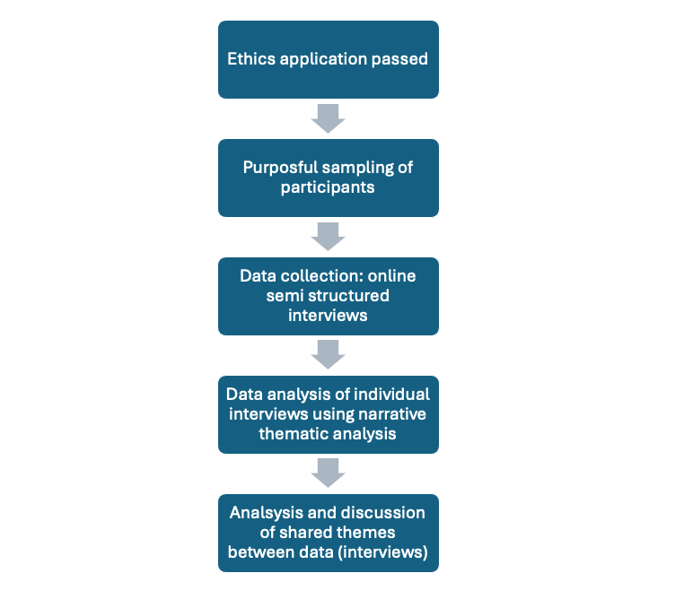
Procedural diagram of research design

Quality Appraisal of the Data
Daly et al., (2006) highlight that due to the flexibility and range of qualitative research methods, all the different study designs available to researchers are “not easily captured in a single set of quality criteria” (p.45) and they advise that evidence from qualitative studies will look very different from that generated by quantitative studies. Riessman (2008) further argues that “…fixed criteria for reliability, validity, and ethics developed for experimental research are recommended and misapplied; they are not suitable for evaluating narrative projects” (p.185). Similarly, Butina (2015) notes that no specific strategies have been established as best suited for the narrative approach. Despite this, I remained conscious of ensuring that my study upheld principles of quality throughout the research process. The Total Quality Framework (TQF) was developed to assist researchers working with qualitative methods by promoting specific outcomes, such as: (a) gathering high-quality data, (b) enabling more valid and reliable data interpretations, and (c) ultimately generating highly useful results (Roller et al., 2015, p.16). Additionally, Roller and colleagues suggest that the TQF can serve as a valuable resource for consumers of qualitative research findings, as it bolsters trust in the study’s accuracy and usefulness. The TQF is versatile, accommodating research designs that are flexible and not restricted to a single paradigm, allowing it to be applied at every stage of the research process. The TQF emphasises four key areas: credibility, analysability, transparency, and usefulness. Considerations of credibility in terms of research scope and data collection have been addressed in the subsections on sampling, the pilot study, and data collation and organisation for analysis.

Issues related to analysability, particularly those concerning data processing and analysis, have been addressed in the sections on data collation and organisation, while validity concerns have been explored in the context of semi-structured interviews. Roller and Lavrakas (2015) recommend maintaining a reflexive diary as an effective strategy for enhancing the credibility of qualitative data. In alignment with this, I have documented my reflections on how my values and beliefs have influenced my interpretation of the literature and research process. I sustained this practice throughout both data collection and analysis and some of these reflections can be found in Appendix A.

Roller and Lavrakas (2015) define transparency as “completeness and disclosure in the final documentation that researchers create about a qualitative research study” (p. 44), alongside the researcher’s commitment to producing thick descriptions. To ensure transparency in my study, I have carefully documented my research processes and maintained an audit trail of all relevant materials, which are included in the appendices (referred to throughout the chapters).

Ethical Considerations
I adhered to the standards outlined in The University of Sheffield Ethics Policy Guidelines and obtained ethical approval from the University of Sheffield’s Board prior to data collection and participant recruitment. Please see Appendix B for ethics approval letter. The ethics policy emphasises that, as a fundamental principle of research ethics, participants must be “fully informed about how and why their data will be collected and used as part of a research project, and by whom” (University of Sheffield, n.d.). To ensure this, I provided information forms and secured informed consent from all participants, including their right to withdraw. (please see Appendix C and D for examples of these). I also verbally reinforced the right to withdraw at the beginning of interviews, as well as letting participants know they could stop at any point throughout the interviews and withdraw until two weeks after the interviews have taken place. Participants were debriefed at the end of interviews and given the opportunity to ask any further questions. Participants were sent copies of the transcripts for interviews via email shortly after they had taken place, and were given the opportunity to let me know if there was anything incorrectly transcribed, or anything they were unhappy with. Participants were informed of the process and of my supervisor's contact details, should they wish to report any concerns or raise any worries with someone other than me. In relation to avoiding possible harm, I considered that having participants engage in interviews about an educational journey that might have been difficult to talk about might bring up uncomfortable feelings for them. To mitigate this effect, I provided signposting to a charity that they could contact in the event that they needed to reach out for support.

Participants personal data has been anonymised and original transcript and audio recording from Google Meet stored on a secure password protected university approved drive, which only I had access to. These files will be deleted within a predetermined time frame, as stated on the participant information form. Anonymised transcripts were stored on a secure password protected Google Drive that is associated with my university account, and only my supervisor and I had access to these.

Participants
The aim of my study was not to generalise the findings to a broader population; therefore, a large, statistically significant sample size was not necessary. Principles of narrative analysis “…assumes that the detailed investigation of very small numbers of research subjects’ processes of making sense of their experience is seen as being of intrinsic interest” (Wareham, 2012, p. 33). I decided to conduct up to six interviews, considering the time available for data collection and analysis. To ensure the possibility of comparing and contrasting themes within the narrative thematic analysis, I established a minimum of two interviews. According to the principles outlined in the TQF, Roller and Lavrakas (2015) emphasise the importance of carefully defining the target population for research, ensuring clarity and relevance in participant selection. I undertook purposeful sampling of participants as I had a clear idea of the features I needed from my participants, as dictated by my research question. These included the following:
- Participants must have CYP who have experienced a school education before flexischooling was employed as an approach.
- Participants must have been flexischooling their CYP for at least two academic terms (this means I can include those flexischooling with less than a year’s experience but ensure they have gained enough momentum to reflect on their experience).
- Participants must be based in the UK e.g. England, Ireland, Scotland, and Wales.

Morgan (2017) writes that qualitative methods will often be successful or not, depending on whether or not “high-quality sources” (p.124) can be identified. To recruit participants, a recruitment advert with an embedded QR code that linked to my information sheet (see Appendix E) was shared on Flexischooling Families social media sites (Facebook and Instagram), which are both run by volunteers as part of a nonprofit organisation that aims to support families in the UK who are, or want to flexischool. At the time of recruitment, the Facebook page had 16,000 members and the Instagram page had 9,322 followers. The Facebook page has been used as means by which to recruit participants for other research projects that focussed on Flexischooling, (e.g. Griffin et al.,2024; Paxman, 2022; Baker et al., 2019; Lawrence, 2017 & 2018), and the research flyer was posted on my behalf by administrators of these accounts, each week for around nine weeks. My recruitment advert was also emailed to three schools and posted on an X account for an organisation called Finding the Flex, who support those interested in flexischooling options. The recruitment advert was circulated in the summer term of 2024 and I was able to recruit three participants during this time. All three participants were recruited through the Facebook and Instagram accounts and once they contacted me to express interest, I emailed them a copy of the consent form for signing and arranged an online interview schedule at a time that suited them. According to the QFT, the importance of acknowledging the limitations in achieving full representation from a specific population sample is emphasised (Roller and Lavrakas, 2015). I recognise that my research does not include all potential participants, as it has been limited to those currently engaged on social media platforms. This could lead to a bias in my findings, as it may exclude flexischoolers who do not participate in these online communities. I would have preferred to recruit more participants, however I kept in mind that with qualitative research, there is no perfect sample size to consider, as rules for optimum sample size do not exist (Patton, 2022). According to the National University Library (2023) recruitment should be terminated when no new participants are forthcoming, and this is commonly known as sampling to the point of redundancy. With this in mind, the recruitment ended at three participants.

Pilot Study
In line with the TQF, conducting a pilot study is crucial for assessing and reflecting on potential biases and researcher behaviour. Roller and Lavrakas (2015) highlight that inconsistencies in data collection tasks can introduce bias into the research. In my study, factors such as interview techniques and procedural variations could contribute to such inconsistencies, making a pilot study an essential step in refining the research approach. Based on conversations with others who had sought the views of flexischoolers for research purposes, I understood that the population I intended to study was likely to yield a limited number of participants. I therefore discussed and agreed with my university supervisor, the possibility of using a contact who was already known to me, who had similar characteristics to my ideal participants. In this case, I used a contact who was home educating their child with SEN. Whiting (2008) writes that to “develop and enhance personal skills before conducting research interviews, it is useful to practise the technique of interviewing” (p.36). I completed a pilot study, and it helped me consider my interview approach in a critical way. Although the feedback from my pilot study was positive, some modifications were implemented based on personal reflections, before I carried out final interviews with real participants. See Appendix A for personal reflections on my pilot study.

Data Collection: Semi-structured Interviews.
As Creswell (2013) identifies, data collection is typified by a series of tasks ranging from determining a strategy for sampling and identifying participants, to conducting interviews or carrying out questionnaires. My primary source of data collection was through in-depth online interviews. These were qualitative, semi-structured interviews and they were designed to collect the subjective viewpoints and experiences of participants (Braun & Clarke, 2013; Flick, 2018), which I was hoping to gather through the participants' storytelling their experiences.

Where did the Interviews take Place?
Interviews were offered online and over the telephone, and in the end all three took place online, and lasted between one hour and one hour and half. As I was recruiting participants nationally, I believed that in person interviews would be a less feasible option, due to parents who were likely to be short of time based on their homeschooling responsibilities. I did consider that having cameras on and therefore conducting face to face interviews might impact how the participants interacted with me, and I wondered if social desirability may impact the participants' performance within the interviews. Holden and Passey (2009) consider social desirability to be “the tendency for people to present themselves in a generally favourable fashion” (p.441). Although this bias may be lessened during online interviews when the interviewer has the camera turned off (Gibson, 2010), Whiting (2008) reminds us of the importance of building rapport during interview scenarios. In narrative inquiry, the presence of the interviewer is known to impact the story with reference to how he/she listens, encourages, interrupts, initiates topics and so on. I decided that I would begin by having cameras on so that the participants could orient themselves, and then they had a choice of whether or not to have their cameras on throughout the interview. I did this as I privileged the idea of rapport being built, which I believed would help the participants feel comfortable and build trust, which was central to my approach.

Questions and Prompts
To privilege participants' voices, I wanted to use prompts that would encourage and support them telling their stories. Mishler (1986) asserts that a narrative is always a joint production between the listener and storyteller, and I wanted to remain aware of this and allow it to guide my decisions with regards to facilitating the interviews.

Semi-structured narrative interviews followed four key phases. Phase one introduced the session, reiterated confidentiality, and outlined the structure. Phase two focused on rapport-building, helping participants feel comfortable while gathering contextual data (e.g., their child’s age and duration of flexischooling), as recommended by Whiting (2008).

In phase three, I used a main orienting statement (Cudworth, 2014): “Tell me about your journey to and experience of flexischooling,” allowing participants to narrate their experiences in their own words. Finally, phase four involved reflecting on participants' language and themes to prompt deeper discussion. This aligns with Roller and Lavrakas' (2015) suggestion that real-time paraphrasing enhances validity through a question-answer process.

Semi structured interviewing often involves the researcher developing a ‘topic guide’, which aligns with areas of interest that have been identified from the literature, rather than specific lines of questioning (Anderson and Kirkpatrick, 2016). I used Socratic questioning to gain more understanding about flexischooling experiences, using topics that a participant had talked about as a prompt. Examples of my questions and prompts can be found in Appendix F.

Data Analysis: Narrative Thematic Analysis (NTA)
Whilst Butina (2015) points out that there is no universal method to analyse narrative data, Riessman (2008) considers that there are four approaches that are common: thematic, structural, visual and dialogic approaches. I chose to use NTA to understand the experiences of my participants, as it enabled me to focus on the content of the participants individual stories; “the most common of the four approaches [to narrative analysis] is narrative thematic analysis in which content within the text is the primary focus” (Butina, 2015, p. 193). NTA is also a flexible approach that enabled me to pick out themes across the experiences, which aligns with my epistemological choices to acknowledge social and cultural influences. I used an inductive approach, which means I looked at the data (stories) without a theoretically informed coding frame (Willig, 2013). See Appendix A for epistemological reflexivity: NTA and other considerations for analysis.

Thematic analysis (TA) is a commonly used method in psychological research, and it is considered a useful and flexible method, suitable for both small and large samples (Braun & Clarke, 2006). Braun and Clarke (2006) dominate the methodological field of TA and write that it can be employed within different methodological frameworks such as within narrative research, making it an overarching analytical strategy rather than a specific, rigid technique. TA techniques are relevant to the analysis I have carried in this thesis and as such, TA approaches are referenced at times, although there are points at which NTA departs from Braun and Clark's approach.

For NTA, the researcher emphasises coherence of the narrative and maintains the integrity of the participants' stories (Clandinin and Connelly, 2000), rather than breaking the data into decontextualised themes, as is the case with TA. Patton (2000) recommends that with small sample sizes such as mine, the researcher would be best placed to begin with analysis of individual cases, then the “cross case pattern analysis of the individual cases” (p.447). Riessman (2008) also points out that although it is case based, narrative analysis "prompts the reader to think beyond the surface of a text, and...move toward a broader commentary" (p. 13).

Mishler (1996) qualifies that case-based methods of enquiry are not less scientific than population-based, variable centred approaches, and Reissman (2008) agrees that this way of generating knowledge is used throughout history to form theoretical positions. In psychological research and in the physical sciences, “…theories of great significance were developed through the study of individual cases…” (Reissman, 2008, pg. 12). Patton (2002) for example, provides the example of how Piaget’s (1970) observations of his own two children contributed a major breakthrough to how we understand the ways children think, and points out that Freud (1900) established the entire field of psychoanalysis on less than ten case studies.

Within data analysis Patton (2002) points out that analytical approach is often unique, relying on the judgement, skills and creativity of the researcher and as such, I have followed these steps and used in depth analysis of each interview, followed by cross case pattern analysis. Patton (2000) continues to say that “…the analyst's first and foremost responsibility consists of doing justice to each individual case” (p.449). Braun and Clarke (2006) point out that when analysing themes across a whole data set, some of the depth might be lost. They do write however, that a rich overall picture is maintained with this approach, especially when investigating an under-researched area or if “…you are working with participants whose views on the topic are not known” (p.83).

Kim (2016) warns of narrative smoothing when processing and interpreting narrative data, which is where a researcher subjectively interprets the text, attempting to make the story better rather than staying faithful to what was said so it stays “coherent and engaging” (p.192). This is something I was aware of and tried to avoid. Kim (2016) agrees that narrative data analysis involves a high level of interpretation, and so it is a process that is both objective and subjective.

Small Sample Size and NTA
In terms of sample size deemed appropriate for a NTA to be useful, Mores (1995) points out that saturation point (the point at which no new themes emerge), is most commonly seen in social sciences as the key to good research, however is also quick to add, “…there are no published guidelines or tests of adequacy for estimating the sample size required to reach saturation.”(p.147). Guest, Bunce and Johnson (1996) point out that in qualitative research it is especially hard to estimate numbers of participants in advance for hard to reach, stigmatised or hidden populations, which was true of my target population.

The Process of NTA
NTA involves five phases, and I followed these as set out by Butina (2015). As an additional layer to support me with my analysis, I also utilised Leggo's (2011) narrative analytical technique, RITES (Read, Interrogate, Thematize, Expand, Summarize). This technique fits comfortably into Butina’s five phases, and I found it specifically helpful to guide me towards deeper interrogating and thematising once I had carried out the initial descriptive coding phase.

Phase 1: Organisation and Preparation of the Data
For narrative analysis it is necessary to transcribe the content of the interview, including the researchers' questions and the participants' answers. Depending on the aims of the research, it may be appropriate to transcribe all of the pauses and innovations (Crossley, 2000). In this research, I was chiefly interested in the content of the interviews and so I have not focussed or amended anything in order to acknowledge those finer details. Examples of fully transcribed transcripts can be found in Appendix G. Google Meet generated an initial electronic transcript, and I read through each one following the interviews to tidy and check for typos and inaccuracies in the text. I listened to and continually paused and unpaused the original recordings of the interviews to help me to carry out this process. Any identifying information such as the names of a child or a school was replaced by a pseudonym, and anonymised and tidied copies of the transcripts were saved onto a secure drive. Following this process, transcriptions were sent to participants for checking. No participants returned transcripts or pointed out inaccuracies.

Phase 2: Obtaining a general sense of the Information
The second stage started to happen simultaneously with phase 1, as I familiarised myself with the data through the transcription process. I made notes in my research diary on this first reading, some of which became the basis for some preliminary codes and ideas for themes. Step one (read) of Leggo’s (2011) RITES method marries phase one and two of analysis, where a general sense of the story is obtained.

Phase 3: The Coding Process
I initially began the coding process by manually colour coding parts of the transcript based on recurring words or parts of the text I thought were interesting or significant. I created an additional, separate document with a table where I named the code and copy and pasted the relevant highlighted part of the transcript, along with the page number so that I could easily find it again.

Although this process was helpful to begin with and allowed me to get close to the narratives and organise descriptive codes in a visual way, I found that there were too many codes and not enough colours - the process became a little messy and I realised I would need to find an alternative process to build on my coding, and eventually to support me look for themes. As I worked through the data, I ended up abandoning the colour coding and simply added comment boxes in the margins of the document where I felt a code needed a new name or needed to be collapsed into a different code. See below for an example of my developing coding.

Figure 4

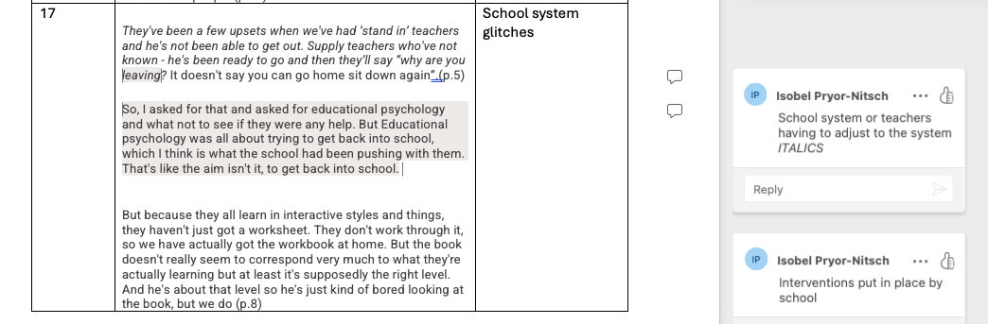
Extract from my coding table

I noted throughout this process that some codes overlapped, and I had coded the same references more than once if this felt relevant. For example, in Helen’s interview the code ‘helping the school understand our child’ and the code ‘being proactive’ seemed to overlap quite a lot and so these ended up being grouped into the new code ‘Advocating for our child’. Another example of this is from Jenny’s interview, where the code ‘school not being proactive’ was collapsed as a category and instead references for this code ended up being sorted into the codes ‘blame or scepticism’. My initial coding was quite descriptive in nature, and I was aware that the frequency of a code does not determine its importance, which is why it was helpful to enlist the second step of Leggo’s (2011) method, which was ‘interrogate’. This stage prompts the researcher to ask questions like: “who? what? when? how? so what?” (p.7) and it was helpful to ask myself some of these questions when I was deciding how to group codes. For this stage I needed a more visual procedure, so that I could see all of my coding in one place and begin to move the codes around. I used the programme Miro to facilitate this. Miro is an online whiteboard tool that can help with data visualisation and mind mapping, as well as other tasks. For each of my interviews I created an interactive board in Miro where I added a virtual post it notes to the board for each code I created, with an extract of text from the narrative which represented that code. I could then manually move the post it notes around the board and cluster them together, draw arrows between them and write additional notes relating to Leggo’s (2011) interrogation stage, to support my thinking. Figure 5 is a section of my Miro board for Jenny’s narrative, showing three post it notes with codes. I have included an example of one of my final codebooks for in Appendix H, which shows how each code fitted with each theme or sub-theme.

Figure 5
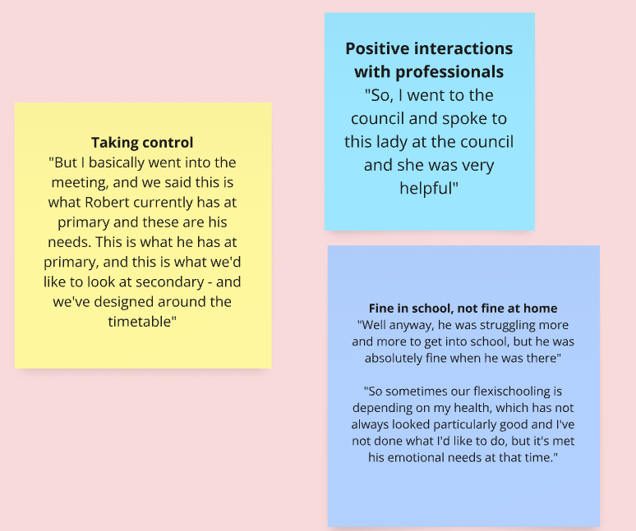
Screenshot of my Miro board showing three post it notes from the coding phase.

Phase 4: Categories or Themes
Themes are clusters of codes that have been interpreted on a higher level. For this stage of the process, codes are ordered into a category or marked as a ‘theme’. Butina (2015) writes; “…categories should reflect the themes that have become apparent and represent the major findings of the study” (p.192). Braun and Clarke (2006) remind us that with any form of TA, themes do not simply emerge from the data, but instead, the researcher is constructing them. There were 26 codes on Jenny’s Miro board, and they ended up being clustered in five themes, although there were various iterations where codes were clustered differently throughout my thinking process. The process took some time, because it was necessary for me to consider values and assumptions linked to broader contexts: themes that lay below the surface of each cluster of codes. For example, in Jenny’s narrative I felt there were several explicit themes relating to her experience of flexischooling, such as the time it had taken to establish a routine, or the school’s initial difficulty in becoming more flexible to meet Roberts’ needs. While I didn’t want to ignore these themes because they were a significant part of her journey, codes that I initially grouped together into these categories became the theme, ‘Flexischooling as a responsive journey: “…it’s taken years....” . See figure 6 for an example of a cluster of codes that made up a themes.

Figure 6
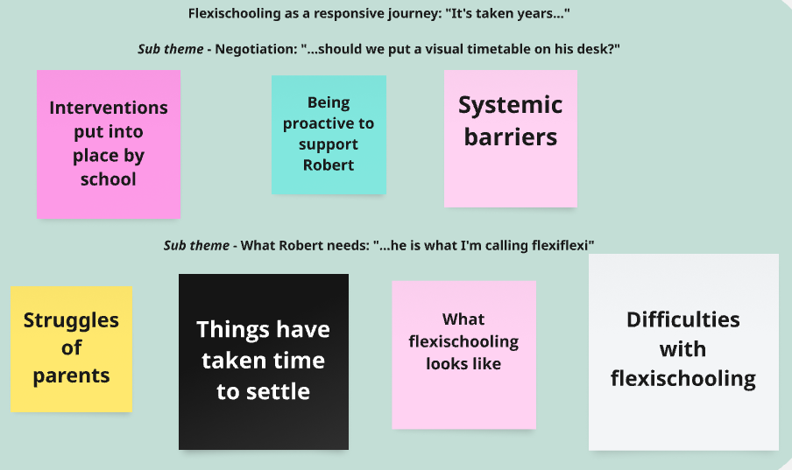
Screen shot from Jenny and Robert’s Miro board, showing codes that had been organised into the theme ‘Flexischooling as a responsive journey: “…it’s taken years…”

A TQF approach to coding advises that at least two coders should intermittently look at each other's coding to help with consistency, however because I was undertaking a piece of work for my thesis, I used supervision time to discuss and reflect on my themes. The third step of Leggo’s (2011) method also states that thematising needs to take place through re-reading of the whole narrative with a focus on the emergent ideas that have surfaced within the coding process, which I found helpful to do alongside using the Miro board to visualise the process.

Phase 5: Interpretation of the Data
Butina (2015) notes that the final stage, ‘interpretation of the data,’ can sometimes occur alongside other research processes. However, it primarily involves making sense of the data by assessing whether the overarching themes effectively address the research aim. I made a visual thematic map for each interview and spent considerable time exploring each one. My analysis of each interview has been presented within the findings section of this report, as a way of honouring the original narrative structure of the mothers’ stories. To complete a final cross case pattern analysis, I wanted to identify themes that were common across all three interviews, so I used the Miro board to create one large thematic map which comprised all of the themes from each interview (see figure 7 for an example of a section of this large thematic map). Full thematic map in Appendix I. In the discussion sections of my report, I expand on and summarise these themes.

Figure 7
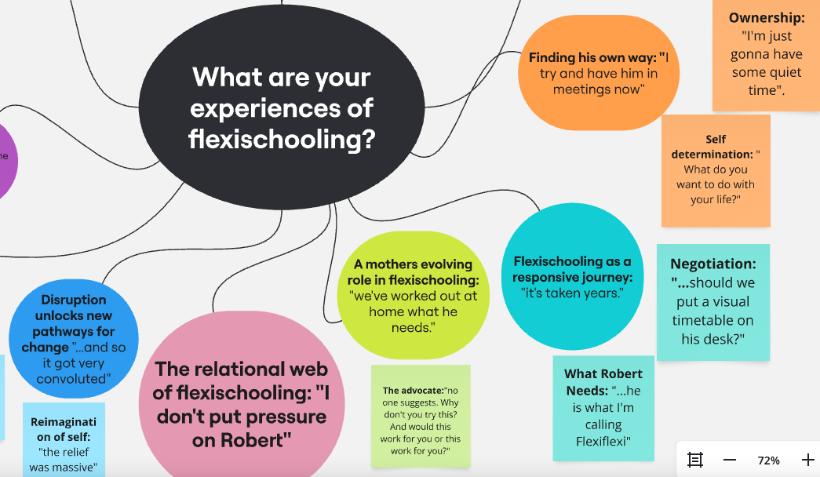
Screenshot of a section of the Miro boards’ large thematic map, which incorporates themes from each interview.

Methodological Limitations
In choosing the method for my research, I believe I have selected an appropriate approach to explore the research question. As my research is exploratory in nature, it was not designed to test a specific hypothesis, but rather to understand the experiences of participants in a deeper, more nuanced way. Despite its suitability for this purpose, there are several methodological limitations to consider.

Lieblich et al. (1998) argue that narrative research lacks scientific rigor due to its inherently loose form and lack of structure. The flexibility of narrative inquiry, while a strength in capturing rich, contextualised data, may also be seen as a limitation when compared to more structured research designs. Polkinghorne (1988) further suggests that narrative research occupies a unique position between qualitative research and arts-based research, which may contribute to its perceived lack of scientific rigor. This blending of methods can challenge the establishment of clear, replicable procedures, and questions may arise regarding the extent to which findings can be generalised. Additionally, Polkinghorne (1988) highlights the difficulty researchers face in accessing the “…realm of meaning of others” (p. 7), suggesting that meaning in narrative research is mediated through the participants’ ability to recall, reflect upon, and articulate their experiences. This reliance on participants' introspection and their narrative ability introduces potential variability in the richness and accuracy of the data collected, as the content of their stories is shaped by their personal recall and self-reflection.

Moreover, I have considered that some participants may find it challenging to convey their stories in an open-ended narrative format, as opposed to responding to structured questions typically used in interviews. Anderson and Kirkpatrick (2016) observe that “…some people may find it particularly challenging to tell their story to a researcher in this way rather than be asked a series of questions like in a television or radio interview” (p. 631). This challenge could impact the completeness and depth of the narratives, as participants may struggle to organise and express their experiences without a more structured framework guiding the conversation. As such, it is important to recognise that the nature of the interview process itself can influence the data produced.

Regarding my philosophical position, some criticisms of social constructionism need to be acknowledged, particularly its tendency to downplay the existence of a stable reality that underpins social structures. Critics such as Fleetwood (2015) argue that social constructionism overemphasises the role of language and human thought in shaping social realities, which can lead to an idealistic or subjective interpretation of reality. Fleetwood (2015) contends that “…social constructionism exaggerates the consequences of activities such as speaking and thinking to the point where it is hard not to define this as an example of subjective idealism” (p. 204). Despite this critique, I maintain that social structures are not static and can be renegotiated through discourse and interaction, which aligns with the core tenets of social constructionism. This philosophical stance remains appropriate for my study, as it allows for the exploration of how meaning is co-constructed through social interactions and the ways participants' narratives reflect their understandings of their own experiences within a broader societal context.

While these limitations are important to consider, they do not undermine the value of narrative research for exploring the complexities of individual experiences. Rather, they serve as a reminder to remain reflexive throughout the research process and to consider how the interplay between researcher, participant, and methodology shapes the construction of meaning.

Chapter 5: Analysis and FindingFindings

In this chapter, I present the findings from my narrative thematic analysis. Given the uniqueness of each participant’s lived experience, I begin by outlining themes that emerged from their individual narratives. Interview excerpts are included in italics to illustrate where these themes became evident, along with page numbers indicating the source location. Full transcripts are available in the appendices (see Appendix G), and an example of a codebook for one of the interviews can be found in Appendix H. I have included a full thematic map (see figure 8), which is a visual representation of themes from each of the interviews. From this map it is possible to see how some themes are interlinked between participants and in the discussion section, I draw attention to key similarities across the three flexischooling experiences that were particularly significant in shaping the overall analysis.

Figure 8

Screenshot of the Miro board: a visual representation of the full thematic map, as represented my by analysis.
Patton (2000) proposes that when using case-based data, a case study narrative is useful to include. On this recommendation, I have written a short summary of the flexischooling arrangement and some basic details that were shared with me by participants, including the age of flexischooled child, the nature of any SEN for example, for each of the participants (Jenny, Helen and Carey), to orient the reader.

Jenny and Robert
Jenny is Robert’s mother, and they live in Scotland, where they have been officially flexischooling since September 2021. Robert has a diagnosis of autism and Jenny shared that he has a pathological demand avoidance (PDA) profile. Jenny shared that they had been doing something similar to flexischooling during the COVID lockdowns in 2020. Before flexischooling was officially introduced, Robert used to have difficulties being in school due to the way some lessons were taught and the level of overstimulation he experienced in the school environment. He would often seem like he was ok when he was in school, but Jenny described how she would have great difficulty getting him into school in the mornings and that he would often be very angry and upset at home. She was finding it hard to keep him physically and emotionally safe, and flexischooling ended up being a bridge between full time school and HE. As part of the agreement Robert spends two afternoons at home and he has some soft start mornings when he needs them - the rest of the time he is at school. At the time of the interview, Robert was almost 12 years old, and he was about to finish primary school. Jenny and Robert had begun having discussions with his secondary school to organise how flexischooling would look when he started his new school.

Thematic Map for Jenny’s Interview
From Jenny’s interview I was able to extract four main themes and seven sub-themes that I felt were significant. The thematic map below (figure 9) is a visual representation of Jenny’s experiences, as represented by my analysis process.

Figure 9
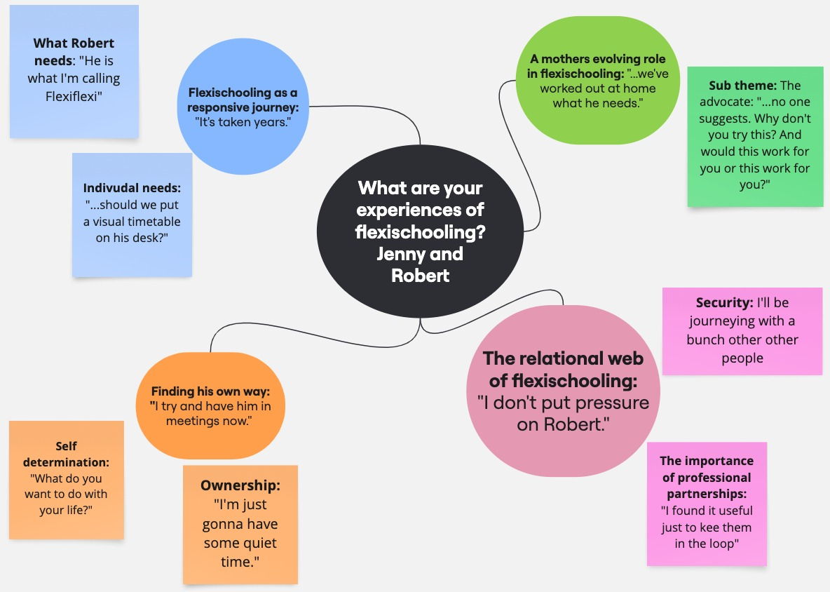
Screenshot of the Miro board: a visual representation of Jenny’s experiences, as represented by my analysis process.

Theme 1 - Flexischooling as a Responsive Journey: “...it’s taken years.”
This theme highlights the time, flexibility, and creativity needed to accommodate Robert’s needs in his flexischooling arrangement. The sub-themes show the ongoing personalisation required, with Jenny experiencing flexischooling as a dynamic journey rather than a static fit within mainstream education. The theme, Flexischooling as a responsive journey: “..it’s taken years”, reflects the continuous adaptation discussed explicitly by Jenny and implicitly throughout the interview. Sub-theme one focuses on Jenny’s evolving approach, while sub-theme two explores school-based systemic adaptations, illustrating how Robert’s needs shaped the flexischooling experience over time.

Sub-Theme - What Robert Needs: “...he is what I’m calling flexiflexi.”
Jenny shared many parts of her flexischooling experience during her narrative, which indicated that Robert’s learning and their flexischooling schedule has always had to be highly adaptable and is often responsive to Robert’s emotional and educational needs, and also to the needs of the wider family. Jenny talked about their flexischooling schedule and discussed different activities they might complete during home learning, and also implied that there is structure in place to ensure Robert’s time is spent on either educational activities or regulating himself when he is not at school.

"It’s often two afternoons of home education but he is what I'm calling ‘flexiflexi’, and it entirely depends on what's happening and basically if he wants to do home education." (p.3)

Jenny did indicate that while things had taken time to settle, Robert had learnt what he needed to support himself to be calmer and had become more comfortable with learning at home, so that as he got older there was more focus on structured learning at home.

“By the time we got into the second year, we'd managed to start doing a bit more.” (p.7)

“As he's getting older it's more a case of, if we're gonna do maths and you're not gonna be in school for maths this last year, (he has been at school for some of the maths), and if there are areas of maths that you're behind in, you need to cover that and in order to get where you want to be, then let's see if we can do that.”(p.8)

Nonetheless, Jenny experiences her own struggles and health needs and as she discussed the difficulties of managing this alongside the rest of her family, it was clear that despite home learning activities having become more explicit and structured over the years, the arrangement still needed to remain malleable.

“I've not been able to educate him all the time because it's been enough just getting the other kids in school for 9am and getting him into school at 10 o'clock by the time he's calm. So sometimes I’m going back to bed again and then picking him up again at one o'clock. And then quite often just resting with him, but he'll read a book.” (p.12)

Sub-Theme - Negotiation: “Should we put a visual timetable on his desk?”
Jenny described the challenges of identifying Robert’s educational needs and the trial-and-error process involved. Understanding his individualised needs required time, collaboration, and advocacy. She highlighted both school interventions and systemic barriers, some of which improved as flexischooling helped Robert attend more regularly. Jenny shared examples of proactively supporting Robert, which contributed to school staff’s growing awareness of his needs.

“I also wanted to find out, kind of, what was happening at break time and pick him up after that so that he could try and communicate to me how he was feeling”. (p.3)

School staff had suggested strategies that they hoped would support him to be calmer in school throughout the day and even though some ideas worked well for him, such as giving him access to a quiet space in school, it was necessary for Robert’s individual needs to be considered more closely.

"So anyway, schools first of the suggestions was, should we put a visual timetable on his desk? With the break time and then a little sunshine next to it so he knows what time break is? The SENCO was looking at me and he got halfway through and then he just went - this isn't gonna work is it. They clearly had all the stuff down for what you do for autistic children, but it wasn’t for Robert at all". (p.11)

There were times when other professionals became involved, and it was felt by Jenny that the agenda of full-time school attendance was a barrier to helping plan for his individual needs. Jenny’s experience of EP input for example was unhelpful to her at that time.

"So, I asked for that and asked for educational psychology and what not to see if they were any help. But Educational psychology was all about trying to get back into school, which I think is what the school had been pushing with them. That's like the aim isn't it, to get back into school."(p.6)

However, Jenny explained that as the flexischooling arrangement came into fruition and seemed to be working well for Robert, the idea of full-time attendance became less important.

"I mean there was a time when their aim was just to get him into school more as I say, and I pushed to say, the aim is not to get into school. The aim is to get him the education. And I think they've kind of got the hang of that."(p.9)

Overall, I believe that Jenny's experiences demonstrate that flexischooling was a lengthy process which required more personal exploration and systemic creativity than might be expected for a child attending school full time.

Theme 2 - A Mother’s Evolving Role in Flexischooling: “We’ve worked out at home what he needs.”
Jenny’s story highlights her growing confidence and expertise in supporting Robert’s education. She worked alongside school staff, navigated systemic challenges, and took control of the adaptive nature of flexischooling. Jenny reflected on Robert’s progress and the strategies needed to support him. The theme, A mother’s evolving role in flexischooling: “We’ve worked out at home what he needs”, acknowledges her journey as an advocate. Her expertise developed over time through challenges with school systems, and she described how her family adapted to help Robert cope with his education.

Sub-Theme - The Advocate: “No one suggests - why don't you try this? And would this work for you or this work for you?”
Jenny talked about her role in advocating for Robert’s education throughout the interview and it was clear that she was proactive about finding out what he needed and liaising with the school from the beginning of Robert’s school life.

"It was hard work putting it in place. It was hard work advocating for him dealing with the school, trying to work out what he needed, dealing with the meetings and realising that I wasn't getting what I needed and just constantly having to push for things all the time. I mean a million times. It's always that battle. No one suggests - why don't you try this? And would this work for you or this work for you?"(p.11)

There were a number of times where Jenny talked about how she learnt when to fight and when to accept an arrangement offered by the school. She experienced several turning points where progress was made towards an arrangement that worked for everyone.

"In fact, I stopped forcing him in first and then when there wasn't any physical force used it was taking a long, long time and we were often just staying at home. And it was only at that point that they realised, and we discussed flexischooling."(p.3)

Often these turning points were followed by Jenny describing how she became bolder and was prompted into taking control within meetings or discussions where decisions were made around Robert’s education. Demonstrating growth and evolution, Jenny described her experience of attending a meeting in Robert’s secondary school more recently, where she was able to categorically request a specific flexischooling arrangement, alongside Robert who was by that point also able to advocate for his own needs. This contrasts with descriptions from earlier parts of the flexischooling journey where there was more reliance on trial and error, and less was known about how to operationalise a more flexible approach to education.

"But I basically went into the meeting, and we said this is what Robert currently has at primary and these are his needs. This is what he has at primary, and this is what we'd like to look at secondary - and we've designed around the timetable."(p.7)

Theme 3 - Finding his Own Way: “I try and have him in meetings now.”
This theme arose from Jenny's descriptions of Robert’s experiences of flexischooling. Themes of Robert’s growing autonomy and independence were apparent to me from my first reading of the transcript and the topic evolved as I read and re-read, and coded different parts of the interview.

Sub-Theme - Ownership: “I’m just gonna have some quiet time”.
I coded moments where Jenny talked about Robert taking ownership throughout the interview and there was a strong sense of Robert taking control and making choices within this theme. The recurring categories are significant in terms of him understanding more about managing his own wellbeing, as well as his motivation to make choices around his education.

"I mean, it has been absolutely transformational for Robert. He's gone from a child who hated school, who wouldn't get dressed, who cried over everything, who came back just angry and smashing things.” (p.6)

It seems that Robert taking control was essential to his wellbeing and helped him to reduce his stress and manage his feelings, as well as keeping him engaged in his education. This was true of his home learning, as well as his school environment.

"So, he is allowed to leave the classroom at any point and go to a quiet space."(p.4)

"Sometimes he's burnt out and he'll say I'm just gonna have some quiet time." (p.5)

Sub-Theme - Self-Determination: “What do you want to do with your life?”
Jenny’s descriptions of Robert throughout her narrative seemed to point towards him understanding the function of his education and what it was all leading too, which was connected to his increasing opportunity to make choices within a flexischooling arrangement, and which seemed to lead him to a more meaningful relationship with learning.

"What do you want to do with your life? And he wants to be a pilot at the moment and he's met with someone who's doing engineering and pilot studies at University and so that would be the sort of thing he’d like to do. And so, what qualifications do you need? That's why you need to do your education, that’s the point of doing your maths. So, what he realised is the point of doing things and that's made a big difference to him."(p.7)

There did seem to be an evolution of confidence in Robert, as according to Jenny’s descriptions he became more invested and excited by the possibilities of his education.

"He's very much taken ownership of things. So, I try and have him in meetings now, especially with the high school. And try and get him to talk as much as possible and to advocate for himself and to say what subjects he wants to do, what subjects he doesn't want to do and I mean, we've got to the situation at our high school where he wants to do everything." (p.8)

Theme 4 - The relational Web of Flexischooling: “I don’t put pressure on Robert.”
This theme highlights the role of relationships in Jenny’s flexischooling experience. She discussed how strong partnerships facilitated positive change for Robert, while weak professional relationships hindered shared understanding. Sub-theme 1 focuses on personal relationships, including trust, friendship, and supportive communities, which helped Jenny feel secure in her decision. Sub-theme 2 emphasises professional relationships within school and the wider system.

Sub-Theme – Security: “I’ll be journeying with a bunch of other people.”
Jenny described how she fosters open communication with Robert, giving him space and choice in home learning. Their trusting relationship played a key role in making flexischooling successful.

“Whatever it happens to be, you can find ways to learn at home. I don't put pressure on Robert. He will learn at home.” (p.10)

Jenny also talked about Robert’s experience in school, and it seemed that trusting relationships between Robert and his teachers featured prominently in his ability to feel comfortable.

“There've been a few upsets when we've had ‘stand in’ teachers and he's not been able to get out. Supply teachers who've not known - he's been ready to go and then they’ll say “why are you leaving? It doesn't say you can go home sit down again.” (p.5)

Outside of school and her home, Jenny found that other communities like parent support groups, members of her church and close friends were all important in supporting her and helping her feel empowered, especially as she prepares for Robert to move up to secondary school.

“I'll be journeying with a bunch of other people.” (p.10)

Sub-Theme - The Importance of Professional Partnerships: “I found that useful just to keep them in the loop.”

Throughout her interview, Jenny references different interactions she had with professionals both inside Roberts school and in the wider local authority. Some of these relationships were key to helping her navigating the flexischooling arrangement.

"So, I went to the council and spoke to this lady at the council, and she was very helpful." (p.2)

Other relationships in school helped Jenny to communicate regularly about Robert’s wellbeing and progress and provided some much-needed consistency for Robert when he was at school.

"And so, I found that useful just to keep them in the loop and to show them that I was doing my bit. I do have to ask for meetings every time I want to meet, but there was one key contact, and Robert has a brilliant relationship with him."(p.9)

Themes in this section relate to the significance of professionals who might recognise different power dynamics and attempt to address them by supporting parents to seek the help they need. Also, good professional relationships require professionals to recognise and respect the advocacy role of parents. Jenny’s experience highlights the importance of professionals who are open to parental input and willing to co-create solutions that prioritise the child’s well-being.

Helen and Tyler
Helen is Tyler’s mother, and they live in England. Tyler is 12 years old and has a diagnosis of attention deficit hyperactivity disorder (ADHD) and ASC. At the time of the interview, Tyler had been flexischooled for around seven months and this arrangement began in the January of his second term in secondary school. Helen describes Tyler as educationally “very bright”, but after finding year 6 at primary school difficult due to a changeup of classes and routines, his parents realised the transition to secondary school would be a challenge. Tyler struggles with perfectionism and he can be very emotionally drained by school, so he needs down time to help him cope with being at school. He is home educated for one and a half days a week, and he attends school for 3 and a half days a week. Tyler does not have an EHCP and is currently able to meet the academic demands of school. He does struggle with motivation to go to school, and he gets overwhelmed when he is at school 5 days a week.

Thematic Map for Helen’s Interview
From Helen’s interview I was able to extract four themes and nine sub-themes. Please see figure 10 for a visual representation of my thematic map.

Figure 10
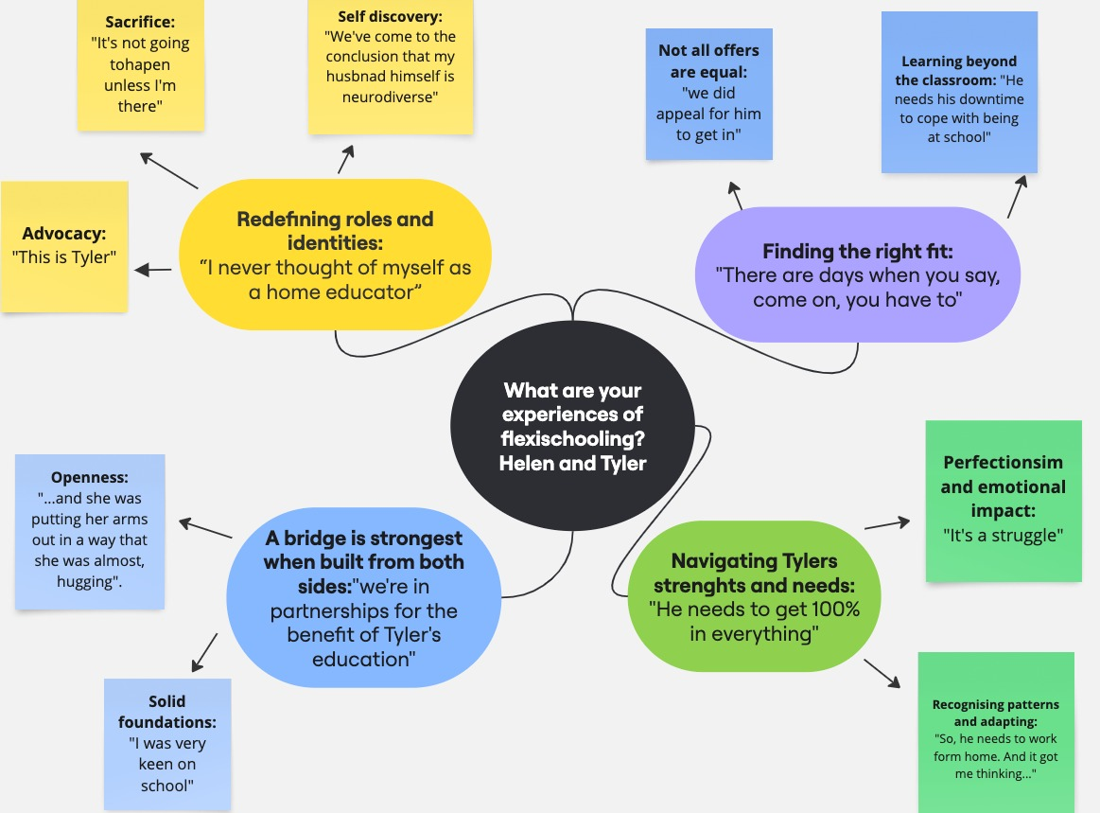
Screenshot of the Miro board: A visual representation of Helen’s experiences, as represented by my analysis process

Theme 1 – A Bridge is Strongest when Built from Both Sides: “We're in partnership for the benefit of Tyler’s education.”

An overarching narrative thread throughout Helen’s story, was one that highlighted strong relationships and the positive partnership between Tyler’s family and school, as well as Tyler and his teachers. I chose the theme name A bridge is strongest when built from both sides: “We’re in partnerships for the benefit of Tyler’s education”, because it seemed to encapsulate the idea that from Helen’s perspective there was often an even distribution of work, communication and flexibility between family and school staff that not only made Tyler’s flexischooling journey possible but helped him flourish. Sub-themes focus on the thoughtful interactions that took place to ensure a meaningful partnership took place.

Sub-Theme – Openness: “She was putting her arms out in a way that she was almost, hugging.”
In Helen’s story, on multiple occasions she references how Tyler’s secondary schools is open to the idea of doing things differently, as well as indicating that they had open methods of communication which made them approachable. For example, Helen told me how accessible school staff were, which included being physically present as well as having a relational communication style. Helen described several occasions where she was able to have impromptu conversations at the school gates during school drops offs and pick-ups, with the deputy head and the head teacher, who were always happy to speak with her in these unstructured times.

“I’d actually spoken to her on the school gates one day when I'd been there and I just talked to her about my concerns about Tyler and hadn't realised who she was at the time, but I remember her saying to me, oh that's really nice that you bring him to school that you're taking care of him as he comes to the school gates and then we take care of him when he's inside. And she was putting her arms out in a way that she was almost, hugging.” (p.5)

It was a chance school gate interaction that resulted in some of the initial flexischooling discussions between Helen and the headteacher of Tyler’s secondary school, which seemed to spark a good partnership for the future.

“So yeah, I was very encouraged by the Heads initial discussion with me and he said he would talk to his Local Authority contact.” (p.5)

Additionally, Helen often talked about the ways that school staff were open to being flexible to accommodate Tyler’s needs when he was in school. This helped Helen to feel that school was a safe place, demonstrating that his teachers understood his individual needs, and had the autonomy to be flexible in response to different children’s needs.

“I think this school really is open to that and understanding, and the teachers have really backed off in terms of punishments, which is - for Tyler, I don't think he's had any negatives this year. The teachers are very mindful of how they dish those out and how counterproductive they are.” (p.6)

“To be honest the teachers know the problem and they'll just contact the inclusion centre straight away rather than Tyler having to proactively say, ‘I want to go’. It's usually now the teacher to say, do you want to go to the inclusion centre? And he might say yes.” (p.9)

Helen also shared examples of ways that the school had policies that encouraged all pupils to access support available within the school.

“…they were very clear that the inclusion centre was for all, and not just those attached to one of the units and that children were free to go into the inclusion centre and get support if and when they needed.” (p.3)

It was not just openness from the school that featured in Helen’s story however, as there were also parts of her narrative that included descriptions of Helen and her family being open to the schools’ changing priorities as the flexischooling journey progressed. For example, Helen described a conversation she had with the head teacher at the beginning of the flexischooling arrangement, where it was suggested that as Tyler moved into Key Stage 4, flexischooling arrangements would need to be reviewed.

“And when in, the Head did say to me, he was quite relaxed about it at key stage 3, but when it came to key stage 4, he would not be so. And I did say that I would hope that we would work towards him being back a hundred percent in school at key stage four, because by then he will have had three years at school to be more familiar with the campus, with the students and with the teachers and also, he will have dropped a lot of what he dislikes. And he will have maturity, so he won't be the smallest in the school.” (p.7)

Within Helens recollection of this conversation, there seems to be clear terms that define the function and boundaries of the flexischooling arrangement, understood by both the head teacher and Helen, which places academic progression, or at least reintegration into the school as the ultimate goal. I feel this is an example of strong systemic discourse where there is a powerful assumption that flexibility is acceptable only if it does not disrupt the route to standardised assessment and normalised educational outcomes.

“…and there are days where say, come on, you have to, and the school is accommodating you by letting you be at home Mondays, so you need to do your bit and go in today.” (p.9)

Importantly, these conversations highlight that the head teacher and Helen were both demonstrating openness and flexibility as they worked together to support Tyler to thrive in his education. However, the conversations also demonstrate that mutual flexibility and openness have a context and conditions that are not necessarily explicitly spoken about. Within this arrangement, the openness does seem to depend on Helens and Tyler’s ability to respond to rules proposed by the school, and it works because Helen respects the authoritative relationship and works towards fulfilling the requirements.

Sub-Theme – Solid Foundations: “I was very keen on school.”
This sub-theme emerged from the way Helen talked about her relationship with school staff which seemed to provide a strong foundation for her trust in the school system. It also felt clear that Helen perceived herself to be in partnership with school professionals and she felt this played a significant role in supporting Tyler’s education. The idea of these connections and collaborations providing a solid foundation fits within the overall theme of ‘A bridge is best built from both sides’, which seemed to underscore the success of Tyler’s flexischooling arrangement.

“I was very keen on school. I loved school myself and wanted my children there. I was very proud of the fact that my oldest had never missed a day.” (p.4)

Despite a difficult journey to finding Tyler a ‘good’ secondary school, and an initial concern over the suitability of the school he was eventually accepted into, Helen’s faith in the school system felt relatively intact following some positive initial interactions with his secondary school’s head teacher.

“So, we started turning our attention to the school he was allocated, and we had an initial meeting with the SENCO - and the head of year joined, which I wasn't expecting but I was very impressed with! And the first thing they said to us was, we're so excited to have Tyler join us in September. And I could have cried.” (p.3)

I also noticed something about the language that was used by Helen when she described certain school practices or decisions, and I felt that these language choices reinforced the idea that she perceived school as an institution she could trust, likely made more stable by her own relationships within school. For example, often Helen chose strength-based descriptions when she was narrating her story and she described a test for example, as a practice to find out which children needed additional support.

“They did a reading test at the start of the year, I think they want to benchmark the kids and look at which children needed additional support, and his reading age came out at 17 plus I think so, educationally/academically he doesn't need as much support as some children will.” (p.5)

I reflected on this and wondered why I felt this language choice was in any way remarkable, and I concluded that often for people who have a negative relationship with the school system, tests are seen as reductive, or a way of marginalising some children. In Helen’s case, her language indicated that she believed that the tests were there to support children. Other examples included times that Helen spoke about Tyler’s own difficulties with being in school, which she tended to identify as a difficulty with his own personal interpretation of situations rather than a difficulty with the way the school operates. For example, she talked about how he responded to being sent to the isolation room for swearing.

“…and he's probably quite scared that they've treated him like that.” (p.3)

Although Helen does not indicate that she agrees with the school practice of isolation rooms in general, and in fact she expresses relief when she describes how the school changed their policy in the end, her description of the situation could indicate more focus around Tyler’s personal fear response in relation to his particular differences, rather than anger or frustration with the school for implementing the policy in the first place.

Helen indicated that she valued the efforts school staff made, and she seemed to feel that interactions were often authentic.

“So, every email the school send me finishes with this. Please let me know if you have any more things you want to talk about, let us know. And I think that's probably their standard way of signing off. But it feels genuine to me”. (p.9)

Building on her own relationship with school, Helen appeared to feel that teachers in Tyler’s primary school knew and understood him well, and this seemed to provide a strong foundation of trust, in relation to supporting Tyler getting the support he needed. Helen explained that it was these relationships that Tyler had in primary school which meant he hadn’t needed an EHCP in place, as his needs were well known.

“But luckily the year five teacher did a fantastic hand over to her. She was a lovely teacher for Tyler for all of year six. I think when she understood more about Tyler, and that's the thing. I think when people get Tyler, they can appreciate his qualities and his abilities, and they really enjoy time with him. He's great one on one with adults.” (p.8)

Sometimes Helen directly referenced positive interactions that had contributed to strong relationships between herself and the school staff. For example, Helen described an early exchange between herself, the SENCO and Tyler’s head of year at his new secondary school, which she said was the first time in a long battle over school choices for Tyler, that she had encountered positivity.

“And the first thing they said to us was, we're so excited to have Tyler join us in September! And I could have cried.” (p.3).

Being met with this initial enthusiasm and warmth seemed to help Helen build trust in the school and reinforced her faith that school staff were invested in supporting Tyler as much as she was. Helen recalled other interactions between herself and the head teacher that demonstrate a relationship where there was a mutual understanding of each other’s positions, particularly around the systemic barriers involved when setting up the flexischooling arrangement.

“So, a few days later, I was back on the school gates, and I saw the Head and sort of smiled that him, and he said “I've spoken to my Local Authority contact and they've said there's an issue over attendance, and he'll have to go down as C” … He will be classed as being absent from school, which will obviously impact on stats and things.’ And I said, yeah, I accept that, and I can understand why you would be reluctant about that.” (p.5)

It seemed that the school’s general openness to doing things differently, as well as their focus on building strong relationships had encouraged Helen and her family to build trust in the systems in place, allowing them in turn, to be open to doing things differently.

Theme 2 – Redefining Roles and Identities: “I never thought of myself as a home educator.”
This theme reflects the parts of Helen's narrative where she spoke about the significant changes that had taken place within the family in order to understand and accommodate Tyler’s need for a more flexible approach to learning. Helen revealed different parts of identity throughout her narrative, chiefly showing that she was determined to prioritise support for Tyler, and that this was valued above all else and independent of her own foundational belief in school attendance.

Sub-Theme – Advocacy: “This is Tyler.”
Despite her positive accounts of school staff and the support they offered in setting up Tyler’s flexischooling arrangement, Helen took a lead role in advocating for him through his school career. There were many examples of times she had devised ways of connecting with school to make sure he had the support she felt he needed.

“So, I looked at all the names of the teachers. I took Tyler’s one page profile… I sent it to every single one of his subject teachers just to say, this is Tyler. These are his skills and his talents, and he may need to use a laptop for certain subjects, and if there's any issues then please contact me so that we can resolve them before they escalate.” (p.3)

I found this interesting, as this small act is something that a SENCO might ordinarily be expected to do in a school. Helen also described how she had carried out her own independent research on flexischooling, and that she had brought this to the attention of the headteacher in order to help him understand it better.

“Yeah, I did say you might want to just check the Local Authority guidance, which I had found…Which it was very difficult to find… it was this study that I'd read about flexischooling. At the very end it referenced quite a number of Local Authorities’ guidance on it.” (p.5)

Sub-Theme – Sacrifice: “It’s not going to happen unless I’m there.”
Helen’s narrative hinted those sacrifices had been endured by the family during the process of trying to get Tyler’s education right. Sacrifices emerged as both physical and emotional strain.

“But there was a point where I did think, I even suggested to my husband, perhaps he needs to go back to work and I need to give up work and be at home with Tyler all the time, if that is what it takes.” (p.10)

It seemed that Helen in particular had shouldered the emotional toll of having a child at home who was distressed by school, and it led to her needing to make a number of adjustments that encroached on her own health and independence.

“At that stage I chose not to appeal the EHCP because all my energies were going into the school appeal and I just didn't have the emotional or physical energy to do both so, so the EHCP just went by the wayside and the appeals were unsuccessful.” (p.3)

Helen hinted that even though she had a good relationship with and had grown trust in Tyler’s current school, some of the emotional impact of the process they had been through to find Tyler an education he would be able to cope with, had left a more permanent mark on her.

“…all three turned him down, which was a real disappointment and still quite bitterness there from my perspective…” (p.2)

Sub-Theme – Self-Discovery: “We’ve come to the conclusion that my husband himself is neurodiverse.”

I noticed that throughout Helen’s narrative she mentioned her shifting perceptions of self and others. For example, she talked about how, through the process of understanding and accommodating Tyler’s difficulties with school, her husband had come to view himself through a different lens.

“I think since supporting Tyler we've come to the conclusion that my husband himself is neurodiverse and it explains why he has struggled with various things.” (p.9)

Helen herself had needed to redefine her identity and become comfortable with the idea that she was a home educator. This may have been particularly difficult for her, considering her strong foundation of trust and faith in the school system, and the pride that she attached to good school attendance with her other children.

“With flexischooling, we wouldn't entertain it if it hadn't been for Tyler's SEN. He has a twin sister and an older sister both of whom have very good school attendance. In fact, the older sisters never missed a day since reception and finishing year 10.” (pg.1)

“It hadn't really sunk in because I never thought of myself as a home educator.” (p.4)

It was clear however, that despite this shift in identity, Helen remained loyal to her own principles as an advocate for her son, but also a person who valued professional’s input.

“I also wanted them to know that I am flexible and open-minded and open to working with the school for Tyler's benefit.” (p.7)

She showed that she valued education, despite facing resistance from within her own marriage.

“My husband hated school. He didn't really get many qualifications when he left and I think he has a more pessimistic view of life to me, and quite often he’ll say; ‘I didn't do well at school, Tyler doesn't really need all this and he might do well later on in life”. Whereas I think he can actually have a successful career, provided he's got the right support around him.” (p.10)

Overall, throughout the flexischooling journey Helen seemed to grapple with sometimes conflicting opinions of herself and others, as well as having to make decisions that challenged her beliefs about normativeness at times. It seems she was prompted to explore her own core values and in doing so, perhaps put aside some of the taken for granted knowledge about the role of schools. My sense was that despite initial setbacks when she was in search of a ‘good’ school, Helen’s eventual experience with Tyler’s secondary school was positive and it reaffirmed her broader belief in the potential of the traditional school system.

Theme 3 – Finding the Right Fit: “There are days’ when you say, come on, you have to.”
This theme highlights the idea that although school is typically seen as a default option, Helen discovered that it is not a case of one size fits all. Careful consideration of provision, as well as an individualised and flexible approach was what worked for Tyler.

Sub-Theme – Not all Offers are Equal: “We did appeal for him to get in.”
Helen demonstrates throughout her narrative that she is tuned into the different ways that Tyler responds to his environment. She explained that she and her husband knew from the end of primary school that Tyler would struggle with a school that did not offer him certain securities and comforts and for this reason, on the run up to his secondary school transition they spent time looking at different schools in the area and initially sought a small school with a ‘good reputation’ for SEND.

“We applied to three small nurturing secondaries who had great reputation for supporting kids with SEN.” (p.2)

Helen explained that she understood different schools offered different provisions and that they did not all adopt the same approaches. She felt some schools would have suited Tyler better than others.

“The one that we felt would have all his friends going to, they have a laptop scheme where everybody has a laptop … so I was really quite keen for him to go to the school, and we did and appeal for him to get in and we weren't successful.” (p.2)

Although Helen went to great lengths to try and ensure Tyler would have access to a school that she felt would best support him as he progressed through Key Stage 3 and 4, her applications were rejected, and Tyler was admitted to his current secondary school as a default option. She soon discovered that despite initial hesitancy over the size and location of the school, teamed with the fact that Tyler's friends were going elsewhere which had initially deterred her, the school offered a good provision for Tyler with a number of benefits not available from other schools she had researched.

“They have a unit at the school for hard of hearing and we were not quite sure what the official description was, and just as Tyler was joining them in September last year they were also opening a unit which was a satellite unit for a special school, supporting children with learning difficulties.” (p.3)

As time went on, Helen realised the breadth of benefits attached to Tyler attendance at this school.

“It went better than I think we thought it would and the homework seemed less strenuous than other schools.” (p.3)

“So, I have had a lot of confidence in the school in terms of their ‘concerned air’ for their students and that's been a wonderful thing to see.” (p.5)

Helen believes that Tyler is now succeeding in his education, and she attributes this success to a number of factors including his current schools offer of provision and their openness to adapting for students who need flexibility. Helen reflected on Tyler’s experience at this school and compared it with what she has since learnt from others who are attending a different school in the area. She ultimately said she believes that if Tyler had attended one of her initially preferred schools who did not seem to be able to prioritise inclusion in the same way, this may have resulted in full time HE.

“In fact, I don't think he'd still be in school if he had gone to that school.” (p 11)

Overall, this theme being present within Helen’s narrative demonstrates that she felt schools do not necessarily offer comparable provision or have the same priorities or attitudes, and that it was not simply school, but the particular qualities of this current school have been instrumental in Tyler’s continued attendance and educational progression.

“So, I’ve been so grateful, and I've gone from feeling like - we've got the worst option completely for his education, to thinking this probably works out for the best.” (p.6)

Sub-Theme – Learning Beyond the Classroom: “He needs his down time to cope with being at school.”
A sub-theme within ‘Finding the Right fit’ was the exploration of different ways for Tyler to spend his time at home that were not necessarily based on traditional lessons, but supported him in his education, nonetheless. On balance, Helen spoke relatively little about what HE looked like for Tyler, and it was clear that there was flexibility within his one and a half days at home and that the priority was his emotional wellbeing.

“In terms of how it's actually working in practice, to us, it's very much - he needs the downtime to cope with being at school the rest of the time, so we're not massively focused on educating him during those times that he's at home.” (p.5)

As well as his down time that helped to keep him regulated, Helen mentioned Tyler’s desire to work autonomously and participate in more structured learning in his own time.

“He does his hour of coding with his online mentor - which he absolutely loves, and he quite often will stay online/stay on the computer after the guys finished and carry on working on whatever it is that he's been doing.” (p.6)

Additionally, Tyler's dad helps him with different skills and exposes him to experiences that do not take place in a contained or structured environment.

“My husband will often take him out for a walk to get some exercise. I think they've been on bike rides as well and they talk a lot about nature… my husband’s very interested in nature and knows a lot about plants and animals and birds and things and they talk about those sorts of things. They go into the town and do practical things. So, Tyler’s getting exposure to going into shops to buy things and that sort of, life skills.” (p.6)

Overall, there appeared to be several strategies and activities within Tyler's home learning schedule that Helen spoke about, that she felt enabled him to take a break from the school environment long enough for him to re-engage on his days in school. Although some activities were more structured and formally ‘learning’ based than others, this time away from the classroom seemed to support him in his wider educational journey.

Theme 4 – Navigating Tyler’s Strengths and Needs: “He needs to get 100% in everything.”

This theme highlights the complexity of Tyler’s strengths and needs, leading to the decision to flexischool in the first place. Sub-theme one is about Tyler’s particular difficulties with school. Sub-theme two relates to the parts of Helen's narrative where she talks about beginning to understand how Tyler’s particular patterns led her to consider flexischooling as an option that might suit him.

Sub-Theme – “Perfectionism” and Emotional Impact: “It is a struggle”.
Helen talks about how Tyler is academically motivated and capable of progressing in school, but he struggles with perfectionism, and this can have an emotional impact and negatively affects his experiences of school.

“We don't see him being delayed in any way educationally.” (p.2)

“He needs to get 100% in everything. It doesn't matter if he’s just one mark off … it’s the end of the world to him, the fact he's got 39 now or 40 is irrelevant. It's this one mark that he got wrong. He finds it unfair and upsetting and they must be wrong.” (p.8)

Helen explained that even with flexischooling in place, Tyler still dislikes attending because of the stress he experiences in the build-up to school.

“He just kind of says all the time, like a mantra ‘I don't want to go to school’. Even on a Saturday he was saying I don't want to go to school tomorrow, or on Sunday. And I would say, it's Monday, you wouldn't be going anyway. But then it intensifies on Monday evening and Tuesday morning and there's nothing we can do. There's not a day that goes by where he doesn't say I don't want to go to school.” (p.10)

At times, the emotional impact of school on Tyler has intensified. This has an impact not only on him but also on the family. Helen explained how this can be upsetting and difficult for them to manage.

“It is a struggle. We've had Tyler turn around and tell teachers he wants to kill himself.” (p.9)

It is interesting that there seems to be an unquestionable requirement for Tyler to go to school, regardless of the intense emotional responses he has. This is perhaps an important moment to reflect, as it is possible to see from the literature that many parents with an autistic child have similar experiences.

Sub-Theme – Recognising Patterns and Adapting: “So, he needs to work from home. And it got me thinking…”

Tyler had shown signs from a young age of finding school difficult and overwhelming at times, but due to the protective factors that had endured throughout primary school, such as strong friendships and relationships with teachers, he had managed to maintain good attendance. Helen said he started to show signs of experiencing more stress in school when things changed in year 6.

“I think the thing that really triggered it was in year 6. He'd been with the same group of children all the way through then for year six, they said we're going to mix up all the classes ahead of secondary to prepare you for the fact that when you get to secondary school, you'll be with lots of different children that you've not been so familiar with - which was a bit of a disaster.” (p.2)

Helen had guessed Tyler would thrive in a smaller environment, and when he started secondary school, he seemed to need more time away from school. This led Helen to recognise that spending more time at home helped him gain more behavioural control and eased his intense emotional responses.

“The school environment is very overwhelming, and it takes a lot out of him every day just to be in school. So, he needs to work from home. And it got me thinking…” (p.4)

The family had noticed that Tyler tended to prefer to avoid certain subjects and when he spent time at home instead of being in school for these, he was calmer.

“We realised that we were keeping Tyler off school every now and then, quite often on a Monday and it coincided with subjects that he's not so keen on or struggles more with, and they tend to be the non-core subjects like art, religious studies, performing arts… Those sorts of subjects. And my husband said, really what we need is, a lot of people since covid work from home one or two days a week. That's what Tyler needs to do.” (p.4)

The conversations held between Helen and her husband seem to be reflected by other parents in the literature exploring COVID 19 school lockdown impacts. The complete change of routine highlighted a different way of approaching education and for some, this was enlightening and led to big changes.

Carey and Sam
Carey is Sam’s mother, and they live in England. Sam is 14 years old. Sam has an EHCP and diagnosis of Down Syndrome, which resulted in him being deemed as clinically vulnerable and advised to stay away from school during COVD school lockdowns. Carey explained that during the pandemic she noticed a number of benefits to Sam being at home including better attainment and wellbeing, and she was not keen on him being back into school full time, which is why she opted to flexischool. Carey flexischooled Sam for his last year of mainstream primary school, which was around one year, following the school lockdowns. At that time, they had a flexischooling agreement that meant he spent four afternoons in school for two hours at a time, and then all mornings, as well as one full day was spent at home. Carey was advised by the LA that Sam's needs would be best met in a specialist secondary school. Carey was happy for him to attend a full-time specialist secondary school however following a number of issues where she felt his needs and potential were not being met, Carey opted to electively home educate Sam. Carey expressed that this was in part, because she could not find a school who would facilitate a flexischooling arrangement which she would have preferred over EHE.

Carey and Sam’s Thematic Map
From Carey’s interview I elicited three main themes and five sub-themes. Please see figure 11 for a visual representation of this thematic map.

Figure 11
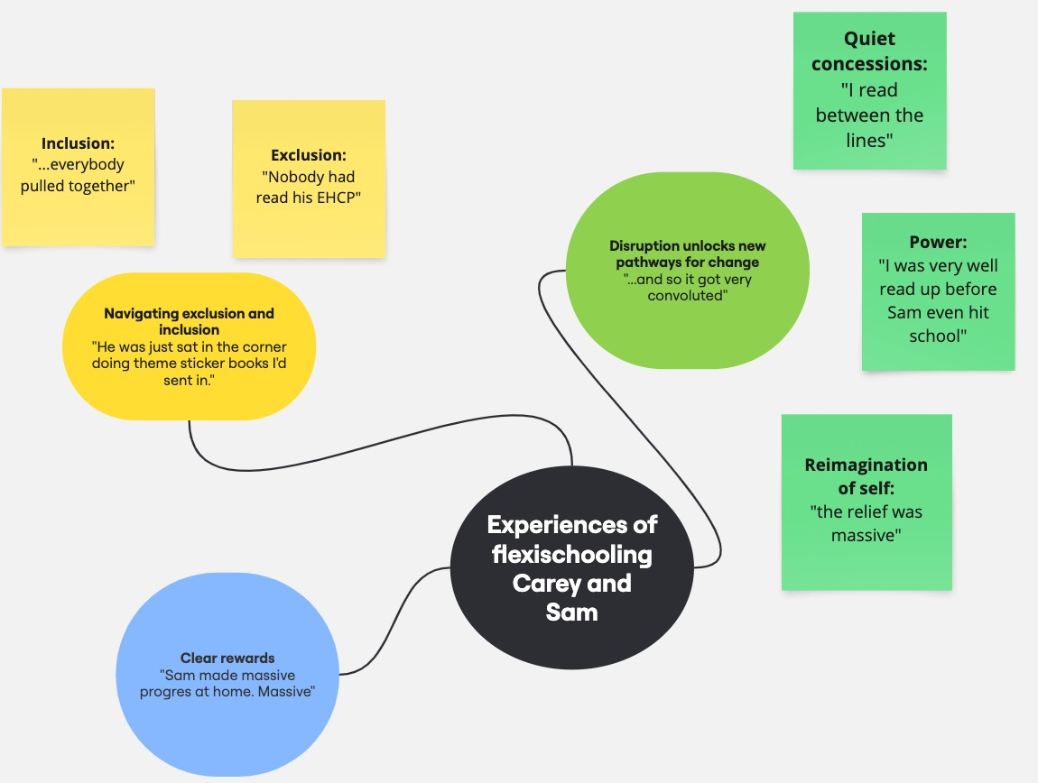
Screenshot of the Miro board: A visual representation of Carey’s experiences, as represented by my analysis process

Theme 1 – Navigating Exclusion and Inclusion: “He was just sat in the corner doing theme sticker books I’d sent in.”

Themes of inclusion and exclusion permeated Carey’s narrative. Carey’s story wove back and forth between her time spent flexischooling, and other past and present school experiences, unfolding in a less sequential way than narratives of the other mother’s flexischooling experiences. This more fragmented account is perhaps indicative that Carey’ journey remains difficult and that a lack of agreement around the structure and content of Sam’s education continues to interrupt her sense of peace.

Sub-Theme – Exclusion: “Nobody had read his EHCP…”
Carey’s perception of much of Sam’s school experience was that he was oftentimes excluded or underestimated due to his SEND, and this led to him not being stretched and challenged to meet his potential. When the pandemic hit and Sam was starting home learning for the first time, she was surprised at the level of work being sent home for him to complete.

“I was absolutely horrified when he came out for the pandemic, as it was very clear from the work that school was sending home - that none of it was right and nobody had any idea. Nobody had read his EHCP and when I was asking basic questions, they weren't giving me the right answers.” (p.11)

Carey explained how this posed a problem for her, because she had trusted that Sam’s primary school at the time had known his needs and would be able to support her to continue his education during a time when he was not able to be in school.

“So, I was basically starting with a blank slate and had to work out how this child who's nonverbal, can't talk to you, can actually do things - and that was really very, very, challenging.” (p.4).

Although there were times throughout mainstream primary school where Carey felt that his contribution was truly valued, she talked about occasions where she felt let down and doubted that they could meet his needs because they underestimated his ability.

“I found out from his lunchtime TA but that he spent most of year 3 cutting out and sticking in the corner of a classroom, or colouring in. He wasn't actually doing much work.” (p.10)

When Sam was offered a place at a specialist secondary school, having made significant progress with his learning through a flexischooling agreement, Carey talked about how she felt that he ended up being let down all over again. She explained that she felt they underestimated his ability and excluded him from participating in a more advanced curriculum.

“They refused to let him write or read, they told me he couldn't do sums or spell - it took me all the way through complaints to July to finally get them to admit that they hadn't done all the stuff.” (p.6)

Unfortunately, it seemed that the staff at the specialist provision Sam attended were unwilling to make exceptions that she felt would support him with his education, and they would not allow Carey to flexischool again.

“And I think what I said to them was, you put these barriers in the way, you're putting things in the way because you're following the national curriculum in order, but he doesn't work like that.” (p.8)

Sub-Theme – Inclusion: “...everybody pulled together…”

Despite difficulties navigating what she believed were numerous exclusionary practices in school related to Sam’s SEND, Carey expressed great satisfaction with parts of Sam’s school experiences, indicating that she felt at times he was very well included in his mainstream primary school. Examples of this can be found in the way Carey talked about Sam’s happiness in school.

“It’s maybe a bit of bleep. But I think going through mainstream school was the best thing for Sam. Although I've had the bumpiest ride through mainstream school, we've had good years.” (p.13)

Carey also talked about teachers who had been instrumental in his success.

“Year 2 he had an absolutely outstanding teacher.” (p.7)

It seemed that Carey attributed a lot of Sam’s success to a commitment to working together, which was facilitated in part by the flexischooling arrangement having created an opportunity for greater collaboration between her and school staff.

“We work really well, as I say, between the three of us - me, the tutor and his teacher at school. He made huge progress.” (p.4)

Sam is currently home educated because Carey has not been able to find a school who she feels can do his education justice. Carey summarised her thoughts on inclusion at one point, by comparing her daughter's experience of school with Sam’s.

“She has been through both her schools, primary and secondary, with no EHCP, because both schools have just put in place what she needed and yeah, I've got Sam at home now with no school who can educate him or want to educate him, and with a very detailed EHCP.” (p.11)

As a result of her experiences, Carey seemed sure that inclusivity in schools does not rely on specific mechanisms, such having an EHCP necessarily, but is it instead more about having the right attitude and motivation.

“So, I'm very, very sceptical at this point as to whether it's actually an EHCP that people need or whether they just want to, if they need the will in school and people that’re prepared to work with him. And I think it's attitude.” (p.11)

This is a particularly pertinent point that Carey makes as she reflects on her experiences and concludes that for her, schools being empowered, (through access to resources, staff attitudes, systemic flexibility etc…) to support individualised needs has been the difference between her son and daughter succeeding in school.

Theme 2 – Disruption Unlocks New Pathways for Change “...and so it got very convoluted...”

Cary described how the COVID pandemic disrupted the status quo, creating opportunities for alternative schooling and long-term change. Sub-theme – Quiet concessions: “I read between the lines” highlights how school closures allowed unofficial flexischooling.
Sub-theme – Power: “I was very well read up before Sam even hit school” explores Cary’s experiences of power shifts with school professionals, enabling new possibilities.
Sub-theme – Reimagination of self: “the relief was massive” reflects Cary’s changing perspective on education and realising she had more control over Sam’s learning.

Sub-Theme – Quiet Concessions “I read between the lines…”
Carey talked about the various structural constraints that proved difficult for school herself, professionals and local authority (LA) representatives to navigate. During COVID lockdowns Sam was allowed to learn at home because he had a doctor’s note which deemed him clinically vulnerable, but when Carey wanted to continue the part time arrangement, professionals were not so keen to agree due to Sam’s SEND and their responsibility to oversee his education.

“Yeah, I think our experience of flexischooling probably isn’t the traditional flexischooling story where someone makes a decision or argues for it.” (p.4)

Carey explained that she felt the initial flexischooling discussions were managed through a series of unofficial nods and winks.

“So, the SEN Department said we can't be part of this because it's your decision between you and the head, but if you are quite happy then on a three-way sort of discussion… so it was a bit nod-nod wink-wink situation. So, I read between the lines and said, so, if you're saying to me that we need to say that we want to do a flexischool arrangement, that's fine.” (p.2)

Carey talked about the fact that it was important to her to have a contract in place to support Sam’s education and protect their agreement, and she explained that she felt his primary school were unsure about the differences between a flexischool agreement and a part time timetable.

“And so it got very convoluted basically because school believed that they were already doing a part-time timetable. They believed we were flexischooling.” (p.1)

Sub-Theme – Power: “I was very well read up before Sam even hit school.”
There were times in Careys narrative where the concept of power became quite central to her experience. For example, although professionals were unsure about her requests to flexischool, Carey felt that she had the power to disrupt the default position, because access to information gave her a position of privilege in relation to knowing what was best for Sam. She explained how it was learned knowledge, or academic credibility that enabled her at times to negotiate with LA and school staff.

“Now, I'm quite well educated. I've got a degree in psychology. I've done early years stuff postgrad, and I was very well read up before Sam even hit school.” (p.9)

Carey’s ability to wield language that conveyed authority and expertise, seemed to support her to challenge some of the things that she found non inclusive about the school system. She explained how she was often entering battles against reductive attitudes or systemic inequalities.

“And one of the things I've done is, I've gone head to head with the head of a local school as part of the appeal where she admitted they put all the children with down syndrome on one particular pathway and she admitted in the appeal from the judge that Sam shouldn't have been on that pathway and I said, but you have no mechanism to change it!” (p.6)

“But I constantly have been up against this attitude.” (p.12)

Many times, however, it was apparent that Carey felt as though she had a lack of power over Sam’s education. She describes how she was asking the head teacher at Sam’s specialist secondary school to consider flexischooling and he was not willing or able to give her an answer. Here the power sat with the headteacher, and this resulted in Carey lacking the control to support Sam in the way she had previously done when he was in mainstream primary school, or through a flexischooling arrangement.

“I started midway through the year, probably even less than that, probably about four months in, to start saying can we please do flexischooling? Can we please consider it? And the Head just kept saying ‘well I’m not anti it’, but he ultimately would not bite, and he would not go ahead with it.” (p.6)

Carey explained that when she realised Sam was not best supported in the specialist setting he had moved to, she had no option to send him to a mainstream and was not allowed to consider flexischooling, she felt powerless against the system and she felt forced to turn to HE in the end.

“But we had no option to put him in flexischooling. He wouldn't have survived in a mainstream secondary school.” (p.6)

“I had to elect to home educate him, which was not what I wanted, because I basically was forced out.” (p.6)

Sub-Theme – Reimagination of Self: “…the relief was massive.”

Within Carey’s narrative she periodically revealed her own views of school, which seemed mixed at times. Often she would use language to describe school that suggested a complete relationship breakdown and a lack of confidence.

“...well, school didn't want him in for the SATs. They didn't want the hassle.” (p.3)

“They didn't have a clue. They were absolutely horrific.” (p.11)

On the other hand, Carey’s opinion of school when pitted against the option of elective HE was quite positive.

“I look at my daughter's education and those of friends who are home educated and there's no comparison between what a fantastic education my daughter's got from the school system and what my friends’ children have, who are purely home educated are getting.” (p.5)

Nonetheless, Carey recognised shifts that came about following COVID school lock downs and her experience with flexischooling. These events ultimately impacted her view of school and her own relationship with HE.

“I mean it’s things, its attitudes, so for example, I think when coming out of the school system and flexischooling, showed me that I could home educate. And it was an important shift for me because I also realised how little time in school is actually spent doing work - you know, on an average day or in a couple of hours, they don’t actually do a lot…” (p.7)

Carey spoke about the benefits she discovered when this shift took place, but she also acknowledged the emotional and practical work of taking on the role of educator.

“The point which I started home educating, the relief was massive.” (p.11)

“With hindsight it wasn't the perfect split because I ended up running around a looney.” (p.3)

Theme 3 – Clear Rewards: “Sam made massive progress at home. Massive”
Although not everything was plain sailing, Cary’s narrative highlighted the wide-reaching benefits of flexischooling that she experienced following the pandemic. These benefits, although not always immediate, were sometimes directly related to Sam’s progress.

“So, it was a bit of a relief really to be able to take the reins even more, or continues to have the reigns, because Sam made massive progress at home – massive.” (p.4)

“I tried all sorts - stickers, number stamps, and he did work eventually, across time.” (p.9)

Sometimes Carey touched on the benefits to Sam’s wellbeing.

“But as I say, the chewing his finger stopped everybody at home has reported, this year in particular, on how much happier Sam's been, how much better his concentration is, how much he pays attention.” (p.12)

Often Carey referenced the positive impact that the opportunity had made on her as a parent and the wider family.

“So, for me it was lovely to still be part of Sam's life, because at the point when the pandemic started, I felt that I didn't know anything about him.” (p.4)

Carey’s reflections painted a picture of a deeply personal and transformative experience of flexischooling, shaped by the challenges and opportunities that emerged in the wake of the pandemic. While acknowledging that the process was not without its difficulties, her narrative consistently pointed to a range of benefits that unfolded over time. These included Sam’s educational progress, improvements in his wellbeing, and, perhaps most significantly, the renewed sense of connection and involvement that Carey felt as a parent. The flexischooling arrangement appeared to offer space for relational repair, personal growth, and a more attuned understanding of Sam’s needs—experiences that extended beyond academic outcomes and into the heart of family life.

Chapter 6: Discussion

Introduction
This research explores parents’ experiences of flexischooling without prior EHE. By sharing their narratives, I aim to provide insights for other parents, carers, and professionals. While each story is unique, common themes emerged across all three interviews. This chapter reflects on the findings in response to my research question, incorporating these themes. Although the study does not seek generalisations, my interpretations are shaped by a social constructionist perspective. Another researcher might offer different readings, so I encourage readers to remain open to alternative interpretations of these narratives. I have included personal reflections in Appendix A, titled ‘Personal Reflections: Upon Completion of the Research’, which might be of interest.

In this chapter I will also consider the implications of this research, followed by an evaluation of the strengths and limitations of the research and methodology. Recommendations for further study will be included.

The main research questions my study sought to explore were concerned with experiences of families.

1.What are the experiences of families who have engaged in a flexischooling agreement, who have previously undertaken full time school attendance?

Because of the thematic approach employed in this study, the discussion does not attempt to isolate responses to each sub-question into separate sections. Instead, the themes identified in each of the narratives analysed are explored more broadly, with links drawn to different sub-questions where relevant. This approach aligns with the principles of narrative inquiry, which emphasise the coherence and fluidity of personal stories (Riessman, 2008; Squire, 2013). For reference, the sub questions I explored are as follows:

- Were any interventions carried out in school before flexischooling was agreed?
- What are the parents’ thoughts or reflections on the idea of ‘inclusion’ since flexischooling has been implemented?
- What has been the impact on family and child wellbeing?

Key Findings from my Thematic Analysis
I combined themes from each of my interviews to provide one large thematic map, which is a visual representation of the overall findings of my research (please see Figure 8 on page 83 ). Although there is a great deal of interplay between these common themes, I have decided to use categories to organise my discussion as it provides a more helpful way to read my interpretations.

A Note on Mothers Featuring as Key Participants
In this study, only mothers appear among participants, simply because they were the sole respondents to the recruitment advertisement. It is likely that this reflects broader societal patterns in which mothers disproportionately shoulder caregiving responsibilities—especially for children with special educational needs (SEN). Research that looked at families who needed to home school during COVID lockdown for example, consistently found that mothers reported taking on more of the caregiving duties (Fitzpatrick, Hastings and Haines; 2024) and experienced high levels of stress, guilt and fatigue when trying to manage work life balance between supporting their children’s education and managing their other work (Kalitsoglou & Topalli, 2024). Acknowledging this imbalance might be one explanation as to why mothers were more likely to volunteer and explains their overrepresentation in flexischooling narratives

Organisation of Discussion Through an Experiential Lens
I identified broad experiential themes across the data. Relationships played a key role in all the mothers’ stories, alongside the challenge of navigating cultural norms and educational systems. Each mother described developing a highly individualised approach to supporting their child, even within a structured flexischooling agreement. Lastly, a recurring theme was their evolving personal identities.

1.Experiencing Identity Shifts
Within all the mothers’ stories there was emphasis on identity, and through my analysis this was a topic that developed into themes and sub-themes that represented parts of their flexischooling experience. Themes within this category highlight experiences of personal and family identity shifting around a flexischooling journey and in this discussion section I explored the identity of home educator and advocate, which featured throughout all mother’s stories.

Home Educators
As discussed in the literature review, there are various assumptions about the identity of flexischoolers. Some view them as home educators seeking partial access to the school system (e.g. DFE, 2024), while media narratives have sometimes pitched them as families with flexible work arrangements prioritising time at home for ideological interests (e.g. Daily Mail, 2024). Paxman (2022) and Lawrence (2017) highlight differences between parents choosing flexischooling due to perceived need versus those with ideological beliefs, suggesting these should not be assumed the same.

Evidence shows overlap between flexischoolers and home educators, leading me to explore whether the mothers I interviewed experienced an identity shift. While these mothers had not been elective home educators, they each referred to themselves as such at times. To explore this shift, I considered Tajfel and Turner's (2004) social identity theory (SIT), which suggests that self-identity is influenced by group membership. SIT also proposes that people view their in-group more positively and compare it to out-groups (Zare, Pathania & Shajaha, 2025).

Each mother in the study experienced an ideological shift upon recognising the benefits of flexischooling, similarly to recent research these benefits included increased wellbeing, attendance, and motivation to learn (Griffin et al., 2024). This shift was positive, as Meighan (1998) and Kunzman and Gaither (2020) suggest, with mothers noting key moments of self-discovery. For example, Helen, initially hesitant about HE, later saw flexischooling with its elements of HE as a solution for her child. Similarly, Carey, who previously viewed home educators as “a bit wacky,” (Carey, p.4) felt she could often do a better job than the school after switching to flexischooling.

Research shows that HE is supported by a community, including larger organisations like Education Otherwise (Atkinson et al., 2006). While SIT suggests that individuals form group identities through socialisation, some studies show that identity in HE is shaped by ongoing interactions with other educators (Chansaengsee, Peungposop, and Junprasert, 2017). However, Helen and Carey did not express involvement in external support groups, with Helen even rejecting advice from a parent forum in favour of her own experiences and perspective.

Kunzman and Gaither (2020) note that HE often evolves from dissatisfaction with school into a belief-driven choice. While Carey’s shift stemmed from school dissatisfaction, she did not mention that she felt affiliated with any particular group, home educators or otherwise, suggesting a more autonomous approach. Jenny, however, seemed to find group membership with support from friends at church and involvement in tutoring other children who were home educated (Jenny, p.6-7), perhaps suggesting more alignment with EHE.

Flexischoolers continue to share educational responsibility with the school, and they may only be their child’s primary educator for one or two days a week, as Griffin et al., (2024) and the experiences of the mothers in the present research suggests. For this reason, they may not engage with the HE community or identify with it as much as might be assumed. Flexischooling families do seem to retain some trust in schools, and it is important to view them as distinct from home educators, navigating a unique position between both worlds, blending formal schooling and elements of HE.

Advocates
Jenny, Helen, and Carey all shared the responsibility of advocating for their children's education, a role that became integral to their identities and impacted various aspects of their lives. They spoke of the effort required to research flexischooling and to persuade professionals to consider alternative approaches. Though advocacy in flexischooling hasn't been widely discussed, it is somehow implicit in the way it aligns with themes in the literature on SEND and parents’ decisions to flexischool or those seeking more flexibility for their children (e.g., Badman, 2009; Morton, 2008; Paxman, 2022; Lawrence 2017; Griffin et al., 2024). Studies on SEND parents often highlight advocacy, with mothers frequently taking on the role of primary educator when children cannot attend school (Parsons & Lewis, 2010; Reilly, 2007). Runswick-Cole et al., (2024) point out that many parents find themselves in the advocacy role and fighting for their child to be included in a way that works for them. “(M)others describe having to “fight” for resources for their children’s (special) education; this includes conflicts about school placements, but also about the type, nature, and amount of support a child receives.” (p.477)

Each mother used language that reflected the conflict inherent in their advocacy role. Helen described struggles when seeking a good school for her son, feeling rejected during the process. Jenny spoke of being dismissed by school staff when she tried to explain Robert's difficulties, while Carey shared how she regularly clashed with school leadership over issues of the inclusion of Sam.

Although Meighan (1988) found that home-educating families were generally more satisfied once they separated from school, Jenny, Helen, and Carey reported positive outcomes from flexischooling but did seem not feel more aligned with home educators than full-time school parents. I wondered if their advocacy experiences made them identify more with the SEND community than with home educators. Research exploring the views of parents of children with SEND frequently report that parents develop a critical stance towards normative educational systems and trajectories (Barnes & Sheldon, 2007). I thought that the mother’s experiences revealed that having a child with SEND challenged their views of the education system, sometimes in an emancipatory way. Despite this, the mothers did not fully reject mainstream education. Instead, they made it work through flexischooling, suggesting that flexischooling could act as a protective factor, preventing parents from feeling “outside the system” and encouraging schools to remain engaged with children’s diverse needs. This potential hasn’t yet been explicitly explored in the literature.

2. Flexischooling as an Inherently Relational Experience
As described in the literature review of the present study, existing rules around flexischooling in UK dictates that requests for flexischooling must come from the family, and decisions about whether to agree to flexischool sit with the headteacher. In Scotland it is typical for the LA to also have some involvement alongside the school’s decision (Scottish Government, 2021). Nonetheless, the wider research around parents of children with SEND tells us that parents' involvement in educational decisions is often perceived as somewhat marginal (Staub, Brühlmann, & Keller 2021; Hodge & Runswick-Cole, 2008), and some studies point towards a lack of flexibility in schools that might block many flexischooling requests (Badman, 2009; Maxwell et al., 2020; Paxman, 2022). Robust communication and strong relationships between schools and families for successful flexischooling is a theme that resonates in the literature (e.g., Baker et al., 2019; Poultney & Anderson, 2019; Lawrence, 2017). Additionally, from a 2025 systematic review of the flexischooling literature in relation to autistic children, Richter et al., (2025) comments: “One could argue that flexi-schooling requires flexibility not only in terms of schooling but also on the part of parents and the school” (p.12). These themes were present in this study throughout each of the mothers’ narratives.

Communication Challenges
Communication challenges were identified as a significant issue by all participants in Lawrence's (2017) study of parents who flexischooled their autistic children. Both Jenny and Carey faced communication challenges especially around negotiating with school for their option to flexischool in the first place. Jenny described how her request was only considered once she stopped using physical force to get Robert into school, suggesting her narrative around Robert's emotional and behavioural instability was not initially believed by the school; “It was hard work putting it in place…” (p.11). Carey’s experience of communications with the senior members of school staff who had the power to agree or decline a flexischooling arrangement were also hard to navigate and she cited difficulties in reaching a mutual understanding of flexischooling. Carey also talked about requesting a flexischooling arrangement in Sam’s specialist secondary school which was turned down, eventually leading her to feel that she had no choice other than to home educate him: “I had to elect to home educate him, which was not what I wanted, because I basically was forced out.” (p.6). Despite Carey’s previous success with flexischooling Sam in primary school, her experiences in particular seem to bear resemblance to many other families within the literature, putting her in the bracket of a ‘last resort’ home educator (e.g. Badman, 2009; Brogger, 2003; Collom, 2005; Halsley, 2010).

Professional Partnerships
Among the mothers interviewed for the current research, Helen was the only one who encountered a headteacher who was open to embrace an initial request for flexischooling, and she was supported to explore the option without being initially turned down or redirected to alternative solutions. In a doctoral study carried out by Hodge (2006) who was exploring experiences of parenting disabled children, parents reported that they valued professionals who kept an open mind and were responsive to parents' input about their child, leading to better collaboration in the future. This seems to be true of Helen's relationship with school, which she described as valuable and effective throughout her story. Despite different starting points, all of the mothers described having a good professional partnership with their school at times, which helped them facilitate flexischooling. A good professional partnership between parents and school is described by Staub et al., (2021) as including communication, trust, identification of the family’s needs and a good framework to facilitate interactions between teachers and families. Griffin et al., (2024) found that just over half of the parents who completed a flexischooling survey reported that a signed and specific contract was in place for their arrangement. Jenny spoke about having a key contact in school which supported good communication and Carey talked about a contract that was drawn up to state the terms of the arrangement, later referencing how Sam benefited from this; “He made huge progress” (Carey, p.4).

Collaboration
Although professional partnerships are known to be effective in providing accountability and consistency (Butler, Rogers, & Modaff., 2019) which is felt to be of particular importance for protecting children and families undertaking flexischooling arrangements, (Robertson and McHardy, 2020), this alone may lack the depth of understanding that more relationally oriented approaches might offer (Davis, Billington, Chilokoa, Whiting 2024). Examples of relational aspects of parent-school partnerships reach beyond structural approaches such as scheduled meetings, contracts and policies and are more focussed on collaboration, shared knowledge/awareness, a welcoming environment and shared responsibility (Sheridan et al., 2012). Building upon this point, I found that collaboration with school professionals was also a key component of all of the mothers' stories. Collaboration is defined as a complex process involving relationship building, shared values and active engagement (Griffiths et al., 2021). In particular I noticed moments of relationally oriented approaches throughout my analysis.

Relationships
Some of the interactions described by the mothers seemed to resemble something in the realm of allyship. Runswick-Cole et al., (2024) spoke to mothers of children with SEND about their experiences with school staff and one described allyship in the context of ‘micro kindnesses’ being bestowed upon them. I believe micro-kindnesses were described and represented significant and positive experiences for Helen in particular. For instance, when Helen recalled an interaction with the deputy head teacher, she described a moment where her role as a mother and their shared responsibility for Tyler’s care were recognised and appreciated: “... I remember her saying to me, oh that's really nice that you bring him to school, that you're taking care of him as he comes to the school gates, and then we take care of him when he's inside” (p.5). This acknowledgment of Helen’s caregiving role appeared to affirm her competence in supporting Tyler’s education, reinforcing her contribution rather than diminishing her ability to make informed educational decisions. Arora (2006) suggests within a flexischooling arrangement it would be important for the school to help the parents feel empowered; “…that they are valued as educators of their child” (p.63), in order to avoid challenging power differentials arising. Similarly, Carey described moments of collaboration that went beyond formal professional partnerships, highlighting a strong sense of togetherness in supporting Sam’s learning alongside his tutor and teacher: “We went back and had a fantastic last year because everybody pulled together and did it” (p.9). Connor & Cavendish (2018) highlight that for effective collaboration, schools must actively empathise with parents of children with SEND and address power imbalances. Jenny described a shift in perspective that she observed at Robert’s school, marking a turning point when the staff began to accept the “flexiflexi” arrangement she had to carefully manage with him. For instance, there were days when Robert, due to his emotional overwhelm, struggled to arrive on time even within the flexible schedule. Over time, the school started to value her perspective, as she explained: “I pushed to say, the aim is not to get into school. The aim is to get him the education. And I think they've kind of got the hang of that.”(Jenny, p.9). Although none of the mothers initially held ideologies that distinguished them from other parents, and the schools were not enacting broad institutional changes, a cultural shift toward a more flexible, relational, and collaborative approach to education appeared to emerge naturally as a result of the flexibility needed. This kind of cultural transformation was observable in Poultney and Anderson’s 2019 study of a school wide flexischooling model, and also in the CfBT report exploring Hollinsclough school (Gutherson and Mountford-Lees, 2011), but has not been explored in the literature that reports on individual or personalised flexischooling. Richter et al., (2025) did write about conditions for establishing positive flexischooling outcomes in relation to autistic children and did distinguish that establishing flexischooling required cooperative, constructive and respectful relationships between parents and schools and implied that that this reaches beyond usual relationships in parent-school relationships.

Every Child Matters initiative of 2003 and The Children Act of 2004 both emphasise the significance of fostering collaborative relationships between schools, parents, and children. As well as parent school collaboration and partnership, parent-child and school-child relationships were important features within all the mothers' stories. Engaging in shared activities and strengthening the parent-child bond have been identified as key benefits for families in previous research, including studies by Kidd and Kaczmarek (2010), Lawrence, (2017) and McDonald and Lopes (2014). Jenny talked about trust a lot in her story, with relation to Robert having trust in school "So, he is allowed to leave the classroom at any point and go to a quiet space." (p.4), and also the trust between mother and son; “I don't put pressure on Robert. He will learn at home.” (p.10). Carey talked about the benefits of spending more time with Sam when he was at home; “So, for me it was lovely to still be part of Sam's life, because at the point when the pandemic started I felt that I didn't know anything about him.” (p.4) and Helen described how her husband spends quality time with Tyler when he’s at home; “My husband will often take him out for a walk to get some exercise. I think they've been on bike rides as well and they talk a lot about nature” (p.6).

The findings suggest that successful flexischooling experiences depend on strong parent-school-child collaboration, emphasising empathy, allyship, trust, and mutual respect. These relational aspects were crucial for the mothers, supporting the ongoing negotiation and flexibility in flexischooling. It would be valuable to explore how school professionals can improve collaboration, as time constraints often limit opportunities (Allen, Riley, & Coats, 2020). Additionally, it appears that flexischooling is not to a standalone intervention but a reflection of a school’s willingness to embrace broader systemic change, aligning with Meighan’s (1988) view that flexischooling represents a cultural shift in parent-school partnerships. I might further suggest that the implementation of flexischooling may influence school culture and how professionals view inclusion and start to see parents as experts in their own children. It would be interesting to see if further research might support this notion, and explore how best to help schools with its implementation.

3 .Systemic Limitations and Normalised Constructs of Schooling can Inhibit Experiences of Inclusion
Themes of improved mental health and wellbeing, better inclusion and a desire for flexibility within the current school system all present themselves within the flexischooling literature (e.g. Poultney and Anderson, 2019; Paxman, 2022; Griffin et al., 2024; Sudea, 2023; Lawrence, 2017 & 2019; Baker et al., 2019). Some wider literature exploring parent views during COVID 19 school lockdowns found that for some, it took this enormous shake up of the system to discover that school was not always supporting their children to thrive (Sawyer, 2022; Laczik and Newton, 2023). Jenny and Carey reported that COVID lockdowns had impacted their decisions to flexischool and although it was not necessarily an easy time for any of them, the opportunity to break from the norm revealed important benefits of reduced school attendance which would not have been exposed otherwise.

In the present study all three mothers reported that improved mental health and wellbeing (described as a decrease in distress brought on by school) were perceivable outcomes from a reduction in school days and/or a change in workloads. All mothers also spoke about either a continued and good level of engagement with school work, or better educational progress as a result of flexischooling. Furthermore, both Jenny and Helen felt that their boys would no longer be in school at all if it hadn't been for the flexischooling arrangement, and at the time of the interview, Carey had felt it necessary to home educate Sam partly due to the fact that flexischooling was not an option at his secondary school. Griffin et al.’s(2024) survey of 31 flexischooling parents found that personalised approaches were important to the parents' and perceived mental health and wellbeing improvements. These narratives around the perceived successes of flexischooling demonstrate that it is possible for some children with SEND to access a more inclusive education with reduced participation in school. “Inclusive education is not about ‘dumping’ pupils into an unchanged system of provision and practice. Rather, it is about how, where and why, and with what consequences, we educate all pupils” (Barton, 1997, p.234).

Despite UK policy having outlined a clear commitment to inclusion in schools aimed to support children with SEND, the subject of inclusivity is complex and there are often competing objectives at play, which involve unequal power relations (Knight et al., 2023). Each mother had a child with identified SEND and yet faced resistance to flexischooling because of normative expectations around school attendance, inflexibility of curriculum demands and future assessment expectations. In contemporary society, it seems that inclusion is inherently contextual—that is, it must occur within the school environment, and is bound by existing constructs, such as the expectation that education takes place over a five-day school week. Before flexischooling was introduced, Jenny and Helen talked about interventions that were implemented to support the boys. However, as dictated by traditional schooling frameworks, these interventions were confined to the school setting, limiting their effectiveness in addressing some of the specific challenges the boys faced with the environmental overwhelm experienced in school. Jenny described strategies such as a visual timetable and a time-out card, though she also noted that Robert spent an excessive amount of time in the pastoral room, seeking a calm space to regulate his emotions. While Carey did not explicitly discuss interventions, she observed that Sam made little educational progress when working one-on-one with teaching assistants in the mainstream classroom.

This is not necessarily fault that lies at a school level, but a wider issue stemming from top down policies and decisions over resources and priorities that limit the scope of education (Knight et al., 2023). Runswick-Cole et al., (2024) comments on the difficulties experienced by schools when children, often those with the title SEND, fail to ‘fit’ and parents request exceptions for them. Runswick-Cole et al (2024) writes, “in a context where resources are limited, the system must resist demands for “more”.” (p.477). In this instance, all mothers faced systemic barriers because they were asking for more - but rather than material resources, ‘more’ demanded increased communication and collaboration, extra trust and understanding around the families perspectives and additional flexibility within the school week.

Barriers for schools are understandable, especially for those with no prior experience of implementation of flexischooling. Existing research highlights potential challenges and risks for schools, including increased teacher workload, safeguarding responsibilities, managing attainment data attendance records (Paxman, 2022). Although school perspectives were not sought in the present study, two of the mother’s accounts do seem to indicate that some of the largest problems were encountered because schools were anticipating many of the aforementioned risks and challenges, and this made them reluctant to begin conversations with parents.

Attendance
Each mother faced barriers when negotiating reduced school attendance to meet their children's academic and wellbeing needs. While greater school attendance is thought to provide protective benefits (Roe et al., 2021; Rajmil et al., 2021; Charney et al., 2022) and is often linked to positive outcomes (DFE, 2023), prioritising full-time attendance above all else can be problematic, it risks framing children struggling with the demands of five-day schooling as the problem, rather than addressing the need for flexibility. Although the terminology was not used by Jenny and Helen, both Robert and Tyler might be described by education professionals as experiencing EBSA. EBSA is characterised by a child showing significant distress by attending school, which can be for a range of reasons including, but not limited to, difficulty associated directly with the CYP and challenges with the school environment (Thambirajah et al., 2008). Breaks from formal education are known to benefit autistic children by reducing sensory overwhelm and behavioural stressors (Attwood, 2003; Kelly et al., 2008); recent research highlights the strong link between autistic children’s difficult experiences of school which can lead to burn out and result in EBSA (e.g. King, Smith & Roy, 2024; O’Hagan, Hebron and Woods, 2022; Hamilton, 2024). Much research also comments on the likelihood of these stressors leading to school exclusions if not properly supported (Bond & Hebron, 2017; Brede et al., 2017). Within the present study, flexible schooling did seem to lead to an increase in longer term attendance for Robert, and Helen suggested that the availability of flexible attendance was a protective factor in keeping Tyler in school. Both mothers said that if it had not been for flexischooling which had been accepted in their present schools, the boys would now likely be home educated: “In fact, I don't think he'd still be in school if he had gone to that school.” (Helen, p. 11)

Jenny and Helen described how their sons' emotional struggles were underestimated by professionals. Robert was overwhelmed by school, leading to violent outbursts at home, with Jenny resorting to physical force to get him to school. She recalled, “...wouldn't get dressed, who cried over everything, who came back just angry and smashing things” (p.6). Helen recounted Tyler’s distress: “It is a struggle. We've had Tyler turn around and tell teachers he wants to kill himself” (p.9). Their experiences align with research on school overwhelm among autistic children (Bond & Hebron, 2017; Lawrence, 2017). Despite this distress, professionals prioritised Robert’s full-time attendance, making reduced hours a last resort. Helen’s school was more open to flexischooling, though with the condition that Tyler return to full-time attendance by Key Stage 4. Carey, meanwhile, had to navigate unofficial agreements with her local authority for primary school flexischooling and later found discussions blocked at Sam’s secondary specialist school.

The mothers’ need to negotiate, bypass conventional channels, and seek alternative support highlights a rigid and school-centric view of inclusion (McDonald & Lopes, 2014; Barton, 1997). By advocating for non-traditional education, they challenged societal norms and were often perceived as difficult or demanding (Runswick-Cole et al., 2024).

4. Traditional Constructs of Schooling and Education may be Limiting
In recent flexischooling research Griffin et al., (2024) found that on non-school days parents were accessing a range of child-led activities and learning, and also using days for rest and low demands. Lawrence’s (2017) study reported that mothers were often using non-school days to offer respite for their autistic children. Similarly, each mother in this study talked about their experience with the HE elements of flexischooling and their descriptions demonstrated that varied and evolving approaches were used on non-school days in response to differing needs. Accounts of both formal and informal learning as well as structured, semi structured and completely autonomous learning were noted as taking place on non-school days and the diverse approaches were said to support the boys in various ways, including helping them feel motivated, reach or maintain academic potential and increase wellbeing. Although formal learning is often seen as a superior form of learning, especially within the context of traditional constructs of schooling which relies on set curriculum and assessment (Hager, 2012), Dewey (1916) famously proposed that education is also about nurturing the whole person, of which intellect is just one part.

Emotional Development and Family Connectivity
For Jenny and Helen, a key motivation for flexischooling was to support emotional well-being. Jenny described how Robert’s time at home evolved from unstructured time to more formal learning as his motivation and well-being improved: “It has taken quite a while to teach him the skills to get to that stage” (Jenny, p.8). Tyler, meanwhile, tended to engage more generally in less structured activities to help him decompress from school: “…he needs the downtime to cope with being at school the rest of the time” (Helen, p.6). While flexischooling days helped both boys remain calmer, school attendance still posed challenges and both mother’s talked about managing this by remaining somewhat flexible within the arrangement.

Spending more time at home also strengthened family relationships. Tyler and his father connected through outdoor activities: “…my husband will often take him out for a walk to get some exercise. I think they've been on bike rides as well and they talk a lot about nature…” (Helen, p.6). Carey observed benefits for the whole family, particularly her daughter: “…it’s benefited me, but also weirdly it’s benefited my daughter… she was happier” (p.12). Reduced stress from school struggles eased family tensions, with Jenny recalling, “the trauma of pulling him in or dragging him in and leaving him was really bad” (p.9).

Being at home may have also helped the boys develop self-awareness and emotional regulation. Jenny noted how Robert began managing his emotions independently: “Sometimes he's burnt out and you'll say, ‘I'm just gonna have some quiet time’” (p.5). Secure attachments with less-stressed caregivers can support emotional development, fostering resilience and self-reflection (Bowlby, 1969; Ainsworth, 1978). Vygotsky (1978) similarly emphasised how social interactions help children regulate emotions and behaviours, suggesting that a calmer home environment created valuable learning opportunities.

In these examples, flexischooling not only provided respite from school-related stress but also strengthened family bonds and reinforced emotional development. The reduction in daily school pressures supported better self-regulation and well-being, while also improving relationships within the family. These findings align with broader research on the benefits of flexible schooling arrangements for children’s emotional and psychological growth (E.g. Richter, 2023; Lawrence, 2017 and 2020).

Academic Potential and Motivation to Learn
Education occurs through both structured and unstructured activities, with child-led learning differing significantly from traditional schooling (Arora, 2003). The mothers used diverse approaches to support their children's academic potential. Carey combined tutors, online programs, and hands-on activities: “I think we've got quite a nice mix of more natural ways of learning… being outdoors with actual formal learning” (p.9). Jenny initially struggled to engage Robert in formal learning but adapted to his needs: “The first year it was just very, very relaxed… trying to encourage him to find his own ways of learning” (p.3).

Self-Determination Theory (SDT) highlights the role of choice and autonomy in fostering motivation (Deci & Ryan, 2017), a theme echoed in the mothers' experiences. Jenny encouraged Robert to advocate for himself in school meetings: “…he’s very much taken ownership… I try to have him in meetings… and to advocate for himself” (p.7). Motivation was high for Sam: “Sam wants to do maths with me. He loves doing the maths” (Carey, p.12). Tyler, too, engaged enthusiastically in structured learning when it aligned with his interests: “He does his hour of coding with his online mentor—which he absolutely loves” (Helen, p.6). Deci & Ryan (2017) suggest that when students' psychological needs (choice, competence, and connection) are met, intrinsic motivation grows and transfers across learning contexts. For Robert, motivation extended beyond home learning: “He is making better choices now in the nurture room about actually getting on with some work” (Jenny, p.6).

Flexibility in teaching topics and methods, rather than more rigid curriculum based learning, did seem to be key to the boy’s perceived success. Carey observed that Sam was often academically underestimated in both mainstream and specialist settings, and flexischooling shifted expectations: “It changed the attitude towards the kind of education Sam could access, and it was a higher level than everybody had been telling me” (p.5).

Flexischooling allowed for adaptable, child-led learning, which increased motivation and engagement. The ability to personalise education, rather than conform to a one-size-fits-all model, fostered both academic success and self-advocacy. These experiences align with SDT, reinforcing the value of autonomy and flexibility in education.

Social Development
Peer to peer relationships were cited by the mothers as important to all children in this study. Research supports the notion that peer groups play a significant role in the social development process (Erikson, 1980). In a recent study into flexischooling children with SEN, Griffin et al., (2024) found that parents most commonly reported no change in quality of friendships groups, but some also reported negative effects which seems to be correlated with less days in school. Out of all the boys, Sam had the fewest days in school during his flexischooling arrangement and Carey did express concern about being unable to provide the peer connections during this time; “I think I do feel that Sam needs some socialisation… He doesn't particularly socialise with anyone else, but I think it's good for him to be around other children. (p.12). Jenny talked about some of the tensions Robert faced, between needing breaks from school and at the same time, not wanting to appear different in front of peers: “One of the big issues we have with flexischooling is that Robert doesn't want anybody to know that he's leaving school early. Or that he's going in late” (Jenny, p.4).

I think these accounts offer a compelling premise for questioning the overall purpose of education. Overall, these findings suggest that flexischooling can help promote inclusion, emotional wellbeing, and academic progress by providing a more personalised and responsive approach to education

Implications

This section considers the theoretical and philosophical contributions this research has made to knowledge and understanding around flexischooling experiences. Firstly I explore the implications for schools and education professionals. Secondly, I consider wider implications which position flexischooling in society and culture.

1.Increasing Transparency and Access to Information about Flexischooling
A crucial implication is that more specific and targeted support is needed to help families and schools navigate the systems around flexischooling, which could be achieved through greater transparency around flexischooling processes. Guidance, processes and examples of good practice made freely available and even promoted for parents on L A or government pages for schools and other professionals likely to be involved with families, such as EPs, would support the demystification of flexischooling and reduce the need for parents to have to constantly justify their decisions or view flexischooling as a ‘last resort’. Preliminary research from Scotland (e.g. Baker et al,. 2019) does suggest that when options become more visible such as on LA websites, more parents become interested in the possibility of flexischooling. Although there is some hesitation around making this information more visible (e.g. the slippery slope), this type of transparency would help shift the narrative towards a fairer and more balanced assessment of needs.

Currently, decisions about flexischooling arrangements are made at the discretion of individual headteachers in England and Wales, and typically with the involvement of LAs in Scotland, leading to inconsistencies in access and implementation. Examples of good practice would contribute to the removal of barriers for schools and would likely go some way towards ensuring that flexischooling is implemented fairly and consistently across schools, in cases where it was deemed an appropriate and supportive intervention. More transparency would ensure that there is less work at the school end, and less work for the parents. An important step would be for the DfE to issue clear and comprehensive guidelines on flexischooling, as well as providing an attendance code appropriate for schools to use in the case of flexischooling days that are taken at home. As Paxman (2022) argues in the review of flexischooling children with SEND, the absence of statutory guidance and lack of appropriate attendance codes contributes to a climate of uncertainty.

By formally acknowledging flexischooling and integrating guidelines into education policy, the DfE could provide much-needed clarity, ensuring that schools feel confident in offering this option and that families can make informed decisions about their children's education.

2.Strengthening Parent-School Relationships
Another implication that emerged from this research is the need for strong relationships between parents and schools. Considering the centrality of the mother’s advocacy role in supporting their children with SEND and the personal toll this took at times for all, frequently resulting in feelings of disempowerment and loss of wellbeing, it was clear that moments of appreciation, acknowledgement and understanding from school was important. Where the professionals in the stories worked with greater openness, curiosity and trust, some of the burden was lifted and better long-term commitment to communication, collaboration and (and sometimes compromise) resulted. It seemed plausible that as a result of schools enlisting these relational approaches, parents were diverted from choosing EHE and overall, there was a more sustained commitment to working together. Therefore, increased commitment to relational approaches between schools and families seems important for helping parents stay engaged in the system and therefore helps alleviate some of the aforementioned worries including CYP’s absence from school impacting achievement, wellbeing, and wider development (DfE, 2023). Although the premise for flexischooling must not and should not rely wholly on the good will and openness of individuals in school and should absolutely be supported by wider systemic structures, these types of authentic partnerships with parents can ultimately create a more inclusive learning environment for children who may not thrive in traditional full-time schooling.

As well as future policies emphasising more formalised flexischooling agreements to support transparency, greater emphasis should be placed on whole school relational approaches and enabling schools to prioritise these. Many schools have the desire and knowledge to be working in this way, and EPs have a role in supporting schools to implement relational approaches where these methods are less developed. Nonetheless, systemic changes are needed to ensure that schools have the time, resources and opportunities to develop and embed relational approaches.

3.Rethinking Learning and Inclusion Beyond the Construct of School
A broader implication resulting from this study is the need to reimagine the narrative around inclusivity in education. Inclusive education, “involves complex processes that engage a range of ideas, behaviours, practices and stakeholders” (Knight et al., 2023, p.496). As discussed in the literature review, being inclusive is sometimes equated with ensuring that all children attend school and participate in mainstream classrooms (Nilholm & Göransson, 2017) and there is currently a strong narrative around this in the UK, as a response to declining attendance following the COVID 19 lockdowns. However, stories from the present research demonstrated that the children were thriving by having access to alternative education environments and approaches. It seems likely that this will be true for other children with SEND or those struggling with full-time schooling, and inclusion may be best achieved via a more individualised approach and by enlisting alternative attendance patterns.

There is a clear need to be cautious with the conversations surrounding part time school attendance, which can be damaging and result in illegal exclusions for children with SEND (e.g. Brede et al., 2017; Towler, 2023). Above implications that refer to transparency and prioritise parent-school relationships highlight that flexischooling is not simply an intervention that can be inserted into any school, rather it is part of a whole school approach, even when actioned for only one student. Prioritising full-time classroom-based school attendance above all else can sometimes mean that professionals who are best placed to support inclusion can overlook those who would benefit from alternative learning environments and approaches. By thinking about inclusion as something that encompasses educational flexibility, policymakers and practitioners can better accommodate the diverse needs of all learners.

Schools, parents and education professionals should be supported to understand the realities of children who need regular breaks from school and learning to feel calm, or might benefit from a different learning environment. The notion of flexischooling could still produce dilemmas for an EP, who must consider responsibilities laid out by the Health and Care Professions Council (HCPC); for example it is stated in the guidance that an EP “must keep within your scope of practice by only practising in the areas you have appropriate knowledge, skills and experience for” (HCPC, 2024). Professionals should be supported to understand the psychological benefits of individualised approaches that do not necessarily take place in the classroom and EPs are potentially well placed to deliver training and support for schools and parents in this area (Arora, 2003).

4.Recognising Flexischoolers as Distinct from Home Educators
Another important implication is the recognition that as far as the limited research will allow us to understand, children who are flexischooled are still predominantly school based (e.g. Paxman, 2022; Griffin et al., 2024) and therefore parents do not necessarily feel more aligned with home educators than parents of full-time school attending children or identify strongly as part of that community. Two of the mothers in this study indicated that, because they only home educate for part of the week, they do not fully engage with HE networks or feel a sense of group membership there. Unlike full-time home educators, when relationships with the school are based on trust and mutual support, flexischooling parents may remain connected to and engaged with their child’s school which can potentially alleviate known tensions around full withdrawal from school. There is an indication that both flexischoolers and home educators often seek alternative educational paths as a response to need, and it might be this that links them more intrinsically rather than shared ideologies around education.

Currently, guidance from the DFE on flexischooling sits with HE policies, which may not be sought out by those seeking regular breaks from school, or accurately reflect the experiences or needs of flexischooling families. More recent Welsh government guidance on improving learner engagement and attendance acknowledges a wider audience for consideration of flexischooling practices, and this is a positive step in the right direction if it is to become a more equitable and positive choice for families and schools. The DfE should consider categorising national guidance for schools and families for flexischooling in its own dedicated place, or incorporate it into SEN policy. This would support flexischooling families to access relevant guidance and support that is more relevant to their particular situation, removing the stigma (often wrongly…) associated with HE.

Future Research
The findings of this thesis has further supported the need for additional research in the area of flexischooling to address gaps in knowledge. As the pool of studies available is still exceptionally small, research conducted by UK government, UKRI or other institutional funders, as proposed by Paxman (2022) would help more people access information and begin to demystify some of the views currently held in the field of education. Research with larger groups of participants and more longitudinal research would be beneficial to address gaps in knowledge around the longer-term impact of flexischooling.

It would be particularly helpful to see how flexischooling is implemented on an individual basis in a more regular e.g. larger, urban primary or secondary school in the UK and not just as a whole school approach in a small, rural school. At present only one small scale Scottish study (Baker et al., 2019) has attempted to capture the perspective or experience of schools adapting and practising curriculum to fit flexischooled children in these environments. Providing a comprehensive case study or range of examples showcasing different implementation approaches and their outcomes would help schools better assess the balance between additional teacher workload and the impact on attendance or assessment results, enabling more informed decision-making.

There is currently no research dedicated to understanding a child or young person’s perspective of flexischooling. Article 12 of the UN Convention on the Rights of the Child (UNCRC), the Children Act (1989) and the Children and Families Act (2014), alongside case law related to SEN in the UK, recognises and protects the right for children's voices to be heard. Involving children in decision making around their education is a way of promoting inclusivity and therefore research that prioritises this would make a valuable contribution to the field of understanding around flexischooling.

The current research explored parents’ experiences of flexischooling children with recognised and diagnosed SEND. Given the rise in prevalence of EBSA (BPS, 2023), an exploration of flexischooling experiences where it has been implemented as a result of CYP experiencing EBSA, either with or without a recognised label of SEND would be interesting. A focus on flexischooling as an intervention to support EBSA would provide a broader understanding of the benefits and limitations of individualised and more flexible educational choices, perhaps mitigating the need for EHCPs to be initiated to support these children.

Policy Takeaways
A key policy takeaway from this research is the need for greater recognition of flexischooling as a legitimate and workable option for families of children with SEN, rather than a last resort arrangement. The narratives presented in this study highlight the ways in which flexischooling can provide children with both access to the social and academic opportunities of school and the flexibility to meet their individual needs at home. Educational policy and guidance could therefore benefit from explicitly acknowledging flexischooling within the wider continuum of inclusive practices, ensuring that schools are equipped to engage constructively with parents who pursue this option. In particular, a specific attendance code should be made available for schools to use when supporting flexischooled children. Additionally, clearer guidance for headteachers and improved local authority support may help ensure that flexischooling arrangements are sustainable and beneficial. For Educational Psychologists, these findings underline the importance of advocating for flexible provision and supporting families and schools to navigate the systemic barriers that currently limit its implementation.

Strengths and Limitations

Strengths
The qualitative and narrative approach employed within this study is something I consider a strength, as it has allowed for the exploration of unique and personal experiences of parents undertaking flexischooling. Through in depth interviews I was able to broaden the understanding of flexischooling and develop interesting discussion points that have clear links to current research, as well as illuminate gaps for further study. This research also attempts to acknowledge the marginalisation of women’s voices in research by attending to narrative experience.

Limitations
There are a number of potential limitations acknowledged within this study. One consideration is the recruitment strategy. From the perspective of the QFT, Roller and Lavrakas (2015) prompt me to consider that there may have been many potential participants that I did not access, as I only reached out to participants currently engaged in social media, which means my research may represent a bias within the population of flexischoolers who do not choose to access Facebook and Instagram. Another consideration is the small number of participants I recruited for interviews. Having only three participants limits the amount of data I had to analyse and while my intention was not to use my data to generalise, a larger sample might have provided more deviating or colliding themes which would have been interesting to explore. A final limitation is the subjective interpretations I formed and applied throughout my analysis. Despite efforts to remain transparent, I know that it is not possible to fully recognise and be conscious of my influence and subjectivity as a researcher (Doucet & Mauthner, 2008), so it is important to highlight that there are possible biases within my interpretation that will have contributed to the understanding I formed.

Conclusion
This thesis has used a qualitative approach to explore the experiences of families who have flexischooled their children with SEN. Narratives have highlighted that flexischooling somehow sits at the intersection of parental advocacy, inclusion and educational flexibility. As we all adapt to the complexities of post-pandemic schooling, the education system finds many children overwhelmed by traditional schooling, and many more parents at a crossroads, reluctant to force their children into school and wanting different options. Flexischooling represents an opportunity to reshape inclusive education through co-constructed, responsive, and less binary models of attendance and learning. It appears that this approach, although not yet supported by clear policy frameworks, fits well within a more relational, transparent, and individualised approach to education which would benefit children, families, and schools alike.

References
Ainsworth, M. D. S. (1978). Patterns of attachment: A psychological study of the strange situation. Erlbaum.

Allen, T., Riley, K., & Coates, M. (2020). What does research tell us? The Art of Possibilities & UCL Institute of Education. Retrieved from https://profiles.ucl.ac.uk/48005-kathryn- riley/publications

Alper, J., Thompson, D., & Baciu, A. (Eds.). (2015). Exploring opportunities for collaboration between health and education to improve population health: Workshop summary. National Academies Press. https://doi.org/10.17226/21755

Ambitious about Autism. (2017). Exclusions. https://www.ambitiousaboutautism.org.uk/what-we-do/policy-and-campaigns/campaigns/education/exclusions​Ambitious about Autism+1Ambitious about Autism+1

Anderson, C., & Kirkpatrick, S. (2016). Narrative Interviewing. International Journal of Clinical Pharmacy, 38(3). ResearchGate. https://doi.org/10.1007/s11096-015-0222-0

Anderson, H., & Gehart, D. R. (Eds.). (2007). Collaborative therapy: Relationships and conversations that make a difference. Taylor & Francis

Apple, M. W. (2000). The cultural politics of home schooling. Peabody Journal of Education, 75(1/2), 256–271. https://doi.org/10.1080/0161956X.2000.9681953

Arora, T. C. M. J. (2003). School-Aged Children who are Educated at Home by their Parents: Is there a role for educational psychologists? Educational Psychology in Practice, 19(2), 103–112. https://doi.org/10.1080/02667360303237

Arseneault, L., Bowes, L., & Shakoor, S. (2010). Bullying victimization in youths and mental health problems: ‘Much ado about nothing’? Psychological Medicine, 40, 717–729.

Atkinson, M., Martin, K., Downing, D., Harland, J., Kendall, S. & White, R. (2006) Support for children who are educated at home: Research Briefing. NFER/ Esme Fairburn

Attendance is everyone’s business. (2/8/23). Children’s Commissioner for England. https://www.childrenscommissioner.gov.uk/resource/attendance-is-everyones-business/

Attwood, T. (2003). Understanding and managing circumscribed interests in children with Asperger syndrome: A pilot study. Autism, 7(3), 267–281.​
Badman, G. (2009). Report to the Secretary of State on the Review of Elective Home Education in England. Department for Children, Schools and Families.

Baghramian, M., & Carter, J. A. (2019). Relativism and epistemic possibility. Philosophical Studies, 176(8), 2191-2208. https://doi.org/10.1007/s11098-018-1133-5
Barnes, C., & Sheldon, A. (2007). ‘Emancipatory’ disability research and special educational needs. In L. Florian (Ed.), The SAGE handbook of special education (pp. 233–246). SAGE.

Baker, Powell, Mallett, Ishak & Collins (2019) Dumfries and Galloway Parenting Science Gang (DGPSG): Freedom of information requests, 2018. Findings published in paper: ‘Flexischooling in Scotland: What We Did and Why’. Other Education: The Journal of Educational Alternatives ISSN 2049-2162 Volume 8 (2019), Issue 1 · pp 58-67

Bamberg, M. (2012). Narrative practice and identity navigation. In: Holstein, J.A. & Gubrium, J.F. (eds.) Varieties of Narrative Analysis. SAGE

Barton, L. (1997). Inclusive education: Romantic, subversive or realistic? International Journal of Inclusive Education, 1(3), 231–242. https://doi.org/10.1080/1360311970010301

BBC News. (2011). Hollinsclough Primary School becomes more viable through flexischooling. BBC News. https://www.bbc.co.uk/news/education-13138157

Becker, G. S. (1993). Human Capital: A Theoretical and Empirical Analysis, with Special Reference to Education (3rd ed.). Chicago: University of Chicago Press.​Amazon+4SCIRP+4SCIRP+4

Benner, A. D., & Graham, S. (2011). Latino adolescents' experiences of discrimination across the first two years of high school: Correlates and influences on educational outcomes. Child Development, 82(2), 508–519. https://doi.org/10.1111/j.1467-8624.2010.01524.x

Berger, P. L., & Luckmann, T. (1966). The Social Construction of Reality: A Treatise in the Sociology of Knowledge. Anchor Books.

Billington, T. (2000). Separating, losing and excluding children: Narratives of difference. Routledge.

Blaikie, N (1993) Approaches to Social Enquiry. Polity: Cambridge

Blanden, J., Crawford, C., Fumagalli, L., & Rabe, B. (2021). School closures and children’s emotional and behavioural difficulties. Institute for Social and Economic Research. https://discovery.ucl.ac.uk/id/eprint/10159856
Blyth, E., Burr, V., & Farrand, A. (2008). Welfare of the child assessments in assisted conception: A social constructionist perspective. Journal of Reproductive and Infant Psychology, 26(1), 31–43. https://doi.org/10.1080/02646830701691301

Bowlby, J. (1969). Attachment and loss: Vol. 1. Attachment. Basic Books.

Braun, V., & Clarke, V. (2006). Using thematic analysis in psychology. Qualitative Research in Psychology, 3(2), 77-101

Brede, J., Remington, A., Kenny, L., Warren, K., & Pellicano, E. (2017). Excluded from school: Autistic students' experiences of school exclusion and subsequent re-integration into school. Autism & Developmental Language Impairments, 2, 1–20. https://doi.org/10.1177/2396941517737511

Brogger, M. (2003). Homeschooling: Tailoring education to individual needs and learning styles. Childhood Education, 79(4), 222-225. https://doi.org/10.1080/00094056.2003.10522755

Bronfenbrenner, U. (1979). The Ecology of Human Development: Experiments by Nature and Design. Harvard University Press

Brown, L. M., & Gilligan, C. (1992). Meeting at the crossroads: Women's psychology and girls' development. Harvard University Press.

Bruner, J. (2002). Narratives of human plight: A conversation with Jerome Bruner. In R. Charon and M. Montello (Eds.), Stories matter – The role of narrative in medical ethics (pp. 3 - 9). New York: Routledge.

Burr, V. (2015). Social constructionism (3rd ed.). Routledge.

Butina, M. (2015). A narrative approach to qualitative inquiry. Clinical Laboratory Science, 28(3), 190-196.
Butler, J., Rogers, L., & Modaff, D. (2019) Communicative challenges in the parent-teacher relationship regarding students with special needs. Communication and Theatre association of Minnesota journal. 43, 6-28

Cassell, C., Grandy, G., & Cunliffe, A. L. (2016). The SAGE handbook of qualitative business and management research methods. SAGE Publications.

Chansaengsee, S., Peungposop, N., & Junprasert, T. (2021). The context and sustainability of social identity of a homeschool group in Thailand. International Journal of Instruction, 14(1), 235-254.

Chantler-Hicks, (13 Dec 2024). Is Ofsted right to fear the rise of flexi-schooling? Schools Week. https://schoolsweek.co.uk/is-ofsted-right-to-fear-the-rise-of-flexi-schooling/#:~:text=The%20first%20mention%20of%20flexi,pupils%20were%20being%20flexi%2Dschooled.

Charney, S. A., Camarata, S. M., & Chern, A. (2022). The impact of the COVID-19 pandemic on children's speech and language development. In COVID-19 and speech-language pathology (pp. 1–18). Routledge. https://doi.org/10.4324/9781003257318

Children Act 2004, c. 31. (2004). United Kingdom: The Stationery Office.

Chow, C. M., Ruhl, H., & Buhrmester, D. (2013). The mediating role of interpersonal competence between adolescents' empathy and friendship quality: A dyadic approach. Journal of Adolescence, 36(1), 191200.https://doi.org/10.1016/j.adolescence.2012.10.004

Christie, H., Hamilton-Giachritsis, C., Alves-Costa, F., Tomlinson, M., & Halligan, S. L. (2022). The impact of the COVID‐19 pandemic on the mental health and wellbeing of UK parents and carers of children with special educational needs and disabilities: A rapid review. JCPP Advances, 2(1), e12095. https://doi.org/10.1002/jcv2.12095

Clandinin, D. J. (2006). Narrative inquiry: A methodology for studying lived experience. Research Studies in Music Education, 27(1), 44-54. https://doi.org/10.1177/1321103X060270010301

Clandinin, D. J., & Connelly, F. M. (2000). Narrative inquiry: Experience and story in qualitative research. San Francisco: Jossey-Bass.

Cohen, L., Manion, L., & Morrison, K. (2017). Research methods in education (8th ed.). Routledge.

Collom, E., & Mitchell, D. E. (2005). HOME SCHOOLING AS A SOCIAL MOVEMENT: IDENTIFYING THE DETERMINANTS OF HOMESCHOOLERS’ PERCEPTIONS*. Sociological Spectrum, 25(3), 273–305. https://doi.org/10.1080/027321790518807

Connelly, F. M., & Clandinin, D. J. (1990). Stories of experience and narrative inquiry. Educational Researcher, 19(5), 2 - 14.

Connor, D. J., & Cavendish, W. (2018). Sharing power with parents: Improving educational decision making for students with learning disabilities. Learning Disability Quarterly, 41(2), 79–84. https://doi.org/10.1177/0731948717698828

Crane, L., Adams, F., Harper, G., Welch, J., & Pellicano, E. (2019). 'Something needs to change': Mental health experiences of young autistic adults in England. Autism, 23(2), 477–493. https://doi.org/10.1177/1362361318757048​ResearchGate+1Sage Journals+1

Creswell, J. W. (2013). Research design: Qualitative, quantitative, and mixed methods approaches (4th ed.). Sage Publications.

Crossley, M. L. (2000). Introducing narrative psychology: Self, trauma, and the construction of meaning. Open University Press

Crotty, M. (1998), The Foundations of Social Research for a detailed breakdown of these philosophical positions.

Daly, J., Willis, K., Small, R., Green, J., Welch, N., Kealy, M., & Hughes, E. (2006). A hierarchy of evidence for assessing qualitative health research. https://doi.org/10.1016/j.jclinepi.2006.03.014

Davis, S. T., Billington, T., Chilokoa, M., & Whiting, C. M. (2024). Relational Practice. Taylor & Francis Group.

de Carvalho, E., & Skipper, Y. (2018). 'We’re not just sat at home in our pyjamas!': A thematic analysis of the social lives of home educated adolescents in the UK. European Journal of Psychology of Education, 34(3), 501–516.

Deci, E. L., & Ryan, R. M. (2017). Self-determination theory: Basic psychological needs in motivation, development, and wellness. Guilford Publications.​Self Determination Theory+10Sciepub+10ResearchGate+10

Danechi, S., & Long, R. (2023, December 1). Home education in England (House of Commons Library Research Briefing No. SN05108). UK Parliament. https://commonslibrary.parliament.uk/research-briefings/sn05108

Denzin, N.K,. & Lincoln, Y.S.(1994) Strategies of Inquiry. In N.K. Denzin and Y.S. Lincoln (Eds) Handbook of qualitative research. Thousand Oaks, CA: Sage

Department for Children, Schools and Families (DCSF). (2022). Flexi-Schooling Policy. Retrieved from [https://assets.publishing.service.gov.uk/media/5a7c95a4e5274a0bb7cb806d/5860.pdf]

Department for Education. (2023, June 8). Schools, Pupils and Their characteristics, Academic Year 2022/23. Explore-Education-Statistics.service.gov.uk. https://explore-education-statistics.service.gov.uk/find-statistics/school-pupils-and-their-characteristics

Department for Education. (2023, May). Why school attendance is so important – and the risks of missing a day. UK Government Education Hub. https://educationhub.blog.gov.uk/2023/05/school-attendance-important-risks-missing-day/

Department for Education. (2024, December 12). Elective home education. Explore Education Statistics. https://explore-education-statistics.service.gov.uk/find-statistics/elective-home-education.
Department for Education. (2024). Elective home education: Autumn term 2024-25. Explore Education Statistics. https://explore-education-statistics.service.gov.uk/find-statistics/elective-home-education/2024-25-autumn-term

Dewey, J. (1916). Democracy and Education: An Introduction to the Philosophy of Education. Macmillan

Doucet, A., & Mauthner, N. S. (2008). What can be known and how? Narrated subjects and the Listening Guide. Qualitative Research, 8(3), 399–409. https://doi.org/10.1177/1468794106093636

Dweck, C. S. (1988). Mindset: The new psychology of success. Random House.

EdPsyched. (n.d.). Parent views: Emotionally based school non-attendance (EBSNA). https://www.edpsyched.co.uk/blog/parent-views-emotionally-based-school-non-attendance

Education Endowment Foundation. (n.d.). Impact of COVID-19 disruptions in primary schools: Attainment gaps and school responses. Education Endowment Foundation. Retrieved March 24, 2025, from https://educationendowmentfoundation.org.uk/projects-and-evaluation/projects/covid-19-disruptions-in-primary-schools-attainment-gaps-and-school-responses

Education Otherwise. (n.d.). Education Otherwise: The History of Home Education. Retrieved March 4, 2025, from https://www.educationotherwise.org/

Educational decision making for students with learning disabilities. Learning disability
Engagement on Student and Parent Outcomes: A Meta-analysis, Journal of Educational and Psychological Consultation, 31:3, 278-306, DOI: 10.1080/10474412.2020.1749062

Eraut, M. (2000). Non-formal learning and tacit knowledge in professional work. Learning in Health and Social Care, 1(2), 103-111.

Erikson, E. H. (1950). Childhood and society. W. W. Norton & Company.

Erikson, E. H. (1980). Identity and the life cycle. Norton.

Esin, C., Fathi, M., & Squire, C. (2013). Narrative analysis: The constructionist approach. In U. Flick (Ed.), The SAGE handbook of qualitative data analysis (pp. 203–216). SAGE.

Fairclough, N. (1992). Discourse and Social Change.

Finlay, L., & Gough, B. (2003). Reflexivity: A Practical Guide for Researchers in Health and Social Sciences. Blackwell Publishing.

Fitzpatrick, S., Hastings, R. P., & Haines, C. (2024). Parenting children with special educational needs and disabilities during COVID-19: A qualitative study of experiences in England. Current Psychology. Advance online publication. https://doi.org/10.1007/s12144-024-06954-

Fleetwood, J. (2015). Social constructionism and its critiques: Beyond subjective idealism. Journal of Social Theory, 40(2), 200-215.

Fleetwood, S. (2004). An Ontology for Organisation and Management Studies: Critical Realism and Organisation.

Fletcher (2017) Applying critical realism in qualitative research: methodology meets method, International Journal of Social Research Methodology, 20:2, 181-194, DOI: 10.1080/13645579.2016.1144401

Flett, G. L. (2018). The psychology of mattering : understanding the human need to be significant. Academic Press, an imprint of Elsevier.
Flexischooling Practitioners group (n.d.) [Facebook group] https://www.facebook.com/groups/133020056831365

Flick, U. (2018). An introduction to qualitative research (6th ed.). Sage.

Foucault, M. (1980). Power/Knowledge: Selected interviews and other writings, 1972-1977 (C. Gordon, Ed.). Pantheon Books.

Freire, P. (1970). Pedagogy of the Oppressed. New York: Seabury Press.​

Gardner, H. (1989). Multiple intelligences go to school: Educational implications of the theory of multiple intelligences. Basic Books.

Gergen, K. J. (1985). The social constructionist movement in modern psychology. American Psychologist, 40(3), 266–275

Gergen, K. J., & Gergen, M. M. (1988). Narrative and the self as relationship. Advances in Experimental Social Psychology, 21, 17-56. https://doi.org/10.1016/S0065-2601(08)60237-6

Gergen, K.J. (2001). Psychological science in postmodern context. American Psychologist, 56, 803-813.

Gibson, W. J. (2010). Online interviewing and researcher bias: Navigating the pitfalls. In Research methods for the digital age (pp. 102-116). Sage Publications.

Giddens, A. (2021, January 8). Forget flexi-working, flexi-schooling is the future. FE News. https://www.fenews.co.uk/exclusive/forget-flexi-working-flexi-schooling-is-the-future/

Goodley, D., & Runswick-Cole, K. (2012). The ethics of normalisation in the context of autism. Disability & Society, 27(6), 789-802.

Grierson, J. (2011, December 5). The rise of flexi-schooling. The Guardian. https://www.theguardian.com/education/2011/dec/05/rise-of-flexi-schooling

Griffin, Paxman, Purle & Lawrence (12 Dec 2024):Flexischooling children with special educational needs: insights from a survey of parents and carers, European Journal of Special Needs Education, DOI: 10.1080/08856257.2024.2437901

Griffiths, A.-J., Alsip, J., Hart, S. R., Round, R. L., & Brady, J. (2021). Together we can do so much: A systematic review and conceptual framework of collaboration in schools. Canadian Journal of School Psychology, 36(1), 59–85. https://doi.org/10.1177/0829573520977832
Guest, G., Bunce, A., & Johnson, L. (2006). How many interviews are enough? An experiment with data saturation and variability. Field Methods, 18(1), 59-82.

Gutherson, L., & Mountford-Lees, J. (2011). New models for organising education: Flexischooling – how one school does it well. Centre for British Teachers (CfBT). https://www.cfbt.org.uk/research

Hager, P. J. (2012). Formal learning. In N. M. Seel (Ed.), Encyclopedia of the Sciences of Learning (pp. 1314–1316). Springer. https://doi.org/10.1007/978-1-4419-1428-6_160

Halsey, P. A. (2010). Parent voices: A phenomenological study of homeschooling African American children. Journal of Black Studies, 41(2), 190-213. https://doi.org/10.1177%2F0021934709355120

Hammersley, M (2013) What is Qualitative Research? London: Bloomsbury Academic.

Health and Care Professions Council. (2024). Standards of conduct, performance and ethics. https://www.hcpc-uk.org.uk/standards/standards-of-conduct-performance-and-ethics/

Hebron, J and Bond, C (2017) Developing mainstream resource provision for pupils with autism spectrum disorder: parent and pupil perceptions. European Journal of Special Needs Education, 32 (4). pp. 556-571. ISSN 0885-6257

Hingley, F. A. (2020). The educational experiences of children and young people who have attended a pupil referral unit in England: A narrative inquiry (Doctoral dissertation, University of Birmingham).

Hirsch, E. D. (1987). Cultural literacy: What every American needs to know. Houghton Mifflin.

Hodge, N. (2006). Disabling Families: How Parents Experience the Process of Diagnosing Autism Spectrum Disorders. A dissertation submitted to Sheffield Hallam university.

Hodge, N., & Runswick-Cole, K. (2008). Between a rock and a hard place: Parents' attitudes to the inclusion of children with special educational needs in mainstream and special schools. British Journal of Special Education, 35(3), 173–180.
https://doi.org/10.1111/j.1467-8578.2008.00390.x ​nasenjournals.onlinelibrary.wiley.com

‌Holden, R. R., & Passey, J. (2009). Social desirability. In M. R. Leary & R. H. Hoyle (Eds.),

Handbook of individual differences in social behavior (pp. 441–454). The Guilford Press.

Holder, J. (2024). EBSA Horizons: Understanding and Supporting Emotionally Based School Avoidance. EdPsychEd. https://www.edpsyched.co.uk/ebsa-horizons

Howell, K. E. (2013). An introduction to the philosophy of methodology. Sage
https://www.legislation.gov.uk/ukpga/2004/31

Humphries, A. (2018). Flexi-schooling Handbook: England and Wales. Educational Heretics Press

Huxley, T. (2019, January 22). Flexible friends. TES Magazine. https://www.tes.com/magazine/archive/flexible-friends-2

Huxley, T. (2020, November 19). Flexible learning will stop pupils being left behind. TES Magazine. https://www.tes.com/magazine/archive/flexible-learning-will-stop-pupils-being-left-behind

Illich, I. (1971). Deschooling society. Harper & Row.

Jackson, N. (2015). Of teaching, learning and sherbet lemons: A compendium of careful advice for teachers. Independent Thinking Press.

Kalitsogolou and Topalli (2024) COVID school and daycare closures left mothers with stress, guilt and fatigue.Phys.org. https://phys.org/news/2024-04-covid-school-daycare-closures-left.html

Kelly, G., Garnett, M. S., Attwood, T., & Peterson, C. C. (2008). Autism spectrum symptomatology in children: The impact of family and peer relationships. Journal of Abnormal Child Psychology, 36(7), 1069–1081.​

Kendall & Taylor (2016) ‘We can't make him fit into the system’: parental reflections on the reasons why home education is the only option for their child who has special educational needs, Education 3-13, 44:3, 297-310, DOI: 10.1080/03004279.2014.974647

Kendall, L., & Taylor, E. (2010). 'We didn't want to stand out': Parents of children with SEN and their experiences of state education. British Journal of Special Education, 37(4), 188-195. https://doi.org/10.1111/j.1467-8578.2010.00490.x

Kendall, L., & Taylor, E. (2016). 'We're not all academic': Exploring alternative education provision and special educational needs. International Journal of Inclusive Education, 20(6), 606-620. https://doi.org/10.1080/13603116.2015.1111448

Kerr, K., & Ainscow, M. (2023). The development of a methodology for enhancing equity within education systems. International Journal of Research & Method in Education. Advance online publication. https://doi.org/10.1080/1743727X.2023.2231862​inn.no

Kidd, L., & Kaczmarek, E. (2010). The experiences of mothers home educating their children with autism spectrum disorder. Issues in Educational Research, 20(3), 257-275.
Kim, J. H. (2016). Understanding narrative inquiry: The crafting and analysis of stories as research. Sage Publications

Knight, C., Conn, C., Crick, T., & Brooks, S. (2023). Divergences in the framing of inclusive education across the UK: a four nations critical policy analysis. Educational Review, 77(2), 495–511. https://doi.org/10.1080/00131911.2023.2222235

Kohler, L., Riessman, C. K., & Speedy, J. (2006). Narrative inquiry in the social sciences: A 20th century development. Journal of Social Science Research, 12(4), 225-240.

Kunzman, R., & Gaither, M. (2020). Homeschooling: An updated comprehensive survey of the research. Other Education-the journal of educational alternatives, 9(1), 253-336.

Laczik, A., & Newton, O. (2023). Schools for All? Young people’s experiences of alienation in the English secondary school system. Edge Foundation. https://www.edge.co.uk/documents/349/DD0940_-_Young_Futures_Young_Lives_FINAL_JVbavJ7.pdf​Edge Foundation+1Edge Foundation+1

Lawrence, C. (2017). 'Parents’ perspectives on flexischooling their autistic children'. National Home Education Research Institute. https://www.nheri.org/parents-perspectives-on-flexischooling-their-autistic-children/​bgro.repository.guildhe.ac.uk+2nheri.org+2nheri.org+2

Lawrence, S. (2012). Flexi-schooling: Autism and Flexischooling: A shared classroom and Homeschooling Approach. Jessica Kingsley Publishers.

Leggo. (2011). Narrative Inquiry: Attending to the Art of Discourse. Language & Literacy (Kingston, Ont.), 10(1). https://doi.org/10.20360/G2SG6Q

Lieblich A, Tuval-Mashiach R, Zilber T. 1998. Narrative research: Reading, analysis, and interpretation. Thousand Oaks, CA: Sage.

Livingstone, D. W. (2001). Adults’ informal learning: Definitions, findings, gaps and future research.

Lynch, S. (2022). Assessing the learning of pupils with special educational needs and disabilities in mainstream secondary physical education: A critical analysis. British Educational Research Journal, 48(6), 1272–1290. https://doi.org/10.1002/berj.3832

Macbeth, A. (2000). Flexischooling: A Potential Role in Diversifying the Home Education Movement. Journal of Alternative Education, 15(2), 87-102.

Main, Heather (2024, February 18). Should you send your children to school three days and homeschool for two? Meet the middle-class mothers embracing flexi-schooling. Daily Mail. https://www.dailymail.co.uk/femail/article-12975099/Should-send-children-school-three-days-homeschool-two-Meet-middle-class-mothers-embracing-flexi-schooling.html

Marsico, G. (2018). Cultural psychology of education: Approaches and strategies. Integrative Psychological and Behavioral Science. Springer. https://doi.org/10.1007/s12124-018-9451-1

Marsico, G., & Dazzani, V. (2022). The politicization of education: Exploring the hidden side of curriculum debates. Frontiers in Psychology, 13, 942140. https://doi.org/10.3389/fpsyg.2022.942140

Maxwell, B., Davies, I., & Nash, V. (2020). 'Policy restrictions on flexischooling in Wales: Examining the experiences of families'. Welsh Journal of Education, 22(1), 45–63.​

Mazama, A. (2016). African American homeschooling practices: Empirical evidence. Theory and Research in Education, 14(1), 26-44.

McDonald & Lopes (2014) How parents home educate their children with an autism spectrum disorder with the support of the Schools of Isolated and Distance Education, International Journal of Inclusive Education, 18:1, 1-17, DOI: 10.1080/13603116.2012.751634

McGregor, G., Mills, M., te Riele, K., & Hayes, D. (2018). Reimagining alternative education: Hard youth and the possibility of reform. Palgrave Macmillan.

Medlin (2000) Home Schooling and the Question of Socialization, Peabody Journal of Education, 75:1-2, 107-123, DOI: 10.1080/0161956X.2000.9681937

Medlin, R. G. (2000). Predictors of academic achievement in home educated children: Aptitude, self-concept, and pedagogical practices. Home School Researcher, 14(3), 1-7.
Meighan, R. (1988). Flexi-schooling : education for tomorrow, starting yesterday. Education New Books.

Meighan, R. (1995). Learning from home-based education. Educational Review, 47, 275-285.

Mertons, J. (1998). Qualitative research methods: An introduction. Sage.

Mishler, E. G. (1996). Missing persons and Recovering developmental stories/histories. In R. Jessor, A. Colby, & R.A. Shweder (Eds.), Ethnography and human development: Context and meaning in social inquiry (p. 74-99). Chicago:University of Chicago Press.

Mohamed, N. (2020). The debate between traditional and progressive education in light of special education. Journal of Thought, 54(3/4), 43-54. https://www.jstor.org/stable/26973759

Montero-Marin J, Allwood M, Ball S, et al. School-based mindfulness training in early adolescence: what works, for whom and how in the MYRIAD trial? Evid Based Ment Health. 2022;25(3):117–124. http://dx.doi.org/10.1136/ebmental-2022-300439

Montessori, M. (1912). The Montessori method. Frederick A. Stokes Company.

Moore, A. (2007). Teaching and learning: Pedagogy, curriculum and culture (2nd ed.). Routledge.

Mores, H. (1995). Reaching saturation: The point where data collection ends. Journal of Qualitative Research, 10(3), 211-217.

Morgan, D. L. (2017). Integrating qualitative methods in research. Sage Publications.

Morpeth, R., & Creed, C. (2012). Reframing basic education to deliver education for all: flexible provision and enabling frameworks. Open Learning: The Journal of Open, Distance and E-Learning, 27(3), 201–214. https://doi.org/10.1080/02680513.2012.716654

Morton, R. (2008). Home education: Constructing a learning environment. A review of the literature. Pastoral Care in Education, 26(1), 51-57. https://doi.org/10.1080/02643940701682547

National Autistic Society. (n.d.). Unlawful and unofficial exclusion. https://www.autism.org.uk/advice-and-guidance/topics/education/exclusions/exclusion-england/unlawful-and-unofficial-exclusion​National Autistic Society+1Ambitious about Autism+1

National University Library. (2023, July 28). Qualitative narrative inquiry research: Section 2.
. https://resources.nu.edu/c.php?g=1013605&p=8398152

National University Library. (2023). Research recruitment guidelines. National University. https://www.nulibrary.edu/research-recruitment-guidelines

Neuman, A., & Guterman, O. (2017). How I started home schooling: founding stories of mothers who home school their children. Research Papers in Education, 34(2), 192–207. https://doi.org/10.1080/02671522.2017.1420815

Neuman, A., & Guterman, O. (2020). “Education is like…”: Home-schooled teenagers’ metaphors for learning, home schooling and school education. Educational Studies, 1–16. https://doi.org/10.1080/03055698.2020.179874

Nilholm, C., & Göransson, K. (2017). What is meant by inclusion? An analysis of European and North American journal articles with high impact. European Journal of Special Needs Education, 32(3), 437–451.

O'Hagan, S. (2021). A thematic review of families home educating their autistic children. Autism, 24(4), 943-959. https://doi.org/10.1177/1362361320902478

Ofsted. (2014). Erpingham CE Primary School, Norwich: Inspection report. Ofsted. https://www.ofsted.gov.uk/inspection-reports

Ofsted. (2024). Annual Report: Education and Social Care. https://www.gov.uk/government/news/ofsted-annual-report-education-and-social-care-serving-most-children-well-but-system-pressures-bite-for-most-disadvantaged ​GOV.UK

Parker, J. G., & Asher, S. R. (1993). Friendship and friendship quality in middle childhood: Links with peer group acceptance and feelings of loneliness and social dissatisfaction. Developmental Psychology, 29(4), 611–621. https://doi.org/10.1037/0012-1649.29.4.611

Parsons, S., and A. Lewis. 2010. The home-education of children with special needs or disabilities in the UK: Views of parents from an online survey. International Journal of Inclusion Education 14, no. 1: 67 –86.

Patton, M. Q. (2000). Qualitative research and evaluation methods (3rd ed.). Sage.

Paulauskaite, L., Cooper, K., Loades, M., & Russell, A. (2022). Elective home education of children with neurodevelopmental conditions before and after the COVID-19 pandemic started: Experiences and perspectives of parents. Frontiers in Psychology, 13, 995217. https://doi.org/10.3389/fpsyg.2022.995217​Frontiers+2ResearchGate+2UCL Discovery+2

Paxman, J. (2022). Flexi-schooling children with special educational needs and disabilities in the UK [Review of Flexi-schooling children with special educational needs and disabilities in the UK]. In 20/20 Health (pp. 2–52). 20/20 Health and The Relationships Foundation. Retrieved August 23, from https://2020health.org/publication/flexi-schooling-children-with-special-educational-needs-and-disabilities-in-the-uk/

Piaget, J. (1964). Development and learning. In R. E. Ripple & V. N. Rockcastle (Eds.), Piaget rediscovered: A report of the conference on cognitive studies and curriculum development. Cornell University.

Pitt, E. (1980). Lines of Development in Primary Mathematics. Belfast: Blackstaff Press.

Polkinghorne, D. E. (1988). Narrative knowing and the human sciences. SUNY Press.

Ponterotto, J. G. (2005). Qualitative research in counseling psychology: A primer on research paradigms and philosophy of science. Journal of Counseling Psychology, 52(2), 126–136. https://doi.org/10.1037/0022-0167.52.2.126

Poultney, M., & Anderson, T. (2019). Application of Systems Leadership Principles: Challenges and Gains in a Rural School Facing Closure. Journal of Educational Leadership, 12(4), 321-335.

Rajmil, Hjern, Boran, Gunnlaugsson, Kraus de Camargo, Raman - Impact of lockdown and school closure on children’s health and well-being during the first wave of COVID-19: a narrative review: BMJ Paediatrics Open 2021;5:e001043.

Ray, B. D. (2004). Home schooling: The ameliorator of negative influences on learning? Peabody Journal of Education, 79(1), 72-106. https://doi.org/10.1207/s15327930pje7901_5

Reid, B (2011). Great Expectations Report. National Autistic Society, London

Reilly, L. 2007. Progressive modification: How parents deal with home schooling their children with intellectual disabilities. Unpublished Doctor of Philosophy Thesis: The University of Western Australia, Perth.

Riessman, C. K. (2008). Narrative methods for the human sciences. SAGE Publications.

Robertson, L., and McHardy, F. (2020) The Use of Flexible Educational Arrangements for Young People: Exploring Practice in Fife. Glasgow: The Poverty Alliance.
Roe, A., Blikstad-Balas, M., & Dalland, C. P. (2021). The impact of COVID-19 and homeschooling on students' engagement with physical activity. Frontiers in Sports and Active Living, 3, 589227. https://doi.org/10.3389/fspor.2021.589227

Rogers, C. R. (1972). Becoming a person. Therapy, relationships and growth in personality. Houghton Mifflin

Roller, M. R., & Lavrakas, P. J. (2015). Applied qualitative research design: A total quality framework approach. Guilford Publications

Rothermel, P. 2011. “Setting the Record Straight: Interviews with a Hundred British Home Educating Families.” Journal of Unschooling and Alternative Learning 5 (10)

Runswick-Cole, K., Douglas, P., Fogg, P., Alexander, S., Ehret, S., Eves, J., Shapley-King, B., Ward, M., & Wood, I. (2024). When Father Christmas is the gaslighter: How special education systems make (m)others “mad.” Journal of Literary & Cultural Disability Studies, 18(4), [page 477) https://doi.org/

Sawyer, C. (2022). Parents' views on EBSNA: A solution-based exploration into emotionally based school non-attendance. [Doctoral dissertation, University of East Anglia]. UEA Digital Repository. https://ueaeprints.uea.ac.uk/id/eprint/89363/​edpsyched.co.uk+6UEA Digital Repository+6UEA Digital Repository+6

Schafer, M. J., & Khan, S. S. (2016). 'Family economy, rural school choice, and flexischooling children with disabilities'. Rural Sociology, 82(3), 524–547. https://doi.org/10.1111/ruso.12132

Shafer, J., & Kahn, L. (2013). Flexi-schooling: A Comparative Analysis of Flexible School Attendance in the UK and the US. Journal of Education Policy, 28(3), 291-310.

Sheridan, S. M., Kim, E. M., Coutts, M. J., Sjuts, T. M., Holmes, S. R., Ransom, K. A., & Garbacz, S. A. (2012). Clarifying parent involvement and family-school partnership intervention research: A preliminary synthesis (CYFS Working Paper No. 2012-4). Retrieved from the Nebraska Center for Research on Children, Youth, Families and Schools website: cyfs.unl.edu

Social Mobility Commission. (2014). Lessons from London schools for attainment gaps and social mobility. Social Mobility Commission. Retrieved March 24, 2025, from https://socialmobility.independent-commission.uk/research-stats/lessons-from-london-schools-for-attainment-gaps-and-social-mobility/

Standing, E. M. (1998). Maria Montessori: Her life and work (Reprint ed.). Plume. (Original work published 1957)

Staub, K., Brühlmann, C., & Keller, S. (2021). Parental satisfaction with school: Important issues, factors, and the context of inclusive healthy schools. Frontiers in Education, 6, 646878. https://doi.org/10.3389/feduc.2021.646878

Steiner, R. (1995). The education of the child: And early lectures on education. Anthroposophic Press.

Tajfel, H., & Turner, J. C. (2004). The social identity theory of intergroup behavior. In J. T. Jost & J. Sidanius (Eds.), Key readings in social psychology (pp. 276–293). Psychology Press. ​

Tellis-James, L., & Fox, L. (2016). Narrative approaches in educational psychology: A study of reflective practices. Educational Psychology in Practice, 32(2), 123-135.

The Telegraph. (2024, February 14). The middle-class parents who send their children to school part-time – and it’s totally legal. https://www.telegraph.co.uk/news/2024/02/14/flexi-school-children-who-learn-from-home-one-day-a-week/?utm_source=chatgpt.com

TheHeadteacher.com. (2022). Hollinsclough Primary’s flexischooling model attracts interest nationwide and abroad. TheHeadteacher.com.

Thomas, A. (2016). Exploring Language and Cultural Dynamics in Home Education Support Groups. Journal of Education Research, 42(3), 321-335.

Towler, J. (2023, September 18). The excluded school children with nowhere to go. Schoolsweek.co.uk. https://schoolsweek.co.uk/the-excluded-children-with-nowhere-to-go/

Tudge, J. R. H., & Hogan, D. M. (2005). An Expanded Ecological Systems Theory of Human Development. In Handbook of Child Psychology: Theoretical Models of Human Development (6th ed.)

Van Lancker, W., & Parolin, Z. (2020). COVID-19, school closures, and child poverty: A social crisis in the making. The Lancet Public Health, 5(5), e243–e244. https://doi.org/10.1016/S2468-2667(20)30084-0

Vygotsky, L. S. (1978). Mind in society: The development of higher psychological processes. Harvard University Press.

Wareham, K. (2012). Engaging with Young People through Narrative Co- Construction: Beyond Categorisation. Educational and Child Psychology, 29 (2), 77 – 87.

Webb, J. (1999). Those Unschooled Minds: Home-Educated Children Grow Up. Nottingham: Educational Heretics Press.​

Welsh Government. (2023). Belonging, engaging and participating: Guidance on improving learner engagement and attendance (Guidance document no. 293/2023). https://www.gov.wales/sites/default/files/publications/2023-10/improving-school-attendance-guidance_0.pdf

Whiting, L. S. (2008). The importance of developing personal skills in qualitative research. Journal of Research Methods, 5(2), 34-40. https://doi.org/10.1177/1049732308314136

Williams, A. J., Billington, T., Goodley, D., & Corcoran, T. (Eds.). (2017). Critical educational psychology. Wiley-Blackwell.

Willig, C. (2013). Introducing qualitative research in psychology (3rd ed.). McGraw-Hill Education.
Sudea, S. (2023, June 29). Flexischooling: a case for enabling more children to go to school less often. Finding the Flex. https://www.findingtheflex.com/post/flexischooling-a-case-for-enabling-more-children-to-go-to-school-less-often

Willingham, D. T. (2009). Why don't students like school? A cognitive scientist answers questions about how the mind works and what it means for the classroom. Jossey-Bass.

Wolfe, T. (2015). Elective Home Education in the UK: Parents' Perspectives and Experiences. Unpublished doctoral dissertation, University of Birmingham.​What is a Suitable Education?

Zare, Pathania & Shajahan (2025). Invisibility of caste in everyday campus life: Indian American students and their understanding of privilege, Social Identities, DOI: 10.1080/13504630.2025.2460702

Appendices

Appendix A: Reflections

Epistemological Reflexivity: Philosophical Position
When I first began exploring philosophical perspectives, I strongly considered whether a critical realist position was more suited to my thesis than that of social constructionism. Cassel, Grandy and Cunliffe (2016) describe critical realism as: “…consistent and credible alternative to positivism, interactionism, sociaomaterialism and constructivism” (p.18). While there are shared features between the two epistemological positions, such as a rejection of positivism and the understanding that knowledge is contextual (Burr, 2015), critical realism posits that an objective reality does exist (Howell, 2013). Fleetwood (2004) highlights that critical realists believe that even if we cannot see the underlying causal mechanisms in the world, there are observable effects that exist: “God may or may not be real, but the idea of God is as real as Mount Everest, because the idea of God makes a difference to people’s actions” (p.198). I wondered if this emphasis on the effects of underlying mechanisms and social structures would suit my research, as I was exploring a phenomenon that challenged a lot of pre-existing social structures and norms around education and schooling. Moore (2007) points out on the other hand, that for a researcher who adopts a constructionist perspective, “…any attempt to capture the “essence” of the world is inevitably doomed to failure, as the world we capture is always a constructed, contingent and subjective world” (p.106). I found that I was more interested in understanding how participants created meaning and interpreted their experience in their own specific contexts. Social constructionism is a good framework from which to explore and analyse how language and discourse allow certain versions of reality to remain dominant (Fairclough, 1992). I started out with an interest in storytelling and my epistemological research led me to understand that narrative enquiry was a qualitative method that emphasised co-construction of meaning, fitting particularly well with social constructionist perspectives, offering a less structured approach than might be adopted by a critical realist. Although a critical realist perspective does not limit the methods that a researcher can choose, Fletcher (2017) points out that it does lend itself well to methods that attempt to find explanation or cause, helping the researcher analyse social problems and suggest solutions for social change. Overall, I was committed to acknowledging and exploring the contextual and relational nature of my participants' experience of flexischooling, rather than uncovering an objective truth about it.

Epistemological Reflexivity: NTA and other Considerations for Analysis
When I was initially contemplating methodology in relation to my philosophical perspective, I understood that there were different research methods compatible with my philosophical position. For example, I considered a phenomenological model and indeed, I still see a lot of crossovers between what I have attempted to capture by using NTA within the context of social constructionism. My research question, ‘What are the experiences of families engaged in a flexischooling agreement who have previously experienced full time school attendance?’ lends itself well to an interpretive phenomenological analysis (IPA), as IPA focuses on the lived experiences of individuals (Howell, 2013). Research projects using IPA often revolve around small data sets, using interviews as a form of data collection (Howell, 2013), which was exactly the approach I was planning on taking with my own research. Additionally, IPA focuses on finding themes within an in-depth exploration of individual cases (Willig, 2013), which I considered also aligned with my own approach. Nonetheless, I found IPA eventually to be less suited to my research aims due to the restrictions it would place upon me, specifically around focussing on the content of the interviews. IPA distinctly leads the researcher to focus on the individual, personal experience of participants (Willig, 2013) and although this was something I intended to capture, I was additionally interested in exploring personal narratives through a broader cultural and social lens. Through my own exploration of different methods, I found that narrative NTA was particularly well suited to data where social or cultural contexts are important (Reissman, 2008), which I considered was a key element to my thesis as I was exploring experiences of flexischooling, which arguably challenges many existing norms and practices in traditional schooling. As Braun and Clarke (2006) write: “…thematic analysis conducted within a constructionist framework cannot and does not seek to focus on motivation or individual psychologies, but instead seeks to theorize the sociocultural contexts, and structural conditions, that enable the individual accounts that are provided” (p.85)

In this sense, NTA was also better aligned with social constructionism, allowing me to consider and explore how narratives reflect broader social and cultural influences (Bamberg, 2012). Ultimately, using an NTA approach instead of an IPA approach, helped me to see beyond individual experience and explore how broader social discourses can shape how flexischooling is experienced.

Personal Reflections: Choosing Narrative
Through my work in education, I have noticed that there is not always time and opportunity to tell stories, but that families whose children have SEN and are seeking support, are often keen to do so in order for their child's needs to be fully understood. In my experience, there will usually have been a series of events, perhaps a struggle or a relationship breakdown, an illness, a transition or a significant change in circumstances that has preceded educational psychology input. Based on my experience, which was fortified by further reading, I initially felt confident that asking my participants to talk about their experiences would result in richly detailed stories that could be empowering for them, as well as provide insight that would address gaps in knowledge around flexischooling. Lawrence’s (2017) thesis exploring personal experiences of shared education, although not strictly a narrative study, was an inspiring example of the valuable insights that can emerge from speaking with mothers about their experiences. When I was researching different types of narrative approaches, I was initially drawn to the Listening Guide (LG) as a flexible and interpretive method that could have suited my research question well, and I was attracted to the possibility of capturing multiple voices of the participants (Gilligan, Spencer, Weinberg & Bertsch, 2003). In the end however, I considered that this method may have been more time consuming for both myself as a researcher and for the participants, as the LG can involve participant re-engagement in order to refine interpretations (Brown and Gilligan, 1992). Considering the home educating role of my potential participants, I wanted to offer less commitment to ensure it was not a reason to drive away interest.

Personal Reflections: Pilot Study
When I listened back to my pilot study interview, I felt that I was taking on too much of an active role in guiding the participants' story, which I thought was closer to a consultative approach rather than a narrative one. For example, I found that when there was a natural pause, I tended to jump in relatively quickly with a question to extract more explicit insights by asking them to expand or clarify something that might support my research aims. This felt like an important reflection, and I like the way Gubrium & Holstein (2001) write about allowing the participant to guide their own narrative throughout the interview process: “We must leave our research efforts open to respondents’ stories if we are to understand respondents’ experiences in, and on, their own terms, leading to less formal control in the interview process” (p.16)

Following my pilot study, I took less of an active role in prompting the participant to say more on any particular topic and allowed them instead to talk freely for longer periods and take natural pauses without the assumption that I needed to fill the gaps. Reissman (2008) advises that narrative accounts usually require space and time to share experience, and the researcher has a prerogative to provide this. For future participants, I let them know that they would be allowed time to talk freely and not be interrupted, but that I might reflect and enquire after anything that stood out to me, once I felt they had come to a more natural end in speaking. The outcome was that a more chronological narrative seemed to emerge from participants, where they were reflecting and explaining their own meaning-making process as their narratives unravelled. I gained feedback from participants confirming that it was a comfortable experience for them.

Personal Reflections: Upon Completion of the Research
Before starting this research, I had an interest in flexischooling, and I was mindful that I might have a bias towards finding the positives in my participants experiences. Finlay and Gough (2003) remind us that personal interests, political positioning and social identity can influence our thoughts and findings as researcher’s and as well as keeping this in mind in the selection of methodological tools and epistemological choices, interpretations of the research might be impacted.

As a trainee EP and a professional who has worked in education for many years, I have a mixed opinion of the ability for schools to meet the diverse needs of children and I would like to see change, including more flexibility in the system. This is an example of my personal and political positioning which I remained mindful of as I worked through my findings and implications. While my own educational background of HE provided me with highly a constructive and very often enjoyable experiences, throughout my career I have also witnessed schools having a tremendously positive impact on children and in particular, I have developed a lot of faith in many of the individuals who work within schools. I have heard over and over from parents and school professionals for example, that it is often a person or people being willing to go the extra mile, bend the rules, put additional time in or flex the system to accommodate an individual child’s needs, that has made the difference between a child being happy and supported, or unhappy and disengaged at school. Within my own research, I learnt that for my participants, flexischooling was an inherently relational experience that relied on the personal openness and flexibility of education professionals - without whom it is unlikely that the arrangements would have been accommodated. I was apprehensive about making too strong a point around the reliance on relational approaches within this thesis, as I considered that this somehow makes systemic changes less accountable, and I feel these should be taking place in order to provide a more equitable education for all. The narratives around parents of children with SEND spending their lives advocating and fighting to get their child an inclusive education are not uncommon. I reflected throughout my analysis particularly, that perhaps I have become somewhat weary of working within a system that seems to inhibit flexibility and rely on the kindness and bravery of individuals.

With regards to the introduction of flexibility in school attendance, there is frequently rhetoric around the protective factors of schools and this is often touted as being a reason why we, as those who work within education, should conclusively mistrust anything less structured as it inhibits our ability to safeguard children. I did not wish to negate the ground upon which many professionals make these assumptions. For some children, school is the place where they receive steady meals and the most consistent caregiving and nurture. For children who have unsafe living circumstances, school is often the front line responder and the place where they are safeguarded and monitored. Emotional Health and Wellbeing Ambassador and Educationalist Nina Jackson is an example of someone who has written and contributed to many important books and resources that promote inclusivity and supportive learning environments for CYP across the world – I appreciate her work. Jackson (2015) has reflected on how her own school provided the structure, sense of belonging and support that she attributes to her success and resilience as an adult. I can also think of many examples in my own work where I have seen the significant protective role that schools play in many children’s lives. None the less, the reliance on schools somehow seems to draw attention away from the necessity of multi-agency collaboration and communities/community organisations who have a part in supporting the health and wellbeing of all CYP. Schools do clearly play a pivotal role in supporting all children, especially those from more disadvantaged backgrounds, and research cited in this thesis demonstrates that schooling can help level the playing field and provide fairer outcomes for all. The focus on traditional schools and schooling being the sole contributors of this support however, I think tends to overshadow the important ways that the system is failing many children with diverse needs and skew the focus towards rigid curriculum and rigours rules, and push the narrative unquestionably towards 100% attendance for all (e.g. the proposed Children’s Wellbeing and Schools Bill, 2025). I reflected on this a great deal throughout this piece of research and tried to present a broad and balanced exploration of this terrain.

During my research for this thesis I was also interested to reflect on ideas that proposed it is fear of ideologies outside of public interest or scepticism around parental ability to educate their children that creates apprehension around alternatives to full time schooling. (e.g. Nelson 2018; Apple, 2000, Reich, 2002). I was intrigued by Apple (2000) who wrote from an American perspective about the cultural politics of home schooling, and was particularly critical due to the impact it could have on the restructuring of society. This concern with individualism in Apples’ 2000 article manifested as a worry that people who want to find alternatives to traditional schooling are in pursuit of freedom and choice, which could have a negative impact on society in general. Apple (2000) broadly refers to home schooling as an ‘anti school’ movement, highlighting mainly issues with home educators who remove their children from school for religious reasons, citing ultra conservatism, and outdated biblical understandings of the family and gender relations as problematic. I could not help but nod along to parts of this article, and I realised I too possess apprehensions towards removal from school in context of extreme conservatism, especially when that does not align with my own world view and threatens more democratic values. Although this research from Apple (2000) did not make it into the body of my thesis, it awakened my interest and prompted me to reflect a lot on the idea of identity, values and inclusion in society in the broader sense. This perhaps led me towards being particularly sensitive to presentation of these themes within the mother’s interviews.

None the less, Apples’ (2000) perspective is of course one based on fear and a demonstration of the fact that it is very easy to get carried along with polarised views of the kind of people that want to challenge the status quo when it comes to education – often thought of as disruptors who threaten social cohesion. From the UK, headlines about flexischooling quote Chief Inspector of Ofsted, Sir Martyn Oliver as he warns of worries around “unorthodox schooling” (Grierson, 2024), demonstrating how the use of language can subtly imply that something is not simply different, it is deviant. As explored within this thesis, flexischoolers currently have a strong association with home educators when it comes to media portrayals and professionals assumptions, and seem to face similar push back, which is somewhat tinged with scepticism and fear. Within this thesis only one of the mothers interviewed had her concerns about her son’s difficulty with school legitimised straight away, and was encouraged to explore flexible schooling without fear from school staff. This school was considered exceptional however, and according to Helen was the first secondary school in the country to receive a Gold Award for mental health support (Helen, p.3). It seems that although not married to each other, home education and flexischooling remain firm bedfellows, tied to the same post that often means their choice is a last resort one rather than a legitimised and supported one. It occurred to me while I worked through the various stages of this thesis, that rarely is the focus of media attention or government propaganda oriented towards the advantages of being out of the classroom and learning different things in a different way. I really enjoyed hearing about the various ways that the mothers in these interviews described how their boys’ learned, and I was especially excited to hear about the positive outcomes which seemed to include, but also dared to reach beyond academic achievement.

In conclusion, I do think that my world view and philosophy impacted the way I interpreted the interviews and the conclusions I have drawn from this research, however I did question my orientation throughout, challenging myself to look again and again at the data and I do feel that I presented a balanced interpretation of three mothers’ experiences.

Appendix B: Ethics Approval Letter

Appendix C: Information Sheet
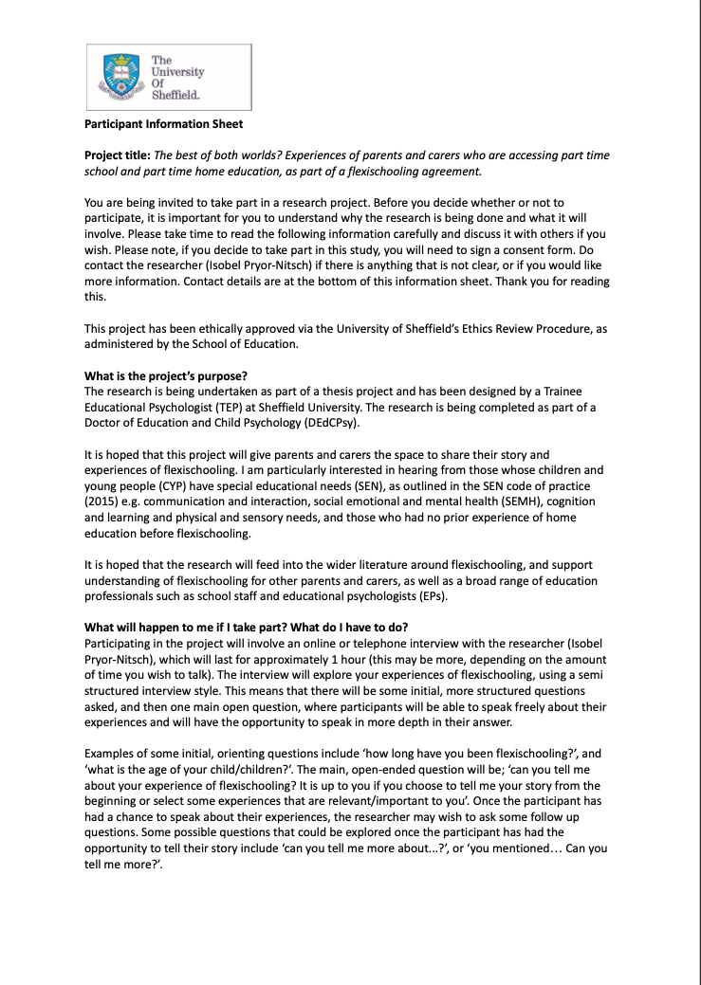
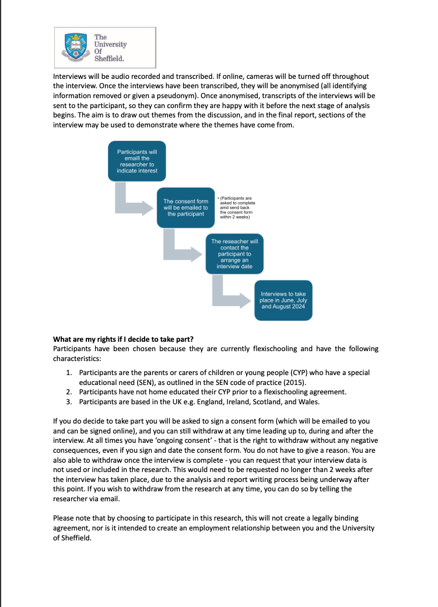
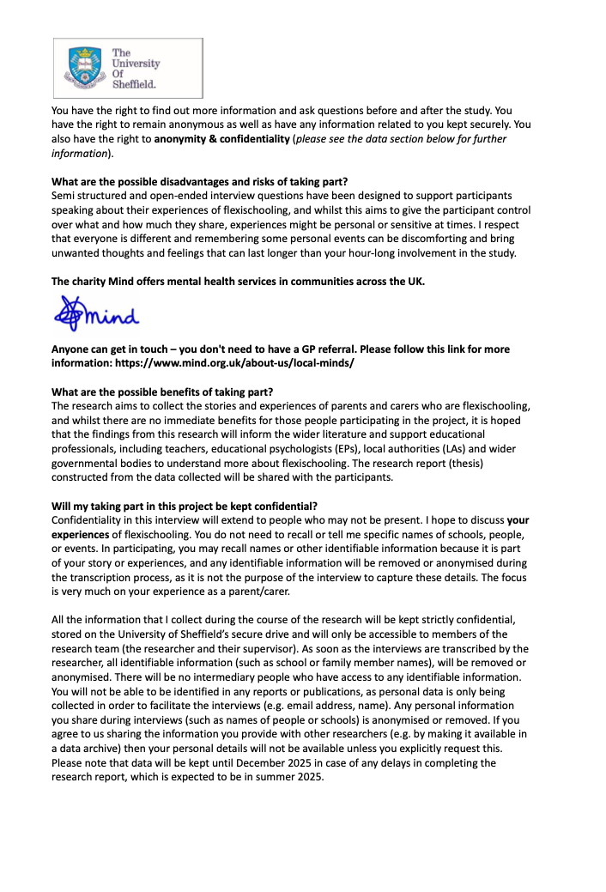
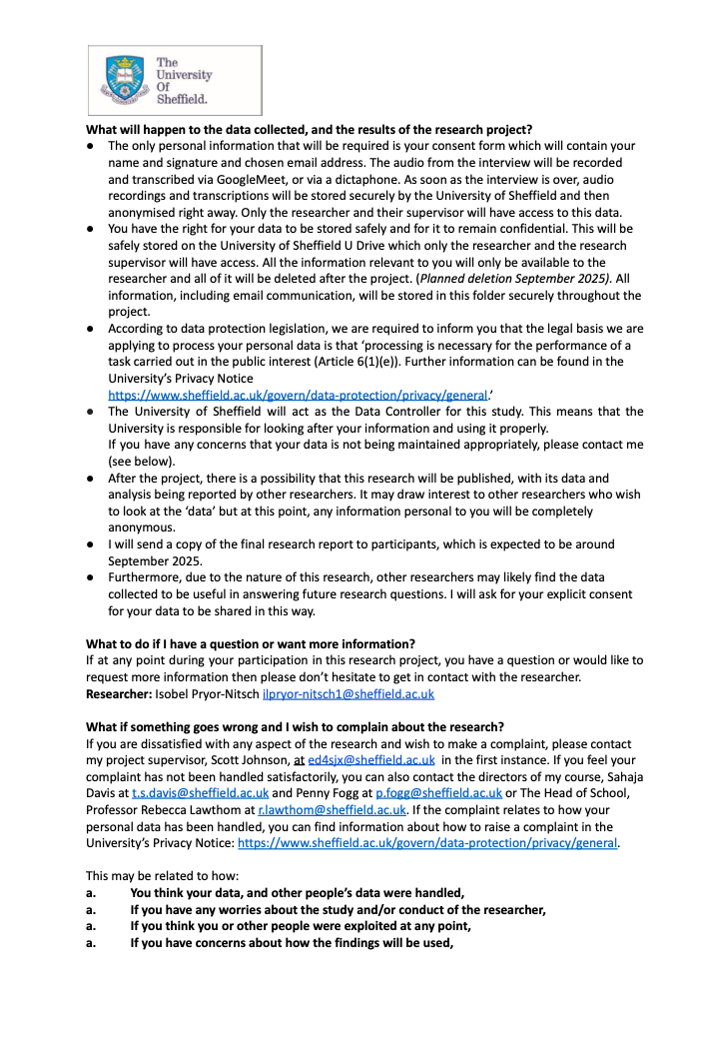


Appendix D: Consent form
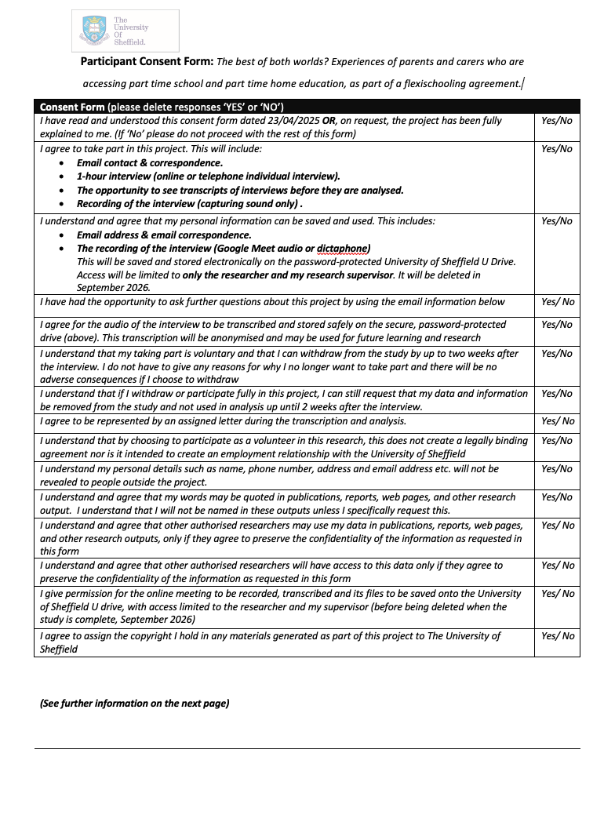

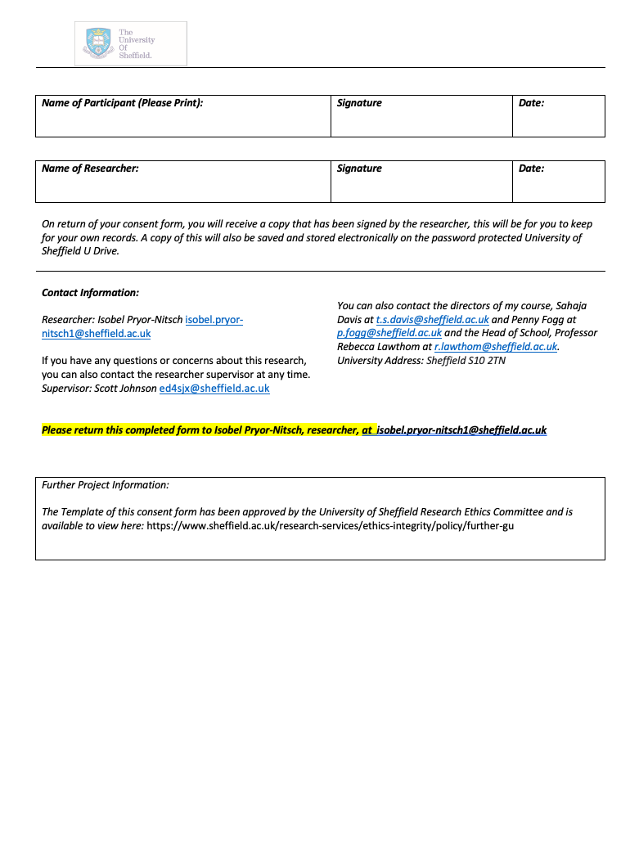

Appendix E: Recruitment Advert
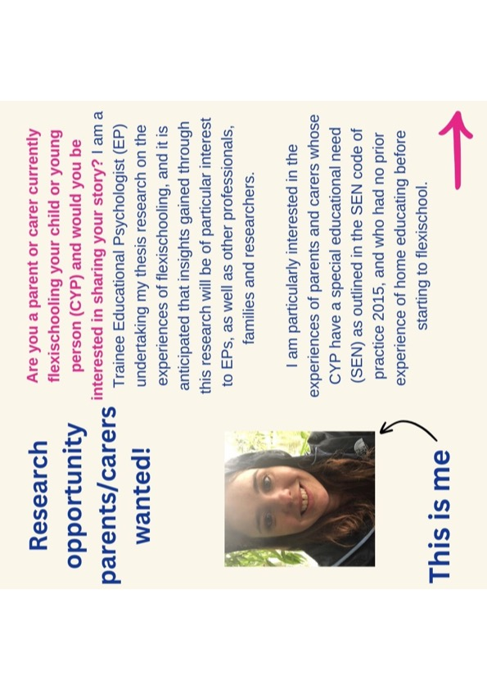

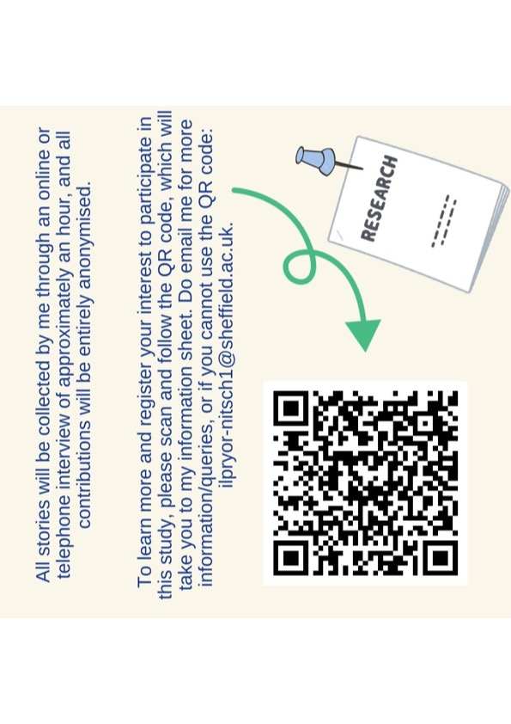

Appendix F: Questions and Prompts

Appendix G: Interview Transcripts
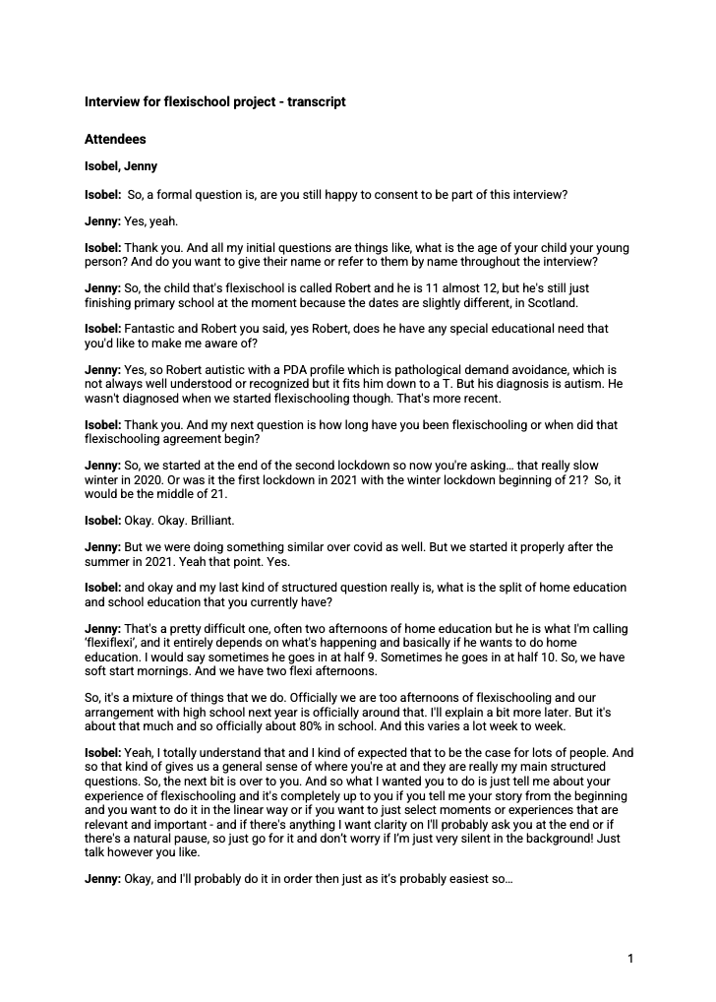
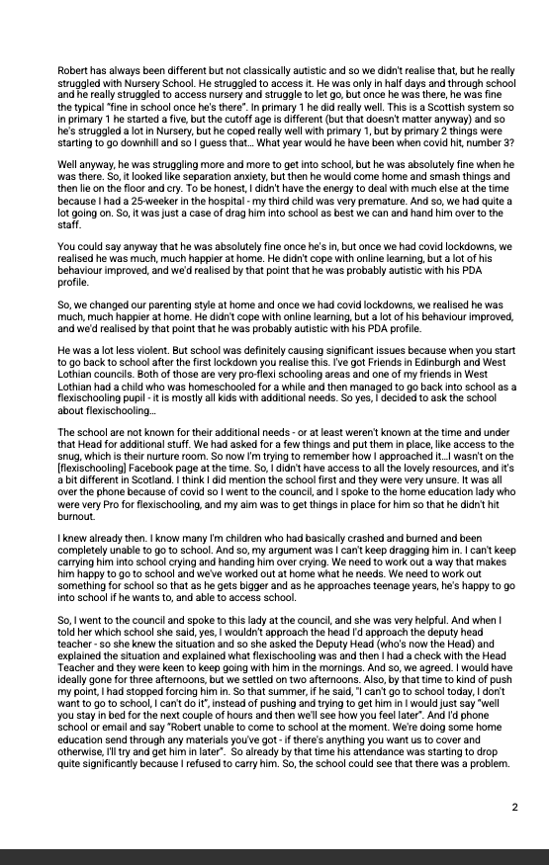
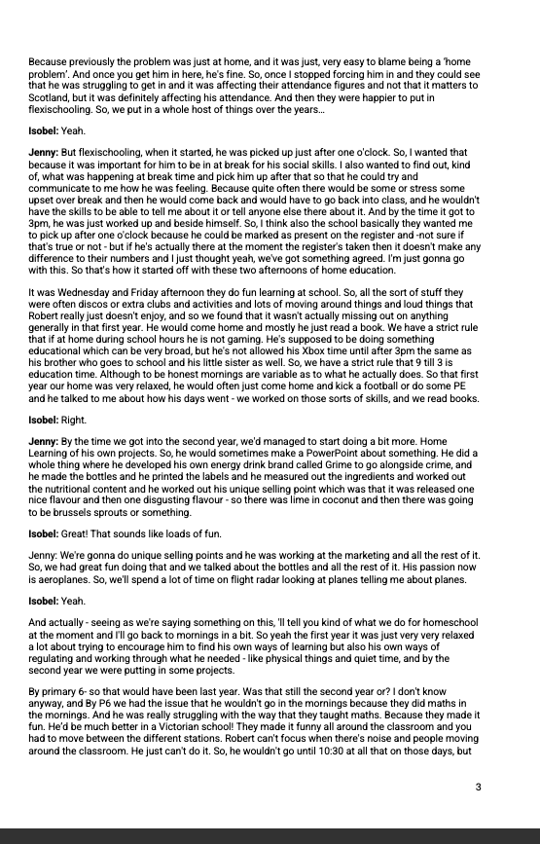
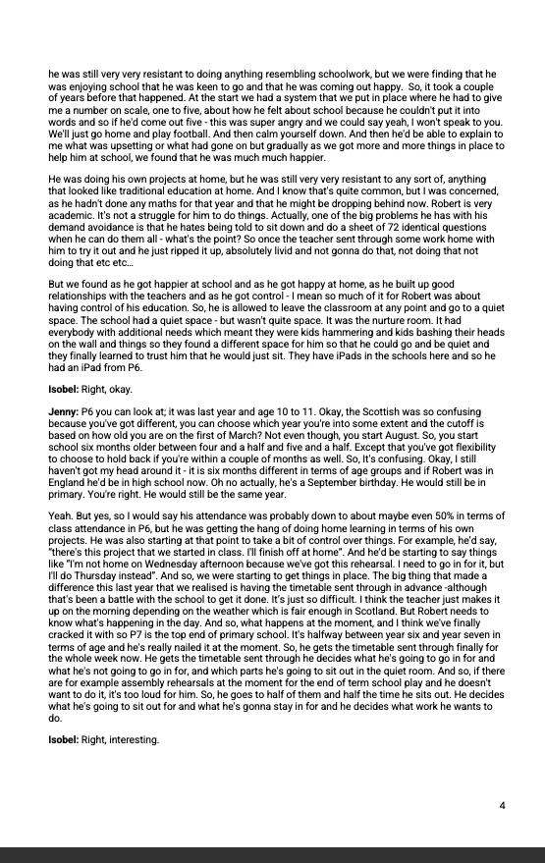
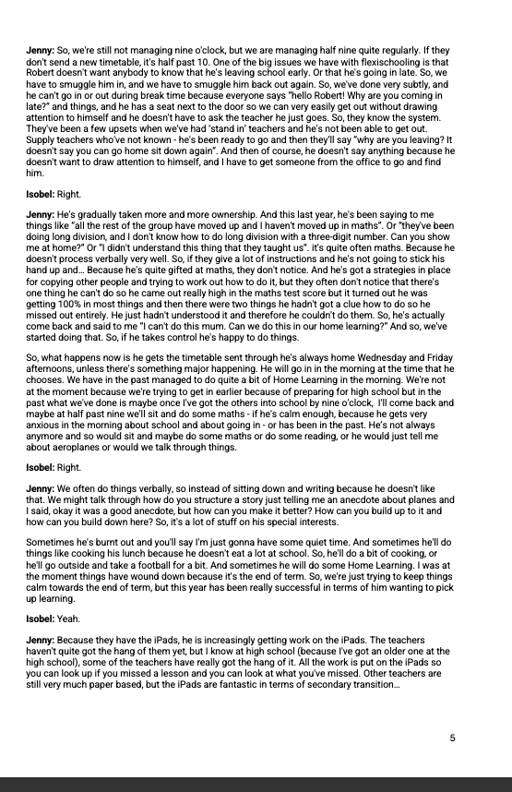
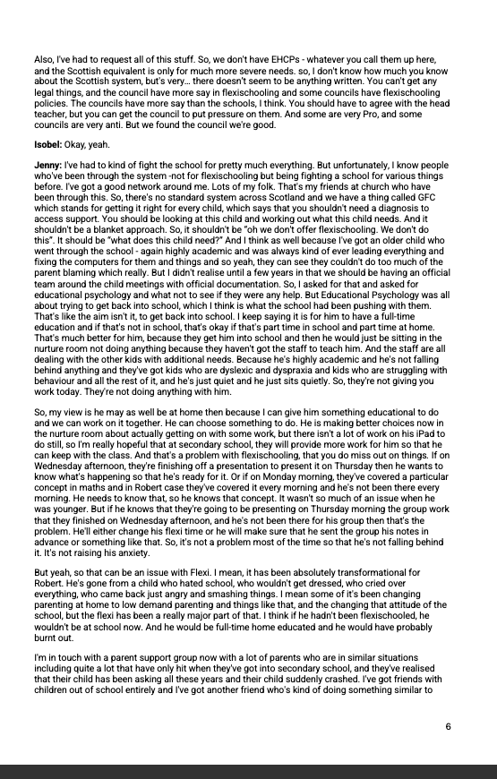
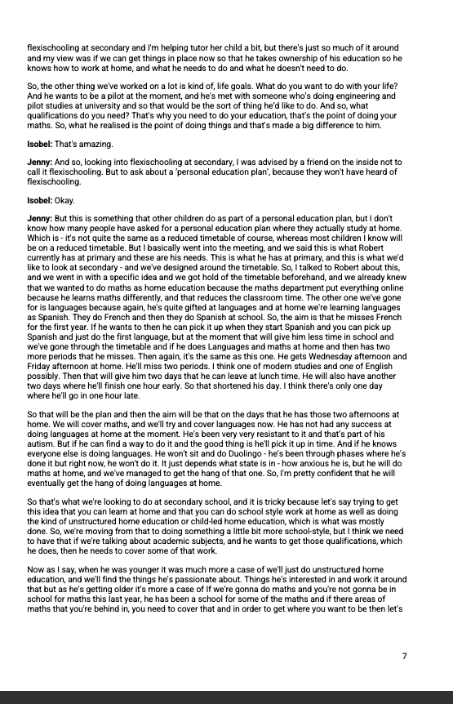
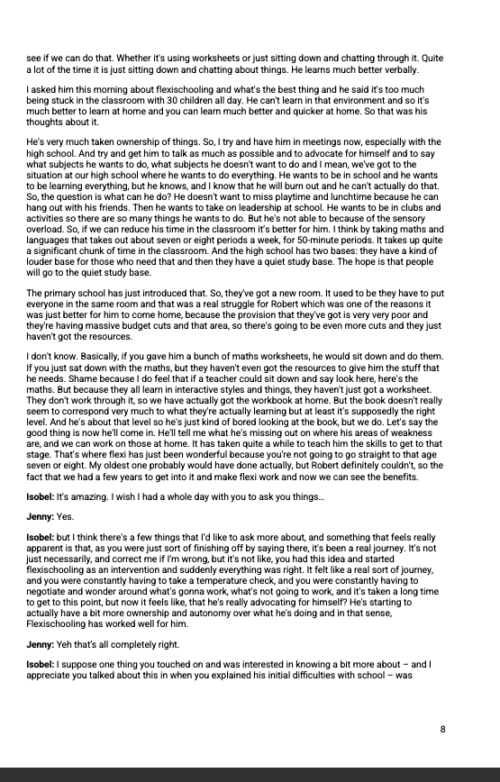
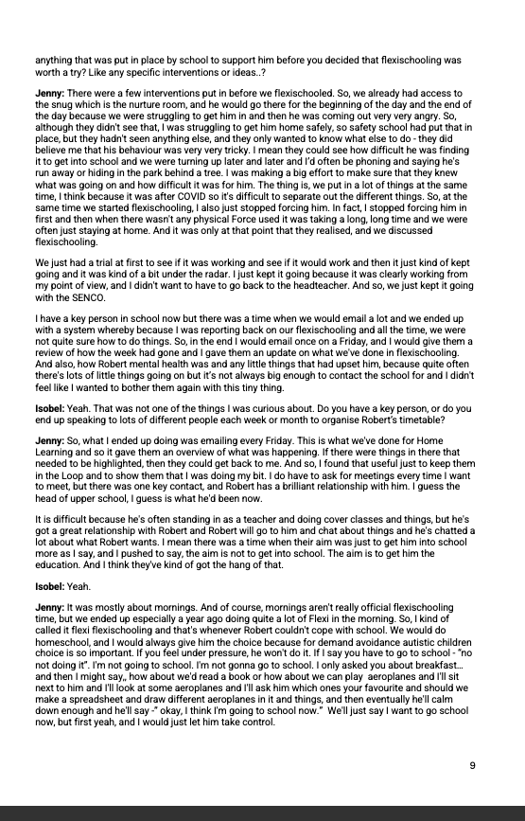
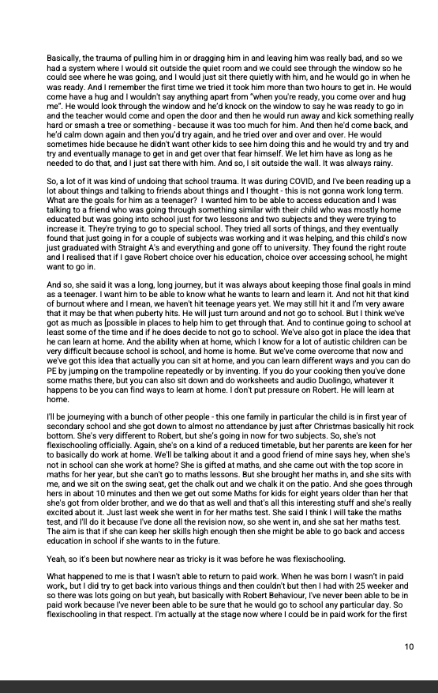
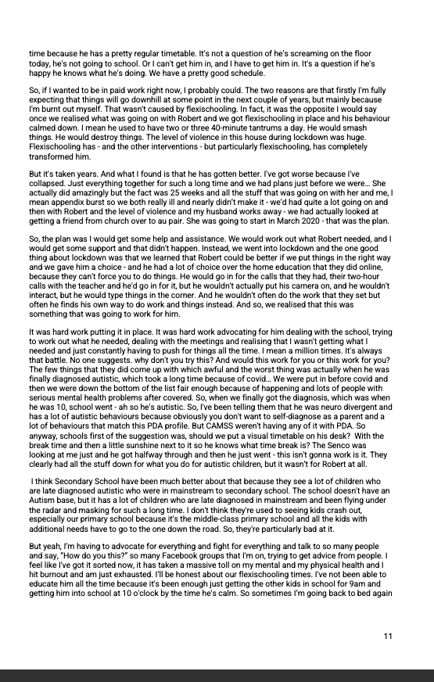
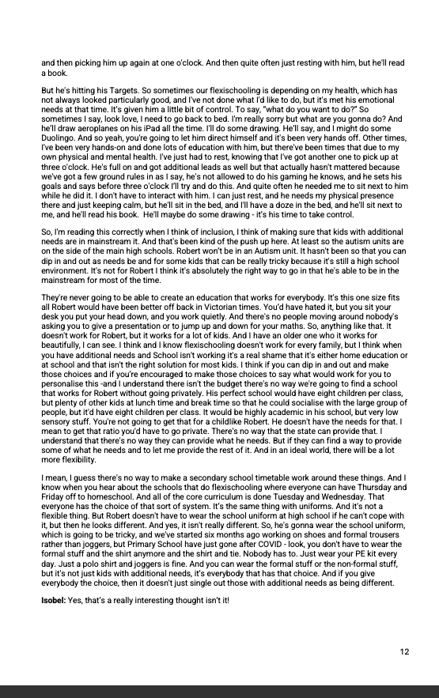

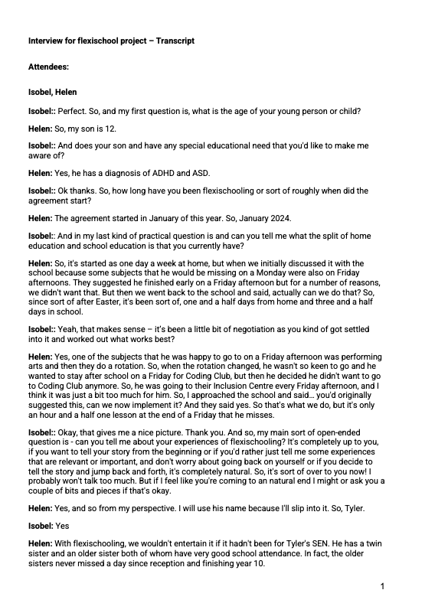
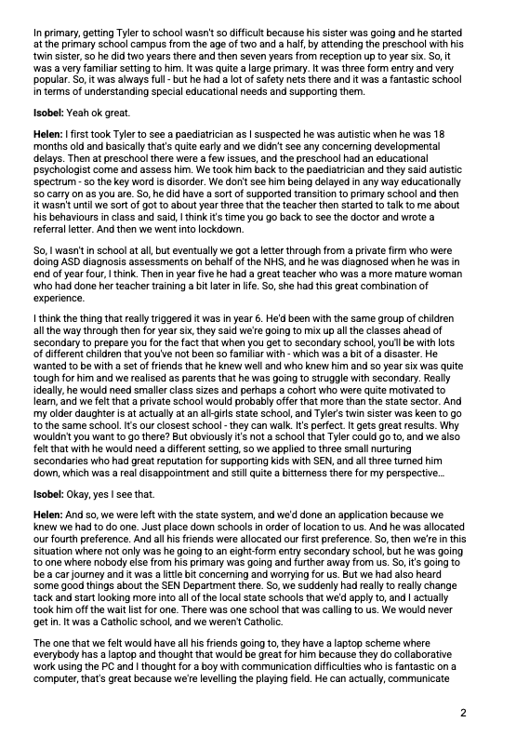
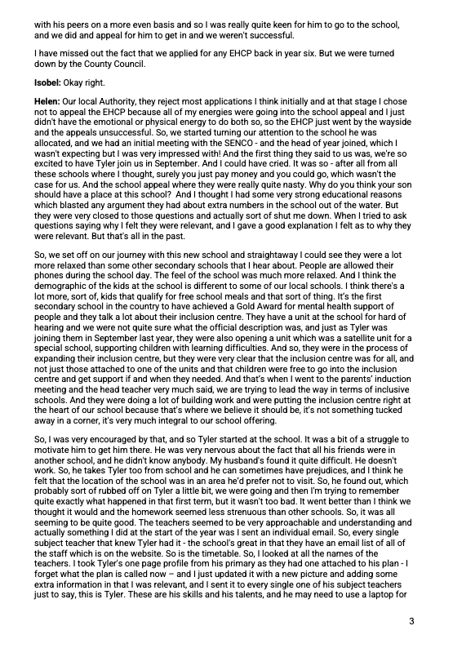
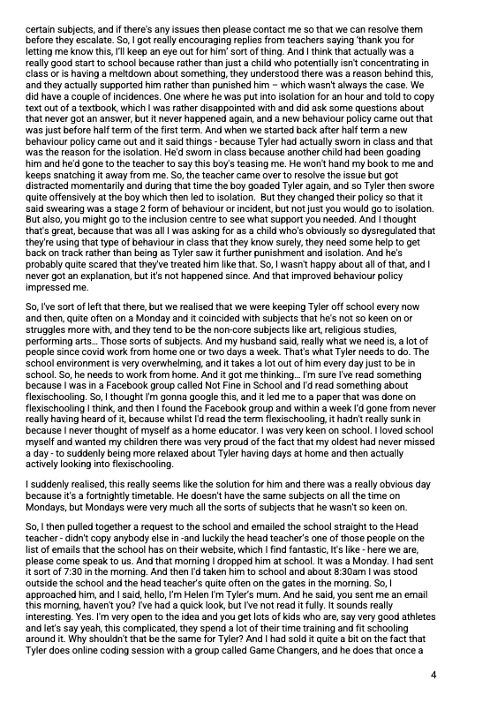
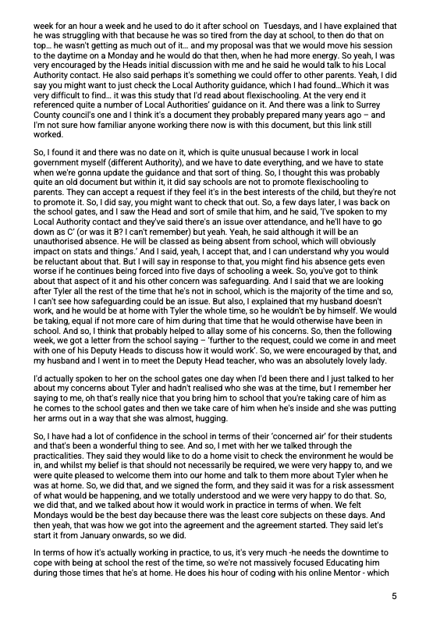
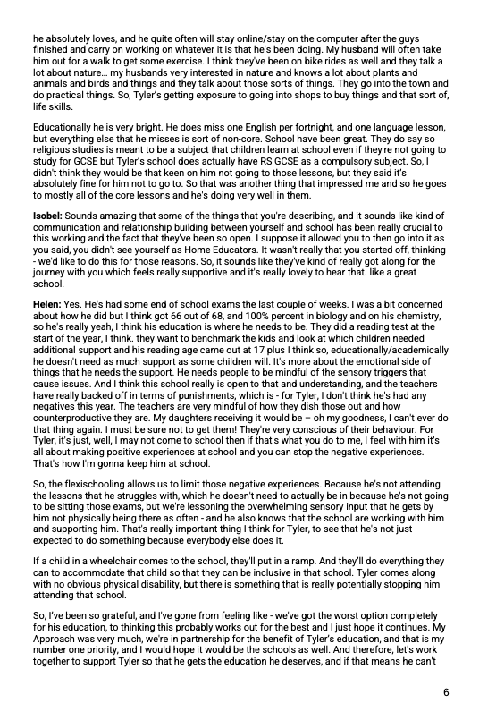
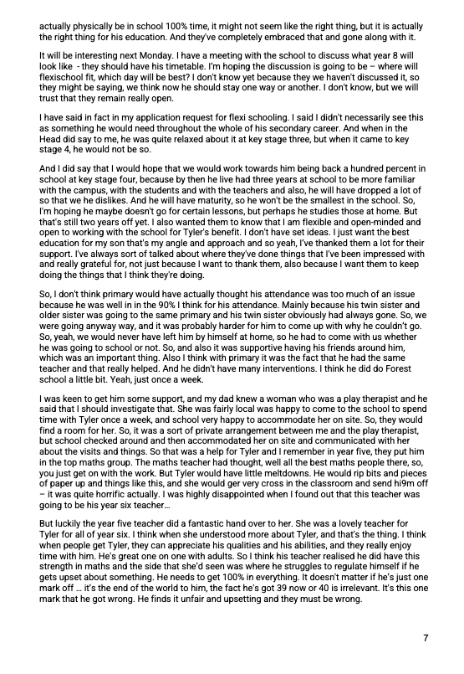
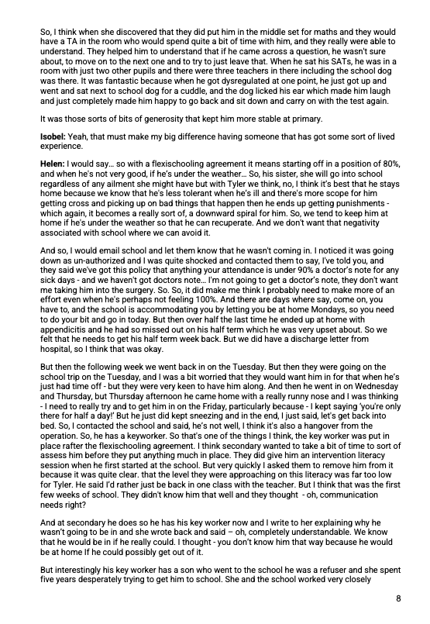
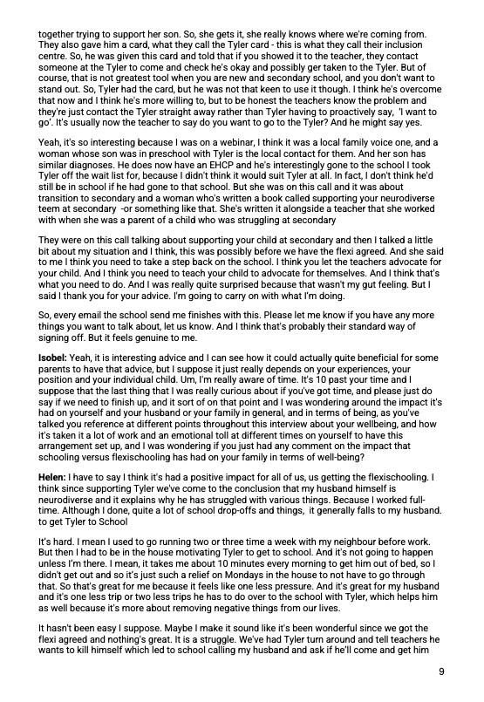
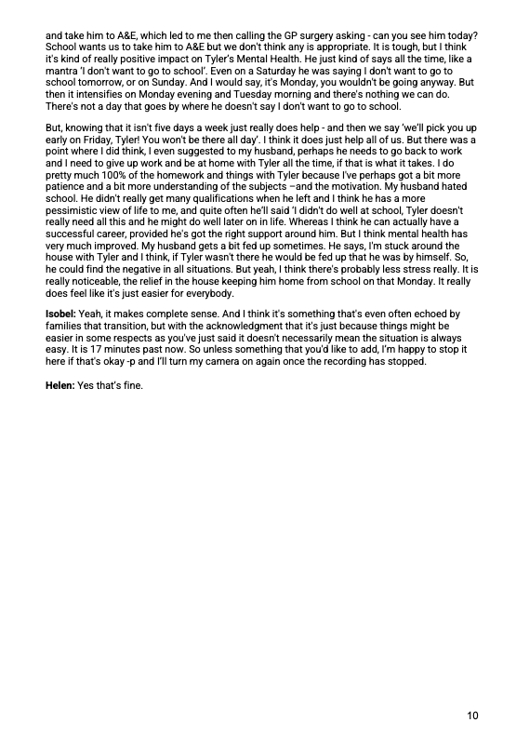
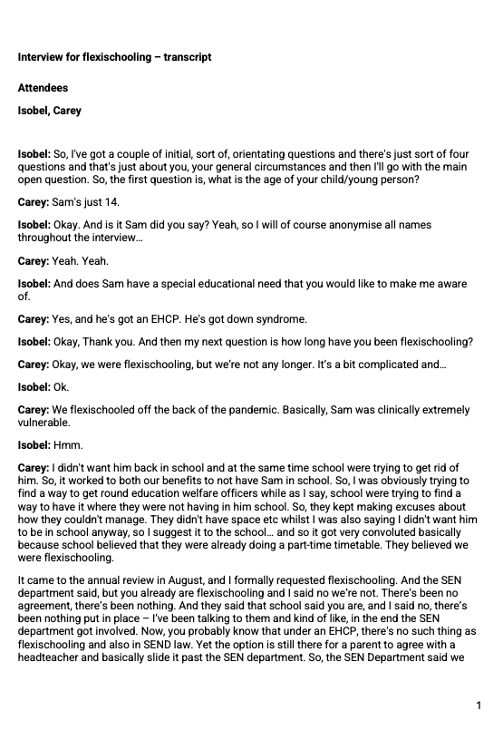
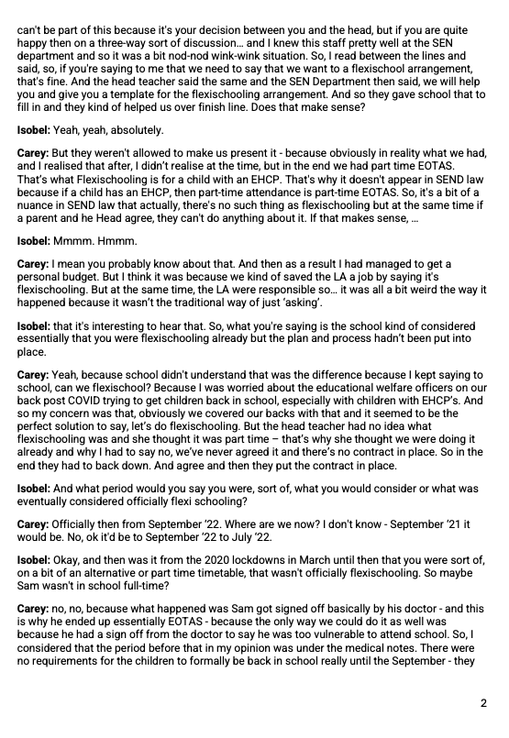
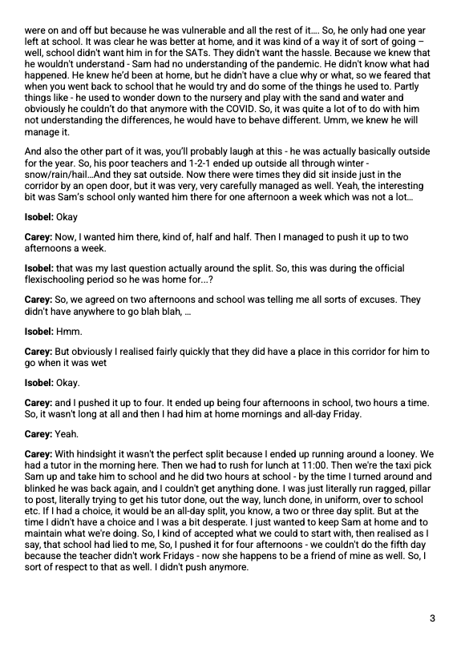
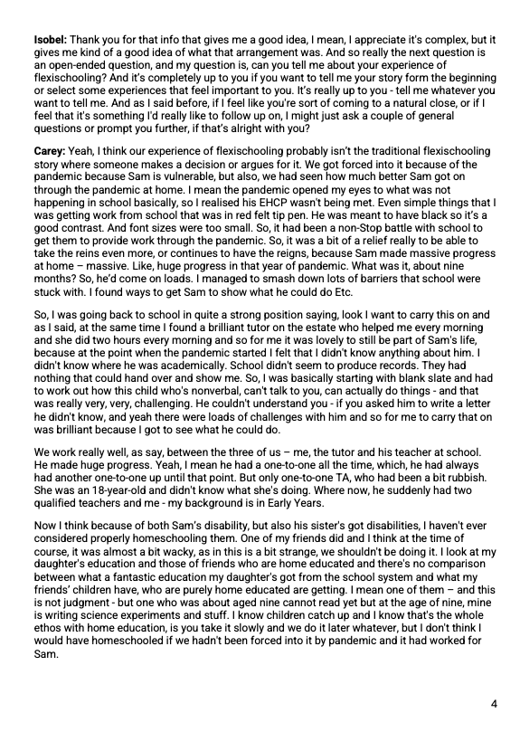
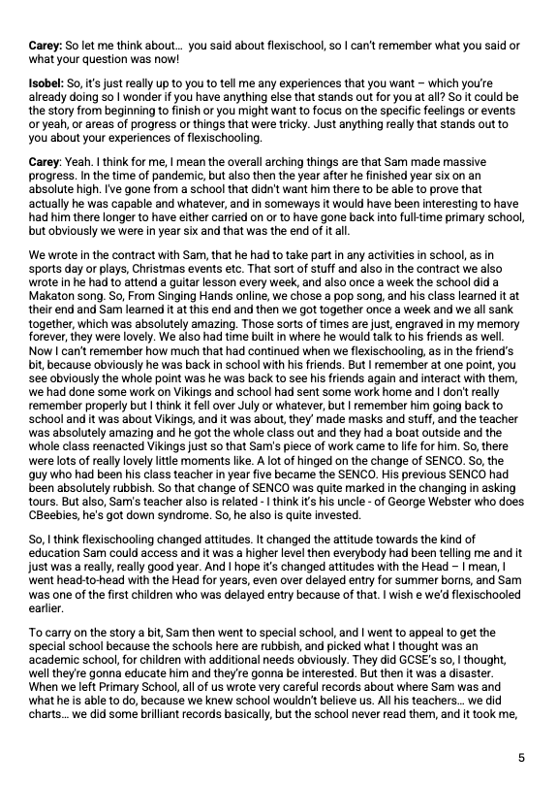
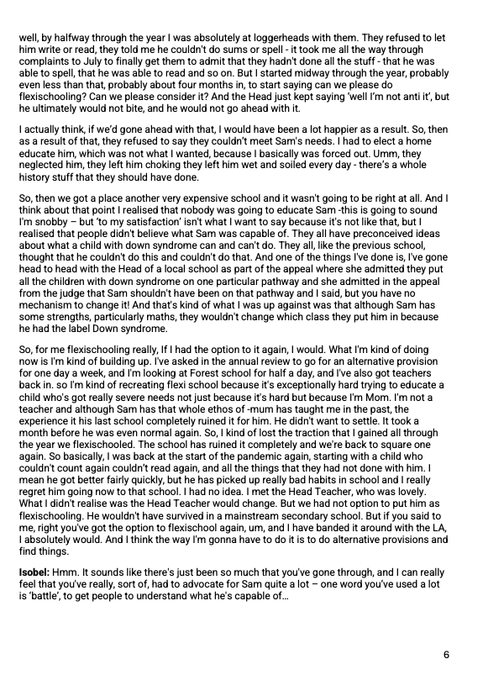
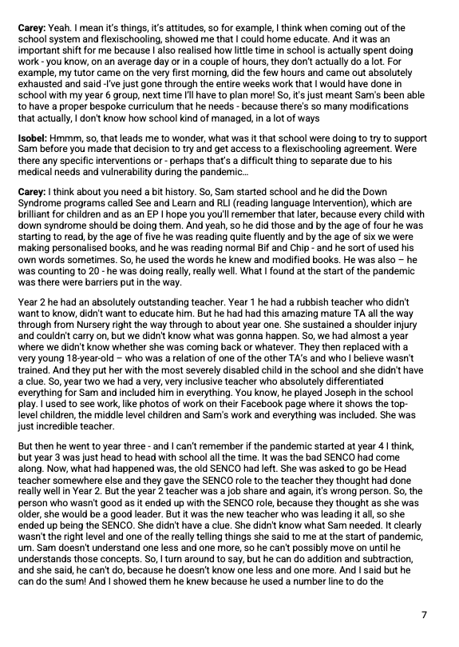
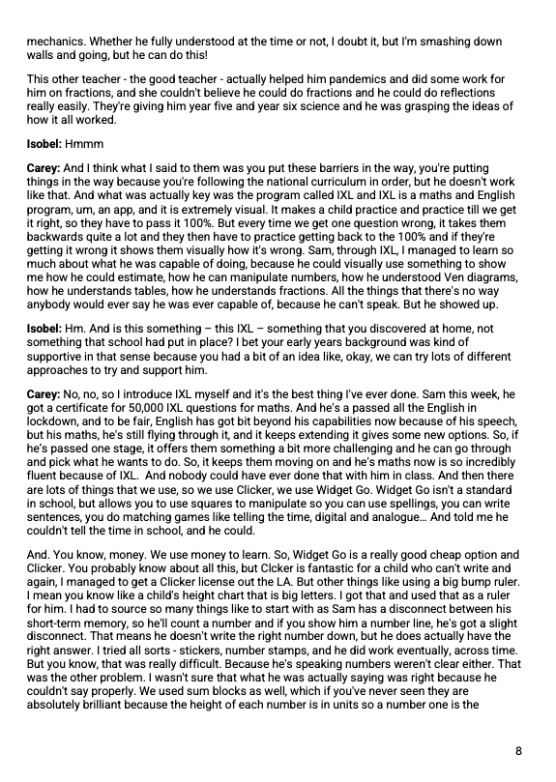
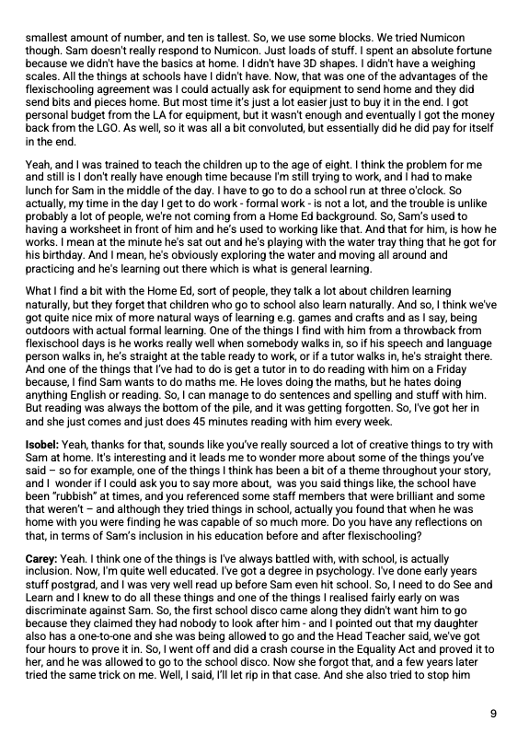
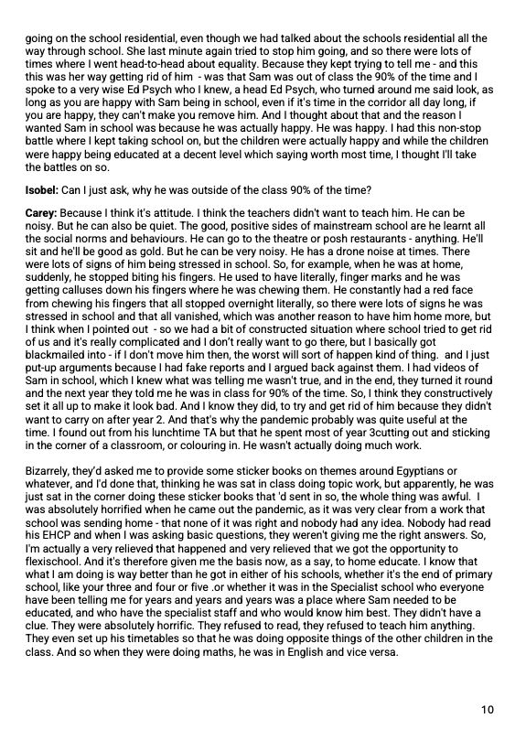
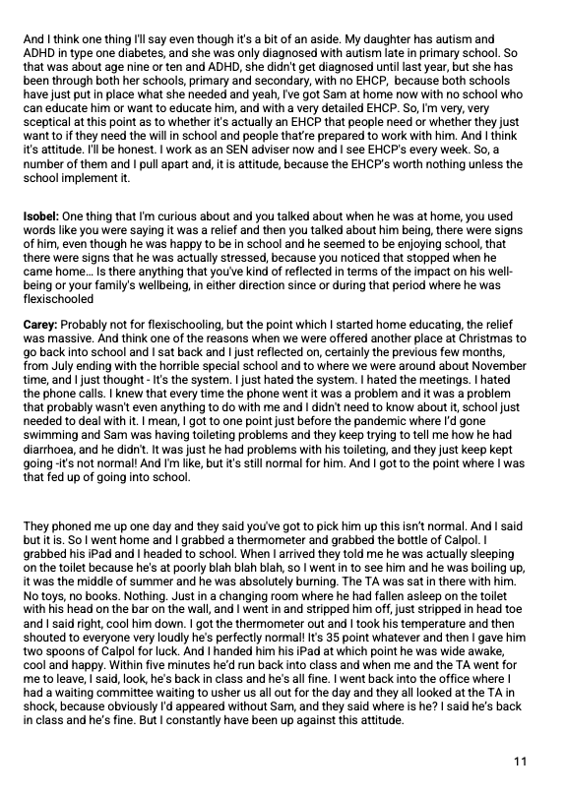
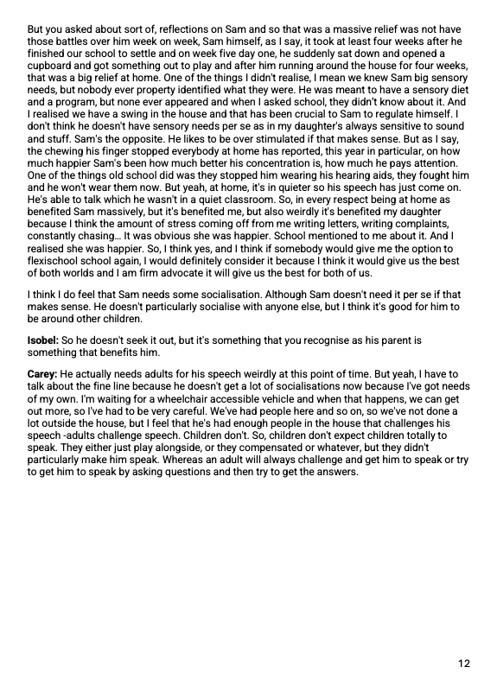
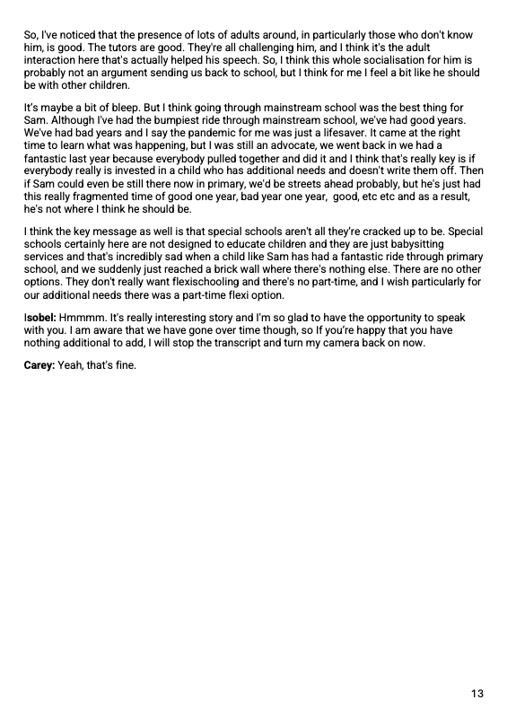

Appendix H: Code Book example

