

Exploring the Lived Experiences of Educational Psychologists in Using Reflection and Ethics as Virtues

Laura Tobin
220110459
Supervised by Dr Sahaja Davis

Research thesis submitted in partial fulfilment for the Doctor of Educational and Child Psychology
School of Education
May 2025

Abstract
This research explores lived experiences of five Educational Psychologists (EP) with varying experiences, length of practice and job roles, working within one Local Authority. Using semi-structured phenomenological interviews, participants reflected upon a work dilemma in which themes of reflection and ethics were commonly raised. This study aims to consider these concepts as ‘virtues’: an acquired human quality which can be strengthened. This research aims to understand EP’s experiences of manifesting and enacting the virtues of reflection and ethics. The exploration into current literature highlights the necessity of this research. Virtues are seldom considered within the world of Educational Psychology. This research aims to address this noticeable gap and develop the theoretical and practical development within Educational Psychology.
Five interviews with EPs were analysed using Interpretive Phenomenological Analysis (IPA), as denoted by Smith et al, (2022). Findings revealed seven Group Experimental Themes (GETS): Using virtuous reflection, virtuous ethicality, the dynamic relationship between the virtues; manifestations of virtues in supporting the job, emotional evocation manifestation, experiences that impact virtues, and barrier to engaging in virtues. These GETs then have associated subthemes which explore the lived experience in more depth. The findings suggest both ethical and reflective virtues are present within Educational Psychology practice and are a crucial part of being an Educational Psychologist. However, there are significant experiences and barriers to engaging in virtues that can be a result of personal, professional or systemic aspects. Additionally, this research highlights a bi-directional relationship between virtuous reflection and virtuous ethics. The deeply complex, nuanced and interwoven nature of virtues is explored. This study calls for additional research into virtues’ place within Educational Psychology, whether this be in the Doctoral training programme, EP practice, or systemic awareness. In essence, this research merely touches on the expanse of how virtues can, and should, be used.

Dedications
Firstly, to my lovely participants. Thank you for your willingness to be open and vulnerable with me about your deeply personal experiences. Your invaluable contribution has been the cornerstone of this thesis and my doctoral journey. I hope I have done your stories justice and together we are able to make an impact on the world of Educational Psychology.
I also wish to extend my gratitude to my supervisors. Frankie, your care and commitment to my doctorate journey and thesis has been insurmountable. Sahaja, your knowledge and reflective power have been of great inspiration. Your ability to invite explorations of the unexplorable is skill I hope to emulate. My unofficial supervisors, my peer cohort whose companionship, support and encouragement have been pinnacle across the doctoral journey. Hannah – thank you for always being one step ahead and continually guiding me.
To Shreya and Carly. These last three years (and all the years leading up to this) would not have been possible without your unwavering love, support and commitment. Each moment has highlighted the power of your friendship. Thank you for always meeting me where I am, and undoubtably providing giggles on the way.
And last but not least, my family. Joe, thank you for never failing to bring light into my life. Despite having no idea what this is all about, your belief in my ability to achieve my dreams has, and will continue to, keep me motivated. Dad, you’re my rock. Your enduring encouragement continually reassures me of my capability. Billy, my best friend, number one fan, support system, and safe haven. This indescribable journey has been made easier, lighter and so much more enjoyable with you by my side. Your presence, support and pride has continued to fuel my passion and determination. Mum, you’re my inspiration. Your dedication and commitment to supporting me is unprecedented. Thank you for answering every panicked phone call, listening to every incomplete musing, and taking on my passions as your own - I am indebted to you. Lastly, to Nana, your presence and pride has been felt every step of this journey.

Abbreviations:
APA | American Psychological Association
BPS | British Psychological Society
DEdCPsy | Doctorate in Educational and Child Psychology
EdPsy | Educational Psychology
EFPA | European Federations of Psychologists Association
EP | Educational Psychologists
EPS | Educational Psychology Service
ES | Experimental Statement
IPA | Interpretative Phenomenological Analysis
GETs | Group Experimental Themes
HCPC | Heath and Care Professional Council
LA | Local Authority
PETs | Personal Experimental Themes
UK | United Kingdom
USA | United States of America

Table of Contents
Chapter 1: Introduction 9
1.1 Overview of Thesis 9
1.2 Recognitions and Research Interests 9
1.3 Significance of Research 10
Chapter 2: Literature Review 12
2.1 Chapter Overview 12
2.2 Contextual Importance of Research 14
2.3 Virtue Ethics: 15
2.3.1 Definition and Ethical Acknowledgements 15
2.3.2 EP Landscape 16
2.3.3 History and Meaning 18
2.3.4 Virtue Development 19
2.3.5 Critiques 21
2.3.6 Links to EP Practice 23
2.4 Reflection 25
2.4.1 Within the EP Context 25
2.4.2 Exploring Meaning 26
2.4.3 Reflection as a Virtue 26
2.4.4 Reflection as a Practice 27
2.4.5 Impact of Reflection 28
2.4.6 Critique 32
2.5 Relationship between Reflection and Ethics 33
2.5.1 Current Context 33
2.5.2 Dynamic Relationship 34
2.6 Research Justification 35
Chapter 3: Methodology 37
3.1 Chapter Overview 37
3.2 Part 1 37
3.2.1 Ontological and Epistemological Positioning 37
3.2.2 Phenomenology as an Ontology and Epistemology 38
3.2.3 Interpretative Phenomenological Analysis 40
3.2.4 Hermeneutics 41
3.2.5 Idiography 43
3.2.6 Quality, Validity and Generalisability 44
3.2.7 Ethics 45
3.3 Part 2: Procedure and Design 47
3.3.1 Participants 47
3.3.2 Semi-structured Interviews 49
3.3.3 Transcription 50
3.3.4 Analysis 50
3.4 Chapter Summary 57
Chapter 4: Findings 58
4.1 Chapter Overview 58
4.2 Theme 1: Using Virtuous Reflection 60
4.2.1 Deep Self-Understanding and Awareness 61
4.2.2 All-Consuming Necessity for Personal and Professional Evolution 62
4.2.3 Self-Criticality 65
4.2.4 Decision-Making Amidst Managing Complexities 65
4.2.5 Sense-Making of Systems and Those Within Them 66
4.3 Theme 2: Using Virtuous Ethicality 67
4.3.1 Permeates All Aspects of One's Life 68
4.3.2 Grappling with Unresolvable Tension of Ethical Limitations 69
4.3.3 Being Malleable to Boundless Ethical Complexities 70
4.4 Theme 3: Dynamic Relationship Between virtues 70
4.4.1 Self-Attunement to Maintain Emotional Resilience and Self-Assurance 71
4.4.2 Strengthening Flow Between Virtues 72
4.4.3 Developing Deep Empathy 73
4.5 Theme 4: Manifestations of Virtues in Supporting the Job 74
4.5.1 Maintain Working and Collaborative Relationships 75
4.5.2 Striving to Execute All Aspects of the Job’s Complexities to Create Meaningful Change 76
4.5.3 Constant Sway of Competence, Knowledge and Practice 77
4.5.4 Identifying, Adapting and Committing to an Authentic Professional Identity 77
4.5.5 Suffocation of Perpetual Constraints 78
4.5.6 Crippling Weight of Professional Responsibility 79
4.6 Theme 5: Emotional Evocation Manifestation 80
4.6.1 Sitting with the Tension of Uncertainty 81
4.6.2 Dynamic Interplay Navigation of ‘Personal’ and ‘Professional’ 82
4.6.3 Importance of Grounding to Find Safety Amidst Ethical Chaos 83
4.6.4 Overt Bodily Response to Challenging Experiences 84
4.6.5 Balancing the Yearn for Change with Acceptance of One's Ability to Create Impact 85
4.7 Theme 6: Experiences that Impact Virtues 86
4.7.1 Personal Hardship 87
4.7.2 Impactful Consequence of Time and Experience 87
4.7.3 Seeking Collaborative, Concrete and External Validation 88
4.8 Theme 7: Barriers to Engaging Virtues 91
4.8.1 Consistent Strain of Limited Time and Mental Capacity 91
4.8.2 Inexperience Exposing One’s Inner World Resulting in Discomfort 92
4.9 Chapter Summary 93
Chapter 5: Discussion 94
5.1 Chapter Overview 94
5.2 Evidence of Reflection and Ethics Being Virtues 95
5.3 Research Question 3: What is the Dynamic Relationship Between Reflection and Ethics as Virtues Within Educational Psychology Practice? 96
5.3.1 Research Question Summary 102
5.4 Research Question 1: According to the Participant, How Are the Virtues of Reflection and Ethics Manifesting and Presenting in Educational Psychologists’ Practice? 102
5.4.1 Virtuous Reflection 102
5.4.2 Using Virtuous Ethics 107
5.4.3 Research Question Summary 109
5.5 Research Question 2: What is the Participants' Experience of Enacting the Virtues of Ethics and Reflection Through the Exploration of a Work Dilemma? 109
5.5.1 Emotional Evocation 110
5.5.2 Experiences that Affect Virtues 113
5.5.3 Research Question Summary 117
5.6 Research Critique - Strengths and Limitations 117
5.6.1 Sensitivity to Context 117
5.6.2 Commitment and Rigour 119
5.6.3 Transparency and Coherence 119
5.6.4 Impact and Importance 120
5.7 Implications on Educational Psychology Practice and Training 121
5.7.1 EP Practice 121
5.7.2 Supervisory Practices 122
5.7.3 Implication of the DEdCPsy Training Course 123
5.8 Opportunities for the Future 124
5.8.1 Research 124
5.8.2 Supervision Model 125
5.9 Personal Reflections 125
References 127
Appendices 140

Chapter 1: Introduction

1.1 Overview of Thesis
This thesis begins with acknowledgements of personal motivations and recognition of my positionality within this research, followed by a brief exploration into the significance and importance of this research. Chapter Two begins with an acknowledgement of the contestable nature of ‘reflection’, ‘ethics’, and ‘virtues’ and considers my positionality of these terms. The chapter is segregated into three main sections: Virtue Ethics, Reflections and Relationship between Reflection and Ethics. Within the first two subsections, concept definitions are provided, along with general and Educational Psychology (EdPsy) contextualisation. For the final section the virtue relationship, current context and dynamism is explored. A critique of previous and current discourses relating to each subsection is also presented. Chapter Three is presented within two parts. The first part outlines my ontological and epistemological positioning, and pertinent methodological aspects, such as Interpretative Phenomenological Analysis (IPA). Here, research quality and ethical considerations are explored. The secondary section delves into research design, providing a comprehensive overview of IPA analysis process. Chapter Four outlines findings of the research, highlighting themes and lived experiences of participants through direct quotes. Chapter Five considers the research questions in light of the analyses. Strengths and critiques of the research are explored, and implication on future EdPsy practice, and potential opportunity for the future. Finally, the thesis is summarised with personal reflections.

1.2 Recognitions and Research Interests
I want to take this time to recognise the privilege I have to be able to engage in such research, in many different ways. I recognise my personal privilege in being able to afford the time and effort into such a venture. Further to this, I wish to acknowledge the physical, societal, and systemic privilege I have in being a white, middle-class, and able-bodied person in completing this research, and more broadly the Doctorate in Educational and Child Psychology (DEdCPsy) course. I am consciously aware that my privilege has given me scope to be able to enter the world of academia, philosophical thinking, and EdPsy.
Further to this, I recognise the impact of this privilege on my positionality and subjectivity in this research. My personal history, life experiences, culture, language and generalised assumptions are inevitably going to influence the research process (Braun & Clarke, 2013). Although the hermeneutic cycle within IPA accounts for this, I feel it important to explicitly recognise who I am in that process, and where my experiences lie.
My interest in this area stems from my personal experiences of using reflective techniques, including journaling and therapy, to better understand myself and seek growth and development. In doing so, I found I began to better understand other people, better understand my role within relationship dynamics, and felt I had a better understanding on how to manage more challenging, and quite often, ethically complex situations both in my personal and professional life. The active process of embedding reflectiveness into my daily living then resulted in becoming more ethically sensitive to myself and others. This encouraged me to engage more reflectively. Which made me wonder, is this done in Educational Psychologist’s (EP) practice? Do other professionals experience this too? And can this be harnessed, used or investigated in more depth?
Finally, I wish to acknowledge there are different ways reflection and ethics are conceptualised. Varying attributes, qualities, and skills are associated with both terms, and each have their own roots and implications. The use of virtues to conceptualised these terms is explored and justified within Chapter 2.

1.3 Significance of Research
My aim of exploring this topic is to generate new knowledge in the field of EdPsy in relation to our ethicality and ability to reflect, using the lens of virtues to frame and conceptualise these qualities. This stems from a personal moral compass of wanting to ensure that all practitioners, and potentially people in general, are able to understand themselves, the impact they have on others and where this desire fundamentally stems from. In understanding this process, and supporting others to do so, I hope the implications of such can support EPs to engage in virtues, in turn developing their reflection, ethics, personal wellbeing, effective outcomes, and overall life satisfaction.
The significance of this research has potential to be impactful within EdPsy. Given the competency guidelines outlined by Health Care and Professionals Council (HCPC) (2023a, 2023b, 2024) and the British Psychological Society (BPS) (2017, 2021a) having specific focuses on both reflection and ethics, broadening our understanding and perspective could be impactful in supporting EPs, specifically in regard to ethical practice, personal wellbeing and job retention. Such philosophical concepts are invited into the world of psychology to create a more unified and holistic approach to better understanding oneself (Kristjánson, 2018). Given the positive impact reflective practice is reported to have (Schön, 1979, 2016; Goleman, 2005; Siegel, 2007; Mann et al., 2009; Clarke, et al. 1996), could the introduction of virtuousness be impactful or influential to EPs? Furthermore, given the non-specific and ambiguous nature of competency guidelines (Joscelyne, 2002) could introducing virtuous ethics support EPs to manage each nuanced situation with better confidence and outcomes?
The call for investigation into using virtues is noted (Handelsman, Knapp & Gottlieb, 2005; Joscelyne, 2002). As highlighted in Chapter 2, there is a distinct absence of contemporary research regarding the use of virtue ethics and reflection within the world of EdPsy. Therefore, this research hopes to begin to contribute towards the growing discourse of the importance of virtues within practicing psychology practitioners, specifically in this case, EPs.

Chapter 2: Literature Review

2.1 Chapter Overview
The objective of this critical literature review is to explore how virtue ethics and virtuous reflections are being used, considered or manifested within EdPsy, with an additional focus on their dynamic relationship. An iterative approach to reviewing literature was completed throughout the course of this research. I was met with considerable challenges in identifying literature exploring virtue ethics and virtuous reflection within the landscape of EdPsy within the United Kingdom (UK). Therefore, this critical review has encompassed additional health and care research, and culturally comparable contexts to the UK. Literature was identified to justify this approach; Caldicott and Braun (2011) identify transferability of ethics literature across interprofessional disciplines. This is also seen within the Health and Care Professionals Council (HCPC) having a general ethical code (2024) that regulates all registered professionals. This notion is also recognised when regarding reflection: Mann et al. (2009) highlight the interdisciplinary approach to reflection.
Prior to outlining the literature review sections, I wish to take a moment to recognise my understanding of the contestable nature of the terms I am using: virtues, ethics and reflection. Ethics and reflection as terms are further explored within the following chapter, however it is important to highlight the process in which the term ‘virtue’ was chosen. I explored various domains, such as Cognitive Behavioural Therapy, Acceptance and Commitment Therapy, Personal Construct Psychology and psychodynamic approaches. Additionally, I explored Buddhist expression and terminology to find the most appropriate approach to engaging in this research. Although all these domains had relevance, I hoped to be able to investigate what it meant to be ethical and be reflective, over practicing in such ways. To be something relates to an ever-present aspect that is ingrained into your personal and professional identity, whilst to practice in something refers to the active engagement within an action or process within a particular context. I aimed to explore deeply embedded ethical and reflective parts of a person, or the ethical and reflective ‘virtues’. Through exploration of MacIntyre’s (1985) work, and philosophical literature, the term ‘virtue’ felt appropriate. The term is able to express the process of becoming, and perpetually engaging in or developing, as opposed to just practising or acting. It recognises virtues as permeating all aspects of life (Aristotle, 2000) whilst requiring cultivation and development (Kristjánsson, 2015). Therefore, this terminology felt most appropriate approach to displaying the metaphysical nature of what I wished to investigate. Within the context of this research ‘virtue’ is defined as: an ever-present quality, trait or skill that can be enhanced or developed; whilst practice is defined as: contextually appropriate application of a learned skill or process.
Additionally, I recognise there are various routes to developing one’s virtues or becoming virtuous. There is a vast religious discourse, of which within the Westernised context in which this thesis was written, is most notably Christianity. Whilst I am conscious of this discipline's significance in the development and understanding of virtue ethics, I opted to take a secular approach. This is for two reasons; the first being due to the vastness of this area, I did not feel I would be able to explore this subsection of religious virtue ethics within enough depth within the confines of this thesis; secondly is related to my positionality, ontology and epistemology. Given I do not ascribe to religion, exploring theologian approaches would both not be aligned to my positionality, and feel unjust given my personal position on religion. Similarly, this is why I did not choose to utilise Buddhist terminology.
With some of background and context of the terminology outlined, I wish to outline the following chapter. Firstly, virtue ethics is explored. It is addressed within the context of EdPsy and followed by the history, a more in-depth exploration of its meaning, and the process of virtue development. This is followed by a critique of virtue ethics, finishing with how virtue ethics can be linked to EP practice. The next section follows a similar structure but for reflection. Reflection is examined within the context of EdPsy. It is critically examined as a virtue and as a practice, whilst using literary evidence to highlight its impact. There is further critique when considering reflection as a virtue. Finally, the dynamic relationship between reflection and ethics is explored. Current contextual understanding is highlighted along with the current research into the dynamic relationship between reflection and ethics. This section ends with a justification of this research, and outlines aims and questions used in an attempt to overcome literary and research gaps.

2.2 Contextual Importance of Research
This section aims to situate the research within the current context for EPs. Due to EP work being related to supporting people commonly within vulnerable positions (BPS, n.d; Willdridge, 2013), all EP work is considered as being of an ethical nature. Bennett (2008) found the majority of EPs frequently experienced ethical dilemmas. The impact leads to personal factors such as burn-out and effective ethical transgressions (Oosthuizen, 2023). McDonald (2009) recognises the impact of developing reflection for self-awareness of oneself, one’s values, and one’s wellbeing. The result positively impacts practitioners' mental wellbeing and sense of professional identity. Due to the consistent changes within EP’s work contexts presenting as impactful on the confidence and competence of practitioners (Fallon et al., 2010, Cameron, 2006) consequently negatively impacting effective ethical decision-making (Kligyte, 2008), further exploration into this feels imperative both for EPs and communities EPs work with.
With EPs under more time, statutory and resource pressure (Watson, 2024; Haycock, 2024; Haycock & Woods, 2025), there is recognition regarding the significant impact this is having on EPs wellbeing (Watson, 2024). As seen above, the impact of which can negatively impact the level of practitioners’ ethicality. Bennett (2008) shared a way to support practitioners is through a virtue approach to ethics. This research aims to understand experiences of how virtuous ethics and reflection are used and can continue to be used to support EPs to be able to engage in effective ethical practice.

2.3 Virtue Ethics:

2.3.1 Definition and Ethical Acknowledgements
Throughout the expanse of literature, there is no short and snappy answer to the question ‘what is virtue ethics?’. Hursthouse (2017) highlights the impossible task of identifying a definitive answer to such a question. I therefore wish to acknowledge the definition of virtue ethics outlined is for the context of this thesis, and by no means do I espouse the following definition is a universal answer to such a long-standing and complex question. Virtue ethics is a moral philosophy that focuses on the ‘character’ of a person, as opposed to rules or consequences of ethical action. Character refers to the collection of internalised moral traits that manifests into ethical response or behaviour: the collection of moral virtues. As such, virtue ethics asks ‘what kind of a person should I be?’ as opposed to ‘what should I do?’. Swanton (2003), supported by Hursthouse (2017) outlines the role of values on virtue development. Personal values are moral principles which inform the enactment of virtues. The commitment to these values develops the moral character and virtues, therefore developing virtue ethics, in turn leading to moral and ethical decision-making. Virtue ethics is the process of becoming ethical, rather than acting ethically. This definition has been developed and collated from various literary readings explored across the context of the research, of which are explored below (Aristotle, 2000; Bryan & Babelay, 2009; Hursthouse, 2017; MacIntyre, 1981).
Additionally, I wish to acknowledge I do not believe virtue ethics as being the ‘best’ way to engage in ethical debate, nor do I ascribe to all of Aristotle’s (2000) moral philosophies. I recognise the position of the two contemporary mainstream approaches; deontology, which is ethical decision-making rooted in duty or moral principles (Alexander & Moore, 2020) and utilitarianism, which is moral action that produces greatest overall good (Briggs, 2023). It feels churlish to solely ascribe to one approach. I recognise this thesis choses to simply adapt and employ long-contested, divisive and contestable terminology in an attempt to develop the understanding of virtue ethics within EdPsy.
The justification of ethics as a general concept is seemingly adaptable depending on one’s philosophical perspective and standpoint. Various literary works, such as Aristotle (2000), Kant and Schneewind (2002), and Mill (2016) justify ethics within their own positionality. The individualistic and dynamic nature of ethics could leave general justifications to be tokenistic and void. Within this research, virtue ethics has been used, and its place and importance within EdPsy will be explored and justified in more depth later.

2.3.2 EP Landscape
Within the UK, ‘Educational Psychologist’ is a protected title, meaning practitioners must be registered to the HCPC. To gain and maintain registration, practitioners must work accordingly in line with the HCPC ethical guidelines (2024). EPs are additionally required to work within the Code of Ethics and Conduct (2021a) as outlined by the BPS. Both guidelines are designed to protect practitioners and ‘clients’. The HCPC denote practitioners must do this through; acting in the best interests of those they serve, maintain professional boundaries and avoid conflict of interests, practice within the scope of their competence, maintain confidentiality unless there are safeguarding concerns or legal requirements, and ensure respect for diversity and cultural sensitivity. Meanwhile, the BPS categorise their ethical code into five key principles; respect for the autonomy and dignity of persons, competence, responsibility, integrity, and social responsibility. There is a considerable overlap between ethical codes, focusing on individual experiencing psychological support, practitioners providing support, and practice completion. Additionally, despite differing contexts, there has been consideration into the American Psychological Association’s (APA) ethical code of conduct (2023). Although some common principles are shared, the approaches differ, most likely due to the cultural and regulatory frameworks. One main difference is the approach to overcoming ethical dilemmas. Whilst the BPS outlines guidance, with a strong notion of reflection for UK psychologists, the APA provides a detailed framework and formal processes in overcoming ethical dilemmas. The exploration into APA felt relevant given the scope of the research and literature having a primary focus on the United States of America (USA).
Despite the context, it is clear ethics are a fundamental aspect of the EP role. This is reflected within ethical codes of conduct all registered practitioners must abide by as outlined by the BPS (2021a) and HCPC (2024), along with the HCPC (2023b) Standards of Proficiency. The impact of these such codes is to support psychologists in various areas within the job role. Pope and Vetter (1992) highlight psychologists rely upon consistent and impartial ethical codes to guide ethical decision-making, particularly in challenging situations. The impact is reported to support and protect the ‘client’. Lazarus (2003) reports the adherence to ethical codes significantly reducing the likelihood of ethical violations, therefore enhancing professionalism of practitioners. Moreover, professionalism is reported as being positively impacted through ethical codes through improved accountability (Fisher, 2021). Associated professionalism and accountability act to promote trust within the ‘client’ and public (Behnke, 2004). As a result, Knapp & VandeCreek (2012) highlighted the development of strong professional working relationships with the ‘client’. By promoting and adhering to ethical codes and policies, trust within the relationship supports the critical collaborative relationships needed to facilitate change (Ainscow et al., 2006; Epstein, 2001; Rix et al., 2013). Additionally, ethical codes are reported to support practitioners through improved professional competency (McLeod, 2013) through the requirement for continual professional development (Barnett at al., 2007), in turn supporting ethical reflection (Barnett et al., 2007). An ethical requirement of self-development simultaneously acts to support practitioner reflection and self-awareness. This results in better ethical competence within highly complex ethical situations and continually adapting socio-political environments in which we work. Given the ever-changing contexts, along with our ethical values being strongly influenced by our context (Lindsay and Øvreeide, 2009), ethical codes that reflect social ethical views are imperative in supporting practitioners to effectively and ethically engage in practice (Hannah & Murray, 2014).
Yet, despite clear, contextually appropriate, and comprehensive ethical codes and guidelines, the guidelines can be considered vague next to the sheer quantity and complexities of ethical dilemmas faced (Joscelyne, 2002). With the ethical climate in which practitioners are working becoming increasingly challenging (Kinsella et al., 2015), there is recognition of the continual challenge practitioners face to ensure professional and ethical engagement (Handelsman et al., 2009; Hildebrand et al., 1995). Handelsman et al. (2009) suggest the current approach to ethics “alienates [practitioners] from [their] moral roots” (p.106). They suggest a positive approach to ethics is likely to be more appropriate and supportive in the application of “ethical excellence” (p.106). They express the place for virtues within positive ethics. Prior to engaging in what this means for EPs and their practice, it feels important to give a history and contextualisation of virtue ethics.

2.3.3 History and Meaning
Virtue ethics is steeped in philosophical history, back to Ancient Greek philosophy. Aristotle is widely recognised as the founder of virtue ethics within his work: Nicomachean Ethics. Russell (2004) understands Aristotle's work to be continually influential on how ethical thought is shaped. However, a renewed interest for virtue ethics was raised in 1958 by Anscombe (2020) when she critiqued ethical theories based upon deontology and utilitarianism. She shared the virtue-based approach to ethics had been neglected by modern philosophers. Her work was presented as pivotal in reigniting virtue ethics in modern philosophy. MacIntyre’s After Virtue (1985) further revitalised the use of virtue ethics. MacIntyre felt modern philosophy was fragmented considering various impacting factors on people and ethics. Therefore, MacIntyre emphasised the impact and influence personal narratives and social influences can have, allowing for a more coherent and holistic understanding of ethics. Foot (2002) further recognised the role virtues play on human flourishing or ‘eudaimonia’.
Despite an ongoing debate around the meaning of virtue-based ethics, the current consensus depicts it as ethicality that does not solely focus on rules, but engages with individual character (Bryan & Babelay, 2009). This character development is said to evolve to be a highly individualised experience that takes place over time within a specific context (Swanton, 2016; MacIntyre, 1985). Within specific contexts, one’s character is developed through what MacIntyre coined as ‘inner goods’, the satisfaction of virtuous behaviour. This virtuous satisfaction reaffirms or adapts one’s character. By the very nature of character and virtues, one constitutes the other. Virtues are based upon one's character, whilst character is found upon one's virtues. Virtue ethics aims to display ethics within a sense of embodiment; to take the question from ‘what should I do?’ to ‘who should I be?’; if a person is virtuous, they will act within morality and ethicality without needing to follow rules or evaluate action outcome. This virtue cultivation results in a meaningful and ethical existence (Foot, 2002).

2.3.4 Virtue Development
So, how are virtues cultivated? The general understanding across various literary works (Aristotle, 2000; MacIntyre, 1985; Hursthouse, 2017; Kraut, 2021; Slote, 2001) suggest virtues are developed through habituation, explicit learning and personal growth. Virtues are not presented as innate, but rather as a result of practice, experience and reflection over a period of time within their “sphere or concern” (Swanton, 2016, p. 199). Lamb et al., (2021) synthesise recent research to identify seven ways in which character virtues are developed:
- Habituation through practice: Virtues are developed and acquired by repeating
practice-based habits along with associated thoughts, feelings and actions repetitively until they become second nature. Annas (2011) emphasises the importance of virtues being intellectual habits over a mindless approach. The habituation allows for a phronesis, or practical wisdom, to be exercised.
- Reflection on personal experiences: Reflection is described as “central” (p.87) to
virtue and character development. Reflecting on experiences can support development of phronesis, as one has capacity to discern features of situations to be able to assess how best to act.
- Engagement with virtuous exemplars: Exemplar role models, who present virtues
and values, allow us to recognise what we wish to emulate. They serve to inspire our actions, attitudes and characteristics.
- Dialogue that increases virtue literacy: Open-ended and safe dialogue provides
space to “discuss complex moral issues, share practical experiences, test theoretical ideas, and learn from others' perspectives” (p. 91) This opportunity, combined with using reflection, develops phronesis.
- Awareness of situational variables: It is recognised that cultural, social and
institutional variables impact character development. Recognising this impact results in careful, mindful, and empathetic assumption of virtues and values onto others and ourselves. Again, this developed phronesis by accepting nuance of each person, environment and situation.
- Moral reminders: Consistent reminders of our ethicality result in a high
self-awareness of our internal standards and values. This, in turn, makes it psychologically challenging to violate them.
- Friendships of mutual accountability: As explored by MacIntyre (1985) and
above points, value development does not happen in isolation. Similarly to ‘engagement with virtuous exemplars’ and ‘dialogue that increases virtue literacy’, other people present different and/or reaffirming notions related to ethics. Being integrated into a community of mutual accountability upholds values and provides space in which ethical contentions can be explored.
Furthermore, Bryan & Babelay (2009) express external factors as impacting virtue development. Aspects such as time pressures, financial and resource constraints, and the overall environment in which one is learning or developing their virtues can be significantly influential. They outline an environment that values, speaks on and accepts virtues are supportive in the virtue development process.

2.3.5 Critiques
Despite being a widely recognised and dominant theory of ethics, it is recognised virtue ethics has faced, and continues to face, many critiques. One of the primary critiques is the lack of distinct action guidelines. Anscombe (2020) highlights the lack of specificity and clarity for individuals who are engaging in moral dilemmas. This was further supported by Williams et al. (2011) who raised critique around immediate and practical decision-making people face when met with moral dilemmas. Yet, Aristotle (2000) felt flexibility of the approach allowed for context-sensitivity. The development of phronesis, despite being down to individual approach, was highlighted as encouraging individuals to be able to broadly and effectively apply virtue ethics. Hursthouse (2017) supported this notion, highlighting practical wisdom allows effective responses to all scenarios, as opposed to reliance on rigid rules that may not account for all environments, contexts and types of moral dilemmas. Annas (2011) praises virtue ethics approach to moral, personal and ethical development, further supporting the notion virtue ethics provides a moral framework in which a deep sense of personal growth and responsibility upholds individual’s ethicality. The concept of ‘rules’ presents as a tokenistic approach to ethics, in which individuals' circumstance and contextual nuance can be missed.
Deontological ethicists raise concern, however, around placing focus primarily on the individual over ethical action itself. Rawls (2005) critiques the lack of focus on ethical action and outcome, and a recognition in which they occur. MacIntyre (1981) also felt this over-emphasis on the individual was a failure of virtue ethics and within his later writings (1985) raised the importance of the impact social contexts in which virtues develop. He integrated social recognition within virtue ethics. MacIntyre’s rejuvenated ethical theory was able to overcome additional critiques of moral elitism and a norm-based approach. Annas (2011), and other feminist ethicists, such as Jaggar (1983), highlight virtue ethics’ creation being male focused within a certain socio-cultural context. There is a recognition lived experiences of marginalised groups or cultures outside of the Western world may not be encompassed within the ‘purest’ form of virtue ethics. Moreover, Carlin and Strong (1995) criticise limitations of generalised Western Philosophical ethics, in which virtue ethics is encompassed; it fails to identify complex ethical dilemmas. They call for a more holistic and flexible approach to ethics, particularly within globalised and multi-cultural settings. Therefore, MacIntyre’s (1985) renewed approach to virtue ethics encompassing social and political contexts of current ethical dilemma, acts as a more inclusive approach. Despite this, it is important to recognise the ethnocentric approach in which ethical approaches will sit (Chabal & Daloz, 2006). Despite MacIntyre’s (1985) more inclusive approach to ethics, one must continue to challenge ethnocentric biases, both personally and systemically, approaching ethics through a more culturally sensitive lens (Chanal & Daloz, 2022).
An additional way virtue ethics was moulded by MacIntyre (1985) was through the recognition of the individualised nature in which virtue ethics manifests. He recognised the need to explore personal thought and emotion. He felt moral decision-making cannot be purely based primarily upon intelligence, moral reasoning or emotions, but is affected by all three. Therefore, acknowledging the impact of inner and outer worlds on individual ethical development provides a holistic approach to complex and nuanced contexts in which we are found. Furthermore, Snow (2010) highlighted virtue ethics, due to its gradual and personal predisposition, may actually be more accessible to practitioners. The personalised and fluid approach provides an opportunity for individualised growth and acknowledgment, that may be more accessible and compatible to required changes to thought, behaviour and action. Finally, as highlighted by Foot (2002), virtue ethics promotes and aligns with eudaimonia, or human wellbeing and flourishing. The concept of the pursuit of personal fulfilment through ethical living. To encourage individuals to aim for meaningful existences can contribute towards happiness and life satisfaction, in turn, promoting social harmony and moral communities (Annas, 2011).

2.3.6 Links to EP Practice
Virtue ethics has been widely used to better understand education (Annas, 2011; Harrison & Walker, 2018; Damon & Colby, 2022) and various psychological theories (Peterson & Seligman, 2006; Richardson, 2012; Han, 2015; Annas, 2003; Miller, 2003), however little research or literature is available on how EPs specifically use virtue ethics, or the impact on EP practice. Yet, as previously explored in ‘EP Landscape’, Handelman et al., (2009) explore how practitioner psychologists, in general, are able to use virtue ethics to develop a positive and effective approach to ethics. Fowers (2005) expresses the virtuous approach to ethics should be a goal for psychologists: “The science and practice of psychology are inherently ethical endeavours that we can pursue best if we are clear about the goods we seek and cultivate the character strengths that support that pursuit” (pp. x-xi). In using collated empirical literature, Handlesman et al. (2009), denote this approach to ethics is more likely to be successful as opposed to “fear-based risk management” (p. 108). Moreover, Prendeville and Kinsella (2022) explore the effectiveness of using ‘value-based practice’ as an ethical framework for EPs, a model developed by Fulford (2008). If EPs are able to recognise and reflect on the impact values have upon ethical decision-making, there is significant positive impact on the individual’s ethicality (Prendeville & Kinsella, 2022). This approach is reported to have “the potential to support EPs to address the ethical complexities that emerge in a wide range of professional contexts” (p.749). The positive ethics approach is also raised by Gottlieb at al. (2008) as being an appropriate way to support trainee psychologists in becoming ethically competent and responsive.
Within the context of DEdCPsy, trainee EPs are quickly integrated into the importance of ethical responsibility (Hannah & Murray, 2014). The European Federation of Psychologists Association (EFPA) (2017) outlines a comprehensive approach in which ethics must be explicitly taught to all trainee psychologists. Given individuals will bring their personal sense of morality, prior to training, the process of ethical decision-making will be down to personal judgement (Hannah & Murray, 2014). Ethical training allows trainees to assimilate to ethical framework for the field of their profession (Handelsman et al., 2005), within this case, EdPsy. This was presented by Dailor & Jacob (2011) who found those explicitly trained in various areas of ethics reported being “better prepared to tackle challenges” (p.619) related to ethical dilemmas. Yet, Gottlieb et al, (2008) suggest the teaching of ethics is not sufficient in supporting trainees, rather trainees should be supported to reflect on their own values, engage in ethical discussions and become reflexive to ethical dilemmas. Handelsman et al, (2005) recognise the requirement of ethical codes, yet raises a critique that this does not allow practitioners to engage in aspirational ethical principles, whereas the positive ethics approach is recognised as producing higher ethical standards (Aoyagi and Portenga, 2010). In a study of trainee EPs in Scotland, Hannah and Murray (2014) found trainees perceive ethics as a utilitarian approach which are professionally guided by the BPS (2021a) and HCPC (2024) standards, to keep them “safe” (p.288). However, trainees recognised the place for a “aspirational and positive view of ethics” (p.288). Although trainees displayed an awareness of codes of practice and personalised understandings into ethics, a significant gap was identified: ethical theory and models of ethical decision-making. A gap specifically outlined by the EFPA (2017) as being foundational to ethical training. Knapp et al, (2014) suggest the introduction of sample ethical dilemmas can be an effective way of supporting trainee psychologists to engage in reflective practice, ethical theory and understanding of practice application. In doing so, trainees are able to bridge the gap between theoretical knowledge and practical implications of ethical decision-making (Fisher, 2021). Lampe and MacLachlan (2017) further support this notion, suggesting explicit training in ethical dilemmas increase moral reasoning, therefore resulting in a higher ethical awareness and ability to navigate complex and nuanced situations when practicing. Additionally, Meara et al, (1996) suggest ethical sensitivity, which is the ability to reflect on the consequences of one's ethical actions and decisions, can be developed through ethical training, ultimately leading to ethical practice. Hannah and Murray (2014) promote ethics being taught on the DEdCPsy. It should integrate explicit approaches to ethics, such as models, theory, and ethical dilemma examples, and have an implicit curriculum: a positive ethics-based approach that hinges on virtues to support trainees to “continually aspire to develop their practice” (p. 292). Therefore, we can extrapolate ethical training can be significantly supported by the introduction and development of ethical virtues. The explicit approach to ethics training seemingly results in ethical virtues such as ethical sensitivity and moral reasoning. Virtues will be taken forth into practice, rather than just used within the specific time of training.
Yet, despite the research and literature available in introducing and engaging practitioner psychology in ethics, there is a clear gap in literature relating to how EPs within the UK are experiencing ethical approaches, and using virtues to support ethical approaches. In my search of the literature, I found one paper by Hannah and Murray (2014) which explores the views and experiences of ethics of trainee EPs within Scotland. Yet, the above literature on ethics has a primary focus on general practising psychologists, mainly within the USA. Although we can assume the findings and evidence provided should translate to qualified EPs in the UK, there is a clear need for distinct research that investigates the use of virtue ethics with EPs, both in general and within the UK.

2.4 Reflection

2.4.1 Within the EP Context
Reflection is considered a fundamental aspect to EP’s training and practice (Rowley et al., 2023). This is explicitly reflected in the professional guidelines and competency frameworks EPs follow: BPS (2017, 2019) and HPCP (2015). Critical reflection aims to develop EPs individual understanding and development, and to seek to engage in broader social critiques (Mezirow, 1991). This development is closely linked to ethical practices, which will be explored later.

2.4.2 Exploring Meaning
“Many definitions of reflection can be found” (Mann et al, 2009, p.596), therefore presenting the term as highly contestable. I am aware of this and therefore felt it appropriate to explicitly explore the ways in which ‘reflection’ has been used and understood within the research. The primary approach is to understand reflection as a virtue, this will be explored in more detail below. Whilst the secondary approach is through reflection as a practice. Again, this will be further explored. The justification behind the dual meaning is as a result of both the available literature, and the participant's understanding of the term ‘reflection’, therefore ensuring the participant's lived experiences were recognised and accounted for as accurately as possible.

2.4.3 Reflection as a Virtue
Historically, the concept of reflection as a virtue has been influenced and developed by many philosophers, as displayed in works by Aristotle (2000), Dewey (2022), and Kant and Schneewind (2002). It is often understood as a mental process of self-examination, thoughtful consideration and rational deliberation. The philosophical underpinnings often associate reflection as being a pinnacle aspect in moral and intellectual development (Dewey, 2022). Despite not being explicitly named as virtuous reflection, the generalised concept was developed within early Greek philosophy, starting with Socrates and Plato. As seen in the famous adage by Socrates, written by Plato: “the unexamined life is not worth living” (Apology, 38a5-6, as cited in Ahbel-Rappe & Kamtekar, 2006, p.228). Aristotle introduced the concept of phronesis, or practical wisdom, stemming from reflective judgement within Nicomachean Ethics (2000). Phronesis is understood as the virtuous trait of reflecting on one's actions in relation to ’the good’. Therefore, virtuously leading individuals to make more morally insightful decisions within the complex and varied experiences.
More contemporary philosophers, such as Kant, also emphasise the role of virtuous reflection within ethical decision-making (Kant & Schneewind, 2002). Kant suggested moral actions should be guided by a reflection; in doing so, one is better able to understand the root of their decisions, and whether it aligns to personal and universal morality. Dewey (2022) integrated an influential concept of virtuous reflection into moral philosophy, and additionally, education. Dewey perceived reflection as a method of problem solving: a way in which one can engage with the world to better inform decision-making. He argued reflection, although critical for moral development, was pinnacle to democratic and educational systems. Existential and phenomenological philosophers, such as Sartre (1943) and Heidegger (1962) however, view virtuous reflection as a way in which one can confirm their individual authenticity and responsibility. Sartre expresses a need for radical self-reflection when meaning-making or making existential choices. Similarly, Heidegger views reflection as a means for an individual to understand and engage with their own existence.
As seen above, MacIntyre (1985) and Foot (2002) revived the concept of virtue ethics within the present day. Both philosophers resurrected reflection as being a centre piece to moral development. Modern virtue ethicists emphasise the role of virtuous reflection as being imperative in supporting individuals to navigate ethical dilemmas, developing moral character, and integrating values into the nuances of daily life. Mi and Ryan (2020) go as far to suggest reflection is a master-virtue: a virtue that impacts the development of all other virtues. Reflection is considered a virtue that significantly contributes towards ethical development. The consideration, or reconsideration, of one’s motivators, values, and actions create a reflective capacity to be able to orient oneself towards continuously developing personal ethicality and a robust, reliable but flexible moral identity.

2.4.4 Reflection as a Practice
The more current and contemporary understanding of reflection is related to reflection as a practice, as opposed to a virtue. Despite Dewey’s (2022) recognising the virtuousness of reflection, he highlighted the importance of recognising the active process of problem-solving and learning to reflect. In which Schön (1979, 1987) developed the influential term and concept of ‘reflective practice’ and being a ‘reflective practitioner’. Kinsella (2010) suggests as a result of Schön's work, “reflective practice has been integrated into professional preparatory programmes, continuing education programmes, and by the regulatory bodies of a wide range of health and social care professions” (p. 4).
Schön (2016) integrates three key constructs into the concept of reflection: reflective practice, reflection-on-action, and reflection-in-action. Reflective practice, according to Schön (1987) involves the critical analysis of our own thoughts and behaviours. The action of deeply connecting thought with action, which in turn links to skill development. Whether the thought is engaging in improvised real-time problem solving (reflection-in-action) or as an intentional retrospective action to inform future actions (reflection-on-action), the process supports the development of intelligent action. Alternative methods of reflection have also been highlighted as impactful in the support of practitioners' development, such as personal reflective learning logs (Wright, 2005) and investment in personal therapy (Norcross, 2005; Atkins, 2006). As highlighted in the following, there is a wealth of literature and research highlighting the impact of reflection on the practitioners, and those they work with.

2.4.5 Impact of Reflection

2.4.5.1 Self-awareness and Emotional Regulation
Reflection can be a powerful tool for developing self-awareness and, in turn, emotional regulation. Schön (2016) describes reflection as a critical tool to develop deeper self-awareness. This supports practitioners to use reflexivity to adjust their approach depending on their previous experiences and current understanding of the context they are in. Additionally, reflection and self-awareness are used to maintain emotional regulation. Goleman (2005) shares reflection is the cornerstone to self-awareness, which in turn impacts one's emotional intelligence, and therefore emotional regulation. A better understanding of one’s inner world leads to recognition of thoughts, feelings and behaviours. In integrating your own emotional experiences, we can gain greater insight into ourselves, again further supporting emotional regulation (Siegel, 2007). The development of this ‘emotional agility’ (David, 2016) allows a calm and rational response to emotionally challenging situations.

2.4.5.2 Learning and Development
As explored by Schön (2016), the reflective process can support our relationships with ‘clients’ and stakeholders through personal exploration. In taking the time to understand oneself, it becomes easier to understand others. This development of professional self-awareness is considered as being encouraged by reflection (Paget, 2001; Clarke et al., 1996; Coulson & Homewood, 2016; Morgan, 2009). The increased self-awareness allows for recognition of areas for professional growth and development (Mann et al., 2009; Schön, 2016; Boud et al., 2013). In turn, leading professionals to seek continuous professional development (Page & Meerabeau, 2000). Ghaye & Lillyman (2000) highlight reflection as supporting practitioners in setting professional goals. In understanding one’s areas of development, the appropriate support or training can be sought, again ensuring continually developing practice. McLean (2003, 2009) explored how reflection supports practitioners to enhance their professional motivation. Again, in having the self-awareness of personal practice, intrinsic motivators are created. This can additionally allow for enhanced autonomy (Clarke, et al., 1996) and self-efficacy (Clarke, et al., 1996; Bandura, 1997; Cigala et al., 2019). With reflection allowing professionals to have an awareness of their professional abilities, autonomy over their development and general role, and the motivation to fulfil the role, Curry and Epley (2022) suggest reflecting can increase practitioners job satisfaction, sustainability and longevity.

2.4.5.3 Health and Wellbeing
Although the link between one's professional life and personal wellbeing is recognised (Samuel et al., 2013; Veage et al., 2014), can reflecting on the ‘professional’ impact personal wellbeing? Burnard (1986), Cigala et al., (2019) and Cole et al., (2022) all share the use of reflection positively impacting individuals’ general health, mental health and emotional wellbeing, again through the development of self-awareness (Ducksbury, 2016; Cole et al., 2022). By using reflection to develop one's self-awareness, practitioners improve self-care (Curry and Epley, 2022; Strumm, 2023). Furthermore, with practitioners having an awareness of their personal and professional needs, they are able to decrease their chances of ‘burn-out’ (Froggett et al., 2015). Veage et al., (2014) further supported professional ‘burn-out’ can be avoided through the use of reflection as a way of developing one's own values; if you feel as though your professional and personal values align, you are less likely to ‘burn-out’. McDonald (2009) further reinforces the notion that personal and professional values can be defined through reflection which supports individuals to have ‘emotional self-protection’ (p.1). Furthermore, McDonald (2009) suggests reflection can be used as a safeguarding mechanism within the professional workplace to ensure psychological safety whilst working. Using reflection to explore personal and professional values allows for transformative personal growth (Wharton et al., 2021) and self-development (McDonald, 2009), which is likely to be translated within the work environment. Additionally, reflection is reported to develop personal resilience (Cole et al., 2022) and a sense of belonging (Cigala et al., 2019) within the workplace, allowing for positive emotional wellbeing regarding work. Sundgren et al., (2021) report reflection and its various supportive outcomes can therefore allow for an enhanced professional quality of life. Given recent updates to HCPC (2023a) competency guidance highlighting the importance of professionals being able to manage stress, stay emotionally healthy and perform self-preservation, it feels important to recognise the role reflection can play.

2.4.5.4 Quality of Practice
Mann et al. (2009) suggest learning from your experience is critical in developing and maintaining professional competency. With reflection being widely reported to increase professional knowledge and judgement (Clarke, et al., 1996; Kinsella, 2010; Lyons, 1999; Ng, 2012; Mann et al., 2009; Wharton, et al., 2021), it can be ascertained that reflection is a way in which practitioners develop their practice. Schön (2016) and Paget (2010) share the view that reflection allows practitioners to integrate theory into practice, therefore increasing individual competency. Furthermore, reflection supports the facilitation of problem-solving (McDonald, 2009), decision-making (Page & Meerabeau, 2000), and critical thinking (Platzer et al., 2000; Durgahee, 1996). Resulting in practitioners developing, maintaining and engaging in quality practice (McDonald, 2009; Taylor, 2010). Similarly, reflection is supportive in encouraging practitioners to continue to engage in professional and educational development (Page & Meerabeau, 2000) and improving practice quality through increased professional knowledge (Clarke, et al., 1996). Reflection allows practitioners to have an increased awareness of the “social, economic and political” (Clarke, et al., 1996, p.173) climate in which professional knowledge is facilitated. With practitioners having an increased awareness of the socio-political, quality practice can be adapted to suit the varied and nuanced contexts. Reflection supports the overall increased critical approach to practice (Rich & Parker, 1995; Pagat, 2001), allowing practitioners to engage a reflexivity to ensure best and continually developing practice.

2.4.5.5 Responding to ‘Clients’
Research supports the notion that practitioners who use reflection are able to develop stronger or improved ‘client’ relationships (Schön, 2016; Curry & Epley, 2022; Falender et al., 2014). Ruch (2005) highlights reflection allows for a relational approach to practice, resulting in better outcomes for the ‘client’. Baker et al. (1997) further reflects this is likely due to psychological safety that is created. Schön (2016) expresses reflection allows practitioners to consider their ‘client’ as a holistic being whose life and current environment is impacting their decisions, choices and responses. In considering we are the centre of our own socio-ecological system (Bronfenbrenner, 1996), we extrapolate an understanding that individual experience and social systems have alternative translations to others. As highlighted by Burnard (1986); “self-awareness can help us be more sensitive in our dealings with others” (p.219). Further to this, reflection is recognised as improving cultural competency (Coulson & Homewood, 2016; Falender et al., 2014) as practitioners become aware and sensitive to oppressive discourses within social systems. This awareness and recognition results in practitioners being better able to challenge oppressive practices (Ng, 2012; Singh & Manjaly, 2022). The management of these often ethically challenging situations is recognised as being further supported by reflection (Yip, 2006), as a result of both awareness and emotional regulation. All, in which, supports both the practitioner, the ‘client’ and the wider system as a whole.

2.4.6 Critique
Despite the wealth of literature, widespread adoption, and common engagement with reflective practice and its associated impact, there are continual concerns relating to the clarity of what ‘reflective practice’ is, and indeed what ‘reflection’ is generally (Kinsella, 2010). Kinsella (2010) highlights the extent of literature that outlines the various methods, attitudes and approaches to reflection, therefore creating a fluid concept that is difficult to define. Furthermore, this article highlights scholars that share critique around the tokenistic approach in which ‘reflection’ is used. However, due to “the messy, fragmented, complex and shifting work of practice” (Rowley et al, 2023, p.20), Schön (1987, as referenced in Rowley et al, 2023) criticised the positivist epistemological positioning of rigorous and scientific-based knowledge, and argues within professional practice the process of learning occurs through reflection and dialogue around one’s practice. Gilroy (1993) argues reflection is “the use made of the concept, and therefore its received meaning, is in no sense a unitary or straightforward one” (p.125). In an attempt to conceptualise reflection, many scholars have hinged upon Aristotle's conception of practical wisdom (Lamb et al, 2021). I question then, whether a virtuous approach to reflection, although not ‘rigorous’, could provide a personalised and impactful approach to the indefinable concept of reflection. In exploring virtuous reflection within a phenomenological sense, could a purely personalised yet highly attuned approach to reflection be invited into EP practice?
Although there is an abundance of literature supporting the impact of reflection and reflective practice, as seen above, there are also critiques around the process of completing reflection. Fook and Gardner (2007) explore the benefits of reflection yet highlight the time-consuming nature of its practice. Without sufficient time or support, practitioners can be left feeling overwhelmed by the continual need for reflective practice. Hatton and Smith (1995) explore the superficial or formulaic nature in which reflection can be completed as a result. Again, there is recognition of the time constraints and rigid frameworks in which reflection takes place. The lack of depth into reflection can limit the effectiveness, therefore preventing the transformative changes or deep-awareness the process hopes to support (Mezirow, 1991). Again, would the process of virtuous reflection be beneficial in overcoming these barriers? If practitioners were to present as reflective, as opposed to acting within reflective practices, could this support practitioners to ensure reflection is effectively adopted?

2.5 Relationship between Reflection and Ethics

2.5.1 Current Context
Ethical and competency guidelines, such as the BPS (2021a, 2017), outline practitioners must consistently reflect. Although within the context of clinical psychology, the guidance highlights the need for practising psychologists to stay “cognisant [to] the importance of self-awareness and the need to appraise and reflect on their own practice’ (BPS, 2008, p.8). Within the context of EdPsy, the need for reflective practice to uphold ethical standards is outlined as a necessary competency to complete the DEdCPsy (BPS, 2019). The continuation of reflection is highlighted within the HCPC Practitioner Psychologist Guide (2023a), although not presented within the ‘ethical boundaries’ section. The report mandates psychologists, but not specifically EPs, must “reflect on and review practice” (HCPC, Standards of Proficiency 2023, 10, 10.1, 10.3, pg. 15). In the context of EPs, Dunsmuir and Leadbetter (2010), supported by Andrews (2018), suggests the Division of Education and Child Psychologists’ professional guidelines have limited focus on reflective practice, despite the outlined necessity of completion. Although there is a clear understanding of the positive impact of reflection on ethics and is highlighted as crucial to ethical practice for practitioners and ‘clients’, there is little legislative guidance or recognition into the development of this relationship. Moreover, there is little recognition as to how ethics is impactful on reflection, and whether there is a dynamic bi-lateral relationship between the two.

2.5.2 Dynamic Relationship
As outlined in the above sections of this chapter, the dynamic relationship between reflection and ethics are understood as being crucial to professional practice. Schön (2016) highlights the use of reflective practice impacting individuals to become more aware of ethical consequences, therefore being better able to foster moral sensitivity and effective ethical decision-making. The development of ethical reflection supports practitioners to critically reflect both upon their own practice, and the ethical frameworks and systems in which they practice (Brookfield, 2017). Brookfield (2017) suggests reflective practitioners critically engage and evaluate the impact of their moral decisions on themselves and others within their practice. This encourages transformative learning through the scope of challenging pre-existing assumptions, and by developing a more nuanced understanding and approach to ethical decisions. In turn, resulting in more ethical decision-making within complex scenarios (Mezirow, 1991). Eraut (2002) emphasises the impact of reflection on continuous ethical development. Reflection fosters an ability to assess and adopt changing ethical standards, therefore ensuring practitioners are accountable and aligned to professional ethics, despite social or political contexts. The notion of accountability is supported by Fook and Gardner (2007). The process of reflection is highlighted as allowing professionals to not only evaluate the contextual changes, but also their own behaviour, ethical standpoints, and ethical lapses. This, in turn, supports the accountability to adjust and engage within ethical practice. There is literature supporting the notion that virtuous reflection also supports the development of practical wisdom, (or phronesis) (Lamb et al., 2021), or within the context of this research, virtuous ethicality.
The dynamic relationship in which ethics supports reflection, however, is seemingly less explored. The current research and literature display a primarily one-directional relationship between reflection and ethics. Although there is acknowledgment of the importance of reflection in supporting ethics, the process of ethical awareness supporting reflection is less evident. Philosophers, such as Socrates, reflect the impacts of ethics encouraging reflection (Apology, 38a5-6, as cited in Ahbel-Rappe & Kamtekar, 2006), however the primary focus is, again upon the importance of self-reflection on the development of ethicality, self-awareness and accountability. Similarly, Aristotle (2000) suggested ethicality guides individuals towards reflection for moral development, yet the primary focus is related to reflection being a requirement for the acknowledgment and development of virtuous traits. Kant and Schneewind (2002) argue ethics encourage critical reflection by engaging individuals with complex and moral questions that require considered thought. Likewise, the process of explicit ethical training encourages a process of reflection to successfully engage (Knapp, VandeCreek and Harris, 2014). There appears to be a general understanding documented across various domains; ethical action is consequentially supported by reflection, however the emphasis on reflection impacting ethics is a primary focus (Gilligan, 1993; Mill, 2016; MacIntyre, 1985).

2.6 Research Justification
There are recognisable the gaps in contemporary research and literature relating to virtue ethics and virtue reflection, particularly within the field of EdPsy. This review highlights the paucity of research into the use of virtues within both the UK, within the general field of psychology, and specifically within the field of EdPsy. Kristjánsson (2018) recognises the “great divide” (p.546) between philosophy and psychology in relation to virtues. He recognises the contentious nature of virtues within the field of psychology and yet highlights the strong “theoretical case for academic ecumenism between psychology and philosophy in researching virtues” (p. 560). There is a call for marrying the two to support the symbiotic growth in both fields. There is a recognition that the use of virtues is currently “on the fringes of psychological work” (p.561), Kristjánsson urges psychologists to engage in this philosophical approach. This research hopes to begin to re-introduce the two domains in the hopes of supporting the development of the field of psychology, in particular EdPsy. This research hopes to address this by the following research aim: to undertake an exploration into the experiences of EPs enacting reflection and ethics as virtues. This was completed using the following research questions:
- According to the participant, how are the virtues of reflection and ethics manifesting and presenting in EP practice?
- What is the participants' experience of enacting the virtues of ethics and reflection through the exploration of a work dilemma?
- What is the dynamic relationship between reflection and ethics as virtues within Educational Psychology practice?

Chapter 3: Methodology

3.1 Chapter Overview
The following section is split into two parts. The first part demonstrates my rationale behind using Interpretative Phenomenological Analysis (IPA) as a methodology. It begins with exploring my ontological and epistemological positioning, followed by an exploration of IPA. This includes recognition of three main concepts within IPA: phenomenology, hermeneutics and idiography. This section recognises the implications of these concepts whilst conducting a study. This is followed by recognition of the quality, validity and generalisability of this research. The second part demonstrates an overview of the research process, including: ethics, sampling, participant information, data collection and analysis.

3.2 Part 1

3.2.1 Ontological and Epistemological Positioning
Ontology is defined as “understanding what is” and epistemology is “understanding what it means to know” (Crotty, 1998, p.10). The ontological and epistemological positioning of this research, including the research aims, is phenomenological. Significant exploration and reflection were spent grappling with my ontological and epistemological positioning. Despite exploring other stances, phenomenology felt the most appropriate.
A relativist approach in which reality is subjective, varying between each individual, and only accessible to the individual experiencing it (Robson & McCartan, 2016), felt the most authentic approach both personally and as a researcher. My ontology closely aligns with the phenomenological understanding that one’s reality is constructed through our lived experiences: the nature and assumptions of our reality sit within the concept of what it is ‘like’ to be human, and not just any human but more specifically, you (Smith et al., 2022). Our conscious experience creates the truths of our world. In turn, my epistemological approach understands the knowledge we have, or create, is derived from our experiences of the world. In turn consciously, or commonly subconsciously, impacting our process of understanding of experiences. These experiential lessons map onto every circumstance of our lives to further support the lens in which one has created. Levers (2013) suggests there are “as many realities as there are people” (p.2).
Willig (2013) shares research using IPA aims to investigate and present the individual experiences, within the nuanced and specific social, cultural and psychological context. Although there are alternative qualitative relativist approaches to research, IPA allows an in-depth exploration into the lived experience of the participant. Although an autoethnographic approach was considered, I am able to recognise my personal connectedness to the research themes is stronger than most. The result of which could result in ineffective impactions for the wider EP community. A feminist/critical perspective was also considered, however the focus on the research is related to people experience, the distinct phenomena of engaging in virtuous ethics and reflection from an authentically individualised perspective. The perspectives of these participants were not related to marginalisation, but rather deeply personal experiences despite their positionality. Therefore, a critical perspective felt like an inappropriate methodology.
Furthermore, in using IPA, my data collection method and data analysis were then informed from my epistemological and ontological positioning. In using a phenomenological approach, I recognise each individual experience as valid and genuine. Yet, I acknowledge that reinterpretation is also valid, not only for the individual but also for others' sense-making of the interpretation of that experience. The continual and receptive sense-making process are derived from a subjective standpoint: one in which IPA accounts for.

3.2.2 Phenomenology as an Ontology and Epistemology
Phenomenology is a philosophical movement focusing on the detailed description of the individuals conscious lived experience. Despite variation across philosophers, phenomenology is best and most widely understood as thinking of what it is like to be human (Smith et al., 2022). Emerging in the 20th century, phenomenology posed an alternative approach that questioned dominant positivist positionality and discourse of the time (Smith, 2011). Widely regarded as the principal father of phenomenology, Edmund Husserl pathed a way for phenomenology. This was most notably supported and adapted by Heidegger, Merleau-Ponty, and Sartre. Husserl (2012) establishes the importance of the perception of a thing or experience, whilst the other philosophers each developed the notion of the person being “immersed into a world of objects and relationships, language and culture, projects and concerns” (Smith et al., 2022, p.16).
Husserl (2012) created a phenomenological approach that aims to explore the core essence of the human experience. The approach intends to investigate ‘attitude’ by focusing on intentionality and reflexivity. Additionally, the notion of ‘bracketing’ was derived to support setting aside preconceived notions and understandings to hone in on the subjective experience of the investigated phenomena. Heidegger (1962), however, critiques this approach and called for a broader focus that recognised the contextual and existential impact on phenomenon: emphasising human existence and how the surrounding world shape one’s experiences. This call for a more holistic approach shaped interpretative aspects of IPA. Smith (2011) recognised pre-existing knowledge and assumptions are a challenge when completing IPA research, and therefore the benefit of ‘bracketing’. Heidegger believes the contextual understanding of the researchers' knowledge and assumptions should be integrated, therefore introducing ‘interpretative’ (Larkin et al., 2006). Husserl developed the notion that researchers’ approach to sense-making or interpretation, also known as hermeneutics, is significant and central to phenomenological research: this will be further explored below.
Merleau-Ponty (1962) introduced the concepts of subjectivity and embodiment when considering how we, as an individual, perceive others. One’s perspective of someone will come from their own embodied sense of understanding: “Thus, while we can observe and experience empathy for another, ultimately we can never share entirely the other’s experiences, because their experience belongs to their own embodied position in that world” (Smith et al., 2022, p.14). This notion of embodiment is recognised as how best humans understand or experience emotions (Ratcliffe, 2019; Fredman, 2016, 2004), and therefore present as crucial when engaging in sense-making. The implication on IPA research is two-fold: the researcher must recognise the importance of the individuals’ emotive and embodiment expression, and understanding we can never truly capture the lived experiences of an individual. Yet the focus on emotions and embodiment must not be overlooked as this is how we can best understand the individual experience (Smith et al., 2022, p.15).
Sartre (1943) extends phenomenology through the recognition that people are continually developing and adjusting as a result of their lived experiences. Kierkegaard (1974) summarises this with: “an existing individual is constantly in the process of becoming” (p.79). This is further manifested through the presence of others, the interpersonal relationships we hold, the biographical history and the social climate in which the individual is present. The impact, or lack thereof, of another person can significantly alter the perception of that experience. Sartre develops Heidegger’s concept of the holistic experience to encompass the relevance of personal and social relationships. The relevance when conducting research is for an acknowledgement of the interpersonal connectedness experienced within lived experiences. Once again, shedding light onto the interpretive nature of IPA. Thus, leading to the matter of interpretation itself: hermeneutics.

3.2.3 Interpretative Phenomenological Analysis
Smith et al. (2022) provides an overview of phenomenology’s history, including the influential philosophers that contributed towards its development. IPA is founded upon the three central philosophical ideas; phenomenology, hermeneutics and idiography. Therefore, these key areas will be explored within the section within the context of this research.
My personal exploration of engaging with and understanding IPA, and the associated philosophical theories, was highly supported by Smith et al.’s (2022) interpretation. This led to an understanding that IPA’s primary concern is gaining a deep and detailed understanding of the individual human experience, and how this experience is shaped by our individualised cognitive processes, emotions and bodily experience. IPA allows personal expression of experiences to better understand how individuals interpret and gain a sense of meaning. This is facilitated through phenomenological inquiry. IPA aims to use this approach to capture the richness of the individual experience and provide a transparent recognition and exploration into the researcher's individual interpretation, understanding and perspective and how this influences the research (Smith, 2024; Smith, 2011). As denoted by Wagstaff and Williams (2014), IPA prioritises participants' understanding of expressed phenomena, therefore by using IPA, this research commits to the intention of ensuring participants’ perceptions are presented as the core focus. This is further reflected in the research questions. In using ‘according to the participant’ and ‘participant experience’, there aims to be a significant focus on the participants' deeply personal expression. Additionally, Smith and Osbourn (2015), suggest IPA is an effective method for researching “complex, ambiguous and emotionally laden” (p.1) topics. Given the nature of reflection and ethics being nuanced and multi-faceted, IPA felt an appropriate way to explore these topics.
Additionally, as a reflective note, it feels significant to recognise that feedback provided by the participants re-affirmed the appropriateness of using IPA as the research methodology. The process allowed individuals to explore experiences in more depth than ever before and enabled them to begin to explore the impact on their virtue development. Participants reflected on the novelty of this experience, and the impact on self-understanding. There was a general consensus of valuing the phenomenological approach to better understanding oneself and one’s practice, resulting in a desire for further engagement.

3.2.4 Hermeneutics
“Hermeneutics is the theory of interpretation” (Smith, et al., 2022, p. 17) and is highlighted as one of the fundamental features of IPA. There is an ongoing debate and criticism within phenomenological literature surrounding the need for interpretation. (Langdridge, 2007; Horrigan-Kelly et al., 2016; Crowther and Thomson, 2020). However, Heidegger (1962) supports the notion that there is an inseparable relationship between the subject and object. Horrigan-Kelly et al. (2016) highlight Heidegger’s understanding of the “embeddedness and inseparability” (p.2) of the person to the world. Interpretation is understood as being required to sense-make our own world and others (Langdrige, 2007). Despite various schools of thought surrounding interpretive phenomenology, I felt closely aligned to the concept of hermeneutics and chose to recognise and employ it throughout this research. I aimed to seek meaning from certain phenomena, whilst recognising my presence and subjectivity.
It feels important to recognise throughout the data analysis, a double hermeneutic approach was used. Finlay (2011) and Smith et al, (2022) share the unavoidable use of interpretation with IPA, and described the double hermetic process as the researcher’s sense-making of the participants' sense-making: “IPA always involves researchers' own interpretations as they try to make sense of what is being said while remaining grounded in the interview text” (Finlay, 2011, p.141). Smith (2011) highlights the non-linear and multi-faceted cycle of interpretation as being significant to the process. Neither the ‘parts’ nor the ‘whole’ of the text can be interpreted, but one must comprehend the parts to understand the whole and vice versa. As such, an iterative process is highly encouraged (Smith et al., 2021). Therefore, both a double hermeneutic and an iterative approach were taken throughout the analysis of this research.
Prior to the analysis, I logged reflective journals post interviews. This aimed to recognise my understanding and influence within the interviews itself. Due to my novice researcher status, I opted to employ Smith et al.’s, (2022) systematic approach to IPA to analyse the data on each transcript. In an attempt to acknowledge and mediate the obstacles of IPA studies, such as personal biases, subjectivity, and preconceptions (Smith, 2011), reflexive methods, such as supervision and reflective logs, were continually utilised. Yet, I am able to acknowledge my personal experiences and knowledge of ethical and reflective virtues will inevitably frame the course of the interviews and analysis. The meaning's significance is clearly highlighted in the mere fact I chose to conduct this research. A consciously aware and reflexive approach was adopted throughout the research and analysis in an attempt to mediate this barrier. Yet, I feel it is important to acknowledge, as recognised by Larkin et al. (2006), my previous knowledge and experience will have influence on the data. IPA, however, accounts and recognises this impact, and perceives the interpretation as a significant part of the process (Willig, 2013).

3.2.5 Idiography
Another fundamental tenet of IPA is the idiographic method. Smith et al. (2022) define idiography as being “concerned with the particular” (pg.24). It aims to move away from creating general assumptions of groups and rather focus on each participant's perspective as unique and situated within the time and context. This is said to be achieved through a detailed exploration of each participant’s experience, highlighting the distinct nuances of each experience (Smith et al., 2022; Smith, 2011). The uniqueness of which is harnessed to identify themes, and only once the individual analysis is achieved, can we begin to identify group themes (Smith, 2004). Smith (2004) highlights the power of delving into ‘the particular’ to be able to illuminate ‘the universal’.
Smith (2011) recognises the unique and nuanced cultural and temporal contexts in which the individual lived experience takes place. Therefore, it feels important to not assume the experience as generalisable and are absolute truths, but rather as an expression of their experience and lived truth at that time. As suggested by Pietkiewicz & Smith (2014), I aimed to understand how individual participants perceived and interpreted their experiences. I recognise individual perceptions of such events may be alternatively perceived and the convergent view of the phenomena cannot be classed as universal. However, I hope by engaging in an in-depth, yet holistic approach, I can foster a deep understanding of each individual to contribute to rich, valuable, and meaningful insights into this phenomenon.

3.2.6 Quality, Validity and Generalisability
The quality and validity of qualitative research is a long-standing debate, due to being hinged upon “perspectives, purposes, language and culture” (Yardley, 2017, p1). The inevitable subjectivity of interpretive methodologies is bound to raise questions of validity. Willig (2013) emphases due to subjectivity, and small-sample sizes, researchers must take a tentative approach in not reaching broad, firm and generalisable conclusions. Yet, Yardley (2017) recognised the distinct need and benefit of qualitative studies, and therefore reviewed literature to identify four key themes in “enhancing, evaluating and demonstrating the quality of qualitative research: sensitivity to context; commitment and rigour; transparency and coherence; and impact and importance.” (p.295). The following subsections outline how these four criteria were considered and employed within this research.

3.2.6.1 Sensitivity to Context
I am consciously aware of the literature, studies, theories and philosophies available to ensure sensitivity to the context. Additionally, I am aware of historical and social contexts in which my research took place. To stay sensitive to the context, I utilised an open and reflective approach, through the use of various types of supervision (peer, thesis supervisor, pastoral supervisor, placement supervisor), and personal reflective logs.

3.2.6.2 Commitment and Rigour
Throughout all processes of this research, I have ensured a thorough and active approach. Diligent engagement with literature and data was undertaken whilst the analysis was openly reflexive. I worked hard to ensure active engagement with the data, including opting for more time-consuming approaches to analysis, such as physically writing. This highlights the commitment to fully immersing myself within the data to ensure accurate and extensive analysis. Additionally, a professional and ethical approach was consistently upheld when engaging with participants and data.

3.2.6.3 Transparency and Coherence
Each stage of the research has been diligently recorded and executed. My ability to be able to showcase the process and outcomes highlights the transparency created throughout this research. Additionally, an explicit and transparent approach was used with participants. All participants, as seen in the ethics section below (see appendix 1 and 2), were aware of the aims and process of the research. I am consciously aware of the contestable nature of the three main aspects of this study: reflection, ethics and virtues. Therefore, I aimed to create a transparent approach to how language has been used and interpreted within Chapter 2.
Coherency was achieved through ensuring the selected methodology was meticulously followed throughout the research process. With each step of the process being followed by the outlined approach (Smith et al., 2022), I was able to create a coherent approach. The accessibility of the process further highlights transparency and coherency. Additionally, all the analysis is firmly grounded in the data.

3.2.6.4 Impact and Importance
No literature or research was found in relation to considering reflection and ethics as virtues within the field of EdPsy. Therefore, this research adds distinct, innovative and valuable knowledge to the understanding. Additionally, this research supports EPs to evaluate and reflexively adapt their personal and professional practice to authentically integrate virtuous approaches.

3.2.7 Ethics
The research adhered to ethical guidelines as presented by BPS’ Code of Human Research Ethics (BPS, 2021b), as seen in the ethics application (see appendix 1). Moreover, ethical approval was granted by the University of Sheffield Ethics committee in May 2024 (see appendix 2). Ethical standards, as denoted by the BPS (2021a, 2021b) were consistently adhered to throughout. Furthermore, as highlighted within the following text, Willig’s (2013) five key ethical principles for conducting research were followed to ensure research integrity and ethical responsibility: informed consent, confidentiality, anonymity, protection from harm, and the right to withdraw.
To ensure participants had informed consent, an information sheet (see appendix 3) outlining the research’s nature, including its purpose, methods, and potential risks was provided to potential participants. This included participants' right to withdraw throughout. Prior to participant engagement, participants were asked to complete a consent form (see appendix 4). Consenting participants were also given the opportunity to ask additional questions before the interview process, and offered a debrief post interview. Prior to the interview, participants were asked to send an email to outline the anonymised ‘work dilemma’ in which they wished to discuss in the interview. The dilemma was to be within the parameters of:
- All people, settings and identifiable information/data will be anonymised.
- A dilemma that does not evoke difficult feelings or emotions for the interviewee.
- Does not implicate anybody as engaging in malpractice.
- A dilemma in which the interviewee feels comfortable engaging in their experiences.
This was requested to ensure the interview topics would not challenge the interviewee’s professional ethical practice and/or cause psychological discomfort. This aimed to protect the participants and those discussed within the dilemma from harm, and enable a sense of psychological safety for participants. There was a wide range of work dilemmas bought to interview, of which the following main themes arose: multi-agency working, parental support, systemic challenges, and collaborative working relationships. Although the context of each dilemma varied, they were all rooted in ethical challenges.
The research was deemed as presenting with minimal harm or distress to the participants. However, due to the nature of research being based upon an exploration into oneself, I was conscious of the feeling of vulnerability this may evoke. Therefore, participants' body language, tone of voice and reactions were closely monitored throughout the process to ensure comfortability. Additionally, participants were reminded of their right to withdraw from the research and interview. Post interview, some participants sent follow-up reflective emails regarding the interview process. Participants were asked for consent to be able to use these emails. All data was appropriately stored, managed and discarded in accordance with the University of Sheffield’s Ethical Guidelines.
To ensure anonymity and confidentiality, pseudonymised names were assigned to the participants and all identifiable information to be redacted from the transcripts. Furthermore, the name of the Local Authority (LA) in which the research was conducted has been redacted, due to presenting with easily identifiable data. This notion was similarly enacted within creating pen portraits within my analysis. Due to the small sample size, the interconnected nature of the EP world, and the distinct job roles, I felt individuals may have been identifiable. Therefore, to ensure anonymity and confidentiality, this information has been purposely omitted.

3.3 Part 2: Procedure and Design
The following describes the used methods of sampling, recruitment data collection, transcription and analysis.

3.3.1 Participants
Smith et al. (2022) denote a purposeful and homogenous group should be used to gain a better understanding of the individual lived experience. The participants are positioned as the expert within the research ‘phenomenon’ (Smith, 2011). Purposive convenience sampling was used to recruit. I began by emailing all qualified EPs within the LA service where I am on placement. The email outlined the research, inclusion criteria and approved ethics. Five qualified EPs took interest in the research and therefore became participants. Given all participants are qualified EPs working within the same LA, the sample group is considered homogeneous. However, the individual job roles within the sample group present as having non-homogeneous tendencies. Due to IPA aiming to investigate the deeply individual lived experiences (Smith et al., 2022), this did not present as an issue. I am aware that in sampling from the service I am embedded into, there will be pre-existing relationships that will have consequences of the interview process. Yet, due to the deeply personal sentiment of one’s lived experiences, I perceived the working relationship as a benefit to ensuring open, honest and reflective interviews.
Throughout the recruitment stage of this research, the senior leadership team took considerable interest in the research and its potential impact. A shared hope was expressed that the research would be able to be disseminated and utilised within the service, resulting in the research, even from the early stages, presenting as impactful. A key criterion of qualitative research as outlined by Yardley (2017).

3.3.1.1 Inclusion Criteria
This research targeted qualified EPs, encompassing gender, length of practice, and current position. All participants had to be registered practitioners, working under the HCPC (2023a, 2023b, 2024) and BPS (2021a) competencies and felt able to reflect on the experience of being an EP. Additionally, having completed the DEdCPsy, it felt fair to assume participants would have a basic conceptualisation and understanding of the research aims. An additional consideration was in inviting EPs to reflect on reflection, I would likely attract those who are more comfortable within a reflective space. Due to IPA wanting to explore the complex and nuanced lived experience of participants, this self-identified approach to engagement did not raise concerns. It presented participants willing to deeply engage and explore lived experiences.

3.3.1.2 Number of Participants
Smith et al., (2022) suggest the optimal number of participants for an IPA study is around 4 to 6. The small sample size presents the researcher with the ability to engage in the rich analysis of the individual (Langdridge, 2007; Smith et al., 2022; Brocki and Wearden, 2006). Five people expressed interest in partaking within the research and returned the consent form. Therefore, those individuals became participants.

3.3.2 Semi-structured Interviews
Prior to engaging with interviews, I took the opportunity to ensure participants felt comfortable and at ease throughout the process. I ensured to arrange the interviews at a time that was convenient for the participants, as I am aware of the limited capacities of EPs. Additionally, I ensured interviews took place in the LA building where the Educational Psychology Service (EPS) is located. The interview rooms were familiar and confidential. The in-person approach to interviewing served two purposes; to ensure a sense of psychological safety and comfort of a familiar environment, and to gain a phenomenological understanding throughout the interview. This felt important for analysis and to tentatively respond to the interview as necessary. Additionally, prior to interview engagement, I ensured each participant had time to retrieve personal comforts, such as a drink or time to decompress. Given the participants are my colleagues, I felt I had a positive rapport with them, however ensuring their psychological safety and comfort was still deeply considered.
Semi-structured interviews are noted as being the most appropriate method (Smith et al., 2022) within IPA studies. Semi-structured interviews “elicit rich, detailed and first-person accounts of experiences and phenomena under investigation” (Pietkiewicz & Smith, 2014, p.10). The use of semi-structured interviews allows for a flow of dialogue whilst affording space for further subjects to arise (Pietkiewicz & Smith, 2014; Smith, et al, 2022).
The interviews lasted approximately one hour and were facilitated through phenomenological interviewing. This was supported by Smith et al.’s (2022) guide to conducting phenomenological semi-structured interviews. All interviews started with the participant being asked to explore the previously identified ‘work dilemma’. Following this, phenomenological interviewing questions were used, following the outlined questioning categories; descriptive, narrative, structural, contracting, evaluative, circular comparative, prompting, and probing. Throughout the interview process, I was able to explore topics that were highlighted by participants that felt relevant to the research aims. In such, actively co-creating the produced data (Smith et al., 2022). Despite the co-creation, I ensured the participant engaged in the majority of the talking, infrequently asking open-ended questions to ensure the interview was not researcher lead.
Immediately after each interview, I engaged in reflective writing. This allowed expression of my phenomenological experience of the interview process, the emotive response, and address any aspects of the interviews that felt particularly pertinent.

3.3.3 Transcription
All interviews were transcribed verbatim through listening and writing (see appendix 5). This allowed me to become fully immersed within the data.

3.3.4 Analysis
Smith et al., (2022) express and encourage individualist approaches to data analysis. However, due to my inexperience within IPA, I chose to adopt the framework outlined in their book.

3.3.4.1 Step 1: Data Immersion
The initial phase of this process involved deep immersion with the data through repeated listening to each interview whilst transcribing. Post transcription, I engaged in reading and re-reading the transcripts both with and without the audio data. This process allowed engagement with the linguistic subtleties that felt pertinent, that may have been initially missed. Additionally, the concept of reflection was continually reflected on. Although participants spoke about their lived experiences of reflecting, I was consciously aware in doing so, an active reflection was being undertaken. Therefore, within the immersion I wanted to stay conscious to the multi-layered expression of exploring a lived experience whilst being amidst one. Yardley’s (2017) highlights the importance of researcher sensitivity to the context as being a fundamental cornerstone to qualitative research. Therefore, staying mindful of the interview environment felt imperative whilst amidst data immersion. This process allowed familiarisation of the complex meanings and experiences raised. Despite the importance and significance of data immersion (Smith et al., 2022), I am now able to reflect the sheer quantity of data, comparable to the time in which was dedicated to completed data analysis, presented as a barrier to full immersion. Despite feeling as though I had entered the participants' world, I question whether if more time were available, whether further and more deep immersion could have been facilitated.

3.3.4.2 Step 2: Exploratory Noting
At this stage of the analysis, I explored various ways of engaging with the data. Eventually, the most authentic approach was to hand-write my analysis on a printed transcript. This approach allowed me to feel completely immersed within the data and be able to express my analysis freely (for example see appendix 7). Smith et al. (2022), once again, express there is no correct way of analysing. This process caused an initial sense of discomfort as the extent of the interview data could result in various avenues of analysis. Therefore, to create a sense of structure within the analytic chaos, I opted to engage in bracketing. Despite bracketing being used, as described in Chapter 3, to set aside preconceived notions and ideas, it also had a secondary use within this research to clarify and maintain the research focus. Smith et al., (2022) encourage a dynamic approach to bracketing in which a reflexive approach is taken to explore and investigate the phenomena. This produces a more concise and refined data set that focuses on the outlined research aims. I engaged in this by physically highlighting moments in which ‘reflection’ and ‘ethics’ were raised within the transcript. This, however, raised personal tensions. I was conscious to not place my research aims on to the participants' experiences, however the vastness of the interview data required an approach to bracketing that would ensure ‘coherency’ within the research (Yardley, 2017). Despite initial discomfort about analytic bias, I was able to recognise the process, as a whole, was a reflective journey for the participant. Therefore, all the data collated was going to be of a reflective nature. Additionally, as highlighted within Chapter 2, reflection and ethics permeate all aspects of life, and therefore all aspects of professional life. The universal nature and pervasiveness of ethics and reflection therefore allowed this bracketing approach to be valid. This recognition created containment during interpretation, alongside an awareness of my influence within the ‘interpretive’ part of IPA.
To best analyse the data, I opted for a colour-coded system to differentiate between the types of analysis: initial noting (black), descriptive analysis (green), linguistic analysis (pink), and conceptual analysis (purple) (for example see appendix 6). This approach was repeated across the transcripts until all the appropriate data had been collected. This process allowed immersion into the data and the participants' lived experiences. I analysed nuanced words, sentences and meanings, to grasp an understanding of the general lived experience from participant perspective. I recognised the flow of the interview allowed a comfortable and reflective space for participants to engage in active reflection. Therefore, participants were able to create a better sense of their lived experience for themselves, and therefore me.
I created many reflective logs, of which encompassed two main experiences. The first being how deeply connected I felt to the participants' experience, and feeling as though I could understand them and their experience, over assuming what was felt. The other reflection raised was my sense of excitement about the research. Additional reflections were raised relating to the privilege I have to be trusted with such personal expressions, and to be able to partake in research that fuels me, and acknowledging my personal circumstances at the time is likely to have impacted how the data was analysed.

3.3.4.3 Step 3: Constructing Experiential Statements
The most authentic approach to documenting each Experimental Statement (ES) was to physically write them. This allowed personal engagement in the process (for example see appendix 7). To ensure statements were not lost compared to the transcript and data, all statements were labelled with the associated line number from the transcript. Additionally, when statements were generally repeated, additional numbers were added to the original ESs (see appendix 7). I was mindful to find the balance between over-consolidating the ES’ and creating copious amounts of data that would not be effectively analysed. As I got more familiar with the analysis process, I created a more fluid approach to note and ES making. This allowed me to feel better immersed within the data, as opposed to feeling a stagnant and rigid approach to analysis.
Throughout this process, I continually become more consciously aware of the hermeneutic circle (Smith et al., 2022) taking place. I became very aware of my choice of words and consciously stayed mindful of the experience of the participant. For example, ‘personal hardship’. Participants shared experiences in which they found challenging yet transformative. This presented within the personal life yet had a profound impact on their professional development. I grappled with the idea that participants may not see these experiences explicitly as ‘hardships’, yet the way in which they were verbally presented, both in the language and the phenomenological feel of expression, presented as such. I am able to recognise the hermeneutic circle is at play; there is an additional layer of understanding of how that experience was received. Consideration was taken to ensure the lived experience was expressed, along with phenomenological and emotional undertones of these experiences. Despite this causing some initial tension, as I wanted to ensure the participants' transcripts were analysed accurately to their lived experience, I was able to seek comfort in the knowledge that IPA recognises the interpretive aspect of analysis. I was able to explore this, as well as future stages, with a peer who was concurrently feeling similar tension.

3.3.4.4 Step 4: Searching for connection across ES’
This step took various forms of experiment. Initially, I followed the advice of Smith et al., (2022) and cut out the experimental statements to be organised (see appendix 8). However, due to the pervasive nature of reflection and ethics, the statements had a natural interconnectedness that resulted in this approach feeling both ineffective and reductionist whilst analysing the complexities of the lived experience. I also attempted to create a Venn-diagram method of analysis, both physically and virtually (see appendix 9). Again, due to the complex interconnectedness, this felt insufficient. I therefore opted to create a spreadsheet in which all the ES’ were noted (for example: see appendix 10). This allowed a flexibility to identifying connections across the statements whilst accounting for the connectivity. As an additional layer, I colour-coded the statements to understand which best answered my research questions (for example see appendix 10). This was initially completed to better make sense of the individual ES’, however I can now reflect it was an effective way to begin to formulate my generalised understanding of the data.
This process focused on the superordinate themes and emerging subthemes that were being presented throughout the ES. I reflect there is a myriad of clusters that could have occurred. Yet, the process in which I undertook succinctly began to align with my research aims and questions. It therefore felt the most appropriate and robust approach to ensuring my research would be successful, ensuring one of Yardley’s (2016) key qualitative principles were fulfilled. The groupings appeared to naturally and coherently begin to sit into clusters in which would become the Personal Experimental Themes (PETs).

3.3.4.5 Step 5: Naming and Consolidating Personal Experimental Themes
The clustered subthemes were carefully named based on the individual experience, as directed by Smith et al. (2022). The PETs are presented in the bold titles, whilst the subthemes are italicised (for example see appendix 10). Each of these themes related to genuine experiences of participants. Due to the flexible yet robust approach taken, I was able to explore the ES’ for their individuality and their interconnected nature.
At this stage, I took the opportunity to seek supervision to ensure an external individual was able to get a phenomenological feel of the lived experience. I wanted to ensure I was steadfast to my methodology and ensure I was not falling into alternative more thematic based analyses. It felt important that not only was the lived experience accurately analysed but also to represent the phenomenological feel of the experiences to those not immersed in the data. This process required fine-tuning, to which some of the PETs had to be refined to become more phenomenological. On reflection, I am grateful I sought external validation. Despite the inner tension of reducing lived experiences to very few words, this process builds a sense of confidence and security that my interpretation and linguistic approach was able to evoke the experience of the individual.

3.3.4.6 Step 6: Repeating for All Participant Data
This process was carefully repeated for all participants. I deliberately replicated the process for each participant, with the intention of grouping at the end of all the stages. However, it quickly became apparent there were convergent themes arising across participants. Despite an awareness of this, I chose to stay mindful of the individual experience and maintain an individual approach to analysis to ensure the individual lived experience was captured. I did not want to become biased to previous analyses nor intended research aims.

3.3.4.7 Step 7: Working with Personal Experimental Themes to Create Group Experimental Themes
As previously stated, despite an individualised approach to analysis, overarching patterns and themes quickly presented themselves. The initial data set, however, was considerably substantial and required refinement. Therefore, I opted to place all the PETs and their subthemes from all participant analyses onto a document to be able to delete repeated theme names (for example see appendix 11). From here, concurrent subthemes and PETs were merged to be able to identify Group Experimental Themes (GETs) and their subthemes (for example see: appendix 12). Significant time was taken to further consider and refine the GETs. This raised tensions, as I found it challenging to strike a balance between coherency, authenticity, group norms and individual experience.
This consistent metaphorical dance with tension arises from wanting to express the individual lived experience, along expressing the convergence across all PETs to create GETs. This convergence, I hope, highlights the homogenous nature of the participant sample. However, I am consciously aware IPA does not place focus on ‘group norms’ (Smith, et al., 2022). Additionally, there was an overt feeling of complexity in refining and creating distinction within the GETs. Their interconnected nature accurately represents the beautifully complex and holistic essence of lived experiences. Yet, to present the GETs as authentically as this would present as chaotic and incoherent, which in accordance with Yardley (2017) would decrease this research’s validity. Therefore, I had to create a sense of simplicity and coherency within the GETs. This felt, and still feels, like an unresolvable compromise. To present the GETs as truly authentic reduces the validity of the research, whilst to present them simplistically loses the essence of the lived experiences. I recognise there is no resolve this tension, however I wish to highlight the tentative approach I took to ensure both polarities were reflected upon and accounted for.
To overcome this tension, I opted to harness language used by participants. Due to the homogeneous nature of the participants, despite varying lived experiences, they showed a similar professional lexicon. This made using the participants' words that encompassed all participants' experiences easier. Additionally, when developing the GETs, I actively avoided any prejudicial terms. For example, participants used pathologizing terms when expressing their discomfort with the ever-developing sense of competence, whilst others spoke on this experience without using such terminology. Therefore, I consciously opted to harness language that encompassed both experiences to be able to express the phenomenological experience, whilst ensuring not to place labels upon those who do not ascribe to them. Another example of this was in developing the GETs ‘constant sway of competence, knowledge and practice’; these words were used within various interviews. The ‘constant sway’ was representative of the evoked emotion that was underlying when discussing the experience of competence, knowledge and practice. Although I am consciously aware ‘constant sway’ is my personal terminology, and my understanding of the lived experience, it felt the most accurate term to verbalise the generalised experience.
The use of supervision was supportive in overcoming the tension of the hermeneutic circle for all participants, on top of the amalgamated approach to expressing the lived experience.
Despite being time-consuming, it felt a worthwhile undertaking to ensure I was able to reflect on tensions, creating GETs that feel balanced between individual experience, group experience, holistic complexities, and simplistic presentations. The time taken highlights the dedication to ensuring all aspects of the research have been deeply considered, and all experiences have to be handled with care and consideration.

3.4 Chapter Summary
The above chapter comprehensively explores the research methodology, highlighting the appropriate use of IPA. In exploring my ontological and epistemological positioning, the use of a phenomenological approach can be considered as appropriate. The research aims to delve into and emphasise the subject nature of individual experiences. The chapter highlights the philosophical foundations of phenomenology: phenomenology, hermeneutics and idiography, whilst recognising their impact and use within this research. The idiographic approach ensures a detailed exploration of the unique experience, whilst the double hermeneutics recognises impact of my interpretation on research. The chapter highlights the use of Yardley’s principles for qualitative research to address concerns relating quality and generalisability. Ethical considerations and codes have been outlined and stringently followed. The second part of this chapter explores the process of conducting the research. This section hopes to justify the methodological choices, outline the ethical considerations and explore each stage of the research process in which semi-structured interviews and purposive sampling were used. Explorations of personal and research tensions have been explored to further justify the choices made.

Chapter 4: Findings

4.1 Chapter Overview
The following section explores themes that arose from analysis. The table below presents 28 identified subthemes arranged into seven GETs. Given the closely interconnected relations within the EP world, pen portraits have not been used to protect participant anonymity.
Table 1: Group Experimental Themes (GETs)
GETs | Subthemes
Using virtuous reflection | Deep self-understanding and awareness
 | All-consuming necessity for personal and professional evolution
 | Self-criticality
 | Decision-making amidst managing complexities
 | Sense-making of systems and those within them
Using virtuous ethicality | Permeates all aspects of one's life
 | Grappling with unresolvable tension of ethical limitations
 | Being malleable to boundless ethical complexities
Dynamic relationship between virtues | Self-attunement to maintain emotional resilience and self-assurance
 | Strengthening flow between virtues
 | Developing deep empathy
Manifestations of virtues in supporting the job | Maintain working and collaborative relationships
 | Striving to execute all aspects of the job’s complexities to create meaningful change
 | Constant sway of competence, knowledge and practice
 | Identifying, adapting and committing to an authentic professional identity
 | Suffocation of perpetual constraints
 | Crippling weight of professional responsibility
Emotional evocation manifestation | Sitting with the tension of uncertainty
 | Dynamic interplay navigation of ‘personal’ and ‘professional’
 | Importance of grounding to find safety amidst ethical chaos
 | Overt bodily response to challenging experiences
 | Balancing the yearn for change with acceptance of one's ability to create impact
Experiences that impact virtues | Personal hardship
 | Impactful consequence of time and experience
 | Seeking collaborative, concrete and external validation
Barriers to engaging virtues | Consistent strain of limited time and mental capacity
 | Inexperience exposing one’s inner world resulting in discomfort

Each GET and associated subthemes will be explored. There was convergence across all subthemes around each participant's lived experience. Despite convergence, some individuals had stronger connections to some subthemes, therefore individual lived experiences have been valued and explored.
Interestingly, participants rarely mentioned specific activities in regard to their practice. Rather ‘practice’ had a focus on the broad areas in which EPs work, including collaborative relationships, systemic thinking, and multi-agency working. Participants had a broad understanding as to what their practice is, as opposed to an exploration into the specific activities one may associate with EP practice.

4.2 Theme 1: Using Virtuous Reflection
Table 2: GET: Using virtuous reflection
GET | Subthemes
Using virtuous reflection | Deep self-understanding and awareness
 | All-consuming necessity for personal and professional evolution
 | Self-criticality
 | Decision-making amidst managing complexities
 | Sense-making of systems and those within them
This GET explores how participants identified how virtuous reflection was used. Participants convergently identified ways in which virtuous reflection supported them, or their practice. The first subtheme of ‘deep self-understanding and awareness’ was consistently highlighted throughout the interviews as a necessity to be able to engage in EP practice. The use of virtuous reflection allows individuals to understand themselves and their practice better. This, in turn, supported the following subthemes. In knowing oneself, individuals were able to identify areas of necessary development, or ‘all-consuming necessity for personal and professional evolution’ This evoked need to develop was able to be identified through continual reflection. This led to ‘self-criticality’. Participants were commonly using virtuous reflection to critique their work, primarily as a method of self-development. Resulting reflection supported the development of their practice. The following subthemes of ‘decision-making amidst managing complexities’ and ‘sense-making of systems and those within them’ presented the impact of using virtuous reflection on practice. In using virtuous reflection, participants were better able to manage current and future decision-making, whilst recognising the impact of systems and those within them. In using reflection to better understand the system and those EPs work with, participants were better able to positively engage in the job role, to facilitate sustainable change. Reflecting on meaningful change reaffirmed areas of development, further fuelling the virtuous cycle of reflection for better understanding.

4.2.1 Deep Self-Understanding and Awareness
A convergence arose in using virtuous reflection to deepen self-understanding and self-awareness. This encompassed: understanding thought and behaviour patterns, recognising strengths and weaknesses, tapping into emotions, gaining an accurate and empathetic perspective, and developing an understanding and alignment to core values. Thus, supporting generalised development and confidence in oneself and one’s practice. ‘Deep’ was chosen to illustrate thorough explorations into who we are and our positionality. Which, as highlighted, results in a better self-understanding and improved practice:
‘Working our own position within it’ (Angela, line 34)
“That aligns with what I think is important” (Rebecca line 27)
This positionality is best understood as an awareness of one’s values and how they impact practice:
“I think [values are] definitely helpful for me, and quite powerful…they’re your non-negotiables” (Hattie, line 103)
When reflecting on self-awareness of values, participants highlighted a response to stimuli that is unsettling. Physiological responses allowed participants to develop self-understanding to recognise how best to respond:
“I just know that feeling now...okay, once I’ve started this thing, I know I’ll feel better in myself” (Sarah, line 54)
Developed self-awareness was shared as being impactful over time and experience, as presented by Sarah’s use of ‘now’. Additionally, linguistic developments throughout the interview reflections highlighted participants' increased sense of self-awareness.

4.2.2 All-Consuming Necessity for Personal and Professional Evolution
Participants necessitated personal and professional growth through an awareness of the never-ending scope for improvement and development in one's life. ‘All-consuming’ was chosen to illustrate a far-reaching, persistent, and continuous urge for self-development. This need for evolution presented as a necessity for two reasons: professional development being pinnacle to the role, which is reflected in HCPC (2023a, 2023b, 2024) and BPS (2021a) guidelines, and a deep need for personal growth. ‘Evolution’ aims to illustrate the complex adaptations and refinements persistently required over time. The process of professional and personal evolution presents as never-ending, as illustrated by Rebecca:
“I think as a person that's what we do, constantly growing aren’t we? We’re constantly learning about things and we are constantly revolving with the world around us” (Rebecca, line 62)
Her repeated use of ‘constantly’ illustrates the persistent and consuming nature of one's need to self-develop. Sarah validates this notion:
“I’m just somebody that likes to always be working towards something. But that could be equally like professionally or personally, so there is always something” (Sarah, line 152)
Sarah’s comment highlights evolution as consistent and widespread. Additionally, the result of such is contextually transferable, as highlighted by Paul:
“And there's that reflexivity to look at ‘okay what do I need to improve on and change in myself first in order to continue to do” (Paul, line 133)
“I probably attribute that to like personal development…there is always more I can learn and understand” (Paul, line 135)
Paul’s reflections on self-development highlight the importance of professional growth, whilst ‘always’ creates an understanding of self-development being never-ending. Sarah mirrors this, yet expresses this is facilitated through reflection:
“It's important that you're always reflecting, questioning your own skills and the work that you’re doing…I don't think I’ll ever reach a point of just sitting comfortably and thinking I’m really good at this and do it all and everything I do is going to be really good because that wouldn’t be helpful for anybody either…it's essential” (Sarah, line 48)
‘Essential’ emphasises the necessity of reflection for self-development. Sarah touches on the ethical implications of not doing so being unhelpful. Given the role’s complexities and ever-changing nature, to assume complete competency presents as naive:
“You’re gonna have to completely shift the way that you think about something and introduce very different ways of working” (Sarah, line 163)
Sarah’s language highlights the need to use self-development for flexibility in ever-changing contexts. To stay rigid to concepts will negatively impact one’s ability to practice. Hattie explores how reflection is used to support this:
“It enables me to process what happened in a different way and…be able to think okay well what can I learn from it? (Hattie, line 123)
“Your practice maybe becomes stagnant if you don't do it, I suppose, erm, whereas I can continue to really grow and change and develop if I am reflecting” (Hattie, line 112)
Reflection is used to support self-development, whether it be personal or professional:
“We need to do it, and it’s something that just helps you learn from your experiences” (Angela, line 53)
‘Just’ highlights a clear and simplistic expression that reflection aids learning and development, no matter the context. The use of reflection across various contexts and experiences supports growth. Rebecca supported this:
“I think that [reflection] is key to personal growth” (Rebecca, line 36)
Rebecca’s use of ‘key’ solidifies the necessity for reflection in self-development. The conceptualisation of reflection being consistently present in one's life supports its virtuous propensity. Professional and personal factors, the persistent nature, and the necessity of continual evolution taking time and dedication are all impactful to virtuous reflection:
“It's a continual process … learning, growth, development…continually doing that over time.” (Hattie, line 110)

4.2.3 Self-Criticality
Participants' experience of using reflection resulted in competence and practice critique. Although practice can be improved and developed through reflection, it is being utilised with self-critical undertones, as outlined below:
“You’re still always going to focus on those things that might have casted a bit of doubt on your skills or your competence” (Sarah, line 132)
“I am quite critical of myself and do beat myself up a bit when I’ve got things wrong” (Rebecca, line 43)
‘Always’ highlights the pertinent feel of virtuous reflection. Rebecca’s affirmative language, such as ‘am’ and ‘do’ further provides evidence to this notion. Participants’ use of self-critical reflection presents as maintaining and developing competencies, and ensuring continual professional evolution.

4.2.4 Decision-Making Amidst Managing Complexities
Despite differing job roles creating individual complexities, all participants felt similar tensions engaging in decision-making within such nuanced contexts. Reflection was used to overcome this. Paul’s expression of this tension highlights how reflection impacts the process:
“What do I do? How do I navigate that process…meeting the needs of the child and having the most impact…whilst also managing the demands and the agendas and the needs of the schools, working in my professional boundaries, what my role is at different points in time because that can shift and change whether it be in caseworks, statutory work and other things” (Paul, line 6)
Paul rhetorically asks many questions whilst sharing various important and considered factors highlighting the complexities. There is an acknowledgment of the balance required between factors whilst recognising the impact of context and time. Paul’s exploration and active questioning presents as active reflection, used to navigate complexities by exploring responsibilities and one's ability to facilitate change. Similarly, Angela said:
“There’s probably a lot more that we could influence…and being involved in than we have the capacity to do and so therefore it’s on what basis do I make the decisions?” (Angela, line 6)
Angela highlights tension around how best to engage in decision-making. I analysed reflection taking place due to the awareness of the complexities of capacity versus ability. Despite less explicit quotes of using reflection to overcome this barrier, participants shared a sense of reflection being used to overcome challenges. There was a general sense of staying consciously aware of complexities, associated challenges and thorough considerations of their role.

4.2.5 Sense-Making of Systems and Those Within Them
Reflection is used to grapple with understanding systems and the associated people. ‘Sense-making’ felt most appropriate to display the complex reflective process of interpreting and giving meaning to systems and individuals within those systems. Despite convergence, this was expressed differently by Angela. Due to Angela’s job role being predominantly leadership and strategic systemic planning, the interview context felt predominantly based around this subtheme. Despite this, a similar experience was expressed by all participants, however the focus centred around schooling systems, as opposed to the EPS and LA systems. Despite an awareness of systems, reflection was predominately used when grappling with understanding those in the system to recognise how best to support:
“Often one perception of the situation is different to others erm, and things do come about that help you to understand that situation” (Hattie, line 82)
“Knowing what their systems are and how they’re working and other relationships” (Rebecca, line 47)
I analysed the use of reflection through a generalised sense of participants' experiences, and the need to explore various methods of sense-making. This was best displayed as participants wanting to reflect to ensure the most effective and impactful practice:
“I come away and think ‘how is it I’m working with them? Is it how I’m explaining, like am I, am I not explaining? Am I not advocating for them properly?” (Rebecca, line 17)
The use of reflection presents as imperative to developing an understanding of systems and those within them to facilitate change.

4.3 Theme 2: Using Virtuous Ethicality
Table 3: GET: Using virtuous ethicality
GET | Subthemes
Using virtuous ethicality | Permeates all aspects of one's life
 | Grappling with unresolvable tension of ethical limitations
 | Being malleable to boundless ethical complexities
This GET and embodied subthemes explore how virtuous ethicality is presenting for EPs, and the impact on their practice. Throughout the interviews, a sense of personal virtuous ethicality was perpetually present. Despite various changes of contexts, job roles and personal manifestations or self-expression, it was clear virtuous ethicality is consistently present. Not just within professional practice, but throughout one’s whole life, hence the subtheme: permeates all aspects of one's life. The purpose of this virtuous ethicality when considering professional practice allowed participants to be able to engage or ‘[grapple] with unresolvable tension of ethical limitations’ that are commonly presented within EP practice. Due to these common and unresolvable ethical dilemmas, EPs shared the necessity to have malleable ethics. Given the complex nuances of each interaction, virtue ethics is an effective way of consistently, yet flexibly, managing each situation.

4.3.1 Permeates All Aspects of One's Life
All participants shared ethicality as being important. Individuals had deeply personal expressions and manifestations within their personal and professional identity. The word ‘permeates’ felt appropriate due to its notion of integration. A sense that ethicality holistically seeps into one’s life. One’s sense of ethicality cannot be avoided, especially when working in ethically challenging environments. This was felt throughout interviews and was clear when analysing the generalised context. Additionally, one word all participants used to express this pervasive feeling was ‘values’. Participants recognised personal values as a way to express ethicality:
“Values feel like something [at your] very kind of core” (Angela, line 71)
“Because that's what my values are and my ethics would say” (Hattie, line 23)
“My values guide me” (Hattie, line 35)
“Ultimately you can't switch off your values, can you?” (Paul, line 92)
“Those feelings of wrong and right stem ultimately from your own values and beliefs” (Angela, line 36)
‘Values’ allowed me to analyse one’s sense of ethicality permeates into all aspects of the individual and manifests within the work context. Values are described as core and fundamental principles that influence a person: this can be seen within the above quotes. In Paul sharing values cannot be switched off, Hattie feeling guided by her values, and Angela describing values as ‘core’ one’s values are understood as pervasive. Additionally, ‘values’ was consistently used when describing ethical dilemmas; one’s values, or sense of ethicality, is relied upon to manage ethically challenging situations. Despite participants acknowledging the reliance upon values to positively engage in the job role, this personal sense of ethicality is deeply integrated into all aspects of their lives and experiences, as they cannot be split from their values. The generalised sense of integration and importance is demonstrated within the below quotes:
“I think [my values are] what gets me up every morning” (Paul, line 98)
“Informed by an innate sense of [my values]” (Paul, line 98)
“Knowing what's important to me in life” (Rebecca, line 75)
‘Life’ allows me to understand the grandiose nature of ethicality. This is also represented by ‘innate’. Values and ethicality feel natural and permeate one's whole life.

4.3.2 Grappling with Unresolvable Tension of Ethical Limitations
All participants shared ethical dilemmas and tensions as unavoidable within the job role, whilst acknowledging the limitations in overcoming the unresolvable challenge. One's ethicality being met with unresolvable limitations creates tension. The term ‘grappling’ was chosen to indicate continual emotional challenge and conscious awareness in engaging with ongoing tension. ‘Tension’ was chosen to demonstrate perpetual strain of various factors. Hattie shared:
“There was a mismatch between what I wanted to be able to do for the young person and what was maybe achievable” (Hattie, line 10)
Hattie displays an awareness of being unable to engage in her ethicality despite the challenge. ‘Mismatch’ highlights the tension between her ethicality and the limitations in facilitation. Similarly, Rebecca shared:
“There are times whereby things happen and you know what they don’t sit well. But you have to sometimes sacrifice that because you have to, it’s so tricky” (Rebecca, line 105)
‘Sacrifice’ highlights the tension felt. Despite her ethicality, Rebecca is forced into engaging into alternative approaches to ensure success. This experience being described as ‘tricky’ highlights the grappling and management of resulting feelings. It feels Rebecca and Hattie want to be practicing in alternative ways that sit better within their ethicality, yet circumstances do not afford it. There is an awareness of the friction caused by their personal ethics and the reality of practice facilitation.

4.3.3 Being Malleable to Boundless Ethical Complexities
As a result of unresolvable ethical tensions, EPs ethicality must be malleable. This adaptability is a necessity when considering the endless ethical complexities faced, depicted by the word ‘boundless’. Due to the vast complexities faced, EPs have flexible manifestation of their ethicality:
“I’ve allowed things to happen that I know don’t sit within my values and then of course, it's not that you forget them, you don’t forget your values but maybe…I don't know maybe within that moment they just become not important, because other things become more important” (Rebecca, line 105)
Despites virtuous ethicality being clear, there is an expression for malleableness to facilitate change.

4.4 Theme 3: Dynamic Relationship Between virtues
Table 4: GET: Dynamic relationship between virtues
GET | Subthemes
Dynamic relationship between virtues | Self-attunement to maintain emotional resilience and self-assurance
 | Strengthening flow between virtues
 | Developing deep empathy
This GET explores the dynamic relationship between virtuous ethics and reflection. It is done through three convergent subthemes. The first, ‘self-attunement to maintain emotional resilience and self-assurance’, presents as a result of using virtuous reflection to develop one’s self-awareness and understanding, allowing an understanding of one's emotional landscape. In having this awareness, practitioners stay attuned to their needs to be emotionally resilient to complex and often challenging environments. This attunement and self-assurance results in ethicality, as practitioners are able to sustain a sense of calm within all environments. The second subtheme ‘strengthening flow between virtues’ highlights the dynamic strengthening relationship the virtues of reflection and ethics have. In being reflective, one becomes more ethical. In being more ethical, one becomes more reflective. Practitioners are able to recognise the ethical necessity of reflection, as outlined within the HCPC Standard of Proficiency (2023b), whilst reflection highlights the overt need for ethics. In engaging in one, practitioners are naturally encouraged to engage in the other. And finally, ‘developing deep empathy’. Being able to reflect on other people's emotions or experiences develops an empathy for the individual. Empathy allows practitioners to better support the individual, resulting in an individualised approach to ethically supporting them: the more we understand other people, the better they are able to be supported.

4.4.1 Self-Attunement to Maintain Emotional Resilience and Self-Assurance
Participants' shared reflection develops self-awareness of their emotional needs. This awareness supports the development of resilience and self-assurance to practice within their personal manifestation of ethicality:
“I feel quite confident in understanding my values, my beliefs what I think is right, what I think is wrong” (Angela, line 36)
The assurance in ethicality results in reflexivity in responding to ethically challenging environments. Paul shares:
“Being reflective, being able to compartmentalise and not be overwhelmed by the emotive nature of whatever the situation is…and move on constructively” (Paul, 114)
Paul uses reflection to become self-aware of his personal tensions, actioning resolve, and continuing to practice within his ethicality. Reflection allows recognition of ethical tensions:
“Having the space to be reflective enables that, for me to explore the tension and why it was there” (Hattie, line 123)
The above quotes highlight how reflection is being used to develop a self-awareness of one's ethicality.

4.4.2 Strengthening Flow Between Virtues
Within various contexts, reflection supports aspects of one's awareness and development, in turn allowing practitioners to better understand their ethicality. This understanding then encourages practitioners to further reflect, therefore strengthening both virtues individually and simultaneously. One participant who was explicit in having an awareness of this virtuous cycle was Hattie:
‘So yeah, probably a two-way relationship between the two, they almost strengthen one another” (Hattie, line 121)
“The relationship strengthens one another” (Hattie, line 123)
“Being reflective allows me to go back to my values and think about how I’ve sat within those…but also, having those values and a strong connection to them allows me to reflect” (Hattie, line 121)
Despite a general sense of the dynamic strengthening relationship being present with other participants, my analysis of this generalised feeling was strongly clarified and justified by Hattie’s clear and overt expression.

4.4.3 Developing Deep Empathy
The dynamic relationship between virtuous reflection and ethics develops empathy. Reflection allows connection with others’ feelings, emotions and understanding, and the challenges they may face, along with one’s internal evocation. ‘Deep’ was chosen to highlight profound connections to truly discern the depth of someone else’s’ inner world, highlighted here:
“I'm listening to stories and it's empathising with the human experience” (Paul, line 59)
“Seeing them as human beings rather than just members of staff” (Rebecca line 32)
“Being able to understand the lived experience of a young person, or any person not just a child but being able to understand somebody's experience to the point where you are almost able to step into their position and consider the situation from their lens” (Hattie, line 73)
From the quote, ‘deep’ feels justified; the emotional resonance and unconditional acceptance of others' perspectives is felt. There is recognition of individual humanness and its impact. This empathic approach is adopted despite associated ethical challenge:
“There are times that people behave in a way that doesn't align with what I think is right, but I have to accept that they as human beings they might have totally different values to me” (Rebecca, line 71)
The individuality of the human experience is recognised using empathy. Participants are supported to draw out this deep empathetic state by reflecting on their own experiences:
“I can almost empathise with the young person in that situation and understand [that is] not a position that I’d want anybody else to experience” (Hattie, line 35)
Hattie’s reflection draws on her emotive awareness to ensure similar challenges are not placed on others. Reflection develops empathic capacity to cultivate ethical practice, whilst ethicality is required to evoke the necessity for reflection. This presents as a virtuous loop, hence the positioning within this GET.

4.5 Theme 4: Manifestations of Virtues in Supporting the Job
Table 5: GET: Manifestations of virtues supporting the job
GET | Subthemes
Manifestations of virtues in supporting the job | Maintain working and collaborative relationships
 | Striving to execute all aspects of the job’s complexities to create meaningful change
 | Constant sway of competence, knowledge and practice
 | Identifying, adapting and committing to an authentic professional identity
 | Suffocation of perpetual constraints
 | Crippling weight of professional responsibility
Here, reflection and ethics as virtues supporting aspects of the job role is explored, investigating the six subthemes raised. All participants were ‘striving to execute all aspects of the job’s complexities to create meaningful change’. Despite the job's complexities, contextual nuance and ethical dilemmas, there was a distinct want to create meaningful change. This was fuelled by virtuous ethicality, whilst how best to accomplish this, and to do so ethically, was supported by virtuous reflection. It was recognised that reflection is used to assess one's competence levels, as there is a ‘constant sway of competence, knowledge and practice’. To stay competent is denoted as necessary to ethicality (HCPC, 2023a, 2023b, 2024; BPS, 2021a). Given the ‘suffocation of perpetual constraints’ EPs face, participants use reflection to ensure they maintain competence and overcome barriers whilst staying deeply rooted in ethicality. One way this is completed is through the ‘[maintenance of] working and collaborative relationships’. As we are aware from previous sub-themes, empathy and sense-making of others arises to engage in ethical and positive practice with others. However, collaborative relationships, such as peers and colleagues, are also used to reflect and collaboratively develop a sense of ethicality within the shared context.
Additionally, the ‘crippling weight of professional responsibility’ poses a challenge within EP practice, in which again reflection is used to best understand the scope of one's ability and how best to approach professional engagements responsibly and ethically. This reflection and internal understanding of ethicality, in turn, develop an ‘authentic professional identity’. However, due to the various challenges, constraints and nuances, this identity must be flexible, again to ensure practitioners are acting within ethicality at all times. The virtuous use of ethics and reflection allow practitioners to better engage in various areas of their job role, whilst maintaining a sense of the professional they are, and wish to present as, despite the challenges faced.

4.5.1 Maintain Working and Collaborative Relationships
EP’s work is strongly influenced by positive and collaborative working relationships. Throughout interviews, participants shared relationship maintenance as being pinnacle to best practice and change facilitation:
“That has felt easier because we've already got those relationships” (Sarah, line 109)
Although the ability to do so can be ethically challenging:
“You're trying to manage balancing that with really keeping the relationships in school, it's really tough (Rebecca, line 15)
“...in a way that won't destroy my relationship with the setting because I need that to evoke change, in a way that won't destroy the home-school relationships. And so, there's a lot of confusion around it” (Rebecca, line 111)
Ethical challenges relating to relationships are managed through developing self-awareness using reflection. The awareness of your influence within the dynamic can be imperative:
“I do think about situations that I’ve been in at work and conversations that I’ve had with people and what they said and what I said and how that might have contributed to the relationship we have, or the situation. (Hattie, line 116)
Reflection supports practitioners' self-awareness and develops empathy, whilst the virtue of ethicality is harnessed to maintain relationships to facilitate meaningful change.

4.5.2 Striving to Execute All Aspects of the Job’s Complexities to Create Meaningful Change
The complexities of the job role, along with the desire to elicit change are recognised throughout all interviews. Participants are striving to do well across all aspects of the job, primarily to create meaningful change. Participants reflected the use of virtues as supporting this process. Participants shared how best to overcome the ethical, contextual and practical complexities faced: reflection. Its facilitation accounts for contextual and nuanced factors. Whilst ethics was utilised to maintain the desire to create change, despite challenges:
“I'm constantly thinking of new ways in which to help and change the system or change our way of working or helping out that young person in a different way.” (Paul, line 81)
“To manage the situation, you’re continually thinking on your feet” (Hattie, line 91)
“I think that's probably why you, or I hold my values quite strongly, because I know that they help me to kind of work in the way that's best for young people” (Hattie, line 101)
Hattie holding her values close displays the importance of personal ethicality in striving to maintain momentum to overcome barriers to create meaningful change.

4.5.3 Constant Sway of Competence, Knowledge and Practice
This subtheme investigates the collective feeling that competency, knowledge and practice is in a continual state of flux or ‘sway’. Participants felt instability in relation to their knowledge, competency and practice. Reflection was harnessed to recognise developmental areas to engage in knowledge seeking, resulting in best practice:
“That’s when you will be pushed back into that sense of feeling a bit less competent, on needing to be more aware and kind of reflective of what actions you’re going to take” (Sarah, line 50)
“I think if I didn’t have [a need for competency development], I don’t think I would be the best practitioner that I could be, I wouldn’t be working in a way that was continually striving for the best practice that I could give” (Hattie, line 134)
Sarah's use of ‘pushed back’ displays a regularity, further supporting the notion of ‘swaying’. Furthermore, both quotes highlight the use of reflection to ensure ethical practice. Reflection and self-awareness of competency development result in the most ethical response to practice.

4.5.4 Identifying, Adapting and Committing to an Authentic Professional Identity
This subtheme explores how virtues support the development of an authentic professional identity. Practitioners are striving to create a professional identity that feels authentic to their personal ethicality. Yet, due to the continual complexities, contextual changes, competency levels and overall uncertainty within the job, this identity requires consistent adaptation. One must commit to a professional identity whilst allowing space for change and holding space for personal values:
“It’s not that you're a different person, you just adopt a different presentation or a way of being, professionalism I suppose it boils down to, but ultimately the values are the same.” (Paul, line 92)
Sarah reflects on some of the ways in which embracing an authentic professional identity can be supportive, both in practice and emotional wellbeing:
“The more you are being authentic to yourself the less that imposter syndrome is something that bears weight on you and might cause some feelings of anxiety around the decision you’re making. It’s quite grounding to be authentic, feeling like you can be authentic to yourself and have kind of faith in the way you’re carrying yourself” (Sarah, line 119)
Further to this, Sarah reflects on the impact having an authentic professional relationship has on those we work with:
“People that I’m working with in the schools do have a better sense of who I am as a person” (Sarah, line 115)
The use of reflecting on one’s professional identity allows practitioners to feel as though they are engaging in work that embodies our ethicality. Although there is an awareness of the flexibility required to positively engage in the work, a sense of authenticity feels ethically sound for practitioners and those they work with.

4.5.5 Suffocation of Perpetual Constraints
It is clear the role is saturated with constraints of various entities. There is a continual desire for improved practice, yet the restraints of perpetual constraints persist. ‘Suffocation’ illustrates being physically and emotionally stifled by the restrictions. The following quote express perpetual constraints faced:
“[The model of working is] restrictive in many ways for how we are accessed and how we work with others. I work within it; I don’t necessarily value it and espouse it as being the best way forward.” (Paul, line 39)
Paul sharing he does not value or espouse the systems highlights the oppressive nature of constraints: there is little one can do to overcome it. Angela shared a similar notion, however explored her options:
“I can stay in this job or I can go somewhere else or if I stay in this job, these are things, I need to do to feel that I'm working from within my own values and beliefs” (Angela, line 34)
Despite individual expression of constraints and the ability to overcome them, there is a consistent sense of challenging emotion evoked:
“But it's deflating and it's frustrating” (Paul, line 44)
“Can be tricky” (Hattie, line 21)
Constraints are having an impact on the emotional wellbeing of practitioners. Yet, virtues are seemingly being used to grapple and persist despite suffocating constraints:
“We are agents of change in what we do even though that happens so small or over time. I think you have to rely on your values to make sure…that we are actually kind of working in a way that promotes equality, inclusion, diversity” (Hattie, line 93)

4.5.6 Crippling Weight of Professional Responsibility
Participants felt the pressure of professional responsibility, which seemed linked closely to their ethicality. There was abundant awareness of the vulnerability EPs are working with and their works’ impact. Yet, the participant who expressed strong connections to professional responsibility was Angela due to her role including systemic decision-making, accountability for service outcomes, and team ethos and wellbeing:
“I feel an overwhelming sense of responsibility” (Angela, line 36)
“The big pressures either way and the big pressures from above” (Angela, line 6)
Despite differing roles, Sarah shared a similar expression:
“I think that has been overbearing for me” (Sarah, line 123)
The ‘overwhelming’ and ‘overbearing’ nature highlights the emotional evocation. This use of ‘crippling’ highlights the emotive sense of challenge. This responsibility presents as one’s ethical virtues manifesting. There is an awareness of wanting to do the best by all people and systems, oneself included. Without this sense of ethicality, and the ability to reflect on them, would such responsibility be felt?

4.6 Theme 5: Emotional Evocation Manifestation
Table 6: GET: Emotional evocation manifestation
GET | Subthemes
Emotional evocation manifestation | Sitting with tension of uncertainty
 | Dynamic interplay navigation of ‘personal’ and ‘professional’
 | Importance of grounding to find safety amidst ethical chaos
 | Overt bodily response to challenging experiences
 | Balancing the yearn for change with acceptance of one's ability to create impact
This GET explores the emotional evocation within the role, and how the virtues relate. It explores how ethicality is experienced, how reflection supports EP’s emotional wellbeing and the feelings raised within the role. Due to the complexities presented within EP practice, practitioners often have to be able to ‘[sit] with the tension of uncertainty’. In doing so, practitioners are able to be more ‘grounded’, therefore finding a sense of ‘safety amidst the ethical chaos’. One space in which this ethical chaos arises is the ‘dynamic interplay navigation of ‘personal’ and ‘professional’’. The two, despite not being able to be separated, can often need to present differently. Using reflection allows participants to understand what role sits where, whilst using ethicality highlights why each role needs to differ. An additional space in which tension arises is ‘balancing the yearn for change with acceptance of one's ability to create impact’. There was a general sense of ethical challenge of not being able to facilitate the level of change desired. Yet, that had to be met with reflection to reach a space of acceptance. Finally, all participants shared the ‘overt bodily response to challenging experiences’. Ethical virtues influence a physiological response in the body, and to understand that response, one must reflect.

4.6.1 Sitting with the Tension of Uncertainty
Participants shared an aligned sense of explicit uncertainty. There was recognition that to positively engage in the job role, one must be able to sit alongside tension: feeling comfortable with being uncomfortable. Despite the internal frustration of uncertainty, particularly within ethically challenging situations, participants used reflection to recognise emotion, its placement in relation to their ethicality and the management their feelings:
“The sitting with uncertainty and sitting with knowing you've got to make a decision that there's never the perfect answer to because you've always got, you know, checks and balances within it” (Angela, line 8)
Angela highlights the aim to seek internal acceptance when managing uncertainty, decision-making and associated emotions. Sarah highlighted the lack of control being met with continuous acceptance:
“I'm not striving to try and get things on an even keel because I don't think it's the nature of the job for us because we don't know what challenges are gonna, you know are just gonna jump up out of nowhere. It can just suddenly be a case or a conversation or anything that can just catch you off guard. Or it can just be the sheer quantity of stuff all the once that appears and I don't feel we're in control of that” (Sarah, line 56)
Sarah explores the various ways in which uncertainty envelopes practitioners. There are chances of change, not just within work and practice, but also wider systems and knowledge:
“The theories and the research that you're using. You've got a be prepared for the fact that you might have been kind of settling in a certain approach…suddenly, that one’s gonna get critiqued…and you're gonna have to completely shift the way that you think about something and introduce very different ways of working” (Sarah, line 163)
Uncertainty manifests in one’s sense of competency, presented work, social-political systems, and evidence-basis used to inform practice. There is no sense of overcoming this, EPs must sit alongside discomfort with peace and acceptance.

4.6.2 Dynamic Interplay Navigation of ‘Personal’ and ‘Professional’
Participants expressed an awareness of the dynamic interplay between ‘personal’ and ‘professional’. The two could not be separated; with the professional comes the personal and vice versa:
“Being an EP is like a vocation, isn't it? It's like, that's who I am” (Sarah, line 73)
Additionally, participants shared a sense of managing this inseparable dynamic whilst needing to create distance for best practice:
“I wouldn’t do that kind of at a personal level but a professional level. I kind of feel like I have to do it.” (Angela, line 101)
Additionally, there is a figurative separation for one’s emotional wellbeing:
“You can't be so deeply in touch with yourself to that degree, I don't think and manage the demands of the job and manage other people” (Rebecca, line 121)
“Well, it’s disappointing, isn't it? You’d like to think you could…constantly…be what you want to be and who you want to be” (Rebecca, line 111)
Rebecca recognised barriers in enacting personal ethicality resulting in the need for flexibility, despite values being bound to all aspects of one’s identity. Paul shares:
“It’s not that you're a different person, you just adopt a different presentation or a way of being, professionalism I suppose it boils down to, but ultimately the values are the same. (Paul, line 92)
Participants use reflection to understand the dynamic interplay between the two identities, where their ethicality lies, and best practice.

4.6.3 Importance of Grounding to Find Safety Amidst Ethical Chaos
EPs are regularly presented with ethical unpredictability, uncertainty or ‘chaos’. Therefore, participants shared a need for grounding, resulting in psychological safety. The term ‘grounding’ was borrowed from participants:
“It's a good kind of grounding tool to come back to at times where you might be feeling a little bit conflicted about how to manage a situation” (Sarah, line 86)
“I think actually it grounds you, doesn't it?” (Rebecca, line 94)
Psychological safety is required for best, and therefore ethical, practice. Reflecting on these values supported this sense of grounding:
“Rely on our values and for us to offer that challenge when we know it doesn't necessarily sit with best practice or with ethics” (Hattie, line 93)
“You're having to go back to those values and be really concrete in what you believe to be able to go forward and challenge when that's not necessarily there’ (Hattie, line 25)
Reflecting on one's values seems pinnacle to grounding into psychological safety to manage ethical chaos.

4.6.4 Overt Bodily Response to Challenging Experiences
Participants' shared overt physiological responses to ethical challenges, explicitly reflecting how and where this change takes place, hence ‘overt’. For participants to explore and easily identify the bodily response suggests the feeling is a regular occurrence. Additionally, participants used ‘feels’ when describing challenging experiences, further highlighting the evocation of a physiological response. Rebecca highlighted:
“Things that instantly evoke that emotional reaction in me that I know aren’t okay” (Rebecca, line 61)
The following quotes are general expressions of how ethically is felt in challenging situations:
“That really doesn’t sit right with me” (Rebecca, line 15)
“It doesn’t sit right, it doesn’t feel good” (Paul, like 68)
“It does not fill me with a sense of calm, so it's kind of a state of unease” (Paul, line 102)
Whilst the following quotes are clear expressions on the physiological response:
“Like a pit I suppose at the bottom of my stomach, like it really sits deep” (Hattie, line 27)
“An uncomfortable feeling in your body…just an uneasiness in my body…I feel it in my chest …my chest probably feels like a little bit tight and my body probably feels a little bit tense…I’ll clench my teeth” (Sarah, line 52)
“My body tenses” (Hattie, line 46)
“I get really uncomfortable in my tummy. I start feeling a little bit sick and I start to feel a bit confused or panicky…you start to feel a bit warm” (Rebecca, line 81)
“You can just feel within your stomach and within, I know for me, it’s my shoulders, my jaw” (Angela, line 29)
Physiological response to ethical challenge is an easily identifiable and common experience for EPs.

4.6.5 Balancing the Yearn for Change with Acceptance of One's Ability to Create Impact
Despite an awareness of barriers, there were clear desires to create impactful change. There were shared sentiments of wanting to create change being met with a necessary acceptance of one’s ability, or lack thereof, to create change; hence ‘yearn’. Participants felt competent to facilitate meaningful change yet restricted by constraints. This evoked a sense of frustration followed by acceptance. Acceptance of impact, constraints, and possible change facilitation:
“There’s the dream. We all know what the dream is. I have a dream…but I'm mindful that you need to be within those first steps. It's like what can I do right now? What is happening right now?...You’ve got to piece it bit by bit, haven't you?” (Rebecca, 125)
The repetitive use of ‘dream’ suggests an ambitious desire, one that evokes a sense of yearning. Measured responses are found through reflection or ‘mindful’-ness. Despite ambition, there is acceptance of the extent of change. This acceptance was further highlighted by ‘you’ve got to piece it bit by bit, haven’t you?’. Despite the yearn and frustration, there is acceptance of what can be done. Sarah shared ‘acceptance’ as imperative to successful EP practice:
“If you’re not the kind of person that finds that, that is comfortable with [accepting], it's going to be a harder road to get down isn't it” (Sarah, line 158)
The yearn for change facilitation supersedes the difficulties, resulting in acceptance. Angela reaffirms:
“Look it's an impossible job, you can't, you just can’t do it all…but I know that I've got my limitations around that” (Angela, line 132)
Internal ethical dilemmas arise from limitations. To engage in the job, and make meaningful contributions, one must persevere whilst accepting the limitations.

4.7 Theme 6: Experiences that Impact Virtues
Table 7: GET: Experiences that impact virtues
GET | Subthemes
Experiences that impact virtues | Personal hardship
 | Impactful consequence of time, context and experience
 | Seeking collaborative, concrete and external validation
This GET explores concepts impactful to virtue creation, attunement, and manifestation. The influence comes from internal, external, personal and professional experiences. One significant area that created an impact on virtue development was ‘personal hardship’. This encourages reflection on ethicality, as to ensure others do not experience such difficulties. Despite being an external process, the impact is internal. Similarly, the impact of ‘time, context and experience’ was consistently raised as significant. As practitioners gain experience over time in various contexts, the virtues are able to be refined and attuned to that moment in time. Virtues develop as a response to the lived experience of the individual. Finally, ‘external validation’ is not only sought, but impactful on virtue development. This is seen through seeking validation from sources such as peers, research, guidelines and accolades. The external validation, or lack thereof, refines the virtues to better suit that individual.

4.7.1 Personal Hardship
Participants reflected on personally challenging situations impacting their ethicality and virtuous reflection. The presence of personal hardship encourages reflection on experience, positionality and desires. The experiences of hardship were highly variable yet had similar impacts on virtues. Below are some expressions of this:
“It was a long difficult journey in the sense I think it challenged my own, made me face up to maybe areas of my own insecurities about my own abilities…it made me realise that okay I need to shape up a bit” (Paul, line 81)
“So, there’s something about that journey and seeing other people where, who I grew up with and what their lives have been like, which then as you think and reflect on it I suppose, so one of my really really strong drivers and strong values in enabling children” (Angela, line 49)
“I think it sits deep because of my previous experiences. So, I, I think the reason it's so important to me… is because I, in previous work experience but also personal experience that, that hasn't always been the case” (Hattie, line 31)
The presence of challenging experiences followed by reflection impacts ethical values. Whether those values are related to personal or professional identity, they are shaped by adversity.

4.7.2 Impactful Consequence of Time and Experience
Passing time and consequential experiences have significant consequences on virtue development and manifestation. Despite participants' experiences and practice duration differing, the impact was widely recognised. Paul shared:
‘It's a way of being I suppose, one that I’ve developed over time” (Paul, 114)
Paul’s ‘way of being’ developing ‘over time’ supports the notion of a virtue. He and Angela, reflected on periods in which those virtues were less prominent:
“I didn’t have the way of, awareness, perhaps, of how to deal with it at the time” (Paul, 133)
‘There's something about what drives you and how that comes about which I think kind of develops, so if you'd have asked me kind of, I don't know, 20 odd years ago, what my values would be or whatever, I’m not sure I could have articulated them” (Angela, line 36)
Angela reflects why she feels better able to understand and reflect on virtues:
“Now through having been in situations, different experiences, seeing the outcomes of varying things… I feel confidence in understanding my values, my beliefs what I think is right what I think is wrong and how I respond to that” (Angela, line 36)
Time and experience allow practitioners space to reflect, creating clarity on what feels ‘right’. Angela comments on different experiences and outcomes refining her beliefs and practice. Rebecca also recognised virtue manifestation being impacted by time and experience:
“...now with practice and experience think ‘okay what might be going on for them’” (Rebecca, line 32)
“I think as you get older, different things become important to you” (Rebecca, line 62)
Time impacts priorities and ethicality. Time and experience allow for reflection on what is important and how to outwardly demonstrate that.

4.7.3 Seeking Collaborative, Concrete and External Validation
‘Validation’ was used to express participants' desire for ideas, actions and practices to be recognised as important, legitimate or valuable. The methods of doing so were: using concrete frameworks, competency criteria, and external opinions. Validation was sought through people, such as peers, therefore ‘collaborative’ felt appropriate; whilst frameworks and criteria present as a concrete validation tool. Despite the method, validation was sought externally. Both Angela and Sarah acknowledge why:
“With your own assessment of competence there is that bit of subjectivity” (Sarah, line 142)
“I think if I just sit with it within my own thinking, we all have patterns of thinking and ways of thinking. I think it's helpful to have those challenges and to have different perspectives. So, I talk about it with people to try and get different views” (Angela, line 12)
One’s ethicality necessitates external justification. By acknowledging subjectivity, there is an awareness that external and collaborative input is required. Yet, this collaborative validation can also serve as competency validation:
“So that perception of other people, of what people have about me.” (Sarah, line 123)
The desire to be perceived as supportive and helpful, validates feelings of competency and ethicality. There is also recognition that other people, throughout competency and professional identity development, were pinnacle in influencing virtue development:
“To have someone help shape my thinking” (Paul, line 83)
Participants recognised the impact of reflecting on peers and colleagues’ virtues moulding their own:
“If another EP was having this conversation, would they, would they manage it in a different way, could I have been managing it better?” (Sarah, line 29)
“Am I saying the thing that my supervisor would say or a more experienced EP would say?” (Hattie, line 21)
These quotes present a desire for collaborative validation. There is respect and recognition of peers’ practice. Rebecca recognised the benefit of having collaborative, safe and containing reflective spaces to seek external and collective validation:
“We’re the same, we have the same values, we have the same issues, we have the same frustrations, sitting with the same feeling…and that was really nice that you've got some, you know, you weren’t alone” (Rebecca, line 54)
The validation and emotional containment of collective spaces supports reflection and the development or affirmation of personal ethics. Therefore, external sources of validation influence virtue manifestation, including using competency frameworks. Given practitioners must work within competency guidelines, there is a foreseeable impact on virtue expression:
“I have to know what the criteria is to be, to validate my proficiency at something” (Sarah, line 131)
This seems further supported by use frameworks and approaches:
“I would always ground myself in some sort of approach” (Sarah, line 31)
“I couldn’t work out what my thinking out around it was, so I used a PATH to map it out to try and make sense of my thinking” (Angela, line 13)
“It's easier…I’m better with I suppose framework and structures than I am just in free flow” (Angela, line 15)
The use of frameworks serves as an emotionally containing approach to using virtues. Given frameworks and approaches are evidence-based, psychological safety is provided. There is more trust within frameworks, approaches and other people’s judgement than one’s own. Sarah says:
“What's the best accolade I could get out of this to tell me that I’m really good at this” (Sarah, line 127)
Our accomplishments and abilities feel credible when externally validated, allowing self-recognition. External validation impacts virtues by shaping development, understanding and recognition, therefore impacting manifestations.

4.8 Theme 7: Barriers to Engaging Virtues
Table 8: GET: Barriers to engaging virtues
GET | Subthemes
Barriers to engaging virtues | Consistent strain of limited time and mental capacity
 | Discomfort of exposing one’s inner world resulting inexperience
This GET recognises presenting barriers in engaging with virtues. They are best understood as being related to inadequate time and capacity, and the experience requiring vulnerability and exposure. Given the identified ‘consistent strain of limited time and mental capacity’, practitioners are unable to engage in virtue identification and development. This, in turn, results in a lack of exposure to exposing one’s inner world. The unfamiliar experience raises feelings of discomfort, resulting in a sense of avoidance.

4.8.1 Consistent Strain of Limited Time and Mental Capacity
A convergent theme of limited time and mental capacity was identified. The presentation of limitations results in mental and emotional strain:
“When I don’t have the space to actually think and reflect that's when I might be more stressed” (Hattie, line 125)
Time and space are required to reflect, with the consequential impact being positive emotional-wellbeing. This emotional grounding results in best practice. The responses, including post interview reflections, shared a felt value in having time to reflect on virtues and explore reflective processes:
“It was a helpful experience to be able to have a bit of reflection time” (Sarah, line 167)
“I’ll take a lot from this today…I’ve enjoyed having this conversation and I'll certainly go away reflect and think actually yeah, how do my values impact practice and I will reflect on that.” (Rebecca, line 94)
“When I’ve been given the opportunity to reflect, that's much better for me, so the space of that is really valuable” (Hattie line 125)
“I don’t think I’ve ever talked about it in this way, ever” (Paul, line 147)
“I’ve never had someone asking the questions that you’ve been asking, you’ve encouraged me to think more deeply about it…it’s been quite nice” (Paul, line 153-154)
The above quotes illustrate that appropriate time and mental space to reflect on values is valued, yet novel. An experience in which participants appreciated and could develop from.

4.8.2 Inexperience Exposing One’s Inner World Resulting in Discomfort
Participants are inexperienced in exploring personal ethics and reflecting on its origins; therefore, evoking discomfort. Regardless of self-exploration experience, doing so felt disconcerting for participants. This phenomenological sense of discomfort arose throughout the interviews when participants began to explore their deeply personal sense of ethicality, as seen in Rebecca’s quote:
“When somebody says we’re gonna talk about values, I think ahhh no, not this again” (Rebecca, line 77)
It is uncomfortable and therefore avoided. ‘Expose’ was used to express the discomfort. The process of making inner thoughts and feelings visible results in vulnerability. The interviews, and post interview reflections highlighted the process being one of empowerment, despite initial exposure fuelling anxiety and discomfort.

4.9 Chapter Summary
The above chapter explores the analysis of data collected. The analysis raised rich and meaningful data in which the participants’ voice can be easily found. A broad range of themes, in which the use of virtuous reflection, the use of virtues ethics, the dynamic relationship between virtues, manifestations of virtues within the EP role, emotional evocation manifestations, experiences, and barriers in engaging virtues arose. Within these themes, the nuanced and complex lived experiences of the participants is explored. This raised interesting and unforeseeable subthemes. Most notably, the strengthening relationship between the virtues.

Chapter 5: Discussion

5.1 Chapter Overview
Evidence is outlined as how reflection and ethics are being considered, by participants, as virtues. Then, this chapter is structured by answering each research question. The analysis spreadsheet (for example, see appendix 10) for each participant was used to understand how each question was answered. Where possible, the research analysis is supported by literary findings. I was struck by the complex bi-lateral relationship presented within Chapter 4, therefore to display the interwoven nature of the virtues, particularly in relation to the dynamisms, a diagram (Figure 1) has been constructed. The diagram displays the bi-directional relationship and impacting factors on the researched virtues. Throughout this chapter, subthemes are used to explicitly link the analysis to the discussion. Coloured highlighting is used throughout Chapter 5 to clearly to display the subtheme to the associated GET, as displayed in Table 9. This highlighting is to support the recognition of the themes, and their emerging relationship.
Table 9: GET colour coding for Chapter 5
GET | Subtheme Highlight Colour
Using virtuous reflection | Red
Using virtuous ethicality | Orange
Dynamic relationship between virtues | Yellow
Manifestations of the virtues in supporting the job | Green
Emotional evocation manifestation | Blue
Experiences that impact virtues | Purple
Barriers to engaging virtues | Pink
Table 9: Table to display each GET and associated highlighting colour of the subthemes throughout Chapter 5.
The specific wording of these themes may be altered for contextual and grammatical purposes; however, the meaning and sentiment of the original theme name still stands. The grouping of these themes was based on the colour coded analysis spreadsheet (for example see appendix 10), experimental groupings (see appendix 13) and the GETs. Some subthemes encompass more than one research question.

5.2 Evidence of Reflection and Ethics Being Virtues
Due to the contestable nature of virtues, as explored within Chapter 2, evidence relating to participants' expression of virtuous reflection and ethics feels necessary. Firstly, the linguistic use of the word ‘be’ or ‘being’ highlights a virtuous nature. This presents the individual as embodying reflection or ethics, as opposed to practicing them:
“Being able to become a reflective individual” (Paul, line 133)
“A development in my way of being” (Paul, line 141)
“Be reflective” (Hattie, line 123)
There is a clear expression of holding virtues personally: a ‘way of being’. Additionally, these aspects are developed over time. Virtues require cultivation, nurture and refinement over time and experience (Lamb, et al., 2021). The following quotes support the virtuous nature through the concept of development:
“I’m still on that process of getting and honing that, or developing that” (Paul, 133)
“[reflection] that's a real skill you need to develop” (Rebecca, line 32)
“[Ethically managing challenging situations] which is again a skill level you develop” (Rebecca, 89)
Putting virtues into practice presents as skills participants are using within practice. Yet, virtues go beyond practice, they are within a person's continued expression. They are present both inside and outside of the work context. They are presenting as a part of the person, who they are over how they act:
“I think reflection is, for me, continual. I think it's something that you do or I feel like I do all the time” (Hattie, line 110)
The continuity justifies its virtuous nature. Hattie shares she engages in reflection all the time, not just in certain contexts. She perceives reflection to be a part of who she is and her nature. Additionally, Paul shared a similar notion whilst highlighting the importance of virtue development and his deeply personal connection that impacts virtues:
“I suppose the development of my way of being I suppose…because I think it's reinforcing what are my values and going back to those first principles. I think each of those, that period of time, over time, strengthened those” (Paul, line 143)

5.3 Research Question 3: What is the Dynamic Relationship Between Reflection and Ethics as Virtues Within Educational Psychology Practice?
This research question initially was the third and final research question. However, I have decided to begin my discussion with this question as it supports the understanding of research questions one and two. The dynamic relationship and intersectionality between the virtues presents as complex. Therefore, it feels important to gain an understanding of the relationship prior to exploring how virtues are experienced, enacted, manifested and presented.
The analysis highlighted the dynamic relationship between virtue reflection and ethics within EdPsy practice. Current research displays a unidirectional relationship: reflection impacting ethics (Schön, 2016; Brookfield, 2017; Mezirow, 1991; Eraut, 2002; Lamb et al., 2021). However, this research highlights a bi-lateral relationship and strengthening flow between virtues: “a two-way relationship between the two” (Hattie, line 121), in which “the relationship strengthens one another” (Hattie, line 123). As explored above, the interconnectedness between the virtues can be complex and closely interwoven. The interconnected nature was identified within the interviews, displayed on the analysis spreadsheet (for example, see appendix 10). It therefore feels inauthentic to present the research in such simplistic and potentially tokenistic terms. Thus, to be able to express the complexity and intricacy of the dynamic relationship the following diagram was created: Figure 1. Similarly to the rest of this chapter, some of the wordings within the diagram have been altered to creating a readable and clear diagram. Again, the meaning and sentiment of the original themes still stand.

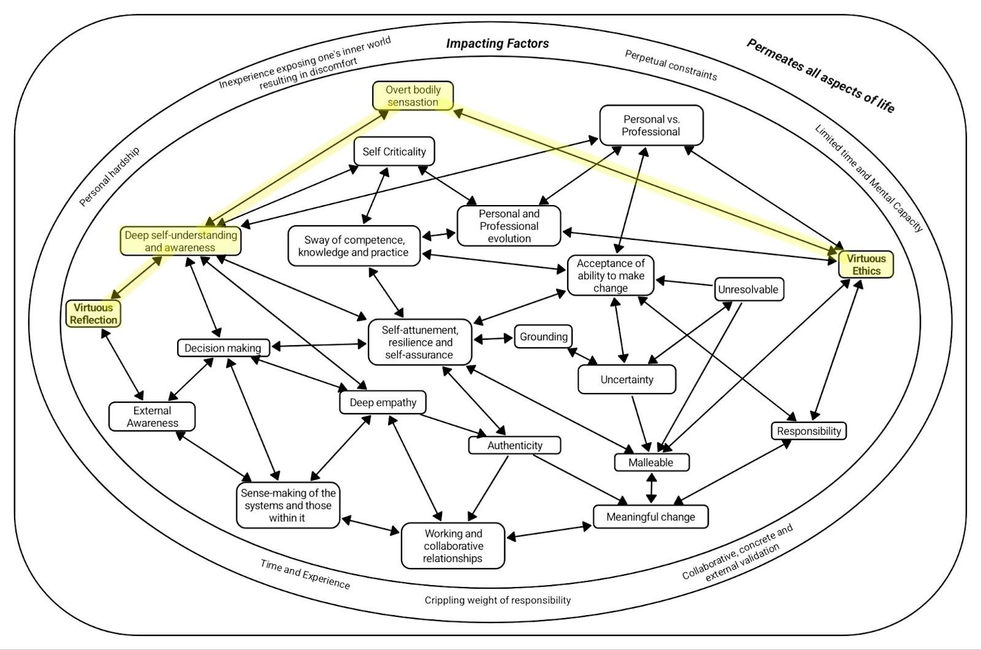
Figure 1: Diagram to display the interconnected and bi-lateral nature of virtuous reflection and virtuous ethics using the subordinate themes.

As displayed on the outer ring of the diagram, virtues permeate all aspects of life. Therefore, the virtues and their dynamic relationships are encompassed across all aspects of one’s life. This is displayed by participants sharing their ethics and values as “very core” (Angela, line 71) which “can’t [be] switch[ed] off” (Paul, line 92). Whilst reflection is presented as a “way of being” (Paul, line 114): “continual…something that you do…all the time” (Hattie, line 110). This highlights the perpetual and holistic nature of the virtues. However, despite the ever-present nature, virtues are highlighted as being impacted by various factors, hence the next circle within the diagram. These factors are displayed in the ring 'impacting factors’ and are consequential to virtue enactment, development and experience. An example within this ring is ‘time and experience’. The impact of participants' experiences both professionally and personally, over the course of time, have impacted their virtue development and manifestation. For example, Rebecca shared that “other things become more important, the more you learn about it” (line 66). Furthermore, Angela deeply reflects on this experience: “over time, you spend time talking and considering those things don't you? With others. And there's something about what drives you and how that's come about which I think develops, so if you'd have asked me, I don’t know, 20 odd years ago, what my values would be or whatever, I'm not sure I could have articulated them. I think probably now through having been in situations, different experiences, seeing the outcomes of varying things and so… I know I feel quite confident in understanding my values, my beliefs, what I think is right, what I think is wrong and how I respond to that as well because I think that there are times in the past where I've probably reacted more emotionally to things. And as I’ve become more experienced, or just older… I’m probably better” (line 36). Both quotes clearly display the impact on time and experience on virtue development and manifestation. Therefore, despite virtues being present, they are within the diagram circle of ‘impacting factors’. The impact of such factors will determine the expression, manifestation and experience of the virtue. Therefore, each lived experience of virtues will be individualised depending on the contextual impacting factors. One’s lived experiences are inevitably therefore going to impact virtue development, manifestation and relationships. As such, the interconnected relationship between the virtues and themes will also be individualised. The diagram above, however, is a collated understanding of the general experiences and impact across all participants and data. Given the data presented as convergent, a collated diagram feels appropriate, and not diminishing to the individual lived experience.
The final and inner-most ring is presenting the interconnected and dynamic relationship between virtuous reflection and ethics. Virtuous reflection and virtuous ethics are placed at opposing sides of the ring, with the subthemes, and how they are connected in between. There is, however, no definitive ‘starting point’ to the diagram, although the diagram presents as best understood when starting with ‘virtuous reflection’ and ‘virtuous ethics’. Their relationship is displayed through the connecting arrows. A line with an arrow on either end displays a bi-directional relationship. The presence of one is impactful to another. Whilst lines with only one arrow suggest a unilateral relationship. The non-arrowed theme is impactful to the arrowed theme, but not the other way round. Examples of both are given below to support in the understanding and use of the diagram.
The explored example of a bilateral relationship is highlighted on the diagram in yellow. Within this example, we will start at ‘virtuous reflection’. As seen above and within Chapter 2, ‘virtuous reflection’ is developed by a deep self-understanding and awareness, whilst this deep understanding supports the awareness and development of virtuous reflection. Therefore there is a bilateral arrow. Each supported the presence, development and manifestation of one another. Further to this, having the internal self-understanding and awareness supports practitioners to recognise aspects of themselves, such as physiological sensations; deep self-understanding and awareness allow EPs to feel and recognise the overt bodily response to challenging experiences. Due to these physiological arousals, EPs are compelled to reflect on its presence in order to develop and deepen their sense of self-understanding and awareness. Again, producing a bi-lateral relationship. The physiological reactions, however, are manifesting as a result of one’s virtuous ethics, most commonly resulting from ones ethics being challenged. The presence of one’s virtuous ethicality is manifesting as bodily and physiological sensations, again producing a bi-lateral relationship. As such, virtuous reflection and virtuous ethics have a linked bi-lateral relationship. Virtue ethics are manifesting and presenting, when challenged, physiological and bodily sensations arise that shed light on its presence. These sensations develop a deep understanding and awareness of oneself that urges virtuous reflection to ensure a best understanding of the self, and the bodily sensations that arise that highlight ones virtue ethics, and so on. In short, through the means of self-understanding and bodily sensations, virtuous reflection is used to become more self-aware of ethicality, meaning the more an individual engages with virtuous reflection, the stronger their relationship with virtuous ethics becomes, and vice versa. Therefore, resulting in a bi-directional relationship.
In regard to the unilateral relationship, the following example is highlighted in the diagram in blue. Due to the presenting ‘uncertainty’, practitioners must present as ‘malleable to boundless ethical complexities’. Further to this, practitioners must be ‘malleable’ to ‘grapple with the unresolvable tensions of ethical limitations’. Yet the sense of practitioner malleability does not impact the level of uncertainty and unresolvable tension presenting in EP practice. Therefore, they are presented as a unilateral relation, or a line with only one arrow. The unresolvable and uncertain nature of EP practice compels malleability. Yet, no matter how malleable, the unresolvable and uncertain nature will persist.
The diagram and use of arrows follow the above format. The interwoven nature of the subthemes and the bi-lateral yet overtly complex relationship between virtuous reflection and virtuous ethics is presented, whilst recognising the importance and placement of each subtheme.

5.3.1 Research Question Summary
There is a clear presenting dynamic relationship between virtuous ethics and reflection. Each virtue supports the development and strengthening of specific manifestations, further inviting additional manifestations. The dynamic relationship is presenting as bi-lateral: to be virtuously reflective develops the internal and external awareness for manifestations such as continual development and emotional regulation. Virtue ethics is then presenting as the need to engage in such reflection, to sustain, develop, and recognise one’s practice.

5.4 Research Question 1: According to the Participant, How Are the Virtues of Reflection and Ethics Manifesting and Presenting in Educational Psychologists’ Practice?
This research highlights virtuous reflection and ethics manifestation and presentation are present within EPs practice. When considering ‘EPs practice’ participants primarily focused on the generalised approach to practice, such as systemic thinking, multi-agency approaches, and collaborative relationships. There was little focus on specific associated activities associated. Therefore, the manifestations and presentations are focused upon the general approaches to EPs practice. The following will explore the impact of virtue ethics and reflection; however, due to their intersectionality, some parts of these sections coalesce.

5.4.1 Virtuous Reflection
The ways in which virtuous reflection manifests within EPs practice primarily revolves around the EPs ability to positively engage with the self to impact practice: “it's about the awareness” (Paul, line 107). This stemmed from the overarching subtheme of deep self-understanding and awareness. This permeates all aspects of one’s life to be impactful both within and outside of professional practice. The impact results in further manifestations. Literature commonly suggests reflective practice can act to deepen self-awareness (Schön, 2016). Schön (2016) shares the use of reflective practice allows practitioners to engage reflexively to improve practice; virtuous reflection has a similar impact. Virtuous reflection manifests in self-criticality and an all-consuming necessity for personal and professional evolution, as presented in this quote by Sarah: “You’re still always going to focus on those things that might have casted a bit of doubt on your skills or your competence” (line, 132). The deep self-awareness allows EPs to better evaluate their practice and competency, to reflexively develop. This is highlighted within literature regarding reflective practices (Paget, 2001; Clarke, et al., 1996; Coulson & Homewood, 2016; Morgan, 2009; Mann et al., 2009; Schön, 2016; Boud et al., 2013). Across the participants, there was a shared sense that reflection is imperative to continually develop, both within the professional context and the personal: “there is always something” (Sarah, line 152) to develop, “always more to learn and understand” (Paul, line 135) and a need to be “consistently growing…constantly learning” (Rebecca, line 62). Given reflection is continually used to develop all aspects of one’s life, as outlined by Sarah: “It's important that you're always reflecting, questioning your own skills and the work that you’re doing” (line 48), the manifestation of virtuous reflection presenting as a required self-awareness to develop.
An additional manifestation of the consequential deep self-understanding and awareness of virtuous reflection is self-attunement to maintain emotional resilience and self-assurance. Participants reflected on the importance of virtuous reflection when managing the emotional challenge of the job role: “make me reflect on the situation more and think okay, I wasn't able to act within [my values]…I would reflect on the situation…and think about what I could do differently next time to make sure that what the tension wasn't as big” (Hattie, line 103). Given the emotional weight of the job's context (Watson, 2023) and the constant sway of competency, knowledge and practice, virtuous reflection is manifesting through self-awareness to maintain resilience in managing demands, whether this be emotional, physical, or mental. Paul described this as “being reflective, being able to compartmentalise and not be overwhelmed by the emotive nature of whatever the situation is” (line, 114). This has a consequential effect on other areas such as identifying, adapting and committing to an authentic professional identity, although this is explored later. This analysis is supported by the current literature based on reflective practice. Goleman (2005) and Siegel (2007) identify emotional awareness and regulation as resulting from reflective practice. Whilst David (2016) identified the impact ‘emotional agility’ has on practice: having the self-awareness of one’s own emotional landscape promotes emotional resilience within challenging environments. Virtuous reflection is manifesting as resilience and assurance in one’s ability to practice.
The manifestation of emotional resilience was relied upon in the importance of grounding amidst ethical chaos. Due to ethical complexities, virtuous reflection was relied upon for emotional grounding within the EP role. Commonly, values were reflected as being “rel[ied]” (Hattie, line 93) upon as “non-negotiables” (Hattie, line 103) to “be able to go forward and challenge” (Hattie, line 25) amidst ethical uncertainty. The use of virtuous reflection allowed participants to recognise their ethical boundaries, which better supported their ability to decision-make amidst managing complexities. The manifestation of self-awareness and self-attunement allowed participants to recognise overt bodily response to challenging experiences. This reflective ability manifested as an ability to ground oneself, to develop the manifestation and presentation of decision-making amidst managing complexities. As shared by Sarah’s desire for “grounding tool[s] to come back to at times where you might be feeling a little bit conflicted about how to manage a situation” (line 86). Valeeva and Khakimova (2015) found ‘emotional competence’, or self-attunement to one’s emotional field, an essential competence for effective EP practice. Whilst Kligyte (2008) highlights the requirement of emotional regulation, or grounding, to be able to effectively engage in “ethical-decision-making” (p.1). A wealth of literature further highlights the positive impact reflection can have upon health and wellbeing (Burnard 1986; Cigala et al., 2019; Cole et al., 2022), specifically including emotional resilience (Cole et al., 2022). Emotional resilience, in turn, supports individual wellbeing (Grant & Kinman, 2014) fuelling the virtuous cycle of positive ethical decision-making. This research, supported by the above literacy sources, suggests using virtuous reflection significantly impacts the overall wellbeing and ethical decision-making, primarily through self-awareness. Virtuous reflection is manifesting as an ability to maintain emotional regulation to effectively engage in practice and decision-making. Similarly, in regard to ethical virtues, Bennett (2008) argues a ‘virtue’ approach to ethics could be more effective in the support of EP ethical practice and decision-making; a sentiment in which this research mirrors.
The presenting effective decision-making was further supported by the use of virtuous reflection in the sense-making of systems and those within them. Virtuous reflection manifested as better understanding the people and systems EPs work with, and the dynamic interplay of the two: “often one perception of the situation is different to others, and things do come about that help you to understand that situation” (Hattie, line 82). In better understanding these aspects, practitioners were able to maintain working and collaborative relationships and develop deep empathy, which is further explored below. Resulting in practitioners being better able to facilitate meaningful change. Rebecca recognised the importance of working relationships in facilitating change: “...in a way that won't destroy my relationship with the setting because I need that to evoke change” (line 111). Although virtuous reflection allows the development of self-awareness, it also presents as an external awareness, of which both are required for effective change facilitation. Literary discourses support the notion of reflection supporting ‘client-relationships’ (Schön, 2016; Curry & Epley, 2022; Falender et al., 2014). Schön (2016) suggests reflective practice supports practitioners' awareness of the holistic nature of others, and the impact of their environment. Self-awareness manifested from reflection is identified as an influential factor on managing and supporting others (Burnard, 1986). Self-reflection aims to “[enhance]...empathy, wellbeing, and resilience in the ultimate furtherance of client outcomes” (Mösler et al., 2023, p.2648). Literature (Norwich et al., 2018; Dunsmuir et al., 2006; Doveston & Keenaghan, 2010; Kellems et al., 2016; Villarreal, 2018) recognises the impact of collaborative relationships on effecting change, despite the ethical challenges (Chenneville et al., 2024). Virtuous reflection is therefore presenting an ethical necessity through the desire to create meaningful change: a subsection further explored in virtuous ethics.
As a result, virtuous reflection manifests in the development of deep empathy. The intersectionality of self-understanding, emotional connectedness, understanding of the systems and others, and a need to facilitate change results in the requirement of empathy. In practitioners being able to “empathise with the human experience” (Paul, line 59) and seeing each individual “as human” (Rebecca, line 32), a better understanding of the person, context or situation could be created. This results in better understanding how to be effective in communication, support and change facilitation. Valeeva & Khakimova (2015) identifies the need for ‘emotional competence’ in EP practice, of which two components are empathy and relationship regulation. Which, as outlined above, mirrors this research. Virtuous reflection is therefore presenting as an internal and external awareness to reach effective change facilitation and positive outcomes.
Finally, virtuous reflection presents as a pinnacle in the identification of the dynamic interplay between the ‘personal’ and ‘professional’. Participants recognise the complex nature of ‘being’ a psychologist. Paul shared “the professional bit is a name on a badge, the role that we do and the job title, how you conduct yourself…I suppose much of it is very personal. What do you bring to that role? Those values…the reason why” (line 135). The personal and the professional aspects of oneself cannot be split (Chilokoa & Jackson, 2025). Yet there is recognition of differences within the personal and professional approaches. The presenting intersection of the two aspects was identified as being values. Participants' values permeated all areas of their lives, although the manifestation and the connectedness could fluctuate depending on the context. Further to this, the presentation and manifestation could be impacted by the consequence of time and experience, as outlined by Rebecca: “I think as you get older, different things become important to you” (line 62). Haas et al., (1988) recognises the impact of personal circumstance, including years of practice, on ethical-decision-making. Whilst McDonald (2009) recognises the impact of reflecting on and being self-aware of one's own values; self-awareness of values maintains emotional wellbeing, which is also supported by above explorations. Similarly, within acceptance and commitment therapy, values play a critical role in fostering reflection. “When values are clarified and the inner compass is adjusted, then self-awareness, self-reflection, and self-improvement make more sense as concepts” (Khalil, 2024, p.1). The awareness of the participants' values acted towards identifying, adapting and committing to an authentic professional identity: “It’s not that you're a different person, you just adopt a different presentation or a way of being, professionalism I suppose it boils down to, but ultimately the values are the same.” (Paul, line 92). The process of virtuous reflection manifests self-awareness of ethicality, morality, or values, leading to the manifestation and presentation of authentic professional identities. Participants encompassed personal values into their professional identity to create authenticity, and ensure positive mental wellbeing (McDonald, 2009), or as Paul put it “life satisfaction” (line 100). Virtuous reflection is manifesting as the ability to hold one’s values close, whilst presenting with a flexible yet authentic approach to their professionalism.

5.4.2 Using Virtuous Ethics
Virtuous ethics is manifesting and presenting within EP practice, permeating all aspects of one’s life. The primary manifestation identifiable to participants was overt bodily responses to challenging experiences. As outlined above, this response highlighted when participants' experienced challenges to their ethicality or values. Due to virtue ethics and values being “very core” (Angela, line 71) and holistic in nature (Aristotle, 2000; MacIntyre, 1981), this manifestation was regularly reflected upon. Yet, virtue ethics also presented as malleable to boundless ethical complexities, often with EPs having to grapple with unreasonable tension of ethical limitations. The unresolvable nature of many ethical situations, which can be further exacerbated by suffocation of perpetual constraints resulted in EPs presenting with a malleable and flexible approaches to managing and engaging with ethical challenges: “I’ve allowed things to happen that I know don’t sit within my values … because other things become more important” (Rebecca, line 105). MacIntyre (1981), and other contemporary virtue ethicists such as Foot (2002) and Annas (1993), explicitly highlight the need for virtue ethics to present as malleable to the contextual nuances, within this context, EP practice.
Virtue ethics are also manifesting as EPs striving to execute all aspects of the job’s complexities to create meaningful change, as Angela explored suggesting she does aspects of the role because “ultimately… there's a reason for doing it which is around making things better for children and families” (line 112). Considering this, virtue ethics further presents as balancing the yearn for change with acceptance of one's ability to create impact. The ethical virtue presentation of wanting to facilitate meaningful change consequently manifests as acceptance around EP’s abilities to be able to do so: “We’re never working in the perfect circumstances, so you want to be making the most of what’s possible at that point in time’ (Angela, line 22). Virtue ethics presents as navigating the dynamic interplay between the ‘personal’ and ‘professional’. The personal desire to facilitate meaningful change is met by the professional awareness of the limitation in doing so, as displayed by Hattie: “that's what my values are and my ethics would say but you're being challenged by the different systems at play as well and the relationship and the dynamic” (line 23). Despite the concurrent experience within this research, this presents as an under researched area. The acceptance of one’s ability to facilitate change presents as a way in which virtue ethics must manifest within EP practice, particularly to stay emotionally resilient and self-assured. The desire and resiliency can be felt within this statement by Rebecca: “We are agents of change in what we do even though that happens so small or over time” (line 93). As a result, virtue ethics is manifesting as a need to maintain resiliency and assurance. The result of which is using virtue ethics to stay grounded amidst ethical chaos. Virtue ethics are presented as a need to facilitate change, whilst having the resilience to accept one’s ability to do so. This resilience creates the persistence to continue in the job role to, ultimately, facilitate change.
Virtue ethics are also presenting as an all-consuming necessity for personal and professional evolution. Hattie reflected on the ethical importance of continual development: “I don’t think I would be the best practitioner that I could be, I wouldn’t be working in a way that was continually striving for the best practice that I could give” (line 134). Continued professional development is recognised as an ethical necessity to ensure professionals continue to update their knowledge, skills and competency (Berdondini & Elton, 2020; Schütte, 2003). Virtuous reflection on the constant sway of competence, knowledge and practice acts to highlight the areas of evolution and development. Hattie’s quote highlights how the development manifests from virtue ethics; the need for development for best practice. This consequently affirms the presentation of virtue ethics as a need for self-awareness. One must be aware of their practice to develop and therefore maintain ethicality. This notion is strongly supported within research related to anti-oppressive practice (Ng, 2012; Singh and Manjaly, 2022). Virtue ethics presents a need for virtuous reflection, which results in self-awareness, confidence, resilience and malleability.

5.4.3 Research Question Summary
Overall, the ways in which virtuous reflection is presenting and manifesting within EP practice is as internal and external awareness. The deep self-understanding and awareness manifests into a need for self-development and emotional resilience. These subsequently evolve into, and are informed by further manifestations, such as personal and professional identity and decision-making. Virtue ethics is presenting and manifesting as the need to engage in virtuous reflection to ensure the development of the self, and improved outcomes for those EPs work with. The manifestations and presentation of ethical virtues inform the ways in which virtuous reflection manifestation, and vice versa.

5.5 Research Question 2: What is the Participants' Experience of Enacting the Virtues of Ethics and Reflection Through the Exploration of a Work Dilemma?
The way in which participants experienced enacting ethical and reflective virtues was primarily linked to the recognisable emotional and physiological responses. This enactment was impacted by external experiences. Due to the interconnected nature of the virtues, as explored in above in research question 3, the experience of virtue enactment encompasses reflective and ethical virtues.

5.5.1 Emotional Evocation
Participants shared identification and enactment of virtues were primarily experienced through emotional evocation. The experience was recognised by overt bodily responses to challenging experiences. Participants shared the deeply physiological and somatic responses as often highlighting their ethical virtues. Participants were easily able to describe these physiological experiences, such as “a pit…at the bottom of my stomach” (Hattie, line 27), “chest…tight[ness]” (Sarah, line 52), and “feeling…sick” (Rebecca, line 81). These experiences encouraged the ethical and reflective virtue enactment. The experience of physiological responses initiated a need to enact virtuous reflection on one’s ethical virtues to engage in a sense of self-understanding and ethical resolve. Research supports the notion that individuals experience physiological, somatic and neurological responses to ethical challenges (Greene et al., 2004; Wong et al, 2022; Berthoz et al., 2006). Damasio (2006) introduced and recognised the crucial role somatic feedback plays in guiding decision-making in complex or moral contexts; it supports quick and intuitive responses (Kahneman, 2012). Participants experienced significant physiological feedback to initiate and recognise virtue enactment, for the ultimate goal of striving to execute all aspects of the job’s complexities to create meaningful change.
The physiological experience presented as important in the enactment of virtues. It highlights challenges to ethical virtues, whilst the initiating virtuous reflection enactment to recognise why the response occurred. The enactment of virtuous reflection, and consequential self-understanding and self-assurance allowed participants to experience a sense of grounding amidst ethical chaos: “Knowing for yourself that you're in a really kind of calm and reasoned state…what you don't want to do is being a panicked state where you're not necessarily able to produce a response that you’re comfortable with” (Sarah, line 38). This is reflected in research by Starcke et al, (2011) who found stress can lead to lower moral decision-making. Therefore, the experience of grounding in enacting the virtues presents as imperative. The experience of grounding was further highlighted as crucial in EP’s ability to sit with the tension of uncertainty. Participants shared within the role there is a consistent underlying level of uncertainty across various levels: personal, environment, community, systemic. Angela shared a consistent sense of “sitting with uncertainty and sitting with knowing you've got to make a decision that there's never the perfect answer to” (line 8). This uncertainty reacts with the virtuous enactment of striving to execute all aspects of the job’s complexities to create meaningful change to create the experience of balancing a yearn for change with acceptance of one's ability to create impact. Despite the recognised uncertainty on psychologists and calls for additional support (Quinlan et al., 2021; Gerber & Hoelson, 2011), Mercieca (2009) shares the importance of EPs sitting with uncertainty. She shares the ability to do so leaves practitioners better able to handle complexities: “learning to tolerate not knowing generates the professional who is in a constant process of becoming through her practice” (p. 170). Rebecca mirrored this notion sharing her experience that “[managing uncertainty] actually makes a practitioner” (line 36). Participants’ experiences of uncertainty present as an unavoidable aspect of the job role. Yet, participants reflected on the experience of grounding presenting as an effective method of managing this tension.
Another distinct experience of enacting virtues was reflective of the ongoing dynamic interplay navigation of ‘personal’ and ‘professional’. The pervasive nature of virtues results in their presence across the personal and professional aspects of one’s life. Participants recognised the experience of limitation in fully enacting virtues within a professional context as suggested by Rebecca who shared “you can’t do it all, can you?” (line 121). This experience of virtue enactment raised a challenge for practitioners navigating their personal desires and sense of ethicality being met with their professional ability. The consistent strain of limited time and capacity presents having a significant impact on the enactment of virtues. The experienced conflict between moral excellence in which their virtues wish to abide by, and the ability to be able to do so. However, McDonald (2009) recognises the benefit of an awareness of one's virtues, or values, in supporting practitioners to have a better mental wellbeing, and therefore job satisfaction. This was also reflected within this research, in the experience virtue enactment contributes to a general “life satisfaction” (Paul, line 100) or within virtue ethics ‘eudaimonia’. Participants were able to recognise the experiences of how their virtues were being enacted to create a positive impact within their profession, even if to a lesser extent than the aspiration. This leads to a general sense of fulfilment, contentment and positive quality of life. Again, McDonald (2009) mirrors this notion. To marry one’s core virtues and values across various contexts of one’s life, albeit having an awareness of one’s ability to facilitate change, can have significant repercussions on the individuals’ job satisfaction and overall wellbeing. Despite the tension participants experienced in attempting to fully enact their virtues, the general experience was one of positivity and continued motivation.
The nuanced context is also understood as being impactful on the experience of enacting virtues. Fallon et al. (2010) recognises the consistent changes within the world of EdPsy have ramifications upon the practitioner: “perhaps the biggest challenge has been to individual EPs’ competence and confidence” (p.13). As a result, participants shared their experiences in engaging in self-attunement to maintain emotional resilience and self-assurance. This experience further progressed participants' experiences of identifying, adapting and committing to an authentic professional identity. This process allowed an internal and external sense of confidence, whilst enacting virtuous reflection to continually recognise their professional positionality: "I'm doing the thing I want to do because it has meaning for me” (Paul, line 87). Participants' experience of authentic professional identities was reflected as needing to be malleable to adjust to the personal, professional, societal and political contexts. Cameron (2006) shares the uncertainty within the socio-political field results in EP’s “experiencing something of an identity crisis” (p.290). Furthermore, the “complex, challenging and ever-changing context where professional confidence is difficult to maintain and where it is easy for EP practitioners to lose sight of their beliefs, hopes and aspirations with which they entered the profession” (p. 289-290). Gaskell and Leadbetter (2009) reflect these challenges and present the creation and adoption of an authentic professional identity an important aspect of the EP role, particularly amidst the ethical chaos and sense of uncertainty, as highlighted by Sarah: “the more you are being authentic to yourself the less that imposter syndrome is something that bears weight on you” (line 119). The experience of virtue enactment is closely aligned to one's personal and professional identity. The experience of this identity development is supported by self-attunement and resilience. This emotional resilience and assurance in one’s own identity develops a malleability in which virtues can be effectively refined and enacted for each nuanced situation.
The overriding experience of virtue enactment was striving to execute all aspects of the job’s complexities to create meaningful change. The ethical virtue of wanting to create meaningful change presenting as a motivation to engage in the job role. Yet, there was an additional experience in being able to effectively enact virtues to facilitate meaningful change: perpetual constraints. This is recognised as being a long-standing challenge for EPs (Hoyne & Cunningham, 2019; Squires & Dunsmuir, 2011; Ginns et al., 2020; Farrell, 2006; Farrell & Woods, 2017; Yoshida et al., 1984), therefore it seems predictable that constraints will affect the enactment of virtues. The intersectionality of striving to create meaningful change as a result of virtuous ethics, and perpetual constraints result in participants experiencing significant challenges, such as crippling weight of professional responsibility, which were described as “overbearing” (Sarah, line 123) and “overwhelming” (Angela, line 36). Participants' experiences of enacting virtues are one of passion yet discomfort. The passion to create meaningful change is met with effective constraints and barriers. As explored above, this is compounded by professional and personal identity. The experience of virtue enactment presents is of persistence, resilience and acceptance.

5.5.2 Experiences that Affect Virtues
Participants shared personal and professional experiences as impactful in virtue manifestation, and therefore how their enactment is experienced. There was a recognition of the development of virtues primarily being impacted by the consequence of time and experience, as highlighted in following quotes “now with practice and experience” (Rebecca, line 32), “through having been in situations, different experiences, seeing the outcomes of varying things’ (Angela, line 36), “developed over time” (Paul, line 114). There was a generalised recognition of experiencing the malleable nature of virtue enactment, both relating to the context in which they are being facilitated, and within the context of one’s life. This experience of virtues enactment and development is closely replicated by Lamb, et al., (2021). The “habituation through practice” (p.84), a concept introduced by Aristotle (2000), presents as a process in which virtues are affected, or developed. Participants explicitly shared the experience of this sentiment; over time and practice the manifestation and experience of virtues is altered, becoming more instinctive. However, participants also experienced the malleable nature of virtues, highlighted by Lamb et al., as “awareness of situational variables” (2021, p.92). They suggest individuals must “[foster an] awareness of how situational variables, cultural influences, and institutional incentives shape character and behaviour” (p.93). There was recognition by the participants that EPS’ culture was effective on their virtue enactment, similarly the environments and communities in which they worked: “My first experience being an EP was in a service that was…proper…more formal…there was more etiquette… So, to me that is part of being an EP…you do need to maintain that bit of formality and etiquette in terms of your role” (Sarah, line 114). It is clear the context in which a practitioner is working can have a significant effect on the experience of virtue enactment.
Lamb et al., (2021) also identified “engagement with virtuous exemplars” (p.88) as effective on virtue development and enactment, much like the participants who shared a desire for seeking collaborative, concrete and external validation. Participants experience of external validation, whether it be through a peer, supervisor, research, or evidence-based framework/approach presented as important in enacting virtues; “ground myself in some sort of approach” (Sarah, line 31), “I’m better with…frameworks and structures” (Angela, line 15), “the criteria…to validate my proficiency” (Sarah, line 131), “Am I saying the thing that my supervisor would say or a more experienced EP would say?” (Hattie, line 21), “have someone help shape my thinking” (Paul, line 83). This objectivity provided psychological safety in enacting virtues within a job role that can feel subjective, despite the standards and guidelines outlined (HCPC, 2023a, 2023b, 2024; BPS, 2021a). This experience is reflected by Watson (2023) who recognised “the protective effects of job resources” (p.135) as having direct implications on practitioner psychological health and wellbeing. Another identified protective factor is the colleague relationships (Watson, 2023). Similarly, Lamb, et al., (2021) identified “friendships of mutual accountability” (p 96) as inevitably shaping the development and experience of virtues. Lamb et al., (2021) share the role ‘discussion’ can have on the support of moral reasoning and ethical development. Participants echoed this sentiment sharing a desire to experience collective peer discussion around challenging situations to support virtue enactment: “And I just think as a team we should have secondary supervision sessions” (Rebecca, line 54), “talk to others about how the situation played out and to reflect on it externally” (Hattie, line 116). Similarly, the concept of ‘clinical supervision’ was raised within follow-up emails and discussion. Participants seeking a sense of collaboration for virtue, practice and competency development is reflective of this. Overall, participants' experiences of enacting virtues can be dependent on the level of external support and validation they receive.
Further to this, “moral reminders” (Lamb et al., 2021, p. 98) present as another way in which virtue enactment is affected. Participants shared ethics permeating all aspects of one’s life, yet recognised the boundless ethical complexities, ethical limitations, and ethical chaos that is regularly experienced within the job role (Bennett, 2008). The persistent nature in which virtuous ethics is experienced by practitioners, whether personally or professionally, acts to consistently remind EPs of the importance of their virtues. “Reflecting on personal experiences” (Lamb et al., 2021, p 87) was raised as being an impactful factor on the experience of virtue enactment through the experience of personal hardship. From the literary exploration, there is an argument that distinct personal challenges, hardship, or adversity, are significant in the development and consequential enactment of virtues (Miller, 2017; Kim et al., 2018; Cole Wright et al., 2020), supporting in the process of resiliency development (Kim et al., 2018). Although it is important to recognise the extent of the adversity is significant on virtues (Thompson & Lavine, 2016). Individual personal experiences impact the enactment of one's virtues. The ever-present nature results in the intersectionality of virtue enactment across all contexts of one’s life, meaning one aspect will invariably impact another. Therefore, the experience of enacting virtues is deeply impacted by the general life experiences of the individual, not just professional experiences.
Participants were able to reflect on the discomfort felt in enacting virtues. The lack of time and motivation to explore one’s experiences of virtue enactment resulted in discomfort: experience exposing one’s inner world resulting in discomfort. Lamb et al., (2021) recognise the importance of “dialogue that increases virtue literacy” (p.91) in the effective enactment and development of virtues. Participants were aware of the distinct lack of engagement and experience relating to exploring one's inner world, and the effects on their practice: “how do you know [what one’s values are]? …I suppose, as an EP, I don't know” (Angela, line 36). The lack of ‘dialogue’ and ‘exposure to their inner world’ resulted in experiencing a significant level of discomfort: “I find it quite challenging…I don’t know if I can do this” (Rebecca, line 77). Although the participants engaged in the topic of ‘how’ virtues are enacted, there was a distinct difficulty and discomfort in recognising the ‘why’: “When somebody says we’re gonna talk about values, I think ahhh no, not this again” (Rebecca, line 77). Yet, the experience of doing so was “a helpful experience” (Sarah, line 165), a concept also supported by literature (Lamb et al., 2021; Kristjánson, 2014; Walker et al, 1995). Participants recognised the lack of opportunity to reflect on their virtues and associated experiences presenting as a barrier to the effective enactment of virtues, resulting in a strong sense of discomfort when explicit reflection on virtue enactment is presented.
Despite the desire, there is also a recognition of the consistent strain of limited time and mental capacity. As previously explored, the perpetual constraints result in a need for acceptance, balance and self-assurance. Yet there was a clear experience of feeling unable to enact these virtues to their full potential. Rebecca shared her best work arises at times where she has had “the headspace [and] given [herself] time to think” (line 83). She shared “September, I probably do my best work because I have summer to just reset and relax. I'm less fatigued and I revisit things that I've not done for a long time…I organise my thoughts…I realign myself with my values” (line 84). Bryan and Babelay (2009) recognise external factors, such as time pressure, financial constraints, and the appropriate learning environment that are negatively affecting virtue development and enactment. Participants' experience of enacting virtues is significantly impacted by the time and mental capacity to be able to engage and explore their virtues. The result of which furthers the inexperience exposing one’s inner world resulting in discomfort.

5.5.3 Research Question Summary
Participants experience virtue enactment through emotions evocation and physiological arousal. This allows the practitioners to respond to the intersectionality of the virtue and the nuanced context appropriately. This impacts on personal and professional identity, and therefore virtue enactment. The experiences of virtue enactment are recognised as being malleable to individuals personal and professional experiences, the nuanced context, and experiences of engaging in virtue enactment.
Before the research, some of the above experiences could have been anticipated. However, the range of experiences are much greater and wider than could have been predicted. The research has been illuminating, providing new knowledge around the EP experience of enacting virtues.

5.6 Research Critique - Strengths and Limitations
The quality of this research draws back to Yardley’s (2017), as explained within the methodology, four key elements for qualitative research.

5.6.1 Sensitivity to Context
Given the research cannot be removed from the context in which it takes place, the recognition of contextual influences is highlighted. Firstly, I recognise the impact of the cultural, social and environmental context in which this research was conducted. Given the nature of the research relating to personal virtues and experiences, this research was addressed with openness and curiosity. I do, however, recognise the demographic of participants was mono-cultural, given the fact I too am a part of this cultural group, there were little adaptations needed in this matter. Yet, I recognise the context-dependent results of the research. Although the research is based on individual experiences, and therefore generalisability is not a specific aim of the completion of this research, it is worth recognising the results of this research are situated within a particular demographic. Further to this, my own experiences, and therefore analysis, stem from similar cultural contexts.
I recognise the additional layer of completing the research within one LA, furthermore the LA I am currently working in. Having an existing relationship with the participants acted as a support mechanism for their comfortability and openness within the interview process. Yet, I am able to recognise pre-existing relationship and power dynamics which could alter the responses and interview conduction.
In regard to the context in which the interviews took place, I ensured measures to make the participants as comfortable as possible. I chose to facilitate the interviews in person to be integrated into the phenomenological experience and be able to sense any micro-cues suggesting adaptations to the interviewing process was required. Further to this, I opted for private meeting rooms within the LA building to complete the interviews. This was for the purpose of having a neutral space which was confidential and familiar. The aim was to ensure comfortability and accessibility which allowed for open discussion resulting in data richness seeped in personal experience.
Finally, I wish to recognise the novel and unfamiliar experience of exploring these topics in such depths. Although all participants are qualified EPs, there was a generalised sense of challenge in exploring these topics. In exploring new concepts, participants may have found articulating and elaborating challenging. This was witnessed and presented within the themes. Participants shared reflections of the interview process, either via email or in-person. This allowed for additional processing space, and additional reflections to be shared. Yet, I perceive the novelty of the research experience as a strength. This process highlights the scope of development that EPs have regarding virtues. This was also reflected by participants shared gratitude for the experience and alternative approach of considering such topics.

5.6.2 Commitment and Rigour
The commitment to completing this research was unequivocal. Considerable time, processing, and reflection was applied at each stage. I spend considerable time with each participant to get a sense of their individual experience. The use of semi-structured phenomenological interviewing presented as an appropriate method of data collection, for the participants, data, and methodology. Additionally, dedicated and iterative approaches to analysis were used to ensure the phenomenon of reflective virtues and ethics were recognised and understood from the perspective of the participant. The combination of these processes resulted in rich and reliable data. Using IPA presented as an appropriate method to recognise the themes and gain understandings of the individual and group experience. Given IPA affords for the hermeneutic cycle, there is a recognition of subjectivity upon the findings. However, throughout the process to stay as subjective as possible, I used reflective processes, such as reflective logs, pilot study, and supervision. Additionally, I sought peer supervision to assess the plausibility of my interpretations.

5.6.3 Transparency and Coherence
Throughout this process I have clearly documented and explained my research process in a way that is accessible. Although I am aware of the contestable and deeply personal nature of virtues, ethics and reflection, I have justified my positionality and explained my use of such terms.
In regards to coherence, I found a consistent and unresolvable tension. To express the complexity and the depth in which these human experiences are manifesting would be extremely ‘messy’, in the beautiful way that human life is. To create completely authentic data created a dense, convoluted and potentially unintelligible dataset. Yet, to create coherence feels overly simplistic: as though a sense of ‘humanness’ was missing. This took considerable reflection and grappling. I spent significant time grappling with the best way to ensure all the themes were accounted for yet were accessible. Although this tension remains present, and the approach taken feels like a compromise, the result of the data is the best management of this dilemma.
Finally, I recognise I have not explored important details of participants such as job titles, length of practice, and area of practice. Although this may seem to be a lack of transparency, this was purposeful. The world of EdPsy is a small and intermeshed community, therefore these factors would make participants easily identifiable. The ethical balance of the participants' anonymity took precedence over the transparency of those details.

5.6.4 Impact and Importance
Given research relating to using virtuous reflection and virtuous ethics with EdPsy presents as a neglected topic to date, this research is pertinent. The notable gap in research and literature related to these topics invites this research to open a new and contemporary dialogue into the use of these virtues for EPs. Outside of EdPsy, the concept of virtuous ethics supporting the process of virtuous reflection also seems to be underexplored. Although this research is merely creating a proto-theory related to the bi-directional nature of these virtues, this research raises an important concept. This research highlights the significant impact virtuous reflection and virtuous ethics has on EP practice, therefore inviting systemic and individual recognition of their importance for various system levels: individual, ‘client’, and systemic.
This research should impact future research, affect the training programmes, impact the service delivery, and individual EP self-exploration. This research, given its philosophical nature, can also be used in the basis for other healthcare professionals, specifically those who follow the HCPC (2023a; 2023b; 2024) and BPS (2017; 2021a) competencies and guidelines.

5.7 Implications on Educational Psychology Practice and Training

5.7.1 EP Practice
Given the ever-change climate in which EPs work, Bennett (2008) argues for a more personal and malleable approach. This research reaffirms this notion. In using an approach, such a virtuous reflection and ethics, we can see the positive impact on the practitioners and the people they are working with. The virtuous approach is understood by Fowers (2005) as being a goal for psychologists in developing their practice and ethics. Further to this, Osswald et al, (2010) shares in making people aware of ethical qualities can influence ethical behaviour. Similarly, within this research, the use of virtuous reflection was a strong supportive factor in the recognising and therefore reflexive nature of virtuous ethics.
I therefore propose EPS’ recognise the importance and value of virtues and seek to create an environment by which they can be fostered and developed. Lamb et al., (2021) highly emphasise the importance of the environment in the support of virtue development. EPS’ should aim to create spaces in which ‘moral reminders’, ‘friendships of mutual accountability’, ‘virtuous exemplars’, ‘virtue literacy dialogue’, and ‘personal reflection’ are encouraged. The use of group reflective spaces is recognised as supporting psychologists’ wellbeing, the overall service culture, collaborative thinking (Heneghan et al., 2014), becoming more attuned to others, colleagues and clients, perspectives (Biggins, 2019) resulting in better quality practice (Ruch, 2005).
Stringer (2001) found EPs will often enter the profession of EdPsy on the premise they wish to practise virtues that have learned and developed through daily experiences. He found “educational psychologists are paid to be virtuous” (p.2), although recognises the systemic challenges faced in engaging in this. I therefore call to invite virtues into EP practice, both by the individual and the systems. Given the deeply complex and nuanced nature of the job role, a virtuous approach to being an EP acts as a personalised approach to seeking clarity amidst the experiences of the job role and the professional competencies one must follow. A process in which we bridge the gap between what decisions to make and ‘how we might best make them’ (Loughlin et al., 2011, p. 843). If practice, professionalism, decision-making, and effective outcomes are so deeply impacted by one’s personal virtues, specifically within the case of this research reflection and ethics, does it not seem naive to omit their presence, value and development in EP presentation and practice? In engaging with the metaphysical, could we invite a more holistic, personalised and ever-developing approach to engaging in the profession?

5.7.2 Supervisory Practices
A direct post-interview reflection from participants was a renewed desire for reflective, professional or, as described by the participants, ‘clinical’ supervision. This was highlighted within the follow-up emails and discussions. I understood this as being a reflective practice in which one is able to focus on who they are, challenge their assumptions or habitual responses, and gain a better understanding of who they are, both personally and professionally. A safe space in which critical reflection can be used to explore, understand and develop one's virtues. In systematic literature reviews of clinical psychology, researchers (Wheeler and Richards, 2007; Lohani & Sharma, 2023; Martin et al., 2021) have found effective supervision to have positive effects of the following areas: self-awareness, competency/skill, self-efficacy, theoretical awareness, sense of being ‘supported’, lower rates of professional burn-out, greater job satisfaction, staff retention, and client outcomes. I therefore urge the field of EdPsy to incorporate a more deeply-reflective supervision approach, that goes beyond an external focus of procedures or individual case work, and aims to allow the individual practitioner to truly explore who they are and what that means for their practice and development. A space in which one’s virtues are identified, nurtured and developed. Given participants desire for external sources of validation, clinical or peer supervision could be an effective method of virtue, competence and confidence development. The BPS professional supervision guidelines for EPs, as outlined by Dunsmuir and Leadbetter (2010) highlight effective supervision should include three level of competency; core competence, relating to the supervisory relationship; professional-specific competence, relating to the specific skills, context, and knowledge linked to EP work; and specialist competence, relating to specialised areas of the job role. From this research, it is appropriate to invite the concept of virtues into professional supervision with EPs to engage in holistic approaches to development. Within other professions, such as social work, the concept of using and developing virtues in supervision is in place, and presents as being effective (Pawar & Anscombe, 2022).
Additionally, this research provides evidence for the importance of virtue development within the EPS. Despite the limited resources, the overall outcome of engaging in such approaches is seen from the research to be positively impactful on the practitioner’s wellbeing, quality of practice, ethical decision-making, client outcomes, and job retention. Given evidence relating to EP job retention (Lyonette et al., 2019), likely linked to the depleting wellbeing of EPs (Watson, 2024), virtues development present as an effective, long-term support mechanism to overcome these barriers within the EP workforce. This research highlights the long-term importance of investing in practitioners' virtues and engagement for the sake of the EPs themselves, the management of EPS’, and for the communities in which EPs worth with.

5.7.3 Implication of the DEdCPsy Training Course
Jordan and Meara (2008) identified virtues, specifically virtue ethics, as “essential component of responsible ethical training and practice” (p.1), therefore raising the need for DEdCPsy courses to invest in developing virtuous skills. The BPS (2019) standards for accreditation of DEdCPsy outline trainees’ “responsive and evolving process to maintain and develop professional practice through the process of appropriate professional reflection and continuing professional development (CPD)” (p.21) whilst recognising the role training programmes have in ethical development. The BPS (2015) guidance to teaching ethics in psychological practitioner training emphasises the development of ethical sensitivity, reasoning, motivation, and implementations, highlighting the role of reflection in this process. This research highlights the role virtuous ethics and reflection could play in the development of ethically competent, and highly reflexive EPs. As such, training courses should consider the facilitation and adoption of virtuous approaches, married to the formal codes and guidelines in an attempt to highlight the deeply personal approach one has to ethical sensitivity, reasoning, motivation, and implementation.
Despite training courses, guidelines, and conduct codes recognising the importance of ethics and reflection, there seems to be a gap in the acceptance of the virtuousness of these aspects and how they could support Trainee EPs. In the completion of this research, I am honoured to be invited to be able to share the outcomes of this research, and the less-conventional approach to ethics and reflection on the DEdCPsy training course at The University of Sheffield. The dissemination of this research, as well the impact of the findings on supporting future EPs in the development of the reflection and ethical virtues comes as a great privilege. Further to this, I encourage and advocate all DEdCPsy courses embrace a virtuous approach to engaging in reflection and ethics. Although metaphysical in nature and rooted in philosophy, this research highlights the importance and implications of doing so.

5.8 Opportunities for the Future

5.8.1 Research
This research has demonstrated interesting findings that can be of value to the profession. Yet, this research is only a preliminary exploration into the vast and relevant field of ‘virtues’ within EdPsy, and potentially various healthcare professional domains.
Further to this, there to be scope for future research into the bi-lateral relationship between virtuous ethics and virtuous reflection. This research introduces this concept, however further research with the primary focus on this area would be required to broaden our understanding of this knowledge, and how best to foster the bi-lateral relationship.
As explored below, there is scope to create a supervisory model that focuses on the bi-directional nature of the virtues, and virtue development as a whole. If this model were to be created, research into the effectiveness and impact would be of benefit.

5.8.2 Supervision Model
Within the research, it was clear participants sought models and external support to engage and develop their practice. Given the unconventional approach of using and developing virtues, there is scope to create a virtuous supervision model that supports EPs to develop virtues. Having a specific, evidence-based model may relieve the tension of the metaphysical nature of virtues and instead offer an approach that feels accessible. The intended impact of such would be the development of virtues, further impacting self-understanding, client outcomes, and practitioner wellbeing.

5.9 Personal Reflections
Within Chapter 1, I asked the questions: Is embedding reflectiveness to impact ethical sensitivity done in EP practice? Do other professionals experience and engage in this process too? Can this approach be harnessed, used or investigated in more depth within the world of Education Psychology?
In the process of answering these questions throughout the research, I was often filled with gratitude. Participants’ ability to be vulnerable and explore their life experiences and inner thoughts speaks to their bravery, and their trust in me to handle such information. My experience of completing the interviews felt as though this process allowed participants to reconnect with a part of themselves that they rarely have the time to do. All of them reflected their appreciation to have a moment to consider themselves: who they are and why. This reaffirmed the importance of virtues, highlighting the lack of time and resources, or potentially even the desire, to engage in such thinking. Yet, the outcome can be one of deep understanding, growth and, albeit potentially annoying, more questions to consider.
The philosophical nature of this research was one of contention for me. Internal tensions often arose regarding implications of this research, having an awareness of the polarised nature and often rejection of the opposing discourse within psychology and philosophy (Kristjánsson, 2018). Therefore, this process has been one of self-trust and willingness to bridge a longstanding gap and consider intangible aspects that can affect EdPsy. Reflective logs supported me in managing this process, serving as a way of mapping out this journey whilst serving as a reminder of its humble beginnings and various intricacies. Another indispensable support throughout this process was the guidance of supervisors, and the ability to stand on the shoulders of giants. This research process has, and will continue to, influence who I am both personally and professionally.

References
Ahbel-Rappe, S., & Kamtekar, R. (2006). A companion to Socrates (1st ed.). Blackwell Pub.
Ainscow, M., Dyson, A., & Weiner, S. (2006). From special education to inclusive education: A review of the literature. Journal of Research in Special Educational Needs, 6(2), 85-99
Alexander, L., & Moore, M. (2020). Deontological ethics. In E. N. Zalta (Ed.), The Stanford Encyclopedia of Philosophy (2020). Stanford University. https://plato.stanford.edu/entries/ethics-deontological/
American Psychological Association. (2023). Ethical principles of psychologists and code of conduct. https://www.apa.org/ethics/code [Accessed on: 25th March 2025]
Andrews, S. (2018). The role of reflective practice for educational psychologists (Doctoral dissertation, Cardiff University).
Annas, J. (1993). The morality of happiness. Oxford University Press.
Annas, J. (2003). Virtue ethics and social psychology.
Annas, J. (2011). Intelligent virtue. Oxford University Press.
Anscombe, G. E. (2020). Modern moral philosophy. In The definition of morality (pp. 211-234). Routledge.
Aoyagi, M. W., & Portenga, S. T. (2010). The role of positive ethics and virtues in the context of sport and performance psychology service delivery. Professional Psychology: Research and Practice, 41(3), 253.
Aristotle. (2000). Nicomachean ethics (W. D. Ross, Trans.). Oxford University Press. (Original work published ca. 350 BCE)
Atkins, P. (2006). Personal therapy in the training of therapists. European Journal of Psychotherapy and Counselling, 8(4), 407–410.
Baker, J. A., Bridger, R., Terry, T., & Winsor, A. (1997). Schools as caring communities: A relational approach to school reform. School Psychology Review, 26(4), 586-602.
Bandura, A. (1977). Self-efficacy: Toward a unifying theory of behavior change. Psychological Review, 84, 191-215.
Barnett, J. E., Baker, S. M., Elman, N. S., & Schulman, E. E. (2007). In the public interest: Ethical issues facing psychologists in the 21st century.
Behnke, S. H. (2004). Ethical standards in professional practice. In Ethical issues in professional practice (pp. 13-28). American Psychological Association.
Bennett, P. (2008). An investigation into Educational Psychologists' views of and experiences in ethical decision making (Doctoral dissertation, University of Sheffield).
Berdondini, L., & Elton, T. (2020). Continuing Professional Development (CPD): Professional and ethical considerations. In The Handbook of Professional Ethical and Research Practice for Psychologists, Counsellors, Psychotherapists and Psychiatrists (pp. 261-272). Routledge
Berthoz, S., Grèzes, J., Armony, J. L., Passingham, R. E., & Dolan, R. J. (2006). Affective response to one's own moral violations. Neuroimage, 31(2), 945-950.
Biggins, A. (2019). Does group reflective practice change how trainee clinical psychologists think about their clients? An Interpretative Phenomenological Analysis.
Boud, D., Keogh, R., & Walker, D. (Eds.). (2013). Reflection: Turning experience into learning. Routledge.
Braun, V., & Clarke, V. (2013). Successful qualitative research: A practical guide for beginners.
Briggs, R. (2023). Utilitarianism. In E. N. Zalta (Ed.), The Stanford Encyclopedia of Philosophy (Fall 2023 Edition). Stanford University. https://plato.stanford.edu/entries/utilitarianism/
British Psychological Society (BPS). (n.d.). Educational psychologist job profile. British Psychological Society. https://www.bps.org.uk/educational-psychologist-job-profile. [Accessed: 14th April 2025]
British Psychological Society (BPS). (2008). Criteria for the accreditation of postgraduate training programmes in clinical psychology. British Psychological Society.
British Psychological Society (BPS). (2015). Guidance on teaching and assessment of ethical competence in psychology education. The British Psychological Society. https://explore.bps.org.uk/content/report-guideline/bpsrep.2015.inf236 [Accessed: 10th April 2025]
British Psychological Society. (BPS) (2017). Professional Practice Guidelines (3rd ed). https://explore.bps.org.uk/binary/bpsworks/7cd81b0048d10fff/b33867dfe47ba494c80dca795cc203acdf4a426630d6ab2b1835429144a575aa/inf115_2017_english.pdf [accessed 23rd October 2023]
British Psychological Society (BPS). (2019). Standards for the accreditation of doctoral programmes in educational psychology.
British Psychological Society. (2021a). Code of ethics and conduct. British Psychological Society. Retrieved from website: https://cms.bps.org.uk/sites/default/files/2022-06/BPS%20Code%20of%20Ethics%20and%20Conduct.pdf [Accessed 21st February 2025]
British Psychological Society (BPS), (2021b). Code of human research ethics. British Psychological Society.
Brocki, M. & Wearden, A. (2006). "A critical review of the use of interpretative phenomenological analysis (IPA) in health psychology." Psychology and Health, 21(1), 87-108.
Bronfenbrenner, U. (1996). The ecology of human development: Experiments by nature and design. Harvard University Press.
Brookfield, S. D. (2017). Becoming a critically reflective teacher. John Wiley & Sons.
Bryan, C. S., & Babelay, A. M. (2009). Building character: A model for reflective practice. Academic Medicine, 84(9), 1283–1288. https://doi.org/10.1097/ACM.0b013e3181b6a79c
Burnard, P. (1986). Integrated self-awareness training: A holistic model. Nurse Education Today, 6(5), 219-222.
Caldicott, C. V., & Braun, E. (2011). Should professional ethics education incorporate single profession or interprofessional learning. Advances in Health Sciences Education, 16, 143–146.
Cameron, R. J. (2006). Educational Psychology: The distinctive contribution. Educational Psychology in Practice, 22(4), 289–304. https://doi.org/10.1080/02667360600999393
Carlin, W. B., & Strong, K. C. (1995). A critique of western philosophical ethics: Multidisciplinary alternatives for framing ethical dilemmas. Journal of Business Ethics, 14, 387-396.
Chabal, P., & Daloz, J. P. (2006). Culture troubles: politics and the interpretation of meaning. Chicago University Press; Hurst.
Chenneville, T., Haskett, M., Sumpter, E., & Wasilewski, S. (2024). Interprofessional collaboration: Ethical considerations for school psychologists. School Psychology, 39(4), 433.
Chilokoa, M., & Jackson, E. (2025). Personal selves, professional lives: Engaging the 'self' in work with families and young people. In Relational Practice: New Approaches to Mental Health and Wellbeing in Schools (pp. 62-75). Routledge.
Cigala, A., Venturelli, E., & Bassetti, M. (2019). Reflective practice: A method to improve teachers’ well-being. A longitudinal training in early childhood education and care centers. Frontiers in Psychology, 10, 2574.
Clarke, B., James, C., & Kelly, J. (1996). Reflective the practice: reviewing issues the debate. International Journal Of Nursing and Refocusing Studies, 33, 171-180.
Cole, M., Kenely, N., & Psaila, C. (2022). Reflective Practice and Reflexivity for Developing Practitioner Wellbeing. In Perspectives on Wellbeing: Applications from the Field (pp. 100-114). Brill.
Cole Wright, J., Warren, M. T., & Snow, N. (2020). Suffering, virtue, and character: Why the science of virtue matters. Acta philosophica: rivista internazionale di filosofia: 29, 1, 2020, 55-72.
Coulson, D., & Homewood, J. (2016). Developing psychological literacy: is there a role for reflective practice?. Journal of University Teaching & Learning Practice, 13(2), 5.
Crotty, M. (1998). The foundations of social research: Meaning and perspective in the research process. Sage.
Crowther, S., & Thomson, G. (2020). From description to interpretive leap: Using philosophical notions to unpack and surface meaning in hermeneutic phenomenology research. International journal of qualitative methods, 19, 1609406920969264.
Curry, A., & Epley, P. (2022). “It makes you a healthier professional”: the impact of reflective practice on emerging clinicians’ self-care. Journal of Social Work Education, 58(2), 291-307.
Dailor, A. N., & Jacob, S. (2011). Ethically challenging situations reported by school psychologists: Implications for training. Psychology in the Schools, 48(6), 619-631.
Damasio, A. R. (2006). Descartes' error. Random House.
Damon, W., & Colby, A. (2022). 10 EDUCATION FOR A PURPOSEFUL LIFE. In Education: A Global Compact for a Time of Crisis (pp. 181-193). Columbia University Press.
David, S. (2016). Emotional agility: Get unstuck, embrace change, and thrive in work and life. Penguin.
Dewey, J. (2022). How we think. Z & L Barnes Publishing.
Doveston, M., & Keenaghan, M. (2010). Teachers and educational psychologists working together: what can we learn?. Support for Learning, 25(3), 131-137.
Ducksbury, LJ (2016) Action is the enemy of thought. DEdCPsy thesis, University of Sheffield.
Dunsmuir, S., Clifford, V., & Took, S. (2006). Collaboration between educational psychologists and speech and language therapists: Barriers and opportunities. Educational Psychology in Practice, 22(02), 125-140
Dunsmuir, S., & Leadbetter, J. (2010). Professional supervision: Guidelines for practice for educational psychologists. Leicester: British Psychological Society.
Durgahee, T. (1996). Promoting in reflection post graduate nursing: a theoretical model. Nurse Education Today, 16, 419-426.
Epstein, J. L. (2001). School, family, and community partnerships: Preparing educators and improving schools. Westview Press.
Eraut, M. (2002). Developing professional knowledge and competence. Routledge.
European Federation of Psychologists Associations. (2017). Teaching professional ethics for psychologists: Recommendations.
Falender, C. A., Shafranske, E. P., & Falicov, C. J. (2014). Reflective practice: Culture in self and other.
Farrell, P. (2006). Developing inclusive practices among educational psychologists: Problems and possibilities. European Journal of Psychology of Education, 21, 293-304.
Farrell, P., & Woods, K. (2017). Consultation and the role of the school psychologist: Barriers and opportunities. In The international handbook of consultation in educational settings (pp. 217-231). Routledge.
Fallon, K., Woods, K., & Rooney, S. (2010). A discussion of the developing role of educational psychologists within Children’s Services. Educational Psychology in Practice, 26(1), 1-23.
Finlay, L. (2011). Phenomenology for therapists: Researching the lived world. John Wiley & Sons.
Fisher, C. B. (2021). Decoding the ethics code: A practical guide for psychologists. Sage Publications.
Fook, J., & Gardner, F. (2007). Practising Critical Reflection Maidenhead.
Foot, P. (2002). Virtues and vices and other essays in moral philosophy [electronic resource] ([New] ed.). Clarendon.
Fowers, B. J. (2005). Virtue and psychology: Pursuing excellence in ordinary practices. American Psychological Association.
Fredman, G. (2004). Transforming emotion: Conversations in counselling and psychotherapy. John Wiley & Sons.
Fredman, G. (2016). Using supervision to prepare our bodies for the therapeutic relationship. In Working with embodiment in supervision (pp. 80-95). Routledge.
Froggett, L., Ramvi, E., & Davies, L. (2015). Thinking from experience in psychosocial practice: reclaiming and teaching ‘use of self’. Journal of Social Work Practice, 29(2), 133-150.
Fulford, K. W. (2008). Values-based practice: a new partner to evidence-based practice and a first for psychiatry?. Mens sana monographs, 6(1), 10.
Gaskell, S., & Leadbetter, J. (2009). Educational psychologists and multi‐agency working: exploring professional identity. Educational Psychology in Practice, 25(2), 97-111.
Gerber, O., & Hoelson, C. N. (2011). Curiosity and coping with uncertainty among psychologists-in-training. New Voices in Psychology, 7(1), 3-18.
Ghaye, T., & Lillyman, S. (2000). Effective clinical supervision. Wiltshire: Mark Allen Publishing.
Gilligan, C. (1993). In a different voice: Psychological theory and women’s development. Harvard university press.
Gilroy, P. (1993). Reflections on Schon: An epistemological critique and a practical alternative. Journal of Education for Teaching, 19(4), 125-142.
Ginns, D. S., Moulton, S. E., Castillo, J. M., Jenkins, A. S., & Hodnett, J. M. (2020). Facilitators of and barriers to school psychologists' social–emotional/behavioral practices. Psychology in the Schools, 57(7), 1003-1021.
Goleman, D. (2005). Emotional intelligence: Why it can matter more than IQ. Bantam.
Gottlieb, M.C., Handelsman, M.M. and Knapp, S. (2008) ‘Some principles for ethics education: implementing the acculturation model’, Training and Education in Professional Psychology, vol 2, no 3, pp 123–8.
Grant, L., & Kinman, G. (2014). Emotional resilience in the helping professions and how it can be enhanced. Health and social care education, 3(1), 23-34.
Greene, J. D., Nystrom, L. E., Engell, A. D., Darley, J. M., & Cohen, J. D. (2004). The neural bases of cognitive conflict and control in moral judgment. Neuron, 44(2), 389-400.
Han, H. (2015). Virtue ethics, positive psychology, and a new model of science and engineering ethics education. Science and engineering ethics, 21, 441-460.
Handelsman, M.M., Knapp, S. and Gottlieb, M.C. (2005) ‘Positive ethics’, in C.R. Snyder and S.J. Lopez (eds) Handbook of positive psychology, New York: Oxford University Press, pp 731–44.
Handelsman, M. M., Knapp, S., & Gottlieb, M. C. (2009). Positive ethics: Themes and variations. Oxford handbook of positive psychology, 105-113.
Hannah, E. F., & Murray, P. (2014). Review of teaching and learning about ethics on a professional training programme for educational psychologists in Scotland. In Exploring the Dynamics of Personal, Professional and Interprofessional Ethics (pp. 279-294). Policy Press.
Harrison, T., & Walker, D. I. (Eds.). (2018). The theory and practice of virtue education. Taylor & Francis.
Haas, L. J., Malouf, J. L., & Mayerson, N. H. (1988). Personal and professional characteristics as factors in psychologists' ethical decision making. Professional Psychology: Research and Practice, 19(1), 35.
Hatton, N., & Smith, D. (1995). Reflection in teacher education: Towards definition and implementation. Teaching and teacher education, 11(1), 33-49.
Haycock, E. H. (2024). Evaluating the Level of Need for Educational Psychology Workforce in England (Doctoral dissertation, The University of Manchester (United Kingdom)).
Haycock, E., & Woods, K. (2025). Conceptualising how much educational psychology service is needed in England: a historical review. Educational Psychology in Practice, 1-19.
Health and Care Professions Council. (2023a). Practitioner psychologist: Professional standards. Health and Care Professions Council. Retrieved from HCPC website: https://www.hcpc-uk.org/standards/standards-of-proficiency/practitioner-psychologists/ [Accessed: 21st February 2025]
Health Care Professional Council. (2023b). Standards of Proficiency. Retrieved from HCPC website: https://www.hcpc-uk.org/globalassets/resources/standards/standards-of-proficiency---practitioner-psychologists.pdf [Accessed: 23rd October 2023]
Health and Care Professions Council (HCPC). (2024). Standards of conduct, performance, and ethics. Retrieved from HCPC website: https://www.hcpc-uk.org/globalassets/resources/standards/standards-of-conduct-performance-and-ethics-2024.pdf [Accessed: 21rd March 2025]
Heidegger, M. (1962). Being and time (J. Macquarrie & E. Robinson, trans).
Heneghan, C., Wright, J., & Watson, G. (2014). Clinical psychologists' experiences of reflective staff groups in inpatient psychiatric settings: A mixed methods study. Clinical psychology & psychotherapy, 21(4), 324-340.
Hildebrand, D., Saklofske, D. H., von Baeyer, C. L., & Yackulic, R. A. (1995). Ethical decision-making in professional consultative practice: A school psychology perspective. McGill Journal of Education/Revue des sciences de l'éducation de McGill, 30(003).
Horrigan-Kelly, M., Millar, M., & Dowling, M. (2016). Understanding the key tenets of Heidegger’s philosophy for interpretive phenomenological research. International journal of qualitative methods, 15(1), 1609406916680634.
Hoyne, N., & Cunningham, Y. (2019). Enablers and barriers to Educational Psychologists’ use of therapeutic interventions in an Irish context. Educational Psychology in Practice, 35(1), 1-16.
Husserl, E. (2012). Husserl Ideas: General introduction to pure phenomenology.
Hursthouse, R. (2017). On virtue ethics. In Applied ethics (pp. 29-35). Routledge.
Jaggar, A. (1983). Feminist politics and human nature. Rowman & Allanheld.
Jordan, A. E., & Meara, N. M. (2008). Ethics and the professional practice of psychologists: the role of virtues and principles.
Joscelyne, T. (2002). Professional practice guidelines: Time for a change?. PSYCHOLOGIST-LEICESTER-, 15(4), 176-177.
Kahneman, D. (2012). Thinking, fast and slow. Penguin.
Kant, I., & Schneewind, J. B. (2002). Groundwork for the Metaphysics of Morals. Yale University Press.
Kellems, R. O., Springer, B., Wilkins, M. K., & Anderson, C. (2016). Collaboration in transition assessment: School psychologists and special educators working together to improve outcomes for students with disabilities. Preventing School Failure: Alternative Education for Children and Youth, 60(3), 215-221.
Khalil, M. (2024). The Values-Based Component of Acceptance and Commitment Therapy (ACT). Accessed at: https://michaliskhalil.com/the-values-based-component-of-acceptance-and-commitment-therapy-act/ [Accessed on: 4th April 2025]
Kierkegaard, S. (1974). Concluding Unscientific Postscript (DF Swenson & W. Lowrie, Trans.)(p. 185).
Kim, J. H., Hawley, C. E., Gonzalez, R., Vo, A. K., Barbir, L. A., McMahon, B. T., Lee, D.H., Lee, J. H. & Lee, Y. W. (2018). Resilience from a virtue perspective. Rehabilitation Counseling Bulletin, 61(4), 195-204.
Kinsella, E. A. (2010). Professional knowledge and the epistemology of reflective practice. Nursing philosophy, 11(1), 3-14.
Kinsella, E. A., Phelan, S. K., Park Lala, A., & Mom, V. (2015). An investigation of students’ perceptions of ethical practice: engaging a reflective dialogue about ethics education in the health professions. Advances in health sciences education, 20, 781-801.
Kligyte, V. (2008). The influence of emotions and emotion regulation strategies on ethical decision-making. The University of Oklahoma.
Knapp, S. J., & VandeCreek, L. D. (2012). Practical ethics for psychologists: A positive approach. American Psychological Association.
Knapp, S., VandeCreek, L., & Harris, H. (2014). Psychologist’s desk reference (4th ed.). Oxford University Press.
Kraut, R. (2021). Aristotle on the human good. Princeton University Press.
Kristjánsson, K. (2014). On the old saw that dialogue is a Socratic but not an Aristotelian method of moral education. Educational Theory, 64(4), 333-348.
Kristjánsson, K. (2015). Virtue ethics and education: A critical introduction. Routledge.
Kristjánsson, K. (2018). Virtue from the perspective of psychology. Oxford handbook of virtue, 546-569.
Lamb, M., Brant, J., & Brooks, E. (2021). How is virtue cultivated?. Journal of Character Education, 17(1).
Lampe, A., & MacLachlan, M. (2017). Enhancing the ethical decision-making skills of psychology students: A case study approach. Ethics & Behavior, 27(1), 25-45.
Langdridge, D. (2007). Phenomenological Psychology: Theory, Research, and Method. Pearson Education.
Larkin, M., Watts, S., & Clifton, E. (2006). Giving voice and making sense in interpretative phenomenological analysis. Qualitative Research in Psychology, 3(2), 102-120.
Lazarus, A. A. (2003). Psychotherapy ethics: Ethical practice of psychotherapy. Journal of Clinical Psychology, 59(1), 47-60.
Levers, M.-J. D. (2013). Philosophical Paradigms, Grounded Theory, and Perspectives on Emergence. SAGE Open, 3(4). https://doi.org/10.1177/2158244013517243
Lindsay, G., & Øvreeide, H. (2009). Professional ethics and psychology. Papeles del psicologo, 30(3), 184-194.
Lohani, G., & Sharma, P. (2023). Effect of clinical supervision on self-awareness and self-efficacy of psychotherapists and counselors: A systematic review. Psychological services, 20(2), 291.
Loughlin, M., Bluhm, R., Buetow, S., Upshur, R. E., Goldenberg, M. J., Borgerson, K., & Entwistle, V. (2011). Virtue, progress and practice. Journal of Evaluation in Clinical Practice, 17(5), 839-846.
Lyonette, C., Atfield, G., Baldauf, B., & Owen, D. (2019). Research on the educational psychologist workforce.
Lyons, J. (1999). Reflective education for professional practice: discovering knowledge from experience. Nurse Education Today, 19(1), 29-34.
MacIntyre, A. (1981). The nature of the virtues. Hastings Center Report, 27-34.
MacIntyre, A. (1985). After virtue: A study in moral theory (2nd ed.). University of Notre Dame Press.
​​Mann, K., Gordon, J., & MacLeod, A. (2009). Reflection and reflective practice in health professions education: a systematic review. Advances in health sciences education, 14, 595-621.
Martin, P., Lizarondo, L., Kumar, S., & Snowdon, D. (2021). Impact of clinical supervision on healthcare organisational outcomes: A mixed methods systematic review. PloS one, 16(11), e0260156.
McDonald, J. P. (2009). Beyond Professional Boundaries: the reflective practitioner, identity and emotional labour in social work (Doctoral dissertation, University of Leicester).
McLean, A. (2003). The motivated school. London: Sage.
McLean, A. (2009). Motivating every learner. London: Sage.
McLeod, J. (2013). An introduction to counselling. McGraw-hill education (UK).
Meara, N. M., Schmidt, L. D., & Day, J. D. (1996). A new look at ethical decision making in psychology. Professional Psychology: Research and Practice, 27(5), 425-430.
Mercieca, D. (2009). Working with uncertainty: Reflections of an educational psychologist on working with children. Ethics and social welfare, 3(2), 170-180.
Merleau-Ponty, M. (1962). Phenomenology of perception. London: Routledge.
Mezirow, J. (1991). Transformative dimensions of adult learning. Jossey-Bass, 350 Sansome Street, San Francisco, CA 94104-1310.
Mi, C., & Ryan, S. (2020). Skilful reflection as a master virtue. Synthese, 197(6), 2295-2308.
Mill, J. S. (2016). Utilitarianism. In Seven masterpieces of philosophy (pp. 329-375). Routledge.
Miller, C. (2003). Social psychology and virtue ethics. The Journal of Ethics, 7, 365-392.
Miller, A. (2017). Virtue through challenge: moral development and self-transformation. Journal of Philosophy of Education, 51(4), 785-800.
Mösler, T., Poppek, S., Leonhard, C., & Collet, W. (2023). Reflective skills, empathy, wellbeing, and resilience in cognitive-behavior therapy trainees participating in mindfulness-based self-practice/self-reflection. Psychological reports, 126(6), 2648-2668.
Morgan, G. (2009). Reflective practice and self-awareness. Perspectives in public health, 129(4), 161.
Ng, S. L. (2012). Reflection and reflective practice: Creating knowledge through experience. In Seminars in Hearing (Vol. 33, No. 02, pp. 117-134). Thieme Medical Publishers.
Norcross, J. C. (2005). The psychotherapist’s own psychotherapy: Educating and developing psychologists. American Psychologist, 60, 840–50.
Norwich, B., Fujita, T., Adlam, A., Milton, F., & Edwards-Jones, A. (2018). Lesson study: an inter-professional collaboration approach for Educational Psychologists to improve teaching and learning. Educational Psychology in Practice, 34(4), 370-385.
Oosthuizen, J. A. (2023). Experiences of educational psychologists in navigating ethical dilemmas (Doctoral dissertation, Stellenbosch: Stellenbosch University).
Osswald, S., Greitemeyer, T., Fischer, P., & Frey, D. (2010). Moral prototypes and moral behavior: Specific effects on emotional precursors of moral behavior and on moral behavior by the activation of moral prototypes. European Journal of Social Psychology, 40(6), 1078-1094.
Page, S., & Meerabeau, L. (2000). Achieving through change reflective Practice: closing the loop. Nurse Education Today, 20, 365-372.
Paget, T. (2001). Reflective practice and clinical outcomes: practitioners' how has influenced their views on reflective practice clinical practice. Journal of Clinical Nursing, 10, 204-214.
Pawar, M., & Anscombe, A. W. (2022). The Use of Virtues or Qualities in Supervision. In Enlightening Professional Supervision in Social Work: Voices and Virtues of Supervisors (pp. 211-225). Cham: Springer International Publishing.
Peterson, C., & Seligman, M. E. (2006). The values in action (VIA) classification of strengths. A life worth living: Contributions to positive psychology, 29-48.
Pietkiewicz, I., & Smith, J. A. (2014). A practical guide to using interpretative phenomenological analysis in qualitative research psychology. Psychological journal, 20(1), 7-14.
Platzer, H., Blake, D., & Ashford, D. (2000). An evaluation of process and from learning through outcomes reflective practice groups on a post registration nursing course. Journal of Advanced Nursing, 31, 689- 695.
Pope, K. S., & Vetter, V. A. (1992). Ethical dilemmas encountered by members of the American Psychological Association: A national survey. American Psychologist, 47(3), 397.
Prendeville, P., & Kinsella, W. (2022). Ethics, values and Values Based Practice in educational psychology. Cambridge Journal of Education, 52(6), 735-757.
Quinlan, E., Schilder, S., & Deane, F. P. (2021). “This wasn’t in the manual”: a qualitative exploration of tolerance of uncertainty in the practicing psychology context. Australian Psychologist, 56(2), 154-167.
Ratcliffe, M. (2019). Emotional intentionality. Royal Institute of Philosophy Supplements, 85, 251-269.
Rawls, J. (2005). A theory of justice (Original ed.). Belknap Press of Harvard University Press.
Rich, A., & Parker, D. L. (1995). Reflection incident and critical analysis: implications their ethical and moral of use within nursing. Journal of Advanced Nursing, midwifery education 22, 1050-1057.
Richardson, F. C. (2012). On psychology and virtue ethics. Journal of Theoretical and Philosophical Psychology, 32(1), 24.
Rix, J., Nind, M., Sheehy, K., & Simmons, K. (2013). Working with teachers to promote inclusive education. International Journal of Inclusive Education, 17(5), 455-470.
Robson, C., & McCartan, K. (2016). Real world research : a resource for users of social research methods in applied settings. (Fourth edition / Colin Robson&Kieran McCartan.). Wiley.
Rowley, J., Giles, P., Hammond, A., Hussein, A., Oakey, M., O'hara, S., Williams, J., & Wood, K. (2023). Applying a framework for critical reflection in educational psychology practice: views of trainee educational psychologists. Educational Psychology in Practice, 39(1), 19-37.
Ruch, G. (2005). Relationship‐based practice and reflective practice: holistic approaches to contemporary child care social work. Child & Family Social Work, 10(2), 111-123.
Russell, B. (2004). History of western philosophy. Routledge.
Samuel, R., Bergman, M. M., & Hupka-Brunner, S. (2013). The interplay between educational achievement, occupational success, and well-being. Social Indicators Research, 111, 75-96.
Sartre, J-P. (1943). Being and nothingness. New York: Washington Square Press. 1956
Schön, D. A. (1979). The reflective practitioner. New York.
Schön, D. A. (1987). Educating the reflective practitioner.
Schön, D. A. (2016). The reflective practitioner: how professionals think in action. Routledge.
Schütte, I. (2003). Continuing professional development for educational psychologists. University of Johannesburg (South Africa).
Siegel, D. J. (2007). Siegel/mindful Brain: Reflection And Attunement In The Cultivation Of Well Being. WW Norton & Company.
Singh, A., & Manjaly, J. A. (2022). Using curiosity to improve learning outcomes in schools. SAGE Open, 12(1), 21582440211069392.
Slote, M. (2001). Morality and the good life: An introduction to ethics through virtue (2nd ed.). McGraw-Hill.
Smith, J. A. (2004). Reflecting on the development of interpretative phenomenological analysis and its contribution to qualitative research in psychology. Qualitative Research in Psychology, 1(1), 39–54. https://doi.org/10.1191/1478088704qp004oa
Smith, J. A. (2011). Evaluating the contribution of interpretative phenomenological analysis. Health psychology review, 5(1), 9-27.
Smith, J. A. (2024). Qualitative psychology: A practical guide to research methods.
Smith, J. A., Larkin, M., & Flowers, P. (2022). Interpretative phenomenological analysis: Theory, method and research.
Smith, J. A., & Osborn, M. (2015). Interpretative phenomenological analysis as a useful methodology for research on the lived experience of pain. British journal of pain, 9(1), 41-42.
Snow, N. E. (2010). Virtue as social intelligence: An empirically grounded theory. Routledge.
Squires, G., & Dunsmuir, S. (2011). Embedding Cognitive Behavioural Therapy training in practice: facilitators and barriers for trainee educational psychologists (TEPs). Educational Psychology in Practice, 27(2), 117-132.
Starcke, K., Polzer, C., Wolf, O. T., & Brand, M. (2011). Does stress alter everyday moral decision-making?. Psychoneuroendocrinology, 36(2), 210-219.
Stringer, P. H. (2001). The virtues of becoming an educational psychologist (Doctoral dissertation, University of Southampton).
Strumm, B. (2023). Reflection for well-being: the reflective practice experiences of social workers employed in global development. Reflective Practice, 24(2), 238-250.
Sundgren, M. K., Millear, P. M., Dawber, C., & Medoro, L. (2021). Reflective practice groups and nurse professional quality of life. The Australian Journal of Advanced Nursing, 38(4), 49-67.
Swanton, C. (2003). Virtue ethics: a pluralistic view. Oxford University Press Incorporated
Swanton, C. (2016). Developmental virtue ethics. Developing the virtues: Integrating perspectives, 116-134.
Taylor, B. (2010). Reflective practice for healthcare professionals: a practical guide. McGraw-Hill Education (UK).
Thompson, R. A., & Lavine, A. S. (2016). The Development of Virtuous Character. Developing the virtues: Integrating perspectives, 95-119.
Valeeva, R. A., & Khakimova, E. K. (2015). Study of educational psychologists' emotional competence development. Rev. Eur. Stud., 7, 91.
Veage, S., Ciarrochi, J., Deane, F. P., Andresen, R., Oades, L. G., & Crowe, T. P. (2014). Value congruence, importance and success and in the workplace: Links with well-being and burnout amongst mental health practitioners. Journal of Contextual Behavioral Science, 3(4), 258-264.
Villarreal, V. (2018). Mental health collaboration: A survey of practicing school psychologists. Journal of applied school psychology, 34(1), 1-17.
Wagstaff, C., & Williams, B. (2014). Specific design features of an interpretative phenomenological analysis study. Nurse Researcher, 21(3).
Walker, L. J., Pitts, R. C., Hennig, K. H., & Matsuba, M. K. (1995). Reasoning about morality and real-life moral problems.
Watson, C. (2023). An Exploration of Educational Psychologists’ Experiences of Occupational Stress and Well-being, and Implications for Practice.
Watson, C. (2024). An exploration of educational psychologists’ occupational stress and well-being experiences in England: implications for practice. Educational Psychology in Practice, 40(3), 320-339.
Wharton, C., Kotera, Y., & Brennan, S. (2021). A well‐being champion and the role of self‐reflective practice for ICU nurses during COVID‐19 and beyond. Nursing in Critical Care.
Wheeler, S., & Richards, K. (2007). The impact of clinical supervision on counsellors and therapists, their practice and their clients. A systematic review of the literature. Counselling and Psychotherapy Research, 7(1), 54–65. https://doi.org/10.1080/14733140601185274 26(2), 70.
Willdridge, K. (2013). An exploration of educational psychologists’ views of their role and job satisfaction (Doctoral dissertation, Cardiff University).
Williams, B. A. O., Lear, J., & Moore, A. W. (2011). Ethics and the limits of philosophy. Routledge.
Willig, C. (2013). Introducing qualitative research in psychology (Third edition.). Open University Press.
Wong, E., Lefter, I., Rook, L., & Brazier, F. (2022). Moral dilemmas in a stressful VR environment.
Wright, J. K. (2005). ‘A discussion with myself on paper’: counselling and psychotherapy masters student perceptions of keeping a learning log. Reflective Practice, 6(4), 507-521.
Yardley, L. (2017). Demonstrating the validity of qualitative research. The Journal of Positive Psychology, 12(3), 295–296. https://doi.org/10.1080/17439760.2016.1262624
Yip, K. (2006). Self-reflection in reflective practice: A note of caution. British Journal Social Work, 36, 777-788.
Yoshida, R. K., Maher, C. A., & Hawryluk, M. K. (1984). School psychology practice: Organizational barriers to professional attainment. Professional Psychology: Research and Practice, 15(4), 571.

Appendices
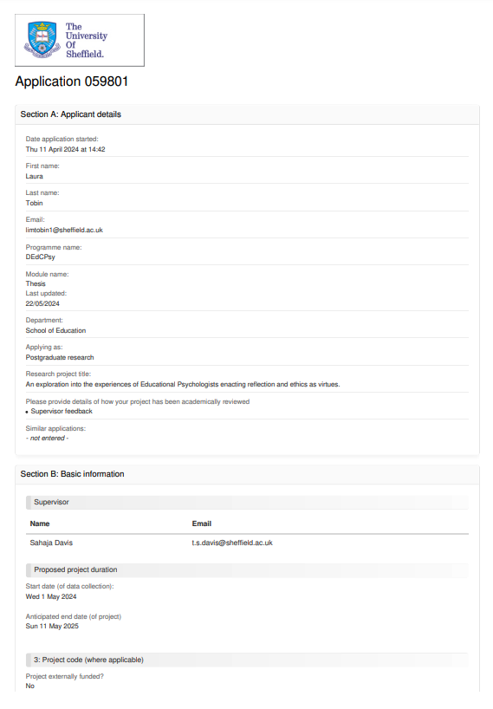
Appendix 1: Ethics application
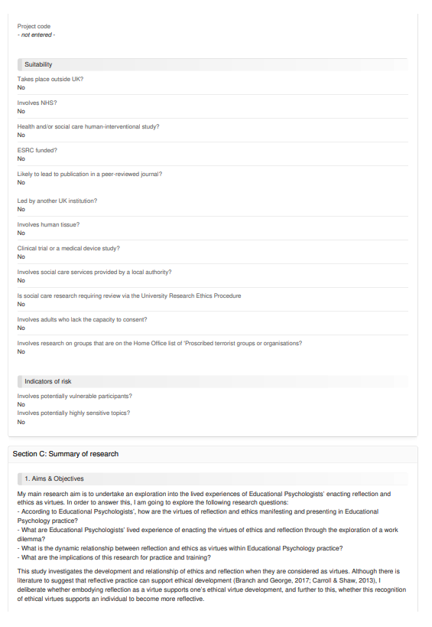

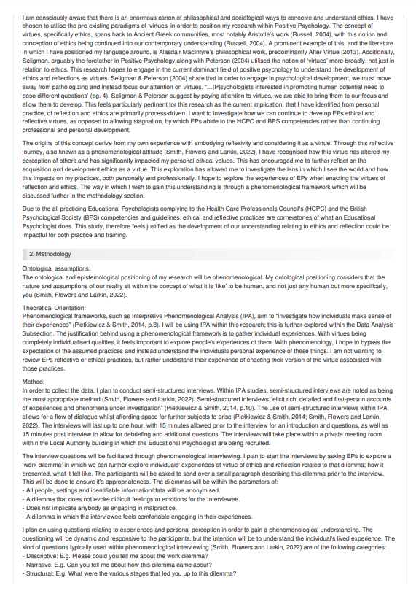
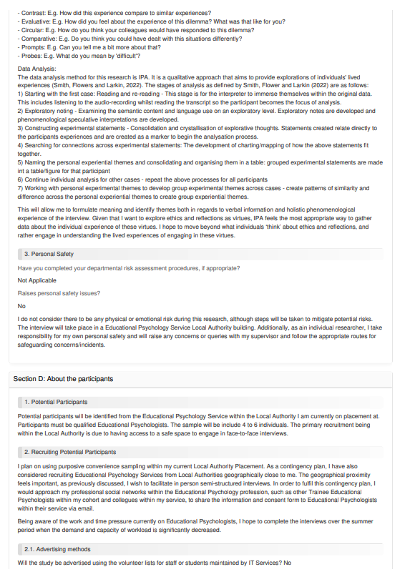
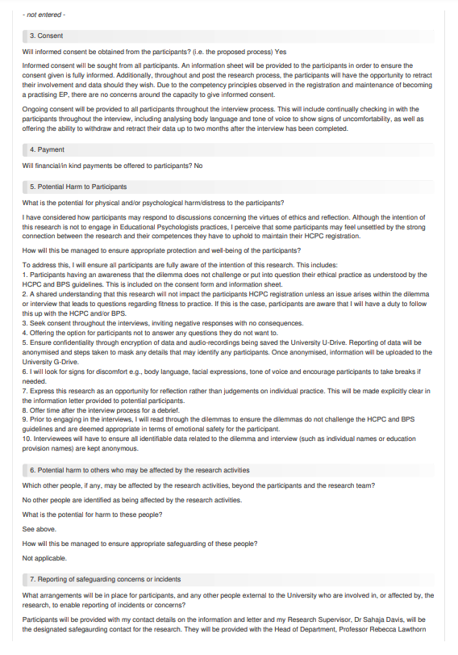
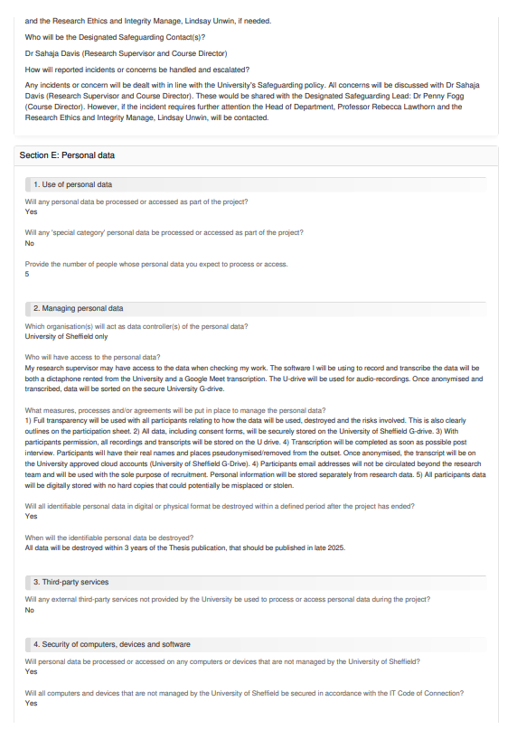

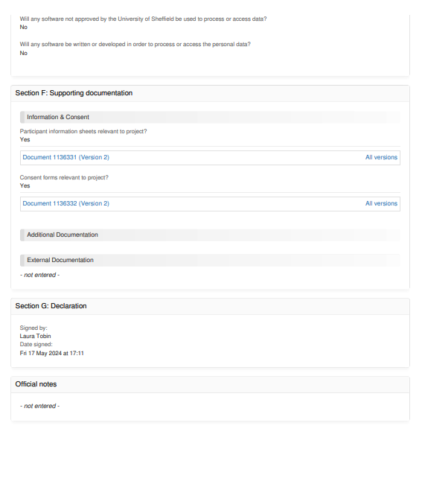


Appendix 2: Ethics approval letter
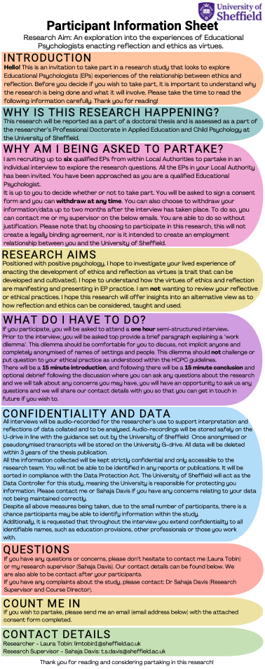
Appendix 3: Participant Information Sheet

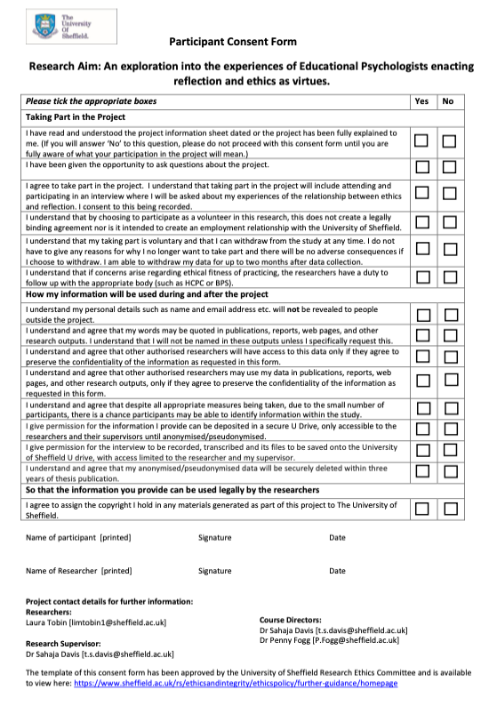
Appendix 4: Participant Consent Form
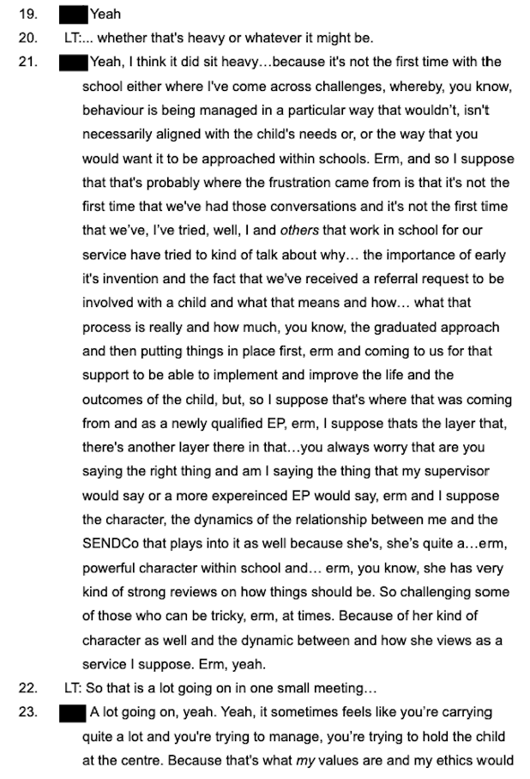
Appendix 5: Example of Transcription with participant initials redacted for anonymity

Appendix 6: Example of handwritten analysis with redacted participant initials for anonymity
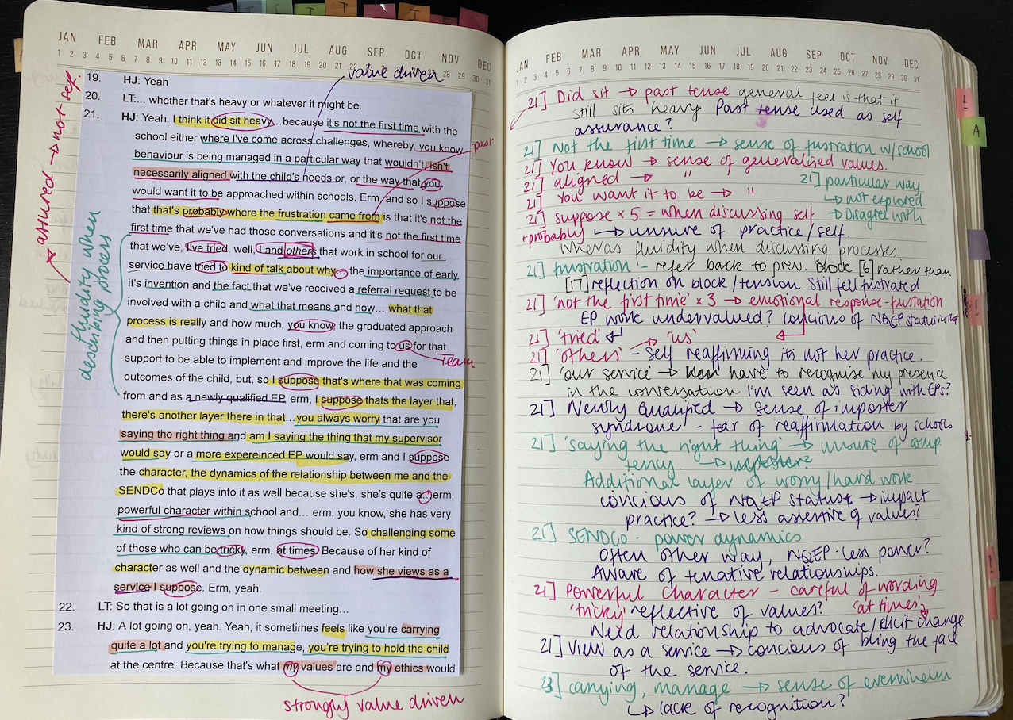

Appendix 7: Example of handwritten experimental statements
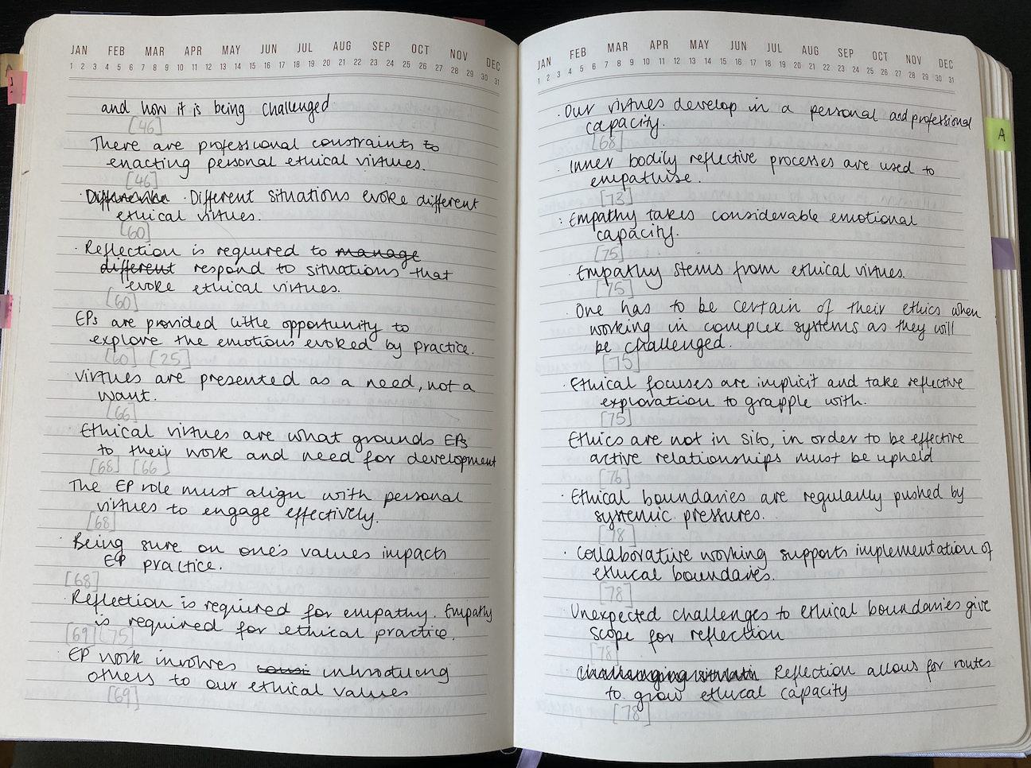

Appendix 8: Photo of attempt to organise Experimental Statements
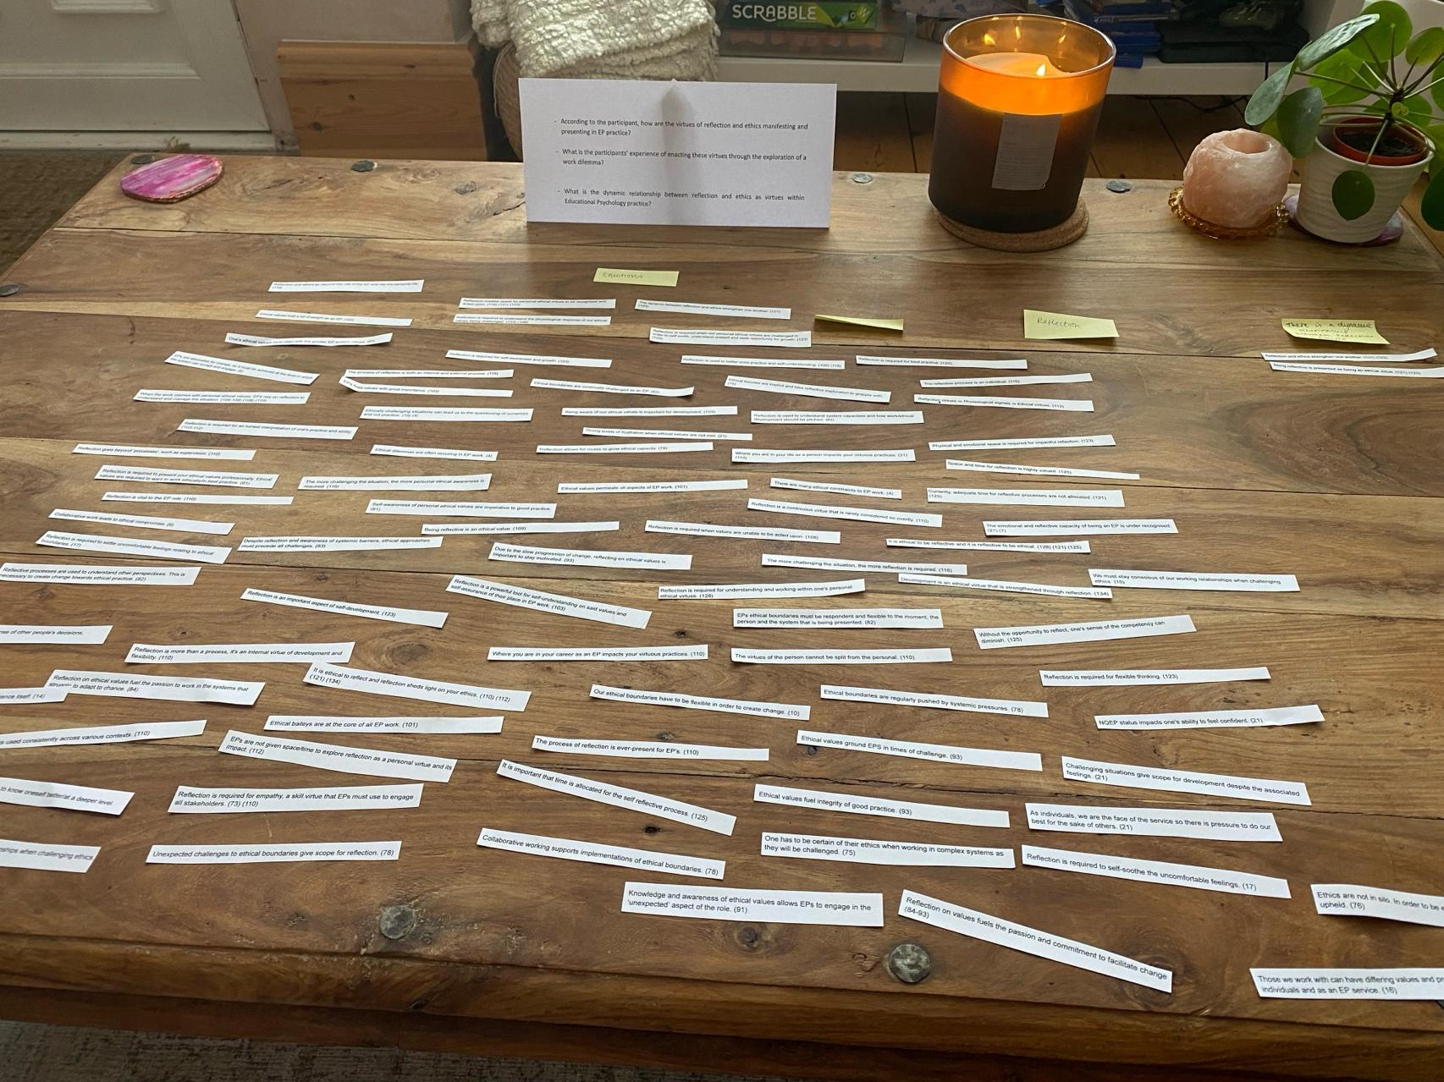

Appendix 9: Photos of physical and technological use of Venn-diagrams to attempt organising Experimental Statements
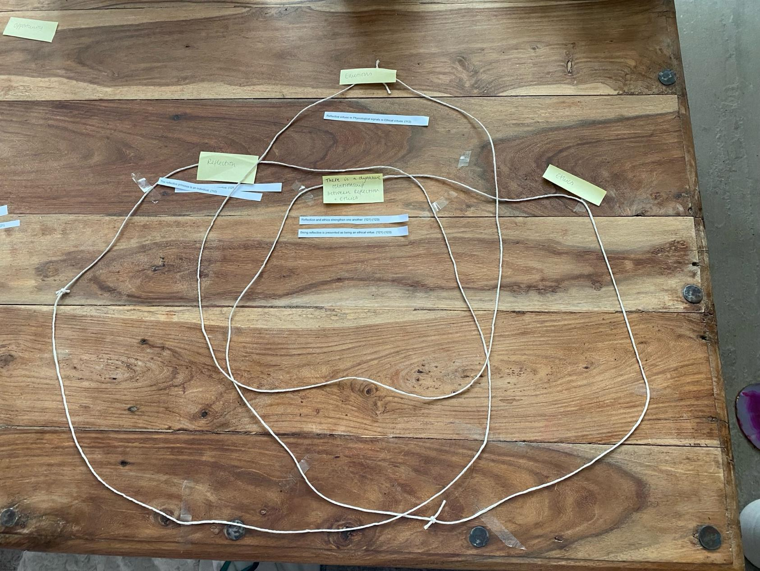

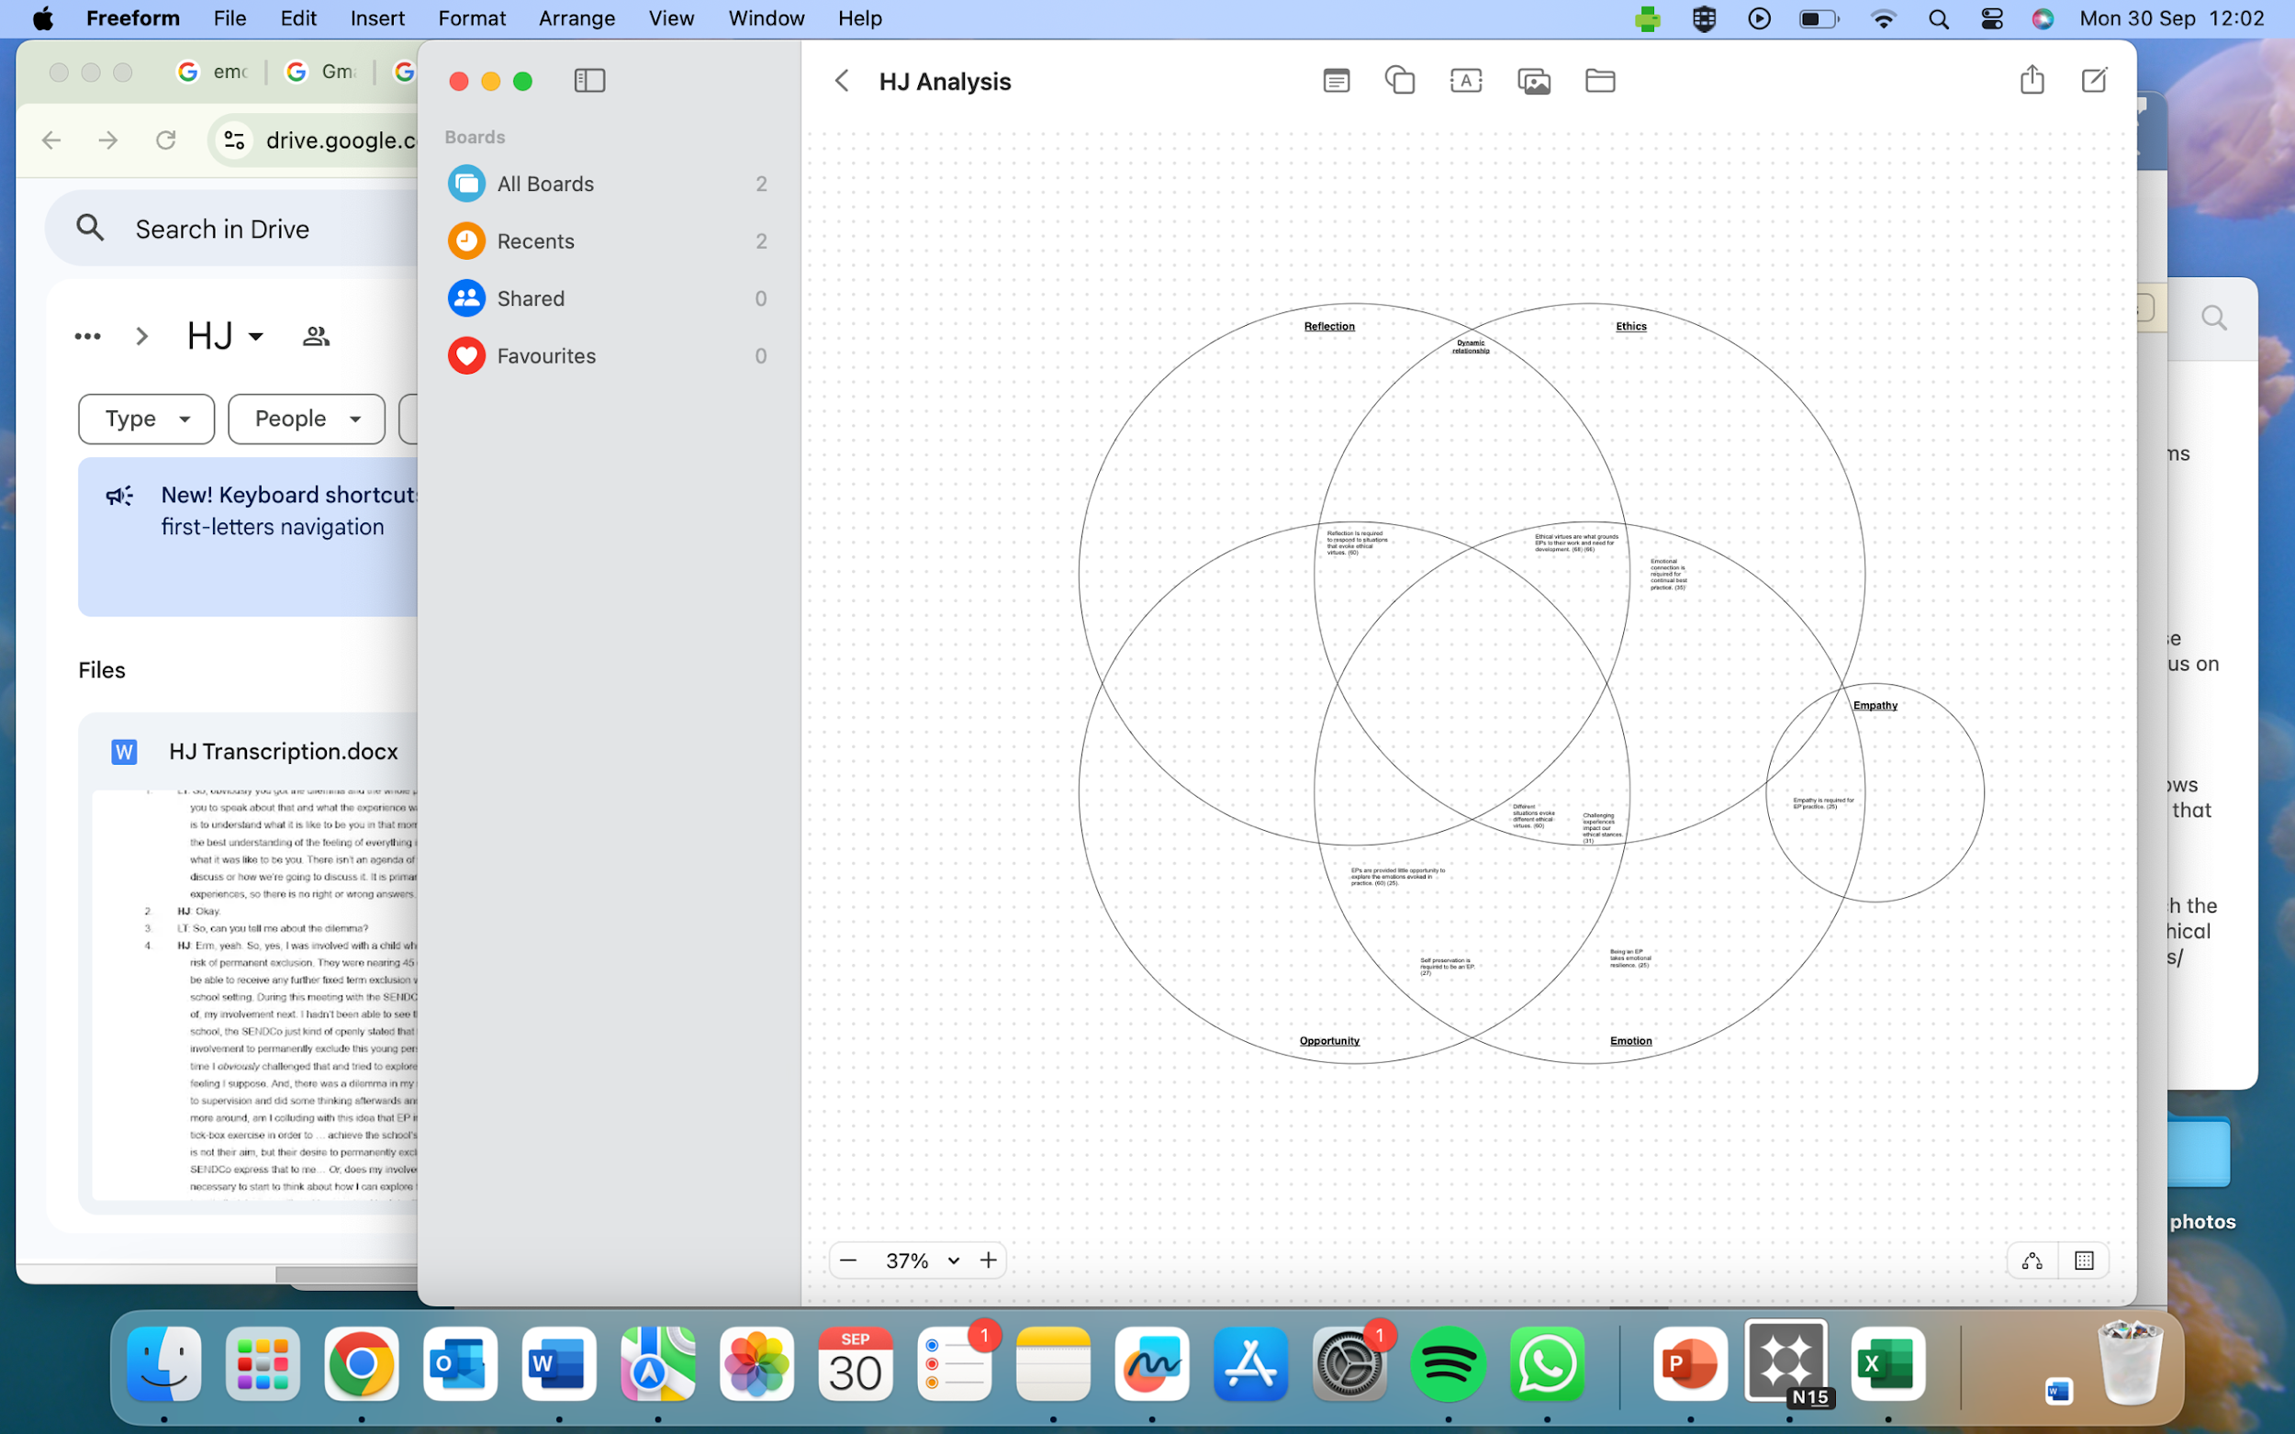
Appendix 10: Example of Analysis spreadsheet (across two pages for better clarity)




Appendix 11: Method of consolidating Person Experiential Themes to create Group Expereintal Themes
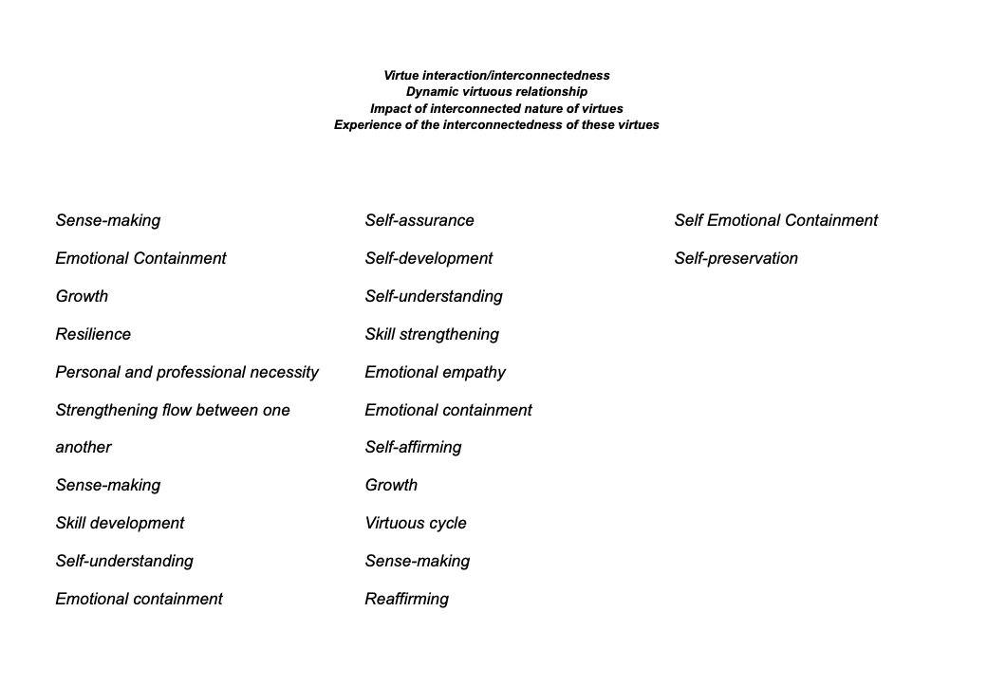

Appendix 12: Accumulated Personal Experimental Themes to create Group Experimental Themes

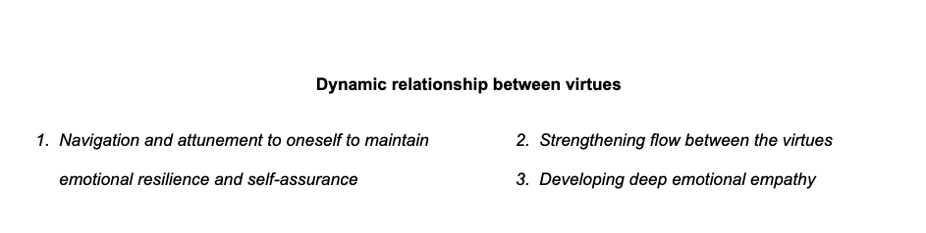

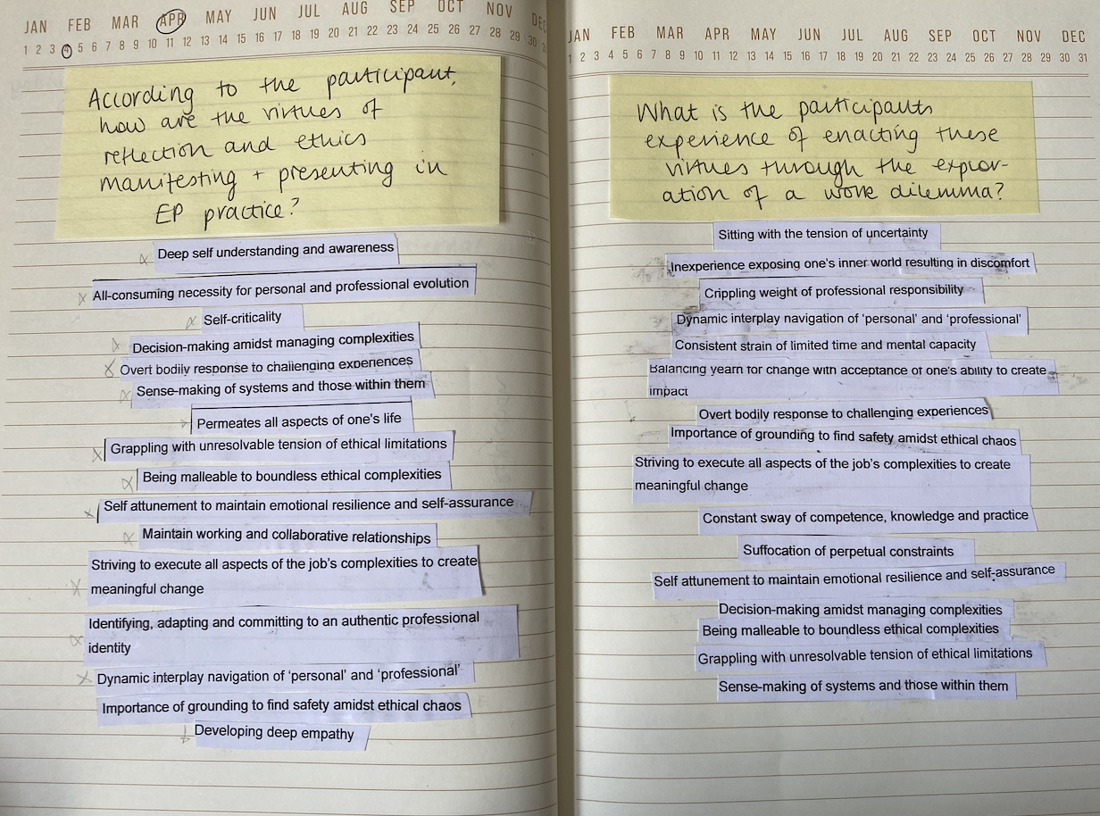
Appendix 13: Photo of experimental groupings of Group Experience Themes to answer the research questio

