

Supporting International New Arrival Students’ Transition into UK Secondary Schools - Appreciatively Exploring Educational Professionals’ Perspectives.

Charlotte Hoey

220110471

Research Thesis submitted in part requirement for the Doctor of Educational and Child Psychology

The University of Sheffield School of Education

Supervised by Dr Sahaja Davis

May 2025

**Abstract**

The transition of International New Arrival (INA) students into UK schools is an increasingly relevant topic, with the most recent statistics showing that 896,000 school-aged children and young people are born abroad (ONS, 2023). However, the socio-political context of migration often frames new arrivals through a deficit lens. Research in the UK has emphasised the importance of understanding INA students' transition experiences. Staff support has consistently been noted as a factor in improving transition experiences (Bhardwaj, 2022; O’Shea, 2018), with research indicating that positive transition experiences contribute to a sense of belonging, acculturation, mental health, social inclusion, and academic achievement (O’Shea, 2018; Cartmell, 2013; Burcham, 2009; Wong, 2020). Therefore, understanding what educational professionals constitute as a positive transition and the best practices in their support, appears timely and essential.

This research took an appreciative approach and offered an alternative to deficit-based narratives, by seeking to uncover strengths within practice. The study was guided by three research questions: (1) How do educational professionals understand positive transition? (2) What do they perceive as best practice? (3) What can be learned to improve future support for INA students' transition?

Six participants, working across the local authority and secondary schools in a variety of roles, engaged in appreciative interviews reflecting on a positive experience of supporting the transition of INA students. The data were analysed using reflexive thematic analysis (Braun and Clarke, 2022), generating four overarching themes and eleven interrelated sub-themes. The discussion section of this thesis examined the research questions, recognising that participants' understandings of positive transition and their perceptions of best practice in supporting INA students were highly interconnected. Drawing on these insights, the study critically considered what could be learned to enhance future support for INA students entering UK secondary schools as well as implications for Educational Psychology practice.

**Declaration Statement**

Throughout the course of this thesis, I changed my name from Charlotte Burgess to Charlotte Hoey. This statement is confirmation that both names refer to the same individual.

**Contents**

|  |  |
| --- | --- |
| **Chapter 1 - Introduction** | Page 11 |
| 1.0 Introduction | Page 11 |
| *1.0.1 Overview* | Page 12 |

|  |  |
| --- | --- |
| **Chapter 2 - Literature Review** | Page 13 |
| 2.0 Introduction | Page 13 |
| 2.1 Migration | Page 13 |
| *2.1.1 The Socio-political context* | Page 13 |
| *2.1.2 Terminology - International New Arrival (INA)* | Page 14 |
| 2.2 Educational Context for INA students in the UK | Page 17 |
| *2.2.1 National and Local School Context for INA students* | Page 17 |
| *2.2.2 Legislation, Policy and Service delivery* | Page 18 |
| *2.2.3 Secondary School* | Page 19 |
| *2.2.4 Section summary* | Page 20 |
| 2.3 Transition | Page 21 |
| *2.3.1 Terminology - Transition* | Page 21 |
| *2.3.2 Bronfenbrenner's Ecological Systems Theory* | Page 22 |
| *2.3.3 Transition experience for INA students into Secondary School* | Page 24 |
| *2.3.4 Theoretical concepts in the importance of positive transition* | Page 28 |
| *2.3.4.1 Acculturation* | Page 28 |
| *2.3.4.2 Sense of belonging* | Page 29 |
| *2.3.5 Section summary* | Page 30 |
| 2.4 Educational Professionals’ role in supporting transition | Page 31 |
| *2.4.1 Terminology - Educational Professional* | Page 31 |
| *2.4.2 Positioning educational professionals’ role in supporting INA transition* | Page 31 |
| 2.4.3 *Current context of educational professionals’ support for INA student transition* | Page 32 |
| 2.5 Next steps | Page 33 |
| *2.5.1 Gaps* | Page 33 |
| *2.5.2 Relevance to Educational Psychology* | Page 35 |
| *2.5.3 Research aims and questions* | Page 35 |
| *2.5.4 Summary* | Page 36 |

|  |  |
| --- | --- |
| **Chapter 3 - Methodology** | Page 37 |
| 3.0 Introduction | Page 37 |
| 3.1 Ontology and Epistemology | Page 37 |
| *3.1.1 Ontology* | Page 37 |
| *3.1.2 Epistemology* | Page 38 |
| *3.1.3 Paradigm* | Page 37 |
| *3.1.4 Researcher Positionality* | Page 39 |
| 3.2 Research Design | Page 40 |
| *3.2.1 Qualitative research design* | Page 40 |
| *3.2.2 Choosing a data collection method* | Page 41 |
| *3.2.3 Appreciative interviews* | Page 42 |
| *3.2.4 Choosing a data analysis method* | Page 43 |
| *3.2.5 Reflexive thematic analysis* | Page 44 |
| *3.2.6 Research design summary* | Page 45 |
| 3.3 Participants and Recruitment | Page 45 |
| *3.3.1 Defining participation criteria* | Page 45 |
| *3.3.2 Sample sizes for qualitative research* | Page 47 |
| *3.3.3 Sampling* | Page 48 |
| *3.3.4 Recruitment* | Page 49 |
| *3.3.5 Participants* | Page 52 |
| 3.4 Data collection | Page 53 |
| *3.4.1 Appreciative interviews* | Page 53 |
| *3.4.2 Appreciative interview prompts* | Page 53 |
| *3.4.3 Conducting the interviews* | Page 55 |
| 3.5 Pilot interview | Page 56 |
| 3.6 Ethical considerations | Page 59 |
| 3.7 Data Analysis | Page 60 |
| *3.7.1 Reflexive thematic analysis process* | Page 60 |
| 3.8 Quality issues | Page 63 |
| *3.8.1 Credibility* | Page 63 |
| *3.8.2 Transparency* | Page 64 |
| *3.8.3 Usefulness and generalisability* | Page 64 |

|  |  |
| --- | --- |
| **Chapter 4 - Analysis** | Page 65 |
| 4.0 Introduction | Page 65 |
| 4.1 Theme 1 - Being human at the heart of support | Page 66 |
| *4.1.1 Subtheme 1 - Wholehearted empathy* | Page 67 |
| *4.1.2 Subtheme 2 – Personal investment connection* | Page 69 |
| *4.1.3 Subtheme 3 - Staff vulnerability* | Page 70 |
| *4.1.4 Theme 1 summary* | Page 72 |
| 4.2 Theme 2 - A dynamic whole person approach | Page 73 |
| *4.2.1 Subtheme 1 - A flexible and holistic centred plan of support* | Page 74 |
| *4.2.2 Subtheme 2 - We couldn’t do it without the family* | Page 75 |
| *4.2.3 Theme 2 summary* | Page 76 |
| 4.3 Theme 3 - Listening to the unspoken | Page 77 |
| *4.3.1 Subtheme 1 - Value in reflecting on past experience* | Page 78 |
| *4.3.2 Subtheme 2 - Attuned to the emotional undercurrents* | Page 79 |
| *4.3.3 Subtheme 3 - Considering the bigger picture of wellbeing* | Page 81 |
| *4.3.4 Theme 3 summary* | Page 82 |
| 4.4 Theme 4 - Synergistic support | Page 83 |
| *4.4.1 Subtheme 1 – Automatic collective action* | Page 84 |
| *4.4.2 Subtheme 2 - Necessity of professional interdependence* | Page 85 |
| *4.4.3 Subtheme 3 - Developing cultural competence* | Page 87 |
| *4.4.4 Theme 4 summary* | Page 89 |
| 4.5 Theme and subtheme interconnections | Page 90 |
| 4.6 Findings conclusion | Page 91 |

|  |  |
| --- | --- |
| **Chapter 5 - Discussion** | Page 92 |
| 5.0 Introduction | Page 92 |
| 5.1 Research Question 1 -How do educational professionals understand  positive transition for INA students into UK secondary schools? | Page 92 |
| 5.2 Research question 2 **-** What do educational professionals perceive to  be best practice in their work supporting the transition of INA students  into UK secondary schools? | Page 95 |
| 5.3 Research Question 3 -What can be learned from how educational  professionals understand and support positive transition for INA students,  to improve practices for future students entering UK secondary schools? | Page 99 |
| *5.3.1 Interconnectedness of RQ1 and RQ2* | Page 99 |
| *5.3.2 Current guidance and practice* | Page 101 |
| *5.3.3 Recommendations for future practice* | Page 102 |
| *5.3.3.1 Fostering Relational and Culturally Competent support* | Page 102 |
| *5.3.3.2 Creating Flexible and Responsive Approaches* | Page 103 |
| *5.3.3.3 Encouraging Reflective Practice and Staff Vulnerability* | Page 103 |
| *5.3.3.4 Promoting Interdisciplinary Collaboration* | Page 104 |
| *5.3.4 An Ecological Approach* | Page 103 |
| 5.4 Implications for Educational Psychology and Research Dissemination | Page 107 |
| *5.4.1 Implications for Educational Psychology* | Page 107 |
| *5.4.2 Dissemination of research* | Page 109 |
| 5.5 Limitations and Future research | Page 110 |
| *5.5.1 Participants* | Page 110 |
| *5.5.2 Data collection* | Page 111 |
| *5.5.3 Data analysis* | Page 112 |

|  |  |
| --- | --- |
| **Chapter 6 - Concluding remarks** | Page 112 |
| 6.0 Conclusion | Page 112 |

|  |  |
| --- | --- |
| **References** | Page 114 |
| **Appendices** | Page 133 |
| Appendix I – Gatekeeper email and research summary document | Page 133 |
| Appendix II – Participant Information Sheet | Page 136 |
| Appendix III – Participant Consent Form | Page 139 |
| Appendix IV - Debrief sheet | Page 143 |
| Appendix V – Ethics Approval Letter | Page 144 |
| Appendix VI - Powerpoint slide used in interview | Page 145 |
| Appendix VII - Outline of Braun and Clarke’s 6 Phases of RTA | Page 146 |
| Appendix VIII – Transcript of Interview 1 (Integration and Partnerships) | Page 146 |
| Appendix IX – Transcript of Interview 2 (SENCo) | Page 154 |
| Appendix X – Transcript of Interview 3 (Senior and Virtual School EP) | Page 161 |
| Appendix XI – Transcript of Interview 4(Admissions and Attendance) | Page 164 |
| Appendix XII – Transcript of Interview 5 (Head of Outreach) | Page 168 |
| Appendix XIII – Transcript of Interview 6(Teacher and Head of Year) | Page 172 |
| Appendix XIV - Reflective diary entries | Page 176 |
| Appendix XV - Data coding NVIVO | Page 183 |
| Appendix XVI - Theme development NVIVO | Page 186 |
| Appendix XVII - Theme defining NVIVO | Page 187 |

**List of figures**

|  |  |
| --- | --- |
| Figure 1 | Bronfenbrenner’s Ecological Systems theory (1979) Page 23 |
| Figure 2 | Process for conducting Appreciative Interviews. Informed by Schultze and Avital (2011)  Page 54 |
| Figure 3 | Analysis Theme and Subtheme interconnections Page 90 |
| Figure 4 | Interconnectedness of RQ1 and RQ2 adapted Ecological Systems theory  Page 100 |
| Figure 5 | Adapted Ecological Systems theory for understanding and supporting positive transition experiences for INA students into UK Secondary Schools Page 106 |

**List of tables**

|  |  |
| --- | --- |
| Table 1 | Participation inclusion criteriaPage 47 |
| Table 2 | Team roles in relation to supporting INA students Page 48 |
| Table 3 | Recruitment of participants response rate Page 50 |
| Table 4 | Participant interview chronology Page 51 |
| Table 5 | Relevant participant information Page 52 |
| Table 6 | Pilot interview feedback and response Page 59 |
| Table 7 | Analysis Themes and Subthemes  Page 66 |

**List of abbreviations**

|  |  |
| --- | --- |
| **BPS** | British Psychological Society |
| **CYP** | Children and Young People |
| **DCSF** | Department for Children, Schools and Families |
| **DfE** | Department for Education |
| **EAL** | English as an Additional Language |
| **EP** | Educational Psychologist |
| **EPS** | Educational Psychology Service |
| **INA** | International New Arrival |
| **LA** | Local Authority |
| **OFSTED** | Office for Standards in Education |
| **RTA** | Reflexive Thematic Analysis |
| **SENCo** | Special Educational Needs Coordinator |
| **TEP** | Trainee Educational Psychologist |
| **UK** | United Kingdom |
| **UNCRC** | United Nations Convention on the Rights of the Child |

**Chapter 1 - Introduction**

**1.0 Introduction**

My interest in exploring transition support for International New Arrivals (INA) students as a research area began during my time as a secondary school teacher, where I worked in an increasingly multicultural school community. Over time, I saw firsthand the complexities of transition faced by new-to-country students who joined partway through the academic year, each bringing diverse migration experiences, whether displaced by conflict or migrating for economic reasons. During my time in the classroom, I had the privilege of witnessing the resilience of INA students, but also their challenges in adjusting to a new educational system. As such I became acutely aware of how critical transition support was in shaping their sense of belonging, emotional wellbeing, and educational engagement.

As I worked closely with these students, I also became more conscious of the broader societal narratives surrounding migration, which are often framed in deficit-based or negative terms. This led me to reflect on how the wider societal context surrounding migration forms an important backdrop to INA students’ transition experiences, and how an awareness of this context may be important in shaping sensitive and inclusive support. Therefore, recognising the complex and layered nature of these transitions deepened my interest in understanding how educational professionals perceive positive transitions and what they view as best practice in this area.

While existing research highlights challenges faced by INA students, it often overlooks the role of educational professionals in facilitating positive transitions highlighting a critical gap in the literature. Educational transitions will remain an important topic for schools given that migration to the UK is predicted to continue to rise (Home Office, 2023) and Educational Psychologists (EPs) can play a key role in this through advocating for systemic change and promoting inclusive practices.

Given this, it felt important to approach the research in a way that foregrounded strengths, possibilities, and professional insight, rather than focusing solely on problems or gaps. I chose to use appreciative interviews as a way of encouraging participants to reflect on and share examples of what they felt had worked well in supporting INA students’ transitions. This approach aligned with my commitment to recognising and valuing the expertise of educational professionals, as well as promoting socially just narratives that emphasise positive practices and opportunities for growth. By focusing on what has been experienced as positive, I hoped to contribute to a more empowering and hopeful understanding of how INA students can be supported to thrive within their transition to a UK secondary school.

Therefore, this research aims to explore how educational professionals understand positive transition for INA students in UK secondary schools; to identify the practices they view as most supportive; and to consider, from their perspectives, how future practices might be improved. These aims are intended to centre the lived realities of their practice, as professionals working closely with INA students, and ultimately contribute towards an understanding of support for INA students’ transition.

In this research, I acknowledge my position as an outsider to the lived experiences of INA students while also aligning myself with those who seek to support them. As a researcher, I do not share the direct experience of transitioning into a UK secondary school as an INA student, thus my understanding is shaped through the lens of educational professionals rather than firsthand accounts from the students themselves. This will be further discussed in Chapter 3.

The following research questions will therefore be explored within this thesis:

***Research question 1*** – How do educational professionals understand positive transition for INA students into UK secondary schools?

***Research question 2 -*** What do educational professionals perceive to be best practice in their work supporting the transition of INA students into UK secondary schools?

***Research question 3 -*** What can be learned from how educational professionals understand and support positive transition for INA students, to improve practices for future students entering UK secondary schools?

***1.0.1 Overview***

This thesis reviews the relevant literature to consider transition support for INA young people. It outlines the methodology and procedures used to gather data from the educational professional participants. The analysis and discussion section provides information about the themes that arose and reflexively considers my own views and experiences within this. The discussion section discusses the themes in relation to the research questions and their relevance to educational psychology. Finally, the limitations of this research and implications for relevant professionals and organisations have been considered.

**Chapter 2 - Literature Review**

**2.0. Introduction**

This section will present a review of the literature to establish the background for the research. The review will present an overview of the current context of migration for young people to the UK, considering this both statistically and the influence of socio-political factors. The term INA will be defined before reviewing the literature that has explored INA students' experiences of *‘transition’* to UK secondary schools. In short, the definition of transition in this research context involves the stages and processes involved in helping INA students adjust to a new school environment, with a focus on the professional support they receive at each stage. The literature review will then define the term *‘educational professionals’* then explore the role of these in the support provided during transition for INAs. Psychological theory relating to transition will be used to frame the research aims, highlight identified gaps, and demonstrate its relevance to Educational Psychology (EP) practice.

**2.1 Migration**

***2.1.1 The Socio-political context***

The term ‘migration’ is a broad concept relating to the act of moving from a person’s typical place of residence, either within the same country (internal migration) or across national bordersinto other countries (international migration) for a range of reasons, and this residence being either for temporary or permanent periods (International Organization for Migration, 2022). Within this literature review, ‘migration’ will be used to refer to international migration.

The estimated number of international migrants globally has increased by 83% over the past two decades (International Organization for Migration, 2022). Such increases in migration have led to significant demographic changes in local communities and student populations within schools globally (UNICEF, 2021). However, worldwide, migration appears to be a complex issue. Views regarding migration across Europe, in particular, vary widely (Heath et al., 2020) whilst public resistance to immigration in certain areas globally has become a significant divisive influence, with discourses of migration at the forefront of political discussions and news-sharing outlets. Language and education are frequently at the forefront of contentious discussions regarding migration in several western democracies, where xenophobia and racism are on the increase (Welply, 2023).

Within the UK specifically, such socio-political tensions were further magnified during the summer of 2024 where anti-immigration fuelled riots took place across the country. The widespread media coverage during and following these, will have played a crucial role in shaping public opinion towards immigration, by amplifying narratives around security and control whereby social media platforms became spaces of hostility fuelled by misinformation.

Most recent statistics from 2023 report that people born outside the UK made up an estimated 14.5% of the UK’s population, or 9.6 million people (Office for National Statistics [ONS], 2023) and historically, the UK had a relatively open approach to immigration, particularly after World War II when workers from Commonwealth countries were encouraged to fill labour shortages (Doty, 1996). However, this has shifted towards more restrictive approaches, particularly during the Brexit campaign, when proponents of leaving the EU highlighted immigration and stricter control over UK borders as a central point of discussion. Since then, the government has implemented policies to reduce net migration, such as introducing more stringent visa requirements, a points-based system, and setting annual migration targets (Home Office, 2022).

The UK’s immigration statistics are expected to rise by the next census, and the Home Office (2023) reports that as of March 2023, migration into the UK was noted to be 90% higher than the year ending March 2022 (Home Office, 2023) presumably influenced by factors such as the war in Ukraine and the UK’s humanitarian policy for Hong Kong BNO status holders (Home Office, 2023).

Thus, the topic of migration remains highly relevant within the UK and therefore also within education, particularly for INA CYP and their families, many of whom face the dual challenges of adjustment and belonging within systems increasingly shaped by external political narratives. Notably, data for this study was gathered shortly before the riots and analysed during, thus, the socio-political climate is an important contextual factor that underpins the relevance and framing of this research.

***2.1.2 Terminology - International New Arrival***

Distinguishing between different groups of migrants can be difficult, with research utilising varying phrases to acknowledge individuals who have experienced forced (or involuntary) migration, e.g. those who have experienced violent displacement from their home countries and are subsequently forced to seek refuge elsewhere (Castles, 2003, as cited in Mamali and Arvanitis, 2022) as well as voluntary migrants, who alongside a guardian, choose to leave their home country for various reasons such as employment or harsh living conditions within their country of birth (Sahin-Mencutek, 2020).

International New Arrival is a term used to describe Children and Young People (CYP) who are international migrants to the country; therefore, this term encompasses the subgroups of refugees, asylum seekers and children whose parents are working or studying in the UK thus considered as economic migrants (Department for Children, Schools and Families [DCSF], 2007 as cited in Burgess, 2024). INA is therefore a broad term that encompasses both voluntary and forced migration under one heading. McKenna (2005) (as cited in Hastings, 2012) argued that although there is a great deal of heterogeneity in the experiences of CYP who have experienced forced and voluntary migration to a new country, individual differences remain within these groups.

Considering Asylum Seekers and Refugees (ASR) and voluntary migrants both under the one term of ‘INA’ has been the choice adopted by the UK government across policy and legislation (DCSF, 2007). The New Arrivals Excellence Programme (NAEP) is a Department for Education (DfE) published document designed to “provide support and guidance for schools in setting up systems to track the progress of newly arrived pupils as well as support in evaluating current policies and practices to plan more effective provision for new arrivals” (New Arrivals Excellence Programme Guidance, DCSF, 2007, p .6). The NAEP define INA as “Including refugees, asylum seekers and economic migrants from overseas” and state that this group as a whole may experience challenges in “learning English as an Additional Language (EAL); difficulties in managing the transition to a new country; feeling misunderstood, unvalued or alienated if they cannot see their culture, language, experiences reflected around the school or in the classroom” (New Arrivals Excellence Programme Guidance, DCSF, 2007, p. 3), thus suggesting overlap in the experiences of INA young people beginning school in the UK. In this context, the term ‘new arrival’ is also present, as seen in Ofsted's (2013) instructions to school inspectors in England. The term is used to consider both the duration of residence in the country and proficiency in English.

These examples demonstrate that UK services will therefore adopt approaches that do not distinguish between refugees, asylum seekers, and economic migrants when providing support. Instead, the focus is placed on the CYP’s needs rather than their specific legal status. In addition to this, it is important to note that schools do not hold detailed information regarding a student’s migration status; instead, they rely on information shared by the family or the young person themselves. The most likely information that will be shared is that the student has moved to the UK and when this was. As a result, schools will not differentiate support based on migration status, but will likely be aware that the student is a new arrival to the UK thus I recognise that ‘INA’ is likely the term most commonly used in British schools to refer to CYP who have recently relocated to the UK from their country of origin.

There is no strict, universally defined time boundary for how long a child or young person is considered an INA in the UK. This lack of formal definition reflects the complexities of migration experiences and the varying rates at which individuals and families adjust and settle into their new environments. In practice, the period during which a student is supported as an INA may differ depending on local authority policies, school procedures, and the individual needs of the child. The research ‘*Using narrative to make sense of transitions: supporting newly arrived children and young people’* by Hulusi and Oland (2010) provides a useful working definition, describing a "new arrival" as a CYP who migrated to the UK up to three years ago. This timeframe recognises that the early years following arrival are critical for the overall educational transition, language acquisition, and social integration (Hulusi and Oland, 2010; Demie, 2013; Evans and Liu, 2018). Demie (2013) shows that English language learners, many INA students, face the largest attainment gaps within the first two to three years post-arrival. This highlights the need for focused support during this period, further justifying the use of a three-year timeframe to define INA.

Consequently, this definition acknowledges that the support needs of newly arrived students tend to be most acute during this period of time defined. Therefore, this research adopts the three-year timeframe as a practical guideline, as it aligns with the existing literature. Chapter 3 specifically references this definition and applies it as a criteria for identifying INA students within the scope of this research.

Throughout this research, I will adopt the term ‘International New Arrival’ however it is necessary to note that when reviewing the current literature, the terminology used by the original authors will be utilised which may vary from the terminology agreed here.

### **2.2 Educational Context for INA Students in the UK**

***2.2.1 National and Local School Context for INA Students***

Schools in England do not classify students dependent on their migration status, but rather on their ethnicity and spoken language (whether English is an additional language [EAL]) (Udrescu-Clarke, 2023). This means that it is difficult to ascertain the current numbers of migrant students accessing UK schools, meaning the length of time a CYP may be referred to as an INA student, varies from school to school.

The latest school data, as reported by the UK Government, from the academic year 2023-2024 indicates that 37.4% of students in primary schools and 36.6% of secondary school students are from an ethnic minority background, which is up from 36.1% and 35.4% in 2022/23 (ONS, 2024). The linguistic background of INA students is very diverse, with most young people in this group speaking a language that is not the primary language of the host country (Horgan et al, 2022). The latest school data reported by the UK Government indicates that 22.8% of primary and 18.6% of secondary school students have a first language other than English, making them EAL learners (ONS, 2024).

This shows that language and cultural diversity exists increasingly within UK schools and as INA status is not recorded, there is a reliance on educational professionals to know the young people joining, in order to best support them through the transition.

***2.2.2 Legislation, Policy and Service delivery***

Despite the clear diversity within UK schools, government legislation and policy appears to have given little consideration to the school transition and integration of INA students (Manzoni & Rolfe, 2019 as cited in Burgess, 2024). The most recent government policy specifically concerning support of migratory students within education and seemingly the only document focused on bridging the gap between education and migration in its broadest sense, is the New Arrivals Excellence Programme Guidance [NAEP] (DCSF, 2007, as cited in Burgess, 2024). This guidance outlines ways in which professionals might support new arrivals, including an emphasis on the importance of collecting information on a student’s social, cultural, and linguistic background to contextualise assessment data and inform appropriate transitional support (DCSF, 2007, p.17).

However, the guidance focuses on both INA students and students moving from another school within the UK whose experiences will likely be very different to those who are new to the country and the UK education system. Criticisms of the NAEP guidance could note it has cultural sensitivity gaps and the guidance's emphasis on universal practices for professionals and one-size fits all approach, could be seen to overlook nuances of the communities experiences. In particular, it fails to take into account influencing factors such as emotional well-being and mental health needs and does not include student voice in identifying what has contributed to positive transition experiences.

This guidance must also be understood in light of funding shifts that will have directly impacted schools’ capacity to implement support. Until 2011, LAs received an Ethnic Minority Achievement Grant (EMAG), which was to be utilised to support the learning of EAL students and the achievement of ethnic minority learners (which may also include INA students) (NALDIC, 2015). Budget cuts to public services meant that this funding was removed and mainstreamed into general school funding, meaning there was no requirement for the funds to be allocated specifically to support EAL students (Manzoni and Rolfe, 2019; NALDIC, 2015), thus leaving schools to support INA students with fewer resources, in particular, likely to influence the transitional support for INAs. It is, therefore, even more critical to understand what a positive transition is and what the best practices support this.

These funding constraints are further compounded by the nature of traded services in some LAs, where support for INA students is often only accessible through paid external services. This approach risks reinforcing inequalities, as access to necessary support becomes based upon a school’s financial decisions and capacity, rather than the needs of its students.

The gaps in both policy design and service delivery mentioned, become even more critical when considered within the wider socio-political context. As aforementioned, during the summer of 2024, a number of anti-immigration riots broke out across the UK increasing political debate around border control and the implementation of increasingly restrictive policies, reflecting a shift towards stricter and less supportive views on migration. Such tensions inevitably impact the lived experiences of INA students and their families as well as intensify fear, uncertainty, and exclusion (Hastings, 2012).

Such socio-political realities will likely influence educational experiences for INA young people as they shape how migration is understood, how support is enacted, and in turn how INA students experience joining a UK school and come to see themselves as belonging (Rutter, 2006). In this context, educational support would not be expected to only be focused on curriculum delivery, but also offering emotional, language, and cultural support to students adjusting to a new country under often emotional circumstances.

Thus, the combination of outdated frameworks, funding reductions, and the socio-political pressures highlights the urgency of better understanding what a positive transition looks like for INA students and identifying best practices that can meaningfully support it.

***2.2.3 Secondary school***

Research suggests there may be more challenges for INA students in secondary school than in primary school. Appa (2005) interviewed refugee young people, as well as their families and educational professionals, in schools across four UK LAs, with findings noting differences in relation to transition experiences and overall support for primary aged refugee children versus secondary. In particular, Appa shared that refugee CYP in secondary schools had less positive experiences, noting less nurturing support and poorer relationships with staff than the primary-aged refugee students (Appa, 2005; as cited in Burcham, 2009).

The educational structure and set-up of UK secondary schools has been mentioned to explain some of the differences found in Appa’s research, recognising that they are usually much larger and students move between different classes and teachers for each subject, thus creating a more dispersed and less stable social environment (Burcham, 2009). In addition, academic demands in secondary schools are much more complex than in UK primary schools (Walqui and Schmida, 2016), therefore emphasising the need for focused research specifically at the secondary school level for INA students.

From a developmental perspective, adolescence has been recognised to be a particularly challenging time for INAs (Wong, 2020). Valentine et al (2009) stated that secondary-aged INA students face significant challenges in negotiating their sense of identity, often experiencing feelings of loss and confusion. In contrast, having a positive cultural identity and feeling a sense of belonging in school have been identified as crucial factors for INA students' well-being (Cartmell and Bond, 2015); however, as highlighted, the structure and environment of secondary schools can make it more difficult to cultivate these positive experiences. In fact, Rutter (2006) stated that secondary schools may be the educational setting that is least able to meet the needs of migrant children (Rutter, 2006 as cited in Burcham, 2009).

***2.2.4 Section summary***

As outlined above, whilst the narrative around migration in general takes a deficit-based stance, it appears even more necessary to consider how updated guidance, legislation and research could focus on what’s working well in practice when considering support for INA students, so as not to feed into any problem-laden narratives. The UK’s immigration statistics are expected to rise when measured at the next census (Home Office, 2023 as cited in Burgess, 2024) consequently, the importance for research surrounding support for students who are new to both the country and UK schools remains an important research gap.

It is recognised that the secondary school years present unique challenges for INA students (Appa, 2005; Cartmell and Bond, 2015; Valentine et al, 2009) and as noted, reduced resources (Manzoni and Rolfe, 2019; NALDIC, 2015) and outdated guidance (DCSF, 2007) suggests that focusing solely on challenges will perhaps not provide a proactive or supportive way to move forward with supporting INAs during transition. Therefore, research focused on how to best support positive transition experiences for INAs into secondary appears extremely necessary and should be further explored to ensure that INA students are not further disadvantaged, and a positive transition experience is facilitated.

This literature review will now go on to focus specifically on ‘transition’ by reviewing the literature surrounding the experiences of transition for INA students, alongside psychological theory encompassed within this.

**2.3 Transition**

**2.3.1 *Terminology - Transition***

The broadest definition of the term transition comes from the Oxford Dictionary, stating transition is ‘the process or a period of changing from one state or condition to another’ (OED, 2025). The DfE generally refers to transition as the process of moving from one stage of education to another (DfE, 2020). The Children and Families Act (2014) uses the term transition to describe the life changes a child or young person may go through (Children and Families Act, 2014).

Literature and research surrounding transitions for INA students emphasise that it is not possible to separate the changes and experiences that come with the physical move, as the process of joining a UK school is multifaceted (Hulusi and Oland, 2010; O’Shea, 2018). The experience involves various types of support: psychological, academic, social, and practical, and this comes from a variety of people at multiple points, from planning (pre-arrival) to the arrival and the time following their joining the school environment. In studies specifically exploring the experiences of INA students’ transition to a UK school, research has spoken with students who had joined the school 5-weeks prior (Wong, 2020) up to 3-years post school arrival (Hulusi and Oland, 2010). Thus, defining the transition of INA students simply as a ‘move’ would be too reductive and incomplete because transitioning encompasses several steps involving planning and people.

The NAEP guidance from the Department for Children, Schools and Families (DCSF) defines transition as the process of supporting INA students as they adapt to the UK and the UK education system (DCSF, 2007). This guidance emphasises that transition as a process includes the planning, preparation and implementation of strategies to support this change (DCSF, 2007). All of these efforts are vital to a positive and successful experience and capture the idea that transition for INA students is much more than just moving from one country to another; it involves a complex, multi-dimensional process that is well-planned and supported to consider support for emotional, social, academic, and cultural adaptation (Tabor and Milfont, 2011; Wong, 2020).

When it comes to defining transition in this research,the literature and resources mentioned suggest that transition is a process and period of change, both physical and psychological (DCSF, 2007; Hulusi and Oland, 2010; O’Shea, 2018; Wong, 2020). For INA students in particular, it encompasses multiple stages, such as pre-arrival (preparing before joining the school), arrival (Joining the UK school), and integration (Settling into and experiencing the school). It emphasises the shift or move between two systems and the changes the student experiences during that shift.

In short, the definition of "transition" in this research context involves the stages and processes involved in helping INA students adjust to a new school environment, with a focus on the professional support they receive at each stage.

***2.3.2 Bronfenbrenner’s Ecological Systems Theory***

In understanding what transition is for INA students, it is important to consider the wider systems at play, making Bronfenbrenner’s Ecological Systems Theory (1979) a valuable framework for understanding how multiple layers of the environment influence a student’s transition experience.

Bronfenbrenner (1979) created a model of human development termed the Ecological Systems Theory, suggesting that individuals' development is influenced by their interactions with a series of interconnected environmental systems. The model explains how people are part of living and ever-changing systems that can be considered to fit into five environmental levels whereby each one influences the other (Bronfenbrenner, 1979).

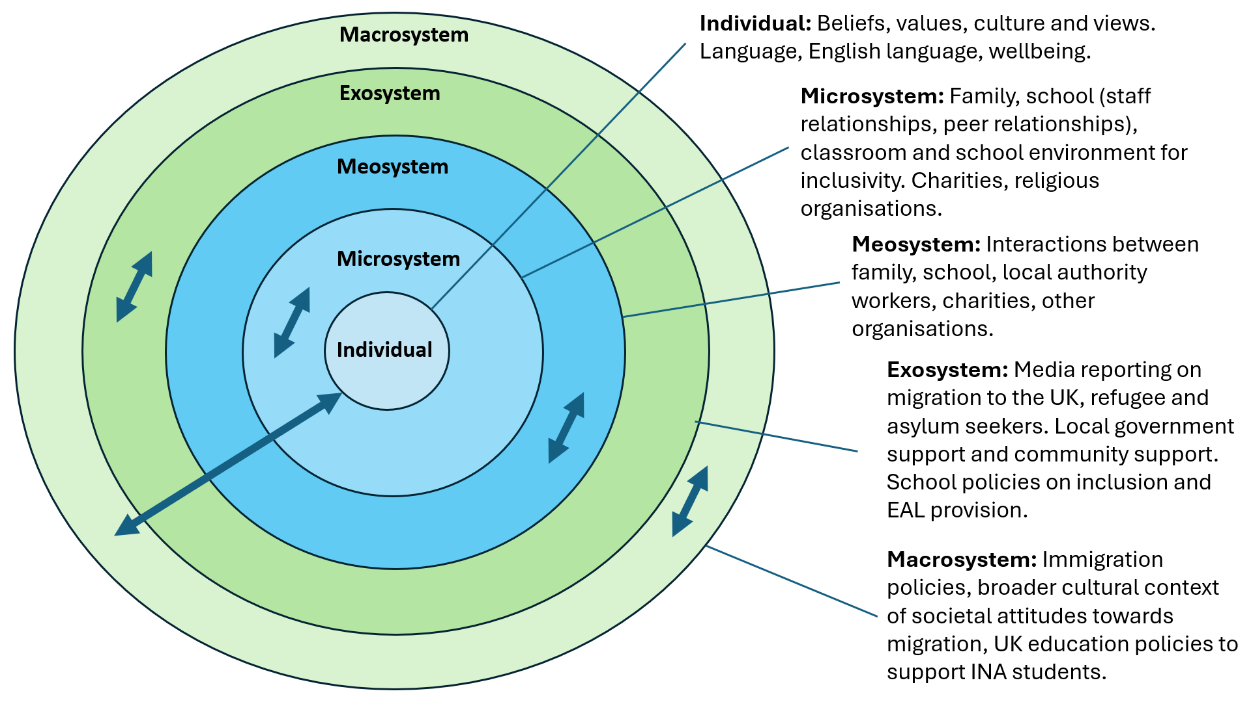

*Figure 1 – Bronfenbrenner’s Ecological Systems theory (1979) reflecting INA students.*

Given the complex sociopolitical context and policy frameworks discussed earlier as relevant to this research, Bronfenbrenner’s Ecological model provides a structured way to show how policies and social attitudes at the macro- and exosystem levels filter down through local authorities, schools, families, and peers at the meso- and microsystem levels to shape INA students' transition experiences (Bronfenbrenner, 1979). This systemic perspective is essential because it highlights that transition support is not only about individual adaptation or isolated school interventions but is embedded within a broader network of social and institutional influences.

While Bronfenbrenner later refined this theory into the Bioecological Model, which focuses more on the interaction between individual characteristics and proximal processes (Bronfenbrenner, 2005), this research emphasises the broader environmental and systemic contexts influencing INA students’ transition. Therefore, the original Ecological Systems Theory (Bronfenbrenner, 1979) is better suited here as it recognises the multi-layered external contexts (e.g. family, school, local authority policies, societal attitudes) that collectively influence INA students’ transitions and shape the work of educational staff supporting them.

The Ecological Systems Theory is widely accepted and utilised within studies regarding educational support for newly arrived school-aged children in England (Bhardwaj, 2022; Cartmell, 2013; O’Shea, 2019; Rutter, 2006). Considering the experiences of INA students’ migration, it is likely that many young people have experienced separation from their immediate family (Moskal and Tyrrell, 2016) thereby causing disruption within their microsystem. It has been recognised that schools will play a significant role as they become a primary and potentially stable factor for INA students within their microsystem (Manzoni and Rolfe, 2019). However, Rutter (2006) suggests that much of the literature regarding migrant students' transition into UK schools has framed the ‘success or failure’ of students' experience as primarily the responsibility of individual schools. It is arguably far more complex, involving a range of factors at multiple levels. In particular, Rutter (2006) noted that the focus of UK education policy tends to "give little attention to out-of-school social factors that impact childrens’ progress" (Rutter, 2006, p. 4), therefore highlighting the need to also consider the wider systems (Exo and Macro) when looking at the transition of INA students. Considering this, direct transition support for INA students comes at all levels of the ecosystem through LA policy and services available both within and outside of the school building to support them physically, financially, and emotionally.

The ecological model emphasises the influence of various environmental factors on INA students during their transition to UK schools (Shown above in Figure 1). School plays a vital role as one of the primary contexts that they will experience once they arrive in the UK (Cartmell, 2014); however, it is not the only service or factor at play in supporting INA students, and therefore, other educational professionals working within various parts of the system are necessary to consider. Within this research, I adopt an ecological approach to consider many of the broader contextual factors influencing support for INA students.

***2.3.3 Secondary school transition experience for INA students***

For non-INA students, beginning school in the UK is linked with a variety of feelings: some experience anxiety (Symonds, 2015), whilst both primary and secondary CYP report feeling afraid (Bagnall, Skipper and Fox, 2020; Hodgkin et al., 2013). However, the transition process may be more complicated for INAs joining secondary school, as it carries many unique challenges linked to adjusting to a new school environment, including forming new relationships and establishing routines. INAs face the additional challenge of adapting to a new culture, in many cases also language and dealing with prejudice and discrimination (Sheikh and Anderson, 2018). Additionally, INAs navigate between the values and behaviours of the broader society alongside their home culture while making sense of their two worlds (Motti-Stefanidi, 2019). There has been some literature gathering the voices of INA young people describing their experiences of transitioning to UK secondary schools, all demonstrating similar findings (Bhardwaj, 2022; Hastings, 2012; King, 2020; O’Shea, 2018; Wong, 2020).

Hastings (2012) used semi-structured interviews and Interpretative Phenomenological Analysis (IPA) to explore the experiences of six male adolescent refugees who transitioned to one mainstream UK secondary school. All participants had joined the school between 1-5 years ago and had not attended any other school in the UK. Participants reported initial feelings of loneliness and wanting to seek safety because they were scared. One notable limitation of Hastings' (2012) study is that participants were interviewed at varying points in their transition, with some reflecting on their experiences shortly after arriving at the school, while others were reflecting on their transitions up to five years later. This time-related variation means that participants' recollections of their initial experiences, may differ depending on how much time has passed. For participants who transitioned several years ago, their memories might be influenced by how much they have adapted to their new environment, the support they have received, strategies they’ve developed over time to cope with the challenges as well as broader factors within their exosystem/macrosystem. As such, their current reflections may not fully capture the immediate emotional responses and difficulties they experienced when they first arrived.

Wong (2020) explored the secondary school transition experience of three male INA students with the status of economic migrants within weeks (between five and twelve) of their arrival at their UK school. Wong’s research, unlike Hastings’(2012), took place very early in their transition and participants described feelings of loss, sadness, and apprehension regarding their new experience and associated frustrations and difficulties with language acquisition and making friends (Wong, 2020). It is important to note that although the students in Wong’s study were defined as economic migrants; the findings were similar to those of the refugee students in Hasting’s study (Hastings, 2012) and aligns with other research that highlights the initial feelings of isolation and loneliness experienced by migrant children when transitioning to secondary school (O’Shea, 2019; Sobitan, 2022). While Hastings (2012) and Wong (2020) shed light on migrant student emotional experiences of transition, they both however focus on relatively small, male only, samples and therefore the lack of gender diversity, limits the generalisability of the findings and the exclusion of female voices risks presenting a skewed perspective of the transition experience, failing to account for the diversity of experiences that may exist across gender. This limitation underscores the need to explore broader research on the factors that influence INA students' transition experiences, for instance, language skills directly contributing to the school experience of all students (Liebkind, Jasinskaja-Lahti and Solheim, 2004).

Many INA students described lack of fluency in English to be a barrier to positive school experiences at the beginning of their transition into a UK secondary school (Bhardwaj, 2022; Hastings, 2012; King, 2020; O’Shea, 2018; Wong, 2020). Gunderson (2017) reported a longitudinal study of 25,000 migrant students in Canada whereby the majority reported being placed in largely English-only lessons where their difficulties in reading and writing English meant that the classroom material was too difficult to access thus further fuelling their anxious feelings. This research however was conducted in Canada and may not be generalisable to the approaches of UK secondary school’s. Moreover, while Gunderson's study is valuable, it predominantly focuses on the challenges posed by language barriers thus potentially oversimplifying the complex realities faced by INA students by failing to consider how broader systemic factors, such as discrimination or access to resources, intersect with language difficulties to shape their educational experiences.

Hall (2019) gathered the views of twenty-four migrant students who had moved to the UK at primary or secondary age, all of whom spoke English as an Additional Language. A key finding was that some students felt their learning needs were not fully recognised by school staff. For example, they were placed in classes with lower-level work based on their perceived language needs and schooling background (Hall, 2019). This suggests that INA students' experiences of learning English and facing academic challenges may vary depending on their prior language experience, as well as the structure and support available in their new school, highlighting the importance of taking a more holistic approach.

Some INA students have reported feeling that the best way to learn English was through making friends (Messiou & Azaola, 2018). However, several studies have shown that INA students' English proficiency tended to be a significant barrier when socialising with peers (Bhardwaj, 2022; Hastings, 2012; King, 2020; O’Shea, 2018; Wong, 2020). King (2020) used thematic analysis to obtain the newly arrived pupil voice of four secondary-aged Czech and Slovak students regarding their experiences of their transition to a UK school. All participants had been in the country between 1-3 years before their involvement in the research, and all participants reported verbal bullying, with some also experiencing physical altercations (King, 2020). Although King’s sample size was relatively small and research based solely on Czech and Slovak students, these findings have been supported in other studies suggesting that it may be a prevalent issue faced by migrant students in UK schools, particularly those transitioning into secondary school. Hastings (2012) also found that peer bullying at school was a prominent theme for four out of six refugee participants in their study. Hastings’ research utilised IPA methodology and a key strength of using IPA in this research meant that Hastings’ research focussed on how the participants interpret and make meaning of their experiences within their specific sociocultural context. Despite this strength, the small sample size in both studies, along with the relatively short time frame of their observations, makes it difficult to draw broad conclusions about the transition experience of INA students in the long-term or across different school environments.

O’Shea (2018) used visual methods and IPA to look at five Eastern European migrants' experiences of arriving at a mainstream secondary school in the UK and developing a sense of belonging. One participant in their study shared that they had experienced bullying. However, they suggested that friendships and positive peer relationships appeared to promote a sense of belonging for the participants (O’Shea, 2018), which has previously been identified in other research relating to INA students’ transition into secondary (Cartmell, 2013). Thus, these studies have shown the significance of friendships and positive peer relationships in supporting INA students belonging and transition experiences, nevertheless they may oversimplify the process of belonging for INA students by not fully considering the broader and interconnected systemic and structural factors that can impact their experiences. Without considering these broader factors, the importance of peer relationships may be overstated, potentially leading to an incomplete or idealised understanding of what contributes to belonging for INA students.

A theme across many studies has been the positive influence of educational staff’s support (teachers and pastoral staff in particular) (Bhardwaj, 2022; Cartmell, 2013; 2015; Hastings, 2012; King, 2020; O’Shea, 2018; Wong, 2020). Cartmell (2013) aimed to understand belonging and how schools foster it, based on the perspectives of five migrant students who had been attending a UK secondary school for less than twelve months. A theme recognised was how participants felt support from adults aided their sense of belonging, one participant noted “*you know you belong to this school if you go to school and the teachers… help you much*” (Cartmell, 2013, p. 114). Burcham also shared key themes from the six male refugee participants in their study, which centred around how they felt they needed help during their transition to the UK secondary school, and that the adults were the ones who were supportive and provided the help: *"Only Mr Smith has helped me. He is my best friend"*, *"When I asked for help they never ignored me”*, *"I would like to say thanks to these teachers for helping me"* (Burcham, 2009, p. 66). Participants expressed their views and emphasised the importance of building relationships with adults at school to feel supported during their transition into UK secondary. Andrade, Roca and Perez noted that positive connections were based on several factors, including offering support and time to listen to the young person and their migration experiences (Andrade, Roca and Perez, 2023). Thus, it has been suggested that fostering positive relationships and having supportive teachers and adults around during the transition to secondary school positively influences the experience of INA students (Adrade, Roca and Perez, 2023; Bhardwaj, 2022; Hastings, 2012; King, 2020; O’Shea, 2018; Wong, 2020).

***2.3.4 Theoretical concepts in the importance of positive transition***

As mentioned, findings from many of the studies strongly note the challenges and difficulties in the experiences of INA students during their transition into UK secondary schools thus, recognising the importance of positive transition experiences in mediating these negatives to ensure that INA young people are well supported. ‘Acculturation’ and a ‘sense of belonging’ are considered crucial to positive transition experiences for INA young people (Cartmell, 2013), when these two factors are managed effectively, they have been suggested to promote resilience, self-confidence, and social integration, all of which contribute to a successful and positive transition into a UK secondary school (Cartmell, 2013).

***2.3.4.1 Acculturation***

Research describes how individuals who move away from their country of origin go through a process of loss in many ways, from their own cultural norms, environment, and, in some cases, social support (Berry, 1980). The term ‘acculturation’, as suggested by Berry, refers to the changes that occur in individuals and groups due to exposure to a different culture (Berry, 1980). Individuals must assess how and whether they preserve their cultural identity (Berry, 1980), and their surroundings may have an impact on this experience because minority groups are not always in charge of their acculturation strategy which is predicated on the dominant group's stance on inclusivity and openness for cultural diversity (Berry, 1980).

Tereshchenko and Archer (2014) interviewed seventy-one Eastern European migrant students who had moved to the UK, and noted that some felt tension in their acculturation experience between keeping part of their cultural identity and the lack of cultural acceptance within their school and community (Tereshchenko and Archer, 2014). This experience can be defined as acculturation stress (Berry, 1980). Acculturation stress can affect emotional health, social relationships, and academic engagement (Tineo et al, 2024).

For INA students, the school transition involves more than just joining a new educational system; it also includes how various factors within the ecosystem influence their acculturation process and the resulting stress they may experience. Findings from Hendry et al.’s (2007) study looking at identity formation for new arrival students supported Bronfenbrenner’s (1979) ecological systems model emphasising that multiple levels of acculturation are shaped by the interactions and factors across different system levels (as cited in Cartmell, 2013). In this context, acculturation theory highlights the importance of understanding how these factors impact the transition process and outcome. Berry (1991) stresses the need for an ecological perspective, which examines cultural interactions at three levels: national, individual, and institutional, to support a positive transition for INA students.

***2.3.4.2 Sense of Belonging***

Sobitan (2021) explored school experiences among seven refugee students and suggested that relational aspects across the transition, such as consistent and positive peer, staff, and home/school relationships, promote a sense of belonging for INA pupils (Sobitan, 2021).

Definitions of a sense of belonging vary throughout the literature, however Cartmell and Bond (2015) interviewed five INA students in a secondary school to understand how they define a sense of belonging. The INA students described belonging as ‘positive emotions’ and went on to explain how it was an absence of negative feelings (Cartmell and Bond, 2015). Thus, it suggests how aspects of the positive transition experience align with the student experiencing a sense of belonging.

Experiencing a sense of belonging suggests that students are less likely to experience social isolation and loneliness (Baumeister and Leary, 1995), as recognised within literature noting from INA pupils’ voices that social inclusion was one an important and positive experience during their transition to UK secondary school (Wong, 2020). Additionally, research suggests that an increased sense of belonging in school was shown to support students' well-being and reduce chances of experiencing anxiety and depression, as well as being linked with higher self-esteem (Arslan, 2021). Arslan’s research was not based on work with INA students, and Cartmell and Bond (2015) recognise that transition and development of a sense of belonging may be even more challenging for INA pupils compared with their peers, however fact their research found that INA students referred to ‘support from others’ as a key factor in their developing a sense of belonging (Cartmell and Bond, 2015), therefore recognising the importance of supporting a positive transition for this group of students.

In line with research surrounding transition for INA students, Waters, Cross, and Shaw (2010) utilised the ecological model Bronfenbrenner (1979) suggested, to look at factors that support the development of a sense of belonging for new arrival students. They noted that students’ ‘connectedness’ is related to both the individuals within their direct school system and the organisational factors supporting outside of the school system, which is related to the individual's sense of belonging (Waters, Cross and Shaw, 2010). This research suggests the importance of support at various levels in influencing a student's sense of belonging for a positive transition.

***2.3.5 Section summary***

This section has explored the experiences from the voices of INA students regarding their transition to a UK secondary school. Research has recognised that there are many challenges faced by INA students during this transition and thus highlights the importance of ensuring support reflects a positive experience. What is noted consistently, is the value INA students placed on educational professionals’ support in promoting positive transition experiences, and theory suggests that this can lead to a young person going through acculturation and developing a sense of belonging. This, therefore, highlights the relevance of focusing on perspectives of best practice in this support from the voice of the educational professionals. This review will now go on to define ‘educational professional’ as well as their role in supporting INA students’ transition.

**2.4 Educational Professionals’ role in supporting transition**

**2.4.1 *Terminology - Educational Professional***

The DfE Special Educational Needs (SEND) Code of Practice refers to ‘professionals’ as anyone who is paid for their work to support CYP in some capacity (DfE, 2015). I use the term educational professional to encompass all staff within the education sector, including those directly involved in teaching and those working in other roles such as administration, student support services, education support services, etc. Their work supports and enhances the educational process, even if they are not directly involved in teaching (Darling-Hammond et al., 2020). Educational professionals may contribute to the overall educational ecosystem in various ways, whether through direct instruction or supporting roles that shape educational policies, standards, and environments​ (Lenhoff, Singer and Gottfried, 2022).

***2.4.2 Positioning educational professionals’ role in supporting INA transition***

It is widely agreed within recent literature and policy that educational professionals in host countries play a crucial role in INA children adjusting to their new country and school environment (Bhardwaj, 2022; O’Shea, 2018; King, 2020; Wong, 2020). In particular, the role of schools is seen as critical because they are one of the primary services that migrant children will encounter during their transition (Block et al., 2014). Rutter (2006) stated that educational professionals should aim to make the young person's initial weeks in their new schooling environment a positive experience. The underlying view shared is that both staff based within the school and LA are key to this and the overall transition experience for INA students (Hamilton and Moore, 2004; Owen-Hughes, 2020; Whiteman, 2005). It is noted necessary for the transition, that support is focused on numerous factors beyond classroom instruction (Bhardwaj, 2022; O’Shea, 2018; King, 2020; Wong, 2020), and as such requires expertise from multiple professionals.

In particular, in the UK, INA students' experiences of support can be very different depending on LA policies and procedures, therefore influencing the offer from educational professionals (Appa, 2005). Despite this, generally, current government guidance encourages relevant agencies (schools and LA support services for INAs) to collaborate with the shared goal of supporting the individual needs of new arrival students (DfE, 2014; DCSF, 2007), suggesting that students will have varied access to professional support for their transition to a UK secondary school. Such policy would, therefore, propose that only looking at school-based support practices is redundant in considering the broader picture of transition for INA students; however, Owens-Hughes (2020) found that literature considering support for ASR children rarely focused on the wider systems of support and was primarily aimed at exploring what is happening within the school environment alone. They argued that exploring educational professionals' perspectives, including those based in school settings and outside services, could help influence how those situated within various ecosystemic levels (schools, LAs and government) approach inclusivity for refugee children.

Rutter (2006) argues that educational support for INA children should adopt an ecological approach. Therefore, to only consider support from within the direct school environment would not be the most useful approach. This has been agreed by Reed et al (2011) suggesting the ecological model provides a useful conceptual framework to consider who and what involvement is needed to support children as they transition into a new system. It is acknowledged that this won’t just come from those directly in the school but the variety of services in the wider systems.

***2.4.3 Current context of educational professionals’ support for INA student transition***

When considering support for INA students during the transition to a UK secondary school, I have already noted that both school and LA-based professionals are working within complex systems that continue to evolve as influenced by migration policies and public attitudes. In addition to this, professionals are clearly working with reduced resources and outdated guidance in their support for INA students’ transition, and studies have highlighted the challenges that school based professionals, in particular, recognise in working to support INA students. Findings from school staff supporting INAs have reported a lack of confidence in their role and need for updated training (Flockton and Cunningham, 2021) particularly relating to trauma (Manzoni and Rolfe, 2019) as well as highlighting their navigating cultural and linguistic diversity whilst acknowledging reduced resources and time (Arnot et al, 2014; Manzoni and Rolfe, 2019).

Despite this, much research aforementioned in this literature review has centred on gathering the voices of INA students to understand their secondary transitional experiences (*see section 2.3.3*) and has recognised that staff support was almost always deemed as positive (Bhardwaj, 2022; Cartmell, 2013; Hastings, 2012; King, 2020; O’Shea, 2018; Wong, 2020). Where positive experiences of transition are described, they are often attributed to the relational support and inclusive practices of the adults around them (Cartmell, 2013; Hastings, 2012; Wong, 2020). Thus, it shows the value placed on educational professionals' support in promoting positive transition experiences and a sense of belonging (Cartmell, 2013) and therefore educational professionals are not just responding to systems, but they’re shaping them.

Educational Professionals are notably key to positive experiences of transition for INAs, making their perspectives on, how they define this, and how their support is enacted to elicit these positive experiences, both timely and essential. The literature often centres on barriers or outcomes, and possibly reinforced due to the narratives surrounding migration within politics and the media, however educational professionals are not only key in delivering support, they are also capable of initiating changes within the micro- and meso systems that surround the young person, as conceptualised in Bronfenbrenner’s ecological systems theory (Bronfenbrenner, 1969). This presents a notable gap to explore this with educational professionals from an angle of ‘what works’ focusing on identifying strengths and best practices in supporting INA students' transition, particularly in light of the increasing complexity and diversity of INA profiles in UK secondary schools.

**2.5 Next steps**

***2.5.1 Gaps***

Transition in the context of this research refers to the stages such as pre-arrival (preparing before joining the school), arrival (joining the UK school), and integration (settling into and experiencing the school) involved in helping INA students adjust to a new school environment.

As recognised throughout this literature review, transition for INA students into UK schools is a highly relevant topic due to the increasing numbers of individuals migrating to the UK; most recent statistics show that 896,000 school-aged CYP were born abroad (ONS, 2023). The socio-political context of migration has long meant that a deficit lens is often utilised when considering new arrivals within the media, likely influencing societal views. In addition to this, government policy has not prioritised transition support for INA students into UK schools, evident given the most recent policy is from 2007 (DCSF, 2007). Even so, this guidance could be more appropriate for a primary school model or too simplistic to truly understand the complexities of secondary school and the developmental needs of adolescents.

Research within the UK has made it a priority to gather the voices of INA young people to understand their experiences of transition to a secondary school (Bhardwaj, 2022; Hastings, 2012; King, 2020; O’Shea, 2018; Wong, 2020). Research has tended to find similar themes recognising difficulties in the transition experience in particular relating to peer relationships and bullying, language acquisition being a barrier to learning, and general feelings of anxiety, worry and helplessness (Bhardwaj, 2022; Hastings, 2012; King, 2020; O’Shea, 2018; Wong, 2020). What has been consistently noted, however, is that students recognised ‘staff support’ as being a positive factor in influencing their overall transition experience (Bhardwaj, 2022; Hastings, 2012; O’Shea, 2018; Wong, 2020).

Generally, current government guidance encourages relevant agencies (schools, LA support services for INAs) to collaborate with the shared goal of supporting individual needs of new arrival students (DfE, 2014; DCSF, 2007), suggesting that students will have varied access to educational professional support for their transition to a UK secondary school. Research has highlighted how positive transition experiences can lead to a young migrant person feeling a sense of belonging (O’Shea, 2018; Cartmell, 2013) and support their acculturation (Cartmell and Bond, 2015; Burcham, 2009), which overall can assist in supporting individuals wellbeing, mental health (Wong, 2020) and has shown to aid social inclusion (King, 2020) and academic motivation and achievement for INA young people (Wong, 2020) demonstrating the importance of research relating to INA school transitions.

Given that educational professionals have been recognised as important to the positive experiences of transition for INAs, this makes their perspectives on, how they define this, and how their support is enacted to elicit these positive experiences, both timely and essential. Coupled with the recognised deficit narratives around migration in the current context of the UK, it is crucial to better understand the practices that foster inclusion and belonging for INA students. The research hopes to fill the gap in the literature that overlooks how educational professionals understand and facilitate positive transition, meaning this research seeks to not focus on the barriers or difficulties relating to the transition process and support. Consequently, this research takes an appreciative approach meaning it seeks to emphasise strengths, possibilities, and professional insight, rather than focusing solely on problems or gaps within practice; arguably essential within migration-related educational practice.

Through carefully designed research questions and thoughtful methodological considerations, this research aims to explore, from the perspective of educational professionals, what is perceived as a positive transition and what is best practice in supporting these transitions for INA students and to consider actionable insights from the perspectives of those directly involved in supporting INA students.

***2.5.2 Relevance to Educational Psychology***

Morris (2017) suggests that Educational Psychologists (EPs) can assist stakeholders in understanding the psychological aspects of transition. EPs play a key role in helping educational professionals and policymakers critically assess their views and practices while also bringing to light the sociopolitical factors that shape these approaches, which is crucial when considering support for INA students during transition to a UK secondary school. Gillham (2022) suggests that a primary part of the role of an EP is taking a community approach to their work thus promoting the interest of marginalised groups (Burgess, 2024).

This aligns with the transformative position in which EPs are placed to recognise injustices and challenge these to support inclusive practices (Banks, 2024). With this in mind, EPs often use their knowledge from a strengths-based perspective to advocate for systemic changes, which is highly relevant given the structure of this research. Thus, by highlighting a ‘what works’ approach through exploring best practice, EPs can encourage educational professionals to adopt such practices to leverage these strengths and facilitate positive change, in this case, INA students transition to a UK secondary school.

In most LAs, EPs are the only applied psychologists, making them uniquely positioned to accessibly work with various educational professionals (Owens-Hughes, 2020). As such EPs can promote and illuminate best practices for supporting INA students' transition across various levels in which they work (school-based, family, and wider services).

***2.5.3 Research aims and questions***

As aforementioned, this research seeks to look further at what works, considering support for INAs.

The research aims are as follows:

* To explore how educational professionals understand a positive transition for INA students in UK secondary schools.
* To identify best practices in supporting INA students’ transition as perceived by educational professionals.
* To consider recommendations from the perspectives of educational professionals to improve future practices supporting INA students’ transitions into UK secondary schools.

These research aims will be facilitated by the following research questions:

***Research question 1*** – How do educational professionals understand positive transition for INA students into UK secondary schools?

***Research question 2 -*** What do educational professionals perceive to be best practice in their work supporting the transition of INA students into UK secondary schools?

***Research question 3 -*** What can be learned from how educational professionals understand and support positive transition for INA students, to improve practices for future students entering UK secondary schools?

***2.5.4 Summary***

This section has provided an overview of the key literature to establish the background for the research. Within this section the definitions have been noted for ‘INA’, ‘transition’ and ‘educational professional’, terms which will be referred to throughout the rest of this thesis. Gaps have been identified to justify the aims and research questions that have been used to guide the research. The next section will go on to discuss the methods utilised to explore the chosen research questions.

**Chapter 3 - Methodology**

**3.0 Introduction**

The methodology section of this thesis will outline the research design, data collection, and data analysis processes that guide the study. This chapter will detail the specific steps taken to thoroughly consider the decisions made whilst taking into account ethical and quality issues, as well as practical considerations.

This chapter is presented in a chronological order. I will explain the key decisions that I made in the order that I made them, as well as the dilemmas and justifications that I made to ensure that decisions linked to my positionality, epistemology and ontology, which has moulded my research. Additionally, I will show how each decision influenced the next step of the research process.

**3.1 Ontology and Epistemology**

By adopting a social constructivist (SC) ontology and an interpretivist epistemology for research, I am interested in understanding how individuals construct meaning in their specific social contexts and how they interpret their experiences. In this research, I explore how educational professionals understand positive transition and best practice in supporting it. I also recognise that by asking them to reflect on a specific experience of supporting a new arrival student, their interpretations are shaped by their interactions and the unique environments in which their roles are situated.

***3.1.1 Ontology***

I take a SC ontology within this research. This perspective assumes that reality is not objective or fixed but is socially constructed and shaped by culture and context (McCaslin and Hickey, 2001; Keaton and Bodie, 2011). In light of this research, the "reality" of a positive transition for INA students is something that educational professionals create through their interactions, experiences, and cultural understandings. As I aim to explore how educational professionals collectively construct and understand the concept of a "positive transition” rather than seeking a universal or objective truth, I want to uncover the different ways in which these professionals perceive and define success based on their own social and professional contexts thus aligning with a SC ontology.

I am asking participants to reflect on positive experiences, which indicates that I see the professionals as active agents in constructing meaning about what constitutes a "positive" transition. From a constructivist viewpoint, knowledge is not discovered but co-constructed within specific social and cultural contexts (McCaslin & Hickey, 2001; Keaton & Bodie, 2011). This means that understandings of how to support INA students are shaped by the unique educational environments, cultural norms, and social interactions within each school or community. I am particularly interested in how these contextual factors, such as organisational policies, cultural expectations, and interpersonal dynamics, influence the ways professionals think about and approach their transition support for INA students.

Given that reality is understood as multiple and subjective, this research does not seek a single “correct” answer. Instead, I aim to capture a range of interpretations and perspectives from educational professionals, each shaped by their individual experiences, values, and social environments. Through this, I hope to deepen understanding of what constitutes best practice in supporting positive transitions for INA students and the factors that inform these views.

***3.1.2 Epistemology***

I take an interpretivist epistemology. This approach is focused on understanding how individuals make sense of their experiences, it acknowledges the subjective interpretations of participants over objective measurements (Hiller, 2016). I’m interested in how educational professionals interpret and give meaning to their experiences supporting INA students. I want to capture the detailed accounts of how they understand, within their roles and experiences, what they perceive as best practices, and what they believe contributes to successful transitions. I am not just interested in "what" they do but "why" they do it and how they make sense of it through their reflections.

Although my focus is on understanding and interpretation, the insights gained from this research are likely to have practical implications. While I’m not seeking to suggest a universal solution, there is a level of understanding I hope to gain from the professionals’ experiences that can inform future practice. I hope to identify practical insights that can guide future practices. By understanding how professionals interpret positive transitions, the data may derive lessons that can help improve the support for INA students in other schools or contexts, acknowledging that these insights are context-specific and flexible, rather than rigid guidelines (Schwandt, 1994).

My research aims to explore how professionals understand positive transitions for INA students and what they consider to be best practices in supporting these students. Adopting a SC ontology enables me to focus on how these understandings are shaped by various social and contextual factors, while an interpretivist epistemology emphasises the importance of interpreting their subjective experiences.

***3.1.3 Paradigm***

By explicitly framing my research around an important social justice point related to INA students, I position my work within the transformative paradigm. Highlighting the challenges these students face through the literature and utilising the research to seek to explore how professionals can address these issues by reflecting on positives that can potentially be used within future practice, contributes to the transformative aim of creating a more equitable educational environment (Watkins and Cooperrider, 2000; Mertens, 2008).

In summary, my emphasis on the practical implications of my findings aligns with the transformative paradigm (Mertens, 2009) while also intersecting with applied and critical research approaches, particularly in advocating for policy or practice changes. Rather than altering my paradigm, I see it as enhancing my approach by highlighting the practical applications of my research, strengthening its impact on educational practices for INA students.

### **3.1.4 Researcher Positionality**

In qualitative research, researcher positionality is critical as it acknowledges the influence of the researcher's personal and professional background, experiences, and values on the research process (Holmes, 2020). For this study, my position as a researcher is shaped by both my professional experiences and my personal values in promoting social justice for INA students and challenging the often negative narratives surrounding migration. As aforementioned, this aligns with the transformative paradigm (Mertens, 2009) which frames my research as I seek to explore how educational professionals can best support INA students during their transition into UK secondary schools.

In this research, I acknowledge my position as an outsider to the lived experiences of INA students while also aligning myself with those who seek to support them. As a researcher, I do not share the direct experience of transitioning into a UK secondary school as an INA student, meaning my understanding is shaped through the perspectives of educational professionals rather than firsthand accounts from the students themselves. While this focus allows for an exploration of how professionals perceive and enact support, it also means that the nuanced realities of INA students’ experiences are not captured directly. However, my position aligns with those who work to support these students as this research aims to identify best practices in transition support. My academic and professional background as well as my values mentioned, likely influenced my engagement with the data and interpretations of the findings. To ensure transparency, I have incorporated reflexive statements throughout the analysis (Chapter 4), acknowledging how my positionality may have shaped the research process while maintaining a critically reflective approach to understanding positive transition for INA students.

**3.2 Research Design**

This section will outline the chosen research design as well as discuss the considerations made when deciding on methods of data collection and data analysis.

***3.2.1 Qualitative research design***

I have chosen to take a qualitative approach to this research. Qualitative research is particularly beneficial in capturing the rich, contextual details of participants' experiences, which is essential when examining a topic that intersects and reflects both culture and educational policy (Denzin, 2008; Kelly, 2023). Capturing these rich experiential details is afforded because qualitative research embraces subjectivity (Haven and Van Grootel, 2019).

Ritchie et al (2003) suggests that subjectivity has the ability to transform findings, as it reflects the meaning making of social phenomena within the context of the conditions in which people live and work (Ritchie et al, 2003 as cited in Haven and Van Grootel, 2019). By focusing on the subjective perspectives of individuals and their experiences within educational systems, this approach allows for a deeper understanding of how these experiences shape practices and further influence experiences for INA students.

From reviewing the literature, although there is a substantial body of qualitative research on the experiences of migrant students in secondary schools, much of it focuses on highlighting the challenges and systemic barriers faced by new arrival students, often reinforcing a deficit-based narrative rather than exploring examples of positive support and successful transitions. Denzin (2008) states that ‘Qualitative research consists of a set of interpretive material practices that make the world visible’ (Denzin, 2008, pp.311-312). This approach in my research allows for enriching the academic discourse but also has the potential to contribute meaningfully to the ongoing debates around equity, inclusion, as well as provide actionable insights supporting enacting change.

Additionally, considering my SC ontology and interpretivist epistemology, utilising a qualitative approach aligns well because it prioritises depth, and takes into account subjective understanding that fit the constructivist and interpretivist view of reality and knowledge.

***3.2.2 Choosing a data collection method***

I considered using semi-structured interviews for a number of reasons. As the researcher and interviewer, the idea of having a structured set of questions and prompts to guide me felt safe and more comfortable. I reflected how having my questions pre-prepared may mean that I miss or overlook valuable information because their response wasn’t something I had anticipated. Given that I had come to the point of choosing this research partly due to reflecting upon my own experiences, I felt that the most valuable way to gather the participants' views would be through them discussing experiences rather than answering a set of questions that may restrict their reflections. Additionally, when considering my own epistemology and ontology, the predefined structure of semi-structured interviews would likely prevent a full exploration of the intricacies and context-specific factors that are central to a constructivist and interpretivist approach (Omodan 2024; Elliot and Timulak, 2005).

I considered using an appreciative inquiry and working through the entire 4D framework (Cooperrider, Stavros and Whitney, 2008) with a focus group. Appreciative inquiry as a whole tends to be utilised with a group to support organisational change and I considered whether a focus group would be most appropriate for this research. As I would be seeking the voices of people from a variety of roles who support INA students, I considered how group power dynamics could impact certain voices being heard. In addition, I was not sure to the extent of how roles and services had worked together previously, thus there may already be some dynamics and relationships that could influence how people respond. I also considered this on a time and logistical basis whereby I would be recruiting a variety of people for one agreed timeslot and considered that this may reduce the chance of engagement and participation with the research.

***3.2.3 Appreciative interviews***

I chose to utilise individual appreciative inquiry interviews as my method of data collection.

An appreciative interview is a process designed as a retrospective inquiry supporting the interviewee to elicit and reflect upon highpoints and the recognition of strengths and possibilities within a given scenario (Michael, 2005 as referenced in Avital, Bond and Lyytinen, 2009). The appreciative interview approach is intended to uncover the strengths of “what is” and use them to broaden the possibilities of “what might be”. The appreciative interview technique is most notably found in the literature as part of the appreciative inquiry model (Cooperrider, 1986) which makes extensive use of storytelling as a method of discovery and is traditionally used to support organisational change (Cooperrider and Whitney 1999).

Recognising the strengths-based approach to eliciting voice, appreciative interviewing as a standalone method separate from a full process appreciative inquiry, has been used throughout research and reported favourably (Arundell, Sheehan and Peters 2021; Langley and Meziani, 2020; Michael, 2005; Schultze and Avital, 2011). Michael (2005) utilised sixty appreciative interviews in their research and evaluated the use of this technique. Michael’s findings reported that participants were eager to share their stories, gave honest and unprepared responses, and spoke openly without fear of judgment. Schultze and Avital (2011) reflected that using appreciative interviews to elicit data allowed the opportunity for open ended storytelling which challenged traditional direct questions as a form of interviewing and thus they felt supported a sense of equality between the researcher and interviewee, supporting open and honest dialogue (Schultze and Avital, 2011; Langley and Meziani, 2020).

Given the negative portrayal of migration in the media and the predominance of deficit-focused narratives within the literature, this research sought to offer an alternative perspective by adopting a strengths-based, appreciative focus that highlighted positive migration-related educational practices and opened up possibilities for more supportive and inclusive approaches. I chose to use appreciative interviews as a way of encouraging participants to reflect on and share examples of what they felt had worked well in supporting INA students’ transitions. This approach aligned with my commitment to recognising and valuing the expertise of educational professionals, as well as promoting socially just narratives that emphasise positive practices and opportunities for growth. By focusing on what has been experienced as ‘positive’, I hoped to contribute to a more empowering and hopeful understanding of how INA students can be supported to thrive within their transition to a UK secondary school.

Appreciative interviews help achieve this by eliminating the need to defend negative experiences, encouraging participants to share personal stories instead of rehearsed responses (Michael, 2005). Appreciative interviewing does not ignore challenges but encourages participants to set them aside and focus on strengths and opportunities for positive change (Elliott, 1999; Khawaja, 2021).

When considering my epistemology and ontology, appreciative interviewing has a strong interpretivist element focusing on understanding how people interpret and make sense of their positive experiences (Reed, 2006; Bushe, 2012). The method seeks to explore the meaning professionals give to their experiences, especially in specific contexts like working with INA students. The method asks participants to reflect on and interpret their experiences, which means the emphasis is on subjective meaning-making rather than discovering objective facts (Reed, 2006; Whitney and Trosten-Bloom, 2010). This approach is interpretive and constructivist, as participants are involved in actively making sense of their experiences, while also considering how they can create positive outcomes in the future.

***3.2.4 Choosing a data analysis method***

I considered using critical discourse analysis which examines the extent to which language reflects and reproduces social power dynamics, ideologies, and inequalities (Mullet, 2018). I felt that this aligned with my values when considering how narratives regarding migration tend to be portrayed through a position of power, yet I did not feel this analysis fit my research questions.

I also considered using thematic analysis (TA). TA generally takes a more objective stance, focusing on identifying and organising themes within the data based on predefined coding frameworks or established analytical methods (Nowell et al, 2017). However, considering my positionality, along with the personal views and experiences that motivated me to pursue this research, I find it important to acknowledge the biases and assumptions that have likely influenced me throughout the process. Considering my SC ontology, TA does not acknowledge how meaning and understanding will be negotiated through the interview process between the interviewee and researcher (Braun and Clarke, 2006) and thus, it was not utilised for this research.

***3.2.5 Reflexive Thematic Analysis***

I utilised Reflexive Thematic Analysis (RTA) to analyse the data from the interviews. RTA is a research method used to identify, analyse, and interpret patterns (themes) within qualitative data (Braun and Clarke, 2019). Braun and Clarke recognise that theme development requires notable interpretative work from the researcher. As a result, RTA understands researcher subjectivity as a resource to the data analysing process rather than a potential threat to the knowledge production (Braun and Clarke, 2019; Braun and Clarke, 2021). Within the process of RTA, the researcher reflects upon their own assumptions and considers how these may shape their findings, for example recognising the data analysis as being context-bound and how this likely influences the meaning making.

RTA acknowledges that codes “are actively created by the researcher at the intersection of data, analytic process and subjectivity” (Braun and Clarke, 2019, p.594) and are a key aspect of an interpretivist epistemology. As a researcher, I acknowledge that I am an active participant in the meaning-making process during interviews and discussions with educational professionals. Through my prompts, reflective questioning, and engagement with their interpretations, I play a role in helping them articulate how they understand and construct their practices in supporting INA students. RTA allows for an inductive and deductive approach to analysis. This means that whilst the analysis begins with an exploratory (inductive) stance to the data, the researcher can also bring in theoretical concepts (deductive) to help interpret the findings (Braun and Clarke, 2019). As aforementioned, my interest within this area means that it would be difficult to purely take an inductive approach.

Additionally, considering my data collection method, appreciative interviewing takes a positive worldview however it does not deny negatives and criticisms (Elliott, 1999). Therefore, it is possible that participants will make reference to challenges and it is important that this is still analysed. RTA allows for the researcher to consider the latent meanings, to draw on reflections and consider the broader meaning behind the data. Thus, for this data, it would allow me to contextualise any mentioned challenges to maintain a focus on the potential for positive transition while ensuring the credibility of participants' experiences.

***3.2.6 Research design summary***

As noted, this research took a qualitative approach by utilising appreciative interviews to gather the data, then used RTA to analyse the findings. These link with my interpretivist epistemology and SC ontology.

I will now go on to explain the decisions that were made with key reflections and clear decision points listed throughout.

**3.3 Participants and recruitment**

To fulfil my research aims, I recruited six participants currently working within various education related roles within the LA in which I am working. Across the next section, I will outline how I defined my participation inclusion criteria, sampled and recruited the participants.

***3.3.1 Defining participation criteria***

As noted, the research aims of my study are to:

1. To explore how educational professionals understand a positive transition for INA students in UK secondary schools.
2. To identify best practices in supporting INA students’ transition as perceived by educational professionals.
3. To consider recommendations from the perspectives of educational professionals to improve future practices supporting INA students’ transitions into UK secondary schools.

I have already defined these key terms in Chapter 2 as follows:

***International New Arrival*** - Children and Young People who have migrated to the UK within the past three years (Hulusi & Oland, 2010). This definition encompasses several subgroups, including refugees, asylum seekers, and the children of individuals who have come to the UK for work or study as economic migrants (DCSF, 2007).

***Transition -*** Involves the stages and processes involved in helping international students adjust to a new school environment, with a focus on the professional support they receive at each stage.

***Educational Professional -*** All staff who are paid for their work in the education sector, including both those directly involved in teaching and those working in other roles such as administration, student support services, education support services etc.

Given that different LAs have different services and teams that work to support INAs, it felt necessary to gather participants from the same LA as they will likely be reflecting on the same processes. Therefore, participants would only be recruited from the LA or schools within the LA in which I am placed as a TEP. The inclusion criteria for the research, as presented below in Table 1, required participants to answer yes to each of the bullet points in order to be eligible to take part in the research.

In the research ‘Using narrative to make sense of transitions: supporting newly arrived children and young people’, Hulusi and Oland (2010) defined ‘new arrival’ as being three years or fewer since arrival in the UK, hence considered in bullet point one of the participation criteria. Bullet points two and three are in line with this research’s definition of transition.

|  |
| --- |
| Participant inclusion criteria:  Within your current job role, you have worked with a:   * Young person who arrived in the country in the past 3 years. * The young person has not previously been educated within a school in the LA. * At the point of your involvement, the young person was joining (pre-arrival) or had joined (arrival) a secondary school. |

*Table 1 - Participant inclusion criteria*

***3.3.2 Sample sizes for qualitative research***

It was important that I considered my research sample size prior to participant recruitment as this would likely influence my decisions for sampling and recruitment methods.

The most recent guidelines from Braun and Clarke (2013) recommended an ideal sample size for a project exploring participants' individual experiences would be between ten and twenty participants. Vasileiou et al (2018) reviewed research utilising single-time qualitative interviews and thematic analysis, the method design for this research, and found that the sample sizes tended to be at the lower end of the range suggested by Braun and Clarke (2013). Vasileiou et al (2018) noted that researchers justified their smaller sample sizes as enabling for significant reflection, dialogue and time to be spent on each transcript, ensuring a more latent level of analysis. With my own research, I considered that with a focus on experience, I hoped to explore the data further than through a superficial descriptive level and recognised that time would be an important factor in facilitating this which would influence the sample size I aimed to get. I also kept in mind the practical constraints relating to time given to complete this research, and uncertainty regarding access to participants. Therefore, I set out with the aim of undertaking six to eight participant interviews. I completed my data collection with six participants.

***3.3.3 Sampling***

During the preliminary stages of this research, through my role as a TEP, I had made contact with and spoken informally to staff from teams across the LA who I was made aware were working in some capacity to support INA students and families. These included the Virtual School, Integration and Partnerships team, the Language Support team and the School Admissions team. In doing so, I had been able to learn more about each of their teams, how they work to support INA’s (*See Table 2 below*) relevant for considering participant recruitment, and to understand how the EPS can work with them at the LA level which also supported the development of this study's research aims and questions.

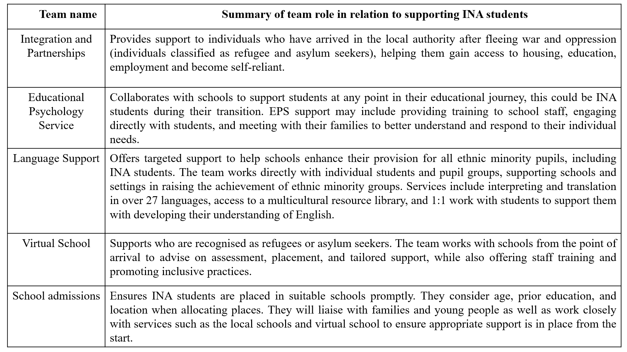

*Table 2 - Team roles in relation to supporting INA students*

In addition, through these conversations I was informed of which secondary schools they had worked with most frequently and would have a number of INA students thus suggesting staffing groups that may fit my participant criteria.

When my research gained ethical approval in May 2024, I emailed the various team managers I had spoken to or been made aware of as potentially working with staff who fit my participant criteria this included contacting the virtual school, integration and partnerships team, language support, school admissions as well as the EPS and three school SENCos as mentioned in my conversations with the services noted. Having identified that I was aiming to recruit between six to eight participants, I felt that contacting all eight of my connections would increase my chances of getting a range of participants from across the services and teams and fulfil my planned sample size.

The team managers and SENCos contacted were provided with a research summary (Appendix I) and asked to share this with their teams. Potential participants were given information on how to contact me as the researcher to express their interest in taking part. Those who got in touch were then provided with an information sheet and a link to an online consent form. Once consent was given, we communicated to arrange a mutually convenient date and time for the virtual interview.

Through this way of recruitment, participants were not contacted directly by the researcher but rather they were informed of the research via their managers, who acted as gatekeepers. In social science research, the term 'gatekeeper' refers to individuals who control access to the field (Aaltonen & Kivijärvi, 2019). In the case of this research, the gatekeepers controlled access to potential participants. The effects of obtaining a sample through gate-keepers has been discussed within qualitative research, yielding mixed views (Wanat, 2008). I decided to utilise a gatekeeper sampling method because I felt that this would support me with gathering data from a variety of people whom I wouldn’t know of or how to reach. I was aware that my participant criteria was very specific, and wanted to ensure that my research was being shared with groups who were most likely to fit this as I didn’t feel this would be the case through different means of sampling such as voluntary response sampling.

***3.3.4 Recruitment***

I recruited six participants for this research. Of the eight gatekeepers contacted, I gathered participants from five of these teams. Relevant participant details are discussed below in the participant section.

Of the eight gatekeepers approached, three emailed their teams about the study and included me in the email, therefore I was able to see how many potential participants were contacted which allowed me to get an idea of the response rate (*Table 3*). The response rate is the proportion of those approached regarding the study and the total number who participated (Patel, Doku and Tennakoon, 2003).

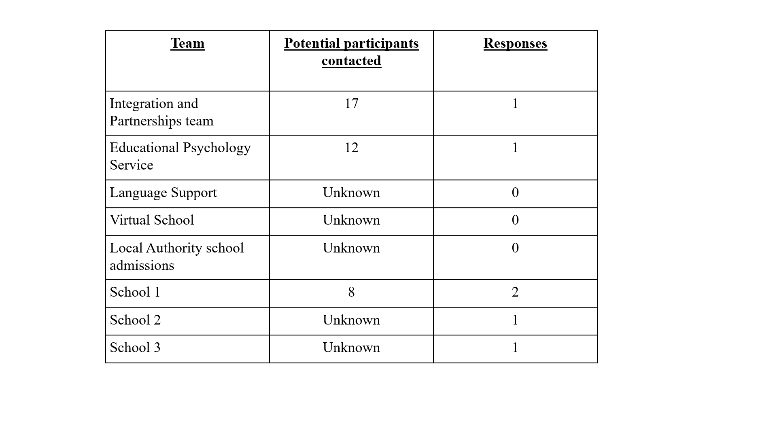

*Table 3 - Recruitment of participants response rate*

I am unaware how many participants were contacted from five of the other team managers I spoke with, however I did get participants from two of these teams. From the teams whereby I did not receive any responses and was not included in their correspondence sharing the research with staff, I did not contact managers a second time.

It is important to note, that not all of the people contacted may have fit the very specific participant criteria and therefore gives a possible reason for the relatively low response rate, however given that my planned sample size was between six to eight participants, the number of responses allowed me to fulfil this.

Contact was made with all the gatekeepers early June 2024 following reflection from the pilot study the week prior (this will be further discussed in the pilot study section).

Once participants emailed to show interest in partaking in the study, I shared with them an information sheet (Appendix II) and consent form (Appendix III). Participants were reminded in our email correspondence that they could ask any questions, and that they had no obligation to take part in the study should they wish to withdraw themselves at any point until the time stated in the consent form when the anonymised data would be analysed. All who contacted to show interest, did take part in the study. None of the participants requested to speak beforehand, and virtual meetings were arranged at a time that was convenient for them.

Participants' contact to show interest in the study came spread over a number of weeks in June, but given the GCSE examinations taking place throughout the month, all of the interviews with school based professionals did not take place until July. A potential challenge was the consideration of these participants dropping out in the time between indicating that they wish to take part, and waiting for their interview. If this were to be the case then I would need to consider another plan given that I had received interest from my minimum decided sample size. I reflected that as these participants had approached me to show interest and had been honest about their busy schedules, then they had displayed enough of an interest and desire in the topic to be unlikely to drop out. Therefore, I did not pursue any other active recruitment methods and waited for these participants to have time post GCSE examinations. All participants who contacted me did take part in the study, an interview schedule can be seen below in Table 4.

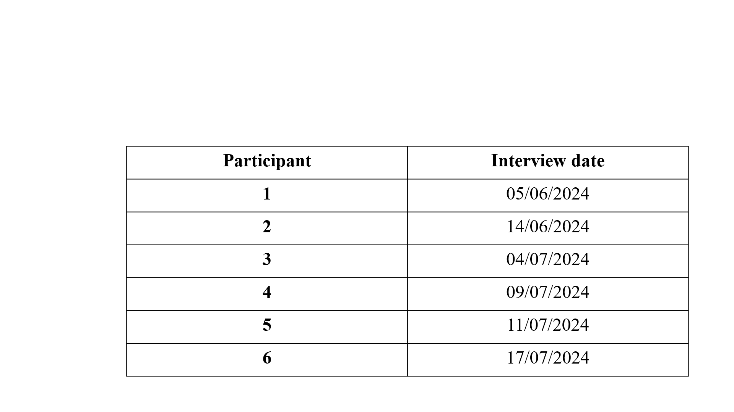

*Table 4 - Participant interview chronology*

As I had interviewed the minimum number of participants I needed for the study by the beginning of the summer holidays, and had not received any further interest from other potential participants, I decided to stop recruiting at this point.

***3.3.5 Participants***

I recruited six participants. At the beginning of each interview, I clarified with the participant that they met the inclusion criteria that was included in the study overview sheet, participant information sheet and consent form.

Participants will be referred to by their job roles throughout this research as it provides important context regarding the participant's insights, experiences, and reflections. Some of the participants working within educational settings had numerous job responsibilities which were reflected upon throughout their interviews, so these have been listed within their title. Two participants shared their lived experience of having migrated to the UK themselves, this is included as relevant information for reflection within the data analysis and shown below in Table 5.

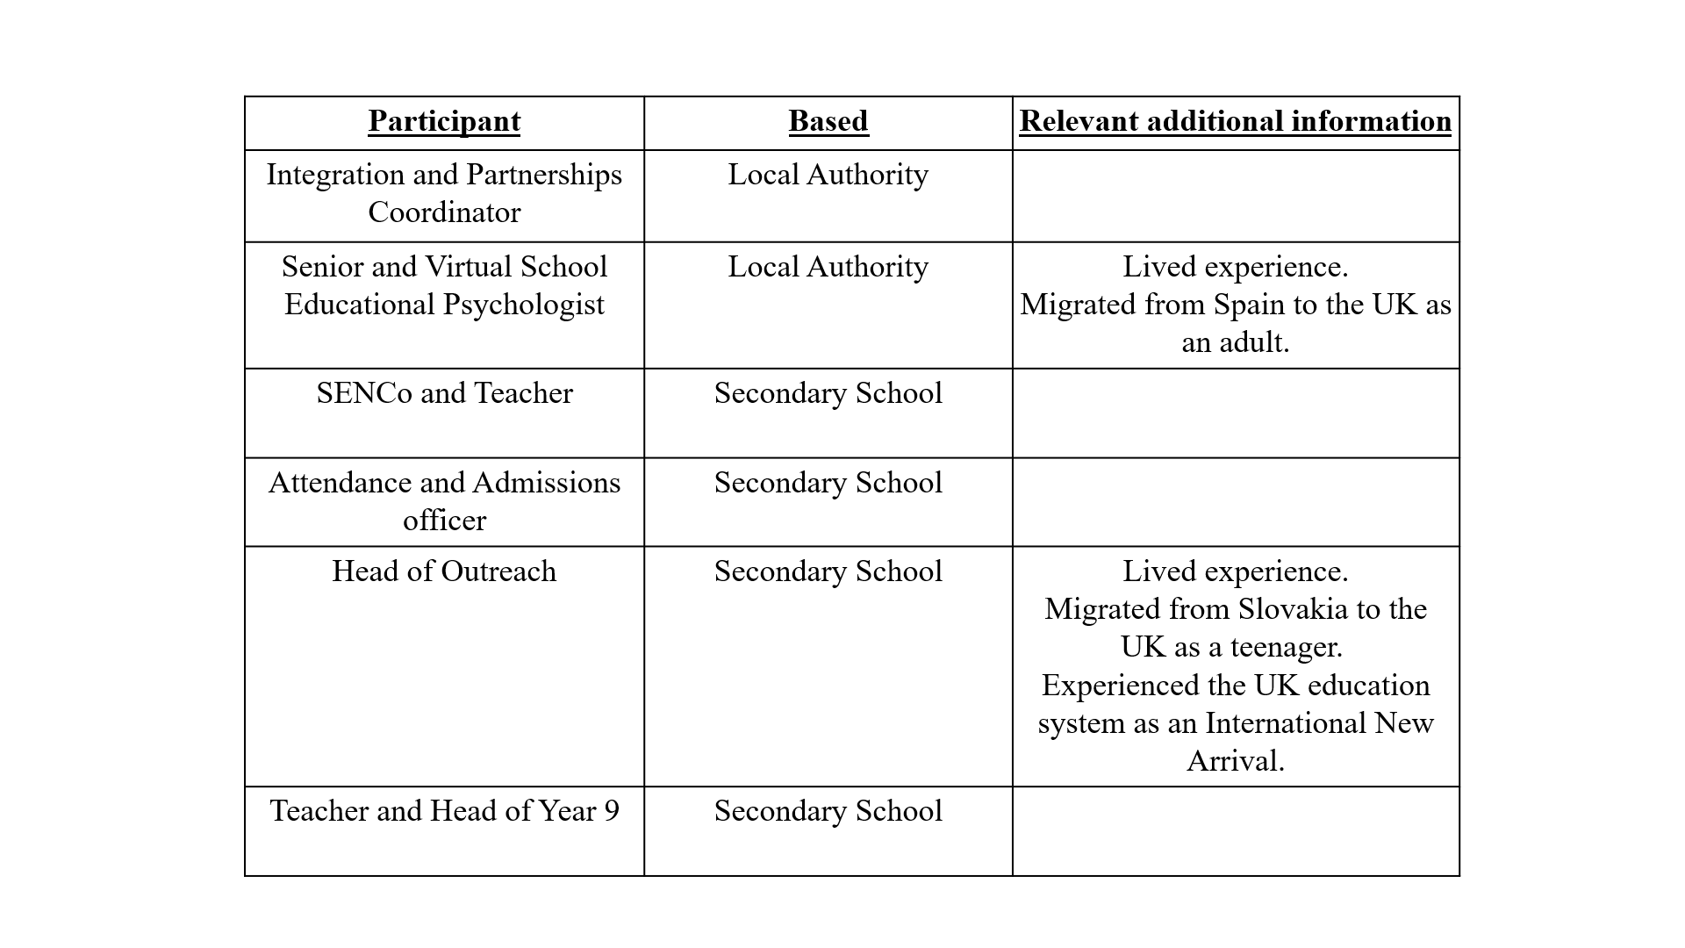

*Table 5 - Relevant participant information*

**3.4 Data collection**

***3.4.1 Appreciative interviews***

In appreciative interviewing, questions are framed positively, with hope and creativity, to encourage reflection on highpoints and visionary thinking, such as asking ‘What made it possible?’, ‘Why was it a positive experience?’, ‘What could make this possible to happen again?’ (Cooperrider, Stavros and Whitney, 2008). The questions are designed to flow from a personal to a collective perspective, and from a retrospective to a forward-looking orientation. (Schultze and Avital, 2011). Thus, by utilising this method of data collection the aim was to explore positive experiences of supporting the transition of INA students as in their transitional period to joining a UK Secondary school. The interview hoped to gain participants' perspectives of what made their support positive and consider what we can learn from this to identify strengths and potential for improvement within the support provided, in the future.

***3.4.2 Appreciative Interview prompts***

Appreciative interviews, when utilised in isolation from an appreciative inquiry cycle, are based on the same principles suggested by Cooperrider and Srivastva (1987). The appreciative interview leads from a specific affirmative topic and with guidance from the researcher prompts using questioning in a hopeful and appreciative tone, the participant considers the strengths and positives of an experience (Michael, 2005; Schultze and Avital, 2011; Enright et al, 2014; Arundell, Sheehan and Peters, 2021). The focus of the questions and the resulting conversation is introspective, whereby the participant will be reflecting upon their own experience and views (Adams, Schiller and Cooperrider, 2004).

The underlying premise of appreciative interviewing is two-fold: to explore retrospectively the positive experiences, strengths and successes of a situation and then to prospectively consider how that could be achieved again (Michael, 2005; Schultze and Avital, 2011). Michael (2005) emphasises the importance of inviting participants to tell stories by beginning with an open-ended question and guiding with prompting questions that alternate between reflecting on the past and the future, as well as between personal and collective perspectives.

Schultze and Avital (2011) suggest that the interview design and probing questions should aim to leverage the best of ‘what is’ and ‘what might be’ presenting a process for conducting the interviews which has been used to inform this research as shown below in Figure 2.

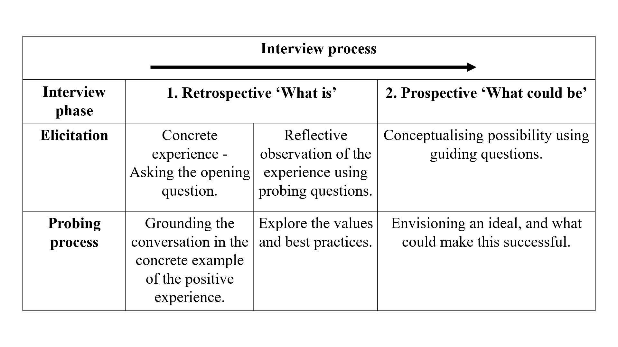

*Figure 2 - Process for conducting Appreciative Interviews. Informed by Schultze and Avital (2011)*

Interviewers may use probing questions such as: ‘What made it possible?’ ‘Why was it a positive experience?’ ‘What could make this possible to happen again?’, as well as asking participants to consider values, skills and best practices. (Michael 2005; Schultze and Avital, 2011; Arundell, Sheehan and Peters 2021). Thus, to prepare for the interviews, I compiled a brief list of questions and prompts to help guide the conversation if needed, following the structure presented above in Figure 2 as informed by Schultze and Avital (2011).

Opening question:

Can you describe a time when you feel you positively supported an INA young person, during a transitional period?

Retrospective probing questions:

* What do you feel made this a positive experience for those involved?
* What did you do, feel, or tell yourself that made this a positive experience?
* What made it possible?
* What values do you feel were important in making this a positive experience?
* What skills do you feel were important in this experience?

Prospective guiding questions:

* What could make this possible to happen again?
* What do you see as potential ways to achieve this future?

***3.4.3 Conducting the interviews***

The data for this study was collected via a virtual interview and interviews lasted between thirty to forty-five minutes. I decided to conduct the interviews virtually for practical reasons. Firstly, in the LA I am placed, the office is open plan and doesn’t have allocated desks meaning that should I want to complete the interviews in person, the office would not be viable due to the lack of privacy. Secondly, given that I was attempting to access participants from a variety of roles and workplaces, to ask that we have the interview in person at their workplace would potentially put some participants off taking part as this would be something for them to organise, or they may not have the available space. Research has highlighted that virtual interviews enhance accessibility and convenience for both interviewers and participants, especially when targeting hard-to-reach populations (Archibald et al, 2019). Due to the time scale planned for this study, I felt that virtual interviews would be the most appropriate.

I did consider how conducting my interviews virtually may impact the rapport building with participants and potentially influence their responses as it may feel more natural in person, however a study by Deakin and Wakefield (2014) found that in virtual interviews conducted via Skype, participants shared that they felt at ease in familiar environments. They suggested that the quality of the interaction was not limited by the virtual nature of the interview (Deakin and Wakefield, 2014) so I did not feel that the virtual aspect of the interviews would impact the data.

Interviews were conducted with cameras on, and participants were assured that they could turn theirs off should they wish however none of the participants did. I started by confirming that they had read the information sheet and they were the one who signed the consent form. Participants were reminded of their right to withdraw. Following the pilot study, I had created a PowerPoint presentation to briefly cover what I was asking of the participants (Appendix VI) and to clarify that they met the participation criteria of having an experience to reflect on. Participants were reassured that mentioning any less positive points was alright, as that was relevant due to being part of their experience. Participants were all happy to take part and none of them had any questions.

Throughout the interview I endeavoured to show active listening to participants through non-verbal cues such as nodding and adjusting body language to compensate for communication gaps with the interview being virtual (Seitz, 2016). As well as using short verbal responses such as ‘Yes,’ and ‘Mm-hmm,’ as research suggests that this communication encourages a conversational rhythm from participants by signalling that the interviewer is interested in hearing more (Coburn, 2009). Additionally, reflecting upon feedback from the pilot study (Section 3.5) whereby my colleague shared that they felt they were able to speak without interruption as I waited until a natural pause to ask a probing question.

I used a range of the probing questions, listed above, when they felt most appropriate following the participants' narrative. These can be found within the transcriptions (Appendices IX - XIII).

**3.5 Pilot interview**

I completed a pilot study prior to my participant interviews. A pilot study is a small-scale study conducted to assess the viability of conducting the main study, to refine the data collection methods and identify any potential practical or ethical issues (Aziz and Khan, 2020). As a novice researcher, the pilot study was an opportunity to practise my interviewing skills with the opportunity for feedback.

The pilot study was completed with a previous colleague, who currently works as a secondary school teacher. Given the specific participant inclusion criteria that was needed, I decided to approach an individual whom I knew fit these criteria.

Given that I had a relationship with this individual already, I felt that the familiarity would support a more relaxed atmosphere, and this would help me to feel more comfortable in trialling my interview and the participant to feel more comfortable in sharing their thoughts. I did, however, consider how this familiarity could introduce a bias and influence the honesty in the feedback they give me. In order to mitigate the potential for the participant providing me with overly positive feedback to avoid making our relationship uncomfortable, I was conscious of how I framed their support with this pilot study. I ensured that the participant was aware that any feedback would be constructive in supporting the refinement of the research process or instruments, which included the skills I demonstrate as an interviewer.

The pilot interview took place virtually, over the same platform I would be utilising for the research interviews. I have summarised the feedback I received from the pilot and how I chose to respond to this in Table 5 below.

|  |  |
| --- | --- |
| ***Feedback*** | ***Response*** |
| My colleague suggested that it may be useful to have a reminder of the question visually at the beginning given that the research was taking place virtually. They stated that my initial introduction of the research was useful, but a lot of information was provided at once.  Additionally, they suggested that although it wasn't in our pilot interview, sometimes the internet connection can cause delays or make hearing a bit difficult, so to have the opening question on the screen would be useful. | I reflected that my research participants would have already had the information sheet and consent form, as well as an opportunity to ask any questions before the interview. Given this, I possibly wouldn’t have talked as much in the beginning as I did with my pilot participant.  I agreed with what my pilot participant suggested about having the initial question visually and created a PowerPoint slide that I shared on the screen to my participants at the beginning of the interview. Although neither I nor my participants experienced any technical difficulties, I was glad that I had the information on the screen should there have been any problems. This PowerPoint slide can be found in Appendix VI. |
| In a conversation with my colleague we discussed how they found it hard to not mention some negative points even when reflecting on a positive experience. We spoke about the nature of the context of this research and how this would likely be the case for my research participants too. | The interviewing technique of appreciative interviews supports the opportunity for open ended storytelling Avital (2011). In this way, it eliminates a presumed need to defend or justify bad experiences (Michael, 2005). Although this point is noted within the information sheet, given my colleagues' reflections it felt important that this is also highlighted to participants at the beginning, along with the safeguarding and consent information.  Reflecting on my pilot participants, I decided to share this more explicitly with the participants at the beginning of the interview and to add it to the PowerPoint slide that would be shown on the screen (*as noted above*). |
| My colleague found the interview structure clear and felt at ease with the way it was conducted.  My colleague also shared that they appreciated that they were allowed to speak through their experiences without me interrupting but instead waiting until they came to a natural pause in the conversation. | I also felt that the interview went well. The interview lasted for around 30 minutes and produced a volume of data that seemed relevant and could be analysed within a reasonable timeframe. I utilised a range of prompts that I had collated but used these in a natural way as to allow the participant to speak openly without guiding their narrative. As both myself and my colleague felt this went well, I therefore used the same approach with the research participants. |
| My colleague and I reflected on how they used some abbreviations when talking about aspects specific to their school context and some of these I did not know. We talked about how it could be difficult to follow a narrative without knowing what some of these mean, but also not wanting to interrupt the flow of the storyteller (interviewee). | I considered asking my participants not to use abbreviations in advance of the interview, however I felt that this would be me altering their narrative and wanted them to talk freely. I decided to utilise the approach that my colleague had said they appreciated, which was to wait until there was a natural pause and use that as an opportunity to clarify what the abbreviation meant. |

*Table 6 - Pilot interview feedback and response*

**3.6 Ethical considerations**

This research was granted ethical approval from the University of Sheffield's Ethics Board on the 9th May 2024 (Appendix V) and adhered to the British Psychological Society’s (2021a) Code of Ethics and Conduct. Within this, I ensured that participants informed consent was gained, there was no deception, and they were aware of their right to withdraw, as well as their personal information being kept confidential by ensuring I had a clear data management plan. An overview of how I achieved this is reflected below.

Participants received an information summary via their managers (Appendix I) and an information sheet (Appendix II) after contacting me. They signed a consent form (Appendix III) and were encouraged to ask questions before the interview. Although no psychological risks were anticipated, I considered the potential physical impact of virtual interviews, such as eye strain, and informed participants they could take breaks or pause at any time. Participants were also told they could withdraw without explanation. A debrief sheet was sent via email (Appendix IV), and contact details for a safeguarding officer were provided.

As participants were gained through gatekeepers, the team managers had agreed by sending out the details of this research to their staff, they understood that if a staff member was to contact me and take part then they would be taking around forty-five minutes out of their working day for the interview. I did not disclose whether anyone from their team participated, ensuring confidentiality. Participants are referred to by their job role, with other details controlled for anonymity, including their names and LA.

To ensure online security, interviews were held in a password-protected virtual room. Recordings were stored on a password-protected Google Drive and deleted after analysis.

**3.7 Data Analysis**

***3.7.1 Reflexive Thematic Analysis process***

RTA follows a six-step process to facilitate guidance through data analysis. Appendix VII outlines how I approached these phases within the context of this research study.

Throughout all the stages of the data analysis process, I kept a reflexive diary to acknowledge my assumptions as well as to reflect and consider the choices and actions I took which supported my interpretation of the data (Braun and Clarke et al, 2023), these can be found in Appendix XIV.

Braun and Clarke (2006) explain that a researcher can take two approaches to RTA: a top-down approach whereby the researcher analyses by separating out data into the specific research questions, or a bottom-up approach in which the researcher takes a more inductive approach to the data. Gibbs (2007) suggests that these approaches to coding are not exclusive, and most researchers move back and forth between them, because in most cases researchers may have defined research questions, but they are interested in an exploratory approach to this. Analysing the data as a whole allows the analysis process to be more driven by the data itself, and then the researcher can consider the overall themes in relation to the research questions afterwards (Maguire and Delahunt, 2017).

With regards to this research, I considered analysing the data separately for each research question given that RQ1 was more focused on understanding (which might highlight subjective perspectives, experiences, or values), and RQ2 was about perception of best practices (which might identify actions and strategies). When considering this, I held in mind that by analysing separately I may find that some broader themes emerge that could be relevant to both questions. I wondered if by analysing the interview scripts without forcing it into predefined categories based on the research questions, whether this may allow for a deeper, and more nuanced understanding of the data. In addition, this would align with an interpretivist epistemology.

Thus, by analysing the data as a whole, I felt this would give more flexibility to interpret the data in context. Therefore, the aim was to allow the themes to emerge naturally in response to all the research questions rather than forcing them into separate categories. Once themes have been identified, the research questions within the discussion section of this thesis could be revisited, in order to discuss the relevant themes and subthemes, with each question.

***Step 1: Data familiarisation***

I transcribed the interview recordings as part of the familiarisation stage. This involved listening to each of the recordings through several times, ensuring to capture accurately what the participants were saying but also that any points where identifying factors were used, were redacted to ensure that both the participants, as well as locations and other individuals referred to, were kept as anonymous as possible. Additionally, the transcripts were annotated to note points of tone changes, laughter and pauses. Initial reflections were noted within my reflexive diary (Appendix XIV and shared throughout Chapter 4 of this thesis). All transcripts can be found in the Appendices (Appendix VIII - XIII)

In familiarising myself with the data and reflecting on the appreciative interviews I had conducted, I acknowledged that participants had discussed challenges and difficulties during the interviews. As aforementioned, even though appreciative interviewing takes a positive worldview, it does not deny deficiencies and criticism (Elliott, 1999). When analysing these discussions, in line with appreciative interviewing and RTA, I sought to interpret what the difficulties revealed about the strengths and resourcefulness of participants. For example, challenges that were discussed with regards to supporting students were often paired with reflections on how staff adapted, or because they felt ill-equipped and showed their care for wanting to provide the best support possible (all further discussed in Chapter 4 and Chapter 5). In this way, I reframed the negative comments as indicators of areas where positive change could occur, rather than simply seeing them as shortcomings.

Throughout the analysis, I continued to reflect on the text as a whole and consider the latent meanings (in line with RTA) to maintain a focus on the potential for positive transition while ensuring the credibility of participants' experiences. RTA enabled me to draw on my own reflections and consider the broader meaning behind the data, allowing me to contextualise any challenges mentioned.

***Step 2: Data coding***

All transcripts were uploaded to NVivo which was utilised for coding and theme generation. I read through transcripts individually, noting specific sentences or phrases that I felt were interesting and then would label this with a code name.

Some codes initially were more descriptive, for example highlighting explicitly what was said such as ‘*I think also then the communication with the language support team within the council*’ (Appendix XI) was coded under ‘Communication’. Additionally, I began making interpretive codes, for example those statements that I felt reflected a broader meaning such as, ‘*...Being flexible to the needs of every pupil, whilst also allowing them to access a curriculum thinking about their understanding that their access might be different…’* (Appendix XIII) was coded under several codes including ‘Equity’.

As mentioned above, throughout this stage I was continually reflecting and reading the text as a whole to consider the wider meaning of any difficulties and negatives mentioned. For example, a participant talking about feeling unprepared when read in context of the surrounding data from a participant reflected their vulnerabilities in acknowledging how they wanted to do the best job for the young people they were genuinely invested in. This showed care and strength in the relational underpinnings of their support and was therefore coded as ‘staff vulnerability’ and ‘relationships’.

After the initial coding, I could see where each of the references for the codes had come from across the transcripts: 81 codes with 807 references *(See Appendix XV).*

***Step 3: Initial theme generation and Step 4: Theme development and review***

I continued going through all the codes, some of which clearly showed some overlaps when considering the latent description and this made it easier to streamline some codes. This part became more difficult when I had to take a step back to ensure I was considering the themes on a less surface based level. At first, this meant creating new codes that felt to be a better representation of what was being shared. I spread this stage out over a couple of weeks, allowing myself time to reflect and come back to it to ensure that I was interpreting a wider meaning.

After the initial theme generation, I could see where each of the references for the codes had come from across the transcripts: 22 codes with 246 references *(See Appendix XVI).*

***Step 5: Theme refining, defining and naming and Step 6: Writing up***

Knowing when to stop theme refining and decide on the finalised theme names that I would be writing up, was something I had to contemplate. There is no clear cut off for this and is at the researchers discretion as it is considered inescapably situated and subjective (Braun and Clarke, 2023), however key indicators that depth has been reached within the data analysis include the repetition of themes whereby the same codes and themes keep reappearing, (Fusch and Ness, 2015). Given that I had taken a period of a few weeks to go back and forth through the themes and the data allowing time for reflection (as shown in my reflective diary shared throughout the analysis section of this thesis), I felt that I had achieved a depth of understanding of the data thus I ended my data analysis at this point.

Final theme refining resulted in 4 themes and an additional 11 subthemes *(See Appendix XVII).*

**3.8 Quality issues**

According to Yadav (2022), the varied paradigms in qualitative research prevent the establishment of a universal set of quality criteria. Tracy (2010) notes that criticisms of traditional criteria have prompted the development of new benchmarks and standards, leading to the emergence of several quality frameworks that typically emphasise criteria such as trustworthiness/credibility, usefulness, generalisability, transparency, and reflexivity (Burgess, 2024).

***3.8.1 Credibility***

Within qualitative research, credibility refers to the extent to which the findings accurately reflect the participants' experiences and viewpoints. (Stahl and King, 2020) and thus researchers must consider how their method and analysis captures the participants' realities. It is necessary to mention that the central part of appreciative interviewing is the positive route taken to data collection and thus the methodological approach is biased towards considering an appreciative lens towards the research topic. To make my research credible, it was important that participants were aware that the positive stance to the question did not mean they could not deviate from this, should that be important in understanding their experience. Therefore, I clearly articulated that their experiences as a whole were important and not to disregard any less positive points. Liebling, Price, and Elliott (1999) state appreciative research is not a way of concluding complete truths, in fact much like all qualitative research, it offers a partial view of the topic (Liebling, Price and Elliot, 1999 as cited in Enright et al, 2014).

In fact, credibility pertains to the degree of alignment between the participants' perspectives, the researcher’s portrayal of their experiences, as they relate to the research questions (Tobin and Begley, 2004 as cited in Nowell et al, 2017). As such, the data analysis phase of research can also influence the perceived credibility of the research. Utilising reflexive thematic analysis, I documented my reflections throughout the process and referred back to them at various stages of the analysis, to remain aware of how my own biases and assumptions might shape the interpretation of the data.

***3.8.2 Transparency***

Transparency within research relates to what is happening during the analysis/reporting and thus the dissemination phases of the research (Aguinis and Solarino, 2019). Transparency shows the researchers integrity and trustworthiness in how they have arrived at the findings being presented. Therefore, throughout this research I utilised a research journal and reflected throughout. I have also documented within this thesis, my own positionality in what brought me to have an interest in this topic as well as my own preconceived notions and honest thoughts throughout this process. I found that naturally in conversation with my participants before beginning the interview I shared that I had previously worked as a teacher in a school supporting a high number of INA students hence my interest in this area.

***3.8.3 Usefulness and Generalisability***

In research, 'usefulness' pertains to how the study can aid in improving practice. This will be explored further in the discussion section of this thesis. I believe this research is valuable due to the increasing migration of CYP to the UK, a trend expected to continue (Home Office, 2023), which will raise the demand for LAs to support the transition of INA students into secondary schools. This research may help inform policy and practice both within the LA and beyond.

In qualitative research, generalisability is viewed through the lens of transferability, defined as "the degree to which the results of qualitative research can be transferred to other contexts or settings with other respondents" (Korstjens and Moser, 2018, p. 121 as cited in Burgess, 2024). This research could be applicable to the transition of INA students across other LAs. To aid transferability and generalisability, I will offer a detailed account of the transition processes within the LA, allowing readers to assess based on the provided 'thick description’ (Korstjens and Moser, 2018, p. 121).

I will return to the quality issues discussed in Chapter 5 to consider how I addressed these concerns throughout the research process. This includes reflecting on how the methods used, such as appreciative interviews, contributed to the richness of the data and allowed for useful and meaningful insights. Additionally, I will assess the steps taken to ensure transparency and credibility of the findings.

**Chapter 4 - Analysis**

**4.0 Introduction**

As mentioned in Chapter 3, the data was analysed as a whole rather than separated into research questions at this point. The aim was to allow the themes to emerge naturally in response to all the research questions, rather than forcing them into separate categories, and then once themes have been identified, to revisit the research questions within the discussion section of this thesis to discuss the relevant themes and subthemes, with each question. Thus, the purpose of this analysis section is to present each theme and subtheme that arose and support these with quotes from the data.

Upon analysis of the participants' interviews, I identified four themes and eleven sub themes supporting these.

|  |  |
| --- | --- |
| **Theme** | **Subtheme** |
| **Being human at the heart of support** | * Wholehearted empathy * Personal investment connection * Staff vulnerability |
| **A dynamic whole person approach** | * A flexible and holistic centred plan of support * We couldn’t do it without the family |
| **Listening to the unspoken** | * Value in reflecting on past experience * Attuned to the emotional undercurrents * Considering the bigger picture of wellbeing |
| **Synergistic support** | * Automatic collective action * Necessity of professional interdependence * Developing cultural competence |

*Table 7 - Analysis Themes and Subthemes*

The quotes are presented as spoken by the participants with omissions of identifiable information such as names, geographical locations and school names. Ellipses (...) have been used at points to shorten long sections of speech while maintaining the overall meaning so as not to overwhelm the reader and streamline to the specific point (Maxwell, 2013).

Within some theme sections, there are reflective boxes outlining my thoughts and dilemmas that I faced during the analysis process. Acknowledging and leaning into my own subjectivity and bias to make analysis decisions, is something that is recognised within the RTA process. Thus, I present my thoughts to enhance the transparency of my decision-making process.

**4.1 Theme 1 - Being human at the heart of support**

|  |  |
| --- | --- |
| **Theme** | **Subtheme** |
| Being human at the heart of support | * Wholehearted empathy * Personal investment connection * Staff vulnerability |

A key theme emerging from the participants' interviews was the human element at the core of their support approach thus the theme is termed ‘Being human at the heart of support’.

‘Being human’ refers to the qualities that make us human. Ikeda (2005) suggested humanism can be characterised as being compassionate for the needs of others, as well as recognising our own needs within this relational context. Aldefer (1972) suggested that connectedness is a central human motivation and therefore, being human could be said to encompass a variety of relational qualities such as empathy, understanding, kindness, and the ability to connect with others on an emotional and personal level, which is reflected in the data for this theme.

The ‘heart’ within this data context, suggests a sense of deep emotional involvement, compassion, and authenticity. As highlighted by the participants, meaningful and positive experiences of support for INA students goes beyond task completion; it is about genuinely seeking to truly understand how it feels for them and what can make their support the most meaningful and positive for the young people. Thus ‘at the heart of support’ indicates that the core of the support comes from a place of empathy and genuine care and this theme emphasises human nature as the driving force behind the support, implying that the support is not just transactional or mechanical, it’s heartfelt, and emotionally engaging from the educational professionals involved. Overall, this theme reflects the emotional and relational aspect of support from the educational professionals involved in providing it. Three sub themes further explore this central idea.

**Subthemes**

***4.1.1 Subtheme 1: Wholehearted empathy***

Participants referred to situations where they appeared to internalise suggesting they deeply felt the feelings and emotions of the young people and families they were working to support and further explained how they really to understand their experiences. For some of the participants they discussed feeling the emotions themselves, imagining the perspectives of the INA children and families and how this influenced their responses. ‘Wholehearted empathy’ is therefore the term used to describe this subtheme, as it relates to participants' descriptions of being emotionally open and deeply compassionate for the INA young people they were supporting. This goes beyond simply empathising, but this sub theme represents a more authentic connection rooted in the emotional understanding for the young people and their families, from the educational professionals.

*"When the child saw that I was speaking Spanish, she came, she hugged me, she was crying, and I could only imagine how lonely they must have felt during those couple of weeks that they didn't speak any English." (Educational Psychologist)*

*“…but for her that was monumental. And honestly, even thinking right now like it gets me so like proud and almost emotional about it. So yeah, I think it made a really positive impact for me because I, I mean it was very, I feel like emotional at that point because she was, she is as a person, was very emotional and you had that connection with her…” (Teacher/Head of Year)*

Participants didn’t just acknowledge the feelings of the people they were supporting but also internalised the emotional weight of the experience. Literature defines this as affective or emotional empathy, being the “emotional response that stems from another’s emotional state” (Eisenberg and Fabes, 1990, p. 132). For example, the EP not only recognises the young person's tears and actions but reflects deeply on the loneliness, choosing to feel how the child might have felt, creating an emotional resonance with their experience. Similarly, the teacher highlighted how one emotional moment (noted as monumental for the student) had a profound, lasting emotional effect on them also.

*"I guess that people just sort of, valued that we recognise that someone's struggling or family is struggling and this isn't something. Perhaps that can wait. If that makes sense?" (Admissions and Attendance)*

Participants reflected on a cognitive empathy, the mental perspective taking of another (Smith, 2006). Participants showed an awareness of the struggles faced by the young people and their families, in the case of the admissions and attendance participant, having a genuine and wholehearted empathy by recognising family struggles or hardship, meant responding to their needs as a priority.

***Connection to the main theme***

‘Wholehearted empathy’ emphasises recognising and feeling the struggles of others and in the supporting roles of the participants in this research, this appears to be at the heart of it. Participants discussed understanding as well as feeling the emotions and challenges of those they were helping and how these were stand out aspects for them in the support they delivered.

***4.1.2 Subtheme 2: Personal investment connection***

Participants discussed points of deliberate meaningful effort on their part to build relationships with the INA young people they were supporting. Thus, this sub theme is termed ‘personal investment connection’ to explain how participants emotionally, mentally, and in one case physically committed to the INA young peoples’ well-being and positive experience. What the participants described was not just about spending time with the young people they were supporting, it was about actively caring for the relationship and aiming to play a role in their lives in a meaningful way.

*“Erm, at the time, one of our members of staff was just about to retire. And she actually agreed to stay on until the July. She she would. She's one of these. That would have gone above and beyond regardless, but she she became a little bit of a. I don't want to say a mum figure because not a mum figure but she was they they would. She didn't just teach them. She didn't just teach them English. She was there when they had problems. She was the one sorting the problems out when they came and they've not got uniform and things like that. She was the one running and getting them the uniform, or erm if parents wanted something she was the one ringing the the council, the Refugee Council. She she just took them under her wing and wasn't like a teacher.” (SENCo)*

The staff member described here was a teaching assistant, who went beyond their traditional role. She showed a deep personal commitment to the students, offering support that extended beyond academics. This kind of investment in the students' lives shows a personal, emotional connection taking on the role of a supportive guide and advocate.

*"he finds great joy in her trying to learn Arabic. And I've done that myself… So I can, I can say a few words in Arabic and it just brings them a sense of, oh, right. You know, it's you want to learn about my culture as well and it is that connection it's about you know the value of. Human connection and. Relationships…” (Teacher/Head of Year)*

This participant discussed how intentional work and effort was put into their support for INA students and how this goes beyond the simple expectations of their roles. Not only is the teacher sharing knowledge, but they’re also learning from the student and engaging on a deeper, more personal level. The purposeful and thoughtful actions involved an emotional and relational investment in the students’ well-being, by engaging with them in a way that acknowledges their individuality, cultural backgrounds, and specific needs.

***Connection to the main theme***

Participants speaking about these human-centred connections in the context of positive transition for INA students, they are reflecting how the context of ‘Being human at the heart of support’, requires a deep commitment to seeing students as more than just learners and reflect on the conscious effort to connect with students in ways that are authentic to the students’ experiences.

***4.1.3 Subtheme 3: Staff vulnerability***

Participants discussed feeling ill equipped in being able to support new arrival students effectively and to the quality of care that they wanted to, thus this sub theme is termed ‘Staff vulnerability’. This vulnerability comes from the emotional and practical challenges that arise when staff care deeply about providing quality care but feel unable to meet the high standards they set for themselves.

*"Without, without sounding awful that came a bit of a shock to all of us because obviously their English was very, very limited and we, if I'm honest, we we didn't know what we were doing initially. So we had really big induction meetings with where they all came in together with the Refugee Council, with as many people as as possible." (SENCo)*

*“So then it was filtered down and it rolled, kinda went into panic mode. Like what we're going to do with this and then obviously my role at the time was supporting erm, I was the only support worker for refugees in the Council at the time so it's like almost you’re the most experienced person for the for the job. So you're going to take a lead on it, even though I was only a grade seven at the time or whatever it is, I didn’t have that much experience for what was really necessary.” (Integration and Partnerships)*

*“So got the schools were applied for (Identifying factor removed) and basically they were saying they’d not had a foreign student before an that and they were a bit scared of taking em 'cause this person was, you know, very new to the country, very little English. They were worried about how they were going to cope at school.” (Integration and Partnerships)*

*“...I think we've, we've kind of taken it under the SEN, although none of us are specialists at all.” (SENCo)*

These quotes demonstrate the vulnerability of staff in the face of uncertainty and how this can create uncomfortable emotional feelings. Overall, these quotes exemplify staff vulnerability by showing how participants particularly feel and are concerned about being exposed in their role.

*"I know that when I've spoken to, to the teachers and say, we've got a new student coming to your class and they’re new country and there's some new English. It just tends to be a panic and I get it because. You want to do the best by everyone and you want to ensure that students feel, supported and happy and they're able to learn. And when you don't have that experience in that, I can understand why that's quite stressful situation because you don't let people down." (SENCo)*

This quote acknowledges the emotional stress and pressure that comes with wanting to do the best for students, especially when they feel inadequate within the role. Thus, the vulnerability lies in their fear of failing to meet the needs of students, which shows the emotional and professional weight staff carry when they want to ensure student success.

***Connection to the main theme***

Staff vulnerability ties into the idea of being human, being open and imperfect. Staff recognised and spoke about their limitations within the context of speaking about support for INA students that they felt was positive.

Within this main theme, staff vulnerability isn’t to be seen as a weakness but rather it’s an honest recognition of the challenges that come with caring deeply for students and wanting to do right by them. Thus, for the participants, vulnerability in this context was driven by the desire to not let those they are supporting down, and wanting to provide support to the best of their ability whilst acknowledging within their support that they have faced moments of uncertainty or insecurity.

**4.1.4 Theme 1 summary**

In this research context, ‘being human at the heart of support’ for the participants reflected how the act of supporting INA students is not just a professional duty but rather a deeply human endeavour. The subtheme ‘whole hearted empathy’ recognises how educational professionals feel positive transition support is enhanced by being emotionally present with someone. The staff members who were interviewed, note how within their positive experiences of INA support they were actively connecting with the students on a personal level, which requires a ‘personal investment connection’. Participants acknowledged their own vulnerabilities and limitations which are part of being human and shows their desire to provide authentic care and positive support experiences.

|  |
| --- |
| **Reflexive box 1** |
| I had grappled with whether ‘Staff vulnerability’ should be an entire theme within itself. This felt to come out strongly within the data, whether stated explicitly by the participants, or through the way they talked around this. I continued to re-read the quotes that I had coded into this broader idea and it felt that staff were admitting their unknowns and being vulnerable, because they wanted to do the best job possible within the support they provided. Being vulnerable and openly showing your vulnerability itself, or feeling like you can’t, felt to me to be an aspect of just being human. It is a normal feeling to want to do the best and feeling vulnerable to admit that you don’t feel equipt or adequate to do that yet. Therefore, taking how the staff felt vulnerable or presented their vulnerabilities, from the participants' quotes, I felt that it fitted most appropriately as a sub theme within the wider theme of ‘Being human at the heart of support’. |

**4.2 Theme 2 - A dynamic whole person approach**

|  |  |
| --- | --- |
| **Theme** | **Subtheme** |
| A dynamic whole person approach | * A flexible and holistic centred plan of support * We couldn’t do it without the family |

Analysis of the data appeared to show how participants felt support for INA students was best when there was a focus on their needs through a holistic lens whereby, they were responsive in their practice to the needs of the young person, and also their family. ‘A dynamic whole person approach’ is the name given to represent this theme

‘A whole person approach’ has been suggested to be used interchangeably with ‘holistic’ as a way of thinking that considers a person's physical, mental and emotional well-being (Thomas et al, 2018). Podger et al (2010) suggested that a whole person approach includes thinking of the person as an individual situated within a particular context and culture, therefore they are members of a family and community thus these should also be considered in any supporting approaches. It’s about acknowledging that people are multidimensional and that each part of them influences the others. For example, in an educational context, it means seeing students as learners but also as individuals with family, emotional, social, and personal needs.

‘A dynamic whole person approach’ therefore recognises that INA young people are not just defined by one aspect of their lives within education rather acknowledging the interconnectedness of various factors influencing their experiences and the need for educational professionals to be fluid and responsive to this. Overall, as a theme within this research it represents how educational professionals recognised adaptable practices driven by a holistic lens whereby participants relied on family involvement in how they approached their support, this is discussed across the two sub themes that emerged.

**Subthemes**

***4.2.1 Subtheme 1: A flexible and holistic centred plan of support***

Participants discussed how any planned support or usual approaches, maintained a flexible undertone acknowledging the necessity of being adaptable to provide the best support applied to meet the diverse and changing needs of these students and their families. Thus, recognising the importance of ‘a flexible and holistic centred plan of support’ within the positive transition experiences.

*“Flexible to the needs of every pupil, whilst also allowing them to access a curriculum and understanding that their access is about equity rather than equality at points.” (Teacher/Head of Year)*

*“Yeah, erm I think it's it's about obviously just looking at a family arriving, it's again, you know, it's not just school when we get a case of a guy and his wife and four kids have arrived erm obviously accommodation is the number one priority erm 'cause most of the people who are living here already are in single person accommodation or shared accommodation.” (Integration and Partnerships)*

Participants referred to positive experiences of transition support when the school as a whole and or the individual providing direct support, took a holistic view to the support. Whereby, this particularly related to what the young person needed to be safe, comfortable and happy overall, beyond usual typical school expectations to engage with curriculum learning.

*“I feel it was more the expectations from school, I think they were very good at being flexible and understanding that at that point the priority for this young person wasn't to learn Maths or Science or even to learn English, they just wanted this young person to make her feel comfortable at school and to have a good life at home, you know, to have her basic needs met.” (Educational Psychologist)*

*“It wasn’t just about this person needs to learn English it was also about making her feel good at school, making sure that her needs at home were appropriately met.” (Educational Psychologist)*

***Connection to the main theme***

This sub theme ties into the main theme of ‘a dynamic whole person approach’ because it demonstrates participants' view of the necessity for adaptability, flexibility, and a comprehensive understanding of the INA students' needs as a whole. This approach is dynamic because it involves continually assessing and adjusting how they plan and respond to INA students' transition to reflect the changing needs of their students and families.

***4.2.2 Subtheme 2: We couldn’t do it without the family***

The participants in this study discussed the idea that family was integral to helping them to understand the needs of the child as a whole and the necessity of this deeper understanding to integrate into their support planning. The subtheme, ‘we couldn’t do it without the family’ therefore refers to how the educational professionals interviewed, felt that the support they provided required input in some form, from the family of the INA young people.

*“And, and teachers were concerned about her wellbeing but because we had that time with the family initially, it really helped with knowing how to approach parents to share some information around that to support her and them.” (Admissions and Attendance)*

*“Having that understanding that all these things have had happened and could have an impact on the child's well-being and was really important…So the fact that school were able to understand that they needed somebody to translate but also they needed to listen to their family, I think that was key.” (Educational Psychologist)*

*“I guess the parental voices are really key in understanding the situation for the family so that we can support wider and how that will then impact within school.” (Admissions and Attendance)*

Participants spoke of how implementing support relied on parents playing an active role in helping identify what the young person needs, in some cases by bridging the gap by sharing insights into the student's well-being or by recognising the necessity of that support.

*“It's again, I think it was the the relationship working on the relationship with parents as well. Mainly actually because. Parents, a lot of the times refused, you know, help. We offered our help. They weren't sure what that was. They refused.” (Head of Outreach)*

*“think that the parental voice is really key because ultimately when that child leaves school, they go home and they speak to the parent about the day. In some cases, they might not. And then they'll be coming in every day. Then they're not able to communicate with people about how that feels, but if we were able to have that relationship with home and it's just such a community approach.” (Admissions and Attendance)*

***Connection to the main theme***

This sub theme links to the main theme by emphasising the importance of family involvement in creating support systems that are holistic and adaptive. Participants shared how families of INA students can provide critical contextual information that influences how school responds to the needs of the young person, from a whole child perspective.

**4.2.3 Theme 2 summary**

The theme of ‘a dynamic whole person approach’ connects how participants noted the importance of providing flexible, adaptable, and holistic support to meet the diverse and evolving needs of INA students and their families. Participants highlighted that effective support required more than just academic considerations. This successful approach to support as described from participants is dynamic, able to continually adjust to the changing circumstances of the students and their families. A key aspect of this support is the involvement of families, as their insights are invaluable in understanding the broader context of the student's life, which directly informs how schools can provide the most appropriate care and support.

|  |
| --- |
| **Reflexive box 2** |
| I debated the need for any subthemes with the overall theme that I was sensing coming out during the data analysis. I reflected whether being holistic means working with and considering the families anyway thus the necessity of having subthemes when the idea of holistic can encompass this. I continued to re-read the quotes that I had collectively filtered into the main theme that was coming out during the initial theme generation stage. I decided that the family side of things needed to be a subtheme because actually it wasn't just about recognising the young person’s needs in a holistic way, it was about how are professionals acting in that holistic whole child way. Participants' quotes showed how much they relied on the families to provide their support and without this they couldn’t be flexible in their approach, they couldn’t act fully holistically and therefore flexibility and family had to be two separate themes that would be encompassed by the main theme. |

**4.3 Theme 3 - Listening to the unspoken**

|  |  |
| --- | --- |
| **Theme** | **Subtheme** |
| Listening to the unspoken | * Value in reflecting on past experience * Attuned to the emotional undercurrents * Considering the bigger picture of wellbeing |

A theme which appeared across the data was how participants in their experiences of supporting INA students, were often‘listening to the unspoken’*.* In this context, participants appeared to be making sense through their previous experiences of providing support and working with INA students and their families, to cue them into what is necessary in new situations before it needing to be said. The idea of ‘listening’ being that they are attending to this non-verbal communication as able to provide valuable information.

In addition to this, participants reflected on the importance of being attuned to non-verbal cues in meeting with the young people and their families. Participants recognised that even without words, they could sense feelings of discomfort and need for various support that was not explicitly communicated. Participants explained at times how they utilised their reflections and attunement to the emotional undercurrents, to overlook verbal communication whereby young people or their families did not accept support offered, rather perceiving and responding to the non-verbal signals as they were holding in mind wellbeing as the bigger picture.

**Subthemes**

***4.3.1 Subtheme 1 - Value in reflecting on past experience***

This subtheme highlights how the participants talked about drawing on their past experiences of supporting young people, families and in particular INA CYP, to inform decision-making, and ultimately influenced how they responded to students' needs during their transition. Participants deemed this valuable as they felt that it helped them to provide support that aided a positive transition.

*"And I guess that I had the experience of knowing what it felt like for me with how these admission meetings usually go I would feel quite smoothly, child arrives, you know, we discuss, their previous school and experiences, what subjects they’ve done and stuff." (Admissions and Attendance)*

*"You know, I do these sorts of meetings frequently, I’ve been in this role for almost seven years, so I know when things feel a bit different" (Admissions and Attendance)*

These quotes illustrate how the staff member's past experience led to a sense of confidence and familiarity supporting their ability to adapt to new situations and adjust their approach when something feels different.

*"Some of the stories that you hear through various pupils are traumatic. And, you know, they have got PTSD. They have got trauma in terms of what they've been through and that they're then that it exposes, you know, behaviours or how they handle things and how they react." (Teacher/Head of Year)*

Participants discussed how reflecting on their experience of hearing stories of trauma from other students, it allowed them to make connections about the emotional and behavioural needs of students. Thus through reflecting on this being able to be more proactive and informed in their practice.

***Connection to the main theme***

This sub theme reflects the main theme as the quotes from participants reflect how by considering their experiences in similar situations supporting INA young people and their families, it has supported them to anticipate and identify the unspoken context, and adapt their practice to respond.

***4.3.2 Subtheme 2 - Attuned to the emotional undercurrents***

Participants discussed how they responded through support via sensing the young people/family’s needs, or feelings within the moment of their involvement. Participants discussed how the need for this wasn’t communicated verbally, but felt that they understood what was being emotionally communicated anyway. Therefore, the sub theme is termed ‘attuned to the emotional undercurrents’ referring to being sensitive to the emotional atmosphere and understanding that there may be emotions that people are experiencing, even though they're not openly saying them.

*“The communication, perhaps wasn’t there, but just a feeling…” (Admissions and Attendance)*

*“But the more that kind of we were speaking you could sense that the mum and dad were finding it really tricky that they didn’t know what was going on and that the siblings were being and sort of used as translators.” (Admissions and Attendance)*

These quotes highlight the staff’s ability to perceive any subtle, unspoken emotional signals. For example, the participant in these quotes appears sensitive to the emotional atmosphere of the situation, even though the family may not be voicing these concerns directly. The participant describes a feeling or a sense, but possibly is noticing the nonverbal signals like tone, body language, and silence.

*“I think the fact that I was able to tell the child about the things that she could do here in the UK and give her some ideas of games she could play with children and things like that was very reassuring for her.” (Educational Psychologist)*

*“They refused a lot of other services, you know, like. This specific girl went through a lot of trauma and they DRASACS, they refused, you know, CAMHS and didn’t turn up to appointments because of their worries you know, so. I had to almost like take them that, you know, book an appointment, rearrange and then, you know, remind them on the day or even just give them a lift and, you know.” (Head of Outreach)*

The EP and head of outreach both have lived experiences as people who migrated to the UK, they did not explicitly state if their experiences influenced their attunement to the emotional needs of the CYP and families, however their quotes show how they almost read between the emotional lines to identify what was needed and why.

*“And that's something we never asked about. We we never talked about any experiences, but there was one of the boys that was was older. I think he was the year twelve and he used to do a lot of the translating so if if there was anything for any of the other students, particularly the upper school ones, he would translate. Erm and he he actually sat with, the lady that took them in and he he just explained everything to her. He was really open…there was no conversation whatsoever, but he he just sat one day, I think after school and stayed for about an hour and just sort of told her everything. And she was like and then she was thanking him then like for trusting in her and being able to sort of confide.” (SENCo)*

Across these quotes, participants discuss how their ability to perceive the emotional cues of others influenced how they responded as a result.

***Connection to the main theme***

This sub theme connects to the main theme as participants discuss being able to sense and feel the emotional cues of the people they were working to support. Due to this deeper attunement, they listened to the unspoken cues and ultimately responded most effectively to the needs of the young people and families.

***4.3.3 Subtheme 3 - Considering the bigger picture of wellbeing***

Participants discussed decision making in line with the wider picture of wellbeing for the young people they were supporting. Even when wellbeing was not explicitly spoken about, it remained an undertone of recognition within their work and informed decisions.

*“Recognising that there was more to this than the three children that I guess enroll. It was what's the impact on the family here? What might they be feeling?” (Admissions and Attendance)*

This quote reflects how even without explicit conversation about it, the participant is holding in mind the unspoken emotional needs of the family and the wider impact of this student. It appears the participant is seeing the whole family unit and reflecting that their wellbeing and emotional state are integral to the child’s own success and wellbeing in school.

*“I think just having that time initially to just sort of get that conversational language more than anything just so that they could sort of start on a positive rather than going in and and it just being like Oh my God, what what is going on in in this classroom because of lower school, a couple of them did feel that way they they really did struggle.” (SENCo)*

*“Erm, and basically all the students went to that school, even though the school was probably full, they agreed to take em' as a cohort to make it easier, other than em' being sent to all different schools. So that did work really well. Erm, all going to the same school as well, so I think that was important. Obviously they could support each other. They weren't, weren’t a single person going into a school of five hundred people feeling isolated, you know, all the, all the, you know, all the people they knew were going to that school as well.” (Integration and Partnerships)*

*“I'm again thinking from this case, I think it was important the fact that school could understand that this person didn't speak any English and she would need some specific targeted support to learn English because I feel in most of my case work with EAL pupils, I think they are expected to learn English from just being there in the classroom. And that has an impact on their well-being so. That this school was able to understand that and to change their expectations was really important.” (Educational Psychologist)*

In these quotes, it appears that participants are referring to pre-empting the potential impact on emotional wellbeing, without this being spoken about when the decision-making process was occurring, it remained as an undertone that informed next steps.

***Connection to the main theme***

These quotes link to the main theme of ‘listening to the unspoken’ as they show how participants are proactively thinking about and or responding to emotional needs and cues that are not explicitly verbalised from the young person/families.

**4.3.4 Theme 3 summary**

The theme of ‘listening to the unspoken’ noted how participants perceived the importance of responding to the emotional and contextual needs of INA students and their families, even when these needs are not explicitly communicated. Participants highlighted how their past experiences informed their ability to recognise subtle emotional cues which guided their decision-making and support strategies. Furthermore, they emphasised the importance of considering the broader emotional wellbeing of the entire family, recognising that unspoken emotional needs influenced the success of the student’s transition, even when this was not verbally communicated or considered a focus of the support by others.

|  |
| --- |
| **Reflexive box 3** |
| During the theme generation stage I wondered whether ‘wellbeing’ fitted into both of the other subthemes that I had already begun to name and therefore wasn’t strong enough to be separated as its own subtheme. I think this was coming from my own understanding of how wellbeing needs may be sensed in the emotional tone of the room from thinking about previous work. However, participants weren’t necessarily just talking about reflecting or looking for non-verbal cues to note that wellbeing was important to consider, it was rather an unspoken point in general that participants were already thinking about when working with the young people and their families. Therefore, this felt necessary to be taken as its own subtheme. |

**4.4 Theme 4 - Synergistic support**

|  |  |
| --- | --- |
| **Theme** | **Subtheme** |
| Synergistic support | * Automatic collective action * Necessity of professional interdependence * Cultural competence |

Analysis of the data appeared to show how participants felt support for INA students was best when the support was synergistic, thus ‘synergistic support’ is the name given to this theme. Synergy is a term used to describe how a combined effort from more than one person, produces a greater result than the sum of the individual efforts combined. In the case of this research, synergistic support refers to the collaborative effort of educational professionals where people, teams, and resources worked together in a way that supported a positive transition experience for INA students. In this context, the idea of synergistic support emphasises that each individual's or team's expertise and actions contributed to a larger, more impactful outcome for the INA young people. Within the data, this refers to how educational professionals worked with each other, but also how they worked with the young people in developing culturally aware practices or to understand more about the young people they were supporting.

To create synergy, the participants made reference to communication, collaboration, trust and shared goals to provide their transition support. This is discussed across the three sub themes that emerged.

**Subthemes**

***4.4.1 Subtheme 1 - Automatic collective action***

‘Automatic collective action’ as a subtheme, refers to how participants noted that within their support, despite having little notice or preparation, they immediately responded to work together toward a common goal. Participants discussed how they felt transition support was positive when staff involved in the support responded quickly and almost instinctively without hesitation to assume a role within the support demonstrating the idea of an automatic response.

*“It was just the Educational Psychologist, the school SENCo and the head teacher, and I imagine that if things went well it was because probably the SENCo and the head teacher were able to communicate the message very well to the rest of the team.” (Educational Psychologist)*

This participant notes how the school staff members recognised the need for this to be a collective responsibility and the automacy from the trust that in sharing the message, staff were able to take ownership in their role towards the shared goal in supporting the young person and their family.

*“I think just everybody working together that again like I say that it was, we knew what was happening, we didn't get much notice, we got like oh, you know, we found out like the week before this was happening erm so we've pulled everyone together, and yeah, I think all the stops are pulled out” (Integration and Partnerships)*

*“Erm just everyone had the, everyone had to do, everyone was focused on on getting it sorted quickly and you know for the benefit of these people erm and they just yeah when everyone's focused on the same thing, it works really well.” (Integration and Partnerships)*

*“We'll never get how that situation feels because I haven't been in that situation but we get that this is something that is really important as a family approach and to not put additional onto the young people and so, it was a nice situation to be in when you have all of these services who sort of pull together already.” (Admissions and Attendance)*

Participants referred to how professionals were able to quickly respond and pull together, even when they received little notice suggesting that despite the limited time to prepare, the team instinctively acted. The phrase "pull together" reflects the collective effort and shared responsibility. This aligns with the idea of collective action, where each professionals’ contribution was crucial, but the effort was collaborative, with the focus on a unified goal.

***Connection to the main theme***

The quotes within this sub theme align with the ‘synergistic support’ by emphasising how teams were able to work together to provide positive transitions support, by focusing on the same goal, and responding quickly and efficiently despite time limitations or feelings of unknown. The immediacy in the responses of the situations discussed shows the collaboration and how when professionals share this common focus and automacy in their responses to support, this synergy creates a stronger, more effective outcome than if each individual worked separately.

***4.4.2 Subtheme 2 - Necessity of professional interdependence***

Participants discussed how they, in some cases, relied on other professionals and services to support their work and in some instances, how they felt that they were looked upon by others showing this idea of collaborative support between professionals in order to meet the needs of the young people and families they were working with.

*“We'd got erm from the EMTAS* team (*Language support) we’d got people coming in and and doing bespoke work as well. So we we worked really closely with them and we tended to use those more for the the students down at lower school, so they didn't get that bespoke package as such.” (SENCo)*

*“I think also then the communication with the language support team within the council, in this situation they were incredible and sort of within twenty minutes, there was someone virtually who's able to translate.” (Admissions and Attendance)*

Participants referred to times when they sought out expertise from other professionals to help them to effectively deliver their support.

*“I did a little CPD for all our new, our new like trainee teachers. Just to teach them about Roma children specifically, why they misbehaving, how to manage their behaviour, why they behaving in the way they behave in, you know, little background on the history and and their whole life and how that's impacting their behaviour.” (Head of Outreach)*

*“So there was a couple where there would have been an SEN need in their own language as well, so we we we struggled there a little bit because how do we assess what the need is because how do we see what level they're at because we didn't have anyone we we used EMTAS to ask and some people came in.” (SENCo)*

These participants discussed how they recognised that expertise and experience was needed to best understand and provide support in these situations. For one of the participants, they were the one who was able to provide the support and knowledge to their colleagues, the other describes reaching out to another team for support to help their team.

***Connection to the main theme***

The subtheme ‘necessity of professional interdependence’ contributes to the wider theme of ‘synergistic support’ as participants are emphasising the importance of collaboration and the combined expertise of professionals to achieve wider shared goals, in supporting INA students. This interdependence not only allows for quick responses to needs but also ensures that all aspects of the students' education and well-being are addressed in a coordinated and collaborative way. These interdependent roles create a synergy that enables more effective and holistic support whereby each professional’s contribution is to enhance the work of others.

***4.4.3 Subtheme 3 - Developing cultural competence***

Participants made reference to various aspects underpinning a developing cultural competence. Cultural competence is understood as an ongoing process in which individuals demonstrate openness and curiosity in broadening their cultural worldview through active learning and reflection (i.e. cultural awareness and sensitivity), while also purposefully adapting their practice to meet the needs of individuals from different cultural backgrounds (i.e. responsiveness) (Maidment, 2011). It is considered ongoing because culture is dynamic, and people’s cultural identities are continuously shaped by experience, context, and relationships (Denboba, 1993). As such, professionals must remain reflective and active in their approaches. In this study, participants described thoughts, feelings, and actions that reflected a developing cultural competence.

*“And in that respect comes that understanding and and a curiosity wanting to learn, you know, it's it's a two way street isn't it?” (Teacher/Head of Year)*

*“But then he finds great joy in her trying to learn Arabic. And I've done that myself. I remember, you know, years ago there was over the years. So I can, I can say few words in Arabic and it just brings them a sense of, oh, right. You know, it's you want to learn about my culture…” (Teacher/Head of Year)*

*“The community approach is just naturally there, because the kids are usually from the local community, I live in the community and a lot of students who we enrol are from the local, area. But in the cases of new arrivals, that dialogue isn't already naturally there and that understanding of experiences. And so, actually, taking a community approach is really key.” (Admissions and Attendance)*

Participants spoke about wanting to learn more and understand more about other cultures so that they can respond in the most culturally responsive way within their support for INA students/families. Participants recognise where there may be the potential for cultural barriers and thus by being open and curious they can develop their practice.

*“Yeah. And I think something important is that that they didn't know what it was. So why would you agree to something when you don't know what that is? Because that's scary. Isn't scary, isn't it? And I imagine if this is explained to them in English, you know by somebody they don't know and don't don't trust. I suspect a lot of lot of families who refuse help like that.” (Head of Outreach)*

This participant reflected on the cultural barriers within this situation that appeared to have influenced how the family felt and responded. Within this, the participant was able to unpick the lack of trust the family likely felt and how this stemmed from different cultural experiences in understanding the offered help.

*“On the walls as well. I know it sounds simple, as simple as that but. The walls of corridors, specifically the English one, has poems from every language. So every language in the school is represented. So again, it's just things like that that I think do constitute best practise to ensure that it's it's not. Feeling not creating a a feeling of. Other or difference it's inclusion and it's it's belonging and it's feeling OK.” (Teacher/Head of Year)*

This participant demonstrates an awareness and respect for the diverse cultural backgrounds of their students. They speak about how the school created an environment where cultural differences are acknowledged and valued.

***Connection to the main theme***

Developing cultural competence fits into the theme of ‘synergistic support’ because as shown from participants' quotes, seeking to foster an environment of mutual respect, trust, and collaboration is deemed essential in positively supporting transition for INA students. In the context of synergistic support, participants discussed the willingness to understand and learn about each other's backgrounds and create a stronger collaboration between educational professionals, the students, and their families. It means that the professionals are not just helping the students, but they are also learning from the students and their communities, fostering a more equal partnership thus makes it easier for everyone to work together harmoniously toward the goal of supporting INA students. This aligns with synergistic support because it shows how creating an inclusive environment that respects and acknowledges cultural differences promotes collaborative relationships between students and staff.

**4.4.4 Theme 4 summary**

The theme of ‘synergistic support’ highlights the collaborative and interconnected efforts among professionals to provide effective support to INA students and their families. Participants emphasised the importance of responding both quickly and as a team, taking ownership of their roles in the support for shared goals. This synergy was further enhanced by professional interdependence, with staff recognising the need to draw on the expertise of other professionals to deliver comprehensive support. Additionally, a developing cultural competence played a vital role, as participants expressed a deep interest in understanding and respecting cultural differences to improve their interactions and support strategies. By fostering mutual respect and collaboration, both with colleagues, across wider professional teams, and with students and families, participants discussed how they were able to provide inclusive and responsive support.

|  |
| --- |
| **Reflexive box 4** |
| I went back and forth deciding whether there should be an additional subtheme of ‘communication’. Participants referred to their communication with the young people, parents, colleagues and other professional teams. I couldn’t settle on this due to wondering if communication was too simplistic to truly show the practice within this, communication was rather an action for a purpose rather than the purpose itself. Communication rather is utilised within taking collective responsibility and is necessary for professional interdependence. Communication with stakeholders is strengthened by cultural competency, but developing cultural competency is what is underpinning how the communication goes. Therefore, it didn’t feel to truly represent what participants were feeling, saying or implying, by having communication as its own subtheme. |

**4.5 Theme and Subtheme interconnections**

As aforementioned, the data was analysed as a whole rather than separated into research questions at this point. Throughout the analysis, I reflected how it seemed that the subthemes were highly related to each other in how the participants discussed providing the positive transition support suggesting that the themes were not isolated concepts but rather worked together in a dynamic and interdependent way.

I have created a diagram to show the interconnectedness between the themes and subthemes.

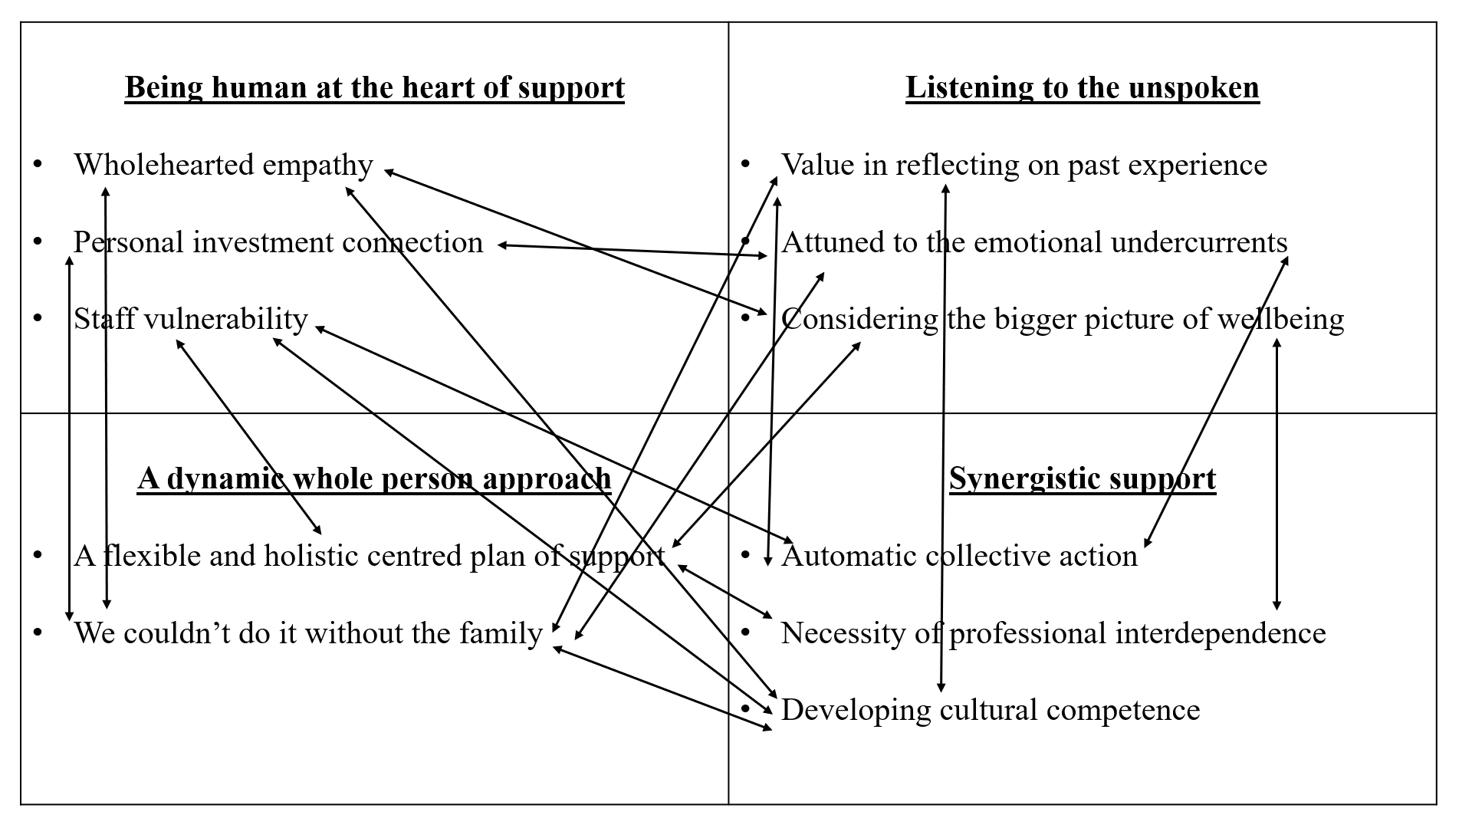

*Figure 3 - Analysis Theme and Subtheme interconnections*

For example, I considered based upon my own reflections and what felt present within the stories shared by the participants, that in order for transition support to reflect ‘developing cultural competence’ *(Theme 4, Subtheme 3)* it recognises the value and relies on involvement with the student’s family in order for educational professionals to have an a more nuanced awareness of the family’s cultural context. In addition, ‘staff vulnerability’ would be important so that staff could be open to sharing that they require support in this area, especially if they have been unable to ‘reflect on their previous experiences’ of supporting INA young people. Here, the concepts of cultural competence, family involvement, and staff vulnerability were not separate but deeply intertwined. I noted the presence of these three subthemes, which, when considered together, painted a fuller picture of what 'developing cultural competence’ means or could look like within' transition support.

Similarly, when analysing the importance of having a ‘flexible and holistic plan of support’, it appeared that this approach was also related to staff feeling competent in their role. This competence, again, tied back to ‘staff vulnerability’ e.g. if staff felt they lacked confidence or knowledge, they would be less likely to implement a holistic plan effectively. Moreover, a holistic plan extended beyond practical support to include attention to the emotional wellbeing of the students, which required staff to be ‘attuned to emotional undercurrents’ and seek additional professional support when necessary. This, in turn, reflected the need for ‘professional interdependence’, where the ability of one staff member to offer support was enhanced by collaboration with others. In this case, the sub themes of competence, vulnerability, emotional wellbeing, and interdependence were all closely connected and reflected how one aspect influenced and relied on the others.

This interconnectedness suggests that the sub themes are not discrete or isolated concepts but are rather parts of a larger, more intricate framework in how moving forward, transition support for INA students could be considered. This interconnected nature reflects the complexity of the data and suggests that the themes and subthemes cannot be fully understood without considering how they interact. This will be further mentioned in the discussion section of this thesis.

**4.6 Findings conclusion**

The findings outlined four main themes and a further eleven sub themes that strengthened the understanding of the data from the participants' interviews. Within this analysis section, I have outlined some key decision points and how I thought through these dilemmas that have now led to the finalised themes/subthemes, as shown in reflective boxes throughout.

The findings presented an interconnected nature to how participants understood positive transition, and the best practice within their support and can be shown in Figure 3. How these theme findings link with the initial research questions will be explored in the discussion section of this report.

**Chapter 5 - Discussion**

**5.0 Introduction**

This research aimed to explore how educational professionals understand positive transition for INA students into UK secondary schools and identify what they perceive as best practices to support this transition.

In this discussion, I will reflect on the analysis findings alongside literature to address the research questions presented in Chapter 2. While the themes presented in the analysis are interdependent and cannot be fully understood in isolation, I will address the key insights here with relation to the research questions as well as implications for educational professionals' future practice. Considerations for policy and Educational Psychology practice will also be discussed. Finally, I will return to the quality issues mentioned in Chapter 3, as well as reflect upon this study's limitations and suggest how future research could address these and build upon the findings.

**5.1 Research question 1: How do educational professionals understand positive transition for INA students into UK secondary schools?**

Educational professionals in this study understand positive transition as a process that is fundamentally relational, holistic, and responsive to evolving needs.

Educational professionals emphasised the importance of meaningful human connections, suggesting that they understand positive transition as INA students feeling genuinely seen, valued, and emotionally supported (Theme 1: Being human at the heart of support). This aligns with relational pedagogy, which highlights the role of trust and empathy (Theme 1, Subtheme 1: Wholehearted empathy) in fostering student belonging (Gravett, 2022). This relational focus is reflected across the wider literature. McFadden’s (2023) study with refugee students in Wales found that relationships were key to positive educational experiences. Bhardwaj, 2022, O’Shea, 2018; King, 2020; Wong, 2020 similarly identified the emotionally nurturing role of staff is often likened to parental care in supporting INA students and can ease adaptation to new school environments. These studies, which centre INA students’ voices, affirm the importance participants in this study placed on positive transition being fundamentally relational.

The importance of relationships in positive transition is underscored by the challenges INA students face, including bullying and discrimination related to linguistic, cultural, and racial differences (Hastings, 2012; King, 2020). These negative experiences can significantly affect students' emotional wellbeing, and the emphasis on relationships from participants in this study suggests an awareness that positive transition also involves counteracting the exclusion and marginalisation that INA students may experience. For example, professionals described emotional responses such as feeling *“proud and almost emotional”* or describing students hugging teachers who spoke their home language. Therefore, reinforcing the idea that positive transition is deeply rooted in moments of human connection.

Professionals also recognised that positive transition extends beyond relational connection and must be holistic, addressing INA students' broader needs, including wellbeing, family circumstances, and cultural identity (Theme 2: A Dynamic whole-person approach). One participant stated, *"It wasn't just about this person needs to learn English—it was also about making her feel good at school, making sure that her needs at home were appropriately met."* This reflects participants’ understanding that positive transition is not just about academic progress but about ensuring students feel emotionally secure and culturally acknowledged. This perspective challenges dominant policy discourses that often prioritise language acquisition and academic attainment (DCSF, 2007), overlooking the more complex realities of INA students' experiences. By recognising the importance of the ‘whole-person’, participants in this study recognise that positive transition extends beyond the classroom and aligns with findings from Cartmell and Bond’s (2015) study, where INA students defined ‘belonging’ as “feeling understood as a person” (Cartmell and Bond, 2015, p. 97).

This holistic view aligns with Rutter (2006) who critiques how ‘good practice’ in refugee education is often narrowly framed around access to schooling rather than comprehensive psychosocial support. Berry’s (1980) acculturation framework suggests that successful adaptation depends on the extent to which students' cultural identities and wellbeing are respected as research gathering the voice of INA’s indicates that they often feel disconnected when navigating unfamiliar systems (McFadden, 2023). Thus, the findings reinforce the idea that positive transition is not only about adjusting to a new culture, but also about feeling their own culture is recognised and respected which comes through a recognition of a holistic approach to support.

Beyond relational and holistic elements, educational professionals also understood positive transition as a responsive process, requiring adaptation to students’ evolving needs at different stages of transition. One participant reflected on how their initial approaches to supporting Roma students were not effective, prompting deeper reflection and adaptation. This suggests an awareness that positive transition is shaped by multiple interacting systems (e.g., school, home, peer groups, governmental policy), requiring ongoing responsiveness to shifting influences. This finding indicates that educational professionals see positive transition as a continuous process that needs to be regularly adjusted to meet students' changing needs.

Bronfenbrenner’s (1979) Ecological Systems Theory aligns with this understanding, highlighting how interconnected systems shape a student’s experience because changes in one system can impact another, necessitating ongoing responsiveness. Participants recognised that transition experiences are not only influenced by the school environment but also by the wider socio-political context shaping their support. For instance, one participant reflected on their initial uncertainty in supporting new arrivals: *"We didn't know what we were doing initially. So we had really big induction meetings…with as many people as possible."* This aligns with the subtheme ‘Automatic collective action’ (Theme 4: Synergistic support), as professionals described how support naturally evolved in response to students' needs. Rutter (2006) highlights the importance of acknowledging and responding to post-migration experiences such as poverty, racism, and uncertain migration status when considering transition. These findings suggest that educational professionals saw positive transition as an ongoing, dynamic process rather than a static event, requiring continuous awareness of and responsiveness to the various systems shaping students' experiences.

***Summary***

Educational professionals in this research understand positive transition as a relational process grounded in wholehearted empathy, personal investment, and cultural understanding of the young people they support. Beyond forming meaningful connections, they view positive transition as holistic, recognising the need to consider the whole person, including their wellbeing and family circumstances. Additionally, positive transition is understood as responsive, meaning that professional approaches are not static but adaptable, evolving to meet students' individual needs based on considering the interconnections of numerous systems in which INA young people exist during their transition to a UK secondary school.

This broader view pushes back against dominant research and policy framings which often reduce positive transition to measurable academic outcomes, positioning language proficiency as the gateway to integration (DCSF, 2007). In contrast, participants’ views re-centre the emotional and relational aspects of transition, offering a humanised and situated understanding of what INA students need to experience positive transitions.

**5.2 RQ2: What do educational professionals perceive to be best practice in supporting the transition of INA students into UK secondary schools?**

Educational professionals in this study perceive best practices for supporting the transition of INA students as multifaceted. In line with RQ1, they perceive a relational and cultural grounding to best practice, as well as recognising the importance of professional reflectivity, collaboration, and staff vulnerability.

As highlighted in the findings for RQ1, relationships were seen as key to a positive transition; however, what distinguished best practice was not just valuing these relationships, but putting them into action through specific, intentional strategies. Professionals described going beyond their formal role responsibilities with one participant likening support to that of a ‘mum figure’, where they were not only there to help with academics or school-based issues, but also to offer emotional support for example through active listening. The subtheme ‘personal investment connection’ (Theme 1, Subtheme 2) captures this. One participant described how a colleague postponed their retirement to continue supporting INA students, and described support such as “*she just took them under her wing*” affirming a nurturing and consistent presence as well as emotional availability. Such practice exemplifies how best practice isn't just about what professionals do, but how they do it: with warmth, intention, and a willingness to invest emotionally in students’ lives. This kind of personal investment is particularly important for INA students who may be navigating disrupted relationships, loss, or a sense of disconnection (Rutter, 2006). Furthermore, this aligns with Hastings’ (2012) research, whereby one participant described how a trusting relationship with school staff extended beyond the school context, helping them feel a sense of belonging to the UK demonstrating that when professionals offer a consistent, caring presence, it can help foster belonging, and support wellbeing during transition.

Another area of best practice that was highlighted was the significance of cultural competence as reflected through curiosity and responsiveness, such as learning phrases in a student's home language, actively seeking to learn more about their culture and promoting home language. Hastings (2012) recommended the active use and development of students’ first languages as a way to support transition for refugee students and participants in this study reinforced this culturally sustaining perspective by recognising wellbeing and cultural connection as key to a positive transition.

It is important to note that participants emphasised that culturally competent strategies cannot be viewed in isolation from the relational context in which they are delivered meaning implementing strategies that signal cultural inclusion without a foundation of cultural curiosity, responsiveness, and genuine relational investment, risks becoming reductionist and superficial. As one participant described, *“the walls of corridors… has poems from every language… it's inclusion and it's belonging”*, it was clear that the impact of such practices lay not just in the action, but in how they are embedded within warm, trusting relationships that communicate emotional attunement and respect for a young person’s identity.

Another key element of best practice identified was reflecting on past experiences (Theme 3, Subtheme 1). Participants described how they engaged in real-time reflection, particularly during meetings that felt different from previous successful ones, to inform their decision-making. This aligns with Schön's (1979) Reflective Practitioner Theory, that professionals develop their practice through reflecting both in action (adapting to situations in real-time) and on action (analysing past experiences to improve future practice) (Schön, 1979). The methodology for this research invited participants to reflect and discuss a past experience; therefore, they were encouraged to reflect on action. However, participants in this study described being attuned to the emotional undercurrents (Theme 3, Subtheme 2) in action during their involvement with INA students and their families. Although participants weren’t always able to verbalise how or what they had reflected, most described a feeling and a sense, an attunement to their own emotions almost, for example, '*I've been in this role for almost seven years, so I know when things feel a bit different*' and '*had the experience of knowing what it felt like for me with how these admission meetings usually go I would feel quite smoothly*'. For these participants, leaning into that feeling and having the confidence to trust in it was important and supported them in making decisions. French (1997) shared how teachers' anxieties about their competence in supporting EAL students influence their ability to adapt to their needs most effectively. Thus, by reflecting on these situations, professionals can adapt their support, which reinforces Schön's argument that reflective practice supports ongoing learning, allowing professionals to provide more meaningful, holistic, and responsive support (Schön, 1979).

Partnership with families emerged as a fundamental component of best practice in supporting the transition of INA students to UK secondary schools, as reflected in the subtheme ‘We couldn’t do it without the family’ (Theme 2, Subtheme 2). Participants emphasised the importance of building trust through culturally sensitive practices, such as using translators, maintaining regular communication, and addressing concerns proactively. One participant shared that families who were initially hesitant about accepting support often required reassurance and ongoing engagement before they could trust the process. This process aligns with existing research (Rutter, 2006) that emphasises how families’ experiences of discrimination or marginalisation can affect their willingness to engage with professionals and is recognised in the findings of King’s (2020) study gathering the voices of newly arrived Czech and Slovak secondary students. Participants shared that their families were frequently excluded from school decisions, and this led to negative feelings, hindered trust and worsened their overall transition experience (King, 2020).

Collaboration with families has been highlighted as a recommendation for INA transition throughout literature (Cartmell, 2013; King, 2020) and policy (DCSF, 2007) therefore it is arguably already recognised as a key support strategy. However, specifically participants in this study emphasised the importance of communication with families to understand the student's background, emotional wellbeing, and home life and this was critical in offering tailored support. This suggests that best practice is not found solely in the act of communicating with home, but in the value placed on this relationship, by educational professionals. In this study, participants emphasised that they ‘couldn’t do it without the family,’ highlighting that meaningful collaboration begins with a deep recognition of the family's role and contribution. This approach is grounded in Bronfenbrenner’s Ecological Systems Theory (1979; Bronfenbrenner & Morris, 2006), which positions the family as the most influential system in a child’s development. According to this theory, collaboration with the family is essential for understanding the multifaceted factors that impact INA students' transition and supporting their development holistically and it could be seen as tokenistic if the family are included as a procedural act, rather than recognised as a valuable tool to aid professionals’ practice.

In this study, best practice was also recognised around staff identifying the need to seek support within their role. Although 'staff vulnerability' (Theme 1, Subtheme 3) could be seen as a negative, within the context of this research, it was identified as a recognition of wanting to support in the best possible way, showing that they had fostered relationships grounded in genuine care and empathy. Thus, when feeling vulnerable in their abilities to provide the best support, it acted as an important driving factor in professionals recognising and reaching out for working partnerships with others, particularly other teams, thus the 'necessity of professional interdependence' (Theme 4, subtheme 2).

Cartmell's research on how secondary schools promote a sense of belonging for INA students identified collaboration between staff as a theme within the research (Cartmell, 2013). Cartmell’s participants emphasised the value of the school EAL team, describing how their presence made it easier for other staff to acknowledge when they didn’t feel fully equipped to offer the necessary support. This suggests that having connected, specialised teams in place fosters a culture of openness and collaboration and as recognised in this study, when staff feel supported and capable through working alongside these teams, they are better positioned to provide support to INA students. This finding highlights a key part of best practice for INA student support is staff recognising and seeking support to develop their own practice by working with other professionals. This highlights how, when acknowledged and embraced, professional vulnerability can be a powerful tool for strengthening relationships and enhancing the support provided to INA students.

***Summary***

The findings of this research identified that best practices for supporting INA students' transition to UK secondary schools are underpinned by relational practice, emphasising trust and emotional availability. Participants highlighted the importance of connecting with students and their families by demonstrating empathy and cultural curiosity. Professional-Family partnership was noted as vital for creating individualised plans, in particular with regard to student wellbeing.

Additionally, reflecting on past experiences supported professionals in being responsive to need and adjusting their support. In line with this, staff vulnerability was seen as a useful and necessary practice, whereby professionals used it as a catalyst to seek other professional input and foster interdependent relationships.

**5.3 - RQ3: What can be learned from how educational professionals understand and support positive transition for INA students to improve practices for future students entering UK secondary schools?**

***5.3.1 Interconnectedness of RQ1 and RQ2***

As aforementioned and displayed in Figure 3 in Chapter 4, the subthemes identified were not discrete or isolated concepts but rather parts of a larger, more intricate framework for how transition support for INA students could be considered moving forward. This reflected the complexity of the data and suggested that the themes and subthemes could not be fully understood without considering how they interact.

This interconnectedness aligns with Bronfenbrenner’s ecological systems theory (1979), which suggests human development as shaped by multiple interacting layers of influence. Similarly, INA student transition support is not a linear process but an evolving interaction between different levels of how it is understood, and how it is supported.

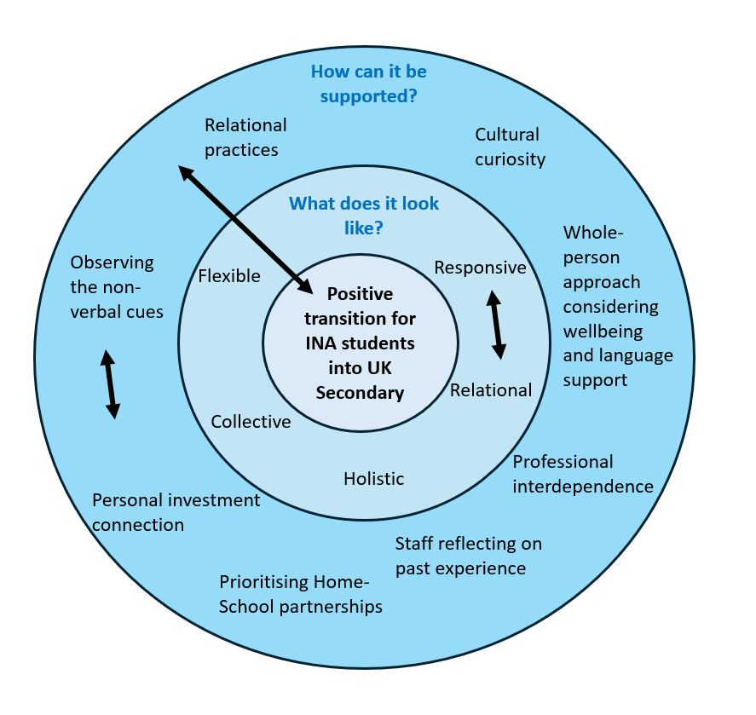

*Figure 4 - Interconnectedness of RQ1 and RQ2 adapted Ecological Systems theory*

At this stage, two key layers can be identified:

* The first layer represents the findings of RQ1, showing how educational professionals understand positive transition.
* The second layer builds on this (RQ2), identifying best practices and demonstrating how these understandings translate into support strategies.

These layers are interdependent; professionals' understanding of positive transition (RQ1) is shaped by their experiences of implementing best practices (RQ2), while best practices continue to evolve as professional understanding deepens.

The next section will examine current guidance and best practices through this lens before considering recommendations for future practice. Later, I will return to this ecological model to explore how systemic improvements (RQ3) further influence and reinforce transition support.

***5.3.2 Current guidance and practice***

As Chapter 2 of this thesis mentions, the guidance of the New Arrivals Excellence Programme (NAEP) (DCSF, 2007) remains the most comprehensive government-issued framework specifically addressing the support of INA students in UK schools despite being published 18 years ago. The policy's emphasis on structural and procedural recommendations does not fully capture the emotional and affective dimensions of transition support, which emerged as critical in this research.

In line with the findings of this research, the DCSF (2007) guidance promotes flexible and personalised support for INA students, however it frames this flexibility as a structural adjustment rather than considering the cultural competence, reflexivity and relational approaches from staff that enable this. This research argues that providing flexible support relies on these aspects, and LAs and schools may struggle to accurately assess INA students' needs, as much of the understanding to adapt support emerges from the interconnectedness of best practices and understandings of positive transition aforementioned in RQ1 and RQ2.

Likewise, family involvement is recognised in the NAEP guidance as necessary for transition success; however, this risks becoming a superficial policy goal rather than an integrated practice when the relational aspects of how to do this and both the individuals providing the support and the culture of the organisation take a broader perspective considering how to build this trust alongside considering wellbeing needs, how to be culturally sensitive and also recognising the value of the partnership. This suggests that the NAEP guidance (DSCF, 2007) underestimates the central role of relational engagement and the additional aspects that strengthen the staff support such as reflecting and being vulnerable themselves, therefore assuming that personalised support can simply be enacted through institutional planning rather than through ongoing, human-centred interactions as recognised in this research.

This study suggests that best practice is not just about what professionals do (interventions, strategies) but how they do it (relationships, emotional engagement, reflexivity). By highlighting these nuanced, human-centred aspects, this research extends beyond existing policy frameworks and suggests that future practice should align with a more holistic, emotionally aware, and reflexivity-focused approach to INA transitions. This section will now consider these key interconnections between the research questions and discuss recommendations for future practice.

***5.3.3 Recommendations for future practice***

*5.3.3.1 Fostering relational and culturally competent support*

Relational approaches and culturally competent support are crucial for positive transition support, which requires both emotional attunement and cultural curiosity and responsiveness. As identified in this research, educational professionals must invest personally in their connection with INA students to support fostering trust and belonging for the young person. Without cultural awareness, relational practices risk being superficial and fail to meet INA students' holistic needs.

Regarding future practice, educational professionals' training should prioritise developing and understanding relational skills and cultural responsiveness within their roles (Hughes and Beirens, 2007; Manzoni and Rolfe, 2019). For example, training focusing on active listening, recognising non-verbal cues, empathy, and culturally responsive strategies should be integrated into training programs for all educational professionals to support inclusion, and most necessary for professionals whose work specifically supports INA students. To ensure consistency for all professionals supporting INA students, LAs should offer this training, thus targeted for both LA-based and school-based staff, which explicitly states the purpose of relational practice and the links with cultural competence so they can embed these strategies into their support. Additionally, time should be allocated within the transition process for building relationships between professionals and INA students, as connections are foundational to fostering trust, emotional security, and a sense of belonging (Roffey, 2012). Schools can achieve this through a key-adult approach (McFadden, 2023), where a designated staff member forms a consistent, supportive relationship with the student.

A concern is that some roles mean these professionals are involved with INA students for a limited time during the transition process, which can hinder the development of meaningful relationships. While targeted training and time for key adult relationships are essential, fostering relational and culturally competent support should not be limited to specific professionals working directly with INA students. Instead, schools and LAs should adopt whole-organisation approaches by ensuring that all staff have a foundational understanding of culturally responsive and relational practice, which is embedded through INA-specific induction training for all staff. Therefore, by prioritising these practices within policies and professional development plans, inclusive practice becomes a shared responsibility.

*5.3.3.2 Creating flexible and responsive approaches*

The findings recognise that transition support for INA students must be flexible and dynamic for the evolving needs of the young people and their families. A holistic, whole-person approach was identified as best practice, focusing on identifying and thus supporting academic and emotional wellbeing needs. Family involvement was seen as crucial, with participants noting that close collaboration helps tailor support and intentional approaches strengthen trust within these professional-family relationships.

As recognised in the NAEP (DCSF, 2007), schools, in particular, should recognise that transition support is not linear and should create structures that allow for ongoing adaptation. One way to do so is to strengthen professional-family partnerships to deepen holistic and cultural understanding. This ensures that support for INA students extends beyond the classroom or school environment.

Mazoni and Rolfe (2019) suggest that professionals should prioritise building trust with families early in the process by clearly communicating processes and explaining the purpose of their support (adapted to their language requirements). In addition, McFadden (2023) suggests the benefit of professionals connecting with local refugee organisations and migrant support charities to make links with the communities’ families are situated within. This allows for the development of potential collaborations, such as enrolment or open days (McFadden, 2023).

*5.3.3.3 Encouraging reflective practice and staff vulnerability*

The connection between reflecting on past experiences and staff vulnerability underscores the importance of continuous professional learning and space to reflect in effectively supporting INA students. Reflective practice, as described by the educational professionals, allowed them to critically examine their support experiences for INA students, and helped them identify areas where they felt support could be strengthened or felt underprepared or uncertain. Rather than viewing vulnerability as a weakness, the findings suggest that acknowledging times of uncertainty and inadequacy in providing the best support can be a strength, prompting professionals to seek professional development from colleagues to improve their approaches and ultimately work towards a more positive transition experience for INAs.

Regarding future practice, educational professionals in schools and LAs should be provided with structured opportunities for self-reflection, such as through peer and group supervision. This provides professionals with the space to reflect on and process their experiences to consider further ways to develop their support for INA students. Encouraging ongoing reflective practice helps professionals recognise and address their own biases (McGregor and Cartwright, 2011), strengthening their ability to connect meaningfully with INA students. Supervision both within teams (e.g. pastoral team in school) and across teams (for example, in the LA - integration and partnerships/virtual school/EP/refugee council) can help identify areas where professionals feel they require additional support and can function as CPD to provide guidance. Having planned reflection and supervision as part of the setting's offer (be that LA or school) fosters an environment where reflection and vulnerability are valued rather than stigmatised; this can empower educational professionals to continuously develop their skills (Schön, 1979), leading to more positive support for INA students.

*5.3.3.4 Promoting interdisciplinary collaboration*

The findings from RQ1 and RQ2 highlight the necessary role of interdisciplinary collaboration for positive transitions of INA students. Findings suggested that best practice support requires a cross-team effort were professionals work interdependently. While collaboration may be seen as a natural and necessary response recognised in the NAEP guidance (DCSF, 2007), challenges arise when working across different systems (e.g., LA, school-based, trust-based), where role definitions and communication methods signal the need for more structured systems to improve collaboration.

To address this, interdisciplinary collaboration should be embedded within the culture of schools, trusts, and LAs. One way to achieve this is by formalising networks through dedicated working groups within LAs focused on INA student transition support. Currently, collaboration occurs reactively in response to specific cases. Instead, these teams should have designated time and space for continuous collaboration, ensuring expertise is shared and best practices are embedded across LAs and schools. Establishing formalised groups would also facilitate ongoing cross-departmental discussions, joint training, and shared reflective spaces, making collaboration a sustained priority rather than an occasional effort. Where LAs seek to embed this, they demonstrate that they prioritise support for INA students and their families within their working culture.

***5.3.4 An Ecological Approach***

Earlier in section 5.3.1, I introduced an ecological perspective to illustrate how educational professionals’ understandings of positive transition (RQ1) and best practices (RQ2) are interconnected (Figure 4). This framework now extends further to incorporate RQ3, which considers systemic recommendations for future practice.

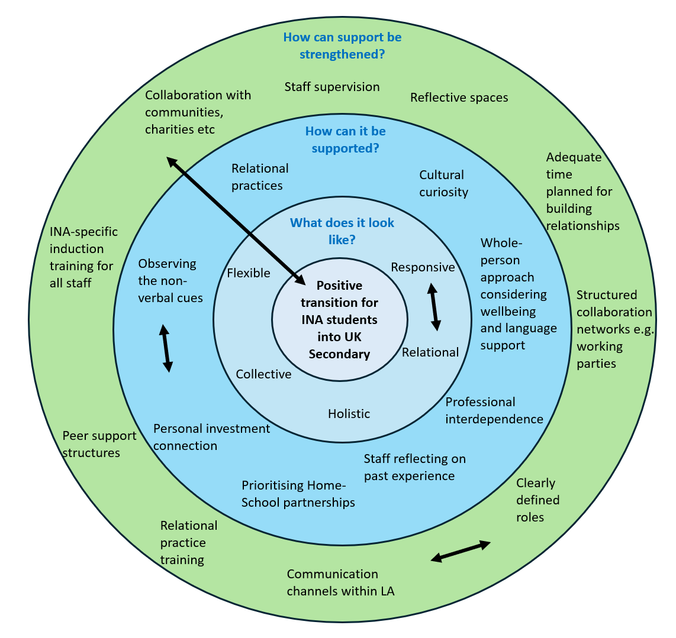

*Figure 5 - Adapted Ecological Systems theory for understanding and supporting positive transition experiences for INA students into UK secondary schools*

The diagram above places 'positive transition for INA students into UK secondary schools' at the centre, emphasising its role as the outcome of support systems operating at multiple levels. While the first two layers (RQ1 and RQ2) demonstrate how educational professionals perceive and implement best practices, the final layer (RQ3) highlights the role of systemic change in shaping and sustaining transition support. For example, narratives around migration can directly and indirectly impact school cultures, resource allocation, and professional confidence in their support for INA students. Thus, while professionals' understanding of positive transition (RQ1) evolves through practice (RQ2), systemic improvements at school, LA, and national policy levels (RQ3) can either facilitate or hinder this process. In turn, stronger institutional support, better facilitation of professional development, and more inclusive policies create conditions that further refine best practices and deepen professional understanding.

These layers are not separate but rather interdependent, continuously influencing one another.

This model suggests key implications for future practice. For example, understanding positive transition (RQ1) as an evolving concept shaped by experience and reflection is critical for arguing the necessity of supervision and reflective spaces for educational professionals who work closely to support INA student transition. This is especially important for those supporting INA transition, and highlights the need to prioritise collaborative teams/working parties within LAs. In addition, as best practices (RQ2) are implemented and refined, they enhance professional understanding, creating a feedback loop that strengthens transition support, therefore advocating for continued professional development, and training to develop knowledge and skills for relational practice, collaborative practice and culturally responsive practice. Crucially, the influence of systemic changes (RQ3) can impact both perception and practice, ensuring transition support remains responsive to INA students' evolving needs.

In line with the aforementioned recommendations for future practice for schools, trusts, and LAs as a collective, this ecological perspective highlights the need for policy to reflect the interconnected nature of transition support. The most recent guidance (DCSF, 2007) presents a simplistic, structured approach that does not consider these dynamic relationships. Moving forward, this model could inform a more responsive framework for policy and practice.

**5.4 Implications for Educational Psychology and Research Dissemination**

This section will discuss the research findings and implications for future practice, as mentioned earlier, with specific reference to Educational Psychology. Following this, it will discuss how this research will be disseminated.

***5.4.1 Implications for Educational Psychology***

The role of an EP is being reconstructed frequently due to increased demand on services and evolving needs, thus arguments have been made that in order to be more responsive to the needs of the communities, the EP profession should take a shift towards a community educational psychology model (Gillham, 2022; Makay, 2006). The community psychology vision embraces a wider range of disciplines and utilises concepts from economics, sociology and politics to apply psychology within a community, with the aim of social change (Stringer, Powell and Burton, 2006). Community psychology recognises the multi-levels of influence on communities, thus considers responses and actions across a variety of systems (Makay, 2006) which I feel aligns with the aims and process taken for this research and so will be reflected in the implications suggested.

The sociopolitical context of migration plays a significant role in shaping the experiences of INA students and the professionals who support them. As discussed in Chapter 2, migration remains a politically contentious topic in the UK, with government policies often reflecting broader public anxieties about immigration, coupled with the removal of specific funding for supporting INA students in education as well as a lack of specific policy. All of which can influence school cultures, resource allocation, and attitudes toward INA students as reflected in some research showing INA students experience bullying and discrimination from peers and sometimes staff (O’Shea, 2018; King, 2020). Such socio-political framing may create additional challenges for educational professionals, who must navigate the complexities of supporting students within a system that may be under-resourced or shaped by restrictive policies. EPs, therefore, have a role in helping schools critically reflect on these external influences, ensuring that support for INA students remains strengths-based rather than deficit-focused. Additionally, the BPS (2017) states the importance of psychologists' continued awareness of assumptions based on stereotypes, the history and cultural development of racism in a western society, and to continue to promote inclusivity and challenge negative views in the promotion of social justice. EPs can support whole-school and LA initiatives that embed relational, culturally responsive and reflective practice into policy and staff development, ensuring it becomes part of the organisation's culture rather than an individual effort.

EPs are the only applied psychologists uniquely positioned to work with various educational professionals (Owens-Hughes, 2020). Patel, Tribe and Yule (2018) suggest that LA psychologists should seek to work at a strategic level to ensure that support for INA students is embedded within broader systemic frameworks rather than being addressed through isolated interventions. EP's often work at the intersection of education, health, and social care, making them well-positioned to facilitate cross-sector collaboration for INA student support. In addition, by operating at this level, EP's can influence policy development, guide best practices, and build the capacity of schools and LAs to respond effectively to the needs of INA students; this could include the development of structured working groups within LAs, ensuring transition support is proactive rather than reactive and supporting with the identification of SEND in CYP with cultural and linguistic differences.

In addition, EPs are experienced in supervision, and thus, opportunities to offer support in promoting reflective practice and facilitating reflective spaces for group supervision where professionals can consider their practice, could be relevant moving forward. EPs already promote reflective practice in schools through consultation and sometimes supervision; this could be expanded to structured debriefing sessions for professionals working with INA students. In addition, by advocating for psychologically safe spaces for staff reflection, EPs can help reduce stigma around vulnerability and encourage continuous professional development.

This research was purposefully planned to identify strengths within the systems and support from professionals working for INA students' during transition into UK secondary schools. Thus, when considering the implications, EPs can support a systemic shift in how professionals and educational systems approach the needs of INA students. Rather than viewing migration as something they are unequipped to respond to, EPs can help schools and LAs build confidence in supporting INA students effectively. By identifying and reinforcing what works, EPs can encourage a strengths-based perspective that highlights the strengths that already exist within the support offered by educational professionals. Through this approach, EPs can play a key role in shaping more proactive, inclusive, and empowering support systems that enable professionals to feel better equipped and responsive to the needs of INA students.

***5.4.2 Dissemination of research***

Within the LA where this research was conducted, I plan to present my findings to the EP team I am currently working with. As I will not be remaining in the LA after my viva, I won't have the opportunity to directly share this with the relevant teams that the research is intended to inform. However, by presenting it to the EP team, I hope it will be disseminated through discussions, influencing their direct work with schools and any strategic developments related to INA student support.

Beyond the LA, I am part of a UK-wide INA working group of EPs committed to promoting inclusion for INA students. I intend to share my research with this group to share knowledge, hoping to inform practice more widely and contribute to collective discussions on best approaches. Additionally, I plan to explore opportunities to publish aspects of this research to reach a broader audience of educational professionals and policymakers.

**5.5 Limitations and Future Research**

This section will critically evaluate the research to consider limitations and opportunities for future research. Specifically, limitations will focus on the research design, including participants, data collection methods, and data analysis and refer to the aforementioned quality considerations of credibility, transparency, usefulness and generalisability, from Chapter 3.

***5.5.1 Participants***

This research was conducted within one LA, potentially limiting the transferability to other areas despite the findings highlighting valuable insights within the area in which it was conducted. According to the most recent census, approximately 12.4% of the LAs population was born outside of the UK, below the national average of 14% (ONS, 2021). The exact number of INA students in secondary schools within this authority is unknown as data is not held regarding migration status; however, it is possible that the experiences and needs of these students joining schools in this area may not fully reflect the broader transition experiences for INA students joining schools in other parts of the UK.

The number of migrant individuals in the LA as well as the countries the families were arriving from, may have influenced the types of support available and the overall understanding of what constitutes a positive transition by educational professionals. In areas of the country with higher INA student populations, there may be differences in the challenges and resources available, including staff, meaning that the understanding of positive transition and best practices as identified may not be as relevant in these other areas.

Despite this recognised limitation, the findings provide an in-depth exploration of the topic in line with the research aims, and therefore, the insights recognised could be used to inform policy and practice within this LA recognising the usefulness of the findings. In addition, the findings are likely relevant to LAs with smaller or emerging INA populations and hence could be considered generalisable in this context. To consider the applicability of the findings to LAs with larger INA student populations, future research could repeat this study in other authorities in the UK.

As highlighted throughout this thesis, there has been research within the UK that gathers the views of INA students regarding their transition experiences into secondary school, which has helped shape this research by focusing on educational professionals as a valuable source of insight into their support. In addition, educational professionals are in a position to directly advocate for shaping policies and change their support practices, making their insights useful when enacting change. This research could however be strengthened by triangulating the data to include the views of INA young people and their families to provide a more holistic view of how positive transitions are experienced and supported by all stakeholders involved.

***5.5.2 Data collection***

A recognised limitation of appreciative interviews is that they intentionally explore positive aspects and strengths within a participant's experiences. Although participants were not stopped from talking about negatives, it remains that the research findings may not fully reflect the difficulties in the system with implementing recommendations or addressing challenges related to supporting INA students during transition. Utilising this method was a choice in line with the negative narratives around migration present within numerous educational support systems. Therefore, a key aim for this research was to adopt a strengths-based approach to identify and leverage how educational professionals can best support INA students’ transition into UK secondary schools. It is important to note that although the guiding questions for the interview had a positive focus, participants were not prevented from speaking about negatives and difficulties, and this was present within all the interviews to varying amounts and has been considered within the data analysis and interpretations.

Whilst acknowledging that this data collection approach may provide a more limited view of educational professionals' perspectives, it is critical to adopt a strengths-based approach when researching a topic often framed in terms of deficits. In considering the implications for future practice, I suggest that building upon recognised strengths will be beneficial for ensuring positive transition experiences for INA students into UK secondary schools. Thus, while the primary aim of this research was to explore the topic through a positive lens, future studies could continue using a strengths-based approach while triangulating data with other methods that allow for a more significant participant sample. For example, focus groups or surveys, could capture a broader range of experiences, including those that may not emerge through appreciative interviews alone.

***5.5.3 Data analysis***

While subjectivity is often seen as a strength in qualitative research, I brought my personal and professional experiences into the data analysis process through RTA. However, credibility in research refers to the alignment between the participants' perspectives in relation to the research question they are presented with, and the researcher’s portrayal of their experiences (Tobin and Begley, 2004 as cited in Nowell et al, 2017). I hope to have offered readers transparency regarding my influence on the interpretation of the data by outlining my positionality in both Chapter 1 and Chapter 2, and also including reflexive notes throughout the analysis presented in Chapter 4.

**Chapter 6 - Concluding Remarks**

**6.0 Conclusion**

This research took an appreciative approach, particularly suited for exploring strengths within migration-related educational practice and offered an alternative to deficit-based narratives. Six participants, working across one LA and secondary schools in a variety of roles, including teachers, support staff, and local authority officers, engaged in appreciative interviews reflecting on what they perceived as a positive experience of supporting the transition of INA students. The data were analysed using reflexive thematic analysis (Braun and Clarke, 2022), generating four overarching themes and eleven interrelated sub-themes.

Educational professionals in this study understood positive transition as a process that is fundamentally relational, holistic, and responsive to evolving needs. Participants also perceived best practices for supporting the transition of INA students as multifaceted whereby relational and cultural groundings are key, as well as recognising the importance of professional reflectivity, collaboration, and staff vulnerability. I introduced an ecological perspective to illustrate how educational professionals’ understandings of positive transition (RQ1) and best practices (RQ2) are interconnected and considered systemic recommendations for future practice. Implications for Educational Psychology were considered, as well as how future research could build upon what has been recognised here whilst limitations within the study were acknowledged.

From a personal perspective, this research came about from my time as a secondary school teacher where I saw firsthand the complexities of transition faced by INA students who joined partway through the academic year. As such I became acutely aware of how critical transition support was in shaping their sense of belonging, emotional wellbeing, and educational engagement. Recognising the complex and layered nature of these transitions deepened my interest in understanding how educational professionals perceive positive transitions and what they view as best practice in this area. Stemming from my values of promoting inclusion and social justice, while recognising the negative narratives surrounding migration and the need for updated policies to provide consistent support for INA students, through the completion and dissemination of this research, I hope to contribute positively both to the field of research supporting INA students and to the recognition of the potential within systems that aim to help them.

**References**

Aaltonen, S. and Kivijärvi, A., 2019. Disrupting professional practices with research-driven intervention. Researcher–gatekeeper negotiations in the context of targeted youth services. *Qualitative Social Work*, *18*(4), pp.621-637.

Act, E., 2010. Equality act. *The Stationary Office, London*.

Adams, M.G., Schiller, M. and Cooperrider, D.L., 2004. With our questions we make the world. In *Constructive discourse and human organization* (Vol. 1, pp. 105-124). Emerald Group Publishing Limited.

Adams, P., 2006. Exploring social constructivism: Theories and practicalities. *Education*, *34*(3), pp.243-257.

Aguinis, H. and Solarino, A.M., 2019. Transparency and replicability in qualitative research: The case of interviews with elite informants. *Strategic management journal*, *40*(8), pp.1291-1315.

Andrade, A.S., Roca, J.S. and Pérez, S.R., 2023. Children's emotional and behavioral response following a migration: a scoping review. *Journal of migration and health*, *7*, p.100176.

Appa, V., 2005. *A study on how asylum seekers and refugees access education in four local authorities in England*. National Children's Bureau.

Archibald, M.M., Ambagtsheer, R.C., Casey, M.G. and Lawless, M., 2019. Using zoom videoconferencing for qualitative data collection: perceptions and experiences of researchers and participants. *International journal of qualitative methods*, *18*, p.1609406919874596.

Arnot, M., Schneider, C., Evans, M., Liu, Y., Welply, O. and Davies-Tutt, D., 2014. School approaches to the education of EAL students. *Language development, social integration and achievement. Cambridge: The Bell Educational Trust Ltd*.

Arslan, G., 2021. School belongingness, well-being, and mental health among adolescents: Exploring the role of loneliness. *Australian Journal of Psychology*, *73*(1), pp.70-80.

Arundell, F., Sheehan, A. and Peters, K., 2021. Developing and conducting appreciative inquiry interviews. *Nurse Researcher*, *29*(4).

Avital, M., Boland, R.J. and Lyytinen, K., 2009. Introduction to designing information and organizations with a positive lens. *Information and Organization*, *19*(3), pp.153-161.

Aziz, A. and Khan, N., 2020. The potential uses of pilot study in qualitative research. *Journal of Research & Reviews in Social Sciences Pakistan*, *3*(1), pp.750-767.

Bagnall, C.L., Skipper, Y. and Fox, C.L., 2020. ‘You're in this world now’: Students’, teachers’, and parents’ experiences of school transition and how they feel it can be improved. *British Journal of Educational Psychology*, *90*(1), pp.206-226.

Baker, S.E. and Edwards, R., 2012. How many qualitative interviews is enough.

Banks, S., 2024. *Exploring the views and experiences of UK educational psychologists in relation to social justice and educational psychology practice* (Doctoral dissertation, The University of Manchester (United Kingdom)).

Baumeister, R.F. and Leary, M.R., 2017. The need to belong: Desire for interpersonal attachments as a fundamental human motivation. *Interpersonal development*, pp.57-89.

Beiser, M., Hou, F., Hyman, I. and Tousignant, M., 2002. Poverty, family process, and the mental health of immigrant children in Canada. *American journal of public health*, *92*(2), pp.220-227.

Berry, J.W., 1980. Acculturation as varieties of adaptation. *Acculturation: Theories, models and findings/Westview*.

Bhardwaj, A.M., 2022. *" Work hard and never give up": A narrative exploration of the school experiences of pupils who have migrated to England* (Doctoral dissertation, University of Birmingham).

Block, K., Cross, S., Riggs, E. and Gibbs, L., 2014. Supporting schools to create an inclusive environment for refugee students. *International journal of inclusive education*, *18*(12), pp.1337-1355.

Braun, V. and Clarke, V., 2006. Using thematic analysis in psychology. *Qualitative research in psychology*, *3*(2), pp.77-101.

Braun, V. and Clarke, V., 2013. Successful qualitative research: A practical guide for beginners.

Braun, V. and Clarke, V., 2019. Reflecting on reflexive thematic analysis. *Qualitative research in sport, exercise and health*, *11*(4), pp.589-597.

Braun, V. and Clarke, V., 2021. Can I use TA? Should I use TA? Should I not use TA? Comparing reflexive thematic analysis and other pattern‐based qualitative analytic approaches. *Counselling and psychotherapy research*, *21*(1), pp.37-47.

Braun, V. and Clarke, V., 2021. To saturate or not to saturate? Questioning data saturation as a useful concept for thematic analysis and sample-size rationales. *Qualitative research in sport, exercise and health*, *13*(2), pp.201-216.

Braun, V., Clarke, V., Hayfield, N., Davey, L. and Jenkinson, E., 2023. Doing reflexive thematic analysis. In *Supporting research in counselling and psychotherapy: Qualitative, quantitative, and mixed methods research* (pp. 19-38). Cham: Springer International Publishing.

Brindley, S., Alexander, P., Amis, D., Lownds, S., Shaw, C. and Stephney White, S., 2022. Teaching and learning in UK English classrooms: Tales from the pandemic. *English in Australia*, *56*(2), pp.67-75.

Bronfenbrenner, U. (1979). The ecology of human development. Cambridge, MA: Harvard University Press.

Bronfenbrenner, U., 2005. *Making human beings human: Bioecological perspectives on human development*. sage.

Bronfenbrenner, U. and Morris, P.A., 2007. The bioecological model of human development. *Handbook of child psychology*, *1*.

Burcham, C.E., 2009. *The experience of male adolescent refugees during their transfer and adaptation to a UK secondary school* (Doctoral dissertation, Institute of Education, University of London).

Burgess, C. (2024). Research proposal, Supporting International New Arrival students’ transition into a UK Secondary Schools - An Appreciative Inquiry exploring Educational Practitioners Perspectives.[Unpublished manuscript]. School of Education, University of Sheffield

Bushe, G.R., 2012. Appreciative inquiry: Theory and critique. In *The Routledge companion to organizational change* (pp. 87-103). Routledge.

Campbell, S., Greenwood, M., Prior, S., Shearer, T., Walkem, K., Young, S., Bywaters, D. and Walker, K., 2020. Purposive sampling: complex or simple? Research case examples. *Journal of research in Nursing*, *25*(8), pp.652-661.

Cartmell, H. and Bond, C., 2015. What does belonging mean for young people who are International New Arrivals. *Educational & Child Psychology*, *32*(2), pp.89-101.

Cartmell, H., 2013. An Exploration of how Secondary Schools Promote a Sense of Belonging with Pupils who are International New Arrivals (INA). *PQDT-UK & Ireland*.

Castles, S., 2003. The international politics of forced migration. Development, 46, pp.11-20.

*Children and Families Act 2014*, c. 31. Available at: https://www.legislation.gov.uk/ukpga/2014/6/contents (Accessed: 16 February 2025)

Clarke, S., Sloper, P., Moran, N., Cusworth, L., Franklin, A. and Beecham, J., 2011. Multi‐agency transition services: greater collaboration needed to meet the priorities of young disabled people with complex needs as they move into adulthood. *Journal of Integrated Care*, *19*(5), pp.30-40.

Coburn, C., 2009. *When listening works* (Doctoral dissertation, La Trobe University).

Coleman, M. and Briggs, A.R. eds., 2002. *Research methods in educational leadership and management*. Sage.

Cooperrider, D.L. and Srivastva, S., 2005. Appreciative inquiry in organizational life. *Cooperrider, DL, Sorensen, P., Yager, T., Whitney, D., Appreciative inquiry. Foundation in positive organization development, Champaign, Illinois:, Stipes Publishing*, pp.61-104.

Cooperrider, D.L., 1986. Appreciative inquiry: Toward a methodology for understanding and enhancing organizational innovation. *Doctoral Dissertation. Case Western Reserve University*.

Cooperrider, D.L., Stavros, J.M. and Whitney, D., 2008. *The appreciative inquiry handbook: For leaders of change*. Berrett-Koehler Publishers.

CP, A., 1972. Existence, Relatedness, and Growth. *Human Needs in Organizational setting*.

Cummins, J., 2000. Language, power and pedagogy: Bilingual children in the crossfire. *Multilingual Matters*.

Darling-Hammond, L., Flook, L., Cook-Harvey, C., Barron, B. and Osher, D., 2020. Implications for educational practice of the science of learning and development. *Applied developmental science*, *24*(2), pp.97-140.

Davies, M. and Webb, E., 2000. Promoting the psychological well-being of refugee children. *Clinical Child Psychology and Psychiatry*, *5*(4), pp.541-554.

Daza, S.L., 2008. Decolonizing researcher authenticity. *Race ethnicity and education*, *11*(1), pp.71-85.

Deakin, H. and Wakefield, K., 2014. Skype interviewing: Reflections of two PhD researchers. *Qualitative research*, *14*(5), pp.603-616.

Demie, F. and Hau, A., 2013. *The achievement of pupils with English as an additional language: an empirical study*. Lambeth Research and Statistics Unit.

Denzin, N.K., 2008. *The landscape of qualitative research* (Vol. 1). Sage.

Department for Children, Schools and Families (DCSF). (2007). New Arrivals Excellence Program Guidance. Retrieved from<https://ealresources.bellfoundation.org.uk/sites/default/files/documentfiles/New%20Arrivals%20Guidance.pdf>

Department for Children, Schools and Families (DCSF). (2007). New Arrivals Excellence Program Guidance. Retrieved from<https://ealresources.bellfoundation.org.uk/sites/default/files/documentfiles/New%20Arrivals%20Guidance.pdf> dissertation, Cardiff University)

Department for Education & Department of Health. (2015). Special educational needs and disability code of practice. Retrieved from<https://www.gov.uk/government/publications/send-code-of-practice-0-to-25>[Accessed: 15 February 2025].

Department for Education, 2013. *The national curriculum in England: Key stages 3 and 4 framework document*. Department for Education.

Department for Education, 2014. *Admission and Appeals Policy*. December 2014. Available at: https://www.gov.uk/government/publications/admission-and-appeals-policy [Accessed: 15 February 2025].

Department for Education, 2014. *School applications for foreign national children and children resident outside England*. Available at: https://www.gov.uk/government/publications/school-applications-for-foreign-national-children-and-children-resident-outside-england [Accessed: 15 February 2025].

Department for Education, 2015. Special educational needs and disability code of practice: 0 to 25 years. *Department for Education*.

Department for Education, 2020. *Education, health and care needs assessments and plans: Guidance on temporary legislative changes relating to coronavirus (COVID-19)*. Updated 26 August 2020. Available at:<https://core.ac.uk/download/333654504.pdf> [Accessed: 15 February 2025].

Devine, D., 2013. ‘Value’ing children differently? Migrant children in education. *Children & Society*, *27*(4), pp.282-294.

Doty, R.L., 1996. Immigration and national identity: constructing the nation. *Review of International Studies*, *22*(3), pp.235-255.

Dryburgh, N.S., Ponath, E., Bukowski, W.M. and Dirks, M.A., 2022. Associations between interpersonal behavior and friendship quality in childhood and adolescence: A meta‐analysis. *Child Development*, *93*(3), pp.e332-e347.

Dyer, L., 2022. *Exploring school staff members’ understanding about influences on the experiences and belonging of students of Caribbean Descent in schools: A Reflexive Thematic Analysis* (Doctoral dissertation, University of Nottingham).

Eisenberg, N. and Fabes, R.A., 1990. Empathy: Conceptualization, measurement, and relation to prosocial behavior. *Motivation and emotion*, *14*(2), pp.131-149.

Elliott, R. and Timulak, L., 2005. Descriptive and interpretive approaches to qualitative research. *A handbook of research methods for clinical and health psychology*, *1*(7), pp.147-159.

Ellis, L.M. and Chen, E.C., 2013. Negotiating identity development among undocumented immigrant college students: a grounded theory study. *Journal of counseling psychology*, *60*(2), p.251.

Ellis, S., Tod, J. and Graham-Matheson, L., 2012. *Reflection, renewal and reality: teachers' experience of special educational needs and inclusion*. Birmingham: NASUWT.

Enright, E., Hill, J., Sandford, R. and Gard, M., 2014. Looking beyond what's broken: towards an appreciative research agenda for physical education and sport pedagogy. *Sport, Education and Society*, *19*(7), pp.912-926.

Evans, M. and Liu, Y., 2018. The unfamiliar and the indeterminate: Language, identity and social integration in the school experience of newly-arrived migrant children in England. *Journal of Language, Identity & Education*, *17*(3), pp.152-167.

Eynon, M.J., O’Donnell, C. and Williams, L., 2018. Gaining qualitative insight into the subjective experiences of adherers to an exercise referral scheme: A thematic analysis. *Journal of Health Psychology*, *23*(11), pp.1476-1487.

Flockton, G. and Cunningham, C., 2021. Teacher educators’ perspectives on preparing student teachers to work with pupils who speak languages beyond English. *Journal of Education for Teaching*, *47*(2), pp.220-233.

Fusch Ph D, P.I. and Ness, L.R., 2015. Are we there yet? Data saturation in qualitative research.

García-Ramírez, M., de la Mata, M.L., Paloma, V. and Hernández-Plaza, S., 2011. A liberation psychology approach to acculturative integration of migrant populations. *American journal of community psychology*, *47*, pp.86-97.

Gibbs, G., 2007. Thematic Coding and Categorizing.

Gillham, B. ed., 2022. *Reconstructing educational psychology*. Routledge.

Gravett, K., 2022. Relational Pedagogies.

Guba, E.G. and Lincoln, Y.S., 1989. *Fourth generation evaluation*. Sage

Guest, G., Bunce, A. and Johnson, L., 2006. How many interviews are enough? An experiment with data saturation and variability. *Field methods*, *18*(1), pp.59-82.

Gunderson, L., 2017. *English-only instruction and immigrant students in secondary schools: A critical examination*. Routledge.

Hall, G., 2019. The experiences of secondary school students with English as an additional language: Perceptions, priorities and pedagogy.

Hamilton, R. and Moore, D., 2004. Educational interventions for refugee children. *Theoretical perspectives and implementing best practice*.

Harter, S., 1999. The construction of the self: A developmental perspective. new York: Guilford. Dieses Buch analysiert das Sich-Herausbilden eines einzigartigen Sinnes für das Selbst bei Individuen infolge kognitiver und sozialer Konstruktionsprozesse und liefert einen theoretischen Hintergrund für diese Entwicklung.

Hastings, C., 2012. The experience of male adolescent refugees during their transfer and adaptation to a UK secondary school. *Educational Psychology in Practice*, *28*(4), pp.335-351.

Heath, A., Davidov, E., Ford, R., Green, E.G., Ramos, A. and Schmidt, P., 2020. Contested terrain: Explaining divergent patterns of public opinion towards immigration within Europe. Journal of Ethnic and Migration Studies, 46(3), pp.475-488.

Hendry, L.B., Mayer, P. and Kloep, M., 2007. Belonging or opposing? A grounded theory approach to young people's cultural identity in a majority/minority societal context. *Identity: An International Journal of Theory and Research*, *7*(3), pp.181-204.

Hiller, J., 2016. Epistemological foundations of objectivist and interpretivist research.

Hodgkin, K., Fleming, S., Beauchamp, G. and Bryant, A., 2013. Perception to Reality: Pupils’ expectations and experiences of the primary-secondary school transition. *Perception*, *6*(1), pp.28-40.

Holmes, A.G.D., 2020. Researcher Positionality--A Consideration of Its Influence and Place in Qualitative Research--A New Researcher Guide. *Shanlax International Journal of Education*, *8*(4), pp.1-10.

Home Office (2022) New Plan for Immigration: legal migration and border control (accessible). Available at:<https://www.gov.uk/government/publications/new-plan-for-immigration-legal-migration-and-border-control-strategy/new-plan-for-immigration-legal-migration-and-border-control-accessible> (Accessed: 13/10/2023).

Home Office (2023) Hong Kong British National (Overseas) route (accessible). Available at:<https://www.gov.uk/government/publications/hong-kong-british-national-overseas-route/hong-kong-british-national-overseas-route-accessible#about-this-guidance> (Accessed: 13/10/2023).

Home Office National statistics (2023) GOV.UK. Summary of Statistics. Available at:<https://www.gov.uk/government/statistics/immigration-system-statistics-year-ending-march-2023/summary-of-latest-statistics> (Accessed: 13 October 2023).

Horgan, D., Martin, S., O’Riordan, J. and Maier, R., 2022. Supporting languages: The socio‐educational integration of migrant and refugee children and young people. *Children & Society*, *36*(3), pp.369-385.

Hughes, N. and Beirens, H., 2007. Enhancing educational support: Towards holistic, responsive and strength‐based services for young refugees and asylum‐seekers. Children & Society, 21(4), pp.261-272.

Hulusi, H. and Oland, L., 2010. Making sense of transitions through narrative: Supporting newly arrived children and young people. *Journal of Emotional and Behavioural Difficulties*, *15*(4), pp.341-351.

Ikeda, D., 2005. *Toward a new era of dialogue: Humanism explored*. Soka Gakkai International.

International Organization for Migration (2022), world migration report.<https://publications.iom.int/books/world-migration-report-2022>

Keaton, S.A. and Bodie, G.D., 2011. Explaining social constructivism. *Communication Teacher*, *25*(4), pp.192-196.

Kelly, G.J., 2023. Qualitative research as culture and practice. *Handbook of research on science education*, pp.60-86.

Khawaja, M., 2021. Using appreciative inquiry to explore effective medical interviews. *Behavioral Sciences*, *11*(9), p.116.

King, C., 2020. *Using thematic analysis to obtain the newly arrived pupil voice: An exploration into the experiences of school for Czech and Slovak secondary-aged pupils* (Doctoral dissertation, University of Nottingham).

Korstjens, I. and Moser, A., 2018. Series: Practical guidance to qualitative research. Part 4: Trustworthiness and publishing. *European Journal of General Practice*, *24*(1), pp.120-124.

L. Haven, T. and Van Grootel, D.L., 2019. Preregistering qualitative research. *Accountability in research*, *26*(3), pp.229-244.

Lamb, M. and Budiyanto, 2013. Cultural challenges, identity and motivation in state school EFL. In *International perspectives on motivation: Language learning and professional challenges* (pp. 18-34). London: Palgrave Macmillan UK.

Lamph, G., Nowland, R., Boland, P., Pearson, J., Connell, C., Jones, V., Wildbore, E., L Christian, D., Harris, C., Ramsden, J. and Gardner, K., 2023. Relational practice in health, education, criminal justice, and social care: a scoping review. Systematic Reviews, 12(1), p.194.

Langley, A. and Meziani, N., 2020. Making interviews meaningful. *The Journal of Applied Behavioral Science*, *56*(3), pp.370-391.

Lenhoff, S.W., Singer, J. and Gottfried, M., 2022. Thinking ecologically in educational policy and research. *Peabody Journal of Education*, *97*(1), pp.1-5.

Liebkind, K., Jasinskaja-Lahti, I. and Solheim, E., 2004. Cultural identity, perceived discrimination, and parental support as determinants of immigrants’ school adjustments: Vietnamese youth in Finland. *Journal of adolescent research*, *19*(6), pp.635-656.

Maguire, M. and Delahunt, B., 2017. Doing a thematic analysis: A practical, step-by-step guide for learning and teaching scholars. *All Ireland journal of higher education*, *9*(3).

MacKay, T., 1978. The educational psychologist as community psychologist: Holistic child psychology across home, school and community. *Educational & Child Psychology*, *23*(1), pp.7-15.

Mamali, P. and Arvanitis, E., 2022. Refugee children in Europe and their access to compulsory educational systems: A policy framework analysis. The Reach of Intercultural Education & Inclusion, p.20.

Manzoni, C. and Rolfe, H., 2019. How schools are integrating new migrant pupils and their families. *National institute of economic and social research*.

Margaret Podger, D., Mustakova‐Possardt, E. and Reid, A., 2010. A whole‐person approach to educating for sustainability. *International Journal of Sustainability in Higher Education*, *11*(4), pp.339-352.

Maxwell, J.A., 2013. *Qualitative research design: An interactive approach: An interactive approach*. Sage.

McCaslin, M. and Hickey, D.T., 2001. Educational psychology, social constructivism, and educational practice: A case of emergent identity. *Educational psychologist*, *36*(2), pp.133-140.

McFadden, C., 2023. *Listening to young refugees' experiences of education in Wales* (Doctoral dissertation, Cardiff University).

McGregor, D. and Cartwright, L., 2011. Developing reflective practice: A guide for beginning teachers. McGraw-Hill Education (UK).

McKenna, N., 2005. Daring to Dream: Raising the achievement of 14 to 16 year old asylum-seeking and refugee children and young people.

Mertens, D.M., 2008. *Transformative research and evaluation*. Guilford press.

Messiou, K. and Azaola, M.C., 2018. A peer-mentoring scheme for immigrant students in English secondary schools: a support mechanism for promoting inclusion?. *International Journal of Inclusive Education*, *22*(2), pp.142-157.

Michael, S., 2005. The promise of appreciative inquiry as an interview tool for field research. *Development in practice*, *15*(2), pp.222-230.

Milbourne, L., 2002. Unspoken Exclusion: Experiences of continued marginalisation from education among'hard to reach'groups of adults and children in the UK. *British Journal of Sociology of Education*, *23*(2), pp.287-305.

Milner IV, H.R., 2007. Race, culture, and researcher positionality: Working through dangers seen, unseen, and unforeseen. *Educational researcher*, *36*(7), pp.388-400.

Morgan, D.L., 2014. Pragmatism as a paradigm for social research. *Qualitative inquiry*, *20*(8), pp.1045-1053.

Morris, R.I., 2017. *Exploring the potential contribution of educational psychologists to post-school practice*. The University of Manchester (United Kingdom).

Moskal, M. and Tyrrell, N., 2016. Family migration decision-making, step-migration and separation: children's experiences in European migrant worker families. *Children's Geographies*, *14*(4), pp.453-467.

Motti-Stefanidi, F., 2019. Resilience among immigrant youths: Who adapts well, and why?. *Current Directions in Psychological Science*, *28*(5), pp.510-517.

Mpata, S., A Narrative Inquiry into the Sense of Belonging, Alienation and Exclusion of Immigrant Students.

Mullet, D.R., 2018. A general critical discourse analysis framework for educational research. *Journal of Advanced Academics*, *29*(2), pp.116-142.

Mwita, K., 2022. Factors influencing data saturation in qualitative studies. *International Journal of Research in Business and Social Science (2147-4478)*, *11*(4), pp.414-420.

NALDIC (2015) *Do schools get extra money to support EAL learners?*, *NALDIC*. Available at: https://www.naldic.org.uk/eal-teaching-and-learning/faqs/doschoolsget_extra_moneyto_support_eal_learners/ (Accessed: 23 October 2023).

Nowell, L.S., Norris, J.M., White, D.E. and Moules, N.J., 2017. Thematic analysis: Striving to meet the trustworthiness criteria. *International journal of qualitative methods*, *16*(1), p.1609406917733847.

Office for National Statistics (2024) *School workforce in England 2023*, *GOV.UK*. Available at: https://explore-education-statistics.service.gov.uk/find-statistics/school-workforce-in-england (Accessed: 24 January 2025).

Office for National Statistics (2024) *Schools, pupils and their characteristics, academic year 2023/2024*, *GOV.UK*. Available at: https://explore-education-statistics.service.gov.uk/find-statistics/school-pupils-and-their-characteristics (Accessed: 24 January 2025).

Office for National Statistics. (2019) International migration and the education sector – what does the current evidence show? pp. 2-3.

Office for Standards in Education and Children's Services [OFSTED], 2014. *The Annual Report of Her Majesty's Chief Inspector of Education, Children's Services and Skills 2013/2014*. The Stationery Office.

Omodan, B.I., 2024. *Research Paradigms and Their Methodological Alignment in Social Sciences: A Practical Guide for Researchers*. Taylor & Francis.

O'Shea, G., 2018. *An Interpretative Phenomenological Analysis (IPA) study of Eastern European migrants' experiences of arriving at and sense of belonging to a mainstream secondary school in the UK* (Doctoral dissertation, University of Essex and Tavistock & Portman NHS Trust).

Owen-Hughes, H., 2020. *The Inclusion of Refugee and Asylum-Seeking Children: Exploring Educational Professionals’ Perspectives through Meta-Study and Appreciative Inquiry* (Doctoral dissertation, Newcastle University).

Oxford University Press, 2025. *Oxford English Dictionary* [online]. Available at:<https://www.oed.com/dictionary/transition_n?tab=meaning_and_use#17951457> [Accessed: 15 February 2025].

Ozer, E.J., Wolf, J.P. and Kong, C., 2008. Sources of perceived school connection among ethnically-diverse urban adolescents. Journal of Adolescent Research, 23(4), pp.438-470.

Parker, C., Scott, S. and Geddes, A., 2019. Snowball sampling. *SAGE research methods foundations*.

Patel, M.X., Doku, V. and Tennakoon, L., 2003. Challenges in recruitment of research participants. *Advances in Psychiatric Treatment*, *9*(3), pp.229-238.

Patel, N., Tribe, R. and Yule, B., 2018. Guidelines for Psychologists working with Refugees and Asylum-seekers in the UK: Extended version. The British Psychological Society.

Patton, M.Q., 2014. *Qualitative research & evaluation methods: Integrating theory and practice*. Sage publications.

Pilgrim, D., 2019. *Critical realism for psychologists*. Routledge.

Pinson, H. and Arnot, M., 2010. Local conceptualisations of the education of asylum‐seeking and refugee students: from hostile to holistic models. *International Journal of Inclusive Education*, *14*(3), pp.247-267.

Reed, J., 2006. *Appreciative inquiry: Research for change*. Sage publications.

Reed, R.V., Fazel, M., Jones, L., Panter-Brick, C. and Stein, A., 2012. Mental health of displaced and refugee children resettled in low-income and middle-income countries: risk and protective factors. *The Lancet*, *379*(9812), pp.250-265.

Ritchie, J., Lewis, J., Nicholls, C.M. and Ormston, R., 2003. *Qualitative research practice* (Vol. 757). London: sage.

Roffey, S., 2011. Developing positive relationships in schools. In Positive relationships: Evidence based practice across the world (pp. 145-162). Dordrecht: Springer Netherlands.

Roller, M.R. and Lavrakas, P.J., 2015. *Applied qualitative research design: A total quality framework approach*. Guilford Publications.

Roorda, D.L., Jorgensen, T.D. and Koomen, H.M., 2019. Different teachers, different relationships? Student-teacher relationships and engagement in secondary education. *Learning and Individual Differences*, *75*, p.101761.

Rousseau, C. and Guzder, J., 2008. School-based prevention programs for refugee children. *Child and adolescent psychiatric clinics of North America*, *17*(3), pp.533-549.

Rubin, K.H., 2011. *Handbook of peer interactions, relationships, and groups*. Guilford Press.

Rutter, J., 2006. *Refugee children in the UK*. McGraw-Hill Education (UK).

Sahin-Mencutek, Z., 2020. Migration narratives in policy and politics. Retrieved January, 22, p.2021.

Schön, D.A., 1979. The reflective practitioner. New York.

Schultze, U. and Avital, M., 2011. Designing interviews to generate rich data for information systems research. *Information and organization*, *21*(1), pp.1-16.

Schwandt, T.A., 1994. Constructivist, interpretivist approaches to human inquiry. *Handbook of qualitative research/Sage*.

Scott, D., 2013. *Education, epistemology and critical realism*. Routledge.

Scott, R., 2021. Language and learning loss: The evidence on children who use English as an Additional Language.

Seitz, S., 2016. Pixilated partnerships, overcoming obstacles in qualitative interviews via Skype: A research note. *Qualitative research*, *16*(2), pp.229-235.

Sheikh, M. and Anderson, J.R., 2018. Acculturation patterns and education of refugees and asylum seekers: A systematic literature review. *Learning and individual differences*, *67*, pp.22-32.

Smith, A., 2006. Cognitive empathy and emotional empathy in human behavior and evolution. *The Psychological Record*, *56*(1), pp.3-21.

Sobitan, B., 2021. *How may we understand the experiences of school belonging amongst students with refugee backgrounds?* (Doctoral dissertation, Newcastle University).

Spencer, L., Ritchie, J., Lewis, J. and Dillon, L., 2004. Quality in qualitative evaluation: a framework for assessing research evidence.

Stahl, N.A. and King, J.R., 2020. Expanding approaches for research: Understanding and using trustworthiness in qualitative research. *Journal of developmental education*, *44*(1), pp.26-28.

Stringer, P., Powell, J. and Burton, S., 2006. Developing a community psychology orientation in an educational psychology service. *Educational and Child Psychology*, *23*(1), p.59.

Symonds, J., 2015. *Understanding school transition: What happens to children and how to help them*. Routledge.

Tabor, A.S. and Milfont, T.L., 2011. Migration change model: Exploring the process of migration on a psychological level. *International Journal of Intercultural Relations*, *35*(6), pp.818-832.

Tatsuki, D., 2006. What is authenticity. *The language teacher*, *16*(5), pp.17-21.

Tereshchenko, A. and Archer, L., 2014. New migration, new challenges: Eastern European migrant pupils in English schools.

Tervalon, M. and Murray-Garcia, J., 1998. Cultural humility versus cultural competence: A critical distinction in defining physician training outcomes in multicultural education. *Journal of health care for the poor and underserved*, *9*(2), pp.117-125.

The Bell Foundation (2023) *Changing lives and overcoming exclusion through language education* Available at: https://www.bell-foundation.org.uk/ (Accessed: 21 October 2023).

Thomas, H., Mitchell, G., Rich, J. and Best, M., 2018. Definition of whole person care in general practice in the English language literature: a systematic review. *BMJ open*, *8*(12), p.e023758.

Thomas, N., 2022. *“Does that mean we’re middle class now?”: Experiences of educational psychologists who identify as coming from a low socioeconomic status background in accessing, training, and practicing within the profession* (Doctoral thesis)

Tineo, P., Bixter, M.T., Polanco-Roman, L., Grapin, S.L., Taveras, L. and Reyes-Portillo, J., 2024. The impact of acculturative stress on internalizing problems among racially and ethnically minoritized adolescents and young adults in the US: A systematic review and meta-analysis. *Social Science & Medicine*, p.117192.

Tobin, G.A. and Begley, C.M., 2004. Methodological rigour within a qualitative framework. *Journal of advanced nursing*, *48*(4), pp.388-396.

Tracey, L., Bowyer-Crane, C., Bonetti, S., Nielsen, D., D'Apice, K. and Compton, S., 2022. The Impact of the COVID-19 Pandemic on Children's Socio-Emotional Wellbeing and Attainment during the Reception Year. Research Report. *Education Endowment Foundation*.

Tracy, S.J., 2010. Qualitative quality: Eight “big-tent” criteria for excellent qualitative research. *Qualitative inquiry*, *16*(10), pp.837-851.

Trevithick, P., 2003. Effective relationship-based practice: A theoretical exploration. Journal of social work practice, 17(2), pp.163-176.

Udrescu-Clarke, I., 2023. *Children’s experiences of migration to the United Kingdom and adaptation in British primary schools: An Interpretative Phenomenological Analysis study* (Doctoral dissertation, University of Essex & Tavistock and Portman NHS Foundation Trust).

UNICEF (2021) Child migration DATA. Available at: https://data.unicef.org/topic/child-migration-and-displacement/migration/#:~:text=million%20in%202020.-,In%202020%2C%20the%20number%20of%20international%20migrants%20reached%20281%20million,million%20of%20them%20were%20children (Accessed: 07 October 2023).

United Nations High Commissioner for Refugees (2015). Emergency handbook: Migrant definition (4th ed.). Retrieved October 21, 2023, from<https://emergency.unhcr.org/entry/44937/migrant-definition>

United Nations. General Assembly and Canada. Human Rights Directorate, 1991. *Convention on the Rights of the Child*. Human Rights Directorate.

Valentine, G., Sporton, D. and Nielsen, K.B., 2009. Identities and belonging: A study of Somali refugee and asylum seekers living in the UK and Denmark. *Environment and Planning D: Society and space*, *27*(2), pp.234-250.

Vasileiou, K., Barnett, J., Thorpe, S. and Young, T., 2018. Characterising and justifying sample size sufficiency in interview-based studies: systematic analysis of qualitative health research over a 15-year period. *BMC medical research methodology*, *18*, pp.1-18.

Walqui, A., Chu, H. and Schmida, M., 2016. How can schools support secondary newcomers academically, socially, and emotionally?. *Policy Brief. Institute of Education Sciences. WestEd, SanFrancisco*.

Walsh, P. and Sumption, M. (2023) ‘Ukrainian migration to the UK’, *The Migration Observatory*. The University of Oxford, 8 August. Available at: https://migrationobservatory.ox.ac.uk/resources/briefings/ukrainian-migration-to-the-uk/ (Accessed: 21 October 2023).

Wanat, C.L., 2008. Getting past the gatekeepers: Differences between access and cooperation in public school research. *Field methods*, *20*(2), pp.191-208.

Waters, S., Cross, D. and Shaw, T., 2010. Does the nature of schools matter? An exploration of selected school ecology factors on adolescent perceptions of school connectedness. *British Journal of Educational Psychology*, *80*(3), pp.381-402.

Watkins, J.M. and Cooperrider, D., 2000. Appreciative inquiry: A transformative paradigm. *OD professional*, *32*(1), pp.6-12.

Welply, O., 2023. English as an additional language (EAL): Decolonising provision and practice. *The Curriculum Journal*, *34*(1), pp.62-82.

Whiteman, R., 2005. Welcoming the stranger: a qualitative analysis of teachers' views regarding the integration of refugee pupils into schools in Newcastle upon Tyne. *Educational Studies*, *31*(4), pp.375-391.

Whitney, D.D. and Trosten-Bloom, A., 2010. *The power of appreciative inquiry: A practical guide to positive change*. Berrett-Koehler Publishers.

Willis, M.E., 2023. Critical realism and qualitative research in psychology. *Qualitative research in psychology*, *20*(2), pp.265-288.

Wong, A., 2020. *Exploring the secondary school experiences of International New Arrivals*. The University of Manchester (United Kingdom).

Yadav, D., 2022. Criteria for good qualitative research: A comprehensive review. The Asia-Pacific Education Researcher, 31(6), pp.679-689.

**Appendices**

**Appendix I –** Gatekeeper email and research summary document

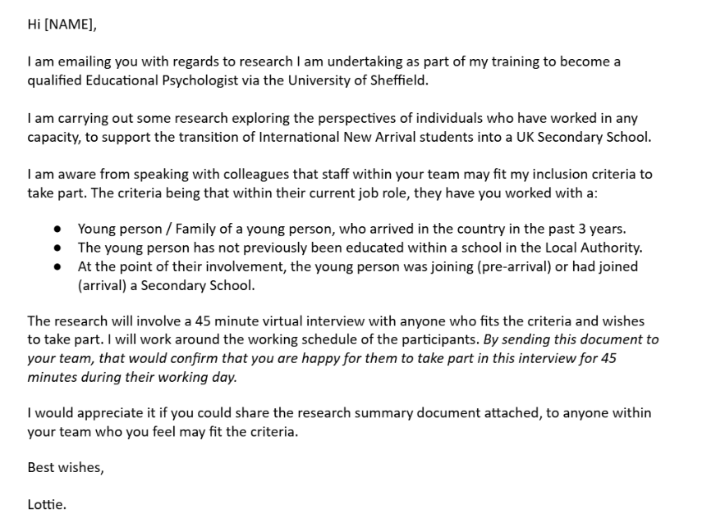

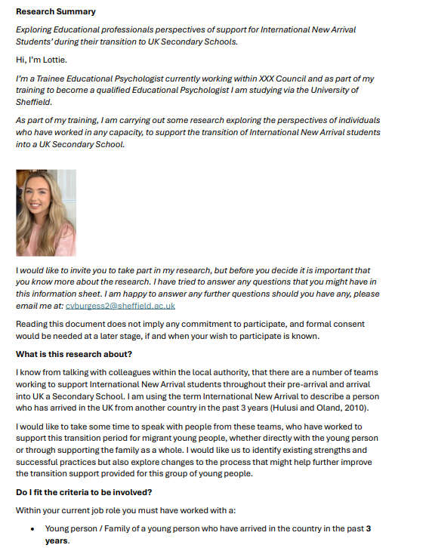

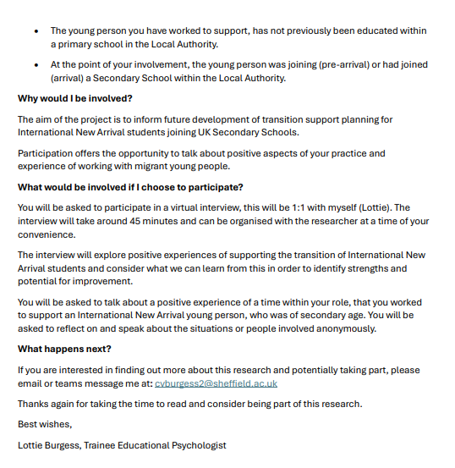

**Appendix II –** Participant Information Sheet

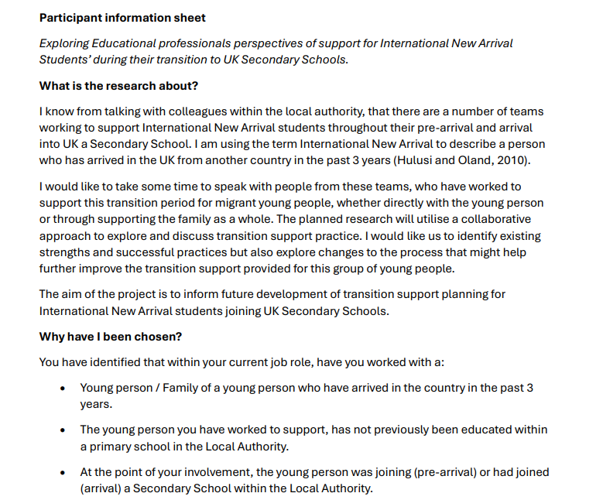

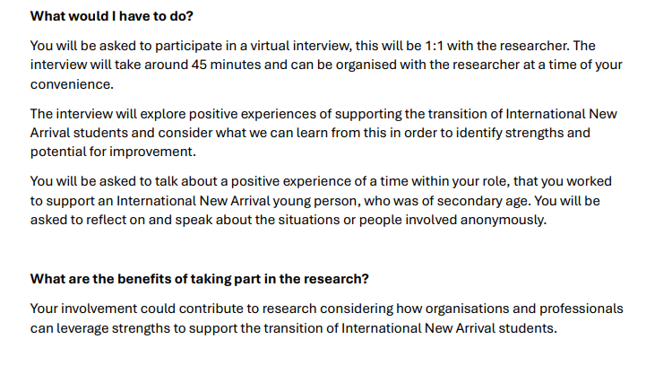

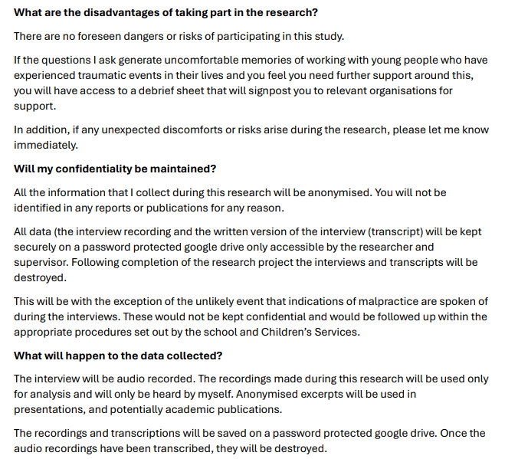

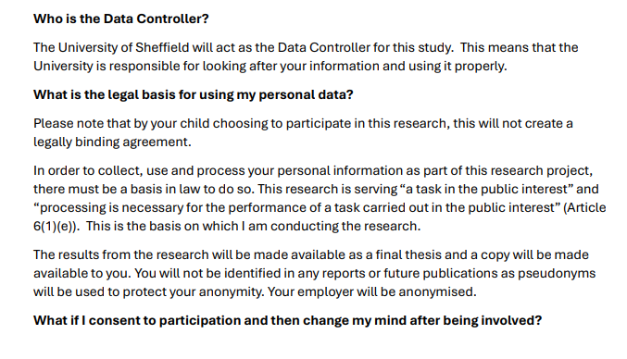

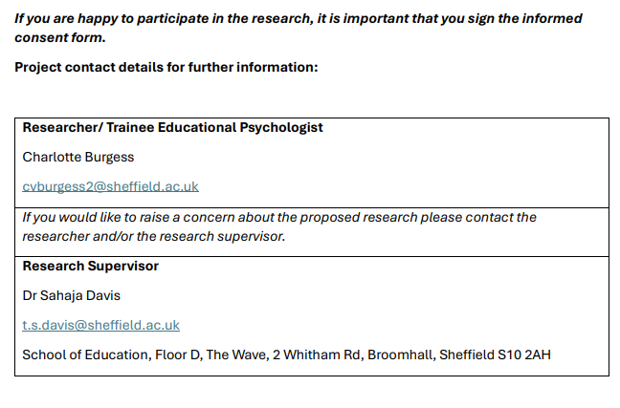

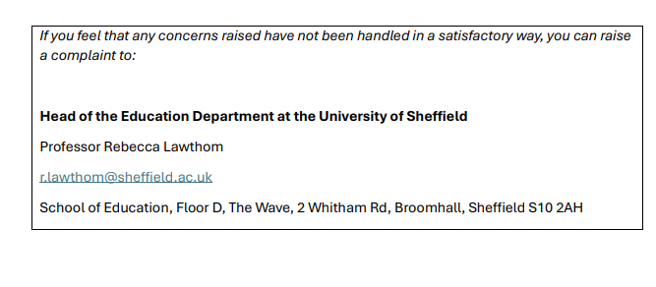

**Appendix III –** Participant Consent Form

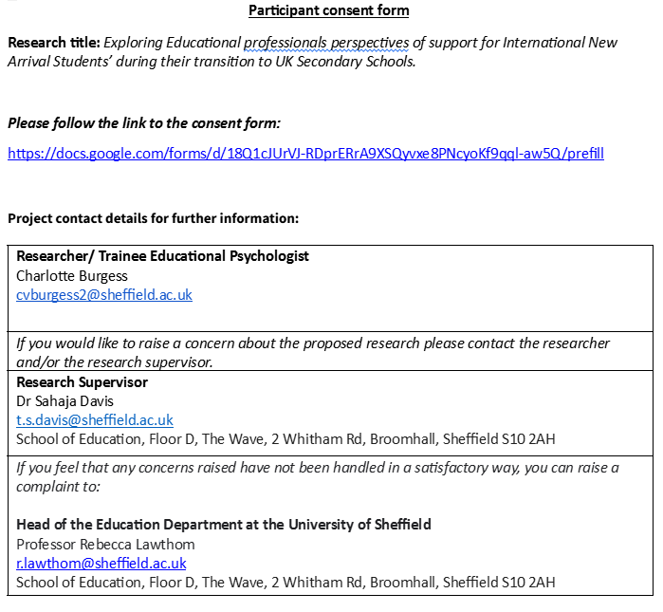

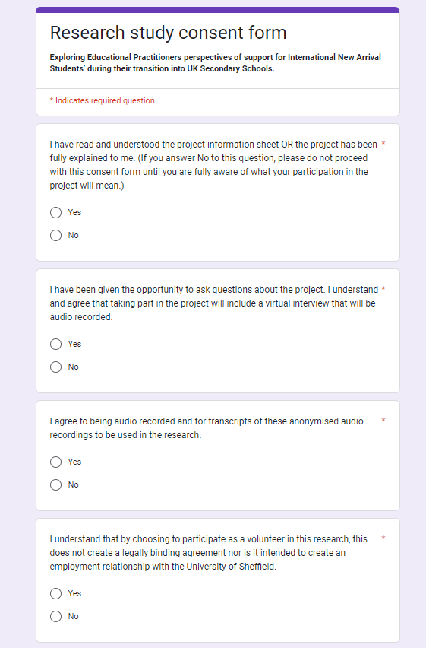

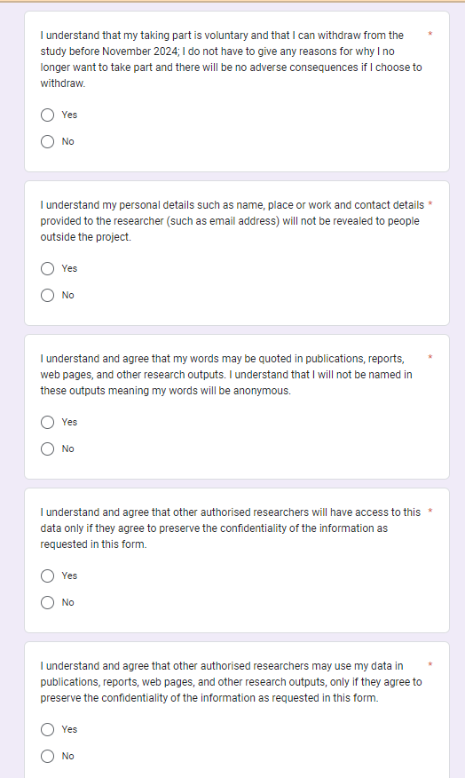

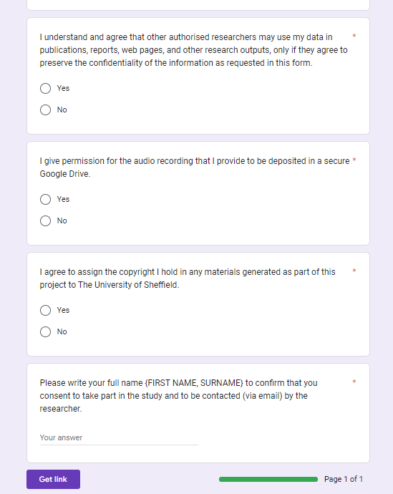

**Appendix IV -** Debrief sheet

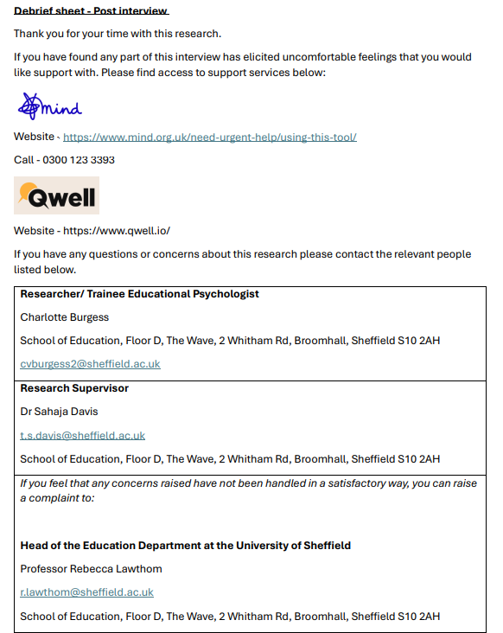

**Appendix V –** Ethics Approval Letter

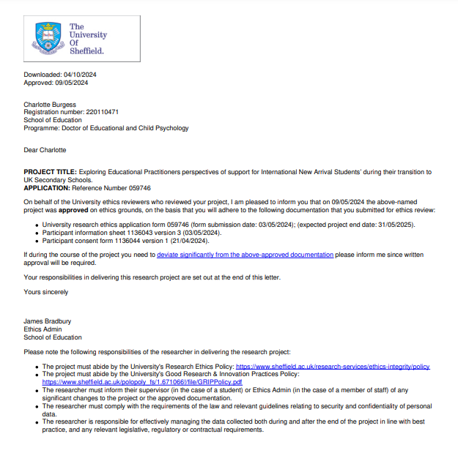

**Appendix VI -** Powerpoint slide used in interview

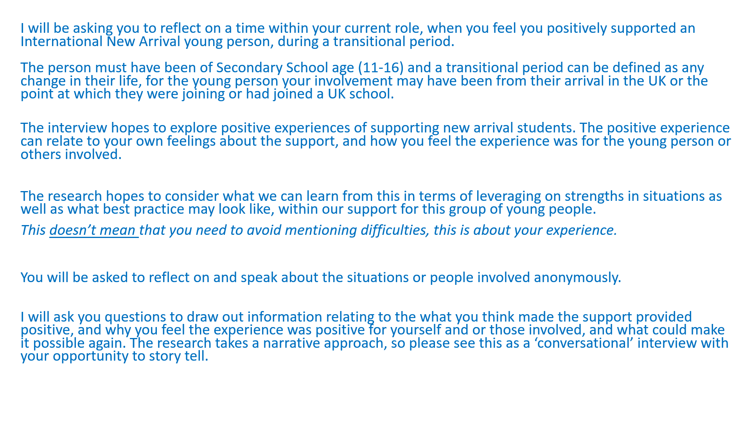

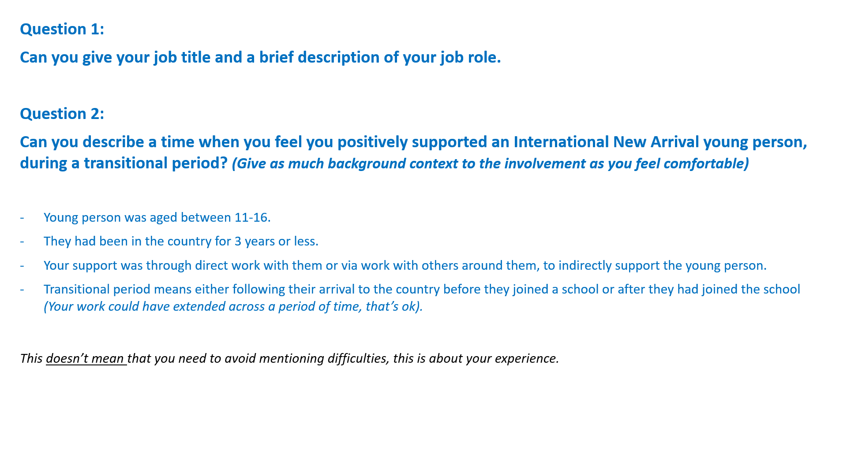

**Appendix VII -** Outline of Braun and Clarke’s 6 Phases of RTA

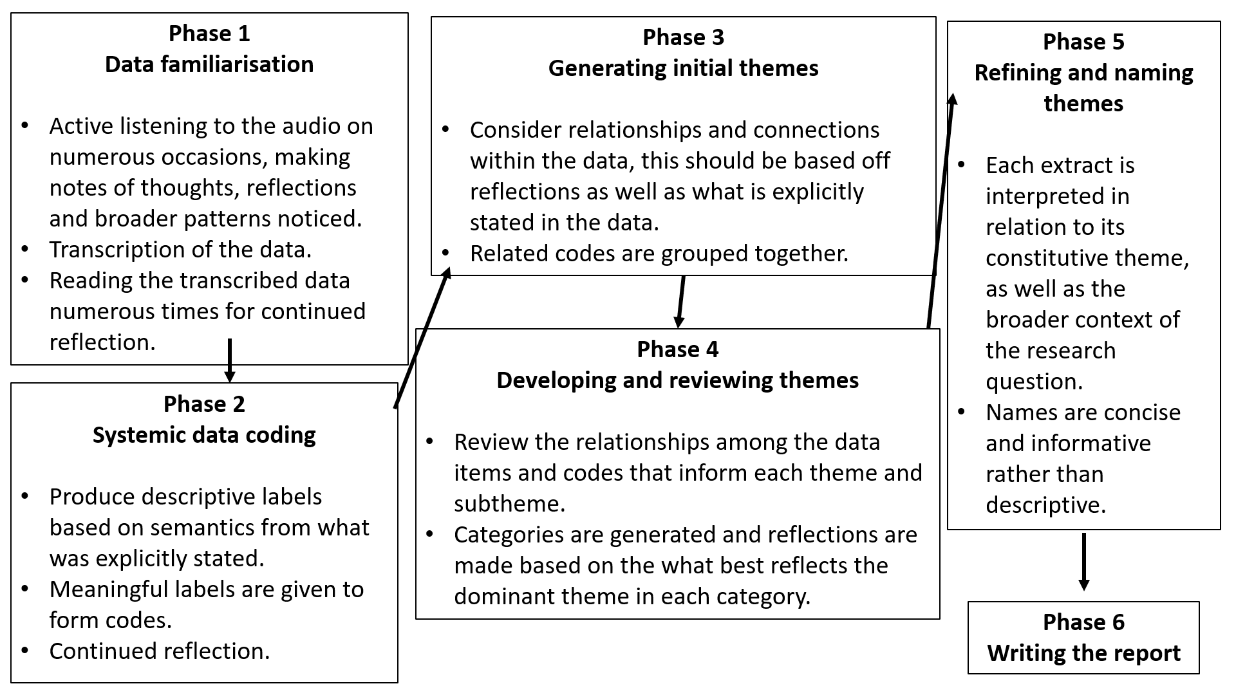

**Appendix VIII –** Transcript of Interview 1 (Integration and Partnerships)

**Researcher:** It’s recording now.

**Integration and Partnerships coordinator:** Okay.

**Researcher:** So this is the question erm. So it says, can you describe a time when you feel you're positively supported an international new arrival young person during a transitional period. Erm, give as much sort of background context about the involvement as you feel comfortable. Obviously the young person you should be thinking about or the work with their family, they were aged eleven to sixteen, they'd been in the country for less than three years, your support was through em' or indirectly through work with others.

**Integration and Partnerships coordinator:** Mm hmm mm hmm.

**Researcher:** Erm, and a transitional period means that you were involved either when they had just joined the country or as they were joining a school or when they were in the school.

**Integration and Partnerships coordinator:** Mm hmm.

**Researcher:** Does all of that make sense?

**Integration and Partnerships coordinator:** Yeah, yeah, yeah.

**Researcher:** Yeah? Fab. So just feel free to sort of go through speaking erm about whatever feels relevant about your experience, with relation to those points. Ok?.

**Integration and Partnerships coordinator:** OK erm, I mean generally, so yeah, the, the, the biggest one, so I've I've been involved in two, two sections. So the biggest one is when a member of the family's here, usually the father, they apply for family reunion. Erm, the wife and children, sometimes it's the other way around husband and children arrive erm through family reunion and then obviously the children are there and one of the things we do erm is help em' get into school. So that, that's a very big part of our job. And the second part I've been really, really involved is when we have the Afghan women's development football team arrive at the***(Identifying factor removed)*** hotel so we had a hundred twenty people arrive all in one go. And I can't remember the figures for secondary school, but I think there was seventy kids involved in that in that first cohort, all needing schools. And that was a really I'll tell on that one. That was a really positive thing 'cause we knew they were all coming and where they were gonna to be located, we got a really good relationship with ***(Identifying factor removed)*** school. Erm, and basically all the students went to that school, even though the school was probably full, they agreed to take em' as a cohort to make it easier, other than em' being sent to all different schools. So that did work really well.

**Researcher:** Mm.

**Integration and Partnerships coordinator:** They basically arrived in November and they were all in school within a matter of weeks.

**Researcher:** Mhmm.

**Integration and Partnerships coordinator:** Erm, all going to the same school as well, so I think that was important. Obviously they could support each other. They weren't, weren’t a single person going into a school of five hundred people feeling isolated, you know, all the, all the, you know, all the people they knew were going to that school as well. Erm, that went really well 'cause obviously, education were involved, admissions, it was, we knew what was happening, there was a process and everyone got together and it worked really well. Erm, and then obviously we we supported the children throughout that admission process.  
We helped em' with school uniform and stuff like that so that that one did work really well. The difficult, so the other ones we do is we have a lot used to have a lot of em', now I'm on a manager's roles I'm not as involved with the process as I used to be, but when I was doing the support worker role so yeah, people arrived to family reunion erm and we're part of the thing we do the school application.

**Researcher:** Mm hmm.

**Integration and Partnerships coordinator:** Erm, got a really good relationship with admissions at the time. Did everything from doing the parent portal application to taking em’ to the school on the on the viewing days, meeting the, meeting the staff, the teachers being shown and stuff like that. Did that really really well.

**Researcher:** Mm.

**Integration and Partnerships coordinator:** Erm, one of the difficulties is with new arrivals on family reunion they're usually placed in emergency accommodation or temporary accommodation. This can be anywhere in ***(Identifying factor removed)*** and not where they're going to settle. So one of the issues is we get em' into school and then six months later they're moving into other accommodation, which is a completely different part of the city.

**Researcher:** Mm.

**Integration and Partnerships coordinator:** Erm, and then you're having to do all the transfers and stuff like that and it takes time and this person might be in going to school in***(Identifying factor removed)*** and now living in***(Identifying factor removed)*** or something like that, you know, just an example and the the difficulties of maintaining that school while applying for the new school erm.

**Researcher:** Mm hmm.

**Integration and Partnerships coordinator:** So yeah, I mean, a few schools have had really positive experiences with a uh couple of schools. I'll give one instance of a school, ***(Identifying factor removed)*** so we had a family. So a guy was living in the country. His wife and two kids got visas to come over we managed to get em' accommodation in ***(Identifying factor removed)*** and supported accommodation. So we got there. So got the schools were applied for ***(Identifying factor removed)*** and basically they were saying they’d not had a foreign student before in that thing and they were a bit scared of taking it 'cause this person was, you know, very new to the country, very little English. They were worried about how they were going to cope at school. So it took a long. The school were very good. We had meetings, we went for a look, you know showed round. They had a student liaison officer for the year who was very proactive, but then the admission took ages 'cause the school was saying they couldn't support.

**Researcher:** Mmm.

**Integration and Partnerships coordinator:** The student with em' 'cause of a lack of English, so I was liaising with em' with the bilingual support team in***(Identifying factor removed)*** Council, but 'cause they weren’t on a resettlement scheme, there was no funding for the bilingual support going in, but they were saying the school gets paid a pocket of money every year for this, so they should be providing this anyway. The school was saying no, it's not something we've ever done. We don't, you know. And it just took and for all this, there was this poor student waiting to start school.

**Researcher:** Mm hmm.

**Integration and Partnerships coordinator:** Erm and not getting an education for, you know, it was a good few months in the end. Before it finally got sorted, but it did get sorted erm in the end. It took a lot of uh to and fro and not arguing but people taking responsibilities so erm. Yeah, but I think I think they, yeah. So generally the process works quite well. I've done a lot of school admissions, have been admitted school, the other. The other thing, it's not a school thing is the when they say the full and then your first choice, second choice, third choice, they're all full and then the student gets offered the next closest school which.

**Researcher:** Mm hmm.  
 **Integration and Partnerships coordinator:** Can be two bus journeys away erm, uh. And it's just difficult if it, you know logistics again two hour bus journey sometimes just to get school in the morning erm, but you know, not just that but the time to get to a bus stop to get some bus, then catch another bus in the waiting in between. So that's a big thing. And then parents saying they can't, you know, most parents don’t have transport in this situation 'cause again they're new to the country so it's not like you just drop em' off in the car or whatever.

**Researcher:** Mhmm.

**Integration and Partnerships coordinator:** Erm, yeah.

**Researcher:** I'm, I'm interested in sort of the first situation that you were talking about with erm when you spoke about your work with a large group of of families coming over and and you feel like that was quite a positive situation 'cause you sort of had, you knew where they were going in terms of housing erm and in terms of schools. And I'm just wondering sort of what, what did you feel supported in that situation? Cause you said that was quite a positive one. How did that feel for you?

**Integration and Partnerships coordinator:** I mean it was good. I mean the the reason why I was support 'cause they're on the resettlement scheme,***(Identifying factor removed)*** council got a lot of funding for that. So it is a difference to the other refugee schemes 'cause we got we got erm paid per person per day that was staying in that hotel. If you imagine a hundred twenty people, that's quite a large sum of money. So we were able to do things a lot more than we would people coming from the normal asylum and refugee routes. So but that yeah. I mean, it was great seeing, you know, they were arriving in the country in November.

**Researcher:** Mm hmm.  
 **Integration and Partnerships coordinator:** It wasn't. I can't remember exactly the timescape. It wasn't long before they were all at school and and learning and that just there was nothing worse than, you know, being in the hotel and having seventy kids running around all day with nothing, you know, there was a play room for the younger kids, but for the for this age group eleven, sixteen, yeah, bored, boredom. You know, they're in hotels, there's no, you know, you haven't got games playing and stuff like that and learning. So it was. It's really good to get that sorted quickly. And there's the multi agency approach from the council was really good on that one.

**Researcher:** Yeah. And I'm just thinking in terms of how like the young people would have felt about the situation.

**Integration and Partnerships coordinator:** Yeah.

**Researcher:** How do you think that they would have felt with how sort of quickly and smoothly everything went?

**Integration and Partnerships coordinator:** Yeah, really good. One of the things you know, they're all saying is we want to get back into education. You know, we've, we've we've fled the Taliban, we've been like in hiding and managed to get to Pakistan and this, you know, for this like three or four months without any education. So they all just wanted to learn erm and, you know, improve their English and get back to stuff they were doing over in Afghanistan. So yeah erm.

**Researcher:** Yeah, that's yeah, that's that's such a lovely situation to hear. But I also definitely sort of resonate with the more trickier situations that you've mentioned.

**Integration and Partnerships coordinator:** Mmm.

**Researcher:** I'm just thinking you've mentioned quite a lot that you feel like the positive experiences were able to be that way 'cause of the multi agency approach. What, what has been good about the multi agency approach?

**Integration and Partnerships coordinator**: Mm hmm. I think just everybody working together that again like I say that it was, we knew what was happening, we didn't get much notice, we got like oh, you know, we found out like the week before this was happening erm so we've pulled everyone together, and yeah, I think all the stops are pulled out 'cause of the situation at the time. It was a national thing. People are aware that, yeah, you know what happened over there and there was a lot of help offered so erm yeah, and together, you know, I could say to get everyone in the same school is just. Yeah, it's unheard of, really. And there was a lot of people, so erm kudos to schools and admissions for making it happen yeah.

**Researcher:** Yeah, definitely. What else do you think really helped that situation? So you've mentioned a multi agency approach and sort of the communication. What else do you think made it so successful and positive?

**Integration and Partnerships coordinator:** Probably the funding, like yeah, cause erm yeah we were able to sort things out quickly 'cause there was money there to do it and that’s not always the case.

**Researcher:** Mm hmm.

**Integration and Partnerships coordinator:** Yeah.

**Researcher:** What skills do you think came from sort of the people who were involved to make it such a good experience?

**Integration and Partnerships coordinator:** Erm just everyone had the, everyone had to do everyone was focused on on getting it sorted quickly and you know for the benefit of these people erm and they just yeah when everyone's focused on the same thing, it works really well.

**Researcher:** Mmm. Yeah, I agree with that from sort of my experiences and just thinking in terms of reflecting on how erm how you could make a situation like that happen in such a successful way again. What strengths do you think that people could draw on?

**Integration and Partnerships coordinator:** Erm I think having erm, we had a central point of contact for everybody. So pretty much, yeah, I was. I was like ***(Identifying factor removed)*** you're going to be going to this hotel and we've got a hundred twenty people arriving and you're going to coordinate everything that happens with these people and. Yeah. So it was about meeting everybody up and having regular regular meetings and feedback and just getting all sorted. And yeah, preparing the best we could and knowing what will come in and the limited time we had.

**Researcher:** I'm just interested from your role, sort of. Who? Who's your communication with? How do you get this information?

**Integration and Partnerships coordinator:** Basically the Home Office told I don't know, the whoever high up in***(Identifying factor removed)*** council that they sorted the hotel and just said that the Afghan women's football team will be arriving in in a week then.

**Researcher:** Yeah.

**Integration and Partnerships coordinator:** So then it was filtered down and it rolled, kinda went into panic mode. Like what we're going to do with this and then obviously my role at the time was supporting erm, I was the only support worker for refugees in the Council at the time so it's like almost you’re the most experienced person for the for the job. So you're going to take a lead on it, even though I was only a grade seven at the time or whatever it is, I didn’t have that much experience for what was really necessary.

**Researcher:** Mm hmm. Yeah.

**Integration and Partnerships coordinator:** Yeah, thrusting thrust into this thing. And yeah, they used the experience of that, the wider team, you know erm what we were doing anyway, with asylum seekers 'cause we use that experience to make it work for this arrival 'cause of the stuff we've been doing for other people, I mean.

**Researcher:** Mm. Yeah. So I guess within within your role then were you having much contact with sort of the young people?

**Integration and Partnerships coordinator:** Yeah. Yeah. Well, I mean, we were at the hotel and they were there every day. So we'd we we had a we we took a room in the hotel, a big room. I don't know what it was before, but that we had to date and then people just used to come to the office every day with. So I mean, it wasn't just scores. I was talking, you know, we had obviously we had a hundred twenty GP registrations to do, we had a hundred twenty benefit claims that everyone they need to make universal credit claims. So it was like a full on first few weeks of getting we had a plan like you know the most important things and we just work through it and obviously schools for kids was.

**Researcher:** Yeah.

**Integration and Partnerships coordinator:** On the list. But we yeah, we had a plan and there was, you know we got picked a few staff from different teams and we all went in there for first couple of months and yeah just work through it bit by bit.

**Researcher:** Yeah. Yeah, I think that it's. I think it's so rewarding to work in a job like that isn't there? But I can definitely sort of hear the challenges that you're saying.

**Integration and Partnerships coordinator:** Hmm hmm.

**Researcher:** Erm, I'm just interested in kind of what do you think best practice looks like and for kind of like you and your role when you're supporting new arrivals?

**Integration and Partnerships coordinator:** Yeah, erm I think it's it's about obviously just looking at a family arriving, it's again, you know, it's not just school when we get a case of a guy and his wife and four kids have arrived erm obviously accommodation is the number one priority erm 'cause most of the people who are living here already are in single person accommodation or shared accommodation. So the wife and kid, they can't stop there for a couple of nights you know, it's it's presented as homeless pretty much erm so there's this housing's number one priority. And then, I think I mentioned, yeah, so that at the moment they'll put, they'll put in a hotel for four to six weeks before they get temporary accommodation. That hotel is most likely at the moment to be outside of***(Identifying factor removed)*** so you've just you can't start planning for schools 'cause you can make an application for a school, but you have no idea where they're going to be when they move back to***(Identifying factor removed).*** So yeah, it's it's that's I know I'm not answering the question you asked, but that's the frustrating part.

**Researcher:** Yeah.

**Integration and Partnerships coordinator:** But yeah, getting obviously the the parent portal for me is a really straightforward tool to use to get people registered for school you know, just to get em' on in the time and then you can start doing applications a bit later down. The important thing is registering straight away so they're on there. I've got a really good relationship with admissions, so if I've got any issues I can, you know, instead of going through the general admissions thing, I just go straight to join taking a look at this. They’ve been really supportive of this of this client, especially with the hotel.

**Researcher:** Mm hmm.  
 **Integration and Partnerships coordinator:** Yeah.

**Researcher:** I feel like you've mentioned parents quite a lot. And I guess that what, what do you feel like your role is when supporting a young person? And and then obviously you know that that the parents there too.

**Integration and Partnerships coordinator:** Mm hmm. So it's it's about obviously again, you know, the parents, the the one who's just arrived has probably got no comprehension of the English language or very little and the person who's here, you know, a lot of the time they've got basic English, but any forms, erm application, stuff like that they, you know, they don't understand how to do so it's it's about supporting the whole family through all that through that thing. And then, then when you start school it's it's like school uniforms and things like that, they're roughly on very low, probably waiting for the first first benefit payment so it's about supporting em' through the the various things. So yeah, it's it's, I don't know, it's just and then, you know, their parents can get frustrated at the time things take when you know they come over and the kids are out of education for two to three months. So it's about supporting em' to do stuff at home as well. You know, we we erm, we get the early early help team involved sometimes and to give em' stuff to do at home.

**Researcher:** Mhmm.

**Integration and Partnerships coordinator:** Just so yeah, things that things are taking along.

**Researcher:** Yeah. And I guess it sounds like a lot of a lot of your work is making sure that you're sort of speaking with other services and liaising that way.

**Integration and Partnerships coordinator:** Mm hmm. Mm hmm. Yeah, yeah.

**Researcher:** How do you sort of find that aspect in supporting new arrivals?

**Integration and Partnerships coordinator:** Yeah, mixed. I mean some some we get, you know really good response, some other parts of the Council agencies, it's like banging head against all the time but that's the that's the thing, but one positive for me with kids starting school is they they pick up the English language a lot quicker than the parents 'cause they're they're mixing with kids every day and erm they're learning it every day and we often find that you know further down the line they're helping you to put their parents with the with the translation and understanding things and letters and stuff like that. So I think that that's really important part of integration 'cause obviously the parents who've got their you know what they do and then the children.

**Researcher:** Mm.

**Integration and Partnerships coordinator:** Learning language faster than em' and and supporting em' as well, so that that was well.

**Researcher:** Yeah. That's really nice and it's kind of like that whole family approach, isn't it? That you know, positive support comes through being able to support everyone around the young person and no, definitely I think I think that's really key. So I'm just like sort of the final question is thinking about how. How sort of positively support new arrivals may look in the future? What do you think would be needed for that to happen?

**Integration and Partnerships coordinator:** Mm hmm mm hmm. Yeah. Erm, I think just, I think school in general, not just for refugees, it's difficult. Now all schools tend to say they are full when you do an application it's it's very rare you get your first first choice of where you want to go and then. So I mean that's just erm, that's just the general population as such, when we're adding larger amounts of people coming from the refugee and asylum process, obviously adding to the the stress of the schools at the moment, I'm aware of one that someone was accepted but as a school they're saying they just haven't got the staff to do this, haven't got the staff at the school to do that.

**Researcher:** Hmm.

**Integration and Partnerships coordinator:** I think obviously there's a the bigger picture needs sorting out regarding education anyway but when it's when it when it works, it works well, but I think there's the issue of places and stuff in for the schools.

**Researcher:** Mm.

**Integration and Partnerships coordinator:** That that need sorting out for it to work smoothly.

**Researcher:** Yeah. So what to you? What does it look like when it is working?

**Integration and Partnerships coordinator:** Yeah. I mean, it's like I said, the parent portal's really straightforward to use, doing an application, the staff getting the letter saying you know your place has been accepted. It's it's it's it's a straightforward process when it works well and if the space is and yeah it goes through this smoothly and then the admittance to support. I find a lot of schools are very supportive of the new arrivals and they put things extra things in place to support people who are English isn't the first language.

**Researcher:** Mm.

**Integration and Partnerships coordinator:** Like I said, the yeah, the closer to the city centre type schools, obviously a lot more aware of it and you go a bit further out and then you know you've got your own or two. So I think that's where schools struggle, erm but definitely around this area all across***(Identifying factor removed)*** the diversity of the schools, they're just it's just second nature to em' now, do any new arrivals with English not as a first language and they’ve got that support in place. So everything's there, you know, the bilingual support.

**Researcher:** Mm hmm, that's really reassuring to hear and and I've had quite a lot of positive things about some of those schools, especially so that's that's really lovely to hear, fab. And I think that's probably all for me. I've got so much from this, which is really, really lovely and hopefully with everybody else that I interview should hopefully build like a really nice picture about what, what the positive support looks like when it's going well.

**Integration and Partnerships coordinator:** Yeah, yeah, yes. Yeah.

**Researcher:** And so yeah, thank you. I'm just going to stop the recording.

**Researcher:** Stopped recording

**Appendix IX –** Transcript of Interview 2 (SENCo)

**Researcher:** Started recording

**Researcher:** It’s recording now.

**SENCo:** Okay.

**Researcher:** So, can you describe a time when you feel you're positively supported an international new arrival young person during a transitional period.

**SENCo:** A few years ago we we had an actual EAL coordinator because we had a lot of students that came in and there was, English wasn't their first language but then we we didn't feel the need for that purely because a lot of it was sort of third generational then and actually English was really, really good. Erm, staff adapted really, really well and then obviously when erm, the, the Afghan situation arose we had in the January, I think we took around. Around eighteen students that came to us across the, the well across the five year groups, potentially six year groups. Erm, so we've got erm, I think we had about seven at key stage three and the rest of them were at key stage four, maybe one or two in Key Stage five.

**Researcher:** Mm hmm mm.

**SENCo:** And I think. Without, without sounding awful that came a bit of a shock to all of us because obviously their English was very, very limited and we, if I'm honest, we we didn't know what we were doing initially. So we had really big induction meetings with where they all came in together with the Refugee Council, with as many people as as possible. Erm. Actually, determining how old they actually were was a big issue because none of them had a passport. Anything like that with an actual date of birth on. So we've got some, I I don't know if this is what you want, but we've got some, it looked as if they they could be married with children and it was like, no, they're thirteen, it was like, no, I'm not sure that we are. So we that that side of things took quite a long time to to determine which year groups we needed to put people in.

**Researcher:** Mm hmm.

**SENCo:** Erm**,** At the time, one of our members of staff was just about to retire.  
And she actually agreed to stay on until the July, so key stage four. We, because it was GCSE year for a lot of them and even the the year tens at that point we kept together with the year eleven and I think there was one year twelve. Erm, I could be wrong, but I think there was one that was a little bit older, but they they wanted to be them all to be together rather than sending one to college and on their own for a little bit. So, so we kept them all together and they had just a bespoke timetable. Erm, one of the ladies just literally delivered, she was there sort of socially, emotionally and and to academically get them some basic English.  
Erm so, she she was English based so she literally just delivered English and Maths to them.  
Erm, for maybe five or six months erm because none of them were entered for the GCSE, so it was just building that and and looking at what the next pathways would be doing. Doing trips to college for the year elevens erm, getting the year tens enough sort of English to be able to access some Maths and English the following year to just sit the the Maths in English, so the year tens that came, did actually do GCSEs the following year. Erm alongside that, we'd got erm from the EMTAS team, we’d got people coming in and and doing bespoke work as well. So we we worked really closely with them and we tended to use those more for the the students down at lower school, so they didn't get that bespoke package as such. That was more for the upper school to get them sort of that conversational language ready for post sixteen or or year eleven.

**Researcher:** Mm hmm.

**SENCo:** Erm, at lower school we we, we put them into our lower ability groups with, rightly or wrongly there I suppose, with erm where we knew the TA support would be. Erm and we had them in lessons just sort of immersed into the language as much as possible, really. Erm initially there was no, no work had to be completed it was just being in there listening, communicating with the other students. Erm quite quickly, it became apparent that a few of them, actually their their English was was better than so we could actually move them into higher higher ability sets not not sort of too high but they soon started completing work and we're able to to access that a lot with erm Google Translate use of Twinkl because I think we could sort of translate PowerPoints and things erm there with them, but that's where we use the EMTAS team as well, because they would come in and and I think each year group had two or three hours of of actual specialist support as well, sort of based on working on their English skills and and things there. Erm so the two, the two key stages were very, very different in the support that they had.

**Researcher:** Mm hmm mm.

**SENCo:** Erm and I think I think it definitely worked because to be fair, we've still got. We’ve still got a lot of these students, the ones that were at lower school, are still working their way through when we've got sort of some year ten, we've had two girls literally just complete their GCSEs and have done quite well. We had two erm last year that did their GCSEs and were quite successful so I think that that time at upper school where we didn't put that pressure on, we just used it to to learn the language I think worked for them really, really well and at lower school, we’re not needing now, the the language that they've got and the ability that they're at, we're not needing to sort of withdraw and and do those additional English lessons there. They're now just in lessons and doing amazing, to be fair, they're they've done really, really well. Sadly, a couple have moved on because they've they've now been housed and it's not within the area and which is a real shame because some of them you, you just knew because they got that language, they were going to be highly intelligent and they were going to sort of fly in and a couple of those have gone, which it would have been really nice to just see how how they actually achieved because it it would have been good.

**Researcher:** Yeah.

**SENCo:**  But I think since then.We've not. We've had an odd couple of students, but again, I think because they've been in primary for a year or two, they've come in and gone into sort of mainstream mainstream straight away we've not had to have that sort of integration in there, they, they've, they've just gone straight in and and have coped with that in a achieving quite well. But I think that was our biggest cohort where initially  
we we did kind of go into panic. Staff were incredibly worried. What, what am I doing?  
We've kind of put little things together we've we've made like an EAL handbook erm.  
That just talks about the, using the Bell Foundation quite a lot of it, so the levels erm of language acquisition, acquisition and things like that erm and we've kind of not necessarily assessed as such, but we've we can identify where the students were. So they all the staff have got handbooks to use for strategies we've done as much training as we can possibly do erm with staff and and I think we've we've kind of taken it under the SEN, although none of us are specialists at all. So initially when people were like, oh, what do I do for this? We've we've kind of gone down a bit of an SEN route as well think think of your weakest students and how you break down your tasks and you scaffold the work and and do that but where possible use Google Translate just have odd words keywords translated on your, on your PowerPoint. And it seems to have worked. It seems to have come together and and the students seem happy enough and those that are at upper school are achieving and and are coming out with something at the end really.

**Researcher:** I find it really interesting. 'cause, you've said that obviously it was a really tricky situation when all these new students arrived, but actually you're now saying that this actually ended up being or you feel like it was positive and quite successful. So I'm just wondering what what is it that you feel tells you that this was a successful situation?

**SENCo:** I think, the, particularly at upper school that first year, when they when we got to July erm. Just the difference in the students. So when they came in at in the January, they would all be sort of just together all the time they'd they'd be talking erm in their own language and communicating and interacting with us but I think because we gave them just one key person. By the end of that time they the relationship was there, they were chatting, they were speaking English. Erm, they were, I mean, they were so polite that they tried really hard initially, even the key stage three, they they come in and be like morning. So they picked up the odd things, but they really struggled to to get their point across. But by the end of it, just it was just you could just see from facial expressions just the way that they're presented they were much happier, much more confident erm they were, they would give English a go even if it was a topic they were a little bit unsure of of. They'd really have a go and they just they embraced everything. Erm they wanted additional work to do when they got home and it was like, no, you, you're doing like, absolutely brilliantly and enough (laughs), but they just they really just engaged with our school community as well and they they made friends, they had peers that would come in and so we still got them into sort of the practical things so they still went to PE, they still went into technology, they still went in those lessons where we we wouldn't be sort of expecting them to sit at GCSE but they made friends and they they, they just seemed happier it you could just tell really.

**Researcher:** Yeah, I guess. What do you think it was specifically that you guys did that made that so positive for them?

**SENCo:** I just think they were just included. They were just welcomed into the school community and it wasn't erm. They they weren't. I know they weren't in upper school they had that specific work to get them, sort of conversational and to be able to move on when they left us. But, they were they were included in everything erm. They went and sat in assembly, even though they obviously wouldn't have known they they went on the school trips with with their year group and they were just welcomed and everybody just really tried hard with them and and wanted to talk to them and I think they just felt as if they fit in.

**Researcher:** Yeah, definitely. And I think you also, you talked about that staff member who agreed to sort of stay on. And I'm just thinking from your point of view, what do you think the values were that the staff had that made this so successful?

**SENCo:** Yeah. She she would. She's one of these. That would have gone above and beyond regardless, but she she became a little bit of a. I don't want to say a mum figure because not a mum figure but she was they they would. She didn't just teach them. She didn't just teach them English. She was there when they had problems. She was the one sorting the problems out when they came and they've not got uniform and things like that. She was the one running and getting them the uniform, or erm if parents wanted something she was the one ringing the the council, the Refugee Council. She she just took them under her wing and wasn't like a teacher. She was just there to support anything, really, any, any sort of area they needed support with, they would. She she just helped with everything. There were some really difficult times. There were some students that really did struggle mental health wise.

**Researcher:** Mm hmm.

**SENCo:** Some of them were here alone or well, just with an older sibling.  
Erm really really struggled with their mental health and we did need to have CAMHS. We did need to have a lot of support for those erm, but again, she was just a consistent person that was there throughout the whole thing, there was never a time that she she wasn't available to them, erm so she supported a lot of that with external agencies and and just just helping because yeah, some a couple of them. One boy in particular really, really sort of low at times because they they still had contact with home.

**Researcher:**   
Mm hmm.

**SENCo:** Erm but it's not the same is it they. And it was just an older sibling. And yeah, it just it was. It was upsetting for them really. But she she was just, like, consistent person. That was there sort of for that six months or so that just I think was what they needed at that time.

**Researcher:** Absolutely. Yeah, definitely. And I think the fact that she chose to stay to do that says a lot about her as a person. I'm interested. You mentioned about the induction meetings that you that you guys did at the beginning. What can you tell me a little bit about sort of what that looked like, who would be involved, what was the purpose?

**SENCo:** Yeah. Yeah. It was the head teacher and one of the assistants heads for inclusion. Erm, they came in with like representatives from EMTAS as well erm, older siblings, parents. Everyone was invited to come along so we could see, tell them what, what we were going to do, where they were. Where they are going to be which because we're a split site school. So which site they would be coming to. It was a chance for us to fit them up with uniform. It was a chance to we everybody got a laptop, so they'd got sort of access to to Google Translate constantly and and have that time. It was I think a bit like an admissions process where we we tried to get as much information as we possibly could erm. But that that was difficult because date of births were a little bit sort of they they kind of say it's it's this and then they fill something in and in school and it were like oh that's not what we had before (laughs) and we'd have to work with the Refugee Council then to just for them to just do a little bit of investigating.

**Researcher:** It sounds good that you kind of had those those links with other services that we're able to come in and I think support you guys as much as they're supporting the family.

**SENCo:** Yeah, yeah.

**Researcher:** So that you can work collaboratively and get all of that. I'm just thinking if sort of in the future. If you were to get like another large group of new arrival students, what do you think would make it possible for you to have such a successful time again?

**SENCo:** I think if we if we did have an another arrival, we would need to as much as immersing key stage three into those lessons was was good because they they they've now got that I think I think they need the basics first like what we offered at upper school and working together and that wasn't easy because that lady didn't speak any other languages or anything. So a lot of the communication was sort of through actions and and translate, but I think I think even just a short time, even if it's just four, six weeks that is focusing solely on language and conversational language so that they can at least ask for things that they need, express that sort of needs and their wants and things like that. Just just so that they, when they're in lesson, they can just communicate because there was a couple that didn't pick up the language there. There was a couple erm and of course, they've they've moved on now. So there was a couple where there would have been an SEN need in their own language as well, so we we we struggled there a little bit because how do we assess what the need is because how do we see what level they're at because we didn't have anyone we we used EMTAS to ask and some people came in.

**Researcher:** Yeah.

**SENCo:** One of them, it was, it was quite. Not clear, but we we did sort of start GDA pathway.Erm, we weren't sure how successful we were going to be with that because we weren't sure whether they'd be in sort of the ***(Identifying factor removed)***area to see the whole process out erm, and unfortunately that students not with us so I don't know how how far that went, but. Parents were very keen erm through the Refugee Council to to have sort of these investigations because they they've got their concerns as well erm. But I think even though some some of them over there had done English, spoke English, had their little bit of language, I think just having that time initially to just sort of get that conversational language more than anything just so that they could sort of start on a positive rather than going in and and it just being like Oh my God, what what is going on in in this classroom because of lower school, a couple of them did feel that way they they really did struggle. But then seeing them now having just left and just literally completed the GCSEs it it's a massive transformation of where they started to, to where they've left us so.

**Researcher:** Yeah, and it's so lovely when you sort of feel like you've got the a success story 'cause it. It must be so overwhelming for them. And I, I guess sort of what, what do you think that these young people felt about your support?

**SENCo:** Yeah. Erm that first year, when they were all together, I think it was very, very positive. Erm, that second, the second year when there there was no one Afghan boy and one Ukrainian girl went into year eleven. And I think had that the Ukrainian girl absolutely thrived, she went on and had she been able to have another year with us, I think she would have absolutely smashed her GCSEs because she was highly intelligent it was just that barrier, the other boy erm. And and the girls have just done GCSEs, I think to some extent felt a little bit little bit let down in a way, because when it came to exams, all we could put in was the dictionary and initially the ten percent extra time and and the the they'd say can you can you sit with me can you can you read it to me can you do? And it was like no we we we can't. Erm and I think had we been able to sit with a couple of students in a room and and just. Not not giving them information, but personalising it and just.Sitting and maybe doing each question at at once, which I know we can't do, I think, then again they would have had completely different experience of GCSEs because they. They didn't know how to use a dictionary and in the time that we've got actually showing them how to use a dictionary was but they didn't have the English and to to look and they they couldn't in their own language sort of comprehend what the English word. Was it the right one at the at the sort of got the right words that they needed? Erm and I think. For me, I think that's the bit where we're not supporting when we're expecting them to do exams and and we're only literally giving them, it did increase to twenty five percent extra time this year. But again, that extra time, if you've not got the language, isn't going to make a difference. And I think they got upset with that. Just the fact that I can't do it, I don't know what the words mean. And I read the questions and and obviously at GCSE the language is is for someone with quite a good grasp of English and and they just. Yeah, I think that that was their biggest upset I would say that the they knew what they want to say but they just couldn't get it down.

**Researcher:** Mm hmm. And I think, but it actually sounds like they're really valued all of the other bits that you could do for them. And then this sort of I guess, systemic barrier because it is a sort of a national thing that that you couldn't alter but when you could personalise and alter the other things, they really valued that.

**SENCo:** Yeah, yeah, definitely, definitely. And they, they were just typical teenagers as well they did sort of they would come to the hub because we've got a hub on both sites, it's just like our safe space really. They'd come to the hub and they'd be sat and it would be like, what lesson should you be in? Oh, I'm. I'm not going to that one like no, you are (laughs). It's like it doesn't matter, you've still got to go (laughs). So they they still did just what sort of our students would be doing, i'll just try and get out of this if I can (laughs). Initially as well, I don't think they they understood the the timings as such, they knew they'd got to be in school at half past eight, but I don't think they realised just how important that would be because driving to work or if we're driving between sites, you'd see them just sauntering down as and it could be like ten o'clock and they were just walking in as if, yeah, I'm up now, I'm. I'm coming, and it was like, no, you've you've got to be here. And uniform, it's like we've given you the uniform and we we bought, like shoes. They weren't the trendiest of shoes. They were just like, go to Asda and get the size that they needed, and they were just like, I'm not wearing those (laughs) and it was like, are you going to have to. And they'd come in and like, really bright coloured things, and it was like, no, you you can't wear those. So they did, but they were just looking at that no, we don't like that and it's no you're going to have to wear it, this is sort of our school policy and it's what we do. And it that took a little while because they would just get up when they got up and and come in and and think that it was OK to just turn up whenever they wanted to, but they soon adapted and they soon sort of.

**Researcher:** Mm.

**SENCo:** But some of them didn't have sort of that parent figure that was.  
But then you see the others where parents were here and and clearly because they've been, they've been doctors and things over there, though those parents and those students or were immaculately turned out on time every day really valued, sort of the education, but they they were really appreciative at the end of every day they would try and sort of say bye and have a nice night and thank you and they they really did just you could just tell they appreciate what they were just so happy that there was somewhere safe and they were getting an education, I think.

**Researcher:** And that's huge, isn't it? Absolutely huge that I think the safety part, the education and the Community part like you're you're interacting with the families and supporting so many other aspects is is really important.

**SENCo:** And that's something we never asked about. We we never talked about any experiences, but there was one of the boys that was was older. I think he was the year twelve and he used to do a lot of the translating so if if there was anything for any of the other students, particularly the upper school ones, he would translate. Erm and he he actually sat with, the lady that took them in and he he just explained everything to her. He was really open and and sort of and I think. That was because of that trust in that relationship, because it it wouldn't have happened and things like that. But he was older as well, and I guess he could process a little bit more where the lower school never there was no conversation whatsoever, but he he just sat one day, I think after school and stayed for about an hour and just sort of told her everything. And she was like and then she was thanking him then like for trusting in her and being able to sort of confide. And and little things. So again that just showed. What that relationship was like, I think up there there.

**Researcher:** And I think there's something quite big in that in that she was also learning from him. And that is so essential in understanding their community. Their experiences. Yeah, that that's incredible. I'm really glad that you've shared that with me because I think that was so.

**SENCo:** Yeah. Is that the kind of thing you wanted?

**Researcher:** Yeah, exactly. Let me just stop recording.  
 **Researcher:** Stopped recording

**Appendix X –** Transcript of Interview 3(Senior and Virtual School EP)

**Researcher:** started recording

**Researcher:** So just start off. So can you describe a time when you feel you're positively supported a new arrival young person during a transitional period? And just sort of share as much as you want in as much detail and I can just sort of jump in along the way.

**Senior Educational Psychologist:** Yeah, that's fine. So this happened a few years ago. I I think about four years ago and it wasn’t my school but they ring me because the young person was from Spain and they had just arrived to the country I think uh the week before. She was erm, already attending school, but her behaviour was very erratic to school’s understanding, she was running around, she was shouting, she was moving her arms very erratically and they just didn't understand what was going on, so she didn't speak any English as well, and her dad didn't speak any English, so they called me to support as a translator and an EP with the school EP, the family and school, because even school hadn't really had the chance to have a good conversation with the parents. And uh it was really meaningful for me because not even though I wasn't, I wasn't really the main EP in that conversation, I felt I was also a cultural support for that family. When the child saw that I was speaking Spanish, she came, she hugged me, she was crying, and I could only imagine how lonely they must have felt during those couple of weeks that they didn't speak any English. So I helped them understand what school wanted, their concerns, what the EP was there for and we had a really good conversation about the whole history of the young person, even when she was in Spain and also how she had moved to the UK and it resulted that the situation at home was very difficult. They were essentially homeless. They were living in a hotel provided by the local authority and dad was working as a delivery person all day, even at night, and he would take the young person with him. So she she was sleeping in her dad's van all night, and it was a really unhealthy situation. And uh thanks to that we were able to have a more holistic approach to understand the young person's behaviour and we were able to work out that she needed some emotional support. She also needed to have some bilingual support in terms of having perhaps the school routine written in English and Spanish and the activities in both languages and some opportunities to do activities in her own language so that she she could feel that at some point she was given sort of a break because obviously she didn't understand anything of what was happening in lesson. So when when we reached the conclusion that she was displaying that behaviour because she was just too anxious and she didn't want to stay in the classroom and after a couple of months I saw my colleague and she told me how this young person had made such a significant change after we've had that consultation and we, we'd worked out a plan to support her. And it was really meaningful for me because not only because obviously it was positive, but also because there was a strong focus on the young person's emotional well-being and how holistic the approach had been to support her. It wasn’t just about this person needs to learn English it was also about making her feel good at school, making sure that her needs at home were appropriately met.

**Researcher:** Mmm yeah, that was a lovely story. Erm, I'm just wondering from your point of view, what do you think made all of that possible like you're saying it was, you know, a lovely outcome at the end and you feel like she, you know, got the support that she needed. What do you think made it possible, I guess, from from your work?

**Senior Educational Psychologist:** Yeah, I think it wasn't necessarily my work I feel it was more the expectations from school, I think they were very good at being flexible and understanding that at that point the priority for this young person wasn't to learn Maths or Science or even to learn English, they just wanted this young person to make her feel comfortable at school and to have a good life at home, you know, to have her basic needs met. And then we were able to work from there, I think. If I need to pick something that I did well in that situation, I think it was just the the emotional support I was able to provide to the child and and the parent in Spanish in in a familiar language to them, and also a bit of the cultural translation helping them understand how schools work here and the sort of expectations and routines they have.

**Researcher:** Yeah, I think something that it also kind of like kind of sounded like you were saying was just being human.

**Senior Educational Psychologist:** Yeah.

**Researcher:** Actually just that sort of human element of of recognising sort of the emotions. And, so what other people did you work with specifically I guess?

**Senior Educational Psychologist:** Yeah. It was just the educational psychologist, the school senco and the head teacher, and I imagine that if things went well it was because probably the senco and the head teacher were able to communicate the message very well to the rest of the team.

**Researcher:** Mm hmm. Yeah. What do you think that the young person in the family felt about your involvement?

**Senior Educational Psychologist:** I think they felt relieved about having me there and I, I forget I forgot to mention that the move was very traumatic to the child. They took her at night, they drove all the way from Spain to the UK. They didn't tell her where she was going, what was happening because her dad was so anxious that he needed money and he needed to find a way to survive that, I, I think he must have had, like, an impulse and he just drove her there in the UK. So I I think the fact that I was able to tell the child about the things that she could do here in the UK and give her some ideas of games she could play with children and things like that was very reassuring for her.

**Researcher:** Yeah, and once again, just coming back to, you know, this is a young person whose experienced a lot and needs a lot of sort of emotional support. I think is key to what you're kind of saying. I'm just thinking what values do you think made this a positive experience? So your values that sort of drew this?

**Senior Educational Psychologist:** I think the main values were wanting to work holistically, so understanding that there is a child having a home life as well and having a past life before arriving to school. I think that was very important because sorry I forgot to mention something else so this child's mum had passed away the year before so on the top of everything that was happening there was potentially a bereavement process going on so.  
Having that understanding that all these things have had happened and could have an impact on the child's well-being and was really important and also I think another value, I'm not sure how to word it though or if this is a value but just listening or trying to understand. So the fact that school were able to understand that they needed somebody to translate but also they needed to listen to their family, I think that was key.

**Researcher:** Mm hmm. Yeah, I think it's it's value in their experience as well, isn't it.

**Senior Educational Psychologist:** Yeah.

**Researcher:** So if you were to sort of come across erm, a similar case or work with with young people who have, you know, been on these sort of journeys and experienced all of this change from a different country. What do you think would make it possible for it to be as good again?

**Senior Educational Psychologist:** I think having an initial meeting as soon as possible with the young person's family, but also the young person if they are able to participate, it's really important because it allows you to have that open dialogue that makes sure that you can explain how things are working here and also understand what they are coming from, what they expect, what they need.

**Researcher:** Mm hmm, yeah. What about from other teams? What do you think other teams would need to do to make it positive again in the future?

**Senior Educational Psychologist:** Well, ideally, if this conversations could take place with as many professionals as possible, if relevant. So, for example, social social care in this situation, or even employment support for dad also in in in that interview and then health because we don't really know if the child may be experiencing some sort of pain or maybe they can help with the anxiety.

**Researcher:** Like a multi agency approach. Yeah, no, absolutely.

**Senior Educational Psychologist:** Yeah, yeah.

**Researcher:** I don't think I've got anything else that I would want to sort of chat about in this case, but do you feel is anything else that is important to mention?

**Senior Educational Psychologist:** Yeah, I I think maybe I'm. I'm again thinking from this case, I think it was important the fact that school could understand that this person didn't speak any English and she would need some specific targeted support to learn English because I feel in most of my case work with EAL pupils, I think they are expected to learn English from just being there in the classroom. And that has an impact on their well-being so.  
That this school was able to understand that and to change their expectations was really important.

**Researcher:** Yeah, I think that's absolutely key. It's about, you know, taking a young person for what they are and what they need as an individual. Definitely. Perfect. Thank you for that.

**Researcher:** stopped recording.

**Appendix XI –** Transcript of Interview 4 (Admissions and Attendance)

**Researcher:** started Recording

**Researcher:** Okay, I think this is recording now. So the question is, can you please describe a time when you feel you've positively supported an international new arrival student during a transitional period, just give as much background or context as you can without giving any identifying factors.

**Admissions and attendance officer:** Yep, that's fine. So obviously in my role as an attendance and admissions officer, I come across a lot of new arrival students and their families kind of in my day-to-day job. I would say that the number of students that we've had definitely increased. From lots of different places really. I guess we've had a lot of new students under the Afghan Resettlement scheme. I guess this situation, I'm thinking of more specifically was a couple of years ago and there was a family, a young girl with her, two older siblings and then Mum and Dad, So the younger girl was going to be joining in year eight and the two older siblings into Year eleven. And I guess that. This one really sticks in mind for me because the parents, they couldn't really speak English and the older siblings in Year eleven had an okay understanding of English. So, in the meeting. So they’d obviously applied online through the council, so we like email or ring them and plan a meeting for them to come in to the school, and what we do is they have an initial transition meeting, so that meeting it would be me from admissions, and sometimes a head of year, but just because of stuff, and that doesn't always happen. So it tends to just be me.

**Researcher:** Mm hmm mm.

**Admissions and attendance officer:** And this family they’d, they arrived and obviously, in the initial meeting, the plan is to sort of. Just get them in and get the information that we need. Get them on the system. It's usually a little bit more but I guess, but this situation really stuck with it in my mind with me because of the sort of fulfillment that I felt. So like I said, the mum and dad didn't really speak much English and the oldest siblings in Year eleven. They were kind of the sort of translators for the family and obviously, for the little one in year eight, who would be going into a year group by themselves. And kind of didn't have the spoken language themselves that they knew that their two siblings did in year eleven. I could sense that that was quite an anxiety inducing time for them.

**Researcher:** Mm hmm mm.

**Admissions and attendance officer:** So in this meeting a lot of my communication was going through the older siblings. And I guess that I felt a little bit tricky with that, you're the one’s who's joining the school, you're the students, and they were really having to do sort of, sort of an adult's job and you could just tell how grateful but also kind of deflated the parents were that, that they were in a situation where they could have the older kids doing that. But also I guess they kind of gave a little bit of a sense of not wanting to give too much away in that they were struggling because they were going through the older siblings, they didn't know exactly what was being translated. And so obviously, we just start off with getting understanding of kind of their ages and like where they live and getting all the admin details you know. But the more that kind of we were speaking you could sense that the mum and dad were finding it really tricky that they didn't know what was going on and that the siblings were being and sort of used as translators. And I myself found that a little bit uncomfortable because I sort of reflected on how some of my meetings usually go with the parents sharing the information and the kids usually just sat there listening. And I was like, I was thinking of how different this is for them, and already that kind of feeling for the kids like, you've really got the advocate on behalf of everyone and even the parents wanting to do more and feeling a bit stuck. So, I sort of asked if we could just sort of pause for a minute, I spoke with someone from the leadership team and said, can we get someone to translate. And we're really lucky here, we have got a really good leadership team who were willing to sort it straight away, and pay the money and get the translator. Because it’s not free you know?

**Researcher:** Yeah!

**Admissions and attendance officer:** You don't get the translators for free unless the families or children are coming over through a refugee scheme or resettlement scheme. So because of that, we had to pay. And so I try to explain to the Year, eleven students who are helping to translate that. And they were really sort of. Sort of grateful, I guess that we recognised there may be some support needed, and that kind of felt like, this is, the basics but I can really sense even with the language barrier sort of the relief from the Mum and Dad that obviously they were conscious that there was a lot put on to the oldest siblings and the youngest sibling feeling probably really out of it. Perhaps, I'm not sure, thats just what I thought.

**Researcher:** Mmhmm. You’ve very reflective and I just wonder at this point, what you think the strengths were or best practice in how you supported in the situation up to this point.

**Admissions and attendance officer:** Yeah. So, I guess a strength really that I was. I guess for me, using my sort of empathetic skills and recognising body language, sort of how someone feels. You know I do these sorts of meetings frequently, I’ve been in this role for almost seven years, so I know when thing feel a bit different. I think also then the communication with the language support team within the council, in this situation they were incredible and sort of within twenty minutes, there was someone virtually who's able to translate. It was kind of like everybody pulled together and that sort of that understanding of none of us will get it but we get it. If that makes sense?

**Researcher:** Mmhmm, yeah.

**Admissions and attendance officer:** We'll never get how that situation feels because I haven't been in that situation but we get that this is something that is really important as a family approach and to not put additional onto the young people and so, it was a nice situation to be in when you have all of these services who sort of pull together already. Yeah. Shall I give some more information about what happened?

**Researcher:** Yeah absolutely, yeah. Thanks.

**Admissions and attendance officer:** So when we got the translator, Mum and Dad they started to share a little bit about I guess where they had migrated from and what support they had accessed since arriving in the UK. They weren’t immediately open enough with the fact that they needed, additional things, in terms of financial help with school uniform. But I think that because we showed just being genuine, like the fact their voice was valued and also needed, they began to open up a little bit more and we were able to ask those questions about what they need and stuff like that. And so it's just a really sort of heart warming situation.

**Researcher:** Yeah.

**Admissions and attendance officer:** And I think why this one stood out to me is because, like, I sort of then communicate with staff about what any new starters need and helps to inform classes and stuff. So I was there for when they came back to start and sort of transition to the school and to see the kids joining their year groups and begin to make friends and enjoy school really. The younger sibling, you know the one in year eight, she did seem to have a more difficult time in the beginning with I guess feeling comfortable in school and beginning to make friends. And, and teachers were concerned about her wellbeing but because we had that time with the family initially, it really helped with knowing how to approach parents to share some information around that to support her and them.

**Researcher:** That sounds like there was really good communication between staff too that helped to make this a more positive experience for the them. What values do you feel were important in making this a positive experience?

**Admissions and attendance officer:** I think that being able to take that approach to support the family and to then communicate with the family. I don't think that could have happened, without a sort of family approach. I think because we were able to have that family communication so early on, and really show that beyond the school building, as an school we want our students to be happy and safe and that comes from home too. But really, this is just inclusion right? I wouldn’t say that because we required support to have this communication with the family that the values are different to what I would take with any child or family that comes in for admissions meetings. It maybe just looked different and possibly felt different, because there was that element of being more culturally aware and adapting to the situation.

**Researcher:** Yeah, definitely. And I think you've obviously mentioned that a multi agency approach What do you think it was about the Multi agency approach that was so supportive in this situation?

**Admissions and attendance officer:** I think that people responded quickly, and I know that, that kind of might be the bare minimum of the situation, but it was almost like. I guess that people just sort of, valued that we recognize that someone's struggling or family is struggling and this isn't something. Perhaps that can wait. If that makes sense? But this definitely couldn't have happened without that multi agency approach. I think that we would have continued in that kind of stuck situation of wanting to do more but not knowing how.

**Researcher:** What do you think the family thought about your involvement?

**Admissions and attendance officer:** I think that they were, I guess relieved that. Even without being able to communicate it verbally initially. I'd recognise that they needed the support, The communication, perhaps wasn't. There, but just a feeling. I guess it's just those values of, wanting to work holistically for someone and seeing The child is part of the family and like I said, I do these all the time. For. English speaking children who are just coming from the local area or across the area. Recognizing that there was more to this than the three children that I guess enroll. It was what's the impact on the family here? what might they be feeling and How can we make this process better for the long term because obviously, we didn't just want to get the basic information. I'll names, etc get them on the system and then there's no communication with the family again because, that isn't The way that we like to work. But especially in this situation that we would have ended up that being the case. There hadn't been of the multi agency approach And so the Slt who are on board, and we are very lucky in this school that they wear.

**Researcher:** Mhmm. What did you do, feel, or tell yourself that made this a positive experience?

**Admissions and attendance officer:** Yeah, I think experience really helped me in this situation because like I said, I had all of these other admissions meetings to reflect on and I know that when I've spoken to, to the teachers and say, we've got new student coming to your class and the new country and there's some new English. It just tends to be a panic and I get it because. You want to do the best by everyone and you want to ensure that students feel, supported and happy and they're able to learn. And when you don't have that experience in that, I can understand why that's quite stressful situation because you don't let people down. And I guess that I had the experience of knowing what it felt like for me with how these admission meetings usually go I would feel quite smoothly, child arrives, you know, we discuss, their previous school and experiences, what subjects they’ve done and stuff. And I knew how kind of straightforward those can be. And this one didn't feel like that. So I think that sort of experience really helped me. I think that allowed me to be so empathetic. And also, obviously to have the connections and the links to be able to say, right, I need to go and get this language support and I knew that that was there, which I guess that in other situations, like I was mentioned with the teachers, they don't always have those resources that access or to know to do that. So, I think that that made it quite a positive situation for me to be able to reflect on. Like when things have felt good and why this one perhaps didn't and why I needed to change something because I could sense that the family needed some more support.

**Researcher:** Mmm. Yeah. That's great. Thank you. So obviously this was a really positive situation for you and I'm just wondering, what do you think? Could make situations like this happen again in the future. So obviously support and transitions positively for new arrivals. What do you think would be the key things to be?

**Admissions and attendance officer:** I think trainings, obviously a huge thing, like I said, my feelings that we needed to get other people involved was that I had experienced, what I felt were quite simple, straightforward positive, transition, meetings, and then seeing the student go through into school, make the friends, make these links etc. But I, Knew that because I'd experienced it. And I think that I said if you're a teacher in a classroom who is used to sort of a certain way of doing things and then you get a student who doesn't speak English and needs some additional support and, they're just into the culture and they find it difficult to meet friends, you would probably need a little bit more training and thinking about, how do I support them to integrate, beyond just. Beyond just my classroom. I think it is a whole school approach, isn't it? But I definitely say training would be something key and for all parties involved, because if I wasn't there that day personally, normally, does it there would have been somebody else who would have done it and that would have just been, sort of anyone because we have, a process of we collect this information. We tell them to start date, we found out what they like, etc and then they just go in and I think that's really tricky. So to make it positive in the future. I think also would be maybe like meeting with parents separately in these cases, did all those conversations need to happen with the children there? In some cases the parents I guess especially ones who are coming over as as Asylum seekers, they might have experienced some really traumatic and difficult things that they don't want to keep talking about in front of their children, I guess the parental voices are really key in understanding the situation for the family so that we can support wider and how that will then impact within school. Because like I said, in this case, the Year, eight student was really struggling understandably but thankfully we had made that connection with home to be able to have that sort of dialogue with the parents and to be able to build that trust with the parent to say, an we talk to you about Some additional support for your child. And I don't think that. I don't think that that's an easy situation to do. I think that the parental voice is really key because ultimately when that child leaves school, they go home and they speak to the parent about the day. In some cases, they might not. And then they'll be coming in every day. Then they're not able to communicate with people about how that feels, but if we were able to have that relationship with home and it's just such a community approach. I feel like because, in a lot of other admission and transition meetings. The community approach is just naturally there, because the kids are usually from the local community, I live in the community and a lot of students who we enroll are from the local, area. But in the cases of new arrivals, that dialogue isn't already naturally there and that understanding of experiences. And so, actually, taking a community approach is really key. So, yeah, obviously, sorry, training. Erm a community approach And obviously the Multi Agency side of things is going to be key to everything. I would say. Yeah.

**Researcher:** I think it's really lovely, that you've noticed that the parental voice actually is quite key and in making that community practice

**Admissions and attendance officer:** Yeah, so we naturally have that when the majority of the students are from the local area. But when they're not I think it's so important that we make that priority and. Because ultimately the times when I've seen what feels like a successful transition for new arrivals, and especially in this case, when I'm talking about, these students in particular, it was when we'd really taken time to understand What the family needs. I guess on a wider level what is essential for them to be safe and comfortable. That sort of back and forth. It feels necessary and I guess that It's something that we could miss in some transition situations I guess if they’re not well planned and thought out pr just not having the necessary training with the right people.

**Researcher:** I feel like that was a really lovely way to end this and thank you for everything that you said. It's very insightful. Is there anything else that we've not talked about that you feel like you'd like to add on?

**Admissions and attendance officer:** No. No, I think that's everything. Thank you.

**Researcher:** Perfect. I'll stop the recording here then.

**Researcher:** stopped recording.

**Appendix XII –** Transcript of Interview 5 (Head of Outreach)

**Researcher:** started Recording

**Researcher:** It’s recording now.

**Head of Outreach:** Mhmm.

**Researcher:** So, can you describe a time when you feel you're positively supported an international new arrival young person during a transitional period. Erm, give as much sort of background context about the involvement as you feel comfortable.

**Head of Outreach:** So when they come through admissions and obviously if if there's a language barrier, something like that, they, they ask me to come round and and and support uh and if we notice that you know they they don't speak English then any communication, any communication home goes through me and also if we recognise that the child is new to to the country then put them in a new to English classroom where they learn ESOL. I mean like English all day kind of thing

**Researcher:** Yeah.

**Head of Outreach:** And then that's like a twelve week programme. And if they if they, if the teacher feels that they are, they've learned enough to go into the mainstream classroom, then they transition. If not, then. They complete another twelve week programme.

**Researcher:** I find that really interesting that you've kind of you've got like a good structure in place. I'm just wondering from your point of view. So is there any sort of student or family that comes to mind that you kind of think it was a really positive well planned transition, for them from sort of the admissions route, I guess being integrated.

**Head of Outreach:** Yeah, we had. We had a child who came through. She was in in new to English for about two years. I don't know if this is positive or not (laughs) but uh. And then when I when I started working here, she came into my classroom and and I taught a little bit and I noticed that there was some some uh SEN need there. So obviously because of a language barrier that wasn't noticed before because she was in new to English, they just assumed that she she's she needs to learn the language first but obviously I noticed that there was an SEN, so we made a lot of referrals, speech and language, you know. CAMHS and everywhere else and and now she's getting a lot of support and and she's transitioned to like our SEN class.

**Researcher:** Mm hmm.

**Head of Outreach:** Erm which is also great that we have because not every school has it and she's doing she's doing well. Now she's able to communicate on her own with like the professionals that she's got all of good relationships because she was very withdrawn uh before because she didn't get any learning, she just felt that she was, like, very different from everyone but now she's opening up and. And obviously I communicate a lot with the families, make appointments for them and and things like that. So I think this is this is the positive.

**Researcher:** I think that's really lovely and I think that your involvement with the family is quite key. And I'm just wondering what do you think made it positive for them?

**Head of Outreach:** It's just the fact that they have someone who understands them, you know, because if you don't know anything about the culture, the language or the ways, it's hard to misinterpret a lot of things that that are happening. You know and, and because I come from the background, I kind of understood why they having these difficulties and I was able to find the right approach to to like almost help them integrate, you know with with the new like laws and rules and the ways you know in England because it's all all new to them and because they live with their little community, they never actually integrated properly and and. Like. Adapted to the way you know. Of of of British ways kind of thing.

**Researcher:** Yeah. So it kind of sounds like you used your own experiences in order to support them. What did you feel about that experience that told you it was a good one or a positive one?

**Head of Outreach:** Erm, I think the fact that he would she would be lost in the system for a lot longer. And potentially get permanently suspended because she was because she couldn't understand the learning she chose to truant and around school and and cause trouble and people didn't understand that was down to obviously her needs.

**Researcher:** Mm hmm.

**Head of Outreach:** Erm, so when I when she came into my class, I actually taught in her own language as well. So I spoke English most of the time. But, if if I noted that she didn't understand what was happening, I explained it in in her own language and and she didn't understand either, you know. So basically I picked up a lot from that.

**Researcher:** I'm just wondering from that what your involvement was with maybe like all the stuff in the school to help them to understand a bit about her?

**Head of Outreach:** Yeah. So I did. I did a little CPD for all our new, our new like trainee teachers. Just to teach them about Roma children specifically, why they misbehaving, how to manage their behaviour, why they behaving in the way they behave in, you know, little background on the history and and their whole life and how that's impacting their behaviour. Erm, and they found it very useful because it helped them kind of develop a relationship with the children because they really struggle with following rules and expectations because of their home life is very different, is not very structured, there's no discipline in in anything that they're doing pretty much. So obviously they struggle to adapt in school. So I kind of showed them a way around to get them on side too, so they're able to follow and not just, you know, come and fail and. And go home.

**Researcher:** I think it also sounds like you're saying relationships are key to what makes the experience, I guess good for the staff and the young person.

**Head of Outreach:** Yeah, that's that's it's just it's cultural for them. Erm, and I suspect it's it's it's same for all disadvantaged families because they they go through similar experiences, so they they need to feel that the other person is kind and that they can trust them. Because if you just give them an instruction, they'll just refuse because it might not be comfortable for them or they just don't want to do it and that's it. They won't do it. But if if they have a relationship with you, they don't do it just because they like you and they'll do it for you kind of thing, so I think this is like a neutral approach to all disadvantage.

**Researcher:** Yeah, Definitely. I'm intrigued about the sort of admissions process that you were talking about. So what does that look like? And I guess, what did that look like for the young person that you were talking about?

**Head of Outreach:** So I'm I'm normally called to admissions when when there's a language barrier (laughs) because these are run by somebody else. But if if I speak five and half languages.

**Researcher:** Oh wow (laughs).

**Head of Outreach:** So when when they struggle, they call me and if I can speak language or it's like go through the admissions and I find out well everything I need to know about the child and then I make a decision if they're going to go to the SEN or, you know, the new to English or if they go to their mainstream classrooms.

**Researcher:** OK, so you're able to sort of once again draw upon your skills and your experience to support. What do you think is the best practise within the work that you do?

**Head of Outreach:** I mean, it's probably the languages is one of the main things she's been able to speak the language, because without that it's it's hard for them if they, if you don't understand the rules and the ways and then the expectations is hard to meet it. So if I'm able to explain in the in the home language, obviously it's just easier for them to follow it.  
But their best practise will probably just be to be understanding in patient. We do a lot of work in the community. We go out, we help them with appointments. You know, we'll register with dentist and.And helping with housing and, you know, early help referrals and food banks and and all that is is obviously from from the behaviour perspective, that's my job really to manage behaviour. So to fix that I go into into depth of helping the family overall to to fix that behaviour because I can see that it's coming from from home, you know. And then if home is not established and stable, then obviously the child will not behave in school. So I think every school should have. You know like this this outreach sector where families can get help and advice and help them like with the. Don't know, like I don't know, just to adapt.

**Researcher:** Mm hmm.Yeah, I know. I think having worked in in schools with a lot of new arrival students, I definitely agree with that. I'm thinking about if we think back to the the young person that you were talking about, what values do you think were important that you brought to that situation?

**Head of Outreach:** I think safety, really.

**Researcher:** Yeah.

**Head of Outreach:** She was. She just felt safe and. And a lot of lot of children just feel safe when they're talking to me. Almost knowing that I'm going to do the right thing for them, they don't trust other people. Because also he's because with my job I have, I can give them my time, I speak to them. I know a lot about them. They know a lot about me. 'cause I tell them about my experiences. So I think they just it's it's the trust I think is the main thing.

**Researcher:** I think that trust in the two way thing, you know, you're asking a lot of them to be open about their experiences. And then you're also given that back. I think that it takes a lot to just open up and tell yourself to people.

**Head of Outreach:** But I think this is a practise that every person can adopt. You know they doesn't doesn't have to be an outreach worker to to have this approach. Obviously, every every school demands discipline and everything else, and I agree with that. That has to be up there, but also that the times that we offer children needs to be needs to we need to give them more time. Umm. And just work on those relationships because with our relationships nothing will work as it should.

**Researcher:** Absolutely. And if we think about that situation again with that young person, what do you think would make that possible to happen again in such a positive way? What do you think was needed to make that go so well?

**Head of Outreach:** It's again, I think it was the the relationship working on the relationship with parents as well. Mainly actually because. Parents, a lot of the times refused, you know, help. We offered our help. They weren't sure what that was. They refused. They refused a lot of other services, you know, like. This specific girl went through a lot of trauma and they DRASACS, they refused, you know, CAMHS and didn't turn up to appointments because of of their worries you know, so. I had to almost like take them that, you know, book an book, an appointment, rearrange and then, you know, remind them on the day or even just give them a lift and, you know. So I think it was that relationship. And now if if something is needed, if I say right, I think, you know, we need a referral to, I don't know speech and language and they’ll say what is this? And then I explained, you're like, OK. Yeah. And so I think it’s that. The relationship with trust that was important with. Yeah. And I think something important is that that they didn't know what it was. So why would you agree to something when you don't know what that is? Because that's scary. Isn't scary, isn't it? And I imagine if this is explained to them in English, you know by somebody they don't know and don't don't trust. I suspect a lot of lot of families who refuse help like that.

**Researcher:** Mm hmm. Definitely. I would agree with that. I don’t have any more questions, is there anything else you’d like to add before I stop recording?

**Head of Outreach:** No I think that’s everything thanks.

**Researcher:** stopped recording.

**Appendix XIII –** Transcript of Interview 6 (Teacher and Head of Year)

**Researcher:** OK, fab. So that's recording. So yeah, just start off with describing a time when you feel you possibly supported an international new arrival young person during a transitional period.

**Head of Year and Teacher:** So there was a young girl, aged fifteen and she came to our school from Afghanistan. She had to flee because of her country. At the time, while is still in war and the specifically the talent she was in, she was and her family was in a really dangerous situation. So she had to to flee. It was her mum and her sister that came with her, so she was really emotional as well about having to leave that that time but. When she did leave, and she eventually came to our school. She walked through a long journey. She arrived at our school. It was the start of year eleven to late October, so just a month or so into year eleven, and obviously she was expected to still sit the GCSE. So I think that was a very kind of short time frame, but it was a really positive one by the end of it, although very intense due to the various things that we put in place. So. I obviously was there as a pastoral support as well as having her for intervention once every week for an hour. Not a lot of time. And then her English teacher, I worked closely with her to support her as well as her just other general teachers, and knowing her friend group, she'd come to us at the office in terms of lunch times as well, and by the end of it, despite the, you know, the turbulence that had gone through her emotionally kind of. The sad stories that she'd experienced and told us about, which were heartbreaking, to say the least. She left. Feeling, really, I suppose, like she'd found her feet almost in***(Identifying factor removed)*** and she did have a sense of belonging and A and a home there, which was really lovely to see. And she, you know, she painted a lovely picture for her English teacher, which was of Afghanistan. And she she drawn like herself and her English teacher and a few of us on it. And I know that meant a lot to an English teacher and stuff because she was in tears about it. And obviously she was really proud at all points as well to talk about her country. And worked really hard. So I think by the end of it. When it came to, well, may. Start of her exams and we had our last few intervention sessions before actual exams. She was really kind of getting to grips with what she had to do when, you know, thinking about, you know, learning a whole, you know, system of exams and a new school system and the way that she had to do things, it was, it was a lot for her. But she was really, you could see in herself in a confidence in at the work ethic she was putting across. That she she knew she could do it and that she knew she could come to me or or whoever the support system she had that she was a number of us around her. She was confident to come up to us and say, oh, can you help me do that or what do I do? And obviously, with an English background myself it was. Given those intervention sessions for her specifically, her English at GCSEs, I found a great pride. In the work that she produced in our little in our sessions a week and she was like a sponge, she just wanted to do the best for her and and for her family. She was saying, like, I want to, I'm going to do this. I want to make my mom proud. I want to, you know, I want to go and do do good in the world. So yeah, that's why I'd say that's a quick one.

**Researcher:** What do you think was best practise in your work in this situation? So you're talking about your sort of interventions with her. What do you think it it was that was coming across as sort of that was best practise that made that possible?

**Head of Year and Teacher:** So it was, I suppose, a very multifaceted approach. So she had an intervention session with me. Her English teacher. Should the session that she was placed in and the the setting she was placed in. So that culture of that, it was her English class as a whole, as a very EAL based. Class, so the support the scaffolding, the specific focus of her GCSE for English. Were enabling her to get the best progress for her. She was also on a separate course for an AQA. It's called Unit award scheme. Which again other pupils were on it and it allows them to again just achieve successes and gain qualifications which are helping them be prepared for after high school. So almost creating like an employment portfolio, so things as well as employment, but also life skills. So for instance, how does financing work in the UK? How can you go and complete ACV? What would an interview look like you have to complete a mock interview and you have to be essentially deemed passable. Does that make sense? How would you go and have to deal with a rental situation so these different she achieved about twenty or so unit award scheme certificates, which is no easy feat considering obviously each one sometimes had from five objectives to some of them eight or twelve. So and she was dedicated to do that. So she had that kind of support system or English support system. Obviously with our interventions that we were doing it ahead of year on the other side of it as well. So there was not only me, but there was, there's a whole head of year, I suppose, faculty, so she knew she didn't just have me. She had year ten. She had year nine. Because they are very close knit, her friends in year ten. And so we're saying I'll come and speak to you. Come and speak to other people. So she knew it was a very open situation in school, which I think as well the general culture of the school. Allows for. A sense of belonging to be created with straight away in terms of the first few days she's there. She's buddied up, and then we're making sure we're constantly checking in. On the walls as well. I know it sounds simple, as simple as that but. The walls of corridors, specifically the English one, has poems from every language. So every language in the school is represented. So again, it's just things like that that I think do constitute best practise to ensure that it's it's not. Feeling not creating a a feeling of. Other or difference it's inclusion and it's it's belonging and it's feeling OK. And. You've been, you know, acknowledging that difficulty that they've been through all that. Some of the stories that you hear through various pupils are traumatic. And, you know, they they have got PTSD. They have got trauma in terms of what they've been through and that they're then that it exposes, you know, behaviours or how they handle things and how they react. So I think we're very good in our school at creating a culture that is. Flexible to the needs of the every pupil, whilst also allowing them to access a curriculum and understanding that their access it's about equity rather than I think equality at points.

**Researcher:** So I'm just thinking like what values do you think were important in in this situations? 'cause you're talking about like whole school culture. So what these made this a positive experience?

**Head of Year and Teacher:** Yeah. And. Empathy. Emotional intelligence.

**Researcher:** Hmm.

**Head of Year and Teacher:** A kindness, I suppose. They come under an umbrella of all three there. Really, but. As well as respect for the differences in the culture.

**Researcher:** Hmm.

**Head of Year and Teacher:** And in that respect comes that understanding and and a curiosity wanting to learn, you know, it's it's a two way street isn't it? So I think. Every pupil who I've ever taught and who I know generally across the school. It was only the other day, and another English teacher. She had a young year eight boys who's come in and he's just been the country a month. He can't speak any English, so she was speaking and you know, translating. But then he finds great joy in her trying to learn Arabic. And I've done that myself. I remember, you know, years ago there was over the years. So I can, I can say few words in Arabic and it just brings them a sense of, oh, right. You know, it's you want to learn about my culture as well and it is that connection it's about you know the value of. Human connection and. Relationships and I think that's completely how you can build a sense of belonging and then in turn that could be creates progress and that creates success. So when they do leave us in year eleven like this student has now has after what seven months of being with us, she felt able actually to go and be like OK, yeah, I can, I can go out and have communion, you know, have conversations and.

**Researcher:** Mm.

**Head of Year and Teacher:** Tackle things head on without being as nervous as she was at the start.

**Researcher:** Mm hmm. And what? What do you feel for yourself made? There's a positive experience of. Why have you chosen this one? What could you feel?

**Head of Year and Teacher:** This student I’m speaking about was, I mean, she was a beautiful soul it generally. But she really she really tried in those. I'm talking, I suppose from my intervention sessions. She was so hard working. She wanted to do the best for herself and the best for her family, and I think that she could see as well that. She wasn't on her own, so she was constantly, you know? Oh, thank you for that, miss or, you know, all the different resources or she knew that I was doing things or, you know, or whoever she was, she could see she was part of the team and I think. For instance, just one of the intervents. Well, various intervention sessions we had to do on creative writing, prepping for a GCSEs, and then they get marked really highly on word choice. So I was working a lot on vocabulary verb specifically. And we'd worked all previously on adjectives, but she she's retained it so well and you could see the pride that she had in her work when she was creating, you know, her word was inky. So, for instance, for instance, she'd say. The Inky night sky was. Spotted with stars and that seems quite simple, but for her that was monumental. And honestly, even thinking right now like it gets me so like proud and almost emotional about it. So yeah, I think it made a really positive impact for me because I, I mean it was very, I feel like emotional at that point because she was she as us as a person, was very emotional and you had that connection with her and she was so proud of it. She was, she would work very hard and come and show you as well. She'd go away and come and show you the work she'd done at that night, let alone, you know, over the weekend. And and she was embedding everything that she'd learned. She's like a sponge. That girl, she was brilliant.

**Researcher:** Oh, I think you just described such like a lovely scenario and just thinking in the future, what do you think would make it possible to achieve such? I guess a positive situation again for another international new arrival.

**Head of Year and Teacher:** I think again, like I'm gonna probably sound like I'm repeating myself here, but it is just about the the small things of connection and getting to know them, seeing them, you know, as a person and and seeing them as an individual.  
Somebody who has, you know, a family and a background in a home country and not seeing them as just another student who is just, you know, walking in the door along with others, you know, the other however many kids. I think. I always do try and make it my mission at the start of my year academic year, but generally, especially when people are coming in throughout the year. When they are maybe alone or feeling a little bit more reticent because they've joined late or they've joined at a certain point of the year to make sure you you speak to them and and make them feel welcome and then you can introduce them because when you know them, then you can like, oh, have you done this or have you met this person and then that makes that connection almost around them. So you kind of almost making.  
A map for them so you know whether it's clubs or whether it's things they can go to in the community or whether it's people that they can be friends with in school.  
If you kind of put them in the middle and then you can almost create this web from them which they can go to as well. So it is. It's just I think that that's how it it works and that's how I try and do it myself. For every pupil I meet.

**Researcher:** Mm hmm.

**Head of Year and Teacher:** Yeah, I think it's just making them feel like they're part of.  
The web of our culture.

**Researcher:** I really like that analogy. I've not heard that before. That's a really nice analogy, and I think that's the end of anything that I'd want to ask. Is there anything important that you'd want to add on?

**Head of Year and Teacher:** Mm hmm. I think I suppose just over the years now, but I think I've met an awful lot of students over that time. Probably well, thousands now by now.  
But I'd say the ones, obviously there's a certain handful that stick in your mind, and I'd say my proudest moments of teaching so far have all been in some way related to EAL pupils. But again I think it's because of the connections because of the hard work we put in.  
I just think over the years you you build those connections with those kids and they can see that you want the best for them like they want the best for you. And I don't think that is maybe the same for all students specific. I mean obviously working in certain areas, you have different cohorts of children and you can, I think tell from. Pupils who have navigated difficulty and navigated. Maybe a path that is not as easily laid out for others. They are very grateful and very determined to make their path smoother, if that makes sense. The metaphor there that I'm going to give. And I think that there's a strength there that I admire.  
And that's what I would say.

**Researcher:** What a lovely way to end. If you don’t have anything else to add onto that then I’ll stop the recording here if that’s ok?

**Head of Year and Teacher:** Yeah that’s fine.

**Researcher:** stopped recording.

**Appendix XIV** - Reflective diary entries

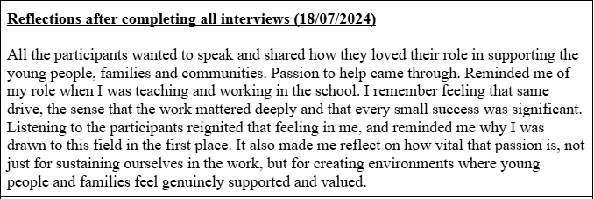

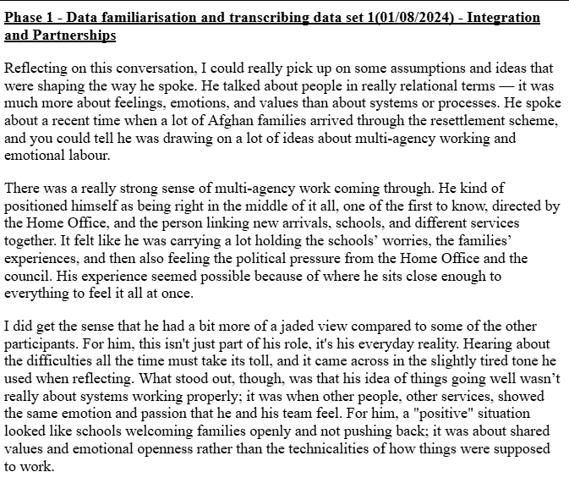

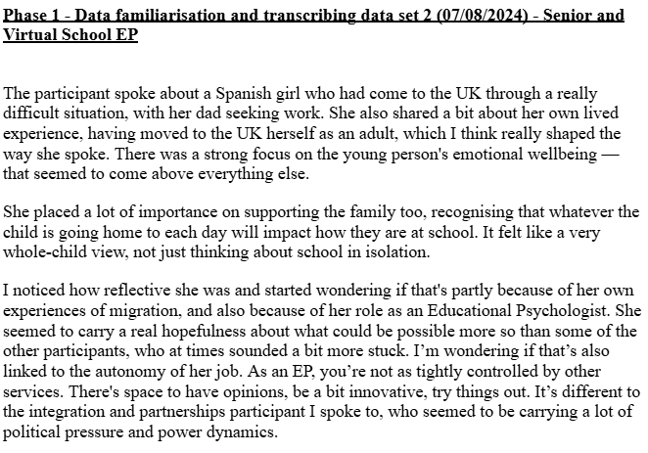

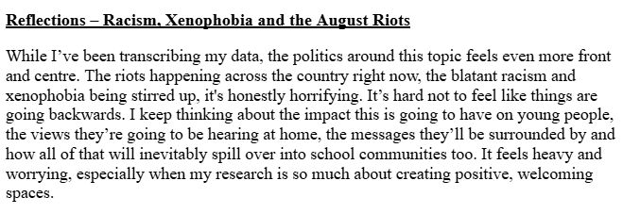

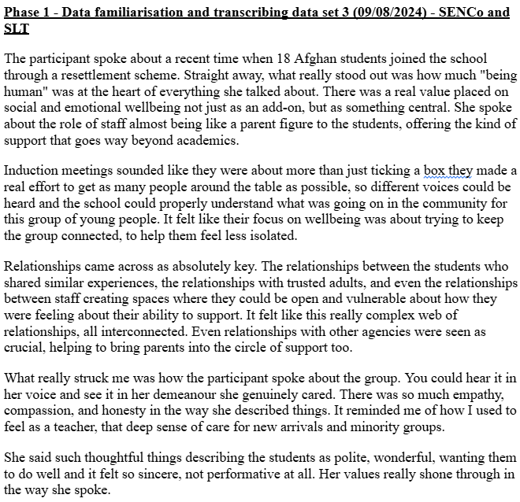

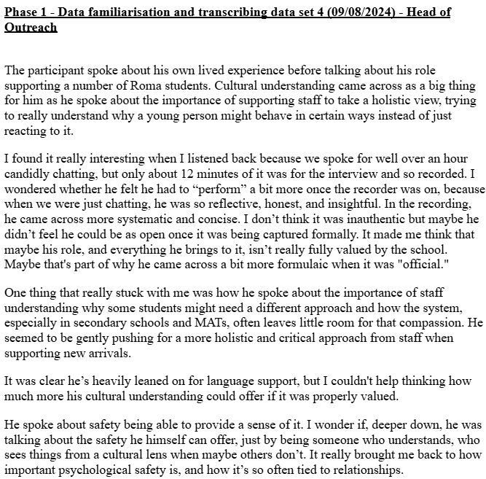

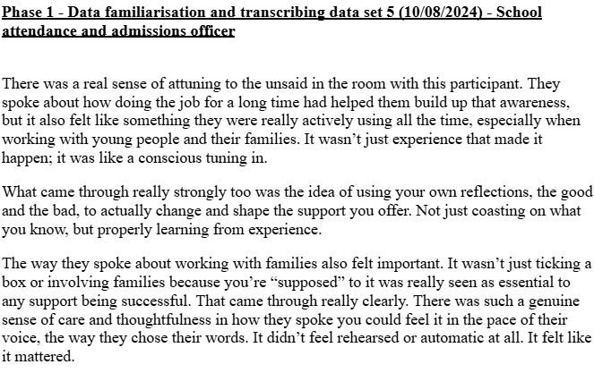

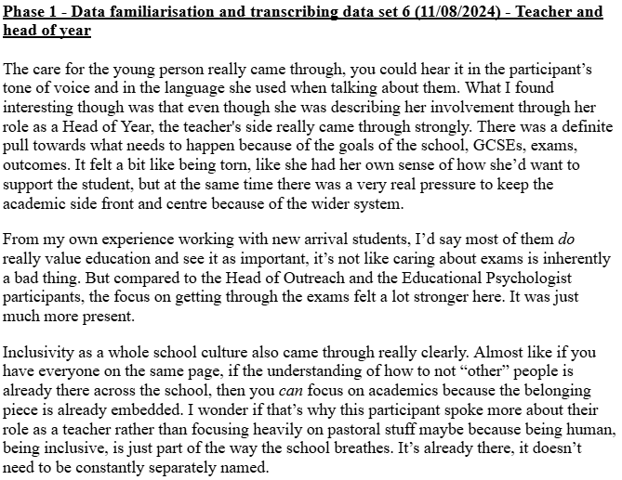

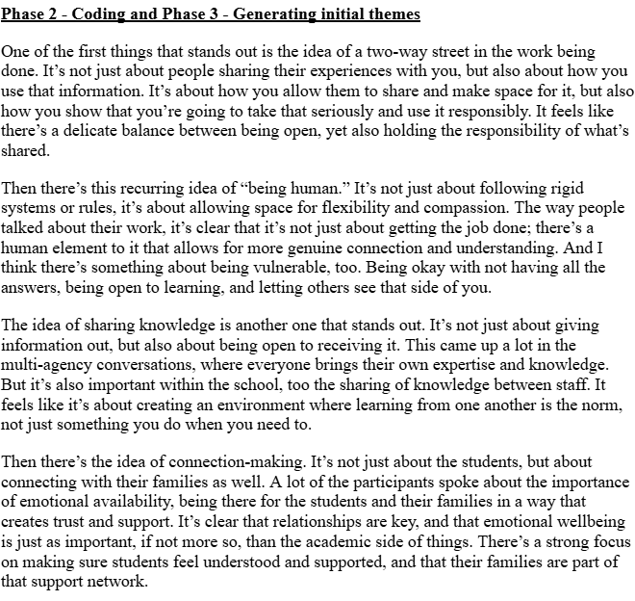

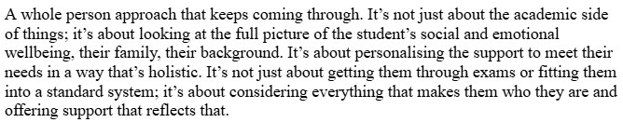

**Appendix XV -** Data coding NVIVO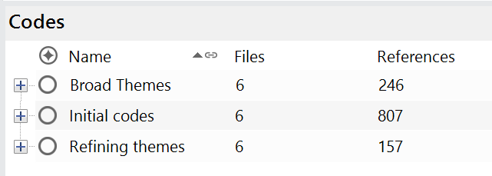

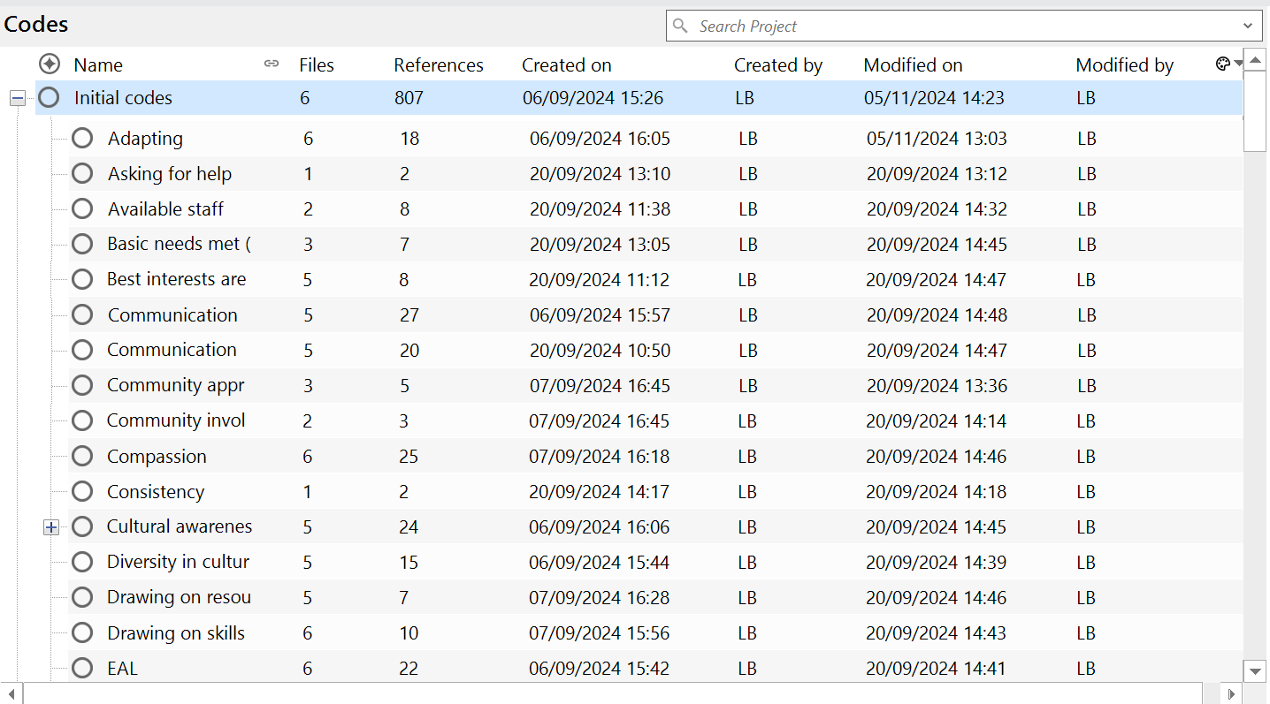

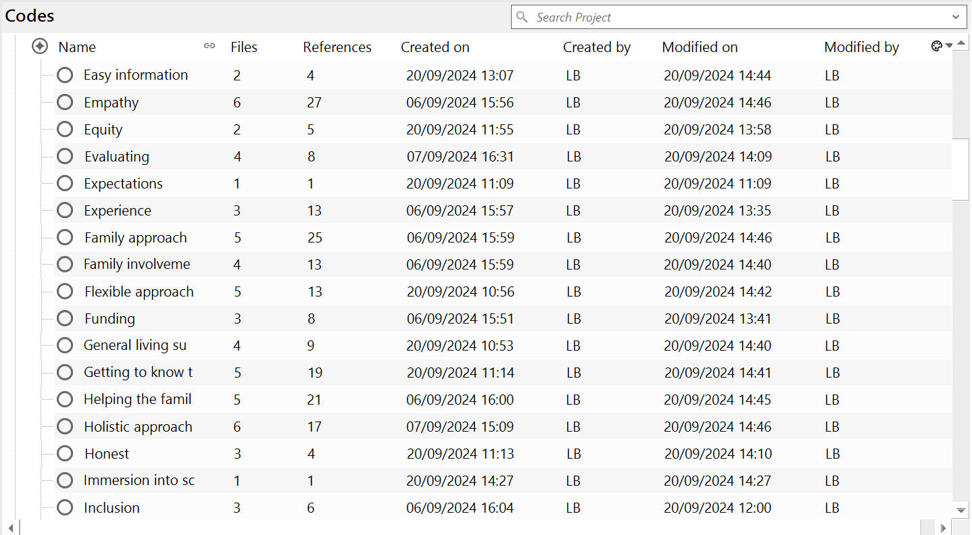

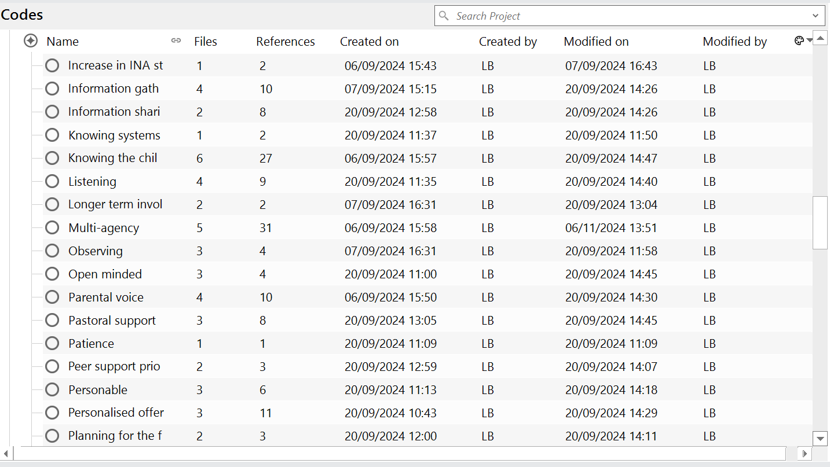

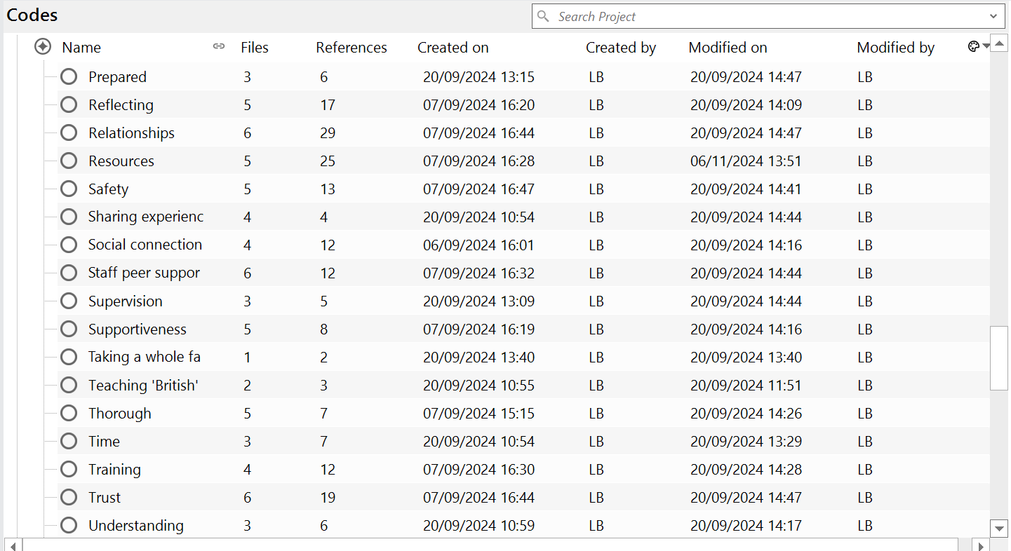

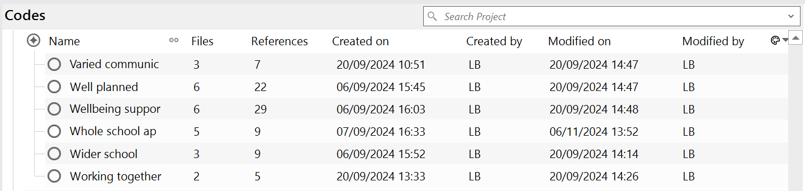

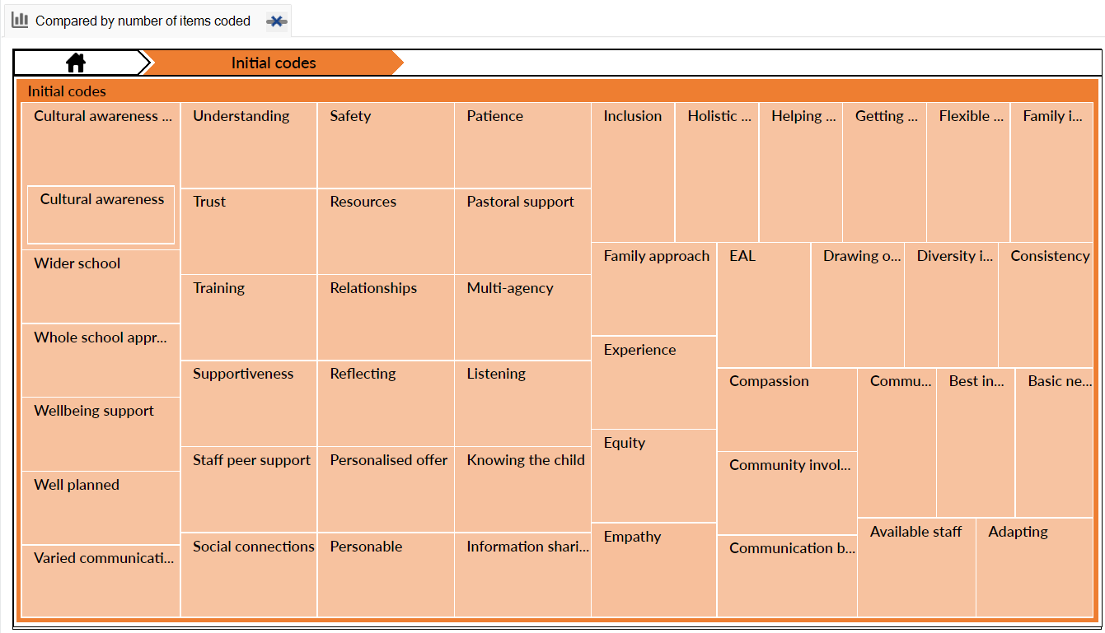

**Appendix XVI -** Theme development NVIVO

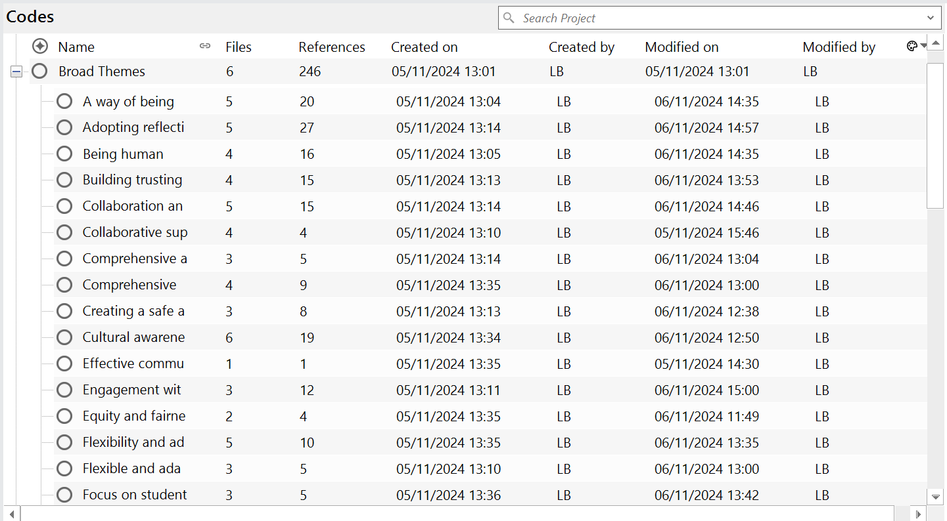

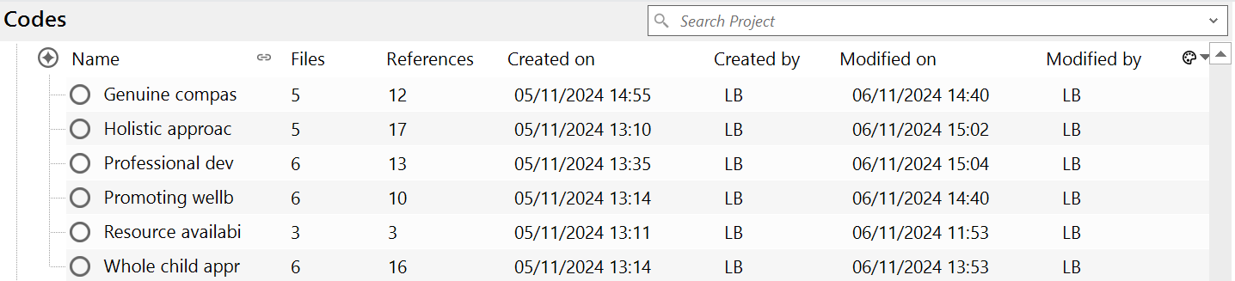

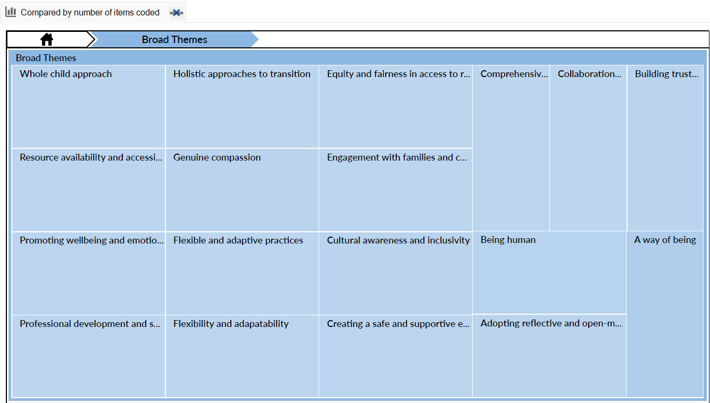**Appendix XVII -** Theme defining NVIVO



