

Initials, Goods and Buildings:
Marriage as a Material and Social Practice in Early Modern England

Leonie Price

A thesis submitted in partial fulfilment of the requirements for the degree of
Doctor of Philosophy
2024

University of Sheffield
Faculty of Arts and Humanities
School of History, Philosophy and Digital Humanities

I, the author, confirm that this thesis is my own work. I am aware of the University’s Guidance on the Use of Unfair Means (www.sheffield.ac.uk/ssid/unfair-means). This work has not previously been presented for an award at this, or any other, university.

Acknowledgements
First, I would like to thank my primary supervisor, Professor Phil Withington. From the MA dissertation that provided a litmus test for this thesis right through to today, thank you Phil for your enduring belief both in me and my project, for your encouragement and indispensable advice, and for always knowing the right question to ask to shift my perspective. Thank you also to my second supervisor, Dr Kate Davison, for your kindness, guidance and support throughout. I am so grateful to both of you for your time, wisdom and help and consider myself very lucky to have worked with you both.
I would also like to thank my undergraduate supervisor at Durham University, Dr Adrian Green. Two modules on architecture and the built environment and ‘The Birth of a Consumer Society’ have had a huge influence on my thinking. A passing comment on initialled buildings in a seminar is the reason this thesis exists at all, and thank you Adrian for all of your support and encouragement over the years.
The conferences and seminars I have attended throughout this project have introduced me to many people who have shared their insights with me, for which I am so grateful. Thank you especially to the members of the Vernacular Architecture Group for your enthusiasm and generosity; to members of the Social History Society; to Emma Marshall and Ella Sbaraini and everyone at the ‘Emotion, Embodiment and the Everyday’ conference in 2021; and to members of the Renaissance Society of America for your thoughts and comments in 2023. A huge thank you as well to everyone who has made the Sheffield Centre for Early Modern Studies such a wonderful community to be part of.
I could not have completed this thesis without help from so many people along the way. Thank you to the teams at Lancashire Archives and Cheshire Record Office for retrieving seemingly endless documents and being kind enough to share and discuss spreadsheets and the peculiarities of the records with me. Thank you to former Adlington Estate archivist Simon Harris, too, for so readily sharing rough transcriptions and unfinished files with me. A huge thanks must also go to the countless people whose doors I have knocked on over the course of this project. Your kindness in discussing and often welcoming me into your homes has been key to this research, and I hope you get something from reading this.
Thank you, too, to the many other wonderful people who have supported me through this process, and through several very difficult years that saw both the pandemic and the loss of my dad and my grandad. Thank you to so many friends for your warmth and love. To Luce for never not being able to understand, and for holding my hand the whole way; to Suze for late-night wisdom and all-hours loveliness; to Nina for the belief, the silliness and the real talk; to El for your unwavering faith, and for being the kindest, most thoughtful of people; to Beck, Beth and Cole for everything; to James for always being ready for a deep-dive; to Emily and Lucy M for matching my love for the weird and wonderful; to Sarah for cathartic climbs when I needed them most; to Lucy B and Hannah for sweetness, light and the greatest and most wide-ranging of natters; to Lana and Marie for so much love across time and space; and to Sophie and Cian for riding this wave with me. To my family as well: your confidence in me is a gift for which I am ever grateful. Thank you to Denise, Kevin and Leah for always having my back and supporting me in everything I do. Thank you to my grandparents for always bringing so much warmth, humour and joy and for chatting endless hours of magical tommy rot with me. Thank you to my incredible mum for your unending support, love and care, and for always finding time for me even when time is short – you’re so very special. And last but never, ever least, thank you to Eoghan for everything you are. You’re a balm to my soul and I couldn’t have done it without you.
Finally, this thesis is dedicated to two of the people who would’ve loved to have read it most: John and Jack, my dad and my grandad. Thank you for being so instrumental in me finding my voice in the first place and for always being so interested in what I had to say thereafter. The countless hours we spent chatting about history and life itself are baked into this thesis, and both it and me are all the better for it.

Abstract
Dated initials commemorating married couples were common in early modern England, present upon personal possessions, household goods and carved into the fixtures, fittings and façades of people’s homes. Initials on buildings have traditionally been explored by architectural historians, while initialled objects have generally been considered by historians of material culture. Overcoming this division and considering the built environment as another form of material culture, this thesis examines the meanings invested in inscriptions in seventeenth- and eighteenth-century England. It analyses homes engraved with marital commemoration in two case study communities in Lancashire and Cheshire, using extensive archival research to trace the couples who inscribed them and investigate their reasons for doing so. This thesis also uses quantitative and qualitative methods to situate, compare and analyse inscribing couples within their communities; examines contemporary printed texts to understand perceptions of inscription in wider society; and scrutinises the visual vocabulary used in inscriptions in both areas through an art historical and anthropological lens.

This thesis contends that inscription was a social and cultural practice entangled with religion, superstition, wealth and status, to which individual couples attached deep emotional meaning. Couples inscribed their homes when secure in their tenure, upon the birth of their children, and to reinforce their bond as marriage partners, demonstrating and celebrating their commitment to each other, their family and their home. This research underscores the central role of materiality in people’s emotional and social lives in early modern England. It demonstrates that objects and buildings were important tools for self-understanding and meaning making and shows that inscriptions further magnified the power of material culture in mediating and reinforcing personal and interpersonal experiences. It highlights the necessity of adopting an interdisciplinary approach to understanding early modern relationships with goods and the built environment and shows the value of contextualising individual homes within a wider community-based study.

Contents
List of Abbreviations 6
List of Maps, Figures and Tables 7
Introduction 14
- Historiographical Perspectives on Inscriptions and Marriage 16
- Social Practice Theory 31
- Methods and Sources 41
- Argument and Chapter Structure 48
Chapter One – Inscription Culture: Inscribed Buildings and Objects in 53
Early Modern England
- Text, Tokens and Talismans: Inscriptions of Love and Protection upon 57
Objects and the Body
- Houses, Hearts and Bodies: Religious Scholars and Inscribed Thresholds 71
- Monuments and Memory Cultures: Inscribed Spaces in Early Modern 84
England
Chapter Two – Two Local Societies: the Middling Sorts in Bolton-le-Sands 101
and Prestbury
- Population, Wealth and Status in Bolton-le-Sands and Prestbury 106
- Work Activities in Bolton-le-Sands and Prestbury 124
- Literacy and ‘Letteracy’ in Bolton-le-Sands and Prestbury 142
- Bequeathing Practices in Bolton-le-Sands and Prestbury 155

Chapter Three – Household Formation and Inscription Culture in 169
Bolton-le-Sands and Prestbury
- Case Study Properties in Bolton-le-Sands Parish 172
- Case Study Properties in Prestbury Parish 204
Chapter Four – Material Culture and Inscription in Bolton-le-Sands 237
and Prestbury
- Documentary Traces: Consumption and Household Goods 239
- Personal Property: Inscriptions within the Home 252
- The Inscribed Façade: Inscriptions and Iconography on the 277
Fabric of the Home
Conclusion 302
Appendix 1: Maps 307
Appendix 2: Figures 314
Appendix 3: Tables 394
Bibliography 439
List of Abbreviations

AEA – Adlington Estate Archive

CA – Cumbria Archives

CRO – Cheshire Record Office

KRO – Kendal Record Office

LA – Lancashire Archives

NHLE – National Heritage List for England

OED – Oxford English Dictionary

TNA – The National Archives

List of Maps, Figures and Tables

List of Maps (Appendix 1)
Map 1: Locations of Bolton-le-Sands and Prestbury parishes within northern England 308
Map 2: Locations of Bolton-le-Sands townships within Bolton-le-Sands parish 309
Map 3: Locations of Prestbury townships within Prestbury parish 310
Map 4: Locations of six case study properties within Bolton-le-Sands parish 311
Map 5: Locations of five case study properties within Prestbury parish 312
Map 6: Location of five inscribed properties at Meg Lane in Sutton, Prestbury 313

List of Figures (Appendix 2)
Figure 1: Inscribed entryway at Hall Farmhouse, Over Kellet, Bolton-le-Sands parish 315
Figure 2: Inscribed cupboard at Hall Farmhouse, Over Kellet, Bolton-le-Sands parish 316
Figure 3: Illustrated map of all townships within Prestbury parish 317
Figure 4: An early modern horn book 318
Figure 5: Subscription from the will of John Leaper of Over Kellet, Bolton-le-Sands 319
parish
Figure 6: Subscription from the will of Isabell Dickinson of Bolton-le-Sands 320
Figure 7: Inscribed entryway at Thwaite End Farmhouse, Bolton-le-Sands 321
Figure 8: Datestone at the Manor House, Slyne-with-Hest, Bolton-le-Sands parish 322
Figure 9: Façade of the Manor House, Slyne-with-Hest, Bolton-le-Sands parish 323
Figure 10: Façade of Hall Farmhouse, Over Kellet, Bolton-le-Sands parish 324
Figure 11: Inscribed entryway at End Cottage, Bolton-le-Sands 325
Figure 12: Inscribed fireplace at Cobblers’ Lodge, Bolton-le-Sands 326
Figure 13: Marriage entry for William and Elizabeth Wilkinson, 1687, 327
facsimile of Bolton-le-Sands parish register

Figure 14: Marriage entry for William and Elizabeth Wilkinson, 1687, 328
print edition of Bolton-le-Sands parish register
Figure 15: Illustration of the inscribed entryway at Old Hall Farmhouse, 329
Over Kellet, Bolton-le-Sands parish from Emmeline Garnett’s The Dated
Buildings of South Lonsdale, (Lancaster, 1994)
Figure 16: Initialled datestone at Gap House, Kettleshulme, Prestbury parish 330
Figure 17: Inscribed entryway at Gap House, Kettleshulme, Prestbury parish 331
Figure 18: Initialled hopper head at Gap House, Kettleshulme, Prestbury parish 332
Figure 19: Façade of Gap House, Kettleshulme, Prestbury parish 333
Figure 20: Rear of Gap House, Kettleshulme, Prestbury parish 334
Figure 21: Façade of Langley Hall, Sutton, Prestbury parish 335
Figure 22: Inscribed entryway at Langley Hall, Sutton, Prestbury parish 336
Figure 23: Door jambs at Langley Hall, Sutton, Prestbury parish 337
Figure 24: Inscribed plaque at Brooks Cottage, Butley, Prestbury parish 338
Figure 25: Inscribed plaque (1715) inside lychgate of St Peter’s Church, Prestbury 339
Figure 26: Inscribed plaque (1728) inside lychgate of St Peter’s Church, Prestbury 340
Figure 27: Inscribed plaque (1721) in Prestbury village 341
Figure 28: Inscribed plaque (1751) in Prestbury village 342
Figure 29: Façade of Heybridge Farmhouse, Butley, Prestbury parish 343
Figure 30: Initialled datestone at Heybridge Farmhouse, Butley, Prestbury parish 344
Figure 31: Dated hopper head at Heybridge Farmhouse, Butley, Prestbury parish 345
Figure 32: Initialled hopper head at Eyam Hall, Derbyshire 346
Figure 33: Initialled hopper head at Parliament Street, York 347
Figure 34: Initialled datestone at Yew Tree House, Butley, Prestbury parish 348
Figure 35: Subscription from the will of Elizabeth Wales of Bolton-le-Sands 349
Figure 36: Illustration of a Gloucestershire spice cupboard from Nat Alcock 350
and Linda Hall’s Fixtures and Fittings in Dated Houses 1567-1763, (York, 1994)

Figure 37: Illustration of an inscribed Westmoreland spice cupboard from Nat 351
Alcock and Linda Hall’s Fixtures and Fittings in Dated Houses 1567-1763, (York, 1994)
Figure 38: Illustration of an inscribed spice cupboard at Church Cottage, 352
Bolton-le-Sands from Emmeline Garnett’s The Dated Buildings of South Lonsdale,
(Lancaster, 1994)
Figure 39: Inscribed cupboard at the Manor House, Slyne-with-Hest, 353
Bolton-le-Sands parish
Figure 40: Detail of the inscribed cupboard at the Manor House, Slyne-with-Hest, 354
Bolton-le-Sands parish
Figure 41: Illustration of an inscribed Lancastrian press cupboard 355
Figure 42: Illustration of a partially-completed inscription on a 356
mid-seventeenth-century cupboard
Figure 43: Detail of the inscribed fireplace at Cobblers’ Lodge, Bolton-le-Sands 357
Figure 44: Detail of the inscribed entryway at McGaffigans Yard, Bolton-le-Sands 358
Figure 45: Façade at McGaffigans Yard, Bolton-le-Sands 359
Figure 46: Datestone at Arnold House, Corsham, Wiltshire 360
Figure 47: Initialled hopper head at the Manor House, Bracondale, Norwich 361
Figure 48: Inscribed entryway at 12 High Street, Galway 362
Figure 49: Inscribed entryway at New Capernwray Farmhouse, Bolton-le-Sands 363
Figure 50: Illustration of the astrological symbol for cancer from Joseph Moxon’s 364
A tutor to astronomy and geography, (London, 1698)
Figure 51: Inscribed entryway at Hawkshead Farmhouse, Bolton-le-Sands 365
Figure 52: Inscribed entryway at Hall Farmhouse, Over Kellet, Bolton-le-Sands 366
Figure 53: Inscribed entryway at Old Edge, Heptonstall, West Yorkshire 367
Figure 54: Datestone at Old World Cottages, Rollesby, Norfolk 368
Figure 55: Datestone at Drove Hey Farmhouse, Sutton, Prestbury parish 369
Figure 56: Façade at Drove Hey Farmhouse, Sutton, Prestbury parish 370
Figure 57: Datestone at Greendale House, Kettleshulme, Prestbury parish 371
Figure 58: Datestone at the Malthouse, Slyne-with-Hest, Bolton-le-Sands parish 372
Figure 59: Datestone at Thorneycroft Farmhouse, Kettleshulme, Prestbury parish 373
Figure 60: Inscribed entryway at Kirkhouse, Capernwray, Bolton-le-Sands parish 374
Figure 61: Illustration of an astrological chart from Julius Firmicus’ Materni 375
Iunioris Siculi V. C. ad Mauortium Lollianum Astronomicon, (Rome, 1551)
Figure 62: Inscribed fireplace at Postgate Farm, Glaisdale, North Yorkshire 376
Figure 63: Initialled hopper head at Bollington, Prestbury parish 377
Figure 64: Initialled hopper head at Lyme Hall, Disley, Cheshire 378
Figure 65: Dated hopper head at Lyme Hall, Disley, Cheshire 379
Figure 66: Datestone at The Dukes Head, Great Yarmouth, Norfolk 380
Figure 67: Dated entryway at Jordangate House, Macclesfield, Prestbury parish 381
Figure 68: Inscribed door hinge at Yew Tree Farmhouse, Butley, Prestbury parish 382
Figure 69: Inscribed door handle at Fern Lee Farmhouse, Sutton, Prestbury parish 383
Figure 70: Datestone at Fern Lee Farmhouse, Sutton, Prestbury parish 384
Figure 71: Datestone at Oak Cottage, Langley, Prestbury parish 385
Figure 72: Datestone at Ridge Hall Farmhouse, Sutton, Prestbury parish 386
Figure 73: Datestone at Ridge Hill Farmhouse, Sutton, Prestbury parish 387
Figure 74: Inscribed crest at Ridge Hill Farmhouse, Sutton, Prestbury parish 388
Figure 75: Inscribed crest at Pott Lords Farmhouse, Sutton, Prestbury parish 389
Figure 76: Façade at the Malthouse, Slyne-with-Hest, Bolton-le-Sands parish 390
Figure 77: Datestone at 6 Packet Lane, Bolton-le-Sands 391
Figure 78: Datestone at Hogarth House, Over Kellet, Bolton-le-Sands 392
Figure 79: Datestone at Walnut Tree Farmhouse, Butley, Prestbury parish 393

List of Tables (Appendix 3)
Table 1: Distribution of will and inventory pairs by decade within the 395
Bolton-le-Sands and Prestbury wider survey

Table 2: Inscribed properties and inscribers within the core sample in 396
Bolton-le-Sands parish
Table 3: Inscribed properties and inscribers within the core sample 397
in Prestbury parish
Table 4: Number of households in Bolton-le-Sands and Prestbury from 398
the 1664 hearth tax
Table 5: Population estimates for Bolton-le-Sands and Prestbury from 399
the 1664 hearth tax
Table 6: Chargeable and not-chargeable households in Bolton-le-Sands and 400
Prestbury from the 1664 hearth tax
Table 7: Number of hearths per household in Bolton-le-Sands and Prestbury 401
from the 1664 hearth tax
Table 8: Number of hearths per household in Bolton-le-Sands from the 402
1673 hearth tax
Table 9: Number of hearths per household in Kettleshulme township, 403
Prestbury, from the 1662 and 1673/4 hearth tax
Table 10: Gender and marital status among testators in the Bolton-le-Sands 404
and Prestbury wider survey
Table 11: Mean and median wealth according to gender and marital status 405
in the Bolton-le-Sands and Prestbury wider survey
Table 12: Prevalence and wealth of male testators within different occupational 406
and status groups in the Bolton-le-Sands and Prestbury wider survey
Table 13: Prevalence and wealth of male testators within different occupational 407
and status groups in the Bolton-le-Sands and Prestbury core sample
Table 14: Wealth of husbandmen and yeomen in the Bolton-le-Sands and 408
Prestbury wider survey
Table 15: Occurrence of different work activities in the Bolton-le-Sands and 409
Prestbury wider survey
Table 16: Occurrence and scale of livestock farming in the Bolton-le-Sands and 410
Prestbury wider survey
Table 17: Occurrence and scale of livestock farming in the Bolton-le-Sands and 411
Prestbury core sample
Table 18: Prevalence of different textiles and textile production equipment 412
in inventories within the Bolton-le-Sands and Prestbury wider survey
Table 19: Prevalence of different types of moneylending in inventories 413
within the Bolton-le-Sands and Prestbury wider survey
Table 20: – Moneylenders by gender and marital status in the Bolton-le-Sands 414
and Prestbury parish wider survey
Table 21: Mean amounts owed to moneylenders in the Bolton-le-Sands and 415
Prestbury wider survey
Table 22: Ownership of books in eight English regions, 1675-1725, from Lorna 416
Weatherill’s Consumer Behaviour and Material Culture in Britain, 1660-1760,
(London, 1996)
Table 23: Percentage of wills with no testators’ marks and full signatures 417
in the Bolton-le-Sands and Prestbury wider survey
Table 24: Proportion of yeomen’s wills with full signatures in the Bolton-le-Sands 418
and Prestbury wider survey
Table 25: Prevalence of different types of subscription marks in wills within the 419
Bolton-le-Sands and Prestbury wider survey
Table 26: Availability of subscription evidence for inscribers in the Bolton-le-Sands 420
and Prestbury core sample
Table 27: Bequests of real property, moveable goods and personal estate 421
in wills within the Bolton-le-Sands and Prestbury wider survey
Table 28: Proportions of testators in the wider survey bequeathing different 422
forms of personal property, differentiated by whether they were also
bequeathing real estate
Table 29: Mean number of cash bequests according to gender in wills 423
within the Bolton-le-Sands and Prestbury wider survey
Table 30: Recipients of cash bequests in the Bolton-le-Sands and Prestbury 424
wider survey, differentiated according to their relationships with testators
Table 31: Mean total cash gifted by testators making cash bequests 425
in the Bolton-le-Sands and Prestbury wider survey
Table 32: Mean number of cash bequests and mean total cash bequeathed 426
among inscribers in the Bolton-le-Sands and Prestbury core sample
Table 33: Relationships between testators and recipients of cash bequests 427
within both the core sample and wider survey in Bolton-le-Sands and Prestbury
Table 34: Prevalence of different degrees of room grouping in inventories 428
within the Bolton-le-Sands and Prestbury wider survey
Table 35: Prevalence of different types of objects in inventories within 429
the Bolton-le-Sands and Prestbury wider survey
Table 36: Prevalence of different types of cooking equipment in 431
inventories within the Bolton-le-Sands and Prestbury wider survey
Table 37: Prevalence of different types of seating in inventories within 433
the Bolton-le-Sands and Prestbury wider survey
Table 38: Prevalence of different kinds of beds and mattresses in inventories 434
within the Bolton-le-Sands and Prestbury wider survey
Table 39: Prevalence of different kinds of beds and mattresses in inventories 435
within the Bolton-le-Sands and Prestbury wider survey
Table 40: Prevalence of different bedding textiles in wills and inventories 436
within the Bolton-le-Sands and Prestbury wider survey
Table 41: Prevalence of different types of tableware in inventories 437
within the Bolton-le-Sands and Prestbury wider survey
Table 42: Prevalence of different kinds of pottery in inventories within 438
the Bolton-le-Sands and Prestbury wider survey

Introduction
In the village of Over Kellet, just over six miles north of Lancaster and four miles inland from Morecambe Bay, the lintel of Hall Farmhouse has remained the same for over 300 years. Carved with the letters ‘R^{G}D 1704’, it commemorates the couple who built it: Robert and Deborah Gibson (Figure 1, p.315). Stepping over the threshold of the house, a cupboard set into the wall by the fireplace was discovered during recent renovations, hidden from view for generations but carved with an inscription that echoes the lintel, reading ‘RG : DG 1715’ (Figure 2, p.316). A wealth of personalised objects survive from early modern England, with initials present upon anything from jewellery to snuffboxes, chairs to tankards, and cribs to cushions. While many of these objects survive primarily in museum collections or as antiques in private homes, the initials at Hall Farmhouse remain in situ. Inscriptions carved into the fabric of homes have traditionally been considered separately from those carved upon objects, divided along disciplinary lines. Consequently, the inscribed façades of houses have generally been examined by architectural historians while inscribed interiors, household goods and personal possessions have been discussed by scholars of material culture. With two sets of marital inscriptions surviving across the exterior and interior of the Gibsons’ home, Hall Farmhouse serves as a bridge between the two disciplines, drawing attention to the continuities that early modern people would have perceived across inscriptions on objects and buildings.
This thesis is concerned with understanding the significance of marital inscriptions in early modern England, charting and untangling the meanings embodied within inscriptions that referenced husbands and wives alongside one another. It interrogates the expectations couples brought to the inscriptions they commissioned, and considers what they were hoping to achieve when inscribing their homes and possessions. To do so, this thesis analyses inscribed homes in two communities in Lancashire and Cheshire. Using a case study approach rooted in extensive archival research, it traces the couples who built these properties and commissioned the marital inscriptions upon and inside their homes, undertaking a close reading of inscription practices and investigating how individual families and couples might have understood inscriptions within the context of their everyday lives. This thesis also examines contemporary printed texts to survey perceptions of inscription in wider society; uses quantitative and qualitative methods to situate, compare and analyse inscribing couples within their communities; and scrutinises the visual vocabulary used in inscriptions in both areas through an art historical and anthropological lens.
In the process, this thesis contends that inscription was a rich social and cultural practice entangled with religion, superstition, wealth and status, to which individual couples attached deep emotional meaning. Couples inscribed their homes when secure in their tenure, upon the birth of their children, and to reinforce their bond as marriage partners, demonstrating and celebrating their commitment to each other, their family and their home. This thesis also interprets marriage itself as a social practice sustained through objects and buildings and highlights the central role of materiality in people’s emotional and social lives in early modern England. In making these arguments, the thesis contributes to the growing historiography that regards material culture as an important tool for self-understanding and meaning making, and argues that inscriptions magnified its power in personal and interpersonal experiences. It highlights the necessity of adopting an interdisciplinary approach to understanding early modern relationships with goods and the built environment and shows the value of contextualising individual homes within a wider community-based study.

Historiographical Perspectives on Inscriptions and Marriage
Early modern inscriptions were multi-faceted and, as a consequence, are connected to a wide range of different scholarly fields. The following two sections contextualise this examination of inscriptions through reference to existing historiography and discussions of social practice theory. Charting the implications of different analytical and theoretical frameworks – even where they have not been directly implemented over the course of this thesis – serves to underscore the wide-ranging significance of inscriptions and inscription practices within early modern England and highlight the broader contribution made by this research to understandings of early modern society.
There is a long historiography surrounding inscribed buildings. In 1953, domestic inscriptions were central to one of the most influential theories in English architectural history: W. G. Hoskins’ theory of the ‘Great Rebuilding’ of rural England. Basing his conclusions upon dates carved into surviving houses, Hoskins argued that rising prosperity among yeomen and husbandmen precipitated a major increase in building activity between 1570 and 1640. Revisiting Hoskins’ theory and also relying on dated, inscribed properties, R. Machin suggested that the ‘Great Rebuilding’ occurred somewhat later, peaking ‘circa 1700 rather than circa 1600’. Importantly, Machin also advanced a more nuanced understanding of inscriptions, arguing that dates could mark building works (or even marriages and changes in ownership) without signifying the complete construction or reconstruction of a home. While Hoskins’ theory has been repeatedly critiqued in subsequent decades, scholars have continued to use his terminology, with many also using dated buildings and inscriptions to pinpoint and understand periods of building activity in different English regions.
Adopting a similar local lens, numerous illustrated editions have featured buildings inscribed with dates and initials when identifying and classifying different styles of British vernacular architecture. A long tradition of local historical research is an important reference point for this thesis, particularly since a rich architectural and historical guide exists for one of the two parishes at its heart: Bolton-le-Sands in northern Lancashire, home to Robert and Deborah Gibson mentioned above. Published in 1994 by Emmeline Garnett, The Dated Buildings of South Lonsdale comprises brief but extensively researched historical summaries of a considerable proportion of all dated inscriptions in the hundred of South Lonsdale, including Bolton-le-Sands parish. Charting all inscriptions nearby from the early modern period to the present day, Garnett has also suggested that the most vigorous phase of building activity took place in north Lancashire between 1670-1700, based on dates inscribed upon local properties.
In focusing on the Great Rebuilding, Garnett has primarily explored the connection between inscriptions and the financial ability to rebuild a home. In so doing, although she has not explicitly framed inscriptions as celebrations of wealth, economic circumstances loom large as the main explanation for inscriptions in her work. Both Matthew Johnson and Chris King have critiqued the predominance of economics in previous considerations of early modern housebuilding, with Johnson advocating for a more culturally orientated focus in the field of vernacular architecture, as well as arguing that inscribing a house was a culturally informed process. Adrian Green took some steps towards synthesising economic and cultural arguments for inscriptions in his unpublished doctoral thesis, suggesting that they constituted outward advertisements of wealth at a time when fewer couples were able to marry – something Green attributed to the prohibitive financial demands of securing a partner and establishing an independent household in the late-seventeenth century.
Green has argued elsewhere that, when carved upon houses, ‘inscriptions announced [a] successful marriage to visitors and passers-by’, and has proposed that ‘the force of inscriptions gained greater meaning when marriage and security of tenure were a rarer achievement’. More recent work by Harold Mytum, Hanneke Ronnes and Alexandra Westra has reinforced a cultural turn in the study of inscribed buildings, connecting the use of dated initials on homes with the development of the concept of linear time and with identity formation. Negotiating these different perspectives, this thesis recognises the force of economic explanations and the possibility of a connection between wealth and inscription. At the same time, it also further explores the socio-cultural significance of inscriptions upon buildings and the different significations such inscriptions might have carried for contemporaries.
While inscriptions on the outside of buildings have been considered by architectural historians, many scholars operating within the broad field of material culture have also considered marital inscriptions on objects. Furniture historian Victor Chinnery coined the term ‘marriage initials’ in reference to the proliferation of dates and initials commemorating matrimony on a huge range of seventeenth- and eighteenth-century domestic wooden wares. Sheelah Ruggles-Brise also documented the common use of three initials in glassware circulated by English tavern owners, while Frank Britton consistently noted the presence of similar marital initials on contemporary ceramics in his illustrated volume on English glazed earthenware. More recent works have engaged more readily with the intentions underlying these initials. While Angela McShane has noted how ‘more marriages than ever were commemorated with cheap, personalized items’ which, although ‘purchased to commemorate a single moment … retained their significance over the entire length of the marriage’, Tara Hamling has argued that initials and dates carved into wooden furniture served to ‘memorialise and display formative occasions in the establishment and development of the family or household’. Nigel Jeffries, Nicholas Major and Idit Ben-Or have all used the term ‘triads’ to describe the use of three initials on contemporary bottles and trade tokens. Their accounts have demonstrated how such initials were used as emblems by married couples running joint businesses and, crucially, have highlighted the existence of a shared stylistic vocabulary throughout early modern England.
An emphasis on the meanings of everyday practices is central to the wealth of material culture scholarship dealing with inscriptions. In her important book Graffiti and the Writing Arts of Early Modern England, literary scholar Juliet Fleming investigated writing practices and the early modern paradigm surrounding textual inscriptions on objects. In doing so, she revealed how ‘an almost magical way of thinking about the physical properties of language’ characterised the Renaissance ‘inscriptional mode’, demonstrating that engraved text operated at the interface between the material, spiritual and cognitive worlds. Using a theoretical framework influenced by Michel Foucault, Fleming argued that ‘matter activates meaning beyond itself’, with early modern material culture inseparable from a wider ‘Renaissance episteme’ which formed the ‘intellectual and technological unconscious of the period’. Considering printed texts, wall-writing and inscribed objects in recovering this early modern paradigm, Fleming’s discussion is characteristic of the multi-disciplinarity of historical ‘material culture studies’, which grew out of anthropological and archaeological scholarship in the 1970s and ‘80s. Informed by material culture scholarship from a variety of different fields, this thesis positions itself among existing interdisciplinary studies, adopting a multiform approach in analysing the meanings of inscriptions and inscription practices in early modern England.
Pursuing a similarly multidisciplinary approach, historian Antony Buxton has cited frameworks informed by semiotics – a field developed by linguistics scholars – in his research into domestic culture in early modern England. Discussing the agency of objects and spaces, Buxton describes the approach of Ferdinand de Saussure, who analysed the ‘symbolism invested in words and signs’. For de Saussure, words were not inherently meaningful but were ‘signifiers’ instead, combined in the mind with the ‘signified’ to form ‘meaning-imbued “signs”’. Sara Pennell has used similar terminology, interpreting early modern ‘mundane objects’ as ‘material signs’ through which the ‘social imaginary’ can be explored – understood, like Foucault’s ‘Renaissance episteme’, as a contemporary paradigm that ‘shapes and sustains particular practices’. For Pennell, Buxton and Fleming, objects do not simply represent ‘evidence of practices’ but instead were the vessels through which such practices were ‘enabled, learnt and assimilated’. Informed by these perspectives, this thesis approaches inscriptions, inscribed objects and buildings as participants in practices, examining materiality and practices in tandem as a way of understanding how people in early modern England understood themselves, their relationships and material culture.
The recurrent emphasis on ‘practices’ in material culture research is rooted in a longstanding interest in ‘the practices of everyday life’. Separately to the development of ‘material culture studies’, the aesthetic qualities of objects have long been studied within art history and the history of design, both traditionally (though less so today) concerned with the study of elite goods and artworks. Historiographies of consumption signalled a new emphasis on material culture in historical research in the 1980s, and the simultaneous growth of cultural studies in the latter half of the twentieth century foregrounded the experiences of non-elites and everyday life itself. As Tara Hamling and Catherine Richardson have argued in Everyday Objects, this ‘prompted a renewed interest in material culture because everyday life is rooted in the experience of materiality’. The approaches of a range of historians who have explored goods as participants in everyday practices are essential in what follows. In writing about materiality and everyday life in English houses, Matthew Johnson has expressed a similar outlook to Pennell, arguing that rather than ideas being expressed in the production of materiality, ‘ideas, beliefs and cultural attitudes are continually shaped and mediated through the practices of the material world’. Crucially, Johnson has framed houses themselves as ‘material objects’, locating them firmly inside the bounds of material culture analysis.
A similar approach is also fundamental to the work of Chris King, who has challenged the concept of the built environment as a ‘passive backdrop or container for the expanding world of moveable domestic objects’. Like Johnson, King has conceptualised buildings as an integral element of material culture ‘conceived as a totality’, building upon a wide range of important social and cultural historical research that has sought to understand how people interacted with goods within the home. King and Johnson’s approaches are echoed in Tara Hamling and Catherine Richardson’s A Day at Home in Early Modern England, which explores ‘the household in its fullest sense as a conjunction of building, people and possessions’, framed by an understanding that objects and spaces mutually contributed to experiences and activities within the house. Informed by Johnson, King, Hamling and Richardson, the fabric of the house itself is understood as an extension of material culture, actively participating in the social practices playing out within, around and in partnership with it. This thesis combines these insights with the work of historians of consumption, who have sought to understand relationships with goods. Influenced by the use of social historical methods in cultural historical enquiry, it employs quantitative methods seen most notably in the work of Lorna Weatherill and Mark Overton, Jane Whittle, Darron Dean and Andrew Hann, examining the social meaning of material goods in the home.
Interpreting the home and its contents as mutually constitutive of domestic material culture, this thesis also considers the emotions embodied in buildings and objects. In 2018, Stephanie Downes, Sally Holloway and Sarah Randles edited a volume focusing specifically on how people in ‘pre-modern Europe’ ‘made, commissioned, and used objects to facilitate their emotional lives’. The emotional dimensions of objects have featured prominently in the historiography of early modern English material culture, and this is particularly true in relation to inscribed and personalised objects. Historians considering English embroidery, for example, have been well attuned to the emotional significance of the practice and its products. Susan Frye has examined the emotion surrounding initials in needlework, arguing that stitching their initials provided women with a means of negotiating and reinforcing changes of name and identity brought about by marriage. Antonia Brodie, meanwhile, has researched a single stitched sheet in the collection of the Victoria and Albert Museum, revealing that multiple generations of the same family embroidered marital initials into the garment, transforming it into a family tree and an emotionally significant heirloom. Also working with stitched sources, Barbara Burman has represented initialled tie-on pockets as tangible extensions of selfhood for women of all classes, secreted close to the body.
Likewise, a wealth of research has demonstrated the role of inscribed objects in courtship, used as love tokens between couples across the social spectrum. While many more goods survive for the wealthier members of early modern society, Bridget Millmore has shown how the addition of inscribed initials transformed everyday coins into emotionally significant love tokens for couples unable to afford jewellery. In a similar vein, Angela McShane has shown how inscribed tobacco boxes were an intensely personal means of reinforcing self-understanding and identity, as well as being used to convey love and affection. These studies form part of a wider literature on the emotional significance of different categories of objects. They bridge a distinction Giorgio Riello has conceptualised in relation to global material culture research: between the consideration of ‘unique objects’ in museum collections on the one hand, and the study of objects as commodities on the other, considered as ‘types’ rather than individual things. Existing scholarship has demonstrated the importance of examining inscribed objects on a case-by-case basis, interrogating the different meanings such objects were capable of carrying. At the same time, the wealth of studies of individual objects has indicated the existence of a wider language of inscription, present across many different types of goods. Synthesising these approaches, this thesis considers a range of individual examples of inscriptions on both objects and buildings, exploring their characteristics as ‘unique objects’ while building a bigger picture of inscription practices in early modern England.
While emotions feature prominently in material culture studies and in existing histories of inscribed objects, concepts from within the history of emotions also provide important insight into how examining inscriptions contributes to better understandings of early modern society. In 2001, William Reddy formulated the concept of ‘emotives’: words used to talk about emotions that have ‘a transformative effect on both the self and others’. Importantly, Reddy also theorised the concept of a hegemonic ‘emotional regime’ within each society, potentially stipulating a very narrow form of emotional expression which in turn created various spaces of ‘emotional refuge’ as a means of navigating and escaping repression and ‘emotional suffering’. Barbara Rosenwein has critiqued Reddy’s ‘bipartite view of society’, positing the idea of ‘emotional communities’ in which different sets of emotional conventions could exist side-by-side, rather than in opposition with one another. For Rosenwein, a shared ‘emotional vocabulary’ might exist within a society but be drawn upon differently by various groups which themselves constituted emotional communities, tied together by interpersonal relationships, shared goals, texts or institutional affiliations. This thesis examines the wider ‘emotional vocabulary’ that informed inscription practices in early modern England. It uses individual inscriptions to explore the way this vocabulary was adapted by different individuals, couples and families in Bolton-le-Sands and Prestbury and in so doing charts the existence of different, loosely defined, emotional communities.
Rosenwein has examined inscriptions in her own work, exploring funerary epitaphs produced in medieval Gaul. Using inscribed text to explore emotions surrounding death, she has emphasised the degree to which emotions were both social and relational and has documented how various emotional communities co-existed throughout the region, commemorating death in different ways. Although Rosenwein used surviving material culture in her research, early modern historian Sasha Handley has critiqued ‘anthropocentric models’ of emotional communities. In a recent article on the ritualistic consumption of sack posset – considered the ‘pinnacle’ of a wedding feast and particularly key in generating ‘lusty nuptial affections’ between the bride and groom – Handley has argued that the potency of wedding rituals relied on both material and human participants. Demonstrating how sack posset sealed ‘social and affective relationships’ between the couple and their wider community, she has underlined the central significance of ‘non-human agents’, positioning sack posset as key in the ‘multi-tiered emotional community that cohered around a wedding’. This expansive view of emotional communities offers a useful perspective. It also tallies closely with findings elucidated over the course of this thesis, which reveals that inscriptions mediated relationships (often across multiple generations) between people and objects, between families and their homes and between married couples.
Wider understandings of the relationship between emotion and inscription in what follows are also partly informed by the work of Monique Scheer. Rosenwein argued that emotions are ‘always delivered “secondhand”’, with any ‘gestures, bodily changes, words, exclamations, tears’ all comprising ‘symptoms that must be interpreted’, operating as emotional signals rather than constituting emotions themselves. Scheer, however, has argued that feelings emerge in the ‘doing’ of emotions rather than happening prior to and separate from any bodily expressions or performances. Adopting a Bourdieuian approach, Scheer has framed emotions as practices and understood them as embodied, grounded both in the social structures comprising the habitus and the situation encountered by the body. Scheer has framed behaviours that engender feelings as ‘emotional practices’, charting how activities like courtship were not simple expressions of emotions already in existence but rather had a transformative effect, cultivating feelings. Scheer’s approach highlights the importance of attempting to grasp the social significance of inscriptions. As will become clear, inscriptions on buildings and objects were closely entangled with transforming houses into homes both for couples themselves and for their descendants. Considering the wider potential for inscribed text to function as ‘emotional management’ allows for inscriptions to be conceptually situated within relationships.
Scholars of material culture and emotion have long explored the interconnectedness of materiality with people’s everyday lives. Framed in dialogue with this broad literature, this thesis centres on the social, cultural and emotional dimensions of inscribed material culture. In adopting an approach to material culture that includes the fabric of early modern homes, this thesis examines inscribed objects and buildings in tandem, allowing concepts from studies of material culture and emotion to inform a reassessment of arguments developed within architectural history. In the process, this study shows that inscriptions upon and within homes were important tools for people forging connections between their property and their family. It also highlights how shaping domestic space was intrinsically linked with identity formation, with those commissioning inscriptions doing so with an awareness that the text carved upon their houses and possessions would in turn influence their lives in and amongst them.
As a final historiographical point, since the inscriptions considered here were all created and situated within a domestic context, this thesis is also necessarily informed by existing scholarship on the family. Traditional historiographies of the family have dealt with marriage directly, looking at married life in early modern households. In recent decades, however, historians have problematised the idea of the family as a nuclear unit centred around a married couple. While the lives of married couples are key in what follows, discussions are informed by an expansive body of work engaging with the family as a broad category. Among this is a range of scholarship examining the lives of bachelors, widowers, widows and ‘never married’ women. Particularly significant in this has been the development of the household as a key point of enquiry, in which Naomi Tadmor’s concept of the ‘household family’ (which included single heads of households, adopted children, nieces, nephews, servants and apprentices all living under the same roof) has been central.
Scholars working on the broader fields of gender relations, work and property have all taken the household as their starting point, not limiting analysis to families centred around marriage but exploring marriage as an important topic of analysis within a wider frame. Real and personal property is a key issue in examining inscribed houses and objects. Similarly, work is an important point of discussion in understanding the wealth of individual households and case study communities. Consequently, the work of historians like Amy Erickson and Jane Whittle is invaluable in what follows, even where not directly concerned with married couples themselves. By a similar token, studies of marital breakdown and disputed marriage contracts form another crucial touchstone, offering insights into contemporary expectations surrounding matrimony, courtship and the many possible steps understood to precede weddings in early modern England. Uniting all of these different considerations, the work of historians like David Cressy, Christine Peters and Joanne Begiato are all central to the following discussion, examining different events in the life cycle through the lens of ritual and considering the social, material and behavioural stipulations surrounding marriage in seventeenth- and eighteenth-century society. Connecting the study of material and architectural sources to the history of the family, this thesis demonstrates that inscriptions on objects and buildings were as linked to the memorialisation and identity formation of families over several generations as they were to moments of family formation, revealing their diachronic as well as synchronic significance.

Social Practice Theory
A social practice theory approach is useful in bringing these various historiographical themes together. Considering inscriptions as practices allows for them to be situated within contemporary modes of thought and feeling, and emphasises the importance of behaviours and social conditions in producing inscriptions. Consequently, rather than examining inscriptions on objects and buildings for their own sake, this study explores how inscriptions were embedded in everyday understandings of marriage, the home and the self, as well as the communities and wider society within which inscribing couples and families lived. In so doing, this thesis considers marital inscriptions as a practice within a practice, using practice theory to understand and interrogate marriage as a form of social practice.
There is no single, coherent theory of practice. Ludwig Wittgenstein and Martin Heidegger are commonly cited as early proponents of a practice approach but, although social theorist Theodore Schatzki has worked closely with Wittgenstein’s work, neither twentieth-century philosopher spoke explicitly of ‘practices’. Practice theories were first formulated in the 1970s and 1980s and arose from the social sciences. Alongside Anthony Giddens, the writing of Pierre Bourdieu remains the most well-known on the subject, but nonetheless lacks a consistent theory of practice. This has been attributed to the close relationship between practices and the ‘habitus’, as the habitus was understood to be moulded through practices and was instead Bourdieu’s main concern.
Following the first wave of writers engaging with practice theory, a second wave dominated by Theodore Schatzki and Andreas Reckwitz came to the fore in the late 1990s and early 2000s. Their interpretations have much in common and Reckwitz builds on Schatzki in his own work, attempting to codify diverse practice perspectives in ‘Toward a theory of social practices’. In the process, Reckwitz elucidates the unique value of practice theory. In putting practices rather than individuals centre stage, practice approaches challenge the ‘purpose-oriented’ view of a social order predicated upon individual interests. By the same token, practice theories refute ‘norm-oriented’ approaches in which all-encompassing norms and values underlie and generate social order. Primarily, as a cultural theory, a practice approach recognises that shared knowledge underlies social action. Concurrently however, practice theories allow for the absence of a normative consensus. These stances are useful in what follows because they invite the dual consideration of inscriptions as structured by wider understandings of inscription practices among contemporaries, while simultaneously leaving room for the forces of individual decision- and meaning-making in producing inscriptions.
Sherry Ortner has emphasised that practice theories are beneficial because they seek to portray ‘all three sides of the … triangle: that society is a system; that the system is powerfully constraining, and yet that the system can be made and unmade through human action and interaction’. In spotlighting actions and interactions, practice theories offer a means of decentring the mind, texts and speech, and allow for ‘bodily movements, things, practical knowledge and routine’ to be brought to the fore. The routinised, bodily nature of interactions with inscribed objects and spaces in the home is prioritised in ensuing discussions, contextualising these interactions among wider expectations surrounding marriage and inscription. In so doing, this thesis seeks to understand the three sides of the triangle Ortner describes. It attempts to chart the societal systems informing and underlying inscription and marriage as practices. At the same time, it also investigates specific examples of inscriptions within marriage as an insight into how people understood this system, and how they used materiality variously to support, negotiate and adapt marriage as a system within their day-to-day lives.
Importantly for this research, social practice theory also offers a useful framework when considering objects and buildings in tandem to analyse early modern understandings of inscription. Understood praxeologically, a practice is an action or a series of actions carried out by an individual or group. Within this configuration, each practice is structured and delimited by its own set of rules or norms – though these are almost always implicit rather than explicit, present primarily as ‘tacit knowledge’. Schatzki has asserted that practices are ‘temporally-evolving, open-ended sets of doings and sayings’ held together by the practical understanding of how to participate in the practice, its associated emotions, necessary objects and locations, and ‘wider understandings’. The ‘wider understandings’ and cultural contexts surrounding practices then give structure to their constituent actions, rendering them socially meaningful. Though changeable over time, slowly adapted by different people in different ways, meanings are inherent to practices and practice theorists cast individuals as ‘carriers’ of practices: agents taking part in ‘routinized … complexes of bodily movements’, ‘forms of interpreting, knowing how and wanting’ and the ‘usage of things’. The social knowledge that produced inscribed artefacts is rarely explained in surviving documents. Instead this thesis recovers the associations inscription carried by triangulating discussions of inscription in printed sources with contemporary ideas about marriage and the materiality both of the marital home and surviving inscriptions. In so doing, this thesis argues that inscriptions and the possessions they appeared upon jointly reinforced emotion – including conjugal love – and self-perception, supporting people’s understandings of themselves as married.
Correspondingly, the theoretical framework underpinning the following examination of objects, buildings and marital inscriptions posits marriage as a social practice, supported by interrelated inscription practices. Using this lens serves as a continual reminder that the idea of ‘marriage’ is not self-sustaining: in social groups where marriages take place, entry into marriage as well as married life thereafter is predicated upon a collection of behaviours which, together, reinforce and maintain marriage as a social pact. Marriage readily fits Reckwitz’ definition of a social practice as a ‘series of bodily performances’ which ‘give the world of humans its visible orderliness’. This concept maps on to the theory put forward by Chantal Mouffe in which ‘subject positions’ (Schtazki gives the examples of ‘father, Jew, acrobat’) ‘help compose who people are’. In Mouffe’s framework, the identity of an individual is not inherent but is based on subject positions, which in turn are engendered through practices. Viewed in this way, marriage is a constituent practice within the organisational category of the family, comprised of ‘bodily performances’ which are themselves intertwined with processes of self-understanding and identity formation.
Elizabeth Shove, Mika Pantzar and Matt Watson have argued that practices exist both as ‘performances’ and ‘entities’. By their reckoning, in order for any performance to be coherent in a specific moment, it must draw upon a repertoire of entities that render the practice meaningful and recognisable. Shove et al have used Reckwitz’ vocabulary of ‘elements’ to codify this, illustrating that entities are made up of ‘forms of bodily activities, forms of mental activities, “things” and their use, a background knowledge in the form of understanding, know-how, states of emotion and motivational knowledge’. The paraphernalia of early modern courtship and weddings (including Handley’s ‘sack posset’) and the exchange of rings, love tokens, gifts, money and property all constituted the recognisable material foundations of an early modern marriage, reinforced by the movement of household goods and the process of home making. Speech-acts and discourse had both a short and long term role in the form of vows and in status shifts from single to spouse (and, for women, the surname changes this entailed). The influence of marriage on the character and content of day-to-day conversations was also crucial, whilst the configuration of marital relationships defined new roles and duties to each other, to each other’s families, and to the newly-formed household. Simultaneously, new meanings developed through interaction in and with the primary arena of these actions: the marital home. The sum of these ‘elements’ – comprised of actions, spaces, objects and discourses – constituted marriage in early modern England, signifying a recognisable social practice and cultural code.
Certain actions such as the wedding, cohabitation, and consummation were vital to early modern marriage. Although they were not the only elements of the practice, without fulfilling them a person could hardly be identified – or identify themselves – as married. Political philosopher Alasdair MacIntyre has formulated the concept of ‘internal goods’. Inherent in all practices and derived from striving to develop, perfect and showcase the skills required of any practice and its elements, ‘internal goods’ are what any participant stands to gain – comparable in some ways with theories of social capital. Applying MacIntyre’s theory to the practice of ‘family history’, Wendy Bottero has reasoned that internal goods make practices enjoyable for their own sake – regardless of whether this enjoyment is derived from being competent at the practice, or being capable of outwardly performing competence. Applied to marriage, this framework suggests that successfully participating in and demonstrating achievement of the elements associated with marriage would bring its own reward. Inscriptions on the outside of homes have primarily been interpreted as outward facing statements, particularly of status and wealth. Inscriptions on smaller and more explicitly personal possessions, meanwhile, have been more readily interpreted as sentimental or for interior reflection. As this thesis brings both readings together, a social practice approach is useful in developing one of its key arguments: that wherever inscriptions were used, they were as important for those commissioning them (and routinely interacting with the spaces they codified) as they were for anyone else who encountered them, beyond the household.
With regard to the ‘creative and negotiated dimension of kinship’ and family life, sociologist Anne-Marie Kramer has reported the extent to which ‘people take as much pleasure in making themselves connected and rooted, as in being rooted and connected’. The process of active construction underpinning family relationships and identities has also been emphasised by Bourdieu in ‘On the family as a realized category’, arguing that:
‘inaugural acts of creation (imposition of the family name, marriage, etc.) have their logical extension in the countless acts of reaffirmation and reinforcement that aim to produce, in a kind of continuous creation, the obliged affections and affective obligations of family feeling’.
Bourdieu depicted the family as a moulded ‘social artefact’ which humans had become socialized to see as the norm, and included conjugal love within this framework. In a similar vein, twentieth-century structuralists like Foucault used practice theory approaches to highlight the cultural codes maintaining political and economic systems. Where Davide Nicolini has discussed the ‘family’ alongside the ‘authority, institutions, and organizations’ all perpetuated by social practices, he has signalled that comparable processes of construction, creation and reinforcement are at play. Considering early modern marriage as a social practice allows it to be understood as a multiform process, inviting the critical evaluation of its numerous and variable constituent elements. Within this scheme, the full resonance of inscribed objects and buildings within contemporary society can be better analysed and understood.
A practice approach and its associated emphasis on ‘elements’ is particularly useful for interrogating the materiality of early modern marriage. Outside of practice theory, social relations have been cast as fundamentally human relations, separable from the world of goods. In contrast with this, practice theory has been portrayed as the means by which we can ‘dissolve (rather than resolve) the irreducible dualism’ dividing the material and the social – indeed, social practices have been hypothesised as the ‘interface’ between the two. Scholars of practice theory are in disagreement over the exact role of objects in social practices. Schatzki, for example, believes that material things exist in ‘arrangements’ with practices but are nonetheless distinct from them. Conversely, Reckwitz maintains that ‘things’ are as crucial as actions and participate in social practices ‘just as human beings do’. He has argued that wherever objects are necessary elements of practices, the interactions between humans and objects (‘subject-object relations’) cannot be subordinated to or seen as less important than those between humans (‘subject-subject relations’). Marriage was a social pact in early modern England, just as it is today. Nonetheless, it entailed material and corporeal consolidation and was predicated upon tangible co-operation and unity. Practice theories serve as a reminder that apparently ‘social’ actions cannot be separated from their material contexts. Insofar as inscriptions commemorate couples, families and lineage, added to the fabric of buildings synonymous with these concepts, this thesis argues that they were simultaneously entangled with the fabric of familial identities and relationships.
Reckwitz’ framework of social practices also includes one element which has not yet been discussed here, but which is important in considering inscribed homes and possessions: space. The approach King has referred to as ‘“material culture” conceived as a totality’ – comprising objects and buildings – implicitly also includes the spaces formed by objects and contained within and around buildings. Reckwitz has argued that social practices ‘spatialise’ as a necessity. Developed by Henri Lefebvre, the concept of ‘spatialisation’ frames space as both material and cultural: produced by positioning objects and bodies in a particular way, embodying social relationships. With a perspective later echoed by Reckwitz, Lefebvre argued that spaces are ‘secreted’ by the ‘spatial practices’ of any given society. Taking this further, Reckwitz has underlined the relationship between objects, spaces and practices in stating that every practice is subject to ‘artefact-space structuration’. Crucial for Reckwitz are the ‘affects’ which are ‘directed at artefacts/objects and are structured by the spaces these artefacts/objects form’. Reckwitz uses ‘affects’ in place of ‘emotions’, reasoning that the latter suggests a passive reaction to a stimulus rather than the active, dynamic experience implied by ‘affects’. Other scholars have found ‘emotion’ a full enough term and ‘emotion’ alone is used in the following discussion, with the arguments put forward by Reckwitz incorporated into its meaning.
Conceptualising space as an active participant in practices adds another layer to analysis of inscriptions on objects and buildings. Reckwitz’ perspective informs one of the key contentions of this thesis whereby marriage as a social practice, entangled with inscription, is understood to have contributed to the production of domestic space. This thesis argues that all the inscriptions considered here created inscribed spaces. Like Hall Farmhouse discussed above, multiple houses also featured inscriptions both on their interiors and their façades. This thesis reveals that inscription was consciously repeated throughout the early modern home – often across several years and sometimes even decades – creating potential constellations of inscription. In considering the social, cultural and emotional potency of inscribed objects and buildings, this thesis understands the spaces they formed to be similarly significant. Where the social practice of marriage was subject to ‘artefact-space structuration’ within the inscribed home, Reckwitz’ framework provides an insight into the extent to which material culture and the spaces it created were continuously involved in sustaining and reinforcing familial relationships and identities.
This thesis contends that where inscriptions specifically referenced marriage they ought to be considered an element of marriage itself, and analysed together with the spaces, emotions and people who occupied the area in which inscriptions appeared. Where elements with diverse characteristics are negotiated in what follows (things, bodies, emotions, knowledge, spaces) finding an ‘interface’ between them is invaluable. Consequently, a social practice approach which confronts these multiple elements from the outset and strives to consider them jointly is most useful to analysis. Such an approach serves as a reminder that no single element premising marriage initials can be considered in isolation, and that only in understanding the social practice of marriage as a multiform action and a means of emotional management can its constituent elements be comprehended.

Methods and Sources
At the heart of this thesis is a comparison between inscriptions and inscription practices in the parishes of Bolton-le-Sands in northern Lancashire and Prestbury in eastern Cheshire (Map 1, p.308). Following an exploration of how inscriptions were being used and discussed in contemporary printed texts in the first chapter, three subsequent chapters examine the Lancashire and Cheshire case study communities in depth. They chart the economic, social and material lives of middling sort households in both areas, examining how those inscribing their homes (commonly referred to as ‘inscribers’ throughout) compared with their peers. Individual inscribed homes are explored in extensive detail, using archival sources to reconstruct the circumstances surrounding inscription. The final chapter then considers the materiality of a range of different inscriptions, exploring the iconography and imagery used in both areas. The thesis combines a granular, micro-historical approach to considering individual inscriptions, houses and families with traditional local historical methods. While research into each parish is vital for understanding how each inscribing household sat within their wider region, each property also contributes to a deeper understanding of the community within which it stands. With research relating to both areas consistently situated within analysis of broader cultural trends surrounding inscription in early modern England, the granular and wide lens approaches used here mutually reinforce one another.
Situated in north Lancashire on the south-eastern edge of Morecambe Bay, the southern boundary of Bolton-le-Sands parish lies just four miles north of Lancaster. The parish church of Holy Trinity lay within Bolton-le-Sands village, serving the townships of Bolton-le-Sands, Slyne-with-Hest to the south, and Over Kellet and Nether Kellet to the north (Map 2, p.309). The name Bolton-le-Sands has only been used since the nineteenth century, prior to which the village and parish were referred to as Bolton ‘in Lonsdale’ owing to its location in the hundred of South Lonsdale, or Bolton ‘in Kendal’ on account of the deanery to which it was attached. Other documents also include the names Bolton ‘near the sands’, ‘by the sands’ or ‘in the sands’ due to its proximity to the shoreline which, at low tide, could be crossed on foot and by carriage by travellers heading to Cartmel. Small chapelries appear to have existed in Bolton-le-Sands village for travellers to pray for safe passage or give thanks after a journey across the sands. However, the only two clergy appointed in the parish were the vicar at Holy Trinity and a curate serving the separate benefice of Over Kellet – a ‘township-chapelry’ in its own right which had its own baptism, marriage and burial registers from 1648 onwards.
Prestbury parish was far larger than Bolton-le-Sands parish. One of the unusually large parishes dotting the north of England, Prestbury comprised 32 townships in the seventeenth century (as seen in Figure 3, p.317) and was the third largest of any parish in the country. This study is primarily concerned with inscribed houses in the townships of Butley, Sutton, Wildboarclough and Kettleshulme – marked on the map in Map 3 (p.310). Property ownership represents a key difference between the parishes of Bolton-le-Sands and Prestbury, and one of the major findings of this thesis relates to the ways in which differences in tenure impacted inscription practices. While in Bolton-le-Sands the occupation of land through freehold or copyhold ‘for inheritance’ agreements was commonplace, copyhold ‘for lives’ tenancies were widespread in Prestbury. Many residents in the four Prestbury townships considered here held their estates under lease from members of the local landowning families the Leghs of Adlington, the Leghs of Lyme and the Stanley family, who held the earldom of Derby. Where available, leases have provided invaluable insight into the history of houses considered in Prestbury parish.
Bolton-le-Sands and Prestbury were selected as case study communities following a preliminary research phase. Central to the methodology underpinning this thesis is the understanding that the materiality of inscriptions is fundamental in understanding their meaning and significance. Consequently, the selection of case study communities was dependent on the survival of inscriptions, requiring that any community chosen would be rich in standing buildings with inscribed text dating from the seventeenth and eighteenth centuries. Comprising a database of ‘all nationally protected historic buildings and sites in England’ (including ‘listed buildings, scheduled monuments, protected wrecks, registered parks and gardens, and battlefields’) the National Heritage List for England (NHLE) provided a crucial tool for identifying surviving inscribed properties. Search functions made it possible to retrieve listing entries which featured the terms ‘inscribed’, ‘inscription’, ‘initial/s’ and ‘engraved/engraving’, expediting the process of finding homes with marital inscriptions carved into or otherwise placed upon their fabric.
Bolton-le-Sands formed a starting point in the selection process. An appendix in the John D. Marshall-edited Autobiography of William Stout of Lancaster referenced an inscribed Bolton-le-Sands property with the initials ‘T^{Y}E’ and year ‘1680’ carved above its main doorway. The inscription commemorated Thomas and Ellen Yates, and further searches using the NHLE revealed a network of initialled homes throughout the parish. Visiting the properties in person, it became evident that additional inscriptions survived in unlisted buildings, in cases where inscriptions had either been repositioned or reused in altered and reconstructed properties not of sufficient historical significance to be recognised by the listing process. Identifying as many similar properties as possible in other areas using the NHLE, I then undertook site visits to parts of East Anglia and Cheshire. In Norfolk, inscribed properties were scattered throughout the county. Owing to the fact that this would necessitate in-depth research into multiple different parishes, Norfolk was discounted as an infeasible community study. While the Prestbury townships posed their own challenges given their location within a large parish, the survival of a high proportion of standing buildings within a small area rendered Prestbury a suitable counterpart to Bolton-le-Sands.
Undertaking site visits served two key functions. Firstly, it facilitated exhaustive documentary research. For Bolton-le-Sands and Prestbury, the recovery and consultation of as many written sources as possible offered a means of reconstructing the lives of those using inscribed text upon their homes, opening a gateway into understanding the meanings inscribers perceived within the inscriptions they commissioned. Site visits therefore allowed me to establish connections with owners and tenants of inscribed properties, investigating existing knowledge of surviving documents. In some cases this gave me direct access to sources that had not been deposited into archives, which would otherwise have remained unknown. Secondly, site visits also enabled the identification of surviving material culture. My original research intentions involved examining inscribed standing buildings and analysing inscribed objects held in museums and in private collections. Unexpectedly, the first visit to Bolton-le-Sands revealed inscribed fixtures, fittings and household goods surviving inside multiple homes whose façades also featured inscriptions. In most cases, both sets were added by the same families. Directly contacting inhabitants of inscribed buildings therefore provided crucial access to many original fixtures and furnishings, which I was able to photograph and record where appropriate.
At least 54 inscribed properties constructed between 1650 and 1750 survive in the Bolton-le-Sands townships considered here, with at least 36 surviving across the four townships examined in Prestbury. While I attempted to visit and photograph all inscriptions, I unfortunately met some insurmountable obstacles. On occasions where I could not contact inhabitants of houses where inscriptions were not visible from public paths (for example where new porches had been constructed, protecting and obscuring inscribed façades, or where carvings had been repositioned either inside or at the rear of properties) I was forced to discount houses from my research. This impacted seven properties in Prestbury, reducing my sample to 29. Bolton-le-Sands was less affected, since a strikingly high proportion of inscriptions have been included in a comprehensive gazetteer: The Dated Buildings of South Lonsdale. As mentioned above, this extensively researched publication by Emmeline Garnett includes a wealth of brief but extensively researched historical summaries of dated inscriptions throughout the South Lonsdale hundred, in which Bolton-le-Sands is located. Consequently, even where I was unable to access inscriptions myself, Garnett’s illustrations generally provided sufficient detail to still include houses within my research.
Having identified a wider source base of 54 homes in Bolton-le-Sands and 29 in Prestbury, I cross-referenced all surviving inscriptions with local parish registers. With many dated initials comprising three or four letters and therefore referencing both the forenames and shared surnames of married couples, it was possible to use marriage entries in the parish registers of nearby churches to identify couples who had commissioned inscriptions. This method allowed me to connect many homes with specific families or couples. Nonetheless, owing to many gaps in parish register coverage, this was not always achievable. In response to this scarcity of sources, I created an additional ‘core sample’ within the wider sample of inscribed homes, selecting an equal number of properties from each parish where it was possible to determine the names of those responsible for inscriptions. The core sample included 20 houses (ten from Bolton-le-Sands and ten from Prestbury) connected with 38 inscribers (19 from each area) and will be introduced in full at the beginning of chapter two.
This thesis engages with inscription practices at a variety of different levels. Inscriptions and inscribers in the core sample are investigated at the most granular level: as many written sources relating to them as possible have been collated, exhaustively researching the economic, social, material and life cycle circumstances surrounding inscription and building a deeper understanding of the different moments and meanings people commemorated in and upon their homes. The wider sample provides a broader lens for inscriptions, allowing for the exploration of different designs and iconographies and building a richer picture of the stylistic vocabulary surrounding engraved text and dates in both areas. Exploring each region at the parish level offers a means of understanding inscribers in context, seeing how they compared with neighbours and peers of similar social standing and situating them within their communities. Zooming out further and exploring the meanings attributed to inscriptions in contemporary print culture affords an opportunity to consider ideas about inscription in early modern England and how epigraphs compare with wider perceptions of the relationship between the body and materiality in seventeenth- and eighteenth-century society.

Argument and Chapter Structure
This thesis establishes that those who commissioned inscriptions upon the outsides of their homes in Bolton-le-Sands and Prestbury generally came from within the broad social group of the middling sorts. As a result, this is the group with which this thesis is primarily concerned. In distinguishing between the ‘degrees of people’ living in early modern England, Keith Wrightson has demonstrated how contemporary William Harrison understood the gentry as sitting atop the hierarchy, followed by the citizens and burgesses possessing the freedom of England’s cities, with the yeomen of the countryside beneath them, and at the bottom the labourers and servants seen as worthy only ‘to be ruled and not to rule other’. Harrison perceived differences in status depending on rural or urban life, and Wrightson confirms that social stratification differed according to local context, with ostensibly similar status groups possessing variable levels of wealth depending on where they lived. The eight townships considered across Bolton-le-Sands and Prestbury parishes were all rural in the 1650-1750 period examined here. All were either hamlets or villages but were within reach of market centres: as mentioned above, Bolton-le-Sands was just a short distance from Lancaster, while Prestbury parish included the growing market town of Macclesfield, which had a burgeoning silk trade and expanded considerably in the ensuing centuries.
Although wealth is an important element of this discussion, understandings of the middling sorts in what follows are informed by status-based definitions put forward by Wrightson as well as Margaret Hunt, Henry R. French and Jonathan Barry and Christopher Brooks. Accounting for their breadth and diversity, the middling sorts are understood as ‘beneath the gentry but above the level of the labouring classes’, mostly working for a living but with a growing number supported ‘wholly or partially by rental income or other investments’. Notably, Barry and Brooks have also emphasised that although the middling sorts did have to ‘work for their income’, they generally worked for themselves rather than for anyone else, ‘rarely employed by others’. While Barry and Brooks have also described them as ‘neither very rich nor very poor’, Hunt has also suggested that most middling people had incomes between £50 and £2,000, with the ‘bulk’ concentrated among those earning between £80 and £150. In terms of actual occupations, here the middling sorts generally aligned with Weatherill’s understanding of them as comprising ‘the lesser gentry, professions, merchants, shopkeepers, farmers, yeomen, husbandmen, and craftsmen’, who Weatherill argues made up around half of all English households in the late-seventeenth century.
The first chapter of this thesis commences with an exploration of inscription practices in contemporary print and examines the wider cultural significance of inscription in early modern England. Informed by scholarship engaging with the meanings of individual words and concepts in early modern society, it examines how the terms ‘inscribe’ and ‘inscription’ were used in printed texts. It also examines how inscriptions were being discussed in contemporary publications, demonstrating that early modern authors consistently drew parallels between inscribing objects and buildings and inscribing the body. The chapter considers a wide range of genres spanning drama, advice literature, religious texts and antiquarian writings and argues that inscription was widely discussed in contemporary society. It also introduces some key themes that will be developed upon in relation to case study areas and specific examples, highlighting the discourse surrounding inscribed text as a reinforcement of emotions and interpersonal relationships and underscoring the perceived role of inscription practices in contemporary memory cultures.
The second chapter moves from discussions of wider society in early modern England to a detailed exploration of townships in Bolton-le-Sands and Prestbury. Examining life among the middling sorts in both parishes, the chapter situates those who inscribed their homes within their wider communities, using hearth tax records, wills and inventories to investigate population, wealth, status, work, literacy and bequeathing practices. Comparing the two parishes with each other and comparing inscribers with their peers in each locality, the chapter demonstrates that the middling sorts in Bolton-le-Sands were poorer than in Prestbury, and that inscribers were consistently not the wealthiest group in both areas, conflicting with existing historiographical arguments. Based on high literacy rates in the two parishes and even higher rates among inscribers, the chapter also establishes that those who commissioned inscriptions were defining themselves through text, using epitaphs as a cultural symbol within a wide network of similarly literate peers. The chapter also delineates differences in bequeathing practices between the two localities, charting differences in land ownership that limited copyhold tenants in Prestbury but did not impact freehold occupants in Bolton-le-Sands. Crucially, this chapter argues that wealth was not the primary factor in inscription, demonstrating that inscribers were engaging in a complex practice shaped by the cultural meaning of literacy and the types of tenancies they held.
The third chapter further develops these points by reconstructing, in as much detail as possible, the moment of inscription within the life cycles of inscribers. Using in-depth archival research spanning parish registers and probate materials, letters, tax records and legal depositions, as well as a range of admissions registers, the chapter traces the circumstances surrounding the addition of each inscription. It argues that inscriptions were important physical symbols of marriage, cementing and displaying a couple’s union and their commitment to home and family. It shows how marriage initials performed key social functions, added to houses ahead of marriage to strengthen marriage contracts and used by single men to advertise their eligibility. It also shows that initials were used to mark tenancy changes, reinforcing property ownership or inheritance, and uses tenancy agreements to demonstrate that the vulnerability of property tenure in Prestbury meant that many delayed adding initials to homes until confident they would remain within their family. The third chapter argues that inscriptions carved into the architectural fabric of domestic buildings facilitated identity formation, the emotional reinforcement of key life cycle events, and the establishment of a legacy. Ultimately, it reveals that inscriptions were a social tool used by couples to transform a house into a home both for themselves and for subsequent generations.
Chapter four examines household goods, inscriptions on objects inside homes, and the visual vocabulary used in epigraphs in Bolton-le-Sands and Prestbury. Based on references to inscribed goods in wills and inventories as well as examples in museum collections, it argues that inscriptions transformed everyday objects into heirlooms and magnified interpersonal and emotional experiences. Adopting a similar approach to the previous chapter in using archival sources to understand initialled objects surviving inside standing buildings, this chapter contends that inscriptions turned houses into emotionally significant spaces. Examining inscriptions within and upon homes through an anthropological lens and tracing the meanings of constituent symbols and images, the final chapter also explores the meanings of different placements of inscriptions, demonstrating how superstitious and religious practices contributed to their significance. Ultimately this chapter contends that, whether on objects or buildings, inscriptions were loci of emotion, reinforcing relationships and memories.
While marital inscriptions were prevalent in early modern England, contemporary sources were mostly silent on the uses and meanings of the marriage initials common among them. In recognising the extent to which early modern marriage was a material and social practice, this thesis demonstrates the role of inscriptions in sustaining marriage, engendering a sense of legacy and shared identity, and allowing couples to shape their understandings of themselves and their lives together within, and in relation to, the marital home.

Chapter One: Inscription Culture: Inscribed Buildings and Objects in Early Modern England
Introduction
In the twenty-first century, inscriptions are broadly understood as ‘a set of characters or words written, engraved, or otherwise traced upon a surface’. The Oxford English Dictionary states that common surfaces for inscriptions include monuments, buildings, stones, tablets, medals, coins and vases, as well as the inner covers of books and other compositions. While most definitions represent inscription as a descriptive or dedicatory act, providing a ‘record’ for posterity, one modern definition also carries bodily connotations, with ‘inscription’ used in anatomy to describe one internal organ coming into contact with another. Comparable bodily associations are visible in early modern dictionaries. Compiled in 1708 by John Kersey, the Dictionarium Anglo-Britannicum defined an ‘Inscription’ as ‘a Title, Name, or Character, written or engraven upon any thing’. As this entry suggests, ‘inscribe’ was used almost interchangeably with ‘engrave’ in the early modern period. Another entry defined ‘Imprint’ as ‘to engrave or fix a thing in one’s mind’, and this chapter will demonstrate how, in early modern England, ‘inscribe’ and ‘engrave’ were understood as actions that could be performed on or within the body, whether in material or metaphorical terms. It will chart the connections that contemporaries perceived between inscribing text upon material culture and the built environment and simultaneous processes of inscribing the flesh, mind and soul, exploring the role of engraved text in shaping emotions, memories and faith.
This chapter examines the use of the words ‘inscribe’, ‘inscription’, ‘engrave’ and ‘engraving’ in early modern English printed books. It does not deal with inscribed homes in Bolton-le-Sands and Prestbury directly but instead works with early modern print to investigate the contemporary paradigm which rendered inscriptions (and the practices that produced them) significant. In so doing, it interrogates the meanings people living in Bolton-le-Sands and Prestbury may have attached to text engraved upon their properties and possessions, informing analysis in later chapters. Crucially, this chapter demonstrates that inscriptions were widely discussed in contemporary society. Moreover, it highlights how text inscribed upon objects and buildings was understood as capable of acting upon the human body, which could itself be ‘engraven’.
Often present within published descriptions of the engraved body was the heart, which Michael Stolberg has emphasised was the ‘principal site’ of early modern emotion. Contemporaries believed that that the heart was animated both by ever-moving ‘hot vital spirits’ that invigorated the body, and by the ‘ephemeral affective movement’ of changing emotions. Pulled between these two beliefs, Katie Barclay and Bronwyn Reddan have emphasised that the early modern heart had an ‘instability of meaning’, functioning ‘physiologically as emotion was directed as corporeal experience, and metaphorically as a structure of self’. Just as the body itself was believed to be ‘relatively open, relatively permeable’, subject to changes in environment, weather, diet and the cosmos itself, so too was the heart perceived as ‘porous’, capable of receiving and containing a host of input spanning the written word, religious teachings, memories and emotions. All of these understandings are tangible in the books discussed below.
Early modern writers often referred to the body in simultaneously material and either spiritual or metaphorical terms. Consequently, the following discussion adopts an expansive approach to the body. While the body and soul were generally regarded as separate, the belief that ‘the body was determined, ultimately, by the soul’ was widely accepted among educated people between 1550 and 1700. Richard Sugg has argued that ‘the soul was responsible not just for the most obvious senses, such as sight and hearing, but for the entire unity of mind, will and bodily motion’. Correspondingly, discussions of ‘the body’ throughout this chapter are consistently entwined with ideas about the mind, soul and spirit which, as will be seen, were all frequently depicted as surfaces ripe for inscription. Most texts considered did not delineate any boundaries between these different elements. Rather than doing so here, the primary focus is on the centrality of inscriptions in contemporary print, using discourse involving inscriptions to understand how contemporaries conceived of the relationship between inscribed material culture on the one hand, and people on the other.
Placing inscriptions upon objects and buildings was a material and social practice conditioned by a long history. In early modern England, the built environment was replete with inscriptions made in the previous 1200 years, added during the Roman occupation of Britain and thereafter. Early modern authors understood themselves as both inheritors and protectors of an inscribed landscape and inscriptions formed the backbone of many antiquarian texts, mined by the historians of the age for information on the distant and more recent past. In the wake of the Reformation, Protestant emphases on the Word of God went hand-in-hand with an enthusiasm for distancing faith from its previously heavily-ritualised Catholic trappings. In this context, Scott Newstok has argued that text replaced ritual as the primary vessel of meaning. Inscription was also prevalent throughout Christian scripture, with Protestant scholars emphasising the value of textual inscriptions on different types of material culture as a means of transmitting and reinforcing God's teachings. Within a culture that esteemed inscribed text as both a means of religious instruction and as an invaluable tool for decoding and preserving the past, concomitant with understandings of inscription as a bodily experience, it is evident that the inscriptions present in Bolton-le-Sands and Prestbury were part of a much larger discourse.
This chapter discusses early modern inscription cultures in three ways. The first section considers perceptions of romantic love as textual, inscribed on or inside the body. Examining contemporary ideas about talismans and discussions of inscribed objects in early modern literature and advice books, the section explores how the materiality of engraved text contributed to its ability to initiate, enable and perpetuate love. The second section focuses on religiously motivated books. It charts contemporary beliefs in the function of inscriptions, whereby the flesh, mind and soul became inscribed with faith and a love for God through reading and interacting with Christian teachings inscribed on the built environment. This section also considers the threshold, examining anthropological literature and investigating the scriptural basis for textual inscriptions at the entryway to the home – a common site for inscriptions in Bolton-le-Sands and Prestbury.
Following on from considering literary and explicitly religious texts, the third section considers how early modern authors described and understood monumental inscriptions in the physical built environment. This section argues that inscribed text formed an essential part of contemporary memory cultures, with inscriptions understood as a means of promoting virtuous actions and deeds and memory framed as textually engraved upon the body. Together, the three sections show that inscriptions were a key concern in early modern England. They were widely discussed across a range of genres spanning drama, poetry, advice literature, published sermons and exegetical works, and were central to early modern antiquarian writing. Inscriptions were applied not only to commemorate events and actions but to inscribe the emotions, teachings and ideas they contained within the bodies of those who read them, reinforcing emotional experiences and faith and engendering virtuous conduct. There is no evidence for whether those living in Bolton-le-Sands and Prestbury were engaging directly with any of the texts discussed here. Instead, the wider cultural context traceable through print is used to highlight the potential meanings and associations inscribed text might have carried in both parishes. In later chapters discussing the significance of inscriptions at case study properties in both areas, the insights provided by this chapter will prove essential.

Text, Tokens and Talismans: Inscriptions of Love and Protection upon Objects and the Body
To begin, this section explores the use of inscribed text in communicating and reinforcing romantic love. It examines the ways in which love and courtship were described in early modern plays, advice books and conduct literature, and in the process demonstrates that love was framed as something inscribed upon the body. Throughout this discussion, it will also become clear that inscribed objects were closely connected to the concept of text inscribed within the heart and upon the flesh. Early modern magical beliefs and the writings of natural philosophers and physicians will be examined, highlighting the use of objects as talismans in averting evil and invoking good fortune. Contemporary printed discussions of love tokens and posy inscriptions will be considered through this lens, elucidating the crossovers between talismans and early modern courting gifts inscribed with text, demonstrating how text itself was understood to possess talismanic powers. Where words of love were inscribed materially upon objects, and emotions were believed to be inscribed upon and within the body, this offers a vital insight into the bodily significance and potency of textual inscriptions in early modern England.
In early modern English texts, an engraved heart was portrayed as steadfast. In John Lyly’s 1588 play Gallathea, for example, the title character declares ‘I will never love any but Phillida, her love is engraven in my heart’. Contemporaries also described love as an inscription on the outside of the body, as in The False Favourit Disgrac’d by George Gerbier D’Ouvilly (1657), where court favourite Hippolito asks the Duke’s daughter Lucebella to ‘Permit my loyall lippe, on your pure hand, T’inscribe the figure of my perfect love’. In La Stratonica – a novel originally written in Italian but ‘Englished’ in 1651 – Libanus asks himself whether through speaking with the queen he ‘mayst have occasion to engrave [his] Love in her’. Libanus’ question operates on two levels, as while he ostensibly describes a conversation, his remarks also carry strong sexual undertones. Read both ways, his verbal expressions of love have material dimensions: in creating emotion ‘engraved’ within the queen’s body, they thereby enable the hoped-for physical consummation of his desires. Other writers equated the body with books or manuscripts, similarly adorned with inscribed text. In Alexandre de la Roberdière’s novel Love Victorious (1684), Dorimont wonders whether he can supersede the feelings his rival Oronces has awoken in the woman he loves. Using terms associated with writing, he ruminates on how to ‘blot out the first impressions, which love had engraved in her heart’, describing Eugenia’s body as a written surface with emotion inked or carved upon it.
Using a similar paradigm, the 1656 conduct book Pearls of Eloquence describes the immutability of inscriptions present within the body. A widow within the text refuses a suitor’s attempts to woo her by stating ‘you imagine that my love to my former husband was Written in a Table-Book, the Letters whereof may be soon wiped out, again; no, it was engraven upon my heart’. The table-book cited was an early modern means of notetaking, and often appears in close association with memory in early modern English texts and plays. Portable table-books had treated pages and were used with styluses rather than ink, allowing them to be written, erased and rewritten countless times. They served as a means of jotting often disorganised information, which could then be copied into commonplace books or elsewhere if long-term records were required – something contemporaries believed was crucial for physical storage as well as a vital part of internalising and processing information for mental preservation. Where Pearls of Eloquence emphasised the ephemerality of text within a table-book, the engraved heart was portrayed as its polar opposite, cast once more as a symbol of permanence.
In these contexts, engraved text was associated with commitment, dedication and permanence. The trope of the engraved heart is visible in contemporary descriptions of inscribed objects, where the proximity of such objects to the heart communicated the sincerity of their owners’ feelings. In 1695, the anonymous text The Life of that Incomparable Princess praised the recently-deceased Queen Mary II. Expressing admiration for the love she had for her husband, King William III, the book explained how ‘the three great Matrimonial Vows to Love, Honour and Obey, were engraved in that Tablet she wore next her heart’. ‘Tablet’ was a contemporary term for a piece of jewellery. It denoted flat, ‘tablet-cut' precious stones or metals as well as – as is most likely on this occasion – hinged lockets or pendants, which often opened to reveal portrait miniatures. In specifically describing the tablet as worn next to her heart, the writer sought to emphasise Mary’s virtue as a wife, highlighting the power her vows to ‘Love, Honour and Obey’ exercised over her actions as a result of their bodily – and by implication spiritual – placement. Based on wider understandings of inscriptions and the heart already discussed, the reader would have interpreted the inscribed words as indelibly linked to the intentions and behaviours of the queen.
Such understandings of inscribed objects would have been partly reinforced by the contemporary prevalence of textual amulets, intended to influence people’s actions and circumstances. By the seventeenth century, wearing words as talismans had been common practice for over two millennia, having been widespread in pre-Christian Europe and the ancient world. Huge numbers of surviving Pharaonic Egyptian hieroglyphic amulets reveal profound convictions surrounding the power of the written word and its capacity to interact with, and influence, the human body. Likewise, in ancient Greece, text was inscribed upon semiprecious stones, jewellery, lead and papyrus, worn directly on the body or carried within clothing, while in ancient Rome, physicians advocated wearing papyrus inscribed with ‘abracadabra’ to defend against plague. Early Christians perpetuated the use of ancient textual amulets, incorporating them into rituals for protection and healing. Although condemned (to varying degrees) as superstitious paganism by theologians and clerics over hundreds of years, Don Skemer has demonstrated how, by the end of the Middle Ages, the use of text as a means of protection was a thriving, widespread practice at the heart of Christian society.
Textual inscriptions were used for similar purposes into the early modern period, understood as a means of protecting the body in the present and influencing its future. In 1609, medical-astrologer Simon Forman tattooed his skin with the marks of Venus, Jupiter and Cancer. By placing favourable celestial alignments upon his body and conferring it with talismanic power through inscription, he hoped to positively alter his destiny. Connecting the astrological interests of his contemporaries with the use of talismanic objects, natural philosopher Francis Bacon acknowledged in 1626 that ‘If a Man carries a Planets Seal, or a Ring, or some Part of a Beast, believing strongly’ then ‘It may make him more Active, and Industrious; and again, more Confident and Persisting, than otherwise he would be’. Just as Forman used cosmic inscriptions to change his fate, Bacon hinted that others were using talismans and engraved objects to improve their situations. Multiple historians have shown how the materiality of text was key to its power, with David Cressy highlighting how bibles and biblical passages were valuable healing tools and Margaret Healy discussing the use of pocket-bibles as protective objects in the Civil War, worn on the body to defend against injury. Taken together, it is clear that the presence of text and inscriptions intensified belief and was a crucial element in relationships between objects and their owners.
Importantly, belief in the potency of text was not limited to purely ‘superstitious’ practices and was not a peripheral or uneducated perspective. Proponents of ‘natural magic’ – including Isaac Newton – placed faith in the innate power of words. Although natural magic was subsumed into science and natural philosophy, it included many customs that would be considered magical today. Francis Bacon, for example, pursued the recovery of ‘Adamic language’ in the early 1600s, searching for words lost in the Fall that had been given to Adam by God and which captured the ‘true essence’ of things. In rediscovering these words, Bacon hoped to restore mankind’s pre-eminence and power over nature, wielded through linguistic knowledge. Text and textual amulets also formed an important part of contemporary charm traditions, and Owen Davies has highlighted the central role of text in English charms in particular, which he has attributed to Protestant emphases on the written word. Paralleling the pursuit of the ‘essence of things’ in natural philosophy, English Protestants often saw text as central to a return to the ‘primitive’ early church, guided by the purity of scripture. In contrast with French charms, which were most often performed solely through oral incantation and recitation, English equivalents were more likely to be activated when written down or through being inscribed and subsequently worn by the affected person. Text was key for contemporary natural philosophers, clerics, astrologers and charm-makers and was highly esteemed within learned, religious and ‘superstitious’ practices, understood as holding considerable power by a considerable proportion of early modern English society.
Many of the charms Davies has discussed were used for helping the sick or injured. Just as Forman inscribed his skin, Jennifer Allen Rosecrans has shown how – in addition to amulets, charms and talismans – writing on the body was deployed by physicians to encourage healing. As the seventeenth century progressed, physicians and contemporary scholars like Robert Boyle viewed textual amulets with increasing scepticism, arguing that their efficacy was a mechanical product of their constituent ingredients rather than a product of text itself. Learned figures like Boyle wrote in response to persistent practices, however, and it is evident that text remained a central tool for protection and good fortune. In A Journal of the Plague Year (1722), Daniel Defoe described how ‘the People deceiv’d’ used amulets inscribed with ‘Abracadabra, form’d in Triangle’ to ‘fortify the Body … against the Plague’, citing a practice closely resembling that used in ancient Rome over a thousand years before. Although with a complex history, moving in and out of favour with different learned circles over the sixteenth, seventeenth and early-eighteenth centuries, there was a wealth of belief in the power of inscribed text and a considerable market for textual amulets in early modern England.
Surviving print sources also show how inscribed objects were integral in early modern courting rituals, with lovers commonly exchanging gifts engraved with text. A complaint published in 1676 decried attempts made by monks to seduce nuns at the abbey of St Katherine, near Provence. The monks used gifts in their seductions, bringing ‘Rings, Gloves trimmed with Ribbons, Watches, Looking-glasses, Seals, wherein they engraved their Ciphers, and the first letters of their Names, interwoven with Motto's and Emblems that expressed their Passion’. The monks used inscriptions to create affection seemingly where romantic relationships did not previously exist – a function Samuel Gardiner referenced explicitly when describing the purposes of inscribed courtship gifts almost a century earlier, in 1599. Gardiner stated that:
‘These Rings which passed to and fro betweene louers, vsually were engrauen, and had seales vpon them. Such emblemes and poesies, as might seeme to stirre vppe affections the better, and continue kindnesse were carued vpon them.’
Gardiner’s description chimed with the picture painted by the nuns’ complaint, demonstrating that inscribed gifts not only marked affection already in existence between romantic partners, but that they were also important in ‘stirring’ it up, initiating it in the first place. The ‘kindnesse’ Gardiner says these objects served to ‘continue’ testifies to the ongoing role of such gifts, too, suggesting that inscribed objects were a means both of generating connections between people and infinitely reinforcing them.
The ‘poesies’ Gardiner mentions were integral in many inscribed love tokens. Posies were mottoes or short verses, often specifically intended for inscription upon objects. One anonymous publication printed in 1674 (titled Cupids posies and purportedly authored by Cupid himself) asserted the role of inscribed text in courting, sub-titled ‘The lover sheweth his intent, by gifts that are with posies sent’. The publication offered posies to be inscribed or embroidered upon different commodities, and in addition to objects referenced in the title – ‘bracelets, handkercers, and rings, with scarfes, gloves and other things’ – suggested posies for items ranging from thimbles and bodkins to knives, girdles, and even the inside of cabinet drawers. The use of inscribed text in such love tokens overlapped with their potency in protective amulets discussed above, and John Lyly’s Campaspe (1584) made direct comparison between the two. One character commented how in the absence of war ‘youthes that were woont to carry devises of victory in their shieldes, engrave now posies of love in their ringes’. Though used to lament the delicacy of men pursuing sentimentality, who might instead have been rendered brave and fearless by battle, Lyly highlights the crossover between inscribed objects as protective ‘good luck’ talismans and as love tokens, with both offering a means of willing and materialising hoped-for outcomes, whether martial or romantic.
In both cases, textual inscriptions appear vested with the power to act upon material and interpersonal experiences. Juliet Fleming has argued that posy rings operated within the same frameworks that governed talismanic uses of text. With unseen inscriptions placed upon the inner bands of posy rings, pressed directly against the skin, Fleming has emphasised that – like talismans – they engaged with the magic-adjacent ‘forces of sympathy that once bound the different elements of the material and spiritual world’. The ‘sympathy’ Fleming describes was underpinned by two key ‘laws’ of ‘sympathetic magic’ that had dominated popular medicine in previous centuries. ‘Contact’ comprised the first law, with healing rituals based upon touching healing objects. ‘Similarity’ was the second, necessitating physical semblances between healing objects and the affected body-part.
These older ideas of sympathy recur in texts describing inscriptions, where the materials chosen for carving served to reinforce the words impressed upon them. In an exegetical work of 1653, clergyman Thomas Taylor discussed the ephod worn by Aaron in Exodus 25. He described how the garment was set with ‘two Onyx stones, and in them the names of the twelve tribes of Israel engraven’. According to Taylor, this signified ‘That the names of the godly are not lightly written, but fast engraven in the love and memory of Christ, as those names were engraven in very hard stones’. Cupids posies repeatedly draws the same comparisons between objects and inscriptions, with materiality reinforcing the strength of engraved sentiments. A ‘posie of a Ring’, for example, reads ‘Like to a circle round, no end in love is found’, while an engraving on a bodkin reads ‘Like unto a Bodkin so is love, Sharp, untill the swéet we prove’. Whether in texts discussing romantic love or spiritual faith, early modern writers consistently buttressed the idea that the power of textual inscriptions was linked to the materiality of the objects they appeared upon.
Contemporary writers were also clear that inscriptions were widely understood as a means of reinforcing memories and commemorating loved ones. Seventeenth-century clergymen Stephen Charnock, Thomas Brooks and Joseph Caryl all referenced the same passage from Isaiah 49:16. In this passage, God addressed Zion and its people, proclaiming ‘will I not forget thee. Behold, I have graven thee upon the palms of my hands; thy walls are continually before me’. Using Isaiah 49:16 in their own texts, Charnock, Brooks and Caryl all elucidated the role of worn inscriptions as emotive memory prompts in contemporary society. Charnock, for example, wrote that ‘Men ingrave upon their Rings the Image of those friends that are dearest to them, and as the Jews in their Captivity engraved the Effigies of their City upon their Rings, to keep her in perpetual remembrance’. Brooks similarly stated ‘Look as persons engrave the mark name or picture of those whom they dearly love, and entirely affect, upon some stone that they wear at their breasts, or upon some ring that they wear on their finger’. Caryl, meanwhile, professed:
‘They who desire to preserve their friends fresh in memorie, get their pictures in their houses or engrave them upon rings and jewels which they wear alwaies about them. But he that cuts the image of his friend in his flesh, or draws it upon his skin, how zealous is he of his [friend’s] remembrance? Pictures and amulets may be lost, but our hands cannot fall off.’
Charnock, Brooks and Caryl each used the Isaiah passage to demonstrate the constancy of God’s love. Together, they all emphasised that God’s inscribed palms signified that ‘[Zion] was still in his eye, and alwaies dear to his heart’. Though their exact wording differed, all three men also contrasted God’s actions with the contemporary tendency towards wearing inscribed commemorative objects. In so doing, they illuminated the emotive functions of contemporary inscribed objects as anchors for memory and tools of interpersonal devotion, appealing to what were clearly widely understood ideas about inscriptions and their uses. The emphasis upon God’s engraved palms reinforces Fleming’s argument of magical ‘sympathy’, positioning inscriptions placed against – and indeed directly upon – the skin as the most highly-charged and powerful mode of inscription. God’s palms were configured as the highest display of affection and the strongest spur to memory in these passages. However, Charnock, Brooks and Caryl positioned inscriptions on the flesh upon the same spectrum as engraved memorial jewellery, casting inscribed objects as a more accessible, earthly means of remembering – and holding love for – others.
Inscribed objects worn on or near to the body anchored emotions and memories in materiality, physically reinforcing interpersonal bonds. This is true of inscriptions wherever they appeared, lending physical form to otherwise intangible, invisible experiences. In William Lower’s play The Enchanted Lovers, Ismenia speaks with one of her suitors, Thimantes, about their courtship. She states that their previous discussions of love had been ‘hitherto … but airy words’. In response, Thimantes asserts that ‘our names engraven in every place, will speak my love, Ismenia, I promise’. In pledging to materialise their love through carved text, Thimantes appeals to inscriptions as evidence of the sincerity and constancy of his feelings. By stating ‘every place’, he suggests that the words he will engrave will be openly legible, constituting a public announcement of emotion and cementing his commitment to his lover.
The narrator of George Wither’s love elegy Fidelia (1619) plays with a similar image. In doing so, he draws parallels between an inscribed, public surface and his own body. When happening upon a carving made by a past lover, the narrator remarks ‘There I beheld, what on a thin rin’d tree | Thou hadst engraven for the love of mee’. Abandoned by his partner, who he laments ‘cunningly thy Passions thou could’st faine’, he likens the carved bark to his pain at their parting, stating ‘when I behold those Trees whose tender skin | Hath that cut out, which still cuts me within’. Though inscribed in public and not worn directly against the body, the inscriptions Lower and Wither describe were intensely personal. For Thimantes and Ismenia they gave weight to expressions of feeling, while for Wither’s narrator, inscribed text was experienced as though carved upon his own flesh, mourned like a physical scar. Inscriptions were evidently understood as closely tied with emotions. Consequently, even when removed from the body they had the capacity to remain intimately connected with it, crystallising and reinforcing interpersonal relationships.
This section has explored the many ways in which inscribed text was understood as acting upon the body in early modern England. It has demonstrated how romantic love was often framed as something inscribed on or within the body. It has also charted the role inscribed objects played in creating these corporeal, metaphorical inscriptions, engendering emotion and bolstering interpersonal connections. In addition, this section has examined the mechanisms of sympathy that informed contemporary ideas about the relationship between the body and material culture. In doing so, and in highlighting the prevalence of text in early modern English talismans, charms, love tokens and courtship gifts, it has been possible to demonstrate that when present upon the body or in close proximity to it, text was understood as capable of influencing human actions and emotions. These understandings appeared in printed books across a range of different genres, expressed by poets, playwrights, churchmen, natural philosophers and the authors of advice literature. Together they suggest that inscriptions used in commemoration of marriage in early modern England, as in Bolton-le-Sands and Prestbury, would have been connected to a broader paradigm that positioned inscription as a symbol of permanence and devotion, as a tool for reinforcing emotion, and as innately connected with the body.

Houses, Hearts and Bodies: Religious Scholars and Inscribed Thresholds
Having explored contemporary understandings of romantic love and memory as something inscribed upon the body, the following section turns to consider the role of inscriptions in discussions of faith. Moving away from early modern drama and conduct literature, this section is instead primarily concerned with the works of religious authors, examining sermons and exegetical texts and their scriptural foundations. This section will demonstrate how clerics and theological scholars understood text as the means through which God’s teachings entered the human body. The following will examine books written by clerics with a range of denominational affiliations. In so doing, it will become clear that regardless of denominational background, in early modern England faith was widely formulated as inscribed textually inside the body. It will explore the paradigm of the threshold, incorporating anthropological research to untangle the significance of the main doorway to the home in early modern ritual. It will also investigate the way in which threshold inscriptions were discussed by clergymen. In so doing, this section will demonstrate that the threshold was conceived of as architectural, at the entryway to the house; as spiritual and allegorical; and as bodily, at the gateway to the heart. Charting the connections between these different spaces, this section will showcase the role of inscriptions at the interface between God, the body and the home, arguing that textual inscriptions were vessels for protection, belief, and a medium of engendering and reinforcing love for God.
Religiously motivated texts spoke about a love for God in similar ways to writers discussing romantic love, framing it as something written upon or within the body. Barclay and Reddan have emphasised that throughout the early modern period hearts were depicted as ‘holding things, whether Christ, Mary, various saints, other hearts, writing, memory, emotion, humanity’. While Protestant theology emphasised the centrality of God’s Word in Christian practice, contemporary authors also framed the receipt of religious instruction as a process of internal inscription, allowing knowledge, acceptance and love of God to be written within the anatomy. Describing the Word of God, Seventh Day Baptist minister Thomas Tillam professed ‘I present it to you, the good Spirit engrave it in your hearts that you may honour it in your lives’. Tillam outlined a clear progression: that when God’s teachings had been presented, understood and internalised, they would be permanently inside the body, continually influencing the believer. Clergyman William Fenner’s The riches of grace charted a parallel path for successfully internalising God’s teaching, emphasising the importance of ‘meditations, repetitions, prayer, and the like duties to engrave it into your hearts’ so ‘that your lives may be guided by it’.
Nonconformist minister Thomas Watson also emphasised the assimilation of religious text into the body, arguing that:
‘To learn Christ, is to be made like Christ. When the divine characters of his holiness are engraven upon our hearts. We all with open face, beholding as in a glasse the glory of the Lord, are changed into the same image.’
Across these three texts, the internalisation of God’s Word was represented through inner inscription. The engraved heart was deployed as a symbol of constancy and served to communicate transformation, with inner change (represented by inscription) consistently portrayed as closely linked to outward expressions and altered behaviours. For Watson, this transformation was total, with the inner inscription of religious learning allowing the faithful to be recast in the image of Christ. For Tillam, Fenner and Watson, a heart engraved with Godly love and Christian knowledge and a life lived in reverence and Christian action were characterised as mutually dependent with the metaphorical inscription of Christian teachings upon the body representing a key starting point for faith.
Understandings of inscriptions working within human bodies to spur faith and Christian action are closely connected to early modern understandings of inscriptions upon objects and buildings. In the same way as it was used in discussions of romantic love, the engraved heart was used by religious authors to convey permanence. In sermons given at Coventry in 1670, preacher Thomas Allestree stated that in spite of the death of friends it is possible to ’bare a constant love towards them … like golden Letters engraven indelibly upon [the] heart’. Allestree emphasised the immovability of an inscription once made within the body – something echoed in statements made by Quaker Francis Howgill when stating ‘I love you eternally: yea, yee are my brethren and sisters for ever, sealed in my heart, and engraven to be read for ever’. As well as making three allusions to perpetuity in this one short passage, Howgill referenced the legibility of inscription made within his own chest. The metaphor unites the physical body with the materiality of text, explicitly depicting the body as a textual surface. It also highlights that a key function of engraved words within wider society was their long-term presence, intended to continually motivate thought, action and emotion.
Some religious authors also explicitly depicted inscriptions upon buildings in this way, as a necessary material reinforcement of spiritual and emotional experiences. Nonconformist minister Thomas Doolittle wrote Earthquakes Explained in response to an earthquake which struck London in 1692. Doolittle argued that earthquakes were punishment for sin, citing biblical references in which God sent earthquakes ‘as forerunners of calamities to come’. Doolittle emphasised the importance of faith in God as prevention of these ‘calamities’ and framed inscriptions upon the home as a powerful means of averting them. He urged ‘O write upon your Walls, however engraven it on your hearts and memories, My House was shaken with an Earthquake, and yet it stands’. For Doolittle, mural inscriptions were a means of ensuring ‘That you may be the more sensible of, and so more thankful for God’s great Mercy in sparing you in the day of his Power’. Doolittle mobilised an engraved heart both as a symbol of Christian faith and as a bodily consequence of surviving difficult circumstances with God’s intervention. In inciting inscription upon the home, though, Doolittle positioned it as fundamental in maintaining the potency of memories engraved within the body. For Doolittle, material inscriptions bolstered inner inscriptions, memorialising experiences and acting as continual spurs to remembrance, action and steadfast faith.
When Doolittle was writing in the late-seventeenth century, the trope of domestic mural inscriptions as marks of faith had a long history. Juliet Fleming has highlighted the established ‘practice of wall-writing in post-Reformation England’, tracing its origins to two passages in Deuteronomy. The first (Deut. 6:4-9) listed countless methods key to remembering and honouring God’s word, including teaching it ‘diligently unto thy children’, speaking of it always – when ‘thou sittest’, ‘walkest’, ‘liest down’, and ‘risest’ – and, significantly for a study of inscriptions upon and within the home, writing professions of faith ‘upon the posts of thy house, and on thy gates’. The same instructions are repeated almost verbatim in Deut. 11:18-21, and continental reformers were heavily influenced by both passages. Martin Luther, for example, advocated the entire Bible be written on the inside and outside of the house for all to see, while Jean Calvin believed the biblical repetition across two chapters was ‘not superfluous, where God telleth us again, that it is good for us to have his law written everywhere’. Indeed, Calvin argued that God’s word should be ‘painted on our walles as in tables, and let us have things to put us in minde of it early and late’.
The Ancient History of the Septuagint, translated by poet and cleric John Donne and published posthumously in 1633, referenced the same passage from Deuteronomy. Donne wrote that God ‘hath ordained we draw upon the Doores and Ports of our houses such inscriptions as shall move us to actions of thankes, still to renewe our memories: GOD and his goodnesse in our thoughts’. In the same passage, Donne stated that God had forbidden anything ‘that should make us forget or deface in our memories the power and providence of GOD’. Andrew Hiscock has demonstrated the way in which Donne consistently sought to embed memory within the materiality of the body, articulating it in physical terms. As well as arguing that textual inscriptions in the built environment functioned as inducements to memory, in using the word ‘deface’ Donne also framed memory itself as textual, treating it figuratively like the written word, equally capable of being blotted out. In the face of displeasing God by forgetting His omnipotence, inscriptions offered a resolution, maintaining Him in the forefront of all actions and thoughts. Perceptible in the writings of Doolittle, Calvin and Donne – despite the denominational differences between them – are the contemporary perceptions of the continuities between inscriptions on spaces and upon the bodies and minds of those inhabiting them. The writings of religious scholars reveal the way in which text engraved upon objects and buildings was understood as deepening and reinforcing internal processes of devotion, and how the body and mind in turn were both positioned as inscribed surfaces, with the faith inscribed upon them marshalled by their environment.
Present in both Deuteronomy passages already discussed, and repeatedly cited by early modern authors describing engraved text, the threshold of the house was an important location for the inscriptions advanced by sixteenth- and seventeenth-century theologians. Throughout the Old Testament, marked doorways repeatedly functioned as a means of self-identification with Christianity and as a protective tool. The story of Passover described in Exodus 12:1-14 features this association and was widely referenced by early modern religious writers, as will be discussed. Within the passage, God speaks to Moses and Aaron and tells them that upon slaughtering a lamb, they ought to ‘take some of the blood and put it on the sides and tops of the doorframes of the houses where they eat the lambs’. That night, as he moves through Egypt bringing death to firstborn children and animals, God states that ‘the blood will be a sign … on the houses’, inducing him to ‘pass over’ the marked homes, exempting their inhabitants from ‘destructive plague’.
For many early modern scholars, the doorposts in the Passover story were deeply symbolic, closely linked with the body. In a semi-anonymous work written by ‘T. O.’, published in 1680 and titled Christ’s voice to sinners: or, Christ waiting at the door of the sinner’s heart for entrance, the imagery of the soul, heart and body as furnished with a doorway is a recurrent theme. T. O. explains that Christ visits the door of sinners because their ‘Doorposts’ are unadorned with ‘sprinklings of the Pascal lamb’, stating that Christ (as in the Passover story) ‘takes possession by sprinkling his Blood upon the soul’. T. O. argues that ‘the Soul [opens] to Christ, when the Blood of Christ cleanses the heart’, urging ‘O sinners get this Blood upon your Door-posts’. Echoing Barclay and Reddan’s argument about the ‘instability’ of the early modern heart as both physical and metaphorical, the posts T. O. depicts occupy a liminal space, representing a spiritual-yet-bodily entryway for faith. By extension, T. O. casts the internal bodily space guarded by doorposts as a sealable vessel of safety and retreat from harm – akin to a home – when inciting the verse ‘Isa 26.19 Enter into the Chambers and shut the Doors, till the Indignation be over past’.
In Christ’s voice to sinners, the sprinkling of blood on the doorposts of the soul denoted a first step in receiving Christ and, consequently, faith. T. O. also emphasised that although many ‘think they have let him in’, their ‘Profession is but a kiss a meer Complement, if you do not let him take possession of your souls’. T. O. placed these false ‘Professors and sinners’ as equals, highlighting the wrongfulness of outward, disingenuous presentations of faith. By a similar token, popular sixteenth-century preacher Henry Smith highlighted the importance of matching internal commitments and beliefs to external displays, urging listeners to ‘See that you have not onely the two side postes, and the upper doore postes of your houses, stricken over with the bloud of the Lambe, but your harts purged through faith in his bloud’.
Oxford cannon John Wall directly addressed the connection between the door posts and the soul of the believer, championing the ‘precious blood of that paschall Lambe, sprinkled upon the door posts of our hearts and consciences’ as a tool to avoid transgression. Clergyman John Hinckley extended the metaphor further, writing ‘May Holiness to the Lord be written, not only on our Horse Bridles, the Phylacteries of our Garments, but upon the door posts of our hearts, and the frontispeice of all our actions’. For Hinckley, engraved words were fundamental participants in the lives of upright Christians, with a textual, inscribed commitment to God playing an active role in all deeds and behaviours, giving testament to the faith with which they were conducted and being repeatedly reaffirmed in the process. Across all these texts, marks made upon door posts were positioned as exemplifications of Christian belief, devotion and virtue. Understood as both material and metaphorical places, as both architectural and corporeal, contemporary authors blurred the distinction between the physical door posts of the house and the spiritual door posts they argued were situated within the body. In so doing, they created an equivalence between marks and inscriptions made upon them both.
Equating the body with a house is a recurrent theme in these texts. The relationship between the two was well established in contemporary society, mirrored in writings from throughout early modern Europe. Particularly looking at western Europe, Daniel Jütte has highlighted overlaps in terminology used to describe the body and domestic spaces in several European languages. Ocular terms were used for windows and window coverings in both German and English; walls and wall coverings were described with terms used for clothing in French and German; and there were long-held associations between the architectural façade and human faces in Italian literature and indeed throughout Europe. French surgeon Pierre Dionis transposed domestic spaces directly on to the human body in describing the kitchen as the bas-ventre, meaning the lower abdomen or groin, while ‘bodystead’ featured prominently in English descriptions of the same space. Jütte has assembled a range of biblical passages that reflect the same correspondences in religious teachings, including descriptions of the body as an ‘earthly house’ and ‘temple of God’ that the ‘Spirit of God dwelleth in’, and citing Jesus’ promise to believers that they ‘as lively stones, are built up a spiritual house’.
Both the human body and heart were configured by early modern English scholars as interior spaces furnished with door posts, compared directly with houses. As the body housed the human soul, and the heart was understood as the seat of the soul in particular, it is understandable that writers discussed the permeability of the boundary between the inner self and outer world using these same terms. Given the continual emphasis placed on the metaphorical-cum-material threshold of the body by these scholars, and the central concern of this thesis with threshold inscriptions upon houses in Bolton-le-Sands and Prestbury parishes, it is helpful to examine wider understandings of the domestic threshold itself and its correspondence with ideas about the body and engraved text. The threshold was a key site in early modern England with an array of complex significations and associated with a wide range of ritualised practices. Writing in 1908, anthropologist and ethnographer Arnold van Gennep emphasised the centrality of conceptual threshold-crossing in many rituals. In his theorisation of society as a house with rooms and corridors, each threshold – and its associated ritual – marked the commencement of a new status. Working with the Latin term for threshold, ‘limen’, van Gennep defined such ‘rites of passage’ according to three distinct sub-sections: preliminary, associated with separating the individual from their previous state; liminary, suspending the individual between their former and future states; and postliminary, incorporating the individual into their new state.
Edward Muir has demonstrated how van Gennep’s model of threshold-crossing played out in various ways in early modern ritual. Baptism, for example, often involved purging the child of sin at the church door (preliminary), taking the child from its parents and sprinkling it with water (liminary), and finally passing the child into the arms of its new god-parents (postliminary), representing its admission into the Christian community. In early modern marriage rituals, the threshold was just as prevalent. David Cressy has demonstrated how prior to being declared a sacrament in the sixteenth century, English marriage ceremonies mostly took place at the church porch. Only once the couple had been blessed by the priest and had exchanged rings and vows would the wedding party move inside. Niall Allsopp has also emphasised how even after marriages began to take place within the church, threshold rituals at the entrance to the couple’s home continued to play an important role in wedding celebrations. In early modern Wales, couples reputedly marked their marriage by jumping over a broom lain at a slant across the main doorway to the house, while the practice of carrying a bride across the threshold lives on in many western cultures today. This practice was mentioned in Ben Jonson’s nuptial masque Hyemniae, written for the Earl of Essex’s wedding in 1606, where a marginal note described it as a Roman superstition: ‘This was also another Rite; that she might not touch the Threshold as she entered, but was lifted over it. Servus saith, because it was sacred to Vesta’.
It is notable that pre-Christian associations with the threshold persisted within Christian societies. These associations fed into the rationale of placing inscriptions upon domestic doorways and van Gennep’s concepts of threshold-crossing appear in these contexts. Writing in 1683, Nonconformist minister Matthew Poole prefaced his advice to inscribe the threshold of the home with God’s law by stating that, previously, the ‘Heathens’ had ‘placed their tutelary gods’ behind their doorposts so that ‘they might have their Eyes and Minds upon them, whensoever they went out or came in’. Positioned upon the boundary to the home, Poole emphasised that the power of these idols (and of the Christian God’s Word) lay in accompanying the believer as they moved between states, carried with the body into both the public and private realms. Anxieties over the division between these spaces reinforce that inscriptions suggested by religious authors were intended as a means of creating unity between the inner and outer self. In 1618, Presbyterian cleric John Paget published a criticism of a dissenting sect, the Brownists. Paget likened the group to an inscribed home, using a metaphor of disunity between threshold inscriptions and the reality of its inhabitants among his criticisms. He stated
‘Truth seems to be as it were engraven upon the lintel or upper-door-poste of your house, so that unto those which passe by your porch, or draw neere to enter in, your building at the first sight seems to be the House of truth; but unto them that enter further to view what deceitfull work is in it, your building may then quickly be discerned to be the House of falsehood and forgerie’.
Miriam Eliav-Feldon has described how the ‘early modern obsession with false identities’ was widespread throughout Europe. Contemporaries were intensely fearful of deceitful individuals falsifying anything from their religious affiliations to their position in the social order. This manifested in anguish over people’s words and appearances, and as a coalescence of both words and appearances, inscribed buildings make understandable metaphorical representations of these fears, simultaneously playing into widespread equivalences between bodies and houses. In The riches of grace (1641) clergyman William Fenner brought these many overlapping significations together, critiquing the false faith of many Christians who, he argued,
‘are like ale-houses with faire inscriptions engraven at the entry or walls of the house, as love God, feare God, honour the King, pray continually, be watchfull, and the like; yet there is nothing but drunkennesse, and cursing, swearing, and all hellish ungodlinesse within’.
For Fenner as for Paget, external inscriptions (and thereby professions of faith) could be misleading. They spoke of one thing while their inscribers did another, striking at the heart of early modern concerns with deception and hypocrisy.
Inscriptions were widespread in religious writings produced in early modern England. They appeared within a similar framework to that used by authors describing romantic love, with inscriptions upon the body, including within the heart, mind and soul, used to communicate constancy, fidelity and piety. Inscriptions at the threshold of the house were cast by religious writers as a devotional act, providing a constant reminder of God’s Word and framed as an aide in inscribing Christian teachings within the body, bolstering personal experiences of faith and connections to God. Wherever threshold inscriptions were used, whether metaphorically or otherwise, a shared understanding of a culture of domestic doorways engraved with text is apparent. Even where authors acknowledged how misleading architectural inscriptions could be – pronouncing beliefs not adhered to by those inscribing their homes – writers reinforced that the intended purpose of textual engravings lay in supporting and deepening faith. In the minds of early modern people, the body and home were intimately connected. In treating the two in parallel, writers advanced the body as a textual surface, influenced by its environment. In this context, inscribed thresholds – though open to abuse – were a means of creating unity across the internal and external world both of buildings themselves and the bodies that inhabited them.

Monuments and Memory Cultures: Inscribed Spaces in Early Modern England
Building on previous discussions of the talismanic power of text and the role of inscriptions in placing a spiritual love for God within the body, the following section examines memorialisation through inscription in early modern England. Moving from earlier investigations of the metaphorical uses of inscription in texts authored by clergymen, this section examines perceptions of inscriptions upon the early modern built environment. The proliferation of carved text in English churches in the wake of the Reformation is considered, alongside the concurrent desire of antiquarians to protect and publish transcriptions of monuments and engraved words in the late-sixteenth and early-seventeenth centuries. The role of inscriptions in glorifying and encouraging virtuous conduct is also investigated, as well as the way in which inscriptions facilitated support for – and negotiations with – civic and political authorities. In so doing, it will be made clear that inscriptions were recognised as key in connecting to and understanding the past, and were fashioned as an essential means of memorialising contemporary society for the future. The final section looks at early modern writing about memory, making it clear that inscription was regarded by some as a bodily experience, with text upon the built environment compared directly with text upon the mind. Over the course of the following, inscription is apprehended as a material, architectural and bodily process with central significance in early modern England.
Scott Newstok has emphasised how in the wake of the Reformation, Protestant memory cultures became increasingly textually-orientated. Whether individuals’ lives were commemorated with monuments or in print, the late-sixteenth and early-seventeenth centuries witnessed a shift away from traditional Catholic emphases on ritual, towards a growing Protestant emphasis on the written word as the primary vessel of meaning. Churches had long been important arenas in which local elites could commemorate civic improvements and ecclesiastical donations. With the gentry possessing rights to patronage in their local area, Thomas Tolley has argued that they conceived of parish churches as their natural ‘spiritual homes’, where their tombs constituted important statements of belonging and ownership. Alongside these monumental epitaphs, church interiors were replete with inscribed text, including a wealth of newly-added scripture. Robert Whiting has posited that the replacement of Catholic images of saints with ‘the Protestant word is dramatically evident’ throughout early modern England. A decree made by Elizabeth I enforced the display of the Decalogue in every parish church, and Jonathan Willis has shown how the Ten Commandments were consistently inscribed upon large boards or directly upon the wall in decorative text, sometimes very lavishly illustrated. Textual inscriptions were central to both monumental and devotional cultures.
Writing in the second half of the seventeenth century, Nonconformist minister John Wells asserted the value of the Decalogue through reference to its materiality, emphasising that God’s Word was ‘written and engraven upon Tables of stone, not on leaves of paper, not on sheets of parchment, but on Tables of stone’. Wells used inscription as a by-word for permanence, just as many of the authors discussed above had done. In describing the effects of preaching, Wells asserted that ‘a repeated Law to their Ears, might be a rivetted Law in their hearts’, again underscoring the corporeal power of religious instruction, permanently changing the bodies and in turn the behaviours of believers. Detailing the sites for God’s inscriptions, Wells used the term ‘Gods house’ to denote earthly churches as well as the spiritual realm inhabited by God, repeatedly equating the two. Describing how God had gifted eunuchs honouring the sabbath with ‘everlasting remembrance’, Wells argued that though they had ‘no progeny to bear up their name, yet their name shall be engraven in Gods house, which shall out-vie the duration of the most numerous off-spring’. With Wells describing engraving as the vessel through which God conveyed his teaching and the commemorative form favoured by Him – in both his immaterial and earthly churches – the influence of contemporary memory cultures on Wells’ writing is clear, with inscription deemed the primary vessel of remembrance and of material and mnemonic durability.
Inscriptions were considered key by early modern authors writing about the history of Britain and provided the foundation of many antiquarian texts. Authored by William Camden, Britannia (1586) comprised a survey of England, Wales, Scotland and Ireland. It relied heavily on inscriptions, which functioned as direct links between the Britain Camden knew and that of the ancient past. Paralleling the potency attributed to inscribed words by early modern religious scholars, Angus Vine has shown how, for Camden, linguistic traces present in inscriptions constituted a ‘powerful historical tool’ through which he might better understand names, ancestral bloodlines and peoples, restoring and mastering knowledge of the past. According to Camden, the origins of ‘Britain’ itself lay in Roman poetry and inscriptions via ‘the authoritie of Martial, Juvenal and Ausonius. Procopius also, who nameth this Isle BRITTA. In like manner the old Inscriptions set up by the Britaines themselves, wherein are read, BRITO, BRITONES, BRITTUS.’ Drawn from Philemon Holland’s English translation of Britannia (Camden wrote the original in Latin) this passage includes the first of more than 160 uses of the word ‘inscription’, with inscriptions on the built environment central to the text.
Newstok has described Camden as motivated by an ‘anxious sense of mission’, aware that inscriptions – though lasting for hundreds of years – were vulnerable to decay and loss. Camden was therefore keen to preserve them in print. Notably, as much as the knowledge transmitted by inscriptions was of key concern, Camden clearly valued the inscriptions themselves, and cited them in full even where they did not survive. On one occasion, Camden mentions an inscription featured in the writings of twelfth-century historian William of Malmesbury, explaining how
‘in his daies there was an old stone translated from the ruines of the wall into the Chapter house of the Names, which had this Inscription: ANNO DOMINICAE INCARNATIONIS AELFREDVS REX FECIT HANC VRBEM. DCCC.LXXX. REGNI SVI VIII. That is, In the yeare of the incarnation of our Lord, King Aelfred built this Citie, 880. of his raigne the eighth’.
Early modern scholars like Camden perceived inscriptions as historical witnesses charting and expounding evidence of the past. Camden saw it as his responsibility to compile and preserve this textual evidence in print, and in doing so faithfully, providing exact copies as far as possible, Camden highlighted the contemporary significance afforded to inscriptions as a form, striving not to dilute their value. Wherever antiquarians wrote about the importance of inscriptions in understanding Britain and its past, they highlighted the way in which inscriptions were perceived in the present, intending to project contemporary society into the distant future.
Inscriptions were equally central to antiquarian John Stow and appear consistently throughout his published works. In A Survey of London (1598), Stow undertook a similar task to Camden, committing inscriptions made upon the built environment to print. His description of ‘Towerstreet warde’ lists all those commemorated with monuments in the church of ‘Saint Dunstone in the East’, ending ‘and many other worshipfull personages besides, whose monuments are altogether defaced’. Recording all monuments at ‘Alhallowes Barking’, Stow again named every individual whose tomb was ‘not defaced’, providing their occupations and dates of death as well as noting the presence of many other ‘diuers Tombes without inscription’. Philip Schwyzer has demonstrated how, in the wake of the Reformation, creating memorials to (often lost) memorials offered a means of repairing perceived ruptures in cultural memory enacted by iconoclasm and immense social upheaval. Sherlock has argued that for fellow antiquarian John Weever, iconoclasm was a ‘practical and not a theological problem’, concerned with the destruction of the past by ‘erasing words’ rather than destroying images. Weever recorded epitaphs extensively and urged others to do the same, criticising London tomb-makers for carving inscriptions without producing printed copies. In a culture that placed so much emphasis on the power of the written word, text formed a key connection to both past and future. In the context of recent destruction, inscriptions were both a threatened art form and a crucial repository of memory, and continued to flourish. Early modern authors on monumental commemoration ascribed primacy to words over images, with heraldry occupying a middle ground between the two. Copied into print, the potential fragility of inscriptions was acknowledged, but their value ultimately reinforced.
Among Stow’s central concerns was the preservation of civic histories, keen to record individuals responsible for funding and commissioning the London he described. In doing so, inscriptions provided direct bridges to the past and – even where unable to access them – Stow’s writing hinged on their existence. Describing the ‘Bridges of the citie’, he wrote
‘many charitable men gave lands, tenements, or summes of money towards maintenance thereof, all which was sometimes noted, and in a table fayre written for posterity, remayning in the Chapple, til the same Chapple was turned to a dwelling house, and then remoued to the Bridge house: the effect of which Table I was willing to haue published in this booke, if I could haue obtained the sight thereof’.
Barrett Beer has emphasised the extent to which Stow’s civic background influenced his outlook and played out in his work. Inscriptions played a key role in the guild settings Stow was familiar with: Jasmine Kilburn-Topping has highlighted the significance of inscribed goods in guild rituals, with engraved donations like gilt cups and plate commemorating individual guild members. As well as memorialising specific individuals and evoking power, inscribed goods gave material form to the concept of the guild, engendering a symbolic community of guildsmen that extended into the past. For Stow, inscriptions underlined the importance of guilds in the fashioning of London and allowed him to generate and celebrate a network of virtuous donors, office holders and statesmen, bolstering the conceptual London produced in his work.
Stow made it clear that in preserving inscriptions he sought to communicate directly with officeholders. His ‘Epistle Dedicatorie (to the Lord Mayor and Aldermen)’ – which prefaced the 1604 edition of the Survey – explained how he included ‘examples of men deseruing immortalitie … of virtuous liuing … diligently to be marked, and aptly to bee applied’. The inscriptions and commemorations he documented were intended as a ‘perswasion to honestie, godlinesse & virtue of all sorts’, allowing readers to absorb ‘some colour of wisdome, inuitements to virtue’ and a ‘loathing of naughtie factes’. For Stow and many of his contemporaries, inscriptions commemorating the past had key functions in the present. Writing in 1618, poet Richard Brathwaite argued that owing to ‘morall Epitaphs … some haue been moued to imitate their memorable liues in actions and attempts of like nature’. The example of ancient Rome loomed large in the minds of early modern authors, and contemporary social, political and intellectual thought was consistently influenced by Roman precepts. Reproducing inscriptions made to the ‘foure ancient families in Rome’, Brathwaite stated that ‘By these memorable Impresses, were their successors ennobled, and to their imitation more ardently excited’. Brathwaite cited the role of Roman inscriptions in encouraging noble actions across multiple generations, perpetuating the honour and integrity his contemporaries coveted. In praising the social value of inscriptions – and in Stow’s case, in transcribing and disseminating them – Brathwaite and Stow positioned inscription as a tool for improving society and its leaders.
Camden used inscriptions in a parallel manner. Describing Roman roads constructed across Britain, he argued that they were key for exercising ‘souldiers, and the common multitude, lest being idle, they should grow factious’. Camden styled the roads as a tool for moral betterment, with inscription playing a key role: the ‘high waies’ were punctuated by pillars carved with way-marks and ‘Caesars name’, and were shouldered by ‘Tombs and Sepulchers, with Inscriptions graved upon them in memoriall of brave and noble men, that the passengers by, might be put in mind, that as those sometimes were mortall men, so themselves are now’. While functioning as a reminder of mortality, once again inscriptions were framed as stimuli to action, highlighting that the ‘brave and noble’ accolades commemorated among the dead ought to be emulated by the living. The inscribed highways Camden described mirrored the triumphal arches constructed along the processional routes taken by Stuart monarchs James I and VI and Charles II at their coronations, when entering London. Christine Stevenson has emphasised how the Restoration arches were heavily influenced by Roman prototypes. Alongside speeches, poems and lyrics, inscriptions upon them encouraged virtuous conduct from the king himself, using laudando praecipere (‘exhorting while celebrating’) to praise Charles while counselling him to adopt appropriate policies and maintain civil peace. Key to Camden’s discussions of the past were understandings of inscriptions in the present. Rather than passive backdrops, they were perceived as active participants in society, fixing acts and deeds in stone and bequeathing them to contemporaries and future generations to emulate.
Inscriptions upon buildings were widely understood both as a means of memorialisation and of influencing conduct within inscribed spaces. A 1641 petition levelled against controversial and divisive figure Bishop Richard Montagu used textual inscription as a metaphor in calling for the restoration of parliamentary unity. The ministers responsible for the petition sought to reconcile the higher and lower houses with one another and with the king, so that ‘matters now much amisse in Church and Common-wealth may bee so Reformed’. If this was achieved, the writers proclaimed that ‘this YEERE may be accompted Annus Aureus, and … may bee Inscribed and engraven in Marble affixed to the House, in Letters of Gold, SACRED TO MEMORIE AND TO POSTERITIE, THE (LONG EXPECTED) HAPPIE PARLAMENT’. The petition framed commemorative inscription as a collective future goal. Making allusions to marble and gold, it evoked the grandiose monuments seen in contemporary churches that dominated elite architectural remembrance cultures. Unity once achieved and inscription made, the words would speak in parliament for years to come, attempting to secure continuing parliamentary peace.
A similar image appeared in pamphleteer William Prynne’s A Counterplea to the Cowards Apologie (1647). Also concerned with behaviour in parliament, Prynne praised a call made in the House of Commons centuries earlier, stating that the entreaty for unimpeded decision-making was ‘worthy to be engraven on the walls of both Houses in Letters of Gold’. Both the Appeale and the Counterplea deployed mural inscriptions as figurative memorialisations, showing them acting like many early modern memorials – as Sherlock has shown – with ‘an intention to change the present and secure a better future’, influencing current events. Texts inscribed upon walls were understood by contemporaries as actively involved in social interaction, shaping conduct within and beyond their vicinity. A sermon made in 1644 by Protestant minister Henry Wilkinson explicitly stated the connection between inscribed spaces, virtuous conduct and the body – echoing the pronouncements of other religious authorities discussed in the previous section of this chapter. Wilkinson offered an extensive quote in Latin, calling for all members of parliament to rid themselves of anger, hatred, friendship and flattery upon entry, remaining level-headed and just. He formulated the principles he listed as ‘an inscription not so fit to bee written on a Parliament house doore, as on every Parliament mans heart’. Wilkinson repeated the imagery used by many other religious authors in describing God’s teachings, applying it to a civic setting. He privileged inscriptions within the body as the source of moral action and thought while reinforcing the role of inscriptions on buildings as conduits for improved behaviour. Mural inscriptions were positioned once again as a means of affecting individual and social change, linked with religious ideas that framed them as presented externally to be subsequently internalised.
Like many religious authors, Wilkinson described inscriptions on the built environment as closely related to the body, in terms of physicality, belief and behaviour. Wilkinson appealed to the idea of the doorway as a key entryway, with inscriptions there informing the behaviour and events that would take place inside, acting upon those entering and leaving the space. While Wilkinson referred to ‘a Parliament house doore’, the same logic is evident in descriptions of words carved upon domestic doorways, offering a more direct insight into the kinds of inscriptions surviving in great numbers in Bolton-le-Sands and Prestbury. In a book published in 1673, The wonders of the little world, Church of England clergyman Nathaniel Wanley portrayed the allegorical figure ‘Doris the Athenian’. Following a thirty-six year career in governance, Doris retreated to the countryside and became a husbandman, where ‘Upon the Frontispiece of his House these words were engraven, Fortune and Hope adieu to you both, seeing I have found the true entrance to Rest and Contentment’. Retiring from society to the privacy of his new rural home, Doris inscribed the threshold as a means of defining the boundary of his property and announcing what would and would not take place within it.
For Doris, engraving text on the façade of his house allowed him to determine the tenor of his new of life and communicate his intended way of living with others, expressing a decision aligned with his core principles. A similar outlook is perceptible in the writings of French Catholic theologian Pierre Charron, who also cast frontispiece inscriptions as an externalisation of deeply held beliefs. A 1697 translation of Charron’s De la Sagesse (Of Wisdom) confronts the difficulty of ever knowing one’s own mind. Charron describes his frustrations with the hubris of those who fail to see ‘there is a sort of Ignorance and Doubt, more Learned, more Generous’ than the conceit of one’s own convictions. Charron cites ‘the Psalmist’ in stating ‘The Lord knoweth the Thoughts of Man, that they are but in vain’, and asserts that he is ‘so fully possess’d of this Truth, that I have order’d this Motto, I know not; Je ne scay; to be engraved over the Gate of my little house’. In so doing, Charron rendered the exterior of his house a reflection of his internal experiences. In visually expressing something he believed God already knew, he attempted to overcome the false certainties of those he deplored, whose exteriors ‘boasted Science and Certainty’ without acknowledging ‘the Defects and Poverty of our own Understanding’ when faced with an omniscient Christian God.
It is notable that George Stanhope, the translator responsible for reworking Charron’s text into English, used the phrase ‘fully possess’d’. Charron inscribed words summarising his beliefs upon his most important possession: his home. The engraved text brought Charron’s outer environment in line with his inner world, externalising his convictions while professing ownership both of those convictions and of his property. The seventeenth- and eighteenth-century inscriptions still extant in Bolton-le-Sands and Prestbury mostly comprise initials. This form of inscription does not appear to have been explicitly discussed in any contemporary printed texts, absent from all books examined here and from architectural guides and manuals that therefore have not featured in this chapter. In spite of this, published references to threshold inscriptions consistently reveal a close conflation between the doorway to the home and its inhabitants’ core beliefs, drawing attention to a perspective which will inform analysis of inscribed initials in Bolton-le-Sands and Prestbury parishes in later chapters.
The writings of Wilkinson, Wanley and Charron – like many religious authors – highlight that inscriptions upon the built environment were understood as closely tied with the body, mind and soul. Regardless of the content of inscriptions, whether memorialising events, deeds or individuals, externalising beliefs and core principles, or displaying biblical passages or religious exhortations, they were intended to act upon the body, taken in by those reading them and reconfigured as actions, meditations or thoughts. So close was the connection between inscriptions and the body in early modern England that memory itself was understood by some as an inscriptive practice. Originally written in the 1610s, John Willis’ Mnemonica was fully translated into English in 1661. It advanced wall-writing as a memory tool, but the walls Willis discussed were entirely cognitive, existing solely within the mind – which Willis theorised as a ‘repository’. Willis gave this cerebral ‘repository’ architectural form, framing it as ‘an imaginary fabric, fancied Artificially, built of hewen stone, in form of a Theater’. Willis’ ‘repository’ had precise dimensions, too. It was twelve yards long, six yards wide, and seven yards high; it had a flat leaded roof; and it was open on one side, where the reader was to mentally position themselves. The repository was divided into rooms and was intended ‘to be represented before the eyes of our minde, wheresoever we are’.
Willis’ formulation of the ‘repository’ was accompanied by numerous methods for recollection. All of these methods were highly visual and textual: Willis proposed that ideas were ‘a visible representation of things to be remembred’, arguing that – in order to more easily recall them – ‘Idea’s are to be vested with their proper circumstances … for like as Writings, the fairer they are, are more facilly read’. Willis’ Mnemonica formulated the mind as a tangible, interior room adorned with pictures, objects, wall-writing and inscriptions. In chapter ten, which explicitly discussed representing ideas as text, Willis argued that an idea ought to be ‘imagined to be written with black letters in a plain white Table, four foot square, hanging against the opposite wall of the Repository’. Willis concluded that the letters must be ‘of such magnitude, that they may be plainly read by one standing somewhat remote’ so as to be ‘easily attracted by the visual faculty, and transferred to Memory, such like writings and inscriptions are frequently seen in walls of Churches and houses’. Acknowledging the role and presence of inscriptions in wider society, Willis’ repository was evidently governed by his experiences of the material world. Produced in response to existing inscriptions, Willis’ Mnemonica reinforced the intentions with which contemporary inscriptions were made, presented externally to be taken into the body. Simultaneously, in conceiving of the mind as a space ripe for inscription, and framing inscription upon the inner surfaces of the body as a process of writing upon walls, contemporary connections between inscribing cultures of remembrance on the built environment and upon the body can be fully appreciated, comprehended as mutually constitutive.
This section has built on earlier discussions of romantic and spiritual love. It has moved from metaphor into materiality and explored the perceived role of inscriptions upon the wider built environment. It has demonstrated that inscriptions were understood as the centre-point between past and future, used by antiquarians to understand historical Britain and Ireland and perceived as channels for them to bolster their visions of contemporary society, emphasising the centrality of guilds and the glory of the Roman past. Inscriptions were also framed as a means of shaping subsequent generations, promoting virtuous conduct and attempting to hold authorities to account. Where earlier sections established the centrality of text in understandings of love, faith, the body and the home, this section has shown how this centrality extended to comprehensions of other architectural spaces, key in memorialising their construction. Just as text was understood as the form taken by love when inscribed within the flesh and the vessel through which God's teachings were permanently placed within the heart, text was key in commemoration. With remembrance textually inscribed upon the built environment, memory was conceived as taking a similar textual form within the mind and body. Spanning all these domains, inscriptions were intimately connected with understandings of objects, spaces, the self and society in early modern England.

Conclusion
In outlining the concept of the ‘porous heart’, Katie Barclay and Bronwyn Reddan have captured the early modern sense of the organ as having the capacity to receive and contain a whole host of input, spanning religious teachings and love for God, memories, writing, and emotions. Where the heart was understood as permeable, inscriptions possessed the ability to penetrate the interior world of human bodies – even if metaphorically – influencing their internal emotions and experiences. This was dependent, of course, on the attainment of some level of literacy, which will be explored in relation to Bolton-le-Sands and Prestbury in the following chapter. However, it is significant that exposure to text was understood as a means of placing text inside the body, metaphorically formulated as words engraved upon the heart, mind or elsewhere upon the flesh. Consequently, inscription translated into both material and bodily permanence, rendering faith, emotions and recollections steadfast and immovable.
In the writings of many early modern authors, inscriptions exerted power over human actions and deeds, and Barclay and Reddan have highlighted how perceptions of the heart as ‘porous’ reveal a contemporary understanding of ‘the human as product of environment and engagement with the world’. Early modern writers describing romantic love, Christian belief and memorials and monuments all exhibit understandings of inscriptions as intimately connected with the body, influencing it by inscribing love, faith, virtue and memories within. Paralleling Bourdieu’s concept of the habitus as shaped by the many social practices and structures it encounters, the inscribed body depicted in early modern books thinks, feels and acts in accordance with the inscriptions upon it. When inscriptions were placed upon objects and the built environment, they were intended to create and perpetuate these bodily connections, acting upon those reading and otherwise interacting with them.
Inscriptions upon homes and household objects in Bolton-le-Sands and Prestbury cannot be separated from wider cultural perceptions of inscriptions and inscription practices. Inscriptions had become increasingly significant in a Protestant culture that actively encouraged their use, and were widely understood as a tool for fashioning both the self and wider society. In commemorating marriage, inscriptions in both parishes constituted a means of inscribing marital love upon the home and within the bodies of its inhabitants. In being placed at the threshold, these inscriptions incorporated older Christian ideas of faith as well as extra-Christian conceptions of protection. Acting within a much larger network of English memorials, they aggrandised the couples responsible for building or improving the home and monumentalised a tangible legacy for future generations. Inscribed text was a key locus for interconnected ideas of emotion, action, belief and inheritance in early modern England. In being placed on the centre of the home, at a key site bound up with understandings of the body and the family and layered with scriptural significance, textual inscriptions in Bolton-le-Sands and Prestbury parishes had a range of potential meanings.
Chapter Two: Two Local Societies: the Middling Sorts in Bolton-le-Sands and Prestbury Parishes
Introduction
Inscriptions on the façades of homes were highly visible additions to the built environment. When inscribers commissioned epigraphs on their properties, they did so to shape their own self-perceptions and familial identity (both in the present and in future) and to influence the way they were perceived by neighbours, peers and passers-by. Most frontispiece inscriptions in the Bolton-le-Sands and Prestbury townships considered here comprised the initials of married couples. In his unpublished doctoral thesis and in later work, Adrian Green has connected lower marriage rates in the late-seventeenth century with the act of placing inscriptions commemorating marriage on the outside of homes. Suggesting that rebuilding and inscribing a house was closely tied with wealth, Green has argued that in a context where fewer couples were financially able to marry – and thereby establish an independent household, as expected in contemporary society – inscribed initials and dates ‘may well have been a marker of this achievement’. Green’s primary interest lay in understanding processes of rebuilding and his hypothesis on dated inscriptions was a secondary concern. However, given that rebuilding was undoubtedly expensive and inscriptions have been interpreted as outward statements of wealth, this chapter explores how far affluence was a factor in their creation.
While the previous chapter made it clear that inscription was widely used and discussed among literate groups, this chapter explores the local dimensions of inscription practices in Bolton-le-Sands and Prestbury. It explores wealth in both areas as well as a range of other metrics including population, work, social status, literacy, land ownership and bequeathing practices. It examines the social circumstances inhabited by the middling sort couples and individuals who commissioned inscriptions upon their homes and compares them with their peers living nearby. In the process, this chapter shows that there was no clear-cut connection between inscription and wealth. Inscribers were not the wealthiest in their communities as might be expected, and although they shared many characteristics with their neighbours, they possessed higher levels of literacy and exhibited stronger preferences for bequeathing their possessions within their immediate families. Together these findings suggest that meanings other than wealth were closely tied to domestic uses of inscription in early modern England.
This chapter performs two kinds of cultural and socio-economic comparison. It compares the middling sorts in Bolton-le-Sands and Prestbury with each other and with those commissioning inscriptions upon their homes. In doing so, this chapter utilises two different datasets. The first, labelled the ‘wider survey’ throughout, represents a broad pool of middling sort residents from each parish. The second, referred to as the ‘core sample’, consists only of people who inscribed their homes. The wider survey contains 198 people: 99 from Bolton-le-Sands and 99 from Prestbury. Each person included made a will prior to death and had their moveable goods recorded and valued in an inventory thereafter. As a result, discussions involving the wider survey are informed by 198 will and inventory pairs, encompassing 396 documents in total. In Bolton-le-Sands, all individuals in the wider survey lived within the townships of Bolton-le-Sands itself, Slyne-with-Hest, Nether Kellet and Over Kellet. In Prestbury, those surveyed lived in Butley, Sutton and Wildboarclough townships.
It was originally anticipated that the wider survey would contain 100 inhabitants from each area. Documentary survival for Prestbury acted as a limiting factor, however, as just 99 will and inventory pairs dated 1650-1750 survive for the townships considered here. Considerably more probate materials survive for Bolton-le-Sands parish townships, necessitating further sampling of available sources to create a dataset of equal size for each area. While selecting as close to ten document pairs per decade would have produced as representative a sample as possible, surviving documents were unevenly distributed. Table 1 (p.395) demonstrates how some decades were necessarily over-represented within the sample to balance the under-representation of others. Mark Overton, Jane Whittle, Darron Dean and Andrew Hann have argued that inventories generally survive for those in the broad social category of the middling sorts. Given that the majority of inscribers fell within this category, the wider survey will be used to understand middling sort people living in both areas.
The wider survey will be used to understand the differences between both parishes, establishing the mean wealth of people within various categories according to sex, marital status and occupation. To understand inscription practices and inscribers themselves, individuals within the core sample will then be considered alongside those in the wider survey, investigating how inscribers’ wills and inventories compared with others of comparable status within their communities. Much smaller than the wider survey, the core sample contains 38 householders (19 from Bolton-le-Sands and 19 from Prestbury). These householders are in turn connected with 20 inscribed properties, ten from each area. Terminology used to refer to the wider survey is consistent throughout the chapter, but people within the core sample have often also been described as ‘inscribers’.
Beyond the core sample of 20 inscribed homes, many more inscribed properties survive in both areas. There is no way of reliably ascertaining original numbers of such properties, but considerably more remain standing in northern Lancashire than in east Cheshire. The Bolton-le-Sands townships are home to at least 54 inscribed properties in total, while at least 36 are present within the Prestbury case study area. Some of these additional properties will be discussed in later chapters, particularly in relation to the inscribed imagery and symbols used in each parish. While many of these additional properties are of uncertain provenance, the core sample is composed only of properties where it has been possible to trace the original inscribers. Tables 2 and 3 (pages 396 and 397) provide details of all homes and inscribers included in the core sample, accompanied by a list of all surviving inscriptions. As can be seen, wills and inventories exist for less than half of all inscribers, with seven wills and eight inventories available for inscribers in Bolton-le-Sands, and five wills and just one inventory linked to inscribers in Prestbury. In this context, data from the wider survey is also useful in mitigating documentary scarcity among the core sample, shedding light on inscribers where documents linked directly to them were not obtainable.
This chapter is broken down into four sections: population and wealth; work; literacy; and bequeathing practices. Charting the basic composition of both case study areas, the first section uses hearth tax records to estimate overall population and uses inventory data to explore assessed wealth in each parish. It shows that Prestbury was both more populous than Bolton-le-Sands and that the middling sorts living there were financially better off. Crucially, this section also reveals that inscribers were not the wealthiest within their communities, with their inventories consistently showing them to be less affluent than their peers. Following on from this, the second section compares occupational structures in each parish, including the profitability of different forms of labour undertaken. This section shows how arable agriculture was similarly prevalent in both communities but that there were notable differences in livestock farming, accounting for greater wealth among yeomen and husbandmen in Prestbury. Since most inscribers were yeomen, it is possible to conclude that inscribers living in east Cheshire were likely wealthier than in Bolton-le-Sands, even if inscribers living in both areas were not the wealthiest group among their neighbours.
Building on considerations of printed material in the previous chapter, the third section examines the ability to read and write in both parishes. Using different forms of subscription marks in wills, it delineates literacy rates and investigates how widely initials carved upon homes would have been understood in both communities. Although it is understandably difficult to ascertain how many people could read but not necessarily write, this process reveals that familiarity with text was high among the middling sorts in both areas, with most testators at least able to form and therefore recognise the alphabet. Notably, literacy was even higher among inscribers. Ultimately, this section demonstrates that inscriptions carved upon homes had a wide audience in contemporary Bolton-le-Sands and Prestbury and that they constituted an important socio-cultural language, carrying connotations of status (in addition to other meanings, which will be explored in later chapters).
The final section works with wills to examine bequests of land, household goods and cash in both areas. It demonstrates how the most dominant form of land ownership differed in both regions, with complex tenancy agreements in Prestbury likely accounting for lower relative numbers of will-makers among the local population. It shows that Prestbury residents had fewer freedoms than in Bolton-le-Sands, subject to restrictions in buying and selling property and unable to raise mortgages against their land and homes. Examining cash bequests here also betrays customary differences between the two parishes, with testators in Prestbury more likely to disperse money widely among kin and friends than in Bolton-le-Sands. In contrast with this, a much greater tendency among inscribers to bequeath cash primarily to children and spouses suggests a heightened concern with inheritance, lineage and the maintenance of wealth within the nuclear family.

Population, Wealth and Status in Bolton-le-Sands and Prestbury
This section begins by analysing population in Bolton-le-Sands and Prestbury parishes via the 1664 hearth tax. It shows that Prestbury was considerably more populous at the start of the period considered here and that, based on numbers of hearths, the two regions had a similar balance of comparably sized homes. This discussion is followed by an examination of wealth. Importantly, all indices available for assessing wealth in early modern England have their limitations, and Bolton-le-Sands and Prestbury are no exception. It is incredibly rare to be able to assess prosperity over the full course of the life cycle and the inventories used here depict only a single moment, shortly after death. The information they contain suggests that middling sort residents in Prestbury were more affluent than in Bolton-le-Sands. Conversely, inscribers’ inventories consistently exhibited less wealth than the average within their status group. Combined with the absence of inscribers from many hearth tax returns and the scarcity of inventories available for many of them, this discussion reveals that wealth is a limited lens for examining inscription practices. In so doing, it highlights the necessity of examining other factors like literacy and property ownership to understand the meanings inscriptions carried, paving the way for discussions in the rest of the chapter.

Population Levels in Hearth Tax Returns from Bolton-le-Sands and Prestbury
Previous studies of individual parishes have estimated overall population through combined analysis of probate documents and parish registers (as with Carmel Biggs’ study of Blakesley, Northamptonshire) or have used registers to perform ‘parish reconstitution’ (as with Tony Wrigley and Roger Schofield’s The Population History of England). Neither approach is feasible here. Prestbury parish registers comprise large pieces of folded – often damaged – vellum, upon which entries for all 32 townships are mixed together, complicating the study of individual townships. Parish registers for both case study areas are also frequently silent where key life cycle events were known to have taken place – for example, where additional documents clarify that marriages and births occurred, but no traces of weddings or baptisms exist. For some Prestbury townships, these silences are especially prevalent. Records are particularly sparse for Wildboarclough township, for example, and it appears that, due to the size of Prestbury parish and Wildboarclough’s relative isolation within a secluded valley, inhabitants had less regular contact with the parish church, which was eleven miles away by road. Nearby Forest Chapel dates to at least 1673, but a 1707 source states that the chapel was ‘not consecrated’ with ‘no certain maintenance for a minister’, and registers there do not begin until 1759. In his wider analysis of Cheshire county, R. B. Walker suggested that – based on 1821 attendance records – only around 20% of the population appear to have attended regular services, which Walker has attributed to Cheshire’s multiple especially large parishes, like Prestbury.
In the face of these difficulties, the hearth tax is the most suitable tool for understanding population in both areas. Levied twice a year, at Lady Day and Michaelmas, the hearth tax ran for 27 years between 1662 and 1689. Documents vary greatly in coverage and detail, and survival is inconsistent: Bolton-le-Sands townships appear in surviving tax returns for 1663-66 and 1670-73, while some of the Prestbury townships considered here appear in records from 1662-64 and 1670-74. Some returns provide lists of names, showing heads of all taxed households and the numbers of hearths within their homes, while others cite only total sums collected in each area, offering no insight into individual inhabitants. There are recurrent issues with those absent from the hearth tax too, as exemption clauses were added to the 1662 parliamentary bill which introduced it, thereby excluding all tenants of properties worth less than twenty shillings’ annual rent as well as those with estates small enough to be excused from paying rates to the church. Exemption certificates were produced separately and are as variable in their survival as the hearth tax itself. Although those exempted were often described as paupers, Adrian Green has noted that many were not actually in receipt of poor relief, with the most marginal and transitory branches of society (‘actual paupers’) not captured by the hearth tax at all.
In light of exemption and absence, some historians have suggested that up to a third of the population may be missing from hearth tax records. In response, Grace Wyatt has shown that two estimates of total English population based solely on tax returns produced similar figures to those of Tony Wrigley and Roger Schofield – who made no use of hearth tax data. Consequently, in spite of possible pitfalls, the hearth tax is the best available source for understanding population levels in Bolton-le-Sands and Prestbury. Karen O’Brien has used the 1664 hearth tax return to examine population composition and living standards within the Cheshire hundred of Nantwich – c.30 miles from the southern Prestbury parish boundary. In 1664, rather than using separate exemption certificates, constables listed chargeable and non-chargeable homes alongside one another, naming heads of both types of household within a single document. Surviving returns for 1664 for both Bolton-le-Sands and Prestbury have the same characteristics as those for Nantwich, naming individual household heads and constituting the most complete snapshot of life in both communities.
Table 4 (p.398) shows the number of households listed in Bolton-le-Sands and Prestbury in the 1664 hearth tax, with more homes in Prestbury than in Bolton-le-Sands. Constables collecting taxes in Lancashire listed 156 households across the townships of Bolton-le-Sands, Slyne-with-Hest, Nether Kellet and Over Kellet. Within Prestbury parish, only the case study townships of Butley and Sutton were specified in the Cheshire hearth tax return, with no reference to Wildboarclough. Other returns also show Sutton grouped with the small township of Wincle, sometimes referred to as ‘Sutton downes cum Winkell’, and though the 1664 records do not state this explicitly, similar numbers of Sutton households across several returns suggest this grouping was common practice among constables. Given that wills from Kettleshulme have not been considered, the return for Kettleshulme has also not been used. Documents therefore suggest that Butley and Sutton comprised at least 241 households. Tom Arkell has suggested that an average household size of 4.3 can be used alongside the hearth tax to gauge total population across provincial capitals, small towns and rural areas alike. Table 5 (p.399) shows calculations of population in both communities using Arkell’s figure, suggesting at least 671 people lived in Bolton-le-Sands and 1036 in Butley and Sutton. As a result, even without information for Wildboarclough, population levels were demonstrably over 54% higher in Prestbury townships than in Bolton-le-Sands.
The hearth tax also allows some consideration of living standards in early modern England. While the 1664 return shows considerable variation within Bolton-le-Sands and Prestbury across their constituent townships, it indicates that living standards were roughly equivalent overall. O’Brien has argued that townships with a high ratio of taxed to untaxed households were relatively well-off, and vice versa. Looking at the entire hundred of Nantwich, O’Brien demonstrated that 38% of households across all sixty-seven townships were not charged in 1664. Table 6 (p.400) shows numbers of taxed and untaxed households in Bolton-le-Sands and Prestbury in the same year, with summary totals for each parish. Considerable variation is visible across Bolton-le-Sands. While at least half of all households were exempt in Nether Kellet and Bolton-le-Sands township, proportions of non-payment in Slyne-with-Hest and Over Kellet were much smaller, at just 17% and 18% respectively. Bolton-le-Sands and Nether Kellet were less populous, though, meaning that high numbers of untaxed households did not significantly raise the parish-wide average of 24% - considerably lower than O’Brien’s findings for Nantwich. Proportions were less polarised across the two Prestbury townships represented here, which fell within 5% of one another. Overall, the two parishes therefore exhibited roughly equivalent rates of payment and non-payment.
Examining average numbers of hearths among homes featured in the hearth tax also provides an insight into living standards, and proportions were strikingly similar in both parishes. Table 7 (p.401) shows numbers of hearths per household across all Bolton-le-Sands and Prestbury townships, presenting this as a percentage of the overall housing stock in each area. Garthine Walker has demonstrated that in Congleton – eight miles from Sutton – 6% of houses had three hearths or more. Her figures closely mirror those from Prestbury townships, where 6.2% of houses fit this criterion. Although Prestbury returns included the largest home in the tax, with ten hearths belonging to John Bancroft of Sutton, proportions of larger homes were lower overall than in Bolton-le-Sands parish, where 9% had more than three hearths. Nonetheless, circumstances were strikingly similar overall. Walker has suggested that between three and five hearths were necessary for a household to be considered ‘comfortably off’ in the late-seventeenth century, and less than 9% of householders visible in the hearth tax were living in these conditions in either community.
The hearth tax is less useful for understanding inscribers directly. Among the core sample of twenty initialled properties, most were inscribed after the years covered by surviving hearth tax records. Many inscribers are therefore absent from tax returns. One couple who do appear in the hearth tax inscribed Church Cottage in Bolton-le-Sands in 1672. Marking the lintel with the year and their initials, ‘I^{H}I’, John and Jane Hall first appear in the return for Michaelmas in 1673, where John Hall was deemed taxable for a one-hearth property. Scholars have noted that different numbers of hearths were linked to varying levels of personal wealth in different regions. For example, rural two-hearth households often demarcated higher relative comfort than homes of the same size within towns. Table 8 (p.402) shows numbers of hearths per household across the townships of Bolton-le-Sands, Over Kellet, Nether Kellet and Slyne-with-Hest according to the hearth tax for 1673. Compared to 1664, the overall number of households had increased by 24. The number of properties with more than one hearth had also increased, comprising almost 32% of the total – compared with 24% nine years earlier. Since a third of their contemporaries were inhabiting larger houses that had either been rebuilt or enlarged within the previous decade, the Halls do not appear to have been among the wealthiest in their community at the time that they constructed and inscribed Church Cottage.
While Church Cottage appeared in only one hearth tax return, property owned by George Brocklehurst – inscriber of Gap House, Kettleshulme – featured in multiple hearth tax documents. In addition to two later sets of initials dating to the 1770s, Gap House has an in-set datestone reading ‘GB 1662’. Table 9 (p.403) shows all taxed properties included in the 1662 and 1673/4 hearth tax returns for Kettleshulme township. Brocklehurst was one of three householders taxed for two hearths in 1662, among the wealthiest 10% of Kettleshulme inhabitants charged in that year. The 1663 return was identical, so has not been included here. Kettleshulme is absent from surviving 1670 and 1671 returns for Cheshire, and documents dated 1672 or 1673 consist only of exemptions. Records from 1673/4 comprise the only other Kettleshulme return listing taxpayers, and as seen in Table 9, a further seven households were chargeable in that year. Having either enlarged his house or expanded his property holdings within the village, Brocklehurst was the only 1673/4 taxpayer with four hearths. Unlike the Halls of Church Cottage, Brocklehurst was in the wealthiest 10% when placing an inscription upon his home in 1662, and seemingly became even wealthier throughout the subsequent decade. Without similar later documentation for the Halls – who may also have improved their economic situation – the hearth tax offers only a limited view of the few inscribers it references, offering only a snapshot of both communities rather than explaining any changes over time.
The hearth tax facilitates comparison of Bolton-le-Sands and Prestbury in a single year. It reveals a slight difference in proportions of residents inhabiting one-hearth homes in each area and shows that Prestbury was more populous. It is less useful for understanding specific individuals, however, referencing people living in only two of the 20 inscribed properties comprising the core sample.

Wealth and Status in Surviving Probate Inventories
Mark Overton et al have demonstrated that probate inventories were generally produced for those living above the poorest 40% of society, and below the wealthiest 10%. This represents the broad social group of the middling sorts, within which most inscribers fell. Building on the picture of living standards presented by the hearth tax, the following section uses inventories to interrogate relative wealth in both communities. It is important to note, as many historians have, that inventories had many limitations. Owing to the fact that they do not reference real estate, J. S. Moore has asserted that inventories are undoubtedly ‘not a reliable guide to the total wealth of any individual’. Margaret Spufford, meanwhile, has detailed the many omissions made by inventories, obscuring debts, total wealth and moveable property owned by widows. Given that only a small number of inventories survive for inscribers themselves (eight for Bolton-le-Sands, and one for Prestbury), wider assessments of wealth in what follows will therefore be based on inventories drawn from the survey of 198 will and inventory pairs. Inventoried inscribers will then be situated within this middling sort survey and compared with their peers. Wider conclusions will help in understanding the lives of inscribers for whom inventories do not survive, building a picture of their possible economic position where probate documents cannot.
Table 10 (p.404) shows the gender and marital status of inventoried will-makers in the Bolton-le-Sands and Prestbury wider survey, revealing that married men were in the majority in both areas. Similar proportions of male and female testators also populated both groups, although Prestbury included almost twice as many bachelors and two married women – a category absent among testators from Bolton-le-Sands. Table 11 (p.405) shows the average assessed wealth of the same groups of people, based on sums calculated by inventory appraisers. Female testators were consistently the poorest group: despite comprising one quarter of the sample, women represented half of the poorest ten testators in each area and almost half of the poorest quartile. While some individual women were relatively wealthy (Over Kellet spinster Agnes Ward was the second wealthiest person in the Lancashire sample, with £542 at her death) median wealth among women was much lower than among men. In addition, while female Bolton-le-Sands testators were wealthier than Prestbury women, Prestbury men (including married men) were the wealthiest group overall. Since 18 of all 20 inscribed houses in the core sample were headed by married men when their inscriptions were added, the wider survey indicates that inscribing couples were more likely to be wealthier in Prestbury than in Bolton-le-Sands.
Table 12 (p.406) shows the occupational and status groups of male testators in the wider survey alongside the mean assessed wealth of men in each category. Most male inscribers were yeomen, and again the wider survey suggests that this group was wealthier in Prestbury than in Bolton-le-Sands. Categories used are derived from descriptors given in probate documents. Echoing the approach taken by Jane Whittle in her work on the economic lives of wives and widows, descriptors blending occupation and status have been preserved, like ‘gentleman’, ‘yeoman’ and ‘husbandman’. ‘Professional’ refers to clergymen and schoolmasters present in the survey, while ‘tradesman’ encompasses those with named trades, including tanners, masons, tailors, carpenters and cordwainers, among others. Testators categorised as ‘unknown’ were given no occupational or status descriptors in wills, inventories or other cross-referenced documents. Table 13 (p.407) shows the distribution of male inscribers across the same social categories, and the mean assessed wealth of those in each group. William Wilkinson was categorised as a yeoman in his will and a tradesman in his inventory, as seen in Table 2 (p.396), and since Table 13 is based on information from inventories, Wilkinson has been categorised as a tradesman here. ‘Professional’ and ‘labourer’ have both been removed because neither category appeared within the core sample. The many gaps in the table reflect the relatively small number of inventories available for inscribers in both areas – particularly in Prestbury, where an inventory was made for only one inscriber, William Clowes of Langley Hall, Sutton. Moving through the occupational and status descriptors present in Tables 12 and 13, the following section will consider each group in turn.
While the nobility and gentry sat atop the English social hierarchy, the seventeenth century saw ‘unprecedented social mobility’. As much as status intersected with wealth, the highest status individuals were not consistently the wealthiest – to which inventories in both Bolton-le-Sands and Prestbury are testament. As seen in Table 12 (p.406), two gentlemen featured in the wider will and inventory survey, and both were from Bolton-le-Sands. ‘Gentleman’ denoted different levels of wealth in different parts of early modern England, but was a term generally reserved for those able to live on rental income. Discussing Lancashire, Yorkshire and Cheshire, Garthine Walker has described how two thirds of the gentry in these counties were worth less than £500 in the early 1600s. Though many improved their lot in the following century, Keith Wrightson has highlighted how in the seventeenth century Lancashire gentlemen ranged from the vastly wealthy – worth nearly £1000 a year – to those who were ‘essentially large farmers’, with as little as £77 annual income. The two Bolton-le-Sands gentlemen surveyed reflect some of this variability, assessed with moveable goods worth £444 and £135 respectively.
Beneath the gentry, the yeomanry was also highly variable. Wrightson has emphasised that yeomen living in southern England could be wealthier than northern gentlemen, despite their inferiority within the social hierarchy. It is notable that the poorer of the two gentlemen in the Bolton-le-Sands survey, Robert Toulnson, was assessed with only £17 more than the average inventoried wealth among yeomen in the same area, calculated at £118. Individually, 13 Bolton-le-Sands yeomen were also wealthier than Toulnson. The wealthiest among them was John Blackbourne, who possessed goods worth £620 at his death. Blackbourne had personal estate valued almost four times as highly as Toulnson’s and was almost £200 wealthier than the other gentleman in the Bolton-le-Sands survey, John Wilson. Since gentlemen were absent from the Prestbury survey, assessing comparable wealth dynamics between the gentry and yeomanry there is not possible. Significantly, though, the wealthiest yeoman in Prestbury was assessed with £1099 at his death – almost double the sum attributed to Blackbourne in Bolton-le-Sands. While the gentry were ostensibly the highest social group in both areas, many yeomen possessed moveable goods valued much more highly, living in greater comfort than their social superiors. Comparing yeomen in both communities, it is notable that some in Prestbury were considerably wealthier than any living in Bolton-le-Sands.
Beneath the yeomanry were husbandmen. The two groups had many similarities: as Peter Laslett has argued, ‘all yeomen were husbandmen, because they worked the land, but not all husbandmen were yeoman’, having ‘neither the qualifications nor the status’. Some contemporaries defined yeomen as those owning freehold land worth more than 40 shillings per year, possessed of greater security and freedoms than those with copyhold tenancies. Wrightson has emphasised that the yeomanry was in fact more varied than this – an argument which holds true for Prestbury, where many yeomen were copyhold tenants occupying reputedly more precarious positions and yet claiming yeoman status. As the boundaries separating the two groups could be blurred, Wrightson concluded that the real difference between yeomen and husbandmen was the extent of their landholdings, with yeomen generally possessing substantial property in excess of 50 acres and husbandmen owning smaller quantities of land.
Just as the fortunes of the yeomanry and gentry overlapped, wealthy husbandmen could also be better off than yeomen. This was more common in Prestbury, where both husbandmen and yeomen exhibited higher levels of wealth than in Bolton-le-Sands. Wrightson has shown that 14% of inventoried yeomen living in seventeenth-century Pendle, Lancashire were assessed with less than £50. By contrast, 45% of inventoried Pendle husbandmen had more than £50, demonstrating considerable intersection between the two status groups. Informed by Wrightson’s findings, Table 14 (p.408) uses a sliding scale to represent the relative prosperity of yeomen and husbandmen in Bolton-le-Sands and Prestbury. Husbandmen in both communities were poorer overall, as expected, but the balance of wealth differed notably between the two parishes. In Prestbury, husbandmen were generally richer: compared with just 25% in Bolton-le-Sands, 50% of Prestbury husbandmen were worth more than £50 upon their death. Since 42% of yeomen in Prestbury were also assessed with less than £50, a higher proportion of husbandmen there were wealthier than their immediate social superiors.
In Bolton-le-Sands, meanwhile, just 28% of yeomen were worth less than £50 – a considerably smaller portion than in Prestbury. At the same time, while 23% of Prestbury yeomen possessed more than £200 at their death, just 13% of yeomen in Bolton-le-Sands placed within this highest category in the table. Moreover, as previously discussed, some of the wealthiest Prestbury yeomen were assessed with more than £1000, attaining levels of wealth unseen in Bolton-le-Sands. Consequently, even while both husbandmen and yeomen were poorer overall in Bolton-le-Sands, wealth was distributed more evenly among them. In contrast, although Prestbury husbandmen were wealthier, Prestbury yeomen experienced greater extremes in assessed wealth, with higher proportions of testators at both the poorer and much richer ends of the spectrum. Yeomen comprised the majority among inscribers in both areas. Based on this information from the wider survey, it is reasonable to conclude that inscribers living in Prestbury were as likely as those in Bolton-le-Sands to be worth more than £100 at their death. Simultaneously, inscribers living in Prestbury were most likely to be in possession of much higher sums than their Bolton-le-Sands equivalents.
Table 13 (p.407) refers to inventoried male inscribers present in the core sample. It shows the distribution of these inscribers across the same occupational and status categories discussed above, as well as the average assessed wealth of men in each category. Notably, average wealth for inscribers was lower in each category than the wider survey, suggesting inscribers were not the wealthiest within their communities. As previously mentioned, data is particularly scarce for Prestbury, with only one inscriber – gentleman William Clowes of Langley Hall – represented within the table. Clowes was the only gentleman linked to the Prestbury case study area, and his inventory wealth – assessed at £185 10s – places him at the less wealthy end of the gentry scale outlined by Wrightson. Compared with the wider survey, Clowes was valued with just £28 more than the average among Prestbury yeomen, of whom 26% possessed higher total wealth than him at their death.
While no will for Clowes survives, no probate materials whatsoever are available for the only gentleman in the Bolton-le-Sands core sample, Cornelius Greene of the Manor House, Slyne-with-Hest. Greene is therefore absent from Table 13. With limited, highly variable information for Greene’s status group, it is difficult to make a reasonable estimate of his wealth. The fortunes of Greene’s peers, gentlemen Robert Toulnson and John Wilson, at £135 and £444, might indicate that his moveable goods were unlikely to be worth more than £500. Nonetheless, with a considerable gulf between them across such a limited range – and without information for Greene himself – this can only be the most tentative of conclusions. Since probate inventories exclude real estate, and gentry status was traditionally defined by considerable income from rented property, inventory assessments – particularly among the gentry – likely do not constitute an accurate picture of wealth. In any case, the gentry were not assessed with the highest value moveable goods in either Bolton-le-Sands or Prestbury. This is also true of the one inventoried inscriber among the gentry class.
Examining the inventoried wealth of inscribers classified as yeomen, it is apparent that they too were consistently absent among the wealthiest within their status group. The wealth of inscribing yeomanry couples in Prestbury is difficult to access, since inventories cannot be connected to any yeomen inscribers there. For Bolton-le-Sands, as is visible in Table 13 (p.407), average wealth among inscribing yeomen was almost half that seen among yeomen in the wider survey, at just £61 compared with £118. As is also clear in Table 13, however, only three of the four inscribing yeomen from the Bolton-le-Sands core sample have been included in wealth analysis. Valued at £914, the sum at the foot of the inventory of Robert Hawthornthwaite of Kirkhouse, Over Kellet portrays him as the wealthiest of anyone connected with Bolton-le-Sands in either the survey or core sample. While Kirkhouse lay within Bolton-le-Sands parish, adorned with an inscription, Hawthornthwaite’s inventory recorded him as a resident of Scorton (15 miles south of Over Kellet, in the parish of Garstang) upon his death. Hawthornthwaite’s inventory also makes it clear that almost all of his possessions were at Scorton, with just two entries among over seventy bullet-points (many of which list several items) referring to goods ‘att Kellitt’. Where men as wealthy as Hawthornthwaite were absent in the Bolton-le-Sands wider survey, his sole example may indicate that higher levels of wealth were more likely among inscribers in Bolton-le-Sands than any other group. However, this is inseparable from Hawthornthwaite’s residence elsewhere and he has therefore been excluded. Excepting Hawthornthwaite, who was a notable outlier, none of the Bolton-le-Sands inscribers categorised as yeomen by their probate materials were among the wealthiest within their community.
Beneath the yeomanry, the only husbandman in the core sample was Richard Barker of Thwaite End, Bolton-le-Sands. In-keeping with all other inscribers, Barker’s estate was valued lower than the mean among his status group in the wider survey. The one inscriber absent from tables already discussed is the one exception to this rule. Wife to Richard, Isabell Barker of Thwaite End was the only inventoried female inscriber within the core sample. Living as a widow for 11 years after Richard’s death, Isabell was assessed with £114 7d in 1704 – considerably more than the £46 average of those surveyed within her husband’s status group. Jane Whittle has examined the probate inventories of married couples where they exist for both husbands and their widows between 1534 and 1699. Assessing a similar group of 75 men and their widows between the late-sixteenth and early-eighteenth centuries, Amy Erickson showed that over half of widows died with wealth identical to, or greater than, that of their husbands. Whittle, by contrast, found that the majority within her own sample (76% of 75 widows) died poorer than their husbands.
Richard died just seven years after the Barkers inscribed their home. In her own writing on Thwaite End, Emmeline Garnett has suggested that the £90 in debt visible in Richard’s inventory was a product of rebuilding (and inscription) work. Isabell was appointed executrix by her husband and would have been responsible for paying off his debts. Upon her death she owed just £26 14s 2d, seemingly having cleared Richard’s arrears significantly. Five of the seven inventoried male inscribers, like Richard, predeceased their wives. Given that inscribers (excepting Hawthornthwaite) were consistently poorer than those in the same status groups within the wider survey, the Barkers’ case suggests that this may be partly linked to their position as inscribers, having either laid out or borrowed money to build or rebuild their homes. However, given that no other pair of inventories survives for an inscribing husband and wife partnership, it is impossible to state how representative Richard and Isabell’s experiences were. Nevertheless, the Barkers’ documents indicate that a single inventory cannot be relied upon to fully represent the wealth of any household – inscribing or otherwise. Inventories from the wider survey are useful in building a picture of the relative wealth of the middling sorts in Bolton-le-Sands and Prestbury – particularly given the lack of inventories available for inscribers from Prestbury. In spite of this, the paucity of inscribers’ inventories and their portrayal of only a brief moment in inscribers’ lives makes them unsuitable as the foundation of wider conclusions about inscription and wealth.

Conclusion
This section has examined population, wealth and status in Bolton-le-Sands and Prestbury. Compiling hearth tax data, it has shown that the Prestbury townships considered here were more populous than those in Bolton-le-Sands. It has shown that living standards were roughly similar at the start of the 1650-1750 period, but that wealth among the middling sorts was generally higher in Prestbury – something particularly marked among yeomen and husbandmen. Since most inscribers in both areas were yeomen, it is reasonable to suggest that inscribers in Prestbury were likely to have been wealthier than in Bolton-le-Sands even while inscribers in both areas were not the wealthiest group overall. Simultaneously, this section has also highlighted issues with ascertaining prosperity from assessed wealth in inventories. Rare instances where inscribers were present in multiple tax returns or where inventories survive for both inscribing parties have highlighted otherwise unseen complexity, indicating how wealth could change over the course of the life cycle. For some, this fluctuation may have been connected to inscription itself. This section has demonstrated that inscription was not straightforwardly connected to wealth and that the measurement of wealth carries a host of difficulties. Further sections will underline the importance of a wide-ranging approach to understanding the many factors influencing and underpinning inscriptions, but this is an important starting point for understanding both communities in greater depth and the place of inscription practices within them.

Work Activities in Bolton-le-Sands and Prestbury
Building on analyses of population, wealth and status in the first section, the following section considers different types of work undertaken in Bolton-le-Sands and Prestbury. Different work activities will be explored through materials and equipment found in inventories, supplemented with detail from wills. As in the first section, findings from the wider survey will then be compared with information connected to inscribers to understand their position within their communities. Where inventories are particularly scarce for Prestbury inscribers, the work activities of their peers provides a useful insight into their possible living situations. This section will show that although farming was the majority occupation in both parishes, higher levels of wealth among yeomen and husbandmen in Prestbury can be attributed to higher levels of cattle farming. Similar patterns are visible among textile producers, who were producing goods with a lower return in Bolton-le-Sands and were generally poorer than those in Prestbury. Inventories also suggest that higher sums of money were being lent out by couples in Prestbury than in Bolton-le-Sands. This section shows that there were different sources of income in the two parishes and that this was responsible for some disparities in wealth. Once again it is clear that the middling sorts living in Prestbury were generally richer than those in Bolton-le-Sands, and that inscribers in both communities were less affluent than their wealthiest peers.
The following discussion of work uses a model presented by Jane Whittle in her 2014 article, ‘Enterprising widows and active wives: women’s unpaid work in the household economy of early modern England’. Moving beyond the opaque marital status descriptors used by appraisers to describe female testators, Whittle used inventories to assess the work activities of 75 widows, supplemented – as here – with wills. Whittle outlined six categories of work comprising arable farming; livestock farming; food processing (dairying, malting and brewing); textile production (shearing cloth, weaving, and the preparation and spinning of woollen and linen yarn); specialist trades and occupations (crafts and keeping shops, inns and taverns); and moneylending. Table 15 (p.409) shows the incidence of different work activities in Bolton-le-Sands and Prestbury probate materials. Implementing some of Whittle’s frameworks, this section explores a selection of these work activities in turn, investigating the prevalence, nature and profitability of agricultural, livestock and textile-based labour and moneylending in both communities. In so doing, it becomes clear that although the two areas had many parallels and were different by degrees rather than in any fundamental way, there were evident distinctions in lifestyle and wealth, potentially contributing to differences in inscription practices between the two areas.
Whittle argued that for inventories to contain irrefutable evidence of arable agriculture, they needed to satisfy at least two of the following conditions: there must be crops in the ground, grain in the store, or husbandry equipment on-site. Table 15 shows that just under half of all testators within the survey (48 in Bolton-le-Sands and 41 in Prestbury, equating to 89 out of 198 overall) met these conditions, signalling that arable agriculture was a key occupation among the middling sorts in both areas. Proportions were similar among inscribers with surviving probate materials, with 57% of the seven inventoried Bolton-le-Sands inscribers involved in arable agriculture. In Prestbury, Clowes’ inventory included a ‘corn chamber’ worth £4, but as no individual goods were itemised it is unclear whether either grain or husbandry equipment were actually present. Three additional Prestbury inscribers bequeathed husbandry equipment in their wills, accounting for 60% of the Prestbury core sample for whom wills survive and suggesting a high incidence of arable agriculture even where inventories were not available to attest to it.
In terms of scale, inventory inconsistencies render it difficult to gauge the quantities farmed by different households. Appraisers in Bolton-le-Sands specified crops ‘growing’ more often than those in Prestbury, making direct comparison impossible. The ‘five acres of barley’ in the inventory of Thomas Jenkinson of Bolton-le-Sands, for example, was almost undoubtedly intended for local markets rather than home consumption alone, but these rare valuations of individual crops or statements about acreage planted offer only scarce indications of yield. Crop production was seasonal, with inventories reflecting household stores only at the time of the testator’s death rather than any real production levels. Compounding issues further, valuations of grains and crops often included other goods stored alongside them in barns and outhouses, making it impossible to consistently compare testators’ arable outputs across the two communities. The same issues were prevalent among inscribers, and although it is clear that the majority of households in the core sample were farming crops, the extent of their production cannot accurately be evaluated.
By comparison, livestock was more easily comparable: more often itemised, counted and individually priced by appraisers than crops. In apprehending levels of engagement with livestock production among widows and wives in her own work, Whittle organised farming into four categories:
- Needing no more than a garden (including poultry, bees, 1-2 pigs)
- Requiring a garden and common land access (3-10 pigs, 1-10 sheep, 1-2 cattle)
- Requiring farm land (10-20 pigs, 10-50 sheep, 3-10 cattle)
- Requiring farm land (>20 pigs, >50 sheep, >10 cattle).
Whittle’s model provides a single scheme for comparing ownership of different animals, allowing land requirements and stock value to be easily translated regardless of the specific interests of each farmer. Dividing surveyed testators in Bolton-le-Sands and Prestbury into the same ownership categories highlights differences in the scale of livestock production within and between the two communities.
Whittle’s model also provides a crucial means of overcoming one issue inherent in sampled inventories: asset grouping. The inventory of Nathan Bethom of Bolton-le-Sands, for example, describes three horses and ten cows, but mentions only ‘sheep worth 2l 8s’, failing to enumerate the flock. Likewise, appraisers valuing the goods of James Bell of Over Kellet recorded his cows as worth £22, his horses worth £20, and his sheep worth £5. Asset grouping like this prevents any estimation of total livestock numbers in both areas, obscuring the realities of ownership from view. Considerably more prominent in north Lancashire than east Cheshire, 47% of Bolton-le-Sands inventories including livestock also contained asset-grouped references to either cattle or sheep. Just 4% of Prestbury inventories containing livestock were grouped in this way. When animals had been grouped, Whittle’s model allowed them to be incorporated into analysis, since farmers like Bethom and Bell can still be categorised. Bethom’s ten cattle, for example, place him in category three: despite the unknown quantity of sheep in his possession, at £2 8s they are highly unlikely to number more than the 50 required to qualify him for category four. For Bell, appraisers’ valuations are sufficient to ascertain the extent of his stock, also placing him in category three. By this process, all 37 testators lacking some detail surrounding their livestock possessions can be placed within a category, facilitating comparison between case study communities.
Sub-dividing livestock farmers in the wider survey into different categories reveals distinctions in the scale of farming between the two areas. Consequently, just as Prestbury farmers were running larger operations, they were clearly also deriving higher incomes from livestock farming than in Bolton-le-Sands. Table 16 (p.410) demonstrates the distribution of farmers within these categories. Rather than farming for subsistence alone, all surveyed testators in categories three and four were likely engaging with wider markets for meat, dairy or textiles. Although most livestock farmers in both regions fell within category three, the marked difference between individuals in category four confirms that a significantly higher proportion were running larger farms in Prestbury than in Bolton-le-Sands. One Wildboarclough testator, John Hadfield, had 160 sheep – over 70 more than the most prominent sheep farmer in Bolton-le-Sands, Richard Lucas. Moreover, Lucas was the only will-maker surveyed in Bolton-le-Sands with more than 80 sheep at his death, while Hadfield was one of two such testators in Prestbury. Equally, while three farmers were appraised with over 20 cattle at their death in Bolton-le-Sands, six such testators were present in the Prestbury survey. Rather than being dramatically different from ownership patterns in Bolton-le-Sands, therefore, the inventories of livestock farmers in Prestbury reveal differences of proportion. Larger farms were present on a wider scale in east Cheshire case study areas, with the potential for particularly large farms like Hadfield’s to thrive. This is in keeping with previous findings relating to wealth and status in both communities, which also revealed a greater proportion of wealthy yeomen and husbandmen in Prestbury without showing that all members of both groups were universally better off than in Bolton-le-Sands.
86% of inventoried inscribers in Bolton-le-Sands had livestock among their effects. Categorising these inscribers according to ownership, it is apparent that none were among the wealthiest livestock farmers in each of their communities. In Prestbury, inscriber William Clowes owned livestock, accounting for 100% of the inventoried core sample there. The will of Prestbury inscriber Thomas Frost of Lower Barn, Wildboarclough also included a bequest of ‘tenn ewe sheep’ to his grandson John Cooper. In specifying that the ewes gifted to John were ‘to be chosen out by his father’, Frost revealed that his flock numbered more than ten, providing sufficient detail to place him within an ownership category. Unlike Table 16, owing to smaller numbers of surviving documents, Table 17 (p.411) collates findings from both wills and inventories of inscribers in both areas to categorise livestock ownership. Table 17 reveals that all inscribers known to have owned livestock were either in categories two or three. Hawthornthwaite was the only inscriber in the highest category in either area, assessed with 37 cattle and 32 sheep at his death, but he has been excluded from the table because he was living elsewhere. With a high proportion of inventoried inscribers in category three and none in category four, inscribers were clearly neither the wealthiest nor the most productive livestock farmers in their respective communities. Whether or not they possessed wealth unseen in their probate documents, they were not deriving it from livestock production.
Cattle were high value capital goods. As a result, those owning cattle are more likely to feature in surviving probate documents. Sebastian Keibek and Leigh Shaw-Taylor have demonstrated that early modern farmers were three times more likely to leave inventories than manufacturers, and 20 times more likely than labourers. They have also shown that inventories were made more often for artisans with livestock than artisans without, offering a possible explanation for the presence of cattle and sheep in 91% of male tradesmen’s inventories in the wider survey. Since the wider survey comprises will and inventory pairs from both Bolton-le-Sands and Prestbury, potential biases have been mitigated as far as possible: even if livestock farmers were more likely to be represented among both types of documents, comparing the wealth of those represented in both areas remains meaningful. Unlike the wider survey, which comprises only individuals with surviving wills and inventories, inclusion in the core sample is predicated upon whether individuals inscribed their homes, regardless of whether probate materials linked to them also survive. It is possible that un-inventoried inscribers within the core sample left no inventories precisely because they owned neither sheep nor cattle. The will of inscriber Thomas Frost suggests otherwise, though, containing a reference to livestock despite no accompanying inventory being made. Nevertheless, for most inscribers without inventories, their possessions and wealth are impossible to discern. As far as any conclusion can be drawn, the wider survey indicates that the wealthiest livestock farmers in each area were better off in Prestbury than Bolton-le-Sands, possessing larger shares of land, supporting larger stocks of animals, and generating higher incomes. If inscribers performed similar work, their ownership may have followed similar patterns.
Livestock were being used for different purposes in both case study areas, supporting greater wealth in Prestbury than in Bolton-le-Sands. Prestbury testators were more likely to own cattle (at least 75% did so, compared with 63% in Bolton-le-Sands) and were far more likely to be engaging in cheese production. While only 15 Bolton-le-Sands inventories in the wider survey referenced cheese, 46 Prestbury inventories included either cheese or cheese-making equipment – 44 of which also included cows. Twenty-three surveyed testators owned cheese vats, boards, tubs, basins, and testers – all key cheese-making tools. Nineteen of these producers were also storing cheese in their homes, suggesting the others had since either retired, become too unwell to do so or were using other premises. Apart from Robert Hawthornthwaite, who owned two cheese presses at Scorton but none in Bolton-le-Sands, cheese and cheese-making equipment was absent from all inscribers’ inventories in both areas. The will of inscriber Thomas Frost from Wildboarclough included a bequest ‘unto Robert Frost my son the great Table and forme in the house place and bedstocks … meal arke … Cheese press … two stone cesterns and swine trough and the great swine turnell and allsoe all my husbandry ware’. Within the first of 11 bequests made by Thomas, the cheese press featured alongside goods of high economic and emotional value – perhaps heirlooms – and goods central to the running of his household and farm.
Cheese-making was an important source of income for testators in Prestbury, present alongside multiple other work activities. This aligns with other research into farming in Cheshire, since Jon Stobart has found that mixed agriculture was common throughout the county, where farmers grew crops and kept a variety of livestock while manufacturing cheese on a commercial basis. The majority of Prestbury cheese-makers within the survey were yeomen, husbandmen and widows, but two tradesmen – both with four cows – were also participating. Although many inventories grouped cheese with other goods, where valued alone it clearly had the capacity to comprise a significant proportion of a testator’s wealth. The inventory of John Hough of Sutton, for example, included cheese appraised at £30, while the inventory of Peter Hall of Butley made reference to cheese valued at £22. The prioritisation of the cheese press in Frost’s will further reinforces the importance of cheese-making for Prestbury inhabitants.
Although inventories do not reveal the distance at which cheeses from Prestbury were being sold, when present in large amounts in testators’ inventories, cheese was undoubtedly destined for sale. In the late-seventeenth and early-eighteenth centuries, Cheshire cheese dominated the market in London, privileged over cheese from neighbouring counties for its higher quality. Charles Foster has charted the wide-reaching production of these ‘Cheshire’ cheeses, demonstrating the involvement of makers in North Wales, Shropshire, Derbyshire and Staffordshire, as well as throughout Cheshire itself. As will be explored in chapter four, household goods in Prestbury inventories show clear trading connections with Staffordshire and its market towns, across the nearby county border. It is therefore reasonable to speculate that Prestbury cheese-makers were participating in the booming trade with London, selling cheese to factors operating routes via the Trent to the Humber or over land to key cheese ports at Frodsham on the Mersey for passage to the capital by sea. By comparison, Bolton-le-Sands inventories more frequently reference butter – present on 19 occasions compared with just six in Prestbury. Whereas cheese was a high value product capable of being stored and traded over greater distances without losing its quality, butter was much more likely produced either for home use or for more localised consumption.
Although cattle and cheese appeared more often in Prestbury inventories, sheep were more prevalent in Bolton-le-Sands. Livestock were essential in textile production, which was a key source of income for many households in early modern England. Norman Lowe has demonstrated that northern Lancashire was heavily involved in wool production by the early 1500s. The wider survey reflects this regional specialisation, with 40 testators engaging in sheep farming in Bolton-le-Sands compared with just 18 in Prestbury. Spinning wheels and looms represent the most visible traces of wool processing, but are not the only evidence of production: by the early-eighteenth century, spinning wheels worth less then sixpence were increasingly available, but were often too cheap to be included by inventory appraisers. Likewise, the inexpensive, ubiquitous equipment required for distaff spinning is consistently absent from surviving documents. An expansive approach to textile production has been adopted here, considering preparatory equipment like heckles and wool cards and interpreting the presence of different kinds of yarn (particularly, following Whittle, ownership of ‘wool without sheep’) as evidence of textile-based labour, even where looms and spinning wheels were not mentioned.
Table 18 (p.412) shows references to different textiles and textile-working equipment in the Bolton-le-Sands and Prestbury wider survey. While similar numbers of spinning equipment were present in both areas, the prevalence of other associated items suggests that textile labour was more widely undertaken in Bolton-le-Sands. Seventeen inventories featured spinning wheels in both areas. Twenty-four inventories referenced yarn in Bolton-le-Sands, though, perhaps indicating a higher incidence of low-cost, more easily accessible, distaff spinning. Although often grouped with men’s goods in inventories, spinning wheels were primarily used by women. This gendered dimension has resulted in spinning often being considered a ‘by-employment’, seen as a means of supplementing household income rather than as a primary occupation, even while Craig Muldrew has shown that spinning was the most common form of paid work performed by women by 1750. Spinning would have contributed significantly to earnings in both Bolton-le-Sands and Prestbury.
Table 18 also includes references to hemp and flax, which were used in linen manufacture. Since hemp and flax were more prevalent in Bolton-le-Sands and worth less than wool, wider involvement in their production may be connected to lower levels of wealth than in Prestbury. In addition to the references to hemp yarn and cloth seen in the table, a total of 36 Bolton-le-Sands inventories referenced hemp products, also including hempseed, and processed and unprocessed hemp crops. In contrast, just five Prestbury inventories mentioned ‘hemp’, likely referring to cloth. Quality and price varied considerably for different textiles, but hemp products were reputedly the cheapest and most basic, earning their producers just two or three pence per pound. While more testators in Bolton-le-Sands owned sheep, seemingly engaging in higher levels of wool production than in Prestbury, a higher proportion were also participating in spinning activities and forms of textile production involving hemp that provided considerably lower returns.
Compared with the accessibility and ubiquity of spinning, weaving was more restrictive and considered more specialised. Weavers were male and qualified for the profession through apprenticeships. Rather than spinning wheels, they used looms, which were valued more highly and so were more likely to appear as bequests – indeed, in 1731 Sutton widow Alsant Hulme set aside forty shillings for her friend Ruth Brown, with a separate considerable sum of £3 to Brown’s brother ‘to buy him a loom’. Carole Shammas has found that looms in English inventories almost invariably belonged to men explicitly identified as weavers. This was not the case in Prestbury, where four testators possessing looms upon their death were described using other occupational terms. However, the one loom recorded in Bolton-le-Sands was owned by the only man identified as a ‘webster’ across the full survey. There were only two spinning wheels and no looms within inscribers’ inventories. In keeping with testators in the wider survey, the wheel belonging to inscriber William Wilkinson of Cobblers’ Lodge in Bolton-le-Sands was accompanied by linen yarn, hemp, hemp yarn and flax. Described as a tailor in his inventory (despite being recorded as a yeoman in his will), and given the gendered nature of spinning, it is possible that Wilkinson and his wife Elizabeth were operating a joint trade in textile processing and manufacture. Assessed with just £25 4½d, Wilkinson possessed goods valued markedly lower than the average among both yeomen (£118) and tradesmen (£74) within his parish.
Although Wilkinson was one of only two inscribers whose probate materials referenced spinning equipment, this does not explain his limited wealth. Compared with the mean assessed wealth of spinning wheel owners in his parish, which was £53, Wilkinson was still notably poorer. The single loom-owning testator in Bolton-le-Sands was assessed wealthier than those engaging in spinning – as might be expected – with £61. Loom owners in Prestbury were even wealthier on average, at £118.7, but Prestbury spinning wheel owners were wealthiest of all, worth an average of £221.9. Although spinning was primarily undertaken by women, as previously discussed, most inventories including wheels in both areas belonged to men: 64% in Bolton-le-Sands and 71% in Prestbury. When spinning wheels appeared within the inventories of widows and spinsters, and women were spinning independently rather than within male-headed households, they were predictably poorer. However, even though independent women were otherwise wealthier in Bolton-le-Sands than in Prestbury, wheel-owning women in Prestbury were much wealthier than in Bolton-le-Sands, averaging £77 in assessed wealth compared with just £13.8. Wherever testators were engaging in textile production, it was often just one of many work activities undertaken in the home. As such, examining the relationship between textile labour and wealth provides a complex picture. In spite of this, it is nonetheless reasonable to conclude that higher numbers of loom owners in Prestbury than in Bolton-le-Sands were directly connected to higher levels of wealth. Taken alongside differences in materials used for spinning in both areas, and differences in the wealth of individual women engaging in spinning, Bolton-le-Sands appears to exhibit higher proportions of low-investment and comparatively lower return spinning activities.
Like spinning, moneylending has often been considered a ‘by-employment’, since it generated interest and was an important source of income for many households in early modern England. Similar numbers of testators practiced lending in both communities, but the demographics of lenders varied, with fewer women participating in Prestbury than in Bolton-le-Sands. Higher sums were also being laid out in Prestbury, perhaps connected to higher overall wealth. Lending occasionally featured in wills where testators bequeathed sums owed to them to other friends and family, or requested that they be redistributed – as with Matthew Mottershead of Butley, who gifted £30 he was owed to the poor in yearly five shilling instalments. However, for testators in Bolton-le-Sands and Prestbury, lending is most consistently visible in inventories, included alongside valuations of moveable goods. Appraisers used a wide range of terms to describe lending, but Brian Holderness has identified three main types: bills – often explicitly ‘without specialty’ – were generally smaller sums intended as short-term loans; bonds could be larger, but mostly also had no ‘specialty’ or ‘securities’, without real property as collateral; while mortgages were lent against the value of real estate. Although Peter Spufford has argued that most loans were likely informal, he has acknowledged the rise of formalised bonds and agreements. Craig Muldrew has demonstrated that such arrangements became increasingly common between the 1620s and 1670s, binding lenders and recipients together in formal legalised settlements with agreed interest rates and repayment schedules.
Table 19 (p.413) shows the prevalence of different lending types within the wider survey. Where ‘unspecified debts due’ appears within the table, this lending was not necessarily informal: appraisers recorded lending inconsistently, sometimes listing all debtors by name and elsewhere simply stating ‘debts owed to the deceased’. Likely partly because of such irregularities in recording practices, historians’ calculations surrounding engagement with moneylending vary widely. In his study of East Kent probate accounts, Peter Spufford estimated that five in every six people had contracted debts. In the East Midlands and Norfolk, meanwhile, Brian Holderness demonstrated that 40% of the 4,650 inventories he examined (relating to the years 1650-1720) referenced debts owed to the deceased. According to inventories, numbers in Bolton-le-Sands and Prestbury lay closer to the latter, at 60% and 51% respectively. Proportions were similar among inventoried inscribers in Bolton-le-Sands, where either 57% or 63% were engaging in moneylending, depending on whether Hawthornthwaite is included in calculations. Lending was absent in the inventory of William Clowes – the only source available for Prestbury inscribers.
Table 20 (p.414) shows moneylending in both communities according to gender and marital status. The character of lending was quite different in both areas, dominated by women in Bolton-le-Sands but not in Prestbury, and involving higher outlays of cash in Prestbury than in Bolton-le-Sands. Most single women in Bolton-le-Sands were involved in lending – reflecting a pattern seen repeatedly throughout early modern England. Mary Hodges has demonstrated how female widows were essential to credit networks in Woodstock, Oxfordshire, lending money more extensively – both within and beyond their immediate community – than men. High engagement with lending is also visible among the four Bolton-le-Sands spinsters in the survey. Women often gained access to their finances upon their majority rather than at marriage, and moneylending allowed spinsters to increase the value of their portion, either living off interest or improving their opportunities for marriage. In Bolton-le-Sands, 78% of women and just 53% of men were involved in moneylending. The mean value of women’s lending in Bolton-le-Sands was also higher, at £76 compared to £69 for men, and two women were among the top five testators owed the highest sums of money by borrowers.
The picture was quite different in Prestbury. There, proportions of women lending were half those seen in Bolton-le-Sands, at 39%, while net proportions of lending among men were roughly the same, at 54%. Sums lent were also much lower among women, averaging just £41, compared with £100 for men. Jane Whittle has shown that across Durham, Cheshire, Chesterfield, Stratford-upon-Avon, East Kent, Devon and Cornwall, widows were lending on more informal terms than men, with bills and bonds present in only one fifth of their inventories. This may offer some explanation as to why numbers are so dramatically different, with lending perhaps more extensive than surviving documents attest, but this can only be speculative. Through dual reference to inventories and the Lichfield census of 1695, Judith Spicksley has suggested that single women possessed as much credit as single, married and widowed men combined. Calculating total lending from inventories alone, this does not appear to hold true for either Bolton-le-Sands or Prestbury, likely because documents relating to women were in the minority in both areas. Comparing overall sums put out at interest by testators in each community, totals were similar but are slightly higher in Prestbury (£4563 compared with £4354 in Bolton-le-Sands). In line with other findings about wealth between the two parishes, this reinforces the idea that the middling sorts in Prestbury as better off than those in Bolton-le-Sands.
Table 21 (p.415) shows the mean value owed to testators in the same categories discussed above, disaggregated according to sex and marital status. Prestbury lenders were owed more money overall. As seen in the table, however, many groups in Bolton-le-Sands were owed higher average sums than their Prestbury counterparts, including widowed men and all groups of women. Since married men comprised the biggest group in both areas, though, the higher sums owed to them in Prestbury significantly impacted the overall average. All but two inscribers inhabited households headed by married men when inscribing their homes and the mean sum owed to inventoried inscribers in Bolton-le-Sands maps onto the table very closely, averaging out at £48 compared to the £51.1 average among married men in the wider survey. While no average is available for inventoried inscribers in Prestbury, data from the wider survey suggests that married male inscribers (and their households) were likely to have lent out higher total cash and were likely also wealthier than their Bolton-le-Sands counterparts.
In investigating four key work activities in Bolton-le-Sands and Prestbury, and connecting work with wealth, this section has shown that testators in Prestbury were more prosperous. Arable and livestock farming were both vital. Key distinctions were nonetheless apparent, with more wealthy, large-scale livestock farmers in Prestbury producing high-value cheeses tradable over long distances. Textile producers were also poorer in Bolton-le-Sands than Prestbury, undertaking higher quantities of poorly paid work. Moneylending for profit was widespread in both communities but while lending involved fewer women in Prestbury, sums owed to married men there were higher, suggesting couples had greater cash stores to put out at interest.
Examining inscribers, wealth derived from arable farming was difficult to gauge, but inscribers were evidently not among the wealthiest livestock farmers in each area. Low source survival obscured inscribers’ involvement in both textile production and moneylending. Significantly, while inscribers were almost certainly wealthier in Prestbury than Bolton-le-Sands, evidence universally indicates that they were not the wealthiest within their communities. As far as these types of sources are able to indicate, there was no clear link between inscription and wealth.

Literacy and ‘Letteracy’ in Bolton-le-Sands and Prestbury
The following section examines literacy levels in Bolton-le-Sands and Prestbury parishes. Given that inscribed objects and buildings are central to this thesis, this section analyses the extent to which people in both areas would have been able to read or interpret initials carved upon houses. To begin, it assesses book ownership in both communities, and in so doing demonstrates the infeasibility of measuring literacy in these terms. The reading and writing abilities of those in the wider survey are then examined, with attention paid to the full range of signatures and marks made by testators signing their wills. Moving from the wider survey to the core sample, where it has been possible to research inscribers in greater depth, wills and other traceable signed documents are used to gauge the literacy inscribers. An expansive approach to literacy is adopted throughout, underscored by Mark Hailwood’s emphasis on ‘letteracy’, whereby the ability to recognise – and, for some people, to form – individual letters is understood as (at least) semi-literacy and included in analysis. This section demonstrates that literacy and ‘letteracy’ was high among the will-making middling sorts in Bolton-le-Sands and Prestbury. Levels were even higher within the core sample, where the ability to recognise and form individual letters was almost universal. This section confirms that initials inscribed upon homes would have been widely understood among the middling sorts in both communities. It also shows that inscribers using initials upon their homes were invariably literate, not only identifying themselves with text, but also using it to communicate with a wide range of their peers, conveying socially and culturally meaningful ideas about their status and outlook.
Interrogating book ownership shows the importance of assessing early modern literacy by other means, since there were far fewer books in wills and inventories from Bolton-le-Sands and Prestbury than there were testators able to sign their full name. Detailed sales catalogues and book lists survive for many wealthy book owners and institutional and private libraries, even where the original books do not. Some scholars have also used probate inventories to understand book ownership, examining the stock of booksellers and the collections of clergymen, academics, and the professional and gentry classes. Outside these wealthier circles, book ownership was far less reliably recorded. Appraisal practices varied, but as cheap print became widely available, lower quality reading materials were often excluded from probate inventories, which generally cited only higher quality goods. Combined with the fact that many consumers of contemporary chapbooks and printed ballads left no inventories at all, there is very little evidence of cheap print in the hands of what Margaret Spufford has termed ‘the humble reader’.
Low levels of book ownership in case study communities at first sight suggests low levels of literacy. Within the sample survey of 396 wills and inventories from Bolton-le-Sands and Prestbury, books were present in 10% and 16% of inventories respectively. Table 22 (p.416) shows percentages of inventories containing books in different regions examined by Lorna Weatherill between 1675 and 1725. The growing Staffordshire town of Stoke-on-Trent was just 20 miles south of Sutton township and findings from Weatherill’s ‘North-west midlands’ – comprising the industrialising landscapes of northern Shropshire and Staffordshire – correlate closely with ownership levels seen in Prestbury inventories. Fewer Bolton-le-Sands inventories contained books, matching levels seen in ‘North-east England’ –where book ownership was the lowest of any region considered by Weatherill. Although Bolton-le-Sands and Prestbury were situated within the broader geographical areas Weatherill examined, neither fell within regions explicitly defined in her study. Weatherill’s ‘North-west England’, for example, denoted industrialising areas of Lancashire south of the Ribble, thereby excluding the east Cheshire area in which Prestbury was located and concentrated too far south to include Bolton-le-Sands. Weatherill’s ‘Cumbria’, spanning from Morecambe Bay to Solway Firth, seemingly included Lancaster and Bolton-le-Sands, but Weatherill specifies that her sample inventories were drawn from the poorest, northernmost areas of the region, where book ownership was still almost double that seen in inventories from Bolton-le-Sands. If predicated on book ownership alone, literacy levels would appear to be very low in Bolton-le-Sands and somewhat higher in Prestbury, in line with other regions nearby.
Inventories in Bolton-le-Sands and Prestbury offered little insight into specific titles owned. Apart from bibles – referenced on three occasions in Bolton-le-Sands and twice in Prestbury – books were never itemised, instead simply grouped and valued by appraisers. Books appeared upon even fewer occasions in surveyed wills, absent in Bolton-le-Sands and bequeathed by only three Prestbury testators. These scant references were marginally more telling, though, with bequests of two bibles showing that they carried considerable emotional and material significance for their owners. For Sutton chapman Hugh Stonehewer, a bible comprised one of only two bequests made in his entire will. A bequest of ‘my first husbands bible’, meanwhile, gifted by Sutton woman Elizabeth Greaves to her daughter, likely also acted as a means for her to protect the descent of an heirloom, given that her second husband was still living upon her death. For Sutton schoolmaster Daniel Hulme, three books gifted to two different tailors were all religious, comprising ‘Bishop’s Hart’s Thortes’, ‘Burkitt’s Exposition’, and ‘The Whole Sute of Prayer’. The books named in these three Prestbury wills were consistent with Nesta Evans’ findings for South Elmham, Suffolk, where almost all books found in inventories and wills were religious in nature. All wills describing books belonged to testators whose inventories already referenced reading materials, thereby not affecting overall proportions of book ownership in the survey.
In contrast with this, much higher numbers of testators were literate than their possessions indicate. While inventory appraisers regularly ignored lower quality print, as previously discussed, often only the most emotionally or financially valuable books were mentioned in wills. Probate documents – and assessments of book ownership based upon them – consequently offer a very limited perspective on contemporary literacy. Reinforcing this, complete signatures at the foot of many wills from Bolton-le-Sands and Prestbury indicate that more testators were literate than the scarcity of books would suggest. Table 23 (p.417) shows the total number of wills sampled in each ten-year period between 1650 and 1750. It presents percentages of wills without any testators’ marks in each decade, alongside percentages of wills carrying full signatures – calculated both as a proportion of the full sample and as a proportion of wills with any kind of mark, including initials, crosses, lines, circles and all other pen-produced symbols. Rather than proof of illiteracy, unmarked wills provide no insight into literacy levels whatsoever: some were copies made presumably after the death of the testator, therefore unsigned; some were nuncupative, made orally and similarly unsigned; while others carry only a seal with no pen-mark, or have been damaged at their lower edge, meaning no mark survives. As seen in Table 23, such documents have necessarily been excluded from some calculations. Notably, even without excluding unmarked wills, 36% of testators in Bolton-le-Sands and 23% in Prestbury were signing using full signatures, demonstrating unequivocally that literacy was much higher than book ownership would suggest.
The introduction of schools to the parishes considered here appears to have improved local literacy. In her research into South Elmham parish, Nesta Evans found that c.30% of marked wills contained testators’ full signatures. A similar proportion of marked wills contained full signatures in Prestbury (26.1%) but figures from Bolton-le-Sands were considerably higher (43.4%). Considering yeomen’s wills in isolation (the occupational group primarily responsible for initialling homes in both communities, and among whom Evans also found a 30% full signature rate) the difference between the two parishes is more distinct. As Table 24 (p.418) shows, 51.2% of marked yeomen’s wills contained full signatures in Bolton-le-Sands, compared with 26.3% in Prestbury. This may have been partly due to differences in schooling in the two parishes. Schools opened in Bolton-le-Sands township in 1625 and in Over Kellet township in 1650. Schools accessible for testators were founded somewhat later in Prestbury parish, opening in Prestbury village in 1665 and in Sutton township in 1689. This tallies with a significant increase in literacy among Bolton-le-Sands testators after the 1680s, when those who would have been among the schools’ first pupils were more likely to be present in the sample, reaching their sixties and seventies. Proportions of full signatures in Bolton-le-Sands demonstrate some fluctuation but generally increased as the period progressed, from 18% in 1660-69 to 100% in 1740-50. There is no clear trend in literacy in Prestbury, where similar proportions of testators were signing wills with full signatures at the beginning and end of the period considered, with 50% doing so in both the 1650s and 1740s.
‘Signature studies’ scholars have used subscriptions to estimate literacy levels. Traditionally, they have interpreted the ability to form a signature as symbolising literacy and branded those unable to do so as illiterate. Using signatures, David Cressy concluded that c.30% of men and 10% of women could sign their names by the early 1640s. He has suggested that this rose to 50% of men and 25% of women by the late-seventeenth century, and has argued that 38% brides and ~62% of grooms had some level of literacy from the 1750s onwards, based on eighteenth-century marriage registers. Other signature studies scholars have used court depositions to understand literacy levels across social hierarchies. In using wills to assess literacy in Bolton-le-Sands and Prestbury, there is undoubtedly an issue previously acknowledged by R. A. Houston, whereby it is only possible to understand the narrow portion of the population making final testaments. Nonetheless, inscriptions were applied to homes primarily by middling sort couples, who are best represented among surviving wills. In this context, examining literacy through wills offers a useful insight into the sphere within which inscribed initials were commissioned.
In early signature studies research, Roger Schofield suggested that subscriptions denoted a ‘middle range’ of literacy. In so doing Schofield framed literacy as a spectrum. This approach is significant for Bolton-le-Sands and Prestbury, where the ability to read and use initials is a key category of investigation. Schofield advanced the idea of a gulf between the two skills of reading and writing and emphasised that since schools had taught reading before writing since the sixteenth century, many with intermittent schooling would likely have been able to read but not write. Eleanor Hubbard has nuanced older methods of literacy assessment with this in mind, arguing that initials should be included in assessments of reading and writing ability. Examining late-sixteenth- and early-seventeenth-century legal depositions, Hubbard has shown that while 10% of women signing depositions within London used full signatures, 25% used either signatures or initials. In his recent reassessment of rural literacy in early modern England, Mark Hailwood also demonstrated that compared to the 24% of people using a full signature to sign church court depositions and quarter sessions examinations, 45% used either initials or their full signature. Broadening analysis in this way, both Hubbard and Hailwood have shown that – although variable – literacy was considerably more widespread than full signatures alone would suggest. In this context, the ability to produce initials indicated some understanding and recognition of the alphabet, signalling at least some ability to read and write.
Hailwood has nuanced this broader approach to literacy yet further, examining the full range of subscription present on contemporary documents. As well as their full names or initials, Hailwood’s typology incorporated the circles, crosses, lines and occupational icons also used by signatories, which he argued denoted many different levels of dexterity and familiarity with a pen. Hailwood has emphasised that the determination to understand literacy has meant that ‘letteracy’ has been overlooked, failing to perceive ‘a widespread ability to recognise and form individual letters’ but not necessarily ‘whole words’. This is hugely significant in examining the use of initials upon homes in Bolton-le-Sands and Prestbury, where interrogating ‘letteracy’ enables a deeper understanding of how these inscriptions would have been perceived in both areas.
Table 25 (p.419) presents a breakdown of mark-making (and its absence) across the 99 wills and inventories surveyed in each community. Among testators, initials were used even more widely than signatures. Following Hubbard and Hailwood and combining initials and signatures, it is clear that over two thirds of will-makers used the alphabet to sign their final testament: 86.7% in Bolton-le-Sands and 70.5% in Prestbury. As reading was often taught before writing, these testators may also have possessed an even higher ability to recognise lettering than their penmanship betrayed. It is also possible that basic literacy extended beyond those producing full signatures and initials in Bolton-le-Sands and Prestbury. As seen in Figure 4, (p.318), crosses were the first letters encountered in the ‘horn books’ widely used as teaching aides from the sixteenth century onwards. Present in several Bolton-le-Sands wills and in 18.7% of marked wills from Prestbury, crosses required controlled use of a pen, leading Hailwood to interpret them as revealing considerable familiarity with text, even if not full literacy. Including crosses in analysis, at least 92.8% of testators in Bolton-le-Sands and 88.6% from Prestbury may have received at least some formal instruction in reading and writing.
The quality of initials produced by testators also varied considerably. Some initials correspond with Hailwood’s description of fairly simplistic, straight-line ‘Roman’ letters, qualitatively different from many signatures in cursive script. While many were likely motivated by pragmatism, others exhibit some elements of conscious choice. Figure 5 (p.319) shows the subscription made by yeoman John Leaper of Over Kellet at the foot of his will. At first glance, only one of Leaper’s initials – the upper right, a capital ‘R’ – is immediately comprehensible. However, further examination reveals that Leaper was emulating black-letter: the typeface seen in the third and fourth row of the horn book in Figure 4 (p.318). With this in mind, it is clear that the upper left letter is a capital ‘J’ and the lower right initial a capital ‘L’, comprising two pen strokes like the version seen in print. Using lettering derived directly from print, Leaper may have possessed limited skill. Adam Fox has shown how contemporaries differentiated between the ability to read and write ‘print hand’ and ‘written hand’, with the latter deemed more complex. Leaper’s decision to use black letter may have been either stylistic or pragmatic, but in setting his initials out in a triangle – echoing the style of initials found on lintels throughout his parish – he was clearly referencing an established form of self-identification. Adrian Green has argued that inscriptions of initials and dates were ‘mimetic upon print’, influenced by the use of initials in the title pages of printed books. Whether or not this is the case, the subscription made by Leaper in his will undoubtedly represents a synthesis between print lettering and designs present upon the local built environment.
Discussing the socio-cultural significance of literacy, Keith Wrightson has argued that the seventeenth century witnessed gradual economic and cultural polarisation. He has suggested that the middling sorts played a key role in the division of society not along the lines of the ‘gentry and the common people, but the ‘better sort’ and the mass of the labouring poor’. Wrightson has contended that education was central to this shift, with the spread of literacy facilitating a ‘broadening of the mental horizons’ of the middling sorts, facilitating their assimilation with the ‘attitudes and values of their social superiors’. In this context, initials on the façades of homes were potential outward projections of literacy attainment, which functioned as a signifier of status. John Leaper used initials in the formation seen on homes, in a hand copied from print. Although it is unclear whether he was also able to sign his name in full, Leaper’s signature clearly involved conscious decision-making, appropriating a design commonly found upon homes and appealing to the many connotations of literacy and architectural display found in his locality, even if he was not fully literate himself.
Estimating literacy from wills relies inescapably on expressions of writing skill made primarily near the close of an individual's life. For the wider survey, this may mean literacy levels have in fact been underplayed. The will of Isabell Dickonson of Bolton-le-Sands, for example, includes a mark not immediately discernible as initials. As seen in Figure 6 (p.320), however, the left down-stroke is reminiscent of a letter I, while the curved figure on the right is likely an attempt at a letter D. Dated just ten days before her burial, and thereby produced only shortly before her death, Dickinson’s confused attempt at writing her initials cannot be taken as definitive evidence of her skill level. Likewise, schoolmaster Daniel Hulme of Sutton, whose inventory included over £3 of books and whose occupation would have demanded full literacy, marked his will with a cross. This undeniably signified a decline in his condition and a misrepresentation of literacy levels achieved throughout his life. In line with this, Nesta Evans has argued that it was ‘not uncommon for known literate individuals to be capable of making only a shaky cross on their wills’. The appearance of an R initial at the foot of the will of Robert Gibson of Over Kellet (1725) ought to be regarded in a similar light. Given the presence of Gibson's full signature on a document dated 20 years earlier, the initial on his will evidently denoted a change in health rather than his most skilful penmanship. Since testamentary documents were created near the close of testators’ lives, literacy rates were undoubtedly higher than wills are able to reveal.
It has been possible to identify changes in Robert Gibson’s literacy throughout his lifetime because other documents signed by him, besides his will, have been examined. In addition to Isabell Barker, George Preston and William Wilkinson, Gibson is one of the few individuals present in both the wider survey and core sample. All four inscribers were from Bolton-le-Sands, and no comparable overlaps existed for inscribers in Prestbury parish. Literacy was assessed for the 198 inventoried testators in the wider survey using wills alone. While sourcing other signed documents for those surveyed was infeasible because of scale, collating as many surviving sources as possible for the 38 inscribers comprising the core sample was key to understanding inscribed houses in greater depth. Consequently, a more accurate picture of literacy has been obtainable for inscribers, considering documents produced over the full course of their lives.
As Table 26 (p.420) shows, subscribed documents were traceable for just over half of all 38 core sample inscribers, available for ten individuals from Bolton-le-Sands and ten from Prestbury. Notably, of those for whom subscribed documents survive, between 95-100% had some awareness of the alphabet and some familiarity with a pen, using signatures, initials and crosses. The one inscriber listed as signing with a circle, Elizabeth Hawthornthwaite, may have had higher literacy skills than immediately apparent. Like a cross, circles demanded considerable dexterity, and a second signature – a circle bisected with a horizontal line – may in fact be an imperfect attempt at a lower case ‘e’. Once again, while this by no means constituted full literacy, it is important to acknowledge the degree to which the skill was a spectrum rather than a binary. Among inscribers, at least half of those with traceable signatures in each area used their full names in their subscriptions, with 50% doing so in Bolton-le-Sands and 90% in Prestbury. Although a relatively small sample size, this was the inverse of the situation among testators in the wider survey, where more testators used signatures and initials in Bolton-le-Sands than in Prestbury. Although all surviving sources linked to inscribers have been considered wherever practicable, it is possible that similar in-depth research for those in the wider survey would have revealed equivalent high levels of literacy. Regardless, surviving marks strongly suggest that literacy among the middling sorts was high in both areas, with inscribers exhibiting exceptionally high levels of literacy within their wider social group. Since inscribers were not necessarily the wealthiest within their communities, it is also apparent that literacy did not correspond perfectly with wealth, further reinforcing Wrightson’s point that literacy was a socio-cultural as much as a practical issue.
This section has shown that an overwhelming majority of the will-making middling sorts in Bolton-le-Sands and Prestbury had some degree of literacy. Almost 90% of those surveyed in both communities were either fully literate, able to read and write with a high degree of fluency, or were ‘letterate’, able to recognise and form individual letters with a pen. This proportion was even higher among inscribers within the core sample, of whom 95% were signing documents using full signatures, initials or crosses. Initials were a widely used form by which people identified themselves and, rather than being a purely pragmatic choice, were a consciously chosen means for some people to style themselves, with some echoing in ink the designs carved upon local houses in stone and seemingly appealing to the many social and cultural connotations these inscriptions carried. Some initialled signatures were likely the product of limited schooling. However, in recognising and charting the many shades of literacy exhibited within signatures upon wills, it is possible to ascertain that familiarity with text was widespread in Bolton-le-Sands and Prestbury. Those using initials or crosses upon wills may have experienced a decline in dexterity towards the end of their lives and many likely recognised individual letters even when they struggled to form them, with reading levels likely much higher than the ability to write at all life stages, but especially so when testators were nearing the ends of the lives. When inscribers commissioned initials to be placed upon the frontispieces of their homes in Bolton-le-Sands and Prestbury, they identified themselves with and through text. They signalled their own literacy and status but, importantly, did so in a form widely understood by others, communicating with a wide network of literate middling sort people within their community.

Bequeathing Practices in Bolton-le-Sands and Prestbury
The final section of this chapter turns from analyses of wealth, status, work and literacy to consider patterns of bequeathing present in wills. In so doing, it examines whether inscribers approached bequests in the same ways as their peers. Given the close relationship between inscriptions upon buildings and objects and the ownership of real and personal property, bequests offer an important insight into the ways testators approached and distributed both categories of material culture. This chapter highlights one key difference between both case study areas in the predominance of copyhold land in Prestbury and the apparent absence of this form of landholding in Bolton-le-Sands. This section explores the effect these different forms of tenure had on residents in both areas, demonstrating that Prestbury inhabitants in both the core sample and wider survey were subject to restrictions in property transfer and mortgage raising that those in Bolton-le-Sands were not, and showing how the management of land through tightly-controlled leasing systems may be responsible for lower numbers of wills in Prestbury despite a larger relative population. Considering gifts in wills reveals that similar proportions of testators were bequeathing real estate in both areas, but that bequests of household goods were more numerous in Prestbury. This is an indicator of something explored in greater depth and detail in chapter four, suggesting differences in the quantity and variety of goods consumed in each area. Examining cash bequests reveals customary differences, with Bolton-le-Sands testators prioritising close family and those in Prestbury more likely to share cash with their wider kin networks. A parallel distinction is also apparent among inscribers, who exhibited a higher propensity to bequeath cash only to their immediate relatives. Using wills to consider bequests in this way reveals key incongruities between the two parishes, as well as between inscribers and their peers.
Ninety-nine will and inventory pairs made between 1650 and 1750 survive for testators in the Prestbury townships considered here. With more documents available for testators living in the north Lancashire case study area, wills and inventories linked to Bolton-le-Sands have been sampled to create a survey comprising just 99 testators for each parish. Given that the Prestbury townships were more populous than those in Bolton-le-Sands, lower numbers of Prestbury document pairs likely indicates differences in will-making behaviour. These differences appear to have been connected to the jurisdiction of local landowners. In Butley, Sutton and Wildboarclough, many properties lay within the bounds of the Adlington estate, belonging to the Leghs of Adlington; within the Lyme estate, belonging to the Leghs of Lyme; or within lands owned by the Stanley family, who had been earls of Derby since the fifteenth century. Traceable across documents held at Adlington Hall and within the papers of the Stanley family at Lancashire Archives are the copyhold leasing agreements in which many Butley, Sutton and Wildboarclough properties were held.
Surviving Prestbury tenancies reveal a ‘copyhold for lives’ leasing system – something seemingly absent in all case study properties in Bolton-le-Sands. ‘Copyhold for lives’ involved householders leasing their homes for their lifetimes and for the ‘lives’ of two other individuals, who also had rights to the holding and would inherit ‘tenant right’ if the first tenant died. These agreements constituted complex and often insecure means of ownership, but fines could be paid to introduce additional tenants, facilitating property transfer without recourse to wills. Glimpses of this practice are visible in the will of Roger Birtles of Butley, a testator within the wider survey. Instead of transferring his tenement outright, Birtles used his will to add clauses to an existing tenancy agreement, ensuring that ‘if my sonne Thomas dye that [property] assigned for his use shall descend & come to his children if Allice Jackson who is a life in my lease be then liveing’. Birtles discussed ‘copyhold for lives’ property in his will to clarify pre-existing descent structures outlined in lease documents. Comparably, the will of inscriber Thomas Frost stipulated that his son Robert would receive ‘all my tenements Land and Tenement I now hould by Lease from and under the Earle of Derby with all title term and interest therein’. Again, rather than transferring property outright, Frost used his will like Birtles: he provided detailed instructions on property transfer that had clearly been established in other documents, stipulating that his son should compensate his siblings with £125, and outlining how this was to be divided among them.
Similar structures are visible in the wills of other Prestbury residents. The will of Richard Chaddock, for example, reveals that his home was being leased from Peter Legh of Lyme. Outlining the division of his property, Chaddock stated that half should pass to his wife ‘during her life if the lives mentioned in the Lease thereof or any of them so long happen to live’. He conferred the other half upon his son, who would inherit his ‘title terme tenant right and interest therein’. Like Frost’s son, Chaddock’s son would have been named in pre-existing leases, likely as the second ‘life’ after his father and thereby as heir to his tenant right. Since Chaddock’s wife was dependent on the ‘lives’ of other named lessees rather than being instated as a ‘life’ herself, Chaddock’s will created provision for her, clarifying that the house should be split equally between his wife and son rather than inherited by his son wholesale. When Frost referenced his son-in-law’s lease, stipulating that his daughter’s husband should ‘put [her] Life in a new Lease of his tenement and seele her a joynter upon the said tenement’, amounting to £6 a year in case of his death, Frost sought to create similar security for a female relative. Wills like Frost’s, Birtles’ and Chaddock’s all worked in partnership with lease documents, defining the testators’ wishes within structures of descent that were ultimately established and enforced by other documentation. In these cases, where property was managed and controlled through routinised access to lease documents, this likely contributed to lower relative numbers of wills among Prestbury inhabitants.
Even in Prestbury wills not directly referencing copyhold tenure, many described ‘heriots’: a form of death duty paid to manorial lords upon the death of a tenant, either in livestock, goods or money. Heriots were explicitly tied to copyhold leasing systems and were wholly absent from wills surveyed in Bolton-le-Sands. Before outlining any bequests, the will of inscriber John Johnson of Fern Lee Farmhouse in Sutton stated ‘it is my Will and mind that my debts Herriots and funeral Expences shall be first paid and discharged out of my personall estate’. The payment of debts and funeral expenses was a routine part of the probate process and was often mentioned in prefaces to early modern English wills. The concurrent reference to heriots in prefaces like Johnson’s casts their payment as a similarly essential, practical procedure. Heriots appear in fifteen wills from the wider survey in an array of contexts. Given that they are often mentioned in passing, as an implicit expectation, it is likely that the fifteen appearances of the term may not be an exhaustive list of all testators liable for heriot payment.
It seems that tenants could not control what goods were seized for heriots. The will of Edward Plant of Butley, for example, includes a bequest ‘unto my beloved Wyfe Anne Plantt One Cowe which shee called her Owwne and the Blacke Mare’. Plant is conscious that his bequest may be overruled, stipulating that ‘if it hapen that either the s[ai]d Cowe or Mare be taken for a Harriot, then my Will and Mynde further is that my s[ai]d Wyfe shall have such Cowe as shee lykes of myne in her choyce’. Lloyd Bonfield has stressed that in early modern England, heriots were due in particular upon the death of individuals occupying their land under copyhold tenure. The consultation of manorial records is beyond the scope of this study, but explicit descriptions of copyhold structures and the presence of heriots in many wills and inventories (combined with surviving leases for numerous initialled homes, which will be explored in the following chapter) are nonetheless sufficient to conclude that copyhold ‘for lives’ remained active in Prestbury. Conversely, it was much less significant in Bolton-le-Sands, if present at all.
In Bolton-le-Sands, testators owned real property in a combination of freehold and ‘copyhold of inheritance’. The will of Christopher Bell of Over Kellet, for example, describes ‘my ancient customary Estate as Lands Tenements and Hereditaments’ – where ‘customary estate’ represents an alternative term for copyhold tenure. Compared with copyhold ‘for lives’, copyhold ‘of inheritance’ was more secure: held by a single tenant, it could be more easily bought or sold, with securities so much greater that Juliet Gayton has argued that it could be considered ‘almost freehold’. Importantly, like freehold, estates possessed in copyhold of inheritance could be used to raise mortgages, thereby functioning as collateral for loans in a way that more restrictive copyhold ‘for lives’ could not. Although the wills of some Prestbury testators mention freehold estate, they were in a minority, and the majority of will-makers and inscribers inhabited leased property, subject to its accompanying constraints.
Of the five wills connected to Prestbury inscribers, four reference property held by copyhold lease from local landholders. While the will of Thomas Deane of Yew Tree House did not mention copyhold property, references in other documents nonetheless confirm that Deane’s inscribed home was leased ‘for lives’ from the Leghs of Adlington. Three more male copyhold tenants – Thomas Crowther of Heybridge Farmhouse in Butley, Roger Brooks of Brooks Cottage, also in Butley, and Edmund Thornley of Bank Top Cottage in Wildboarclough – died intestate. Consequently, at least eight of the ten inscribed Prestbury properties comprising the core sample were held in copyhold ‘for lives’ agreements. As well as facing complications when buying and selling their homes, Prestbury tenants inhabited a more insecure system. If they attempted to secure their properties, they were chargeable for fines to re-lease them; they were chargeable for heriots upon their death; and they had fewer financial freedoms, unable to raise mortgages against their real estate. The full effect this had upon inscription will be explored in the following chapter, but this represents a marked difference between the two areas.
Table 27 (p.421) shows the composition of bequests of real estate and moveable goods in Bolton-le-Sands and Prestbury. Numbers of testators bequeathing real estate were similar, at 65 in Bolton-le-Sands and 62 in Prestbury. Notably, numbers of all other kinds of bequests (except livestock) were higher in Prestbury, consistently either close to or more than double the number made in Bolton-le-Sands. This notable distinction is an early indicator of a situation which will be discussed in depth in chapter four, where examining household goods in inventories will demonstrate that Prestbury homes contained a greater variety and number of objects. Table 28 (p.422) shows numbers of bequests as a proportion of testators both bequeathing and not bequeathing real estate, demonstrating that in both communities those not bequeathing real property were more likely to make bequests of almost all types of goods. Among testators from both parishes, similar proportions of wills contained bequests of only real property and cash – present on 30 occasions in Bolton-le-Sands and in 27 instances in Prestbury.
In her review of different sources for understanding property ownership among women in early modern England, Amy Erickson found that cash was the most common bequest among both male and female testators. This was the case in both Bolton-le-Sands and Prestbury alike , where over 75% of wills in each area referenced cash. Numbers of cash bequests per will were significantly different in the two communities, however. Just as Prestbury wills included more references to household goods, a total of 713 cash bequests by Prestbury testators overwhelmed the 304 made in all Bolton-le-Sands wills. Cash bequests were complex and there is no universal framework for interpreting their meaning. Cash gifts in wills followed wider patterns of gift exchange which, as Pierre Bourdieu has argued, gained meanings in each individual moment of exchange, with both giver and receiver participating in meaning creation. Testators visibly bequeathed cash for different reasons: while some prescribed annual sums or stipulated the creation of trusts to support dependent family members, others specified sums intended for individual goods, as in the will of Thomas Mason, who gave ten shillings to a woman in a neighbouring village and two shillings and sixpence to her son, to buy him a coat. Just as some amounts constituted a recipient’s full inheritance, others could be small tokens of affection and esteem. Lloyd Bonfield, for example, has noted that insubstantial sums often given to sons and daughters were inaccurate reflections of total wealth passed to the next generation, instead showing parents ‘topping up’ money previously given when children had married or reached their majority.
Table 29 (p.423) presents a breakdown of cash bequests by sex and marital status, demonstrating the mean number of bequests made by individuals in each category. Women in both areas exhibited higher average numbers of cash bequests than men. Even while many women’s wills involved more limited means, Sara Mendelson and Patricia Crawford have detailed how women often carefully distributed ‘meagre possessions’ among a wide circle of friends and family. While Lloyd Davies has also argued that women’s wills reveal a deep concern with interpersonal relationships, Amy Erickson has challenged the idea that women’s bequests were innately more affectionate than men’s, stating that the apparently more careful, particular dispersal of individual household goods by women was ‘actually an artefact of England’s peculiar rules of coverture’ whereby married men more commonly bequeathed their entire personal estate to their wives or children wholesale. Elevated numbers of cash bequests among women may be linked to this, with widows left to divide their husbands’ estates in their own wills or able to administer cash gifts even when the rest of the home and its contents had been bequeathed to other parties by their spouse.
In both areas, bachelors made the highest average number of cash bequests overall. David Cressy has emphasised that cash bequests were a key means of renewing and strengthening bonds with kin, but that this concern was secondary to providing for more immediate family. Cressy has highlighted how the cash bequests made to a wide range of kin by one Essex bachelor within his study would unlikely have been made had he had a wife and children of his own. As Table 29 revealed, the mean number of cash bequests was higher across all sex and marital status categories in Prestbury, averaging 8.7 bequests per will compared with 4.1 in Bolton-le-Sands. Table 30 (p.424) shows the content of these bequests, charting the relationship between testators and the recipients of their cash gifts. In keeping with a higher number of bequests per will in Prestbury than in Bolton-le-Sands, cash bequests of almost all kinds were more common in Prestbury. Notably, though, while bequests to most groups were proportionally higher, bequests to kin and friends were considerably elevated in Prestbury, suggesting different approaches to giving in both areas. Cash gifts to executors were similarly much more common in Prestbury, with many testators leaving customary amounts between five and twenty shillings to those administering their estates. This difference may be partly explained by the tendency to appoint kin and friends as executors in Prestbury, while will-makers in Bolton-le-Sands were much more likely to appoint executors from among their wives and immediate family members – who may have been less expectant of token gifts of thanks or who had received other testamentary provision.
Claudia Minett has suggested that differences in the number and extent of cash bequests may be connected to wealth, but this is not directly apparent in Bolton-le-Sands and Prestbury. Examining cash gifts and prosperity in Giggleswick, North Yorkshire across a 150-year period, Minett has shown that kin networks visible in wills underwent ‘shrinkage’ in times of economic hardship, with money shared among fewer beneficiaries. Consistently lower numbers of bequests in Bolton-le-Sands might reflect differing financial circumstances in the two communities, congruent with lower assessed wealth in Bolton-le-Sands than in Prestbury. Table 31 (p.425) however shows that the mean of cash bequeathed by different sex and marital status groups was consistently higher in Bolton-le-Sands, suggesting that this conclusion may not be accurate. Prestbury bachelors bequeathed the highest sums, which – taken alongside Tables 29 and 30 – they were clearly sharing with many beneficiaries. Where Bolton-le-Sands spinsters seemingly also bequeathed large amounts, the mean has been raised significantly by wealthy spinster Agnes Ward, dominated by her £237 of cash bequests. With mean cash bequeathed per will almost £10 higher in Bolton-le-Sands than Prestbury, and Bolton-le-Sands the poorest of the two areas, wealth alone was likely not responsible for these differences. Instead, it appears that testators were motivated by custom, sharing larger sums with their immediate families in Bolton-le-Sands and primarily using cash gifts to maintain wide-ranging friendships and kin relationships in Prestbury.
Cash bequests do not provide direct insights into wealth. Bequests represented different proportions of different testators’ estates and commonly referenced cash that testators did not immediately have to hand, requiring executors to sell real or moveable property to raise sums intended for beneficiaries. As complex nexuses of custom and emotion, cash bequests are better suited to providing insights into differences in priority. Notably, cash bequests were as prevalent in surviving inscribers’ wills as in the wider survey, with all will-making inscribers in Bolton-le-Sands and 80% of will-making inscribers in Prestbury bequeathing cash. As seen in Table 32 (p.426), inscribers in Bolton-le-Sands made more cash bequests on average than in the wider survey (6.3 per will, compared with 4.1 per will) while numbers were roughly equivalent in both categories for Prestbury (8.5 in inscribers’ wills compared with 8.7 in surveyed wills). Inscribers in both communities, though, bequeathed significantly more cash overall, averaging £97.7 in Bolton-le-Sands (compared to £61.8 among surveyed testators) and £162.5 (rather than £52 within the survey) in Prestbury.
As seen in Table 33 (p.427), inscribers also differed from testators in the wider survey, exhibiting a much greater tendency to bequeath wealth within their immediate families. As most will-making inscribers were men, the table also shows percentages of bequests to different recipients made by married testators in the wider survey, for comparison. With spinsters and bachelors excluded from analysis, it is apparent that married testators were more likely to gift cash to immediate family than other groups. Nevertheless, these preferences were present among married inscribers to an even greater degree. If, as Marcel Mauss has suggested, the value of gift exchange lies both in satisfying material needs and strengthening social bonds, it is notable that inscribers’ wills embody an even greater intention to protect and prioritise their immediate families. In the context of inscriptions upon homes celebrating the family and household, it is notable that inscribers’ wills manifest similar heightened concerns with family and inheritance.
Bequeathing practices in Bolton-le-Sands and Prestbury reveal notable differences between the two parishes. Bolton-le-Sands testators were more likely to possess freehold land. Prestbury residents, meanwhile, more often tenanted lands within the estates of wealthy local landowners, subject to complex leasing agreements. The full effect this had upon inscription will be explored in later chapters, but this section has demonstrated that such leasing agreements afforded Prestbury inhabitants fewer freedoms than their Bolton-le-Sands counterparts. These circumstances were also experienced by inscribers. The two areas also diverged significantly in relation to cash bequests. Prestbury testators gifted money more widely than in Bolton-le-Sands, where will-makers bequeathed larger sums within smaller networks. Examining cash bequests also revealed how the priorities of inscribers differed from those in the wider survey, focusing on their immediate families and gifting high sums within even smaller circles than their peers. Building on previous sections, this discussion has once again highlighted issues in using probate materials to measure wealth. Instead it has shown that inscribers exhibited different or more heightened interests in linear inheritance than their peers and that the relationship between wealth and inscription is complex, peppered with other key socio-cultural factors and meanings.

Conclusion
In conclusion, this chapter has elucidated two key points. Firstly, it has demonstrated that inscription was not solely determined by wealth. Inscribers in neither community were as wealthy as would be expected if only the most prosperous in early modern society were commissioning inscriptions for the façades of their homes. Instead, probate materials indicate that other factors informed inscription: inscribers were among some of the most highly literate people in their respective localities, showcasing their literacy on their homes and appealing to the many cultural significations associated with both literacy and text in contemporary society, and exhibiting a heightened inclination to preserve wealth within their immediate families.
Despite these noteworthy findings, this chapter has also consistently evinced a second key point: that probate materials are limited in what they can tell us about inscription practices and the meanings that householders attached to inscribed text. Rare occasions where inscribers featured in multiple hearth tax returns or where two sets of probate documents provided insights into both inscribing marriage partners several years apart have demonstrated how inadequate wills and inventories are for understanding the complex social practice of inscription, given that they offer a glimpse of only a single moment in inscribers’ lives. This is compounded by the fact that relatively few wills and inventories are available for inscribers in the core sample. Consequently, while tracing the vital insights that these sources can provide into both communities and the position of inscribers within them, this chapter has also underscored the necessity of additional, alternative approaches. Built upon extensive archival research, the following chapter will investigate several instances of inscription in each locality in turn. In examining multiple initialled homes in Bolton-le-Sands and Prestbury alongside the people responsible for inscribing them, it will build on findings discussed in this chapter, developing a richer perspective of inscription and its meanings for people living in early modern England.

Chapter Three: Household Formation and Inscription Practices in Bolton-le-Sands and Prestbury
Introduction
Based on inscribed houses in north Lancashire, Emmeline Garnett has revisited W. G. Hoskins’ concept of the Great Rebuilding. Through reference to a wide range of written sources, Garnett examined the timing of middling sort couples making architectural alterations to their homes. Her primary interest, though, was the economics and mechanics of rebuilding, and she used documents particularly to trace property transfer and understand the financial circumstances of those commissioning changes to their homes. Also focusing on processes of rebuilding, Adrian Green has speculated on the socio-cultural reasons for inscription. He has hypothesised that engraved initials and dates were ‘related to rising rates of literacy’ and were ‘mimetic upon print’, and has argued that the peak in the production of marital inscriptions in the late-1600s was intimately connected with declining rates of marriage. Green has suggested that in an environment where rising standards of living and the expense of establishing an independent household placed marriage beyond reach for many (who therefore opted to remain single) the use of marriage initials on homes served as an outward assertion of the ability to marry and build – or rebuild – a shared marital home.
This chapter adopts Garnett’s method as a means of investigating Green’s contention. It uses a micro-historical approach to understand rebuilding and inscription at 11 different properties in Bolton-le-Sands and Prestbury. Rather than focusing on inscription primarily as a means of understanding and dating rebuilding as Garnett has, or considering the meaning of inscriptions as an issue secondary to rebuilding as Green has, this chapter identifies and analyses the many different factors influencing the use of inscriptions upon the home. Combining an economic and socio-cultural lens, this chapter considers the financial and life cycle circumstances that contributed to the ability to rebuild while also using documentary sources to explore the different meanings individuals, couples and communities attached to inscriptions.
The following discussion comprises detailed analysis of a range of archival sources. It untangles property transfer and familial relationships associated with each inscribed building to understand the different factors informing inscription and explore common (or divergent) experiences within and between both parishes. The 11 case study homes considered here all appear within the core sample of 20 inscribed properties discussed in the previous chapter. From among the 20 inscribed houses, six have been selected from Bolton-le-Sands and five from Prestbury parish. Properties have been chosen based on availability of written sources either before or after inscription, providing an insight into the social and material circumstances in which different inscriptions were used. Investigating each inscribed home in depth, this chapter examines all surviving documents related to the families who rebuilt and inscribed them. Documents consulted include parish registers, marriage licences, wills and inventories wherever available, as well as letters and legal documents involving inscribers, land and hearth tax records, indices of officeholders, and school and university admissions. For Prestbury, lease documents in the archive of the Adlington Estate have also proven invaluable in tracing the stories of inscribed properties and their inhabitants.
The chapter is grouped into two sections according to parish to elucidate common patterns in each area. Houses within each section are then examined in turn. Properties are mostly ordered by theme rather than by chronology or location, but in Prestbury parish three houses held under copyhold ‘for lives’ tenancies from the Adlington Estate have been grouped for clarity. The first section explores six homes in Bolton-le-Sands. Four exhibit short gaps between marriage and inscription, while three were built and inscribed by couples who already had children, confident in their fertility and that their property would descend within their immediate family. The last two houses feature marital inscriptions made before any marriage had been formalised in church, seemingly cementing a commitment to marry between a contracted couple in one case and used by a single man to advertise his eligibility in another.
The second section demonstrates how five homes in Prestbury reveal parallel concerns in altogether different contexts. Crucially, differences in tenure emerge as a key factor in the timing of inscription. The first two properties showcase the role of inscriptions in communicating inheritance within families. Some homes also feature multiple epigraphs on the same façade, signalling the continuing significance of inscriptions as well as the different meanings attached to them by several generations of the same family. The final three properties – all situated within the historic Adlington Estate – underscore the importance of security of tenure. Some couples inscribed immediately after marriage while others neither rebuilt nor personalised their properties until they had an heir. Consequently, the influence of different forms of land ownership on inscriptions is clear, with inscribers possessing insecure copyhold tenancies significantly more hesitant to commission expensive architectural changes to their homes.
More written sources generally survive for wealthier members of early modern society. Since properties included within this chapter all have some surviving written sources associated with them, wealthier inscribers may be better represented. Wealth undoubtedly rendered rebuilding and inscription possible, creating an economic threshold above which most inscribers were situated. However, as will be seen, the display of wealth was never the sole meaning of inscriptions added to the outside of homes. Inscription was a layered practice connected with the celebration and establishment of lineage. Inscriptions were used to assert ownership of properties gained, purchased or rebuilt upon marriage as well as those inherited later in life. Inscriptions could communicate status and were used variously by established families keen to confirm their place within the social hierarchy and by aspirational, upwardly-mobile couples and individuals attempting to increase their social standing. Importantly, marital inscriptions also implicitly communicated a commitment to family and home. Their role in reinforcing marriage promises and emotional connections, carved in stone as authoritative statements of loyalty, speaks to the diversity of meanings they embodied far beyond wealth alone.

Case Study Properties in Bolton-le-Sands Parish
The following section considers six inscribed houses in Bolton-le-Sands parish. Three are located in Bolton-le-Sands township, within the village itself and in surrounding areas, two are in the township of Over Kellet to the north-east of the parish, and one is within Slyne-with-Hest, at its southern edge. Rather than by location, the houses have been ordered according to theme. The section commences with more straightforward examples, where wealth and social aggrandizement are evident factors in inscription. It then moves into more complex case studies where the factors surrounding inscription are more nuanced, including the apparent commemoration of spousals and the commissioning of marriage initials by unmarried inscribers.
The exact locations of all initialled properties considered in this section can be found in Map 4 (p.311). The first house, Thwaite End Farmhouse, lies within Bolton-le-Sands township, to the north of the village in an area known as Thwaite End – adjacent to a hill known as Thwaite Brow. The second house, known as the ‘Manor House’, is located in the township of Slyne-with-Hest, positioned on the main road connecting the village of Bolton-le-Sands to the north with Lancaster to the south. The third property, Hall Farmhouse, stands on the western edge of Over Kellet village, on the road to Carnforth. End Cottage, the fourth case study, is again within Bolton-le-Sands township, close to the shore in an area known mostly as Bolton Holmes but occasionally referred to as ‘Sandside’. Also within Bolton-le-Sands township, the fifth property – Cobblers’ Lodge – stands nearer to the centre of the village, just 0.2 miles from the parish church by modern roads. The final case study, known now as Old Hall Farmhouse, stands near to the heart of Over Kellet village, close to the crossroads comprising its centre-point.
In bringing together disparate documentary traces relating to couples responsible for carved initials, as well as their parents and successive generations wherever available, it is possible to better understand the life cycle circumstances and meanings bound up in remodelling or rebuilding a home and, consequently, inscription. As will be seen, inscriptions in Bolton-le-Sands were used to confirm partnership. The following examples demonstrate that initials were added to houses by couples secure in their tenure as an affirmation of their union, used to cement newly rebuilt properties as homes for themselves and their families. Inscriptions were also used to confirm partnership by couples who were not yet married, and the use of incomplete marriage initials by a bachelor yet to marry suggests they could even be used to advertise eligibility. In Bolton-le-Sands, inscriptions on the façades of houses were closely connected to concepts of union and lineage. Wherever they were used they appear to have been as important for couples’ understandings of themselves as for any outward projection of identity, allowing people to personalise and define their joint domestic property.

Case Study 1: Thwaite End Farmhouse, Bolton-le-Sands
Briefly discussed in the previous chapter, Thwaite End Farmhouse in Bolton-le-Sands township was inscribed by Richard and Isabell Barker. The initials carved upon the lintel above the main doorway read ‘R^{B}I 1687’ (Figure 7, p.321). Married in the parish church nearby in June 1685, the Barkers were sufficiently wealthy to undertake rebuilding work within two years of their wedding. As the previous chapter mentioned, Richard died young and intestate with an inventory – like all male inscribers – valued considerably lower than other men of the same social status within his parish. Isabell, however, was assessed with much higher personal wealth upon her death nine years later. The range of sources available suggests that, in spite of Richard’s apparent limited funds, the house was a tool of social aggrandizement, built by a couple whose combined wealth at marriage allowed them to improve the material circumstances inhabited by their family for future generations.
The Barkers’ marriage entry describes Richard as ‘of Thwayte end’. The house itself now carries this name, located near to Thwaite Brow – a hill on the northern edge of Bolton-le-Sands village. The first parish register entry using the name belonged to Robert Barker, described as a resident ‘of Wheate end’ upon his burial in July 1673. Although no surviving documents explicitly confirm their relationship, Robert was likely Richard’s father, living in a house on the current site at least eight years before the inscription was added. The official list entry for Thwaite End notes a second-storey window with ‘a chamfered surround of C17th type’. As is often the case with inscribed buildings, the listing does not attempt to date the house beyond the year carved upon it, and although Richard and Isabell undoubtedly undertook some rebuilding work at the property, it is uncertain whether they added the inscribed lintel to a previously-standing building or reconstructed the house.
Garnett has concluded that Isabell and Richard rebuilt Thwaite End Farmhouse entirely. Richard’s burial does not appear in the Bolton-le-Sands register, but the inventory taken thereafter signals that he died soon before 6th August 1694. The inventory includes £90 in ‘Debts owinge’ by him, which Garnett has speculated stemmed from the remodelling of Thwaite End Farmhouse some years earlier. This is certainly possible, given that in his study of the account books of Richard Wigglesworth of Conistone in Wharfedale (east of Bolton-le-Sands, in the Yorkshire Dales), Arthur Raistrick estimated that rebuilding a decently-sized farmhouse cost contemporaries between £75 and £100. Equally, however, money-lending was commonplace in early modern England and Richard’s debts could feasibly be the result of numerous different investments. His inventory also references £80 in bills and bonds owed to him by others, so while Garnett concludes that Barker ‘[died] young, leaving heavy debts’, this was by no means an inordinate sum for the couple, who had lent comparable amounts elsewhere. In the inventory produced upon Isabell’s death in 1703, she was owed the same £80 sum as her husband, while owing just £26 14s 2d to others, having significantly cleared Richard’s arrears.
Assessed with just over £114, Isabell died possessing reasonable wealth. Significantly higher than her husband’s assets of £38 10s, Isabell had headed a financially successful household since Richard’s death, even while paying off their debts. One possibility is that Richard’s inventory did not reflect the reality of the couple’s shared possessions, perhaps excluding those brought to marriage by his wife. Examining pairs of probate documents produced upon the death of husbands and later upon the deaths of their widows, Amy Erickson has shown that women consistently brought over 50% of the wealth attributed to their husbands. Erickson has also shown that women’s wealth more often lay in moveable goods than land and therefore manifested differently in surviving sources, speculating that widows followed their husbands’ appraisers through the house, instructing them to exclude the objects they had contributed – requests which in many cases would have been heeded.
The fact that Isabell’s inventory shows more moveable goods than Richard’s aligns with Erickson’s conclusions, but it is still clear that Isabell had improved the family’s finances after the loss of her husband. Both Isabell and Richard’s inventories only include room names, making no reference to any itemised goods. However, examining goods that are present, Isabell’s stock in sheep had evidently increased from £1 to almost £8; she was in possession of more (or higher quality) horses, valued at £7 rather than £4; and she had maintained the family’s cattle stock. Some clue to the family’s status is also indicated by confident signatures at the foot of both Isabell and her eldest son John’s final testaments, signifying their full literacy. Both she and John also applied their own seals to their wills, which Elizabeth Hallam has suggested was associated primarily with higher status testators.
John died just thirteen years after his mother, in 1716. Described as a husbandman like his father, John’s probate documents reveal considerable wealth. Having paid the £60 ‘finale Provision’ stipulated in Isabell’s will to his three younger siblings, John was in full possession of his parents’ estate: he owned eight acres of arable land and meadow (in addition to the lands associated with the main house); he was deriving £12 in rental income; and was in a position to bequeath a substantial £120 to his only daughter – considerably more than the £77 average bequeathed among other married, middling sort men in the area. John’s eldest son, meanwhile, received the farm at Thwaite End, which John referred to as ‘my mansion house barns stables and all my estate of arable pasture and meadow grownd’.
In a 1641 translation of John and William Rastell’s legal glossary Les termes de la ley (1527), ‘mansion’ was defined as ‘in our law most commonly taken for the chief messuage … of the Lord of a Mannor’. That the Barkers laid claim to this high-status term is suggestive of their self-perceptions, bolstered by a personalised, recently-improved property that served as an emblem of their elevated status. The house at Thwaite End provided a means through which the Barkers were able to establish themselves as a couple and family. By the time the lintel was carved in 1687, Richard and Isabell already had two sons and could be reasonably confident that the property would remain within their immediate family. While Isabell’s surname prior to marriage is known, there is no evidence of her family’s wealth nor the value of her marriage portion. Nonetheless, the contextual evidence explored here may suggest that there was a connection between inscription and female agency within the marriage and home, perhaps aligning with Green’s argument that inscriptions marked houses as the ‘joint enterprise of the couple’. Thwaite End was the home of a socially aspirational family who over the course of the ensuing decades increased their stake in the local area and further improved their social standing. With the addition of their initials, Thwaite End Farmhouse was cemented as a material legacy that would house and provide for the Barkers in coming generations.

Case Study 2: The Manor House, Slyne-with-Hest
Like Thwaite End, the initials at the Manor House in Slyne-with-Hest were likely added soon after marriage. No wills or inventories survive for either marriage partner commemorated, but a range of other sources indicate their elevated social standing. The Manor House was built by an office-holder and office-holder’s daughter, and although the exact wealth each party brought to marriage is not known, the initials can be understood as representing the joining of two powerful local families. Taken alongside the many fine architectural elements added at the same time, the assertion of wealth, status and lineage all appear to have been key factors in inscription, producing a suitable home for a family involved in local politics, with high-ranking acquaintances and friends.
The datestone plaque upon the façade of the Manor House is inscribed ‘C^{G}M 1681’, commemorating Cornelius and Mary Greene (Figure 8, p.322). The lintel uses architectural detailing characteristic of doorways throughout north Lancashire and the Yorkshire Dales and similar to that already seen at Thwaite End. Compared with Thwaite End, however, the Manor House lintel is more elaborate, featuring multiple layers of carved relief work. The initials adorn a raised plaque in the centre of an impressive façade characterised by symmetry, a high proportion of large windows, and drip course ornamentation – providing shelter from rain and excessive sunlight (Figure 9, p.323). No marriage records for the couple have been traceable, but Mary and Cornelius’ eldest son was baptised at Bolton-le-Sands parish church on 28th July 1681 (the same year commemorated by the datestone) and it is highly likely the couple were married by 1680 at the latest. As at Thwaite End, the Manor House inscription appears to commemorate rebuilding in the years following marriage, cementing the house as an aggrandization of the couple’s shared status and as a legacy for subsequent generations.
Mary Greene is identifiable in later wills as the daughter of Thomas Simpson of nearby Torrisholme – an attorney who became mayor of Lancaster in 1703. As for Cornelius’ family, the Victoria County History states that the ‘Greenes are said to have had land in Slyne from the time of James I’. Garnett dates their emergence somewhat earlier, arguing that they were established in Slyne by 1543 but, in either case, the site occupied by the Manor House likely came to the couple via Cornelius. The baptism record for the Greenes’ first child, Thomas, describes Cornelius as a gentleman. He appears with the same title in three sacrament certificates confirming that ‘Cornelius Greene gent.’ received the sacrament in Bolton-le-Sands parish church twice in 1680 and again on 2nd January 1686. Seeking to exclude Nonconformists, the first Test Act of 1673 required that all office holders take the Anglican sacrament (and denounce Catholic transubstantiation) within three months of succeeding to a post. Although none of the certificates describe Cornelius’ post explicitly, he was evidently assuming civic office at this time and is listed among the freemen of the Borough of Lancaster. The provenance of an additional court summons dated Easter 1692 is unclear, but again shows ‘Cornelius Greene gent.’ being called to the Lancaster Quarter Sessions. Keith Wrightson has emphasised that the qualifications for rank below ‘knight’ were never rigorously maintained. This meant that ‘gentleman’ was a surprisingly flexible – sometimes self-proclaimed – term, with some claims to gentility occasionally being rejected during rare visitations from the College of Heralds. Acknowledged as a gentleman in legal documents rather than simply self-identifying as such, it is likely that Greene’s claims were secure.
Though neither Cornelius nor Mary made a will, letters reveal that Thomas, their eldest son, inherited the Manor House upon Cornelius’ death in 1712. The will of Thomas’ widow references ‘all my law books’, and Garnett has speculated that both Thomas and his father pursued legal careers. The family’s connections and status can also be further inferred from letters, even though none written by Cornelius or Mary themselves survive. Four letters reveal that Cornelius and Thomas made consistent attempts to settle two of the younger Greene sons, William and Richard, in business in London. Written by William to his father, the letters are a glimpse into a longer exchange, showing Cornelius providing money and recommendations to support his son’s endeavours. William describes interactions with high-ranking businessmen in town: through his father he was in contact with the MP for Lancaster, Robert Heysham; Daniel Wilson, MP for Westmoreland and Sherriff of Lancashire; a ‘Mr. Bradyll Merch.’ (seemingly John Braddyll, a merchant with the East India Company); and wealthy Liverpool merchant Sir Thomas Johnson.
William’s contacts all hailed from the north-west, and he was visibly striving to develop his father’s existing networks to his own advantage. It was not uncommon for younger sons of the gentry and aristocracy to pursue a living through trade, but Cornelius was unable to guarantee his son’s successes and William’s attempts were repeatedly frustrated. In another letter to his father, William describes asking Heysham to recommend him for a position worth £50 a year but laments losing out to another man with better contacts capable of recommending him directly to the Lord Treasurer. Despite Cornelius clearly having connections in London, his status and the strength of his ties fell short when seeking a smooth path to business for his sons. As Wrightson has demonstrated, while the sons of the gentry dominated within mercantile circles, their success was not always certain, and some were overtaken by others of lower social origins.
Cornelius’ anxieties for his sons are palpable in their own writing. The pressures of success evidently loomed large for William, whose letters are overrun with fears of disappointing his father, consistently afraid of being taxed with ‘Carelessness and Negligence’ in the face of numerous setbacks. The same apprehensions litter his brother Richard’s writings, too, even after Cornelius’ death. Richard wrote a letter to Thomas in 1721 (after Thomas had inherited the Manor House) from ‘William’s Fort, Whydah’ – an English trading post in present-day Ouidah, Benin, constructed with the sole purpose of trading in enslaved people. Within the letter, Richard lamented, ‘This is the worst Service I could have fallen into, but I must take my fortune’. Although the Greenes were of considerable standing within north Lancashire, they were not wealthy enough to settle the younger Greene sons with estates of their own, nor did they carry sufficient social capital to easily secure them positions in trade. The Greenes were members of the local gentry but their situation was not without insecurity, and the reconstruction of the Manor House undoubtedly marked an important step in attempting to bolster their status.
The Manor House represented a tool for the Greenes to consolidate their position in Slyne. Examining the letters of their family reveals the fragility the Greenes perceived in an early modern England where, as Wrightson has argued, social mobility was a ‘constant phenomenon’, with gentility dependent not only on the acquisition but also the retention of wealth. While the prosperity of their younger sons is less evident in surviving documents, the fortune and eminence of their eldest son’s line grew in subsequent generations. Cornelius and Mary’s great-grandson, another Thomas Greene, was born in 1794 and was MP for Lancaster in 10 parliaments, appointed High Sheriff of Lancashire in 1823, and made constable of Lancaster Castle in 1865. In 1816, he purchased the manor of Slyne from the crown, able to style himself ‘lord of the manor’.
Garnett argues that the name ‘Manor House’ was nineteenth-century ‘snobbery’, dating from this later period rather than used by Cornelius and Mary themselves. Although it came later, ‘Manor House’ is an appropriate term for what the couple were striving to achieve. Cornelius and Mary Greene finished the Manor House to a level befitting their shared status of office holder and office holder’s daughter. Wealth undoubtedly informed inscription, influencing the design of the house and its commemorative epigraph. Anxieties over threats to their wealth are also apparent, with the couple keen to assert their status and display their prosperity to others. In amongst this, however, the importance of lineage and a commitment to home and family is also clear. Commemorating themselves on the outside of their home, Cornelius and Mary configured the property as a familial project. Gaining a son in the year of its completion, just like the Barkers at Thwaite End, the Greenes could also be confident in their fertility and that the house would continue within their line. As a result, the Manor House symbolised the couple’s desire to assert their current standing and to position themselves as progenitors of future achievements, tying them to the land as they increased their stake in local and national politics.

Case Study 3: Hall Farmhouse, Over Kellet
The entryway lintel at Hall Farmhouse in Over Kellet commemorates Robert and Deborah Gibson, carved with the initials and year ‘R^{G}D 1704’ (Figure 1, p.315). Just like Thwaite End and the Manor House, Hall Farmhouse appears to have been altered soon after marriage, and with sufficient funds to undertake building work so swiftly, wealth was undoubtedly a factor in the Gibsons’ ability to inscribe. Compared with the Manor House, Hall Farmhouse was less grand but was nonetheless a sizeable, impressive home. The list entry for the property has not been updated since 1967 and is incredibly brief, but as seen in Figure 10 (p.324), the inscribed doorway occupies the centre of a symmetrical façade. Although the modern house features five sash windows, the outline of nine earlier windows are visible, possibly original features. The remnants of two drip courses are also discernible, placed between the upper and lower storeys and beneath the roof, an inessential stylistic addition echoing those seen at the Manor House. Carved upon a newly rebuilt property soon after marriage, the inscription at Hall Farmhouse was undoubtedly partly informed by wealth.
Surviving documents suggest that the Gibsons were financially comfortable. The inventory taken upon Robert’s death in July 1725 names him as a yeoman. Robert was wealthier than many of his will-making neighbours present in the wider sample, assessed with £105 upon his death compared to the £95 mean (and £63 median) among other men in the parish. Compared with other yeomen, however, who on average were assessed with £118, the Gibsons were apparently less wealthy than their peers. In terms of arable agriculture, Robert’s ‘corn growing’ was valued at £30, indicating considerable output from the family farm. Giving insights into the Gibsons’ livestock production, cause papers dated 1721-2 show disputes over tithe payments between the Gibsons and their neighbours. When asked to offer up three shillings’ wool tax, as well as one lamb, the ‘Tythgatherer’ Thomas Dickinson alleged that Robert and Deborah refused to pay more than 2s 6d. Dickinson also stated that of the thirteen lambs the Gibsons allowed him to choose from, they in fact had ‘more & better lambs’ hidden away. While Robert was appraised with £6 worth of ‘Sheep in all Kinds’ upon his death, the tithe dispute is an indication of the steady income the Gibsons’ flock provided, earning them in excess of £1 in wool at each tithe interval. This alone is not especially high, but combined with their sizeable agricultural output and the £25 worth of cows included in Robert’s inventory, the Gibsons appear to have been operating a reasonably productive farm.
An earlier document suggests that Robert was of comparable social standing to Thomas Dickinson the tithe collector, perhaps bolstering the couple’s willingness to contest tithe payment. In a 1705 testimonial letter addressed to ‘Nicholas Lord Bishop of Chester’, Robert and Dickinson’s signatures appear side by side, described (along with eleven others) as signatures of the ‘ffeoffies of ye free school of Over Kellett’. In 1697, £200 was endowed by Over Kellet inhabitant Thomas Wilson to ‘provide one sufficient schoolmaster to teach a free grammar school at and in the schoolhouse lately erected’. Wilson died in 1702, and by 1705 it appears that the school was in the care of the feoffees, using the testimonial letter to assert their right to ‘certifie [their] free approbation’ of the new schoolmaster. Present among the feoffees, Robert was clearly eminent and respected within the village, though without the additional civic powers Dickinson possessed.
No records survive for the marriage of Robert and Deborah Gibson. In similar cases throughout South Lonsdale, Garnett has generally estimated that marriage took place one year before the christening of a couple’s first child. The baptism of Robert and Deborah’s first son, Richard, appears in the Over Kellet register on 28th October 1704. Garnett has also highlighted that some registers in the South Lonsdale area occasionally included both birth and baptism dates, revealing that the two events customarily occurred six to eight weeks apart. With this in mind, the Gibsons were likely married by 1703 at the latest. Notably, as at the Manor House, the Hall Farmhouse inscription matches the year in which the couple’s first child was born.
Tony Wrigley and Roger Schofield put forward the idea that people delayed marriage until economically able to enter into it. This has been widely questioned and, as Joanne Begiato has argued, is a model dependent on the false concept that everyone ‘married prudently’, ‘planned their union well in advance’, ‘secured the appropriate financial resources’ and made their vows in church. Despite challenges to the traditional model, Garnett has nonetheless concluded that the death of parents enabled individuals to marry, leaving them financially solvent and in control of the family estate. Examining events in the years preceding the Gibsons’ marriage, Garnett’s argument certainly carries some weight, and it is clear that even while many couples did not delay marriage until financially comfortable, some may still have done so. When Robert and Deborah married, Robert was likely around thirty-three years old. Robert’s father, Richard, died four years before the wedding at most, in 1699. Richard died intestate and so Hall Farmhouse defaulted to customary transfer, passing first to Richard’s wife and ultimately to his eldest son, Robert, upon his wife’s death. No burial record is available for Robert’s mother, making the exact date of property transfer uncertain, but it is reasonable to speculate that Robert gained possession of the house in the years between his father’s death and his wedding.
In addition to Hall Farmhouse in Over Kellet, Robert’s will also references other ‘lands tenements and hereditaments with the appurtenances thereunto belonging’ in Priest Hutton, three miles north by road. Amy Erickson has posited that there are many issues with the ‘conventional idea’ that men delayed marriage until able to ‘afford to support’ a wife and children, arguing that there was in fact ‘far more economic equality in marriage’ than this would suggest. According to Erickson, any wealth brought by Deborah would have either matched or exceeded the value of Robert’s assets, which included his family home.
The Gibsons were not the wealthiest in their parish, but they were financially comfortable at marriage and able to invest in rebuilding their property. Numerous historians have argued that wealth has been overemphasised as a factor determining when or if people married, but wealth and the timing of its attainment evidently informed when a couple would be able to alter the architectural fabric of their property and subsequently inscribe it. Investing in doing so in the year that saw the birth of their first child and eventual heir, the Gibsons – like the Barkers and Greenes – would have felt more confident that Hall Farmhouse would remain within their immediate family. Examining surviving archival documents is key in revealing how wealth interacted with inscription, informing the moment at which couples were able to inscribe within their marriage. At the same time, it reveals that this was not necessarily the sole reason for inscription, with lineage and a commitment to family featuring prominently among inscribers’ priorities.

Case Study 4: End Cottage, Bolton-le-Sands
End Cottage is located on the western edge of Bolton-le-Sands village, in a lowland area adjacent to the shore, known as Bolton Holmes. Similar to Thwaite End, the Manor House and Hall Farmhouse, End Cottage was inscribed with initials soon after marriage, commemorating William and Jennet Hall (Figure 11, p.325). On this occasion, surviving documents reveal some details about the value of the bride’s portion as well as the assets of her spouse. Confirming Erickson’s argument, sources suggest that Jennet contributed a significant sum while marrying a groom who already had a property of his own. Once again, it is clear that the possession of wealth at marriage was key in determining the timing of a couple altering their home and having the simultaneous ability to inscribe it.
Reading ‘W^{H}I 1687’, the lintel at End Cottage commemorates William and Jennet Hall who married in the year marked by the inscription, on 26th May 1687. William was the son of John and Jane Hall, whose initials are inscribed into the lintel of a house adjacent to Bolton-le-Sands parish church. John and Jane also appear within the core sample along with their home, Church Cottage, which is inscribed ‘I^{H}I 1672’ – marked with the same year that William’s father, John, died. Jane outlived her husband by seventeen years. Upon her death in August 1699, Church Cottage passed to William’s younger sister, Elizabeth, and her husband Thomas. Garnett seems uncertain in her conclusions but has stated that, having been inherited by Elizabeth, Church Cottage was ‘app[arently] a second ten[ement]’, with End Cottage therefore ‘app[arently] the ancient Hall ten[ement]’.
As discussed in the previous chapter, the only hearth tax return featuring John Hall showed him being charged for just one hearth in 1673. Three explanations are possible. Firstly, in 1672 John and Jane Hall (and their children) may have been living at End Cottage, with Church Cottage not yet completed, meaning that End Cottage alone appeared in the hearth tax. Secondly, the 1672 hearth tax may have charged tenants rather than property owners, therefore not reflecting any additional properties rented out by the Halls, perhaps including End Cottage. Thirdly, even if the Halls owned multiple properties, Church Cottage may have been the only chargeable house, with William’s reconstruction of End Cottage fifteen years later rendering it habitable for the first time in years. No will for John Hall survives to provide any clarification, but his inventory does not mark him out as especially wealthy, assessed with just £48 at his death.
At End Cottage, Jennet Hall died in 1721, survived by William for seven more years. The probate inventory produced on William’s death, like his father’s, does not reference significant wealth. William’s belongings were appraised at just over £32, but household goods (excepting his ‘purse and apparell’) were not itemised, with the sum instead comprising one mortgage (£15), one bill (£12) and one other sum ‘due’ to him (£2 10s). William was seventy-two at his death, and there are some clues that he had made transfers of wealth earlier in life rather than waiting to bequeath property in his will. The largest bequest in his final testament amounted to £10 given to his second son, while his two daughters received £7 each. One and a half acres of ‘arable ground’ and one and a half acres of ‘Meadow ground’ are the only property referenced in the will – both of which were entailed to the Halls’ eldest son, John. End Cottage itself is not mentioned, suggesting it had already been transferred through an inter vivos settlement. In his analysis of Preston, Sussex, Lloyd Bonfield has demonstrated that over one third of (will-making) landowners living there between 1562 and 1702 also made inter vivos land transfers. As discussed in the previous chapter, Bonfield stresses that wills were a supplementary option rather than the sole means of devolving assets, arguing that where sons and daughters seemingly received insubstantial sums – as in Hall’s case – scant survival of marriage and family settlements reveal that these bequests were supplementing resources already given over. Given that William’s probate documents reflect his situation only at the end of his life, it is possible that they fail to accurately represent wealth accumulated by him throughout his lifetime, already distributed to his family.
The rebuilding of End Cottage in the first year of Jennet and William’s marriage was likely possible due to marriage settlements that do not survive. Jennet was born in nearby Slyne-with-Hest to Francis Ashton and his wife on 27th May 1659. Multiple Ashton children died before adolescence, and Jennet was one of only three siblings surviving to adulthood – with no male heir among them. The eldest, Elizabeth, was married in July 1680. Jennet was married seven years later in 1687 and Anne married last, in 1692. Following the marriage of his eldest daughter, Francis Ashton made two property sales, one on 15th February 1686 and another on 8th October 1687. The sales involved multiple acres of land and outhouses in the neighbouring parish of Warton, and totalled £50 and £62 respectively. Making these sales in the months before – and immediately after – Jennet’s marriage, it is highly likely that Francis Ashton was raising funds to finance the marriage settlements of his two younger daughters.
Like the Barkers, Greenes and Gibsons, the Halls were in a financial position to rebuild and inscribe their home early in their marriage. Examining surviving documentation renders this discernible, revealing how the site on which End Cottage was built passed to William from his parents and suggesting that Jennet brought a considerable marriage portion with her to marriage, to which her parents contributed in the lead up to her nuptials. Once more it is evident that the addition of an inscription in the early years of marriage was contingent upon the possession of wealth at marriage. The couple do not appear to have been hugely wealthy in the later years of their marriage, but in possessing considerable funds at its commencement were able to construct (or alter) their future home. Altered using their joint resources, the inscription reinforced their union, reshaping what appears to have been the property of the Hall family as William and Jennet’s marital home. It is therefore clear that wealth played an important role in the timing of inscription but, as will be explored further, was not the only factor.

Case Study 5: Cobblers’ Lodge, Bolton-le-Sands
Compared with the houses already examined, the initials at Cobblers’ Lodge in Bolton-le-Sands reveal greater complexity surrounding inscription. Rather than on the outside of the house, the Cobblers’ Lodge epigraph is located inside, carved into the fireplace lintel. Notably, the couple commemorated by the Cobblers’ Lodge fireplace were married a year later than the date cited in the inscription carrying their initials. In these circumstances, the letters appear to have symbolised their intention to marry or functioned as a cementation of a marriage informally conducted within a private house. Replete with emotional and social significance far beyond the expression of wealth, the inscription at Cobblers’ Lodge is a testament to the richness of early modern inscription practices.
The initials at End Cottage suggest the house was completed in 1687, when William and Jennet Hall were formally married. The inscription at Cobblers’ Lodge in Bolton-le-Sands, however, suggests that building work commenced before a wedding had even taken place, opening a discussion of the many different steps in early modern marriage. The initials at Cobblers’ Lodge occupy the centre of the fireplace lintel in what is now the living room, with the letters ‘W^{W}E’ surmounting the year, 1686 (Figure 12, p.326). The initials stand for William and Elizabeth Wilkinson, who married in Bolton-le-Sands on 25 April 1687 – a year later than the inscribed date. Garnett has navigated this incongruity by suggesting that the Wilkinsons were in fact married on 25 April 1686. Nonetheless, while some parish registers mark entries in different formats and render exact dating difficult, the Bolton-le-Sands register is clear in stating ‘Mariges Since March 25 1687’ atop the page featuring the Wilkinsons’ nuptials (Figure 13, p.327). The print edition of the Bolton-le-Sands register also aligns with this (Figure 14, p.328). As a result, the basis for Garnett’s conclusions is unclear, with her perhaps opting to follow the inscription and doubt the credibility of the register rather than suggesting that the two events occurred in different years.
Two explanations present themselves for the disparity between the marriage year and the Cobblers’ Lodge inscription. Rather than the wedding itself, the inscription may commemorate a betrothal between William and Elizabeth, marking their intention to marry. Equally, it may mark spousals contracted between them. In describing the many steps of early modern marriage, Colin R. Chapman has argued that the actual starting point for marriage was unclear, capable of being the betrothal; an ‘espousal’; the verbal declaration of the couple as man and wife (in church or elsewhere); or the physical consummation of their union. While betrothals often involved agreements between the families of the bride and groom, necessitated by the couple’s decision to marry, spousals were more varied and seemingly permitted the couple to be understood as already married. Understandings of these many variable waypoints in the marriage process differed widely, and contemporary religious figures disagreed over what constituted each stage.
David Cressy has emphasised that neither law nor religion required formal betrothals, contracts or spousals. Discussing the ‘contracting’ of marriage, Jacobean domestic advisor William Gouge asserted that ‘many make it a very marriage, and thereupon have a greater solemnity at their contract than at their marriage’. Spousals, too, could look strikingly similar to weddings (albeit in different settings) and Christine Peters has emphasised that the exchange of vows of consent was central to both spousal and marriage proceedings. Even where couples engaged in handfasting and ‘trotheplighting’ – a ritualised joining of hands – many ceremonies still resembled church weddings, deploying similar language and symbolism and followed by comparable feasting and public celebrations. Writing in 1642, Daniel Rogers stated that ‘espousals, betrothings, assurings, contractings, affirmings (for they are all one) [were] very solemn matters’, drawing parallels between the many equivalent ceremonies and making it clear that, whatever the terminology used, contemporary society generally understood there to be numerous steps between courtship and marriage.
While the exact content of these ceremonies varied, an awareness of the possible stages between courtship and marriage is useful in examining the Cobblers’ Lodge inscription. Writing in 1686, Henry Swinburne stated that ‘in some places the Woman after these spousals, presently cohabited with the Man, but continued unknown till the Marriage day’. Swinburne suggested that espoused couples might share a home, fulfilling a key tenet of early modern marriage even while remaining chaste before a formal wedding in church. While Peters has concluded that Swinburne may have been contrasting pre-Reformation England with his own present day (stating as he did that ‘some men may imagine that spousals are now in great measure out of use’), some historians have argued that spousal traditions continued to different degrees in different parts of the country. E. K. M. Jarman, for example, has shown that spousals continued in the English north-west into the mid-seventeenth century, discernible in marital disputes brought to the consistory court of Chester. Comparatively, Colin R. Chapman has demonstrated that some Cheshire parish registers from the 1610s and some from Kent in the 1630s record spousals as well as marriages, affording them some recognition within the structures of the early modern church. Joanne Begiato, meanwhile, has argued in favour of a ‘distinct regional culture of matrimony’ in north-western England, suggesting that this enabled traditional rituals like spousals to continue even when elsewhere they apparently fell into decline earlier in the seventeenth century.
David Cressy has found instances of traditional handfasting and contracting ceremonies into the 1680s. Moreover, published as late as 1694, the Ladies’ Dictionary described the ‘nuptial promise’ thus:
‘though in law it is not an oath, yet so solemn a protestation before God and those present as witnesses is as binding, and ought to be as religiously observed. Marriage without a pre-engagement or contract looks so odd, that it appears more like the coupling of irrational than rational creatures’.
In spite of arguments that by the late-seventeenth century English marriages were created in church, it appears that the formalisation of a union in a religious setting was not necessarily its first and only starting point. The picture was undoubtedly complicated, and there can be no certainty over whether William and Elizabeth Wilkinson had a betrothal, contracting ceremony, or spousal ahead of their church wedding in 1687. Regardless, it is significant that the period between courtship and formalisation in church was understood as liminal and transitional in early modern England. In these circumstances, it is understandable that a commemorative inscription could be carved upon Cobblers’ Lodge before the couple appeared together within the parish register. Present inside the home rather than on the façade, it is also feasible that the inscription commemorates a union that had been agreed upon in private without yet being publicly solemnised.
The Cobblers’ Lodge inscription may have acted as a material reinforcement, either bolstering a marriage not yet confirmed in English or Christian law or cementing William and Elizabeth’s intention to marry in the near future. Given that many ritualised agreements between couples and their families took place in private homes, it is also possible that the Cobblers’ Lodge inscription formed a backdrop to such a scene, marking a decisive event in the Wilkinsons’ relationship. If Swinburne is to be believed, the inscription may even have commemorated the commencement of William and Elizabeth’s cohabitation, perhaps recognised as married within their community even while not strictly permitted to consummate their union. Importantly, the inscription appears to have been produced once the marriage had been contracted in some way, with one or either party confident enough in the merging of their assets to make costly alterations to real property. In this context, the Cobblers’ Lodge inscription not only offers significant insights into the path to marriage in seventeenth-century Bolton-le-Sands but also demonstrates the role of inscribed text as an emotional, economic and socio-cultural commitment to marriage and family.

Case Study 6: Old Hall Farmhouse, Over Kellet
The inscription at Old Hall Farmhouse in Over Kellet is in a traditional marriage initial formation. However, it does not commemorate a married couple. Instead, it was added by Walter Cocke – a bachelor – and references his name alone. As Walter eventually married, with later sources describing him as a house carpenter and his brother as a mason, the carving raises important questions about the role of marriage initials in contemporary Bolton-le-Sands. The survival of an incomplete inscription at Old Hall suggests that initials carried a host of socio-cultural connotations beyond marriage, perhaps partly contributing to the eventual marriage of the single man responsible for them and potentially useful for his line of work.
The initials at Old Hall Farmhouse are carved into a lintel situated at the rear of the house. Likely originally placed above the main entryway, the lintel appears to have been repositioned during nineteenth-century construction work. It has not been possible to contact the owners of the current house and therefore not possible to photograph the inscription, but a drawing produced by Garnett provides a sufficient reference point, as seen in Figure 15 (p.329). Carved ‘W ^{C} 1715’, the epigraph visibly follows the marriage initial configuration seen at all houses previously considered in this chapter but includes a blank in place of a wife’s initial. Walter Cocke is commemorated by the inscription and inherited the house from his great uncle (also called Walter Cocke) in 1693 – although he only gained control of the property after the death of his great aunt in 1699.
No baptism of Walter Cocke has been traceable, but Garnett suggests he was born in 1691. Supposing this to be correct, Walter would have reached his majority in 1712, seemingly commencing the rebuilding of the house soon after and completing it in 1715, as cited by the datestone. Garnett notes that Walter married in ‘1731, aged 40, Mary Johnson, but never completed datestone’. While Walter and Mary were undoubtedly married (Mary is referenced in his will in 1767 and was still living at his death) Walter had in fact been married once before. On 11th July 1720, Walter married Margaret Gibson of Over Kellet by licence. Marriage by licence originated among the elite and was generally more expensive than a traditional parish marriage by banns. R. B. Outhwaite has suggested that c.18% of all English marriages were conducted by licence by the early 1750s, with couples favouring this method as a form of clandestine marriage, marrying outside their home parish to avoid challenges to legitimacy. Both Margaret and Walter were native to Over Kellet, suggesting this was not the reason, and as Gill Newton has argued, marrying in the private ceremony that a marriage by licence afforded may have been an ‘aspirational choice’.
Margaret and Walter had two children, Richard and Anne. Richard died at just nine months old in April 1722 and Margaret died a mere seven years later, buried on 4th November 1729. Walter entered into the marriage mentioned by Garnett two years after Margaret’s untimely death, marrying Mary Johnson on 27th May 1731 in Preston Patrick, Westmoreland – ten miles north of Over Kellet. The register for Heversham parish, in which Preston Patrick was located, includes the baptism of Mary Johnson on 10th February 1691, suggesting the couple married in the bride’s parish as was customary. Prior to his death, Walter’s will describes him as a resident of ‘Nether Levens in the county of Westmoreland’ – a township also within Heversham parish – and it appears that the couple moved northwards due to Mary’s connections with the area. Born between 1731 and 1745, all five of the Cockes’ children were baptised in Over Kellet. One daughter, Elizabeth, also married in Over Kellet in 1754. The family appear to have moved to Westmoreland thereafter, as the marriage entries for their son, Thomas Cocke, and daughter, Mary Cocke, list them both as residents of Heversham in 1758 and 1765 respectively. Notably, though, Thomas Cocke’s marriage took place in Bolton-le-Sands – the home parish of his bride – showing that the family had continuing ties with the area despite their relocation several miles north.
All these points are important when untangling the inscription Cocke applied to the façade of his home. The marriage initials on the lintel raise two crucial questions. Firstly, as a bachelor, why did Walter use marriage initials at all? Secondly, why did the carving remain incomplete even after Walter married? Local historian William Farrer noted in the nineteenth century that Walter Cocke was a house carpenter, and Garnett repeats this, citing Farrer’s unpublished manuscript collection among her sources. It has not been possible to retrace Farrer’s steps, and Walter’s will describes him only as a yeoman. Garnett also mentions that Walter’s brother, Thomas, was a mason. With later parish register entries describing Thomas’ descendants as ‘stonemasons’, it is feasible that this was true, potentially a family trade. Garnett states that Walter was ‘well able to rebuild’. Garnett generally used this term to signify the possession of necessary funds, but here the phrase is doubly significant since Walter and Thomas Cocke’s combined skillset would have enabled them to lead on the rebuilding of Old Hall Farmhouse themselves.
Walter is unusual in the core sample for being unmarried when rebuilding his home. Since all other dated marriage initials in the parish are complete, it is impossible to state whether they were left just partially finished for any length of time, perhaps with full dates and initials added after marriage. Regardless, the Old Hall stone references a date five years before marriage, unseen at any other property inscribed with marriage initials. Considering the brothers’ trades, it is possible that Walter’s brother carved his datestone, with Old Hall Farmhouse acting as an advertisement of their joint craftsmanship and experience with a design prevalent throughout the region. Importantly, Walter’s datestone also proclaimed his ownership of – and residence within – an independent household. This statement carried a weight of its own, acting as an outward profession of wealth. Similarly, however, the stone announced Walter’s readiness for matrimony, specifically leaving a blank for the initial of a wife rather than leaving no space at all. The inscription therefore demonstrated that Walter was economically and materially stable whilst functioning on a social level, declaring his commitment to home and family and, ultimately, his intention to marry.
The questions surrounding the decision to leave the third initial blank can only be speculatively answered. The failure to complete the datestone may be connected to Margaret’s premature death and the loss of their only son. Common to Thwaite End Farmhouse, the Manor House and Hall Farmhouse is the birth of a son either before or in the same year as the date cited in each inscription. Without a male heir, the descent of the property within their family line may have been uncertain, leaving them unwilling to further alter (and invest in) the house. The causes of Margaret’s death are unknown, but with their second and last child born six years before her death, it is not infeasible that any illness or condition she experienced disrupted life at the house, pushing amendment of the datestone into irrelevance.
Also opting to leave the inscription blank after his second marriage, it is feasible that Walter and Mary did not conceive of Old Hall Farmhouse as their long-term home. While Walter’s will reveals that the couple relocated to Mary’s native parish, it also shows Walter bequeathing Old Hall Farmhouse to their eldest son, Thomas, without referencing the home Walter and Mary inhabited at Nether Levens. No surviving marriage settlements, conveyances or wills reveal how the couple obtained their Nether Levens property, but it likely came to them through Mary’s family and was perhaps even protected by a jointure. Despite the complexity surrounding the inscription remaining blank, Walter’s use of marriage initials without actually being married highlights the socio-cultural significance of these inscriptions in Bolton-le-Sands parish. While wealth enabled Walter Cocke to rebuild and inscribe Old Hall Farmhouse, the inscription carried numerous other associations and meanings besides wealth. It symbolised Walter’s investment in his home and future family, signalled his intention to marry, and perhaps even advertised the skills he and his brother possessed. In doing so, the inscription represented Walter’s stake in securing a position among his peers and neighbours, adopting a shared commemorative language that carried social and cultural power even when incomplete.

Conclusion: Bolton-le-Sands Parish
In Bolton-le-Sands, marriage initials possessed a wide range of associations. They served social functions, marking property as the possession of married (in many instances recently married) couples, or even advertising singleness, universally used to affirm ownership, status and some degree of wealth. The wealth brough to marriage by many of the husbands and wives considered here is not discernible for certain, but the one occasion where more sources are available – for Jennet Hall of End Cottage – indicates that wealth brought by a bride may have contributed to the placement of marital inscriptions upon the home. Without sources for all inscribing couples (and other non-inscribing partnerships) however, any link can only be speculative. For many of the married couples considered here inscriptions were also entangled with lineage, often applied to homes rebuilt by couples confident in the descent of their property within their immediate family. Beyond this, inscriptions evidently served emotional purposes too, reinforcing couples’ commitments to home and family and to each other, to the extent that couples yet to be married – or even bachelors soon to be seeking a bride – perceived marriage initials as a useful visual and material language worthy of investment, whether on the inside or outside of their home. Inscriptions were an important tool through which inscribers sought to assert themselves within their communities. Crucially, they also enabled inscribers to shape their own understandings of themselves and their families, creating a façade – or interior – in line with their self-perceptions and transforming a newly rebuilt property into a home for subsequent generations.

Case Study Properties in Prestbury Parish
Adapting the same in-depth archival approach used for houses in Bolton-le-Sands, the following section explores five inscribed case study properties in Prestbury parish. As indicated in chapter two, additional sources survive for many Prestbury homes that were never produced for those in Bolton-le-Sands, owing to differences in land ownership and tenure between the two parishes. Three of the five houses considered here were held in a copyhold ‘for lives’ system from the Legh family of Adlington Hall, with a wealth of lease documents providing greater insight into land transfers within families than is accessible for Bolton-le-Sands. As above, this section is organised thematically rather than by location. Discussion begins with the use of inscriptions to assert property ownership in the wake of intergenerational land transfer, moving through aspirational inscriptions and the significance of different design choices and into considerations of parenthood, lineage and the influence of leases upon the timing of inscription.
The location of all houses considered is plotted in Map 5 (p.312). The first property – Gap House – lies at the north-eastern edge of Prestbury parish, in the township of Kettleshulme. One of two houses examined here to have been inscribed by different generations of the same family, Gap House invites discussion about why families layered different forms of commemoration upon their homes. The second case study, Langley Hall, lies to the south of Prestbury village and Macclesfield, near the present-day boundary of Macclesfield Forest. The third example, Brooks Cottage, stands close to the centre of Prestbury village, just 0.1 miles by road from the parish church. Located on the opposite side of the River Bollin, though, Brooks Cottage lies within Butley rather than Prestbury township. The fourth property, Heybridge Farmhouse, stands a short distance away on Heybridge Lane, to the east of Prestbury village and also within Butley township. To the north of Prestbury village, within a hamlet now known as Butley Town, stands the fifth and final case study property, Yew Tree Farmhouse. Consistently evident in these examples is the importance of inscriptions in cementing ownership of property as well as the key obstacle presented by copyhold ‘for lives’ tenancies, regularly resulting in couples delaying inscribing their homes until confident in the continuation of their lineage.
The following examples from Prestbury reveal connections between inscription and security of tenure. When property had been newly inherited, inscription (and any associated rebuilding) was a tool for reappropriating domestic space, allowing couples to mark new phases in the history of their house. In the context of copyhold ‘for lives’ tenancies, this inscriptive appropriation was often delayed until couples were confident that their property would remain within the family. This confidence was clearly contingent on fertility, and there is potential for deep emotional connections between inscription and key life cycle events in some of the properties considered here. Owing to the inability of copyhold tenants to raise mortgages against their homes, however, delays may also have had financial dimensions. As seen in Bolton-le-Sands, inscriptions in Prestbury also emphasised ownership and control over space – as important for tenants’ self-perceptions as for any outward projections of identity simultaneously being expressed. Wealth brought to marriage by wives may also have contributed to inscription and where some of the epigraphs considered here refer only to husbands, wealth and property brought by their brides may have been deemed less significant. The following examples reveal some differences in inscriptive commemoration between both parishes. Nonetheless, inscriptions were clearly integral to shaping domestic space and forging connections between owners and their properties. On many occasions, it is also clear that – as in Bolton-le-Sands – they were a means of reinforcing connections between couples.

Case Study 7: Gap House, Kettleshulme
Three different sets of initials are etched into the façade of Gap House in Kettleshulme. The earliest, ‘GB 1662’, is etched into a datestone inserted high into the façade of the house beneath the roof line (Figure 16, p.330). On the opposite façade, the initials ‘G^{B}A 1773’ are carved into the keystone within the archway above the main door (Figure 17, p.331) while at the side of the house, between the two datestones, the initials ‘G^{B}A 1773’ are impressed into a hopper head (Figure 18, p.332). All visible façades of the house feature dated initials, with only the fourth face – obstructed by the hill into which Gap House is built – free from inscription. The initials were added by two different generations of the same family, both by the mid-seventeenth-century owner who commissioned the reconstruction of Gap House and by his descendants 110 years later. The first set were used to mark the building’s completion, added by a bachelor shortly before his marriage. Following successive changes of hands, the property passed to a different branch of the family who, rather than efface their ancestor’s initials, added two copies of their own to the house in the 1770s. All three sets of initials were used to assert ownership, one in the wake of rebuilding and two to cement the inheritance of a property that was of huge familial significance.
A 1651 document from the Halmote Court for the Manor and Forest of Macclesfield shows the admission of George Brocklehurst into lands owned by his late father. No record of George’s marriage survives, but an entry in the Taxal parish register describes the birth of a son, George, to George and Elizabeth ‘Brouckelhurst’ in 1665. It is unclear whether the couple were married by 1662, the year etched into the earliest datestone, but the remodelling of the house feasibly coincided with the first years of their marriage. Equally, like Walter Cocke in Bolton-le-Sands, George may have remodelled Gap House while still a bachelor, making it difficult to assess any connection between wealth brought by different spouses and the nature of inscription. ‘George’ appears to have been a family name reserved for male heirs and the child baptised in 1665 was likely the Brocklehursts’ first son. The paucity of parish register entries renders it uncertain whether any daughters preceded him, but George was likely born in the early years of the couple’s marriage, which probably took place in the early-1660s.
George and Elizabeth’s son lived only for a short time. Baptised in July, his burial appears just three months later, on the same page of the parish register. No other baptism entries for the couple exist, but evidence from 1738 suggests they soon had another son who received the same family name, ‘George’. A document concerning the boundary between Kettleshulme and Taxal includes the depositions of seven local residents. Among them, a man named George Brocklehurst is described as ‘upwards of seventy two years of age … Born in Kettleshulme aforesaid where he has liv’d eversince’. To be 72 at the time of his deposition, George would have been born in either 1666 or 1667, suggesting he was a second son, born to George and Elizabeth after the death of their earlier child.
Other deponents in the 1738 document implied that George was of significant local standing. In describing rumoured plans to construct a road across the disputed land, Joshua Walker claimed that while Thomas Slack owned the ‘original paper’, ‘a copy … was in George Brocklehurst’s hands’. The 1662 hearth tax return includes Slack and Brocklehurst’s forebears side by side, listing them both as inhabitants of properties with two hearths while all but one of the other thirty villagers taxed possessed just one. Two more returns referencing Kettleshulme survive, from 1664 (which included neither Slack nor Brocklehurst) and 1673/4. By the later return, while Slack was again charged for two hearths, Brocklehurst was assessed with four. It is uncertain whether Brocklehurst had improved his own home or acquired additional property nearby. Hearth tax idiosyncrasies may even mean that he owned the same property in both years and was simply being charged differently. Nevertheless, George Brocklehurst was clearly among the wealthiest of his neighbours in the late 1600s and was a key reference point in local land disputes later in his life.
Dated 1748, George Brocklehurst’s will is the earliest referencing Gap House directly. Seemingly never proven, an original copy remains at the house, in the possession of its current residents. In her book An Old Silk Family, Mary Crozier suggests that when Oliver Brocklehurst, gentleman, died in 1566, his lands in Glossop, Derbyshire, passed to George Brocklehurst, who then sold them and ‘settled at Gap House’, Kettleshulme. Crozier does not cite this information and no parish register entries are forthcoming, making it difficult to ascertain how the two men were related. Crozier suggests the same George Brocklehurst ‘was admitted to copyhold property within the manor and forest of Macclesfield in 1623’. Original papers still held at Gap House confirm this, while an earlier document shows that a George Brocklehurst possessed the Gap House estate by at least 1612.
When George Brocklehurst died in 1748, Gap House passed to his eldest son, also called George. The 1748 will makes it clear that his second son, William, inhabited a property known as ‘The Capershaw’ which lay within the wider estate. When William’s elder brother died childless in 1767, the full Gap House estate was entailed to William ‘and his heirs male’. William’s own will, made 1770, references several other lands to be passed to his own son, also called George. Notably, however, Gap House itself is absent and it appears that William had already conveyed the primary residence to his son as an inter vivos transfer while continuing to live at The Capershaw until his death. William’s son married Ann Bulloch of Lyme Handley (another Prestbury parish township, neighbouring Kettleshulme) in 1771. William died two years later, in 1773 – the same year featured in inscriptions added to Gap House by his son and daughter-in-law.
Reading ‘G^{B}A 1773’, both later sets of initials likely commemorate a period of rebuilding. The façade featuring the later datestone differs significantly from that featuring the 1662 plaque to the rear, defined by symmetry and stonework congruent with the eighteenth-century date (Figures 19 and 20, pages 333 and 334). Facing the driveway, the 1773 inscription would have been the first thing seen by visitors approaching the house, occupying the centre of the façade. Crucially, the initials also mark a turning point in the history of the house. Given that Gap House had consistently passed from father to son for several generations, George inheriting the estate from his uncle represented a significant shift. When George and Ann placed their initials upon the house, they were commemorating their joint ownership of a property of which they had gained recent control. This was also a statement of continuity. In possessing initials matching those of his ancestor who had rebuilt the house 110 years earlier, George was doubly able to position himself as the appropriate heir to the estate.
At Gap House, initials were closely tied with ownership. The first set were added by the man responsible for constructing the earliest parts of the current house in the 1660s. Whether or not he was married when the earlier iteration of the house was completed, the initials were a mark of pride in construction and a symbol of identity, associating himself with literacy on the façade of his home. Added over a century later, the second and third sets of initials represented both continuity and change. Adopting and transforming the commemorative language used by his ancestor, the later George Brocklehurst drew parallels between himself and his earlier relative, further altering and improving the house at the heart of his familial estate. Variously communicating lineage, ownership and marriage, and commemorating both rebuilding and familial connection across decades, inscriptions were an important tool for identity formation at Gap House, both from personal and outward facing perspectives.

Case Study 8: Langley Hall, Sutton
The inscription at Langley Hall occupies a cartouche above the main doorway (Figures 21 and 22, pages 335 and 336 ). Dated 1696, the three letters inside the cartouche are partly illegible and the exact meaning of the initials is unclear. Using surviving documents to trace the factors influencing inscription offers some way of overcoming this issue and, as at Gap House, it is clear that the letters were added in the wake of property transfer. The couple who inscribed Langley Hall inherited the property at some point after 1693. With one legible letter visibly commemorating their shared surname, the inscription is comprehensible as a mark of ownership, placed upon Langley Hall by a couple who had newly rebuilt or at least partly altered a house that had been in their family for half a century.
The Clowes family of Langley Hall were of gentry status. Seventeenth-century parish records relating to them are scarce but, owing to their status, their genealogy can be partially reconstructed from two nineteenth-century volumes produced by antiquarians George Ormerod and John Burke. Ormerod argues that Langley Hall came into the Clowes family in 1651, when William Clowes married ‘Katharine, daughter of Robert Yeveley of Langley, gent. and by that marriage acquired Langley’. Burke, by contrast, simply states that William was ‘living in 1651’, and rather than providing a marriage date suggests that William and Katherine’s heir, William, was born on 27th February that year.
Presuming he was born in approximately 1651, William Clowes would have been twenty-eight years old when he married Mary Greene in the summer of 1679. Mary was the daughter of Macclesfield alderman William Watson and his wife Elizabeth (also an alderman’s daughter) and had been married once before. Her first husband was Thomas Greene of Bollington – a wealthy gentleman from a neighbouring parish. At his death in 1675, Greene’s inventory valued his personal estate at just over £750, including over £40 in silver plate alone. Greene was considerably wealthy and his will includes bequests of £800 to his and Mary’s eldest daughter, and £300 to their youngest. A clause in his will also references a premarital agreement made with Mary’s father, involving the re-leasing of some of Greene’s properties as a jointure for his bride. Widowed at just twenty-five years old and in control of properties gained through her first marriage, Mary was likely an attractive match in possession of considerable wealth.
The initials at Langley Hall were applied in 1696, when the property was in William and Mary’s hands. Although the cartouche was added seventeen years after their marriage, it is uncertain whether the initials should be understood as marriage initials. The upper letter is a ‘C’, likely signifying ‘Clowes’, but the significance of the two lower initials is less clear. The official listing for the property describes the plaque as reading ‘M C A’ (i.e. ‘M^{C}A’). These letters do not match with any members of the Clowes family except for Mary, and it is unlikely that she would have been commemorated alone while both she and her husband were still living. It is possible that the ‘M’ is an ornate ‘W’, referencing William, with the third initial perhaps representing a middle name absent from surviving documentation. Although uncommon, the signature of John Leaper discussed in the previous chapter – laid out in a marriage initial triad but representing his forename, middle name and surname – suggests this is not an impossibility. The comma separating the two lower Langley Hall initials is unusual, too, generally unseen in marriage initial inscriptions and perhaps referring instead to a phrase or motto. No such phrases with the initials ‘M A’, however, have been traceable. Signs of disintegration elsewhere on the cartouche, along with visible differences between the disrupted linework of the lower right initial and the heavily floreated styling and flourishes of the upper and lower left letters suggest the lower right may have been damaged or incorrectly painted in the past. It may even have once been an ‘R’, referencing William’s eldest son and eventual heir, Robert. Emmeline Garnett has demonstrated fourteen instances of father-son commemoration in South Lonsdale but no comparable Prestbury parish examples have been discussed in extant scholarship.
Examining contemporary documents is useful in seeking to better understand the significance of the Langley Hall inscription, even while the exact meaning of each individual letter is unclear. Baptism records survive for just one of William and Mary’s three children. The baptism of ‘Catherine daughter of William Clowes’ appears in the Prestbury parish register in 1680, a year after the couple’s marriage, and is recorded as taking place in Bollington – the township Mary had inhabited during her marriage to her first husband. Burke cites the birthdate of another child, Robert, as 28th August 1682 while a third child, William, is only traceable in a burial entry dated 1693. The burial entry for William in the Macclesfield parish register describes him as the son of William Clowes ‘of Langley’. It is uncertain whether the couple had taken up residence in Langley Hall itself, but they had clearly left Bollington by this date, relocating to Langley village.
Two more deaths occurred in 1693, with William losing both of his parents within months of one another. This appears to have paved the way for building works at Langley Hall, including the addition of the initialled cartouche. While the burial entry for William and Mary’s son suggests they may have at least been living nearby, upon the death of William’s father the couple undoubtedly inherited the full Langley estate. The official listing describes Langley Hall as a ‘well-proportioned example of provincial Renaissance architecture’. Its seven bays feature unbroken symmetry, and the large shell-moulded doorcase occupying the centre of the façade further magnifies the initials. Either side of the door, stylised W initials are incorporated into the jambs (highlighted in Figure 23, p.337). The initials above – whatever precisely they may signify – are ornate, heavily floreated with flourishes reminiscent of leaves and feathers, and a design reminiscent of a crown surmounting the surname letter. While the swirling flourishes have not been consistently applied, some variation is apparent in the sizing and shape of the letters, and the head beneath the plaque has been described as ‘primitively carved’, the Langley cartouche is unlike anything in the immediate area. It was applied by a couple who had inherited the property in recent years and, along with the house it appeared upon, represented an ambitious attempt to mark the family out as abreast of contemporary design and tastes. Mary Clowes had been married to an incredibly wealthy Cheshire gentleman. While William was much less wealthy upon his own death, Langley Hall and its initials were undoubtedly a cementation of ownership and status, and a tribute to a continuing family legacy.

Case Study 9: Brooks Cottage, Butley
Brooks Cottage takes its name from the couple who rebuilt it in 1686: Roger and Ellen Brooks. The house appears in documents produced in the months before their wedding and is identifiable as a key asset during the merging of their estates. In spite of this, Roger and Ellen seemingly never lived at the property and perhaps never planned to do so. The inscription at Brooks Cottage differs from the marriage initials prevalent on most homes discussed here. It is an even clearer assertion of ownership, featuring the full names of the couple who built it, and examining the context surrounding its creation suggests that this level of detail was important for Roger and Ellen, who – unlike anyone else in the core sample – did not inhabit the home they inscribed. Considering the ways in which the inscription differs from other case studies in the core sample offers a deeper insight into wider inscription practices. In highlighting the different types of identity formation bound up in different types of inscriptions, the way in which marriage initials were perceived and used by inscribers is easier to discern.
Brooks Cottage is one of the few properties in the Prestbury sample inscribed shortly after marriage. Its inscription reads ‘Rodger Brooks and Ellen his Wife Erected this house In the : 24 yeare of his Life : Ano Dom 1686’ (Figure 24, p.338). Roger and Ellen were married by licence on 20th August 1685. Once again, as much as historians have argued that couples sought marriages by licence to marry in secret, avoiding making banns, this was evidently not the case for Roger and Ellen. The survival of a lease document dated 10th March 1685 – over five months before the couple’s wedding – indicates that the marriage undoubtedly involved forward planning, more likely motivated by aspiration or a desire for privacy than disreputable secrecy. The 10th March lease instituted the couple as joint leaseholders of the property occupying the current site of Brooks Cottage. Significantly, it names both ‘Roger Brooke of Butley, slater’ and ‘Ellen Brooke his wife’, explicitly recognising the couple as legal marriage partners before they had been officially wed in church. Just as the inscription at Cobblers’ Lodge in Bolton-le-Sands signalled the liminality of the phase between courtship and formalised marriage, the documents connected to Brooks Cottage also hint that the lines were blurred.
John Addy has demonstrated the vitality of marriage contracting in Prestbury parish, examining references to the practice in nearby Sutton and Adlington. Contracting generally involved a verbal agreement to marry, often involving an informality that made them vulnerable to abuse. Addy has highlighted several instances where contracts contested in court (and where no formal marriage later took place) were upheld due to fornication, pregnancy or the wilful deceit of one party by another. Though evidence about marriage contracts often stems from these kinds of court disputes, the Brooks Cottage lease demonstrates that Roger and Ellin were merging their assets ahead of marriage based on a form of contract or agreement – perhaps verbal, or which has since been lost. Whatever the circumstances, the couple evidently understood themselves (and were understood by the two attorneys named on the lease) as marriage partners even before a formal solemnization by licence had taken place.
Addy has also emphasised that eldest sons were often unable to marry ‘until their father, and sometimes their mother, died’. Roger Brooks’ father, also named Roger, died in February 1683. Just two years before the first lease citing Roger and Ellen’s tenure of Brooks Cottage, it is highly likely that the death of Roger’s father contributed to his ability to marry, providing him either with property or inherited funds. The lease made on 10th March 1685 names no previous owners of the Brooks Cottage site and the lease provides frustratingly little detail, leaving it unclear whether Roger inherited or purchased the house, or whether he and Ellen had bought it together. In any case, the lease constituted a tool through which the couple merged their real property in advance of marriage, showing a payment of £4 10s to ‘Thomas Legh of Adlington, esquire’ to introduce Roger, Ellen ‘his wife’ and ‘Thomas Brooke his brother’ as leaseholders ‘for life’.
Roger and Ellen seemingly never lived at Brooks Cottage. According to the inscription, the house was reconstructed a year after the first lease and the date on the couple’s marriage licence, completed in 1686. Among documents surviving in the archive of the Adlington Estate, a ‘grant indented’ early in the following year – signed 3rd February 1687 – constituted an agreement between Roger Brooks and Henry Johnson of Macclesfield. The agreement specified that Johnson would ‘stand seised of the new house erected’. At the same time, it stipulated that the property would remain the possession of Roger and Ellen, intended for Ellen's ‘use and benefit’ in case of Roger's death and providing ‘maintenance’ for Ellen and any of the couple’s children still in their minority at the time.
The 1687 grant suggests that Roger Ellen were renting out Brooks Cottage. A lease created after Roger and Ellen’s deaths lends further credit to this idea. Dated 3rd December 1740, the later lease shows a payment of £21 to local landlord ‘Charles Legh of Adlington, esquire’, to introduce Roger and Ellen’s son, Robert, as lead tenant within the ‘copyhold for lives’ system. The 1740 lease also introduced Roger, Robert’s son, and John, Robert’s brother, as leaseholders, as well as reaffirming Thomas, Roger’s brother, who had been a life in the original lease drawn up in 1685. The 1740 lease stipulated that the ‘messuage, cottage and garden with their appurtenances lying in Butley’ was ‘now divided into 4 dwellings’, suggesting that the cottage – having been partitioned further – was still providing rental income for the Brookes family.
Roger and Ellen became joint leaseholders of a property on the site of Brooks Cottage as a result of their marriage. They likely inherited it, were given control of it as either of their marriage portions, or used their portions to purchase it together. Roger and Ellen then developed the site, building what is still known as Brooks Cottage and adding the inscription, before sub-letting the house to Henry Johnson. The property subsequently appears to have been split into multiple households, with Roger, Ellen and their descendants deriving rental income from the parcel of cottages. Even to the present day the address referenced in the official property listing extends across two house numbers, since Brooks Cottage remains divided into two smaller homes.
The styling of the inscription at Brooks Cottage is quite different from others already discussed. Also unlike any other properties in the core sample, Brooks Cottage is the only known occasion upon which a couple rebuilt a house seemingly without living in it. This may have influenced the inscribed text. While the frontispiece plaque does not feature marriage initials, it nonetheless commemorates both marriage partners, giving their names in full. The inscription also provides a very clear narrative, stating who built the house, the year in which it was completed, and giving Roger’s age. Other inscriptions with a similar emphasis on names, dates and deeds survive throughout Prestbury village, all within 0.1 miles of Brooks Cottage. Two inscriptions at the Lychgate at St Peter’s Parish Church, Prestbury are stylistically similar to that at Brooks Cottage and use the same language. The first reads ‘This Building was Erected Ano Dom 1715 Robert Brough Richard Sandbach George Taylor ~ Nathaniel Bunnel Church Wardens’ (Figure 25, p.339), while the second is carved ‘This Portal was removd & newly Erected & the Stone Walk adjoyning layd & the Hearse House Built Anno Dom 1728 Sam^{l} Harryman Tho^{S} Mottershead Adam Slack Edmund Massey Church Wardens’ (Figure 26, p.340). In describing structures that were ‘Erected’ and dating them in Latin using ‘An[n]o Dom’, both use a similar framework to that seen at Brooks Cottage. Names are a key feature across all three inscriptions, which take pains to attribute building work to specific people, and two other lengthy inscriptions on nearby buildings reveal a similar concern with provenance (Figures 27 and 28, pages 341 and 342).
With Roger and Ellen never living at Brooks Cottage and perhaps never intending to, it is notable that the inscription they commissioned for their home operated in a similar way to surviving civic inscriptions nearby. To be accurately interpreted by those outside the house, marriage initials require knowledge of the full names of the couples they commemorate. In contrast, the Brooks Cottage plaque emphasises ownership through narrative, providing all details necessary for any outside reader to fully understand the house and its owners. This distinction was perhaps more significant for a couple who lived elsewhere. In Roger and Ellen's absence, the inscription at Brooks Cottage spoke about its owners independently and with more clarity than marriage initials could. Equally, however, the inscription required a greater level of literacy to be understood, operating as a more restrictive assertion of status. In the context of Roger and Ellen subletting the property, the content and form of the inscription perhaps also reinforced a difference in status between the Brookes and their tenants, using text to separate themselves from those paying rent to them. The inscription at Brooks Cottage was a multifaceted addition to the home. Inscribed upon a cottage in which they had invested in the early days of their marriage, it proclaimed their union and their joint successes. It did so with an eye on posterity, adopting the style used in many civic epigraphs and dedications nearby, glorifying Roger and Ellen like prosperous local benefactors. In doing so it also bridged a gap between the house and a couple who did not inhabit it, emphasising their joint ownership of a property they had built and which helped to maintain them throughout their marriage.

Case Study 10: Heybridge Farmhouse, Butley
Heybridge Farmhouse, like Gap House, features two sets of inscriptions on its façade (Figure 29, p.343). Dated ninety years apart (1682 and 1771) the inscriptions were added by different generations of the same family. Like Brooks Cottage, Heybridge Farmhouse was held under a ‘copyhold for lives’ tenancy from the Leghs of Adlington. Unlike Brooks Cottage, however, which was inscribed immediately after marriage, Heybridge was inscribed over a decade after the wedding of the couple who rebuilt it. Examining contemporary documents reveals that Heybridge Farmhouse was rebuilt by an upwardly mobile, socially aspirational couple who succeeded in improving their family’s situation. Simultaneously, it is apparent that their copyhold tenancy brought a range of constraints, leaving them more vulnerable and less able to invest freely in rebuilding and personalising their property in the early years of their marriage.
Thomas Crowther and Martha Jackson married in January 1670. Made only a year later and introducing both Martha and Thomas as leaseholders, the earliest surviving lease for Heybridge Farmhouse was made in 1671, in the wake of their union. Contracted between ‘Thomas Crowther of Hebridge Lane within Butley, husbandman’ and ‘Thomas Legh of Adlington, esquire’, the surviving document is in fact a re-lease, naming Thomas, his wife Martha, and his mother Marie as lifetime leaseholders chargeable for a one-off fee of £40 and an annual rent of thirteen shillings and ten pence. The 1671 lease clarifies that the property had been in Thomas’ family for several generations, referencing an earlier agreement between his grandfather, Raph Crowther, and Sir Urian Legh in 1613. The 1613 lease also made Raph’s daughter Marie (Thomas’ mother) a leaseholder, aged just six or seven years old. When Thomas and Martha were added to the lease in 1671, Marie was the only original leaseholder still living.
The first inscription at Heybridge Farmhouse, like all others considered here, likely marked a period of rebuilding (Figure 30, p.344). By the year cited in the inscription, 1682, Thomas and Martha had been married for twelve years. Although the initials read ‘ ^{T}F^{C ‘}, ostensibly taking the form of inverted marriage initials, they in fact only commemorate Thomas, making no reference to Martha. Martha did not die until 1697, meaning the ‘F’ initial cannot be attributed to the forename of a second wife. Possible explanations for the significance of the letter include ‘founder’ (although the 1671 lease indicates this was not strictly true); ‘family’ or familia, perhaps cementing the property as home to the Crowthers across multiple generations; or even fide, meaning ‘of faith’ or ‘faithfully’. It may also reference Thomas’ father, Francis, who died in 1659. As the ‘F’ initial has been placed beneath the date rather than in closer proximity to Thomas’ own initials, it more likely signifies the Latin term fecit. Meaning ‘he/she made [it]’, fecit was strongly associated with craftsmanship, authorship and artistry in early modern Europe, used by makers to identify themselves upon a wide range of objects from crockery and timepieces to musical instruments and weaponry; used in print, paintings and sculptures; and incorporated into monuments and buildings. Importantly, Michael Clarke has noted that fecit could be used alongside both names and initials and was commonly abbreviated to either fec. or f, as seen on the façade of Heybridge Farmhouse.
In many of the Bolton-le-Sands case study properties, inscribed dates were very close to the year in which couples married. By contrast, the twelve-year gap between marriage and rebuilding at Heybridge Farmhouse amounts to a considerable delay. The copyhold ‘for lives’ tenancy possessed by the Crowthers may be partly to blame. As discussed in the previous chapter, copyhold for lives tenure was insecure. Moreover, tenants occupying ‘for lives’ properties were unable to raise mortgages against the value of their real estate. Freeholders in Bolton-le-Sands who found themselves unable to fund the rebuilding of their homes in the years after marriage could at least mortgage their property or use it as a surety when borrowing money from friends, neighbours and acquaintances. By contrast, the threshold for borrowing was much higher for life leaseholders like Thomas and Martha, whose property could not be used as a surety and who needed to accrue finances differently than many of their Bolton-le-Sands counterparts. In these contexts and with these constraints, land ownership provides a reasonable explanation for longer delays between marriage, rebuilding and inscription. Similarly, however, while the value of the portion brought to the marriage by Martha cannot be traced, it is likely significant that Heybridge Farmhouse had been in Thomas’ family for generations when it was inscribed with his initials. While this does not show any positive correlation between bridal wealth and marital inscription, the absence of marital commemoration may indicate that Thomas privileged patriarchal forms of commemoration as a result of his familial claims to the land.
Significantly, while there appears to have been some connection in Bolton-le-Sands between fertility (and parenthood) and inscription, this may also have been magnified in a copyhold ‘for lives’ context. Given the insecurity of ‘for lives’ tenure, couples likely needed to be even more confident that their property would remain within their family before investing in any large-scale changes. When the inscription was added to Heybridge Farmhouse in 1682, Thomas and Martha had four children: Jane, b.1671; Susanna, b.1676; Thomas, b.1678; Ralph, b.1682. They also had two male heirs, both born within the five years preceding the datestone inscription. Giving his own name to his eldest son – a tradition not practiced by previous generations of the Crowther family – Thomas was seemingly attempting to institute a family name. Ambitiously styling himself as the first in a line of Thomas Crowthers, the significance of Thomas using only his own initials within the inscription at Heybridge Farmhouse stands in even greater relief. Celebrating himself through a connection to the site that stretched at least as far back as his grandfather, the inscription can be read as Thomas staking a claim in his family’s long history, framing the newly rebuilt house as a home for future generations that might also share his name.
Thomas outlived Martha, who died in 1697, by ten years. He was buried in February 1707 and the next surviving lease, dated 1711, shows the ‘messuage, farm and tenement with the appurtenances at Heybridge Lane in Butley’ in the hands of Thomas and Martha’s eldest son, Thomas. Having left the family home, Thomas had relocated to nearby Stockport, described in the 1711 lease as ‘Thomas Crowther of Heaton Norris, yeoman’. No will survives for Thomas’ father, offering no indication of his status near the end of his life, but compared with the 1671 lease that described him as ‘husbandman’, his son’s apparent attainment of yeoman status by 1711 marked an upswing in the family’s social position. Just as the 1671 lease was created after Thomas and Martha’s wedding, the 1711 lease was necessitated by their son’s nuptials, confirming Thomas, his new bride and his brother, Ralph as leaseholders.
Thomas married Hannah Gilbody, daughter of Stockport chapman Thomas Gilbody, in January 1711, three months before the lease was made. Hannah’s father had died in 1703, while she was still a minor. Aged just twenty when she married Thomas, Hannah was twelve years his junior. As Margaret Pelling has noted, the spousal age gap was ‘rarely more than ten years’ in early modern England, and this difference would have been considerable. Although described as a yeoman in the 1711 lease, Thomas Crowther’s will described him as a ‘chapman’. Considering his bequests, however, it is more likely that he was a wealthy shopkeeper. Hannah’s father was also described as a chapman upon his death but seems to have been in a similar situation to Thomas, evidently owning both a shop and his own home. It is feasible that Thomas and Hannah met through his commercial connections, perhaps even having served as her father’s apprentice. Marrying soon after the death of his own father, like many other men considered in this chapter, Thomas’ marriage was likely precipitated partly by his inheritance of the family estate at Heybridge Lane. As for Hannah, her father’s will includes a bequest for a portion worth at least £100, making her an attractive prospect in spite of her age.
Over the course of Thomas and Hannah’s marriage, the family’s social position continued to rise. Their eldest son, James, entered a career in the church. He matriculated at Oxford University in 1734, where – notably – the admissions register described him as ‘Crowther, James, s. Thomas, of Stockport, co. Lancaster, gent.’. When James was added to the lease for Heybridge Farmhouse in 1740, introduced as leaseholder after his mother and father, the lease included a similar reference to ‘Thomas Crowther of Heaton Norris, co. Lancashire, gentleman’. As discussed above, Thomas was not described as a gentleman upon his death in 1742, suggesting he occupied the fluid boundary at the fringes of gentry status, able to style himself as a member of the gentry without necessarily being universally recognised as such. James died just thirteen years after his father in Catworth, near Cambridge. His will contains the last reference to Heybridge Farmhouse traceable in any documents related to the family. Within it, James explained that he would inherit the house in Butley, referred to as ‘Crowthers Tenement’, upon his mother’s death and requested that his wife, Mary Dorothea, be added to the lease, securing the property for her and their children.
No further lease documents are traceable for Heybridge Farmhouse. Mary Dorothea Crowther lived until 1789 and likely had some control over the house when it was inscribed again in 1771. As at Gap House, the later inscription at Heybridge occupies a lead hopper head (Figure 31, p.345). In his authoritative writing on English Leadwork, Lawrence Weaver has described how similar hoppers were popular in late-seventeenth-century England and became increasingly widespread throughout the 1700s. Decorative additions like the winged cherub seen at Heybridge were often manufactured separately to the hopper heads themselves and soldered on afterwards, with many similar designs found across the country. As seen in an example at Eyam Hall in Derbyshire, dated 1676 (Figure 32, p.346) and another from York, dated 1769 (Figure 33, p.347) cherub stencils could also be accompanied by initials. Though it likely remained within their possession, it is unclear whether any of the Crowthers were still living at Heybridge Farmhouse when the hopper head was added. Heybridge does not appear to have been a primary residence for the family since Thomas Crowther’s death there in 1707, likely rented out either within the family or to non-relatives. In this context, the hopper head represented a fashionable and practical addition to the house, alluding to classical imagery and updating the seventeenth-century façade with a popular contemporary design. At the same time, the owners did not use initials or text, maintaining earlier commemoration to their relative who had rebuilt the property but opting not to personalise a house in which they apparently did not live.
The two inscriptions at Heybridge Farmhouse appear to have had quite different motivations. The first marked the rebuilding of the house, added by a man keen to improve his family’s social position and create a property matching his social aspirations. While seemingly looking like marriage initials, the 1682 inscription commemorated Thomas Crowther alone and the role he claimed for himself as the first of several hoped-for generations who would share his name and profit from his efforts. While Thomas was successful, his family’s achievements took them away from Heybridge Lane, with his son amassing an extensive portfolio of properties in nearby Stockport and his grandson obtaining a respectable role in the clergy in Cambridgeshire. The 1771 inscription reflected these shifts. It represented a tasteful improvement to the century-old property but featured no further initials, maintaining the home as a site seeped in family history without the personalisation that might have been added had it been inhabited by its owners in the present.

Case Study 11: Yew Tree House, Butley
Yew Tree House lies within the hamlet now known as Butley Town. Like both Brooks Cottage and Heybridge Farmhouse discussed above, Yew Tree House was historically part of the Adlington Estate, with its inhabitants subject to similar ‘copyhold for lives’ tenancies. These circumstances undoubtedly informed the inscription at Yew Tree House, seeing the couple responsible – Thomas and Hannah Deane – wait until the birth of their first child to inscribe (and perhaps also rebuild) their home. Also like Brooks Cottage, surviving leases include references to the couple as husband and wife long before their church wedding, indicating once more that a prolonged contracting process created a liminal period between courtship and marriage. For Thomas and Hannah to delay inscription until confident that Yew Tree would remain within their immediate family, inscription was evidently closely connected with lineage, dependent on fertility and the security of familial wealth.
The first lease mentioning Thomas and Hannah Deane in relation to Yew Tree House dates from 24th January 1699. Thomas and Hannah Wood did not in fact marry until over eleven months later, on either the 28th or 29th December 1699. Describing Hannah as ‘now wife’ of Thomas, the 1699 lease reveals a similar contracting process to that seen at Brooks Cottage, where Roger and Ellen Brookes were described as married over five months before their union was solemnised in church. The Yew Tree document outlines the transfer of a life leasehold, replacing the ‘life of James Wood’ with ‘the lives of [Thomas] and Hannah his wife’. The lease makes it clear that Thomas paid ‘the sum of £50’ to James to do so, becoming lead tenant in his place.
Prior to Thomas and Hannah’s marriage, Yew Tree House had been owned by Hannah’s family. The 1699 lease describes the property as ‘formerly in the possession of George Wood, deceased (late father of Hannah, now wife of [Thomas])’. Parish register entries suggest that Hannah was in fact George’s granddaughter, and that James – paid by Thomas – was her uncle. An earlier lease dated 3 May 1662 shows the sale of a ‘messuage, farm and tenement’ to ‘George Wood of Poynton, yeoman’ for ‘the sum of £140’. George seemingly bought out the previous tenant and re-leased the property in the lives of his three sons, John, Peter and James. Hannah’s actual father, Peter Wood, died a year after her birth, perhaps explaining her uncle’s role in her marriage arrangements. Based on the £140 mentioned in the earlier lease, the £50 paid by Thomas would not have been sufficient to buy the house outright. No lease survives to indicate that any land was divided from the estate and retained by any of Hannah’s relatives, suggesting that a majority share of Yew Tree House formed part of Hannah’s marriage portion, with Thomas paying the remainder.
The lease drawn up in 1699 confirmed Thomas and Hannah as lifetime leaseholders. Added twelve years after the lease and the couple’s subsequent wedding, the plaque set into the frontispiece of Yew Tree House reads ‘T^{D}H 1711’, commemorating Thomas, Hannah and their shared surname (Figure 34, p.348). The Deanes baptised their first child on 18 May 1710 – the year before the carved date – and there is an evident connection between fertility and the inscription. The pressure and expectation Thomas and Hannah felt around securing their property is tangible in their eagerness to re-lease Yew Tree in June 1715, introducing ‘Wood Deane their son’ as a lifetime leaseholder (alongside themselves) when he was just five years old.
In naming their child Wood Deane, the couple used Hannah’s family name as their eldest son’s forename. Scott Smith-Bannister has shown that this approach to naming sons was most common among the elites in early modern England, having risen in popularity after the Reformation. Examining the English peerage, Smith-Bannister has demonstrated that ‘money’ was the ‘one clear thread which united the practice’, with the majority of surname forenames referencing the maternal line on occasions where the mother was ‘either an heiress or a co-heiress to her father’s estate’. Smith-Bannister has also emphasised that, when used by peers, the rarity of such names served to differentiate them ‘most especially, from those of lower social status’. Given that Hannah’s family were instrumental in furnishing the couple with their home, and that she brought considerable material wealth with her to the marriage, Thomas and Hannah’s decision to name their heir in her family’s honour paid clear homage to this. Simultaneously, given the origins of the practice among the elites, it is reasonable to conclude that for the Deanes this was an aspirational act.
Many of the case study properties examined in this chapter have featured inscriptions added only after the birth of a first child, implying some connection between confidence in fertility and the decision to make a permanent statement of ownership on the fabric of the home. Nowhere is this connection more discernible than at Yew Tree House, where the birth of a son heralded the end of a twelve-year gap between marriage and inscription. In this context, inscription had multiple factors. It commemorated partnership and the joining of wealth, and it communicated status, adorning a newly rebuilt home. In occupying a site that had previously been held by Hannah’s family and commemorating both her and her husband, it paid homage to her significance in the couple’s material situation while also connecting past and present. Added only after they had produced the child that would become their future heir, and whose name represented a parallel consolidation of two families, the inscription also forged a connection with lineage and the family’s future.

Conclusion: Prestbury Parish
In Prestbury as in Bolton-le-Sands, inscriptions served a range of different functions. When placed on the outside of homes they were consistently used to celebrate ownership while being entangled with statements of wealth, status and lineage. The survival of more detailed documentation for many Prestbury properties considered here makes the transfer of property through and within families clearer than for similar houses in Bolton-le-Sands, with inscriptions evidently being used to celebrate the passage of a site from one generation to the next, marking inheritance or a new phase in the history of the property. In situations such as these, it is discernible that inscriptions connected owners to their properties, as important for inscribers as for anyone outside the family able to read and interpret the carved text. Clearly inscription was important in recognising the contribution of bridal wealth and property, but documents cannot reveal whether brides within inscribing couples were universally wealthier than grooms. Ownership recurs as a key factor in these houses, with some gaining multiple different inscriptions or being inscribed by non-resident owners to forge or maintain connections to buildings they did not inhabit.
Particularly evident in Prestbury and absent in Bolton-le-Sands are frequent delays between marriage and inscription, and it is clear that copyhold ‘for lives’ tenancies presented complications. When tenants did not inscribe immediately after marriage, this appears to have been the result of financial constraints that affected copyholders and freeholders differently. Both areas show the combined importance of inscription in cementing emotional and material ties between inhabitants and their homes. They also demonstrate a consistent emphasis on lineage and building a property that would serve future generations. There was even more pressure around this in Prestbury, with inscription functioning as a symbol of stability and security within an insecure lease system. Self-aggrandisement clearly also had a role, but wealth alone was never the sole or most essential motivation.

Conclusion
This chapter has examined six inscribed properties in Bolton-le-Sands and five in Prestbury. Based on extensive analysis of parish registers and exhaustive research into surviving archival sources, it has demonstrated that inscriptions carried a wide range of associations within these early modern communities. Existing scholarship has tended towards considering architectural inscriptions on the outside of homes as outward facing statements, primarily concerned with advertising wealth and status. Many of the properties considered in this chapter belonged to middling sort couples who appear to have been financially comfortable at marriage. It is possible that, having been chosen based on higher numbers of surviving written documents relating to them, the sample selected here is biased towards inscribers with higher levels of wealth. While wealth was undoubtedly a factor in inscription – entangled as it was with rebuilding, which could be costly – the previous chapter demonstrated that inscribers were not simply the wealthiest within their communities. Building on that, this chapter has addressed the display of wealth directly and has shown that, wherever present, wealth was just one of many meanings embodied within contemporary inscriptions and inscription practices.
If inscriptions are to be considered outward facing statements, it is vital to recognise that they consistently foregrounded family and lineage. The inscriptions considered in Bolton-le-Sands universally emphasised a commitment to home and family, framing – as Green has suggested – the inscribed property as the ‘enterprise of the couple’. Indeed, the understanding of initials as emblematic of partnership was so pervasive within the parish that a couple who were not yet married used marriage initials inside their future home to reinforce their union, while a bachelor applied incomplete marriage initials to the façade of his property in anticipation of matrimony and perhaps even as a symbol of his preparedness for it. In this context, it is important to note that inscriptions were not just instantaneous but were continuously powerful, used by inscribers to shape their own relationships and understandings of their own identities as much as to communicate this outwardly with others in their communities. Wherever inscriptions were placed in Bolton-le-Sands, they functioned as symbols of lineage, partnership, ownership, wealth and status for those who were secure in their tenancies, added by couples inhabiting a freehold property and often connected closely with fertility.
Different land ownership systems prevailed in some parts of Prestbury parish, where copyhold ‘for lives’ tenancies left some residents in more insecure positions than their Bolton-le-Sands counterparts. In Prestbury, surviving documents made the connection between property transfer and inscription more evident, with epigraphs visibly commemorating a new phase in the history of houses, marking their passing from one generation to the next. Multiple inscriptions on a single property evince the role of inscription as a means of connection between different generations, using different forms of the same stylistic language to emphasise lineage and continuity in different ways. Moreover, lease documents revealed dynamics that would otherwise remain unseen, highlighting the power of inscription as a means of connecting with and maintaining sovereignty over a property that its inscribers had opted not to inhabit. In all of these contexts, wealth informed the act of inscription but did not define it. Adapted by the many individuals and couples who commissioned dated text to be carved upon their homes, inscription enabled people to identify themselves with and through literacy as well as a commitment to family, home and lineage. Consequently, inscription was a rich and complex socio-cultural practice entangled with identity formation, the reinforcement of conjugal and familial relationships, processes of mastering and shaping domestic space and, fundamentally, the transformation of a house into a home.

Chapter Four: Material Culture and Inscription in Bolton-le-Sands and Prestbury
Introduction
This chapter explores the materiality of people’s lives in Bolton-le-Sands and Prestbury parishes. Previous chapters have considered the broader cultural significance of inscribing words and initials on material culture (and, implicitly, the built environment) in early modern England. The social and economic landscape of the north Lancashire and east Cheshire townships has been charted, and the different circumstances and meanings surrounding inscriptions in Bolton-le-Sands and Prestbury have been untangled. In seeking to better understand the significance of inscribed text in both areas, this chapter now turns to the material form taken by inscriptions within each case study community. Informed by approaches from anthropology, archaeology and art history, this chapter interrogates the visual language used in inscriptions, seeking to further comprehend the connotations attached to them in contemporary society and how they may have changed between 1650 and 1750.
To do so, the following discussion approaches objects and buildings together as ‘“material culture” conceived as a totality’, examining the overlaps in meaning and form across different types of inscriptions. In addition to surviving material sources, it also makes use of the wider survey at the heart of chapter two, comprising 396 wills and inventories linked to 198 people – 99 from each parish. The first section uses inventories to chart the contents of middling sort homes in both areas, to discern the markets for goods with which local people had contact, and to apprehend consumption practices in the two localities. It thereby builds on conclusions reached in chapter two, demonstrating that as well as being wealthier Prestbury was also more materially rich and diverse than Bolton-le-Sands, with a growing market for newer forms and types of goods. Wills and inventories are also used in the second section, where a close reading of probate documents – and the silences they contain – is used to understand the presence of inscribed objects within contemporary homes. This section also explores the meanings attached to inscribed objects when they appear as bequests, building on existing literature that has emphasised their potency as heirlooms. Analysis is also supplemented by surviving objects and artefacts both in museum collections and still extant within case study homes, delineating their meaning and interpersonal value through reference to parish registers and other documentation.
The final section is concerned with the use of inscriptions on the architectural fabric of case study homes, where buildings have been marked with letters, dates and a range of other symbols. A focus on contemporary belief systems and comparison with other symbols found elsewhere in Europe, as well as a ‘local’ approach to contextualising each home within its neighbourhood, opens the possibility of deciphering these inscriptions and the significance of their different placements around the home. In the process, this chapter demonstrates that inscription was an important medium for reinforcing a multiplicity of different beliefs and ideas about domestic space. Carved text carried social, cultural, emotional and spiritual significance. It was used to commemorate marriage in a variety of different forms that had the capacity to cement inscribers within different emotional communities. Simultaneously, it was hugely important for the emotional community of the household, codifying the house as a shared home, shaping couples’ understandings of themselves as married, and capable of invoking protection of the couple and their joint property.

Documentary Traces: Consumption and Household Goods
When examining ownership of different types of goods in Bolton-le-Sands and Prestbury parish townships, it is necessary to address issues affecting source material. Inventories offer a key means of assessing household possessions across the two areas, but data pulled from these documents is unavoidably impacted by differences in recording practices among the appraisers responsible for their production. Inventory appraisers throughout England were selective by nature, often discounting foodstuffs, cheaper fuels and smaller objects from their assessments, and regularly neglecting to itemise the commonly-found phrase ‘clothing and apparel’. Table 34 (p.428) demonstrates the extent to which those responsible for valuing goods in Bolton-le-Sands and Prestbury parish townships also engaged in room grouping, further obscuring ownership of goods otherwise routinely mentioned. Room names appear in a majority of documents across the whole sample, often as headers to subsequent lists of goods. However, when used here, ‘room grouping’ specifically refers to cases where individual goods in a named room pass entirely without comment. In the inventory of John Daine of Sutton, for example, appraisers have listed ‘Goodes standinge in the parlor’, ‘Goodes in the Chamber over the house’ and ‘Things standing in the shope’, offering valuations of each room without any further description of their contents. Some degree of room grouping was present in 24% of inventories in Bolton-le-Sands and just 10% of inventories from Prestbury, presenting considerably more of an obstacle in the north Lancashire case study area.
Table 35 (p.429) shows the presence of different categories of goods in inventories and wills from Bolton-le-Sands and Prestbury parish townships. There is a visible difference between the two areas at first glance, with higher numbers of Prestbury parish inventories referencing objects in almost all categories. This can be explained partly by differences in room grouping, given that Table 34 demonstrated a significantly higher tendency towards grouping in Bolton-le-Sands (where testators’ belongings were more than twice as likely to be partly or wholly grouped by room than in Prestbury). Where grouping is present, occasionally some farming equipment, livestock and crops have still been specified, and scant information on furniture and small numbers of household goods is sometimes given. Several partially grouped inventories from Bolton-le-Sands also include broad terms like ‘pewter’ and ‘brass’, while bedding, ‘linens’, and storage objects like arks and chests consistently appear among the very few objects itemised by appraisers who have nonetheless favoured grouping. By consequence, Table 35 shows less of a marked difference between these specific categories across the two case study areas, although overall numbers of inventories referencing them are nonetheless lower in Bolton-le-Sands.
Aside from basic cooking equipment, the one category of goods more commonly referenced in Bolton-le-Sands inventories than in Prestbury is wooden wares. Described as either ‘wooden’ or ‘wood vessels’ by Bolton-le-Sands appraisers, Prestbury inventories also mention ‘trine’, ‘treine’ and ‘treen’ ware. Literally meaning ‘made of tree’, treen ware was another name for the many types of wooden utensils and dining wares in use in early modern England. Two inventories make use of both terms, citing ‘Treene ware & wooden ware’ alongside one another, apparently suggesting subtle differences in what appraisers understood each to be. Historians of material culture have frequently cited clergyman and writer William Harrison’s 1577 comments about rising standards of living in contemporary England, which he suggested was visible through the ‘exchange of vessel, as of treen platters into pewter’. Donald Woodward has argued that while wooden wares may indeed have begun to be considered ‘somewhat old fashioned’ by the later 1500s, they were still in wide use throughout the 1600s and thereafter. The inventories sampled here reinforce Woodward’s argument, with wooden wares present in both Bolton-le-Sands and Prestbury to a considerable degree. However, the fact that they were among the only goods cited more often in Lancashire townships than in Cheshire is revealing, suggesting that a higher proportion of increasingly outmoded goods were present in homes in Bolton-le-Sands than in Prestbury.
Tableware will be considered in greater detail below, but higher numbers of wooden dining utensils is an indication of patterns that continue across other object categories. Consistently, it is apparent that inventories from Bolton-le-Sands contained more traditional and fewer ‘newer’ goods that were gradually present in Prestbury and elsewhere, supplementing and replacing older forms and changing existing modes of living in meaningful ways. Four of the objects categorised as ‘miscellaneous goods’ in Table 35 have been seen in this light: books, looking glasses, clocks and pictures have all been examined as markers of shifting consumption practices by scholars using inventories to interrogate domestic material culture. Lorna Weatherill categorised all of these objects as either uncommon or extremely rare in inventories in 1675, and linked all of them to ‘front stage’ activities, meaning that they were implicated in the appearance of the home and the way in which individuals and the household were able to present themselves. Importantly, Weatherill also emphasised the role of regional variation in this, where places with the fewest of these goods in 1675 also had the fewest in 1725, book-ending a period of rapid change in England that was nonetheless experienced to different degrees. Ownership of all four goods increased in both Bolton-le-Sands and Prestbury as the period considered here progressed, but as with other goods, numbers were consistently lower in north Lancashire.
Basic cooking equipment is the only other category from Table 35 where references to goods were more numerous in inventories from Bolton-le-Sands than Prestbury (present in 47 inventories compared with 9 from east Cheshire). In contrast with cooking pots and pans, ‘basic cooking equipment’ refers to goods placed directly into the fire, such as trivets, gridirons and brandreths (stands with legs to support cooking pots), and spits and ‘rackencrookes’, suspended over the fire, typically used in roasting meat. Given the high presence of goods intended for supporting cooking pots, larger pots were almost certainly in use in Bolton-le-Sands, but were not generally itemised by appraisers. This tallies with the findings of Weatherill, who noted in her regionally-differentiated study of early modern inventories that Lancaster was one of three diocese (along with Carlisle and Lichfield) where cooking pots were not consistently listed. Weatherill concluded that pots were likely hidden, grouped together in phrases such as ‘all the brass’, and it is certainly true that collective terms were more commonly used by appraisers in Bolton-le-Sands than in Prestbury. In fact, 92% of Bolton-le-Sands inventories referencing brass did so using un-itemised collective terminology, compared with 62% of those from Prestbury. Where cooking pots were itemised in Prestbury inventories, many were purportedly made of iron which, like brass, was often also grouped: 73% of Bolton-le-Sands inventories mentioning iron employed terms like ‘iron gear’, ‘iron wares’ or ‘iron things’, while in Prestbury just 51% of iron references were indiscriminate. The inventory of John Barker of Bolton-le-Sands is a prime example of this trend, containing itemised furniture but only referencing ‘Brass and pewther’ and ‘Iron Gear & Wood vessell’ when summarising cookware, kitchenware and tableware.
These recording practices frustrate attempts to uncover real ownership levels of cooking equipment. However, disaggregating the data further allows for some slight improvement in understanding. Table 36 (p.431) categorises cooking equipment in greater detail. While it is likely that many more pots and pans were owned by Bolton-le-Sands testators than is explicitly stated, the greater tendency among Prestbury appraisers towards using descriptive terminology when listing kitchenware is significant in and of itself. Bolton-le-Sands appraisers did not eschew itemisation entirely, as exemplified by the consistent details given for ‘basic cooking equipment’. These more rudimentary objects were often fashioned from iron (like many pots and pans) but the fact that they received considerably more attention in Bolton-le-Sands than in Prestbury may be an indicator of their greater significance for north Lancashire householders. By the same token, Table 35 demonstrated that a wide range of fire equipment including grates, bellows, backstones and tongs – of which many were also made of iron – were itemised to a much greater degree in east Cheshire than north Lancashire. In comparing total numbers of inventories referencing any pots and pans with those citing their material, purpose or size, Prestbury appraisers appear to have been itemising individual goods as a means of fully representing a wide range of possessions, where similar objects of multiple different specifications were present in many Prestbury homes. It is difficult to account for these possible idiosyncrasies, but the use of terminological differentiation in Prestbury and not in Bolton-le-Sands may indicate differences in ownership, with a greater variety of goods in east Cheshire than in north Lancashire.
Developing this hypothesis, Tables 37 and 38 (pages 433 and 434) examine two categories of goods in greater detail: seating and tables. Numbers of inventories referencing each furniture type are shown, alongside sub-categories determined by appraisers’ descriptions. Room grouping poses a barrier, rendering it unclear whether Prestbury inventories actually contained more goods, or whether they simply appear to because of higher levels of itemisation. By separating these objects into sub-categories, it is apparent that Prestbury homes were not only more likely to contain seats and tables, but that they also possessed a wider range of seating and table types. The many descriptors employed by Prestbury appraisers necessitated the use of sub-categories here: thirteen different terms were used to describe tables alone, with an additional twelve terms used to describe chairs, and eight for stools. The terms used instance a range of formal differences. Some specify the shape or size of items, while others allude to how they were produced or to adaptations that made them unique. Appraisers valuing the goods of Roger Broadhurst of Sutton describe a ‘let down table’, implying an object whose form could be changed to suit different occasions. Other terms identify the wood or stone from which furniture had been carved, or the different textiles and colours used to upholster them.
While possible that Prestbury appraisers tended more towards using additional detail in their accounts, this is unlikely to have been without cause. Mark Overton et al have argued that where present in early modern inventories, descriptive terms were a necessary means of differentiating between various types of goods within the home. By the same token, rather than ‘systematically omitting large numbers of items’, an absence of detail has been understood as a signifier of fewer (less varied) items, providing appraisers with comparatively less need to distinguish between them. Multiple inventories underscore this argument. For example, the home of Prestbury parish widow Mary Amery purportedly contained ‘2 Joynt Stooles’ in the parlour, ‘3 old Stooles’ in the kitchen, and ‘5 Back Stooles’ and ‘3 Buffett Stooles’ in the hall chamber. In Amery’s inventory descriptors offer distinguishing features of the same type of furniture, in addition to naming the rooms in which they stood. This is in stark contrast to Bolton-le-Sands, where descriptive terms appear in only two inventories out of a total of 57 referencing chairs, stools or tables. These silences are unlikely to be simply a result of different appraisal priorities or preferences, and instead reflect material differences in the availability and presence of a wider range of furniture in Prestbury townships. Appraisers’ descriptions exhibit practical as well as aesthetic differences in the make-up of east Cheshire homes.
The patterns observable across seating and tables are also echoed in references to beds and bedding textiles. Table 39 (p.435) presents numbers of inventories and wills citing different forms of bed furniture and mattresses from both case study areas. ‘Bedstocks’ and ‘bedsteads’ were different terms for bedframes, extant in similar numbers in each region. Notably, however, although overall numbers of inventories featuring bed furniture were similar, Prestbury appraisers again used a considerably wider range of terms, using an additional six descriptors completely unseen in Bolton-le-Sands. This relationship is repeated across all categories of bed goods, true of references to bed furniture and mattresses in wills and inventories alike. Bolton-le-Sands wills appear to include higher numbers of bed furniture at first glance, but this is misleading: Prestbury will-makers used the ambiguous term ‘bed’ much more frequently than ‘bedstead’ or ‘bedstocks’, and where unaccompanied by a textile descriptor like ‘feather’ or ‘chaffe’, this probably referred to both bedframe and mattress. In any case, even where numbers of goods are at times similar, levels of detail are significantly higher in Prestbury parish than in Bolton-le-Sands, further developing a picture of homes with a richer variety of day-to-day furniture.
Descriptions of bedding textiles also show higher levels of differentiation within Prestbury documents. As Table 40 (p.436) shows, almost all categories of sleeping textiles were mentioned more frequently in Prestbury. This is not to say that all were definitively present in more homes: the collective terms ‘bedding’ and ‘bedclothes’ were used more often in Bolton-le-Sands, encompassing a range of textiles that this practice of grouping has hidden from view. Numbers of references to sheets were similar in both areas, used as a standalone term without further specification in an identical number of inventories. Often used interchangeably with ‘sheets’, but also including tablecloths and napkins in many cases, the terms ‘linen’ and ‘linens’ denoted a wide variety of fabrics in early modern England, including flax and hemp, as well as linen itself. While flax and hemp are only referenced in Prestbury documents, comparative silence in Bolton-le-Sands inventories may obscure similar variations: 36 Bolton-le-Sands inventories mention hemp cloth, yarn, hempseed, and hemp crops, in contrast to just four references in Prestbury inventories. Given the higher prevalence of raw and processed flax in Bolton-le-Sands, higher numbers of ‘sheets’ and ‘linens’ there may have been made of this material – perhaps even home-grown or homespun – but this passed without comment. Comparing the numbers of inventories referencing bedding textiles with the comparative incidence of room grouping, this is one instance where grouping is likely a significant contributing factor to the greater absence of textiles in Bolton-le-Sands inventories. Object grouping and lack of itemisation compounds this further, and the main conclusion that can be drawn is not one of absolutes but rather of impressions. Prestbury households, in featuring a wider range of different goods in higher numbers, certainly appear to have contained a richer variety of bedding textiles.
Patterns observed are useful in further understanding tableware, too. Table 41 (p.437) shows the number of inventories making reference to different types of eating and drinking utensils. Although numbers cannot be taken as an exact measure of ownership (it is highly likely that more than two Bolton-le-Sands testators possessed dining dishes at their death, for example), apparent again is the greater variety of goods present in Prestbury parish households. As the table’s final row indicates, object names were used in only a fraction of the overall sample: just one fifth of Bolton-le-Sands inventories and roughly one third from Prestbury featured named tableware, meaning that inventories often included multiple names together. Although room grouping was more prevalent in Bolton-le-Sands, this alone does not account for the gulf between the two areas, given the absence of eating and drinking wares in otherwise-itemised lists of goods from Bolton-le-Sands. By contrast, where eating and drinking wares received attention in Prestbury, individual inventories consistently included a wider range of terms. As a result, it appears that the greater tendency towards itemisation in Prestbury was borne from a necessity to distinguish between a wider array of objects within similar categories of use.
In addition to named eating and drinking wares, other goods used for this purpose were undoubtedly present in case study households but were hidden by broad terminology. In Bolton-le-Sands, the phrase ‘earthen pots’ – which likely included eating and drinking wares – appears in 28 inventories, grouped together by appraisers. While Table 35 (p.429) showed exactly the same number of inventories referencing earthenware goods in each case study area (31 per region), the situation was qualitatively different in Prestbury, where appraisers opted for further specificity. Table 42 (p.438) shows named pottery types in both areas. In contrast with Bolton-le-Sands, some Prestbury appraisers distinguished between different types of earthenware based on its place of production. Bar one inventory – that of William Worthington of Sutton – there was no overlap in terminology, with appraisers using only one word for pottery goods per inventory. It is thus unclear whether appraisers’ assessments are an accurate measure of all goods present in households, but their records are nonetheless useful in understanding the types of goods with which local people were familiar and which were making it into Prestbury homes.
Eleven Prestbury inventories describe Ticknall ware, rendered variously as ‘tirkney ware’, ‘ticknor ware’ and ‘tigney ware’ by appraisers. Produced in the town of Ticknall, Derbyshire, from the late-fifteenth century onwards, Ticknall ware was transported throughout the midlands as far as southern Lancashire to the north, and Oxfordshire to the south. Janet Spavold and Sue Brown have traced seventeenth-century sales of Ticknall goods at Leek, a market town just seven miles from the southern edge of Prestbury parish. Ticknall pots appeared in Randle Holme’s Academy of Armoury in 1688, described as ‘earthen weare called Tickney ware’, but Holme captured Ticknall at the beginning of its decline: although industry was booming in the mid-1600s, production was eclipsed by the more famous Staffordshire potteries thereafter. The Prestbury inventories reflect this pattern, with all 11 references to Ticknall ware occurring between 1667 and 1706, citing goods purchased in the preceding decades. Although Prestbury was less than 50 miles from Ticknall, as Ticknall’s potteries were superseded, local trading relationships appear to have suffered.
Burslem was a key centre among the north Staffordshire potteries outvying Ticknall’s production, and it became a thriving hub in the late-seventeenth and early-eighteenth centuries. When Burslem pots appeared in a Prestbury inventory in 1729 – belonging to Sutton husbandman John Wilkinson – they were being distributed nationally and were even part of colonial exports to North America and the Caribbean. Two streams of goods were produced: those for a ‘local’ market, comprising ‘coarse’ kitchen wares; and higher quality products for a middling market also stretching further afield. Weatherill suggests that the ‘local’ market for Burslem extended just north of the Staffordshire-Cheshire border – roughly five miles south of Wilkinson’s home in Sutton – but without further detail it is unknowable whether his pottery was the coarser or more up-market type. It is possible that not all earthenware in testators’ homes was from either Burslem or Ticknall as stated by appraisers, and that when used these terms described a majority of goods or were even implemented in the way a modern consumer might name goods through reference to brands as a by-word for other objects of the same type. In any case, appraisers’ familiarity with these types of pottery and terms, and that their timing reflects known shifts in production, demonstrates the market with which Prestbury testators had contact, able to access and purchase newly available goods as they were being developed. The absence of comparable phrases in Bolton-le-Sands may indicate a lack of exposure to these shifts in market goods.
Burslem was also a centre for ‘white ware’ – referenced in four Prestbury inventories. Dependent on imported white Dorset clay, however, Burslem white ware production only commenced from the 1730s onwards, and as three of the four Prestbury references date from 1710 and earlier, these products were likely not Burslem-made. In addition to earthen wares produced from white clay, ‘white ware’ also referred to tin-glazed white earthenware, mainly produced in larger towns and cities. These urban centres were the primary markets for their own goods, and Weatherill and Rhoda Edwards have commented that only the gentry and ‘trading classes’ from the provinces would have been regularly purchasing products from these hubs. The four Prestbury inventories citing white wares largely confirm Edwards and Weathrill’s arguments, given that two belonged to tradesmen and one to a tradesman’s widow. The use of room grouping and collective terms like ‘earthenware’ was undoubtedly an issue in both case study areas – and more so in Bolton-le-Sands – and true ownership levels have been obfuscated by these practices. Nevertheless, the glimpses of Ticknall, Burslem and white ware goods in Prestbury parish are hugely telling. Even without knowledge of the exact quality of these products, together they reveal an area in contact with markets of national and international significance, exposed to cosmopolitan tastes. The variety of pottery goods present in some Prestbury homes – and recognised by local appraisers – represents a tangible distinction between the two case study areas, revealing differences in consumption practices, standards of living, and the pace of change.
Examining wills and inventories is a useful tool for understanding the material worlds inhabited by those living in Bolton-le-Sands and Prestbury parish townships. Probate documents open a window into the way in which the areas differed, creating and consistently reinforcing a view of Prestbury homes as more densely furnished and equipped with a wider range of goods. These goods spanned cooking, eating and drinking wares, and encompassed textiles as well as larger items of furniture. Notably, for all their many shades of difference, these documents do not reveal any fundamental oppositions between the two areas. Levels of silverware were similarly low in both, and though numbers of new goods like pictures, looking glasses and clocks were higher in Prestbury, they were by no means present across the board. Testators in Bolton-le-Sands and Prestbury were different by degrees and by access rather than in any fundamental outlook, too: in neither area do they appear to have been using their resources to ape the nobility, instead opting to improve their comfort and situation through purchasing a higher number and wider range of specialised (and aesthetically appealing) furnishings and household goods. As a result, Prestbury emerges as a community not fundamentally different to Bolton-le-Sands, but one with a more rapidly increasing standard of living, undoubtedly better connected to national markets and shifting trends. The following sections will explore the relationship of this situation to inscription practices.

Personal Property: Inscriptions within the Home
Amongst the many objects owned by testators and other householders in Bolton-le-Sands and Prestbury parishes, inscriptions were undoubtedly present. Unfortunately, wills and inventories do not provide an exact mirror to possessions, and regularly contain silences. Appraisers provided varying levels of detail, as charted above, referencing objects using only one or two adjectives, if at all. Nonetheless, inscription was common throughout early modern England, and though goods varied in their distribution and designs, inscriptions upon homes in Bolton-le-Sands and Prestbury are a strong indicator that personalised inscribed goods were also present within these communities. This section uses scant documentary evidence to reconstruct potential inscription practices upon such goods in both case study areas. Surviving instances of inscriptions are also used – some of which are present in case study homes – and are charted and contextualised through reference to documentary and written sources to better understand their meanings. Comparison with other contemporary sources – both written and material – has been used to develop this picture further and to theorise what else may have been present within these case study homes. The picture that emerges suggests that inscriptions served dual emotional and practical purposes in the early modern home, used by householders to shape both their own perceptions of themselves and the ways in which they were perceived and understood by others.
Amidst more opaque references to different household ‘wares’ and furniture, some highly personal objects can be found in case study inventories. Compared with other local documents, the list drawn up on the death of Sutton widow Alsant Hulme in 1731 is especially detailed. Only three inventories in the full sample itemise any clothing (in-keeping with wider findings from across early modern England), yet Hulme’s references several different items including a cloak, caphood, petticoats, waistcoats and linen undergarments. Hulme’s inventory is also unique in referencing a ‘tobacco box’. These highly personal objects were often absent from testamentary documents, having either been gifted to friends and family during the testator’s life or excluded by appraisers as a result of their diminutive size.
Tobacco paraphernalia was by no means rare, however, and ownership levels in Bolton-le-Sands and Prestbury parish were likely significantly higher than documents suggest. While tobacco boxes were increasingly owned from the 1650s onwards and snuff was widely embraced later in the century, by the 1720s both forms of tobacco-taking transcended different social levels and were a ubiquitous feature of lower and middling sort life across Europe and colonial British America. Angela McShane has noted that boxes like Hulme’s were considered ‘a vital accessory for any man or woman of real or aspirational fashion – whether they used tobacco or not’. Within the top quintile of the sample in terms of assessed wealth, possessing over £156 at her death (she was 16th wealthiest across 99 inventories), Hulme was likely not the only testator in possession of tobacco goods. In spite of the detail they applied to her effects, Hulme’s appraisers neglected to mention the form, decoration, or material comprising the tobacco box. It is listed amongst a haphazard group, containing a ‘lanthorn Shelves 3 Cushions trowell & tobacco box’. Valued collectively with these goods at 3 shillings and 10 pence, Hulme’s box was considerably cheaper than the silver tobacco box owned by Somerset exciseman John Cannon, which in 1725 cost 12s 6d and was engraved with a Latin motto and his astrological nativity chart.
Although Hulme’s box was not necessarily made from high-value materials, its design likely incorporated an inscription. Boxes could be incredibly expensive or more crude in form, but regardless of quality were consistently shaped and decorated in ways relevant to their owner. In addition to verses and imagery placed upon them in workshops, box designs featured cartouches specifically intended for the addition of initials, names, trades and dates – what McShane refers to as ‘routinized life writings’ that were markers of identity and connected the owner with specific moments in their life cycle. Documentary evidence purports an established trend for mutual ‘box-gifting’ between men and women, with a wealth of surviving objects carrying hearts, flowers, courtship scenes and love posies upon them, as well as pairs of initials. McShane and Edward Town have noted that whether gifted, inherited or purchased, the reinscription of second-hand boxes was common across the social spectrum, suggesting a widespread appreciation for the emotional dimensions of these objects and the attention paid to the words present upon them.
Tobacco boxes like Hulme’s were often kept in pockets, carried close to the body by men and women alike. Their inscriptions were highly personal, often identifying the owner themselves or featuring words added by loved ones. The wearing of words in close proximity to the flesh was visibly a priority in early modern jewellery, too, and although no rings, necklaces or bracelets are described in Bolton-le-Sands and Prestbury parish documents, examining the use of these objects offers important insight into the relationship between personal possessions and inscriptions in contemporary society. In addition to tobacco- and snuff-boxes, which were common love tokens given during courtship or in commemoration of marriage, posy rings performed a similar function. Often inscribed on their inner band, they pressed words against the skin of the wearer, in an attempt – as Juliet Fleming has argued – to bridge the interface between the material and spiritual. One example from the Victoria and Albert Museum features the Latin engraving TIME·DEVM·ET·ME·AMA·QD – ‘fear God and love me’ – alongside a triangle of three marriage initials, carved together into the inner surface of the ring. Posy rings offered a means of materialising emotion, and Fleming asserts that posy rings acted as both a ‘promise’ in themselves, and as a ‘material witness’ to promises made in speech, with the ring grounding an inscribed statement and verbal emotional ‘performance within its own material being’.
Simultaneous with the development of the posy ring, the mid-seventeenth century saw the spread of the ‘memorial’ or ‘mourning ring’. Carrying initials or other inscriptions memorialising a lost individual, Diana Scarisbrick has argued that by the mid-1600s the earlier memento mori ring type, which focused on the ‘exhortation of godly living’ and contemplation of human mortality, had been transformed into the specific ‘memorial of individuals’. Financial provision for the creation of such jewellery was not uncommon among contemporary bequests, and Cara Sian Middlemass has demonstrated that specially purchased and customised rings became a ‘conventional testamentary token of regard – for those who could afford it’. Leaving his own jewellery to his son rather than commissioning a new ring, Yorkshire yeoman Nicholas Fenay made clear his intentions that his gold signet ring, engraved with his initials and the words Nosce te ipsum meaning ‘know thyself’, should be given so ‘that my said son, William Fenay, in the often behouldinge and consideringe of that worthy poesye may be the better put in mynd of himselfe and of his estate’. Through the use of inscription, early modern jewellery was positioned as a means of consistently reactivating emotion, reminding the wearer of their status and duty when visible to them, and attempting to enact the words and actions spelled out as instructions when unseen, pressed against the surface of the skin. Although such objects are unmentioned in Bolton-le-Sands and Prestbury documents, they may well have been present. People living in both areas were likely aware of these practices, within communities where inscription was evidently intimately connected with the commemoration of conjugal love and key life cycle events.
Coins are scarcely itemised in early modern English inventories, and cash is routinely summarised as ‘money’ among the possessions of case study testators. Undoubtedly present within the home and in pouches and pockets held close to the body, however, coins (although not always those issued by the Royal Mint) were widespread in early modern England. Primarily among poorer groups, coins had a huge range of possibilities for personalisation, with low-cost keepsakes regularly created among the labouring classes by filing down and effacing existing coin designs and replacing them with new dedicatory inscriptions. Bridget Millmore has charted over 5,000 examples of love tokens produced in this way between 1700 and 1856, and has recorded a range of details upon them including initials, names, dates, events, occupations and locations, as well as mottoes and popular sayings. Such coins are almost invariably absent in testamentary and probate evidence, both too small and of too little economic value to be mentioned where possessions were appraised, but more significantly, often the only surviving trace of their makers and recipients.
Among coins used directly by wealthier Bolton-le-Sands and Prestbury testators, trade tokens would very likely have been present. Made in response to shortages in coinage, trade tokens were produced en masse by shopkeepers and tradespeople across England. An estimated 12,000 different types of token were produced at the peak of production between 1648 and 1672, with c.3,500 originating in London. Though tokens could only be redeemed for royal currency with those who originally minted them, they travelled long distances and were in wide circulation throughout the country, routinely accepted and used as small change in goods exchanges. Marriage initials like those found upon homes in both case study areas (often referred to as ‘triads’ or ‘triplets’ by numismatists) were prominent among token designs, commemorating the husbands and wives who ran businesses together. Researching London, Idit Ben-Or has found that over half of coin types minted in the capital in the mid-seventeenth century included marriage initials. Similar proportions are reflected closer to case study areas: of the eight Lancaster coins that were minted between 1667 and 1670 and described in William Boyne’s three-volume trade token gazetteer, four featured marriage initials. Across the twenty-three coins Boyne recorded from the areas of Congleton, Knutsford, Macclesfield and Stockport – which all neighboured Prestbury – eight included marriage initials. Coins and trade tokens were a key part of daily life, kept close to the skin while in the possession of their temporary owner. Featuring sets of marriage initials, they reflected wider cultural trends and means of commemoration, and may have played a role in transmitting this iconography to different areas of early modern England.
While coins were held close to the body outside the home, sheets and bedding fabrics were in close contact with the skin during sleep, and thereby took on a range of emotional significances. Present in inventories from Bolton-le-Sands and Prestbury parishes but with consistently scant descriptive detail, household linens were rich in personalisation. Primarily, bedsheets were worked at home, cut, stitched and shaped by female members of the household. Sasha Handley has demonstrated that decorative panels, borders and stitched designs were routinely added even when sheets were bought readymade, and many surviving examples were kept as treasured heirlooms despite their everyday purpose. Again the probate documents of widow Alsant Hulme offer a glimpse of a widespread practice, as she makes reference to a personalised sheet. Among eighteen bequests to twelve different beneficiaries, four friends and relatives received linens and sheets from Hulme. To her friend Elizabeth Vardon, Hulme bequeathed ‘a pare of sheets sode [sewn] with Red yarne in the Corners’. The only description of embellished household textiles in the full sample, the appearance of Hulme’s sheets can only be guessed at. The corners may have been marked in an accent colour with decorative stitching or edging. Equally possible, however, Hulme may have applied lettering to the sheet. Handley remarks that the treasuring of linens as heirlooms would have been more possible in wealthier homes, but that simple initials and minor decorative additions were used by – and were within reach of – a broad social spectrum of householders.
Some textual additions had functional motivations. Names and initials were stitched into many textiles, including undergarments and other clothing, sheets, tablecloths and napkins, to assist with laundering. Equally importantly, the thriving second-hand textile market rendered marking a key concern, with stitches resistant to unpicking offering protection against theft and loss. Inscription aided household organisation, too, and Sasha Handley has shown how the letters ‘B’, ‘F’, and ‘S’ – stitched into numerous surviving early modern bedsheets – facilitated differentiation between ‘Best’, ‘Family’ and ‘Service’ quality textiles. Contemporary household manuals stipulated the ideal height, quality and form of sewn initials, in a society where ‘needlework in general, and marking in particular [was perceived] as embodying virtuous neatness’, closely tied with the orderly running of the home.
Linens and their stitched additions were a cornerstone of early modern domesticity, and Hulme’s wide dispersal of sheets among her friends and family was undoubtedly practical, distributing these valuable resources among her loved ones. Concurrently, though, her bequests likely also had a sentimental dimension. Mark Hailwood has found documentary traces of linen-marking in seventeenth-century Kent, with testators possessing initialled sheets and napkins at their death. In both cases detailed by Hailwood, the initials were not the testators’ own and perhaps signified that the objects were inherited heirlooms, or were the handiwork of wives or daughters, kept not only for their function but for the emotions and connections they embodied. Hailwood has argued that this stitching of initials on household goods amounted to ‘humble heraldic self-fashioning’, undertaken self-consciously beyond any simultaneous utility. Early modern wills were replete with symbolic bequests. Small sums of money were commonly bequeathed to more distant kin as a token of regard rather than pure pragmatism, and Hulme’s will features amounts as small as twelvepence to members of her wider kin network. Combined with her careful identification of different sheets for different recipients, the emotion underlying Hulme’s decision-making process is evident. Though we cannot know the form taken by the ‘Red yarne in the corners’ of Hulme’s sheets, it was a means through which Hulme could inscribe herself upon them.
Only one object was explicitly described as initialled in the probate documents comprising the Bolton-le-Sands and Prestbury wider survey: a writing desk. In her 1702 will, widow Elizabeth Wales bequeathed ‘my little desk letterd E·H: Aº Domini 1677’. At the time of her death, Wales had been married three times. Her first marriage to Henry Holme is the source of the initials inscribed upon the desk and though she was married at the time, the desk appears to have been made for her alone, eight years into their marriage. The couple were married for fifteen years until Henry’s death in early 1684. Elizabeth married again just a year later, but kept the desk throughout her lifetime, never altering the initials to match any later surname. The provenance of the desk can only be guessed at, but it was evidently inscribed in the years following Elizabeth’s first marriage. It is possible that it was hers prior to matrimony, with the initials added later. Similarly, the desk may have been purchased after marriage, either by Elizabeth herself or as a gift by her husband. Potentially either gifted or bought using shared funds despite being intended for her use alone, the desk almost certainly represented a significant economic and emotional investment.
James Daybell has noted that while the term ‘desk’ denoted two things – either portable, lockable boxes intended to rest on flat surfaces, or table-like objects with flat or angled top pieces – both were invariably associated with reading and writing. Based on the mark made by Wales at the foot of her will (Figure 35, p.349), she would traditionally be interpreted as illiterate. Nonetheless, her ownership of a desk for her personal use is a strong indication that she was not. One interpretation of Wales’ mark is that she may have been intending to sign the document with a cross – the first letter learned by children using the horn-book at school. Comparatively, considering the down-stroke to the left of the cross, Wales’ mark may also have been an inaccurate attempt at the letter ‘H’. If this was the case, this might signify that Wales was still identifying herself using the surname initial of her first husband. Any conclusion can only be tentative, and the first reading is likely closer to the truth. In any case, Wales’ dexterity was likely in decline in her final years, rendering any assessment of her literacy difficult when based on her signature alone. Her ownership of a personalised desk is representative of a far higher understanding of letters than her will would suggest, reinforcing the argument that such arguably rudimentary signatures were in fact used by those with considerable literacy skills in early modern England.
Wales refers to four women as sisters in her final testament: Elizabeth Holme, Isabell Chippindall, Elling Chaffer, and Elizabeth Ashton. Just one sister, however, was related by blood. Though she married Robert Chippindall in 1663, Isabell Toulnson was baptised in Skerton, Lancaster, on 24th August 1645 – seemingly a twin to her sister, Elizabeth Toulnson, later Elizabeth Wales. Among eleven beneficiaries named in her will, Wales made twenty bequests. Like many early modern women’s wills, clothing featured significantly: almost all of Wales’ bequests were clothing, which she distributed among nine women comprising kin, friends, daughters of friends, and her maid, Mary Cauffield. Making her twin sister the sole executor of her will, she also bequeathed all of her ‘goods, Chattells, utensils of household, sumes of money … charge of rents’ and all other personal estate to her. Excepting a bond owed to her by a debtor – worth £20 and also bequeathed to Isabell – Wales’ initialled desk was her only non-clothing bequest. Significantly, she chose to pass it to Isabell’s daughter: Wales’ niece, Deborah Chippindall.
Amy Louise Erickson has demonstrated the ways in which bequests differed by gender. While men’s wills were primarily concerned with the dispersion of money, animals and land, women in Erickson’s sample most commonly featured cash bequests, followed by clothing, textiles, kitchen- and tableware, and furniture, in order of frequency. Erickson suggests this was partly explicable by life stage: many male will-makers were survived by their wives and thus bequeathed the majority of their household in-tact to their partner or heir, while female will-makers were in most cases already widowed. Erickson has shown that female testators generally favoured female legatees, preferencing daughters, granddaughters, nieces, female in-laws and friends. This is borne out by all of Wales’ bequests. Wales’ sister, Isabell, and her husband, Robert, had at least eight children still living when Wales made her will in 1702. Deborah was the youngest, and the only among them yet to come into her majority – at Wales’ death, she was either 17 or 18 years old.
In opting to bequeath her one itemised household object to Deborah, Wales was seemingly creating provision for a female relative as far as she was able to do so. Making just one cash bequest of an unrecovered bond and otherwise distributing only textiles, the desk represented a means through which Wales could provide for Deborah in her minority, perhaps contributing to her material dowry as was customarily undertaken by godparents. Crucially, the desk may also have been viewed as an heirloom by Wales and her niece. As an initialled – and therefore perhaps otherwise decorated – piece of specialised furniture, the writing desk is likely to have been a comparatively high-value purchase. However it was acquired, whether purchased by Wales alone, purchased as a dual-investment by Wales and her first husband (from which Wales alone would benefit) or purchased by Henry Holme as a gift for his wife, the sentimental value underlying each possibility and the inscription on the desk itself creates an array of layered meanings. In giving the desk as one of only two bequests made to her blood relatives, the object stands in clear relief from the rest of Wales’ will: while distributing her gowns and petticoats among her friends and kin was evidently important to her, it is the desk that she passed to the next generation of her blood family, underlining its importance as an heirloom.
In addition to a reference to an initialled writing desk in a Bolton-le-Sands will, initialled cupboards survive in two case study homes from Bolton-le-Sands parish. Both are set into the wall, matching the timeline that Ronald Brunskill set out in his authoritative handbook of vernacular architecture, where he suggested that built-in cupboards became popular in English farmhouses over the course of the seventeenth century. James Walton suggests such cupboards were descendants of earlier ‘keeping-holes’ – spaces made in walls for the storage of possessions – and that in some regions these spaces were increasingly fitted with doors as the 1600s progressed. Describing Westmorland in particular, Walton states that cupboard doors were ‘richly carved and often dated’ and although Brunskill has been credited with terming these objects ‘spice cupboards’, this is a phrase Walton was using over twenty years earlier. Including two Westmorland examples side-by-side in Oak Furniture, Victor Chinnery referred to them variously as a ‘salt cupboard’ and ‘joined wall cupboard’, in spite of their striking similarities. Contemporary names for these decorated panels remain unknown, and ‘spice cupboard’ has passed into common parlance among archaeologists and architectural historians on account of them being ‘generally assumed to be the dry depository of valuable salt and spices’.
The spice cupboard surviving at Hall Farmhouse in Over Kellet was inscribed by Robert and Deborah Gibson. In addition to the initialled lintel examined in the previous chapter, featuring a marriage initial triangle (Figure 1, p.315), the spice cupboard inside the house is decorated with two marriage initial pairs, RG and DG (Figure 2, p.316). Each pair is underwritten by two numerals, 17 and 15 respectively, together forming the year 1715. The lettering on the cupboard is more ornate than that above the front door, featuring stylised serifs. The wooden surface between the relief-carved characters has been dimpled, creating an ordered pattern, but decoration on the central panel is otherwise limited. In-keeping with other spice cupboard designs, string courses run down the centre of each doorframe piece, as well as down the left and right edges of the door. Of the 17 surviving spice cupboards illustrated in Nat Alcock and Linda Hall’s Fixtures and Fittings in Dated Houses 1567-1763, 14 include this string course design, as seen in two examples from Gloucestershire and Westmoreland in Figures 36 and 37 (pages 350 and 351). The cupboard also features a lock, suggesting that it may have been used for the storage of valuable possessions – perhaps even the imported spices that have given these cupboards their name. As the cupboard is situated in the wall immediately next to the hearth, the heat from the fire would certainly have helped to keep these valuable foodstuffs dry and free from mould.
Emmeline Garnett has speculated that the Gibson family may have kept an inn within the house. Unfortunately, where tavern- and inn-keeping can sometimes be gauged from the number of chairs and drinking vessels in a testator’s possession, the inventory made at the end of Robert Gibson’s life is entirely grouped by room and gives no detail of individual objects. Robert’s grandfather was named as an innkeeper in 1651, and his son Richard was described with the same occupation in a document dating from 1739. Consequently, even without direct evidence that Robert and Deborah operated an inn from their home, this is a definite possibility. Nine of Alcock and Hall’s 17 spice cupboards feature locks like that at Hall Farmhouse. While this may have been a common feature of these objects, the prevention of theft from guests and customers would have further underlined the need for security. Mark Hailwood has highlighted how the owners of public houses also used their initials as anti-theft measures, commissioning them to be engraved into silver spoons and cups, as well as pewter dishes, as a means of recognising their goods if stolen. Tavern bottles – used for alcohol storage and for consumption off the premises – employed a similar iconography in the seals used to label them. Sheelah Ruggles-Brise has demonstrated the widespread use of marriage initials upon these bottles, in some cases alongside motifs representing the alehouse from which they came, allowing them to be returned to their vendors after use. Notably, some of the licensees Ruggles-Brise discusses were also issuing trade tokens, which (as seen above) commonly featured marriage initial ‘triads’.
In positioning marriage initials in the main reception room of the house, Robert and Deborah Gibson placed them in a prominent location. Tara Hamling has charted how investment in domestic fixtures and furniture intended for long-term display provided a means for people to ‘sustain their memory’ and ‘extend their agency’ beyond death. Acting in partnership with the initials on the lintel, the inscribed spice cupboard further consolidated Robert and Deborah’s significance in their family history, rebuilding and improving the family home. Contemporary understandings around what have now been termed ‘spice cupboards’ are difficult to grasp, but independently of any detailed decoration these enclosed recesses may well have been recognised as storage for high-value products. Whatever its contents, though, a personalised, lockable cupboard bearing the Gibsons’ initials would have been a visible symbol of the couple’s wealth and union. Considering the possibility that the Gibsons ran an inn or tavern from their home, the repeated use of their initials on both the lintel above the main door and within the house may also have served a commercial function. Retailing couples throughout early modern England routinely used marriage initials as a means of identifying themselves upon their products and trade tokens, and this may have been the case at Hall Farm, with the Gibsons using an emblem representative of domestic harmony to advertise their home and the provisions on offer within. Regardless of their occupation, as explored in the previous chapter, Robert and Deborah Gibson had made alterations to their home around the time of their marriage. Decorating the exterior of the property with marriage initials at the time, and adding yet another layer of personalisation inside the house four years later, they were shaping Hall Farm as their shared marital home.
A second spice cupboard survives in situ near to Hall Farm, in neighbouring Bolton-le-Sands. It stands in the living room of Church Cottage – a house accessed by a small lane next to the parish church. It has not been possible to access the property and examine the spice cupboard firsthand, but a rough illustration in Emmeline Garnett’s The Dated Buildings of South Lonsdale serves as an insight into its basic appearance (Figure 38, p.352). Swirled patterns around the frame of the cupboard are visible, and the butterfly hinges closely resemble those seen at Hall Farmhouse. The possibilities for analysing further material details are limited, and Garnett’s illustration shows neither a handle nor lock. Crucially, however, the lettering is clear and the cupboard can be linked to Edmund and Grace Freare, married in April 1664. Possibly like the Gibsons, the Freares were innkeepers. Parish register entries include baptisms for six children born to the couple between 1665 and 1676. With no clear connection between the date on the cupboard and any significant life cycle event, it is possible that the year commemorated by the inscription – 1683 – was simply the year in which the cupboard was commissioned by the couple.
Significantly, Edmund and Grace Freare never lived in Bolton-le-Sands at Church Cottage, where their spice cupboard door now survives. Baptism records cannot be traced for either of them, but the parish register entry made upon the Freares’ marriage describes them both as residents of neighbouring Slyne. The baptism entries of their six known children all record the same location, while Grace’s 1710 burial record names her as ‘Gracia Frear de Sline’, strongly suggesting the couple remained in the village throughout their lives. The lintel above the main door at Church Cottage bears the initials not of Grace and Edmund, but of John and Jane Hall, discussed in the previous chapter. As chapter three outlined, Garnett has argued that the Halls rebuilt Hall Cottage in 1672 as well as owning the ‘ancient Hall tenement’ of End Cottage at Bolton Holmes. The Halls’ son, Willliam, appears to have taken possession of End Cottage after his father’s death in 1672, rebuilding and inscribing it with his bride’s initials in 1687. Church Cottage, meanwhile, passed to his sister, Elizabeth Hall.
It was not uncommon for children to inherit property upon marriage, and Elizabeth may have received the cottage as part of her dowry. In 1695 she married Thomas, the second son of Edmund and Grace Freare discussed above. Thomas appears to have brought the Freares’ spice cupboard door with him from his parents’ home, placing it within the fabric of the building he would inhabit with his bride. While two of Thomas’ five siblings died in childhood, three survived to adulthood and the eldest, William, seems to have been the only Freare sibling to continue living in the family’s original village. Recorded as an inhabitant of Slyne upon his burial in 1725, William likely inhabited the Freares’ home until his death. Thomas’ ownership of his parents’ initialled spice cupboard, combined with the external lintel featuring Elizabeth’s parents’ initials, amounts to a continuum of initialled commemoration across Church Cottage. In relation to fixtures carved with family portraits, Hamling has argued that they ‘ensured the continued presence of deceased ancestors within the very spaces they once occupied’. In leaving his parental home but bringing the spice cupboard with him from Slyne, Thomas balanced the material legacies of his own family with those of his wife, creating a synthesis of inscribed surfaces across the home they shared and ensuring the memorialisation of both branches of their families.
Although not a ‘spice cupboard’, a third cupboard survives in situ in Bolton-le-Sands, located at the Manor House in Slyne. The cupboard stands in a reception room entirely furnished with surviving seventeenth-century panelling. At the front of the house and adjacent to the front door (but separated from it by a hallway) the room is described in a 2018 heritage statement as a ‘parlour’, though no documentation survives from which any trace of contemporary room use or naming practices can be discerned. In contrast with the marriage initials on the façade of the house (‘C^{G}M 1681’, in commemoration of Cornelius and Mary Greene), the cupboard inside is inscribed with the same year (1681) but features only the initials of Cornelius Greene (Figures 39 and 40, pages 353 and 354).
While the spice cupboards surviving at Church Cottage and Hall Farmhouse were intended for the storage of goods in a lockable space, the initialled cupboard at the Manor House had a slightly different purpose. In modern parlance, ‘cupboard’ denotes an item of furniture with a hinged door, allowing its contents to be hidden from view. Although featuring multiple hinged doors, the Manor House cupboard also incorporates earlier understandings of the word ‘cupboard’, with an open shelf for the display of goods. In the Middle Ages, the term ‘cupboard’ was used in reference to side tables specifically intended for storing and showcasing valuable objects like plate and tableware, as well as for use at mealtimes in serving food. Chinnery argues that a change occurred from the mid-sixteenth century onwards, at which point ‘cupboard’ became an ambiguous term used in reference to both open shelving and to storage with hinged, closeable doors. The Manor House cupboard sits between both understandings of the term.
In both form and decoration, the Greenes’ cupboard is strikingly similar to one illustrated in Chinnery’s Oak Furniture (Figure 41, p.355). Chinnery describes his example as a ‘joined press cupboard’ from near to Lancaster, stating that ‘identical carving is found in this area and further north, from before 1650 until after 1720, evidence of a strong continuance in local traditions’. The Manor House cupboard is a reinforcement of Chinnery’s claim, with identical bands of decoration across it (Figures 39 and 40, pages 353 and 354). The Manor House cupboard differs in having an additional wide, squat drawer on its middle level, and rather than being solely a ’press cupboard’ (which Chinnery suggests was used only to describe cupboards with doors) it features an open shelf at its head with decorated spindles at either side. This difference can be partly accounted for by the fact that the Greenes’ cupboard has been made to fit the panelling adorning every wall of the parlour it stands within, allowing additional height not possible in the free-standing example showcased by Chinnery. That it has been fixed to the panelling also accounts for cupboard’s survival, still present in a house no longer owned by descendants of the family responsible for its production.
Without an inventory for either Cornelius or Mary Greene, there is no way of knowing what exactly was displayed atop the initialled cupboard in the parlour. Nonetheless, our understanding can be informed by contemporary trends. Throughout the seventeenth and eighteenth centuries, there was a growing number of goods intended not only for use but also for display within the home. Personalised table wares were increasingly available to consumers at the lower as well as the top end of the market, in a range of materials spanning pewter and pottery wares as well as wooden and trine goods. As mentioned in the introduction to this thesis, Angela McShane has argued that from the 1650s onwards ‘more marriages than ever were commemorated with cheap, personalised items, including slipware mugs and cups, earthenware jugs and chargers, wriggle-work pewter tankards and engraved glasses’, all decorated with a new couple’s initials and readily available for early modern consumers to buy. In his journal, Giles Moore (rector at Horstead Keynes, Sussex, in the mid-1600s) describes a purchase made in September 1673 of ‘3 small deepe Pewter dishes … marked G^{M}S’ – discernibly a set of marriage initials commemorating he and his wife, Susanne. These inscribed goods were not solely significant to couples in the immediate wake of their weddings, either: when Moore commissioned the dishes in 1673 he had been married for over twenty years, fitting with McShane’s assertion that commemorative items ‘retained significance over the entire length of the marriage they celebrated’, purchased not just at the commencement of marriage but years afterwards, in Moore’s case.
A huge range of eating and drinking vessels survive decorated with text as well as images that offer some insight into what may have been present in the Greenes’ home. Juliet Fleming has highlighted the existence of what she calls ‘speaking crockery’: the wealth of early modern pottery emblazoned with poems, names, ‘royal arms or guild insignia’, advice to drink (or abstain from drinking too much), and ‘pious exhortations’. In his compendium of London Delftware, Frank Britton has demonstrated the prevalence of marriage initials across many of these different types of pottery, present alongside religious images and those in celebration of various monarchs, next to pastoral scenes and upon imitation chinoiserie, and upon items painted with the heraldry and mottoes of various guilds. Examining guilds in particular, Jasmine Kilburn-Toppin has demonstrated the ubiquity of initials in guild spaces, arguing that guild members competed to have their ‘initials, marks, words, or armorial bearings displayed in the most prestigious spaces and chambers within company buildings’ – a trend which included the initials of married couples, as well as individual guildsmen. In the upper middling circles to which the Greenes belonged, initials were recognised as symbols of power and status. They were tools of self-identification and identity formation, and in being a means of staking a claim of ownership within competitive spaces like the guild, they were understood as a stand-in for the body itself.
Whatever the vessels that stood upon the shelf of the Manor House cupboard looked like, it is vital to consider that the cupboard acted in partnership with them. The initials on the cupboard, perhaps echoed in the crockery or plate that sat atop it, were intended to endorse the personal successes of Cornelius Greene (and by extension his family), carrying messages about the wealth, taste and status of their owner(s). Although the cupboard inscription differed from the marriage initials present upon the front of the house, both sets of initials embedded into the fabric of the building worked together. Understanding the pathway taken by a visitor into the Manor House is an important means of understanding this. Antony Buxton has examined shifts in room use during the early modern period and demonstrated that while ‘chambers’ were spaces in which the whole family could retire, they were also intended for the private reception of guests. Parlours had similar functions, and inventories demonstrate an increasing quantity of seating within them as the seventeenth century progressed, intended for the entertainment of ‘larger company’.
Buxton emphasises that parlour spaces consistently facilitated (and prioritised) the sociability of the household head, allowing them to retreat and entertain in comfort, ‘away from the household’. With the Greenes’ wide-ranging network of upper-middling and gentry status contacts, including members of parliament, the entirety of the Manor House was intended to impress. The symmetrical façade with its marriage-initialled plaque aggrandised the couple and their joint wealth. Passing under this monumental threshold, visitors would arrive in the hallway, a liminal space increasingly present in homes over the course of the seventeenth century, from which visitors would gain admission to different rooms depending on their relationship to the family and their own status. Higher status guests would most likely be guided to the parlour, greeted by the personalised, high-quality cupboard – decorated with the initials of Cornelius as household head – incorporated into matching panelling. Hamling has argued that commissioning inscribed cupboards was particularly significant for families and individuals like the Greenes, who didn’t have arms and so sought to ‘concretise’ their social achievements in other ways. The initialled cupboard gave explicit material form to Greene’s successes. Present in a space in which Cornelius would have received important guests into the home, in many cases doing so on his own, the cupboard – and likely the crockery or plate upon it – put his prosperity and power centre stage.
The similarities between the Manor House cupboard and Chinnery’s example are certainly indicative of the strength of the Lancastrian regional style, but also demonstrate the vitality of the local market in initialled joined furniture. While the Greenes’ cupboard featured the initials only of Cornelius, Chinnery’s example includes the dated marriage initials ‘IEM 1658’. Anticipating the popularity of inscription, contemporary craftsmen monopolised upon pervading trends, and a rare survival of an unfinished cupboard reveals the strength of this market and the mechanisms underpinning it. Figure 42 (p.356) reveals the partially-completed frieze of a cupboard, where the final numeral in the date ‘165-’ is yet to be added, and a blank triad awaits the marriage initials of the couple who would finally buy it. Chinnery concludes that many initialled and dated pieces must have been prepared in this way, made ‘off-the-peg’ for a thriving market, though often unseen because they were almost invariably finished as intended.
The production of initialled and inscribed furniture was indeed widespread, with a huge range of household goods available for personalisation. The Manor House cupboard is one example among many larger pieces that would have featured in primary living spaces, including benches, chairs and forms. Some of these goods may have been gifts from either the bride or groom’s families to assist in furnishing the newly-established marital home, or purchased later by the couple when funds allowed. As was likely at the Manor House, larger personalised furniture joined a wide array of household goods replete with possibilities for inscription, with textually-decorated tableware sitting alongside often-initialled, hand-worked napkins and tablecloths, and with ‘speaking crockery’ displayed on sideboards alongside cushions embroidered by female members of the household. In discussing a cradle inscribed with marriage initials, Hamling has emphasised the importance of its original position in the home, present in primary living spaces ‘alongside other wooden items of furniture, to memorialise and display formative occasions in the establishment and development of the family or household’.
Inscribed goods did not stand alone as they are often seen in museums and private collections. Instead, ownership of them was entangled with possession of a wide range of other household goods with which they combined to create composite spaces within the home. Where initialled cupboards survive within initialled houses, they offer a glimpse of these spaces, allowing us to comprehend contemporary interiors in a way often closed off through documents alone. They also offer an important insight into the emotional significations that inscribed objects and houses share, highlighting connections between interiors and exteriors not consistently recognised in existing historiography. Through supplementing surviving fixtures and furnishings with inventories, wills and other written sources, it is possible to understand the paths trodden by these objects and their owners. Equally, in contextualising traces of inscribed possessions in documents that show only a shadow of their presence, it is possible to better appreciate their many points of interaction with the lives of early modern people. Where initialled goods were present in Bolton-le-Sands and Prestbury parishes they were part of everyday life, used at mealtimes, during sleep, during visits to taverns, used as small change, and present in the fabric of the home. Rather than a ‘passive backdrop’ to everyday life, they played a key role in facilitating it, and where they commemorated the lives and relationships of specific people, inscriptions acted as emotional anchors between generations, across both space and time.

The Inscribed Façade: Inscriptions and Iconography on the Fabric of the Home
Building on explorations of the significance of initials and inscriptions inside homes in Bolton-le-Sands and Prestbury parishes, the following section addresses dated initials incorporated into the architectural fabric of surviving properties. Although primarily concerned with dated initials on the outside of homes, inscriptions upon stone fireplaces also form part of this discussion, further emphasising the material continuum between the house interior and exterior. This section develops arguments made in the previous chapter about the role of inscriptions in shaping domestic spaces and conjugal and familial relationships. Combining approaches used by material culture scholars with those of anthropologists, archaeologists and art historians, it interrogates the meanings underlying inscriptions in both areas. The iconography present in and around inscriptions is examined, as well as the motivation for placing inscriptions in different locations around the home. Considering images and symbols used in dated initials through the lens of contemporary belief systems, this section builds on existing scholarship and touches on other examples of similar imagery found elsewhere in England. This ideological and iconographical inquiry into dated initials in Bolton-le-Sands and Prestbury builds a fuller picture of the impulse to inscribe in both communities, charting stylistic differences and considering how intentions may have changed over time.
The previous chapter considered the life cycle significance of the initials present at Cobblers’ Lodge in Bolton-le-Sands. Inscribed with the initials ‘W^{W}E’ and the year 1686 (Figure 12, p.326), the fireplace commemorates either a betrothal or spousals made between William and Elizabeth Wilkinson, acting as a material reinforcement of a marriage that was only formalised in church the following year. The lettering occupies the centre of the fireplace lintel, but the full inscription extends to a range of layered, symbolic imagery. Unpicking contemporary beliefs about the fireplace and how they relate to the marks present within the Cobblers’ Lodge inscription is an important step in appreciating the significance of inscribed initials in early modern homes.
Present in seventeenth- and eighteenth-century publications and evinced by archaeological findings, early modern beliefs about protecting the home often centred on both the fireplace and the main doorway. The two were permeable gateways into the home, perceived as routes through which harmful forces might gain entry. One oft-cited means of protecting the hearth was the ‘witch bottle’: in his Astrological Practice of Physick, published in 1671, astrologer Joseph Blagrave advocated banishing a witch (who had possessed a victim’s body) by taking the ‘urine of the Patient’ and placing it in a bottle along with nails, pins or needles. Such bottles have been found containing a variety of ‘sharp and spiky’ objects, as well as hair, fingernails, and felt hearts pierced with pins. Discussing 187 such bottles found up to 2001, archaeologist Brian Hoggard has demonstrated that the majority were buried beneath the hearth, with most others interred at thresholds and beneath walls – additional points of defensive anxiety within the home.
There are no witch bottles associated with Cobblers’ Lodge, but the emphasis on the hearth in contemporary protection rituals is an important lens through which to consider the fireplace inscription. Witch bottles were one of many early modern ‘apotropaic’ devices believed capable of ‘averting evil influence or ill luck’. In addition to artefacts, numerous symbols and patterns were mobilised in protecting the home, some of which can be seen alongside the engraved initials at Cobblers’ Lodge. The pentagrams upon the upper left and right sides of the fireplace are characteristic of apotropaic marks codified by anthropologist Alfred Gell, comprising interweaving geometric shapes designed to trap threatening spirits in a form of ‘demonic fly paper’. The pentagram combines the infinitesimal geometric pattern common to many apotropaic symbols across the globe with Christian symbolism, with its five points representative of the five wounds of Christ on the cross. In the sixteenth and seventeenth centuries the pentagram became specifically associated with fortification against witchcraft and its use within homes like Cobblers’ Lodge has been interpreted as a spiritual defensive strategy. Positioned immediately next to the initials, at both sides of the spiritually charged site of the fireplace, the pentagram is an indication that protection against malevolent forces was likely a concern for the Wilkinsons when remodelling Cobblers’ Lodge.
Alongside the pentagram, an additional Christian apotropaic symbol is built into the Cobblers’ Lodge marriage initials. The raised ‘W’ initial signifying the couple’s shared surname is unlike the ‘W’ beneath it, used for William’s forename (Figure 43, p.357). The higher W is stylised, in a form often found upon domestic as well as religious buildings in England from the fifteenth century onwards: formed of two overlapping Vs, it has been widely interpreted as meaning Virgo Virginum, or ‘Virgin of Virgins’. Similar symbols like AM, AMR and MR (meaning Ave Maria, Ave Maria Regina and Maria Regina respectively) have all been found alongside the ‘double v’ symbol, concentrated around doorways, windows and chimneys and inciting the protection of the Virgin Mary. Chris Caple has argued that, like the pentagram, between the sixteenth and eighteenth centuries these collections of letters were specifically associated with protection against witchcraft. Matthew Champion argues that Marian inscriptions and graffiti marks originated in the medieval church where they were an accepted form of parochial worship and lay piety, acting as a direct link between an individual and their God. Champion suggests their meanings may have shifted in different settings, and that they were part of a continually-evolving system of folk belief, enabling them to become ritualised protection marks used in the home.
The use of a Marian mark in the centre of the fireplace, bookended by pentagrams at either side, is strongly suggestive of a protective intention within the Cobblers Lodge inscription. Integrated into marriage initials, moreover, the meanings underlying the markings may be even more layered. The ‘double v’ has been made an emblem of the couple’s surname, perhaps invoking contemporary ideas about the sanctity of marriage as a force for mutual protection and a defence against sexual sin. As discussed in the previous chapter, William and Elizabeth do not appear to have been formally married in the year marked by the inscription. If the initials can be considered a cementation of their intention to marry, and thus a mark of their betrothal or spousals rather than marriage itself, the invocation of Virgo Virginum for a couple who had likely promised themselves to one another but had not yet necessarily consummated their union may be all the more meaningful.
Around the corner from Cobblers’ Lodge, just 300 metres away, another house features dated initials with a distinct protective element. The property is unlisted, and Emmeline Garnett refers to it in her gazetteer simply as ‘McGaffigan’s Yard’, referring to the family-owned iron merchant now occupying the site. Following considerable changes to the building, only the inscribed doorway – reading ‘GPA 1694’ (Figure 44, p.358) – and a three-light chamfered mullioned window are visible from the exterior (Figure 45, p.359). The initials likely refer to George and Alice Preston, married in Bolton-le-Sands on 26 December 1676. The ‘A’ initial is stylised: rather than a horizontal line, its central bar is V-shaped. The result is a letter M incorporated within the A, transforming the initial into the Marian mark, ‘AM’, meaning Ave Maria. The same configuration is visible on other contemporary façades, as at Arnold House in Corsham, near Bath (Figure 46, p.360) and at the Manor House in Bracondale, Norwich (Figure 47, p.361). One example from Galway city, Ireland, makes the connection explicit, featuring a stylised ‘A’ within two pairs of marriage initials, surmounted by a marital crest, the year 1615, and the words ‘AVE MARI GRACIA’ (Figure 48, p.362). Notably, only the ‘A’ forename initial is a Marian mark, doubly imbuing the personalisation with the Marian symbolism of the rest of the inscription. That this symbolism was being used on the west coast of Ireland, which had strong shipping links with the north-west of England in this period, may be a testament to an overlapping, shared visual culture.
The ‘AM’ mark can be found in similar circumstances to the ‘VV’ present at Cobblers’ Lodge, used to fortify points of defensive anxiety around the home. Discussions of apotropaic marks and the invocation of magic have been treated with suspicion by some scholars, likely because of their associations with folklore and folk magic that, as Champion asserts, have been ‘generally regarded as only marginally academic’. However, the McGaffigan’s Yard inscription contains an additional element suggesting protection was a key concern. Considering the numerals above the marriage initials, the tails of the numbers 6 and 9 are extended, almost meeting with one another. At nearby New Capernwray Farmhouse, the same numbers have been rotated a full 90 ̊(Figure 49, p.363). Consequently, both inscriptions incorporate the zodiac sign for Cancer (Figure 50, p.364). One of the most notable astrological works of its time, William Lilly’s expansive Christian Astrology (1647) provides detailed interpretation of each sign of the zodiac, offering instruction in using the stars and planets for divination and prophecy. Describing Cancer, Lilly asserts that it should be used to seek answers to all questions related to ‘Lands, Houses, Tenements, Inheritances, … all ancient Dwellings, Gardens, Fields … the quality and nature of the grounds one purchaseth’. The sign was closely associated with houses and immovable property in early modern England, rendering it apt for inclusion in a threshold inscription.
Lilly advocated using the positions of the skies to understand the present and future, and other seventeenth-century practitioners proclaimed that astrological symbols could be used to influence individuals’ fates. As mentioned in chapter one, medical-astrologer Simon Forman marked three celestial bodies governing his horoscope on his own body in 1609, believing that if placed at a precise astrological moment, they could alter the course of his life. Mary Fissell has also demonstrated that giving material form to astrological symbols played a significant role in some early modern charms. Fissell cites a 1706 spell against houseflies, calling for a plate inscribed with the zodiac symbol for Pisces to be buried beneath the centre of the house while a chant was recited. Astrological signs and readings were believed to have real-world consequences. Astrologer John Partridge outlined the precise conditions for ‘the Laying of Foundations of Cities, Houses, and other Building’s [sic]’ in Mikropanastrone (1692), and argued that notable buildings ‘ruined with Age for want of Repair’ or ‘burnt by that dreadful Fire 1666’ had been built without proper deference to the stars.
When considered alongside contemporary modes of thought, it is entirely comprehensible that couples should seek to mobilise the power of the constellations and signs of the zodiac in remodelling their home. At McGaffigan’s Yard and New Capernwray Farmhouse, George and Alice Preston and Thomas and Eling Greenwood were using the astrological symbol that governed land, property, and domestic space to attempt to positively impact both the building and their lives there. It is impossible to know whether they observed the stars or made any verbal invocations when adding Cancer to the lintels that bore their initials, but in situating this symbol at their thresholds they were engaging in an auspicious practice, rooted in protecting their home.
Protection of the home was a key concern for early modern people, and this took a variety of forms. In addition to Marian marks present upon several thresholds, other religious imagery is also present. The addition of bands across the midpoint of the numeral ‘1’ (or the letter I or J) is common to many carved lintels in Bolton-le-Sands parish. At Hawkshead Farmhouse and at Old Hall Farmhouse, for example, the number ‘1’ has been accentuated to such a degree in both instances that it is strongly evocative of the Latin cross (Figures 51 and 52, pages 365 and 366). Elsewhere in England, inscriptions render this Christian appeal for protection explicit. At Old Edge near Heptonstall, now in West Yorkshire, Thomas Greenwood placed the words ‘PEACE WITHIN THY GATE’ above the threshold to his home, underwritten by his initials, T G, at both sides (Figure 53, p.367). Greenwood may have been making reference to Psalm 122, which states of Christians with faith in God ‘they shall propser that love thee. Peace be within thy walls, and prosperity within thy palaces’. Likewise, one of the earliest middling-sort datestones featuring marriage initials that I have been able to trace, in Rollesby, Norfolk, also states ‘GOD BLESS US’ (Figure 54, p.368). Positioned above the year 1585 and the initials ‘TG MG’, the inscription is an irrefutable appeal for God’s protection and guidance. Though none of the homes in Bolton-le-Sands or Prestbury parish are inscribed with lengthier dedications such as these, the religious imagery within them and their concerns with protection are nonetheless evident.
One of the most widely-known apotropaic symbols, the ‘daisy wheel’ appears in multiple forms upon initialled datestones in Bolton-le-Sands and Prestbury townships. Two can be seen at Drove Hey Farm, Sutton, on either side of the initials of Thomas and Emme Armett, married in 1687 (Figure 55, p.369). Produced using a compass or shears, the daisy wheel, or ‘hexafoil’, often comprises a six-petalled flower within a circle. Originally used as decoration upon baptismal fonts, daisy wheels became widely-used tools of spiritual protection, present in large concentrations throughout medieval churches as well as across later domestic and civic buildings, furniture and other household goods. In his wide-ranging research into early modern inscriptions, Timothy Easton has found that agricultural buildings and stables were ‘by far the most common’ site for daisy wheels, concluding that this was driven by concerns over threats to cattle and other farmed animals. Drove Hey is a laithe house featuring barns and living quarters within the same building. As visible in Figure 56 (p.370) separate entrances for livestock and humans are positioned at opposite ends of the façade, with the datestone lying between them. Several building phases are discernible, with the eldest, possibly sixteenth-century, section located on the left, supplemented by further extensions to the right. The datestone lies within the wing used for animals and agriculture. Easton might suggest this livestock connection is wholly intentional, but, equally, the initialled stone may be materially tied to the wing whose construction or reconstruction it commemorates. In either case, the protective significance of the symbols themselves is similar, given that humans and animals shared the same building.
The initials on Greendale House in Kettleshulme – another Prestbury parish township – also feature a hexafoil (Figure 57, p.371). Present above the initials ‘E : S’ and the year 1734, the hexafoil is more ornate than many cited by scholars concerned with medieval and early modern apotropaic symbols. The production of hexafoils has been the subject of frequent debate, and in recent years scholars have agreed that rather than the compasses of professional craftsmen, many carved into homes and religious buildings were made using small domestic shears, available to ‘all levels of society regardless of their trade’. The hexafoils at Drove Hey are at slightly different heights, and have been impressed into the stone at different depths: the left-hand daisy wheel is much clearer than the right, which has been carved closer to the surface and is therefore fainter. In contrast with these more rudimentary marks, the hexafoil at Greendale was undoubtedly professionally produced. Rather than a possible addition by members of the family, the Greendale hexafoil is integral to the design of the more decorated datestone it occupies. As such, it may represent the integration of images that were previously primarily symbolic and protective into a broader iconographic lexicon, still present upon thresholds and in keeping with rural tradition, but with slightly different motivations.
The datestone at the Malthouse, Slyne-with-Hest, within Bolton-le-Sands parish, features comparable imagery (Figure 58, p.372). In the centre of the letters M^{R}A, commemorating Matthew and Anne Redhead who married in 1746, there is a flower. Although lacking the circle within which a traditional hexafoil routinely appears, the six petals of the flower are nonetheless strongly reminiscent of the symbol. The stone features considerable adornment, encompassing ornate, decorative lettering within an elaborately carved frame. The curved, almost-botanical flourishes in the upper corners have worn over time, but, as at Greendale, the flower-like image is a key part of the decorative scheme. Similar forms to those seen at the Malthouse are present just half a mile from Greendale too, at Thorneycroft Farmhouse, Kettleshulme. There, the initials ‘GB’ are surrounded by four flowers – two with six petals, two with eight (Figure 59, p.373). Utilising imagery reminiscent of the hexafoil, as at the Malthouse, both appear to reappropriate the older symbol within more elaborate, decidedly botanical imagery. In all three instances, the datestones at Greendale, the Malthouse and Thorneycroft occupy the threshold of the house, directly above the door. Apotropaic associations may still have been present for those commissioning them, but by the mid-eighteenth century the visual language deployed upon these homes appears to have synthesised older traditions and symbols within shifting modes of representation.
Other symbols with apparent apotropaic associations appear to have passed into a broader decorative vocabulary. The images accompanying the initials on the threshold of Kirkhouse in Capernwray, Bolton-le-Sands parish, are enigmatic, but also appear to be linked with spiritual protection (Figure 60, p.374). The wheels at the four corners of the lintel appear related to the daisy wheel or hexafoil, incorporating a six-pointed star at their centre. Like the pentangles present at Cobblers’ Lodge, they include a maze of interlocking geometric linework which is a common apotropaic feature, and Champion has shown how the pentangle and six-pointed star were seemingly interchangeable among early protective symbols. The lines also make twelve points of contact with the outer circle, with similarities to charts made by early modern astrologers, pin-pointing all twelve signs of the zodiac (Figure 61, p.375). These charts could be found in printed almanacs, widely used in early modern England, and may be one route through which such imagery was appropriated upon the home.
The initials at Kirkhouse identify Robert and Elizabeth Hawthornthwaite, married in August 1656. Previous discussions have established that Robert was a resident of Garstang, 15 miles away from Kirkhouse, upon his death and Garnett has suggested that the couple never lived at the property at all, instead rebuilding it for their second son, William. This intention may underlie the noticeable alteration made to the surname initial H, where the uplifted central bar forms a W incorporated within the letter (in a similar fashion to the integrated ‘AM’ symbol), perhaps representing William within the inscription alongside his parents. The significance of the two forms on either side of the surname initial is unclear, but two interpretations present themselves. Firstly, they may be representations of scorpions, invoking the zodiac sign Scorpio. Lilly writes that Scorpio governed ‘the Estate of Men deceased, Death, its quality and nature; the Wills, Legacies and Testaments of Men deceased’. In (re)building the house for their son, it is possible that the Hawthornthwaites displayed Scorpio on the threshold in allusion to this legacy. Secondly, and more likely, the carvings may be representations of trees. Comparable symbols survive upon a fireplace at Postgate Farm in Glaisdale, in the North York Moors, visible in Figure 62 (p.376). Bill Angus has interpreted these outlines only as ‘a stylized tree’ in his analysis, but in emphasising a host of other apotropaic symbols at Postgate Farm, has implied that the tree performs a similar function. Notably, the Glaisdale fireplace combines elements similar to the Kirkhouse lintel, with hexafoil designs also present at the outside shoulder of each tree.
While the hexafoil appears to have been remodelled and reworked over time, appropriated within new design schemes, equivalent shifts can be traced for the overlapping mesh patterns seen in the Kirkhouse lintel. A hopper head at Bollington – a township in Prestbury parish not examined in detail within this thesis – incorporates web-like symbols (Figure 63, p.377). As at Kirkhouse, a six-pointed star within an outer circle is present, and the overlapping ‘VV’ commonly utilised as an apotropaic device also lies among the initials. Two hopper heads at Lyme Hall (a large nearby mansion rebuilt with Palladian and Baroque styling in the 1720s) incorporate related imagery, highly ornate with their complex interweaving patterns reminiscent of fretwork (Figures 64 and 65, pages 378 and 379). The elaborate flourishes on the hopper also incorporate knotwork like that seen at the Dukes Head in Great Yarmouth, where love knots underlie initials in a similar fashion (Figure 66, p.380). Knots such as these – like the ‘true lover’s knot’, elaborately coiled and without beginning or end – represented the ‘insolubility of the lovers’ union’. The Baroque styling of the partly illegible initials at Langley Hall in Sutton (discussed in depth in chapter three and seen in Figure 22, p.336), and above the inscribed date at Jordangate House in Macclesfield (Figure 67, p.381), also contain echoes of Renaissance knotwork in their interwoven flourishes.
As with the hexafoils at Greendale, the hopper heads at Lyme Hall offer an insight into the synthesis of apotropaic and decorative elements. Many of the symbols present on the hopper heads echo those deployed as protection (six-pointed stars, saltire crosses and woven meshes) but the hoppers themselves have not been codified as such because of the status of the Leghs responsible for them. This is a key issue in the historiography, where elite styling has been alienated from symbols attributed to ‘folk belief’ along status lines, where in fact much more overlap was sometimes at play. While the elite-commissioned Lyme Hall hoppers would be more likely read as decorative, other concerns are evident. Equally, where the Kirkhouse imagery might be interpreted as ritualised protective symbols, this is unlikely to have been the sole motivation of the Hawthornthwaites responsible for adding it. The meshwork may even have been an interpretation of love knots seen elsewhere, though likely combined with contemporary apotropaic elements. To deny this possibility does a disservice to the decorative judgements of the Hawthornthwaites, for whom imagery likely also spanned security, emotional and familial significance and ornament.
Discussed in the previous chapter, the Yew Tree datestone – inscribed ‘T^{D}H 1711’ – commemorates Thomas and Hanna Deane (Figure 34, p.348). Married twelve years earlier, the stone was added in the wake of the birth of their first child, Wood Deane, who was to be their eventual heir. Raised high on the building, the datestone contains minimal decoration, featuring lettering with subtly bifurcated serifs within a simple carved frame. An additional inscription survives at the threshold, however. Present within the home, a long T-hinge extends across the inside of the main door, carved with the letters ‘T D 1711’ (Figure 68, p.382). In its current position, the inscription is upside down, for which there are two possible explanations. Firstly, when approached from outside, the current door opens clockwise. Had it previously opened anticlockwise, the hinge would have been fitted to the opposite edge of the frame, rendering the lettering upright and legible within the home. Alternatively, the door may always have opened in the same direction, in which case the T-hinge itself would originally have been rotated 180º, upright but situated on the outside face of the door. Given that the inscribed hinge has been preserved in situ for over three hundred years, it is most likely that previous inhabitants opted to bring its carved face inside the home, protecting the initials rather than discarding them.
Crucially, even while the Yew Tree datestone commemorated Thomas and Hanna together, the hinge is marked only with Thomas’ initials. If originally placed outside, the Yew Tree hinge would have stood directly at head height, unmissable for anyone entering the house or standing at the threshold, awaiting admission. Although marital datestones cemented houses as an ‘enterprise of the couple’, as Adrian Green has suggested, this dual commemoration could at times be supplanted with the mark of the male head of the household, as visible with the parlour cupboard at the Manor House, Bolton-le-Sands. Green has also emphasised elsewhere that the ‘material culture of marriage was ultimately an affirmation of patriarchy’, stressing that this played out even in the layout of ‘inscribed initials’ themselves, ‘where the standard form was the husband’s initial on the left’. As the previous chapter demonstrated, the original house at Yew Tree came to the Deanes via Hannah’s family, leading to the use of her former surname, Wood, as the forename of the eldest son. Regardless of the route by which the house and lands had come to the couple, it was nonetheless rebuilt during their marriage, with Thomas as head of the household. Given the central role of patriarchy in early modern society, it is possible that this context underpinned Thomas’ use of his own initials at the threshold. While the datestone with his and Hannah’s initials was most prominent, celebrating the reconstructed house as their shared home, the hinge inscription demarcated the house as his property, highlighting and aggrandising his personal significance in the story of a building that was otherwise more closely entwined with his wife’s family history than his own.
The following section explores a sequence of inscribed properties situated at different points along Meg Lane in Sutton, within Prestbury parish. The lane led out of the centre of the hamlet, up a steep incline known as Ridge Hill, and the locations of all properties discussed can be found in Map 6 (p.313). This section posits the inscriptions upon these houses as operating within an emotional community of their own, sharing a distinct iconography that appears to have developed as a result of their proximity to one another. Part-way up the lane and directly opposite Drove Hey Farm, Fern Lee Farmhouse features two sets of marriage initials. One set occupies a door handle and knocker, inscribed J^{J}E and dated 1724 (Figure 69, p.383), while the second adorns a datestone on the apex of the front porch, dated 1725 (Figure 70, p.384). Both were commissioned by John and Elizabeth Johnson, who married in May 1717. The handle incorporates the fleur de lis – a sign with a wealth of Christian associations. Virginia K. Henderson has demonstrated that it was understood as a Marian symbol throughout early modern Europe, widely employed in allusions to the Virgin Mary. For those using the fleur de lis as an emblem in numerous European states, its potency also lay in its connection to the Holy Trinity, and for the French monarchs it served as an outward affirmation of divine favour.
With the initials placed directly beneath the fleur de lis, the two forms mirror one another, inviting a connection between the sanctity represented by the three petals and the three letters of the couples’ names. Cut into the shape of an equilateral triangle – one of the most widely-known symbols for the Trinity in early modern Europe – the inscribed plaque repeats this imagery. Another at Oak Cottage in nearby Langley pairs the triangle with the Marian ‘AM’ letter discussed earlier, cementing similar religious connotations (Figure 71, p.385). The initials at Fern Lee raise a theme perhaps underlying many more uses of three letters in marriage initial imagery throughout Prestbury, Bolton-le-Sands, and the rest of England: that couples may have been using three letters, placing them in a triangular configuration regardless of the shape of their datestones, as a means of connecting their names, and thereby their marriages, with the Trinity.
Given the widespread use of the fleur de lis in early modern heraldry, the head of the Fern Lee knocker ought to be considered a marker of status as much as piety for the Johnsons. In his Academy of Armory, Randle Holme presents a protracted list of flowers used in blazon, accompanied by example crests of families using them. The ‘Flower de lis’ is the very first on Holme’s list, and he privileges it as ‘the fairest for shew’ (though he patriotically asserts that ‘the English Rose out passeth it for smell’). Beyond its religious connotations, the fleur de lis was immediately recognisable as a stylised heraldic symbol. The Johnsons did not have arms of their own, but their neighbours’ houses render their concerns with heraldic devices more comprehensible. Excepting Drove Hey Farm opposite, the Johnsons’ nearest neighbours were at Ridge Hall, a mile down the lane towards Sutton village. Until it was sold in 1730, Ridge Hall was held by a local gentry family, the Leghs. An offshoot of the Leghs of Lyme Hall and of Adlington, discussed above, the family were significant landowners in the area. Indeed, the will of John Johnson describes his ’tenement in Sutton’ as held by lease from ‘Peter Legh of Lyme Esquire’. The rebuilt Ridge Hall (the original was largely destroyed in the Civil War) is dated ‘1580’ (Figure 72, p.386). Partly encircled by a moat which carries a separate Scheduled Monument listing, which has been interpreted by Historic England as a marker of ‘prestigious aristocratic and seigneurial residences … intended as a status symbol rather than a practical military defence’. With its impressive façade and high-status pedigree, whose relatives retained control over the land on which Fern Lee Farmhouse was built, Ridge Hall made an imposing neighbour.
Fern Lee lay within a landscape occupied by high status families. Ridge Hill House stands beyond Ridge Hall and carries the initials of Henry and Emme Cherry on one of two side gables (Figure 73, p.387). A much-worn crest is visible on the adjacent gable, seemingly comprising nine Latin crosses and headed by three figures no-longer discernible (Figure 74, p.388). Henry Cherry was undoubtedly wealthy with significant local authority: his will outlines additional tenements and parcels of land owned elsewhere in Sutton, and he appointed a gentleman among his two executors. The same document describes Cherry as a yeoman, and though it is uncertain whether the arms he displayed were officially sanctioned or self-assumed, they were a key element in how the Cherrys presented themselves at Ridge Hill, atop their large house. In the opposite direction from Fern Lee, up the hill away from Sutton village, the Johnsons’ next immediate neighbours were the inhabitants of Pott Lords Farmhouse. Present high upon the side of the house, the initials ‘I H’ and the year 1693 occupy a datestone also featuring a heraldic-style crest (Figure 75, p.389). The Grade II listing for the property states the initials belong to Isaac Hadfield, but no reference for this is present, and very little information relating to Pott Lords has been traceable elsewhere. Hadfield is absent from parish registers within 100 miles of Prestbury parish church (1650-1750) and is not named in any Sutton tax assessments.
Regardless of scant information for Pott Lords, the presence of heraldic symbolism there and at nearby Ridge Hill, and the considerable status of the Johnsons’ neighbours at Ridge Hall, positions the use of the fleur de lis at Fern Lee as in keeping with a local stylistic vocabulary. Even where the Johnsons did not have arms of their own, they made use of symbols derived from heraldry. Rather than emblazoned across their home and visible from the road like the inscriptions of their neighbours, though, the Johnsons’ fleur de lis is much smaller, present upon the door. As a handle, the inscribed, decorative ironwork would have been regularly used by members of the household, codifying the space as they entered it, and reinforcing their idea of themselves as well-placed among their wealthy neighbours. As a knocker, the object also invited and necessitated interaction from those visiting the house, enabling the Johnsons to be read as having considerable cultural and financial capital within the neighbourhood – albeit aware of their lower status in comparison with the heraldry of the Cherrys and Leghs – and as a pious, Christian couple.
As seen in relation to the inscribed houses discussed in this section, two key differences emerge between inscriptions surviving in Bolton-le-Sands and Prestbury: placement and iconography. In terms of placement, inscribers in Bolton-le-Sands consistently set initials immediately above the main door. Many were commissioned directly upon lintels, as at McGaffigans Yard (Figure 44, p.358), New Capernwray Farmhouse (Figure 49, p363.), Kirkhouse (Figure 60, p.374), Thwaite End (Figure 7, p.321), End Cottage (Figure 11, p.325) and Church Cottage. This may be partly a consequence of building materials, and Barbara Hutton and Joyce Martin have concluded that many of the carved doorways of the Yorkshire Dales (comparable in form with those in Bolton-le-Sands) were likely the product of the local millstone grit ‘[taking] carved decoration well and [holding] a sharp edge over a long period of time’. Even where datestone plaques were used – as at the Manor House (Figure 8, p322.), the Malthouse (Figure 76, p.390), Packet Lane (Figure 77, p.391) and Hogarth House (Figure 78, p.392) – they were generally set within close proximity of the lintel, in keeping with local tradition. In contrast, while some Prestbury datestones have been incorporated into entryway lintels, as at Langley Hall (Figure 22, p.336), many were positioned further from the main door. The original datestone at Gap House (Figure 20, p.334), for example, discussed in the previous chapter, was set just below the roofline, along with those at Yew Tree House (Figure 34, p.348), Walnut Tree Farmhouse (Figure 79, p.393), Drove Hey Farmhouse (Figure 56, p.370) and Pott Lords (Figure 75, p.389), while those at Heybridge Farmhouse (Figures 29 and 30, pages 343 and 344) and Ridge Hill (Figures 73 and 74, pages 387 and 388) were placed at the apex of gabled roofs.
There are also some discernible differences in iconography. As much as building materials may have contributed to the decision to carve inscriptions directly into lintels in north Lancashire, there are also evident connections between the imagery incorporated into them and the potency of the threshold as a site requiring protection. Apotropaic symbols feature prominently in Bolton-le-Sands alongside – or even within – marital inscriptions, discussed here in most depth in relation to McGaffigans Yard (Figure 44, p.358), New Capernwray Farmhouse (Figure 49, p.363), Kirkhouse (Figure 60, p.374) and Cobblers’ Lodge (Figure 12, p.326), but also seen at a wide range of other properties throughout the parish. Similar symbols have been incorporated into some Prestbury inscriptions, as at Drove Hey Farm (Figure 56, p.370), but apotropaic designs are primarily traceable as influences on later floral and botanical imagery, present alongside mid-eighteenth-century inscriptions as at Greendale (Figure 57, p.371), Thorneycroft (Figure 59, p.373) and Walnut Tree (Figure 79, p.393). Similar iterations of these designs are visible in Bolton-le-Sands, also located at later houses like the Malthouse (Figure 58, p.372).
Across both parishes, there appears to have been a shift away from primarily apotropaic symbols as the period 1650-1750 progressed. This seems to have occurred somewhat earlier in Prestbury and may be connected to differences in overall wealth and consumption patterns traced earlier in this chapter. Given the apparent exposure of the Prestbury middling sorts to new forms of goods, it is also possible that this accompanied shifts in belief systems, craft traditions and modes of expression, with Prestbury parishioners exposed to different influences at a different rate to those living in Bolton-le-Sands. In both areas it is apparent that inscriptions retained apotropaic influences into the mid-eighteenth century, but it appears that the potency of these connections waned somewhat earlier in east Cheshire than in north Lancashire. Evidently the unique character of each emotional community in question played an important role in iconography, too, as this investigation of a series of inscribed houses at Meg Lane in Sutton has shown. The presence of the aristocratic Legh family on the lane appears to have contributed to the tendency towards using heraldry, seeing families without claim to gentry status as well as those occupying land by lease from superior landholding families adopting heraldic-inspired iconography.
Initials inscribed into the exterior of homes in Bolton-le-Sands and Prestbury parishes served multiple functions. When placed high on the façade, as at Yew Tree, they are understandably more readily interpreted as outward-facing assertions of identity and ownership by couples making architectural improvements, signalling their successes to friends and neighbours. Surviving traces like hinges and handles, however, offer a glimpse of the other ways in which these homes might have been personalised – though much more fragile and easily swept away with the passage of time. These traces reveal hints of what may have been present upon other homes, as well as being a testimony of continuing associations with the threshold, even where the visual language used was otherwise free from apotropaic marks. This continuation is tangible too where older protective marks appear to have become subsumed within a shifting decorative vocabulary. Rather than replaced wholesale, it seems more likely that this visual language retained some of its longstanding associations, visibly deployed in similar sites around the home and maintained or reappropriated to different degrees by different groups and households.

Conclusion
The combination of documentary sources and material culture in situ within and upon surviving homes offers a huge insight into the materiality of people’s lives in Bolton-le-Sands and Prestbury parishes. Written materials are key in understanding the ways in which the contents of people’s homes – and the access people had to different goods – varied by location, marking Prestbury as better connected to developing markets in newer, innovative household products and wares. The same documentary sources also reveal the stock people placed in initialled objects when present in their homes, conceiving of them as inheritable treasures to be kept throughout their lives and passed down as heirlooms to subsequent generations. Combined with the material contextualisation of goods often absent in probate materials but a common feature in people’s lives – like coins and tobacco boxes –– the presence of inscribed objects in both areas can be better comprehended. Based on the material survival of inscribed goods within standing buildings, the role of initials in transforming objects into emotional anchors is clear, and in retracing the steps taken by items when carried from one home to another, it is possible to discern the importance of these objects for their early modern owners.
Contrasts perceptible in the ownership of different kinds of goods are borne out in the stylistic vocabulary used upon homes in Bolton-le-Sands and Prestbury parishes. A shift clearly occurred in both areas between 1650 and 1750, with stylised, protective symbols increasingly recast as more life-like botanical imagery, or even set aside. This appears to have happened earlier in Prestbury, where heraldic displays were more readily distanced from the immediate threshold and the uptake of ornate Baroque designs reveal concerns with status, ornament and fashion less immediately visible in Bolton-le-Sands. This is not to say that the language of representation and belief changed overnight, however, and it is clear that an emphasis on the threshold remained important even when symbols associated with its protection were not in explicit use. Equally importantly, the use of symbols (where present) should not be interpreted as cancelling out the concurrent desire of inscribers to display status and proclaim success among their peers. These concerns were likely parallel within each community, regardless of the specifics within which they were enshrined, even if those making such statements in Prestbury – given access to developing markets further afield and faster participation in national visual trends – may have been aiming to present themselves to a wider circle of peers.
Consequently, initials and inscriptions ought to be understood as multi-faceted tools for protection, display and identity formation. Notably, their value inside the home and in objects and textiles in close contact with the skin should alert us to their significance for the household themselves as much as for the benefit of others. In outwardly professing their identities, inscribers were also shaping their perceptions of themselves, creating material reinforcements of emotional, interpersonal bonds and dual successes – as much as any profession of wealth. This is especially marked when inscriptions appear upon the very threshold of the home, suffused with symbolism invoking spiritual protection of the couple themselves as well as the space they inhabited together. Even when seemingly free from coded symbols, threshold inscriptions constituted a codification of space. Whether seen as permeable gateways for malevolent forces or simply the gateway through which a family routinely entered their home, materially-inscribed thresholds, and the inscribed objects that populated the rooms within them, were concerned with another world inherent in the materiality of domestic life: one in which people occupied shared mental and emotional – as much as physical – spaces.

Conclusion
This thesis has argued that inscriptions transformed and intensified people’s experiences of objects and buildings in early modern England. The first chapter investigated references to inscription in contemporary print. In doing so, it showed that acts of inscription and material examples of inscriptions were widely discussed across an array of contemporary genres and by writers of various denominational backgrounds. The chapter demonstrated how interactions with inscribed text were understood as the means through which the body (including the heart, soul and mind) could become engraved and charted how, in print, inscription was framed as the form taken by emotion upon and within the body. It showed how this was true of romantic love and the tendency towards giving inscribed love tokens, but that it was also true of faith and a love for God, particularly evident in the way contemporary religious writers portrayed inscribed biblical passages and their influence over those routinely encountering and reading them. These discussions underscored the extent to which inscribed objects and buildings were understood as capable of being intimately connected with both the flesh and spirit. Consequently, processes of reading, writing, touching and interacting with inscribed text (including passing through inscribed doorways) were deemed capable of transposing textual inscriptions on to the potentially written surface of the body. Finally, examining contemporary print also revealed that inscriptions were believed to be key in influencing future ideas about early modern society. With antiquarians consumed by charting the history of England and its cities through reference to historic epitaphs, inscribed text undoubtedly played a central role in memory cultures and the forging of connections between past, present and future.
Having established this as a lens through which to consider examples of early modern inscription, this thesis then turned to examine inscription practices in the case study communities of Bolton-le-Sands and Prestbury. Engaging with previous architectural historical perspectives on inscribed buildings, the second chapter advanced the arguments of Matthew Johnson and Chris King and demonstrated that economics is a blunt tool for understanding the significance of early modern inscriptions. Undertaking a detailed comparison of the two parishes and examining inscribers alongside their middling sort peers, the second chapter established that Prestbury was better off than Bolton-le-Sands and revealed that inscribers were not straightforwardly the wealthiest group in either area. The chapter also highlighted the almost-universality of some reading skill among inscribers. In the process, it posited the idea of inscription as a cultural expression of literacy, adopting Wrightson’s perspective of literacy as a cultural symbol in its own right and arguing that even where inscribers were not the wealthiest among their peers, demonstrations of literacy via inscription provided a channel for assertions of status. The second chapter also highlighted differences in outlook between inscribers and others within their parishes, showing inscribers’ heightened concerns with maintaining wealth within their immediate families. The chapter highlighted key differences in landholding, too, confirming Green’s hypothesis that security of tenure was an important factor in the timing of inscriptions on the outside of homes.
The third chapter built on arguments developed in chapter two and further confirmed the unsuitability of economics as the primary explanation for inscriptions. It demonstrated the vibrancy and complexity of inscription practices as a multiform means of commemoration through reference to 11 case study homes and 13 different inscriptions. The chapter also showed how inscribers in Bolton-le-Sands and Prestbury used and adapted inscriptions in different ways, interpreting and reinterpreting a variable language of representation at different moments in the life cycle. Overall, this investigation demonstrated that the determining factor in inscriptions on the outside of homes was ownership and the shaping of domestic space. For some – particularly in Bolton-le-Sands – properties were rebuilt immediately after marriage or in advance of it, with inscribers using shared funds or seemingly taking out a mortgage. For others – especially in Prestbury, where mortgages could not be raised – inscribers waited until able to fund the project themselves or until confident of their fertility and that any investment made would remain within the family. In the wake of property transfer, epigraphs evidently offered opportunities for marking the reappropriation of space and a new phase in the history of the house. Relatedly, it is notable that professions of ownership were more explicit for those who did not then inhabit the properties they inscribed. For others, connections between properties and their owners were formed internally rather than on the façade, cementing a joint property ahead of a marriage yet to be formalised. Wherever they were used, inscriptions anchored inhabitants and their properties together and had a huge capacity for symbolically reinforcing commitments to each other and to their home. In materialising partnership upon the fabric of the house, inscriptions cemented union and unity in the very space that would nurture the couple, their children and future generations: the marital home.
Chapter four developed these arguments further. Building on detailed analysis of inscriptions on the outside of homes, it explicitly addressed buildings and objects both as elements of domestic material culture. In so doing, it highlighted the necessity of examining inscribed buildings through a similar lens to inscribed objects, drawing attention to the parallels that existed across both sites of material commemoration. This chapter compared the two case study parishes in greater depth, investigating the materiality of middling sort homes in each area and showing that Prestbury was materially and financially richer than Bolton-le-Sands, with different consumption patterns. Contextualising inscriptions in domestic space through reference to a range of contemporary inscribed and initialled objects, this chapter emphasised the huge capacity for inscription within the early modern home even where written sources from Bolton-le-Sands and Prestbury only rarely mentioned them directly. It also explored the significance of inscribed objects surviving in case study homes, reconstructing the everyday circumstances in which these goods would have been used as a way of recovering their social and emotional meanings.
This thesis has demonstrated the extent to which inscription was a multiform practice. Inscribed initials were widely used in early modern England as symbols of identity, present as emblems on tavern bottles and trade tokens, etched into tobacco boxes, jewellery, sewing equipment and tableware, and stitched into clothing and household textiles. Whether always visible or not, inscriptions shaped relationships with and understandings of goods, capable of elevating items into meaningful treasures and heirlooms. While they served practical purposes, their significance was rarely one-dimensional and inscriptions were hugely important in what Monique Scheer has described as ‘emotional management’. When used in courtship, inscribed text did not simply communicate affection but advanced relationships, further generating and reinforcing feelings. Inscriptions were similarly important in early modern marriage. Rather than being an end point of courtship, marriage was a social practice in and of itself, requiring constant reinforcement. Defined by Theodore Schatzki as ‘temporally-evolving, open-ended sets of doings and sayings’, social practices have been theorised as dependent upon the knowledge of how to participate in them, involving necessary emotions, objects and locations. Cohabitation within a shared household was fundamental to marriage in seventeenth- and eighteenth-century England, and at a middling sort level brought with it a host of expectations around ownership of different kinds of goods. The material culture of the home – both its contents and the building itself – thereby enabled couples to understand themselves as married, perceiving themselves as correctly performing and participating in the social practice of marriage.
This thesis has argued that marital inscriptions offered a means of further harnessing the emotional and social power of domestic material culture. Inscribing buildings and objects with initials and names universally shaped them as an extension and externalisation of the self. In the context of inscribed real property this amounted to transforming a house into a home, in turn making it an extension of the couple and family that lived within it. Notably, this was never a one-way process. As much as inscribed material culture was commissioned and therefore shaped by the people who inscribed their identities upon it, this thesis has also shown that early modern people inscribed material culture with an awareness that these inscriptions would in turn shape them, informing their understandings of themselves and mediating their relationships with others.

Appendix 1:

Maps

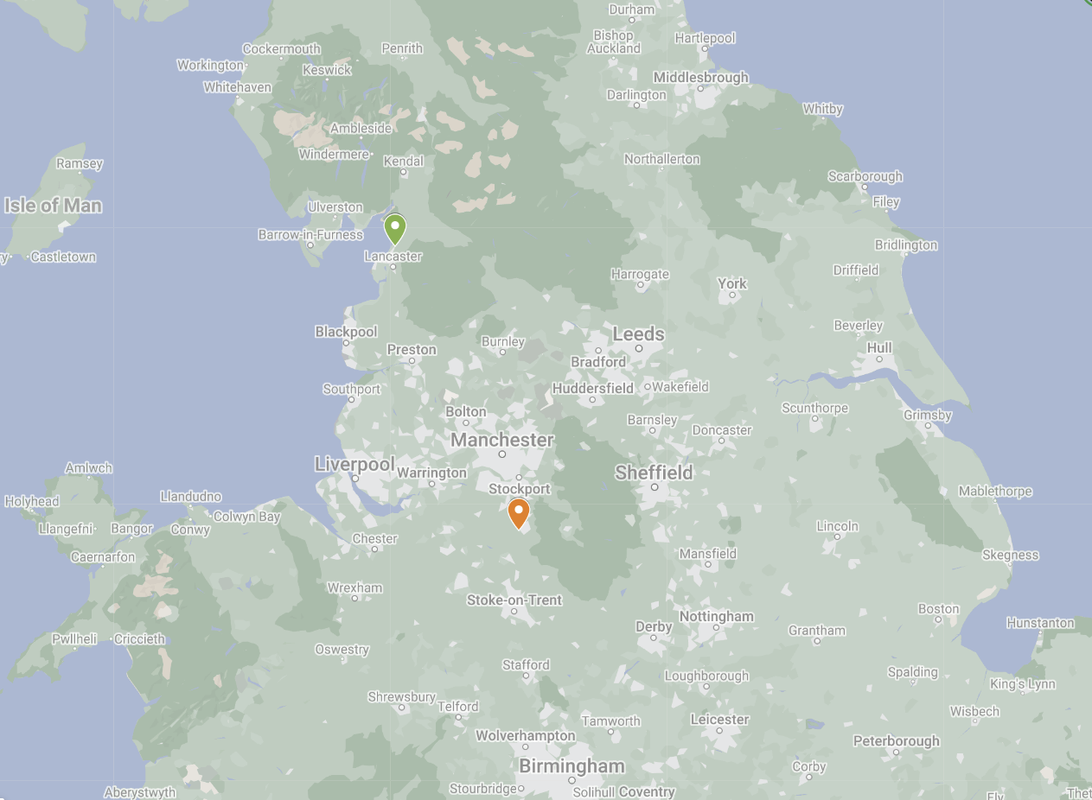
Bolton-le-Sands Parish
Prestbury Parish
Map 1 – Locations of Bolton-le-Sands and Prestbury parishes within northern England.
(Map produced using Google My Maps, [http://google.com/maps/d/u/0; accessed 10 November 2024])

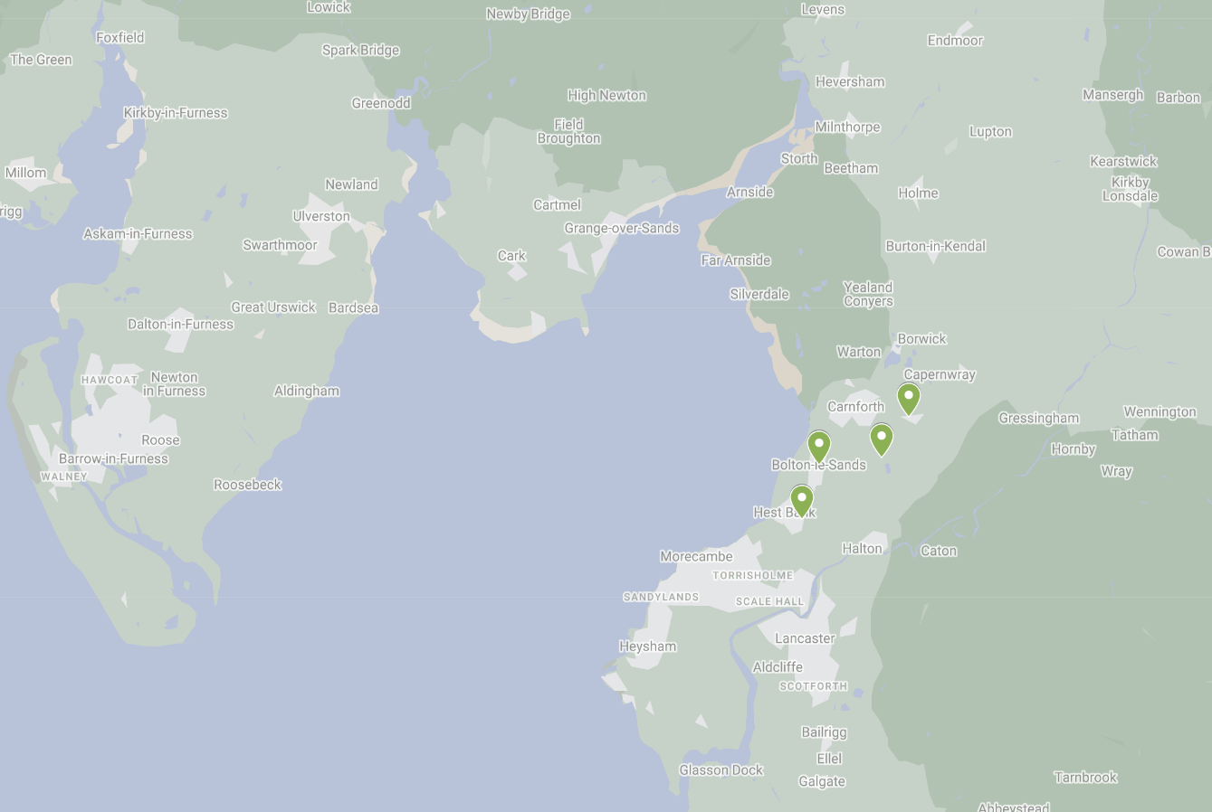
Slyne-with-Hest
Over Kellet
Nether Kellet
Bolton-le-Sands
Map 2 - Locations of Bolton-le-Sands, Slyne-with-Hest, Over Kellet and Nether Kellet townships, all within Bolton-le-Sands parish.
(Map produced using Google My Maps, [http://google.com/maps/d/u/0; accessed 10 November 2024])
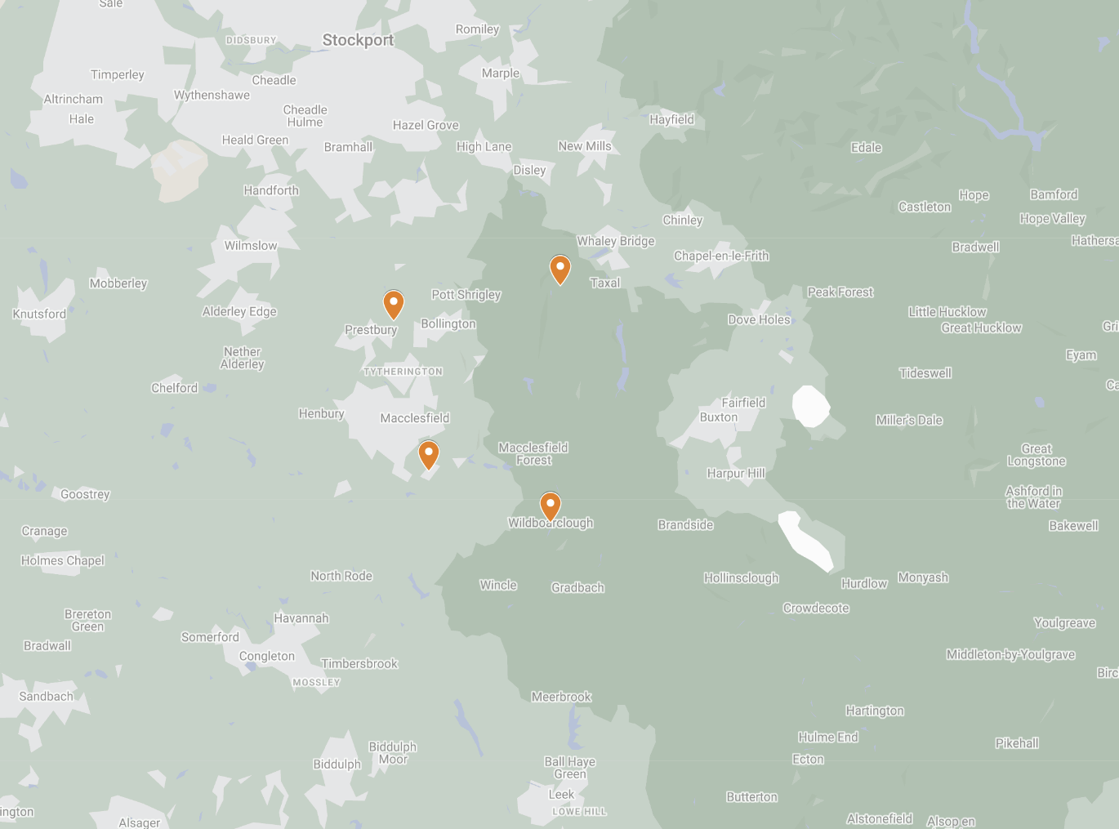
Wildboarclough
Kettleshulme
Sutton
Butley
Map 3 - Locations of Butley, Sutton, Wildboarclough and Kettleshulme townships within Prestbury parish.
(Map produced using Google My Maps, [http://google.com/maps/d/u/0; accessed 10 November 2024])

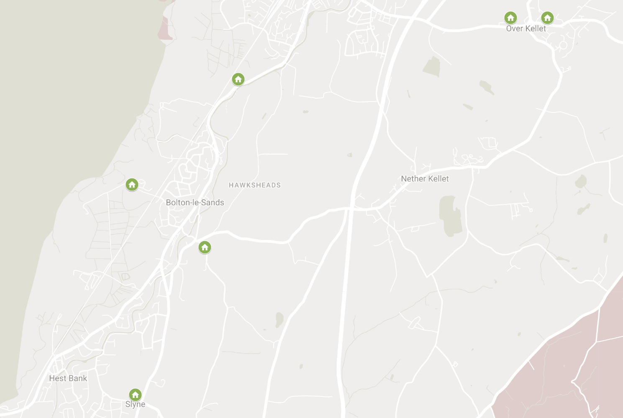
Hall
Farmhouse
Old Hall
Farmhouse
To Carnforth

Thwaite End

End Cottage

Cobblers’ Lodge

Manor House
To Lancaster

Map 4 – Case study properties within Bolton-le-Sands parish and their locations.
(Map produced using Google My Maps, [http://google.com/maps/d/u/0; accessed 10 November 2024])
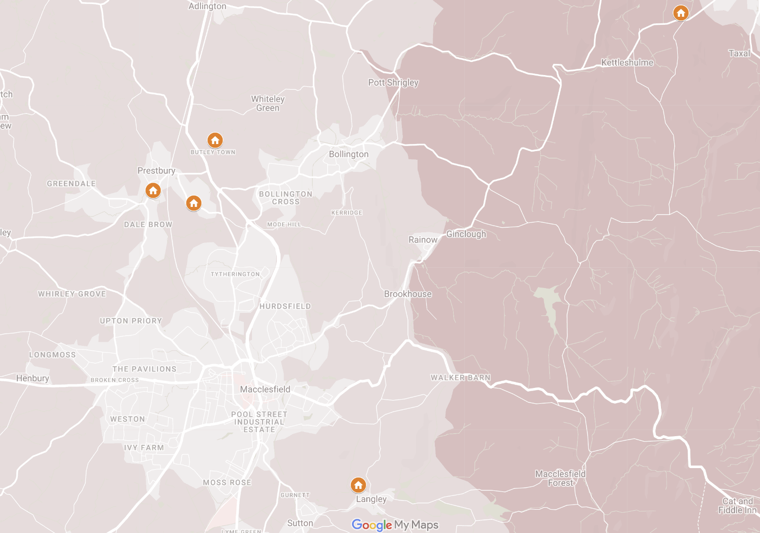
Heybridge
Farmhouse
Brooks Cottage
Langley Hall
Gap House
Yew Tree Farmhouse
Map 5 - Case study properties within Prestbury parish and their locations.
(Map produced using Google My Maps, [http://google.com/maps/d/u/0; accessed 10 November 2024])
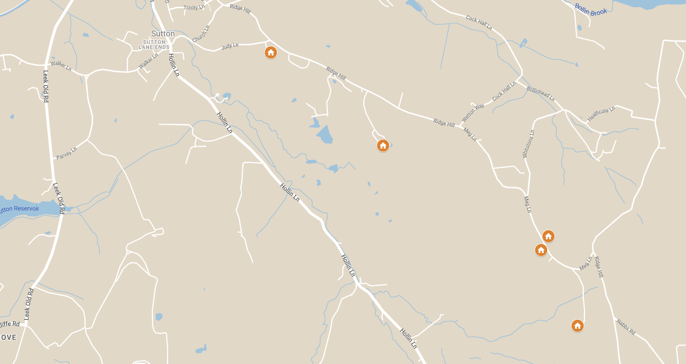
Map 6 – Five properties situated along Meg Lane, Sutton, within Prestbury parish.
Ridge Hill Farmhouse
Ridge Hall Farmhouse
Pott Lords Farmhouse
Fern Lee Farmhouse
Drove Hey Farmhouse
(Map produced using Google, My Maps, [http://google.com/maps/d/u/0; accessed 8 December 2024])

Appendix 2:

Figures

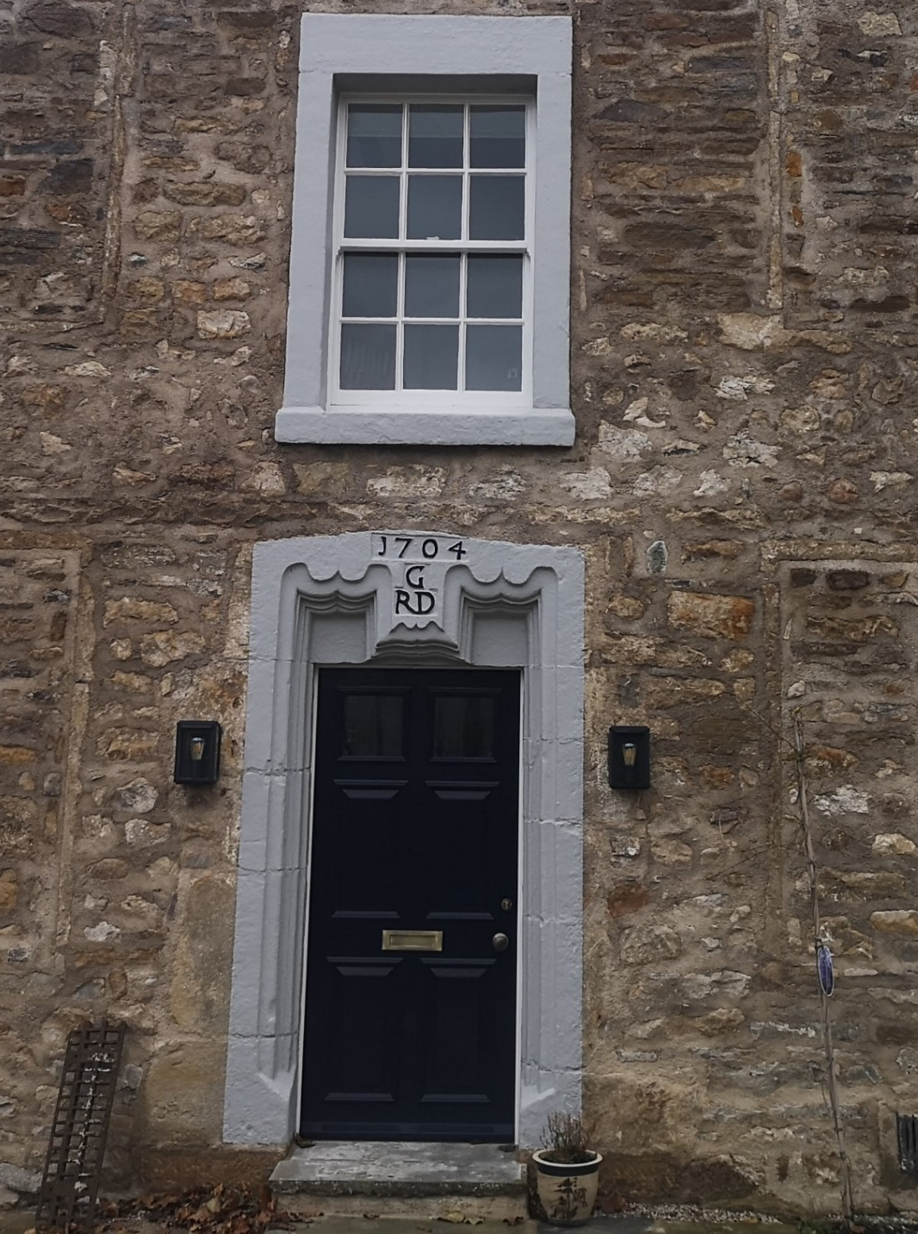
Figure 1 – Initials of Robert and Deborah Gibson at Hall Farmhouse, Over Kellet, within Bolton-le-Sands parish.
(Image author’s own)

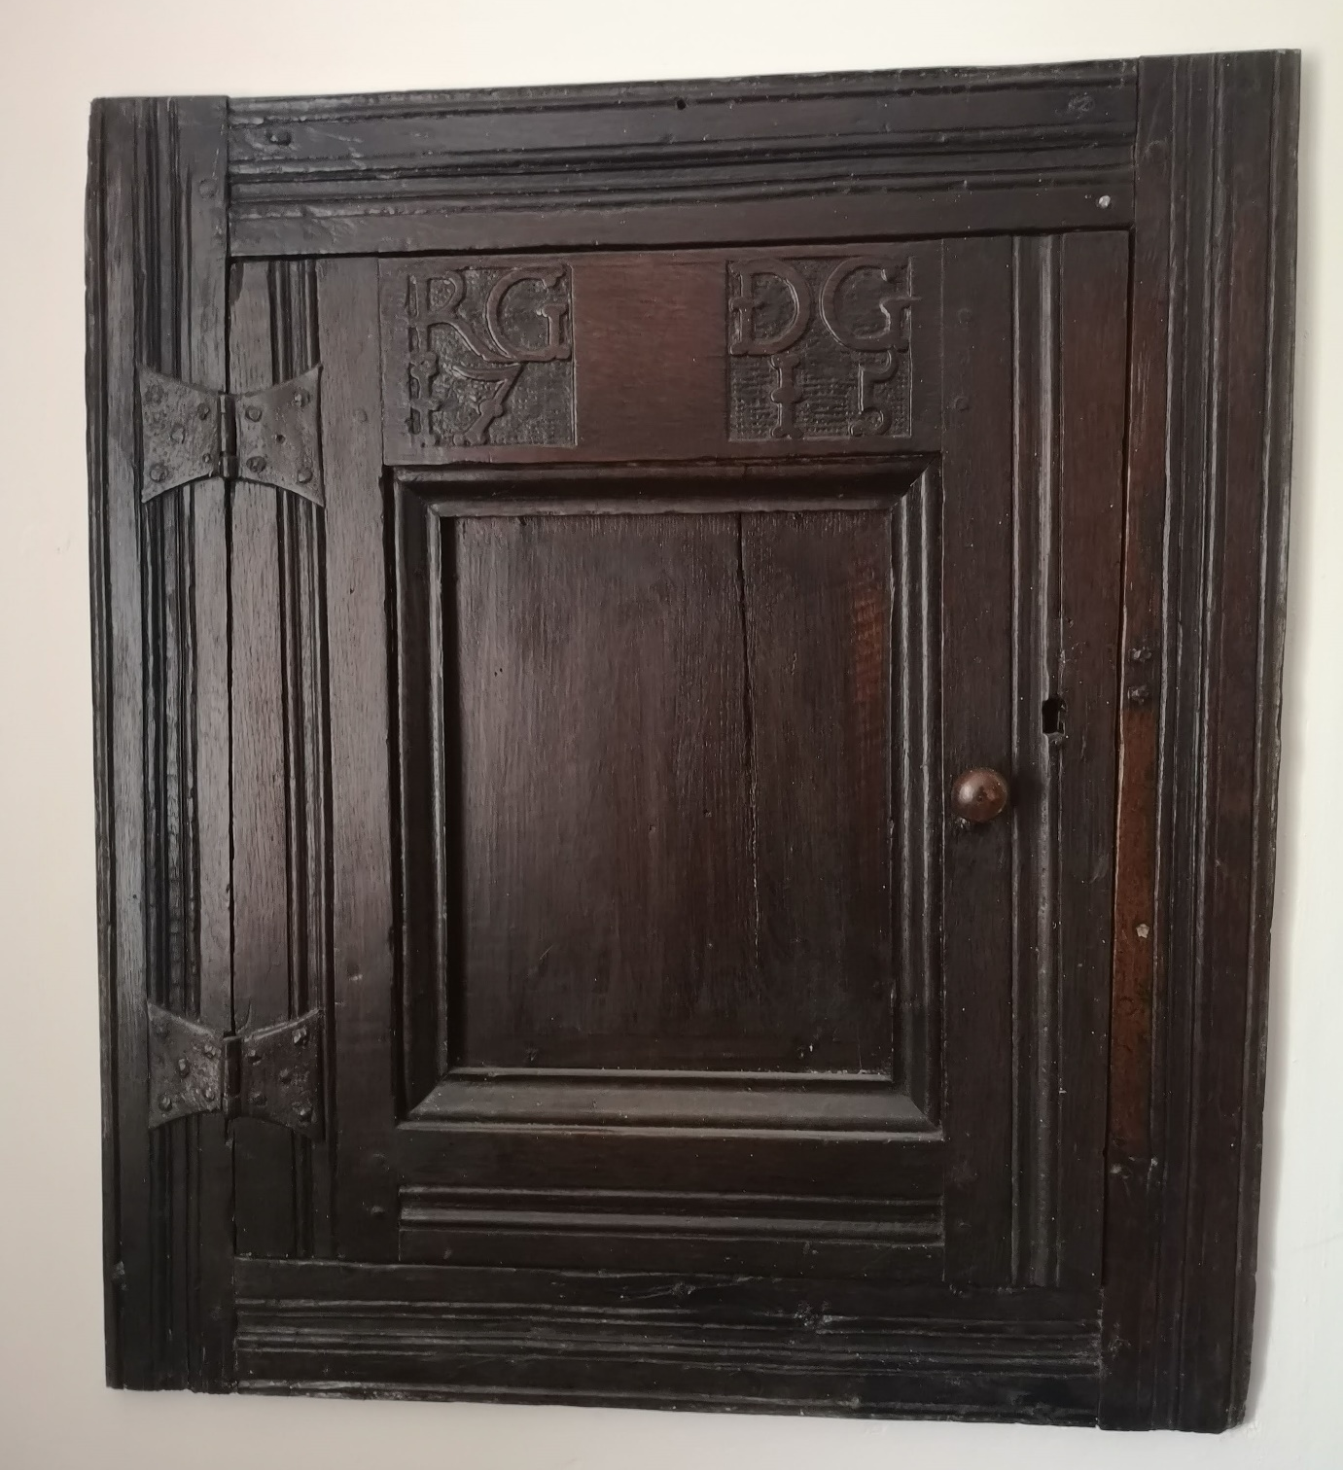
Figure 2 – Inscribed cupboard at Hall Farmhouse, Over Kellet, within Bolton-le-Sands parish, inscribed with the initials of Robert and Deborah Gibson.
(Image author’s own)

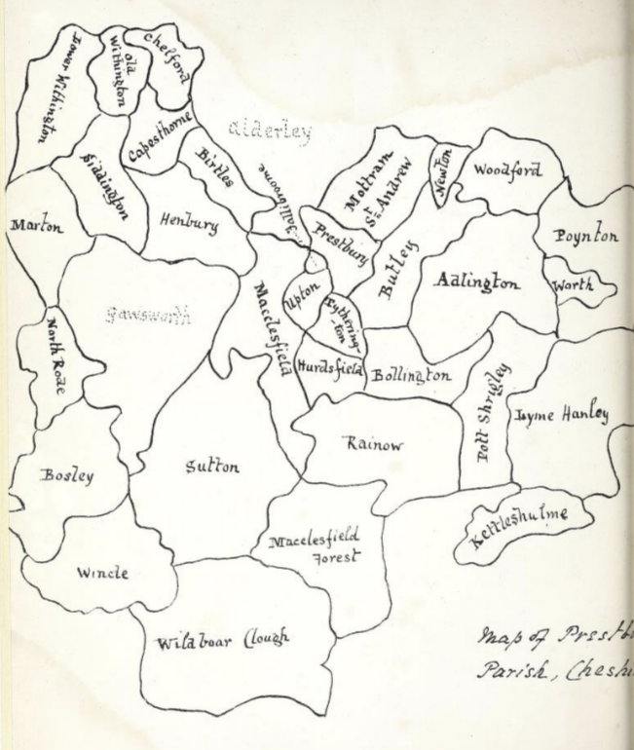
Figure 3 – Illustrated map of all townships within Prestbury parish.
(Image from Frank Renaud, Contributions towards a history of the ancient parish of Prestbury, in Cheshire, (Manchester, 1876), p.x)

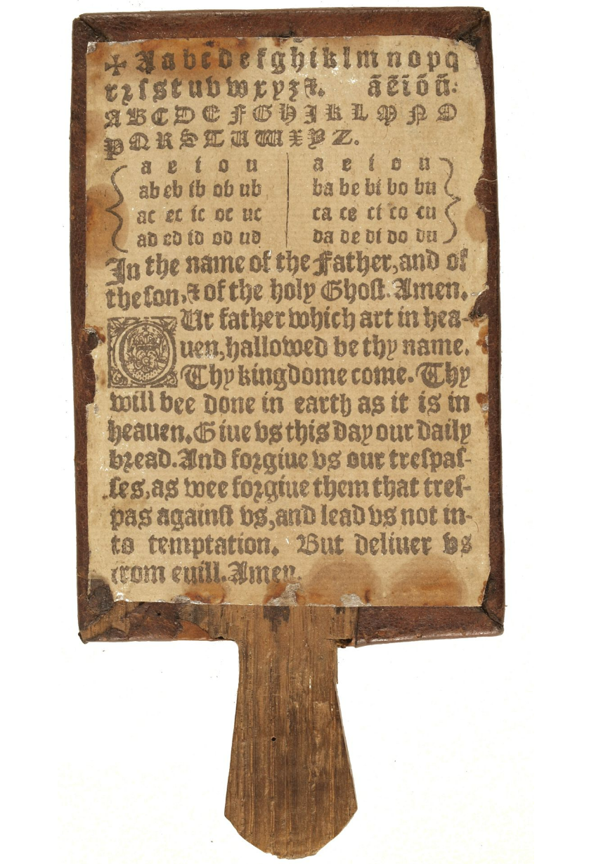
Figure 4 - Horn book, showing lower case letters with black-letter capitals beneath.
(Image from ‘Front of horn book, STC 13813.5.’, Folger Shakespeare Library, [https://digitalcollections.folger.edu/node/208004; accessed 2 December 2024]

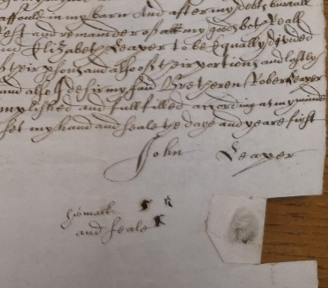

Figure 5 - Subscription at the foot of the will of John Leaper, 1666.
(Lancashire Archives, (hereafter LA): WRW/K/R454A/29, Will of John Leaper of Over Kellet, yeoman, 1666; image author’s own)

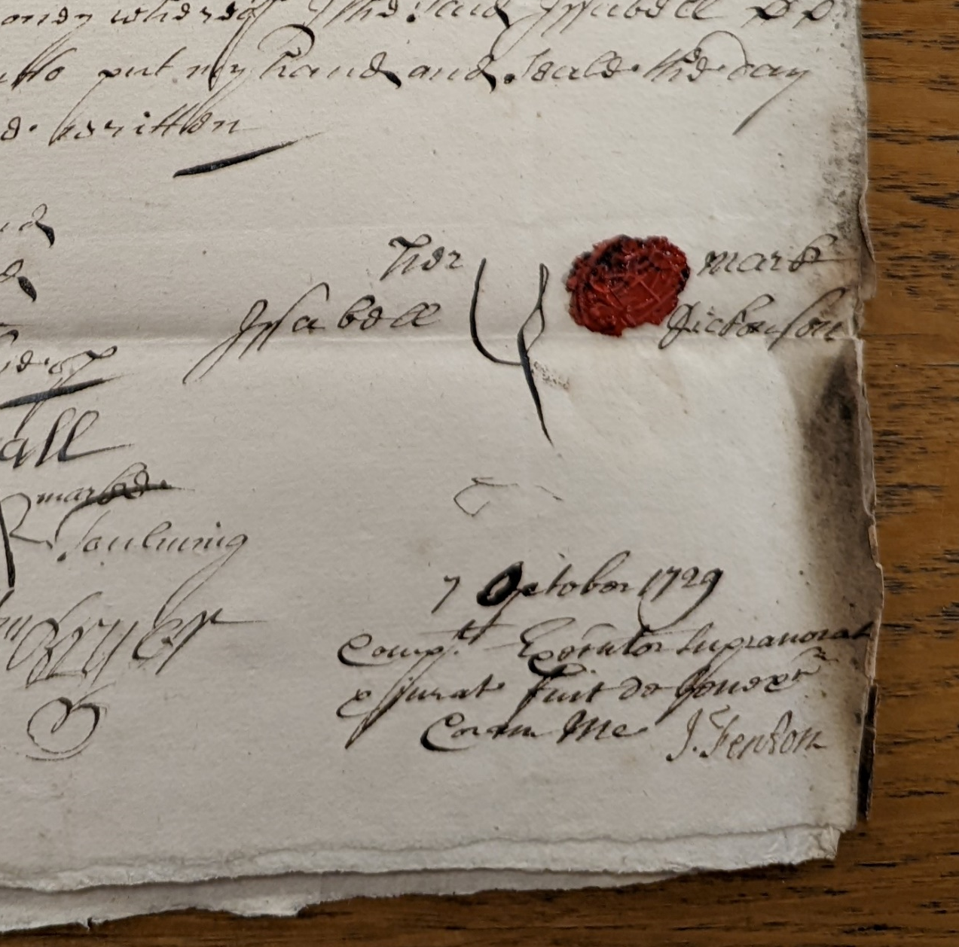

Figure 6 - Subscription at the foot of the will of Isabell Dickonson, 1729.
(LA: WRW/K/R428B/5, Will of Isabell Dickonson of Bolton-le-Sands, widow, 1729; image author’s own)

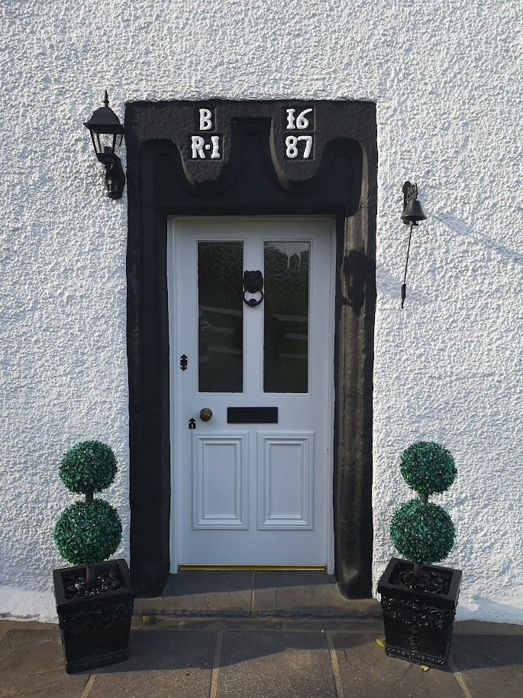

Figure 7 - Inscribed lintel at Thwaite End Farmhouse, within Bolton-le-Sands parish.
(Image author’s own)

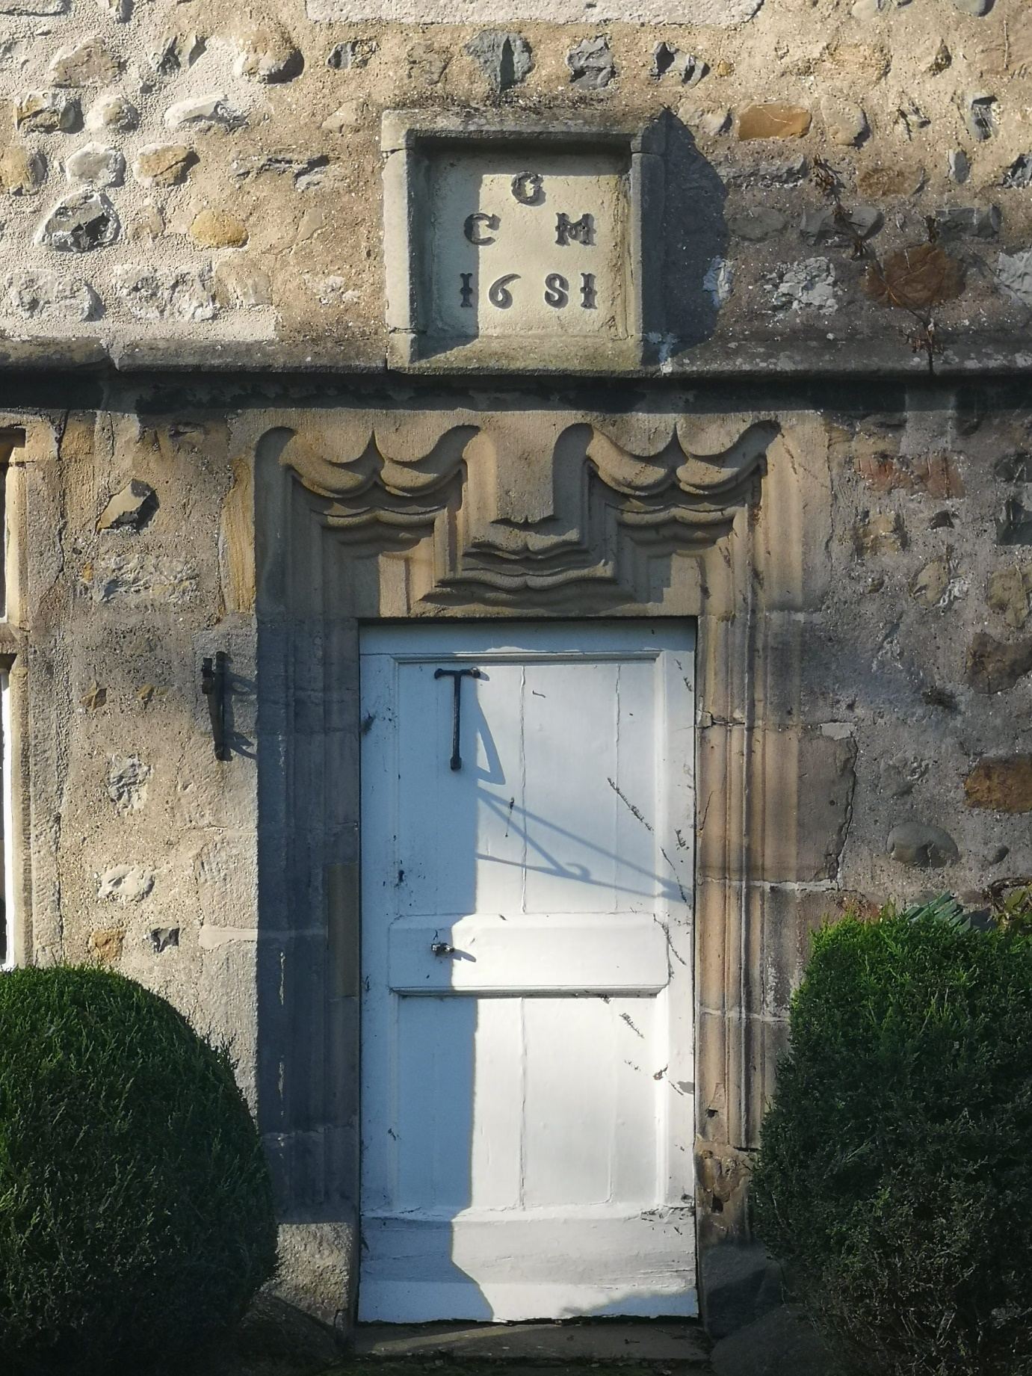

Figure 8 - Inscribed plaque at the Manor House, Slyne-with-Hest, within Bolton-le-Sands parish.
(Image author’s own)
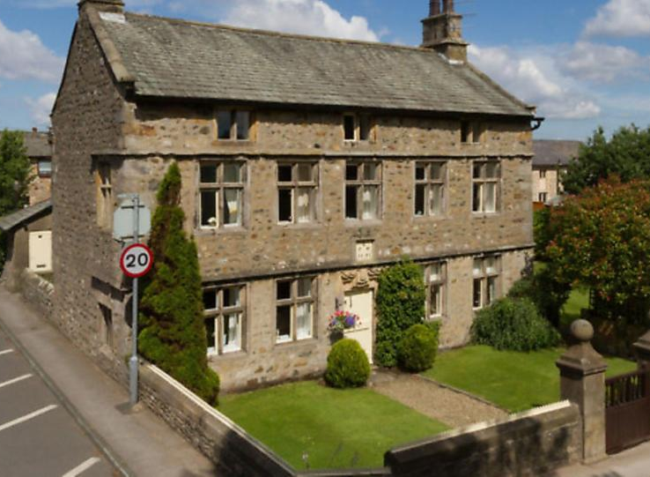

Figure 9 - Full façade at the Manor House, Slyne-with-Hest, within Bolton-le-Sands parish. (Image from ‘Dream Properties – Manor House, Slyne, Lancaster’, Lancashire Life, https://www.greatbritishlife.co.uk/magazines/lancashire/22621021.dream-properties---manor-house-slyne-lancaster/; accessed 8 May 2024])

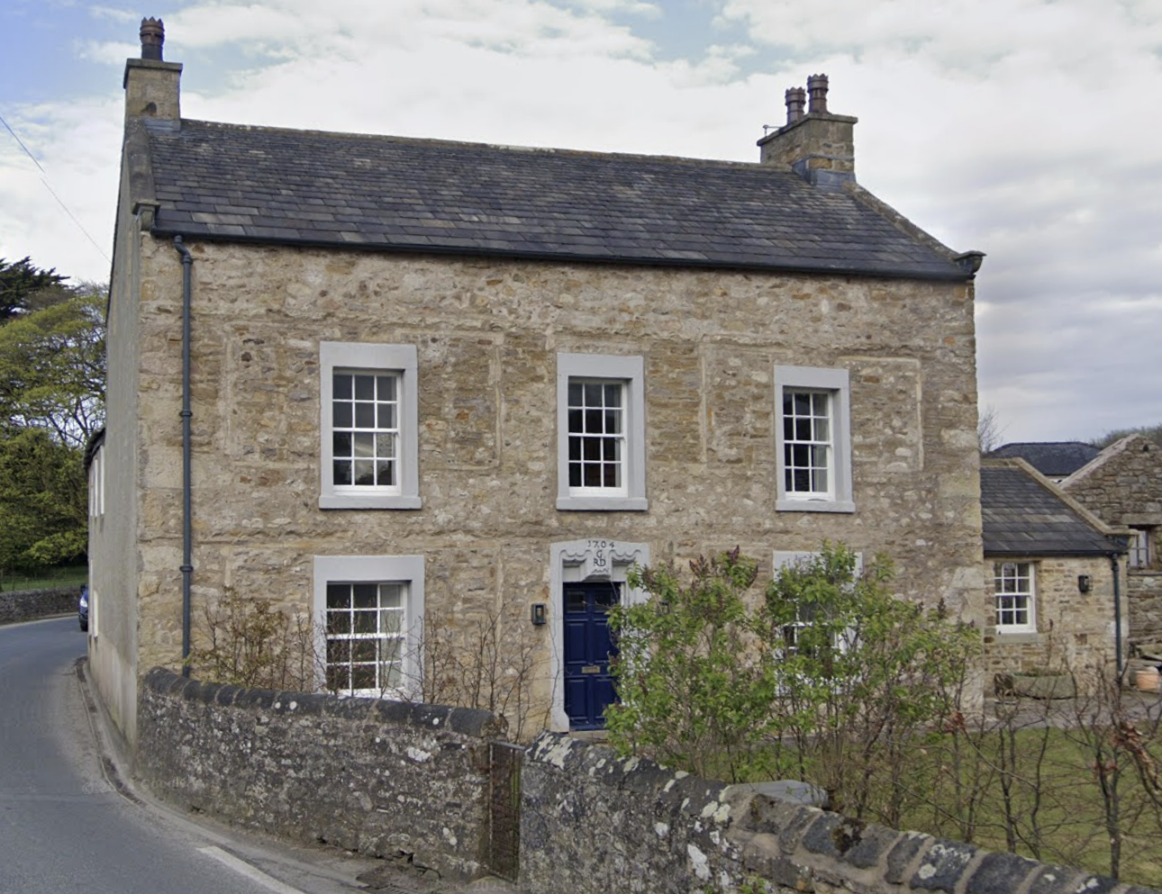

Figure 10 – Façade at Hall Farmhouse, Over Kellet, within Bolton-le-Sands parish.
(Image from Google Maps, [https://www.google.com/maps/@54.1235886,-2.739355,3a,75y,99.2h,84.62t/data=!3m7!1e1!3m5!1sPdO-UHHcdLXeMlWpWiuRiw!2e0!6shttps:%2F%2Fstreetviewpixels-pa.googleapis.com%2Fv1%2Fthumbnail%3Fcb_client%3Dmaps_sv.tactile%26w%3D900%26h%3D600%26pitch%3D5.3831122784881416%26panoid%3DPdO-UHHcdLXeMlWpWiuRiw%26yaw%3D99.20267495045651!7i16384!8i8192?entry=ttu&g_ep=EgoyMDI0MTIxMS4wIKXMDSoASAFQAw%3D%3D; accessed 26 April 2024])
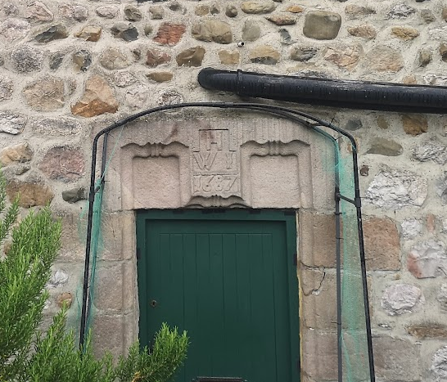
Figure 11 - Inscribed lintel at End Cottage, Bolton Holmes, within Bolton-le-Sands parish.
(Image author’s own)

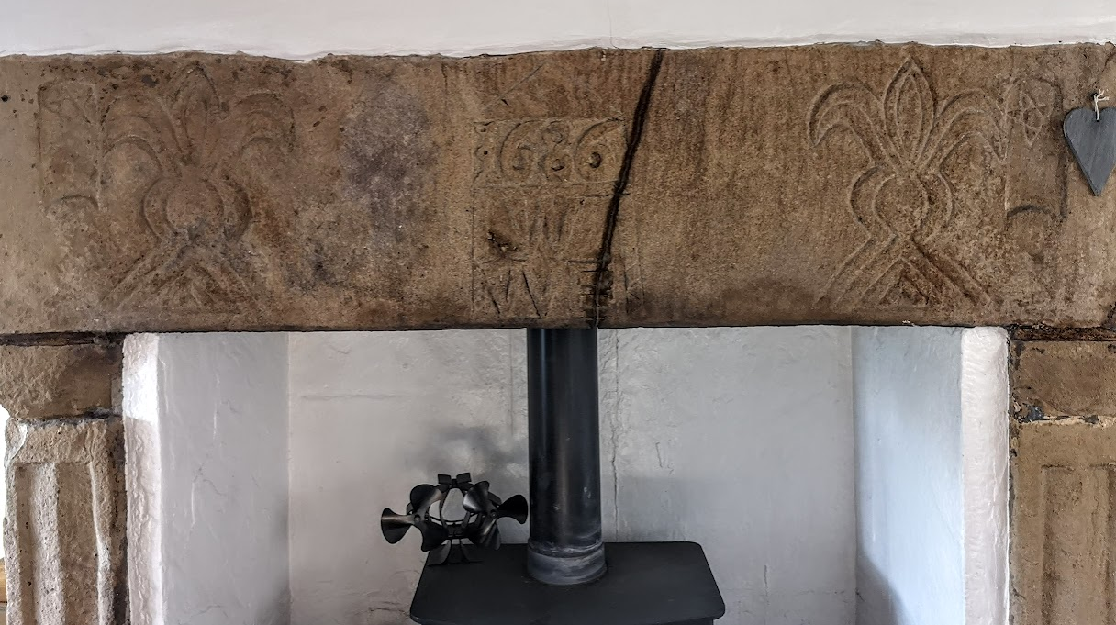
Figure 12 – Inscribed fireplace with initials W^{W}E and year 1686 at Cobblers’ Lodge, Bolton-le-Sands township.
(Image author’s own)

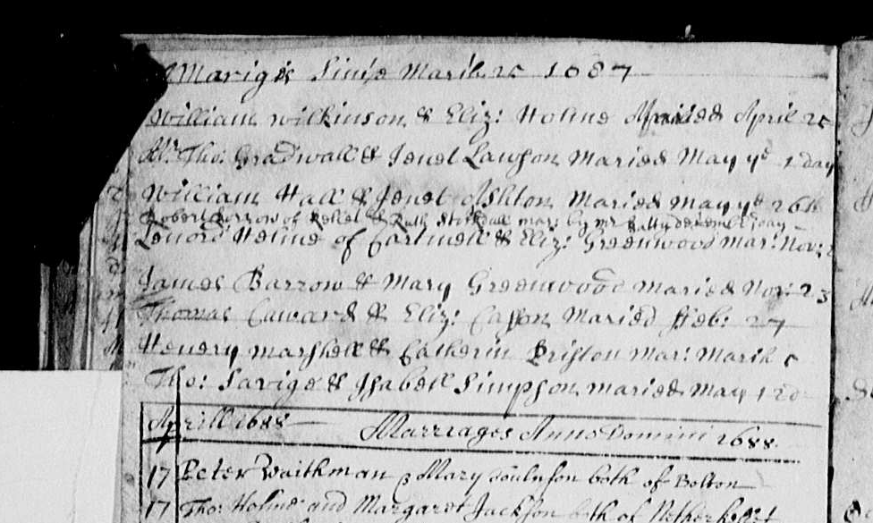
Figure 13 - Marriage entry for William and Elizabeth Wilkinson, 25th April 1687. Text reads ‘Mariges Since March 25 1687 William Wilkinson & Eliz: Holme Maried April 25’.
(Image from Findmypast, [https://search.findmypast.co.uk/record?id=S2%2FGBPRS%2FLANCS%2F4360292%2F01019&parentid=GBPRS%2FLANCS%; accessed 20 June 2020])
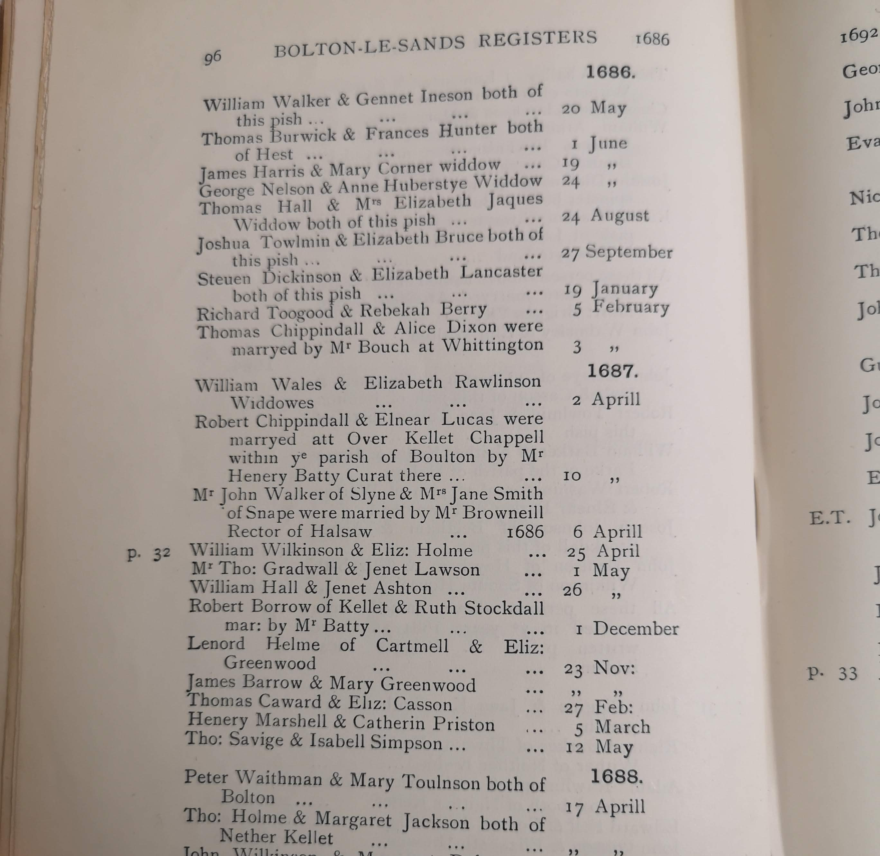
Figure 14 - Print edition of Bolton-le-Sands parish register citing the Wilkinsons’ marriage on 25th April 1687.
(Image from Henry Brierley (ed.), The Registers of the Parish Church of Bolton-le-Sands in the County of Lancaster, 1665-1736, (Lancaster, 1911), p.96)

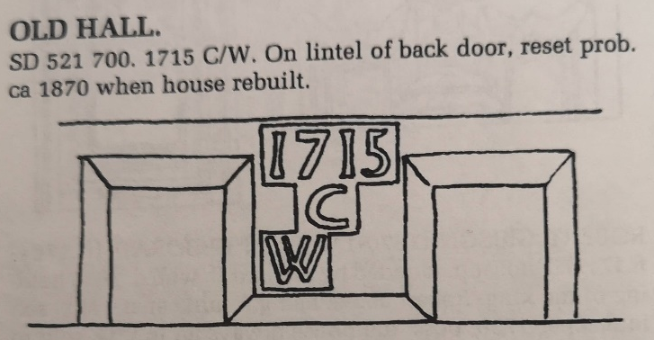

Figure 15 – Illustration of the initials of Walter Cocke inscribed into the lintel at Old Hall Farmhouse, Over Kellet, within Bolton-le-Sands parish.
(Image from Emmeline Garnett, The Dated Buildings of South Lonsdale, (Lancaster, 1994), p.122)
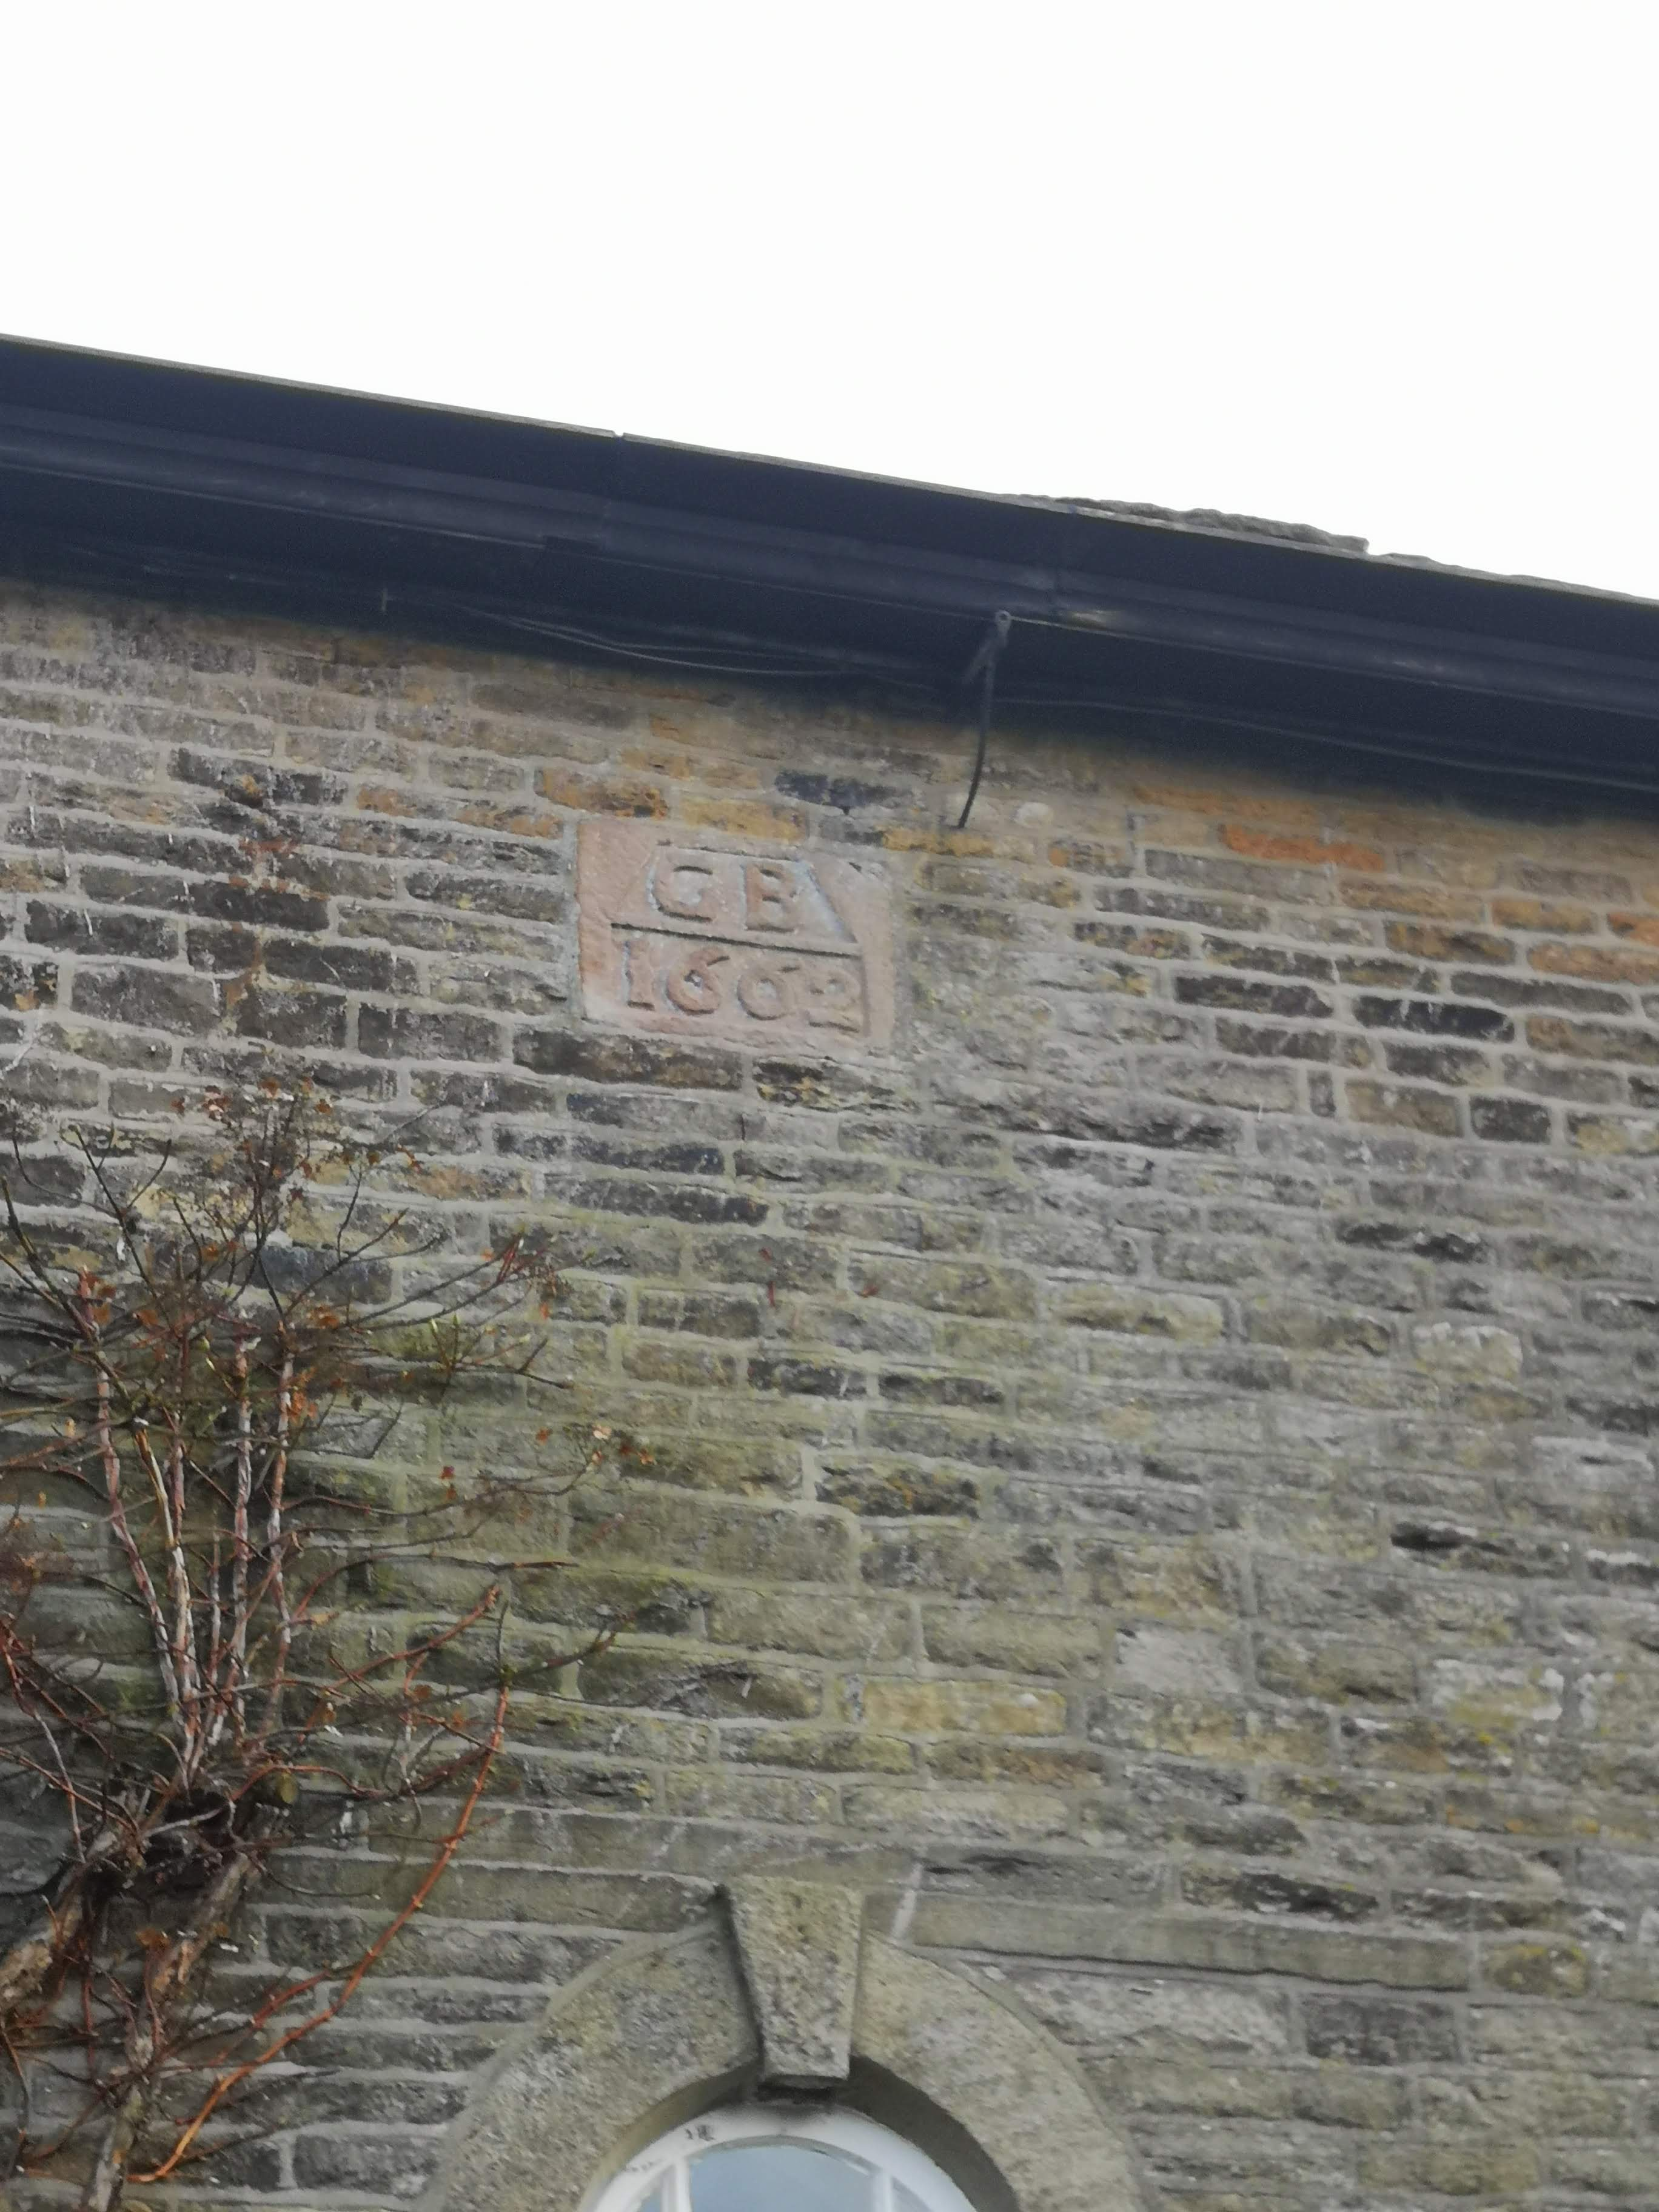
Figure 16 – Earliest initials present at Gap House, Kettleshulme, within Prestbury parish, reading ‘G B 1662’.
(Image author’s own)

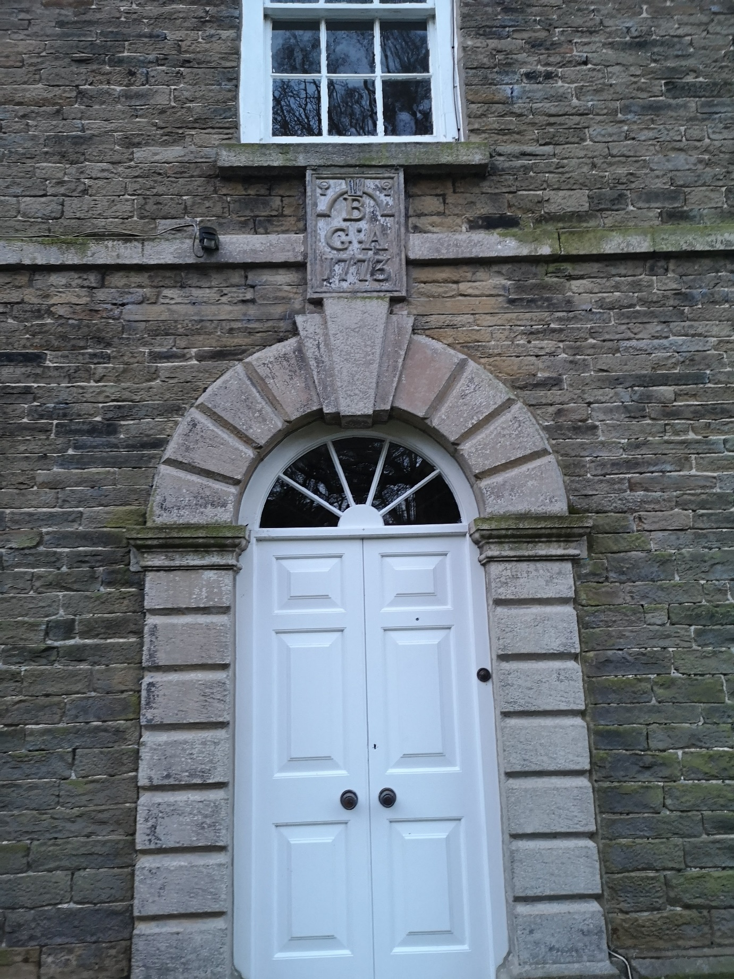
Figure 17 – Later initialled datestone at Gap House, Kettleshulme, within Prestbury parish, reading ‘G^{B}A 1773’.
(Image author’s own)

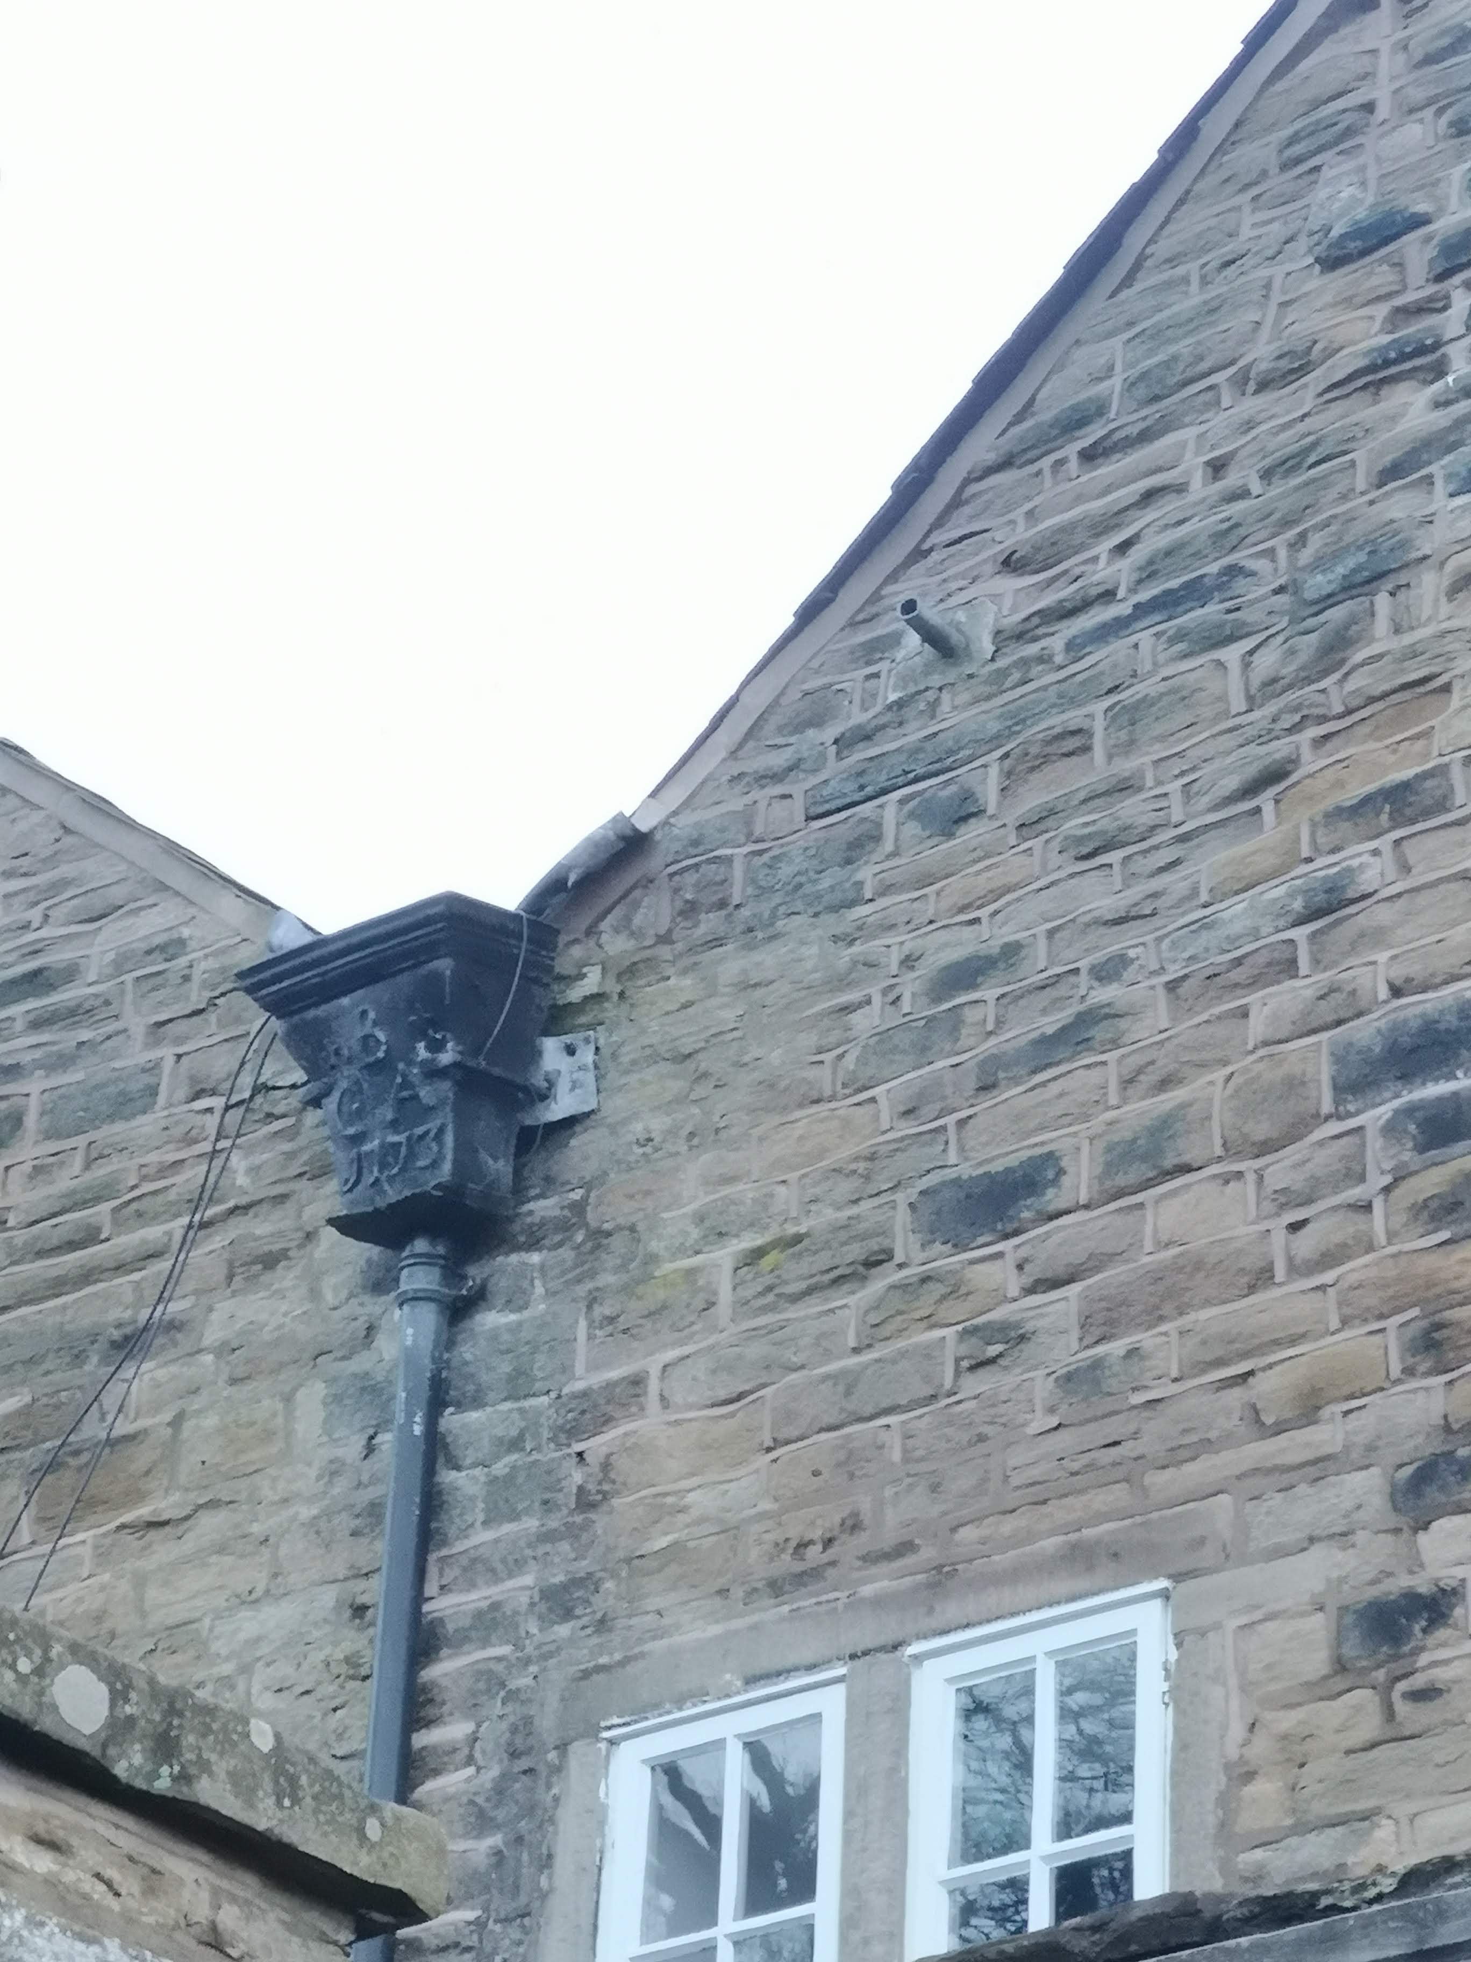
Figure 18 – Initialled hopper head with inscription (‘G^{B}A 1773’) matching second datestone at Gap House, Kettleshulme, within Prestbury parish.
(Image author’s own)

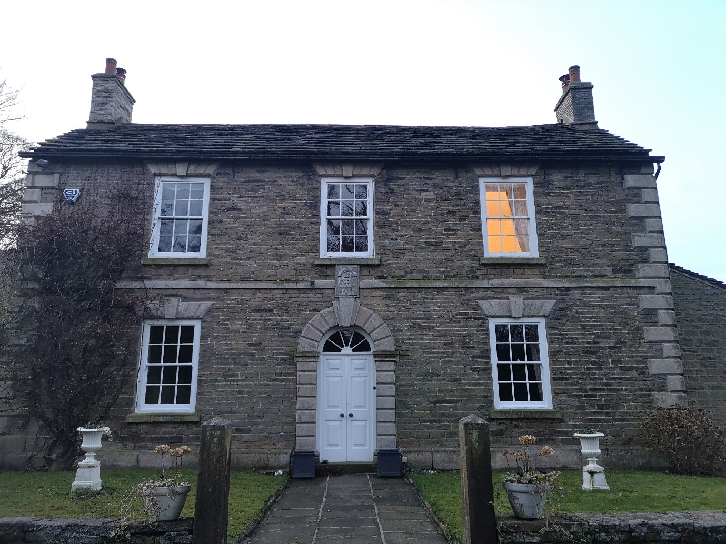
Figure 19 – Façade at Gap House, Kettleshulme, featuring datestone above main entryway, reading ‘G^{B}A 1773’.
(Image author’s own)

s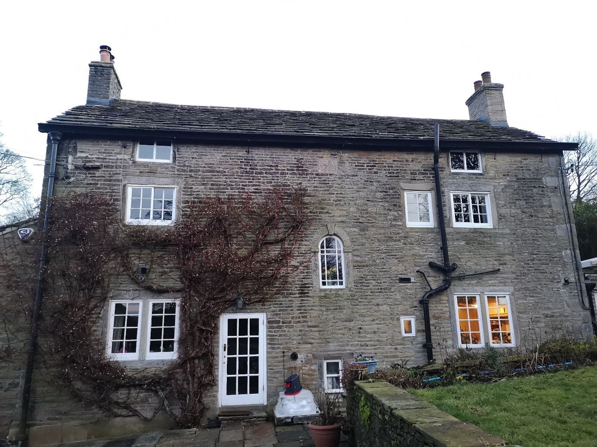
Figure 20 – Rear of Gap House, Kettleshulme featuring earliest datestone reading ‘GB 1662’, with position highlighted.
(Image author’s own)
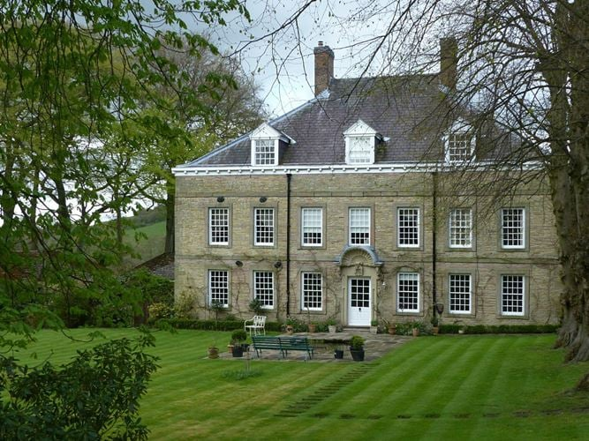
Figure 21 – Façade at Langley Hall, Sutton, within Prestbury parish.
(Image from ‘Langley Hall’, Grade II* Listed Building in Sutton, Cheshire East, List Entry No. 1139480 [https://historicengland.org.uk/listing/the-list/list-entry/1139480; accessed 17 June 2024])
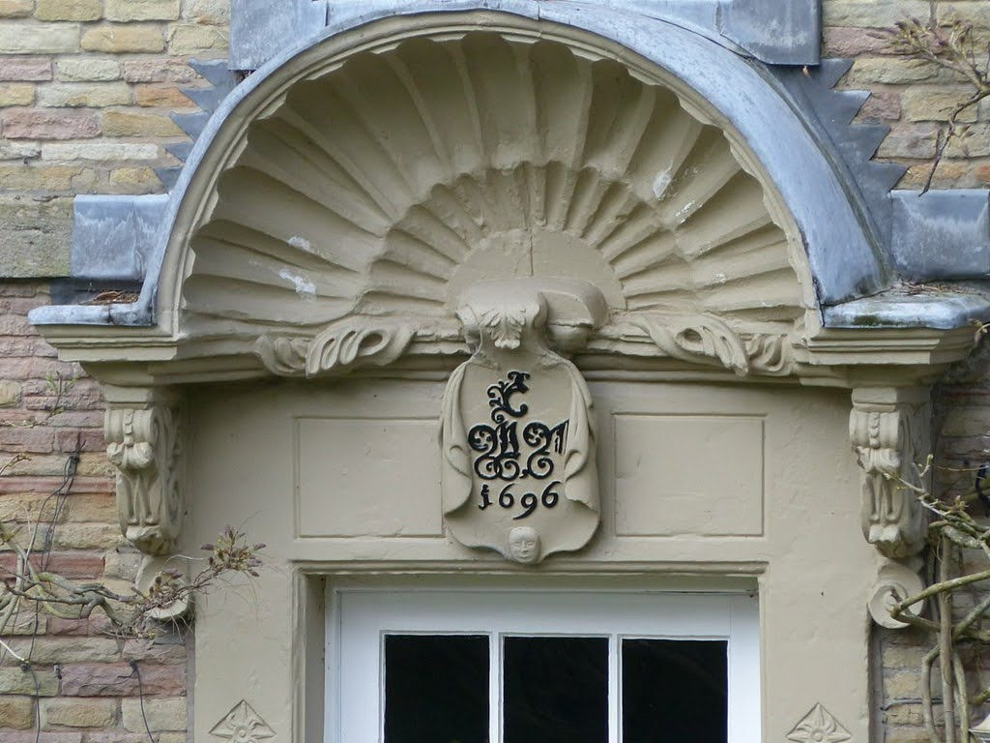
Figure 22 – Initialled cartouche at Langley Hall, Sutton, within Prestbury parish.
(Image author’s own)
Figure 23 – Initialled cartouche at Langley Hall, Sutton, with stylised ‘W’ jambs highlighted.
(Image author’s own)
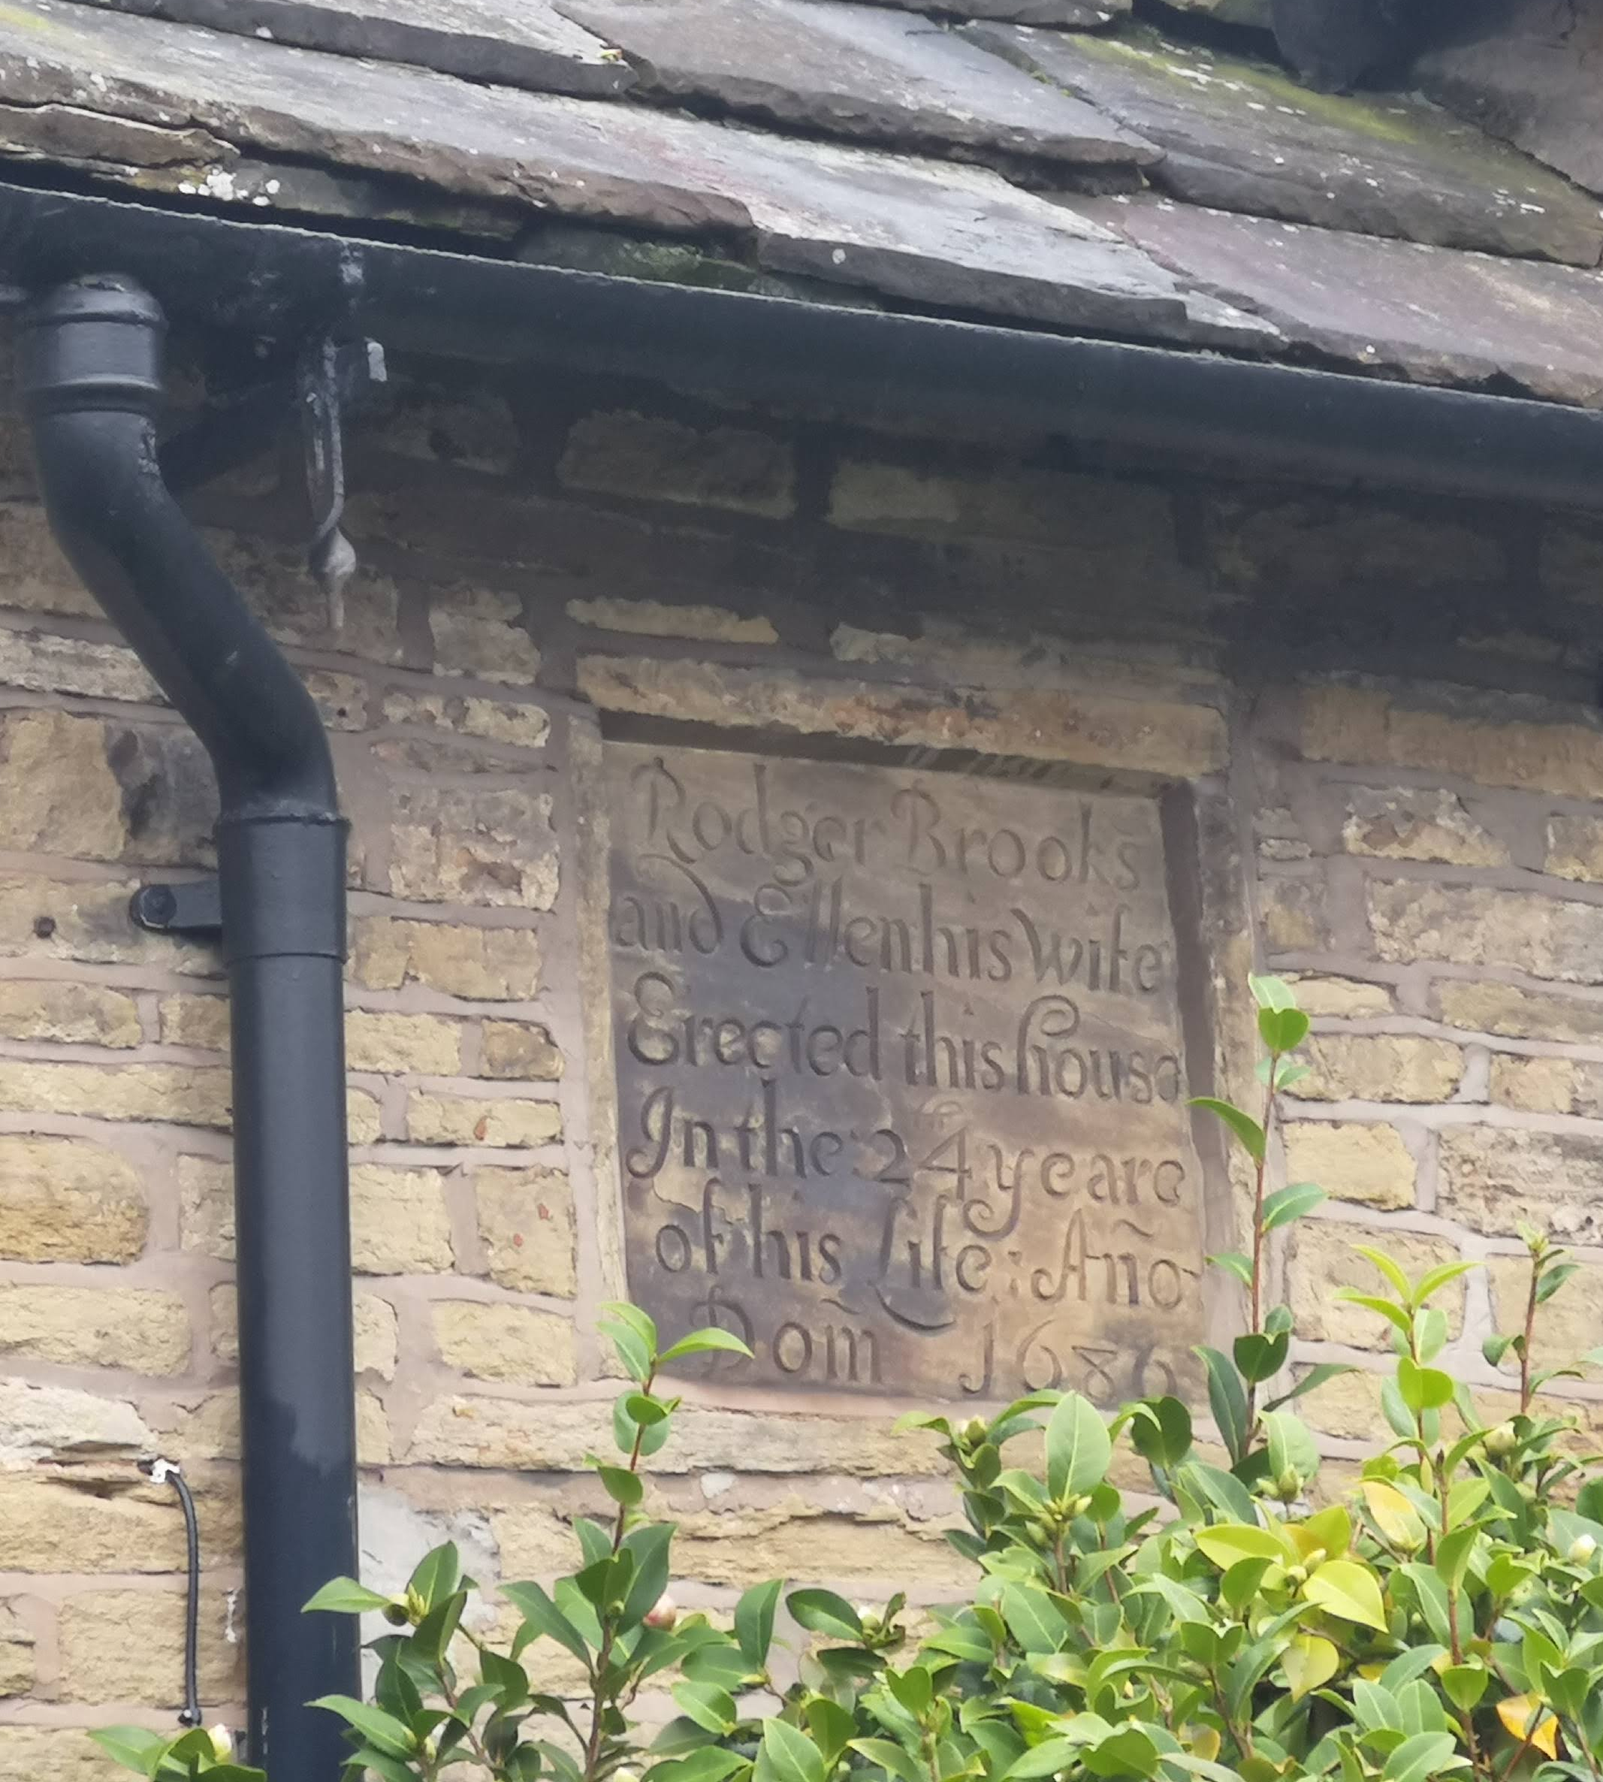
Figure 24 - Inscribed plaque at Brooks Cottage, Butley, within Prestbury parish. Inscription reads ‘Rodger Brooks and Ellen his wife Erected this house In the 24 yeare of his Life: Año: Dom 1686’.
(Image author’s own)

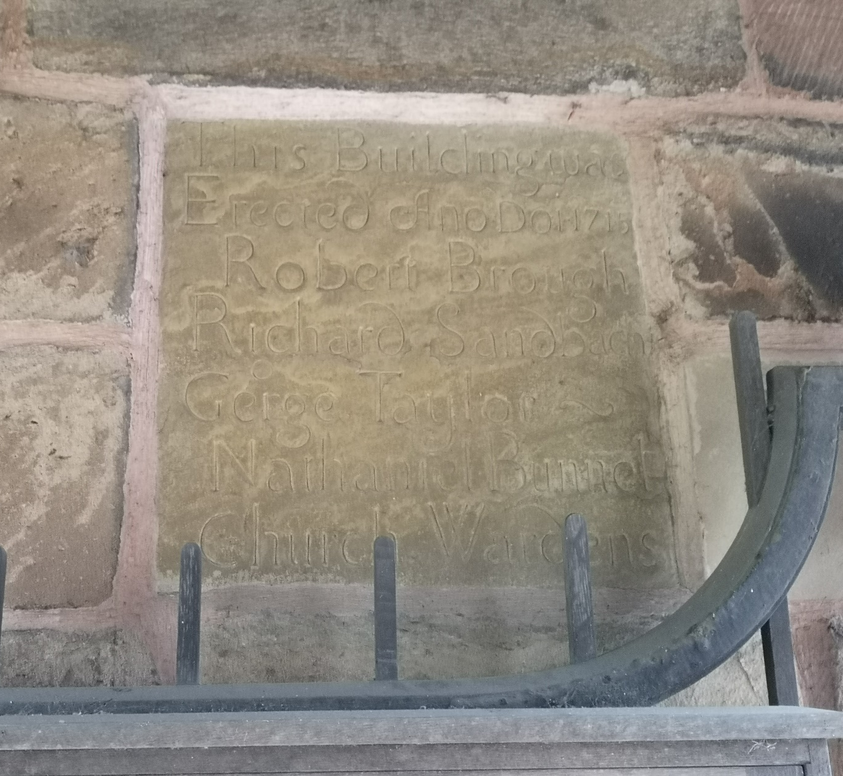
Figure 25 - Inscription on the lychgate at St Peter’s Church, Prestbury, dated 1715. Inscription reads This Building was Erected Ano Dom 1715 Robert Brough Richard Sandbach Geºrge Taylor Nathaniel Bennet Church Wardens’.
(Image author’s own)

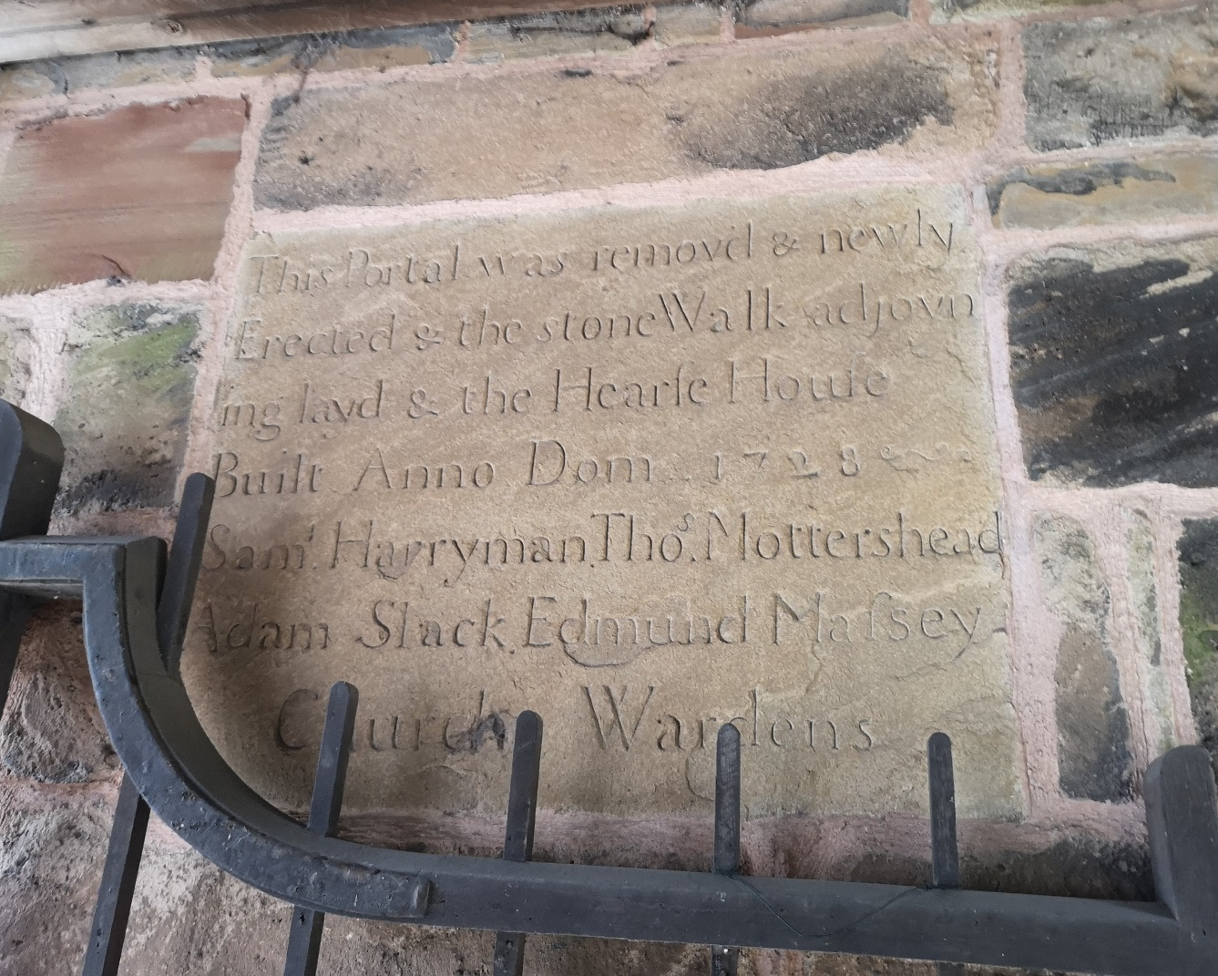
Figure 26 – Second inscription on the lychgate at St Peter’s Church, Prestbury. Inscription reads ‘This Portal was removd & newly Erected & the stone Walk adjoin-ing layd & the Hearse House Built Anno Dom 1728 Sam^{l} Harryman Tho^{s} Mottershead Adam Slack Edmund Massey Church Wardens’.
(Image author’s own)

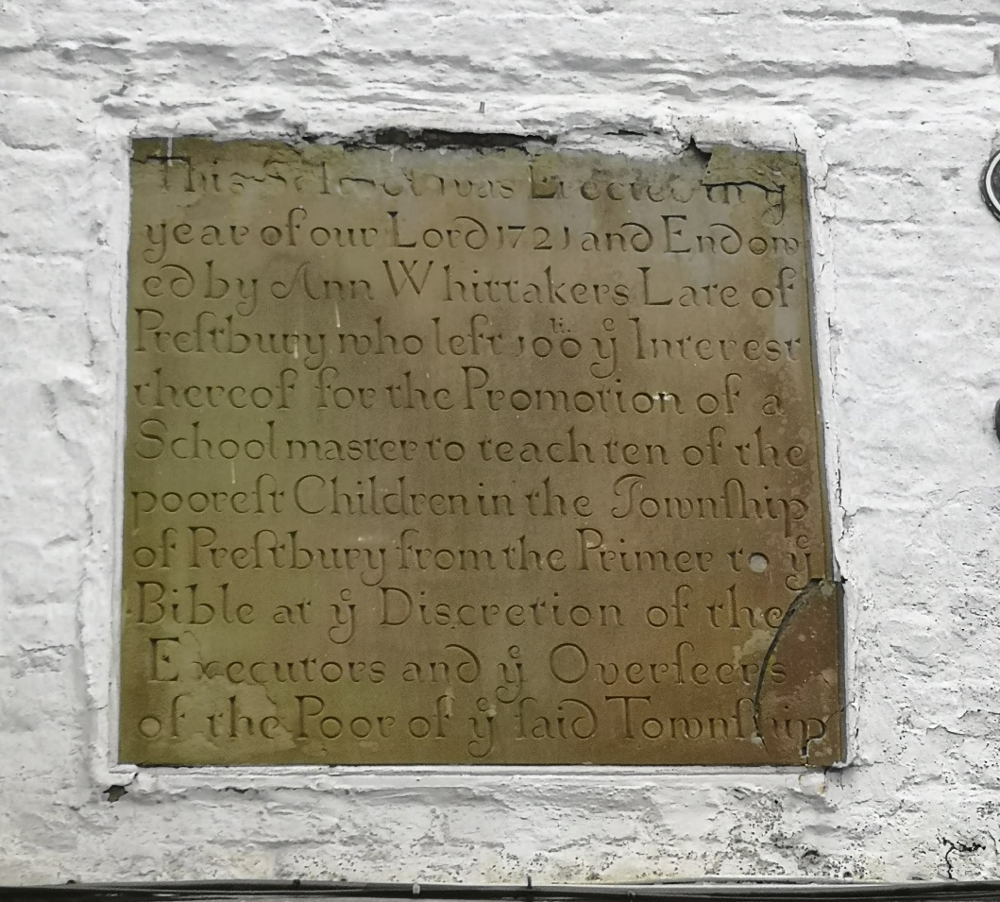
Figure 27 – Inscription still extant in centre of Prestbury village, dated 1721. Inscription reads ‘This School was Erected in ye year of our Lord 1721 and Endow-ed by Ann Whitakers Lare of Prestbury who left 100^{li} y^{e} Interest thereof for the Promotion of a Schoolmaster to teach ten of the poorest Children in the Township of Prestbury from the Primer to y^{e} Bible at y^{e} Discretion of the Executors and y^{e} Overseers of the Poor of y^{e} said Township’.
(Image author’s own)

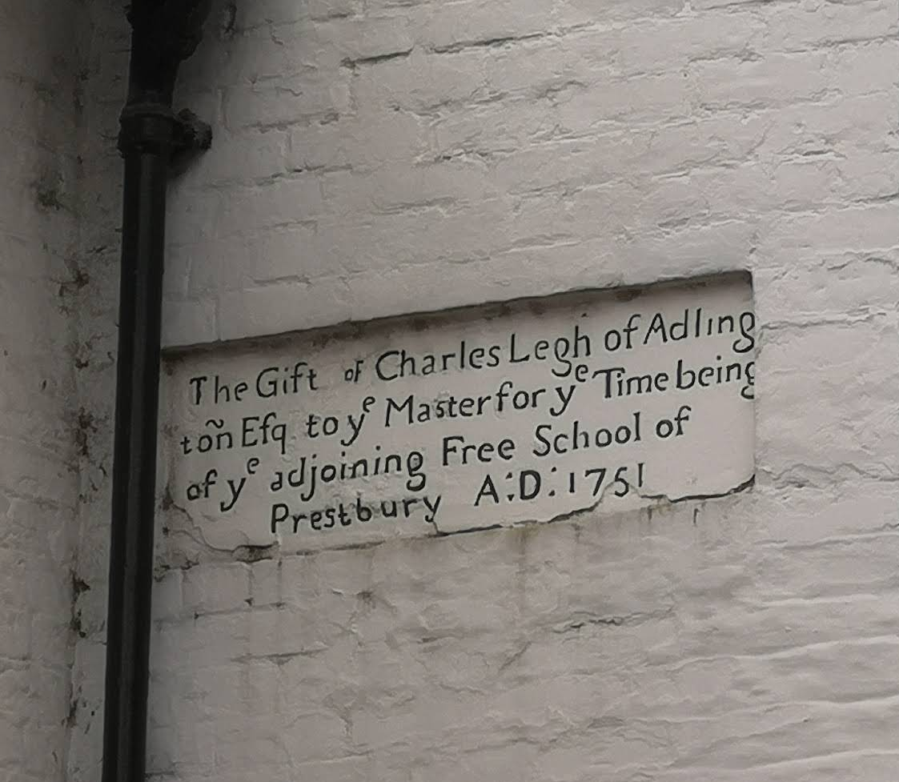
Figure 28 – Second inscription in centre of Prestbury village, dated 1751. Inscription reads ‘The Gift of Charles Legh of Adling-ton Esq to y^{e} Master for y^{e} Time being of y^{e} adjoining Free School of Prestbury A:D: 1751’.
(Image author’s own)

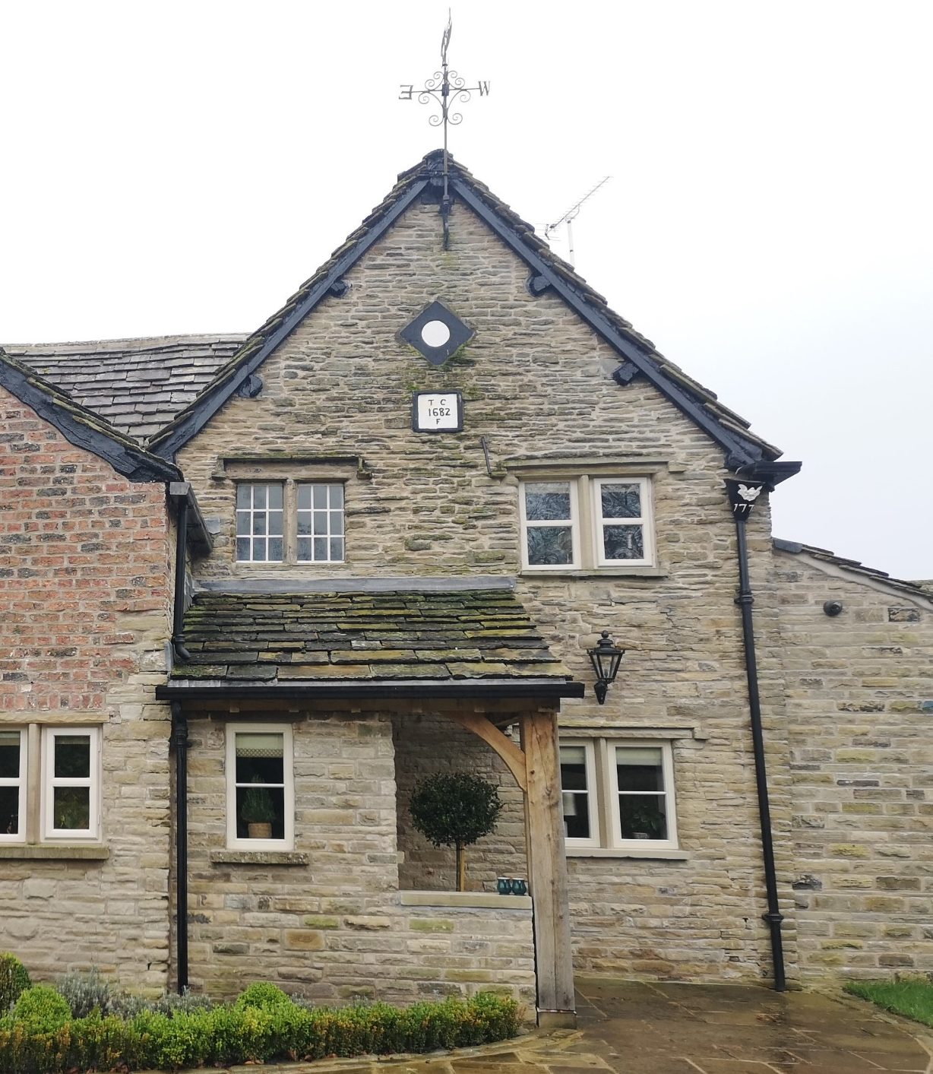

Figure 29 – Two inscriptions on the façade of Heybridge Farmhouse, Butley, within Prestbury parish.
(Image author’s own)
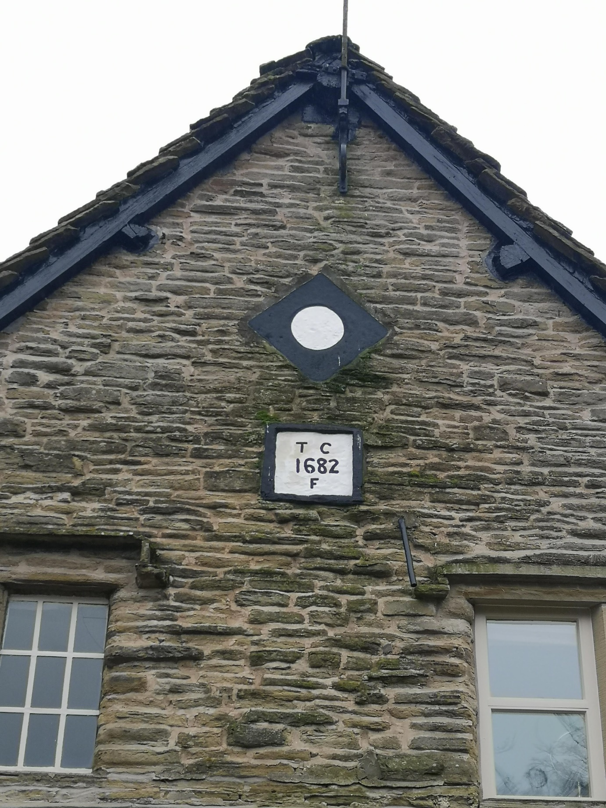
Figure 30 – Detail of earliest inscription at Heybridge Farmhouse, Butley, within Prestbury parish, dated 1682.
(Image author’s own)
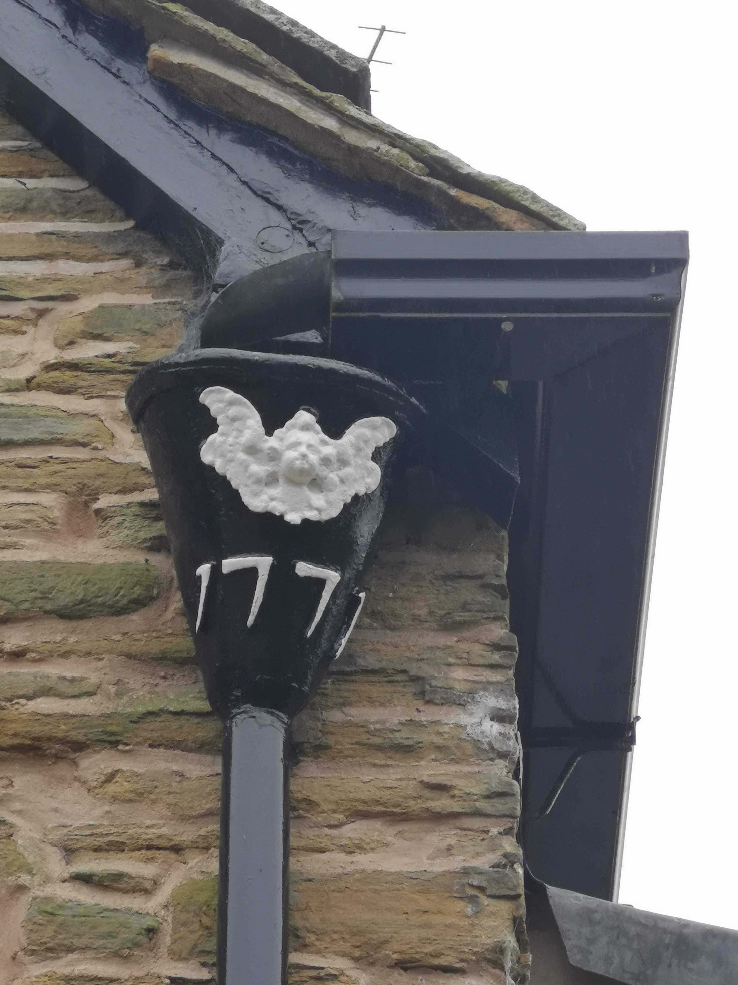
Figure 31 – Inscribed hopper head at Heybridge Farmhouse, Butley, dated 1771.
(Image author’s own)

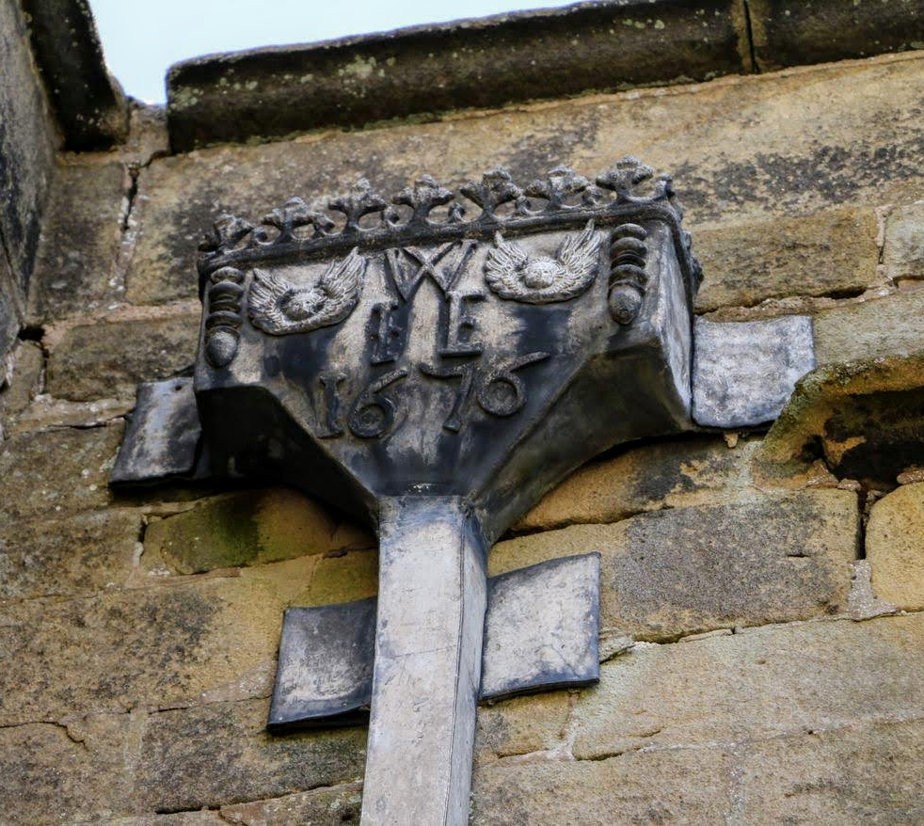
Figure 32 – Initialled and dated hopper head at Eyam Hall, Derbyshire, commemorating John and Elizabeth Wright. (Image author’s own)

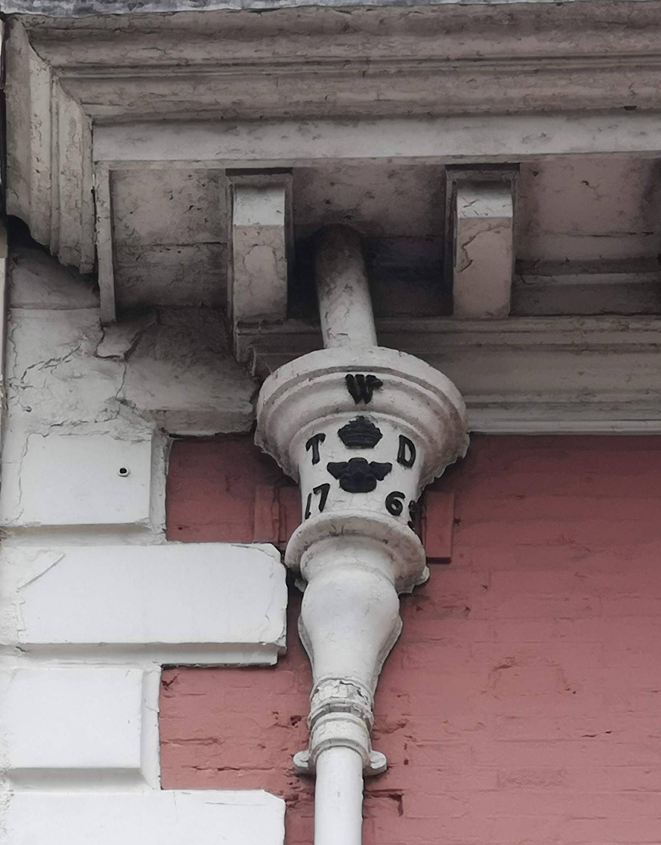
Figure 33 – Initialled hopper head at Parliament Street, York.
(Image author’s own)

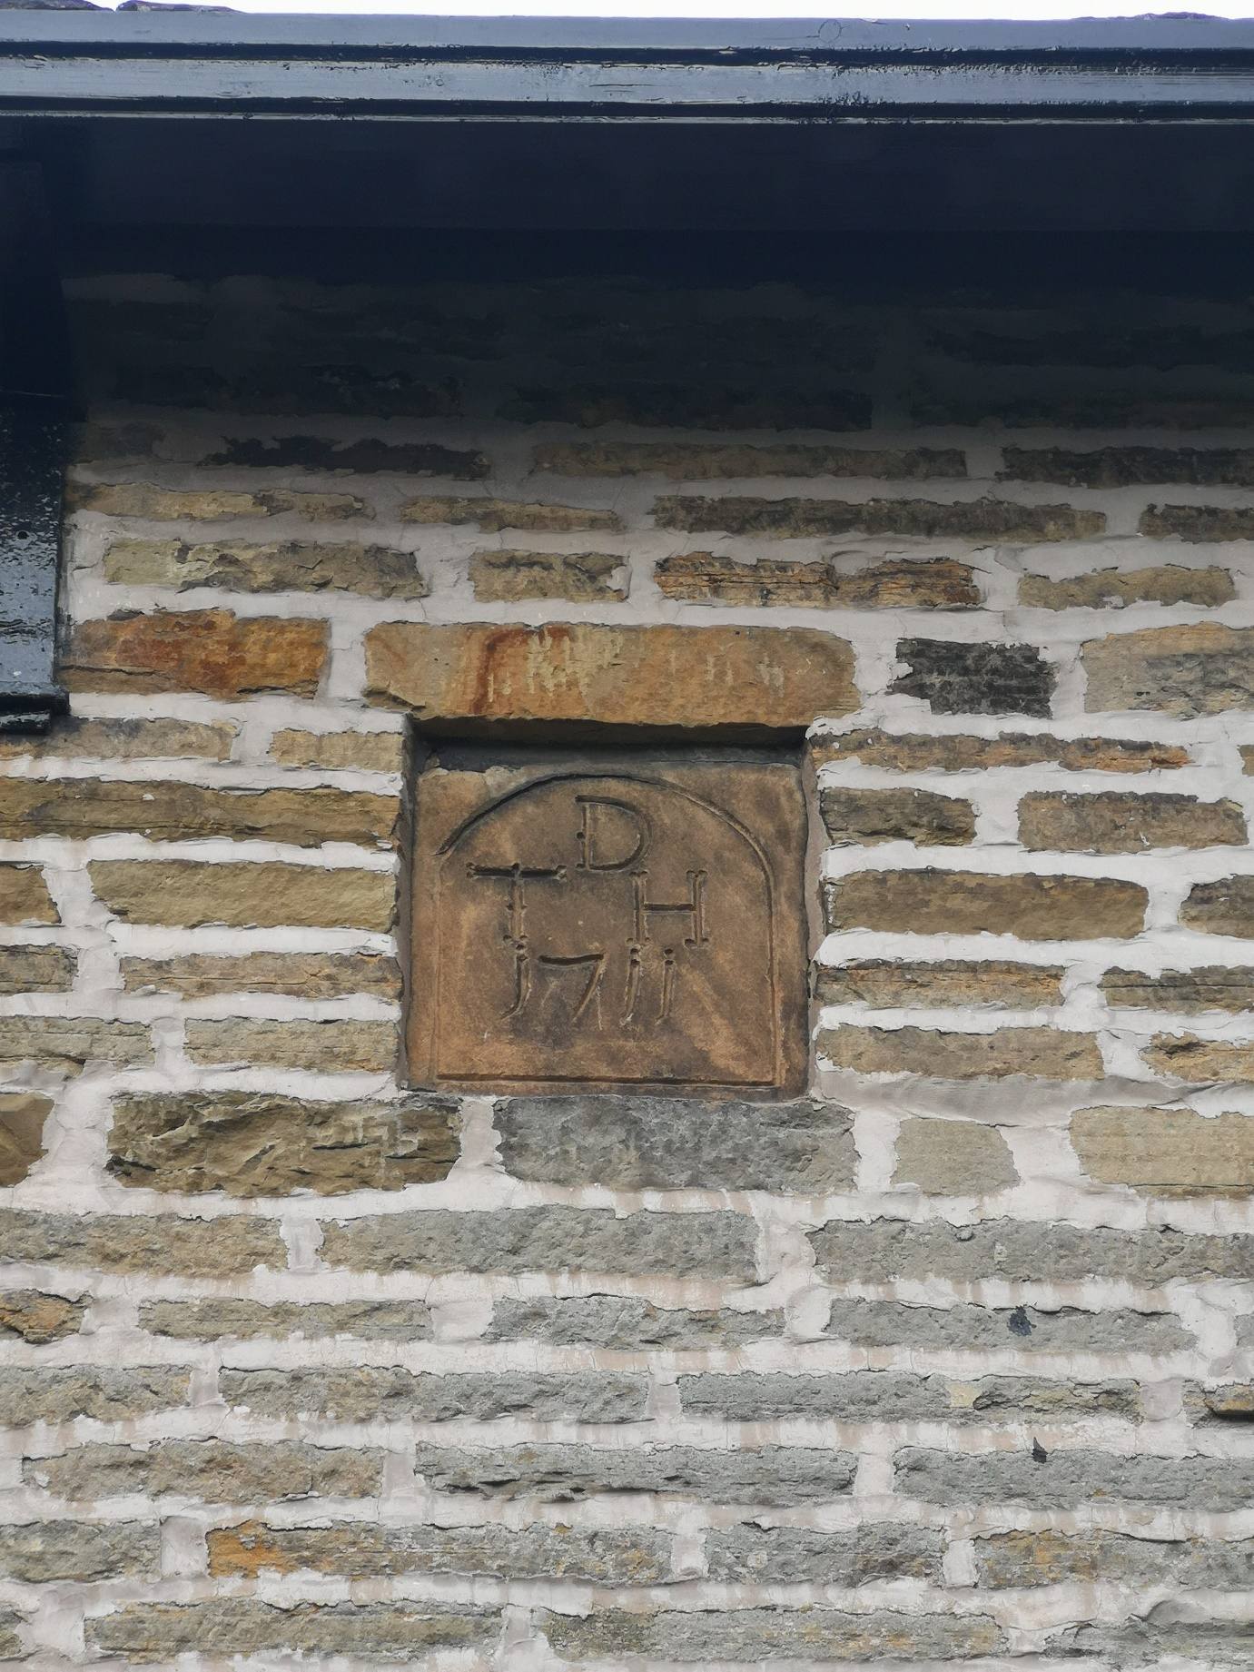
Figure 34 – Initialled datestone at Yew Tree House, Butley, within Prestbury parish. Inscription reads ‘T^{D}H 1711’.
(Image author’s own)
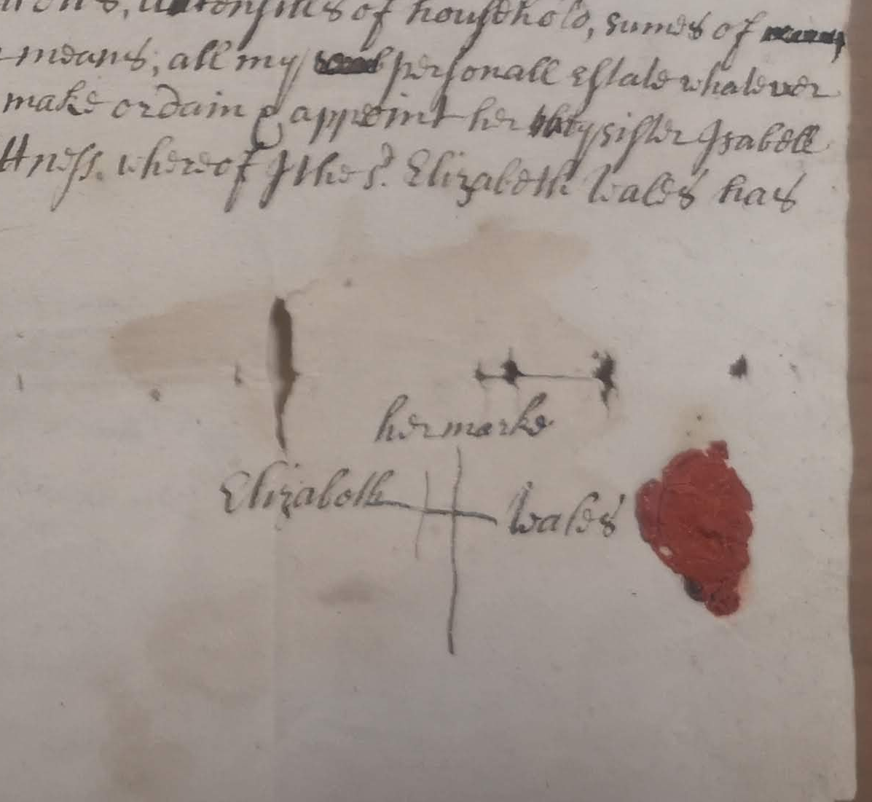
Figure 35 – Signature of Elizabeth Wales of Bolton-le-Sands, widow, within her will, 1702.
(LA: WRW/K/R490A/10, Will of Elizabeth Wales of Bolton-le-Sands, widow, 1702; image author’s own)

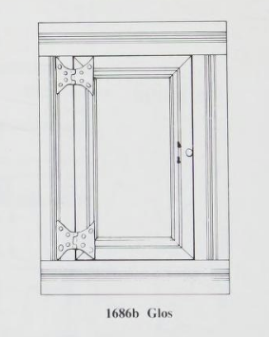
Figure 36 – Spice cupboard, Gloucestershire.
(Image from Nat Alcock and Linda Hall, Fixtures and Fittings in Dated Houses 1567-1763, (York, 1994), p.46)

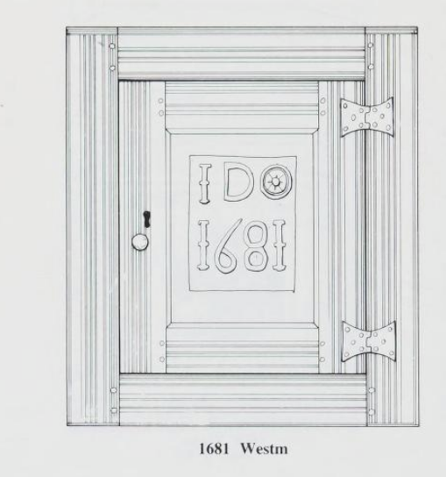
Figure 37 – Inscribed spice cupboard, dated 1681, Westmoreland.
(Image from Nat Alcock and Linda Hall, Fixtures and Fittings in Dated Houses 1567-1763, (York, 1994), pp.48)

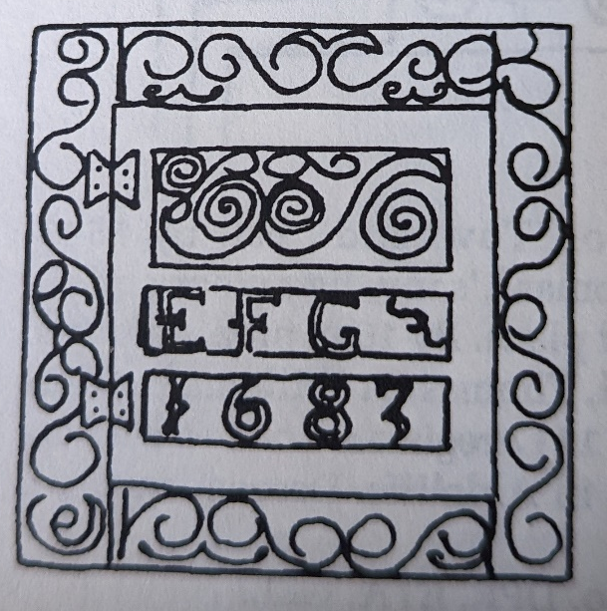
Figure 38 – Spice cupboard surviving at Church Cottage, Bolton-le-Sands, inscribed with the initials of Edmund and Grace Freare and the year 1683.
(Image from Emmeline Garnett, The Dated Buildings of South Lonsdale, (Lancaster, 1994), p.20)

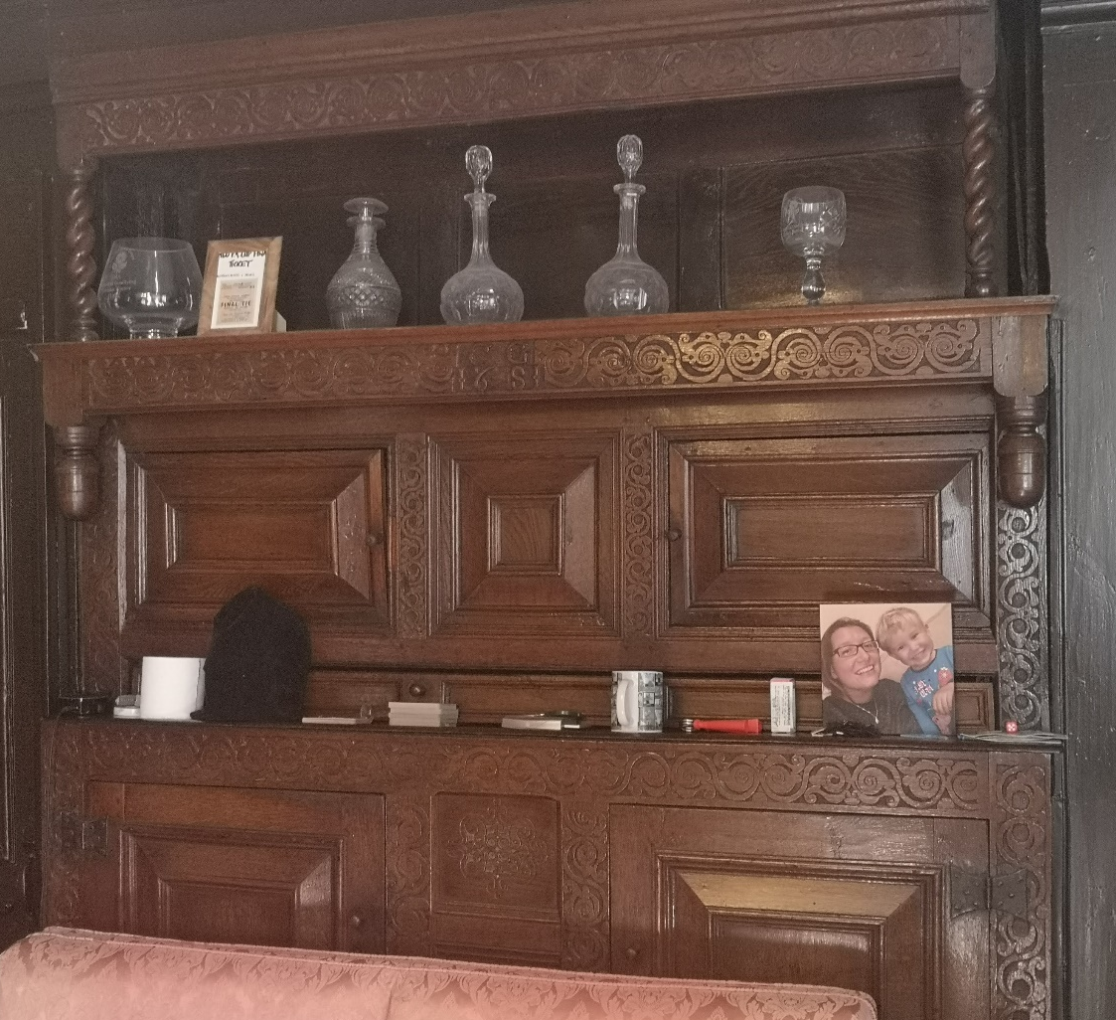
Figure 39 – Initialled cupboard at the Manor House, Slyne, within Bolton-le-Sands parish. Inscribed with the initials of Cornelius Greene – detail given in Figure 40.
(Image author’s own)

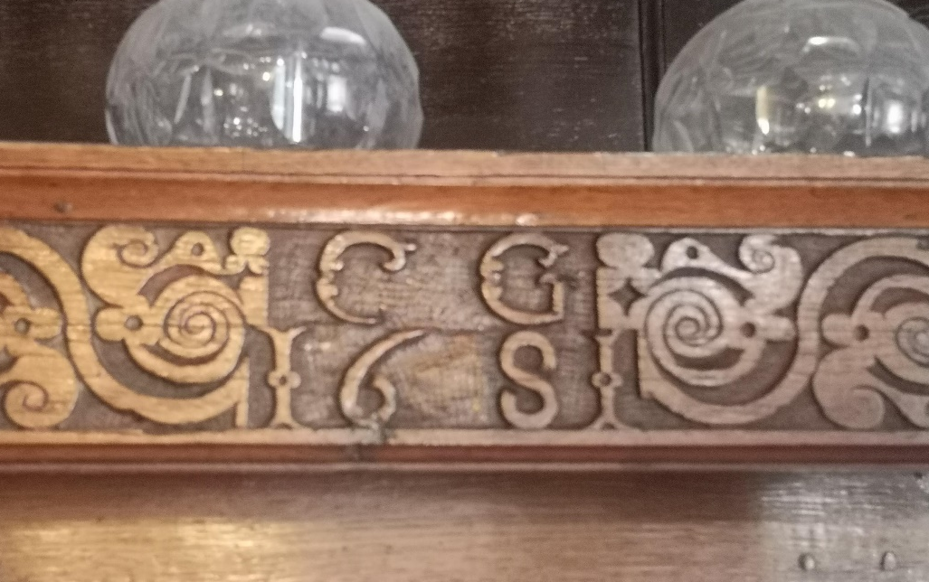
Figure 40 – Detail of initials on the cupboard at the Manor House, Slyne, within Bolton-le-Sands parish.
(Image author’s own)

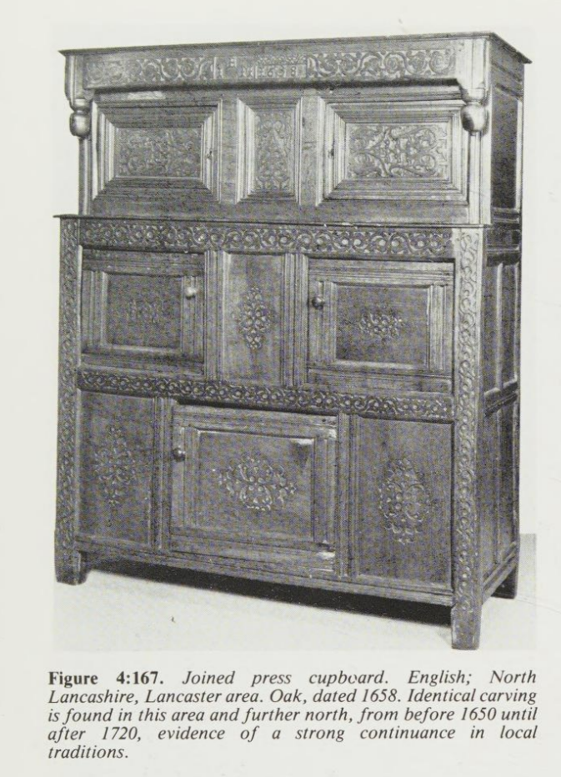
Figure 41 – Initialled press cupboard from north Lancashire, with carvings comparable with that surviving in the Manor House, Slyne, within Bolton-le-Sands parish, seen in Figures 39 and 40.
(Image from Victor Chinnery, Oak Furniture, The British Tradition: A History of Early Furniture in the British Isles and New England, (Woodbridge, 1979), p.227)
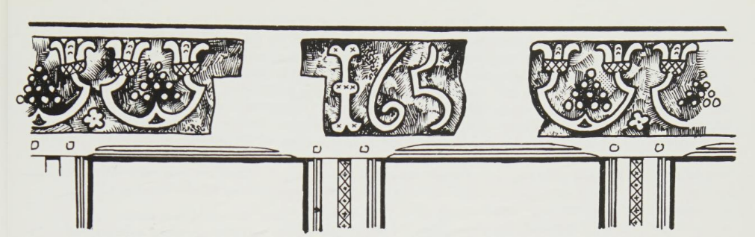
Figure 42 – Partially-completed frieze on a seventeenth-century cupboard, with space left for marriage initials and final date numeral in date ‘165-’.
(Image from Victor Chinnery, Oak Furniture, The British Tradition: A History of Early Furniture in the British Isles and New England, (Woodbridge, 1979), p.49)

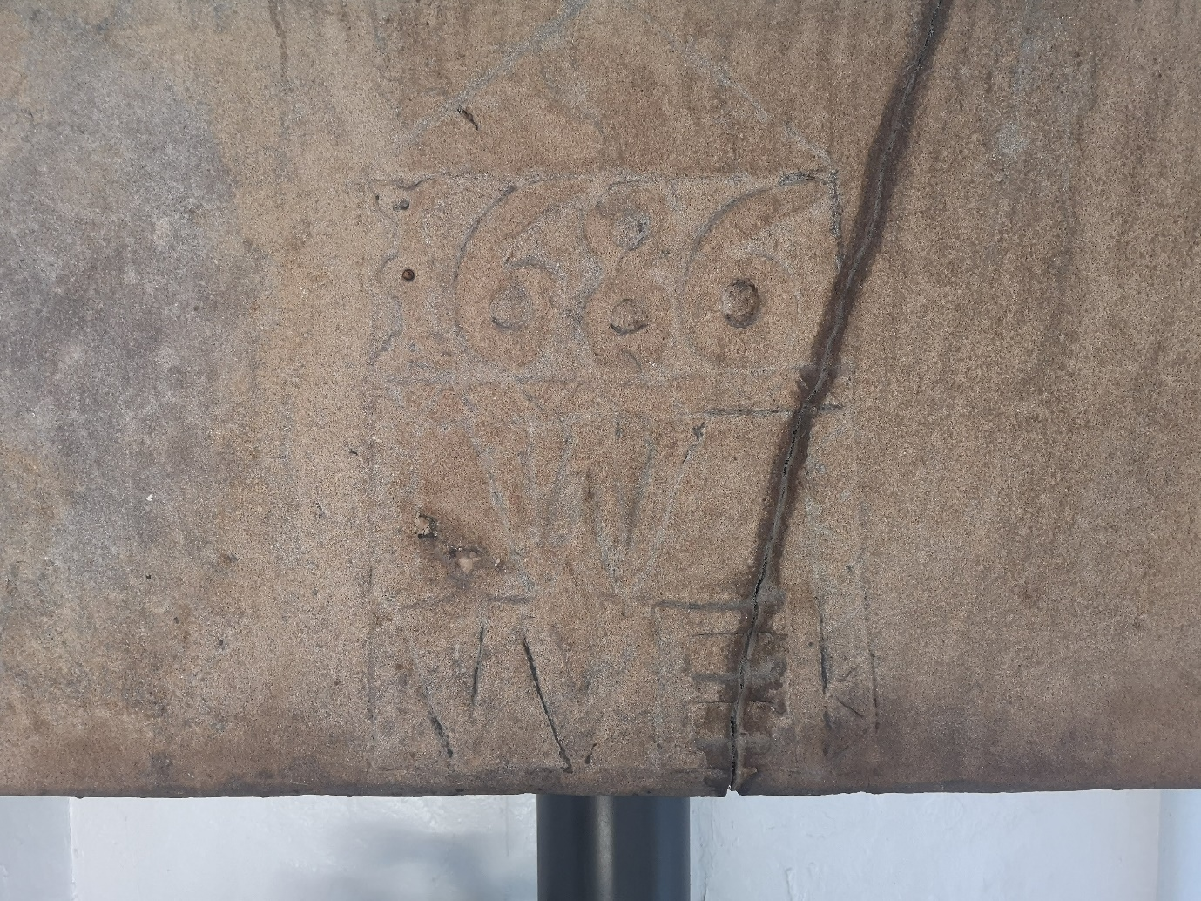
Figure 43 – Close-up of the inscribed fireplace lintel at Cobblers’ Lodge, Bolton-le-Sands, carved with the date 1686 and initials W^{W}E.
(Image author’s own)
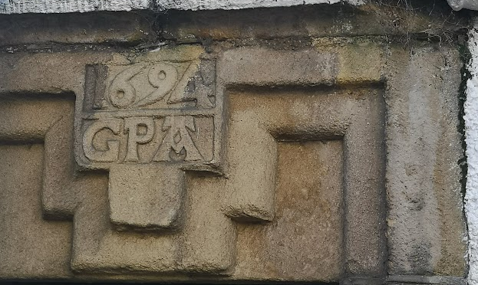
Figure 44 – Close-up of lintel initials at McGaffigans Yard, Bolton-le-Sands. Lintel partially not included because obscured by large advertisement for iron merchant’s business now occupying the property, as seen in Figure 45.
(Image author’s own)

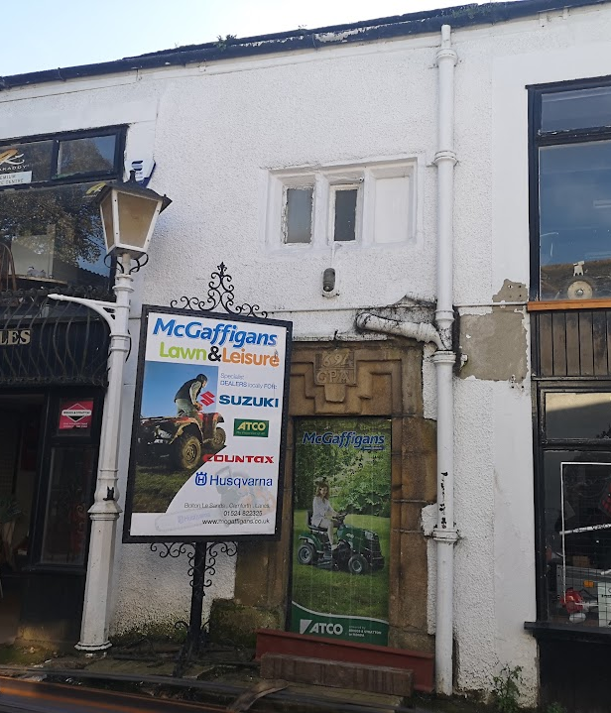
Figure 45 – Façade at McGaffigans Yard, Bolton-le-Sands, featuring a seventeenth-century inscribed doorway inscribed ‘G^{P}A 1694’ and mullioned window above.
(Image author’s own)

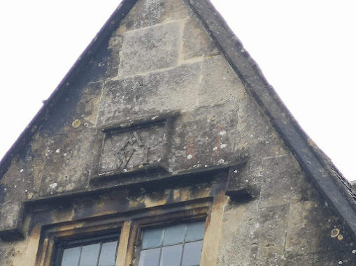
Figure 46 – Initialled plaque in gable at Arnold House, Corsham, Wiltshire. The house incorporates two dormer gables with inscribed plaques: the inscription ‘W^{A}I’ on the left gable commemorates William and Jane Arnold, and the right gable (not pictured here) is inscribed with the year 1703.
(Image author’s own)

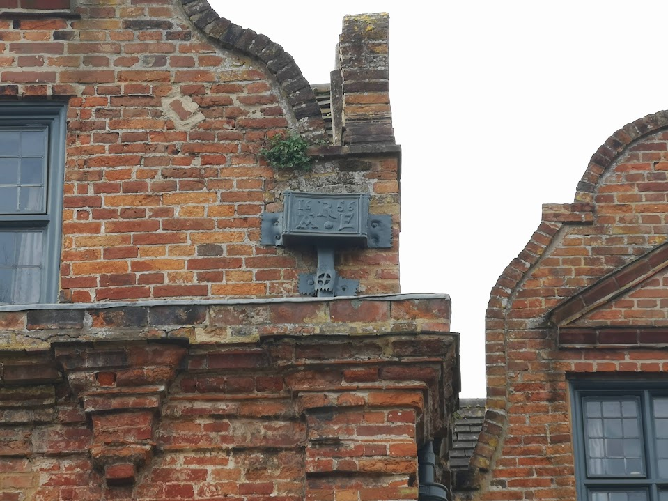
Figure 47 – Initialled and dated hopper head at the Manor House, Bracondale, Norwich. The initials on the hopper head (and on a second datestone not pictured here) read ‘A^{R}E’ and commemorate Augustus and Elizabeth Reeve.
(Image author’s own)

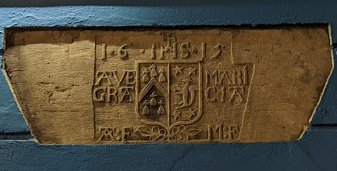
Figure 48 – Inscribed datestone placed directly above a doorway at 12 High Street, Galway city, Republic of Ireland. The left hand side of the crest belongs to the Ffrench family, one of the tribes of Galway, and the inscription and two pairs of initials likely commemorate a marriage.
(Image author’s own)

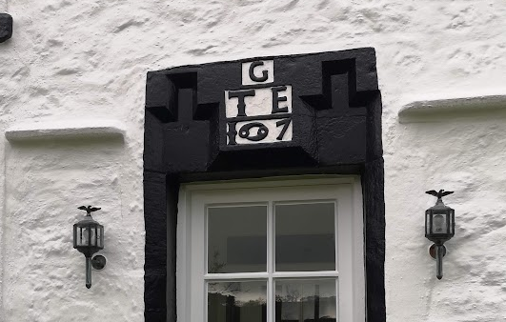
Figure 49 – Inscribed lintel at New Capernwray Farmhouse, Capernwray, within Bolton-le-Sands parish. The zodiac sign for Cancer is visible in the centre of the numerals (reading 1697) positioned beneath the initials of Thomas and Eling Greenwood.
(Image author’s own)

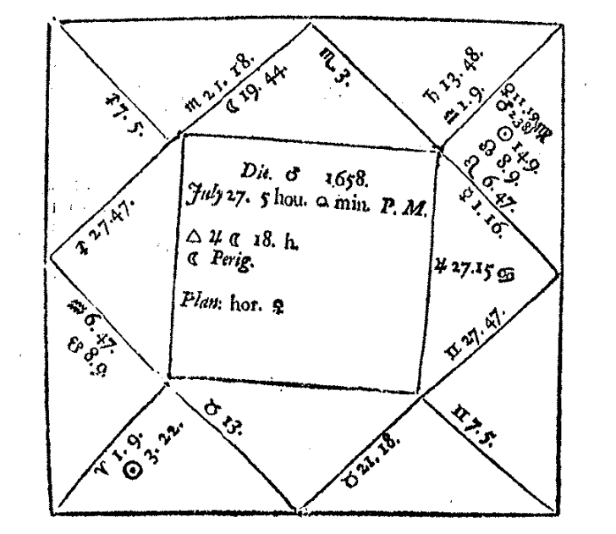

Figure 50 – Contemporary styling of astrological symbol for cancer, highlighted within an illustration from Joseph Moxon, A tutor to astronomy and geography, (London, 1698), p.127

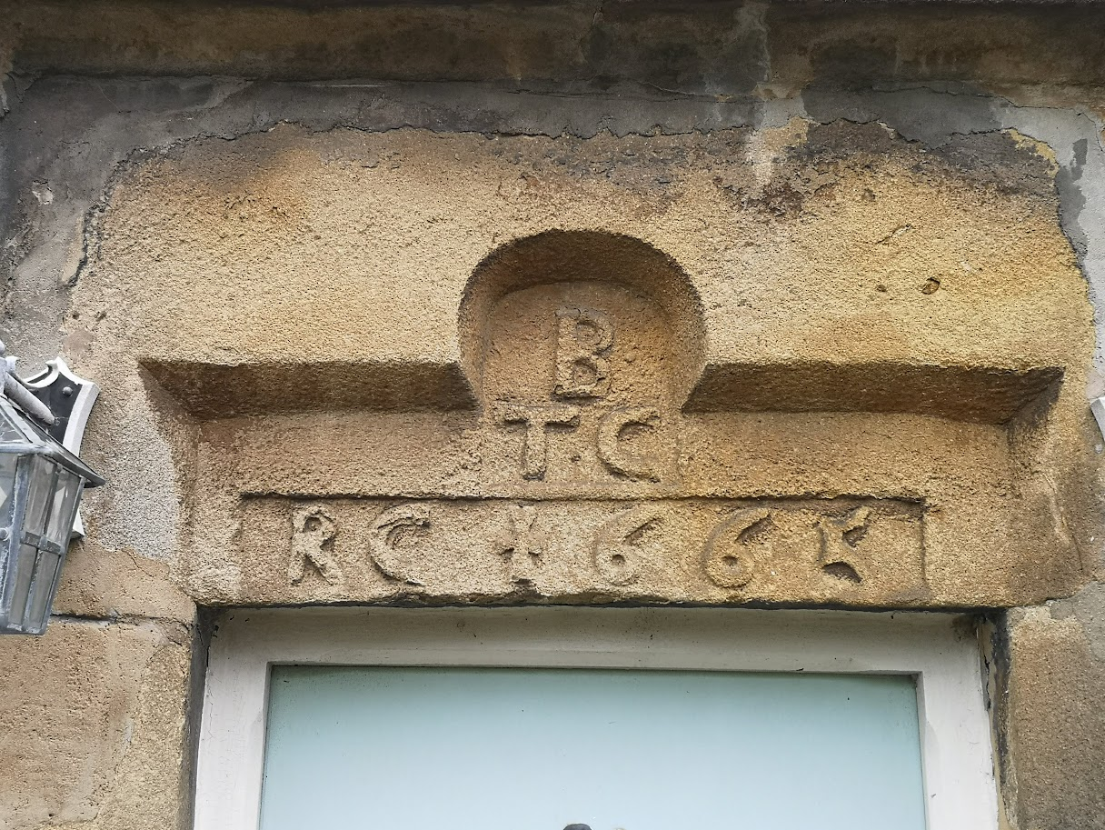
Figure 51 – Inscribed lintel at Hawkshead Farmhouse, Bolton-le-Sands village with cross styling visible on first numeral.
(Image author’s own)

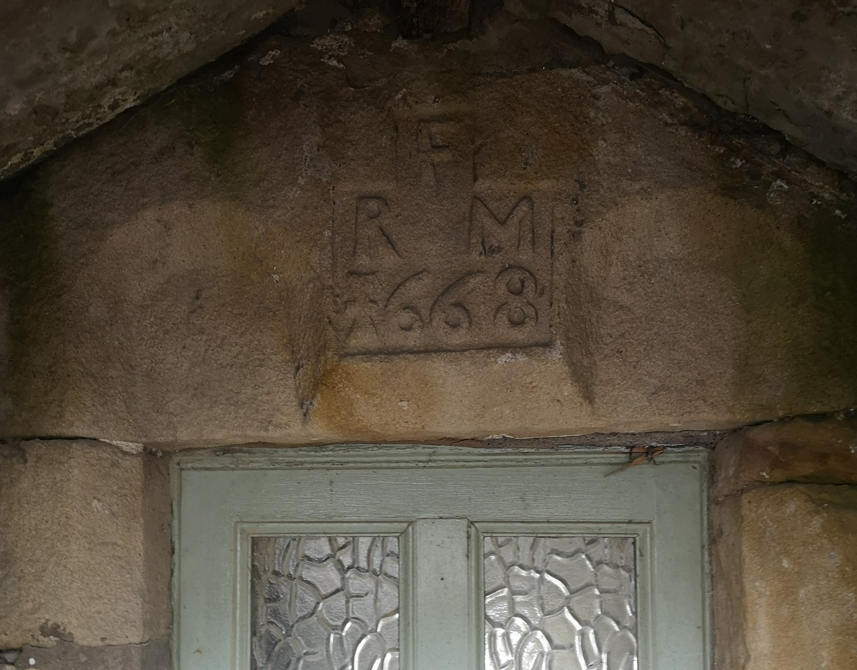
Figure 52 – Inscribed lintel at Hall Farmhouse, Over Kellet, within Bolton-le-Sands parish. Cross styling visible in first numeral, as in Figure 51.
(Image author’s own)

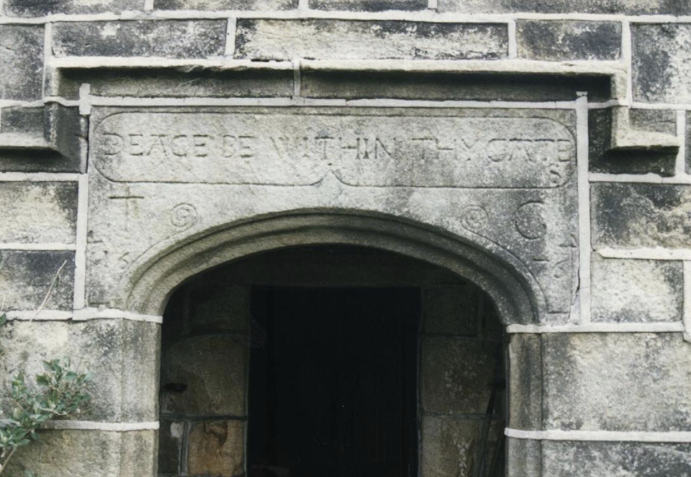
Figure 53 – Inscription placed by Thomas Greenwood at Old Edge near Heptonstall, West Yorkshire. Inscription reads ‘PEACE BE WITHIN THY GATES’ with the initials ‘T G’ and date ‘1576’ beneath.
(Image by David John Cant (@DavidJohnCant), ‘The good people of Halifax were prolific date stone producers. Here, with an amended and possibly intended nod to Psalm 122, one of 1676 for Thomas Greenwood of Old Edge, near Heptonstall.’ [tweet], (9:16am, July 4 2020) [https://x.com/DavidJohnCant/status/1279328151848529920/photo/1; accessed 18 December 2020])

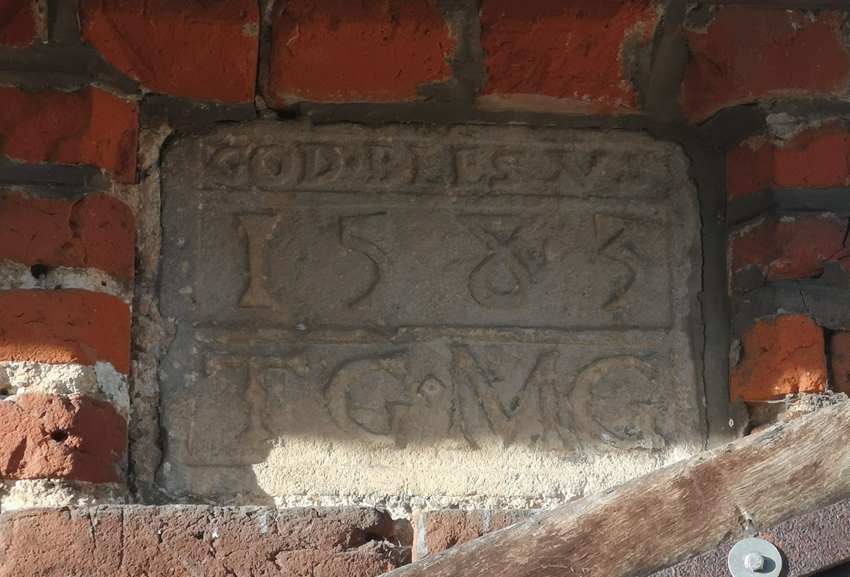

Figure 54 – Datestone at the threshold of Old World Cottages, Rollesby, Norfolk, reading ‘GOD BLESS US’ with the year 1583 and the initials TG and MG.
(Image author’s own)

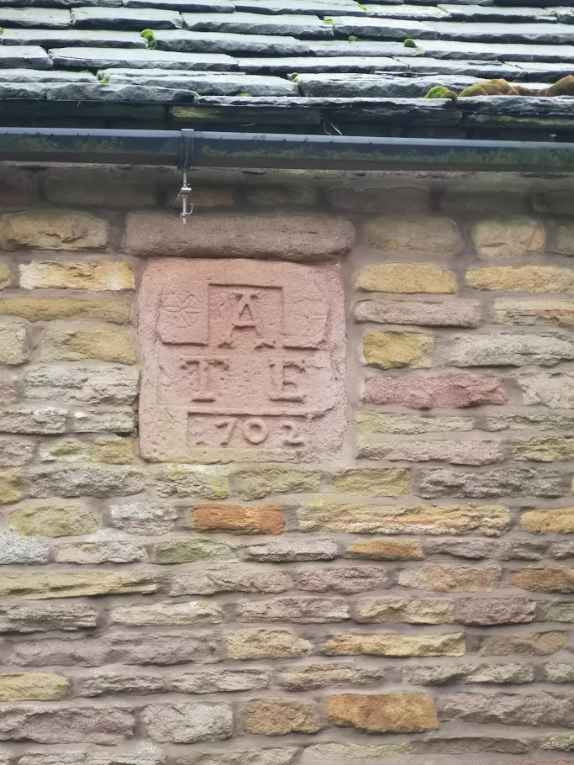
Figure 55 – Initialled datestone at Drove Hey Farm, Sutton, within Prestbury parish, featuring two ‘daisy wheel’ carvings. The initials likely belong to Thomas and Emme Armett, married in Sutton on 19th September 1687.
(Image author’s own)
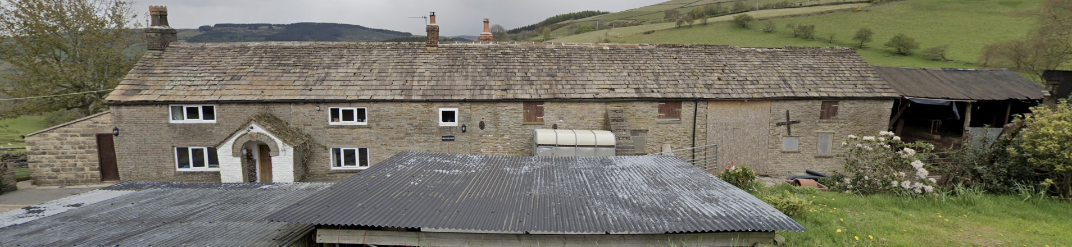
Figure 56 – Full façade of Drove Hey House, Sutton, within Prestbury parish, demonstrating the separate entrances for livestock and the family within the same building. Position of the inscription highlighted.
(Image from Google Maps, captured May 2021, [https://www.google.com/maps/@53.2266234,- 2.0778492,3a,75y,53.87h,90t/data=!3m7!1e1!3m5!1syPNRoMAeVuTnIIqPhOmjEw!2e0!6shttps:%2F%2Fstreetviewpixels-pa.googleapis.com%2Fv1%2Fthumbnail%3Fcb_client%3D maps_sv.tactile%26w%3D900%26h%3D600%26pitch%3D0%26panoid%3DyPNRoMAeVuTnIIqPhOmjEw%26yaw%3D53.865762343354625!7i16384!8i8192?entry=ttu&g_ep=EgoyMDI0MTIxMS4wIKXMDSoASAFQAw%3D%3D; accessed 18 December 2024]
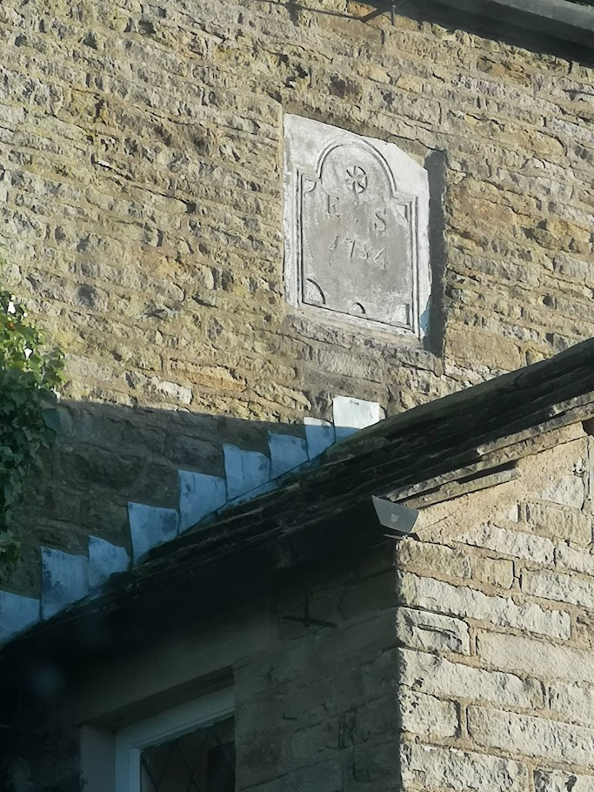
Figure 57 - Datestone on Greendale House, Kettleshulme, within Prestbury parish. Daisy wheel visible above initials E : S and date 1754.
(Image author’s own)

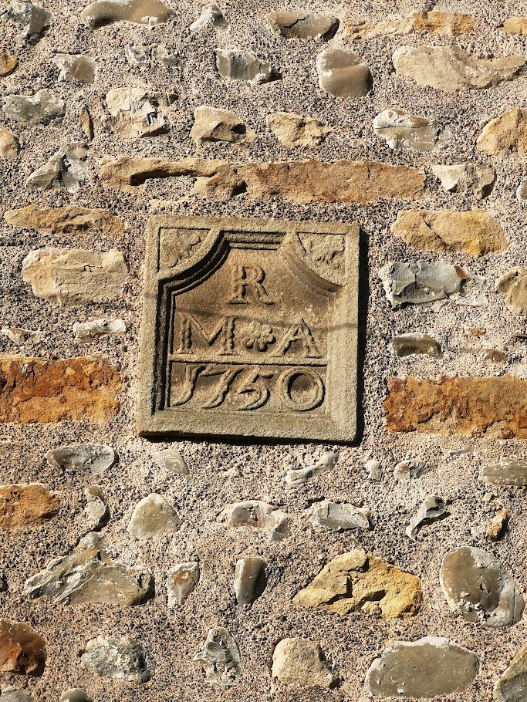
Figure 58 – Datestone at the Malthouse, Slyne-with-Hest, within Bolton-le-Sands parish, featuring initials of Matthew and Anne Redhead.
(Image author’s own)

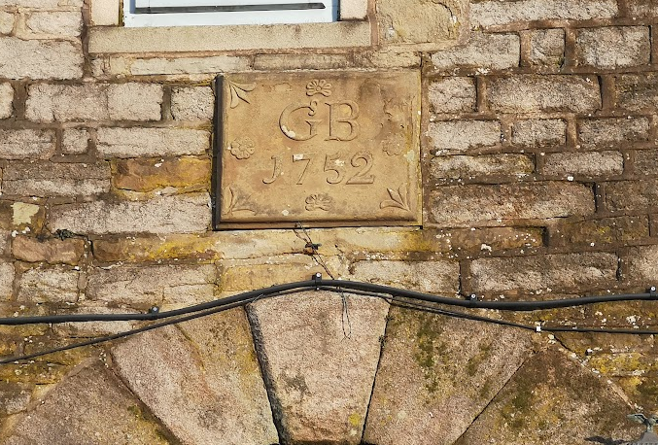
Figure 59 - Initialled datestone at Thorneycroft Farmhouse, Kettleshulme, within Prestbury parish, featuring initials of George Brocklehurst of Gap House.
(Image author’s own)

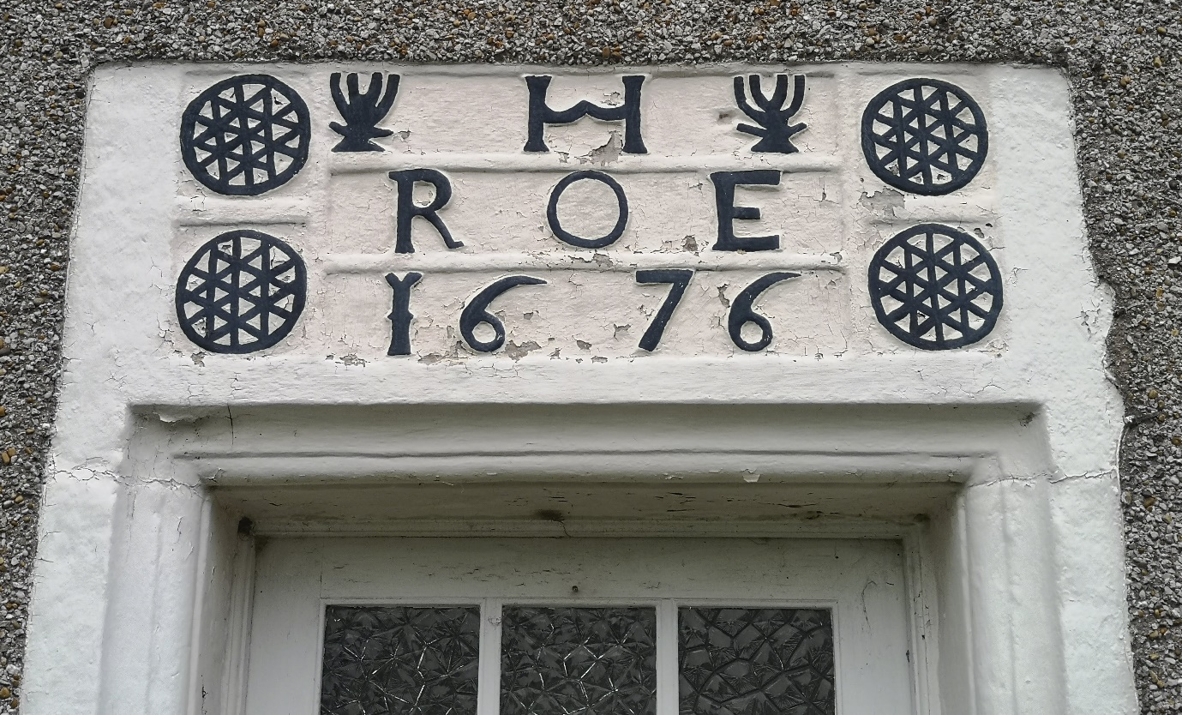

Figure 60 – Inscribed lintel at Kirkhouse, Capernwray, within Bolton-le-Sands parish, featuring initials of Robert and Elizabeth Hawthornthwaite.
(Image author’s own)

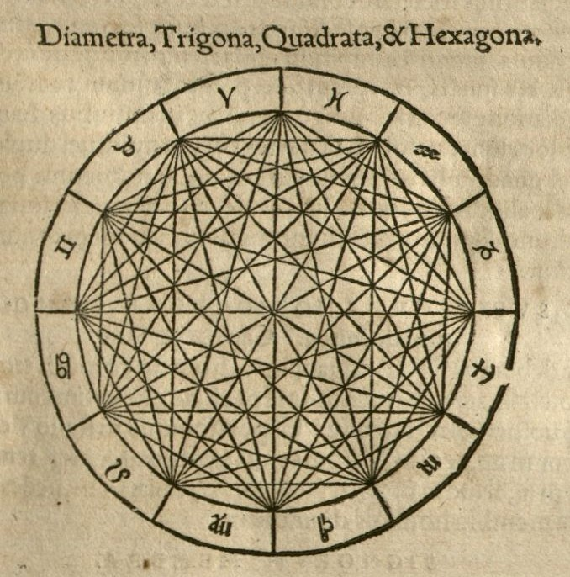
Figure 61 – Astrological chart featuring trigons, quadrants and hexagons, echoing the designs at Kirkhouse, Capernwray, seen in Figure 60.
(Illustration from Julius Firmicus, Materni Iunioris Siculi V. C. ad Mauortium Lollianum Astronomicon, (Rome, 1551), p.95)

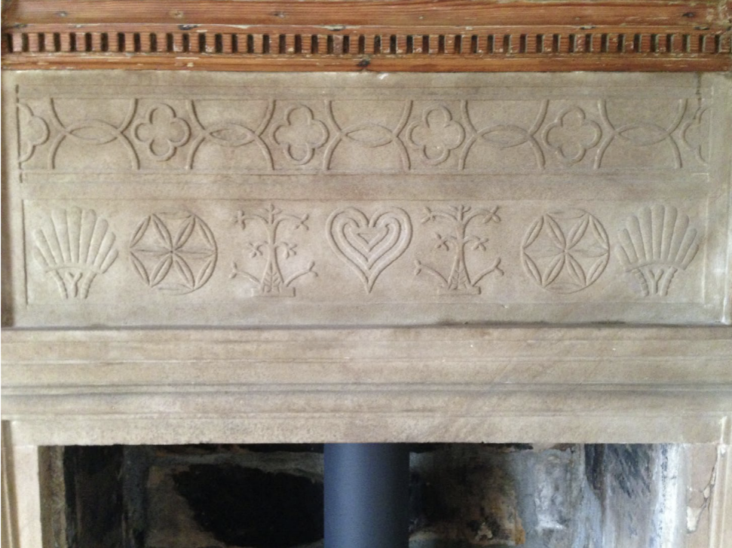
Figure 62 – Inscribed fireplace at Postgate Farm, Glaisdale, North Yorkshire.
(Image from Bill Angus, ‘The apotropaic “witch posts” of early modern Yorkshire: a contextualization’, Material Religion, Vol. 14, No. 1, (2018), pp.55-82, p.62)

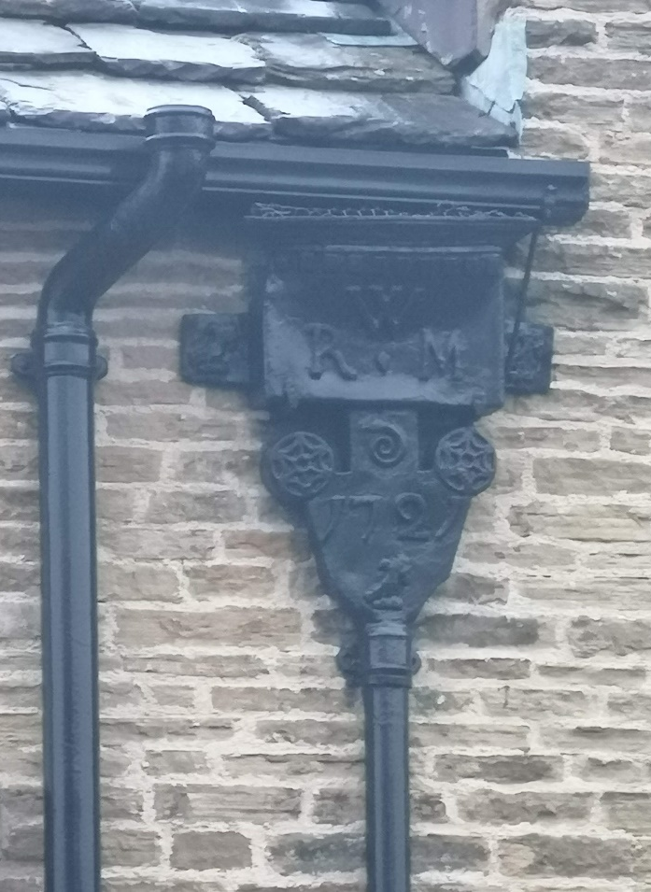
Figure 63 – Inscribed hopper head at Bollington, within Prestbury parish. Origins of initials unknown.
(Image author’s own)

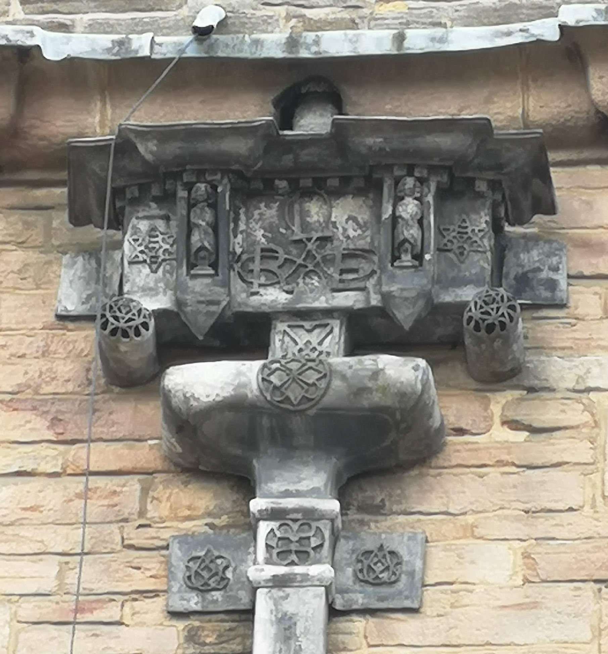
Figure 64 – Hopper head at Lyme Hall, Disley, Cheshire, featuring the initials of Richard and Elizabeth Legh.
(Image author’s own)

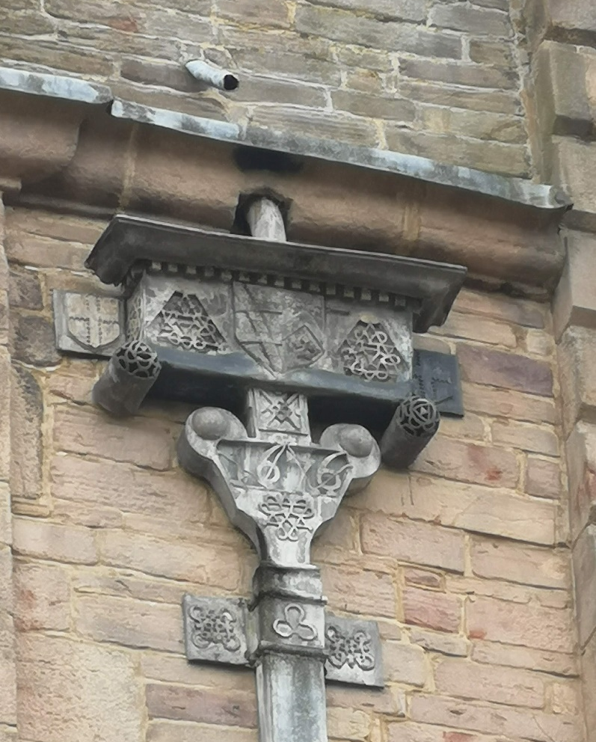
Figure 65 – Second hopper head at Lyme Hall, Cheshire, featuring the date, ‘1676’.
(Image author’s own)

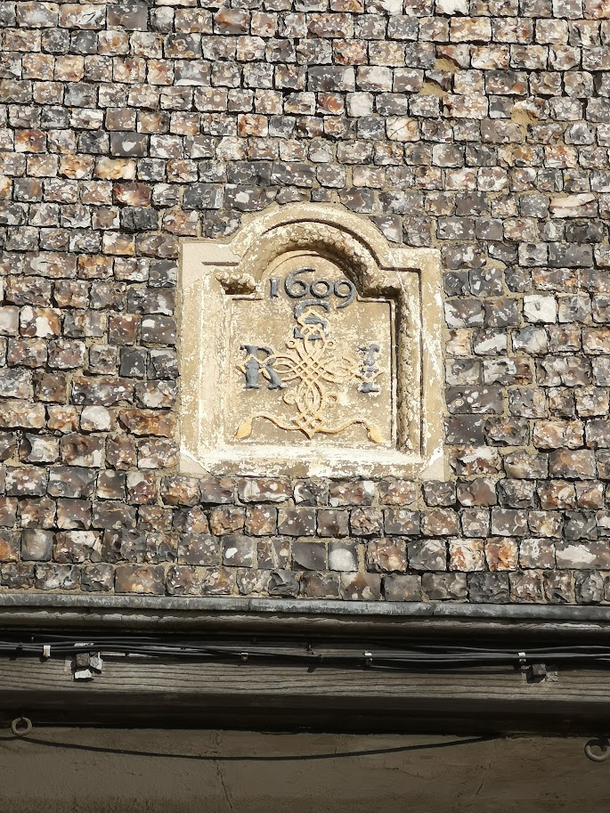
Figure 66 – Initialled datestone at The Dukes Head, Great Yarmouth, Norfolk.
(Image author’s own)

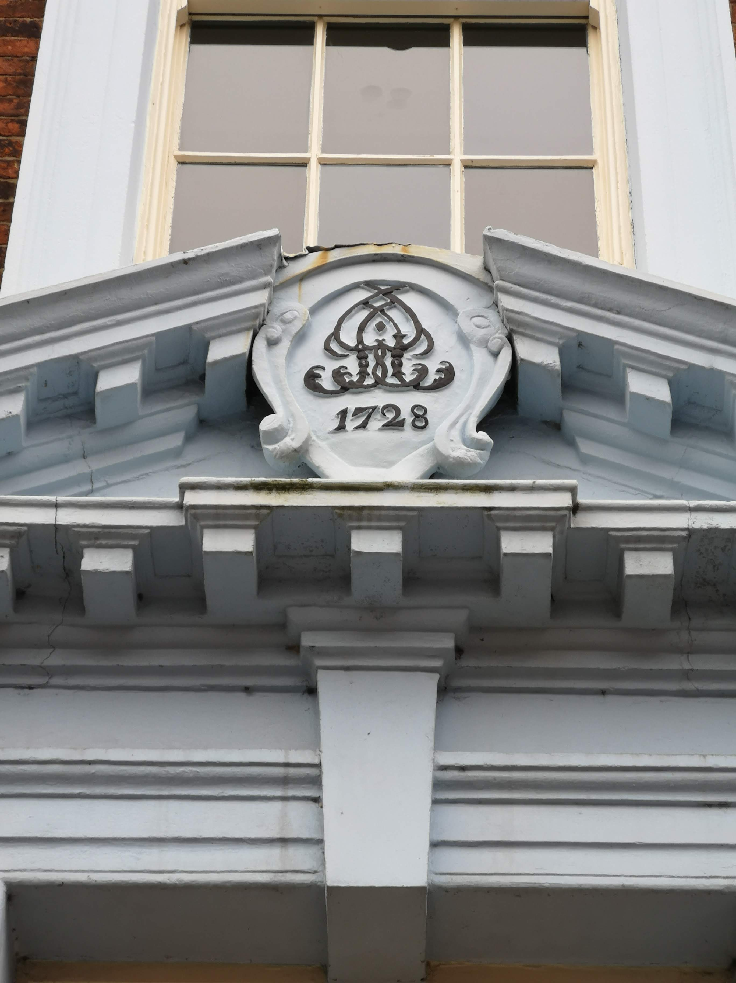
Figure 67 – Stylised cartouche at Jordangate House, Macclesfield, Cheshire.
(Image author’s own)

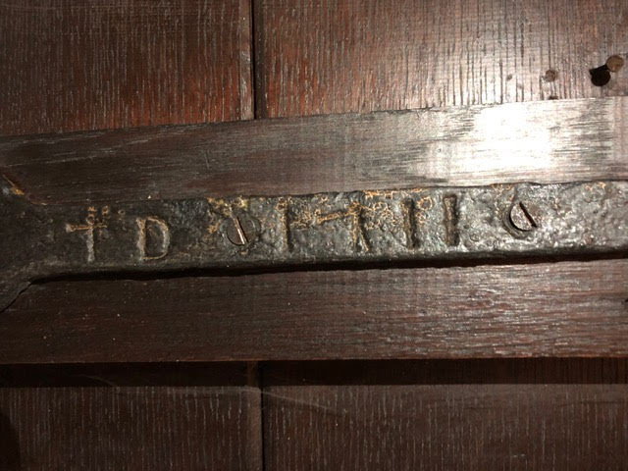
Figure 68 – Inscribed T-hinge reading ‘T D 1711’ at Yew Tree Farmhouse, Butley, within Prestbury parish.
(Image rotated 180 ̊, used with permission of property owner)
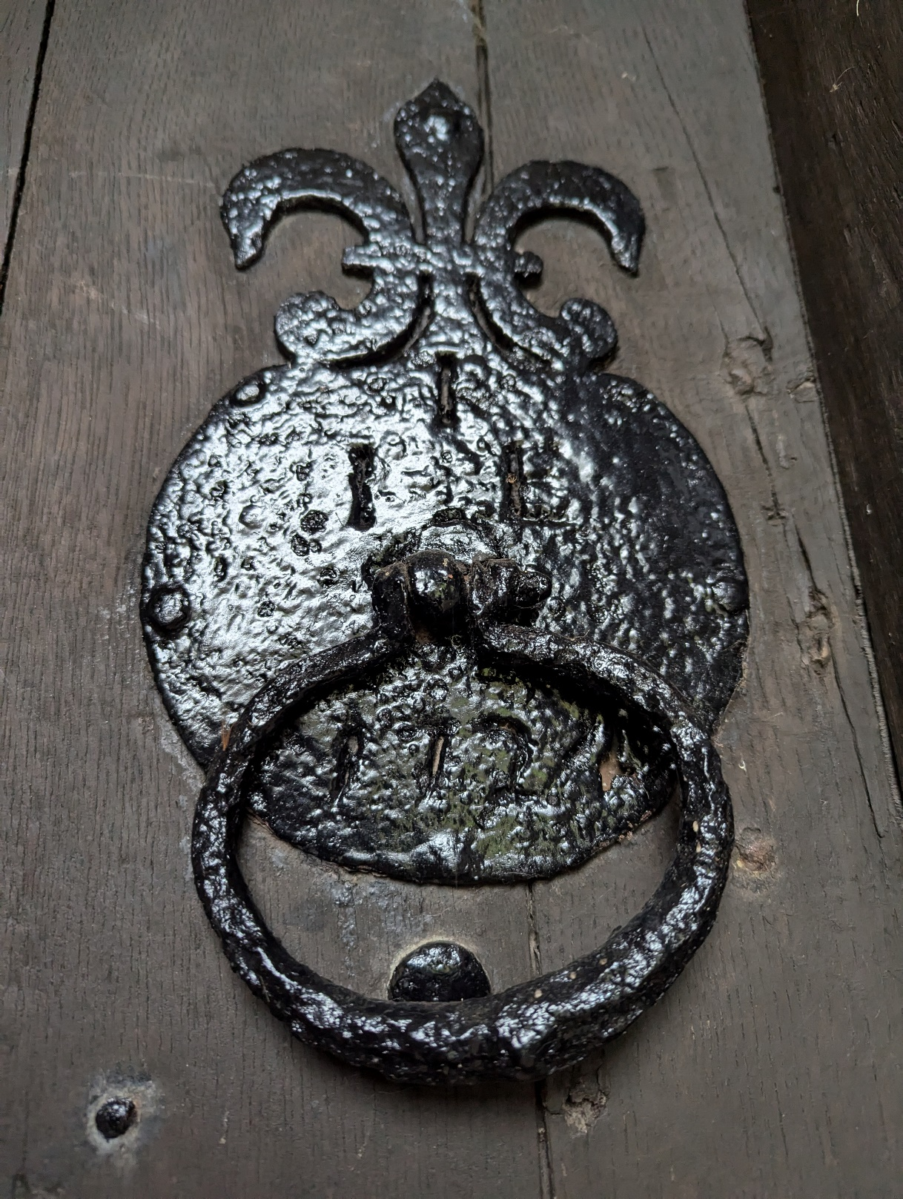
Figure 69 - Iron door handle and knocker at Fern Lee Farmhouse, Sutton, initialled ‘J^{J}E’ above handle and dated 1724 below.
(Image used with permission of Eoghan Conlon)

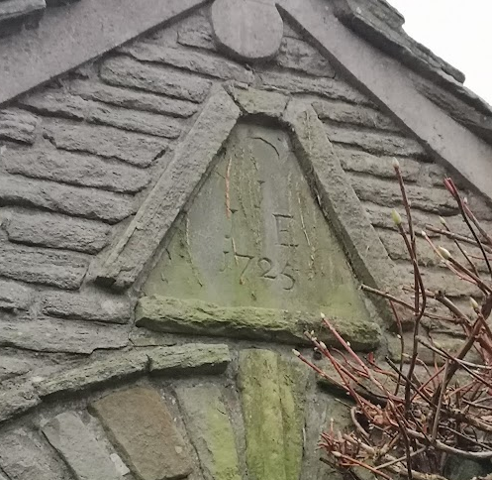
Figure 70 - Datestone at Fern Lee Farmhouse, initialled J^{J}E and dated 1725. Positioned at apex of gabled roof above porch attached to an earlier building.
(Image used with permission of Eoghan Conlon)

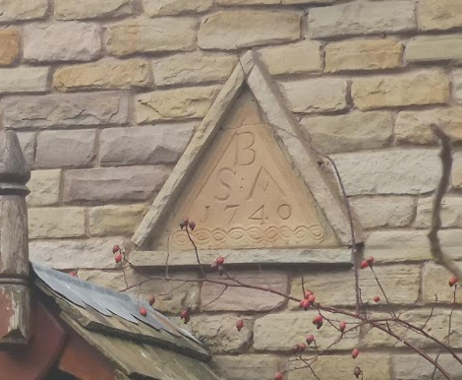
Figure 71 - Datestone at Oak Cottage, Langley, Prestbury, initialled S^{B}A and dated 1740.
(Image author’s own)

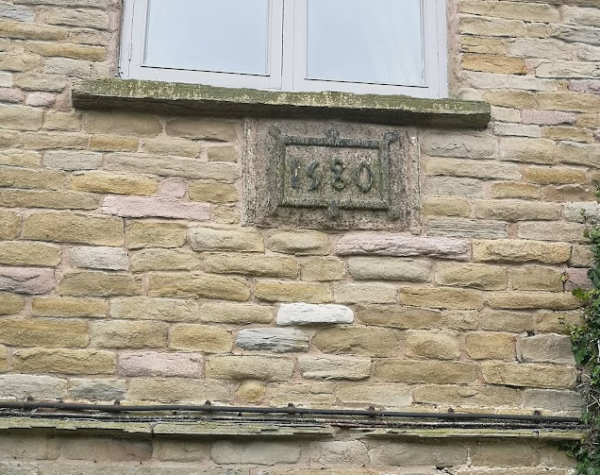
Figure 72 - Datestone at Ridge Hall Farmhouse, Sutton, within Prestbury parish.
(Image author’s own)

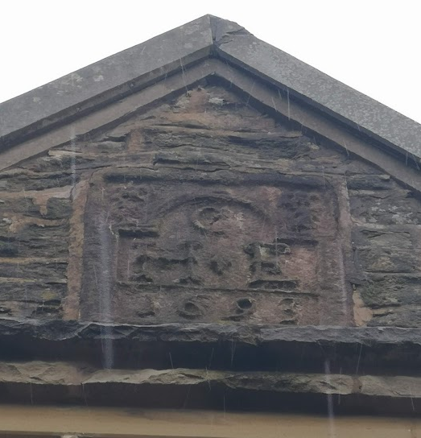
Figure 73 - Initialled datestone at Ridge Hill Farmhouse, Sutton, within Prestbury parish. Inscribed with the initials of Henry and Emme Cherry and the date, 1693.
(Image author’s own)

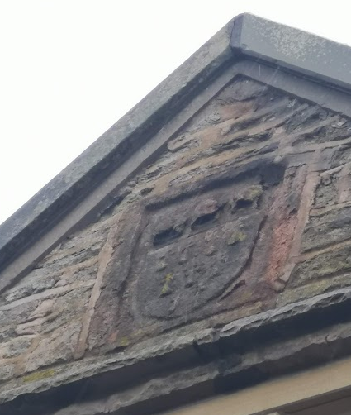
Figure 74 – Worn crest at Ridge Hill Farmhouse, Sutton, within Prestbury parish.
(Image author’s own)

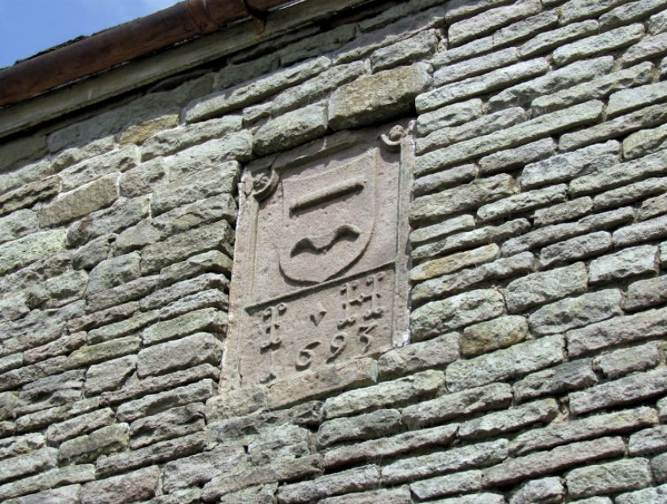
Figure 75 - Heraldic-style crest at Pott Lords farmhouse, Sutton, within Prestbury parish, featuring the initials ‘I H’ and the year 1693.
(Image author’s own)

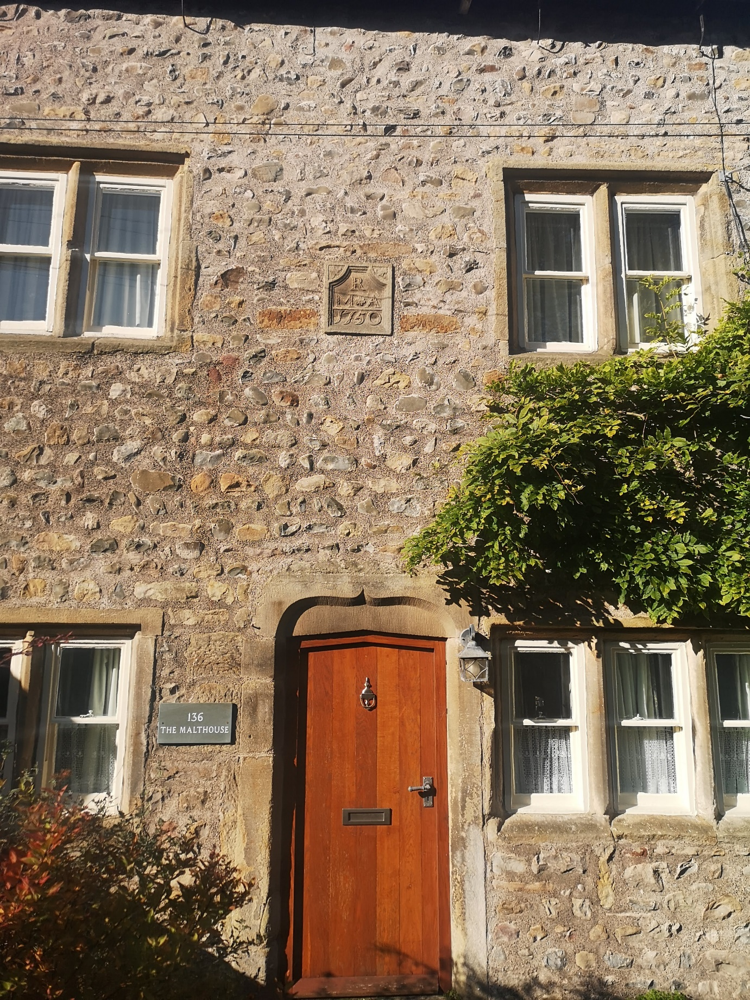
Figure 76 – Raised datestone on the façade of The Malthouse, Slyne (as seen in close-up in Figure 58) within Bolton-le-Sands parish.
(Image author’s own)

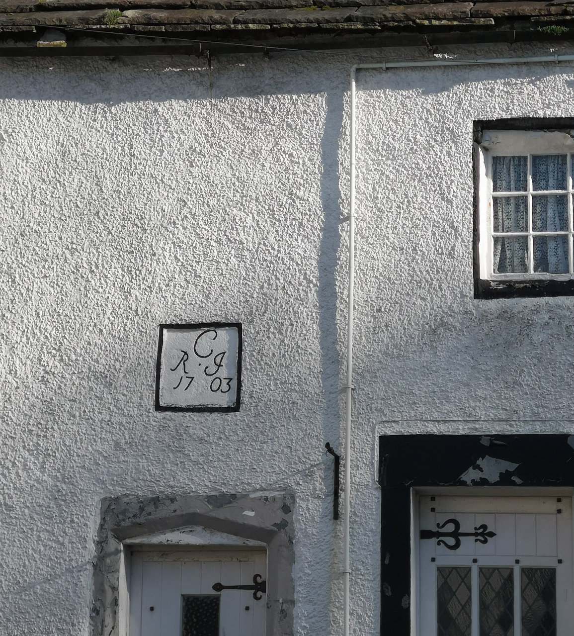
Figure 77 – Raised datestone at 6 Packet Lane, Bolton-le-Sands village.
(Image author’s own)

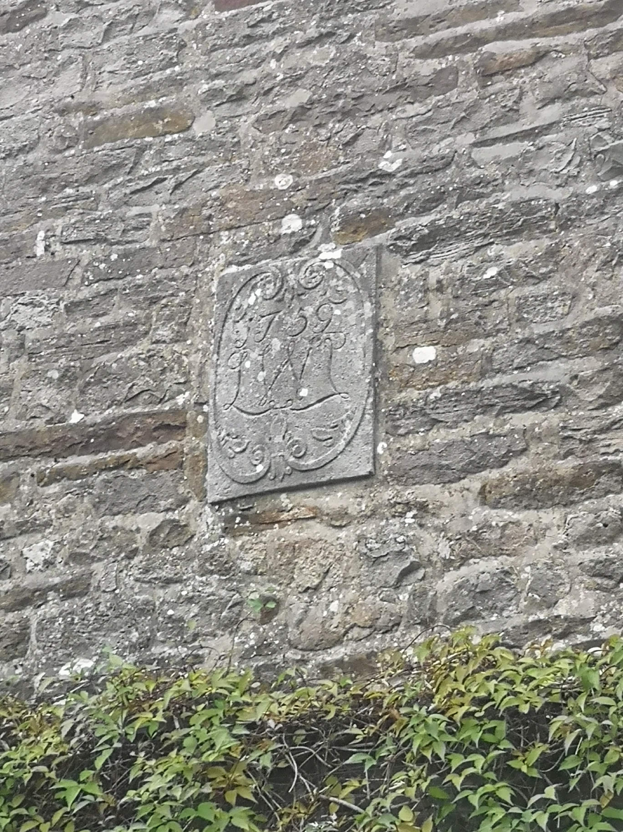
Figure 78 – Raised datestone positioned above the entryway on the façade of Hogarth House, Over Kellet, within Bolton-le-Sands parish.
(Image author’s own)

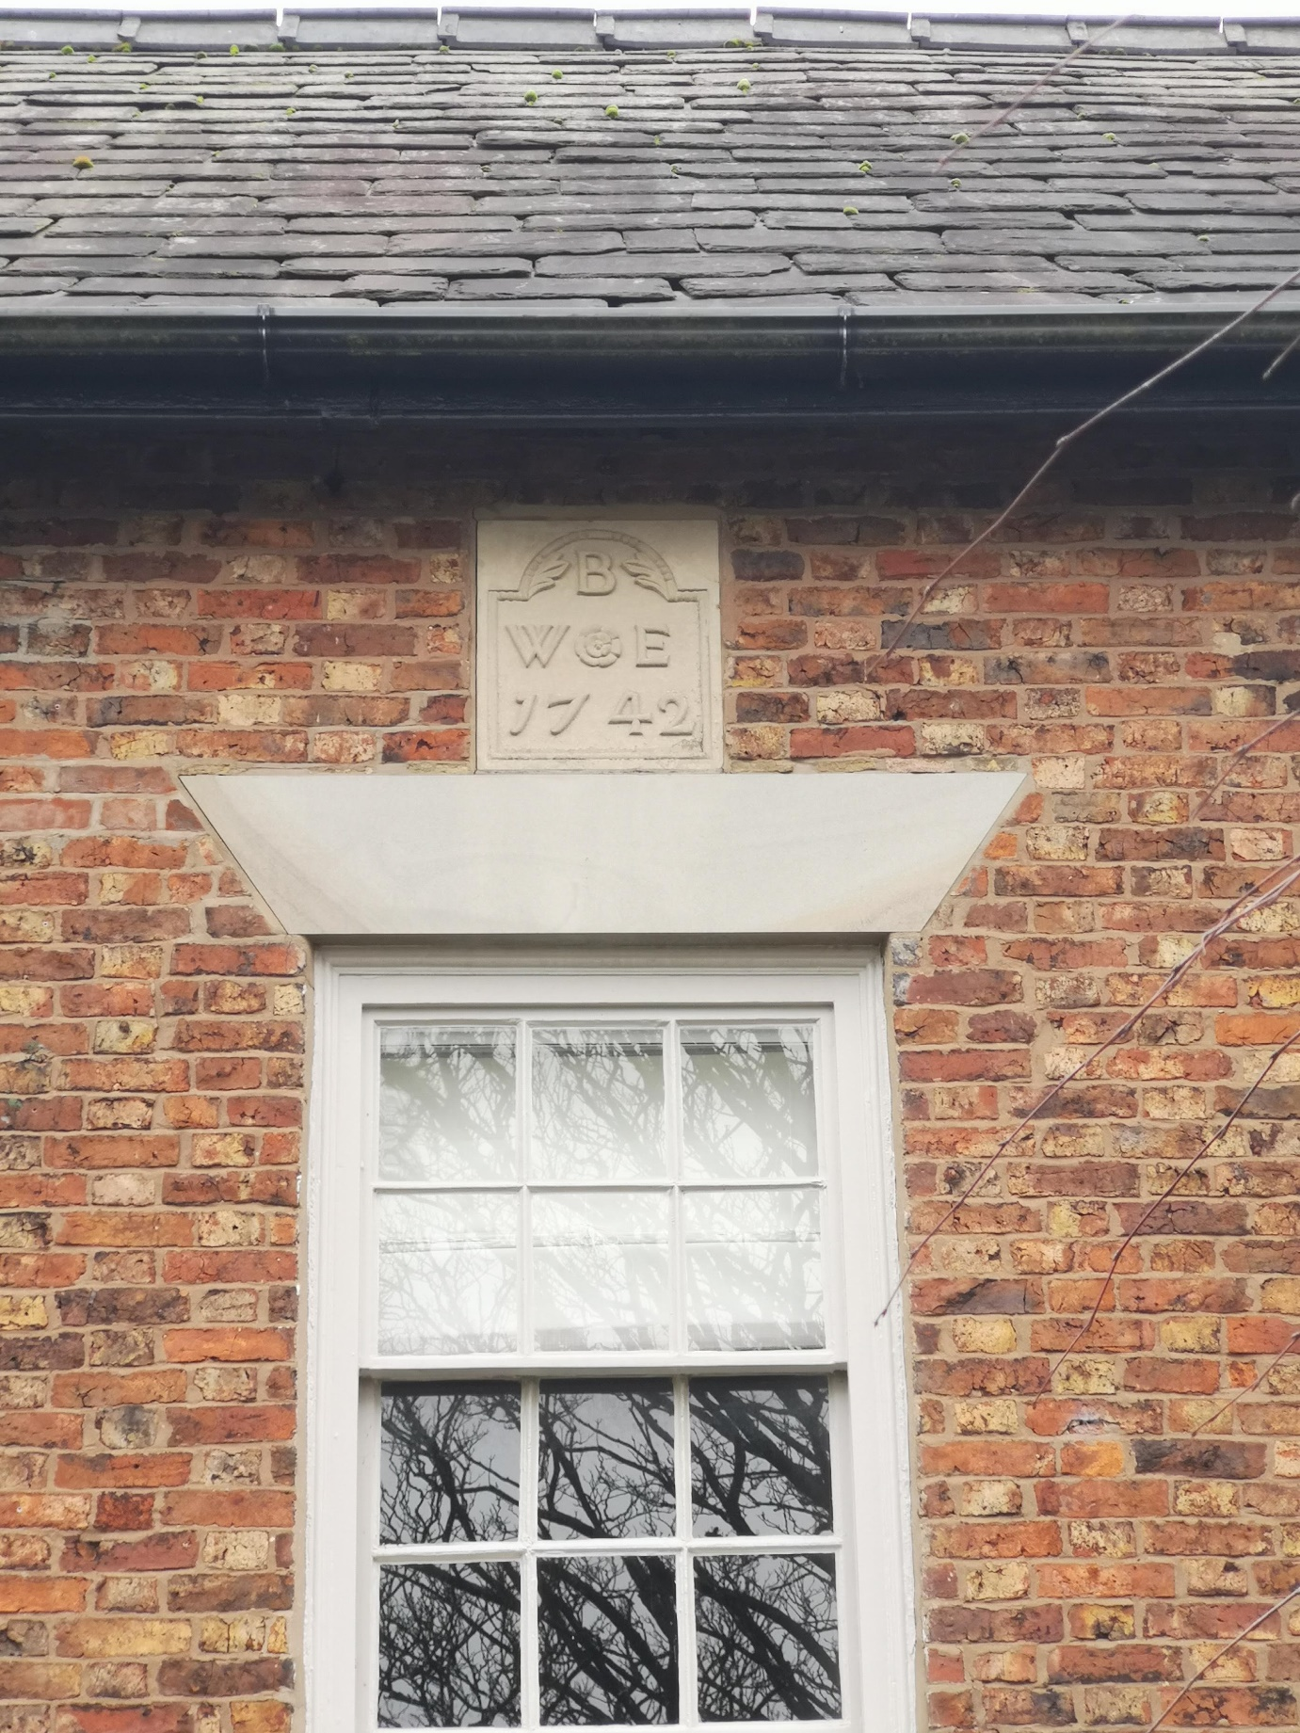
Figure 79 – Datestone on the façade of Walnut Tree Farmhouse, Butley, within Prestbury parish. Positioned in the second storey of the house above the main entryway; identities of inscribers unknown.
(Image author’s own)

Appendix 3:

Tables

 | Bolton-le-Sands | Prestbury
1650-1659 | 8 | 3
1660-1669 | 11 | 10
1670-1679 | 10 | 9
1680-1689 | 7 | 14
1690-1699 | 10 | 10
1700-1709 | 9 | 16
1710-1719 | 16 | 6
1720-1729 | 12 | 21
1730-1739 | 9 | 5
1740-1749 | 7 | 5
Total | 99 | 99

Table 1 – Distribution of will and inventory pairs by decade within the wider survey in Bolton-le-Sands and Prestbury parishes.
Township | Property | Inscription | Position | Name of Inscriber/s | Male Occupation / Status | Will | Inventory | Inventoried Wealth | Hearth Tax | Value of Cash Bequests | Degree of Literacy
BLS | Church Cottage | I ^{H} I 1672 | Façade, lintel | John Hall | Unknown | No | Yes | £17 12s 8d | 1673 | - | Unknown
 |  |  |  | Jane Hall |  | No | No | - | None | - | One initial
OK | Kirkhouse | R ^{H} E 1676 | Façade, lintel | Robert Hawthornthwaite | Yeoman | Yes | Yes | £914 14s 4d | None | £420 | Unknown
 |  |  |  | Elizabeth Hawthornthwaite |  | No | No | - | None | - | Circle
SwH | Manor House | C ^{G} M 1681 | Façade, datestone | Cornelius Green | Gentleman | No | No | - | None | - | Full signature
SwH | Manor House | CG 1681 | Interior, cupboard | Mary Green |  | No | No | - | None | - | Unknown
BLS | End Cottage | W ^{H} I 1684 | Façade, lintel | William Hall | Yeoman | Yes | Yes | £32 10s | None | £36 5s | One initial
 |  |  |  | Jennet Hall |  | No | No | - | None | - | Unknown
BLS | Cobblers’ Lodge | W ^{W} E 1686 | Interior, fireplace | William Wilkinson | Yeoman/ Tradesman (Tailor) | Yes | Yes | £25 4.5d | None | £10 | Full signature
 |  |  |  | Elizabeth Wilkinson |  | No | No | - | None | - | Cross
BLS | Thwaite End | R ^{B} I 1687 | Façade, lintel | Richard Barker | Husbandman | No | Yes | £38 10s | None | - | Unknown
 |  |  |  | Isabell Barker |  | Yes | Yes | £140 14s 9d | None | £60 5s | Full signature
BLS | McGaffigan’s Yard | G ^{P} A 1694 | Façade, lintel | George Preston | Yeoman | Yes | Yes | £45 4s 10d | None | £2 6s | One initial
 |  |  |  | Alice Preston |  | No | No | - | None | - | Unknown
OK | Hall Farmhouse | R ^{G} D 1704 | Façade, lintel | Robert Gibson | Yeoman | Yes | Yes | £104 19s | None | £200 | Full signature
OK | Hall Farmhouse | RG DG 1715 | Interior, cupboard | Deborah Gibson |  | No | No | - | None | - | Unknown
OK | Old Hall | W ^{C} 1715 | Façade, lintel | Walter Cocke | Tradesman (Carpenter) | Yes | No | - | None | £180 5s | Full signature
SwH | The Malthouse | M ^{R} A 1750 | Façade, datestone | Matthew Redhead | Unknown | No | No | - | None | - | Unknown
 |  |  |  | Anne Redhead |  | No | No | - | None | - | Unknown
Total Number: | 10 | 12 | 12 | 19 |  | 7 | 8 | 7 | 1 | 7 | <52% Some Degree of Literacy

Table 2 – Names of inscribed properties and inscribers within the core sample in Bolton-le-Sands parish, including content and location of inscriptions within each property.
Township | Property | Inscription | Position | Name of Inscriber/s | Male Occupation / Status | Will | Inventory | Inventoried Wealth | Hearth Tax | Value of Cash Bequests | Degree of Literacy
Ket. | Gap House | G B 1662 | Rear, datestone | George Brocklehurst | Yeoman | No | No | - | 1662, 1663, 1673/4 | - | Unknown
Ket. | Gap House | G ^{B} A 1773 | Façade, datestone | George Brocklehurst | Yeoman | Yes | No | - | None | 0 | Full signature
Ket. | Gap House | G ^{B} A 1773 | Side, hopper head | Ann Brocklehurst |  | No | No | - | None | - | Full signature
But. | Heybridge Farmhouse | T _{F} C 1682 | Façade, datestone | Thomas Crowther | Yeoman | No | No | - | None | - | Unknown
But. | Brooks Cottage | Rodger Brooks and Ellen his Wife Erected this house In the 24 yeare of his Life: Año: Dom 1686 | Façade, plaque | Roger Brooks | Tradesman (Slater) | No | No | - | None | - | Full signature
 |  |  |  | Ellen Brooks |  | No | No | - | None | - | Unknown
Wildb. | Lower Barn | TF : SF 1690 | Façade, datestone | Thomas Frost | Yeoman | Yes | No | - | None | £131 | One initial
 |  |  |  | Sarah Frost |  | No | No | - | None | - | Unknown
Wildb. | Bank Top | ET : ET 1690 | Façade, datestone | Edmund Thornley | Unknown | No | No | - | None | - | Full signature
 |  |  |  | Wife of Edmund Thornley |  | No | No | - | None | - | Unknown
Sutt. | Ridge Hill | H ^{C} E 1693 | Façade, datestone | Henry Cherry | Yeoman | Yes | No | - | None | £4 | Full signature
 |  |  |  | Emme Cherry |  | No | No | - | None | - | Unknown
Sutt. | Langley Hall | W ^{C} ? 1691 | Façade, cartouche | William Clowes | Gentleman | No | Yes | £185 10s | None | - | Full signature
Sutt. | Drove Hey | T ^{A} E 1702 | Façade, datestone | Thomas Armett | Unknown | No | No | - | None | - | Full signature
 |  |  |  | Emme Armett |  | No | No | - | None | - | Unknown
But. | Yew Tree House | T ^{D} H 1711 | Façade, datestone | Thomas Deane | Yeoman | Yes | No | - | None | £100 | Full signature
But. | Yew Tree House | T D 1711 | Interior, door hinge | Hanna Deane |  | No | No | - | None | - | Unknown
Sutt. | Fern Lee | J ^{J} E 1725 | Porch, datestone | John Johnson | Yeoman | Yes | No | - | None | £415 | Full signature
Sutt. | Fern Lee | J ^{J} E 1724 | Porch, door handle | Elizabeth Johnson |  | No | No | - | None | - | Unknown
Total Number: | 10 | 14 | 14 | 19 |  | 5 | 1 | 1 | 1 | 4 | <52% Some Degree of Literacy

Table 3 – Names of inscribed properties and inscribers within the core sample in Prestbury parish, including content and location of inscriptions within each property.

Bolton-le-Sands | No. of Households | Prestbury | No. of Households
Bolton-le-Sands | 35 | Butley | 61
Slyne with Hest | 36 | Sutton | 180
Nether Kellet | 18 | Total | 241
Over Kellet | 67
Total | 156

Table 4 – Number of households in Bolton-le-Sands and Prestbury parish townships according to 1664 hearth tax returns.

Bolton-le-Sands | Total Population | Prestbury | Total Population
Bolton-le-Sands | 151 | Butley | 262
Slyne with Hest | 155 | Sutton | 774
Nether Kellet | 77 | Total | 1036
Over Kellet | 288
Total | 671

Table 5 – Population estimates for Bolton-le-Sands and Prestbury parish townships based on 1664 hearth tax data.

 | Total No. of Households | No. of Taxed Households | No. of Untaxed Households | Percentage of Untaxed Households
Townships within Bolton-le-Sands Parish
Bolton-le-Sands | 35 | 22 | 13 | 59%
Slyne with Hest | 36 | 30 | 6 | 17%
Nether Kellet | 18 | 9 | 9 | 50%
Over Kellet | 67 | 57 | 10 | 18%
Total | 156 | 118 | 38 | 24%
Townships within Prestbury Parish
Butley | 61 | 50 | 11 | 18%
Sutton | 180 | 138 | 42 | 23%
Total | 241 | 188 | 53 | 22%

Table 6 – Number of chargeable and not-chargeable households in Bolton-le-Sands and Prestbury parish townships according to 1664 hearth tax returns.

 | Bolton-le-Sands Parish |  | Prestbury Parish
 | Number of Houses | Proportion of Total | Number of Houses | Proportion of Total
1 hearth | 118 | 75.6% | 192 | 79.7%
2 hearths | 24 | 15.4% | 34 | 14.1%
3-5 hearths | 13 | 8.3% | 13 | 5.4%
6-8 hearths | 1 | 0.6% | 1 | 0.4%
9+ hearths | 0 | 0% | 1 | 0.4%
Total | 156 | 99.9% (100%) | 241 | 100%

Table 7 – Number of hearths per house in all townships considered within Bolton-le-Sands and Prestbury parish, according to 1664 hearth tax returns.

 | Bolton-le-Sands Townships
 | Number of Households | Percentage of Households
1 hearth | 121 | 67.2%
2 hearths | 42 | 23.3%
3-5 hearths | 15 | 8.3%
6-8 hearths | 2 | 1.1%
9+ hearths | 0 | 0%
Total | 180 | 99.9% (100%)

Table 8 – Number of hearths in different households presented within the 1673 hearth tax return for Lancashire.

 | Kettleshulme Township
 | Number of Households | Percentage of Households
1662 Hearth Tax Return
1 hearth | 29 | 90.6%
2 hearths | 3 | 9.4%
Total | 32 | 100%
1673/4 Hearth Tax Return
1 hearth | 35 | 89.7%
2 hearths | 3 | 7.6%
3-5 hearths | 1 | 2.6%
Total | 39 | 99.9% (100%)

Table 9 – Numbers of households with different numbers of hearths in Kettleshulme township in hearth tax returns from 1662 and 1673/4.
 | Bolton-le-Sands | Prestbury
Men | 72 | 76
Bachelor | 6 | 12
Married | 56 | 48
Widower | 10 | 16
Women | 27 | 23
Spinster | 4 | 2
Married | 0 | 2
Widow | 23 | 19

Table 10 – Gender and marital status among testators in the Bolton-le-Sands and Prestbury wider survey.

 | Bolton-le-Sands |  | Prestbury
 | Mean Assessed Wealth | Median Assessed Wealth | Mean Assessed Wealth | Median Assessed Wealth
Men | £103 | £63 | £122 | £72
Bachelor | £165 | £80 | £194 | £112
Married | £95 | £64 | £111 | £79
Widower | £108 | £43 | £96 | £29
Women | £80 | £38 | £48 | £33
Spinster | £168 | £58 | £29 | £29
Married | - | - | £47 | £47
Widow | £64 | £38 | £50 | £33
Both Sexes | £96 | £55 | £104 | £61

Table 11 – Mean and median wealth according to gender and marital status in the Bolton-le-Sands and Prestbury wider survey.
 | Occupational and Status Descriptors from Probate Materials
 | Gentleman | Yeoman | Husbandman | Professional | Tradesman | Labourer | Unknown | Total
Bolton-le-Sands
Number of Surveyed Testators | 2 | 49 | 4 | 1 | 8 | 1 | 7 | 72
Mean Assessed Wealth of Surveyed Testators | £290 | £118 | £46 | £36 | £74 | £13 | £48 | £103
Prestbury
Number of Surveyed Testators | 0 | 43 | 12 | 1 | 13 | 0 | 7 | 76
Mean Assessed Wealth of Surveyed Testators | - | £157 | £74 | £130 | £72 | - | £72 | £121

Table 12 – Prevalence and wealth of male testators within different occupational and status groups in the Bolton-le-Sands and Prestbury wider survey.

 | Occupational and Status Descriptors from Probate Materials
 | Gentleman | Yeoman | Husbandman | Tradesman | Unknown | Total
Bolton-le-Sands
Number of Inventoried Inscribers | 0 | 3 | 1 | 1 | 1 | 6
Mean Assessed Wealth of Inscribers | - | £61 | £38 | £25 | £18 | £44
Prestbury
Number of Inventoried Inscribers | 1 | 0 | 0 | 0 | 0 | 1
Mean Assessed Wealth of Inscribers | £185 | - | - | - | - | £185

Table 13 – Prevalence and wealth of inventoried men within different occupational and status groups in the Bolton-le-Sands and Prestbury core sample.

 | Bolton-le-Sands | Prestbury
Total No. of Husbandmen | 4 | 12
£50+ | 25% | 50%
£100+ | 0% | 33%
£200+ | 0% | 0%
Total No. of Yeomen | 46 | 43
£50+ | 72% | 58%
£100+ | 43% | 44%
£200+ | 13% | 23%

Table 14 – Wealth of husbandmen and yeomen in the Bolton-le-Sands and Prestbury wider survey.

Work Activity | Bolton-le-Sands | Prestbury
Arable Agriculture | 48 | 41
Livestock Agriculture | 72 | 77
Food Processing | 38 | 43
Textile Production | 41 | 30
Specialist Trades | 11 | 15
Money-lending | 56 | 47

Table 15 – Occurrence of different work activities according to Whittle’s model in the Bolton-le-Sands and Prestbury wider survey.

Ownership Category | Bolton-le-Sands |  | Prestbury
Ownership Category | Number of Testators | Percentage of Livestock Farmers | Number of Testators | Percentage of Livestock Farmers
1 | 5 | 6.9% | 2 | 2.6%
2 | 17 | 23.6% | 14 | 18.2%
3 | 39 | 54.2% | 41 | 53.2%
4 | 11 | 15.3% | 20 | 26%
Total | 72 | 100% | 77 | 100%

Table 16 – Number and proportion of livestock farmers within different ownership categories in Bolton-le-Sands and Prestbury, based on inventory data from the wider survey.

Ownership Category | Bolton-le-Sands |  | Prestbury
Ownership Category | Number of Testators | Percentage of Livestock Farmers | Number of Testators | Percentage of Livestock Farmers
1 | 0 | 0% | 0 | 0%
2 | 1 | 16.7% | 1 | 50%
3 | 5 | 83.3% | 1 | 50%
4 | 0 | 0% | 0 | 0%
Total | 7 | 100% | 2 | 100%

Table 17 – Number and proportion of livestock farmers within different ownership categories in Bolton-le-Sands and Prestbury, based on wills and inventories belonging to core sample inscribers.

 | Bolton-le-Sands |  | Prestbury
 | Wills | Inventories | Wills | Inventories
Equipment | 0 | 17 | 2 | 17
Loom | 0 | 1 | 2 | 4
Spinning Wheel | 0 | 14 | 0 | 14
Heckle | 0 | 2 | 0 | 0
Wool Cards | 0 | 3 | 0 | 1
Yarn | 0 | 24 | 0 | 12
Woollen | 0 | 2 | 0 | 0
Linen / flax | 0 | 2 | 0 | 6
Hemp | 0 | 9 | 0 | 0
Cloth | 1 | 10 | 1 | 14
Woollen | 0 | 4 | 0 | 8
Linen / flax | 0 | 4 | 0 | 0
Hemp | 0 | 4 | 0 | 5
Broadcloth | 0 | 0 | 0 | 1
Huckleback | 0 | 0 | 0 | 1
Wool (without sheep) | 0 | 1 | 0 | 4
Leather | 1 | 6 | 0 | 3

Table 18 – Prevalence of different textiles and textile production equipment in inventories within the Bolton-le-Sands and Prestbury wider survey.

Type of Moneylending | Numbers of Inventories Referencing Moneylending
Type of Moneylending | Bolton-le-Sands | Prestbury
Any lending | 59 | 50
Formalised lending: | 32 | 38
Bonds | 23 | 27
Bills | 12 | 12
With specialties | 6 | 8
Securities | 0 | 1
Credits | 4 | 0
Mortgages | 4 | 0
Obligations | 0 | 2
Articles of agreement | 0 | 1
Unspecified debts due | 29 | 15

Table 19 – Prevalence of different types of moneylending in inventories within the Bolton-le-Sands and Prestbury wider survey.

 | Bolton-le-Sands |  |  | Prestbury
 | No. of Money-lenders | Total No. of Testators | Percentage Engaging in Money-lending | No. of Money-lenders | Total No. of Testators | Percentage Engaging in Money-lending
Men | 38 | 72 | 53% | 41 | 76 | 54%
Bachelor | 4 | 6 | 67% | 9 | 12 | 75%
Married | 31 | 56 | 55% | 23 | 48 | 48%
Widower | 3 | 10 | 30% | 9 | 16 | 56%
Women | 21 | 27 | 78% | 9 | 23 | 39%
Spinster | 4 | 4 | 100% | 0 | 2 | 0%
Married | 0 | 0 | - | 0 | 2 | 0%
Widow | 17 | 23 | 74% | 9 | 19 | 47%
Total | 59 | 99 | 60% | 50 | 99 | 51%

Table 20 – Moneylenders by gender and marital status in the Bolton-le-Sands and Prestbury wider survey.

 | Mean Amount Owed to Moneylenders (£)
 | Bolton-le-Sands | Prestbury
Men | 69.1 | 100
Bachelor | 126 | 150
Married | 51.1 | 89.6
Widower | 165.7 | 77.2
Women | 75.8 | 40.6
Spinster | 153 | 0
Married | - | 0
Widow | 57.6 | 49.7
Total | 71.4 | 89.5

Table 21 – Mean amounts owed to moneylenders in the Bolton-le-Sands and Prestbury wider survey.

Regions Defined by Weatherill | Percentage of Inventories Referencing Books
London area | 30%
North-east England | 10%
East Kent | 26%
Cambridgeshire | 12%
North-west England | 20%
Hampshire | 24%
North-west Midlands | 15%
Cumbria | 17%

Table 22 – Ownership of books in sampled inventories from eight English regions, 1675-1725. Data drawn from a larger table published in Lorna Weatherill, Consumer Behaviour and Material Culture in Britain, 1660-1760, (London, 1996), p.44
 | Bolton-le-Sands |  |  |  | Prestbury
 | Total No. of Wills Per Decade | Wills without Testators’ Marks (%) | Wills with Full Signatures (%) | Marked Wills with Full Signatures (%) | Total No. of Wills | Wills without Testators’ Marks (%) | Wills with Full Signatures (%) | Marked Wills with Full Signatures (%)
1650-59 | 9 | 55% | 0% | 0% | 3 | 33% | 33% | 50%
1660-69 | 11 | 18% | 18% | 22.2% | 10 | 10% | 30% | 33.3%
1670-79 | 10 | 20% | 20% | 25% | 9 | 44% | 11% | 20%
1680-89 | 6 | 17% | 50% | 60% | 14 | 21% | 7% | 9.1%
1690-99 | 11 | 27% | 36% | 50% | 10 | 0% | 20% | 20%
1700-09 | 9 | 11% | 44% | 50% | 16 | 0% | 33% | 31.3%
1710-19 | 15 | 0% | 40% | 40% | 6 | 0% | 66% | 66.7%
1720-29 | 15 | 0% | 48% | 47.6% | 21 | 5% | 14% | 15%
1730-39 | 9 | 11% | 56% | 62.5% | 5 | 0% | 20% | 20%
1740-50 | 4 | 25% | 75% | 100% | 5 | 20% | 40% | 50%
1650-1750 | 99 | 16% | 36% | 43.4% | 99 | 11% | 23% | 26.1%

Table 23 – Percentage of wills with no testators’ marks and full signatures in the Bolton-le-Sands and Prestbury wider survey.
 | No. of Yeomen’s Wills | No. of Unmarked Yeomen’s Wills | No. Yeomen’s Wills with Full Signature | Percentage of Yeomen’s Wills with Full Signature | Percentage of Marked Yeomen’s Wills with Full Signature
Bolton-le-Sands | 49 | 6 | 22 | 44.9% | 51.2%
Prestbury | 43 | 5 | 10 | 23.2% | 26.3%

Table 24 – Proportion of yeomen’s wills with full signatures in the Bolton-le-Sands and Prestbury wider survey, calculated both as a proportion of the full survey and as a proportion of wills with any marks added by testators.
 | Bolton-le-Sands |  |  | Prestbury
 | No. of Wills | Percentage of Marked Wills |  | No. of Wills | Percentage of Marked Wills
No Mark | 16 | - | 92.8%  86.7% | 11 | - | 88.6%  70.5%
Signature | 36 | 43.4% | 92.8%  86.7% | 23 | 26.1% | 88.6%  70.5%
One Initial | 28 | 33.7% | 92.8%  86.7% | 31 | 35.2% | 88.6%  70.5%
Two Initials | 7 | 8.4% | 92.8%  86.7% | 8 | 9.1% | 88.6%  70.5%
Three Initials | 1 | 1.2% | 92.8%  86.7% | 0 | - | 88.6%  70.5%
Cross | 5 | 6% | 92.8%  86.7% | 16 | 18.7% | 88.6%  70.5%
Circle | 1 | 1.2% | 92.8%  86.7% | 6 | 6.8% | 88.6%  70.5%
Line/s | 3 | 3.6% | 92.8%  86.7% | 2 | 2.3% | 88.6%  70.5%
Other Marks | 2 | 2.4% | 92.8%  86.7% | 2 | 2.3% | 88.6%  70.5%
Total | 99 | 100% |  | 99 | 100%

Table 25 – Prevalence of different types of subscription marks in wills within the Bolton-le-Sands and Prestbury wider survey.
 | Bolton-le-Sands | Prestbury
Known Subscription | 10 | 10
Full Signature | 5 | 9
Initials | 2 | 1
Cross | 2 | 0
Circle | 1 | 0
No Evidence of Subscription | 9 | 9
Total People in Core Sample | 19 | 19

Table 26 – Availability of subscription evidence for inscribers in the Bolton-le-Sands and Prestbury core sample.

 | Number of Testators Making Bequests
 | Bolton-le-Sands | Prestbury
Real Estate | 65 | 62
Furniture | 26 | 34
Kitchenware | 5 | 14
All Textiles | 17 | 29
Clothing | 14 | 17
Bedding | 6 | 15
Cash | 75 | 88
Charity | 8 | 15
Livestock | 11 | 11
Husbandry Equipment | 2 | 9
Total No. of Testators | 99 | 99

Table 27 – Bequests of real property, moveable goods and personal estate in wills within the Bolton-le-Sands and Prestbury wider survey.

 | Bolton-le-Sands |  | Prestbury
 | Real Estate | No Real Estate | Real Estate | No Real Estate
Furniture | 23% | 32% | 31% | 41%
Kitchenware | 3% | 8% | 10% | 22%
All Textiles | 26% | 41% | 27% | 32%
Clothing | 21% | 29% | 16% | 19%
Bedding | 9% | 18% | 15% | 16%
Cash | 71% | 85% | 88% | 89%
Charity | - | 8% | - | 5%
Animals | 11% | 12% | 11% | 10%
Husbandry Equipment | 2% | 3% | 10% | 8%

Table 28 – Proportions of testators in the wider survey bequeathing different forms of personal property, differentiated by whether they were also bequeathing real estate.
 | Mean Number of Cash Bequests
 | Bolton-le-Sands | Prestbury
Men | 3.8 | 8.4
Bachelor | 5.6 | 17.1
Married | 3.8 | 6.4
Widower | 3.1 | 6.5
Women | 4.7 | 9.6
Spinster | 4.5 | 6
Married | - | 8.5
Widow | 4.7 | 10.1
Total | 4.1 | 8.7

Table 29 – Mean number of cash bequests according to gender in wills within the Bolton-le-Sands and Prestbury wider survey.

Recipient of Cash Bequest | Number of Wills
Recipient of Cash Bequest | Bolton-le-Sands | Prestbury
Immediate Family | 37 | 53
Spouse | 6 | 16
Children | 35 | 43
Wider Family | 28 | 36
Siblings | 14 | 16
Nieces / nephews | 13 | 8
Grandchildren | 8 | 17
Other | 32 | 55
Kin | 15 | 43
Friends | 4 | 19
Charity | 9 | 15
Executors | 1 | 10
Unknown | 12 | 12
Total | 75 | 88

Table 30 – Recipients of cash bequests in the Bolton-le-Sands and Prestbury wider survey, differentiated according to their relationships with testators.

 | Mean Total Cash Bequeathed (£)
 | Bolton-le-Sands | Prestbury
Men | 70.2 | 57.6
Bachelor | 41.7 | 75.4
Married | 77.3 | 60.4
Widower | 59.5 | 51.2
Women | 43.8 | 33.7
Spinster | 74.6 | 23.8
Married | - | 30
Widow | 36.5 | 35.3
Total | 61.8 | 52

Table 31 – Mean total cash gifted by testators making cash bequests in the Bolton-le-Sands and Prestbury wider survey.

 | Bolton-le-Sands | Prestbury
Mean Number of Cash Bequests | 6.3 | 8.5
Mean Total Cash Bequeathed (£) | 97.7 | 162.5

Table 32 – Mean number of cash bequests and mean total cash bequeathed among inscribers in the Bolton-le-Sands and Prestbury core sample.

 | Bolton-le-Sands |  |  | Prestbury
 | Percentage of cash bequests among inscribers | Percentage of cash bequests in wider survey | Percentage of cash bequests among married testators in wider survey | Percentage of cash bequests among inscribers | Percentage of cash bequests in wider survey | Percentage of cash bequests among married testators in wider survey
Immediate family | 85.7% | 49.3% | 62.5% | 100% | 60.2% | 79.5%
Wider family | 42.9% | 37.3% | 30% | 50% | 40.9% | 31.8%
Other | 28.6% | 41.3% | 32.5% | 50% | 56.8% | 45.5%

Table 33 – Relationships between testators and recipients of cash bequests within both the core sample and wider survey in Bolton-le-Sands and Prestbury.

 | Number of Inventories
 | Bolton-le-Sands | Prestbury
No Room Grouping | 75 | 89
Some Room Grouping | 24 | 10
Some Goods Itemised | 21 | 9
No Goods Itemised | 3 | 1
Total | 99 | 99

Table 34 – Prevalence of different degrees of room grouping in inventories within the Bolton-le-Sands and Prestbury wider survey.

 | Inventories |  | Wills
 | B-L-S | Pr. | B-L-S | Pr.
Furniture
Beds and bed furniture | 62 | 85 | 17 | 23
Storage | 70 | 85 | 22 | 22
Seating | 68 | 77 | 3 | 8
Tables | 38 | 72 | 9 | 10
‘Wares’
Pewterware | 64 | 76 | 0 | 8
Brassware | 64 | 74 | 3 | 11
Ironware | 44 | 70 | 0 | 5
Wooden ware | 54 | 48 | 0 | 0
Earthenware | 31 | 31 | 0 | 0
Glassware | 4 | 16 | 0 | 0
Copperware | 0 | 12 | 0 | 0
Silverware | 3 | 5 | 1 | 3
Cooking and the Hearth
Cooking pots / pans | 24 | 57 | 3 | 10
Basic cooking equipment | 47 | 9 | 0 | 0
Cooking utensils | 4 | 25 | 1 | 0
Fire equipment | 18 | 42 | 0 | 3
Miscellaneous Goods
Books | 7 | 15 | 0 | 3
Looking glasses | 1 | 15 | 0 | 0
Clocks | 6 | 12 | 0 | 2
Pictures | 0 | 4 | 0 | 1
Weapons | 4 | 4 | 0 | 0
Musical instruments | 1 | 1 | 0 | 0

Table 35 – Prevalence of different types of objects in inventories within the Bolton-le-Sands and Prestbury wider survey.
(‘Beds and bed furniture’ includes bedstocks, bedsteads and mattresses referred to as ‘beds’ in this period. Mattress beds have not been differentiated from bed furniture because in some instances ‘bed’ is used to refer to the whole bed, rendering this impossible. ‘Storage’ includes arks, coffers, chests and trunks, presses, dishboards and cupboards (including livery cupboards). ‘Earthenware’ includes all vessels referred to as ‘earthen’ in Bolton-le-Sands, but in Prestbury parish other items described as Ticknall ware, Burslem ware and white ware have also been included. These are discussed in greater detail below. ‘Cooking pots / pans’ have only been counted where explicitly mentioned. Some may have been grouped by appriasiers with ‘brassware’, ‘ironware’ and ‘copper ware’, but this has never been assumed. ‘Basic cooking equipment’ refers to griddles, grid irons, trivets and brandreths placed directly in the fire during cooking, and spits and ‘rackencrookes’ suspended over the fire, also used for cooking. ‘Cooking utensils’ includes smaller objects used directly in cooking and food preparation, including ladles, toasting irons, flesh forks and pestles and mortars. ‘Fire equipment’ includes bellows, tongs, grates, backstones and other tools used in managing the hearth for cooking and heating the home. Total numbers of inventories represented here have not been included because the diversity of different categories included makes this infeasible.)

 | Bolton-le-Sands | Prestbury
Basic Cooking Equipment | 47 | 9
Griddle | 26 | 0
Grid Iron | 12 | 3
Brandreth | 24 | 2
Spit | 11 | 5
Rackencrooke | 2 | 0
Trivet | 0 | 1
Cooking Pots | 13 | 43
'Pot’ only | 8 | 7
Material specified | 6 | 35
Iron pot | 4 | 26
Brass pot | 2 | 20
Pewter pot | 0 | 1
Lead pot | 0 | 1
Purpose specified | 1 | 2
Posset pot | 0 | 2
Pie pot | 1 | 0
Possnet | 1 | 0
Cooking Pans | 22 | 36
‘Pan’ only | 8 | 6
Material specified | 3 | 11
Brass pan | 2 | 12
Iron pan | 1 | 2
Purpose specified | 16 | 26
Frying pan | 15 | 20
Dripping pan | 1 | 6
Saucepan | 0 | 6
Brewing pan | 0 | 1
Size specified | 0 | 1
Little pan | 0 | 1
Skillet | 0 | 22
Cooking Utensils | 4 | 25
Kettle | 0 | 20
Ladle | 2 | 8
Toasting / bread iron | 0 | 6
Flesh fork | 0 | 4
Pestle and mortar | 2 | 3
Total | 58 | 60

Table 36 – Prevalence of different types of cooking equipment in inventories within the Bolton-le-Sands and Prestbury wider survey.
(Further information on Table 36: ‘Cooking pots’ are specified because the majority of pots referenced in Bolton-le-Sands are earthen pots, typically used for drinking. Some unspecified pots may also fall under this umbrella. There is only one instance of earthenware pots used for drinking in the Prestbury inventories. Cooking pans’ are specified because Prestbury inventories also feature bed pans, candle pans, furnace pans, singeing pans, and warming pans, all used for other household purposes. One warming pan also featured within one Bolton-le-Sands inventory.)

 | Bolton-le-Sands | Prestbury
Chairs | 50 | 71
Unspecified type | 50 | 66
Form specified | 0 | 10
Additional material specified | 0 | 3
Colour specified | 0 | 2
Purpose specified | 0 | 1
Stools | 38 | 55
Unspecified type | 38 | 47
Form specified | 0 | 18
Shape specified | 0 | 2
Colour specified | 0 | 1
Size specified | 0 | 1
Other seating | 14 | 31
Form | 10 | 28
Bench | 0 | 4
Long seat | 2 | 0
Settle | 5 | 1
Total | 54 | 77

Table 37 – Prevalence of different types of seating in inventories within the Bolton-le-Sands and Prestbury wider survey.

 | Bolton-le-Sands | Prestbury
Tables | 38 | 72
Unspecified Type | 36 | 60
Shape specified | 0 | 15
Size specified | 2 | 10
Material specified | 0 | 3
Form specified | 0 | 4
Total | 38 | 72

Table 38 – Prevalence of different kinds of beds and mattresses in inventories within the Bolton-le-Sands and Prestbury wider survey.

 | Inventories |  | Wills
 | B-L-S | Pr. | B-L-S | Pr.
Bed Furniture | 55 | 57 | 13 | 7
Bedstocks | 33 | 31 | 6 | 4
Bedstead | 22 | 26 | 7 | 2
Standing  bed/bedstead | 0 | 7 | 0 | 0
Sealed  bed/bedstead | 0 | 2 | 0 | 0
Bed with colour  description | 0 | 4 | 0 | 2
Wainscot bed | 0 | 0 | 0 | 1
Truckle bed | 0 | 6 | 0 | 0
Lower  bed/bedstead | 0 | 2 | 0 | 0
‘Bed’ (mattress only OR mattress + furniture) | 17 | 54 | 4 | 21
Unspecified | 7 | 41 | 3 | 19
Feather bed | 7 | 26 | 1 | 5
Chaffe bed | 4 | 22 | 0 | 3
‘Coarse’ bed | 0 | 2 | 0 | 0
Total | 62 | 85 | 17 | 23

Table 39 – Prevalence of different kinds of beds and mattresses in inventories within the Bolton-le-Sands and Prestbury wider survey.
(‘Bed’ may refer to the mattress alone or solely the wooden furniture elements, and appears to be used differently by different appraisers: ‘beds and their furniture’ recurs in multiple documents, but ‘bed’ is used consistently by testators in Prestbury parish seemingly to refer to both the furniture and the mattress. Bedstocks and bedsteads do not appear to be different terminology for the same object in all cases as previously assumed – some testators are described as having both bedstocks and bedsteads in Prestbury, although this is not the case in Bolton-le-Sands where the two are used as alternative terms. Truckle and lower beds were lower quality beds stored beneath another bed (often on castors or pulleys) to be pulled out when required.)

 | Bolton-le-Sands |  | Prestbury
 | Inventories | Wills | Inventories | Wills
Collective Terms | 64 | 4 | 56 | 14
‘Bedding’ | 59 | 3 | 41 | 7
‘Bedclothes’ | 4 | 1 | 1 | 1
‘Linen’/’linens’ | 23 | 0 | 33 | 6
Sheets | 21 | 3 | 20 | 4
Unspecified material | 20 | 1 | 20 | 3
Linen | 1 | 2 | 0 | 0
Flax | 0 | 0 | 2 | 1
Hemp | 0 | 0 | 1 | 0
Round | 0 | 0 | 4 | 0
Coverings | 16 | 0 | 32 | 5
Blanket | 6 | 0 | 28 | 5
Coverlet | 13 | 0 | 12 | 1
Rug | 0 | 0 | 8 | 0
Bedhilling | 0 | 0 | 2 | 1
Bedcover/bedcovering | 0 | 0 | 2 | 0
Throw | 0 | 0 | 1 | 0
Quilt | 0 | 0 | 1 | 0
Head Support | 10 | 2 | 38 | 3
Bolsters | 7 | 2 | 28 | 3
Pillows | 2 | 0 | 21 | 3
Pillowcases | 4 | 0 | 13 | 1
Additional Textiles | 0 | 0 | 9 | 3
Bed hangings / bed  curtains | 0 | 0 | 8 | 3
Valance | 0 | 0 | 6 | 0
Tester | 0 | 1 | 0 | 0
Total | 71 | 8 | 78 | 18

Table 40 – Prevalence of different bedding textiles in wills and inventories within the Bolton-le-Sands and Prestbury wider survey.
(Flax and linen were derived from the same plant, but where appraisers differentiated between them this distinction has been maintained.)

 | Bolton-le-Sands | Prestbury
Food Service | 5 | 13
Doublers | 4 | 0
Trenchers | 1 | 9
Porringers | 1 | 3
Salvers | 0 | 2
Posset pots | 0 | 2
Platters | 0 | 1
Dining Wares | 2 | 19
Dishes | 2 | 17
Plates | 0 | 7
Bowls | 0 | 1
Drink Service | 12 | 13
Bottles | 12 | 10
Flagons | 1 | 2
Jugs | 0 | 1
Drinking Vessels | 9 | 20
‘Drinking pots’ | 1 | 0
Unspecified pots | 8 | 7
Mugs | 0 | 5
Cups | 0 | 3
Goblets | 0 | 3
Pints | 0 | 2
Quarts | 0 | 1
Noggins | 0 | 1
Tankards | 0 | 1
Total | 19 | 31

Table 41 – Prevalence of different types of tableware in inventories within the Bolton-le-Sands and Prestbury wider survey.

 | Bolton-le-Sands | Prestbury
‘Earthen’ Products | 31 | 17
‘Ticknall Ware’ | 0 | 11
‘White Ware’ | 0 | 4
‘Burslem Ware’ | 0 | 1
Total | 31 | 31

Table 42 – Prevalence of different kinds of pottery in inventories within the Bolton-le-Sands and Prestbury wider survey.
(Data from wills has not been included because documents from neither area feature explicit references to earthenware products.)

Bibliography
Primary Sources: Manuscript Sources
Adlington Estate Archive
DLA 26/17, Lease between Thomas Legh of Adlington, esquire, and Roger Brooke of Butley, slater, 10 March 1685
DLA 27/12, Counterpart lease between Thomas Legh of Adlington, esquire, and Thomas Crowther of Hebridge Lane within Butley, husbandman, 16 June 1671
DLA 27/22, Counterpart lease between John Legh of Adlington, esquire, and Thomas Crowther of Heaton Norris, yeoman, 13 April 1711
DLA 27/26, Counterpart lease between Charles Legh of Adlington, esquire, and Thomas Crowther of Heaton Norris, gentleman, 29 September 1740
DLA 27/27, Lease between Charles Legh of Adlington, esquire, and Robert Brooke of Butley, slater, 3 December 1740
DLA 27/6, Counterpart lease between Thomas Legh of Adlington, esquire and George Wood of Poynton, yeoman, 1662
DLA 28/11, Counterpart lease between John Legh of Adlington, esquire and Thomas Deane of Nether Alderley, yeoman, 24 January 1699
DLA 30/11, Counterpart lease between John Legh of Adlington, esquire and Thomas Deane of Butley, 24 June 1715
DLA 71/28/8, Grant between Roger Brooke of Butley, slater and Henry Johnson of Broken Cross, Macclesfield, silk twister, 3 February 1687

Cheshire Record Office
DDS 20/15, Depositions and evidence concerning disputed boundaries in Taxal and Kettleshulme, 1738
ED/C/8/1, Diocese of Chester Marriage Licence Bonds and Allegations, 1669-1836
P 14, Parish Register of St Mary’s Church, Stockport
P 143, Parish Register of St Mary’s Church, Nether Alderley
P 233/1/1/1 Parish Register of St James Church, Taxal, 1685-1755
P 287, Parish Register of St Peter’s Church, Prestbury
P 85, Parish Register of St Michael and All Angels Church, Macclesfield
WS 1661, Inventory of Thomas Green of Sutton, yeoman, 1661
WS 1661, Will of Roger Birtles of Butley, yeoman, 1655
WS 1664, Inventory of Lawrence Bennett of Sutton, tanner, 1664
WS 1673, Will of Elizabeth Greaves of Sutton, yeoman’s wife, 1673
WS 1675, Inventory of Thomas Greene of Bollington Waters, gentleman, 1675
WS 1684, Inventory of Roger Brookes of Butley, occupation N/A, 1683
WS 1690, Will of Edward Plant of Butley, yeoman, 1678
WS 1692, Will of Hugh Stonehewer of Sutton, chapman, 1692
WS 1703, Will of Thomas Gilbody of Stockport, chapman, 1703
WS 1705, Inventory of Hugh Butler of Sutton, yeoman, 1705
WS 1708, Inventory of Mary Amery of Sutton, widow, 1708
WS 1717, Will of Henry Cherry of Sutton, yeoman, 1717
WS 1717, Will of Henry Cherry of Sutton, yeoman, 1717
WS 1719, Inventory of William Clewes of Langley, gentleman, 1719
WS 1722, Inventory of John Hough of Sutton, yeoman, 1721
WS 1722, Will of Richard Chaddock of Sutton, yeoman, 1721
WS 1723, Will of Matthew Mottershead of Butley, yeoman, 1722
WS 1726, Will of Thomas Frost of Wildboarclough, yeoman, 1726
WS 1727, Inventory of John Daine of Sutton, husbandman, 1727
WS 1728, Will of Daniel Hulme of Sutton, schoolmaster, 1728
WS 1731, Will of Alsant Hulme of Sutton, widow, 1731
WS 1734, Inventory of Peter Hall of Butley, yeoman, 1733
WS 1741, Inventory of Roger Broadhurst of Sutton, blacksmith, 1741
WS 1742, Will of John Johnson of Sutton, yeoman, 1742
WS 1749, Will of Thomas Mason of Sutton, husbandman, 1748
WS 1759, Will of James Crowther of Catworth, Huntindonshire, clerk, 1755
WS 1774, Will of William Brocklehurst of Kettleshulme, yeoman, 1770

Cumbria Archives
BPR 21/I/4, Parish Register of St Cuthbert’s Church, Aldingham, 1734-1755

Gap House
Admission of George Brocklehurst into the Halmote Court for the Manor and Forest of Macclesfield, 1651
Memorandum, 24 November 1612
Surrender of land in Kettleshulme to George Brocklehurst, 7 April 1623
Will of George Brocklehurst of Kettleshulme, yeoman, 1748

Kendal Record Office
WPR 8, Parish Register of St Peter’s Church, Heversham, 1605-1956

Lancashire Archives
ARR/2/4/10/111, Tithe Dispute, Archdeaconry of Richmond, 1721-1
ARR/37/97/2, Testimonial Letters for James Smith, Rector of Halton, 1705
DDC/73, Conveyance for surrender and sale between Francis Ashton of Hest Bank, yeoman, and Henry Coward of Lancaster, ironmonger, 15 February 1686
DDC/74, Conveyance for surrender and sale between Francis Ashton of Hest Bank, yeoman, and Jane Drinkall of Warton, widow, 8 October 1687
DDGR Box C1, Letters to the Greene family at Slyne, 1706-1776
PR 2784, Parish Register of St Wilfrid’s Church, Halton, 1754-1812
PR 3262/1/1, Parish Register of St Mary’s Church, Lancaster, 1599-1691
PR 3315/1/1, Parish Register of Holy Trinity Church, Bolton-le-Sands, 1642-1737
PR 3315/1/8, Parish Register of Holy Trinity Church, Bolton-le-Sands, 1754-1811
PR 3328, Parish Register of St Cuthbert’s Church, Over Kellet, 1653-1812
QSJ 8/14/3, Sacrament Certificate, 18 April 1680
QSJ 8/14/75, Sacrament Certificate, 26 December 1680
QSJ 8/22/1, Sacrament Certificate, 2 January 1686
QSJ/8/22/1, Lancashire Quarter Sessions, Sacrament Certificate, 26 December 1686
QSP/712/11, Summons, 1692
WCW/Supra/C384/75, Will of Thomas Crowther of Heaton Norris, chapman, 1742
WRW/A/R45A/32, Will of Robert Hawthornthwaite of Scorton, Garstang, 1686
WRW/K/R409/B/48, Inventory of John Blackbourne of Over Kellet, yeoman, 1651
WRW/K/R410C/41, Inventory of John Bruce of Bolton-le-Sands, webster, 1664
WRW/K/R412A/42, Inventory of James Bell of Over Kellet, yeoman, 1682
WRW/K/R413A/10, Inventory of Richard Barker of Thwayte End, occupation N/A, 1694
WRW/K/R414A/10, Inventory of Isabell Barker o of Bolton-le-Sands, widow, 1703
WRW/K/R415A/11, Inventory of John Barker of Thwaite End, Bolton-le-Sands, husbandman, 1716
WRW/K/R415A/49, Will of Christopher Bell of Over Kellet, yeoman, 1723
WRW/K/R416B/21, Inventory of Nathan Bethom of Bolton-le-Sands, yeoman, 1735
WRW/K/R428B/5, Will of Isabell Dickonson of Bolton-le-Sands, widow, 1729
WRW/K/R436A/61, Will of Robert Gibson of Over Kellet, yeoman, 1725
WRW/K/R441A/11, Inventory of John Hall of Boulton Holmes, (occupation not given), 1672
WRW/K/R444/21, Inventory of William Hall of Bolton Holmes, yeoman, 1728
WRW/K/R444/21, Will of William Hall of Bolton Holmes, yeoman, 1727
WRW/K/R448B/29, Inventory of Thomas Jenkinson of Bolton-le-Sands, yeoman, 1684
WRW/K/R454A/29, Will of John Leaper of Over Kellet, yeoman, 1666
WRW/K/R480C/28, Inventory of Robert Toulnson of Bolton-le-Sands, gentleman, 1677
WRW/K/R490B/37, Inventory of John Wilson of Over Kellet, gentleman, 1706
WRW/K/R490B/6, Inventory of William Wilkinson of Bolton-le-Sands, tailor, 1710
WRW/K/R497/102, Will of Walter Cocke of Nether Levens, yeoman, 1767
WRW/K/R613/47, Inventory of Agnes Ward of Over Kellet, spinster, 1719
WRW/R490A/10, Will of Elizabeth Wales of Bolton-le-Sands, widow, 1702

The National Archives
E179/132/355, Hearth Tax Assessment for Lancashire, Lonsdale Hundred, 29 September 1673 – 19 November 1674
E179/244/34 Part 1, Hearth Tax Assessment for Cheshire, Macclesfield Hundred, 26 March – 11 June 1663
E179/244/34 Part 1, Hearth Tax Assessment for Cheshire, Macclesfield Hundred, 26 March – 11 June 1663
E179/250/11 Part 1, Hearth Tax Assessment for Lancashire, Lonsdale Hundred, 19 April 1664
E179/86/141, Hearth Tax Assessment for Cheshire, Macclesfield Hundred, 14 October 1664 (or later)
E179/86/141, Hearth Tax Assessment for Cheshire, Macclesfield Hundred, 1662
E179/86/152 Part 2, Hearth Tax Assessment for Cheshire, Macclesfield Hundred, Exemption Certificates, 1 June 1672 – 10 April 1673
E179/86/153, Hearth Tax Assessment for Cheshire, Macclesfield Hundred, 29 September 1670 – 29 September 1671
E179/86/155, Hearth Tax Assessment for Cheshire, Macclesfield Hundred, 25 March 1673 – 12 January 1675
E179/86/155, Hearth Tax Assessment for Cheshire, Macclesfield Hundred, 1673 and 1674

Printed Primary Sources
Allestree, Thomas, A funeral handkerchief in two parts : I. Part. Containing arguments to comfort us at death of friends, II. Part. Containing several uses which we ought to make of such losses : to which is added, Three sermons preached at Coventry, in December last, 1670, (London, 1671)
Anonymous, An appeale of the orthodox ministers of the Church of England against Richard Mountague, late Bishop of Chichester, now Bishop of Norwich, (Edinburgh, 1641)
Anonymous, Cupids posies, for bracelets, handkercers, and rings, with scarfes, gloves and other things. Written by Cupid on a day, when Venus gave me leave to play, verbum sat amanti. The lover sheweth his intent, by gifts that are with posies sent., (London, 1674)
Anonymous, The Auncient History of the Septuagint. Newly done into English by I. Done, (London, 1633)
Anonymous, The Life of that incomparable princess, Mary, our late sovereign lady, of ever blessed memory who departed this life, at her royal pallace at Kensington, the 28th of December, 1694, (London, 1695)
Assarino, Luca, The unfortunate queen a new romance, written in Italian by Luke Assarino and now Englished by J.B., (London, 1651)
Bacon, Francis, Sylva Sylvarum, (London, 1626)
Bird, Ruth (ed.), The Journal of Giles Moore, (Lewes, 1971)
Brathwaite, Richard, The good wife: or, A rare one amongst women whereto is annexed an exquisite discourse of epitaphs: including the choisest thereof, ancient or moderne. Musophilus., (London, 1618)
Brooks, Thomas, The silent soul, with sovereign antidotes against the most miserable exigents, (London, 1660)
Camden, William, Britain, or A chorographicall description of the most flourishing kingdomes, England, Scotland, and Ireland, and the ilands adjoyning, out of the depth of antiquitie beautified vvith mappes of the severall shires of England: vvritten first in Latine by William Camden Clarenceux K. of A. Translated newly into English by Philémon Holland Doctour in Physick: finally, revised, amended, and enlarged with sundry additions by the said author, (London, 1637)
Cann Hughes, Thomas (ed.), The Rolls of the Freemen of the Borough of Lancaster, 1688-1840, Part I, (Lancaster, 1935)
Caryl, Joseph, An exposition with practicall observations continued upon the eighth, ninth and tenth chapters of the book of Job being the summe of thirty two lectures, delivered at Magnus neer the bridge, London, (London, 1647),
Charnock, Stephen, A supplement to the several discourses upon various divine subjects, (London, 1683)
Charron, Pierre, Of wisdom three books / written originally in French by the Sieur de Charron; with an account of the author, made English by George Stanhope, (London, 1697)
D’Ouvilly, George Gerbier, The false favourit disgrac'd. and, The reward of loyalty. A tragi-comedy, never acted, (London, 1657)
de la Roberdière, Alexandre, Love victorious, or, The adventures of Oronces and Eugenia a novel / written in French by the Sieur de la Roberdiere ; translated by J.E., (London, 1684)
Defoe, Daniel, A Journal of the Plague Year, (London, 1722)
Dionis, Pierre, L’anatomie de l’homme, (Paris, 1694)
Doolittle, Thomas, Earthquakes explained and practically improved occasioned by the late earthquake on Sept. 8, 1692 in London, many other parts in England, and beyond sea, (London, 1693)
Elder, William, Pearls of eloquence, or, The school of complements Wherein ladies, gentlewomen, and schollars, may accommodate their courtly practice with gentile ceremonies, complemental, amorous, and high expressions of speaking, or writing of letters, (London, 1656)
Eliot, George, The Mill on the Floss, (London, 1860)
Fenner, William, The riches of grace a treatise shewing the value and excellency of a gracious spirit by comparing it with the nature and spirits of wicked and ungodly men, which desire not the wayes of the Lord Jesus, (London, 1641)
Foster, Joseph, Alumni Oxonienses: The Members of the University of Oxford, 1715-1886, (Oxford, 1888)
Gardiner, Samuel, The portraitur of the prodigal sonne liuelie set forth in a three-fold discourse, (London, 1599)
Gouge, William, Of domesticall duties eight treatises, (London, 1622)
H., N., The Ladies Dictionary, (London, 1694)
Harrison, William, The Description of England, (London, 1577)
Hinckley, John, Pithanelogia, or, A perswasive to conformity by way of a letter to the dissenting brethren / by a country minister. (London, 1670)
Holme, Randle, Academy of Armoury, (London, 1688)
Howgill, Francis, This is onely to goe amongst friends, (London, 1656)
Kersey, John, Dictionarium Anglo-Britannicum: or, A General English Dictionary, (London, 1708)
Lilly, William, Christian Astrology, (London, 1647)
Lower, William, Three new playes, Viz. The noble ingratitude. A pastoral-tragi-comedy. The enchanted lovers. A pastoral. The amorous fantasme. A tragi-comedy., (London, 1661)
Lyly, John, A moste excellent comedie of Alexander, Campaspe, and Diogenes played beefore the Queenes Maiestie on twelfe day at night, by her Maiesties children, and the children of Poules, (London, 1584)
Lyly, John, Gallathea As it was playde before the Queenes Maiestie at Greene-wiche, on Newyeeres day at night. By the Chyldren of Paules, (London, 1592)
Marshall, John D. (ed.), The Autobiography of William Stout of Lancaster, (Manchester, 1967)
Moxon, Joseph, A tutor to astronomy and geography, (London, 1698)
O., T., Christ's voice to sinners: or, Christ waiting at the door of the sinner's heart for entrance, (London, 1680)
Paget, John, An arrow against the separation of the Brownists, (Amsterdam, 1618)
Partridge, John, Mikropanastrone: Or an astrological vade mecum briefly teaching the whole art of astrology’, (London, 1692)
Poole, Matthew, Annotations upon the Holy Bible, wherein the sacred text is inserted and various readings annex’d, together with parallel scriptures, (London, 1683)
Prynne, William, A Counterplea to the Cowards Apologie, Manifesting by an Ancient Record and Law; the Unlawfullnesse of Passing Any Vote or Judgement Against Law, or Conscience, for Feare of Death, Danger, or Any Forfeiture, in Any Court, Counsell or Judicature, Especially in the Houses of Parliament, (London, 1647)
Rastell, John and William Rastell, Les termes de la ley, (London, 1641)
Rogers, Daniel, Matrimoniall Honour: Or, the mutuall Crowne and comfort of godly, loyall, and chaste Marriage, (London, 1642)
Smith, Henry, Iacobs ladder, or The high way to heauen Being the last sermon that Master Henry Smith made. And now published, not (as many forged things haue beene in his name) to deceiue the Christian reader, but to instruct and prepare him with oyle in his lampe, ioyfully to meete the Lord Iesus in his second comming, (London, 1595)
Stow, John, A Survey of London, (London, 1603)
Swinburne, Henry, A treatise of spousals, or matrimonial contracts wherein all the questions relating to that subject are ingeniously debated and resolved, (London, 1686)
Taylor, Thomas, Moses and Aaron, or, the types and shadows of our Saviour in the Old Testament opened and explained, (London, 1653)
Tillam, Thomas, The seventh-day Sabbath sought out and celebrated, or, The saints last design upon the man of sin with their advance of Gods first institution to its primitive perfection ... : with the Christians glorious conquest over that mark of the beast, and recovery of the long-slighted seventh day to its antient glory, wherein Mr. Aspinwal may receive full answer to his late piece against the Sabbath, (London, 1657)
Varet, Alexandre-Louis, The nunns complaint against the fryers being the charge given into the court of France, by the nunns of St. Katherine near Provins, against the Fathers Cordeliers their confessours / several times printed in French, and now faithfully done into English, (London, 1676)
Wall, John, Christian reconcilement or God at peace with man in Christ, delivered in a sermon at St Mary's in Oxford, (Oxford, 1658)
Wanley, Nathaniel, The wonders of the little world, or, A general history of man in six books, (London, 1673)
Watson, Thomas, Autarkeia, or, The art of divine contentment, (London, 1654)
Wells, John, The practical Sabbatarian, or, Sabbath-holiness crowned with superlative happiness, (London, 1668)
Wilkinson, Henry, The gainefull cost. As it was delivered in a sermon preached before the Right Honourable House of Lords, in the Abbey Church of Westminster, on Wednesday the 27 of November, being the day appointed for solemn and publike humiliation, (London, 1644)
Willis, John, Mnemonica, or, The art of memory drained out of the pure fountains of art & nature, digested into three books : also a physical treatise of cherishing natural memory, diligently collected out of divers learned mens writings, (London, 1661)
Wither, George, Fidelia, (London, 1619)

Secondary Sources
Abels, Richard, 'Heriot', in Michael Lapidge, John Blair, Simon Keynes, and Donald Scragg (eds), The Wiley Blackwell Encyclopedia of Anglo-Saxon England, (Chichester, 2013), pp.241-240
Addy, John, Death, Money and the Vultures: Inheritance and Avarice 1660-1750, (London, 2013)
Addy, John, Sin & Society in the Seventeenth Century, (Abingdon, 1989)
Alcock, Nat and Linda Hall, Fixtures and Fittings in Dated Houses 1567-1763, (York, 1994)
Alcock, Nat, ‘The Great Rebuilding and its later stages’, Vernacular Architecture, Vol. 14, No. 1, (1983), pp.45-48
Allen Rosecrans, Jennifer, ‘Wearing the universe: symbolic markings in early modern England’, in Jane Caplan (ed.), Written on the Body: The Tattoo in European and American History, (London, 2000), pp.46-60
Allsopp, Niall, ‘The Review of English Studies Prize Essay: Threshold rituals in early modern England: a case study in Robert Herrick’, The Review of English Studies, Vol. 68., No. 285, (2016), pp.405-427
Angus, Bill, ‘The apotropaic “witch posts” of early modern Yorkshire: a contextualization’, Material Religion, Vol. 14, No. 1, (2018), pp.55-82
Arkell, Tom, ‘Multiplying factors for estimating population totals from the hearth tax’, Local Population Studies, No. 28, (1982), pp.51-57
Baldwin, Martha R., ‘Toads and plague: amulet therapy in seventeenth-century medicine’, Bulletin of the History of Medicine, Vol. 67, No. 2, (1993), pp.227-247
Barclay, Katie and Bronwyn Reddan (eds), The Feeling Heart in Medieval and Early Modern Europe: Meaning, Embodiment, and Making, (Berlin, 2020)
Barker, David, ‘“The usual classes of useful articles”: Staffordshire ceramics reconsidered’, Ceramics in America, Vol. 1, (2001), pp.72-93
Barry, Jonathan and Christopher Brooks (eds), The Middling Sort of People: Culture, Society and Politics in England 1550-1800, (Basingstoke, 1994)
Barry, Jonathan and Elizabeth Parkinson, ‘Part I: Bristol hearth tax: 1662-1689’, in Roger Leech, Jonathan Barry, Alison Brown and Elizabeth Parkinson (eds), The Bristol Hearth Tax, 1662-1673, (Bristol, 2017), pp.8-40
Beer, Barrett, Tudor England Observed: The World of John Stow, (Stroud, 1998)
Begiato, Joanne, ‘“So now you are wed enough”: clandestine unions in the north-west of England in the first half of the eighteenth century’, in Michael Lobban, Joanne Begiato and Adrian Green (eds), Law, Lawyers and Litigants in Early Modern England: Essays in Memory of Christopher W. Brooks, (Cambridge, 2019), pp.207-228
Begiato, Joanne, Unquiet Lives: Marriage and Marriage Breakdown in England, 1660–1800, (Cambridge, 2009)
Bendall, Sarah Anne, ‘To write a distick upon it: busks and the language of courtship and sexual desire in sixteenth- and seventeenth-century England’, Gender and History, Vol. 26, No. 2, (2014), pp.199-222
Bennett, Judith M., Ale, Beer, and Brewsters in England: Women’s Work in a Changing World, 1300-1600, (Oxford, 1996)
Ben-Or, Idit, ‘Women’s work on small change: privately issued currency by women in mid-seventeenth century London’, Humanities and Social Sciences Communication, Vol. 9, No.107, (2022), pp.1-10
Berry, George, Discovering Trade Tokens, (Princes Risborough, 1969)
Bevan Zletar, Antoinina, ‘Anne Clifford and her Bible’, Studies in English Literature 1500-1900, Vol. 57, No. 1, (2017), pp.157-180
Biggs, Carmel, ‘Early modern Blakesley: a study based on wills 1543-1700', Northamptonshire Past and Present, Vol. 58, (2005), pp.37-53
Blagrave, Joseph, Blagraves astrological practice of physick discovering the true way to cure all kinds of diseases and infirmities being performed by such herbs and plants which grow within our own nation, (London, 1671)
Blundel, Richard and Angela Tregear, ‘From artisans to “factories”: the interpenetration of craft and industry in English cheese-making, 1650-1950’, Enterprise & Society, Vol. 7, No. 4, (2006), pp.705-739
Bonfield, Lloyd, ‘Contrasting sources: court rolls and settlements as evidence of hereditary transmission of land amongst small landowners in early modern England’, University of Illinois Law Review, Vol. 1984, No. 3, (1984), A Symposium in Legal History: English Common Law: Studies in the Sources, pp.639-658
Borsay, Peter and Lindsay J. Proudfoot, Provincial Towns in Early Modern England and Ireland: Change, Convergence and Divergence, (Oxford, 2012)
Bottero, Wendy, ‘Practising family history: ‘identity’ as a category of social practice’, The British Journal of Sociology, Vol. 66, No. 3, (2015), pp.534-556
Bourdieu, Pierre, ‘On the family as a realized category’, Theory, Culture & Society, Vol. 13, No. 3, (1996), pp.19-26
Bourdieu, Pierre, Language and Symbolic Power, (Cambridge, 1992)
Bourdieu, Pierre, Outline of a Theory of Practice, (Cambridge, 1977)
Bourdieu, Pierre, The Logic of Practice, (Cambridge, 1990)
Boyne, William, Trade tokens issued in the seventeenth century in England, Wales, and Ireland, by corporations, merchants, tradesmen, etc., Vol. 2, (London, 1889)
Braun von Stumm, Gustave, "L'origine de la fleur de lis de rois de France du point de vue numismatique", Revue Numismatique, Vol. 13, (1951), pp .43-58
Brierley, Henry (ed.), The Registers of the Parish Church of Bolton-le-Sands in the County of Lancaster, 1665-1736, (Lancaster, 1911)
Britton, Frank, London Delftware, (London, 1987)
Brodie, Antonia, ‘Marking and memory: an embroidered sheet in the collection of the Victoria and Albert Museum’, Textile: Cloth and Culture, Vol. 14, No. 2, (2016), pp.160-175
Brunskill, Ronald W., Traditional Buildings of Britain, (London, 1981)
Brunskill, Ronald W., Vernacular Architecture: An Illustrated Handbook, (London, 1970)
Burke, John, A Genealogical and Heraldic History of the Commoners of Great Britain and Ireland, Vol. 4, (London, 1838)
Burman, Barbara and Ariane Fennetaux, The Pocket: A Hidden History of Women’s Lives, (Yale, 2019)
Burman, Barbara, “A Linnen Pockett a Prayer Book and Five Keys’: approaches to a history of women’s tie-on pockets’, in Maria Hayward and Elizabeth Kramer (eds), Textiles in Text: Re-establishing the Links Between Archival and Object-Based Research, (London, 2007), pp.157-163
Buxton, Antony, Domestic Culture in Early Modern England, (Woodbridge, 2015)
Caple, Chris, ‘The apotropaic symbolled threshold to Nevern Castle – Castle Nanyfer’, Archaeological Journal, Vol. 169, No. 1, (2012), pp.422-452
Carroll, William, ‘The virgin not: language and sexuality in Shakespeare’, Shakespeare Survey, No. 46 (1994), pp.107–120
Chamberlain, Gary, ‘From holy water to holy waters’, Water Resources IMPACT: Religion, Culture and Water, Vol. 14, No. 2, (2012), pp.6-9
Champion, Matthew, ‘Magic on the walls: ritual protection marks in the medieval church’, in Ronald Hutton (ed.), Physical Evidence for Ritual Acts, Sorcery and Witchcraft in Christian Britain: A Feeling for Magic, (London, 2015), pp.15-38
Champion, Matthew, Medieval Graffiti: the Lost Voices of England’s Churches, (London, 2015)
Channen Caldwell, Mary, ‘’Flower of the lily’: late-medieval religious and heraldic symbolism in Paris, Bibliothèque Nationale de France, MS Français 146’, Early Music History, Vol. 33, (2014), pp.1-60
Chapman, Colin R., Marriage Laws, Rites, Records and Customs, (Dursley, 1996)
Chinnery, Victor, Oak Furniture, The British Tradition: A History of Early Furniture in the British Isles and New England, (Woodbridge, 1979)
Churches, Christine, ‘Women and property in early modern England: a case study’, Social History, Vol. 23, No. 2, (1998), pp.165-180
Clay, Christopher, ‘Lifeleasehold in the western counties of England 1650-1750’, The Agricultural History Review, Vol. 29, No. 2, (1981), pp.83-96
Cogan, Susan, ‘Building the badge of God: architectural representations of persecution and coexistence in post-Reformation England’, Archive for Reformation History, Vol. 107, No. 1, (2016), pp.165-192
Cox Jensen, Freya, Reading the Roman Republic in Early Modern England, (Leiden, 2012)
Cox, Jeff and Nancy Cox, ‘Probate 1500–1800: a system in transition’ in Tom Arkell, Nesta Evans and Nigel Goose (eds), When Death Do Us Part (Oxford, 2000), pp.14–37
Craig, Robert, ‘Some aspects of the trade and shipping of the River Dee in the eighteenth century’, Transactions of the Historic Society of Lancashire and Cheshire, Vol. 114, (1962) pp.99-128
Crawford, Patricia and Sara Mendelson, Women in Early Modern England 1550-1720, (Oxford, 1998)
Crawford, Patricia, Blood, Bodies and Families in Early Modern England, (Abingdon, 2004)
Cressy, David, ‘Books as totems in seventeenth-century England and New England’, The Journal of Library History, Vol. 21, No. 1, (1986), pp.92-106
Cressy, David, ‘Kinship and kin interaction in early modern England’, Past & Present, No. 113, (1986), pp.38-69
Cressy, David, ‘Literacy in context: meaning and measurement in early modern England’, in John Brewer and Roy Porter (eds), Consumption and the World of Goods, (Abingdon, 1994), pp.305-319
Cressy, David, Birth, Marriage & Death: Ritual, Religion, and the Life-Cycle in Tudor and Stuart England, (Oxford, 1997)
Cressy, David, Literacy and the Social Order: Reading and Writing in Tudor and Stuart England, (Cambridge, 1980)
Crossland, Zoe, ‘Materiality and embodiment’, in Dan Hicks and Mary C. Beaudry (eds), The Oxford Handbook of Material Culture Studies, (Oxford, 2010), pp.386-405
Crozier, Mary, An Old Silk Family, 1745-1945: The Brocklehursts of Brocklehurst-Whiston Amalgamated Limited, (Aberdeen, 1947)
Cunnisson, Ian (trans.), Marcel Mauss, The Gift: Forms and Functions of Exchange in Archaic Societies, (New York, 1967)
Davies, Lloyd, ‘Women’s wills in early modern England’, in Andrew Buck, Margaret Ferguson and Nency Wright (eds), Women, Property, and the Letters of the Law in Early Modern England, (Toronto, 2004), pp.220-236
Davies, Owen, ‘French charmers and their healing charms’, in Jonathan Roper (ed.), Charms and Charming in Europe, (Basingstoke, 2004), pp.91-112
Daybell, James, The Material Letter in Early Modern England: Manuscript Letters and the Culture and Practices of Letter-Writing, 1512-1635, (Basingstoke, 2012)
Dolan, Alice and Sally Holloway, ‘Emotional textiles: an introduction’, Textile: Cloth and Culture, Vol. 14, No. 2, (2016), pp.152-159
Dolan, Alice, ‘Touching linen: textiles, emotion and bodily intimacy in England c.1708-1818’, Cultural and Social History, Vol. 16, No. 2, (2019), pp.145-164
Downes, Stephanie, Sally Holloway and Sarah Randles (eds), Feeling Things: Objects and Emotions through History, (Oxford, 2018)
Duck, Jonathan, ‘The domestic, ritual use of ‘salt niches’ in southern and eastern England, c.1500 to 1700 AD’, in Liz Thomas and Jill Campbell (eds), Buildings in Society: International Studies in the Historic Era, (Oxford, 2018), pp.9-23
Easton, Timothy, ‘Apotropaic symbols and other measures for protecting buildings against misfortune’, in Ronald Hutton (ed.), Physical Evidence for Ritual Acts, Sorcery and Witchcraft in Christian Britain: A Feeling for Magic, (London, 2015), pp.39-67
Easton, Timothy, ‘Parallel worlds: barns and scribed circles’, Magazine of the Society for the Protection of Ancient Buildings, (Winter 2016), pp.42-49
Eliav-Feldon, Miriam, ‘Introduction’, in Miriam Eliav-Feldon and Tamar Herzig, Dissimulation and Deceit in Early Modern Europe, (London, 2015)
Entwistle, Kenneth, From Bodeltone to Bolton-le-Sands, (London, 1982)
Erickson, Amy Louise, ‘Possession – and the other one-tenth of the law: assessing women’s ownership and economic roles in early modern England’, Women’s History Review, Vol. 16, No. 3, (2007) pp.369-385
Erickson, Amy Louise, ‘Property and widowhood in England 1660-1840’, in Cavallo and Warner (eds), Widowhood, pp.145-163
Erickson, Amy Louise, Women and Property in Early Modern England, (London, 1993)
Erickson, Robert A., The Language of the Heart, 1600-1750, (Pennsylvania, 1997)
Escolme, R. D. (ed.), William Farrer, Old Over Kellet Houses, (Carnforth, 2003)
Evans, Joan, A History of Jewellery, 1100-1870, (New York, 2003)
Evans, Nesta, ‘Testators, literacy, education and religious belief’, Local Population Studies, Vol. 25, (1980), pp.42-50
Farrer, William, ‘Townships: Slyne-with-Hest’, in A History of the County of Lancaster, Vol. 8, (London, 1914)
Fissell, Mary, ‘Vermin in early modern England’, History Workshop Journal, No. 47, (1999), pp.1-29
Fleming, Juliet, Graffiti and the Writing Arts of Early Modern England, (London, 2001)
Foster, Charles F., Cheshire Cheese and Farming in the North West in the 17th & 18th Centuries, (Northwich, 1998)
Fox, Adam, ‘Words, words, words: education, literacy and print’, in Keith Wrightson (ed.), A Social History of England, 1500-1750, (Cambridge, 2017), pp.129-151
Foyster, Elizabeth, ‘Marrying the experienced widow in early modern England: the male perspective’, in Cavallo and Warner (eds), Widowhood, pp.108-124
French, Henry R., ‘The search for the ‘middle sort of people’ in England, 1600-1800', Historical Journal, Vol. 43, No. 1, (2000), pp.277-293
French, Henry R., The Middle Sort of People in Provincial England, 1600-1750, (Oxford, 2007)
Froide, Amy M., Never Married: Singlewomen in Early Modern England, (London, 2007)
Frye, Susan, Pens and Needles: Women's Textualities in Early Modern England, (Philadelphia, 2013)
Garnett, Emmeline, ‘The Great Rebuilding and economic change in South Lonsdale 1660-1730’, The Historic Society of Lancashire and Cheshire, Vol. 137, (1987), pp.55-75
Garnett, Emmeline, The Dated Buildings of South Lonsdale, (Lancaster, 1994)
Gayton, Juliet, ‘Mortgages raised by rural English copyhold tenants 1605-1735’, in Chris Briggs and Jaco Zuijderduijn (eds), Land and Credit: Mortgages in the Medieval and Early Modern European Countryside, (Cham, 2018), pp.47-80
Gell, Alfred, Art and Agency: An Anthropological Theory, (Oxford, 1998)
van Gennep, Arnold, Les Rites de Passage, (Paris, 1909)
Gentle, Rupert, Rachael Field and Belinda Gentle, Domestic Metalwork, 1640-1820, (Woodbridge, 1994)
Giddens, Anthony, Central Problems in Social Theory: Action, Structure and Contradiction in Social Analysis, (London, 1979)
Giddens, Anthony, The Constitution of Society: Outline of the Theory of Structuration, (Cambridge, 1984)
Gomez, Frances Gerald, ‘The endowed schools of Lancashire from the seventeenth to the early nineteenth century’, (University of Leeds, 1987; unpublished PhD thesis)
Goose, Nigel, ‘How accurately to hearth tax returns reflect wealth? A discussion of some urban evidence’, Local Population Studies, Vol. 67, (2001), pp.44-63
Gordon, Andrew, ‘The act of libel: conscripting civic space in early modern England’, Journal of Medieval and Early Modern Studies, Vol. 32, No. 2, (2002), pp.375-397
Gowing, Laura, ‘The twinkling of a bedstaff: Recovering the social life of English beds 1500-1700’, Home Cultures, Vol. 11, No. 3, (2014), pp.275-304
Gowing, Laura, Gender Relations in Early Modern England, (London, 2012)
Grassby, Richard, Kinship and Capitalism: Marriage, Family, and Business in the English-Speaking World, 1580-1740, (Cambridge, 2001)
Green, Adrian, ‘Consumption and material culture’, in Keith Wrightson (ed.), A Social History of England, 1500-1750, (Cambridge, 2017), pp.242-266
Green, Adrian, ‘Heartless and unhomely? Dwellings of the poor in East Anglia and north-east England’, in Joanne McEwan and Pamela Sharpe (eds), Accommodating Poverty: The House and Living Arrangements of the English Poor, c. 1600-1850’, (London, 2011), pp.69-101
Green, Adrian, ‘Houses and households in County Durham and Newcastle c.1570-1730’, (Durham University, 2000; unpublished PhD thesis)
Green, Juana, ‘Properties of marriage: proprietary conflict and the calculus of gender in Epicoene’, in Jonathan Gil Harris and Natasha Korda (eds), Staged Properties in Early Modern English Drama, (Cambridge, 2002), pp.261-288
Griffin, Emma, ‘A conundrum resolved? Rethinking courtship, marriage and population growth in eighteenth-century England’, Past & Present, Vol. 215, (2012), pp.125-164
Griffiths, Elizabeth and Jane Whittle, Consumption and Gender in the Early Seventeenth-Century Household: The World of Alice Le Strange, (Oxford, 2012)
Gruia, Ana Maria, ‘Magic in the house: functions of images on medieval stoves tiles from Transylvania, Moldavia and Walachia’, Studia Patzinaka, Vol. 5, (2007), pp.7-46
Guerrini, Anita, ‘The ghastly kitchen’, History of Science, Vol. 54, No. 1, (2016), pp.71-97
Gulley, J. M., ‘The Great Rebuilding in the Weald’, Gwerin, Vol. 3, No. 3, (1961), pp.126-141
Hailwood, Mark, ‘Rethinking literacy in rural England, 1550-1700’, Past & Present, Vol. 260, No. 1, (2023), pp.38-70
Hallam, Elizabeth, ‘Turning the hourglass: gender relations at the deathbed in early modern Canterbury’, Mortality, Vol. 1, No.1, (1996), pp.61-82
Hamling, Tara and Catherine Richardson, A Day at Home in Early Modern England: Material Culture and Domestic Life, 1500-1700, (New Haven, 2017)
Hamling, Tara and Catherine Richardson, Everyday Objects: Medieval and Early Modern Material Culture and its Meanings, (Abingdon, 2010)
Hamling, Tara, ‘The household’, in Anna French (ed.), Early Modern Childhood: An Introduction, (London, 2020), pp.33-54
Hamling, Tara, '“An arelome to this hous for ever”: monumental fixtures and furnishings in the English domestic Interior, c.1560- c.1660’, in Andrew Gordon and Thomas Rist (eds), The Arts of Remembrance in Early Modern England: Memorial Cultures in the Post Reformation, (Abingdon, 2013), pp.59-83
Handley, Sasha, ‘Lusty sack possets, nuptial affections and the material communities of early modern weddings’, Environment and History, Vol. 28, No. 3, (2022), pp.375-395
Handley, Sasha, ‘Objects, emotions and an early modern bed-sheet’, History Workshop Journal, Vol. 85, (2018), pp.169-194
Handley, Sasha, Sleep in Early Modern England, (Yale, 2016)
Harding, Vanessa, ‘Sons, apprentices and successors in late medieval and early modern London: the transmission of skills and work opportunities’, in Finn-Einar Eliassen and Katalin Szende (eds), Generations in Towns: Succession and Success in Pre-Industrial Urban Societies, (Newcastle, 2009), pp.153-168
Haydon, Colin, ‘Religious minorities in England’, in H. T. Dickinson (ed.), A Companion to Eighteenth-Century Britain, (Oxford, 2002), pp.241-251
Heal, Felicity, The Power of Gifts: Gift Exchange in Early Modern England, (Oxford, 2014)
Healy, Margaret, ‘Wearing powerful words and objects: healing prosthetics’, Textual Practice, Vol. 30, No. 7, (2016), pp.1233-1251
Heape, Richard, Inscribed and Dated Stones and Sundials In and Adjoining the Ancient Parish of Rochdale, (Cambridge, 1926)
Henderson, Virginia K., ‘Retrieving the “Crown in the Hawthorn Bush”: the origins of the badges of Henry VII’, in Douglas Biggs, Sharon Michalove and Compton Rees (eds), Traditions and Transformations in Late Medieval England, (Leiden, 2002), pp.237-259
Henry, John, ‘The fragmentation of Renaissance occultism and the decline of magic’, History of Science, Vol. 46, No. 151, (2008), pp.1-48
Hertz, Gerald B., ‘The English silk industry in the eighteenth century’, The English Historical Review, Vol. 24, No. 96, (1909), pp.710-727
Hessayon, Ariel, ‘Og King of Bashan, Enoch and the books of Enoch: extra-canonical texts and interpretations of Genesis 6:1-4’, in Ariel Hessayon and Nicholas Keene (eds), Scripture and Scholarship in Early Modern England, (Aldershot, 2006), pp.5-40
Hiscock, Andrew, Reading Memory in Early Modern Literature, (Cambridge, 2011)
Hodges, Mary, ‘Widows of the ‘middling sort’ and their assets in two seventeenth-century towns’, in Tom Arkell, Nesta Evans and Nigel Goose (eds), When Death Do Us Part: Understanding and Interpreting the Probate Records of Early Modern England, (Oxford, 2000), pp.306-324
Hoggard, Brian, ‘The archaeology of counter‐witchcraft and popular magic’, in Owen Davies and Willem de Blécourt (eds), Beyond the Witch Trials: witchcraft and magic in Enlightenment Europe, (Manchester, 2004), pp. 167–186
Hoggard, Brian, Magical House Protection: the Archaeology of Counter-Witchcraft, (Oxford, 2019)
Holderness, Brian A., ‘Credit in English rural society before the nineteenth century, with special reference to the period 1650-1750', The Agricultural History Review, Vol. 24, No. 2, (1976), pp.97-109
Hoskins, W. G., ‘The rebuilding of rural England, 1570-1640’, Past & Present, Vol. 4, No. 1, (1953), pp.44-59
Houston, R. A., ‘The development of literacy: Northern England, 1640-1750’, Economic History Review, Vol. 35, No. 2, (1982), pp.199-201
Hoyle, R. W., ‘An ancient and laudable custom: the definition and development of tenant right in north-western England in the sixteenth century’, Past & Present, Vol. 116, (1987)
Hubbard, Eleanor, ‘Reading, writing and initialing: female literacy in early modern London’, Journal of British Studies, Vol. 3, (2015), pp.553-577
Hufton, Olwen, The Prospect Before Her: A History of Women in Western Europe, Vol. 1 (1500-1800), (London, 1995)
Hunt, Edgar, ‘Inscriptions on harpsichords’, The English Harpsichord Magazine, Vol. 1, No. 8, (1977)
Hunt, Margaret, The Middling Sort: Commerce, Gender and the Family in England, 1680-1780, (Oakland, 1996)
Husbands, Chris, ‘Hearth tax exemption figures and assessment of poverty in the seventeenth-century economy’, in Nick Alldridge (ed.), The Hearth Tax: Problems and Possibilities, (Hull, 1983), pp.45-58
Hutton, Barbara and Joyce Martin, Doorways in the Dales, (York, 1986)
Jarman, E. K. M. (ed.), The Record Society of Lancashire and Cheshire: Volume 146,Justice and Conciliation in a Tudor Church Court: Depositions from EDC 2/6, Deposition Book of the Consistory Court of Chester, September 1558 – March 1559, (Lancaster, 2012)
Jeffries, Nigel and Nicholas Major, ‘Mid 17th- and 19th-century English wine bottles with seals in London’s archaeological collections’, Post-Medieval Archaeology, Vol. 49, No. 1, (2015), pp.131-55
Jenkinson, Matthew, ‘The City and the King: Architecture and Politics in Restoration London, by Christine Stevenson’, The English Historical Review, Vol. 130, No. 547, (2015), pp.1563–1565
Jensen, Phebe, Astrology, Almanacs, and the Early Modern English Calendar, (London, 2020)
Johnson, Matthew, ‘English houses, materiality, and everyday life’, Archaeological Papers of the American Anthropological Association, Vol. 26, No. 1, (2015), pp.27-39
Johnson, Matthew, ‘Rethinking the Great Rebuilding’, Oxford Journal of Archaeology, Vol. 12, No. 1, (1993), pp.117-125, p.119
Jütte, Daniel, ‘Living stones: the house as actor in early modern Europe’, Journal of Urban History, Vol. 42, No. 4, (2016)
JWRC Conservation, The Manor House, Slyne: Proposed Conversion of Outbuilding to Tea Room: Heritage Statement, (Morecambe, 2018)
Keibek, Sebastian A. J. and Leigh Shaw-Taylor, ‘Early modern rural by-employments: a re-examination of the probate inventory evidence’, The Agricultural History Review, Vol. 16, No. 2, (2013), pp.244-281
Kilburn-Toppin, Jasmine, ‘Gifting cultures and artisanal guilds in sixteenth- and early seventeenth-century London’, The Historical Journal, Vol. 60, No. 4, (2017), pp.865-887
King, Chris, ‘’Closure’ and the urban Great Rebuilding in early modern Norwich’, Post-Medieval Archaeology, Vol. 44, No. 1, (2010), pp.54-80
King, Chris, ‘Domestic buildings: understanding houses and society’, in Catherine Richardson, Tara Hamling and David Gaimster (eds), The Routledge Handbook of Material Culture in Early Modern Europe, (Abingdon, 2017), pp.115-129
King, Steven, ‘Chance encounters? Paths to household formation in early modern England’, International Review of Social History, Vol. 44, (1999), pp.23-46
Kotansky, Roy, ‘Incantations and prayers for salvation on inscribed Greek amulets’, in Christopher A. Farone and Dirk Obbink (eds), Magika Hiera: Ancient Greek Magic and Religion, (Oxford, 1991), pp.107-137
Kramer, Anne-Marie, ‘Mediat[is]ing memory: history, affect and identity in Who Do You Think You Are?’, European Journal of Cultural Studies, Vol. 14, No. 3, (2011), pp.379-395
Laslett, Peter and Richard Wall (eds), The Household and Family in Past Time, (Cambridge, 1972)
Laslett, Peter, The World We Have Lost, (London, 1965)
Laslett, Peter, The World We Have Lost: Further Explored, (London, 2000)
Law, Robin, ‘William’s Fort: the English fort at Ouidah, 1680s-1960s’, in John Kwadwo Osei-Tutu (ed.), Forts, Castles and Society in West Africa: Gold Coast and Dahomey, 1450-1960, (Leiden, 2018), pp.119-147
Leedham-Green, E. S., Books in Cambridge Inventories: Book-Lists from Vice-Chancellor’s Court Probate Inventories in the Tudor and Stuart Periods, (Cambridge, 1986)
Lefebvre, Henri, ‘The production of space’ in Jen Jack Gieseking, William Mangold (eds) with Cindi Katz, Cetha Low, Susan Saegert, The People, Place and Space Reader, (Oxford, 2014), pp.289-293
Lenartowicz, Krzysztof, ‘Equilateral triangle and the Holy Trinity’, Journal of Architecture and Urbanism, Vol. 38, No. 4, (2014), pp.220-233
Lewis, Samuel, A Topographical Dictionary of England, Volume 3, (London, 1845)
Long, Bridget, ‘“Regular Progressive Work Occupies My Mind Best”: Needlework as a Source of Entertainment, Consolation and Reflection’, Textile: Cloth and Culture, Vol. 14, No. 2, (2016), pp.176-187
Lowe, Norman, The Lancashire Textile Industry in the Sixteenth Century, (Manchester, 1972)
Lowry, Elizabeth, ‘Household textiles 1660-1850: hidden items of material culture from the country house’, Family & Community History, Vol. 23, No. 2, (2020), pp.95-118
Machin, R., ‘The Great Rebuilding: a reassessment’, Past & Present, Vol. 77, (1977), pp.33-56
MacIntyre, Alasdair, After Virtue: A Study in Moral Theory, (Paris, 1985)
MacKinnon, Dolly, ‘“Charity is worth it when it looks that good”: rural women and bequests of clothing in early modern England, in Susan Broomhall and Stephanie Tarbin (eds), Women, Identities and Communities in Early Modern Europe, (Farnham, 2008), pp.79-93
Manco, Jean, ‘Bath and the Great Rebuilding’, Bath History, Vol. 4, No. 2, (1992), pp.25-51
Maran, Joseph and Philipp W. Stockhammer, ‘Introduction’, in Joseph Maran and Philipp W. Stockhammer (eds), Materiality and Social Practice: Transformative Capacities of Intercultural Encounters, (Oxford, 2012), pp.1-3
Marsden, Adrian, ‘How and how far did seventeenth-century tokens circulate? A consideration of some of the evidence from Norfolk’, Token Corresponding Society Bulletin, Vol. 13, No. 6, (2021), pp.213-222
Marsh, Bower (ed.), Memorial Rings: Charles the Second to William the Fourth, in the Possession of Frederick Arthur Crisp, (London, 1908)
Marshall, George, ‘Monumental Inscriptions’, East Anglian, Vol. 3, (1868), pp.320-339
McKendrick, Neil, John Brewer and John Harold Plumb, The Birth of a Consumer Society: The Commercialization of Eighteenth-Century England, (Bloomington, 1982)
McLaren, Angus, Reproductive Rituals: The Perception of Fertility in England from the Sixteenth Century to the Nineteenth Century, (New York, 1984)
McShane, Angela, ‘Bad habits and female agency: attending to early modern women in the material history of intoxication’, in Merry Weisner Hanks (ed.), Challenging Women’s Agency and Activism in Early Modernity, (Amsterdam, 2020), pp.25-64
McShane, Angela, ‘Belonging and belongings: identity, emotion and memory stored in a tobacco box’, in Dagmar Freist, Sabine Kyora and Melanie Unseld (eds), Transkulturelle Mehrfachzugehörigkeiten als kulturhistorisches Phänomen. Räume – Materialitäten – Erinnerungen, (Bielefeld, 2019), pp.59-82
McShane, Angela, ‘Subjects and objects: material expressions of love and loyalty in seventeenth-century England’, Journal of British Studies, Vol. 48, (2009), pp.871-886
McShane, Angela, ‘Tobacco-taking and identity-making in early modern Britain and North America’, The Historical Journal, Vol. 65, (2022), pp.108-129
Mendelson, Sara and Patricia Crawford, Women in Early Modern England, 1550-1720, (Oxford, 1998)
Middlemass, Cara Sian, ‘Mourning jewellery in England, c.1500-1800’, (Newcastle University, 2018; unpublished PhD thesis)
Millmore, Bridget, ‘Love tokens: engraved coins, emotions and the poor 1700-1856’, (University of Brighton, 2015; unpublished PhD thesis)
Minett, Claudia, ‘Patterns of bequest among the ‘middling sort’ in the parish of Giggleswick: 1600-1750’, North Craven Heritage Trust Journal, (2017), pp.12-17
Mitchiner, Michael and Anne Skinner, ‘English tokens, c.1425-1672’, British Numismatic Journal, Vol. 54, No. 11, (1984), pp.86-153
Moore, J. S., ‘Probate inventories: problems and prospects’, in Philip Riden (ed.), Probate Records and the Local Community, (Gloucester, 1985), pp.11-28
Mouffe, Chantal, ‘Feminism, citizenship, and radical democratic politics’, in Judith Butler and Joan Scott (eds), Feminists Theorize the Political, (London, 1992), pp.369-384
Muir, Edward, Ritual in Early Modern Europe, (Cambridge, 2005)
Muldrew, Craig, ‘‘Th’ancient Distaff’ and ‘Whirling Spindle’: measuring the contribution of spinning to household earnings and the national economy in England, 1550-1770', Economic History Review, Vol. 65, No. 2, (2012), pp.498-526
Muldrew, Craig, The Economy of Obligation: The Culture of Credit and Social Relations in Early Modern England, (Basingstoke, 1998)
Mytum, Harold, ‘Materiality and memory: an archaeological perspective on the popular adoption of linear time in Britain’, Antiquity, Vol. 81, No. 312, (2007), pp.381-396
Newstok, Scott L., Quoting Death in Early Modern England: The Poetics of Epitaphs Beyond the Tomb, (London, 2009)
Newton, Gill, ‘Clandestine marriage in early modern London: when, where and why?’, Continuity and Change, Vol. 29, No. 2, (2014), pp.151-180
Nicolini, Davide, Practice Theory, Work, and Organization: An Introduction, (Oxford, 2012)
O’Brien, Karen, ‘Companions of heart and hearth: hardship and the changing structure of the family in early modern English townships’, Journal of Family History, Vol. 39, No. 3, (2014), pp.183-203
O’Hara, Diane, ‘The language of tokens and the making of marriage’, Rural History, Vol. 3, No.1, (1992), pp.1-40
Ormerod, George, The History of the County Palatine and City of Chester, Vol. 3, (London, 1819)
Ortner, Sherry, ‘Theory in anthropology since the sixties’, Comparative Studies in Society and History, Vol. 26, No. 1, (1984), pp.126-166,
Outhwaite, R. B., Clandestine Marriage in England, 1500-1850, (London, 1995)
Overton, Mark, Jane Whittle, Darron Dean and Andrew Hann, Production and Consumption in English Households, 1600-1750, (London, 2004)
Palmer, Ned, A Cheesemonger’s History of the British Isles, (London, 2019)
Parsons Earwaker, John, East Cheshire: Past and Present: Or, A History of the Hundred of Macclesfield, in the County Palatine of Chester, Volume 2, (London, 1880)
Pearson, David, ‘Patterns of book ownership in late seventeenth-century England’, The Library, Vol. 1, No. 2, (2010), pp.139-167
Pelling, Margaret, ‘Finding widowers: men without women in English towns before 1700’, in Sandra Cavallo and Lyndan Warner (eds), Widowhood in Medieval and Early Modern Europe, (London, 1999), pp.37-54
Pelling, Margaret, ‘Who most needs to marry? Ageing and inequality among women and men in early modern Norwich’, in Lynn Botelho and Pat Thane (eds), Women and Ageing in British Society Since 1500, (London, 2001)
Pennell, Sara, ‘”Pots and pans history”: the material culture of the kitchen in early modern England’, Journal of Design History, Vol. 11, (1998), pp.201-216
Pennell, Sara, ‘Mundane materiality, or should small things still be forgotten? Material culture, micro-histories and the problem of scale’, in Karen Harvey (ed.), History and Material Culture: A Student’s Guide to Approaching Alternative Sources, (London, 2009), pp.173-191
Pennell, Sara, ‘The material culture of food in early modern England, c.1650-1750’, in Sarah Tarlow and Susie West (eds), The Familiar Past? Archaeologies of Later Historical Britain, (London, 1999), pp.35-50
Peters, Christine, ‘Gender, sacrament and ritual: the making and meaning of marriage in late medieval and early modern England’, Past & Present, No. 169, (2000), pp.63-96
Randles, Sarah, ‘"The Pattern of All Patience": Gender, Agency and Emotions in Embroidery Pattern Books in Early Modern England’, in Susan Broomhall (ed.), Authority, Gender and Emotions in Late Medieval and Early Modern England, (Basingstoke, 2015), pp.150-167
Reckwitz, Andreas, ‘Affective spaces: a praxeological outlook’, Rethinking History, Vol. 16, No. 2, (2012), pp.241-258
Reckwitz, Andreas, ‘The status of the “material” in theories of culture: from “social structure” to “artefacts”, Journal for the Theory of Social Behaviour, Vol. 32, (2002), pp.195-217
Reckwitz, Andreas, 'Toward a theory of social practices: a development in culturalist theorizing', European Journal of Social Theory, Vol.5, No.2, (2002), pp.243-263
Reddy, William, The Navigation of Feeling: A Framework for the History of Emotions, (Cambridge, 2001), pp.145-172
Refford, Brian, The Bonds of Trade: Commerce and Community in the Liverpool Slave Trade, 1695-1775, (San Diego, 2008)
Renaud, Frank, Contributions Towards a History of the Ancient Parish of Prestbury: in Cheshire, (Manchester, 1876)
Richardson, Catherine, ‘Furniture and furnishings’, in Amanda Flather (ed.), A Cultural History of the Home in the Renaissance, (London, 2021), pp.83-102
Richardson, Catherine, Domestic Life and Domestic Tragedy in Early Modern England: The Material Life of the Household, (Manchester, 2009)
Richardson, Catherine, Tara Hamling and David Gaimster, ‘Introduction’ in Catherine Richardson, Tara Hamling and David Gaimster (eds), The Routledge Handbook of Material Culture in Early Modern Europe, (Abingdon, 2017), pp.3-28
Riello, Giorgio, ‘Global things: Europe’s early modern material transformation’, in Catherine Richardson, Tara Hamling and David Gaimster (eds), The Routledge Handbook of Material Culture in Early Modern Europe, (Abingdon, 2017), pp.29-45
Rist, Thomas, ‘Monuments and religion: George Herbert’s poetic materials’ in Andrew Gordon and Thomas Rist (eds), The Arts of Remembrance in Early Modern England: Memorial Cultures of the Post Reformation, (Abingdon, 2013), pp.105-124
Robin, Cynthia and Nan Rothschild, ‘Archaeological ethnographies: social dynamics of outdoor space’, Journal of Social Archaeology, Vol. 2, No. 2, (2002), pp.159-72
Ronnes, Hanneke and Alexandra Westra, ‘An age of autography: the English sixteenth-century country house and its dated inscription’, Explorations in Renaissance Culture, Vol. 2, (2011), pp.39-64
Rosenwein, Barbara, ‘Review of William Reddy, The Navigation of Feeling: A Framework for the History of Emotions, (Cambridge, 2001)’, American Historical Review, Vol. 107, No. 4, (2002), pp.1181-1182
Rosenwein, Barbara, Emotional Communities in the Early Middle Ages, (Ithaca, 2006)
Rosselin, Céline ‘The ins and outs of the hall: a Parisian example’, in Irene Cieraad (ed.), At Home: An Anthropology of Domestic Space, (Syracuse, 1999), pp.53-59
Rosselin, Céline, ‘The ins and outs of the hall: a Parisian example’, in Irene Cieraad (ed.), At Home: An Anthropology of Domestic Space, (Syracuse, 1999), pp.53-59
Ruggles-Brise, Sheelah, Sealed Bottles, (London, 1949)
Rushton, Peter, ‘Property, power and family networks: the problem of disputed marriage in early modern England’, Journal of Family History, Vol. 11, No. 3, (1986), pp.205-219
Ryan, Pat, ‘The buildings of rural Ingatestone, Essex 1556-1601: ‘Great Rebuilding’ or ‘Housing Revolution’?’, Vernacular Architecture, Vol. 31, No. 1, (2000), pp.11-25
Satris, Stephen, ‘Review: Theodore Schatzki, Social Practices: A Wittgensteinian Approach to Human Activity and the Social, (Cambridge, 1996)’, The Review of Metaphysics, Vol. 52, No. 1, (1998), pp.174-175
Saul, Nigel, English Church Monuments in the Middle Ages, (Oxford, 2009)
Scarisbrick, Diana, Rings: Jewelry of Power, Love and Loyalty, (London, 2007)
Scarisbrick, Diana, Rings: Symbols of Wealth, Power and Affection, (London, 1993)
Schatzki, Theodore, ‘A primer on practices: theory and research’, in Joy Higgs, Ronald Barnett and Stephen Billett (eds), Practice-Based Education: Perspectives and Strategies, (Rotterdam, 2012), pp.13-26
Schatzki, Theodore, ‘Materiality and social life’, Nature and Culture, Vol. 5, No. 2, (2010), pp.123-149
Schatzki, Theodore, The Site of the Social: A Philosophical Exploration of the Constitution of Social Life and Change, (Pennsylvania, 2002)
Scheer, Monique, ‘Are emotions a kind of practice (and is that what makes them have a history)? A Bourdieuian approach to understanding emotion’, History and Theory, Vol. 52, No. 2, (2012), pp.193-220
Schlueter, June, ‘Drawing in a theatre: Peacham, de Witt, and the table-book’, Theatre Notebook, Vol. 68, No. 2, (2014), pp.69-86
Schofield, Roger, ‘Dimensions of illiteracy, 1750-1850’, Explorations in Economic History, Vol. 10, No. 4, (1973), pp.437-454
Schwyzer, Philip, ‘“A tomb once stood in this room”: memorials to memorials in early modern England’, Journal of Medieval and Early Modern Studies, Vol. 48, No. 2, (2018), pp.365-385
Seznec, Jean, The Survival of the Pagan Gods: The Mythological Tradition and Its Place in Renaissance Humanism and Art, (Princeton, 1972)
Sherlock, Peter, Monuments and Memory in Early Modern England, (Bodmin, 2008)
Shove, Elizabeth, Mika Pantzar and Matt Watson, The Dynamics of Social Practice: Everyday Life and How It Changes, (Newbury Park, 2012)
Skemer, Don, Binding Words: Textual Amulets in the Middle Ages, (Pennsylvania, 2006)
Smith, James, ‘Dated houses in Rothesay’, Transactions of the Buteshire Natural History Society, Vol. 12, (1939), pp.119-127
Smith-Bannister, Scott, Names and Naming Patterns in England, 1538-1700, (Oxford, 1997)
Spavold, Janet and Sue Brown, Ticknall Pots & Potters from the Late Fifteenth Century to 1888, (Derbyshire, 2005)
Spicksley, Judith, ‘”Fly with a duck in thy mouth”: single women as sources of credit in seventeenth-century England’, Social History, Vol. 32, No. 2, (2007), pp.187-207
Spufford, Margaret, ‘The limitations of the probate inventory’ in John Chartres and David Hey (eds), English Rural Society, 1500–1800, (Cambridge, 1990)
Spufford, Margaret, Small Books and Pleasant Histories: Popular Fiction and its Readership (Cambridge, 1985)
Spufford, Peter, ‘Long-term rural credit in sixteenth- and seventeenth-century England: the evidence of probate accounts’ in Tom Arkell, Nesta Evans and Nigel Goose (eds), When Death Do Us Part: Understanding and Interpreting the Probate Records of Early Modern England, (Oxford, 2000), pp.213-228
Stallybrass, Peter, Roger Chartier, Mowery J. Franklin and Heather Wolfe, ‘Hamlet’s tables and technologies of writing in Renaissance England’, Shakespeare Quarterly, Vol. 55, No. 4, (2014), pp.379-419
Stanley, Peter Edward, The House of Stanley: The History of an English Family from the Twelfth Century, (Edinburgh, 1988)
Stevenson, Christine, ‘Occasional architecture in seventeenth-century London’, Architectural History, Vol. 49, (2006), pp.35-74
Stevenson, Christine, ‘Occasional architecture in seventeenth-century London’, Architectural History, Vol. 49, (2006), pp.35-74
Stobart, Jon (ed.), The Comforts of Home in Western Europe, 1700-1900, (London, 2020)
Stobart, Jon, ‘Food retailers and rural communities: Cheshire butchers in the long eighteenth century’, Local Population Studies, Vol. 79, (2007), pp.23-37
Stolberg, Michael, ‘Emotions and the body in early modern medicine’, Emotion Review, Vol. 11, No. 2, (2019), pp.113-122
Stone, Laurence, Family, Sex and Marriage in England 1500-1800, (London,1977)
Sugg, Richard, The Smoke of the Soul: Medicine, Physiology and Religion in Early Modern England, (London, 2013)
Swann, Marjorie, Curiosities and Texts: The Culture of Collecting in Early Modern England, (Philadelphia, 2001)
Sweet, Rosemary, ‘Antiquaries and antiquities in eighteenth-century England’, Eighteenth-Century Studies, Vol. 34, No. 2, (2001), pp.181-206
Tadmor, Naomi, ‘Early modern kinship in the long-run: reflections on continuity and change’, Continuity and Change, Vol. 25, No.1, (2010), pp.15-48
Tadmor, Naomi, Family and Friends in Eighteenth-Century England: Household, Kinship and Patronage, (Cambridge, 2001)
Taylor, John, Stories in Stone: Datestones in Rossendale, (Bacup, 1988)
Thatcher Ulrich, Laurel, ‘Wheels, looms, and the gender division of labor in eighteenth-century New England’, The William and Mary Quarterly, Vol. 55, No. 1, (1998), pp.3-38
Thomas, Arun and Asokan Mundon, ‘Robert Adams: the real founder of English East India Company’s supremacy in Malabar’, Journal of Humanities and Social Science, Vol. 20, No. 5, (2015), pp.19-26
Tolley, Thomas, ‘Visual culture’, in Raluca Radalescu and Alison Truelove (eds), Gentry Culture in Late-Medieval England, (Manchester, 2006), pp.167-182
Tomíĉek, David, ‘Magic and ritual in late-medieval and early-modern popular medicine’, in Albrecht Classen (ed.), Magic and Magicians in the Middle Ages and the Early Modern Time, (Berlin, 2017), pp.591-608
Town, Edward and Angela McShane (eds), Marking Time: Objects, People, and Their Lives, 1500-1800, (New Haven, 2020)
Vine, Angus, In Defiance of Time: Antiquarian Writing in Early Modern England, (Oxford, 2010)
de Vries, Jan, The Industrious Revolution: Consumer Behaviour and the Household Economy, 1650 to the Present, (Cambridge, 2008)
Wald (Konstanz), Christina, ‘Shakespeare’s art of entanglement: The Tempest‘s tragicomedy dramaturgy or knotting and untying’, Shakespeare, Vol. 19, No. 3, (2023), pp.269-295
Walker, Garthine, Crime, Gender and Social Order in Early Modern England, (Cambridge, 2003)
Walker, R. B., ‘Religious changes in Cheshire, 1750-1850’, The Journal of Ecclesiastical History, Vol. 17, No. 1, (1966), pp.77-94
Wall, Richard, ‘Bequests to widows and their property in early modern England’, History of the Family, Vol. 15, No.3, (2010), pp.222-238
Wallis, P. J., ‘A preliminary register of old schools in Lancashire and Cheshire’, The Historic Society of Lancashire and Cheshire, Vol. 120 (1968), pp.1-21
Walsby, Malcolm, ‘Book lists and their meaning’, in Malcolm Walsby and Natasha Constantinidou (eds), Documenting the Early Modern Book World: Inventories and Catalogues in Manuscript and Print, (Leiden, 2013), pp.1-24
Walsham, Alexandra, ‘Domesticating the Reformation: material culture, memory and confessional identity in early modern England’, Renaissance Quarterly, Vol. 69, (2016), pp.566-616
Walton, James, ‘The built-in bed tradition in North Yorkshire’, Gwerin: A Half-Yearly Journal of Folk Life, Vol. 3, No. 3, (1961), pp.114-125
Walton, James, ‘The open hearth’, Country Life, (1948), pp.1160-1161
Warren, Ian, ‘The English landed elite and the social environment of London c.1580-1700: the cradle of an aristocratic culture?’, English Historical Review, Vol. 116, No. 518, (2011), pp.44-75
Weatherill, Lorna and Rhoda Edwards, ‘Pottery making in London and Whitehaven in the late seventeenth century’, Post-Medieval Archaeology, Vol. 5, No. 1, (1971), pp.160-181
Weatherill, Lorna, ‘A possession of one’s own: women and consumer behaviour in England, 1660-1740’, Journal of British Studies, Vol. 25, No. 2, (1986), pp.131-156
Weatherill, Lorna, Consumer Behaviour and Material Culture in Britain, 1660-1760, (London, 1996)
Weatherill, Lorna, The Pottery Trade and North Staffordshire, 1660-1760, (Manchester, 1971)
Weaver, Lawrence, English Leadwork: Its Art and History, (London, 1909)
Whiting, Robert, The Reformation of the English Parish Church, (Cambridge, 2010)
Whittle, Jane, ‘Enterprising widows and active wives: women’s unpaid work in the household economy of early modern England’, The History of the Family, Vol. 19, No. 3, (2014), pp.283-300
Whittle, Jane, ‘Inheritance, marriage, widowhood and remarriage : A comparative perspective on women and landholding in north-east Norfolk, 1440-1580’, Continuity and Change, Vol. 13, No. 1, (1998), pp.33-72
Whittle, Jane, ‘Land and people, in Keith Wrightson, A Social History of England, 1500-1750, (Cambridge, 2017), pp.152-173
Willis, Jonathan, The Reformation of the Decalogue: Religious Identity and the Ten Commandments in England, c.1485-1625, (Cambridge, 2017)
Wilson, John Marius, The Imperial Gazetteer of England and Wales, (Edinburgh, 1870)
Withington, Phil, ‘The invention of ‘happiness’’, in Michael Braddick and Joanna Innes (eds), Suffering and Happiness in England 1550-1850: Narratives and Representations, (Oxford, 2017), pp.23-44
Witte, Jr., John, ‘Church, state and marriage: four early modern Protestant models’, Oxford Journal of Law and Religion, Vol. 1, No. 1, (2012), pp.151-168
Woodward, Donald, ‘Straw, bracken and the Wicklow whale: the exploitation of natural resources in England since 1500’, Past & Present, Vol. 159, (1998), pp.43-76
Wrightson, Keith, English Society, 1580-1680, (London, 2002)
Wrigley, Tony and Roger Schoﬁeld, The Population History of England, 1541–1871: A Reconstruction, (Cambridge, 1981)
Wyatt, Grace M., ‘Nantwich and Wybunbury, 1680-1819: a demographic study of two Cheshire parishes’, Transactions of the Historic Society of Lancashire and Cheshire, Vol. 139, No. 2, (1989), pp.1-30

Internet Sources
‘Brooks Cottages, 1 and 2, Pearl Street’, Grade II Listed Building in Prestbury, Cheshire East, List Entry No. 1139574, https://historicengland.org.uk/listing/the-list/list-entry/1139574?section=official-list-entry
‘Dream Properties – Manor House, Slyne, Lancaster’, Lancashire Life, https://www.greatbritishlife.co.uk/magazines/lancashire/22621021.dream-properties---manor-house-slyne-lancaster/;
‘Drove Hey Farm, laithe house (dwelling and attached barn) dated 1702’, Cheshire Historic Environment Record, https://www.heritagegateway.org.uk/Gateway/Results_Single.aspx?uid=MCH24616&resourceID=1004
‘Former mayors of the city of Lancaster’, Lancaster City Council, https://www.lancaster.gov.uk/the-council-and-democracy/civic-and-ceremonial/former-mayors-of-the-city-of-lancaster
‘Front of horn book, STC 13813.5.’, Folger Shakespeare Library, https://digitalcollections.folger.edu/node/208004
‘Greene, Thomas (1794-1872), of Slyne and Whittington Hall, Lancs’, in David Fisher, The History of Parliament: the House of Commons 1820-1832, (Cambridge, 2009), https://www.historyofparliamentonline.org/volume/1820-1832/member/greene-thomas-1794-1872
‘Hall Farmhouse’, Grade II Listed Building in Over Kellet, Lancaster, List Entry No. 1071870, https://historicengland.org.uk/listing/the-list/list-entry/1071870?section=official-list-entry
‘Heysham, Robert (1663-1723), of London and Stagenhoe, Herts.’, in David Hayton, Eveline Cruickshanks, Stuart Handley (eds), The History of Parliament: the House of Commons 1690-1715, (Cambridge, 2002), https://historyofparliamentonline.org/volume/1690-1715/member/heysham-robert-1663-1723
‘Langley Hall’, Grade II* Listed Building in Sutton, Cheshire East, List Entry No. 1139480, https://historicengland.org.uk/listing/the-list/list-entry/1139480?section=official-list-entry
‘Old Hall and Nos 1 and 2 Old Hall Cottages’, Grade II Listed Building in Over Kellet, Lancashire, List Entry No. 1362443, https://historicengland.org.uk/listing/the-list/list-entry/1362443?section=official-list-entry
‘Pott Lords Farmhouse, Meg Lane’, Grade II Listed Building in Sutton, Cheshire East, List Entry No. 1139445, https://historicengland.org.uk/listing/the-list/list-entry/1139445?section=official-list-entry
‘Ridge Hall moated site and annexe’, Scheduled Monument in Sutton, Cheshire East, List Entry No. 1012355, https://historicengland.org.uk/listing/the-list/list-entry/1012355?section=official-list-entry
‘Thwaite End Farmhouse’, Grade II Listed Building in Bolton-le-Sands, Lancaster, List Entry No. 1362396, https://historicengland.org.uk/listing/the-list/list-entry/1362396?section=official-list-entry
‘The National Heritage List for England: Search the List’, Historic England, https://historicengland.org.uk/listing/the-list/
Burman, Barbara and Seth Denbo, ‘The history of tie-on pockets’, Pockets of History Project, https://www.vads.ac.uk/digital/collection/POCKETS
Catalogue of the Victoria & Albert Museum, https://www.vam.ac.uk/collections
Cant, David John (@DavidJohnCant), ‘The good people of Halifax were prolific date stone producers. Here, with an amended and possibly intended nod to Psalm 122, one of 1676 for Thomas Greenwood of Old Edge, near Heptonstall.’ [tweet], (9:16am, July 4 2020), https://x.com/DavidJohnCant/status/1279328151848529920/photo/1
Clarke, Michael, ‘fecit.’, The Concise Oxford Dictionary of Art Terms, (Oxford, 2010), https://www-oxfordreference-com.sheffield.idm.oclc.org/view/10.1093/acref/9780199569922.001.0001/acref-9780199569922-e-706
Curry, Patrick, ‘Lilly, William (1602-1681), astrologer’, Oxford Dictionary of National Biography, https://www.oxforddnb.com/view/10.1093/ref:odnb/9780198614128.001.0001/odnb-9780198614128-e-16661
Early English Books Online, http://proquest.com/eebo
Farrer, William and J. Brownbill (eds), Victoria History of the County of Lancaster: Vol. 8, (London, 1914), http://www.british-history.ac.uk/vch/lancs/vol8
Findmypast, http://findmypast.co.uk
Goodwin, Jonathan, ‘An assessment of ceramic finds recovered during the Peeling Back the Layers community archaeology project, Under Whitle Farm, Longnor, Staffordshire’, (January, 2017), Tudor Farming Interpretation Group: Peeling Back the Layers Project, https://www.tudorfarming.co.uk/_files/ugd/18f02a_8e65f3ef0d5a403cb32abb743593742c.pdf2023
King James VI Bible, https://www.kingjamesbibleonline.org
Oxford English Dictionary Online, http://oed.com/
Richardson, Catherine, Tara Hamling and Graeme Earl, ‘Social Statuses of Early Modern England’, Middling Culture: The Cultural Lives of the Middling Sort: Writing and Material Culture, 1560-1660, https://middlingculture.com/social-statuses-of-early-modern-england/#Upper-Middling

W. G. Hoskins, ‘The rebuilding of rural England, 1570-1640’, Past & Present, Vol. 4 (1953), pp.44-59.
Ibid.
R. Machin, ‘The Great Rebuilding: a reassessment’, Past & Present, Vol. 77, (1977), pp.33-56, p.55.
Ibid., p.40.
J. M. Gulley, ‘The Great Rebuilding in the Weald’, Gwerin, Vol. 3, No. 3, (1961), pp.126-141; Nat Alcock, ‘The Great Rebuilding and its later stages’, Vernacular Architecture, Vol. 14, No. 1, (1983), pp.45-48; Emmeline Garnett, ‘The Great Rebuilding and economic change in South Lonsdale 1600-1730’, Transactions of the Historic Society of Lancashire and Cheshire, Vol. 137, (Liverpool, 1988), pp.55-75; Jean Manco, ‘Bath and the Great Rebuilding’, Bath History, Vol. 4, No. 2, (1992), pp.25-51; Pat Ryan, ‘The buildings of rural Ingatestone, Essex 1556-1601: ‘Great Rebuilding’ or ‘Housing Revolution’?’, Vernacular Architecture, Vol. 31, No. 1, (2000), pp.11-25; Chris King, ‘’Closure’ and the urban Great Rebuilding in early modern Norwich’, Post-Medieval Archaeology, Vol. 44, No. 1, (2010), pp.54-80.
Richard Heape, Inscribed and Dated Stones and Sundials In and Adjoining the Ancient Parish of Rochdale, (Cambridge, 1926); James Smith, ‘Dated houses in Rothesay’, Transactions of the Buteshire Natural History Society, Vol. 12, (1939), pp.119-127; John Taylor, Stories in Stone: Datestones in Rossendale, (Bacup, 1988); Barbara Hutton and Joyce Martin, Doorways in the Dales, (York, 1986); Emmeline Garnett, The Dated Buildings of South Lonsdale, (Lancaster, 1994).
Garnett, Dated Buildings.
Garnett, ‘The Great Rebuilding’.
Matthew Johnson, ‘Rethinking the Great Rebuilding’, Oxford Journal of Archaeology, Vol. 12, No. 1, (1993), pp.117-125, p.119; Chris King, ‘Domestic buildings: understanding houses and society’, in Catherine Richardson, Tara Hamling and David Gaimster (eds), The Routledge Handbook of Material Culture in Early Modern Europe, (Abingdon, 2017), pp.115-129.
Adrian Green, ‘Houses and households in County Durham and Newcastle c.1570-1730’, (Durham University, 2000; unpublished PhD thesis), [http://etheses.dur.ac.uk/1600/2/1600_v2.pdf?EThOS%20(BL); accessed 20th May 2020], pp.172-3.
Adrian Green, ‘Consumption and material culture’, in Keith Wrightson (ed.), A Social History of England, 1500-1750, (Cambridge, 2017), pp.242-266, p.251, p. 252.
Harold Mytum, ‘Materiality and memory: an archaeological perspective on the popular adoption of linear time in Britain’, Antiquity, Vol. 81, No. 312, (2007), pp.381-396; Hanneke Ronnes and Alexandra Westra, ‘An age of autography: the English sixteenth-century country house and its dated inscription’, Explorations in Renaissance Culture, Vol. 2, (2011), pp.39-64.
Victor Chinnery, Oak Furniture: The British Tradition: A History of Early Furniture in the British isles and New England, (Woodbridge, 1986).
Frank Britton, London Delftware, (London, 1987); Sheelah Ruggles-Brise, Sealed Bottles, (London, 1949).
Angela McShane, ‘Subjects and objects: material expressions of love and loyalty in seventeenth-century England’, Journal of British Studies, Vol. 48, (2009), pp.871-886, p.877; Tara Hamling, ‘The household’, in Anna French (ed.), Early Modern Childhood: An Introduction, (London, 2020), pp.33-54, p.39.
Nigel Jeffries and Nicholas Major, ‘Mid 17th- and 19th-century English wine bottles with seals in London’s archaeological collections’, Post-Medieval Archaeology, Vol. 49, No. 1, (2015), pp.131-55; Idit Ben-Or, ‘Women’s work on small change: privately issued currency by women in mid-17th century London’, Humanities and Social Sciences Communication, Vol. 9, No.107, (2022), pp.1-10.
Juliet Fleming, Graffiti and the Writing Arts of Early Modern England, (London, 2001).
Ibid., p.13, pp.19-27, p.140.
Ibid., p.23.
Catherine Richardson, Tara Hamling and David Gaimster, ‘Introduction’ in Catherine Richardson, Tara Hamling and David Gaimster (eds), The Routledge Handbook of Material Culture in Early Modern Europe, (Abingdon, 2017), pp.3-28, p.5.
Antony Buxton, Domestic Culture in Early Modern England, (Woodbridge, 2015), p.13.
Ibid.
Ibid., p.13, with reference to Roy Harris, Reading Saussure: A Critical Commentary on the Cours de Linguistique Générale, (London, 1987), p.58, pp.219-20.
Sara Pennell, ‘Mundane materiality, or should small things still be forgotten? Material culture, micro-histories and the problem of scale’, in Karen Harvey (ed.), History and Material Culture: A Student’s Guide to Approaching Alternative Sources, (London, 2009), pp.173-191, p.179.
Ibid.
Tara Hamling and Catherine Richardson, Everyday Objects: Medieval and Early Modern Material Culture and its Meanings, (Abingdon, 2010), p.13.
Neil McKendrick, John Brewer and John Harold Plumb, The Birth of a Consumer Society: The Commercialization of Eighteenth-Century England, (Bloomington, 1982); Lorna Weatherill, ‘A possession of one’s own: women and consumer behaviour in England, 1660-1740’, Journal of British Studies, Vol. 25, No. 2, (1986), pp.131-156; Lorna Weatherill, Consumer Behaviour and Material Culture in Britain, 1660-1760, (London, 1996); Elizabeth Griffiths and Jane Whittle, Consumption and Gender in the Early Seventeenth-Century Household: The World of Alice Le Strange, (Oxford, 2012).
Hamling and Richardson, Everyday Objects, p.13.
Matthew Johnson, ‘English houses, materiality, and everyday life’, Archaeological Papers of the American Anthropological Association, Vol. 26, No. 1, (2015), pp.27-39, p.30.
King, ‘Domestic buildings’, p.116; In an archaeological context, Cynthia Robin and Nan Rothschild have also used the term ‘passive backdrop’ in arguing that space was ‘socially constructed and constitutive of social relationships’, in Cynthia Robin and Nan Rothschild, ‘Archaeological ethnographies: social dynamics of outdoor space’, Journal of Social Archaeology, Vol. 2, No. 2, (2002), pp.159-72, p.161.
King, ‘Domestic buildings’, p.116.
Tara Hamling and Catherine Richardson, A Day at Home in Early Modern England: Material Culture and Domestic Life, 1500-1700, (New Haven, 2017), p.16.
Weatherill, Consumer Behaviour; Mark Overton, Jane Whittle, Darron Dean and Andrew Hann, Production and Consumption in English Households, 1600-1750, (London, 2004).
Stephanie Downes, Sally Holloway and Sarah Randles (eds), Feeling Things: Objects and Emotions through History, (Oxford, 2018).
Alice Dolan and Sally Holloway, ‘Emotional textiles: an introduction’, Textile: Cloth and Culture, Vol. 14, No. 2, (2016), pp.152-159; Bridget Long, ‘“Regular Progressive Work Occupies My Mind Best”: Needlework as a Source of Entertainment, Consolation and Reflection’, Textile: Cloth and Culture, Vol. 14, No. 2, (2016), pp.176-187; Sarah Randles, ‘"The Pattern of All Patience": Gender, Agency and Emotions in Embroidery Pattern Books in Early Modern England’, in Susan Broomhall (ed.), Authority, Gender and Emotions in Late Medieval and Early Modern England, (Basingstoke, 2015), pp.150-167; Sasha Handley, ‘Objects, emotions and an early modern bed-sheet’, History Workshop Journal, Vol. 85, (2018), pp.169-194.
Susan Frye, Pens and Needles: Women's Textualities in Early Modern England, (Philadelphia, 2013).
Antonia Brodie, ‘Marking and memory: an embroidered sheet in the collection of the Victoria and Albert Museum’, Textile: Cloth and Culture, Vol. 14, No. 2, (2016), pp.160-175.
Barbara Burman, “A Linnen Pockett a Prayer Book and Five Keys’: approaches to a history of women’s tie-on pockets’, in Maria Hayward and Elizabeth Kramer (eds), Textiles in Text: Re-establishing the Links Between Archival and Object-Based Research, (London, 2007), pp.157-163.
Sarah Anne Bendall, ‘To write a distick upon it: busks and the language of courtship and sexual desire in sixteenth- and seventeenth-century England’, Gender and History, Vol. 26, No. 2, (2014), pp.199-222; Felicity Heal, The Power of Gifts: Gift Exchange in Early Modern England, (Oxford, 2014).
Bridget Millmore, ‘Love tokens: engraved coins, emotions and the poor 1700-1856’, (University of Brighton, 2015; unpublished PhD thesis), [eprints.brighton.ac.uk/13793/1/Bridget%20Millmore%20PhD%20Final.pdf; accessed 6 June 2022].
Angela McShane, ‘Bad habits and female agency: attending to early modern women in the material history of intoxication’, in Merry Weisner Hanks (ed.), Challenging Women’s Agency and Activism in Early Modernity, (Amsterdam, 2020), pp.25-64.
Sara Pennell, ‘”Pots and pans history”: the material culture of the kitchen in early modern England’, Journal of Design History, Vol. 11, (1998), pp.201-216; Laura Gowing, ‘The twinkling of a bedstaff: Recovering the social life of English beds 1500-1700’, Home Cultures, Vol. 11, No. 3, (2014), pp.275-304; Sasha Handley, Sleep in Early Modern England, (Yale, 2016); Alexandra Walsham, ‘Domesticating the Reformation: material culture, memory and confessional identity in early modern England’, Renaissance Quarterly, Vol. 69, (2016), pp.566-616; Cara Sian Middlemass, ‘Mourning jewellery in England, c.1500-1800’ (Newcastle University, 2018; unpublished PhD thesis), [http://theses.ncl.ac.uk/jspui/handle/10443/4188; accessed January 2020]; Alice Dolan, ‘Touching linen: textiles, emotion and bodily intimacy in England c.1708-1818’, Cultural and Social History, Vol. 16, No. 2, (2019), pp.145-164; Jon Stobart (ed.), The Comforts of Home in Western Europe, 1700-1900, (London, 2020).
In relation to the global turn in material culture research, Riello has demonstrated how ‘unique objects’ in museum collections have been used to tell global stories, capable of encompassing ‘an entire world of material change and exchange’. He has demonstrated a second trend towards researching ‘traded commodities’, using individual goods as a lens for the exploration of commerce and consumption patterns on a global scale. Giorgio Riello, ‘Global things: Europe’s early modern material transformation’, in Richardson, Hamling and Gaimster (eds), The Routledge Handbook, pp.29-45, pp.30-31.
Barbara Rosenwein, ‘Review of William Reddy, The Navigation of Feeling: A Framework for the History of Emotions, (Cambridge, 2001)’, American Historical Review, Vol. 107, No. 4, (2002), pp.1181-1182, p.1182.
William Reddy, The Navigation of Feeling: A Framework for the History of Emotions, (Cambridge, 2001), pp.145-172.
Barbara Rosenwein, Emotional Communities in the Early Middle Ages, (Ithaca, 2006), p.22.
Ibid., p.26.
Ibid., pp.57-78.
Ibid., pp.57-78, p.25.
Sasha Handley, ‘Lusty sack possets, nuptial affections and the material communities of early modern weddings’, Environment and History, Vol. 28, No. 3, (2022), pp.375-395, p.375.
Ibid., p.376.
Ibid., p.378, p.385.
Ibid., p.27.
Monique Scheer, ‘Are emotions a kind of practice (and is that what makes them have a history)? A Bourdieuian approach to understanding emotion’, History and Theory, Vol. 52, No. 2, (2012), pp.193-220.
Ibid., p.204.
Ibid.
Ibid.
Peter Laslett, The World We Have Lost, (London, 1965); Peter Laslett and Richard Wall (eds), The Household and Family in Past Time, (Cambridge, 1972); Laurence Stone, Family, Sex and Marriage in England 1500-1800, (London,1977); Angus McLaren, Reproductive Rituals: The Perception of Fertility in England from the Sixteenth Century to the Nineteenth Century, (New York, 1984).
Margaret Pelling, ‘Finding widowers: men without women in English towns before 1700’, in Sandra Cavallo and Lyndan Warner (eds), Widowhood in Medieval and Early Modern Europe, (London, 1999), pp.37-54; Elizabeth Foyster, ‘Marrying the experienced widow in early modern England: the male perspective’, in Cavallo and Warner (eds), Widowhood, pp.108-124; Amy M. Froide, Never Married: Singlewomen in Early Modern England, (Oxford, 2007).
Naomi Tadmor, Family and Friends in Eighteenth-Century England: Household, Kinship and Patronage, (Cambridge, 2001).
Patricia Crawford and Sara Mendelson, Women in Early Modern England 1550-1720, (Oxford, 1998); Richard Grassby, Kinship and Capitalism: Marriage, Family, and Business in the English-Speaking World, 1580-1740, (Cambridge, 2001); Patricia Crawford, Blood, Bodies and Families in Early Modern England, (Abingdon, 2004); Laura Gowing, Gender Relations in Early Modern England, (London, 2012); Naomi Tadmor, ‘Early modern kinship in the long-run: reflections on continuity and change’, Continuity and Change, Vol. 25, No.1, (2010), pp.15-48; Richard Wall, ‘Bequests to widows and their property in early modern England’, History of the Family, Vol. 15, No.3, (2010), pp.222-238; Olwen Hufton, The Prospect Before Her: A History of Women in Western Europe, Vol. 1 (1500-1800), (London, 1995); Judith M. Bennett, Ale, Beer, and Brewsters in England: Women’s Work in a Changing World, 1300-1600, (Oxford, 1996); Jan de Vries, The Industrious Revolution: Consumer Behaviour and the Household Economy, 1650 to the Present, (Cambridge, 2008).
Amy Louise Erickson, Women and Property in Early Modern England, (London, 1993); Amy Louise Erickson, ‘Property and widowhood in England 1660-1840’, in Cavallo and Warner (eds), Widowhood, pp.145-163; Amy Louise Erickson, ‘Possession – and the other one-tenth of the law: assessing women’s ownership and economic roles in early modern England’, Women’s History Review, Vol. 16, No. 3, (2007) pp.369-385; Jane Whittle, ‘Enterprising widows and active wives: women’s unpaid work in the household economy of early modern England’, The History of the Family, Vol. 19, No. 3, (2014), pp.283-300; Jane Whittle, ‘Inheritance, marriage, widowhood and remarriage : A comparative perspective on women and landholding in north-east Norfolk, 1440-1580’, Continuity and Change, Vol. 13, No. 1, (1998), pp.33-72.
Peter Rushton, ‘Property, power and family networks: the problem of disputed marriage in early modern England’, Journal of Family History, Vol. 11, No. 3, (1986), pp.205-219; Diane O’Hara, ‘The language of tokens and the making of marriage’, Rural History, Vol. 3, No.1, (1992), pp.1-40; Juana Green, ‘Properties of marriage: proprietary conflict and the calculus of gender in Epicoene’, in Jonathan Gil Harris and Natasha Korda (eds), Staged Properties in Early Modern English Drama, (Cambridge, 2002), pp.261-288; Joanne Begiato, Unquiet Lives: Marriage and Marriage Breakdown in England, 1660–1800, (Cambridge, 2009); John Addy, Sin & Society in the Seventeenth Century, (Abingdon, 2013).
David Cressy, Birth, Marriage, and Death: Ritual, Religion, and the Life-Cycle in Tudor and Stuart England, (Oxford, 1997); Christine Peters, ‘Gender, sacrament and ritual: the making and meaning of marriage in late medieval and early modern England’, Past & Present, No. 169, (2000), pp.63-96; Joanne Begiato, ‘”So now you are wed enough”: clandestine unions in the north-west of England in the first half of the eighteenth century’, in Michael Lobban, Joanne Begiato and Adrian Green (eds), Law, Lawyers and Litigants in Early Modern England: Essays in Memory of Christopher W. Brooks, (Cambridge, 2019), pp.207-208.
Andreas Reckwitz, 'Toward a theory of social practices: a development in culturalist theorizing', European Journal of Social Theory, Vol.5, No.2, (2002), pp.243-263, p.244.
Anthony Giddens, Central Problems in Social Theory: Action, Structure and Contradiction in Social Analysis, (London, 1979); Anthony Giddens, The Constitution of Society: Outline of the Theory of Structuration, (Cambridge, 1984); Pierre Bourdieu, Outline of a Theory of Practice, (Cambridge, 1977); Pierre Bourdieu, The Logic of Practice, (Cambridge, 1990); Pierre Bourdieu, Language and Symbolic Power, (Cambridge, 1992).
Elizabeth Shove, Mika Pantzar and Matt Watson, The Dynamics of Social Practice: Everyday Life and How It Changes, (Newbury Park, 2012), p.5.
Reckwitz, 'Toward a theory'.
Ibid., p.245.
Ibid.
Sherry Ortner, ‘Theory in anthropology since the sixties’, Comparative Studies in Society and History, Vol. 26, No. 1, (1984), pp.126-166, p.159.
Reckwitz, 'Toward a theory', p.259.
Andreas Reckwitz, ‘Affective spaces: a praxeological outlook’, Rethinking History, Vol. 16, No. 2, (2012), pp.241-258, p.248.
Theodore Schatzki, The Site of the Social: A Philosophical Exploration of the Constitution of Social Life and Change, (Pennsylvania, 2002); Theodore Schatzki, ‘A primer on practices: theory and research’, in Joy Higgs, Ronald Barnett and Stephen Billett (eds), Practice-Based Education: Perspectives and Strategies, (Rotterdam, 2012), pp.13-26, p.15.
Stephen Satris, ‘Review: Theodore Schatzki, Social Practices: A Wittgensteinian Approach to Human Activity and the Social, (Cambridge, 1996)’, The Review of Metaphysics, Vol. 52, No. 1, (1998), pp.174-175, p.175.
Reckwitz, 'Toward a theory', p.259.
Reckwitz, 'Toward a theory', p.251.
Chantal Mouffe, ‘Feminism, citizenship, and radical democratic politics’, in Judith Butler and Joan Scott (eds), Feminists Theorize the Political, (London, 1992), pp.369-384, cited in Theodore Schatzki, Social Practices: A Wittgensteinian Approach to Human Activity and the Social, (Cambridge, 1996), p.8.
Reckwitz, 'Toward a theory', p.251.
Shove, Pantzar and Watson, Dynamics, p.7.
Ibid.
Reckwitz, ‘Toward a theory’, p.249.
Handley, ‘Lusty sack possets’.
Alasdair MacIntyre, After Virtue: A Study in Moral Theory, (Paris, 1985), p.273.
Ibid.; Bourdieu has discussed social capital in relation to the family in Pierre Bourdieu, ‘On the family as a realized category’, Theory, Culture & Society, Vol. 13, No. 3, (1996), pp.19-26.
Wendy Bottero, ‘Practising family history: ‘identity’ as a category of social practice’, The British Journal of Sociology, Vol. 66, No. 3, (2015), pp.534-556, p.543.
Ibid.
Anne-Marie Kramer, ‘Mediat[is]ing memory: history, affect and identity in Who Do You Think You Are?’, European Journal of Cultural Studies, Vol. 14, No. 3, (2011), pp.379-395, p.393.
Bourdieu, ‘On the family’, p.22.
Ibid., p.25.
Reckwitz, ‘Toward a theory’, p.243.
Davide Nicolini, Practice Theory, Work, and Organization: An Introduction, (Oxford, 2012), p.3.
Joseph Maran and Philipp W. Stockhammer, ‘Introduction’, in Joseph Maran and Philipp W. Stockhammer (eds), Materiality and Social Practice: Transformative Capacities of Intercultural Encounters, (Oxford, 2012), pp.1-3, p.2.
Nicolini, Practice Theory, p.3; Maran and Stockhammer, ‘Introduction’, p.2.
Theodore Schatzki, ‘Materiality and social life’, Nature and Culture, Vol. 5, No. 2, (2010), pp.123-149, p.135.
Andreas Reckwitz, ‘The status of the “material” in theories of culture: from “social structure” to “artefacts”, Journal for the Theory of Social Behaviour, Vol. 32, (2002), pp.195-217, p.208.
Reckwitz, ‘Toward a theory’, p.253.
King, ‘Domestic buildings’, p.116.
Reckwitz, ‘Affective spaces’, p.252.
Henri Lefebvre, ‘The production of space’ in Jen Jack Gieseking, William Mangold (eds) with Cindi Katz, Cetha Low, Susan Saegert, The People, Place and Space Reader, (Oxford, 2014), pp.289-293, p.291.
Ibid.
Reckwtiz, ‘Affective spaces’, p.249.
Ibid.
‘Townships: Bolton le Sands’, in William Farrer and J. Brownbill (eds), Victoria History of the County of Lancaster: Vol. 8, (London, 1914), pp.132-136 [http://www.british-history.ac.uk/vch/lancs/vol8/pp132-136; accessed 1 October 2022] - Farrer also states that Holy Trinity Church was previously known as St Michael’s. Since Holy Trinity is the current name of the church, this has been used throughout.
Kenneth Entwistle, From Bodeltone to Bolton-le-Sands, (London, 1982), pp.1-3.
Ibid.
John Marius Wilson, The Imperial Gazetteer of England and Wales, (Edinburgh, 1870), p.1072.
B. E. Harris (ed.), Victoria County History of Chester: Vol. 3, (Oxford, 1980), pp.3-4.
Leases for the Legh family of Adlington are held within the Adlington Estate Archive. A significant portion of these sources have been transcribed by hand and were kindly made available to me by former estate archivist Simon Harris. The papers of the Legh family of Lyme Hall are held at Manchester Archives (GB124/E17) but did not need to be consulted in what follows. Leases for properties held by the Stanley family within Prestbury are all held at Lancashire Archives, in collection DDK. Original leases have not been considered, since they are unsorted and are stored across 200 boxes, but two lease registers are available for Macclesfield under references DDK/2102 and DDK/2103.
‘The National Heritage List for England: Search the List’, Historic England, [https://historicengland.org.uk/listing/the-list/; accessed 8 November 2024].
I was aware that all inscribed properties would not necessarily be listed but found this a useful method for identifying areas rich in standing buildings. Searches for each specific term were filtered by county and I examined both urban and rural areas. A high turnover in urban property markets and high levels of cyclical rebuilding resulted in significantly lower numbers of surviving inscribed buildings in towns and cities, leading me to select two rural areas, since my methodology centred around standing buildings.
John D. Marshall, (ed.), The Autobiography of William Stout of Lancaster, (Manchester, 1967), p.299.
Garnett, Dated Buildings.
I performed all searches for houses in Bolton-le-Sands before consulting Garnett’s Dated Buildings, attempting to avoid repeating any errors Garnett may have made. My conclusions occasionally differed from Garnett’s and each instance of this is highlighted in what follows. Garnett also appears to have accessed additional sources that I could not retrace and in these instances, Garnett is cited as the source for information on key life cycle event rather than any original primary source material.
This issue was more prevalent in Prestbury. Although Prestbury was a large parish, it had very few chapelries and it is questionable whether parishioners in townships distant from Prestbury parish church were consistently able to attend church services. This dynamic is explored in greater depth in Chapter Two, but explain low coverage of key life cycle events in parish registers.
Keith Wrightson, English Society, 1580-1680, (London, 2002), p.27.
Ibid., p.33.
Gerald B. Hertz, ‘The English silk industry in the eighteenth century’, The English Historical Review, Vol. 24, No. 96, (1909), pp.710-727. Macclesfield was a chapelry within Prestbury parish until 1835, when the townships of Hurdsfield, Kettleshulme and Macclesfield were all absorbed into the newly-formed parish of Macclesfield. The church of St Michael and All Angels became the parish church at this point, but had its own baptism, marriage and burial registers commencing in 1572. Samuel Lewis, A Topographical Dictionary of England, Volume 3, (London, 1845), p.202; Cheshire Record Office (hereafter CRO): P 85, Parish register for St Michael and All Angels’ Church, Macclesfield, 1572-1937.
Margaret Hunt, The Middling Sort: Commerce, Gender and the Family in England, 1680-1780, (Oakland, 1996); Henry R. French, ‘The search for the ‘middle sort of people’ in England, 1600-1800', Historical Journal, Vol. 43, No. 1, (2000), pp.277-293; Henry R. French, The Middle Sort of People in Provincial England, 1600-1750, (Oxford, 2007); Jonathan Barry and Christopher Brooks (eds), The Middling Sort of People: Culture, Society and Politics in England 1550-1800, (Basingstoke, 1994).
Hunt, The Middling Sort, p.15.
Barry and Brooks, The Middling Sort, p.2.
Ibid.; Hunt, The Middling Sort, p.15.
Weatherill, Consumer Behaviour, pp.13-14; The website of the recent Middling Culture project elucidates the various categories comprising the broad group of the middling sorts in greater detail. Although primarily centring urban experiences, some definitions are still applicable in the rural context explored here. ‘Substantial yeomen’, for example, have been defined as ‘upper middling’ status, likely having had ‘at least a grammar school education’ and potentially wealthy enough to be approaching elite status and gain a coat of arms in later life. This definition applies to some of the families considered here. Most, however, were of ‘yeoman’ status, also referred to as ‘solid / accumulative middling’ status by the Middling Culture project team. This group were characterised by ‘some claim on property’, potentially holding ‘minor public office roles’ and often ‘actively’ seeking to ‘increase their cultural capital (through leisure activities, furnishings, household items, and social networks)’. Crucially, this group have also been interpreted as keen to ‘shore up this status for their families and children’, as seen in many of the case studies explored here. Catherine Richardson, Tara Hamling and Graeme Earl, ‘Social Statuses of Early Modern England’, Middling Culture: The Cultural Lives of the Middling Sort: Writing and Material Culture, 1560-1660, [https://middlingculture.com/social-statuses-of-early-modern-england/#Upper-Middling; accessed 1 December 2024].
Phil Withington, ‘The invention of ‘happiness’’, in Michael Braddick and Joanna Innes (eds), Suffering and Happiness in England 1550-1850: Narratives and Representations, (Oxford, 2017), pp.23-44.
“inscription, (n.), 2.”, Oxford English Dictionary Online (OED), (Oxford, 2020), [https://doi.org/10.1093/OED/5453391824; accessed 30 October 2020].
Ibid.; “inscription, (n.), 3. a.”, OED, [https://doi.org/10.1093/OED/5453391824; accessed 30 October 2020].
“inscription, (n.), 2.”, OED, [https://doi.org/10.1093/OED/5453391824; accessed 30 October 2020]; “inscription, (n.), 4.”, OED, [https://doi.org/10.1093/OED/5453391824; accessed 30 October 2020].
John Kersey, Dictionarium Anglo-Britannicum: or, A General English Dictionary, (London, 1708), p.IN.
Ibid.
Michael Stolberg, ‘Emotions and the body in early modern medicine’, Emotion Review, Vol. 11, No. 2, (2019), pp.113-122.
Ibid., p.114.
Katie Barclay and Bronwyn Reddan (eds), The Feeling Heart in Medieval and Early Modern Europe: Meaning, Embodiment, and Making, (Berlin, 2020), p.7.
Richard Sugg, The Smoke of the Soul: Medicine, Physiology and Religion in Early Modern England, (London, 2013), p.14; Ibid.
Sugg, Smoke, p.15, p.12.
Ibid., p.15.
Rosemary Sweet, ‘Antiquaries and antiquities in eighteenth-century England’, Eighteenth-Century Studies, Vol. 34, No. 2, (2001), pp.181-206, p.188, p.203; Angus Vine, In Defiance of Time: Antiquarian Writing in Early Modern England, (Oxford, 2010), p.17.
Scott L. Newstok, Quoting Death in Early Modern England: The Poetics of Epitaphs Beyond the Tomb, (London, 2009), p.26.
Ibid.
John Lyly, Gallathea As it was playde before the Queenes Maiestie at Greene-wiche, on Newyeeres day at night. By the Chyldren of Paules, (London, 1592), p.H1.
George Gerbier D’Ouvilly, The false favourit disgrac'd. and, The reward of loyalty. A tragi-comedy, never acted, (London, 1657), p.59.
Luca Assarino, The unfortunate queen a new romance, written in Italian by Luke Assarino and now Englished by J.B., (London, 1651), p.71.
Alexandre de la Roberdière, Love victorious, or, The adventures of Oronces and Eugenia a novel / written in French by the Sieur de la Roberdiere ; translated by J.E., (London, 1684), p.27.
William Elder, Pearls of eloquence, or, The school of complements Wherein ladies, gentlewomen, and schollars, may accommodate their courtly practice with gentile ceremonies, complemental, amorous, and high expressions of speaking, or writing of letters, (London, 1656), p.41.
June Schlueter, ‘Drawing in a theatre: Peacham, de Witt, and the table-book’, Theatre Notebook, Vol. 68, No. 2, (2014), pp.69-86, p.70.
Peter Stallybrass, Roger Chartier, Mowery J Franklin and Heather Wolfe, ‘Hamlet’s tables and technologies of writing in Renaissance England’, Shakespeare Quarterly, Vol. 55, No. 4, (2014), pp.379-419, pp.411-412.
Anonymous, The Life of that incomparable princess, Mary, our late sovereign lady, of ever blessed memory who departed this life, at her royal pallace at Kensington, the 28th of December, 1694, (London, 1695), p.36.
“tablet, n. 2. c.”, OED, [https://www-oed-com.sheffield.idm.oclc.org/view/Entry/196808?rskey=fALfhI&result=1&isAdvanced=false#eid; accessed 13 November 2020]; Joan Evans, A History of Jewellery, 1100-1870, (New York, 2003), p.75.
Jean Seznec, The Survival of the Pagan Gods: The Mythological Tradition and Its Place in Renaissance Humanism and Art, (Princeton, 1972), p.42.
Don Skemer, Binding Words: Textual Amulets in the Middle Ages, (Pennsylvania, 2006), p.25.
Roy Kotansky, ‘Incantations and prayers for salvation on inscribed Greek amulets’, in Christopher A. Farone and Dirk Obbink (eds), Magika Hiera: Ancient Greek Magic and Religion, (Oxford, 1991), pp.107-137, p.114; Margaret Healy, ‘Wearing powerful words and objects: healing prosthetics’, Textual Practice, Vol. 30, No. 7, (2016), pp.1233-1251, p.1238.
Skemer, Binding Words, p.21.
Ibid., p.22; p.73.
Jennifer Allen Rosecrans, ‘Wearing the universe: symbolic markings in early modern England’, in Jane Caplan (ed.), Written on the Body: The Tattoo in European and American History, (London, 2000), pp.46-60, p.56.
Ibid.
Francis Bacon, Sylva Sylvarum, (London, 1626), p.902.
David Cressy, ‘Books as totems in seventeenth-century England and New England’, The Journal of Library History, Vol. 21, No. 1, (1986), pp.92-106; Healy, ‘Wearing powerful words’, p.1238.
John Henry, ‘The fragmentation of Renaissance occultism and the decline of magic’, History of Science, Vol. 46, No. 151, (2008), pp.1-48, p.9.
Ibid.
Ibid., p.24.
Ibid., p.24.
Owen Davies, ‘French charmers and their healing charms’, in Jonathan Roper (ed.), Charms and Charming in Europe, (Basingstoke, 2004), pp.91-112, p.108.
Ariel Hessayon, ‘Og King of Bashan, Enoch and the books of Enoch: extra-canonical texts and interpretations of Genesis 6:1-4’, in Ariel Hessayon and Nicholas Keene (eds), Scripture and Scholarship in Early Modern England, (Aldershot, 2006), pp.5-40, p.20.
Davies, ‘French charmers’, p.108.
Rosecrans, ‘Wearing the universe’, p.56.
Martha R. Baldwin, ‘Toads and plague: amulet therapy in seventeenth-century medicine’, Bulletin of the History of Medicine, Vol. 67, No. 2, (1993), pp.227-247, pp.231-239.
Daniel Defoe, A Journal of the Plague Year, (London, 1722), p.40.
Alexandre-Louis Varet, The nunns complaint against the fryers being the charge given into the court of France, by the nunns of St. Katherine near Provins, against the Fathers Cordeliers their confessours / several times printed in French, and now faithfully done into English, (London, 1676).
Ibid., p.57.
Samuel Gardiner, The portraitur of the prodigal sonne liuelie set forth in a three-fold discourse, (London, 1599), p.236.
‘poesy (n.), 3.’, Oxford English Dictionary, (Oxford, 2023), [https://doi.org/10.1093/OED/4034319762; accessed 1 August 2024].
Anonymous, Cupids posies, for bracelets, handkercers, and rings, with scarfes, gloves and other things. Written by Cupid on a day, when Venus gave me leave to play, verbum sat amanti. The lover sheweth his intent, by gifts that are with posies sent., (London, 1674).
Ibid.
John Lyly, A moste excellent comedie of Alexander, Campaspe, and Diogenes played beefore the Queenes Maiestie on twelfe day at night, by her Maiesties children, and the children of Poules, (London, 1584), p.E2.
Juliet Fleming, Graffiti and the Writing Arts of Early Modern England, (London, 2001), p.141.
David Tomíĉek, ‘Magic and ritual in late-medieval and early-modern popular medicine’, in Albrecht Classen (ed.), Magic and Magicians in the Middle Ages and the Early Modern Time, (Berlin, 2017), pp.591-608, p.598.
Ibid.
Thomas Taylor, Moses and Aaron, or, the types and shadows of our Saviour in the Old Testament opened and explained, (London, 1653).
Ibid., p.103.
Ibid.
Cupids posies, posy no. 15, posy no. 42.
Isaiah 49:16, King James VI Bible, [https://www.kingjamesbibleonline.org/Isaiah-Chapter-49/#16; accessed 9 February 2021].
Stephen Charnock, A supplement to the several discourses upon various divine subjects, (London, 1683).
Thomas Brooks, The silent soul, with sovereign antidotes against the most miserable exigents, (London, 1660), p.282.
Joseph Caryl, An exposition with practicall observations continued upon the eighth, ninth and tenth chapters of the book of Job being the summe of thirty two lectures, delivered at Magnus neer the bridge, London, (London, 1647), pp.80-81.
Brooks, The silent soul, p.282.
William Lower, Three new playes, Viz. The noble ingratitude. A pastoral-tragi-comedy. The enchanted lovers. A pastoral. The amorous fantasme. A tragi-comedy., (London, 1661), p.18.
Ibid.
Ibid.
George Wither, Fidelia, (London, 1619).
Ibid., p.B3.
Ibid.
Barclay and Reddan, Feeling Heart, p.7.
Thomas Tillam, The seventh-day Sabbath sought out and celebrated, or, The saints last design upon the man of sin with their advance of Gods first institution to its primitive perfection ... : with the Christians glorious conquest over that mark of the beast, and recovery of the long-slighted seventh day to its antient glory, wherein Mr. Aspinwal may receive full answer to his late piece against the Sabbath, (London, 1657), p.B1.
William Fenner, The riches of grace a treatise shewing the value and excellency of a gracious spirit by comparing it with the nature and spirits of wicked and ungodly men, which desire not the wayes of the Lord Jesus, (London, 1641), p.76.
Thomas Watson, Autarkeia, or, The art of divine contentment, (London, 1654), p.12.
Thomas Allestree, A funeral handkerchief in two parts : I. Part. Containing arguments to comfort us at death of friends, II. Part. Containing several uses which we ought to make of such losses : to which is added, Three sermons preached at Coventry, in December last, 1670, (London, 1671), p.270.
Francis Howgill, This is onely to goe amongst friends, (London, 1656), p.12.
Thomas Doolittle, Earthquakes explained and practically improved occasioned by the late earthquake on Sept. 8, 1692 in London, many other parts in England, and beyond sea, (London, 1693).
Ibid., p.A3.
Ibid., p.118.
Ibid.
Fleming, Graffiti, p.64.
Deuteronomy 6:4-9, King James VI Bible, [https://www.kingjamesbibleonline.org/Deuteronomy-Chapter-6; accessed 5th March 2021].
Jean Calvin, Sermons on Deuteronomy, translated by Arthur Golding, (London, 1587), p.473, cited in Fleming, Graffiti, p.66.
Ibid.
Anonymous, The Auncient History of the Septuagint. Newly done into English by I. Done, (London, 1633), p.103.
Ibid.
Andrew Hiscock, Reading Memory in Early Modern Literature, (Cambridge, 2011), pp.181-182.
‘deface (v.), sense 3.a’, June 2024’, OED, (https://doi.org/10.1093/OED/9309856774; accessed 1 July 2024]; ‘deface (v.), sense 3.b’, OED, [https://doi.org/10.1093/OED/6186697007; accessed 1 July 2024].
Exodus 12:7; Exodus 12:12-13, King James VI Bible, [https://www.kingjamesbibleonline.org/Exodus-Chapter-12; accessed 26th August 2021].
T. O., Christ's voice to sinners: or, Christ waiting at the door of the sinner's heart for entrance, (London, 1680).
Ibid., p.7
Ibid.
Barclay and Reddan, Feeling Heart, p.7.
T. O., Christ’s voice, p.18.
Ibid., p.20.
Ibid.
Henry Smith, Iacobs ladder, or The high way to heauen Being the last sermon that Master Henry Smith made. And now published, not (as many forged things haue beene in his name) to deceiue the Christian reader, but to instruct and prepare him with oyle in his lampe, ioyfully to meete the Lord Iesus in his second comming, (London, 1595), p.D4.
John Wall, Christian reconcilement or God at peace with man in Christ, delivered in a sermon at St Mary's in Oxford, (Oxford, 1658), p.15.
John Hinckley, Pithanelogia, or, A perswasive to conformity by way of a letter to the dissenting brethren / by a country minister. (London, 1670), pp.66-67.
Daniel Jütte, ‘Living stones: the house as actor in early modern Europe’, Journal of Urban History, Vol. 42, No. 4, (2016), pp.659-687.
Ibid., p.663, p.668, p.666 – Jütte demonstrates how shutters (Fensterladen) were etymologically connected to the word for eyelid (Lid) in German. Eyelids themselves were also known as Augenladen, meaning ‘eye-shutters’, while an English synonym, ‘blinds’, reveals similar ocular associations. Walls coverings were referred to as chemise (shirt) in French and Tünche in German, from the Latin for tunic. Likewise, German architectural treatises referenced wall covering as the Bekleidung or ‘clothing’ or the house, while uncovered walls were described as naked (le nud du mur) in French.
Pierre Dionis, L’anatomie de l’homme, (Paris, 1694), p.153; Anita Guerrini, ‘The ghastly kitchen’, History of Science, Vol. 54, No. 1, (2016), pp.71-97, p.80.
2 Corinthians 5:1, 1 Corinthians 3:16, 1 Peter 2:5, all cited in Jütte, ‘Living stones’, p.661.
Robert A. Erickson, The Language of the Heart, 1600-1750, (Pennsylvania, 1997), pp.26-28.
Arnold van Gennep, Les Rites de Passage, (Paris, 1909).
Céline Rosselin, ‘The ins and outs of the hall: a Parisian example’, in Irene Cieraad (ed.), At Home: An Anthropology of Domestic Space, (Syracuse, 1999), pp.53-59, p.53.
Edward Muir, Ritual in Early Modern Europe, (Cambridge, 2005), p.19.
Ibid., p.21.
David Cressy, Birth, Marriage & Death: Ritual, Religion, and the Life-Cycle in Tudor and Stuart England, (Oxford, 1997), pp.336-339.
Niall Allsopp, ‘The Review of English Studies Prize Essay: Threshold rituals in early modern England: a case study in Robert Herrick’, The Review of English Studies, Vol. 68., No. 285, (2016), pp.405-427, p.409.
Muir, Ritual, p.38.
Ben Jonson, Hymeniae, ed. David Lindley (London, 1606), lines 428-9, cited in Allsopp, ‘Threshold rituals’, p.418.
Matthew Poole, Annotations upon the Holy Bible, wherein the sacred text is inserted and various readings annex’d, together with parallel scriptures, (London, 1683), n. pag.
John Paget, An arrow against the separation of the Brownists, (Amsterdam, 1618), p.118.
Miriam Eliav-Feldon, ‘Introduction’, in Miriam Eliav-Feldon and Tamar Herzig, Dissimulation and Deceit in Early Modern Europe, (London, 2015), pp.1-8, p.1.
Ibid.
Fenner, The riches, pp.76-77.
Newstok, Quoting Death, pp.8-26.
Ibid., p.26.
Nigel Saul, English Church Monuments in the Middle Ages, (Oxford, 2009), p.368
Thomas Tolley, ‘Visual culture’, in Raluca Radalescu and Alison Truelove (eds), Gentry Culture in Late-Medieval England, (Manchester, 2006), pp.167-182, p.176.
Robert Whiting, The Reformation of the English Parish Church, (Cambridge, 2010), p.133.
Jonathan Willis, The Reformation of the Decalogue: Religious Identity and the Ten Commandments in England, c.1485-1625, (Cambridge, 2017), pp.301-305.
John Wells, The practical Sabbatarian, or, Sabbath-holiness crowned with superlative happiness, (London, 1668), p.562.
Ibid., p.669.
Ibid., p.675.
Ibid., p.66.
Vine, In Defiance, p.17.
Andrew Gordon, ‘The act of libel: conscripting civic space in early modern England’, Journal of Medieval and Early Modern Studies, Vol. 32, No. 2, (2002), pp.375-397, p.381.
Vine, In Defiance, pp.51-52.
William Camden, Britain, or A chorographicall description of the most flourishing kingdomes, England, Scotland, and Ireland, and the ilands adjoyning, out of the depth of antiquitie beautified vvith mappes of the severall shires of England: vvritten first in Latine by William Camden Clarenceux K. of A. Translated newly into English by Philémon Holland Doctour in Physick: finally, revised, amended, and enlarged with sundry additions by the said author, (London, 1637), p.25.
This figure is derived from an in-text search for ‘inscription’ within the OCR-produced version of Camden’s Britannia (London, 1637) within Early English Books Online [http://proquest.com/eebo; accessed 31 October 2024]. Owing to the frequency of transcription errors in OCR-generated text, the number may in fact be higher.
Newstok, Quoting Death, p.7.
Ibid., pp.214-215.
John Stow, 'Towerstreet warde', in C. L. Kingsford (ed.), A Survey of London. Reprinted from the Text of 1603, (Oxford, 1908), pp.129-138, [https://www.british-history.ac.uk/no-series/survey-of-london-stow/1603/pp129-138; accessed 24 November 2021].
Ibid.
Philip Schwyzer, ‘“A tomb once stood in this room”: memorials to memorials in early modern England’, Journal of Medieval and Early Modern Studies, Vol. 48, No. 2, (2018), pp.365-385.
Peter Sherlock, Monuments and Memory in Early Modern England, (Bodmin, 2008), p.206.
Marjorie Swann, Curiosities and Texts: The Culture of Collecting in Early Modern England, (Philadelphia, 2001), p.115.
Sherlock, Monuments, p.229.
Stow, ‘Bridges of this citie’, in Kingsford, Survey, pp.21-27 [https://www.british-history.ac.uk/no-series/survey-of-london-stow/1603/pp21-27; accessed 24 November 2021].
Barrett Beer, Tudor England Observed: The World of John Stow, (Stroud, 1998), p.17, p.23.
Jasmine Kilburn-Toppin, ‘Gifting cultures and artisanal guilds in sixteenth- and early seventeenth-century London’, The Historical Journal, Vol. 60, No. 4, (2017), pp.865-887, p.876.
Ibid., p.877.
Stow, ‘Introduction: select dedications and epistles’, in Kingsford, Survey, pp. lxxiv-lxxxi, [http://www.british-history.ac.uk/no-series/survey-of-london-stow/1603/lxxiv-lxxxi; accessed 24 November 2021].
Ibid.
Richard Brathwaite, The good wife: or, A rare one amongst women whereto is annexed an exquisite discourse of epitaphs: including the choisest thereof, ancient or moderne. Musophilus., (London, 1618), p.D6.
Freya Cox Jensen, Reading the Roman Republic in Early Modern England, (Leiden, 2012), p.2.
Brathwaite, The good wife, p.E2.
Camden, Britannia, p.64.
Camden, Britannia, p.65.
Christine Stevenson, ‘Occasional architecture in seventeenth-century London’, Architectural History, Vol. 49, (2006), pp.35-74, p.58.
Matthew Jenkinson, ‘The City and the King: Architecture and Politics in Restoration London, by Christine Stevenson’, The English Historical Review, Vol. 130, No. 547, (2015), pp.1563–1565, p.1564.
Anonymous, An appeale of the orthodox ministers of the Church of England against Richard Mountague, late Bishop of Chichester, now Bishop of Norwich, (Edinburgh, 1641), p.36.
Ibid.
Thomas Rist, ‘Monuments and religion: George Herbert’s poetic materials’ in Andrew Gordon and Thomas Rist (eds), The Arts of Remembrance in Early Modern England: Memorial Cultures of the Post Reformation, (Abingdon, 2013), pp.105-124, pp.113-115.
William Prynne, A Counterplea to the Cowards Apologie, Manifesting by an Ancient Record and Law; the Unlawfullnesse of Passing Any Vote or Judgement Against Law, or Conscience, for Feare of Death, Danger, or Any Forfeiture, in Any Court, Counsell or Judicature, Especially in the Houses of Parliament, (London, 1647), p.4, p.1.
Sherlock, Monuments, p.3.
Henry Wilkinson, The gainefull cost. As it was delivered in a sermon preached before the Right Honourable House of Lords, in the Abbey Church of Westminster, on Wednesday the 27 of November, being the day appointed for solemn and publike humiliation, (London, 1644).
Ibid., p.B1.
Nathaniel Wanley, The wonders of the little world, or, A general history of man in six books, (London, 1673)
Ibid., p.575.
Pierre Charron, Of wisdom three books / written originally in French by the Sieur de Charron; with an account of the author, made English by George Stanhope, (London, 1697).
Ibid., p.31.
Ibid.
Ibid., p.32.
John Willis, Mnemonica, or, The art of memory drained out of the pure fountains of art & nature, digested into three books : also a physical treatise of cherishing natural memory, diligently collected out of divers learned mens writings, (London, 1661).
Ibid., p.52.
Ibid.
Ibid., p.56.
Ibid., p.58.
Ibid., pp.61-64.
Ibid., p.82.
Ibid., p.83.
Barclay and Reddan, The Feeling Heart, p.7.
Ibid.
Adrian Green, ‘Houses and households in County Durham and Newcastle c.1570-1730’, (Durham University, 2000; unpublished PhD thesis); Adrian Green, ‘Consumption and material culture’, in Keith Wrightson (ed.), A Social History of England, 1500-1750, (Cambridge, 2017), pp.242-266, pp.251-252.
Green, ‘Houses’, pp.175-176.
The precise number of surviving wills and inventories relating to Bolton-le-Sands townships is unknown. Due to cataloguing practices at Lancashire Archives, wills from both Bolton-le-Sands and Bolton (a larger town further east than Bolton-le-Sands, now within Greater Manchester) have both been categorised under the single name ‘Bolton’. There are at least thirty more will and inventory pairs available for Bolton-le-Sands townships that have not been included in the wider survey, but without examining every will it is not possible to state the total number that survive.
Mark Overton, Jane Whittle, Darron Dean, Andrew Hann, Production and Consumption in English Households, 1600-1750, (Abingdon, 2004), p.26.
Since the core sample comprises both people and inscribed properties, ‘inscribers’ is a useful way of distinguishing between buildings and the people who commissioned inscriptions upon them.
Carmel Biggs, ‘Early modern Blakesley: a study based on wills 1543-1700', Northamptonshire Past and Present, Vol. 58, (2005), pp.37-53; Tony Wrigley and Roger Schoﬁeld, The Population History of England, 1541–1871: A Reconstruction, (Cambridge, 1981).
Frank Renaud, Contributions Towards a History of the Ancient Parish of Prestbury: in Cheshire, (Manchester, 1876), p.9.
R. B. Walker, ‘Religious changes in Cheshire, 1750-1850’, The Journal of Ecclesiastical History, Vol. 17, No. 1, (1966), pp.77-94, p.81.
Jonathan Barry and Elizabeth Parkinson, ‘Part I: Bristol hearth tax: 1662-1689’, in Roger Leech, Jonathan Barry, Alison Brown and Elizabeth Parkinson (eds), The Bristol Hearth Tax, 1662-1673, (Bristol, 2017), pp.8-40, p.8.
Ibid., p.8.
Adrian Green, ‘Heartless and unhomely? Dwellings of the poor in East Anglia and north-east England’, in Joanne McEwan and Pamela Sharpe (eds), Accommodating Poverty: The House and Living Arrangements of the English Poor, c. 1600-1850’, (London, 2011), pp.69-101, p.72.
Chris Husbands, ‘Hearth tax exemption figures and assessment of poverty in the seventeenth-century economy’, in Nick Alldridge (ed.), The Hearth Tax: Problems and Possibilities, (Hull, 1983), pp.45-58.
Grace M. Wyatt, ‘Nantwich and Wybunbury, 1680-1819: a demographic study of two Cheshire parishes’, Transactions of the Historic Society of Lancashire and Cheshire, Vol. 139, No. 2, (1989), pp.1-30, p.6; Wrigley and Schofield, Population History.
Karen O’Brien, ‘Companions of heart and hearth: hardship and the changing structure of the family in early modern English townships’, Journal of Family History, Vol. 39, No. 3, (2014), pp.183-203.
Ibid., p.186.
The National Archives (hereafter TNA): E179/250/11 Part 1, Hearth Tax Assessment for Lancashire, Lonsdale Hundred, 19 April 1664, rot 2, rot 3, rot 14d, rot 15 Nether Kellet.
TNA: E179/244/34 Part 1, Hearth Tax Assessment for Cheshire, Macclesfield Hundred, 26 March – 11 June 1663, f 4.
Tom Arkell, ‘Multiplying factors for estimating population totals from the hearth tax’, Local Population Studies, No. 28, (1982), pp.51-57, p.54: Arkell has also argued that London was the exception to this rule, since households there consistently had more residents than anywhere else in England.
O’Brien, ‘Companions’, p.186.
Ibid., p.188.
Garthine Walker, Crime, Gender and Social Order in Early Modern England, (Cambridge, 2003), p.21.
Ibid., p.21.
National Archives: E179/132/355, Hearth Tax Assessment for Lancashire, Lonsdale Hundred, 29 September 1673 – 19 November 1674, rot 7.
Nigel Goose, ‘How accurately to hearth tax returns reflect wealth? A discussion of some urban evidence’, Local Population Studies, Vol. 67, (2001), pp.44-63, p.55.
Dates for the latter are speculative and it is unclear whether they were produced in Michaelmas 1673 or at Lady Day in 1674.
TNA: E179/86/141, Hearth Tax Assessment for Cheshire, Macclesfield Hundred, 14 October 1664 (or later), rot 15d.
TNA: E179/244/34 Part 1, Hearth Tax Assessment for Cheshire, Macclesfield Hundred, 26 March – 11 June 1663, f 11v.
TNA: E179/86/153, Hearth Tax Assessment for Cheshire, Macclesfield Hundred, 29 September 1670 – 29 September 1671; TNA: E179/86/152 Part 2, Hearth Tax Assessment for Cheshire, Macclesfield Hundred, Exemption Certificates, 1 June 1672 – 10 April 1673, p.174.
TNA: E179/86/155, Hearth Tax Assessment for Cheshire, Macclesfield Hundred, 25 March 1673 – 12 January 1675, f 171.
Mark Overton, Jane Whittle, Darron Dean, Andrew Hann, Production and Consumption in English Households, 1600-1750, (Abingdon, 2004), p.26.
Margaret Spufford, ‘The limitations of the probate inventory’ in John Chartres and David Hey (eds), English Rural Society, 1500–1800, (Cambridge, 1990), pp.139–74; Jeff Cox and Nancy Cox, ‘Probate 1500–1800: a system in transition’ in Tom Arkell, Nesta Evans and Nigel Goose (eds), When Death Do Us Part (Oxford, 2000), pp.14–37.
J. S. Moore, ‘Probate inventories: problems and prospects’, in Philip Riden (ed.), Probate Records and the Local Community, (Gloucester, 1985), pp.11-28, p.12.
Spufford, ‘Limitations’.
Assessed wealth is based on sums from inventories, calculated from estimations of the value of household goods, including money owed to the deceased has been included and subtracting any money owed by the deceased.
Five of the ten poorest testators in both parishes were women. Twelve of the twenty-five poorest testators in Bolton-le-Sands were women, while ten of the poorest twenty-five in Prestbury were women.
Lancashire Archives (hereafter LA): WRW/K/R613/47, Inventory of Agnes Ward of Over Kellet, spinster, 1719.
The two inscribers not necessarily inhabiting households headed by married men were Walter Cocke, who was undoubtedly unmarried when he inscribed Old Hal in 1715, and George Brocklehurst Senior, whose marital status when he inscribed Gap House in 1662 is unknown based on lack of evidence.
Jane Whittle, ‘Enterprising widows and active wives: women’s unpaid work in the household economy of early modern England’, The History of the Family, Vol. 19, No. 3, (2014), pp.283-300, p.190.
Antoinina Bevan Zletar, ‘Anne Clifford and her Bible’, Studies in English Literature 1500-1900, Vol. 57, No. 1, (2017), pp.157-180, p.161.
Whittle, ‘Enterprising widows’, p.290.
Walker, Crime, p.20.
Keith Wrightson, English Society, 1580-1680, (London, 2002), p.33.
LA: WRW/K/R490B/37, Inventory of John Wilson of Over Kellet, gentleman, 1706; LA: WRW/K/R480C/28, Inventory of Robert Toulnson of Bolton-le-Sands, gentleman, 1677.
Wrightson, English Society, p.33.
LA: WRW/K/R409/B/48, Inventory of John Blackbourne of Over Kellet, yeoman, 1651.
Cheshire Record Office (hereafter CRO): WS 1705, Inventory of Hugh Butler of Sutton, yeoman, 1705.
Peter Laslett, The World We Have Lost: Further Explored, (London, 2000), p.44.
Wrightson, English Society, p.39.
Ibid.
Ibid.
Ibid., p.41.
Compared with Table 12, the categories ‘professional’ and ‘labourer’ have both been removed, since these groups were absent among the core sample.
CRO: WS 1719, Inventory of William Clewes of Langley, gentleman, 1719.
LA: PR/3315/1/1, Parish Register of Holy Trinity Church, Bolton-le-Sands, Baptism of Thomas Greene, 28 July 1681; LA: QSJ/8/22/1, Lancashire Quarter Sessions, Sacrament Certificate, 26 December 1686.
LA: WRW/A/R45A/32, Will of Robert Hawthornthwaite of Scorton, Garstang, 1686.
Ibid.
Whittle, ‘Enterprising widows’.
Erickson, Women and Property, p.193.
Whittle, ‘Enterprising widows’, p.292.
Garnett, Dated Buildings, p.21.
Jane Whittle, ‘Enterprising widows and active wives: women’s unpaid work in the household economy of early modern England’, The History of the Family, Vol. 19, No. 3, (2014), pp.283-300.
Ibid., p.286.
Ibid., p.288.
LA: WRW/K/R448B/29, Inventory of Thomas Jenkinson of Bolton-le-Sands, yeoman, 1684.
‘Livestock’ in this instance refers to all animals used in the production of foodstuffs (such as meat, dairy and honey) or textiles. Where only horses were present (as in three Bolton-le-Sands inventories) these documents have been excluded. Inventories from both areas itemised many different types of cattle, differentiated according to age as well as purpose. For data collection, calves, dairy cows, beef cattle, and working oxen have been grouped together.
Whittle, ‘Enterprising widows’, p.289.
LA: WRW/K/R416B/21, Inventory of Nathan Bethom of Bolton-le-Sands, yeoman, 1735.
LA: WRW/K/R412A/42, Inventory of James Bell of Over Kellet, yeoman, 1682.
CRO: WS 1726, Will of Thomas Frost of Wildboarclough, yeoman, 1726.
Collation has not been performed within the wider survey owing to the difficulty of assigning ownership categories to livestock farmers where evidence comes from wills alone.
In any case, Hawthornthwaite’s inventory references only ‘one Cow att Kellitt’, with the rest of his animals presumably at his primary residence in Scorton. Consequently, even if Hawthornthwaite were included in consideration, his stock within Bolton-le-Sands parish actually only qualified him for category 2; LA: WRW/A/R45A/32, Will of Robert Hawthornthwaite of Scorton, Garstang, 1686.
Sebastian A. J. Keibek and Leigh Shaw-Taylor, ‘Early modern rural by-employments: a re-examination of the probate inventory evidence’, The Agricultural History Review, Vol. 16, No. 2, (2013), pp.244-281, p.259.
Ibid., p.260.
Ibid.; In real terms this equates to 12 of 14 tradesmen in Prestbury, and all 9 tradesmen in Bolton-le-Sands.
CRO: WS 1726, Will of Thomas Frost of Wildboarclough, yeoman, 1726.
CRO: WS 1726, Will of Thomas Frost of Wildboarclough, yeoman, 1726.
Jon Stobart, ‘Food retailers and rural communities: Cheshire butchers in the long eighteenth century’, Local Population Studies, Vol. 79, (2007), pp.23-37, p.28.
CRO: WS 1722, Inventory of John Hough of Sutton, yeoman, 1721; CRO: WS 1734, Inventory of Peter Hall of Butley, yeoman, 1733.
Richard Blundel and Angela Tregear, ‘From artisans to “factories”: the interpenetration of craft and industry in English cheese-making, 1650-1950’, Enterprise & Society, Vol. 7, No. 4, (2006), pp.705-739, pp.711-712.
Charles F. Foster, Cheshire Cheese and Farming in the North West in the 17th & 18th Centuries, (Northwich, 1998), p.8.
Ibid.
Ned Palmer, A Cheesemonger’s History of the British Isles, (London, 2019), p.20.
Norman Lowe, The Lancashire Textile Industry in the Sixteenth Century, (Manchester, 1972), p.7.
Keibek and Shaw-Taylor, ‘Rural by-employments’, p.254.
Amy Louise Erickson, ‘Possession – and the other one-tenth of the law: assessing women’s ownership and economic roles in early modern England’, Women’s History Review, Vol. 16, No. 3, (2007), pp.369-385, p.372.
Whittle, ‘Enterprising widows’, p.288.
Craig Muldrew, ‘‘Th’ancient Distaff’ and ‘Whirling Spindle’: measuring the contribution of spinning to household earnings and the national economy in England, 1550-1770', Economic History Review, Vol. 65, No. 2, (2012), pp.498-526, p.500.
Ibid., p.499.
Ibid., p.506.
Laurel Thatcher Ulrich, ‘Wheels, looms, and the gender division of labor in eighteenth-century New England’, The William and Mary Quarterly, Vol. 55, No. 1, (1998), pp.3-38, p.9.
CRO: WS 1731, Will of Alsant Hulme of Sutton, widow, 1731.
Carole Shammas, Pre-Industrial Consumer in England and America, (London, 1990), p.32.
LA: WRW/K/R410C/41, Inventory of John Bruce of Bolton-le-Sands, webster, 1664.
LA: WRW/K/R490B/6, Inventory of William Wilkinson of Bolton-le-Sands, tailor, 1710.
Ibid.
LA: WRW/K/R410C/41, Inventory of John Bruce of Bolton-le-Sands, webster, 1664.
CRO: WS 1723, Will of Matthew Mottershead of Butley, yeoman, 1722.
Brian A. Holderness, ‘Credit in English rural society before the nineteenth century, with special reference to the period 1650-1750', The Agricultural History Review, Vol. 24, No. 2, (1976), pp.97-109, p.100.
Peter Spufford, ‘Long-term rural credit in sixteenth- and seventeenth-century England: the evidence of probate accounts’ in Tom Arkell, Nesta Evans and Nigel Goose (eds), When Death Do Us Part: Understanding and Interpreting the Probate Records of Early Modern England, (Oxford, 2000), pp.213-228.
Craig Muldrew, The Economy of Obligation: The Culture of Credit and Social Relations in Early Modern England, (Basingstoke, 1998), p.112.
While money lent by testators was consistently recorded in both communities, money borrowed featured in just 34% of Bolton-le-Sands inventories and even more rarely in Prestbury, present just once. This omission was consistent in many inventories throughout early modern England, discussed in detail by Margaret Spufford in Spufford, ‘Limitations’. As a result, only money lent by testators has been considered here. Rent arrears and tradesmen’s book debts have also been excluded from considerations, since producing profit was not the primary intention of these types of lending.
Spufford, ‘Rural credit’, p.215.
Holderness, ‘Credit in English rural society’, p.102.
Mary Hodges, ‘Widows of the ‘middling sort’ and their assets in two seventeenth-century towns’, in Tom Arkell, Nesta Evans and Nigel Goose (eds), When Death Do Us Part: Understanding and Interpreting the Probate Records of Early Modern England, (Oxford, 2000), pp.306-324, pp.319-321.
Amy Louise Erickson, Women and Property in Early Modern England, (London, 1993), p.93; Judith Spicksley, ‘”Fly with a duck in thy mouth”: single women as sources of credit in seventeenth-century England’, Social History, Vol. 32, No. 2, (2007), pp.187-207, p.199.
Whittle, ‘Enterprising widows’, p.296.
Spicksley, ‘Single women as sources of credit’, p.203.
Robert Hawthornthwaite, owed £654 at his death, has once again been excluded from calculations on account of being resident in a different parish at the time of his death. Had he been included, the mean sum owed to inventoried inscribers would have been £169.2.
Mark Hailwood, ‘Rethinking literacy in rural England, 1550-1700’, Past & Present, Vol. 260, No. 1, (2023), pp.38-70.
Malcolm Walsby, ‘Book lists and their meaning’, in Malcolm Walsby and Natasha Constantinidou (eds), Documenting the Early Modern Book World: Inventories and Catalogues in Manuscript and Print, (Leiden, 2013), pp.1-24, p.7.
David Pearson, ‘Patterns of book ownership in late seventeenth-century England’, The Library, Vol. 1, No. 2, (2010), pp.139-167; E. S. Leedham-Green, Books in Cambridge Inventories: Book-Lists from Vice-Chancellor’s Court Probate Inventories in the Tudor and Stuart Periods, (Cambridge, 1986).
Margaret Spufford, Small Books and Pleasant Histories: Popular Fiction and its Readership (Cambridge, 1985), p. 48.
Ibid., p.45.
Lorna Weatherill, Consumer Behaviour and Material Culture in Britain, 1660-1760, (London, 1996), p.57; The town of Stoke on Trent is just twenty miles from Sutton township, at the southern edge of Prestbury parish.
Ibid., p.57.
Ibid., p.55.
Ibid., pp.58-59.
CRO: WS 1692, Will of Hugh Stonehewer of Sutton, chapman, 1692.
CRO: WS 1673, Will of Elizabeth Greaves of Sutton, yeoman’s wife, 1673.
CRO: WS 1728, Will of Daniel Hulme of Sutton, schoolmaster, 1728.
Nesta Evans, ‘Testators, literacy, education and religious belief’, Local Population Studies, Vol. 25, (1980), pp.42-50, p.46.
Ibid., p.44.
P. J. Wallis, ‘A preliminary register of old schools in Lancashire and Cheshire’, The Historic Society of Lancashire and Cheshire, Vol. 120 (1968), pp.1-21, p.11, p.13.
Ibid., p.20, p.21.
David Cressy, Literacy and the Social Order: Reading and Writing in Tudor and Stuart England, (Cambridge, 1980), pp.53-54.
David Cressy, ‘Literacy in context: meaning and measurement in early modern England’, in John Brewer and Roy Porter (eds), Consumption and the World of Goods, (Abingdon, 1994), pp.305-319, p.314.
Ibid.
R. A. Houston, ‘The development of literacy: Northern England, 1640-1750’, Economic History Review, Vol. 35, No. 2, (1982), pp.199-201, p.201.
Roger Schofield, ‘Dimensions of illiteracy, 1750-1850’, Explorations in Economic History, Vol. 10, No. 4, (1973), pp.437-454, p.440.
Ibid.
Eleanor Hubbard, ‘Reading, writing and initialing: female literacy in early modern London’, Journal of British Studies, Vol. 3, (2015), pp.553-577.
Ibid., p.577.
Hailwood, ‘Rethinking literacy’, p.10.
Ibid., pp.15-17.
Ibid., p.8.
Ibid., p.25.
Ibid., p.16.
Ibid., p.11.
LA: WRW/K/R454A/29, Will of John Leaper of Over Kellet, yeoman, 1666.
Adam Fox, ‘Words, words, words: education, literacy and print’, in Keith Wrightson (ed.), A Social History of England, 1500-1750, (Cambridge, 2017), pp.129-151, p.136.
Green, ‘Consumption and material culture’, p.252.
Wrightson, English Society, p.235.
Wrightson, English Society, p.235.
Ibid., p.232.
LA: WRW/K/R428B/5, Will of Isabell Dickonson of Bolton-le-Sands, widow, 1729.
LA: PR/3315/1/1, Parish Register of Holy Trinity Church, Bolton-le-Sands, Burial of Isabell Dickonson, 24 September 1729.
CRO: WS 1728, Will of Daniel Hulme of Sutton, schoolmaster, 1728.
Evans, ‘Testators, literacy, education’, p.44.
LA: WRW/K/R436A/61, Will of Robert Gibson of Over Kellet, yeoman, 1725.
Peter Edward Stanley, The House of Stanley: The History of an English Family from the Twelfth Century, (Edinburgh, 1988), p.139.
Adlington Estate Archive (AEA): DLA; LA: Stanley, Earls of Derby (of Knowsley) 1235-1892, DDK Boxes 1-8, Boxes 10-15, Boxes 18-20: Original Leases for the Derby Estates in Macclesfield Hundred.
Christopher Clay, ‘Lifeleasehold in the western counties of England 1650-1750’, The Agricultural History Review, Vol. 29, No. 2, (1981), pp.83-96; R. W. Hoyle, ‘An ancient and laudable custom: the definition and development of tenant right in north-western England in the sixteenth century’, Past & Present, Vol. 116, (1987), pp.24-55.
Jane Whittle, ‘Land and people, in Keith Wrightson, A Social History of England, 1500-1750, (Cambridge, 2017), pp.152-173, p.155.
CRO: WS 1661, Will of Roger Birtles of Butley, yeoman, 1655.
Ibid.
CRO: WS 1726, Will of Thomas Frost of Wildboarclough, yeoman, 1726.
CRO: WS 1722, Will of Richard Chaddock of Sutton, yeoman, 1721.
Ibid.
CRO: WS 1726, Will of Thomas Frost of Wildboarclough, yeoman, 1726.
Richard Abels, 'Heriot', in Michael Lapidge, John Blair, Simon Keynes, and Donald Scragg (eds), The Wiley Blackwell Encyclopedia of Anglo-Saxon England, (Chichester, 2013), pp.241-240.
CRO: WS 1742, Will of John Johnson of Sutton, yeoman, 1742.
John Addy, Death, Money and the Vultures: Inheritance and Avarice 1660-1750, (London, 2013), p.15.
CRO: WS 1690, Will of Edward Plant of Butley, yeoman, 1678.
Ibid.
Lloyd Bonfield, ‘Contrasting sources: court rolls and settlements as evidence of hereditary transmission of land amongst small landowners in early modern England’, University of Illinois Law Review, Vol. 1984, No. 3, (1984), A Symposium in Legal History: English Common Law: Studies in the Sources, pp.639-658, p.653.
LA: WRW/K/R415A/49, Will of Christopher Bell of Over Kellet, yeoman, 1723; Christine Churches, ‘Women and property in early modern England: a case study’, Social History, Vol. 23, No. 2, (1998), pp.165-180, p.167.
Juliet Gayton, ‘Mortgages raised by rural English copyhold tenants 1605-1735’, in Chris Briggs and Jaco Zuijderduijn (eds), Land and Credit: Mortgages in the Medieval and Early Modern European Countryside, (Cham, 2018), pp.47-80, pp.48-49.
Ibid., p.48.
CRO: WS 1717, Will of Henry Cherry of Sutton, yeoman, 1717; CRO: WS 1726, Will of Thomas Frost of Wildboarclough, yeoman, 1726; CRO: WS 1742, Will of John Johnson of Sutton, yeoman, 1742; Will of George Brocklehurst of Kettleshulme, yeoman, 1748, consulted with the permission of Sue Matthewson at Gap House on 20 February 2020. The four inscribed properties these testators were associated with were Ridge Hill Farmhouse, Lower Barn, Fern Lee Farmhouse and Gap House respectively.
Adlington Estate Archive (hereafter AEA): DLA 28/11, Counterpart lease between John Legh of Adlington, esquire and Thomas Deane of Nether Alderley, yeoman, 24 January 1699; AEA: DLA 30/11, Counterpart lease between John Legh of Adlington, esquire and Thomas Deane of Butley, 24 June 1715.
Erickson, ‘Possession’, pp.372-373.
Pierre Bourdieu, Outline of a Theory of Practice, (Cambridge, 1977), pp.7-9.
CRO: WS 1749, Will of Thomas Mason of Sutton, husbandman, 1748.
Bonfield, ‘Contrasting sources’, p.658.
Sara Mendelson and Patricia Crawford, Women in Early Modern England, 1550-1720, (Oxford, 1998), p.198.
Lloyd Davies, ‘Women’s wills in early modern England’, in Andrew Buck, Margaret Ferguson and Nency Wright (eds), Women, Property, and the Letters of the Law in Early Modern England, (Toronto, 2004), pp.220-236, p.230; Erickson, ‘Possession’, p.374.
David Cressy, ‘Kinship and kin interaction in early modern England’, Past & Present, No. 113, (1986), pp.38-69.
Ibid., p.64.
Claudia Minett, ‘Patterns of bequest among the ‘middling sort’ in the parish of Giggleswick: 1600-1750’, North Craven Heritage Trust Journal, (2017), pp.12-17.
With only four spinsters in the sample, Agnes’ bequests significantly raised the mean among her peers.
Erickson, ‘Possession’, p.372.
Ian Cunnisson (trans.), Marcel Mauss, The Gift: Forms and Functions of Exchange in Archaic Societies, (New York, 1967), p.41.
Emmeline Garnett, ‘The Great Rebuilding and economic change in South Lonsdale 1660-1730’, The Historic Society of Lancashire and Cheshire, Vol. 137, (1987), pp.55-75; W. G. Hoskins, ‘The rebuilding of rural England, 1570-1640’, Past & Present, Vol. 4, No. 1, (1953), pp.44-59.
Adrian Green, ‘Consumption and material culture’, in Keith Wrightson (ed.), A Social History of England, 1500-1750, (Cambridge, 2017), pp.242-266; Adrian Green, ‘Houses and households in County Durham and Newcastle c.1570-1730’, (Durham University, 2000; unpublished PhD thesis), [http://etheses.dur.ac.uk/1600/2/1600_v2.pdf?EThOS%20(BL); accessed 20th May 2018], pp.172-176.
Green, ‘Consumption and material culture’, p.252.
Green, ‘Houses and households’, pp.172-176.
All eleven properties considered are listed buildings. The names used to refer to all of them are derived from the National Heritage List for England (NHLE), since even where it is evident that these names were not used in the 1600s and 1700s, their original names were either not fixed or are not known.
Lancashire Archives (hereafter LA): PR 3315/1/1, Parish Register of Holy Trinity Church, Bolton-le-Sands, 1642-1737, Marriage of Richard Barker and Isabell Wither, 6 June 1685.
Ibid.
LA: PR 3315/1/1, Parish Register of Holy Trinity Church, Bolton-le-Sands, 1642-1737, Burial of Robert Barker, 9 July 1673.
‘Thwaite End Farmhouse’, Grade II Listed Building in Bolton-le-Sands, Lancaster, List Entry No. 1362396 [https://historicengland.org.uk/listing/the-list/list-entry/1362396?section=official-list-entry; accessed 25 April 2024].
Emmeline Garnett, The Dated Buildings of South Lonsdale, (Lancaster, 1994), p.21.
LA: WRW/K/R413A/10, Inventory of Richard Barker of Thwayte End, occupation N/A, 1694.
Garnett, Dated Buildings, p.21.
Arthur Raistrick, Old Yorkshire Dales, (London, 1971), pp.56-73, cited in Garnett, ‘The great rebuilding’, pp.68-9.
Garnett, Dated Buildings, p.21.
LA: WRW/K/R414A/10, Inventory of Isabell Barker of Bolton-le-Sands, widow, 1703.
As discussed in the previous chapter, Richard was a husbandman. The average assessed wealth among Bolton-le-Sands husbandmen was £46. While Richard’s inventoried wealth was below this average, Isabell’s assessed wealth was much higher, suggesting she was considerably better off than others within the same status group. If Richard’s debts stemmed from investment in rebuilding as Garnett suggests, it is conceivable that his inventory – produced following his premature death – offers a skewed view of the couple’s finances before they had the opportunity to recover. In any case, the inventories of other inscribers in the core sample do not reveal similar debts, suggesting outlay of funds for rebuilding was not the universal reason for lower overall wealth among inscribing couples.
Mary Hodges, ‘Widows of the ‘middling sort’ and their assets in two seventeenth-century towns’, in Tom Arkell, Nesta Evans and Nigel Goose (eds), When Death Do Us Part: Understanding and Interpreting the Probate Records of Early Modern England, (Oxford, 2000), pp.306-324, p.312.
Amy Louise Erickson, Women and Property in Early Modern England, (London, 1993), p.182.
Ibid.; Amy Louise Erickson, ‘Possession - and the other one-tenth of the law: assessing women’s ownership and economic roles in early modern England’, Women’s History Review, Vol. 16, No. 3, (2007), pp.369-385, p.371.
LA: WRW/K/R414A/10, Inventory of Isabell Barker of Bolton-le-Sands, widow, 1703.
Elizabeth Hallam, ‘Turning the hourglass: gender relations at the deathbed in early modern Canterbury’, Mortality, Vol. 1, No.1, (1996), pp.61-82, p.80.
LA: PR 3315/1/1, Parish Register of Holy Trinity Church, Bolton-le-Sands, 1642-1737, Burial of John Barker, 27 November 1716.
LA: WRW/K/R414A/10, Will of Isabell Barker of Bolton-le-Sands, widow, 1703; LA: WRW/K/R415A/11, Inventory of John Barker of Thwaite End, Bolton-le-Sands, husbandman, 1716.
LA: WRW/K/R415A/11, Will of John Barker of Thwaite End, Bolton-le-Sands, husbandman, 1716.
John Rastell and William Rastell, Les termes de la ley, (London, 1641), f. 199.
Adrian Green, ‘Houses and households in County Durham and Newcastle c.1570-1730’, (Durham University, 2000), unpublished PhD thesis [http://etheses.dur.ac.uk/1600/2/1600_v2.pdf?EThOS%20(BL); accessed 20 February 2020], pp.172-173.
Barbara Hutton and Joyce Martin, Doorways in the Dales, (York, 1986).
LA: PR 3315/1/1, Parish Register of Holy Trinity Church, Bolton-le-Sands, 1642-1737, Baptism of Thomas Greene, 28 July 1681.
LA: PR 3262/1/1, Parish Register of St Mary’s Church, Lancaster, 1599-1691, Baptism of Mary Simpson, 4 August 1658; Garnett, Dated Buildings, p.153; ‘Former mayors of the city of Lancaster’, Lancaster City Council [https://www.lancaster.gov.uk/the-council-and-democracy/civic-and-ceremonial/former-mayors-of-the-city-of-lancaster; accessed 16 April 2024].
William Farrer, ‘Townships: Slyne-with-Hest’, in A History of the County of Lancaster, Vol. 8, (London, 1914), pp.136-139, [https://www.british-history.ac.uk/vch/lancs/vol8/pp136-139; online edition accessed 14 May 2024].
Garnett, Dated Buildings, p.153.
LA: PR 3315/1/1, Parish Register of Holy Trinity Church, Bolton-le-Sands, 1642-1737, Baptism of Thomas Greene, 28 July 1681.
LA: QSJ 8/14/3, Sacrament Certificate, 18 April 1680; LA: QSJ 8/14/75, Sacrament Certificate, 26 December 1680; LA: QSJ 8/22/1, Sacrament Certificate, 2 January 1686.
Colin Haydon, ‘Religious minorities in England’, in H. T. Dickinson (ed.), A Companion to Eighteenth-Century Britain, (Oxford, 2002), pp.241-251, p.241.
Thomas Cann Hughes (ed.), The Rolls of the Freemen of the Borough of Lancaster, 1688-1840, Part I, (Lancaster, 1935), pp.121-122.
LA: QSP/712/11, Summons, 1692.
Keith Wrightson, English Society, 1580-1680, (Abingdon, 1982), p.32.
Ibid.
LA: DDGR Box C1, Letters to the Greene family at Slyne, 1706-1776, William Greene to Thomas Greene, 14 June 1711.
Garnett, Dated Buildings, p.154.
LA: DDGR Box C1, Letters to the Greene family at Slyne, 1706-1776, William Greene to Cornelius Greene, 24 November 1711.
Heysham was MP for Lancaster 1698-1715, MP for the City of London 1715-22, and London alderman 1720-23: ‘Heysham, Robert (1663-1723), of London and Stagenhoe, Herts.’, in David Hayton, Eveline Cruickshanks, Stuart Handley (eds), The History of Parliament: the House of Commons 1690-1715, (Cambridge, 2002), [https://historyofparliamentonline.org/volume/1690-1715/member/heysham-robert-1663-1723; online edition accessed 8 April 2024]; Arun Thomas and Asokan Mundon, ‘Robert Adams: the real founder of English East India Company’s supremacy in Malabar’, Journal of Humanities and Social Science, Vol. 20, No. 5, (2015), pp.19-26; Brian Refford, The Bonds of Trade: Commerce and Community in the Liverpool Slave Trade, 1695-1775, (San Diego, 2008), p.22. N.B.: Heysham and Johnson were both heavily involved in the trade in enslaved people. Heysham was the most prominent independent trader in enslaved people during Anne’s reign, and Johnson was one of the earliest traders in enslaved people to operate out of Liverpool.
Ian Warren, ‘The English landed elite and the social environment of London c.1580-1700: the cradle of an aristocratic culture?’, English Historical Review, Vol. 116, No. 518, (2011), pp.44-75, p.55.
LA: DDGR Box C1, Letters to the Greene family at Slyne, 1706-1776, William Greene to Cornelius Greene, 24 November 1711.
Wrightson, English Society, p.36.
LA: DDGR Box C1, Letters to the Greene family at Slyne, 1706-1776, William Greene to Cornelius Greene, 24 November 1711.
LA: PR 3315/1/1, Parish Register of Holy Trinity Church, Bolton-le-Sands, 1642-1737, Burial of Cornelius Greene, 12 December 1712.
Robin Law, ‘William’s Fort: the English fort at Ouidah, 1680s-1960s’, in John Kwadwo Osei-Tutu (ed.), Forts, Castles and Society in West Africa: Gold Coast and Dahomey, 1450-1960, (Leiden, 2018), pp.119-147, p.120.
LA: DDGR Box C1, Letters to the Greene family at Slyne, 1706-1776, Richard Greene to Thomas Greene, 21 January 1721.
Wrightson, English Society, p.35.
‘Greene, Thomas (1794-1872), of Slyne and Whittington Hall, Lancs’, in David Fisher, The History of Parliament: the House of Commons 1820-1832, (Cambridge, 2009), [https://www.historyofparliamentonline.org/volume/1820-1832/member/greene-thomas-1794-1872; online edition accessed 10 April 2024].
Farrer, ‘Slyne’, VCH.
Garnett, Dated Buildings, p.154.
‘Hall Farmhouse’, Grade II Listed Building in Over Kellet, Lancaster, List Entry No. 1071870, [https://historicengland.org.uk/listing/the-list/list-entry/1071870?section=official-list-entry; accessed 21 May 2024].
LA: WRW/K/R436A/61, Inventory of Robert Gibson of Over Kellet, yeoman, 12 July 1725.
LA: ARR/2/4/10/111, Tithe Dispute, Archdeaconry of Richmond, 1721-1.
Ibid.
LA: WRW/K/R436A/61, Will of Robert Gibson of Over Kellet, yeoman, 3 May 1725.
LA: ARR/37/97/2, Testimonial Letters for James Smith, Rector of Halton, 1705.
LA: DDX/103, Papers of the Wilson family of Elswick, 1700s-1900s, cited and transcribed in Frances Gerald Gomez, ‘The endowed schools of Lancashire from the seventeenth to the early nineteenth century’, (University of Leeds, 1987; unpublished PhD thesis), p.84.
LA: ARR/37/97/2, Testimonial Letters, 1705.
Garnett, ‘Great rebuilding’, p.66.
LA: PR 3328, Parish Register of St Cuthbert’s Church, Over Kellet, 1653-1812, Baptism of Richard Gibson, 28 October 1704.
Garnett, ‘Great rebuilding’, p.66.
Tony Wrigley and Roger Schoﬁeld, The Population History of England, 1541–1871: A Reconstruction, (Cambridge, 1981).
Joanne Begiato, ‘“So now you are wed enough”: clandestine unions in the north-west of England in the first half of the eighteenth century’, in Michael Lobban, Joanne Begiato and Adrian Green (eds), Law, Lawyers and Litigants in Early Modern England: Essays in Memory of Christopher W. Brooks, (Cambridge, 2019), pp.207-228, p.210; Steven King, ‘Chance encounters? Paths to household formation in early modern England’, International Review of Social History, Vol. 44, (1999), pp.23-46, p. 26; Emma Griffin, ‘A conundrum resolved? Rethinking courtship, marriage and population growth in eighteenth-century England’, Past & Present, Vol. 215, (2012), pp.125-164, pp. 153–154.
Garnett, ‘Great rebuilding’, p.66.
LA: PR 3328, Parish Register of St Cuthbert’s Church, Over Kellet, 1653-1812, Baptism of Robert Gibson, 2 October 1670.
LA: PR 3328, Parish Register of St Cuthbert’s Church, Over Kellet, 1653-1812, Burial of Richard Gibson, 17 July 1699.
LA: WRW/K/R436A/61, Will of Robert Gibson of Over Kellet, yeoman, 1725.
Erickson, Women and Property, p.182.
Erickson, Women and Property, pp.182-186.
LA: PR 3315/1/1, Parish Register of Holy Trinity Church, Bolton-le-Sands, 1642-1737, Marriage of William Hall and Jennet Ashton, 26 May 1687.
LA: PR 3315/1/1, Parish Register of Holy Trinity Church, Bolton-le-Sands, 1642-1737, Burial of John Hall, 5 August 1672.
LA: PR 3315/1/1, Parish Register of Holy Trinity Church, Bolton-le-Sands, 1642-1737, Burial of Jana Hall, 5 August 1699.
Garnett, Dated Buildings, p.20, p.21.
The National Archives (hereafter TNA): E179/132/355, Hearth Tax Assessment for Lancashire, Lonsdale Hundred, 29 September 1673 – 19 November 1674, rot 7.
LA: WRW/K/R441A/11, Inventory of John Hall of Boulton Holmes, (occupation not given), 1672. Again, since Jane outlived her husband, it is important to note that this may not be an accurate representation of the couple’s joint assets.
LA: PR 3315/1/1, Parish Register of Holy Trinity Church, Bolton-le-Sands, 1642-1737, Burial of Jennet Hall, 25 July 1721; LA: PR 3315/1/1, Parish Register of Holy Trinity Church, Bolton-le-Sands, 1642-1737, Burial of William Hall, 28 April 1728.
LA: WRW/K/R444/21, Inventory of William Hall of Bolton Holmes, yeoman, 1728.
LA: WRW/K/R444/21, Will of William Hall of Bolton Holmes, yeoman, 1727.
Ibid.
Lloyd Bonfield, ‘Contrasting sources: court rolls and settlements as evidence of hereditary transmission of land amongst small landowners in early modern England’, University of Illinois Law Review, Vol. 1984, No. 3, (1984), A Symposium in Legal History: English Common Law: Studies in the Sources, pp.639-658, p.653.
Ibid., p.658.
LA: PR 3315/1/1, Parish Register of Holy Trinity Church, Bolton-le-Sands, 1642-1737, Baptism of Jennet Ashton, 27 May 1659.
LA: PR 3315/1/1, Parish Register of Holy Trinity Church, Bolton-le-Sands, 1642-1737, Burial of Mary Ashton, October 1672; LA: PR 3315/1/1, Parish Register of Holy Trinity Church, Bolton-le-Sands, 1642-1737, Burial of Randolph Ashton, 1 October 1674.
LA: PR 3315/1/1, Parish Register of Holy Trinity Church, Bolton-le-Sands, 1642-1737, Marriage of Thomas Singleton and Elizabeth Ashton, 3 July 1680.
LA: PR 3315/1/1, Parish Register of Holy Trinity Church, Bolton-le-Sands, 1642-1737, Marriage of Robert Bradd and Anne Ashton, 23rd (month illegible) 1692.
LA: DDC/73, Conveyance for surrender and sale between Francis Ashton of Hest Bank, yeoman, and Henry Coward of Lancaster, ironmonger, 15 February 1686; LA: DDC/74, Conveyance for surrender and sale between Francis Ashton of Hest Bank, yeoman, and Jane Drinkall of Warton, widow, 8 October 1687.
LA: PR 3315/1/1, Parish Register of Holy Trinity Church, Bolton-le-Sands, 1642-1737, Marriage of William Wilkinson and Elizabeth Holme, 25 April 1687.
LA: PR 3315/1/1, Parish Register of Holy Trinity Church, Bolton-le-Sands, 1642-1737, Marriage of William Wilkinson and Elizabeth Holme, 25 April 1687.
Garnett, Dated Buildings, p.21.
Colin R. Chapman, Marriage Laws, Rites, Records and Customs, (Dursley, 1996), p.32.
Ibid.
David Cressy, Birth, Marriage and Death: Ritual, Religion and the Life-Cycle in Tudor and Stuart England, (Oxford, 1997), pp.267-276.
Ibid., p.271.
William Gouge, Of domesticall duties eight treatises, (London, 1622), p.202.
Christine Peters, ‘Gender, sacrament and ritual: the making and meaning of marriage in late medieval and early modern England’, Past & Present, No. 169, (2000), pp.63-96, p.83.
Cressy, Birth, Marriage and Death, pp.268-269.
Daniel Rogers, Matrimoniall Honour: Or, the mutuall Crowne and comfort of godly, loyall, and chaste Marriage, (London, 1642), pp.104-106.
Henry Swinburne, A treatise of spousals, or matrimonial contracts wherein all the questions relating to that subject are ingeniously debated and resolved, (London, 1686), p.A2.
Peters, ‘Gender, sacrament and ritual’, p.86.
E. K. M. Jarman (ed.), The Record Society of Lancashire and Cheshire: Volume 146,Justice and Conciliation in a Tudor Church Court: Depositions from EDC 2/6, Deposition Book of the Consistory Court of Chester, September 1558 – March 1559, (Lancaster, 2012), p.xxxi, p.71.
Chapman, Marriage Laws, p.33.
Begiato, ‘“So now you are wed enough”’, p.214.
Cressy, Birth, Marriage and Death, p.276.
N. H., The Ladies Dictionary, (London, 1694), p.349.
Cressy, Birth, Marriage and Death, p.273.
‘Old Hall and Nos 1 and 2 Old Hall Cottages’, Grade II Listed Building in Over Kellet, Lancashire, List Entry No. 1362443 [https://historicengland.org.uk/listing/the-list/list-entry/1362443?section=official-list-entry; accessed 15 May 2024].
R. D. Escolme (ed.), William Farrer, Old Over Kellet Houses, (Carnforth, 2003), p.15.
Garnett, Dated Buildings, p.122.
Ibid.
LA: WRW/K/R497/102, Will of Walter Cocke of Nether Levens, yeoman, 1767.
LA: PR 3328, Parish Register of St Cuthbert’s Church, Over Kellet, 1653-1812, Marriage of Walter Cocke and Margaret Gibson, 11 July 1720.
Gill Newton, ‘Clandestine marriage in early modern London: when, where and why?’, Continuity and Change, Vol. 29, No. 2, (2014), pp.151-180, p.153.
R. B. Outhwaite, Clandestine Marriage in England, 1500-1850, (London, 1995), p.48.
Newton, ‘Clandestine’, p.153.
LA: PR 3328, Parish Register of St Cuthbert’s Church, Over Kellet, 1653-1812, Baptism of Richard Cocke, 18 June 1721; LA: PR 3328, Parish Register of St Cuthbert’s Church, Over Kellet, 1653-1812, Baptism of Anne Cocke, 12 May 1723.
LA: PR 3328, Parish Register of St Cuthbert’s Church, Over Kellet, 1653-1812, Burial of Richard Cocke, 3 April 1722; LA: PR 3328, Parish Register of St Cuthbert’s Church, Over Kellet, 1653-1812, Burial of Margaret Cocke, 4 November 1729.
A second record of the marriage survives from St Mary’s Church, Lancaster, simply stating the year, 1731. This was likely a copy.
Kendal Record Office (hereafter KRO): WPR 8, Parish Register of St Peter’s Church, Heversham, 1605-1956, Baptism of Mary Johnson, 10 February 1691.
LA: WRW/K/R497/102, Will of Walter Cocke of Nether Levens, yeoman, 1767.
LA: PR 3328, Parish Register of St Cuthbert’s Church, Over Kellet, 1653-1812, Baptism of Thomas Cocke, 30 September 1731; Baptism of Elizabeth Cocke, 20 June 1734; Baptism of Mary Cocke, 19 December 1738; Baptism of Mary and Hannah Cocke, 10 February 1744.
LA: PR 3328, Parish Register of St Cuthbert’s Church, Over Kellet, 1653-1812, Marriage of Stephen Buck and Elizabeth Cocke, 3 December 1754.
LA: PR 3315/1/8, Parish Register of Holy Trinity Church, Bolton-le-Sands, 1754-1811, Marriage of Thomas Cocke and Hannah Robinson, 2 November 1758.
Farrer, Old Over Kellet Houses, p.15; Garnett, Dated Buildings, p.122, p.212.
LA: WRW/K/R497/102, Will of Walter Cocke of Nether Levens, yeoman, 1767.
Garnett, Dated Buildings, p.122.
LA: PR 2784, Parish Register of St Wilfrid’s Church, Halton, 1754-1812, Marriage of Walter Cock and Margaret Kellet, 15 November 1774.
Garnett, Dated Buildings, p.122.
LA: WRW/K/R497/102, Will of Walter Cocke of Nether Levens, yeoman, 1767.
Admission of George Brocklehurst into the Halmote Court for the Manor and Forest of Macclesfield, 1651, consulted with the permission of Sue Matthewson at Gap House on 20 February 2020.
Cheshire Record Office (hereafter CRO): P 233/1/1/1 Parish Register of St James Church, Taxal, 1685-1755, Baptism of George Brocklehurst, 30 July 1665.
In any case, however, scant documentary evidence survives in relation to his bride, Elizabeth.
CRO: P 233/1/1/1 Parish Register of St James Church, Taxal, 1685-1755, Burial of George Brocklehurst, 23 September 1665, Taxal Parish Register.
CRO: DDS 20/15, Depositions and evidence concerning disputed boundaries in Taxal and Kettleshulme, 1738.
Ibid.
TNA: E179/86/141, Hearth Tax Assessment for Cheshire, Macclesfield Hundred, 1662, Rot 15d Kettleshulme.
TNA: E179/86/155, Hearth Tax Assessment for Cheshire, Macclesfield Hundred, 1673 and 1674, F171 Kettleshulme.
Karen O’Brien, ‘Companions of heart and hearth: hardship and the changing structure of the family in early modern English townships’, Journal of Family History, Vol. 39, No. 3, (2014), pp.183-203, p.186.
Will of George Brocklehurst of Kettleshulme, yeoman, 1748, consulted with the permission of Sue Matthewson at Gap House on 20 February 2020.
A later note on the will states that it was ‘never proved’ and copies appear to be absent from county archives, suggesting it did not pass through the courts.
Mary Crozier, An Old Silk Family, 1745-1945: The Brocklehursts of Brocklehurst-Whiston Amalgamated Limited, (Aberdeen, 1947), p.10. Crozier’s primary interest is the branch of the Brocklehurst family involved in the Macclesfield silk industry. The family tree loosely elucidated by her on (pp.10-13) appears to conflict with parish register entries and wills explicitly mentioning the Gap House estate, and as her sources are not cited and her steps cannot be retraced, the ongoing discussion does not engage directly with her work.
Ibid.
Surrender of land in Kettleshulme to George Brocklehurst, 7 April 1623, consulted with the permission of Sue Matthewson at Gap House on 20 February 2020; Memorandum, 24 November 1612, consulted with the permission of Sue Matthewson at Gap House on 20 February 2020.
Will of George Brocklehurst of Kettleshulme, yeoman, 1748, consulted with the permission of Sue Matthewson at Gap House on 20 February 2020.
Ibid.
CRO: WS 1774, Will of William Brocklehurst of Kettleshulme, yeoman, 1770.
CRO: P 287, Parish Register of St Peter’s Church, Prestbury, Marriage of George Brocklehurst and Ann Bulloch, Kettleshulme, 22 October 1771.
George Ormerod, The History of the County Palatine and City of Chester, Vol. 3, (London, 1819), p.374; John Burke, A Genealogical and Heraldic History of the Commoners of Great Britain and Ireland, Vol. 4, (London, 1838), pp.724-725.
Ormerod, Chester, p.374.
Burke, Commoners, p.725. Baptism records survive for some of the couple’s other children, but it has not been possible to retrace Burke’s steps and corroborate his suggestion.
William and Mary’s marriage licence states 23rd June, while the couple’s marriage was solemnized on 10th July: CRO: ED/C/8/1, Diocese of Chester Marriage Licence Bonds and Allegations, 1669-1836, Marriage by licence of William Clowes of Prestbury and Mary Greene of Bollington, 23 June 1679; CRO: P 287, Parish Register of St Peter’s Church, Prestbury, Marriage of William Cloues and Mary Greene, Sutton, 10 July 1679.
Burke, Commoners, p.725.
CRO: ED/C/8/1, Diocese of Chester Marriage Licence Bonds and Allegations, 1669-1836, Marriage by licence of Thomas Greene of Bollington and Mary Watson of Hurdsfield, 28 November 1670.
CRO: WS 1675, Inventory of Thomas Greene of Bollington Waters, gentleman, 1675.
Ibid.
CRO: WS 1675, Will of Thomas Greene of Bollington Waters, gentleman, 1675.
‘Langley Hall’, Grade II* Listed Building in Sutton, Cheshire East, List Entry No. 1139480, [https://historicengland.org.uk/listing/the-list/list-entry/1139480?section=official-list-entry; accessed 20 May 2024].
LA: WRW/K/R454A/29, Will of John Leaper of Over Kellet, yeoman, 1666.
Garnett, ‘Great rebuilding’, p.66.
CRO: P 287, Parish Register of St Peter’s Church, Prestbury, Baptism of Catherine Clowes, 16 June 1680
Burke, Commoners, p.725.
CRO: P 85, Parish Register of St Michael and All Angels Church, Macclesfield, Burial of William Clowes, 1 July 1693. The burial entry has been translated here, originally rendered in Latin as the burial of ‘Gulielmus filius Gulielmi Clowes de Langley’.
CRO: P 85, Parish Register of St Michael and All Angels Church, Macclesfield, Burial of Catherina Clowes, 7 April 1693; CRO: P 85, Parish Register of St Michael and All Angels Church, Macclesfield, Burial of Gulielmus Clough, 8 November 1693.
CRO: P 85, Parish Register of St Michael and All Angels Church, Macclesfield, Burial of William Clowes, 1 July 1693.
‘Langley Hall’, Grade II* Listed Building in Sutton, Cheshire East, List Entry No. 1139480 [https://historicengland.org.uk/listing/the-list/list-entry/1139480?section=official-list-entry; accessed 20 May 2024].
CRO: ED/C/8/1, Diocese of Chester Marriage Licence Bonds and Allegations, 1669-1836, Marriage by licence of Roger Brooke of Prestbury and Ellen Hammond of Gawsworth, 20 August 1685.
Newton, ‘Clandestine’, p.153.
Adlington Estate Archive (hereafter AEA): DLA 26/17, Lease between Thomas Legh of Adlington, esquire, and Roger Brooke of Butley, slater, 10 March 1685.
John Addy, Sin & Society in the Seventeenth Century, (Abingdon, 1989), pp.170-176.
Ibid.
Ibid., p.170.
CRO: P 287, Parish Register of St Peter’s Church, Prestbury, Burial of Roger Brooke of Butley, 9 February 1683; CRO: WS 1684, Inventory of Roger Brookes of Butley, occupation N/A, 1683.
AEA: DLA 26/17, Lease between Thomas Legh of Adlington, esquire, and Roger Brooke of Butley, slater, 10 March 1685.
AEA: DLA 71/28/8, Grant between Roger Brooke of Butley, slater and Henry Johnson of Broken Cross, Macclesfield, silk twister, 3 February 1687.
Ibid.
Ibid.
AEA: DLA 27/27, Lease between Charles Legh of Adlington, esquire, and Robert Brooke of Butley, slater, 3 December 1740.
Ibid.
Ibid.
‘Brooks Cottages, 1 and 2, Pearl Street’, Grade II Listed Building in Prestbury, Cheshire East, List Entry No. 1139574, [https://historicengland.org.uk/listing/the-list/list-entry/1139574?section=official-list-entry; accessed 26 April 2024].
CRO: P 287, Parish Register of St Peter’s Church, Prestbury, Marriage of Thomas Crowther and Martha Jackson, 20th January 1670.
AEA: DLA 27/12, Counterpart lease between Thomas Legh of Adlington, esquire, and Thomas Crowther of Hebridge Lane within Butley, husbandman, 16 June 1671.
Ibid.
Marie Crowther was born in 1606. She married Francis Crowther, Thomas’ father, in 1628, thereby keeping the same surname before and after marriage. CRO: P 287, Parish Register of St Peter’s Church, Prestbury, Baptism of Marie Crowther of Butley, 10 February 1606; CRO: P 287, Parish Register of St Peter’s Church, Prestbury, Marriage of Francis Crowther and Mary Crowther, 28 September 1628.
CRO: P 287, Parish Register of St Peter’s Church, Prestbury, Burial of Martha Crowther of Butley, 27 May 1697.
CRO: P 287, Parish Register of St Peter’s Church, Prestbury, Burial of Francis Crowther of Butley, 10 June 1659.
Christine Stevenson, ‘Occasional architecture in seventeenth-century London’, Architectural History, Vol. 49, (2006), pp.35-74, p.49; Edgar Hunt, ‘Inscriptions on harpsichords’, The English Harpsichord Magazine, Vol. 1, No. 8, (1977); George Marshall, ‘Monumental Inscriptions’, East Anglian, Vol. 3, (1868), pp.320-339; A search for ‘fecit’ in the catalogue of the Victoria and Albert Museum alone returns over 300 objects produced between 1500 and 1800. [https://www.vam.ac.uk/collections; accessed 23 April 2024].
Michael Clarke, ‘fecit.’, The Concise Oxford Dictionary of Art Terms, (Oxford, 2010) [https://www-oxfordreference-com.sheffield.idm.oclc.org/view/10.1093/acref/9780199569922.001.0001/acref-9780199569922-e-706; accessed 23 April 2024].
Juliet Gayton, ‘Mortgages raised by rural English copyhold tenants 1605-1735’, in Chris Briggs and Jaco Zuijderduijn (eds), Land and Credit: Mortgages in the Medieval and Early Modern European Countryside, (Cham, 2018), pp.47-80, p.48.
Ibid., p.48.
CRO: P 287, Parish Register of St Peter’s Church, Prestbury: Baptism of Jane Crowther, 11 February 1671; Baptism of Susanna Crowther, 11 October 1676; Baptism of Thomas Crowther, 22 December 1678; Baptism of Ralph Crowther, 2 May 1682.
The 1671 lease – showing the descent of Heybridge via the ‘life’ claim of Thomas’ mother, Marie Crowther – indicates that gender was not necessarily as important in ‘for lives’ tenancies as might be expected, but the significance of having four children is still worth noting.
CRO: P 287, Parish Register of St Peter’s Church, Prestbury, Burial of Martha Crowther, 27 May 1697
CRO: P 287, Parish Register of St Peter’s Church, Prestbury, Burial of Thomas Crowther of Butley, 4 Feb 1707.
AEA: DLA 27/22, Counterpart lease between John Legh of Adlington, esquire, and Thomas Crowther of Heaton Norris, yeoman, 13 April 1711.
Ibid.
CRO: P 14, Parish Register of St Mary’s Church, Stockport, Marriage of Thomas Crowder and Hannah Gilbody, 10 January 1711.
CRO: P 14, Parish Register of St Mary’s Church, Stockport, Baptism of Hannah Gilbody, 21 April 1690.
Margaret Pelling, ‘Who most needs to marry? Ageing and inequality among women and men in early modern Norwich’, in Lynn Botelho and Pat Thane (eds), Women and Ageing in British Society Since 1500, (London, 2001), pp.31-42.
LA: WCW/Supra/C384/75, Will of Thomas Crowther of Heaton Norris, chapman, 1742.
Thomas’ will references his ownership of shop premises with rooms above, suggesting he was by no means the peripatetic hawker often implied by ‘chapman’. Margaret Spufford has stated that most chapmen had no fixed premises (and often no fixed abode, living in relative poverty) but the wills of both Thomas Crowther and his father-in-law Thomas Gilbody include their own commercial spaces with rooms above, as well as their own domestic property elsewhere. Even though no inventory survives, it is clear that Crowther was far wealthier than the majority of chapmen Spufford describes, with at least six different properties in his possession upon his death. (The economic and social standing of chapmen is discussed in Margaret Spufford, Small Books and Pleasant Histories: Popular Fiction and its Readership in Seventeenth-Century England, (Cambridge, 1981), pp.120-126)
CRO: WS 1703, Will of Thomas Gilbody of Stockport, chapman, 1703.
Vanessa Harding has highlighted the integration of apprentices within their masters’ nuclear families and the commonality of apprentices marrying their masters’ widows or daughters: Vanessa Harding, ‘Sons, apprentices and successors in late medieval and early modern London: the transmission of skills and work opportunities’, in Finn-Einar Eliassen and Katalin Szende (eds), Generations in Towns: Succession and Success in Pre-Industrial Urban Societies, (Newcastle, 2009), pp.153-168, p.5. Amy M. Froide has also demonstrated that it was common for shopkeepers to take apprentices: Amy M. Froide, Never Married: Singlewomen in Early Modern England, (London, 2007), p.91.
CRO: WS 1703, Will of Thomas Gilbody of Stockport, chapman, 1703: Gillbody bequeathed £400 to be divided between his younger children to serve them in their majority. Excluding her eldest brother, Hannah was one of four younger children, therefore receiving at least £100.
CRO: P 14, Parish Register of St Mary’s Church, Stockport, Marriage of Reverend James Crowther and Mary Dorothea Style, 13 June 1750; CRO: P 14, Parish Register of St Mary’s Church, Stockport, Burial of Reverend James Crowther, 8 May 1755; CRO: WS 1759, Will of James Crowther of Catworth, Huntindonshire, clerk, 1755
Joseph Foster, Alumni Oxonienses: The Members of the University of Oxford, 1715-1886, (Oxford, 1888), p.323.
AEA: DLA 27/26, Counterpart lease between Charles Legh of Adlington, esquire, and Thomas Crowther of Heaton Norris, gentleman, 29 September 1740.
Wrightson, English Society, p.32.
CRO: P 14, Parish Register of St Mary’s Church, Stockport, Marriage of Reverend James Crowther and Mary Dorothea Style, 13 June 1750; CRO: P 14, Parish Register of St Mary’s Church, Stockport, Burial of Reverend James Crowther, 8 May 1755.
CRO: WS 1759, Will of James Crowther of Catworth, Huntindonshire, clerk, 1755.
CRO: P 14, Parish Register of St Mary’s Church, Stockport, Burial of Mary Dorothea Crowther, 3 January 1789.
Lawrence Weaver, English Leadwork: Its Art and History, (London, 1909), pp.45-64.
Ibid., p.53.
Probate materials do not survive for Mary Dorothea Crowther or any of the couple’s children, but Heybridge Farmhouse does not appear to have been a primary residence for this line of the family since Thomas Crowther’s death there in 1707.
AEA: DLA 28/11, Counterpart lease between John Legh of Adlington, esquire and Thomas Deane of Nether Alderley, yeoman, 24 January 1699.
Two parish register entries survive from two different parishes, providing conflicting dates. CRO: P 287, Parish Register of St Peter’s Church, Prestbury, Marriage of Thomas Dean and Hanna Wood, 28 December 1699, Prestbury Parish Register; CRO: P 143, Parish Register of St Mary’s Church, Nether Alderley, Marriage of Thomas Dean and Hannah Wood, 29 December 1699.
AEA: DLA 26/17, Lease between Thomas Legh of Adlington, esquire, and Roger Brooke of Butley, slater, 10 March 1685.
Ibid.
Ibid.
A 1715 lease describes Yew Tree House as ‘formerly in the holding of Peter Wood, deceased, father of Hannah’ (AEA: DLA 30/11, Counterpart lease between John Legh of Adlington, esquire and Thomas Deane of Butley, 24 June 1715). This is in direct conflict with the details of the 1699 lease. A baptism record for ‘Hanna daughter of Peter Wood of Butley’, suggests the 1715 lease is in fact correct. Peter was George’s son, making Hannah George’s granddaughter, and making James her uncle (CRO: P 287, Parish Register of St Peter’s Church, Prestbury, Baptism of Hanna Wood, 30 March 1677).
AEA: DLA 27/6, Counterpart lease between Thomas Legh of Adlington, esquire and George Wood of Poynton, yeoman, 1662. Poynton lies to the north of Butley and was another township within Prestbury parish.
Ibid.
CRO: P 287, Parish Register of St Peter’s Church, Prestbury, Burial of Peter Woode, 29 June 1678.
CRO: P 287, Parish Register of St Peter’s Church, Prestbury, Baptism of Wood Deane, 18 May 1710.
AEA: DLA 30/11, Counterpart lease between John Legh of Adlington, esquire and Thomas Deane of Butley, 24 June 1715. The lease states that the property was ‘formerly in the holding of Peter Wood, deceased, father of Hannah’. This is in conflict with the 1699 lease, which named George Wood as Hannah’s father. While the 1699 lease therefore suggested that Hannah was sister to George’s sons John, Peter and James who were all named in the lease, she appears to have actually been Peter’s daughter, making her George’s granddaughter. A baptism record for A Hannah Wood, daughter of Peter Wood of Butley, suggests the 1715 lease is in fact correct (CRO: P 287, Parish Register of St Peter’s Church, Prestbury: Baptism of Hanna Wood, 30 March 1677).
Scott Smith-Bannister, Names and Naming Patterns in England, 1538-1700, (Oxford, 1997), p.7.
Ibid., p.126.
Ibid., p.127.
Green, ‘Houses and households’, p.173.
Chris King, ‘Domestic buildings: understanding houses and society’, in Catherine Richardson, Tara Hamling and David Gaimster (eds), The Routledge Handbook of Material Culture in Early Modern Europe, (Abingdon, 2017), pp.115-129, p.116.
Donald Woodward, ‘Straw, bracken and the Wicklow whale: the exploitation of natural resources in England since 1500’, Past & Present, Vol. 159, (1998), pp.43-76, p.68.
Cheshire Record Office (hereafter CRO): WS 1727, Inventory of John Daine of Sutton, husbandman, 1727.
‘treen, (adj.) and (n.)’, Oxford English Dictionary Online, (Oxford, 2023) [https://doi.org/10.1093/OED/1126872768; accessed 28th November 2023].
CRO: WS 1664, Inventory of Lawrence Bennett of Sutton, tanner, 1664; CRO: WS 1661, Inventory of Thomas Green of Sutton, yeoman, 1661.
William Harrison, The Description of England, (London, 1577), p.xxix.
Donald Woodward, ‘Straw, bracken’, p.64.
Mark Overton, Jane Whittle, Darron Dean, Andrew Hann, Production and Consumption in English Households, 1600-1750, (Abingdon, 2004); Lorna Weatherill, Consumer Behaviour and Material Culture in Britain, 1660-1760, (London, 1996).
Weatherill, Consumer Behaviour, p.28.
Ibid.
Ibid., p.205.
Lancashire Archives (hereafter LA): WRW/K/R415/A11, Inventory of John Barker of Bolton-le-Sands, husbandman, 1716.
Terms used to describe tables were: little; small; long; round; oval; square; livery; hanging; let-down; with frame; ash; oak; stone. Terms used to describe chairs were: sealed; green; black; throne; armed; double-armed; turned; joined; leather; cloth; rush-bottom; nursing. Descriptive terms for stool were: buffet; ‘close’; back; joined; round; black; little; plain.
CRO: WS 1741, Inventory of Roger Broadhurst of Sutton, blacksmith, 1741.
Overton et al, Production and Consumption, p.116.
Ibid.
CRO: WS 1708, Inventory of Mary Amery of Sutton, widow, 1708.
Elizabeth Lowry, ‘Household textiles 1660-1850: hidden items of material culture from the country house’, Family & Community History, Vol. 23, No. 2, (2020), pp.95-118, p.102.
As discussed in chapter two, flax production was far more widespread and prominent in Bolton-le-Sands than in Prestbury.
‘Earthen pots’ may also have referred to some items used in food preparation, as earthenware cooking pots were also in circulation in seventeenth century England. This is explained in Sara Pennell, ‘The material culture of food in early modern England, c.1650-1750’, in Sarah Tarlow and Susie West (eds), The Familiar Past? Archaeologies of Later Historical Britain, (London, 1999), pp.35-50, p.44.
Jonathan Goodwin, ‘An assessment of ceramic finds recovered during the Peeling Back the Layers community archaeology project, Under Whitle Farm, Longnor, Staffordshire’, (January, 2017), Tudor Farming Interpretation Group: Peeling Back the Layers Project, [https://www.tudorfarming.co.uk/_files/ugd/18f02a_8e65f3ef0d5a403cb32abb743593742c.pdf2023; accessed 29 November 2024].
Janet Spavold and Sue Brown, Ticknall Pots & Potters from the Late Fifteenth Century to 1888, (Derbyshire, 2005), pp.128-131.
Randle Holme, Academy of Armoury, (London, 1688), from a facsimile image in Rupert Gentle, Rachael Field and Belinda Gentle, Domestic Metalwork, 1640-1820, (Woodbridge, 1994), p.110-111; Goodwin, ‘An assessment’, p.15.
David Barker, ‘“The usual classes of useful articles”: Staffordshire ceramics reconsidered’, Ceramics in America, Vol. 1, (2001), pp.72-93, pp.74-5.
Lorna Weatherill, The Pottery Trade and North Staffordshire, 1660-1760, (Manchester, 1971), p.80.
Ibid., p.76.
Ibid., p.29.
Lorna Weatherill and Rhoda Edwards, ‘Pottery making in London and Whitehaven in the late seventeenth century’, Post-Medieval Archaeology, Vol. 5, No. 1, (1971), pp.160-181, p.172.
Ibid. p.178.
This distinction is also made by Overton et al in their comparison of Cornwall and Kent, two areas with more evident differences but nonetheless not too dissimilar in outlook, in Overton et al, Production and Consumption, pp.116-120.
CRO: WS 1731, Inventory of Alsant Hulme of Sutton, widow, 1731.
Mary Hodges, ‘Widows of the ‘middling sort’ and their assets in two seventeenth-century towns’, in Tom Arkell, Nesta Evans and Nigel Goose (eds), When Death Do Us Part: Understanding and Interpreting the Probate Records of Early Modern England, (Oxford, 2000), pp.306-324, p.317.
CRO: WS 1731, Inventory of Alsant Hulme of Sutton, widow, 1731.
Angela McShane, ‘Tobacco-taking and identity-making in early modern Britain and North America’, The Historical Journal, Vol. 65, (2022), pp.108-129, p.118.
Ibid.
CRO: WS 1731, Inventory of Alsant Hulme of Sutton, widow, 1731.
McShane, ‘Tobacco-taking’, p.120.
Angela McShane, ‘Belonging and belongings: identity, emotion and memory stored in a tobacco box’, in Dagmar Freist, Sabine Kyora and Melanie Unseld (eds), Transkulturelle Mehrfachzugehörigkeiten als kulturhistorisches Phänomen. Räume – Materialitäten – Erinnerungen, (Bielefeld, 2019), pp.59-82, p.66
Ibid., p.69.
McShane, ‘Tobacco-taking’, p.125.
Edward Town and Angela McShane (eds), Marking Time: Objects, People, and Their Lives, 1500-1800, (New Haven, 2020), p.310, p.318.
Juliet Fleming, Graffiti and the Writing Arts of Early Modern England, (London, 2001), p.140.
‘Ring, 17th century (made)’, Victoria & Albert Museum, [https://collections.vam.ac.uk/item/O118545/ring-unknown/; accessed 20 October 2021].
Fleming, Graffiti, p.142.
Bower Marsh (ed.), Memorial Rings: Charles the Second to William the Fourth, in the Possession of Frederick Arthur Crisp, (London, 1908), p.1.
Diana Scarisbrick, Rings: Jewelry of Power, Love and Loyalty, (London, 2007), p.166; Diana Scarisbrick, Rings: Symbols of Wealth, Power and Affection, (London, 1993), p. 85.
Cara Sian Middlemass, ‘Mourning jewellery in England, c.1500-1800’, (Newcastle University, 2018; unpublished PhD thesis), p.68.
James Raine, The Fabric Rolls of York Minster: Vol. 35, (Durham, 1858), p.350, cited in Ibid., p.56.
Chapter three explored this connection in detail.
Bridget Millmore, ‘Love tokens: engraved coins, emotions and the poor 1700-1856’, (University of Brighton, 2015; unpublished PhD thesis), p.24.
Ibid., p.14.
George Berry, Discovering Trade Tokens, (Princes Risborough, 1969), p.3.
Adrian Marsden, ‘How and how far did seventeenth-century tokens circulate? A consideration of some of the evidence from Norfolk’, Token Corresponding Society Bulletin, Vol. 13, No. 6, (2021), pp.213-222.
Michael Mitchiner and Anne Skinner, ‘English tokens, c.1425-1672’, British Numismatic Journal, Vol. 54, No. 11, (1984), pp.86-153, p.124.
Idit Ben-Or, ‘Women’s work on small change: privately issued currency by women in mid-seventeenth century London’, Humanities and Social Sciences Communication, Vol. 9, No.107, (2022), pp.1-10, p.4.
William Boyne, Trade tokens issued in the seventeenth century in England, Wales, and Ireland, by corporations, merchants, tradesmen, etc., Vol. 2, (London, 1889), p.402.
Ibid., Vol. 2, pp.89-93.
Sasha Handley, Sleep in Early Modern England, (Yale, 2016), pp.133-134.
Ibid., p.134.
CRO: WS 1731, Will of Alsant Hulme of Sutton, widow, 1731.
Handley, Sleep, p.134.
Barbara Burman and Seth Denbo, ‘The history of tie-on pockets’, Pockets of History Project, p.5 [https://www.vads.ac.uk/digital/collection/POCKETS; accessed 16 October 2023].
George Eliot, The Mill on the Floss, (London, 1860), p.282: Eliot’s nineteenth-century novel shows Mrs Tulliver taking great pride in a tablecloth indelibly stitched with her maiden name, stating ‘I marked ‘em so as nobody ever saw such marking – they must cut the cloth to get it out, for it’s a particular stitch’.
Handley, Sleep, p.130.
Barbara Burman and Ariane Fennetaux, The Pocket: A Hidden History of Women’s Lives, (Yale, 2019), p.96.
Mark Hailwood, ‘Rethinking literacy in rural England, 1550-1700', Past and Present, (2022), pp.1-33, pp.28-29.
Ibid., p.28.
Carmel Biggs, ‘Early modern Blakesley: a study based on wills 1543-1700', Northamptonshire Past and Present, Vol. 58, (2005), pp.37-53, p.45; CRO: WS 1731, Will of Alsant Hulme of Sutton, widow, 1731.
LA: WRW/R490A/10, Will of Elizabeth Wales of Bolton-le-Sands, widow, 1702.
LA: PR 3315/1/1, Parish Register of Holy Trinity Church, Bolton-le-Sands, 1642-1737, Burial of Henry Holme, 29 January 1684.
James Daybell, The Material Letter in Early Modern England: Manuscript Letters and the Culture and Practices of Letter-Writing, 1512-1635, (Basingstoke, 2012), p.44.
Hailwood, ‘Rethinking literacy', p.25.
Ibid., pp.15-17.
LA: PR 3315/1/1, Parish Register of Holy Trinity Church, Bolton-le-Sands, 1642-1737, Marriage of Robert Chippindall and Isabell Toulnson, 24 August 1645.
Dolly MacKinnon, ‘“Charity is worth it when it looks that good”: rural women and bequests of clothing in early modern England, in Susan Broomhall and Stephanie Tarbin (eds), Women, Identities and Communities in Early Modern Europe, (Farnham, 2008), pp.79-93, p.87; Pennell, ‘”Pots and pans history”’, p.211; LA: WRW/K/R490A/10, Will of Elizabeth Wales of Bolton-le-Sands, widow, 1702.
Amy Louise Erickson, ‘Possession - and the other one-tenth of the law: assessing women’s ownership and economic roles in early modern England’, Women’s History Review, Vol. 16, No. 3, (2007), pp.369-385, p.373.
Ibid.
The Bolton-le-Sands parish register includes baptism entries for 10 children whose father is listed as Robert Chippindall: LA: PR 3315/1/1, Parish Register of Holy Trinity Church, Bolton-le-Sands, 1642-1737: Baptism of Jane Chippindall, 5 July 1664; Baptism of Alice Chippindall, 20 January 1666; Baptism of Frances Chippindall, 9 June 1668; Baptism of Alice Chippindall, 26 September 1669; Baptism of Francis Chippindall, 1 September 1672; Baptism of Elizabeth Chippindall, 15 August 1675; Baptism of Richard Chippindall, 1 September 1678; Baptism of Elnear Chippindall, 8 May 1681; Baptism of Deborah Chippindall, 22 June 1684; Baptism of John Chippindall, 15 January 1687. Three children – Alice, Frances and John – died in infancy, and two of their names were re-used by the couple.
The parish register entry for the baptism of Deborah Chippindall is affected by staining on the manuscript, rendering the exact date of the ceremony illegible.
Catherine Richardson, Domestic Life and Domestic Tragedy in Early Modern England: The Material Life of the Household, (Manchester, 2009), p.77.
Ronald W. Brunskill, Vernacular Architecture: An Illustrated Handbook, (London, 1970), p.146.
James Walton, ‘The built-in bed tradition in North Yorkshire’, Gwerin: A Half-Yearly Journal of Folk Life, Vol. 3, No. 3, (1961), pp.114-125, p.124.
James Walton, ‘The open hearth’, Country Life, (1948), pp.1160-1161; Ronald W. Brunskill, Traditional Buildings of Britain, (London, 1981), p.107, p.113, p.115, cited in Jonathan Duck, ‘The domestic, ritual use of ‘salt niches’ in southern and eastern England, c.1500 to 1700 AD’, in Liz Thomas and Jill Campbell (eds), Buildings in Society: International Studies in the Historic Era, (Oxford, 2018), pp.9-23, p.9.
Victor Chinnery, Oak Furniture, The British Tradition: A History of Early Furniture in the British Isles and New England, (Woodbridge, 1979), p.490.
Brunskill, Vernacular Architecture, p.146.
Nat Alcock and Linda Hall, Fixtures and Fittings in Dated Houses 1567-1763, (York, 1994), pp.46-49.
Emmeline Garnett, The Dated Buildings of South Lonsdale, (Lancaster, 1994), p.121.
LA: WRW/K/R436A/61, Inventory of Robert Gibson of Over Kellet, yeoman, 1725.
Garnett, Dated Buildings, p.121.
Alcock and Hall, Fixtures and Fittings, pp.46-49.
Hailwood, ‘Rethinking literacy’, p.29.
Sheelah Ruggles-Brise, Sealed Bottles, (London, 1949), p.34.
Ibid.
Tara Hamling, '“An arelome to this hous for ever”: monumental fixtures and furnishings in the English domestic Interior, c.1560- c.1660’, in Andrew Gordon and Thomas Rist (eds), The Arts of Remembrance in Early Modern England: Memorial Cultures in the Post Reformation, (Abingdon, 2013), pp.59-83, p.63.
Garnett, Dated Buildings, p.20.
Alcock and Hall, Fixtures, p.24.
Garnett, Dated Buildings, p.20.
Ibid.
The Bolton-le-Sands parish register includes baptism entries for six children whose father is named as Edmund Freare/Frear. LA: PR 3315/1/1, Parish Register of Holy Trinity Church, Bolton-le-Sands, 1642-1737: Baptism of William Freare, 1665; Baptism of Thomas Freare, 1667; Baptism of Edmund Freare, 1669; Baptism of Grace Freare, 14 January 1672; Baptism of John Freare, 24 May 1674; Baptism of Samuel Freare, 3 April 1676.
LA: PR 3315/1/1, Parish Register of Holy Trinity Church, Bolton-le-Sands, 1642-1737, Marriage of Edmond Freare and Grace Wingreen, 13 April 1664.
LA: PR 3315/1/1, Parish Register of Holy Trinity Church, Bolton-le-Sands, 1642-1737, Burial of Gracia Frear, 21 April 1710.
Garnett, Dated Buildings, p.21.
LA: PR 3315/1/1, Parish Register of Holy Trinity Church, Bolton-le-Sands, 1642-1737, Marriage of Thomas Frear and Elizabeth Hall, 13 March 1695.
LA: PR 3315/1/1, Parish Register of Holy Trinity Church, Bolton-le-Sands, 1642-1737, Burial of William Fryer, 29 November 1725.
Hamling, ‘“An arelome”’, p.74.
JWRC Conservation, The Manor House, Slyne: Proposed Conversion of Outbuilding to Tea Room: Heritage Statement, (Morecambe, 2018), p.4.
Chinnery, Oak Furniture, p.227; Antony Buxton, Domestic Culture in Early Modern England, (Woodbridge, 2015), p.220.
Ibid.
Ibid., p.486.
Angela McShane, ‘Subjects and objects: material expressions of love and loyalty in seventeenth-century England’, Journal of British Studies, Vol. 48, (2009), pp.871-886, p.877.
Ruth Bird (ed.), The Journal of Giles Moore, (Lewes, 1971), p.29.
Ibid., p.viii: Bird states that no exact date for Moore’s marriage is traceable, but in a diary entry dated 1665 Moore describes a gift he gave to his wife 16 years before. Thus, by 1673, he had almost certainly been married for over twenty years; McShane, ‘Subjects and objects’, p.877.
Fleming, Graffiti and the Writing Arts, pp.152-153.
Frank Britton, London Delftware, (London, 1987), p.110, p.131, p.125, p.158.
Jasmine Kilburn-Toppin, ‘Gifting cultures and artisanal guilds in sixteenth- and early seventeenth-century London’, The Historical Journal, Vol. 60, No. 4, (2017), pp.865-887, p.880-881.
This is a point Tara Hamling has also developed in relation to permanent fixtures within the home, positing them as a ‘permanent replacement for the social body’, memorialising the individual responsible for them into perpetuity – particularly among the ‘sympathetic audience’ of their own descendants. Hamling, ‘“Arelome”’, p.83.
Buxton, Domestic Culture, p.213.
Ibid., p.226, p.236.
Ibid., p.226.
Céline Rosselin, ‘The ins and outs of the hall: a Parisian example’, in Irene Cieraad (ed.), At Home: An Anthropology of Domestic Space, (Syracuse, 1999), pp.53-59, pp.55-56.
Hamling, ‘“Arelome”’, p.68.
Chinnery, Oak Furniture, p.49.
Catherine Richardson, ‘Furniture and furnishings’, in Amanda Flather (ed.), A Cultural History of the Home in the Renaissance, (London, 2021), pp.83-102, p.94.
Tara Hamling, ‘The household’, in Anna French (ed.), Early Modern Childhood: An Introduction, (London, 2020), pp.33-54, p.39.
Cynthia Robin and Nan Rothschild, ‘Archaeological ethnographies: social dynamics of outdoor space’, Journal of Social Archaeology, Vol. 2, No. 2, (2002), pp.159-72, p.161; King, ‘Domestic buildings’, p.116.
Joseph Blagrave, Blagraves astrological practice of physick discovering the true way to cure all kinds of diseases and infirmities being performed by such herbs and plants which grow within our own nation, (London, 1671), p.154.
Zoe Crossland, ‘Materiality and embodiment’, in Dan Hicks and Mary C. Beaudry (eds), The Oxford Handbook of Material Culture Studies, (Oxford, 2010), pp.386-405, p.399.
Brian Hoggard, ‘The archaeology of counter‐witchcraft and popular magic’, in Owen Davies and Willem de Blécourt (eds), Beyond the Witch Trials: witchcraft and magic in Enlightenment Europe, (Manchester, 2004), pp. 167–186, p.173 cited in Ibid.
“apotropaic, (adj.)”, OED, [https://doi.org/10.1093/OED/6972711737; accessed 2nd March 2023]
Alfred Gell, Art and Agency: An Anthropological Theory, (Oxford, 1998), pp.83-84.
Ana Maria Gruia, ‘Magic in the house: functions of images on medieval stoves tiles from Transylvania, Moldavia and Walachia’, Studia Patzinaka, Vol. 5, (2007), pp.7-46, p.13.
Chris Caple, ‘The apotropaic symbolled threshold to Nevern Castle – Castle Nanyfer’, Archaeological Journal, Vol. 169, No. 1, (2012), pp.422-452, p.444; The room in which the fireplace is located also features a well in the floor, a short distance in front of the hearth. Wells have long been intimately connected with ritual beliefs and practices, perhaps magnifying the need for protective symbols inside the house rather than simply at the threshold. Gary Chamberlain, ‘From holy water to holy waters’, Water Resources IMPACT: Religion, Culture and Water, Vol. 14, No. 2, (2012), pp.6-9.
Matthew Champion, ‘Magic on the walls: ritual protection marks in the medieval church’, in Ronald Hutton (ed.), Physical Evidence for Ritual Acts, Sorcery and Witchcraft in Christian Britain: A Feeling for Magic, (London, 2015), pp.15-38, pp.29-30; Timothy Easton, ‘Apotropaic symbols and other measures for protecting buildings against misfortune’, in Hutton, Physical Evidence, pp.39-67, p.42; Brian Hoggard notes that Matthew Champion has questioned the direct translation of ‘VV’ as Virgo Virginum, and asserts that regardless of whether these exact words were intended, their positioning and use alongside other Marian marks remains the same, in Brian Hoggard, Magical House Protection: the Archaeology of Counter-Witchcraft, (Oxford, 2019), p.87.
Caple, ‘The apotropaic symbolled threshold’, p.445.
Ibid.
Champion, ‘Magic on the walls’, pp.31-36.
Ibid., p.36.
John Witte, Jr., ‘Church, state and marriage: four early modern Protestant models’, Oxford Journal of Law and Religion, Vol. 1, No. 1, (2012), pp.151-168, p.164.
Henry Swinburne, A treatise of spousals, or matrimonial contracts wherein all the questions relating to that subject are ingeniously debated and resolved, (London, 1686), p.A2: Swinburne reports on how ‘in some places the Woman, after these Spousals, presently cohabited with the Man, but continued unknown till the Marriage-day’.
Garnett, Dated Buildings, p.22.
LA: PR 3315/1/1, Parish Register of Holy Trinity Church, Bolton-le-Sands, 1642-1737, Marriage of George Preston and Alice Kitson, 26 December 1676.
Robert Craig, ‘Some aspects of the trade and shipping of the River Dee in the eighteenth century’, Transactions of the Historic Society of Lancashire and Cheshire, Vol. 114, (1962) pp.99-128, p.110, pp.120-121; Peter Borsay and Lindsay J. Proudfoot, Provincial Towns in Early Modern England and Ireland: Change, Convergence and Divergence, (Oxford, 2012), p.191.
Champion, ‘Magic on the walls’, p.21.
Patrick Curry, ‘Lilly, William (1602-1681), astrologer’, Oxford Dictionary of National Biography, [https://www.oxforddnb.com/view/10.1093/ref:odnb/9780198614128.001.0001/odnb-9780198614128-e-16661; accessed 29 September 2023].
William Lilly, Christian Astrology, (London, 1647), p.52.
Jennifer Allen Rosecrans, ‘Wearing the universe: symbolic markings in early modern England’, in Jane Caplan (ed.), Written on the Body: The Tattoo in European and American History, (London, 2000), pp.46-60, p.47.
Mary Fissell, ‘Vermin in early modern England’, History Workshop Journal, No. 47, (1999), pp.1-29, p.17.
Ibid.
John Partridge, Mikropanastrone: Or an astrological vade mecum briefly teaching the whole art of astrology’, (London, 1692), p.248.
Psalms 122:6-7, King James VI BIble, [https://www.kingjamesbibleonline.org/Psalms-Chapter-122/; accessed 10 December 2024].
CRO: P 287, Parish Register of St Peter’s Church, Prestbury, Marriage of Thomas Armett and Emme Oldfielde, 19 September 1687.
Champion, ‘Magic on the walls’, p.26.
Matthew Champion, Medieval Graffiti: the Lost Voices of England’s Churches, (London, 2015), p.42; Easton, ‘Apotropaic symbols’, p.48.
Easton, ‘Apotropaic symbols’, p.48; Timothy Easton, ‘Parallel worlds: barns and scribed circles’, Magazine of the Society for the Protection of Ancient Buildings, (Winter 2016), pp.42-49.
‘Drove Hey Farm, laithe house (dwelling and attached barn) dated 1702’, Cheshire Historic Environment Record, [https://www.heritagegateway.org.uk/Gateway/Results_Single.aspx?uid=MCH24616&resourceID=1004; accessed 23 March 2024].
Champion, ‘Magic on the walls’, p.26.
Cumbria Archives (hereafter CA): BPR 21/I/4, Parish Register of St Cuthbert’s Church, Aldingham, 1734-1755, Marriage of Matthew Redhead and Ann Canney, 27 October 1746.
Champion, ‘Magic’, p.28.
Phebe Jensen, Astrology, Almanacs, and the Early Modern English Calendar, (London, 2020), p.4.
Garnett, Dated Buildings, p.119.
Ibid.
Lilly, Christian Astrology, p.54.
Bill Angus, ‘The apotropaic “witch posts” of early modern Yorkshire: a contextualization’, Material Religion, Vol. 14, No. 1, (2018), pp.55-82, p.73.
As outlined in previous chapters, Lyme Hall was owned by a different branch of the Legh family of Adlington, landholders with whom many inscribers in Prestbury had copyhold ‘for lives’ tenancies.
Christina Wald (Konstanz), ‘Shakespeare’s art of entanglement: The Tempest‘s tragicomedy dramaturgy or knotting and untying’, Shakespeare, Vol. 19, No. 3, (2023), pp.269-295, p.280; William Carroll, ‘The virgin not: language and sexuality in Shakespeare’, Shakespeare Survey, No. 46 (1994), pp.107–120, p.115.
CRO: P 143, Parish Register of St Mary’s Church, Nether Alderley, Marriage of Thomas Dean and Hannah Wood, 29 December 1699; CRO: P 287, Parish Register of St Peter’s Church, Prestbury, Baptism of Wood Deane, 18 May 1710.
Adrian Green, ‘Houses and households in County Durham and Newcastle c.1570-1730’, (Durham University, 2000; unpublished PhD thesis), [http://etheses.dur.ac.uk/1600/2/1600_v2.pdf?EThOS%20(BL); accessed 20 February 2020], pp.172-173.
Adrian Green, ‘Consumption and material culture’, in Keith Wrightson (ed.), A Social History of England, 1500-1750, (Cambridge, 2017), pp.242-266, p.252.
CRO: P 287, Parish Register of St Peter’s Church, Prestbury, Marriage of John Johnson and Elizabeth Thornicroft, 7 May 1717.
Virginia K. Henderson, ‘Retrieving the “Crown in the Hawthorn Bush”: the origins of the badges of Henry VII’, in Douglas Biggs, Sharon Michalove and Compton Rees (eds), Traditions and Transformations in Late Medieval England, (Leiden, 2002), pp.237-259, p.241.
The emblems of England, Scotland, France, and Italy (Florence and Parma) all included the fleur de lis: Mary Channen Caldwell, ‘’Flower of the lily’: late-medieval religious and heraldic symbolism in Paris, Bibliothèque Nationale de France, MS Français 146’, Early Music History, Vol. 33, (2014), pp.1-60, p.26; Gustave Braun von Stumm, "L'origine de la fleur de lis de rois de France du point de vue numismatique", Revue Numismatique, Vol. 13, (1951), pp .43-58, p.52.
Susan Cogan, ‘Building the badge of God: architectural representations of persecution and coexistence in post-Reformation England’, Archive for Reformation History, Vol. 107, No. 1, (2016), pp.165-192, p.178; Krzysztof Lenartowicz, ‘Equilateral triangle and the Holy Trinity’, Journal of Architecture and Urbanism, Vol. 38, No. 4, (2014), pp.220-233.
Holme, Armory, p.61.
John Parsons Earwaker, East Cheshire: Past and Present: Or, A History of the Hundred of Macclesfield, in the County Palatine of Chester, Volume 2, (London, 1880), p.451.
CRO: WS 1742, Will of John Johnson of Sutton, yeoman, 1742.
‘Ridge Hall moated site and annexe’, Scheduled Monument in Sutton, Cheshire East, List Entry No. 1012355, [https://historicengland.org.uk/listing/the-list/list-entry/1012355?section=official-list-entry; accessed 7 April 2024].
It has not been possible to trace this armorial crest in any heraldic literature.
CRO: WS 1717, Will of Henry Cherry of Sutton, yeoman, 1717.
‘Pott Lords Farmhouse, Meg Lane’, Grade II Listed Building in Sutton, Cheshire East, List Entry No. 1139445 [https://historicengland.org.uk/listing/the-list/list-entry/1139445?section=official-list-entry; accessed 7 April 2024].
Findmypast, [http://findmypast.co.uk; accessed 4 September 2023], searched for all parish register entries with the name ‘Isaac Hadfield’ (with name variables filter on) within 100 miles of Prestbury, 1650-1750. Additional searches using I* Hadfield and J* Hadfield to include any other entries with the same forename initial produced similar results; TNA: E179/86/141, Hearth Tax Assessment for Cheshire, Macclesfield Hundred, 1662; TNA: E179/244/34 Part 1, Hearth Tax Assessment for Cheshire, Macclesfield Hundred, 26 March – 11 June 1663; TNA: E179/244/36, Hearth Tax Assessment for Cheshire, Macclesfield Hundred, 14 October 1664 (or later); TNA: E179/86/153, Hearth Tax Assessment for Cheshire, Macclesfield Hundred, 29 September 1670 – 29 September 1671; TNA: E179/86/155, Hearth Tax Assessment for Cheshire, Macclesfield Hundred, 1673 and 1674; TNA: E179/86/155, Hearth Tax Assessment for Cheshire, Macclesfield Hundred, 25 March 1673 – 12 January 1675.
Barbara Hutton and Joyce Martin, Doorways in the Dales, (York, 1986), p.1.
Monique Scheer, ‘Are emotions a kind of practice (and is that what makes them have a history)? A Bourdieuian approach to understanding emotion’, History and Theory, Vol. 52, No. 2, (2012), pp.193-220, p.204.
Theodore Schatzki, The Site of the Social: A Philosophical Exploration of the Constitution of Social Life and Change, (Pennsylvania, 2002); Theodore Schatzki, ‘A primer on practices: theory and research’, in Joy Higgs, Ronald Barnett and Stephen Billett (eds), Practice-Based Education: Perspectives and Strategies, (Rotterdam, 2012), pp.13-26, p.15.

