Name of Candidate:
Dr Mohsin Amin Gondal
MBBS, MRCP (UK)
For the degree of Doctor of Medicine, M.D.
Registration no: 220253011
Project Title:

Estimating the clinical effectiveness of virtual fractional flow reserve (vFFR) and its potential impact upon the quality of life and costs of treatment in coronary artery disease
Name of Supervisor: Professor Julian Gunn
Name of Co-Supervisor: Dr Paul Morris Date: 4th June 2025

Statement of Probity

I confirm that I have abided by the University of Sheffield’s regulations on plagiarism and that all written work is my own and has not been PLAGIARISED from other paper-based or electronic sources. Where used, material gathered from other sources has been clearly cited in the text.
Date: 4th June 2025
Name (Print): Mohsin Amin Gondal

Abstract

Background:
Invasive (measured) fractional flow reserve (mFFR) is a pivotal tool for evaluating and directing management strategies for moderate coronary artery disease (CAD); however, its utilisation in clinical practice is limited due to its invasive nature, expense, and time constraints. Virtual FFR (vFFR) computed from the coronary angiogram (CAG) can be performed without needing a pressure wire or hyperaemia induction. Whilst vFFR is gaining clinical effectiveness data, little is known about its cost-effectiveness and implications for quality of life (QOL). In the VIRTU-4 study, patients with acute and chronic coronary syndromes underwent CAG and vFFR assessment. Their management plan was made on the basis of the CAG, and any potential (virtual) change after vFFR was documented.
Hypothesis:
Management plans based upon vFFR will lead to important potential changes in cost-effectiveness and QOL compared to those based upon coronary angiograms only at 12 months.
Methods:
Patients in VIRTU-4 were contacted at one year for clinical endpoints, including all-cause mortality, myocardial infarction, stroke, hospital re-admissions, repeat revascularisations, outpatient attendances and cardiac rehabilitation. Data on quality of life (EQ-VAS and EQ-indexed scores), NYHA and CCS classes at one-year follow-up were gathered. Total costs incurred were calculated. Patients who experienced a virtual change in management plan following vFFR disclosure underwent review in two independent expert MDTs to predict virtual changes in the actual outcomes if vFFR-based plans had been followed. The clinical and economic implications of these changes were estimated, guided by available literature.
Results:
Of 308 patients in VIRTU-4, 266 were contactable at one year. There were seven deaths, five MIs, and three strokes. In the ACS cohort, there were 32 cardiac re-admissions and five repeat revascularisations, and in the CCS cohort, 25 cardiac re-admissions and seven revascularisations. There was no statistically significant difference in patients' QOL at 12 months compared to baseline. However, QOL parameters demonstrated improvement after excluding non-cardiac factors. 65/266 patients (24.4%) had a virtual change in management plan after vFFR disclosure. vFFR-based treatment decisions would have saved 26 invasive pressure wire assessments. Within the ACS group, 17/39 patients (43.5%) treated with PCI would have received conservative treatment, whereas in the CCS group, 13/26 patients (50%) who received conservative treatment would have undergone PCI. vFFR-guided plans would have resulted in an average virtual increase in the cost of £60 per patient in the virtual change subset (n=65), comprising a saving of £163 per patient in the ACS group and an extra spend of £395 per patient in the CCS group. vFFR guidance could have led to a virtual increase in QOL scores for ACS patients by 0.3% in EQ-VAS (p=0.96) and 0.1% in EQ-indexed scores (p=0.96). For CCS patients, vFFR could have resulted in a virtual increase of 6.7% in EQ-VAS (p=0.02) and 5% in EQ-indexed scores (p=0.03). When factoring in the cost of a vFFR licence to the total annual costs, the ICER remained well below the willingness-to-pay (WTP) threshold for the UK, demonstrating the cost-effectiveness of vFFR+CAG compared to CAG-only. The ICERs were £2803, £4077, and £6626 per QALY for voucher-based licence costs of £50, £100, and £200 per patient, respectively. Similarly, with an institutional license, the ICERs were £4077, £5352, and £7901 per QALY for annual license tariffs of £20,000, £30,000, and £50,000, respectively.
Conclusions:
Incorporating vFFR into revascularisation plans for coronary artery disease (CAD) not only resulted in a change of management plans in one-fifth of cases but could also offer potential clinical and economic benefits over conventional CAG, with trivial additional net costs.

Acknowledgements
First and foremost, I would like to express my gratitude to Prof Julian Gunn and Dr Paul Morris for granting me the opportunity to pursue this research project under their guidance. I am most grateful for the endless support and mentoring throughout the project and during the thesis writing. A special thanks to Prof Gunn for providing me with emotional support during my challenging family circumstances.

I want to thank Dr Kenny Morgan and Dr Hazel Haley for their valuable contributions as members of my project's independent expert MDT MDTs. I extend my appreciation to Becky and Nonnie, outstanding medical students who have dedicated their efforts to assisting me in collecting data for this project. I am also very grateful to the British Heart Foundation (BHF) for their invaluable support and funding, without which this research would not have been feasible. This academic project has been immensely fulfilling as it allowed me to acquire numerous new skills, which will prove highly beneficial in future endeavours.

Lastly, I am incredibly thankful to my dear wife Tanzeela for being my most significant support throughout this exceptional journey and to my daughter Mirha who made this task even more joyful with her cuddles and love.

Statement of contribution
I designed the questionnaire for the telephone consultation follow-up to standardise the data collection. In addition, I also contributed to the data collection. I conducted four expert MDTs (two with each expert MDT) in which I presented the case history, clinical findings, and CAG images, collated and analysed the data, and wrote up the findings from VIRTU-4, and of the subset with change in management plans with vFFR. In addition, I also supervised the work of two BSc students during my project and oversaw their data collection.

INDEX
Abstract 2
Acknowledgements 4
Statement of contribution 5
Abbreviations 9
1. Introduction 17
1.1 Coronary artery disease (CAD): epidemiology and disease burden 17
1.2 Pathophysiology of coronary artery disease 17
1.3 Risk factors for coronary artery disease (CAD) 19
1.4 Anatomy of the coronary arterial tree 19
1.5 Clinical manifestation of coronary artery disease 20
1.6 Investigations and assessment of coronary artery disease (CAD) 25
1.7 Treatment for coronary artery disease 31
1.8 Coronary blood flow fundamentals 36
1.9 Why should coronary physiology be considered? 37
1.10 How to assess coronary physiology? 38
1.11 Health economics: why is it important for healthcare systems? 53
1.12 Health economics of coronary artery disease (CAD) 57
1.13 The VIRTU-4 study 62
2. Methods 66
2.1 VIRTU-4 HE overview 66
2.2 Research ethics and integrity 68
2.3 Data collection 69
2.4 Summary of VIRTU-4 HE design 71
2.5 Total cost estimation 87
2.6 QALY estimation 95
2.7 ICER calculation 95
2.8 Statistical analysis 96
3. Results 97
3.1 Clinical outcomes from the entire VIRTU-4 HE 97
3.2 QOL outcomes from the entire VIRTU-4 HE 107
3.3 Health economics outcomes from the entire VIRTU-4 HE 120
3.4 Clinical outcomes from the virtual change subset 125
3.5 QOL outcomes for the virtual change subset 128
3.6 Health economics outcomes from the virtual change subset 136
3.7 Outcomes from the expert MDTs 145
3.8 Incremental cost-effectiveness ratio (ICER) calculation for vFFR 153
4. Discussion 157
4.1 Summary of results 157
4.2 Outcomes from entire VIRTU-4 HE 158
4.2.1 How did the rates of hospital re-admissions and repeat revascularisations differ between management plans (OMT vs IT) in ACS and CCS? 158
4.2.2 Interval changes in QOL scores at one year follow-up 160
4.2.3 Did the adopted management strategy impact the QOL scores? 161
4.2.4 Gender disparities in QOL 162
4.2.5 Did EQ-VAS closely correlate with EQ-indexed scores? 164
4.3 Outcomes in the virtual change subset 164
4.3.1 The impact of vFFR upon treatment plans in CAD 164
4.3.2 Does vFFR have an impact upon QOL? 165
4.3.3 Cost implications of the virtual changes in parent cardiologists' treatment decisions after the vFFR 166
4.3.4 What was the impact of vFFR on the concordance of treatment plans between the parent cardiologists and the expert MDTs? 167
4.4 Handling of vFFR by expert MDTs 168
4.4.1 Concordance of treatment plans between the two expert MDTs 168
4.4.2 Cost implications of the expert MDT’s decisions 170
4.5 Were the ICERs for the CAG-based and vFFR-based outcomes below the willingness to pay (WTP) threshold? 170
4.6 Impact of COVID-19 171
4.7 Potential role of vFFR outside the ACS and CCS settings 172
4.8 Limitations of this study 173
4.9 Research Implications of this study 175
4.10 Future directions 176
4.11 Final conclusions 177
5. Bibliography 177
6. Appendix: 196
6.1 VIRTU-4HE - Questionnaire for the follow-up telephone consultation 196
6.2 Comparison of the individualised “actual” and post-vFFR “virtual” EQ-VAS and EQ-indexed scores of patients in the virtual change subset 199
6.3 Individualised outcomes from the parent cardiologists 203

Abbreviations
AI  AKI | Artificial intelligence  Acute kidney injury
BHF | British Heart Foundation
CCS Class | Canadian Cardiovascular Society Class
CABG | Coronary artery bypass graft
CAD | Coronary artery disease
CAG | Coronary angiography
CFD | Computational fluid dynamics
CMRI | Cardiac magnetic resonance imaging
CTCA | Computed tomography coronary angiography
CVD | Cardiovascular disorders
DAPT | Dual antiplatelet therapy
DES | Drug-eluting stent
ECG | Electrocardiography
ESC | European Society of Cardiology
ETT | Exercise tolerance test
FFR | Fractional flow reserve
FFR_{CAG} | FFR derived from coronary angiography
FFR_{CT} | FFR derived from computed tomography
GRACE score | Global registry of acute coronary syndrome
HE | Health economics
Hs-cTn | High-sensitivity cardiac troponin
ICER | Incremental cost-effectiveness ratio
iFR | Instantaneous wave-free ratio
IHD | Ischemic heart disease
IRA | Infarct-related artery
IVUS | Intravascular ultrasound
LAD | Left anterior descending artery
LCX | Left circumflex artery
LDL-C | Low-density lipoprotein - C
LMS | Left main stem
LVEDP | Left ventricular end-diastolic pressure
LVSD | Left ventricular systolic dysfunction
MACE | Major adverse cardiovascular events
mFFR | Measured fractional flow reserve
MVD | Multi-vessel disease
MVR | Myocardial vascular resistance
NHS | National Health Service
NICE | National Institute for Health and Care Excellence
NIH | Neo-intimal hyperplasia
NSTEMI | Non-ST-elevation myocardial infarction
NYHA Class | New York Heart Association class
OCT | Optical coherence tomography
OMT | Optimal medical therapy
P_{a} | Aortic coronary pressure
PCI  POBA | Percutaneous coronary intervention  Plain old balloon angioplasty
P_{d} | Distal coronary pressure
PET | Positron emission tomography
PPCI | Primary percutaneous coronary intervention
PRO | Patient-reported outcomes
PVD | Peripheral vascular disease
QALY | Quality-adjusted life years
QCA | Quantitative coronary angiography
QOL | Quality of life
RCT | Randomized controlled trial
SAQ | Seattle angina questionnaire
SPECT | Single photon emission computed tomography
STEMI | ST-elevation myocardial infarction
TIMI score | Thrombolysis in myocardial infarction score
UA | Unstable angina
UDMI | Universal definition of myocardial infarction
URMS | University research management system
VAS | Visual analogue scale
vFAI | Virtual functional assessment index
vFFR | Virtual fractional flow reserve
vFFR_{CAG} | Virtual FFR from coronary angiogram

List of Figures
Figure 1: Arterial blood supply of the heart 25
Figure 2: ECG (panel A) showing Wellen’s sign. 30
Figure 3: CAG demonstrating normal coronary arteries 35
Figure 4: Illustration of percutaneous coronary intervention (PCI) 39
Figure 5: Illustration of coronary artery bypass graft (CABG) 40
Figure 6: Ohm’s Law governing coronary physiology 42
Figure 7: FFR (Pd/Pa) as distal coronary pressure to aortic pressure ratio 44
Figure 8: An example of FFR performed in the right coronary artery 44
Figure 9: An example of RCA vFFR computation with VIRTUheartTM. 56
Figure 10: EQ-5D-5L indexed questionnaire and EQ-VAS scale 62
Figure 11: Consort diagram for inclusion and exclusion in the VIRTU-4 HE 76
Figure 12: Outline of VIRTU-4 HE study 78
Figure 13: Expert MDTs flow chart 78
Figure 14: Summary of expert MDTs flowsheet. 79
Figure 15: Example 1 – Virtual change of plan from invasive mFFR to OMT. 83
Figure 16: MDT flowsheet for Example 1. 84
Figure 17: Example 2 - Virtual change of plan from 1V-PCI to 2V-PCI. 85
Figure 18: MDT flowsheet for Example 2. 86
Figure 19: Example 3 - Virtual change of plan from culprit-vessel PCI + additional vessel mFFR to culprit-vessel PCI only. 87
Figure 20: MDT flowsheet for Example 3 88
Figure 21: Example 4 - A tale of a diffuse disease with positive vFFR. 89
Figure 22: MDT flowsheet for Example 4 90
Figure 23: Example 4 - CABG changed to multi-vessel PCI. 91
Figure 24: MDT flowsheet for Example 5 92
Figure 25: Age distribution graph 103
Figure 26: Total number of hospital admissions. 105
Figure 27: Re-admissions per patient in ACS and CCS groups 106
Figure 28: Repeat revascularisation at one-year follow-up 108
Figure 29: Comparison of anti-anginal medications from baseline to one-year follow-up. 109
Figure 30: Comparison of the number of OP visits and investigations 110
Figure 31: NYHA and CCS class interval change at one year. 111
Figure 32: QOL scores from baseline to one-year. 113
Figure 33: QOL scores segregated according to the ACS and CCS cohorts. 114
Figure 34: QOL scores comparison (One-way ANOVA) of the ACS (n=180) and CCS (n=86) patients in VIRTU-4 115
Figure 35: Correlation between EQ-VAS and EQ-indexed scores 116
Figure 36: QOL scores at one year, after exclusion of the patients with non-cardiac reasons for reduction in QOL 118
Figure 37: QOL scores for the ACS and CCS patients at one year, after exclusion of the patients with non-cardiac reasons for reduction in QOL. 119
Figure 38: QOL scores in the ACS patients according to age groups. 120
Figure 39: QOL scores in the CCS patients according to age groups. 121
Figure 40: QOL scores (medical therapy vs invasive therapy) in ACS patients 122
Figure 41: QOL scores (medical therapy vs invasive therapy) in CCS patients. 123
Figure 42: QOL scores comparison (men vs women) 124
Figure 43: QOL scores comparison (diabetics vs non-diabetics). 125
Figure 44: Total healthcare costs of patients in VIRTU-4 HE at one year segregated according to the management plans (OMT, PCI and CABG) 127
Figure 45: Mean cost per patient in VIRTU-4 according to the management plans (OMT, PCI, and CABG) 128
Figure 46: Summary of total resources used post-index procedure at one-year. 129
Figure 47: Averaged cost of resources used per patient at one-year. 129
Figure 48: Virtual change in the management plans for the virtual change subset patients according to the parent cardiologists. 130
Figure 49: Pre-vFFR-management plans concordance between parent cardiologists and expert MDTs within the virtual change subset 131
Figure 50: Post-vFFR-management plans concordance between parent cardiologists and expert MDTs within the virtual change subset 132
Figure 51: One-way ANOVA analysis of QOL scores of ACS (n=39) and CCS (n=26) patients from the virtual change subset of VIRTU-4. 134
Figure 52: Interval change in the "actual" and post-vFFR "virtual" QOL scores at one year within the virtual change subset 135
Figure 53: Interval change in the "actual" and post-vFFR "virtual" EQ-VAS scores at one year within the virtual change subset 136
Figure 54: Interval change in the "actual" and post-vFFR "virtual" EQ-indexed scores at one year within the virtual change subset 137
Figure 55: Interval change in the "actual" and post-vFFR "virtual" QOL scores within the virtual change subset at one year after exclusion of patients with non-cardiac reasons for reduction in QOL 139
Figure 56: Interval change in the "actual" and "virtual" EQ-indexed scores in the virtual change subset at one year after exclusion of patients with non-cardiac reasons of reduction in QOL. 140
Figure 57: Interval change in the "actual" and "virtual" EQ-VAS scores of ACS and CCS patients in the virtual change subset at one year, after exclusion of patients with non-cardiac reasons of reduction in QOL 141
Figure 58: Total cost for the virtual change subset according to the management plans (OMT, PCI, and CABG) 142
Figure 59: Comparison of the total costs of outcomes in the virtual change subset with patients without a virtual change in management. 147
Figure 60: Comparison of the cost of “actual” outcomes in the virtual change subset with patients without a virtual change in management 148
Figure 61: Comparison of the "actual" and "virtual" mean cost per patient within the virtual change subset according to management plans (OMT, PCI, CABG). 149
Figure 62: Pre- and post-vFFR concordance between plans from MDTs. 151
Figure 63: Comparison of the total cost of outcomes of the pre- and post-vFFR plans of virtual change subset patients (according to the expert MDTs) 158
Figure 64: ICER for the proposed three-tier annually renewable "voucher-based" licence cost of vFFR 160
Figure 65: ICER for the proposed three-tier annually renewable "institutional" licence cost of vFFR. 161

List of Tables
Table 1: Modifiable and non-modifiable risk factors for CAD 20
Table 2: Canadian Cardiovascular Society (CCS) classification for angina severity 22
Table 3: NYHA classification 23
Table 4: Alternative non-hyperaemic pressure indices. 44
Table 5: NHS tariffs for outpatient cardiology investigations 94
Table 6: Study Demographics 98
Table 7: Summary of MACE outcomes 99
Table 8: Cardiac reasons for re-admissions in ACS and CCS patients 102
Table 9: Non-cardiac reasons for reduction in QOL in ACS and CCS patients 110
Table 10: Summary of the total costs of followed-up patients in VIRTU-4 at one-year follow-up, according to the management plans (OMT, PCI, CABG) 119
Table 11: Comparison of the “actual” and post-vFFR “virtual” change in NYHA and CCS classes at one year (according to the parent cardiologists’ plans) 126
Table 12: Non-cardiac reasons for exclusion from QOL analysis within the virtual change subset 130
Table 13: Comparison of the individualised "actual" and post-vFFR "virtual" cost of the index procedure for the ACS patients (n=39) in the virtual change subset according to the parent cardiologists’ plan 135
Table 14: Comparison of the individualised "actual" and post-vFFR "virtual" costs of the index procedure for the CCS patients (n=26) in the virtual change subset according to parent cardiologists’ plans 137
Table 15: Individualised pre- and post-vFFR management plans and associated change in the costs of indexed procedures according to the expert MDT-1 for the virtual change subset patients 144
Table 16: Individualised pre- and post-vFFR management plans and associated change in the costs of indexed procedures according to the expert MDT-2 for the virtual change subset patients 147
Table 17: Comparison of the individualised "actual" and post-vFFR "virtual" QOL scores of ACS patients in the virtual change subset at one year 195
Table 18: Comparison of the individualised "actual" and post-vFFR "virtual" QOL scores of CCS patients in the virtual change subset at one year 197
Table 19: Individualised "actual" and post-vFFR "virtual" outcomes from parent cardiologists’ treatment plans within the virtual change subset 199
Table 20: Comparison of the individualised "actual" and "virtual" EQ-VAS and EQ-indexed scores of ACS patients in the virtual change subset……………………… 196
Table 21: Comparison of the individualised "actual" and "virtual" EQ-VAS and EQ-indexed scores of ACS patients in the virtual change subset……………………… 198
Table 22: Individualised "actual" and post-vFFR "virtual" outcomes from parent cardiologists’ treatment plans for the ACS and CCS patients within the virtual change subset.……………………………………………………………………………………. 200

1. Introduction

Coronary artery disease (CAD): epidemiology and disease burden
Cardiovascular disease (CVD) has been one of the significant causes of mortality and morbidity throughout the world, affecting both developed and developing countries. About one-third of the deaths globally are caused by cardiovascular disorders (CVD). (1) Coronary artery disease constitutes (CAD) the most significant proportion (46%) of CVD-related fatalities. (1) Each year, an estimated 3.8 million men and 3.4 million women die from CAD worldwide. (2) According to the British Heart Foundation (BHF), CAD is accountable for 66,000 deaths annually in the UK. (2) Geographically, death rates related to CAD are the highest in Scotland and Northern England. (3) Similarly, the highest CAD mortality rates are reported amongst people of South Asian ethnicity (Indians, Pakistanis, and Sri Lankans). (3) The incidence of coronary artery disease has steadily increased throughout the world in the last few decades. An estimated 2.3 million people in the UK have CAD, with about half a million hospital admissions yearly. (4) Approximately 100,000 people suffer from a heart attack each year. (4) However, the survival rate after a heart attack has significantly risen to 7/10 compared to 3/10 in the 1960s, presumably owing to the advancement in the available treatment options. (4) CAD represents a significant financial burden of £9bn on UK National Health Services (NHS) annually, of which a significant proportion is spent on providing medications and emergency hospitalisations in primary and secondary care, respectively. (2)

1.2 Pathophysiology of coronary artery disease
Atherosclerosis is a chronic inflammatory condition that develops fatty streaks resulting in a gradual build-up of lipid and fibrous materials in the sub-intimal layer of arterial walls. This, in turn, predisposes to increased vessel wall thickness and calcification, which may lead to thrombosis in the event of a plaque rupture. (5)
Following any endothelial lining injury, monocytes, T-cells, and macrophages mount a local inflammatory response. This causes them to migrate into the sub-endothelial space, releasing pro-inflammatory cytokines, inhibiting nitric oxide production, stimulating expression of adhesion molecules like vascular adhesion molecule-1 (VCAM-1), and recruiting smooth muscle cells (SMCs), the exact mechanism for which is not entirely clear. (6) SMC replication causes dense extracellular matrix accumulation and forms a fibrous cap, constituted by intimal SMCs surrounded by a matrix composed of connective tissue and intra/extracellular lipids. The fibrous plaque formation can distort the laminar blood flow, and the shear hydrostatic forces may cause the plaque to become unstable (fissure or rupture), consequently exposing the lipid-rich core to circulation. (5,6) This results in the activation of the atherothrombotic response (platelet aggregation, intrinsic and extrinsic pathways), leading to the formation of a thrombus, which can either occlude the artery partially or entirely (see Figure 1). (6)

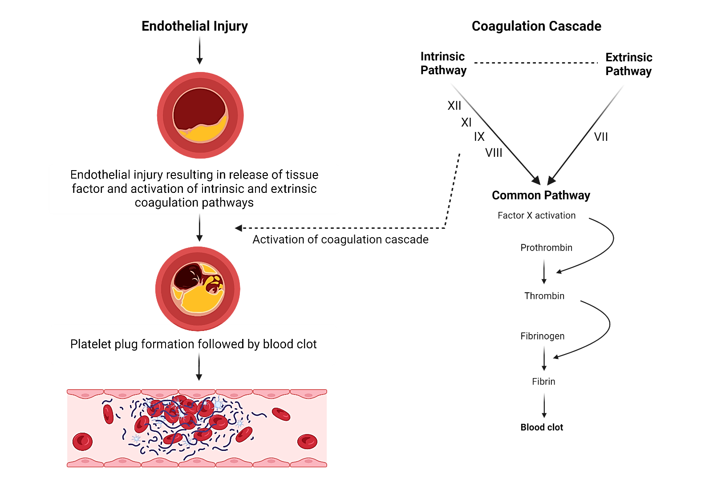
Figure 1: Endothelial Injury leading to coagulation cascade activation resulting in platelet plug and blood clot formation (Image created with Biorender).

The extent of thrombus occlusion defines the cardiac clinical manifestation of any of the three acute presentations: unstable angina (UA), non-ST elevation myocardial infarction (NSTEMI) or ST-elevation myocardial infarction (STEMI). Atherosclerotic plaques may co-develop in other vascular beds simultaneously, which can manifest clinically as cerebrovascular accident (CVA), aortic aneurysm (AA) or peripheral vascular disease (PVD). (7)

1.3 Risk factors for coronary artery disease (CAD)
Although coronary artery disease (CAD) is multifactorial, the risk factors can be classified as modifiable and non-modifiable categories, as illustrated in Table 1. (8) Early identification and management of the modifiable risk factors helps to minimise mortality and morbidity associated with CAD and hence, should be targeted as a fundamental goal in the prevention of adverse outcomes. (8)

Table 1: Modifiable and non-modifiable risk factors for coronary artery disease

Modifiable | Non-modifiable
Smoking | Age
Diabetes | Gender
Hypertension | Family history
Obesity | Ethnicity
Dyslipidaemia | Homocystinuria
Sedentary lifestyle
Dietary factors

1.4 Anatomy of the coronary arterial tree
The arterial blood supply of the heart originates from the left and right aortic sinuses. The left coronary tree starts as the left main stem (LMS), which usually bifurcates into the left anterior descending (LAD) and left circumflex artery (LCx) (see Figure 1). Although several variations of this commonality are described in the literature, its details are beyond the scope of this review.
The left anterior descending artery (LAD) supplies almost 2/3rd of the heart, giving rise to diagonal branches and septal perforators (9). It is responsible for the arterial supply of the interventricular septum from the mid to apical segment and 2/3rd of the basal interventricular septum. (9) The left circumflex artery (LCx) provides blood supply to the lateral wall of the left ventricle and gives origin to obtuse marginal branches. (10) The right coronary artery (RCA) arises from the right coronary sinus of the aorta and supplies blood to the right ventricle, commonly the posterior 1/3rd of the interventricular septum. (10,11)

1.4.1 Coronary dominance
The dominance of the coronary system is determined by the artery giving rise to the posterior descending artery (PDA), which is responsible for the blood supply to the posterior one-third of the interventricular septum. Right dominance has been the most common, constituting about 85.5%, followed by left dominance at 9.7% and co-dominance at 4.8%. (10,12)

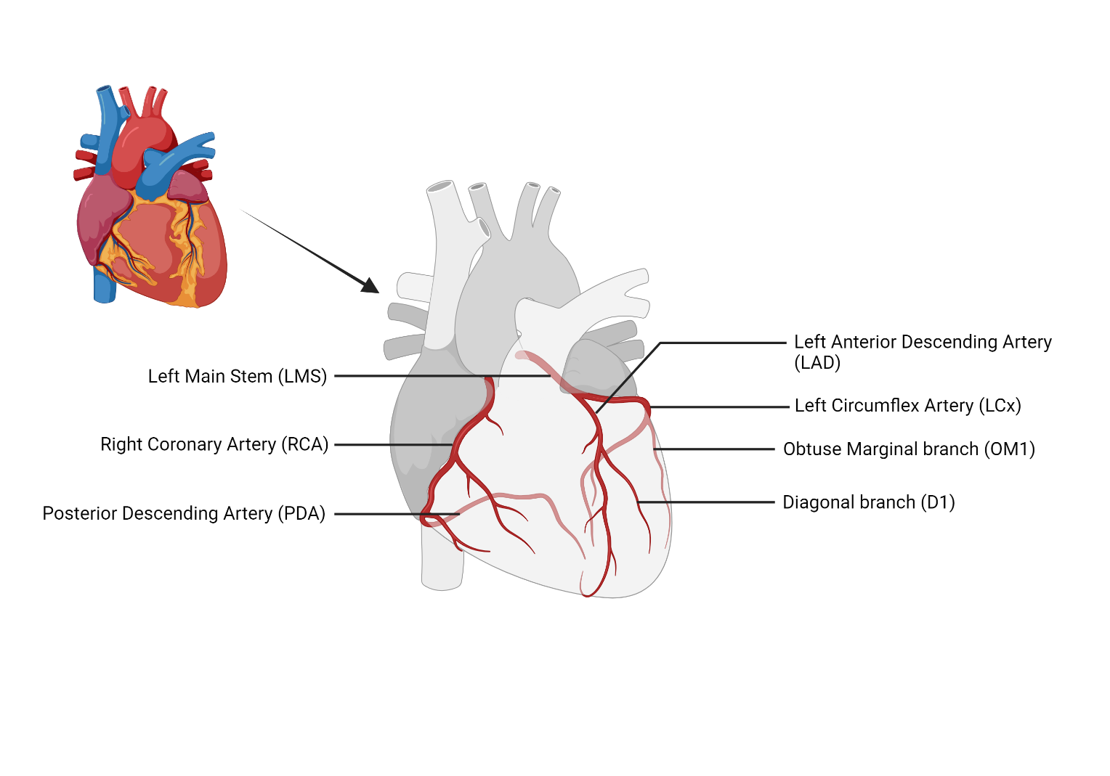
Figure 1: Arterial blood supply of the heart (Image created with Biorender)

1.5 Clinical manifestation of coronary artery disease
The presentation of CAD depends upon the stability of atherosclerotic plaque. Therefore, the dynamicity of the atherosclerotic phenomenon can result in various clinical manifestations, which can be categorised as either chronic coronary syndrome (CCS) or acute coronary syndrome (ACS). (5,6)

1.5.1 Chronic coronary syndrome (CCS)
The term “chronic coronary syndrome” was introduced by the European Society of Cardiology (ESC) in the revised guidelines for previously called stable CAD in 2019. (13) Despite the chronicity and progressive nature of CAD, the disease may remain quiescent for several years before any clinical manifestation. However, the development of angina implies myocardial ischaemia due to an imbalance between myocardial demand and supply. (14)
A triad characterises the classical presentation of an anginal attack: (14)
- Retrosternal heaviness or pressure-like feeling radiating to the arm, neck, or jaw.
- Symptoms are usually precipitated by exertion.
- Relieved with either rest or nitro-glycerine.
The classical triad of angina may not be present in all patients, and several atypical presentations have also been described. Hence, they could be divided as per the “Diamond Classification” into typical, atypical, or non-cardiac if they meet three, two or one symptom on the triad list, respectively. (15)
The Canadian Cardiovascular Society (CCS) classification has been widely used in clinical practice to grade the angina severity in relation to the exercise threshold, as illustrated in Table 2. (13)

Table 2: Canadian Cardiovascular Society (CCS) classification for angina severity
Grade | Angina severity | Description
I | Angina at strenuous exertion | Angina during strenuous or prolonged ordinary activity (walking or climbing stairs).
II | Angina at moderate exertion | Slight limitations of ordinary activities when performed rapidly, walking uphill, climbing more than one flight of stairs at a normal pace, or under emotional stress
III | Angina at mild exertion | Symptoms after walking one or two blocks on level ground or climbing one flight of stairs at a normal pace
IV | Angina at rest | Angina with any level of exertion or even at rest

CAD may lead to the development of heart failure symptoms due to myocardial injury, resulting in left ventricular systolic dysfunction (LVSD), which commonly presents as shortness of breath (SOB) upon exertion, paroxysmal nocturnal dyspnoea and with acute pulmonary oedema in extreme cases. Like the Canadian Cardiovascular Society Classification, the extent of the symptoms related to exertion is routinely described using the New York Heart Association (NYHA) classification, which has been defined in Table 3. (1)

Table 3: NYHA classification
NYHA Class | Description
Class 1 | No limitations to ordinary activity
Class 2 | Mild symptoms and slight limitations during ordinary activity
Class 3 | Significant limitation due to SOB during ordinary activity, but remains comfortable at rest
Class 4 | Symptoms of SOB even at rest

1.5.2 Acute coronary syndrome (ACS)
Acute coronary syndrome (ACS) refers to a constellation of three conditions, all with similar pathophysiology, and acute chest pain as a sequel. These are unstable angina (UA), non-ST elevation myocardial infarction (NSTEMI) and ST-elevation myocardial infarction (STEMI). The clinical presentation of ACS is broad, ranging from being angina-free at the time of presentation to ongoing ischaemia, hemodynamic instability, life-threatening cardiac arrhythmias, cardiogenic shock, or even cardiac arrest. (16) These high-risk manifestations of CAD warrant prompt recognition by taking a thorough history, detailed clinical examination, urgent electrocardiography (ECG), and cardiac biomarker evaluation, all of which guide towards accurate diagnosis and early risk stratification. (16)

1.5.2.1 Universal definition of myocardial infarction (UDMI)
The universal definition of myocardial infarction (UDMI) describes the myocardial infarction (MI) as an increase in the level of cardiac biomarkers (preferably a high-sensitivity cardiac troponin (hs-cTn) T or I) above the 99th percentile of the upper reference limit, in addition to one of the following: (17)
1. Symptoms of myocardial ischaemia.
2. New ischaemic ECG changes.
3. Development of pathological Q waves on ECG.
4. Imaging evidence of loss of viable myocardium or new regional wall motion abnormality in a pattern consistent with an ischaemic aetiology.
5. Intracoronary thrombus detected on angiography or autopsy. (17)

1.5.2.2 ST-elevation myocardial infarction (STEMI)
ST-elevation myocardial infarction refers to an acute onset of severe chest pain with associated characteristic ST-elevation on the ECG. It is usually the sequel of rupture or erosion of an atherosclerotic plaque, causing complete occlusion of the coronary artery. (16) Such patients require urgent revascularisation and restoration of coronary blood flow via the insertion of a stent in the occluded artery through the primary percutaneous coronary intervention (PPCI) pathway. (18) There are more than 100,000 patients admitted every year in the UK with MI, and STEMI constitutes almost 39% of these admissions. (18) Despite notable improvement in myocardial infarction (MI) outcomes, the current survival rate (seven out of 10), owing to prompt healthcare provision, still indicates potential for further augmentation. (3) The prognosis in these circumstances depends upon age, comorbidities, the artery involved, the size of the infarct and time delay in coronary intervention. (19,20)

1.5.2.3 Non-ST elevation myocardial infarction (NSTEMI) and unstable angina (UA)
Non-ST elevation myocardial infarction (NSTEMI) and unstable angina (UA) symptomatically mimic each other regarding chest pain or dynamic ECG changes. However, the main distinction is that cardiac troponin, the marker of cardiomyocyte necrosis, is elevated in NSTEMI. (21) The treatment in most such patients is an urgent cardiac catheterisation with a view to definitive treatment either in the form of percutaneous coronary intervention (PCI) or coronary artery bypass surgery (CABG). Several risk stratification scores are used in clinical practices, including the Global Registry for Acute Coronary Events (GRACE) Thrombolysis in Myocardial Infarction (TIMI) score. (18-20) The European Society of Cardiology (ESC) advocates using these risk stratification tools to guide whether an immediate (<2 hours), urgent (<24 hours) or selective invasive management strategy should be adopted. (17) An example of NSTEMI with dynamic ECG changes (deep T-wave inversion in anterolateral precordial leads) and CAG findings is shown in Figure 3.

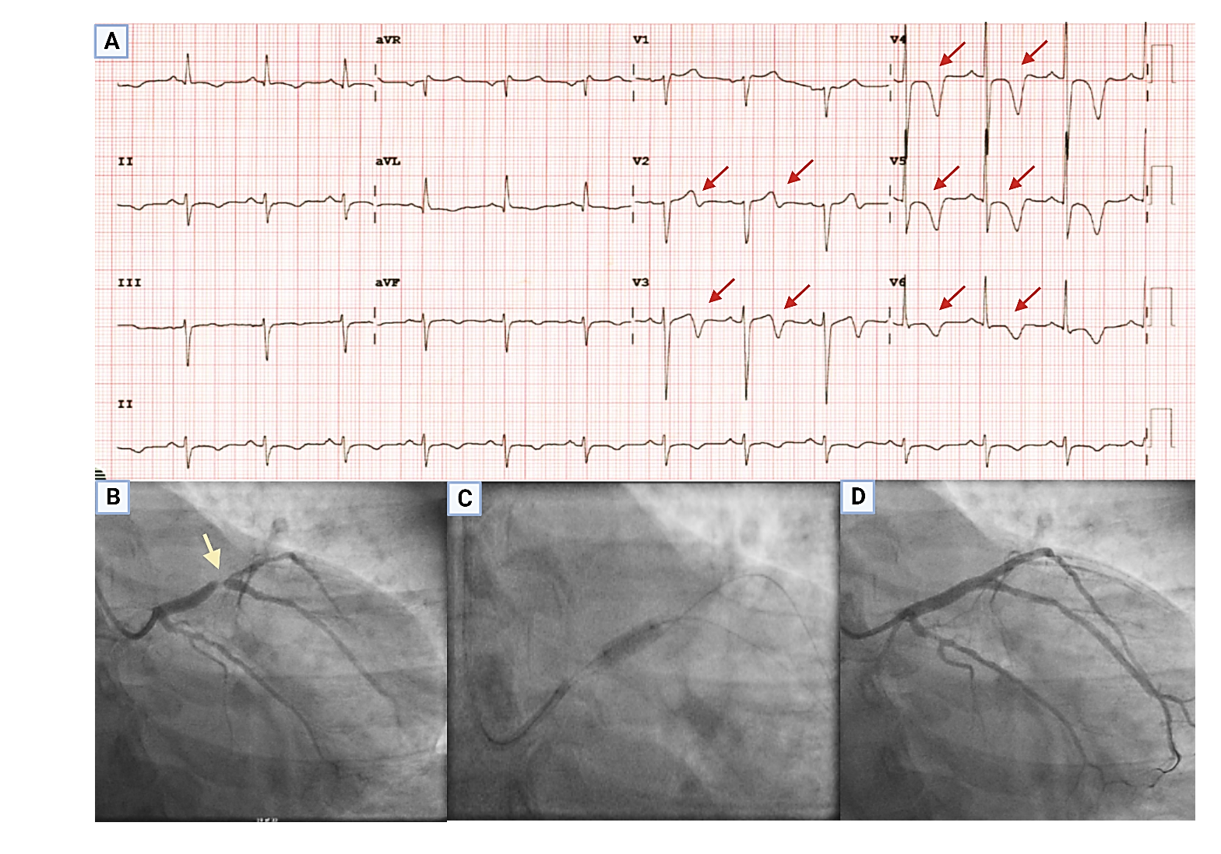
Figure 2: ECG (panel A) showing biphasic deep TW inversions in the anterior leads (Wellen's sign), which correlates with the coronary angiogram findings of critical proximal LAD lesion marked with a yellow arrow (panel B), which was stretched with a balloon (panel C) and subsequently treated with a drug-eluting stent (DES).

1.6 Investigations and assessment of coronary artery disease (CAD)
The selection of the most appropriate investigation for the suspected CAD is vital in the decision-making; hence, the ESC recommends a pre-test probability (PTP) approach. (22) The PTP depends on several factors, including age, gender, comorbid conditions (hypertension, diabetes) and the nature of the reported symptoms. (22) Once the diagnosis is confirmed, patients should be initiated on the optimal medical therapy (OMT) immediately, along with risk stratification for subsequent events. Based on the above information, the treating physician must decide upon the investigation, which can reliably include or exclude the diagnosis of CAD. The investigation panel could be divided into non-invasive and invasive categories.

1.6.1 Non-invasive Investigations

1.6.1.1 Baseline Investigations
According to the ESC guidelines, suspected CAD disease patients should have baseline investigations performed, which can be tailored according to the clinical presentation. These investigations should be preceded by a thorough clinical history and examination, followed by a 12-lead electrocardiography (ECG), chest X-ray (CXR), and blood tests (complete blood count, renal functions, creatinine, lipid profile and high-sensitivity cardiac troponin assays). Glycosylated haemoglobin (HbA1c) levels should also be considered if there is a history of type 2 diabetes mellitus (DM). (22) The echocardiography could also exclude any area of regional wall abnormality (RWMA) as a surrogate marker of an ischaemic insult. (22)

1.6.1.2 Anatomical non-invasive testing
In the UK, the National Institute of Health and Care Excellence (NICE) guidelines (CG95 - recent onset chest pain of suspected cardiac origin) recommend performing computed tomography coronary angiography (CTCA) as the first-line investigation in patients with a low probability of CAD, because of its high negative predictive value as evidenced by SCOT-HEART and PROMISE trials. (23,24) The SCOT-HEART study, comprising 4,146 patients, demonstrated a lower mortality rate and non-fatal MI (2.3% vs 3.9%) when CTCA was performed in addition to the routine non-invasive testing (predominantly exercise ECG) at 5-year follow-up. (23) Similarly, the PROMISE trial randomised 10,003 patients with low-intermediate risk of CAD to either receive CTCA or non-invasive ischemia testing and showed that there was no difference in MACE (3.3% CTCA vs 3.0% functional) at 25 months follow-up. (25) Despite its usefulness in CCS settings, performing CTCA routinely in suspected ACS patients failed to prove an effective strategy. (26) In the RAPID-CTCA trial (n=1748), patients were randomised to undergo either an early CTCA or routine standard management. The conclusions were that guiding management strategy based on CTCA in suspected ACS patients with intermediate risk had no difference in mortality (5.8% CTCA vs 6.1% routine). Furthermore, CTCA did not reduce the number of invasive coronary angiograms (54% CTCA vs 61% routine). In addition, this approach was associated with a slightly increased length of hospital stay (2.2 days vs 2.0). (26)
Although CTCA is an excellent screening tool, it has its limitations. The presence of extensive calcification, irregular heart rate in atrial fibrillation (AF), inability to achieve a slower heart rate < 65/min, elevated body mass index (BMI), and failure to perform the breath-holding during scanning are a few factors which can significantly decrease the image quality and hence, can negatively impact the predictive capabilities of CTCA. (27)

1.6.1.3 Functional non-invasive testing
Functional non-invasive testing includes the detection of ischaemia either by exercise or pharmacology. Exercise leads to an escalated myocardial workload and oxygen demands, resulting in the reproduction of anginal symptoms or the development of new regional wall motion abnormalities depicting ischaemic substrate. On the other hand, pharmacological stress testing provokes coronary vasodilation and demarcates the area of ischaemic myocardium as a perfusion defect. (28)

1.6.1.3.1 Exercise treadmill test (ETT)
The use of ETT in clinical practice has gradually declined due to its relatively inferior diagnostic performance compared to other functional assessment techniques. (28) An exercise test becomes uninterpretable if the patient has an underlying bundle branch block (BBB), paced rhythm, resting ECG changes, or drugs like digoxin. (28) Clinical use of ETT is now limited to specific circumstances, such as assessment of asymptomatic valvular disease, exercise-related hemodynamic response in hypertrophic obstructive cardiomyopathy (HOCM), arrhythmia provocation testing and evaluation of sudden cardiac death (SCD) in some inherited cardiac conditions. (22)

1.6.1.3.2 Stress echocardiography
Inducible ischaemia can be evaluated on echocardiography by demonstrating regional wall motion abnormalities (RWMA), even before any ST-segment changes are visible on the ECG. (28) Ischaemic stress may be induced by physical exercise or a pharmacological agent (dobutamine commonly used). Stress echocardiography can also provide valuable information about concomitant cardiomyopathy, diastolic dysfunction, and valvular heart disease. (29) Stress echocardiography proved cost-effective and demonstrated superior diagnostic accuracy than the ETT in a prospective randomised trial of 385 patients. (30) Another study directly compared dobutamine-stress echo (DSE) with myocardial perfusion scanning (MPS) and found comparable diagnostic accuracy for stress echocardiography and myocardial perfusion without any statistically significant difference. (31) However, poor acoustic windows due to obesity, chronic obstructive pulmonary disease (COPD), or chest wall deformities (pectus excavatum or carinatum) may adversely affect the diagnostic yield of stress echocardiography. (29,30)

1.6.1.3.3 Myocardial perfusion imaging (MPI): single photon emission computed tomography (SPECT) and positron emission tomography (PET)
Regional myocardial perfusion can be assessed non-invasively by intravenous administration of technetium-99m labelled radioisotopes (sestamibi or tetrofosmin). The emitted radiation is detected with a gamma camera for single photon emission computed tomography (SPECT) or positron emission tomography (PET), either with pharmacological or exercise stress. (32) A reversible perfusion defect in the myocardium reflects inducible ischaemia. (32) Myocardial perfusion scan (MPS) has an excellent negative predictive value (NPV). In a study of 421 patients, a normal stress perfusion test was associated with a <1% risk of MACE or non-fatal myocardial infarction at 12 months. (32) The PACIFIC trial was the first trial (n=208) to perform a head-to-head comparison of PET, SPECT and CTCA. It revealed that PET had the highest diagnostic accuracy (85%) vs SPECT (77%) and CTCA (74%) in identifying hemodynamically significant stenosis, judged by FFR <0.8. (33) A recently published meta-analysis showed that the sensitivity and specificity of SPECT to diagnose CAD are approximately 79% and 85%, respectively. (34) One of the significant limitations of SPECT is that it provides information on relative perfusion, which may lead to a false negative result in the presence of “balanced ischaemia”, commonly observed in left main stem (LMS) or triple vessel disease (3VD). (35) PET, despite its high spatial resolution and quantitative blood flow estimation ability, is limited by its high costs, availability, and shorter half-life tracers, which may pose some difficulty for stress imaging. (35)

1.6.1.3.4 Stress cardiac magnetic resonance imaging (sCMR)
Stress cardiac magnetic resonance imaging (sCMR) has emerged as an imaging modality with high diagnostic accuracy for CAD, compared to other non-invasive imaging technologies, without ionising radiation. (36) The CE-MARC study was a large prospective trial in which 752 patients with suspected CCS were randomised to undergo stress CMR, SPECT or invasive coronary angiogram. Stress CMR showed superiority over SPECT in terms of sensitivity (86.5% CMR vs 66.5% SPECT) and negative predictive value (90.5% CMR vs 79.1% SPECT) for identifying underlying CAD. (37) In CE-MARC 2, stress CMR-based strategy caused a significant reduction in invasive coronary angiograms when compared to NICE guidelines-directed pathways (7.5% CMR vs 28.8% NICE), without any compelling differences in MACE (2.5% CMR vs 1.7% NICE) at 12 months follow up. (38)
Due to its high spatial resolution, large field of view, and ability to aid tissue characterisation, CMR can also add information about the left ventricular systolic function, perfusion, myocardial scarring, and viability in a single setting. (36) Morbid obesity (more than 150kg), claustrophobia, and inability to incorporate the exercise protocols for stress testing appear to be the only few limitations. (36)

1.6.2 Invasive Investigations

1.6.2.1 Invasive coronary angiography (CAG)
Sones and Shirley were the first to conduct a coronary angiogram (CAG) in 1960, which paved the way for the first coronary angioplasty performed by Andreas Grüntzig in 1977. (39) CAG is essentially a lumenogram by which coronary arteries can be evaluated for any narrowing by administering a contrast agent (see Fig 4). This can be performed through vascular access obtained via the radial or femoral artery. As per ESC guidelines, an invasive coronary angiogram should be reserved as the first line for patients with ACS or CCS with persistent anginal symptoms despite optimal medical therapy (OMT). (22) Advancements in coronary angiogram techniques have substantially improved, reducing the risk of complications (estimated to be 0.1-0.2%). (40) This is especially true for the radial approach, as revealed in the RIVAL study (7051 patients), which showed a lower risk of major bleeding (1.9% vs 4.5%) and life-threatening vascular complications (1.4% vs 3.7%) in comparison with the femoral approach. (41) Functional assessment should also be considered in addition to invasive CAG, especially in multivessel disease (MVD) or if estimated stenosis is 50-90% due to chances of mismatch between the visual-functional significance of the lesions. (14)

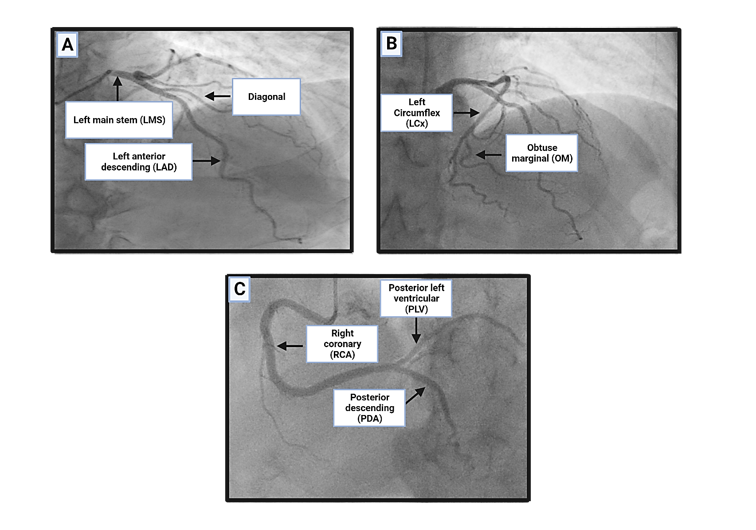
Figure 3: CAG demonstrating normal coronary arteries. A and B - Left coronary artery. C – Right coronary artery

1.7 Treatment for coronary artery disease

1.7.1 Lifestyle modification

Implementing healthy lifestyle changes (regular physical exercise, healthy body mass index, stopping smoking) deserves keen attention due to the high potential gains by minimal spending and benefits that could be evident within six months. (42) Smoking cessation may lead to an overall 36% reduction in cardiovascular mortality. (43) Regular exercise (30-60 minutes of aerobic activity for more than five days/week) can reduce MACE by 14-17%. (44) The ESC recommendations on cardiovascular disease (CVD) prevention in clinical practice serve as an excellent guide to create an impact on CAD primary prevention in the real world. (42)

1.7.2 Optimal medical therapy (OMT)

1.7.2.1 Antiplatelet agents
The antiplatelet agent, aspirin, and the combination of it with a P2Y12 inhibitor (clopidogrel, ticagrelor or prasugrel) (dual antiplatelet agents; DAPT) are the mainstay of treatment in ACS, and for those undergoing revascularisation with angioplasty in CCS. Aspirin has been an important drug for decades in CAD, with a role in secondary prevention. (45) During maintenance therapy, ticagrelor provides a more reliable and consistent level of P2Y12 inhibition, and a more rapid onset of the antiplatelet effect than clopidogrel. (46,47) Similarly, prasugrel has a more predictable, swift, and potent platelet switch-off effect than clopidogrel, at the expense of slightly higher bleeding events. (48) Usually, DAPT is recommended for six months in CCS patients (PCI-treated) and 12 months after an ACS, with limited evidence for Ticagrelor continuation on a long-term, in a lower dose of 60mg twice daily, for higher ischaemic-risk patients. (49)

1.7.2.2 Anti-anginal medications
Anti-anginal drugs mainly improve the symptoms of effort angina but have limited benefits in CAD in reducing MACE in patients without left ventricular dysfunction (LVSD). (22) Beta-blockers and calcium-channel blockers are considered the first-line anti-anginal agents, as evidenced by a meta-analysis of 46 studies. (50) A favourable outcome of beta-blockers on mortality and MACE is proven in patients with a prior history of MI or LVSD. However, due to a lack of placebo-controlled randomised studies, the prognostic benefit data has been limited in the presence of normal LV function and no history of previous MI. (51,52). The ACTION trial (n=3825) showed improved anginal symptom control with a dihydropyridine calcium blocker (nifedipine) with a slight reduction in the need for an invasive coronary angiogram but no overall benefit on mortality. (53) Ivabradine, a second-line agent for angina, has demonstrated non-inferiority to beta-blockers or calcium-blockers with no effect on MACE, as investigated in the BEAUTIFUL trial comprising 10,917 patients. (54,55) Similarly, Nicorandil and Ranolazine have also been recommended as second-line agents for achieving anginal control without effects on MACE as showed in IONA (n=5126) and MERLIN-TIMI 36 trial (n=6560), respectively. (56,57)

1.7.2.3 Cholesterol-lowering medications
Treatment with a statin is recommended in both established CAD and deemed high-risk CCS patients, irrespective of low-density lipoprotein-C (LDL-C) levels (target < 1.4mmol/L). (42) Statin therapy aims to reduce LDL-C levels to less than 50% of the baseline values. (42) Ezetimibe may be used as an add-on statin therapy if the LDL-C targets are not achieved. (58) Similarly, proprotein convertase subtilisin-kexin type-9 (PCSK-9) monoclonal antibodies (Alirocumab, Evolocumab) have emerged as novel treatments to reduce LDL-C effectively with an overall reduction in cardiovascular ischaemic events. (59,60)

1.7.3 Percutaneous coronary intervention (PCI)
Following the first angioplasty in 1977, percutaneous coronary intervention (PCI) entered an era of dynamic evolution from ‘plain old’ balloon angioplasty (POBA) and bare metal stents (BMS) to second and third-generation drug-eluting stents (DES). (39) BMS were initially employed as a bail-out strategy to deal with acute vessel closure with POBA, followed by the development of drug-eluting stents due to problems with in-stent restenosis. (61) Since then, there has been ongoing research and advancement in stent technology with a prime focus on strut design and thickness, deliverability, flexibility, polymer choice, and bioresorbable stent scaffolding. (62) This evolving innovation has remarkably improved the clinical outcomes, as evidenced by a patient-level meta-analysis of three randomised trials of Everolimus-eluting stents vs first-generation stents, comprising 1581 patients. The results showed that the Everolimus stents had significant advantages over the first-generation stents in terms of mortality (7.8% vs 11.7%), stent thrombosis (3.4% vs 6.1%), target vessel revascularisation (14.2% vs 20.1%) and reinfarction (8.1% vs 11.2%) at five years. (63)
Revascularisation with primary PCI is the default strategy in patients with STEMI (64). As soon as the diagnosis is confirmed based on history, clinical examination, and electrocardiography (ECG), PPCI should be performed ASAP from the onset of symptoms up to a 48-hour window. (67,68) However, in NSTEMI, patients should undergo risk stratification into high, intermediate and low-risk, which guides the timings of revascularisation as <2 hours, <24 hours and a selective-invasive approach, respectively. (69-71) In a meta-analysis of 46 randomised trials (n=37757), PCI in acute coronary syndrome resulted in a reduction in all-cause mortality (RR 0.84; 95% CI: 0.75-0.93; p=0.02). In addition, PCI showed a decremental trend in cardiovascular mortality (RR 0.69; 95% CI: 0.53-0.90; p=0.007) and recurrent MI (RR 0.74; 95% CI: 0.62-0.90; p=0.002). (64) Even the benefits of PCI were superior to conservative treatment in NSTEMI for the octogenarian population (>80 years of age) and led to a reduction in the incidence rates of cumulative primary endpoints of death, MI, stroke, and repeat revascularisation by 0.76; 95% CI: 0.63-0.93; p=0.005. (65) In another single-centre study of 491 octogenarian patients (mean age of 83), a survival benefit of 21.8% in the PCI arm was observed at three-year follow-up, therefore suggesting improved outcomes with PCI. (66)
In contrast, OMT plays a pivotal role in CCS, with angioplasty only being an adjuvant to the OMT (14,23,28). Although a 5-year follow-up of the FAME-2 trial showed the sustained benefit of PCI + OMT over OMT alone (72), a further meta-analysis showed only modest improvement in prognosis (73). The evidence of benefit of revascularisation in CCS is limited to patients who have evidence of ischaemia on stress testing (>10% burden), multivessel disease (MVD) with impaired LV systolic function, and significant LMS or proximal LAD involvement. (27,74) Therefore, compared to OMT alone, revascularisation with PCI in CCS settings is essentially aimed at reducing angina and improving the exertional capacity and QOL.
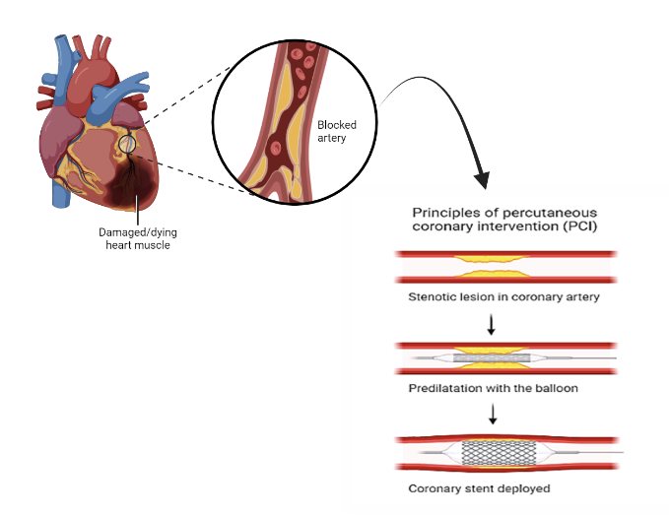Figure 4: Illustration of percutaneous coronary intervention (PCI) – Image created with Biorender

1.7.4 Coronary artery bypass grafting (CABG)
Surgical revascularisation with CABG was established as the first definitive treatment option a decade before angioplasty evolved and has been available since the 1970s. (75) Arterial (mammary or radial) or venous (long saphenous vein) conduits are used to bypass the segments of coronary stenoses, with a preference for arterial grafts due to better long-term outcomes. (76) One of the most extended follow-up studies of CABG, spanning 30 years, showed a median life expectancy of 17.6 years, with >94% of patients requiring some form of revascularisation post-CABG during a lifetime span. (77) A meta-analysis of 11 randomised controlled trials (RCTs) of 11,518 patients showed that CABG sustained a mortality benefit over PCI in patients with diabetes (10.0% CABG vs 15.5%PCI), multivessel disease (8.9% CABG vs 11.5% PCI) and with high SYNTAX score (a scoring system for the extent of coronary disease) of 33 or higher (9.2% CABG vs 11.2% PCI) over 5-years follow-up. (76) Another RCT comprised of 4394 patients including the SYNTAX, EXCEL, NOBLE and PRECOMBAT trials, revealed no statistically significant difference in MACE between CABG and PCI (10.2% CABG vs 11.2% PCI) amongst the patients with isolated left main stem (LMS) disease, and low-intermediate anatomical complexity (SYNTAX score of less than 33) at 5-year follow-up. However, PCI was associated with a higher rate of revascularisation (18.3% vs 10.7%) and a lower rate of stroke (2.7% vs 3.1%) compared to CABG. (79) Hence, a heart-team multidisciplinary approach is highly recommended to assist physicians and patients in making a final informed decision.

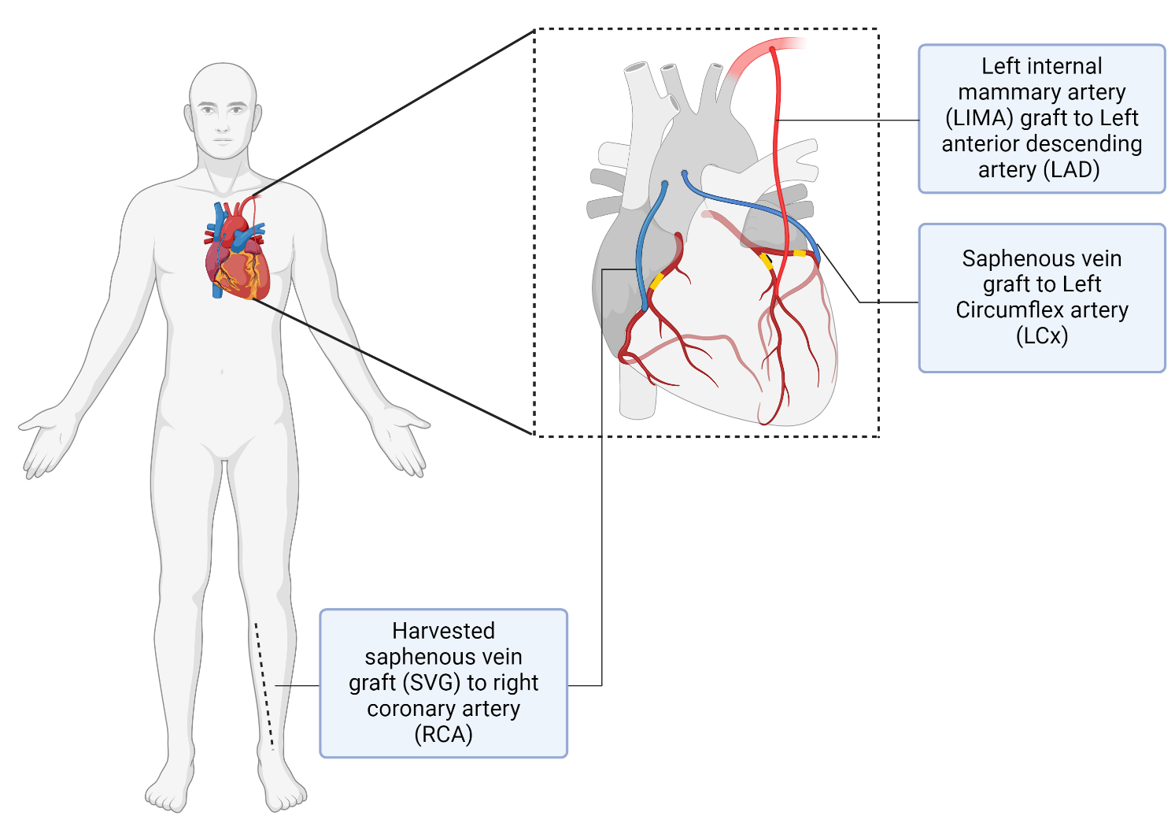
Figure 5: Illustration of coronary artery bypass graft (CABG) with the left anterior mammary artery (LIMA), radial artery and saphenous vein graft (SVG) – Image created with Biorender

1.8 Coronary blood flow fundamentals
The human heart has the highest metabolic activity of any organ and can extract the highest amount of oxygen, up to 75%. (80) Resting coronary blood flow is approximately 250ml/min (0.8ml/min/g of heart muscle), which equates to only 5% of the cardiac output. (80) However, it can increase to 300-400% of the resting state during exercise. (81) Coronary perfusion is paradoxical to the perfusion of other tissues. All the tissues receive the blood supply during systole. At the same time, the coronary perfusion happens during the diastolic phase, as in systole, where the contracting myocardium compresses the coronary vasculature. (83) Myocardium, a highly metabolically active tissue, can extract up to 60-70% oxygen at the baseline resting period. Hence, the increased myocardial demand is met primarily by increased coronary blood flow through coronary vasodilation, with little contribution from increased oxygen extraction. (83)
Coronary perfusion is a complex triad of flow, pressure, and resistance, coupled with neurohormonal modulation, which ensures an adequate balance in the myocardial arterial demand and supply. When this harmony is altered, it initiates an ischaemic cascade, producing a clinical constellation of CAD. (80) Multiple factors that may affect the coronary perfusion include: (80)
a. Perfusion time – tachycardia reduces the diastolic phase duration and reduces myocardial perfusion.
b. Vessel wall diameter – this is affected by vasomotor tone through autoregulation, stenoses in the vessel, microvascular disease, and variations in myocardial metabolism via the release of nitric oxide and adenosine.
c. Concomitant disorders – hypertension, diabetes, heart failure, or aortic valve stenosis.
d. Drugs – beta blockers, calcium channel blockers, nitrates, or inotropes.
Gould et al. first demonstrated that the resting coronary blood flow is not significantly affected unless the lesion is at least 85% stenotic. (84) However, even lesions with 30-40% stenosis during maximal hyperaemia may restrict the maximal achievable coronary blood flow. Hence, the actual magnitude of reduction in absolute coronary flow is most compelling during maximal hyperaemia. (84)
The difference between aortic diastolic pressure and left ventricular end-diastolic pressure (LVEDP) drives blood flow down the coronary arteries. (80) The basic principle governing this flow can be understood by the application of Ohm’s law, in which coronary flow (Q) is equal to the ratio of the pressure gradient (ΔP) divided by the resistance (R) imposed by stenosis (if any) and microvascular resistance, as illustrated in Figure 6. (80)

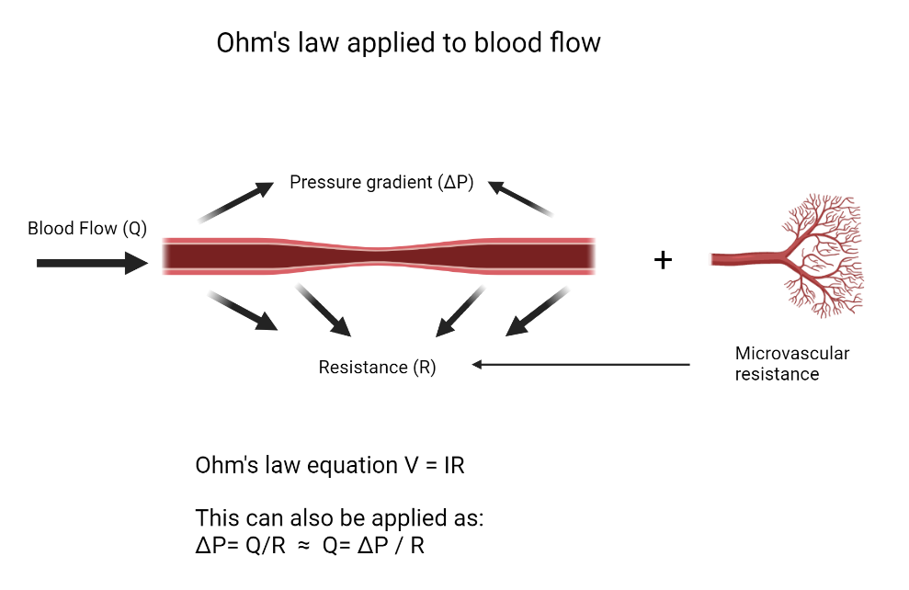
Figure 6: Ohm’s Law governing coronary physiology where coronary flow (Q) is equal to the pressure gradient (ΔP) divided by the resistance (R)

1.9 Why should coronary physiology be considered?
The current management of many ACS and CCS patients with a high probability of CAD is with an invasive coronary angiogram to decide upon a revascularisation strategy, either with percutaneous coronary intervention (PCI) or coronary artery bypass graft (CABG). (85) However, a coronary angiogram is essentially a 2-D lumenogram, and visual assessment alone does not corroborate well with the physiological significance due to imaging imprecision and a considerable inter-observer variation in the estimation of the lesion’s severity. (86,87) The RIPCORD trial (200 patients) showed a discrepancy in the evaluation of an angiographic moderate lesion between visual assessment and FFR. The study showed an alteration in the management plans of 26% (53/200) of the patients after disclosing FFR values. (88) A sub-analysis of the FAME trial demonstrated that as many as 65% of the non-LMS lesions with a visually estimated stenosis >50% were functionally non-ischemic (FFR >0.8); (89) and conversely, 20% of the LMS lesions were ischemia-provoking, despite being visually estimated as <50%. (89) Another study of 2986 patients revealed a discordance of 35% between the visual-functional significance, with LMS being more often underestimated. (90) Additionally, there may be further inconsistencies depending upon the quality of the angiogram, aorto-ostial or branch-ostial location of the stenoses, and vessel overlap, which may hinder the evaluation of the coronary tree. (87) Therefore, the angiography-alone strategy to guide decisions about revascularization may be flawed and can lead to unnecessary revascularisation procedures. Hence, coronary physiology should be used as an adjunct for accurate and appropriate decision-making.

1.10 How to assess coronary physiology?
Coronary physiology can be assessed using both invasive and non-invasive means. Invasive methods include pressure wire-based, of which fractional flow reserve (FFR) is the most common, whilst non-invasive virtual FFR can be performed using CT (FFR_{CT}) or hybrid invasive angiogram-based virtual FFR (FFR_{CAG}).

1.10.1 Pressure wire-based invasive fractional flow reserve (FFR)
Fractional flow reserve (FFR) is defined as the ratio of coronary pressure distal to the stenosis (P_{d}) divided by the proximal aortic pressure (P_{a}), calculated during the maximal hyperaemic state, in which the microvascular resistance (MVR) is minimalistic. (91) The mean aortic pressure is measured via a guide catheter, whereas the distal coronary pressure is estimated using a wire with a pressure transducer near the guidewire's tip (see Figure 7). An example of a mid-RCA lesion being investigated with an invasive pressure wire is shown in Figure 8.

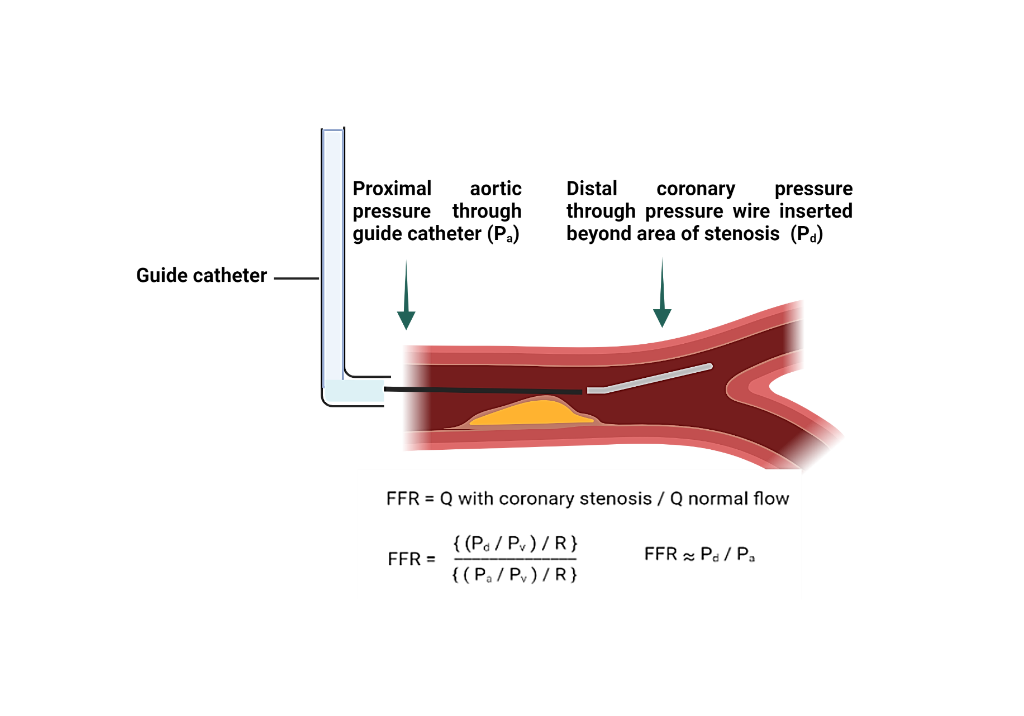
Figure 7: FFR as demonstrated by the ratio of pressure distal to stenosis and aortic pressure Pd / Pa (image created with Biorender)

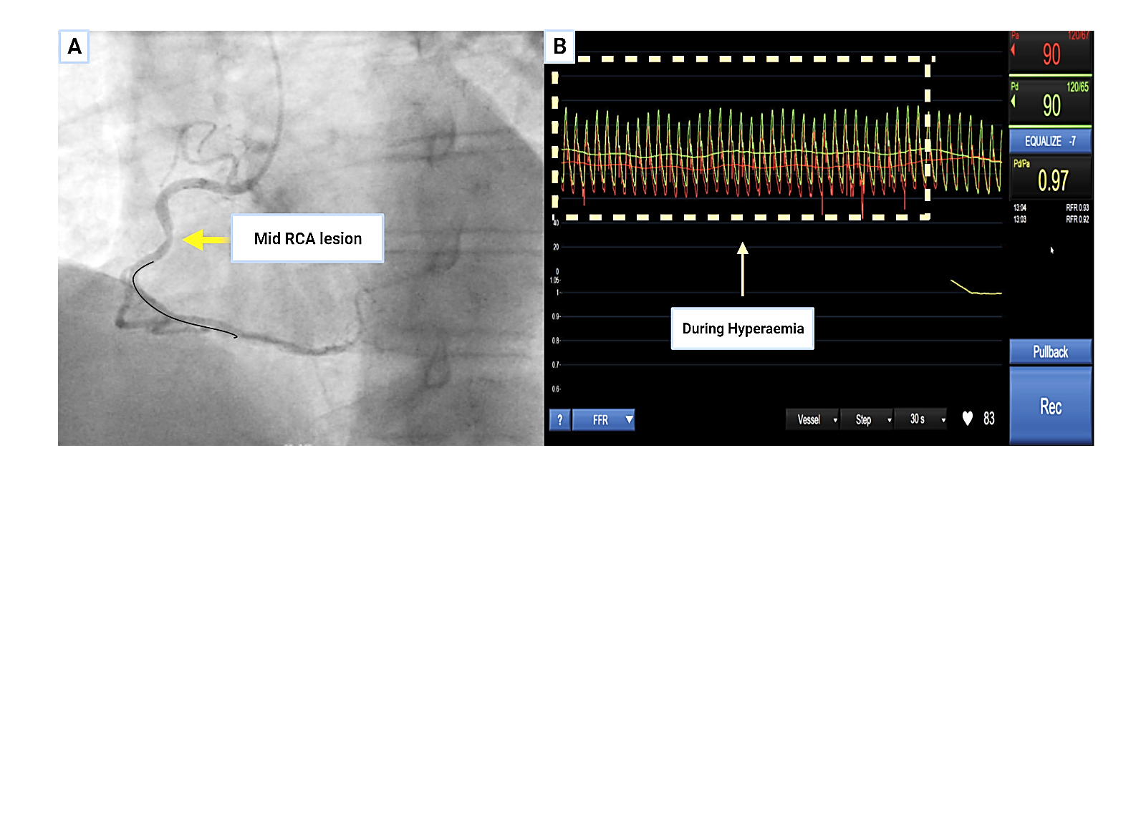
Figure 8: An example of FFR performed in the right coronary artery. Panel A shows the mid-segment of the RCA being evaluated with a pressure wire. Panel B shows a negative FFR of 0.97 (cut off for intervention 0.80) during maximal hyperaemia with intravenous adenosine administration (dotted area)

The presence of hyperaemia is essential to mimic the physiological state of exercise, which requires maximal flow. The hyperaemic state is achieved by the administration of adenosine, which results in the reduction of MVR to minimal levels (92). Adenosine can be given either as an intravenous infusion (140 ug/kg/min) or as an intracoronary bolus. (94) FFR values should always be evaluated by considering the clinical context and should not be used as a dichotomous variable for clinical decision-making, with a threshold of 0.8 as the cut-off for coronary intervention. (93,94)

1.10.1.1 Clinical validity of FFR

1.10.1.1.1 Evidence in chronic coronary syndrome (CCS)
FFR has been endorsed by the ESC with a class 1 indication in CCS settings when there is coronary stenosis of 50-90% by visual assessment and when results from non-invasive ischemia testing are either unavailable or inconclusive. (13,94,95) This is based on the conclusions from three seminal trials: DEFER, FAME and FAME-2. The DEFER (deferral vs performance of percutaneous coronary intervention of functionally non-significant coronary stenosis) was the first study, published in 2001, to evaluate the clinical impact of FFR-guided revascularisation in 325 patients. If the invasive FFR was ≤0.75, PCI was performed, and if the FFR was > 0.75, then patients were randomised to either PCI or medical therapy. This showed that the composite rate of mortality and MI was significantly lower in patients in whom PCI was deferred when FFR was ≥0.75, compared to the group where PCI was performed (2.2% in DEFER vs 7.9% in PERFORM). (93)
The FAME trial (fractional flow reserve vs angiography for multivessel evaluation), published in 2009, randomised 1005 patients with multivessel disease (MVD) to angiography-alone versus FFR-driven revascularisation if the FFR was ≤0.8. In the angiography-guided arm, any stenosis above 50% was revascularised, while in the FFR-guided arm, patients underwent PCI only if the FFR was ≤0.8. The results demonstrated that the FFR-guided strategy was associated with a significant reduction in the combined primary endpoints of major adverse cardiac events (MACE), as well as the need for repeat revascularisation (8.4 % vs 12.9 %, p=0.002) at two years follow up. (96) Later, 5-year follow-up data of FAME showed the consistent and long-term benefit of the FFR-guided revascularisation strategy in multivessel CAD regarding MACE (31% in angio-guided vs 28% in FFR-guided). Furthermore, there was a reduction in the number of stents placed per patient (mean 2.7 +/- SD1.2 in angio-guided vs 1.9 +/- SD 1.3 in FFR-guided arm). (97)
The FAME-2 trial was an open-labelled, multicentre, randomised controlled trial at 28 sites in Europe and North America, which investigated the superiority of FFR-driven revascularisation (when FFR is ≤0.8) over medical therapy alone. The trial included 1220 patients with stable CAD who had a minimum of one hemodynamically significant vessel (FFR ≤0.8) and were randomised to either receive OMT or percutaneous coronary intervention (PCI). The trial had to be terminated prematurely due to primary endpoints (death, myocardial infarction, and urgent revascularisation) being remarkably significant in the PCI arm than the medical therapy cohort (4.3% PCI vs 12.7% in OMT, HR with PCI 0.32). The difference was driven primarily by urgent unplanned revascularisation in the OMT group (1.6% vs 11.1%, HR with PCI 0.13). (98)

1.10.1.1.2 Evidence in acute coronary syndrome (ACS)
The role of FFR is robust in assessing intermediate severity in CCS. However, its utility in ACS remains an area of debate. Routine use of FFR in ACS is not advocated due to concerns of pseudo-negative FFR related to the concomitant rise in microvascular resistance. (99) However, it holds its accuracy for the non-culprit lesion evaluation in multivessel disease (MVD). (100)
Given the current emphasis on complete / near-complete revascularisation in the ESC guidelines, the COMPLETE, PRAMI, and CvLPRIT trials revealed a reduction in MACE when complete revascularisation was compared to the culprit-only approach in STEMI patients with MVD. However, in all these studies, the decisions were based on visual assessment instead of FFR guidance. (102,103,104) COMPARE-ACUTE, DANAMI-3-PRIMULTI, FAMOUS-NSTEMI and FLOWER-MI instead utilised an FFR-driven approach to guide decisions for bystander disease in the ACS cohort with MVD. COMPARE-ACUTE trial randomised 885 patients to PCI of infarct-related artery (IRA) only versus FFR-guided PCI of non-culprit lesions. This showed that the primary outcome (all-cause deaths, MI, and urgent revascularisation) occurred in 20% of the culprit-only treated group vs 8% in the FFR-guided complete revascularisation group. (105) DANAMI-3-PRIMULTI (627 patients) reinforced the results of COMPARE-ACUTE and showed the benefit of FFR-driven complete revascularisation in terms of MACE (13% in complete vs 22% in the culprit lesion-only strategy). (106) Similarly, the FAMOUS-NSTEMI trial (350 patients) showed a higher rate of revascularisation in NSTEMI patients who had CAG-guided vs FFR-guided treatment (22.7% vs 13.2%). In addition, it also showed an overall change in management in 75/350 (21.6%) of the patients after FFR disclosure, which was keeping in with the RIPCORD trial. (107) In contrast, FLOWER-MI (1171 patients) found that FFR-guided revascularisation was not superior to CAG-guided strategy in STEMI in terms of MACE at one year (5.5% in FFR vs 4.2% in angio-only). (108)
A real-world observational study of over 7000 patients with ACS who were treated with FFR guidance for PCI as compared to angiography-guided PCI showed lower in-hospital mortality (1.1% vs 3.1%), shorter length of stay (4.6 days vs 5.3 days) and reduction in AKI (12.5% vs 14.6%). (109) Lee et al. studied the prognosis of deferred non-culprit coronary lesions with FFR for both ACS (n=301) and CCS (n=1295) over a 2-year follow-up period. They concluded that deferral of non-culprit lesions in ACS had a higher incidence of MACE in ACS as compared to CCS (3.8% ACS vs 1.6% CCS), which was essentially due to higher rates of ischaemia-driven revascularisation (2.8% ACS vs 1.1% CCS). (110) A meta-analysis involving three studies, FAMOUS-NSTEMI, FAME and Leesar et al., revealed a modest reduction in the incidence of myocardial infarction in ACS patients (6.6% FFR-guided vs 10.4% CAG-guided), without any statistically significant reduction in all-cause mortality or target vessel revascularization. (111) Recently, another meta-analysis of 9 studies comprising 5457 patients compared the outcomes of FFR-guided revascularisation for both ACS and CCS patients, mainly focussing on those who had deferral of revascularisation after FFR. This showed that all the event rates were higher in ACS in comparison with CCS the cohort (MACE 17.6% vs 7.3%, recurrent MI 5.3% vs 1.5%, target vessel revascularisation 16.4% vs 5.6%) despite the use of FFR-driven revascularisation management. (112)
As the evidence for FFR in the ACS setting comes from sub-group analysis and small registries, larger randomised control trials (RCT) are required to support its liberal use in such scenarios. Hence, the updated 2020 ESC guidelines on ACS have given a Class IIb (level of evidence B) recommendation for performing FFR in the ACS settings to treat a non-culprit artery. (113)

1.10.1.1.3 Limitations of Invasive FFR
Despite all the evidence in favour of FFR, it has its limitations. FFR values are calculated based on three significant assumptions which may not be universally applicable. The first is that coronary pressure and flow are directly proportional to each other. However, the relationship is curvilinear with a non-zero pressure intercept (113). The second assumption is that microvascular resistance (MVR) is minimal and constant during the period of maximal hyperaemia and is similar to what it would be in an undiseased coronary artery. However, this is not always the case as intrinsic (endothelial dysfunction, microvascular dysfunction with diabetes, hypertension, left ventricular hypertrophy, hypertrophic cardiomyopathy) and extrinsic factors (caffeine intake) can cause blunting of the microvascular responsiveness to vasodilate and hence can affect FFR. (114) The third assumption is that venous pressure can be ignored. Indeed, it is rarely measured in day-to-day clinical practice due to time constraints and the need for additional venous access. However, in patients with left ventricular dysfunction, LVEDP (left ventricular end-diastolic pressure) is elevated, and so is the right atrial pressure (RAP), which in turn is suggestive of elevated microvenous pressure; it may impact the actual FFR values. (115,116)
Similarly, the evidence related to using FFR in an unprotected left main stem (LMS) is limited and comes from small observational studies, as most of the randomised trials of FFR excluded LMS patients. Of these studies, Hamilos et al. reported the 5-year clinical outcomes of 213 patients who had the revascularisation deferred if FFR was >0.8. It showed no statistically significant difference in event-free survival rates (89.8% revascularisation arm vs 74.2% deferral arm). (117)
Overall, FFR is a reliable assessment tool; however, due to its invasive nature, need for pharmacological hyperaemia, adverse features with adenosine (hypotension, chest tightness, bronchospasm), additional time and cost in a busy catheter lab. and technical aspects such as drift and failure to equalise, may lead to misleading results. (118) The use of FFR as a dichotomous variable may pose a predicament, especially when it is in the grey zone (0.75-0.85) because, in this range, the diagnostic accuracy (correctly predicting ischaemia) drops to <80%. In such cases, revascularisation decisions should be based on broader clinical judgement. (119)

1.10.1.1.3 Alternative non-hyperaemic clinical Indices
A few other auxiliary indices are also validated against FFR in clinical practice, essentially based on the principles of FFR but without the need for physiological hyperaemia. One is the instantaneous wave-free ratio (iFR), a resting index measuring the Pd /Pa in the diastolic phase, representing the highest coronary flow period. (120) Both DEFINE-FLAIR (2492 patients) and iFR-SWEDEHEART (2037 patients) trials revealed non-inferiority of iFR to FFR for the primary endpoint of a composite of death, MI, or unplanned revascularization. (121,122) Other non-hyperaemic resting indices in clinical practice are shown in Table 4. (123)

Table 4: Alternative non-hyperaemic pressure indices with description.
Pressure Index | Hyperaemia required | Clinical cut-off value | Calculation of the index
FFR | Yes | 0.80 | P_{d} / P_{a} during the maximal hyperaemia with adenosine (over three beats)
iFR | No | 0.89 | P_{d} / P_{a} during the wave-free period (over five beats)
RFR | No | 0.89 | Instant lowest P_{d} / P_{a} ratio over the entire cardiac cycle (over five beats)
Resting  P_{d} / P_{a} | No | 0.91 | P_{d} / P_{a} during the entire cardiac cycle (three beats)
DFR | No | 0.89 | P_{d} / P_{a} during the period between P_{a} < mean P_{a} and down sloping (over five beats)
dPR | No | 0.89 | Averaged P_{d} / P_{a} over diastolic phase (over five beats)

1.10.2 Imaging-based virtual fractional flow reserve (vFFR)

1.10.2.1 Computational fluid dynamics (CFD)
Computational fluid dynamics refers to a set of techniques that allows the computer to simulate flow numerically by conjunctural application of laws of physics, applied mathematics, and fluid mechanics. (124) It has been in operation for more than 50 years in the mechanical engineering field to study heat transfer, pressure, and fluid dynamics. CFD requires a multidisciplinary approach involving engineers, mathematicians, and computer experts collaborating to develop software that can swiftly solve algorithms. (125) CFD can provide both qualitative and quantitative predictions of flow and pressure following the laws of conservation of mass, energy, and momentum (the Navier-Stokes equation) using a computer-generated model (126). CFD has already been widely utilised in many safety-critical systems, including aerodynamics and hydrodynamics. Recently, there has been a steep rise in biomedical and healthcare research-related applications of CFD modelling directly to the cardiovascular system (CVS) for blood flow simulation. (127) Algorithms mark the physical boundaries on the clinical segmentation and divide the digital geometry into multiple volumetric cells or elements (discretisation) to prepare the constructed image for analysis within the permitted physiological boundaries. Hence, coronary blood flow can be simulated in a computed generated, post-processed 3-D model. (128)
The basic steps of CFD modelling can be divided into seven vital steps: (127)

- Clinical Imaging – Imaging should provide good-quality anatomical pictures in an appropriately pre-agreed format to allow segmentation and data extraction. X-ray angiography, CT or MRI can all be used as imaging modalities.
- Segmentation and reconstruction – This process converts the acquired clinical images to in-silico geometries, which identify the physical boundaries of the area of interest. The segmented area's motion could be tracked if image acquisition is selected over a cardiac cycle period.
- Discretisation – Spatial discretisation, or meshing, divides the in-silico geometries into a finite number of volumetric cells. Temporal discretisation causes division into specific time steps. A refined mesh and time step (spatiotemporal discretisation) can reveal the hemodynamic behaviour of the intended modelled segment.
- Boundary condition – Specific physiological parameters (patient-specific or data from physical modulation) are applied at the region's inlet, outlet, and walls to be analysed (for example, the proximal and distal vessels).
- Simulation – CFD solver to concurrently compute the Navier-Stokes and continuity equations for more than one million elements simultaneously, running over several cardiac cycles according to the pre-defined physiological parameters.
- Post-processing – The relevant data between the flow and pressure relationship is extracted on a refined, constructed 3D model.
- Validation – CFD-modelled results are then validated against a pre-specified standard (such as measured FFR) for diagnostic accuracy, reliability, and reproducibility.

1.10.2.1.2 Applications of CFD in clinical medicine
CFD can permit swift, low-risk prototyping, which may replace expensive in-vitro experimentation with the in-silica testing model, which has been a significant factor in the rapid uptake of CFD in the medical devices industry. Recent advancements in 3D imaging-based CFD modelling, using either computed tomography (CT) or coronary angiography (CAG), have enabled us to understand, assess and predict the pressures across the areas of stenoses non-invasively, of which vFFR is a prime example. In addition, there has been an emerging trend of CFD utility to model the complex hemodynamics in mechanical heart valves, evaluate the interaction of blood flow with prosthetic valves, and the aetiology of prosthetic valve failure and leaflet thrombosis. (129) Similarly, CFD can also help us understand the correlation between neointimal hyperplasia (NIH) and vessel wall shear stress, which may aid in improving stent strut design and predict post-intervention results. (130) (131) Furthermore, planning an intervention for patients with aortic dissection and prognosticating their long-term outcomes, optimisation of ventricular assist device (VAD) designs, modelling in complex congenital heart disease and shunt-flow are a few areas where CFD has proven to be highly effective. (132-135) Due to innovation in artificial intelligence (AI), the adoption of CFD and related technology has been on a steep rise in clinical practice.

1.10.2.2 CT-based fractional flow reserve (FFR_{CT})
National Institute of Health and Care Excellence (NICE) guidelines CG95 (‘Recent-onset of chest pain of suspected cardiac origin’) recommend performing a CT coronary angiogram (CTCA) as a first-line investigation due to its high negative predictive value for patients in whom the clinical assessment alone cannot reliably exclude CAD, based upon PROMISE and SCOT-HEART trials. (136) (137) (24,25) The incorporation of CFD into the CTCA images can be used to estimate FFR_{CT} without the need for any additional contrast or radiation. (138,139) Of the non-invasive vFFR entities, FFR_{CT} has demonstrated most of the clinical evidence in its favour. The DISCOVER-FLOW (103 patients) study was the first trial that demonstrated the ability of FFR_{CT} to diagnose lesions of physiological significance with an accuracy of 87.4% (95% confidence Interval) when compared with invasive FFR. (126) The NXT trial (254 patients) confirmed a diagnostic accuracy of 81% with a negative predictive value of 93% for FFR_{CT}. (140) The PLATFORM trial (585 CCS patients) showed that invasive CAG could be avoided in 61% of patients when FFR_{CT} was added to CTCA. (26) In a sub-study of the PACIFIC trial (208 patients), FFR_{CT}, SPECT and PET were compared to invasive FFR, and FFR_{CT} showed a higher sensitivity (90%) in comparison to SPECT (42%) and PET (81%). (141) This evidence, in addition to the report from medical technology guidance (MTG) from NICE in 2017, enabled FFR_{CT} to be included in NICE guidelines (CG95) (141)

1.10.2.2.1 Limitations of FFR_{CT}
Despite its advantages as an excellent negative predictive test, CT may be significantly limited due to poor image quality, motion artefacts, tachyarrhythmias, and extensive calcification. All of these may hamper the coronary segmentation process, hence making FFR_{CT} unanalysable, which was the case in 11%, 12% and 13% of the patients included in the DeFACTO (139) PLATFORM (26) and NXT (140) trials, respectively. Furthermore, off-site licensing (FFR_{CT} is a product of HeartFlow®) and processing times of up to 24 hours are other factors of importance in implementing the practicalities of FFR_{CT} in the real world. (92) Although CTCA with an inclusive FFR_{CT} can have a role in CCS patients, the latest ESC guidelines stressing early interventional strategy practically exclude its utility in the ACS cohort.

1.10.2.3 CAG-based fractional flow reserve (vFFR_{CAG})

1.10.2.3.1 Commercially available systems available for vFFR_{CAG}
Several systems employing different methodologies are available to estimate vFFR via CAG, employing different methodologies. These include Quantitative Flow Ratio (QFR), Cardiovascular Analysis System for Vessel FFR (CAAS-vFFR) and FFR_{angio}, all of which will be discussed in detail below.

1.10.2.3.1.1 Quantitative Flow Ratio (QFR)
Quantitative Flow Ratio (QFR), developed by Medis (based in Leiden, Netherlands) and Pulse Medical Imaging (China), had the initial studies conducted via the CFD techniques, however later employed 3D reconstruction with faster QCA-based computation algorithms, using the coefficients derived from Poiseuille and Bernoulli law. In the FAVOR pilot study, the hyperaemic flow was computed using three distinct flow models (143):
- The fixed hyperaemic flow velocity provided fixed flow-QFR (fQFR).
- TIMI frame counting analysis estimated the contrast-QFR (cQFR) during the non-hyperaemic state. (143,144)
- Adenosine-induced hyperaemia is derived as adenosine-QFR (aQFR).
The authors reported good overall diagnostic accuracy of all three flow models, with the highest diagnostic yield of cQFR. Hence, cQQFR was adopted as the model of choice and is currently utilised in clinical practice. (143)

1.10.2.3.1.2 Cardiovascular Analysis System for Vessel FFR (CAAS-vFFR):
CAAS-vFFR by Pie Medical Imaging (Maastricht, Netherlands) utilises the simple analytical algorithms of viscous resistance and separation loss phenomenon, using the Poiseuille and Bernoulli law, as elaborated by Gould and Kirkeeide et al. (145). The software uses patient-specific clinical data to estimate the maximal hyperaemic flow by using measured aortic pressure as the inlet boundary, assuming that flow velocity at the inlet is preserved. (92,144) The system automatically detects an optimal end-diastolic frame from two orthogonal views, at least 30º apart, through ECG triggering, allowing the physiological assessment of the segment of interest.

1.10.2.3.1.3 FFR_{angio}
FFRangio by Cathworks Ltd. (Kfar-Saba, Israel) is an adenosine-free system that employs the rapid flow analysis technique based on Poiseuille and Bernoulli law and the algorithms using epipolar ray tracings. (92) The entire coronary bed is modelled into a 3D reconstructed electric circuit, with every segment acting as a sequential resistor in the circuit. The resistance is, thus, exhibited according to the length and diameter of the segment with stenosis. The impact of each segment is estimated towards the overall resistance. Subsequently, two models are created by the software, a lumped model with stenosis and a second one without stenosis, to calculate the ratio of estimated maximal flow, both in the presence and absence of stenosis. The software requires user correction to rectify any movement artefact through correction of the axis. The final result is presented in the form of a colour-coded 3D-generated model of vFFR. (92)

1.10.2.3.2 Clinical evidence for vFFR
vFFR computed using angiogram-based images (vFFR) sparked a keen interest in interventional cardiology research. The first trial to evaluate vFFR was VIRTU-1, which utilised VIRTUHeartTM software. (146) In the VIRTU-1 trial (35 vessels studied in 19 patients), the diagnostic accuracy vFFR of VIRTUHeartTM was found to be 97%, with a mean deviation of 0.06 from the measured FFR, and a mean delta of 0.02, indicating a lack of bias. (147) Lately, a personalised vFFR (including the weight, height, heart rate, diastolic blood pressure and frailty score) has been shown to improve the diagnostic accuracy of the software for detection of any ischaemic lesion (FFR ≤0.8), with a computing time of fewer than four minutes. (147,148).
Of the available vFFR commercial systems, QFR has gathered most of the evidence. FAVOR II Europe-Japan showed a diagnostic accuracy of QFR against the measured FFR to be 86.8%, whereas, in FAVOR II China, it was around 92.4%. (149,150) FAVOUR III trial (China) was the first multicentre, sham-controlled, randomised trial, comprised of 3847 patients, who were randomised to QFR-guided PCI (n=1913) and angiography-guided PCI (n=1912). It showed that the QFR-driven PCI strategy was superior in the composite endpoints of death, MI, and ischaemia-related revascularisation at one-year follow-up than the angiography-guided arm (5.8% QFR-guided vs 8.8% in angio-guided). (151) In addition, the QFR arm had a slightly shorter procedural duration (53.7 min QFR-guided vs 59.4 min CAG-guided) and reduced use of contrast media. (151)
The FAST study (n=100) showed a diagnostic accuracy of 89% for CAAS-FFR (152) and 96% in the FAST-EXTEND trial (294 patients) when compared with invasive FFR. (145) These positive results were further reinforced in FAST II, a multicentre, prospective trial of 334 patients, which even comprehended more complex lesions, including calcified, bifurcation and tortuous lesions. (153) FAST III is an ongoing multicentre, randomised trial examining the efficacy of vFFR vs FFR-guided treatment plans for revascularisation. (149)
The FAST-FFR study revealed an excellent diagnostic accuracy of FFRangio at around 92% while retaining its diagnostic accuracy at around 87% even when the FFR values were between 0.75 – 0.85. (154) In a pooled analysis of five studies, FFRangio showed a consistent diagnostic accuracy of around 93% across various patient factors (age, gender, diabetes, and BMI), including complex lesion types. (155) FFR affirmed a good diagnostic certainty when compared to FFR for reclassifying the extent of CAD, as per the SYNTAX scoring system. (156) In a recently published study (536 patients, 601 lesions), revascularisation decisions were evaluated using FFRangio. The revascularisation was “deferred” if the lesions were estimated as vFFR-negative (n=256, 52%) and intervention was “performed” in 236 patients (48%). It showed a lower incidence of MACE at one-year follow-up (2.5% deferred vs 4.1% performed arm). (157)

1.10.2.3.3 The prototype: VIRTUHeartTM
The University of Sheffield team was the first to develop a vFFR system (VIRTUHeartTM), which operates on the fundamentals of CFD technology and provides a computed vFFR based on the invasive coronary angiogram (CAG). VIRTUHeartTM is not licenced for clinical use and is currently employed only as an academic research tool.
To calculate vFFR using VIRTUHeartTM, the first and vital step is to obtain a good quality CAG. To identify the best end-diastolic frame, two orthogonal views are selected at least 30 degrees apart, with good contrast opacification, minimal magnification and without any panning (148). The 3D model is then subjected to boundary conditions after segmentation and discretisation. CFD solver software (ANSYS-CFX) then simulates the flow and pressure to provide a 3D reconstructed image with computed vFFR. (148) An example of RCA modelling to estimate the vFFR with VIRTUheartTM has been shown in Figure 9.

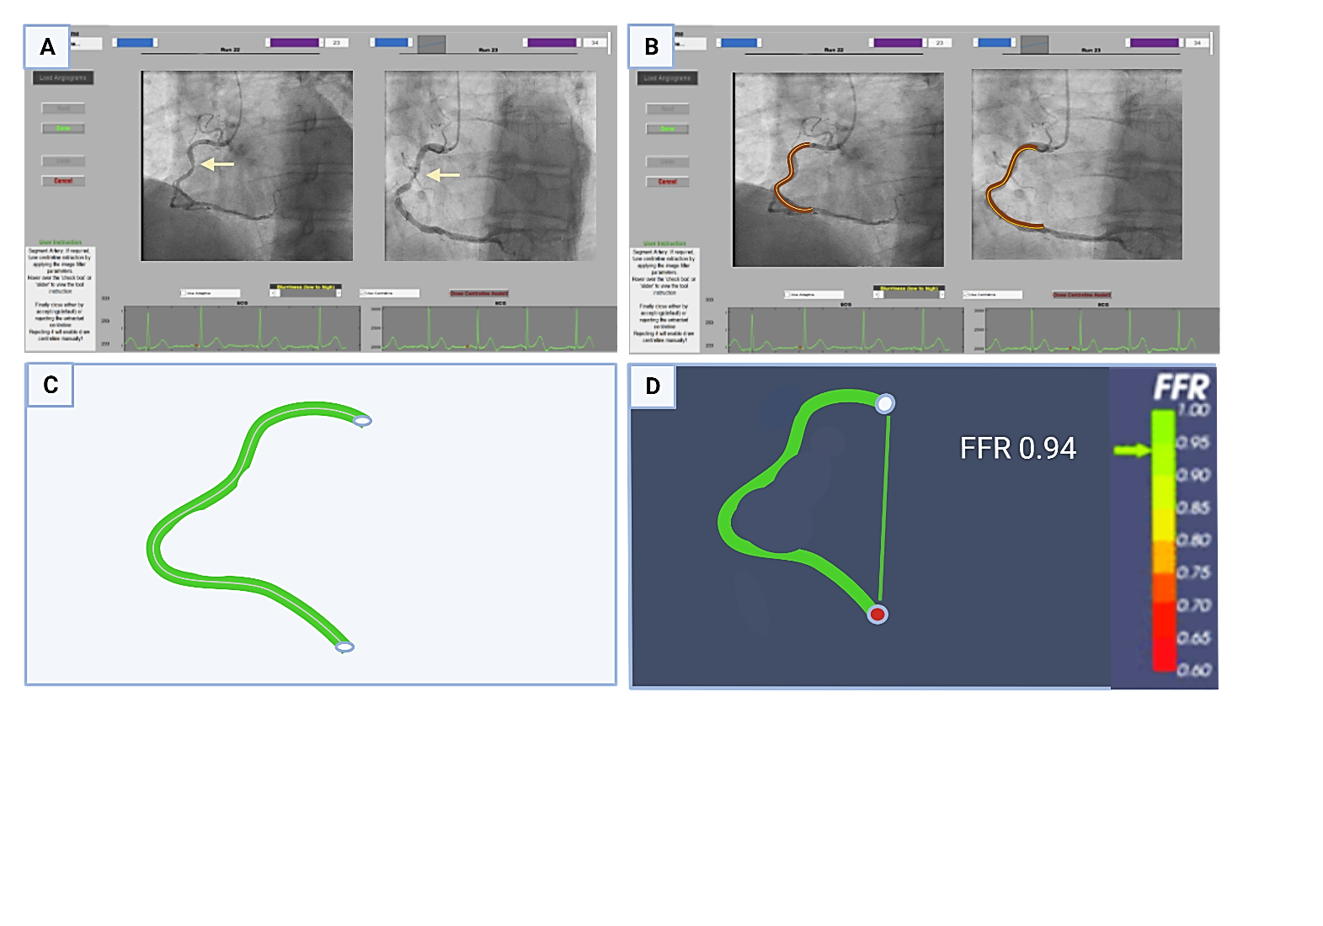
Figure 9: An example of RCA vFFR computation with VIRTUheartTM. Panel A shows a moderate lesion in the mid-RCA (marked with arrows). Panel B shows the outlined segment of RCA after segmentation and application of boundary conditions, ready to be transferred to the CFD simulator. Panel C shows the post-CFD simulation vFFR results in RCA demonstrating non-significance (vFFR 0.94).

The recently conducted VIRTU-4 trial used VIRTUheartTM software and showed a hypothetical change in the management plans of 20.5% of the patients in both ACS and CCS cohorts. Details of this study, which form the basis for my work, have been provided in section 1.13. Another novel application of the Sheffield VIRTUHeartTM system is the development of a virtual coronary intervention (VCI) tool that can predict the physiological outcomes after stent deployment using CFD with a radius correction tool. (148) VCI predicted the functional significance after angioplasty with a diagnostic accuracy of 93% in 101 patients, assessed against measured FFR after stent deployment and only required 95 seconds to perform a simulation in the study. (148)

1.10.2.4 Pros and cons of vFFR
vFFR has the advantages of being fast (only requiring 4-15 minutes per vessel), non-invasive, and can be performed in real time. (126) It can analyse several vessels simultaneously without needing a pharmacological agent for hyperaemia induction. It can also predict a virtual pullback and post-intervention vFFR results. (126) It can nullify the risk of pressure wire-related dissections and be incorporated into any cardiac catheter lab, even without interventional capabilities. (126,158)
Although the final 3D colour-coded constructed model is visually appealing, vFFR has a few limitations. A good-quality angiographic image is necessary to provide an accurate vFFR value. Aorto-ostial, branch ostial and left main stem (LMS) lesions are challenging to model. The software requires meticulous training to reduce the interobserver bias, as in a study, expert re-analysis of the results led to a change in vFFR values, altering the management plan in 37% of cases. (159) Moreover, there is a theoretical assumption that the microvascular resistance remains constant. However, the microvascular response is patient-specific and may be affected by fluid status, blood pressure, and heart rate. (92) There is a limitation to modelling very severe lesions closer to a pixel width; however, there is no question that such tight lesions will be physiologically significant. (92, 146) In addition, if the offer is in the grey zone (between 0.75 and 0.85), there remains to be some doubt in the reliability of the results, and invasive FFR may be required. (92) In summary, vFFR has the potential to be an excellent tool for guiding revascularisation strategies as well as being a gatekeeper to invasive FFR, with further research underway to improve the method.

1.11 Health economics: why is it important for healthcare systems?
Health economics emerged as a sub-discipline of economics in the 1960s and is a tool to facilitate decision-making and provide a framework for how finite public health resources could be allocated to provide the best possible healthcare whilst keeping the cost to the minimum. (160, 161) Health economics is utilised to analyse the cost-effectiveness of any intervention or programme. (162) Owing to technological advancement and innovation, novel treatments must be frequently gauged against the current standards of care to assess if the incremental benefits re worth the additional cost. A personalised and patient-centred approach has given importance to a standard measure, the quality-adjusted life year (QALY), universally used by health economists (see section 1.11.3). (161) Nevertheless, models for health economics evaluation have their weaknesses and hence require continuous analytical review for assessing the impact of society and reducing the ambiguity of the predicted outcome. (161)

1.11.1 Why is health economics important?
In an era of rising healthcare expenditure costs, there is an ever-growing concern about the endurance of healthcare delivery systems worldwide. Consequently, governments around the world have placed a high priority on the healthcare budget, as well as economic considerations, when planning and evaluating their health systems. The United States (US) spent about $7960 per capita on healthcare in 2009, corresponding to 17.4% of its GDP (gross domestic product), and it is estimated to rise to 4% annually. (163) Health economic evaluation is necessary to appraise critically the available therapeutic interventions and treatment options and to ensure that the most cost-effective management protocols are implemented. The goal of health economics is to determine the benefit received from the resources utilised to execute a healthcare programme or any intervention. It also aids in evaluating the “opportunity cost”, which refers to the evaluation of benefits reaped from taking an alternative utility of those resources.
In summary, health economic evaluation results in:
- Assessment of the available financial resources.
- Estimating total QALYs gained with a particular intervention.
- Efficacy of the achieved benefits of the resources utilised.
- Develop unequivocal methodologies for policymaking and strategise priorities.
- Financial appraisal on the impacts of the intended healthcare policy.
- Comparing those policies or programmes to other initiatives.
- Ensuring that the current spending is in alignment with the proposed government policies.
- Identifying additional strategical tactics which may lead to comparable outcomes. (164)

1.11.2 Methods of health economics evaluation
Health economics evaluation is performed using various economic tools, which include:
- Cost-minimisation analysis (CMA) – evaluates the cost difference between two interventions for a similar outcome.
- Cost-effectiveness analysis (CEA) estimates the costs and outcomes of alternative interventions using outcomes in “natural units, " including life-years gained, complications avoided, symptom-free days or cases diagnosed.
- Cost-utility analysis (CUA) – focuses on the estimation of patients’ preference for being in a particular health state, referred to as utility score (between 0-1), with the outcome reported as quality-adjusted life years (QALY)
- Cost-benefit analysis (CBA) – evaluates the outcomes of an intervention, which are estimated from a financial perspective.

1.11.3 Quality-adjusted life years (QALY)
A QALY is defined as the product of quality of life and life expectancy and has now emerged as the key outcome in the CEA and CUA evaluations. (163)
QALY = Number of life years gained x quality of life in those years
By incorporating it into a single metric, QALY can concurrently yield the benefits from a reduction in morbidity (quality gains) and mortality (life year gains). (163) It aids in estimating the value of health states relative to one another and, hence, can furnish meaningful information to policymakers about the technical and allocative efficiency of resources. Despite being an important marker, QALY has some limitations, especially in chronic disorders, as the patient’s adaptability to the disease may skew the values. (163)

1.11.4 Incremental cost-effectiveness ratio (ICER)
ICER is the main result of CEA and CUA economic analysis. It is determined by dividing the cost difference between the two available treatment options by the difference in the unit health outcomes. The typical examples of ICER include costs per life-years gained, costs per QALY gained or costs per event avoided. (165) This can be simplified as (166)
ICER = Cost_{(a)} – Cost_{(b)} / Outcome_{(a)} – Outcome_{(b)}
“Willingness to pay” refers to the maximum amount a customer is willing to pay for the service. ICER can be used for resource allocation if the willingness to pay could be established as a threshold for the outcome of interest. Hence, if the ICER exceeds this threshold, the intervention is perceived as too expensive and vice versa. There is no universal ICER threshold to guide a resource allocation decision; hence, it can vary geographically. UK has adopted an ICER threshold of £20,000 - £30,000/ QALY, while the US has a $50,000 – $150,000 / QALY for resource allocation. (163)

1.11.5 EQ-5D-5L scores (EuroQOL assessment questionnaire)
In the last two decades, researchers have developed a keen interest in patient-reported outcomes (PROs); several questionnaires such as EQ-5D, Short Form health survey (SF-36/12) and Seattle Angina Questionnaire (SAQ) have been developed to focus on how patients feel and report objectively after an intervention. EQ-5D, developed by the EuroQOL group in 1987, has gained the most acceptance worldwide to aid clinician decision-making (medications, devices, and intervention) by health-related quality of life, supported by the patient's self-reported health outcomes. (167) EQ-5D is well-known for simplicity in its scoring system and interpretation and is comprised of EQ-indexed and EQ-VAS (visual analogue scale) scores. The EQ-5D was initiated as a three-level version of EQ-5D-3L, but the EuroQOL task force later upgraded it to a five-level version (EQ-5D-5L). The EQ-5D indexed questionnaire determines the well-being of the patient in the following five dimensions: (167)
- Mobility
- Self-care
- Usual activity
- Pain and discomfort
- Anxiety and depression

The scores from each dimension assessed in the EQ-5D-5L indexed score represent a five-digit code (ranging from 11111 being the best to 55555 the worst). There are 3125 possible health states from the EQ-5D indexed scores. All these individualised five-digit values from the EQ-indexed scores are then mapped into a solitary value, also called the "utility". The utility has been sorted according to the country-specific data set from the EuroQOL. This utility value ranges between 0 and 1 and is used for QALY estimation, a vital tool in health economics evaluation. In contrast, the EQ-VAS score is a simpler version of assessing QOL. It represents the self-reported impression of the patient's functionality and general health status. The scores are between 0-100 (0 being the worst and 100 being the best health the patients could imagine for themselves). Both the EQ-5D-5L indexed and EQ-VAS are shown in Figure 10.


Figure 10: EQ-5D-5L indexed questionnaire and EQ-VAS scale according to EuroQOL

1.12 Health economics of coronary artery disease (CAD)
CAD is amongst the most important public health problems in the United Kingdom as measured by the economic burden of the disease. CAD represents a significant financial burden on the National Health Service (NHS), estimated at around £9bn annually. The growing financial burden is not only due to direct costs associated with treating CAD but also due to indirect costs associated with productivity loss and work disability after the index coronary event.
In the UK, between 2012 and 2018, approximately 1,792,655 non-invasive imaging investigations were performed for suspected CAD or as a non-invasive test to guide definitive revascularisation, with an annualised growth rate of 4%. (168) According to the NHS tariffs 2022-2023, the costs related to these non-invasive investigations were CTCA (£322), stress echo (£186), MPS (£282), cardiac MRI (£577), and invasive coronary angiogram (£1685 - £2369). (169) (170) The average annual direct cost of treatment for CAD in the UK varies from OMT (£2412) to PCI (£1923 - £6923) and CABG (£8427 - £17,712) depending on the complexity of the procedure, according to the NHS tariffs 2022-2023, representing a major financial strain on the economy. (169-171)
CAD is a global problem, and the health economic cost of CAD management is rising rapidly. CAD is estimated to cost the European Union (EU) approximately €169M annually, of which 62% is related to direct healthcare costs. (172) The remainder of expenditure reflects productivity losses (21%) and informal care costs (17%) post-event. (172) In Canada, the cost of per-patient absenteeism from work after a heart attack ranged from C$6974 for one year to C$10,702 for four years. (173) Similarly, in the US, an annual cost of $43.3bn was estimated for the loss of work related to health disabilities post-coronary events. (173) According to one American Heart Association (AHA) report, the medical billing costs for cardiovascular disease will rise from $555 billion to $1.1 trillion in 2035. (174) Health economics plays a vital role in strategising the health care policy in an era of steep inflation with finite resources.

1.12.1 Health economics of PCI
PCI has been the cornerstone of CAD treatment, with considerable progress and ongoing research into the available technology. In the UK, PCI costs vary from simple procedures requiring a single stent for focal lesions (£1879) to complex cases where the cost may amount to £6198, according to the NHS tariffs 2022-2023. (170) In addition to the complexity of the procedure and the number of stents deployed, the access site also plays a vital role in the overall cost burden. As revealed in the RIVAL trial (7021 patients), performing PCI via a trans-radial rather than a trans-femoral approach improved clinical outcomes and significantly impacted the financial cost. (175) In a health economic evaluation meta-analysis of 323,656 patients, the trans-radial approach was found to offer savings of £250.59 per procedure (a 22% reduction) mainly driven by shorter hospital admission duration (£190.43) and escalated rates of same-day discharge (from 23.5% to 57.2%). (176) In the real-world analysis, adopting the radial approach is estimated to provide annual savings of £33.40 million to the UK health economy. (176)
PCI is a cost-effective revascularisation treatment after optimal medical therapy in one or two-vessel CAD. However, PCI has historically been considered in conjunction with CABG in complex triple-vessel or LMS CAD. The economic evaluation of the SYNTAX trial (n=1800) with complex 3-vessel disease, LMS disease or higher SYNTAX score >33 revealed that the total initial index costs were approximately $10,000 higher in the CABG arm ($33,190) than the PCI arm ($23,154). However, during five years of follow-up, costs levelled between the two groups due to more frequent hospital admissions, repeat revascularisation procedures and incremental medication expenses in the PCI group. (177) CABG was associated with an improved ICER of $10,695 at one year with a sustained benefit of $27,485 at five years. (177) However, the sub-group analysis of low Syntax score patients (Syntax <22) revealed that PCI was a more viable economic mode of revascularisation with an ICER of $15012 in favour of PCI. (177) Similarly, the economic appraisal of the FREEDOM trial (1900 patients with diabetes and MVD) revealed that although CABG was overall $8622 more costly than PCI for the index admission; at a five-year follow-up, the cost difference reduced to only $3641 per patient. (178) The expected QALY gained by CABG was 0.86 with an associated ICER of $8064 at one year, with a sustained ICER favourability for CABG at $27,022 at five years. (178). Despite the trials clinically favouring one form of revascularisation or the other, decision-making in the 'real world' remains multifactorial. Therefore, a multidisciplinary approach by the "heart team" is encouraged in complex cases so that a consensus decision can be made in the best interest of the patients.

1.12.2 Health economics of invasive FFR
FFR has proved its effectiveness in clinical settings, not only by improving patient outcomes but also by cost-effectiveness in the long run. A one-year cost-utility analysis of FAME showed improved costs ($14,315 FFR-guided vs $16,700 angiogram-guided arm). (179) A three-year follow-up of FAME-2 revealed that the mean initial cost was higher in the PCI versus the OMT group ($9944 vs $4440), but at three years, the values were similar in both groups ($16,792 vs $16,737). The cost equalisation was due to more revascularisations performed in the OMT cohort. (179) An ICER was estimated to be $17,300 per QALY at two years and $1600 at three years when comparing the FFR-guided PCI to OMT alone. (179) Similarly, in the RIPCORD study (200 patients), the management plan was changed in 26% (52/200) of the patients with FFR, of which 28% (25 out of 89 patients) initially planned for PCI were converted to an OMT plan, and 13% (9 out of 72 patients) originally planned for OMT were converted to a PCI plan, resulting in a 9% net reduction of unnecessary revascularisations, which had an impact on the costs related to PCI and related complications. (180) The RIPCORD-2 trial (n=1100) revealed that adding systematic FFR in all the vessels neither improves the cost (£4510 in the FFR group vs £4130 Angio group, p=0.137) nor makes any difference in the quality of life (75 in FFR vs 75 in Angio, p=0.88) at 12 months follow-up. (171) In the COMPARE-ACUTE trial (885 patients), the economic analysis showed that FFR-guided complete revascularisation was beneficial in comparison to IRA intervention-only, at both one year (€8150 vs €10,319) and three years (€8653 vs €11,100). (181) Overall, the available literature supports the clinical and economic benefits of FFR-guided revascularisation.

1.12.3 Health economics of vFFR
The data related to the cost-effectiveness of vFFR is limited and mainly comes from the studies of FFR_{CT}. The PLATFORM trial (584 patients) demonstrated cost efficiency in FFR_{CT} versus planned-invasive CAG in CCS patients ($8127 vs $12,145) at one-year follow-up. (26) A single-centred UK study (251 patients) showed that the average time in a chest pain diagnostic pathway for definitive investigations for CAD could be reduced from 44 to 28 days if CTCA + FFR_{CT} conjunctural approach is used in comparison to CTCA-alone, at a minor increase in cost of £45 per patient. (182) In 2017, medical technology guidance (MTG32) released by NICE stated that FFR_{CT} is cost-effective and predicted that it may save up to £214 per patient. (141) NICE also stated that adopting the FFR_{CT} approach could lead to savings of up to £9.1m by 2022, which led to the inclusion of FFR_{CT} in the CG95 guidelines. (141)

1.12.4 NICE appraisal of vFFR softwares (QFR and CAAS vFFR)
vFFR, in contrast to invasive FFR and FFR_{CT}, is a relatively new technology; hence, minimal data on the cost-effectiveness of vFFR are available. NICE published a diagnostic guidance (DG43) related to the clinical and cost-effectiveness of the imaging software (QAngio XA 3D QFR and CAAS-vFFR) during CAG. Clinical effectiveness was assessed using a simulation study to estimate the probable impact of vFFR on coronary outcomes compared to invasive FFR evaluation. The sample population was taken predominantly from 39 studies of QFR and three studies of CAAS-vFFR, and the predictive MACE data were extracted from the IRIS-FFR registry as the primary outcome of the simulation analysis. For clinical effectiveness analysis, three treatment strategies for revascularisation decisions were analysed.
- Invasive FFR-guided strategy – Perform FFR for all vessels and revascularise if FFR is ≤0.80.
- vFFR-guided strategy – Perform QFR for all vessels and revascularise if QFR is ≤0.80, without invasive FFR assessment.
- For grey zone patients:
  - If vFFR is less than 0.78, revascularisation should be performed.
  - If vFFR is more than 0.84, there is no need for revascularisation.
  - If vFFR is 0.78 – 0.84, invasive FFR-guided revascularisation should be performed at ≤0.80 threshold.
The outcome of this simulation analysis revealed that the FFR-guided strategy would have led to a revascularisation rate of 40.2%, and the vFFR-guided and grey zone strategies would have led to rates of 42.0% and 43.2%, respectively. Overall, the difference in the clinical evidence slightly favoured invasive FFR over vFFR to guide revascularisation decisions following CAG. It is important to note that this analysis was only performed for stable anginal patients (CCS). As per the outcomes from the ISCHAEMIA and COURAGE trials, revascularisation only improved the quality of life by enhancing anginal symptoms without affecting the MACE outcomes in CCS settings. (183-184)

The cost-effectiveness analysis was also performed using the economic model with a diagnostic and prognostic part. Five strategies were considered:
- Invasive coronary angiogram
- Invasive coronary angiogram + FFR / iFR
- Invasive coronary angiogram + QFR
- Invasive coronary angiogram + QFR, followed by invasive FFR if QFR is in the inconclusive zone (0.78 – 0.84)
- Invasive coronary angiogram + CAAS-vFFR
The base case cost submission for QFR for 200 people per year was £223.50, and for CAAS-vFFR, it was £172.18. The unit cost of invasive FFR / iFR was estimated to be £436.80. Both deterministic and probabilistic models were used for cost-effectiveness analysis, expressed in terms of net health benefit (NHB) at a willingness-to-pay (WTP) threshold of £20000 per QALY gained. Although CAG with FFR was marginally cost-effective at the economic evaluation, the overall net difference in the benefit was minimal. For QFR, the incremental cost was £140 for QALY gain of 0.007, whereas for the CAAS-vFFR, the incremental cost was £240 for QALY gain of 0.012. (185)

The conclusions from this appraisal were:
- vFFR can provide helpful information in some cases without requiring an invasive FFR and mitigate the risks associated with invasive FFR.
- The diagnostic accuracy of QFR was more robust and better correlated with invasive FFR; however, the diagnostic accuracy of CAAS-vFFR was uncertain and required more studies.
- More data are required to evaluate the cost-effectiveness of vFFR compared to traditional CAG alone.
- vFFR is not currently recommended for routine use until more data on patient outcomes is available.
These conclusions suggest that the available data are insufficient to support the widespread use of vFFR in clinical settings. Larger randomised trials may be required to provide more robust evidence to substantiate the efficacy and cost-effectiveness of vFFR.

1.13 The VIRTU-4 study

1.13.1 Background
VIRTU-4 was performed to evaluate the impact of virtual FFR (vFFR computed from the CAG) upon the management of CAD. The approach to use visual assessment of CAG to identify physiologically significant coronary lesions may be suboptimal, resulting in unnecessary or missed lesions requiring revascularisation. Physiological guidance using invasive FFR has shown to change the management plans in 25-38% patients in several studies. (89) Similar to invasive FFR, computed vFFR from the CAG (vFFR) has also demonstrated good diagnostic accuracy when compared to invasive FFR in several studies (145,147,153), hence reflecting a broader potential to be utilised in clinical settings without exposing the risks associated with invasive FFR.

1.13.2 VIRTU-4 design
VIRTU-4 was a prospective, virtual, observational study, including both ACS and CCS patients. A total of 517 patients were screened, of whom 308 (208 ACS and 100 CCS) were recruited. The ACS patients were recruited from Northern General Hospital (NGH), part of Sheffield Teaching Hospital NHS Foundation Trust. The CCS patients were recruited from four district general hospitals (DGH) across South Yorkshire: Doncaster Royal Infirmary (DRI), Rotherham General Hospital (RGH), Barnsley Hospital and Chesterfield Royal Hospital (CRH). It's noteworthy that CCS patient recruitment was significantly impacted by COVID-19, as elective pathways were suspended to prioritise care for COVID-affected patients. As a result, the originally planned number of CCS patients (208) was reduced to 100. Conversely, there was minimal disruption to the ACS pathway in Sheffield.
The recruited patients underwent an invasive coronary angiogram with a pre-specified protocol (good catheter engagement and contrast opacification, no magnification, and at least two cine images 30 degrees apart, recorded over four cardiac cycles). Based upon the visual assessment of coronary angiogram, the initial management plan from the parent cardiologists was recorded (pre-vFFR plan), in addition to the confidence level in their treatment plans. The management plans from the parent cardiologists could include one of the following three strategies:
- Optimal medical therapy (OMT) - This included either initiating anti-anginal medications de-novo (if not on any medications before) or uptitrating the current doses to maximum tolerated levels.
- Percutaneous coronary intervention (PCI) - This included visual assessment-guided PCI and an invasive FFR-guided PCI strategy if indicated.
- Coronary artery bypass grafting (CABG) - This included the number of grafts proposed by the cardiologist after the visual evaluation of CAG.

VIRTUHeartTM software was subsequently applied to vessels exhibiting visually apparent lesions with 30-90% stenosis. The vFFR values were disclosed to the parent cardiologists as computed via VIRTUHeartTM software, and the notional change in the management plan was documented. The change in the plans was virtual because VIRTUheartTM is currently a research-based tool only and is not yet licenced by the Medicines and Healthcare Products Regulatory Authority (MHRA) as a clinical decision-making tool. Patients were followed up six months later via telephone to collect data on major adverse cardiovascular events (MACE), including cardiovascular death, myocardial infarction, repeat revascularisation (performed or planned), symptoms, hospital admissions, and any outpatient investigations performed. QOL data were also collected using the EQ-5D-5L questionnaire at six-month follow-up.

1.13.3 Primary and secondary endpoints of VIRTU-4
The primary endpoints included:
- Evaluate the proportion of patients for whom treatment plan virtually changed after vFFR disclosure between OMT, PCI, or CABG.
The secondary endpoints included:
- MACE at one year (cardiovascular death, MI, re-revascularisation).
- Evaluation and correlation of intra-observer and inter-observer variability of vFFR values.
- Comparison of VIRTUHeartTM against commercially available alternative software, including CAAS-vFFR (Pie Medical Imaging) and QFR (Medis Medical Imaging).
- Evaluation of the effect of vFFR upon the cardiologists' confidence levels.

1.13.4 Outcomes summary from VIRTU-4
In the ACS cohort, there were six MACE events (one death, two MIs, two unplanned revascularisations and one intracranial bleed). In the CCS cohort, there was one MI, but no mortality was reported. There were 33 (23%) unplanned hospitalisations in the ACS cohort and 10 (10%) in the CCS cohort at six months. There was an increase in the confidence level of treatment plans made by the cardiologists in 34.8% in the CCS group and 61% in the ACS group. Addition of vFFR led to a virtual change in the management plan in 65 of 208 (31%) patients in the ACS and 25 of 100 (25%) CCS patients. 52 out of 208 patients (25%) in the ACS cohort were virtually changed to receive medical therapy instead of invasive treatment with PCI. In contrast, 39 out of 100 patients (39%) in the CCS cohort were virtually switched from medical treatment to invasive treatment. The study also demonstrated an invasive FFR could be potentially avoided in 14% (29/208) of ACS patients.

What has VIRTU-4 taught us?
The VIRTU-4 findings are in line with other studies, such as RIPCORD and FAMOUS-NSTEMI, demonstrating the discrepancy between the visually assessed functional significance of a coronary lesion and an FFR-guided approach, in this case, achieved with vFFR. (89) (107) Above results demonstrated that performing vFFR can influence the decision-making in approximately one-quarter of the patients. However, the long-term implications of these changes have yet to be understood. vFFR could be particularly beneficial in cases of multivessel CAD, as it may downgrade the perceived severity and extent of the disease, thereby potentially avoiding unnecessary multivessel PCI or CABG surgery. vFFR can also guide the management of bystander disease in acute settings, promoting a trend towards optimal medical therapy (OMT). This approach can help avoid unnecessary stent placement or invasive FFR evaluation, potentially reducing the overall cost of the index procedure.

Methods

2.1 VIRTU-4 HE overview
The VIRTU-4 HE study is the extended follow-up of data derived from the VIRTU-4 trial, focusing primarily on the impact of vFFR on costs and QOL. All the patients in the VIRTU-4 were eligible to be included in the VIRTU-4 HE. The ACS cohort from the VIRTU-4 included patients with NSTEMI and unstable angina, excluding those with STEMI. In contrast, the CCS cohort consisted of patients experiencing angina symptoms despite being on two anti-anginal medications. The ACS patients were recruited from Northern General Hospital (NGH) in Sheffield, whereas CCS patients were recruited from four district general hospitals (DGHs) in South Yorkshire: Rotherham General Hospital, Chesterfield Royal Hospital, Doncaster Royal Infirmary, and Barnsley District General Hospital. This distribution reflects the practice at the time, where ACS patients underwent CAG/PCI in Sheffield, while CCS patients underwent CAG in their respective DGHs.

2.1.1 Inclusion and exclusion criteria
Inclusion criteria:
All patients from VIRTU-4 ACS (n=208) and CCS (n=100) cohorts were eligible to be included in the study.
Exclusion criteria:
1. Patients who remained uncontactable after five attempts to contact on different occasions.
2. Patients who could not participate in questionnaire completion due to health reasons, such as dementia.
3. Patients who did not wish to continue participation in the trial.

2.1.2 Hypothesis
Virtual FFR-based (vFFR) based management plans can result in important potential changes in cost-effectiveness and QOL compared to the treatment plans based on conventional coronary angiography at 12 months.

2.1.3 Aims and practical objectives
In this project, I aim to analyse the data derived from VIRTU-4 to:
- Determine the clinical outcomes (MACE, interval change in NYHA and CCS class) at 12 months.
- Assess the interval change in quality of life (QOL) one year after the enacted treatment plan (OMT, PCI, or CABG).
- Perform a total cost analysis of all the patients at one year in VIRTU-4.
- Report the actual and virtual outcomes of the virtual change subset patients.
- Compare the costs of the treatment decisions based upon a visual assessment of CAG-alone vs those of the notional changes when vFFR was added to CAG.
- Link the potential impact of cost and clinical outcomes with vFFR-driven notional change in the management plans in accordance with published literature.
- Perform an analysis of concordance between the vFFR-suggested and the expert MDT plans.

The practical objectives include:
- Collate the data from the VIRTU-4 trial.
- Perform a telephone follow-up consultation to collect the data regarding three-point MACE (death, MI, stroke), ischemia-driven revascularisation, hospital re-admissions, outpatient attendance and investigations.
- Evaluate the interval change in NYHA and CCS classes.
- Assess the effect of revascularisation on patient-reported quality-of-life scores.
- Compare the vFFR-driven virtual change in QOL with actual QOL scores.
- Calculate the costs of the treatment plans from the NHS financial perspective.
- Evaluate the impact of vFFR addition to CAG on the costs against the traditional CAG-alone approach.
- Compare how the virtual change in the management strategies post-_{vFFR} would affect the short- and long-term costs and the clinical outcomes.

2.1.4 VIRTU-4 HE endpoints

2.1.4.1 Clinical endpoints
The clinical endpoints at the one-year follow-up were:
- MACE (death, MI, stroke).
- Hospital re-admissions.
- Acute or elective repeat revascularisations.
- Service-related consequences (outpatient investigations or any pending investigations).
- Probable impact of vFFR upon the quality of life (QOL).

2.1.4.2 Health economics endpoints
The health economics endpoints were:
- Actual cost of entire VIRTU-4, which includes the costs of index procedure, hospital re-admissions, revascularisations, outpatient visits and investigations, and cardiac rehabilitation.
- The (virtual) cost of the subset with a virtual change in the plan after vFFR.
- The cost of the subset with no change in the plan after vFFR.

2.2 Research ethics and integrity
Ethical approval was granted for the VIRTU-4 trial (VIRTU-4 Integrated Research Application System {IRAS} ID - 270127, REC reference: 19/NW/0580). The sponsor for this study was the University of Sheffield, and ethical approval was granted for long-term follow-up of VIRTU-4 patients, covering the VIRTU-4 HE study as well.

2.3 Data collection
Data for the VIRTU-4 HE study were collected through telephone consultations. The patients were contacted using the preferred contact details as per noted during the recruitment. The contact details were further matched with the NHS Electronic Health Records (EHR). Our team contacted primary care services and the local DGH hospital teams for those who could not be reached to ensure no alternative contact details were available. Those who remained uncontactable after at least five attempts on different occasions were excluded from the analysis. The data were transcribed to password protected ExcelTM sheets separately for ACS and CCS patients.

2.3.1 Standardised questionnaire
A questionnaire was designed to ensure the standardisation of the data collection. We regained consent from the patients to ascertain that they were happy to proceed. The questionnaire included specific questions related to health outcomes, including MACE events (death, MI, stroke). Information was also gathered regarding any repeat acute or elective revascularisation procedures (both percutaneous and surgical) after the initial treatment within 12 months. Only cardiac cause-driven hospital admissions (both acute and elective) were included; any attendance in emergency department (ED) or GP appointments were excluded. Data related to outpatient (OP) attendance, investigations performed in the outpatient settings, and the total number of OP attendances for each patient were also collated.
Patients were also asked about their occupation, how long they had abstained from work, and if their work nature had changed significantly after the procedure. The impact of the procedure on patients and their families, regarding mental and financial stress, was also questioned, along with need of any social care. Although ACS patients are routinely referred to cardiac rehabilitation; however, due to the COVID-19 pandemic, most of the appointments were either cancelled or switched to virtual ones. The data related to attendance in cardiac rehab were also gathered to assess the opportunity loss of rehab due to COVID-19. The detailed questionnaire can be viewed in the Appendix section.

2.3.2 Quality of life (QOL) scores
The QOL data were collected using the EQ-5D questionnaire during the telephone consultation. The EQ-5D-5L version of the EuroQOL group was utilised, and both the EQ-indexed and EQ-VAS scores were gathered at a 12-month follow-up to be compared from the baseline (at the time of recruitment). Additionally, the QOL scores were compared after excluding potential non-cardiac reasons for the reduction and predicted virtual QOL scores (based on the expert MDT and literature).

2.3.3 Clinical classifications (NYHA and CCS class) used in data collection
The data relating to NYHA and CCS classes at the time of recruitment in the VIRTU-4 were documented, which served as a baseline. The symptoms were re-evaluated at 12 months via telephone consultation to assess the interval change in the NYHA and CCS classes. The expert review MDTs also predicted the virtual change in the NYHA and CCS classes (in addition to the actual outcomes) for those who had a virtual change in their treatment plans.

2.3.4 Data protection and storage
The General Data Protection Regulations (GDPR) were strictly followed throughout the length of study, and all the patient data were anonymously collected and utilised transparently, confidentially, and lawfully. The data were collected in paper questionnaire form during telephone consultation and then transcribed to an encrypted, password-protected laptop ensuring confidentiality. The data were stored in password-protected Excel™ sheets separately for both ACS and CCS patients. Access to the data was shared only with our research team members through a password-protected Google SheetsTM document. After transcription, all the paper questionnaires were securely kept in the research academic office in the Chesterman wing, D-floor, Northern General Hospital (NGH). Data collection and analysis were strictly conducted in accordance with the General Data Protection Regulation (GDPR).

2.4 Summary of VIRTU-4 HE design
All patients included in the VIRTU-4 were contacted via telephone consultation and data were collected related to clinical outcomes (MACE, hospital re-admissions, repeat revascularisations, CCS and NYHA classes). Those who remained uncontactable after at least five attempts on different occasions were excluded from the analysis (28 excluded from ACS and 14 from the CCS group). The clinical and health economics endpoints were evaluated in the contactable patients of VIRTU-4 (n=266) and is shown in Figure 11.

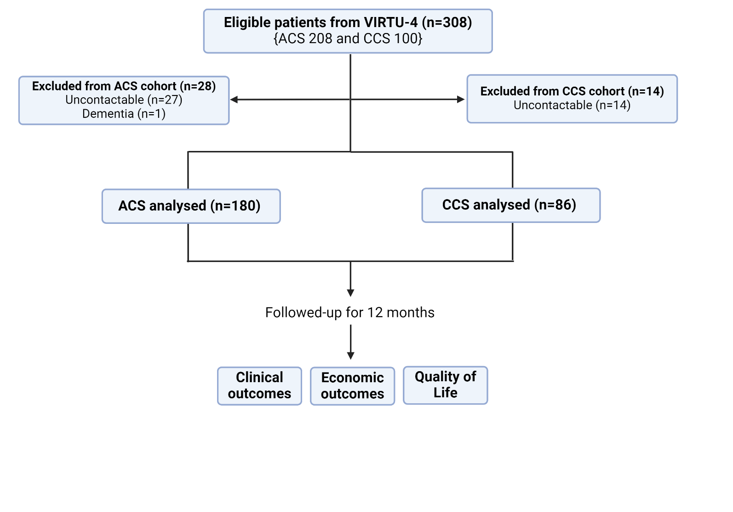
Figure 11: Consort diagram for inclusion and exclusion in the VIRTU-4 HE study

In addition, a particular emphasis was placed on patients whose management plans were virtually altered by their parent cardiologists after vFFR disclosure (n=65), referred to as ‘virtual change subset’. It was aimed to evaluate the potential impact of vFFR on total costs and QOL resulting from changes in treatment decisions. The patients in the virtual change subset (n=65) were re-discussed in two independent expert multidisciplinary teams (MDTs), each comprising two interventional cardiologists. Both MDTs convened twice (each MDT lasted for four hours) to discuss the virtual change subset patients. The MDTs were conducted in the same format as the main VIRTU-4 study to standardise the decision-making process. The MDTs were presented with a detailed medical history and clinical data, followed by the CAG cine images. MDTs proposed a management plan based on the visual assessment of CAG (pre-vFFR plan). The vFFR results were then disclosed and the virtual change in the treatment strategy was recorded (post-vFFR plan). The pre- and post-vFFR plans from the MDTs were then used to check against the VIRTU-4 parent cardiologists’ plans to check for concordance. The MDTs were also presented with the actual clinical outcomes regarding MACE, QOL, NYHA and CCS classes. The virtual changes in management plans were linked to the potential clinical, economic and QOL consequences (in line with the published literature) to estimate the impact of vFFR addition to CAG-based treatment in CAD.
In summary, the aims of the expert MDTs were to:
- Evaluate the concordance of the pre- and post-vFFR treatment plans between the parent cardiologists from the VIRTU-4 and the expert MDTs to assess the variability between individual vs collective decision-making.
- Link the potential impact of virtual change in treatment from vFFR to the clinical (MACE, NYHA class, CCS class) and economic outcomes along with QOL.
The outline of VIRTU-4 HE study, and flow chart of expert MDTs have been shown in Figures 12,13, and 14 respectively.

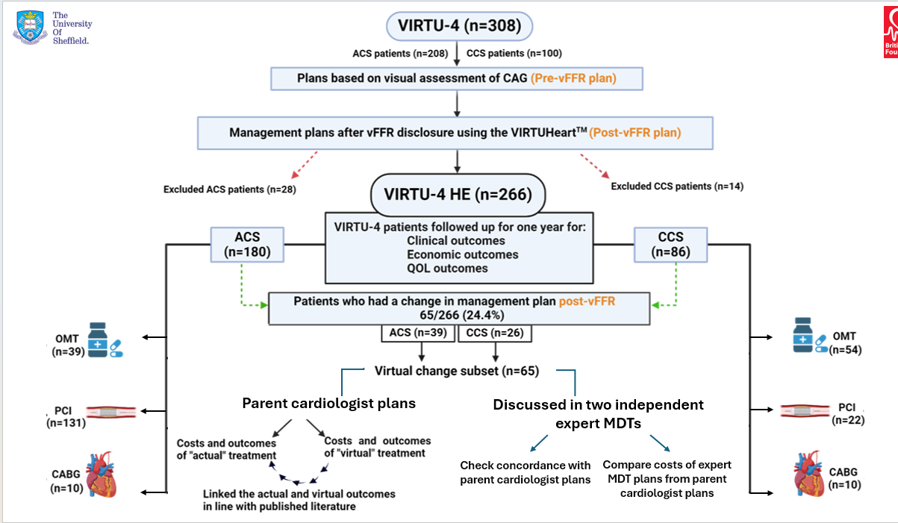
Figure 12: Outline of VIRTU-4 HE study

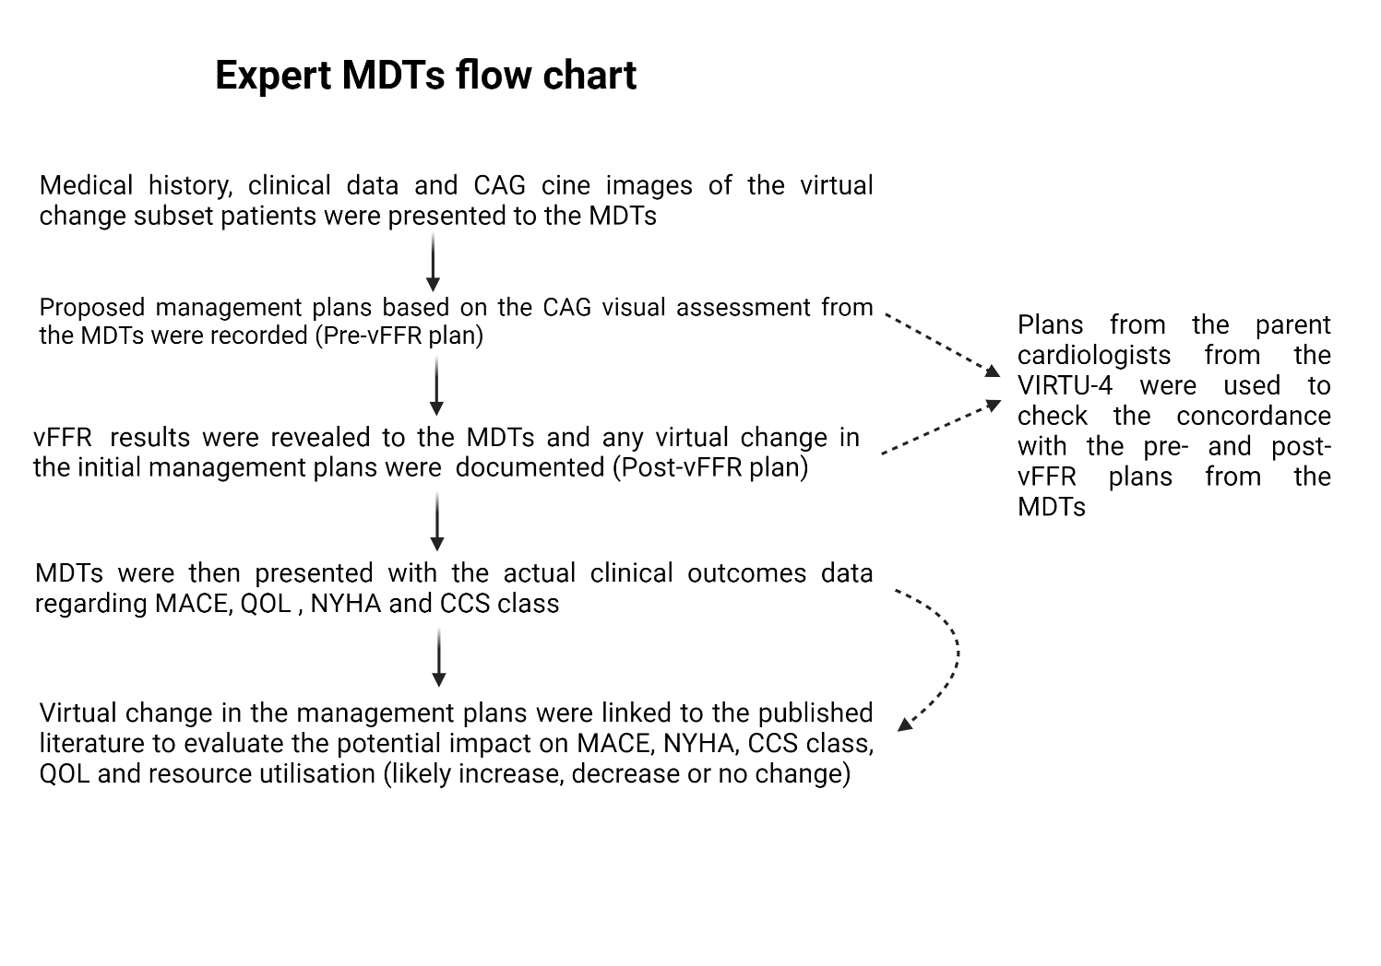
Figure 13: Expert MDTs flow chart
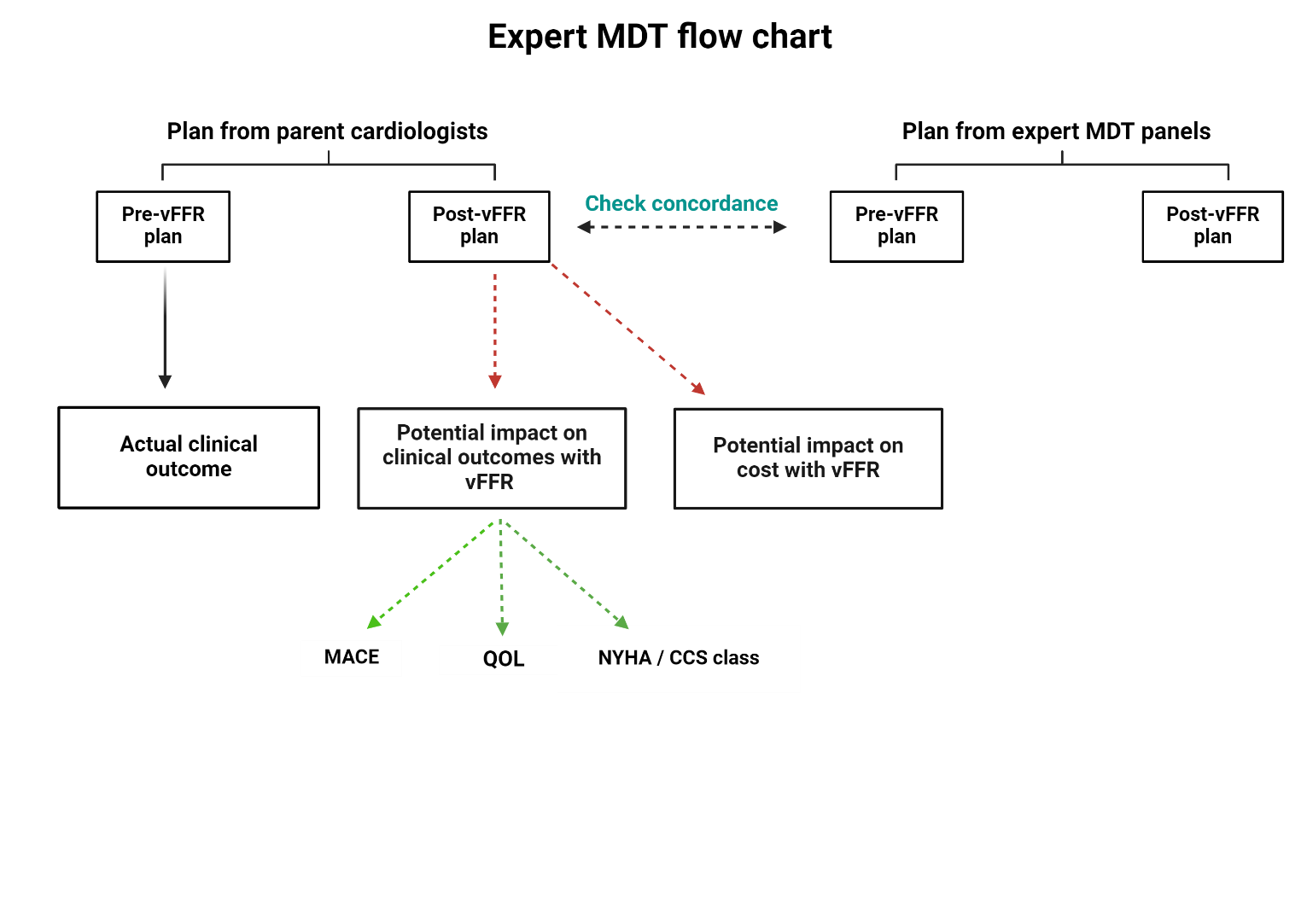
Figure 14: Summary of expert MDTs flowsheet.

2.4.1 Concordance between the parent cardiologist and expert MDTs plans
The treatment plans from the expert MDTs were correlated to those from the parent cardiologists in VIRTU-4. It is of note that a general cardiologists treated the CCS patients (recruited from DGHs), whereas the ACS (recruited from NGH) patients were treated by interventionists (cardiologists specialised in coronary intervention). The pre-vFFR concordance was performed to determine the interobserver variability in the visual assessment of stenotic lesions on CAG and treatment plans based on them. Post-vFFR plan concordance was used to assess interobserver variability in adapting to the vFFR recommendations and to evaluate how vFFR could facilitate more appropriate treatment decisions, based on the assumption that MDT collective decision-making is more appropriate than individual decision-making. The notional changes in the management plans were linked to the virtual outcomes in line with the available published literature to estimate the potential clinical and economic impact of vFFR-based treatment decisions in ‘real world’ practice.

2.4.2 Estimating the potential clinical and economic impact of the virtual change in treatment with vFFR
The expert MDTs were presented with the patient's actual clinical outcomes from the virtual change subset at a one-year follow-up. The MDTs provided their independent expert opinion for each patient individually about how the vFFR-directed plans could have impacted the treatment plans. The potential change in outcomes with the virtual change in the treatment plans after vFFR were extrapolated from already published literature and were applied to the patients to estimate the impact on MACE, QOL, resource utilisation and improvement in CCS/NYHA classes (referred to as ‘virtual outcomes’). The estimation of virtual outcomes from the published literature and their applicability to the patients has been discussed below with examples.

2.4.2.1 Estimating the virtual change in MACE
The literature was extensively searched for the cumulative incidence of MACE and QOL in ACS and CCS settings that had the closest match to our cohort of patients in order to estimate the outcomes. Therefore, the MACE risk for the ACS patients was sourced from RITA-3 and a real-world large observational study of 5112 patients. The RITA-3 study (n=1810) compared the early invasive therapy vs the conservative management for patients with acute coronary syndrome. It demonstrated lower MACE in the invasively treated patients (13.5%) vs the conservatively treated patients (18.4%). (186) The observational study interrogated the PCI and CABG in ACS settings and found no statistically significant difference in MACE at one year (11.1% PCI vs 11.7% CABG, p=0.66), though, the long-term follow-up at ten years showed noticeable benefit with CABG (28.4% PCI vs 20.4% CABG, p<0.006). (187)
The annual MACE risk associated with treatment strategies for CCS patients was sourced from FAME-2 and FAME-3 studies. The FAME-2 (n=1220) investigated the FFR-guided PCI against medical therapy in stable CAD, whereas FAME-3 (n=1500) probed the outcomes of FFR-guided PCI against CABG in multivessel stable CAD. The annual MACE risks for stable CAD patients treated with OMT, PCI and CABG were 19.5%, 8.1% and 6.9% respectively. This difference in MACE between OMT and invasive treatment (PCI and CABG) was primarily driven by repeat revascularisations in the OMT arm, without any obvious mortality benefit with PCI or CABG. (188,189) Similar results were also shown in ISCHAEMIA and COURAGE trials of stable CAD about symptom improvement without any mortality benefit. (183, 184)
In accordance with the above evidence, within the ACS cohort, if the vFFR suggested invasive treatment over medical therapy, an additional predicted MACE risk of 4.9% was factored into the virtual outcomes, based upon findings from the aforementioned literature. For the CCS cohort, since invasive treatment did not significantly impact mortality, the primary difference was attributed to repeat revascularisation; therefore, if the vFFR suggested an invasive strategy but the patient was managed medically, a projected 11.4% risk of repeat hospital admission was incorporated into the virtual outcomes.

2.4.2.2 Estimating the virtual change in QOL
The impact of treatment on QOL for ACS patients was also furnished from the RITA-3 study (n=1810), which showed that QOL improved significantly in invasively treated ACS patients compared to medical therapy alone. (190). The interval change in the EQ-VAS and EQ-indexed scores at one year for medically treated patients was 6.2 ± 1.2 and 0.063 ± 0.009, respectively. However, invasively treated patients had a more significant interval change in EQ-VAS 9.2 ± 1.2 and EQ indexed scores 0.079 ± 0.009 from the baseline. (190) There was no statistically significant difference in the QOL scores between PCI and CABG at one-year follow-up in the ACS patients (p=0.6). (186) For the CCS patients, both FAME 2 and FAME 3 trials suggested a greater improvement in the QOL with invasive treatment (PCI and CABG) compared to medical therapy alone. The interval change for EQ-VAS and indexed scores was 5.3 ± 16 and 0.04 ± 0.015 for the patients treated with OMT, whereas the interval change for EQ-VAS and EQ-indexed scores at one year for invasive therapy (with PCI and CABG) was 10.3 ± 10 for EQ-VAS and 0.07 ± 0.15 for EQ-indexed scores. (191) The impact on QOL with PCI and CABG was identical at one year in FAME-3. However, patients treated with revascularisation (PCI or CABG) were more likely to stay angina-free than with medical therapy alone. This benefit in QOL was sustained even in the elderly population over 75 years of age. (192)
Therefore, based upon the aforementioned literature, within the ACS cohort, if the vFFR suggested invasive treatment over medical therapy, the virtual scores were adjusted by adding 3 points to the EQ-VAS and 0.01 to the EQ-indexed scores. Similarly, for the CCS cohort, if the vFFR suggested invasive therapy over medical therapy, a virtual increase of 5 points in EQ-VAS and 0.03 in EQ-indexed scores was applied. Conversely, if the vFFR suggested an unnecessary intervention in ACS or CCS patients, the same scores were deducted from their original QOL scores to reflect the potential adverse impact upon the overall quality of life.

2.4.2.3 Estimating the potential risks associated with invasive therapy
Any invasive procedure is not without its risks. Even an invasive pressure wire assessment alone, without a follow-on PCI, has associated risks, including coronary dissection 0.03%, arrhythmias 0.02%, severe bronchospasm 0.02%, stroke 0.08%, and death 0.015%, according to the IRIS FFR registry. (193) Similarly, in large registries, a 30-day mortality risk associated with CABG and PCI is around 3.5% and 0.5%, respectively. (194,195)

2.4.2.4 Examples of vFFR-driven change in treatment plans and its potential impact on outcomes

Example 1 - Virtual change from mFFR to OMT plan
A 54-year-old female, with prior history of MI, HTN, hypercholesterolaemia, presented as ACS. A mid RCA lesion of moderate stenosis was noted, and post-CAG plan was to perform an invasive FFR. The plan was virtually changed to OMT after vFFR values showed physiological non-significance (vFFR 0.94). The invasive mFFR performed in this case for mid RCA was 0.96, which was concordant to the mFFR results. By following the vFFR plan, a patient could avoid undergoing an unnecessary invasive mFFR assessment, thereby eliminating the potential risk of coronary dissection (0.03%). This translates to a virtual peri-procedural MACE risk reduction of 0.015% according to the literature. There would be no change in QOL, as patients would continue to be treated with OMT due to a non-significant mFFR. However, economically, following the vFFR plan could save the cost of a pressure wire, which is £586.
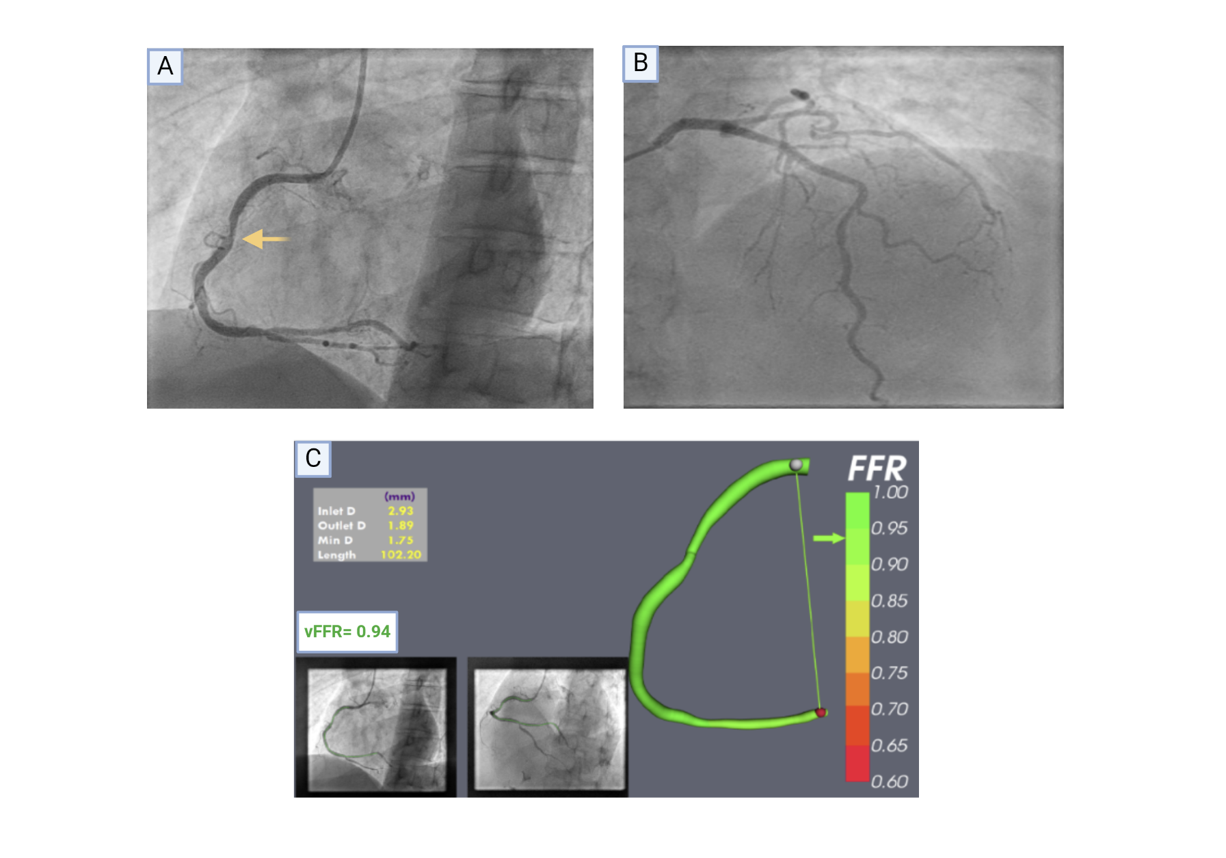
Figure 15: Example 1 – Virtual change of plan from invasive mFFR to OMT. A - Mid RCA moderate lesion on CAG marked with an arrow, B - Undiseased left coronary system, C - vFFR model of RCA demonstrating physiologically non-significant lesion (0.94). (vFFR image – courtesy of Dr H Haley).

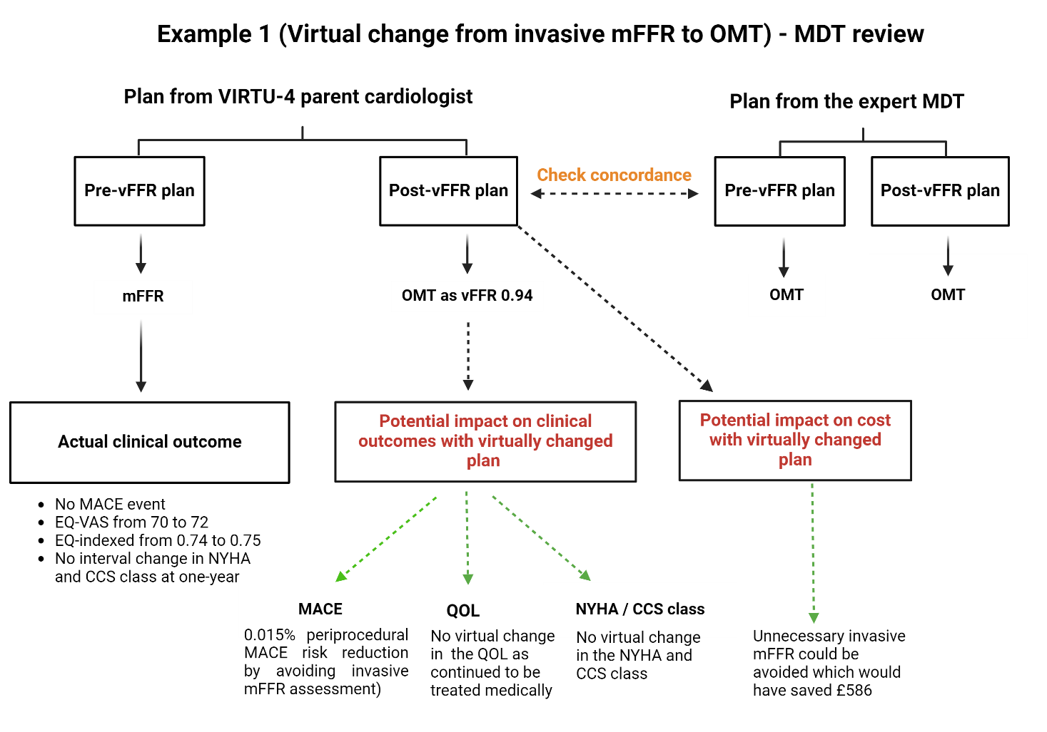
Figure 16: MDT flowsheet for Example 1 – ‘Virtual change from invasive mFFR to OMT’ showing the impact of vFFR on the virtual clinical and economic outcomes.

Example 2- Virtual change from one-vessel PCI to two-vessel PCI
71 years old, with significant smoking history, presented with ACS. After the CAG, it was planned to perform PCI of LAD, and to medically manage the LCx lesion as was visually appearing moderately stenotic on CAG. vFFR results for LAD were concordant with the visual assessment (vFFR=0.67), however, vFFR demonstrated a significantly positive result (vFFR=0.56) for LCx which was initially deemed to be non-significant by visual estimation (visual-physiological discordance). The treatment plan was virtually changed to two vessel PCI (PCI to LAD and LCx) after vFFR which would have been clinically more appropriate as LCx lesion would warrant revascularisation. As a result, it could potentially reduce the annual incidence of MACE and repeat revascularisation by 4.9% and 11.4%, respectively. Although, the procedure itself will result in an extra spend of £420 for additional vessel revascularisation but could virtually improve QOL scores by 3 ± 1 (EQ-VAS) and 0.1 ± 0.01 (EQ-indexed) by improving the anginal frequency/CCS class.

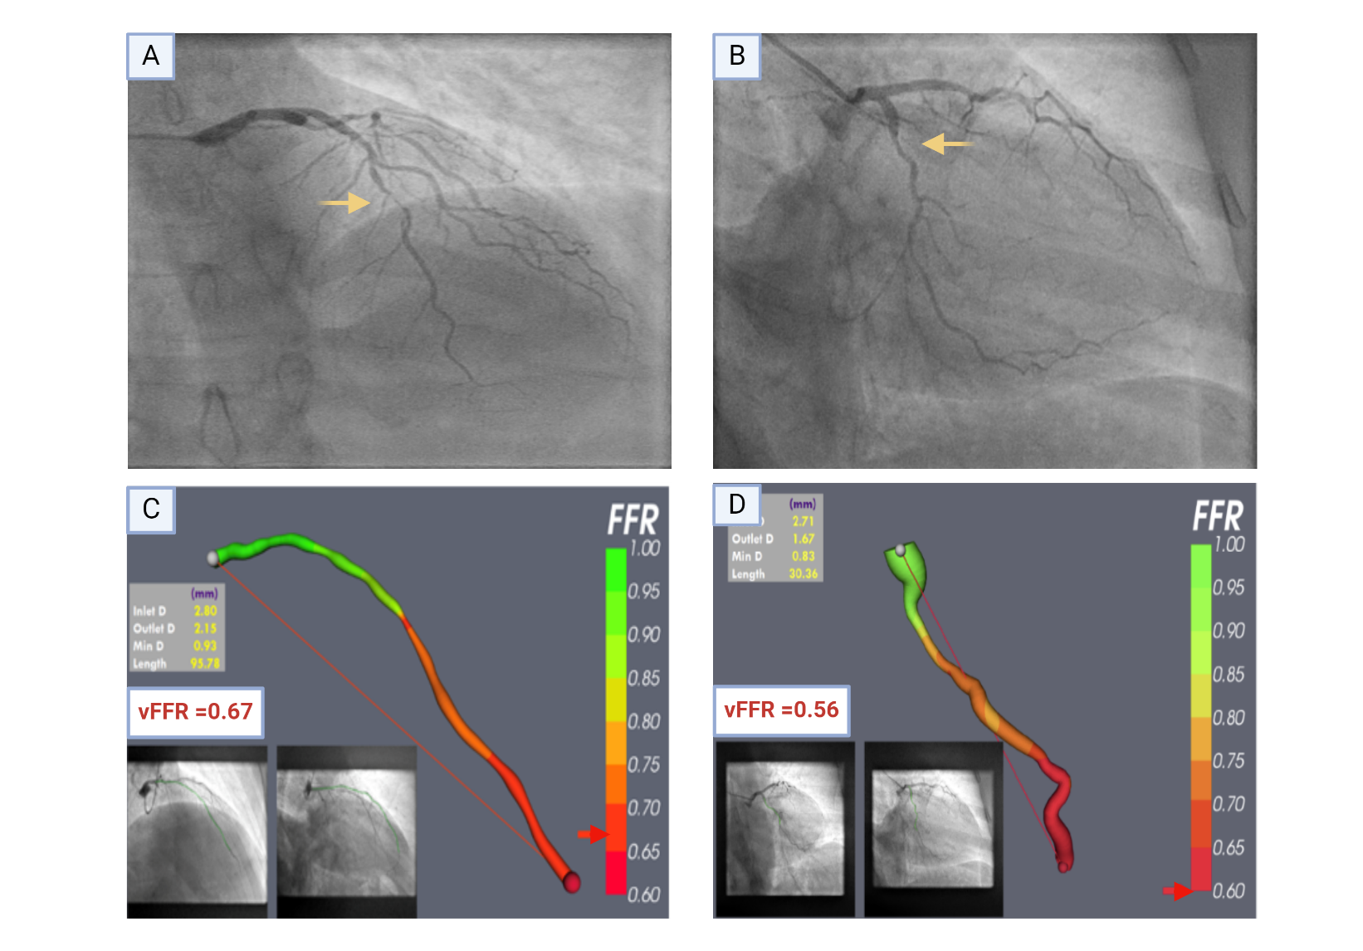
Figure 17: Example 2 - Virtual change of plan from one-vessel PCI to two-vessel PCI. A - Severely diffused left anterior descending (LAD) artery disease on CAG marked with an arrow, B - Visually moderately stenotic lesion in left circumflex (LCx) artery marked with an arrow (for medical therapy in the pre-vFFR plan), C - vFFR model of LAD demonstrating significantly ischaemic vFFR (0.67), D – vFFR model of LCx showing markedly ischaemic lesion (0.56) resulting in virtual change in plan from one-vessel PCI to two-vessel PCI. (vFFR image – courtesy of Dr H Haley).

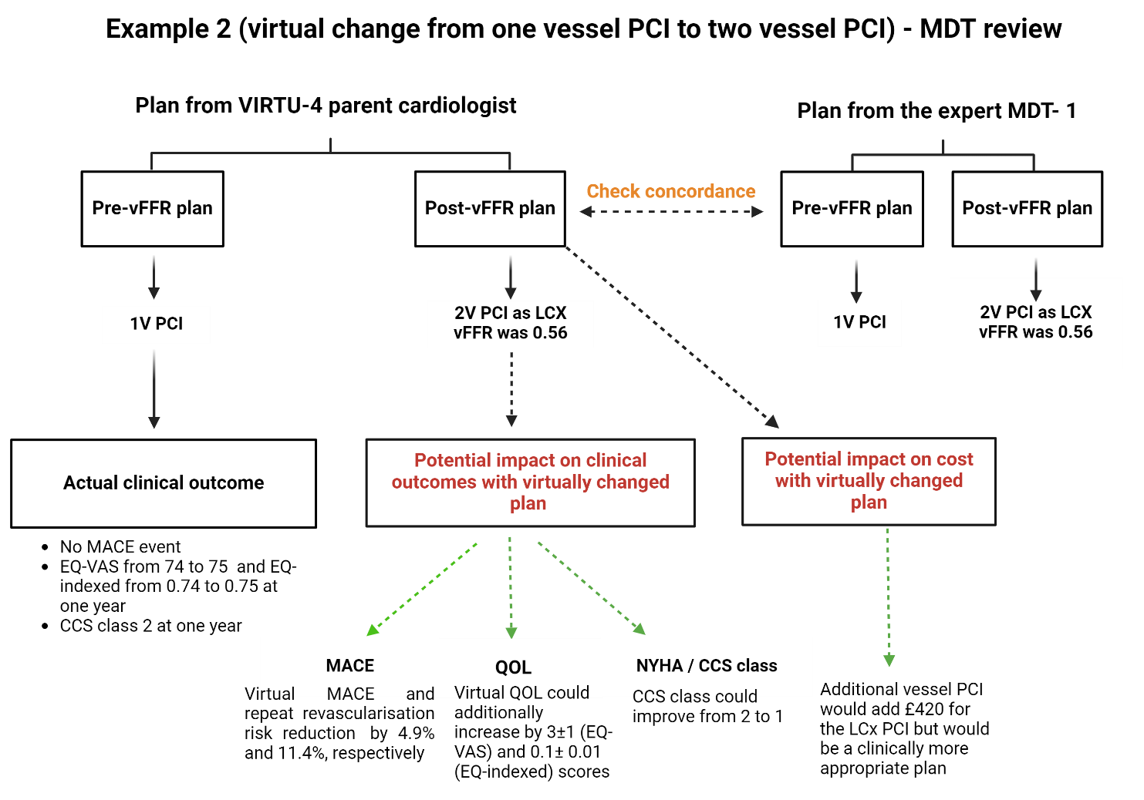
Figure 18: MDT flowsheet for Example 2 – ‘Virtual change from one vessel PCI to two vessel PCI’ showing the impact of vFFR on the virtual clinical and economic outcomes.

Example 3 - An avoidable peri-procedural TIA
78 years old with ACS presentation, had a tight lesion in the posterior descending artery (PDA) as the likely culprit along with a moderately stenotic mid LAD lesion. The initial pre-vFFR plan was to perform PCI of PDA along with an invasive mFFR assessment of mid LAD lesion. Patient underwent successful PCI of PDA lesion. However, during the mFFR evaluation of LAD lesion, patient developed acute confusion and speech disturbance (peri-procedural TIA) due to which the procedure was abandoned. vFFR results showed that LAD lesion was physiologically non-significant (vFFR=0.83). An urgent CT head was performed which didn’t show an infarct and fortunately, the patient had a complete recovery within couple of hours. Hence, following a vFFR plan not only would have avoided an iatrogenic peri-procedural TIA but also resulted in cost savings of an invasive mFFR (£586). The virtual annual MACE risk could be reduced by 0.015%. Although, the neurological features resolved fully, but a full-blown ischaemic stroke could have had a detrimental impact on QOL and costs.

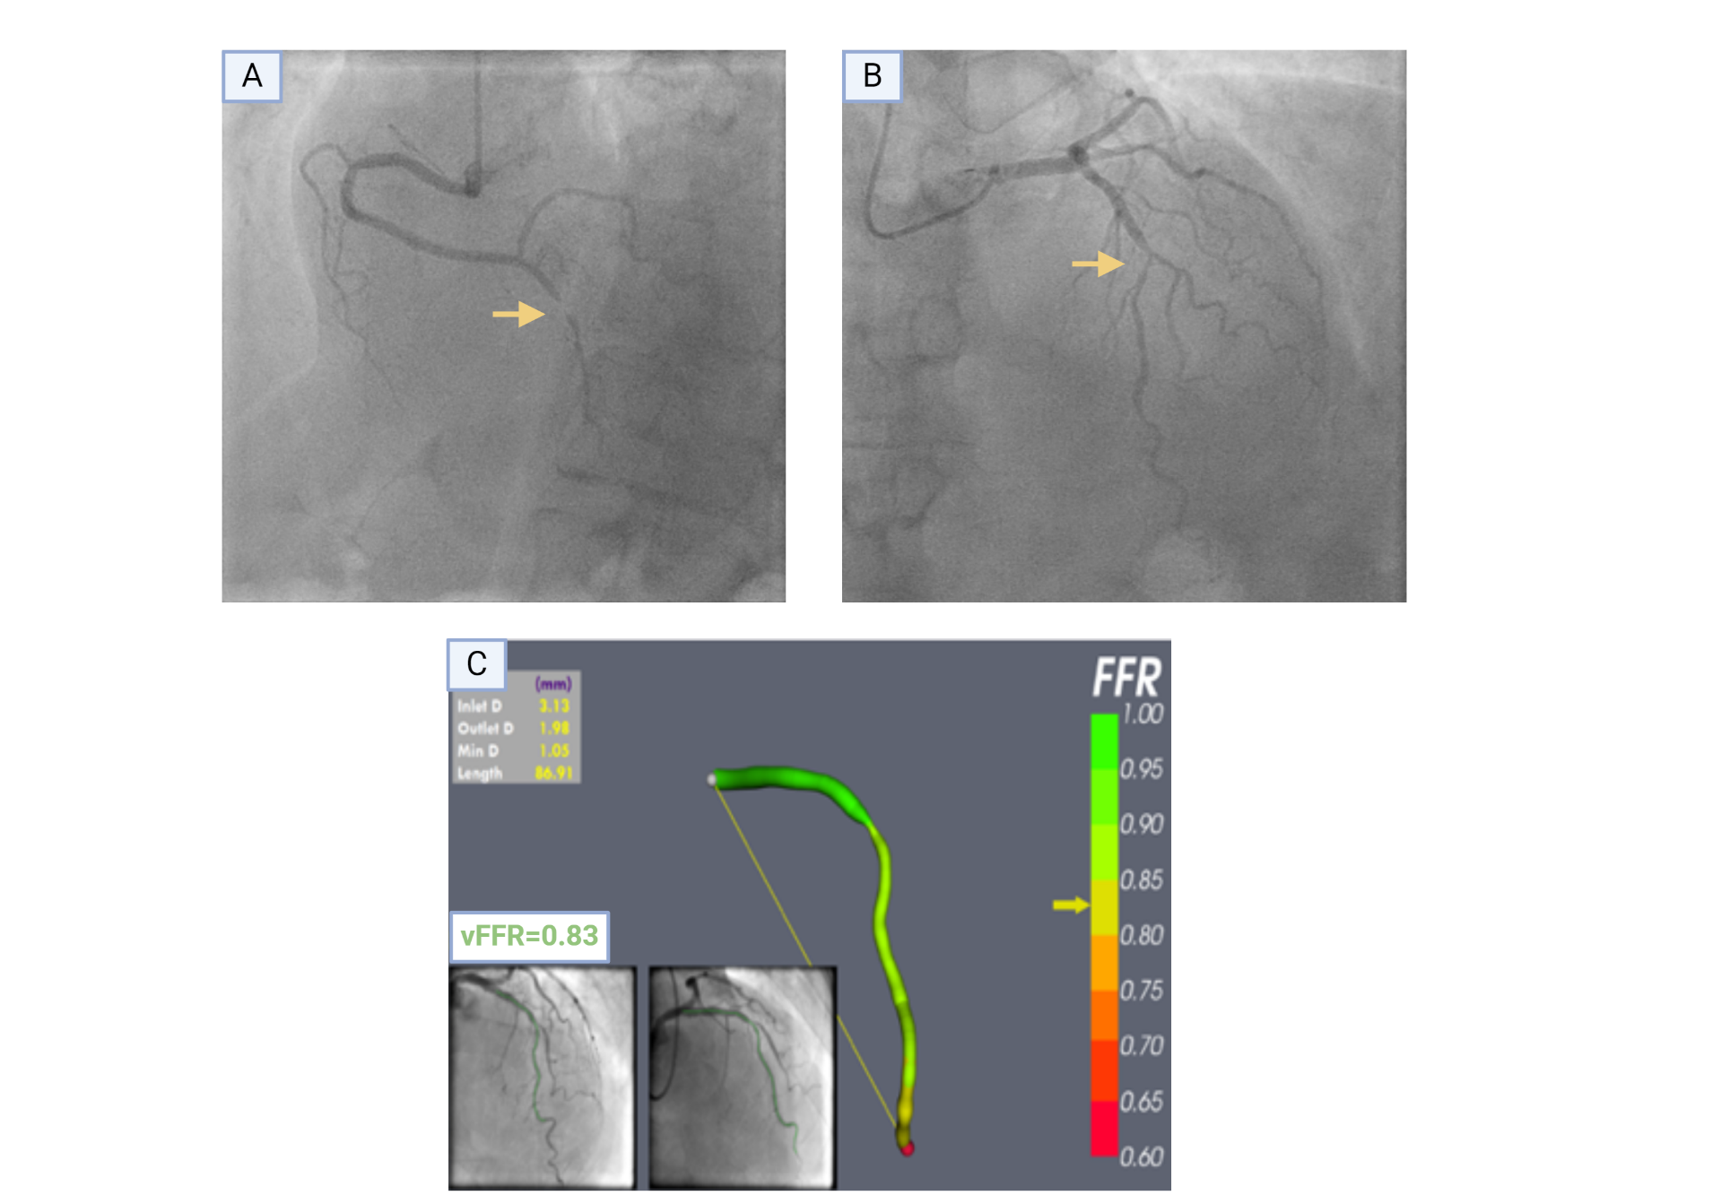
Figure 19: Example 3 - Virtual change of plan from culprit-vessel PCI + additional vessel mFFR to culprit-vessel PCI only. A - Very tight lesion in the posterior descending artery (PDA) as the likely culprit (marked with arrow). B – Moderately stenotic lesion in the mid-LAD (marked with arrow), C – vFFR model of LAD demonstrating physiologically non-significant lesion (vFFR=0.83) which could have prevented an adverse event by avoiding unnecessary instrumentation with invasive mFFR. (vFFR image – courtesy of Dr H Haley).

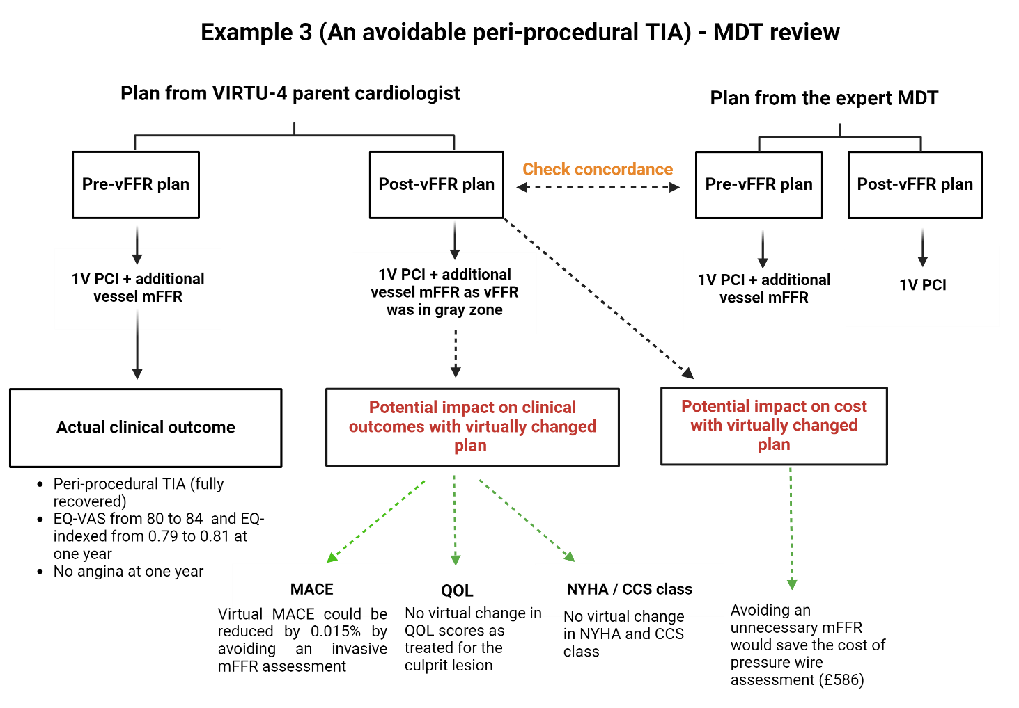
Figure 20: MDT flowsheet for Example 3 – ‘An avoidable peri-procedural TIA’ showing the impact of vFFR on the virtual clinical and economic outcomes.

Example 4 - A tale of diffuse disease
A 76-year female with prior history of treated hypertension and smoking presented with ACS. CAG showed a culprit tight lesion in the PDA and diffused disease in LAD from mid to distal segment. Pre-vFFR plan was to perform PCI to PDA lesion and medical treatment of LAD. vFFR demonstrated a positive result (0.74) and therefore, plan was switched to two vessel PCI. However, it’s important to mention that it showed a diffused distal ischaemia in LAD. This case exemplifies that although vFFR is a valuable tool for CAD treatment planning, the results must still be weighed in a broader clinical judgment in order to avoid being drawn into overzealous invasive treatment with positive vFFR results that may be detrimental to the patients. Following vFFR plan in this scenario could have exposed patient to an additional 0.5% MACE risk from PCI, additional cost of £420, and could have resulted in reduction in QOL scores by 3 ± 1 (EQ-VAS) and 0.1 ± 0.01 (EQ-indexed).
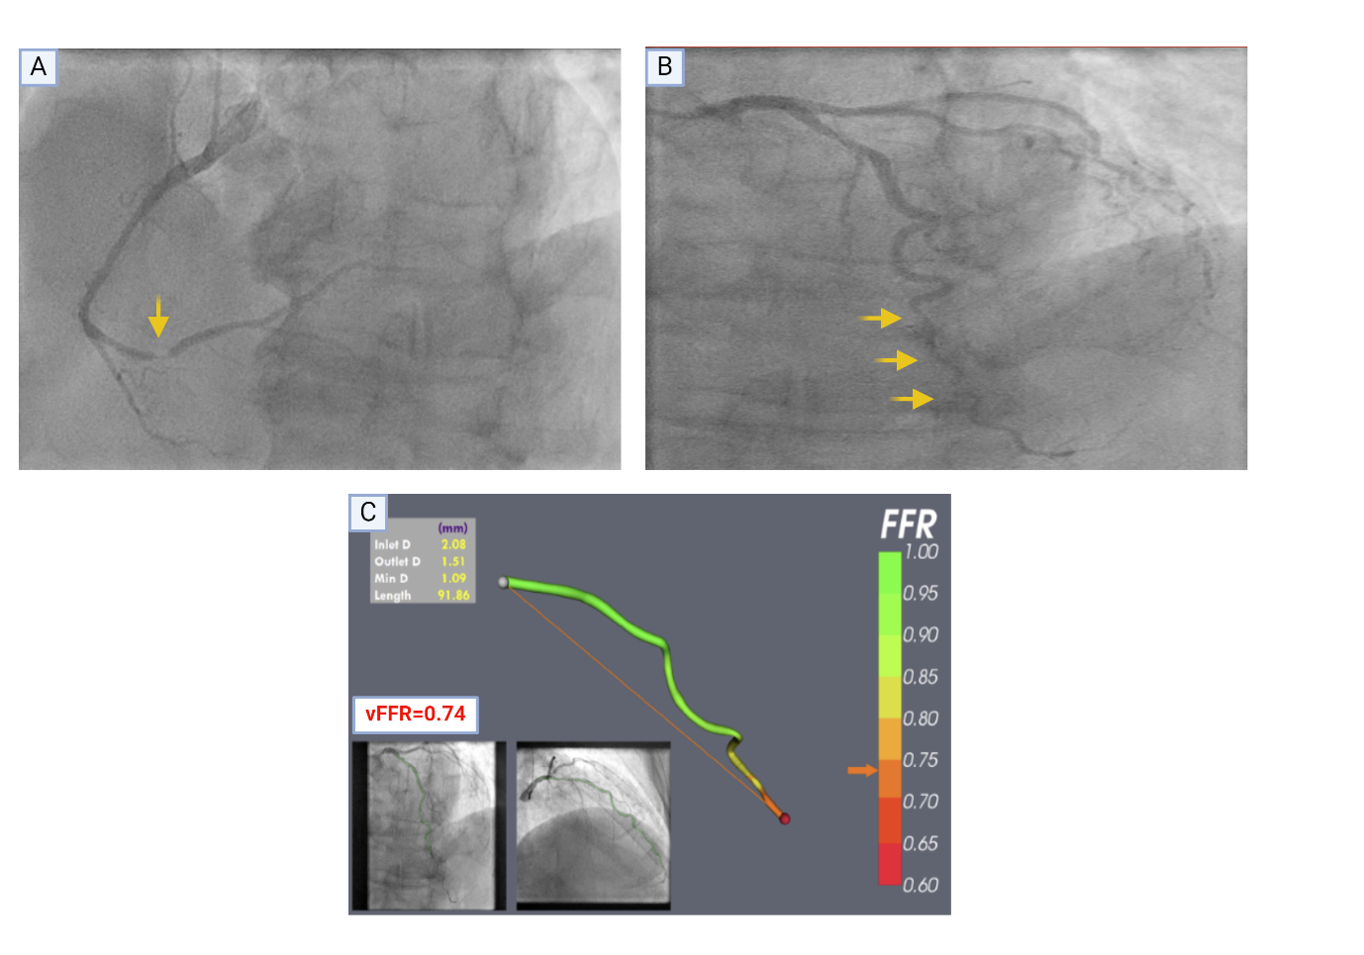
Figure 21: Example 4 - A tale of a diffuse disease with positive vFFR, A - Tight lesion in PDA marked with an arrow (culprit for ACS), B - Diffused distal LAD disease (marked with arrows), C - vFFR modelling of LAD demonstrate distal LAD positive results (vFFR=074) but diffused distal disease not worth for intervention, and hence managed medically. (vFFR image – courtesy of Dr H Haley).

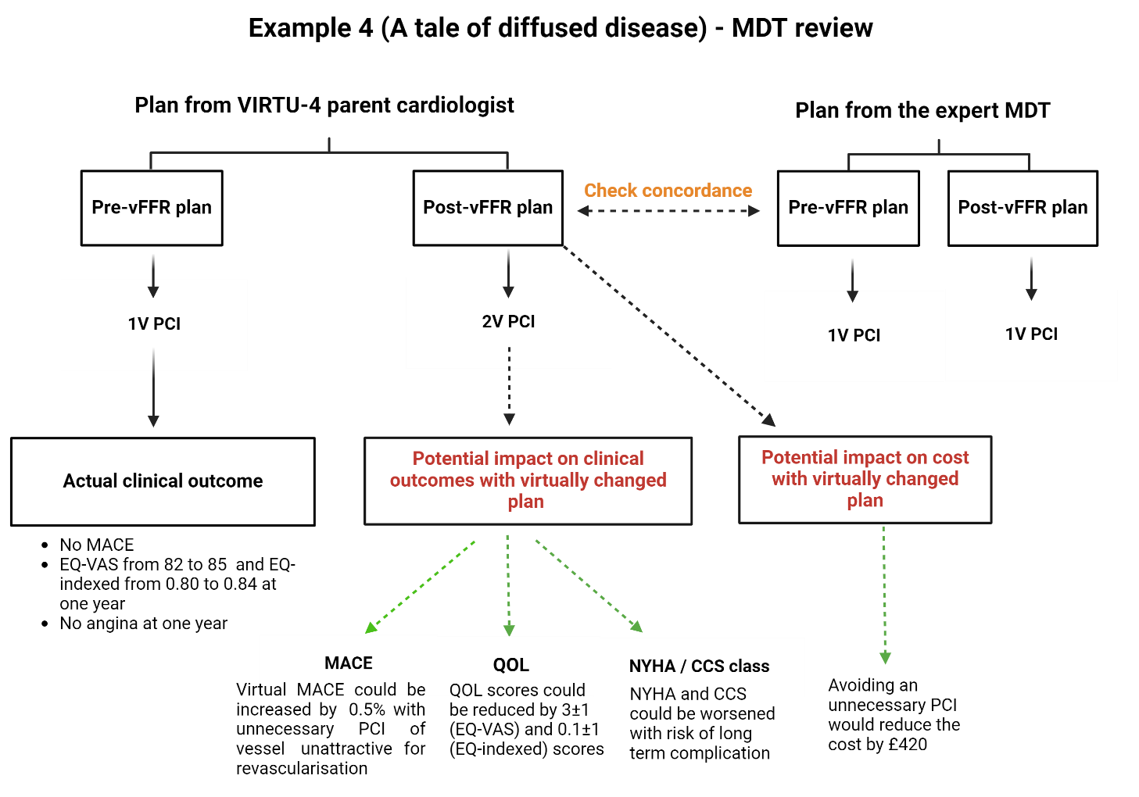
Figure 22: MDT flowsheet for Example 4 – ‘A tale of diffused disease’ showing the impact of vFFR on the virtual clinical and economic outcomes.

Example 5 - An avertible CABG
A 73-year-old smoker, with hypertension and diabetes, presented with worsening symptoms of angina despite OMT. The coronary angiogram demonstrated multivessel disease with severe diffuse disease in RCA, moderate long segments of LAD and LCx disease. Considering diabetes and multi-vessel disease, the initial plan pre-vFFR was to refer for CABG but vFFR demonstrated that visually significant looking LCx lesion was physiologically non-significant (vFFR=0.85), hence lowering the SYNTAX score, due to which post-vFFR plan was virtually changed to two-vessel PCI. This change in plan could have saved the patient from a major heart surgery and its associated 3.5% higher 30-day mortality compared to PCI. With this change, a two-vessel PCI plan would have delivered major virtual savings of £8972 versus the CABG plan. As PCI and CABG result in a similar improvement in QOL, the interval change will be unequivocal.

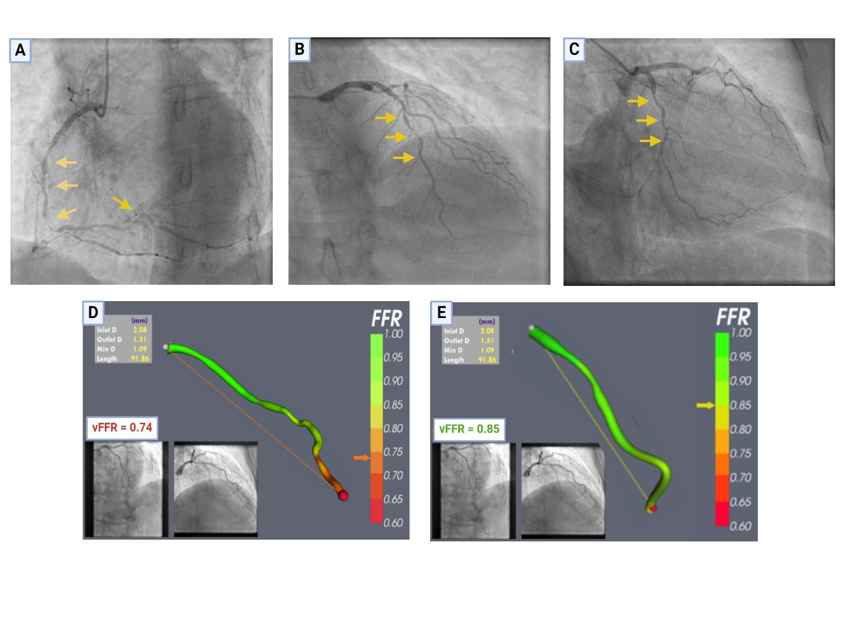
Figure 23: Example 4 - CABG changed to multi-vessel PCI, A - Severe diffused from mid-distal RCA marked with arrows, B – Mid-distal long segment of LAD disease (marked with arrows), C – Moderate lesion in the proximal LCx, D - vFFR modelling of LAD confirmed ischaemic lesion (vFFR=0.74), E – vFFR modelling of LCx demonstrated a physiologically non-significant lesion (vFFR=0.85) which led to change in management plan from CAG to multi-vessel PCI. (vFFR image – courtesy of Dr H Haley).

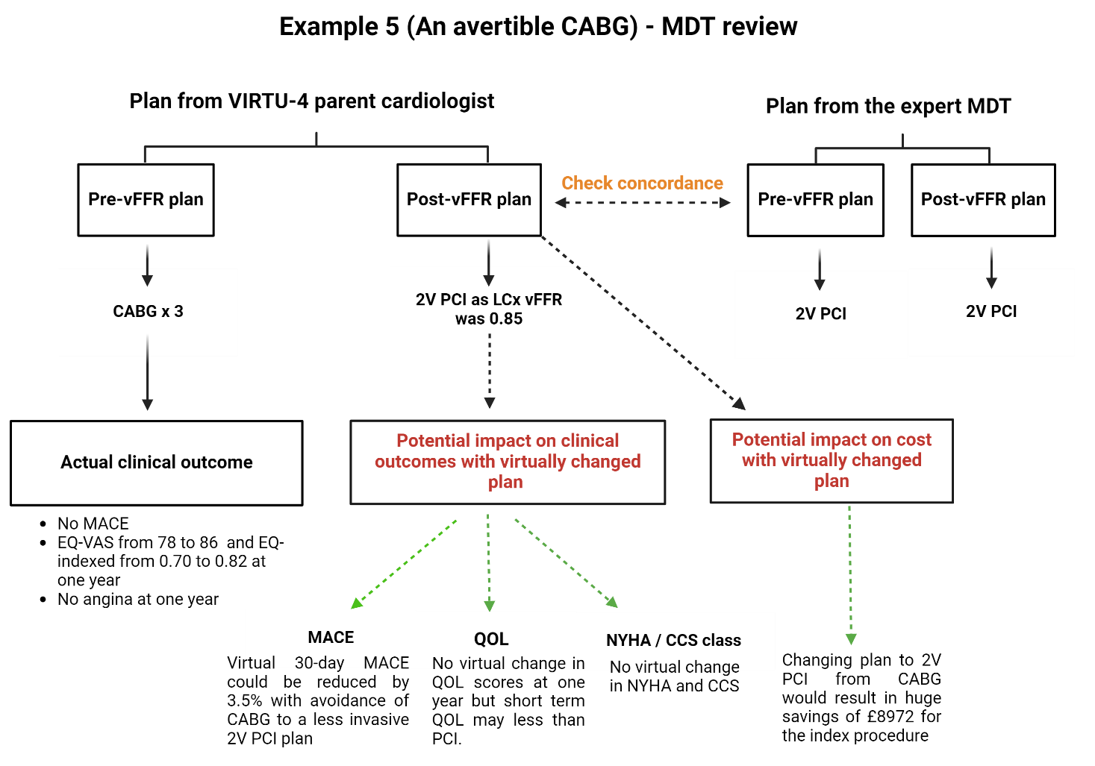
Figure 24: MDT flowsheet for Example 5 – ‘An avertible CABG’ showing the impact of vFFR on the virtual clinical and economic outcomes.

2.5 Total cost estimation

2.5.1 How do NHS tariffs work? HRG4+ codes explained
For the last few decades, most developed healthcare systems have adopted prospective payment arrangement methods to ensure the efficient delivery of excellent care with a prompt allocation of funds. (196) An integral part of this approach is using a classification model that can differentially categorise the patients to patriate the funds. In England, the classification system is called the Healthcare Resource Group (HRG), through which costs are calculated. (197) The HRG categorisation was first launched in 1991, with coding by individual specialities, based upon the International Classification of Diseases (ICD) and National Procedure Codes (NPC) from the Office of Population Censuses and Surveys (OPCS). (196) This contrasted with the US-based Major Diagnostic Categories (MDCs) system, which used a single-organ approach instead. (196). In the last few years, HRG4+ was introduced, in which changes included the diagnostic and procedural hierarchy, and complications and comorbidity (CC) splits were also included. (197) This emphasised the need to accurately code comorbidities and complications on the patient’s health records to apply the cost tariff that appropriately reflects the complexity. (196) The HRG4+ code comprises five characters arranged as two letters, followed by two numbers and one letter at the end. For example, the code for heart valve replacement is “ED24B”, which indicates the following: (196)
- 1st Letter – Represents the body system (E for Cardiology).
- 2nd Letter – Represents the treatment area (D for Heart valves).
- Two numbers – Represent the intervention performed (24 for the surgical valve replacement)
- 5th Letter – Represents complications and comorbidity split indicating the level of severity in the HRG (B for CC score of 6-10)
The CC split aids in incorporating the complexity and severity index in the HRG4+ codes and is calculated based on the summed-up scores for all significant comorbidities, which means that a multi-morbid patient will have a much higher CC score. The higher the CC score, the higher the procedural cost. We have estimated the bottom bracket (0-6 CC score) for our data analysis, as it applies to most patients.

2.5.2 Cost of VIRTUHeartTM licence
VIRTUHeartTM software is currently a research tool only and is awaiting the approval of the Medicine and Healthcare Products Regulatory Agency (MHRA) in clinical practice. As no final cost was attached to the VIRTUHeartTM software, it was used during VIRTU-4 without any additional cost. However, to evaluate the impact of licence cost of VIRTUHeartTM, two different models were proposed for the cost comparison with conventional angiography.
The first model was an annually renewable voucher-based model with a cap of 200 patients per year (like the model adopted in the NHS appraisal of vFFR). However, instead of a single tariff, a three-tier voucher-based model of £50, £100, and £200 per patient was proposed for analysis. Annual licencing/maintenance fees, clinical staff training, and certification fees were considered to be included in the cost of final tariff.
The second model was based upon an annual renewable institutional licence tested with VIRTUHeartTM. A three-tier annual licence cost of £20000, £30000, and £50000 (low, medium, and high cost) was proposed to estimate the impact on the annual expenditure from the NHS perspective. Though there was no limit to the number of patients scanned in the institutional model, the analysis was conducted for 200 patients as an analogy to the first model. Hence, if the VIRTUHeartTM were employed for 200 patients in the institutional licence, then it would bring the VIRTUHeartTM costs to £100, £150, and £250 per patient for the annual institutional licence cost of £20000, £30000, and £50000 respectively. The final ICER per QALY was calculated separately for all the three-tier tariffs in both proposed models (see results section).

2.5.3 Costs for the management plans

2.5.3.1 Costs for optimal medical therapy (OMT)
The costs of the medications prescribed for VIRTU-4 patients were gathered from the BNF indicative drug price list (online version). All patients with CAD were routinely prescribed aspirin; ACS patients received ticagrelor, whilst CCS patients received clopidogrel, as per the locally agreed policy for the second antiplatelet agent. In addition, both cohorts received an ACE inhibitor, of which ramipril 5mg once a day was the most prescribed. Bisoprolol 5mg and atorvastatin 80mg once a day were amongst the most frequently recommended beta-blockers and statins, respectively. For the doses of both bisoprolol and ramipril, the prescription was ranged between 1.25mg and 10mg once a day. Because there is no significant difference in the tariffs of different doses, the cost of 5mg for both drugs was used for standardisation. Patients also received glyceryl trinitrate sublingual spray to be used as required in an acute anginal attack. Therefore, the total annual cost of optimal medical therapy (OMT) per ACS patient is £710, whereas for a CCS patient, it is £160. The annual cost of individualised medication lists for each patient was calculated for the detailed analysis (see Table 5).

Table 5: BNF indicative prices (2023) for cardiac medications
Medication | Maintenance Dose | Number of tablets in a pack | Cost per tablet | NHS indicative cost/month | Annual cost
Aspirin | 75mg OD | 28 | £0.02 | £0.74 | £8.88
Clopidogrel | 75mg OD | 30 | £0.04 | £1.46 | £17.52
Ticagrelor | 90mg BD | 56 | £0.97 | £54.60 | £655.20
Atorvastatin | 80mg OD | 28 | £0.05 | £1.40 | £18.25
Ramipril | 5mg OD | 28 | £0.05 | £1.43 | £17.16
Bisoprolol | 5mg OD | 28 | £0.02 | £0.73 | £7.30
Isosorbide Mononitrate XL | 25mg OD | 28 | £0.24 | £6.75 | £87.99
Glyceryl Trinitrate spray | 400mcg/puff | NA | £0.13/puff | £3.85 | £3.85
Total annual costs for ACS patients (with Ticagrelor as dual anti-platelet agent) |  |  |  |  | £710
Total annual costs for CCS patients (with Clopidogrel as dual anti-platelet agent) |  |  |  |  | £160

2.5.3.2 Costs for each management plan according to NHS tariffs 2022-23
The costs for each treatment strategy were modelled using the NHS tariffs 2022-23 (explained above). The lower bracket of CC scores (0-6) was used to standardise the cost of the procedures. Individual-level cost modelling was performed for all patients in the VIRTU-4 HE study, with a separate analysis conducted for the virtual change subset to compare costs between the actual management plans and the vFFR-suggested virtual plans. The individualised treatment plans could fall into one of the following categories:
- OMT only (separately costed under OMT section, see below)
- Measured FFR (mFFR)
- One-vessel PCI (1V PCI)
- Two-vessel PCI (2V PCI)
- Single vessel PCI with measured FFR guidance (1V PCI + mFFR)
- Two-vessel PCI with measured FFR guidance (2V PCI + mFFR)
- CABG
For invasive FFR assessment, the cost of pressure wire (£570) and adenosine infusion (£586) were included as per locally agreed tariffs, making the total cost to be £586. Please note that in all these management plans, the cost of coronary angiogram was excluded (£2649 for ACS and £968 for CCS patients) to focus on the potential change in the cost with an alteration in treatment strategy; therefore, only the post-CAG costs were included in the analysis. In addition, the annual cost of medications (£710 for ACS and £160 for CCS patients) was included in the cost of invasive treatment (both for PCI and CABG) as their integral part of treatment. The NHS tariffs 2022-23 for the treatment strategies and their simplified version used for detailed analysis are shown in Tables 6 and 7, respectively.

Table 6: NHS tariffs 2022-23 for each treatment strategy individually.
Treatment Strategy | HRG description | HRG code | NHS tariffs 2022-23 |  | Total cost (after CAG cost exclusion)
Diagnostic CAG | Standard Cardiac Catheterization with CC 2-3 | EY43E | Elective | £968 | £968
 |  |  | Non-Elective | £2649 | £2649
Measured FFR (mFFR) | Standard Cardiac Catheterization with CC 4-6 and Invasive FFR | EY43E + Pressure wire cost + Adenosine Infusion cost | Elective | £968 + £570 + £16 | £586
 |  |  | Non-Elective | £2649 + £570 + £16 | £586
One vessel PCI (1V PCI) | Standard PCI with CC score 4-7 | EY41C | Elective | £2071 | £1103
 |  |  | Non-Elective | £3375 | £726
Two-vessel PCI (2V PCI) | Complex PCI with CC score 4-7 | EY40C | Elective | £2460 | £1492
 |  |  | Non-Elective | £3795 | £1146
One vessel PCI + mFFR  (1V PCI + mFFR) | Standard PCI with CC score 4-7 + Invasive FFR | EY40C + Pressure wire + Adenosine Infusion | Elective | £2071 + £570 + £16 | £1689
 |  |  | Non-Elective | £3375 + £570 + £16 | £1312
Two vessel PCI + mFFR  (2V PCI + mFFR) | Complex PCI with CC score 4-7 + Invasive FFR | EY40C + Pressure wire + Adenosine Infusion | Elective | £2460 + £570 + £16 | £2078
 |  |  | Non-Elective | £3795 + £570 + £16 | £1732
CABG x 2/3 | Standard CABG with CC score 0-4 | ED28C | Elective | £8384 | £8384
 |  |  | Non-Elective | £10,828 | £10,828
CABG x 4 | Complex CABG with CC score 0-4 | ED26C | Elective | £10,247 | £10,247
 |  |  | Non-Elective | £12529 | £12,529

Table 7: Simplified version of the tariffs for management strategies
Plan | ACS | CCS
OMT | £710 | £160
mFFR | £1296 | £746
1V PCI | £1436 | £1263
1V PCI + mFFR | £2022 | £1849
2V PCI | £1856 | £1652
2V PCI + mFFR | £2442 | £2238
CABG x 2 / 3 | £11,538 | £8544
CABG x 4 | £13,239 | £10,407

2.5.3.3 Costs for hospital re-admissions
Hospital admission costs were determined for both acute and elective hospitalisations. Most elective patients attended for their index procedure as a day case. Overnight admissions were not required unless clinically indicated. The mean number of admission days in the ACS and CCS cohorts were estimated. As most ACS patients from the DGHs are transferred to NGH according to the waiting list, the number of days spent in DGH was discounted from analysis (due to logistics and to avoid skewing results). The hospital stay per day and any inpatient investigations were only costed to admission if performed post-vFFR. In addition, phlebotomy and basic radiological testing (like X-rays) were excluded from the analysis due to their limited relevance to the study. The tariffs per day of stay in the cardiology ward and coronary care unit (CCU) were determined locally by the finance department of Sheffield Teaching Hospitals (£296 for the cardiology ward and £1139 for the CCU). Most CCS patients attended as day cases only; hence, they were not classed as admission.

2.5.3.4 Outpatient attendance costs
The cost of a single outpatient attendance was also taken from the NHS tariffs 2022-23, which listed the first attendance to be charged at £182 (code WF01B) and a follow-up at £96 (code WF01A). All the clinic attendances within the one-year follow-up were included for analysis.

2.5.3.5 Outpatient investigation costs
The price for investigations performed as outpatients was obtained from NHS tariffs 2022-23. Holter monitors were costed according to the local department tariffs (see Table 8).

Table 8: NHS tariffs for commonly performed outpatient cardiology investigations
Investigation | HRG4+ Code | NHS Tariffs 2022-23
Echocardiogram | RD51A | £83
Cardiac MRI | RD10Z | £574
CTCA | RD22Z | £88
MPS | RN20Z | £496
Exercise Testing | DZ31Z | £289
Holter monitor | Departmental tariff | £131

2.5.3.6 Impact upon the virtual cost with vFFR
The total cost was calculated for all the patients as incurred in VIRTU-4 and then separately at the virtual change subset level. The costs for the pre- and post-vFFR treatment decisions for the virtual change subset were calculated individually, to evaluate the impact on the total expenses at one-year follow-up.
The virtual change in the cost was calculated as follows:
Virtual change in the cost = Virtual treatment plan costs – Actual treatment plan costs
The percentage change for ACS and CCS patients was calculated for the full cohort of VIRTU-4 HE (n=266) and the virtual change subset (n=65) using the formula:
Virtual Cost change % = (Total actual cost – Change in vFFR subset / Total actual cost) x 100

2.6 QALY estimation
QALYs were calculated for one year based on EQ-index scores, which were derived from five domains: mobility, self-care, usual activity, pain/discomfort, and anxiety/depression. Each domain's isolated score was combined to produce a single digit number. This number was then subtracted from '1' to provide the 'utility'. Since QALYs were calculated for one year, the 'utility' values were directly converted to QALYs by multiplying it with ‘one’. The actual QALYs from the CAG-based treatment plans and the virtual improvement in the QALYs from the vFFR-based plans (as per the virtual change in QOL according to the published literature) were used for the ICER calculation.

2.7 ICER calculation
ICER for the virtual change subset was calculated for the three-tier proposed cost for both the voucher-based and institutional licence models using the formula:
Cost of intervention _{CAG} – Cost of intervention _{vFFR}
ICER = --------------------------------------------------------------------
QALY of intervention _{CAG} – QALY of intervention _{vFFR}
The total cost of the CAG-based plans and the virtual changes in management plans with vFFR were estimated using the NHS tariffs for 2022-23 (as mentioned above in section 2.5). QALYs for the CAG-based treatment plans and QALYs from the vFFR-based treatment plans were estimated. The ICER was calculated by subtracting the total cost of CAG-based treatment plans from the cost of vFFR-based treatment plans, and by subtracting the total QALYs gained from CAG-based plans from the QALYs gained from vFFR-based plans (using the parent cardiologists' plans from VIRTU-4). Additionally, the ICERs were estimated separately for both voucher-based and institution-based costs of vFFR licensing using a low, medium, and high tariff approach. This three-tiered method was used to assess their relationship to the UK WTP threshold (£20,000 - £30,000) for cost-effectiveness.

2.8 Statistical analysis
All the statistical analysis was performed with IBM SPSS software, version 29 and GraphPad version 8.0.2. The categorical variables (both nominal and ordinal) were presented as counts and percentages, whereas the continuous (scale) variables have been represented as mean ± standard deviation, where appropriate and when data was normally distributed. The categorical data were analysed using the Chi-squared test or the Fisher exact test, as appropriate. The Student T-test (paired and unpaired), Mann-Whitney, and McNemar-Bowker test were used for the parametric and non-parametric analysis. The Welch’s T-test was utilised where unequal sample sizes or variances were encountered. Shapiro-Wilk test was used to check the normality distribution of the sample. One-way ANOVA and Kruskal Wallis tests were used (where appropriate) to analyse any statistically significant difference in the medians of multiple groups. All p-values were two-sided, and the p-values <0.05 were considered statistically significant. The Pearson (for parametric) and Spearman (for non-parametric) correlation analyses were performed along with regression analysis to observe the strength, direction, and magnitude of the relationship between the quantitative variables.

3. Results
The results section has been divided into clinical and health economics outcomes, presented separately for the complete VIRTU-4 (n=266) and the virtual change subset (n=65).

3.1 Clinical outcomes from the entire VIRTU-4 HE

3.1.1 Patient contactability
The VIRTU-4 HE study was conducted on the data derived from the VIRTU-4 trial, which included 308 patients (208 in VIRTU-4 ACS and 100 in VIRTU-4 CCS). I was able to gather data from 180/208 (86.5%) patients in the ACS arm after the exclusion of 28/208 (13.5%), of whom 27/208 (13%) were uncontactable and 1/208 (0.5%) had dementia. Similarly, in the CCS group, the data were collected for 86/100 (86%) after the exclusion of 14/100 (14%) uncontactable patients. There were 7/308 (2.27%) deaths at one-year follow-up, of which 3/208 (1.4%) were in ACS and 4/100 (4%) in the CCS group.

3.1.2 Study demographics
The demographics and age distribution of the patients are shown in Table 9 and Figure 25, respectively.

Table 9: Study Demographics (Values are mean ± SD and frequency with percentage when appropriate)
Demographic Characteristics | ACS (n=180) | CCS (n=86)
Age ± SD | 64 ± 11.76 SD | 65.9 ± 8.86 SD
Male, n (%) | 127 (73.8%) | 59 (74.7%)
Female, n (%) | 45 (26.2%) | 20 (25.3%)
Diabetes, n (%) | 40 (23.3%) | 29 (36.7%)
Hypertension, n (%) | 104 (60.5%) | 41 (51.9%)
Smoking history, n (%) | 57 (33.1%) | 11 (13.9%)
Hypercholesterolemia, n (%) | 99 (57.6%) | 45 (57%)
Stroke, n (%) | 9 (5.2%) | 6 (7.59%)
Previous MI, n (%) | 30 (17.4%) | 19 (24.1%)
Peripheral Vascular Disease, n (%) | 3 (1.7%) | 2 (2.53%)

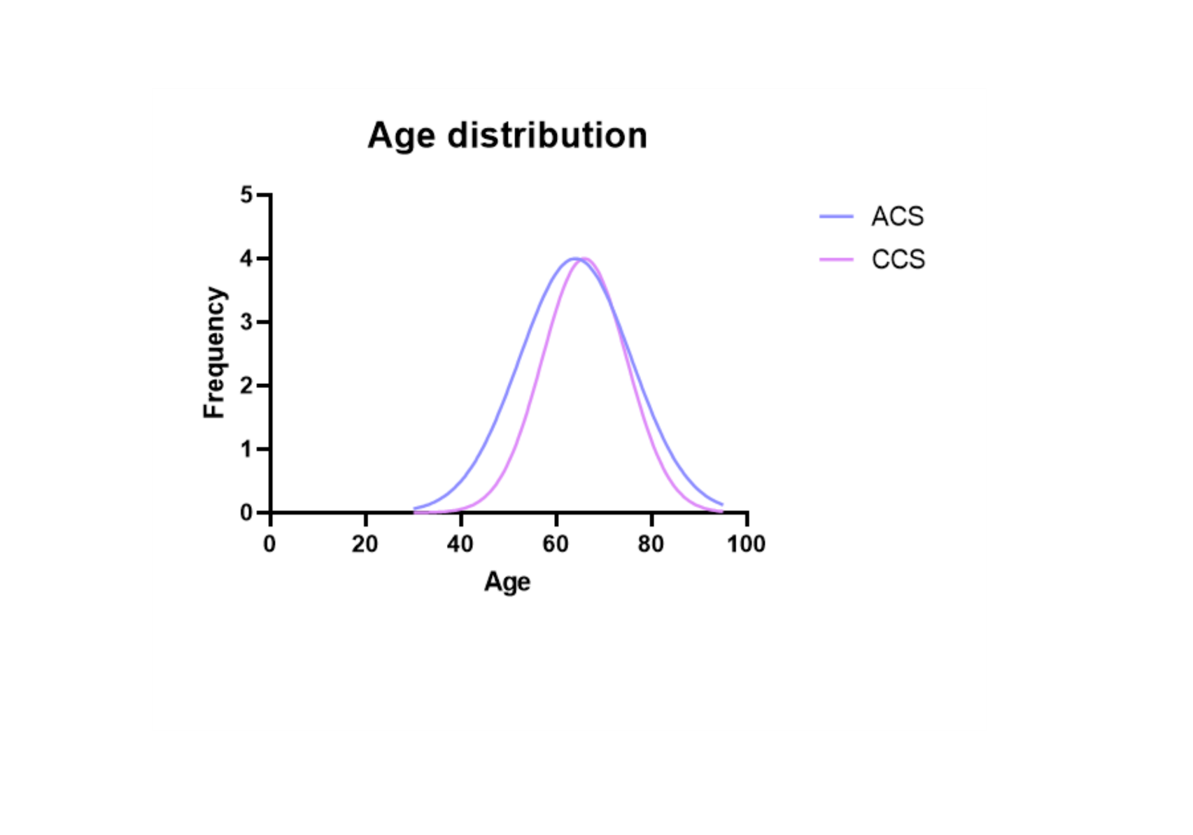
Figure 25: Age distribution graph showing Gaussian distribution for both ACS (n=180) and CCS (n=86) groups

3.1.3 Major adverse cardiovascular events (MACE)
The three-point MACE events (including death, MI, and stroke) were evaluated at one year and are shown in Table 10.

Table 10: Summary of MACE in VIRTU-4
MACE | Details | ACS n (%) | CCS n (%)
 | Death  MI  Stroke | 3 (1.6)  4 (2.2)  2 (1.1) | 4 (4.6)  1 (1.1)  1 (1.1)

3.1.4 Hospital re-admissions
In ACS, 32/180 (17.7%) had re-admissions due to cardiac cause, of which 29/32 were acute and 3/32 were elective admissions). In the CCS cohort, 25 (29%) patients had an admission due to a cardiac reason, of which 16/25 (64%) were acute and 9/25 (36%) elective admissions. The hospital re-admissions are shown in Figure 26.
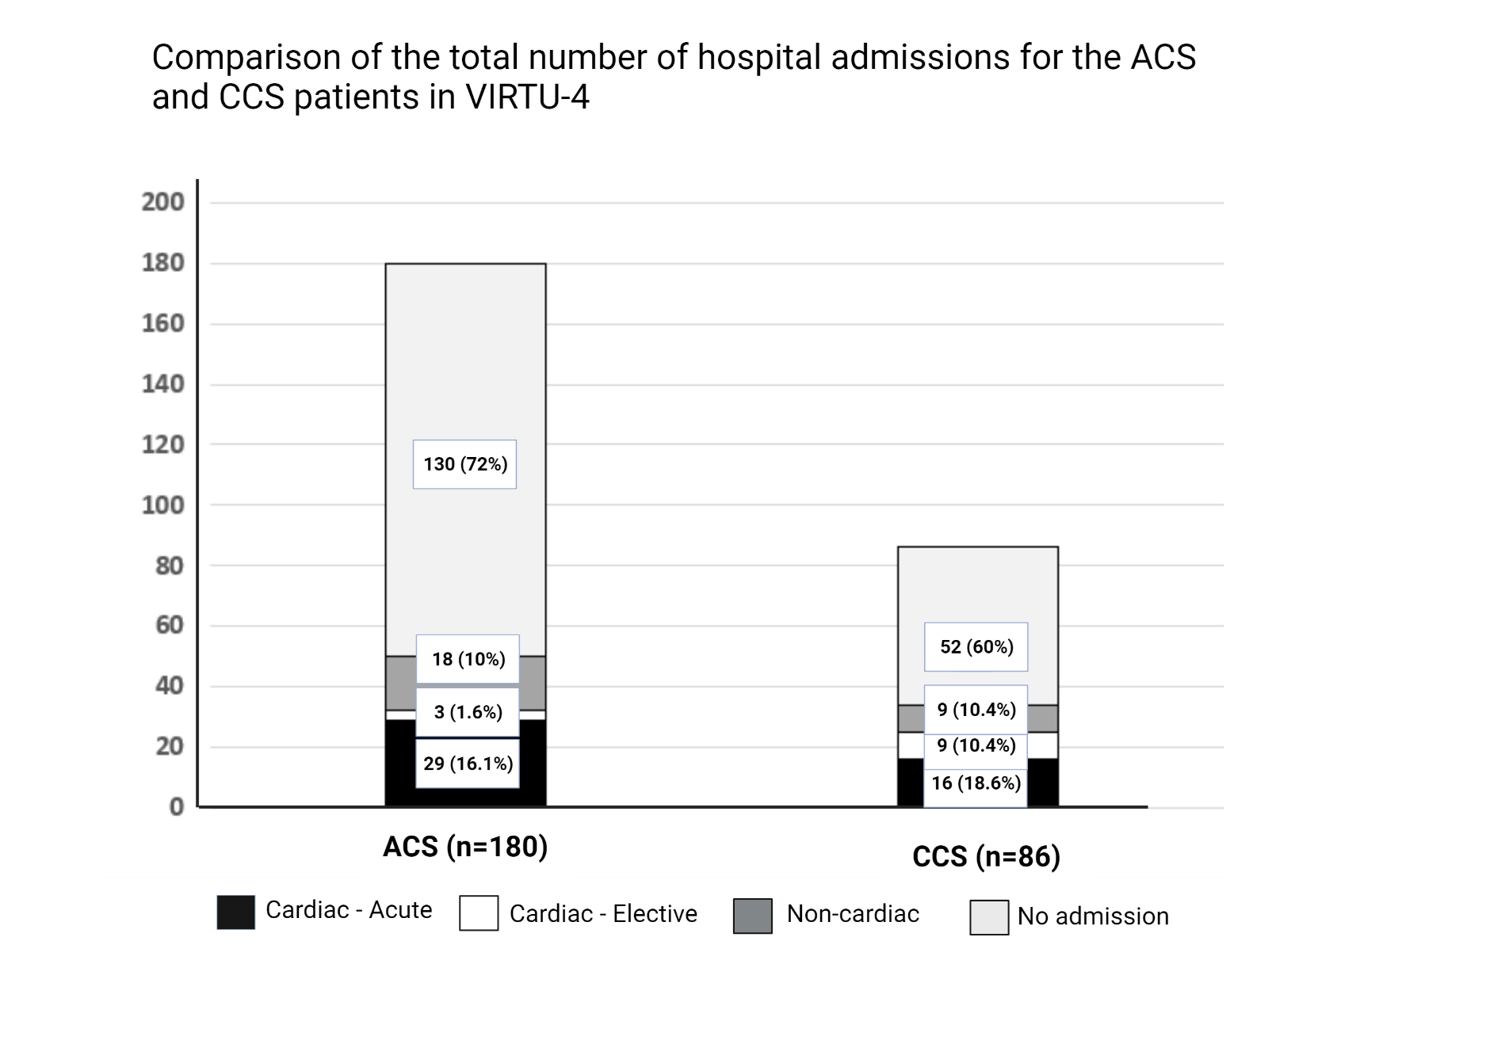Figure 26: Comparison of the total number of hospital admissions for the ACS and CCS patients in VIRTU-4.

3.1.4.1 Number of hospital re-admissions per patient
In the ACS cohort, 32 patients required hospital admissions, of which 21/32 (65.6%) had a single admission, whereas 11/32 (34.3%) required more than one admission. In contrast, the CCS group had 25 admissions, of which 23/25 (92%) had a single admission and 2/25 (8%) needed more than one admission (p <0.001). The differential count of admissions per patient is shown in Figure 27.
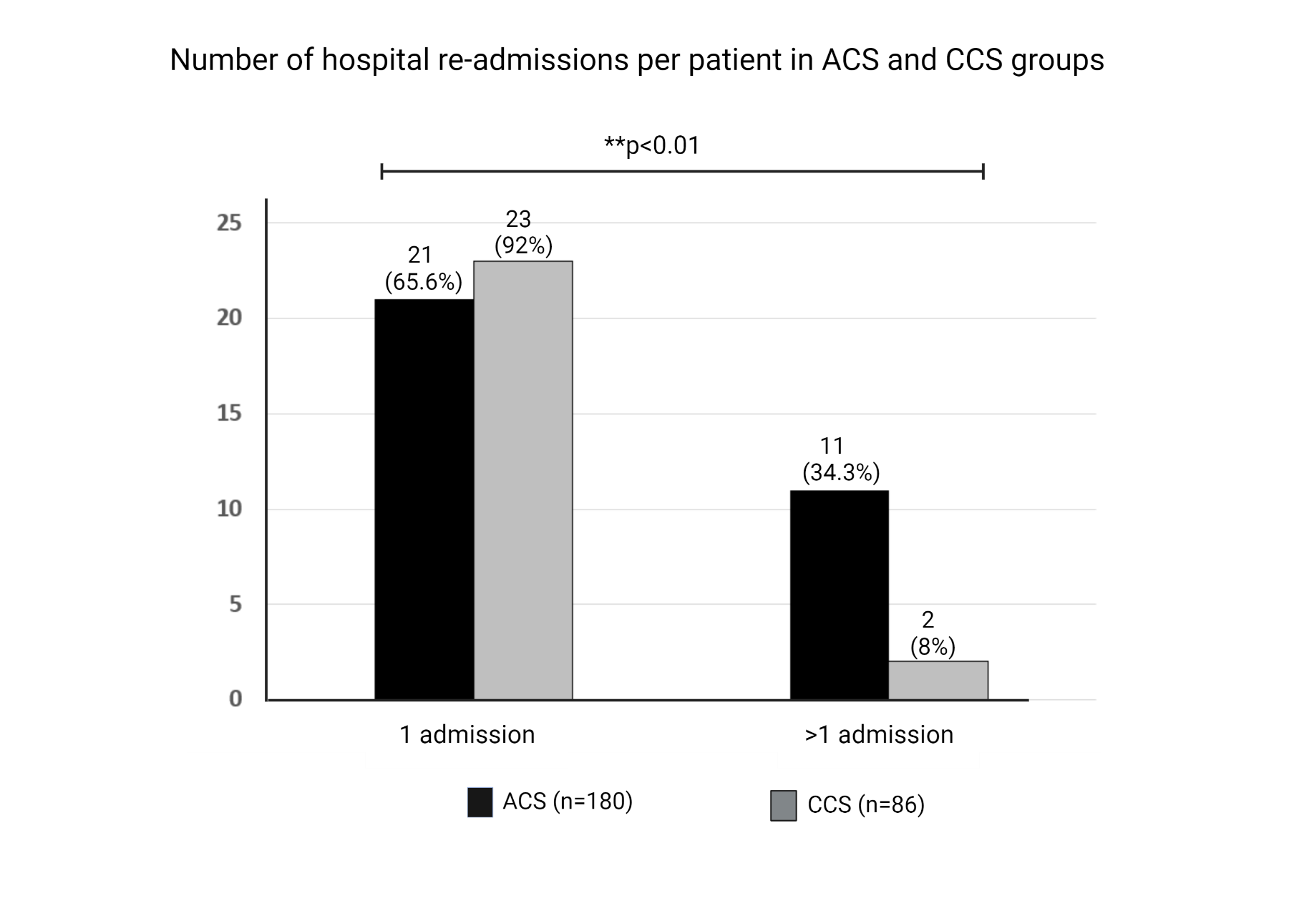
Figure 27: Re-admissions per patient in ACS and CCS groups

3.1.4.2 Reasons for hospital admissions and length of stay
The median lengths of hospital stay per re-admission for ACS and CCS patients were 1.24 ± 1.88 and 1.95 ± 3.44 days, respectively. Acute chest pain was the most common reason for admission in ACS, whereas in CCS, elective admission for PCI was the most common reason for hospital admission. A detailed account of all reasons for hospitalisation is shown in Table 11.

Table 11: Cardiac reasons for re-admissions in ACS and CCS patients
Cardiac reasons for hospital re-admissions | Total number of admissions in ACS group (n=32) |  | Total number of admissions in the CCS group (n=25)
 | Chest pain | 18/32 (56%) | Elective PCI | 9/25 (36%)
 | NSTEMI | 4/32 (12.5%) | CABG | 8/25 (32%)
 | Unstable angina | 3/32 (9.3%) | Chest pain | 4/25 (12.5%)
 | CABG | 3/32 (9.3%) | Pericarditis | 1/25 (4%)
 | Atrial arrhythmia | 2/32 (6.2%) | Heart Failure | 1/25 (4%)
 | Elective PCI | 1/32 (3.1%) | Diuretics dose adjustment | 1/25 (4%)
 | Repeat CAG | 1/32 (3.1%) | Defibrillator shocked | 1/25 (4%)

3.1.5 Repeat revascularisation procedures
In the ACS group, 5/180 (2.7%) patients required repeat revascularisation procedures, of which 4/5 (80%) had an acute PCI due to MI and 1/5 (20%) had an elective procedure due to persistent anginal symptoms. In the CCS group, 7/86 (8.1%) patients required repeat revascularisation; 5/7 (71.4%) had an elective PCI due to angina (who were initially treated with OMT), 1/7 (14.2%) had an acute PCI due to MI and 1/7 (14.2%) had to undergo an urgent CABG due to PCI complication. These results are shown in context in Figure 28.
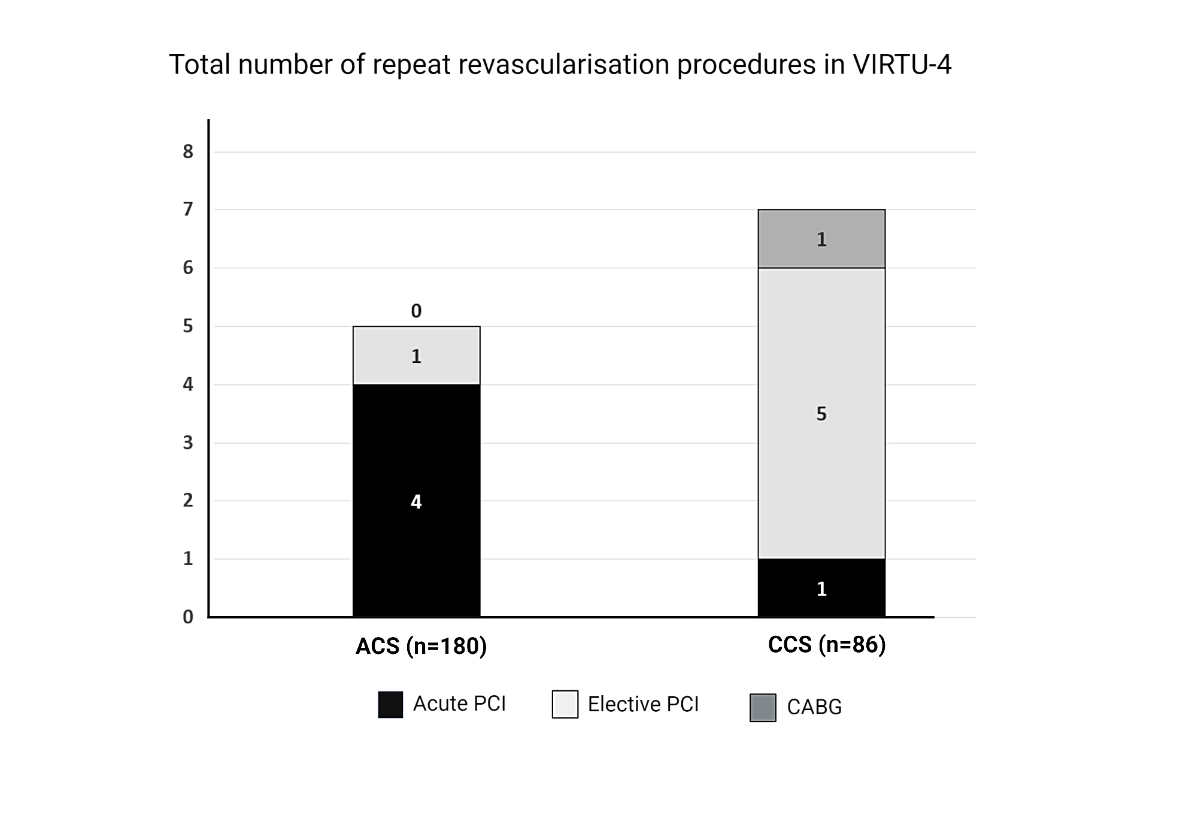
Figure 28: Repeat revascularisation at one-year follow-up

3.1.6 Number of anti-anginal medications at follow-up
In the ACS group, the mean number of anti-anginal medications at baseline and follow-up was 0.14 ± 0.35 and 1.13 ± 0.69, respectively (p<0.01). Most of the CCS patients were already established on two anti-anginal medications before any invasive CAG was planned. Hence, the equivalent numbers in the CCS group were 1.71 ± 0.95 and 1.64 ± 0.83 at baseline and follow-up, respectively (p=0.53). These data are shown in Figure 29.

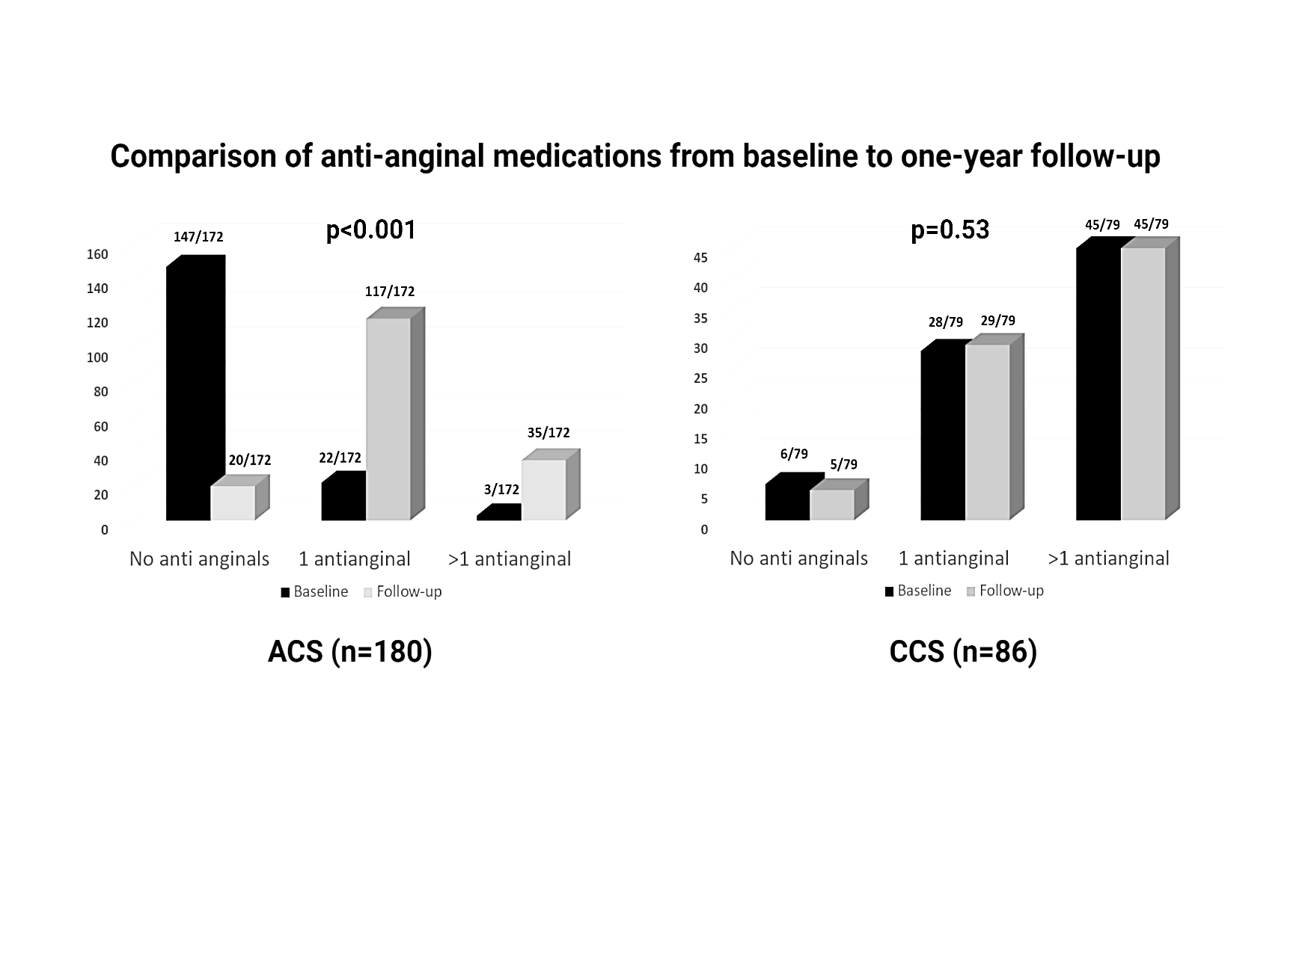
Figure 29: Comparison of anti-anginal medications from baseline to one-year follow-up.

3.1.7 Outpatient follow-up and investigations
The mean number of OP visits in the ACS and CCS groups were 1.64 ± 1.37 and 1.79 ± 1.60, respectively (p=0.59). The visits and investigations are shown in Figure 30.
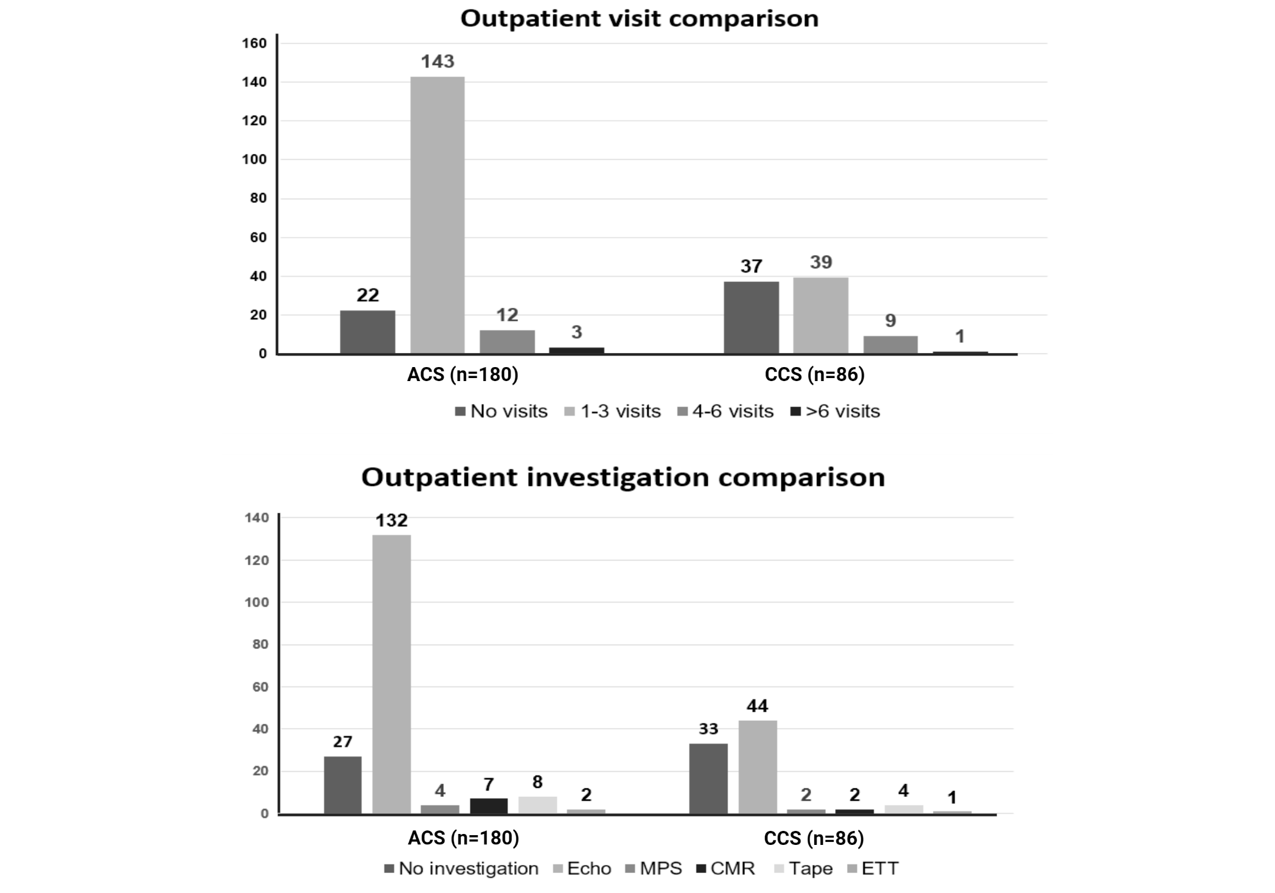
Figure 30: Comparison of the number of OP visits and investigations in ACS and CCS patients

3.1.8 Social care and cardiac rehabilitation
In the ACS cohort, there were 84/180 (46.6%) patients who attended cardiac rehabilitation sessions, compared with 8/86 patients (9.3%) in the CCS arm. Social care was required in the ACS group in 7/180 (3.8%) and in the CCS group in 1/86 patients (1.1%) (p=0.44).

3.1.9 Interval change in NYHA and CCS classes at one year
There was a significant improvement in the baseline NYHA class for the ACS (p=0.001) and CCS (p=0.02) patients at one-year follow-up. In the CCS cohort, there was a statistically significant improvement noted in the CCS class at one year follow-up from the baseline (p=0.001), but in comparison, patients included in the ACS cohort didn’t demonstrate improvement in their CCS class (p=0.76). The interval change in NYHA and CCS classes for both ACS and CCS cohorts is shown in Figure 31.

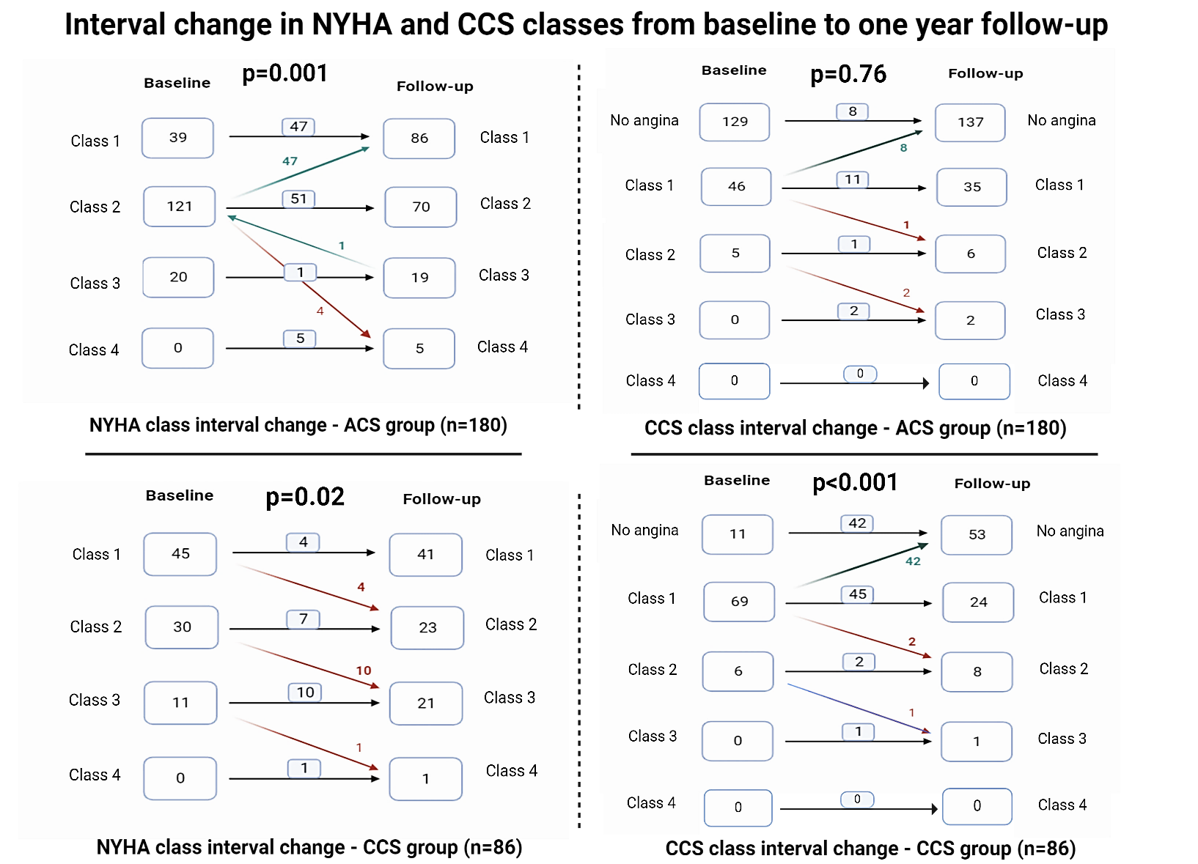
Figure 31: NYHA and CCS class interval change at one year for ACS cohort (n=180) demonstrated significant improvement in both NYHA and CCS class, however, in the CCS cohort (n=86), CCS class improved more significantly but NYHA only had a minor improvement.

3.2 QOL outcomes from the entire VIRTU-4 HE

3.2.1 Interval change in QOL scores at one year from the entire VIRTU-4 HE

The QOL scores in VIRTU-4 did not demonstrate any noticeable interval change at one-year follow-up (EQ-VAS, p=0.99, EQ-indexed, p=0.24). In the ACS cohort (n=180), 105/186 (58.3%) patients had an increment in QOL scores, 67/180 (37.2%) had a reduction, while 14/180 (7.7%) had no change from the baseline scores at one-year follow-up. In the CCS cohort (n=86), 57/86 (66.2%) had an increase, 28/86 (32.5%) had a decrease, and 1/86 (1.1%) remained unchanged. The mean interval change was 0.15 ± 7.10 for EQ-VAS and 0.01± 0.07 for EQ-indexed in the ACS cohort, while in the CCS cohort, the mean interval change was 0.88 ± 1.99 for EQ-VAS and 0.03 ± 0.02 for EQ-indexed score. The EQ-VAS and indexed scores are presented for the entire VIRTU-4 cohort (n=266) in Figure 32, and separately for the ACS (n=180) and CCS (n=86) groups in Figure 33, along with ANOVA analysis of QOL scores of ACS and CCS cohorts in Figure 34.

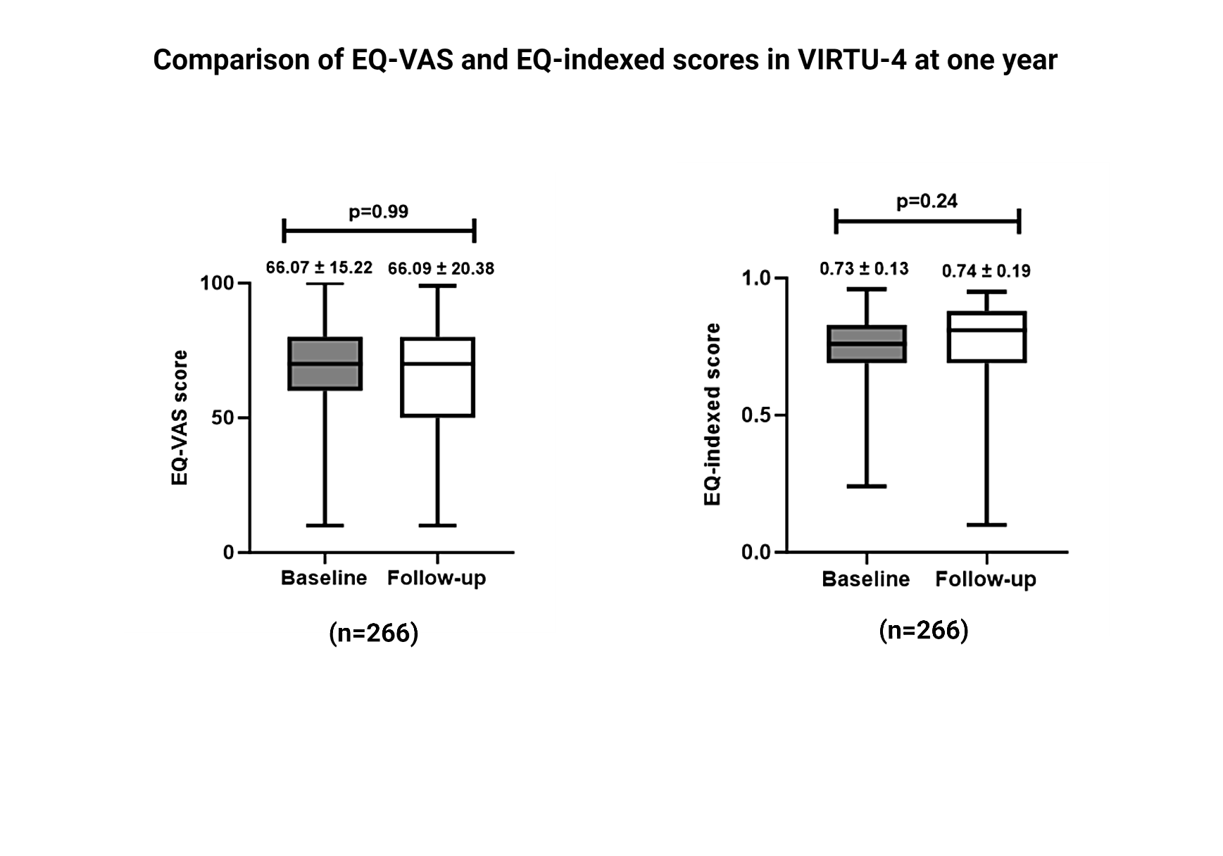
Figure 32: Comparison of EQ-indexed and EQ-VAS scores from baseline to one-year follow-up demonstrated statistically non-significant interval change at one year.
.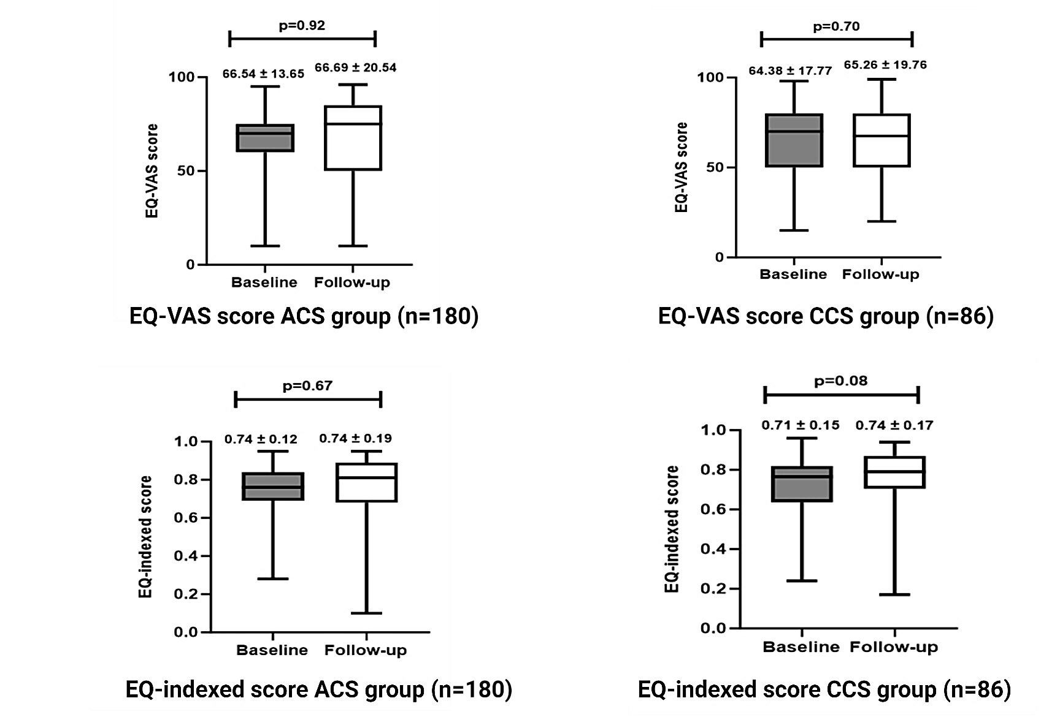
Figure 33: EQ-indexed and EQ-VAS scores segregated according to the ACS and CCS cohorts did not show any significant interval change at one year.

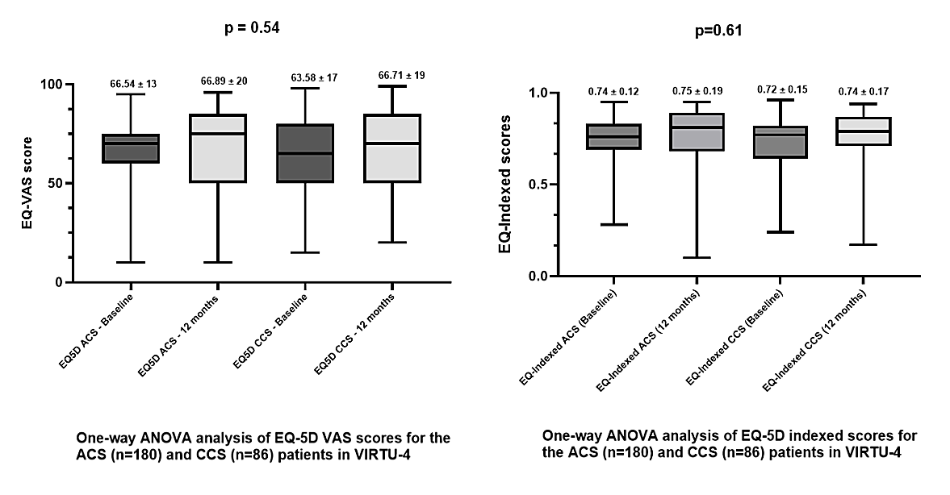
Figure 34: One Way ANOVA analysis of the EQ-VAS and EQ-indexed scores of ACS (n=180) and CCS (n=86) patients in VIRTU-4

3.2.2 Correlation between EQ-indexed and EQ-VAS scores
The EQ-VAS and EQ-indexed scores of all the patients in VIRTU-4 HE had a good correlation (r=0.79; p<0.001) at one-year follow-up, suggesting that the patient’s self-evaluation of health status as a single score (EQ-VAS) corresponds well to their subjective valuation in five dimensions of health, as assessed in EQ-5D indexed (see Figure 35).

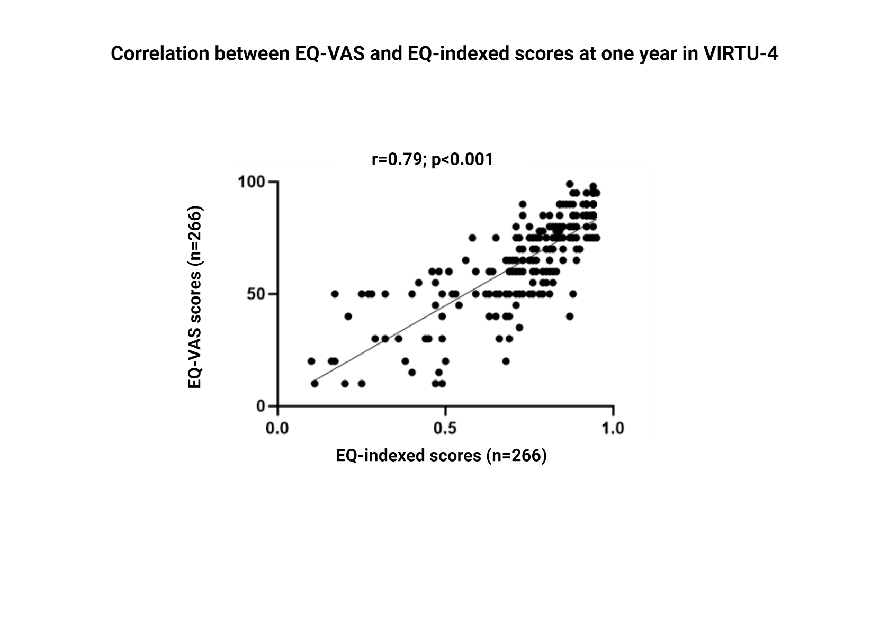
Figure 35: Spearman’s rank correlation coefficient between EQ-VAS and EQ-indexed scores at one year in VIRTU-4 demonstrates an excellent correlation (r=0.79, p<0.001).

3.2.3 Interval change in QOL scores at one year after exclusion of patients with non-cardiac reasons for reduction in QOL
Several non-cardiac reasons contributed to a reduced QOL for ACS and CCS patients. These reasons included mental health issues, arthritis, respiratory problems, malignancy, financial stress, inflammatory bowel disease, and peripheral vascular disease. Therefore, 50/180 (27.7%) in the ACS group and 23/86 (26.7%) in the CCS group QOL scores were excluded. Hence, data were re-analysed in the remaining 130/180 (70.9%) patients in the ACS group and 63/86 (70.8%) patients in the CCS group. The non-cardiac reasons for the reduction in QOL are shown in Table 12.

Table 12: Non-cardiac reasons for reduction in QOL in ACS and CCS patients
Non-cardiac reasons for reduced QOL | ACS n (%) | CCS n (%)
Mental Stress | 19 | 5
Arthritis | 11 | 7
Respiratory causes of SOB | 4 | 5
Financial Stress | 7 | 1
Cancer-related | 1 | 3
Peripheral vascular disease (PVD) | 1 | 1
Inflammatory bowel disease | 1 | 0
Frailty | 6 | 1
Total | 50 (27.7%) | 23 (26.7%)

The interval change at one-year follow-up in the non-cardiac excluded patients from the VIRTU-4 study (n=193), and separately as ACS (n=130) and CCS (n=63) groups, are shown in Figures 36 and 37, respectively.

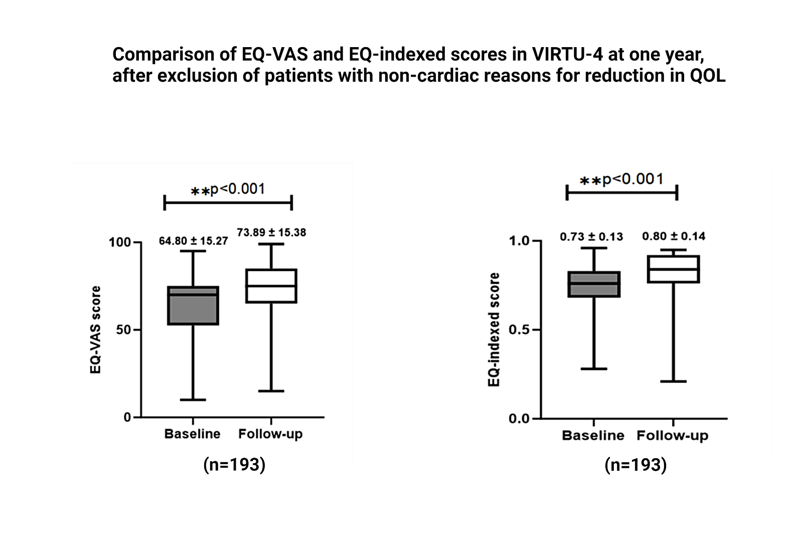
Figure 36: EQ-indexed and EQ-VAS scores at one year, after exclusion of the patients with non-cardiac reasons for reduction in QOL, demonstrating minor improvements in both parameters

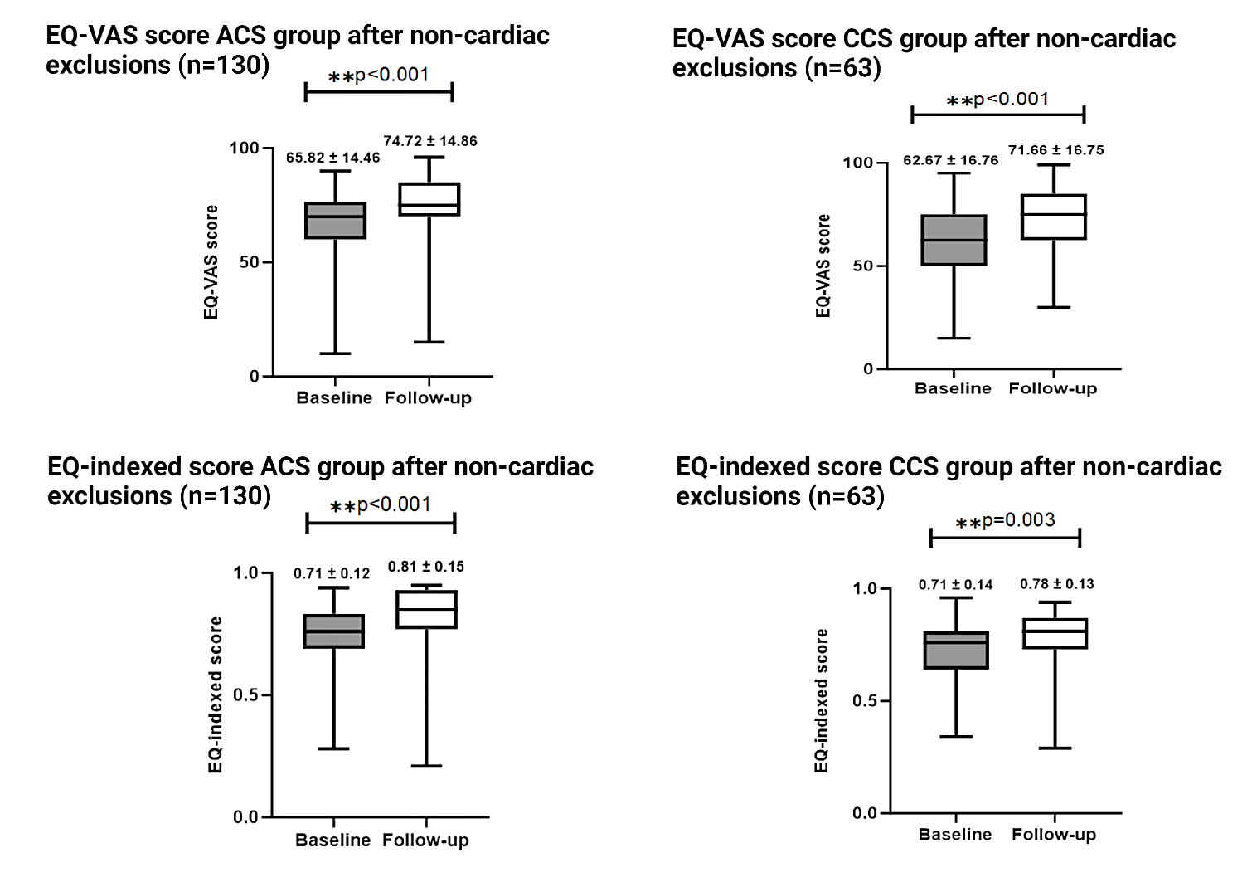
Figure 37: Comparison of EQ-indexed and EQ-VAS scores for the ACS and CCS patients at one year, after exclusion of the patients with non-cardiac reasons for reduction in QOL, demonstrating significant improvements in both parameters.

3.2.4 Interval change in QOL scores according to age
Patients in the VIRTU-4 HE study were divided into age tertiles (<60 years, 61-70 years, >70 years) to evaluate the impact of age on QOL after treatment of CAD. In ACS and CCS patients, there was no significant improvement in the EQ-VAS and EQ-indexed scores at one-year follow-up compared to the baseline across all age groups (see Figures 38 and 39).

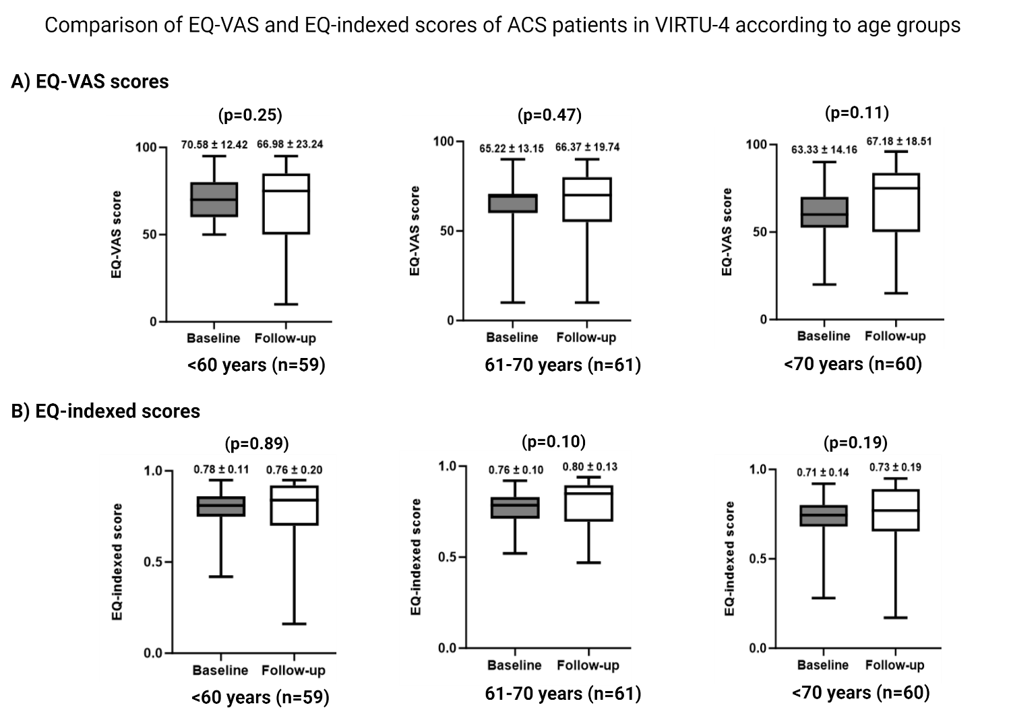
Figure 38: Comparison of the EQ-VAS and EQ-indexed scores in the ACS patients according to age groups.

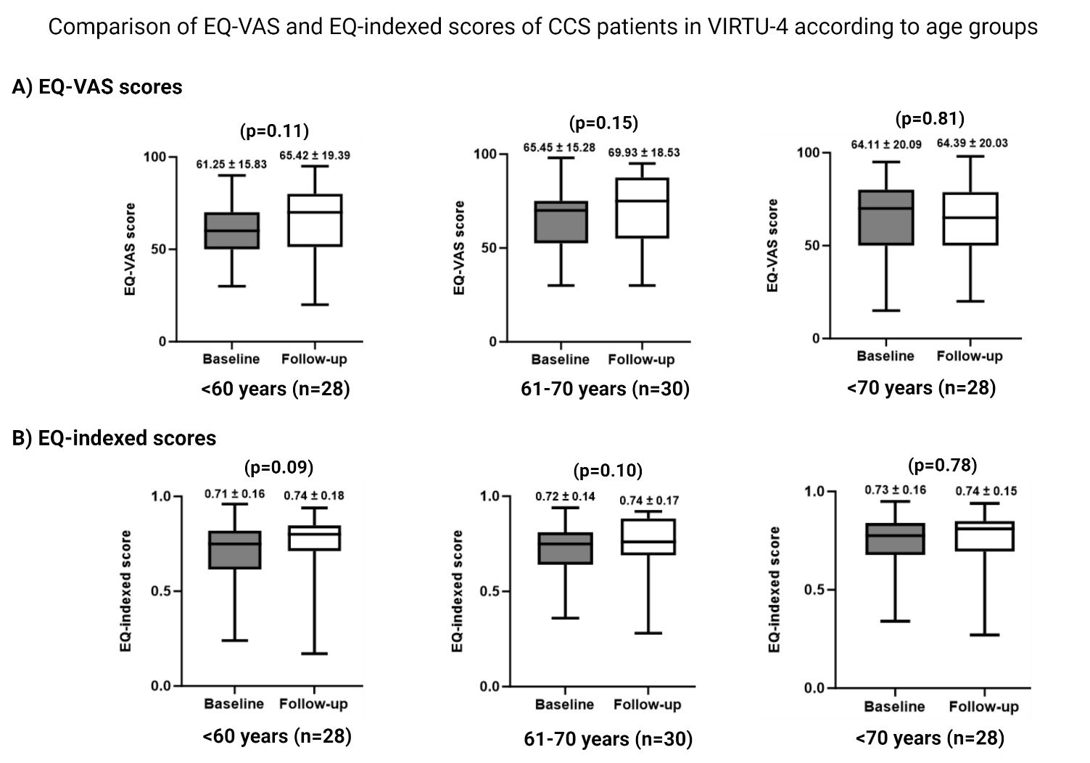
Figure 39: Comparison of the EQ-VAS and EQ-indexed scores in the CCS patients according to age groups.

3.2.5 Interval change in QOL scores according to management plans
Due to a low number of CABG patients, the EQ-VAS and EQ-indexed scores of those who had CABG were combined with those who underwent PCI and were grouped as “invasive therapy”. These “invasive therapy” scores were then compared with the patients treated with “medical therapy” alone. In the ACS cohort, there was no difference in the scores of patients treated with medical therapy (EQ-VAS; p=0.40, EQ-indexed; p=0.65) or invasive therapy (EQ-VAS; p=0.28, EQ-indexed; p=0.12). However, in the CCS cohort, invasively treated patients had a statistically significant improvement (EQ-VAS; p=0.03, EQ-indexed; p=0.04) compared to medically treated patients (EQ-VAS; p=0.73, EQ-indexed; p=0.26), reflecting the benefit of revascularisation on life quality. The EQ-VAS and EQ-indexed scores of ACS and CCS patients treated with medical and invasive therapy have been shown in Figures40 and 41.

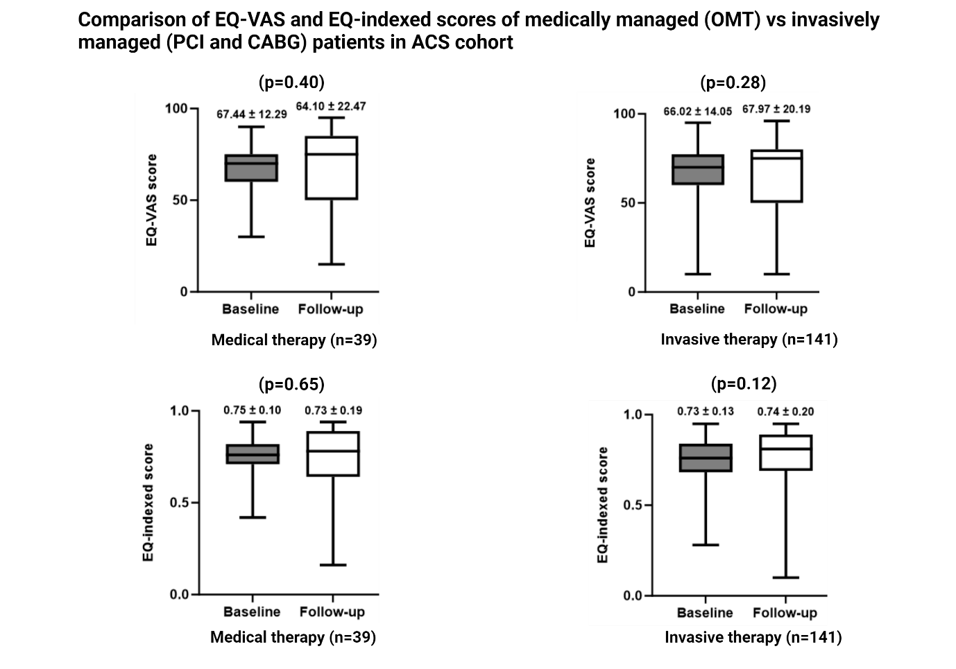
Figure 40: Comparison of the EQ-VAS and EQ-indexed scores of medically treated patients with invasive treatment in the ACS cohort.

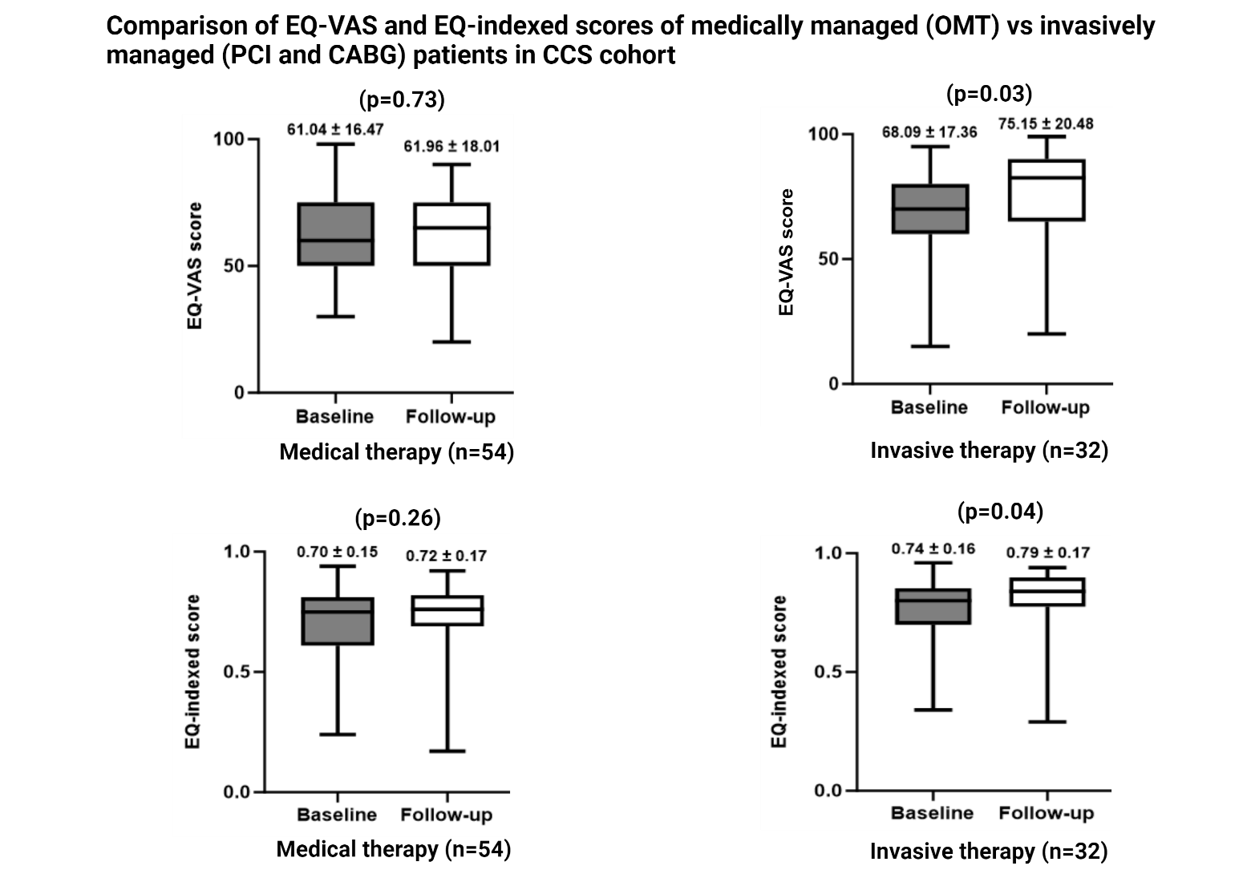
Figure 41: EQ-VAS and EQ-indexed scores of CCS patients treated with invasive therapy demonstrated a statistically significant improvement compared to the patients treated with medical therapy.

3.2.5 Interval change in QOL scores according to gender
The EQ-VAS and EQ-indexed scores were segregated according to gender and demonstrated that the men had a statistically significant increase in the QOL scores (EQ-VAS; p=0.03, EQ-indexed; p=0.04) at one-year follow-up from baseline. In comparison, women reportedly had a trend towards reduced QOL scores, but it did not reach statistical significance (EQ-VAS; p=0.57, EQ-indexed; p=0.68). The gender-segregated EQ-VAS and EQ-indexed scores in ACS and CCS patients have been shown in Figure 42.

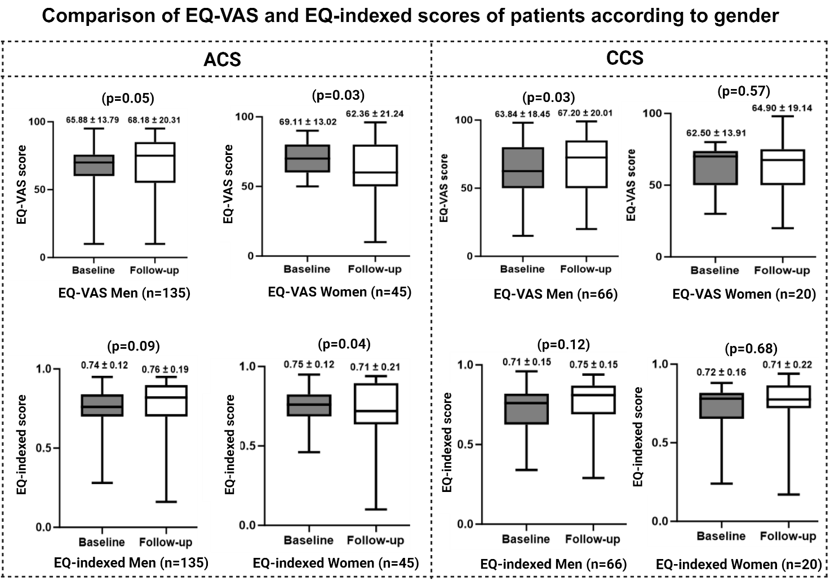
Figure 42: Comparison of the EQ-VAS and EQ-indexed scores of ACS and CCS patients demonstrated less improvement in QOL in women compared to men.

3.2.6 Interval change in QOL scores in patients with diabetes
In patients with diabetes, there was no difference in QOL scores for ACS (EQ-VAS; p=0.07, EQ-indexed; p=0.49) and CCS cohorts (EQ-VAS; p=0.98, EQ-indexed; p=0.77) at one-year follow-up from the baseline (see Figure 43).

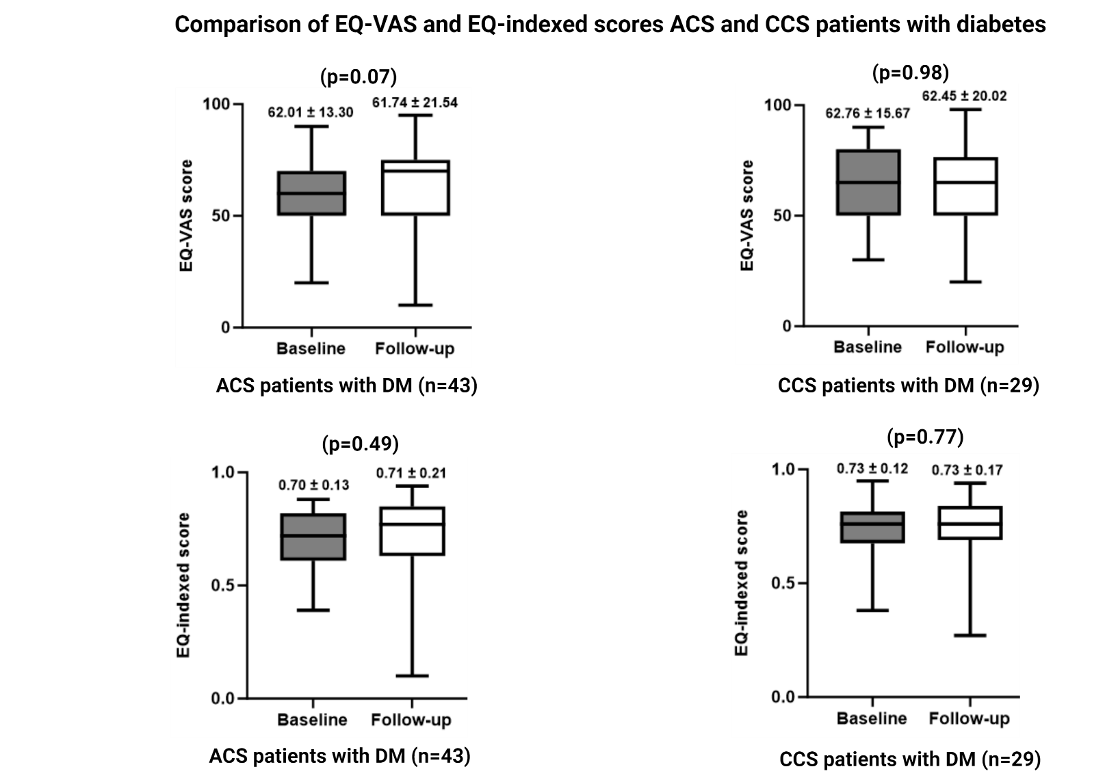
Figure 43: Comparison of EQ-VAS and EQ-indexed scores for ACS and CCS patients with diabetes.

3.3 Health economics outcomes from the entire VIRTU-4 HE

3.3.1 Total cost of the healthcare for entire VIRTU-4 HE
For each patient followed up, the costs of the index procedure, hospital re-admission, repeat revascularisation, outpatient visits and investigations, and cardiac rehabilitation were calculated to obtain the total cost of the complete followed-up cohort in VIRTU-4 HE (n=266). The total cost of followed-up patients in VIRTU-4 HE is summarised according to the management plans (OMT, PCI, and CABG) in Table 13 and Figure 44.

Table 13: Summary of the total costs of followed-up patients in VIRTU-4 at one-year follow-up, according to the management plans (OMT, PCI, CABG)
Treatment group | Outcomes | Total costs | Cost per patient (average)
ACS (n=180) | OMT (n=39) | £80516 | £2064.5
 | PCI (n=131) | £354522 | £2706.2
 | CABG (n=10) | £159203 | £15920.3
CCS (n=86) | OMT (n=54) | £55341 | £1024.8
 | PCI (n=22) | £48511 | £2205.2
 | CABG (n=10) | £103611 | £10361.1
ACS and CCS combined (n=266) | OMT (n=93) | £135857 | £1460.8
 | PCI (n=153) | £403033 | £2634.2
 | CABG (n=20) | £262814 | £13140.7
Total (n=266) |  | £801704 | £3013.9

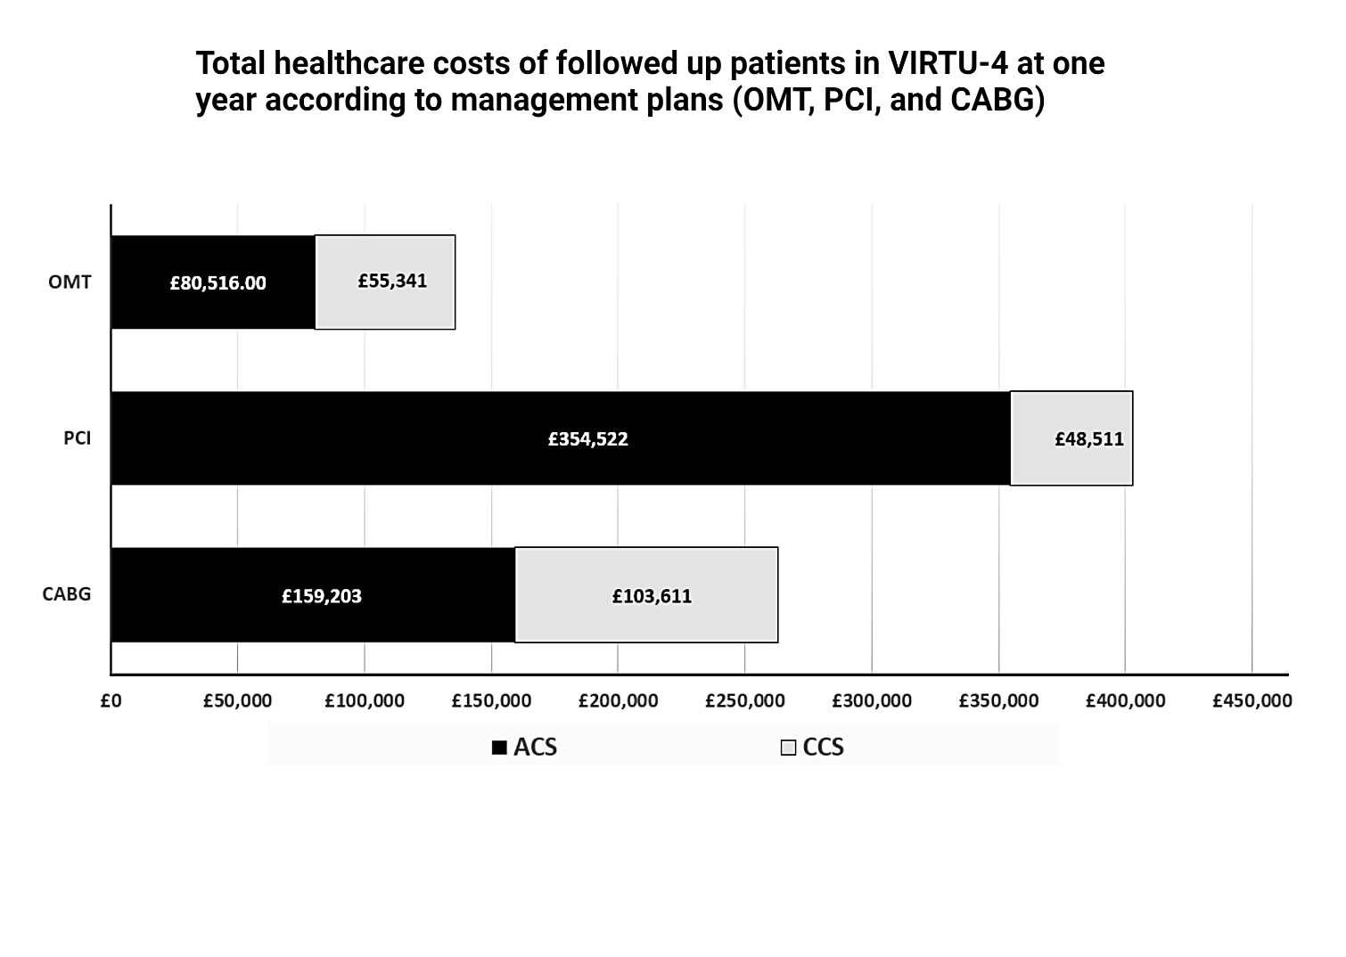

Figure 44: Total healthcare costs of followed-up patients in VIRTU-4 at one year according to the management plans (OMT, PCI, CABG)

3.3.2 Mean cost per patient according to the management plans (OMT, PCI, CABG)
The mean cost per patient for VIRTU-4 HE patients (both for ACS and CCS cohorts) was calculated according to the management plans (OMT, PCI and CABG) summarised in Figure 45.
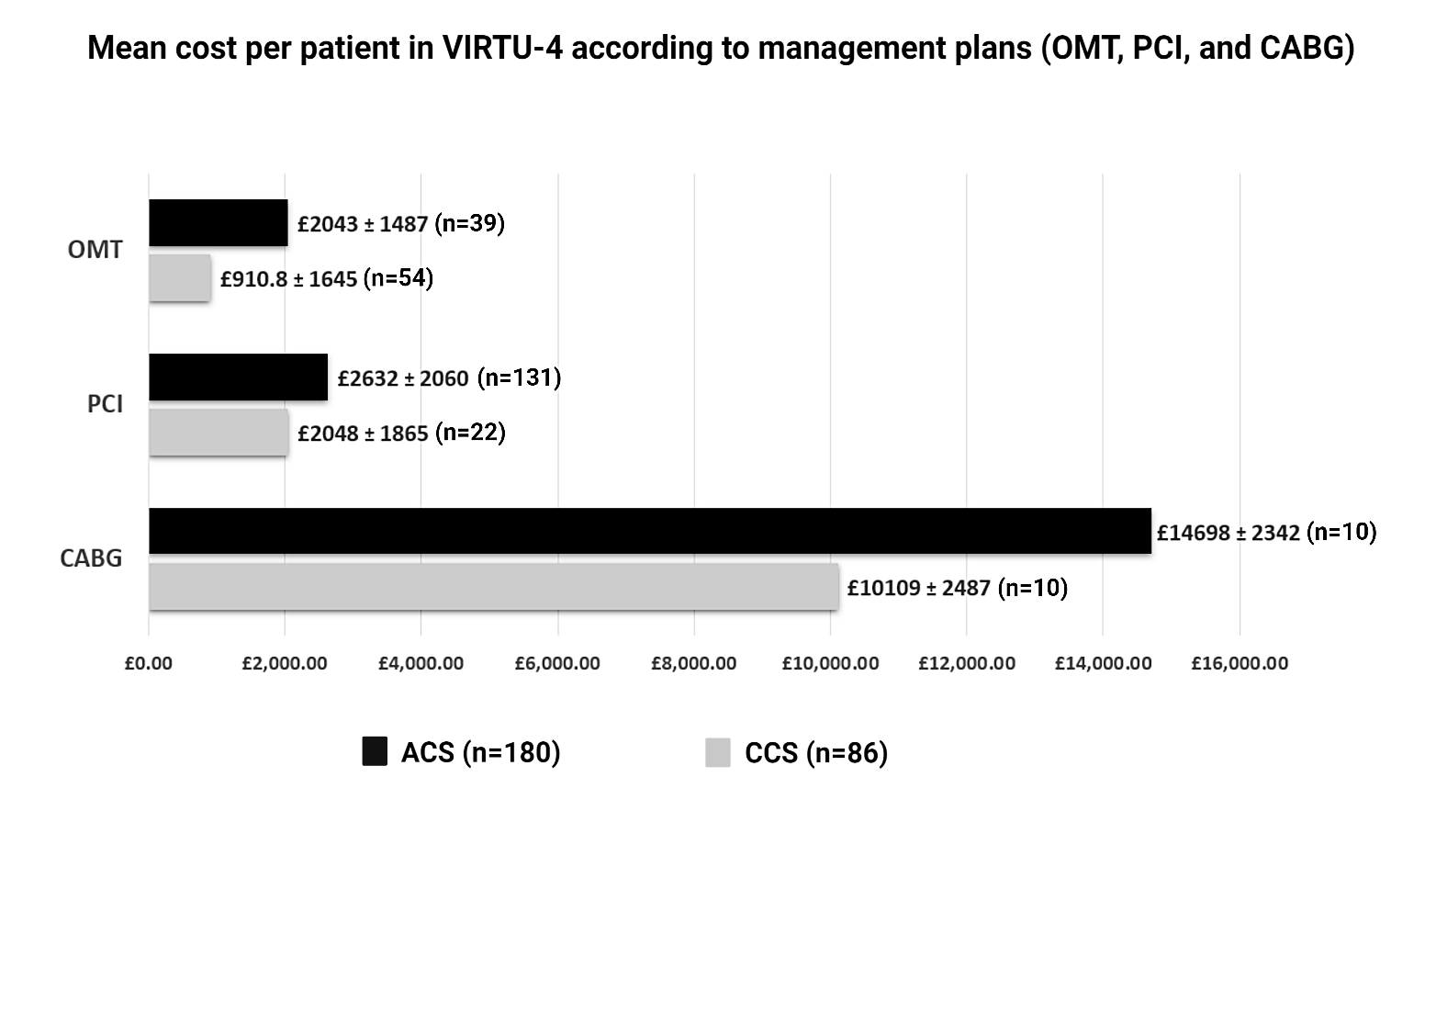
Figure 45: Mean cost per patient in VIRTU-4 according to the management plans (OMT, PCI, and CABG)

3.3.3 Total costs of healthcare resources used in VIRTU-4 HE within one year
The total healthcare resources used within one year after the index procedure including the costs of any repeat revascularisation, hospital admission, outpatient visits, outpatient investigations and cardiac rehabilitation for the full cohort (n=266) is shown in Figure 46 along with the average cost per patient in Figure 47.

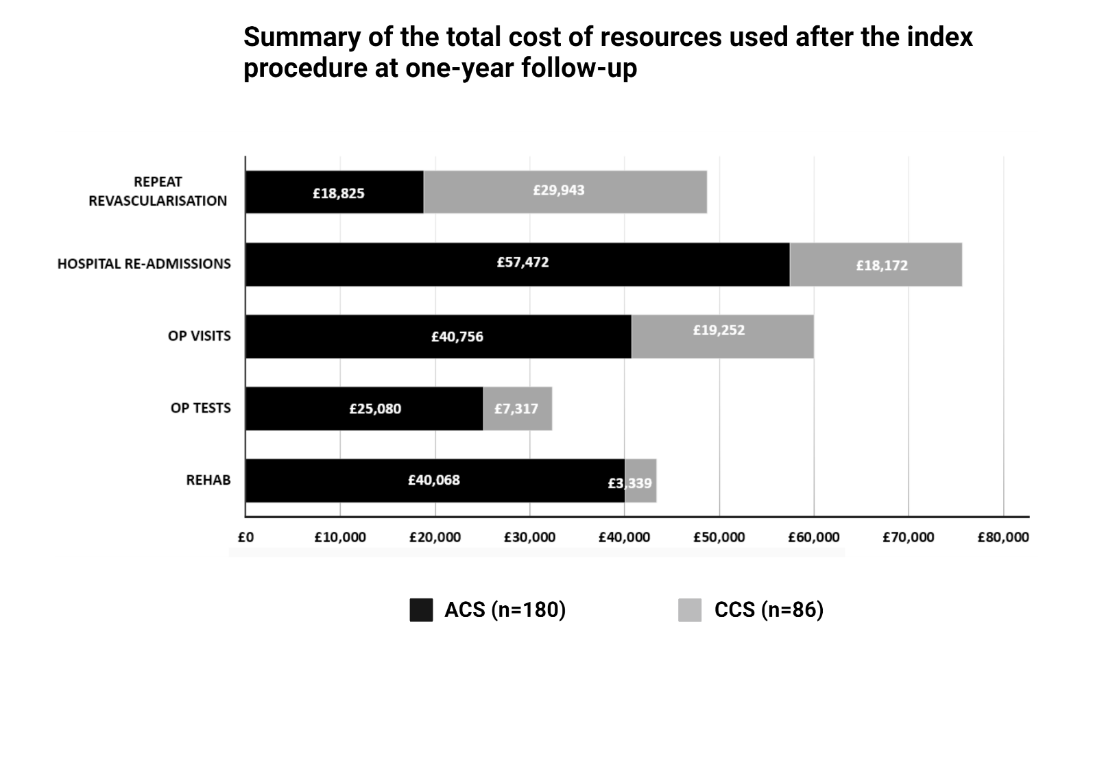
Figure 46: Summary of the total cost of resources used after the index procedure at one-year follow-up.

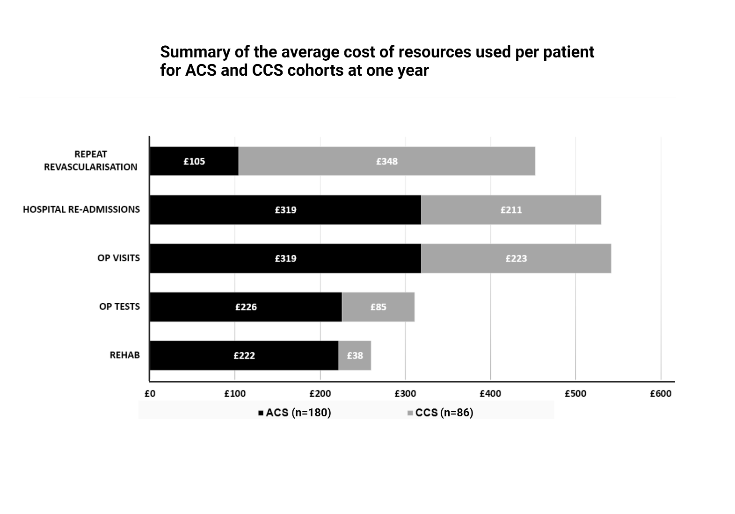
Figure 47: Summary of the average cost of resources used per patient at one-year for ACS and CCS patients.

3.4 Clinical outcomes from the virtual change subset

3.4.1 Summary of the virtual changes in management plans within the virtual change subset according to the parent cardiologists
65/266 (24.4%) patients in VIRTU-4 HE had a virtual change in management plan after vFFR disclosure (39 ACS and 26 CCS patients). The virtual changes in the management plans of the ACS and CCS patients post-vFFR within the virtual change subset are shown in Figure 48, and its detailed economic impact is shown in Table 22 (see Appendix 6.2).

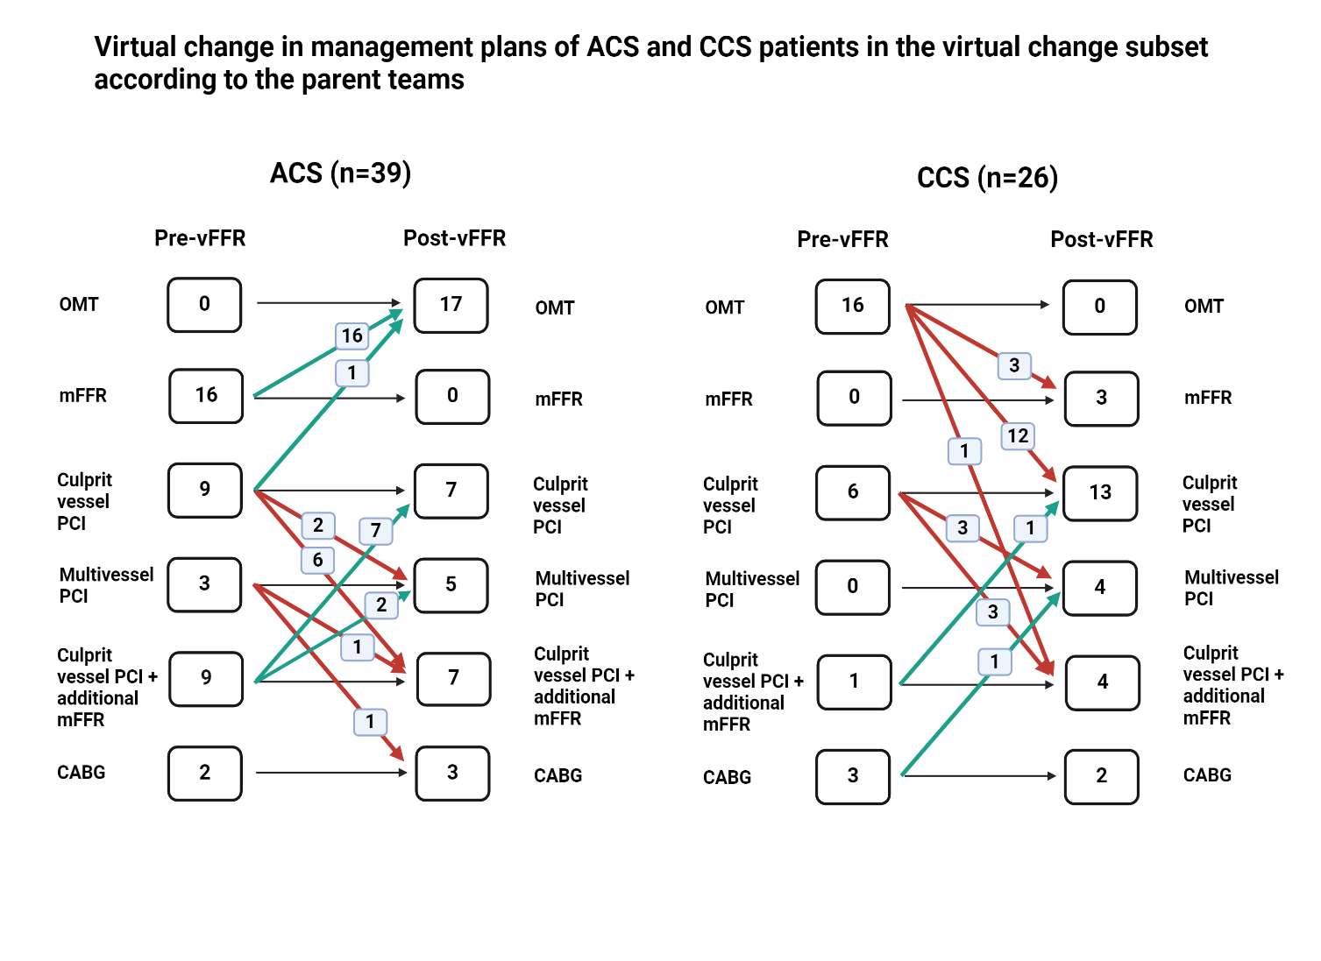
Figure 48: Virtual change in the management plans for the patients included in virtual change subset according to the parent cardiologists (red arrows represents a higher complexity of procedure and therefore, representing higher procedural costs with a virtual change in treatment plan, whereas green arrows represent a lesser complex procedure and therefore, lower index procedural costs associated with a virtual change in treatment decision).

3.4.2 Comparison between the pre- and post-vFFR plans from parent cardiologists and expert MDTs within the virtual change subset
A comparison was performed for the pre-and post-vFFR plans from the parent cardiologists with the expert MDTs. The pre-vFFR comparison of the parent team with 1st expert team’s plans of ACS group (n=39) showed that 16/39 (41%) patients had identical plans, which increased to 26/39 (66.6%) post-vFFR disclosure (p=0.04). In CCS group (n=26), 13/26 (50%) patients had identical pre-vFFR plans, increasing to 17/26 (66.6%) post-vFFR disclosure (p=0.4). When compared with the 2nd expert team, 18/39 (46%) patients from the ACS group (n=39) had identical parent cardiologists plans as those of the 2nd expert team, which increased to 24/39 (61.5%) post-vFFR disclosure (p=0.2). In the CCS group (n=26), 9/26 (34%) patients had identical pre-vFFR plans as those for the 2nd expert team; this number increased to 10/26 (38%) post-vFFR disclosure (p=0.9). The comparison of the pre- and post-vFFR treatment strategies from the parent cardiologists and the expert MDTs is shown in Figures49 and 50.
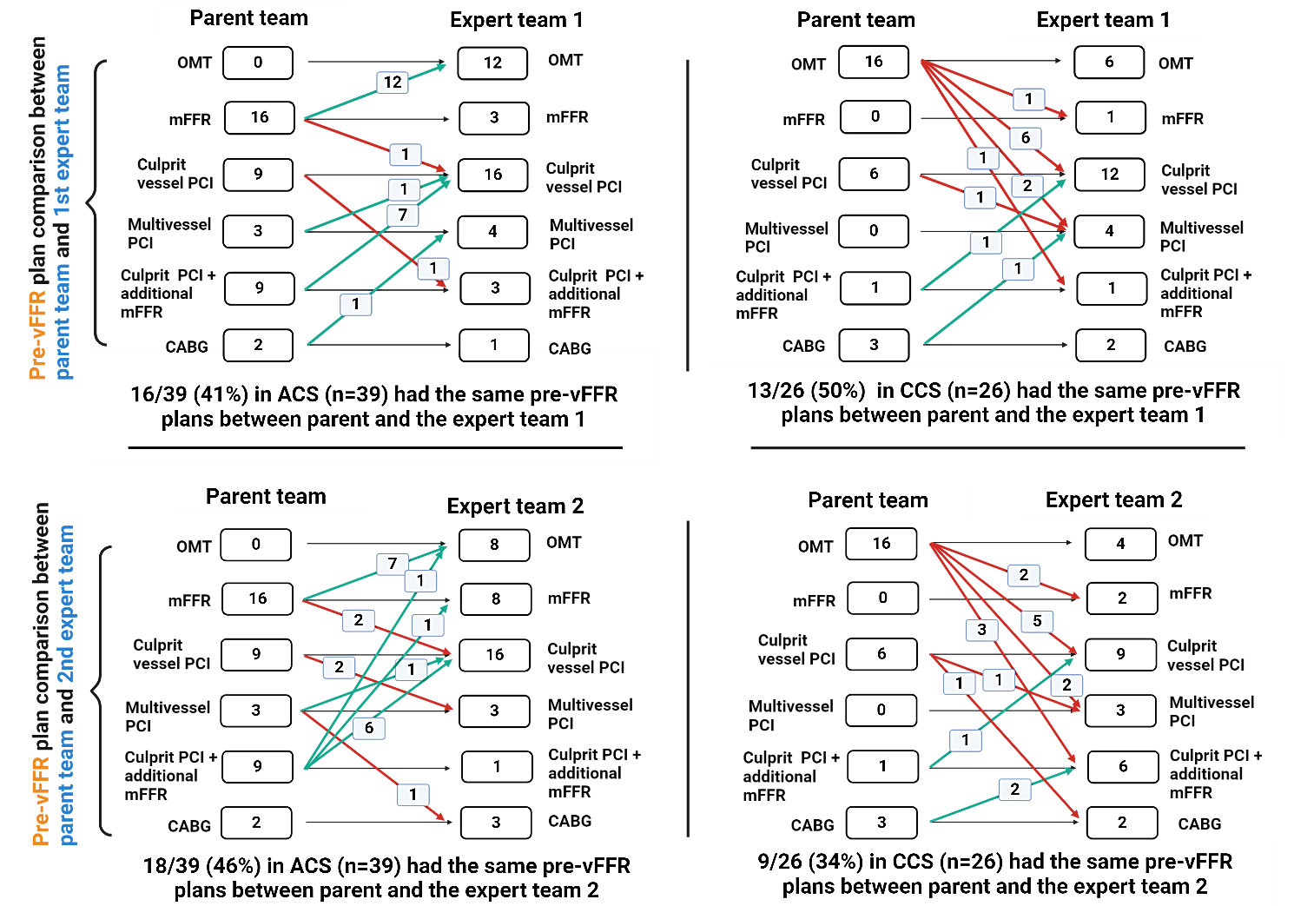
Figure 49: Concordance between the pre-vFFR-management plans of parent cardiologists and both expert MDT plans for the ACS and CCS patients in the virtual change subset

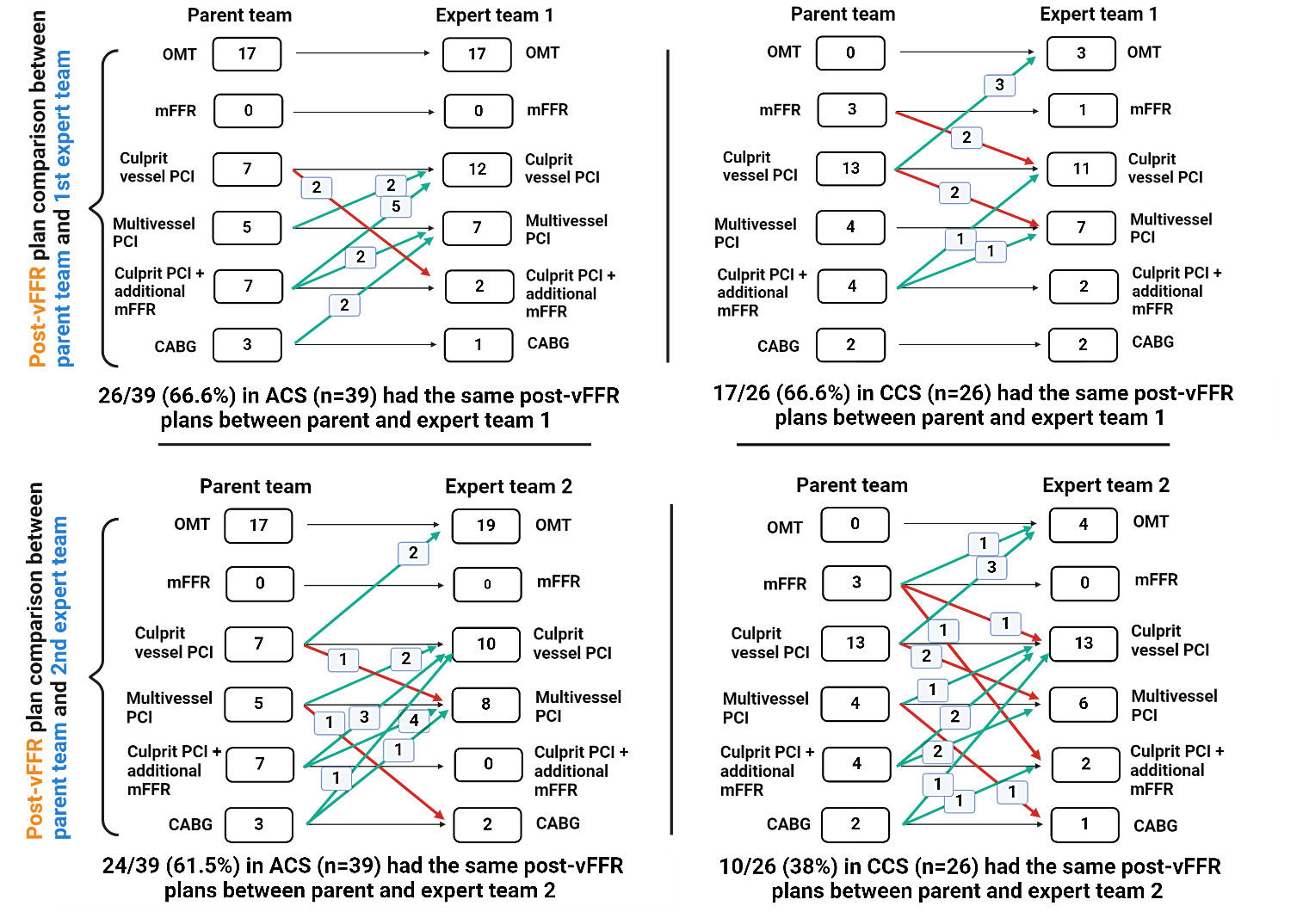
Figure 50: Concordance between the post-vFFR-management plans of parent cardiologists and both expert MDT plans for the ACS and CCS patients in the virtual change subset

3.4.3 Comparison of the “actual” and post-vFFR “virtual” change in the NYHA and CCS class at one-year follow-up
The virtual outcomes extrapolated from the published literature regarding the potential changes in the NYHA and CCS classes compared to the actual outcomes, if vFFR-suggested plan would have been followed, is shown in Table 14.

Table 14: Comparison of the “actual” and “virtual” change in NYHA and CCS classes at one year (according to the parent cardiologists’ plans) within the virtual change subset showed that the CCS and NYHa classes would have virtually improved significantly in CCS patients, however, no significant change was demonstrated in the ACS patients.
Outcome | ACS patients (n=39) |  | p-value | CCS patients (n=26) |  | p-value
CCS class | Actual | Virtual | p=0.99 | Actual | Virtual | p=0.004
No angina | 30 (77.7%) | 31 (80.5%) |  | 16 (61.5%) | 25 (96%)
CCS class 1 | 6 (13.8%) | 5 (11.1%) |  | 5 (19.2%) | 1 (4%)
CCS class 2 | 3 (8.3%) | 3 (8.3%) |  | 4 (15.3%) | 0
CCS class 3 | 0 | 0 |  | 1 (3.8%) | 0
CCS class 4 | 0 | 0 |  | 0 | 0
Outcome | ACS patients (n=39) |  | p-value | CCS patients (n=26) |  | p-value
NYHA class | Actual | Virtual | p=0.96 | Actual | Virtual | p=0.005
NYHA class 1 | 21 (50%) | 23 (55.5%) |  | 13 (48%) | 23 (88%)
NYHA class 2 | 15 (41.6%) | 13 (36.1%) |  | 7 (28%) | 3 (12%)
NYHA class 3 | 2 (5.5%) | 2 (5.5%) |  | 6 (24%) | 0
NYHA class 4 | 1 (2.7%) | 1 (2.7%) |  | 0 | 0

3.5 QOL outcomes for the virtual change subset

3.5.1 Individualised “actual” and post-vFFR “virtual” EQ-VAS and EQ-indexed scores within the virtual change subset
The individualised QOL scores of the ACS (n=39) and CCS (n=26) patients from the virtual change subset are shown in Tables 22 and 23, respectively (see appendix).

3.5.2 Comparison of the mean interval change in the “actual” and “post-vFFR virtual” EQ-VAS and EQ-indexed scores within the virtual change subset
The mean “actual” scores from the virtual change subset patients were compared against the “virtual” scores deduced from the available literature. It demonstrated that in the CCS patients (n=26), there was a virtual improvement in the QOL scores (EQ-VAS; p=0.03, EQ-indexed; p=0.02) at one year when compared to the actual scores. However, the QOL scores for ACS remained non-significant (EQ-VAS; p=0.98, EQ-indexed; p=0.96). When segregated for ACS and CCS patients, ACS (n=39) patients had a non-significant notional increase of EQ-VAS 0.33 ± 0.01; p=0.98, EQ-indexed 0.01 ± 0.01; p=0.96, whereas CCS patients had virtual improvement of EQ-VAS 6.20 ± 0.17; p=0.03, EQ-indexed 0.05 ± 0.01; p=0.02. A one-way ANOVA was conducted to compare the change in QOL scores between ACS and CCS patients within the virtual change subset, which revealed no significant differences in either EQ-VAS (p = 0.38) or EQ-indexed scores (p = 0.47), shown in Figure 51. A further comparison of mean “actual” and “virtual” EQ-VAS and EQ-indexed scores for the entire virtual change subset and the ACS (n=39) and CCS (26) patients separately is shown in Figures52, 53 and 54, respectively.

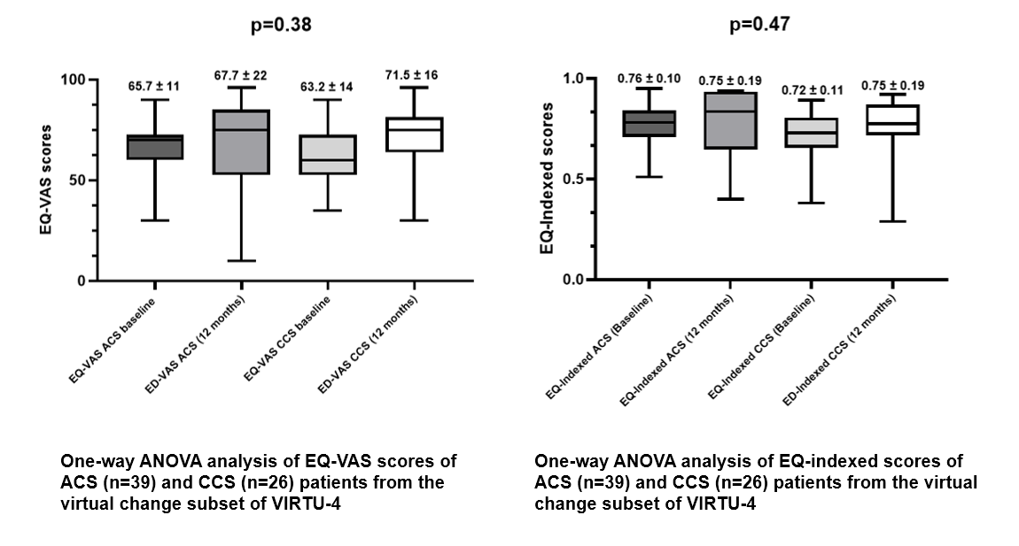
Figure 51: One-way ANOVA analysis of EQ-VAS and EQ-indexed scores of ACS (n=39) and CCS (n=26) patients from the virtual change subset of VIRTU-4.

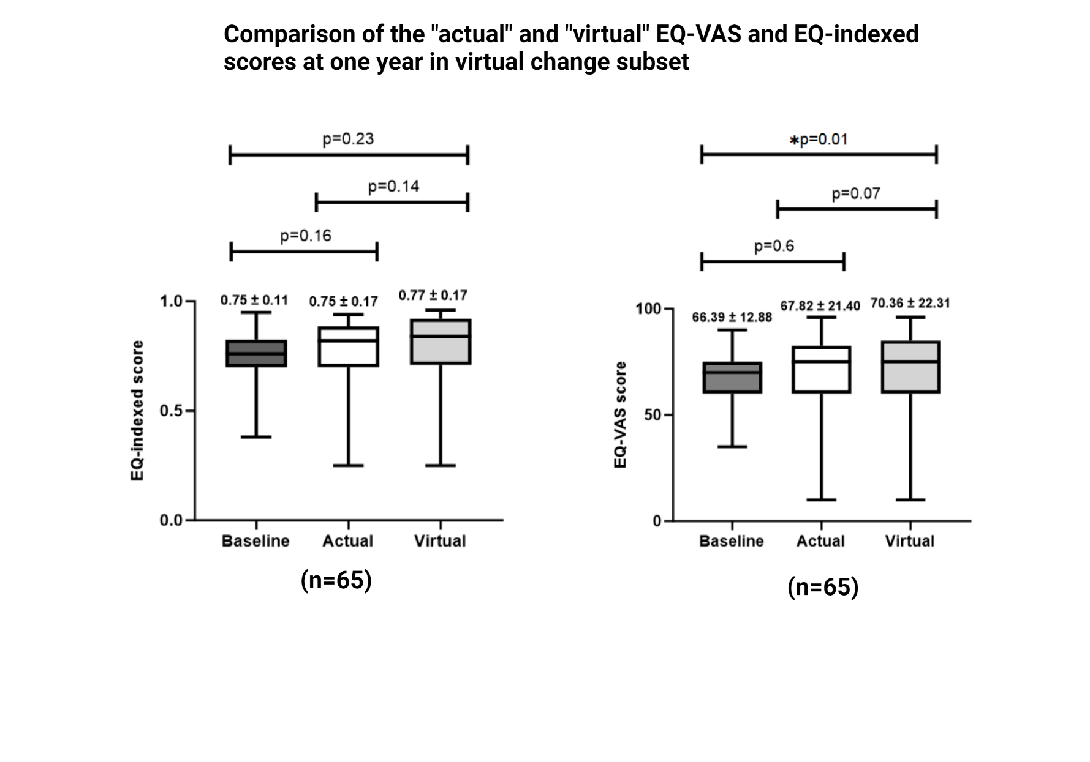
Figure 52: Comparison of the "actual" and "virtual" EQ-VAS and EQ-indexed scores at one year in the virtual change subset
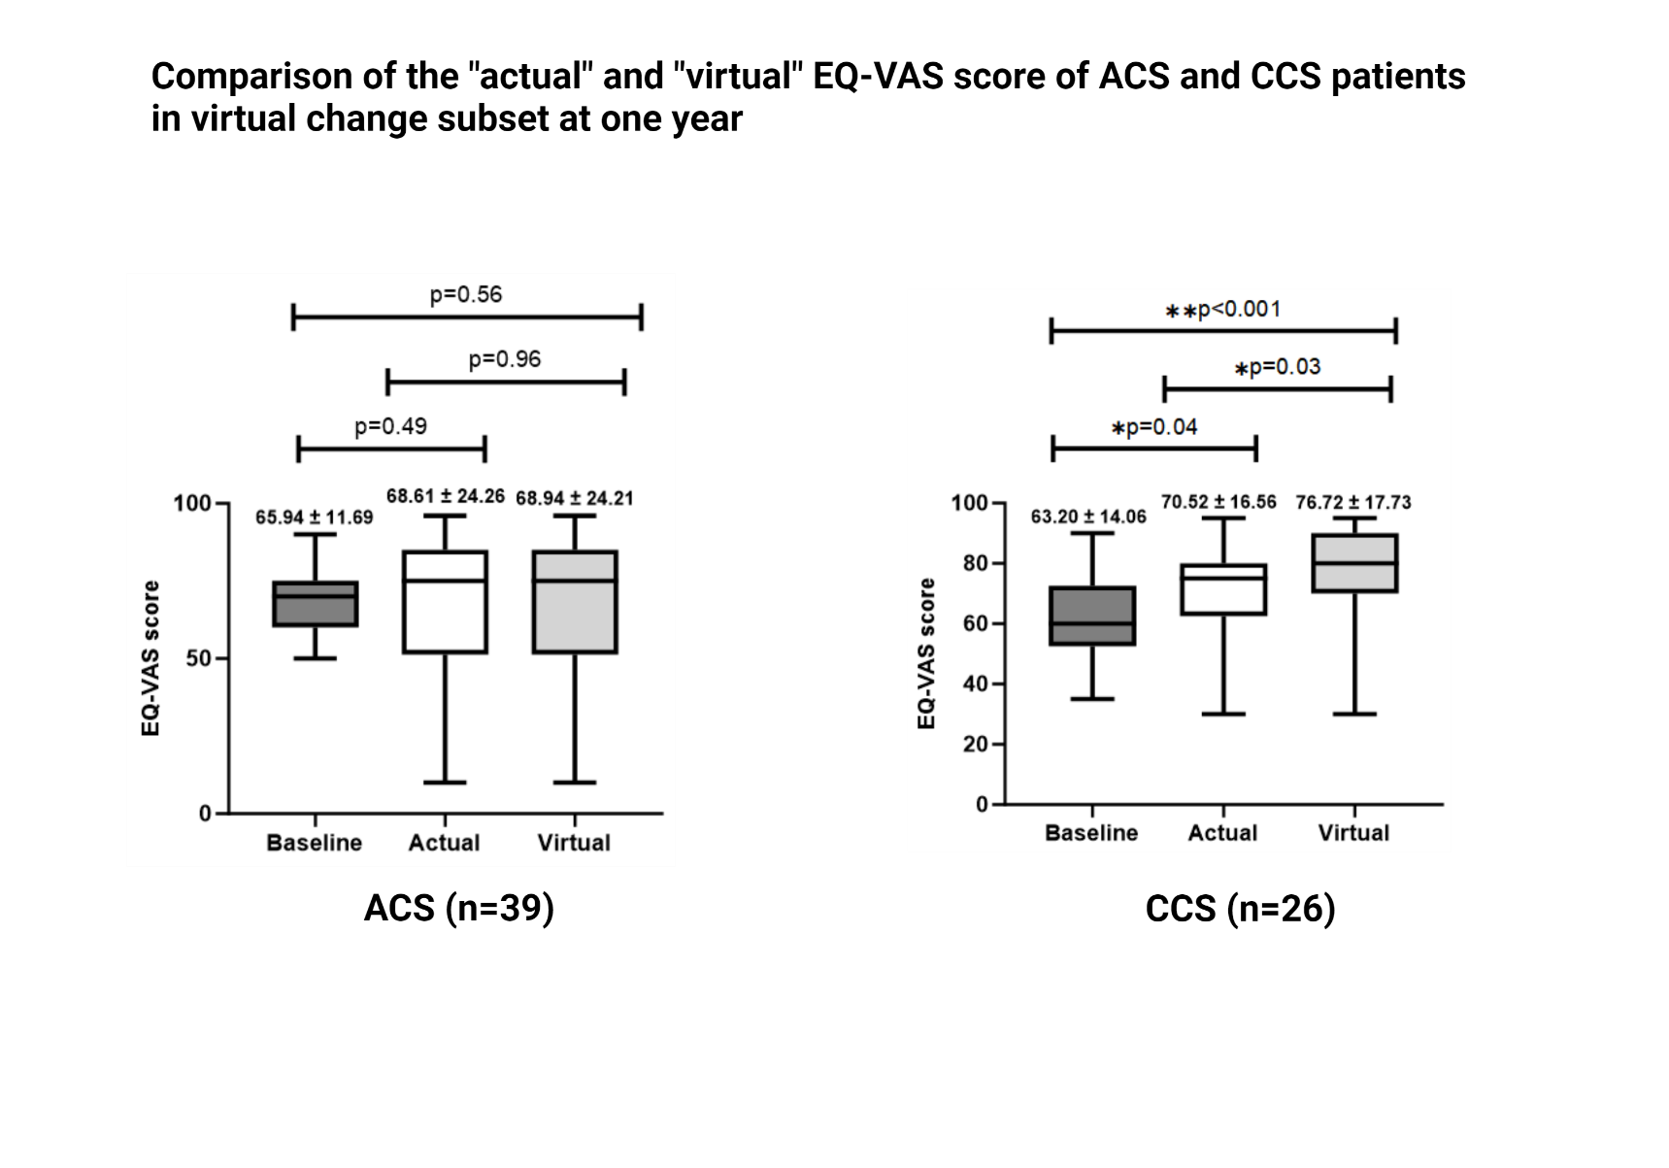Figure 53: Comparison of the "actual" and "virtual" EQ-VAS scores of ACS and CCS patients at one year in the virtual change subset

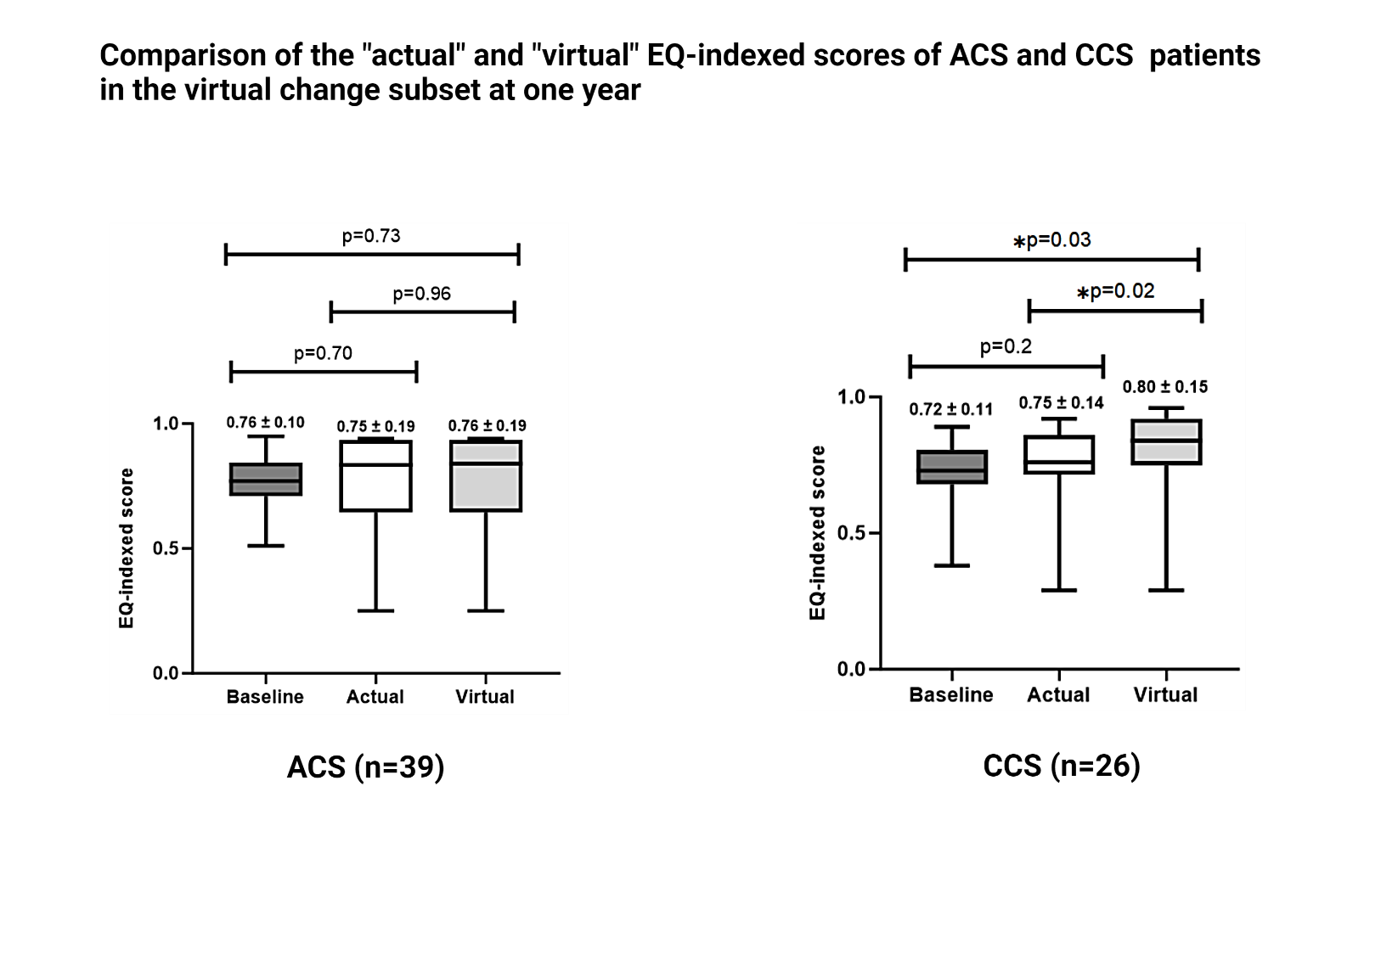
Figure 54: Comparison of the "actual" and "virtual" EQ-indexed scores of ACS and CCS patients at one year in the virtual change subset

3.5.3 Comparison of the interval change in “actual” and post-vFFR “virtual” EQ-VAS and EQ-indexed scores within the virtual change subset after the exclusion of patients with non-cardiac reasons for reduction in QOL
Like the entire VIRTU-4 QOL scores, the virtual change subset had the QOL scores evaluated after excluding non-cardiac reasons for reduction in QOL. It demonstrated that in the virtual change subset, 16/65 (24.6%) had a decrease in EQ-5D scores for non-cardiac reasons (13 ACS and 3 CCS patients). Therefore, a repeat analysis was performed in 49/65 (75.3%) patients after exclusion of non-cardiac causes (summarised in Table 15). The interval change in the EQ-VAS and EQ-indexed scores for the virtual change subset is shown in Figures 55, 56, and 57, respectively.

Table 15: Non-cardiac reasons for exclusion from QOL analysis of the ACS and CCS patients in the virtual change subset
Non-cardiac reasons for exclusion of patients from QOL analysis in the virtual change subset | ACS (n=39) | CCS (n=26)
Mental Stress | 5 (7.6%) | 0
Arthritis | 3 (4.6%) | 2 (3%)
Financial stress | 3 (4.6%) | 1 (1.5%)
Inflammatory bowel disease | 1 (1.5%) | 0
Frailty | 1 (1.5%) | 0
Total | 13 (20%) | 3 (4.6%)

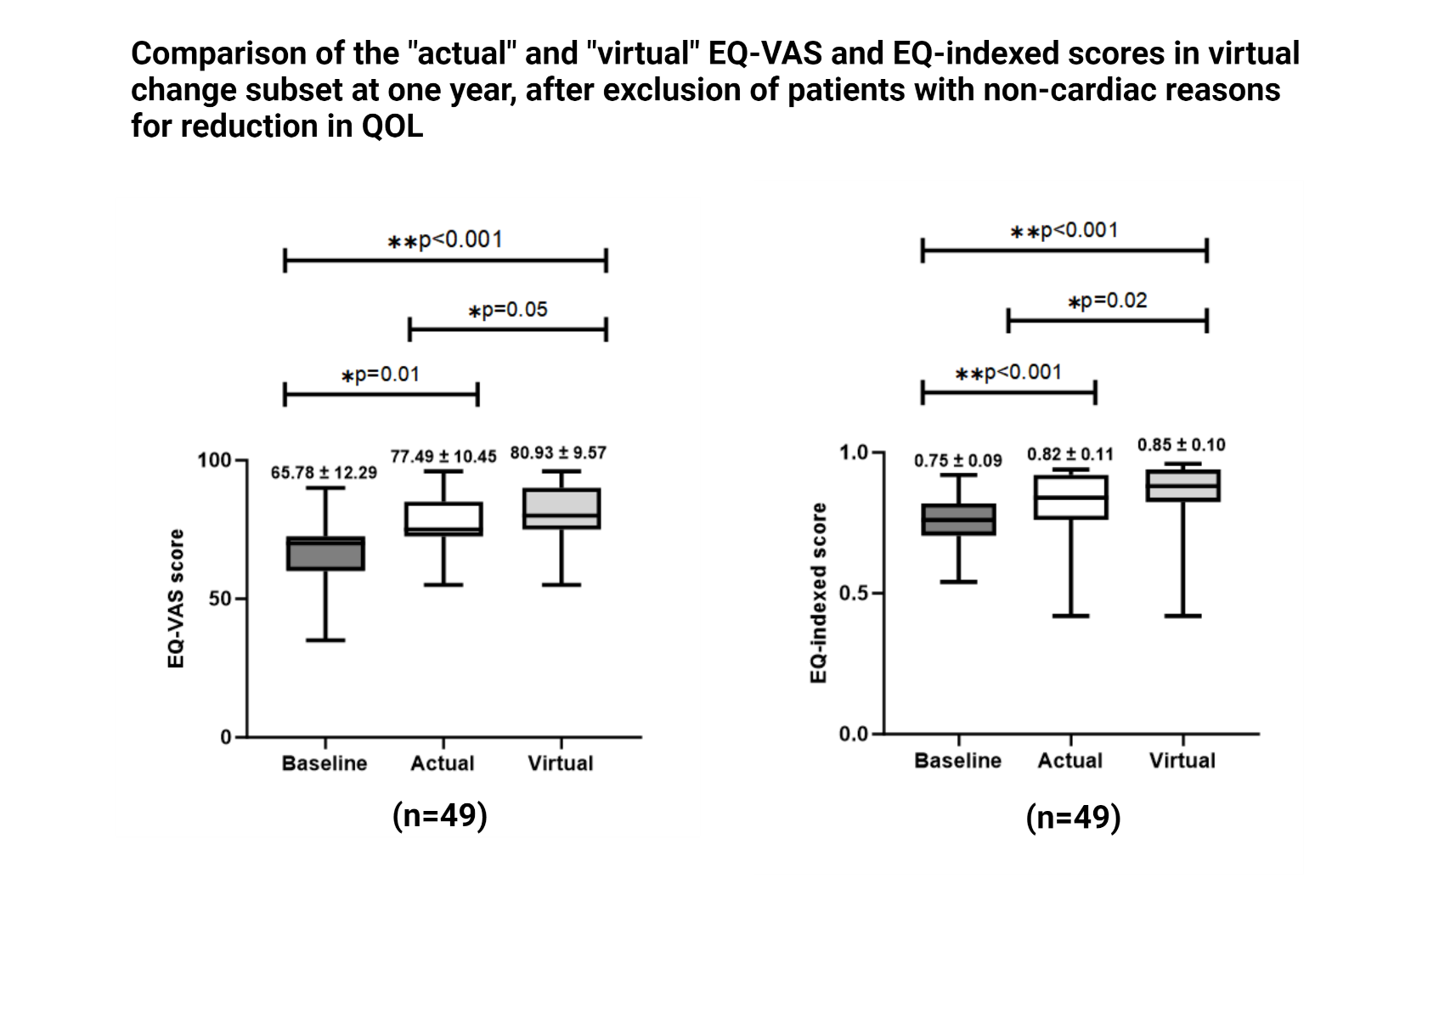
Figure 55: Comparison of the "actual" and "virtual" EQ-VAS and EQ-indexed scores within the virtual change subset at one year after exclusion of patients with non-cardiac reasons for reduction in QOL demonstrated statistically significant change in both parameters.
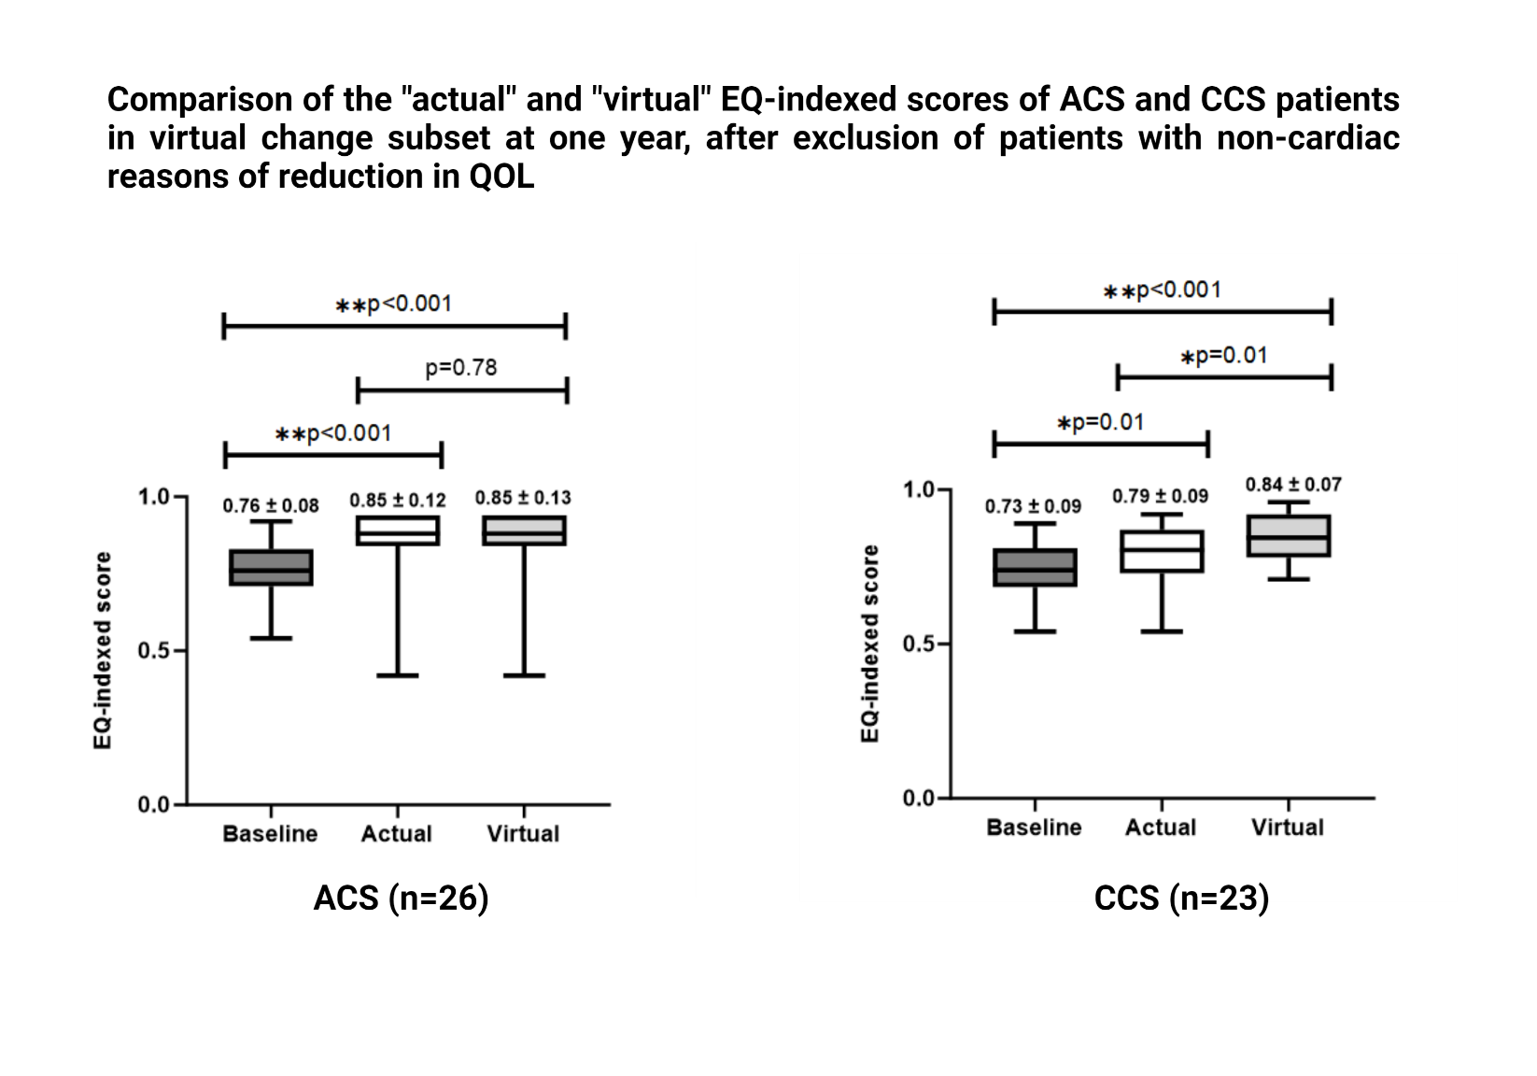
Figure 56: Comparison of the "actual" and "virtual" EQ-indexed scores of ACS and CCS patients in the virtual change subset at one year after exclusion of patients with non-cardiac reasons of reduction in QOL.

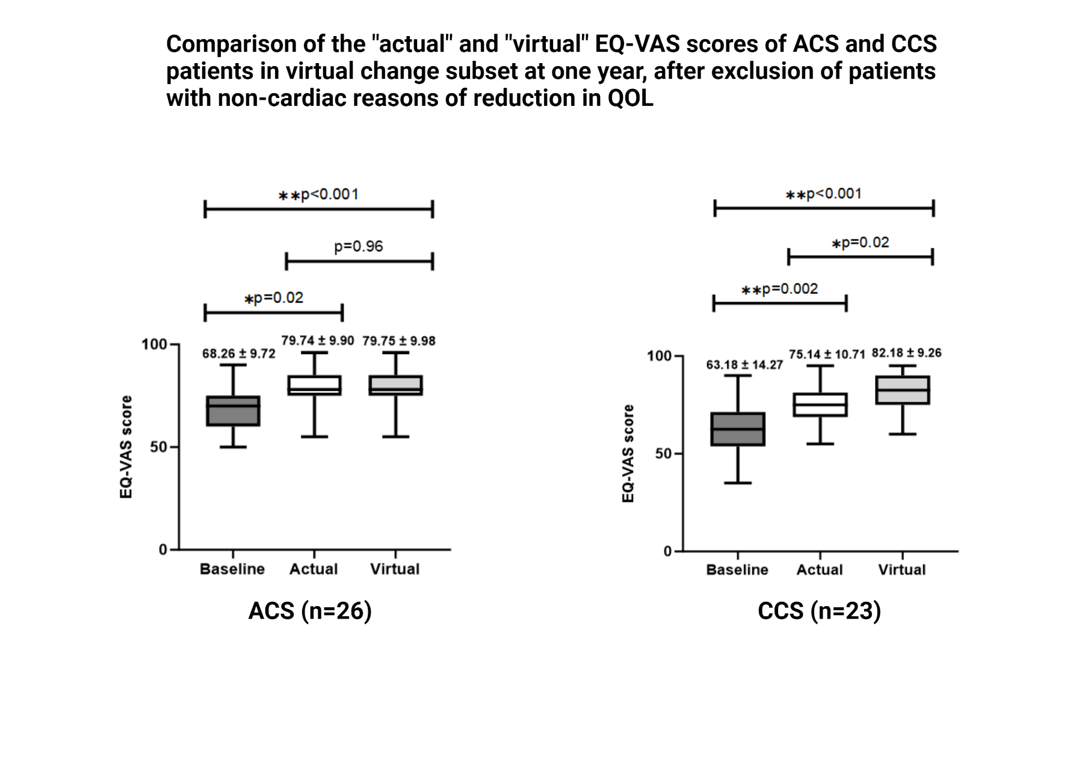
Figure 57: Comparison of the "actual" and "virtual" EQ-VAS scores of ACS and CCS patients in the virtual change subset at one year, after exclusion of patients with non-cardiac reasons of reduction in QOL

3.6 Health economics outcomes from the virtual change subset

3.6.1 Total cost of the virtual change subset according to the management plans (OMT, PCI, CABG)
The total cost, including any hospital re-admission, repeat revascularisation, outpatient visit and investigations, and cardiac rehabilitation, of all the patients in the virtual change subset, according to the management plans (OMT, PCI, CABG), are summarised in Figure 58.
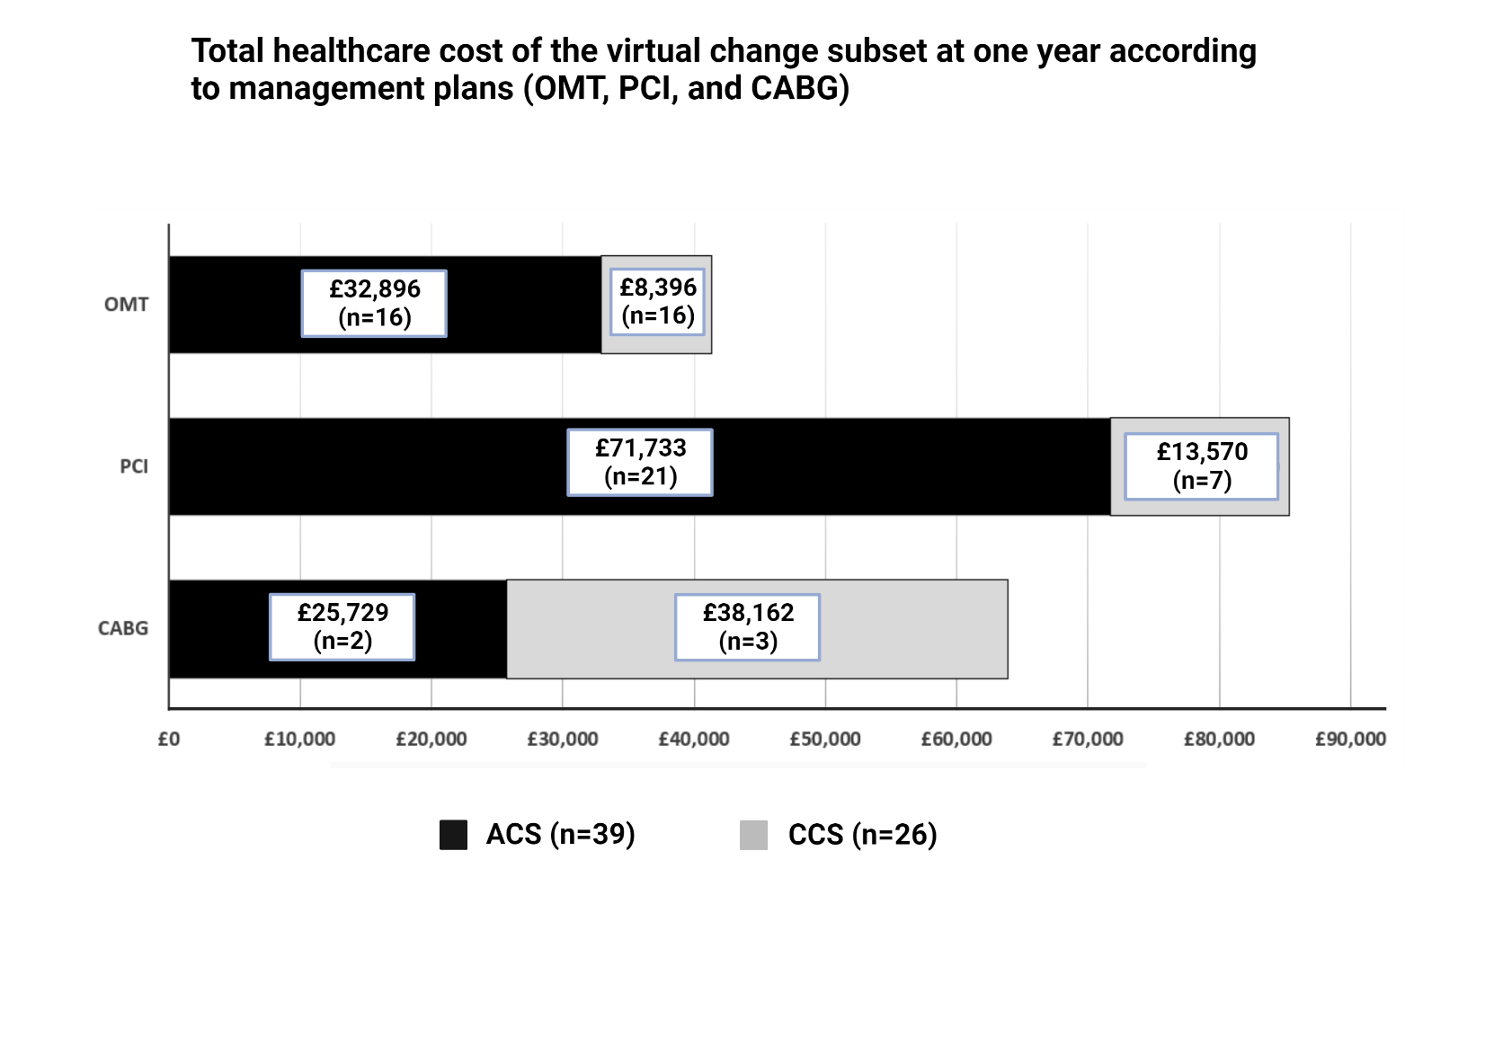
Figure 58: Total cost for the virtual change subset according to the management plans (OMT, PCI, and CABG)

3.6.2 Comparison of individualised "actual" and post-vFFR "virtual" costs of the index procedure within the virtual change subset – according to the parent cardiologists’ plan
Following the vFFR-suggested plans in ACS patients (n=39), 30/39 (76.9%) patients would have a virtual decrease, while 9/39 (23%) patients had a virtual increase in the cost of indexed procedures. In addition, 26 invasive pressure wire assessments could be saved in the 39 ACS patients (each pressure wire costs £586). The total savings in the ACS patients would have been significantly more had one patient’s plan not notionally changed from multivessel PCI to CABG (CABG being the most expensive plan costing up to £10828). This alteration in the management strategy of a single patient to CABG impacted the overall savings in ACS patients by £8972. However, this shows real-world clinical practice. In the CCS patients (n=26), 21/26 (80%) patients had a virtual increase, 4/26 (15.3%) had a decrease, and 1/26 (3.8%) had no change in the cost of the indexed procedure with vFFR. The individualised actual and virtual costs of the indexed procedures for the ACS and CCS patients from the virtual change subset have been shown in Tables 16 and 17.
Table 16: Comparison of the individualised "actual" and "virtual" cost of the index procedure for the ACS patients (n=39) in the virtual change subset according to the parent cardiologists’ plan
Study ID | Actual management plan (A) | Virtual change in management plan (B) | Cost of the actual management plan | Cost of the post-vFFR virtual management plan | Virtual change in the cost  (B-A)
6 | 2V PCI | mFFR + 2V PCI | £1856 | £2442 | + £586
14 | 1V PCI | mFFR + 1V PCI | £1436 | £2022 | + £586
16 | CABG x 3/ AVR (+mFFR) | CABG x 3/ AVR | £14315 | £13729 | - £586
38 | 1V PCI | mFFR + 1V PCI | £1436 | £2022 | + £586
40 | mFFR | OMT | £1296 | £710 | - £586
42 | mFFR + 1V PCI | 1V PCI | £2022 | £1436 | - £586
50 | mFFR | OMT | £1296 | £710 | - £586
59 | 1V PCI | OMT | £1436 | £710 | - £726
62 | mFFR | OMT | £1296 | £710 | - £586
66 | mFFR | OMT | £1296 | £710 | - £586
70 | mFFR | OMT | £1296 | £710 | - £586
77 | 1V PCI | mFFR + 1V PCI | £1436 | £2022 | + £586
78 | mFFR | OMT | £1296 | £710 | - £586
85 | 1V PCI + OCT | mFFR + 1V PCI | £2216 | £2022 | - £194
89 | mFFR + 1V PCI | 2V PCI | £2022 | £1856 | - £166
91 | mFFR + 1V PCI | 1V PCI | £2022 | £1436 | - £586
95 | mFFR | OMT | £1296 | £710 | - £586
108 | mFFR + 2V PCI | 2V PCI | £2442 | £1856 | - £586
125 | mFFR | OMT | £1296 | £710 | - £586
127 | mFFR + 1V PCI | 1V PCI | £2022 | £1436 | - £586
159 | 1V PCI | 2V PCI | £1436 | £1856 | + £420
174 | mFFR + 1V PCI | 1V PCI | £2022 | £1436 | - £586
180 | 2V PCI | CABG x 2 | £1856 | £10828 | + £8972
181 | 1V PCI | mFFR + 1V PCI | £1436 | £2022 | + £586
189 | mFFR | OMT | £1296 | £710 | - £586
192 | 1V PCI | 2V PCI | £1436 | £1856 | + £420
195 | mFFR | OMT | £1296 | £710 | - £586
209 | 2V PCI + Staged 1V PCI | 2V PCI | £5231 | £1856 | - £3375
211 | mFFR | OMT | £1296 | £710 | - £586
214 | mFFR + 1V PCI | 1V PCI | £2022 | £1436 | - £586
242 | mFFR | OMT | £1296 | £710 | - £586
247 | mFFR | OMT | £1296 | £710 | - £586
248 | CABG x 2 + mFFR | CABG x 2 | £11414 | £10828 | - £586
262 | mFFR | OMT | £1296 | £710 | - £586
263 | mFFR | OMT | £1296 | £710 | - £586
266 | mFFR + 1V PCI | 1V PCI | £2022 | £1436 | - £586
269 | 1V PCI | mFFR + 1V PCI | £1436 | £2022 | + £586
274 | mFFR | OMT | £1296 | £710 | - £586
287 | mFFR + 1V PCI | 1V PCI | £2022 | £1436 | - £586
Average cost per patient |  |  | £2249.4 | £2086.1 | - £163.3
1V PCI represents PCI performed for one vessel, and 2V PCI denotes PCI performed for two vessels.
"+" shows a virtual additional cost, whereas "-" represents a virtual reduction in the cost of the index procedure due to a notional change in the management plan.

Table 17: Comparison of the individualised "actual" and "virtual" costs of the index procedure for the CCS patients (n=26) in the virtual change subset according to parent cardiologists’ plans

Study ID | Pre-vFFR management plan (A) | Post-vFFR management plan (B) | Cost of the pre-vFFR management plan | Cost of the post-vFFR management plan | Change in cost (B-A)
D1 | OMT | 1V PCI | £160 | £1263 | + £1103
D7 | CABG x 3 | 2V PCI | £8544 | £1652 | - £6892
D20 | 1V PCI | mFFR + 1V PCI | £1263 | £1849 | + £586
R4 | OMT | 1V PCI | £160 | £1263 | + £1103
R6 | OMT | 1V PCI | £160 | £1263 | + £1103
D25 | 1V PCI | mFFR + 1V PCI | £1263 | £1849 | + £586
D26 | 1V PCI | 2V PCI | £1263 | £1652 | + £389
D27 | OMT | 1V PCI | £160 | £1263 | + £1103
D28 | OMT | 1V PCI | £160 | £1263 | + £1103
D33 | 1V PCI | 2V PCI | £1263 | £1652 | + £389
R12 | OMT | 1V PCI | £160 | £1263 | + £1103
B7 | OMT | 1V PCI | £160 | £1263 | + £1103
B11 | CABG x 4 | CABG x 2 | £10407 | £8544 | - £1863
D59 | OMT | mFFR | £160 | £746 | + £586
B15 | 1V PCI | mFFR + 1V PCI | £1263 | £1849 | + £586
B16 | mFFR + 1V PCI | 1V PCI | £1849 | £1263 | - £586
B21 | 1V PCI | 2V PCI | £1263 | £1652 | + £389
D73 | OMT | mFFR + 1V PCI | £160 | £1849 | + £1689
R14 | OMT | mFFR | £160 | £746 | + £586
S2 | OMT | 1V PCI | £160 | £1263 | + £1103
D77 | OMT | 1V PCI | £160 | £1263 | + £1103
B34 | OMT | 1V PCI | £160 | £1263 | + £1103
C1 | OMT | 1V PCI | £160 | £1263 | + £1103
D96 | OMT | 1V PCI | £160 | £1263 | + £1103
D106 | OMT | mFFR | £160 | £746 | + £586
B69 | CABG x 3 | CABG x 2 | £8384 | £8384 | No change
Average cost per patient |  |  | £1512.3 | £1907.2 | + £394.8
1V PCI represents PCI performed for one vessel, and 2V PCI denotes PCI performed for two vessels.
"+" shows a virtual additional cost, whereas "-" represents a virtual reduction in the cost of the index procedure due to a notional change in the management plan.

3.6.3 Comparison of the total costs of the “actual” and post-vFFR “virtual” plans from parent cardiologists within the virtual change subset
The total cost of the virtual change subset (n=65) in accordance with the management plans from parent cardiologists were estimated, which showed that following the vFFR-suggested plans would result in an extra cost of £3898 (average extra cost of £59.9 per patient). For the ACS patients (n=39), vFFR would virtually save £6369 (average savings of £163.3 per patient), while for the CCS patients (n=26), vFFR would cause a hypothetical increase in the cost by an extra £10267 (average increase of £394.8 per patient). The increase in the CCS patients was owing to a virtual change in plans from conservative to invasive treatment; 16/26 (61.5%) patients from OMT to PCI, 3/26 (11.5%) additional vessel invasive mFFR, and 3/26 (11.5%) from single vessel to multivessel PCI. A summary of the total cost of the actual and virtual outcomes for both the ACS and CCS patients in the virtual change subset is shown in Figure 59.

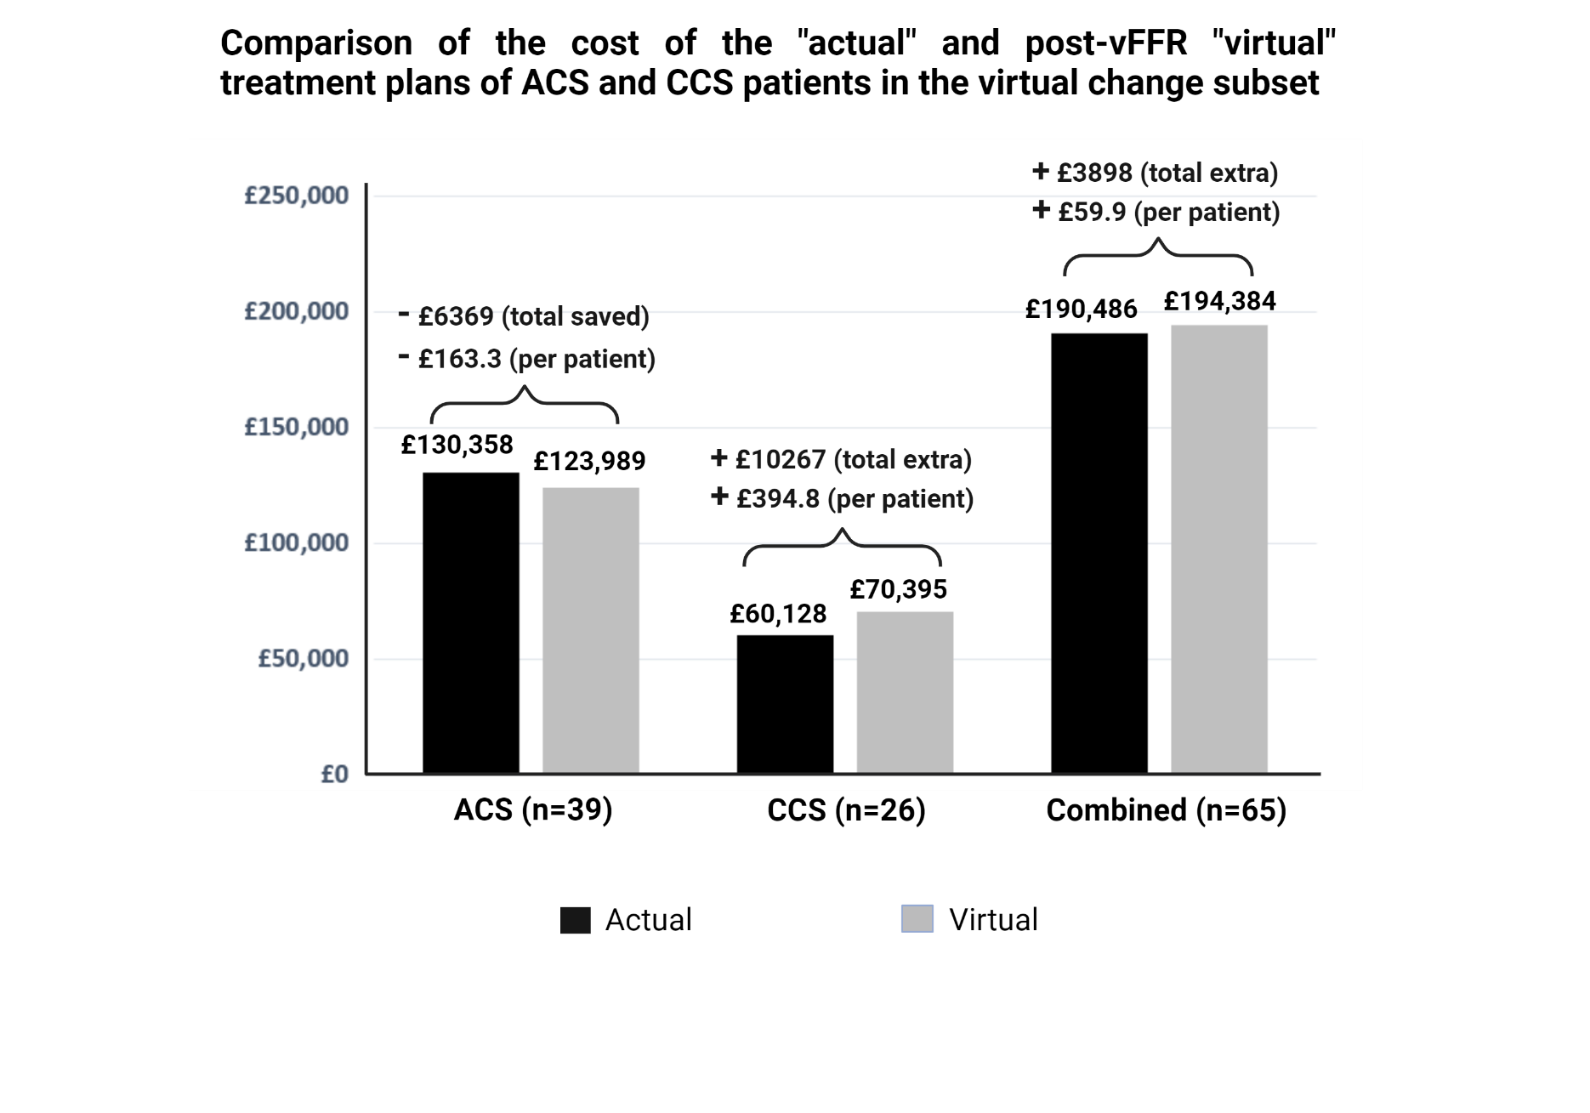
Figure 59: Comparison of the total costs of “actual” and post-vFFR “virtual” treatment plans of ACS and CCS patients in the virtual change subset showing that following the post-vFFR plans would have resulted in savings of £163 per person in ACS while it would lead to an extra spend of £394 per person (equivalent to an overall extra spend of £59.9 person for the virtual change subset, n=65).

3.6.4 Comparison of the cost of actual outcomes of the virtual change subset with that of patients without a virtual change in treatment (according to parent cardiologists’ plans)
The total cost of the management plans for the virtual change subset (n=65) and those without a virtual change in the management plans (n=201) is shown in Figure 60.
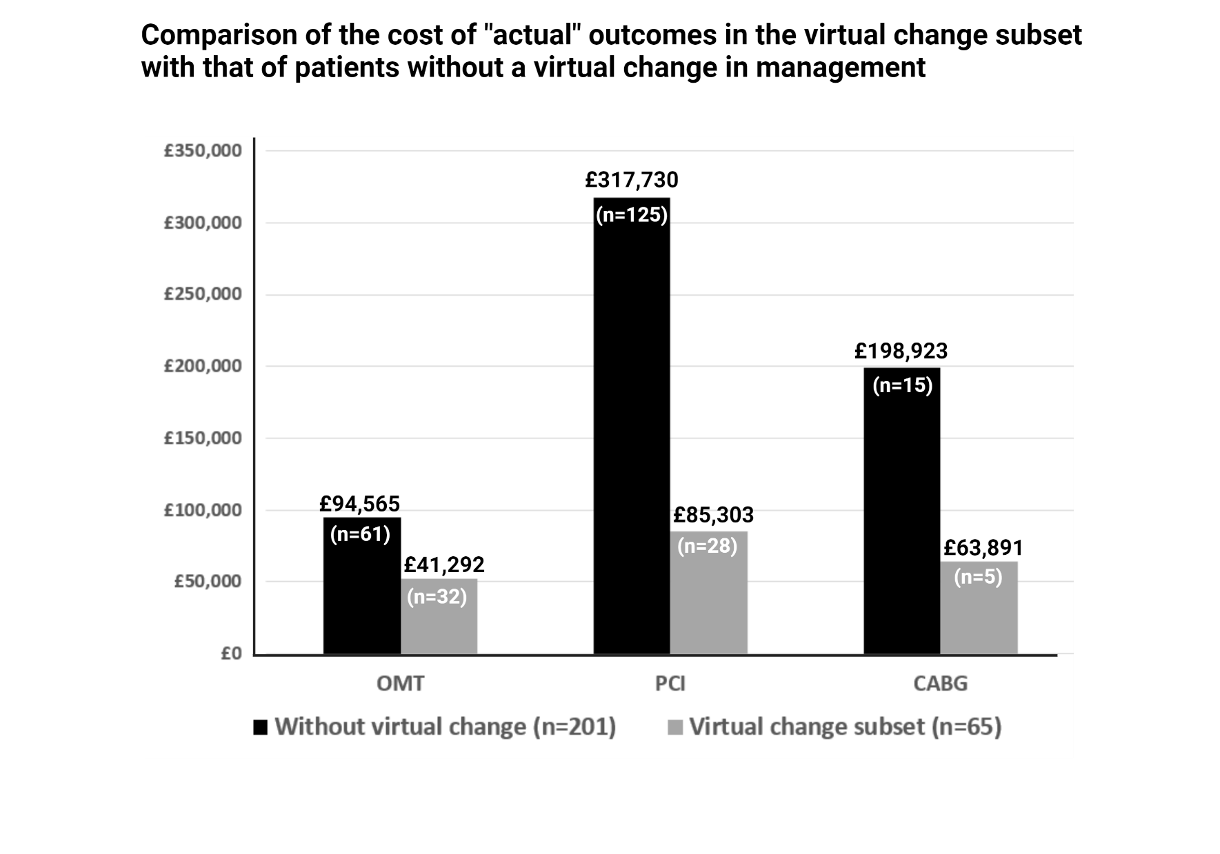
Figure 60: Comparison of the cost of “actual” outcomes in the virtual change subset with patients without a virtual change in management

3.6.5 Comparison of the mean cost per patient in the virtual change subset, according to the management plans (OMT, PCI, CABG)
In the ACS group, vFFR would have reduced the cost per patient in the OMT-treated patients by £438 ± 590 (by reducing the number of invasive FFRs performed). However, in the PCI-treated patients, it would have increased the cost per patient, either by additional vessel stenting or increasing the number of stents per vessel (£802 ± 765). In CABG-treated patients, vFFR would have reduced the number of grafts needed by non-invasively providing the physiological significance of lesions, hence avoiding invasive mFFR and saving the pressure wire cost (£586). In the CCS group, vFFR would increase the cost per patient in the OMT-treated patients by recommending more PCI, therefore increasing the cost by £1047 ± 41.4. In the PCI-treated patients, the cost would increase by £521 ± 32 by increasing the number of vessels to be treated with stents. In the CABG group, the cost per patient would decrease by £2919 by reducing the number of grafts needed. The comparison of the mean “actual” and “virtual” cost per patient of the ACS and CCS patients from the virtual change subset is shown in Figure 61.

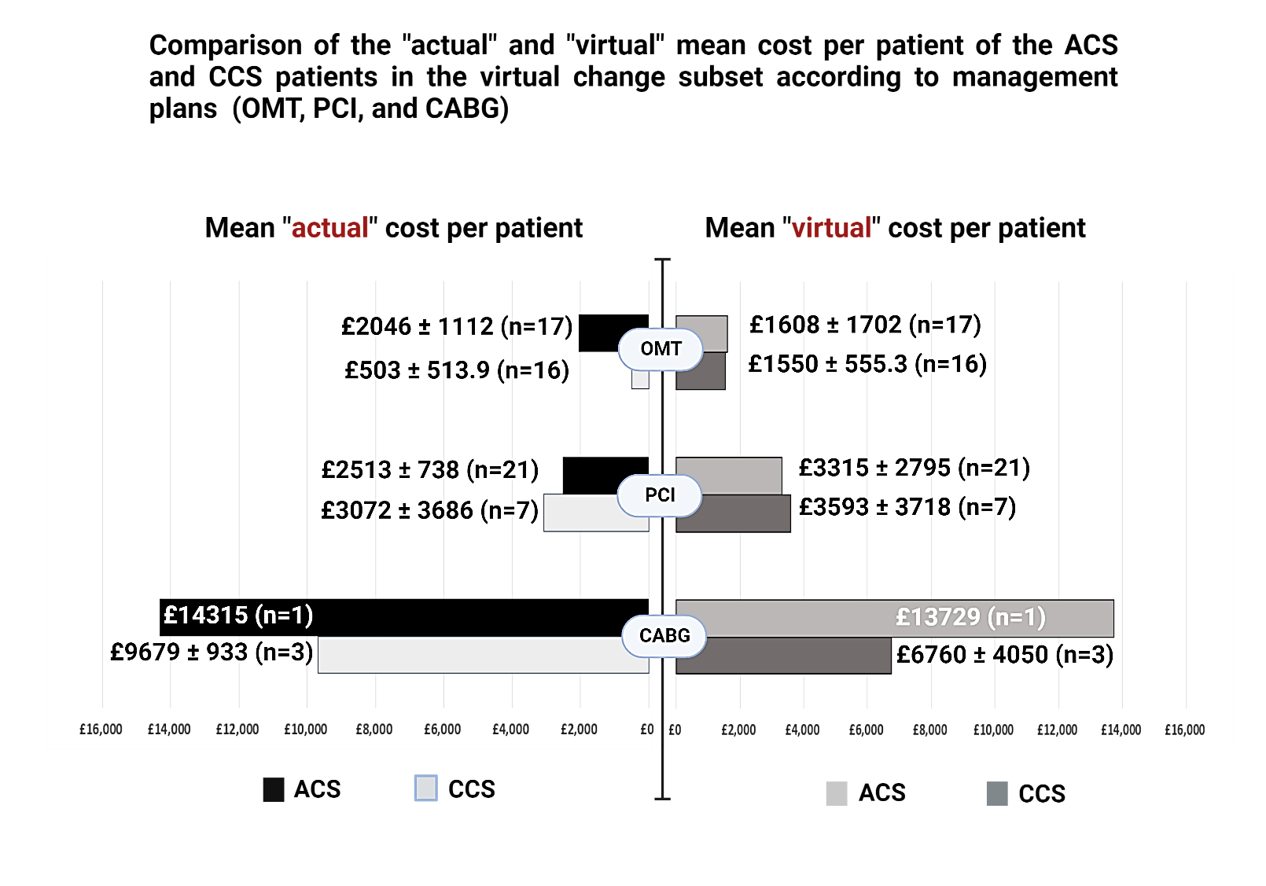
Figure 61: Comparison of the "actual" and "virtual" mean cost per patient within the virtual change subset according to management plans (OMT, PCI, CABG).

3.6.6 Percentage change in the total cost in VIRTU-4 and the virtual change subset
The vFFR-driven plans would have led to a total increase of £3898 for the patients in the virtual change subset. As a result, the virtual change subset and the entire VIRTU-4 cohort cost increased by 2% and 0.48%, respectively.

3.7 Outcomes from the expert MDTs

3.7.1 Individualised pre- and post-vFFR management plans from the expert MDTs
The pre-and post-vFFR management plans from the expert MDT were recorded the same way as those from the parent cardiologists in VIRTU-4. The patient’s clinical history was presented, followed by the CAG cine images. The pre-vFFR plans based on the visual assessment of the CAG were documented. The virtual change in the treatment strategy was noted after the vFFR results were disclosed to the expert teams. The concordance was then checked between the pre- and post-vFFR plans of two expert MDTs to evaluate the reproducibility rates of decisions amongst the expert teams. The pre-vFFR concordance showed that 24/39 (61.5%) ACS (r=0.53; p=0.25) and 14/26 (53.8%) CCS patients (r=0.49; p=0.35) had the same treatment plan from both MDTs. Post-vFFR concordance demonstrated that the numbers increased to 29/39 (74.3%) for ACS (r=0.89; p=0.02) and 16/26 (61.3%) for the CCS group (r=0.62; p=0.25). The individualised pre- and post-vFFR management decisions, their associated virtual costs of the index procedures, and the concordance of both expert MDT plans have been shown in Figure 62, Tables 18 and 19.

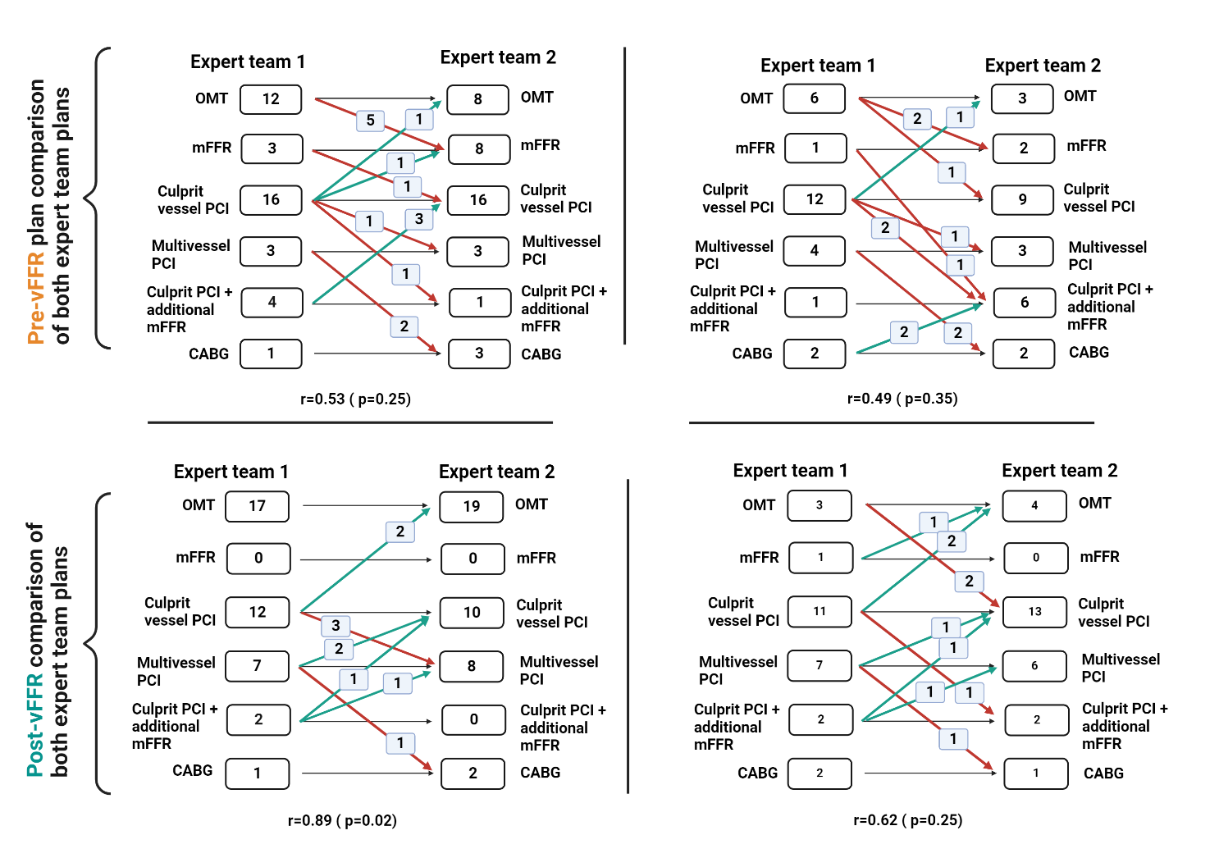
Figure 62: Concordance of the pre- and post-vFFR management plans from expert teams.

Table 18: Individualised pre- and post-vFFR management plans and the associated change in the costs of indexed procedures according to the expert MDT-1 for the virtual change subset patients
Pre- and post-vFFR management for the “ACS patients” and impact on costs of the index procedures (based on expert MDT-1)
Study ID | Pre-vFFR expert plans | Post-vFFR expert plans | Cost of the actual management plans | Cost of the virtual management plans | Virtual change in the cost  (B-A)
6 | 2V PCI | 2V PCI | £1856 | £1856 | No change
14 | 1V PCI | 1V PCI | £1436 | £1436 | No change
16 | CABG x 3 (+mFFR) | CABG x 3 | £12376 | £11790 | - £586
38 | 1V PCI | 1V PCI | £1436 | £1436 | No change
40 | mFFR | OMT | £1296 | £710 | - £586
42 | 1V PCI | 1VPCI + mFFR | £1436 | £2022 | + £586
50 | OMT | OMT | £710 | £710 | No change
59 | 1V PCI | OMT | £1436 | £710 | - £726
62 | OMT | OMT | £710 | £710 | No change
66 | OMT | OMT | £710 | £710 | No change
70 | 1V PCI | OMT | £1436 | £710 | - £726
77 | 1V PCI + mFFR | 2V PCI | £2022 | £1856 | - £166
78 | mFFR | OMT | £1296 | £710 | - £586
85 | 1V PCI + mFFR | 1V PCI | £2022 | £1436 | - £586
89 | 1V PCI + mFFR | 2V PCI | £2022 | £1856 | - £166
91 | 1V PCI | 1V PCI | £1436 | £1436 | No change
95 | mFFR | OMT | £1296 | £710 | - £586
108 | 1V PCI + mFFR | 2V PCI, no mFFR | £2022 | £1856 | - £166
125 | OMT | OMT | £710 | £710 | No change
127 | 1V PCI | 1V PCI | £1436 | £1436 | No change
159 | 1V PCI | 1VPCI | £1436 | £1436 | No change
174 | 1V PCI | 1V PCI | £1436 | £1436 | No change
180 | 1V PCI | 2V PCI | £1436 | £1856 | + £420
181 | 1V PCI | 1V PCI | £1436 | £1436 | No change
189 | OMT | OMT | £710 | £710 | No change
192 | 1V PCI | 1VPCI | £1436 | £1436 | No change
195 | OMT | OMT | £710 | £710 | No change
209 | 2V PCI + 1V PCI (staged) | 2V PCI | £5231 | £1856 | - £3375
211 | OMT | OMT | £710 | £710 | No change
214 | 1V PCI | 1V PCI + mFFR | £1436 | £2022 | + £586
242 | OMT | OMT | £710 | £710 | No change
247 | OMT | OMT | £710 | £710 | No change
248 | 2V PCI | 2V PCI | 1856 | £1856 | No change
262 | OMT | OMT | 710 | £710 | No change
263 | OMT | OMT | £710 | £710 | No change
266 | 1V PCI | 1V PCI | £1436 | £1436 | No change
269 | 1V PCI | 1V PCI | £1436 | £1436 | No change
274 | OMT | OMT | £710 | £710 | No change
287 | 1V PCI | 1V PCI | £1436 | £1436 | No change
Average per patient |  |  | £1879.5 | £2058 | £178.5
1V PCI represents PCI performed for one vessel, and 2V PCI denotes PCI performed for two vessels.
"+" shows a virtual additional cost, whereas "-" represents a virtual reduction in the cost of the index procedure due to a notional change in the management plan.
Pre- and post-vFFR management for the “CCS patients” and impact on costs of the index procedures (based on expert MDT-1)
Study ID | Pre-vFFR expert plans | Post-vFFR expert plans | Cost of the actual management plans | Cost of the virtual management plans | Virtual change in the cost  (B-A)
D1 | 1V PCI | 1V PCI | £1263 | £1263 | No change
D7 | 2V PCI | 2V PCI | £1652 | £1652 | No change
D20 | 1V PCI | 2V PCI | £1263 | £1652 | + £389
R4 | OMT | OMT | £160 | £160 | No change
R6 | OMT | OMT | £160 | £160 | No change
D25 | 1V PCI | mFFR + 1V PCI | £1263 | £1849 | + £586
D26 | 1V PCI | 2V PCI | £1263 | £1652 | + £389
D27 | 1V PCI | 1V PCI | £1263 | £1263 | No change
D28 | 2V PCI | 2V PCI | £1652 | £1652 | No change
D33 | 2V PCI | 2V PCI | £1652 | £1652 | No change
R12 | OMT | OMT | £160 | £160 | No change
B7 | OMT | 1V PCI | £160 | £1263 | + £1103
B11 | CABG x 4 | CABG x 3 | £10407 | £8384 | - £2023
D59 | OMT | mFFR | £160 | £746 | + £586
B15 | 1V PCI | mFFR + 1V PCI | £1263 | £1849 | + £586
B16 | 1V PCI | 1V PCI | £1263 | £1263 | No change
B21 | 1V PCI | 2V PCI | £1263 | £1652 | + £389
D73 | 1V PCI + mFFR | 1V PCI | £1849 | £1263 | - £586
R14 | mFFR | 1V PCI | £746 | £1263 | + £517
S2 | 1V PCI | 1V PCI | £1263 | £1263 | No change
D77 | 1V PCI | 1V PCI | £1263 | £1263 | No change
B34 | 2V PCI | 2V PCI | £1652 | £1652 | No change
C1 | 1V PCI | 1V PCI | £1263 | £1263 | No change
D96 | 1V PCI | 1V PCI | £1263 | £1263 | No change
D106 | OMT | 1V PCI | £160 | £1263 | No change
B69 | CABG x 2 | CABG x 2 | £8384 | £8384 | No change
Average per patient |  |  | £1512.3 | £1908.6 | £396.3
1V PCI represents PCI performed for one vessel, and 2V PCI denotes PCI performed for two vessels.
"+" shows a virtual additional cost, whereas "-" represents a virtual reduction in the cost of the index procedure due to a notional change in the management plan.

Table 19: Individualised pre- and post-vFFR management plans and the associated change in the costs of indexed procedures according to the expert MDT-2 for the virtual change subset patients
Pre- and post-vFFR management for the ‘ACS patients’ and impact on costs of the index procedures (based on expert MDT-2)
Study ID | Pre-vFFR expert plans | Post-vFFR expert plans | Cost of the actual management plans | Cost of the virtual management plans | Virtual change in the cost  (B-A)
6 | 2V PCI | 2V PCI | £1856 | £1856 | No change
14 | 1V PCI | 1V PCI | £1436 | £1436 | No change
16 | CABG x 3 (+mFFR) | CABG x 3 | £12376 | £11790 | - £586
38 | 1V PCI | 2V PCI | £1436 | £1856 | + £420
40 | mFFR | OMT | £1296 | £710 | - £586
42 | 1V PCI + mFFR | 1VPCI | £2022 | £1436 | - £586
50 | OMT | OMT | £710 | £710 | No change
59 | 1V PCI | OMT | £1436 | £710 | - £726
62 | OMT | OMT | £710 | £710 | No change
66 | OMT | OMT | £710 | £710 | No change
70 | 1V PCI | OMT | £1436 | £710 | - £726
77 | 2V PCI | 2V PCI | £1856 | £1856 | No change
78 | mFFR | OMT | £1296 | £710 | - £586
85 | 1V PCI | 1V PCI | £1436 | £1436 | No change
89 | 1V PCI | 1V PCI | £1436 | £1436 | No change
91 | 1V PCI | 1V PCI | £1436 | £1436 | No change
95 | 1V PCI | OMT | £1436 | £710 | - £726
108 | 1V PCI | 2V PCI | £1436 | £1856 | + £420
125 | OMT | OMT | £710 | £710 | No change
127 | 1V PCI | 1V PCI | £1436 | £1436 | No change
159 | 1V PCI | 1VPCI | £1436 | £1436 | No change
174 | 1V PCI | 1V PCI | £1436 | £1436 | No change
180 | 1V PCI | 1V PCI | £1436 | £1436 | No change
181 | 2V PCI | 2V PCI | £1856 | £1856 | No change
189 | OMT | OMT | £710 | £710 | No change
192 | 1V PCI | 2V PCI | £1436 | £1856 | + £420
195 | mFFR | OMT | £1296 | £710 | - £586
209 | CABG x 3 | CABG x 3 | £11790 | £11790 | No change
211 | mFFR | OMT | £1296 | £710 | - £586
214 | 1V PCI | 2V PCI | £1436 | £1856 | + £586
242 | mFFR | OMT | £1296 | £710 | - £586
247 | CABG x 2 | OMT | £11790 | £710 | - £11080
248 | mFFR | 2V PCI | £1296 | £1856 | - £560
262 | mFFR | OMT | £1296 | £710 | - £586
263 | OMT | OMT | £710 | £710 | No change
266 | mFFR | OMT | £1296 | £710 | - £586
269 | 1V PCI | 1V PCI | £1436 | £1436 | No change
274 | mFFR | OMT | £1296 | £710 | - £586
287 | OMT | OMT | £710 | £710 | No change
Average per patient |  |  | £2132.2 | £1699.4 | £432.8
1V PCI represents PCI performed for one vessel, and 2V PCI denotes PCI performed for two vessels.
"+" shows a virtual additional cost, whereas "-" represents a virtual reduction in the cost of the index procedure due to a notional change in the management plan.
Pre- and post-vFFR management for the ‘CCS patients’ and impact on costs of the index procedures (based on expert MDT-2)
Study ID | Pre-vFFR expert plans | Post-vFFR expert plans | Cost of the actual management plans | Cost of the virtual management plans | Virtual change in the cost  (B-A)
D1 | OMT | OMT | £160 | £160 | No change
D7 | CABG x 3 | 2V PCI | £8384 | £1652 | - £6732
D20 | 2V PCI | 2V PCI | £1652 | £1652 | No change
R4 | mFFR | IV PCI | £746 | £1263 | + £517
R6 | OMT | OMT | £160 | £160 | No change
D25 | 1V PCI + mFFR | 2V PCI | £1849 | £1652 | - £197
D26 | 1V PCI | 2V PCI | £1263 | £1652 | + £389
D27 | 1V PCI | 1V PCI | £1263 | £1263 | No change
D28 | 2V PCI | 2V PCI | £1652 | £1652 | No change
D33 | CABG x 2 | CABG x 2 | £8384 | £8384 | No change
R12 | mFFR | 1V PCI | £746 | £1263 | + £517
B7 | OMT | OMT | £160 | £160 | No change
B11 | 1V PCI + mFFR | 1V PCI | £1849 | £1263 | - £586
D59 | OMT | OMT | £160 | £160 | No change
B15 | 1V PCI | 1V PCI | £1263 | £1263 | No change
B16 | 1V PCI | 1V PCI | £1263 | £1263 | No change
B21 | 1V PCI | 1V PCI | £1263 | £1263 | No change
D73 | 1V PCI + mFFR | 1V PCI | £1849 | £1263 | - £586
R14 | 1V PCI + mFFR | 1V PCI + mFFR | £1849 | £1849 | No change
S2 | 1V PCI + mFFR | 1V PCI | £1849 | £1263 | - £586
D77 | 1V PCI | 1V PCI | £1263 | £1263 | No change
B34 | 2V PCI | 2V PCI | £1652 | £1652 | No change
C1 | 1V PCI | 1V PCI | £1263 | £1263 | No change
D96 | 1V PCI | 1V PCI | £1263 | £1263 | No change
D106 | 1V PCI | 1V PCI | £1263 | £1263 | No change
B69 | 1V PCI + mFFR | 1V PCI + mFFR | £1849 | £1849 | No change
Average per patient |  |  | £1781.4 | £1502 | £279.4
1V PCI represents PCI performed for one vessel, and 2V PCI denotes PCI performed for two vessels.
"+" shows a virtual additional cost, whereas "-" represents a virtual reduction in the cost of the index procedure due to a notional change in the management plan.

3.7.2 Comparison of the pre- and post-vFFR cost of outcomes in the virtual change subset according to the expert MDT’s treatment plans
The pre- and post-vFFR plans from the expert MDT MDTs were costed according to the treatment strategies to estimate the virtual costs if expert plans had been followed. Plans from the first expert MDT would have led to a notional savings of £6663 (average savings of £170.8 per patient) in the ACS patients (n=39), whereas for the CCS patients (n=26), there would be an extra spend of £3039 (average extra cost of £116.8). It would lead to an overall savings of £3678 (average savings of £56.5 per patient) for the virtual change subset (n=65).
Following the second expert team’s treatment plans would lead to virtual savings of £16878 (average savings of £432.7 per patient) for ACS (n=39) and £7265 (average savings of £279.4 per patient) for CCS patients (n=26). The overall savings for the entire virtual change subset (n=65) would be £24143 (average savings of £371.4 per patient). This suggests that the plans from expert team were more cost-efficient compared to the parent cardiologists’ plans, especially the ones from the CCS cohort. The pre- and post-vFFR management plans from both expert teams and their associated outcome costs are shown in Figure 63.

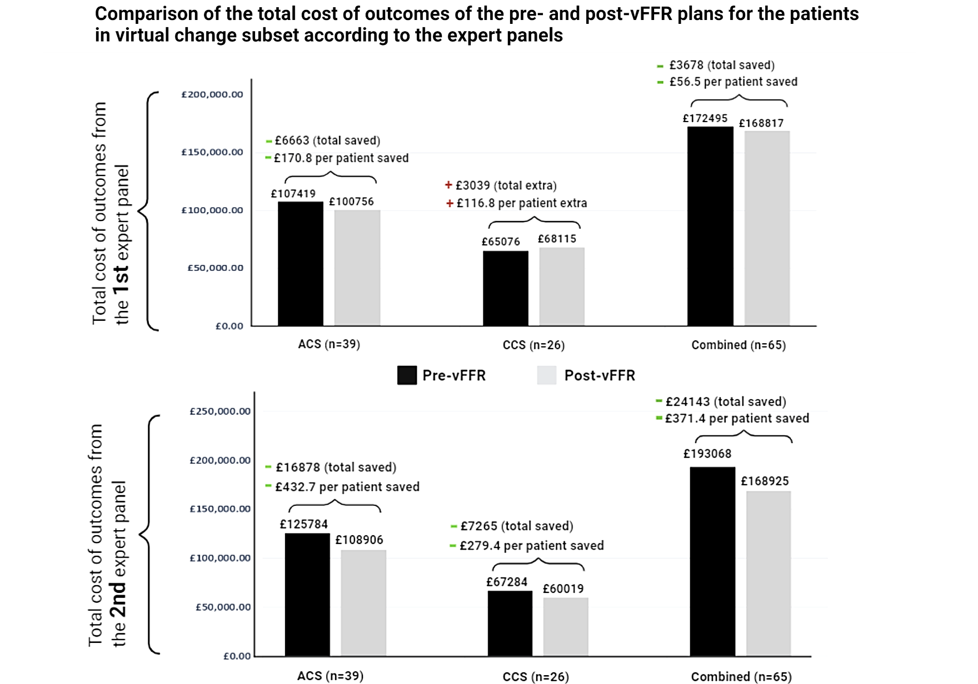
Figure 63: Comparison of the total cost of outcomes of the pre- and post-vFFR plans for the patients in virtual change subset according to the expert MDTs

3.8 Incremental cost-effectiveness ratio (ICER) calculation for vFFR
The ICER for the outcomes from the virtual change subset was calculated for the three-tier proposed cost for both the voucher-based and institutional licence models using the formula:
Cost of intervention _{CAG} – Cost of intervention _{vFFR}
ICER = --------------------------------------------------------------------
QALY of intervention _{CAG} – QALY of intervention _{vFFR}
The total cost of the CAG-based plans and the virtual changes in management plans with vFFR were estimated using the NHS tariffs for 2022-23. QALYs were calculated for one year based on EQ-index scores, which were derived from five domains: mobility, self-care, usual activity, pain/discomfort, and anxiety/depression. Each domain's isolated score was combined to produce a single digit number. This number was then subtracted from '1' to provide the 'utility'. Since QALYs were calculated for one year, the 'utility' values were directly converted to QALYs. The ICER was calculated by subtracting the total cost of CAG-based treatment plans from the vFFR-based treatment plans and by subtracting the total QALYs gained by CAG-based plans from the QALYs gained by vFFR-based plans. The ICERs were estimated for both the voucher-based and institution-based cost of vFFR licence, considering from low to high tariffs to indicate if they were below the WTP threshold.
The ICERs for the three-tier “voucher-based” licence cost of vFFR @ £50, @ £100, and @ £200 were £2803, £4077, and £6626 per QALY gained, respectively. The corresponding numbers for “institution-based” per-annum licence cost of vFFR @ £20000, @ £30000, and £50000 were £4077, £5352, and £7901 per QALY, respectively, all of which are below the willingness-to-pay (WTP) threshold of £20,000 for the UK. The ICERs for the proposed voucher-based and institutional licences have been shown in Figures 64 and 65.

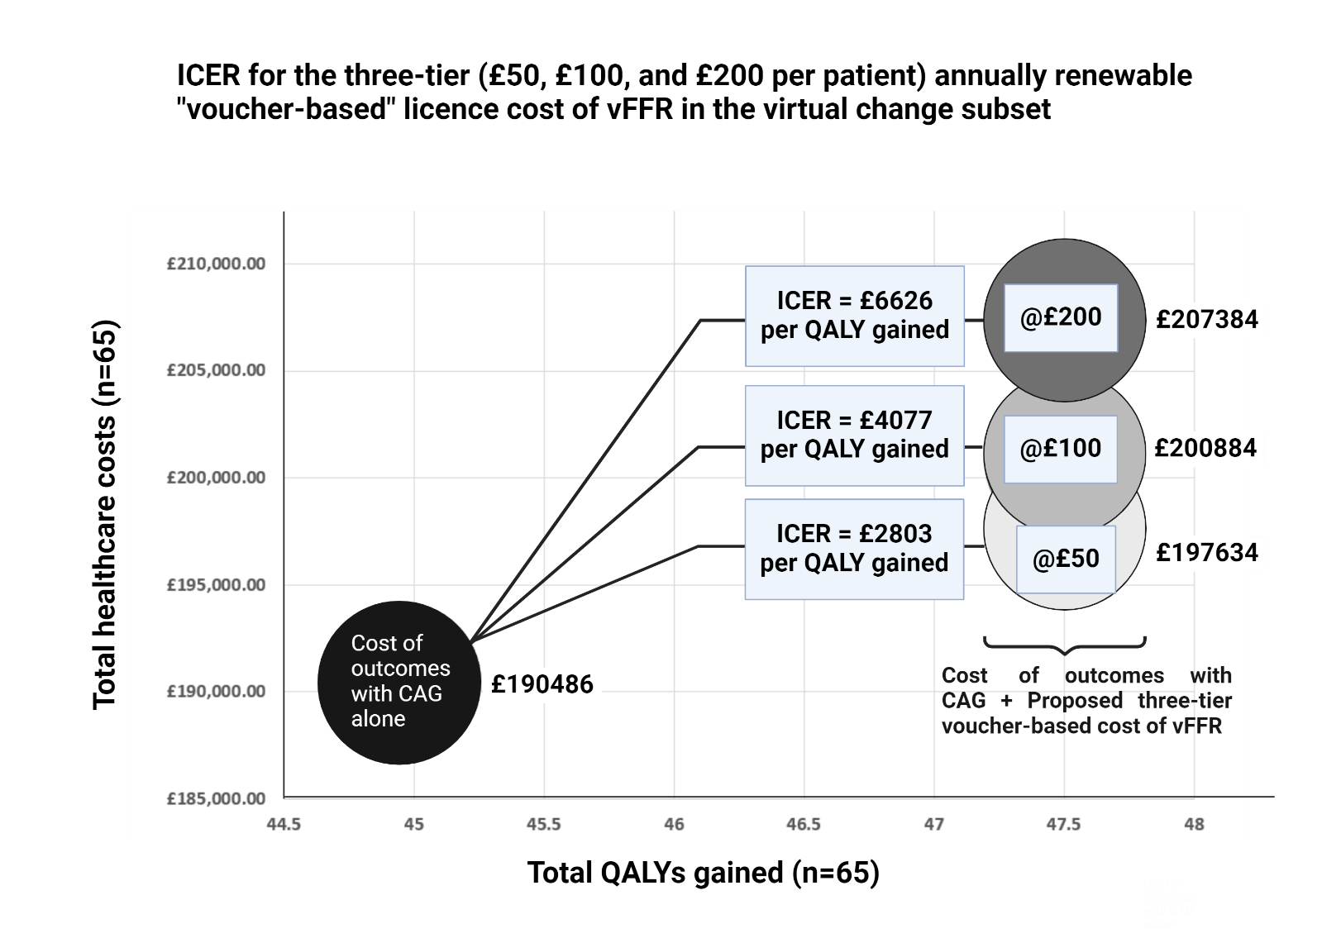
Figure 64: ICER for the outcomes in the virtual change subset with a proposed three-tier annually renewable "voucher-based" licence cost of vFFR.

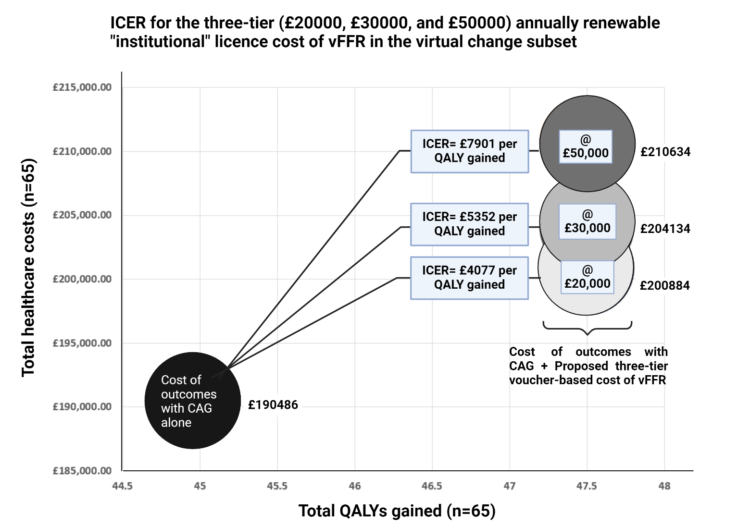
Figure 65: ICER for the outcomes in the virtual change subset with a proposed three-tier annually renewable "institutional" licence cost of vFFR.

4. Discussion

4.1 Summary of results
In this study, I have demonstrated the potential clinical and economic impact of vFFR upon CAD management in ‘real world’ clinical practice. The data from VIRTU-4 were analysed in 266 patients (180 ACS and 86 CCS patients) for a follow-up duration of one year. There were seven deaths, five MIs, and three strokes. In the ACS cohort, there were 32 cardiac cause-driven hospital re-admissions, of which 29 (91%) were acute, and three (9%) were elective, compared to the CCS cohort, which had 25 cardiac re-admissions (16 acute (64%) and nine elective (35%)). Five (2.7%) repeat revascularisations were performed in the ACS and seven (8.1%) in the CCS cohort. At 12 months follow-up, 48/180 (27%) in the ACS cohort improved in the NYHA class (p=0.001), but only 8/180 improved in the CCS class (p=0.76), when compared to the baseline. On the other hand, in the CCS cohort, 15/86 worsened in the NYHA class (p=0.02) while 39/86 (45%) improved in the CCS class (p=0.001) at one year compared to baseline.

The QOL scores in VIRTU-4 did not demonstrate improvement in either EQ-VAS (0.2% increase; p=0.99) or EQ-indexed (0.1% increase; p=0.99) scores at one-year follow-up (p=0.99). However, re-analysis following an exclusion of patients with non-cardiac factors showed a significant increment of 9% in EQ-VAS (p<0.001) and 7% in EQ-indexed scores (p<0.001), respectively. There was no impact of age or presence of diabetes upon QOL scores. Patients treated with invasive therapy demonstrated more improvement in QOL than those treated with medical therapy; in the ACS cohort, this increment in the invasive therapy group was 3.8% in EQ-VAS (p=0.05) and 1% in EQ-indexed scores (p=0.40) whereas, in the CCS cohort, the equivalent increment with invasive therapy was 13% in EQ-VAS (p<0.001) and 7% in EQ-indexed scores (p=0.01).
After vFFR disclosure, a virtual change in the management plans of 65/266 (24.4%) patients was observed (the ‘virtual change’ subset). 17/39 (43.5%) of ACS patients in the virtual change subset were recommended to have OMT who were initially planned to undergo invasive treatment. vFFR could have avoided 26 invasive pressure wire assessments (£586 each). In contrast, 13/26 (50%) CCS patients were recommended to have PCI who were originally planned to have OMT. Implementing these vFFR-driven virtual changes in management plans would have resulted in notional savings of £163 per ACS patient and additional spending of £395 per CCS patient. When considering the entire cohort (n=266; including those in whom there was no notional change with vFFR), this amounted to an average extra spend of £14.60 per patient, which is 0.48% of their total care costs.
Furthermore, vFFR could have resulted in more patients demonstrating improvements in NYHA and CCS classes in addition to those who showed actual improvements. In CCS, vFFR-based plans would have led to a virtual improvement of NYHA and CCS classes in 13/26 (50%, p=0.005) and 10/26 (38.4%, p=0.004) patients, respectively. ACS, in contrast, would have experienced a virtual improvement in 2/39 (5.1%, p=0.96) and 1/39 (2.5%, p=0.99) patients in NYHA and CCS classes, respectively, by following the vFFR-driven treatment plans. Virtual QOL analysis of the virtual change subset (n=65) showed that vFFR-based treatment plans would have resulted in an additional increment of 3.5% in EQ-VAS (p=0.01) and 7% in EQ-indexed scores (p=0.002) in the CCS patients (n=26), whereas, in ACS (n=39), a virtual increment of 1% in EQ-VAS (p=0.96) and 1% in EQ-indexed scores (p=0.78) would have been evident. Therefore, incorporation of vFFR can facilitate more appropriate decision-making in CAD, thus leading to improved clinical, economic, and QOL benefits, with only a minimal additional cost.

4.2 Outcomes from the entire VIRTU-4 HE cohort

4.2.1 How did the rates of hospital re-admissions and repeat revascularisations differ between management plans (OMT vs IT) for the ACS and CCS cohorts?
CAD remains one of the common reasons for hospitalisation and re-admission and is associated with significant financial strain on the healthcare system. A retrospective analysis of an ACS registry of 3000 patients demonstrated a hospital re-admission rate of 21.3% within a year. (209) Another study also demonstrated an annual re-admission rate of 21.5% (202). My study revealed 82/266 (30.8%) re-admission rate in the entire VIRTU-4 population. In the ACS cohort, there were 50/186 (26.8%) re-admissions, of which 32/50 (64%) had a cardiac cause. 29/32 (90%) of those were acute, and 3/32 (10%) were for elective revascularisation procedures. There were 32/86 (37.2%) re-admissions in the CCS cohort, of which 25/32 (78.1%) had a cardiac cause. 16/25 (64%) of those were acute, and 9/25 (36%) were elective (p=0.01). Of the 32 ACS patients with re-admission, 11/32 (34.4%) required more than one admission, which contrasted with the figure for the CCS cohort, which was 2/25 (8%) (p=0.01). It is crucial as patients with ACS have the propensity for multiple admissions, which not only adds to the cost but is also associated with increased mortality. (202) The rates of re-admissions and repeat revascularisations were also determined according to the treatment plans. In the ACS cohort, patients treated with OMT (n=39) had 10/39 (25.6%) re-admissions due to cardiac reasons, whilst invasively treated patients (n=141) had 22/141 (15.6%) re-admissions. Similarly, in the CCS cohort, OMT-treated patients (n=54) had 7/54 (13.0%) re-admissions, whilst invasively treated patients (n=32) had 2/32 (6.2%) re-admissions. This implies that patients deemed appropriate for invasive treatment require fewer hospital admissions than medically treated patients. In my study, OMT-treated patients had higher repeat revascularisation rates than the invasively treated group in both ACS and CCS cohorts. In the ACS cohort, there were 5/180 (2.7%) subsequent revascularisations, of which 4/5 were acute PCIs and one was an elective PCI. This contrasted with the CCS cohort, which had 7/86 (8.1%) revascularisations, of which 1/7 was an acute PCI, 5/7 were elective PCIs, and 1/7 (14.2%) was an elective CABG. When segregated by treatment plans, 2/39 (5.13%) patients treated with OMT required repeat revascularisation, compared with 3/141 (2.12%) with invasive treatment (p=0.29) in the ACS cohort. Similarly, in the CCS cohort, patients treated with OMT had 5/54 (9.2%) revascularisations, compared with 2/32 (6.25%) treated with invasive treatment (p=0.98).

Although these numbers are small and, of course, non-randomised – meaning that patients allocated to OMT were so treated for a reason - they are consistent with the available literature, which shows that invasive treatment results in a reduced need for future hospitalisations and revascularisations compared with conservative management (73, 93), although there are no dedicated RCTs to compare CABG vs PCI in the ACS setting. According to two large patient-level meta-analyses, the choice of revascularisation in multivessel disease, often encountered in ACS, is dictated by anatomical complexity and extent of disease, the presence of diabetes and comorbid states, the need for expeditious revascularisation, and surgical risk scores. (213, 214) Revascularisation in CCS, however, has a modest (at most) effect on MACE and prognosis and is therefore reserved for patients who remain symptomatic despite OMT or for specific indications like left main stem (LMS) disease, impaired LV function, and extensive ischaemia (>10% of the myocardium). (215)

The above results also highlight another important aspect from the health economics perspective; that, despite OMT having a lower cost than invasive treatment, it led to more re-admissions and revascularisations, ultimately inflating the costs. Conversely, revascularisation may be expensive in the short term but more cost-effective in the long run. This observation presupposes that PCI is feasible in patients presently allocated to medical therapy. However, in real-world clinical practice, medical therapy might be considered more appropriate for certain patients, even if angiographic findings suggest the need for revascularisation, particularly when the potential risks outweigh the anticipated benefits. Hence, it is important to carefully interpret the aforementioned results, taking into account the assumption that the patients are suitable for revascularisation. Furthermore, the duration of follow-up in this study was one year, and a longer follow-up could provide information about the impact upon long-term MACE, repeat hospitalisation and repeat revascularisation with conservative and invasive strategies in both ACS and CCS settings.

4.2.2 Interval changes in QOL scores at one year follow-up
In clinical and research practice, patient-reported outcome measures (PROMs) serve as a tool to estimate treatment effectiveness and provide a deeper insight into patients’ QOL. CAD research, however, has been primarily focused on the critical measurable hard endpoints, with scant data on QOL outcomes for individual patients. Even the limited studies reporting QOL scores in CAD have not segregated them according to cardiac and non-cardiac reasons for the reduction in QOL, so there remains a need for further probing these in larger trials. This study evaluated QOL scores pre- and post-exclusion of the non-cardiac reasons for reduction. In the pre-exclusion analysis, the QOL scores showed no compelling change at one-year follow-up (0.2% increase in EQ-VAS, p=0.99 and 0.1% in EQ-indexed, p=0.99). In the ACS cohort, 105/186 (56.4%) patients had an increase, 67/186 (36%) a decrease, and 14/186 (7.5%) no change in QOL scores from baseline to one year. In the CCS cohort, 57/86 (66.2%) had an increase, 28/86 (32.5%) had a decrease, and 1/86 (1.1%) remained unchanged. The % interval increment in QOL scores at one year for the ACS cohort was 0.15% in EQ-VAS (p=0.92) and 0.1% in EQ-indexed scores (p=0.99), whereas, in the CCS cohort, a % interval increment of 0.8% in EQ-VAS (p=0.70) and 1% in EQ-indexed scores (p=0.24) was observed.
After the exclusion of patients with non-cardiac causes, it became evident that reduced QOL scores were mostly related to non-cardiac causes. It applied to 50/67 (74.6%) patients in the ACS cohort and 23/28 (82.1%) in the CCS cohort. The non-cardiac causes included mental health problems, arthritis, COPD, cancer, inflammatory bowel disease and frailty (summarised in Table 12). The repeat analysis after the exclusion of non-cardiac reductions (n=193) revealed an increase of 9% in EQ-VAS (p<0.001) and 7% in EQ-indexed scores. It corresponds to a % increase in QOL of 8.9% on EQ-VAS (p=0.001) and 10% on EQ-indexed scores (p=0.001) in ACS (n=130), and a % increase of 8.9% in EQ-VAS (p=0.001) and 7% on EQ-indexed scores (p=0.003) in CCS patients (n=63).

4.2.3 Did the adopted management strategy impact the QOL scores?
In addition to assessing the clinical effectiveness of any treatment modality, it is important to ascertain whether the improvement in clinical outcomes translates into improvement in the patient’s QOL. Both the COURAGE and ISCHAEMIA trials demonstrated that invasive treatment with PCI or CABG resulted in higher QOL than medically treated patients with stable coronary artery disease. (183, 184) A similar trend was noted for patients with ACS in the RITA-3 study, which showed more improvement in QOL for invasively treated patients than for conservative approaches. (190) My results accorded with the outcomes of these trials: 29/32 (84.3%) invasively treated patients in the CCS cohort showed an improvement in QOL compared to 30/54 (55.5%) medically treated ones (p=0.007). The magnitude of the increase in invasive group was 7% in EQ-VAS (p=0.03) and 5% in EQ-indexed score (p=0.04), whereas in medical therapy, there was only a 0.9% increase in EQ-VAS (p=0.73) and 1% increase in EQ-indexed score (p=0.26). Similarly, in the ACS cohort, 80/141 (56.7%) invasively treated patients reported an increase in QOL compared to 25/39 (64.1%) patients treated with medical treatment (p=0.46). The magnitude of the increase was 1.8% in EQ-VAS (p=0.28) and 1% in EQ-indexed scores (p=0.12). In comparison, the medically treated patients demonstrated a 3.3% reduction in EQ-VAS (p=0.40) and a 2% reduction in EQ-indexed scores (p=0.26).
The above results point towards two notable outcomes: first, patients who received invasive therapy reported better QOL scores than those who received medical therapy in both ACS and CCS cohorts; and second, invasive therapy led to higher QOL in CCS than in the ACS settings. The likely explanation of higher QOL with invasive therapy may be due to a more significant proportion of patients improving in their NYHA and CCS classes than with those with medical treatment. In ACS, 43/141 (30.4%) of the invasively treated patients improved in NYHA, and 22/141 (15.6%) improved in CCS class, compared to medically treated patients where only 5/39 (12%) had an improvement in NYHA and 3/39 (7.6%) had an improvement in the CCS class. Similarly, in the CCS cohort, 26/32 (81%) of the invasively treated patients reported an improvement in CCS class and 24/32 (75%) in NYHA class, whereas in the medically treated patients, only 16/54 (29%) improved in CCS class and 15/54 (27%) in NYHA class, therefore suggesting the greater benefit of invasive therapy where revascularisation is indicated.
It is difficult to ascertain the true cause of a reduction in QOL in the CCS cohort. It may be multifactorial. COVID-19 pandemic-related prolonged waiting times seems to be one of the notable reasons as several patients experienced significant delays in their planned revascularisation procedures. These delays were primarily due to the stringent hospital policies implemented during the pandemic, which postponed elective revascularisation procedures for a significant portion of the follow-up period. This could have influenced their reported QOL during the follow-up period. In summary, while vFFR could have led to higher costs in CCS compared to ACS due to more invasive treatment suggestions, the resultant gain of improved NYHA and CCS classes and QOL scores might have offset these costs.

4.2.4 Gender disparities in QOL
Despite CVD occurring predominantly in men, CAD is equally fatal for both men and women worldwide. A significant gender bias was identified in QOL assessment with CAD treatment. Although data are scarce, according to one registry (n=6591), women reported lower scores in all domains of EQ-5D-5L and self-reported EQ-VAS, regardless of CAD severity or treatment approach. (212) Another study (n=1421) demonstrated reduced QOL in women compared to men by a mean reduction of 6.4% in EQ-VAS scores at one year from the baseline (p<0.001). (213) In my study, a similar trend was observed, where women reported lower QOL scores than men regardless of presentation (ACS or CCS) and mode of treatment (invasive or medical therapy). Overall, there was a mean increase in one year of 2.5% in EQ-VAS (p=0.05) and 2% in EQ-indexed scores (p=0.01) in men (n=199) from the baseline, whereas in women (n=67), there was a reduction of 3.9% in EQ-VAS (p=0.05) and of 3% in EQ-indexed scores (p=0.04) at one year follow-up. Compared to women, men exhibited a similar trend of greater improvement in QOL at one year compared to baseline, regardless of their clinical presentation (ACS or CCS). In the ACS cohort, men reported a significant increase in QOL scores, in contrast to women, for both EQ-VAS (2.4% increase in men vs 6.2% decrease for women; p=0.01) and EQ-indexed scores (2% increase in men vs 4% decrease in women; p=0.02). Similar findings obtained in the CCS cohort; in both EQ-VAS (3.1% increase in men vs 2.4% increase in women; p=0.35) and EQ-indexed scores (4% increase in men vs 1% decrease in women; p=0.04). A trend of higher QOL scores in men was observed in the segregation of QOL scores according to the adopted management strategy. QOL improved more significantly with invasive treatment than medical treatment. In ACS, men treated with invasive therapy showed a more significant improvement than women in EQ-VAS (4.3% increase in men vs 5.3% reduction in women; p=0.006) and EQ-indexed scores (4.1% increase in men vs 2.2% reduction in women; p=0.009). Both men and women demonstrated a reduction in QOL in the medically treated patients, but women reported slightly more reduction than men. EQ-VAS in men was reduced by 0.8% in men vs 0.9% in women (p=0.86), and EQ-indexed scores decreased by 0.5% in men vs 1% in women (p=0.82). These outcomes consistently show that women with CAD report lower QOL, independent of the clinical presentation or treatment modality offered. It was beyond the scope of this study to investigate its reasons. In a few studies, this difference in QOL is shown to be complex and multifactorial, elucidating the potential role of microvascular disease, mental health problems, hormonal changes, and socioeconomic status. However, the exact mechanism remains unclear, suggesting the need for further research. (203, 204)

4.2.5 Did EQ-VAS closely correlate with EQ-indexed scores?
Although EQ-VAS and EQ-indexed scores provide distinct and useful health status metrics, they are not entirely interchangeable. EQ-VAS provides a patient's holistic self-perspective of their overall well-being post-treatment on the day of health survey completion, retaining its position as a valuable tool due to ease of usage, lower cost, higher response, and completion rates amongst the patients. However, it has the disadvantage of being subjective, lacking dimensional health details, and being unable to be directly comparable across populations. (211) EQ-indexed, on the other hand, furnishes detailed explicit health descriptions across five dimensions, including mobility, self-care, pain/discomfort, usual activities, and anxiety/depression and is widely used in cost-effectiveness and cost-utility analysis. However, the disadvantages include complexity, lower completion rates, and being population-based without considering individual preferences. (211) Although both EQ-VAS and EQ-indexed scores are advantageous in their domains, little literature is available regarding how the two metrics correlate. One study reported an excellent positive correlation with the Spearman coefficient as high as 0.74. (211) In my study, a similarly strong correlation was observed between EQ-VAS and EQ-indexed scores (r=0.79, p0.001), which suggests that patients' self-evaluation of health status by EQ-VAS matches well with their objective valuation of health in five dimensions by the indexed scores. Recently, there has been a move towards greater emphasis on indexed scores; however, which score to use depends entirely on the research goals, the complexity of the research question, and practical considerations associated with the appropriate completion of health questionnaires.

4.3 Outcomes in the virtual change subset

4.3.1 The impact of vFFR upon treatment plans in CAD
In the followed-up patients from VIRTU-4, 65/266 (24.4%) patients had a virtual change in management plan after vFFR findings were shown to the operators. In this virtual change subset of 65 patients, vFFR recommended an 17/39 (43.5%) patients to be treated with OMT in ACS than the originally planned invasive mFFR or PCI. Moreover, vFFR-based plans would have avoided 26 invasive pressure wire assessments in ACS (each costing £586). In contrast, vFFR led to an additional 13/26 (50%) CCS patients to be revascularised with PCI. vFFR also resulted in downgrading the complexity of PCI procedure (from culprit vessel PCI + additional vessel mFFR to culprit vessel PCI only) in 5/39 (12.8%) patients in ACS and 3/26 (11.5%) in CCS. On the other hand, 5/65 (7.6%) patients (two in ACS and three in CCS) were switched from one-vessel PCI to multivessel PCI. In ACS, 1/39 (2.5%) patients had the plan changed from multivessel PCI to CABG; in CCS, 1/26 (3.8%) patients had the plan changed from CABG to multivessel PCI. A similar proportion of virtual changes in treatment plans were observed after mFFR disclosure in the RIPCORD (n=200) and FAMOUS-NSTEMI (n=350) studies, in which treatment plans changed by 22% and 26%, respectively. (88, 106) Although the virtual changes appear small in number, they did have considerable economic impact, as discussed below (see section 4.3.3).

4.3.2 Does vFFR have an impact upon QOL?
The uniqueness of this study is that potential outcomes were predicted with a virtual change in management strategy post-vFFR. These virtual outcomes were extrapolated from the published literature to ensure evidence supported them. The trials were selected to include those with the closest match in terms of patients, outcomes, duration of follow-up, and QOL metrics used. Similarly, the expert MDTs also suggested that, in most patients, vFFR delivered more appropriate plans than the visual assessment alone and, therefore, would virtually result in an improved QOL. The appropriateness of the plan was in the form of avoidance of unnecessary invasive mFFR or PCI and their associated risks. In addition, choosing pertinent plans not only makes them more economical but also renders more patients with an angina-free status.
The virtual QOL analysis only applied to the subset (n=65) with a virtual change in their management plan post-vFFR. In the ACS group, 24/39 (61.5%) patients had an actual improvement in the QOL scores; but vFFR-based management would have resulted in an additional 2/39 (5.1%) patients to have an improved QOL, which corresponds to a virtual increase of 1% in EQ-VAS (p=0.96) and 2% in EQ-indexed scores (p=0.14). In the CCS group, 6/26 (23%) patients had an actual improvement in QOL score, but vFFR-based management would have resulted in an additional 13/26 (50%) patients to have an improved QOL, which corresponds to a virtual increase of 6.7% in EQ-VAS (p=0.01) and 3.5% in EQ-indexed scores (p=0.03). The likely explanation of higher predicted QOL in CCS than ACS may have been due to specialist-generalist decision bias (discussed in section 4.10). vFFR would have led to a recommendation that 13/26 patients in the CCS group undergo revascularisation instead of medical therapy as their more appropriate plan. It is reasonable to suppose that revascularising individuals with ischaemic lesions on CAG would improve anginal status, increase exertional capacity, and improve QOL. It is evidenced by a virtual increase of 10/26 patients improving in the CCC class (p=0.005) and 13/26 (p=0.004) in the NYHA class, in addition to the patients with an actual improvement in the CCS and NYHA classes. There was a non-significant virtual change in the CCS class (1/39, p=0.99) and NYHA class (2/39, p=0.96) in the ACS group.

4.3.3 Cost implications of the virtual changes in parent cardiologists' treatment decisions with vFFR
With the application of vFFR, the additional expense for the virtual change subset (n=65) was £3898 (average £59.90 per patient). This supplementary cost accounts for a trivial increase in the total costs of the virtual change subset (n=65) by 2% and 0.5% for the entire VIRTU-4 group (n=266). In the virtual change ACS group (n=39), vFFR would have led to a reduction in the cost of index procedure in 30/39 (77%) patients, whereas 9/39 (23%) patients would have an increase in the costs. That corresponds to a notional saving of £6369 in the ACS group (average £163 per patient). The cost savings in the ACS cohort could have been significantly higher had one patient's plan not changed from multivessel PCI to CABG. The CABG, being the most expensive plan, reduced the overall impact of savings from other patients by £8972 (an average of £67 per patient). However, this is reflective of real-world clinical practice. In contrast, 22/26 (84.6%) patients in the CCS cohort (n=26) experienced a virtual increase, and 4/26 (15.4%) had a decrease in the cost of index procedure after vFFR. Therefore, vFFR would have led to an extra spend of £10267 (average increase of £395 per patient) in the CCS virtual change group, but only £119 per patient in the entire VIRTU-4 CCS group.
Although there was a modest increase in the costs of CCS patients, it is useful to view these costs paired with the potential improvement in outcomes. vFFR demonstrated that there may have been a visual-physiological discordance in 13/26 patients in CCS, which means that visually non-significant appearing lesions on CAG were functionally significant. Therefore, revascularisation would have been their more appropriate plan. Failure to revascularise them may result in long term issues of repeat revascularisation and hospital admissions, thus also adversely affecting QOL. The impact of vFFR in the CCS cohort was more pronounced possibly because patients in this group were managed in non-interventional centres by general cardiologists, not specialised in coronary intervention; suggesting that vFFR may help to improve the decision-making process with an even greater impact in this setting. Hence, it is reasonable to assume that the addition of vFFR would have resulted in more patients receiving appropriately targeted treatment, leading to improved health consequences in the long term.

4.3.4 What was the impact of vFFR on the concordance of treatment plans between the parent cardiologists and the expert MDTs?
I compared the parent cardiologists’ pre- and post-vFFR plans with the expert MDT's recommendations. In the ACS group (n=39), only 16/39 (41%) patients had identical pre-vFFR management plans between their parent and 1st expert team; however, post-vFFR disclosure, it significantly increased to 26/39 (66.6%) patients, indicating a notable improvement (p=0.04).Similarly, in the CCS group (n=26), 13/26 (50%) patients had the same management plan between the parent and the 1st expert team before CAG (pre-vFFR); after vFFR disclosure the number increased to 17/26 (65.3%) patients (p=0.40).
Comparison of plans from the expert MDT-2 showed the similar trend of improvement (though non-significant) in concordance of parent and expert MDT-2’s management plans. In the ACS group (n=39), 18/39 (46.1%) patients had the same parent cardiologist’s management plan as that of 2nd expert team; post-vFFR disclosure, the number of patients with same plans increased to 24/39 (61.5%) patients (p=0.25). Similarly, in the CCS group (n=26), 9/26 (34.6%) patients had the same parent cardiologists plan as that of the expert plan which increased to 10/26 (38%) after vFFR disclosure (p=0.9)
It is perhaps relevant that the patients in the ACS cohort were recruited from the interventional centre, so interventional cardiologists made the treatment plans. In contrast, patients in the CCS cohort were recruited from district hospitals, where general, non-interventional cardiologists made the treatment plans. Whilst any difference in management plans may be attributable to a disparity between cardiologists with interventional and non-interventional backgrounds, this relates well with real-world practice. The index procedural cost of the CCS patients (being more expensive) reflects a potential specialist and logistic difference in plans adopted, which have implications on short- and long-term costs. It is worth mentioning that those who have their CAG performed in the non-interventional centres must undergo a second procedure if revascularisation is indicated, which impacts the cost and exposes them to additional procedural risks. However, it is reflective of contemporary clinical practice in many places. Moreover, a significant increase in the number of patients with the identical post-vFFR plan as those from the expert teams (after vFFR disclosure to the parent cardiologists) suggests that vFFR can help to make decision-making more consistent in CAD and can assist interventional and non-interventional cardiologists in choosing the most cost-effective and appropriate treatment strategies.

4.4 Handling of vFFR by expert MDTs

4.4.1 Concordance of treatment plans between the two expert MDTs
The plans from both expert MDTs were compared to evaluate the inter-observer variability and check the reproducibility of treatment decisions. The literature regarding the outcomes of collective decision-making in MDTs is scarce, but limited data suggest a tendency toward conservative management when a shared-decision approach is adopted. A prospective study of 399 patients discussed in a large tertiary care centre MDT suggested that conservative treatment was the most common decision in more than 30% of the patients, even with complex coronary artery disease. (205) The same patients were re-discussed within a different MDT from the same centre, and reproducibility rates of MDT decisions were demonstrated in up to 80% of cases. (205) In another study, the “Heart Team” reproducibility rate was 76%. (206) The results from my study showed a similar trend. Overall, 38/65 (58.4%) patients pre-vFFR and 45/65 (69.2%) patients post-vFFR had the same plans. In the ACS cohort, 24/39 (61.5%) patients (r=0.53; p=0.25) had the same pre-vFFR plan, increasing to 29/39 (74.3%) patients (r=0.89; p=0.02) after vFFR disclosure. In the CCS cohort, a similar trend was observed, in which 14/26 (53.8%) patients (r=0.49; p=0.35) had the same pre-vFFR plan, increasing to 16/26 (61.5%) patients (r=0.62; p=0.25) after vFFR disclosure. Furthermore, the expert MDT decisions in my study also demonstrated a slight tendency towards conservative treatment than the parent cardiologists. Overall, 12/65 (18.4%) patients in the first and 8/65 (12.3%) in the second expert MDT switched from invasive mFFR or PCI to medical therapy. Furthermore, a recommendation was made against performing an invasive mFFR for an additional vessel apart from culprit lesion PCI in 8/65 (12.3%) patients by the first, and in 6/65 (9.2%) patients by the second expert MDT. There was a trend towards less invasive treatment as 2/65 (3%) patients in the first and 3/65 (4.6%) in the second expert MDT were virtually changed from CABG to multivessel PCI. Conversely, 10/65 (15.3%) and 12/65 (18.4%) patients in the first and second expert MDTs were notionally changed from OMT to PCI within the CCS cohort. The expert teams recommended that PCI should have been enacted as their main plan for those patients, even before the vFFR results, given the severity of the disease. This may have been because the CCS patients were enrolled under the management of general cardiologists, possibly pointing towards non-specialist decision bias (see section 4.9). Although OMT plans may be less costly during the index episodes, they may lead to more healthcare issues, with reduced patient satisfaction and QOL, in the longer term. In addition, it suggests that although revascularisation in CCS does not affect the MACE, it can positively influence the QOL by improving the functional capacity and rendering angina-free status in carefully selected patients for whom revascularisation is warranted. Therefore, the appropriateness of the management plans directly impacts the QOL. The above results suggest that the management strategies of interventional cardiologists may be more cost-effective than those of non-interventional cardiologists. For example, interventionists may be less likely to corroborate non-significant vFFR results with an invasive mFFR. Lastly, there could be a greater propensity to recommend conservative or less invasive treatment in a collective (MDT) environment than for an individual specialist.

4.4.2 Cost implications of the expert MDT’s decisions
The pre-and post-vFFR management plan costs were virtually estimated for both expert MDTs to evaluate how the cost would have varied if the expert MDT decisions were to follow. The first expert team’s plans would have saved a total of £3678 (average £56.5 per patient) for the virtual change subset (n=65), corresponding to savings of £6663 (average £170.80 per patient) in the ACS group (n=39) and an overspend of £3039 (average £116.8 per patient) in the CCS group (n=26); all equating to an overall saving of £14 per patient in the entire cohort (n=266). In contrast, the management plans from the second expert panel would have saved £24143 (average £371.40 per patient) owing to the savings of £16878 (average £432.7 per patient) in the ACS group (n=39) and £7265 (average £279.40 per patient) in the CCS group (n=26) and £90.7 per patient in the entire cohort (n=266). The second expert MDT delivered considerable savings because two patients were virtually switched from CABG to multivessel PCI and OMT plans, respectively, which resulted in savings of £20,000. Despite the current focus on Multidisciplinary Team (MDT) in guidelines, which suggests the benefits of using MDT discussions for most patients due to the appropriateness and cost-effectiveness of plans resulting from collective decision-making, in modern clinical practice, MDT is predominantly reserved for cases that are contentious and intricate, primarily due to administrative and scheduling logistics. Moreover, the simplicity and capability for offline execution can render vFFR a valuable tool in MDT settings, as addressing questions regarding lesion-specific physiology promptly may minimise waiting times and enhance cost-effectiveness.

4.5 Were the ICERs for the CAG-based and vFFR-based outcomes below the willingness to pay (WTP) threshold?
The Diagnostics Assessment Programme (DAP) was launched by the National Institute for Health and Care Excellence (NICE) in 2009 to encourage the swift endorsement of novel, contemporary diagnostic technological tools in the National Health Service (NHS) following their cost-effectiveness analysis (CEA). (217) The CEA has evolved as an objective method of evaluating new medical strategies by 4
er
assessing the incremental health benefits against the incurred incremental costs. This is benchmarked by ICER of the novel intervention against the accepted standard of care concerning a set WTP threshold between £20,000 to £30,000 per QALY in the UK. (217) If the cost of a new intervention is above the described threshold, it is deemed too expensive to adopt, thus reflecting the displaced opportunity costs for other healthcare programs. If, however, the cost of new treatment falls below the WTP threshold, the strategy is considered acceptable to be incorporated into clinical practice. My study estimated ICERs of management plans based on CAG alone and plans incorporating vFFR in addition to CAG. It demonstrated that the costs of implementing vFFR in decision-making are trivial, especially when considered for a longer term. Adding a voucher-based or institution-based vFFR licence cost to the overall costs of the annual outcomes, they are still well below the WTP threshold, endorsing the cost-effectiveness of vFFR+CAG vs CAG-only. When considering the three-tier voucher-based licence costs, ICERs were £2803, £4077, and £6626 per QALY for a voucher cost of £50, £100, and £200 per patient, respectively. On the other hand, when estimated using an institutional licence basis, from low to high tariff tier, ICERs were £4077, £5352, and £7901 per QALY for an annual licence fee of £20000, £30000, and £50000, respectively. Despite the apparent favourable impact of vFFR upon ICER, this study was not sufficiently powered to suggest any recommendations in terms of cost-effectiveness. However, it has produced pilot data for more extensive trials to be conducted with a prime focus on the cost-effectiveness of this technology. Although VIRTUHeartTM is yet to be tested in the "actual" trial setting, this study's outlined economic outcomes are likely to be applicable to the commercially available angiographically computed vFFR software (QFR, CAAS-vFFR). As this cutting-edge tool is probably here to stay, a comprehensive CEA of this technology may remove the final barrier to its more extensive application and acceptance in the diagnostic pathways for chest pain by the NICE.

4.6 Impact of COVID-19
The COVID-19 pandemic significantly impacted global healthcare delivery systems, including the NHS, during the conduct of the VIRTU-4 study, both directly and indirectly. A similar effect was also noted in my follow-on study as well. First, in VIRTU-4, recruitment to the CCS arm was particularly affected, as only 100 patients could be recruited instead of the initially planned 206. Furthermore, during the pandemic, all elective chest pain pathways and outpatient appointments were withheld, which led to considerable delays in patients awaiting elective procedures. Moreover, lack of contact with primary care services, cancellation of clinic reviews, and non-optimization of medical therapy all contributed to the aggravation of symptoms and led to a reduction in QOL. Second, there was a surge in patients with mental health issues during the pandemic, with limited or no psychiatric support available. According to a report from WHO, the COVID-19 pandemic resulted in a 25% increment in the prevalence of mental health issues (199), which by itself is associated with a reduction in QOL, morbidity, and mortality. (200) Several patients were also financially impacted by COVID-19 due to business closures and loss of jobs, resulting in difficulties in affording household bills, mortgage payments and food, which forced them to depend on income support. All of this contributed to stress levels, which led to further health issues. In my study, which followed the pandemic, 32/266 (12%) patients reported significant mental health issues, of which 24 patients (9%) had anxiety/depression, and eight patients (3%) experienced substantial financial problems adding to the pronounced stress. Since the scope of this study did not specifically include mental health assessment, they were not investigated in detail. However, it would be worth exploring these aspects in future studies.

4.7 Potential role of vFFR outside the ACS and CCS settings
When applied to bystander disease, vFFR can provide a valuable physiological measurement to guide the best revascularisation strategy. vFFR has the propensity to identify physiologically significant lesions in multivessel, multi-lesion disease, which is often encountered in clinical practice, and can minimise the risks of instrumentation by providing the relevant data non-invasively. Type-II MI and left ventricular dysfunction (LVSD) secondary to cardiomyopathy are among the common examples. The prevalence of Type-II MI ranges from 2% to 58% among individuals whose initial clinical presentation is MI, whereas cardiomyopathy-related LVSD has a prevalence of 1:2500 in the general population. In such conditions, non-culprit bystander disease is often found on diagnostic CAG, which usually does not require intervention. (207, 208) By providing a non-invasive physiological assessment, which generally demonstrates the non-physiological significance of borderline lesions, vFFR can help reassure both the patients and the physicians and shift the focus of investigations away from coronary disease in such situations. Even if significant bystander disease is not intervened during the index procedure, it still furnishes valuable information to help plan any intervention in the future, should the patients remain symptomatic. In addition, vFFR can provide helpful information in MDT settings, which can assist in decision-making in complex cases. Moreover, vFFR can also result in a down-grading of the severity of CAD based upon visual estimation, suggesting a less invasive plan. According to my study, management plans of 2/65 (3%) patients in the virtual change subset were notionally changed from CABG to multivessel PCI after vFFR disclosure, which was the less invasive treatment option. Furthermore, vFFR can also aid in virtual coronary intervention planning (by simulating a virtual stent insertion) for complex coronary lesions and predict the post-PCI physiological response and any residual ischaemic in the area of interest. (147)

4.8 Limitations of this study
VIRTU-4 HE had several limitations:
1. It was a virtual study in which outcomes from the virtual changes in treatment due to vFFR were predicted using available literature. This approach was necessary because VIRTUHeartTM is a research-only tool and is not licensed for clinical use. Despite efforts to align the virtual outcomes with actual ones based on published literature, the inherent uncertainty of virtual simulations persists.
2. Health economics evaluations with actual outcomes will be more valuable and relevant in real-world practice, as it is challenging to determine the true costs and benefits of this novel technology without a trial involving long-term follow-up.
3. While vFFR is a reliable tool, it cannot entirely replace the invasive pressure wire-driven FFR because values in the grey zone (0.75-0.80) still require invasive mFFR evaluation to precisely assess physiological significance and guide treatment decisions.
4. Patients with severe left main stem (LMS) disease, aorto-ostial lesions, lesions >90%, diffuse coronary artery disease (CAD), and those with prior coronary artery bypass grafting (CABG) were excluded from VIRTU-4. Therefore, the study results should be cautiously applied only to patients similar to those included in VIRTU-4, and extrapolation to patients with different disease patterns should be approached with caution.
5. The impact of vFFR on costs was assessed in relation to the index procedure costs; however, the analysis did not account for its potential influence on other healthcare expenses, such as hospitalisations, outpatient visits, and any additional investigations. Since costs were not modelled over the full 12-month follow-up period and were instead limited to index procedural costs, the analysis reflects only the immediate financial impact of vFFR rather than its long-term cost implications, thereby limiting the cost-effectiveness assessment.
6. CCS cohort in VIRTU-4 was recruited from district hospitals where treatment decisions were made by general cardiologists rather than interventional cardiologists. This potential lack of familiarity with coronary physiology might have introduced bias between treatment plans devised by general cardiologists and those by interventional cardiologists.
7. The study was performed during the COVID-19 pandemic and therefore, due to lack of elective angiography lists, the result may be slightly different to the contemporary clinic practice without the pandemic era. In the usual settings, patients would be optimised with anti-anginal medications and reviewed in the outpatient clinic setting to assess the symptoms improvement with OMT but during the pandemic, patients were able to get limited support from the primary care services and therefore, QOL outcomes may be represent slightly more limitation than the contemporary settings.
8. There is a need for dedicated training along with a learning curve required to operate the software and produce reliable results. Those in the earlier part of the software training or occasional users are more prone to make an error in the modelling steps, which may significantly skew results.
9. An accurate vFFR relies upon a good-quality coronary angiogram. An angiogram with inadequate catheter engagement and poor contrast opacification are the most common reasons for failure to model the intended vessel. Furthermore, lesions at the ostium and bifurcation can be a challenge for vFFR computation.
10. The follow-up duration was only one year, which may be short to comment on the longer-term impact on mortality, morbidity, and costs. In the economic analysis of FAME-2, the OMT-managed patients were less costly at one year but more costly in the coming years, owing to re-admissions and revascularisation; so that, in the third year, the ICERs for both OMT and PCI were comparable. This may apply to my study if a longer follow-up is incorporated.
11. Finally, during the vFFR estimation, predictions and assumptions are made about the maximal and constant microvascular resistance; however, microvascular resistance can be variable. However, using a personalised vFFR in the VIRTUHeartTM has improved the software's accuracy in detecting ischaemic lesions.

4.9 Research Implications of this study
vFFR is an exciting new field under active research, with keen industry interest. Efforts are being made to optimise image quality, improve accuracy, and make it a user-friendly technology. While invasive mFFR has shown positive results in terms of clinical outcomes and long-term economic improvement, vFFR has recently demonstrated promising results, of which China's FAVOR-III trial has received much attention, described in detail in the section "Clinical evidence of vFFR". (198). More data are needed to assess the cost-effectiveness of the currently available vFFR systems (QFR, CAAS-vFFR, FFRangio). My study serves as pilot data for further RCTs to investigate the cost-effectiveness of vFFR-CAG. Although VIRTUHeartTM software is not licenced for clinical use, it has demonstrated good sensitivity (86%) and specificity (89%) against invasive mFFR to identify haemodynamically significant lesions (FFR<0.80) within the VIRTU-4 trial. This has validated its potential clinical applicability; however, a detailed cost-effectiveness analysis is vital if vFFR were to be incorporated into mainstream clinical guidelines.
Another implication of incorporating vFFR technology in the diagnostic pathway is that it may avoid unnecessary revascularisations and associated risks. As per the British Cardiovascular Intervention Society (BCIS) audit data of National Interventional Procedures 2021-22, the UK has a total of 177 cardiac catheterisation centres, of which 60 (34%) are diagnostic-only centres (199). The diagnostic-only labs do not have the facility to perform an invasive FFR. Hence, if there is a clinical need to assess the physiological significance of an intermediate lesion (30-70% diameter stenosis), the patient is required to be transferred to the nearest PCI centre, which implies a more extended hospital stay, extra cost, and an additional invasive procedure with risks associated. Therefore, by adopting vFFR technology, we could provide the benefits of coronary physiology to more CAD patients and improve the cost-effectiveness of procedures.

4.10 Future directions
In this study, vFFR has shown the potential to be a cost-effective alternative to conventional coronary angiography-based decision-making. Although, several studies have compared the clinical outcomes of the vFFR-directed treatment plans, however, there are no head-to-head trials comparing vFFR against the invasive mFFR, which is the current gold standard. This gap in current evidence may be plugged in by the ongoing FAVOUR-III Japan-Europe trial (n=2000), which is planned to compare the QFR-based- with invasive mFFR-based-outcomes in moderately stenotic lesions in stable CAD, having MACE and unplanned revascularisations at 12 months as primary endpoints. (218) A comparative economic assessment can then directly evaluate the cost-effectiveness of vFFR compared to invasive mFFR. This study may serve as a game-changer in the futuristic role of non-hyperaemic, wire-free coronary physiology. It may even be feasible to apply the CAG-based vFFR retrospectively to the pivotal breakthrough trials in which coronary functional assessment was not employed for clinical decision-making, instigating how physiological guidance through vFFR would have influenced the treatment recommendations. Furthermore, the utility of vFFR could be explored in a dedicated study where bystander lesions in ACS settings, are randomised to either undergo intervention or medical management, allowing for evaluation of the clinical outcomes. Such a study would offer valuable insights into the optimal management strategies for such bystander lesions and further contribute to the growing body of evidence supporting physiology-guided decision-making in such circumstances. Additionally, this study could be utilised as a pilot for conducting a study of vFFR with health economics and quality of life as the primary endpoints.
Lastly, with the ever-increasing role of artificial intelligence in clinical medicine, machine learning algorithms can be utilised to significantly enhance the blood flow simulation properties of CFD techniques and improve the accuracy, sensitivity, and specificity of the vFFR.

4.11 Final conclusions
This study shows that adding vFFR to the conventional angiography resulted in a positive virtual impact on the clinical outcomes, overall expenses and QOL by providing relevant physiological information non-invasively and guiding the operator to a more appropriate management plan. It can be achieved with a trivial additional cost, with an ICER well below the WTP UK threshold, making incorporating vFFR clinically and economically feasible in real-world practice. Although invasive mFFR cannot be entirely substituted by vFFR, it can serve as a non-invasive alternative tool to guide treatment in CAD in carefully selected patients undergoing an invasive CAG. The study demonstrated that the virtual change in management plans with vFFR led to more appropriate treatments (when correlated with expert teams) and improved predicted virtual QOL. With its ability to be incorporated into purely diagnostic cardiac catheterisation laboratories, the advantages of physiological guidance could be extended to a greater population of patients with CAD than at present. The pilot data from this study will provide a platform for larger trials to investigate the cost-effectiveness of this technology in future research.

Bibliography

- Wong ND. (2014). Epidemiological studies of CHD and the evolution of preventive cardiology. Nature reviews. Cardiology, 11(5), 276–289.

- Cardiovascular Disease Statistics 2018. British Heart Foundation. https://www.bhf.org.uk/what-we-do/our-research/heart-statistics/heart-statistics-publications/cardiovascular-disease-statistics-2018.

- Townsend N, Wilson L, Bhatnagar P, et al. (2016b). Cardiovascular disease in Europe: epidemiological update 2016. Eur Heart J. 37(42),3232–3245.

- Heart & Circulatory Disease Statistics 2020. British Heart Foundation. https://www.bhf.org.uk/what-we-do/our-research/heart-statistics/heart-statistics-publications/cardiovascular-disease-statistics-2020

- Jebari-Benslaiman S, Galicia-García U, Larrea-Sebal, et al. (2022). Pathophysiology of atherosclerosis. Int J Mol Sci, 23(6), 3346.

- Wolf D, Ley K. (2019). Immunity and inflammation in atherosclerosis. Circulation Research, 124(2), 315–327.

- Zaman AG, Helft G, Worthley SG, et al. The role of plaque rupture and thrombosis in coronary artery disease. Atherosclerosis. 2000 Apr;149(2):251–266.

- Daviglus ML, Stamler J, Pirzada A, et al. (2004). Favorable cardiovascular risk profile in young women and long-term risk of cardiovascular and All-Cause mortality. JAMA, 292(13), 1588.

- Villa A, Sammut E, Nair A, et al. (2016). Coronary artery anomalies overview: The normal and the abnormal. World J Radiol, 8(6), 537.

- Duerinckx AJ. (2006). Anatomy and physiology of coronary arteries. In Springer eBooks (pp. 10–18).

- Loukas M, Groat C, Khangura R, et al. (2008). The normal and abnormal anatomy of the coronary arteries. Clinical Anatomy, 22(1), 114–128.

- Aricatt DP, Prabhu A, Avadhani R, et al. A study of coronary dominance and its clinical significance. Folia Morphologica. 2023;82(1):102-107.

- Knuuti J, Wijns W, Saraste A., et al. (2019). 2019 ESC Guidelines for the diagnosis and management of chronic coronary syndromes. Eur Heart J. 41(3), 407–477.

- Casser A. Chronic coronary artery disease: Diagnosis and management. Mayo Clin Proc. 2009;84(12):1130–46.

- Diamond GA (1983). A clinically relevant classification of chest discomfort. J Am Coll Cardio, 1(2), 574–575.

- Collet JP, Thiele H, Barbato E, et al. (2020). 2020 ESC Guidelines for the management of acute coronary syndromes in patients presenting without persistent ST-segment elevation. Eur Heart J, 42(14), 1289–1367.

- Amsterdam EA, Wenger NK, Brindis RG, et al. 2014 AHA/ACC Guideline for the Management of Patients With Non–ST-Elevation Acute Coronary Syndromes: A Report of the American College of Cardiology/American Heart Association Task Force on Practice Guidelines. J Am Coll Cardiol. 2014 Dec 23;64(24): e139–228.

- Choudhury T, West NE, El‐Omar M. (2016). ST elevation myocardial infarction. J. Clin. Med, 16(3), 277–282.

- Thygesen K, Alpert JS, Jaffe AS, et al. (2018). Fourth Universal Definition of Myocardial Infarction (2018). Circulation, 138(20).

- Roffi M, Patrono C, Collet JP, et al. 2015 ESC Guidelines for the management of acute coronary syndromes in patients presenting without persistent ST-segment elevation. Task Force for the Management of Acute Coronary Syndromes in Patients Presenting without Persistent ST-Segment Elevation of the European Society of Cardiology (ESC). Eur Heart J. 2016 Jan 14;37(3):267–315.

- Cohen M, Visveswaran G. (2020). Defining and managing patients with non‐ST‐elevation myocardial infarction: Sorting through type 1 vs other types. Clin Cardiol, 43(3), 242–250.

- Yasue H, Takizawa A, Nagao M, et al. Long-term prognosis for patients with variant angina and influential factors. Circulation. 1988 Jul;78(1):1–9.

- Williams M, Moss AJ, Dweck, et al. (2019). Coronary artery plaque characteristics associated with adverse outcomes in the SCOT-HEART study. J Am Coll Cardio, 73(3), 291–301.

- Turgeon RD, Sedlak T. (2021). Use of preventive medications in patients with nonobstructive coronary artery disease: analysis of the PROMISE Trial. CJC Open, 3(2), 159–166.

- Douglas PS, De Bruyne B, Pontone G, et al. (2016). 1-Year outcomes of FFRCT-Guided care in patients with suspected coronary disease. J Am Coll Cardio, 68(5), 435–445.

- Hoffmann U, Truong QA, Schoenfeld DA, et al. (2012). Coronary CT angiography versus standard evaluation in acute chest pain. N Engl J Med, 367 4, 299-308.

- Van Den Boogert TP, Claessen BE, Van Randen A, et al. (2021). Implementation of CT coronary angiography as an alternative to invasive coronary angiography in the diagnostic Work-Up of Non-Coronary cardiac surgery, cardiomyopathy, heart failure and ventricular arrhythmias. J. Clin. Med, 10(11), 2374-6.

- Knuuti J, Ballo H, Juarez‐Orozco LE, et al. (2018). The performance of non-invasive tests to rule-in and rule-out significant coronary artery stenosis in patients with stable angina: a meta-analysis focused on post-test disease probability. Eur Heart J, 39(35), 3322–3330.

- Shah BN, Macnab A, Lynch JF, et al. (2018). Stress echocardiography in contemporary clinical cardiology: practical considerations and accreditation. Echo Research & Practice, 5(1), E1–E6.

- Zacharias K, Ahmed A, Shah BN, et al. (2016). Relative clinical and economic impact of exercise echocardiography vs. exercise electrocardiography, as first line investigation in patients without known coronary artery disease and new stable angina: a randomized prospective study. Eur Heart J. Cardiovasc. Imaging, 18(2), 195–202.

- Kowatsch I, Tsutsui J, Osório A, et al. (2007). Head-to-Head comparison of dobutamine and adenosine stress real-time myocardial perfusion echocardiography for the detection of coronary artery disease. J Am Soc Echocardiogr. 20(9), 1109–1117.

- Beller GA, Heede RC. (2011). SPECT imaging for detecting coronary artery disease and determining prognosis by non-invasive assessment of myocardial perfusion and myocardial viability. J Cardiovasc Transl Res, 4(4), 416–424.

- Danad I, Raijmakers P, Driessen R, et al. (2017). Comparison of coronary CT angiography, SPECT, PET, and hybrid imaging for diagnosis of ischemic heart disease determined by fractional flow reserve. JAMA Cardiology, 2(10), 1100.

- Panjer M, Dobrolińska M, Wagenaar N, et al. (2021). Diagnostic accuracy of dynamic CZT-SPECT in coronary artery disease. A systematic review and meta-analysis. J Nucl Cardiol, 29(4), 1686–1697.

- Rahmim A, Zaidi H. (2008). PET versus SPECT: strengths, limitations, and challenges. Nuclear Medicine Communications, 29(3), 193–207.

- Patel AR, Salerno M, Kwong RY, et al. (2021). Stress cardiac magnetic resonance myocardial perfusion imaging. J Am Coll Cardio, 78(16), 1655–1668.

- Greenwood JP, Maredia N, Younger J, et al. (2012). Cardiovascular magnetic resonance and single-photon emission computed tomography for diagnosis of coronary heart disease (CE-MARC): a prospective trial. The Lancet, 379(9814), 453–460.

- Greenwood, JP, Ripley DP, Berry C, et al. (2016). Effect of care guided by cardiovascular magnetic resonance, myocardial perfusion scintigraphy, or NICE guidelines on subsequent unnecessary angiography rates. J Am Med Assoc, 316(10), 1051.

- Sones FM Jr, Shirley ek. Cine coronary arteriography. Mod Concepts Cardiovasc Dis. 1962 Jul; 31:735-8.

- Noto T, Johnson LW, Krone RJ, et al. (1991). Cardiac catheterization 1990: A report of the registry of the society for cardiac angiography and interventions (SCA&I). Catheter Cardiovasc Diagn, 24(2), 75–83.

- Jolly S, Yusuf S, Cairns JA, et al. (2011). Radial versus femoral access for coronary angiography and intervention in patients with acute coronary syndromes (RIVAL): a randomised, parallel group, multicentre trial. The Lancet, 377(9775), 1409–1420.

- Visseren FJ, Mach F, Smulders YM, et al. (2021). 2021 ESC Guidelines on cardiovascular disease prevention in clinical practice. Eur Heart J, 42(34), 3227–3337.

- Critchley J, Capewell S. (2003). Mortality risk reduction associated with smoking cessation in patients with coronary heart disease. JAMA, 290(1), 86-88.

- Keteyian SJ, Brawner CA, Savage PD, et al. (2008). Peak aerobic capacity predicts prognosis in patients with coronary heart disease. Am Heart J, 156 2, 292-300.

- Baigent C, Blackwell L, Collins R, et al. (2009). Aspirin in the primary and secondary prevention of vascular disease: collaborative meta-analysis of individual participant data from randomised trials. The Lancet, 373(9678), 1849–1860.

- Storey RF, Bliden KP, Ecob R, et al. (2011). Earlier recovery of platelet function after discontinuation of treatment with ticagrelor compared with clopidogrel in patients with high antiplatelet responses. Journal of Thrombosis and Haemostasis, 9(9), 1730–1737.

- Storey RF, Angiolillo DJ, Patil SG, et al. (2010). Inhibitory effects of ticagrelor compared with clopidogrel on platelet function in patients with acute coronary syndromes. J Am Coll Cardio, 56(18), 1456–1462.

- Wiviott SD, Braunwald E, McCabe CH, et al. (2007). Prasugrel versus Clopidogrel in Patients with Acute Coronary Syndromes. N Engl J Med, 357(20), 2001–2015.

- Bhatt DL, Bonaca MP, Bansilal S, et al. (2016). Reduction in ischemic events with ticagrelor in diabetic patients with prior myocardial infarction in PEGASUS–TIMI 54. J Am Coll Cardio, 67(23), 2732–2740.

- Belsey J, Savelieva I, Mugelli A, Camm AJ. (2014). Relative efficacy of antianginal drugs used as add-on therapy in patients with stable angina: A systematic review and meta-analysis. Eur J Prev Cardiol, 22(7), 837–848.

- Aarvik MD, Sandven I, Dondo TB, et al. (2018). Effect of oral β-blocker treatment on mortality in contemporary post-myocardial infarction patients: a systematic review and meta-analysis. Eur Heart J Cardiovasc Pharmacother, 5(1), 12–20.

- Hwang D, Lee JM, Kim HK, et al. (2019). Prognostic impact of Β-Blocker dose after acute myocardial infarction. Circulation, 83(2), 410–417.

- Poole‐Wilson PA, Lubsen J, Kirwan B, et al. (2004). Effect of long acting nifedipine on mortality and cardiovascular morbidity in patients with stable angina requiring treatment (ACTION trial): randomised controlled trial. The Lancet, 364(9437), 849–857.

- Fox K, Ford I, Steg PG, Tardif J. (2014). Ivabradine in Stable Coronary Artery Disease without Clinical Heart Failure. N Engl J Med, 371(12), 1091–1099.

- Fox K, Ford I, Steg PG, et al. (2008). Ivabradine for patients with stable coronary artery disease and left-ventricular systolic dysfunction (BEAUTIFUL): a randomised, double-blind, placebo-controlled trial. The Lancet, 372(9641), 807–816.

- IONA Study Group (2002). Effect of nicorandil on coronary events in patients with stable angina: the Impact Of Nicorandil in Angina (IONA) randomised trial. The Lancet (London, England), 359(9314), 1269–1275.

- Morrow DA, Scirica BM, Karwatowska-Prokopczuk E, et al. MERLIN-TIMI 36 Trial Investigators. Effects of ranolazine on recurrent cardiovascular events in patients with non-ST-elevation acute coronary syndromes: the MERLIN-TIMI 36 randomized trial. JAMA. 2007 Apr 25;297(16):1775-83.

- Giugliano RP, Cannon CP, Blazing MA., et al. (2018). Benefit of adding ezetimibe to statin therapy on cardiovascular outcomes and safety in patients with versus without diabetes mellitus. Circulation, 137(15), 1571–1582.

- Sabatine MS, Giugliano RP, Keech A, et al. (2017). Evolocumab and Clinical Outcomes in Patients with Cardiovascular Disease. N Engl J Med, 376(18), 1713–1722.

- Robinson JG, Farnier M, Krempf M, et al. (2015). Efficacy and safety of alirocumab in reducing lipids and cardiovascular events. N Engl J Med, 372(16), 1489–1499.

- Scafa-Udriște A, Niculescu AG, Grumezescu A, et al. (2021). Cardiovascular Stents: A Review of Past, Current, and Emerging Devices. Materials (Basel, Switzerland), 14(10), 2498-99.

- Vale N, Madeira S, Almeida M, et al. (2020). Ten-year survival of patients undergoing coronary angioplasty with first-generation sirolimus-eluting stents and bare-metal stents. Rev. Port. Cardiol; 39: 639–647.

- De Luca G, Dirksen MT, Spaulding C, et al. Drug-Eluting Stent in Primary Angioplasty (DESERT) Cooperation. Drug-eluting vs bare-metal stents in primary angioplasty: a pooled patient-level meta-analysis of randomized trials. Arch Intern Med. 2012 Apr 23;172(8):611-21; discussion 621-2.

- Chacko L, Howard JP, Rajkumar C, et al. (2020). Effects of percutaneous coronary intervention on death and myocardial infarction stratified by stable and unstable coronary artery disease. Circulation: Cardiovasc Qual Outcomes, 13(2), e006363.

- Berg ES, Tegn N, Abdelnoor M, et al. (2023). Long-Term Outcomes of Invasive vs Conservative Strategies for Older Patients With Non–ST-Segment Elevation Acute Coronary Syndromes. J Am Coll Cardiol, 82(21), 2021–2030

- Chen X, Barywani SB, Sigurjónsdóttir R, et al. (2018). Improved short- and long-term survival associated with percutaneous coronary intervention in the elderly patients with acute coronary syndrome. BMC Geriatrics, 18(1), 137-139

- Betriu A, Masotti M. (2005). Comparison of mortality rates in acute myocardial infarction treated by percutaneous coronary intervention versus fibrinolysis. Am J Cardiol, 95(1), 100–101.

- Boersma E. (2006). Does time matter? A pooled analysis of randomized clinical trials comparing primary percutaneous coronary intervention and in-hospital fibrinolysis in acute myocardial infarction patients. Eur Heart J, 27(7), 779–788.

- West R, Cattle BA, Bouyssie M, et al (2010). Impact of hospital proportion and volume on primary percutaneous coronary intervention performance in England and Wales. Eur Heart J, 32(6), 706–711.

- Ibáñez B, James S, Agewall S, et al. (2017). 2017 ESC Guidelines for the management of acute myocardial infarction in patients presenting with ST-segment elevation. Eur Heart J, 39(2), 119–177.

- Byrne RA, Rosselló X, Coughlan J, et al. (2023). 2023 ESC Guidelines for the management of acute coronary syndromes. Eur Heart J, 44(38), 3720–3826.

- Fearon WF, Nishi T, De Bruyne B, et al. (2018). Clinical Outcomes and Cost-Effectiveness of Fractional Flow Reserve–Guided percutaneous coronary intervention in patients with stable coronary artery Disease. Circulation, 137(5), 480–487.

- Windecker S, Stortecky S, Stefanini GG, et al. Revascularisation versus medical treatment in patients with stable coronary artery disease: network meta-analysis. BMJ. 2014 Jun 23;348–351.

- Neumann F, Sousa‐Uva M, Ahlsson A, et al. (2018). 2018 ESC/EACTS Guidelines on myocardial revascularization. Eur Heart J, 40(2), 87–165.

- Kirklin JW, Akins CW, Blackstone EH, et al. (1991). Guidelines and indications for coronary artery bypass graft surgery. J Am Coll Cardio, 17(3), 543–589.

- Domanski MJ, Borkowf CB, Campeau L, et al. (2000). Prognostic factors for atherosclerosis progression in saphenous vein grafts. J Am Coll Cardio, 36(6), 1877–1883.

- Van Domburg RT, Kappetein AP, Bogers AJ. (2008). The clinical outcome after coronary bypass surgery: a 30-year follow-up study. Eur Heart J, 30(4), 453–458.

- Head SJ, Milojevic M, Daemen J, et al. (2018). Mortality after coronary artery bypass grafting versus percutaneous coronary intervention with stenting for coronary artery disease: a pooled analysis of individual patient data. The Lancet, 391(10124), 939–948.

- Akintoye E, Salih M, Olagoke O, et al. (2021). Intermediate and Late Outcomes With PCI vs CABG for Left Main Disease — Landmark Meta-Analysis of Randomized Trials. Cardiovasc Revasc Med, 23, 114–118.

- Ramanathan T, Skinner H. (2005). Coronary blood flow. Continuing Education in Anaesthesia, Critical Care & Pain, 5(2), 61–64.

- Shah S, Pfau S. (2019). Coronary physiology in the Cardiac Catheterization Laboratory. J Clin Med, 8(2), 255-257.

- White CW, Wright CB, Doty DB, et al. Does Visual Interpretation of the Coronary Arteriogram Predict the Physiologic Importance of a Coronary Stenosis? N Engl J Med. 1984 Mar 29;310(13):819–24.

- Morris, PD, Al-Lamee RK, Berry C, & BCIS Research and Development Committee (2022). Coronary physiological assessment in the catheter laboratory: haemodynamics, clinical assessment and future perspectives. Heart (British Cardiac Society), 108(21), 1737–1746.

- Gould KL, Lipscomb K, Hamilton GW. (1974). Physiologic basis for assessing critical coronary stenosis. American Journal of Cardiology, 33(1), 87–94.

- Shishehbor MH, Lauer MS, Singh I, et al. (2007). In unstable angina or Non–ST-Segment Acute Coronary Syndrome, should patients with multivessel coronary artery disease undergo Multivessel or Culprit-Only stenting? J Am Coll Cardio, 49(8), 849–854.

- Toth GG, Toth B, Johnson NP, et al. (2014). Revascularization decisions in patients with stable angina and intermediate lesions: results of the international survey on interventional strategy. Circulation Cardiovasc interven, 7(6), 751–759.

- Green NE, Chen SJ, Messenger P, et al. (2004). Three-dimensional vascular angiography. Current Problems in Cardiology, 29(3), 104–142.

- Whittaker AK, Curzen N. (2013). What has the RIPCORD trial told us about using fractional flow reserve for diagnostic angiography? Interven Cardiol, 5(6), 593–596.

- Park S, Kang S, Ahn J, et al. (2012). Visual-Functional mismatch between coronary angiography and fractional flow reserve. JACC Cardiovasc Interven, 5(10), 1029–1036.

- Tóth GG, Hamilos M, Pyxaras SA, et al. (2014). Evolving concepts of angiogram: fractional flow reserve discordances in 4000 coronary stenoses. Eur Heart J, 35(40), 2831–2838.

- Haley HA, Ghobrial M, Morris PD, et al. (2021). Virtual (Computed) Fractional Flow Reserve: Future Role in Acute Coronary Syndromes. Frontiers in cardiovascular medicine, 8, 735008.

- Peper J, Becker LM, Van Kuijk J, et al (2021). Fractional Flow Reserve: Patient selection and Perspectives. Vascular Health and Risk Management, Volume 17, 817–831.

- Zimmermann FM, Ferrara A, Johnson NP, et al. (2015). Deferral vs. performance of percutaneous coronary intervention of functionally non-significant coronary stenosis: 15-year follow-up of the DEFER trial. Eur Heart J, 36(45), 3182–3188.

- Windecker S, Kolh P, Alfonso F, et al. 2014 ESC/EACTS Guidelines on myocardial revascularization: The Task Force on Myocardial Revascularization of the European Society of Cardiology (ESC) and the European Association for Cardio-Thoracic Surgery (EACTS) - Developed with the special contribution of the European Association of Percutaneous Cardiovascular Interventions (EAPCI). Eur Heart J. 2014 Oct 1;35(37):2541-619.

- Achenbach S, Rudolph TK, Rieber J, et al. (2017). Performing and Interpreting fractional flow reserve measurements in Clinical practice: an expert Consensus document. Interventional Cardiology Review, 12(02), 97-109.

- Tonino PA, De Bruyne B, Pijls NH, et al. (2009). Fractional Flow Reserve versus Angiography for Guiding Percutaneous Coronary Intervention. N Engl J Med, 360(3), 213–224.

- Van Nunen LX, Zimmermann FM, Tonino, PA, et al. (2015). Fractional flow reserve versus angiography for guidance of PCI in patients with multivessel coronary artery disease (FAME): 5-year follow-up of a randomised controlled trial. The Lancet, 386(10006), 1853–1860.

- De Bruyne B, Fearon WF, Pijls NH, et al. (2014). Fractional Flow Reserve–Guided PCI for stable coronary artery disease. N Engl J Med, 371(13), 1208–1217.

- Anchan R, Cifu AS, Paul J. (2021). Management of acute coronary syndromes in patients without persistent ST-Segment elevation. JAMA, 325(15), 1556-1557.

- Ntalianis A, Sels JW, Davidavičius G, et al. (2010). Fractional flow reserve for the assessment of nonculprit coronary artery stenoses in patients with acute myocardial infarction. JACC Cardiovasc Interven, 3(12), 1274–1281.

- Mehta SR, Wood D, Storey RF, et al. (2019). Complete Revascularization with Multivessel PCI for Myocardial Infarction. N Engl J Med, 381(15), 1411–1421.

- Gershlick A, Khan JN, Kelly DJ, et al (2015). Randomized trial of Complete versus Lesion-Only revascularization in patients undergoing primary percutaneous coronary intervention for STEMI and multivessel disease. J Am Coll Cardio, 65(10), 963–972.

- Wald DS, Morris JK, Wald N, et al. (2013). Randomized trial of preventive angioplasty in myocardial infarction. N Engl J Med, 369(12), 1115–1123.

- Smits PC, Abdel‐Wahab M, Neumann F, et al. (2017). Fractional flow Reserve–Guided multivessel angioplasty in myocardial infarction. N Engl J Med, 376(13), 1234–1244.

- Engstrøm T, Kelbæk H, Helqvist S, et al. (2015). Complete revascularisation versus treatment of the culprit lesion only in patients with ST-segment elevation myocardial infarction and multivessel disease (DANAMI-3 PRIMULTI): an open-label, randomised controlled trial. The Lancet, 386(9994), 665–671.

- Layland J, Oldroyd KG, Curzen N, et al. (2014). Fractional flow reserve vs. angiography in guiding management to optimize outcomes in non-ST-segment elevation myocardial infarction: the British Heart Foundation FAMOUS-NSTEMI randomized trial. Eur Heart J, 36(2), 100–111.

- Puymirat É, Cayla G, Simon T, et al. (2021). Multivessel PCI guided by FFR or angiography for myocardial infarction. N Engl J Med, 385(4), 297–308.

- Omran J, Enezate T, Abdullah O, et al. (2019). Outcomes of fractional flow reserve‐guided percutaneous coronary interventions in patients with acute coronary syndrome. Catheter Cardiovasc Interven, 96(2), 149-154.

- Lee JM, Choi GH, Koo BK, et al. (2017). Prognosis of deferred non-culprit lesions according to fractional flow reserve in patients with acute coronary syndrome. Eurointervention, 13(9), e1112–e1119.

- Briasoulis Α, Palla M, Mostafa A, Afonso L, Grines CL. (2015). Fractional flow-guided management in patients with acute coronary syndromes: A systematic review and meta-analysis. Int J Cardiol, 187, 334–337.

- Martins JL, Afreixo V, Santos J, Gonçalves L. Fractional Flow Reserve-Guided Strategy in Acute Coronary Syndrome. A Systematic Review and Meta-Analysis. Arq Bras Cardiol. 2018 Oct;111(4):542-550.

- Van De Hoef TP, Siebes M, Spaan, JE, et al. (2015). Fundamentals in clinical coronary physiology: why coronary flow is more important than coronary pressure. Eur Heart J, 36(47), 3312–3319.

- Matsumoto H, Nakatsuma K, Shimada T, et al. Effect of caffeine on intravenous adenosine-induced hyperaemia in fractional flow reserve measurement. J Invasive Cardiol. 2014 Nov;26(11): 580-5.

- Kumar G. Letter to the editor: The influence of right atrial pressure on fractional flow reserve. The Journal of Invasive Cardiology. 2012 Oct;24(10): A43-4.

- Layland J, Wilson A, Whitbourn R, et al. (2013). Impact of right atrial pressure on decision-making using fractional flow reserve (FFR) in elective percutaneous intervention. International Journal of Cardiology, 167(3), 951–953.

- Müller O, Mangiacapra F, Ntalianis A, et al. (2011). Long-Term Follow-Up after fractional flow Reserve–Guided treatment strategy in patients with an isolated proximal left anterior descending coronary artery stenosis. JACC Cardiovasc Interven, 4(11), 1175–1182.

- Jeremias A, Kirtane AJ, Stone GW. (2017). A test in context. J Am Coll Cardio, 69(22), 2748–2758.

- Petraco R, Sen S, Nijjer S, et al. (2013). Fractional flow Reserve–Guided revascularization. JACC Cardiovasc Interven, 6(3), 222–225.

- Nijjer S, Sen S, Petraco R, et al. (2015). The Instantaneous wave-Free Ratio (iFR) pullback: a novel innovation using baseline physiology to optimise coronary angioplasty in tandem lesions. Cardiovasc Revasc Med, 16(3), 167–171.

- Götberg M, Christiansen EH, Guðmundsdóttir I, et al. (2017). Instantaneous Wave-free Ratio versus Fractional Flow Reserve to Guide PCI. N Engl J Med, 376(19), 1813–1823.

- Escaned J, Ryan N, Mejía‐Rentería H, et al. (2018). Safety of the deferral of coronary revascularization on the basis of instantaneous Wave-Free ratio and fractional flow reserve measurements in stable coronary artery disease and acute coronary syndromes. JACC Cardiovasc Interven, 11(15), 1437–1449.

- Okutucu S, Çilingiroğlu M, Feldman MD. (2021). Physiologic Assessment of Coronary Stenosis: Current status and future directions. Curr Cardiol Rep, 23(7), 88-90.

- Candreva A, De Nisco G, Rizzini ML, et al. (2022). Current and future applications of computational fluid dynamics in coronary artery Disease. Rev Cardiovasc Med, 23(11), 377.

- Reid L. (2021). An Introduction to Biomedical Computational Fluid Dynamics. Advances in experimental medicine and biology, 1334, 205–222.

- Morris PD, Van De Vosse F, Lawford P. (2015). “Virtual” (Computed) fractional flow reserve. JACC: Cardiovascular Interventions, 8(8), 1009–1017.

- Morris PD, Narracott, A, Von Tengg-Kobligk H, et al. (2015). Computational fluid dynamics modelling in cardiovascular medicine. Heart, 102(1), 18–28.

- Taylor CA, Fonte TA, Min JK. (2013). Computational fluid dynamics applied to cardiac computed tomography for non-invasive quantification of fractional flow reserve. J Am Coll Cardio, 61(22), 2233–2241.

- Sotiropoulos F, Borazjani I. (2009). A review of state-of-the-art numerical methods for simulating flow through mechanical heart valves. Medical & Biological Engineering & Computing, 47(3), 245–256.

- Wentzel JJ, Krams R, Schuurbiers JC, et al. (2001). Relationship between neointimal thickness and shear stress after stent implantation in human coronary arteries. Circulation, 103(13), 1740–1745.

- Jiménez JM, Davies PF. (2009). Hemodynamically driven stent strut design. Ann Biomed Eng, 37(8), 1483–1494.

- Georgakarakos E, Ioannou CV, Papaharilaou Y, et al. (2011). Computational evaluation of aortic aneurysm rupture risk: What have we learned so far? J Endovasc Ther, 18(2), 214–225.

- Erhart P, Hyhlik-Dürr A, Geisbüsch P, et al. (2015). Finite element analysis in asymptomatic, symptomatic, and ruptured abdominal aortic aneurysms: In search of new rupture risk Predictors. Eur J Vasc Endovasc Surg, 49(3), 239–245.

- DeCampli WM, Argueta-Morales IR, Divo E, Kassab AJ (2012). Computational fluid dynamics in congenital heart disease. Cardiol Young, 22(6), 800–808.

- Farag M, Karmonik C, Rengier F, et al. (2014). Review of Recent Results using Computational Fluid Dynamics Simulations in Patients Receiving Mechanical Assist Devices for End-Stage Heart Failure. Methodist DeBakey Cardiovasc J, 10(3), 185-189.

- NICE. (2010, March 24). Recent-onset chest pain of suspected cardiac origin: Assessment and diagnosis. Available from https://www.nice.org.uk/Guidance/CG95.

- Moss AJ, Williams M, Newby DE, et al. (2017). The updated NICE guidelines: Cardiac CT as the First-Line Test for Coronary Artery Disease. Curr Cardiovasc Imag Rep, 10(5), 15-20.

- Koo B, Ērglis A, Doh JH, et al. (2011). Diagnosis of Ischemia-Causing coronary stenoses by non-invasive fractional flow reserve computed from coronary computed tomographic angiograms. J Am Coll Cardio, 58(19), 1989–1997.

- Gutberlet M, Krieghoff C, Gohmann R. (2020). Werden die Karten der CT-Koronarangiographie mit der FFR_{CT} neu gemischt? [Is FFR_{CT} a game changer in coronary CT angiography?]. Herz, 45(5), 431–440.

- Nørgaard BL, Leipsic J, Gaur S, et al. (2014). Diagnostic performance of non-invasive fractional flow reserve derived from coronary computed tomography angiography in suspected coronary artery disease. J Am Coll Cardio, 63(12), 1145–1155.

- Graby J, Khavandi A, Thompson DV., et al. (2021). CT coronary angiography-guided cardiovascular risk screening in asymptomatic patients: is it time? Clin Radiol, 76(11), 801–811.

- Hecht HS, Narula J, Fearon WF. (2016). Fractional flow reserve and coronary computed tomographic angiography. Circ Res, 119(2), 300–316.

- Tu S, Westra J, Yang J, et al. (2016). Diagnostic accuracy of fast computational approaches to derive fractional flow reserve from diagnostic coronary angiography. JACC Cardiovasc Interven, 9(19), 2024–2035.

- Ghobrial M, Haley HA, Gosling R, et al. (2021). The new role of diagnostic angiography in coronary physiological assessment. Heart, 107(10), 783–789.

- Masdjedi K, Van Zandvoort LJ, Balbi, et al. (2020). Validation of a three-dimensional quantitative coronary angiography-based software to calculate fractional flow reserve: the FAST study. Eurointervention, 16(7), 591–599.

- Morris PD, Ryan D, Morton A, et al. (2013). Virtual Fractional flow reserve from Coronary angiography: Modelling the significance of coronary lesions. JACC Cardiovasc Interven, 6(2), 149–157.

- Morris PD, Curzen N, Gunn JP. (2020). Angiography-Derived Fractional Flow Reserve: More or Less Physiology?. J Am Heart Assoc, 9(6), e015586.

- Gosling R, Morris PD, Soto S, et al. (2019). Virtual coronary intervention. JACC Cardiovasc Imag, 12(5), 865–872.

- Scoccia A, Tomaniak M, Neleman T, et al. (2022). Angiography-Based Fractional Flow Reserve: state of the art. Curr Cardiol Rep, 24(6), 667–678.

- Westra J, Andersen BK, Campo, et al. (2018). Diagnostic Performance of In-Procedure Angiography-Derived Quantitative Flow Reserve Compared to Pressure-Derived Fractional Flow Reserve: The FAVOR II Europe-Japan Study. J Am Heart Assoc, 7(14), e009603.

- Xu B, Tu S, Song L, et al. (2021). Angiographic quantitative flow ratio-guided coronary intervention (FAVOR III China): a multicentre, randomised, sham-controlled trial. The Lancet, 398(10317), 2149–2159.

- Neleman T, Masdjedi K, Van Zandvoort, et al. (2021). Extended validation of novel 3D Quantitative coronary angiography-based software to calculate vFFR. JACC Cardiovasc Imag, 14(2), 504–506.

- Masdjedi K, Tanaka N, Van Belle É, et al. (2022). Vessel fractional flow reserve (vFFR) for the assessment of stenosis severity: the FAST II study. Eurointervention, 17(18), 1498–1505.

- Fearon WF, Achenbach S, Engstrøm T, Assali A, et al. (2019). Accuracy of fractional flow reserve derived from coronary angiography. Circulation, 139(4), 477–484.

- Witberg G, De Bruyne B, Fearon WF, et al. (2020). Diagnostic performance of Angiogram-Derived fractional flow reserve. JACC Cardiovasc Interven, 13(4), 488–497.

- Omori H, Witberg G, Kawase Y, et al. (2019). Angiogram based fractional flow reserve in patients with dual/triple vessel coronary artery disease. Int J Cardiol, 283, 17–22.

- Witberg G, Bental T, Levi A, et al. (2022). Clinical outcomes of FFRangio-Guided treatment for coronary artery disease. JACC Cardiovasc Interven, 15(4), 468–470.

- Kim KH, Doh JH, Koo BK, et al. (2014). A novel non-invasive technology for treatment planning using virtual coronary stenting and computed tomography-derived computed fractional flow reserve. JACC Cardiovasc interven, 7(1), 72–78.

- Lal K, Gosling R, Ghobrial M, et al. (2021). Operator-dependent variability of angiography-derived fractional flow reserve and the implications for treatment. Eur Heart J, 2(2), 263–270.

- Arrow KJ. (1963). Uncertainty and the Welfare Economics of Medical Care. Am Econ Rev, 53(5), 941–973.

- Kernick D, (2003). Introduction to health economics for the medical practitioner. Postgrad Med J, 79(929), 147–150.

- Smith EA, Cooper NJ, Sutton AJ, et al. (2021). A review of the quantitative effectiveness evidence synthesis methods used in public health intervention guidelines. BMC Public Health, 21(1), 278-283.

- Rudmik L, Drummond M. (2013). Health economic evaluation: Important principles and methodology. The Laryngoscope, 123(6), 1341–1347.

- Turner HC, Archer RA, Downey LE, et al. (2021). An Introduction to the Main Types of Economic Evaluations Used for Informing Priority Setting and Resource Allocation in Healthcare: Key Features, Uses, and Limitations. Front public health, 9, 722927.

- Gafni A, Birch S. (2006). Incremental cost-effectiveness ratios (ICERs): The silence of the lambda. Soc Sci Med, 62(9), 2091–2100.

- Paulden, M. (2020). Calculating and interpreting ICERs and net benefit. PharmacoEconomics, 38(8), 785–807.

- Rabin R, Gudex C, Selai C, Herdman M. (2014). From Translation to Version Management: A History and Review of methods for the cultural adaptation of the EuroQOL Five-Dimensional Questionnaire. Value in Health, 17(1), 70–76.

- Weir‐McCall JR, Williams MC, Shah A, et al. (2023). National Trends in coronary Artery Disease Imaging. JACC Cardiovasc Imag, 16(5), 659–671.

- NHS England -National tariff payment system 2022-2023. https://www.england.nhs.uk/pay-syst/national-tariff/national-tariff-payment-system/

- NHS England. Consultation on 2021/22 National Tariff Payment System. NHS England. 2021. https://www.england.nhs.uk/pay-syst/national-tariff/

- Elguindy M, Stables R, Nicholas Z, Kemp I, Curzen N. (2018). Design and Rationale of the RIPCORD 2 Trial (Does Routine Pressure Wire Assessment Influence Management Strategy at Coronary Angiography for Diagnosis of Chest Pain?): A Randomized Controlled Trial to Compare Routine Pressure Wire Assessment With Conventional Angiography in the Management of Patients With Coronary Artery Disease. Circulation Cardiovasc Qual Outcomes, 11(2), e004191.

- Leal J, Luengo-Fernández R, Gray A, Petersen S, Rayner M. (2006). Economic burden of cardiovascular diseases in the enlarged European Union. Eur Heart J, 27(13), 1610–1619.

- Bauersachs R, Zeymer U, Brière JB, et al. (2019). Burden of Coronary Artery Disease and Peripheral Artery Disease: A Literature Review. Cardiovascular Ther, 2019, 8295054.

- Dunbar SB, Khavjou OA, Bakas T, et al. (2018). Projected Costs of Informal Caregiving for Cardiovascular Disease: 2015 to 2035: A Policy statement from the American Heart Association. Circulation, 137(19), e558–e577.

- Jolly SS, Niemelä K, Xavier D, et al. (2011). Design and rationale of the radial versus femoral access for coronary intervention (RIVAL) trial: a randomized comparison of radial versus femoral access for coronary angiography or intervention in patients with acute coronary syndromes. Am Heart J, 161(2), 254–260.

- Mamas MA, Tosh J, Hulme W, et al. (2018). Health Economic analysis of access site practice in England during changes in practice: Insights from the British Cardiovascular Interventional Society. Circulation Cardiovasc Qual Outcomes, 11(5), e004482.

- Cohen DJ, Osnabrugge RL, Magnuson E, et al. (2014). Cost-effectiveness of percutaneous coronary intervention with drug-eluting stents versus bypass surgery for patients with 3-vessel or left main coronary artery disease: final results from the Synergy Between Percutaneous Coronary Intervention With TAXUS and Cardiac Surgery (SYNTAX) trial. Circulation, 130(14), 1146–1157.

- Magnuson, EA, Farkouh ME, Fuster V, et al. (2013). Cost-effectiveness of percutaneous coronary intervention with drug eluting stents versus bypass surgery for patients with diabetes mellitus and multivessel coronary artery disease: results from the FREEDOM trial. Circulation, 127(7), 820–831.

- Fearon WF, Bornschein B, Tonino PA, et al. (2010). Economic evaluation of fractional flow reserve-guided percutaneous coronary intervention in patients with multivessel disease. Circulation, 122(24), 2545–2550.

- Curzen N, Rana O, Nicholas Z, et al. (2014). Does routine pressure wire assessment influence management strategy at coronary angiography for diagnosis of chest pain? DeThe RIPCORD study. Circulation Cardiovasc interven, 7(2), 248–255.

- Smits PC, Laforgia PL, Abdel-Wahab M, et al. Fractional flow reserve-guided multivessel angioplasty in myocardial infarction: three-year follow-up with cost benefit analysis of the Compare-Acute trial. EuroIntervention: The Journal of EuroPCR in collaboration with the working group on Interventional Cardiology of the European Society of Cardiology, 16(3), 225–232.

- Graby J, Metters R, Kandan SR, et al. (2021). Real-world clinical and cost analysis of CT coronary angiography and CT coronary angiography-derived fractional flow reserve (FFR_{CT})-guided care in the National Health Service. Clin Radiol, 76(11), 862.e19–862.e28.

- Maron DJ, Hochman JS, Reynolds, et al. (2020). Initial Invasive or Conservative Strategy for Stable Coronary Disease. N Engl J Med, 382(15), 1395–1407.

- Boden WE, O'Rourke RA, Teo KK, et al. (2007). Optimal medical therapy with or without PCI for stable coronary disease. N Engl J Med, 356(15), 1503–1516.

- Duarte A, Llewellyn A, Walker R, et al. (2021). Non-invasive imaging software to assess the functional significance of coronary stenoses: a systematic review and economic evaluation. Health technology assessment (Winchester, England), 25(56), 1–230.

- Fox KA, Poole-Wilson P, Clayton TC, et al. (2005). 5-year outcome of an interventional strategy in non-ST-elevation acute coronary syndrome: the British Heart Foundation RITA 3 randomised trial. Lancet (London, England), 366(9489), 914–920.

- Ram E, Sternik L, Klempfner R, et al. (2020). Outcomes of different revascularization strategies among patients presenting with acute coronary syndromes without ST elevation. J Thorac Cardiovasc Surgery, 160(4), 926–935.

- De Bruyne B, Pijls NH, Kalesan B, et al. (2012). Fractional flow reserve-guided PCI versus medical therapy in stable coronary disease. N Engl J Med, 367(11), 991–1001.

- Fearon WF, Zimmermann FM, De Bruyne, et al. (2022). Fractional Flow Reserve-Guided PCI as Compared with Coronary Bypass Surgery. N Engl J Med, 386(2), 128–137.

- Kim J, Henderson RA, Pocock SJ, et al. (2005). Health-related quality of life after interventional or conservative strategy in patients with unstable angina or non-ST-segment elevation myocardial infarction: one-year results of the third Randomized Intervention Trial of unstable Angina (RITA-3). J Am Coll Cardio, 45(2), 221–228.

- Fearon WF, Zimmermann FM, Ding VY, et al. (2022). Quality of Life After Fractional Flow Reserve-Guided PCI Compared With Coronary Bypass Surgery. Circulation, 145(22), 1655–1662.

- Yan BP, Chan LY, Lee, VY, et al (2018). Sustained 3-Year Benefits in Quality of Life After Percutaneous Coronary Interventions in the Elderly: A Prospective Cohort Study. Value in health: The Journal of the International Society for Pharmacoeconomics and Outcomes Research, 21(4), 423–431.

- Ahn JM, Park DW, Shin ES, et al. (2017). Fractional Flow Reserve and Cardiac Events in Coronary Artery Disease: Data From a Prospective IRIS-FFR Registry (Interventional Cardiology Research Incooperation Society Fractional Flow Reserve). Circulation, 135(23), 2241–2251.

- Adelborg K, Horváth-Puhó E, Schmidt M, et al. (2017). Thirty-Year Mortality After Coronary Artery Bypass Graft Surgery: A Danish Nationwide Population-Based Cohort Study. Circulation. Cardiovasc Qual Outcomes, 10(5), e002708.

- Brener SJ, Tarantini G, Leon G, et al. (2018). Cardiovascular and Noncardiovascular Death After Percutaneous Coronary Intervention: Insights From 32 882 Patients Enrolled in 21 Randomized Trials. Circulation. Cardiovasc Interven, 11(7), e006488.

- Grašič K, Mason AR, & Street, A. (2015). Paying for the quantity and quality of hospital care: the foundations and evolution of payment policy in England. Health Econ Rev, 5(1), 50-53.

- Barker JR (2015). Interactive complexity and comorbidity splits in Health Resource Group 4+. Br J Health Care Manag, 21(9), 433–439.

- Song L, Tu S, Sun Z, Wang Y, et al. (2020). Quantitative flow ratio-guided strategy versus angiography-guided strategy for percutaneous coronary intervention: Rationale and design of the FAVOR III China trial. Am Heart J, 223, 72–80.

- British Cardiovascular Intervention Society. (2022, June 14). PCI and Adult Structural Annual Intervention Audit 2021/22 - British Cardiovascular Intervention Society. https://www.bcis.org.uk/pci-and-adult-structural-annual-intervention-audit-2021-22/.

- Talevi D, Socci V, Carai M, et al. (2020). Mental health outcomes of the COViD-19 pandemic. Rivista Di Psichiatria, 55(3), 137–144.

- Kessler, R. C., & Bromet, E. J. (2013). The epidemiology of depression across cultures. Annu Rev Public Health, 34, 119–138.

- Bahall, M., Legall, G., & Khan, K. (2020). Quality of life among patients with cardiac disease: the impact of comorbid depression. Health Qual Life Outcomes, 18(1), 1477-1525.

- Oliveira SM, Costa NBC, Silva GD, et al. (2019). Readmission of Patients with Acute Coronary Syndrome and Determinants. Arquivos brasileiros de cardiologia, 113(1), 42–49.

- Rashidi A, Whitehead L, Glass C. (2022). Factors affecting hospital readmission rates following an acute coronary syndrome: A systematic review. Journal of clinical nursing, 31(17-18), 2377–2397.

- Oreel T H, Nieuwkerk P T, Hartog ID, et al. (2020). Gender differences in quality of life in coronary artery disease patients with comorbidities undergoing coronary revascularization. PLOS ONE, 15(6), e0234543.

- Gijsberts, CM, Agostoni P, Hoefer IE, et al. (2015). Gender differences in health-related quality of life in patients undergoing coronary angiography. BMJ Open Heart, 2(1), e000231.

- Pavlidis AN, Perera D, Karamasis G V, et al. Bapat, V., Young, C., Clapp, B., Blauth, C., Roxburgh, J., Thomas, M., & Redwood, S. (2016). Implementation and consistency of Heart Team decision-making in complex coronary revascularisation. Int J Cardiol, 206, 37–41.

- Long J, Luckraz H, Thekkudan J, et al. (2012). Heart team discussion in managing patients with coronary artery disease: outcome and reproducibility. Interact Cardiovasc Thorac Surg, 14(5), 594–598.

- DeFilippis AP, Chapman AR, De Lemos JA, et al. (2019). Assessment and treatment of patients with Type 2 myocardial infarction and acute non-ischaemic myocardial injury. Circ J, 140(20), 1661–1678.

- Ciarambino T, Menna G, Sansone, G, et al. (2021). Cardiomyopathies: An Overview. Int J Mol Sci, 22(14), 7722-7725.

- Boulos PK, Messenger JC, Waldo SW. (2021). Readmission After ACS: Burden, Epidemiology, and Mitigation. Curr Cardiol Rep 24, 807–815.

- Xu, R. H., Sun, R., Tian, L., Cheung, A., & Wong, E. L. (2024). Health-related quality of life in primary care patients: a comparison between EQ-5D-5L utility score and EQ-visual analogue scale. Health Qual Life Outcomes, 22(1), 955-957.

- Conradie A, Atherton J, Chowdhury E, et al. (2022). Health-Related Quality of Life (HRQoL) and the Effect on Outcome in Patients Presenting with Coronary Artery Disease and Treated with Percutaneous Coronary Intervention (PCI): Differences Noted by Sex and Age. J Clin Med, 11(17), 5231-32.

- Gijsberts CM, Agostoni P, Hoefer IE, et al. (2015). Gender differences in health-related quality of life in patients undergoing coronary angiography. Open heart, 2(1), e000231.

- Byrne RA, Rossello X, Coughlan JJ, et al. ESC Scientific Document Group, 2023 ESC Guidelines for the management of acute coronary syndromes: Developed by the task force on the management of acute coronary syndromes of the European Society of Cardiology (ESC), Eur Heart J, Volume 44, Issue 38, 7 October 2023, 3720–3826.

- Knuuti J, Wijns W, Saraste A, et al. 2019 ESC Guidelines for the diagnosis and management of chronic coronary syndromes. Eur Heart J, 41(3), 407–477.

- Chen G, Peirce V, Marsh W. (2020). Evaluation of the National Institute for Health and Care Excellence Diagnostics Assessment Program Decisions: Incremental Cost-Effectiveness Ratio Thresholds and Decision-Modifying Factors. Value in Health, 23(10), 1300–1306.

- Andersen BB, Sejr-Hansen M, Westra J, et al. (2023). Quantitative flow ratio versus fractional flow reserve for guiding percutaneous coronary intervention: design and rationale of the randomised FAVOR III Europe Japan trial. EuroIntervention, 18(16), e1358–e1364.

6. Appendix:

6.1 VIRTU-4HE - Questionnaire for the follow-up telephone consultation

The person filling out the proforma:
Patient’s name:
Hospital / NHS number:
DOB:
Date of original procedure:
Date of this call:
Time difference (months):
Phone number used:

Introduce yourself and say you are working under the supervision of Professor Gunn and Dr Morris
at the Northern General Hospital Sheffield.
This is a follow-up for the VIRTU-4 study in which you might recall being enrolled. This was a study of
using your angiogram heart pictures to construct a computer model of the circulation to help guide
treatment. The research has gone very well. We enrolled more than 300 patients and showed that
the computer model could (if it were adopted widely) have the potential to change the treatment with stents in around 20% of patients. We are now documenting outcomes on all our study patients,
to see if the computer model would help in the longer term.
Are you happy to continue the follow-up phone conversation, so we can see how you
are getting on?
If yes…
I am going to ask a few questions about your health since the procedure on your heart.

Since the angiogram:
Have you been re-admitted to the hospital? If yes, how many times?
Which hospital?
Was the admission an emergency admission or an elective one?
Was the admission related to heart problems or any other problem?
How long were you in the hospital?
Have you had any outpatient visits to the hospital?
How many times you have visited outpatients?
Which hospital?
Have you had any tests done on your heart?

As far as you are aware, since the procedure, have you had:
A heart attack? When?
A stroke or a mini stroke? When?
Repeat angiograms or stents?
Are you waiting to have some treatment for your heart?

Currently:
Do you get any chest pain or discomfort?
How much effort brings it on? (CCS class of angina 1-4)
Do you get any breathlessness on exertion (NYHA class 1-4)
Have you got a list of your medication handy? Could you bring them to the phone?
Please could you read them out?
(The number of anti-anginal)
Since the original procedure, have you had any changes to your medication?

I’d like to ask you about the impact the procedure has had on your life. I’d like you to compare how things were before with how things are now.
What difference has the procedure made to:
Work?
What is your job?
Have you had to have time off or have you returned to work? How long?
Has the nature of the work changed?
Have you been to the cardiac rehab programme after the heart attack? (to be asked in ACS patients)
Are you on benefits? Has the procedure made any difference?
What was the impact of the procedure on your family?
Did you require any extra help or assistance at home following the procedure on your heart?

I would like to ask a few questions about the impact of the procedure on your quality of life and mental well-being.
Do you have any problems with mobility?
Any problems with caring for yourself?
Are you able to perform your routine daily activities without any assistance?
Do you have any aches and pains in your body limiting your ability to perform routine daily activities?
Has the experience had any effect on your mood? Either better or worse?
How would you rate your general health from 1-100 scale (1 being the worst and 100 being the best health state?
Is there anything else you’d like to mention?

Thank you very much for helping us, and future patients, with the research. It is much appreciated.

6.2 Comparison of the individualised “actual” and post-vFFR “virtual” EQ-VAS and EQ-indexed scores of patients in the virtual change subset

Table 20: Comparison of the individualised "actual" and "virtual" EQ-VAS and EQ-indexed scores of ACS patients in the virtual change subset at one year
Study ID | ACS (n=39) patients in virtual change subset
 | EQ-5D scores (baseline) |  | EQ-VAS score at one-year follow-up |  | EQ-indexed score at one-year follow-up
 | EQ-VAS | EQ-indexed | Actual | Virtual | Actual | Virtual
6 | 90 | 0.92 | 96 | 96 | 0.94 | 0.94
14 | 50 | 0.61 | 15** | 15 | 0.48** | 0.48
38 | 70 | 0.76 | 78 | 78 | 0.84 | 0.84
40 | 90 | 0.94 | 50** | 50 | 0.75** | 0.75
42 | 80 | 0.83 | 90 | 90 | 0.94 | 0.94
50 | 75 | 0.82 | 85 | 85 | 0.94 | 0.94
59 | 75 | 0.82 | 70 | 0.83 | 67 | 0.77
62 | 60 | 0.76 | 75 | 75 | 0.87 | 0.87
66 | 70 | 0.70 | 60** | 60 | 0.64** | 0.64
70 | 80 | 0.83 | 90 | 90 | 0.94 | 0.94
77 | 90 | 0.95 | 60** | 60 | 0.83** | 0.83
85 | 70 | 0.85 | 95 | 95 | 0.94 | 0.94
89 | 70 | 0.82 | 75 | 78 | 0.86 | 0.92
91 | 70 | 0.88 | 50** | 50 | 0.72** | 0.72
95 | 60 | 0.78 | 30** | 30 | 0.66** | 0.66
108 | 80 | 0.86 | 10** | 10 | 0.47** | 0.47
125 | 75 | 0.71 | 55 | 55 | 0.42 | 0.42
127 | 70 | 0.82 | 75 | 75 | 0.89 | 0.89
159 | 50 | 0.54 | 80 | 83 | 0.92 | 0.95
174 | 70 | 0.82 | 75 | 75 | 0.88 | 0.88
180 | 60 | 0.72 | 90 | 93 | 0.84 | 0.90
181 | 70 | 0.76 | 50** | 50 | 0.49** | 0.49
189 | 50 | 0.62 | 15** | 15 | 0.40** | 0.40
192 | 70 | 0.71 | 75 | 78 | 0.72 | 0.74
195 | 70 | 0.82 | 60** | 60 | 0.81** | 0.81
209 | 60 | 0.71 | 85 | 88 | 0.94 | 0.97
211 | 60 | 0.72 | 85 | 85 | 0.88 | 0.88
214 | 50 | 0.76 | 75 | 75 | 0.94 | 0.94
242 | 70 | 0.86 | 75 | 75 | 0.94 | 0.94
247 | 70 | 0.79 | 75 | 75 | 0.83 | 0.83
248 | 60 | 0.51 | 50** | 50 | 0.40** | 0.50
262 | 60 | 0.59 | 60 | 60 | 0.63 | 0.63
263 | 90 | 0.89 | 80** | 80 | 0.71** | 0.71
266 | 50 | 0.75 | 10** | 10 | 0.25** | 0.25
269 | 70 | 0.68 | 85 | 88 | 0.79 | 0.91
274 | 80 | 0.86 | 85 | 85 | 0.94 | 0.94
287 | 60 | 0.75 | 75 | 75 | 0.84 | 0.84
Virtual change was predicted (according to the published literature) by the expert MDT after reviewing the case
** Represents the non-cardiac reduction in EQ-5D scores (n=13/39)

Table 21: Comparison of the individualised "actual" and "virtual" EQ-VAS and EQ-indexed scores of CCS (n=26) patients in the virtual change subset at one year
Study ID | CCS (n=26) patients in virtual change subset
 | EQ-5D scores (baseline) |  | EQ-VAS score at one-year follow-up |  | EQ-indexed scores at one-year follow-up
 | EQ-VAS | EQ-indexed | Actual | Virtual | Actual | Virtual
D1 | 40 | 0.75 | 75 | 80 | 0.87 | 0.90
D7 | 80 | 0.89 | 90 | 90 | 0.92 | 0.92
D20 | 70 | 0.80 | 80 | 85 | 0.85 | 0.88
R4 | 70 | 0.81 | 85 | 90 | 0.84 | 0.97
R6 | 55 | 0.64 | 75 | 80 | 0.76 | 0.79
D25 | 60 | 0.77 | 75 | 80 | 0.83 | 0.86
D26 | 70 | 0.81 | 75 | 80 | 0.87 | 0.90
D27 | 35 | 0.54 | 60 | 70 | 0.69 | 0.74
D28 | 80 | 0.86 | 90 | 95 | 0.92 | 0.95
D33 | 60 | 0.70 | 70 | 75 | 0.73 | 0.76
R12 | 50 | 0.69 | 70 | 60 | 0.76 | 0.71
B7 | 80 | 0.79 | 50** | 50 | 0.68** | 0.68
B11 | 50 | 0.38 | 30** | 30 | 0.29** | 0.29
D59 | 60 | 0.71 | 30** | 30 | 0.45** | 0.45
B15 | 65 | 0.70 | 78 | 83 | 0.79 | 0.82
B16 | 15 | 0.34 | 85 | 85 | 0.88 | 0.88
B21 | 90 | 0.84 | 95 | 98 | 0.89 | 0.92
D73 | 40 | 0.54 | 65 | 70 | 0.71 | 0.74
R14 | 75 | 0.80 | 70 | 75 | 0.72 | 0.75
S2 | 70 | 0.78 | 70 | 75 | 0.64 | 0.67
D77 | 50 | 0.61 | 60 | 65 | 0.73 | 0.76
B34 | 60 | 0.71 | 80 | 85 | 0.89 | 0.92
C1 | 80 | 0.88 | 55 | 60 | 0.76 | 0.79
D96 | 70 | 0.73 | 80 | 85 | 0.82 | 0.85
D106 | 60 | 0.71 | 65 | 70 | 0.73 | 0.76
B69 | 60 | 0.67 | 90 | 90 | 0.84 | 0.84
Virtual change was predicted (according to the published literature) by the expert MDT

** Represents the non-cardiac reductions in EQ-5D scores (n=13/39)

6.3 Individualised “actual” and “post-vFFR virtual” outcomes from the parent cardiologists

Table 22: Individualised "actual" and post-vFFR "virtual" outcomes from parent cardiologists’ treatment plans for the ACS and CCS patients within the virtual change subset
ID | Pre-vFFR plan | Post-vFFR plan | Rationale for change in plan | Virtual change in outcomes as per expert MDT
 |  |  |  | Resource utilisation | MACE | QOL | NYHA/CCS
6 | PCI RCA + LCX | PCI RCA / LCx + mFFR LAD | vFFR LAD 0.82 | Pressure wire cost added (+£586) | Additional risk of coronary dissection (0.03%) and MACE (0.015%) with unnecessary pressure wire | No change | No change
14 | PCI RCA | PCI RCA + mFFR LAD | vFFR LAD 0.64 | Pressure wire cost added (+£586) | Additional risk of coronary dissection (0.03%) and MACE (0.015%) with unnecessary pressure wire | No change | No change
16 | CABG x 3  (plus mFFR) | CABG x 3 (no mFFR) | vFFR negative | Pressure wire cost saved  (-£586) | Avoiding unnecessary mFFR could prevent exposure to periprocedural risks of coronary dissection (0.03%) and MACE (0.015%) | No change | No change
38 | PCI RCA | PCI RCA + mFFR LAD | vFFR LAD 0.75 | Pressure wire cost added (+£586) | Additional risk of coronary dissection (0.03%) and MACE (0.015%) with unnecessary pressure wire | No change | No change
40 | mFFR LAD | OMT | vFFR LAD 0.96 | Pressure wire cost saved  (-£586) | Avoiding unnecessary mFFR could prevent exposure to periprocedural risks of coronary dissection (0.03%) and MACE (0.015%) | No change | No change
42 | PCI LCx + mFFR LAD | PCI LCx | vFFR LAD 0.82 | Pressure wire cost saved  (-£586) | Avoiding unnecessary mFFR could prevent exposure to periprocedural risks of coronary dissection (0.03%) and MACE (0.015%) | No change | No change
50 | mFFR LAD + D1 | OMT | vFFR LAD 0.86, vFFR D1 0.91 | Pressure wire cost saved  (-£586) | Avoiding unnecessary mFFR could prevent exposure to periprocedural risks of coronary dissection (0.03%) and MACE (0.015%) | No change | No change
59 | PCI OM1 | OMT | vFFR OM1  0.92 | PCI cost saved  (-£726) | PCI would have exposed the patient with 0.5% higher 30-day mortality risk | Unnecessary PCI could have resulted in reduction in QOL by 3±1.2 in EQ-VAS and 0.06±0.009 in EQ-indexed scores | CCS class could worsen from 1 to 2, NYHA could worsen from 1 to 2
62 | mFFR LCx | OMT | vFFR LCx 0.93 | Pressure wire cost saved  (-£586) | Avoiding unnecessary mFFR could prevent exposure to periprocedural risks of coronary dissection (0.03%) and MACE (0.015%) | No change | No change
66 | mFFR LAD | OMT | vFFR LAD 0.88 | Pressure wire cost saved  (-£586) | Avoiding unnecessary mFFR could prevent exposure to periprocedural risks of coronary dissection (0.03%) and MACE (0.015%) | No change | No change
70 | mFFR RCA | OMT | vFFR 0.93 | Pressure wire cost saved  (-£586) | Avoiding unnecessary mFFR could prevent exposure to periprocedural risks of coronary dissection (0.03%) and MACE (0.015%) | No change | No change
77 | PCI D1 | PCI D1 + mFFR LAD | vFFR LAD 0.66 | Additional vessel PCI (+£420) | Annual MACE risk could be reduced by 4.9% with PCI of LAD as vFFR significantly positive | PCI LAD could have resulted in a virtual additional increase in QOL by 3±1.2 in EQ-VAS and 0.06±0.009 in EQ-indexed scores | NYHA from class 2 to class 1, CCS class unchanged as already angina free
78 | mFFR LAD | OMT | vFFR LAD 0.91 | Pressure wire cost saved  (-£586) | Avoiding unnecessary mFFR could prevent exposure to periprocedural risks of coronary dissection (0.03%) and MACE (0.015%) | Deceased | Deceased
85 | OCT-guided PCI to LAD | mFFR-guided PCI LAD | vFFR LAD 0.79 | The cost difference between OCT and mFFR  (-£194) | No change | No change | No change
89 | PCI RCA + mFFR LAD | PCI RCA + LAD | vFFR LAD 0.74 | Additional vessel stent (+£420) | Annual MACE risk could be reduced by 4.9% with PCI of LAD | PCI LAD could have resulted in a virtual additional increase in QOL by 3±1.2 in EQ-VAS and 0.06±0.009 in EQ-indexed scores | CCS – no change, NYHA from class 2 to 1
91 | PCI RCA, mFFR LAD | PCI RCA | vFFR LAD 0.84 | Pressure wire cost saved  (-£586) | Avoiding unnecessary mFFR could prevent exposure to periprocedural risks of coronary dissection (0.03%) and MACE (0.015%) | No change | No change
95 | mFFR RCA | OMT | vFFR RCA 0.88 | Pressure wire cost saved  (-£586) | Avoiding unnecessary mFFR could prevent exposure to periprocedural risks of coronary dissection (0.03%) and MACE (0.015%) | No change | No change
108 | mFFR guided PCI LAD + OM1 | PCI LAD + OM1, no mFFR needed | vFFR LAD 0.59, vFFR OM1 0.62 | Pressure wire cost saved  (-£586) | Avoiding unnecessary mFFR could prevent exposure to periprocedural risks of coronary dissection (0.03%) and MACE (0.015%) | No change | No change
125 | mFFR LCx | OMT | vFFR 0.93 | Pressure wire cost saved  (-£586) | Avoiding unnecessary mFFR could prevent exposure to periprocedural risks of coronary dissection (0.03%) and MACE (0.015%) | No change | No change
127 | PCI LAD + mFFR D1 | PCI LAD, no mFFR needed | vFFR 0.93 | Pressure wire cost saved  (-£586) | Avoiding unnecessary mFFR could prevent exposure to periprocedural risks of coronary dissection (0.03%) and MACE (0.015%) | No change | No change
159 | PCI RCA | PCI RCA + LAD | vFFR LAD 0.73 | Additional vessel PCI (+£420) | Annual MACE risk could be reduced by 4.9% with PCI of LAD | PCI LAD could have resulted in a virtual additional increase in QOL by 3±1.2 in EQ-VAS and 0.06±0.009 in EQ-indexed scores | CCS class from 1 to no angina, NYHA 2 to 1
174 | mFFR + PCI RCA | PCI RCA, no need of mFFR | vFFR 0.69 | Pressure wire cost saved  (-£586) | Avoiding unnecessary mFFR could prevent exposure to periprocedural risks of coronary dissection (0.03%) and MACE (0.015%) | No change | No change
180 | PCI RCA | CABG x 2 | vFFR LAD 0.65 | Additional CABG cost (+8972) | Annual MACE risk could be reduced further by 4.9% with CABG | CABG could have resulted in a virtual additional increase in QOL by 3±1.2 in EQ-VAS and 0.06±0.009 in EQ-indexed scores | CCS class from 1 to no angina, NYHA from 2 to 1
181 | PCI LAD | PCI LAD + mFFR D1 | vFFR D1 0.74 | Pressure wire cost added (+£586) | 0.015% additional MACE risk with mFFR as stenting small diagonal may pose risks | Unnecessary PCI of small D1 could have resulted in a virtual decrease in QOL by 3±1.2 in EQ-VAS and 0.06±0.009 in EQ-indexed scores | CCS class could get worse from 1 to 2, NYHA unchanged
189 | mFFR LAD | OMT | vFFR 0.86 | Pressure wire cost saved  (-£586) | Avoiding unnecessary mFFR could prevent exposure to periprocedural risks of coronary dissection (0.03%) and MACE (0.015%) | No change | No change
192 | PCI RCA | PCI RCA + Staged PCI LAD | vFFR LAD 0.56 | Additional vessel PCI (+£420) | Additional PCI could increase the risk of MACE by 0.5% and higher risks as vFFR appears discordantly low | Staged PCI to LAD could have resulted in a virtual additional increase in QOL by 3±1.2 in EQ-VAS and 0.06±0.009 in EQ-indexed scores | CCS class could improve from 1 to no angina, NYHA from 2 to 1
195 | mFFR LCx + RCA | OMT | vFFR LCx 0.92, vFFR RCA 0.94 | Pressure wire cost saved  (-£586) | Avoiding unnecessary mFFR could prevent exposure to periprocedural risks of coronary dissection (0.03%) and MACE (0.015%) | No change | No change
209 | PCI LCx / RCA + Staged LAD PCI | CABG x 3 | vFFR LCx 0.56 | Additional cost with CABG  (+£4578) | CABG would have been associated with slightly higher (3.5%) 30-day mortality risk | CABG could have resulted in a virtual additional increase in QOL by 3±1.2 in EQ-VAS and 0.06±0.009 in EQ-indexed scores | NYHA class unchanged, CCS class could improve from 1 to no angina
211 | mFFR LAD | OMT | vFFR 0.91 | Pressure wire cost saved  (-£586) | Avoiding unnecessary mFFR could prevent exposure to periprocedural risks of coronary dissection (0.03%) and MACE (0.015%) | No change | No change
214 | PCI LAD, mFFR RCA | PCI LAD, no need for mFFR RCA | vFFR RCA 0.92 | Pressure wire cost saved  (-£586) | Avoiding unnecessary mFFR could prevent exposure to periprocedural risks of coronary dissection (0.03%) and MACE (0.015%) | No change | No change
242 | mFFR LCx | OMT | vFFR LCx 0.97 | Pressure wire cost saved  (-£586) | Avoiding unnecessary mFFR could prevent exposure to periprocedural risks of coronary dissection (0.03%) and MACE (0.015%) | No change | No change
247 | mFFR LAD | OMT | vFFR LAD 0.89 | Pressure wire cost saved  (-£586) | Avoiding unnecessary mFFR could prevent exposure to periprocedural risks of coronary dissection (0.03%) and MACE (0.015%) | No change | No change
248 | PCI LAD/ LCx + mFFR RCA | CABG, no need of mFFR | vFFR RCA 0.85 | Pressure wire cost saved  (-£586), however, additional CABG cost (+7300) | MACE risk could be reduced further by 4.9% with CABG; an additional 0.03% coronary dissection and 0.015% MACE risk could be reduced by avoiding mFFR | CABG could have resulted in a virtual additional increase in QOL by 3±1.2 in EQ-VAS and 0.06±0.009 in EQ-indexed scores | Could improve CCS class from 2 to 1, NYHA from 3 to 2
262 | mFFR RCA | OMT | vFFR RCA 0.88 | Pressure wire cost saved  (-£586) | Avoiding unnecessary mFFR could prevent exposure to periprocedural risks of coronary dissection (0.03%) and MACE (0.015%) | No change | No change
263 | mFFR LAD | OMT | vFFR LAD 0.92 | Pressure wire cost saved  (-£586) | Avoiding unnecessary mFFR could prevent exposure to periprocedural risks of coronary dissection (0.03%) and MACE (0.015%) | No change | No change
266 | PCI RCA + mFFR LAD | PCI RCA, no need of mFFR | vFFR 0.87 | Pressure wire cost saved  (-£586) | Avoiding unnecessary mFFR could prevent exposure to periprocedural risks of coronary dissection (0.03%) and MACE (0.015%) | No change | No change
269 | PCI RCA | PCI RCA + mFFR LAD | vFFR LAD 0.74 | Pressure wire cost added (+£586) | vFFR would have led to PCI to LAD and could have improved annual MACE risk by 4.9% | PCI to LAD could have resulted in a virtual additional increase in QOL by 3±1.2 in EQ-VAS and 0.06±0.009 in EQ-indexed scores | CCS could improve from class 1 to no angina, NYHA from 2 to 1
274 | mFFR D1 | OMT | vFFR D1 0.83 | Pressure wire cost saved  (-£586) | Avoiding unnecessary mFFR could prevent exposure to periprocedural risks of coronary dissection (0.03%) and MACE (0.015%) | No change | No change
287 | PCI OM + mFFR LAD | PCI OM, no need of mFFR | vFFR LAD 0.85 | Pressure wire cost saved  (-£586) | Avoiding unnecessary mFFR could prevent exposure to periprocedural risks of coronary dissection (0.03%) and MACE (0.015%) | No change | No change
ID | Pre-vFFR plan | Post-vFFR plan | Rationale for change in plan | Virtual change in outcomes as per expert MDT
 |  |  |  | Resource utilisation | MACE | QOL | NYHA/CCS
D1 | OMT | PCI LAD | vFFR LAD 0.78 | PCI cost added (+£1263) | No change in MACE but could reduce risk of repeat revascularisation/ re-admission by 11.4% by performing PCI instead of OMT | PCI to LAD could have resulted in a virtual additional increase in QOL by 5.3±1.2 in EQ-VAS and 0.03±0.01 in EQ-indexed scores | NYHA could improve from 2 to 1, CCS from 2 to 1
D7 | CABG x 3 | PCI LAD + LCx | vFFR LAD 0.88, vFFR LCx 0.97 | Reduced cost from CABG to PCI  (-£6732) | CABG could have increased 30-day mortality risk by 3.5% compared to PCI | No change as PCI and CABG result in equivalent increase in QOL | No change
D20 | PCI LCx | PCI LCx, mFFR LAD | vFFR LAD 0.74 | Pressure wire cost added (+£586) | mFFR would have led to PCI to LAD, although no change in MACE but could reduce risk of repeat revascularisation/ re-admission by 11.4% | PCI to LAD could have resulted in a virtual additional increase in QOL by 5.3±1.2 in EQ-VAS and 0.03±0.01 in EQ-indexed scores | NYHA could improve from 2 to 1, CCS from 2 to 1
R4 | OMT | PCI LCx | vFFR LCx 0.78 | PCI cost added (+£1263) | No change in MACE but could reduce risk of repeat revascularisation/ re-admission by 11.4% | PCI to LAD could have resulted in a virtual additional increase in QOL by 5.3±1.2 in EQ-VAS and 0.03±0.01 in EQ-indexed scores | NYHA could improve from 2 to 1, CCS from 2 to 1
R6 | OMT | PCI RCA | vFFR RCA 0.75 | PCI cost added (+£1263) | No change in MACE but could reduce risk of repeat revascularisation/ re-admission by 11.4% | PCI to RCA could have resulted in a virtual additional increase in QOL by 5.3±1.2 in EQ-VAS and 0.03±0.01 in EQ-indexed scores | NYHA could improve from 2 to 1 and CCS class from 2 to 1
D25 | OMT | PCI RCA + mFFR LAD | vFFR LAD 0.78 | Additional mFFR cost (+£586) | No change in MACE but could reduce risk of repeat revascularisation/ re-admission by 11.4% | PCI to RCA could have resulted in a virtual additional increase in QOL by 5.3±1.2 in EQ-VAS and 0.03±0.01 in EQ-indexed scores | NYHA could improve from 2 to 1, CCS from 2 to 1
D26 | PCI RCA | PCI RCA + LAD | vFFR LAD 0.67 | Additional vessel PCI (+£420) | No change in MACE but PCI to LAD could reduce risk of repeat revascularisation/ re-admission by 11.4% as vFFR was markedly positive (0.67) | PCI to RCA could have resulted in a virtual additional increase in QOL by 5.3±1.2 in EQ-VAS and 0.03±0.01 in EQ-indexed scores | NYHA could improve from 2 to 1, CCS from 2 to 1
D27 | OMT | PCI LAD | vFFR LAD 0.54 | PCI cost added (+£1263) | No change in MACE but could reduce risk of repeat revascularisation/ re-admission by 11.4% | PCI to LAD could have resulted in a virtual additional increase in QOL by 5.3±1.2 in EQ-VAS and 0.03±0.01 in EQ-indexed scores | NYHA could improve from 2 to 1, CCS from 3 to 1
D28 | OMT | PCI LAD | vFFR LAD 0.79 | PCI cost added (+£1263) | No change in MACE but could reduce risk of repeat revascularisation/ re-admission by 11.4% | PCI to LAD could have resulted in a virtual additional increase in QOL by 5.3±1.2 in EQ-VAS and 0.03±0.01 in EQ-indexed scores | NYHA could improve from 2 to 1, CCS from 2 to 1
D33 | PCI LCx | PCI LCx + LAD | vFFR LAD 0.72 | Additional vessel PCI (+£420) | No change in MACE but could reduce risk of repeat revascularisation/ re-admission by 11.4% | Additional PCI to LAD could have resulted in a virtual additional increase in QOL by 5.3±1.2 in EQ-VAS and 0.03±0.01 in EQ-indexed scores | NYHA could improve from 3 to 2, CCS from 3 to 1
R12 | OMT | PCI LAD | vFFR LAD 0.65 | PCI cost added (+£1263) | No change in MACE but could reduce risk of repeat revascularisation/ re-admission by 11.4% | PCI to LAD could have resulted in a virtual additional increase in QOL by 5.3±1.2 in EQ-VAS and 0.03±0.01 in EQ-indexed scores | CCS class could worsen from 2 to 3, NYHA no change
B7 | OMT | PCI LAD | vFFR LAD 0.35 | PCI cost added (+£1263) | No change in MACE but could reduce risk of repeat revascularisation/ re-admission by 11.4% | PCI to LAD could have resulted in a virtual additional increase in QOL by 5.3±1.2 in EQ-VAS and 0.03±0.01 in EQ-indexed scores | No change in CCS, but NYHA could improve from 2 to 1
D59 | OMT | PCI LAD | vFFR LAD 0.8289 | Additional cost of mFFR) (+£586) | No change in MACE but could reduce risk of repeat revascularisation/ re-admission by 11.4% | PCI to LAD could have resulted in a virtual additional increase in QOL by 5.3±1.2 in EQ-VAS and 0.03±0.01 in EQ-indexed scores | NYHA could improve from 3 to 2, CCS from 2 to 1
B11 | CABG x 4 | CABG x 2 | vFFR RCA 0.85, vFFR LCx 0.88 | Saved cost from CABG complexity (-£1523) | No change | No change | No change
B15 | PCI RCA | PCI of RCA, mFFR LAD | vFFR RCA 0.91, vFFR 0.84 | Pressure wire cost added (+£586) | Avoiding unnecessary mFFR could prevent exposure to periprocedural risks of coronary dissection (0.03%) and MACE (0.015%) | PCI to LAD could have resulted in a virtual additional increase in QOL by 5.3±1.2 in EQ-VAS and 0.03±0.01 in EQ-indexed scores | NYHA could improve from 3 to 2, CCS from 3 to 2
B16 | FFR-guided PCI LAD | PCI LAD | vFFR LAD 0.67 | Pressure wire cost saved  (-£586) | Avoiding unnecessary mFFR could prevent exposure to periprocedural risks of coronary dissection (0.03%) and MACE (0.015%) | No further change in QOL as PCI done privately already improved symptoms | CCS could improve from 3 to 1, no change in NYHA
B21 | PCI LAD | PCI LAD + LCx | vFFR LCx 0.77 | Additional vessel stent (+£420) | No change in MACE but additional LCx PCI could reduce risk of repeat revascularisation/ re-admission by 11.4% | PCI to LAD could have resulted in a virtual additional increase in QOL by 5.3±1.2 in EQ-VAS and 0.03±0.01 in EQ-indexed scores | NYHA could improve from 2 to 1, CCS from 2 to 1
D73 | OMT | PCI LAD + mFFR LCx | vFFR LCx 0.91 | PCI + additional mFFR (+£1849) | No change in MACE but could reduce risk of repeat revascularisation/ re-admission by 11.4% | PCI could have resulted in a virtual additional increase in QOL by 5.3±1.2 in EQ-VAS and 0.03±0.01 in EQ-indexed scores | CCS class from 3 to 2, NYHA class from 3 to 2
R14 | OMT | mFFR LAD | vFFR LAD 0.72 | mFFR cost added (+£586) | vFFR would have led to PCI, which could reduce the risk of repeat revascularisation/ re-admission by 11.4% | PCI could have resulted in a virtual additional increase in QOL by 5.3±1.2 in EQ-VAS and 0.03±0.01 in EQ-indexed scores | CCS class could improve from 2 to 1, NYHA from class 2 from 1
S2 | OMT | PCI LAD | vFFR LAD 0.66 | PCI cost added (+£1263) | No change in MACE but could reduce risk of repeat revascularisation/ re-admission by 11.4% | PCI could have resulted in a virtual additional increase in QOL by 5.3±1.2 in EQ-VAS and 0.03±0.01 in EQ-indexed scores | CCS class from 3 to 1, NYHA from 3 to 1
D77 | OMT | PCI RCA | vFFR RCA 0.88 | PCI cost added (+£1263) | No change in MACE but could reduce risk of repeat revascularisation/ re-admission by 11.4% | PCI could have resulted in a virtual additional increase in QOL by 5.3±1.2 in EQ-VAS and 0.03±0.01 in EQ-indexed scores | NYHA could improve from 2 to 1, CCS from 3 to 1
B34 | OMT | PCI LCx | vFFR LCx 0.69 | PCI cost added (+£1263) | No change in MACE but could reduce risk of repeat revascularisation/ re-admission by 11.4% | PCI could have resulted in a virtual additional increase in QOL by 5.3±1.2 in EQ-VAS and 0.03±0.01 in EQ-indexed scores | NYHA could improve from 2 to 1, CCS from 2 to 1
C1 | OMT | PCI RCA | vFFR RCA 0.50 | PCI cost added (+£1263) | No change in MACE but could reduce risk of repeat revascularisation/ re-admission by 11.4% | PCI could have resulted in a virtual additional increase in QOL by 5.3±1.2 in EQ-VAS and 0.03±0.01 in EQ-indexed scores | NYHA could improve from 3 to 2, CCS from 3 to 1
D96 | OMT | PCI LAD | vFFR LAD 0.73 | PCI cost added (+£1263) | No change in MACE but could reduce risk of repeat revascularisation/ re-admission by 11.4% | PCI could have resulted in a virtual additional increase in QOL by 5.3±1.2 in EQ-VAS and 0.03±0.01 in EQ-indexed scores | NYHA could improve from 2 to 1, CCS from 2 to 1
D106 | OMT | mFFR-guided PCI LAD | vFFR LAD 0.66 | Pressure wire cost added (+£586) | No change in MACE but could reduce risk of repeat revascularisation/ re-admission by 11.4% | PCI could have resulted in a virtual additional increase in QOL by 5.3±1.2 in EQ-VAS and 0.03±0.01 in EQ-indexed scores | NYHA could improve from 3 to 2, CCS from 3 to 1
B69 | CABG x 3 | CABG x 2 | vFFR RCA 0.96 | No difference in cost | No change | No change | No change

