Brief explanatory text:
An inconsistency was identified between the fecundity function for Gammarus used in the model code for Chapter 5 and the function described in the methods (Chapter 3). As a result, all simulations for Chapter 5 were re-run with the correct fecundity function and re-analysed using the same methods. The revised results show that populations are less sensitive to reductions in feeding when interspecific competition is included, compared to those reported in the thesis. However, overall response patterns remain similar. The results also confirm that interspecific competition alters the threshold at which feeding inhibition affects populations compared with single-species models, highlighting its importance for chemical risk assessment in multi-species systems.

Supplementary document – Correction Chapter 5

Background
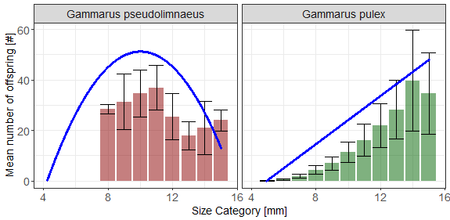
The fecundity function for Gammarus in the model code used to calculate the results in Chapter 5 does not match with the one described in the methods section (Chapter 3) of the thesis. The fecundity function described in the thesis is data from Hynes (1955) for Gammarus pulex (Figure 1, right). The fecundity function used to calculate the results of the competition simulations was that of Gammarus pseudolimnaeus (Figure 1, left), left over from the Galic et al. 2017 based on Hynes & Harper (1972) code that was not corrected and was missed when setting up simulations.
Figure 1: Mean number of offspring by size of modelled gammarids with the incorrect Gammarus pseudolimnaeus (left) and correct Gammarus pulex (Right) fecundity function.

The implication of this is a difference in the fecundity function is very likely to result in a different baseline situation and subsequently different numerical results for time to exclusion.
The following describes the analysis and discussion of the results of simulations run with the correct fecundity function. Methods used for the simulations are the same as those reported in Chapter 5. Given that the baseline situation differs from that reported, the analysis of the results differs slightly focussing on the time to exclusion, with an absence of coexistence.

Correct Results

Baseline situation
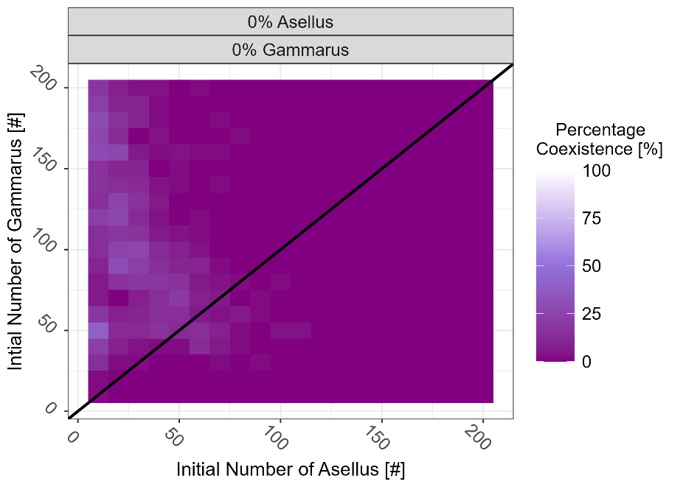
In the baseline situation, exclusion occurs within the experiment time in 97% of simulations on 113 of 400 patches. Conditions where both species are present at the end of the experiment typically occur where Gammarus density is high and Asellus density is low (Figure 2). Exclusion by Asellus is the most common outcome, occurring in 93% of simulations and present on all 400 patches while exclusion by Gammarus does occur at least once on 78 patches but only in 4% of all simulations. Exclusion by Gammarus occurs where initial densities were 60-80 Gammarids and 20 Asellids.
Figure 2: percentage occurrence of coexistence across varying initial population sizes of the baseline scenario where there is no stress on individual feeding rates. The black line represents the point where initial densities of Gammarus and Asellus are equal (i.e. 1:1)
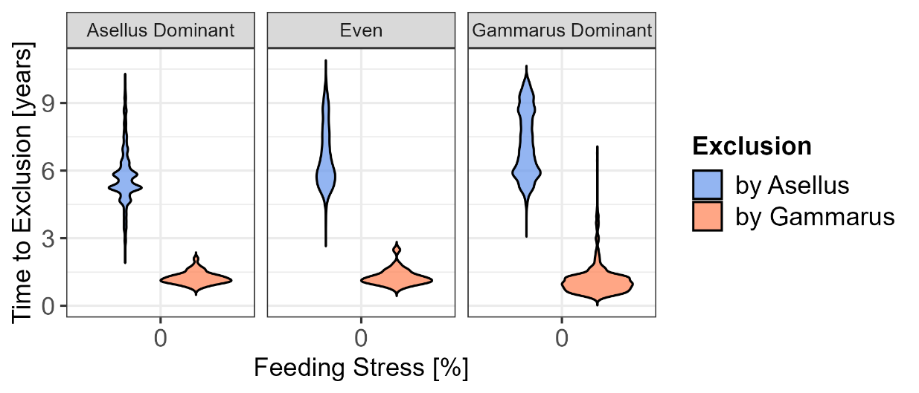
Exclusion of Asellus by Gammarus was quicker than exclusion of Gammarus by Asellus. The median time to exclusion by Gammarus was 1 year (5-95%, 0.5 -2.3 years), while exclusion of Gammarus by Asellus was 6 years (5-95%, 4.6 – 9.3 years). There was little difference in the time to exclusion between Asellus and Gammarus dominant scenarios, with exclusion by Asellus quickest on Asellus dominated patches and vice versa (Figure 3).
Figure 3: Time to exclusion in years by Gammarus and Asellus across patches with different initial ratios of Gammarus and Asellus (dominance) in the baseline scenario.

Reductions in Gammarus Feeding
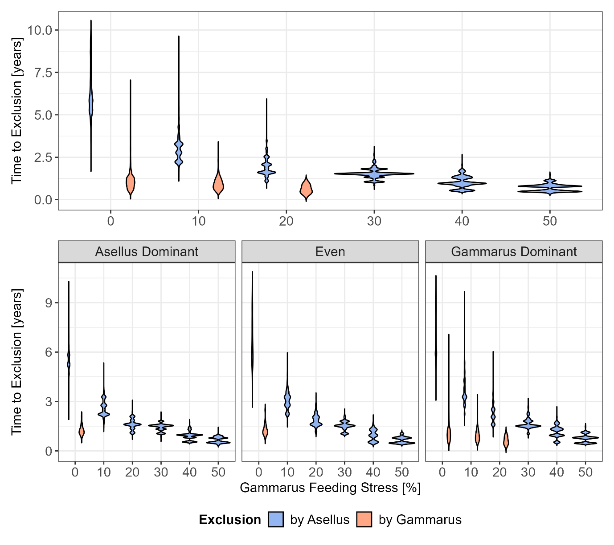
Increasing Gammarus feeding stress leads to exclusion on all patches from the 10% Gammarus feeding stress level (Figure 4). Increasing feeding stress also reduces the time to exclusion of Gammarus by Asellus decreases with increasing Gammarus feeding stress, while the variation across patches also decreasing with increasing feeding stress. At a 30% reduction, Asellus excluded Gammarus in all scenarios with time to exclusion falling to 1.8 years (5-95% 1.2 - 3 years). At the 50% stress level, time to exclusion of Gammarus by Asellus was 0.8 years (5-95%, 0.4 - 1.1 years). When grouping the patches by species initial dominance, Gammarus only persists in Gammarus dominant patches at the 10 and 20% effect level (Figure 4)
Figure 4: The time to exclusion (in years) under different initial conditions and Gammarus feeding stress for all patches (top) and when grouping by species initial dominance (bottom)

Reduction in Asellus feeding
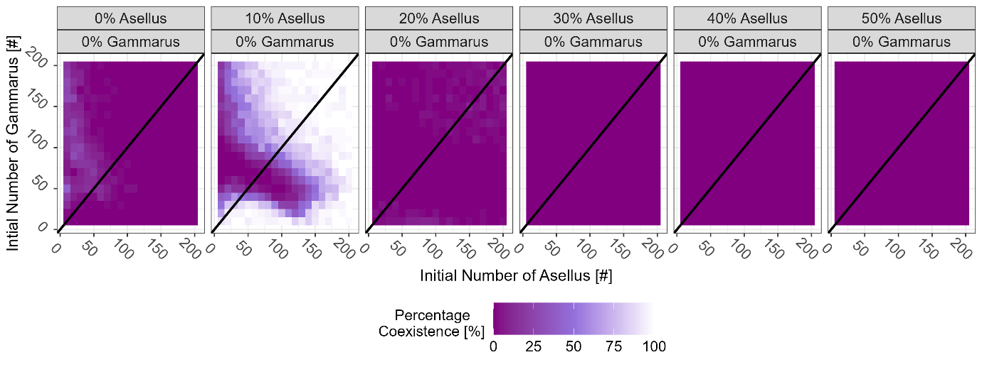
The occurrence of coexistence increases with 10% Asellus feeding stress as Gammarus relative abundance also increases. Here, coexistence occurs in 68% of all simulations on 378 of 400 patches. With 20% Asellus feeding stress, increases, occurring in 1% of all simulations on 119 of 400 patches. Here, Gammarus is the dominant species in all patches. At the 30% Asellus feeding stress, exclusion occurs in all patches (Figure 5)
Figure 5: Percentage occurrence of coexistence across varying initial population sizes with increasing Asellus feeding stress. The black line represents the point where initial densities of Gammarus and Asellus are equal (i.e. 1:1)
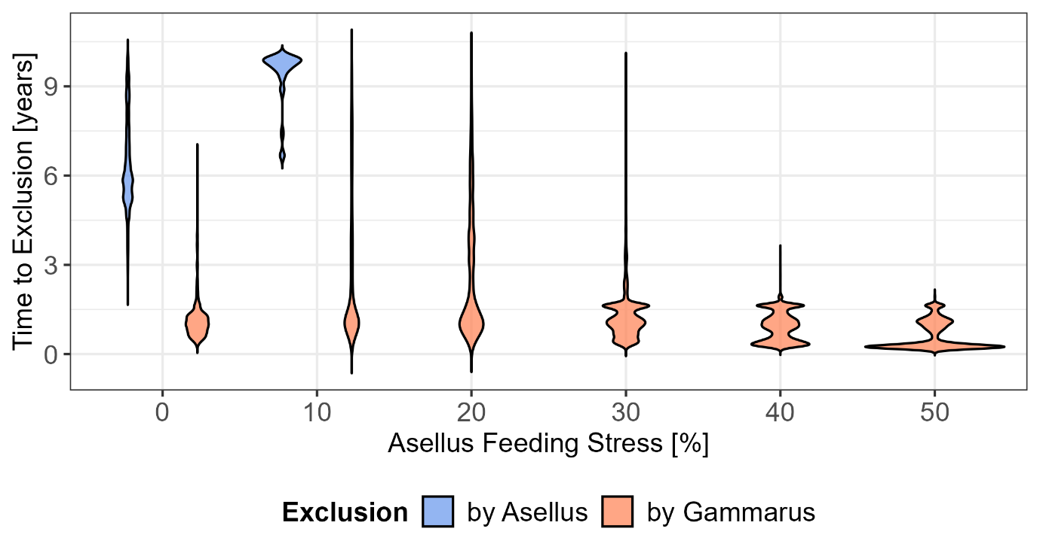
Time to exclusion of Asellus by Gammarus decreases with increasing feeding stress (Figure 6). At 10% Asellus feeding stress, exclusion of Gammarus only occurs on Asellus dominated patches with time to exclusion by Asellus increasing to 9.7 years. With 20% feeding stress of Asellus, Gammarus excluded Asellus in all scenarios with exclusion time ranging from 1.6 years (5-95% 0.6 – 7.12 years), with time to exclusion greater on Asellus dominant patches. This fell to 0.33 years (9-95%, 0.2 - 1.6 years) with 50% Asellus feeding stress.
Figure 6: The time to exclusion (in years) under different initial conditions and Asellus feeding stress.

Increasing absolute stress
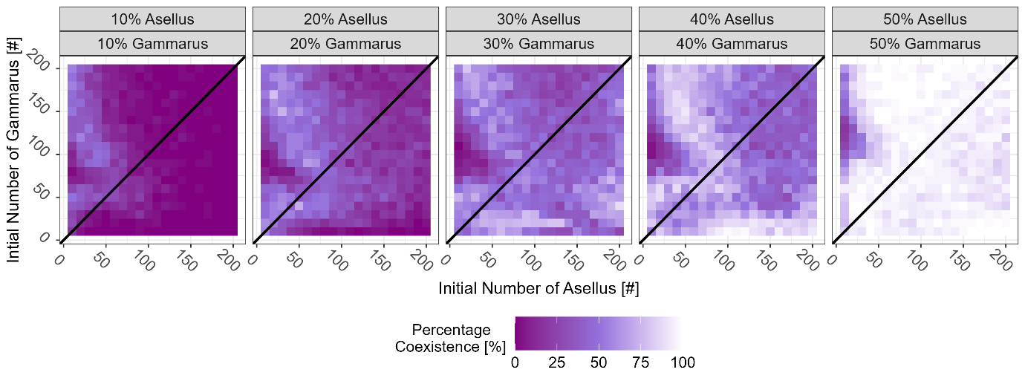
Reduction in feeding rates of both species (absolute stress) resulted in an increased occurrence of coexistence (Figure 7). Coexistence increased from 3% in the baseline 9% at the 10% stress level and to occurring on all patches and in 93% of simulations at the 50% effect level.
Figure 7: Percentage occurrence of coexistence across varying initial population sizes with increasing absolute feeding stress. The black line represents the point where initial densities of Gammarus and Asellus are equal (i.e. 1:1)
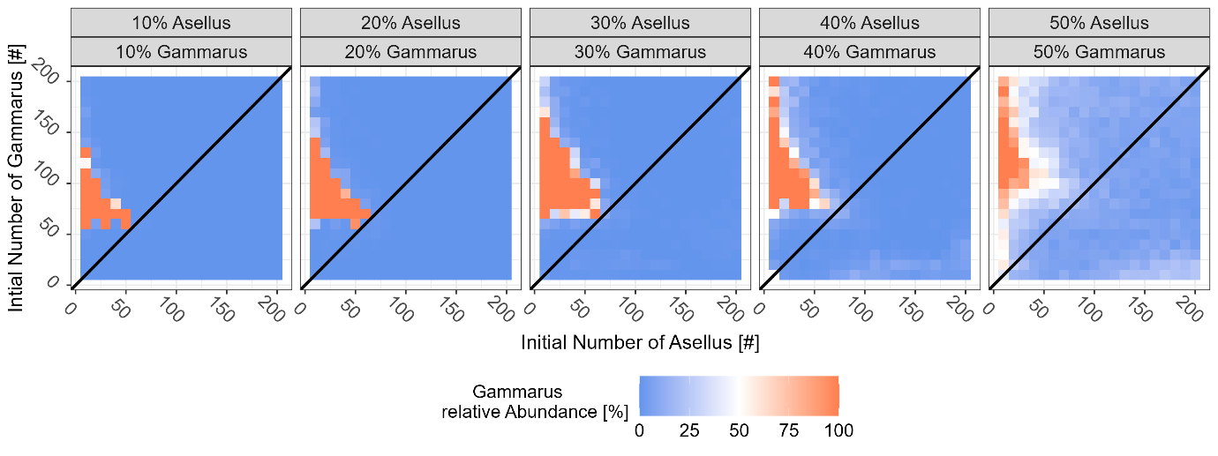
With increasing reduction in both shredder feeding rates (increasing absolute stress), while the relative abundance of Gammarus increases in localised patches, Asellus remains the most dominant species among patches (Figure 8).
Figure 8: The Mean relative abundance of Gammarus at the end of the simulation across varying initial population sizes with increasing absolute feeding stress. Oranges patches represent where Gammarus is the dominant species while blue is indicative of Asellus being the more dominant species. The black line represents the point where initial densities of Gammarus and Asellus are equal (i.e. 1:1)
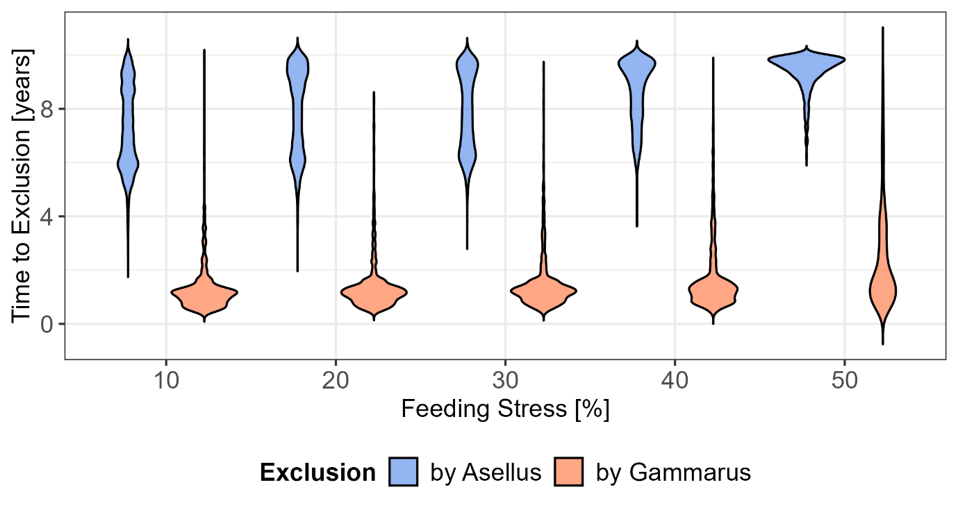
As the occurrence of coexistence increases, the time to exclusion for both species also increases (Figure 9). The variability in time to exclusion by Asellus decreases with increasing coexistence frequency, with 5-95 percentile values 4.5 – 9.3 years in the baseline to 5.7 - 9.9 years at the 30% stress level and 7.9 - 9.9 years at the 50% level. Whereas the variability in time to exclusion by Gammarus increases across these patches with 5-95 percentiles 0.63 – 3.6 years at the 30% stress level and 0.7 to 6.7 years at the 50% stress level (Figure 9). It is important to note that the width of the violin plots is not proportional to the number of replicates represented; as the frequency of coexistence increases, the number of replicates contributing to each violin plot decreases.
Figure 9: The time to exclusion by Asellus and Gammarus (in years) under different initial conditions with increasing absolute feeding stress.

Discussion

Summary
- Interspecific competition for resources between the two species results in species exclusion with 30% threshold for Gammarus and the 20% threshold for Asellus, compared to 70 and 80% at the single species level (Chapter 4).
- Time to exclusion decreases with increasing reduction in feeding stress. For Gammarus this the median time to exclusion falls to within 1 year at the 50% effect level while at the 40% for Asellus.
- While Gammarus populations were the most responsive of the two species to reductions in feeding rates, they were more resistant to exclusion than Asellus.
- Populations on patches where the sensitive species is dominant are most resistant to collapse.
- Increasing reduction in feeding rates of both species resulted in greater occurrence of coexistence (at least increased the time to exclusion)

Summary and comparison to results reported in the thesis
The baseline scenario with the corrected simulations shows significantly fewer occurrences of coexistence between patches with 3% compared to 32% of all experiments as reported in the thesis. Furthermore, the point at which species dominance shifts differs between the two analyses. In the thesis, this transition occurs approximately where Gammarus and Asellus densities are equal. In contrast, in the corrected simulations this shift occurs in an area of localised patch conditions around the point where Asellus = 20 and Gammarus = 60-80.
Consistent with the reduced occurrence of coexistence, the corrected model generally produces shorter times to exclusion than those reported in the thesis. Notably, in the thesis, time to exclusion of Gammarus occurs sooner than that of Asellus with exclusion of Gammarus by Asellus 1-7 years, while exclusion of Asellus by Gammarus is 8-12 years. In the corrected simulations, this pattern is the reverse with exclusion by Gammarus around 1 year and exclusion by Asellus takes around 6 years.
Despite the differences in the baseline scenario, the patterns of effects of reduced feeding rates on the SPU are largely consistent between the two analyses with small differences in threshold values. In the thesis, exclusion of the sensitive species under interspecific competition occurs at 20% reduction in feeding, for both species. In the corrected simulations, exclusion occurs at a 30% reduction for Gammarus and a 20% reduction for Asellus, compared with much higher thresholds (70% and 80%, respectively) under single-species conditions (Chapter 4). Results from the absolute stress simulations in both models show that the occurrence of coexistence increases with increasing reductions in feeding rates for both species, reflecting rising absolute stress on the system. At the 50% effect level, coexistence occurs in nearly all patches, approaching 100%.
In both analyses, increasing reduction in feeding leads to shorter times to exclusion and reduced variability in exclusion times across patches. However, differences emerge in the effect levels required for median time to exclusion to fall below one year - which is more relevant for risk assessments. In the thesis it is reported that the median time to exclusion across all patches falls to 1 year with a 40% reduction in feeding for both species, with patches dominated by the sensitive species experiencing exclusion in under one year at the 20% effect level. In contrast, in the corrected simulations, the median time to exclusion across all patches falls below one year only at a 50% reduction in feeding rate for both species, although patches dominated by the sensitive species experience exclusion within one year at the 30% effect level.

Implications
These results indicate that populations in the corrected model are less sensitive to reductions in feeding when interspecific competition is considered even though the overall response patterns remain similar. Nonetheless, the corrected results still indicate that interspecific competition for resources alters the effect threshold at which feeding inhibition impacts populations compared with single-species models. This highlights interspecific competition as an important factor to consider when assessing the risks of chemicals in multi-species systems.

