

How Practitioners Make Sense of Expressive Story Writing and how that can be Experienced as Therapeutic

Helen Nina Taylor
210103317
A thesis submitted in partial fulfilment of the requirements for the degree
of Doctor of Educational and Child Psychology
Department of Education, The University of Sheffield
Submission Date: February 2025

Acknowledgements

This thesis is for my family.
For my parents – There is no way of exaggerating how I could not have done this without you.
For my children – I can simply say, I could not have done without you.

Thanks are due to all of my supervisors, for all of the times I thought: I could not have done this.
Especially Dr Wint and Dr Williams, but also Dr Fogg, Dr Davies, Dr Begon, Dr Atkin, Dr Seedat and Dr Lourd-Moyo.

Thanks also to my original DEdCPsy 2021-2024 cohort – we all got there in the end.

Lastly, thanks are due to my participants, for their candour and enthusiasm.
I hope this research makes sense for you.

Abstract
This research explores expressive story writing and how that can be experienced as therapeutic. Therapeutic Story Writing Groups (TSWGs) are an expressive story writing intervention that can be used in Educational Psychology (EP) practice and were being delivered in the local authority (LA) I worked in. Previous research into TSWG has used quantitative methodologies and their associated paradigm(s) and none explored the experiences of either facilitators or CYP in qualitative depth. I was interested in how practitioners view the ways TSWGs could support creativity and self-expression in Key Stage 2 students. From a contextualist epistemology and critical realist ontology, reflexive thematic analysis was used to analyse participant interview transcripts, allowing their truths to be validated whilst acknowledging existing structures and instances of power within schools and LA services. Key messages from analysis were: that TSWGs provide something different for children to their usual school experience; that facilitators are not exempt from systemic pressures; that practitioners adapted the intervention’s structure and delivery; that children are given opportunities to make social connections and voice worries; that most children could express themselves comfortably through a process of exploration and externalisation; that the group felt like a relational space, which promoted equalizing and connectedness; that practitioners valued the intervention for building children’s emotional literacy; that practitioners felt children’s confidence generally increased during the sessions; and that there was a sense of transformation taking place in children. Building children’s emotional literacy and providing a sense of transformation in a six-week period demonstrates the potential impact of this relatively low-cost therapeutic and expressive story writing intervention. The benefits of TSWGs reported here indicate that TSWGs could be usefully adopted within LAs to support children, particularly those in Key Stage 2. EPs in most LAs are well placed to train and supervise practitioners in delivering such groups.

Contents
Acknowledgements 2
Abstract 3
List of abbreviations 7
List of figures 8
Chapter 1. Introduction 9
1.1 Personal and professional interest in this research area 9
1.2 Introductory research aims 11
Chapter 2. Literature Review 13
2.1 An Introduction to the Literature Review – Parameters 13
2.2 The Political and the Policy 13
2.3 Definitions and Theoretical Models of Creativity 17
2.4 Creativity and its links to Theoretical Models of Wellbeing 21
2.5 Spaces for Creativity and Play in Childhood 24
2.6 Creative Wellbeing as a Collectivist Value 25
2.7 Creative Constraints – Prior Research 26
2.8 Creative Writing, Writing Therapy 27
2.9 How Creative Writing could Benefit Wellbeing 29
2.10 Creative Writing as an Empowering Group Endeavour 31
2.11 Therapeutic Story Writing Groups (TSWGs) 32
2.12 Rationale for this Research 37
Chapter 3. Methodology 39
3.1 Research questions and aims 39
3.2 Research Paradigms – My Positionality 41
3.2.1 Ontology of the research 43
3.2.2 Epistemology of the research 44
3.3 Research design and Positionality 44
3.3.1 Justification for using reflexive thematic analysis methodology in this research 45
3.3.2 How my positionality likely influenced my choice of methodology 47
3.4 Methods 49
3.4.1 Sampling of the study 49
3.4.2 Participant criteria and recruitment 49
3.4.3 Participant demographics and LA context 50
3.4.4 Data collection and research procedure – Interviews 51
3.4.5 Data analysis 52
3.5 Ethical considerations of recruitment and data collection 54
3.6. How qualitative rigour was ensured 55
Chapter 4. Analysis 58
4.1 Analysis – What’s the story? 58
4.2 Relationship to school culture 59
4.3 Relaxing the structure 62
4.4 Creative freedom and self-expression 65
4.5 The group space 68
4.6 What’s felt to be therapeutic 73
Chapter 5. Discussion 78
5.1 Discussion – That was the story, what are the take-away messages? 78
5.2 Putting the psychological frames around the analytic lenses 79
5.3 How this research builds on and furthers existing research in this area 89
5.4 Reflections on positionality 91
5.4.1 Personal reflexivity 91
5.4.2 Functional and disciplinary reflexivity 92
5.5 What has been answered? Returning to the research questions 94
5.5.1 How practitioners make sense of the therapeutic experience of expressive story writing 95
5.5.2 How practitioners talk about the experience of delivering therapeutic story interventions 97
5.5.3 The ways TSWGs could support creativity and self-expression in Key Stage 2 children 99
5.5.4 What these practitioners value about the intervention 101
5.5.5 Ways TSWGs could be adapted and used therapeutically with adolescents 103
5.6 Further strengths and limitations– What is there still to ask in future research? 104
5.7 Implications for EP practice 110
References 112
Appendices 140
Appendix i: Overview of therapeutic stories in EP practice 140
Appendix ii: Ethical approval certification 141
Appendix iii: Participant information sheet 142
Appendix iv: Consent form 147
Appendix v: Semi-structured interview schedule 149
Appendix vi: Transcription conventions 149
Appendix vii: An example coded transcript 150
Appendix viii: Individual Pen portraits of each participant 188
Appendix ix: Participant reflection after interview, email 2nd August 2023 189
Appendix x: An example from refining coding labels 191
Appendix xi: An example of starting to group coding labels into initial themes 192
Appendix xii: An initial ‘working’ thematic map 193
Appendix xiii: Theme definitions 194
Appendix iv: It’s not everyone’s TSG 195
Appendix xv: Excerpts from my reflexive journal 198

List of abbreviations
BERA British Educational Research Association
BPS British Psychological Society
CBT Cognitive Behavioural Therapy
CYP Children and Young People
DfE Department for Education
EBSA Emotionally Based School Avoidance
EEWP Education Emotional Wellbeing Practitioners
ELSA Emotional Literacy Support Assistants
EP Educational Psychologist
EU European Union
GCSE General Certificate of Secondary Education
GP General Practitioner
IPA Interpretive Phenomenological Analysis
LA Local Authority
MHST Mental Health Support Team
NACCCE National Advisory Committee on Creative and Cultural Education
PACE Playfulness Acceptance Curiosity and Empathy
PERMA Positive emotion, Engagement, Relationships, Meaning and purpose, Accomplishment
PSHE Personal, Social, Health and Economic Education
PTSD Post-Traumatic Stress Disorder
SAT Standard Assessment Test
SEAL Social and Emotional Aspects of Learning
SEMH Social and Emotional Mental Health
SENDCo Special Educational Needs and Disabilities Co-ordinator
SPaG Spelling, Punctuation and Grammar
TEP Trainee Educational Psychologist
TSWG Therapeutic Story Writing Groups
UK United Kingdom
UNCRC United Nations Convention on the Rights of the Child
UNICEF United Nations International Children’s Emergency Fund
US United States
USSR Union of Soviet Socialist Republics
WHO World Health Organisation
List of figures
Figure / table | Title
Figure 1 | Runco (2016): creativity as a continuum of development
Figure 2 | Rhodes (1961): what factors might affect a creative act
Figure 3 | Interpretivism on a continuum
Figure 4 | Overview of themes in analysis
Figure 5 | Overview of content captured in each theme
Figure 6 | Glăveanu (2010): creativity in a tetradic framework

How Practitioners Make Sense of Expressive Story Writing and how that can be Experienced as Therapeutic

1.1 Personal and professional interest in this research
Expressive writing exists in several different forms including open-ended or free writing, autobiographical writing, focused writing, guided writing (like a diary or journal entry), and programmed writing (Chandler, 2002; King et al., 2013; Perez et al., 2021). Therapeutic expressive writing has been used with adults and young people experiencing a range of changes and/or difficulties (see 2.8). The successful use of expressive writing in care homes, prisons, and with General Practitioners (GPs) has been written about (Saunders, 2006; Smith, 2008; Sparks, 2008; Swann, 2009) but there is very little published research looking at the use of therapeutic stories in Educational Psychologist (EP) practice (Pomerantz, 2007).
I worked as a Trainee Educational Psychologist (TEP) in a local authority (LA) which is delivering therapeutic story writing group (TSWG) interventions, and I am interested in how those practitioners delivering the intervention talked about the experience of delivering a group therapeutic story intervention, and what the practitioners delivering that intervention valued about the intervention. There is limited research around TSWG, despite the intervention being employed in, at last count, over 500 United Kingdom (UK) schools in 35 LAs (Waters, 2014); these studies have all been within a quantitative paradigm and have not explored the experiences of facilitators or participants in TSWG in any qualitative depth. I am interested in how practitioners view the ways that therapeutic story writing could support creativity and self-expression in Key Stage 2 students, and this is not something that has previously been explored.
I am also interested in the political context around therapeutic story writing and its potential links to supporting student wellbeing, as, prior to the Covid pandemic, the wellbeing of young people in the UK had already been positioned as having reached the status of a critical psychological problem (Andthen & Mind, 2021; Clarke & Basilio, 2018; Vizard et al., 2020). If EPs take the view that schools can be a mechanism for a process of change (Gulliford, 2005) and that schools are influential systems for deciding how creative behaviours are viewed, and constrained (Albert, 2012), it is relevant to consider how ‘creativity’ may be being positioned within the current educational climate. Since schools are the main socialising agents of children in society (Beghetto, 2010) EPs should carefully consider the positive psychological benefits of creativity and its links to wellbeing (Tamannaeifar & Motaghedifard, 2014). I believe that creative activities enhance student and teacher wellbeing in schools, and wellbeing is an outcome for children and young people (CYP) that should be valued as highly, if not higher, than a young person’s assessment results. If teachers are perceived as creativity benefactors (Moran, 2010), EPs should encourage teachers to enact and engender creativity within classrooms. EPs have a powerful voice in legitimising this perspective and encouraging teachers to see the importance of creativity for their students, and their own, mental health and wellbeing. Although I did not actively engage in exploring the benefits of TSWGs for staff wellbeing, some reflections on this did come out in the analysis and discussion. I contend that EPs should consider adding creative interventions to recommendations for enhancing wellbeing within schools. It is of particular interest to me to explore what therapeutic story writing practitioners consider to be the benefits for students in a group therapeutic story writing intervention, since anecdotally and from prior experience, I would contend that there are few alternative spaces for creative expression currently within UK schools.
Within a political context that is looking for cost-effective and expedient ways of promoting improvements in mental health within schools (McDaid & Park, 2022), it is interesting to explore any possible links between therapeutic story writing and some of the conclusions drawn from research relating to the self-expression paradigm (Pennebaker & Segal, 1999), where, from the positivist paradigm and with largely American student participants, journalling about personally upsetting experiences for thirty minutes a day was argued to gradually and cumulatively improve health outcomes. Journalling is a low-cost intervention and TSWGs, whilst requiring economic resources in training facilitators, is a preventative early group intervention that could avoid higher costs to LAs in later individual referrals. There is a possibility that this research could inform future political policy decision making, in starting to explore what practitioners value as the perceived benefits of an intervention such as TSWGs.
As a TEP drawn to a narrative way of working in future practice, I am furthermore interested in how therapeutic story writing relates to narrative therapeutic understandings more broadly in terms of externalising and storying experiences, to enable some more self-understanding and thickening of an alternative preferred narrative.
As a former English secondary teacher who has both participated in creative writing groups and led these within secondary schools, I am particularly surprised that, to date, no specific therapeutic creative writing intervention exists for 12-16 year olds, and this exploratory research is also intended as a starting point for considering what features of TSWGs could be beneficial for this age group, and how some of these could be linked to research relating to the benefits of expressive writing and journalling.

1.2 Introductory research aims
My interest is broadly in how therapeutic expressive story writing could take place within schools, and any potential links between creativity and wellbeing, as I feel that something therapeutic happens in the space of being part of a creative writing group. I would like to consider, in future research, how that could be explored with teenagers, with a view to highlighting the scope for aspects of this intervention to be adapted for delivery to this older age group.
In my critical literature review I am interested in exploring understandings of creativity within the UK educational system and the supposed positive psychological benefits of creativity and its links to wellbeing. I would also like to explore the posited benefits and/or negatives of creativity for CYP, particularly those relating specifically to creative writing and the use of writing in therapeutic interventions more broadly (writing therapy). The idea of achieving creative wellbeing could be criticised for being an individualist value prized within the Global North, linked to ideas concerning the wellbeing of the person and achieving what that person desires through self-determination and/or personal growth (Prilleltensky & Nelson, 2000), but I am particularly interested in how creative and expressive writing in a group could be empowering, with a community of minoritized people coming together to write, be heard and affirmed (Chandler, 1999; Hacking et al., 2008). I believe that creativity is not necessarily something to be aspired to as a concept linked to a higher form of intelligence, or as a privileged form of self-actualisation within a more affluent or individualist society, but that experiencing creative wellbeing is something which should be achievable for all CYP and that this is particularly something which can be done in a way that promotes community relationships and understanding within and across group identities. I am interested in linking these ideas to my understanding of what might take place within TSWG interventions with CYP. EPs are increasingly encouraged to be self-reflexive, and, in many ways, there are parallels here with creative writing, in which people can therapeutically re-work their biographical narratives in a way EPs can through reflexivity (Elizabeth, 2008). I hope that in this exploratory research I will be able to reflexively bring in my own previous experiences within education and creative writing to deepen my understanding of therapeutic work within the role of EP.

“I expressed some very long felt and deeply felt emotion. And in expressing it, I explained it and then laid it to rest.” (To the Lighthouse, Virginia Woolf)

Literature Review

2.1 An Introduction to the Literature Review – Parameters
This critical literature review opens with a consideration of the wider contexts around how creativity could be enacted by CYP, such as policies affecting UK educational settings in the previous two decades. I then consider definitions and theoretical models of both creativity and wellbeing, from several paradigms, and how there might be spaces for CYP experiencing wellbeing through engaging in creativity, considering how childhood might be a time for creativity and play, or not. Having looked at some of the constraints on creativity that CYP might experience, I then narrow the focus of this literature review to considering specifically how creative writing could be understood within a psychological narrative framework and how creative writing could benefit wellbeing, particularly as a group endeavour. I conclude the literature review by homing in on prior research into TSWGs and outlining the rationale for this research.
Key terms for my initial literature search on StarPlus, Google Scholar, ERIC and Scopus were creativ* and educational psychology or child psychology and wellbeing, well-being or wellness. Once the most relevant journals and articles were identified I conducted further searches based on the publications that were cited in these and revisited the relevant literature informing my previous research. Having decided upon a focus on TSWGs I also considered the literature reviewed in three prior theses on this topic. Furthermore, I considered my previous experience of writing workshops and asked two friends who deliver these what reading they might recommend to someone exploring the therapeutic possibilities of creative writing.

2.2 The Political and the Policy – UK Contexts in which Creativity and Wellbeing are Constructed
Since the wider contexts around how creativity is understood, and how it could be enacted by CYP, are affected by the politics and policies in UK educational settings, this section intends to cover relevant educational reforms of the previous two decades. My positionality is such that I am interested in educational reform from a former teacher perspective, and I started to explore the possible impact of secondary English curricula reforms on creativity, and its potential for enactment by CYP, in former research (Taylor, 2018). I am interested, in this research, to explore how practitioners make sense of expressive story writing and how that could be experienced as therapeutic. From my critical realist ontology, I believe that currently existing school and LA service structures form part of the reality that shapes what meanings are articulated by practitioners in interviews. Furthermore, from my contextualist epistemology, I believe that participant language choices and possible meanings are dependent on context and, I would argue, understanding of the UK political and policy contexts in which ‘creativity’ and ‘wellbeing’ are being constructed and enacted is relevant to the experiences of CYP and practitioners within therapeutic expressive story writing groups. I am interested in how practitioners talk about the experience of delivering these interventions and I believe their talk will be influenced by the contexts around them. From my positionality, I believe ‘creativity’, and the spaces for enacting it, has been challenged by political reforms. Policies relating to ‘wellbeing’, however well intentioned, have not, I would argue, sufficiently ameliorated some of the felt aspects of classrooms as many CYP currently experience them in the UK today. I do not think that many lessons currently feel therapeutic for CYP.
The British government under New Labour created public policy centred on the notion that social exclusion is inextricably linked to destructive influences that damage self-esteem and emotional wellbeing (Blair, 1997). Political concern about emotional wellbeing and the need for welfare and education agencies to develop wellbeing was justified by accounts of the effects of low educational achievement and participation on groups such as working-class boys and single mothers, where low self-esteem and feelings of vulnerability and risk were theorised to be part of a cycle of deprivation (Ecclestone, 2007). The Social Inclusion Programme identified access to arts participation as one of the essential criteria for promoting social inclusion of people with mental health needs (Office of the Deputy Prime Minister, 2004).
Labour introduced the Social and Emotional Aspects of Learning (SEAL) curriculum in 2005 as an evidence-informed adaptation of pre-existing evidence-based United States (US) programmes, with a bank of teaching resources and guidance documents taught through both an explicit curriculum and additional reinforcement of focus skills by all staff members (SEAL Community, n.d.). The SEAL curriculum was based on Goleman’s (2020) concept of emotional intelligence and included advocating for creative arts interventions (Atkinson & Robson, 2012). However, Labour was subsequently criticised by the coalition government for not trialling the SEAL curriculum before rolling it out nationally, and when the Department for Education (DfE) commissioned a review into the implementation of SEAL they found that it was failing to “impact significantly upon pupils’ social and emotional skills, general mental health difficulties, pro-social behaviour or behaviour problems” (DfE, 2010a, p.3), possibly due to a lack of time and/or resources in order to consistently structure and deliver the SEAL curriculum as intended.
Creative Partnerships were set up following the recommendations of the National Advisory Committee on Creative and Cultural Education (NACCCE) for schools to develop partnerships with creative and cultural organisations. In this report, creativity was positioned as helping improve economic prosperity and social cohesion, as well as contributing to students’ self-expression and self-esteem (NACCCE, 1999). Evidence that creativity in education can promote wellbeing was presented to the DfE as part of a review of Creative Partnerships. In this report, student and teacher wellbeing was argued to be positively impacted by Creative Partnerships through improving the school environment and relationships with the local community, and a focus on experiential learning and negotiated pedagogies, where students could co-construct learning (McLellan et al., 2012). Student self-confidence improved, as well as the ability to manage personal stress (Ofsted, 2006) and teachers, as well as students, were empowered through specific creative collaborations (Chappell et al., 2016; Craft et al., 2012). However, no significant difference in overall wellbeing was found between Creative Partnership and non-Creative Partnership schools (Clarke & Basilio, 2018).
The NACCCE report into Creative Partnerships also led to the development of the 2007 English national curricula, where creativity was included as one of its four key concepts (McCallum, 2012). Wyse and Ferrari’s (2015) content analysis of creativity in the national curricula of European Union (EU) member states showed that the UK 2007 curriculum had creativity ratios of occurrence above the EU average; particularly in England, where there were 149 total occurrences. In 2014 the UK curriculum was reformed by the Conservative government, who stated that their intentions in doing so were to free teachers from the bureaucracy of the 2007 curriculum, where “at over 200 pages, the guidance…is…squeezing out room for innovation [and] creativity” (DfE, 2010b, p. 40). The British Educational Research Association (BERA) presented evidence to the Secretary of State during the 2014 curriculum formation, voicing concerns about the removal of Music and Arts and increased accountability. However, draft programmes of study produced in consultation with subject experts were replaced with those created by nominees of the Minister for Schools (BERA, 2011). The 2014 curriculums have been argued to reflect an ideology of traditional knowledge, facts and grammar (Wyse, 2014). The Secretary of State wrote of his intentions to hold schools rigorously accountable and his desire to democratise knowledge whilst showing appreciation for human creativity (Gove, 2012). Such claims are set against reforms that removed any mention of creativity from the previous 2007 curriculum. Furthermore, introduction of the English Baccalaureate (or Progress 8), with its exclusion of creative subjects, meant that nearly a quarter of secondary schools instantly withdrew arts GCSE subjects from their curriculum (Greevy et al., 2012). In primary schools, Troman et al. (2007) have argued that the focus on Standard Assessment Tests (SATs) has meant many creative and collaborative activities are dropped in favour of maximising how well children can perform in key stage tests. In previous research (Taylor, 2018) I consider how the experience of creativity is being eroded within secondary school English classrooms and how that change is impacting the wellbeing of teachers and young people.
Consideration of how school environments may affect public mental health are raised by Bonnell et al. (2013) and the World Health Organisation (WHO) introduced the concept of ‘child-friendly schools’, which includes a focus on encouraging creativity as well as promoting academic abilities (WHO, 2001). In the UK, Wells et al. (2003) outline how promotion of mental health became a key part of UK public health policies, with mental health understood to mean the inclusion of emotional health and wellbeing (DfEE, 1999) and emotional and social competence (DfES, 2001), and schools promoted as one of the key sites for enabling CYP mental health. Despite the SEAL curriculum having been archived, the Personal, Social, Health and Economic Education (PSHE) curriculum became statutory for Key Stages 1 to 4 in September 2020 and, especially in primaries, some schools chose to incorporate aspects of SEAL into their PSHE delivery. Prior to this, PSHE had been delivered through a non-statutory framework, with guidance from the DfE referring to it as “an important and necessary part of all pupils' education” (p.7, DfE, as cited in Long & McGrath, 2024); however, Ofsted inspections had suggested that the quality of PSHE education was not yet good enough in a large proportion of UK schools and recommended that the DfE should give clear messages to schools about the importance of PSHE and help them to improve their provision.
Prior to the Covid pandemic, Clarke and Basilio (2018) argued that the wellbeing of young people in the UK had reached the status of a critical psychological problem, with a prevalent lack of meaningful creative engagement in UK schools argued to be a contributory factor. The UK was ranked as having one of the lowest levels of child wellbeing internationally (United Nations International Children’s Emergency Fund [UNICEF], 2007) and compared to European children, British secondary school pupils were engaging in fewer active and creative endeavours than children in countries with higher levels of wellbeing, such as Spain and Sweden (UNICEF & Ipsos Mori, 2011). The Good Child Report (Rees et al., 2012) documented alarmingly high levels of unhappiness in UK schools which they linked to young people experiencing lack of choice, freedom and autonomy, although they did not connect this explicitly with self-determination theory (Ryan & Deci, 2000; see 2.4). Furthermore, several studies demonstrated that levels of wellbeing can decline with age, which might be partially explained by there being increasingly less time to enjoy a playful and creative attitude to school and life (Tomyn et al., 2015). DfE guidance (2018) outlines the importance of early intervention with CYP experiencing mental health difficulties and stresses how school cultures can promote more resilient children, particularly those who experience cumulative risk factors, with the guidance emphasising that mental health problems can manifest as challenging behaviour and, as such, fixed term exclusions should be considered a last resort. I have noticed in EP practice that there is an increasing dialogue around increasing CYP emotional intelligence/literacy to support children to understand their internal states and how these externally present in behaviour which can challenge others. Dialogue around particular children being positioned as experiencing low self-esteem is also something I have frequently encountered in my work to date. Ecclestone (2007) has criticised ‘emotional intelligence’, ‘wellbeing’, ‘emotional literacy’ and ‘self-esteem’ as popular but slippery concepts, with political interest in emotional vulnerability paralleling the ‘common sense’ assumption that low self-esteem is the root cause of a wide range of social ills.
In 2020, the Conservative government announced an £8,000,000 Covid recovery grant to improve mental health and wellbeing in schools and colleges, known as the Wellbeing for Education Return initiative (DfE, 2020) which was paid in differential amounts through the Education and Skills Funding Agency to different LAs at the end of September 2020, and again, a lower amount of £7,000,000 was portioned out and paid in May 2021, to continue to support recovery from the impact of the Covid pandemic (DfE, 2021). The most recent State of the Nation report suggests that CYP’s mental health and wellbeing is recovering somewhat to pre pandemic levels, but that adolescent females may continue to be one of the groups whose wellbeing has been most significantly impacted by the pandemic (DfE, 2022).

2.3 Definitions and theoretical models of creativity
This section of the literature review considers definitions and theoretical models of creativity from several paradigms. I am interested, in my research, to explore how practitioners view the ways therapeutic expressive writing could support creativity and self-expression in CYP, and how practitioners make sense of expressive story writing. Therefore, a consideration of how ‘creativity’ might be being defined or understood is relevant to my research, and the ways in which ‘creativity’ might be being linked to (self-)expression, or the communication of something creative, to oneself and/or others. Linking to 2.2, I believe in some ways creativity is becoming eroded in current UK school contexts and, I wonder, what is it that CYP could be losing?
Originally, the construct of creativity was perceived as an aspect of intelligence; something hereditary and only the province of a gifted few (Galton, 1869; Terman, 1925). More recently, theories of intelligence have become multidimensional (Gardner, 1983; Gulliford 1956, 1967; Sternberg, 1988; Thurstone, 1952) and creativity is viewed as a unique and distinct aspect of human experience, although for some researchers it still bears some relation to intelligence, e.g. through regarding it as a fundamental condition for ‘giftedness’ (Treffinger, 1991). Creativity is still being constructed as a fixed genetic trait by some researchers, with the genes THP1 and THP2 being reported as associated with creativity (Reuter et al., 2006; Runco et al., 2011). However, there has largely been a paradigm shift in recent creativity research, with creativity no longer defined in terms of personal qualities and outcomes but rather in terms of communication and interaction, developed in collaborative relations: the We-paradigm (Glăveanu, 2010). A systems model of creativity (Csikszentmihalyi, 2014; Nakamura & Csikszentmihalyi, 2001) aligns with social constructivism, with intellectual activity becoming creative accomplishment through interaction and collaboration (Plucker et al., 2004).
Runco (2016) conceptualises creativity as a continuum of development starting with mini creativity and progressing through little creativity to big creativity and then, for some, achieving pro creativity. Vygotsky (1926/2004) believed in the worth of a creative act that is known only to the person who thought of it and might remain a thought process alone; this could be defined as mini creativity. Little creativity would have a tangible product created that could be enjoyed by another – and most creativity researchers would place products that CYP create within educational settings in this category. Csikszentmihalyi (1997, 1999) has suggested that big creativity will include creative products which anybody with the skills and opportunities could create but that these products will be of a more developed form than little creative products, after the creator has had years of creative practice. Finally, pro creativity is conceptualised as something which has been judged to reach that level by gatekeepers of a particular artistic domain, e.g. curators of an art gallery (see Figure 1).

Figure 1
Runco (2016): Creativity as a continuum of development
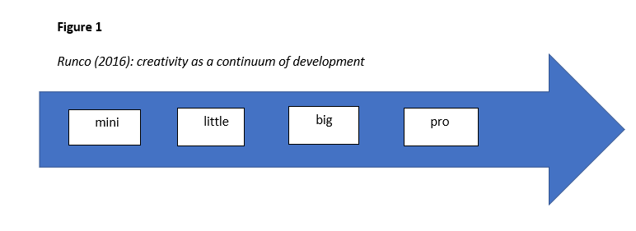Personally, I wonder about the sequential and hierarchical nature of this theory when relating it to the creativity of CYP, who are here assumed to ‘only’ be capable of mini or little creativity, as they will not have had enough experience and practice to demonstrate a more developed big creativity. In my experience, one of the joys of working with (and parenting) children has been when they have shared creative thoughts with me and labelling these as a ‘mini’ form of creativity seems to impose a value judgement which depreciates their – often startling – originality.
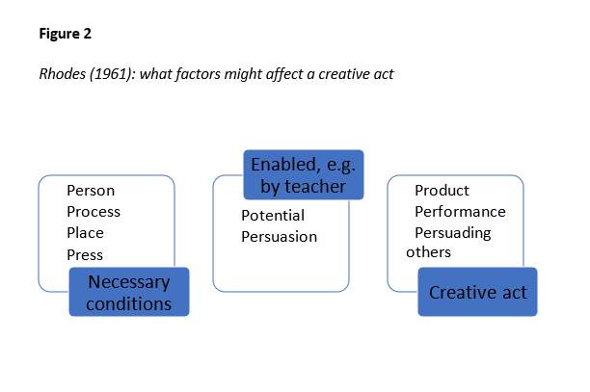
Other researchers, starting with Rhodes (1961), considered what factors might affect a creative act through either enabling or constraining it. Person, process, place (both in terms of immediate environment and sociohistorical context) and press (pressures which effect creative behaviour, e.g. economic circumstance) are considered as necessary conditions for creative potential. CYP have been seen as holding creative potential if all these conditions are favourably in place. Within schools, the role of a teacher could be to enable and persuade creative expression in a performance, product, or in persuading others, e.g. through a creative speech (see Figure 2).
Figure 2
Rhodes (1961): What factors might affect a creative act
I think this theory is helpful in acknowledging how a bio-ecosystemic perspective (Bronfenbrenner, 2005) is relevant for considering how children’s creativity might be enabled or constrained by certain contextual factors such as socio-economic circumstance, and it moves us away from an understanding of creativity as an individualistic personality trait or an aspect of innate intelligence. Most EPs would agree that what goes on around a child, including their interactions with teachers and other influential adults, affects what they produce. I do not think creativity can exist in isolation and, in many ways, teachers collaborate with children in enabling and shaping their creative potential into products.
There are tensions in trying to reach an overarching definition of ‘creativity’. One oft-levelled criticism is that there is a product bias in defining a creative act which results in tangible expression for another to experience as somehow bigger than the creative potential and thoughts which anyone could hold within them. That perspective seems to devalue the creativity which CYP are capable of, and that teachers could enable in their classrooms. If creativity can be valued as a low-stakes process within classrooms then CYP could be enabled to try, fail, and succeed without having to devise an externally judged creative product, thereby allowing them to grow in positive self-beliefs (Anderson et al., 2019).
Some creativity researchers (like Weisberg, 2015) see novelty or originality as the most important criterion for deciding whether something could be considered creative or not. Others (starting with Stein, 1953) believe the usefulness or effectiveness of product to also be necessary to define something as creative. There are implications too in whether the word ‘usefulness’ or ‘effectiveness’ is chosen to describe a creative product. ‘Effectiveness’ allows for a subjective value judgement which means that an individual CYP could decide for themselves that something is creative if they see it as effectively creative (as well as novel or original) themselves (Wyse, 2017). ‘Usefulness’ however implies that creativity can only be judged truly creative if it can be utilized in the knowledge economy (Robinson, 2011). This raises questions about what kinds of creativity are being encouraged as useful in their contemporary socio-political historical context, e.g. funding for innovative weapons technology, where novel ideas manifest as destructive creations.
Plucker et al. (2004) proposed a summary definition: “Creativity is the interaction among aptitude, process, and environment by which an individual or group produces a perceptible product that is both novel and useful as defined within a social context.” (p.90). To focus on the opening of this definition, Fischer (2005) similarly sees creativity as in the interaction between ideas, peoples, and things. Seeing creativity as held within or between an interaction is perhaps similar to taking a relational or social constructionist understanding: creativity existing as enmeshed in the interactions between the different interpretations of various peoples’ thoughts and/or objects. Taking this view would mean creativity cannot be pinned down to a particular thing or thought but should always be considered in relation to the thoughts of the creator and the interpretations of the people experiencing that creative act. However, studies published in psychology journals continue to mainly treat creativity as a dependent variable measured with divergent/convergent thinking or insight problem-solving tasks (Forgeard et al., 2016), e.g. the Torrance Tests (1966).

2.4 Creativity and its links to Theoretical Models of Wellbeing in Positive, Humanistic and Critical Community Psychology
This section of the literature review considers theoretical models of creative wellbeing from several paradigms. I am interested, in my research, to explore how practitioners view the ways therapeutic expressive writing could support creativity and self-expression in CYP, and how practitioners make sense of expressive story writing, including what they value about the intervention. Therefore, a consideration of how ‘wellbeing’ might be being defined or understood is relevant to my research, and the ways in which ‘wellbeing’ might be being linked to creative expression to oneself and/or others. I wonder about the links between ‘creativity’, ‘wellbeing’ and therapeutic interventions such as expressive story writing. I believe that practitioners might be influenced to talk about the experience of delivering a therapeutic story intervention, and the ways in which that CYP could feel the intervention to be therapeutic, because of practitioners’ understandings of what ‘wellbeing’ might look like.
Positive education has been defined as an approach to education that fosters both traditional academic skills and skills for happiness and wellbeing, without compromising either skillset (Waters, 2011). Psychologists in the positive education movement believe that what promotes positive emotions, positive relationships and character strengths also promotes learning and academic success (Bernard & Walton, 2011). Arguably, most important for positive psychologists is what engenders and perpetuates wellbeing.
Wellbeing has been conceptualised as an individual having positive social, cognitive, and emotional functioning (Peters, 1988). More recently, positive psychologists such as Keyes (2002) have put forward the two-factor theory of wellbeing where the concept of flourishing, or thriving, is contrasted to that of languishing, and flourishing is considered a protective factor against mental illness (Gillam, 2018). Similar to the clinical requirement of diagnosing depression based on symptoms of malfunctioning, positive psychologists have argued that mental health must also consist of symptoms of positive functioning (Howell et al., 2013) – i.e., you cannot just feel well, you have to be well and express that wellbeing in some recognisable way to yourself and/or another.
Self-Determination Theory (Ryan & Deci, 2000) puts forwards that eudemonic (positive functioning, as opposed to purely hedonic, or positive feeling) wellbeing is dependent on the fulfilment of three innate needs: autonomy, relatedness and competence. Competence could be conceptualised as succeeding at challenging endeavours and being able to achieve desired outcomes; autonomy as involving experiencing freedom of choice and being in control of one’s own actions; and relatedness understood as connectedness with others, feeling one can rely on others and mutual respect (Clarke & Basilio, 2018).
Amabile and Pratt’s (2016) intrinsic motivation principle of creativity theorises bidirectional causality in that: being creative can make people more intrinsically motivated, and being intrinsically motivated is more likely to lead to creativity, mediated largely by the environment. Intrinsic motivation can lead to greater persistence, more positive affect and higher levels of psychological well-being (Deci & Ryan, 2008). If a person has been appropriately resourced with the necessary autonomy, relatedness and competence to flourish, then, in wellbeing theory (Seligman, 2011), a person can use their character strengths in positive emotion, engagement, relationships, meaning and purpose, and accomplishment (PERMA) to achieve their goal of wellbeing, which in turn leads to a state of flourishing. Flourishing has been described by positive psychologists as a state of thriving, being full of vitality, and prospering as both an individual and in a group. A cautionary note is sounded by Gergen (2009), however, who argues from a relational standpoint that intrinsic motivation is a misnomer, since whatever a student is strongly personally invested in will have its origin in a relationship with a teacher.
Research has looked at how creativity can enhance ‘flourishing’, with studies showing that visual arts, music, drama and literature all have a positive impact on those experiencing creative products from those domains (Lomas, 2016). There is significant evidence from pre-post studies to suggest that being creative helps young people feel a high-level positive affect the next day, with self-reported increased sense of hope, feelings of self-esteem, self-confidence and self-worth. Other studies have found young people engaged in creative acts experienced enhanced motivation to learn, fostered meaningful peer interactions and motivated improved attendance at school, as well as self-reporting decreased stress/anxiety responses or feelings of depression, loneliness or aggression (Anari, 2009; Christensen, 2010; Connor et al., 2018; Darlington, 2010; Hanley, 1995; Jensen & Bond, 2018; Koshland, 2010; Martin et al, 2013; McLauchlan & Winters, 2014; McLauchlan, 2010; Perryman et al., 2015; Renton et al, 2012; Snead et al., 2015). Similarly, participation in arts activities has been suggested to enhance emotional, physical and social wellbeing, including promoting increased resilience in young people (Jindal-Snape et al., 2014; Macpherson et al., 2012; Stickley et al., 2018).
However, Beauregard (2014), in their literature review of eight different classroom-based creative expression programmes, has sounded a cautionary note that although significant improvement was found in hope, coping and resiliency, prosocial behaviours, self-esteem, impairment, emotional and behavioural problems (especially aggressive behaviours), construction of meaning and post-traumatic stress disorder (PTSD) scores in studies based on young people who had engaged with these creative expression programmes, other studies reported no significant change in prosocial behaviours, self-esteem, emotional and behavioural problems, coping and resiliency in adolescent boy participants.
Positive psychology and its focus on wellbeing has come under regular criticism within the (post)positivist paradigm for not assessing wellbeing as a multidimensional construct, only focusing on one aspect of wellbeing and then over generalising findings; as well as the majority of research being correlational in nature (Pollard & Lee, 2003) with a lack of standardised reporting or use of control groups (Slayter et al., 2010). I would agree with the criticism that wellbeing has not been looked at holistically, but I personally do not view the other criticisms as especially damaging since exploratory research does not need to be held to the same standards as experimental research that is interested in causation.
From a critical community psychology perspective Prilleltensky and Nelson (2000) argue that if a person is to be considered to have achieved a state of wellness, this would necessitate them having had material, physical, affective, and psychological needs satisfied. A truly well person would need to be well resourced. Similarly, in the spaces of wellbeing approach (Fleuret & Atkinson, 2007), wellbeing emerges through four interrelated spaces of resource mobilisation: capabilities, social integration, security, and therapeutic processes. The critical realist epistemology, which I align with, argues that there are real and material societal structures which can be tangibly felt and observed: having secure material resources as a necessary precursor to flourishing therefore makes sense to me, from a social justice perspective.
Humanistic psychology has considered how creativity can aid self-expression and self-efficacy, especially within arts therapies (Bandura, 1997). Seeing others successfully be creative without experiencing any adverse consequences (e.g. fear of being made to feel inept) can create a more positive self-concept for a young person, which could then be generalised to other areas (Bandura, 1997). Feeling competent is a precursor to self-actualization (Maslow, 1943) and has been linked to positive academic self-concept (Beghetto, 2006). Wenz and McWhirter’s (1990) clinical report of a group creative writing intervention suggested, from a humanistic paradigm, that creating and sharing writing improved self-actualizing behaviours and self-acceptance amongst group members.

2.5 Spaces for Creativity and Play in Childhood
This section of the literature review considers how there might be spaces for CYP experiencing wellbeing through engaging in creativity, considering how childhood might be a time for creativity and play, or not. Exploring the idea of spaces for creativity and play in childhood links to my research interest in how practitioners might make sense of expressive story writing and how that might be experienced as therapeutic, and therefore how they talk about the intervention and what they value about it. It also links to my interest, in future research, to explore how a group therapeutic story writing intervention could be adapted for use with adolescents.
Wellness could be considered an ecological concept, where a CYP's wellbeing is determined by the level of parental, familial, communal, and social wellness that surrounds them (Prilleltensky & Nelson, 2000); wellbeing could be defined and operationalized at the environmental level by incorporating effects of the developing child’s environmental context (Pollard & Lee, 2003). In schools, the association between play-based learning and wellbeing has led to the development of play-based curricula internationally (Jachyra & Fusco, 2016). However, in the UK, play remains neglected by secondary schools (Clarke & Basilio, 2018) even though playfulness in adolescence has been related to coping with stress (Lieberman, 1971) and increased feelings of wellbeing and valuing school (Staempfli & Mannell, 2007); perhaps adolescents are not encouraged to play because in the adult world play is no longer necessary (Nayak & Kehily, 2007)? Similarly, there have been criticisms levelled at educational contexts which are predicated on evaluating and rewarding young people for their work, e.g. with stickers, which introduces extrinsic motivational factors. Positive psychologists are in general agreement that creativity is enhanced when young people are both intrinsically motivated and not externally evaluated (Baer & McKool, 2009). Barbot et al. (2015) argue that alternative pedagogies such as Montessori or Freinet can lead to young people demonstrating greater creative potential than those experiencing traditional pedagogies. Positive psychologists like Seligman et al. (2009) have been advocating that wellbeing should be taught in schools through individual lessons or even a whole-school wellbeing curriculum as, they argue, it improves learning and fosters creative thinking. However, others, like Bradshaw and Richardson (2009), have stated that wellbeing should be, like play, valued in and of itself, since childhood is a life-stage that should be valued in and of itself, and indicators of CYP wellbeing should not be used to predict child ‘well-becoming’ in adulthood.
Nussbaum (2000) has developed Sen’s capability approach (1999) to propose a list of human capabilities central to life-long wellbeing: play(fulness) and opportunities to experience fun and laughter are regarded as central capabilities. Playfulness has been correlated with both wellbeing (Magnuson & Barnet, 2013) and a tendency to be creative (Glynn & Webster, 1992), arguably through broadening attention and increasing cognitive flexibility (Isen, 1999). Clarke and Basilio (2018) used mediational modelling on 275 Year 7-10 students’ responses to a battery of subjective and self-reported ‘wellbeing and engagement in creativity’ measures, concluding that wellbeing explained the relationship between pupils’ perceived opportunities for playfulness in participatory arts activities and that being playful in creative spaces positively impacts pupils’ overall wellbeing.

2.6 Creative Wellbeing as a Collectivist Value
In this section of the literature review I consider how creativity could benefit wellbeing, particularly as a group endeavour. Exploring the idea of creative wellbeing as a group endeavour links to my research interest in how practitioners might make sense of expressive story writing and how that might be experienced as therapeutic, including what practitioners value about the intervention and the ways in which they talk about it. It also links to my interest, in future research, to explore how a group therapeutic story writing intervention could be adapted for use with adolescents.
Psychological research into creativity surged in 1950s America onwards, following the Sputnik launch and fears that the US educational system was not producing enough young people capable of inventiveness and originality to rival the Union of Soviet Socialist Republics (USSR); creativity became a matter of national security. A valid criticism of creativity research is that it continues to focus on a Euro-American idea of what could be considered creative, without consideration of cultural difference. It is not so much that creativity is a “great equalizer” (Plucker, 2017, p. 303) which enhances intrinsic character and resilience (Crossley, 2015) but that creativity should be considered a means for social change. Neoliberal ideologies have positioned creativity as helping to improve economic prosperity and social cohesion (NACCCE, 1999), but this conception too can be problematised. Cohesion should be considered meaningful to the community it is constructed within and not be imposed upon that community in a homogenising way, pasting over the cracks. If creativity is located somewhere within the interaction between ideas, peoples, and things (Fischer, 2005) then a creative act is also a communal act: a created idea or thing which coheres into meaningfulness when it is experienced and interpreted by another. Creative acts will only promote social cohesion if they are held as meaningful by the community which receives and interprets that creative thought or product (Puddle & Heydon 2024).
If someone wishes to enhance the creative wellbeing of CYP, then arguably they should strive to enhance the wellbeing of the community around that CYP (Prilleltensky & Nelson, 2000). I feel that wellness should be an ecological concept rather than something experienced by a person in isolation. Within positive psychology too, a meaningful life is conceptualised as knowing what your highest strengths are and then using them to belong to and serve something you believe to be larger than yourself (Seligman, 2002). In these ways, creativity could become seen as a collectivist rather than an individualist endeavour.
Traditional conceptions of creativity and its potential benefits often consider its potential to enhance self-esteem as something experienced by an individual in isolation; however, Chandler (1999) brings to the fore a self-in-relation concept of self-esteem, which emphasizes the necessity of connecting to others to boost your self-esteem. Low self-esteem has arguably become seen as a catch-all explanation for a person experiencing psychological difficulties and for these reasons, positive psychologists are arguing that self-respect would be a more meaningful construct underpinning wellbeing (Baumeister et al., 2005; Noble & McGrath, 2015; Seligman et al., 1995). It has long been recognised that inter-personal relationships are fundamental to CYP’s wellbeing (Rees et al., 2010). Proctor et al. (2009), in their review of the literature on adolescent life satisfaction, concluded that CYP who report high levels of life satisfaction have better social and interpersonal relationships. Perhaps self-respect and self-in-relation are intertwined, with those who respect themselves being more connected to and respected by others, thereby also increasing their self-respect.

2.7 Creative Constraints – Prior Research
This section of the literature review considers some of the constraints on creativity that CYP might experience in UK educational systems. This section links to 2.2 and my belief that current school and LA service structures form part of the reality that shapes what meanings this research’s participants might articulate. I would argue that ‘creativity’ and ‘wellbeing’ are being constrained in some ways by current UK educational systems and that this context influences how practitioners talk about the experience of delivering expressive story writing interventions, both in their language choices and possible articulated meanings.
In previous research (Taylor, 2018) I explored how high-pressure accountability, with published school league tables and teachers being set performance-management targets based on student assessment outcomes, was encouraging a narrow focus on exam results and thereby side-lining creative teaching (Crossley, 2015). Performativity (i.e. teaching to the test) was often leading to ‘chalk and talk’ (Beghetto, 2010) and reducing student agency, an important factor in encouraging creativity (Jónsdóttir, 2017). In pressured contexts, some teachers in my previous research admitted to creativity inhibiting practices such as focusing on discipline, closed questioning and emphasising facts (Kampylis et al, 2009). Behaviourist paradigm understandings of managing student behaviour are endemic in schools (e.g. sticker charts, positive stamps in planners) and such contracted rewards have been demonstrated to diminish creativity (Haught-Tromp, 2017). However, school cultures promote extrinsic motivation through encouraging public competition, imposing deadlines and creating an expectation that products will be judged (Beghetto & Kaufman, 2014).
Low-level disruption is a particular target of Ofsted inspections (Spielman, 2018), following the Bennett report emphasising calm, ordered classrooms showing effective learning (Bennett, 2017) and some teachers are fearful of allowing their students too much time for creative self-expression as this might be viewed as unruly behaviour. Social learning theory (Bandura, 1963) suggests that students will imitate creative behaviours from teacher models (Soh, 2017); with teachers feeling less able to be creative due to accountability pressures and an inspection framework focused on calm classrooms, this impact would be felt by the CYP in their classrooms as well since they would not have a creative model to learn from.

2.8 Creative Writing, Writing Therapy
This section of the literature review focuses in on how specifically creative writing could be understood within therapeutic approaches. Relating also to 2.4, since I am interested in how ‘wellbeing’ is being linked to creative expression to oneself and/or others, I wonder about the links between creative writing, writing therapy, and therapeutic interventions such as expressive story writing. From my positionality, as someone who has attended and facilitated creative writing groups, I am interested in how a group therapeutic story writing intervention might be valued for supporting creativity and self-expression in terms of providing a space for creative writing that is different from CYP usual school experiences, and if there are features of the intervention that could be adapted for therapeutic use with adolescents.
When engaged in writing creatively, many creative writers have acknowledged that they experience something akin to the concept of ‘flow’. If the challenge of a writing activity matches the level of skill a writer has, writers can feel a sense of control over the process of writing and yet by intensely focusing on the writing at hand they lose track of time, so intrinsically motivated are they to continue with what they are writing (Forgeard et al., 2013). Nakamura and Csikszentmihalyi (2002) advocate encouraging adolescents to engage in activities that facilitate flow as being intrinsically motivated alleviates anxiety and boredom, they argue, and they link teenagers experiencing flow to academic success, lower rates of ‘delinquency’, better physical health, and improved life satisfaction.
De Salvo (2000) has argued that creative writing can bring perspective on one own’s life by observing, finding meaning, and placing challenges into a larger context. By seeing yourself as capable of dealing with challenge in this way, De Salvo (2000) believes creative writing can lead to greater self-integration and balance. The writing process can therefore promote reflection, new connections, and personal transformation. If we see language games as a way human beings express their internal states (Wittgenstein, 1953) then, in some ways, writing is an exterior - or externalising - dialogue of an interior thought process, which can then enable that internal dialogue to be recognized and reflected on by its author, subsequently examined, and, potentially, understood. Vygotsky (1962) argued that such exterior dialogues bring awareness of an individual’s thought processes. Atwell (1987) believed that writing these exterior dialogues introduces an element of neutrality which can help in solving a problem – something which Allen (2000) saw as transcending the situation. Allen (2000) believed writing personal essays gave student participants an opportunity to experience an expression of themselves through language in a way that changed both their sense of self in the world and the world itself. Participants in Allen’s (2000) study self-reported increased feelings of confidence and improved academic results, including in Maths and Science, which they credited to the writing intervention. From the cognitive paradigm, Klein and Boals (2001) concluded that participants who engaged in a therapeutic creative writing intervention had improved their working memory function because formerly stressful memories had become recorded in such a way that they took up less attentional resources.
Creative therapists have tended to use artistic expression as a healthier alternative to negative emotions (Veach & Gladding, 2007), with Sawyer and Willis (2011) arguing that a successful creative intervention is a process that structures and documents CYP’s success in using alternative coping strategies. Pearson and Wilson (2007) argue that, for children to have sustainable emotional and behavioural changes, this requires neurological change/re-organisation. Cozolino (2002, p.63) posited that catharsis in the absence of cognition did not lead to integration and for “optimal neural functioning” a person’s affect and cognition needed to be engaged; when client and therapist co-construct narratives what is created neurologically is an environment in which multiple neural networks can become integrated (Cozolino, 2002). Bruner (1986) argues that narratives help us order experiences and construct reality; with events being located spatially and temporally in a context, this contextualism can help experiences to be understood (Pepper, 1942). White and Epston (1990) argue that the linear conception of time gives coherent meaning to lives in structured experiences of past, present and future, which enables sense making and a feeling of agency relating to changes in a person’s life; seeing life as progressing. Some researchers have even used the Quixote principle (Levin, 1970) to argue that a new identity can be shaped merely by reading stories about imaginary social worlds.
Writing therapy has been defined as expressive and reflective writing, whether self-generated or suggested by a therapist (Wright & Chung, 2001). Therapeutic creative writing exists in several different forms (see Appendix i). Journal therapy (Progoff, 1975) particularly has been argued to increase self-awareness, facilitate emotional release, enhance mood, enable reflection on problems, and help develop solutions (ibid.) Green (2003) concluded that autobiographical writing enabled students to consider the ways in which they had been affected by classism whilst Schmertz (2018) believed autobiographical writing moved students towards identity reformation since they were reflecting on, writing, and then performing their own narrative. In some ways, creative writing could be seen as part of a solution-oriented framework where a person is enabled to achieve their own solutions to problems through increasing their self-knowledge as a by-product of their writing which, when discovered independently, was welcomed (Chandler & Schneider, 2009).

2.9 How Creative Writing could Benefit Wellbeing
This section of the literature review, linking to 2.8, further considers how creative writing could benefit wellbeing. I am interested in considering this because, in this research, I wish to explore how practitioners make sense of an expressive story writing intervention and how that might be experienced as therapeutic, including their views on the ways it could support creativity and self-expression. I wonder if, from my own experience, whether there is something particular about creative writing that is therapeutic, and if understandings relating to this might form part of practitioners’ sense making of an expressive story writing intervention, or not.
Within the self-expression paradigm participants write about personally upsetting experiences for 20-30 minutes each day (Pennebaker & Segal, 1999). Creative, or expressive, writing has frequently been conceptualised as something that could serve as a release for grief, anger, and depression (L’Abate, 1991). The concept of catharsis dates back to Aristotle’s ‘Poetics’ and is the idea that fictional characters can help the audience of a story to vicariously feel and release anger, despair or anxiety (Heiney, 1995) and there is some support in the literature for exposure theory, where directly confronting an emotional upheaval dulls the emotions associated with the trauma through prolonged exposure (Sexton & Pennebaker, 2009). Pennebaker and Segal (1999) concluded that, based on their laboratory trials on university students, confronting traumatic experiences by writing about them had health benefits. Furthermore, expressive writing did not provide a simple cathartic venting of emotions but rather, in cognitively processing trauma through constructing a story narrative, Pennebaker and Segal believed that this helped participants to organise the emotional effects of their experiences, and doing this, specifically, brought therapeutic benefits. In this way, creative writing from within the self-expression paradigm is akin to ideas inherent in narrative therapeutic practice, where CYP can have space to find ways of thinking and feeling about their experience (Billington, 2006). It has been argued that remembering and re-experiencing sensory details from a time of crisis or trauma is at the core of recovery in therapy, and it is possible that this could be done in writing creatively (Anderson & MacCurdy, 2000; Harris, 2006). DeSalvo (1999) has gone so far as to state that mental illness and suicidal despair is not caused by the trauma itself but by being unable to put the feelings engendered by that experience into words.
Increased self-awareness, mood enhancements, emotional release, reflection on problems and the development of solutions were reported as beneficial effects of expressive journal writing (Riordan, 1996; Smith et al., 2000; Torem, 1993). Poetry therapy has also been argued from a psychodynamic paradigm to “reflect the simplest to the most complex feeling within a person in image[s which are]… the language of dream and, like dreams, and art, poetry opens the unconscious to healing” (Lerner, 1997, p. 94). Similarly, the therapeutic benefits of specifically metaphorical writing have long been argued for to deepen psychanalytic/therapeutic understanding both within the client and by the therapist. For example, Lacan (1977) saw writing as a ‘suppleance’ which could artificially stabilize an imaginary personal identity to permit adequate social functioning – a process that King et al. (2013) argue can protect a writer suffering some of the effects of psychosis, since concentration, focus and memory are all enhanced by writing. Writing poetry has even been argued to be a valid Cognitive Behavioural Therapy (CBT) tool (Collins et al., 2006).
In a US context of promoting the medical/health benefits of psychological interventions, expressive writing has been lauded for being a cost-effective way to gradually and cumulatively improve the health outcomes of those experiencing asthma and arthritis (Smyth et al., 1999; Spiegel, 1999), as well as increasing immune functioning (Pennebaker et al., 1988) and lowering blood pressure (Francis & Pennebaker, 1992). Creative writing has also been advocated as an intervention for those with alcohol, depression, and impulse control disorders (Gillispie, 2003). Expressive writing about traumatic experiences has been found to have no (Batten et al., 2002; Stroebe et al., 2002; Walker et al., 1999) and even negative benefits (Gidron et al., 1996) in other studies though. This might have been due to re-experiencing the trauma when not in a context of present safety (Smyth & Greenberg, 2000).
Creative writing interventions have however been used, with observable benefits, in care homes, prisons, and with General Practitioners (GPs) and nurses (Saunders, 2006; Smith, 2008; Sparks, 2008; Swann, 2009). Developing the self-expression paradigm, Greenberg et al. (1996) supplied an imaginary trauma to participants and these researchers concluded that the same beneficial effects of the creative writing intervention were experienced by participants. King (2001) argued that participants experienced similarly positive benefits after writing about their ‘best possible selves’ and, likewise, Burton and King (2004) posited there were beneficial effects for participants writing about positive experiences.

2.10 Creative Writing as an Empowering Group Endeavour
In this section of the literature review, linking to 2.6, I consider how specifically creative writing could benefit wellbeing when undertaken as a group endeavour.
Creative writing in a group could be empowering, with a community of people coming together to write, be heard and affirmed through each one drawing upon each person’s knowledge, experience, imagination, and voice (Chandler, 1999; Hacking et al., 2008;). Baldwin (1991) commented that reading the writing of another black author made circumstances real with another’s testimony: it became possible to envision change.
Santiago-Welch (1995) believed sharing oneself and receiving positive criticism through creative writing is therapeutic. Several studies in the literature have argued that writing together can enable connection to others through learning about their experience and developing empathy (Chandler, 2002; Perez et al., 2021). Schneider (1993) has called this a “profound understanding” (p 137), and, in a supportive group context, you can feel that you are no longer alone in what you have gone through as you have shared with others who have had a similar set of experiences. Heath (2008) argued that imagination is a prerequisite to considering another person’s point of view and how they experience the world, and perhaps the imagination activated through writing creatively facilitates this kind of empathetic understanding. Anderson et al. (2019) concludes that for adolescents to take creative risks and be more creatively flexible, classroom atmospheres should be perceived as welcoming and relationally supportive by both teachers and peers.
One method of creative writing which has been used with groups considered as low-income and experiencing low self-esteem is the Amherst method, which has been argued to be a “novel approach to intervening in the cycle of poverty…group writing [that] ha[s] resulted in improving the lives of low-income women, immigrants, incarcerated men and women, and sexual abuse victims” (Chandler, 2002, p. 256). Amherst writing in groups has been found to benefit people who are out of work, first time mothers, and new college students, particularly those with minoritized identities (Perez et al., 2021; Rime, 1995; Spera at al., 1994).
The Amherst method constitutes asking group members to each write individually for a timed period either in response to an exercise or freewrite whatever was on their mind and then afterwards volunteers read aloud whilst the group listen and comment on what they liked and what they remember (Chandler, 2002). Proponents of the Amherst method refer to ‘authentic writing’ as that which merges thought and feeling – personally transformative and growth producing writing has both cognitive and affective responses (Brown & Stephens, 1995). Participants are experts of their own experience and writing is a way to share that experience so that previously silenced voices could be heard (Chandler & Schneider, 2009). Chandler (2002) has stated that a relational connection is developed through group processes which lessens the impact of participants coming from different cultures and/or classes. Anderson and MacCurdy (2000) and Hunter and Chandler (1999) both concluded that comments from participants in Amherst writing interventions were, before the intervention, individually oriented on the difficulties they alone were experiencing, whereas, afterwards, participants considered how the community of others could help them. Although I have experienced creative writing groups following the Amherst method and can see the positive benefits that it affords, I wonder how suitable this methodology would be for CYP, who might find such a group setting exposing if the groupings were not well managed.
Creative activities and expressive interventions are often used with CYP because children are more at ease when creating something (Goicoechea et al., 2014). Molina et al. (2003) argue that these kinds of creative activities could be more appropriate for ‘ethnic minority’ children, with Paniagua (2005) positing that traditional talk therapies of sitting in an office disclosing to a professional would likely have no historical or cultural frame of reference for some minorities. I don’t know myself if this would be any different for an ‘ethnic minority’ child than any other as I would assume most children in this age group will have a limited cultural experience of talking therapies. Gillispie’s (2005) adolescent female participants learnt writing techniques in collaborative groups before practising them individually in journals, with the author concluding that this method helped the teenagers naturally confront maladaptive behaviours in each other.

2.11 Therapeutic Story Writing Groups (TSWGs)
In this section of the literature review I consider prior research into, and informing, TSWGs. Since in this research I am interested in how practitioners talk about the experience of delivering a therapeutic story intervention, and TSWGs are one such expressive story writing intervention that is being offered in the LA where I worked at the time of this research, it seems relevant to outline understandings of this intervention in the current literature. Furthermore, I am interested in what practitioners’ value about the intervention and how it might support creativity and self-expression, and therefore it is pertinent to consider how TSWGs originate and what their original intent and research evidence in support of benefits of the intervention might be.
TSWG as a copyrighted intervention with training delivered through the Centre for Therapeutic Storywriting is defined as: ten sessions of one-hour groups for 6 CYP aged 7-13 years, who might be “distracted and disengaged”, with “emotional and behavioural difficulties…getting in the way of their learning” (Centre for Therapeutic Storywriting, 2025). The intervention is further described as supporting “children with emotional difficulties and academic literacy at the same time” and is “a therapeutic teaching model that uses the educational curriculum as a therapeutic context”, which “does not require educational professionals to become therapists but rather to bring psychological-mindedness to their work in supporting pupils with severe behavioural emotional and social difficulties” (ibid.). In terms of inclusion criteria, it is suggested that CYP are on the SEN register for a Social and Emotional Mental Health (SEMH) need, particularly emotional anxiety. However, TSWGs are being offered in the LA where I worked at the time of this research as one possible small-group support intervention that Education Emotional Wellbeing Practitioners (EEWPs) can deliver as six sessions for up to 6 CYP experiencing mild to moderate emotional and wellbeing concerns, and the EEWP service can only be accessed by those schools who are not already supported by a mental health support team (MHST). On the LA website, TSWGs are described as being therapeutic in nature and developing writing skills as well as addressing emotional issues metaphorically, so as not to overwhelm CYP.
These differences in the definitions of TSWG lead to some uncertainty and ambiguity around the use of the term TSWG in my research, because the intervention is being accessed in the LA where this research took place, theoretically, by children experiencing a broad range of one or more mild to moderate emotional difficulties rather than experiencing severe emotional difficulties, particularly anxiety. Furthermore, in the LA, the claim of supporting academic literacy is moderated to writing skills, and the ten sessions are adjusted to six (see also 4.3). With there being some differences in how TSWGs are being defined and enacted, and it being arguable that TSWGs are not necessarily sufficiently fully defined by the Centre for Therapeutic Storywriting, I intend in this research to come to my own definition of what is, for me, ‘therapeutic story writing’, in the awareness that some will agree and others disagree with this definition. Indeed, I welcome future discussion with others around the use of the term.
TSWGs were first written about by Waters in 2002 and then revisited by the same author in 2004 and 2008. Since Waters initially wrote about TSWGs, there has been some limited subsequent research by other researchers into the use of TSWGs with forces children, ‘The Gosport Project’ (Bachelor et al., 2013); and three pieces of doctoral research into TSWGs: as a means of reducing anxiety and enhancing working memory and academic attainment of anxious children (Spriggs, 2015); a case study into TSWGs as a method of resolving emotional issues in a ‘safe space’ for young individuals with behavioural and emotional issues (Walker, 2012); and the effects of expressive (including TSWG) writing techniques on academic outcomes of younger students (Maclean, 2013).
TSWGs were originally conceived of as a weekly Wave 2 group intervention for 7–12-year-old CYP which focuses on developing emotional literacy and writing skill for those considered to have emotional difficulties that impede their learning (Waters, 2008, 2015). Waters (2008), in advocating for TSWG, drew upon the SEAL policy reforms of the time and also presented the unique rationale of the intervention as being one which meant teachers supporting CYP with SEMH needs no longer have to wonder “whether to prioritise the pupil’s emotional well-being or to focus on their academic achievement” (p.187) since TSWG can address both, unlike “play or art therapy… pupils are engaged in actually writing out their stories and thus also developing literacy skills” (ibid.) Waters (2008) argues from a psychodynamic positionality that TSWG provide an emotionally containing environment for CYP to project their own worries and concerns metaphorically onto story characters, meaning they can discuss and process feelings that could otherwise be overwhelming or inappropriate to share in school. The theoretical basis for TSWG is two-fold: firstly, in Bion’s (1984) contention that capacity to think develops within an inter-subjective relationship where an adult contains a CYP’s troubling thoughts and feelings and enables thinking to take place. In TSWG, sharing the CYP stories verbalises their anxieties and emotions, giving them meaning and language that the CYP can then internalise (Bion, 1984), enabling CYP to cope with their feelings and focus their attention on other experiences (Waters, 2004a). The second theoretical basis for TSWG is Assagioli’s (1965) subpersonalities theory, where some subpersonalities are argued to be unconscious and that therefore there is a need to recognize and accept them. Waters (2001) argues that TSWG enables CYP to become aware of their subpersonalities through externalising them onto story characters and that these subpersonalities could become synthesised in such a way as to lead to self-realisation and personal growth (Firman, 2011) when facilitators and CYP consider how to resolve situations between characters. Walker (2012) criticises TSWG for not taking objective measures of improvement in CYP emotional intelligence and identifies that Waters (2002; 2004a) uses only illustrative case study examples to outline the theoretical basis for the intervention.
Due to this use of externalising metaphors, Waters (2008) contends that TSWG are not appropriate for adolescents as these CYP are entering the ‘conceptual stage’ of cognitive development (Piaget & Inhelder, 1969) and therefore are developing an intuitive ability to read metaphor and interpret the stories of others, meaning confidentiality within the group could become an issue. Waters (2008) does however state that a professional could make a judgement whether TSWG would be appropriate for an older or younger child, depending on their level of cognitive and emotional development. In terms of further group inclusionary and exclusionary criteria, Waters (2008) clarified that participants should at least have National Curriculum level 1 literacy and be able to read back what they had written; that groups should have 4-6 CYP; have a gender balance; and a balance of CYP who ‘act in’ or ‘act out’ their emotional difficulties. No reasoning is presented for these criteria, but they seem to me to make sense in terms of group dynamics for an effective intervention.
The traditional model presented by Waters (2004b, 2008) is a one-hour session comprising:
- A short body relaxation technique and a feelings check-in where everyone writes one word that they are currently feeling, subsequently placed on a ‘feelings ladder’ (10 minutes);
- A review of last week’s stories;
- The facilitator suggesting a new story theme based on the emotional issues in the group, providing a story opener and asking the CYP for help on what to write next. CYP can choose to follow this theme or write on a different theme of their choice;
- 10-20 minutes of silent writing when children and facilitator all write stories – the facilitator uses at least one idea provided by the CYP in step 2;
- Time to share stories (with the facilitator actively listening and drawing CYP attention to the characters in the stories) and draw pictures;
- A short listening game to finish.
Delivery of TSWGs is meant to only be done by those who have attended the three-day training. Waters (2004a) evaluated their own intervention in a pilot study, stating that impartiality was maintained through: an external agency assisting in transcription of interviews; being supervised by a leading qualitative academic researcher; and checking her own perceptions of CYP’s development with their TSWG facilitators and main class teachers. To my mind, only the third of these arguments holds weight, as the first two seem irrelevant to the conclusions which Waters has drawn. The participants were opportunistically sampled: 21 CYP were interviewed from four schools across two LAs within an hour and a half’s drive time from Brighton, where Waters lived. Waters selected four schools who had attended the 3 days of TSWG training, delivered at least 10 sessions of TSWG, and who responded first. CYP had just finished, or were about to just finish, their TSWG intervention (Waters, 2004a). Waters also interviewed the 4 SENDCos who delivered TSWG in each school and the CYP’s main class teachers. Obviously, this is a small and localised sample from which to draw generalisable conclusions; however, CYP were overwhelmingly positive about all aspects of TSWG, and I do feel Waters had given careful thought to the semi-structured interview schedule for CYP, which is presented as an appendix to the research.
Interestingly, the Special Educational Needs and Disabilities Co-ordinators (SENDCos) facilitating TSWG all identified that regular supervision sessions to support them would be beneficial, as two disclosed that CYP had written about emotionally traumatic events from their early life experiences (Waters, 2004a) and, what I feel is also interesting, is that despite the argued rationale for the TSWG intervention, “hardly any” (ibid., p. 25) SENDCos or main class teachers referred to CYP improvements in literacy skills.
Despite the “relatively small sample” (ibid., p. 33), Waters confidently concluded, “based mainly on pupil interviews” (ibid., p. 32), that TSWG: enabled CYP to process emotional experiences; move through difficult feelings; encouraged them to develop co-operative and trusting relationships with peers; supported listening and speaking skills; fostered an interactive relationship between the teacher and group; increased CYP concentration and motivation to write; and improved CYP’s self-esteem as writers. I do feel that these conclusions are rather far-reaching considering the number of CYP views that they are based upon, and that the conclusions do not fully answer the initial research questions of the pilot evaluation study, which were to look at the impact of TSWG on emotional, social, and academic learning. It seems to me as if the research question relating to academic learning was rather glossed over by Waters (2004a), despite the argued rationale for TSWG as an intervention that can also improve literacy, as no real conclusions were drawn from the study other than CYP’s subjective feelings they had been writing more since TSWG. Quantitative output of writing, to me, might suggest that CYP valued and enjoyed the intervention, but not that their writing had necessarily qualitatively improved.
Maclean (2013) and Spriggs (2015) more recently returned to these questions of impact of expressive writing interventions on academic attainment. Maclean (2013) and Spriggs (2015) both identified that there is a very limited research evidence base for TSWG and, perhaps for these reasons, drew their systematic literature review conclusions based on the expressive writing paradigm more broadly. Spriggs (2015) designed research intended to explore whether TSWG reduced anxiety, improved working memory capacity, and academic achievement, with a waiting list control and intervention group each measured pre-intervention, post-intervention, and at a four-week follow-up. However, the sample was significantly under powered with 53 identified as the ideal sample size to achieve statistical power at the 0.8 level, and only 26 CYP in the intervention group completing pre and post measures, with only six CYP from the TSWG intervention group taking part in the four-week follow-up (Spriggs, 2015). Despite these difficulties, Spriggs (2015) was able to conclude that there was a statistically significant reduction in self-reported anxiety levels by participants post-intervention, compared to the control group, but this was also due to self-reported anxiety levels increasing in the waiting list control group between the pre and post measures. Furthermore, Spriggs (2015) identified that both control and intervention groups had similar gains in academic performance pre and post measure, however participant dropout rate meant only tentative conclusions could be made, which merit further exploratory research. One improvement which Spriggs (2015) did make on the Bachelor et al. (2013) study was the inclusion of a control group, however.
Bachelor et al. (2013) evaluated the impact of implementing TSWG in Hampshire, with 103 CYP mainly from forces families taking part in TSWG following Waters’ outlined method. Scoring of mean pre and post intervention measures was used to draw conclusions on the therapeutic and academic benefits of TSWG. It is difficult to understand the conclusions drawn from Bachelor et al.’s (2013) research as TSWG facilitators were given a choice of evaluation tools to look at the impact of the intervention and therefore not all CYP were included in each measure of results, with a lack of clarity as to which CYP were included in each measure, and whether some were included in all, or none. However, Bachelor et al. (2013) conclude that all participants showed academic and emotional gains. This seems to me to over generalise the findings of the study.

2.12 Rationale for this Research
Having, through this literature review, focused on the links between creativity, wellbeing, creative writing and therapeutic writing, in varying political contexts which have considered how to achieve ‘mental health’ for CYP, I have narrowed the scope of literature reviewed to a particular expressive and therapeutic writing intervention: TSWGs. Previous research into TSWG has largely been using quantitative methodologies and their associated paradigm(s) and conducted by the original author (Batchelor et al., 2013; Maclean, 2013; Spriggs, 2015; Walker, 2012; Waters, 2002, 2004a, 2008;), without exploring the experiences of facilitators or CYP in TSWG in any qualitative depth.
Pomerantz (2007) identified that there was very little other published work relating to the research, practice or critique of therapeutic stories used by EPs (see Appendix i for an overview of therapeutic stories in EP practice). This exploratory research is intended to consider, in qualitative depth, what features of TSWGs could be beneficial for 7–12-year-olds. I am particularly interested in how practitioners view the ways that therapeutic story writing could support creativity and self-expression in Key Stage 2 students, as this is not something that has previously been explored in published research. I hope that my exploratory research will address some of the gaps in knowledge around the use of TSWGs and that this could have practical applications if potential benefits of the intervention are explored qualitatively. With there being some differences in how TSWGs are being defined and enacted, and it being arguable that TSWGs are not necessarily sufficiently fully defined currently, I hope in this research to also come to my own definition of what is, for me, ‘therapeutic story writing’, whilst exploring the potential benefits of the intervention and how it could be experienced as therapeutic.
It is possible that in future research the use of TSWG, or a similar expressive story writing intervention, could be extended for use with older Key Stage 3 or 4 students and, as a former Secondary English teacher with an undergraduate degree in Literature and Creative Writing, this is something of personal interest. This literature review considers what spaces there are for group collaboration, creativity and play within varied educational contexts and since, to date, no creative writing intervention yet exists for 12–16-year-olds, this research is also an initial exploration of what features of TSWG, as an example of a creative writing intervention, could be beneficial for teenagers.

Methodology

3.1 Research questions and aims
In my critical literature review (see 2.11 and 2.12) I argued that there is not much published research which considers the use of therapeutic and/or expressive story writing in EP practice, but in considering how practitioners view the ways that therapeutic story writing could support creativity and self-expression in Key Stage 2 students, this will address some of the gaps in knowledge around the use of TSWGs, and this could have practical applications if potential benefits of the intervention are explored qualitatively. I am also interested in exploring how TSWGs could be experienced therapeutically, as this is another potential benefit of the intervention.
During the period of this research, I worked as a TEP for a LA which has EEWPs that deliver TWSGs (Waters, 2002, 2004b) as part of their service offer, with an EP overseeing the EEWP group. The EEWPs in this LA work with CYP experiencing mild to moderate SEMH difficulties as part of the graduated response. Practitioners are from varied backgrounds, including clinical and teaching, and are trained in the delivery of low-intensity CBT, mini group interventions, tailored 1:1 support for particular CYP, and TSWGs (see Appendix viii). I was interested in how the EEWPs who deliver TSWG talk about the experience of delivering a group therapeutic story intervention, and what the practitioners value about the intervention. I am interested, in this research, to explore how practitioners make sense of expressive story writing and how that could be experienced as therapeutic. I believe that what practitioners might value about the intervention and the ways that they talk about it will be influenced by the contexts in which they are working. As one of the few group level interventions available for recommendation within primary schools, I believe there is a role for EPs to be more informed about this particular therapeutic and expressive story writing method as, in exploring the benefits for CYP, this group intervention could be implemented in schools at relatively low cost to LAs, if EPs were, for example, utilised in a ‘train the trainer’ approach, similar to the implementation of ELSA programmes (Burton, 2018).
I have kept my research project title broad so that this research could be potentially applicable to other expressive and therapeutic story writing interventions beyond TSWGs, especially as analysis revealed that practitioners were enacting modified versions of the intervention (see 4.3).
Throughout my literature review I have argued that, from my critical realist ontology, currently existing school and LA service structures form part of the reality that shapes what meanings are articulated by practitioners in interviews. Furthermore, from my contextualist epistemology, I believe that participant language choices and possible meanings are dependent on context. Exploring how practitioners talk about the experience of delivering expressive story writing could demonstrate how they are influenced by the contexts around them in which ‘creativity’ and ‘wellbeing’ are being constructed and enacted. This is relevant to the experiences of CYP and practitioners within therapeutic expressive story writing groups.
I am interested, in this research, to explore how practitioners view the ways therapeutic expressive writing could support creativity and self-expression in CYP, and how practitioners make sense of expressive story writing, and the ways in which ‘creativity’ might be being linked to (self)expression, or the communication of something creative, to oneself and/or others (see 2.3). I also wonder about the links between ‘creativity’, ‘wellbeing’ and therapeutic interventions such as expressive story writing (see 2.4, 2.5, 2.8 and 2.9). I believe that practitioners might be influenced to talk about the experience of delivering a therapeutic story intervention, and the ways in which that CYP could feel the intervention to be therapeutic, because of practitioners’ understandings of what ‘wellbeing’ might look like (see 2.4, 2.6 and 2.9). Furthermore, from my positionality, as someone who has both attended and facilitated creative writing groups, I am interested in how a group therapeutic story writing intervention might be valued for supporting creativity and self-expression in terms of providing a space for creative writing that is different from CYP usual school experiences (see 2.2 and 2.7). I think there might be something in the group experience of writing creatively, as in TSWGs, and how these small groups could feel therapeutic for those within them (see 2.6, 2.10 and 2.11). Finally, I wonder if there are features of the intervention that could be adapted for therapeutic use with adolescents. Is there something particular about creative writing that is therapeutic; is it therapeutic to be within a small group that operates in a different way to CYP’s classrooms; or is it, maybe, both?
Therefore, my research questions – and subsidiary research question – are as follows:
- How do practitioners make sense of expressive story writing and how that can be experienced as therapeutic?
- How do practitioners talk about the experience of delivering a therapeutic story intervention?
- How do practitioners view the ways it could support creativity and self-expression in Key Stage 2 students?
- What do these practitioners value about the intervention?
- Are there ways these practitioners believe a group therapeutic story writing intervention could be adapted and used therapeutically with adolescents? (Subsidiary Research Question)

3.2 Research Paradigms – My Positionality
This section of the methodology will consider the ontology and epistemology of the research and which aspects I align to.
It is important to acknowledge how my world view affected the way in which I conducted this research since this influenced the design and direction of the research through any associated philosophical assumptions, values and stances (Merterns, 2015). In terms of paradigms - the belief systems and theoretical assumptions I hold about reality which affect ontology, epistemology and research methodology (Rehman & Alharthi, 2016) - this research was conducted within an interpretivist paradigm and presents multiple interpretations of the studied phenomena; therefore, it did not claim to discover one, single truth (Levers, 2013). Within research, the underlying ontological paradigms can range from positivist paradigms in quantitative methodologies to (largely) interpretivist paradigms in qualitative methodologies (Franklin, 2013). Ontologies could also be understood as realist or relativist, with realism a perspective that broadly considers the world as having structures and objects which interact in cause-effect relations and relativism stating that the world is not so “orderly and rule-bound” (Willig, 2004, p.13). This study adopted an interpretivist paradigm which aims to understand the lived experiences of participants, allowing their truths to be recognised and valued. The interpretivist paradigm and its associated ontology has been said to inform qualitative research (Braun & Clarke, 2013) and therefore was considered suitable for this study. Interpretivism can be understood on a continuum, with people unlikely to be situated at the extremes (see Figure 3). This figure models my own view of how interpretivism could be understood and is intended as a basis for any future discussion.

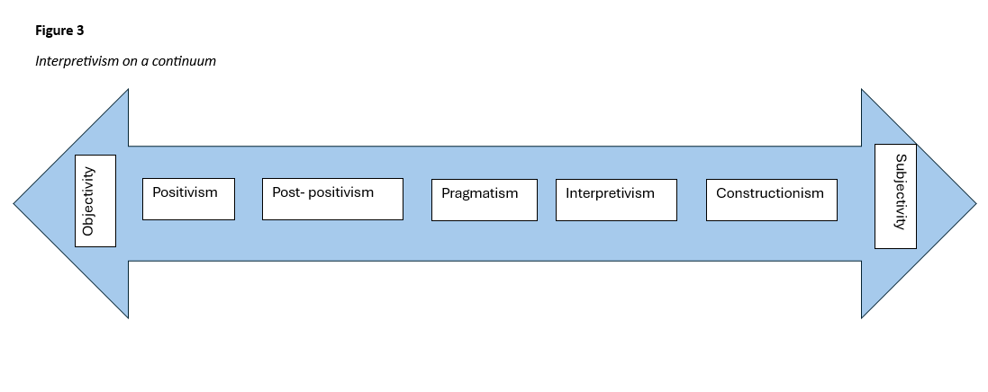
Figure 3
Interpretivism on a continuum
My paradigm – or basic belief and value system (Guba & Lincoln, 1982, 1994) – is one of critical realism, an interpretivist viewpoint that can be thought of as combining ontological realism with epistemological relativism, since I would believe that we can discover some form of ‘truth’, even if that truth is always from a particular perspective or context and there is no Truth unmediated by language or culture.
The language with which EEWPs relate how they make sense of expressive story writing can be interpreted to present their experiences (Boscolo et al., 1987). It is possible to take an experiential and/or critical approach to analysis (these positionalities are not mutually exclusive) and although I might align myself with a critical orientation towards psychological knowledge and practice (for example), I did not seek to take a critical approach to my analysis of participant transcripts, as examples of discursive practices that might be seeking to do something (Potter & Wetherell, 1995, emphasis in the original). As my research questions demonstrate, this research instead took an experiential orientation which focused on how participants think, feel, and make sense of therapeutic expressive writing interventions and therefore was centred more on a hermeneutics of empathy rather than a hermeneutics of suspicion (Ricoeur, 1970). Hermeneutics of empathy is my own contrast position to the hermeneutics of suspicion, by which I mean that I am seeking to empathetically make sense of the reality that was captured in the data, rather than being overtly critical or interrogative in nature. Hermeneutics is broadly understood to mean the interpretation of texts, symbols, actions or experiences. In taking a hermeneutics of empathy, I am intending to demonstrate that I recognise the power structures within the shared co ecosystem in which participants and I worked, but that I am not seeking to challenge those power structures. Rather, I am taking an affirmative approach to interpreting participant experiences, recognising that they made certain decisions and speak in a certain way because of our shared LA context, but I am not wishing to criticise participants for that. Participants might reinterpret past experiences through the lens of the present (Braun & Clarke, 2021), even conceal or forget details or find it difficult to use the ‘best’ words to describe their experiences, but none of these things would alter my underlying view that language can relatively transparently reflect participants’ thoughts, beliefs and feelings. However, though language is used intentionally, this is to convey participants reality and is not therefore conveying a universal truth but rather a mind-dependent truth of meaning particular to that person. This can be linked to an interpretivist understanding, which considers the lived experience of participants and values their truths (see 3.2.1).
Critical realism can be contrasted to alternative paradigms such as social constructionism but is not entirely incompatible with this stance. Indeed, Elder-Vass (2012) has argued for a realist social constructionism, to recognise a moderate version of social constructionism that allows for the material existence of some things which can have causal effects independent of human thought and language. However, referencing causality is problematic for many social constructionists, who tend to prefer non-linear theoretical models focused upon interrelatedness rather than those centred on cause-effect understandings of phenomena (Burr, 2015). The version of critical realism that I might most closely align with is that of Parker (1998), who argues that critical realism allows for a distinction between ontological realism and epistemological relativism, where our knowledge and ideas might be socially constructed through discourse but that aspects of our physical and social environments constrain or privilege the ways available for us to construct understandings of our world. I felt that adopting critical realism as my paradigm was the best fit for this research because it acknowledges existing structures and instances of power within schools and LAs, which I believe shape the ways that practitioners have made sense of their experiences of TSWGs. There is perhaps some tension in my research (see also 3.5) as I am exploring TSWGs that are well-regarded across the LA and there is an associated pressure of finding positive results in analysis, with practitioners being asked to speak candidly about their experiences whilst working in paid employment delivering an intervention that the LA has invested in, and they therefore might have had a vested interest in reporting favourably about TSWG. Taking an experiential orientation to analysis and operating within an interpretivist paradigm, in this research I attempted to validate practitioners' sense making of TSWGs and analyse this with empathy rather than criticality, whilst being mindful of the tensions inherent in the contexts in which this research took place.

3.2.1 Ontology of the research
Ontology is concerned with the nature of reality and asks the question, ‘do things exist independently of our mind, or is our world something constructed from our thoughts?’ (Levers, 2013). I adopted a critical realist ontology when conducting the research as this allowed the acknowledgement of existing structures and instances of power within schools and LA services which form part of the reality that delimits what is possible in participant interviews, with data shaped by the “constraints inherent in the material world” (Sims-Schouten et al., 2007, p. 127). Furthermore, I believe that all knowledge is partial, incomplete, interpretive and provisional (Maxwell, 2012) and therefore data will enable access to a mediated reflection of reality – one that is the participants’ perception of their reality (Willig, 2013) and takes place through the lens of their, and my, cultural memberships – a situated reality (Braun & Clarke, 2023).

3.2.2 Epistemology of the research
Epistemology refers to the nature of knowledge (Tuli, 2010) - it considers the relationship between the known and the knower, what is knowledge and how we know it (Tubey et al., 2015). This research was governed by the interpretivist paradigm which asserts that reality and meaning is subjective, can have multiple versions and is constructed through interactions with others, external environments and society (Crotty, 1998). Within qualitative research epistemology also refers to what knowledge is possible and the ways that is accessed (Braun & Clarke, 2023) and this research fits within the epistemology of contextualism, which means that it considers the “human act in context” (Tebes, 2005, p. 216) and acknowledges that language and meaning can be both ambiguous and dependent on context, with my values and knowledge inevitably shaping my research (Braun & Clarke, 2023). Therefore, this epistemology is a natural fit for reflexive thematic analysis as a methodology since it requires a reflexive researcher (Madill et al., 2000). Adopting a contextualist epistemology and critical realist ontology allowed the acknowledgement of multiple truths, validated each practitioner’s experiences, but also allowed for the understanding that their truths are part of a situated reality mediated by social influences, contexts and cultural memberships.

3.3 Research design and positionality
This research aimed to understand how practitioners value a therapeutic story writing intervention and the ways it could support creativity and self-expression in Key Stage 2 students. Yardley (2017) argued that a particular advantage of qualitative research is that it can demonstrate sensitivity to sociocultural context and, in showing awareness of the participants’ perspectives, consider how particular settings may influence both what participants say and how this is interpreted by the researcher. Research can take inductive or deductive approaches to data, and, in this research, I aligned to an inductive orientation which interprets data and looks for patterns to establish some theoretical generalisations or possible hypotheses, rather than a deductive approach which aims to falsify potential hypotheses and thereby provisionally support or exclude related theories (Stainton Rogers, 2011).
Having chosen reflexive thematic analysis as a methodology, it is important to acknowledge and reflect upon what I, as researcher, might bring to this research (see also 5.4). For example, I remain interested in how CYP can be enabled to express themselves creatively and how this might be being constrained in educational contexts (Taylor, 2018). It is therefore relevant to acknowledge that any mentions of creativity, creative expression or constraints on creativity were likely to ‘jump out’ at me during analysis. My own positionality will also have been shaped by my experiences to date, and these influenced my research design, data collection (in the form of what direction semi-structured interviews took), data analysis and interpretation. For example, having initially done a literature and creative writing degree, I have attended group writing workshops and, as a former teacher, facilitated creative writing groups for teenagers. I have also worked with primary aged children as a teaching assistant and throughout my career have been interested in how school contexts enable and/or constrain wellbeing in adults and CYP alike. One of my core beliefs is that education should be holistic for CYP, with broad curricula that allow CYP to learn exploratively and collaboratively with peers and teachers. I believe children should be given space to make choices, engage in critical thinking, work together, and generate creative products. These interests shaped my literature review and chosen research questions, as well as my analytic interpretations.
My insider/outsider positionality as both LA employee and researcher has also affected the analysis. I was an ‘insider’ in sharing attributes with the participants (being employed by the same LA at the time of the research and sharing some similar past job experiences as TSWG practitioners) but also an ‘outsider’ in that I do not belong to the practitioner’s EEWP group and am also a researcher linked to my university (Braun & Clarke, 2013). Mason-Bish (2018) posits that insider and outsider positionalities are dynamic and constantly changing depending on the context, so it is important to be mindful that participants’ responses will based on the positionality embodied by myself in interviews, with responses being potentially more candid due to a sense of comfort in some shared experiences but also potentially less fully developed, due to an assumption of pre-existing shared knowledge. My approach in this research is one I define as a hermeneutics of empathy, which interprets participant experiences without being overtly critical or interrogative in nature. In taking a hermeneutics of empathy I have also, I believe, identified with participants empathetically in our having had a shared professional context, without being explicitly critical of the decisions that were made through working in that shared context. In reflexive thematic analysis, researcher subjectivity is a resource for analysis (Gough & Madill, 2012) and therefore attempting to control researcher bias is nonsensical.

3.3.1 Justification for using reflexive thematic analysis methodology in this research
Reflexive thematic analysis (Braun & Clarke, 2006, 2023) is a particular big Q form of thematic analysis which has ten core assumptions: that researcher subjectivity is a resource for analysis (Gough & Madill, 2012) and therefore attempting to control researcher bias is nonsensical; that analysis can be weak or strong but never accurate or objective; that coding can be done individually or collaboratively; that good quality coding relies upon both immersion and distance; that themes are patterns anchored by a shared idea, meaning or concept (Braun & Clarke, 2023); that themes are built from codes; that themes do not emerge passively but are actively produced; that analysis is underpinned by theoretical assumptions which must be reflected upon; that reflexivity is key to good quality analysis; and that data analysis is a creative and artistic rather than scientific endeavour.
Reflexive thematic analysis is an inherently flexible process since it offers guidelines rather than rules to follow and can look very different in form depending on the approach and aims of the research. It is possible to take either an inductive or deductive orientation to data, code focusing on either/or both semantic and latent meanings, take an experiential or critical approach, and exist within either a realist or relativist framework (see 3.2). Reflexive thematic analysis tends to be both iterative and recursive and involves deeply questioning data through an engaged, systematic and rigorous analytic process.
Reflexive thematic analysis is an appropriate methodology as it is designed to search for common or shared meanings and is therefore suitable for understanding a set of experiences or thoughts that might be shared views of participants. My research intended to explore participants experiences of delivering TSWGs, with my interest being primarily in any shared understandings of the intervention across the data set.
It was important to me to use reflexive thematic analysis as my positionality in a critical realist ontology means that I feel there is at least in some sense a tangible impact that therapeutic creative writing interventions can have on emotional well-being, although I believe the experience of this felt impact and the mechanisms by which this happens are very much up for debate. My analysis took an inductive approach to the data, entailing identification of themes that were not necessarily in-line with my views, with data collected around topics of interest.
Furthermore, as I explored my interpretations of practitioner views on a therapeutic story writing intervention, I attempted to create a rich story of their experiences and suggest why these interventions might appeal within a particular context. Analysis which creates a rich story of participant experiences seems particularly appropriate for research about TSWGs, which utilise the therapeutic potential of writing stories.
Some might argue that either interpretive phenomenological analysis (IPA) or narrative inquiry might have been more appropriate as methodologies. However, I am more interested in the TSWG intervention and how participants make meaning of this with a reflexive thematic analysis of practitioner understandings as a group, rather than participants’ individual personal experiences and understandings attached to their own selves. Narrative analysis explores what is particular about human action and experience that takes place in a particular context (Kim, 2016) and, similarly, IPA tends to include detailed and idiographic case study examinations that are interested in the life world of participants as well as group understandings (Smith, 2008). My research interest is more focused upon expressive story writing and how that intervention could be experienced as therapeutic in a group setting.

3.3.2 How my positionality likely influenced my choice of methodology
This research takes place within the epistemology of contextualism and acknowledges that language and meaning can be both ambiguous and dependent on context, with my values and knowledge inevitably shaping my research (Braun & Clarke, 2023). Reflexive thematic analysis requires a reflexive researcher (Madill et al., 2000). From my world view, it is not possible to fully ‘bracket’ my position – I cannot take myself out of my research because my past experiences to date and the shared experience of participant interviews (and any shared experiences with participants leading up to that point in time) will mean that data (in the form of interview transcripts) will inevitably be, to an extent, co-created between participants and myself, particularly as we shared some common contexts in working for the same LA (see 3.4.3 and 5.6). One reason that I particularly wanted to use reflexive thematic analysis was that I would be able to recognise and include within analysis how my positionality (values and knowledge) influenced the interpretations I have made.
The emerging field of co-creation in participatory research design is of interest to me personally and as a student at the University of Sheffield, which places a strong emphasis on co-construction of meaning and participatory research in its doctoral training programme (see also 5.4.2). Although not particularly overtly participatory in its design, this research does utilise some of the concepts inherent in co-creation in that I see myself and participants as equal in the potential for generation of meaning through the language choices made in a particular context. Co-creation is an act of collective creativity in which all people are seen as equally capable of creativity, both research designers and participants alike (Sanders & Stappers, 2008). More recently, creativity researchers have become increasingly interested in the concept of human and Artificial Intelligence (AI) co-creativity (e.g., Garcia, 2024; Holmström & Carroll, 2024; O’Toole & Horvát, 2024; Sueur et al., 2024). Although I am wary of AI co-creativity, I do subscribe to the notion that all people equally hold the potential for creativity, although there may be constraints that affect their enactment of this (see 2.3 and 2.7). Therefore, utilising the concept of co-creation to consider how data will inevitably be, to an extent, co-created between participants and myself, positions my research design as, in some ways, a creative act. Braun and Clarke (2023) advocate for reflexive thematic analysis that tells a rich story of participant experiences, and this research aims to understand and tell a compelling story of the lived experiences of participants, some of which I have shared. Epistemologically, as a contextualist, I believe that all knowledge is partial, incomplete, interpretive and provisional (Maxwell, 2012), with data enabling access to the participants’ perception of their reality (Willig, 2013) through the lens of their, and my, cultural memberships – a situated reality (Braun & Clarke, 2023). Analysis reflexively considers how I have interpreted practitioners’ sense making of a creative and therapeutic group intervention for CYP because of our situated reality in a shared LA context, with some shared similar prior professional experiences and cultural memberships (see 3.4.3).
My core beliefs likely shape the ways in which I interpret participant’s accounts of TSWGs and what they value about the intervention. One of my core beliefs (see also 5.4.1) is that creativity is not a concept linked to a higher form of intelligence, or a privileged form of individualistic self-actualisation, but rather that the experience of creativity can enhance wellbeing in a way that is achievable for all CYP, promoting relationships and understanding within and across group identities. In creative writing, I believe people can come to a better self-understanding, and therapeutically re-work their biographical narratives in a way EPs can through reflexivity (Elizabeth, 2008). Ontologically, the version of critical realism that I likely closely align with is that of Parker (1998), who distinguishes between ontological realism and epistemological relativism: our knowledge and ideas might be socially constructed through discourse, but aspects of our physical and social environments constrain or privilege the ways available for us to construct understandings of our world.
Another of my core beliefs is that experiencing creativity is inherently valuable for CYP but that spaces for this within education have become eroded more recently, due to political and policy reforms. I believe that education should be holistic for CYP, with broad curricula that allow CYP to learn exploratively and collaboratively with peers and teachers. I dislike the idea of rows of children sat in silence memorising copied content, or writing according to strict criteria, and believe children should be given space to make choices, engage in critical thinking, work together, and generate creative products.
In this research I am consciously and reflexively bringing in my own previous experiences within education and creative writing to deepen my understanding of therapeutic work within the role of EP. I have interpreted practitioners’ sense making of a creative and therapeutic group intervention for CYP because of our situated reality in a shared LA context, with some shared similar prior professional experiences. Similarities between participants and myself which aided recruitment likely also influenced articulated meanings within interviews and my analytic interpretations, with the sense making of TSWGs and how these could be experienced as therapeutic likely co-created, to an extent, between participants and myself. Some things will have been spoken about, and spoken about in such a way, because participants knew me, to an extent. Some aspects I will have interpreted in analysis in such a way because I knew participants and our shared context(s), to an extent.

3.4 Methods

3.4.1 Sampling of the study
I intended to recruit practitioners delivering therapeutic storywriting interventions in the LA where I was a TEP, as well as potentially practitioners in one or two other northern LAs. This was a form of purposive sampling where participants had first-hand knowledge and experience of facilitating TSWGs. I made a conscious decision to recruit pragmatically due to time constraints inherent in my own personal circumstances and knew that access to, and rapport with, participants would be enabled by our working in the same LA office base. I selected participant recruitment criteria to be practitioners working within northern LA services as the LA in which I was working was located in the north of England, and TEPs in two other local northern LAs had shared with me that their EP services were involved with TSWGs in some way or another. In this way I hoped that having broad recruitment criteria of practitioners working in northern LAs would mean I could overcome any potential difficulties in access to sufficient willing participants. In future research (see 5.6) I would like to return to this research and recruit CYP to interview who have experienced TSWGs but, mindful of the recruitment difficulties that some other TEPs had experienced, as learnt from previous Year 3 TEP research presentations, and the potential additional difficulties of gaining ethical approval for interviewing CYP directly, I made the pragmatic decision to focus recruitment on practitioners delivering TSWGs, for this initial exploratory research.
Braun and Clarke (2023) clarify that there is no ideal sample size for reflexive thematic analysis and smaller datasets of information rich data items can provide enough information power (Malterud et al., 2016). Ideally, I wanted to interview at least five practitioners who are delivering TSWG in a northern LA, and, due to logistical considerations relating to transcription and analysis, determined that ten practitioners should be a maximum cut-off for interview.

3.4.2 Participant criteria and recruitment
The following criteria were used to identify suitable participants for this study. Participants must be:
- Working for any northern LA as an EP, TEP, Assistant EP or EEWP
- Delivering an expressive and therapeutic writing intervention on a regular basis
I was interested in recruiting participants in northern LAs particularly as I was aware prior research into TSWGs was conducted in Hampshire and East Sussex, but I kept my participant recruitment criteria broader than delivering TSWGs specifically to avoid a need to resubmit an ethics application if I did experience difficulties recruiting. There were seven potential participants within the LA in which I currently work who deliver TSWG. To deliver TSWGs, all EEWPs had attended the three-day TSWG training, as funded by the LA. I asked the EEWP who manages the team for permission to attend one of the weekly practitioner team meetings (held online on a Tuesday afternoon) in which I outlined my general research aims and interest in recruiting participants. As outlined in my ethics application, with practitioners consent, as a follow up I then individually emailed practitioners from my university email account, with the participant information sheets and consent forms attached (see Appendices iii and iv), and offered the opportunity to discuss the research further individually outside of a team meeting setting, having set a date by which I would like to hear back if people were willing to take part. I did this so that participants did not feel under pressure from their line manager to participate. Using purposive sampling to recruit participants in this way had some potential drawbacks however in that we were currently employed by the same LA and therefore participants might feel less able to be transparent with their personal views towards the intervention and how it is delivered currently in that LA, given that they might see me as someone with some form of power in the role of TEP and researcher of the intervention that they were employed to deliver. Similarly, despite my efforts to ensure participants could be recruited without undue pressure from their line manager, it is still possible that participants felt somewhat obligated to take part due to my introducing the research as part of a team meeting facilitated by that line manager. I did try to mitigate against participants feeling unduly pressured to participate through my information sheets and recapping of their right to withdraw at the opening of each interview. I felt that having some prior relationships with EEWP colleagues in the same LA had a positive impact on the research, however, in that it aided recruitment.

3.4.3 Participant demographics and LA context
Professionals recruited worked in the same LA which is situated within the Northwest of England in a highly deprived area. TSWGs had been set up by this LA as part of the Covid recovery funding and are delivered for free by EEWPs across the region, alongside other individual therapies or group interventions. TSWGs have proved extremely popular in the LA, with 592 children to date (summer 2024) experiencing this intervention over the three academic years since it started being delivered. The LA has a richly diverse population of CYP from a wide variety of backgrounds and therefore CYP experiencing TSWGs might bring a range of prior cultural experiences that affect the ways in which they respond to writing therapeutically in a group.
The demographic data I collected was how long practitioners have been working within the LA, their previous job roles, and how long they have been delivering TSWGs. This was justified because I believe people’s accounts are shaped by their experiences to date. Participants had all worked in a variety of interesting previous job roles (see Appendix viii). Participants had worked for between 1-20 years within the LA (Mode = 3) and had been delivering TSWGs for between 1-3 years (Mode = 3).

3.4.4 Data collection and research procedure - Interviews
Data was collected in the form of audio recordings from semi-structured interviews conducted online over GoogleMeet. Participants knew my name, job role, and were able to see my face in the video call. I used a pocket audio recording device to record participant audio with their knowledge and consent and followed an interview schedule of open-ended exploratory questions with follow-up prompts and probes, as necessary. An interview schedule of questions was developed, based on the research aims, e.g. “Can you tell me about how you feel about the experience of delivering expressive and therapeutic story writing?” (See Appendix v). Interviews were appropriate for addressing my research questions, as although Joffe (2012) has argued that interviews impose structure and content on people’s thinking, I found that using a semi-structured interview schedule of four key questions (see Appendix v) was helpful to guide participants to respond to those aspects of TSWG in which I am particularly interested. As can be seen in the interview schedule each key question had follow-up probes (if necessary) which asked for more detail in terms of both positive and negative examples. Questions were designed to be descriptive and evaluative (Willig, 2001) and I wanted to ensure that participants were enabled to talk comfortably and in depth about the topics, in what felt like “a conversation with a purpose” (Burgess, 1984, p. 104). Hanna and Mwale (2017) have suggested that synchronous online interviews are particularly suited for sensitive research topics as participants are in both a public and a private space, talking with a researcher but from their own chosen location. Although my research is not particularly sensitive, there are sensitivities to consider within it (such as participant’s feelings towards the intervention and how effective it was) and therefore I was mindful to build my schedule towards the more delicate questions, e.g. “Can you think of a particular time when you think it worked not so well”? (Charmaz, 2014; Leech, 2002). With some having argued that internet communication is an impersonal, detached and impoverished form of social communication (Hewson et al., 1996) I was conscious of focusing on developing rapport so that participants would feel at ease, drawing upon ideas of the importance of relational networks (Billington et al., 2022) in working with other professionals around vulnerable CYP. One of the ways in which I aimed to develop rapport was through speaking with warmth, empathy and genuineness (Rogers, 1965), intending to convey recognition and respect for participants and their worldviews (Beaver, 2011).
I briefly considered focus groups as a method of data collection, since in an ideal focus group a highly synergistic environment can be created in which participants openly share their perceptions (Clapper & Massey, 1996), build on each other’s ideas, and jointly develop new insights (Calder, 1977), aiding me as researcher to develop a deeper understanding of the issue and to see it from the participants’ perspective (Krueger & Casey, 2000). However, I felt individual interviews may allow for more candid responses given the context in which research was taking place, being concerned that participants might be inhibited by the systemic influences of being interviewed with work colleagues, including their line manager, and therefore potentially being unwilling to fully discuss sensitive or personal issues (Morgan, 1997).
Interview audio recordings were stored directly on my Google Drive, as were transcripts. Interviews lasted between 40 minutes and an hour. Interviews were manually transcribed as a verbatim account of the audio recording; (see Appendix vi for transcription conventions). To ensure data security and anonymity all identifying information, such as proper nouns, was removed from the interview transcripts (British Psychological Society [BPS], 2010; Seko et al., 2015). Transcripts were checked back against the original audio and then sent to participants individually for member checking (Lincoln & Guba, 1985), as outlined in my ethics application. To preserve confidentiality and ensure participants were not personally identifiable (BPS, 2010) participants were allocated unique participant numbers and audio was destroyed after transcription. Non identifiable demographic information was drawn upon during analysis and interpretation, linking to the understanding that individual participants perceptions of events and sense making is linked to their experiences to date. Participants tended to reflect on how the roles they play impact on their understandings of TSWGs, and in answering later questions participants engaged reflexively in their responses, relating how they might personalise TSWGs because of how they viewed themselves as individuals.

3.4.5 Data analysis
Analysis was carried out following the iterative and recursive steps outlined in Braun and Clarke (2006, 2023). The six-phase process of my reflexive thematic analysis was:
Phase 1: Familiarisation with the interview audio and several re-readings of the entire data set preceding manually transcribing each participant interview and emailing these to each participant for checking. During transcription, notes for ideas of initial semantic codes were generated, such as “autistic participants” (see Appendix vii).
Phase 2: Generating initial codes through listening to the audio and reading transcripts, noting and collating codes in a table. Manual coding took an inductive approach, giving full and equal attention to each item and retaining any relevant surrounding data (Braun & Clarke, 2006). Meaningful units of text were defined as participant responses. Units of text were included in one or more codes. Supervisor checks of transcripts were introduced as a way of further ensuring quality within qualitative research. Coding labels and transcripts were discussed in research tutorials and my supervisor identified some ideas I had initially not coded, e.g. “I listen”. Initial codes included “EEWP – that sounds like me” (see Appendix x).
Phase 3: Identifying themes within the data by grouping relevant data under descriptive headings (see Appendix xi). Codes were visually represented on Post-its and sorted into candidate theme piles: an initial thematic map (see Appendix xii). At this stage, 13 codes were excluded for not being prevalent across the data set, e.g. “bereavement – she was just struggling”.
Phase 4: Reviewing themes – Checking the themes in relation to the coded data and the entire data set to start building up a thematic ‘map’ and identifying how they interconnect. Candidate themes were reviewed for internal homogeneity and external heterogeneity (Patton, 1990) and in three instances codes were combined for encapsulating the same idea across participants e.g. “Learn about child” and “You get to know the children”.
Phase 5: Defining and naming themes – On-going analysis to refine the specifics of each theme; creating distinct names for each theme. This resulted in a refined thematic map with some codes collapsed due to theoretical overlap (Terry & Braun, 2016). The entire data set was then re-read to check if the refined candidate themes accurately represented articulated meanings, and the data set was re-coded. An emphasis here was to generate latent codes of assumptions and ideas (Braun & Clarke, 2018). Refined codes included “let them run with it”. Themes were re-conceptualised with central organising concepts and the researcher’s interpretative subjectivity deepening the analysis (Clarke, 2017). Six main themes were defined, and codes were collated into ‘theme documents’, ready for reporting. (See Appendix xiii for theme definitions).
Phase 6: Producing the report – Selecting appropriate extracts; discussion of the analysis and relating back to the research question. Some extracts were condensed with bracketed ellipses when fillers or repetition were used by participants, to aid with clarity of understanding.

3.5 Ethical considerations of recruitment and data collection
Following successful confirmation of ethical approval from the University ethics panel (see Appendix ii), participants were provided with information sheets and consent forms (see Appendices iii and iv) which outlined the limits of confidentiality and advised them of their right to withdraw from the study at any time (BPS, 2021). Participants were also verbally reminded of this during the beginning of each interview. It was also explained that if participants did withdraw all their information and data would be destroyed.
Participant information sheets outlined the research project and detailed question topics, with consent form questions broken down so that participants were giving consent to several points as well as overall consent. This consent form included a timeframe after the interview of two weeks during which they could choose to withdraw, prior to data analysis. I checked that participants understood and were informed in giving their consent and collected their completed consent forms back to store in a folder on my GoogleDrive.
To ensure confidentiality of personal data, participant demographics and email addresses were stored on this Google Drive, which is only accessible to myself and my thesis supervisor through the university system. I do not believe that this demographic information made any practitioner's account immediately identifiable as demographic data is only reported collectively and not in connection to quotations. I gave practitioners the opportunity to individually choose their own pseudonyms to use when reporting their words in the write up or assigned one myself if they chose not to. Initially participants had a unique participant code used to cross-reference the data (i.e. audio recordings, demographic data and transcripts).
I did not believe the research was likely to touch upon any sensitive, upsetting or traumatic issues but I signposted participants to external support from Mind and/or Samaritans, if needed, on the information sheets. Students are recruited to TSWGs by professionals within their school settings, and the recruitment criteria is that CYP should only be experiencing 'low level' difficulties such as bullying, friendship issues, low self-esteem and/or anxiety. There was some possibility that practitioners might share concerns about the burdens of intensive emotive work and/or becoming desensitised to children sharing upsetting experiences and, when this arose, I also signposted these professionals to seeking supervisory support about discussing such topics in their weekly supervision as well.
I thought it important to ensure that interviews took place online outside of contractually employed hours, and with participants working from home rather than office bases wherever possible, so that practitioners and I could, to some extent, talk ‘safely’ outside of our roles of being employed by the same LA. With practitioners being asked to speak candidly about their experiences whilst working in paid employment delivering an intervention that the LA has invested heavily in rolling out, they might have had a vested interest in reporting favourably about TSWG. However, I believed there was unlikely to be any potential for harm to either side, as participants were not personally identifiable, and the LA does have a culture of sharing feedback (in terms of both positives and negatives) and acting upon the views of professionals within the service. Additionally, some practitioners moved on to new job roles, in some cases elsewhere in different LAs, at the end of the summer 2023.

3.6. How qualitative rigour was ensured
Yardley (2000) suggests four criteria for good qualitative research: sensitivity to context, commitment and rigour, transparency and coherence, and impact and importance. Throughout research tutorials my supervisor and I constantly revisited Braun and Clarke’s (2023) 15-point checklist for good reflexive thematic analysis as a strategy for ensuring quality in a thoughtful immersion and deep theoretical engagement with the adventure of analysis, rather than following a recipe of set steps (Willig, 2001).
In terms of commitment and rigour, a ‘good’ reflexive thematic analysis should clearly and fully address the research question from a theoretically knowing and reflexive positionality. I kept a reflexive journal (see Appendix xv) so as to incorporate reflections recorded throughout data collection and analysis, in order to make explicit how my values shaped the analysis (Levitt et al., 2018) and question my own reflections on the research process and any emotional responses or assumptions I made throughout, as well as any prior knowledge I might be bringing to the analysis (Cunliffe, 2016; Nadin & Cassell, 2006). Furthermore, doing so assists with maintaining methodological integrity. This research takes place within the epistemology of contextualism and acknowledges that language and meaning can be both ambiguous and dependent on context, with my values and knowledge inevitably shaping my research (Braun & Clarke, 2023). From my world view, it is not possible to fully ‘bracket’ my position – I cannot take myself out of my research because my past experiences to date and the shared experience of participant interviews (and any shared experiences with participants leading up to that point in time) will mean that data (in the form of interview transcripts) will inevitably be, to an extent, co-created between participants and myself, particularly as we shared some common contexts in working for the same LA. One reason that I particularly wanted to use reflexive thematic analysis was that I would be able to recognise and include within analysis how my positionality (values and knowledge) influenced the interpretations I have made. In this research I am consciously and reflexively bringing in my own previous experiences within education and creative writing to deepen my understanding of therapeutic work within the role of EP. Similarities between participants and myself will likely influence articulated meanings within interviews and my analytic interpretations, with the sense making of TSWGs and how these could be experienced as therapeutic likely co-created, to an extent, between participants and myself. Some things will be spoken about, and spoken about in such a way, because participants knew me, to an extent. Some aspects I will interpret in such a way because I knew participants and our shared context(s), to an extent. Being transparent about how my interpretations are co-created with participants and how they originate in some of my core beliefs regarding creativity and education (see 5.4.1) means that I have, I believe, conducted rigorous qualitative research, which is self-questioning and reflexive, as much as questioning others.
One frequent pitfall in reflexive thematic analysis is premature analytic closure and a fully developed and rich analytic narrative should ideally interpret the significance of data in relation to the research question with appropriately distinct yet inter-related themes located within the relevant wider context and with an analysis which explains the meaning I make of the data in a compelling and nuanced way that is also relevant and significant (Braun & Clarke, 2023). Data extracts should be selected carefully across the data set and appropriately balanced with at least 50% analytic narrative, with major analytic claims well illustrated and minor analytic points noted or illustrated with one extract. Maintaining reflexivity and consideration of my own professional role within the same LA context as my participants is, I believe, a crucial part of ethical and transparent qualitative research. Engaging in reflexive awareness of previous experiences and self-questioning around theory also helps guard against analytic foreclosure.
In terms of commitment and rigour, and transparency, I kept an electronic paper trail of coded data items, lists and tables of codes, thematic maps and theme definitions from all stages of the process (see Appendices x - xiii). Taking such steps also assists with maintaining some form of ‘verification’ techniques (Roller & Lavrakas, 2015). Doing so assisted in discussion of my developing research with my supervisor and peer data analysis group, as well as in informal presentation of my analysis. Engaging with others and their questions of my analysis in progress enabled me to review initial coding, analytic observations, thematic maps, theme definitions and write-ups and therefore productively revisit my analysis at each stage of the process.
I felt it was appropriate for my reflexive thematic analysis to engage in participant feedback (King & Brooks, 2018) and member reflections (Tracy, 2010) during analysis, sending transcripts for member checking (Lincoln & Guba, 1985) via email to participants, and as outlined in my ethics application, checking the understandings I gained from interviews individually with them. Member checking is a validation technique where data and/or analysis is returned to participants to check for accuracy and resonance with their experiences (Birt et al., 2016). In doing member checking I sought to check that my data (interview transcriptions) were trustworthy, but also to capture any participant reflections post-interview. I have included any participant reflections within the appendices, as well as individual Pen portraits of each participant (see Appendices viii and ix). This was the second point of contact I had with participants and some member checking of transcripts led to ‘typo’ adjustments, but no other revisions were made.
Other ways in which I tried to ensure that the research was of good quality was using an interview schedule to reduce my influence in the moment and ensure some consistency of responses to topics of interest. I also prioritised immersing myself in the data and not foreclosing the familiarisation stage, listening to audio and re-reading transcripts repeatedly. I returned to the original transcripts frequently during analysis, to check coding labels accurately reflected what had been shared in interviews. Key to this research was the keeping of a reflexive journal and during analysis I reflected on my language choices during the writing up of the analysis and particularly the choice of theme names (see Appendix xv)

Analysis

4.1 Analysis – What’s the story?
This research explored the following research questions:
• How do practitioners make sense of expressive story writing and how that can be experienced as therapeutic?
• How do practitioners talk about the experience of delivering a therapeutic story intervention?
• How do practitioners view the ways it could support creativity and self-expression in Key Stage 2 students?
• What do these practitioners value about the intervention?
• Are there ways these practitioners believe a group therapeutic story writing intervention could be adapted and used therapeutically with adolescents? (Subsidiary Research Question)
The meanings articulated here are part of a situated reality shaped by the contexts and settings participants and I shared in working for the same LA within the UK school system at a particular moment in time, when systemic pressures are undeniably ‘real’ and felt to be present by the practitioners interviewed for this research, myself as researcher, and the children we worked with. One participant chose to add further reflections on their transcript over email, and I have included this, at their request, within the appendices as well (see Appendix ix). As already stated, (see 3.3), my insider/outsider positionality as both employee and researcher has likely affected this analysis, and I decided to include quotations without my name in them, for example, which a couple of participants chose to use in giving their answers. Analysis was also shaped by my personal interest in creativity and creative expression and the spaces there are for children to engage in this within education. All participants articulate reflections that demonstrate their shared values relating to engaging in therapeutic work within a particular time and place, and this was reflected on in research supervision. Such resonances will be reflected upon more fully in my discussion.
This analysis considers practitioner experiences, and sense-making, of delivering expressive and therapeutic story writing and will cover six themes (see Figure 4 and Appendix xiii for theme definitions).
Figure 4
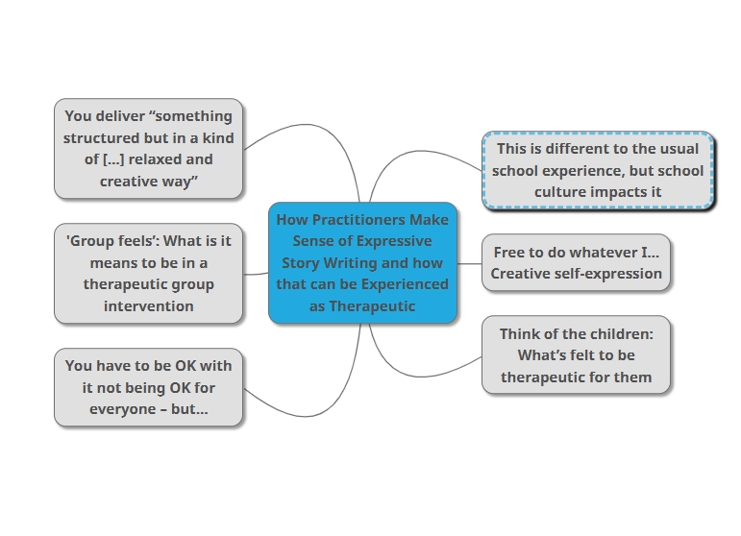
Overview of Themes in Analysis
What’s felt to be therapeutic
Creative freedom and self-expression
Relationship to school culture
It’s not everyone’s TSG
Relaxing the structure
The group space
Note. The theme ‘Not everyone’s TSG’ is reported in the appendices, as it primarily relates to a subsidiary research question. (See Appendix xiv).
I intend to report data extracts illustratively here and will interpret the broader meanings across the data set in the discussion. (See Appendix viii for Pen portraits of each participant).

4.2 Relationship to school culture
Expressive story writing, and the therapeutic experience of that for those who engage in it, was something practitioners contrasted to children’s usual school experiences. A restrictive diet of Spelling Punctuation and Grammar (SPaG), and Maths, is something which affects the experience of expressive story writing groups as practitioners felt that children perceive these groups as something different to their normal experience in school, “a bit puzzling”, or “unusual”; “they are a bit…surprised”. Caitlyn reflected that “it's going to sound really cheesy, but I think it's quite beautiful […] because so much of what they do… all day at school […] is, you know, SPaG and Maths”. Some children, they felt, initially presented as “scared of writing”, particularly those who have literacy difficulties or a dyslexia diagnosis, who are “a bit worried […] about writing until… I go in and reassure them” that their writing would not be marked for accuracy. Marj referred to the experience for children as an “opportunity to be creative without the learning expectations on them” and conveyed to me how school staff often tell her that children will write and say things within the groups that they have not heard from these children before. Alexis, like Caitlyn, reiterated to children in her groups that "I'm not looking at your handwriting, we're not looking at your grammar. This is a chance for you to just express yourself” and Freya empathetically described how children might take “a little while to get into the sort of mindset that they don't have to worry about their grammar and their spelling words and that it's not an English lesson…. and to kind of relax into it.” Relaxing into a mindset that SPaG does not have to matter when you are writing was something significant for the practitioners and the children that they worked with. Although the groups happen within schools and often with familiar school staff present, they transgress some school cultural norms and relaxing the SPaG expectations meant children could express something noticeably different. Marj linked this to the creativity that children exhibited, telling me that when they were no longer inhibited by a fear of mistakes, that was when she saw “the lid coming off of the creativity sort of flowing a little bit more”, since “it takes it off of them […] that pressure off them that this is just your opportunity to write something from your, your thoughts or your feelings without…. being criticized, without, you know, being corrected”. Caitlyn hypothesized that children were probably also thinking “why isn't the rest of school like this?” It’s a question I have pondered myself.
In another contrast to the usual school experience, for those practitioners that had also been teachers previously, delivering this intervention was also better for their own wellbeing, reflecting that it’s “just honestly an amazing piece of work”. Practitioners shared that they benefited from receiving supervision, which is another key difference to the usual school experience, where facilitators of TSWGs in other LAs might be teachers, who do not have access to regular supervision. However, there were acknowledged systemic pressures on practitioners, as there are on schools, and Freya spoke about how “we as practitioners are quite restricted in terms of time and what we’re doing” and that
we don't take the books home anymore. Erm, the schools keep the books and type up the stories because if you're doing sort of two or three a week and with our other kind of case load, it's just not really manageable.
Another aspect of school culture that impacted on meaning-making for practitioners was the behaviour of children in the groups, when these had been put together without either appropriate consideration for group dynamics or an appreciation for the intentions of the intervention. A service level agreement had been put in place to try and mitigate for what had been a frequent difficulty for practitioners, “that school links can select children that […] might not benefit from it, but they just want to give the teachers a break”. “We entrust schools […] to select their own children based on the criteria” and when this trust was broken it affected the experience of expressive story writing for everyone, making practitioners feel “stressed out” and that it’s “frustrating” or “annoying”. Caitlyn reflected honestly about the staffing of the groups, and this was something that resonated for me as a former cover teacher, that
when they've got […] the consistent adult there who the children tend to really respond to… it works a lot better. Erm, and then because I feel happier, I feel like I'm more effective and then I feel like there's a knock-on effect from that.
Naaz told me that even “the most rowdiest group of boys” were “appreciative of the intervention” however and Alexis felt that although “sometimes link adults get called out of the sessions […] Because the pupils know the expectations from the start […] and how to behave […] I've not often had issues when there's not been a link adult there.” Clarity of expectations could be related to these difficulties and whether enough contracting had taken place between the schools and practitioners, to explain how TSWGs were different, with Caitlyn feeling that “because the individual that's requested the work […] they maybe… aren't 100% clear on what… the offer actually is…Sometimes... Yeah, I think they've maybe misunderstood what the nature of the group is actually about” and similarly Freya sharing that “a lot of the time they don’t know much about it before I turn up”. Conversely, Alexis related how she felt she was successfully “letting the school know about the, er, therapeutic space that we'll need and the expectations from that side of things”, and this could be a reason why she experienced less behavioural difficulties. That the intervention needed careful explanation to school staff highlights the difference of these sessions.
Aside from behavioural difficulties, there were other aspects of school culture which impacted upon the experience of the therapeutic storywriting intervention. Poor timetabling when arranging the groups with schools affected the success of sessions, e.g. “they'd arranged it so that half of the group were missing their PE lesson. And I think that didn’t go down well” or “if they come in and something's happened at lunchtime and they're… cross about that they can sometimes find it difficult to… get into the session”. Clarity of roles though helped practitioners have a more successful session however, e.g. to school staff “I'm just there for the writing. You just deal with the silliness” and regarding individuals “I wasn't there to be his teaching assistant. I was there to facilitate that group”. Making time to ensure that schools were clear on what the intervention was able to offer, and what it should not be used for, was a part of the planning process that could either be squeezed out by time pressures or become lost in translation, when practitioners and school staff did not have a shared understanding of what to prioritise.
In terms of what is valued in the intervention, in relation to its differences to the usual school experience, systemic pressures perhaps led to the demand for further groups, with the intervention being offered freely to eligible schools (unlike the traded EP services) and a considerable “waiting list for September”.
Once they've had […] one taste of it, they're constantly, erm, emailing me saying, "Can I please have another one?" […] links are seeing the […] transformation in children. Obviously then that is, erm, transferring into more referrals being made and more requests […] for TSWGs.
Was the intervention perceived so positively because it was free to access and then mostly brought benefits? School culture tends to appreciate achieving results without budgetary input. Demand had ultimately affected the way that the groups were timetabled and delivered, with Naaz wondering about
the number of sessions that […] the trainers suggest as well […] that should be open to interpretation really. And it should be a bit more, erm, […] flexible to that. But it's time, isn't it […]? Unfortunately, we've got so many schools requesting the same thing that it's […] better to have […] six sessions and they can go on and help another group.
This was one example of how structuring delivery had been adapted to suit school culture in the context of the LA.

4.3 Relaxing the structure
For the practitioners that I interviewed, the structure of individual expressive story writing intervention sessions was something that they saw as flexible and adaptable in delivery; after training: “you are able to develop the confidence of being able to make slight changes to your sessions to help the children that you've got sat around the table with you”. The training was an initial requirement spoken of as a “lot to digest” and “they want you to have a group, erm, after your very first day of training” but “what the training doesn't recognize that is not every facilitator is going to be in the same spot of being able to pick their own children”. This made things more difficult for practitioners when the intervention was first being delivered in the LA as concurrently with the training, practitioners needed to have schools ‘on board’ with groups organised for them to work with whilst that understanding of the intervention was still being developed by practitioners too.
Over time “you get practiced at delivering it, you know […] which bits to do quickly and move past and which bits children like to spend more time on” and with this “structure that you follow […] over time […] becomes really, really natural. So then you can bring in some of your own personality” and “add in your own creativity”, or “you can adjust it and […] bring your own take to it”. The intervention was spoken of as “something structured [which could be delivered] in a kind of […] relaxed and creative way.” Marj, Alexis and Naaz, as the more experienced members of the team, felt that TSWGs were, in contrast to other interventions, easy to deliver –
when I'm delivering sessions […] in other capacities, it can be where I have to look back and think, Okay, this is tricky, or this is going to be quite an emotionally triggering, erm, topic or something. So you have to kind of look back and take breaks and pause and […] reflect on […] what you're going to say and what you're going to do. Whereas I find in Therapeutic Story writing it seems to flow really nicely.
One practitioner told me that “I can sort of do it with my eyes closed now”. Marj would consciously adjust timings so that “some children [who] find it difficult to transition between the tasks in the timeframe” are given a couple of extra minutes, for example, in a way that was responsive to the children she was working with.
Some practitioners had conscientiously initially delivered “very much by the book” because “their way of working, the TSW's training […] there isn't much room for manoeuvre in that”, and Caitlyn candidly shared that
I think… there may be pros and cons to the autonomy and flexibility that we have with it because […] we weren't doing it to the letter […] we don't use some of their documents. […] We don't do it exactly […] how [Waters], it's quite prescriptive in a way how she wants it to run. But it's really just how each practitioner wants to do it. I think the core elements are still there, but yeah… I'm not sure what she would've to say about it (laughs).
A contrast was made again here (as with Naaz’s reflection in the first quotation of this theme) between the training and the practitioners who are delivering it ‘on the ground’ and “working with these children, I think it's different, because obviously it's putting theory into practice and there's always going to be things that don't fit as well and things that work wonders”. As they felt more confident over time, practitioners felt legitimised in adapting what they delivered within schools to suit their own personalities and the needs of the children in the local area. This aspect, of being a reflective practitioner – “you learn about [the children] and you learn about your own delivery” – is a core part of working therapeutically.
There is also a particular context to this expressive story writing intervention, which was initially delivered as part of the Covid recovery funding given to the LA. Naaz explained one of her adaptations to me as part of this context:
School can be a really daunting space, especially for kids that have gone through Covid here they've not been able to socially interact with each other and then to be expected to sit around the table in silence isn't gonna benefit them. So being able to have that […] social interaction with people that they might not have been able to… but […] might not be in their inner circle-….And experience their views and their opinions or in different years [… ]when you are […] being instructed on how to deliver these […] they say that what you need is a quiet, calming space. Like meditation music in the background, and encourage children to […] be quiet when they write their stories. I don't do that […] because I say, “do you know what? Let's talk about when you're feeling anxious.” […] you know, I just talk about their feelings a bit more. And it just opens up all kinds of conversations because obviously the child […] in particular that's talking is concentrating on their story. They're not… maintaining eye contact with their peers or with their facilitators. So, they feel more inclined to open up…So it really gets the conversation flowing a lot more.
Relaxing the delivery of groups so that it felt more informal than lessons was one creative way that Naaz had prioritised making social connections and giving children a space to voice their feelings that they might not otherwise have had. Perhaps most poignantly, one of the most different aspects of TSWGs to their usual school context, that practitioners noticed, was that children were “just not used to kind of being asked how they feel at school. Erm...Yeah. And sharing that”. Practitioners felt that children might find the experience “challenging” and “difficult” at first, but it was important for them to be asked e.g.
Do you want to tell us about why you're excited and what that feels like?" [since] I don't know again, how many opportunities some children get… to have that conversation at school or even at home…Erm… and they seem to quite enjoy that as well.
A tension remained for practitioners, however, in that
you’re cramming a lot into not a lot of time. Really…I don't think you always get enough…. time to respond to each child. Especially if you have got […] seven in the group. Erm… because […] you can sometimes do the feelings check in at the start and kids want to talk for like 20 minutes about how they feel. But unfortunately, we've got an hour, erm, to each session. So, you've got to kind of go-- You're conscious of that all the way through.
For me, in this pause, Freya seems to stop herself from articulating that at this point she might ask individuals who have spoken for twenty minutes to be quiet. The unfamiliarity of being given space to talk about their feelings, and children appreciating that time, meant
it can be really hard to sort of put a pause on them because […] you're in a therapeutic environment, you don't want them to feel that […] they haven't been heard or they haven't had their opportunity to share… It's difficult to squeeze it all in.
Other aspects of the intervention might become rushed if ‘too long’ was spent on the feelings check in session at the start. However, no practitioner felt that time on the feelings check in was ‘wasted’, since
a lot of the time you find that it's suddenly a time for them to go, "Oh, by the way, I, I feel like this and this morning I felt like this and this happened to me and you know, I'm really sad about this.
Making time to talk more about feelings was an aspect of personalising the intervention which practitioners appreciated as they felt that this was an opportunity children needed and possibly lacked elsewhere. Alexis shared how important personalisation generally was to her and told me that
I like to get to know them and I…if one of them tells me they've got three cats, I'll mention those three cats in the next session […] And I think when […] they see that someone's taking an interest in them and remembering about them and…. listening to what they're saying, I think that's really important.
Personalising to the children in the groups was felt to be important by Marj too, who explained that she would
tailor them based on sort of what you know, a bit about your group, erm, maybe some particular emotions and feelings you want to address […] say they were having difficulties with anger as an emotion, I would make sure then that I include anger as one of my emotions during the timeframe so that I can kind of… get them to hear how […] an adult would […] deal with it from sort of a therapeutic point of view […] and how their peers would think and feel about it and what they'd, erm, do about it.
Relaxing the formality of the structure of the intervention, as it was originally designed to be delivered, meant that facilitators were fitting the groups to their practice in a way that helped children experience the groups more therapeutically.

4.4 Creative freedom and self-expression
Expressive story writing was talked about as a positive experience for children, as “the chance to express themselves, I think… any kind of creative writing time is beneficial for children” and, for practitioners too, “ it's one of the […] more […] creative things that you get to do […] as interventions go […] it's just a nice intervention to be able to deliver”, making groups an enjoyable experience for practitioners as well as most children. The freedom and fun of the groups was perfectly encapsulated by Alexis when she told me that “the creativity that [children] bring out, honestly […] it just blows me away sometimes. That space…. stories about magic, stories about McDonald's. It's just, you know, lovely freedom to-- I often walk away giggling (laughs)”. However, writing about fast-food rather than emotional experiences might be creative, but it might not be providing a metaphorical catharsis in the way that the intervention was originally intended. Caitlyn recounted how
I don't feel that they're writing from their own experience because when we were on the training […] it was very clear cut in the examples […] where they were coming from perhaps in terms of their own experience. But […] many of the stories […] I've read and heard... […] they're a bit silly. I'm not, they're quite fun, but […] I don't know… whether it's working in the way that it's meant to or whether it's just because we're not doing enough sessions. But... Do you see what I'm trying to say?... I don't necessarily see a lot of that when I'm hearing a story about… Ronnie the Robot popping to KFC for a chicken burger and then he went to sleep. The end (laughs).
From my positionality, and in accordance with my own core beliefs (see 5.4.1), I wonder whether giving children the space to say and write what they wish is an empowering and potentially therapeutic act, since they’ve “had a bit of a laugh and a giggle and done something fun and creative and different” and I wonder if there is a way to refine the intervention to address CYP’s need for freedom and silliness, at times. In contrast to English lessons, Freya recounted how TSWGs were “an opportunity for children to express their feelings and emotions and thoughts through writing, er, just as they want to do it, as they would probably like to do in, in general life”. Children might want to have the agency to take themselves to a fast-food outlet and can therefore do so at any time in their imagination – in expressive story writing they can write about what they want in the ways that they want to write it. Removing pressure and learning expectations meant, for practitioners, “that freedom and that creativity […] come out” of children. For me, it reads as if the creativity is being thought of as there in children, but they might not have been given spaces to express it previously.
There are also safeguarding implications to free creative self-expression. Naaz recounted a particular Year 6 group who had watched a murder TV programme at a sleepover –
and they're just writing about that, which is absolutely fine, but sometimes there might be more to it. So don't be—as a practitioner, don't be dismissive and think, oh, it's all just creativity […] just be willing to read between the lines and have those conversations with the school link and maybe even the child, if it's, erm, appropriate to do so. […] But yeah, […] it is a real good way because […] they feel like they're writing about a third party, so they might be more able to talk about delicate situations, for instance… Erm, so it is just about just being sensitive, reading between the lines and not making [a] child feel uncomfortable at all when they're reading their story.
Naaz equates things being made up to “just creativity”, but in other circumstances this could indicate that there is more underlying a story. Giving a child an opportunity to write what they choose without constraints makes it possible that they might express something about a “delicate situation” which is “triggering, erm, incidents within themselves”. However, on the whole, it was felt that with the intervention you “don't usually find it's too emotionally triggering for anyone”.
A sense of exploration through the act of writing was spoken of by several of the practitioners, who saw the expressive writing as a way of enabling children to begin to make sense of experiences and “explore emotions perhaps that they've not been comfortable exploring before”. Caitlyn insightfully summarises TSWGs as an important space
for that freedom and that creativity to come out because it's so important as a […] means of self-expression isn't it? When either you […] can't say it for whatever reason if you're able to write it, you know. That’s cathartic, isn't it? Because we write poetry, don't we? And yeah. Stories, similarly, to process, those difficult… emotions.
Both Freya and Naaz told me about children who had used TSWG to disclose abuse, writing about “the animal being abused, held under the water, hit […] And it… it emerged that this child is a looked after child”. Processing and exploring what has happened to them, in this example, has given the child enough distance from what happened by externalising their experiences and transferring them onto a fictional animal which
acts like a mask for them, because […] they're able to almost hide behind this animal […] because this was the first time she's actually spoken about some of the experiences, traumas that she's endured…So it […] allows the child the freedom to be creative[…] but to create that distance between their own experience. And now this experience of Bonnie the Bear, for instance, it allows […] that barrier almost that mask. So […] it's…. almost easier to write about a third party than it would've been to talk about your own experiences. Erm, and I find that when, erm, they are sharing their stories they do say, "Oh, Bonnie the Bear did this, Bonnie the Bear did that." And, but if you ask them at the beginning of the session to talk about their feelings, they're very reluctant to engage in that conversation…So you see that transformation from talking about your own feelings to talking about Bonnie the Bear, for instance. So, you see the child open up a lot more when it's through metaphor, creativity, erm etc. So I think […] it definitely acts as a mask for them, erm, because they might not be ready to acknowledge anything that they've been through, but […] they're wanting to tell somebody about it in some form or another.
For me, this child disclosing abuse in a group intervention that is supposed to be only accessed by children with less severe social and emotional mental health needs demonstrates the pressures on all staff in the LA, where a free therapeutic intervention is being accessed by a child that clearly needs more support. However, conversely, the intervention did enable the child to share historic abuse in a way they had not done so before, and this would help the child be more effectively safeguarded in the future and support them therapeutically to heal a little more. Equally valid for practitioners were children who, rather than sharing experiences, were quietly taking things on board: “some very interesting things sometimes come up, erm, or sometimes you just know that they're absorbing it and, and they're taking it in”.
Children were given freedom to respond to the story starters how they chose, with e.g. “one pupil might say, "Oh, he's being chased by a predator." Another pupil might say, "Oh, he's late for an interview for a job. And that’s okay"; however, for Alexis it was noticeable if children expressed themselves ‘more’ creatively: “he wrote the most amazing stories […] And the angles that he approached and the things the characters did, and his pictures were just absolutely amazing”. Likewise, Alexis liked how
some people […] actually link each of their stories week by week. So, it's almost as though the stories follow on. And the second story will mention the character from the first story and… it's quite clever the way that they manage to link these stories together.
Alexis was perhaps the facilitator who saw their practice as most aligned with creative self-expression, calling the intervention “a bit of me”. I am not surprised that commenting on how therapeutic story writing facilitates children’s creative self-expression was a dominant feature of her interview.

4.5 The group space
Something that really resonated for me was that the intervention was not perceived as purely transactional by practitioners, with them providing something and the children getting something, but rather that the group felt like a relational space and it was not even so much about what they did in that time together but how everyone felt when they shared time together - the 'beingness' of the whole experience. Primary in importance for everyone was that this space felt safe and comfortable, with “the privacy, the safe space”, the “non-judgmental space”, being introduced through initial “grounding mindfulness techniques just to get them ready to be in that sort of […] safe space, erm, that calm space”. Freya described this time as a “weekly reprieve” – “it's nice for [children] to be able to come into a safe space and sort of let go and release any... just the stress of the day, really sort of a little break from that”. It seemed to me almost as if the expressive story writing felt like a boundaried relational space which everyone transitioned into, as a contrast to the rest of the school day: “a lot of the children that, erm, I've had in groups haven't really done anything like that before. So, it's kind of new to them”. This was something referenced by school staff as well, who might, Alexis related, “often say, "Oh, really looking forward to this. I feel so relaxed and calm because we do the breathing exercise at the beginning.” Whilst any safeguarding disclosures would have to be shared, otherwise children seemed to find the groups
a safe space for, you know, whatever said within that room stays within that room. […] And the children value that as well because they do feel that they can all be open and honest, and you see that session by session. So, you know that things aren't being said in the playground or, you know, rumours aren't being spread […] the children have... do contribute a lot towards that of course. But I think what they value is […] that space to be just theirs without any expectations […] from an adult.
The group space also felt equalizing in this sense, that adults and children shared an experience where conscious power imbalances were attempted to be redressed, with Naaz telling me that “it brings together the group […] when we do our feelings check-in, I always, erm, include mine as well” and often the link adults and practitioners write stories alongside the children as well, in such a way that “I think it really does…. help them to see things, erm, differently” with staff who can be seen in a different light or from “a completely different side” and “sometimes you can really hear that they've put in so much effort… into their stories”. This is a space in which teachers are being praised by children giving them positive feedback comments on their writing. When sharing stories aloud, Naaz introduced this with “can we share”, which is inclusive language that readdresses power imbalances in the group. Some practitioners, like Freya, felt that since “we do ask the adult who's in the room to write a story as well…[…] I think that's really important that everybody who is in the room does do that” whereas Caitlyn acknowledged “they don't necessarily have to sit around the table and do it with you. They can just be in the room doing their own thing”. Alexis perceived this as a lesser commitment from the link adult and although “sometimes they don't write the stories, which is fine, there's no expectation there at all… Erm, but when the link adult is involved, I think that does make a little bit of a difference”. The group was also equalizing in that “one dominating pupil or a couple that like to dominate […] actually because you're following this strict structure, everybody gets an equal amount of time”. Caitlyn was clear that it’s “the constructive criticism… that we give each other” which benefits everyone, another example of flattening any hierarchies of power.
That this was a group, rather than an individual, intervention was considered particularly beneficial in terms of supporting children’s self-expression. Connection across year groups was valued, with e.g.
a Year-6 child there who's just sat their […] SATs and you've got a year-5 child in the same group. Erm, and they talk to each other. There's a bit of advice they can give to each other when I was in your shoes or, you know, this is what I feel, this is what you could do when you are feeling nervous.
Collaborating on ideas was also spoken of positively, with Marj putting herself into a child’s mindset and voice: “I'm working in a small group, I'm bouncing off other children's ideas… I think they really enjoy it.” Marj had particularly adapted the intervention to
try and bring in the brainstorming to sort of scaffold the stories and […] give them some ideas to run with, obviously without putting ideas in the head. Erm, but just hear from the peers what the peers, erm, might be writing or might be thinking, just to kind of give them that little bit of encouragement […] I think sometimes the creativity of the ideas for some children is difficult.
Marj called these children “those children that [can] look like a deer in the headlights”. Alexis felt with children that “the creativity's there and I, I build on that and I… sometimes I will have to prompt them and give them some ideas”; she also saw creative collaboration as something they as practitioners were engaged in too, with adaptations like her bringing in of fairytale characters “just sharing ideas and keeping that creativity there”.
Having a competitive group dynamic was not helpful, however, and Marj shared that “sometimes you've had children that perhaps the dynamics in the group don't work too well. So there's a bit of competition, there's a bit of, “my story's the best”, you know. “I want to talk first!” So that can be quite difficult because you're trying to provide a therapeutic environment for all the children”.
For a child that was not yet ready for a one-to-one intervention, Freya was advised by the team leader to “suggest to the school that they participate […] in a TSW group first […] like a starting point really for talking about feelings and things in a group setting where they don't feel like the limelight is on them”. Naaz similarly acknowledged how children, when writing, are “not maintaining eye contact” and this ‘being alongside’ was also spoken of by Alexis who would tend to “writ[e] my stories alongside the children”. Writing collectively around a table feels less exposing than individuals answering direct questions about their experiences, and making the group feel playful and enjoyable creates a therapeutic atmosphere that supports children to metaphorically begin to explore and make-sense of what might have happened to them. However, in questioning children about their stories after, Freya felt “they just feel a little bit put on the spot with that within the group setting. And maybe [if] other children weren't listening so much […] it might be easier. Erm, they might be more forthcoming”.
What could certainly present a challenge in a group setting was when a child might make a metaphorical disclosure with
a story that's really emotive and, and slightly…. erm, almost crossing into safeguarding zone… which is difficult because then they've shared that in front of the other children. Erm…which sometimes they don't always take on board. The […] fact that the other children just think, "Oh, […] it's just a story." …Erm, but as an adult you can't help but, you know, be a bit concerned sometimes about what they're writing. […] that can be difficult and […] doesn't always work for… the whole group dynamic.
These difficulties were also compounded when in a group, unlike an individual intervention, “I don't sit and say, "Oh, by the way, this is confidentiality” and then “group workshops and things where children have shared within it and then have been upset that I need to then share that on with […] someone else”. For these children, having others in the group there too meant practitioners might feel they hadn’t done enough for an individual child who had shared a particular experience, e.g. Freya explained how
luckily this girl was having counselling anyway, but kind of not... erm, not offered much in that sense. Like as in she'd opened up about something and then it was […] the end of the session and she went off to her assembly…She shared it with the group… I think […] obviously it was…. good that she had-- I think it kind of showed that the counselling that she was having was obviously benefiting her and that hopefully being in the group was as well, like in terms of opening up. But yeah, it was just quite... I felt quite bad afterwards almost that I felt like I'd not responded enough to that…But there wasn't much that I could do in that situation either.
Having a child freely express something that was a safeguarding concern seems as if it felt a positive lightening for that child but left the practitioner with a lingering sense of unease that the group setting had not allowed them to respond ‘properly’ to the child.
A valued aspect of working as a group was that peers were being taught how to positively and constructively comment on each other’s writing or what feelings others have shared, to “practice those pro-social behaviours and active listening”, and “not just me going “Oh wow, that was good”. This boosted the confidence of both the feedback givers and receivers. Caitlyn also felt that praise from peers was more meaningful for children than that given by practitioners, since they knew their peers better. Marj shared that “kids are actually really good at coming up with things that they liked” and Caitlyn agreed, unlike lessons, “we share and we talk about [stories] and no one's pulling you up on whether that made sense, whether it was silly or whether it was grammatically incorrect”, but Freya felt some groups had been better than others in this respect. Giving and receiving feedback could feel strange for children, and Freya recounted how
they'll read out their stories and then they're maybe not so great at listening to other people's stories full stop. Erm… and yeah, I kind of have to really probe to get them to give feedback on each other’s. Erm….yeah. But I don’t know if that's […] because that doesn't happen in classrooms very much and they find that quite a strange…I'm not sure.
Naaz noted that “the group really notice when somebody might be feeling a bit shy. So when that person reads their story out, they compliment them and tell them […] the aspect of your story that I really enjoy”. Supporting one another whilst writing was also encouraged, rather than individuals writing silently, with Naaz telling children
we have that respect for one another, […but] don't feel that you've got to raise your hand if you want to say something, say it, you know, just if you want to help each other, that's fine, if you want to work together.
This could perhaps be described as “a therapeutic group dynamic” which broadened children’s social connections, “to perhaps mix with children that they don't usually spend time with” and offer their peers emotional support, becoming “more switched on to […] the feelings of their peers”, “if you're feeling sad, come and speak to me. You know, let's play together. Let's do this together”, it “makes them more approachable” and “you can see that transformation, […] becom[ing] more confident”. Marj too commented how empathically “peers in the group will, erm, comfort them and say, "Oh, I, I felt like that, you know, because of this, this, this,” […] really nice way for them to feel like […] their feelings […] are validated and normal”.
Being in a smaller group dynamic gave children more adult attention than some were perhaps used to, and Alexis explained how
I think they…. thrive on being part of something like this. I think they feel special. […] I think they like the fact that […] an adult is coming into school to work with them and that person's not working with everybody else.
For some less confident children it might be crucial that “the rest of their class isn't there” and even quieter students within the groups were “really chatty” when “feisty ones” weren’t there. Marj gave the particular example of children meeting age related expectations but who had social and emotional mental health needs, who
would never really sort of access any one-to-one or small group support, would generally just be expected to get on with […] the academic learning independently […] it's a really nice opportunity for those children to be in that dynamic of, "Wow, like I'm in a small group, I'm receiving lots of […] one-on-one attention from an adult.
“Being in a small group where you get more attention” and “that nice small group environment where everybody can… have their say they want to, they're not put on the spot to read their stories and they’re not pressured in any way” was felt to give children, particularly those who might otherwise be overlooked as they were not exhibiting externalising behaviours or falling behind age related expectations, the right amount of positive attention that they needed within school.

4.6 What’s felt to be therapeutic
When thinking about planning a therapeutic experience for children, practitioners, particularly Alexis, considered how to create and maintain a therapeutic space, including “the physical setup of the room […] the resources”. It was considered that
if the therapeutic space is…erm… spoilt in any kind of way that can impact on the sessions. If for example […] we've had to move rooms, er, at the last minute, that can impact. Although children are extremely resilient, we try our best to make sure the sessions are on the same day of every week at the same time in the same place.
The importance of rapport between practitioners and children was also highlighted where, for children: “this person's coming to our school […] this stranger's coming” and personality features of practitioners were therefore considered, asking questions from the child’s perspective: “Do they get on with them? Do they feel comfortable and at ease with them? .... Are they friendly? Are they approachable, can they ask questions?”. Alexis also detailed how “we ask for a link adult to be in the groups, specifically for any safeguarding issues that come up”. Having a school link was also a helpful resource to be drawn upon to ask e.g. “what is the best way of speaking to this child? We don't wanna put them on the spot”.
Another important aspect felt to be therapeutic was the bond built between practitioners and the group. This did mean that “some of them can get quite fond of you, quite attached to you”, with children seen as valuing “having me to themselves in a small group setup”. Practitioners attempted to adapt their personalities somewhat, to become “really positive and really encouraging and quite nurturing as best I can”, and ensured that children felt like they had some autonomy and choice, particularly in the final session, e.g. “I like to give the job ownership on the front covers” and “I just say to them, “Do you want to write your own sentence starter? Or write your own story?" It was noted by Alexis that
we tell them at the beginning, this book is yours. This actual book will be for you to take home. Or you can share it with your teachers or your friends. And by all means, you can write some more stories if you want. And the excitement that some of them get when they think, "Oh, this is mine to take home and keep, and I can read these to my brothers and sisters.
Giving children ownership and autonomy, telling them “It's your story, your ideas” is quite a radical act in contemporary education where it can feel that children are largely instead being told what they should know and how they should demonstrate that knowledge. Alexis described her approach throughout the sessions as being one of giving children choices, where
some children choose the perspective of the animal, some children try and link it to themselves. So, I just go in there with no expectations and just give them […] the safe space, the comfort, erm… and let […] them run with it themselves.
Children building up emotional literacy was also valued by practitioners: “a lot of them […] gained […] more of an ability to identify how they are feeling and to talk about that”. Marj detailed how for children
putting the labels on those feelings that they might not have quite known what it was about. Exploring what that those feelings look like as well as feel like. […] Marrying […] the emotions up with those things can be really helpful for some children.
Similarly, processing and exploring particularly uncomfortable feelings was referenced, with Naaz explaining how “they're able to, basically, almost process their own, erm, whatever's going on in their mind through these […] story writings, these uncomfortable feelings” and Marj feeling that
it gives them an opportunity to talk about them in a different way […] In school in general life and hectic and busyness, you don't always have opportunity to sit down with each child, and “oh, tell me about how you are feeling, what have you been experiencing?
This seemed to be a crucial difference in supporting children’s self-expression, that practitioners had the time and space, unlike teachers, who “end up firefighting a lot in schools, I think. And you just deal with the problems that are right in front of you and you don't get down […] to the nitty gritty”. Helping children to know what emotions looked and felt like, including uncomfortable ones, and being able to recognise and name these so that they could talk about how they felt, was something all practitioners saw as important and therapeutic for children. This was a personal motivation in taking the job role for some, like Alexis, who “instead of being that person who passed on a mental health concern or an SEMH concern to the SENDCo, kind of wanted to be the other person on the other side that would do that […] follow on work”. As Caitlyn put it, “you're giving them that creative space to work through emotions”.
For many of the children, the small group set up and the positive feedback on their writing meant that their confidence was boosted in a way that schools told practitioners was often then transferred to their lessons elsewhere. Caitlyn described how it felt legitimised and “nice to be able to give them lots of praise and encouragement and I think maybe some of them benefit from that” and gave the evocative example of CYP who might benefit from TSWG, that many former teachers could likely picture of
a child that's possibly got… some kind of attachment issues going on, low self-esteem possibly. Just really… reticent to come and sit down, just farting about with something in the corner and needing a lot of cajoling to write and a lot of praise and lots of incentives.
Marj described how children might feel “capable” of writing “loads” of stories after the intervention and described how she hoped teachers might go “you’ve written a beautiful story […] let’s just tweak this” so that the “learning aspects can be followed up”. Giving children unconditional positive regard, particularly those who might be otherwise “farting about”, was felt to be therapeutic in itself, with several practitioners speaking about “you've got to make that [child], make them feel happy” and “that's got to be beneficial in itself. Having someone that's quite nurturing, just be nice and be there with you. Be present in the moment”. All children were rewarded with stickers and “you're still gonna get a certificate either way at the end of the day”. That positive atmosphere and ways of relating to each other in the groups built children’s confidence and experiences of success and was felt to be therapeutic; the hope was that this would be transferred to lessons as well. My feelings are that class teachers might need some support to relate to some children as practitioners have in these groups and it would help teachers if they could see for themselves how doing so would positively benefit everyone in the class, perhaps by having taken part in some of the groups.
Making children and practitioners feel better was done through the mindfulness activities. Marj described a particular mindfulness story that she often used, “where you fly to a magical kingdom in your imagination and everybody there is cheering you on and saying lovely things about you”. Caitlyn too recounted a mindfulness story she used which was “a child relaxation script […] about going in this little fluffy cloud when you're feeling stressed or angry. And yeah, it does calm me down”. The children sometimes wanted to share this experience with others beyond the group too, with Caitlyn telling me that “some children ask for a copy of the little script that I use, and they stick it in their books see and then they go and show it to somebody else and try and educate somebody else about it”. To me, this demonstrates that children recognise that there’s something different about the groups and want their peers to share in that experience. Again, I feel some teachers might benefit from knowing about these positive effects.
Better coping strategies was felt to be a key therapeutic part of the intervention, with story characters and their responses to feeling emotions e.g.
allows them to understand that, oh, maybe when I'm feeling angry the next time, I shouldn't lash out. I shouldn't trash […] the deputy head's office. I shouldn't, you know, smack a child. What I should do is go and approach […] a trusted adult.
Encouraging children to identify how to behave differently was done indirectly, through questions such as “what have you learned from that, from writing about Sally the Snake?” The mindfulness activities also gave coping strategies, with
trying to also teach them, you know, a strategy that they can use […] out and about in the playground or at home or wherever to... yeah, regulate themselves or just be in the present moment and be calm and, because we know that a lot of the children that we see, they do have some of these difficulties, don't they? […] The feedback I get from them is I feel tired, which means that you probably feel relaxed, which I think means, well that's possibly worked.
As part of thinking about what would be more therapeutic for children, planning for a therapeutic ending was key. This was however constrained by there only being six rather than ten sessions per intervention group in the LA. Naaz acknowledged that “some children, erm, within six sessions, they open up. You think, yeah, that's a really good ending. But with some children you […] do think, yeah, they could have benefited from a couple more sessions”. Alexis recounted how children might be asking her “can we carry on? Can we do more? Can this never stop?” and “if I'm honest, […] I have had pupils get a bit upset, actually, because the session is coming to an end” Similarly, Freya shared that “when they do enjoy it […] they miss it afterwards. And yeah, I think it definitely can be difficult for them”. This was a difficulty that Naaz tried to mitigate and plan for, sharing that she herself felt
so heartbroken when I say, "You can't." Or when they ask for more sessions and you say, "I'm sorry, you know, this is the sixth session". So, what I always do to prepare the kids and to prepare myself for, you know, honestly, is I do a countdown and say, "Look, this is session-1 of 6. This is session-2 of 6." And […] I’ll count down with them. So, when they get to session number 6, it's not a surprise to them. They know that ending […] is quite near. What I do is I try to make the session-6 a bit more special.
Marking the final session and giving a sense of closure was felt to be important by everyone, and often included a sense of celebration, e.g. “you have stickers and have a little bit of cake in the final session”.
Children ‘opening up’ before the end was seen as a good outcome, and a transformation or “complete turnaround” over time was spoken of by all participants, with Freya telling me how, with quieter children, “it was just…. like they... I don’t know, settled into the group and seemed to…. open up a lot more as it went on”. Freya recounted how there was a halfway shift, where
we started the sessions with one child who wanted to share their stories and kind of ended with… everybody sharing their stories and being really into being in the group session and say, we've got like halfway through. And it just shifted erm…and they all seemed a lot more comfortable in it. Erm… and a lot more…. at ease with sort of talking about how they felt and expressing themselves through the story.
Naaz spoke of one of her main intentions being to “encourage them to be open and honest”, as well as suggesting “ways to cope and they do develop their resilience almost”. Singling out particular individuals, Marj acknowledged that “as much as it makes […] a difference […] to all the children in general, you can often spot the odd child that it's made the most difference to”. However, in a difficulty perhaps related to the written product usually being seen as the final output in education, Freya recounted that
it can be quite difficult […] to get much more from the children once they've written the stories sometimes. When you try to sort of ask the open questions or make kind of open statements at the end about the stories. I find that a lot of children do seem to struggle with […] opening up any more than they have done during the story.
It did seem that, over time, most children opened up and articulated their feelings more, and practitioners talked about this as a positive aspect of the experience of delivering the intervention.

Discussion

5.1 Discussion – That was the story, what are the take-away messages?
Analysis considered practitioner experiences, and sense-making, of delivering expressive and therapeutic story writing and covered six themes (see Figure 4). The sixth theme was reported in the appendices as it was linked to a subsidiary research question (see Appendix xiv).
Key messages from the analysis are shown in Figure 5:
Figure 5
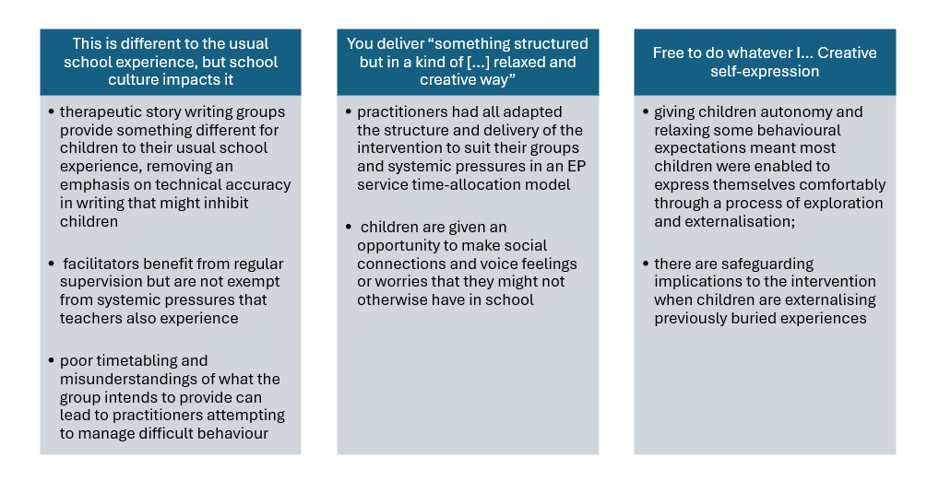
Overview of Content captured in each Theme
Creative freedom and self expression
Relationship to school culture
Relaxing the structure

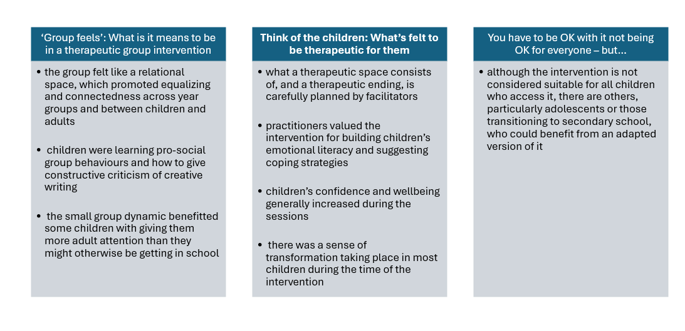
5.2 Putting the psychological frames around the analytic lenses
Not everyone’s TSG
What’s felt to be therapeutic
The group space
What psychological theories or models are useful for understanding what TSWGs do? Functionally, TSWGs provide space and time for children aged 7 to 12 years to engage in an hour-long weekly group creative writing intervention within school. These groups can be facilitated by school staff, often SENDCos, or, as in this research, external professionals such as EEWPs. It is expected that anyone delivering the groups in schools will have attended the three-day training. However, there is a lot more that happens because of providing TSWGs to children in schools, and in this discussion, I will link some of the key points from my analysis to relevant psychological frameworks.
One thing that TSWGs do is provide children with an opportunity to express themselves creatively. Increasingly, creativity has been becoming considered as a relational and intersubjective phenomenon, or what has been termed: the emerging multi-disciplinary field of the cultural psychology of creativity (Glăveanu, 2010). In this understanding, creativity is no longer an in-person attribute but rather is inextricably linked to a social and historical context, a systems view of creativity that has been likened to going beyond the Ptolemaic view of putting the person in the centre of creativity in favour of a Copernican model (Csikszentmihalyi, 1988, p. 336). The sun does not revolve around the Earth in the same way that creativity does not revolve around the person. Glăveanu (2010) puts creativity into the centre of a tetradic framework where creativity is surrounded by four dynamic interrelationships between the creator, creation, community, and culture (see Figure 6).
Figure 6
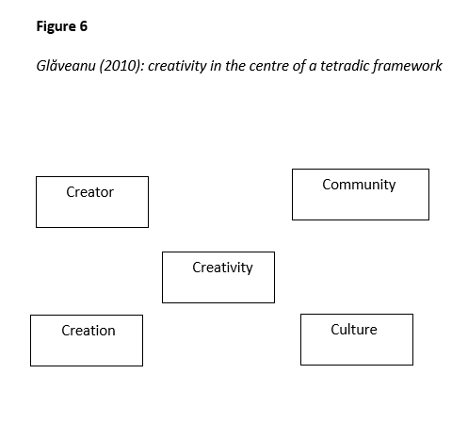
Glăveanu (2010): creativity in the centre of a tetradic framework
Fischer (2005) similarly sees creativity as in the interaction between ideas, peoples, and things. Seeing creativity as held within, surrounded by, or between interactions is like taking a relational understanding: creativity existing as enmeshed in the interactions between the different interpretations of various peoples’ thoughts and/or objects. Therefore, giving children a creative space within school to express themselves sends a message that creativity is something valued in a particular social and historical context, and these contexts affect the ways in which creativity is interpreted. In Glăveanu’s (2010) framework, school would be an aspect of the culture, and the other TSWG members (including the facilitator) would be the community. In the sense that practitioners felt these groups were something different for children from their usual school experience this research builds upon my previous MSc research which looked at constraints on creativity in English lessons (Taylor, 2018). Practitioners are making sense of expressive story writing and how that can be experienced as therapeutic in a socio-historical context where, currently, I believe spaces for creativity and children’s free expression have become eroded within schools. Most of the practitioners interviewed are also former teachers, like me, and they also reflected on how the experience of facilitating these groups was different for them, with a therapeutic atmosphere encouraging children’s expression and autonomy, and the benefit of receiving supervision for any concerns they had. I think it likely that the differences between the TSWGs and a primary literacy lesson are what made it a more enjoyable experience for both adults and children.
Vygotsky (1926/2004) and Winnicott (1971) both saw creativity as a process emerging in childhood play from the interrelationship between a child and their primary caregiver. Bion’s (1984) contention was that capacity to think similarly develops within an inter-subjective relationship where an adult contains a child’s troubling thoughts and feelings and enables thinking to take place. In TSWG, children sharing their stories verbalises their anxieties and emotions, giving them meaning and language that the children can then internalise (Bion, 1984), enabling children to cope with their feelings and focus their attention on other experiences (Waters, 2004a). TSWGs provide a creative space for children to play with difficult feelings and express them through externalisation onto story characters whose actions and feelings they verbalise in a written story narrative. This becomes possible because of the relationship between the children and the TSWG facilitator who contains and helps shape the children’s creative expressions. Exploring some difficult feelings in a playful way, as in TSWGs, has some parallels with taking a Playfulness Acceptance Curiosity and Empathy (PACE) approach (Hughes & Golding, 2012), where children who have experienced abuse and/or neglect are helped to feel safe through parents and professionals taking a playful and relaxed approach to building a relationship with them.
Providing children with a sense of safety is key to trauma-informed practice and consistency, reliability, predictability, availability, honesty, and transparency are all attributes that are related to the creation of safe environments for children (Bath, 2008). Advocating for trauma-informed schools (Walkley & Cox, 2013) has become a recurrent feature of EP practice, particularly for those working with virtual schools. By using the term ‘trauma-informed’ EPs generally mean that, in schools, support for each CYP should be personalised and give young people choice and control, considering their previous experiences and how these intersect with mental health, rather than conceptualising young people as having problems. Furthermore, any support given should always be clearly communicated to a young person (Andthen & Mind, 2021). In totality, being trauma-informed is an ongoing approach to CYP that schools, as organisations, need to mindful of and, in that vein, revisit training biannually. In working with children who have experienced trauma, a sense of safety is crucial, and is created for CYP by adults around them being knowledgeable about the impact of trauma and how to support children, and by the environment around the CYP allowing them to feel safe, rather than still under threat.
In this research it was notable that several children did make safeguarding disclosures to professionals, even in a group setting, and this led to some feelings of discomfort by practitioners who wondered if they should have perhaps explained the limits to confidentiality in this group intervention, as they routinely do when they see a child individually. I think it is also worth highlighting, however, that children clearly felt that the intervention space was sufficiently safe to make a disclosure. There are questions raised by this research though about who should access and respond to safeguarding disclosures when these have been made in a group setting with an external facilitator and, some practitioners acknowledge, not always a link member of the school staff present. It was clear to me that all practitioners interviewed were following safeguarding protocols in speaking with a designated safeguarding lead following any disclosures and that this was professionally appropriate, however there is some sense of felt awkwardness in that children had chosen to use this space and time – a boundaried and relationally different space and time – to make a safeguarding disclosure, and might not have understood that their disclosures could not be kept secret by the adult entrusted with them. Practitioners had created a valued sense of safety for some CYP in the groups, but I wondered about whether these children experienced that feeling at other times within their school.
TSWGs are intended to be offered in the LA where I conducted this research to children who are experiencing ‘low’ or ‘mild’ emotional wellbeing difficulties, many of which could fall under the umbrella concept of experiencing low self-esteem. TSWGs provide a group experience for children who might not be as socially connected or emotionally literate, to facilitate their self-understanding and their understanding of peer emotions, enabling them to generate some positive coping strategies when experiencing difficult feelings. Initially the groups were set up in the LA as part of the Covid wellbeing for education grant recovery funding. Children who had experienced social isolation from peers as part of Covid lockdowns could now be part of a group experience that would enhance their emotional development through making connections both introspectively and intersubjectively. Chandler (1999) has brought to the fore a self-in-relation concept of self-esteem, which emphasizes the necessity of connecting to others to boost your self-esteem. Children attending TSWGs are engaging in generating narratives in which, theoretically, their subpersonalities are externalised onto story characters and thereby synthesised, leading to greater self-realisation (Assagioli, 1965; Waters, 2001). They are doing so in a group setting where they are coming to a greater understanding of their selves in relation to others as well, and this additional layer of social connectedness is likely to be boosting their self-esteem further. By understanding how their peers might respond in similar situations, and hearing a facilitator provide an adult model of a socially appropriate response to a particular emotion, children are being given tools to learn self-regulation in a developmentally appropriate and non-directive way, where they are self-generating, through supportive prompts, their own coping strategies. There also parallels here to the arguments for the development of internal frameworks, rather than external, in emotion coaching approaches, to help children understand and self-regulate their emotions (Gilbert et al., 2021). Positive psychologists have argued that self-respect is a more meaningful construct underpinning wellbeing than self-esteem (Baumeister et al., 2005; Noble & McGrath, 2015; Seligman et al., 1995). I think self-respect and self-in-relation are intertwined, with those who respect themselves being more able to relate to others and be respected by them, and a group intervention provides this level of social connectivity for CYP in a more structured and adult facilitated way than naturally occurring opportunities within school, and this kind of small group intervention might be appreciated by some CYP for doing this.
Several practitioners reflected on the equalizing experience of the groups, with extrinsic rewards provided for all as part of celebrating completion of the group, and some practitioners recounted changes in intrinsic motivation that they noted in individuals, as the groups went on. A ‘halfway shift’ or a felt change in the atmosphere of the group and the output of individuals (both in terms of oral contributions and written responses) was often noticed, and these things were seen by practitioners as indicative of a deepening engagement with, and positive response to, the intervention. In criticism of the intrinsic motivation principle of creativity (Deci & Ryan, 2008), Gergen (2009) argues from a relational standpoint that intrinsic motivation is a misnomer, since whatever a student is strongly personally invested in will have its origin in a relationship with a teacher. The personality of the practitioner facilitating these story writing groups, and their making a connection with young people that they do not – in most instances – have a prior connection with, seems important in terms of enhancing the group’s success. For a child to be personally invested in the group they arguably need to experience a positive relationship with the facilitator, and it was apparent to me in the ways in which children and groups were spoken of that practitioners had quickly developed and felt a rapport with most groups. In relation to Amherst creative writing groups, Chandler (2002) has stated that a relational connection is developed through group processes which lessens the impact of participants coming from different cultures and/or classes. TSWGs draw together a mixed group of children who might not otherwise necessarily be grouped together in a classroom setting; this is in some way akin to their coming from a different culture or class. Key to the relational approach within schools is an understanding that teaching is a relational act, and schools are a site for relational experiences (Davis et al., 2025). TSWGs provide a space to bring people together and enable them to develop relational connections, and this includes collapsing traditional hierarchies such as teacher and student.
Furthermore, the importance of developing relational connections has long been recognised as benefiting psychological wellbeing, particularly by positive psychologists. In wellbeing theory (Seligman, 2011), a person can use their character strengths in PERMA to achieve their goal of wellbeing, which in turn leads to a state of flourishing. Flourishing has been described by positive psychologists as a state of thriving, being full of vitality, and prospering as both an individual and in a group. In relation to creativity and wellbeing, Beauregard (2014), in their literature review of eight different classroom-based creative expression programmes, showed that significant improvement was found in hope, coping and resiliency, prosocial behaviours and self-esteem in young people who had engaged with creative expression programmes. CYP connect to their peers and adult facilitators during TSWGs in a way that is likely to boost their overall psychological wellbeing, not only their self-esteem. Practitioners spoke of TSWGs in such a way as to suggest that they (and often link staff in the setting) saw this time as a boundaried relational and safe space for children within their normal school day. Research has suggested that the use of a relational approach between teachers and students increases positive behaviours including positive changes in emotional regulation, resilience to academic challenge, social competence, student sense of belonging, and staff wellbeing (Allen et al, 2018; Bergin & Bergin, 2009; Driscoll & Pianta, 2010; Roorda et. al, 2017). TSWGs, in using a relational approach, are arguably providing these benefits.
Developmental psychologists have suggested that creativity relates to life satisfaction across the lifespan (Peterson & Park, 2006) and the positive psychology movement views creativity as one of the four key components that contributes to positive mental health (Runco, 2014; Yonatan-Leus et al., 2019) through helping us advocate better for our needs and happiness (Gutterman & Aafjes Van-Doorn, 2024). In the humanistic paradigm, creativity is a pre-requisite for self-actualisation, enabling self-fulfilment and emotional stability (Maslow, 1968, 1973; Rogers, 1954). Self-Determination Theory (Ryan & Deci, 2000) suggests that eudemonic wellbeing (positive functioning) is dependent on fulfilling three needs: autonomy, relatedness and competence. Succeeding at challenging endeavours and being able to achieve desired outcomes can fulfil a sense of competence; experiencing freedom of choice and being in control of one’s own actions provides autonomy; and relatedness is experienced through feeling one can rely on others and mutual respect (Clarke & Basilio, 2018). The Good Child Report (Rees et al., 2012) documented alarmingly high levels of unhappiness in UK schools and in Rees et al.’s (2012) research, unhappiness was linked to young people experiencing lack of choice, freedom and autonomy. More recently, Billington et al. (2022)’s empirical research contends that relational networks are more significant than individual child difficulties and “family circumstances, parental emotional wellbeing and mental health, child safeguarding issues and school climate and culture provide the conditions for emotional wellbeing and mental health for young people in education” (p. 104). I would agree with the viewpoint that there are very few opportunities for most children to make meaningful free choices within education, thereby eroding their opportunities to enact autonomy. I also wonder how much young people are in control of their own actions when adult dialogues and societal structures, including educational systems, are so influential on young people and their ways of responding to the world. For those children who are experiencing – sometimes extraordinarily difficult – circumstances, Billington et al. (2022) have sensitively identified that:
Many young people are unable to leave their distress at the school gates and pressure can build on schools to manage the situations that arise. The focus can often fall on young people’s behaviour as opposed to their distress. Teachers and mentors themselves then become vulnerable in emotionally charged situations as young people and members of staff alike become subject to unmanageable feelings and locked in cycles of harmful distress. This is especially the case should the school climate, its ethos and culture, prove neither sufficiently sensitive nor robust enough to provide the relational conditions that support the wellbeing of all concerned (p.106).
EP work is still frequently constrained by the echoes of old-fashioned ‘referral’ models, where requests for individual involvement frequently come from schools that are being challenged by children’s externalising behaviours linked to their SEMH needs. In challenging contexts teachers might react with a punitive or corrective focus on surface level behaviours, rather than seeking to understand and connect with children behaving in such a way to help them gradually learn that it is possible to have their needs met through more socially desirable coping strategies. Even positive behaviour policies, with their ladders of escalating consequences – you have done X, therefore Y – do not provide children with sufficient autonomy to ‘do different’ to their usual patterns of behaviour. Arguably, systemic difficulties such as the understandings of what kinds of behaviour are acceptable within school and the ways that deviance from this are responded to, are also things that merit more time and attention in EP practice than supporting individual child after individual child. EPs who are enabled to work in a more preventative way, with children at an earlier stage of a graduated response, aligns with SEND conceptualisations of there being different waves, or tiers, of intervention.
There has been a rise in interest in facilitating CYP’s autonomy and providing them with opportunities to include their views and wishes as part of EP work, and as a fundamental right of childhood included within Articles 12 and 13 of the 1990 UN Convention on the Rights of the Child (UNCRC). It is possible that TSWGs are experienced positively by children because practitioners consciously provide them with autonomous choices as part of the groups, which also foster relatedness and competence, through the removal of a primary focus on SPaG. Children who chose to be quiet and not share experiences, but who were perceived as quietly taking things on board, were also valued by practitioners, who might have seen these CYP as making an autonomous choice to be that way and did not compel them to contribute, as might happen in a typical lesson. One of the strengths of the intervention was felt to be that, over time, many quieter CYP did choose to contribute more, with practitioners acknowledging a felt sense of a “halfway shift”. TSWGs additionally provide an opportunity within schools for children to start to build relational networks with peers and staff, and in having a boundaried relational space within schools in which children and adults connect in a flattened power hierarchy the possibility starts to be constructed that children’s challenging behaviour can be understood and responded to in another way. TSWGs seem, to me, to succeed most when they are giving children and staff alike the opportunity to build their eudaimonic wellbeing through autonomy, relatedness and competence.
Dowling and Osborne (1994), from an interactional systems perspective, have described a good learning culture, or open system, as one which has boundaries permeable enough to receive and consider new ideas whilst having robust enough boundaries to offer reasonable security to those working within it. In acknowledging the systemic pressures in the context that they, and teachers, operated within, practitioners in this research demonstrated to me that they felt reasonable enough security within their direct line management team to express some disagreements about altering the length of time that the intervention was delivered for. The open learning culture of this team had also encouraged sharing new ideas in adapting the intervention with some new resources e.g. fairytale characters or including different mindfulness scripts. Having this flexibility was felt to be a positive, with practitioners given autonomy to deviate from the intervention training manual and personalise the intervention for groups and schools they were working with. That EEWPs appreciated space in this research to reflect on how they were delivering TSWGs suggest that there is an argument for having regular time to review and reflect on interventions practitioners are delivering as part of a cycle. A further interesting and unexpected reflection from this research is that the original intervention author may wish to consider if such flexible adaptations are a helpful translation of their intervention, as originally delivered in training attended by practitioners, or not.
It has been argued that creative expression facilitates an adaptive defence for sublimating unconscious drives (Roazen, 1995) and that psychotherapy involving creative acts enables self-discovery and insight through play (Winnicott, 1971). Particularly strong links between creativity and psychotherapy have been theorised, with it argued that both processes involve identifying a problem, formulating an innovative approach towards someone’s concerns, and that leads to a new and useful construct which helps overcome them (Gutterman & Aafjes Van-Doorn, 2024; Walia, 2019;). Others have suggested that for those experiencing emotions and feelings that are difficult to process the art form acts as a container to hold these (Killick, 1997). From the psychodynamic paradigm, Waters suggests that, in TSWGs, children become aware of their subpersonalities through externalising them onto story characters and that these subpersonalities could become synthesised in such a way as to lead to self-realisation and personal growth (Firman, 2011) when facilitators and CYP consider how to resolve situations between characters. Externalisation is also a tenet of narrative therapy and through externalizing conversations people and problems are separated so that problems can be explored without seeing people themselves as problematic or pathological, but rather people have relationships with problems (Combs & Freedman, 2012). TSWGs arguably help children start to understand the relationships that they might have with problem emotions, which are externalised onto story characters. Walker (2012) criticised TSWG for not taking objective measures of improvement in CYP emotional intelligence and this is a criticism that could be levelled at this research too, if it was situated in a quantitative paradigm. However, in this research, all practitioners alluded to children growing in emotional intelligence because of the intervention, with the externalisation of difficulties and playful exploration of these enabling young people to both acknowledge, contain, and start to process their more challenging feelings. Whether this was awareness of a subpersonality on the child’s part is arguable, I would say, but I do think this research demonstrates that TSWGs can lead to some self-realisation and personal growth in children and adults who attend the groups.
TSWGs are a targeted intervention which engages children in a time, space and set of activities distinct from the everyday life of the classroom: children are literally in a different space; with a different mix of children; facilitated by an external professional; and engaged in activities outside the standard curriculum – in some ways the therapeutic space which practitioners in this research alluded to is a liminal space (Turner, 1967), one which separates children from everyday routines and enters them into an alternative social encounter in which different rules, values and relations apply (Atkinson & Robson, 2012). Winnicott (1971) too paid attention to spaces of transition, and the transformative potential of TSWGs perhaps lies somewhere in the groups being in a space outside of children’s normal classroom experience, one where practitioners naturally gravitate towards working in an anti-oppressive manner and setting up a group experience that focuses on power with, rather than power over, children (Allen, 2003). I interpret that many of the therapeutic and transformative aspects of the group, felt by participants, were because the intervention gave children an alternative way to be in school. A TSWG could be appropriate, perhaps, for a child experiencing emotionally-based school avoidance (EBSA), who might be on the EBSA continuum but without this having become their entrenched position towards school, so that TSWG could operate in a preventative way, encouraging a CYP to feel more comfortable within school. If EBSA occurs when ‘pull’ factors that promote non-attendance overcome the ‘push’ factors that encourage attendance (Thambirajah et al., 2008), TSWG could provide the ‘push’ factor that a child might need. A TSWG could enhance a CYP sense of belonging within school, with belongingness understood through Maslow’s (1943) hierarchy of needs’ theory, where the need to belong theory suggests human beings are motivated to maintain relationships which are interpersonal, pleasant and indicate a concern for one’s well-being (Baumeister & Leary, 1995). If a CYP’s perception of belongingness is derived from feeling needed, valued, accepted, and feeling that you complement the environment or system (Yıldız, 2016) around you, TSWGs could be providing those feelings for children who take part.
Practitioners alluded to a therapeutic group dynamic which was non-competitive and benefitted from being a smaller group with more adult attention that could focus on the teaching of active listening, constructive criticism, respect for others and other pro social behaviours, without insisting upon strict silence whilst writing, as children might experience in literacy lessons. The value of groups for individuals have been extensively explored in research literature, with Haynes and Fopiano (2012) suggesting that they can provide support for catharsis; information sharing; promotion of inter and intrapersonal skills; giving of feedback; bonding; provision of hope; and realisation of universality – that individuals are not alone in certain experiences. Wenz and McWhirter’s (1990) clinical report of a group creative writing intervention suggested that creating and sharing writing improved self-actualizing behaviours and self-acceptance amongst group members. Similarly, Santiago-Welch (1995) believed sharing oneself and receiving positive criticism through creative writing is therapeutic. Several studies in the literature have argued that writing together can enable connection to others through learning about their experience and developing empathy (Chandler, 2002; Perez et al., 2021). Heath (2008) argued that imagination is a prerequisite to considering another person’s point of view and how they experience the world, and perhaps the imagination activated through writing creatively facilitates this kind of empathetic understanding. Children in TSWGs are developing empathy for others in the group by sharing writing that externalises difficult feelings and offering each other positive feedback and possible coping strategies for story characters experiencing those emotions.
Due to their use of externalising metaphors, Waters (2008) states that TSWGs are not appropriate for adolescents as they are entering the ‘conceptual stage’ of cognitive development (Piaget & Inhelder, 1969) and therefore are developing an intuitive ability to read metaphor and interpret the stories of others, meaning confidentiality within the group could become an issue. This is certainly a valid consideration considering practitioners in this research shared how some children made safeguarding disclosures in a group setting. Waters (2008) does go on to say, however, that a professional could make a judgement whether TSWG would be appropriate for child older than 12, dependent on their level of cognitive and emotional development, and some practitioners in this research wondered whether secondary students in a nurture classroom, or those who might find transition to secondary more challenging due to their emotional needs, could benefit from TSWGs. Furthermore, the origins of TSWGs in the LA where this research took place were through Covid-19 recovery funding, and it has been suggested that adolescent females may continue to be one of the groups whose wellbeing has been most significantly impacted by the pandemic (DfE, 2022). TSWGs provide, at their best, a relational therapeutic space where children can playfully explore difficult feelings, and playfulness in adolescence has been related to coping with stress (Lieberman, 1971) and increased feelings of wellbeing and valuing school (Staempfli & Mannell, 2007). TSWGs also provide the opportunity for children to engage in a creative activity outside of normal classroom expectations and creativity has been linked to wellbeing in children of all ages, and adults. Anderson et al. (2019) concludes that to be more creatively flexible, adolescents need to perceive classroom atmospheres as welcoming and relationally supportive, with the “valuing of diversity and non-conformity…natural for early adolescent learners” (p. 673). Nakamura and Csikszentmihalyi (2002) advocate encouraging adolescents to engage in creative activities which can alleviate anxiety, and link teenagers experiencing flow in these sorts of activities to academic success, better physical health, and improved life satisfaction. I am still interested, in future research, to explore what features of TSWGs could be adapted for delivery to adolescents.

5.3 How this research builds on and furthers existing research in this area
TSWG training delivered through the Centre for Therapeutic Storywriting is defined as “a therapeutic teaching model that uses the educational curriculum as a therapeutic context” to deliver ten sessions of one-hour groups for 6 CYP aged 7-13 years, who might be “distracted and disengaged”, with “severe emotional and behavioural difficulties…getting in the way of their learning”, particularly emotional anxiety (Centre for Therapeutic Storywriting, 2025). However, TSWGs are being offered in the LA where this research took place as one possible small-group support intervention which is therapeutic in nature and develops writing skills as well as addressing emotional issues metaphorically, so as not to overwhelm CYP. EEWPs deliver six sessions for up to 6 CYP experiencing mild to moderate emotional and wellbeing concerns. Children in the LA might be experiencing a broad range of one or more mild to moderate emotional difficulties rather than experiencing severe emotional difficulties, particularly anxiety. Furthermore, the claim of TSWGs supporting academic literacy is moderated to writing skills, and the ten sessions are adjusted to six. These differences in the understandings of TSWG and describing groups as experiencing TSWG in this research means that the conclusions of this exploratory research necessarily must be somewhat tentative. In exploratory qualitative research, concepts such as treatment integrity or fidelity are not relevant in terms of analysing the usefulness of enacting an intervention such as TSWG but, I believe, despite the variations in how TSWGs might be being enacted, this research does gives further weight to Waters’ own arguments in favour of TSWGs, with participants being largely overwhelmingly positive about the impact of these groups upon the children attending them.
Maclean (2013) and Spriggs (2015) both identified that there is a very limited research evidence base for TSWG, and I hope that this research gives further weight to Waters’ own arguments in favour of TSWGs, with participants being largely overwhelmingly positive about the impact of these groups upon the children that they have worked with. In its conclusions, this research particularly builds upon Walker’s (2012) doctoral case study that identified TSWGs as a method for a young individual resolving behavioural and emotional issues in a ‘safe space’. The notion of ‘safe space’ was frequently referred to by facilitators of the group and felt to be a key component of providing a therapeutic atmosphere that enabled children to externalise and process difficult feelings.
Although Maclean (2013) and Spriggs (2015) focused on the improvements in academic attainment in young or anxious children, through attendance of TSWGs, in line with Waters’ (2008) original intentions for the intervention to develop literacy skills alongside emotional wellbeing, this outcome was not seen as important by participants in this research. This could be because facilitators of TSWGs in this research are EEWPs who, as part of their role, are more interested in children’s mental health than their academic attainment. Spriggs (2015) identified that in their research, both control and intervention groups had similar gains in academic performance pre and post measure. Likewise, Waters (2004a) herself identified however that few SENDCos or main class teachers referred to CYP improvements in literacy skills because of the intervention. Based mainly on 21 child participant interviews, Waters (2004a) concluded that TSWGs enabled children to process emotional experiences; move through difficult feelings; encouraged them to develop co-operative and trusting relationships with peers; supported listening and speaking skills; fostered an interactive relationship between the facilitator and group; increased children’s concentration and motivation to write; and improved children’s self-esteem as writers. I believe this research supports most of these conclusions, although children’s concentration and motivation to write was arguably variable in the groups spoken about by participants of this research.
Bachelor et al. (2013) evaluated the impact of implementing TSWG in Hampshire, concluding that all participants showed academic and emotional gains. Spriggs (2015) explored whether TSWG reduced anxiety, improved working memory capacity, and academic achievement, concluding there was a statistically significant reduction in self-reported anxiety levels by participants post-intervention, compared to the control group. This research does lend some weight to Spriggs’ (2015) conclusions relating to anxiety, with practitioners speaking of children feeling gradually enabled to participate more in groups, both in terms of spoken and written contributions. Although practitioners in this research were not necessarily told if individual children had difficulties with anxiety this is likely to be one of the ‘low level’ emotional difficulties being experienced by some children spoken of in this research. The emotional gains referred to by Bachelor et al. (2013) in their research with forces children is of particular interest to me now that I am working in a new LA with a very high number of forces children, and in some ways this research also lends weight to their conclusions, exploring some of the emotional gains that children arguably experience in greater qualitative depth. This research also potentially identifies some benefits of the intervention that are harder to measure or evaluate and could influence the design and development of future quantitative based studies.

5.4 Reflections on positionality
Considering my analysis, which has endeavoured to closely represent participants’ sense making of TSWGs, it is crucial for my methodology to acknowledge how my interpretations in this discussion are inevitably shaped by my social positionings, personal background and life experiences, research training and experiences, and how these relate to and intersect with my research topic. Wilkinson (1988) has termed these personal, functional, and disciplinary reflexivity and I intend to broadly follow these headings in relation to this research.

5.4.1 Personal reflexivity
Personally, I occupy mainly positions of social privilege, although as a woman and single mother with a chronic health condition, my marginalised social positions do also shape how I experience the world. In this research, in transcribed interview sections cut from analysis, most participants referred to their own status as mothers, or not, and, in one case, this did explicitly inform how they viewed the intervention. Interviews were conducted with participants that I worked alongside in the same LA, shortly before I went on maternity leave, and therefore I was quite visibly pregnant at the time the interviews took place. Being a single mother with a health condition are not visible attributes that people tend to ascribe me, however, and my voice and skin tone instead mark me out as someone who – on first knowing – could be considered socially privileged. I do not tend to widely share aspects of my personal life with colleagues and although participants knew me professionally, they are unlikely to be aware of the more socially marginalised aspects of my identity. However, they are unquestionably there, and they shape the ways I interact with the world, particularly when, for example, I have been positioned throughout my life as someone from a higher or lower social class than those around me, depending on the context I find myself in. This example alone led to my conviction that identities are not fixed and intrinsic but rather shaped and constructed by those around us. Having material resources and a supportive family have given me the scope to subscribe to largely liberal political and ideological commitments such as socialism, humanism and feminism, and a belief that all people have as much right to experience positive functioning and creative self-expression, especially when they might be experiencing very real material constraints. Thinking outside the box is particularly important when people have been boxed in.
One of my core beliefs (see also 3.3.2) is that the experience of creativity can enhance wellbeing in a way that is achievable for all CYP, promoting relationships and understanding within and across group identities. Another of my core beliefs is that experiencing creativity is inherently valuable for CYP but that spaces for this within education have become eroded more recently, due to political and policy reforms. Although this research is not overtly political or emancipatory, I do put forward a version of creativity that I believe is accessible for all children and consider TSWGs as an opportunity for providing a space for staff and student wellbeing within the current educational climate.

5.4.2 Functional and disciplinary reflexivity
In terms of my training, I have always seen myself as a qualitative researcher and associate ongoing reflexivity with ‘best’ EP praxis, as I must be willing to interrogate my own assumptions and understand myself better if I am going to endeavour to help others to likewise. Training with Sheffield University has further shaped my understanding of EP work through an ongoing engagement with relational frameworks, aspiring towards co-constructions of meaning with various stakeholders, keeping one eye on a critical and questioning stance towards presented information, and being mindful of group dynamics in collaborative working. The emerging field of co-creation in participatory research design is of interest to me as a student of the University of Sheffield, which places a strong emphasis on co-construction of meaning and participatory research in its doctoral training programme. Although not particularly overtly participatory in its design, this research does utilise co-creation, in that I see myself and participants as equal in the potential for generation of meaning through the language choices made in a particular context, although there may be constraints that affect their enactment of this (see 2.3 and 2.7). Data was inevitably, to an extent, co-created between participants and myself, but I believe this satisfyingly positions my research design as, in some ways, a creative act. Anti-oppressive practice has exposed the language historically (and even still contemporaneously) used to refer to difference and although not necessarily fully a social constructionist myself (as I do believe in real world material constraints) I believe that I have through this research reflected the view that all knowledge is partial, incomplete, interpretive and provisional (Maxwell, 2012). Adopting a contextualist epistemology and critical realist ontology in this research allowed the acknowledgement of multiple truths, validated each participant’s experiences, but also allowed for the understanding that their truths are part of a situated reality mediated by social influences, contexts and cultural memberships. Contextualism as an epistemology entails the understanding that the interpretations I have made here are situated in the reality that participants and I all worked for the same LA (a shared cultural membership) at particular moment in time, when TSWGs had grown in popularity as a free to access intervention for schools there, following Covid recovery funding to set these up.
Theme one of my analysis held particular resonance as these ideas were covered in my prior Master’s research on creativity. My life experience, as a secondary English teacher with a creative writing degree who has facilitated creative writing groups, has unquestionably affected my interpretations of participant accounts and it is likely that I ‘latched on’ to participant references to creativity and how these are affected by educational contexts since this is an interest I both entered – and will be exiting – the doctorate training with. As previously shared (see 3.3.2), one of my core beliefs is that education should be holistic for CYP, with broad curricula that allow CYP to learn exploratively and collaboratively with peers and teachers. I am not a fan of rows of children sat in silence memorising or copying content, or writing according to strict criteria, and believe children should be given space to make choices, engage in critical thinking, work together, and generate creative products. Reflecting on this here, these beliefs are likely linked to why I appreciate TSWGs as an intervention and shaped the ways in which I interpreted participant’s accounts of their perceived benefits.
In this research I was an insider/outsider researcher, sharing the experience of working for the same LA with the participant group, and yet in being a part of a different team as a TEP about to go on maternity leave I was also sufficiently an outsider for participants to trust me with some honest reflections on their experiences of delivering the interventions within the LA, particularly the ways in which it was affected by delivery as part of a time-allocation model. Participants knew that I was a former teacher and since the majority had also taught in schools themselves as well it is likely that these shared past experiences affected their sense-making of TSWGs, and my interpretation of that. These shifting insider/outsider identities helped built rapport and trust with participants and, in a very real pragmatic sense, enabled efficient recruitment. It is important to also acknowledge that they likely led to accounts which were affected by ‘participant bias’ and ‘demand characteristics’. However, reflexive thematic analysis includes researcher subjectivity as a resource for analysis (Gough & Madill, 2012) and therefore any consideration of bias carries the implicit assumption that there is a possibility of generating unbiased knowledge, and this makes little sense within my ontology and epistemology. This research is a knowing acknowledgement and account of several of many more possible multiple truths that are part of a situated reality mediated by social influences, contexts and cultural memberships.

5.5 What has been answered? Returning to the research questions
This research has sought to answer
• How practitioners make sense of expressive story writing and how that can be experienced as therapeutic
• How practitioners talk about the experience of delivering a therapeutic story intervention
• How practitioners view the ways it could support creativity and self-expression in Key Stage 2 students
• What these practitioners value about the intervention
• If there are ways these practitioners believe a group therapeutic story writing intervention could be adapted and used therapeutically with adolescents (Subsidiary Research Question)
In this section of the discussion, I am presenting reflexively how I have made sense of practitioners’ responses to the semi-structured interview schedule of questions (see Appendix v) and picking out aspects that relate back to my initial research questions, across all themes of the analysis. A ‘good’ reflexive thematic analysis does not map each theme as a response to each research question (Braun & Clarke, 2023) but I felt it would be helpful for reader understanding in this section of the discussion to also consider how far each research question had been answered, at this particular moment in time. Since this research is exploratory and conducted within an epistemology of contextualism it is important to emphasise the difficulty and complexity of forming conclusions, which should not be considered to be definitive and ‘the’ answers, but rather the possible answers I have come to currently, in June 2025.

5.5.1 How practitioners make sense of the therapeutic experience of expressive story writing
Practitioners seem, to me, to make sense of expressive story writing as something different to the school culture that CYP and facilitators might typically experience. The first theme (see 4.2) particularly outlines how expressive story writing does not, in their view, focus upon SPaG in the same ways that CYP might normally experience story writing within school. This “opportunity to be creative without the learning expectations on them” and the idea that expressive story writing “takes it off of them […] that pressure” were aspects of the intervention that practitioners particularly valued. In talking about the experience of delivering a therapeutic story intervention, practitioners referred to learning expectations as a pressure on CYP that needed to be taken off them, for the intervention to be responded to positively by CYP, particularly those with literacy difficulties or a dyslexia diagnosis. In doing this, practitioners made a link with both how expressive story writing can be experienced as therapeutic and the ways it could support creativity and self-expression, e.g. “I'm not looking at your handwriting, we're not looking at your grammar. This is a chance for you to just express yourself”. Practitioners related how, in taking the pressures of learning expectations off CYP, they felt they also saw “the lid coming off of the creativity”. I wonder about the link here between English/literacy lessons and teaching reforms that prioritised the inclusion of assessment foci, or success criteria, for children to achieve specified learning objectives. My feeling is that expressive story writing, like TSWGs, in not including such criteria for children to write to, allows them a greater freedom of creative self-expression than they might experience elsewhere when writing in school. In previous research (Taylor, 2018) I explored how high-pressure accountability, with teachers being set performance-management targets based on CYP assessment outcomes, was encouraging a narrow focus on exam results and thereby side-lining creative teaching (Crossley, 2015). The 2014 curriculum reforms have been argued to reflect an ideology of traditional knowledge, facts and grammar (Wyse, 2014) and in primary schools, Troman et al. (2007) have suggested that the focus on SATs has meant many creative and collaborative activities are dropped in favour of maximising how well children can perform in tests. Social learning theory (Bandura, 1963) suggests that CYP will imitate creative behaviours from teacher models (Soh, 2017); with teachers feeling less able to be creative due to accountability pressures, this impact would be felt by the CYP in their classrooms as well since they would not have a creative model to learn from. Seeing others successfully be creative without experiencing any adverse consequences (e.g. fear of being made to feel inept) can create a more positive self-concept for a young person, which could then be generalised to other areas (Bandura, 1997). Feeling competent is a precursor to self-actualization (Maslow, 1943) and has been linked to positive academic self-concept (Beghetto, 2006).
Practitioners made sense of expressive story writing groups as something beneficial for their own wellbeing. Practitioners interviewed benefitted from regular supervision, felt that they had the autonomy to flexibly adapt the structure of the intervention so as to be responsive to the CYP they were working with, and were supported by a service level agreement to ensure CYP selected for the groups by schools, and the ways in which groups were set up and run, did not get too influenced by CYP challenging behaviour or systemic pressures. Practitioners told me that the intervention was “just honestly an amazing piece of work” and that “because I feel happier, I feel like I'm more effective”. Some practitioners particularly liked writing “stories alongside the children” and the opportunity that this gave them to be creative within their work, where “it's one of the […] more […] creative things that you get to do […] as interventions go […] it's just a nice intervention to be able to deliver”. Adapting aspects of the intervention (see particularly 4.3) was also talked of as something that gave practitioners the opportunity to be creative, in introducing fairy tale characters for example, or bringing in their own mindfulness scripts that they had found to be effective in their work elsewhere, you can “add in your own creativity”. Having the autonomy to adapt the intervention in the LA, and becoming more competent in delivery over time, meant that practitioners felt the intervention “seems to flow really nicely”. Expressive story writing groups can be experienced as therapeutic by facilitators when it meets their needs in terms of both autonomy and competence. Self-Determination Theory (Ryan & Deci, 2000) suggests that positive functioning is dependent on the fulfilment of three needs: autonomy, relatedness and competence and, it appears to me, as if practitioners are having their needs met through delivery of the intervention.
Another way that expressive story writing groups were made sense of was as a space for CYP and adults to increase their connections with each other. Across the age ranges and in different groupings to their usual classes, children will “talk to each other. There's a bit of advice they can give to each other when I was in your shoes or, you know, this is what I feel, this is what you could do when you are feeling nervous”. Practitioners saw CYP as being taught to “practice those pro-social behaviours and active listening” through the intervention and valued how CYP were learning how to give constructive feedback to each other and “not just me going “Oh wow, that was good”. Particular to the context of the LA perhaps, in the groups having been set up initially through Covid recovery funding, some practitioners made sense of expressive story writing groups as working better when they were adapted so that children did not write silently but rather were encouraged to talk about their feelings as they wrote. They explained this to me as “school can be a really daunting space, especially for kids that have gone through Covid here they've not been able to socially interact with each other and then to be expected to sit around the table in silence isn't gonna benefit them.” Several studies have argued that writing together can enable connection to others through learning about their experience and developing empathy (Chandler, 2002; Perez et al., 2021). If imagination is a prerequisite to considering another person’s point of view and how they experience the world (Heath, 2008) then perhaps the imagination activated through writing creatively facilitates this kind of empathetic understanding? Children in TSWGs are developing empathy for others in the group by sharing writing that externalises difficult feelings and offering each other positive feedback and possible coping strategies for story characters experiencing those emotions.

5.5.2 How practitioners talk about the experience of delivering a therapeutic story intervention
In some ways, the delivery of the therapeutic story intervention was talked about as resourcing children with alternative ways of being and responding within school, whether through modelling e.g. constructive feedback, or allowing for a more empathetic understanding of peers. Prilleltensky and Nelson (2000) argued that if a person is to be considered to have achieved a state of wellness, they must have material, physical, affective, and psychological needs satisfied. A truly well person would need to be well resourced. Similarly, in the spaces of wellbeing approach (Fleuret & Atkinson, 2007), wellbeing emerges through four interrelated spaces of resource mobilisation: capabilities, social integration, security, and therapeutic processes. The critical realist ontology argues that there are real and material societal structures which can be tangibly felt and observed: I believe that TSWG could be effective because they are resourcing CYP affectively and psychologically in a therapeutic process, in a way that aids their social integration, and this is made possible because there is the structure of EEWPs providing these groups for CYP to tangibly experience their impact.
An aspect of the expressive story writing group that was talked about as being experienced as therapeutic was the facilitation of CYP in “a therapeutic group dynamic” where they can become “more switched on to […] the feelings of their peers”, “if you're feeling sad, come and speak to me. You know, let's play together. Let's do this together”, it “makes them more approachable”. Chandler (1999) posited the self-in-relation concept of self-esteem, which emphasizes our need to connect to others to boost our self-esteem. Children attending TSWGs are engaging in generating narratives in a group setting where they are coming to a greater understanding of their selves in relation to others, and this additional layer of social connectedness is likely to be boosting their self-esteem further.
Adults and CYP relating to each other in an equalizing way was particularly addressed in the fourth theme (see 4.5), with feelings check-ins that “bring together the group […] I always, erm, include mine as well” and “the constructive criticism… that we give each other” following writing talked of by practitioners as particular opportunities afforded by the intervention for making these sorts of relational connections. I thought it was noticeable that practitioners often talked about the intervention and their role within it using inclusive pronouns such as ‘we’ and ‘our’, which I feel demonstrates that practitioners valued the intervention for promoting relational ways of being within school. More recently, creativity is becoming more frequently defined not in terms of personal qualities and outcomes but rather in terms of communication and interactions which are developed in collaborative relations: the We-paradigm (Glăveanu, 2010). Creativity is, in essence, a relational act. Vygotsky (1926/2004) and Winnicott (1971) both saw creativity as a process emerging in play from the interrelationship between a child and their primary caregiver. By experiencing a positive and playful interaction with an adult, CYP’s creativity can be encouraged. Practitioners told me that they thought when children “see that someone's taking an interest in them and remembering about them and…. listening to what they're saying, I think that's really important”. Gergen (2009) highlighted that whatever a CYP is strongly personally invested in will have its origin in a relationship with another and I wonder whether part of the success of TSWGs lies in the children developing a positive relationship with practitioners who seem to care about them, and this makes them enjoy the intervention more. Bion (1984) posited that capacity to think develops within an inter-subjective relationship where an adult contains a CYP’s troubling thoughts and feelings and enables their thinking to take place. CYP are thinking and processing their experiences through sharing them in metaphorical story form with practitioners. Schools are indeed a site for relational experiences (Davis et al., 2025): practitioners can help CYP to form connections within themselves and with peers because of the connections that practitioners have with CYP. In TSWGs, CYP can have space to find ways of thinking and feeling about their experience (Billington, 2006). This supports some of the conclusions of Waters (2004a) as to the effectiveness of TSWGs.
Expressive story writing groups, and how they could be experienced as therapeutic, was also particularly addressed in the fifth theme (see 4.6), with practitioners referring to how they set up and maintained a therapeutic space within schools that was “non-judgmental”, “calm”, and that gave CYP a sense of “privacy” and safety. Consideration of the parameters of what practitioners defined as a therapeutic space is interesting because it articulates something about the felt aspect of the groups – what it is about the experience of being part of one that can be therapeutic for CYP and adults alike. Tensions were articulated by practitioners about some CYP’s safeguarding disclosures being made in a group setting that had given a sense of safety in order to enable CYP to talk, or ‘open up’, about their experiences, but that might not have provided the same level of privacy (in this aspect) that CYP might have thought they were receiving, due to it being shared with me that confidentiality, and the limits to that, was not explained by practitioners as part of a group level intervention such as this. Practitioners were simultaneously making sense of expressive story writing as giving CYP a “safe space for, you know, whatever said within that room stays within that room” and, in some instances, individuals writing a “story that's really emotive and, and slightly…. erm, almost crossing into safeguarding zone […] that can be difficult and […] doesn't always work for… the whole group dynamic”. Practitioners talked about this experience of delivering therapeutic story interventions in a way that showed they were conflicted. It was valued that children could be “open and honest” and how, with writing and talking about their feelings “obviously the child […] in particular that's talking is concentrating on their story. They're not… maintaining eye contact with their peers or with their facilitators. So, they feel more inclined to open up”. One of the ways that practitioners talked about the benefits that they felt the groups provided was that particular children might “open up a lot more as it went on” and that, particular to TSWGs, “you see the child open up a lot more when it's through metaphor”. However, opening up children so that they then might be making disclosures of abuse in a group setting felt uncomfortable for practitioners who might feel “like I'd not responded enough to that…But there wasn't much that I could do in that situation either”. TSWGs provide a creative space for practitioners to contain and help children shape and play with difficult feelings. Exploring some difficult feelings in a playful way has some parallels to taking a PACE approach (Hughes & Golding, 2012), and it might be that children who have experienced abuse and/or neglect are being helped to feel safe and making a disclosure because EEWPs are taking a playful and relaxed approach to building a relationship with them.

5.5.3 The ways TSWGs could support creativity and self-expression in Key Stage 2 children
Practitioners did seem to make sense of expressive story writing groups and how they could be experienced as therapeutic because of the ways they could support creativity and self-expression. This was particularly explored in the third theme of analysis (see 4.4). Linked to the previous paragraph, tensions were inherent in the ways that self-expression was spoken of by practitioners, in that a CYP might make a disclosure of abuse or also utilise their creativity to write fictional accounts based on inappropriate television programmes watched during sleepovers. Some practitioners seemed to make sense of creativity in a way that equated creativity with making things up, when speaking of this scenario and telling me “as a practitioner, don't be dismissive and think, oh, it's all just creativity”. However, in a more positive way, CYP who “struggle with their feelings, uncomfortable feelings” are given “a fantastic way of expressing those” and practitioners told me that they valued the intervention for giving CYP “the chance to express themselves, I think… any kind of creative writing time is beneficial for children”. It did seem to me as if a contrast was being made again between TSWGs and CYPs usual school experiences of creative writing, when the groups gave “an opportunity for children to express their feelings and emotions and thoughts through writing, er, just as they want to do it, as they would probably like to do in, in general life”. Delivery of groups in a “relaxed and creative way” seemed, to practitioners, to enable the self-expression of CYP, with TSWGs that could be experienced in a fun way by practitioners and CYP alike, who had “a bit of a laugh and a giggle and done something fun and creative and different” and, through the groups, “that freedom and that creativity […] come out”. Nussbaum (2000) proposed that play(fulness) and opportunities to experience fun and laughter is one of a number of central capabilities for life-long wellbeing. Furthermore, playfulness has been correlated with both wellbeing (Magnuson & Barnet, 2013) and a tendency to be creative (Glynn & Webster, 1992), and Clarke and Basilio (2018) concluded that being playful in creative spaces positively impacts wellbeing. It seems, to me, that having the groups be fun and playful was therapeutic in and of itself.
One practitioner particularly referenced the cathartic potential of creative self-expression in stories, in a way that particularly resonated for me, talking about the importance of stories as a “means of self-expression […] When either you […] can't say it for whatever reason if you're able to write it, you know. That’s cathartic, isn't it? Because we write poetry, don't we? And yeah. Stories, similarly, to process, those difficult… emotions”. This practitioner talked of TSWGs as “that creative space to work through emotions”. Within the self-expression paradigm, Pennebaker and Segal (1999) suggested that expressive writing provided both a cathartic expression of emotions and aided in cognitively processing trauma through the construction of a story narrative, helping their participants to make sense of the emotional effects of their experiences. Similarly, in narrative therapy, White and Epston (1990) feel that the linear conception of time gives coherent meaning to lives in structured experiences of past, present and future, which enables sense making and a feeling of agency relating to change. Bruner (1986) argued that narratives help us construct reality. In a link with my chosen epistemology, Pepper (1942) argued that the contextualism of locating events spatially and temporally helps experiences to be understood. Furthermore, group level interventions such are TSWGs are argued to provide support for catharsis and the realisation that others have gone through similar experiences, which builds connections and empathy (Haynes & Fopiano, 2012). Cozolino (2002) posited that affect and cognition needed to be engaged for multiple neural networks to become integrated and, it appears to me, that TSWG are providing this process for CYP in giving them a space to think and feel about their emotional experiences.
Again, particular to TSWGs, another practitioner talked about “metaphor, creativity”, separating these terms with a comma, almost as if they are synonymous concepts. Other practitioners, however, talked in a way that suggested they saw creativity as akin to generating new ideas, telling me that “I think sometimes the creativity of the ideas for some children is difficult” or how, for others, “the creativity's there and I, I build on that and I… sometimes I will have to prompt them and give them some ideas”. It seems to me as if practitioners were considering whether novelty of ideas is what makes something creative (Weisberg, 2015) or were perhaps seeing creativity as an innate aspect of personality that can be measured with divergent/convergent thinking tasks (Forgeard et al., 2016), such as the generation of metaphors. It is likely that metaphors and creativity were seen alongside each other, as concepts, because of the focus on using metaphors to externalise subpersonalities (Assagioli, 1965) in TSWGs.

5.5.4 What these practitioners value about the intervention
In terms of what else practitioners valued about the intervention, additional to what is already discussed above, they spoke of “the […] transformation in children” and the opportunity to build ‘emotional literacy’ through developing “more of an ability to identify how they are feeling and to talk about that”. It was also acknowledged that an equally valid response for some children was to be quieter in the groups and how “sometimes you just know that they're absorbing it and, and they're taking it in” rather than necessarily always wanting to share their feelings and/or stories. For most children, over time, practitioners valued the intervention for it having a tangible impact and “you can see that transformation, […] becom[ing] more confident”. Whether they were sharing stories aloud or not, practitioners talked about the intervention giving CYP a chance to “explore emotions perhaps that they've not been comfortable exploring before” and how CYP are “able to, basically, almost process their own, erm, whatever's going on in their mind through these […] story writings”. Again, some practitioners highlighted a difference to CYP’s usual school experiences in which they might “just not [be] used to kind of being asked how they feel at school” and the feelings check-in was spoken of as being particularly valued by practitioners for allowing space for children to feel heard, although there were tensions in this too in a structured intervention when “it can be really hard to sort of put a pause on them because […] you're in a therapeutic environment, you don't want them to feel that […] they haven't been heard or they haven't had their opportunity to share… It's difficult to squeeze it all in”. The focus on emotional literacy in TSWGs, in interviews, is perhaps to be expected as Waters (2008, 2015) outlines that the intervention concurrently focuses on developing emotional literacy and writing skill, and practitioners interviewed in this research are EEWPs, whose professional remit is supporting CYP emotional wellbeing in schools. Even though Ecclestone (2007) has criticised emotional literacy for being a ‘popular but slippery’ concept, there was a sense I got that practitioners were all feeling many CYP in these groups had made positive gains in their emotional wellbeing through participating in the intervention, and that was experienced as something like a transformation.
I think there is something particular about a writing group which can provide this felt sense of transformation, agreeing with De Salvo (2000) that engaging in creative writing can lead to greater self-integration and balance through the promotion of reflection and making new connections. Writing is an externalising dialogue of an interior thought process, enabling that internal dialogue to be recognized and reflected on by its author, examined, and, potentially, understood. In the Amherst method, ‘authentic writing’ is referred to as that which merges thought and feeling – personally transformative writing has both cognitive and affective responses (Brown & Stephens, 1995). Participants are experts of their own experience and writing is a way to share that experience so that previously silenced voices could be heard (Chandler & Schneider, 2009). Anderson and MacCurdy (2000) and Hunter and Chandler (1999) both concluded that comments from participants in Amherst writing interventions were, before the intervention, individually oriented on the difficulties they alone were experiencing, whereas, afterwards, participants considered how the community of others could help them. Practitioners valued the intervention for being able to indirectly suggest more socially desirable coping strategies for the emotions CYP were having problems with, e.g. it “allows them to understand that, oh, maybe when I'm feeling angry the next time, I shouldn't lash out. I shouldn't trash […] the deputy head's office. I shouldn't, you know, smack a child. What I should do is go and approach […] a trusted adult”. The mindfulness scripts were also valued for bringing a sense of calmness and giving “a strategy that they can use […] out and about in the playground or at home or wherever to... yeah, regulate themselves or just be in the present moment and be calm”. The intervention was also valued for being a “really nice way for them to feel like […] their feelings […] are validated and normal”. In many ways, I believe, TSWGs are operating in a similar way to Amherst groups, with a group of CYP writing to share individual experiences, thereby personally understanding them better, and, in reading aloud, realising that others might share similar difficulties and that their peers could therefore help them. I think it is both the creative writing and the being in a group that are therapeutic.
Giving more attention to quieter students was valued by practitioners, who acknowledged how CYP could be in a smaller group dynamic that had more adult attention than some were used to, particularly those who
would never really sort of access any one-to-one or small group support, would generally just be expected to get on with […] the academic learning independently […] it's a really nice opportunity for those children to be in that dynamic of, "Wow, like I'm in a small group, I'm receiving lots of […] one-on-one attention from an adult.
Practitioners talked about how the groups might be experienced as therapeutic since “I think they…. thrive on being part of something like this. I think they feel special. […] I think they like the fact that […] an adult is coming into school to work with them and that person's not working with everybody else”. CYP who might otherwise be overlooked as they were not exhibiting externalising behaviours or falling behind age related expectations, were, through the intervention, getting more positive attention within school. This aspect was valued about the intervention for “the most rowdiest group of boys” too, who were also “appreciative” of the positive attention and regard they received through taking part in the expressive story writing groups.

5.5.5 Ways TSWGs could be adapted and used therapeutically with adolescents
In terms of ways that a group therapeutic story writing intervention could be adapted for use with adolescents, this subsidiary research question was addressed in the sixth theme (see Appendix xiv), with practitioners talking about the potential to extend the intervention to adolescents, particularly “those children who perhaps have additional needs socially and emotionally, but are able and capable to write, erm, that perhaps are not at the, erm… social emotional age as their chronological age”. Children who are in secondary school nurture groups, who might be 13 and in year “8 and […] they almost take a primary school approach with those pupils” could benefit from therapeutic story writing, practitioners felt. However, particular suggestions or mechanisms for how the intervention could be adapted were not extensively discussed by practitioners and, I feel, this subsidiary research question was only partially answered and would merit further exploratory research. Some topic suggestions were made, such as transition, and puberty, where “you don't want them to be bottling up these feelings because they don't know how to talk about it”, as well as GCSE exams. The content of the intervention was suggested to be “surely just the act of writing creatively, yes. With a bit of emotion stuff in there… would be beneficial? It doesn't have to be all about the story and the metaphor”. Practitioners talked about how the intervention should still be for those “struggling with their feelings” and referenced how they might work individually with children in secondary schools as another aspect of their job role and that “the kids that we have coming through on the one-to-one basis for secondary school […] if you had a TSW, you could easily process your emotions a bit more. You could feel a bit more comfortable, but it's not on offer”. Since it has been suggested that adolescent females may continue to be one of the groups whose wellbeing has been most significantly impacted by the pandemic (DfE, 2022) I think there is certainly a rationale for exploring how some of the principles behind TSWGs could be adapted for use with adolescents, particularly when the context for TSWGs in the LA where this research was conducted was as an intervention to address Covid recovery. This research also looks at what aspects of TSWGs might be being experienced as relational, and I believe there are links between creativity and wellbeing and how the experience of creativity in a group can lead to greater wellbeing because of how participating in creative acts can necessitate more relational ways of being than current school climates. Anderson et al. (2019) concluded that for adolescents to be more creatively flexible, classroom atmospheres should be perceived as welcoming and relationally supportive by both teachers and peers. I believe this is something that TSWGs could provide.
One possible adaptation of aspects of TSWGs could be linked to interactive journalling (Proctor et al., 2012). For example, Gillispie’s (2005) adolescent female participants learnt writing techniques in collaborative groups before practising them individually in journals, with the author concluding that this method helped the teenagers naturally confront maladaptive behaviours in each other. Increased self-awareness, mood enhancements, emotional release, reflection on problems and the development of solutions have been reported as beneficial effects of expressive journal writing (Riordan, 1996; Smith et al., 2000; Torem, 1993). Lacan (1977) saw writing as a ‘suppleance’ which could artificially stabilize an imaginary personal identity to permit adequate social functioning and this concept could be linked to the expressive or cathartic use of metaphor in writing and subpersonality theory, when children attending TSWGs are engaging in generating narratives in which, theoretically, their subpersonalities are externalised onto story characters and thereby synthesised, leading to greater self-realisation (Assagioli, 1965; Firman, 2011; Waters, 2001). I believe this greater self-realisation, reflection on problems and development of solutions, is further enhanced by the supportive group context that can be present within TSWGs. I wonder if, in future research, there are ways that aspects of ‘therapeutic story writing’ within a group can be developed for use with adolescents, to also include some individual interactive journalling techniques somewhat akin to the activities in a CBT workbook that might be completed individually between therapeutic sessions.

5.6 Further strengths and limitations– What is there still to ask in future research?
This research focused on the voice of practitioners and their wealth of experience from delivering TSWGs, but it did not directly enable children to give voice to their experiences of expressive story writing groups. It would be of interest to return to this research in the future with the intent of authentically capturing young people’s views on the intervention and how they experienced it.
Yardley (2000) posits that qualitative analysis which samples a small number of people with specific attributes, like the practitioners recruited for this research, is preferable to a large ‘generalisable’ sample, as richer data can be collected and analysed. Certainly, in conducting qualitative research into TSWGs this research goes into richer depth than the previous quantitative explorations; “questioning pervasive reductionism” (Parker, 2005, p.148) has become an aspect of my broader EP praxis as well. I chose to recruit colleagues in the same LA, but the research could have been extended to contacting practitioners in two other northern LAs which I am aware are currently also offering TSWGs. This might have enabled different insights into how the intervention is delivered in other contexts. With a reflexive thematic analysis methodology, I felt that having some pre-existing professional knowledge and relationships with my five participants meant we had established a good rapport for interviews and participants were comfortable discussing and critiquing TSWGs honestly with me. As can be seen in the transcripts, however, there were points where participants in some senses held back from explicitly criticising LA approaches to the intervention e.g. delivering six sessions of the ten intended in the intervention as designed. Since my participants provided such rich data in their interviews, however, in focusing on five participant accounts I believe I have been able to present a richer and stronger analytic narrative through sustained and detailed theoretical engagement with my data. I think it is also a positive that my analysis has been able to give a sense of the professionals’ evolving practice, e.g. in first following the guidance more closely and then becoming more flexible and responsive in their approach. Practitioners have delivered many TSWGs and so their experiences and views will have also been shaped with time.
Reflexive thematic analysis requires a reflexive researcher (Madill et al., 2000). From my world view, it is not possible to fully ‘bracket’ my position – I cannot take myself out of my research because my past experiences to date and the shared experience of participant interviews (and any shared experiences with participants leading up to that point in time) will mean that data (in the form of interview transcripts) will inevitably be, to an extent, co-created between participants and myself, particularly as we shared some common contexts in working for the same LA (see 3.4.3). One reason that I particularly wanted to use reflexive thematic analysis was that I would be able to recognise and include within analysis how my positionality (values and knowledge) influenced the interpretations I have made. I subscribe to the notion that all people equally hold the potential for creativity, although there may be constraints that affect their enactment of this (see 2.3 and 2.7). Therefore, utilising the concept of co-creation, which is an act of collective creativity in which all people are seen as equally capable of creativity, both research designers and participants alike (Sanders & Stappers, 2008), I acknowledge that data (interview transcripts) will inevitably have been, to an extent, co-created between participants and myself, but this positions my research as, in some ways, a collectively creative act. Epistemologically, as a contextualist, I believe that all knowledge is partial, incomplete, interpretive and provisional (Maxwell, 2012), with data enabling access to the participants’ perception of their reality (Willig, 2013) through the lens of their, and my, cultural memberships – a situated reality (Braun & Clarke, 2023). Analysis reflexively considers how I have interpreted practitioners’ sense making of a creative and therapeutic group intervention for CYP because of our situated reality in a shared LA context, with some shared similar prior professional experiences and cultural memberships. I do not view my inability to separate my self from my research as a limitation of my chosen methodology but rather a strength of reflexive thematic analysis. In making my positionality transparent and acknowledging the role of co-creation in creating some rapport and shared understandings with participants, through interviews and prior shared professional experiences, I view my research as, in some ways, a collaboratively creative act.
I have already acknowledged that my approach to recruitment helped built rapport and trust with participants but likely led to accounts which were affected by ‘demand characteristics’; however, consideration of bias makes little sense within my contextualist epistemology and critical realist ontology. I ensured, so far as possible, that interviews took place online outside of contractually employed hours, with participants working from home rather than office bases, so that practitioners and I could talk ‘safely’ outside of our roles of being employed by the same LA. It was still possible, however, that participants felt some anxiety in speaking openly about an intervention which is so valued by stakeholders within the LA. Maintaining confidentiality was therefore crucial and I also felt it important to ensure participants were comfortable with transcripts and how they might be referred to in anonymised individual Pen portraits, sending these via email for member checking (Lincoln & Guba, 1985) (see 3.6). One participant chose to add further reflections on their transcript over email and I have included this, at their request, within the appendices as well (see Appendix ix).
In this research I am consciously and reflexively bringing in my own previous experiences within education and creative writing to deepen my understanding of therapeutic work within the role of EP. My core beliefs likely shaped the ways in which I interpreted participant’s accounts of TSWGs and what they valued about the intervention. One of my core beliefs (see also 5.4.1) is that the experience of creativity can enhance wellbeing in a way that is achievable for all CYP, promoting relationships and understanding within and across group identities. In creative writing, I believe people can come to a better self-understanding, and therapeutically re-work their biographical narratives in a way EPs can through reflexivity (Elizabeth, 2008). Another of my core beliefs is that experiencing creativity is inherently valuable for CYP but that spaces for this within education have become eroded more recently, due to political and policy reforms. I believe that education should be holistic for CYP, with broad curricula that allow CYP to learn exploratively and collaboratively with peers and teachers. I believe children should be given space to make choices, engage in critical thinking, work together, and generate creative products.
I have interpreted practitioners’ sense making of a creative and therapeutic group intervention for CYP because of our situated reality in a shared LA context, with some shared similar prior professional experiences. Similarities between participants and myself which aided recruitment likely also influenced articulated meanings within interviews and my analytic interpretations, with the sense making of TSWGs and how these could be experienced as therapeutic likely co-created, to an extent, between participants and myself. Some things will have been spoken about, and spoken about in such a way, because participants knew me, to an extent. Some aspects I will have interpreted in analysis in such a way because I knew participants and our shared context(s), to an extent. For example, in the third theme of analysis, I interpret how TSWGs are described by one practitioner as an opportunity for CYP to have “a bit of a laugh and a giggle and do something fun and creative and different” to their usual school lessons, making the link with how another practitioner describes the groups as “an opportunity for children to express their feelings and emotions and thoughts through writing, er, just as they want to do it, as they would probably like to do in, in general life”. It could be argued that I am over-interpreting my participant’s accounts here in linking these two quotations and presenting the possible meanings articulated as similarly putting forward that CYP are limited in terms of their autonomy and self-expression in classrooms, which might not be providing enough opportunities for creativity, playfulness and fun. I continue my analysis by suggesting that, for practitioners, removing pressure and learning expectations from CYP meant “that freedom and that creativity […] come out” of children, as if the ‘creativity’ is being thought of as there in children, but they might not have been given spaces to express it outwardly and unconstrainedly previously. How TSWGs could be experienced as therapeutic, I have interpreted, is as something more creative and fun, and different, to their usual school experience which can, in some ways, inhibit their expression of creativity. Participants were informed prior to interview that I was interested in the ways that therapeutic story writing could support creativity and self-expression in Key Stage 2 students, and the potential benefits for wellbeing in a group therapeutic story writing intervention (see Appendix iii). More than one participant also already knew prior to interview that I was a former English secondary school teacher, who had some negative feelings about that previous professional experience, and that I was interested in/had studied creative writing. Did practitioners speak about these things because they knew they were of interest to me? Did they speak about these things because they were of interest to them? One practitioner was particularly interested in literacy difficulties, because of their own previous professional experiences (see Appendix viii), and so it is likely that they were articulating how TSWGs are therapeutic for not emphasising SPaG accuracy for CYP because they knew dyslexia, and other literacy difficulties, can inhibit CYP from expressing themselves in writing. Reflexive thematic analysis which has relied on a co-creation of meaning between myself and participants is a methodological strength, rather than a limitation, however, because it does not seek to unpick the aetiology of language choices but rather transparently says that these are the words which were shared on that day in that context, and this is what I have interpreted as the latent meanings behind some of those phrases and, if the question is, who is doing the sense making of the therapeutic experience of expressive story writing, yourself or practitioners? then the answer is, unashamedly: both. This interpretive and exploratory research could not have been conducted without the collaboration of my participants and the sense making I have done in my analysis is a creative act based in my previous experiences, but one in which the practitioners articulated meanings are an intrinsic and inextricable part.
As discussed in the literature review (see 2.11), there are differences in the ways that TSWGs are being defined as a copyrighted intervention and the ways in which this is currently being enacted in the LA where this research took place. These differences in the understandings of TSWG and describing groups as experiencing TSWG in this research means that the conclusions of this exploratory research necessarily must be somewhat tentative. For example, as already suggested, CYP experiencing the groups might have a lower threshold in the LA for inclusion in the intervention; they also attend a shorter number of sessions than was originally intended in the training. As I set out in 2.11, my intention in this research has been, in part, to explore my own definition of what I believe might make ‘therapeutic story writing’. In exploratory qualitative research, concepts such as treatment integrity or fidelity are not applicable, in terms of analysing the efficacy of an intervention such as TSWG but, as I acknowledge in 5.3, I believe this research does gives further weight to Waters’ own arguments in favour of TSWGs, with participants being largely overwhelmingly positive about the impact of these groups upon the children attending them.
For me, ‘therapeutic story writing’ could be broadly defined as the act of writing creatively (with minimal structuring in terms of success criteria and emphasis on SPaG) in a small group of well-chosen peers, who are supported by an adult to make positive comments on what they like about each other’s writing. I think organising or structuring the writing into some form of narrative structure about a character or characters – even if that structure is a simplistic beginning, middle and end – is necessary in order to define this creative writing act as a ‘story’. This then links to Bruner’s (1986) contention that narratives help us order experiences and construct reality; events being located spatially and temporally in a context can help experiences to be understood (Pepper, 1942). For practitioners interviewed in this research I think the exploration and externalisation of feelings onto metaphorical story characters was considered to be therapeutic for CYP, with CYP sharing emotions aloud in a nurturing environment, making social connections, and supporting each other in the suggestion of coping strategies, often in an equalizing way between adults and CYP. These aspects, which are more particular to TSWGs and the ways in which they were being enacted in this LA, are not only how practitioners are making sense of expressive story writing and how that can be experienced as therapeutic in a particular context in time, but could also be considered integral parts of ‘therapeutic story writing’ and what could be considered to be therapeutic.
A strength of this research is that it is an initial exploration into the relationships between concepts in literature from a broad range of disciplines and I invite further discussion into what could define ‘therapeutic story writing’. The definition I am reaching towards in this research is my own, from my positionality and experiences to date, and I am interested in how and why others might agree or disagree with the conclusions I have come to. I am interested in returning to this research topic and what it might be about TSWGs and other expressive story writing interventions for CYP or adults that could be considered to be crucial aspects of ‘therapeutic story writing’; particularly if these aspects could be developed into a therapeutic intervention more suitable for adolescents.
From the outset of this research, I have been committed to conducting a rigorous analysis that demonstrated methodological integrity despite the time constraints and, in the interests of transparency, have included examples from my electronic paper trail of coded data items, lists and tables of codes, thematic maps and theme definitions in the appendices, providing a form of ‘verification’ technique (Roller & Lavrakas, 2015). I also include some excerpts from my reflexive journal (see Appendix xv). I am proud of the analysis presented in this doctoral research, and that is how I wanted to feel as I reach the end of my thesis. Exploratory research such as this, which utilises practice-based evidence from within a qualitative paradigm, does not tend to be as influential at a national level since policy makers, like many EPs, are using cognitive heuristics to make decisions in time pressured environments (Cairney & Kwiatkowski, 2017) – with dominant media narratives influencing decision making (Fogg, 2022). It would be good to have the time and space to return to this research after the viva and present the findings back to the LA where the research was conducted, as well as to my current LA, and potentially more widely at a TEP conference. This would broaden the impact of the research, which I believe does have the potential to enhance understanding of therapeutic and expressive story writing in practice, in an under researched area. Additionally, I’d like to explore the possibility of submitting a journal article for publication to disseminate the findings to a wider target audience.
In theme six (see Appendix xiv) the key messages were that although the intervention is not considered suitable for all children who access it, there are others, particularly adolescents or those transitioning to secondary school, who could benefit from an adapted version of it. I remain particularly interested in returning to therapeutic story writing and other expressive writing interventions to consider what features could be adapted to provide a therapeutic expressive writing intervention designed for 12–16-year-olds. In future research it would be interesting to talk to young people directly about what they experienced as therapeutic within the intervention and consider how some of the ‘felt’ aspects of the group that practitioners alluded to might be possible to replicate in an older population. If there is an opportunity to work with my university in future on small-scale research project, I’d like to explore the expressive writing paradigm and journalling/free writing with adolescents, considering how EPs could work with children in secondary schools to provide a targeted group intervention for those experiencing mild and moderate emotional difficulties, delivered through creative self-expression in writing.
Further research could also include teacher reflections on the impact of TSWGs in the classroom, or potentially the reflections of link adults who have seen children in the contexts of TSWGs and main classrooms. Reflecting on the felt sense of transformation that participants spoke of as taking place at a mid-point within groups, it might be of interest to explore a pre and post study, building upon Spriggs’ (2015) research, to capture some of these reflections before and after a TSWG has taken place.

5.7 Implications for EP practice
To my mind, this research has highlighted several implications for EP practice. Firstly, practitioners considered TSWGs as providing something different for children to their usual school experience, with children given an opportunity to make social connections and voice feelings or worries that they might not otherwise have in school. An unanticipated but strong message from this research is, I feel, the highlighting of the importance of taking a relational approach to working with children experiencing emotional difficulties. Teaching children how to work effectively in a group that promotes connectedness, active listening and constructive criticism is beneficial for the confidence and wellbeing of both staff and students and shows that learning can take place in another way in school cultures that might predominantly rely on zero tolerance behaviour policies to ‘deal’ with the externalising behaviours of those with SEMH needs.
Another implication for practice is remaining mindful of the impact of systemic pressures which had led to adapting and personalising the intervention for particular groups in a shorter timeframe than originally intended, and there are some reflections on the strengths and weaknesses of a time-allocation EP service model which can extend the reach of an intervention but potentially foreclose it before all children are ready for a therapeutic ending. Relationship building through the intervention and the provision of something akin to the ideal of an assess plan do review involvement with CYP is, in EP practice, still affected by the current context of large numbers of EHC needs assessments and difficulties in recruitment and retention of LA EPs, leading to schools including children in ‘low level’ emotional difficulty interventions such as TSWGs that might otherwise be better supported by a more in-depth and individualised piece of work, particularly those children externalising previously buried abusive experiences. Therapeutic work with children needs to be sensitively planned for and all practitioners need time and space to be effective. Practitioners in this research receive regular supervision but facilitators of therapeutic and expressive story writing interventions might not usually do so, particularly if they are teaching staff. EPs should endeavour to retain the capacity to provide supervision to staff working regularly with children with emotional difficulties, despite other demands on their time, and continue to advocate for opportunities to have more sustained involvement with young people. It is clear how much young people felt the benefit of a regular six-week intervention in this research.
Having a creative writing intervention be considered effective in building children’s emotional literacy and suggesting coping strategies, providing a sense of transformation that took place in most children during a six-week period, are powerful messages in favour of the potential impact of this intervention. EPs should strongly consider learning how to facilitate an intervention such as TSWGs and make this part of their service offer to schools in their LAs.

References
Albert, R. S. (2012). The achievement of eminence as an evolutionary strategy. In M. A. Runco (Ed.), Creativity research handbook (pp. 95-146). Hampton Press.
Allen, G. (2000). Language, power, and consciousness: A writing experiment at the University of Toronto. In C. M. Anderson & M. M. MacCurdy (Eds.), Writing and healing: Toward a full practice (pp. 249-290). National Council of Teachers of English (NCTE).
Allen, J. (2003). Lost Geographies of Power. Blackwell.
Allen, K., Kern, M. L., Vella-Brodrick, D., Hattie, J., & Waters, L. (2018). What schools need to know about fostering school belonging: A meta-analysis. Educational Psychology Review, 30(1), 1-34. https://doi.org/10.1007/s10648-016-9389-8
Amabile, T. M., & Pratt, M. G. (2016). The dynamic componential model of creativity and innovation in organizations: Making progress, making meaning. Research in Organizational Behavior, 36, 157-183. https://doi.org/10.1016/j.riob.2016.10.001
Anari, A. (2009). Effectiveness of drama therapy in reducing loneliness and social dissatisfaction. Journal of Iranian Psychologists, 5(18), 111-118.
Anderson, C. & MacCurdy, M. (2000). Writing and healing: Toward a full practice. NCTE.
Anderson, R.C., Haney, M., Pitts, C., Porter, L. & Bousselot, T. (2019). “Mistakes Can be Beautiful”: Creative Engagement in Arts Integration for Early Adolescent Learners. The Journal of Creative Behavior, 54(3), 662–675. https://doi.org/10.1002/jocb.401
Andthen & Mind. (2021). Supporting young people – with a focus on trauma: Insight and recommendations report. Andthen.
Assagioli, R. (1965). Psychosynthesis: A Manual of Principles and Techniques. Turnstone Books.
Atkinson, S. & Robson, M. (2012). Arts and health as a practice of liminality: Managing the spaces of transformation for social and emotional wellbeing with primary school children. Health & Place, 18(6), 1348-1355. https://doi.org/10.1016/j.healthplace.2012.06.017
Atwell, N. (1987). In the middle: Writing, reading, and learning with adolescents. Heinemann Educational Books.
Baer, J. & McKool, S. S. (2009). How Rewards and Evaluations Can Undermine Creativity (and How to Prevent This). In S.B. Kaufman & J.C. Kaufman (Eds.), The Psychology of Creative Writing (pp. 277–286). Cambridge University Press.
Baldwin, J. (1991). Sometimes a person needs a story more than food to stay alive. In M. Krysl (Ed.), Curriculum revolution: Community building and activism (pp. 29-40). National League for Nursing Press.
Bandura, A. (1963). Social learning and personality development. Holt, Rinehart, and Winston.
Bandura, A. (1997). Self-efficacy: The exercise of control. Freeman Lawrence.
Barbot, B., Besançon, M. & Lubart, T. (2015) Creative potential in educational settings: Its nature, measure, and nurture, Education 3-13, 43(4), 371-381. https://doi.org/10.1080/03004279.2015.1020643
Batchelor, J., Murray, J., Warhurst, A., & Maclean, G. (2013). Therapeutic Story Writing Groups (Forces): Brief Summary of Gosport Project 2013. Hampshire Educational Psychology.
Bath, H. (2008). The three pillars of trauma-informed care. Reclaiming children and youth, 17(3), 17-21.
Batten, S. V., Follette, V. M., Hall, M. L. R., & Palm, K. M. (2002). Physical and psychological effects of written disclosure among sexual abuse survivors. Behavior Therapy, 33, 107–122. https://doi.org/10.1016/S0005-7894(02)80008-9
Baumeister, R. F., Campbell, J. D., Krueger, J. I., & Vohs, K. D. (2005). Exploding the self-esteem myth. Scientific American Mind, 292(1), 70–77.
Baumeister, R. F., & Leary, M. R. (1995). The need to belong: Desire for interpersonal attachments as a fundamental human motivation. Psychological Bulletin, 117, 497–529. https://doi.org/10.1037/0033-2909.117.3.497
Beauregard, C. (2014). Effects of classroom-based creative expression programmes on children’s well-being. The Arts in Psychotherapy, 41(3), 269–277. http://dx.doi.org/10.1016/j.aip.2014.04.003
Beaver, R. (2011). Educational psychology casework: A practice guide (2nd ed.). Jessica Kingsley Publishers.
Beghetto, R. A. (2006). Creative self-efficacy: Correlates in middle and secondary students. Creativity Research Journal, 18(4), 447-457. https://doi.org/10.1207/s15326934crj1804_4
Beghetto, R. A. (2010). Creativity in the classroom. In J. C. Kaufman & R. J. Sternberg (Eds.), The Cambridge handbook of creativity (pp. 447-463). Cambridge University Press.
Beghetto, R. A., & Kaufman, J. C. (2014). Classroom contexts for creativity. High Ability Studies, 25(1), 53-69. http://dx.doi.org/10.1080/13598139.2014.905247
Bennett, T. (2017). Creating a Culture: How school leaders can optimise behaviour.
Birt, L., Scott, S., Cavers, D., Campbell, C., & Walter, F. (2016). Member Checking: A Tool to Enhance Trustworthiness or Merely a Nod to Validation? Qualitative Health Research, 26(13), 1802–1811. https://doi.org/10.1177/1049732316654870
British Educational Research Association. (2011, 10th October). Letter to Michael Gove. Retrieved from https://www.bera.ac.uk/wp-content/uploads/2014/03/4.-AP-MJ-letter-to-MG-final-101011.pdf
Bergin, C., & Bergin, D. (2009). Attachment in the classroom. Educational psychology review, 21(2), 141-170. https://doi.org/10.1007/s10648-009-9104-0
Bernard, M., & Walton, K. (2011). The effect of You Can Do It! Education in six schools on student perceptions of wellbeing, teaching, learning and relationships. Journal of Student Wellbeing, 5(1), 22–37.
Billington, T. (2006). Working with children. Sage.
Billington, T., Gibson, S., Fogg, P., Lahmar, J., and Cameron, H. (2022). Conditions for mental health in education: Towards relational practice. British Educational Research Journal, 48 (1), 95–119. https://doi.org/10.1002/berj.37550
Bion, W.F. (1984) Second Thoughts: Selected Papers on Psycho-Analysis. Maresfield.
Blair, T. (1997, December) Speech given to Stockwell Park School, London.
Bonell, C., Jamal, F., Harden, A., Wells, H., Parry, W., Fletcher, A., Petticrew, M., Thomas, J., Whitehead, M., Campbell, R., Murphy, S., & Moore, L. (2013). Systematic review of the effects of schools and school environment interventions on health: evidence mapping and synthesis. Public Health Research (Southampton, England), 1(1), 1–320. https://doi.org/10.3310/phr01010
Boscolo, L., Cecchin, G., Hoffman, L., & Penn, P. (1987). Milan systemic family therapy: Conversations in theory and practice. Basic Books.
Bradshaw, J., Hoelscher, P., & Richardson, D. (2009). An index of child well-being in the European Union. In A. Ben-Arieh & I. Frones (Eds.) Indicators of Children’s Well-Being: Theory and Practice in a Multi-Cultural Perspective (pp. 325-369). Springer.
Braun, V., & Clarke, V. (2006). Using thematic analysis in psychology. Qualitative Research in Psychology, 3(2), 77-101. https://doi.org/10.1191/1478088706qp063oa
Braun, V., & Clarke, V. (2013). Successful qualitative research: A practical guide for beginners. Sage.
Braun, V., & Clarke, V. (2018, 25th June). Thematic analysis: An Introduction. Retrieved from https://www.youtube.com/watch?v=5zFcC10vOVY
Braun, V., & Clarke, V. (2021). The ebbs and flows of qualitative research: Time, change and the slow wheel of interpretation. In B. C. Clift, J. Gore, S. Gustaffson, S. Bekker, I. C. Battle, & J. Hatchard (Eds.), Temporality in qualitative enquiry: Theories, methods and practices. (pp. 22-38). Routledge.
Braun, V., & Clarke, V. (2023). Thematic analysis: A practical guide. Sage.
British Psychological Society. (2010). Code of Human Research Ethics. BPS.
British Psychological Society. (2021). Code of Ethics and Conduct. BPS.
Bronfenbrenner, U. (2005). Making human beings human: Bioecological perspectives on human development. Sage.
Brown, J.E., & Stephens, E.C. (1995). Writing as transformation: A new paradigm for content writing. The Clearing House, 69(1), 14- 16. https://doi.org/10.1080/00098655.1995.10114259
Bruner, J.S. (1986). Actual minds, possible worlds. Harvard University Press.
Bukamal, H. (2022). Deconstructing insider–outsider researcher positionality. British Journal of Special Education, 49(3), 327–349. https://doi.org/10.1111/1467-8578.12426
Burgess, R.G. (1984). In the field: An introduction to field research. Unwin Hyman.
Burr, V. (2015). Social constructionism (3rd ed.). Routledge.
Burton, C. M., & King, L. A. (2004). The health benefits of writing about intensely positive experiences. Journal of Research in Personality, 38(2), 150–163. ttps://doi.org/10.1016/S0092-6566(03)00058-8
Burton, S. (2018). Excellent ELSAs: Top tips for emotional literacy support assistants. Inspiration Books.
Calder, B. (1977). Focus groups and the nature of qualitative marketing research. Journal of Marketing Research, 14(3), 353–364. https://doi.org/10.2307/3150774
Centre for Therapeutic Story Writing. (2025). https://therapeuticstorywriting.co.uk/
Chandler, G.E. (1999). A creative writing program to enhance self-esteem and self-efficacy in adolescents. Journal of Child and Adolescent Psychiatric Nursing, 12(2), 70-78. https://doi.org/10.1111/j.1744-6171.1999.tb00047.x
Chandler, G.E. (2002). An evaluation of college and low-income youth writing together: Self-discovery and cultural connection. Issues in Comprehensive Pediatric Nursing, 25(4), 255-269. https://doi.org/10.1080/01460860290042620
Chandler, G.E. & Schneider, P. (2009). Creation and response: Wellspring to Evaluation. In S.B. Kaufman & J.C. Kaufman (Eds.), The Psychology of Creative Writing. (pp.316-331). Cambridge University Press
Chappell, K. A., Pender, T., Swinford, E., & Ford, K. (2016). Making and being made: Wise humanising creativity in interdisciplinary early years arts education. International Journal of Early Years Education, 24(3), 254-278. https://doi.org/10.1080/09669760.2016.1162704
Charmaz, K. (2014). Constructing grounded theory: A practical guide through qualitative analysis (2nd Edn). Sage Publications.
Christensen, J. (2010). Making a space inside: The experience of dramatherapy within a school-based student support unit. In V. Karkou (Ed.), Arts therapies in schools: Research and practice. (pp. 85 – 96). Jessica Kingsley Publishers.
Clapper, D. L., & Massey, A. P. (1996). Electronic focus groups: A framework for exploration. Information & Management, 30(1), 43–50. https://doi.org/10.1016/0378-7206(95)00041-0
Clarke, T. & Basilio, M. (2018). Do arts subjects matter for secondary school students’ wellbeing? The role of creative engagement and playfulness. Thinking Skills and Creativity, 29, 97-114. https://doi.org/10.1016/j.tsc.2018.06.005
Clarke, V. (2017, November). Thematic analysis: What is it, when is it useful, and what does ‘best practice’ look like? Retrieved from https://www.youtube.com/watch?v=4voVhTiVydc
Collins, K.S., Furman, R., & Langer, C.L. (2006). Poetry therapy as a tool of cognitively based practice. The Arts in Psychotherapy, 33(3), 180–187. https://doi.org/10.1016/j.aip.2005.11.002
Combs, G. & Freedman, J. (2012). Narrative, Poststructuralism, and Social Justice: Current Practices in Narrative Therapy. The Counseling Psychologist, 40(7), 1033-1060. https://doi.org/10.1177/0011000012460662
Conner, T. S., DeYoung, C. G., & Silva, P. J. (2018). Everyday creativity as a path to flourishing. The Journal of Positive Psychology, 13(2), 181-189. https://doi.org/10.1080/17439760.2016.1257049
Cozolino, L., (2002). The neuroscience of psychotherapy: Building and rebuilding the human brain. W.W. Norton & Co.
Craft, A., Chappell, K., Rolfe, L., & Jobbins, V. (2012). Reflective creative partnerships as ‘meddling in the middle’: Developing practice. Reflective Practice, 13(4), 579-595. https://doi.org/10.1080/14623943.2012.670624
Crossley, D. (2015). An education worth having: The aspirations and the development of the whole education network in England. European Journal of Education, 50(2), 184-195. https://doi.org/10.1111/ejed.12121
Crotty, M. (1998). The foundations of social research: Meaning and perspective in the research process. Sage.
Csikszentmihalyi, M. (1997). Creativity: The psychology of discovery and invention. Harper Perennial.
Csikszentmihalyi, M. (1999). 16 implications of a systems perspective for the study of creativity. In J.C. Kaufman & R. J. Sternberg (Eds.), The Cambridge handbook of creativity (pp. 313-335). Cambridge University Press.
Csikszentmihalyi, M. (2014). Society, culture, and person: A systems view of creativity. Springer Netherlands.
Cunliffe, A.L. (2016). “On becoming a critically reflexive practitioner” redux: What does it mean to be reflexive? Journal of Management Education, 40(6), 740-746. https://doi.org/10.1177/1052562916668919
Darlington, H. (2010). Teaching secondary school science through drama. School Science Review, 91(337), 109–113.
Davis, S. T., Billington, T., Chilokoa, M., & Whiting, C. (2025). Relational practice: New approaches to mental health and wellbeing in school. Routledge.
Deci, E. L., & Ryan, R. M. (2008). Facilitating optimal motivation and psychological well-being across life's domains. Canadian Psychology/Psychologie Canadienne, 49(1), 14-23. https://doi.org/10.1037/0708-5591.49.1.14
DeSalvo, L. (1999). Writing as a way of healing. HarperCollins.
DeSalvo, L. (2000). Writing as a way of healing: How telling our stories transforms our lives. Beacon Press.
Department for Education. (2010a). Social and emotional aspects of learning (SEAL) programme in secondary schools: National evaluation. DFE-RB049. Department for Education.
Department for Education. (2010b). The Importance of Teaching: The Schools White Paper.
Department for Education. (2018). Mental health and behaviour in schools. Department for Education.
Department for Education. (2020). £8m programme to boost pupil and teacher wellbeing. Gov.uk. Retrieved from https://www.gov.uk/government/news/8m-programme-to-boost-pupil-and-teacher-wellbeing
Department for Education. (2021). Wellbeing for education recovery: Grant determination letter. Gov.uk. Retrieved from https://www.gov.uk/government/publications/wellbeing-for-education-return-grant-s31-grant-determination-letter#:~:text=The%20wellbeing%20for%20education%20recovery%20project,and%20students%20during%20this%20recovery%20period.&text=The%20wellbeing%20for%20education,during%20this%20recovery%20period.&text=for%20education%20recovery%20project,and%20students%20during%20this
Department for Education. (2022, February). State of the Nation 2021: Children and young people’s wellbeing. Research report. DfE.
Department for Education and Skills. (2001). Promoting Children's Mental Health within Early Years and School Settings. DfES. Retrieved from: www.dfes.gov.uk/sen/documents/UPDATE_8. html
Department of Education and Employment. (1999). National Healthy School Standard. Stationery Office. Retrieved from http://wiredforhealth.gov.uk/ healthy/Brochurenew.pdf
Dowling, E. & Osborne, E. (1994). The Family and the School: A joint systems approach to problems with children (2nd ed.). Routledge.
Driscoll, K. C., & Pianta, R. C. (2010). Banking time in Head Start: Early efficacy of an intervention designed to promote supportive teacher–child relationships. Early Education and Development, 21(1), 38-64. https://doi.org/10.1080/10409280802657449
Ecclestone, K. (2007). Resisting images of the ‘diminished self’: The implications of emotional well‐being and emotional engagement in education policy. Journal of Education Policy, 22(4), 455-470. https://doi.org/10.1080/02680930701390610
Elder-Vass, D. (2012). The Reality of Social Construction. Cambridge University Press.
Elizabeth, V. (2008). Another String to Our Bow: Participant Writing as Research Method. Forum, Qualitative social research, 9(1), Article 31.
Firman, D. (2011). Transpersonal psychology: An introduction to psychosynthesis. Retrieved from http://counselingoutfitters.com/ vistas/vistas11/Article_49.pdf
Fischer, G. (2005). Distances and diversity: Sources for social creativity [Paper presentation]. In Creativity and Cognition Studios: Proceedings of the 5th conference on Creativity & Cognition, 128-136. Association for Computing Machinery.
Fleuret, S. & Atkinson, S., (2007). Wellbeing, health and geography: A critical review and research agenda. New Zealand Geographer 63(2), 106–118. https://doi.org/10.1111/j.1745-7939.2007.00093.x
Forgeard, M. C., Kaufman, S. B., & Kaufman, J. C. (2013). The psychology of creative writing. In G. Harper (Ed.), A companion to creative writing (pp. 44-57). John Wiley and Sons.
Forgeard, M. J. C., Kaufman, J. C., Reiter-Palmon, R., & Tinio, P. (2016). Who cares about imagination, creativity, and innovation, and why? A review. Psychology of Aesthetics, Creativity, and the Arts, 10(3), 250-269. https://doi.org/10.1037/aca0000042
Francis, M. E., & Pennebaker, J. W. (1992). Putting stress into words: The impact of writing on physiological, absentee, and self-reported emotional well-being measures. American Journal of Health Promotion, 6(4), 280–287.
Franklin, C. (2013). “It’s a different set of rules isn’t it?” Experiences of the Post-16 Transition from Compulsory Education for Individuals with High Functioning Autism, including Asperger’s Syndrome, and their Parents.
Galton, F. (1869). Hereditary Genius. Macmillan.
Garcia, M.B. (2024). The paradox of artiﬁcial creativity: Challenges and opportunities of generative AI artistry. Creativity Research Journal, 1–14. https://doi-org.sheffield.idm.oclc.org/10.1080/10400419.2024.2354622
Gardner, H. (1983). Frames of Mind: The Theory of Multiple Intelligences. Basic Book Publishers.
Gergen, K. (2009). Relational being: Beyond self and community. Oxford University Press.
Gidron, Y., Peri, T., Connonlly, J. F., & Shalev, A. Y. (1996). Written disclosure in posttraumatic stress disorder: Is it beneficial for the patient? The Journal of Nervous and Mental Disease, 184(8), 505–507. https://doi.org/10.1097/00005053-199608000-00009
Gilbert, L., Gus, L., & Rose, J. (2021). Emotion Coaching with Children and Young People in Schools.
Jessica Kingsley Publishers.
Gillam, T. (2018). Enhancing public mental health and wellbeing through creative arts participation. Journal of Public Mental Health, 17(4), 148-156. https://doi.org/10.1108/JPMH-09-2018-0065
Gillispie, C. (2003). A case report illustrating the use of creative writing as a therapeutic recreation intervention in a dual-diagnosis residential treatment center. Therapeutic Recreation Journal, 37(4), 339-48.
Gillispie, C. (2005). The use of collaborative poetry as a method of deepening interpersonal communication among adolescent girls. Journal of Poetry Therapy, 18(4), 221-231. https://doi.org/10.1080/08893670500289791
Glăveanu, V. P. (2010). Paradigms in the study of creativity: Introducing the perspective of cultural psychology. New Ideas in Psychology, 28(1), 79-93. https://doi.org/10.1016/j.newideapsych.2009.07.00
Glynn, M., & Webster, J. (1992). The adult playfulness scale: An initial assessment. Psychological Reports, 71(1), 83–103
Goicoechea, J., Wagner, K., Yahalom, J., & Medina, T. (2014) Group Counseling for At-Risk African American Youth: A Collaboration Between Therapists and Artists. Journal of Creativity in Mental Health, 9(1), 69-82. https://doi.org/10.1080/15401383.2013.864961
Goleman, D. (2020). Emotional intelligence. Bloomsbury Publishing.
Gough, B., & Madill, A. (2012). Subjectivity in psychological science: From problem to prospect. Psychological Methods, 17(3), 374-384. https://doi.org/10.1037/a0029313
Gove, M. (2012, 1st June). Letter to Tim Oates, chair of the expert panel on the national curriculum. Retrieved from https://www.bera.ac.uk/wp-content/uploads/2014/03/Letter-from-Michael-Gove-to-Andrew-Pollard-and-Mary-James-081211.pdf
Green, A. E. (2003). Learning to tell stories: Social class, narratives, and pedagogy. Modern Language Studies, 33(1/2), 80–89. https://doi.org/10.2307/3195310
Greenberg, M. A., Wortman, C. B., Stone, A. A., & Geen, R. (1996). Emotional expression and physical health: Revising traumatic memories or fostering self-regulation? Journal of Personality and Social Psychology, 71(3), 588–602. https://doi.org/10.1037/0022-3514.71.3.588
Greevy, H., Knox, A., Nunney, F., & Pye, J. (2012). The effects of the English baccalaureate. Retrieved from http://dera.ioe.ac.uk/15641/1/DFE-RR249.pdf
Guba, E. G., & Lincoln, Y. S. (1982). Epistemological and methodological bases of naturalistic inquiry. Educational Communication and Technology, 30(4), 233-252. https://doi.org/10.1007/bf02765185
Guba, E.G., & Lincoln, Y.S. (1994). Competing paradigms in qualitative research. In N. K. Denzin & Y.S. Lincoln (Eds.)., The SAGE handbook of qualitative research (2nd ed., pp. 105-117). Sage.
Guilford, J. P. (1956). The structure of intellect. Psychology Bulletin, 53(4), 267-293.
Guilford, J. P. (1967). The Nature of Human Intelligence. McGraw Hill.
Gulliford, A. (2005). Evidence-based practice in educational psychology: The nature of the evidence. In T. Cline, A. Gulliford & S. Birch (Eds.), Educational psychology (2nd ed., pp. 31-56). Routledge.
Gutterman, D. & Aafjes Van-Doorn, K. (2024). An Exploration of the Intersection Between Creativity and Psychotherapy. Creativity Research Journal, 36(2), 336-347. https://doi.org/10.1080/10400419.2022.2127566
Hacking, S., Secker, J., Spandler, H., Kent, L., & Shenton, J. (2008). Evaluating the impact of participatory art projects for people with mental health needs. Health and Social Care in the Community, 16 (6), 638–648. https://doi.org/10.1111/j.1365-2524.2008.00789.x
Hanley, M. S. (1995). Children of the Drum: Equity pedagogy, knowledge construction, and African American student learning through drama. Retrieved from: http://eric.ed.gov/?id=ED396056
Hanna, P., & Mwale, S. (2017). ‘I’m Not with You, Yet I Am …’: Virtual Face-to-Face Interviews. In V. Braun, V. Clarke, & D. Gray (Eds.), Collecting Qualitative Data: A Practical Guide to Textual, Media and Virtual Techniques (pp. 235–255). Cambridge University Press.
Harris, J. (2006). Psychoanalysis and community poetry workshops. Psychoanalysis, Culture & Society, 11(2), 224–231. https://doi.org/10.1057/palgrave.pcs.2100086
Haught-Tromp, C. (2017). The green eggs and ham hypothesis: How constraints facilitate creativity. Psychology of Aesthetics, Creativity and the Arts, 11(1), 10-17. http://dx.doi.org/10.1037/aca0000061
Haynes, N. M., & Fopiano, J. E. (2012). Group dynamics: Basics and pragmatics for practitioners. University Press of America.
Heath, G., (2008). Exploring the imagination to establish frameworks for learning. Studies in Philosophy & Education. 27 (2), 115-123. https://doi.org/10.1007/s11217-007-9094-7
Heiney, S.P. (1995). The healing power of story. Oncology Nursing Forum, 33(4), 899–904.
Hewson, C., Laurent, D. & Vogel, C. (1996). Proper methodologies for psychological and sociological
studies conducted via the Internet. Behaviour Research Methods, Instruments and Computers,
28, 186–191.
Holmström, J., & Carroll, N. (2024). How organizations can innovate with generative AI. Business Horizons. Advance online publication. https://doi.org/10.1016/j.bushor.2024.02.010
Howell, A. J., Keyes, C. & Passmore, H. (2013). Flourishing Among Children and Adolescents: Structure and Correlates of Positive Mental Health, and Interventions for Its Enhancement. In Proctor, C. and Linley, P.A. (Eds.) Research, applications and interventions: A positive psychology perspective. Springer.
Hughes, D., & Golding, K. S. (2012). Creating loving attachments: Parenting with PACE to nurture confidence and security in the troubled child. Jessica Kingsley Publishers.
Hunter, A., & Chandler, G. (1999). Adolescent resilience. Journal of Nursing Scholarship, 31(3), 243–247.
Isen, A.M. (1999). On the Relationship between Affect and Creative Problem-Solving. In S. Russ (Ed.) Affect, Creative Experience and Psychological Adjustment (pp. 3–18). Brunner/Mazel.
Jachyra, P., & Fusco, C. (2016). The place of play: From playground to policy to classroom wellbeing. Sport, Education and Society, 21(2), 217–238. http://dx.doi.org/ 10.1080/13573322.2014.896331.
Jensen, A. & Bonde, L.O. (2018). The use of arts interventions for mental health and wellbeing in health settings. Perspectives in Public Health, 138(4), 209-214. https://doi.org/10.1177/1757913918772602
Jindal-Snape, D., Morris, J., Kroll, T., Scott, R., Toma, M., Ley, S. & Davies, D. (2014). A narrative synthesis of evidence relating to the impact of arts and community-based arts interventions on health, wellbeing and educational attainment. Glasgow Centre for Population Health.
Joffe, H. (2012) Thematic analysis. In D. Harper and A.R. Thompson (Eds.), Qualitative Research Methods in Mental Health and Psychotherapy: A guide for students and practitioners (pp.109-223). John Wiley & Sons.
Jónsdóttir, S. R. (2017). Narratives of creativity: How eight teachers on four school levels integrate creativity into teaching and learning. Thinking Skills and Creativity, 24, 127-139. http://dx.doi.org/10.1016/j.tsc.2017.02.008
Kampylis, P., Berki, E., & Saariluoma, P. (2009). In-service and prospective teachers’ conceptions of creativity. Thinking Skills and Creativity, 4(1), 15-29. https://doi.org/10.1016/j.tsc.2008.10.001
Keyes, C.L.M. (2002). The mental health continuum: From languishing to flourishing in life. Journal of Health and Social Behavior, 43(2), 207–222. https://doi.org/10.2307/3090197
Killick, K. (1997). Unintegration and containment in acute psychosis. In K. Killick
& S. Schaverien (Eds.), Art, Psychotherapy and Psychosis (pp. 38-51). Routledge.
Kim, J. H. (2016). Understanding narrative inquiry: The crafting and analysis of stories as research. SAGE Publications.
King, L. A. (2001). The health benefits of writing about life goals. Personality and Social Psychology Bulletin, 27(7), 798–807. https://doi.org/10.1177/0146167201277003
King, N. (2012). Doing template analysis. In G. Symon & C. Cassell (Eds.), Qualitative organisational research: Core methods and current challenges (pp. 426-450). SAGE.
King, N., & Brooks, J.M. (2018). Thematic analysis in organisational research. In C. Cassell, A. L. Cunliffe & G. Grandy (Eds.), The SAGE handbook of qualitative business management research methods: Methods and challenges (pp. 219-236). SAGE.
King, R., Neilsen, P., & White, E. (2013). Creative writing in recovery from severe mental illness. International Journal of Mental Health Nursing, 22(5), 444–452. https://doi.org/10.1111/j.1447-0349.2012.00891.x
Klein, K., & Boals, A. (2001). Expressive writing can increase working memory capacity. Journal of Experimental Psychology: General, 130(3), 520–533. https://doi.org/10.1037/0096-3445.130.3.520
Koshland, L. (2010). PEACE through dance/movement therapy: The development and evaluation of a violence prevention programme in an elementary school. In V. Karkou (Ed.), Arts therapies in schools: Research and practice. (pp. 43 - 58). Jessica Kingsley Publishers.
Krueger, R. A., & Casey, M. A. (2000). Focus groups. Sage.
L’Abate, L. (1991). The use of writing in psychotherapy. American Journal of Psychotherapy, 45(1), 87–98.
Lacan, J. (1977). On a question preliminary to any possible treatment of psychosis. Ecrits: A Selection. (pp. 198–249). Tavistock.
Lahad, M., Shacham, M., & Ayalon, O. (2013). The "BASIC PH" Model of Coping and Resiliency: Theory, Research and Cross-Cultural Application. Jessica Kingsley.
Leech, B. (2002). Asking questions: Techniques for semistructured interviews. Political Science & Politics, 35(4), 665–668. https://doi.org/10.1017/S1049096502001129
Lerner, A. (1997). A look at poetry therapy. The Arts in Psychotherapy, 24(1), 81–89. ttps://doi.org/10.1016/S0197-4556(96)00055-X
Levers, M. J. D. (2013). Philosophical paradigms, grounded theory, and perspectives on emergence. Sage Open, 3(4). https://doi.org/10.1177/2158244013517243
Levin, H. (1970). The Quixote principle. In M.W. Bloomfield (Ed.), The interpretation of narrative: Theory and practice (pp.45–66). Harvard University Press.
Levitt, H.M., Bamberg, M., Creswell, J.W., Frost, D.M., Josselson, R. & Suárez-Orozco, C., & Kazak, A.E. (2018). Journal article reporting standards for qualitative primary, qualitative meta-analytic, and mixed methods research in psychology: The APA Publications and Communications Board task force report. American Psychologist, 73(1), 26-46. https://doi.org/10.1037/amp0000151
Lieberman, J. N. (1971). Playfulness and creativity: Some developmental and situational aspects. Psychology of Well-Being: Theory, Research and Practice, 20122(1), 1-10. http://dx.doi.org/10.1186/2211-1522-2-1.
Lincoln, Y. S., & Guba, E. (1985). Naturalistic enquiry. Sage.
Lomas, T. (2016). Positive art: Artistic expression and appreciation as an exemplary vehicle for flourishing. Review of General Psychology, 20(2), 171-182. http://dx.doi.org/10.1037/gpr0000073
Long, R. & McGrath, M. (2024). Personal, Social, health, and economic education in schools (England). Research briefing. House of Commons library.
Maclean, G. (2013). Exploring children's writing during a therapeutic storywriting intervention: A mixed methods study.
Macpherson, H., Hart, A. & Heaver, B. (2012). Building resilience through community arts practice (Project report). Arts and Humanities Research Council Connected Communities.
Madill, A., Jordan, A., & Shirley, C. (2000). Objectivity and reliability in qualitative analysis: Realist, contextualist and radical constructionist epistemologies. British Journal of Psychology, 91(1), 1-20. https://doi.org/10.1348/000712600161646
Magnuson, C. D., & Barnett, L. A. (2013). The playful advantage: How playfulness enhances coping with stress. Leisure Sciences, 35(2), 129–144. http://dx.doi.org/10.1080/01490400.2013.761905.
Malterud, K., Siersma, V. D., & Guassora, A. D. (2016). Sample size in qualitative interview studies: Guided by information power. Qualitative health research, 26(13), 1753-1760. https://doi.org/10.1177/1049732315617444
Martin, A. J., Mansour, M., Anderson, M., Gibson, R., Liem, G. D., & Sudmalis, D. (2013). The role of arts participation in students’ academic and non-academic outcomes: A longitudinal study of school, home, and community factors. Journal of Educational Psychology, 105(3), 709-727. https://doi.org/10.1037/a0032795
Maslow, A. H. (1943). A theory of human motivation. Psychological Review, 50, 370-396.
Maslow, A. H. (1968). Toward a psychology of being. Wiley.
Maslow, A. H. (1973). Self-actualizing people: A study of psychological health. In R. Lowry (Ed.) Dominance, self-esteem and self-actualization. Germinal papers of A.H. Maslow (pp.177–201). Brooks/Cole Publishing Co.
Mason-Bish, H. (2018). The elite delusion: Reflexivity, identity and positionality in qualitative research. Qualitative Research, 19(3), 263–276. https://doi.org/10.1177/1468794118770078
Maxwell, J. A. (2012). A realist approach for qualitative research. Sage.
McCallum, A. (2012). Creativity and learning in secondary English: Teaching for a creative classroom. Routledge.
McDaid, D., & Park, A. (2022). The economic case for investing in the prevention of mental health conditions in the UK. Mental Health Foundation & Care Policy and Evaluation Centre, London School of Economics and Political Science.
McLauchlan, D. (2010). Keeping the kids in school: What the drama class tells us. Encounters in Theory and History of Education, 11, 135–154. https://doi.org/10.24908/eoe-ese-rse.v11i0.2407
McLauchlan, D., & Winters, K.-L. (2014). What’s so great about drama class? Year I secondary students have their say. Research in Drama Education, 19(1), 51–63. ttps://doi.org/10.1080/13569783.2013.872431
McLellan, R., Galton, M., Steward, S., & Page, C. (2012). The impact of creative initiatives on wellbeing: A literature review.
Mertens, D. M. (2015). Mixed methods and wicked problems. Journal of mixed methods research, 9(1), 3-6. https://doi.org/10.1177/1558689814562944
Molina, B., Brigman, G., & Rhone, A. (2003). Fostering success through group work with children who celebrate diversity. Journal for Specialists in Group Work, 28(2), 166–184. https://doi.org/10.1080/714860218
Moran, S. (2010). The Roles of Creativity in Society. In J. C. Kaufman & R. J. Sternberg (Eds.), The Cambridge handbook of creativity (pp. 74-90). Cambridge University Press.
Morgan, D. L. (1997). Focus groups as qualitative research (2nd ed.). Sage.
Nadin, S. & Cassell, C. (2006). The use of a research diary as a tool for reflexive practice: Some reflections from management research. Qualitative Research in Accounting and Management, 3(3), 208-217. https://doi.org/10.1108/11766090610705407
Nakamura, J., & Csikszentmihalyi, M. (2001). Catalytic creativity: The case of Linus Pauling. American Psychologist, 56(4), 337–341. https://doi.org/10.1037/0003-066X.56.4.337
Nakamura, J., & Csikszentmihalyi, M. (2002). The concept of flow. In C. R. Snyder & S. J. Lopez (Eds.), Handbook of positive psychology (pp. 89–105). Oxford University Press.
National Advisory Committee on Creative and Cultural Education. (1999). All our Futures: Creativity, Culture & Education. DfEE Publications.
Nayak, A., & Kehily, M. (2007). Gender, youth and culture: Young masculinities and femininities. Palgrave Macmillan.
Noble, T., & McGrath, H. (2015). PROSPER for student wellbeing: Positive Education Pathways and Policy. Springer.
Nussbaum, M. C. (2000). Women and human development: The capabilities approach. Cambridge University Press.
Office of the Deputy Prime Minister, (2004). Mental Health and Social Exclusion: Social Exclusion Unit Report. HMSO.
Ofsted. (2006). Creative Partnerships: Initiative and impact. HMI 2517. Open University Press.
Ofsted. (2013). Not yet good enough: Personal, social, health and economic education in English schools in 2012. HMI 130065.
O’Toole, K., & Horvát, E.Á. (2024). Extending human creativity with AI. Journal of Creativity, 34, 100080. https://doi.org/10.1016/j.yjoc.2024.100080
Paniagua, F. (2005). Assessing and treating culturally diverse clients: A practical guide (3rd ed.). Sage.
Parker, I. (2005). Qualitative Psychology: Introducing Radical Research. Open University Press.
Patton, M.Q. (1990). Qualitative evaluation and research methods (2nd ed.). Sage.
Pearson, M., & Wilson, H. (2008). Using Expressive counselling Tools to Enhance Emotional Literacy, Emotional Wellbeing and Resilience: Improving Therapeutic Outcomes with Expressive Therapies. Counselling, Psychotherapy, and Health, 4(1), 1-19
Pennebaker, J. W., Kiecolt-Glaser, J., & Glaser, R. (1988). Disclosure of traumas and immune function: Health implications for psychotherapy. Journal of Counseling and Clinical Psychology, 56(2), 239–245. https://doi.org/10.1037/0022-006X.56.2.239
Pennebaker, J.W. & Segal, J.D. (1999). Forming a story: the health benefits of narrative, Journal of Clinical Psychology, 55(10), 1243-1254. https://doi.org/10.1002/(SICI)1097-4679(199910)55:10<1243::AID-JCLP6>3.0.CO;2-N
Pepper, S. (1942). World hypotheses. University of California Press.
Perez, R.J., Acuña, A., & Reason, R.D. (2021). Pedagogy of Validation: Autobiographical Reading and Writing Courses for First-Year, Low-Income Students. Innovative Higher Education, 46, 623–641. https://doi.org/10.1007/s10755-021-09555-9
Perryman, K. L., Moss, R., & Cochran, K. (2015). Child-centred expressive arts and play therapy: School groups for at-risk girls. International Journal of Play Therapy, 24(4), 205-220. http://dx.doi.org/10.1037/a0039764
Peters, R. DeV. (1988). Mental health promotion in children and adolescents: An emerging role for psychology. Canadian Journal of Behavioural Science, 20(4), 389-401. https://doi.org/10.1037/h0079941
Peterson, C., & Park, N. (2006). Character strengths in organizations. Journal of Organizational Behavior, 27(8), 1149–1154. https://doi.org/10.1002/job.398
Piaget, J., & Inhelder, B. (1969). The psychology of the child. Basic Books.
Plucker, J. A., Beghetto, R. A., Dow, G. T. (2004). Why isn’t creativity more important to educational psychologists? Potentials, pitfalls and future directions in creativity research. Educational Psychologist, 39(2), 83-96. https://doi.org/10.1207/s15326985ep3902_1
Plucker, J. A. (2017). Toward a science of creativity: Considerable progress but much work to be done. The Journal of Creative Behavior, 51(4), 301-304. https://doi.org/10.1002/jocb.193
Pollard, E.H. & Lee, P.D. (2003). Child wellbeing: A systematic review of the literature. Social Indicators Research, 61, 59–78.
Pomerantz, K.A. (2007). Helping children explore their emotional and social worlds through therapeutic stories. Educational & Child Psychology, 24(1), 46-55.
Potter, J., & Wetherell, M. (1995). Discourse analysis. In J. A. Smith, R. Harré and L. Van Langenhove (Eds.) Rethinking methods in psychology (pp. 80-92). Sage.
Potter, J. (1998). Fragments in the realization of relativism. In I. Parker (Ed.) Social Constructionism, Discourse and Realism (pp.27-46). Sage.
Prilleltensky, I. & Nelson, G. (2000). Promoting child and family wellness: Priorities for psychological and social interventions. Journal of Community and Applied Social Psychology, 10(2), 85-105. https://doi.org/10.1002/(SICI)1099-1298(200003/04)10:2<85::AID-CASP538>3.0.CO;2-M
Proctor, C. L., Linley, P. A., & Maltby, J. (2009). Youth life satisfaction: A review of the literature. Journal of Happiness Studies, 10(5), 583–630. https://doi.org/10.1007/s10902-008-9110-9
Proctor, S. L., Hoffmann, N. G., & Allison, S. (2012). The effectiveness of interactive journaling in reducing recidivism among substance-dependent jail inmates. International Journal of Offender Therapy and Comparative Criminology, 56(2), 317-332. https://doi.org/10.1177/0306624X11399274
Progoff, I. (1975). At a Journal Workshop: the Basic Text and Guide for Using the Intensive Journal. Dialogue House.
Puddle, J., & Heydon, Z. (2024). Creating connections: The role of arts in bridging divides and bringing communities together. British Future.
Rees, G., Goswami, H., & Bradshaw, J. (2010). Developing an index of children’s subjective wellbeing in England. The Children’s Society.
Rees, G., Goswami, H., People, L., Bradshaw, J., Keung, A., & Main, G. (2012). The Good child report: A review of our children’s wellbeing. The Children’s Society.
Rehman, A. A., & Alharthi, K. (2016). An introduction to research paradigms. International journal of educational investigations, 3(8), 51-59.
Renton, A., Phillips, G., Daykin, N., Yu, G., Taylor, K., & Petticrew, M. (2012). Think of your art-eries: Arts participation, behavioural cardiovascular risk factors and mental well-being in deprived communities in London. Public Health (London), 126(1), S57-S64. https://doi.org/10.1016/j.puhe.2012.05.025
Reuter, M., Roth, S., Holve, K., Hennig, J. (2006). Identification of first candidate genes for creativity: A pilot study. Brain Research, 1069(1), 190–197. https://doi.org/10.1016/j.brainres.2005.11.046
Rhodes, M. (1961). An analysis of creativity. Phi Delta Kappan, 42, 305–310.
Ricoeur, P. (1970). Freud and philosophy: An essay on interpretation (D. Savage, Trans.). Yale University Press.
Rime, B. (1995) Mental rumination, social sharing, and the recovery from emotional exposure. In J.W. Pennebaker (Ed.) Emotion, disclosure, and health. American Psychological Association.
Riordan, R. J. (1996). Scriptotherapy: Therapeutic writing as a counseling adjunct. Journal of Counseling and Development, 74(3), 263–269. https://doi.org/10.1002/j.1556-6676.1996.tb01863.x
Roazen, P. (1995). Reflections on psychoanalysis, creativity, and Jackson Pollock. The American Journal of Psychoanalysis, 55(1), 41–51.
Robinson, K. (2001). Out of our minds: Learning to be creative. Capstone.
Rogers, C. R. (1954). Towards a theory of creativity. ETC: A Review of General Semantics, 11, 249–260.
Rogers, C.R. (1965). Client centred therapy. Houghton Mifflin.
Roller, M. R., & Lavrakas, P. J. (2015). Applied qualitative research design: A total quality framework approach. Gulliford Press.
Roorda, D. L., Jak, S., Zee, M., Oort, F. J., & Koomen, H. M. (2017). Affective teacher–student relationships and students' engagement and achievement: A meta-analytic update and test of the mediating role of engagement. School psychology review, 46(3), 239-261. https://doi.org/10.17105/SPR-2017-0035.V46-3
Runco, M.A., Noble, E.P., Reiter-Palmon, R., Acar, S., Ritchie, T., Yurkovich, J.M. (2011). The Genetic Basis of Creativity and Ideational Fluency. Creativity Research Journal. 23(4), 376–380. https://doi.org/10.1080/10400419.2011.621859
Runco, M. A. (2014). Creativity: Theories and themes: Research, development, and practice (2nd ed.). Elsevier Academic Press.
Runco, M. A. (2016). Commentary: Overview of developmental perspectives on creativity and the realization of potential. In B. Barbot (Ed.), Perspectives on creativity development. New Directions for Child and Adolescent Development, 151, 97–109.
Ryan, R. M., & Deci, E. L. (2000). Self-determination theory and the facilitation of intrinsic motivation, social development, and wellbeing. American psychologist, 55(1), 68-78. https://doi.org/10.1037/0003-066X.55.1.6
Sanders, E. B. N., & Stappers, P. J. (2008). Co-creation and the new landscapes of design. CoDesign, 4(1), 5–18. https://doi-org.sheffield.idm.oclc.org/10.1080/15710880701875068
Santiago-Welch, E. (1995). In J. Melrose (Ed.), Righting wrongs by writing. Amherst Bulletin, 27(44), 1-3.
Saunders, P. (2006). Silent No More: Older Adults as Poets. Creative Writing as a Preventative Approach to Cognitive Decline of the Elderly. UMI Dissertation Services.
Sawyer, C. B., & Willis, J. M. (2011). Introducing digital storytelling to influence the behavior of children and adolescents. Journal of Creativity in Mental Health, 6(4), 274–283. https://doi.org/10.1080/15401383.2011.630308
Schmertz, J. (2018). Writing out academic selves: The literacy autobiography as performance. Pedagogy, 19(2), 279–293. https://doi.org/10.1215/15314200-4359197
Schneider, P. (1993). The writer as an artist: A new approach to writing alone and with others. Amherst Writers and Artists Press
Seko, Y., Kidd, S.A., Wiljer, D., & McKenzie, K.J. (2015). On the creative edge: Exploring motivations for creating non-suicidal self-injury content online. Qualitative Health Research, 25(10), 1334-1346. https://doi.org/10.1177/1049732315570134
Seligman, M. E. (2011). Flourish: A visionary new understanding of happiness and wellbeing. Simon and Schuster.
Seligman, M. E. P., Reivich, K., Jaycox, L., & Gillham, J. (1995). The optimistic child. Houghton Mifflin.
Seligman, M.E.P. (2002) Authentic happiness: Using the new positive psychology to realize your potential for lasting fulfilment. Free Press.
Seligman, M. E., Ernst, R., Gillham, J., Reivich, K. & Linkins, M. (2009). Positive education: Positive psychology and classroom interventions. Oxford Review of Education, 35(3), 293-311. https://doi.org/10.1080/03054980902934563
Sen, A. (1999). Commodities and capabilities. Oxford University Press.
Sexton, J.D. & Pennebaker, J. W. (2009) The healing powers of expressive writing. In S.B. Kaufman and J.C. Kaufman, eds, The Psychology of Creative Writing (pp. 264–273). Cambridge University Press.
Sims-Schouten, W., Riley, S. C., and Willig, C. (2007). Critical realism in discourse analysis: A presentation of a systematic method of analysis using women’s talk of motherhood, childcare and female employment as an example. Theory & Psychology, 17(1), 101-124. https://doi.org/10.1177/0959354307073153
Slayton, S., D’Archer, J., & Kaplan, F. (2010). Outcome studies on the efficacy of art therapy: A review of findings. Art Therapy: Journal of the American Art Therapy Association, 27(3), 108–118. http://dx.doi.org/10.1080/07421656.2010.10129660
Smith, C., Holcroft, C., Rebeck, S., Thompson, N., & Werkowitch, M. (2000). Journal writing as a complementary therapy for reactive depression: A rehabilitation teaching program. Rehabilitation Nursing, 25(5), 170–176.
Smith, J. A. (2004). Reflecting on the development of interpretative phenomenological analysis and its contribution to qualitative research in psychology. Qualitative Research in Psychology, 1(1), 39–54. https://doi-org.sheffield.idm.oclc.org/10.1191/1478088704qp004oa
Smith, S.B. (2008). This sylvan game: Creative writing and GP wellbeing. Australian Family Physician, 37(6), 461-2.
Smyth, J. M. (1998). Written emotional expression: Effect sizes, outcome types, and moderating variables. Journal of Consulting and Clinical Psychology, 66, 174–184. https://doi.org/10.1037/0022-006X.66.1.174
Smyth, J M. & Greenberg, M. A. (2000). Scriptotherapy: The effects of writing about traumatic events. In Paul R. Duberstein & Joseph M. Masling (Eds.), Psychodynamic perspectives on sickness and health (pp.121-163). American Psychological Association.
Snead, B., Pakstis, D., Evans, B., & Nelson, R. (2015). The use of creative writing interventions in substance abuse treatment. Therapeutic Recreation Journal, 49(2), 179-182.
Soh, K. (2017). Fostering student creativity through teacher behaviours. Thinking Skills and Creativity, 23, 58-66. http://dx.doi.org/10.1016/j.tsc.2016.11.002
Sparks, L.P. (2008). The Creative Writing Process As a Means for a Woman Inmate to Cope with Her Incarceration, Rehabilitate Herself Within the Prison Setting, and Prepare for Her Re-entry into Society. University of Arkansas.
Spera, S.P., Buhrfeind, E.D., & Pennebaker, J.W. (1994) Expressive writing and coping with job loss. Academy of Management Journal, 37(3), 722–733. https://doi.org/10.5465/256708
Spiegel, D. (1999). Healing words. Journal of American Medical Association, 281(14), 1328–1329.
Spielman, A. (2018, 22nd June). Amanda Spielman's speech at the Wellington Festival of Education. Retrieved from https://www.gov.uk/government/speeches/amanda-spielmans-speech-at-the-wellington-festival-of-education
Spratt, J., Shucksmith, J., Philip, K. & Watson, C. (2006). ‘Part of Who we are as a School Should Include Responsibility for Well-Being’: Links between the School Environment, Mental Health and Behaviour, Pastoral Care in Education, 24(3), 14-21. https://doi.org/10.1111/j.1468-0122.2006.00374.x
Spriggs, J.H. (2015). Expressive writing interventions for children and young people: A systematic review and exploration of the literature.
Staempfli, M. B., & Mannell, R. C. (2007). Adolescent playfulness, stress perception, coping and well-being. Journal of Leisure Research, 39(3), 393–412. https://doi.org/10.1080/00222216.2007.11950114
Stainton Rogers, W. (2011). Social psychology (2nd ed.). Open University Press.
Stein, M. I. (1953). Creativity and culture. Journal of Psychology: Interdisciplinary and Applied, 36(2), 311–322. https://doi.org/10.1080/00223980.1953.9712897
Sternberg, R. (1988). The Nature of Creativity: Contemporary Psychological Approaches. Cambridge University Press.
Stickley, T., Wright, N. & Slade, M. (2018). The art of recovery: Outcomes from participatory arts activities for people using mental health services. Journal of Mental Health, 27(4), 367-373. https://doi.org/10.1080/09638237.2018.1437609
Stroebe, M., Stroebe, W., Schut, H., Zech, E., & van den Bout, J. (2002). Does disclosure of emotions facilitate recovery from bereavement? Evidence from two prospective studies. Journal of Consulting and Clinical Psychology, 70(1), 169–178. https://doi.org/10.1037//0022-006X.70.1.169
Sueur, C., Lombard, J., Capra, O., Beltzung, B., & Pele, M. (2024). Exploration of the creative processes in animals, robots, and AI: Who holds the authorship? Humanities and Social Sciences Communications, 11(1), 1–12. https://doi.org/10.1057/s41599-024-03125-y
Swann, J. (2009). Creative writing in care homes: Getting started. Nursing and Residential Care, 11(6), 306-9. https://doi.org/10.12968/nrec.2009.11.6.42413
Tamannaeifar, M. R. & Motaghedifard, M. (2014). Subjective well-being and its sub-scales among students: The study of role of creativity and self-efficacy. Thinking Skills and Creativity, 12, 37-42. https://doi.org/10.1016/j.tsc.2013.12.003
Taylor, H. (2018). “Challenging institutionalized power”: English teachers’ representations of creativity in a curricula climate of constraint.
Tebes, J. K. (2005). Community science, philosophy of science, and the practice of research. American Journal of Community Psychology, 35(3-4), 213-230. https://doi.org/10.1007/s10464-005-3399-
Terman, L. M. (1925). Mental and physical traits of a thousand gifted children. In Genetic Studies of Genius (Vol. I). Stanford University Press.
Terry, G., & Braun, V. (2016). “I think gorilla-like back effusions of hair are rather a turn-off”: ‘Excessive’ hair and male body hair (removal) discourse. Body Image, 17, 14-24. http://dx.doi.org/10.1016/j.bodyim.2016.01.006
Thambirajah, M. S., Grandison, K. J., & De-Hayes, L. (2008). Understanding School Refusal: A Handbook for Professionals in Education, Health and Social Care. Jessica Kingsley Publishers.
Thurstone, L. L. (1952). Applications of Psychology. Harper.
Tomyn, A. J., Weinberg, M. K., & Cummins, R. A. (2015). Intervention efficacy among “At risk” adolescents: A test of subjective wellbeing homeostasis theory. Social Indicators Research, 120(3), 883–895. http://dx.doi.org/10.1007/s11205-014-0619-5.
Torem, M. (1993). Therapeutic writing as a form of ego-state therapy. American Journal of Clinical Hypnosis, 35, 267–276.
Torrance, E. P. (1966). The Torrance Tests of Creative Thinking: Norms – Technical Manual. Research Edition, Personnel Press.
Tracy, S. J. (2010). Qualitative quality: Eight “big tent” criteria for excellent qualitative research. Qualitative Inquiry, 16(10), 837-851. https://doi.org/10.1177/1077800410383121
Treffinger, D. J. (1991). Creative productivity: Understanding its sources and nurture. Illinois County Gifted Journal, 10, 6-9.
Troman, G., Jeffrey, B., & Raggl, A. (2007). Creativity and performativity policies in primary school cultures. Journal of Education Policy, 22(5), 549–572. https://doi.org/10.1080/02680930701541741
Tubey, R. J., Rotich, J. K., & Bengat, J. K. (2015). Research Paradigms: Theory and Practice. Research on Humanities and Social Sciences, 5(5), 2224-5766.
Tuli, F. (2010). The basis of distinction between qualitative and quantitative research in social science: Reflection on ontological, epistemological and methodological perspectives. Ethiopian Journal of Education and Sciences, 6(1), 97-108.
Turner, V., (1967). The Forest of Symbols: Aspects of Ndembu Ritual. Cornell University Press.
UNICEF & IPOSS Mori (2011). Child wellbeing in the UK, Spain and Sweden: The role of inequality and materialism. Report Summary. Unicef Innocenti Research Centre. Retrieved from https://www.unicef.org.uk/Documents/Publications/UNICEFIpsosMori_childwellbeing_reportsummary.pdf.
UNICEF (2007). An overview of child wellbeing in rich countries: A comprehensive assessment of the lives and wellbeing of children in economically advanced countries. Unicef Innocenti Research Centre.
Veach, L. J., & Gladding, S. T. (2007). Using creative group techniques in high schools. The Journal for Specialists in Group Work, 32(1), 71–81. https://doi.org/10.1080/01933920600978570
Vizard, T., Sadler, K., Ford, T., Newlove-Delgado, T., McManus, S., Marcheselli, F., Davis, J., Williams, T., Leach, C., Mandalia, D., & Cartwright, C. (2020). Mental Health of Children and Young People in England: Wave 1 follow up to the 2017 survey. Health and Social Care Information Centre.
Vygotsky, L. S. (1926/2004). Imagination and creativity in childhood. Journal of Russian and East European Psychology, 42(1), 7-97.
Vygotsky, L. S. (1962) Thought and language. MIT Press.
Walia, C. (2019). A dynamic definition of creativity. Creativity Research Journal, 31(3), 237–247. https://doi.org/10.1080/10400419.2019.1641787
Walker, B. L., Nail, L. M., & Croyle, R. T. (1999). Does emotional expression make a difference in reactions to breast cancer? Oncology Nursing Forum, 26, 1025–1032
Walker, E. (2012). Therapeutic story-writing.
Walkley, M. & Cox, T.L. (2013) Building trauma-informed schools and communities. Children and
Schools, 35(2), 123-126. https://doi.org/10.1093/cs/cdt007.
Waters, L. (2011) A review of school-based Positive Psychology interventions. The Australian Educational and Developmental Psychologist, 28(2), 75-90. https://doi.org/10.1375/aedp.28.2.75
Waters, T. (2001) Therapeutic Storywriting: Best Practice Research Report. Sussex University. Retrieved from http://therapeuticstorywritingtraining.co.uk/evidence-base
Waters, T. (2002). The Therapeutic Use of Story Writing. Psychodynamic Practice, 8(3), 343-358. https://doi.org/10.1080/1353333021000019376
Waters, T. (2004a). Writing stories with feeling: An evaluation of the impact of therapeutic storywriting groups on pupils’ learning. Retrieved from http://www.therapeuticstorywriting.com/downloads/Writing%20Stories%20with%20Feeling.pdf
Waters, T. (2004b). Therapeutic Storywriting: A practical guide to developing emotional literacy in primary schools. David Fulton Publishers.
Waters, T. (2008). The use of Therapeutic Storywriting Groups to support pupils with emotional difficulties. British Journal of Learning Support, 23(4), 187-192. https://doi.org/10.1111/j.1467-9604.2008.00396.x
Waters, T. (2014). Story links: Working with parents of pupils at risk of exclusion. Support for Learning, 29(4), 298-318. https://doi.org/10.1111/1467-9604.12072
Wells, J., Barlow, J., & Stewart-Brown, S. (2003). A systematic review of universal approaches to mental health promotion in schools. Health Education, 103(4), 197. https://doi.org/10.1108/09654280310485546
Weisberg, R. W. (2015). On the usefulness of “value” in the definition of creativity. Creativity Research Journal, 27(2), 111–124. https://doi.org/10.1080/10400419.2015.1030320
Wenz, K., & McWhirter, J. J. (1990). Enhancing the group experience: Creative writing exercises. Journal for Specialists in Group Work, 15, 37–42.
White, M. & Epston, D. (1990). Narrative means to therapeutic ends. Norton.
Wilkinson, S. (1988). The role of reflexivity in feminist psychology. Women’s Studies International Forum, 11(5), 493-502. https://doi.org/10.1016/0277-5395(88)90024-6
Willig, C. (2001). Introducing qualitative research in psychology: Adventures in theory and method. Open University Press.
Willig, C. (2004). Introducing qualitative research in psychology (2nd ed.). Open University Press.
Willig, C. (2013). Introducing qualitative research in psychology (3rd ed.). Open University Press.
Winnicott, D. W. (1971). Playing and reality. Routledge.
Wittgenstein, L. (1953). Philosophical investigations. (G.E.M. Anscombe, Trans.). Blackwell.
Woolf, V. (1989). Moments of being. Grafton Books.
World Health Organisation. (2001 – last update) Mental health: Strengthening mental health promotion. Fact sheet 220. Retrieved from www.who.int/mediacentre/factsheets/fs220/en/print.html
Wright, J. & Cheung Chung, M. (2001). Mastery or mystery? Therapeutic writing: A review of the literature. British Journal of Guidance and Counselling, 29(3), 277-291. https://doi.org/10.1080/03069880120073003
Wyse, D. (2014). Creativity and the curriculum. Institute of Education Press.
Wyse, D., & Ferrari, A. (2015). Creativity and education: comparing the national curricula of the states of the European Union and the United Kingdom. British Educational Research Journal, 41(1), 30-47. https://doi.org/10.1002/berj.3135
Wyse, D. (2017). How writing works: From the invention of the alphabet to the rise of social media. Cambridge University Press.
Yardley, L. (2000). Dilemmas in qualitative health research. Psychology & Health, 15(2), 215-228. https://doi.org/10.1080/08870440008400302
Yardley, L. (2017). Demonstrating the validity of qualitative research. The Journal of Positive Psychology, 12(3), 295-296. https://doi.org/10.1080/17439760.2016.1262624
Yıldız, M. A. (2016). Serial multiple mediation of general belongingness and life satisfaction in the relationship between attachment and loneliness in adolescents. Educational Sciences: Theory & Practice, 16(2), 553-578. https://doi.org/10.12738/estp.2016.2.038
Yonatan-Leus, R., Tishby, O., Shefler, G., & Wiseman, H. (2017). Therapists’ honesty, humor styles, playfulness, and creativity as outcome predictors: A retrospective study of the therapist effect. Psychotherapy Research, 28(5), 793–802. https://doi.org/10.1080/10503307.2017.1292067
Young, E. (2009). Memoirs: Rewriting the social construction of mental illness. Narrative Inquiry, 19, 52–68. https://doi-org.sheffield.idm.oclc.org/10.1075/ni.19.1.04you
Zarobe, L. and Bungay, H. (2017). The role of arts activities in developing resilience and mental wellbeing in children and young people: A rapid review of the literature. Perspectives in Public Health, 137(6), 337-347. http://doi.org/10.1177/1757913917712283

Appendices

i: Overview of therapeutic stories in EP practice
Aside from TSWGs, other expressive and therapeutic story writing interventions utilised by some EPs are:
- Interactive journalling (Proctor et al., 2012)
- Journal therapy (Progoff, 1975)
- Memoirs (Young, 2009)
- Narrative therapy (White & Epston, 1990) (see also 2.9)
- The self-expression paradigm (Pennebaker & Segal, 1999) (see also 2.10)
- Six Part Story Making, originally a dramatherapy intervention, now adopted by some EPs (Lahad et al., 2013)
- Story Links (Waters, 2014)
- Therapeutic stories (Pomerantz, 2007)
- the Write programme for 16- and 17-year-olds, which is based on the Amherst method (Chandler, 1999) (see also 2.11)

ii: Ethical approval certification
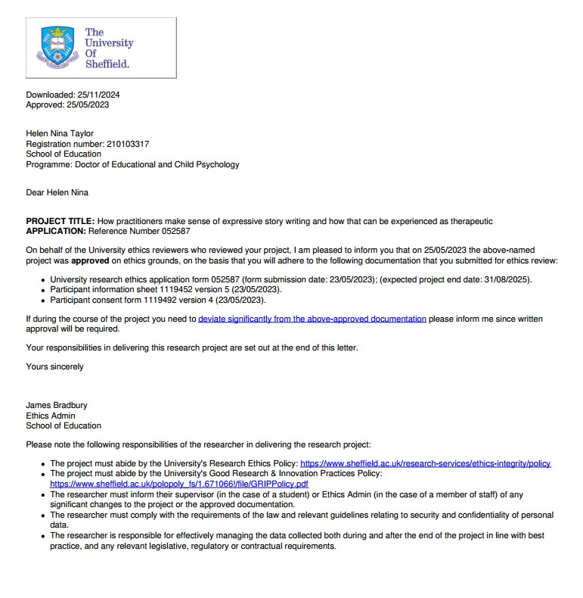

iii: Participant information sheet
Participant Number:
Project title: How practitioners make sense of expressive story writing and how that can be experienced as therapeutic
Investigator: Trainee Educational Psychologist: Helen Taylor
Project supervisor: Dr Francine Wint
Invitation to participate
Up to 10 professional practitioners from local authorities delivering therapeutic story writing groups are being invited to take part in a research project. Taking part is voluntary: it is up to you to decide whether or not you take part. It is important for you to understand what the research is about and what it will involve. Please take time to read the following information carefully and discuss it with others if you wish. If anything is not clear to you or you would like more information please ask.
What is the project about?
I am currently working as a Trainee Educational Psychologist in a local authority which is delivering TSWG interventions and I am interested in how those practitioners delivering the intervention talk about the experience of delivering a group therapeutic story intervention, and what the practitioners delivering that intervention value about the intervention
My particular focus is on how practitioners view the ways that therapeutic story writing could support creativity and self-expression in Key Stage 2 students. It is of particular interest to me to explore what therapeutic story writing practitioners consider to be the benefits for student and staff wellbeing in a group therapeutic story writing intervention
To date, no specific therapeutic creative writing intervention exists for 12-16 year olds, and this exploratory research is also intended as a starting point for considering what features of therapeutic story writing could be beneficial for this age group, and how some of these could be linked to research relating to the benefits of expressive writing and journalling. My interest is not so much in TSWG as a copyrighted intervention but more broadly in how therapeutic story writing could take place within schools, and any potential links between creativity and wellbeing. I would like to consider, in future research, how this could be explored with teenagers, with a view to potentially designing my own future intervention for this age group.
If practitioners choose to take part they will be talking about their experiences of delivering therapeutic story writing groups individually in an online interview for up to one hour
This study forms part of my Doctor of Education and Child Psychology research thesis at Sheffield University
What will I be asked to do?
● answer questions about therapeutic story writing groups in an individual online interview
● you do not have to answer a question if you do not want to.
● spoken answers to questions will be audio recorded but anything you say that could identify anyone will be anonymized – this means all names will be changed, for example
● if you decide you will take part, it is likely to take roughly one hour
● this will be done online, with only the research investigator and the professional practitioner present
What are the advantages and disadvantages of taking part?
Taking part may contribute to knowledge in therapeutic story writing research and the practice of educational psychology services. I will share what I find out with participants when the research is completed, using email and GoogleMeet. I don’t expect there to be any disadvantages to taking part. Taking part in this study is also not expected to cause discomfort or distress, but if such feelings do happen because of taking part, you can access advice or support at Mind and/or Samaritans. You can access Mind by telephoning 0300 123 3393 or emailing info@mind.org.uk. You can access Samaritans by telephoning 116 123 or emailing jo@samaritans.org. If you experience any uncomfortable feelings during the research you will be reminded that you can leave at any time, including during the interview.
How will my information be used?
The information collected during this study will be used to produce my thesis. This will be made available online, as part of the Sheffield University requirements, and as such will be accessible to anyone using White Rose eTheses Online portal. Anonymized quotations might be included in this thesis. A presentation of my findings might be given to educational psychologists in the Local Education Authority (LEA) from which participants were recruited, if they request this. My thesis may be condensed and sent for publication in an academic journal, at a later date.
The people who might read the thesis are my project supervisor, other members of the psychology staff at Sheffield University and external examiners.
Also, the information may be published in academic journals, presented at academic conferences, or used for teaching purposes.
Although the information may be used for these purposes, you will not be identifiable in any way through these activities. You will be allocated a unique participant code, and this will be used instead of your name in the naming of audio transcript files. When your words are reported these will only be attributed to the pseudonym that you have chosen/ Names and other identifying information given in answers will be changed. The audio recording will be destroyed once the thesis is completed. Feedback on the research will be individually given to participants online, with only the research investigator and participant present; further time might be needed for this after completion of the thesis.
Will my information be confidential?
All the information you provide will be treated in confidence. This means that your names will not be passed on to anyone else and your information will be used only for the research or teaching purposes of Sheffield University. Names and email addresses will not be used for the research or teaching purposes of Sheffield University; only paraphrases or short quotations from audio transcripts, which will have any personal identifiers anonymized and will only be referred to in relation to yourself through a pseudonym which you will be invited to choose yourself. All of your information will be stored securely on Google Drive and only my project supervisor and I will have access to this information. The only time that my project supervisor or I would reveal anything to an appropriate authority would be if you give information that we feel could put you or another person at risk of harm. This decision would only be taken following a conversation with my supervisor at Sheffield University, Dr Francine Wint. There is a possibility that confidentiality cannot be completely ensured as since the research is likely to be shared back with the local authority service there is therefore some potential for there to be some unknown to researcher identifiers being included in quotations from participants (e.g. if an experience is shared at interview which has also been shared with the team previously that then links other quotations back to that participant, or if someone uses a particular turn of phrase within a quote then some of the team might be able to link that to that participant.)
Can I change my mind?
Yes, you can stop taking part in the study at any time, including during the interview. You can also ask for part or all your answers to be destroyed. You can do this without any negative consequences and you do not need to provide a reason. If you would like to withdraw from the research please email me quoting your participant number no later than 2 weeks from our interview. Your participant number is provided at the top of this Information Sheet.
Important legal information:
Please note that by choosing to participate in this research, this will not create a legally binding agreement, nor is it intended to create an employment relationship between you and the University of Sheffield.
According to data protection legislation, we are required to inform you that the legal basis we are applying in order to process your personal data is that ‘processing is necessary for the performance of a task carried out in the public interest’ (Article 6(1)(e)).
The University of Sheffield will act as the Data Controller for this study. This means that the University is responsible for looking after your information and using it properly.
This project has been ethically approved via the University of Sheffield’s Ethics Review Procedure, as administered by the School of Education.
Who can I contact for further information?
● The trainee educational psychologist undertaking this study: htaylor9@sheffield.ac.uk
● My supervisor at Sheffield University, Dr Francine Wint, at f.wint@sheffield.ac.uk
● If you wish to talk to an independent representative within the university and someone who is outside of this research study, please contact Professor Rebecca Lawthom, r.lawthom@sheffield.ac.uk, (01142)228172, School of Education, The Wave, 2 Whitham Road, Sheffield S10 2AH.
Complaints and Concerns
If you are not satisfied with any aspect of the research and wish to make a complaint, please contact my supervisor at the university, Dr Francine Wint, at f.wint@sheffield.ac.uk. If you feel your complaint has not been handled in a satisfactory way you can contact the Head of the School of Education, Professor Rebecca Lawthom, at r.lawthom@sheffield.ac.uk. If the complaint relates to how your personal data has been handled, you can find information about how to raise a complaint in the University’s Privacy Notice: https://www.sheffield.ac.uk/govern/data-protection/privacy/general
If you wish to make a report of a concern or incident relating to potential exploitation, abuse or harm resulting from your involvement in this project, please contact the project’s Designated Safeguarding Contact, Dr Francine Wint, at f.wint@sheffield.ac.uk. If the concern or incident relates to the Designated Safeguarding Contact, or if you feel a report you have made to this Contact has not been handled in a satisfactory way, please contact the Head of the School of Education, Professor Rebecca Lawthom, at r.lawthom@sheffield.ac.uk and/or the University’s Research Ethics & Integrity Manager Lindsay Unwin at l.v.unwin@sheffield.ac.uk
What happens next?
Please think carefully about whether you wish to take part in the study. If you do wish to take part, please complete the attached consent form and return it via email to htaylor9@sheffield.ac.uk .Your consent form will be stored on a Google Drive which only the researcher involved in this study will have access to and it will be deleted no later than 24 months after the study is completed.
Thank you for considering participating.

iv: Consent form
Please tick each point to indicate a ‘Yes’.
- I have read and understood the project information sheet. (If you will answer No to this question please do not proceed with this consent form until you are fully aware of what your participation in the project will mean.)
- I have been given the opportunity to ask questions about the project.
- I agree to take part in the project. I understand that taking part in the project will include giving verbal answers to questions about therapeutic story writing groups - see information sheet for more details
- I understand that by choosing to participate as a volunteer in this research, this does not create a legally binding agreement nor is it intended to create an employment relationship with the University of Sheffield.
- I understand that taking part is voluntary and that I can withdraw from the study at any time, including during interview; I do not have to give any reasons for why I no longer want to take part and there will be no adverse consequences if I choose to withdraw. Right to withdraw is for two weeks after the interview takes place, subsequent to which participants cannot withdraw.
How information will be used during and after the project
- I understand my personal details such as name and email address will not be revealed to people outside the project.
- I understand and agree that my words may be quoted in publications, reports, web pages, and other research outputs. I understand that I will not be named in these outputs unless I specifically request this.
- I understand and agree that other authorised researchers will have access to this data only if they agree to preserve the confidentiality of the information as requested in this form.
- I understand and agree that other authorised researchers may use my data in publications, reports, web pages, and other research outputs, only if they agree to preserve the confidentiality of the information as requested in this form.
- I give permission for the answers that I provide to be deposited in a Google Drive until completion of the thesis and potential subsequent publication in an academic journal
- I give permission for my interview to be audio recorded and a transcription made from the audio file and I understand this audio will be deleted after transcription.
- I understand that confidentiality cannot be 100% assured as findings may be shared back with the EPS and there may be some ‘unknown to researcher’ identifiers such as mentions of specific experiences or turns of phrase used in interviews.
So that the information you provide can be used legally by the researchers
- I agree to assign the copyright I hold in any materials generated as part of this project to The University of Sheffield.

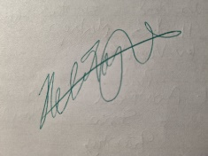
Name [printed] Signature Date
Names of Researcher: Helen Taylor Signature:
Date: 23 May 2023
Project contact details for further information:
University Supervisor: Dr Francine Wint, f.wint@sheffield.ac.uk, School of Education, The Wave, 2 Whitham Road, Sheffield S10 2AH.
A person outside the project who can be contacted in the event of a complaint: Professor Rebecca Lawthom, r.lawthom@sheffield.ac.uk, (01142)228172, School of Education, The Wave, 2 Whitham Road, Sheffield S10 2AH.
Please print, sign, scan and return this consent form by email to: htaylor9@ sheffield.ac.uk

v: Semi-structured interview schedule
- Ethics – consent, confidentiality and audio recording check, 2 weeks to withdraw from now…
- Previous job roles?
- How long working in this LA?
- How long delivering TSWG?
- Can you tell me about how you feel/found the experience of delivering expressive and therapeutic story writing?
  - What really like/don’t like about experience of delivering…?
- How do you feel about facilitating an intervention that focuses on children expressing themselves creatively? Any expectations?
- How do you think children find being asked to engage in creative and self-expressive activities in the intervention?
  - Can you think of a particular time when you think it worked well/not so well?
- How do you think young people found the experience of the group more generally?
  - Benefits/challenges of TSWG? What do you think they valued about it?
- Thanks and pseudonym suggestion?

vi: Transcription conventions
Longer pauses are marked by ellipses and shorter pauses marked by commas; other relevant punctuation is included when it matched intonation or would otherwise alter meaning. Non-verbal activity is included in brackets (Braun & Clarke, 2006) and indistinct audio was marked in brackets as well. Italics were used to indicate that the participant emphasised that word when pronouncing it.

vii: An example coded transcript
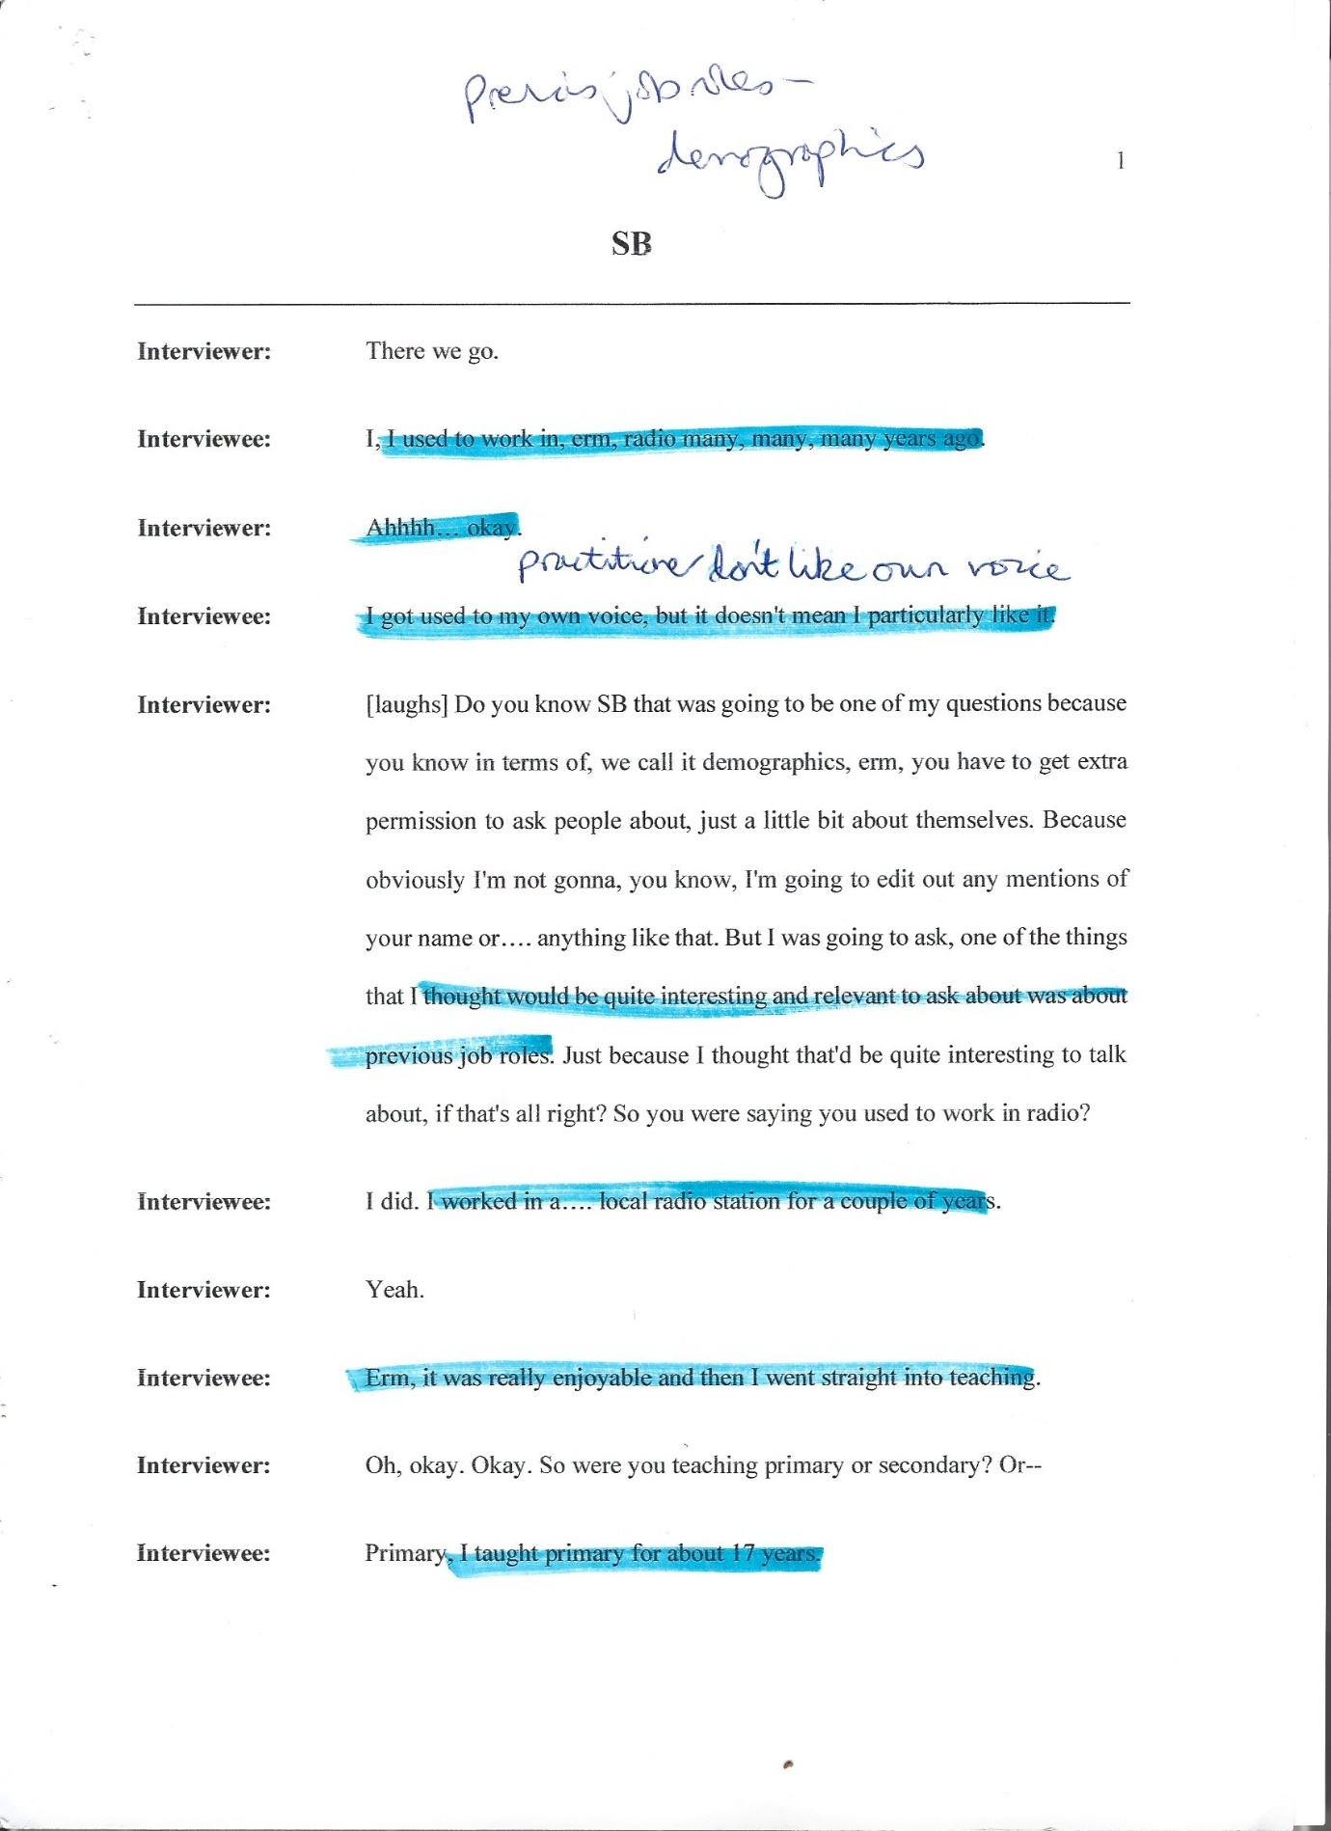

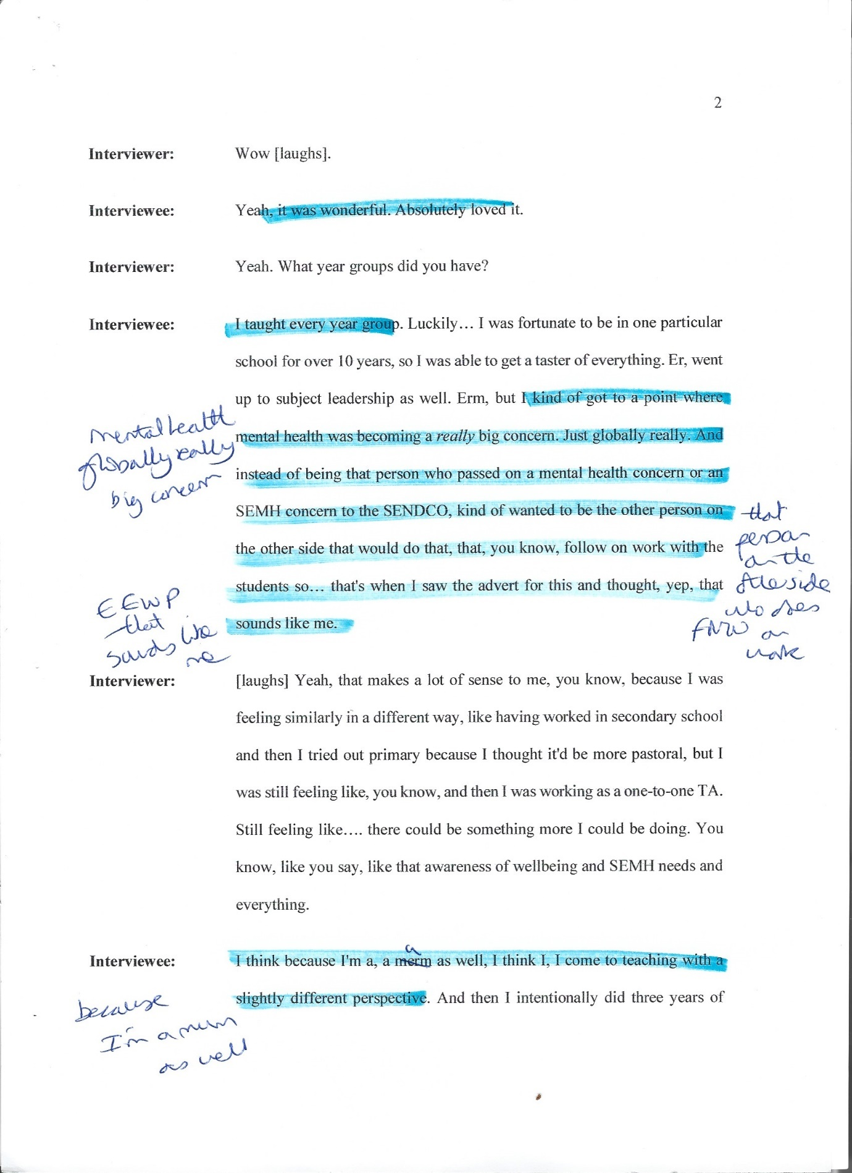

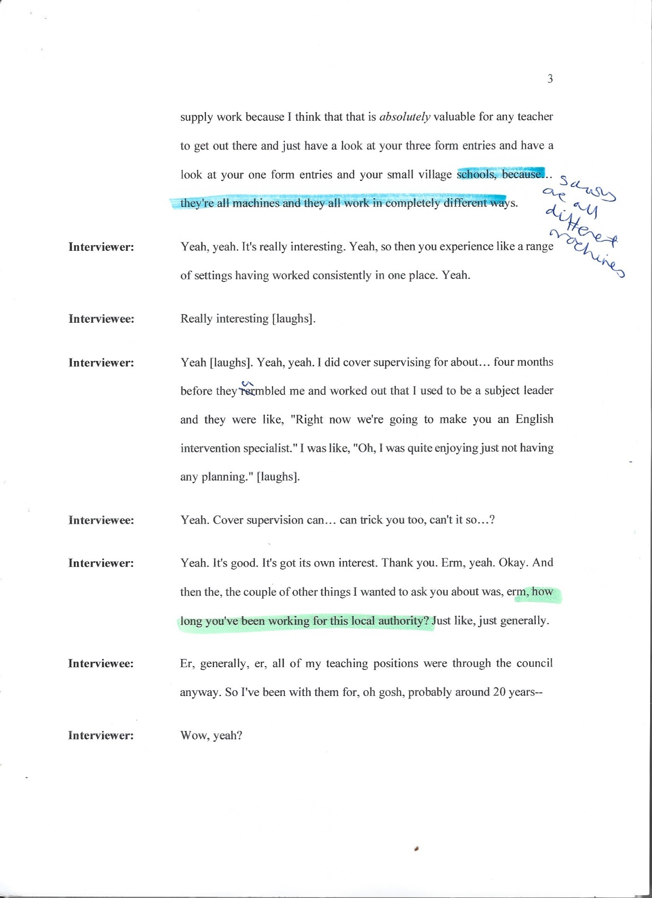

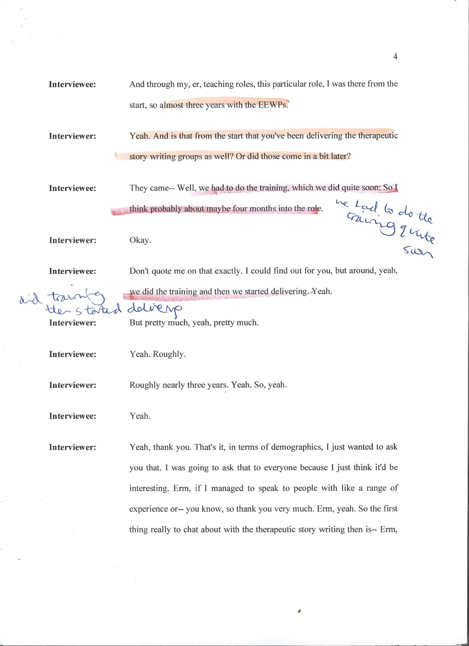

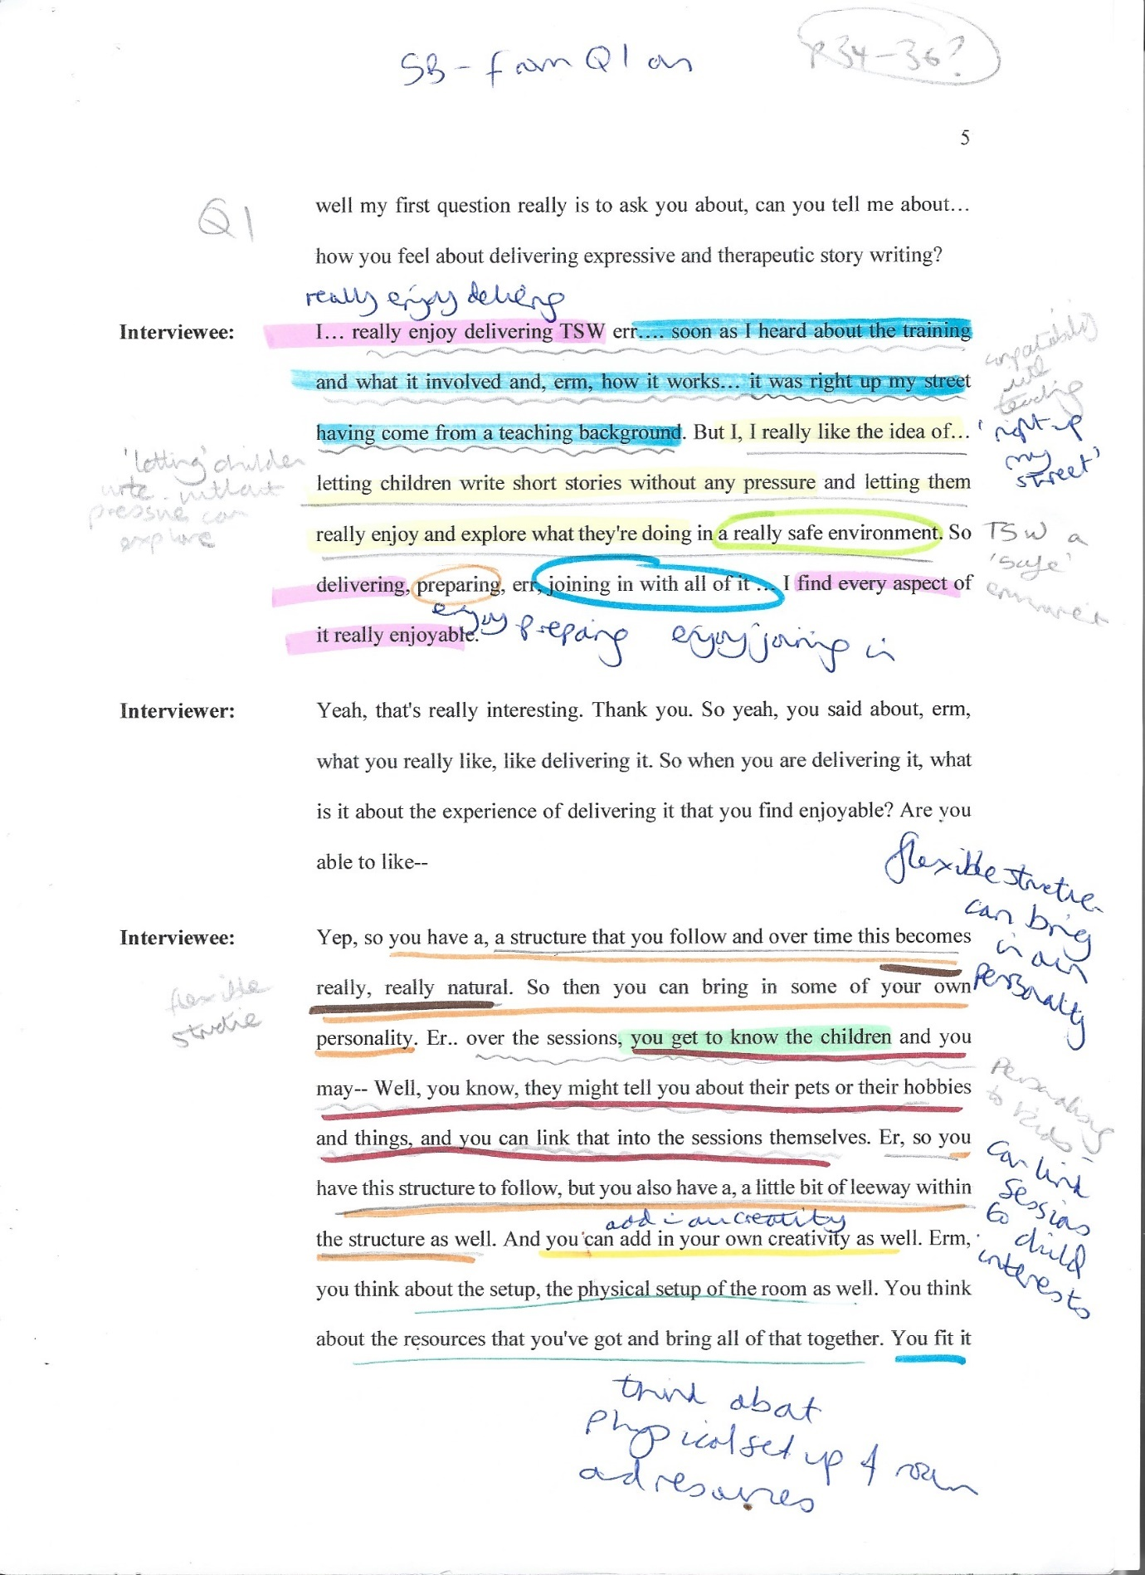

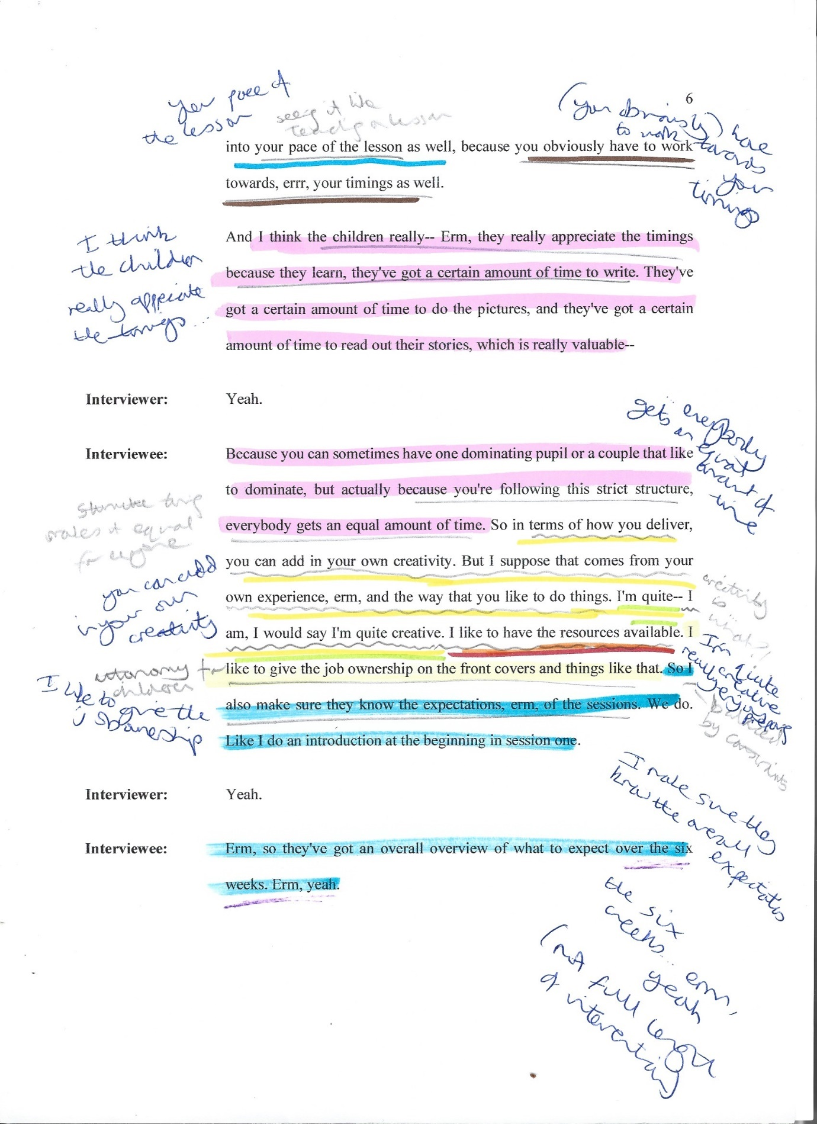
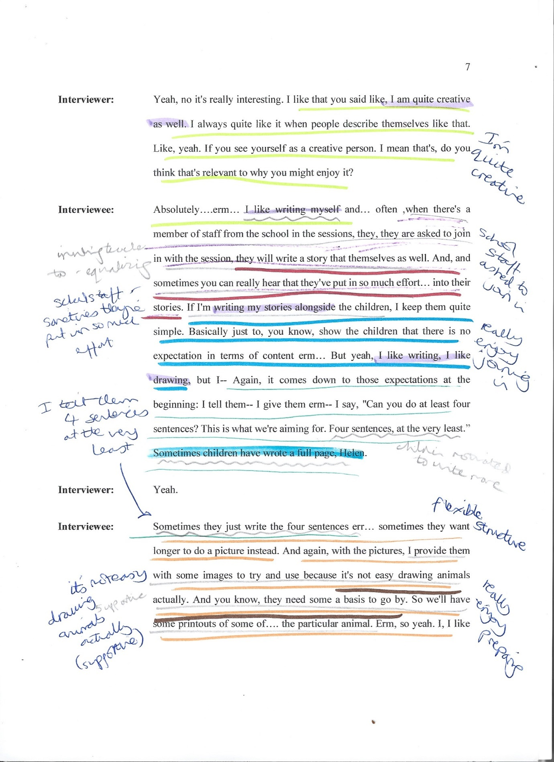

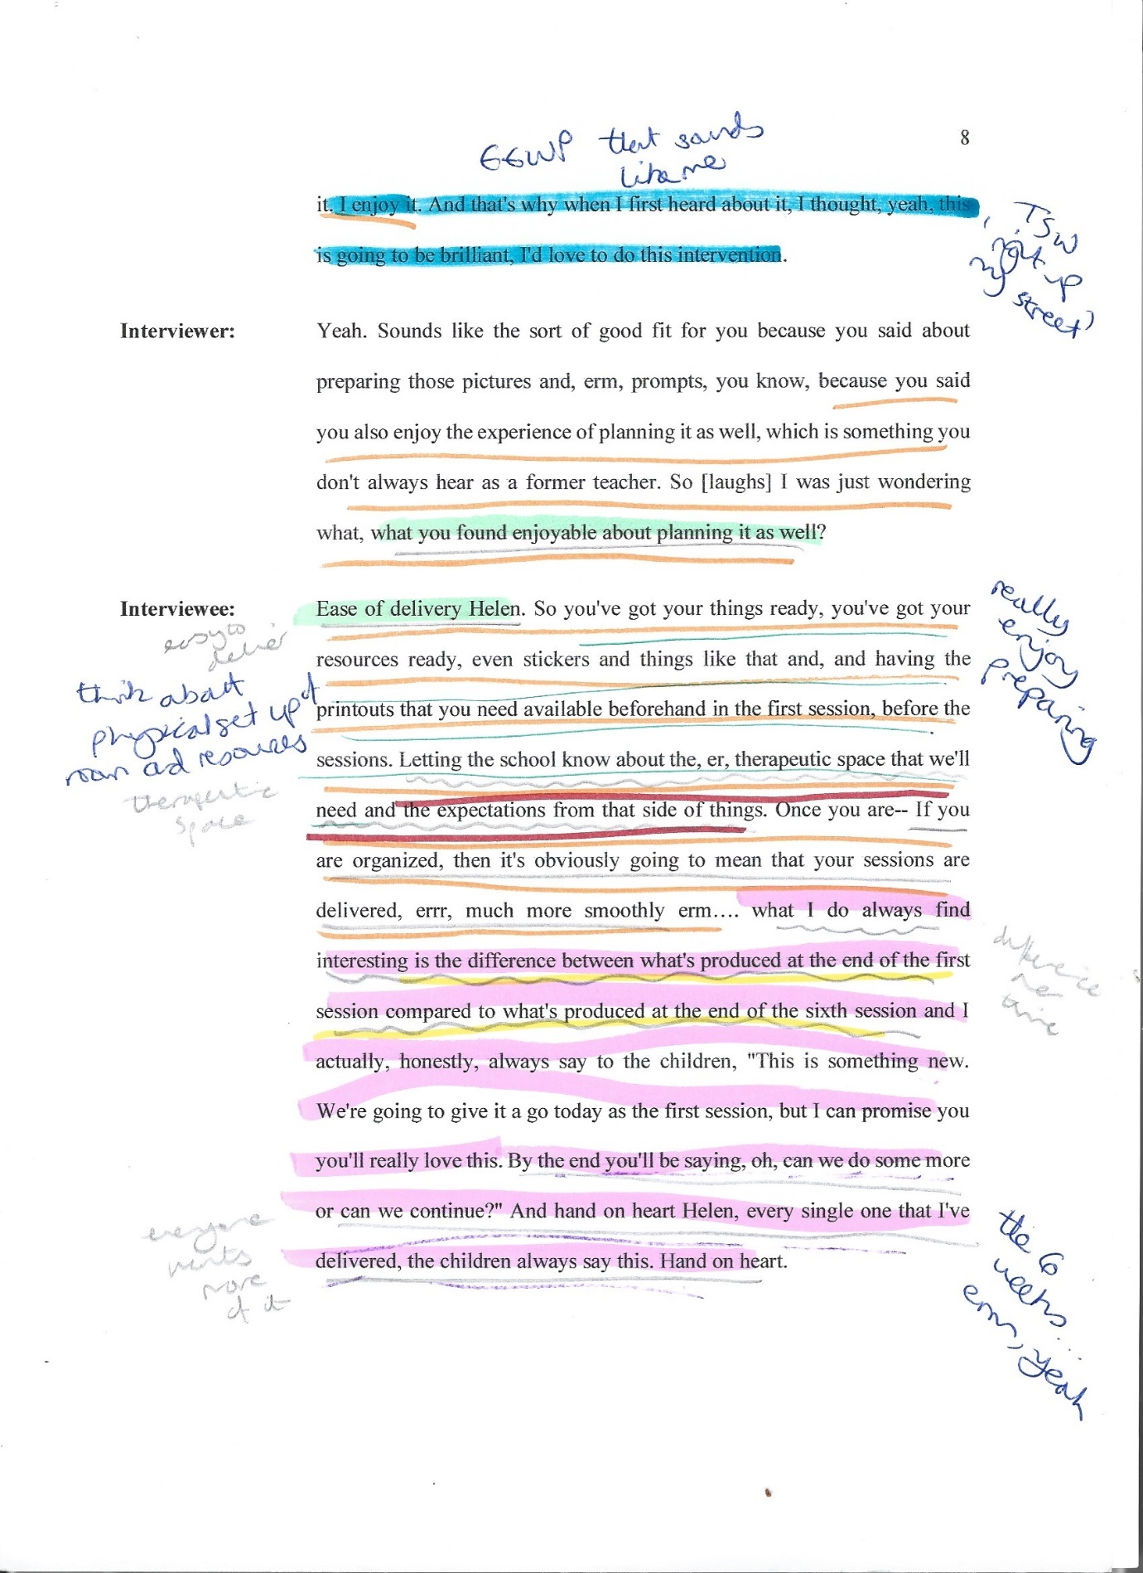

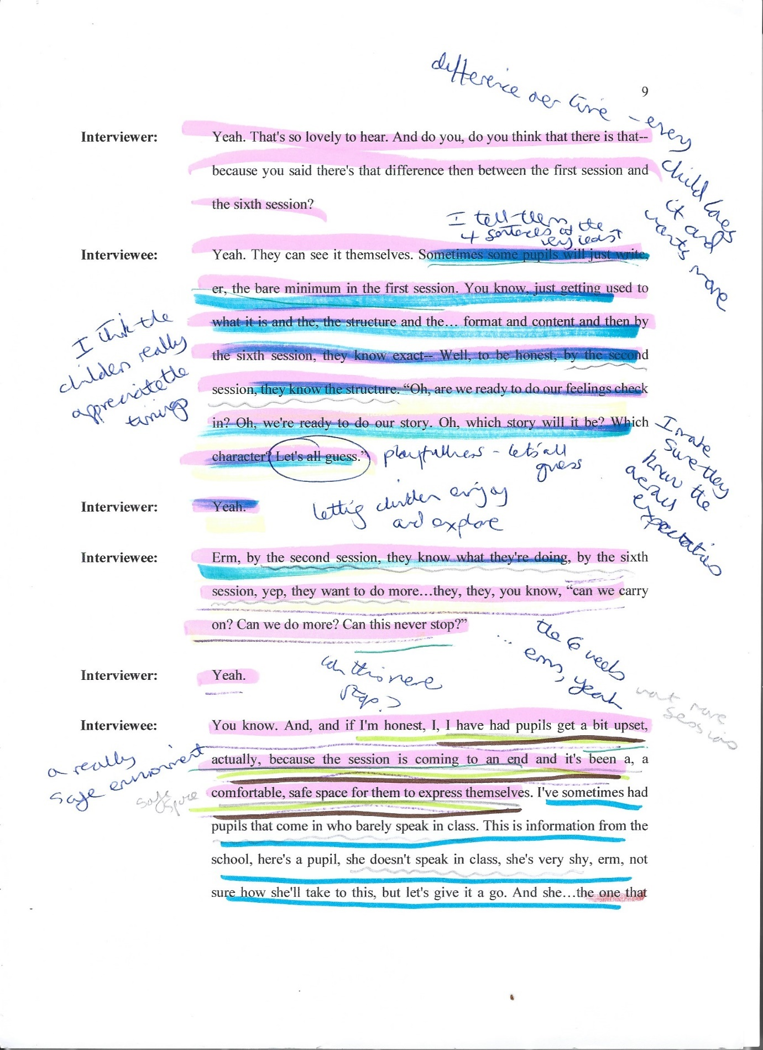

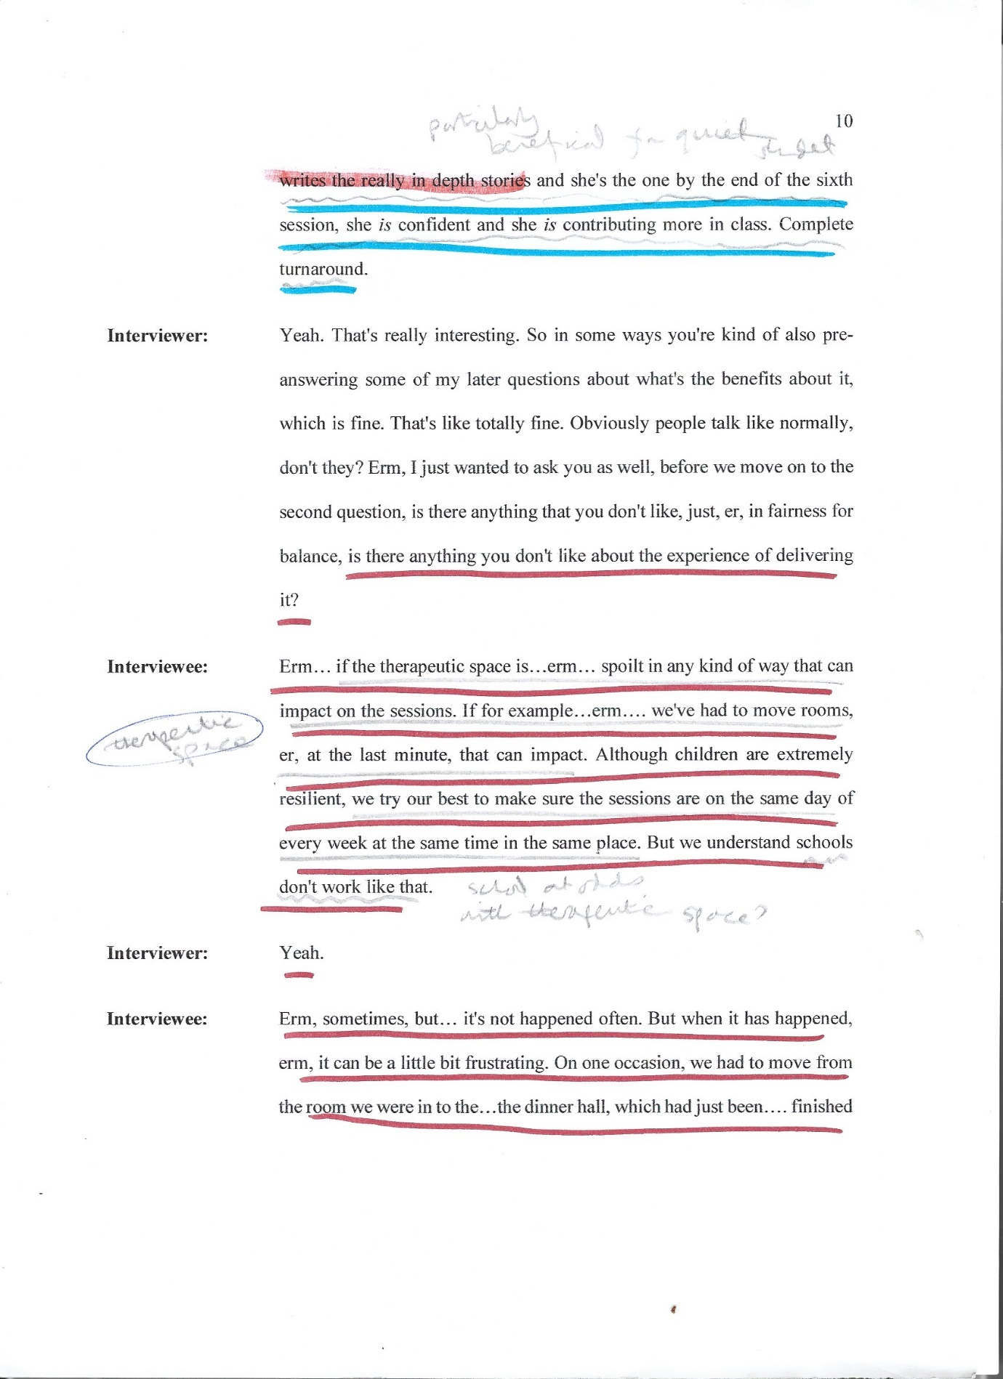

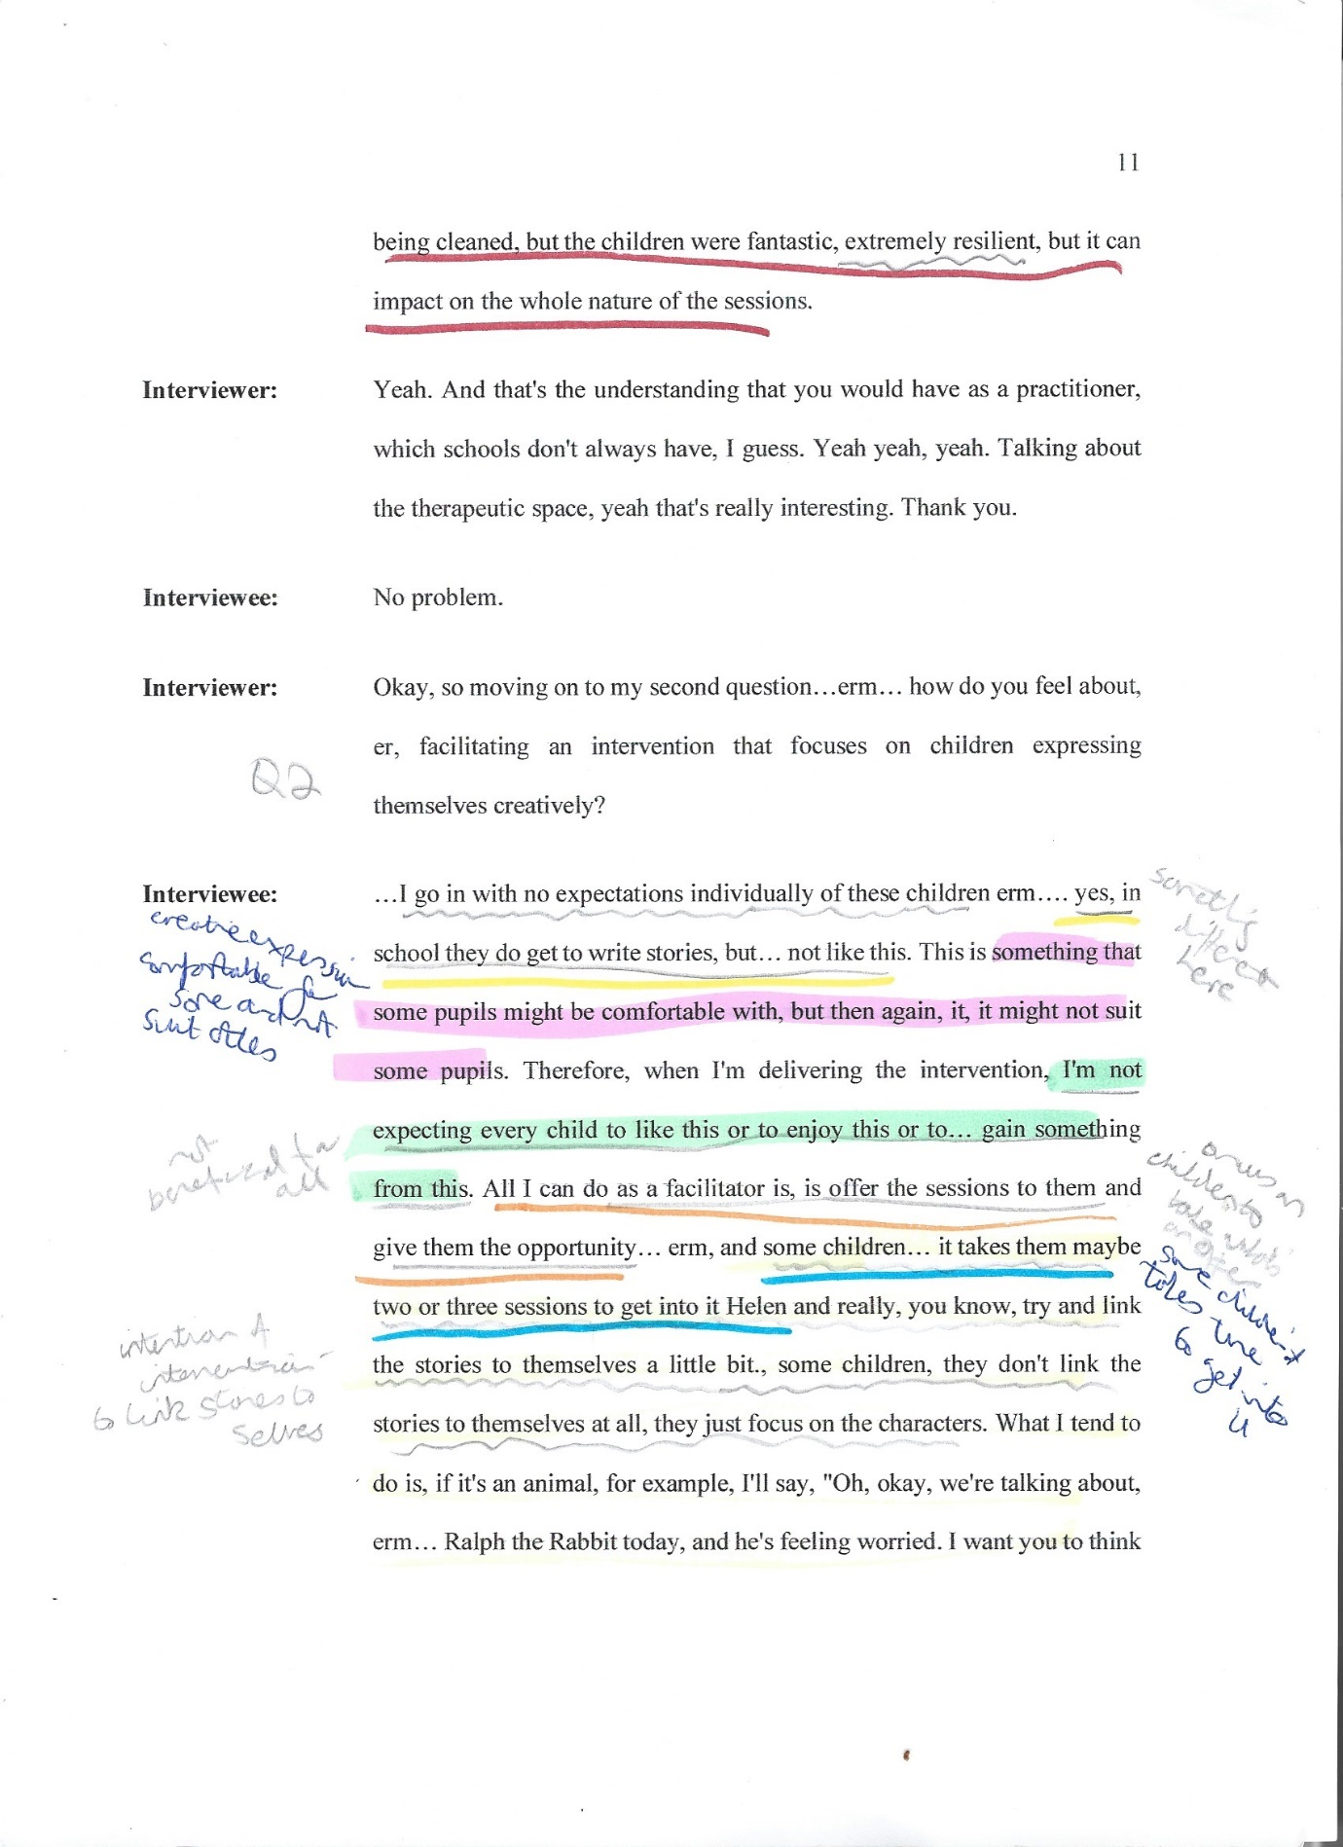

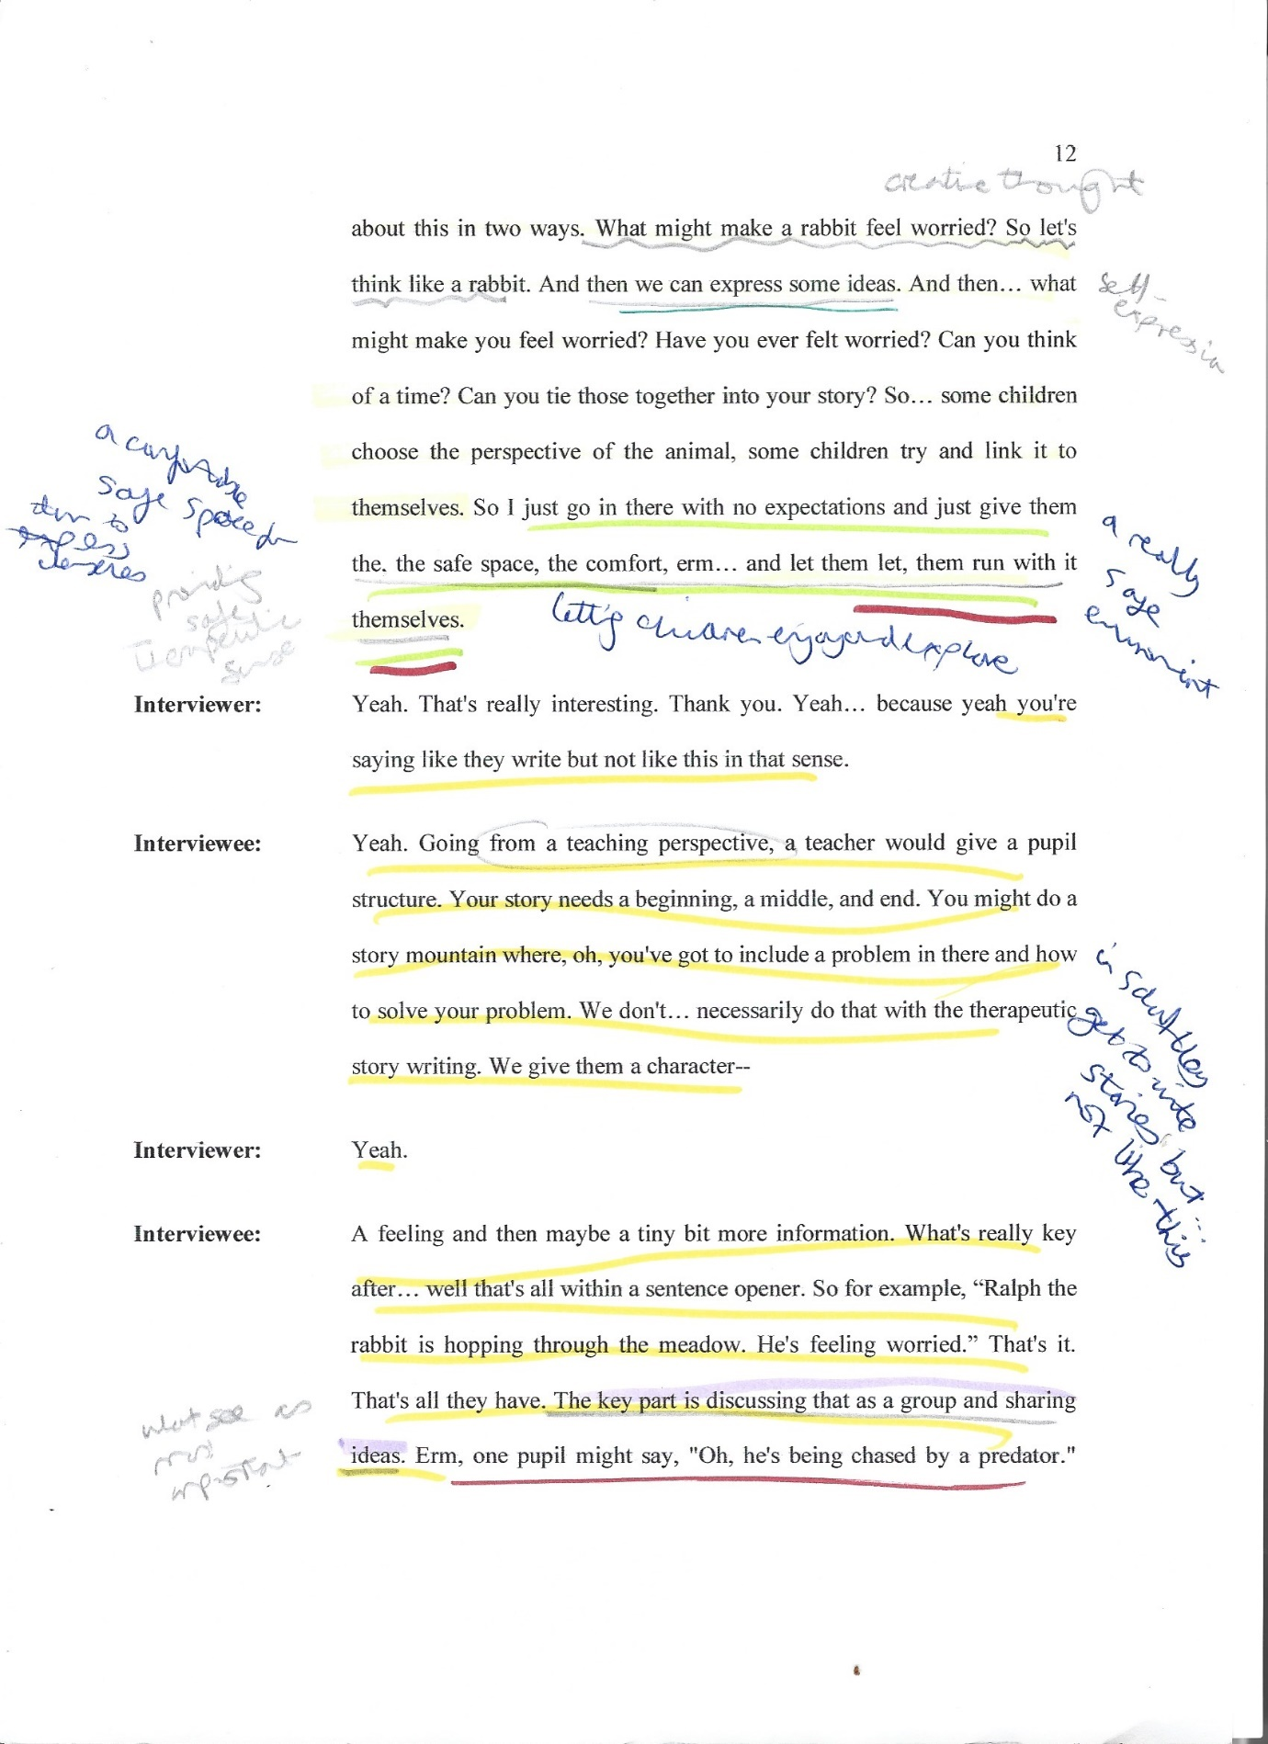

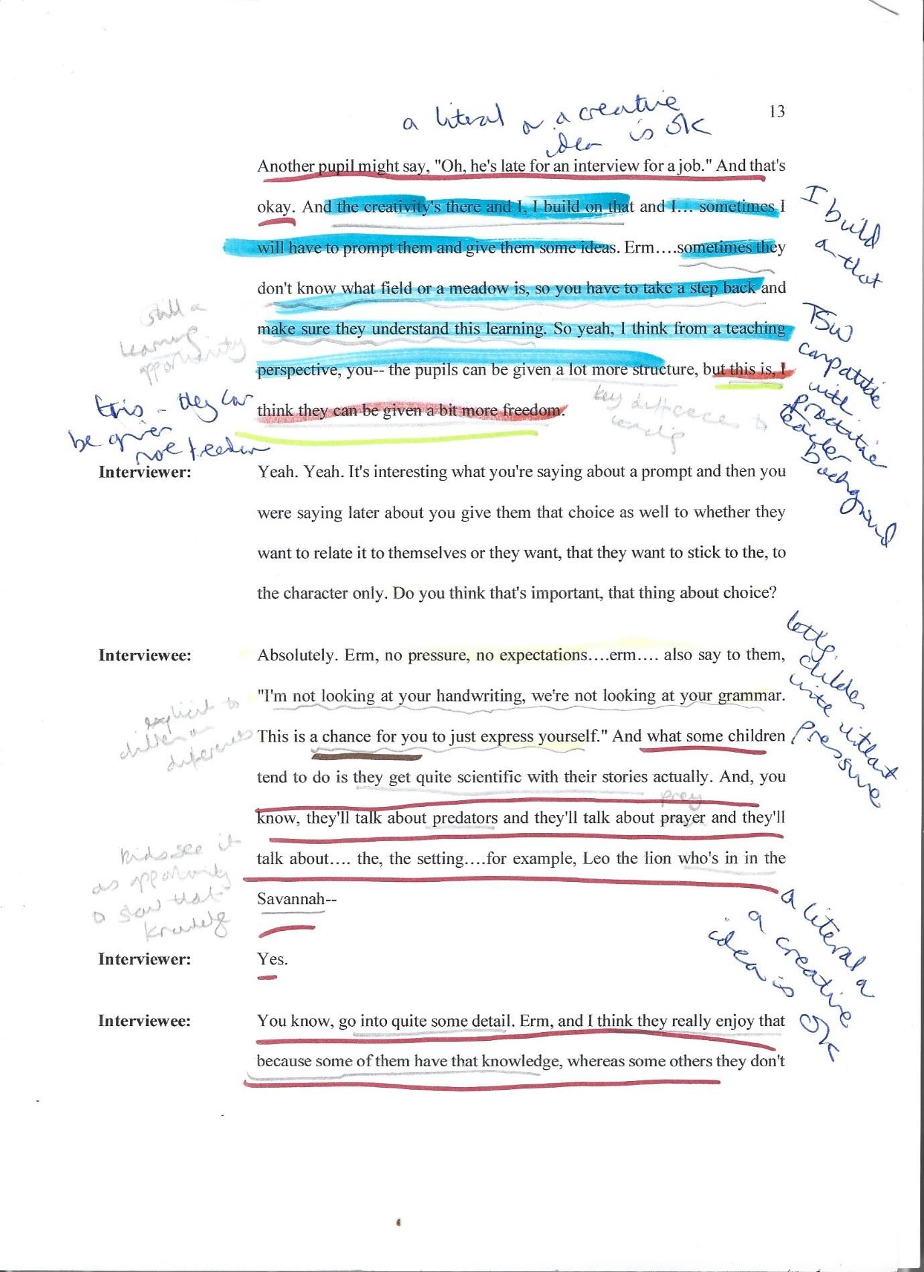

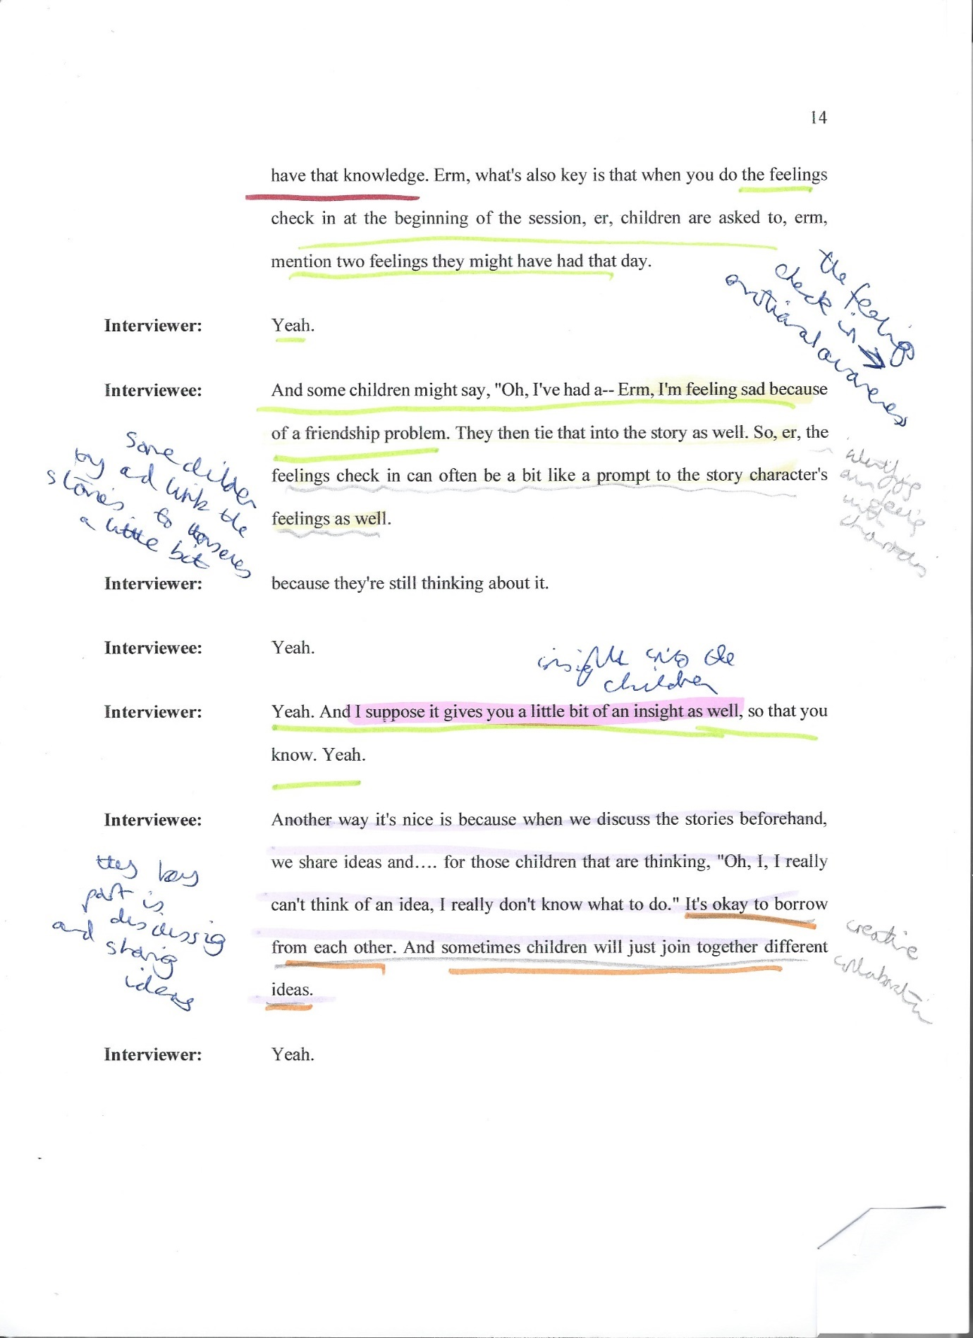

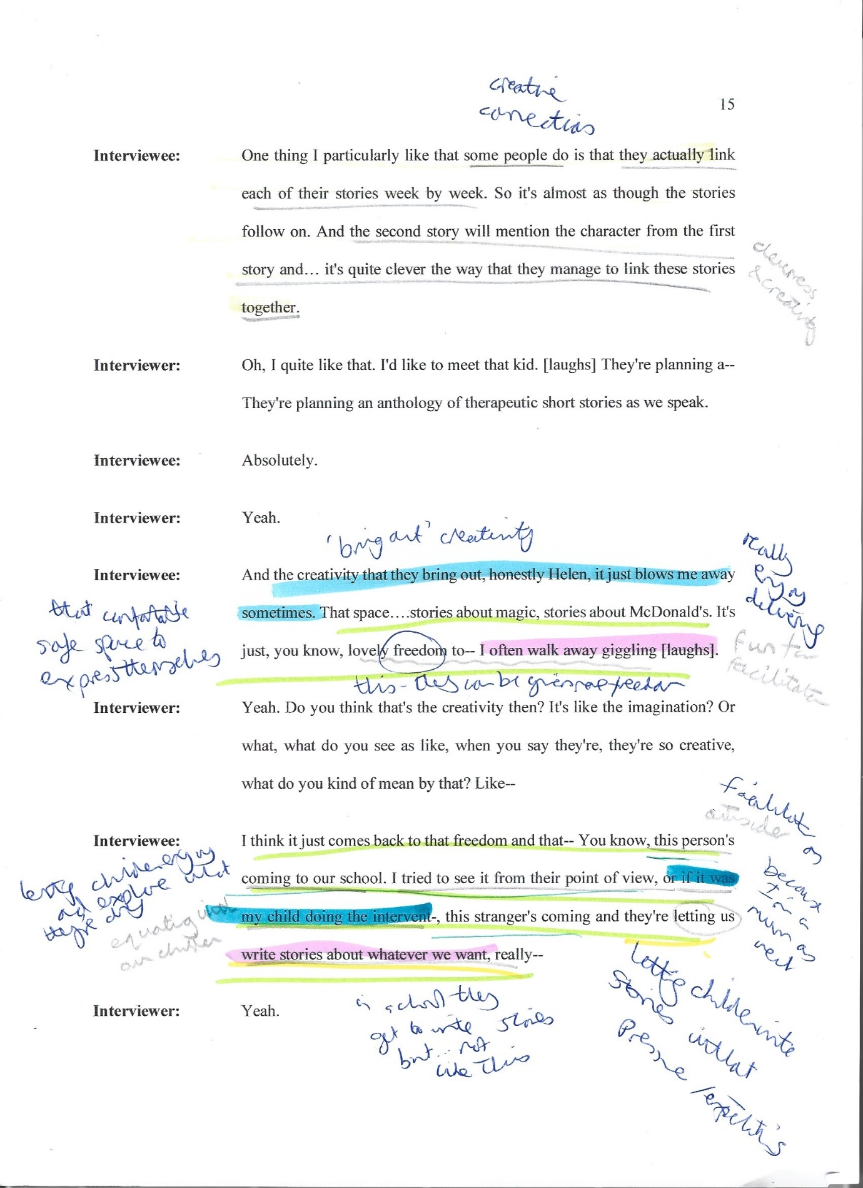

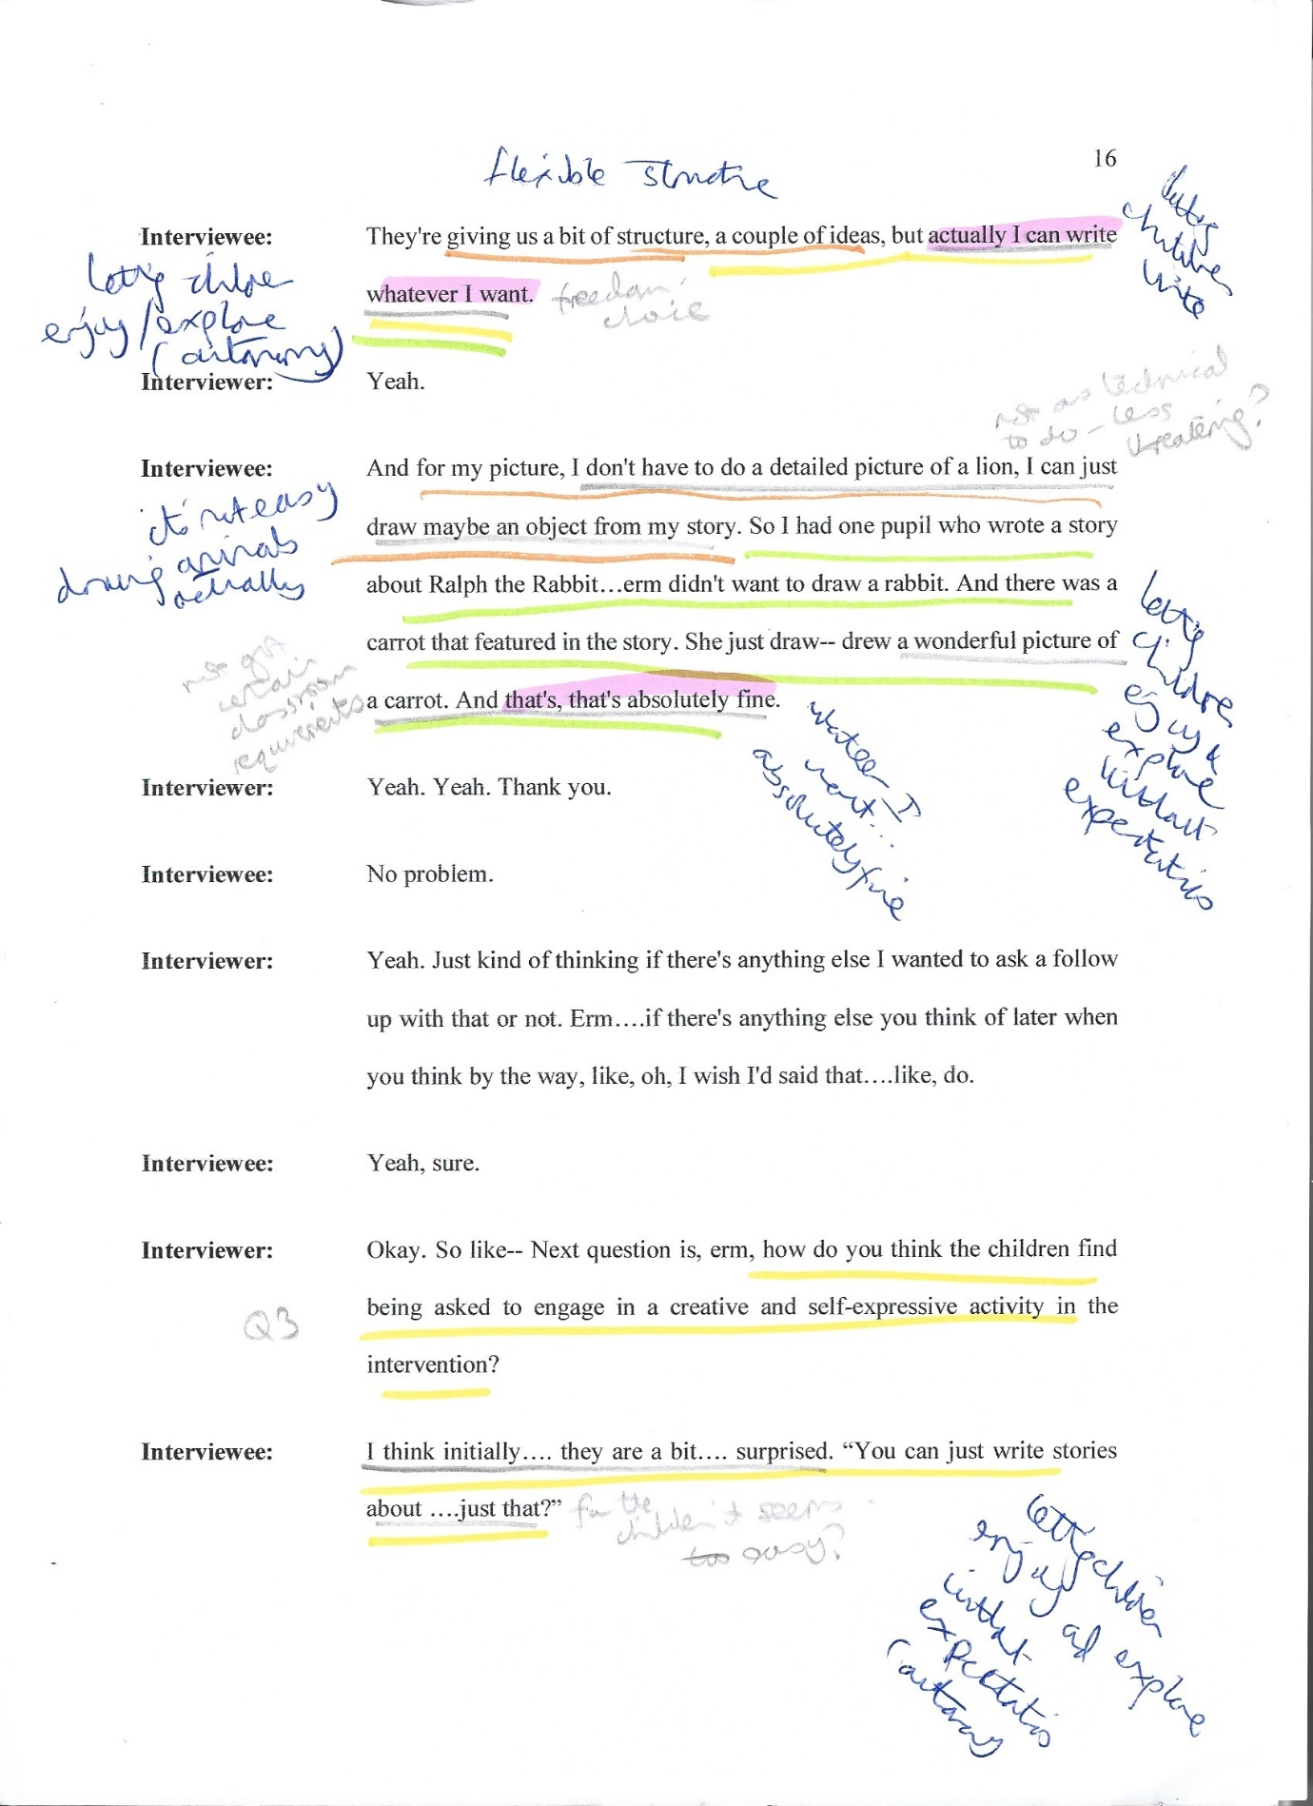

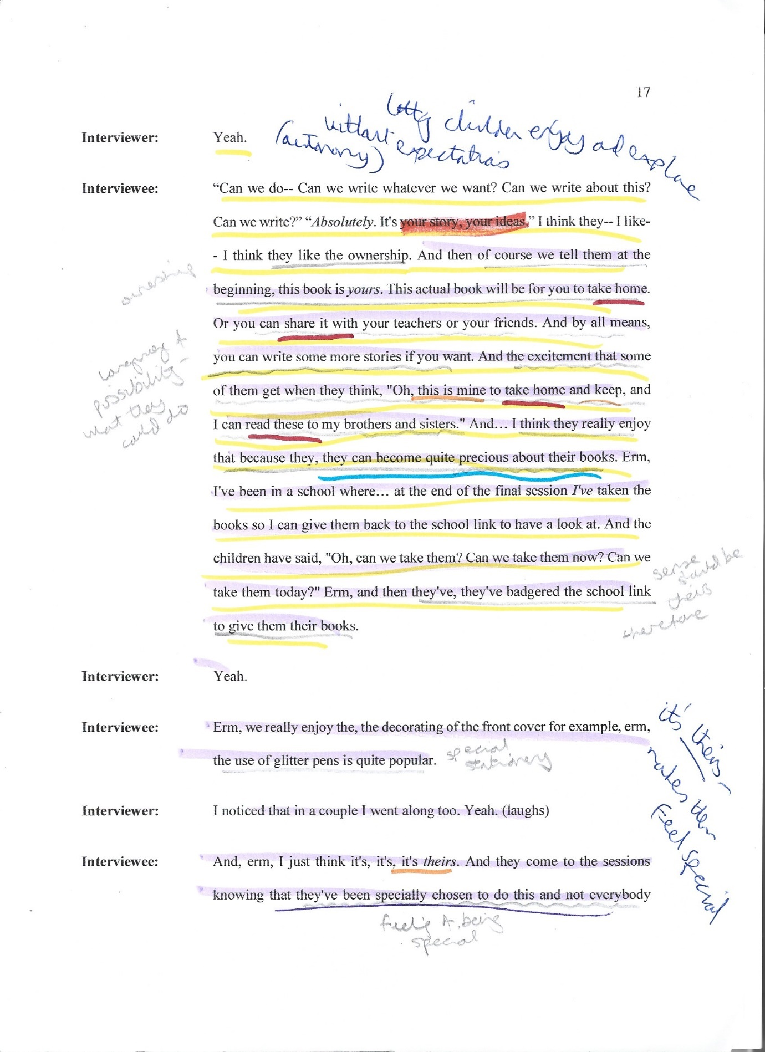

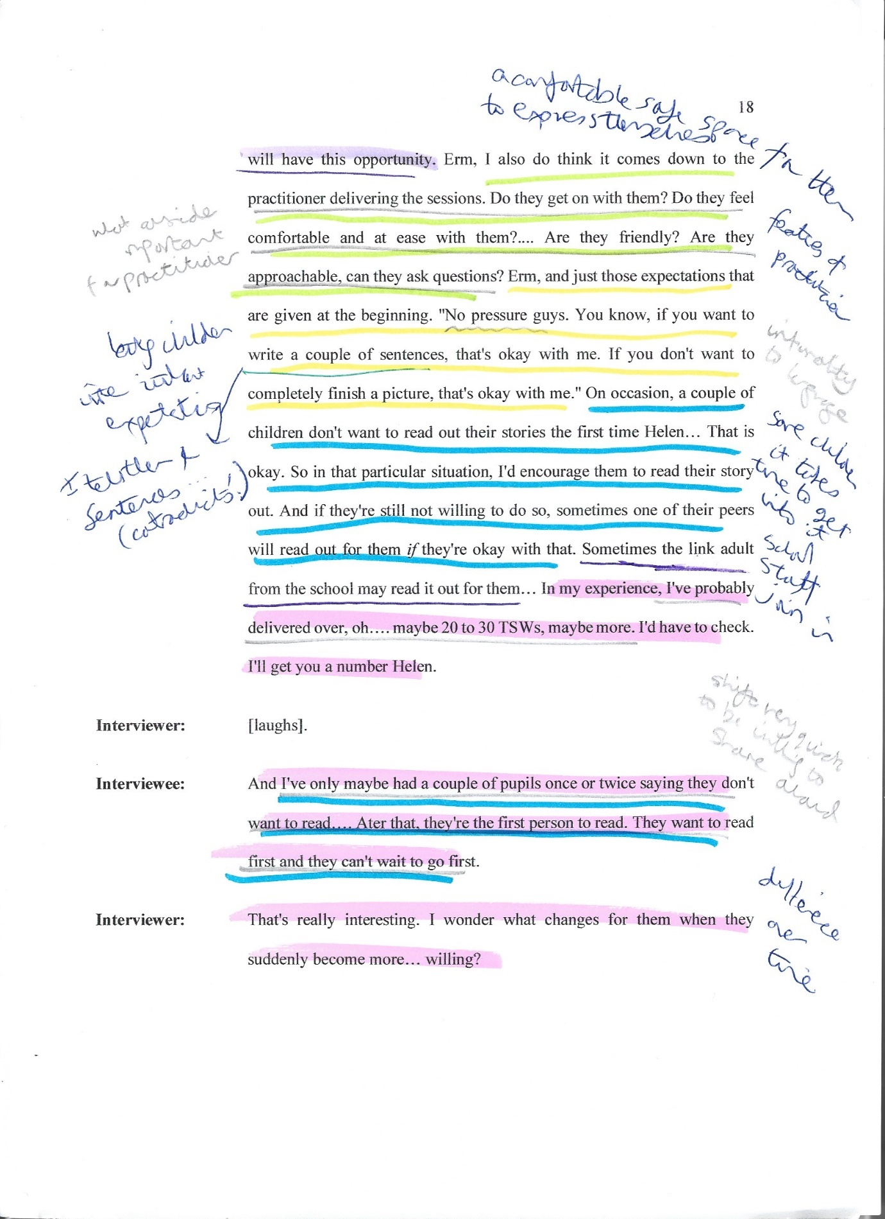

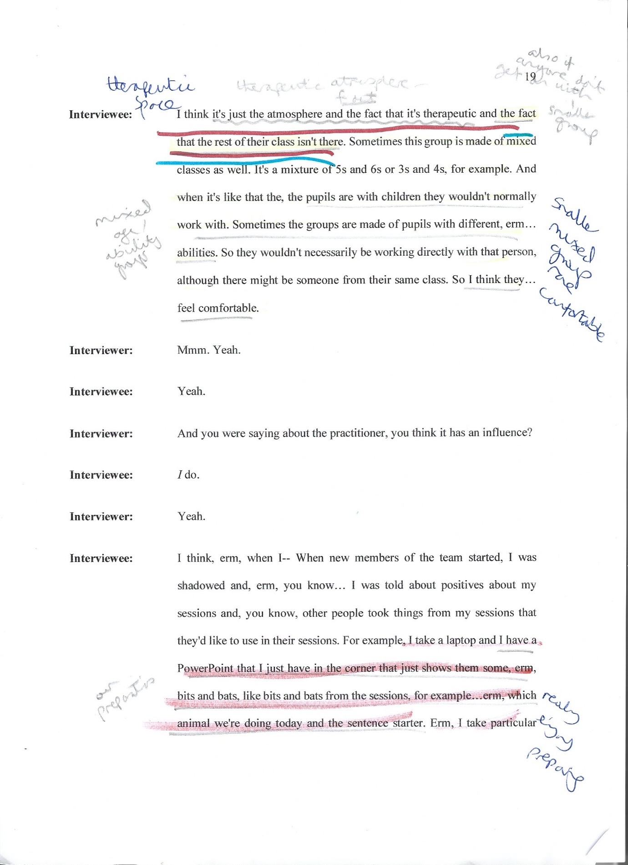

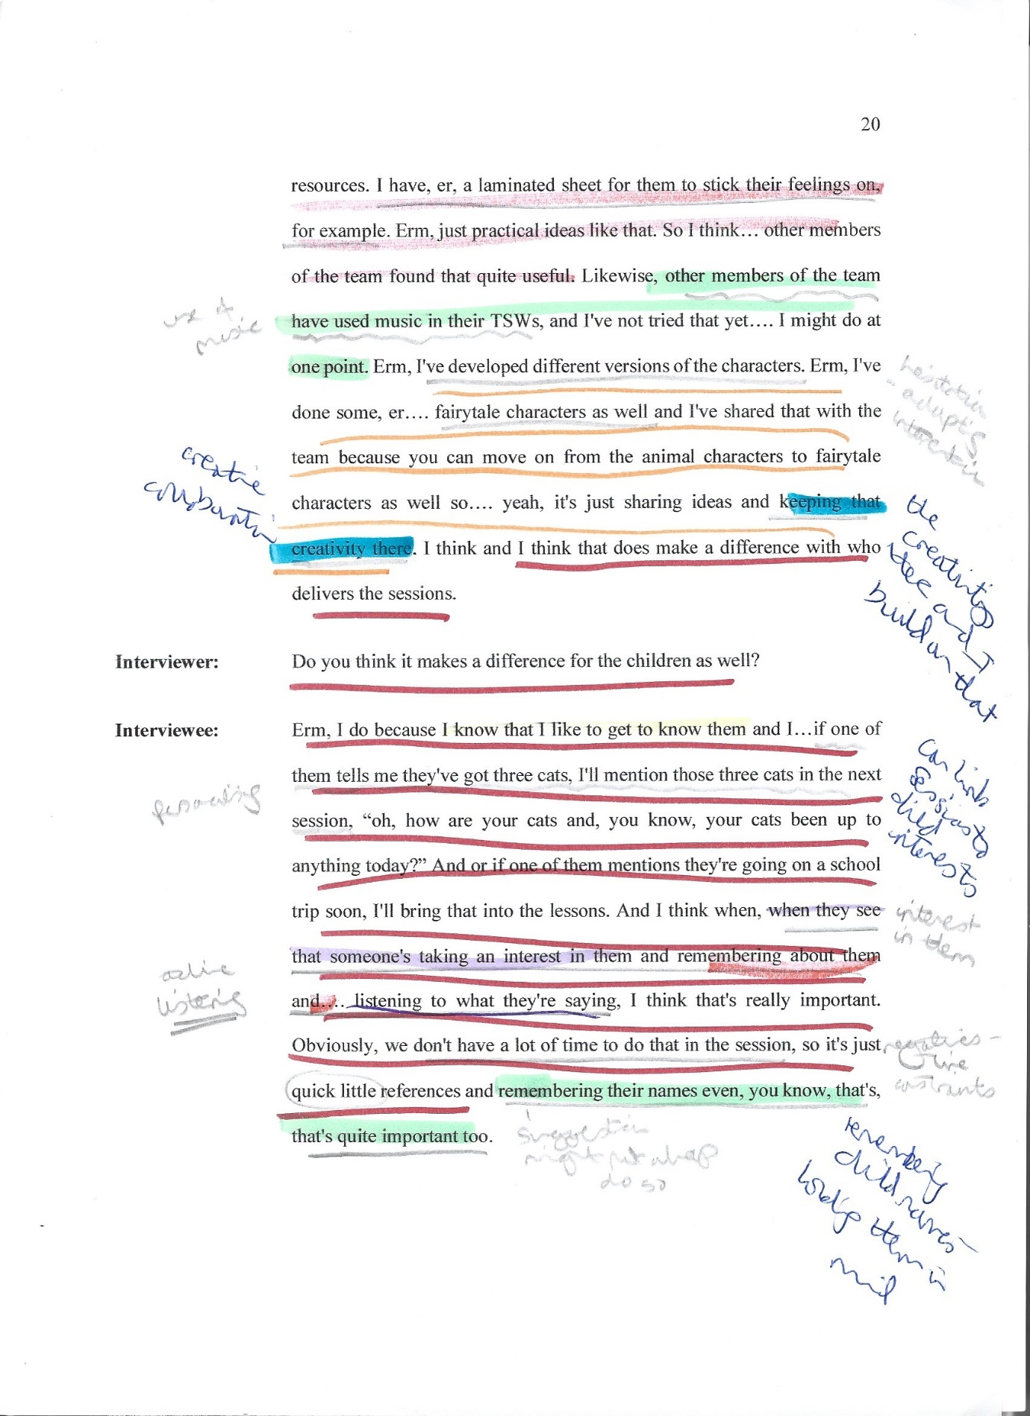

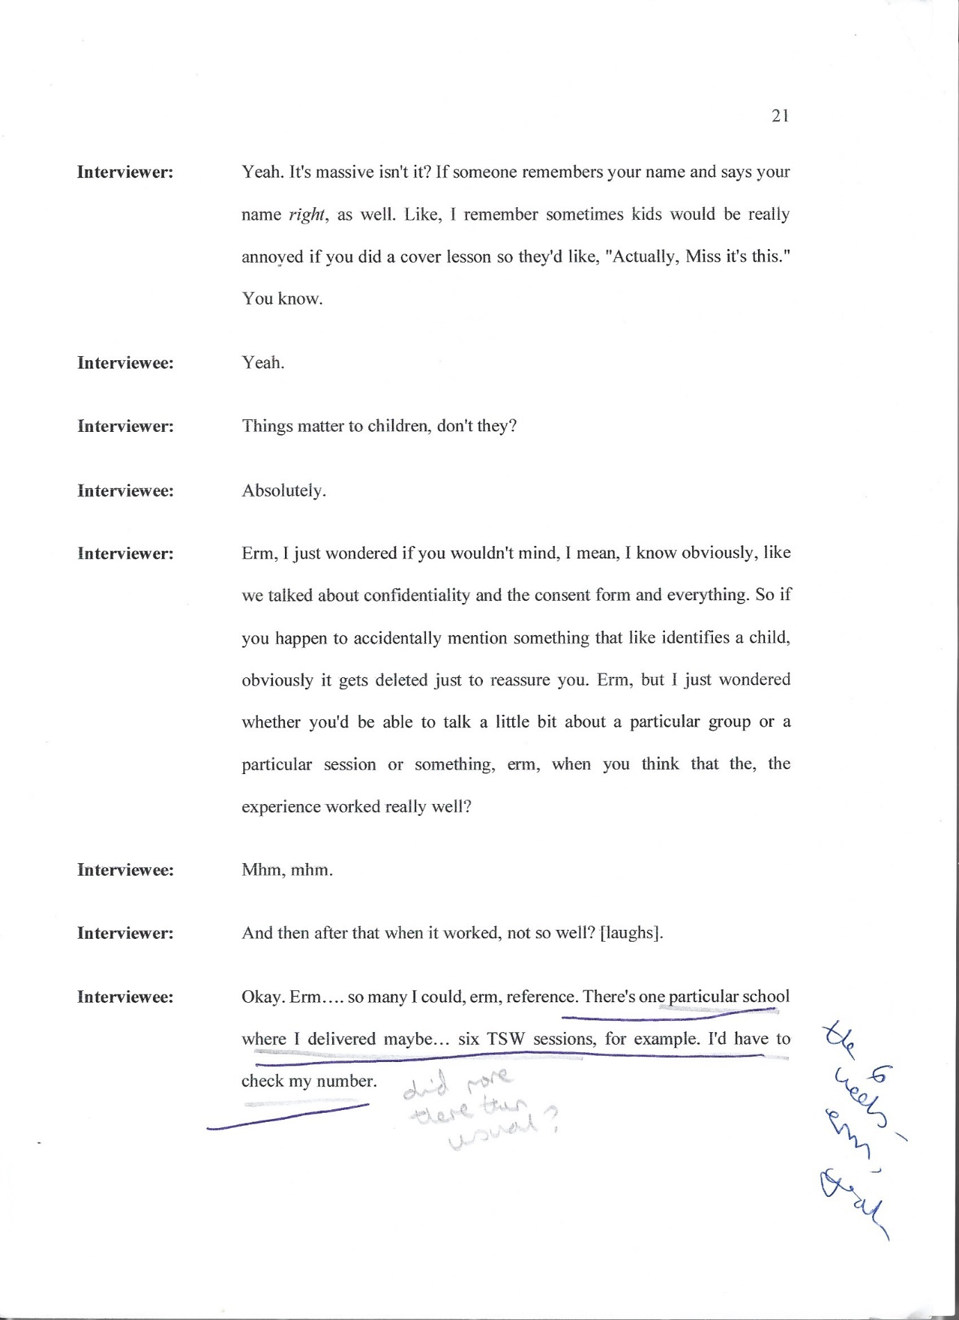

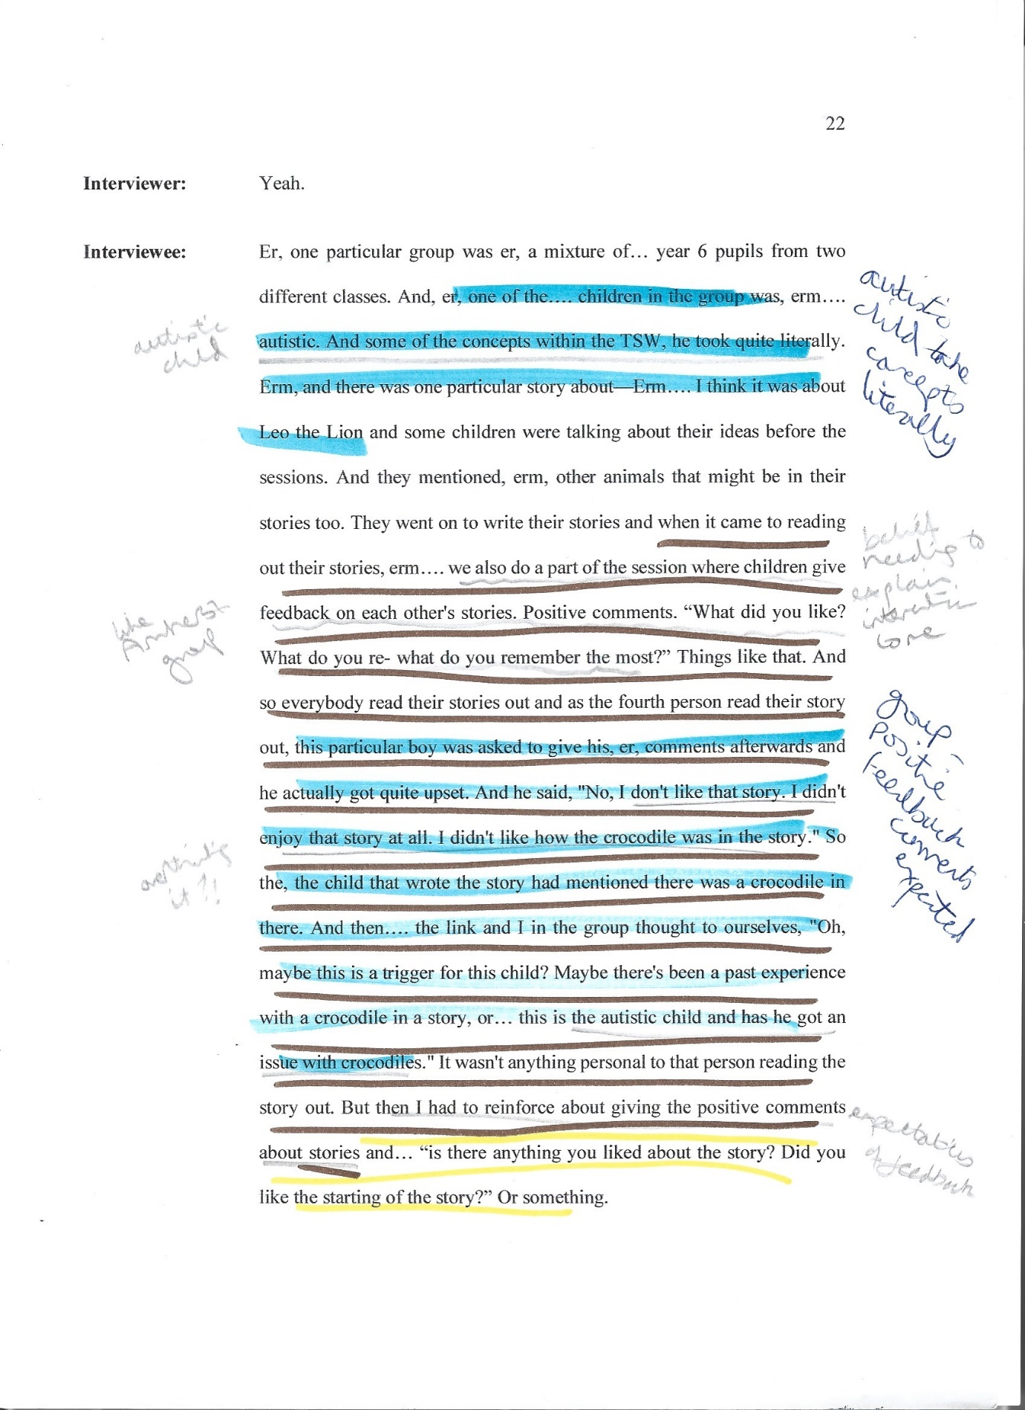

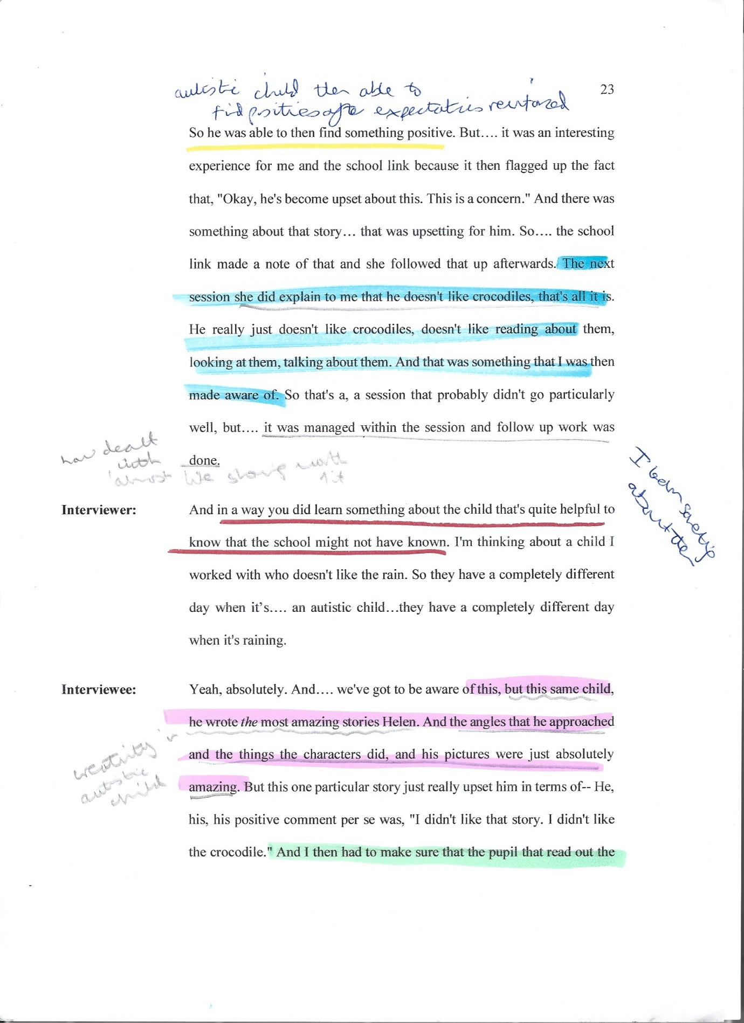

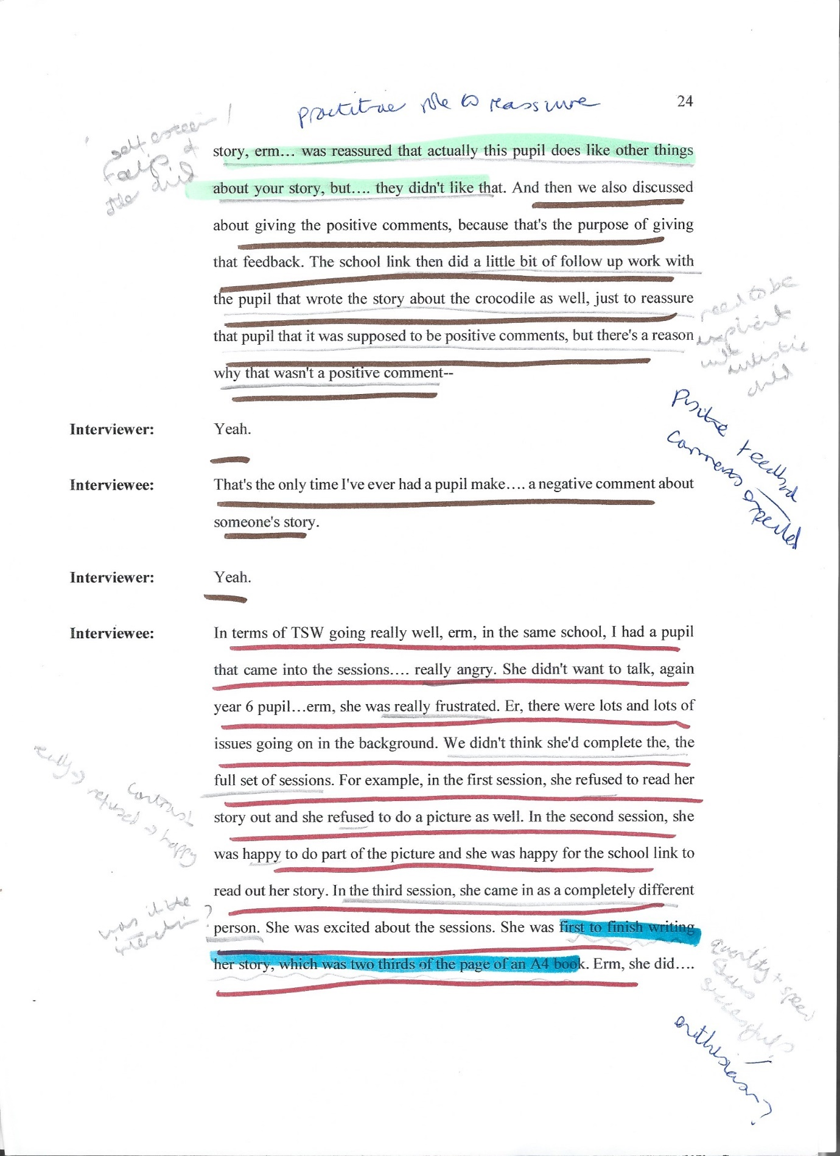

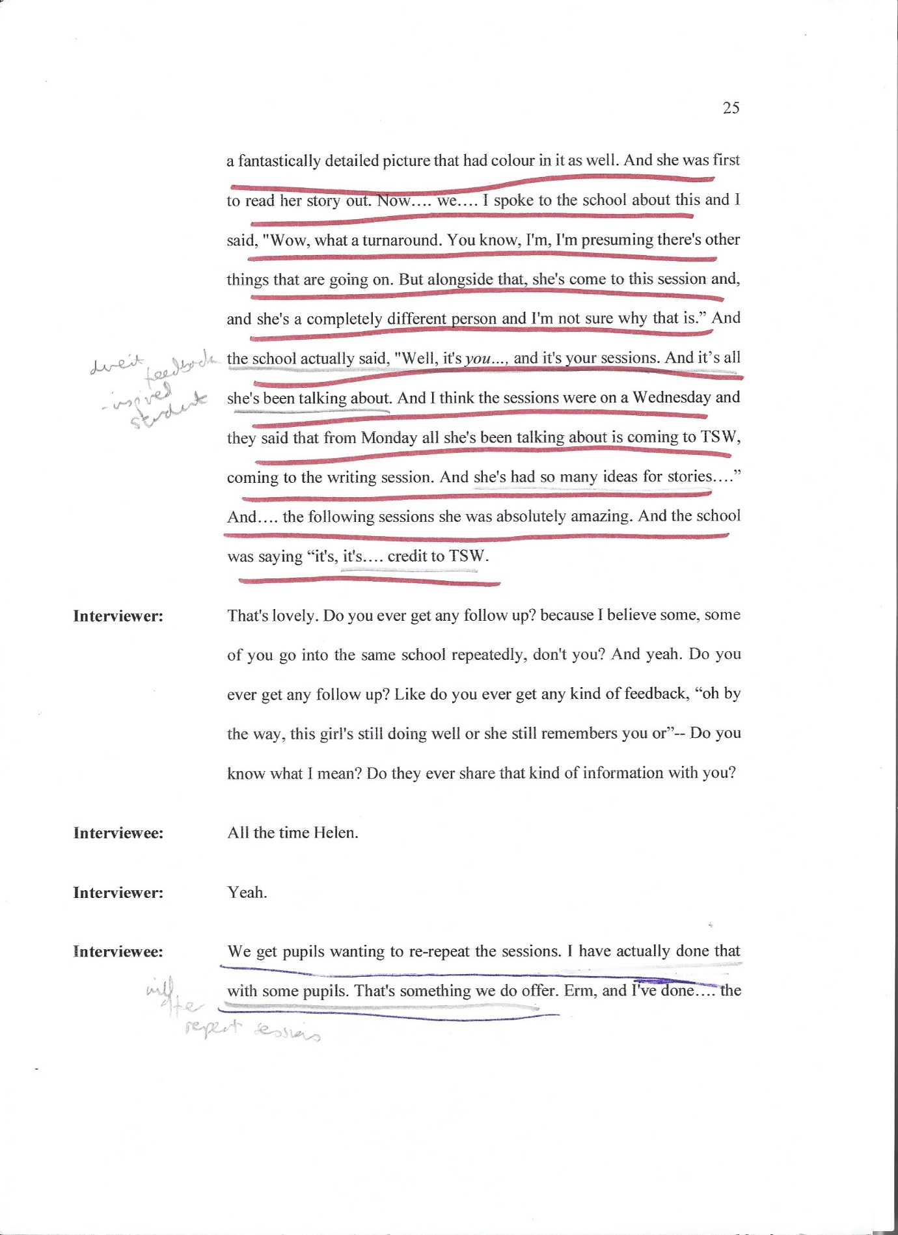

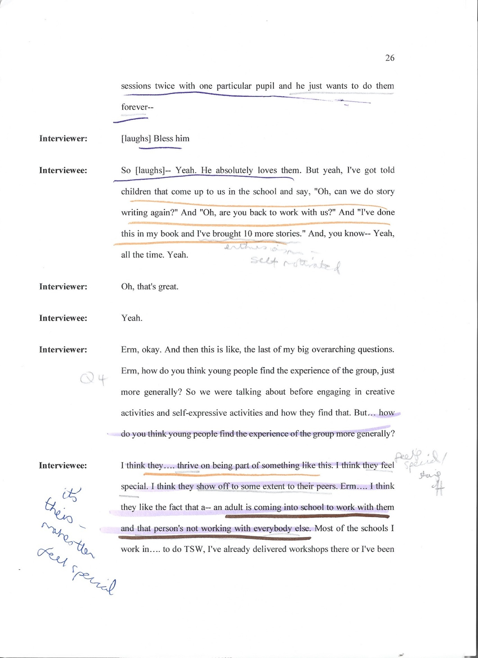

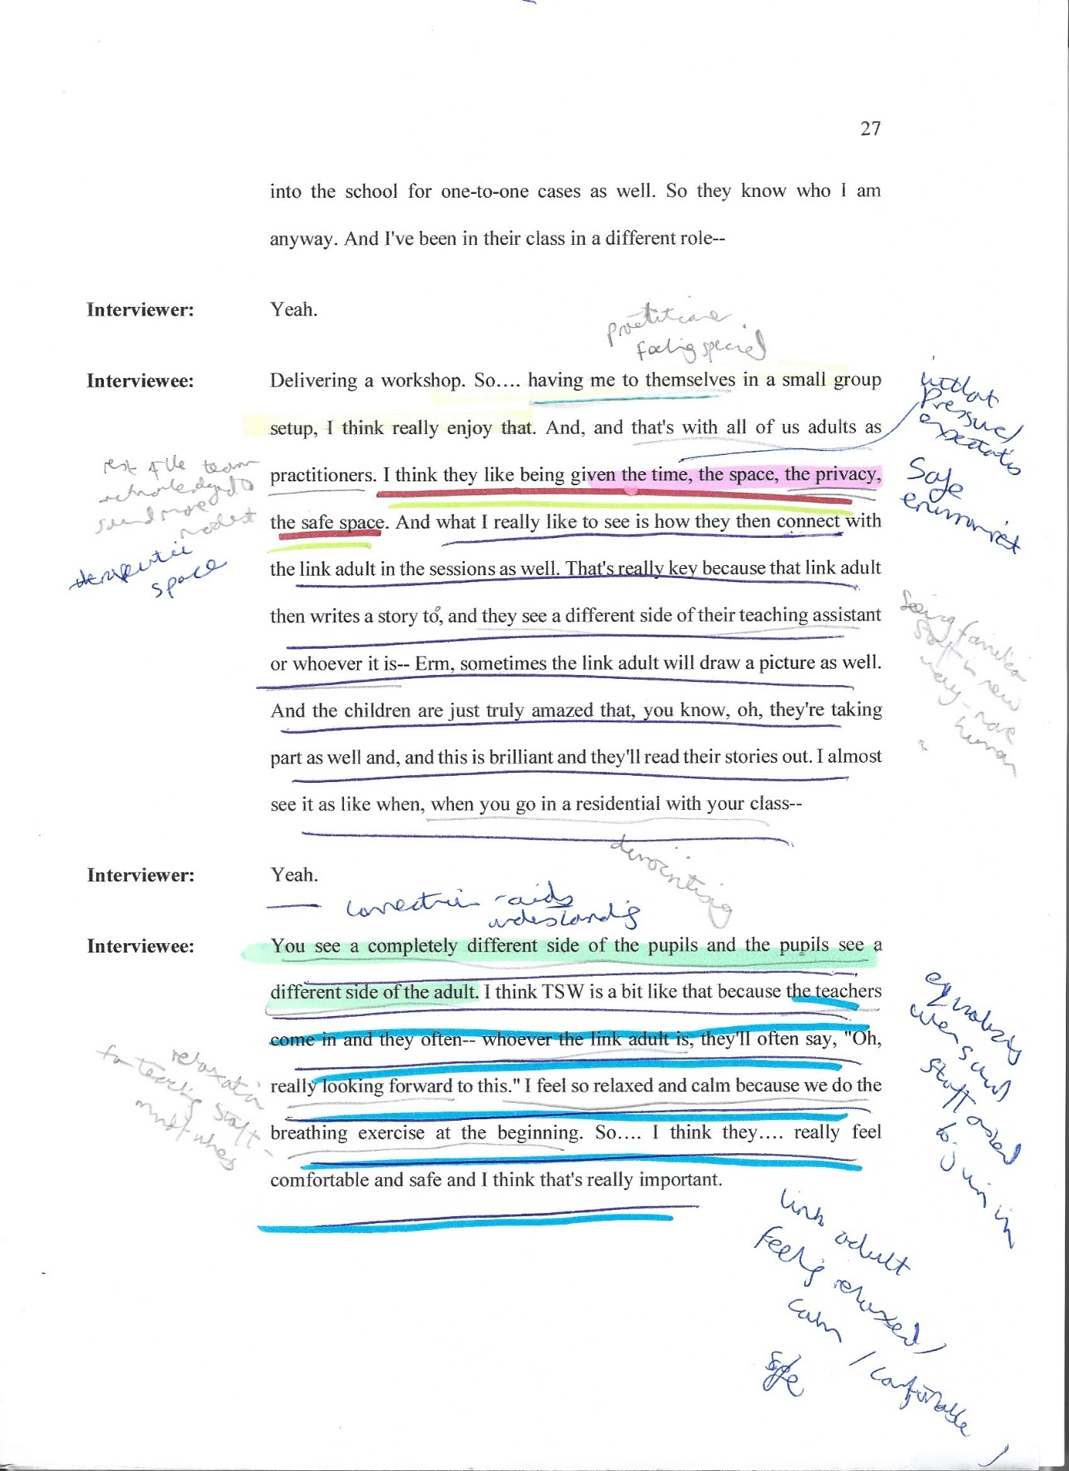

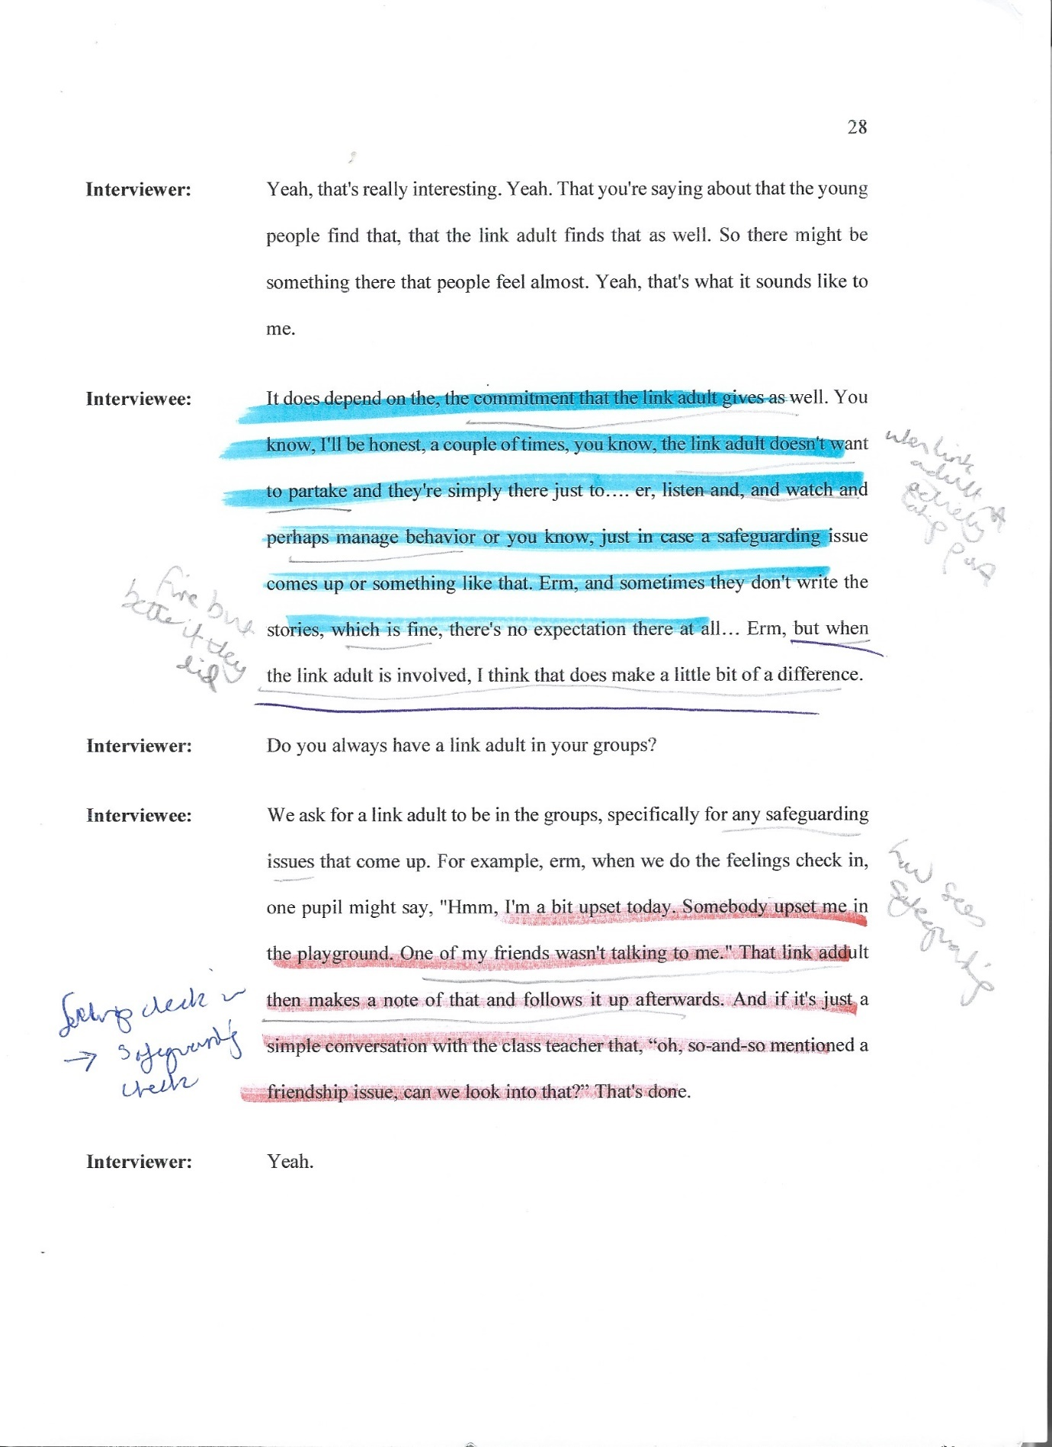

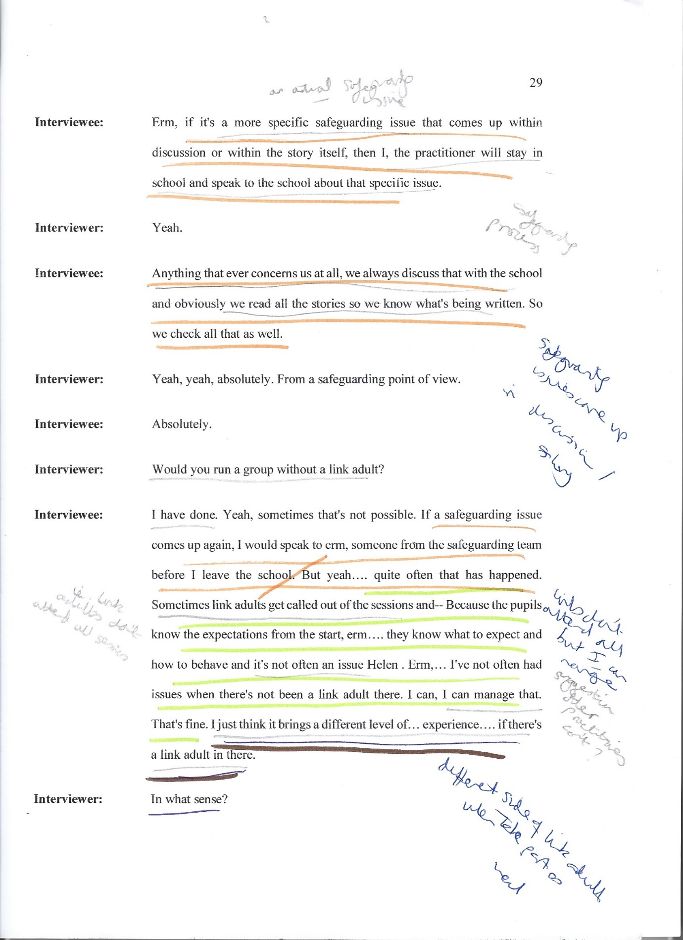

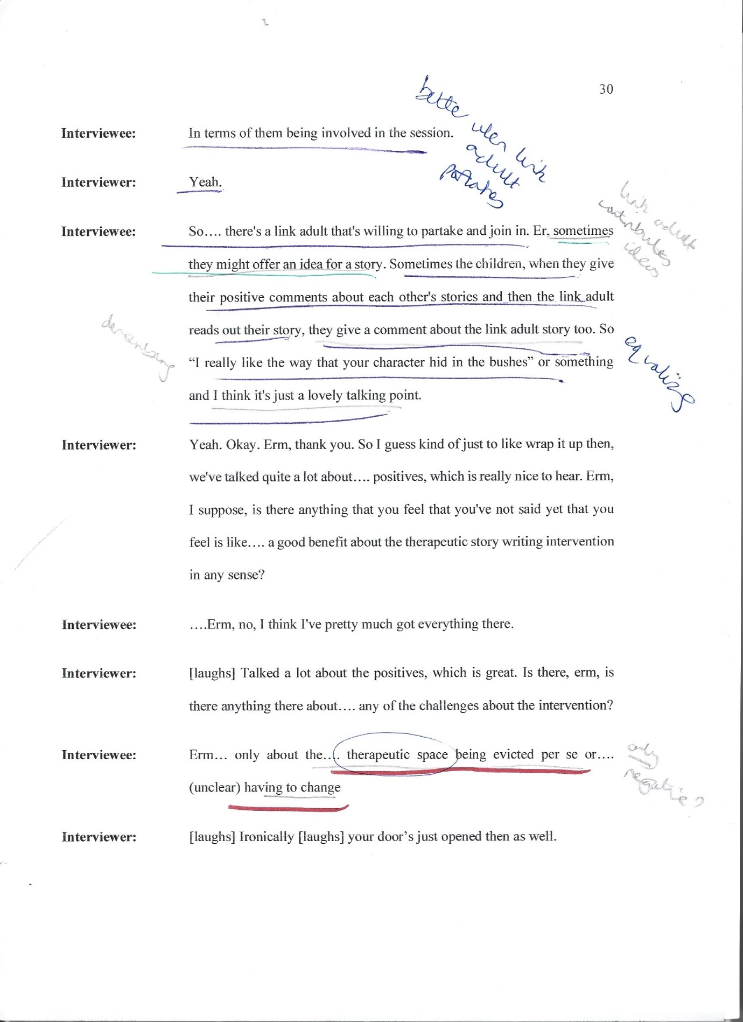

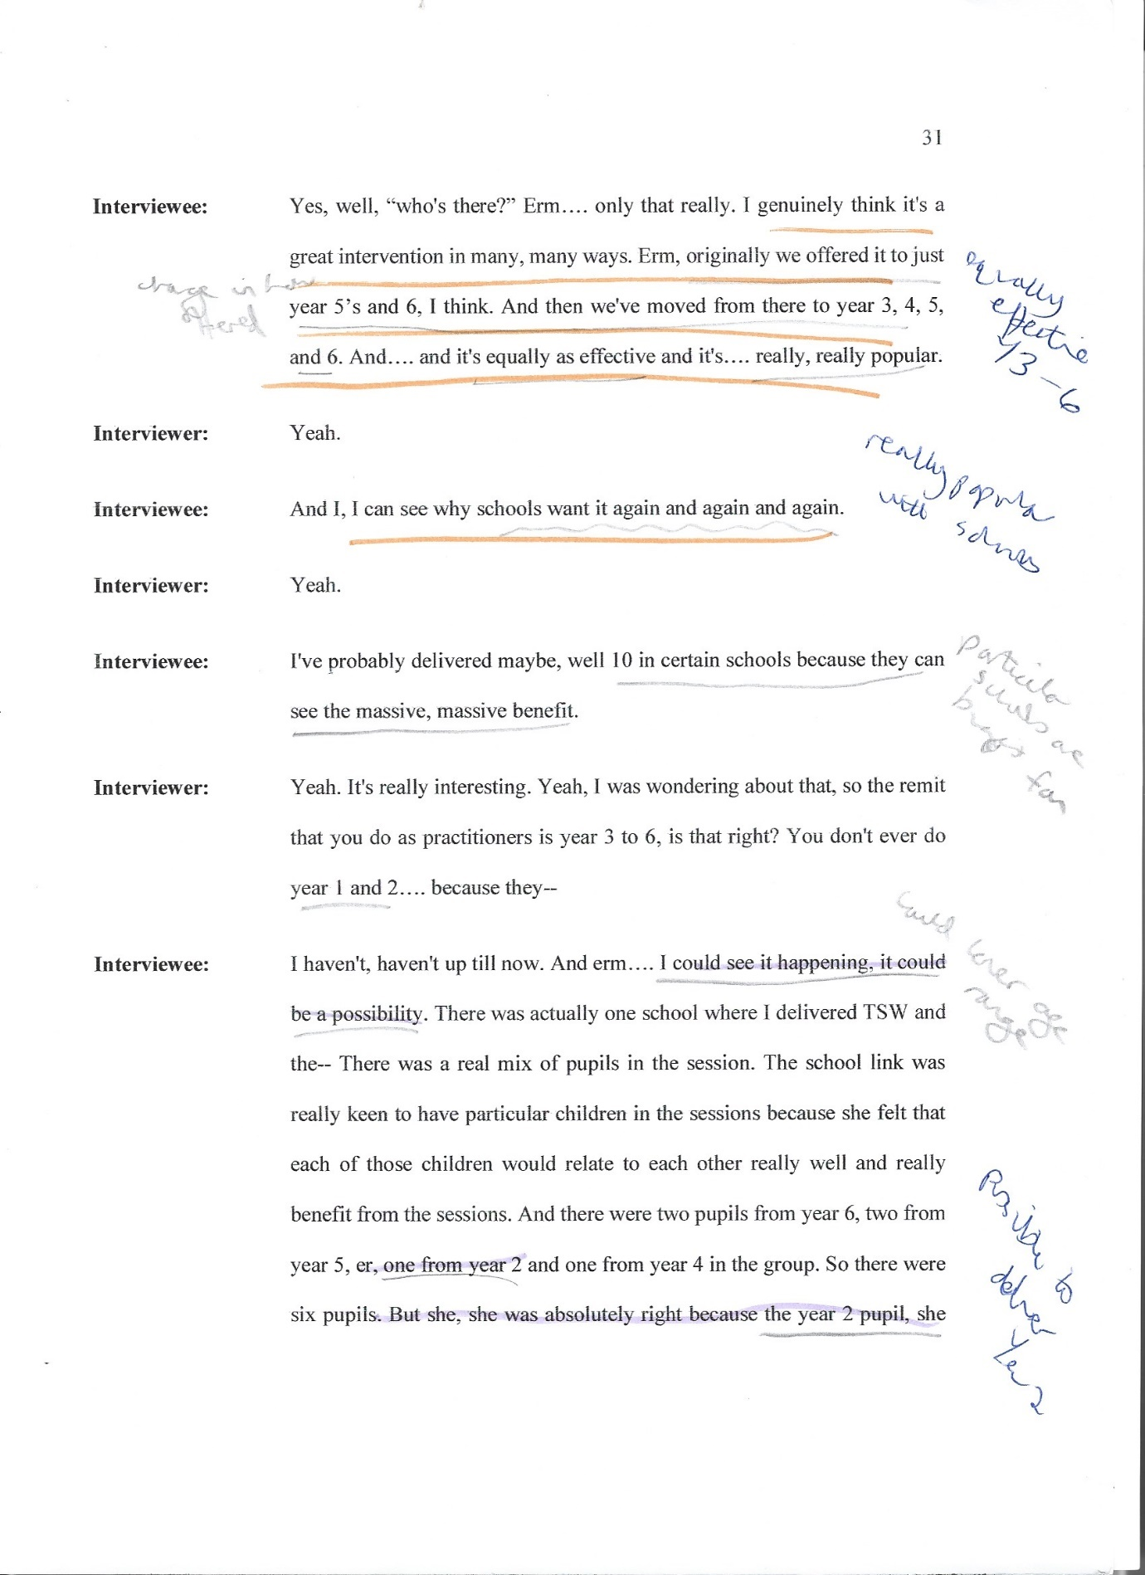

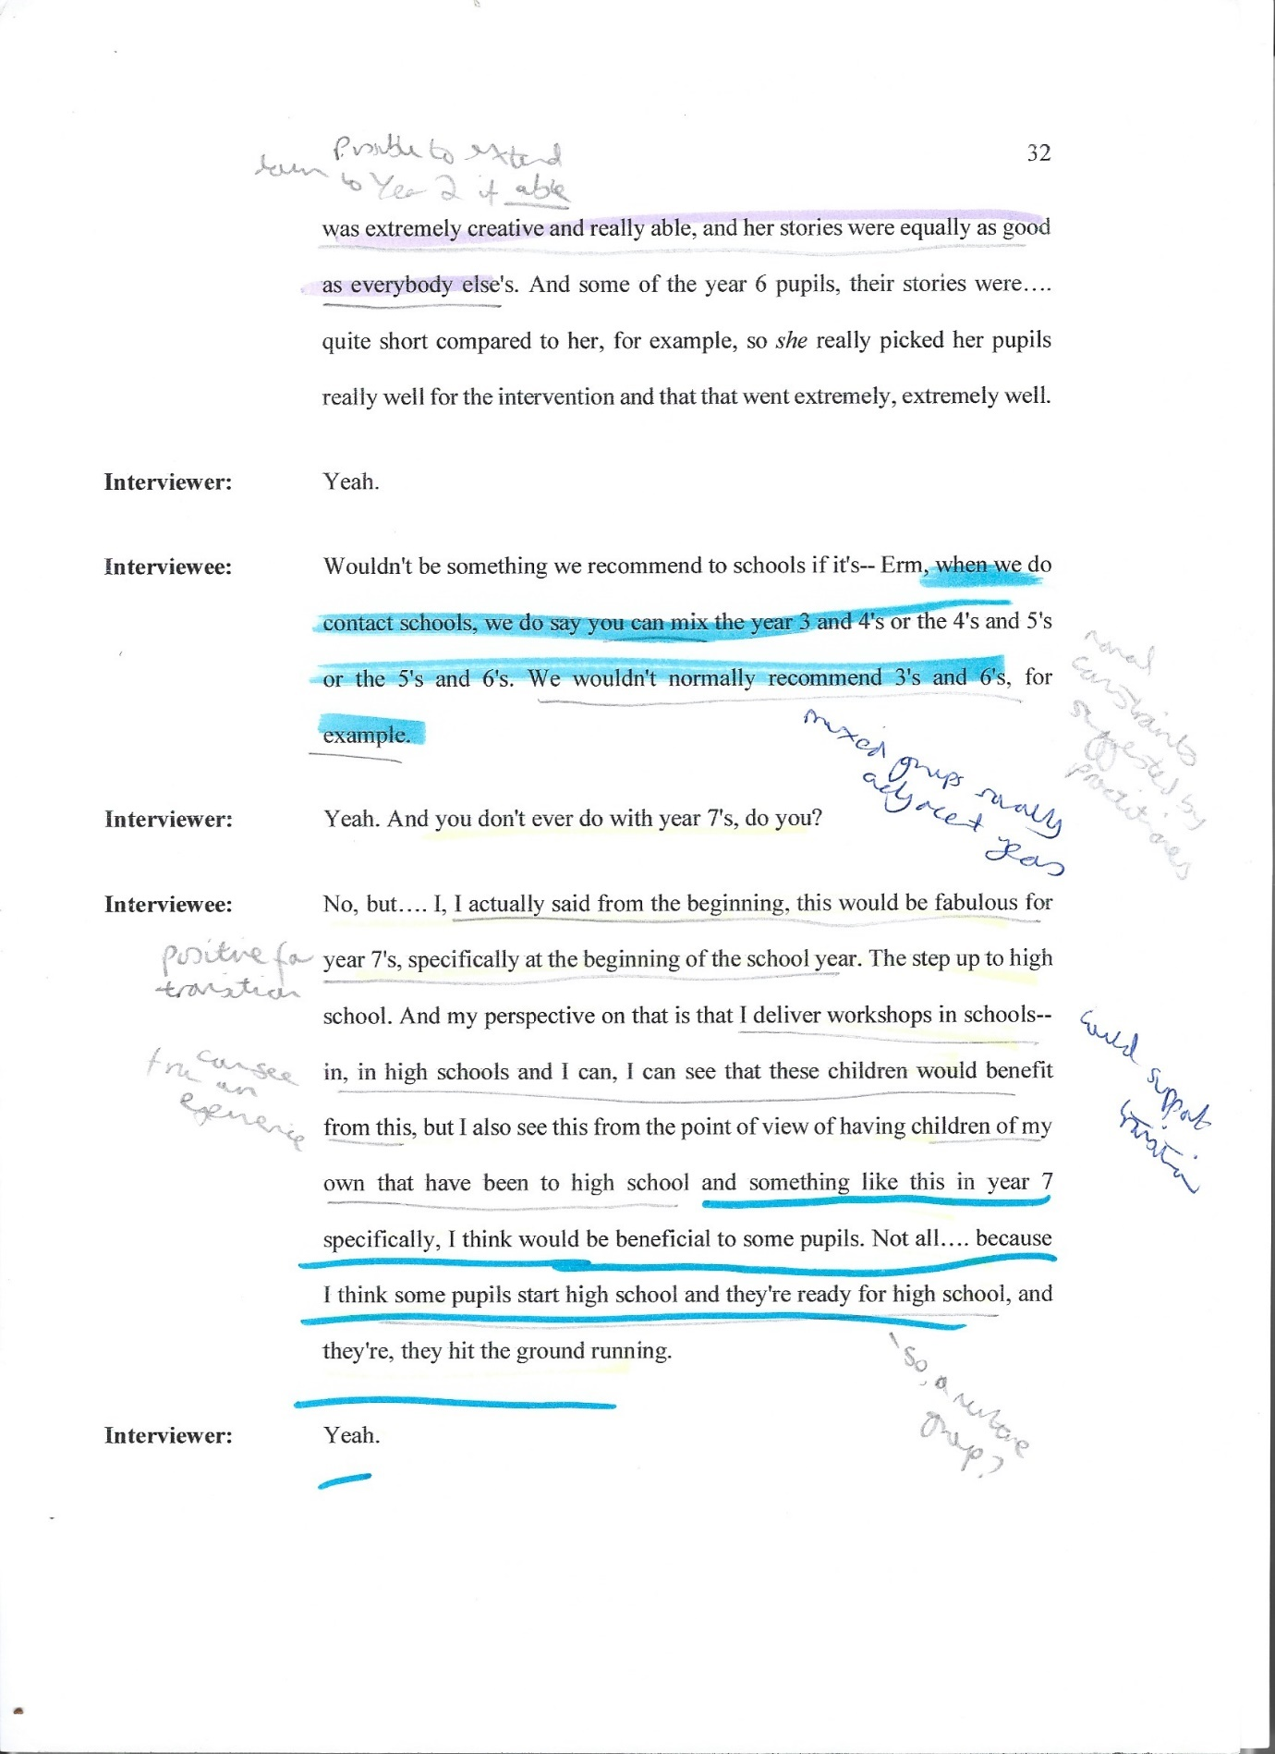

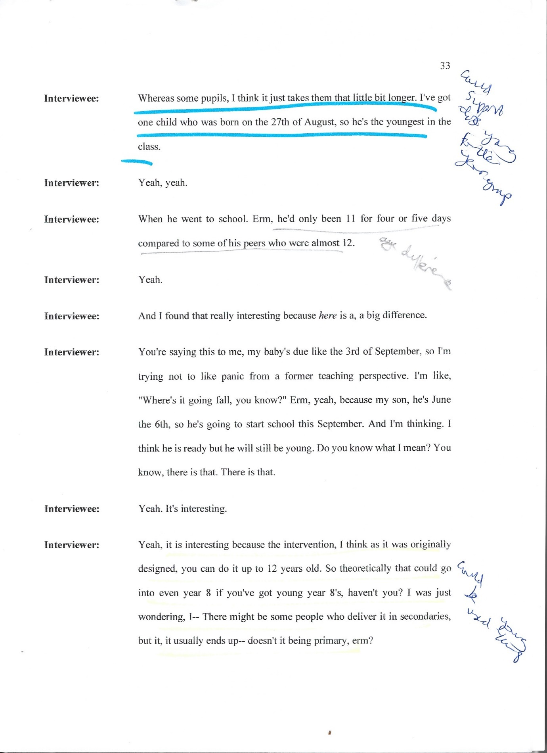

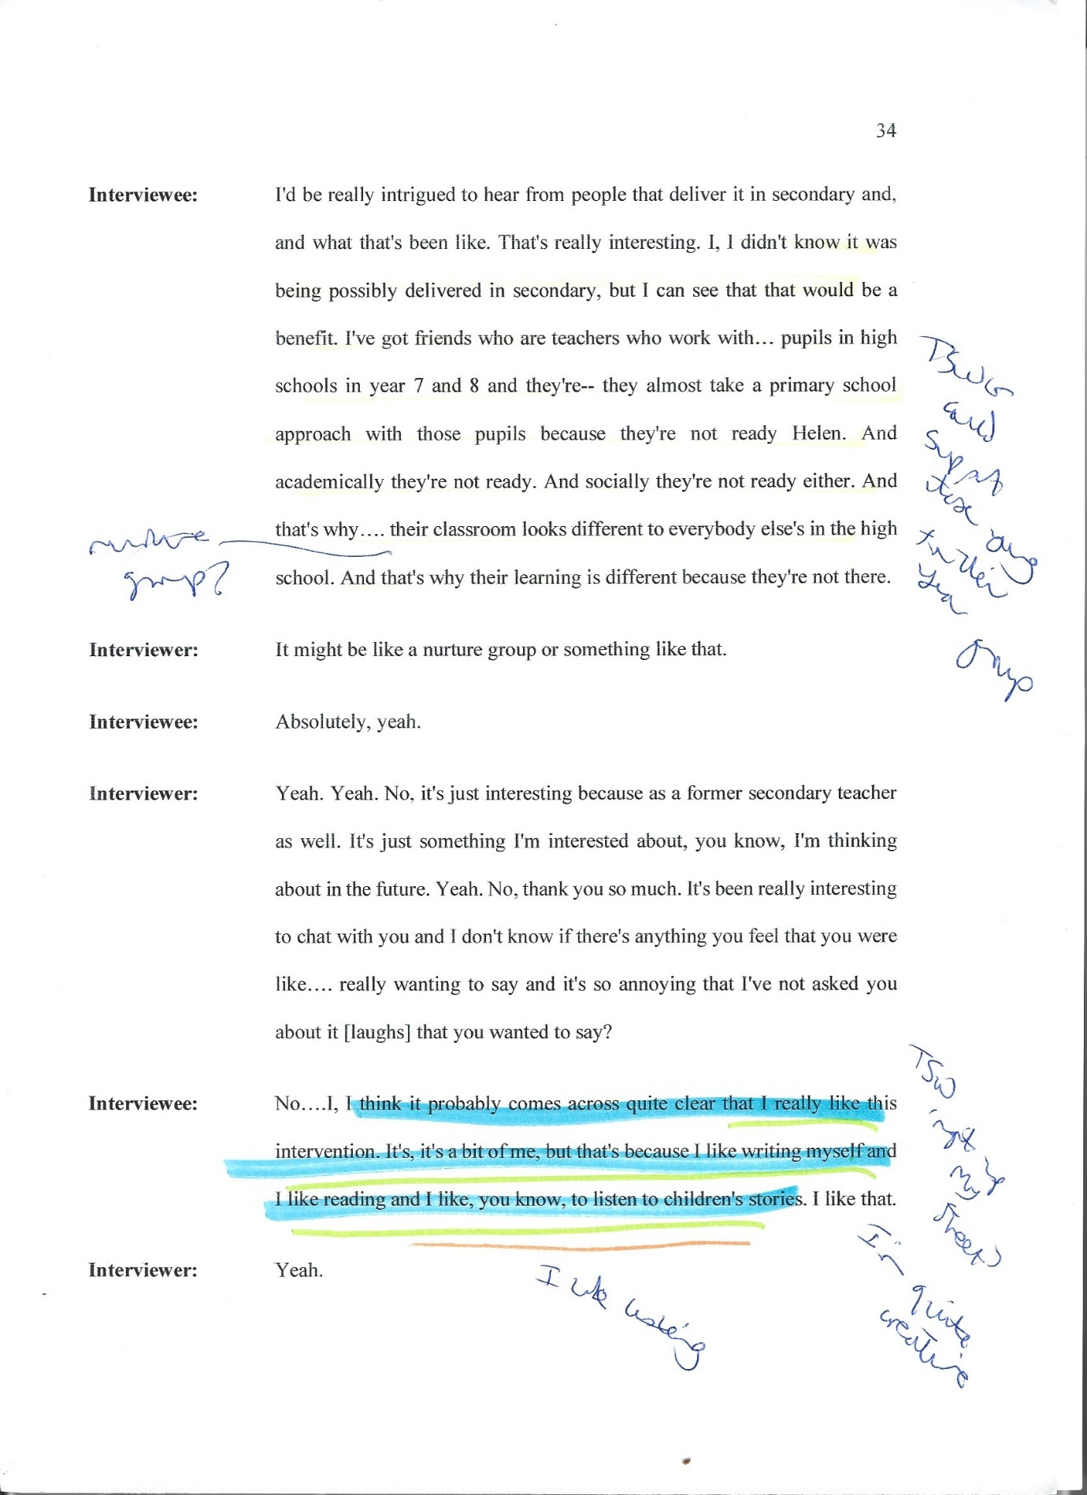

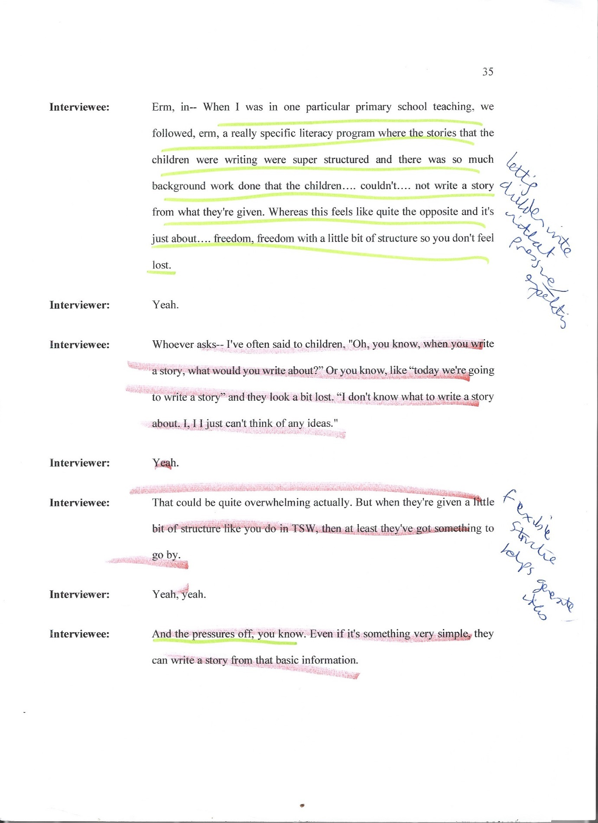

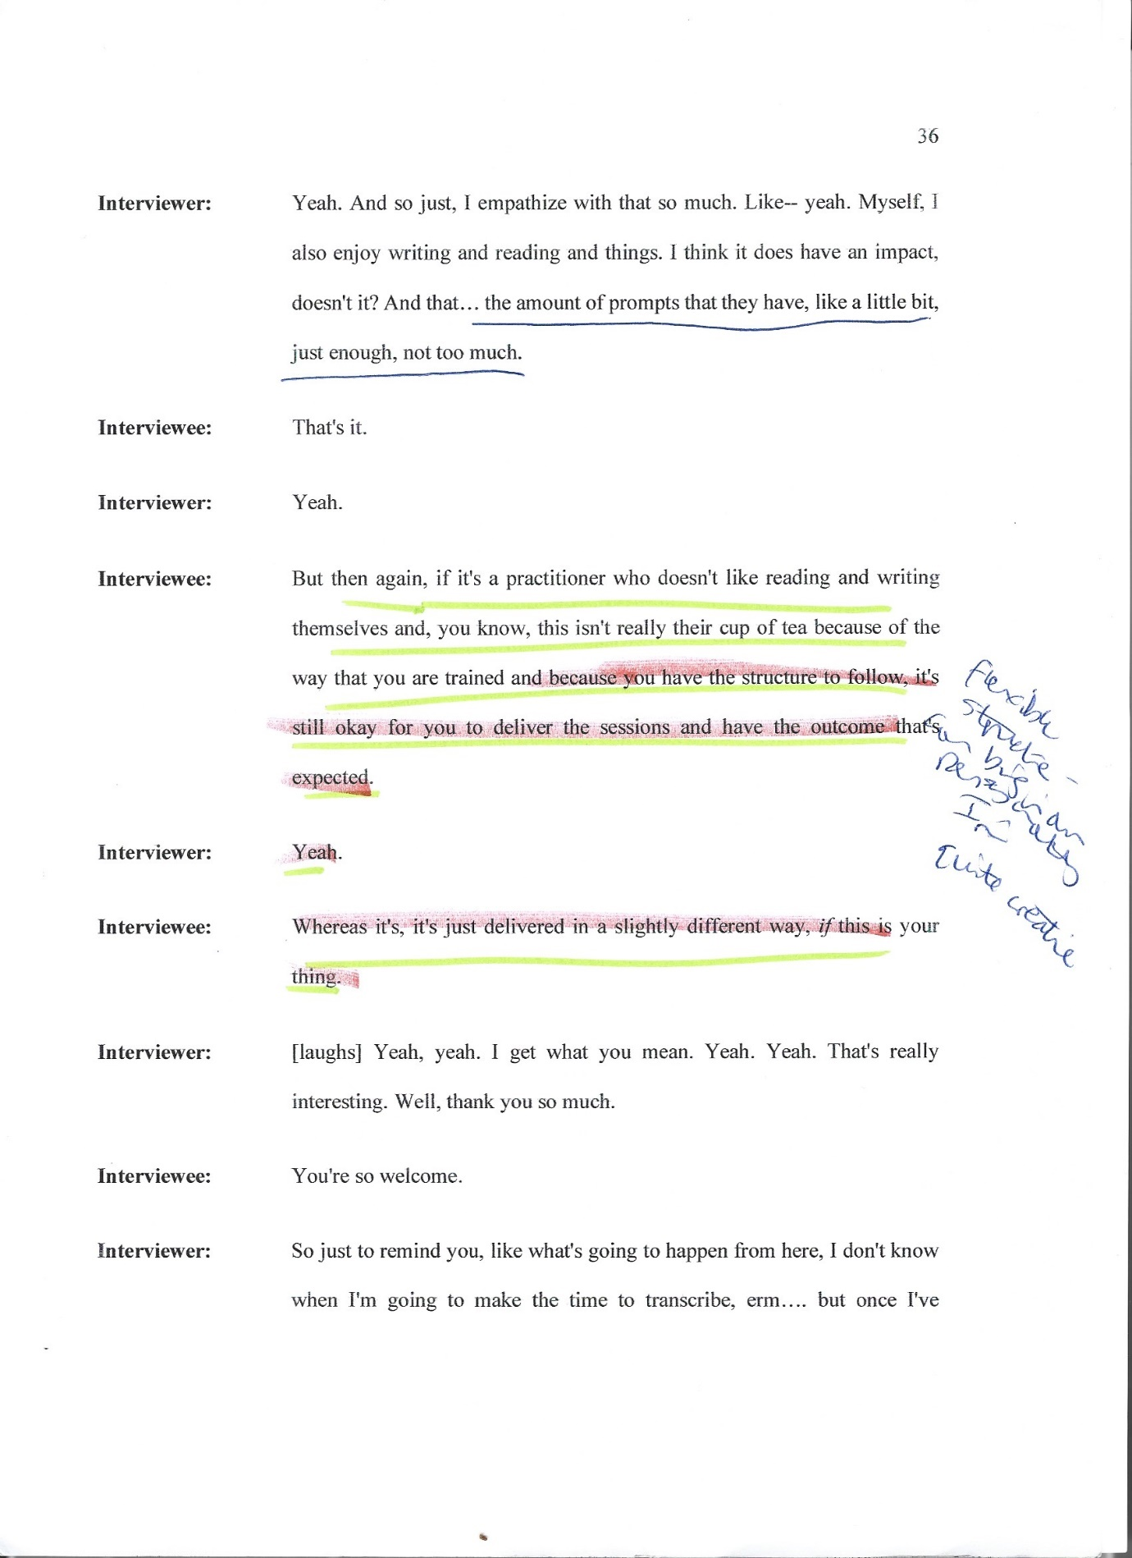

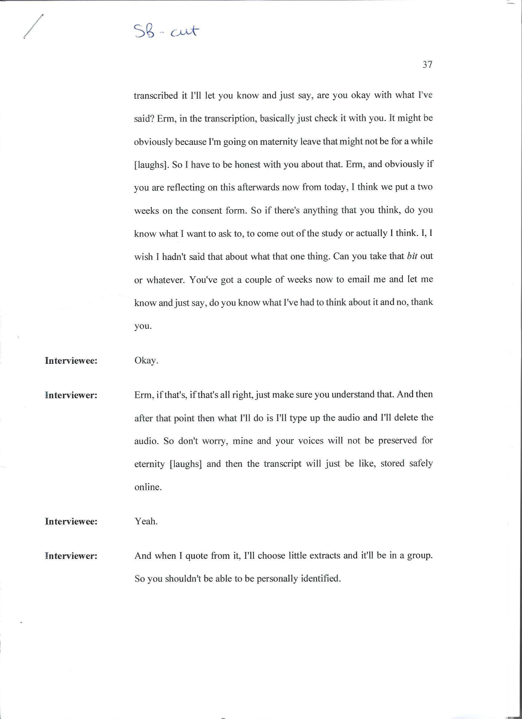

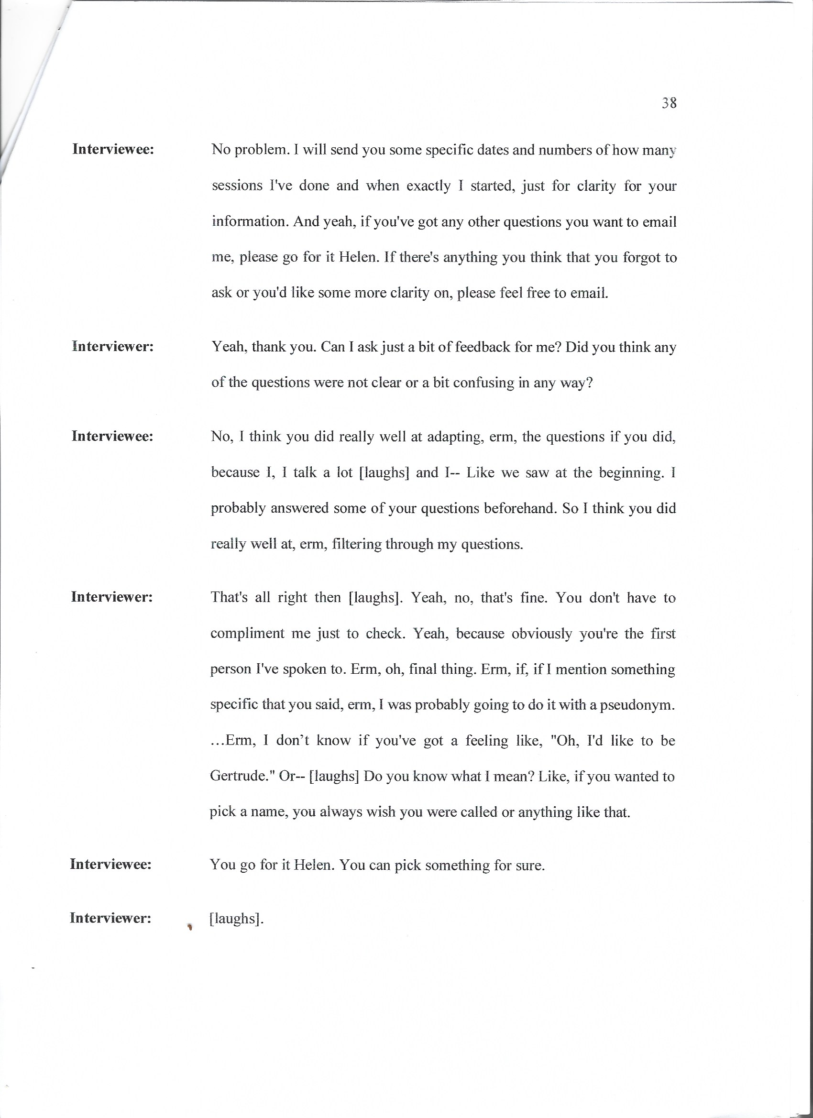

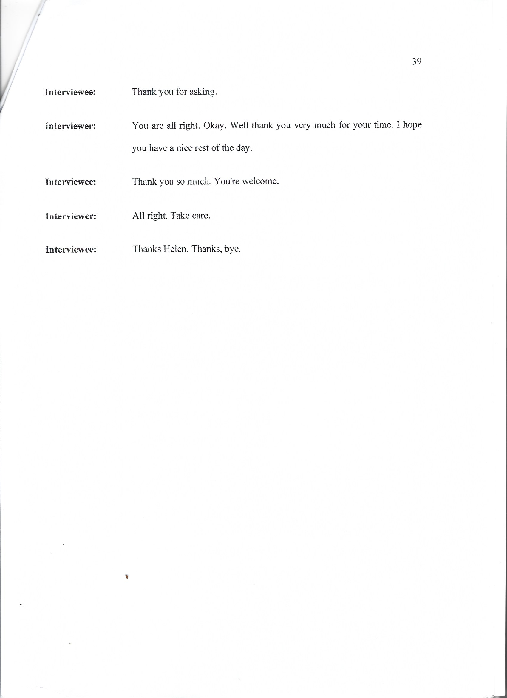

viii: Individual Pen portraits of each participant
What are they called? | ‘Alexis’ – a pseudonym
What are their previous job roles? | Local radio DJ, Primary teacher, Supply teacher
What are their relevant family experiences? | Mum

What are they called? | ‘Caitlyn’ – a pseudonym
What are their previous job roles? | Assistant Psychologist, Speech and Language Therapy Assistant, Rehabilitation Support Worker for a brain injury charity, Teaching Assistant, Support Worker, Qualified Youth Worker, “I’ve also worked in a prison as well in the education department…with young offenders”
What are their relevant family experiences? | Didn’t share these

What are they called? | ‘Freya’ – a pseudonym
What are their previous job roles? | Secondary school teacher, FE College teacher, Teaching assistant, Supply teacher
What are their relevant family experiences? | Didn’t share these

What are they called? | ‘Marj’ – a pseudonym
What are their previous job roles? | 1:1 Primary school teacher, Communication and Interaction lead, Assistant SENDCo, Cover teacher
What are their relevant family experiences? | An autistic younger sibling (14 years their junior)  Parent of young child

What are they called? | ‘Naaz’ – a pseudonym
What are their previous job roles? | Healthcare assistant on acute mental health wards, Psychological therapist, Adult IAPT, Senior mental health practitioner with CAMHs
What are their relevant family experiences? | Didn’t share these

ix: Participant reflection after interview, email 2nd August 2023
“I think some schools staff see TSW as ‘it is better than nothing’ because I see children who are quite complex, e.g. experienced developmental trauma, have attachment difficulties etc and while the staff probably know some of the children aren’t really suitable and need something longer term (play therapy or counselling) I guess they think, it’s free and easily accessible so why not! (or even a box ticking exercise)? Combine these children with the ones that have autism and ADHD – it’s quite a recipe for a challenging 45-60 mins.”

x: An example from refining coding labels
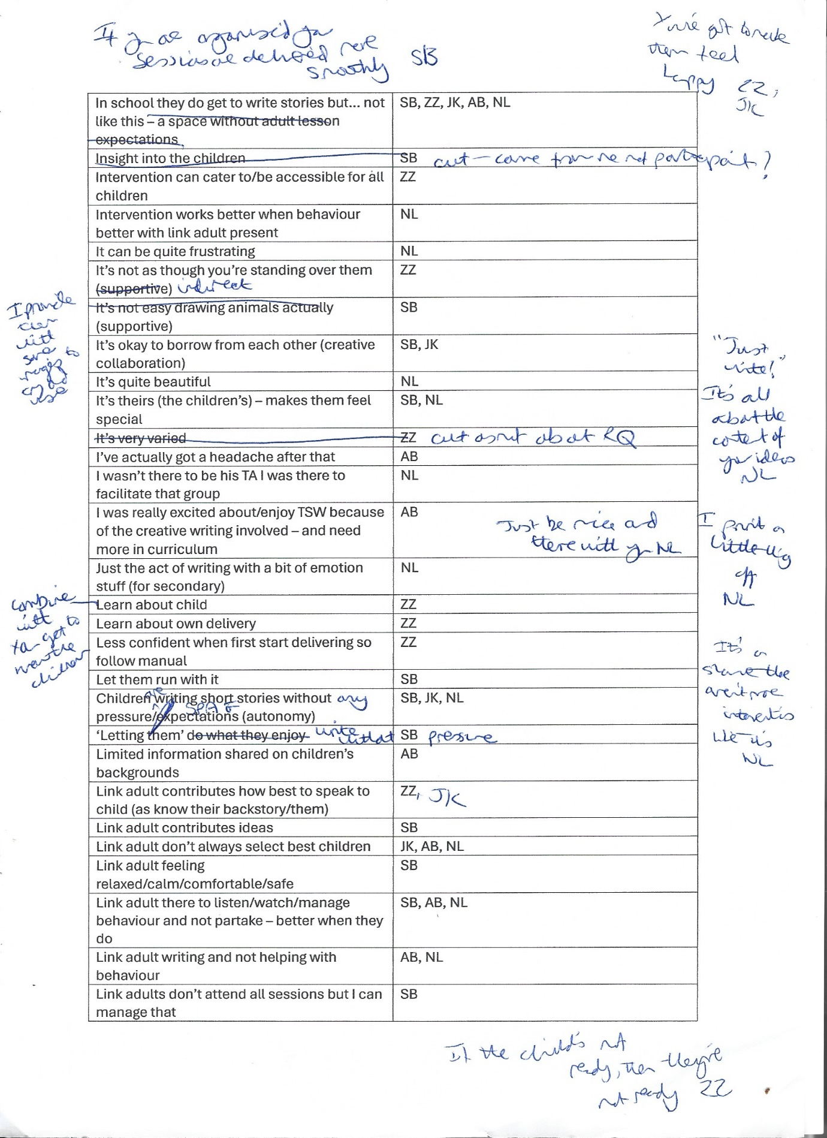

xi: An example of starting to group coding labels into initial themes
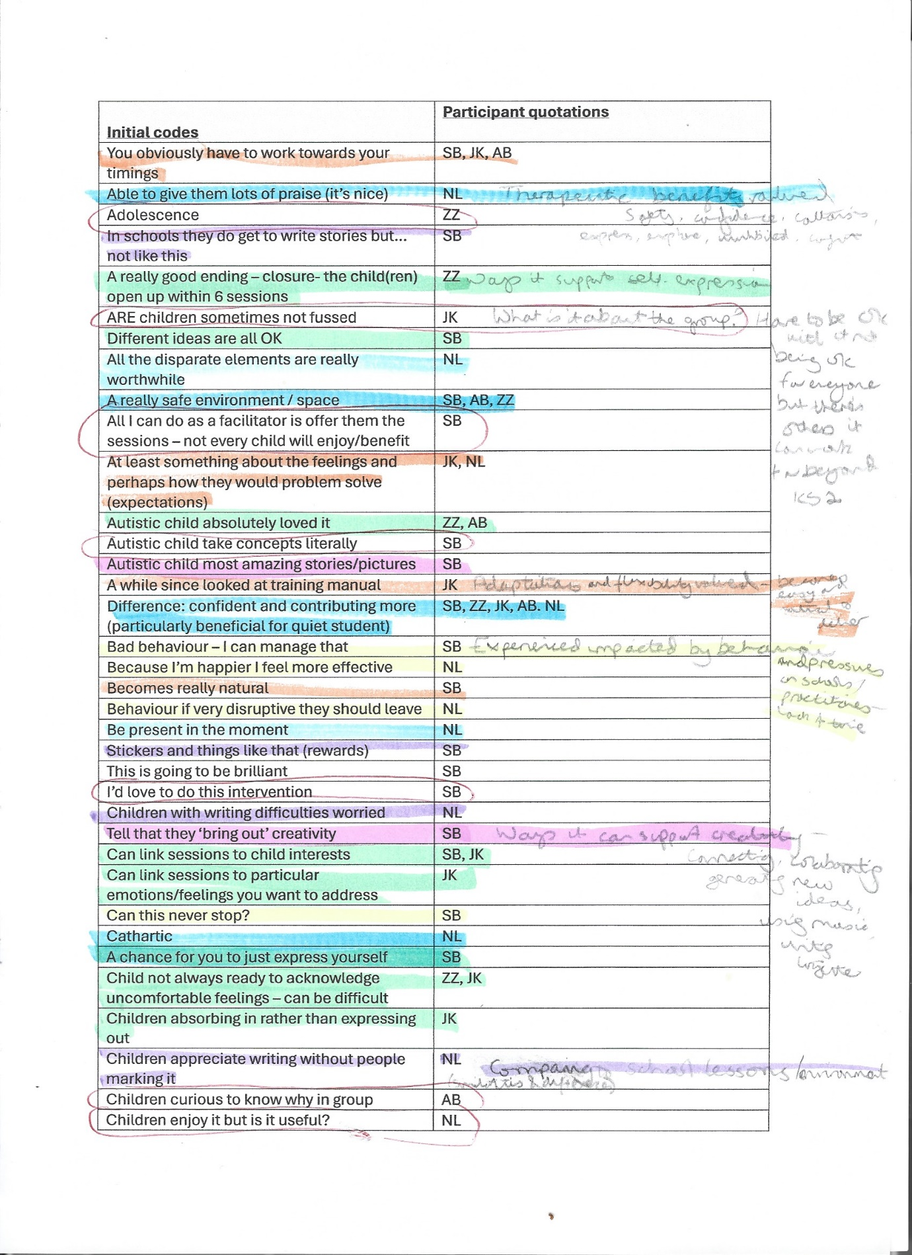

xii: An initial ‘working’ thematic map
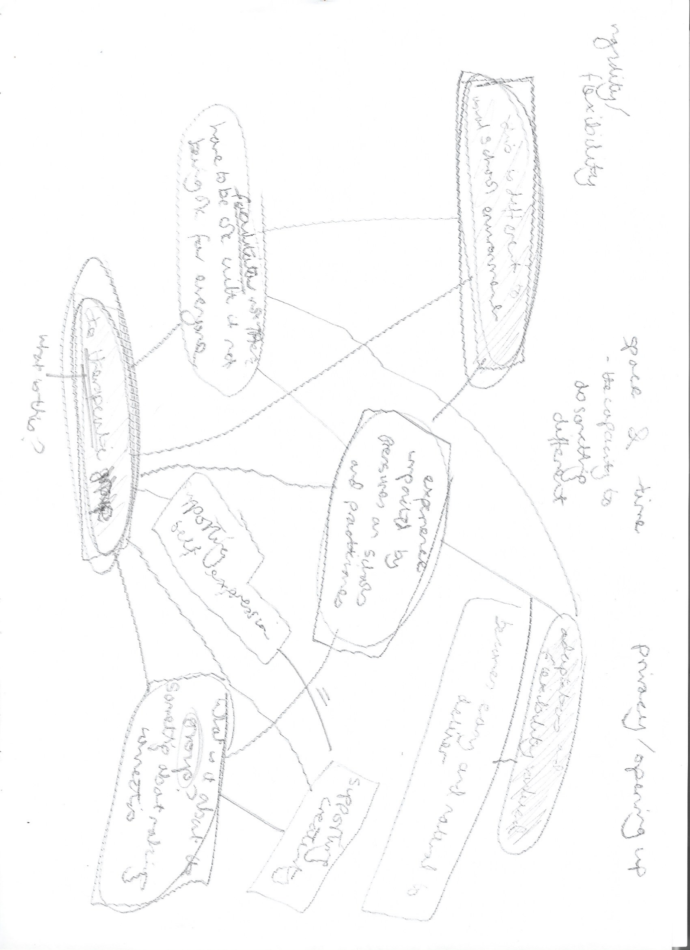

xiii: Theme definitions
(1) Relationship to school culture
This theme encapsulates how TSWGs provide something different for children to their usual school experience, removing an emphasis on technical accuracy in writing that might inhibit children; that facilitators benefit from regular supervision (unlike teachers) but are not exempt from systemic pressures that teachers also experience; and that poor timetabling and misunderstandings of what the group intends to provide can lead to practitioners attempting to manage difficult behaviour.
(2) Relaxing the structure
This theme outlines how practitioners had all adapted the structure and delivery of the intervention to suit their groups and systemic pressures in an EP service time-allocation model and that children are given an opportunity to make social connections and voice feelings or worries that they might not otherwise have in school.
(3) Creative freedom and self-expression
This theme covers the conflicting feeling that giving children autonomy and relaxing some behavioural expectations meant most children were enabled to express themselves comfortably through a process of exploration and externalisation but that there are safeguarding implications to the intervention when children are externalising previously buried experiences.
(4) The group space
This theme outlines how the group felt like a relational space, which promoted equalizing and connectedness across year groups and between children and adults; that children were learning pro-social group behaviours and how to give constructive criticism of creative writing; and how the small group dynamic benefitted some children with giving them more adult attention than they might otherwise be getting in school.
(5) What’s felt to be therapeutic
This theme is all about what practitioners considered a therapeutic space to consist of, and how a therapeutic ending is carefully planned by facilitators; that practitioners valued the intervention for building children’s emotional literacy and suggesting coping strategies; that children’s confidence and wellbeing generally increased during the sessions; and that there was a sense of transformation taking place in most children during the time of the intervention.
(6) Not everyone’s TSG
In this theme (analysis reported below – see 5.10) practitioners spoke about how although the intervention is not considered suitable for all children who access it, there are others, particularly adolescents or those transitioning to secondary school, who could benefit from an adapted version of it.

xiv: It’s not everyone’s TSG
Alexis encapsulated the team’s feelings relating to this theme:
when I'm delivering the intervention, I'm not expecting every child to like this or to enjoy this or to… gain something from this. All I can do as a facilitator […] is offer the sessions to them and give them the opportunity.
For Caitlyn, she felt that groups are “just really varied, different children, different needs, different ability. So, it's a real mixed bag” and, likewise, in terms of children’s evaluations, “the feedback's really variable. Some children… say that it's helpful, er, while some children, quite honest and they'll just say it was boring or they didn't like it”. For her, the positive feedback she had was from “the children that don't tend to have the overtly obvious SEMH needs because sometimes I have children in my group and I just think you are lovely and you don't seem to… need to be here”, but she also acknowledged that they were given limited information on why children were chosen by others for the groups, so she might not know why the children were in the groups but they could have emotional difficulties that they were not externalising and still be benefiting from the intervention. Caitlyn was perhaps the most negative about the groups and wondered “whether they've enjoyed the intervention itself. Or whether they've enjoyed coming out of, I don’t know, geography for 45 minutes, an hour every Wednesday in the afternoon”.
The intervention was not positive for everyone. Practitioners spoke of autistic children who “some of the concepts within the TSW, he took quite literally” and got upset by another child writing about crocodiles or another “boy who I think was definitely, erm, on the autistic spectrum […] got… very upset when other children were talking whilst he was writing his story. And it wasn't quiet like it was meant to be”. However, other autistic children were mentioned by practitioners who really benefitted. Some children with SEMH needs might have a “meltdown” and “storm out”, refusing to engage in sessions. Children with literacy difficulties too might find it challenging, “and it's about just making them feel positive, whatever they've written, even if they've only written…. a really short story that's a couple of sentences long. Other practitioners found these students harder to engage, admitting “it's not great when you get children in there that don't want to write full stop (laughs)” and that “It can be quite frustrating actually because it's therapeutic story writing, not therapeutic picture drawing!”
Younger children, of Year 2 age or lower, might struggle particularly with the writing and laddering their emotions during the feelings check in, since generally “they don't have […] the literacy skills. They don't have[…] the speed to be able to write something […] in such a short time” and “younger children sometimes find that more difficult to… understand where they are in terms of their own emotions compared to [other emotions]”. The intervention was felt to be suitable for those with additional or special educational needs, however. When talking about her own training experience, which took place during Covid lockdowns, Marj reflected that “my bubble of children, a lot of them […] did have additional needs or […] some of them had learning difficulties […] and it worked really well for them”.
Naaz acknowledged how
it can be a really difficult intervention discussing, uncomfortable feelings…Sometimes if the child isn't ready to talk about themselves feeling anxious or ready to acknowledge that feeling in themselves […] They feel so uncomfortable with that emotion that they do not want to go anywhere near it. So at that point, they'll say to me, "Oh, can I change that feeling?
Naaz had also gone back to school links after having a child who might be “wreaking havoc” and “throwing things”, “doing everything to not engage”, and had come to the conclusion that “if the child is not ready, then they're not ready. There is nothing that you could do as a practitioner to force that child” and instead had advocated “let's see if we can do some scaffolding work so they are ready in the future."
When reflecting on children who are not currently accessing therapeutic story writing many facilitators spoke of extending the intervention to adolescents, particularly “those children who perhaps have additional needs socially and emotionally, but are able and capable to write, erm, that perhaps are not at the, erm… social emotional age as their chronological age”.
A nurture group approach was similarly referenced by Alexis, who spoke of “friends who are teachers who work with… pupils in high schools in year 7 and 8 and […] they almost take a primary school approach with those pupils” and how these children could benefit from therapeutic story writing.
For all children, going through primary to secondary transition, and puberty, where “you don't want them to be bottling up these feelings because they don't know how to talk about it”, as well as GCSE exams, were seen as potentially relevant topics for therapeutic story writing with older children. Naaz emotively spoke of it being “something that annoys the school links as well” that the intervention is not offered at secondary level. When wondering about what this could look like various suggestions were offered, such as “surely just the act of writing creatively, yes. With a bit of emotion stuff in there… would be beneficial? It doesn't have to be all about the story and the metaphor” and that you would “make it relevant to [older children]”. Naaz was clear that the intervention could continue to be for those “struggling with their feelings” and voiced my feelings on the topic:
My biggest, erm…. Annoyance with this is that it just stops at a certain age group. And it doesn't consider that […] all the children, even adults will struggle with their feelings, uncomfortable feelings. And this is a fantastic way of expressing those. Yeah. It might not be suitable for all, you know, secondary school kids, but it's not suitable for all primary school children either…[…] I think […] the intervention really needs to be reviewed and say, "It's doing a fantastic piece of work with the primary kids but what can we offer to the secondary school based on […] the core principles of […] TSW, what can we do and how can we adapt it?" You know, there's... like I said, the kids that we have coming through on the one-to-one basis for secondary school […] if you had a TSW, you could easily process your emotions a bit more. You could feel a bit more comfortable, but it's not on offer…I think it's […] something that an annoys me personally […] I think the target audience needs to be expanded. And I think they need to look at this as, you know, if it's worked so well in primary, what can we do with secondary, what can we do with adults? […] You know, the sky's the limit. How can we help, help people out there that are struggling?
Although the group story writing was not beneficial for all children it was currently being offered to in the LA, all practitioners I interviewed felt it could be used with adolescents, if adapted. The ways it could be used with this age group were suggested to be enabling expression and processing of feelings they were struggling with, writing creatively, and making the topics relevant to them e.g. transition, puberty, and exams.

xv: Excerpts from my reflexive journal
15th February 2023: Garnering thoughts on research from fellow TEPs. Possible topics - How do participants make sense of the ways children can make sense of their experiences using therapeutic story writing? Maybe change TSW to expressive writing? Just asking participants what is the active ingredient that makes this therapeutic for children- is this for the adults to say? Trying to work out what the active ingredient is - is it relational? Task? Space? Knowing why it’s popular may support wider intervention development. Does it need to be limited to only TSWG practitioners? Can it be anyone who is supporting creative writing for a therapeutic purpose? Do multiple LAs need to be included in the sample to make it less political? Is the aim to capture stories of delivering TSWG? Not seeking to make generalised claims. Positionality reflections, where am I?!
- There are REAL things at play, like politics - critical realist?
- The focus is asking individuals about how they make sense of what MIGHT be going on… social constructionist?
- Talking to adults about their experience - valid for them…which does feel very relativist…experiential….
- Can you be a critical relativist?
- Quote by Potter “ontologically mute” - that is a legitimate position.
- Relational ontology? Not so much Potter ‘ontologically mute’ – for something hard to pin down where don’t want to adopt a fully relativist position if feels uncomfortable for social justice, need to speak to real inequalities in the world, but how to speak to that can be complicated – Gergen and how the relational plays out… more value in looking at relational ontologies than Potter’s mute ontology?
6th April 2023: Making adjustments and resubmitting the ethical review. The joys. Important to get this bit right of course ethically, even if edits are for things like typos in the School of Education address. Ho hum.
13th June 2023: Positive feedback from attending triage/team meeting of EEWPs – one participant emailed straight away! What a relief after all those TEP Year 3 presentations about the difficulties of recruiting. Hope people aren’t too pressured by line manager – doesn’t appear to be. Seem genuinely interested…
2nd August 2023: A participant has emailed me further ‘after thoughts’ after online interview – check with supervisor if and how these can be included in thesis write up.
17th August 2023: Maternity leave – recommendation to stay engaged with the data, aiming for 3 x 40-minute sessions a week, around the baby… Will I be up in the night, coding?!
30th August 2023: Hilarious typo profanity already noticed in transcription…oh dear, I shouldn’t be howling at my own ineptitude, but I am. Baby any day now…
13th May 2024: Familiarisation - Participants are speaking of children not wanting the intervention to end. Too few sessions but all delivering in their own way. Interesting how personal/personalised it has become… Caitlyn is less enthused and more critical – how to ensure analysis is at the level of group meanings yet the roles each individual has played impacts… Also, is there too much of me in interviews? Should I do a PEN portrait of myself? Thoughts for research tutorial…
14th June 2024: Will I ever find time to analyse whilst on placement? I hope the new authority will give me more time for this. I really need a dedicated block of time… Time, and space… Isn’t this what my participants talked about? Ironic. At least coding means stationery, and lots of it.
5th August 2024: I’m spending my birthday coding! Each to their own but it brings me a sort of joy, I guess. “Stories about magic, stories about Macdonalds…” I love this quotation. Could be a theme name?
10th September 2024: Do you think it's acceptable to name a potential theme after an Oasis song?! Wondering about 'Whatever' since the lyrics seem kind of apt for creative self-expression... What about that bit from ‘The Simpsons’? “Won’t somebody please think of the children?” by Helen Lovejoy, or was it Edna Krabappel…? 2 sides of the same coin. Am I getting too pop culture now?
23rd September 2024: I've got 6 candidate themes currently - is that too many for a thesis? Braun and Clarke are so vague on this…
26th September 2024: Analysis thoughts: there's something there almost intangible in the atmosphere, participants talking about the beingness and relational space of groups – not so much what did (transactional) as shared in the time together… One of most interesting aspects of analysis perhaps, and unanticipated but wondered at before I even started this, back when I was facilitating creative writing groups using the Amherst method…
7th October 2024: Argh, am I over the word count already? Why did I choose qual?
25th November 2024: I’ve spent about a year and a half with my ‘data’ – the captured thoughts of five practitioners, and I’ve sent a draft of my analysis and discussion to my supervisor. Feels like a release and a loss at the same time. What will life be like, after the thesis?
19th May 2025: Viva amendments – what is major and what is minor and how do you draw the line?! What a surprising pleasure to be examined and discuss the thesis, even if I tended to agree rather than defend quite often… As I expected, my themes require retitling. I wonder how Braun & Clarke would respond to this, and requests to make my own personal circumstances pragmatic constraints more transparent? But on the whole, I do agree, the theme titling does need to consider reader understanding, rather than my own creative preferences, which are tangential to the research. I still needed to have a bit of fun with the theme six titling though, punning off a British idiom.

