Performing Tradition And Creative Practice Through Instrumental Folk Music In Contemporary England

PhD Submission

Nicola Beazley

Department of Music
University of Sheffield

May 2024

Abstract

Using the framework of the theory of gesture, this thesis discusses the ways in which contemporary, professional instrumentalists navigate notions of expectation from within their traditional communities, to demonstrate individual creative practices. Using instrumental folk music from England, with a focus on professional output since 2000 as a case study, and building on my pre-existing knowledge and experience, this research analyses creative practices, which include, but are not limited to, writing contemporary folk tunes, arranging contemporary folk tunes, and editing and arranging pre-existing or traditional folk tunes. These creative practices stem from the concept of a gestural toolbox from which individuals learn the stylistic features enacted in their creative practices. Having identified elements of instrumental folk music that are stylistically unique to England, through the use of interviews, surveys, musical analysis and a commentary composition process, the idea of gesture as a creative toolbox establishes various key themes. These themes include notions of regionalism, nationalism and individualism in style, interactions between change and notions of tradition, the relationship between professionalised folk music and its community, and a discussion of what constitutes both conscious and unconscious creative processes.

The data presented in this thesis contextualises both contemporary English instrumental creative practice, and style, within the various forms of community presented, such as professional communities, forms of regional and/or national communities, digital communities, and pocket communities. This research examines elements of musical style that are unique to contemporary instrumental folk music from England and demonstrates that the contemporary English creative practices that are presented form part of a traditional culture that is based in change.

Acknowledgements
This research would not have been possible without the ongoing support, expertise and enthusiasm of Professor Fay Hield. I owe a big thank you to Fay and Dr Andrew Killick for their encouragement throughout this process, and for shaping the research into the final thesis. A thank you must also go to Dr Julia Bishop for her support and feedback, which went beyond the expected, but for which I am grateful for her input.

A huge thank you needs to go to all the participants of this study, especially the core interviewees who lent their time, knowledge and support to this research:
- Bryony Griffith, Alex Cumming, Grace Smith, Rob Harbron, Kathryn Tickell and Pete Judge.
A particular thanks to both Alex and Grace for their trust in me, as I used their creative ideas as a testing board - I’m very grateful for your help. Likewise, the support and enthusiasm that the survey was met with was indicative of the support given by many on the folk scene, particularly in Sheffield, whose ongoing support was much appreciated.

A final thanks go to my family, my lovely mum and dad for their constant support, and to my wonderful husband, Andy Watson, for his ongoing patience, kindness and support in all things from conceptual ideas to data presentation. But mostly for his encouragement and assistance in his care for our little Finlay, who has provided many a joyful distraction.

Table Of Contents:

Abstract 2
Acknowledgements 3
Table Of Contents: 4
Table Of Figures: 9
Chapter 1. Introduction And Rationale 11
1.1. Aims And Research Questions 12
1.2 Historic Context For The Contemporary Folk Scene In England 15
1.2.1 The First Folk Revival: 1890s -1920s 16
1.2.2 The Second Folk Revival: 1950s-1970s 20
1.2.3 The Resurgence: 1990 – Present 23
1.2.4 Professionalised And Globalised Folk 26
1.2.5 Instrumental Music 28
1.3 The Importance Of Individual Creative Practice In England 30
1.3.1 The Importance Of Community 33
1.3.2 Boundaries Of Acceptance 34
1.4 Theories Of Creative Practice From Outside The Folk Scene 37
1.4.1 Individual Creative Practices 40
1.4.2 Gesture 44
1.5 Tradition 48
1.5.1 Invented Tradition 50
1.5.2 Tradition And Change 51
1.6 Conclusion 53
Chapter 2. Methodologies 55
2.1 The Implications Of Fieldwork At Home 55
2.2 Fieldwork 57
2.2.1 Observing The Public Domain. 58
2.2.2 Interviews 59
2.2.3 Key Informants 59
2.2.3.a Bryony Griffith 60
2.2.3.b Rob Harbron 60
2.2.3.c Pete Judge 61
2.2.3.d Will Pound 62
2.2.3.e Kathryn Tickell 62
2.2.4 The Commentary Composition Process 63
2.2.4.a Alex Cumming 65
2.2.4.b Grace Smith 65
2.2.5 Surveys 66
2.2.6 Survey Participants 67
2.2.7 CD Analysis 69
2.3 Score Analysis 71
2.3.1 Problems With Written Music In An Aural Tradition 72
2.3.2 The Creative Score 75
Chapter 3. Key Terms 77
3.1 English 77
3.1.1 Folk 78
3.1.2 Scene 78
3.1.3 Community 79
3.2 Tradition And ‘The Tradition’ 80
3.3 Folk Tunes 81
3.3.1 Repertoire 81
3.3.1.a Unknown / Known 81
3.3.2 Defining Creative Practices 82
3.3.2.a Newly Composed Tunes 84
Chapter 4. The Creation Of A Contemporary English Style 85
4.0 What Is The ‘English’ Sound? 85
4.1 Regionalism Or Nationalism As Style 86
4.1 Stylistic Gestures: A Breakdown 91
4.1.1 Individual Interpretation 92
4.2 Structure And Function 93
4.2.1 Variations On A Structure 97
4.2.2 Function 99
4.2.2.1 The Gesture Of Dance 100
4.3 Tune Type 107
4.3.1 Time Signature Changes 110
4.3.2 Tempo 111
4.4 Variation 113
4.4.1 Melodic Variation 117
4.4.1.a Ornamentation 117
4.4.1.b Common Usages 118
4.4.1.c Uncommon Usages 123
4.4.1.d Contextualising Ornamentation 123
4.4.1.e Instrument Specific Ornaments 126
4.4.2 Harmonic Variation 127
4.4.3 Rhythmic Variation 129
4.4.4 Textural Variation 131
4.4.4.1 The Impact Of Individual Artists 134
4.5 Tonality 136
4.6 The Impact Of Instrumentation 138
4.7 An English Example 141
4.7.1 The Originals 142
4.7.2 The ‘Relocation’ 144
4.8 ‘English Style’: Some Conclusions 148
Chapter 5. The Value Of Tradition 152
5.1 What Is A Traditional Tune? 153
5.1.1 Tradition As Structure And Form, Function And Style 153
5.1.2 Function As A Gestural Framework In Tradition 154
5.1.3 Style As Tradition 155
5.1.4 Origins Of Contemporary - Traditional Tunes 157
5.2 Concepts Of Tradition 164
5.2.1 History And Tradition 165
5.2.2 The Interplay Between The Two; A Continuum Of Past And Present 168
5.3 The Impact Of The Traditional Individual 173
5.3.1 Tradition And The Individual 174
5.3.2 The Professional Individual 175
5.3.3 Figures Of Tradition 177
5.3.4 Reputation And Sources 180
5.4 Tradition And The Community 185
5.4.1 The Role Of The Audience As A Community 189
5.5 A Tradition Of Change 195
5.5.1 Processes Of Change Within Tradition 196
5.5.2 Consciousness Of Change In Tradition 198
5.5.3 The Impact Of Change 201
5.5.4 Boundaries Of Change 207
5.6 A Valued Tradition 211
Chapter 6. English Contemporary Creative Practices 214
6.1 Working With Others 215
6.2 The Creative Individual 217
6.3 Gestures 217
6.4 Processes Of Arranging Tunes 218
6.5 Creative Practices Through Composition 219
6.5.1 Commentary Composition Process With Alex Cumming 223
6.5.2 Commentary Composition Process With Grace Smith 230
6.6 Gestures In Creative Practice 242
6.6.1 Gesturally Imposed Structures Of Tradition 242
6.6.1.a Gestures Of Groove And Tune Type 242
6.6.1.b Gesture Of Structures 245
6.6.1.c Gesture Of Harmonic Accompaniment 246
6.6.1.d Gesture Of Physical Impact Of An Instrument 249
6.6.1.e Gesture Of Ornamentation 250
6.6.2 The Impact Of The Individual: Place, Background, Aesthetics 251
6.6.2.a Gesture Of Place 251
6.6.2.b Gesture Of Individual Background 253
6.6.2.c Gesture As Individual Aesthetics. 255
6.6.3 Current Circumstantial Gestures 256
6.7 Gestural Toolbox 259
6.7.1 Conscious And Unconscious Creative Practices 261
6.8 Conclusion 263
Chapter 7. Conclusive Statements 265
7.1 A Contemporary English Style And Creative Practices 266
7.1.1 A Gestural Toolbox Of Creative Practice 267
7.1.1.b The Gesture Of Variation: 270
7.1.3 Gesture And Style As Cultural Interaction 272
7.1.2 Stylistic Commonalities As Gestures 275
7.2 A Framework Of Tradition - Some Models 279
7.2.1 Tradition In Community. 279
7.2.2 Tradition As Historical Use 280
7.2.3 Tradition As Temporal Ideology. 281
7.2.4 Tradition As A Gestural Framework 282
7.3 Closing Statements 283
7.4 A Reflective Methodology 285
7.4.1 Commentary Composition Process- Uses And Limitations 286
7.4.2 Assumed Knowledge 287
References 289
Appendix 1. Ornament Definitions. 310
Appendix 2. CD Data Analysis 317
Appendix 3. Survey Data 335
Appendix 4. Complete Score Transcriptions: ‘Radstock’ 337
Appendix 5. Complete Score Transcriptions: ‘Brighton Camp’ 339
Appendix 6. Complete Score Transcriptions: ‘One String Jig’ 347
Appendix 7. Complete Score Transcriptions: ‘Brute Angels’ 349

Table Of Figures:
Figure 1. Hargreaves (2012) Reciprocal feedback model of musical processing. 40
Figure 2. Dorothy Noyes (2009) 4-point model of tradition. 50
Figure 3. List of survey participants. 68
Figure 4. List of Artists, Albums and Release Dates, from analysis. 70
Figure 5. The Moon and The Seven Stars, demonstrating a standard tune structure. 95
Figure 6. Commonality Of Structure from CD data. 96
Figure 7. Adderbury Black Joke (Joak) from The Morris Ring tune archive.. 97
Figure 8. ‘Brighton Camp’ - The Slows. 103
Figure 9. ‘One String Jig’ – demonstration of English jig groove. 106
Figure 10. Frequency of Tune Type from CD data. 108
Figure 11. Percentage of time signature changes from CD data. 110
Figure 12. Tempo and tune type - average speeds from CD data.. 111
Figure 13. Average tempos of tunes from ‘Irish Music’, from Keegan (2010). The Parameters of Style in Irish Traditional Music, 2010. 112
Figure 14. Number of extra stylistic forms of musical variation, per track from CD data. 116
Figure 15. Average rate of ornament frequency, as an average per track from CD data. 119
Figure 16. 1st A and B parts of ‘Radstock’. 120
Figure 17. The second time through ‘Radstock’, an A part and a B part. 121
Figure 18. ‘Radstock’: A part with more ornamentation. 122
Figure 19. ‘Brighton Camp’ - harmonic variation. 128
Figure 20. ‘Brighton Camp’ - rhythmic variation. 130
Figure 21. ‘One String Jig’ - B part with rhythmic variation. 131
Figure 22. ‘Brighton Camp’ - unison stabs as textural variation. 133
Figure 23. Tonality as a percentage from the CD data. 137
Figure 24. Popularity of instruments from CD data. 139
Figure 25. A transcription of Franks, transcribed by Nicola Beazley 143
Figure 26. A Transcription of Watermans from thesession.org. 144
Figure 27. Transcription of McCuskers (Frank’s) as performed by Eliza Carthy and the Ratcatchers, transcribed by Nicola Beazley. 145
Figure 28. The 'Slow' in McCuskers as performed by Eliza Carthy and the Ratcatchers, transcribed by Nicola Beazley. 145
Figure 29. McGoldricks (Watermans) as performed by Eliza Carthy and the Ratcatcher, transcribed by Nicola Beazley 146
Figure 30. The 'Slow' in McGoldricks (Watermans) as performed by Eliza Carthy and the Ratcatchers, transcribed by Nicola Beazley 147
Figure 31. Importance of tradition when composing a new folk tune, from survey data. 158
Figure 32. The importance of tradition when being creative with traditional tunes, from survey data. 159
Figure 33. Jump at the Sun - by John Kirkpatrick. 162
Figure 34. Jump at the sun, a variation - different key and extra C part. 163
Figure 35. Importance of audiences to creative practices, from survey data. 191
Figure 36. Number of known and unknown composed tunes from CD data. 198
Figure 37. A timeline of artist’s creative output, showing data analysed and further data for consideration. 204
Figure 38. The circular effect of time and influences on the concepts of tradition. 206
Figure 39. Alex Cumming: first attempt at chord progression. 224
Figure 40. Alex Cumming: finding a melodic motif. 225
Figure 41. Alex Cumming: solidifying the main motif. 225
Figure 42. Alex Cumming: first motif. 226
Figure 43.Grace Smith: establishing the groove, tonic and chord ideas. 231
Figure 44. Grace Smith: figuring out the chords. 232
Figure 45. Grace Smith: established groove and chord progression. 233
Figure 46. Grace Smith: melodic experimentation and ornamentation. 233
Figure 47. Grace Smith: initial melodic idea. 235
Figure 48. Grace Smith: rhythmic variation in melody ideas. 235
Figure 49. Grace Smith: completed A part. 236
Figure 50. Grace Smith: B part chord and tune ideas. 237
Figure 51. Grace Smith: Full-tune transcription. 237
Figure 52. ‘Brute Angels’ - guitar introduction. 240
Figure 53. 1st A and B parts of ‘Radstock'. 241
Figure 54. ‘One String Jig’ - 2nd B part and harmony. 244
Figure 55. ‘Brighton Camp’ - blue notes. 245
Figure 56. Model of gestural composition for forms of English folk tune. 257

Chapter 1. Introduction And Rationale

Framing this whole thesis is the theory of gesture, building on the theory put forth by Middleton (1993). The theory of gesture refers to the learnt musical and social behaviours that inform creative practices and conceptualisations of style, tradition and musical community. It is through this lens that I present a new outlook on the creative practices used by professionals who play instrumental folk music in a style that they identify as belonging to the folk scene in England. A particular focus in this thesis is given to artists who been active in terms of published outputs since 2000. The aim of this thesis is not to provide a categorical definition of what instrumental English folk music is, but instead it offers a more insightful, process-based understanding of the structures of creative practices that inform and nourish it.

As a young person in the late 1990s, with no family background or knowledge of ideas of tradition, I took up the fiddle, and discovered a love of folk music, with no concept of the associated community - there weren’t many others playing this music at the time in Rochdale. However, as I ventured further into the folk scene, through amateur performances, then folk degrees, and then a professional career, it became more and more apparent that the music that I had enjoyed teaching myself was bound by rules and expectations that I had to navigate. As a practitioner within the folk scene, I was now aware of expectations and perceptions of tradition, as a conversation between an idea of a shared history and the contemporary folk scene, between the old and the new, and between ideas of creative practice, change, and established norms. Whilst there are clear elements of creative practice and change presented in the history of the folk scene in England, there is no clear thought in the literature, or in use on the folk scene, on the relationship between ideas of tradition and ideas of change. These are powerful concepts that hold sway and debate on the contemporary scene and mean different things to different people.

Contemporary English style in professionalised, instrumental music is difficult to define, but instrumentalists use elements of style as a gestural basis for their creative practices. The idea of traditionally learnt/informed gestures as the basis of creative practice forms part of a dialectic cycle between individual creative practices and the realisation of tradition. These dialogical relationships, firstly between creative practices and tradition, but also between expectation and creative practice, and between ideas of tradition and change, are key to this thesis. As can be seen throughout, these cyclical relationships have an ever-changing impact on both individuals and their communities.

Although instrumentalists on the folk scene in England talk about their creative practices, the concept has not particularly been acknowledged in the literature or historic accounts of the folk scene. Ideas of professionalism, in particular, are little researched even though the mainstream professionalised English folk scene is enjoying a current surge of interest, particularly since the turn of the millennium. The increasingly modernised and professionalised nature of the folk scene has also impacted the changing role of tradition, where some performers and audiences seek to push the boundaries of this traditional, creative culture, whilst maintaining some link to its traditional form. This provides an interesting field in which to explore the ways that professional folk instrumentalists construct their own creative practices in relation to ideas of tradition. Likewise, the dialogues between concepts of tradition and stability within a creative, professionalised scene that interacts and partakes alongside other cultures has not been examined in any detail within the English folk scene. Understanding this process will feed into ongoing debates on cultural change and stability, and the formation and function of the concept of tradition in an ever-changing globalised culture.

Aims And Research Questions
The central aim of this research is to:
Understand how the dialogical relationship between ideas of tradition and developing change through creative practice, impacts the stability of the contemporary, professional folk scene in England, using the concept of learnt musical behaviours, known as gestures, to demonstrate individual creative practice.

Using the case study of contemporary instrumental folk music from England, I identified three objectives:
- To identify the elements and gestures of instrumental folk that were uniquely English in style.
- To investigate how tradition is constructed, defined and used by contemporary professional instrumentalists and how this affects their creative practices and output.
- To document creative practices, and how they interact with concepts of tradition, and to scope the dialogical relationship between the two, demonstrating the need for change and stability.

From these, I proposed the following four research questions:
- How, in an increasingly professionalised, interacting world, are concepts of national tradition maintained within a culture?
- How do professional folk musicians in England enact their own personal creative practices? And what role does the concept of gesture play in these creative practices?
- Does the creative practice have an effect on the stability of a tradition and do concepts of tradition influence the creation of music or impact what material is produced and presented?
- What can the relationship between concepts of tradition and creative practices reveal about the maintenance and stability of a tradition?
The above questions will be researched through an in-depth study of the English folk music scene of the post-2000 resurgence period up to the contemporary scene. There will be a focus on the creative practices and gestures used by professional folk musicians using traditional/pre-existing material and writing/arranging instrumental music during this period. In order to understand the contemporary resurgence as the research field, an analysis of the historic context of the folk scene in England is presented in Chapter 1, where many key ideologies, that have an impact today, are reviewed. It is in this chapter that the context for the theory of gesture, the psychological lens through which the folk scene is being viewed, is introduced. Other important ideas in the analysis of creative practices from outside the folk scene, such as a ‘toolbox’ of creative ideas, unconscious and conscious modes of creative practice, and reciprocal feedback models accounting for the acts of re-shaping, re-creation and renewal as processes of change, are discussed here.
The methodology, of interviews, analysis, surveys and an experimental method that I have termed the ‘commentary composition process’, is critiqued in Chapter 2, including a discussion on the usages of western score analysis, and a justification for the use of western musical terms in analysis. An explanation of the key terms, such as folk, tradition, and scene, as used by those on the folk scene (as opposed to academic usages), is given in Chapter 3, including the remit of creative practices that are examined in this thesis.
In Chapter 4, the sound of English style is explored, through a breakdown of musical elements that are common to folk music, as gestural ideas, with a focus on the musical elements that are unique to English style. Here, the idea of learnt musical gestures from a community of partakers in the tradition of instrumental folk music from England, is introduced. Chapter 5 will focus on how artists conceptualise their ideas of tradition in terms of their own professional identity, with a focus on the effects of different communities that are impacted by and impact the professional community. Chapter 5 offers an analysis of the individual formation of tradition, and the impact of working within a community that places value on traditional expectations.
Chapter 6 discusses the creative practices of two particular individuals using the commentary composition process, which offers an insight into the conscious and unconscious methods of creative practice. When combined with elements from the previous two chapters on style and tradition, this method produces a gestural model for writing a contemporary traditional English folk tune.
In the concluding chapter, I summarise the findings throughout the thesis, focusing on how the ideas of creative practices work alongside traditional expectations, and how tradition interacts with ideas of change through creative practices. It is through an examination of these processes that I present a gestural framework, as a model that ties together the stylistic gestures discussed throughout the thesis with the learnt traditional behaviours/expectations, and other outside influences, that interact as part of the creative practice. This then feeds back into traditional expectations, meaning that I present a new model of tradition as a form of gestural framework.

1.2 Historic Context For The Contemporary Folk Scene In England
The English folk scene has long been studied under the guise of the British folk music, falling into the realms of historical and sociological fields. These fields, covered by the likes of Harker (1985), Boyes (1993), Bearman (2001), Sweers (2005), MacKinnon (1993) and Brocken (2003), offer insights into the history of the folk revivals in Britain, with little focus on the impact of these revivals on the contemporary folk scene.

Whilst this is not a historic study of the folk scene, it would be prudent not to acknowledge the role of the two folk revivals in England and their lasting impact on today’s practice. The roots of many of the ideological and practical approaches to tradition and creative practices used by contemporary, professional, folk instrumentalists can be traced to these two important periods in the scene’s history. As Brocken writes:

These assumptions are so built into our understanding of folk music that they appear natural. We cannot see that they are, in effect transparent. They are human constructions and, like the very history of the folk revival itself, products of social agency. (Brocken: 2003, p.2).

The impact that these assumptions of social agency have on the contemporary folk scene in England is important but little researched. I will discuss how key ideologies of each revival have been expressed in the literature as a context for my research.

1.2.1 The First Folk Revival: 1890s -1920s
The first folk revival was influenced heavily by the folk song collectors of that time, and their ideologies of what should be collected, from whom, and why, are important to discuss. ‘From whom’ is particularly important, as Sharp’s (1907) definition of his informants, ‘the folk’, has created a lasting image as the illiterate rural class who sang and danced in idyllic English countryside, with little knowledge of the value of the culture that was part of their everyday life:

The song which has been created by the common people, in contradistinction to the song, popular or otherwise, which has been composed by the educated ... ‘the common people' are the unlettered, whose faculties have undergone no formal training, and who have never been brought into close enough contact with educated persons to be influenced by them. (Sharp, 1907, p. 4).

This popular concept constructs a sense of the past based on simpler idealised times; the image of the working man singing whilst he works lives on in collective memory. The image created by the individuals responsible for collecting and portraying folk song from this time (not the people that sang the songs) was of rural authenticity, and of tradition, of a historically accurate and ‘pure’ form of folk song and of folk song delivery:

We should, therefore, expect to find, as, indeed, we do find, that the unconscious music of the folk has all the marks of fine art; that it is wholly free from the taint of manufacture, the canker of artificiality; that it is transparently pure and truthful, simple and direct in its utterance. (Sharp, 1907, p. 34).

Much of the work of the folk song collectors from this period was based on the ideological principles articulated by Karpeles (1951 & 1955) forged from the desire to save the remnants of what they deemed to be ‘pure’ Englishness before it was lost to the growth of industry.

The term folk can be traced back to Herder’s use of the term ‘Volkslieder’ (1778-79) coined to refer to the idea of national song, ‘a constructed vehicle of European romanticists during this period: a ‘pure’ or ‘authentic’ musical expression of a nation’s people that could be harnessed to bolster nationalist sentiment in the face of growing capitalism and crises of national identity’ (Keegan-Phipps, Winters: 2013, p.5). Sharp (1907) believed that folk music was distinct from other music in a manner that portrayed a form of national music that sounded English. For Sharp, this was an important factor in his research on English folk music, and a core factor for his claims for folk music’s use in the reclamation of English national identity, from which national identity and pride could be restored. Anderson (1983) presents a similarly idealised discussion of the idea of a ‘Nation’, which shares the sentiment of Sharp’s views, but, especially in the contemporary context, ignores the current guise of nationalism, which is based in historic roots of racism and colonialism.

Bohlmans’ (1988) theory of a ‘purity of practice’, is more useful to this thesis. This concept, whilst still based on similar romanticised ideals of the past, presents a sense of the value of something being performed as it was performed in the past, and the idea of a historically and factually correct form of existence for the material/style. This is in opposition to the concept of ‘honesty to experience’ (Grossberg: 1993), whereby authenticity is sought through performance and expression, less about the material and more about the individual emotion and interpretation of the material and how that affects an audience. Bohlman’s use of tradition places importance on the perceived past and the historically correct method of cultural practice.

However, the foundations of these notions have long been thrown into dispute. It is now accepted in academic circles and by many within the folk scene, that the definition of the ‘folk’ portrayed by Sharp described a people unlikely to exist during that time. The concept of folk song, and with it the attached principles of the ‘folk’, and tradition have been subject to much analysis and have been found inconsistent, dated and untruthful. Harker (1985) offers a lengthy sociohistorical criticism of much of Sharp’s work, arguing that the myth of the illiterate rural ‘folk’ is a convenient fiction reflecting the opinions of the bourgeois classes, which created various ideological causes, linked with social activists’ movements, and promoted their own English ideology.

There you have it, "folk song" as mediated by Cecil Sharp, to be used as "raw material" or "instrument", being extracted from a tiny fraction of the rural proletariat and to be imposed upon town and country alike for the people's own good, not in its original form, but, suitably integrated into the Conservatoire curriculum, made the basis of nationalistic sentiments and bourgeois values. (Harker: 1985, p. 240).

The appropriation of folk songs by the folk song collectors of this era is evident throughout the academic study of the first folk revival. A sentiment rightly echoed by Boyes:

Cultural products of the rural working class were taken from them and daintily and selectively re-worked. (Boyes: 1993, p. 47).

Boyes argues that the culture and traditions of these people moved with them and changed, adapted, and became relevant in the new environment: perhaps adapting its form and function but existing, nonetheless. The material and the singers (or the ‘folk’) also adapted and changed with time, as Keegan Phipps and Winters (2013) argue, the terms and surrounding ideologies have also changed:

Subject to invention, reinvention and mediation, [eds..] and it is now impossible to talk or write about folk song in absolute terms. (Keegan-Phipps, Winters: 2013, p.7).

The use of the past to construct a history and accompanying tradition, and to inform behaviour in the present, just like the first folk song collectors created the notions linked with a past conceived to be idealised and idyllic, creates a sense of tradition in the present. It is evident that the history of the folk scene in England was a construct formed by the collectors of that era. The reality of the past points to two concepts: the fact that the material collected was created by people (the folk), rather than appearing naturally, and that the type of material that was classed under the genre of folk, and its dissemination, was under the control of the first folk revival folk song collectors.

Roud (2017) deals with folk songs up to 1950s, and whilst this work offers some important insights and critiques of past writers on traditional song, such as Sharp, nothing more contemporary than 1950 is explored. However, some useful discussions of the importance of tradition within change is discussed, whilst in relation to songs, a similar concept can be applied to instrumental tunes:

Crucially, the traditional process includes both the act of performance and the act of learning. Cultural items such as songs are passed from person to person in the performance - listening interaction, and this can be seen as horizontal transmission within a community. But as some the learners will outlive the current performer, the same process transmits the song vertically down the generations. (Roud: 2017, 35).

Similarly, whilst Bishop’s two chapters within ‘Folk Song in England’, deals with ‘tunes’, they refer to folk song tunes and not instrumental tunes. Whilst the two are not at all mutually exclusive, there is a difference in function alone between folk song tunes and folk tunes, and this is not explored. Bishop does acknowledge that ‘this book marks an important start in this direction in its wide-ranging look at musics and performance context’ (Bishop: 2017 p. 667), specifically in this case for songs, but again, important for instrumental tunes. Atkinson (2002) writes in detail about ballad theory, specifically English Traditional Ballad’s, and offers some in-depth, detailed analysis of ballad strands, offering some explanation into the processes of communal editing as a possible explanation for change. However, very little acknowledgment is given to the melodic content of the ballads.

It is apparent that much of the history constructed, collected, and researched in the first folk revival, whilst problematic, is of continued value and importance to those who study it. In particular, the focus on the folk and folk song is an ongoing theme of research. Whilst elements of ideological contextualisation are relevant to contemporary study on the folk scene, there are demonstrable gaps in the research, both historical and contemporary, namely the focus on instrumental music which is a key part of the folk scene in England.

1.2.2 The Second Folk Revival: 1950s-1970s
The concept of ‘folk’ changed during the second period of revival in England. Here, the term was intrinsically linked to the socialist political movement of post-war Britain, where the music itself was influenced by the American folk and blues movement which gained popularity in Britain during this time. Much of the literature that examines the second folk revival in England demonstrates a shift in academic focus, from a historical view point to more of a sociological perspective, focusing on exposing the flaws of the highly politicised and ideological revival, and the re-defining of the key terms and participants. (Boyes: 1993, Lloyd: 1967, Vacca: 2016).

The second folk revival began in earnest towards the end of the Second World War. It was connected to the first folk revival via the upholders of the aforementioned tradition at the (now amalgamated from EFDS (English Folk Dance Society) and FSS (Folk Song Society)) EFDSS (English Folk Dance and Song Society) and has been recorded as a more accurate representation of ‘workers’ music’ – presenting of a harsher historical reality together with far greater critical examination and detail. It is from this revival that the latterly coined expression of ‘traditional music’ stems (Brocken: 2003, p. 12).

Due to the huge cultural and economic upheaval of this era, Sharps’ ideals of folk needed to be updated. Lloyd (1967, p.14) offers insight into the concept of ‘urban’ folk song, expanding on Sharp’s definition of the genre to allow for changes in social class and working environment, and the effect that this had on folksong. Emphasis was placed on the more egalitarian, community approach to music making, giving rise to the folk club scene, which still exists today, though somewhat diminished. MacKinnon’s (1993) sociological perspective deals with the second folk revival as a community in search of an identity different from that offered by post-war mainstream culture, detailing aspects of community and shared identity of the folk scene. The second folk revival offered a new vehicle for the generation of ideals, namely working-class, socialist, and predominantly left-wing ideals based on apparent equality and forward thinking.

There was still a working-class element to the concept, political union and protest songs were rife alongside political commentary (Boyes:1993) but it was an industrial working class, as opposed to the rural one described by Sharp. Add to this the more egalitarian, give it a go, ‘skiffle’ approach (Brocken: 2003) embodied in the folk club environment (often in a working-class pub), encouraging anyone and everyone to join. Folk music and folk song became the stomping ground of the middleclasses:

Britain was a class-ridden society with rigid barriers and social problems that nobody seemed to care about. The mainstream of art, literature and poetry was largely conformist and snobbish. Even folk music was mainly a middle-class study. It is not surprising that new directions in art, literature, and social change tended to have a left-wing flavour (Lloyd: 1967, pp.123-127).

This politically motivated movement was as much a movement away from the current mainstream musical culture, as it was about the rediscovery of English culture and identity. However, much of the basis for this re-discovered English musical and cultural identity was based on principles of authenticity and purity similar to those that Sharp prescribed. The second folk revival was the rediscovery of traditional values and music against the opposition of popular mainstream culture, based on the ideas portrayed by Sharp, and promoted, alongside a leftist and Marxist ideology, by the key movers of the second folk revival. As Keegan-Phipps and Winters state:

Emphasis was also placed on the authenticity of an egalitarian performance context. (Keegan-Phipps and Winters: 2013, p.7).

The concept of tradition, particularly in clubs like the Critic’s Club, was heavily promoted. Participants were encouraged to sing mainly songs from where they were from and to sing in a style that was deemed authentic and proper, at odds with the egalitarian approach that guide many other folk clubs in this era.

By the second revivalist movement of the 1960s and '70s, the importance of "community" as a concept had moved beyond the nationalistic and, through the development of the revivalist movement's socialist ideologies, was imbued with a desire to equate "community" with a strong element of egalitarianism; it was this egalitarianism that would ultimately negate the adoption of clear teacher/learner roles within a large-scale institutional framework. (Keegan-Phipps: 2007, p. 90).

However, The Critic’s Group (also known as the Singers Club), led by Ewan MacColl, is credited as one of the first and one of the most influential, folk clubs. MacColl, regarded as a strong character by many, was heavily influenced by leftist and Marxist political ideologies, and his club, run by notable names such as Peggy Seeger and Sandra Kerr, ‘became the most important institution for embodying MacColl and Seeger’s vision of what the folk revival should encompass’ (Vacca: 2016). The folk club scene sought to embody the ideologies of this revival, egalitarian, unionist, politically motivated and staunchly left-wing.

Sweers (2004) offers an in-depth analysis of ‘Electric Folk’, a contemporary study of its time, dealing with the rise of ‘folk-rock’ during the second folk revival. This work contains interviews with professional artists of the day and starts to examine the impact of cultural change on the folk scene, looking at how outside influences affected the folk scene of the time and how this was then received by audiences. Importantly, this work places the professional musician at the centre of a study of folk music.

An important element to come out of the second folk revival is the increasing levels of professionalisation through performances. Whilst the folk club scene of this time undoubtedly did encourage the formation of the participatory folk scene, in terms of dance, sessions and folk clubs, it also advanced the commercialisation of the music. This does seem at odds with the political ideologies strongly promoted at the time, and it is this juxtaposition that affects elements of the contemporary scene. Though the second folk revival had a focus particularly on folk songs as a performance medium, this level of professionalisation has also affected the contemporary instrumental folk scene.

1.2.3 The Resurgence: 1990 – Present

Burns (2012) focuses on more contemporary ‘folk-rock’, at least from the 90s, in what he terms the ‘Third Folk Revival’. Burn’s actively critiques the outdated theories of tradition from the first folk revival but demonstrates how some of the theories, namely parts of Sharp’s Evolution theory can be modified and used as a useful tool to demonstrate how concepts of tradition change, and how individual musicians, can facilitate this. He appropriately states:

The [third] revival is also performer-based, as many modern folk performers use both traditional and modern music instrumentation and music technology as new means of cultural expression. Finally, the revival is also audience-based, as festival audiences are presented with a broad cultural mix that includes folk music from the British Isles in modern contexts, even while its cultural relevance and identity remain intact despite the variety of settings. (Burns: 2007, 212).

Whilst the idea of a third folk revival is an interesting one and much of the above can be seen in the present scene, the concept of a resurgence is more applicable to this time period. The term resurgence (Keegan-Phipps, Winters: 2013) refers to the renewed interest and growth in participation currently seen in elements of the contemporary folk scene in England. For example, folk dance is currently enjoying a big resurgence in popularity with many documented accounts appearing in forms of national media. This renewed interest has been matched academically, as there has been a recent shift in the field of ethnomusicology to include the contemporary study of English music within its boundaries. The work of Keegan-Phipps (2007; 2009; 2013; 2017) on the digitalisation of folk participation and ideas of folk music education, and Hield (2010; 2019) on community constructs in folk clubs and the diversifying of access for folk singing, as examples, which focuses on the contemporary cultural and artistic practices as defined by those participating in ‘folk’ activities. The term resurgence is evidence of a rethinking of the concept of revivals and again shows the move away from the study of English folk music in terms of the revivals as a self-contained event.

The idea of resurgence is presented in one of the most up-to-date studies of the English folk scene, by Keegan-Phipps and Winters (2013). With a focus on English identity and politics, the predominant focus of this text is on the growth in popularity of the English folk arts post-2000. This offers a look at the contemporary influences of the folk scene and provides thoughts on current concepts such as professionalisation, technological advances and the impact of popular cultures on the folk scene.

‘[T]his resurgence is mostly clearly understood as a growth of popularity and profile of pre-existing practices. It is also unlike previous revivals (and those in other cultures) in the extent of its engagements with aspects of mainstream culture’ (Keegan-Phipps, Winters: 2013, p. 110).

The resurgence is the period of activity on the folk scene in England where my research takes place.

However, relatively little is offered in the way of contemporary academic research into the impact and influence of the individual as an instigator for change within the instrument folk scene from England, as a creative tradition. The relationship between change and continuity is something that is still undergoing contemporary research. There is a lack of research into instrumental folk music from England in particular, compared to its Scottish and Irish counterparts. This thesis seeks to remedy this, examining the role, thoughts and creative practices of instrumentalists who have a current and contemporary, professional output on the folk and traditional scene in England.

1.2.4 Professionalised And Globalised Folk
The remit of this thesis is to examine the role of the professional instrumentalist within the folk scene in England, and it is prudent to dedicate some space to how professionalisation and globalisation have affected folk music. As demonstrated above, a lot of the literature directly relating to the folk scene in England examines it from the participatory level, drawing on the roots of the second folk revival. This means that we must look outside literature relating to the folk scene for a more in-depth discussion on ideas of professionalism.

Turino (2008) introduces the terms ‘participatory’ and ‘presentational’ to demonstrate the differences between social music-making which is predominantly the premise of the amateur musician and heavily staged professional performances. Whilst this is a useful distinction, its application to instrumental music-making on the contemporary folk scene in England is not as distinct, as professional musicians tend to be involved with both elements in different communities. Opening the discussion for a professionalised form of folk and traditional music, Straw (2004) discusses the impact of globalisation and commercialism specifically on music cultures that are viewed primarily through the lens of community in popular music. This is a more helpful view because the idea of community is prevalent in the folk scene in England, and with it comes ideas of communal ownership, meaning that commercialisation has the potential to be contentious. These more nuanced discussions allow for navigation between the different roles held by instrumentalists, as opposed to splitting them into either professional or amateur.

John Blacking (1981) introduces discussions around the function of music in society, and importantly the roles of performer and listener, and the values they entail as artists that relate to labels, such as folk and popular. Blacking presents the view that ‘labels such as 'folk', 'art' and 'popular' tell us nothing substantive about different styles of music; that as categories of value they can be applied to any music’ (Ibid: 1981, p.13). Whilst dated, this text offers some useful ideas on the professionalisation of labels such as folk, but much of what is explored needs re-examination for the contemporary, professionalised folk scene in England. Building on the idea of a professional musician, Taylor (1997) discusses the negotiation between a sense of authenticity and tradition, and how these concepts are employed on a global stage, bringing the idea of global placement, and a sense of where the folk scene in England might fit within a much wider context, which is something not discussed elsewhere. An ambitious book by Tschmuck (2006) follows on with the theme of a global history of the international music industry, which introduces the ideas of creative practice and innovation in terms of professionalisation. Tschmuck comes to a similar conclusion about the importance of a community and perceived past on the creative processes in the recording studio:

We can thus understand innovation activity as a historic process, which cannot be interpreted independently of the attendant social context. (Ibid, p.214)

Likewise, Moeran & Christensen (2013) offers a relevant look at the relationship between creative practices and the professional musician, introducing the idea of creative practice as a method for commercialising cultural products.

It can be concluded that there is research presented about the concept of professionalised labels, and commercialism, with useful terms like participatory and professionalised, which start to move away from the more negative connotations of terms like ‘amateur’, which is highly relevant to the contemporary folk scene from England. The impact of professionalisation on concepts of creative practice, however, needs more contemporary research, especially regarding instrumental folk music from England.

1.2.5 Instrumental Music
Most of the above literary examination focuses on folk song and singing, as opposed to the core element of this thesis, instrumental music. This demonstrates the lack of academic study of instrumental music from the folk scene in England.

Instrumental music has its origins in dance music. Many of the tunes performed today were written for dance from the numerous playing for dance guides, such as the ‘Playford English Dancing Master’, or at least have been influenced by the function of playing for dance:
By and large English folk tunes are functional: they were played for dancing or used for the melody of songs, and so their history reflects the history of song and dance (e.g. as a consequence of the absorption of new dances such as the waltz and the polka into the tradition, the associated tunes became part of traditional players’ repertoire). (EFDSS, Introduction to English Traditional Tunes, 2022).

Playing for dance, whether social dances, such as ceilidhs (common in England), or team dances, such as morris, clog or rapper, is an important part of the contemporary folk scene in England. Dance not only informs and influences the music in terms of structure and function but is often the reason that some of the tunes were collected in the first place. However, whilst the dances were collected and valued, the tunes that accompanied dances were ignored.

The first revivalists paid relatively little attention to ‘instrumentalists unless such players performed with dancers from whom they wished to collect dances’ (Gammon: 2015, p.11) being more interested in collecting the songs and the dances. Even Buckland’s (2006) more recent look at folk dance doesn’t particularly reference the music that accompanies it, in terms of content or style. Carpenter was one of the main collectors who wrote down the traditional musical accompaniment to the dances that were collected during the first folk revival (Bradtke: 2018) but it is Pendlebury (2015) who offers a historic account for the origins of dance music, in Britain and Ireland, but with some focus on English instrumental music, from the origins of the Playford Dancing Master, onwards, to the first folk revival. Pendlebury notes that apparent origins of folk tunes in such collections were not ‘as is generally thought, a collection of village customs collected from the field, but an “aide memoire” for professional dancing masters.’ (ibid: p.3) and whilst the invented nature of the origins of collected tunes may be important to note, the histories, ideologies, and collections of folk dances mirror its song counterparts, from the impact of the first revival, to an increased popularity in the second revival. It would be appropriate to believe that the instrumental accompaniment to these dances underwent similar ideological processes throughout the last century and more.

Keegan-Phipps and Winters comment on the important impact that dance has on the repertoire of English tunes that are played today:

The English instrumental repertory is essentially made up of music composed for dancing; since the dancing in question (morris and ceilidh) is generally formation-based set dancing, the movements are relatively large and slow in comparison with those of the Scottish and Irish competition dance forms, and the music is therefore suited to performance at an appropriately slow and steady pace (Keegan-Phipps and Winters: 2013, p.85)

The style of dance has an impact of the musical style on accompaniment. Whilst some of the notions of style are useful for this study, Gammons (2015) paper on ‘Traditional Fiddle Playing and the Relationship of Competence and Style’ is a historical analysis of fiddle playing, with a focus on competence that includes all players in terms of the interpretation of style. To differ, Watson (2012) presents findings from a study of creative processes with folk and traditional songs, but mainly tunes, on the contemporary professional scene in Scotland. Dealing directly with the creative processes, using score-based analysis and in-depth interview techniques with colleagues, Watson’s work moves forward from stylistic analysis of musical gestures to offer in-depth insight into the creative processes of artists, and the surrounding musical and social impact of these processes. This differs somewhat from the model presented by Keegan (2010), whereby musical elements of styles are broken down and analysed, giving a more rounded idea of what a style sounds like using some of the musical and stylistic elements. Whilst Keegan’s study is based on Irish traditional styles and isn’t focussed solely on the idea of professional folk music, it does offer a helpful model for examining style, which exposes some of the similarities in instrumental music between the two cultures and provides some analytical starting points. Creative processes are examined in Keegan’s research, but unlike Watson’s, they are examined as part of the stylistic analysis of the genre, as opposed to being built on top. The three different ways of presenting creative processes demonstrate different approaches to the concept and thus provide a framework for the placement of this thesis.

It is these three texts that offer a model for where my thesis sits, creating a space for an examination of contemporary English style as used by professional instrumentalists through their creative processes.

1.3 The Importance Of Individual Creative Practice In England
Whilst the impact of individuals within various traditional music cultures from around the world has been researched, (notably Agrama 2010, Kubik 1986, Crowther 1994, and Killick 2013) this has not been widely reflected in the study of English folk music, though there are some examples. The work of Russell (2003) focuses on the importance of individual traditional singers as performers, their performances and how they were received by audiences, moving away from examining traditional song texts as historical artefacts. However, this work focusses solely on singers, offering a detailed and descriptive insight into the impact of one individual on a rural community. It does not draw any further conclusions relating to what these important individuals were renowned for musically, leaving the reader wanting more musical detail to fully understand this one singer’s impact on the sound itself. Work by Risk (2013) looks at the impact of contemporary, creative ‘innovations’ (2013: p.428), namely ‘the chop’, in a fiddle playing tradition. This article provides some analysis of theories of communal acceptance of new creative elements within north Atlantic fiddle tradition, examining the impact of face-to-face transmission of ‘innovation’ learned through participants of a social scene. Risk examines the impact that complexity and observability of the ‘innovative’ technique has on how these ‘innovations’ are selected and adopted into a variety of social scenes throughout the ‘folk world’ before becoming more mainstream, influencing jazz, classical and pop music.

The importance of the individual as a creator is demonstrated in several notable biographies of singers in the English folk scene, (e.g. Eliza Carthy in Parkes (2012), Ewan MacColl in Harker (2007)). However, it is in the first folk revival that the importance of the role of the creative individual is brought to the forefront, something that has not been mirrored in the second folk revival. Therefore, on the folk scene in England, the consideration of creative practice has been researched as a feature of the past, not the present.

Although Sharp (1907) goes on to place the most value and importance on the element of communal selection and editing in his evolutionary theory of folk song selection, he does acknowledge the importance of the individual as an instigator of new and creative elements into a culture. Kidson and Neal (1915) dispute Sharps unfounded claims that folk song was ‘natural’, focusing more on Sharp’s principle of evolution, where Sharp establishes three principles were involved in the creation of the communal product of folk song: continuity, variation, and selection:

Without the first, Continuity, no evolution can take place. Its function is to prepare the way. It is a passive rather than an active agent; a condition, not a cause. The second principle, Variation, creates the material which renders development possible. Variation, in itself, does not necessarily lead to development. Change may produce growth, or it may be sterile; or, again, it may lead to corruption. The function of the third principle, Selection, is to ensure that variation shall, in certain cases, result in organic growth and development. Of itself, variation merely provides the building materials, the bricks and mortar. The moulding of the material, the business of construction, the determination of the form that the building shall take, these are the work of Selection. (Sharp: 1907, p.51)

Continuity is the element in creative practice and in a tradition that ties the new musical element to its perceived past, it is the ‘traditional’ element. Variation is possible through individual creative practice; this is where the voice of the individual, so often denied, plays a vital role in introducing new elements into the pre-existing traditional culture. Lastly, selection acknowledges the role of the cultural community in accepting the new, thereby having a communal creative role.

Gawne (2015) offers a wider discussion of the pitfalls of how applying theories of evolution can be both reductionist and lead to ideas of cultural supremacy. However, certain elements of Sharps model are redeemable, such as the role of the individual. This notation of the individual ties in with Blackings (1986) discussion of the importance of the individual, as a product of their own music-making, discounting ideas of communal impact:

Musical and cultural changes are not caused by cultural contact, population movements, or changes in technology and means and modes of production: they are the results of decisions made by individuals about music-making and music or about social and cultural practice, on the basis of their experiences of music and social life and their attitudes to them in different social contexts. (Ibid: p.3).

Individuals can exercise their creative practices in a variety of conscious and intentional ways: ‘introducing change, or at least variation, into traditional styles’ (Bohlman: 1988, p.75). Thus, the impact of the individual as an instigator of change through creative practices has been examined through the eyes of the folk revivals. However, the role of the individual, despite being evident in Sharps model, was widely ignored by Sharp himself. As Bearman establishes (2001):

The principal Sharp wished to establish was the communal origin of folk song, on which his claims for its popularity and unique value rested. (Bearman: 2001, p.4).

Sharp accepted that there must be an individual beginning or an origin for folk song and music, but that the culture of oral transmission shaped folk song, making it a communal product rather than the work of an individual. It is evident that whilst many place importance on the idea of the creative individual, it is the community that also plays a defining role in establishing the boundaries of expectable creative practice.

1.3.1 The Importance Of Community
The individual and community that they function within is an important relationship. But, certain elements of Sharp’s perspectives contain many dubious claims. The polarisation of creative practice as opposed to tradition is both doubtful and unhelpful, as Bearman discusses:

Continuity was chiefly a literary principle while Variation and Selection were musical: Continuity and Variation acted in opposition to one another, the one representing the eternal stream of tradition, the other the eddies, irregularities and changes of direction resulting from individual contribution. (Bearman: 2001, pp.4-5).

Building on this, Shelemay (2011) poses this relationship between a community and an individual in a tradition as a ‘collective’. Individual creative practices are dependent on personal variation and input, plus the influence of those that receive it: ‘its acceptance and survival depends on how well it accords with the tastes, views and experience of the community’ (Lloyd, 1975, 16). Even in the contemporary scene, the creation of folk material is:

The perpetual struggle for synthesis between the collective and the individual, between tradition and innovation, between what is received from the community and what is supplied out of personal fantasy, in short, the blending of continuity and variation.’ (Lloyd: 1975, 16).

Mignolo (1991) presents an adaptive model of tradition, from the perspective of Latin American musicians teaching in the United States, demonstrating the importance of the idea of a community of partakers:

Thus, the community places itself in relation to a tradition, adapts itself to the present, and projects its own future. (Mignolo: 1991, p1).

There is a split in opinion over the relationship of the collective between ideas of community and continuity, and the individual that is associated with variation. It is not clear how, if at all, opposed these are, or that perhaps they both play a creative role.

1.3.2 Boundaries Of Acceptance
Bohlman (1988) proposes a two-tier approach to how the impact of the individual, as an instigator of change, might interact within a wider communal and cultural circle in a conceptualisation of cultural interaction at the boundary of a culture. The first tier of Bohlman’s key model is:

  - The cultural core is made up of individuals or a small group of ‘core revivalists’. It is at the centre of the tradition that the learning and maintaining of the behavioural norms or ‘authentic practices’ (Hield: 2010, p.59) are key to the functioning within a tradition.

Behavioural norms form part of the unwritten rules and etiquette that make up a culture, rules that can both hold communities together, but also exclude those that have not been privy to the cultural rules and formalities, as discussed in terms of participation by Hield and Mansfield:

[F]or people to feel part of that community, adherence to the environment-specific set of rules is necessary. Official membership procedures and instructions in the rules are not relevant here – membership is visceral and implicitly understood. The newcomer’s problem is that the behavioural boundaries are opaque and are correspondingly challenging to negotiate in the absence of explicit ‘clues’; newcomers to the practice have to learn the rules through participation (Hield and Mansfield: 2019, p.22)

It is the cultural core where the inner values at the ideological core of the tradition: which also includes musical elements and styles, repertoire, performance style and behaviour are maintained. This can also be linked to Livingstons’ (1999) revivalist ideology and discourse, whereby the term ‘’core revivalists’’ (p.69) is to describe a similar phenomenon. In Bohlmans’ and Livingstons’ conceptualisations, it is from the cultural core that the core values (including musical styles and expected musical behaviours, ideologies, and perceived histories), are disseminated.

The second tier of Bohlmans’ model contains the following:

  - The wider scene: is a much larger segment of a culture, where the majority of participants take part in traditional activities. It is in the wider scene that the behavioural norms are enforced on a variety of levels but aren’t perhaps as stringent as at the core. Cultural crossover is also represented in Bolman’s model at the edges of a culture where the innermost ideological and musical values are the least reinforced and therefore interact with influences from outside cultures. It is here that the behavioural norms are most changeable.

At the boundary edge of the wider scene, where the ideas from the cultural core are perhaps less enforced, which (Harrison: 1999, p.10) refers to with the needlessly damaging term ‘pollution’, new ideas and/or musical elements/instruments etc can interact with and influence musical practices, meaning it is at the boundary edges where new creative influences can happen. This is where the ‘micro-dynamics of culture’ happen (Erlman: 1998, p.13). The interaction of the creative practices of the individual, and the reception of the community that dictates the boundaries of behavioural norms.

Tradition has been discussed in terms of community and the individual and their relationship and negotiation between meanings of tradition, the idea of a perceived past, and influence of change, through creative practice. For some, tradition is placed in opposition to change, as the individual is placed in opposition to the community that they function within. This is an oversimplification of a dialogical relationship, of which the creative practices present have not been adequately explored on the folk scene in England.

1.4 Theories Of Creative Practice From Outside The Folk Scene
There is little analysis of the contemporary scene that looks specifically at creative practice as a device for change. This section will offer an insight, from outside the folk scene, into various theories of contextual creative practices, and how they relate to instrumental folk music from England.

Firstly, there needs to be an examination of the differences between the concepts of creativity (or creative practice) and ideas of innovation. Anderson, De Dreu, & Nijstad, (2004) describe three differences between the concepts of creativity and innovation – in relation to innovation in the workplace, but still applicable to this thesis.

- Innovation must involve the ‘’intentional introduction and application’’ (ibid, p.148) of a new way of doing things, whereas creativity involves the generation of new ideas but does not have to involve the application of the ideas in context. Therefore, application or implementation is an inherent component of innovation.
- Because innovation involves application, it must have applicative benefit, i.e. it can be used to better something. This is not necessarily the case for creativity.
- Innovation is not necessarily absolutely new/novel to have value in a context, rather it is usually a mixture of emergent processes, adopted or adapted procedures, and creative reaction to restrictions imposed by the organisation.

As summarised by Tang (2017), the relationship between innovation and creativity is interrelated:

It is cautioned; however, the creativity occurs not only in the early stages of innovation processes, but, rather, all the way through the cyclical, recursive process of idea generation and implementation. Therefore, creativity focuses on idea generation and innovation stressed idea implementation. Creativity is often seen as the first step of innovation.

It is clear that there is overlap in usage/definition of the two terms of creativity and innovation, and that they are often a feature/function of each other. Here, I offer a closer examination of the terms creativity and creative practice.

Deliege and Wiggins (2006) offer a wide range of discussions from many different fields, but all very broad and the term ‘creativity’ itself is vague, alluding to the process by which something new is made, an ‘original’ contribution or ‘novel’ addition to a cultural sphere, which doesn’t distinctly separate it from the discussion of innovation above. (Kaufmann: 2003). However, no definite definition yet exists, other than the following succinct if vague statement from Burnard:

Musical creativities assume many forms, and serve many diverse functions, and are deeply embedded in the dynamic flux and mutation of a musician’s personal and sociocultural life. (Burnard: 2012, p. 213).

Historically, research has been carried out into the biological and psychological origins of creative practices, linked to brain function and intelligence, particularly in the form of I.Q tests. Brown (2013), and Merker (2002) discuses creativity from this biological and psychological viewpoint, Brown in particular, using data collected from Artificial Intelligence, promoting the idea that the purpose of creativity is to make a product or something of use. These definitions and texts are dated and biased, and the linking of creative ability with I.Q measurements and psychological understanding of that time, offers little of use in terms of the theory of creative processes and the insights given to us from this era of creative research should be treated with some caution.

However, some texts offer more insights into the sociological, cultural, and communal aspects of creative processes. Notably, Csikszentmihalyi (1996) offers a cyclical and dialogical theory of creativity. The importance of creating within the rules symbolically provided by the overarching culture from within which the creator functions is demonstrated. This differs from the approach often taken, whereby the act of creating is viewed in opposition to forms of cultural norms, domains, rules, or traditions, as Kristeller demonstrates:

The artist was guided no longer by reason or by rules but by feeling and sentiment, intuition and imagination; he produced what was novel and original. (Kristeller: 1983, p. 107).

Therefore, the idea of juxtaposing processes of creativity against tradition is over-simplified. The creator brings the ‘novelty’ into the cultural domain, and then members of the wider cultures, described as thus ‘a field of experts’ by Csikszentmihalyi (1977), accept and validate the innovation - or not. Similarly, in his later work, Csikszentmihalyi (1977) reiterates the importance of both the individual and the individual functioning within a wider context, influencing the process of creating:

We cannot study creativity by isolating individuals and their works from the social and historical milieu in which their actions are carried out. (Ibid, pp.325-326).

Csikszentmihalyi considers both the historical background of a culture, the present manifestation of the culture and the individual’s place within that. Whilst no concrete theory for the origins of individual creative practice is given, the widening of the field of research to involve socio-cultural effects alongside the agency of the individual are important steps forward.

1.4.1 Individual Creative Practices
Hargreaves (2012) begins to fill the gap in the above model by including individual methods and psychological and sociological influences on processes of creativity. He presents a theory, using a model of ‘network of association’ as a basis for musical imagination, creating a reciprocal feedback model of musical processing, perceiving and production (figure 1).

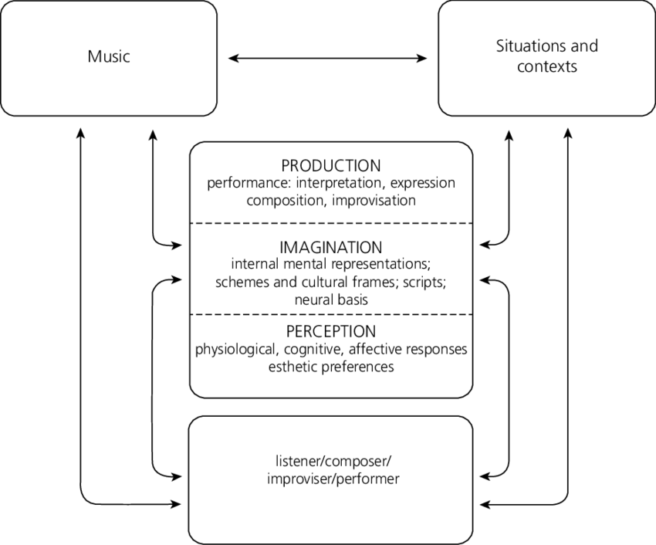
Figure 1. Hargreaves (2012) Reciprocal feedback model of musical processing.
Hargreaves’s model focuses on a ‘network of association’ in a reciprocal form. This model presents the idea that music is influenced by situation and context, by personal imagination and aesthetics, by cultural frames and expectation, but importantly that all these elements are similarly influenced by the music that is created. Once a piece has been created, it exists and has a consequential effect and influence, even unconsciously on musical creations that may follow, whether that be an influence that is directly musical, or the process or the acceptance of the piece. There is a dialogical relationship between music, the creator, and the receivers, as Hargreaves describes:

Individuals combine their networks of musical and cultural associations to include their corresponding associations with the people, situations and events that they have experienced in their lives: these are effectively personal networks of association, which are subject to constant change as new pieces or styles are experienced in different social-cultural situations. (Hargreaves: 2012, p.547).

Hargreaves’s (2012) model also includes elements of ‘internal representation’, affective responses’ and ‘aesthetic preferences’ detailing more specifically the influences that influence creativity. Hargreaves combines this sociological approach with psychological theory to begin to pick out the processes by which people create. These include aesthetic preferences, internal mental representations, schemas and culture frames, cognitive processes and affective responses. These elements function on a personal and individual level, often subconsciously, influencing and being influenced by contemporary cultural context, and individual and communal historical context. Hargreaves’ model draws a parallel with theorems proposed by Hill (2012), whereby the ‘toolbox’ (or schema to borrow from Piaget), could be used to provide one possible explanation for apparent moments of flowing creativity with no discernible origin, a difficult theory to find proof to corroborate. Hill (2012) in the study of contemporary folk music from Finland, proposes a concept of composing and creating within cultural and traditional constraints, offering a useful three point model:
- The manipulation of patterns, such as melodic and textual phrases and motifs,
- The amalgamation and arrangement of diverse materials and devices, referred to by musicians as their "toolbox",
- The exploration of systems, such as idioms, forms, pitch sets, and sound production conventions. (ibid, p.85).

Hill examines creative processes as a manipulation of patterns, introducing the idea of a toolbox of conventions from which musicians may pick and choose bits of stylistic musicality that they wish to use in their own creative practices as part of their toolbox. The idea of a creative toolbox is also examined by Hanson & Herz (2011), in the context of an art classroom. Their findings are that each partaking member has their own individual toolbox of ‘interests activities goals, and habits of mind that they accumulate’ (p.34). Hill also offers the idea that the exploration or exploitation of systems such as structure, ornamentation, or tonality, creates a set sound and expected idiom. This supports the idea that, for a piece of music to be considered part of that tradition or part of that culture that piece of music must contain some relationship to these systems conventions and patterns.

This text compliments Hargreaves’ theorems, offering not only an insight into the processes by which artists compose, using techniques from musical analysis, but also exploring the impact of culture and society: the conventions and exploration of systems. Kern (2006) coins the term ‘vectors of creativity’, referring to the sources of creativity created from the dialogical nature of the relationship between constraints or rules imposed within a culture:

Concepts of creativity and rules are inherently linked in the concept of activity. The relation between rules and creativity, which is neither antagonistic nor sequential but rather dialectical, is identified to be crucial for organizations. Rules are not only regarded as constraints and invariants for activity, but also as sources of creativity. They are, therefore, vectors for creativity. A set of informal rules, called genre, plays an important role in the articulation of the individual’s creativity within collective activity. (Kern: 2006: p.63).

This dialogue is a source of creativity. This poses similarities with Burnard’s (2012) term ‘creativities’, exploring the multi-layered processes of creativity and the potential reasons behind it: detailing the ‘fluid relationship between cultural and social systems […] acknowledging that real-world musical practice encompasses multitude creativities.’ (Burnard: 2012, 35).

Likewise, offering research into creative practices that include a multitude of processes, Akesson (2006) offers an insight into creative processes within a culture and a tradition. It is a theological framework that aims to account for the different sorts of creative processes used, particularly when working with traditional material. The three points that are introduced are the following:

- Re-creation: ‘means staying close to the source’,
- Re-shaping: ‘means consciously changing and/or arranging traditional music’,
- Renewal: ‘means creating new melodies and/or lyrics based on traditional style and with knowledge of the tradition, keeping the essence’ (Akesson: 2006, pp. 8-9).

These three main concepts help to demonstrate how performers approach their interaction with the traditional material, with the aim of looking at the link between creative processes, tradition and revitalisation. In particular, it demonstrates creative practices as a choice, between staying within the norms of a tradition or choosing to create from it. Importantly, it includes all three alongside each other as equal creative processes, all forming part of the same idea of tradition. Keegan (2010) likewise offers some thoughts on creative processes in Irish folk music, namely a discussion between the idea of conscious composition and unconscious variation:

Another important issue that I have avoided here is the relationship between improvisation and variation, the implication being that the latter is a much more composition, premeditated process. This is further complicated by the fact that the latter term is one current in the tradition for both processes while the former is one that is seen as coming from outside the tradition and belongs to other musics and musicians.’ (Keegan: 2010, p.78)

Both of these texts offer applicable thought on creative processes from within other folk traditions and have elements that are applicable to the folk scene in England. By drawing on a wider pool of creative theories, it is clear to see how creative practices within the instrumental folk scene in England might work, as a combination of a relationship between the individual, and their community, not in opposition, but as a negotiation between ideas of behavioural norms, and the re-shaping of behaviours.

1.4.2 Gesture

Building on the above texts, and linking them together is Middleton’s (1993), where the core idea of gesture is introduced. With a focus primarily on popular music studies, and the introduction of a form of musical analysis beyond that used in western classical music, this text draws some dated conclusions but offers a useful analysis for the psychological explanation and analysis of creative practice. It is from this text that the key framework of gesture is taken forward.

The idea of schema is closely linked to that of gesture. Schema, introduced above, (Piaget: 1936) a term borrowed from psychology, accounts for the method by which humans make sense of their surroundings, people, and environment, to categorise and organise information so that appropriate behaviour can be judged and displayed. Schema, and therefore gestures, are influenced by upbringing and by the societies that an individual functions within. An individual’s cultural upbringing is ingrained into their schema, which is only built on and changed when an individual is exposed to new people, places, and cultures. It is these influences that impact our creative practices and stylistic output for years to come. Gestures form a ‘creative schema’ or a creative toolbox (Hill: 2012) of ideas, methods and social and personal expectations that are called upon, mostly unconsciously, when creating, as discussed above.

Middleton (1993) presents a ‘Theory of Gesture’, which describes musical creativity as a process by which musical sounds are organised and developed to reflect how an individual feels and functions, creating an actual representation of our individual minds within the music.

This I understand as possessing affective and cognitive as well as kinetic aspects - by which I mean simply that how we feel and how we understand musical sounds is organised through processual shapes which seem to be analogous to physical gestures. (Middleton: 1993, p.177).

Caulkins (2016) goes on to expand on Middleton’s defection of gesture to mean physical sound producing gestures, offering the following expansion point:

The term ‘musical gesture’ can refer to a physical sound-producing gesture or, in a more abstract sense, to a sound that metaphorically invokes a sense of motion from one point to another. (Ibid, p.1).

This view of gesture moves Middleton’s definition forward, it is the means and motives behind the sound productions that are key to the analysis of creative practice. This idea is linked to the term ‘topic’ taken from western classical music composition techniques, whereby a certain musical idea would be used to evoke an image or an association in the listener’s mind, the term gesture encompasses this and more. The ‘Theory of Gesture’ accounts for the depth of the impact of culture, and upbringing within a culture (nurture), on a person’s individual creative style. Different cultures are bound within their own identity, which, whilst ever-changing and adapting, have a core of social constraints, whereby desired behaviour is tutored into those within the said culture from an early age, or are learnt upon entrance to the culture. As Middleton states:

“My own feeling is that musical gestures - deep structures or principles which give unity to a music culture - are underlaid with still deeper generating 'gestures': kinetic patterns, cognitive maps, affective movements. But these are probably specific to a culture too: people seem to learn to emote, to order experience, even to move their bodies, through locally acquired conventions. […] Human nature is always already encultured.” (Middleton: 1993, p. 178).

It is these constraints, whilst often tested and pushed, that Middleton’s theory describes as having a large effect on how, why, and what musicians create. The theory can also account for creative differences between different cultures, accounting for cultural differences in preference for musical performance style and aesthetics.

It is important to note that the cultural and societal emphasis of creative influences described thus far does not diminish the importance of the individual in creative practices, an element that, particularly in terms of musical creative practices and creative practices within the folk scene, is under-researched. The individual and their creativity are contextualised by the cultures and societies that they function within. Csikszentmihalyi (1988) describes it thus, discussing the importance of a cultural approach to creativity, describing the importance of the concept that the individual cannot create in a vacuum, but only within a stable cultural domain within a field that interacts with others:

“What we call creative is never the result of individual action alone; it is the product of three main shaping forces: a set of social institutions, or field, that selects from the variations produced by individuals those that are worth preserving; a stable cultural domain that will preserve and transmit the selected new ideas or forms to the following generations; and finally, the individual who brings about some change in the domain, a change that the field will consider to be creative.” (Csikszentmihalyi: 1988, p. 325).
The individual plays a core role, and Hill (2012) expands on the importance of cultural systems, to include theorisation on what influences the individual aesthetic choices to influence the act of creation. Three main points are discussed: the manipulation of musical patterns, phrases, and gestures; the arrangement of diverse ideas and devices, and the exploration of cultural systems, such as ideologies, forms/functions, and conventions of sound production. It is culture that enforces these systems and forms the basis for gestures.
In popular music studies, like above, the importance is placed both on the individual as a creator and as a product of their community, demonstrating a shift towards a more holistic view of communally based creative practice. To quote Negus (2011) ‘the romantic notion of the great individual’ (p. 8) is still an influence although the lens through which creative practice is viewed centres around ideas of authorship and ownership. Theories surrounding ideas of authorship are particularly relevant to today’s folk scene, and the creative practices that it encompasses. The importance of the role of the aural tradition (discussed further in 2.3.1) creates many issues surrounding creative practice and authorship. There is a complex relationship between notions of authorship, particularly when new arrangements of pre-existing material arise, because it isn’t clear in such a shared tradition if individuals can truly ‘own’ anything. Whilst, ideas of source reputation, (discussed further in 5.3.2/3/4), as a form of authorship are important, it has been suggested that the individual names attached to pieces, performances, songs etc, are simply the resulting symbols of the collective composition process, as discussed by Bennett (2002). In an aural tradition, where change is part of the process, the idea of an author, is respected, but not necessarily regarded as individual ownership.

1.5 Tradition
The concept of tradition is multifaceted, both in its multiplicity of uses by those in the folk scene in England and in academic practices.

Ben-Amos (1984) offers a seven-point model to help define tradition within American folklore. Whilst referring to folklore, culture, performance and sets of rules or conditions, all of which feature and/or interact within the many working definitions of tradition, the overlapping elements within each of his seven points leads to a lack of clear conclusion. In particular, defining ‘tradition as culture’ only opens the term up to the same criticisms and problems that the act of defining ‘culture’ offers, which is not the focus of this thesis. Of his seven points, it is perhaps ‘tradition as cannon’, be that a body of material identifiable as belonging to a particular cultural identity, that proves most useful to this thesis. Cannon and constructs of repertoire are also discussed in Gorak (2001), and whilst an interesting element, it is more prudent to discuss repertoire as a function of community as opposed to a direct and established canon.

Another other useful point in Ben-Amos (1984) is ‘tradition as process’, the temporal element linking a culture’s past to its present. This refers to customs valued enough to pass on by each generation, creating a sense of stability through the process of tradition, of the transmission and preservation of the practices and behaviours that are deemed ‘traditional’.

However not all theories of tradition place stability at its heart. Feintuch (1993) writes, ‘this sort of creative editing, a paring away of those characteristics and features deemed inappropriate and a reorganisation of what is left’ on a communal level implies the value of the item in its perceived idealised past but allows for the modification of these elements to fit the purpose of the now. Similarly, Glassie (1982) promotes the concept that tradition is ever-changing within the stability of a culture. Glassie states that tradition is constantly in a ‘matter of constant negotiation, always shifting, sometimes radically’ (ibid: p.26), opposing those who deny ‘the fact that cultures and traditions are created, invented – wilfully compiled by knowledgeable individuals’ (Ibid: p.398). Both these texts place tradition not only as a changeable cultural feature but as an active part of a conversation between individuals and communities. The sense of a past alongside shared ideological values and a preferred sense of musical and performance styles referred to as being ‘traditional’, creates a strong connection to a shared identity within a community. It is these shared values that result in shared and expected behaviour, that form the basis of a culture.

Glassie’s work marks a change in the definition of tradition being studied as something that is in the past, to something that is changing in the ever-present, and something that is not always rooted in a historically accurate past. In a similar vein, Dorothy Noyes (2009) introduced a 4-point model for the various functions of tradition:
Figure 2. Dorothy Noyes (2009) 4-point model of tradition.
As can be seen in figure 2, several key features appear throughout these models of tradition, namely the importance of a community of partakers and the importance of a link to the past. All these theories offer models that can be applied to many elements of the folk scene in England, but the predominant focus so far has been about the past, and how it presents itself in the now. As discussed in 1.1, the perceived history of the folk scene in England, as used in the first folk revival isn’t particularly based on truth.

1.5.1 Invented Tradition
The idea of an invented tradition is explored by Hobsbawm and Ranger (1983), who define tradition as a set of governing rules implied within a culture to create and maintain a cultural boundary:

A set of practices normally governed by overly or tacitly accepted rules and of a ritual or symbolic nature, which seek to inculcate certain values and norms of behaviour by repetition which automatically implies continuity with the past. (Ibid, pp. 1-2).
Whilst elements of Hobsbawm and Ranger’s work offer useful theories, its dated perception and wide overview of a range of cultures offer little in-depth reflection or discussion on the phenomena that are so well suggested. To build on this Rosenberg (1993) examines the idea that audiences and musicians alike play a role in choosing, both directly and by implication, which elements of a tradition are to be revived. Rosenberg also looks in depth at theories of revival and why people invent and use concepts of tradition and revival as part of their individual and shared identities when partaking in a musical culture, a feature discussed in 1.2.1 in relation to the first folk revival.

The concept of invented traditions is further discussed in terms of imagined communities (Anderson, 1983) and in terms of ‘fake song’ (Harker, 1985) all of which add to the idea that our perceptions of our own history, of the origins of our cultural traditions, and the template for the desired behaviours and practices, may not be as based in fact as is perceived; they may be invented constructs, echoing Glassie’s theory.

1.5.2 Tradition And Change
The above texts start to move away from the view of participants of traditional cultures as naïve bystanders, unaware of their influence on a tradition. Some acknowledgements of the intentional role that participants have played in shaping, changing and actively evolving tradition, is starting to be seen. As echoed by Bauman, tradition, invented or not, can be part of an active and deliberate process of reshaping and change:

Traditions are based on human actions which are copied, varied, and/or invented by groups that take their material from within their own specific cultural system, or from other. (Baumann: 1989, p.82).

Importantly, and building on the theme of exploring creative practice and deliberate change within tradition, Bronner (2000) discusses folklore in terms of innovation and individual initiative, describing the concept of tradition as a process by which people make sense of change in culture:

If tradition as the basis of folklore is indeed both invented and inherited, individual and social, stable and changing, oral and written, of past and present, of time and space, about both authority and freedom, then what does it exclude? Is it shorthand for a feeling of connection rather than a process of transmission? Is it possible to make it empirical if it depends so much on judgement and perception? Or is that its strength-to point to the ways that spiritual and social connection can be subjectively invoked? As "traditions," the term references discrete texts that are therefore empirically documentable; as "tradition," it sounds like an overarching force, pattern, or authority--often outside of awareness. (Bronner: 2000, p.72).

Bronner not only expresses doubts in the accuracy of constructs of both history and tradition but demonstrates tradition as a connection, a link to the perceived and almost definitely constructed past. The concept of the idealised past, which brings with it an accompaniment of associated cultural traditions, whether based on historical truth, if there is such a thing, is a powerful tool. This concept can create a connection not only to others, perhaps with the same ideological and political views, but also creates a connection to a shared view of the past and a sense of belonging, a very human instinct. Importantly, and building on the academic theme of exploring change within tradition, exposing the culture of English folk music as being one of substantial change, Bronner discusses folklore in terms of innovation and individual initiative, describing the concept of tradition as a process by which people make sense of change in culture.

1.6 Conclusion
The historical context of any musical practice is important. Many of the aims, ideologies, and values that the folksong and dance collectors put into the idea of folk music are still present and impact what is recognised as the folk scene today. It is not to say that folk music in England began with the first revivalists, but the labelling of the term began at this point, and the impact that the revivals and those involved continue to have on the contemporary scene are manyfold. Understanding this historical context lays the groundwork for understanding the contemporary scene. Within this historical context are bound ideas of tradition and its lasting impact. The idea of tradition, which is linked with all sorts of ideas of history and value, is also linked to ideas of change.

Creative practices play an important role in all musical cultures: the English folk scene, past and current is no exception. Sharp (1907), Bearman (2001), Bohlman (1988), Lloyd (1967), and Bronner (2001), the role that individual creative process has been discussed but has not been fully explored in a contemporary sense in the literature. The importance of the individual is something that is rarely addressed regarding the folk scene in England, by either the academic circles or within the scene itself. The agency that the performer and creator have within the English folk scene, as a method of change, cultural interaction and dissemination is vastly undervalued and under-researched.

There is a more general gap in the research into the contemporary folk scene in England. Instrumental folk music in the contemporary English scene has undergone very little research in comparison to its singing sister. Alongside this, there is little investigation into the relationship between creative practice and ideas tradition. The folk scene has undergone a lot of change in the resurgence, and whilst some of the established revival ideologies prevail, it is not clear which ones or how they are enacted. It should be clear that change has always been part of the concept of tradition, but the academic study of it hasn’t been particularly researched in the professionalised instrumental folk scene in England. The role of change in the tradition of instrumental folk music in England is where the core research of this thesis lies.

Chapter 2. Methodologies
As discussed by Rice (2008) methodology within ethnomusicology is something that has long been theorised about, by Hood (1960), Merriam (1964), and Nettl (1983), with a unified theoretical framework yet to be agreed on that is distinct to the field of study. I used a ‘‘polyphonic theoretical’’ (Rice: 2008, p.43) framework, to combine different theoretical approaches used by ethnomusicologists. Musical analysis was used alongside the information gathered from interviews, survey data, and my observations of material in the public domain, to demonstrate how the music is being used in relation to its context.

2.1 The Implications Of Fieldwork At Home

The method of using fieldwork to integrate into a new, ‘exotic’ and foreign culture was historically a hallmark of ‘post-armchair scholarship’ (Maanen: 1988) ethnomusicological methodology. Whilst these methodologies are important, more recent work (Chou, Stock: 2008) has noted the benefits of carrying out ethnomusicological research into a culture that a researcher already functions within. The work of Hield (2010) which looks at ideas of community constructs in folk singers and Keegan-Phipps (2013) which looks into the characteristics of an instrumental folk session are two core examples of researchers who successfully conduct research in the field that they partake in as performing musicians. As an English folk musician, I am researching in my ‘home’ field and have used these works as a guide to navigate the pitfalls and highs of researching in my ‘home’ field.

As a regular attendee, performer, and teacher, I am well acquainted with the discourses held by the participants of the folk scene from several years of more generalised study in this field. As a practising musician within this field, I didn’t face the problem of acclimatising myself into the folk scene as a musician. My ‘fieldwork’ and ‘field play’ (Rice: 2008) are not so separate: my epistemological methods are likewise not so separate from the ontology of learning as a musician within the scene, as I am already one. I would identify myself as an ‘insider’ with an emic perspective and insight into the folk scene, with a great deal of pre-existing knowledge and contacts within the field of study.

However, researching within a home field comes with its own difficulties. As I am immersed in my field of study for large parts of my life, from academia, to performances, to my personal friendships, it is difficult to create separation between these different elements. Living within my field meant that I am always aware of changes and interesting events, even when not attending in a research capacity. This makes for a good researcher, one who is aware of the living scene, but is also a little overwhelming at times. This is again discussed by Rice (1983) who states that being integrated into your field of study is simply part of good research techniques as an ethnomusicologist.

“When one is in the field, isn’t existence also fun and playful, at least from time to time? And don’t we, as human beings, enter into caring, as well as working, relationships with other human beings while in the field, even as we do our research, apply our methods, and test our theories?” (Rice: 1983, p.47).

Researching at home poses other problems, and is a topic theorised at length by Collins and Gallinat (2010). My research had the potential to create tensions in my relationships with my fellow musicians and colleagues, as the data that I am interested in stems from their inner and personal thoughts on their own musicality and creative practices. These people, especially my closest musical friends and collaborators, were aware of the research that I am carrying out, as it was discussed. There was the potential for people to change their behaviours around me, or to not feel comfortable discussing things openly with me, meaning I couldn’t be certain that the information that they were presenting was an accurate representation of their actual thoughts and feelings. These thoughts and feelings might also be affected and changed by my research and involvement as a researcher in their musical lives. This is one of the many metaphorical shadows cast by the researcher within the field and is something that researchers have been struggling within the field of Ethnomusicology for many years. This was dealt with within my consent guidelines as approved by the University of Sheffield, whereby participants had the right to view what I recorded and used from interviews and observations and to withdraw if they so wished. For my closest friends and colleagues regular consent checks will take place to try to maintain an open and trustful relationship.

It is important to reflect that my own professional playing or creative practice is not the focus of this thesis, I am not carrying out personal research and do not form any part of the data collected. However, because of my experience of researching within my home field, I have embodied knowledge, which is a lens for analysis, and helps form conclusions, meaning I can recognise the nuances involved in both the musical playing styles of musicians, but also understand the language used in reference to performing/creating, and interpreting ideas of tradition. Whilst I am not forming any of the data for this thesis, my pre-existing home knowledge and experience are acting as an informer.

2.2 Fieldwork

Fieldnotes often act as ongoing and changeable scripts for the mediation between experience and interpretation/analyses. (Barz and Cooley: 2008, p.209).

Barz and Cooley’s (2008) work on researching in the field and taking fieldnotes offered insight on specifically how to allow my fieldnotes and experiences in the field to shape the direction of my research, rather than be narrowed by my own preconceived thought processes. Similarly, Babiracki, (2008) and Cohen, in Barz and Cooley (2008) write about the importance of critical ethnography as a methodology of ethnomusicology. Both use different types of fieldnotes to examine their own perceptions throughout their research and how these perceptions change, noting the impact that their presence and research has had on the people from within the field and on the musical material/traditions that are being studied.

Therefore, the form of fieldnotes that were taken for this fieldwork, did not take the form of a diary. Instead, digital observations were recorded of online events that occurred during my data collection period. This included online reviews, online newspaper articles, and Facebook/Twitter conversation insights, all of which were in the public domain. Using elements of the above theories of fieldnotes, I sought to gain a wider insight into the folk scene and by using what artists were readily putting out into the contemporary scene of their own free will, I endeavoured not to be influenced by my own preconceptions.

As part of my fieldwork were the following elements:

2.2.1 Observing The Public Domain.
As part of my fieldwork was impacted by COVID-19, I also transcribed and analysed several public events with notable professional musicians that were carried out by a variety of folk organisations during 2020 in a bid to keep folk music alive during this period. For example, Hudson Records ran a weekly Listening Club with artists, pre-recorded but streamed on YouTube for free, where artists would listen through their own albums, and talk the audience through various aspects of the mechanics of writing the music and making the album. This offered an insight into the artists’ creative practices, and it was interesting to see the audience’s reaction in a digital form as they interacted with the artists’ YouTube stream during the performance, asking questions. Likewise, I analysed the content of several online talks and podcasts, notably by Dr Alice Little, which focused on English folk tunes, what they meant in the past, in the present, and in the future, which was specifically helpful with interviews with notable artists.

2.2.2 Interviews
Interviews were central to this study, as the data that I collected is based on the thoughts, opinions and perspectives of the people who actively participated in the English folk scene. It seems much more prudent to research what the participants themselves deemed interesting and important, rather than focusing solely on my own ideas, meaning that my research was open to questions and perspectives that I had not previously considered. Therefore, the interviewing structure that I used was the semi-structured model, a ‘focussed interview’ (Merton et al: 1956 in Robson: 2002, p. 283). I had overall control of the direction of the subject matter, but space was left for the participants to direct the discussion as they deemed appropriate. Participants in English folk music tend to be committed to their own thought-out and preconceived ideas about what they’re doing and why: this is what my study aims to research. It is useful to objectively analyse how the music, alongside perceptions of tradition, are used by participants to gain an insight into how far the participants actively do what they profess to do.

I carried out 7 in-depth interviews with key informants that fit within a narrow range of definition; professional musicians, who actively took part in instrumental music, that have self-identified as playing in an English style, and who were active on the folk scene from around the 2000s. The results of the interviews are not characteristic of all thought on English Folk music, rather they are used to illustrate several individuals’ perspectives. All these interviews aim is to provide a rounded view from the contemporary English folk scene as a whole, rather than one perspective or focusing too much on my own preconceived ideas.

2.2.3 Key Informants
As discussed in my methodology, for my key informants, I want to interview a select type of participant from the folk scene in England. Namely, a professional musician, who had professional musical output featuring instrumental music that they identified to by ‘English’ since the early 200s. The following individuals were those that were interviewed because they fit this remit as is evident in the biographies used below that were taken directly from their professional websites:

2.2.3.a Bryony Griffith
https://bryonygriffith.com/about/

Bryony Griffith is an English fiddle player and singer from Huddersfield, West Yorkshire with a rich repertoire of English dance tunes and songs. In 2017 she was appointed as senior lecturer in vocals and fiddle on the new Folk, Roots and Blue Music degree at Leeds Conservatoire.

Bryony’s debut solo album ‘Nightshade’ was released in 2014 and saw her stepping away from the comfort of a band to showcase solo fiddle tunes and songs. With only occasional accompaniment from Jack Rutter on guitar and herself on piano and strings, the arrangements are intimate and honest. 2018 saw the release of ‘Hover’, Bryony’s first solo album of purely traditional fiddle tunes. Solo English fiddle albums are scarce, and Hover is a significant and unique move in terms of English fiddle music. The album received 5* reviews and award nominations including the Fatea Instrumentalist of the Year and fRoots editor’s Album of the Year.

2.2.3.b Rob Harbron
https://robharbron.com/biog

Rob Harbron is a uniquely skilled player of the English concertina, described by The Guardian as a ‘concertina wizard’ and renowned for his highly individual and harmonic style of playing. He is a member of Leveret (alongside Sam Sweeney and Andy Cutting), with whom he has toured extensively and released four landmark albums.
Known for his work with a wide range of artists including Jon Boden and the Remnant Kings, Emma Reid, and The Full English, he has also worked extensively with the National Youth Folk Ensemble and the Royal Shakespeare Company. Now he is exploring solo playing with a repertoire which includes settings of rediscovered traditional tunes as well as his many fine compositions. His debut solo album Meanders was released in 2019, and he has recently published a tune book containing 54 original and adapted tunes.

2.2.3.c Pete Judge
https://www.threecanewhale.com/about/

Three Cane Whale are:
Alex Vann – mandolin, bowed psaltery, bouzouki, zither , banjo, dulcimer
Pete Judge – trumpet, cornet, dulcitone , harmonium, lyre, glockenspiel, tenor horn
Paul Bradley – acoustic guitar, miniature harp
A multi-instrumental acoustic trio based in Bristol, UK, featuring members of Spiro, Get The Blessing and Scottish Dance Theatre. As intricate as a team of watchmakers, as spare as a mountain stream, the music encompasses both a cinematic sweep and an intimate delicacy, in which “the aroma of muddy leaves and old nettles is almost tangible” (The Observer)
The band’s third album, Palimpsest, was recorded at Real World Studios in Wiltshire, produced by Adrian Utley, and released on January 15th, 2016, with artwork specially designed by Dorset’s Little Toller press, and accompanied by a UK-wide, Arts Council supported, album launch tour. Palimpsest was chosen by The Telegraph as one of the ‘Best Folk Music Albums Of 2016″, by fRoots as one of its 5-star Playlist Albums, and by The Guardian for its Folk World Music Playlist.

2.2.3.d Will Pound
https://willpound.com/about/

One of the finest harmonica and melodeon players of his generation, Will Pound has pushed the boundaries working on and with a number of projects and musicians which in the past and present include Will Pound and Eddy Jay, Stevens & Pound, Jenn Butterworth, Dame Evelyn Glennie, Liz Carrol, Martin Simpson, Guy Chambers, Concerto Caledonia, Robbie Williams and The Hillsborough Charity Single. He has travelled across most of Europe and as far as Australia for his music delighting and giving audiences awe inspiring performances.

He has appeared on TV & Radio many times including appearances on BBC Breakfast, BBC2, Radio 2, BBC Radio Scotland, BBC Radio 2 Folk Awards, MTV, Radio 1xtra to name a few. Will has been nominated 3 times for the BBC Radio 2 Folk Musician Of The Year Award in 2012, 2014 and 2015, has won FATEA Magazine Instrumentalist Of the Year 2013, 2014 and also was nominated for Songlines Magazine best newcomer.

2.2.3.e Kathryn Tickell
https://www.kathryntickell.com/biography

Kathryn Tickell is the foremost exponent of the Northumbrian pipes; a composer, performer, educator and successful recording artist with many releases to her name, whose work is deeply rooted in the landscape and people of Northumbria.

Kathryn currently tours with her band The Darkening, named after the Northumbrian word for twilight. Kathryn has gathered stellar musicians from Northumberland, Scotland and England to invoke the sounds of Ancient Northumbria. The Darkening’s debut album received praise: “A clever, shape-shifter of a record, founded on an exceptional band.” (The Observer). “A crucial and exhilarating band setting the world on fire.” (fRoots).

2.2.4 The Commentary Composition Process
As part of the score analysis, I collected data from an experimental method the result of which I have termed a ‘commentary composition process’. The aim of this method was to combine musical score analysis with a working commentary on creative practices, offering an in-depth, but highly individualised data set. To assess a working model of the actual methods by which musicians use their creative processes, I asked two professional musicians to compose a short tune whilst recording themselves in real-time, describing and explaining what and why they were making various musical decisions and actions as they were doing them. The whole process was transcribed as a commentary composition process.

Given the personal nature of the process that I was asking the musicians to divulge, I chose two musicians that I already had a working relationship with (Alex Cumming, see 2.2.4.a, my touring duo partner, and Grace Smith, see 2.2.4.b, whom I had taught alongside). My rationale was that I was more likely to get an honest and representative insight into the inner workings of the individual creative practice if the musicians felt comfortable enough talking to me. Because of my familiarity with both these musicians, as my colleagues and friends, it meant that we already understood each other’s awareness and knowledge of the scene, as a consequence of working within a relatively small scene. Therefore, there was already a pre-existing level of trust built on our working relationships which I hoped would lead to open and honest responses.

The following steps took place:

- One commentary composition process took place face-to-face, recorded with Alex during a normal duo rehearsal. The other took place in private, during the pandemic, when Grace wrote and recorded her process on her own and sent it via email.
- I asked both artists to write a tune and talk me through the process as they went. I emphasised that I wasn’t interested in the end product, just the process. I offered no specifications, other than that I wanted the whole process to be recorded for transcription and analysis.
- I set no time limit and simply let the artists’ work through their processes in their own time - Grace recorded that she took a break during the process.
- I did not offer any interruptions or questions until after the process was complete so as not to influence the artists.

The aim of this was to get a deep insight into the inner workings of the individual creative practice if the musicians feel comfortable enough to divulge some of their inner thinking. The resulting data was transcribed: the whole creative practice in score form, and the accompanying description in text form to demonstrate as fully as an interpretation can, the whole creative practice. This provided the basis for follow-up questions to further explore the creative practice and allowed me to gain a deeper understanding of how their personal creative practices work.

As commented on above, there were two different approaches to the recording process of the commentary process, due to the impact of COVID-19. The first experiment took place face-to-face, whereby I was in the room whilst the recording took place. Whilst I chose to let Alex complete the process to his satisfaction before asking questions, I could still ask any follow-up within the context of the interview. However, Grace recorded her commentary and musical process on her own, in her own time. This had several potential impacts, firstly, I didn’t witness the process first hand, and couldn’t ask questions in context, meaning that there was potential for the data to be inaccurate or incomplete. However, I don’t believe that this is the case and think that the commentary composition may be a more honest depiction of Grace’s creative practice, because I wasn’t watching or influencing.

It is impossible to rule out the fact that by placing both these musicians and their creative practices in an artificial creative environment and setting them a task where they knew they were being observed; their resulting behaviour may not depict a fully accurate picture of their creative practice. But the commentary composition process offers an experimental insight into the individualised creative practice.

There were 2 of these commentary compositions carried out with the following artists, the following is taken directly from their professional websites:

2.2.4.a Alex Cumming
https://www.alexcummingmusic.com/about.html

Alex Cumming is a traditional Singer, Accordionist, Pianist and dance caller hailing from Somerset, England, now living in Brattleboro VT, USA. He performs songs and tunes from around the United Kingdom and America with a great depth of knowledge of the tradition. Alex has made his mark on the folk scene with his rhythmic dance-able accordion style, strong voice and his fun and engaging stage presence.
Alex is a member of Celtic trio Bellwether (with Louise Bichan, Eric McDonald), award winning acapella quartet The Teacups and critically acclaimed duo Alex Cumming & Nicola Beazley.

2.2.4.b Grace Smith
https://gracesmithmusic.co.uk/bio

Grace Smith is a fiddle and viola player. Her band, the Grace Smith Trio, released their debut album Overleaf in Autumn 2023 which has had a great critical reception.

Grace is a dedicated music educator and is in high demand as a tutor. She was Producer for the 2023 Folkworks Summer School and has taught in many settings for a wide range of ages and abilities, including for National Youth Folk Ensemble, Newcastle University, Fosbrook Folk Education Trust, North East Fiddle School, Liverpool Philharmonic Youth Company, Band on the Wall, and music hubs across the country.

2.2.5 Surveys
I conducted a survey and distributed it through a network of professional musicians, using social media. ‘Surveys are capable of obtaining information from large samples of the population’ (Glasow: 2005, p1). The aim of the survey was to get a wider pool of data about tradition and how professional instrumentalists negotiate ideas of tradition with their own creative practices. The survey gave me access to a wider variety of opinions and thoughts with the intention of being more representative of the field that I am researching, a method prescribed by Jove and Wolf (2016).

The survey was conducted via google-form, using a combination of open-ended questions, and qualitative questions, offering participants a chance to voice their opinions in-depth, and some shorter more data based quantitative and closed-ended questions. As my target audience for this survey comes from a relatively small pool of professional musicians, who tend to have a high understanding of the field that they work with, the ‘survey questions […] use words that are consistent with the educational level of the intended respondents (McIntyre: 1999, p.78), meaning that it was assumed that the respondents would already have the knowledge required to respond in an appropriate manner.

I decided that the survey was not to be publicly shared on social media, to ensure that only a certain subsect of musicians (professionals) had access to the survey, as per the remit of this thesis. The survey was shared via personal messaging, with the request of forwarding the survey on to other professional musicians that might be of interest, with the hope of researching musicians that I did not know or may not have thought of. The reach of the survey went further than my circle of professional friends and colleagues, reaching musicians that I wouldn’t have had contact with, but did focus on my age group of peers, as these were in closest contact.

The survey yielded 29 in-depth responses. The average age of this survey data is not particularly representative of the folk scene, as it focused on my relatively younger peer group. However, a wide range of musicians filled out the survey, 18yrs - 65+, and a wide range of instruments, from banjo to fiddle, squeeze instruments to saxophones. There were statistically fewer women and gender minorities who returned the survey, which is representative of the gender split of particularly instrumental players on the folk scene in England. The majority of the participants that returned the survey were white, again something that is representative of both the current performers and current audiences on the English folk scene.

2.2.6 Survey Participants
The 29 participants of the survey and their role as professional instrumentalists are as follows (full survey data is in Appendix 3):
Figure 3. List of survey participants.

2.2.7 CD Analysis
The term CD analysis also refers to the analysis of digital forms of CD, such as recordings on Bandcamp or on Spotify. Regarding the use of musical recordings, as I was using recordings already within the public domain, I did not need written consent.

I analysed a variety of artists all of whom had released a CD containing English instrumental folk music between 2000-2015. Some of these artists were ones that I was familiar with, with some overlap with the participants of the survey, and some that were not familiar. Whilst there are fewer tracks analysed for certain artists, this is simply because many artists have released CDs containing both songs and tunes, meaning that I did not need to analyse every track if it were a song. Some artists had not released many relevant CDs within the last 15 years, meaning that there was less data available within the constraints of this study. The output of 17 artists was analysed, with a total of 25 CDs, 153 tracks and a running time of 12 hours, 31 minutes, and 12 seconds.

It is important to note that tunes are commonly played in a set - referring to two or more tunes, usually within the same time signature, being played back-to-back without a break between, which is called ‘a set of tunes’. This is a stylistic norm on the folk scene from England. The material analysed was split into two different methods, by track, and by tune. This is because some tracks have more than one tune and whilst this was not used to calculate the rate of ornaments for example, this was considered when looking at frequency of tune type, for example. Musical gestures such as structure, tonality, and tune type, were counted on a tune-by-tune basis, rather a than track basis. The following albums were analysed (see Appendix 2 for track-to-track analysis):
Figure 4. List of Artists, Albums and Release Dates, from analysis.

I listened to each instrumental track once, listening out for the following categories:
- Tune Type,
- Tempo,
- Tonality,
- Structure,
- Ornamentation,
- Rhythmic and melodic variation,
- Tune origins (whether the composer is known),
- Any key arrangement ideas present.

I tallied each of the categories above, creating a spreadsheet of track-by-track records of stylistic points of interest, building up a picture of how the above were used by musicians in their professional output of their creative practices.

The idea behind using professional, recorded material to gain a stylistic overview of the instrumental folk scene in England, is because it is the form of folk music that has the largest diaspora, even though it isn’t representative of the whole of the folk scene. This means that it is the form of folk music that is most likely to be heard by those not within the scene. However, to get a representative view of professional instrumental folk music from England, the recorded output is both easier to measure, and is the most widely influencing factors that shape the contemporary folk scene.

2.3 Score Analysis

I produced 6 musical scores, 4 of which analysed professionally recorded tracks from the musical output of 4 professional musicians. 2 were transcriptions of the commentary composition process. This data was collected from both CD and score analysis of the following set tracks (complete score transcriptions are in Appendices 4-7):

- ‘Radstock’, performed by Bryony Griffith (Hover: 2018),
- ‘Brute Angels’, composed and performed by Three Cane Whale (Palimpsest: 2016),
- ‘‘Brighton Camp’’, performed by the Will Pound Band (Through The Seasons: 2018),
- ‘One-Stringed Jig’, composed and performed by Rob Harbron (Meanders: 2019).

Musical analysis is important to this thesis because I wanted to give a rounded view of the sounds, creative practices, and thoughts behind the processes of the individuals in question.

Musical analysis is the application of theory to reveal individuality within and between levels of structure (Tenzer: 2006, p.6).

Cook (1987) defined musical analysis as "the practical process of examining pieces of music in order to discover, or decide, how they work” (Ibid: p.1). However, Cook’s theory, alongside much musicological thinking on musical analysis, is based on score-based analysis. This type of analysis, known as formalism, is predominantly concerned with looking at structures within music and comparing them to denote meaning, this poses problems in relation to the context of this study.

2.3.1 Problems With Written Music In An Aural Tradition

Several problems arise with the use of written scores for the depiction of musical sound. Firstly, the use of score-based analysis as a historic artefact can only relay so much about the composers’ intentions and motivations. This type of historical analysis relies as much on another’s interpretation of the score (the esthetic) as it does on the composer (the poietic): it assumes, mostly, composer intent, with no concrete method of proving this intent (from Nattiez: 1987). The relationship between the poietic and the esthetic is examined as a process of analysis, demonstrating the change of agency from the poietic, the act of creating or the creator, and how it is received and interpreted by the esthetic. Inductive poietics, as described above, using the ‘immanent structures of work’ to draw conclusions on the poietics, is suggested to be the most common type of musical analysis (ibid: pp.139-142), but one based mainly on conjecture. If the purpose of musical analysis is ‘to discover, or decide, how they work’ based on the examination of written historical scores, then this offers us little useful insight for the purposes of this study.

In other words, using more of Nattiez’s ‘hermeneutic’ (p.162) method of non-formalised analysis, whereby the score is accompanied by a deep and descriptive text analysis, which includes extra-musical descriptors and a contextual setting for the musical sound, provides a more open, less rigid method of analysis. This is how the creative practices behind sound production can be seen. The purpose of the musical notation is to demonstrate certain factors that are of interest in the music used to offer a possible interpretation of what the performers and creators of the music have said, demonstrating the processes described in interviews in visual and audio representation.

Secondly, theories of semiology, whereby a score is made up of many symbols and structures that are distinct, recognisable and are used to represent various aspects of musical sound play an important role in musical analysis. The use of the western classical score as one of the main modes and methods of formalised musical analysis is a symbol of western classical music, lending itself predominantly to portraying the motifs, traits and characteristics of western classical music (Nattiez: 1987, pp.157-159), and not often lending itself as a method for transcription and analysis of non-western/non-classical music. This is problematic for this thesis for several reason.

Namely, there are elements in instrumental folk music from England that are not always standardised and not easily notated using western classical music systems. Indeed the terminology used on the instrumental folk scene from England is often based on that from western notation, even though the application isn’t always the same. As Killick (2020) states, ‘the notation should be able to convey any information about sound that could conceivably be relevant to an analysis—which probably means any information about sound whatsoever’ and systems of western classical notation can’t accurately depict all the musical detail used by performers of traditional music. This is not because instrumental folk music is simpler, it’s simply because folk music wasn’t intended to be written up using this system of notation.

Whilst using western classical notation results in the simplification of folk music, it is one of the main systems of notation used, meaning that it needs to be used within the context of a community, whereby the extra stylistic details that aren’t written down can be learnt aurally. The stylistic details are what make elements of instrumental folk music from England identifiable as ‘English’, and so these aurally learnt details are key to this thesis, and this juxtaposition between written and aural transmission is clearly a feature of this thesis. It is the case that western notation and its terminology is used on the folk scene in England, despite its often cobbled application, as can be seen in Keegan-Phipps and Winters (2013) use of terms like crochet and quavers when analysing rhythmic variation, and in the many instrumental tune books that quantify reels as being in 4/4, and polkas being in 2/4, where the reality in performance can be a personal interpretation of the style of a piece.

Therefore forms of written music are important. Western notation is an often-used method for sharing music, as is ABC notation, both of which are especially prevalent in the digital age, with many websites being used to share written forms of both printing and handwritten and archival musical material. However, in academia, a modified approach to the use of westerns scores is needed to bridge the gap between the active use of them on the scene, alongside the learnt, aural knowledge that is only privy to those who already know the stylistic gestures of the scene.

It is not the aim of the musical analysis of this study to provide a new standardised method of analysis or transcribing of a performed piece, nor to demonstrate a unilateral method of creative practices through analysis, nor to compare the creative practices analysed with each other. For the purpose of analysis of style in English folk and traditional tune playing and for exchanging this knowledge with others, western classical notation systems and the standardisation that accompanies them seems to be a necessary compromise. However, despite the ease of sharing written music, the written form should not be equated with the standard, style and technique on the folk scene. A much more complex musical notation system would be needed to capture all this detail.

2.3.2 The Creative Score
The score will not be the starting point of the research, the analysis won’t be informed by the score, and the score will be used to present the analysis findings. As it is the creative practices of an individual that are of most interest, it seems more prudent to start from the point of the creative practices, from the individual themselves, using the individual to provide a first-hand account, of their own ‘extra-musical processes’, the ‘why’ behind the ‘how’. The sound produced as a product of the creative practice needs to be considered, to produce a form or structure on which musical elements can be discussed in context. Sound is often a little-acknowledged element of musical analysis, especially where scores exist:

Though, there is a suspicion that sometimes insufficient attention has been paid to the sounds themselves - to the intra-musical structures of what I call the 'primary' level of signification (Middleton: 1990, p.220).

The combination of information taken from interviews and the musical sound transcriptions will be used to provide an appropriate picture of musical analysis, based on information from the creative practice and the creative individual and less on my own conjecture. By using this method to move away from using a score as a catalyst for analysis, but rather as a method for presenting findings, a rounded and more objective view of an individual’s creative practice will be presented.

The aim of this thesis is to use score analysis, alongside extra-musical context and data collected from interviews. Using more non-formalist methodology will provide an individual and holistic insight into the psychological and contextual thought processes and reasoning behind creative practices, not just the production of musical sound. In short, to use sound and thought combined demonstrates a deeper insight into individual thought processes.

Chapter 3. Key Terms
In Chapter 1, I presented the historical context for this thesis, and how the many ideological and stylistic phenomena have formed and still impact the folk scene today. However, there is sometimes a rift between academic discussions of terms, and how they are used by participants in the folk scene. This section dedicates some space to the usages of terms, as used by participants on the scene, and will define what I will use throughout this study.

3.1 English
It is important to note that the term ‘English’, used throughout this thesis has undergone much consideration, particularly since the 2020s, when the increased focus on the Black Lives Matter movement during the COVID-19 Pandemic have led many to reconsider the instituaionalisation of events, practices and experiences that we are all party to in England. This is relevant, as although I am not offering a new definition of ‘English’ or ‘England’, I want to acknowledge that whilst the use of the term ‘English folk scene’ is widespread within the scene itself, it does not mean that there aren’t other types of folk music that exist, are practised and performed within England and also that the musics performed as part of the English folk scene include musics and musicians from all over the world. It is important to acknowledge this discrepancy, especially given that the majority of the participants in the self-coined ‘English folk scene’, tend to be middle class and white (Lucas, 2013). It is due to privillage within the English folk scene that it hasn’t particularly engaged with this issue until now where a concerted effort is being made by some to be more diverse and inclusive in their definition of folk, in particular in the English folk scene.

3.1.1 Folk
The term folk has a long history and range of definitions and uses, both within academia and within the English folk scene, as discussed in 1.1, resulting in a fair amount of variation in what individuals use the term folk to describe.

The term folk is often defined in the field according to how the term is most commonly used by those on the self-defined ‘folk scene’ (Hield: 2010, Winters and Keegan-Phipps: 2013). Therefore, folk is defined solely by those that actively take part in it, it applies to any activity, musical form, and persons that self-identify as ‘folk’, the English folk scene encompasses all of this. This is the definition that I also use, allowing the term folk to be defined by those who perform, create, promote and consume the music.

3.1.2 Scene
The term scene is used throughout this thesis, which can be problematic in several instances. The term refers to ‘coexisting musical practices’ (Bealle: 2013, p.2) within a context, be it a place, or an online community. In the digitalised and globalised world in which English folk music exists, it is difficult to point at a scene and claim it is representative of all forms of English folk music. Nonetheless, it is a shared sense of community, ideals, musical styles, and perceived history that connects people within a scene not always bound by place.

For this thesis, the term English folk scene is used, as it is used in the discourse of the scene, meaning that I am using the language and terminology that is used by participants on the scene. I do believe that the term ‘folk music from England’ provides a more open and less problematic definition of the music, leaving the term open to other forms of folk music that exist in England. Therefore, using the term ‘folk music from England’ means that I need to define which particular aspect of folk music from England that I am choosing to study.

To use the term as it is used by participants of the folk scene seems wrong, as it is ‘othering’ of musics that co-exist in England, but it is the closest definition of scene that exists in an applicable form for this thesis.

3.1.3 Community
The term community is used throughout this thesis to talk about the wider participation of people are differing levels/parts of the folk scene in England. As discussed in 1.3 the idea of community has been particularly prevalent in the folk scene in England since the 80s, although its application today encompasses a wider variety of ideas. I have chosen to break the idea of community into 4 different sections, for usage in this thesis:

- The professional musician. The key participant for this research is anyone who makes a living in some way of performing and working with folk and traditional music from England. Any instrumentalist with a professional output of recorded or gigged material, that makes up a large proportion of their professional identity is deemed a professional musician. There is some crossover in the musicians interviewed, as many are singers as well, but I take the definition of self-identification as a professional musician forward for use in this thesis.
- Amateur musicians. People who partake in the folk scene for fun, taking part in sessions, folk clubs and ceilidh, and specifically not looking to make a living from the performance of folk music.
- Audiences. Audiences play a vital role, particularly in terms of the professionalised folk scene, as the paying ‘consumers’ of folk music. On the folk scene in England, audiences can be made up of several different and overlapping sectors, including both professional and amateur musicians, paying audience members, and industry members, including agents, festival bookers etc. This multifaceted definition of audience is what I take forward in this thesis.
- Industry. This community can refer to many different levels of people partaking in folk music from England, including record labels, agents, festival bookers, and event organisers.

There are also other communities of partakers such as online, digital communities of music makers, as well as regional, pocket communities who specialise in very local traditions. Whilst these are useful categories, they are perhaps a simplistic realisation of a more complex scene where in reality most people who participate in the folk scene in England can be part of more than one of the above groups and regularly move from one to another.

3.2 Tradition And ‘The Tradition’
The term tradition in the academic sense has been discussed in 1.5, but the term often has a different use by participants on the folk scene in England. Tradition is often paired with the term ‘folk’; the two terms are sometimes used interchangeably within the folk scene in England, resulting in a problematic discourse when writing for academic audiences. Also, confusingly, in terms of folk tunes, tradition can also mean of unknown composer, and/or a style in which tunes can be played, which pose a juxtaposition in the uses present in the contemporary scene.

The term tradition is habitually paired with the term ‘the tradition’. The term ‘the tradition’ is commonly used by those on the folk scene as a sign of respect for an all-encompassing ‘entity’ (Watson: 2013, p.3) that includes important ideology, history, music, song, dance and the community that interacts with it.

For the purposes of this thesis, this is the definition that I take forward. Tradition as a connection to the idea of a past, and ‘the tradition ‘ is the material that it has produced and to like-minded partakers in the music. In Chapter 5, I will present a discussion of the term tradition as conceptualised by the professional musicians that use it on the instrumental folk scene in England.

3.3 Folk Tunes
The idea of folk tunes (known simply as ‘tunes’ in the discourse of participants) is a core concept to this thesis. The term tunes in this context refers solely to a form of melody performed instrumentally only - not as a basis for song melody. The historical context for folk tunes was as a form of dance music. This does still play an important role in the contemporary folk scene, but not all folk tunes are performed for dance. However, any tune that is performed in the structure or style of a tune historically intended for dance is considered a folk tune for this thesis.

3.3.1 Repertoire
There are cannons of familiar folk tunes that exist in various communities across England, but cannon formation is not the focus of this thesis. It is nigh impossible to account for the origins of a folk tune as being exclusively English, therefore this thesis is more concerned with the style in which folk tunes are played, not their country of origin. This then allows for the current repertoire that exists and is played frequently in England, which includes folk tunes from around the world, including tunes that might be deemed English in origin.

3.3.1.a Unknown / Known
The term traditional is associated with anonymity, and this applies to folk tunes. However, because many folk tunes are learnt aurally, composers are not always known. To account for the tunes that are newly composed, but the composer is not known, these tunes have an ‘unknown’ origin for this thesis.

In a similar fashion, tunes that are composed, either by a contemporary composer or if the historic composer of material is known, these tunes are referred to as having a ‘known’ origin for this thesis. This is to account for the idea that the term ‘composer’ is not used particularly often on the folk scene in England.

3.3.2 Defining Creative Practices

As discussed in 1.4, the terms creativity and innovation have different meanings in the literature but are often interrelated, as well as having different meanings in the context of the folk scene. The relationship between the two terms is likewise complicated in their usage in this thesis, as I am looking at the end product (the professional output) as a data source, and I am looking at the process as a way to understand how it is the professional output is produced. Perhaps it’s more accurate to describe the relationship between the two terms as a scale, and different innovative and creative practices co-exist along it, as defining a clear line between innovation and creative practice in terms of change in instrumental music is not the aim of this thesis. There isn’t necessarily evidence of a complete overhaul of instrumental folk music from the English tradition, but lots of ‘new’ things are created in a smaller fashion, leading to innovation in a smaller way within a tradition. With similar parallels to this thesis, the view of creative practice from popular music studies ‘embraces both the ordinary and exceptional in terms of their productive tension’ (Negus, Pickering: 2004, p.159) draws parallels with the definitions of innovation and creativity discussed in 1.4 and likewise leaves room for both large scale changes and smaller changes that stay with the boundaries of the expected norms. However, whilst the term innovation is perhaps fitting, it is rarely used on the folk scene, where the term creativity is mentioned more often and so I have chosen to focus on the term creative practices for this thesis. Creative practices that result in any sort of newness, whether that be performable material or not, are still a valid form of work.

The creative practices in instrumental English folk music are manifold, referring to (but not limited to):

- The process of writing a new tune- a new melodic line. This can be seen in context through the analysis of two tunes, in chapter 6.
- The process of re-making/editing a pre-existing tune- this is linked to the concept discussed in the literature of ‘Re-creation, Re-shaping, Renewal’ (Akesson: 2006, pp. 8-9). This is demonstrated at the end of chapter 4, whereby two existing tunes have been edited, and a different version created.
- The process of making a new arrangement of a pre-existing composed or traditional tune. This can be linked with the point above. The term arrangement, as employed by those on the English folk scene can refer to anything from the accompanying chord progression, a new/different tonality, new instrumentation, new groove or being performed in a new rhythmic style, be it faster or slower, with more ornamentation, or less, or changing the structure of the tune. This is again demonstrated in the two tunes analysed at the end of chapter 4, whereby the groove, instrumentation and style are substantially altered, compared to the referenced originals.
- Selectively pairing tunes together to create sets is an active creative practice.
- Selecting new repertoire to be performed. This act is also a creative one, by which artists exercise their own expressive freedoms, even in collaborative situations.
Both a newly written tune, and a pre-existing tune might undergo the same sort of arrangement process, which could be something as simple as a different chord progression or could result in a new and different form of the tune. Whether or not this counts as composition or deliberate variation, is up to personal interpretation, but my use of the term creative practices includes both as of equal importance. A single one of the above processes could be examined as its own creative entity, but the rationale behind treating them all under the banner of creative practice is because the focus of this thesis is not on innovative and ’intentional introduction and application’ of new music, but an examination of the micro-processes of creative elements. The use of creative practice as the unifying term to describe the many different forms of ‘newness’ is a deliberate choice, because it isn’t focused on an end product, but focuses more on the processes that artists undergo and because above creative practices can be both viewed and used as separate creative events, or as products and influences on each other.

It should be clear that the creative practices within English folk instrumental music do not place these elements of creative work in opposition to the pre-existing, or ‘traditional’ elements of the scene, rather they are part of the same fluid dialogue which musicians work with, choosing to re-create from the tradition or to write a whole new set of notes, in a traditional style. Some creative practices may result in large, boundary- pushing change, and innovative, new musical applications, but also allows for the smaller creative practices, those that are completely within the expected norms and boundaries of a community, which carry just as much importance. It is not the place of this thesis to place value, but more to examine processes. How English folk musicians have chosen to evoke their creative practices in relation to and within (or not) their tradition has undergone little research, and that is what I take forward in this study.

3.3.2.a Newly Composed Tunes

This thesis deals with tunes that are both deemed traditional, or of unknown origin and written folk tunes, of known origin. For this thesis, any tune, whose composer is a known contemporary of the contemporary scene, and who’s tune is written and/or performed in a traditional style, will be called a newly composed tune.

Chapter 4. The Creation Of A Contemporary English Style
It is important to discuss what instrumental folk and traditional style from England sounds like, including notions of what gestures of style are particular to folk music from England, and how these styles sit within the context of its neighbouring traditions (i.e. Ireland and Scotland). This chapter dedicates space to the gestures and sounds of the instrumental folk scene from England, using artists’ perceptions and musical output to discuss the role of style, its relationship with individual professional musicians, and how the idea of style has an impact on the creative practices present on the instrumental folk scene in England.

4.0 What Is The ‘English’ Sound?
Style is an important concept to all genres of music, but not a concept that is easily defined. In the folk scene in England, the term is used in association with the concept of tradition. As Vic Gammon says:

Style is a collective (inter-subjective, socially constructed) idea of the appropriate way to play, the use of the musical elements that go together to make what is perceived as a style. (Vic Gammon: 2015, p.3)

This is the concept that I carry forward. All forms of traditional music have a distinct set of musical gestures and sounds, making a style more easily recognisable in order to help define it from other traditional musics. English instrumental music shares a lot of commonalities in style with its neighbouring traditions, sharing many structural and instrumental similarities with folk and traditional music from Scotland and Ireland, for example.

However, the idea of an ‘English Style’ is something that is much debated amongst many on the English folk scene today, particularly regarding instrumental playing. Without historical/archival evidence of how English folk tunes were played before the introduction of sound recording technology, it cannot be known for sure how the traditional tunes that exist today would have been played.

There is music about the music of the past that we will never and can never understand. The sum total of our knowledge of the past is the source material we consider filtered through our own understanding, perceptions and misconceptions. (Ibid: p.2).

Not being brought up surrounded by music from ‘the folk tradition’ in England, it was something that I learnt as a young teenager when I started attending folk clubs, sessions, and festivals. Back then it was largely a mixture of styles that I wasn’t completely aware of, coming under the term ‘folk’, although terms like Irish folk music or Scottish folk music were talked about. It wasn’t until I attended Newcastle University as an undergraduate that I was particularly exposed to the idea of style in English folk music. However, these ideas of style were not concrete and differed from musician to musician, and from place to place. This made it hard as a musician with no real prior background in English folk tune playing to work out a style of playing to adopt as my own (or perhaps this was more useful to my playing, meaning I had more freedom to be creative and choose the stylistic aspects that I desired). Although as an academic it is difficult to define what musical details combined to make a style that was definable as belonging in England.

4.1 Regionalism Or Nationalism As Style

Jon Boden gives a metaphor for how individual, and regional style might build to create a sense of national style:

Stylistic traditions are often described as rivers, and rightly so; rivers bend and evolve with the landscape and conditions, rather than appearing fully-fledged out of nowhere. Many small tributaries may run alongside each other before eventually converging and forging a broader channel. What marks the English fiddle style is that we are still at that tributary stage. (Jon Boden: The Strad, 2014)

In a similar fashion to local linguistic accents and dialects, in the same way that there is no singular English accent, there is no singular ‘English’ style of playing, in a useful metaphor for individual style given by Bryony Griffith:

That goes back to you’ve got an English accent with your playing you can’t hide it, unless you really, really practice listening to that Irish tune player, listening to exactly how that person plays it. (Bryony Griffith: interview, 2017)

Indeed, to be specific, many different, more regional styles make up the umbrella of Scottish folk music, for example, or likewise, Irish music, and this is likely to be the case in England. It would be more prudent to say music from Scotland (or England, Ireland, etc). Some musicians, such as Kathryn Tickell, feel that identifying an ‘English Style’ creates an artificial grouping:

I don't see how there can possibly be a traditional ‘English Style’. I mean folk music is inherently regional. (Kathryn Tickell: interview, 2021)

The idea of folk music being ‘inherently regional’ is complex but relevant. From my own experience of music across the North of England, the evidence for the existence of historical regional styles is clear. Northumberland, for example, has its own ‘distinctive style of traditional music […] particularly known for its bagpipes (the Northumbrian smallpipes), fiddle music, pitmen’s songs, the border ballads, and its traditional dance forms: rapper dancing and Northumbrian clog dancing’ (Simon Mckerrell: 2015). Similarly, music from the Northwest of England differs again. Interestingly, historically both regions have had a lot of cultural and social interactions with neighbouring Scotland and Ireland. However, the resulting music is quite different, especially in the current contemporary context. Further south, in South Yorkshire, the music changes again; much of the session tunes played in a session at Newcastle University, (which contained a lot of Scottish and Irish repertoires) were not known when I first moved to Sheffield. However, when I moved, my personal repertoire was both influenced by the new musicians that I was then interacting within Sheffield, and also influenced the Sheffield repertoires, meaning that several tunes travelled down with me and have taken a regular place within the Sheffield sessions.

Professional folk musicians have a unique place in the scene as they are affected by commercialised influences. Namely, they need to have mass appeal on the folk scene. However, as demonstrated in the artist’s professional biographies in 2.2.2 and 2.2.3, some artists tend to brand themselves with a strong sense of self and regionalism. For example, a key part of Kathryn Tickell’s professional image is her link to Northumberland, and its distinct form of regionalism (as demonstrated in her bibliography in 2.2.3.e). A similar argument can be made for Bryony Griffith. In fact, out of all the professional biographies (in 2.2.3) used for this thesis, only one mentions the term England/English at all - and that is more likely to be in reference to the form of instrument (Rob Harbron’s English Concertina). Even when a form of regional identity is not mentioned, the term England/English is still not used to define the professionally produced music analysed. It seems apparent that professional instrumentalists playing folk music in England seem reluctant to define themselves or their music as just being English. This could be for many reasons, including the fact that historically promoted left-wing ideologies that influence much of the contemporary folk scene are at odds with the more right-wing forms of nationalism that are more associated with ideas of England and the English today.

And so, professionals have turned to ideas of regionalism to promote their ideas of style. This means that a sense of overall English is difficult to define, as the scene is comprised of individualism and elements of regionalism. This impacts both the overall style and how it is perceived in that, whilst there are stylistic gestures that can be defined as English, professionals seek to label via forms of individualism and regionalism, which results in s a lack of coherent thought in terms of identity, and in turn, on English style.

It may be that Bryony Griffith’s ‘Radstock’ (see Appendix 4), found in the Yorkshire Fiddle Collection, might have been from Yorkshire, and it might be that the fiddle style in which Bryony Griffith has recorded is based on a regionally Yorkshire style. But the fact remains that there is no real record of what this would have sounded like, and therefore the style it is played in is just as likely to be influenced by Bryony Griffith’s contemporary colleagues as it is by ideals of a past style. Whilst elements of perceived historic regionalism may still impact overall ideas of style in England, it is much more likely that these styles are implemented and promoted by various individuals with a strong sense of personal style. It is the individual identity, not the region - although they are obviously interrelated - that is an influencing factor. And could explain the discrepancies in definitions of English style or lack thereof. If what professional musicians are describing is individual style, as opposed to a lost ideal of regionalism, then it is little wonder that this results in a lack of perceived overall style as discussed by the artists for this thesis.

Style, as a form of musical gesture, is a dialogical conversation between the different regional identities, and the apparent need for a more cohesive form of style for the commercial aspects of the folk scene. Organisations like English Folk Expo, and the Folk Alliance seek to find musicians and musics that can be identifiable and therefore exportable as forms of ‘national music’ – ‘We host festivals and events throughout the year to introduce the best folk, roots and acoustic music to new and existing audiences.’ The complex notion of ‘national’ identity and a national music (see Keegan-Phipps, Winters: 2013 for more on ‘national music’) is evident in the desire of many organisations and artists to promote their music, showing that English folk music, is worthy of exploration and promotion on the international stage. However, this does clash with notions of national identity that are equated more with a right-wing/nationalist political standpoint, particularly in the wider current English political scene. This contrasts to some degree with ‘the vast majority of English folk musicians, dancers and audiences actually share left-of-centre politics and oppose the nationalist rhetoric of the far right’ (Keegan-Phipps: 2017, p.6). This is important because the desire for a national style which may or may not exist, does influence the professionalised and commercialised aspect of the folk scene in England and in turn influences creative and musical output. Regional styles, which are varied, as in many countries, are harder to package and sell on an international stage.

Regional styles make it hard for there to be one distinct musical sound and identity but also allow for the development of a rich network of musical ideas and change. The overlap between regions and countries in terms of style, instrumentation and function has led to the scene we have today and will continue to develop and change for the generations to follow. However, behind the idea of a regional style are the individuals who perform, write, research, and promote the music and traditions of each area. The importance of the individual to the sense of regional and national style cannot be underestimated.

This is not to particularly advocate for a form of national style - it is logical that many countries, particularly ones much larger than England, have a variety of regional styles across the geographical landscape, but it is relevant to examine the idea of identity for its impact on the professional musician. Whilst there is no agenda or at least no Cecil Sharp (1907) styled plans for national song, the fact remains that maintaining a professional career in a niche music scene such as instrumental folk music from England, suggests that there are stylistic gestures can as identifiable as uniquely as ‘English’.

All these tunes have travelled around and picked up the styles and the accents of those players that have played them. It is not the origins of a tune, some of which are lost to history, that are important, but more the stylistic elements with which is it performed, which give us a contemporary sense of instrumental style from England. It remains hard to point at a style of instrumental music from England and say that it is representative of all instrumental folk from England, and as clarified above, that is not the aim of this thesis. The ideas of regionalism, invented or historical, and individualism, are clearly an influencing factor, which makes identification difficult on a professional and commercialised platform. The idea of style as gesture, be it regional or national, is important to the identity that instrumentalists on the folk scene in England put forward professionally.

Below is a brief examination of what the term style means to the professionals currently working on the scene in England, to determine, regardless of artistic background, how the term functions today.

4.1 Stylistic Gestures: A Breakdown
I offer a data-driven insight into the current use of musical gestures on the instrumental folk and traditional music scene in England today, by breaking the concept of style down into the following components/gestures loosely based on a model offered by Keegan (2010) but adapted to offer the following points:

      - Structure, and function,
      - Tune type, time signature and tempo,
      - Ornamentation,
      - Variation,
      - Tonality,
      - Instrumentation.

The impact of the individual artist and their professional output, via the CD data, will be examined using the above categories. It is important to note, as problematised in 2.3, that I will be using western classical terms in much of my analysis, some of which are used by the participants of this thesis, and some that are not. These terms are commonly used in reference to musical elements in folk music in the literature (see Keegan-Phipps and Winter; 2013, and Keegan 2010) and they are not used uncritically here. Much of the language used in reference to folk music, combines some western classical terminology into the diaspora (see the Educational Resources in the reference list), but it isn’t always the case. Combined with the contextual data collection from surveys and interviews, it is my view that the use of western terminology backed up by commentary, provides a holistic and more understandable explanation of the musical gestures present, this critique will continue throughout the following analysis.

4.1.1 Individual Interpretation
The role of individual interpretation is a key element in instrumental folk music from England. Few of the stylistic characteristics that will be discussed in this chapter are included in the notation used by those on the scene, both in a historical sense and in the present day.

If you're used to using classical music or published sheet music which includes performance directions – phrasing, dynamics, articulation, expression, ornamentation, etc. – then you'll notice the absence of any performance or interpretation instructions in most folk music transcriptions. It's up to each individual player or singer to come up with their own interpretation. There is no right or wrong way to do it – what's thought of as the English folk style is really a composite of hundreds or thousands of individual styles of playing or singing. The 'dots' are only the starting point and it's up to each individual player to decide how the music goes. (EFDSS, Folk Music: A resource for creative music-making, Key Stages 3 & 4, 2014)

It is also necessary to point out the many written forms of English tunes, in tune books or archive material for example, don’t notate many forms of ornamentation or phrasing for example, usually leaving ornamentation as a choice for each musician. As Sam Sweeney demonstrates in relation to notation styles in Norway, comparatively:

I visited Norway to study its traditional fiddle music for three weeks. I returned home with a few books and was astounded by the way in which the tunes were notated. Every ornament, bow change, double-stop and melodic variation was included in the transcription. This is almost never the case with English manuscripts. It is rare to be given anything except the pitch and duration of the notes - no articulation, ornamentation or anything to help you bring the tune off the page. (Sam Sweeney: The Strad, 2014).

The act of decorating a simple melodic line is both an individual choice in musicality and a choice that is influenced by the community of musicians that partake in tune playing. Many of the stylistic characteristics of the music, including ornamentation as a gesture, are learnt characteristics, learnt through the playing, and sharing of the music, interacting with other musicians, and heavily influenced by aural transmission. The impact of individual choice is an important and influencing feature when it comes to style.

4.2 Structure And Function
The ‘use of traditional structures e.g. AABB,’ (Nancy Kerr, survey, 2020), as a ‘structured framework’ (Nancy Kerr, survey, 2020), or in other words, gesture, can be used as a template for arranging (and writing) material. Structure plays an important role in many musical styles, and particularly so in instrumental tune playing from England, because of its roots in dance music. The gesture of structure of traditional tunes in England is often ‘assumed’ knowledge that people have absorbed from the general knowledge of the scene:

We know what shape a trad tune has, it has 8 bar parts that repeat (Rob Harbron, email correspondence, 2017).

A common structure in instrumental tunes played in England is AABB, whereby an A section, usually of 8 bars in length, is repeated, followed by a B section, usually also 8 bars long, also repeated, creating a tune that is 36 bars long (Keegan-Phipps and Winters, 2013, p.17). Some tunes have three parts (C part) and sometimes four parts (D part), but all are usually structured using this format. Within each 8-bar repeated section, the following structure commonly ensues consisting of 4 phrases:

      - question phrase,
      - answer phrase, usually finishing on a note from the dominant chord, creating an imperfect or unfinished cadence,
      - the question phrase again (or a variant thereof),
      - the final answer phrase, usually finishing on the tonic note, dictating the end of that music section.

This is demonstrated using the traditional jig commonly played in England, The Moon and Seven Stars, transcribed in figure 5. The ‘question phrase’ is in the first two bars, based around the tonic of D major. The ‘answer phrase’ in bars 3-4, cadences to an imperfect cadence, as the melody line is hinting at an A chord, and the final answer, bars 7-8, cadences back to the tonic of D.
Figure 5. The Moon and The Seven Stars, demonstrating a standard tune structure.
The structures that are present in traditional tunes are ingrained in musicians playing, as a gestural idea, so much so that when writing new tunes or arranging tunes, the structure is present on an almost subconscious level and ‘they [the structures] are of immense importance’ (Kathryn Tickell: interview, 2021). In fact, the standard 32-bar tune structure is so commonplace that it is mentioned multiple times in the survey data, with phrases like ‘I typically will through compose a 32 or 48-bar tune’ (Archie Churchill-Moss: survey, 2020) or ‘generally my tunes follow [the 32] bar format’ (John Dipper: survey, 2020). It is unsurprising that in the tracks analysed, the following percentages demonstrate the prevalence of the 32-bar structure in folk tune playing from England.

Figure 6. Commonality Of Structure from CD data.
Overwhelmingly, the structures in 88% of the tracks analysed in figure 6 follow the expected pattern of a 32-bar AABB tune. Some also had a C part, which is included in the AABB structure, as this isn’t out of the ordinary. However, the ‘Other Structure’ percentile in the graph refers to an odd number of bars in each section, or a longer A section and short B section, or any tune that didn’t follow the 8-bar by 8-bar structure that isn’t commonly used throughout folk tune playing in England.

This reinforces the importance of the structures that are related to the function of dance, whereby 88% of the tunes analysed follow the expected structure. The 12% of the tunes analysed that do not follow the expected structure allows for the tunes that exist in the traditional scene that don’t follow that specific 8 by 8 dance structure but are still used for dance, usually a specific dance (discussed further in 4.2.1). This category also allows for tunes that are written entirely without any dance structures in mind, perhaps in cases where musicians are looking to push the boundaries of expected structures. The music of Three Cane Whale is of note, where much of the music does not follow the expected structures. Only two tracks by Three Cane Whale, conformed to the expected structures, hinting at their background from outside the folk scene, and their intended function of listening, not dance.

4.2.1 Variations On A Structure
It is important to note that the AABB structure is not the only gestural structure to feature within the canon of pre-existing folk and traditional instrumental material. Indeed, there are many traditional tunes that do not follow this structure at all, as is evident in the 12% in figure 6. Tunes like this can relate to a specific dance. As Rob Harbron writes:

It’s normal for Cotswold Morris tunes to have a structure where the B part is twice as long as the A part - so you’d have e.g. a 4 bar A part that repeats, then a new 4 bar B part plus the 4 bar A part and that whole 8 bar B part would repeat. (Rob Harbron: email correspondence, 2017)

Another example of a more unusual, or not-equal structure is the joak, or joke, whereby the B part is substantially longer than the A part - usually to fit to a specific dance or figure.
Figure 7. Adderbury Black Joke (Joak) from The Morris Ring tune archive..

This is demonstrated with the Black Joak (figure 7), where the A part is 6 bars long, but repeated, and the B part is 10 bars long, but not repeated.

Whilst the predictable and frequently used AABB structure is a common feature, there is clearly room for some movement within that structure. As Ford discusses the expected structures are a useful tool, but shouldn’t be forced:

Some of the structures for arrangement that I end up using could fit an overarching template; introduction that brings in the groove, tune comes in A & B, variation on A&B, breakdown that introduces a new idea, return to A/B that develops or continues the new idea introduced in the breakdown. […] a lot of my arrangements might follow this path I don't try and force them to if it doesn't feel right for the tune. (Ford Collier: survey, 05/10/2020)

One possible reason for this high prevalence and commonality of structure is simply because when it comes to arranging the pre-existing/pre-written tunes, the structures are already fairly set, in that they relate to a dance form that they were used for. The creative practice at this point starts from something that already exists, and structure seems to act as a template upon which other musical and creative gestures are placed, rather than be a gesture for change in itself.

Choosing to not write a tune that follows the above structure is also an option that many professional musicians opt for. ‘Avoid[ing] sticking to standard tune structures (32 bar AABB for example)’ (Alex Garden: survey, 2020) is a sentiment echoed by many, ‘as this can hinder the freedom of creativity and steer towards cliches’ (Alex Garden: survey, 2020). But, by choosing to not conform exactly to the dance form structure, the structure itself is still influencing the creative practice, even if as something to react against.

And you know, pretty much everything I’ve ever written conforms roughly to that. But at the same time, I’m often trying to challenge that process a bit, or stretch it slightly, so most of my tunes, aren’t just 8 bars or all in the same meter, and so on. (Rob Harbron: email correspondence, 2020)

Most of the tunes analysed did follow the expected structural patterns, the outliers being Three Cane Whale and Rob Harbron. However, it is clear from the data collected that there is an overall common structure, influenced heavily and enforced by its relationship to dance, meaning that the expected 36 bars long, split into two halves each of eight bars length creating an A part and a B part is a common and defining characteristic of the instrumental tune playing from England. However, this structure is also incredibly common in Scottish and Irish traditional and folk tune playing, meaning that on its own, despite its importance and commonality in discussion, the commonality of structure as a gesture cannot be used to solely identify a tune’s origins.

4.2.2 Function
The function, what the music is being performed for, has an obvious effect on how it is arranged. It is important to note that all the music analysed comes from professional recordings, and therefore the function of that music is to be recorded for commercial use and this will have affected musical choices such as the tempo of the music, the instrumentation, and the interaction between musicians involved.

However, the historically intended function of these tunes was for dancing, as discussed above, and that historically valued function has a lasting impact today, as its impact on structure has clearly already been discussed. Will Allen gives 3 examples of the differing impact that playing and arranging for dance has had on his creative practices.

With Brown Boots, we use a lot of improvisation, so might give ourselves rough boundaries of arrangement (like how we're going to start/finish/change tune, plus maybe one or two features mid-set (like a stop). With Silver Street it's a bit more formulaic as there are more people, so we need to know what we're doing at any given time. With Ravens [Tower Ravens Rapper] it's all entirely set as the music and the dancing has to work together exactly. (Will Allen: survey, 2020).

It is important to dedicate some space to the function of dance and its impact on instrumental music from the folk scene in England.

4.2.2.1 The Gesture Of Dance
As discussed in the literature, it is important to remember the importance of traditional dance forms from England in relation to the tunes played. Indeed, it is difficult to talk about the gesture of structure without relating it to the function of the dance form that those structures typically accompany, as demonstrated above.

The dance movements directly inform how the music is played to accompany, and how it differs from other forms of folk dance, i.e. in Scotland and Ireland. But the impact of dance on the music can also extend newly composed tunes for dance. Will Pound comments directly on the structures used by his dance team, and how this affects his instrumental approach to the tunes used to accompany them:

Now dancing is really interesting, for example in Earlsdon, the Northwest team that I’m with, you’ll find that some of the dances that Pete writes, […] have no bar structure at all, he’ll write a dance like that so the bars will be like random and we used to play across it, which is really interesting. (Will Pound: interview, 2020)

Many of the stylistic gestures discussed in this chapter are used to create the gesture of dance-ability/groove in the music, which will be explored below:

These tunes are meant to be danced to, so our mission as players is to make the music as danceable as possible, whether there are dancers present or not. (Sam Sweeney: The Strad, 2014)

The influence of dance over traditional instrumental music is still important today, even when tunes are played simply for listening and without the intended function of dance. Even, in the professional recorded commercial output, the imposed structures of dance are mentioned in relation to tunes, even ones just played for listening. Here are two further instances, particularly of instrument folk music from England, where the function of dance as a gesture impacts the way that the music sounds:

4.2.2.1.a Slows
A key example of where a function directly affects the musical arrangement is ‘slows’:

Slows are a feature of some traditional Cotswold Morris dances, it is a section in the dance, usually a solo or double jig dance, whereby a dancer has the freedom to have a solo to show off, usually by leaping as high as possible.

In every culture throughout the world, when the dancers want to exhibit their virtuosity, it gets faster. This is not the case for Morris dancers, the slows are their chance to showcase their prowess. Slower music means they attempt to defy gravity in a far more difficult time frame, depending on the musicians to nurture every last millimetre of flight out of each movement. (John Dipper: interview, 2015)

To accompany this, the music likewise changes from a steadier, more consistent beat, to a much more elongated, legato and freely moving musical phrase, or changes time signature, usually from 6/8 to 4/4, meaning the beat changes to allow more time for the dancers. The musical arrangement of the tune must change in order to meet the needs of the dance, which is the reason for the music to exist. The slows allow the dancers the time and the space to leap and caper as high as they can, demonstrating athletic skill. A skilled musician performing for dance matches the beat with the footwork of the dancer, following rather than metronomically leading the dance.

Slows are a small feature in recorded material; there were 6 slows present in the CD data, and another in the score analysis of Will Pounds ‘Brighton Camp’ (Appendix 5). On the third time through ‘Brighton Camp’, as recorded by Will Pound, there is a section of slows (see bar 89, figure 8). The B part melody, usually played as a majority of running quaver notes, is played with the same melodic line but using crotchets, making the melody twice as long. The overall beat stays the same throughout this section, and alongside the longer chords played on the melodeon and the reduced percussion part, to one beat per bar, means that the steady and consistent beat that has so far been present in the tune is less emphasised.
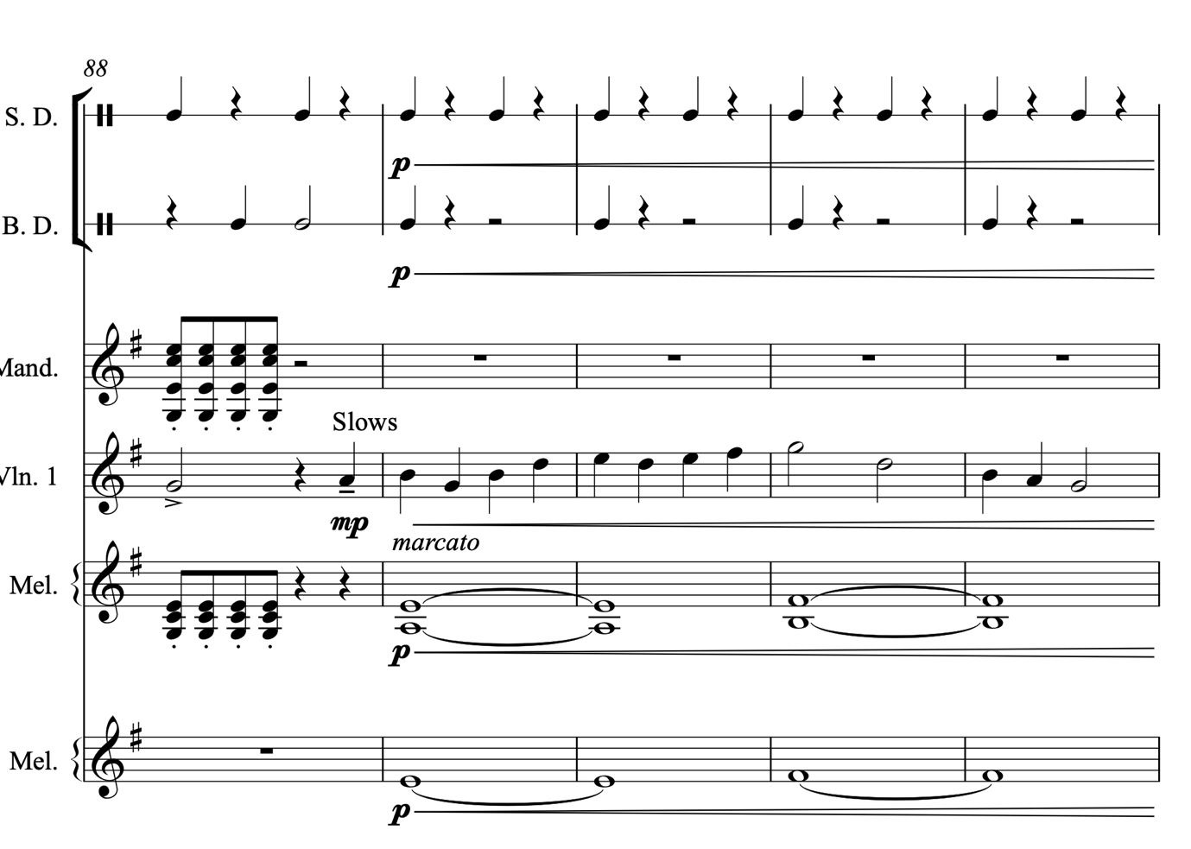
Figure 8. ‘Brighton Camp’ - The Slows.
The slow allows for the fiddle to play in a more expressive manner, utilising more ornaments and vibrato, before moving back to the full-time quaver version of the tune for the final four bars, still maintaining the 16-bar structure from before.

It is important to note that this gestural element is not always played for dance, it is played in several contemporary contexts, including professionally on the stage or in recorded material, where dancing may take place in the audience, but is a more spontaneous byproduct of the music, as opposed to a planned event. Moreso, the interesting feature of this change in function is that much of the ‘dance element’ has been retained, even when there are no dancers present. In a similar vein, slows are a uniquely English feature. Being so closely linked to the function of morris dance, which contemporarily is a predominantly English dance (which is also popular in America and Canada), but with very little stylistic crossover in terms of dance or music with its musical and cultural neighbours.

Slows aren’t a huge feature in the recorded professional output analysed for this thesis, potentially to do with the lack of playing directly for dance - but are nonetheless a feature. This hints at the importance placed on the historical function of the tunes, that some professionals choose to include in their professional output as a marker of English style. For example, Will Pounds ‘Brighton Camp’ from his album ‘Through the Seasons: A Year in Morris and Folk Dance’ is an outward statement of the musics link to its dance function, and the inclusion of features like the slow (demonstrated in Appendix 5) seem an obvious link to English folk dance. The slows present in Eliza Carthy and the Ratcatchers arrangement of ‘Franks’ and ‘Watermans’ are an equally bold statement of Englishness (discussed in 4.7).

4.2.2.1.b Groove
Sam Sweeney quotes the term ‘danceable’ (Sam Sweeney: The Strad, 2014) and brings the concept of groove as a gesture into the discussion. John Spiers comments on how groove affects method of writing tunes:

Similarly with rhythm, dotting and swing, I have attempted to show how I would normally play the tune with runs of straight or dotted quavers but that doesn't mean they all have absolute values of time. Finding the groove is essential to good dance playing and written notes are a mere skeleton asking to be fleshed out. (John Spiers: JIGGERY POKERWORK - The John Spiers Tune Book, 2017).

Groove, the idea of propulsion and ‘rhythmical swagger’ (Jon Boden: The Strad, 2014) or swing in both the rhythm of a melodic line and in the harmonic accompaniment is clearly one important method by which danceability can be instigated. It is, however, a difficult thing to measure, because it’s so ingrained in the stylistic aspects of instrument music from England. It could be argued that all the tracks analysed for the CD data featured ‘groove’, and it is hard to quantify its effects.

The rhythmic structure of a tune plays an important role in creating groove and giving space for extra stylistic details, like ornamentation. The stereotypical quaver-based movement of the dance tunes (Keegan: 2010, p.87) that characterise much of Irish and Scottish music, for example, are different in folk and traditional music from England. In England, Crotchets are the most common note duration to feature (Keegan-Phipps and Winter: 2013, p. 85) again linking music to the dance style that it accompanied (morris dancing). This commonness of duration can affect both the groove and articulation, influencing the creative practices that a musician may choose to employ. For example, choosing to break up any consecutive crotchet durations with ornaments, or a different emphasis of groove, can drive a tune forward.

However, there are certain types of groove that are more closely associated with a sense of English style. A commonly discussed use of groove is in the playing of English jigs for morris dancing. The jig groove is a swung 6/8 pattern characterised by a heavier off-beat, emphasising the 3rd and 6th beats of the bar, as opposed to the norm of the 1st and 4th, creating a lifting off-beat feel.

Beats 1 and 4 would normally have the biggest emphasis, with a lesser emphasis on beats 3 and 6, and very little on beats 2 and 5. […] You might have noticed that I’ve talked about slightly emphasising the main beats - an overemphasis on the main beats can make a tune sound leaden and lumpy.’ (Chalmers: The Fiddle Project - English Jigs, 2013.)

This English jig groove is demonstrated in the score analysis of ‘One String Jig’, written, and performed by Rob Harbron. The tune is highly rhythmic and the groove under the jig is what I would describe as a typical English jig gesture with the lifting offbeat, almost swung momentum throughout.
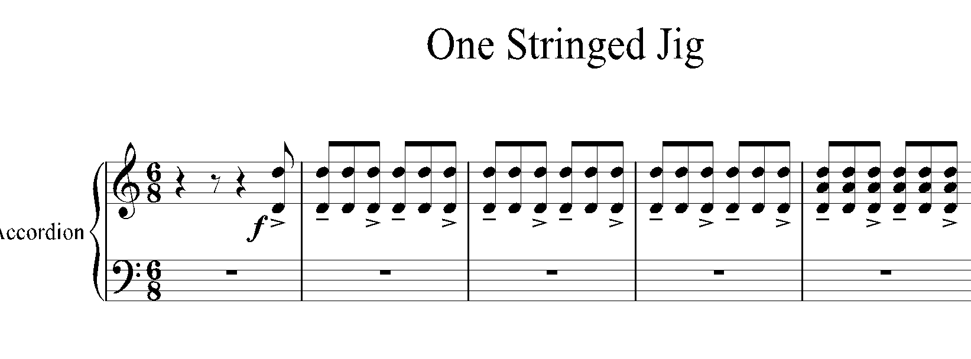
Figure 9. ‘One String Jig’ – demonstration of English jig groove.
The ‘swing’, as a gesture of English style, is represented in the score using ‘tenuto’ on beats 1 and 4 of each bar, usually used to dictate that a note needs to be held to its full note value, and an accent on beats 3 and 6 of each bar, usually used to show that a note needs to be more pronounced and emphasised (as demonstrated in figure 9). In this piece, however, these two articulation markings are used more as a key than as a performance direction, showing that something that is rhythmically interesting is happening, but in reality, it is neither an accent nor a tenuto being used. It is more a lift and emphasis placed on the above notes, creating an almost swing-like groove. The groove in the score analysis is a key method of instigating rhythmic variation and interest in the piece, adding to the danceability of a contemporarily composed, traditionally styled tune.

The core gestures of style, structure and function are the key markers that help musicians identify a tune as belonging to a particular style, genre, and tradition. Structure and function are both interrelated musical gestures that clearly affect each other, and both have an influencing role on the idea of style in instrumental folk music from England. Again, playing instrument folk music for dance is not at all a solely English concept, but gestures of the dance traditions in England have seemingly impacted stylistic gestures of tune playing including the professional output of artists on the contemporary scene. The structures, even those that don’t conform but are linked to the tradition through function, provide the expected framework and it is the ornamentation, groove, tonality and harmonies, as discussed below, that create the interesting arrangements over the top of the expected structures, as demonstrated by Jon Boden:

[T]hat’s kind of how folk music works, you give yourself a structure, the simplest form of structure is I suppose is if you’re playing a tune, that’s in a sense a structure that you’re all following, but then you’re all kind of going off in different ways to make it exciting and you kind of hope that a bit of magic’s going to out of that. (Jon Boden: Hudson Records Listening Club - Rose In June, YouTube, 2020)

Structure, and by extension, historic function, are the building blocks for other gestures of style to be built on top.

4.3 Tune Type
The importance of dance, even as a historic influence can be recognised in the common tune types used by professional musicians. Tune types are a key stylistic gestures across instrumental folk scenes in the U.K and Ireland in general, they are part of the categorisation systems employed by those on the scene. Tune types are the external structures that contain the expected internal phrases (discussed in 4.2) and link instrumental music today to the past dance function for which much of this music existed. As discussed in 2.3.1, the use of western classical terminology is not always relevant, and whilst the time signatures of the tune types are clearly important, referring to them as jigs in 6/8, or reels in 4/4 is not particularly reflective of a scene that refers to tune types as a relation of the dance, i.e. as a jig. The exception to this is a 3/2 hornpipe, discussed further below, where the time signature is part of the name of the tune type. Indeed, difficulties come when trying to transcribe the differences between reels or polkas, as arguably they could be written in either 4/4 or 2/24. However, it is the groove that these polkas are played with, the aural knowledge as opposed to the written, that differentiates them from reels, and vice versa. Examples of jigs, reels, and polkas feature heavily in these types of folk musics and are common in professional performances (Keegan-Phipps and Winters: 2013, p.86), although there are differences in styles, such as differences in tempo, between English music their Scottish or Irish counterparts. Waltzes and slip-jigs are a feature alongside tune types from elsewhere; America, Ireland and Scotland were quite as common influences on artists in the survey data, alongside evidence that these tune types are well-known, recognisable structures used by professional musicians on the scene in England.

Figure 10. Frequency of Tune Type from CD data.
In England in particular, the most used tune type out of the 153 tracks analysed was the polka, there were 50 instances of polkas, most closely followed by the jig, of which there were 40 as demonstrated in figure 10. Reels, similar to polkas in tune playing from England were the 3rd most common tune type, closely followed by an equal number of 3/2 hornpipes and waltz. Other tune types that were perhaps in free time or a tune type that changes time signature, featured 23 times in the 153 tracks. Marches and slow tunes were the least common tune types used in the tracks analysed.

There were an almost equal number of waltz and 3/2 hornpipes (commonly known as 3/2s). This type of hornpipe differs from the dotted tune in 4/4 which commonly appears in Irish, Scottish and English tunes, despite the commonality in name. 3/2 hornpipes are a tune type that appear to be predominantly English, with links back to common appearances in historic tune books like the Playford English Dancing Master. They are most associated with Northumbrian instrumental style, as discussed by Nancy Kerr:

Historically, 3/2 hornpipes have been more closely associated with the Northumbrian pipes. (Nancy Kerr: 2015, p.1)

And appear widely in historic collections across the Northwest, such as John of the Green - The Cheshire Way. Grace Smith wrote was a 3/2 hornpipe as part of the commentary composition process (presented as score analysis in 6.5.2), and that active choice came about from the fact that she had a context of current 3/2s in her repertoire, demonstrating that 3/2 hornpipes are in the toolbox of tune type choices that professional instrumentalists use in England.

I'm going to try to write a 3/2 hornpipe, this is a type of tune I really enjoy playing but I've not actually written very many so I thought this would be a fun thing to try. (Grace Smith: interview, 2021)

With 24 3/2s also appearing in the data (figure 10), it is the joint 4th most common tune type to appear on recorded CD, and being not at all as common as reels, polkas, or jigs in the other similar musical folk traditions of Scotland and Ireland, it can be concluded that 3/2 hornpipes play a distinct role as a uniquely English tune type.

Whilst 24 tune types were 3/2 hornpipes, out of the 130 tunes analysed in the CD data set, 23 of them did not fall into the categories of a known tune type like a jig or a reel. This is a significant number, but most of those 23 non-conforming tunes (21 tunes) came from the same artists, and therefore the data set is skewed. Three Cane Whale rarely played a tune that would fall into a tune-type category commonly associated as a gesture of instrumental folk music. Nonetheless, it is still important to acknowledge that not all professional instrumental music output falls under the expected tune type structures, and there is a certain amount of creative leeway afforded in terms of recognisable tune type, although most artists from this data set do conform.

4.3.1 Time Signature Changes
Each tune type is distinguished by its time signature as the identifying feature of a particular type of dance. It is important to note that within the tracks analysed, the tune type rarely changed within a track or a set of tunes.

Figure 11. Percentage of time signature changes from CD data.

94% of the time, a jig was followed by another jig in a set, for example, keeping within the same tune type and key signature. Only 6% (9 tracks) have a time signature change (figure 11). Again, Rob Harbron and Three Cane Whale are the main performers whose tune playing and writing don’t always follow these gestural norms, playing in more irregular time signatures or free time.

However, it can be concluded that changing time signatures within a track or set of tunes is not a large gestural feature of professional instrumental folk music from England.

4.3.2 Tempo
The relationship between tempo and tune type also plays a role in understanding English style. It is useful to analyse the bpm (beats per minute) as it helps us gain an understanding of tempo as a stylistic indicator, based on the output of these artists. However, it is important to note that terms such as tempo and bpm are unlikely to be used in reference to tune playing and are not terms that feature in the data set. Whilst they are useful descriptors, it is likely the musicians play at whichever speed feels natural and comfortable- and that fits the functional gesture of dance.

Figure 12. Tempo and tune type - average speeds from CD data..
As can be seen in figure 12, the fastest overall tune type was the waltz, with an average speed of 140 bpm, but with the highest spread to the maximum of 190+bpm (beats per minute). In contrast, unsurprisingly, the slow tunes were much slower, at around 78bpm. However, the jigs, reels, polkas and 3/2 hornpipes all have a relatively similar average speed of between 105bpm and 125bpm. Whilst the overall spread of tempos for each tune type is obviously different, with one particularly slow jig at just over 40bpm, and one particularly fast reel at over 180bpm, however the average tempo is relatively stable between the 3 most common tune types and the 3/2 hornpipe.

There are comparisons drawn between music from Scotland, Ireland and other ‘Celtic’ musics in terms of tempo, with music from England usually being described as ‘slower’ (Keegan-Phipps and Winter: 2013, p. 85) in tempo. Certain musicians from these musical traditions do set a much faster pace of around 140bpm, as can be seen from Keegan’s (2010, p. 88) analysis below (referring to Irish music):

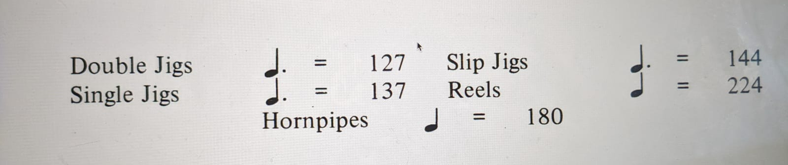
Figure 13. Average tempos of tunes from ‘Irish Music’, from Keegan (2010). The Parameters of Style in Irish Traditional Music, 2010.

The largest spreads in tempos are for hornpipes, slow tunes, waltzes, and others, meaning that, from the CDs analysed, musicians play these tunes at a variety of tempos. This differs from the jigs, 3/2s, polkas and in particular, reels, where the range of bpms are a lot smaller, meaning that there seems to be more consensus between artists on the tempo that these tune types are played at. There is an interesting correlation between the popularity of tune type, and consensus of tempo, there seems to be more consistency in tempo amongst the more commonly recorded tune types.

Tune types and their self-contained structure are clearly influencing factors in the creative practices of musicians within the instrumental tune-playing scene from England. The overall structure as a road map of melody, its time signature, its tempo, and its tempo changes are important musical gestures that must be considered in creative practices, as without them, it would be difficult to qualify a piece of music as belonging within the folk and traditional instrumental tradition from England. Some musicians ‘like the structure and patterns this offers’ (Sarah Matthews: survey, 2020), even to the extent that these structures influence musicians when working and creating music outside of the English folk scene; the ‘traditional material, it is still there as a framework’ (Jon Boden: survey, 2020).

One of the things that they liked about my writing was that it had an accent, a voice, that no matter what I was trying to do and how far away I was trying to move from my roots they were pervasive, you know, you can't escape them […] I think you can do so much within those structures. (Kathryn Tickell: interview, 2020)

Clearly a valued stylistic gesture, tune types, and their structures are identity markers, linked to function, and to place, and they are the foundation on which a lot of the other musical gestures discussed are built upon. Even today, when the context of the music has changed, it was the original intended function of this music that created the markers of identity.

4.4 Variation
The use of variation as a gesture in an arrangement of a tune is a common way in which musicians add variety and excitement to their performances and arrangements. As Keegan writes:

Variation is another difficult concept to articulate. It lies anywhere between composition and improvisation and of course is an aspect of all the other technical parameters of style we speak of (i.e. the way a player will ‘vary’ the use of ornamentation, phrasing, articulation etc.). However that we will talk about here is the deliberate changing of main melody of the tune for aesthetic effect. How much this process is composition or improvisatory (two intrinsically interconnect ideas) is very much down to the musician and in an Irish context the word variation seems to cover both. It is important again to emphasise that the use of variation is a stylistic choice. (Keegan, 2010, p 78.)

Whilst the terms ‘composition’, ‘composer’ and ‘composer’ were used by participants of the survey, Keegan (2010) talks about ‘premeditated processes’ (ibid. p.81) of composition as being more concurrent with ideas of improvisation, compared with the more ‘in the moment’ process of variation. However, in terms of instrumental music in England, improvisation and ‘in the moment’ variation, co-exist, as part of the performance processes, and importantly, the term variation often refers to either process. This links to Akessons (2006), discussed in 1.3.1, where there are different elements of creative practice, which include recreation, or staying close to the source - i.e. melodic or rhythmic variation for example, and renewal, whereby a whole new tune is written based on knowledge of the tradition.

Variation, as a concept, can refer to a multitude of musical elements, but for this thesis, I have used the following 4 categories for my analysis of variation. Melodic variation, harmonic variation, rhythmic variation, and textural variation, refer to changes in the melody line, changes in the harmonic accompaniment, changes in both the rhythmic accompaniment and the rhythmic make-up of the melody line, and to changes in the arrangement or accompaniment around the melody line, respectively. This is to help categorise the variant forms in relation to the forms of creative practice outlined in 3.3. 100% of the tunes analysed contained some sort of melodic or rhythmic variation as a gesture, meaning that no tune was played the same way twice. As Jamie Roberts comments, variation is a key gesture of instrumental music on the folk scene in England:

I'm a big fan of people who play a tune but add variety each time round whilst retaining the tune’s fundamental elements so it's still recognisably the same tune but played differently each time. (Jamie Roberts: survey, 2020).

It is important to acknowledge the role of variation as a form of creative practice, in all its forms, as a large feature of this music. Variation is both the premeditated form of the creative practice and the unintentional form, to account for the fact that improvisation is both an intentional and unintentional gesture of instrument folk music from England.

The various forms of variation, including ornamentation (see Appendix 1 for detailed explanations of ornamentation in English style), melodic variation and rhythmic variation, that are used by artists analysed for the CD data are shown below in figure 14. I have chosen to group ornamentation with melodic variation instead of having its own stylistic and gestural category for analysis. This is because ornaments are often added to a tune, as an individual form of stylistic gesture, meaning that they often result in a change of the melody line, hence the categorisation as melodic variation.

Figure 14. Number of extra stylistic forms of musical variation, per track from CD data.
The grace notes appear as the most frequent form of variation in 148 tracks, out of 153,
The grace notes appear as the most frequent form of variation in 148 tracks, out of 153, followed by mordents, in 126 tracks, and rolls in 107. Birls are a feature but are more heavily concentrated in 57 tracks, in contrast to the low frequency of rate per minute demonstrated in figure 15 below. Likewise, left-hand pizzicato, despite having a higher frequency of rate per minute, only appears in 7 tracks, reinforcing the idea that these ornaments are highly favoured by a few artists and are not necessarily widely used across all the tracks. However, it is still clear from this graph that the grace note is the most highly favoured ornament used by these musicians.

This graph also makes it easier to demonstrate the ornaments and musical gestures that are hard to quantify, such as double-stopping (also difficult to quantify as individual ornamentation), and variation, such as melodic and rhythmic variations.

Every track analysed contained both melodic and rhythmic variation, meaning that whilst playing a tune multiple times during a track, musicians are actively finding ways to develop the melody, or groove to create and maintain interest for themselves and the listener. This variation would also include slows, appearing in 6 tracks, as a form of melodic and rhythmic variation. Forms of variation that will be discussed but aren’t present on the graph are gestures such as dynamics and harmonic variation, as these feature throughout the tracks analysed are thus much harder to quantify.

4.4.1 Melodic Variation
There are many different forms of variation, from the changing of melody notes to adding decorative ornamentation.

4.4.1.a Ornamentation
As a general concept, ornaments as a gesture are a form of often melodic (and sometimes rhythmic) decoration used to create interest and variation in a melodic line. Sam Sweeney, here describes ornamentation as a personal form of decoration:

Ornaments are decorations that we add to the basic notes of a tune to add variation and interest. Which ornaments to use, and when to use them, are very personal decisions to make. (Sam Sweeney: Masterclass, Strad Magazine, 2014).

And likewise:

Ornamentations such as ‘cuts’ and ‘rolls’ (realisations of which are similar to ‘mordents’ and ‘turns’ in the Western Classical vocabulary […] are particularly significant in ‘breaking up’ crotchets so as to disrupt any sense of static resolution and this maintain the regular, driving momentum of the predominating quaver movement. (Keegan-Phipps and Winter: 2013, p. 85).

Whilst this seems simple enough, the individual ornaments within a style are difficult to define as they are often performed in an individualistic manner. The content of this analysis isn’t an exhaustive list of ornamentation used, and there may be many other types of decoration, some more instrument-specific, with other names, and usages.

Borrowing and exchanging, alongside adapting and reinventing decorations are a key part of the instrumental folk scene from England, because of the lack of standardisation present across the scene, as discussed at the start of this chapter. The lack of historical sources or audio examples, especially those of a usable standard, means that it can’t be known for sure what ornamentation as a stylistic gesture, may or may not have sounded like. But this also means that professional musicians have more freedom to use and explore ornamentation as they desire through their own creative practice.

Here, I present an in-depth analysis of the CD data, detailing individual ornamentations as stylistic gestures to give an overview of how ornamentation as variation is used by these professional instrumentalists from the folk and traditional scene in England.

4.4.1.b Common Usages
It can be seen in figure 15 that the ornament used with the greatest frequency was the grace note, where the rate of grace notes per track is by far the highest. On average 4 per minute, with a spread average of 1.9 to 5.5 per minute, and with some much higher outliers of up to 14 per minute, meaning that they seem to be the ornament most favoured by these musicians.

Next most favoured is the mordent, at 2.4 per minute, with a spread of 1.5 to 3 per minute, with as many as 12 per minute as an outlier. Rolls are also commonly used by artists, averaging at 1.9 per minute with a tighter spread of 1.8 and 2.8 per minute and with the highest outlier of around 11 per minute.

Whilst grace notes are clearly the most widely used form of ornamentation across all the CD data, the ornament is more popular on certain instruments. For example, in groups where the fiddle is the lead tune player, there are substantially more grace notes used. This conclusion is also present in the score analysis, where the fiddle-based artists use the most ornamentation and the melodeon/concertina and the Three Cane Whale composition contain next to none.
Figure 15. Average rate of ornament frequency, as an average per track from CD data.

In Bryony Griffith’s recording of ‘Radstock’, ornamentation is used throughout the arrangement as a form of variation (see figure 16).
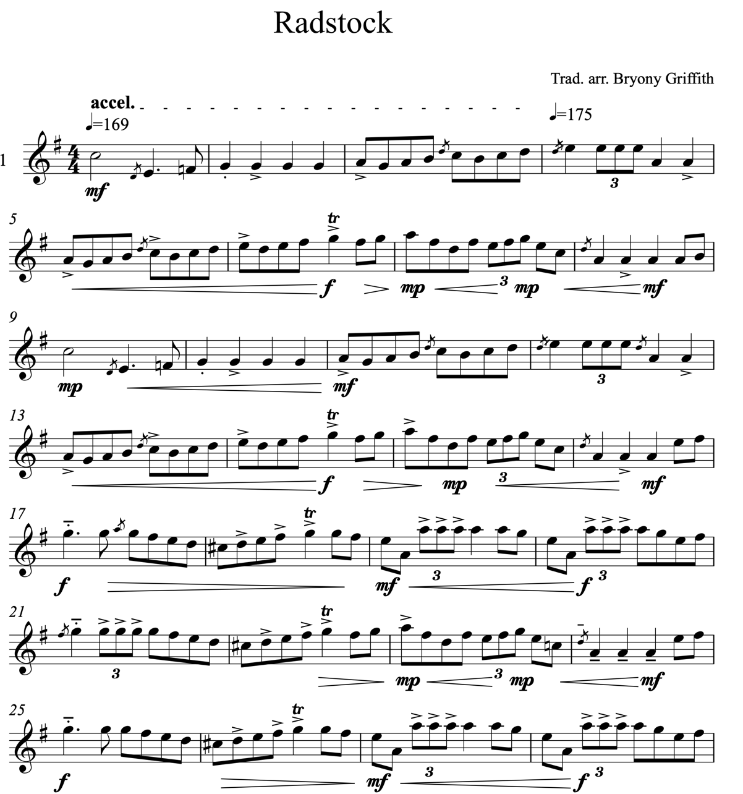
Figure 16. 1st A and B parts of ‘Radstock’.
However, the ornamentation used throughout is varied each time through the tune. In the first time through the tune, there are birls (seen in bars 19-20, and bars 27-28 in figure 16). As explained in Appendix 1, the effect of the birl is a more rhythmically driving ornament than the classical triplet, often played, as Bryony Griffith does, with a crunchy bow noise to create the desired effect.

Grace notes are also a feature of the first time through the tune, for example in bars 1, 3 and 4, figure 16, whereby extra notes, like faster passing notes, are added to decorate the melody line. Grace notes, combined with the use of varied articulation, indicated here using staccato and accents, create a dance-like groove - suitable for its original intended function. It should be noted that the articulation marks used do not necessarily dictate an exact staccato or accent but more demonstrate a lift and then emphasis on the off-beat of a bar, again compounding the groove.

As the second time through the tune comes around (figure 17), the arrangement is building and becoming more complex, with more ornaments added.
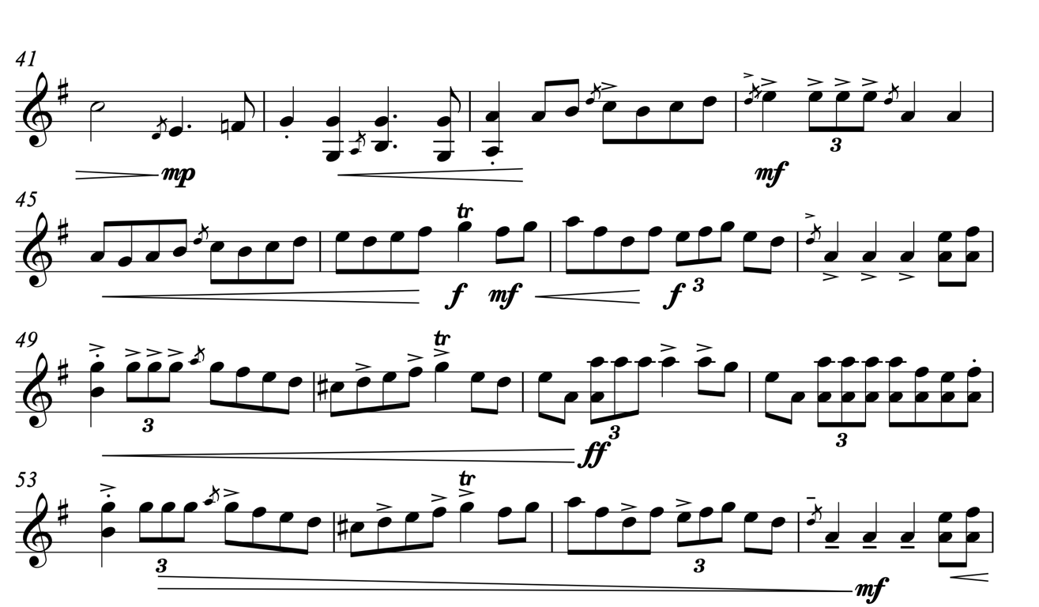
Figure 17. The second time through ‘Radstock’, an A part and a B part.
Double-stops are a common feature of the second time around the tune. The double-stops have two effects: to hint at the chordal accompaniment of the tune and to help the variation build over the three repetitions of the tune. Compare below the amount of double-stops in the above time through the tune (figure 17) compared to the last time through (figure 18).

There are also trills present in the second time through the tune, dictated by the tr symbol on the high G in bar 70 in figure 16. It serves the purpose of breaking up the crotchet note in the piece, and provides the momentum of a quaver rhythm, creating a rhythmic drive that follows on and into the quaver runs on either side.
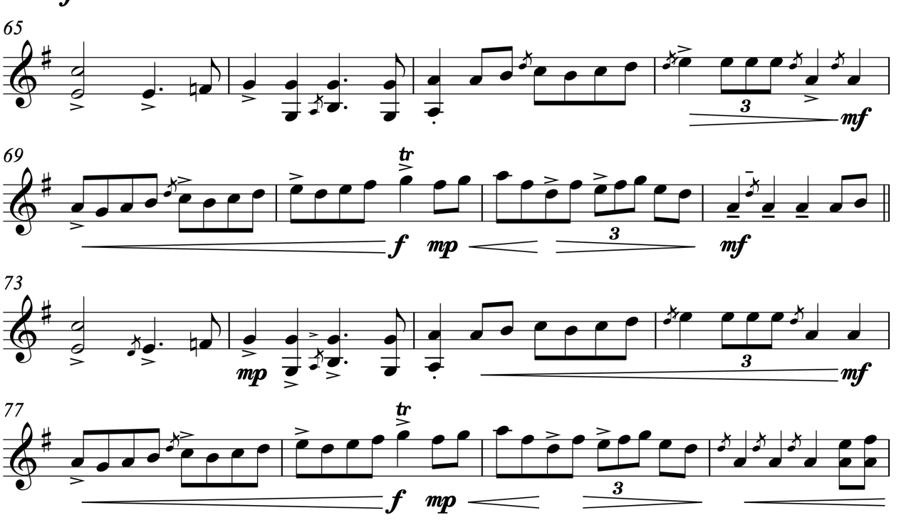
Figure 18. ‘Radstock’: A part with more ornamentation.

Cuts are also used throughout this arrangement, but, on the last time through the tune more ornamentals are used as a gesture to build up the arrangement such as in bar 72 and 80, figure 18, for example, the ornament is a cut, where a finger is used to briefly tap on the string, ‘cutting’ the note in half, not with pitch, but with a rhythmic strike. The pitch at which the ornament is written simply dictates the finger most likely used to produce the rhythmic ornamentation, by tapping on a string.

As discussed and demonstrated in the score analysis, the fiddle playing of Bryony Griffith contains much ornamentation, and likewise, so does Ross Grant in Will Pound’s Band. When a tune is performed as a solo, or with limited accompaniment, there is more ornamentation, possibly to create more interest in the melody line that would perhaps have been created using harmony or chordal lines, rhythmic accompaniment, or textural interest. This, however, is a personal and individual choice for each player, as they perform, both on a conscious and unconscious level, as Kathryn Tickell describes:

Ornaments definitely don't influence me because I always play with them, […] I would play them [tunes from a tune book] from sight and would play them with ornamentation, not even just the ones where it's got a little twiddle over it, it comes out with ornamentation whether I wanted to or not. (Kathryn Tickell: interview, 2021)

However, whilst this may be true in the score analysis, I would stretch it further in conjunction with the CD data and say that any instrument that has the role of a predominantly melodic nature within a band - i.e. not there to just accompany - uses more ornaments. This then accounts for the large number of grace notes used on most instruments that have a melodic role, and accounts for the lack of ornamentation when an instrument is providing its own accompaniment, such as ‘Brighton Camp’ and ‘One String Jig’ (complete score transcriptions in Appendices 5 and 6).

4.4.1.c Uncommon Usages
The least common ornament present is the slide, with a very small spread, showing that there aren’t many used throughout all the tracks, at less than 1 per minute. Similarly, with the cran (1 per minute), trill (less than 1 per minute) and birl (1.3 per minute).

The reason behind these more uncommon usages cannot be found in the data alone. It remains to be seen why certain ornaments are simply used less, it could be that they are reserved for a particular use, or that they are borrowed from a different tradition, and have not been fully incorporated into English style. However, it is clear, that in the current output on the scene in England, these ornaments are not yet common.

4.4.1.d Contextualising Ornamentation
It is important to note, that ‘Brute Angels’, ‘Brighton Camp’, and ‘One-Stringed Jig’ were picked by the artists themselves for analysis, as the artists thought that it would best demonstrate what was talked about in the interview. ‘Radstock’ was not picked by Bryony, but by me, because it contained interesting fiddle ornamentation - meaning that this skews the data analysis. However, the rest of Bryony’s tracks were included in the CD data, so an overall picture of her style and its impact on the scene can be seen there. However, it could be that these pieces such as Brute Angels simply don’t have as much ornamentation as others performed by the same artist. Certainly, analysis of the rest of the respective albums does reveal more ornamentation, in particular rolls on longer notes, but ornaments do not seem to be a huge feature of the playing of Three Cane Whale, for example.

Several conclusions could be drawn from this:

Firstly, the musicians whose CDs were analysed have chosen not to use a large amount of ornamented decoration in their playing. In fact, the in-depth analysis of 20 albums from across the last 15 years reveals patterns across English instrumental folk. Complex ornamentation is not a huge feature in tune playing in England. The most common ornament used is the grace notes and mordents to a significant degree, with some rolls and occasional birls. However, there are some stark differences in playing styles. Some, especially fiddle players, do have a tendency for some ornamentation, whereas other instrumentalists instead place a heavier emphasis on rhythmic variation and groove. The use of ornaments also relates to the context of the performance. For example, fiddle players may choose to use more ornaments when playing solo, than in an ensemble context, whereas a melodeon player may choose to embellish a tune with chords instead of ornaments, an option not available on every instrument. This again comes down to personal influences, for example, a musician who is in musical contact with many Irish or Scottish musicians may adopt different ornamentation styles and apply them to English tunes. All these contexts can have a varying impact on the level and content of the ornamentation.

Secondly, as apparent in the CD data and the score analysis, the use of ornamentation as a feature of instrumental tune playing in England is both individualistic and role dependent. It’s individualistic in that artists may choose to use whichever ornamentation suits both their personal sense of style and the piece that they are playing.

The melody line itself can have a varying impact on the individual ornamentation. For example, the frequency of note types, i.e. frequent runs of quavers, leaves little room for certain types of ornamentation, whereas longer crotchet notes leave more time. Similarly, dotted crotchets, common in jigs for example, mean that the placement of a roll may be different, with a longer hold on the written note before moving to the ornament. Stylistic differences in English music (which generally has more crotchet beats, than its Scottish or Irish counterparts, as discussed by Keegan-Phipps and Winter (2013) above) opens the melody lines up for more ornamental interpretation, in the same way that it allows for variation in rhythm and groove.

It’s also individualistic in that it is instrument-specific. This overlaps slightly with the idea that the ornamentation presented in the data analysed is role dependent, and its usage is both reflective and changeable depending on whether an instrument is solely playing the melody or playing both melody and accompaniment at the same time.

Individual contexts have a large influence on how and what ornamentation may be used in the decoration of a tune. This has led to variety in the ornamental decoration used, varying from player to player, from instrument to instrument. Thus, creating a personal, individual form of variation. It is clear, however, that ornamentation does not play a huge role in the current style of English instrumental tune playing of the artists analysed. It could be concluded that whilst ornamentation is a personal and individual choice, ornaments are a present but not prolific feature in professional English tune playing.

4.4.1.e Instrument Specific Ornaments
It is important to note the history of the influence of ornaments, and where they have come from. Many, as already discussed, are borrowed and since incorporated into styles of playing tunes in England. They are borrowed from the different musical cultures that musicians interact with, a relationship made even easier in today’s world of increased connectivity. Historically, many ornaments came from the desire to copy the sounds created by another instrument, often the pipes. For example, the cran in Ireland and Scotland, a popular ornament on the pipes and whistle, is now imitated by the fiddle to create a similar stylistic and rhythmical effect.

However, there are ornaments that are specific to the playing of particular instruments, that function due to the physical technicalities of playing that instrument and are not transferable in the same way to other types of instruments. The technical ability of an instrument is here acting as a gestural feature of style.

Of course, some instruments lend themselves to more ornamentation than others (notably the flute, pipes and whistle) and some do not lend themselves to crans and rolls at all (e.g. the banjo and mandolin). (Keegan: 2010, p.71)

For example, playing full chords is not possible on a woodwind instrument, and is not possible in the same way on a bowed string instrument. Likewise, certain ornaments work differently on some instruments than others, for example:

Many of the ornamental patterns used on the established instruments of Irish music, especially legato "rolls" and the fiddler's bowed "triplets," cannot be copied exactly on the melodeon. In their place melodeon players generally substituted single and double grace-note ornaments using an adjacent button on the instrument. (Smith: 1997, p. 436).

Other types of musical decoration are completely instrument-specific, such as double-stopping, the act of playing on two strings at once, creating either a drone or a harmony alongside the tune. This is only possible on bowed string instruments and is a common feature of many fiddle players on the scene. Variation, in all its forms, as described above, may simply arise from being played on a specific and different instrument, whereby the mechanics of the instrument itself means that a tune may be performed with a specific set of ornamentation, groove, and accompaniment. Hence the differences in availability of methods of variation between Bryony Griffith’s fiddle arrangements, and Will Pound’s full band line-up.

As demonstrated above, there are both individual ornamentation and instrument-specific ornamentation that act as gestural influences over the decoration of a melody line and in turn influence the stylistic portrayal of a piece of music.

4.4.2 Harmonic Variation
Harmonic variation instigates musical interest and change in an arrangement through changes in the harmonic, often chordal accompaniment, of a melody. It can take the form of differing the harmonisation of the chordal accompaniment or creating/changing an accompanying harmony line. But harmony, as a form of variation, is harder to quantify than melodic variation, because it is a natural part of ensemble playing on the folk scene, meaning that it is one of the main gestures for creating change and interest in instrumental folk music.

For example, harmonic variation is a part of Will Pound’s arrangement of ‘Brighton Camp’, a feat comparatively easier due to the whole band arrangement, as opposed to the solo fiddle arrangement of ‘Radstock’.

Figure 19. ‘Brighton Camp’ - harmonic variation.
We pick up the score towards the end of the arrangement in figure 19, where more harmonic interest is added. Under the fiddle solo, the melodeon and mandolin perform rhythmic punctuations firstly on the relative minor chord, E minor, for four bars, (in bars 73-76, figure 19) followed by the sub-dominant chord, C major (in bars 77-80, figure 19). At no point does the harmonic accompaniment cadence to the tonic, building the tension throughout this section, meaning harmonic variation plays a big role in this arrangement.

4.4.3 Rhythmic Variation

Our melodies are rich in modal scales, rhythmic variation etc which identifies them as 'folk' and I feel that should be reflected in any arrangement. (Sandra Kerr: survey, 2020).

As Sandra Kerr comments, rhythmic variation is a key stylistic gesture in the arranging process of instrumental folk tunes from England. This form of variation can be anything from the changing of melody rhythm, or changing of accompanying rhythm, to create some sort of effect, or build or drop in tension. Rhythmic variation can be simple, or as complicated as changing the emphasis of the beat within a tune, i.e. to an offbeat, or syncopated beat. There are also rhythmic ornaments, as discussed in Appendix 1, the birl, in some cases and cuts.

Rhythmic variation is also used in ‘Brighton Camp’, particularly in the melodeon part. The notes of longer duration are subdivided into their constituent parts, played in a staccato or/and accented manner, meaning that the flow of the tune is almost constantly driving forward, and not rhythmically static by the longer crotchet or minim notes - demonstrated in bar 38 (figure 20). This is doubly emphasised by the fiddle joining the melodeon on the tune in unison, likewise, accenting the rhythmic variation, making it stand out.

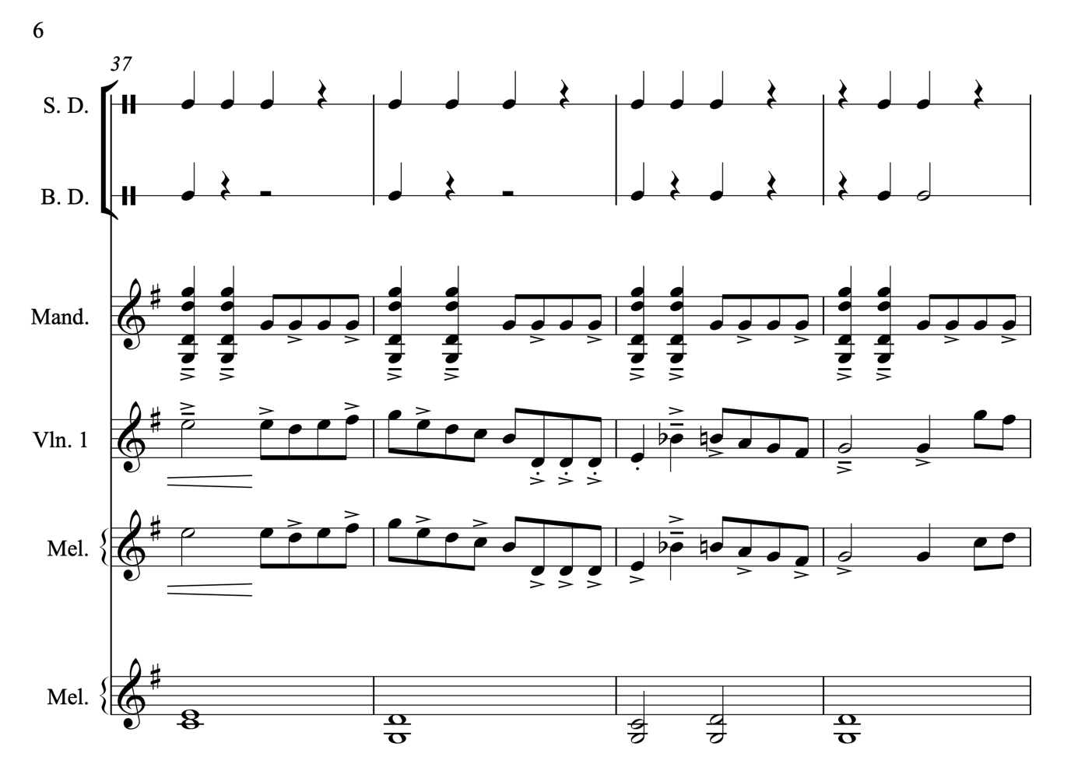
Figure 20. ‘Brighton Camp’ - rhythmic variation.
Likewise, rhythmic variation plays an important role in Rob Harbrons’ ‘One String Jig’, where rhythmic variation is used to create interest from the start. The transcription of a dotted quaver to a quaver with a tenuto marking is used to indicate that dotted notes are pushed on a little more. These are then followed by a bar of less swung melody. This is different to the B part, where the same melodic material is played with rhythmic variation in figure 21, bars 18 & 19. Bar 18 has a more straightened-out version of the tune, with no dotted rhythms, and the crotchet note on beat 4 elongates the swing even further. In the first figure the second phrase is played with less of a swing, but in bar 19, figure 21, a dotted-quaver to semiquaver rhythm has been added again to create more variation.

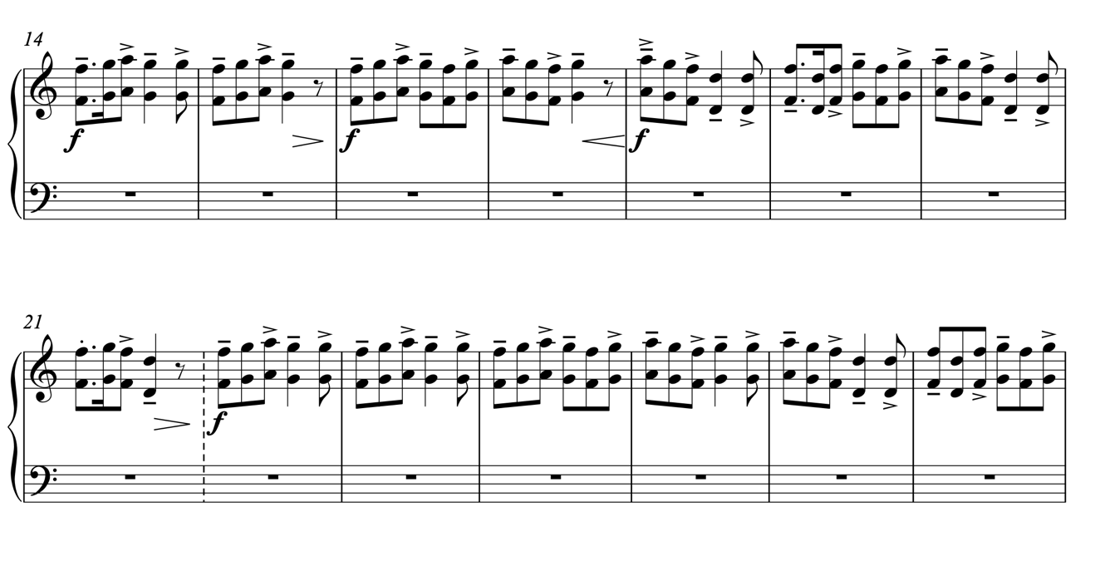
Figure 21. ‘One String Jig’ - B part with rhythmic variation.
Rhythmic variation and the idea of groove is an underlying gesture of playing instrumental folk and traditional tunes from England. It is important to note that rhythmic variation is influenced by the historic dance function of these tunes. ‘If playing for dancing I am conscious about rhythmic signposts for than dancers,’ (Richard Moss: survey, 2020) meaning that it is important to use rhythm in a way that compliments and guides the dance, without creating confusion with too much complexity,. Rhythmic variation is vital to both create a groove that makes people want to dance, and to create interest for both listener and player - linking the process back to the ’danceability’ (Sam Sweeney: The Strad, 2014) discussed in (4.2.2.1).

4.4.4 Textural Variation
Textural variation is the method whereby musical interest is created by adding extra musical gestures around the melody, which can include rhythmic variation and groove, or chords, harmony, and countermelodies. Textural variation can both include moving away from one simple line of melody, and one line of accompaniment, to thicker textural arrangements within the ensemble setting, but it can also be a move from a big band sound to the single melody line. It can be achieved using chord structures and harmonies, and the active avoidance of them. This can add interest to a melody line, by both creating other harmonic/accompanying lines or featuring just the solo melody, as Sarah Matthews discussed in her model for arranging traditional (and contemporary) material:

- Should it start with the tune?
- Should it have a basic introduction?
- Should it drone through the first time or have chords or have no chords / no accompaniment at all?
- How many other instruments would come in?
- Should there be an opportunity for free playing and improvisation? –
- How can I vary the melody and make it interesting upon repeats? (Sarah Matthew: survey, 2020).

Figure 22 presents an example of textural variation being used in the second time through the tune ‘Brighton Camp’. The first two bars of the tune and accompaniment are the same as the first time (bars 41-42, figure 22), but the second two bars are interrupted by the unison rhythm (bars 43-44, figure 22) The whole ensemble plays in unison, at a loud dynamic, reminiscent of the introduction, but with melodeon also playing the rhythmic break. This is both a form of dynamic variation and textural variation, as it rapidly changes from a relatively full texture to an unexpected unison texture and back again. The simple addition or subtraction of instruments in an ensemble setting creates dynamic contrasts in the creative practice of ensemble writing.
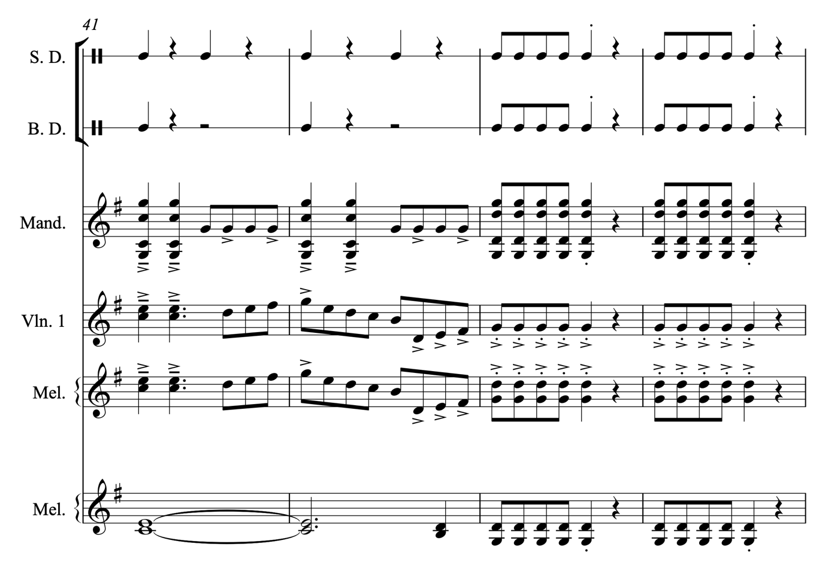

Figure 22. ‘Brighton Camp’ - unison stabs as textural variation.
Textural variation can be about ‘creating some sort of 'shape' with the arrangement using various things such as tension/release & dynamic’ (Jamie Roberts: survey, 2020) by constructing harmonic and timbral interest:

The first time round the tune I will be consciously trying to create a feeling of building towards something (tension) harmonically (using alternate / less obvious chords) and dynamically. Then reaching the second time round the tune, the most obvious chords have more impact (the release). (ibid).

Textural variation can appear in many forms, from working with many other musicians to weave and create textures, or simply on a solo instrument, like the melodeon choosing when and where to add basses or chords to vary a melody. It is a musical gesture that is influenced both by the individual and by the function of the music.

4.4.4.1 The Impact Of Individual Artists
As identified throughout this section, variation is a core gesture in the stylistic sound of instrumental folk and traditional music from England and plays an important role in the creative practices of the individual artists that have been interviewed and analysed. Figure 14 (in 4.2) demonstrates the amount of variation and individual interpretation that is present in the CD data (full analysis in Appendix 2), and this is a useful tool for viewing the idea of an overall style.

However, one artist’s use of variation can skew the data, meaning that what is essentially, for example, an ornament used as a favoured by one artist, can be misconstrued as an ornament commonly used by all. It is also useful to view how many tracks featured each ornament. To account for the different number of tracks from each artist analysed, I’ve calculated the rate of each feature, which is essentially how many of each variation are present per minute per artist.

There are several notable examples of the impact of the individual that skew the view of the data. This is the case with left-hand pizzicato, favoured highly by Nancy Kerr in particular, and used at a high frequency, but not spread out across the different CDs and tracks, giving a false representation. Left-hand pizzicato was used across two tracks, but more frequently between 1.7 and 3 times a minute, on Nancy Kerr’s albums in her duo with James Fagan. The element also appears on the Melrose Quartet albums, where she is one of the fiddle players, at a rate of 0.26 per minute. In a band context, left-pizzicato only appears on one track but appears as a much bigger feature of her playing as the tune lead in her duo. It could be concluded that the occurrence of left-hand pizzicato in these tracks is down the Nancy Kerrs individual use of stylistic gestures, particularly given that the only other artists to feature left-hand pizzicato was Eliza Carthy, at a rate of 0.28 a minute, on one track.

In a similar fashion, grace notes, which are the most common use of ornamental variation, were used at a much higher rate by individuals, like Bryony Griffith who used 584 across all her 18 recorded tracks on ‘Hover’ and ‘Nightshade’, and Sam Sweeney who used 308 across 13 out of 14 tracks on ‘Unearth Repeat’. This compares to lower rates of usage by artists such as Will Pound, with 62 grace notes used over 7 out of 10 tracks and Eliza Carthy with only 46 across all 5 tracks analysed. This is an interesting point of discussion because a lot of the ornamentation present in the data set seems to be utilised by fiddle players. But the lower rate of the most common form of ornamentation presented in the data, which can be seen in Eliza Carthy’s playing can demonstrate that not all the differences can be accounted for due to instrumental technique but can also be accredited to individual style and taste. Therefore, grace notes are not a huge feature of Eliza Carthy’s personal style of playing.

There are also individual differences in terms of instrumentation that affect the rate of ornamentation, for example, instrument-specific forms of variation, like, for example, double-stopping, which is an obvious feature across many individual fiddle players, such as Bryony Griffith and Eliza Carthy, but isn’t a feature possible on the melodeon for example.; this form of decorative, and harmonic variation is skewed via the instrumentation presented in the CD data.

The impact of the creative choices of the individual artists is evident in the CD data presented. However, this doesn’t diminish the importance of this data. The professional artists and their recorded material are at the forefront of disseminated style, as it is their music that is most widely shared and listened to. Individuals’ choices and uses of variation are at the forefront of defining gestures used in contemporary instrumental styles from England.

Variation, melodic or harmonic, is dictated by a personal sense of style, aesthetics, and instrumentation. A personal sense of style, coupled with working with other musicians, can mean that, whether arrangements are either full band arrangements or solo instruments that can provide their own accompaniment to a tune, a tune can be ‘hinted at [in its original form] but essentially become[s] a slight variant of the original’. (Simon Care: survey, 2020). All these influences, however, are key gestures to the arranging processes of instrumental folk tunes from England.

4.5 Tonality
I try and push forms, and tonality to new complexity - I am hoping to gain new audiences from people who don't know what folk is, or are happy to listen to music, and not necessarily prejudge by a label. (John Dipper: survey 2020).

As John Dipper states, tonality is an important feature to most musical forms, including instrumental folk and traditional music from England. Tonality in folk music from England can be broken down into 3 forms: major, minor and modal. Both the major and minor scales are also a type of mode of course, but for the purposes of this thesis, I am dividing them into the 3 distinct categories.

Figure 23. Tonality as a percentage from the CD data.
The data in figure 23 shows that well over half of the tracks analysed (62%) were major. This compares to a much lower percentage of minor tunes, 23%, and modal keys, 15%.

Artists seem to favour major tunes over minor tunes. Perhaps the major keys, maybe easier to listen to and understand as an audience member, lend themselves better to the commercial side of folk music, although that is more probably correlation than causation.

However, whilst modal tonality is not a huge feature represented in the recorded data, they are still a significant feature of the tunes analysed, as it is a total of 35 out of 153 tunes that were analysed that are modal. In comparison with the total of minor tunes, 55, which were analysed, that’s not a hugely significant difference in the percentage of tonality. What is significant is the very large proportion of major tunes.

It might be assumed that modal tonality is a ‘hallmark of’ (Bishop, in Roud, p.653) folk music (in particular songs) and taking ‘into account the selectivity of the collectors’ (Ibid) the analysis of their existence in folk tunes may ‘lead to the identification of possible trends’ (Ibid) in terms of tonality. There is a distinct trend in tune playing to the major. Conformity in tonality could be due to several reasons. The CDs that were analysed were released over a wide time range (15 years) and to a degree may have influenced each other, meaning that on a small scene such as the folk scene in England, it is probable that musicians have listened to others on the scene and have taken on board their influence. Or this could be down to the commercial element of the folk scene, the desire to sell CDs, to create an income and secure future gigs. Staying within the expected norm helps ensure that the audiences and people who pay for the music know what they are expecting, breaking these norms could have a negative effect on the commercial aspects of music making, or appeal to a smaller niche within the scene. Therefore, artists are choosing to create something that appeals to the wider scene, and perhaps major and minor tunes are simply more accessible to the listener.

4.6 The Impact Of Instrumentation
The instruments used to create a particular sound within a tradition are important, as they impact a musician’s creative choices. The use of instrumentation can be used to showcase the stylistic and aesthetic sound that a musician may desire and impact the notes or harmonic choices that they may choose to create with. An analysis of the instruments used in the CD data demonstrates the wide range of instrumentation that are used instrumental on the folk scene in England as demonstrated in figure 24.

Figure 24. Popularity of instruments from CD data.

The fiddle is the most popular instrument, meaning that 25 musicians played the fiddle across all the tracks analysed. This is followed by the acoustic guitar, at 17 musicians, and the melodeon at 12 musicians. The graph then fades out towards the more unusual instrumentations, such as dulictone and bagpipes (played by one musician each across the tracks).

It is in the middle section that is the most interesting data, whereby a handful of professional musicians are starting to incorporate elements such as brass into their professional output - where between 3 and 5 musicians recorded on instruments such as the trumpet, and the bass trombone. Whilst not hugely popular instrumental choices, the fact that these instruments do feature more than once in the CD data could suggest that they are a small feature of style in the instrument folk scene in England, as opposed to an instrument played by one musician across the CD data which seems to suggest that a particular sound appealed to an individual musician for a particular musical idea.

An example of outside influence impacting and changing the folk scene in England can be examined by looking at the involvement of brass instruments and horns (saxophones) in the scene. These instruments are not overly common on the scene. Brass instruments have always been part of the scene, but present only in a small way and not particularly part of mainstream folk culture as an ‘authentic’ and ‘traditional’ behaviour. They have played small parts on a professional level, predominantly by ‘Brass Monkey’ in 1982. However, over 4 decades later, after the impact of bands such as Blowzabella, Bellowhead (in particular), Steamchicken, The Unthanks, Kate Rusby, and The Old Dance School, brass instruments, and particularly the saxophone, are becoming commonplace within the scene, even down to the grass-roots amateur activities, such as sessions. There is more in-depth work, such as the year folk award winner Martin Green spent ‘immersed in brass banding scene - the compositions, competitions, and the communities’ and my own E.P ‘Echoes’, which explored the similarities and differences between the communities and music of the brass band and folk worlds. The 33 years and the persistence of musicians to include this outside influence has meant that the inclusion of brass has become more popularised and is considered more of a norm within the tradition.

The instrument choices available to professional musicians as part of their professional output show a clear bias towards instruments that are typically associated with folk music. However, the addition of brass and other ‘non-folk’ instruments is an interesting addition to the stylistic sound of the scene. Whilst instrumentation alone cannot give us an impression of an all-round English style, as instruments themselves seem to transcend genres: it is hard to shake off the associations that certain instruments have with certain styles of music, such as Kathryn Tickell’s Northumbrian pipes. Therefore, the instrumentation does provide an insight into the current gestural sound of the scene is.

4.7 An English Example
In 2006 Eliza Carthy and The Ratcatchers released ‘Rough Music’ featuring a variety of traditional English songs and tunes, and contemporary material. Interestingly, the album contains a tune set called ‘McCuskers and McGoldricks English Choice’, featuring a tune written by both John McCusker (Frank’s) and Mike McGoldrick (Waterman’s), both notable musicians and composers within the Scottish and Irish traditions. Both Frank’s and Waterman’s are well-known tunes across the Irish and Scottish scenes, and on the English scene to a certain extent, with both tunes being played at sessions with relative frequency. How both these tunes have been arranged for this album are examples of innovation and change, and demonstrations of some gestures of English style, as discussed below.

The recording of Mcuskers (Frank’s) and McGoldrics (Waterman’s), present a very different stylistic take on the well-known tunes. As arranged by Eliza Carthy and The Ratcatchers, the tunes are significantly different in style to their usual performances:

Two Celtic tunes affectionately reconstructed and relocated. (Album sleeve notes: 2006)

The wording itself, taken from the sleeve notes, suggests a change in the music style, ‘relocated’ refers to moving away from the Irish and Scottish contemporary traditions, to England, meaning that the two newly composed tunes are played in an English Style as interpreted by the artists on this CD.

4.7.1 The Originals
When played in their usual ‘Celtic’ style, the tunes, a reel (4/4) time for Franks and a 7/8 tune for Watermans, would be played at a fast tempo, between 243-250BPM for Frank’s, and 173-181BPM for Waterman’s. A slight lilt, or very slight swing of the quaver runs is applied, but the main groove is driving (figure 25).

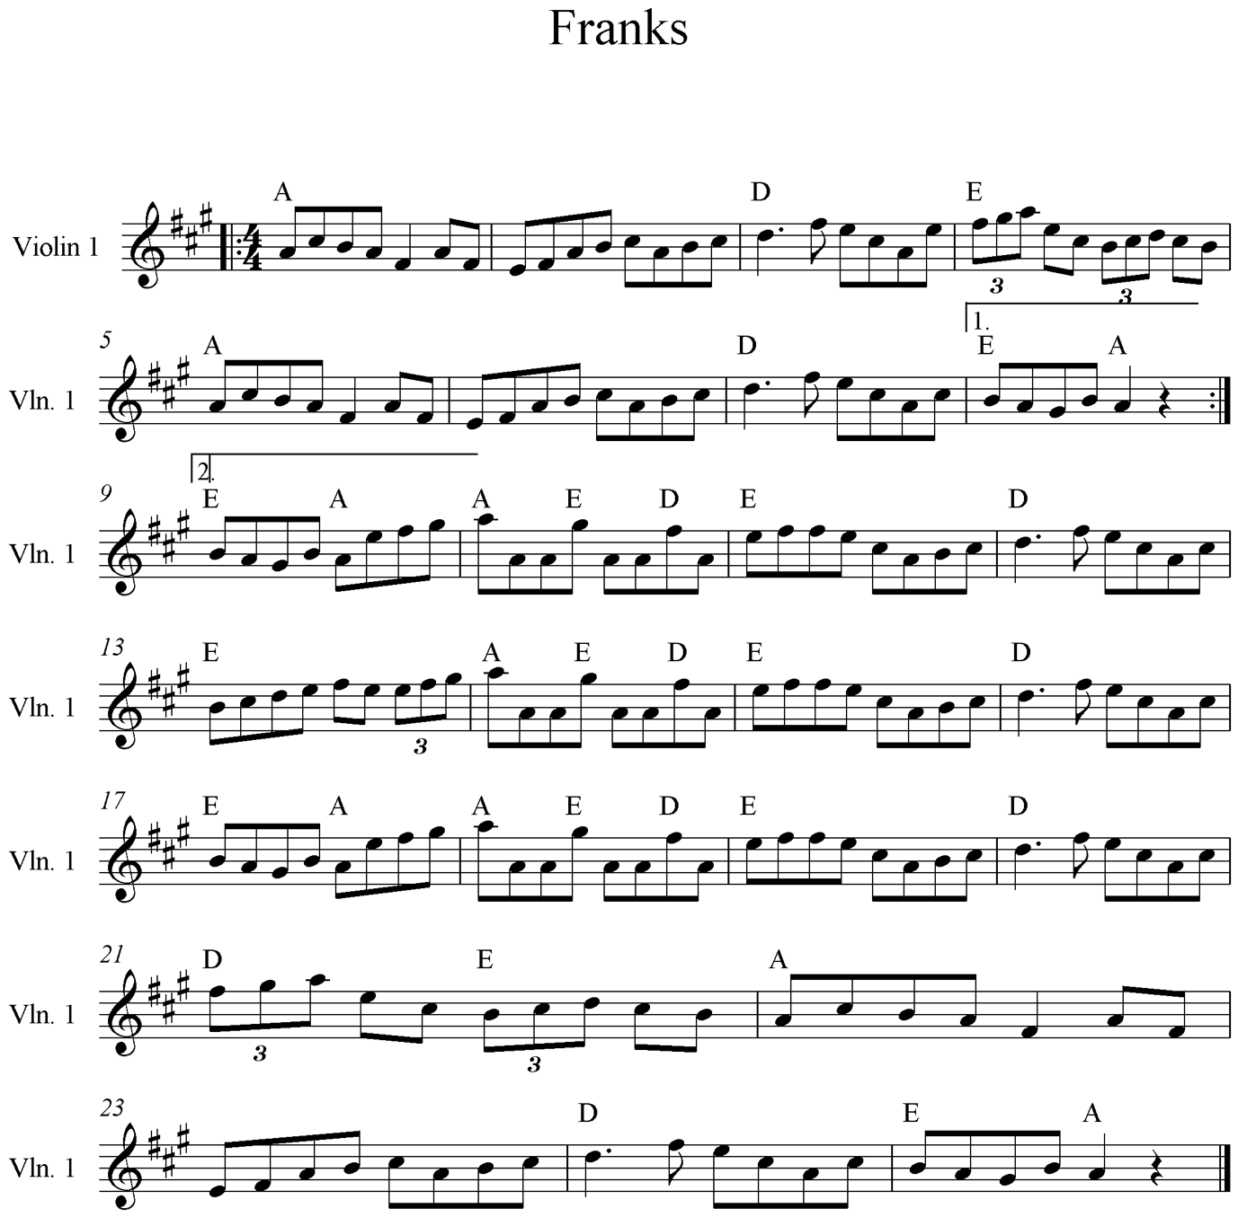
Figure 25. A transcription of Franks, transcribed by Nicola Beazley
In my experience, Frank’s is most commonly played in A major, although has been transposed into other keys, like G for a more instrument-friendly key for instruments such as the melodeon. The tune contains many triplets (melodic decorations) and some string crossings in the B part, creating the 3-3-2 (grouping of quavers) groove over the 4/4 tune (in bars 14 and 18 of figure 25).

Likewise, Waterman’s is most commonly played in E minor, which is a relatively friendly key to most ‘folk’ instruments (figure 26).
Figure 26. A Transcription of Watermans from thesession.org.

4.7.2 The ‘Relocation’
However, when performed by Eliza Carthy and the Ratcatchers, the tunes have both been removed from their original time signatures and have been made into jigs (6/8). These are not the fast-paced, rhythmically driven jigs associated with tune playing from across Ireland and Scotland, but much slower English jigs. The tempo at which this relocated version of Frank’s is played is 98bpm.

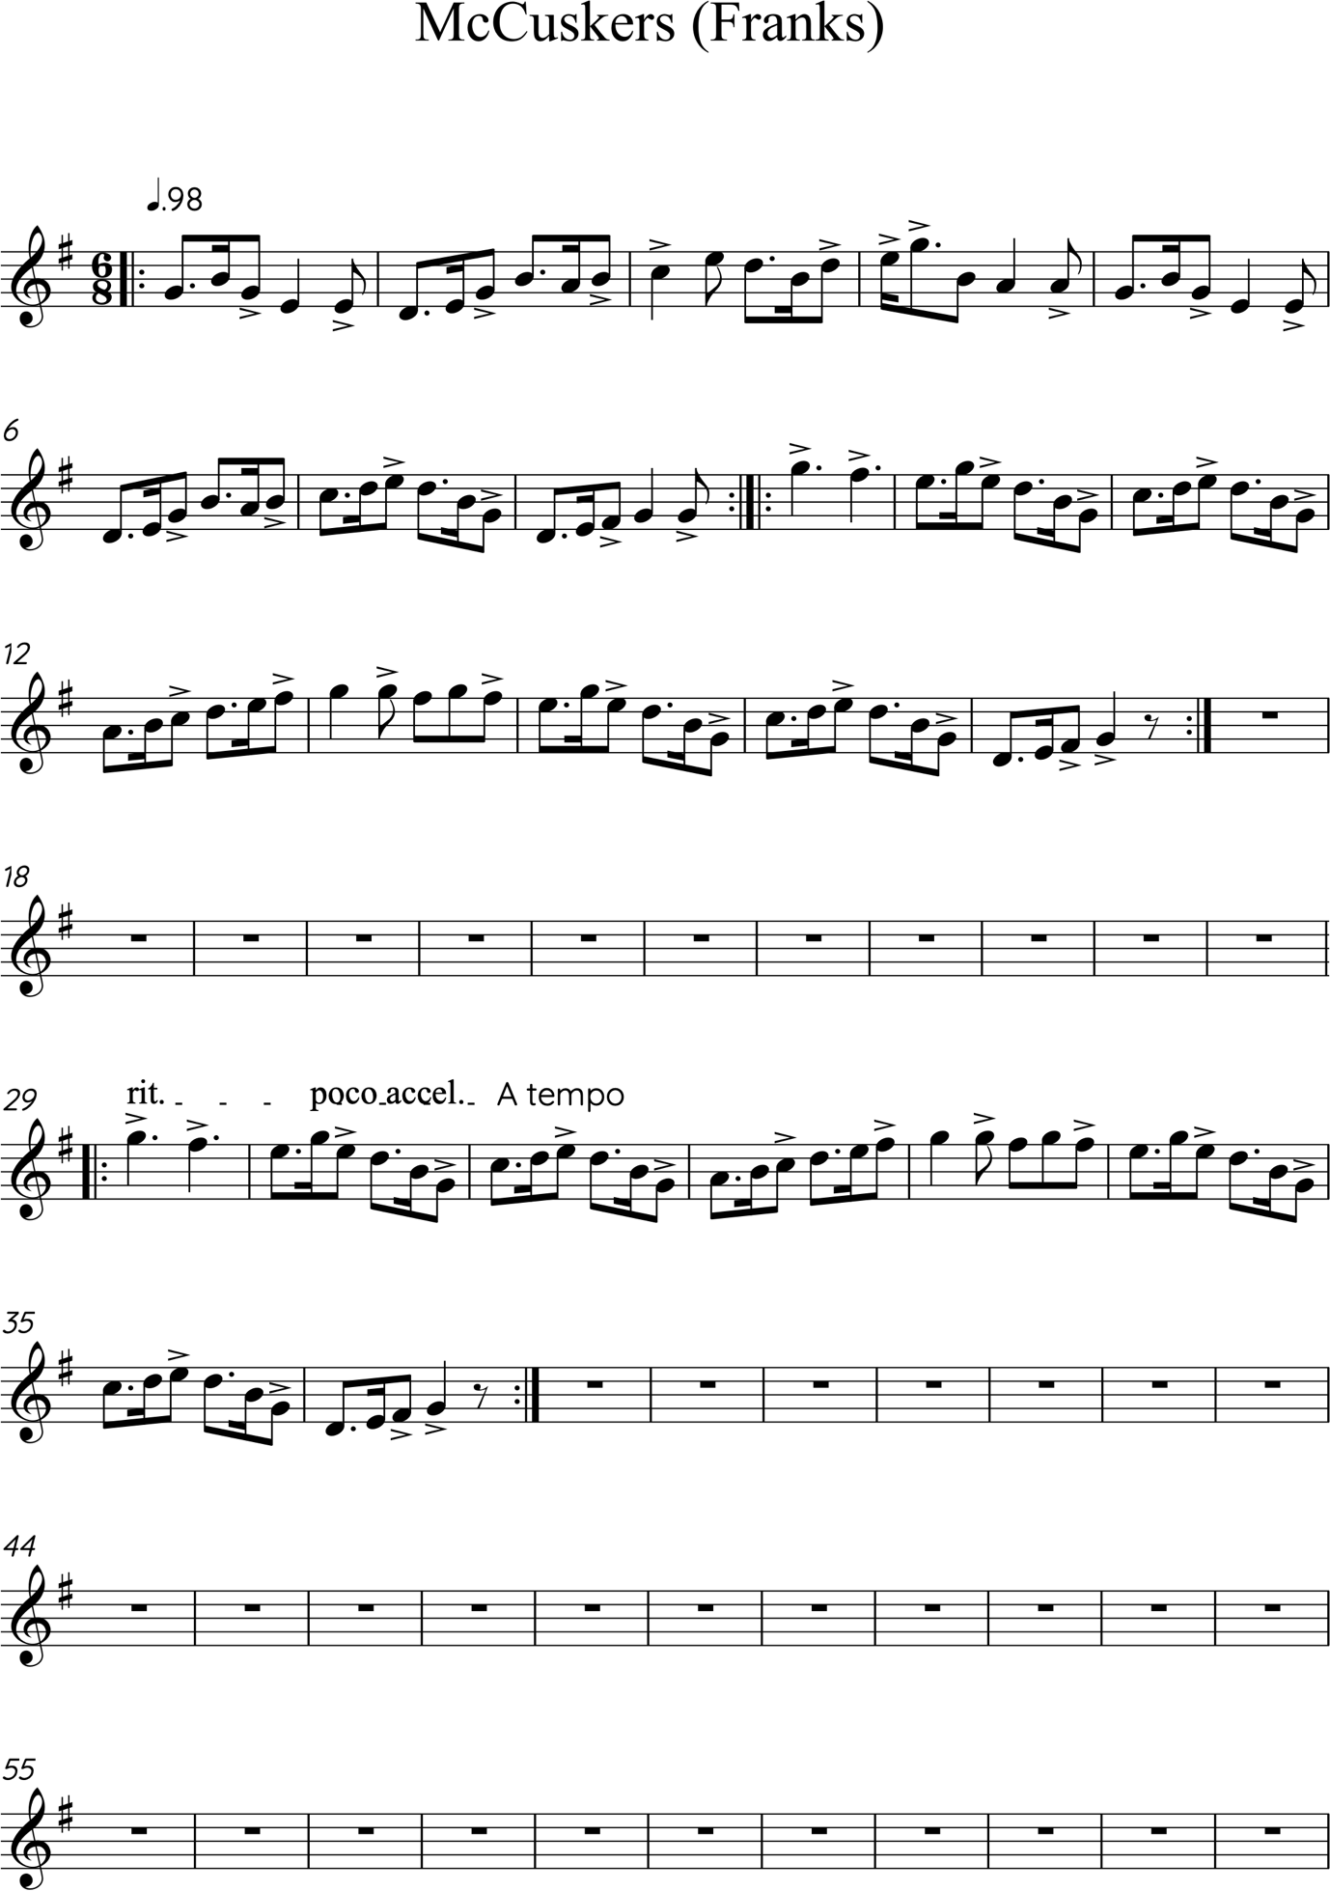
Figure 27. Transcription of McCuskers (Frank’s) as performed by Eliza Carthy and the Ratcatchers, transcribed by Nicola Beazley.
A swung groove is added, with a strong emphasis on the backbeats in each bar - on the 3 and the 6, in figure 27. The key signature has also been changed into the key of G, more suitable for the English melodeon used in the band.

Not only has the groove been changed to something more stereotypically English, almost in an exaggerated manner, but just before the change into the second tune, in the B part, the longer dotted crotchet notes, in bar 28, figure 29, are stretched out further, leaving a slight gap and lift in between each note, slowing the beat before resuming the correct tempo two bars later:

Figure 28. The 'Slow' in McCuskers as performed by Eliza Carthy and the Ratcatchers, transcribed by Nicola Beazley.
This could be a hint at the idea of a slow. There is no feasible reason for the slows to appear in this arrangement, save for aesthetic choice, because the tune is not used for morris and does not have a dance or slows traditionally associated with it. One conclusion could be that the slows were added to over-emphasise the ‘Englishness’ of the arrangement, to make it obvious and very different from its original.

Similarly, Waterman’s is played as a jig, but still with a slower pace and a swung backbeat groove (figure 29).

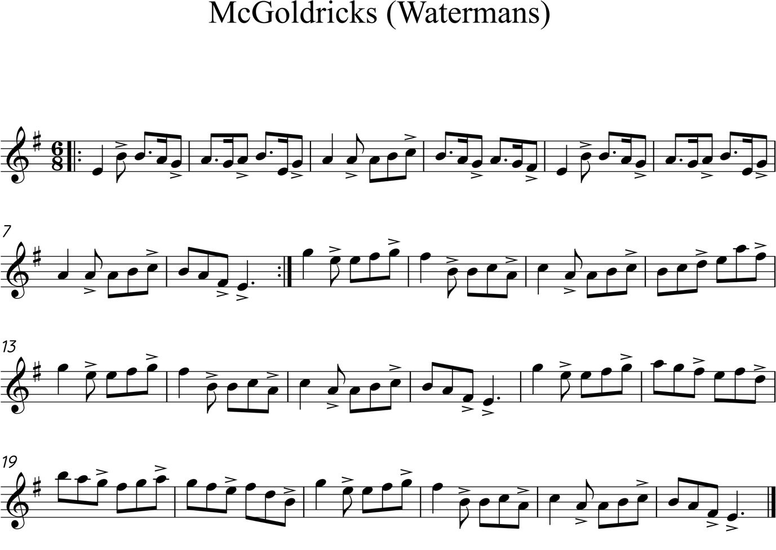
Figure 29. McGoldricks (Watermans) as performed by Eliza Carthy and the Ratcatcher, transcribed by Nicola Beazley
The tune, originally written on whistle (or potentially flute), usually played with lots of rolls and fiddle ornamentation, instead appears with lots of double stops on the fiddle, and an aggressive upbeat feel, not at all like its smoother, original counterpart.

Again, the slows appear, in figure 30, even more obviously done than in the previous tune:
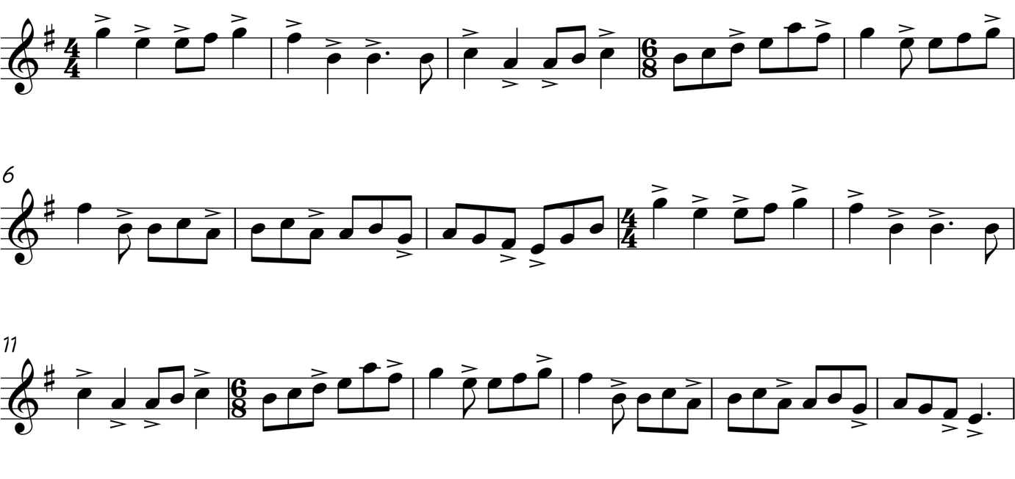
Figure 30. The 'Slow' in McGoldricks (Watermans) as performed by Eliza Carthy and the Ratcatchers, transcribed by Nicola Beazley
There isn’t just a slowing down of the beat, like in McCuskers, rather the slow part of the tune changes time signature into 4/4, in figure 30, creating a heavily crocheted and accented affected before rolling back into the 6/8 jig time that we’ve become accustomed too.

Both tunes sound dramatically different from the original forms, and whilst the melodic material has not been drastically changed, it goes to show what impact groove, ornamentation, and instrumentation have on the stylistic sound of a tune. The lack of whistle, and the influence of English melodeon, particularly the gesture of its off-beat accompaniment, the rhythmical and punchy fiddle, alongside the less decorative version of the melody, and the influence of the slows create a very different feel to the Irish and Scottish style that the pieces were originally written with. It should be noted that this is an English style as interpreted by these artists. As discussed at the start of the chapter, there is no one overall style of playing in England, and it isn’t justifiable to say that this recording is English style in the singular, although several of these musicians have played for morris dance, broadly the style we can assume they are emulating.

However, it is important not to underestimate the influence of professional artists and their performative output, and how this has influenced the stylistic playing across the wider scene, influencing other musicians to also play in this exaggerated English style. Therefore, it isn’t necessarily the melodic content, although important, that dictates a style, it is other musical gestures, the structure, the ornamentation, and groove for example, that play a vital role in portraying a style.

4.8 ‘English Style’: Some Conclusions
This Chapter started with a quote from Vic Gammon:

Style is a collective (inter-subjective, socially constructed) idea of the appropriate way to play, the use of the musical elements that go together to make what is perceived as a style. (Gammon: 2015, p3)

And has gone on to examine the many different musical gestures that make up the perceived English style, from ornamentation to variation, from structure to function. Presented with data, from those who perform professionally on the scene, conclusions can be drawn about these different musical elements: that there are overarching trends, and commonalities in the musical gestures presented on the folk scene in England. Some of these gestures clearly feature in other folk traditions from around the world too, but there are gestures presented that seem to be uniquely English in style - such as the slows, and the 3/2 hornpipes. Some trends are overwhelmingly clear from the data presented throughout this chapter, for example:

- Major keys are the most common form of tonality,
- Common structures and use of groove frequently appear across all the data sets analysed for this thesis and impact each other.
- Ornamentation does not play a huge role in the current style of English instrumental tune playing.

It could be concluded that whilst most of these gestures are personal and individual choice, the cliches used in the Relocation of Eliza Carthy’s recording of Franks and Watermans show that these elements are still important ideas to musicians.

It becomes clear from the data collected that it is the interpretation and, importantly, variation upon these different musical gestures, and on the melody and accompanying lines themselves, that is key to the existence and flourishment of these different regional styles. 100% of the tracks analysed contained some sort of variation, whether it be a change in rhythm, melody or harmony, decoration, groove or accompaniment. Not once was a tune played the same way twice, a feat helped by the idea that any written music used (which is a presumption) acts only as a template from which an artist’s creative practices can apply their own idea of style. Competency, ‘as in the degree of mastery of stylistic elements’, (Gammon: 2015) is also needed to successfully partake in variation and improvisation of any kind. Knowledge of the melodic material must be secure, alongside a toolbox of music gestures that each individual musician feels competent and comfortable with. Variation can happen on many levels, it can be in the moment, it may be planned, it may be a conscious decision, it may not, but it acts as a device by which a professional can hold the attention of their audience. Musicians must be secure in their own personal abilities, creative practices and musical interpretations for variation to be successful.

Because of a lack of historical sources for many of the musical gestures discussed above, musicians who perform in an English style have borrowed and adapted ornaments, and instruments even, from other cultures, particularly from Scotland and Ireland. This is alongside the material that perhaps originates in Ireland or Scotland, that are commonplace in the English scene. This is not to say that the scene in England is claiming these tunes as its own; although I have no doubt that this does happen, but more that these tunes have been adapted, and anglicised to fit the styles that are played across England, from region to region. This again, points us to the idea of many regional styles, or even further to local styles and community styles, all of which, together make up different elements of an English style.

The type of English style analysed for this thesis is made up of many changeable and interacting gestures, from individual aesthetic choice and their creative practices to the impact of variation and aural transmission, to outside influence of new musical gestures and style, all of which affect the template of the basic tunes that are played. These gestures, which are learnt from interactions with others on the English folk scene, are internalised on an individual level, accounting for the many individualisations of style that appear in traditional tune playing. All these gestures also change over time, with development and interactions with new musicians and new musics. Certainly, regional styles exist, amongst those communities that play together with regularity, creating the norms in style and repertoire for a certain area (such as pocket communities). On a national level, at festivals, where people from across the country get together and share material and skills, or online, in social groups where people can share their music regardless of geographical barriers, there is certainly overlap between communities. And again, not to forget the importance of the professional, who transcend these barriers, and can feature in many communities at once, through digital recordings, transmission of their own interpretations, ornamentation, instrumentation etc to a far wider group than regional communities can reach. But this just goes to show that the scene in England, and the idea of English style, is made of a multifaceted and complicated network of relationships, of the exchange of music, technique and gestures, ideas that are held both by whole communities and by individuals. English style is the negotiation between these different changing elements, it is the sum of many parts creating a patchwork of musical traditions and communities across the country.

To address the issues from the start of this chapter, is to acknowledge that there are elements of distinctive musical style that are particular to instrumental folk music from England, as portrayed by the artists analysed for this thesis. There are lots of shared stylistic gestures within the context of England’s neighbouring traditions, from general structures and forms to common instrumentation. There are also distinct gestural differences from certain types of specific instrumentation (such as the melodeon), to groove and rhythmical gestures influenced by traditional dance forms. But, there are clearly features that stand out as stylistic gestures of instrumental folk music specifically from England.

Chapter 5. The Value Of Tradition
The concept of tradition, as discussed in 1.4 and 3.1.3, is a contested and argued idea, inside academia and within the folk scene in England, with no concrete conclusion. However, given the frequency with which tradition as a broad concept is spoken about, referenced, and debated, not just by academics, but also professional performers and amateurs alike on the folk scene in England, the concept of tradition and its role, is clearly important. This is evident in John Spiers’s response when asked how he might define tradition:

That’s tricky because I think I know what the definition is ... but I think I disagree with it. I think it's supposed to mean a tune which has spent a considerable amount of time being played and passed on for generations in such a way that it has evolved and changed with every learning of it which kind of rub away any square corners that the original composer left in. It leaves the tunes with a very distinctive feel of being just the essence with none of the bullshit. Because the transmission of a tune from one player to another requires two things (the learning which is not always 100% accurate, and the person learning it wanting it do so because they actively like the tune) I see it in a very similar way as the theory of evolution ... survival of the fittest ... but with an inbuilt ability to change if learnt on another instrument, or fitted to a different dance, or just to suit a player. The reason I say I disagree with it is because I don't think a tune should be considered non-traditional if it is being widely played and passed on from player to player just because you know who the composer was. I think tunes such as Jump at the Sun by John Kirkpatrick or even my own Jiggery Pokerwork are if anything more traditional than some of the more obscure tunes in the Playford collections. (John Spiers: survey, 2020)
Already, the conflicted relationship that professional musicians seem to have with a term tradition, can be seen, even though it features as part of their professional work. This chapter explores who values tradition and how, considering both individual and community approaches to practice, the notion of tradition applies to the musical elements themselves, and the interplay between continuity and change and their impact on the boundaries of tradition.

5.1 What Is A Traditional Tune?
To discuss the value of tradition, it is important to first analyse what professional musicians conceptualise as being traditional, and for this thesis that revolves around what is classed as a traditional tune.
Whilst a significant portion of this research has been dedicated to defining the structures and forms of traditional tunes, defining a tune as being ‘traditional’ is difficult; the concept of tradition itself is unclear. In terms of folk tunes from England, there does not seem to be a set way to define a tune as being traditional amongst its participants. There are, however, several gestures that are common features used by artists in reference to instrumental tunes from the folk scene in England. The common features including structure, function, style, and origins will be discussed, with an analysis of the history of tradition, and its relationship with both the creative individual and their audiences. Finally, a discussion of the role of professionalisation and the impact of change on the boundaries of the tradition will conclude what role the term has on the instrumental folk scene in England.

5.1.1 Tradition As Structure And Form, Function And Style
Structure and form play a vital role in the ways musicians identify a tune as belonging to a tradition. The term ’structure’ was mentioned 21 times by 13 different musicians, referred to alongside the term AABB, referencing the commonly expected structure within the tradition of folk tune playing in England. Some artists go as far as defining a traditional tune in relationship to its structure and form, defining a traditional tune as:
A tune that is either in a dance form - 8 or 16 bar sections, or a tune that is roughly following the Question - Answer - Question - 2nd Answer form. (John Dipper: survey, 2020)
Or
A melody with characteristic rhythms and patterns ... phrases that are easy to pick up by ear, open for interpretation and improvisation ... usually right for playing for dancing. (Sarah Matthews: survey 2020)
This links the structure of the tune, in terms of length, phrases and shape, to its most commonly intended function: dance. There are exceptions, not every performance of a fast tune has the function of dance, but in general, the slower tunes and the instrumental listening pieces or listening tunes (my term) are not intended for dance.

5.1.2 Function As A Gestural Framework In Tradition
Structure and function are both important and are linked; the function informs the shape that the structure takes, and the structure of the music enables the function of the music to take place. Regardless of the historical function of the music, the structures remain present and useful despite the change to the stage or recorded album, meaning that structure is a defining and present gesture of traditional tunes within the English folk scene. It is difficult to discuss them in isolation. The often-quoted historical function of traditional tunes is dance, ‘trad sounding, dance-type tunes (Will Allen, survey, 2020)’, and this can influence the creative practice of writing tunes.

I am increasingly writing tunes as dance tunes, so I'm very conscious of the dance forms as I am writing them. (Lewis Wood: survey, 2020)
Dance was broadly referred to 29 times in the survey, alongside 21 mentions of the term structure. The ‘internalised structures and styles’ (Richard Moss: survey, 2020) that are strongly associated with tune playing by professional musicians on the folk scene in England are actively influencing tune creation, because of the function of dance, even when not being used in that context. The function of dance is an influencing factor on the form and structure, even when starting from simple ‘rhythmic cycles (Archi Churchill-Moss: survey, 2020), it is ‘how [these] can be shaped into a tune using traditional structures’ (Cohen Braithwaite-Kilcoyne: survey, 2020) that demonstrates the interaction between the traditional enforced ideas and the new.

5.1.3 Style As Tradition
A similar argument could be made for the stylistic aspects of tune-playing and writing. The stylistic gestures, like ornamentation, groove, tempo, harmonic accompaniment, and other extra stylistic gestures, turn a tune from the simple notes, into something that is recognisable as belonging to a particular style, tradition, and genre. These gestures are learnt alongside the melodic notes and are ingrained into an individual sense of a tune. This individual sense of style is then transferred to any new tunes written.

I also use what I would describe as a playing style from the tradition as the basis for how I approach any music. The technical aspects of my playing are so ingrained that they're a kind of lens I can use to see all music through. (Ford Collier: survey, 2020)
The ‘lens’ of traditional style, form and function can influence any other form of music making. This affects the structure, for example, the AABB form, both in an accepting manner promoting the structure:

Most of my music relates to European dance styles and ideals i.e. number of bars, structure etc (Mel Biggs: survey, 2020),
or by actively going against it:

I will often try to avoid sticking to standard tune structures (32 bar AABB for example) until the last minute as this can hinder the freedom of creativity and steer towards cliches. (Alex Garden: survey, 2020)
However, being ‘respectful of them’ [structure, style, and function] but not restricted by them’ (Jess Arrowsmith: survey, 2020) also appears as a common thread in the survey data. The ingrained nature of structure, style and function is ever present as an ever-important genre marker of the scene.

The most important aspect of the tradition to me is a certain playing style and sound. For me, the most instantly recognisable aspects of a player who comes from the tradition are the technical aspects of their playing style (e.g. ornaments etc.) and the feel they have for the rhythms of tunes etc. (Ford Collier: survey, 2020).
Summed up coherently by Nancy Kerr, is the concept that tradition, as style, form, and function, which can be used as a form of creative change.

The democratic availability of traditional features as a fantastic catalyst for composition means people at all levels have the opportunity to make new music. (Nancy Kerr: survey, 2020).
The fact that there are all these stylistic and structural templates or frameworks that exist and have existed for many generations is a valuable source of important information. However, the idea that these structures and styles are rigid and unchanging is false. It’s also false to suggest that the generations before us were not creative with these structures either, or else the wealth of traditional and folk material present today would not exist.
The influence of tradition could be seen less as a set of rules but more as ‘a springboard for creativity’ (Nancy Kerr: survey, 2020). Tradition is a form of creative practice, not just an influencing factor on creative practices, it is ‘a reservoir of melodically, lyrical and stylistic material and knowledge that can be used freely’ (Jon Boden: survey, 2020). Tradition ‘is such a strong foundation from which […] generations can be excited by and build upon.’ (Sandra Kerr: survey, 2020).
The stylistic and structural markers of the genre and the musical sounds by which folk and traditional tune playing from England can be identified, are part of the ‘toolbox’ (Hill: 2012, p.85) from which the most appropriate structure or style for our current purpose can be selected. Structure, style, and form are the building blocks of what is deemed to be traditional, as well as the building blocks of new material. Traditionally accepted structures, forms and functions affect the creative practices of artists on the folk scene in England. Maintained by the community that partakes in the musical tradition, stylistic indicators are defined enough to be distinctly recognisable to performers and to a certain extent, the audience, but loose enough to allow for new material, tunes and stylistic indicators to enter the community and tradition. Style, form, and function are an important part of this tune-playing tradition in England and all three influence the creative practices of the artists creating within the scene.

5.1.4 Origins Of Contemporary - Traditional Tunes
The concept of composed tunes is not one that is new on the folk scene in England, as John Dipper (interview: 2015) states, ‘people in the previous generation bothered to come up with some tunes and I think that we’d [be] bone idle if we didn’t add to that repertoire’, meaning that new tunes have always been written added to the repertoire, and even claimed as traditional within the cannon. If the stylistic aspect of the tune, its form, structure and how it is played, allows a tune to belong to a particular category of music, meaning it ‘would not be out of place played with other trad tunes’ (Richard Moss: survey, 2020) then by that logic, any tunes written today could be called traditional and still fit within the recognisable stylistic genre of folk and traditional tune playing from England. As John Spiers states:

I don't think a tune should be considered non-traditional if it is being widely played and passed on from player to player just because you know who the composer was. (John Spiers: survey, 2020)

However, when writing new music, as a creative practice, how often, or how conscious, are the effects of tradition, on a personal level? As can be seen in figure 31, 17 (58.6%) musicians thought the ideas of tradition impacted their creative practices.

Figure 31. Importance of tradition when composing a new folk tune, from survey data.
With a rating of 5 = very important, 4 = important, and 3 = undecided, 5 (17.2%) participants could be considered neutral to the concept of tradition whilst writing their own tunes, more than with traditional tunes, and 7 (24.1%) thought it wasn’t important at all, meaning more people deemed tradition less important when working with their own material. Compare this with figure 32 where, when dealing with pre-existing tunes that are deemed traditional, over 50% thought that concepts of tradition did play an important role in how they treated the musical material, it shows that the two creative elements are treated differently.

Figure 32. The importance of tradition when being creative with traditional tunes, from survey data.
In figure 32, 20/29 participants (68.9%) treated traditional tunes differently because they are traditional tunes. The concept of them being traditional is clearly something important and to be respected. On the other hand, 4 (13.7%) participants claimed they weren’t impacted by ideas of tradition whilst using traditional tunes, and 5 (17.2%) thought it wasn’t important at all to think about tradition whilst using traditional tunes. Most responses show that tradition was an important factor among participants. The concept of tradition is important when dealing with traditional tunes with a perceived history and age.
However, concepts of tradition as an important influence were still the largest common rating out of all options given on the survey, meaning that during the creative practice of both writing new material and arranging traditional material, both are influenced by the importance of tradition, however, the participant may choose to define the term.
The act of writing a contemporary-traditional tune (or tunes that are written in the style of a traditional tune) is an interesting phenomenon, as at some point all tunes were new, and were gradually accepted into the canon of a community.

It's a kind of interesting subgenre of traditional music, I think, is modern tune writing, which doesn't, nobody quite has a name for and its always mixed in with traditional tunes. (Jon Boden: survey, 2020)
However, this is not always so; contemporary-traditional tunes written by known composers are not often referred to as ‘traditional tunes’, nor are they unquestioningly accepted. There isn’t a singular set process for acceptance, nor is there a specific name for it. Perhaps one way to differentiate newly composed/ contemporary-traditional tunes from older/traditional tunes is to be referred to as ‘written in a traditional style’. Indeed, a project in Scotland, looking at newly composed material that has links to folk, but is not necessarily classed as folk, or traditional, refers to such tunes as ‘Beyond Tunes’ (Watson: 2013).
Style, ornamentation, structure, instrumentation, and groove are all viewed through the lens of the community that partake in the tradition, therefore having an important influence over what can be deemed a traditional tune. These musical gestures help define and are defined by the ways in which traditional tunes were played in the past, and these musical elements can also be applied to future compositions and new tunes. The ‘collective consciousness’ (James Delarre: survey, 2020), the voice of the community within which the concept of tradition exists, influences what is deemed acceptable in terms of style. Therefore, any ‘tune written within the style of a tradition, [..] that others can recognise as traditional,’ (Richard Moss: survey, 2020) could become part of the wider tradition if it is written in the style of the tradition, functions as part of a tradition and forms part of the communal canonical repertoire.
An example of a contemporary-traditional tune that is played as part of the tradition is ‘Jump At The Sun’, as suggested by John Spiers in 5.0. Jump at the Sun was written by John Kirkpatrick in 1971, but the tune is still a popular session tune, performed on the contemporary folk scene in England. Because of the length of time that the tune has existed for, the effect of change can be seen clearly. The popularity of the composed tune is such that it appears in communities all around the world and conforms to the idea of a newly composed/contemporary-traditional tune. The so-called original version of the tune (according to Oxford Slow Sessions) is thus (figure 33):
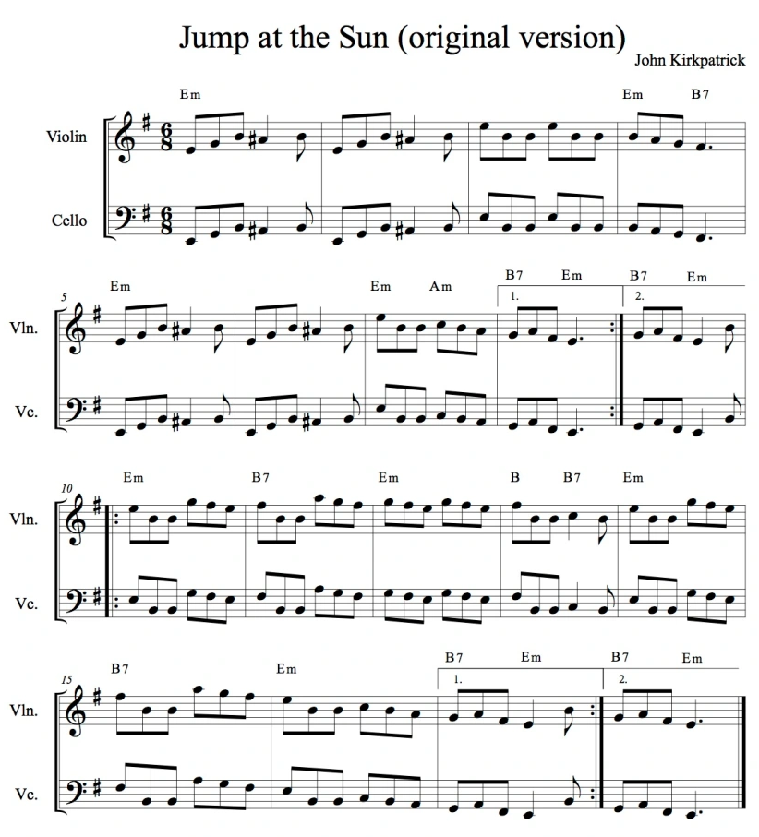
Figure 33. Jump at the Sun - by John Kirkpatrick.
But this tune has been vetted by the multiple communities that it has had contact with and has been widely accepted into the traditional repertoire. The result of this is many different versions, all slightly changed, that exist around the world. On thesession.org there are 25 written variations of the tune, including a range of keys, from the composed E minor to Bb minor and so forth. The variations also include a range of transcribed ornamentation, some examples transcribed rhythmic groove, and some transcription had an extra C (as demonstrated in figure 34) and sometimes a D part - the tune originally only has 2 parts. In the comment below the variations, there are a further 12 transcriptions of the tune (in ABC notation) accompanying main explanations of how the tune sounds/is used around the world.
Figure 34. Jump at the sun, a variation - different key and extra C part.
The tune is now known by several more names too, such as ‘The Acidic Fairies, All For Piers, Dancing At The Sun, Fairies On Acid, Jump Up Sun, The South Of France, The Spy.’, although many seem keen that the composition is attributed to the professional musician who wrote it. Whilst this is a contemporary tune, with a known composer (to some), it is nonetheless part of the tradition of tune playing from around the world, including England.

The name of the composer is important for artists on the contemporary folk scene to keep and quote, meaning that newly composed/contemporary tradition tunes are kept within their own subsection of the canon of shared repertoire. However, this knowledge, of the composer, isn’t always retained, resulting in the wealth of anonymous and traditional material, whereby the composer has been forgotten. It remains to be seen what the impact of the digitised forms of folk tunes will have on the retention of this information for future generations.
Categorising instrumental material by style alone, as opposed to categorising by origin, potentially allows for a more open and accepting definition of what constitutes a traditional tune, than classification by age, or historic influence. Perhaps this is more reflective of a music and a tradition that does not, and isn’t supposed to, sit neatly in a box. This open-ended definition of a traditional tune allows both newly composed/contemporary-traditional tunes and older tunes, tunes that are deemed traditional, to co-exist as part of the same repertoire, allowing for a flexible view of what a traditional tune is. This construct of a traditional tune as a style allows the idea that newly written tunes can be accepted, even gradually, into the canon of repertoire though retaining a conceptually separate status.

5.2 Concepts Of Tradition
Tradition and what a traditional tune is, are interesting but ‘subjective and complex’ concepts (Nancy Kerr: survey, 2020), meaning different things to different people, but as an ever-present influencing factor to many on the folk scene in England. Space will be dedicated here to exploring how professional musicians on the scene conceptualise personal notions of tradition.

5.2.1 History And Tradition
The importance of the past, in a very vague and widely idealised sense, is a key theme throughout the folk scene in England, referring to ‘something that has happened for many years.’ (Jon Dyer: survey, 2020). A sense of age, equated with value, is also clearly an influencing factor in conceptualising tradition; Cohen Braithwaite-Kilcoyne (survey, 2020) defines traditional music as ‘a historical tune with no known composer’ placing age as a central concept in tradition for example. The importance of age and a perceived past is repeated numerously in relation to the concept of tradition, for example: ‘One which has been transmitted from player to player over a period of time,’ (Sandra Kerr: survey, 2020) and ‘But I think there is a place for learning history, origins, settings, and styles’ (Martin Clarke: survey, 2020). This often-repeated concept appears together with the contradictory concept of anonymity, again the idea that the tune is so old, that it is no longer known who wrote it, adding to the idealism and romanticism of the past. This is evident in slightly romanticised phrases such as:

Often the title and composer's name will be forgotten through time. (Alex Garden: survey, 2020)
And,
To me, a traditional tune is an old tune where the writer is unknown and is associated with a particular place of origin (which is often recognisable from the style of tune). (Richard Moss: survey, 2020)
Whilst taking inspiration for creative practices from the past is by no means a negative influence and clearly has had an impact on musicians over the generations, these notions are based on something that may not have happened that causes some people issues, it is based on an idealised and romanticised history.

I think so many parts of our identity have been lost due to this very narrow way of observing folk culture and tradition; many don't see beyond the English Folk of Victorian Romanticism. (Mikey Kenney: survey, 2020)
It seems the term tradition is used in the hope of preserving the way things were once done, adhering to the notion from the literature that to change things is to interfere with the comfort of familiarity. This focuses on the idea that tradition is important because it is thought that people did it the same way in the past. However, whilst the term is tied up with nostalgic, romanticised but false premises of the past being better than the present, it is prevalent within the scene.

What I’m really interested in, and I guess this became a really exciting thing for me with Unearth Repeat, is, if you like, a sort of fictional, romantic relationship I have with the people of the 17th and 18th century, and what music they were making and writing. (Sam Sweeney: TradFolk interview, 13/1/2022)
There is no consensus on how old something must be in order to be held in traditional esteem. Some say, ‘At least 100 years old that is clearly functional (generally for dancing) rather than obviously composed’ (Jon Boden: survey, 2020) but this figure seems both personal and arbitrary, and in no way accounts for the constant shifting in time. What isn’t deemed traditional now, because it isn’t old enough, will one day become old enough.
This is all without considering what the music actually sounded like 100 years ago. There are many archives and manuscripts but relatively few recordings. Also, field recordings are ‘just one snapshot of a tradition which was very much not in the best of health and many of its players old and not very good at their instruments’ (John Spiers: survey, 2020). Even manuscripts, which could be seen as more prescriptive and concrete, only offer a small insight into the music of the time, containing no real indicator of playing style. There is no way of knowing how traditional tunes sounded in the past. The idea that tradition is merely made up of elements of the past is just a construct in the present, as the music was always ‘evolving right up to that moment’ (Simon Care: survey, 2020).
With the clear influence of age and the idea of a past comes the idea of being respectful to the concept of tradition, and the material that it has produced. For example:

I feel a strong attachment to traditional styles/structures and always want to be respectful of them but don't feel that they should be restrictive. (Jess Arrowsmith: survey, 2020)
And,
Learning how things have been done in the past, respecting that in referencing it, but then also subtly changing it for modern ears. (Mel Biggs: survey, 2020)

It seems that this respect for the tradition is treated with caution, and with no desire that it should mean that things should stay the same. There seems to be the need for change, with comments like ‘continuous evolution’ (James Delarre: survey, 2020) and not getting ‘stuck in the past’ (Mel Biggs: survey, 2020) or becoming part of a ‘a re-enactment society’ (George Sansome: survey, 2020).
Whilst many artists comment on the importance of the past influencing their creative decisions, many don’t consider the past as something to religiously adhere to.

Worship the flames, not the ashes - it is something that should not be stuck if it’s fluid it can survive. If it is stuck and regimented, it will only fester and die. (John Dipper: survey, 2020)

Many artists seem to take a compromise between celebrating and respecting what has gone before but not letting that stifle their creative practices going forward.

If you just play the same old tunes […] it's not a living, growing thing. It'll soon go stale! (George Sansom: survey, 2020)
There seems to be some juxtaposition in thoughts between defining the term with notions of age and anonymity which give the idea of tradition its value, whilst also believing in allowing change into a tradition, and stating that change has always played a role in tradition. However, the balance between the past and present is evident in how professional musicians choose to handle their creative practices within a tradition, and both are evidently important to the professional musicians who were surveyed.

5.2.2 The Interplay Between The Two; A Continuum Of Past And Present
It is apparent that tradition requires a conscious negotiation between ideas of the past and the present, and that in essence tradition itself is the link between the two:

Continuum of past and present. (Nancy Kerr: survey, 2020)
And,
A link to the past and a link to other humans past and present. (Sandra Kerr, survey: 2020)
Because tradition could be seen as a continuum between the two, some interpret it as the past informing musicians of what has gone before, and influencing current creative practices, but in no way hindering new interpretations or material. However, many deem it important to know what has come before, in order to build on it in creative practices, again, a common thread, linked with ideas of the survival of the tradition, such as:

I agree that it is important, because a music which does not develop and reflect change, will not survive. (Sandra Kerr: survey, 2020)
It is clearly important to the artists interviewed, that not only the tune playing and creating tradition in England is one that allows for change and development, but that it needs this changing element to function. Not allowing in new ideas can cause it to stagnate and not attract new voices into the scene and may eventually die out: ‘It's a process, rather than a fixed repertoire or a fixed idea of how to perform the music.’ (George Sansome: survey, 2020). Many view the interpretation of the past into the present as an act of tradition in itself, a ‘continuous evolution informed by what has gone before.’ (Jess Arrowsmith: survey, 2020). The influence of ‘newly written tunes expand[s] the repertoire and continue[s] the tradition’ (George Sansome: survey 2020), in the same way that new interpretations of old tunes can expand the tradition, both whilst celebrating it, keeping ‘a link with the past, and restat[ing] its relevance for today, […] Tradition isn't static.’ (George Sansome: 2020). The past can be acknowledged and respected without being stifling of the present.

The most important thing about tradition is that it stays permanently rooted in the present. It's not about historical performance practice, it's about relating to a tune in an honest and relevant way. (Owen Ralph: survey2020)
This brings forward the idea of the ‘living tradition’ is a core concept on the folk scene in England and in the UK, appearing in the title of one of the more widely disseminated folk music magazines (now in digital form): ‘The Living Tradition’, where ‘the main aim of the magazine is to highlight the rich heritage of traditional music in the UK, Ireland and further afield, and attempt to bring it to a wider audience.’. The idea that a musical tradition is living, and changing, does not negate the importance of the past, it simply shows that the tradition that exists today can be acknowledged, and even celebrated without simply re-enacting it; it is ‘a path from previous music and customs to future music and customs. A continual development.’ (Fi Fraser Coope: survey, 2020).
The music I am involved in is a 'living tradition' born out of what has gone before but reflecting my life as an individual now. Without the 'living' in front of it can just mean what people do or have done traditionally for years whether that is music, custom or pageant. (Jo Freya: survey, 2020)

The idea of a ‘living tradition’ which clearly includes elements of change within creative practice is important to many musicians:

Something kept alive through living people, learnt from people not just texts or artefacts, which sustains a community surrounding the tradition. (Kate Griffin: survey, 2020)
And,
If the tradition stops being a living thing then it will cease to be relevant. (Matt Norman: survey, 2020)
The continual development of a tradition is a complex concept for some people to adjust to, as it requires the acceptance of change, but, for many artists, tradition is about a compromise between the past and the present. It seems prudent that the past does influence what music is made today, given, as discussed above, the value that the folk scene in general places on knowing historical and social contexts. Whilst any perceived history is clearly important to understanding the present-day context of the music, it is important to acknowledge that the past is simply an interpretation of cultures history in the present. As Ford comments, tradition has always been constantly changing:

I think tradition is ultimately in an odd situation - it's a constantly changing, dynamic activity that's created as it goes along by its own participants, and yet the main driving force behind this activity is interaction with material that was arbitrarily captured from a (presumably similar) dynamic process that was going on a hundred years ago, and which we can't know anything about beyond the probably overly romantic impressions of the collectors that took this material out of its usual context and froze it a format that it is alien to the actual activity. (Ford Collier: survey, 2020)

Similarly, the current view of the present, and the music that is made and the traditions that are chosen to carry forward, will be up for interpretation by future generations. To some, tradition is the interpretation of the past in the present. Thought on tradition can refer to a sense of history, social identity, and regional style, it can refer to structural, stylistic and functional cohesion and it can be used to link present-day creative practice to the perceived past. As Sandra Kerr notes:

Tradition is about structure, functionality, social identity, regional style, often the oral/aural transmission of material. (Sandra Kerr: survey, 2020)
It also seems that on the folk scene in England, it is deemed important for folk musicians to have pre-existing knowledge of the perceived history that accompanies the traditions of the scene. Some believe it is important to be consciously ‘as aware and educated on the tradition as possible’ (George Sansome: survey, 2020) meaning that the perceived and known history surrounding the musical material and its functional performance context is clearly crucial to having perceived and valuable musical output.

It's important to understand where you fit in as a musician - i.e., who's come before you, and who's around you. It helps to know where the music has come from when making decisions on where you're taking it. (George Sansome: survey, 2020).
This viewpoint, of ‘learning history, origins, settings and styles’ (Martin Clarke: survey, 2020) and knowing the cultural context and history of a tradition and music, is important to some musicians.
It is a conscious effort from both the professional musicians and a conscious expectational norm from the audience/others in the scene. It ensures that knowledge is learnt and passed on. It demonstrates the complexity of the relationship between folk music of the past and of now and how this, demonstrated by the soundbite-like quotes above and the data gathered, is consciously navigated. Understanding where a tradition comes from can help to inform musical creative practices going forward. Even consciously choosing to keep things the same is a choice dictated by an understanding of the past.

Tradition means a variety of different things to a variety of different people. There are many interpretations, and as is evident above, repeatable and soundbite-like phrases are used to comfortably describe the term on an individual level. The level of commonality in the soundbite-like responses suggests that there are readily available answers that professional artists have in response to questions about interpretations of tradition. This could form part of the required knowledge about the scene, as discussed by George Sansone above, and indicate on some level that artists have learnt from each other in regard to the concepts, which makes sense given the aurally shared history and materials.

From the level of soundbite-like responses, it could be inferred that there’s a lack of deep thought about the concept and that professionals have these phrases almost on rote because they believe it is expected of them. But due to the nature of the survey, and the artists that I asked to be involved, I do believe that their answers are thought-out and representative of the views across the folk scene. I think that the similarity and cohesion in answers simply point at a cohesion and some consensus on the idea of tradition on the instrumental folk scene from England.

5.3 The Impact Of The Traditional Individual
Much of the discussion throughout this chapter has referred mostly to historical constructs of ideas of tradition and the impact that the past has on the present. Whilst, clearly important, this doesn’t particularly explore how the concept of tradition functions within today’s professionalised scene and has not yet been explored through the lens of the individual and the community within which these concepts reside.

In popular music studies, the importance is placed both on the individual as a creator and as a product of their community, demonstrating a shift towards a more holistic view of communally based creative practice. To quote Negus (2011) ‘the romantic notion of the great individual’ (p. 8) is still an influence although the lens through which creative practice is viewed centres around ideas of authorship and ownership. Theories surrounding ideas of authorship are particularly relevant to today’s folk scene, and the creative practices that it encompasses. The importance of the role of the aural tradition (discussed further in 2.3.1) creates many issues surrounding creative practice and authorship. There is a complex relationship between notions of authorship, particularly when new arrangements of pre-existing material arise, because it isn’t clear in such a shared tradition if individuals can truly ‘own’ anything. Whilst, ideas of source reputation, (discussed further in 5.3.2/3/4), as a form of authorship are important, it has been suggested that the individual names attached to pieces, performances, songs etc, are simply the resulting symbols of the collective composition process, as discussed by Bennett (2002). In an aural tradition, where change is part of the process, the idea of an author, is respected, but not necessarily regarded as individual ownership. Notions of authorship, individuality and ownership are further discussed here.

5.3.1 Tradition And The Individual
As discussed in 1.4, part of what maintains the idea of tradition as a distinct culture is the impact that individuals have on the tradition and musical output. Individuals choose to conform to the behavioural norms that are expected by those functioning within a culture, or not. It is the individual, their choices, output, musical or otherwise, and their behaviours that either comply with or seek to change the framework of a tradition.

From the moment tunes come into being, they're being changed. Each person a tune will pass through will change the tune somewhat. My studies of regional musical accents have shown that tunes move and change just as freely as the people who carry them. If we try to maintain them without interpretation, then it ceases to be part of the tradition we're talking about. The most important aspect of the tradition is that tunes are shared and passed along. It's impossible to do that without them accruing the personalities of the players who've carried them. (Mikey Kenney: survey, 2020).

Individual musicians can play the same tune, using the same framework but produce a different creative outcome.

I think it's therefore unsurprising that individualised approaches to the music arise and that UK folk music and similar self-taught traditions are uniquely placed to innovate in interesting ways. (Ford Collier: survey, 2020).

The impact of the individual is a highly creative one, whereby the lack of standardisation present within the tradition and community can leave space for interpretation and new influences. However, this also leads to a lack of stylistic cohesion within a tradition of many individuals.

This is in part a strength – English fiddlers are nothing if not individual – but it is also a weakness. Without the solidity witnessed in other traditional styles, the English fiddle is not in a strong position to promote itself. (Jon Boden: The Strad, 2014).

The role that the individual, professional musician plays in shaping and defining concepts and musical output of a tradition is a conversation between the individual and the community within which they function, as each musician brings with them their own influences, including influences from outside the folk scene in England. Here, the role of the professionalised individual is unique, and the impact of such individuals is explored below.

5.3.2 The Professional Individual
The professionalisation of instrumental folk music from England poses many interesting questions and problems, including the negotiation between a large, and historical, amateur scene of partakers, with what is deemed a communal ownership of the shared knowledge and repertoire of the scene. However, professional artists, as disseminators of the English instrumental folk scene, do play an important role. These instrumentalists are the most visible, both to those on the scene and to those on the outside. The negotiation between their own personal and musical creative practices, and the traditional ideas promoted and employed within the culture is of key importance to the idea of professionalised folk music. A successful professional must negotiate the relationship between their own personal creative practice and output, with the need to appeal to audiences and industry alike. The professional folk instrumentalist has the unique role of having influence over the change instigated in their chosen musical traditions, as their creative practices have the widest reach within the scene. This has been particularly exacerbated by the internet, and easily accessible digital forms of professional material being made widely available on platforms such as YouTube and Spotify, meaning that professional musicians can have an important and influencing role on several levels. However, the influence of the internet has also meant amateur musicians can bypass booking agents to share materials with a potentially equally wide audience. The professional folk musician needs more on top of their musical ability, including abilities to build profile, promotion and presumed status and influence over people. Therefore, the creative role of the professional is one of an influencer, because they are selling an image and an association to elements of the tradition (or reacting against it).

The commercialisation of instrumental folk music dictates, to a certain extent, the creative practices of artists. The commercial output of a professional instrumentalist needs to be successful as a wage earner, and form part of a coherent and recognisable identity and this influence cannot be discounted when considering creative practices. As Nancy Kerr mentions, the idea of commercialism does influence the creative choices that might be made:

I support the pushing of boundaries generally. However, I don't like the reduction of melodies - when practitioners leave out the interesting features, perhaps to fit ideas of commercialism or other genres and styles. (Nancy Kerr: survey, 2020).

Professionals within the folk scene, are instigators of change in the scene through the of new musical influences and/or trends, impacting the toolbox of gestures available for future creative practices of their own personal styles, and that of others. It is important to note that professional musicians do not always have to impact change in a significant way but can add to the canon of pre-existing music with smaller elements of change. This links to Akesson’s (2006) theory of re-shaping, and renewal, whereby creative change doesn’t have to happen on a large scale to be valuable, and this is demonstrated in the common practice on the instrumental folk scene in England, in the vast amount of pre-existing material that is edited, rearranged and repurposed on a regular basis. This can be seen in the split between pre-existing material used on the CDs analysed, in comparison with the newly composed material, as demonstrated further in 5.5.2. They were roughly equal, demonstrating the importance of both. The relationship between creative practices and the stylistic gestures that are available within the tradition for use are a dialogical result of change and negotiation of the relationship between professional musicians and the role of the audience.

5.3.3 Figures Of Tradition

Challenging boundaries and being accepted can also depend on how much agency you have in the scene. There are current figures, and historic, known as ‘tradition bearers’ for example, musicians in their respected fields who are upholders of their tradition, someone who displays all the behavioural norms, both musical and social, that are deemed acceptable to the tradition by others within that culture. Tradition bearers are advocates for their culture and can be both amateur and professional musicians/partakers. This can be associated with a ‘gatekeeper’ like expectation of pre-existing knowledge, giving rise to terms like ‘coming from the tradition’, coming from ‘a folk family’, or ‘folk royalty’. All of which can create barriers to access for potential newcomers.

It seems to some, that creative leeway is sometimes afforded, that the process of boundary-pushing and influencing change through creative practices is not so clear cut, particularly if there is a professional, ‘big’ name or ‘folk royalty’ involved. And this creative agency is acted upon, resulting in much change and new influence being brought into the scene through the lens of professionalisation. However, this agency isn’t straight away afforded to all.

Even a relatively conservative folk audience will let you get away with an awful lot as long as you can prove your folk credentials by throwing in some material that is recognisably ‘trad’. […] People like Eliza Carthy and Bellowhead were allowed an awful lot of creative leeway because they had proved their folk credentials early on. […] The problem is that audiences are inconsistent and don’t think too hard about these things. They will loudly declare “that’s not folk!” about someone doing basically the same thing as Nancy Kerr, if they have not proved their trad credentials from the start. The narrative around the music matters to these audiences. […] I reckon someone like Jon Boden would have to do something seriously outrageous to be considered to have gone too far. […] There just has to be that narrative link back to tradition for audiences to be on board. (Owen Ralph: survey, 2019)

It seems that some believe that more liberties can be taken with ideas of tradition, in particular when it comes to creative practice with traditional musical gestures, if you have the right background as Owen Ralph refers it as: ‘folk credentials’ (Owen Ralph: survey, 2019). Folk credentials can be taken to mean something that gives you authority with your audience/ industry, whether that be your name, your background, or who you perform with. Agency through creative practice is more likely to be accepted professionally if you know the right people:

It is interesting that Leveret seem to have broken through that, and I can only assume that that’s because, you know, they are extraordinary musicians, and what a pedigree they’ve got, you know Sam being in Bellowhead of course, that’s a big help, and you know, once you’ve got those kind of elements hovering around the band, it sort of does help. (Pete Judge: interview, 2019)

But much of this is based on how other musicians, professionals, industry officials and audiences alike perceive the creative practices of others on the scene. Professional perception, the perceived intent of creative output, is a difficult concept to define as it is uniquely personal and can only really be experienced by the beholder. However, once placed into the public domain, whether in written or audio form, the perception no longer belongs solely to the creator. The listener also has the agency to interpret the music and intent in any way that they so wish, and not always in the way that was originally intended.

“I think, so here’s the weird thing, because my playing style is very English and I’ve heard other people play my tunes and they automatically sound way less English, because the tune itself is not actually that English sounding, but because of the way I play, my style of playing, my sound it is.” (Alex Cumming: interview, 2017).

This post-creation interpretation through public consumption can be based in the preconceived notion of what the music should be and how the artist should perform. This then affects what further material is created, either to conform to expectations or to differ as an individual creator.

“People misinterpreted it as provocation. Occasionally the Telegraph or the Guardian would write that I was ’sticking two fingers up at the folk establishment’ and that idea has always quite upset me. The expectation was ridiculous as far as I was concerned and always has been. It’s based on assumptions that people have made that just aren’t true about what is and isn’t an acceptable way to present traditional songs. I grew up with traditional music, my parents’ record collection was full of that stuff. But there’s something to be said for outsiders who don’t have any preconceived notion coming into folk music and just discovering it for themselves. I sort of envy those people – someone like Stick In The Wheel, who didn’t grow up with it and get to come in and decide what they want to do, what they like and what they don’t, without having a whole weight of history behind them.” (Jim Moray: FRUK, 2016).

However, it seems that not everyone thinks that is the case. Some believe that to be creatively free you must first prove your ‘folk credentials’ as discussed above.

The role the individual can play within a tradition can be seen, and it is a juxtaposed role. On the one hand, there is the importance of the tradition holders, who seemingly uphold and demonstrate the behavioural norms within a tradition. But, because of the agency afforded to them, they can take more creative risks and can choose to influence more change into a tradition. This is also likely balanced by certain expectations of audiences, who expect certain musical, and behavioural attributes due to the performer’s association with the idea of tradition. The idea of a figure of tradition can have a large impact on both the shape of a tradition, and the creative practices that go into it and can play a role in both maintaining expected traditional elements and instigating traditional change. It is the creative practices of the individual that shape the scene moving forward.

5.3.4 Reputation And Sources
The idea of reputation, both in terms of personal reputation as a musician, but also in terms of being referred to by other professional musicians as a trusted source is linked to the idea of a tradition bearer. This section gives space to the idea of the source reputation of the individual and the importance of archival/historic sources.

It is very common for artists to reference the source from which they learnt their material. This can take written form, in the sense of CD sleeve notes for example, or verbal form, in terms of stage banter and introductions. In many CD notes, there are references to historical and archival tune books and collections, such as:

Baron William Blakeney, this was published in London by Charles and Samuel Thompson 1765. (Melrose Quartet: track 10, 2023).
And,
The Lakeland fiddler William Irwin’s manuscript is a goldmine of great tunes. (Spiers and Boden: track 11, 2021).
And,
Jigs from New Harmony appears in an 1826 manuscript from New Harmony, Indiana. This manuscript has been made available through the Village Music Project website. Another source among the 90 or so featured in the Village Music Project is John Johnsons Choice Collection of Country Dance, Volume 2, published c. 1750), from which James Maggot was taken. (Granny’s Attic: track 1, 2021).
The notion of the history behind the tunes is clearly important for musicians to tell their audiences, it provides traditional context and demonstrates that there is perceived knowledge going into the performance/recording - meeting the expectations of the folk audience.
Yes, I think I do, by making reference always to who I learned a tune or song from, and in trying to keep at least a sense of their singing/playing when I interpret their material. I think this is both respectful of the tradition, and I never pass up the opportunity to teach something....! (Sandra Kerr: survey, 2020).

This process, of referencing the source material, giving a sense of perceived authenticity behind a tune, can be seen in part as showing respect for the tradition and for where it comes from. It almost seems part of the creative practice, gaining the knowledge to legitimise the creative choices available.

When performing a self-written piece, with no perceived history, musicians then tend to tell the story that inspired the tune. It seems that artists need to ground their work in some sort of context, whether it be historical or based in current circumstances.

‘I wrote it when I was working in the only proper job I ever had… the only thing that kept me going were sugar hits from this mysterious jar of fudge’. (Moore, Moss, Rutter: track 7, 2014).
And,
The Ironing Board Hornpipe was named after John’s ironing board as an attempt to remind him to use it more often… it hasn’t been successful. (Spiers and Boden: track 9, 2021).

It seems that artists feel the need to ground their work in some sort of context, whether it be historic or current circumstance. This could be a method whereby a professional offers personal insight, in order to engage an audience, or it could be a performance habit, where the performance of a tune, regardless of its background, must be justified contextually.

On the other hand, it is other musicians, often, but not always professionals, that are referenced as a contextual introduction to a piece. This is evident on several levels, including the fact that many musicians quote direct influence from musical colleagues on the scene today (as seen in the survey data). Likewise, many artists mentioned both current and historical examples of artists who were influential, demonstrating that peers and colleagues are equally influential in the individual creative practice. Also, as artists within the same small scene, there is a lot of overlap between individuals working in multiple groups, listening to each other, supporting each other, and playing together in a non-professional capacity too. Clearly, the impact that professional instrumentalist and their creative outputs have on each other is an influencing factor in creative decisions. Sometimes this is understandable because they wrote the piece, such as ‘Mrs. Foster’s Fudge is penned by Chris Wood’ (Moore, Moss, Rutter, track 7, 2014) or ‘Jess wrote the second tune as a birthday present for James.’ (Melrose Quartet, track 8, 2023). Or because that person is someone who is personally held in high esteem by a fellow musician, quite often a tradition bearer, presumably with the aim of giving the tune performance some authenticity in terms of traditional context. Common phrases appear in sleeve notes on a variety of CDs, such as:

Cheshire Hornpipe was learnt from the playing of John Kirkpatrick. (Spiers and Boden: track 11, 2021).
And,
Featured on the English Acoustic Collectives sublime ‘Ghosts’ record. (Moore, Moss, Rutter: track 7, 2014).
And,
Chloe learned this lively session tune from the playing of Irish fiddle player and member of Altan, Ciaran Tourish. (Bottle Bank Band, The Windmill, 2016).

Therefore, alongside the origin of a tune, who the tunes are directly learnt from is important too, tying into the idea of a tradition bearer. This can be seen throughout the scene, listening to archival recordings, and emulating what is perceived to be ‘authentic’ style in the tradition they belong to. A perceived link to the tradition, whether it be by archival source, or via a figure of tradition is deemed important, not only in giving a professional performer a sense of authenticity and agency but also in giving success:

It’s a very interesting comparison with Leveret I think, who are, a terrific band, fantastic players, all of whom come from the tradition […] I think their music fits, even though they’re an instrumental band, because of the virtuosity of the band, the quiet virtuosity of their playing and the fact that a lot of their stuff seems to be rooted in traditional music[…] (Pete Judge: interview, 2019).

This again brings back the idea of ‘folk credentials’ (Owen Ralph: survey, 2019) but this time being broadened out to include archival source material, bringing forth the idea that once it is proved to an audience that a professional knows their history, and the tradition behind the material, their creative practices can be as individualised and unique as desired:

The folk scene is certainly in a place now that I can pretty much bring in whatever instruments I want, weird contemporary classical tropes, whatever it may be, and the audience will stick with it because they've accepted the 'trad' source material. (Owen Ralph: survey, 2020).

But why is the concept of a professionalised, individual figure of tradition, and the source material so important to the idea of tradition on the folk scene? Professional musicians at the forefront of change and revival, play a unique role in instigating change. Their relationship with tradition, and ideas of what went before, in previous revivals and by previous professionals, is something that is ever actively influencing, both against ideas of tradition, and complimenting them, the future form of the tradition. It is in the individual, as historic tradition bearers, or not, that can inspire more musicians and more creative practices, especially in such an aural tradition as instrumental tune playing in England:

Ideas of tradition affect many aspects of my own creativity largely because it is the music that I listen to the most and am therefore most likely to emulate. (Alex Garden: survey, 2020).

By learning from each other, it is no wonder that both historical knowledge, stylistic musical gestures, and behaviours are passed on. And by writing newly composed/contemporary-traditional tunes, and telling the stories behind them, performers are simply added to the historical context for future generations of players. The relationship between the individual, their creative practice and the concept of tradition is ever-changing, ever-negotiating, and cyclical.

5.4 Tradition And The Community
Community is vital to the folk scene in England because, as with most cultures around the world, it is where the music and traditions exist, are carried on, thrive, and developed. As Noyes (1995) writes: ‘the reality of a community with which to identify comes from collective acts […] Acting in common makes community’ (ibid: p.468). Without communities of participants, there is no cohesive element that can be called folk music, folk tunes, or folk traditions. It is within communities that these cultural elements survive and thrive.
Tradition as a sense of community is a common thread, and not just to a current community of partakers, but the concept of tradition is also a link to past communities who also shared in the music and culture.

Something that has been in existence for a long time ... something that has been handed down through generations by ear ... something that celebrates seasons and marks occasions in people's lives ... something that helps us to understand where we have come from and remember things that have gone before ... to help us know why we come to be the way we are in the present. (Sarah Matthews: survey, 2020).

Tradition can actively create a ‘community, [with] a shared language and interest’ (Richard Moss: survey, 2020), forming a common repertoire and re-enforcing the commonality of the expected musical gestures. It is the community, rather than the individual, that moulds the shape of a traditional culture, deciding what tunes are ‘'accepted' and 'selected', as Sharp puts it, and [...] become part of a common repertoire.’ (Sandra Kerr: survey, 2020)

[Tradition is] ‘something kept alive through living people, learnt from people not just texts or artefacts, which sustains a community surrounding the tradition. It's not exclusive, anyone can dip into a tradition and learn from it, but it feels like there must [be] a core group of people with strong connections, maybe geographically or personally, to keep a clear identity of the tradition as it develops and changes over time. (Kate Griffin: survey, 2020).
However, besides these soundbite-like mentions of community, there are few definitions of what that might look like on the folk scene today. Community can exist on a variety of levels, as a community of professional musicians for example, or in the pocket communities (my own term), the smaller sub-communities, regionally based, that have their own traditions and ways of creating and making music. Pocket communities can overlap and interact with others, particularly at larger professional events such as festivals, or smaller more seasonal celebrations. Professional musicians also belong to a variety of other pocket communities of music-making, within groups of other professionals that share their time, music and expertise. This includes the use of the digital and online activities that function as cultures in their own right. The folk community now has two established levels of interaction: person-to-person, and online interaction, a feature extrapolated in the COVID-19 pandemic of 2020.
Pocket communities are not always geographical places but exist as smaller communities of interaction. Professional musicians, however, travel through these pocket communities, experiencing and sharing their traditions, interpretations, and repertoire both physically, by going on tour, visiting sessions and attending events, and digitally, via music releases and online concerts/streaming. Professional musicians have a job that allows themselves to be influenced by and influence each pocket community as they move through them. This can involve bringing new styles and techniques as well as repertoire into larger pre-existing communities thus creating change.
The influence of the digital as a professional output can instigate change even more quickly and permanently, as recordings are easily referred back to. This has also helped the dispersion of the culture and its musical ideological ideas to a far wider audience than was possible before. Communities that share and partake in a culture can now interact from around the world. However, in this world of cultural change and increasing interaction, due to advances in digital technology, boundaries between individual cultures become blurred.
These communities hold the identity of a traditional culture together, by using shared stylistic indicators and passing material on to new members. These new members do not produce an identical copy of what was given to them, rather they make the music and the tradition relevant to them. As the ‘collective consciousness of the performers’ (Kate Griffin: survey, 2020) changes, so does the music and creative output. The idea of a collective consciousness is an interesting point, it is within a community that musicians can learn and pass on gestures of style, groove, ornamentation, structure, perceived history, and function, resulting in repertoire and features that have been passed down over generations of musicians with their own creative practices. These pocket communities fall under the umbrella of ‘the English folk scene’, meaning that there isn’t one singular type of English tune playing, but rather many smaller different styles and traditions which overlap and change, but fall under one banner, ‘[sustaining] a community surrounding the tradition’ (Kate Griffin: survey, 2020).
Considering tradition as a community of people who have a shared practice in the present offers up a much more inclusive idea of music-making than a community of people who focus on a perceived shared past. The shift from focusing on the past as an indicator of tradition, to contemporary communal acceptance as an indicator is clear as indicated by Mel Biggs:

I used to think it was any old tune in which the writer was unknown. Over the years, this has changed to tunes which have become popularised among the playing community over time. (Mel Biggs: survey, 2020).

Community as a form of contemporary communal acceptance can shape the values and ideologies that the tradition puts forth in the shape of behavioural norms and rules. ‘Traditions are often rooted in values that define what is considered important, meaningful, or desirable within a culture. Values can guide decision-making processes and influence moral judgements, impacting behaviour profoundly. […] These are unwritten rules or expectations within a culture regarding acceptable behaviours.’ (Rossi: 2020). These behavioural norms and rules can be powerful determinants of behaviour, shaping individuals’ creative practices, particularly in relation to their musical output and relationship with their audience. As commented, belonging to a community that is identifiable allows other likeminded audiences to belong:

I am not trying to create a new genre. I'm trying to signal to someone who already knows they enjoy a form of 'folk' that they might enjoy this new direction too. (Alex Garden: survey, 2020)
The relationship between the role of the individual and the community within which that creative individual resides, can be seen here. The collective consciousness is what enacts the collective identity of what exists within the folk scene in England, and because it helps shape the work of the individual, on an active and passive level. The individual can interpret and change tunes, both traditional, and newly composed/contemporary-traditional, in their personal creative practices, but it is the consciousness of the collective community of the scene that both sets out the musical norms and expectations of what has gone before, whilst also choosing and editing what may be passed forward.
Community has a large and lasting impact on the folk scene, as it is where the shared practices of partaking in tune playing takes place. It makes sense then that it has an effect on the creative output of the tradition, simply because it helps enforce its ideals and its musical and social norms. It is the community of cultural partakers that, in the end, accept or reject material, and this also changes over time.

5.4.1 The Role Of The Audience As A Community
It is not just the musicians, the creators and the professional performers that influence creative output, the audience, as consumers also impact the creative practices on the folk scene in England. Audiences, by choosing to spend their money on certain artists, buying certain CDs, and choosing to attend certain concerts or festivals, hold important sway and influence over the creative shape of the scene. Once made, the creative output of an artist usually undergoes a performance, or exhibit of the new material, meaning it is now open to the judgement, acceptance, or criticism of an audience.

The audiences of the folk scene, to regular attendees, are as much a part of the cultural core of the tradition as the performers. They are partakers, amateur performers, dancers, and learners themselves. Particularly in the folk and traditional scene in England, where audiences typically already have a knowledge and understanding of both the music, the perceived history, and its ideology, and play an important role in upholding the behavioural gestures, and in some way maintaining what it means to partake in the traditions of the culture.

I guess it's important when performing to a 'folk' audience to be aware that they will come in with their own biases and assumptions about what 'folk' and tradition actually are, and to know when you are asking the audience to stretch those assumptions a bit to accommodate what you are doing. (Owen Ralph: survey, 2020).

But within this communal knowledge, there are biases, privileges and expectations to be met in terms of expected social norms and musical behaviour. The authentic process and expected behaviours are known by the majority. The audiences of English folk and traditional music are also part of the dialogue between the tradition and the performers. The importance of appealing to an audience is part of this dialogue and plays an influencing factor on the creative practices of professional musicians when working with both traditional and newly composed tunes. It can be seen from the data gathered in figure 36, in that overall, the importance of the audience reactions are rated as important to artists, with the majority, 65.6% rating it a 4 or 5 of importance. Artists do seem to consider their audience during their creative practices, no doubt by trying to create something that would be accepted and commercialised, but also by trying to push boundaries and potentially gain new listeners.

Figure 35. Importance of audiences to creative practices, from survey data.
Comparatively, in figure 35, 4 artists claimed that what audiences thought of their music did not sway them creatively, and 5 people were neutral to the idea. However, when questioned further, there appears to be a more nuanced relationship that negotiates between the power of an audience (including pressures of cd/ticket sales and industry expectations) and individual creative practice and desires.

Some actively think about creating music in the hope ‘gain[ing] new audiences from people who don't know what folk is, or are happy to listen to music, and not necessarily prejudge by a label’ (John Dipper: survey, 2020). Likewise:

I don't create music to please others but I am pleased when people like it. I actively push audiences to understand the music and yes, especially as a sax player. (Jo Freya: survey, 2020).
It seems common that professional artists want to both appeal to their own personal sense of creative practices, whilst also appealing to existing and new audiences. The role of the audience seems to contain multitudes. It can seek to offer expectations of conformity whilst also offering potential of change and it seems that it is the professional artist who must navigate the two.
Regardless of artists that deny any commercial influence, which some do such as:

Audiences, no, never. They can take or leave what I play and whilst I would be sad if nobody liked it, I wouldn't change it. (Owen Woods: survey, 2020).
The commercial output of a professional musician needs to be successful as a wage earner and this influence cannot be discounted when considering an individual’s creative practice. It seems unlikely that an artist who wishes to make a living from performing and recording music cannot care about the reception of their creative practices, simply because a living would not be possible. The commercial side of the folk scene, whether people like it or not, does have an impact on how music is made, performed and sold. When relying on bookings, performances, and sales of material for a livelihood, what an audience thinks means a lot to a full-time professional musician. This juxtaposition between the two powers is also evident in the CD data, whereby most of the music analysed did not do the unexpected and stayed broadly within the realms of acceptability within the folk scene. Those that do actively push boundaries admit to having their own more niche subculture and audience, and perhaps struggle to get the mainstream folk gigs, such as Three Cane Whale.

But that hasn’t really translated into, kinda of, a massive living to be honest, it is a struggle, we still find it a struggle to get gigs. […] And in someways we’re not a natural festival band, because our music is pastoral, it somethings, it’s quite contemplative, although there are some energetic and lively pieces, a lot of it is contemplative and quiet and it fits into certain stages at certain festivals but we’re certainly not kind of a headlining band. […] And when we try to put together tours around the rest of the country we’ve struggled, we can’t command enough money to actually make it viable. So we’ve still not done the amount of touring that we’d like to do. […] . So we’re carving our own set of venues I suppose. But we certainly don’t seem to fit in to a natural circuit. (Pete Judge, interview, 2019)
Some view this as being detrimental to the folk scene, and the music that is held within it:
I often feel like some people are missing out on some incredible music purely because they've told themselves they only like things that sit within a certain, often quite narrow 'genre'. The term 'Folk' means such different things to so many different people - someone who is heavily involved with the traditional folk scene might say that it's not 'folk' unless it's traditional material performed in a particular way, whereas most of the wider population who are not specifically involved with the folk scene often use the term 'folk' as an umbrella term for any acoustic based sub-genre. […] I think it's a case of being conscious of where you sit within the scene and seeking out the audience that will most likely appreciate what you do. (Jamie Roberts: survey, 2020).

It seems that the folk scene in England, whilst small, is an umbrella term for numerous sub-genres that co-exist within the tradition,. For example, bands like Three Cane Whale have carved out their own folk niche, a sub-scene within the folk world, crossing over with influences from other genres, and appealing to different types of audiences in and beyond the folk scene in England. Three Cane Whale have formed their own pocket community within the folk scene in England. Brute Angel (Appendix 8) is markedly different from all the other scores analysed for this thesis, not containing many of the stylistic markers discussed, and by their own admittance, the music has formed a niche following, rather than large success on the folk scene. Those who are classed as ‘folk’ under a commercial label may have elements of ‘folk’ in their music but not overly embraced by the existing folk scene participants, because their music breaks more expectations- as discussed by Three Cane Whale above. This may result in a loss of certain types of folk community, but leaves room for others, and importantly, has the potential to include more listeners into the community - ones that aren’t usually attracted to the idea of traditional folk music. Therefore, the role of the audience is only as influential as an individual/band allows over their creative practices.

It is clear that the cyclical relationship between the professional musician and their communities plays a role in both instigating and accepting change, whilst also maintaining expectations of tradition, in the form of behavioural and musical styles and in particular, structures. Because the creative practices of the individual, professional musician are essentially a negotiation between personal creative practice and creating something that a musician thinks that a community will like, there is relative stability. The give and take between the two, ensures that there is space for change in the creative practice, but that also enough stability remains. This ensures that a tradition remains presently relevant, whilst also connected, even in a perceived way, to what came before. As Keegan (2010, p.92) comments about Irish traditional music: the most important elements of the stylistic and creative discussions above ‘is that it comes out of the community that sustains its performance’, a similar notion can be applied to instrumental folk music from England.

The role of community is of equal importance to both the maintenance of a traditional community of partakers and on the creative practices of those partakes. Audiences, booking agents, promoters and record labels, all as separate, but interacting community-like entities, from the folk scene in England in general, have their own preconceived expectations, and knowledge, contributing to their own personal constructs of tradition and what fits in it, bringing both limitations and openness to change. Change is instigated by the individual, but vetted by the participating community, meaning that the cultural boundaries are both continually challenged and enforced by all who partake, as discussed by Blacking (1986). The concept laid out by Sharp (1907), whereby the community is continuity, and the individual is change, setting out the opposition between tradition and change is false and an oversimplification, thus concurring with Bearman’s (2001) criticisms. The relationship between the community and the individual both have elements of continuity, and respect for the idea of a traditional past and both cultural gestures play a creative role in instigating and vetting new change in a tradition. Audiences, booking agents, promoters and record labels Individuals have just as many opinions on what constitutes valuable musical contributions, as a professional instrumentalist with a platform, and can have just as much sway over a community. The individual and their community have an intertwined role of continuity and creative practices, and they both are needed. The relationship between the two acts as a feedback loop, ever-changing through the influence of the individual and the acceptance of the community, which in turn creates space for new audiences, and new music to be created and enjoyed. It is a relationship that demonstrates the wider effects of creative practice within a valued tradition within a close community.

5.5 A Tradition Of Change
Tying together all threads throughout this chapter, of soundbite definitions of what a traditional tune might be, the impact of the professional, and creative practices as accepted by the wider community, and one influence is present throughout: the desire for change.
Change can mean a multitude of things. It can be something as simple as introducing a new arrangement of a pre-existing tune into a community or finding a pre-existing archival tune and re-introducing it into the present cannon. Change can also be the act of introducing a whole new tune into a community. All of these, and more are elements of creative practice (discussed further in Chapter 6) that clearly happen as part of the continuation of the tradition on the folk scene in England.
On the folk scene in England in particular, it seems like ‘folk audiences can sometimes be resistant to change, so sometimes this needs to be done carefully, but it is important nonetheless.’ (Lewis Wood: survey, 2020). This is true particularly when working with both traditional and cultural expectations, and personal, individual creative practices.
The importance of this careful compromise is sometimes acknowledged as an influencing factor, especially in the commercialised and professionalised world of music and ticket sales where there is a need to appeal to an audience to make a living. However, the idea that tradition and change are at opposite ends of a scale simply isn’t the case for many artists who work with instrumental tunes from the folk scene in England. Here, I present a discussion of the idea of change, and how artists interact with the concept of change within a tradition.

5.5.1 Processes Of Change Within Tradition
The relevance of change as an element of tradition, in broad terms, is important ‘because there has never been a point where new tunes and influences haven't entered the tradition and if the tradition stops being a living thing then it will cease to be relevant.’ (Matt Norman: survey, 2020). Change and the introduction of new musical elements into the tradition, community and wider culture has always been a part of that culture, and the creative practices of musicians are simply continuing a process of change that has always been ongoing. In other words:
‘It wouldn't be a tradition if it didn't evolve.’ (Kate Griffith: survey, 2020).
Traditional tunes need to adapt and change over time and new material needs to go ‘into the mix to keep it alive.’ (Fi Fraser Coope: survey, 2020). This rightly links to the fact that all material, whether it is deemed tradition or not, was composed by someone at some point.
The processes of change can be seen in action within the community of thesession.org (which does include professional musicians) as demonstrated with Jump at the Sun in 5.1.4, whereby musicians have taken a tune and changed it to suit whatever purpose it is that they are playing for, including instrumentation and function. The free nature of websites like thesession.org are a vessel for sharing knowledge but also a lens for seeing how people are using and changing material at will, across the ecosystem of the world. The resource that is left behind contains the process of change from an original upload of a tune (which may not be the original written version) to multiple changed variations of the same tune carrying the stamp of the individual creative practice.
The new elements of music, new tunes and social context that are a result of the creative practice and social influences from our lived experience, undergo the process of communal editing and acceptance, once accepted into a community, and may one day be the traditional tunes/styles/behaviours of future generations. In other words, ‘every new generation adds to it and makes it their own before the next inherits it’ (Samuel Horlock: survey, 2020), creating an ongoing and ever-changing interpretation of the tradition for each generation.

We need to have new and exciting pieces being added to our traditional repertoire. People need to have that creative output opportunity. If they are decent tunes, they themselves will endure and be traditional one day. (Sarah Matthews: survey, 2020).
The concept of a cycle of creative reinterpretations of tradition, and ‘a healthy ecosystem of new material (and interpretations of old material) cycling through’ (Alex Garden: survey, 2020), again brings us back to the negotiation between the desire of some to preserve the past, and for those that want to influence change. For many, creative practices are a compromise between the two. For example:

I don't have a problem with particular artists who only play traditional material at all. I think they are as important and interesting as those who are adding new compositions. (Ford Collier: survey, 2020).
or
Some tunes remain almost unchanged for centuries, whereas some undergo so much transformation that they're unrecognisable from their roots. All of that is interesting to learn about but doesn't affect the ability to make music and share enjoyment. (Martin Clarke: survey, 2020).
Change is an ongoing process within the traditional culture of professional tune-playing. Change has always been a part of tradition, instigated by both individual performances, professional or otherwise, and the community they perform in. Change is valued as part of the tradition by these artists, and they feel tradition shouldn’t, and doesn’t come at the cost of change. The process of change, whilst of importance, is balanced and compromised with notions of what may have come before.

5.5.2 Consciousness Of Change In Tradition
Making music and sharing music seems to be more important according to these musicians than where the tune comes from; both old and new tunes have equal value when played and enjoyed within a community of musicians. In the CD data, the weighting of material from a known composer differs only slightly from an unknown composer.
Figure 36. Number of known and unknown composed tunes from CD data.
Out of 218 individual tunes (not tracks) analysed, 112 of the tunes that were performed were by a known composer and 106 from unknown composers, leaving a difference of six between the two types. This demonstrates, in figure 36, that the two creative outputs are valued almost equally by professional musicians and are treated equally in terms of variation and interpretation in their own creative practice, despite knowing who composed the tune. It seems that once a tune enters the communal scene and tradition, it is accepted that other people will interpret and creatively change a composed tune at will.
One artist, however, did not provide the data on the origins of the tunes used on his CD: Sam Sweeney. There is no record of whether or not he composed much of the material on his CD Unearth Repeat, or whether the composer was simply unknown. Certain tunes, like Shepherds Hey and The Princess Royal are widely recognised as traditional, which suggest that there is at least a mix of ownership on the CD, but there is no information supplied to provide sources or origins. This is interesting for several reasons:

As discussed in 5.3.4, sources are important to professional musicians and audiences alike on the folk scene. Conscious knowledge and the ability to demonstrate that knowledge is often a requirement from the audience, whether it be from a historic manuscript, learnt from another named musician on the scene, or there’s an anecdote behind a self-penned tune, these stories make up part of the expected performance norms of a professional. To break from this convention is a conscious decision:

I’ve purposely kept back information on the music in the notes; I don’t say which are traditional, which are half trad or original and it’s very much on purpose because the folk scene is obsessed with provenance and research and not concerned enough with just loving music. (Sam Sweeney: KLOF, 2020).
Traditionally styled material is being performed without the spoken or written reference to the tradition that it came from, emphasising the artist’s individual and professional interpretation and variation, as opposed to where the material may have come from. This means that both newly composed/contemporary-traditional and traditional material is being consciously treated equally and is potentially received equally by the audiences. The idea of placing importance on the tunes and the music, rather than the sources shifts the audience's focus from the past to the present, whereby the musicianship and the creative practice of the individual are valued above all else. ‘What this does is lose all focus on which tunes are traditional, and which are originals while listening; this is all just music being played by people who love to play it.’ (Glenn Kimpton: KLOF, 2020) and the grasp of the importance of tradition is consciously lessened.
Many feel that it is important to give as well as receive from the folk tradition – ‘the greatest composer of all - Anon. gave all their material to us, and we should add to it.’ (John Dipper: survey, 2020). The influence of new tunes as an instigator for change is a common thread as discussed by Jon Boden:

Session culture thrives on new tunes coming and going and I think it leads to a more vibrant scene if that is primarily through composition / re-imagining rather than trawling through old manuscripts for overlooked gems (although that is very important too). (Jon Boden, survey, 2020).
Drawing upon the wealth of online archival resources gives a potential accessibility perhaps to learning about some of the traditions and histories of England, that was perhaps unheard of for previous generations. One could argue that it is easier than ever for someone to go ‘back to [their] roots and learn from them (traditional music archives)’ (Sandra Kerr: survey, 2020). There is obvious value to these resources as an historic artefact, and in some way is a glimpse into the past heritage of parts of the folk scene in England. Some believe in the maintenance of identity in tradition, in keeping some distinction between cultures, ideas and style.
I believe that it is important to maintain diversity in music, so that if one is involved with folk/traditional music one should be aware of its very particular character and disciplines, and try to emulate and maintain them. This is not to dismiss development and experimentation, but it would be a great shame should the very distinctive sound and essence of our music be lost in some kind of 'musical melting pot' (Sandra Kerr: survey, 2020).
However, this is not overly common; many artists seem to think that the maintenance of a distinct culture ‘must be done with a fair enough knowledge of what has come before; a compromise between creativity and preservation’ (Mikey Kenney: survey, 2020). In other words, a compromise is needed.

For me, ideas of tradition are more due to an interest in the history and style of traditional material, rather than a steadfast belief in maintaining traditions for the sake of preservation or feeling bound by executing things in a traditional style. (Cohen Braithwaite-Kilcoyne: survey, 2020).
Change, and conscious, informed change at that, is clearly a key part of working within a tradition. Artists value knowing their sources and the impact that the musical, behavioural and stylistic norms can have on their own creative practices. Again, it can be a choice to then move away from the notions of tradition, but this is usually an informed and conscious choice made by acting on prior knowledge of the scene. Consciousness, and choosing the processes of change can impact the musical output, and how it is received.

5.5.3 The Impact Of Change
Tradition has always been subject to change, even though this has not been acknowledged both academically and by the participants within the folk scene. Through referring to constructs of community, Glassies’ (1982) comments could equally refer to the idea of tradition being distantly not static.

[tradition as a functioning part of culture is] “a matter of constant negotiation, always shifting, sometimes radically” (ibid, p.26).
It seems that musical ideas have always travelled, mixed, and changed through interactions with others, within the folk scene itself; many influences from other cultures can be seen, from dances to instrumentation. It could be argued that the sound performed today, only exists because its predecessors were influenced by other musical cultures that they interacted with, allowing for change. Some would argue that the metaphorical ‘musical melting pot’ plays a key role in the survival and relevancy of the tradition in folk music from England - ‘interpreting old material in contemporary ways—is itself a tradition’ (Owen Ralph: survey, 2020).
The quality of the music outweighs the importance of progression: ‘new doesn't necessarily mean good (i.e. a piece of music should stand up on its own merits, rather than being lauded for being new).’ (Cohen Braithwaite-Kilcoyne: survey, 2020). In the same way, just because a piece is deemed traditional, it doesn’t mean it is good, in the sense that ‘good’ is whatever appeals to an individual’s aesthetic tastes and doesn’t necessarily mean the same thing to every musician or listener.
The influence of change is ever present in the folk and traditional instrumental scene in England. Even the smallest elements of change have a lasting impact on the professional musicians on the scene, whether writing a new tune for their community or simply for fun. It seems that much of the change does not have any large-scale impact, but contributes to a small but meaningful wealth of music that already exists within the scene.
For example, the impact of change, particularly in the professionalised folk scene can be seen through the evolution of the BBC Radio 2 Folk Awards. Know on the scene as ‘The Folk Awards’, the event aimed to celebrate ‘outstanding achievement […] within the field of folk music, with the aim of raising the profile of folk and acoustic music.’ The event ran from 2000 to 2019 and has been both broadcast live on radio and TV. Over the course of its existence, the Folk Awards went from strength to strength, increasing more and more in profile. The changing of the professional image from ‘The self-appointed "music of the people" was considered no place for competition, self-aggrandisement’ (Collin Irwin: The Guardian, 2014) to include celebrities, who are fans, but whose expected image lies well outside the folk world, such as Martin Freeman and Matt Berry who were given the role of presenting awards. Folk Instrumentalist of the Year was a category in its own right, alongside other categories, demonstrating the musicianship of the instrumentalists as a professional component of the folk scene in England. In fact, the biggest indication of change can be seen in the level of professionalism that took the awards from the apparent suggested audience of ‘the upstairs room of a pub’ to world-class venues such as the Royal Concert Hall in Glasgow, and the Royal Albert Hall, London - for several years. If nothing else demonstrates the changes undergone in the professionalised world, in terms of musical output, but also representation, image and reputation, it is the rise of the professional scene through the accreditation of the Folk Awards – whether or not people agree with them. It is difficult to measure the direct impact that award ceremonies have on the creative practices of the professionals that belong to the same scene. Whilst dislike of the concept has been expressed online, it would be fair to assume that just as some artists claim that the impact of audience reception is of no concern to them, the same could be said for the Folk Awards. However, the Folk Awards served the purpose of raising the image and reputation of instrumental folk music (alongside others) and raised the bar in expectations of professionalisation.

Change is slow on the folk scene in England, evident in the lack of widespread elements of change in the CD data and demonstrable in the analysis of Jump At The Sun. The tune was composed over 40 years ago, and whilst there are elements that are new and different in the variations from other musicians, the core of the tune is still recognisable as the tune that John Kirkpatrick wrote. Change happens, but it is not always quick, and it is not always big change.

Whilst there have been instances of scene-wide changes in perception and sometimes musical style, these have been spread across decades. Artists, and bands, stay active on the folk scene, for a very long time. In terms of the folk scene, 15-20 years isn’t very long, especially to measure the impact of change. However, the impact of change can be felt in smaller ways in the present and only when looking back over this generation’s output onto the folk scene, in future years, can the impact of our change really be seen. Whilst it is difficult to measure the change that has taken place within the scene between 2000-2015, when just analysing those dates, looking beyond them creates a clearer picture of change.

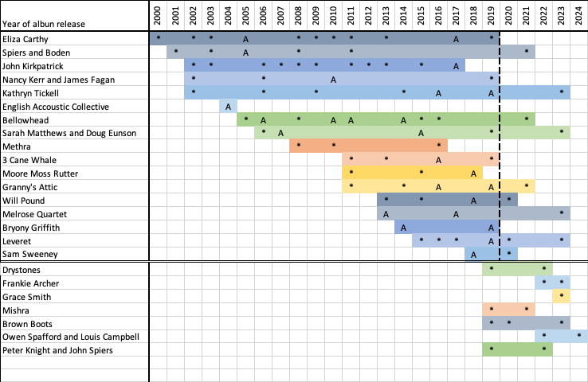

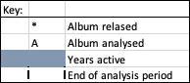
Figure 37. A timeline of artist’s creative output, showing data analysed and further data for consideration.
Figure 37 is a timeline of some of the professional output of recorded instrumental folk music since 2000. The majority of these artists are from the CD data, and the CDs that I analysed for this thesis are marked with an A. The * indicate that an album was released in that year. It is important to note that whilst all the CDs represented above contain instrumental material, not all the tracks on the majority of the CDs were solely instrumental. The dotted line represents the end of my data collection period for this thesis. There are also CDs not represented in my CD data, although some of those artists were surveyed and/or interviewed. The reason that I have chosen to include this data is because it demonstrates the longevity of the folk scene. But the artists featured underneath the horizontal double line are artists that have had more recent professional releases – post analysis. It is within these releases that there is a wealth of instrumental influences present. From EDM and electronica to post-rock sounds and rock, from the influence of Indian classical music to more traditional folk-dance influences. There are a lot of new musical sounds happening in the releases of these few newer (but not necessarily younger), artists alone, at least according to their individual professional promotions. There is still a place for the traditional elements, and they clearly featured through much of the analysis for this thesis, but the music that is now being released contains wider levels of musical influence from outside the folk scene in England. Change, in both big stylistic and instrumental changes, and small levels of everyday variation, plays an important role in the recent past and the present of the instrumental folk scene in England.

It is apparent that the role of time has an important role in the sense of stability and style. This role is twofold; as discussed above by various artists on the scene, time or a perceived link to a history is quoted in terms of defining tradition - phrases such as ‘an old tune, with no known writer’ for example are common. It is also more of a tangible influence; in that it can be used as a measurement for change as demonstrated in the above timeline.

The idea of time, as a method by which change can be measured, is also the method by which the relationship between the individual and their creative practices and the communal sense of identity and tradition can be viewed. This relationship is demonstrated below:

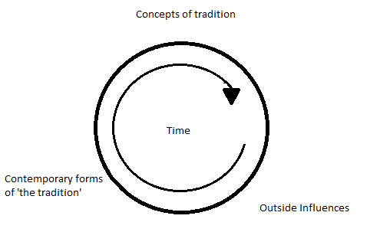
Figure 38. The circular effect of time and influences on the concepts of tradition.
Figure 38 shows how the influence of time can be seen affecting concepts of tradition which are ever-changing. Affected by outside influences at the boundaries of the culture and gradually filtering through becoming accepted into the participant’s own perceptions of what tradition is, the outside influences fuse with pre-existing elements of the culture to form a contemporary form of the tradition. This new form is both still recognisable and, most importantly, still identifies as part of the original culture. As more time passes, this contemporary form of the culture, with its new authentic processes and interpretations of tradition, becomes the norm; as part of the cultural core (from Bohlman’s 1988) model of boundary formation, discussed in 1.3.2), and thus the circle begins again.

Whilst using the idea of time to deem the value of something as traditional, may not be useful; age, and the passing of time, seems a poor judge of change and acceptor of the new, it is a useful device for viewing the change as it is (or is not) accepted by the community within the tradition. The continuity, or ever-evolving nature of accepted traditional/musical gestures demonstrated in the above model, is backed up on numerous occasions in the survey data, summarised here by Simon Care:

I don’t believe tradition to be static I believe it to be evolving I struggle with traditionalists who adhere to the “line in the sand” concept, as in that’s how it was collected and that’s how it should remain. For example, all a collector did was to take a snapshot of a moment in time and the tune/song was evolving right up to that moment. So how would it have sounded 20/50 years later if it had continued to evolve. (Simon Care, survey, 2020)

The effect of new forms of instrumental musics, be it newly written tunes, ‘Beyond Tunes’ or old tunes reintroduced into a community, with new musical and stylistic influences on them, can be profound. However, the impact and effect of this change are difficult to measure and see within a generation. For example, the impact of change isn’t hugely represented in the CD produced since the 2000s (in the CD data). There are outliers, artists who do stretch the idea of boundaries within a tradition, and as mentioned the impact of instrumentation has undergone relatively large amounts of change since the 2000s, with the increased influence of brass, and electronic instrumentation. When artists talk about their own creative practices, they are being creative, but within the expected boundaries of tradition. It is a creative tradition.

5.5.4 Boundaries Of Change
Is it possible to introduce too much change into a tradition, so much so that it crosses the boundary of what is identifiable as a form of instrumental folk music played in England? Some would say so:

Many compositions of mine end up in the bin if I deem them to have strayed too far from what I feel a good traditional tune should be; if it becomes too complex for dancing or too "busy" to enjoy without too great a deal of concentration, then I've likely written something too "progressive" for my own personal agenda! (Mikey Kenney: survey, 2020).
Creative practices may push too much change into a tradition and community, meaning that it is hard for other partaking individuals to understand or accept certain elements, especially if too much change happens at once. It is ‘necessary to adhere to some sense of the older styles and character of the tradition in order to maintain its 'difference' (Sandra Kerr: survey, 2020), meaning that it’s important that a tradition remains distinct, and identifiable within the boundaries of its own genre. For example, when asked, if there can be too much change, Jon Boden answers with:

Yes absolutely, and quite easily. There is a point in any process of arrangement or composition "in the tradition" where you travel so far from where you started that the starting point becomes either irrelevant or (worse and more often) actually undermines the new piece of music, so it's like the arrangement is in active conflict with the source material. That always produces naff music. (Jon Boden: survey, 2020).

This introduces the idea of moving so far away from the elements of the tradition that define it, that it is no longer recognisable as part of the scene from which it came. Perhaps it is the traditional gestures that are valued and needed to stand out above all else when using traditional styles.
However, this seems to be the minority. Many artists questioned in the survey supposed the idea of change, stating ‘It can't be pushed too far’ (Archie Churchill-Moss: survey, 2020), ‘I think anything goes! No lines!’ (Jess Arrowsmith: survey 2020) and ‘You should never put limits on music and creativity.’ (Jon Dyer: survey, 2020). However, the idea of boundaries is met with slightly more caution:

My perception is very broad but based on knowledge. People who push the boundaries well understand the music implicitly. Where it doesn't work is where someone thinks it's just a tune and does anything with it without understanding feel, lift, dance and the other things that this music serves. I only fully understand folk music but other influences creep in but never without a constant reflection and nod to where my main influences come from. (Jo Freya: survey, 2020).
And,
The boundaries of every genre are always being pushed into new territories, which is something that may be embraced by some people but not sit well with others. (Jamie Roberts: survey, 2020).
This approach to finding what the impact of change might be in terms of what artists deem the boundaries of the tradition and boundaries of where they’re willing to take their own ideas of music change, relies again on the consciousness of knowing what came before. This brings us around to the idea that ‘There are purists who wish to preserve the tradition in a way that is irrelevant or full and I think this helps no one and forgets that the whole point of folk music is it should bring people together’ (Matt Norman: survey, 2020), meaning that to some, being too concerned with traditional, and avoiding change negates the point of playing folk music in general.
However, to some, the relationship between the idea of tradition and its boundary is referred to, by some, as ‘a continuum and either side of the line will be almost indistinguishable. Everyone's lines will be in a different place, (John Spiers: survey, 2020) bringing in an individualised approach to defining boundaries of change. Tradition and change are part of the same scale, and where artists choose enhances helps shape their creative practice.
For example, albums such as Jim Moray’s ‘Sweet England’ (2013), with the use of electronics and more experimental sounds, and the impact of bands such as Bellowhead (Burlesque: 2006, Hedonism: 2010, Broadside: 2013, Revival 2013), with their use of big band brass line ups, and more orchestrated arrangements, introduced new musical gestures, creating levels of change into the scene that can still be seen today. And these were accepted (if gradually) into the scene. Bands like the Drystones (Vulpus: 2022) are using electronic dance influences, Sam Sweeney and his electronic almost ‘post’ soundscapes (Unearth Repeat: 2020), Old Dance School (Forcast:2010, Chasing the Light: 2012), The Unthanks (The Unthanks with Brighouse and Rastrick Brass Band: 2012) and Kate Rusby (Sweet Bells: 2009) using brass band influences, Methera (Methera: 2008, Vortext: 2016) and Leveret (Diversions: 2019) with their more chamber ensemble sounds demonstrate just some of the other musical influences present on the folk scene. Some changes can have a larger and quicker impact, on my generation of instrumental players - Bellowhead are hugely influential, much of their repertoire, styles of playing and some instrumentation remains on the scene today. However, it does seem that most of the changes instigated by the creative practices of individual musicians are usually smaller, and the possibility of too much change seems somewhat unlikely.

The only danger in pushing too far is alienating your audience! (Ford Collier: survey, 2020).
Most of the professional artists surveyed supported the idea of change being an important influence, particularly on their own creative practice within the tradition. However, there are no clear boundaries identified, and whilst change is supported it is unclear as to when change might be too much. Only Jon Boden talks specifically about moving beyond the tradition, presumably in terms of stylistic functions and structures that identify as part of a genre, and not many talk about the idea of change without referring to what might constitute too much change. Whilst there was no clear boundary identified, they are a useful tool for identification, but not as a tool for limitation. Informed, conscious knowledge affords creative practice the agency to take the music wherever the individual wants.

‘The boundaries of every genre are always being pushed into new territories, which is something that may be embraced by some people but not sit well with others’ (Jamie Roberts: survey, 2020) creating a sense of push and pull between the individual and others within the scene. This means that the lines between each individual and their interpretation of their own traditional culture are blurred by their sense of personal authenticity. This negotiation between the creative influence of the individual, and the desire to maintain a unique sense of style, a cohesive sense of identity, and a sense of personal authenticity, is at the forefront of the artist’s interaction with ideas of tradition. This is the fine line between a distinct cultural identity and the influence of its many individual participants. It is in the hands of the community of partakers, both on a national level and in the regional pocket communities that the acceptance of new musical gestures and change happens, it is in this relationship that the boundaries are set. Different changes happen and are accepted on different levels across the scene - or not. Each partaker, whether a professional artist or audience member, plays a role in instigating and accepting change, through the music that is consumed, or by the concerts that are attended.

5.6 A Valued Tradition
At the start of this chapter, the aim was to discuss what tradition, particularly in terms of what a traditional tune meant to professional musicians that play instrumental music on the folk scene in England. There is no single definition used by the artists, although there are many commonalities that are spoken about. It is the individual interpretation of the concepts of tradition (of which there are many) and the personal value placed on these concepts that perhaps account for the mixed response to the concept. But a new definition of tradition isn’t important, the fact that so many people speak about the concept, often with reverence, dictates that it is important and impacts both the creative practice of individuals working on the scene and the acceptance processes of their audiences and communities that they work within.

Tradition is the sense that there is a value in what has gone before, which is worth preserving. Exactly what is worth preserving is a personal thing. It may be a style, or a corpus of tunes, a dance, an instrument, or a community. (Owen Woods: survey, 2020).
Coherently summed up by Woods, the multifaceted, interrelated value of tradition can be seen. Whilst tradition clearly influences much of the scene, it is perhaps the relationship between the scene and the professional musicians, and the relationship between the scene, its traditions, and other scenes and their traditions, that result in today's movable, flexible and ever-changing interpretation of tradition. However, it seems prudent to break the value of the concept of tradition down into 3 overarching categories:
- History: What has gone before, and how it is interpreted in the future,
- A community and the individuals: the people that partake and promote the above,
- Gestures: Structure, style and function or a corpus of tunes, a dance, or an instrument.

This personal and individualised relationship negotiating the importance of the past to the present-day tradition changes over time, with each new experience, and individuals and communities alike may value certain bits of history differently. It is how each individual artist within their community navigates their way through the relationship of past and present that creates a vibrant scene with lots of different historical and musical interpretations.
Given that the value of tradition to professionals in the contemporary folk scene is as much about negotiation and acceptance of change, it does seem that this statement from Lewis Wood about the relationship between tradition and the impact of change is widely agreed:
Tradition is often used as a reason why people shouldn't change the way things are done, and I completely disagree with this logic. (Lewis Wood: survey, 2020).

Change is part of tradition, without it, tradition ceases to be relevant, and folk music ceases to be relevant to the people who partake in it, which is the key to the continuation of the music, history, and scene. Change is as much a negotiation between the community (of the past and present) and the idea of traditions, as the idea of a historically perceived past being relevant to today’s community. The professional interaction with this negotiation is, as Will Allen (survey, 2020) comments ‘a sliding scale’ of personal choice, some may want to appeal greatly to their audiences, some, as demonstrated above, may not be as influenced by this.
Change, in terms of creative practice, can also heavily influence repertoire, this can be seen when a tune becomes widely popular on the festival session scene, meaning it filters into the repertoire of multiple musicians. This in turn can affect other musical gestures, such as arrangement, style, structure, ornamentation, and instrumentation. Change, in creative practice and output, can impact and influence all these musical and behavioural norms, and potentially change the influx of new gestures. Creative outputs can also reinforce these norms at the artist’s choice. It is in these boundaries of change, where communities vet the input of the creative practices of the individual that the outer acceptances and expectations of the community of tradition, can be seen. This brings the cycle back around, the relationship between artists and their tradition is still the push and pull between the old and new, but not historically old, more the pre-existing on the current scene, and it is the potential for change that moves this relationship forward.
The relationships between the creative practices and the professional individual, the communities and the audiences, the conscious knowledge, and conscious choices are what make a tradition identifiable. It is in the richness of the variety of communities that function within a culture where change and individualism have the potential to learn from each other and flourish.

Chapter 6. English Contemporary Creative Practices
This chapter is dedicated to exploring the creative practices used by those who write and arrange instrumental tunes on the folk scene in England by examining professional creative output. There are multiple levels of creativeness throughout the instrumental folk scene in England, from writing new tunes to creating arrangements of pre-existing material, from selecting new repertoire to be performed, to creating the order of tracks on a CD. I have split the creative practice discussed in this chapter into two topics, although there is a distinct overlap between the two:
- Processes of arranging tunes,
- Processes of writing tunes.

Although not all artists write their own music, many prefer to arrange pre-existing archival music, or music that is in the collective consciousness of those playing and performing on the scene in England.

There is, however, a grey line between arranging and composing in the folk world. Composition usually refers to the creation of new melodic material, in this case, a wholly new tune, chord progression or riff. However, some might call the arranging of old, pre-existing tunes a form of composition. The idea here is that there is a wealth of rarely heard music hidden in old books and by searching through them, a gem of a tune may be found and reintroduced to the world. However, these tunes may not be fully formed, may not be written down in full, or may simply not be to the full liking of a musician. Tunes may be changed, in terms of melody line, rhythmic groove, key or feel. However, in most cases, the essence of the tune is kept the same, meaning there is some resemblance to the original version. Hence, an old tune is being arranged, using deliberate change and variation to create something different and new, no matter how slight. It could be argued that this is both a form of composition and a form of arranging, both resulting in something new.

6.1 Working With Others
It is important to note, before moving on to analyse creative practice in context, that much of the arranging of traditional, or newly written material doesn’t happen in isolation - particularly when it comes to instrumental music. It is somewhat rare on the folk scene to have a solo performance whereby a single instrument, with no singing, is used to professionally entertain for a whole concert. Working with other musicians is a key skill and finding a role for your instrument, i.e. as an accompanying or melody player, is part of the creative practice. It is rare that an individual’s creative practices are not affected by another musician’s influence, i.e. ‘[it] totally depends on the other musicians, instrumentation and the collective mood.’ (John Dipper: survey, 2020).

It would make sense that in a bigger group, more detailed instruction might be given to provide each musician with a role, whereas, in a duo, particularly a practised one, there is a lot more room for unspoken interaction and improvisation. Jon Boden discusses the varied approaches to working in different types of bands:

For band arrangements it's sometimes about finding a riff that works as a counterpoint to the tune - so potentially quite a musically intrusive process. For duo/acoustic arrangements it's mostly about finding a good tune and then playing it in a lot, then using harmony/rhythm/variation to keep the tune interesting and to help with build ups etc. (Jon Boden: survey, 2020.)

In smaller groups, there is more room for individual improvisation and on-the-spot changes to be made, as there are fewer other instruments and musicians that this change could compromise. This is a common thread, the idea of ‘generally playing around tunes, seeing what ideas come out’ (Cohen Braithwaite-Kilcoyne: survey, 2020), ‘improvising with the tune’ (Alex Garden: survey, 2020), and then ‘pick out parts of the tune that might inspire a 'riff' or secondary melody to accompany’ (Alex Garden: survey, 2020). However, function also plays a role, whereby the intended purpose for the arrangement can dictate what form it takes, as discussed by Will Allen:

Depends what it's for. With Brown Boots, we use a lot of improvisation, so might give ourselves rough boundaries of arrangement (like how we're going to start/finish/change tune, plus maybe one or two features mid-set (like a stop). With Silver Street it's a bit more formulaic as there are more people, so we need to know what we're doing at any given time. With Ravens [rapper dance] it's all entirely set as the music and the dancing has to work together, exactly. (Will Allen: survey, 2020)

Much of the following analysis is conducted from the perspective of one musician, using data collected from interview responses. Whilst this allows me to give an in-depth analysis of their thoughts and views, it possibly only shows one side of the story. In particular, in the group pieces, such as ‘Brighton Camp’ (Appendix 5), and ‘Brute Angels’ (Appendix 7), there is clearly more than one person’s creative practices at work, and whilst these working relationships are sometimes alluded to, it is not completely clear who is creatively responsible for what. Even solo performances, such as ‘Radstock’ (Appendix 4) and ‘One String Jig’ (Appendix 6) may have had the creative input of the sound technician who recorded the tracks, for example. Perhaps it is in the last two analyses, with the commentary composition process (6.5) that the creative practice of solely an individual is seen in action.

6.2 The Creative Individual
Creative practices are a complex phenomenon to describe and are something that happens on a spectrum of ease to different people. Similarly, the origins and influence behind a creative idea are difficult to pinpoint and articulate, even on a personal and individual level. The following section is dedicated to exploring the origins and methods behind creative and compositional ideas.

6.3 Gestures
Gestures is a theory put forth by Middleton (1993), as discussed in 1.4.2. Drawing comparisons with Hill’s (2012) idea of the manipulation of patterns, Middleton’s text also combines the idea of Piaget’s (1936) ‘schema’, a method of organising patterns, experiences and relationships, on a conscious and unconscious level, with the idea of gesture as embodied patterns. Gestures can have a great many different influences on different people and are drawn on as a variety of conscious and unconscious influences in the creative practice. Gestures, as a toolbox idea, can help us understand the idea that composing music ‘just happens’, that an idea behind a piece just appears in the mind and manifests itself as a piece of music. The idea can account for individual creative differences in that each musician has their own toolbox of skills, personal tastes, and ideologies, based on the gestures that they have acquired and been influenced by throughout their lives. The internalised creative practices stem from what is already known and are influenced by what an individual is experiencing, and this is both an ongoing and ever-changing process and a process that always retains the individual characteristics and familiar patterns, of muscle memory, that make musicians creatively distinct from each other. Drawing on these strands of schematic and musical influences, an expansion of Middleton’s gestural theory, as a gestural toolbox is presented below.

6.4 Processes Of Arranging Tunes
As discussed in chapter 3, the process of arranging tunes can refer to many different things. Arranging can refer to the act of bringing a simple melodic outline to a group of musicians or a band, and the act of creating an arrangement. This can happen on an individual level, whereby a musician may write out set parts for others to play, or on a communal level, whereby the tune is shared amongst all, and ideas are generated through playing together. The initial melodic outline may be changed and adapted, or it may remain the same and a variety of arranging techniques such as:

- Harmonising and variation of harmonisation,
- Solos, improvisation, and melodic variations,
- Key changes,
- Riffs,
- Groove,
- Builds, Drops, and textural and dynamic techniques,
- Ornamentation,
- Tempo changes,
- Instrument specific techniques.

All of these musical gestures are used to create and sustain interest in a melody line, whether it be new or old, as Sarah Matthews discusses:

When thinking about arrangement I always think about the overall shape of the entire piece ... should it start with the tune? Should it have a basic introduction? Should it drone through the first time or have chords or have no chords / no accompaniment at all? How many other instruments would come in? Should there be an opportunity for free playing and improvisation? How can I vary the melody and make it interesting upon repeats? I like to do something different each time through ... so I may bring in more ornamentation or variations on the theme of the original tune. (Sarah Matthews: survey, 2020).

Whilst there are certain patterns, or ‘well-worn paths that can be travelled’ (Ford Collier: survey, 2020) that artists will tend to work with, it is important to note that, as mentioned on multiple occasions by the artists, there is no one set process for the arranging of traditional material, more several different routes to try.

6.5 Creative Practices Through Composition
Writing new music, particularly in the instrumental folk scene in England, has undergone little research. It’s a personal process that is difficult for the individual to describe. However, there are some key threads that will be explored in context below. Some describe their creative practices truthfully, but for the purposes of this thesis, vague phrases like:

I find my favourite of my own tunes are the ones that almost write themselves. (Lewis Wood: survey, 2020).

I either wait for an almost complete tune to fall out of my fingers and then work it up and refine it a little, this often happens when I am distracted by driving or walking. (James Delarre: survey, 2020).

"Mostly I write on the edge between conscious and subconscious. Some of my best melodies have come to me on the brink of sleep. My phone is full of sleepy hums. […] Sometimes they come fully formed, mostly they take months or even years to be completed. (Mel Biggs: survey, 2020).

However, many follow a slightly more tangible route of starting with ‘short melodies/rhythmic cycles (1 or 2 bars)/intervals’ (Archie Churchill-Moss: survey, 2020) or ‘little riffs’ (Kate Griffin: survey, 2020) or a ‘hook’ (Jess Arrowsmith: survey, 2020). These then undergo the process of ‘expanding, recycling, reworking […] into an 'extended' A or B part for a tune,’ (Archie Churchill-Moss: survey, 2020) where edits are made to ‘change phrases/change the order or phrases and try to give the tune a coherent shape’ (George Sansome: survey, 2020).

These gestural influences of structure, function, ornamentation, and harmony, etc, have obviously had an impact on all the musicians interviewed and analysed, and some of that is evident in their creative products. But much of the above also exists in the creative practices of other musicians on the scene:

I wouldn't say I have a set process (as it often varies depending on the other musicians I'm working with), but one approach that I often take is to initially decide on the most obvious way of harmonising the melody (by which I mean deciding on chords, not coming up with a melodic harmony line). This is often the most predictable and therefore 'satisfying' for the listener. I'd then explore a number of alternative ways of harmonising the tune, which can then give plenty of options for arrangement ideas. If a tune is played a number of times round, I'm thinking about creating some sort of 'shape' with the arrangement using various things such as tension/release & dynamic etc. - for example it might be that we decide that the second time round a tune is going to be a climactic moment, so the first time round the tune I will be consciously trying to create a feeling of building towards something (tension) harmonically (using alternate / less obvious chords) and dynamically. Then reaching the second time round the tune, the most obvious chords have more impact (the release). (Jamie Roberts: Survey, 2020)

And likewise, talking about starting with a ‘short segment or idea’ (Alex Garden: survey, 2020) and ‘improvis[ing] around the "skeleton" of the tune, finding ornamentations and variations that suit my own playing style and keeping note of them’ (Mikey Kenney: survey, 2020).

I then build ideas around it on a large manuscript page in pencil and start to join sections together with arrows or numbers. I will often try to avoid sticking to standard tune structures (32 bar AABB for example) until the last minute as this can hinder the freedom of creativity and steer towards cliches. I find this especially useful when writing the ends of phrases/cadences. (Alex Garden: survey, 2020)

And then, once formed, the processes of working a piece up to an ensemble level follow a similar pattern:

I find there are some well-worn paths that can be travelled. For example, some of the structures for arrangement that I end up using could fit an overarching template; introduction that brings in the groove, tune comes in A & B, variation on A&B, breakdown that introduces a new idea, return to A/B that develops or continues the new idea introduced in the breakdown. This is not a set structure though, and although a lot of my arrangements might follow this path I don't try and force them to if it doesn't feel right for the tune. […] I'll usually start trying to determine the feel by playing chords or riffs along to the tune (sometimes by recording myself playing the tune first, sometimes with another person playing the tune) and seeing what ideas work with the tune. It's a bit like rummaging around in my tool kit of riffs and chordal ideas to find something that fits the job or takes the tune in an interesting direction. (Ford Collier: Survey, 2020)

There is no singular method by which an artist creates, but examples of the process of writing tunes, directly called ‘composing’ by some, is explored below. The next section is dedicated to exploring the creative practices of individuals as they write new instrumental material. In this section, I offer a retrospective approach to exploring how the composers composed the following pieces, whereby I interviewed and asked follow-up questions once I had analysed the musical content. This differs from my experimental approach discussed below.

To briefly conclude, writing a tune which structurally and tonally mostly conforms to the musical style as described in chapter 4 contains much of the same musical gestures that were used when arranging traditional tunes. As demonstrated above, the following are all evident in the above arrangement of a newly written tune and a pre-existing or traditional tune:

- Structure,
- Groove and rhythmic variation,
- Ornamentation,
- Melodic variation,
- Textural variation,
- Harmonic variation.

Whilst simple musical analysis cannot, in this case, account for the inner workings of the creative practices of the individuals interviewed above, it is telling that the musical features listed are used, in different ways, in both traditional tune arrangements and the newly written tunes that were analysed for this thesis (see Appendices 4 - 7 for complete score analysis). However, as discussed in the literature, musical analysis cannot demonstrate the inner workings, conscious or otherwise, of the creative practice, even when combined with the interview data from the creator and so a more in-depth approach is needed. What follows is an experimental method which aims to get a deeper look at the creative practice in context.

6.5.1 Commentary Composition Process With Alex Cumming
Alex composed just an A part, the first section of what would usually be a 32-bar dance tune, made up of two repeated 8-bar sections.

My brain just works in those phrases. I don’t even have to think about it to know when a 32-bar phrase is done, or a 16-bar phrase, or a 48-bar tune, it just comes out. So whenever I try and write something it is always rounded as a dance piece of music, so it is always my starting point. (Alex Cumming: interview, 2018).

This melody was composed around the chord sequence, and the key signature and tonality were similarly a conscious decision. A time signature was not consciously decided on in advance, although a groove in 4/4 was performed from the start.

I just like minor tunes because I [am] really into minor 7 chords on the bass side at the moment. [...] I’ve recently written a tune in G minor, and I’ve recently written a tune in D minor, so I’m actively in my mind eliminating those keys. (Ibid).

The first phrase is based on the decided chord sequence as follows (figure 39).
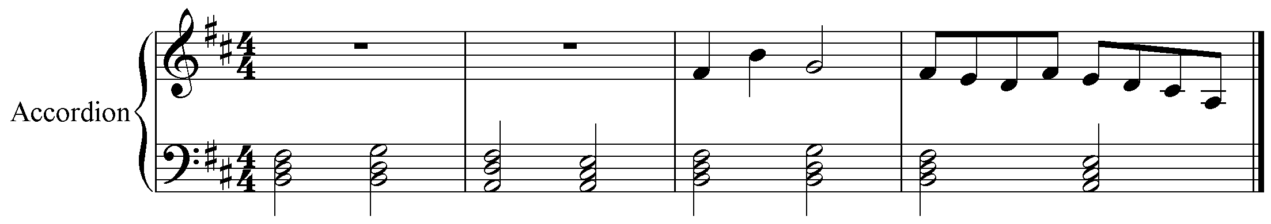
Figure 39. Alex Cumming: first attempt at chord progression.

So at the moment, I’m just playing around with chord sequences, just seeing what I think sounds nice. I think to start with I might base something around this chord sequence. (Ibid).

The chord progression itself, in B minor, features the occasional inversion, but is based solely on an i - VI - III - VIII progression from the start, a more unusual progression in standard folk tune accompaniment. Happy with the chords, the melodic line is progressed by experimenting with the initial phrase displayed above, where the initial, basic melodic outline is made almost entirely out of the notes that feature in each chord.

The thing that makes my style of writing tunes particularly me, when I’m writing a tune I’m writing the chords and the bass sequence at the same time. When I’m writing a tune I am very consciously aware of what my left hand and right hand are doing. (Ibid).

Roughly based in the same octave, a descending motif is favoured, but not fully decided on - the pauses indicate the indecision and the fine-tuning to the notes to the pre-existing chord progression. The steady beat, clearly a tool used to create flow in the melodic line from the start is interrupted at this point, whilst fine tuning occurs, resulting in phrases that do not fit easily within the bar or the beat, such as bar 6-7 (figure 40).

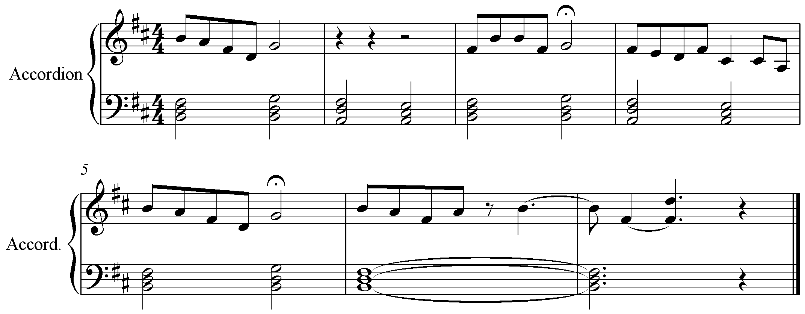
Figure 40. Alex Cumming: finding a melodic motif.
The second phrase, here shown in the second half of bar 2 (figure 41), is the first phrase to become mostly solidified, and features throughout as an extended mordent-type phrase, finishing on chord II (A major in bar 6, figure 41), signifying that the tune has not yet finished.
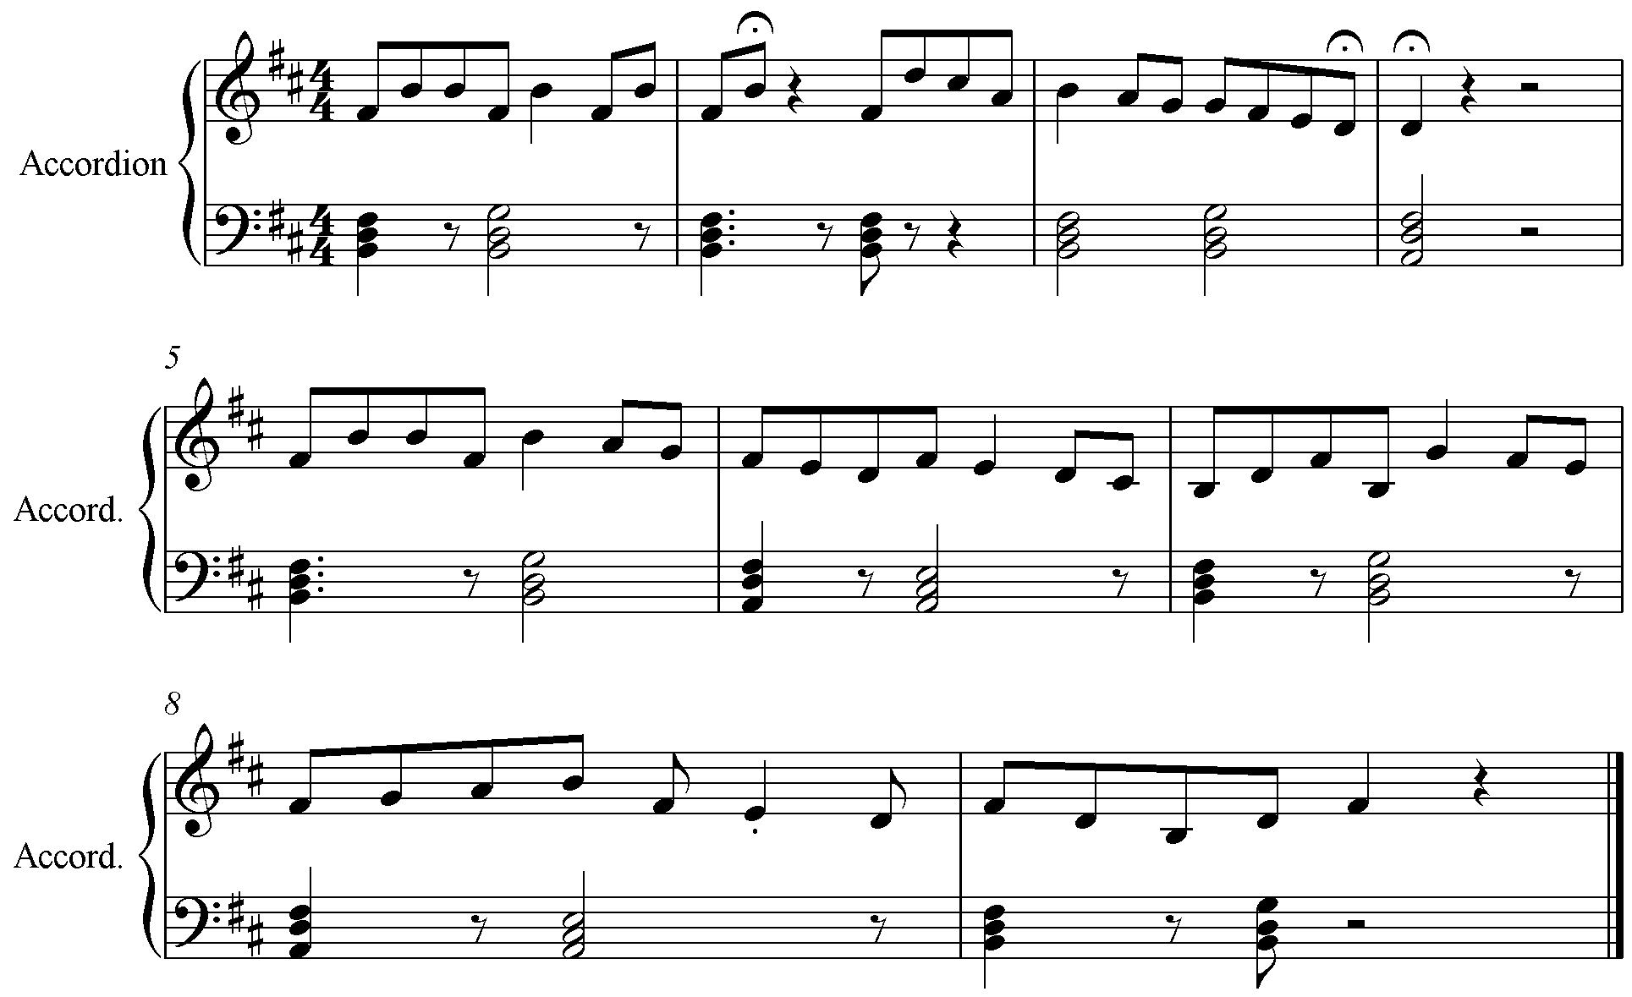
Figure 41. Alex Cumming: solidifying the main motif.
However, the rest of the melodic line has not yet quite been completed in the mind of the composer, resulting in several more minutes of changing the motifs and playing around with the other notes in the prescribed chords. Several variations of the first phrase now exist, in bars 1, 2 and 5, (figure 41) and the pauses again, indicate uncertainty about the cadence points, possibly about aligning the melodic note up with the chords in the bass hand. The bass hand and the chords, however, are now fully established, and are becoming part of a syncopated groove, whilst the melody line is being written above; this is most noticeable in bars 5, 6, 7 and 8 (figure 41) and really emphasises the bass line as an active part of the tune, as opposed to just functioning as an accompaniment.

The first phrase is decided on (figure 42). An arpeggiated figure, first ascending then descending with passing notes, unlike the initial versions of the phrases above, which were based mainly on the chordal notes.
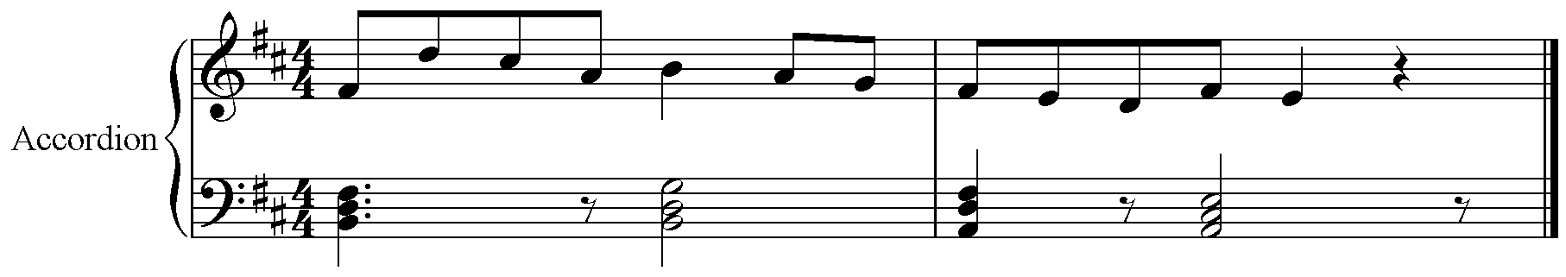
Figure 42. Alex Cumming: first motif.
The melodic line is then prioritised above the bass line and is allowed to progress on its own without the bass hand accompaniment, thus freeing it from the constraints of the chord progression (figure 43).

And now the decision I need to make here, I’ve done the chord phrase that I like and wanted to write, and I’ve got to decide now whether I’m just going to do that chord phrase all the way through or change it up here. So what I’m actually going to do now is see what my fingers do without the chords. It’s partly to do with standard patterns in traditional tunes, because certain scales and arpeggios patterns are very common. (Ibid).

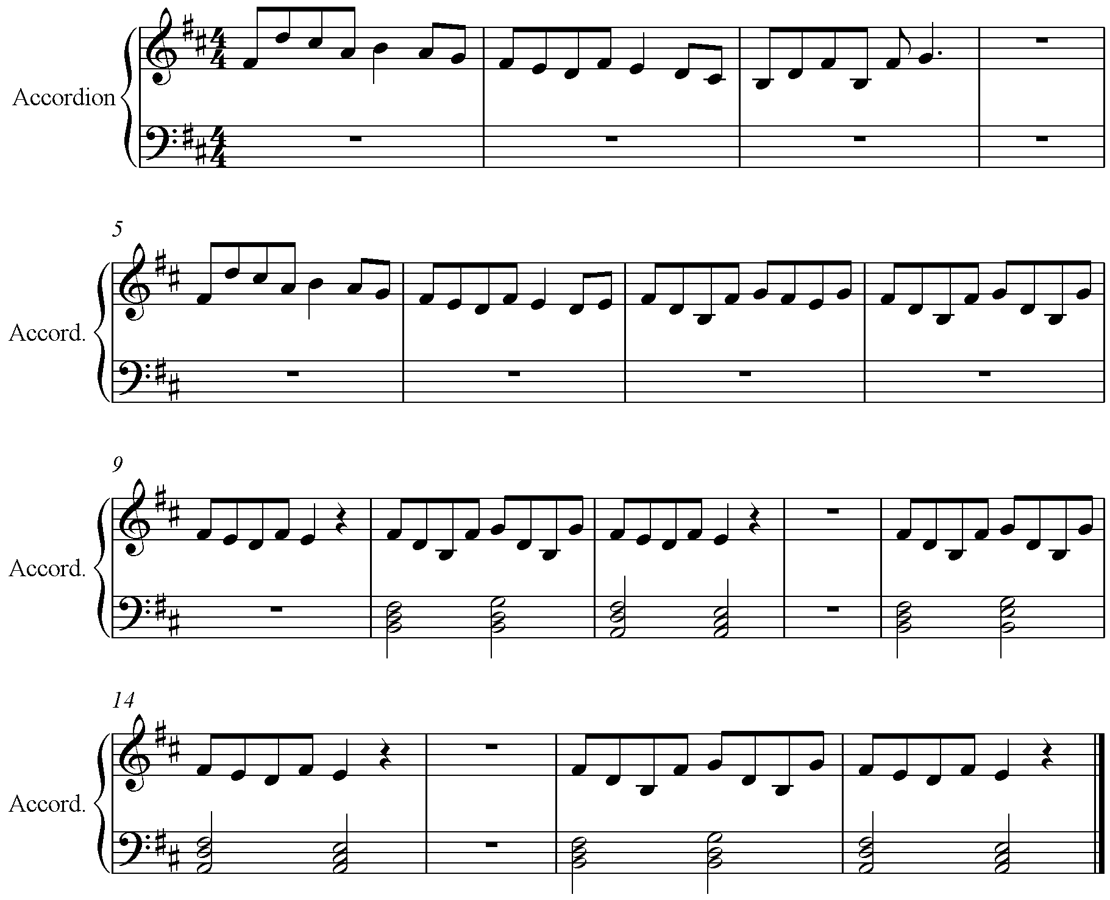
Figure 43. Alex Cumming: melody writing without the template of the chords as a structure.
With the melodic line and accompaniment complete up to the turn-around phrase, the cadence point on chord VII at the end of bar 4 (figure 44), the first melodic phrase is repeated again, as is customary. This use of repeated melodic material means that only an end phrase needs to be decided on, resulting in the following few final cadence ideas, in bars 4 and 6, finishing on the tonic of B minor (figure 44).

So there is that framework of endings that you can go to. You have a little tool kit of endings that you can try out and if you like it you can do it or do a variation of it. (Ibid).

The constant chord progression that is present throughout changes to take into account the end-of-phrase and the cadence appropriately, using a I-VII-I progression, letting the listener know that it is the end of the section (figure 44).

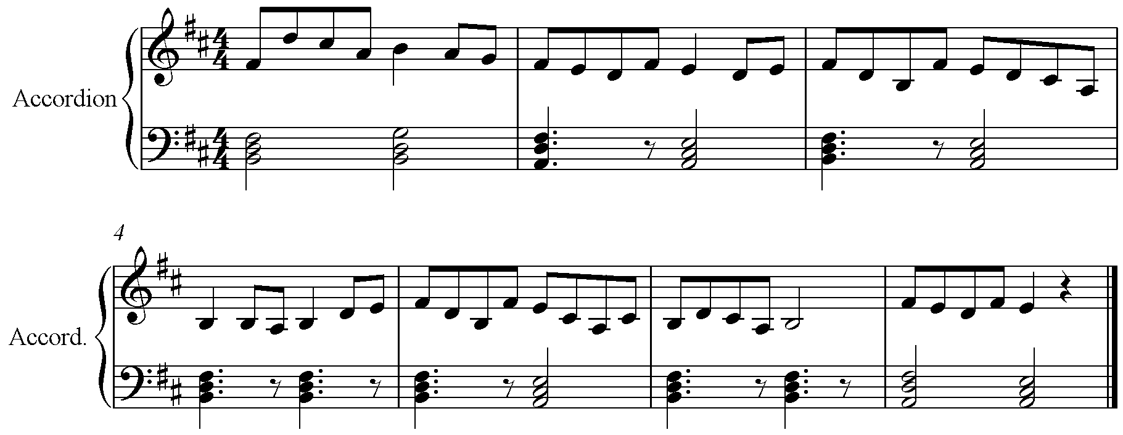
Figure 44. Alex Cumming: trying out ideas at the cadence points.
With a little more playing and learning of the tune, setting each phrase deliberately and keeping the groove and beat at a constant tempo, the tune is completed. Its full performance, with repeats, bass line, ornaments and groove, is below (figure 45). The repeat of the tune has been transcribed to demonstrate further the realisation of the tune and the stylistic variation that he adds.

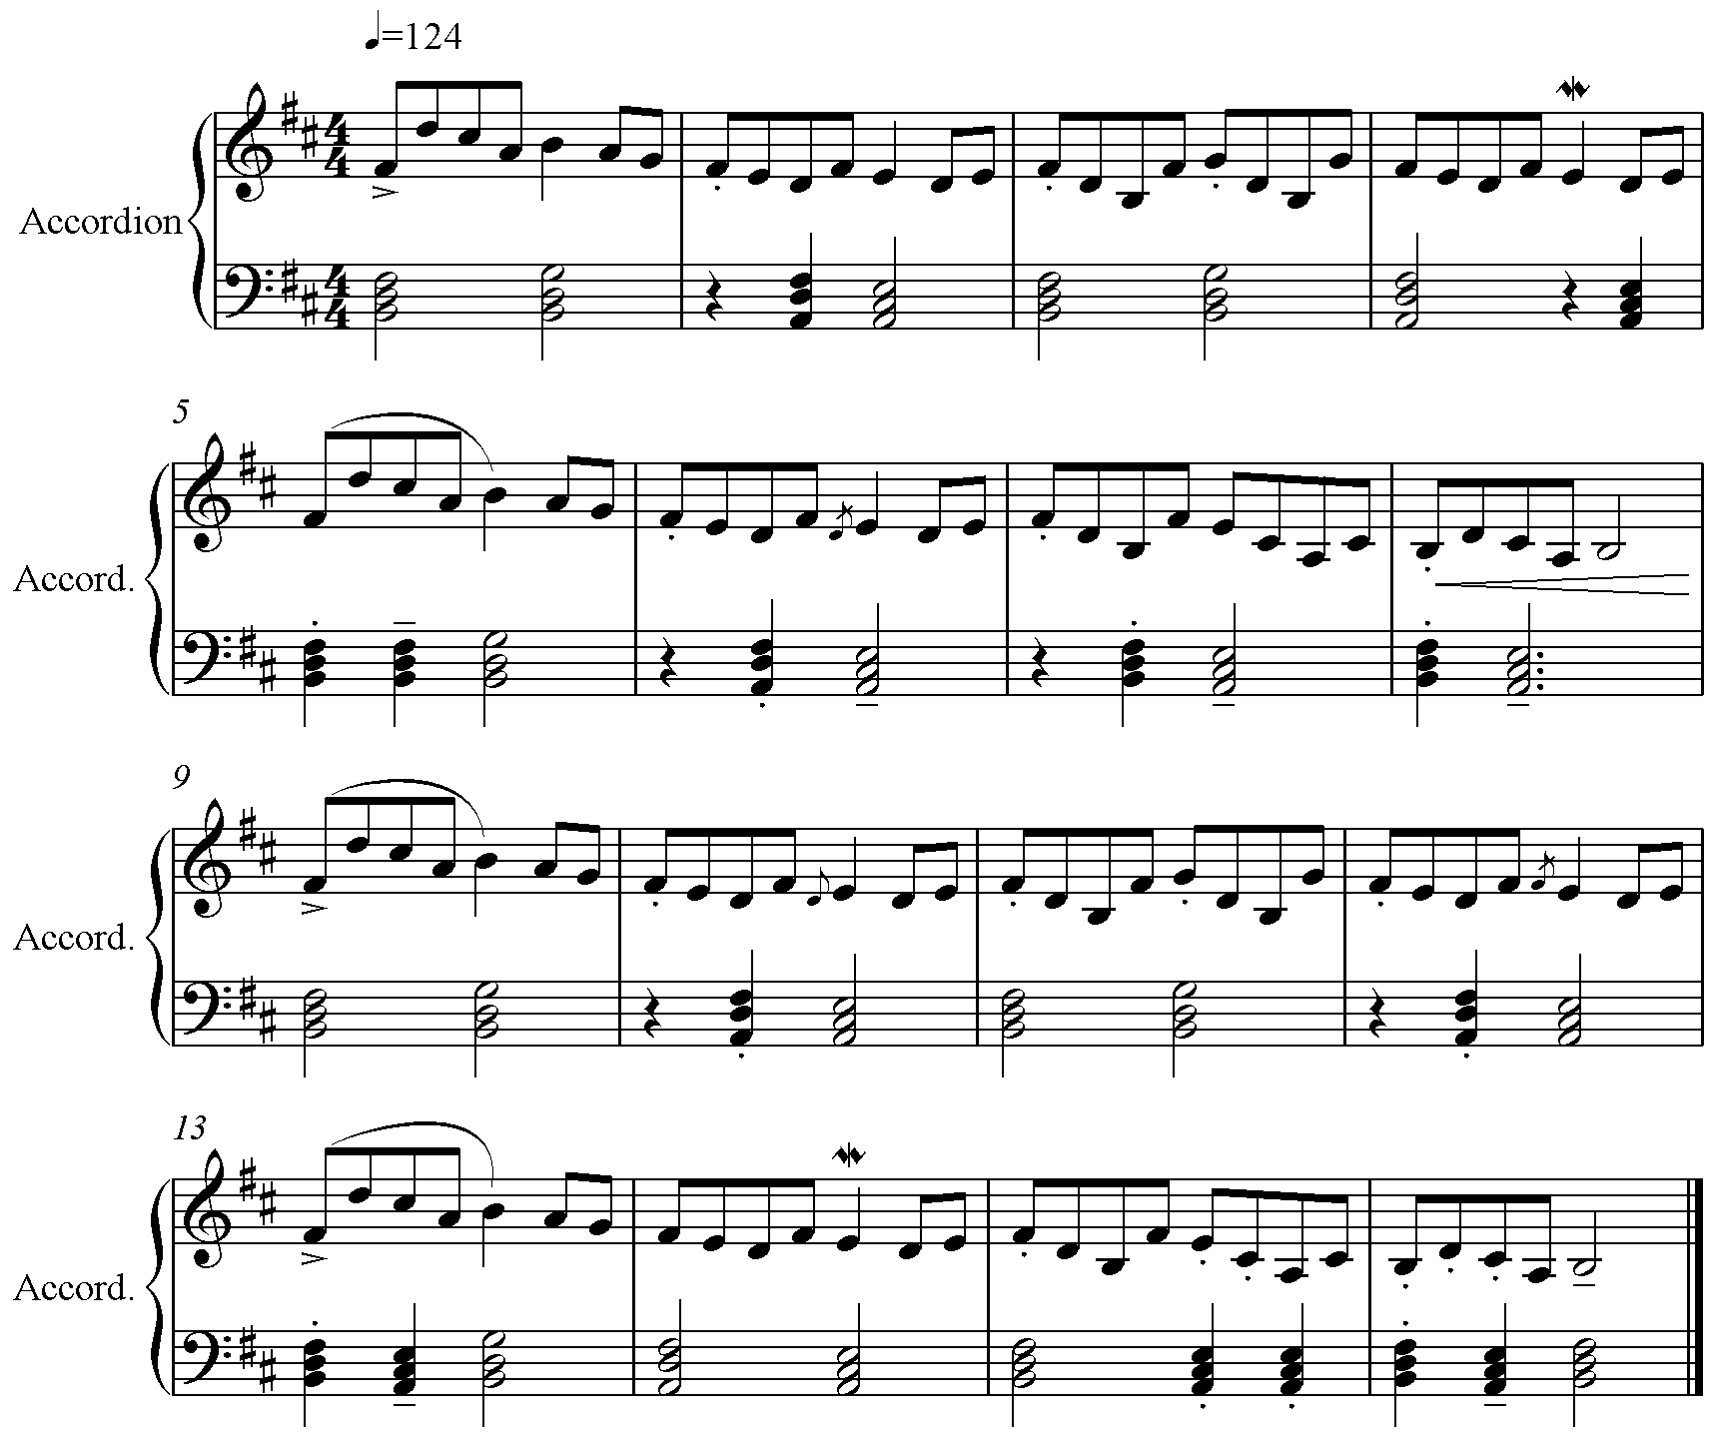
Figure 45. Alex Cumming: final realisation of the A part of the tune.
Performed at a constant 124bpm, the left-hand rest, staccato and tenuto notes, such as bars 5 - 8 (figure 45) create a syncopated groove, different to the one expressed above. The chord progression that was the synthesis for the tune does not remain as written above throughout; there are passing chords which disrupt the flow, adding to the groove, such as the added tonic chord in bar 5 and the extra chord V in bar 13 (figure 45), moving through chords i-VII-VI. The most notable difference in the chord progression is the lack of perfect cadence at the end of the first section, in bar 8, whereby the second chord is held, creating tension and dissonance that is only resolved once the melody has started again, a feeling supported by the only notable dynamic in the piece, a crescendo into the following bar.

It’s based on the very basic construct of traditional tunes basing themselves around chords 1, 4 and 5, and within that framework you can move to relative minors. If you look at most standard traditional tunes they’ll finish on the 1. I don’t always do that, I like to hold the 5 through if it’s half way through a bit of music, or hold the 4 through, or do something different. (Ibid).

The tune itself is slightly swung, and the staccato marks signify not just a shorter note but a note that is lifted out of the tune and emphasised thus. This is a common characteristic of the piece, happening throughout bars 1 - 16 (figure 45). The first phrase, however, is notably slurred. Ornaments are also added in this performance; mordent (in bars 4 and 14) or grace notes (bar 6, figure 45) are added to the same phrase, interestingly the same note throughout the piece.

6.5.2 Commentary Composition Process With Grace Smith
Grace starts by deliberately selecting her tune type and time signature, alongside her key signature and tonality, commenting on the impact that her instrument has on her creative choices.

I'm going to try to write a 3/2 hornpipe, this is a type of tune I really enjoy playing but I've not actually written very many so I thought this would be a fun thing to try. I'm going to aim to start in D major because I'm a fiddle player and that's quite a nice key on the fiddle. it's in the middle of the instrument so that would be a good place to start off. And I'm going to just play a bit of rhythm in 3/2 to get into
the feel of the time signature. (Grace Smith: interview, 2021).

Consciously starting by recording a groove on the tonic note in figure 46, Grace then decides to ‘have a play around some different chord ideas in that time signature’(Ibid).

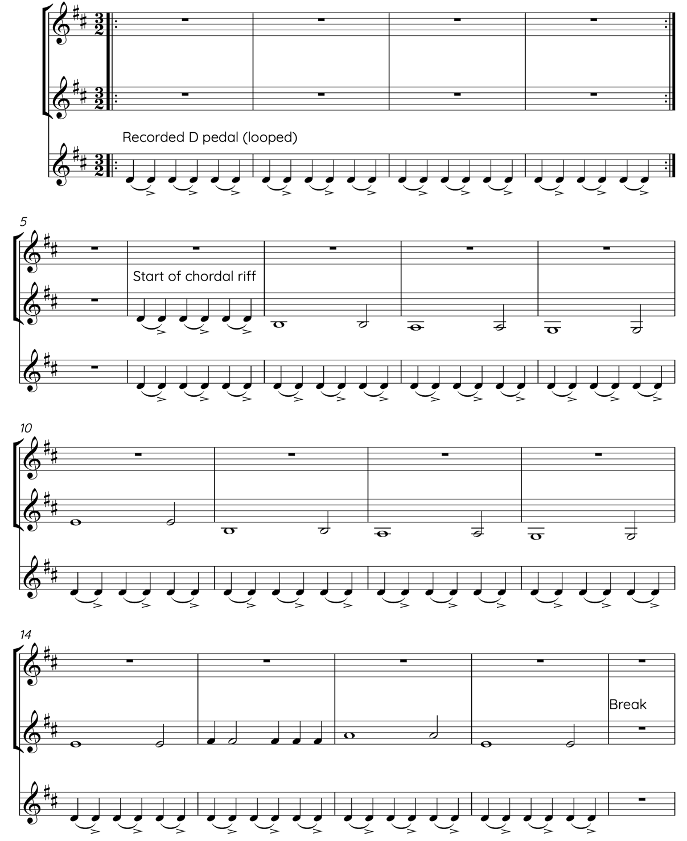
Figure 43.Grace Smith: establishing the groove, tonic and chord ideas.
After playing over her recorded self, using the accented, offbeat groove on an open D string as the starting point of the tune, Grace experiments with other singular notes to create chords with herself in figure 44, working out what the harmonic shape of the tune might be.
I'm just kind of playing different double stops and listening to them compared to that D which is my kind of key signature tonic rather than thinking about specific chords and their function, but I do like chord A, it sounds nice quite like starting on the fourth and then resolving it to the tonic after I've kind of started the phrase. (Ibid).
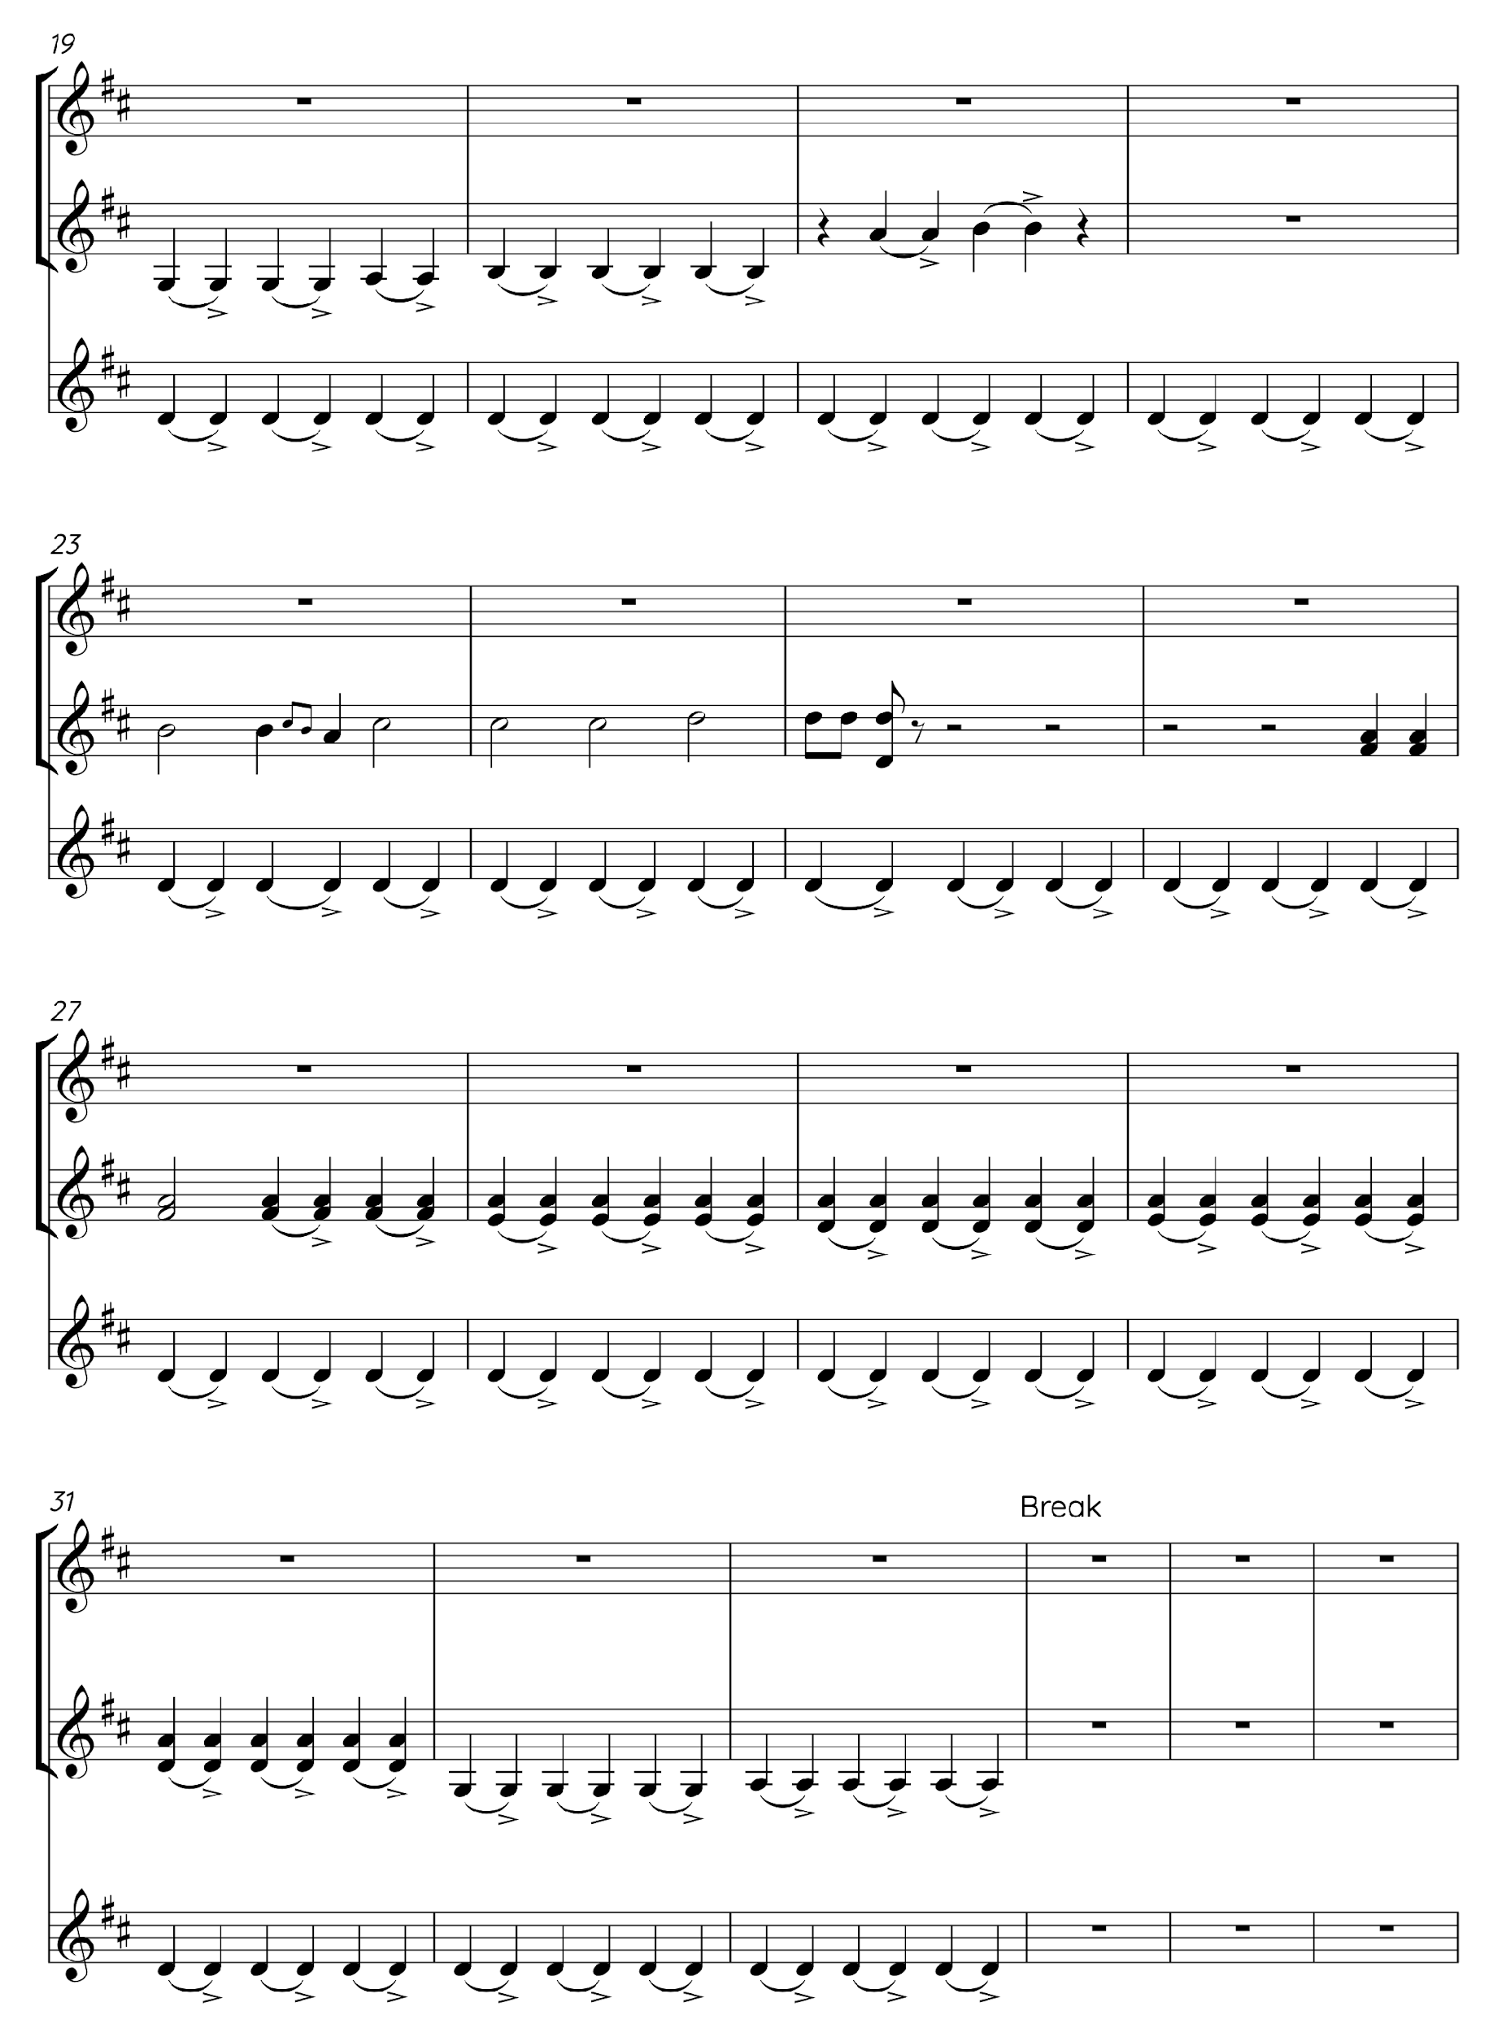
Figure 44. Grace Smith: figuring out the chords.
The process then starts to become more deliberate and shaped, ‘starting on the G moving up to D with the A on the top so you get that resolution to the D and then on the second phase starting the same but going to the B and a D for B minor.’ (Ibid) This results in the groove below (figure 45) whereby the chord structure is established, including passing notes to bridge the changes between chords and grace notes.
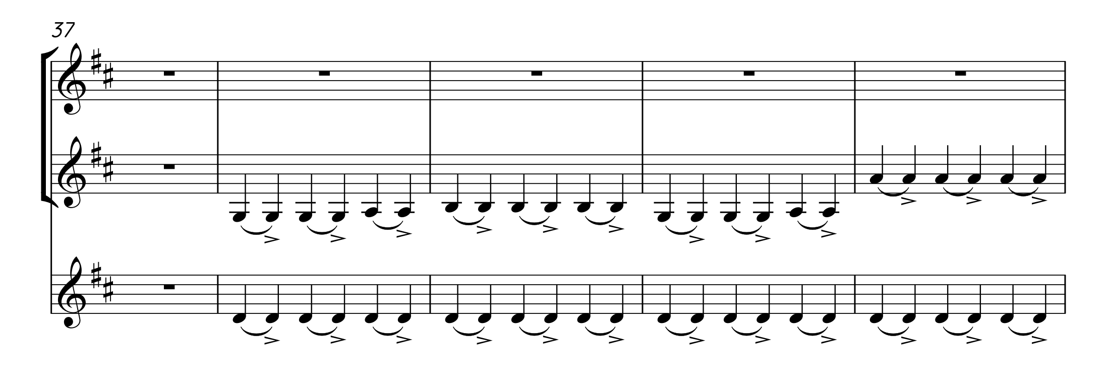
Figure 45. Grace Smith: established groove and chord progression.
The resulting harmonic structure is created (figure 45): G, passing note of an A (hinting at a D chord) in the last beat of bar 1, leading to the B minor in bar 3, and then a D chord to finish. Settled on the chords for now, Grace then moves on to creating a melody line, by ‘have[ing] a little play around some different phrases with that kind of double stop pattern looped round on my speakers’ (Ibid). Here are some examples of melodic starting points that Grace explores, punctuated by breaks where the recorded D loop and chords were reset, allowing time to think.
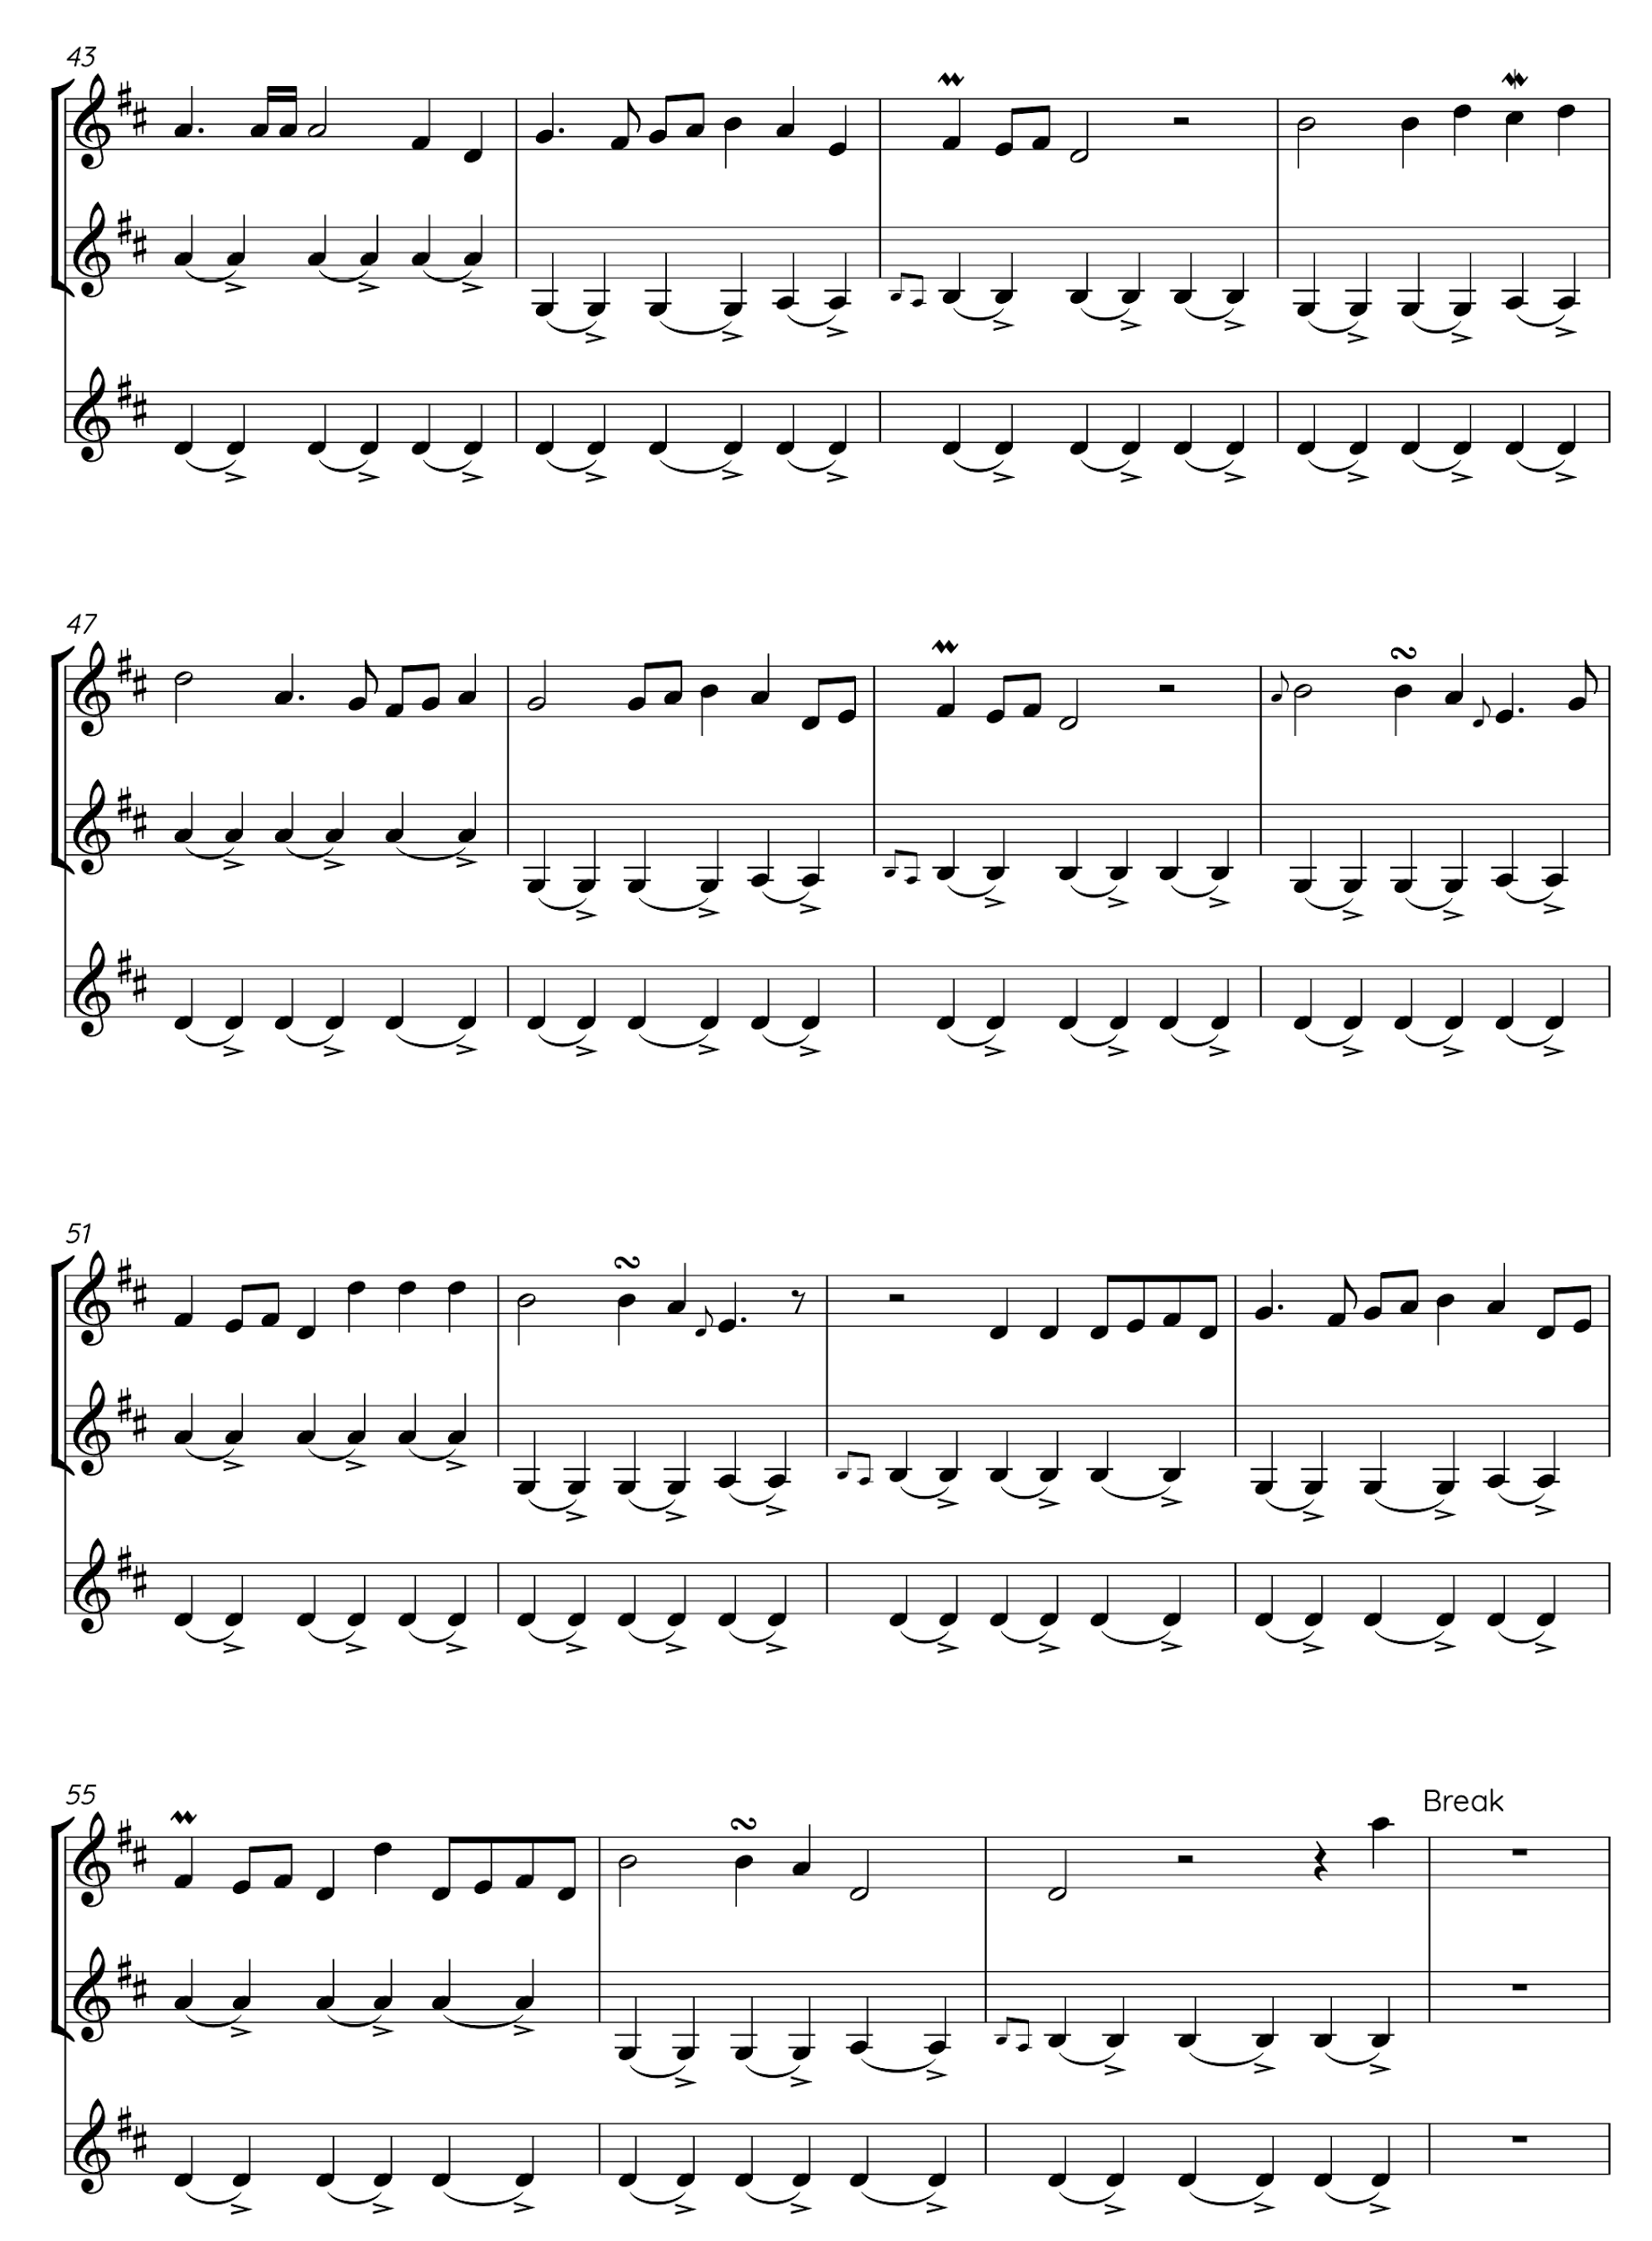
Figure 46. Grace Smith: melodic experimentation and ornamentation.
Several things can be noted from the above experimentations in figure 46. Ornamentation is present in Grace’s creative practices from the start - rolls, grace notes and mordents are used as she tries to shape her melody. It is also clear that Grace has a lot of different rhythmic phrases to choose from, from runs of quavers, to march-like crotchets. Grace comments on the importance of varying rhythms:

You've got those long minim beats in each phrase so trying to have some melody that moves faster than that. So there's kind of the option of having those quaver beats or dotted crotchets or minims yeah so there's moving a bit faster rhythmically over those longer beats. (Ibid).

It’s at this point that Grace starts to write up her own tune, using MuseScore, to give a rough outline of the shape of the tune:

I've also just got MuseScore up and to write out some of the phrases that I quite liked. Sometimes I think it helps me to visualise what the tune looks like and maybe start to kind of put phrases into place and think structurally what's going to work. (Ibid)

Grace also comments:

Just putting this on the [written] music, it does kind of help me just kind of get something fixed rather than just improvising and experimenting for too long and doing the same things round and round. (Ibid)

Grace settles on the following phrase idea for the start of her melody (bar 59, figure 49). She then begins to vary the scalic pattern to shape it - note that at this point she has stopped the chord progression from being looped underneath, perhaps to free herself from this structure briefly to allow for more possibilities.
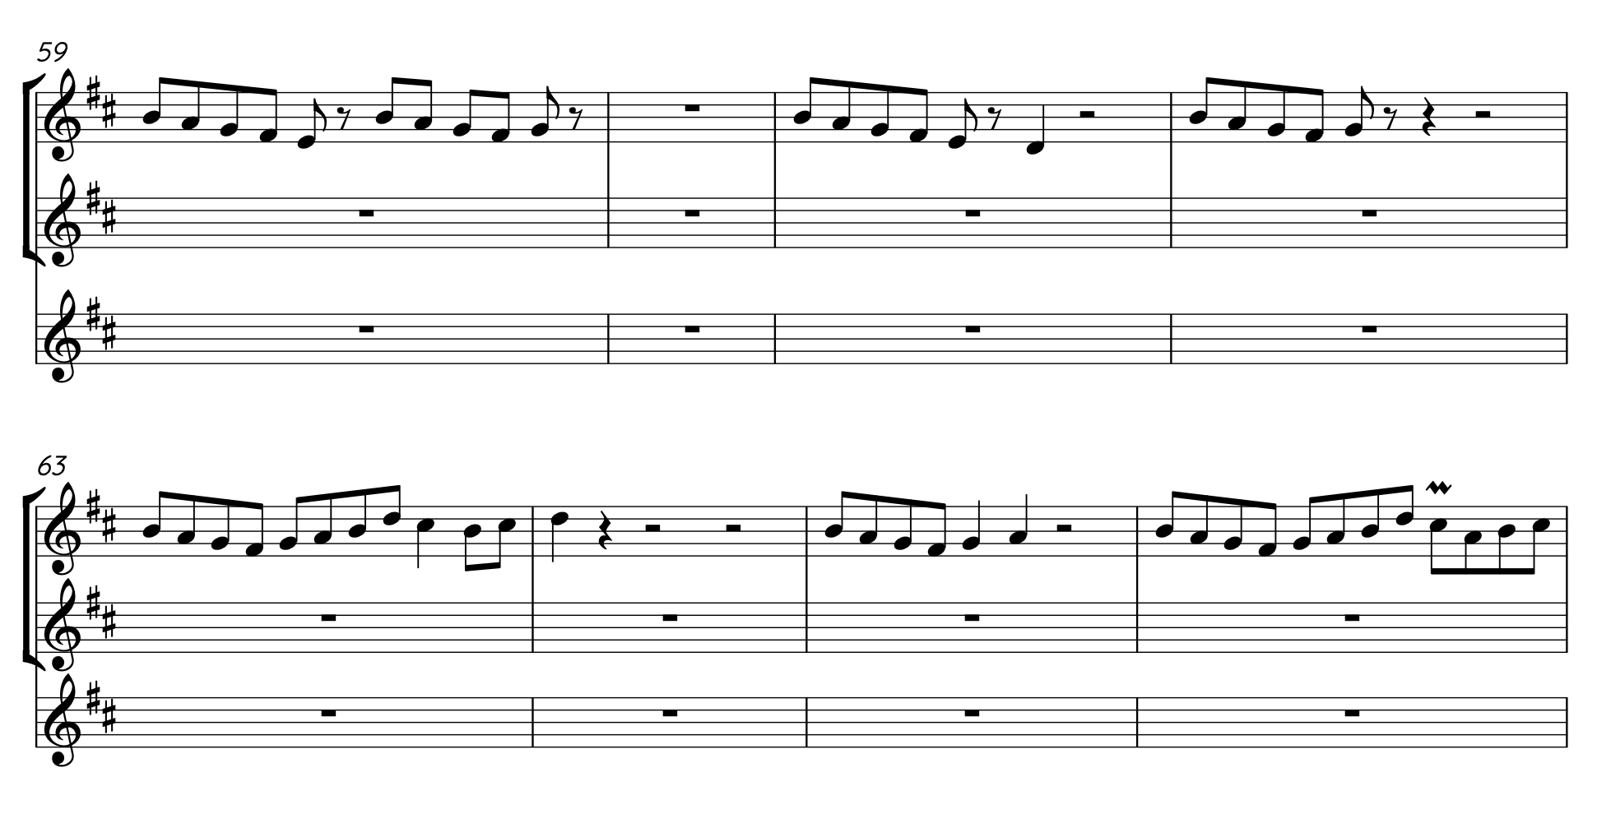
Figure 47. Grace Smith: initial melodic idea.
I think going down is kind of more natural, it was […] quite quaver-y, doing too much of that scaly run stuff. (Ibid)

This process continues, adding more to variety to the rhythms, as can be seen in the variation between the runs of quavers in bar 63 (figure 47) compared to the longer crotchets in bar 72 (figure 48) of its counterpart variation, which starts in bar 75 of figure 51. Similarly, Grace is adding more variety to the notes used, and how they might hint at the harmonic structure. The pre-recorded loop, containing the chord structure, is reintroduced as a method of linking the melody to the predetermined chord progression.

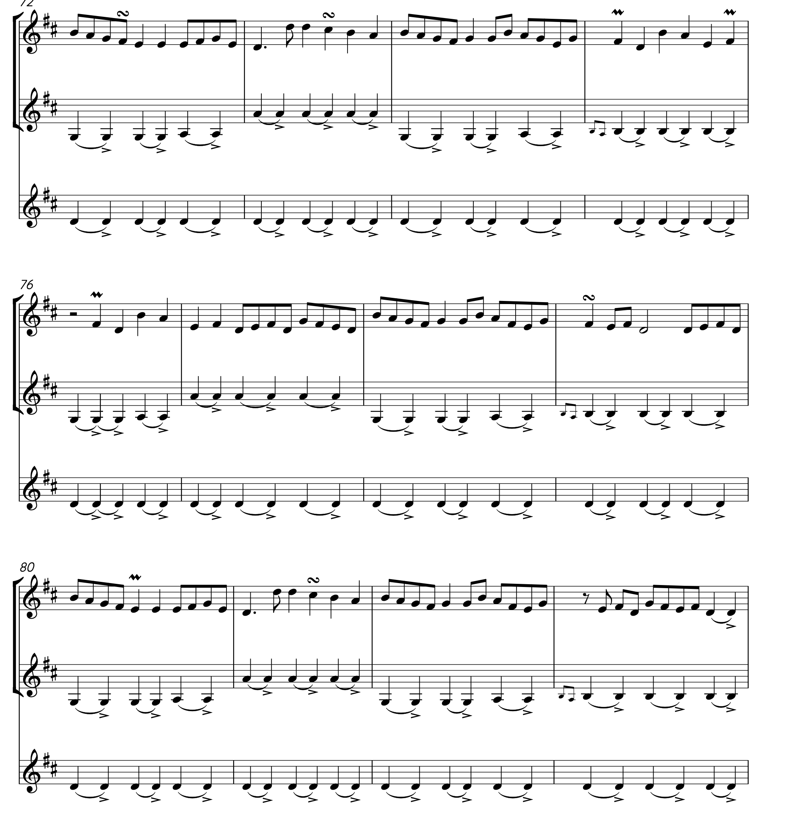
Figure 48. Grace Smith: rhythmic variation in melody ideas.
A definite shape is starting to take place, but again Grace comments on the importance of a melodic shape feeling right on her instrument, saying ‘I've got my 3 bars of feeling nearly there I think I might change the end of that third bar - it's not feeling quite right under my fingers’ (Ibid). With a few more adjustments, the A part is complete (figure 49).
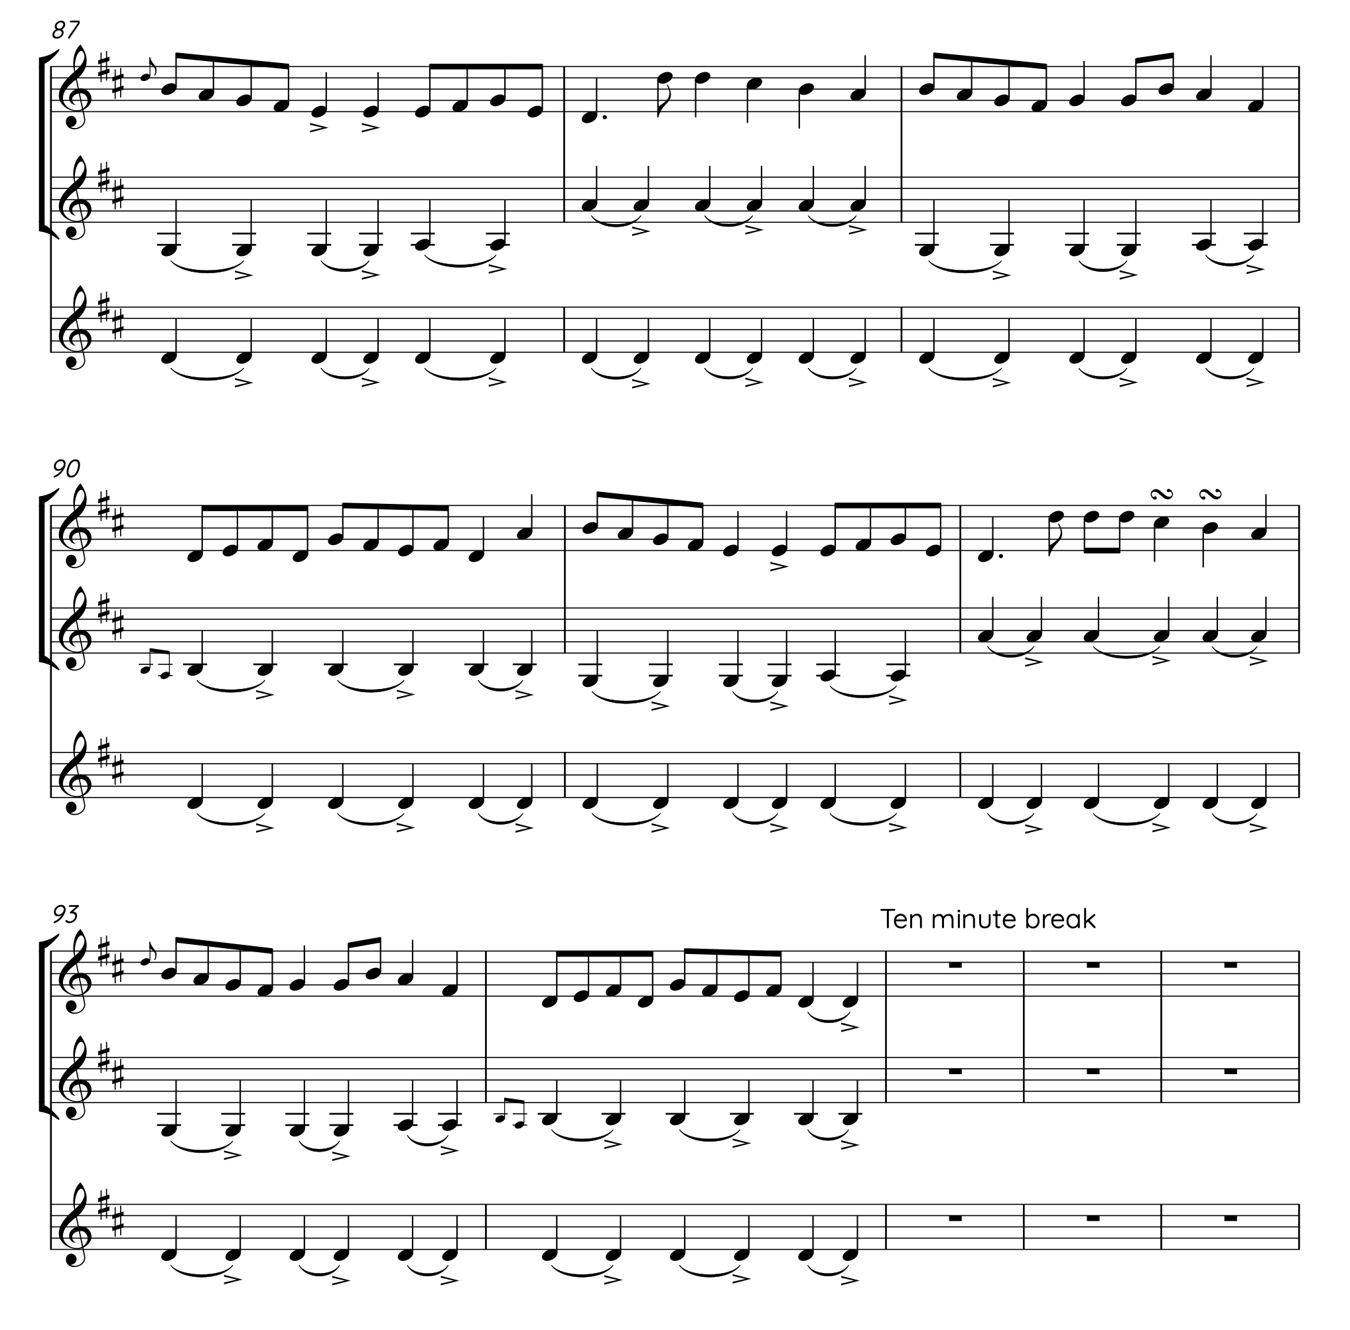
Figure 49. Grace Smith: completed A part.
The A part follows the standard structure associated with dance tunes in England: it is 8 bars long, with a ‘question, wrong answer, question, right answer phrase’ structure, finishing on the tonic. The harmonic structure remains as it was at the start, and the phrases can be seen as they are developed throughout the process appearing in this transcription, from the quaver runs in bar 87, to crotchet patterns (in bar 88, figure 49) which break the quaver-led movement. Ornaments are still present throughout.

Moving on to the B part, Grace comments:

I thought as an idea for a B part, I kind of want something different to happen. Because we’ve had that same chord loop to inspire the A part quite a lot by now, so just by moving to an A chord I thought would kind of lead me to a different feel. So I've done another quick recording of the A part double stops and then done something for the B part, which is in A and E on the fiddle, and then D for phase two, and back to A for phrase three, and then to the B minor for phrase four. So the D and the B are in the same places in the A part, quite often especially starting out with the tune from scratch I'll try to structurally kind of repeat certain phrases and so it links in with the first section. (Ibid).
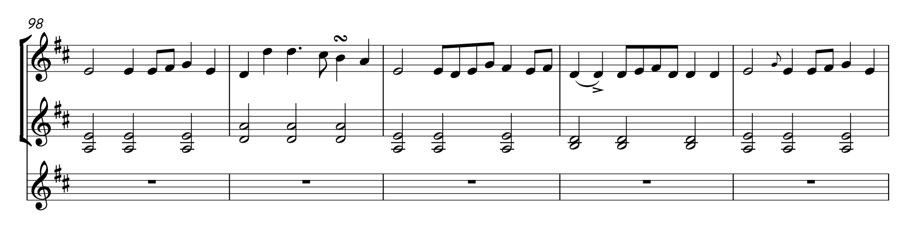
Figure 50. Grace Smith: B part chord and tune ideas.
With the chord sequence decided Grace decides to ‘us[e] that same phrase tune phrases’ as the A part in order to provide melodic similarities and links between the two sections, creating the cohesion of belonging to the same piece (figure 50). But there are some obvious differences, especially harmonically, due to the new chord progression:

For the first phase of the B part, C sharp which gives us our A chord, it sounds you know a bit more surprising when we've been really kind of D/B minor until now. (Ibid)

A similar experimentation process to the A sections takes place, playing around with the melody line, and varying the rhythms, but keeping the groove and the new chord structure. The full transcription of the final product is below (figure 51):
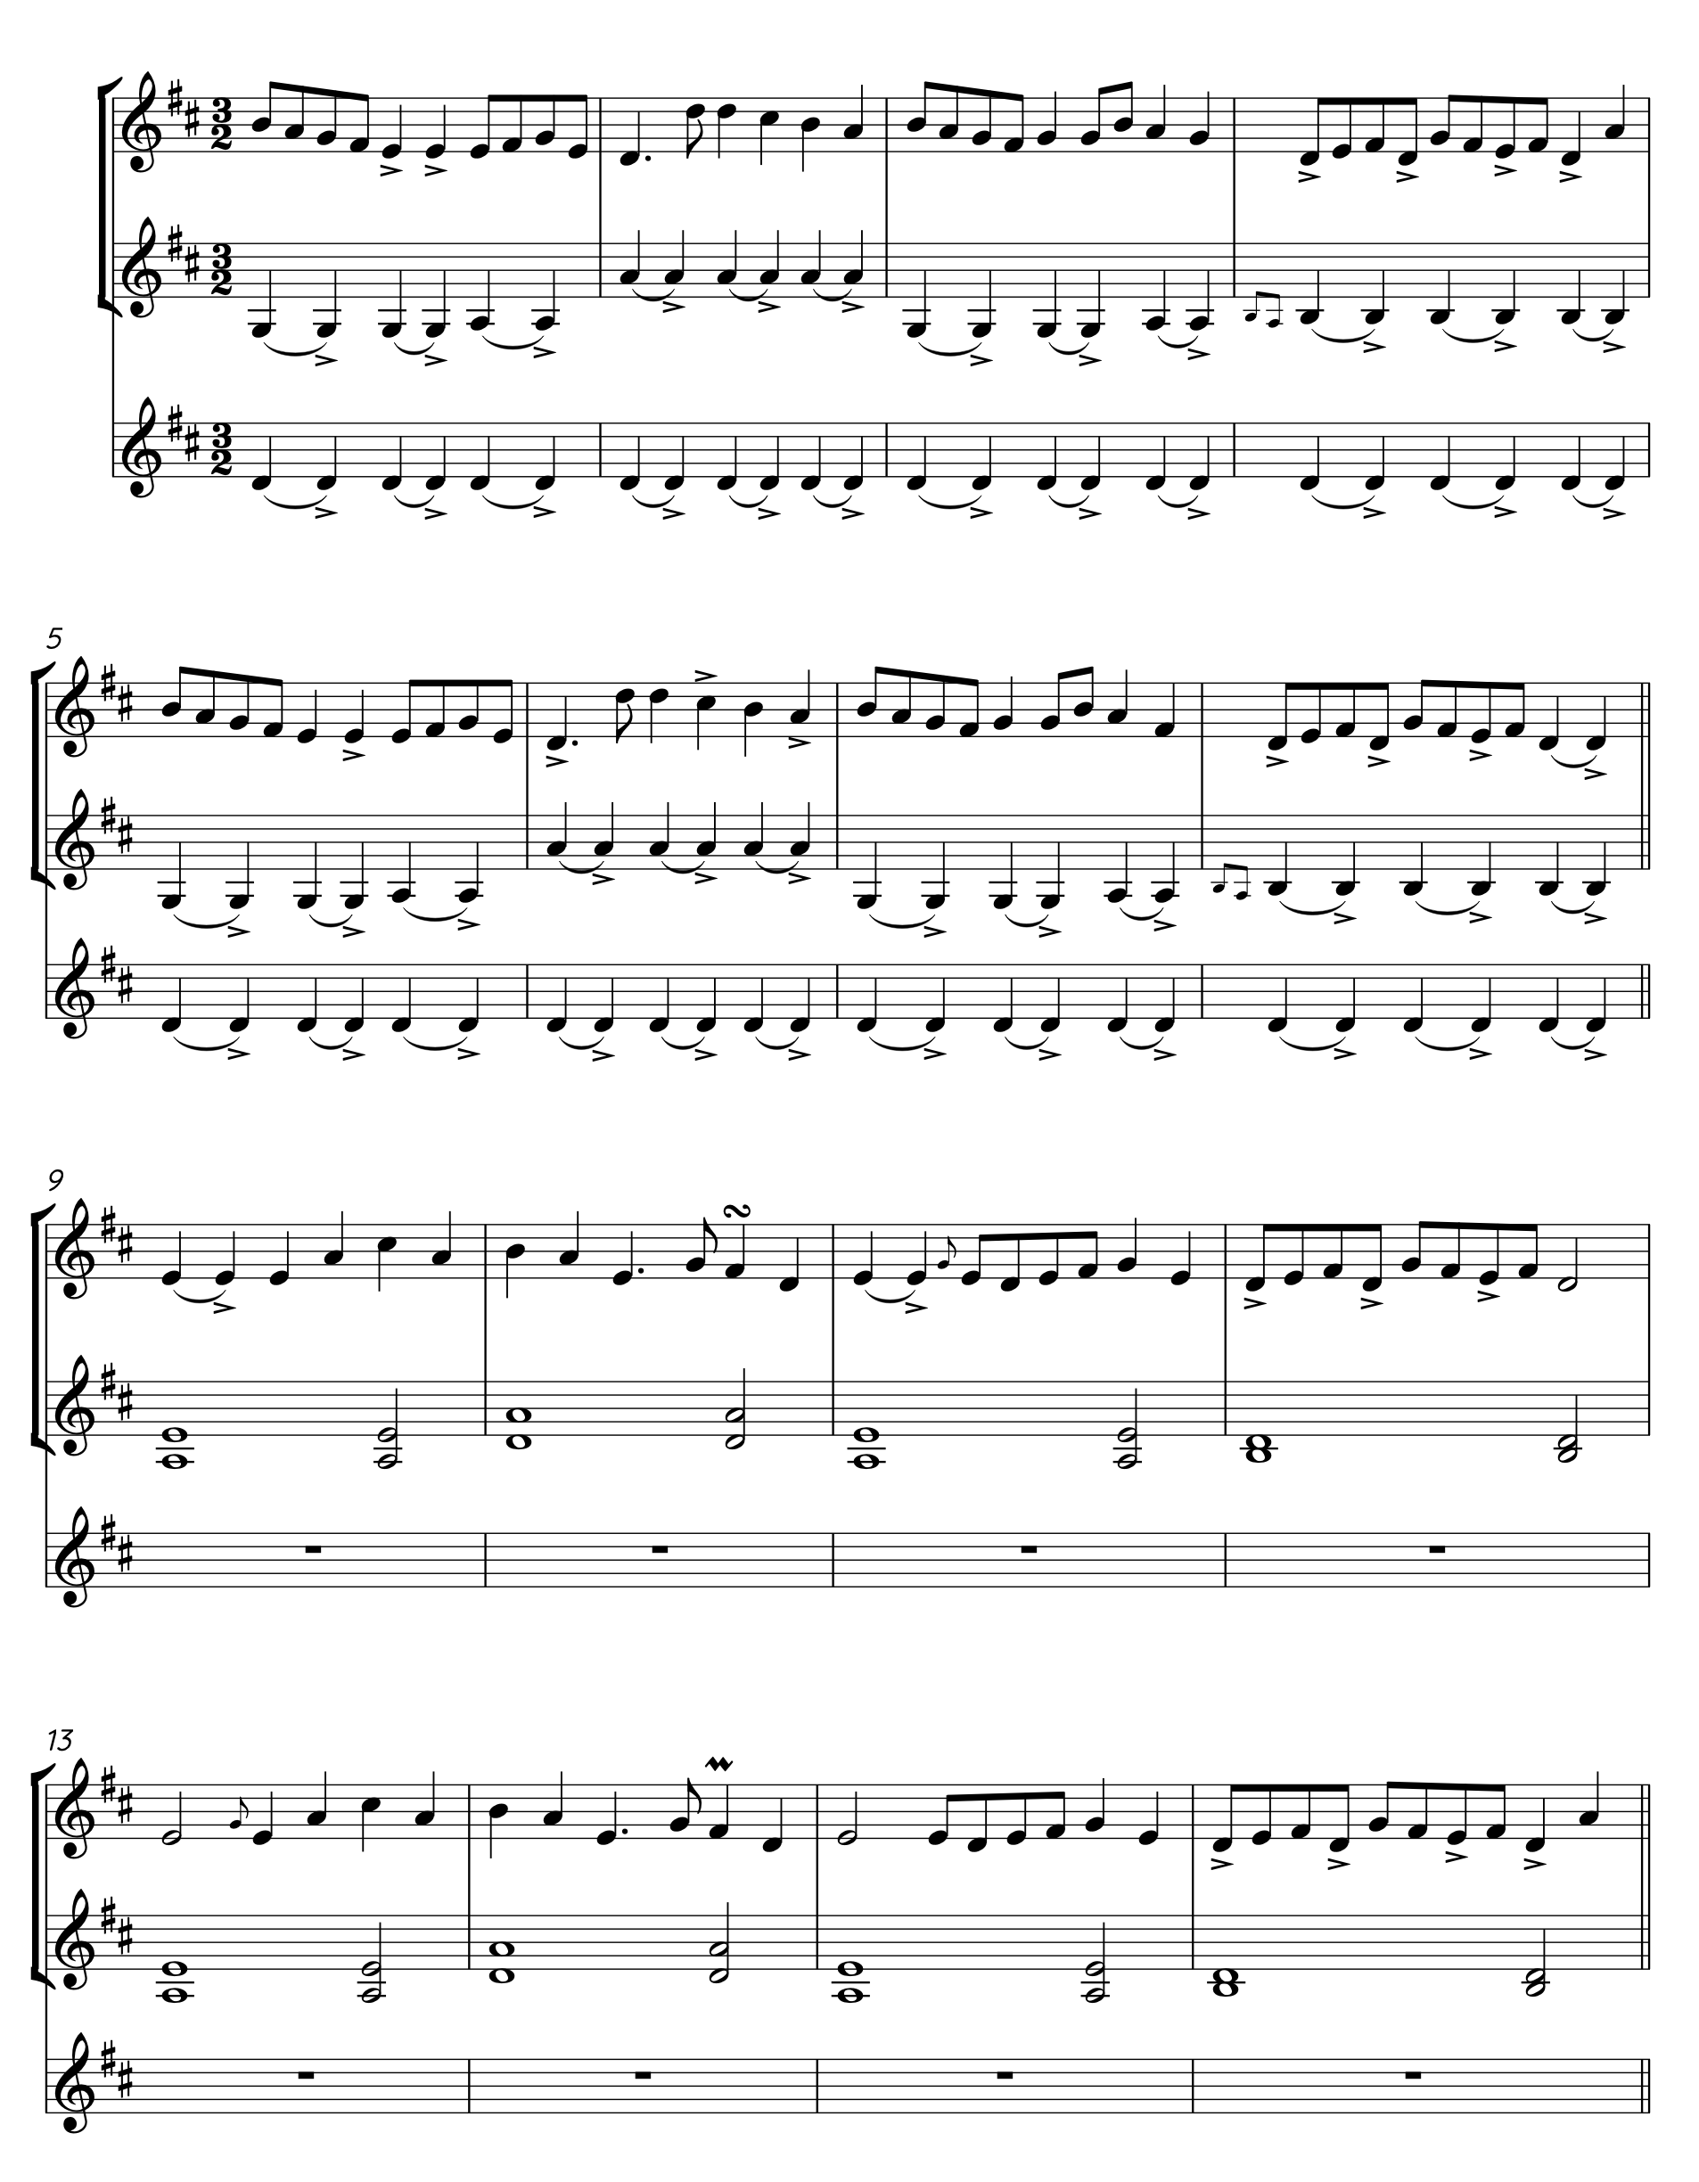
Figure 51. Grace Smith: Full-tune transcription.

Grace’s final comments on the process are as follows:

I would say that's taken about an hour, had a break in between, so probably an hour in a bit to come up with something which is definitely quicker than I would normally write a tune. Normally I'd maybe have an idea and record something and then come back to it over, I don't know maybe a few days or a week or something, but sometimes something happens quicker if you're inspired.

I think the way I did that is fairly typical of how I've written tunes in the past so maybe starting with the harmony idea and building up from there. As I said at the start, I’ve not really written many 3/2 tunes but it's a tune form that I really like to play and so I'm glad I experimented with that. The kind of product as it is now quite different to [what] I expected it might be so I'm really happy with it and I was kind of aware that there's a few 3/2 that I played quite a lot, and I didn't want to just kind of use the rhythm from that or something and make it sound too similar […]. So I'm glad I kind of started with that 3/2 feel just on a drone and then adding the chords and that helped take it [in] a different direction to kind of what was in my head as a 3/2 hornpipe. (Ibid)

This experimental commentary composition process offers a fascinating view into the creative practices of these musicians. There are obviously extenuating factors, such as the time constraints and the fact that the process was requested and recorded, but overall, the process delivers an insight that follows many of the patterns above, such as structure, variation, ornamentation, and harmonic accompaniment. All these musical gestures play a role, but to see how they are used in real-time, as a musician moulds them into shape, demonstrates the strength of certain aspects of style used within the scene. The use of familiar patterns (as muscle memory), both on an individual level and on the distinct instruments, with which the musicians play around demonstrates the toolbox approach (Hill: 2012) to the creative process. This process has many similarities and some differences with the creative practices discussed above; below is an examination of these:

6.6 Gestures In Creative Practice
Whilst it is difficult to provide a cross-analysis of all the pieces used for this case study, because the same level of background and interview information wasn’t collected on each piece, it is possible to draw together some of the similarities and differences in the processes above and demonstrate how gestures are used throughout the creative practices of a variety of musicians.

6.6.1 Gesturally Imposed Structures Of Tradition
The creative practices that these musicians undergo demonstrate a dialogical relationship between several different active influences of traditionally imposed structural forms of:

- Groove and Tune Type
- Structures
- Harmonic and Melodic Variation
- Ornamentation

6.6.1.a Gestures Of Groove And Tune Type
The most common theme running throughout the above analysis is the impact of groove and time signature/tune type. Both the arrangement of the traditional tune (‘Brighton Camp’, Appendix 5) and the newly written tunes (One String Jig’, Appendix 6 and ‘Brute Angels’, in Appendix 7) start by establishing the beat and groove of the piece. And the established grooves then carry on throughout.

For example, in ‘Brute Angels’, the acoustic guitar starts, with an arpeggiated figure, which sets the tune type of a 3/2 hornpipe (figure 52). However, it is not particularly played at the speed of a 3/2 hornpipe, the usual tempo usually being around the mean of 117 BPM, whereas ‘Brute Angels’ is at a much steadier 79 BPM. The mandolin is playing long notes, at a higher pitch than the guitar, which last a bar in length each time, and these descend in a step-like pattern. The effect is quiet and lilting, it is behaving as a ‘listening’ piece so far.

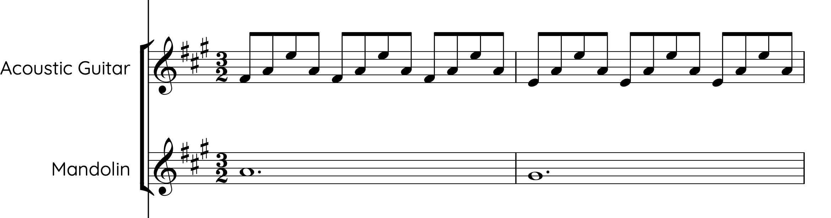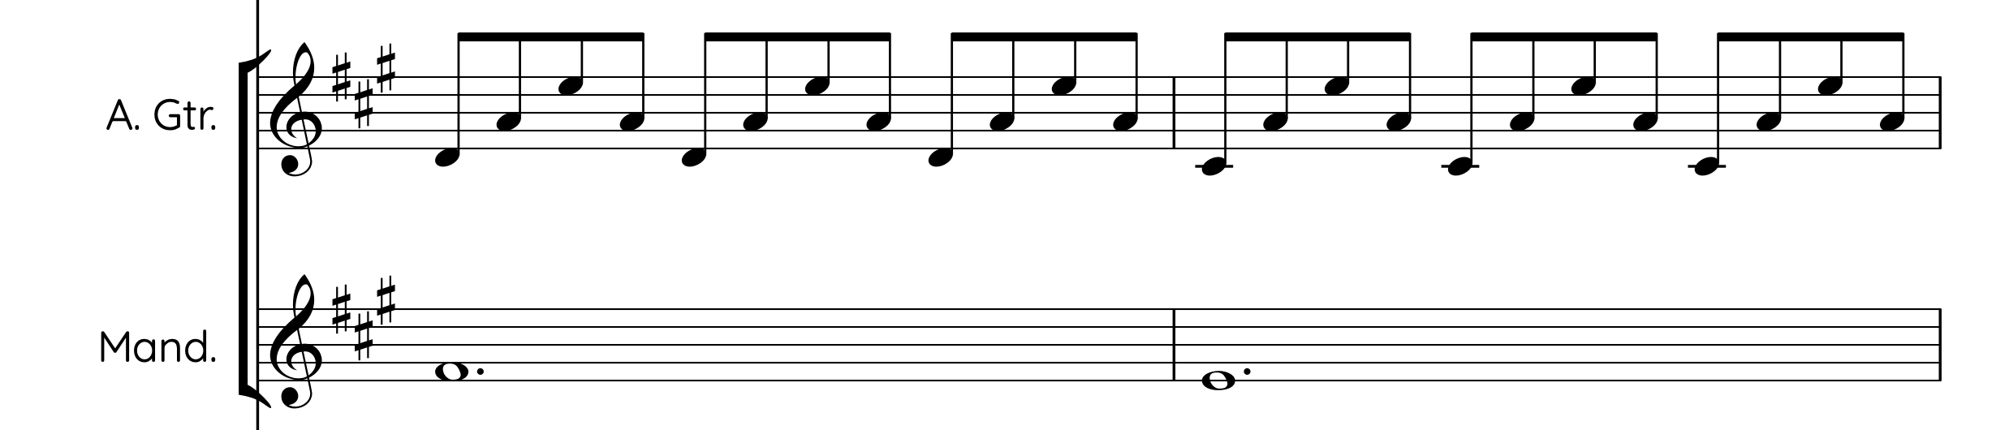
Figure 52. ‘Brute Angels’ - guitar introduction.
Therefore, whilst it is a much more gentle and little pulse, as opposed to a dance-like groove, there is clearly an established rhythmic beat and sense of groove to ‘Brute Angels’.
And even though ‘Radstock’ (Appendix 4) doesn’t start with the groove there is a distinct groove throughout the arrangement.

The piece starts with an accelerando across the first three bars, settling at the tempo of 175bpm, however, the tempo is pulled around throughout the piece, meaning that a metronomic beat was not maintained throughout, allowing for artistic and musical expression, whilst also possibly hinting at the tune’s origins of morris dancing, whereby a strict beat is not needed, and the musician must follow the dancer.

The piece has a strong yet moveable pulse throughout, but a rhythmic groove is used to create interest in this piece. Notably, there is an occasional back beat groove used, such as bars 2 and 3 in figure 56, whereby the offbeat of every quaver beat is emphasised, meaning the strong beat of the bar is not so strongly emphasised. When used to contrast with bars that have accents and pulse on the strong beat of the bar, such as bars 1 and 4, this creates rhythmic interest throughout.

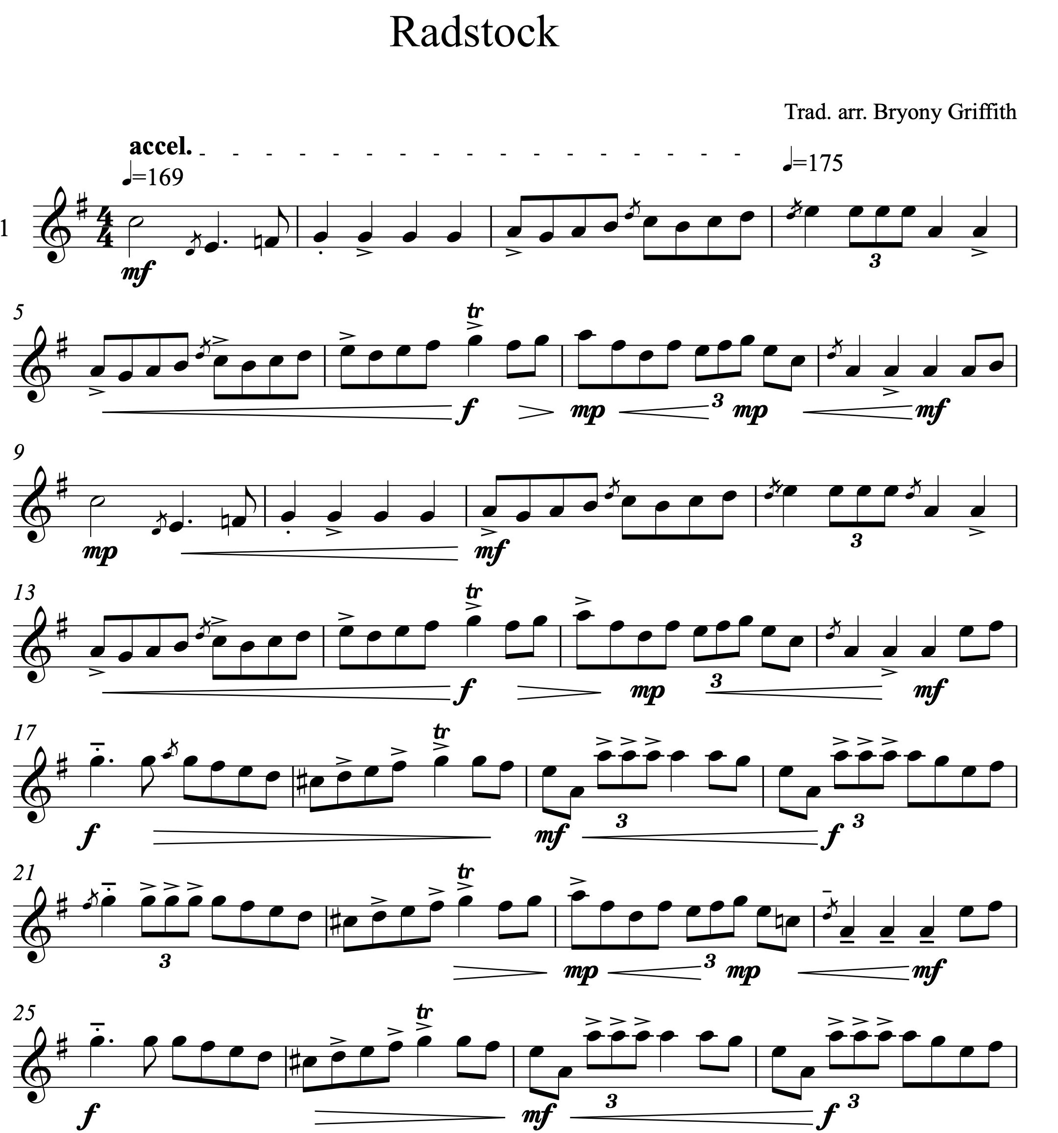
Figure 53. 1st A and B parts of ‘Radstock'.
Even in the commentary composition process, the groove was one of the first things to be established - both as a 3/2 hornpipe and as a 4/4 reel - ‘I'm going to just play a bit of rhythm in 3/2 to get into the feel of the time signature.’ (Grace Smith: interview, 2021). In Alex’s case, a time signature was not consciously decided on in advance, but for Grace, it was a conscious decision. As dance, as a gesture, is linked to time signature, it is important to note that neither musician talked directly about the influence of the dance tune types, i.e. reel or jig, but both fall naturally into picking a recognisable tune type to create within.

Similarly, the functional gesture of dance is also present in ‘Radstock’. Double-stops, as a decorative feature, are a common feature of Bryony Griffith’s playing on her album ‘Hover’; she attributes this to playing for her Morris side and having to compete with the Morris bells and other extraneous noises during outside, public performances - ‘I need to be loud’ (Bryony Griffith: interview, 2017). It is clear that the functional gesture of dance has an impact on both the arranging and writing of tunes:

It is more formulaic, based on structures that have gone before and are required for dance. (Mel Biggs: survey, 2020).

Groove, and the time signatures which indicate a particular tune type, play an important role as a gestural building block of tune arranging and tune writing. It is the musical gesture of groove that makes tunes danceable, which was their intended historical function. The different methodologies of instigating groove, from the use of slurs and articulation in Bryony Griffith’s and Alex Cumming’s work, for example, to the vamping effect of chords and pedal notes in Rob Harbron’s and Will Pound’s arrangements, all add the extra stylistic interest needed and desired in order to make these pieces interesting to the listener and successful in terms of the professional output of a musician.

6.6.1.b Gesture Of Structures
Structure is a key feature of instrumental folk music from England, hinting at the music’s historical function, and acting as a gesture for the genre.

Use of traditional structures e.g. AABB, Chorus, refrain etc. - these may evolve with the piece or be there as a frame from the start. (Nancy Kerr: survey, 2020).

Grace’s tune, for example, falls neatly into the expected structure, although this is not actively discussed as an influencing factor over her creative decisions. In fact, the common overall structure of 32 bar tunes is present in both the newly composed tunes and in ‘Radstock’ and ‘Brighton Camp’. And even though ‘One String Jig’ doesn’t conform to this expected structure, its structure is still a recognisable feature of the scene in England, as discussed by Rob Harbron in chapter 4.

‘Brute Angels’ is again the exception to these gestural expectations of structure, here the piece has an unusual structure (in folk terms): AA, B, C, AA, B, D - all of varying lengths (A is 8 bars repeated, B is 2 bars long, C is 10, and D is 12 bars long). However, this is not the norm as presented in any of the other score analysis or CD data.

It is clear how something as culturally ingrained as structural gestures can be both a consciously influencing factor and an unconsciously influencing gesture in creative practice. Structure acts as both a template for both arranging and writing tunes, but also as a recognisable identifier for those working with traditional influences in instrumental music on the scene in England.

6.6.1.c Gesture Of Harmonic Accompaniment
Both Grace and Alex started by discussing what chord progression they wanted to base their melody line on; their respective melodies were composed around the chord sequence. This is a common theme in the survey analysis too:

When arranging the tune I think about chord structure and rhythm mostly, also trying to pick out parts of the tune that might inspire a 'riff' or secondary melody to accompany, build up to or break down to. (Alex Garden: survey, 2020).

The general harmonic accompaniment and chord structure throughout all the pieces analysed for this case study is relatively simple, sticking well within the standard (I, IV, V, vi, in a major key for example) gestural accompaniment even in the minor and modal tunes. The tonic is strongly established in each piece, and whilst there are moments of dissonance and tension these are less common. However, in ‘One String Jig’ there are the following moments of close harmonic clashes (figure 57):

A pedal continues throughout the second B part, but another harmony line is also added - a line that follows the melody exactly a 3rd below. At this point, the pedal of D and A are still present as they were in the A part, and this creates some dissonance with the harmony of thirds. In particular, the E and G in the melody/harmony against the D and A in the pedal notes, this dissonance builds over the first 4 bars of the B part, (bars 39-41 and 46-49, figure 54) until, the end of the B part that recapitulates the phrase from A (bar 42–45 and 50-53, figure 54), the harmony line of thirds drops out, leaving just the melody and the D and A pedals, giving us some relief from the dissonant build up.
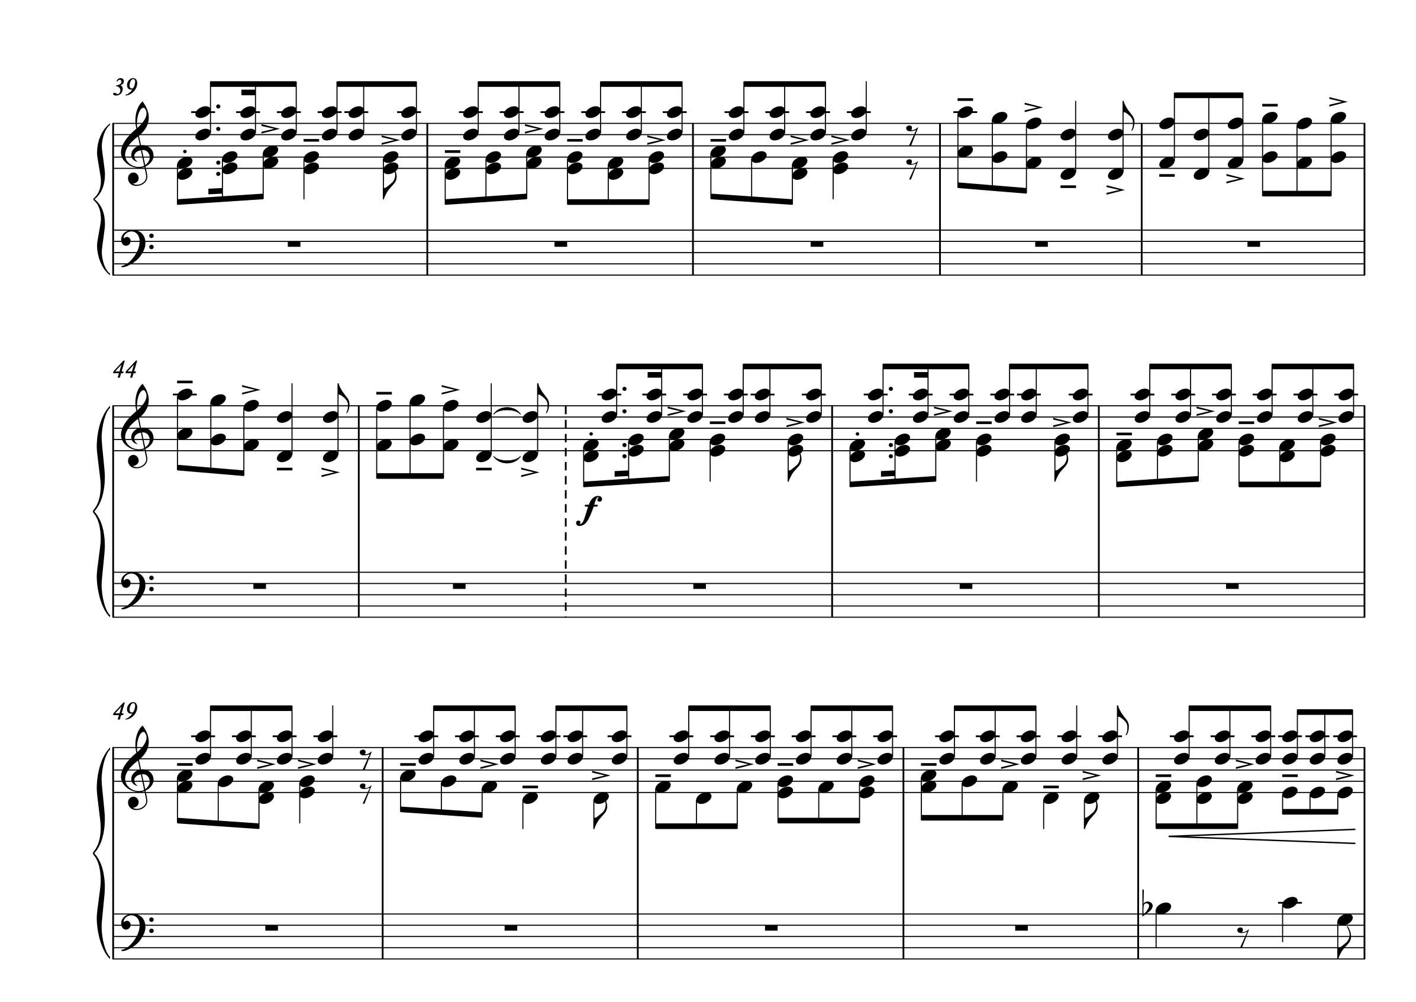
Figure 54. ‘One String Jig’ - 2nd B part and harmony.
Harmony can be used to create moments of tension, and whilst the norm of this score analysis is distinctly consonant, instances of dissonance are just as important. Likewise, there are circumstances where Alex Cumming differs from the traditional norms that he adheres to, for example subverting the cadence point, holding on the dominant chord (chord V) until the repeat of the melody line begins again.

‘I like to hold the 5 through if its halfway through a bit of music’ (Alex Cumming: interview, 2018).

Alex Cumming chose to deliberately not fulfil the finished cadence, usually expected at this point, but withholds it, creating tension and suspense that is only broken at the very final perfect cadence, demonstrating an active choice to differ from the traditional norms. This effect creates more interest in the tune, for both the listener and performer, as the sense of anticipation that it creates keeps the listener’s attention. Alex Cumming has used the traditional structure of a folk tune as a template, and from this he has deliberately subverted the traditionally enforced structure, thus creating a slight variation on what is expected.

Likewise, changes to harmonic structure can be implemented by accidentals, which are a feature of ‘Brighton Camp’, adding a different colour to the otherwise very major and tonal arrangement (figure 55).
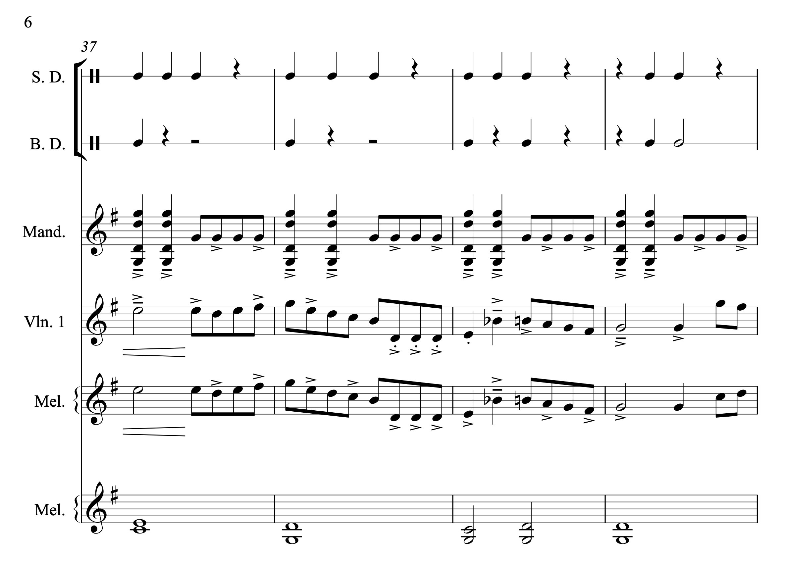
Figure 55. ‘Brighton Camp’ - blue notes.
Blue notes, or accidental notes, are also used in both the melodeon and fiddle parts. At the final cadence point, the C in the melody line that that contributes to the chord IV in the IV-V-I cadence is changed to Bb, (introducing the minor third into the otherwise G major tonality), before sliding up, resolving to the major third to bring the tune back to the tonic (bar 39, figure 58). This accidental note adds a very different feel to the piece which has been centralised mainly on the tonic throughout.

Despite the differences in approach to harmonic variations, the creative output still sounds like it belongs to the genre of instrumental folk and traditional music from England and is identified as this. It can be concluded that harmonic accompaniment as a gesture plays an important role in the creative practices of musicians, often (but not always) as a starting template from which a melody is formed. Other musical gestures are then used to add further interest to an arrangement, such as groove and ornamentation.

6.6.1.d Gesture Of Physical Impact Of An Instrument
The gesture of instrument, meaning the particular qualities or restrictions of an instrument, i.e. what they’re designed to do and how they work, has an impact on the creative practices. Alex Cumming’s instrument, the accordion, is designed to play both chords and melody at the same time as an active technique. The fiddle can do both, but not at the same time but the impact of writing on Grace Smith’s chosen instrument is clear:

I'm going to aim to start in D major because I'm a fiddle player and that's quite a nice key on the fiddle. (Grace Smith: interview, 2021).

The physical gesture of her instrument and its inability to fully play chords and a melody at the same time doesn’t limit the creative process. Grace chose to start with a chord structure, going out of her way to record a tonal centre first and then compose over it. The gesture of harmonic structure is playing a huge role in this creative practice. The use of a combination approach as a creative practice is a common one:

Mostly I write/develop ideas with the instrument. Although I have recently written a piece away from the instrument using notation software - layering ideas and hearing it in real time without having to translate it/find it/noodle it on the accordion. (Mel Biggs: survey, 2020).

Feeling at home on an instrument, knowing innately how it works and sounds can play an important role in the creative practice, allowing the mind to focus on the sound, as opposed to the production of that sound. But on the other hand, the creative practice of writing on a lesser-known instrument can be equally valuable, helping musicians to avoid personal cliches or predictable phrases, simply because what works better on certain instruments may not be the easy options on other instruments.

Often I find inspiration whilst playing an instrument I am not too familiar with, for example one of the most popular tunes that I have written came to me whilst I was noodling away on a chromatic button accordion, an instrument I only have a fleeting relationship with. (James Delarre: survey, 2020).

Instruments, as a tool for musicians to use as part of their personal, individual creative practices, act not just as recognisable sound for a certain style of music but hold certain nostalgic and historical connotations that are associated with a particular style or tradition. The instrument, or digital means of writing a tune clearly has an impact on the creative practices by placing limitations on what each individual instrument and its player can physically do. It is perhaps with the use of digital techniques, as demonstrated by Grace above, that these limitations are removed, and the creative choices available are widened.

6.6.1.e Gesture Of Ornamentation
There is, overall, little ornamentation used throughout the pieces analysed. Certain individuals use quite a wide variety of frequent ornamentation, such as Bryony’s fiddle playing in ‘Radstock’. Bryony comments on her own learning of ornamentation, from both people that she plays alongside, from western classical music and from tuition books (all as forms of gesture which influence her playing):

In the early days my mum bought me an Irish tune book, the Irish Anthology […] think just playing with other people as well, or just listening, not one specific person, but hearing an ornament or a twiddle in a session, maybe from, probably not English players, people with like Ruth and Rodge Pepe, doing a thing and going how did they do that. So, it’s adding little bits of stuff and accidently as well. […] I can take what I already know from Classical [music]. (Bryony Griffith: Interview, 2017)

Notably, none of these learning sources about specifically about ‘English ornamentation’. However, in the playing of the two other fiddle players analysed, Grace Smith and Ross Grant (in ‘Brighton Camp’), ornamentation is present as a feature of their playing/writing and arranging. Grace’s use of ornaments is clear from the start of her process (figure 48).

However, whilst there is the odd ornament present in the other pieces analysed, they are certainly not a big feature. It can be concluded that, as evident from the CD data in chapter 4, that ornaments a not a defining gestural feature of professional, instrumental folk music from England.

6.6.2 The Impact Of The Individual: Place, Background, Aesthetics
The creative practices that these musicians undergo also demonstrate a dialogical relationship between the associated gestures:

- Place
- Background
- Aesthetics

6.6.2.a Gesture Of Place
Place, as a gestural idea, has an impact on the type of music composed, and indeed provides new sources of inspiration to many creative people around the world. ‘Music is socially meaningful not entirely but largely because it provides means by which people recognise identities and places, and the boundaries which separate them.’ (Stokes: 1997: p.5). Using sounds to create a sense of place as an audio image, or to evoke the sound of a culture have long been methods by film composers and songwriters to transport the listener to where they perceive that place to be. Exploring new cultures and being exposed to new gestures of place can both change and influence an individual’s personal creative schema to absorb these new gestures and strengthen the individual's sense of personal musical and cultural identity against what could be perceived to be a different musical culture.

Place also need not be a physical space, especially not with the influence of the internet, and the ease of interaction (both good and bad) with other cultures has led to more interaction and appropriation. However, the influence of place as a gesture brings with it the influence of new sounds and musics that can affect the creative practices of artists within the scene:

I try to take a slant in the tune so maybe make the arrangement sound baroque, contemporary classical or even jazzy. In my bands it's a collaborative process. Gadarene very much draws on specific influences for each arrangement such as reggae, funk or club music. (Matt Norman: survey, 2020)
The physicality of place, alongside the labels that are used to categorise both place and genre in traditional music, such as English, Scottish, Irish etc, also have an impact as gestures. The influences listed by the participants of the survey are varied. When asked about how they would describe both the music that they make and what influences them. The use of language is interesting; there is a clear split between those musicians that describe their music and influences as being ‘traditional’ (51%) and those that describe it as ‘folk’ (37%) with particular reference to English traditional, and/or folk. Some musicians do not specify a direct name for the music that they play and create, instead referencing the cultural place from where the music comes from, i.e. England (48%), Ireland (17%), Scotland (10%), USA (6.8%), India (3%), and European (6.8%), using the country name as a vague overall category which in reality contains multitudes of different cultural and musical forms. All the participants of the survey were invited to partake because they professionally perform some sort of music specifically from England, specifically on the current English folk scene. However, as can be seen, and unsurprisingly, these professional musicians draw influences and identify with a much broader musical influence than just a singular style.

Some participants (6.8%) do specify with more clarity a region from which their music comes from or is influenced by, for example, Southern English or Northern European music, but the majority refer to an overall country and its overall associated style. Other than the genre labels of ‘traditional’ and ‘folk’, accompanied by a region or place, only 4 out of 29 (13.7%) participants referenced another genre as a direct influence on a personal sense of style and musical identifiers.

Place was clearly a large influencing gesture on the composition of ‘Brute Angels’, Pete describes the landscapes as a method for structuring or creating rhythmic patterns, as part of the creative practice:

I really have used landscape and the process of walking through landscape as way of structuring pieces as well. I definitely think there’s a rhythmic thing that comes from walking that is in what I write, you know, I’ll often hammer something round on the piano for a while, get annoyed at it, and go out for a walk, and going round and round in my head, and sometimes resolving the problem of where to take it, through the process of walking and letting it rattle around in my skull. (Pete Judge: interview, 2019).

The impact of place as a gesture, as a source of influence on the individual creative practice, is evident in several different ways. It acts as a physical and conceptual gesture that both defines a culture and a community and allows for cross-over between the two to happen. It also acts as a gesture of inspiration.

6.6.2.b Gesture Of Individual Background
It is also the background of the musicians, what they have been exposed to both musically and socially, and the places that they inhabit that shape these creative practices. The members of Three Cane Whale did not develop musically within the scene. Pete is a self-defined jazz musician, whereas Paul Bradley on guitar and harp, and Alex Vann on mandolin, bouzouki and banjo amongst others, have slightly more links to a background in the folk scene. Alex Vann, in particular, is a member of Spiro, who are described as ‘raw, punk-infused take on minimalist systems music and the dark side of folk’, are themselves influenced by folk, rather than being just folk or traditional music.

We’ve been going for nearly ten years now and when we started out we were really, you know, we were really delighted by the way that people responded to the music, cause we weren’t sure what it was, we never quite know how to describe it which I think is again a slight problem, we sort of landed on ‘multi-instrumental acoustic chamber folk’ which kind of, sort of marries that slightly classically thing, to the folk thing. (Pete Judge: interview, 2020).

Being influenced by the folk scene leaves room for outside influences and gestures, from other genres of music and from other traditions. In a similar theme, Rob Harbron, describes where he grew up as an influence on his music making, but also mentions more current places and cultures that have impacted his creative practices:

I grew up in northern England, playing a music mostly from Northumberland and Ireland. Later I moved to the south of England and found myself playing a different repertoire of tunes including Morris tunes, but I’ve also been really influenced by Swedish music, French and European dance tunes, old time and Quebecois tunes, and so on. I think my tunes reflect the journey I’ve been on as a musician, which includes some influences from way outside the tradition, rather than being representative of any specific place or region. I write a lot of tunes which are inspired by a particular location and for me certain tunes do have a strong sense of place, but in defining my own music I think in terms of personal style rather than regional identity. (Rob Harbron: email correspondence, 2020).

The background as a gesture on an individual can play a huge role in determining creative and aesthetic choices. The musical elements, sounds and cultures that an individual is exposed to throughout their lives have had an impact on the sounds, musical elements, and musical choices that are available to them, this forms their aesthetic toolbox of ideas.

6.6.2.c Gesture As Individual Aesthetics.
In a similar manner, current repertoire, or repertoire that exists within a community all form part of the gesture of place. Both Grace and Alex mention that their current repertoire and playing influence the type of tune that they write. Grace comments that although her chosen tune type is within her known repertoire of tunes; it’s not something that she has explored in her tune writing thus far:

‘I'm going to try to write a 3/2 hornpipe, this is a type of tune I really enjoy playing but I've not actually written very many.’ (Grace Smith: interview, 2021).

And similarly, but by using this his prior knowledge of his creative practices as a cause for elimination, Alex writes:

‘I’ve recently written a tune in G minor, and I’ve recently written a tune in D minor, so I’m actively in my mind eliminating those keys.’ (Alex Cumming: interview, 2018).

The creative practice can be informed by the material and rules that are already bound within an individual’s prior knowledge of their own tradition, influenced by place and other artists/musicians that they are exposed to, including being influenced by other artists that have released music currently within the scene:

Sometimes I set out to write a tune in the style of XYZ (insert type of trad tune here) and when I do that, I think about what aspects of the tune make it work in that particular style. I wrote a 3/2 Hornpipe in the style of some tunes I heard Leveret play. (Will Allen: survey, 2020)

And from outside the scene:

Influences are anything I have ever listened to in my whole life from traditional music through pop, jazz and classical etc. (Jo Freya: survey, 2020).
For Rob Harbron, in ‘One String Jig’, it was both at once:
The starting point for this tune was the hugely restricted melodic range, which was dictated by the notes available on the home-made, single stringed fiddle that the musician I was working with was playing. That’s also where the name came from. I riffed around the notes that were available and ended up with a phrase that reminded me of the Morris dance tune Saturday Night, so I borrowed the structure of that tune, common to a lot of Cotswold Morris tunes, and the tune fell into place from there. (Rob Harbron: email correspondence, 2020).

The places that individuals live within, or have travelled through, and the people that they have met and interacted with, influence the creative practice, either as a conscious choice, or unconscious. Some musicians can actively talk about the places, styles and people that have influenced them, and some do not, but the gestures are there, nonetheless. Individual style and choice are present throughout the process, each individual note is decided on based on whether it aesthetically appeals to the creator; this sense of aesthetics and stylistic appeal must originate from somewhere.

6.6.3 Current Circumstantial Gestures
It would be prudent to point out a large current circumstance effect that both Grace and Alex comment on - the fact that the way in which this particular composition was created is not a normal way to write a tune. To have to talk someone else through a process that is normally a very private and closed event, full of internal needs and tastes, is not a natural process, and this along with the time constraints could be one explanation for the instances where one idea is discussed out loud, but another is manifested in the actual process - for example, the changing of the chord structure. The impact of the length of time given can be seen throughout, by how the tune is being developed, the added dynamics, articulations, syncopated accompaniment and changes to chord structure all showcases the idea that the musician is comfortable with the structure of the notes and is adding in more stylistic details on top.
As I say normally, I would do this over a longer period of time, so it's been interesting to do it quite quickly and have like a solid thing. […] Normally I'd kind of be at that stage for a lot longer. I would say I'd kind of play around with it and leave it for a bit and then come back to it. (Grace Smith: interview, 2021).

It could be argued that being given a longer length of time to compose (rather than 10 minutes) would be more natural and further the progression of this creative practice to include not only a corresponding B section but also more musical detail, resulting in a more in-depth piece, perhaps more representative of this individuals’ playing and composing techniques. It could be presumed that the band arrangements of ‘Brighton Camp’ and ‘Brute Angels’ went through these processes and a further editing process, refining the compositional material to suit the particular needs of the band, taking an even longer amount of time.

In a similar vein, recording and performing can also be current gestures that affect the creative practice; ‘refinement also happens as a natural process when performing regularly.’ (John Spiers, survey, 2020). Recording, as a creative practice, is very detail-oriented, and once recorded there is a version that is set, and one performance of a piece, and all its ornaments, harmonic accompaniment, and all the above gestures, can be listened to multiple times. This creates the opposite effect to a live performance, whereby many musicians adapt and react to each other during the performance, as a creative practice . This can lead to spontaneous new ideas (within the structures and gestures described above):

It’s interesting working with classical musicians and brass band players and then with folkies, because with folkies […] what you’re rehearsing is the kind of broad structure and trying to get that right, whether you’re arranging it as you go, or whether you’re trying solidify what you’ve already decided to do or whatever, and then the kind of magic that happens, you leave that to happen in the moment, in the spontaneous moment and sometimes it happens and sometimes it doesn’t, but that’s kind of how folk music works, you give yourself a structure, the simplest form of structure is I suppose is if you’re playing a tune, that’s in a sense a structure that you’re all following, but then you’re all kind of going off in different ways to make it exciting and you kind of hope that a bit of magic’s going to come out of that. (Jon Boden: Hudson Records Listening Club, 2021).

However, current circumstances such as these, or external circumstances and practical needs always influence the creative practice, whether it be writing or arranging new material for a band, a research project, a stage show or evening at a session, there are constant constraints placed on the es, meaning an accurate relaxed representation of tune writing may be impossible to achieve, as it is almost always ongoing.

Circumstances that affect the creative practice can include commissions, as Nancy talks about the helpfulness that a deadline can have on the creative practice:

I write to commission often, with publishing and/or performance deadlines as a factor - I find structured frameworks help with this. (Nancy Kerr: survey, 2020)

Or even writing a tune as a gift or form of celebration:

The process usually begins with the inspiration regarding who or what I am writing for (to mark an occasion - birthday, anniversary, the birth of a child etc. to pay homage to a person or place ) and then moves on to the decision regarding the style of melody I want to explore ( for instance , I've written tunes which emulate those found in the NE of England - 3/2 hornpipes, rants - and in the Northumbrian piping tradition -e.g. the use of octave leaps. ) It is always a conscious process for me. (Sandra Kerr: survey, 2020).

Commissions, self-imposed or not, are an imposition placed on the creative practice, creating a boundary, of time or of style, to be created within. The commentary composition processes explored in this thesis have worked essentially like a commission, in that I placed upon the musicians a boundary that they had to work to. This impacted the creative practices that they underwent.

The current circumstances be it the reason for the practice, or the current repertoire, community and scene, or musicians/creators that an individual is working with, all impact the creative practice. The gestures wrapped up within these communities and practices are always changing and adapting, and bringing new meaning as an individual interacts with new people/communities/musics etc.

All these influences on the performance of a tune, from personal taste, dictated by a musician’s musical background and historical influences, from working with others who bring their own personal sense of style to the negotiation, alongside instrumental limitations and possibilities, are important when considering the creative practices of musicians when writing new material and arranging pre-existing and newly composed material. However, it is always ‘the tune [that] usually dictates the arrangement, harmony rhythm etc. It depends on if the arrangement is for listening, dancing, or playing or pleasure.’ (Richard Moss: survey, 2020), meaning that without the original material or structures, there could be nothing to create from.

6.7 Gestural Toolbox
Building on Hill’s (2012) concept of a ‘toolbox’ of influence, I have presented the gestures outlined above, as a collection of various cognitive, cultural and societal influences that influence how a piece is created. This is presented in the model in figure 59, which is my realisation of both Middleton’s (1993) Theory of Gestures, Bolman’s (1988) Model of Boundaries and my own analysis of the creative practices discussed above. Based on a reciprocal and cyclical model such as Hargreaves (2012), this model refers to the creation of a standard English folk tune, following the culturally accepted two-part structure, an A and a B part, both of 8 bars in length, finishing, usually, with a perfect cadence at the end of both parts. However, this model could be easily adapted to be applied to creative practices from outside the instrumental folk scene from England by following the phrase-by-phrase development and linking or repetition of key phrases or textual movements.

I have chosen to use Middleton’s (1993) term, ‘gesture’, and Hill’s (2012) term, ‘toolbox’ as the term gestural toolbox most accurately describes both the cultural and societal influences and choices that musicians make, alongside elements of musical analysis. This is represented in figure 56.

Figure 56. Model of gestural composition for forms of English folk tune.
The gestures that form the basis of our personal and creative schema influence the creation and formation of an idea, be it a complete musical phrase, a rhythmic feel, or a chord progression. This initial idea is played around on repeat until it is extended to form a longer, more finalised phrase. This repeating and extending process is repeated further, always influenced by various gestures until the structural outline of the piece, and the basic chord progressions and melody are complete.

The reciprocal feedback element is key to the model, as the process of creation is ongoing, constantly being re-adapted. The perception and acceptance of the new piece by the wider cultural circle also have a large influence on the creation of new musical ideas. Multiple repetitions take place, fine-tuning phrases and developing melodic lines until they are complete within the schema of the individual. Once completed, the melodic line undergoes the same analysis but on a much larger scale, through the act of communal acceptance, whereby the wider society within that culture, and sometimes from outside it, accept or edit the creation to deem it socially acceptable. This is representative of Long’s theory of reactivity:

The one factor constant throughout is the concept of tradition, being that of expected social and musical behaviours or material and performance style. Tradition is always influencing, even as something to actively react against (Long: 1973, in Bohlman: 1988, 75).
The product then undergoes another process of reassessment, whereby the writer has the choice of potentially changing elements to be more in fitting with the communally desired styles or choose to actively react against these ideals. The reciprocal feedback model, is on-going and continues as it is passed through each individual musician that uses it,

6.7.1 Conscious And Unconscious Creative Practices

Gestures, operating largely on an unconscious level, are part of our personal schema/toolbox that allows us to piece together musical ideas and phrases based on past experiences and what is learnt as individuals within a culture. As discussed by both Hargreaves (1999) and Akesson (2006), the creative practices of musicians can include: aesthetic choice, internal schemas, and cultural, individual, and communal historical context. These function on an unconscious level, alongside the conscious re-creation and renewal of creating new melodies, based on traditional style and with knowledge of the tradition. This also links with Keegan’s (2010) theory of differing between conscious variation, and unconscious improvisation as discussed in. All these theories are point towards the idea that creative practices function on both a conscious and unconscious level, and these gestures and influences present themselves in the survey data collected, such as Owen Ralph (survey, 2020) who claims, ‘Arranging tunes is a very unconscious process for me’ or ‘I'm always conscious of trying to not come up with something that sounds too much like another tune’ (Jamie Roberts, survey, 2020) and I never try to write them, they just happen when I'm improvising (Owen Woods, survey, 2020).

This unconscious and conscious effect on creative practice is also present in the commentary compositional process. There are choices made in Alex’s practices above that were not talked about in the commentary process, such as a time signature not being consciously decided on in advance, although a groove in 4/4 was performed from the start, and that the structures discussed in 4.2 form part of his acknowledged, but unconscious creative practice’s:

I don’t even have to think about it to know when a 32-bar phrase is done, or a 16-bar phrase, or a 48-bar tune, it just comes out. (Alex, 2018)

This either hints at the idea that these elements didn’t seem important enough to mention, or, more likely, that the missing elements are so ingrained into the creative practice that it is done unconsciously. To differ, Grace’s creative practices are more talked through, and elements such as defining a key signature, and time signature are clarified, as explored in 6.5.2.

Therefore, there are also elements of the above practised that are very consciously decided on, such as Grace wanting to avoid a melody line that sounds like a pre-existing tune, meaning that this decision is a consciously informed decision made from knowing the scene.

I was kind of aware that there's a few 3/2 that I played quite a lot, and I didn't want to just kind of use the rhythm from that or something and make it sound too similar. (Grace, 2021)

Likewise, Alex consciously decides on a key signature, based on his prior compositional knowledge.

I just like minor tunes because I [am] really into minor 7 chords on the bass side at the moment. [...] I’ve recently written a tune in G minor, and I’ve recently written a tune in D minor, so I’m actively in my mind eliminating those keys. (Alex, 2018).

It is clear that each individual musician has their own creative practice, and these differ in how conscious or unconscious they are when arranging, creating, and researching new material. It seems evident that the creative practice is a combination of both learnt conscious and learnt unconscious elements. Either way, creative practices in instrumental music are a key element on the folk scene in England and this examination has discussed how professional musicians use different elements from their personal gestural toolbox in their creative practices when arranging material.

6.8 Conclusion
There has been relatively little research dedicated to the creative practice of writing/arranging new and traditional tunes within the folk and traditional music scene in England. This is despite the prevalent and ongoing creative nature of the tradition demonstrated by the individual musicians above.

The factor constant throughout this process is the concept of tradition, being that of expected social and musical behaviours or material and performance style. These gestures of musical style are hugely evident in most of the creative practices explored above and it can be concluded that structure, groove and tune type, variation and to a lesser extent ornamentation, play an identifying role in the processes of instigating change into the stylistic tradition.

It could be argued that the role of the individual and their creative practices within tradition is of utmost importance in instigating change; theirs is a reactive relationship, sometimes even a collaborative relationship resulting in various forms of change and resistance. The commentary composition process in this paper sheds some light onto the creative practices that the professional folk musicians undergo, demonstrating their ever-adapting dialogical relationship between their own aesthetic instincts and the forms and structures that are expected and imposed by the scene, audiences, and perceived historical accuracy of the tradition that they create within. The creative practices explored above are a negotiation and conversation between a musician’s personal identity, their gestural toolbox, and the community that they work within, professional and otherwise, that uphold both the musical and social values within which an individual functions.

This does, however, leave unanswered the question of how far away from these traditionally desired structures and forms can a musician push and still be incorporated within their traditional culture. Both the concepts of tradition and the creative practices within a community are necessary for music’s continuing development and change, enforcing, influencing and supporting one another. Professional musicians, at the forefront of change and revival, play a unique role in instigating change, and their relationship with tradition and ideas of what went before in previous revivals and by previous professionals is something that is ever actively influencing the future form of the tradition, whether it be in positive reinforcement, or active opposition.

Chapter 7. Conclusive Statements
In this chapter, I will draw together the main threads of conclusions discussed so far and discuss an analysis of the conceptualisation and relationship of tradition and creative practice, as held by professional instrumentalists on the folk scene in England. In particular, the following key points, based on the initial research questions will be discussed:

- How the common practices that have been identified from within traditional communities act as a gestural toolbox of style which can be used to enact change and stability through creative practice.
- What musical features the gestural toolbox contains, including influences present in the data collected from inside the instrumental folk scene in England. This also includes the impact that individual artists (or bands) can have in instigating change, and what this looks like in terms of the musical gestures unique to the current folk scene in England.
- How the gestural framework might account for moments of unconscious creative decision-making.
- How the construction, definition and use of frameworks of tradition can be adapted to include the gestural toolbox concept, demonstrating an adaptable model for the multiple usages of the idea of tradition on the English folk scene.
- How all the above impacts both notions of stability and changeability and musical practice within the scene, as both large-scale change and small-scale variation, scoping the relationship of tradition and creative practice as part of the folk scene in England.
- The usefulness of the commentary composition process, as a demonstration of the gestural framework concept, alongside a critique of its methodological flaws.
Individual creative practices are a key theme and play an important role in the instrument folk scene in England. As a case study, the interaction between constructs of tradition and individual creative practices can tell us a lot about the professionalised, folk and traditional instrumental scene from England. There are several conclusions that can be drawn from this analysis:

7.1 A Contemporary English Style And Creative Practices
This section will explore the musical sounds that have been identified through the data as the stylistic gestures and creative practices present on the instrumental folk scene in England. The commonalities in the musical output from the CD data and the score analysis demonstrate that there are identifiable elements of English sound used by the professional artists analysed for this thesis, including specific grooves, specific types of rhythmic variation, and the use of particular dance structures. This will be discussed below as part of a gestural toolbox. The first extended look at what English style is, is one of the original contributions of this thesis. But it should be clear that the commonalities found are just a snapshot of certain artists, at a certain time, and do not and cannot account for all of English style. This is just the first step in defining English style, which, for this thesis, is defined by the gestures researched as part of the creative practices analysed and does not provide an overall definition of style.

One of the problems of trying to define an overall style of instrumental folk music from England is linked to the ideas of regional diversity in English folk music, as discussed in 4.1. Place plays an important role in the folk scene, as discussed, it is often linked to the idea of communal identity, ideas of shared style within pocket communities, and shared history. Place itself is a stylistic gesture because it contains distinct musical gestures learnt and promoted within a community. It is therefore important to acknowledge the role of regional style in the search for a national one.

However regional style is also hard to define. Often, in the contemporary scene, is spearheaded by an individual, meaning that it is difficult to separate the individual from the idea of regional style. No one individual can own the idea of what a national English style might be, but many refer to geographical region in their playing. When combined with the lack of historical, written sources on the concept on English instrumental style, and the lack of musical detail in much of the written forms of folk tune, there is plenty of space for individual interpretation, creating a strong sense of individual style. This leaves room for sounds such as Three Cane Whale, meaning that individuality is by no means a bad thing. But, because of regionalism and individual styles of playing, it is difficult to define a national English style of instrumental folk.

To reiterate Bryony Griffith’s accent vs language analogy (4.0), an idea which is echoed by Kathryn Tickell (4.3.2) there is a common style that contains the shared norms and elements of a community like a language does, but the way that these elements are used is a choice, dictated by the multitudes of creative gestures discussed. It is in the dialect of instrumental music that regional differences can be heard, such as the clear Northumbrian influence in Kathryn Tickell’s music. Likewise, it is the idiolect of sound, the individual accent, and the interpretation of the sociolect that allows professional musicians to find their own voice, as part of the modern English accent musical accent (Rob Harbron: podcast, 2021).

However, given the importance of the impact of the individual, and of regional styles, there are still musical commonalities within the data. There are elements that can be seen in the English style of playing analysed here, even if strongly identifiable through individual players, and these stylistic gestures are part of a creative practice in tradition. As noted above, these findings do not suggest an overall definition of English instrumental style but offers the first steps in defining common gestures. More work is clearly needed to examine instrumental style in England in more depth. However, the common gestures in the creative practices analysed are discussed as part of the gestural toolbox framework below.

7.1.1 A Gestural Toolbox Of Creative Practice

The idea of a musical toolbox appears in academia (Hill: 2012) and is used as a concept by several artists in the survey and the interview data (see chapter 4 for examples). Many of the categories that appear in the gestural toolbox, as discussed in chapter 6, also feature as the categories for analysis used in the CD data. This wasn’t a deliberate choice but shows how relevant these ideas are to the real-life instrumental playing on the scene. It is clearly a useful conceptualisation of how gestures of style (that aren’t written down) can be used as a framework for individual creative practices. The gestural toolbox contains the learnt stylistic gestures of the folk scene in England, such as the structures and the grooves, as creative behaviours, whilst also accounting for individual aesthetic tastes in creative practices. Some gestures of style, learnt from playing in particular communities of particular traditions, become part of an internalised process of both conscious and unconscious effect during the creative practices of an individual. It remains to be seen if there is awareness of the impact of these creative choices within individual interpretations of tradition, or whether the process is always guided by the learnt rules and expectations (from the gestural toolbox). This very much ties in with the data presented in the commentary composition process in Chapter 6, for example in Alex Cumming’s and Grace Smith’s unquestioning use of structure in their creative practices. Elements of the toolbox of gestural structures are so ingrained that they aren’t questioned: the structures, forms and accompaniment are ‘just there’. This happens on both a conscious level, choosing to deliberately avoid creating in a certain way, or unconsciously as a form of habit. Ideas of tradition and the gestures that they uphold influence individual creative practice, both consciously and unconsciously, meaning that their impact is difficult to measure.

It is clear that artists both consciously and unconsciously make changes as part of their creative practices, and these changes vary in scale and impact, but nonetheless still feature as part of innovative practice as a product of professionalism. The relationship between unconscious and conscious creative practice is complex, multi-faceted and works on several levels. It is clear from the survey data that change is very much desired, on a conscious level, by the participants. The complex relationship between ideas of wanting to respect tradition, but not at the cost of change was presented in (5.5.1). However, as commented on (5.53 and 5.5.4) there is little in the way of conscious change present in the musical analysis presented in the CD data- there are of course notable expectations to this, but much of what was analysed in the time period of this thesis, present similar usages of the gestures of style. It is in these traditional gestures of style which are used in the creative practices, that the more tangible and definable elements of conscious and unconscious activities can be seen and these elements that are representative of the English style are explored below.

Keegan (2010) model for the analysis of traditional elements of style in Irish traditional music is widely applicable to the analysis of English style, not least as there is overlap in the stylistic gestures presented in both types of folk music. Whilst some gestures discussed in chapter 6, such as structure and function are commonalities to both, the way that these elements are employed by professional musicians can be used to identify gestures of an English style. To summarise this sense of contemporary English style, as promoted by a particular group of musicians used for this thesis, can include but is not limited to the following gestures:

7.1.1.a The Gesture Of Dance
The function of dance, introduced and discussed by the artists surveyed and interviewed for this study (see chapter 4), has an important impact on the musical style and creative practice, whether intended for dance or not. It can be further split into two sections, demonstrating how danceability can give a uniquely English sense of groove.

There is an overarching commonality in structure present across the CD data and in the score analysis. However, even though there is conformity in the data, the idea of a standard (AABB) structure that is not just typical of England, but features in many other types of folk musics, such as Irish and Scottish folk music. It is the variants of structure, and the use of other functional gestures, such as slows in certain types of morris dancing, that are uniquely English in style. Therefore the gesture of dance is an influencing feature within the stylistic and creative toolbox.

Likewise, the gesture of groove, including syncopation and elements of rhythmic variation, is also a common thread discussed in conjunction with the function of dance. Keegan-Phipps and Winters (2013), note that the differences in tempo and note length are also key stylistic gestures of English style, for two reasons. My data reflects this. Firstly, as discussed in Chapter 4, the tempos for tunes in England are typically slower than in Ireland or Scotland, in terms of bpm. Secondly, combining this with the presence of more crotchet movement typical of English tunes, as opposed to Irish or Scottish tunes, results in more rhythmic room for groove and variation within a melody line. It is in the style of contemporary English creative practice that allows for variation in groove to make tune playing ‘danceable’, which can be seen in the English jig groove demonstrated in 4.2.2.1.b. Again, this confirms that the gesture of dance, plays a current and important role, regardless, of the context of the music.

The creative choices that an artist can make are influenced by the commonality of the learnt and expected structure and the importance of the functionality of groove. The structural framework, as a gesture for creative practices, provides the stability from which change can be instigated. This has been demonstrated overwhelmingly through the commonality of structure in the CD and score data, and how often it is referred to, together with notions of tradition, in the artists that were surveyed.

7.1.1.b The Gesture Of Variation:
The gesture of variation is a key creative practice used by instrumental musicians on the folk scene in England, as discussed in chapter 4, and is clearly an important part of an individual’s expression and a tool in their creative practices. The act of misremembering, or consciously changing material, both traditional or individual contemporary-traditional tunes, as they pass from person to person, from scene to scene and from generation to generation is one that essentially wears down a musical idea, piece, or gesture, until it is at its best and most useful/appealing to the community that it lives within, at that time. The unintended act of variation through aural transmission, as a vehicle for communal editing (as discussed in the literature in 1.1 and in the survey data) has resulted in a wide variety of tunes, and, given the limited range of notes that some instruments commonly used on the folk scene have, there is still a substantial amount of material used and played with regularity on the scene.

There is some type of variation present in every track analysed for the CD data, where no tune was played the same way twice, an idea which is voiced by Bryony Griffith in Chapter 6 and is present in all of the score analyses used for this thesis. On a smaller level, the idea of varying a tune is used as a compositional device, demonstrated in Alex’s and Grace’s work, whereby they experiment around a short phrase, usually within a small range of notes, and change and vary it until they have shaped it into a phrase that they wished to use. There is little evidence of huge change as a result of variation, the fact that variation is happening constantly throughout the creative practice means that the gesture of variation does play an important role.

The importance of variation, to build on Keegan-Phipps and Winter’s notion ‘playing around the tune’ (2013: p.88) is a large feature in the data collected, due to tempo and note value. These gestures are also commonalities in other folk traditions, in particular Scottish and Irish traditions, and are not particularly unique to English music. Variation, on the smallest levels, such as individual ornamentation, or to bigger forms such as the improvisational ‘in the moment’ levels of individual change (as described by Jon Boden in Chapter 6) or rhythmic and harmonic variations in the ensemble setting, appear as the biggest commonality in the musical data.

7.1.1.c Ornamentation (as part of variation):
Ornamentation is a small feature of instrumental style in folk music from England, but there is nothing demonstrably English about the ornaments used, which are either borrowed from other culture, or at least shared with others. The grace note is by far the most form of ornamentation used by professional instrumentalists in England, as discussed in chapter 4. Out of all the available stylistic elements in the gestural toolbox, it is clear from the data that ornamentation doesn’t play a particularly large role in the current instrumental folk scene, rather it is in the playing of certain individuals that usage can be seen. Ornamentation isn’t particularly a device which professional musicians choose to use in order to create melodic variation.

Variation, as a creative practice, is present throughout the folk scene, meaning that arranging tunes, writing tunes, and even playing tunes is an inherently creative act. Both the lack of ornamentation and the abundance of variation present in the score analysis in Chapter 6 is also represented in the survey data, where ornamentation is only mentioned once, but the gesture of variation is spoken about multiple times.

The above stylistic gestures (usually learnt from others within the tradition, as discussed in 5.1.3) form the toolbox of musical gestures from which professional musicians can choose as part of their creative practices. These choices can account for individual taste during the creative practice, which goes some way to explaining how we can create so much material that can be deemed to fit within the idea of our tradition, considering folk musicians are quite tightly bound by set structures. The gestural toolbox gives enough room and variety for individual creative impact to be felt.

7.1.3 Gesture And Style As Cultural Interaction

As concluded above, there are clearly elements of instrumental style that can be identified as English. However, these elements do not exist in a vacuum, they interact with other genres and cultures and as has been demonstrated in the CD analysis, musical and gestural influences from outside the folk scene in England, impact and influence the professional output heard today. Instrumental folk and traditional music from England is influenced by and influences multiple other styles of music, this is evident from the artists in the survey, who lists a variety of creative influences, from outside the folk scene in England, such as reggae, punk, rock, and classical music, traditional musics from other cultures around the world.

Figure 57. Demonstrating examples of cultural interaction of outside influences on instrumental folk music from England, taken from survey data, and CD analysis
Figure 57 demonstrates the interaction of instrumental folk music from English with other genres and cultures, by conscious or unconscious influences or via popular trends. This is a reductionist representation perhaps as in reality, this is a multidimensional model where each circle overlaps with many other circles to some degree, however, it demonstrates that the folk scene is not a standalone scene and has always been changed and influenced by other cultures. Interactions with other communities and other traditions within the wider folk scene (as in Scottish and Irish folk music for example, as referenced in the survey) are also an important influencing factor in shaping and changing a culture and tradition, creating interaction where new elements can be taught and learnt from each community and from each bit of tradition.

It is important to note that the term cultural appropriation plays an important role in this examination of cultural interaction. The method by which musical gestures, such as instrumentation, throw into light the issues that surround the appropriateness of that behaviour. Given the current context of the scene, and that the majority of the partakers in English folk music in general as white and middle class, it seems more important than ever to have these conversations. The term wasn’t mentioned at all by the artists questioned, nor was it asked by me, although the subject was briefly touched on, unprompted, with some awareness by two artists who work with traditional Indian music, suggesting that people feel they are drawing on influences from their own lived experiences, and don’t view it as cultural appropriation. The two musicians who worked with Indian musicians seem to be part of a growing trend of working with other cultures on the folk scene, but creative process analysed for this thesis represent the experiences of the majority of the participants in this study. The term cultural appropriation, and the ideology surrounding it, is something that has grown in the consciousness of both the wider public and on the English folk scene, since 2019, and therefore it is a worthy area of further study in relation to cultural interaction and instrumental folk music in England.

The impact of outside influence also is present in the CD data. There are elements of outside influence, namely in Three Cane Whale’s more unusual chamber-folk styled arrangements as discussed in 6.6.2.b, or in Sam Sweeney’s post-rock influenced guitar riffs in Unearth Repeat (see 5.5.2 and 5.54), and of course in the instrumentation of Bellowhead as mentioned above, and more. Keegan-Phipps and Winters (2013, p.75) go as far as to categorise some of these cultural interactions with more commercialised labels such as ‘classical folk’ or ‘folk-pop’ and ‘jazz-folk’. And these labels are useful, but it seems apparent from the survey data that artists don’t particularly place much importance on these labels. Keegan-Phipps and Winters (2013: p.65) acknowledge this in a comment about the ‘inherently processual nature of folk music, and the data seems to agree with this analysis, that no matter what other elements and combinations of other instrumental influences impact the idea of folk, it is mostly just accepted into the label of being ‘folk’. This concept of the unnecessary nature of labels, links with Blacking’s (1981) theory that the concept of labels was commercialised and offered little categorical value. It seems the idea of English style as the label is more of a suggestion, not a hard or fast rule of how to play a tune, it is more an indication of which overall stylistic and gestural tradition it belongs to. This allows for the impact of cultural interaction to be balanced by those artists who choose to keep their creative practices more within the expected musical norms of the current tradition.

Blacking (1986) claims that changes in music are not caused by cultural contact, or impacted by technology, and that changes are introduced by the individual within their social context. Whilst changes are clearly instigated through the relationship between the individual and their community, as demonstrated above, cultural contact is a clear influence on the creative practice of the individual professional instrumentalist in England. Cultural contact has brought with it notable changes in instrumentation and sonic elements that feature on the professional scene today. Whilst the structure of the melodies is rarely impacted by outside influence and largely stays consistent, influences from outside the culture of instrumental music from England are being used as part of an individual’s creative practice, impacting the above gesture of style, such as instrumentation and arrangement for example. It can be concluded that the impact of cultural interaction with other cultures does play an important role in instrumental music within the English folk scene.

7.1.2 Stylistic Commonalities As Gestures

A key feature present throughout this thesis is that there are elements of instrumental folk music, as discussed in chapter 4, and several commonalities in the creative practices that form part of English instrumental style, as promoted by these particular musicians questioned at this particular time, as discussed in chapter 6. However, these commonalities are not evident in the discussions with professional musicians, presented in chapter 4. Instead, the idea that there is a lack of cohesive music identity that can be defined as being ‘English’ is prevalent; this is also evident in the lack of literature on instrumental tune playing in England. It is important to examine why there is this discrepancy between the thoughts of professional instrumentalists and their musical output, as analysed for this thesis.

A common question raised throughout this research is what constitutes an English style, and how is it employed on the folk scene in England today. The overall conclusion that seems to be drawn by many artists on the folk scene believe that there isn’t a distinct style and that the sense of English style in folk and traditional music, is still being searched for. Adding to this is the fact that, at least verbally, the importance of change in the tradition, and using outside influences, is something that is welcomed by the professional musicians. Artists are talking about wanting to experiment and influence change into the music; as discussed in chapter 5, the idea that upholding traditional ideas shouldn’t come at the cost of change is a commonly expressed theme.

However, there isn’t a huge amount of evidence of this change in the CD data (there is quite a lot of overlap between those who answered the survey, and those whose CDs I chose to analyse). There is evidence of individuals and bands instigating change through creative practices, for example, the more recent exploits into using gesture of ‘new instrumentation’ (whereby instruments and sounds not historically associated with the folk sound have been introduced) and big band folk styles, but the music produced is still bound by traditional expectations of structure and form. Likewise, for who actively talk about trying to distance themselves from the idea of tradition and the musical connotations that are attached (as discussed in chapter 5); the musical analysis doesn’t quite match this conscious pull away from the tradition. For example, in Unearth Repeat as discussed in 5.5.2 and 5.5.4, the musical content of the tunes themselves is stylistically and gesturally traditional. Other than the use of electronic instrument, or other ‘non-folk’ instruments as a creative gesture, with the reverb effect hinting at a slightly ‘post-rock’ influence, the arrangements aren’t often detracting away from the idea of the traditional.

The two points are clearly linked. It seems at odds that whilst there is no clear or conscious thought on what constitutes English tune-playing style, there is also little clear evidence of musical change from outside the norm. Most elements of creative practices are based around smaller (but still valuable) forms of variation, or the changing of instrumentation, with some outside musical instrumentation. The lack of significantly changing output, despite a verbal desire for change, and demonstrable conformity to a sense of stylistic sound, again points to the fact that there are several coherent elements of instrumental folk music in an English style, as discussed above in 7.1.

This is an interesting declaration, on several levels. Firstly, despite the idea of apparent lack of coherent English style from the artists interviewed, there is a commonality in the gestures and sounds analysed in the CD data. Common gestures such as repeated structures, tonalities, grooves, and common ‘folk’ instrumentations, alongside the lack of features like commonality in ornamentations, point out that there is more in common than not. There is variation, particularly on an individual level, but the vast majority sticks well within the expected gestures of structures, form, and grooves. This is demonstrated in the instrumental tracks recorded by Bellowhead are a combination of traditional and newly composed tunes arranged for an 11-piece band, as analysed in the CD data. By and large, the tunes sets played by Bellowhead stay largely within the expected gestures of the folk scene, and as such, much of the material played became highly popular and featured regularly in sessions. The tracks analysed for chapter 4, include a wide range of outside influences, from differing instrumentation to jazz and pop influences, although structurally both the contemporarily composed tunes and the traditional tunes do not vary much from the norm.

Even to justify going against these gestural norms, traditionally imposed gestures are used as something to react against where the likes of Alex Garden and Rob Harbron talk about choosing to actively write tunes that oppose the structural norms. Once traditional, gestural norms are learnt, it seems they can impact creative practices from the start on an unconscious level, making it a difficult relationship to articulate by musicians, as discussed in 6.3.1. It is in this relationship that the impact of people’s constructs of tradition, and how it interacts with a personal sense of musicianship and creative practice, can be seen. Tradition itself is part of the creative practice, and in some cases, this means things staying roughly the same, where gestural trends are adhered to, but it can also include new trends and bigger changes being slowly accepted onto the scene.

It can be concluded, that despite the desire for change from artists evident in the survey data, and some instances of larger changes in instrumentation on the folk scene in England since the 2000s, the music that has been professionally produced and the musical gestures that are shaped by the ideas of tradition have remained relatively stable. This ties into the discussion presented in 1.4, where the definition of the term innovation allows for a scale of big change and smaller creative practices. There are commonalities in gestural and stylistic elements that are featured in the vast majority of music analysed, and the commentary composition processes that were written for this thesis. The interest and change instigated in the sonic sound of a traditional tune are developed more from the use of variation, and the influence of different instrumentations, influences from other musical genres that coexist with the folk scene.

The stability of the musical stylistic output is not in question, due to the commonalities discussed above. Whilst there are clear differences in the musical cultures that various artists are choosing to interact with and incorporate into their music, it is nonetheless a feature of contemporary English creative practice that elements of new musical influence and instrumentation are used over the traditional expected structures and functions of folk tunes in England. The commonalities in creative practices allow for the existence of change in the culture but also a sense of stability through the similarity of creative influence.

The commonalities presented through this conclusion demonstrate a complicated, but cohesive sense of style in English instrumental folk music, with some features, whilst not uniquely belonging to English music by any definition but are used in a way that could be defined as English. These musical gestures and the way that they are employed within creative practices are also not unique to England; the building blocks of music, such as structure, form, and groove, are important musical elements worldwide. However, it is in the learnt gestures from the community of traditional players that the individual gestural toolbox can be used in creative practices. This is a usage that clearly happens by choice on some levels, and unconsciously on others. And whilst the impact of these individual creative practices is small, it is through them that scene wide changes can be, slowly, seen.

7.2 A Framework Of Tradition - Some Models
In Chapter 5, I discussed the many descriptions of tradition that artists gave when questioned about what the terms tradition and traditional tune meant to them. Some clear conclusions can be drawn from the above analysis of the function and importance of the concept of tradition as discussed by artists who perform on the instrumental folk scene from England. It is important to remember the open-ended nature of the questions asked of the artists; I, as the researcher, did not offer a definition of tradition, that was left up to the interpretation of each individual artist. Because there is no concrete definition or usage of the term on the folk scene in England, I am wary of swaying opinion. The commonalities are useful to dissect, and there are some common themes that I will draw together here. Combined with data from musical analysis from Chapters 4 and 6, I provide a model of how tradition is conceptualised by professional tune players on the folk scene in England.

In Chapter 1, I introduced Dorothy Noyes (2009) 4-point model for the various functions of tradition, containing:

- ‘Historical usage’,
- ‘Tradition as Communication’,
- ‘Tradition as temporal ideology,
- ‘Tradition as Communal Property’.

However, looking at tradition through the lens of professional folk musicians in England suggests some amendments. I propose the following 4-point model building on Noyes concepts:

7.2.1 Tradition In Community.

Communication happens within and between communities. The sharing of music and its histories and ideologies happen within a community of like-minded partaking individuals. This includes the behavioural and musical norms and the values that are shared and enforced by the community. Community is where the histories, traditions and stories are passed on alongside the musical gestures and functions that are in contemporary use, forming a link to a perceived past. This promotes the idea that it is important to be educated on the traditions and histories that accompany the music by understanding the context from which they came.

The term community is used by professional artists on the scene, as the idea of community contains not just the people that partake in various traditions that exist under the umbrella term of folk, but also hold the knowledge, both historic and current, and gestural norms that enable people to actively take part in the musical culture. Communal property, as in shared knowledge and history, is important to ideas of tradition, many artists claim it should be respected and can influence performance, but this can only happen within a community that values it. Without the people in a community, there can be no shared knowledge or communal property. ‘Tradition as community’ seems more prudent as a wider term to embrace the diverse participants and their creative output.

7.2.2 Tradition As Historical Use
History, invented or not, plays an important role as an influencing factor over tradition. It is an imagined link to a potentially imagined and romanticised past that is deemed valuable and worth persevering/promoting. The idea of tradition as historical use has the potential to verge on more the side of re-enactment, or re-interpretation. This is a highly individualised way of thinking of tradition, although no doubt it can create groups and communities of like-minded individuals dedicated to the same cause.

It is evident, both in the literature and in the survey data collected from the professional instrumentalists, that the notions of a perceived and shared history are important to the contemporary professionalised scene, even if the factuality of that past is a construct in the present. Professional folk musicians in England treat the musical elements that are deemed historically accurate for the tradition, with an element of respect, but not a reverence that results in a lack of change. The idea of a past provides many gestural influences on the stylistic output of a tradition, both in the personal sense of an individualised past, as discussed in 6.6.2.b, and in the communal sense of a shared ideological past. Respect should be shown for both the musical content, the style and the traditions that accompany it, but respecting and the absence of change aren’t the same thing. It is notable that throughout the data collected for this thesis, that although there is no large-scale change present in the musical analysis present, there is clearly a desire to allow for change within the creative tradition within the professional music community.

7.2.3 Tradition As Temporal Ideology.

Tradition as temporal ideology, linked to the idea of tradition as past, shows the importance of time, or maybe more appropriately, age. This again links to the idea of treating something that was deemed traditionally valuable in the past with care and respect today. This is demonstrated in the survey data, whereby it is clearly deemed important that individuals working within the tradition be educated on the traditions and histories that accompany the music. By enabling an individual to know and understand the historical and cultural context of a tradition, but also interpret it, making it relevant to themselves and their community, this concept promotes the idea that the right to change and develop the music and the traditions must be earnt by first knowing and understanding the context from which they came.

As Noyes (2009) writes, ‘it implies separation as well as continuity’, whereby an individual can be informed on the perceived histories and accompanying knowledge of the gestures of a tradition but choose to be different in their creative practices. Or, whilst tradition as history is clearly important, it is a choice to re-enact perceived musical histories in the present or a choice to do something that is musically and creatively different. This can be seen in the soundbites about the romanticism of the idealised past, which artists actively acknowledge as an influence on creative practices (see 5.2.1). This is an act of using an element of a perceived past to create contemporary value in the present and supports the notion of an invented tradition/history, with generations either forgetting, misremembering or reinterpreting their history for present purposes.

7.2.4 Tradition As A Gestural Framework
Interestingly, there is no direct mention of any musical features in the original model, simply because it was not proposed to be a singular model of traditional music. I propose to add a 4th point to the amended model focusing on musical gestures in tradition, linked closely to both the idea of community and the idea of history. I propose:

A gestural framework offering musical elements that act as identifying markers of a genre or style. The gestural framework forms part of the creative-gestural toolbox from which elements of learnt musical style can be used as part of creative practices that can be recognisable as part of a particular tradition.

This features in both the CD and score analysis, for example, the prevalence of the AABB structures, as one form of gestural and stylistic marker. The gestural framework doesn’t need to be rigid and doesn’t exist in one singular culture - AABB exists across the ‘Celtic’ folk traditions too - but can be changeable and adaptable, adding gestures of style to the framework that are identifiable to one specific culture, but to bring certain gestural elements together into one identifiable community.

The gestural framework is one of my key contributions of this thesis, based on the data I have contributed thus far. The data shows that the idea of style, and most importantly, with it, structure, has the role of simultaneously providing the elements of musical, and social, behaviour that are accepted and identified as belonging to instrumental folk music from England, but also provide the toolbox of stylistic gestures from which professional musicians can enact their creative practices from. It can both account for the importance of learning from within the community and for the moments of unconscious creative practices, whereby the learnt gestures appear as part of creative practices. As this framework functions on an individual level, and as explored in chapter 6, it can also account for the individual differences in uses of gesture, due to individual differences in background, upbringing and place. The gestural framework provides an adaptable and mouldable model for creative practice.

Musicians that perform instrumental folk and traditional music from England enact traditional gestures in a variety of different and personal ways. Most importantly, to musicians that were interviewed for this study, the term tradition, and the music it produced, had to be relevant to them. The individualised nature of creative practice as a tradition and knowing that each individual musician’s choices in gestures and creative practices are not going to be accepted by all who listen, consume, and create within a community is not something that actively stops musicians from being creative in their practices. In a similar manner, individual interpretations of the concepts of traditional gesture and creative practice are not universally shared by all those within a culture. It is an individual's interpretation of these four influences of history, or a perceived past, community and gestural framework that results in a varied musical scene. Change can and does function as part of a cohesive community within the wide range of communities that participate in the tradition.

7.3 Closing Statements
The discussions presented throughout this chapter lay the much-needed groundwork on the structures, forms, ornamentations, and other musical and stylistic gestures that have been missing from the academic study of folk music in England. It remains to be seen what the further impact of the change discussed throughout this thesis is. A more longitudinal study would be needed to demonstrate the effect of contemporary influence on the folk scene in England, namely because as discussed in 5.5.3, 15-20 years isn’t a long time on the professionalised folk in England, as it’s largely the same performers that have a professional output over this time. In a similar view, it would be prudent to extend the commentary composition process from this thesis to include the workings of creative practice in an ensemble setting, as the negotiation between individuals would be much clearer to see.

For the bigger picture, looking at the duality of both the research of style and impacts of creative practice in neighbouring cultures, in particular Scotland and Ireland, there is still much research needed into instrumental folk music from England. This should include, as a prudent follow-up to this study, the importance of ideas of tradition and creative practices on style as valued by the audiences and industry elements of the folk scene in England.

However, chapter 7 has been dedicated to drawing together the themes of an English style explored in chapter 4, ideas of tradition from chapter 5, and ideas of creative practices from chapter 6, all within the bounds of a gestural framework. The gestural framework provides a cyclical model of creative practice, whereby the ideas promoted in the traditional communities that a professional has a multifaceted relationship with, provide both a learning space for the stylistic gestures of the framework, but also an influencing space, for professional musicians to introduce new musical gestures. The gestural framework, working on an individual level, sets up folk music from England as a creative tradition, accounting for all levels of change as creative practice. It is evident that there is no large-level fractious change happening, but as discussed, creative practice in the form of variation plays a hugely important role as a gestural feature of the genre. As does the influence of new instrumentation.

The mainstay of this interaction is one of stability: there is clearly a core sound and in particular, structural influence, present in professional instrumental folk music from England, and it clearly has its roots in perceived ideas of historic sound and tradition (even if they are invented). The idea of a historically valued past is part of the gestural framework, it clearly influences the current output. This frames the concept of tradition, as a case study, in a different light, and provides a relaxed model for its function within the English folk scene. This demonstrates, perhaps most importantly, that the concept of tradition can be modified for current contemporary use within the gestural framework, as is demonstrated by the small-scale changes that can be seen in the CD data, and the timeline of influence in 5.5.3. The gestural framework plays an important role in this, accounting for both learnt traditional gestures, from the wider community of partakers, and for individual aesthetical differences in creative practice. This demonstrates that there are features of instrumental folk music that both stylistically and creatively play an important part in defining professional English tune playing. As stated in the introduction, it is not the aim of this thesis to provide a hard and fast definition of English instrumental music, because as discussed, it can mean many different things to different people. This thesis has offered a more insightful, process-based understanding of the scene through the examination of the gestures of the creative practices that inform the idea of English style.

7.4 A Reflective Methodology
During the course of this research, the COVID-19 Pandemic of 2020 hit. This meant that my initial plan of a fieldwork diary of recorded observations at several of the major folk festivals in England over the course of three summers was no longer viable. This had an impact on the research that was carried out and brought around a change in what could be defined as ‘fieldwork at home’. The field of research, as it was, couldn’t exist during this time, there were no festivals, gigs, clubs, or social meet-ups taking place in order for me to gather data. This new online field offered its own problems when every tiny bit of social contact took place online but did open up new avenues of opportunity for research and communication. It meant that interviews no longer had to take place in a noisy festival site and could instead be conducted in more controlled conditions. Time and availability were still an issue, but the more flexible nature of online work meant that communication was slightly easier. This methodology also helped refine the field into focusing specifically on the recorded musical output of professional musicians, almost as a singular entity, allowing for more depth into this area, as opposed to the original idea of analysing at festivals, whereby audience and industry reactions may have yielded a different sort of data. The impact of COVID-19 certainly changed my thinking on what the ‘field’ was, and being forced to consider the digital communities as my field meant that a network of interviewees and survey participants were readily available at the end of a Facebook or email.

Instead, I carried out an extensive analysis of recorded English tune playing from the analysis of various professional outputs. This was useful in two ways; in that it was a readily available and public source of information and fitted perfectly with the remit of reaching the impact of the professional instrumentalist. The easy access to digitised performances of instrumental folk music meant it was much easier to gain a sense of stylistic gestures as used by musicians and isn’t something that I would have considered otherwise. The CD data that was analysed yielded a great deal of data; however, all of the CDs were chosen by me. Whilst I aimed to ensure that the material wasn’t just from my own tastes, and did include several CDs that I didn’t previously know, it is likely that there was a personal skew in the data. If done again, I would include a question in the survey, asking for participants to nominate music that they think is representative of their views in the survey for analysis.

In contrast to this, the survey selection process was more participant-driven, meaning that I asked the initial participants, namely friends colleagues to pass the survey on to anyone that they deemed appropriate. This meant it reached a further pool of participants than I would have been able to reach on my own, meaning that the data collective was broader, but more importantly, representative of the wider rather than my own perceptions.

Similarly, the participant-led interviews, whereby I had starting points, but the questioning was led by what the participants found interesting, worked well. The same questions weren’t used each time, and I could use the previous interview to shape the next interview, in a bid to gain as much information as possible. If I were to do this again, I would revisit the first interviewees again, at the end of the interviewing process, and question them based on the knowledge that I had gained by the end of the process. This would ensure that the same width and breadth of question was carried out throughout the process.

7.4.1 Commentary Composition Process- Uses And Limitations
The commentary composition process (as defined in f2.2.4) of observing the creative practices of individual artists was successful. A long process, perhaps, but one that yielded a lot of information that I wouldn’t have gained using an applied retrospective method of questioning after the creative practice. Recording both the creative practices directly alongside the vocalisations both during and following the process provides a more detailed and has the potential to be a more honest depiction of what was happening.

However, the commentary composition process does have limitations. It offered a highly individualised and in-depth insight into the creative practices of two friends, and I felt that interviewing friends and colleagues was particularly useful as it felt like they were on board with the process and were open and honest about their experiences and processes. However, I believe that this process would be hard to repeat with as in-depth results with musicians that I wasn’t as familiar with, nor can the two sets of findings be applied to the creative practices of other musicians on the scene.

The commentary composition process only shows the start of the creative process, the initial stage of composition, whereas, as discussed throughout this thesis, the creative process goes far beyond this initial stage. The commentary composition process can in no way account for the usage or change of the tunes after the recording process stops. This research method can only show a short snapshot of the creative process and is limited in its further application. However, it would be interesting to repeat the commentary composition process during a group rehearsal to gain access to the arranging and editing part of the creative practice discussed. There would certainly be difficulties in repeating the commentary composition process and accurately getting the same clarity and depth of information. If there was a way to minimise research effect, having an insight into the group creative practice could demonstrate the further application of creative processes beyond the initial compositional process. It would also provide some less individualised data on the creative process and begin to demonstrate the collective/communal editing process as part of the creative practice and have the potential to give some useful analysis into another element of instrumental creative practice in England.

7.4.2 Assumed Knowledge
The final element of researching ‘at home’ that needs to be acknowledged, a phenomenon that has become more apparent to me as this thesis has progressed, is the assumptions and personal beliefs that I hold, which have been shaped by my lived experiences of the folk scene and how they have influenced the shape of this research. I acknowledged in my methodology that the research for this thesis was not a personal study of my own playing, however, the knowledge that I had prior to the research, and the knowledge that I gained throughout the research process clearly impacted the conclusions drawn.

There are elements of the instrumental folk scene in England that aren’t written down but are simply learnt behaviours. I have also been part of this learning process through my experience as a musician on the scene, and this assumed knowledge needed to be addressed, and explained fully, examining the privilege of that ‘insider knowledge’ so that it can be understood by those who don't share the same musical background. It was frustrating at points to have to write down elements of style, or instrumental history that I ‘know’ but hadn’t a frame of reference for, given the lack of source information in the literature. Such is the aural tradition that much of what I have learnt, has been taught aurally to me, or I have learnt through lived experience, both of which were at times hard to quantify and reference for this thesis. However, this insider approach certainly made me look elsewhere to back up or refute the elements that I thought I knew. This included gestures of style of which I was presumptuous, for example, elements of ornamentations used, when in fact these were the result of individual artistic impact, and not a scene-wide stylistic element.

The existing relationships that were used in aid of this thesis, in particular the commentary composition processes, were useful. Many on the folk scene, especially professionals, have a great deal of knowledge and well-though-ideas on topics such as tradition, which meant that everyone was starting on the same level of understanding. As such, the relationships seem to help the research, as the interviewees were keen to have their voices heard. I think the element of more personal discussion about creative practice took some by surprise. The elements of soundbite-like discussions of tradition were widely available, but creative processes were less easily discussed. However, I think that the insider relationship helped navigate the idea that creative practice ‘just happened’ because I come from a similar musical background, with much of the same language, terminology and understanding as the participants.

References

Agrama, A. Hussein. (2010). ‘Ethics, tradition, authority: Toward an anthropology of the Fatwa.’ American Anthropological Association. Journal of the American Ethnological Society. Volume 37(1), pp. 2-18.

Akesson, I. (2006). ‘Re-creation, Reshaping, and Renewal among Contemporary Swedish Folk Singers Attitudes toward Tradition in Vocal Folk Music Revitalization’ STM-Online. Volume 9, pp. 1-21.

Anderson, B. (1983). Imagined Communities: Reflections on the Origins and Spread of Nationalism. London: Verso Books.
Anderson, N., De Dreu, C. K., & Nijstad, B. A. (2004). ‘The routinization of innovation research: a constructively critical review of the state-of-the-science.’ Journal of Organizational Behaviour. Volume 25, pp. 147–173.
Anderson, N., & King, N. (1993). ‘Innovation in organizations’. In C. L. Cooper & I. T. Robertson (Eds.), International Review of Industrial and Organizational Psychology/ Volume. 8, pp. 1–34.
Atkinson, D. (2002). The English Traditional Ballad: Theory, Method, and Practice. Oxfordshire: Routledge
Atkinson, D., Russell, I. (2003). Folk Song: Tradition, Revival, and Re-creation. Aberdeen: Elphinstone Institute, University of Aberdeen.

Babiracki, C. (2008). ‘Between Life History and Performance: Sundari Devi and the Art of Allusion.’ Ethnomusicology. Volume 52, (1), pp. 1-30.

Barz, G and Cooley, T. (2008). Shadows in the Field New Perspectives for Fieldwork in Ethnomusicology. Oxford: Oxford University Press.

Baumann, M. P. (1989). ‘The Musical Performing Group: Musical Norms, Tradition, and Identity.’ The World of Music, Volume 31(2), pp. 80–113.

Bearman, C. J (2000). ‘Who Were the Folk? The Demography of Cecil Sharp's Somerset Folk Singers.’ The Historical Journal. Volume 43 (3). pp. 751-775.

Bearman C. J (2001). The English Folk Music Movement 1898 — 1914. PhD Thesis, University of Hull. Available from: https://hull-repository.worktribe.com/output/4212184 (Accessed April 2024)

Bearman, C. J. (2002). ‘Cecil Sharp in Somerset: some reflections on the work of David Harker’ Folklore. Volume 113 (1) pp 11- 34.

Bealle, John. (2013). ‘DIY MUSIC AND SCENE THEORY’, The meetings of the Midwest Chapter of the Society for Ethnomusicology, Cincinnati, Ohio, April 13.

Ben-Amos, D. (1984). ‘The Seven Strands of Tradition: Varieties in its Meaning in American Folklore Studies.’ Journal of Folklore Research, Volume 21, pp. 97-131.

Bennett, A. Whitely, S, Hawinson, S. (2008) Music, Space and Place Popular: Music and Cultural Identity. London: Routledge, pp. 28–38.

Blacking, J. (1981). ‘Making artistic popular music: the goal of true music’. Popular Music. Volume 1, pp. 9-14.

Blacking J. (1986). ‘Identifying Processes of Musical Change.’ The World of Music. Volume 28 (1) pp. 3-15.

Blank, T. (ed.) (2009). Folklore & the Internet: Vernacular Expression in a Digital World. Logan, Utah State University Press.

Bohlman, P. (1988). The Study of Folk Music in the Modern World. Bloomington and Indianapolis, Indiana University Press.

Boyes, G. (1993). The Imagined Village; Culture, Ideology and the English Folk Revival. Manchester, Manchester University Press.

Bradtke, E. (2010) ‘Fiddle tunes from under the bed: extracting music from Carpenter’s recordings’ in Crossing Over, Fiddle and Dance Studies from around the North Atlantic 3. The Elphinstone Institute, University of Aberdeen, pp. 4-48.

Brocken, M. (2003). The British Folk Revival 1944-2002. Aldershot, Ashgate Publishing.

Bronner, S. J. (2000). ‘The Meanings of Tradition: An Introduction.’ Western Folklore, Volume 59 (2) pp. 87-104.

Bronner, S. and Nicolaisen, W. (1992). Creativity and tradition in folklore: new directions. Logan, Utah: Utah State University Press.

Brown. D (2013). ‘Developing computational design creativity systems’ International Journal of design creativity and innovation.’ International Journal of Design, Creativity and Innovation. Volume 1 (1) pp. 43-55.

Buckland, T. (2006). (ed) Dancing from Past to Present: Nation, Culture, Identities. London, University of Wisconsin Press.

Burnard, P. (2012). Musical Creativities in Practice. Oxford: OUP Oxford.

Burns, R. (2012). Transforming Folk: Innovation and Tradition in English Folk-rock Music. Manchester, Manchester University Press.

Caulkins, A. D. (2016). ‘Musical Gesture’ in Analysis: Gesture-Class as a formal structure. Master’s Thesis. UC Irvine. Available: https://escholarship.org/uc/item/1c43n5wj (Accessed May 2024)

Chou, C. (2002). "Experience and Fieldwork: A Native Researcher's View." Ethnomusicology. 46(3), pp. 456-486.

Coffey, A. (1999). The Ethnographic Self, Fieldwork and the Representation of Identity. Sage Publications: London.

Cohen, J. (2008). ‘Shadows in the classroom’ in Shadows in the Field: New Perspectives for Fieldwork in Ethnomusicology. New York: Oxford University Press, pp 157- 166.

Collins, P. and Gallinat, A. (2010). The Ethnographic Self as Resource: Writing Memory and Experience into Ethnography. Oxford, UK: Berghahn Books, pp.1-24.

Cook, N. and Everist, M. (eds.) (1999). Rethinking Music. Oxford: Oxford University Press.

Crowther, G. (1994) ‘Identity and creativity: contemporary Haida ceremonialism’s.’ The Cambridge Journal of Anthropology. Volume 17 (2), pp. 84-102.

Csikszentmihalyi, M. (1997). Creativity: Flow and the Psychology of Discovery and Invention. New York, HarperCollins Publishers Inc.

Csikszentmihalyi, M. (2014). Society, Culture, and Person: A Systems View of Creativity. In: The Systems Model of Creativity. Springer, Dordrecht. Pp. 325-340. https://doi.org/10.1007/978-94-017-9085-7_4

Day, E. (2011). ‘Me, My*self and I: Personal and Professional Re-Constructions in Ethnographic Research.’ FQS. Volume 3 (3).

Deliege, I. and Wiggins. G (eds) (2006). Musical Creativity Multidisciplinary Research in Theory and Practice. Psychology Press.

Erlmann, V. (1998). ‘How Beautiful Is Small? Music, Globalization and the Aesthetics ‘of the Local. Yearbook for Traditional Music, Volume 30 (12).

Feintuch, B. 1993. "Musical Revival as Musical Transformation." In Transforming Tradition: Folk Music Revivals Examined, edited by Neil V. Rosenberg. Urbana: University of Illinois Press, 183-193.

Fu, Y. and Jove, D. and Smith, T. and Wolf, C. (2016). The SAGE Handbook of Survey Methodology. India: SAGE Publications.

Gammon, V (2015). ‘Traditional Fiddle Playing and the Relationship of Competence and Style.’ Conference Paper, Newcastle University.

Gawne, R. (2015). ‘The cultural evolution.’ Science, Vol. 350 (6261), pp.639-639.

Glassie, H. (1995). ‘Tradition.’ The Journal of American Folklore. Volume 108 (430) pp. 395-412.

Glasow, P. (2005). Fundamentals of Survey Research Methodology. Virginia, Washinton, MITRE.

Gorak, J. (ed.) (2001). Canon vs. culture: reflections on the current debate. New York: Garland

Hanson, M. H., & Herz, R. S. (2011). ‘A “Toolbox Approach” for Developing Thoughtfully Structured, Creative Art Experiences.’ Art Education, Volume 64(1), pp. 33–38.

Hargreaves, D. J. (1999). ‘Developing Musical Creativity in the Social World.’ Bulletin of the Council for Research in Music Education, Volume 142, pp. 22–34.

Hargreaves. D (2012). ‘Musical imagination: Perception and production, beauty and creativity’. Psychology of Music. Volume: 40 (5), pp. 539-557

Harker, B. (2007). Class act: the cultural and political life of Ewan Maccoll. Pluto Press.

Harker, D. and Bearman, C. J. (2002). ‘Cecil Sharp in Somerset: Some Reflections on the Work of David Harker.’ Folklore, Volume 113(1), pp. 11–34.

Harrison, S (1999). ‘Cultural Boundaries’ Anthropology Today, Volume 15 (5) pp. 10-13.

Hield, F. (2010). English Folk Singing and the Construction of Community. PhD thesis, University of Sheffield. Available from: https://etheses.whiterose.ac.uk/1544/ (Accessed April 2024).

Hield, F, and Mansfield, P. (2019). ‘Anything Goes? Recognising Norms, Leadership and Moderating Behaviours at Folk Clubs in England.’ Ethnomusicology Forum Volume 28 (30) pp. 338–61. doi:10.1080/17411912.2020.1765827.

Hill, J. (2007). ‘"Global Folk Music" Fusions: The Reification of Transnational Relationships and the Ethics of Cross-Cultural Appropriations in Finnish Contemporary Folk Music.’ Yearbook for Traditional Music, Volume 39, pp. 50-83.

Hill, J. (2005). From ancient to avant-garde to global: Creative processes and institutionalization in Finnish contemporary folk music. University of California, Los Angeles.

Hill, J. (2012). I’mprovisation, Exploration, Imagination: Techniques for Composing Music Orally.’ Revue de Musicologie, Volume 98 (1), pp. 85-106

Hill, J, (2009). ‘Rebellious Pedagogy, Ideological Transformation, and Creative Freedom in Finnish Contemporary Folk Music’ Ethnomusicology, Volume 53 (1), pp. 86-114

Hobsbawm, E. and Ranger, T. (eds.) (1983). The Invention of Tradition. Canto Classics. Cambridge: Cambridge University Press.

Hood, M. (1960). ‘The challenge of 'bi-musicality'.’ Ethnomusicology, Volume 4 (2), pp.55-59.

Karpeles, M. (1951). ‘Some Reflections on Authenticity in Folk Music.’ Journal of the International Folk Music Council. Volume 3, pp. 10–16.

Karpeles, M. (1955). ‘Definition of Folk Music.’ Journal of the International Folk Music Council, Volume 7, pp. 6–7.

Kaufmann, G. (2010). ‘What to Measure? A new look at the concept of creativity.’ Scandinavian Journal of Educational Reseach. Volume 47 (3).

Keegan-Phipps, S. (2007). ‘Deja Vu? Folk Music, Education, and Institutionalization in Contemporary England.’ Yearbook for Traditional Music Volume 39, pp. 84-107.

Keegan-Phipps, S. (2009). `Folk for art's sake: English folk music in the mainstream milieu'. Radical Musicology, Newcastle upon Tyne, Available from :http://www.radical-musicology.org.uk (Accessed April 2024).

Keegan-Phipps, S. and Winter, T (2013). Performing Englishness: identity and politics in a contemporary folk resurgence. Manchester, Manchester University Press.

Keegan-Phipps, S. (2017). ‘Identifying the English: essentialism and multiculturalism in contemporary English folk music.’ Ethnomusicology Forum, Volume 26(1), pp. 3–25.

Keegan, Niall, (2010). ‘The Parameters of Style In Irish Traditional Music.’ Inbhear, Journal of Irish Music and Dance, Volume 1 (1) pp 63-96.

Kern, A. (2006). ‘Exploring the Relation between Creativity and Rules: The Case of the Performing Arts.’ International Studies of Management & Organization, Volume 36 (1) pp. 63-80

Kidson, F. Neal, M. (1915). English folk-song and dance. England: University Press.

Killick, A. (2013). Hwang Byungki: Traditional Music and the Contemporary Composer in the Republic of Korea. Routledge.

Killick, A. (2020) Global notation as a tool for cross-cultural and comparative music analysis. Analytical Approaches to World Music, Volume 8 (2). pp. 235-279.

Kristeller, P. (1983). ‘"Creativity" and "Tradition".’ Journal of the History of Ideas. Volume 44 (1) pp. 105-113.

Kubik, G. (1986). ‘Stability and Change in African Musical Traditions.’ The World of Music. Volume 28 (1) pp. 44–69.

Livingston, T. E. (1999). ‘Music Revivals: Towards a General Theory.’ Ethnomusicology, Vo;ume 43 (1) pp. 66–85.

Lloyd, A. (1967). Folk Song in England. Great Britain: Lawrence & Wishart Ltd.

Lomax, A. (1968). Folk Song Style and Culture. New Brunswick, U.S.A.: Transaction Publishers, 2000.

Lucas, C. (2013). ‘The Imagined Folk of England: Whiteness, Folk Music and Fascism.’ Critical Race and Whiteness Studies. Volume 9(1) pp.1-19.

Maanen, J. (2011). Tales of the Field: On Writing Ethnography. Chicago: University of Chicago Press.

MacKinnon, N. (1994). The British Folk Scene: Musical Performance and Social Identity. Buckingham, Open University Press.

McIntyre, L. (1999) The practical skeptic: core concepts in sociology. California: Mountain View, Mayfield Publisher.

Merker, B. (2002). ‘Music: the missing Humboldt system’. Musicae Scientiae, Volume 6 (1) pp. 3-21.

Merriam, A. (1964). ‘The Anthropology of Music.’ Methods. Volume 5 (2) pp. 2-125

Middleton, R. (1993). ‘Popular Music Analysis and Musicology: Bridging the Gap’. Popular Music, Volume 12 (2) pp. 177-190.

Middleton, R. (1990) Studying popular music. Open University Press.

Mignolo, W. (1991). ‘Canons A(nd)Cross-Cultural Boundaries (Or, Whose Canon are We Talking about?)’. Poetics Today, Volume 12 (1), pp1-28.

Moeran, Brian, Christensen, Bo T. (2013). Exploring creativity: evaluative practices in innovation, design and the arts. Cambridge University Press Cambridge: Cambridge University Press.

Nattiez, J. (1987). Music and Discourse: Towards a Semiology of Music. Princeton: Princeton University Press.

Negus, K. (2011). ‘Authorship and the popular song’. Music and Letters. Volume 93 (4), pp. 607-629.

Negus, K. Pickering, M. (2004) Creativity, Communication and Cultural Value. California: SAGE Publications Ltd.

Nettl, B. (1965). Folk and traditional music of the Western Continents. New Jersey: Prentice-Hall, Inc.

Nettl, B. (1983). The Study of Ethnomusicology: Twenty-nine Issues and Concepts. U.S.A: University of Illinois Press.

Noyes, D. (2009). ‘Tradition: Three Traditions.’ Journal of Folklore Research, Volume 46 (3), pp. 233–268.

Pace, S. (2012). ‘Writing the self into research: Using grounded theory analytic strategies in autoethnography’. In (Eds.) McLoughlin, N. and Brien, D. Creativity: Cognitive, Social and Cultural Perspectives. Central Queensland University.

Parkes, S. (2012) Wayward Daughter: An Official Biography of Eliza Carthy. Soundcheck Books LLP.

Pendlebury. C. (2015). ‘Jigs, Reels and Hornpipes: A History of “Traditional” Dance Tunes of Britain and Ireland.’ Master Dissertation. University of Sheffield. Available at: https://etheses.whiterose.ac.uk/8262/1/Dissertation-Pendlebury-030315.pdf (Accessed: April 2024)

Piaget, J. (1936). Origins of intelligence in the child. London: Routledge & Kegan Paul.

Rice, T. (2008) "Comparative Musicology," in Macy, L. (ed) Grove Music Online. Available from www.grovemu sic.com, (Accessed April 2024).

Risk, L. (2013) ‘The Chop: The Diffusion of an Instrumental Technique across North Atlantic Fiddling Traditions.’ Ethnomusicology 57, no. 3, 428–54

Robert G. H. Burns. (2007). ‘Continuity, Variation, and Authenticity in the English Folk-Rock Movement.’ Folk Music Journal, Volume 9(2) pp. 192–218.

Robert G. H. Burns. (2012). Transforming Folk: Innovation and Tradition in English Folk-rock Music. Manchester University Press.

Robson, C. (2002). Real World Research: A Resource for Social Scientists and Practitioner Researchers. Oxford: Blackwell.

Roesnburg, N. (1993) Transforming Tradition: Folk Music Revivals Examined. U.S.A: University of Illinois Press.

Roud, S. (2017). Folk Song in England. With contribution from Bishop, J (2017). London: Faber and Faber.

Russell, I. (2006). "Working With Tradition: Towards a Partnership Model of Fieldwork." Folklore Volume 117, pp. 15-32.

Sharp, C J. (1907). English Folk-Songs: Some Conclusions. Taunton: Barnicott & Pearce.

Sharp, C. (1927). ‘’Selections from Cecil Sharp’s Manuscripts.’’ The Journal of the English Folk Dance Society. Volume 1, pp. 43–45.

Shelemay, K. K. (2011). ‘Musical Communities: Rethinking the Collective in Music.’ Journal of the American Musicological Society, Volume 64(2) pp. 349–390. https://doi.org/10.1525/jams.2011.64.2.349

Stock, J. P. J. (1999). "Is Ethnomusicology Relevant to the Study of British Folk music?" Musical Tradition (Summer) http://web.ukonline.co.uk/mustrad/articles/ethnomus.html.

Stock, J. P. J. (2004). ‘Documenting the Musical Event: Observation, Participation, Representation’. In. Clarke, E. & Cook, N. Empirical Musicology: Aims, Methods, Prospects. Oxford, Oxford University Press, pp. 15-34.

Stock, J. P. J. and Chou Chiener (2008). ‘Fieldwork at Home: Asian and European Perspectives.’ In Barz, G. & Cooley, T. J, Shadows in the Field: New Perspectives for Fieldwork in Ethnomusicology, pp. 108-124.

Straw, W. (2004). ‘Systems of Articulation, Logics of Change: Communities and scenes in popular music.’ In S. Frith. Popular Music: Critical concepts in media and cultural studies. Abingdon, Routledge.

Sweers, B. (2005). Electric Folk; The Changing Face of English Traditional Music, Oxford, Oxford University Press.

Taylor, T. (1997). Global Pop: World Music Markets. Routledge.

Tenzer, M. (ed.) (2006). Analytical Studies in World Music: Analytical Studies in World Music. Oxford: Oxford University Press.

Tang, Min. (2017). ‘Creativity and innovation: Basic concepts and approaches.’ in Handbook Of The Management Of Creativity And Innovation: Theory And Practice. Singapore: World Scientific Publishing Company, 2017.

Tschmuck, P. (2006). Creativity and Innovation in the Music Industry. Springer-Verlag Berlin Heidelberg.

Turino, T. (2008). Music as Social Life: The Politics of Participation. Chicago: University of Chicago Press.

Vacca, G. (2016). Legacies of Ewan MacColl: The Last Interview. Routledge.

Watson, L. (2012). The New Traditional School in Scotland: Innovation, beyond-tune composition and a Traditional musician’s creative practice. PhD thesis, Conservatoire of Scotland, University of St. Andrews.

Websites:
ABRSM (2024) Qualification Specification: Practical Music Bowed Strings from 2024 [online]. Available at: https://www.abrsm.org/sites/default/files/2023-09/bowed-strings-2024-practical-syllabus-20230606.pdf (Accessed April 2024)

Adams, Rachel. (2018) The Morris renaissance: how the young and stylish are breathing new life into an ancient folk dance. [online]. Available at: https://www.countryfile.com/photography/morris-dancing-revival (Accessed May 2024)

Bailey, Roy. (2011) ROY BAILEY – BBC RADIO 2 FOLK AWARDS. [online] Available at: http://www.thedemonbarbers.co.uk/guest-blog-roy-bailey-bbc-radio-2-folk-awards/ (Accessed May 2024)

Boden, Jon. (2014) What does the future hold for English fiddling? [online] Available at: https://www.thestrad.com/featured-stories/what-does-the-future-hold-for-english-fiddling/6546.article (Accessed April 2024)

Cumming, Alex. (2023) Alex Cumming, Folk Musician and Singer. [online] Available: https://www.alexcummingmusic.com/about.html (Accessed May 2024)

Cumming, T. (2015) English folk music: drawing from the past, pointing to the future. [online] Available at: https://www.theguardian.com/music/2015/may/13/spiro-leveret-english-folk-music-reviving-old-tunes (Accessed April 2024)

Cumming, T. (2017) 'English music is lumpy if you don't play it well': interview with folk trio Leveret. [online] Available at: https://theartsdesk.com/node/80113/view (Accessed April 2024)

East Tennessee State University. (2024) Schema Theory: What is a Schema? [online] Available: https://www.etsu.edu/teaching/resources/more_resources/schema.php (Accessed May 2024)

EFDSS (2024) Beginners Guide to English Folk Dance [online]. Available at : https://www.efdss.org/images/present/Docs/Resource-Bank-PDF/BeginnersGuideEnglishFolkDance.pdf (Accessed April 2024)

EFDSS (2024) Folk Music: A resource for creative music-making (Key Stage 3 and 4) [online]. Available at: https://www.efdss.org/learning/resources/a-z/2515-efdss-resource-bank-creative-music-ks3-and-4 (Accessed April 2024)

EFDSS (2024) Historical Dance Tune Books [online]. Available at: https://www.efdss.org/vwml-digitised-resources/historic-dance-and-tune-books (Accessed 2024)

Flint, Jeremy. (2023) ‘Morris dancing is going through a cool period’: the strange renaissance of the English folk dance. [online] Available from: https://www.timeout.com/uk/dance/morris-dancing-is-going-through-a-cool-period (Accessed May 2024)

Folk Alliance International (2024) About Folk Alliance International [online]. Available at: www.folk.org/about (Accessed April 2024)

Griffith, Bryony. (2024) About. [Online] Available: https://bryonygriffith.com/about/ (Accessed May 2024)

Harbron, Rob. (2022) Biog. [Online] Available: https://robharbron.com/biog (Accessed May 2024)

Haigh, Chris. English Fiddle. [online] Available: https://www.fiddlingaround.co.uk/scandinavia/index.html (Accessed May 2024)

Jones, Sam (2009) Morris dancing: Is that all folks? [online]. Available at: https://www.theguardian.com/news/blog/2009/jan/05/morris-dancing (Accessed April 2024)

Kimpton, Glenn. (2020) Sam Sweeney: Unearth Repeat (Artist of the Month) [online] Available: https://klofmag.com/2020/03/sam-sweeney-unearth-repeat-artist-of-the-month/#:~:text=What%20this%20does%20is%20lose,who%20love%20to%20play%20it. (Accessed May 2024)

Kimpton, Glenn. (2020) Artist of the Month Interview: Sam Sweeney on Unearth Repeat [online] Available: https://klofmag.com/2020/03/unearth-repeat-interview-sam-sweeney/ (Accessed May 2024)

Linklater, Magnus (2009) Good News; Morris Dancing is Dying Out, [online]. Available at: https://www.thetimes.co.uk/article/good-news-morris-dancing-is-dying-out-vgdf69dkb7m (Accessed 2024)

Oxford Slow Sessions. (2014) Jump at the Sun. [online] Available: https://oxfordslowsession.com/about/tune-of-the-month/jump-at-the-sun/ (Accessed May 2024)

Pfitzinger, Scott. (2019-2024) Playford’s Dancing Master: The Complete Dance Guide [online]. Available at: https://playforddances.com/ (Accessed April 2024)

Pound, Will. (2023) About. [online] Available: https://willpound.com/about/ (Accessed May 2024)

Savill, Richard, (2008) Morris dancing 'could die out if young blood not recruited soon' [online]. Available at: https://www.telegraph.co.uk/news/uknews/3104670/Morris-dancing-could-die-out-if-young-blood-not-recruited-soon.html (Access April 2024)

Smith, Grace. (2023). Bio. [Online] Available: https://gracesmithmusic.co.uk/bio (Accessed May 2024)

Sound Roots (2023) About [online]. Available at: https://www.englishfolkexpo.com/about/ (Accessed April 2024)

Spiers, J, (2020) [Twitter] 4 July.

Sweeney, Sam. (2013) A guide to playing English folk music. [online] Available at: https://www.thestrad.com/video/masterclass-a-guide-to-playing-english-folk-music/3721.article (Accessed April 20240

The Living Tradition - Listening Post (2024) Welcome to The Living Tradition - Listening Post [online]. Available at https://www.folkmusic.net/ Accessed April 2024).

Three Cane Whale (2016). About. [online] Available: https://www.threecanewhale.com/about/ (Accessed May 2024)

Tickell, Kathryn. (2024) Biography. [online] Available: https://www.kathryntickell.com/biography (Accessed: May 2024)

Zierke, Reinhard. (2013) Mainly Norfolk: English Folk and Other Good Music [online]. Available at https://www.mainlynorfolk.info/folk/ (Access May 2024)

Education Resources

Chalmers, Debs, English Jigs Book One (VIOLIN), (Deborah Chalmers- self-published)
Griffiths, J. (2015) Traditional Fiddle (Oxford University Press)
Hardy, Stewart. (2009) Secret of Jigs Tips and Technique for Fiddle, (Stewart Hardy- self-published)
Lerwick, Alan. (1966) The Kilted Fiddlers. (Centerstream Publishing)
Mallinson, D. Wade, A. (2013) The English Concertina Absolute Beginners. (Dave Mallinson Publications)
McNevin, Paul. (1998) A Complete Guide to Learning the Irish Fiddle. (Waltons Irish Music)
Spiers, John. (2017) JIGGERY POKERWORK - The John Spiers Tune Book. (Boars Hill Music)

Podcasts

Little, Alice. ‘English folk tunes in performance today’, Folk Tunes and Englishness. [Podcast audio], May, 2021.

Heap, Joe. ‘John Spiers‘, The Towersey Festival Project. Podcast audio, July 2020

Hudson Records (2020) Hudson Records Listening Club - Jon Boden - Rose In June [online video) Available at: https://www.youtube.com/watch?v=66OJ1ZzjS6c&ab_channel=HudsonRecords (Accessed April 2024)

Bright Young Folk (2009) Spiers & Boden interview - John Spiers on English folk music. [online video] Available at: https://www.youtube.com/watch?v=9AgLrvEYmbQ&list=PLB3D199F690A657D1&index=7&ab_channel=BrightYoungFolk (Accessed April 2024)

CD’S and Recordings
Bellowhead. (2005). E.P.onymous. [CD]. UK: Megafone Records.
Bellowhead. (2006). Burlesque. [CD]. London: Westpark Music.
Bellowhead. (2008). Matachin. [CD]. UK: Navigator Records.
Bellowhead. (2010). Hedonism. [CD]. UK: Navigator Records.
Bellowhead. (2012). Broadside. [CD]. UK: Navigator Records.
Bellowhead. (2014). Revival. [CD]. UK: Mighty Village/Island Records.
Bellowhead. (2015). Pandemonium: The Essential Bellowhead. [CD]. UK: Navigator Records.
Bellowhead. (2016). The Farewell Tour. [CD]. UK: Navigator Records.
Bellowhead. (2021). Reassembled. [CD]. UK: Hudson Records.
Brown Boots. (2019). Winter Run. [CD]. UK: Self-Release.
Brown Boots. (2020). First Steps. [CD]. UK: Self-Release.
Brown Boots. (2023). Striding Out. [CD]. UK: Self-Release.
Bryony Griffith. (2014). Nightshade. [CD]. UK: Selwyn Music.
Bryony Griffith. (2018). Hover. [CD]. UK: Selwyn Music.
The Drystones. (2027). We Happy Few. [CD]. UK: Self-Release.
The Drystones. (2022). Vulpus. [CD]. UK: Self-Release.
Eliza Carthy. (2000). Angels & Cigarettes, [CD]. UK: Warner Brothers.
Eliza Carthy. (2002). Anglicana. [CD]. UK: Topic.
Eliza Carthy. (2003). The Definitive Collection. [CD]. UK: Highpoint.
Eliza Carthy. (2005). Rough Music. [CD]. UK: Topic.
Eliza Carthy. (2008). Dreams of Breathing Underwater. [CD]. UK: Topic.
Eliza Carthy & Norma Waterson. (2010). Gift. [CD]. UK: Topic.
Eliza Carthy (2011). Neptune. [CD]. UK: Hem Hem.
Eliza Carthy (2013). Wayward Daughter. [CD]. UK: Topic.
Eliza Carthy & The Wayward Band. (2017). Big Machine. [CD]. UK: Topic.
Eliza Carthy (2019). Restitute. [CD]. UK: Under the Bed Records.
English Acoustic Collective. (2004). Ghosts. UK: R.U.F Records.
Frankie Archer. (2022). Over the Border. [CD]. UK: Frankie Archer.
Frankie Archer. (2023). Never So Red. [CD]. UK: Frankie Archer.
Grace Smith Trio. (2023). Overleaf. [CD]. UK: Grace Smith Trio.
Granny’s Attic. (2011). Mind the Gap. [CD]. UK: Monty Funk Records.
Granny’s Attic. (2014). Better Weather. [CD]. UK: Granny’s Attic.
Granny’s Attic. (2016). Off The Land. [CD]. UK: WildGoose Studios.
Granny’s Attic. (2019). Wheels of the World. [CD]. UK: Grimdon Records.
Granny’s Attic. (2021). The Brickfields. [CD]. UK: Grimdon Records.
Kate Rusby. (2008). Sweet Bells. [CD]. Yorkshire: Pure Records.
Leveret. (2019). Diversions. [CD]. UK: RootBeat Records.
Methera. (2008). Methera. [CD]. UK: Methera.
Methera. (2010). In Concert. [CD]. UK: Methera.
Methera. (2016). Vortex. [CD]. UK: Methera.
Mishra. (2019). The Loft Tapes. [CD]. UK: Mishra Music.
Mishra. (2021). Reclaim. [CD]. UK: Mishra Music.
Nancy Kerr & James Fagan. (2002). Between the Dark and Light. [CD]. UK: Fellside Recordings.
Nancy Kerr & James Fagan. (2006). Strands of Gold. [CD]. UK: Fellside Recordings.
Nancy Kerr & James Fagan. (2010). Twice Reflected Sun. [CD]. UK: Navigator Records.
Nancy Kerr & James Fagan. (2019). An Evening With Nancy Kerr & James Fagan. [CD]. UK: Little Dish Records.
Jim Moray. (2003). Sweet England. [CD]. UK: Niblick Is A Giraffe Records.
John Kirkpatrick. (2003). Orlando’s Return: 55 English Traditional Tunes. [CD]. UK: Mally.
John Kirkpatrick. (2003). Garrick’s Delight: 48 English Traditional Tunes. [CD]. UK: Mally.
John Kirkpatrick. (2006). Carolling & Crumpets. [CD]. UK: Fledg’ling.
John Kirkpatrick. (2007). Make No Bones. [CD]. UK: Fledg’ling.
John Kirkpatrick. (2008). Going Spare. [CD]. UK: Free Reed.
John Kirkpatrick. (2009). The Dance of the Demon Daffodils. [CD]. UK: Fledg’ling.
John Kirkpatrick. (2011). God Speed the Plough. [CD]. UK: Fledg’ling.
John Kirkpatrick. (2013). Every Mortal Place. [CD]. UK: Fledg’ling.
John Kirkpatrick. (2015). Tunes From the Trenches. [CD]. UK: Fledg’ling.
John Kirkpatrick. (2017). Coat-Tails Flying. [CD]. UK: Fledg’ling.
Kathryn Tickell. (2002). Back To The Hills. [CD]. UK: Resilient Records.
Kathryn Tickell. (2006). Strange But True. [CD]. UK: Park Records.
Kathryn Tickell. (2009). The Best of Kathryn Tickell. [CD]. UK: Park Records.
Kathryn Tickell & The Side. (2014). Kathryn Tickell & The Side. [CD]. UK: Resilient Records.
Kathryn Tickell & Friends. (2016). Water of Tyne. [CD]. UK: Magnetic North East.
Kathryn Tickell & The Darkening. (2019). Hollowbone. [CD]. UK: Resilient Records.
Kathryn Tickell & The Darkening. (2023). Cloud Horizons. [CD]. UK: Resilient Records.
Leveret. (2015). New Anything. [CD]. UK: RootBeat Records.
Leveret. (2016). In the Round. [CD]. UK: RootBeat Records.
Leveret. (2017). Inventions. [CD]. UK: RootBeat Records.
Leveret. (2019). Diversions. [CD]. UK: RootBeat Records.
Leveret. (2020). Variations Live. [CD]. UK: Leveret Music.
Leveret. (2023). Forms. [CD]. UK: Leveret Music.
Melrose Quartet. (2013). Fifty Verses. [CD]. UK: Melrose Quartet.
Melrose Quartet. (2017). Dominion. [CD]. UK: Melrose Quartet.
Melrose Quartet. (2023). Make the World Anew. [CD]. UK: Melrose Quartet.
Moore Moss Rutter. (2011). Moore Moss Rutter. [CD]. UK: RootBeat Records.
Moore Moss Rutter. (2015). II. [CD]. UK: RootBeat Records.
Moore Moss Rutter. (2018). III. [CD]. UK: Hudson Records.
Nicola Beazley. (2019). Echoes. UK: Self-Release.
The Old Dance School. (2010). Forecast. [CD]. UK: Transition Records.
The Old Dance School. (2011). Chasing The Light. [CD]. UK: Transition Records.
Owen Spafford & Louis Campbell. (2022). You, Golden. [CD]. UK: Spafford Campbell Records.
Owen Spafford & Louis Campbell. (2022). 102 Metres East. [CD]. UK: Real World Records.
Peter Knight & John Spiers. (2018). Well Met. [CD]. UK: Knight & Spiers.
Peter Knight & John Spiers. (2022). Both in a Tune. [CD]. UK: Knight & Spiers.
Sam Sweeney. (2018). The Unfinished Violin. [CD]. UK: Hudson Records.
Sam Sweeney. (2020). Unearth Repeat. [CD]. UK: Hudson Records.
Sarah Matthews & Doug Eunson. (2006). Proper Swell. [CD]. UK: Coth Records.
Sarah Matthews & Doug Eunson. (2007). On Shining Wings. [CD]. UK: Coth Records.
Sarah Matthews & Doug Eunson. (2015). Song and Laughter. [CD]. UK: Coth Records.
Sarah Matthews & Doug Eunson. (2019). Chimes. [CD]. UK: Coth Records.
Sarah Matthews & Doug Eunson. (2023). Poise. [CD]. UK: Coth Records.
Spiers & Boden. (2001). Through & Through. [CD]. UK: Fellside Recordings.
Spiers & Boden. (2003). Bellow. [CD]. UK: Fellside Recordings.
Spiers & Boden. (2005). Tunes. [CD]. UK: Fellside Recordings.
Spiers & Boden. (2008). Vagabond. [CD]. UK: Navigator Records.
Spiers & Boden. (2011). The Works. [CD]. UK: Navigator Records.
Spiers & Boden. (2021). Fallow Ground. [CD]. UK: Hudson Records.
Three Cane Whale. (2011). Three Cane Whale. [CD]. UK: Idyllic Records.
Three Cane Whale. (2013). Holts and Hovers. [CD]. UK: Fieldnotes.
Three Cane Whale. (2016). Palimpsest. [CD]. UK: Fieldnotes/Little Toller.
Three Cane Whale. (2019). 303. [CD]. UK: Fieldnotes.
The Unthanks with Brighouse and Rastrick Brass Band. (2021). Diversions Vol.2. [CD]. UK: RabbleRouser Music.
Will Pound. (2013). A Cut Above. [CD]. UK: Lulubug Records.
The Will Pound Band. (2015). The New Tradition. [CD]. UK: Lulubug Records.
Will Pound. (2018). Through The Seasons. [CD]. UK: Lulubug Records.
Will Pound. (2020). A Day Will Come. [CD]. UK: Lulubug Records.

Appendix 1. Ornament Definitions.

Roll
The roll is a melodic decoration, usually played with several notes in quick succession. This ornament is usually played within a slur, creating a smooth change between notes. It is commonly used decorated notes of a longer value, but the timing of a roll can vary widely from player to player and in each melodic setting. It is important that the flow of the roll does not affect the rhythmic flow of the tune.

Rolls can be split into two categories:
- The long roll, or just ‘roll’ as discussed above, is the movement from the key melodic note to a higher pitch, back to the key note, moving lower and then usually, but not always back to the key note.
- The short roll, or half-roll, is a similar concept, but without starting on the key note, almost ‘rolling’ onto the melody note.

The symbol for the roll is identical to the western classical symbol for a turn, however, whilst similar, these are not the same.

Western Classical Symbol | Explanation | Graphical demonstration
Roll | Long Roll  Or  Short Roll | 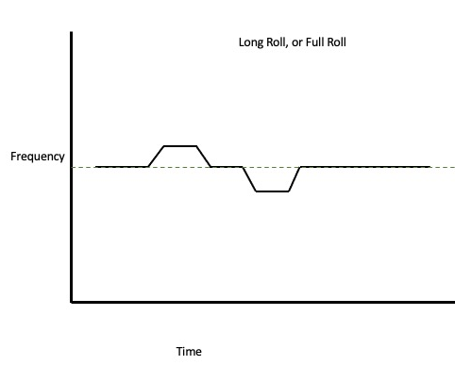  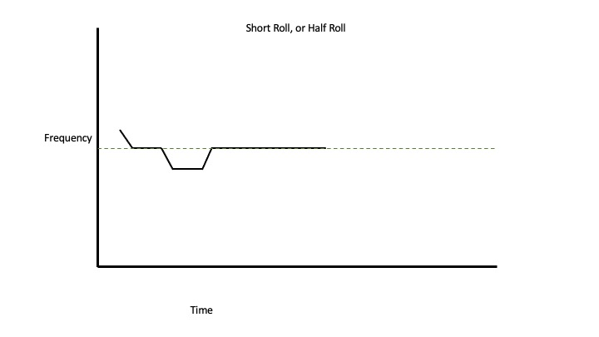
Figure 1. The Roll

Grace Note
A grace note is a note (sometimes 2 or more) that precedes a note in the tune, moving swiftly from one note to another, either up in pitch, or down. It pre-empts the note, and in folk music, can be both on the beat and before the beat, at each musician’s discretion.

Western Classical Symbol | Graphical demonstration
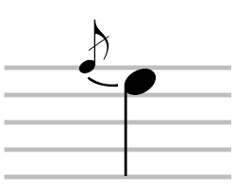  Or  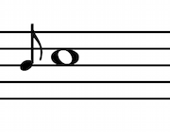 | 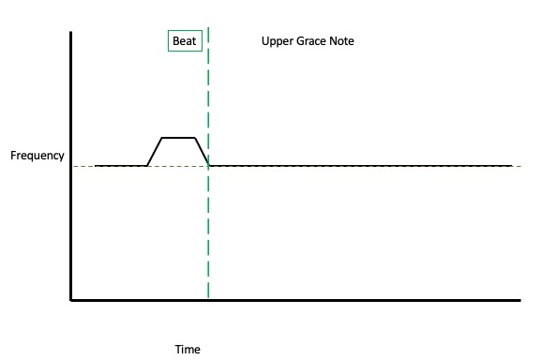  Or  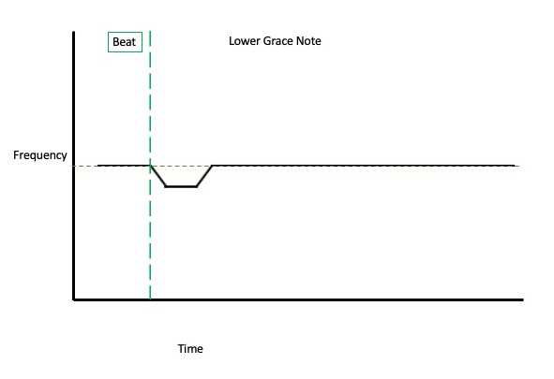
Figure 2. The Grace Note
Because the grace note is movable, both in terms of pitch, and in terms of timing, on the beat or just before, it seems that both the Western Classical symbols for acciaccaturas and appoggiaturas are used somewhat interchangeably to demonstrate where grace notes may fall in a tune, confusingly without meaning to convey a sense of timing.

Mordent
A mordent is a rapid oscillation between two notes, usually a tone or a semi-tone apart. Unlike a trill, the mordent consists of just one or possibly two quick movements.

A mordent can move upwards or downwards, from the written note, up a tone/semi-tone, and back to the written note, or down a tone/semi-tone in between the main tune note. There is no standardisation in beat for the mordent, it can appear both before the beat and on the beat, at the interpreter’s discretion.

Western Classical Symbol | Explanation | Graphical demonstration
Upper Mordent  Or  Lower Mordent | Upper Mordent  Or  Lower Mordent | 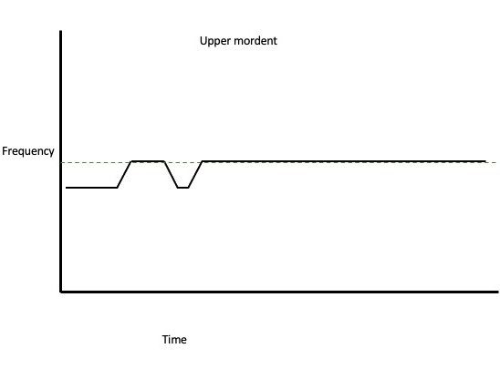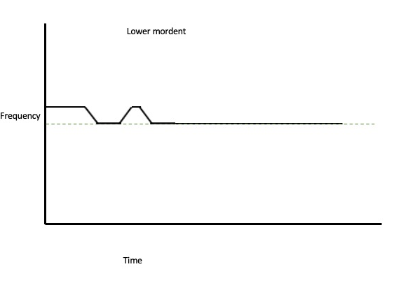
Figure 3. The Mordent
Sometimes known as a ‘jerry’ or a ‘lower jerry’ (Stewart Hardy: 2009) the mordent is often found at the end of phrases, as a way of decorating the melody line when it moves from the dominant to the tonic, or in melodic terms, from the 7th to the 8th, to cadence the melody. The ornament itself is common in Scandinavian fiddle playing (Chris Haigh) and can also be linked to a similar ornament in Baroque music (Zimmermann: 2021).

Triplet/Birl
In western classical music, a triplet is three notes, played in the space of two where all the notes are of equal value and length. However, in folk music in England, whilst we may use the word triplet, it doesn’t always mean the same as above. Another term for triplet, commonly used in Scottish traditional fiddle music is the birl. The birl is two semiquavers followed by a quaver.

Of course, on different instruments the effect is produced through different ways of interacting with the specific instrument. On the fiddle it is achieved through rapid changes in the direction of the bow; on the banjo by a quick succession of single strokes with the plectrum; on the accordion (both the button and piano) by the rapid successive tapping of a single button or key, usually by different fingers; on the flute by using something akin to classical triple tonguing techniques or rapid successive glottal stops. (Keegan: 2010, p.71).

The triplet sign is often used to represent both a birl and a triplet. It is also called a ‘treble’ in some traditions (MacNevin: 1998 p.38). This is sometimes referred to as a ‘bowed triplet’ in fiddle playing.

Western Classical Symbol | Explanation
Triplet  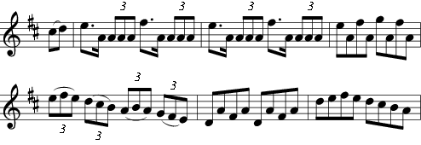 | Melodic Triplets  Birl  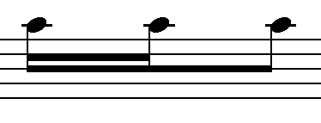
Figure 4. The birl
Melodic triplets would consist of two or more different notes within the triplet, sometimes moving in a scale-like pattern between the two notes on either side, almost linking them up. Rhythmic birls tend to stay on one note and are used as a device to add rhythmic variation or to punctuate a melody line.

There is some overlap between the two types; some birls might have melodic movement, and some triplets may stick on one pitch, but is the rhythmical difference between the triplet and the birl that is important.

Cut
The cut, sometimes known as a ‘tap’ or even a ‘flick’, can be played with a varying amount of pressure, speed and attack. It is often confused with the grace notes (see above), but the important difference between the two is that a grace note should have a distinct pitch, and a cut is more like a rhythmic effect - the sound is momentarily stopped and restarted. They can also sometimes be used to cut a note in half, with a ‘hammer-on’ effect on a note.

Western Classical Symbol | Explanation | Graphical demonstration
Cut | Cut  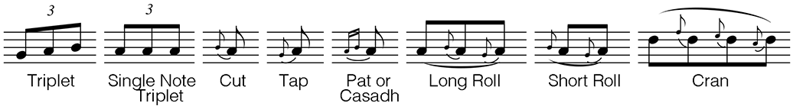 | 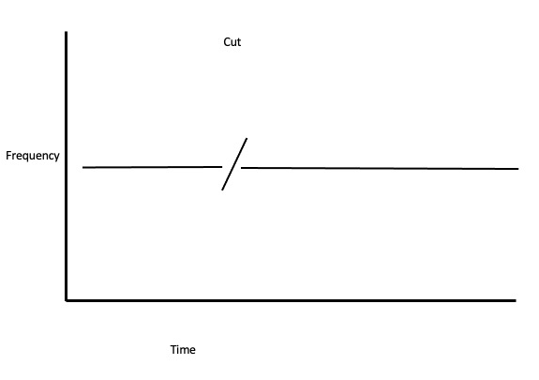
Figure 5. The Cut
Confusingly, the Western Classical symbol for a grace note is often used to demonstrate a possible place for a cut.

Cran
A cran is played by playing a note and then rhythmically cutting the note two or three times each time. The three cuts may vary in pitch within a slur (usually), or it may be cut with an unpitched note, creating a rhythmical effect.

Explanation | Graphical demonstration
 | 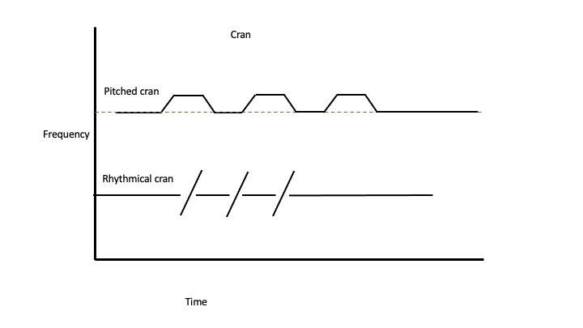
Figure 6. The Cran

Appendix 2. CD Data Analysis

A track-by-track log of the stylistic gestures used. The analysis is split by an artist per page. Rates of features are calculated as the number of uses of each feature per minute. in each track (Count of the feature / decimal time).

CD | Album name
Title | Track name
Origin | Whether the tune was composed or traditional
Duration | Track duration (mins: secs)
Decimal Time | Decimal representation of track duration (minutes)
Roll | Number of Rolls used in this track
Rate of Rolls | Rate of rolls in this track (per minute)
Double Stops | Number of Double Stops in this track
Rate of Double Stops | Rate of Double Stops in this track (per minute)
Mordent | Number of Mordents in this track
Rate of Mordents | Rate of Mordents in this track (per minute)
Left Hand Pizzicato | Number of Left-Hand Pizzicato in this track
Rate of Left-Hand Pizzicato | Rate of Left-Hand Pizzicato in this track (per minute)
Trill | Number of Trills in this track
Rate of Trills | Rate of trills in this track (per minute)
Slides | Number of Slides in this track
Rate of Slides | Rate of slides in this track (per minute)
Birl | Number of Birls in this track
Rate of Birls | Rate of Birls in this track (per minute)
Grace Note | Number of Grace Notes in this track
Rate of Grace Notes | Rate of Grace Notes in this track (per minute)
Melodic Variation | Was melodic variation used in this tune
Rhythmic Variation | Was rhythmic variation used in this tune
Triplet | Number of Triplets in this track
Rate of Triplets | Rate of Triplets in this track (per minute)
AABB | Yes/No whether this tune followed the AABB structure
Other Structure | Was another/which structure was used
Major Key | Was this tune in a major tonality. ‘1’ denotes ‘yes’.
Minor Key | Was this tune in a minor tonality. ‘1’ denotes ‘yes’.
Modal | Was this tune in a modal tonality. ‘1’ denotes ‘yes’.
Tune type (jig/reel/hornpipe) | The tune type
Tempo (BPM) | Tempo in Beats Per Minute

5.1 Bellowhead

5.2 Eliza Carthy

5.3 English Acoustic Collective
5.4 Granny’s Attic

5.5 Bryony Griffith

5.6 Rob Harbron

5.7 Nancy Kerr and James Fagan

5.8 John Kirkpatrick

5.9 Leveret
5.10 Sarah Matthews and Doug Eunson
5.11 Melrose Quartet

5.12 Moore, Moss & Rutter

5.13 Will Pound
5.14 Spiers and Boden

5.15 Sam Sweeney

5.16 Three Cane Whale

5.17 Kathryn Tickell

Appendix 3. Survey Data
These are the questions that were presented in the google form, with the response types listed.
Name (first name is fine) | Free Text Response
Instrument (s) | Free Text Response
Band/group/performance name | Free Text Response
What do you define your style of playing as? | Free Text Response
Do you write your own tunes? (If no skip next question) | Free Text Response
Can you describe your process of writing a tune? What are your influences? Do you have a set process? how conscious is it? Any other important information, etc? | Free Text Response
Do you arrange ‘traditional’ tunes? (If no skip next question) | Free Text Response
Can you describe your process of arranging 'traditional' tunes? What are your influences? Do you have a set process? how conscious is it? Any other important information, etc? | Free Text Response
How important is working with other musicians to your personal creativity and musicality? (1=not at all, 5= very important) | 1, 2, 3, 4, 5
What does the idea of tradition mean to you? | Free Text Response
In your own words, what constitutes a 'traditional' tune to you? | Free Text Response
How important are these ideas of tradition? (1=not at all, 5= very important) | 1, 2, 3, 4, 5
How important are ideas of tradition to your music making, when writing your own tunes? (1=not at all, 5= very important) | 1, 2, 3, 4, 5
How important are ideas of tradition to your music making, when using ‘traditional' tunes? (1=not at all, 5= very important) | 1, 2, 3, 4, 5
How much do ideas of tradition affect your own musical creativity? (1=not at all, 5= very important) | 1, 2, 3, 4, 5
Can you expand on your above answer? | Free Text Response
How important is it to you, that new material/interpretations of 'traditional' tunes enter the English folk scene- and if important, why? | Free Text Response
How important is the reaction of audiences to your creative output? Do you actively think about how your music will be received or is not particularly relevant to you? (1=not at all, 5= very important) | 1, 2, 3, 4, 5
Do you actively try to push audiences perception of what 'folk' or 'trad' music it is? If so, why and how? | Free Text Response
Can you push this perception of what folk or trad music is too far? If so, where do you draw the line? | Free Text Response

Appendix 4. Complete Score Transcriptions: ‘Radstock’

Appendix 5. Complete Score Transcriptions: ‘Brighton Camp’
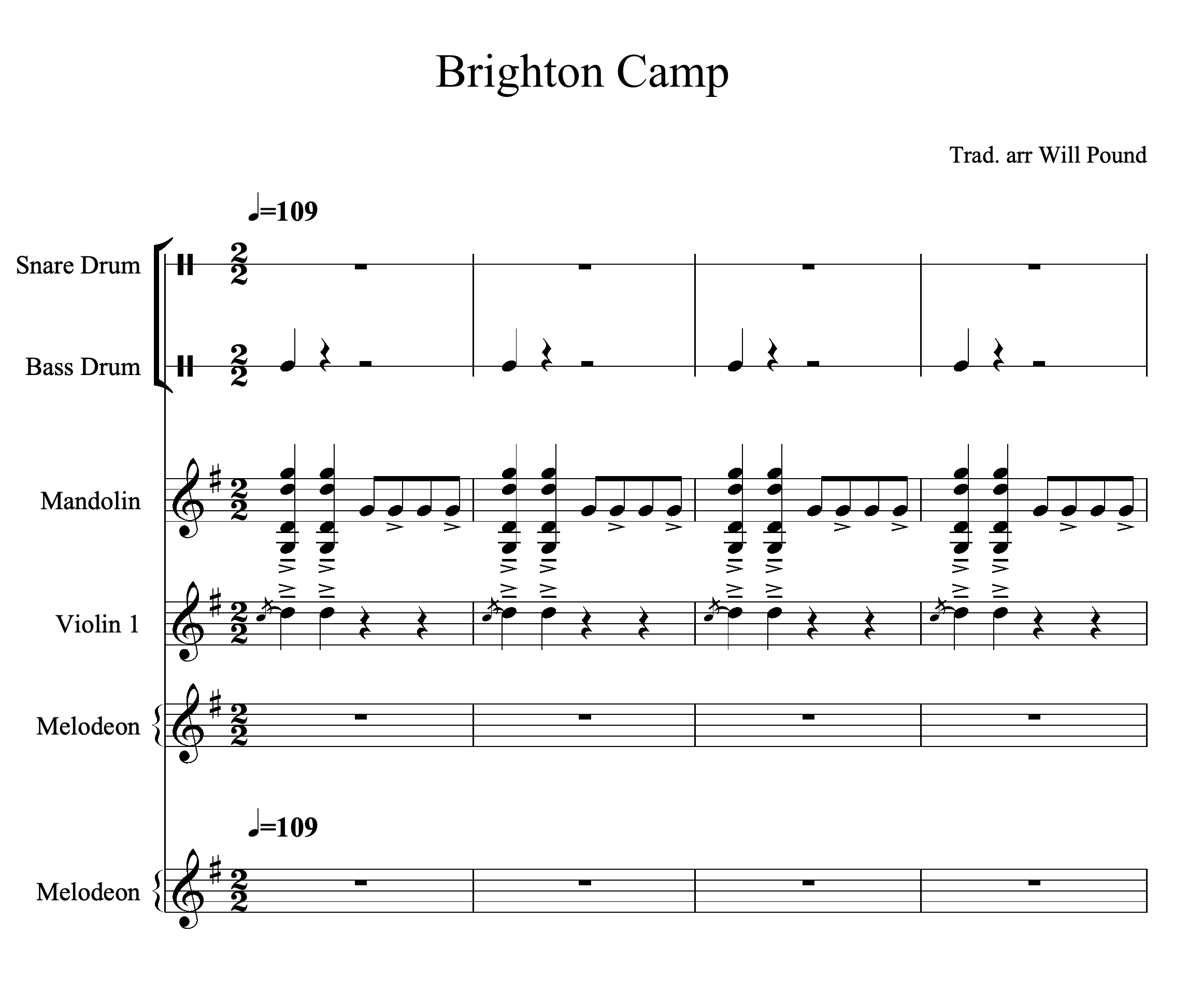

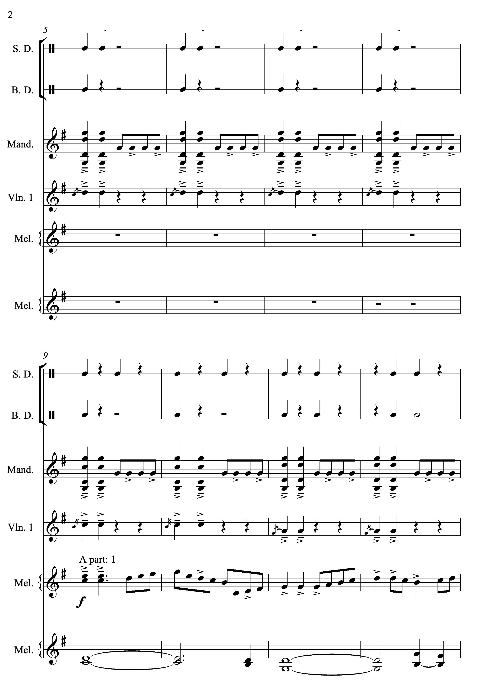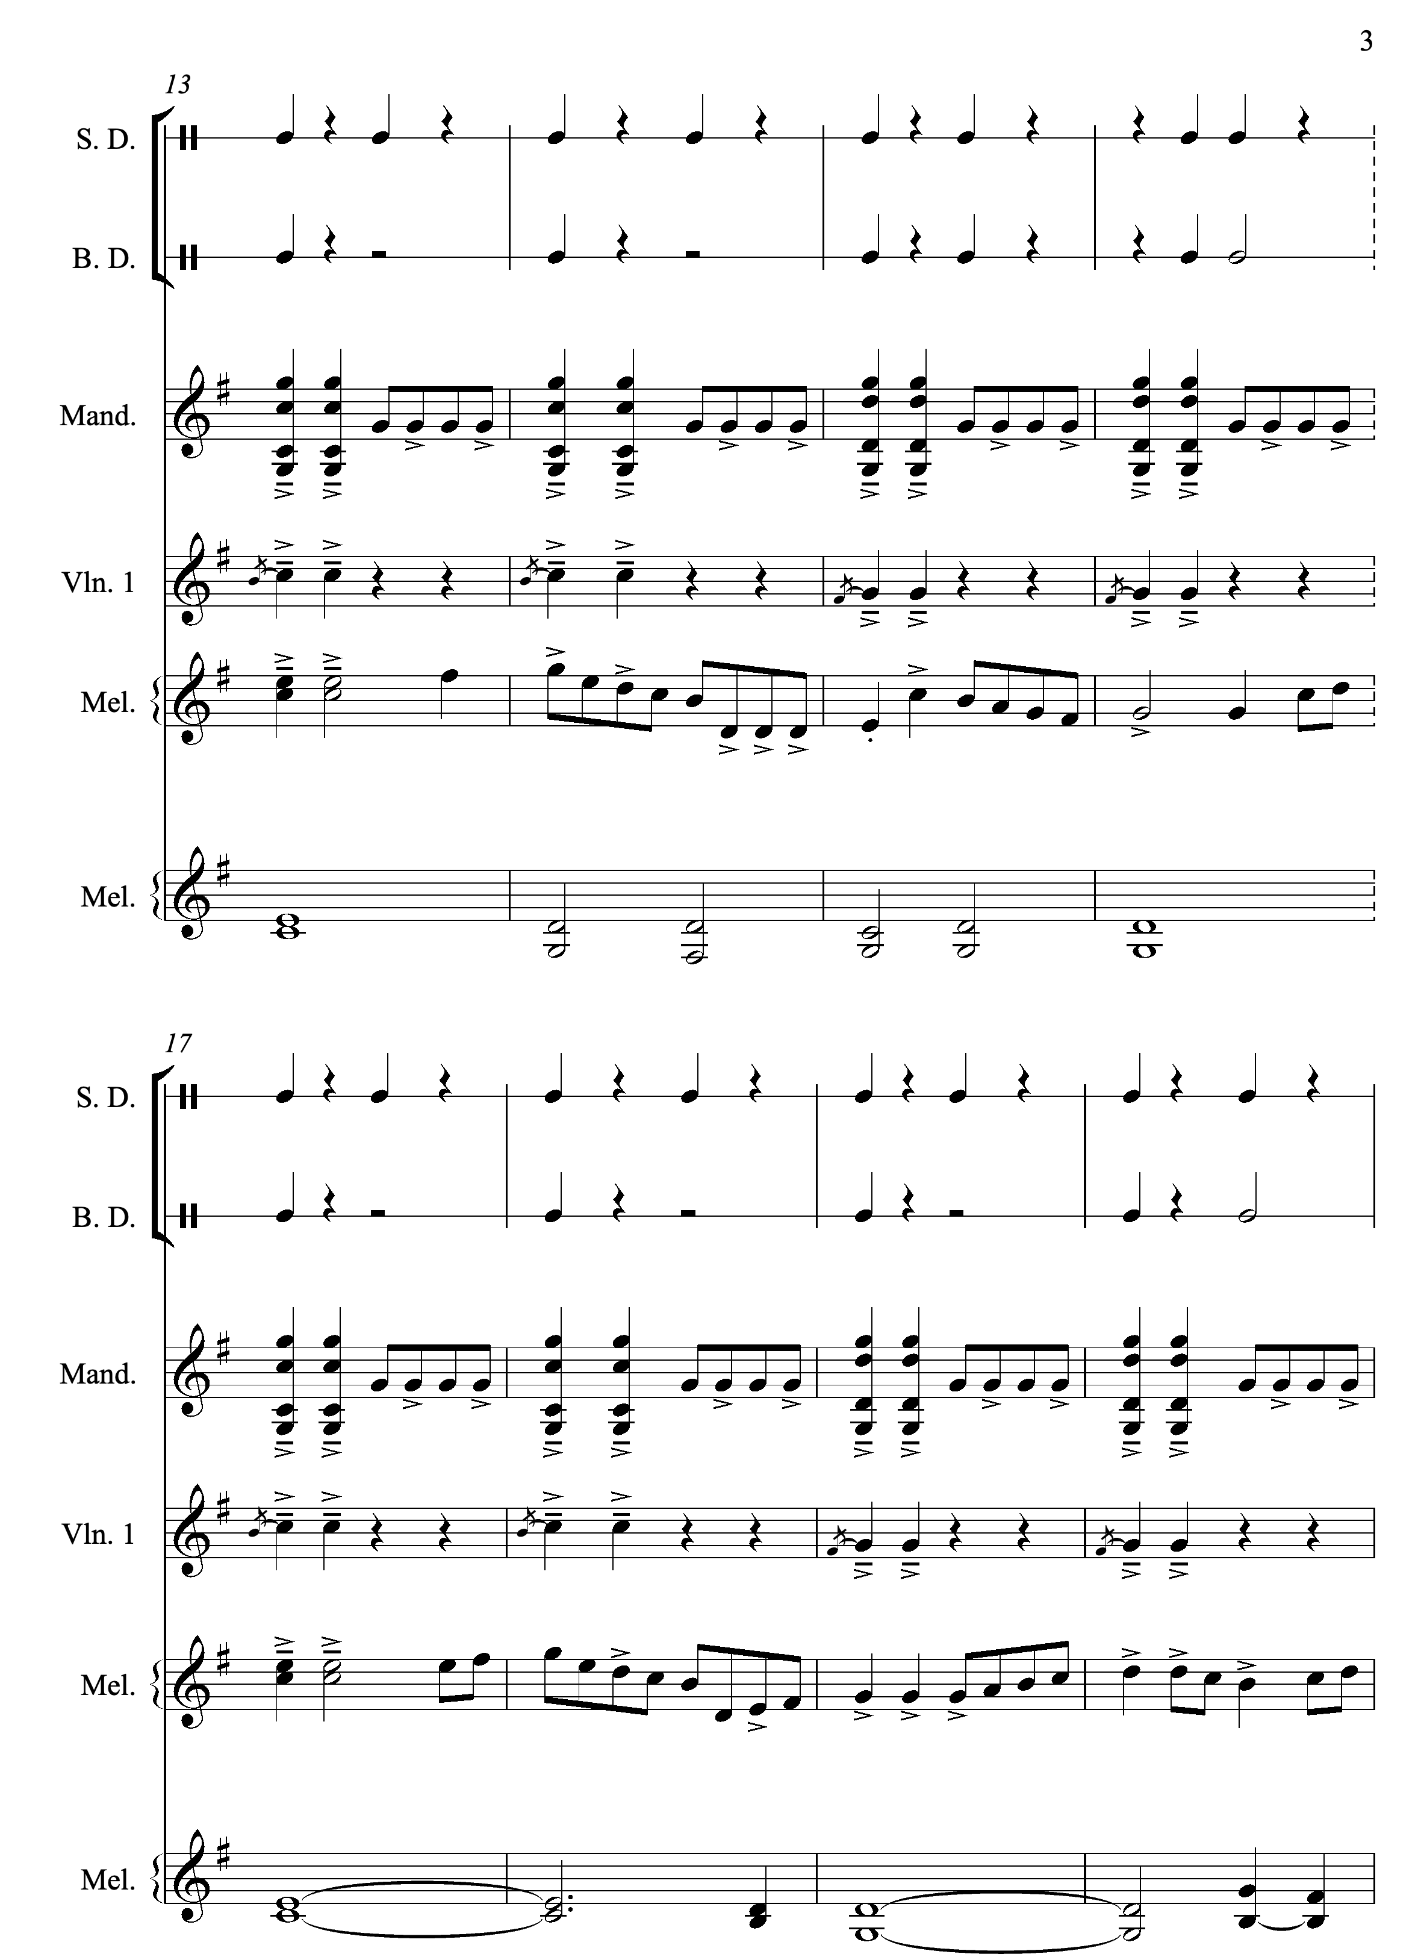
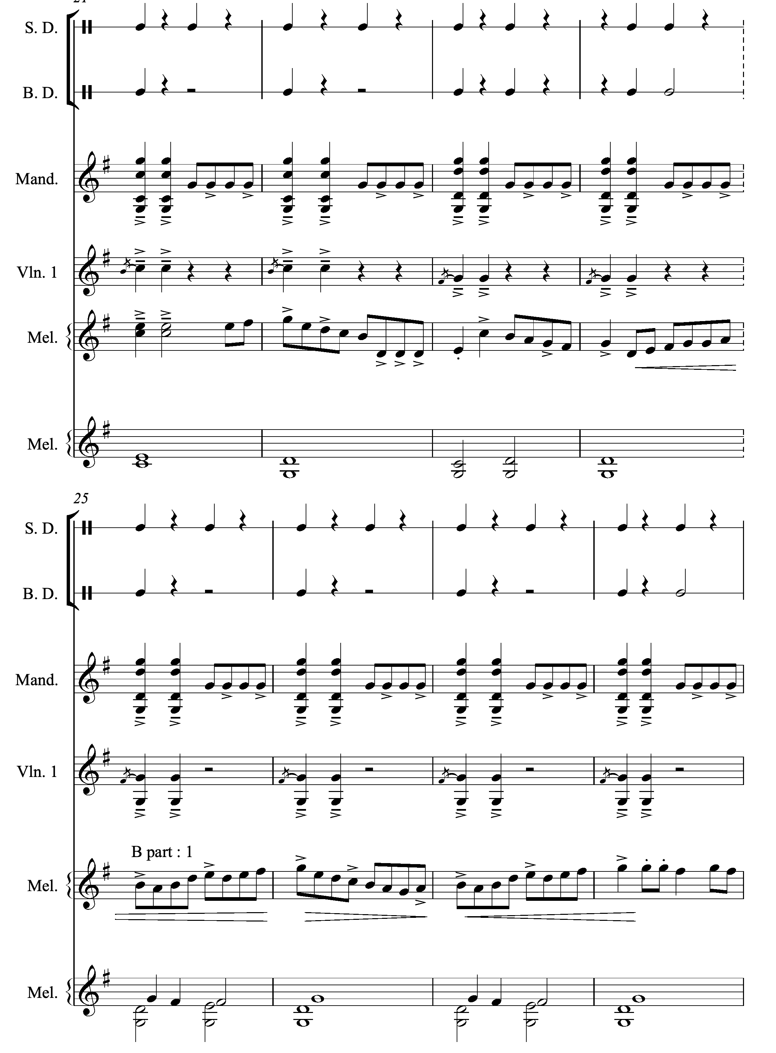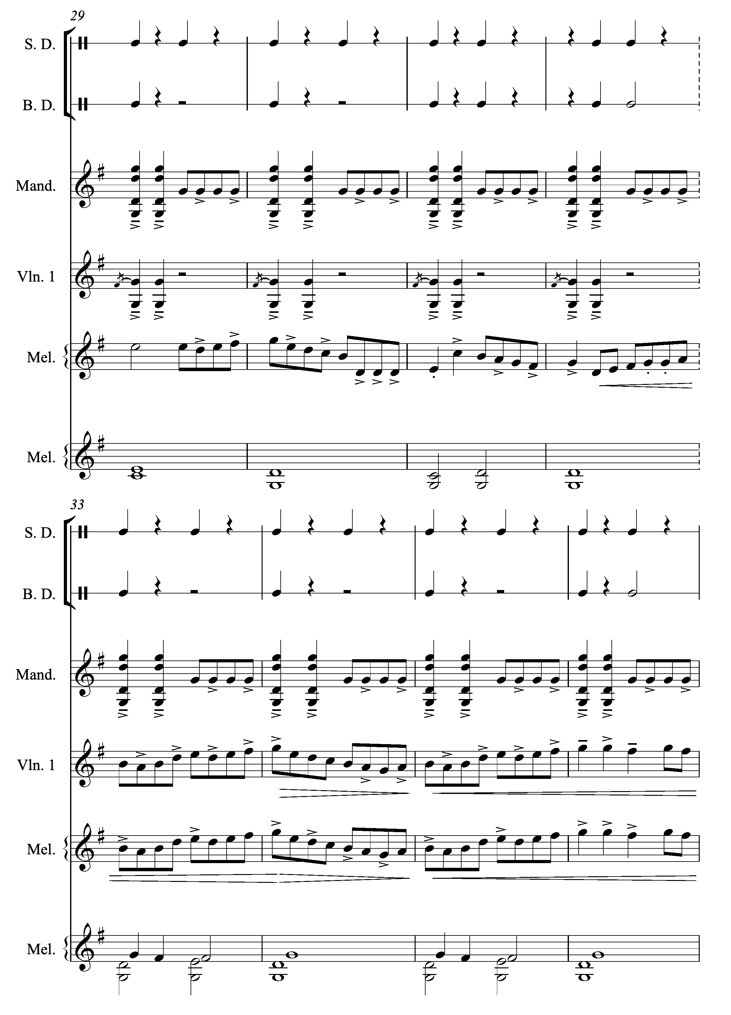
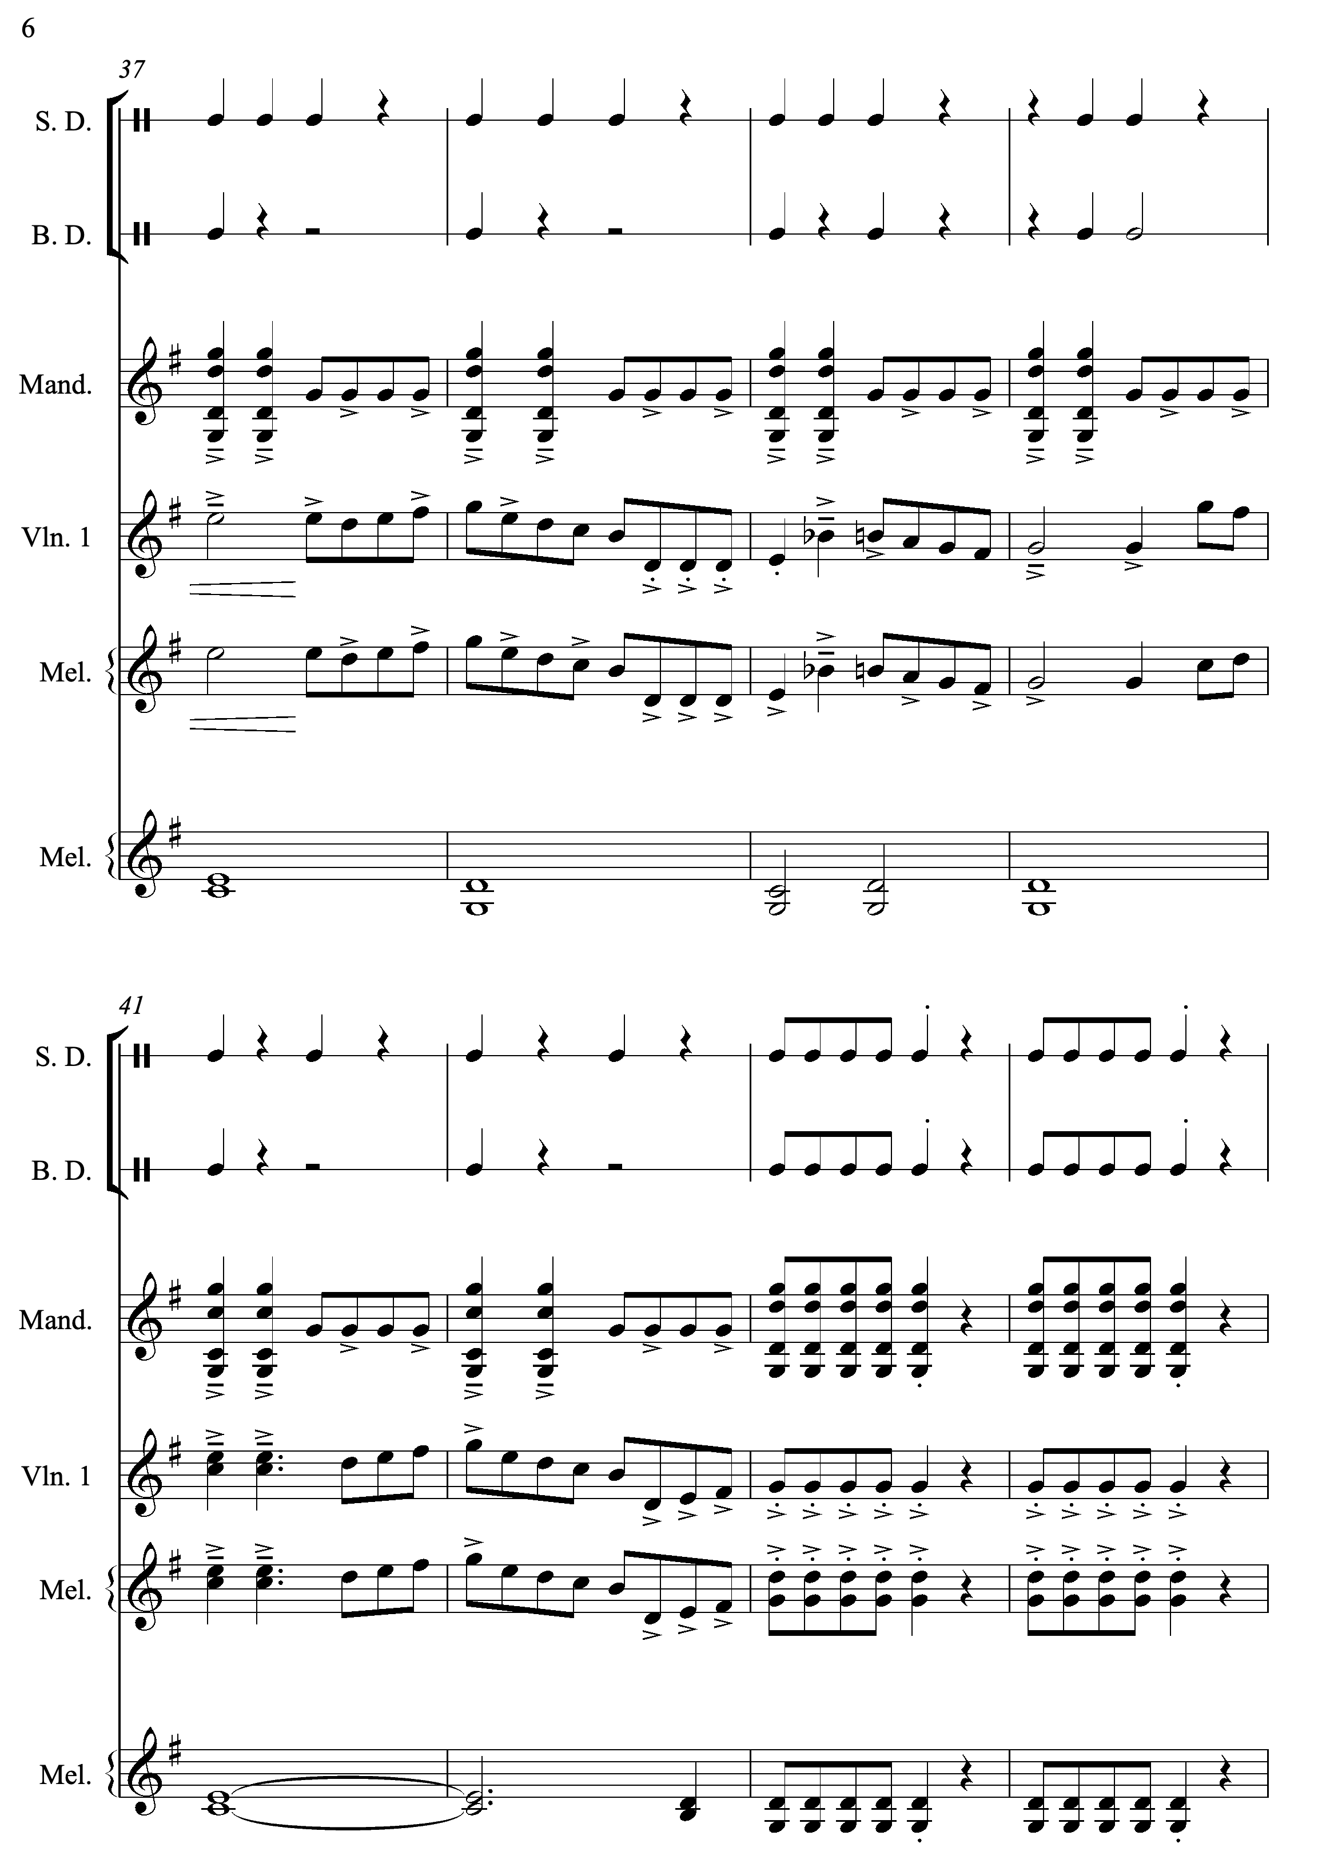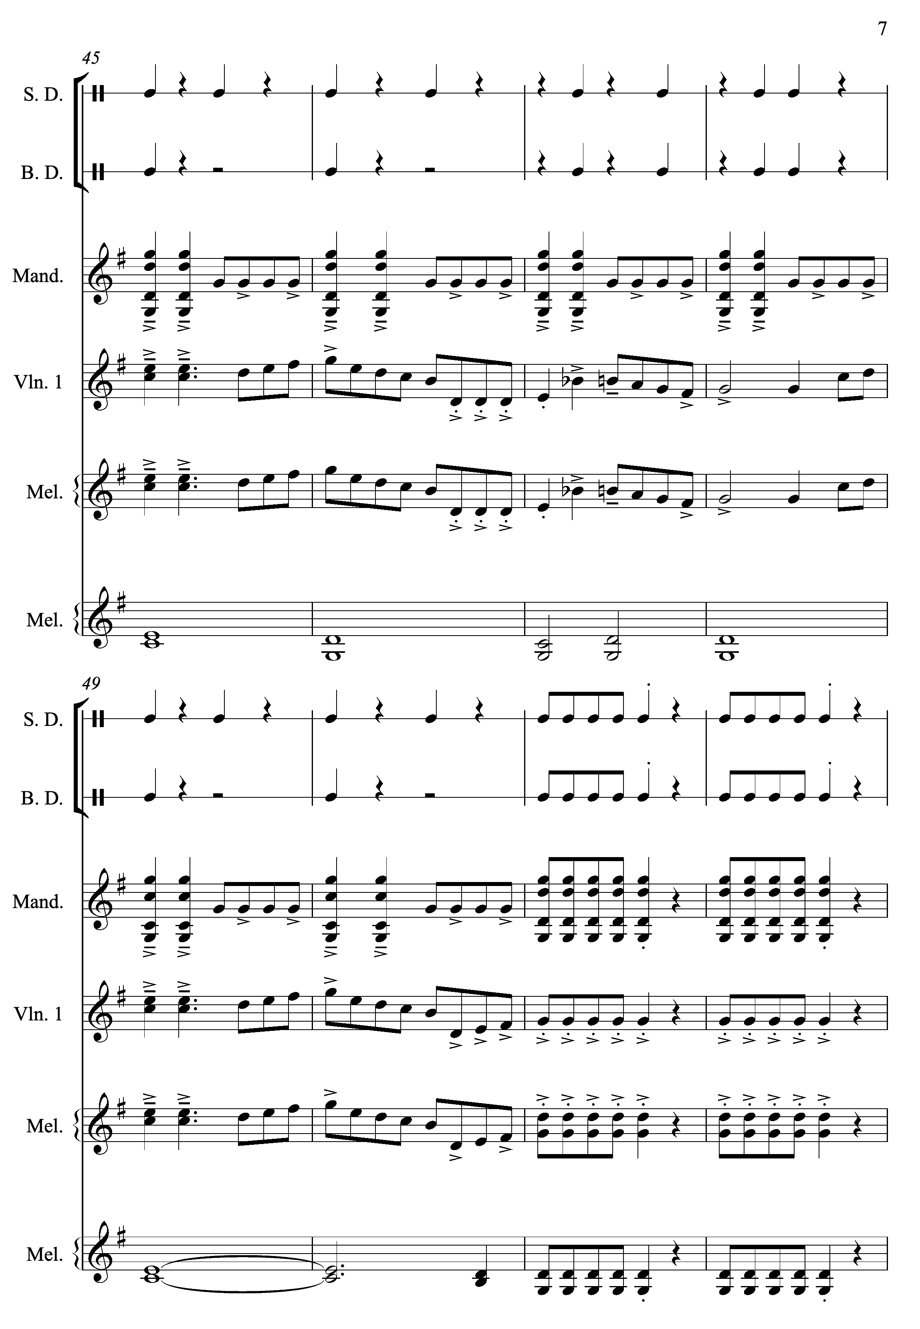
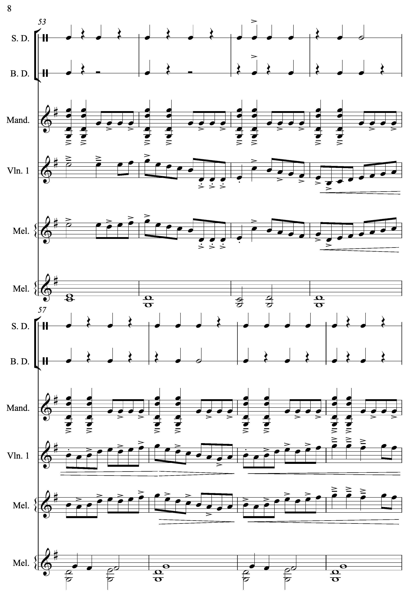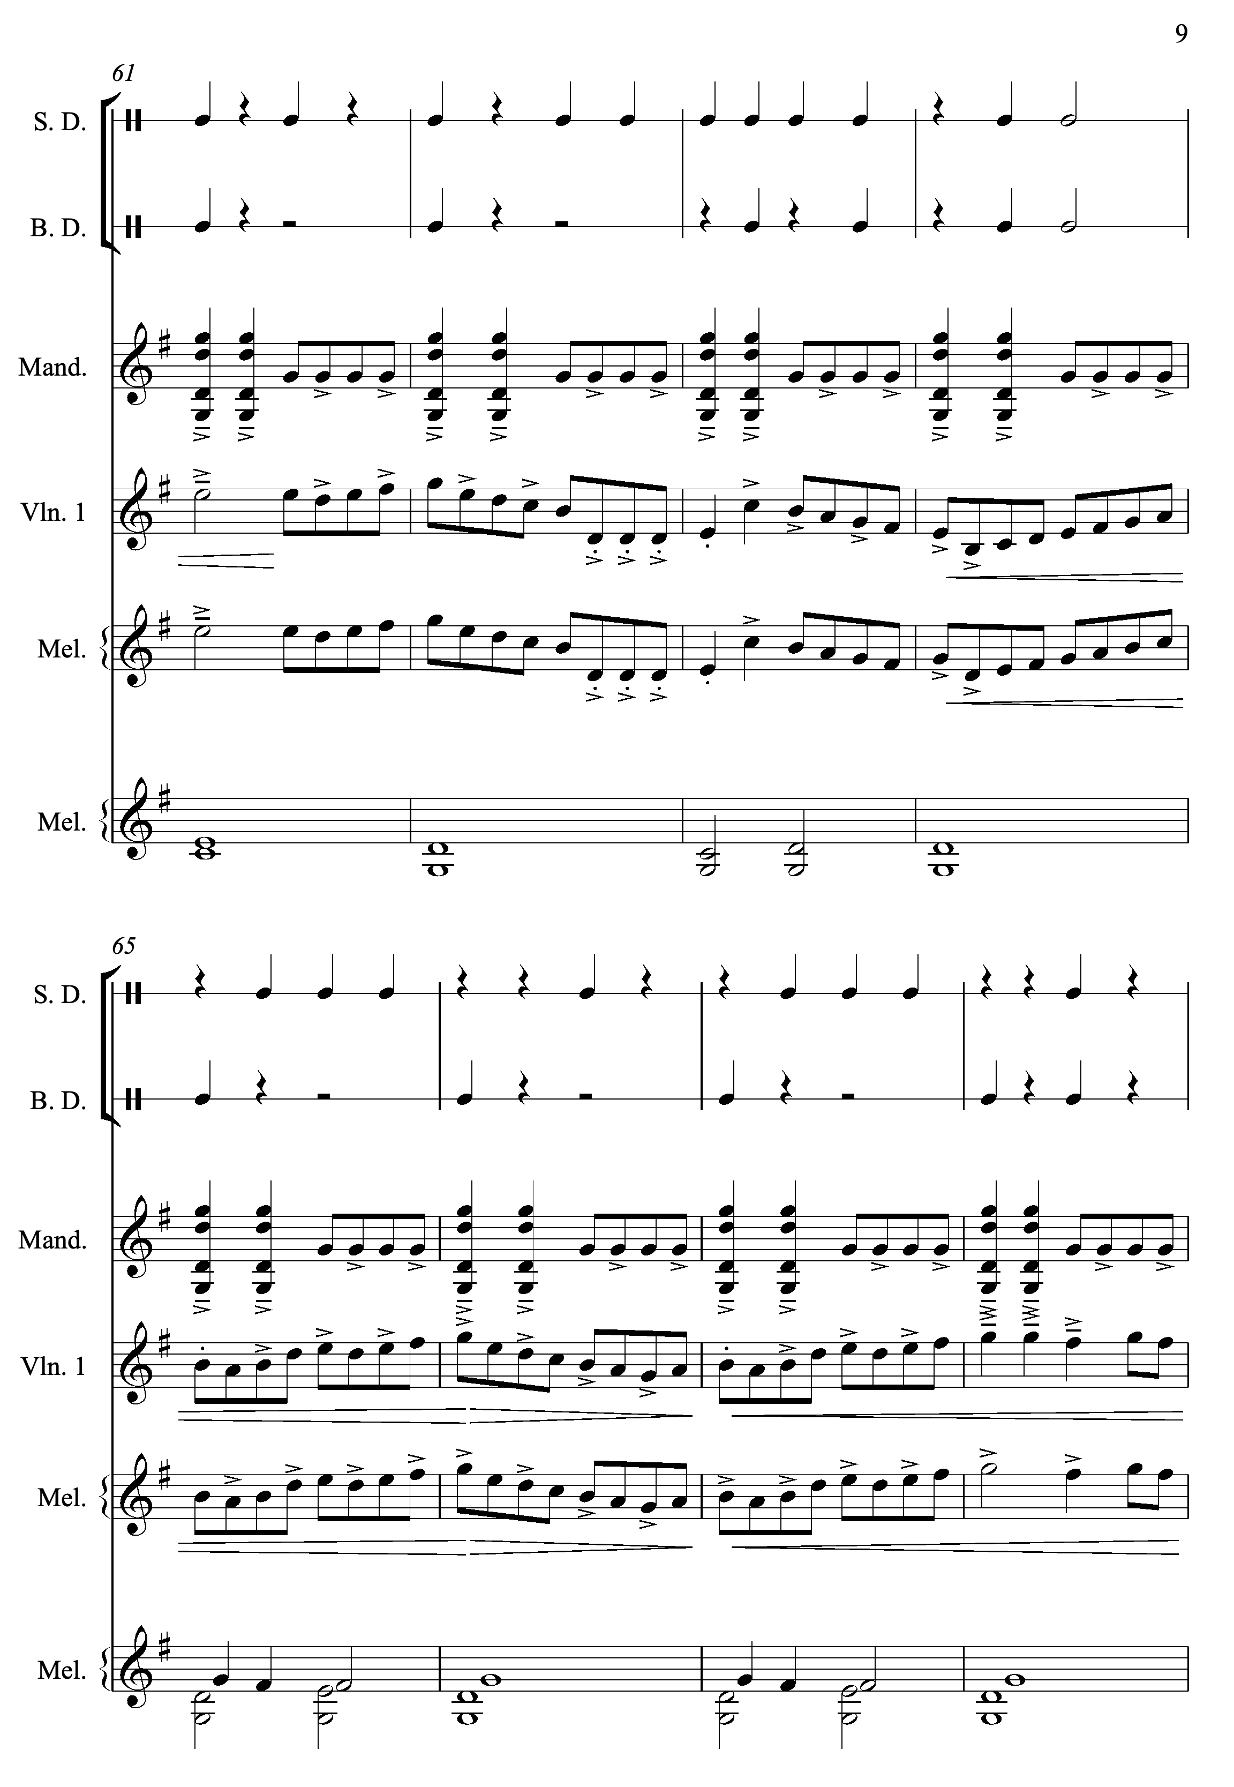
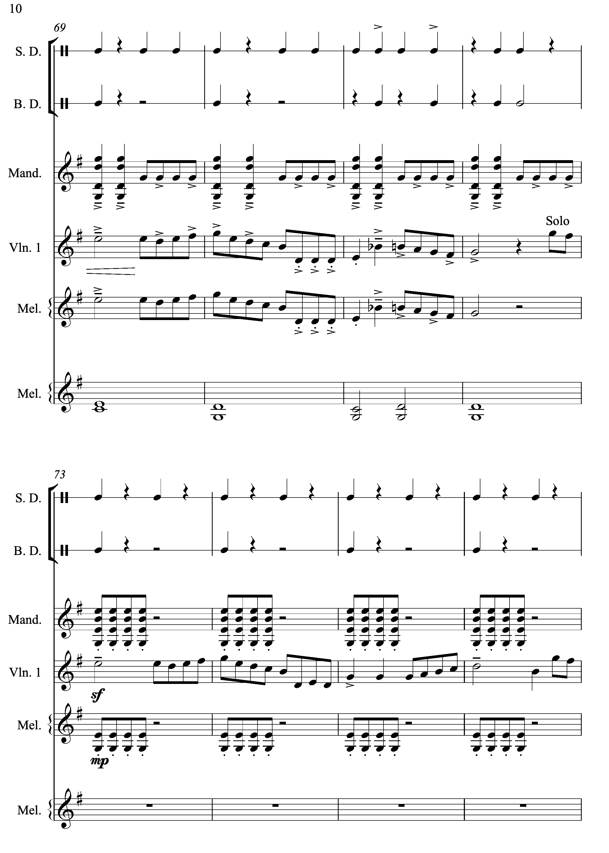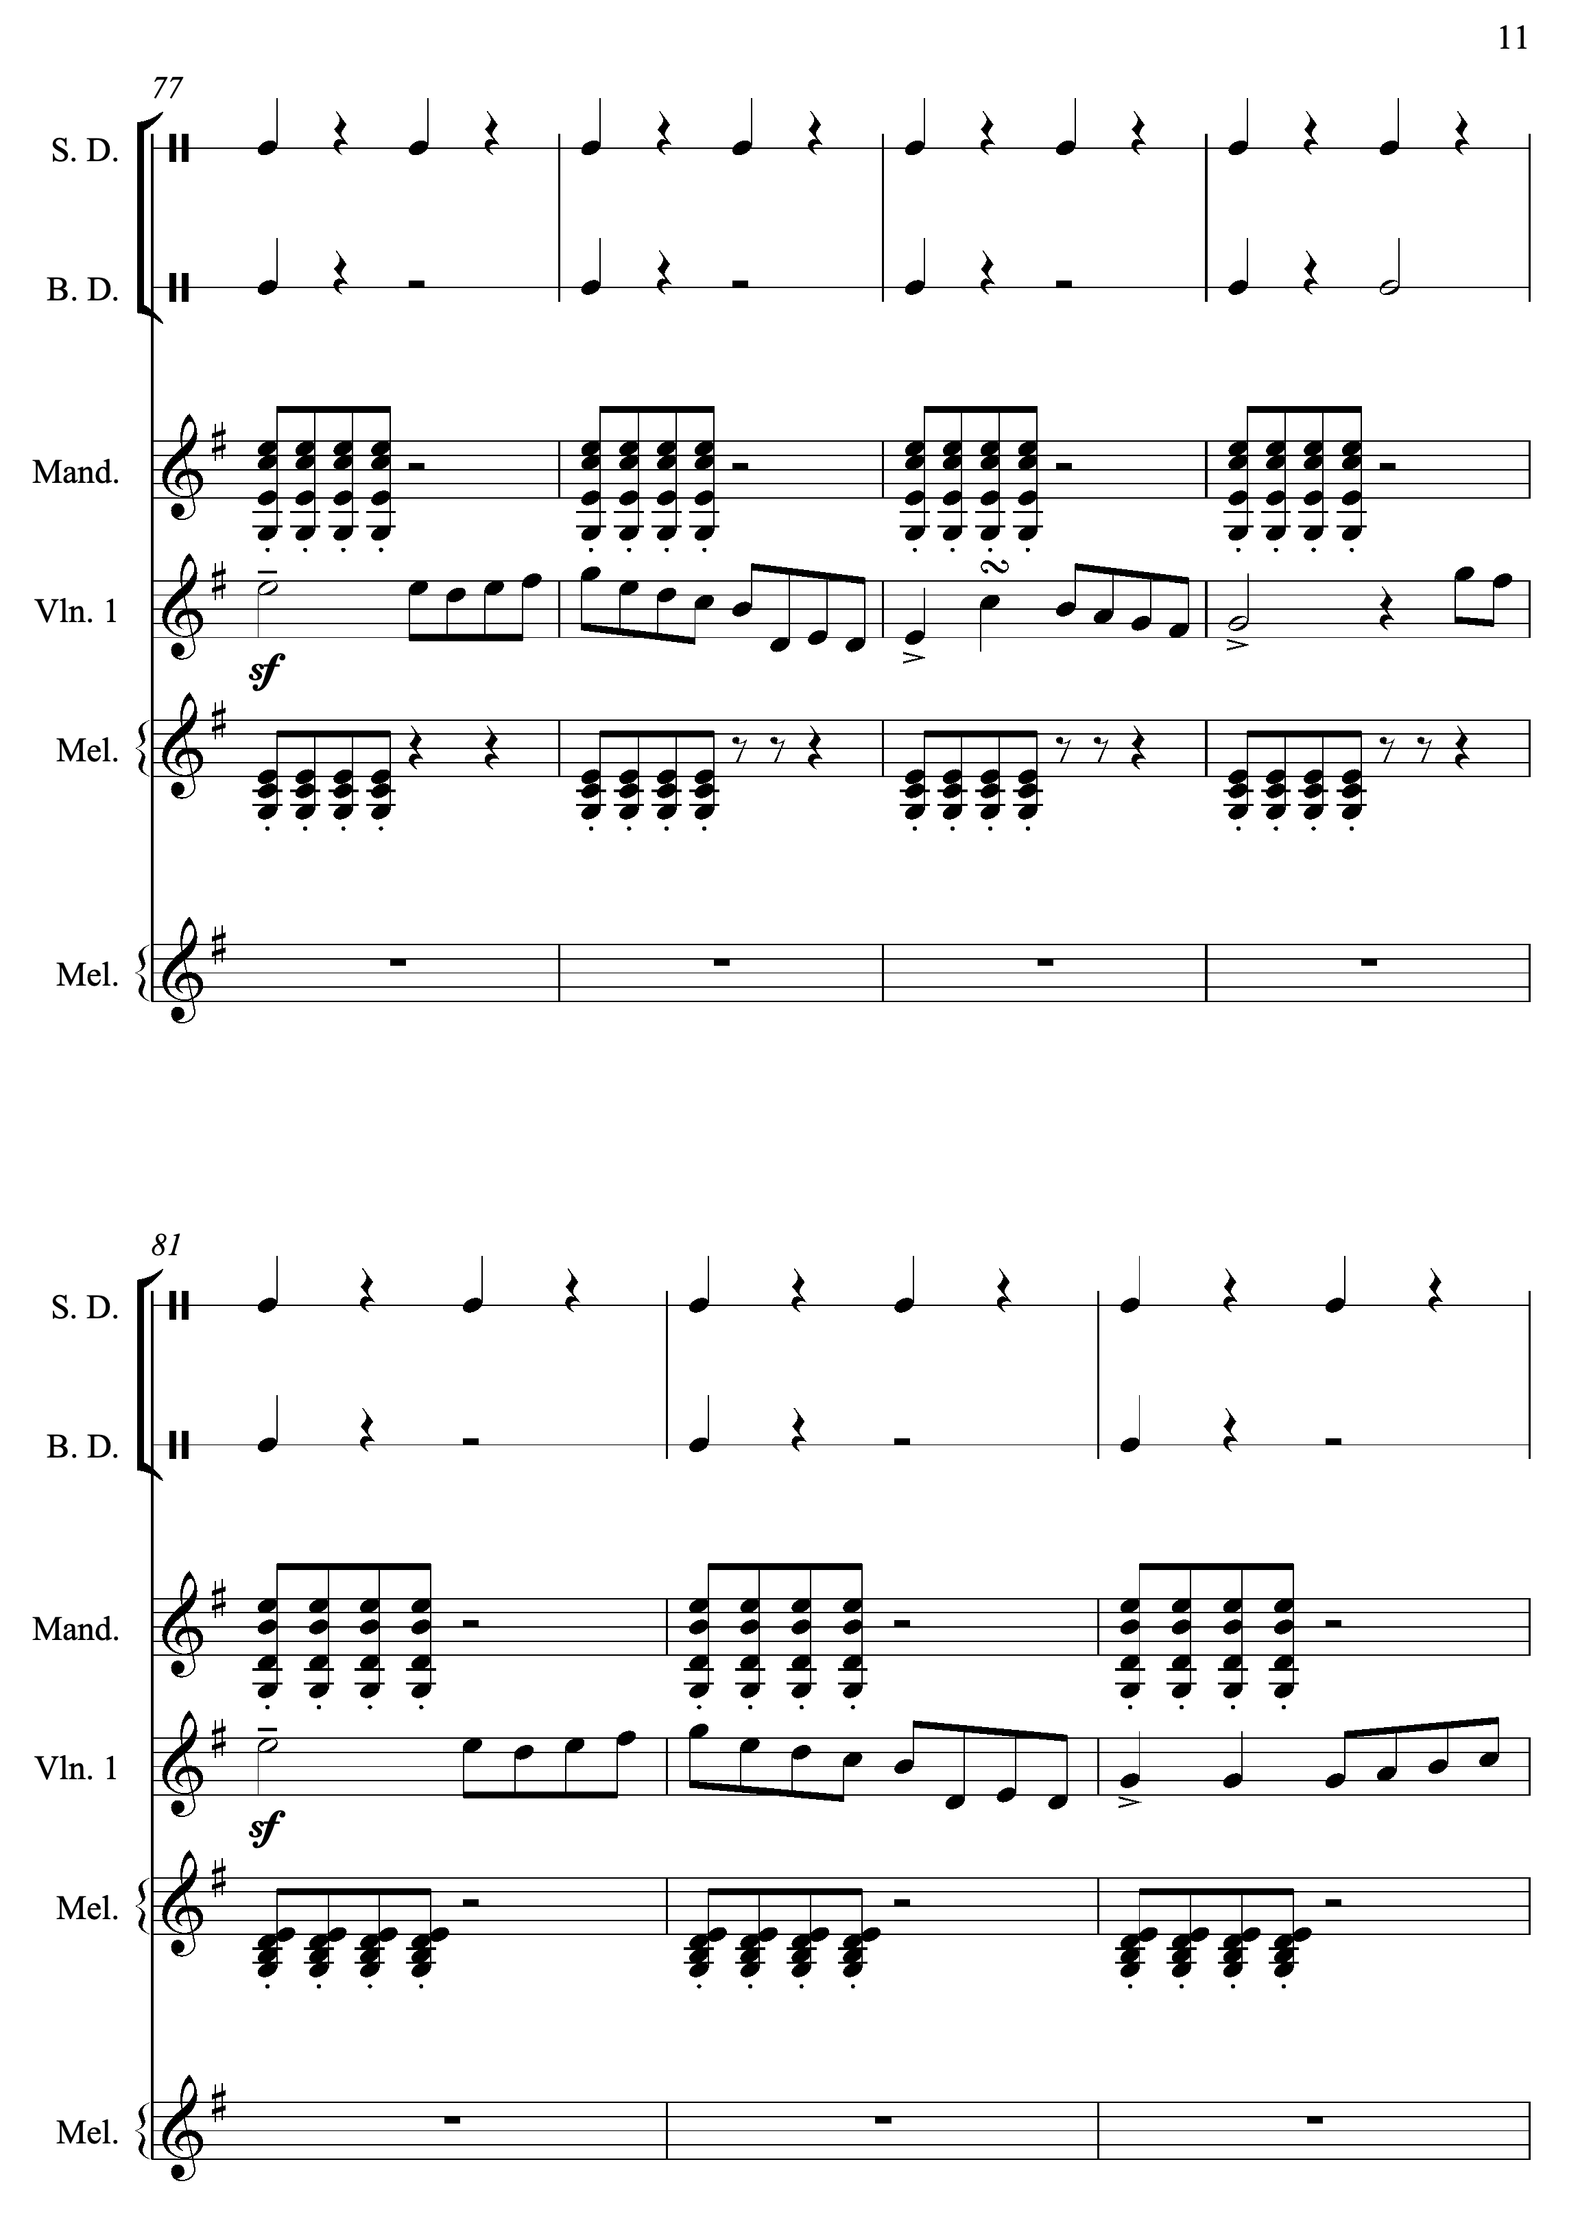
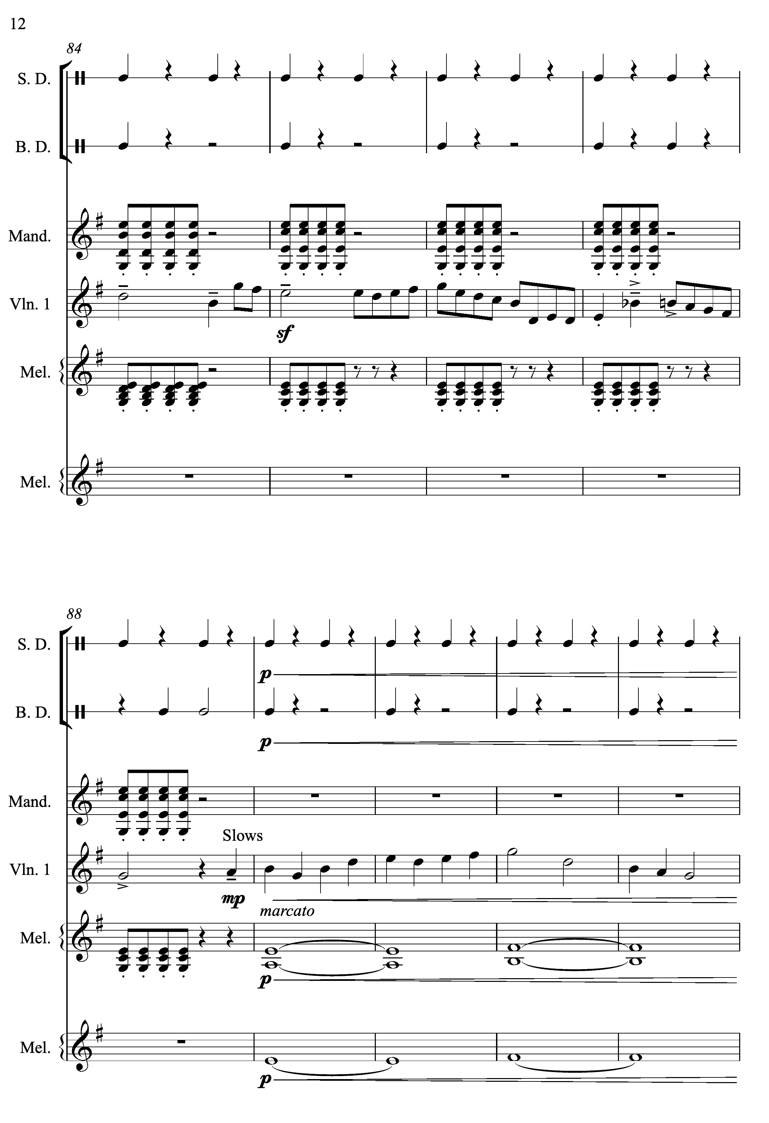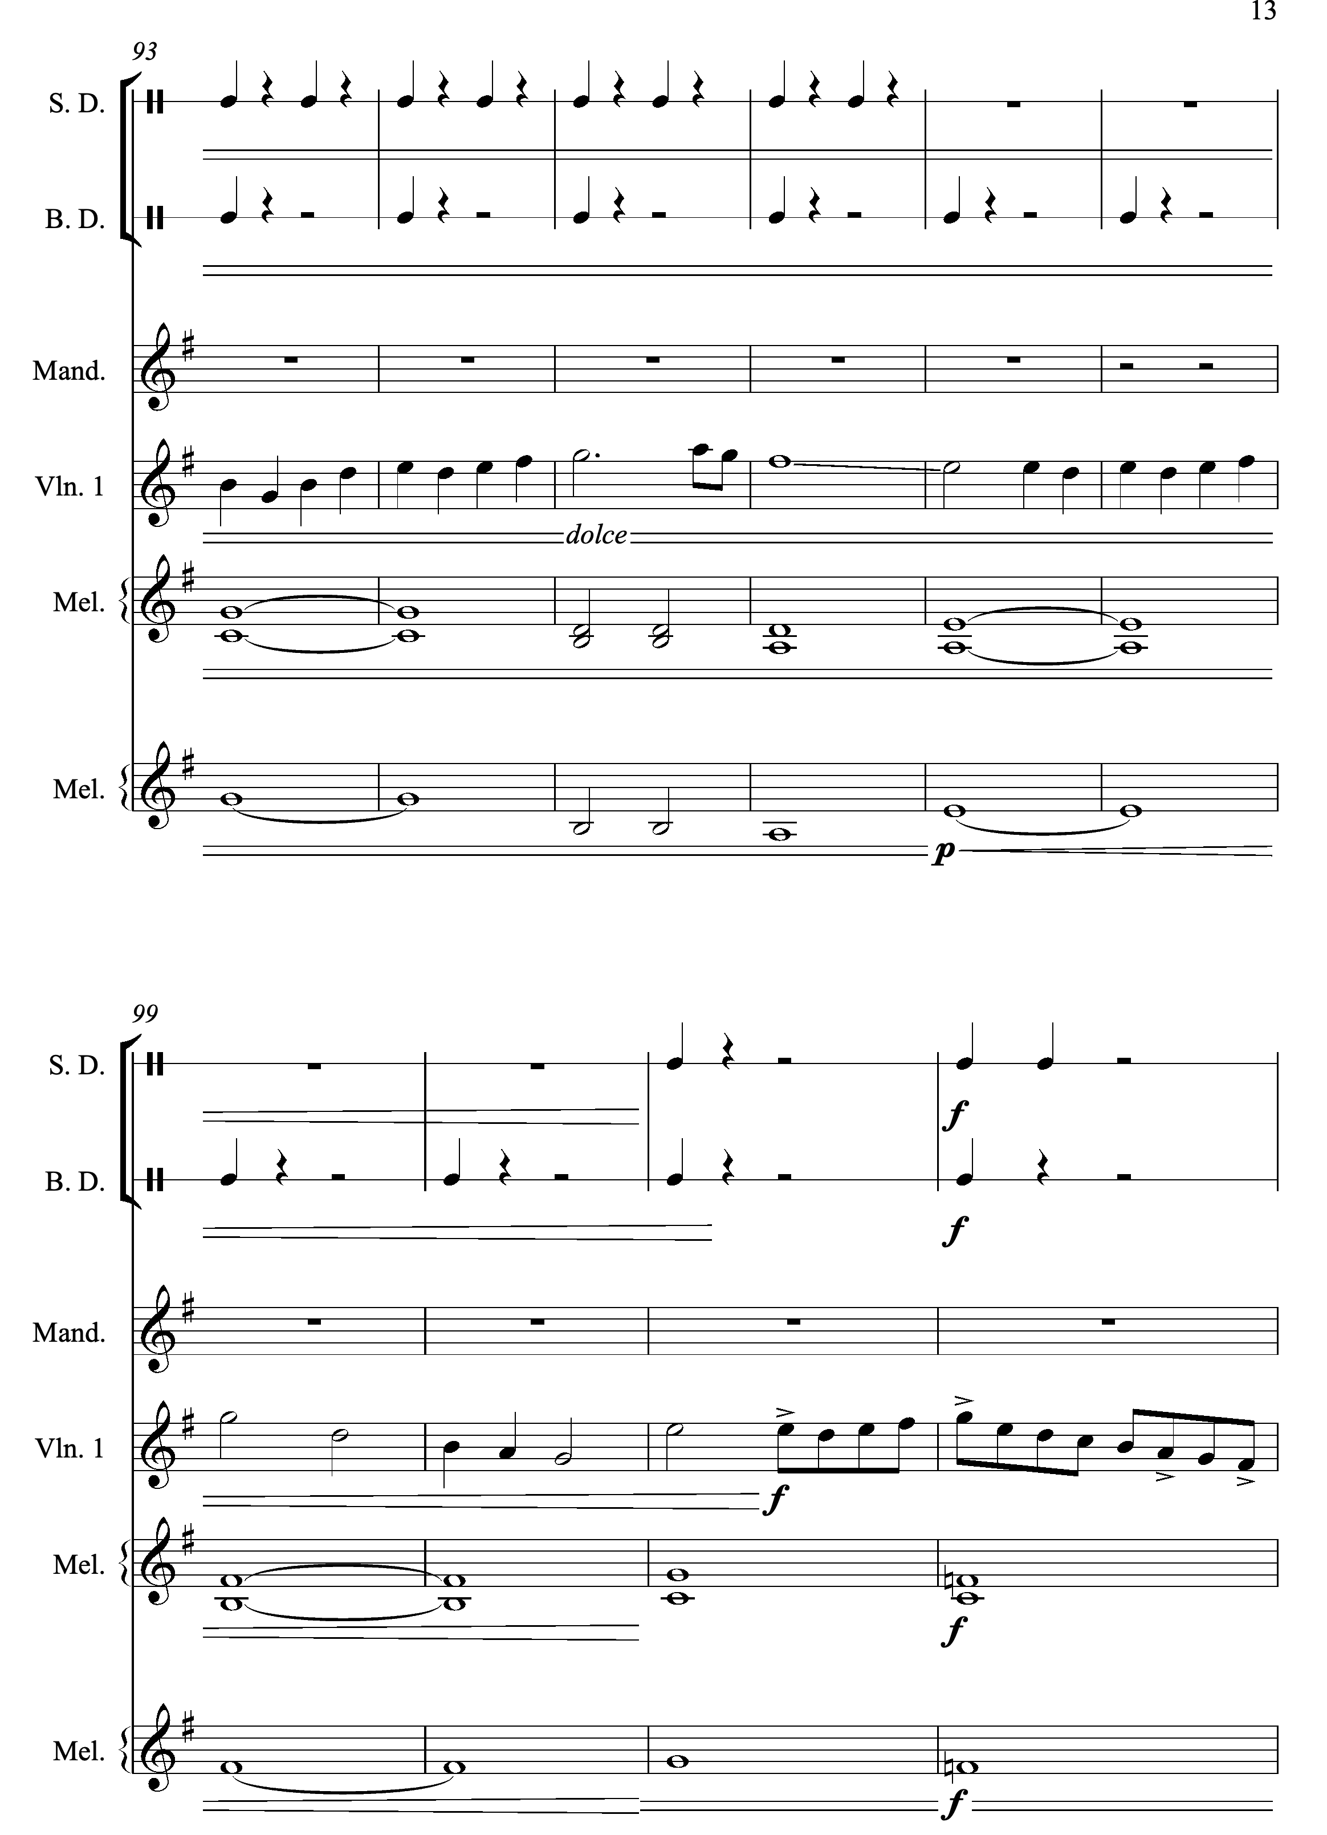

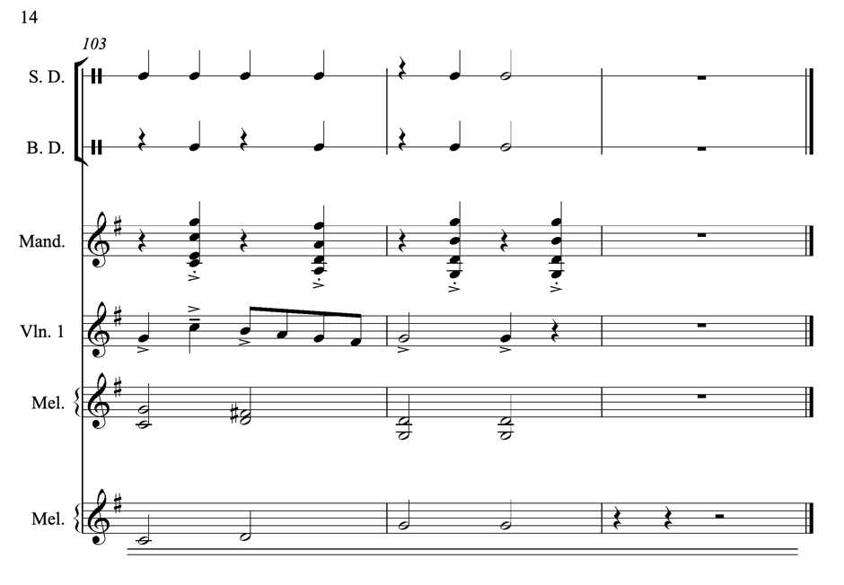

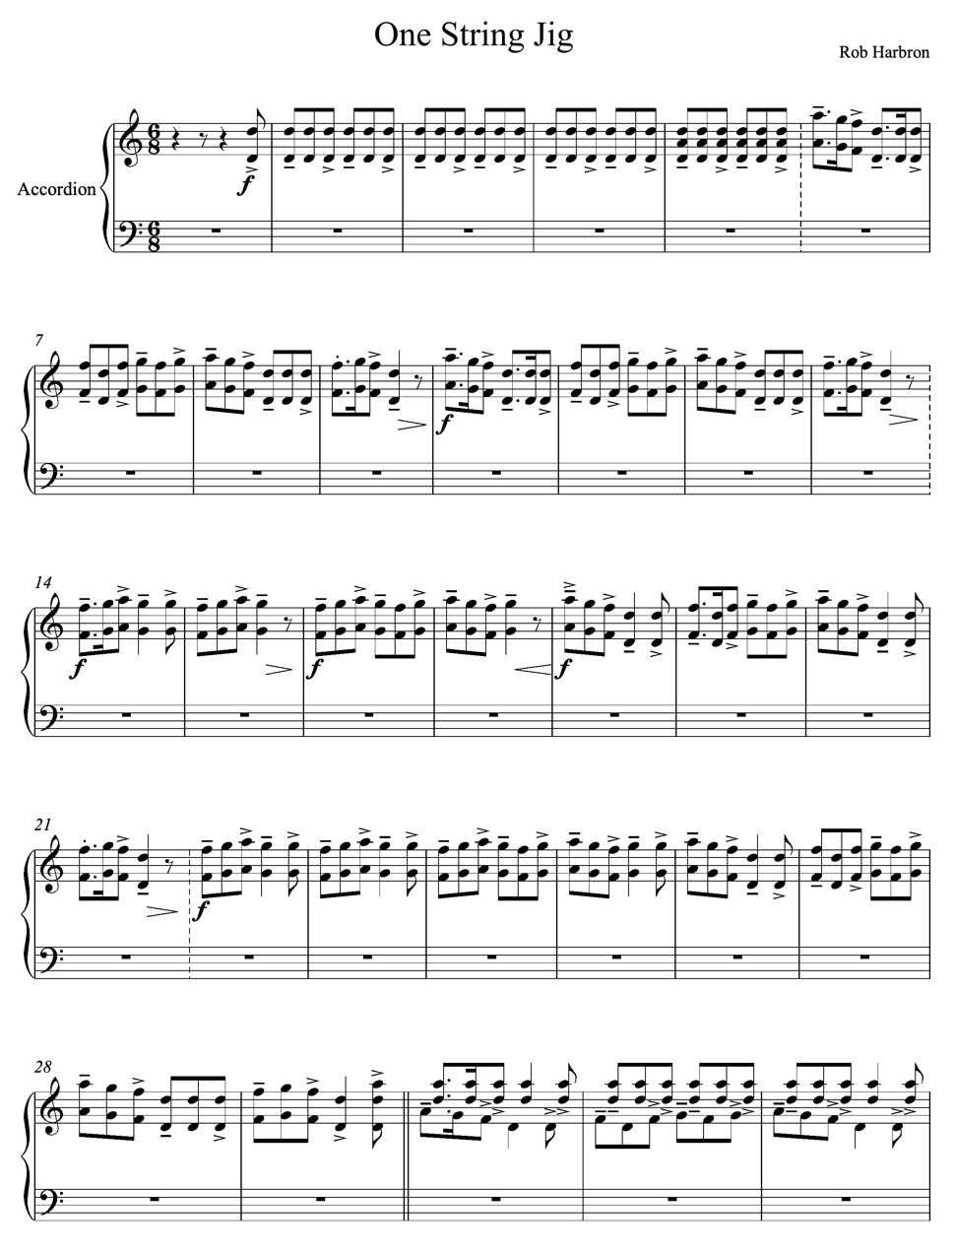
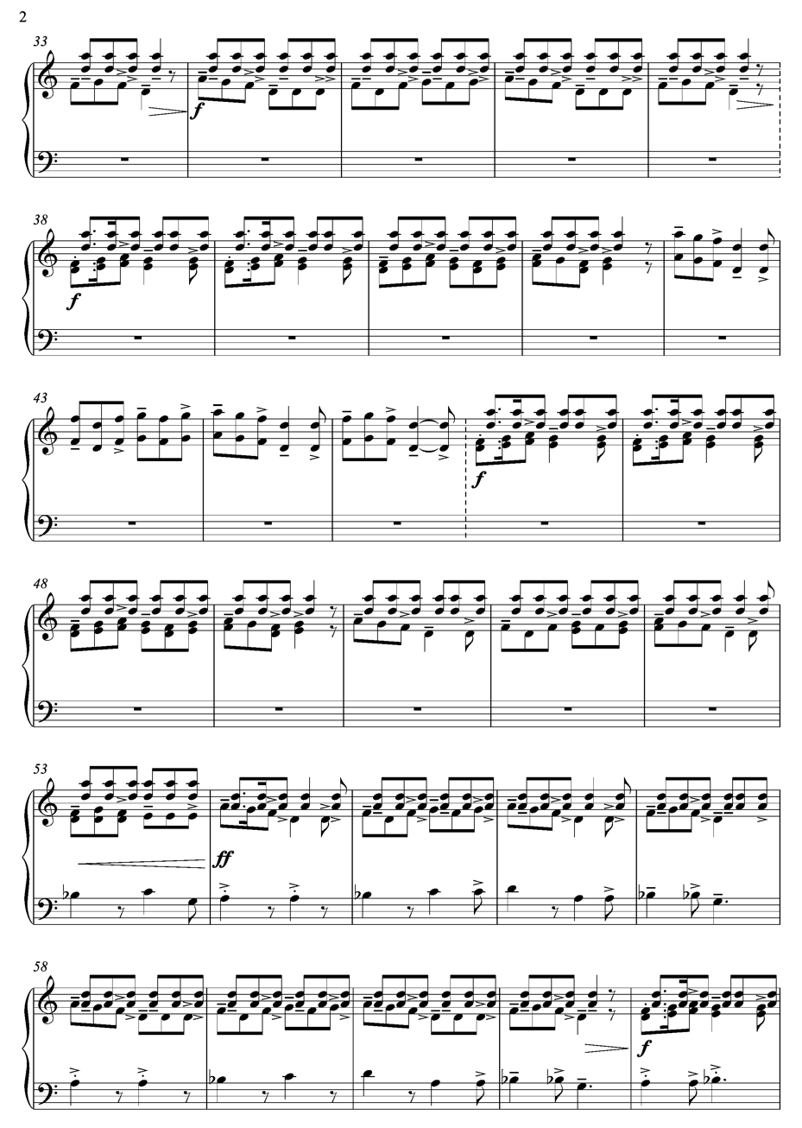
Appendix 6. Complete Score Transcriptions: ‘One String Jig’

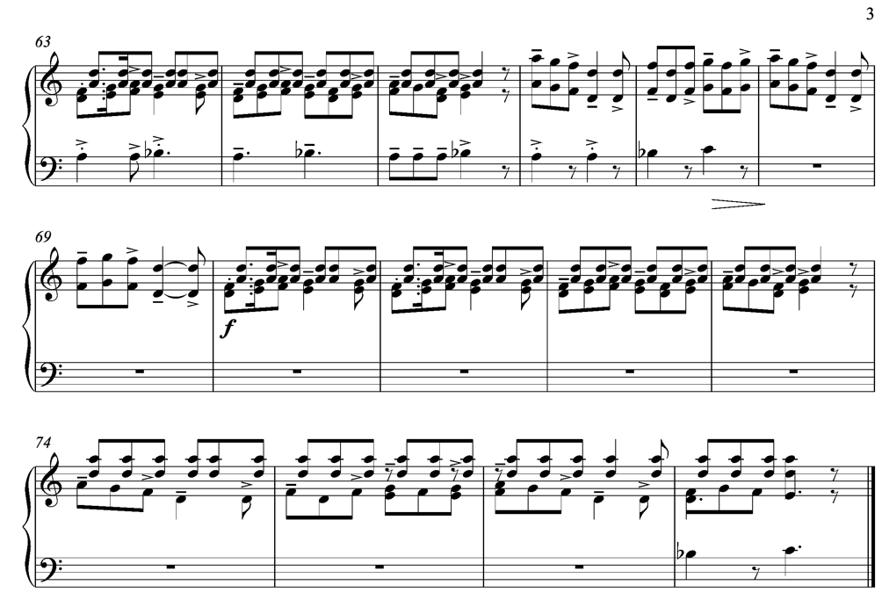

Appendix 7. Complete Score Transcriptions: ‘Brute Angels’

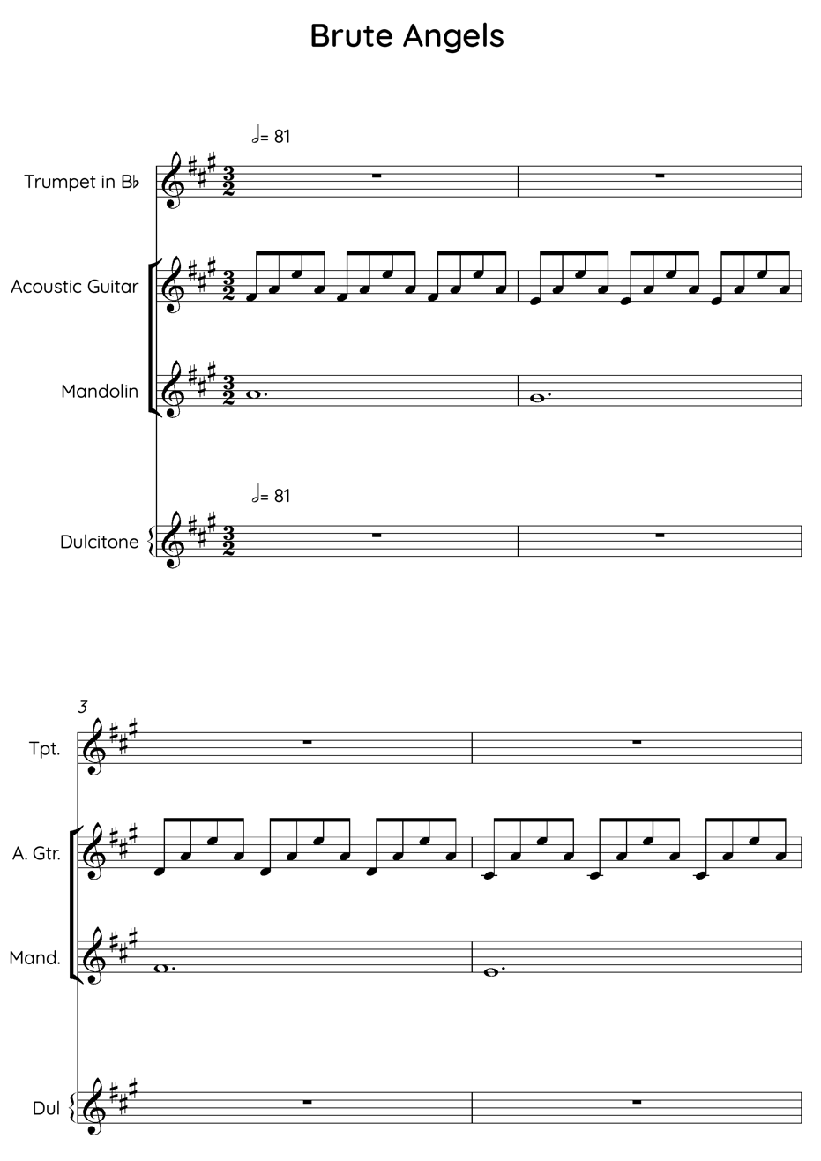
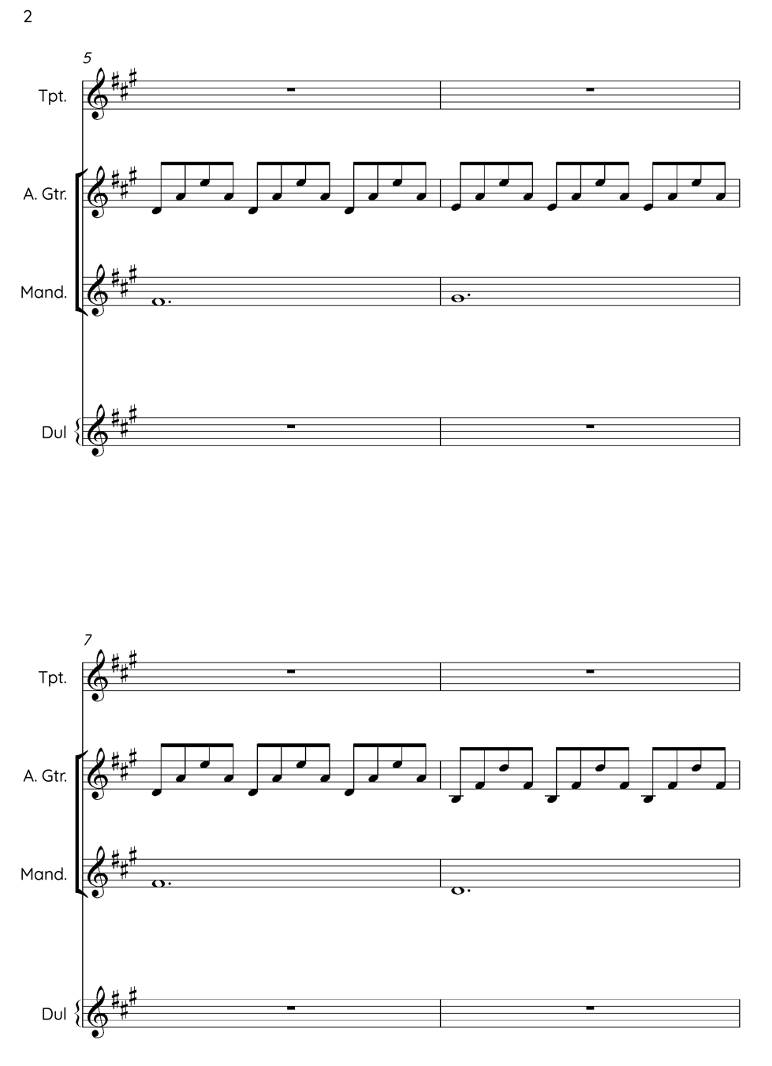

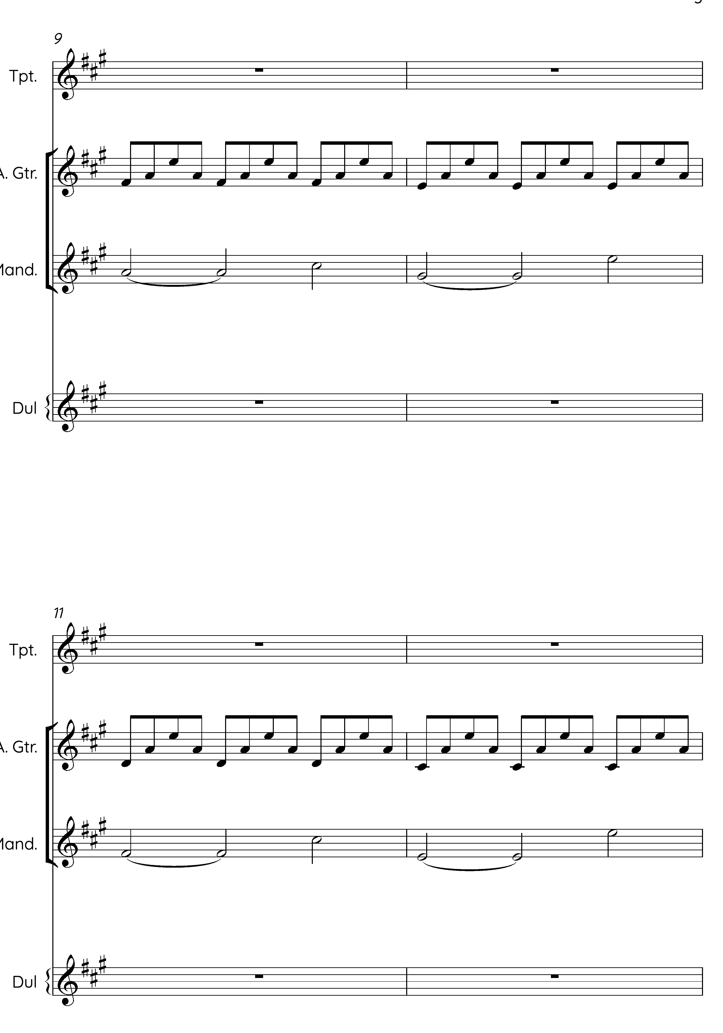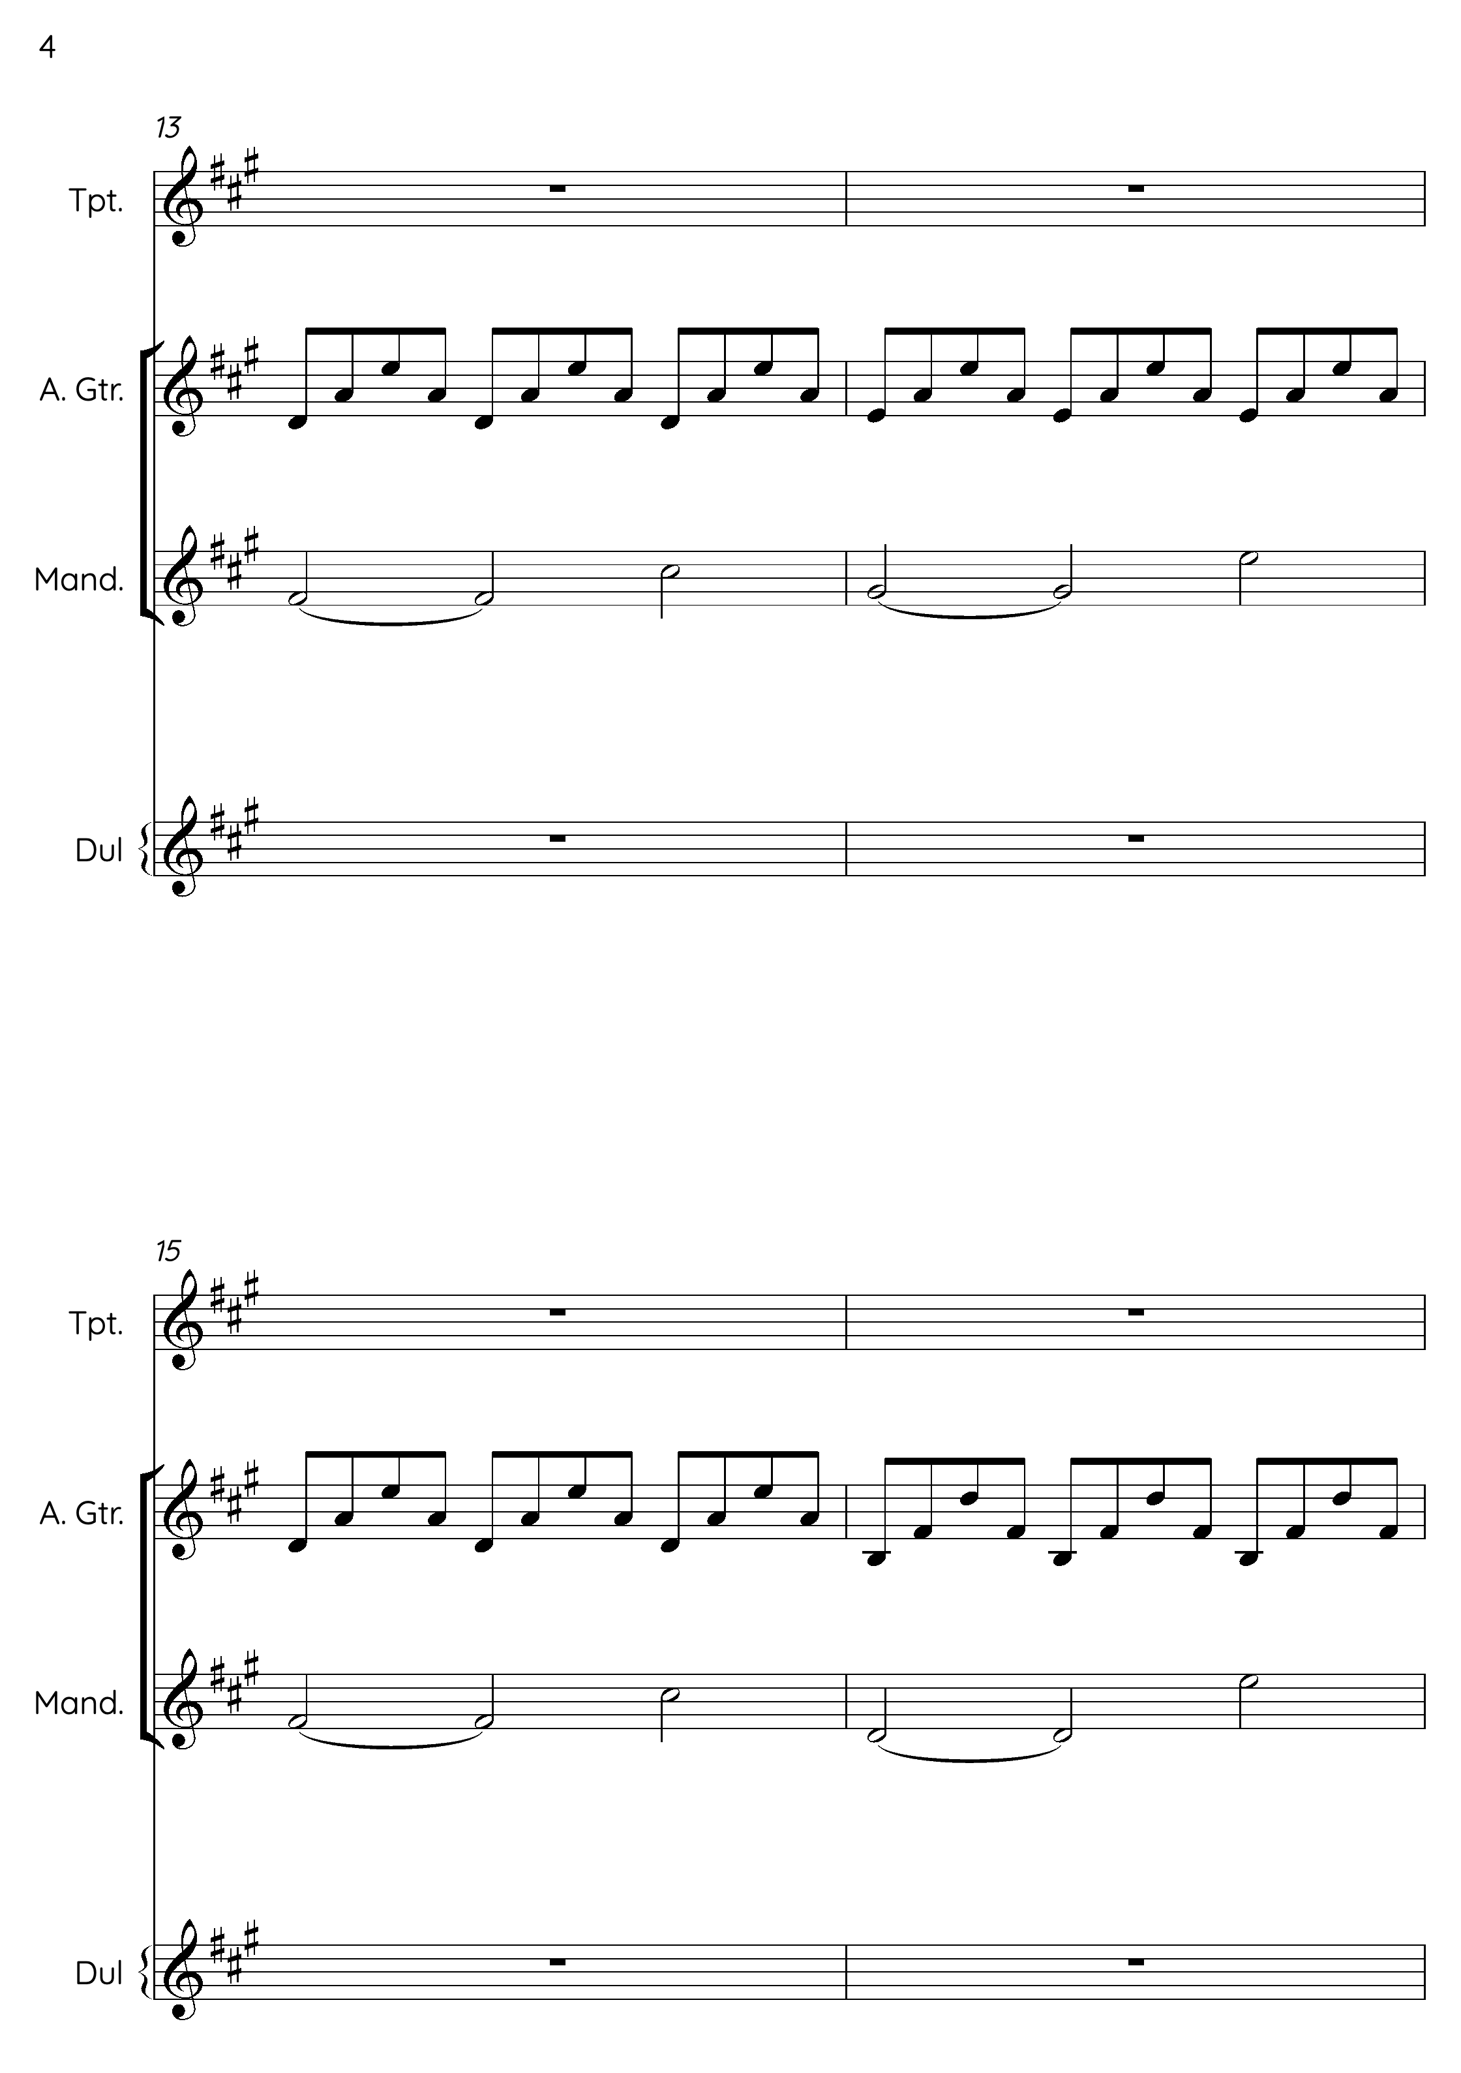
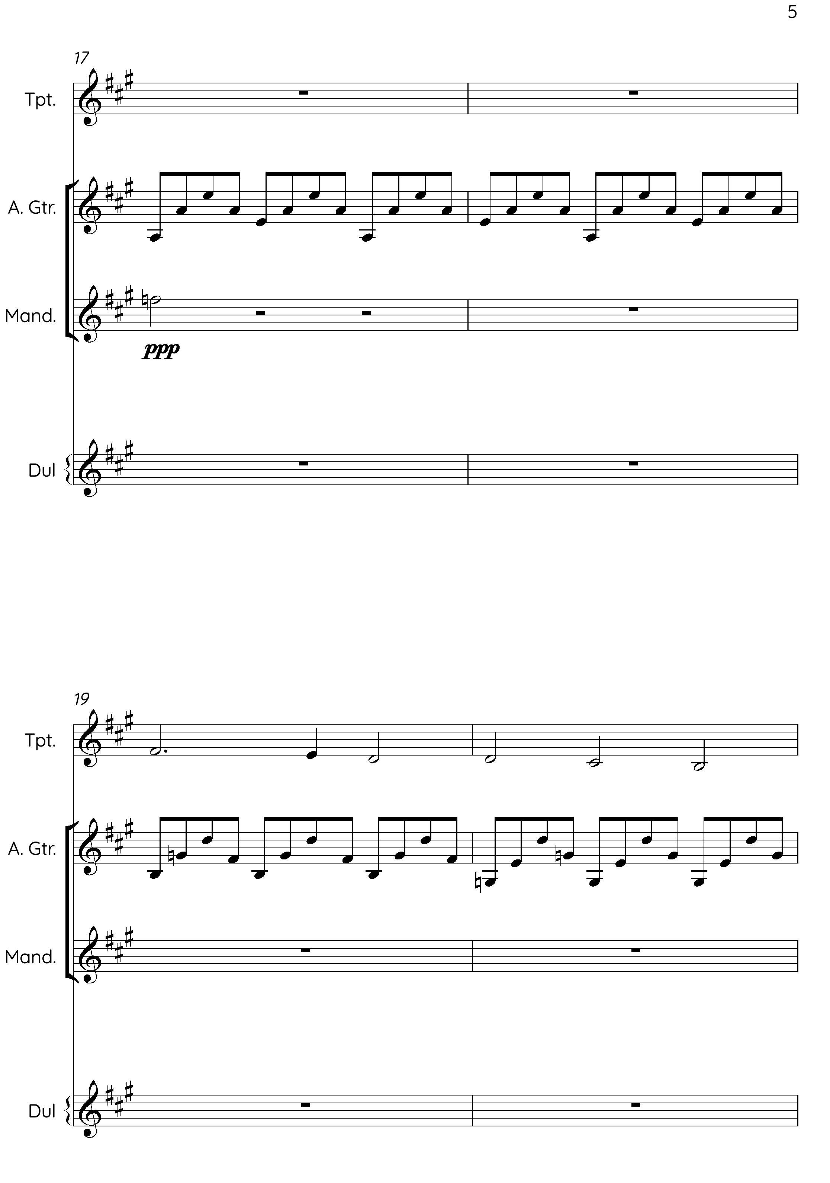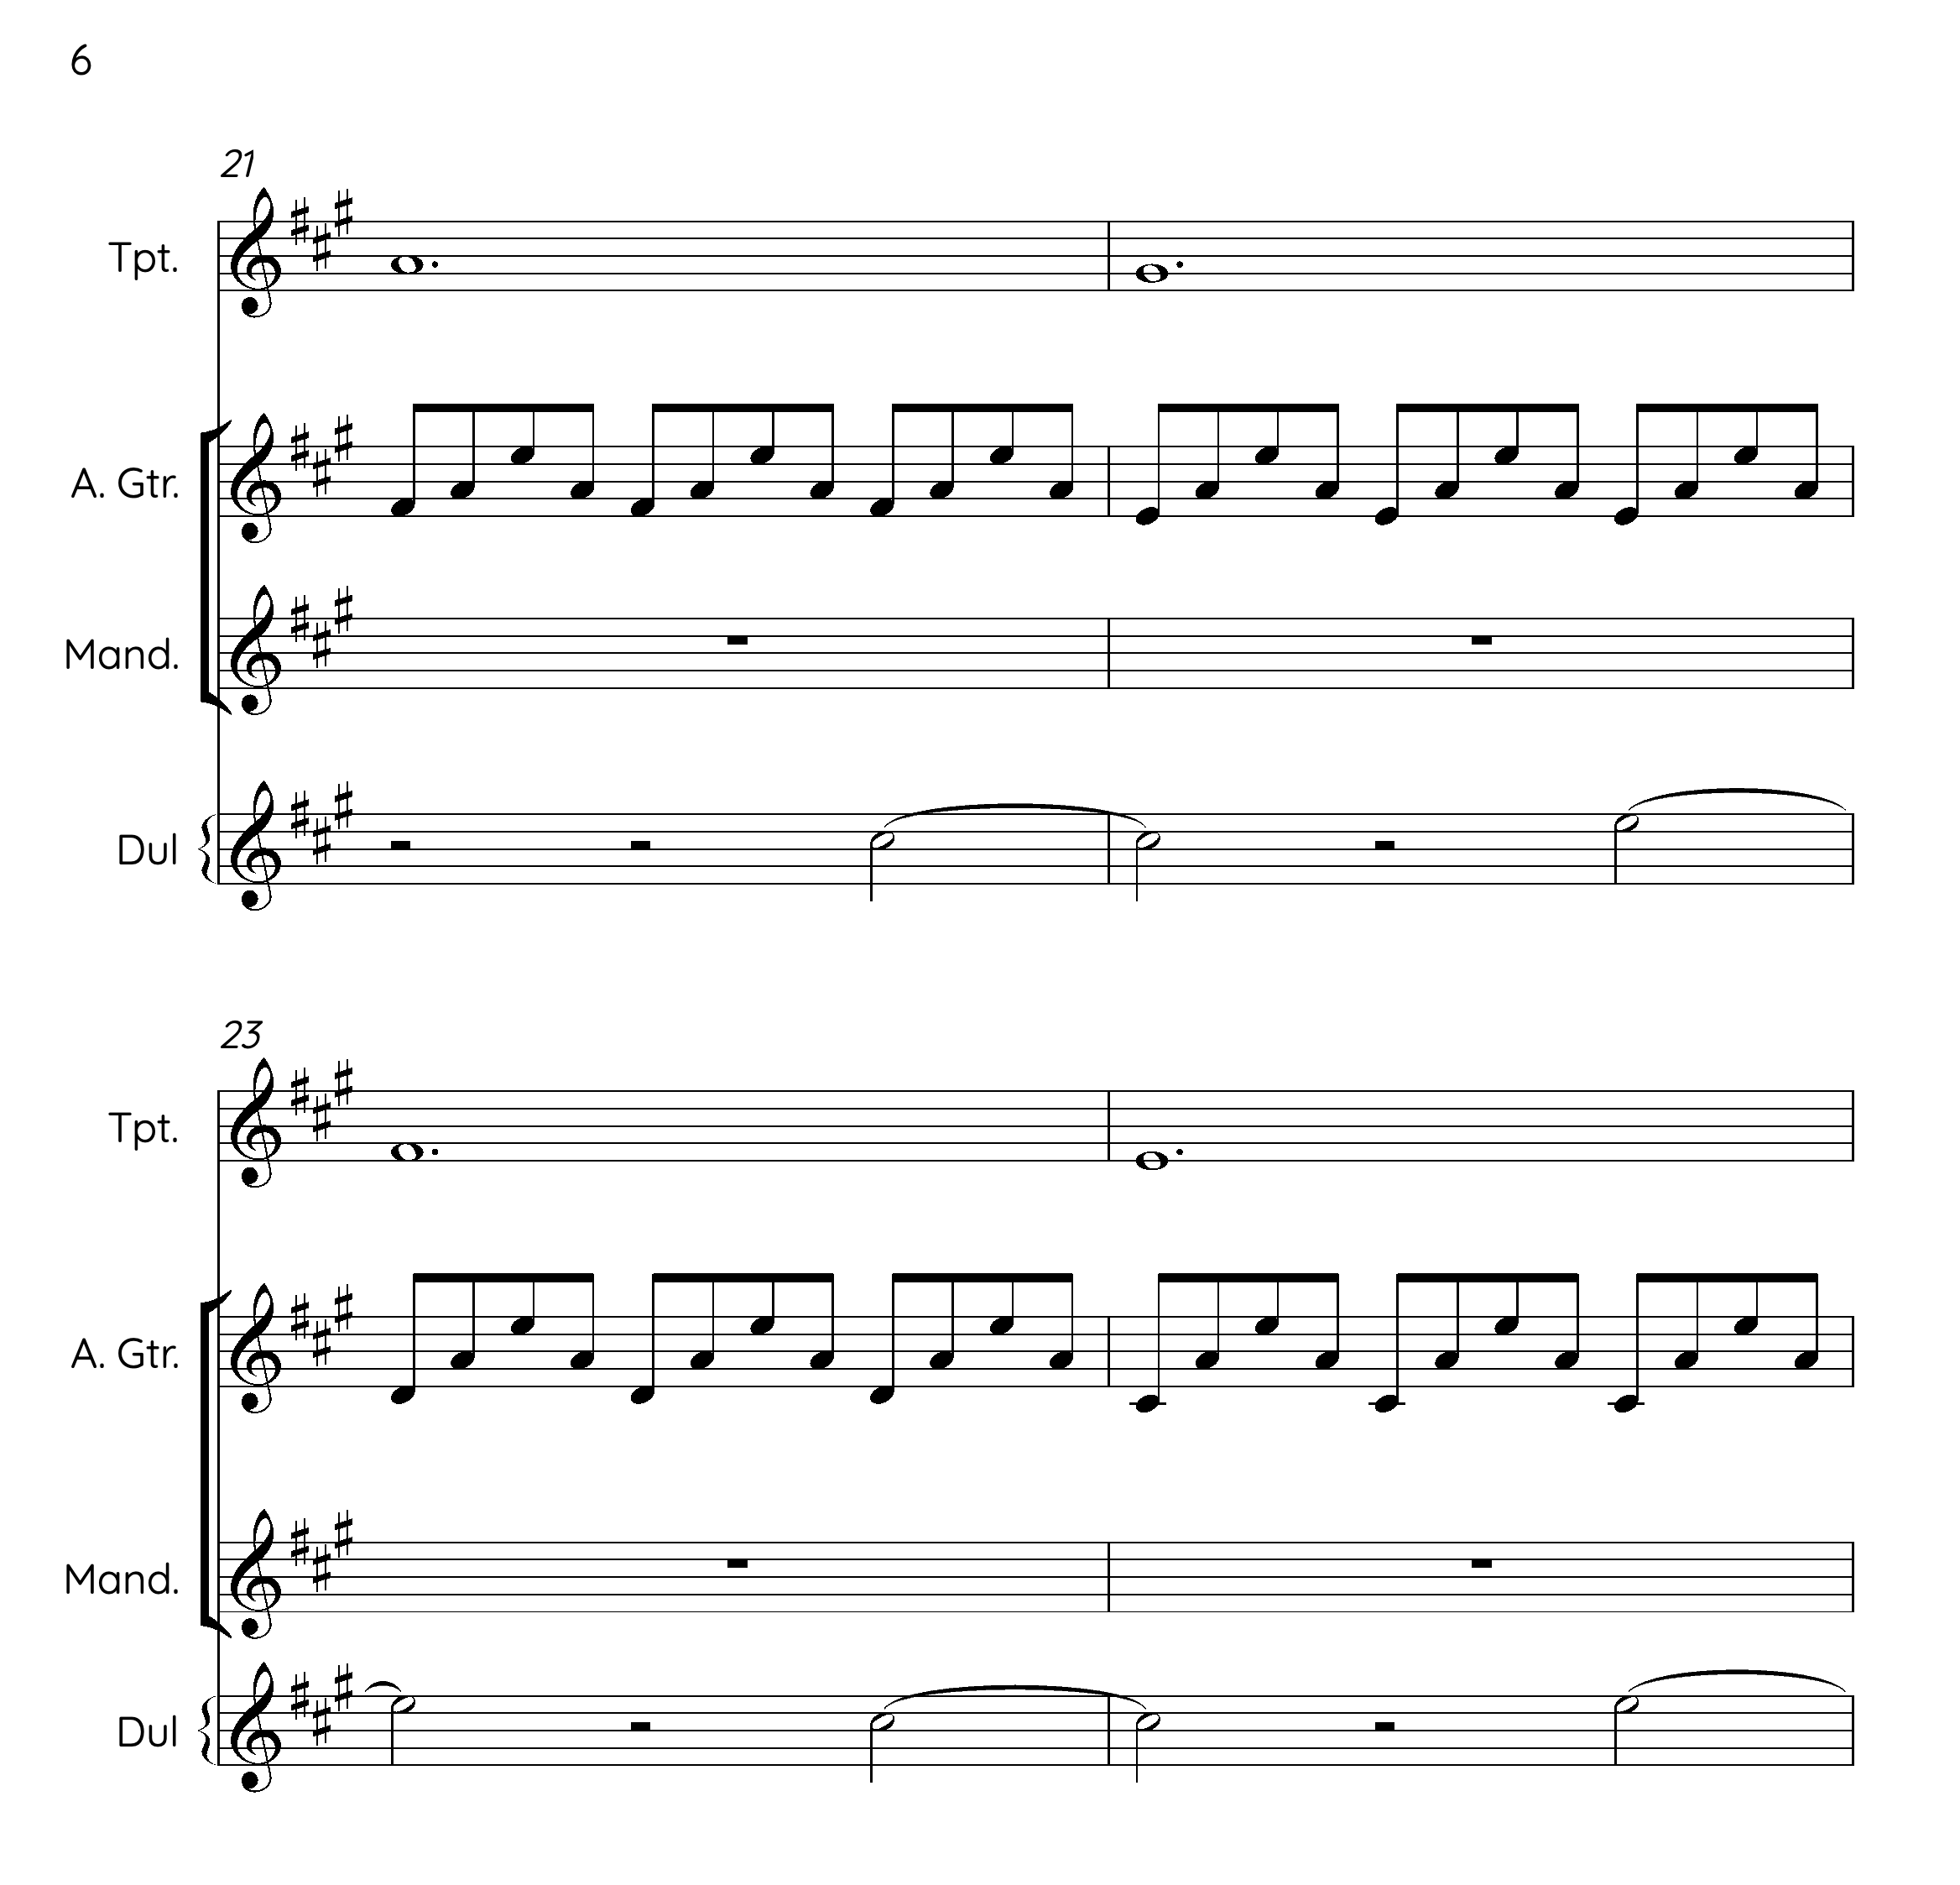
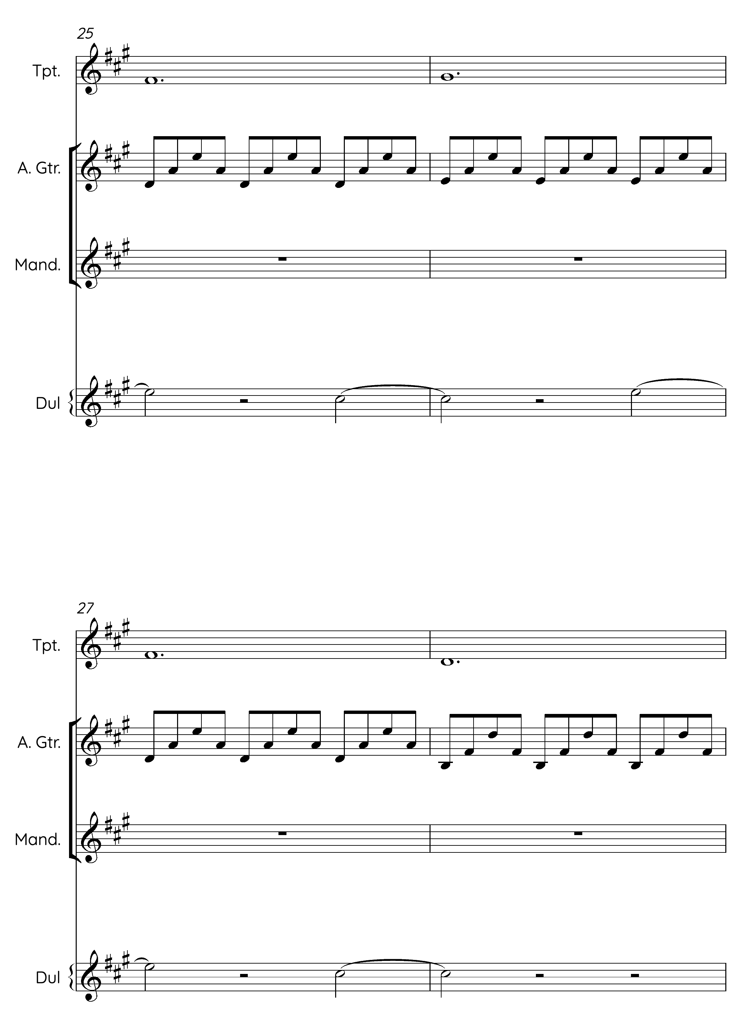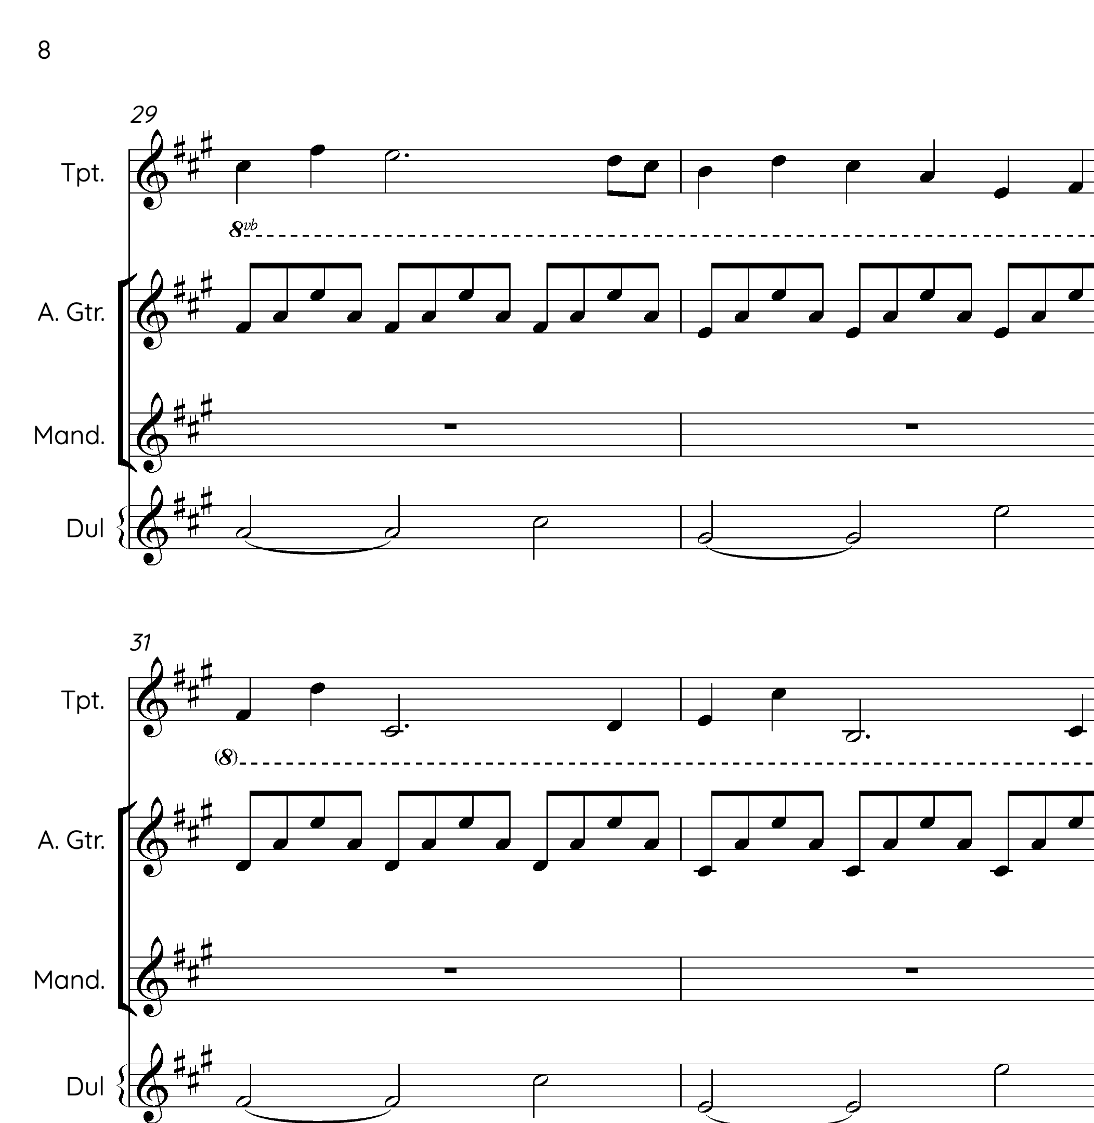
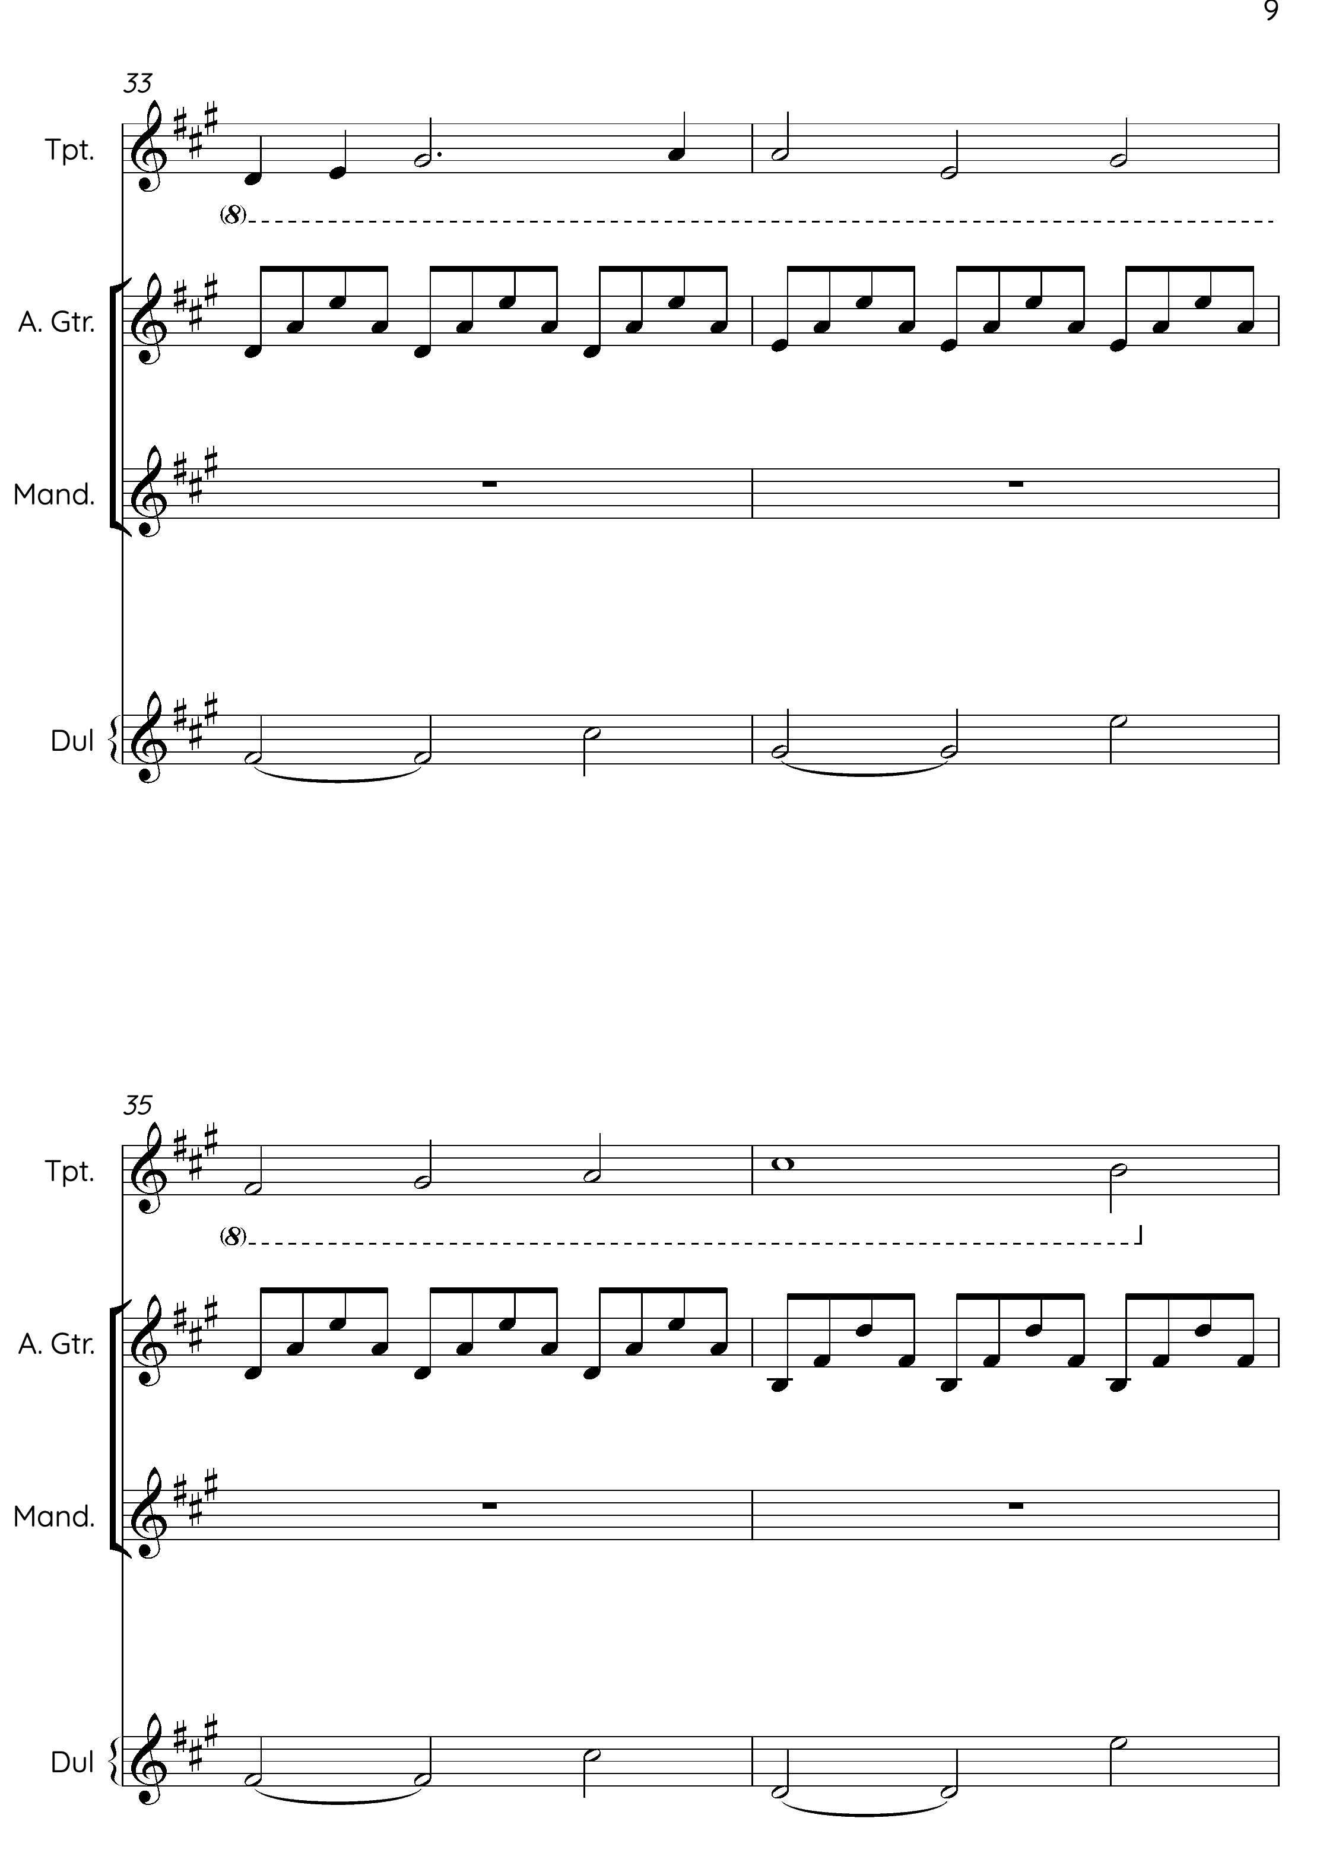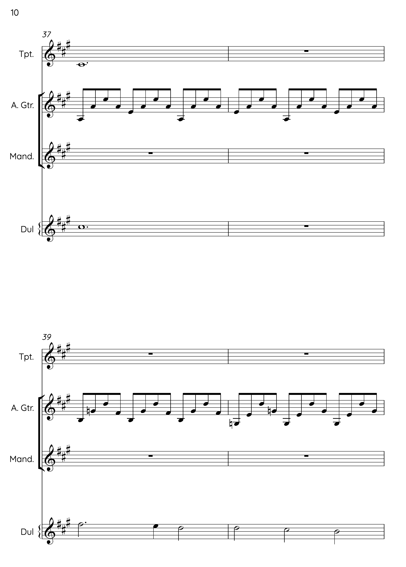
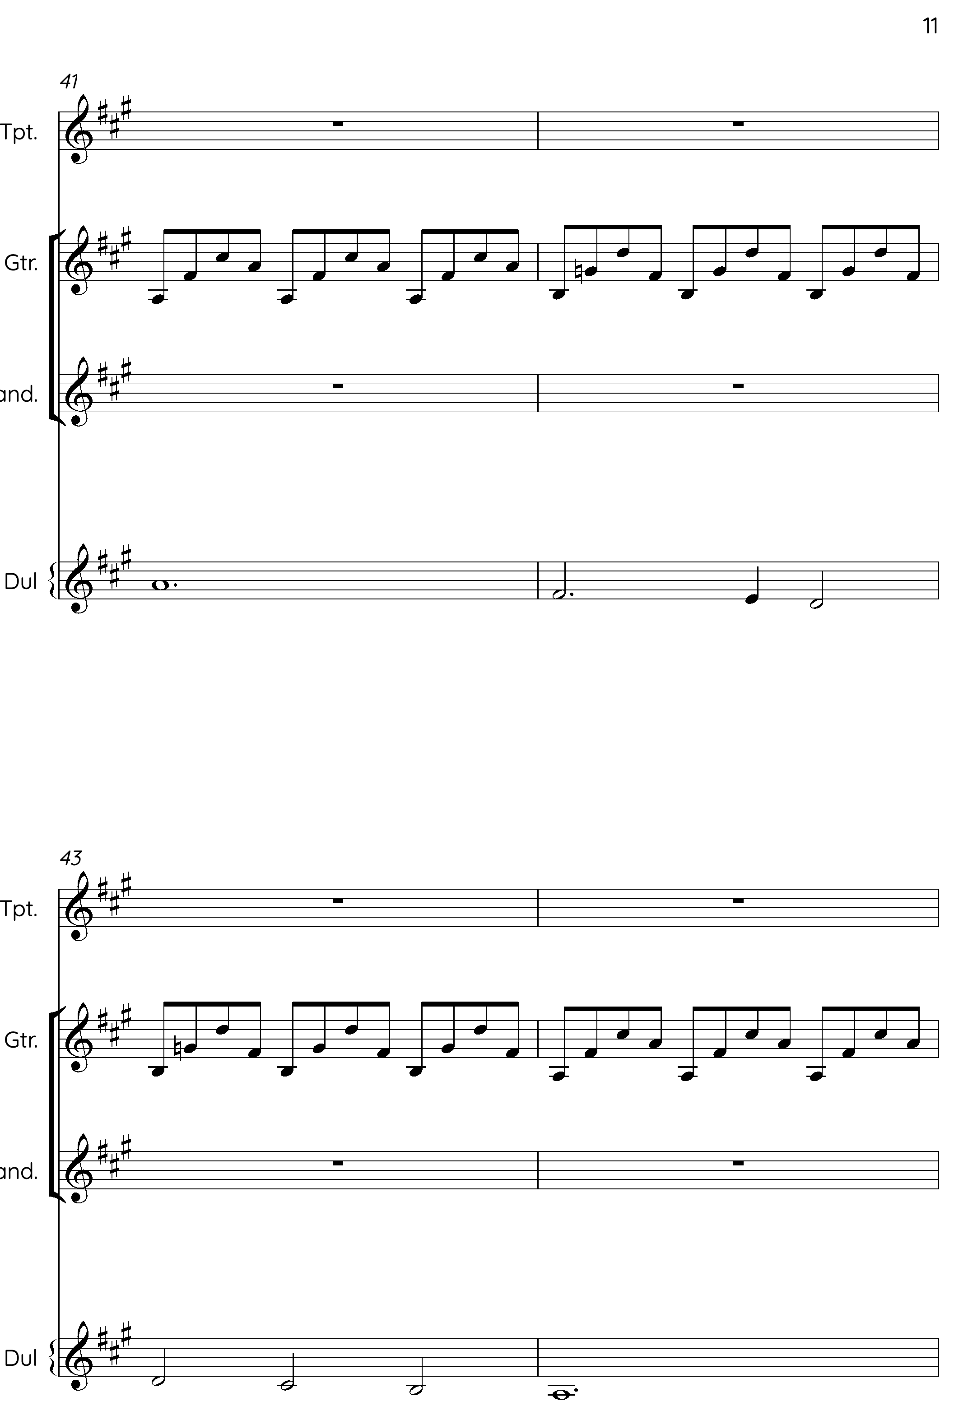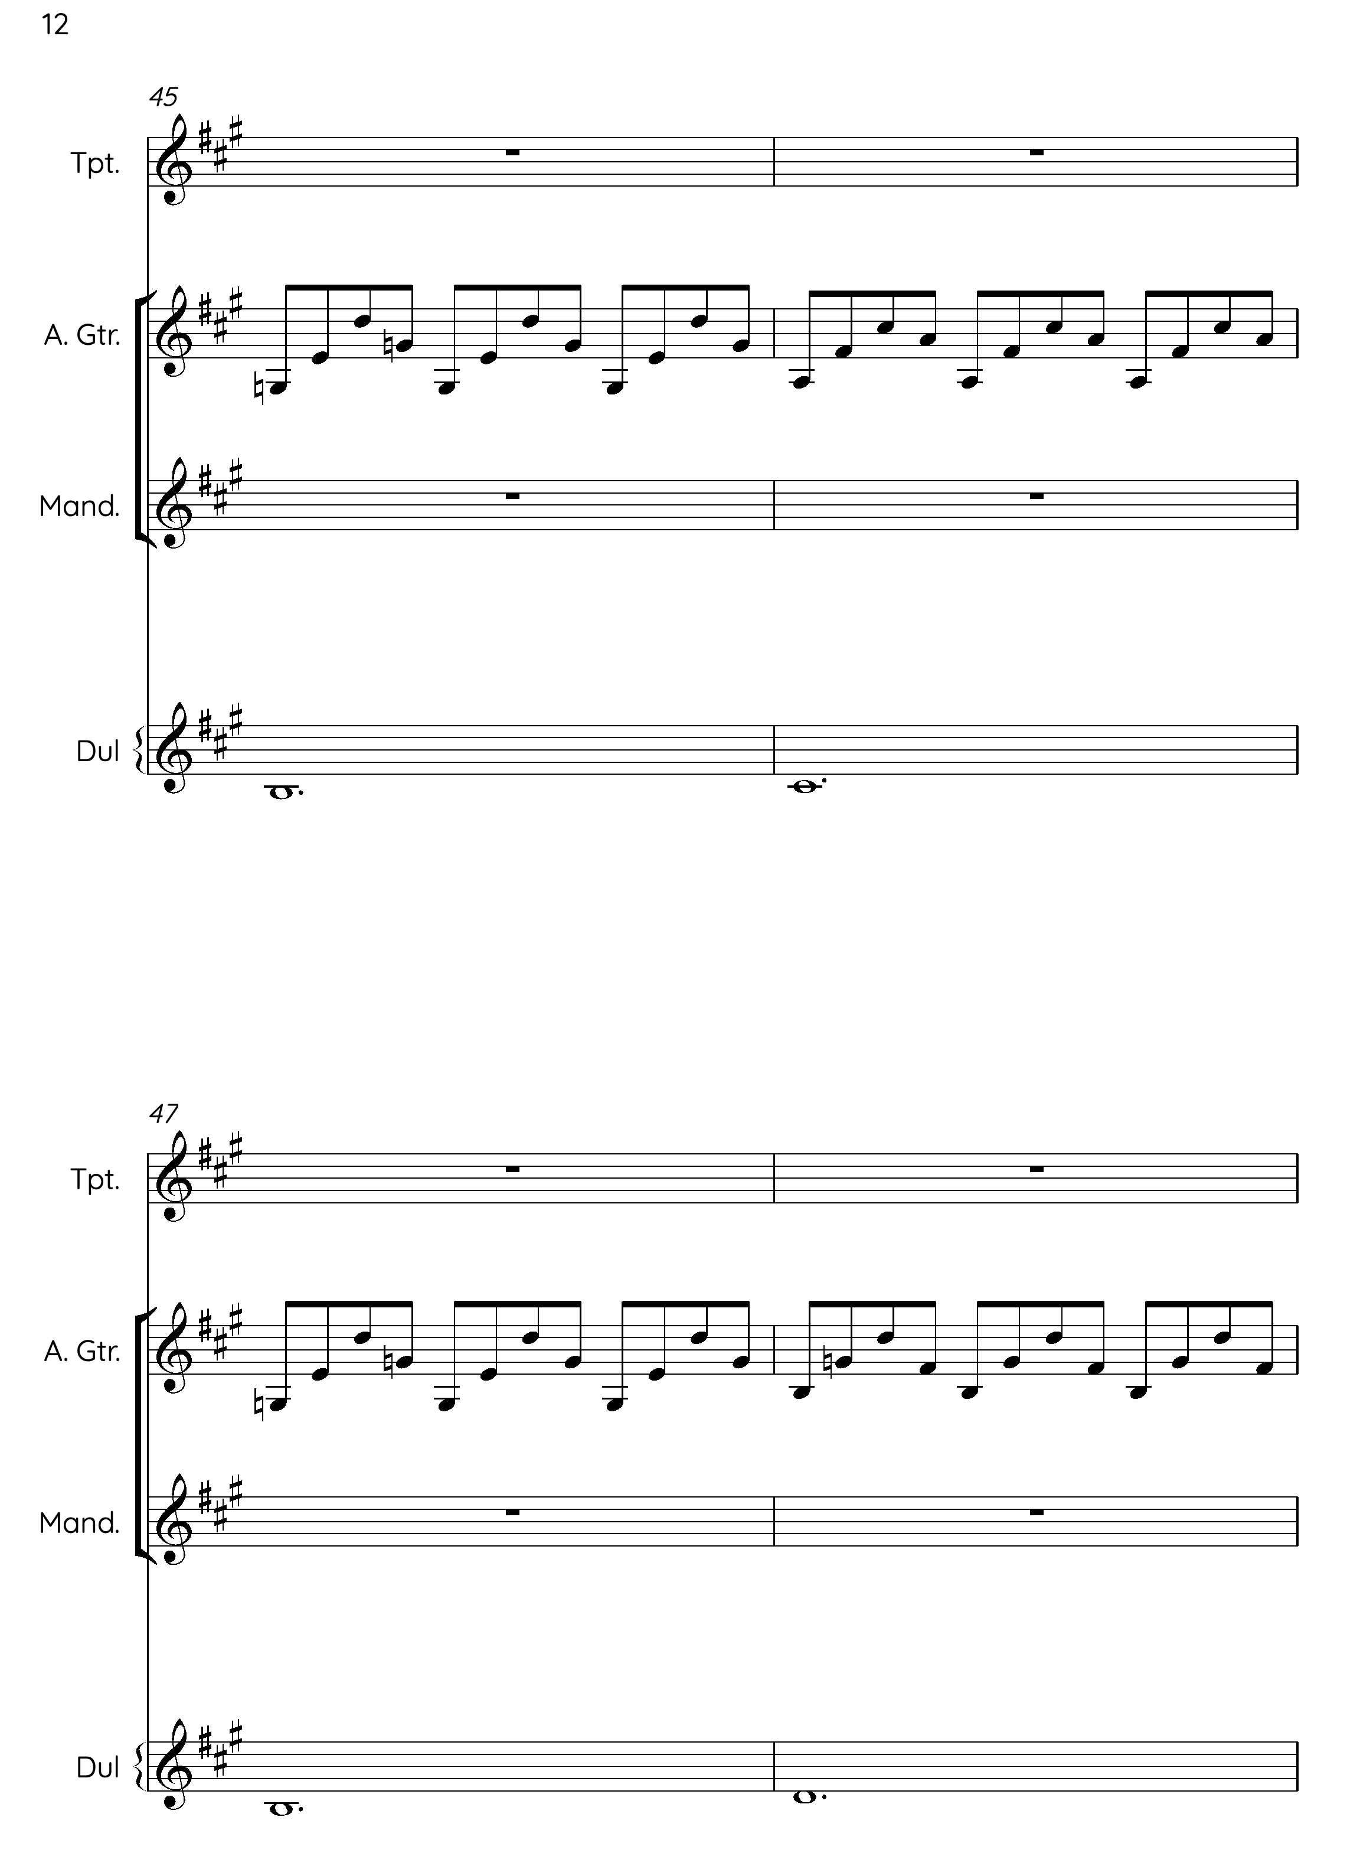
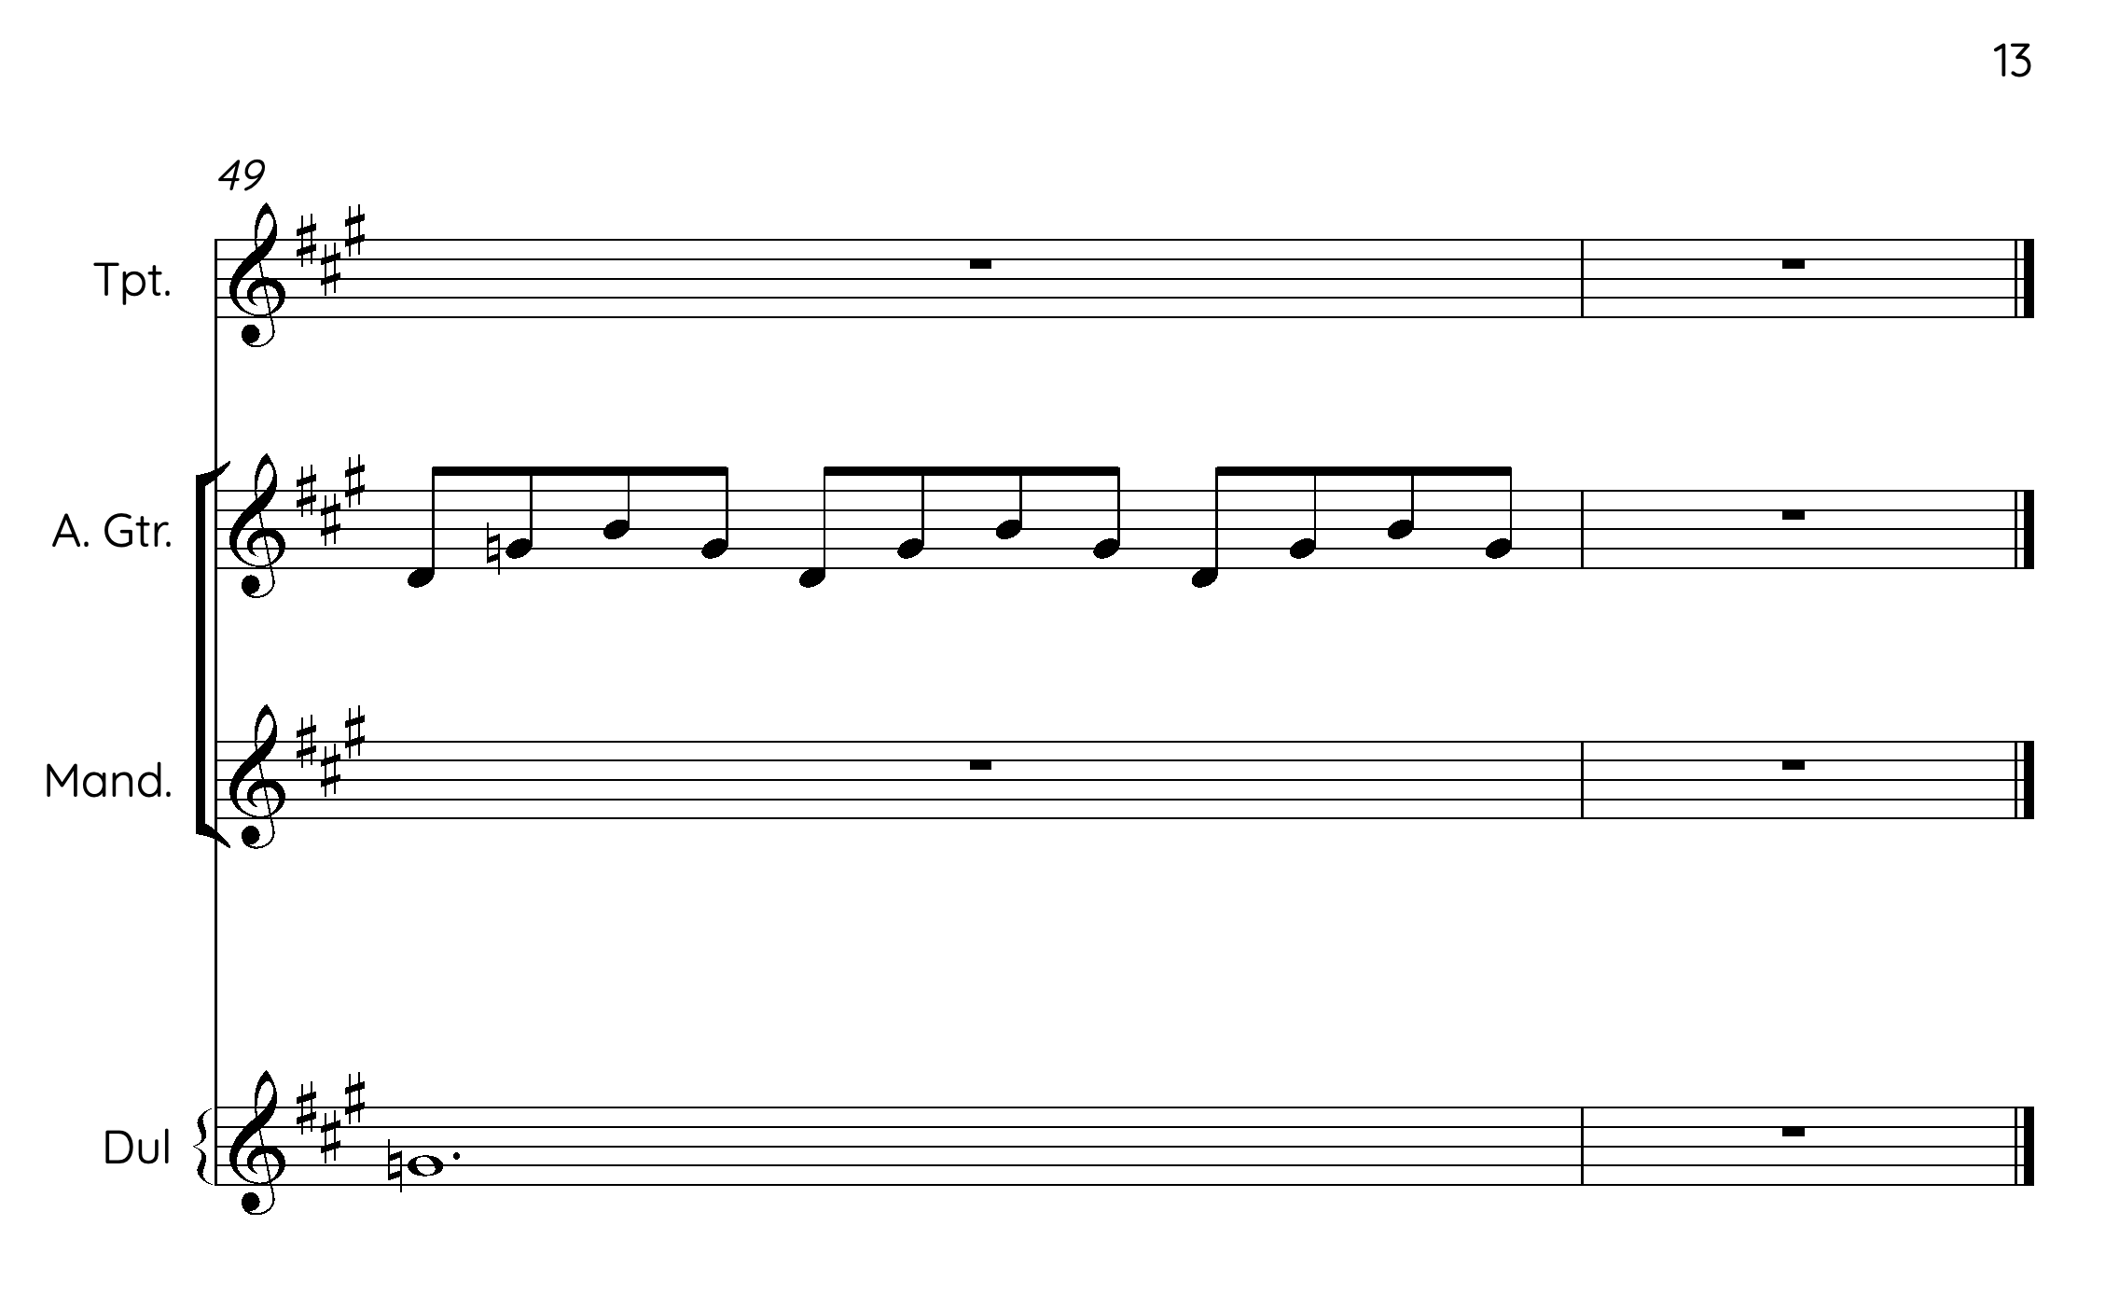

Articles such as: ‘‘Morris dancing is going through a cool period’: the strange renaissance of the English folk dance’’. https://www.timeout.com/uk/dance/morris-dancing-is-going-through-a-cool-period And ‘’The Morris renaissance: how the young and stylish are breathing new life into an ancient folk dance’’. https://www.countryfile.com/photography/morris-dancing-revival
https://playforddances.com/
https://www.vwml.org/topics/tunes
https://open-morris.org/morris-dancing/
https://www.britannica.com/science/schema-cognition
https://www.britannica.com/science/schema-cognition
See Appendix 1 for details on theory of gesture.
Referring to ‘tradition as lore’, ‘tradition as cannon’, ‘tradition as process’, ‘tradition as mass’, ‘tradition as culture’, and ‘tradition as language’, ‘tradition as performance’. Ben-Amos himself admits this is not definitive model.
See the work being done by Access Folk, Esperance, and the line-up at Cambridge Folk Festival 2023 for example.
All tunes were once composed. By traditional I mean those tunes that are deemed to be traditional by those that use them, as opposed to newly composed tunes who are clearly claimed and authored.
https://northeastfolk.wordpress.com/2015/01/26/tunes/
https://folk.org/about/
https://www.englishfolkexpo.com/about/
https://www.efdss.org/learning/resources/a-z/2515-efdss-resource-bank-creative-music-ks3-and-4
The exception being certain educational books directly linked to technique and playing, as opposed to simply repertoire books.
https://themorrisring.org/files/sheetmusic/adderburyblackjoke.pdf
https://www.efdss.org/images/present/Docs/Resource-Bank-PDF/BeginnersGuideEnglishFolkDance.pdf
This is not how jigs are played in England when played for rapper dancing which relies on a constant, even and driving 6/8 groove, which matches the stepping of the dancers.
The above box and whiskers plot, contain the following information: x = mean, The middle line = median, The box = the interquartile range (where 50% of the data points lie), The outer lines = minimum and maximum, The dots = outliers.
There are also forms of variation that can be deemed rhythmic variation, as discussed in Appendix 4.
This could also be a stylistic choice when they know they're committing this tune/arrangement to recording, meaning it might be different and more likely to change if/when performed live.
Arguably, brass instruments have always been part of the scene in England, but as a less common feature of the English folk scene. In particular, the Britannia Coconut Dancers from Bacup in Lancashire have always danced to a brass band, (now Stackstead Brass Band) which are particularly common as colliery bands in the mining areas of Industrial England. There were also the ‘Village Bands’ who featured amateur musicians who played whatever they had to hand, including brass - to accompany such things as the traditional carols at Christmas.
https://www.martingreenmusic.co.uk/love (29/2/2024)
https://www.fatea-records.co.uk/magazine/reviews/NicolaBeazley/ (29/22024)
Growing up in the Pennine town of Rochdale, which is a proud brass banding area, I have been privy to much brass banding in my youth. Rochdale Youth Brass Band was one of the best youth bands in the country, and my middle brother was the tuba player - who played in several other brass bands - so weekends were often split between folk festivals and brass band competitions.
thesession.org is a publicly edited space, whereby anyone can transcribe and upload their own versions of folk tunes from around the world. The website claims to a library of Irish folk and traditional material in particular, but in reality, the origins of many tunes are unknown, and so tunes from around the world can be searched for. The material is present using musical scores, ABC notation, and a midi recording, hinting at the fact that many participants who play folk music may not actively read musical scores. https://thesession.org/tunes/3367
‘[The] current working defection of ‘beyond tune’ is a musical composition: - Created by a traditional musician living in Scotland. - Composed for music performance or listening (e.g. not scores for radio, tv, film or theatre) - Composed for any instrumentation (or voice) but often with a traditional/folk element. - Approximately 8 minutes or longer OR, if shorter in length, innovates significantly from the conventions of traditional music (this could include free improvisation or technology-enhanced music). - NOT a conventional set of tunes or traditional/folk song’’ (https://tradmus.com, 2024)
https://oxfordslowsession.com/
https://tradfolk.co/music/music-interviews/sam-sweeney-going-solo/ (28/2/2024)
(https://www.folkmusic.net/, 12/1/2022)
This isn’t to say that amateur musicians can’t be instigators of change, in a scene with considerable overlap between the professional and amateur, they can. But they would lack the platform and therefore lack the influence that the professional has the potential to have and the impact of this would be harder to measure.
Tradition bearers is a whole section on the categorisation website Mainly Norfolk. https://www.mainlynorfolk.info/folk/records/traditionbearers.html
The idea of a folk family is also common thread, used by promoters and the media. For example, there are many families of singers that perform together, and they are often well known and sort after on the scene in England: https://www.independent.co.uk/arts-entertainment/music/music-magazine/music-magazine-features/the-dark-side-of-family-folk-music-771803.html
A term often used by promoters and media to describe artists of a certain age, caliber and often family name. https://www.leaderlive.co.uk/news/17486712.folklore-martin-carthy-king-british-folk-music-main-man/
https://klofmag.com/2016/10/an-interview-with-jim-moray/
https://www.tutorchase.com/notes/ib/psychology/3-3-1-impact-of-tradition-on-behaviour (28/2/2024)
Admittedly, despite its presumed inclusive nature, the very fact that there are so many authentic processes to be learnt and respected can be overwhelming, and act as a barrier.
https://klofmag.com/2020/03/unearth-repeat-interview-sam-sweeney/
https://en.wikipedia.org/wiki/BBC_Radio_2_Folk_Awards#:~:text=The%20BBC%20Radio%202%20Folk,radio%20station%20BBC%20Radio%202.
https://www.theguardian.com/music/musicblog/2014/feb/20/bbc-folk-awards-2014-colin-irwin
http://www.thedemonbarbers.co.uk/guest-blog-roy-bailey-bbc-radio-2-folk-awards/
Many of these artists released albums before 2000, and have a substantial back catalogue, but the remit of this thesis is from 2000.
As detailed in survey data.
http://www.spiromusic.com/newsite/?page_id=2
Such as tonality, tune type (jig, reel etc), speed and groove.
‘At a practical level, it might be argued that it is more difficult to vary the tune dramatically in these traditions due to a relative lack of ‘space’ created by the dense quaver rhythms.’ (Keegan-Phipps and Winters, 2013, p.88)
To use broad terms to describe genres that undoubtedly have a far more complex makeup than one commercialised title allows. As with the term folk scene.
It is important to note that not all musicians in Bellowhead have their upbringing in the folk world and therefore bring a plethora of influences with them.
New instrumentation across the last 15 years has seen a growth in the use of brass instruments, and the input of electronic sounds and links to the idea of chamber folk, as explored in Chapter 4.
https://www.fiddlingaround.co.uk/scandinavia/
Alan Lerwick, ‘The Kilted Fiddlers’, 1996.

