

Understanding adult self-harm in a community sample

Samina Kiran Tariq

A thesis submitted in partial fulfilment of the requirements for the Doctorate in Clinical Psychology

Clinical Psychology Unit
Department of Psychology
The University of Sheffield

December 2024

Declaration
This thesis has been submitted for the award of Doctorate in Clinical Psychology at the University of Sheffield. It has not been submitted to any other institution, or for the purpose of obtaining any
other qualifications.

Structure and Word Counts

Section One: Literature Review
Excluding references and tables - 7997
Including references and tables - 13,057

Section Two: Research Report
Excluding references and tables - 7886
Including references and tables - 10,211
Total Word Count (combining lay summary, literature review and research report)
Excluding references and tables – 15,883
Including references and tables – 23,268

Lay Summary
Literature Review Self-harm is a global public health phenomenon, and repeated self-harm is evidenced as a key risk factor for suicide and death. Understanding the reasons for self-harm can present the opportunity to offer effective interventions. To understand the self-reported reasons for self-harm, a qualitative evidence synthesis using a ‘best fit’ framework was completed. Three electronic databases were searched for relevant studies, with 16 meeting the inclusion criteria for analysis. The synthesis revealed 12 functions of self-harm which were grouped under three broad themes: self-harm helped manage and shift distressing emotional states, self-harm was a positive experience, and self-harm defined the self by connecting the physical with the personal (values and beliefs). Recommendations included person-centred formulations that consider the multifaceted functions of self-harm, so that interventions offered are meaningful and in alignment with idiographic goals.
Empirical Report Self-harm literature largely provides insight into the population of individuals who report to emergency care services, with less being known about unreported self-harm that remains hidden at a community level. To highlight the significant amount of the population it affects and how little is known about their experiences, self-harmers in communities are epitomised as the submerged part of an iceberg. This qualitative study explored the self-harm experiences of 23 adults who accessed support from the voluntary, community and social enterprise sector (VCSE). Reflective thematic analysis revealed two overarching themes: meaning behind the cuts, and a matter of life and death. Recommendations included promoting better understanding of self-harm in community and clinical settings.

Acknowledgements
My deepest gratitude to the research participants who shared their personal experiences of self-harm, trusting the research team with their stories. Your openness and honesty have been invaluable in deepening our understanding of this complex issue. Your voices have contributed to meaningful research that will help inform better support and interventions for others. Thank you for your courage and generosity in sharing your experiences.
I am very grateful for the invaluable support and guidance I have received from my research supervisor, Vyv Huddy. Your insights, encouragement, and expertise have been instrumental throughout this journey, and I truly appreciate your time and dedication. I would also like to extend my gratitude to Joe Hulin for generously sharing his knowledge on self-harm research. Your contributions have been incredibly helpful in shaping my understanding and approach to this important topic. Thank you both for your support and mentorship.
Warmest thanks to my fellow D.Clin. trainees, the academic team, my clinical tutor, Kate Raynor, and the Disability and Dyslexia Support Service, for your encouragement and support. Your guidance, camaraderie, and belief in my abilities have played a significant role in my growth, both personally and professionally. The learning, shared experiences, and collaborative spirit have not only shaped my confidence but have also made this journey all the more meaningful. I am truly grateful for the inspiration and kindness you have shown me along the way.
To my dearest parents, family and friends, thank you for your unwavering love, grace, and endless support. Your kindness, encouragement, and belief in me have been my anchor through every challenge.

Table of contents
Declaration ii
Structure and Word Count iii
Lay Summary iv
Acknowledgements v

Section One: Literature Review …………............................................................................................1
Abstract ..............................................................................................................................................2
Introduction .......................................................................................................................................3
Method ..............................................................................................................................................4
Results ................................................................................................................................................9
Discussion.........................................................................................................................................22
Conclusion ........................................................................................................................................32
References ........................................................................................................................................40

Section One Tables
Table 1.1: Descriptive framework of self-reported reasons for self-harm …………………………………………..6
Table 1.2: Inclusion and exclusion criteria…………………………………………………………………………………………11
Table 1.3: Table of Extracted Data Characteristics…………………………………………………………………………….17
Table 1.4: Commonly self-reported non-suicidal reasons for self-harm found in qualitative studies…22
Section One Figures
Fig 1.1: PRISMA diagram………………………………………………………………………………………………………………….14
Section 1 Appendices
1.1: A Priori Framework ……………………………………………………………………………………………………………….50
1.2: Descriptive Framework …………………………………………………………………………………………………………51
1.3: Spider Tool for Qualitative Evidence Synthesis ……....................................................................52
1.4: CASP Template ...........................................................................................................................53
1.5: CASP Qual Results ......................................................................................................................59
1.6: Summary of Functions from Reviewed Studies ……………………...................................................63
1.7: Extract from Studies ……………………............................................................................................65
1.8: Reflective Journal Excerpts........................................................................................................66

Section Two: Research Report .......................................................................................................67
Abstract ............................................................................................................................................68
Introduction .....................................................................................................................................70
Method ............................................................................................................................................75
Results ..............................................................................................................................................80
Discussion.........................................................................................................................................91
Conclusion........................................................................................................................................96
References .......................................................................................................................................97

Section Two Tables
Table 1: Demographic characteristics of participants………………………………………………………………………..81
Table 2: Themes and contributions to themes by participant……………………………………………………………82
Table 3: Identified themes and sub-themes with supporting notes…………………………………………………..83

Section Two Figures

Figure 1: Iceberg model of self-harm and suicide…………………………………………………………………………….71
Figure 2: Map of themes and explanatory sub-themes…………………………………………………………………….83

Section Two Appendices ……………………………………………………………………………………………………………106
2.1: Iceberg Model of Suicide and Self-harm..................................................................................106
2.2: Ethics Approval Letter for Primary Study .................................................................................107
2.3: Ethics Approval for this Study ..................................................................................................108
2.4: Participant Information Sheet .................................................................................................109
2.5: Participant Consent Form ........................................................................................................114
2.6: Interview Guide .......................................................................................................................115
2.7: Analysis Excerpts …………………………………………………………………………………………………………………117
2.8: Reflective Journal Excerpts ......................................................................................................121

Section One: Literature Review
Self-reported accounts on non-suicidal reasons for self-harm: A ‘best fit' framework
synthesis

Abstract

Objective
Research highlights that repeated self-harm is a higher risk factor for suicide. However, there is also a growing understanding that not all self-harm is intentional suicide. Understanding the reasons for self-harm, other than suicide, can present the opportunity to offer effective person-centred interventions. This review aimed to synthesise present literature on the self-reported reasons for non-suicidal self-harm.

Method
A systematic search strategy of Medline, PsycINFO, and Scopus produced 16 studies that met inclusion criteria and examined the self-reported reasons for self-harm.

Results
All eligible studies were qualitative, peer-reviewed empirical studies, appraised and analysed using a ‘best-fit’ framework synthesis. The synthesis revealed 12 functions of self-harm which were grouped under three broad groups: response to distress, a positive experience, and defined the self.

Conclusions
Self-reported accounts of self-harm revealed that regulating emotions was a prominent reason for self- harm. However, there were also a number of self-affirming and positive functions of self-harm reported by participants. Recommendations included person-centred formulations that consider the multifaceted functions of self-harm, so that interventions offered are meaningful and in alignment with idiographic goals.

Practitioner points:

- People self-harm to regulate emotions, but this is idiosyncratic and might obscure the purpose of the self-harm
- Self-harm can resonate with a person’s sense of self and personal values, and therefore, clinicians should take care when encouraging behaviour change
- To maximise better treatment outcomes, interventions for self-harm need to be person-centred and aligned to a person’s idiographic reasons for self-harm
Keywords: Self-harm, non-suicidal self-injury, ‘best-fit’ framework synthesis, qualitative

Introduction
Self-harm is a global public health phenomenon with an estimated 14 million episodes reported per year (Moran et al., 2024). The prevalence is believed to be higher, as many individuals who self-harm do not report to services (Geulayov et al., 2018; McManus et al., 2019). Repeated self-harm is evidenced as a key risk factor for suicide and death (Hawton, 2015; Mayor, 2019). The prevalence of self-harm and its associated risks highlight the severity of the problem, while understanding the reasons for self-harm informs policy and practice interventions.
A key difficulty in understanding the reasons for self-harm stems from the lack of agreement about terminology, and also which behaviours constitute self-harm. In current literature on self-harm, the two most prominent terms used are ‘self-harm’ and ‘non-suicidal self-injury’ (Doyle, et al., 2017). Non-suicidal self-injury (NSSI) is used in the DSM-5 in US-based research (Hawton et al., 2012) and refers to the direct, intentional destruction of one’s own body tissue without intent to die (Nock, 2009). Within the UK, the National Institute for Health and Care Excellence (NICE, 2022) uses the term ‘self-harm’, which incorporates self-injury and goes further to include self-poisoning, not distinguishing the act in terms of intent to die. Conversely, distinguishing the intent behind the behaviour may not always be clear (Kapur et al., 2013) and the behaviours may change over time (Owens et al., 2015). This review uses the term self-harm, which is in keeping with UK based research on self-harm.
Literature on self-harm has progressed from framing self-harm within the context of suicide, in which self-harm is understood as an attempt to end life (Millard, 2024) to understanding the meaning behind the behaviour (Barnow & Linden, 1997). Functional models of self-harm emerged to examine the motivation for non-suicidal self-harm (Steele et al., 2023). Literature exploring self-harm from a functional perspective is based on the principle that self-harm is a meaningful behaviour that has a motive and serves a purpose (Claes & Vandereycken, 2007). Prominent reviews on the functions of self-harm have provided evidence-based and theoretically-informed insights into the functions of self-harm.
Suyemoto (1998) organised the clinical and research literature theoretically and identified six functional models of self-harm. The Affect Regulation model (Favazza, 1996) posits that self-harm is a means through which an individual manages or regulates intense emotional states. The Anti-suicide model cites self-harm as a protective factor against death (Himber, 1994). The Boundaries model (Carroll et al., 1980) posits the individual self-harms to cite themselves as a separate being in relation to others, which can be a response to a fear of abandonment. The Dissociation model (Gunderson, 1984) suggests self-harm helps an individual connect the physical self with the emotional self through physical stimuli and can also be used to reverse this effect. The Environmental model is influenced by social learning theory (Bandura, 1973), in that individuals harm themselves due to earlier experiences of harm, i.e. being physically reprimanded for doing something wrong, or being exposed to harm and abuse from an early age. The Sexual model (Daldin, 1990) cites the function of self-harm as sexual gratification or punishing sexual feelings or actions.
Klonsky (2007) developed Suyemoto’s (1998) work further by undertaking an empirical review of 18 studies which revealed supporting evidence for five of the six functions of self-harm described by Suyemoto (1998) (except the sexual model) and incorporated another two functions - sensation seeking and self-punishment. The Sensation-seeking model (Shearer, 1994) suggests self-harm offers a thrill-like stimulus. The Self-punishment model (Linehan, 1993) of self-harm posits the act as expressing anger and self-hatred. Nock (2009) devised a four functional model proposing that self-harm served interpersonal or intrapersonal functions that were either seeking positive or negative reinforcement. Clearly, there are a wealth of models explaining non-suicidal reasons for self-harm, with the discussion being limited to the most prominent models.
Edmondson et al. (2016) undertook the first systematic review to identify the functions of self-
harm as reported by individuals who self-harm. A novel synthesis approach - ‘best fit” framework method was utilised to allow expansion of existing published models (Carroll et al., 2013). Edmondson et al. (2016) reviewed the prominent existing models of self-harm, namely from the work of Suyemoto (1998), Klonsky (2007), and Nock (2009) and derived eight functions of self-harm: managing distress or affect regulation; interpersonal influence; punishment; managing dissociation; sensation-seeking; averting suicide; expressing and coping with sexuality; and maintaining or exploring boundaries. These eight functions informed the a priori framework against which they reviewed existing literature up until February 2015 (Appendix 1.1). The review endorsed the eight functions in the priori framework and identified a further seven additional reasons for self-harm: gratification, sense of personal mastery, a personal language, sense of belonging, self-validation: strength/toughness, protection of self and others, and experimental. The themes were clustered under three overarching themes: responding to distress, self-harm as defining the self, and self-harm as a positive experience. Table 1.1 presents the Edmondson et al. (2016) descriptive framework of self-reported reasons for self-harm and Appendix 1.2 provides an overview of these themes alongside prominent models on the functions of self-harm.

Table 1.1
Edmondson et al. (2016) Descriptive framework of self-reported reasons for self-harm
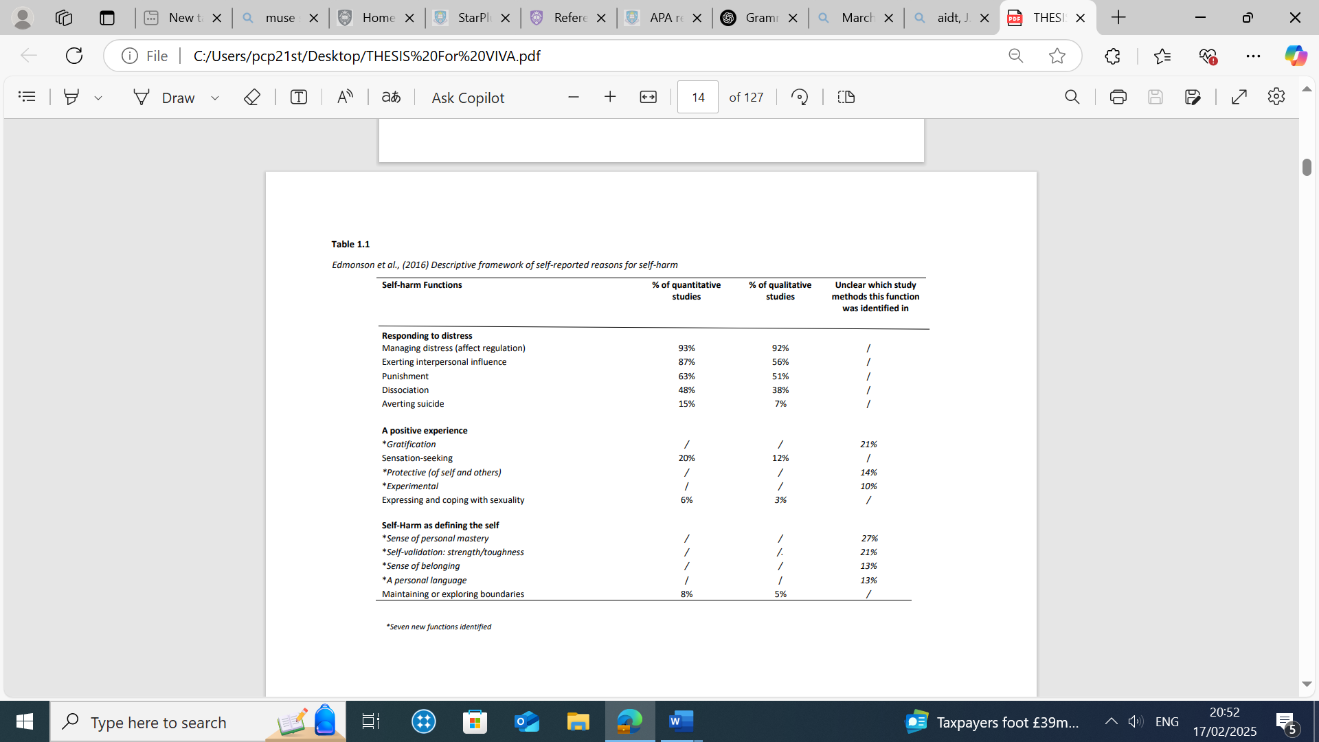

The Edmondson et al. (2016) review expanded our understanding of the reasons for self-harm by synthesizing research that highlights the diverse and complex functions this behaviour serves. The review provided insights into the lived experience of individuals who engage in this behaviour, which helped shift the discourse from viewing self-harm as a problematic behaviour rooted in personal distress to recognizing it as a personally meaningful and positive behaviour (Bryant et al., 2021; Wand et al., 2018). Understanding the way individuals describe and make sense of their self-harm experience is critical to guiding psychological formulation, tailoring therapeutic interventions to individual needs, and increasing the likelihood of positive outcomes for individuals (British Psychological Society, 2011).
Given that research into self-harm is evolving, an updated meta synthesis of the Edmondson et al. (2016) review on the functions of self-harm would enrich our understanding of the current population’s reasons for self-harm. Clinical Psychology emphasizes the importance of collaborative, individualized formulations (Johnstone & Dallos, 2014). An updated meta-synthesis would reinforce the need for service-user-informed perspectives on self-harm, ensuring that formulations incorporate the language and meanings used by individuals with lived experience, rather than imposing externally constructed models.
Whilst there have been reviews reporting on the functions of self-harm that have captured prevalence, these have included quantitative studies (Giles et al., 2018; Taylor et al., 2018). Arguably, these reviews do not permit achieving an in-depth understanding of the lived experiences of self-harm that qualitative studies facilitate given their exploratory approach (Carroll, 2017).
Since the publication of the Edmondson et al. (2016) systematic review, almost a decade ago, the prevalence of self-harm has continued to rise (McManus et al., 2019). Recent studies have identified the rapid development of the online space as being a significant contributing factor in this increase (Haidt, 2024). Sharing of content in relation to self-harm (chats, photos, videos or live-streaming) has been found to influence others to do the same, with motivating factors identified such as being part of a community, finding it fun, competing with others who self-harm, a pleasurable experience, or a reasonable behaviour (Arendt et al., 2019; Gámez-Guadix et al., 2022; Susi et al., 2023). Furthermore, the use of algorithms by social media platforms risks individuals becoming continuously exposed to self-harm related material, which can trigger individuals to self-harm or can make disengagement from this content difficult, and further increase self-harm.
Research suggests that digital self-harm became more prevalent during COVID-19 due to increased online activity and the need for alternative coping strategies (Cheng et al., 2023; John et al., 2021; Marchant et al., 2017). Furthermore, pandemic-related stressors such as social isolation, uncertainty, and disruptions to daily routines were cited as having altered the way individuals engage in and perceive self-harm (Hawton et al., 2021). Indeed, the mental health burden of the Covid-19 pandemic, and increased exposure to self-harm and suicide material online, suggest the motivations for self-harm may be changing with time, reinforcing the need to update the Edmondson et al. (2016) review on the functions of self-harm.
This review aims to provide an updated synthesis on the self-reported non-suicidal reasons for self-harm, using qualitative studies. The review adopts a ‘best-fit’ framework synthesis method, a type of systematic review that allows consideration of existing models conceived for a different but relevant population, to then be examined in light of the evidence (Carroll et al., 2013). This study will use the Edmondson et al. (2016) descriptive framework as the priori framework (Appendix 1.2) and studies published since March 2015, the date to which their reviewed studies were limited. Data that do not fit into one of the themes of the priori framework will be analysed using thematic analysis techniques with the possibility of developing the descriptive framework further.

Methods
Scoping review
To determine the viability of the review, a scoping exercise was undertaken to assess the literature on the functions of self-harm between March 2015 and September 2024. This involved conducting a preliminary search of key databases; Web of Science (all databases) and PsycINFO (via Ovid) to identify relevant qualitative studies. The scoping process helped to ensure there was sufficient literature to support a comprehensive review.

PROSPERO
The protocol for this review was registered in advance on the PROSPERO International prospective register of systematic reviews (reference: CRD42024605486). As this review provides an update on the Edmondson et al. (2016) review, the research methods from the original study have been adopted with some justifiable changes where necessary.

Search Strategy
A SPIDER tool (Cooke et al., 2012) was initially applied (Appendix 1.3), partially informed by the Edmondson et al. (2016) search strategy. The searches were completed in October 2024 across three databases: Scopus, Web of Science (all databases) and PsycINFO (via Ovid). The search syntaxes (Table 1.1) incorporated synonyms, related concepts, and alternative spellings to help generate relevant studies. Given that the Edmondson et al. (2016) review included studies up until February 2015, this study restricted the date to retrieve studies from March 2015 to September 2024.

Table 1.1

Search syntaxes
Construct | Terms
Self-harm behaviours | “Self-Mutilation” OR “Wounds, Penetrating” OR  self-harm* OR self-mutilation* OR self-injury* OR self-poison* OR selfcut* OR DSH* OR deliberate self-harm* OR self destruct* behavio?r* OR overdos*
Self-harm reasons | “Motivation” OR motiv* OR “Intention” OR intent* OR incentive* OR motivators reason* OR driv* OR caus* OR purpose* OR function* OR explanation*
Note: individual search terms for each construct were combined with the Boolean operator ‘OR’, and broad constructs were
combined with the Boolean operator ‘AND’.

Study Selection
The studies found through the database search were imported into an Excel spreadsheet; duplicates were subsequently removed. All the studies’ titles and abstracts were then reviewed against the inclusion and exclusion criteria (see Table 1.2). The full text of the remaining studies were read. To mitigate bias and promote reliability during the study selection process (Waffenschmidt et al., 2019), a second reviewer (fellow trainee on the Doctor of Clinical Psychology) used the criteria for double screening (10% of the titles and abstracts, and 30% of the full studies).

Table 1.2

Inclusion and Exclusion Criteria
Inclusion criteria | Exclusion criteria
- Qualitative studies | - Quantitive studies
- Self-reported reasons of self-harm will be included for questionnaire studies if it is clear that items are worded to elicit personal motives from respondents such as open-ended questionnaires used in online surveys | - Studies that reported reasons attributable solely to psychotic symptoms or those that reported suicidal intentions only
- Results from interviews (qualitative) studies will be included only if there was a clear specific account attributed to an individual respondent or illustrated by an example or a direct quotation | - Papers or studies from grey literature (e.g. unpublished theses, dissertations or organisational reports
- Studies published in English language between March 2015 to September 2024
- Published in peer-review journal

Data extraction
Data of each study’s author, date of publication, country, population, age range, number of participants, research methods, and reasons for self-harm were extracted and inputted into a Word document (Table 1.3). Parallel to this document, another document was created to extract the reasons for self-harm, with supporting evidence from direct quotations cited by the study authors.
Data synthesis
A ‘best fit’ framework synthesis (Carroll et al., 2011, 2013) was used to analyse the data. The Edmonson et al. (2016) descriptive framework of self-reported reasons for self-harm, which had 15 reported functions (themes), was selected as a priori framework to code and analyse the data from included studies. Data were coded using codebook thematic analysis using guidance from Miles et al. (2014). Reasons for self-harm were identified from direct quotations in the results section of each reviewed study, which either presented individual reasons or, at times, included multiple reasons within a single quotation. A tally mark was assigned each time a function appeared in the study results section, and whilst this added a quantitative element to qualitative research, it was used alongside contextual analysis by the researchers to maintain the depth and meaning of the data.
Codes from the studies were then extracted and allocated as reasons for self-harm to the themes in the a priori framework. If reasons for self-harm were identified that did not fit the a priori framework, then new themes could be generated. However, as the results section will elaborate, no new themes emerged and in fact some themes from the a priori frame were removed. However, as the results section will elaborate, no new themes emerged and in fact some themes from the priori framework were removed.
Reflexivity
Researchers involved in qualitative research are entrusted with the personal accounts of participants, which they have responsibility of analysing, interpreting, and presenting to the wider world. It is therefore imperative that we have safeguards in place to catch biases that could influence data extraction, interpretation, and analysis processes (Shaw, 2010; Shufutinsky, 2020). The principal researcher in this review regarded herself as an outsider to the research interest having never self-harmed. However, the researcher had worked with clients who self-harm, have suicidal ideation, or have attempted suicide. Thus, the researcher came with a mixture of clinical and academic experience which possibly reduced the risk of personal experiences shaping interpretations, allowing for an analytical and objective perspective to inform data analysis.
The researcher also acknowledges the cultural (working class, third generation British-Pakistani), religious (Muslim), and professional (trainee clinical psychologist) aspects of identity are influences that may consciously or unconsciously influence the lens with which she comes to engage with this review. For example, in the Pakistani Muslim culture, self-harm is often hidden, considered a taboo, and the individual is stigmatised for a perceived lack of faith and respect for the body that is gifted to them by Allah (God). While the researcher did not consciously internalise these judgements, they nonetheless limited her personal understanding due to her cultural environment.
The researcher has also experienced the loss of a friend through suicide, which influenced the initial research interest and also brought a sense of sadness and emotional weight to the topic. The researcher position was thus complex and informed by an array of influences that needed a space for reflection and understanding. To account for these factors, the researcher kept a reflective journal throughout (excerpts available in Appendix 1.8) which supported ongoing self-reflection (Darawsheh, 2014). Regular supervision offered opportunities to explore reflections and consider new perspectives.

Quality Assessment
A quality appraisal of all 16 studies was undertaken using the Critical Appraisal Skills Programme (CASP; 2018) for qualitative studies. The CASP is recommended within healthcare research to appraise the quality of a study (Noyes et al., 2019). The CASP checklist contains 10 questions which are grouped into under three areas: validity, results, and clinical application, each of which have three answer options; ‘yes’, ‘no’ and ‘can’t tell’. CASP (2018) does not have a formal scoring system for its checklists (Long et al., 2020), and therefore some researchers have adapted the tool by assigning a score to each criterion to quantify study quality (Boeije et al., 2011; Lewin et al., 2023), which was also adopted in this quality assessment. An Excel spreadsheet was created to assess the ten CASP criteria, with each met criterion carrying a weighting of one point, and zero if the criterion was unclear or not met (Appendix 1.4). The quality score ranged from 0 to 10, categorised as low (<3) - high risk of bias, significant methodological concerns, medium (4-6) - some methodological limitations but acceptable rigour, or high (>7) - strong methodological rigor with minimal bias. The second reviewer appraised 25% of the studies in parallel with the principal researcher, which allowed for the minor differences in two of the studies to be discussed, re-evaluated and resolved. There was agreement in the results of the appraisal (see Appendix 1.5 for results of appraisal).

Summary of Included Papers
In total 3959 studies were retrieved from the database searches. 1863 studies were found to be duplicates and removed before screening took place. 2096 studies were screened using the inclusion and exclusion criteria, and subsequently, 2061 studies were removed, leaving 35 studies for full text review. 19 studies were excluded, reasons for which are given in the PRISMA diagram. Finally, 16 studies were included in this review. The PRISMA diagram in Figure (Moher et al., 2009) outlines the study selection process.
Figure 1.1
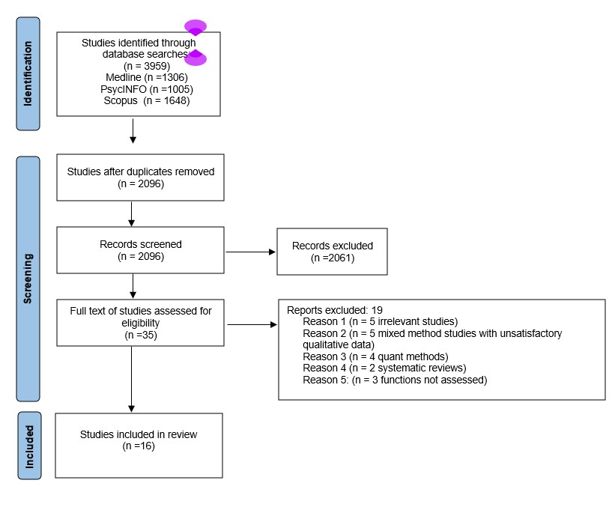

PRISMA Diagram

Quality Appraisal Results
A quality appraisal of all 16 studies was undertaken using a scoring strategy to quantify the quality, and all studies were rated as of high quality with an average score of 9 (Appendix 1.5). All studies explicitly identified the aims of the research, received ethics approval, appropriately selected qualitative methods, explained and or justified the study design. Recruitment strategy, data collection and analysis methods were appropriately explained. Four studies did not provide consideration for the relationship between researcher and participants (Cliffe & Stallard, 2023; Ogden & Bennett, 2015; Shahwan et al., 2021; Woodley et al., 2021). Clear statements of findings, themes and appropriate use of participant quotes were found in all studies. All except one study considered research limitations, implications for practice and recommendations for future research.
Data Characteristics
This review included 16 qualitative studies with 276 participants’ self-reported accounts of self-harm. Participants' ages ranged from 13 to 72 years, with a mean age of 26 (SD = 10.96). 80% of the collective sample was female, comprising 222 females, 40 males, 6 transgender males, 2 transgender females, 4 non-binary individuals, and 2 individuals whose gender was undisclosed. 8/16 (50%) studies did not report ethnic diversity, leaving the ethnic backgrounds of 168 participants unknown. Among the remaining 108 participants, 56 were White British, 19 Asian British, 8 of mixed ethnicity, 1 White American, 2 Black British, 11 Chinese, 2 Indian, 5 Malayan, and 4 undisclosed.
Most studies appeared to focus on adolescent or young adult populations, although there was overlap between age groups which affected clarity. For example, Miller et al. (2021) defined young people as those aged between 13 and 17, while Mughal et al. (2023) classified young people as those aged 19 to 25. Similarly, Shahwan et al. (2022) included adolescent and young adults, with participants ranging from 17 to 29 years. The most commonly reported method of self-harm was cutting.
Studies included participants because they were from clinical settings (5/16, 31%), the community (4/16, 25%), university students (3/16, 19%) or were from mixed clinical and community samples (4/16, 25%). Sample size ranged from 9 to 62. A few studies focused on specific population groups, including three on adolescent girls, two on university students, one on LGBTQþ individuals, one on older adults, and one on South Asian adults.
The majority of studies used semi-structured interviews to collect data (13/16, 81%), while one used free text box responses (questionnaire), one used Q-Methods, and one employed polytextual (photo elicitation) techniques. Most studies utilised thematic analysis (10/16, 63%), followed by Interpretative Phenomenological Analysis (IPA) (5/16, 31%), and one study used Principal Component Analysis. Full details of the studies included in this review are available below in Table 1.3.

Table 1.3
Table of Extracted Data Characteristics
 | Author / Year/ Title | Country | Population |  |  | Sample size |  | Age range |  | Gender |  | Ethnicity |  | Method of self-harm |  | Research Approach |  | Self-harm functions
 | Bryant et al. (2021)  Understanding the functions of repeated self-harm: A-Q Methodology Approach | England | Mixed: Clinical & community |  |  | 59 |  | 19 – 57  Mean age=32 |  | F = 48  M = 10  TM = 1 |  | Not reported |  | Cutting, burning, poisoning, ligatures or preventing wounds from healing |  | Q – Methods  Principal Component Analysis |  | - Managing distress (affect regulation)  - Self-punishment  - Exerting interpersonal influence  - Averting suicide  - Gratification  - Personal mastery  - Validation/ strength / toughness  - A personal language
 | Cliffe and Stallard (2023)  University students’ experiences and perceptions of interventions for self-harm | England | University students |  |  | 25 |  | 18 – 31  Mean age= 21 |  | F = 20  M = 4  1 = NB |  | WB = 20  AB = 4  ME = 1 |  | Cutting |  | Interviews  Thematic Analysis |  | - Managing distress (affect regulation)  - Exerting interpersonal influence
 | Edmondson et al. (2018)  Using photo-elicitation to understand reasons for repeated self-harm: a qualitative study | England | Mixed: Clinical & community |  |  | 8 |  | 18 – 65  Mean age=34 |  | F = 6  M = 2 |  | Not reported |  | *Varied, self-poisoning |  | Polytextual (photo elicitation)  Thematic analysis |  | - Managing distress (affect regulation)  - Self-punishment  - Protect of others  - Personal mastery  - A personal language
 | Edwards-Bailey et al. (2023)  A qualitative exploration of student self-harm and experiences of support-seeking within a UK university setting | England | University students |  |  | 16 |  | 18 - 38  Mean age=26 |  | F = 13  M = 2  1 = NB |  | WB = 14  AB = 2 |  | *Varied,  cutting |  | Interviews  Thematic Analysis |  | - Managing distress (affect regulation)
Gender: F = Female , M = Male, NB = Non-binary, TM = Transgender male, TF = Transgender female, UD = Undisclosed
Ethnicity: AB = Asian British, *AB = for purpose of reporting consistency and ease, studies that reported ethnicity in terms of Pakistani British, Indian British, or Bengali British, were in this review described as *AB and will be added to the AB descriptive in the summary, BB = Black British, CH = Chinese, ID = Indian, ML = Malay, ME: Mixed ethnicity, *ME: for purpose of reporting consistency and ease, studies that reported mixed ethnicity were in this review described as *ME and will be added to the ME descriptive in the summary, UD = Undisclosed, WA = White American, WB = White British
*Varied self-harm methods: not all reviewed studies provided clarity on methods of self-harm, with some only stating there were various methods or in addition would state the most common. For these studies, ‘Varied’ followed by the most common self-harm methods reported have been listed in the table
Author / Year/ Title |  | Country |  | Population | Sample size |  | Age range |  | Gender |  | Ethnicity |  | Method of self-harm |  | Research Approach |  | Self-harm functions
Miller at al. (2021)  A Qualitative Study of Understanding Reasons for Self-Harm in Adolescent Girls |  | England |  | Clinical | 9 |  | 13 – 17  Mean age=15 |  | F = 9 |  | Not reported |  | Cutting |  | Interviews  IPA |  | - Affect regulation  - Anti-suicide  - Disassociation
Mughal et al. (2023)  The functions of self‐harm in young people and their perspectives about future general practitioner‐led care: A qualitative study |  | England |  | Clinical | 13 |  | 19 - 25  Mean age=22 |  | F = 12  TM = 1 |  | WB = 7  ME = 3  AB = 2  WA = 1 |  | *Varied, cutting, poisoning |  | Interviews  Thematic analysis |  | - Managing distress (affect regulation)  - Self-punishment  - Averting suicide  - Dissociation  - Personal mastery  - A personal language
Norman et al. (2023)  “I can’t describe it and they can’t see the rain.” An interpretative phenomenological analysis of the experience of self-harm in young adults who report difficulties identifying and describing their feelings |  | England |  | University students | 8 |  | 18 – 29  Mean age=22 |  | F = 6  UD = 2 |  | AB = 1  BB = 1  ME: 2  WB = 2  UD = 2 |  | Cutting |  | Interviews & polytextual (photo elicitation)  IPA |  | - Averting suicide  - Dissociation  - Personal mastery  - A personal language
Ogden & Bennett (2015)  Self-harm as a means to manage the public and private selves: A qualitative study of help seeking by adults |  | England |  | Community  (participants international) | 25 |  | 19 – 45  Mean age=29 |  | F = 23  M = 2 |  | Not reported |  | Cutting, biting, scratching, head banging, self-hitting, digging nails into skin, |  | Free text boxes response  (questionnaire)  Thematic analysis |  | - Managing distress (affect regulation)  - Self-punishment  - Exerting interpersonal influence  - Averting suicide  - Dissociation  - Gratification  - Personal mastery  - Validation/ strength / toughness
Gender: F = Female , M = Male, NB = Non-binary, TM = Transgender male, TF = Transgender female, UD = Undisclosed
Ethnicity: AB = Asian British, *AB = for purpose of reporting consistency and ease, studies that reported ethnicity in terms of Pakistani British, Indian British, or Bengali British, were in this review described as *AB and will be added to the AB descriptive in the summary, BB = Black British, CH = Chinese, ID = Indian, ML = Malay, ME: Mixed ethnicity, *ME: for purpose of reporting consistency and ease, studies that reported mixed ethnicity were in this review described as *ME and will be added to the ME descriptive in the summary, UD = Undisclosed, WA = White American, WB = White British
*Varied self-harm methods: not all reviewed studies provided clarity on methods of self-harm, with some only stating there were various methods or in addition would state the most common. For these studies, ‘Varied’ followed by the most common self-harm methods reported have been listed in the table
Author / Year/ Title | Country | Population | Sample size | Age range | Gender | Ethnicity | Method of self-harm | Research Approach | Self-harm functions
Özen-Dursun et al. (2023)  A qualitative study on lived experience of self-harm in South Asians in the UK: From reasons to recovery | England | Community | 11 | 19 – 40  Mean age=26 | F = 5  M = 6 | *AB = 9  *ME = 2 | Head banging, | Interviews  Thematic analysis | - Affect regulation  - Self-punishment
Shahwan et al. (2021)  A qualitative study of motivations for non-suicidal self-injury in a sample of psychiatric outpatients in Singapore | Singapore | Clinical (outpatients) | 20 | 17–29  Mean age =24 | F = 14  M = 6 | CH = 11  IN = 2  ML = 5  UD = 2 | Cutting, self-hitting, banging head | Interviews  Thematic analysis | - Managing distress (affect regulation)  - Self-punishment  - Exerting interpersonal influence  - Dissociation  - Protection of others  - Personal mastery  - Validation/ strength / toughness
Stänicke et al. (2020)  Discovering One’s Own  Way: Adolescent Girls’ Different  Pathways into and Out of Self-Harm | Norway | Clinical (outpatients) | 19 | 13 -18  Mean age=16 | F = 19 | Not reported | Cutting | Interviews  IPA | - Self-punishment  - Experimental
Stänicke (2021)  The Punished Self, the Unknown Self, and the  Harmed Self – Toward a More Nuanced Understanding of  Self-Harm Among Adolescent Girls | Norway | Clinical (outpatients) | 19 | 13 -18  Mean age=16 | F = 19 | Not reported | Cutting | Interviews  IPA | - Managing distress (affect regulation  - Self-punishment  - Exerting interpersonal influence  - Averting suicide  - A personal language
Gender: F = Female , M = Male, NB = Non-binary, TM = Transgender male, TF = Transgender female, UD = Undisclosed
Ethnicity: AB = Asian British, *AB = for purpose of reporting consistency and ease, studies that reported ethnicity in terms of Pakistani British, Indian British, or Bengali British, were in this review described as *AB and will be
added to the AB descriptive in the summary, BB = Black British, CH = Chinese, ID = Indian, ML = Malay, ME: Mixed ethnicity, *ME: for purpose of reporting consistency and ease, studies that reported mixed ethnicity were in this
review described as *ME and will be added to the ME descriptive in the summary, UD = Undisclosed, WA = White American, WB = White British
*Varied self-harm methods: not all reviewed studies provided clarity on methods of self-harm, with some only stating there were various methods or in addition would state the most common. For these studies, ‘Varied’ followed
by the most common self-harm methods reported have been listed in the table
Author / Year/ Title | Country | Population | Sample size | Age range | Gender | Ethnicity | Method of self-harm | Research Approach | Self-harm functions
Troya et al. (2019) Understanding self-harm in older adults: A  qualitative study | England | Mixed: Clinical & community | 9 | ≥60 years  Mean age=63 | F = 6  M = 3 | WB = 8  BB = 1 | Cutting | Interviews  Thematic analysis and constant comparison methods | - Managing distress (affect regulation)  - Exerting interpersonal influence  - Gratification  - Sensation seeking  - Personal mastery  - A personal) language
Wadman et al. (2017) An interpretative phenomenological analysis of the experience of self-harm repetition and  recovery in young adults | England | Mixed: Clinical & community | 6 | 19-21  Mean age=20 | F = 5  M = 1 | WB = 5  *AB = 1 | Cutting, burning, scratching, biting, rubbing glass onto skin, sticking sharp objects in self, head banging, preventing wounds from healing, hair pulling, punching self/ wall/window | Interviews  Interpretative Phenomenological Analysis | - Managing distress (affect regulation)  - Self-punishment
Williams et al. (2023) Understanding the processes underlying self-harm ideation and behaviours within LGBTQþ young people: A qualitative study | England | Community | 19 | 16-25  Mean age=21 | F = 10  M = 1  TM = 4  TF = 2  NB = 2 | Not reported |  | Interviews  Thematic analysis | - Self-punishment  - Exerting interpersonal influence
Gender: F = Female , M = Male, NB = Non-binary, TM = Transgender male, TF = Transgender female, UD = Undisclosed
Ethnicity: AB = Asian British, *AB = for purpose of reporting consistency and ease, studies that reported ethnicity in terms of Pakistani British, Indian British, or Bengali British, were in this review described as *AB and will be
added to the AB descriptive in the summary, BB = Black British, CH = Chinese, ID = Indian, ML = Malay, ME: Mixed ethnicity, *ME: for purpose of reporting consistency and ease, studies
that reported mixed ethnicity were in this review described as *ME and will be added to the ME descriptive in the summary, UD = Undisclosed, WA = White American, WB = White British
*Varied self-harm methods: not all reviewed studies provided clarity on methods of self-harm, with some only stating there were various methods or in addition would state the most common. For these studies, ‘Varied’
followed by the most common self-harm methods reported have been listed in the table
Author / Year/ Title | Country | Population | Sample size | Age range | Gender | Ethnicity | Method of self-harm | Research Approach | Self-harm functions
Woodley et al. (2021)  How Individuals Who Self-Harm Manage Their Own Risk—‘I Cope Because I Self-Harm, and I Can Cope with my Self-Harm’ | England | Community | 10 | 19-45  Mean age=27 | F = 7  M = 3 | Not reported | Cutting, rubbing glass onto skin, sticking sharp objects in self | Interviews  Thematic analysis | - Managing distress (affect regulation)  - Gratification  - Personal mastery
Gender: F = Female , M = Male, NB = Non-binary, TM = Transgender male, TF = Transgender female, UD = Undisclosed
Ethnicity: AB = Asian British, *AB = for purpose of reporting consistency and ease, studies that reported ethnicity in terms of Pakistani British, Indian British, or Bengali British, were in this review described as *AB and will be
added to the AB descriptive in the summary, BB = Black British, CH = Chinese, ID = Indian, ML = Malay, ME: Mixed ethnicity, *ME: for purpose of reporting consistency and ease, studies that reported mixed ethnicity were in
this review described as *ME and will be added to the ME descriptive in the summary, UD = Undisclosed, WA = White American, WB = White British
*Varied self-harm methods: not all reviewed studies provided clarity on methods of self-harm, with some only stating there were various methods or in addition would state the most common. For these studies, ‘Varied’
followed by the most common self-harm methods reported have been listed in the table

Results

Self-harm functions
The analysis identified 12 of the 15 functions of self-harm from the priori framework, grouped under the three broad groups of responding to distress, self-harm as a positive experience, and defining the self. No evidence was found for three priori themes. No new themes beyond the a priori framework were found, and subsequently a revised descriptive framework on the functions of self-harm was produced (Table 1.4).
Table 1.4
Commonly self-reported non-suicidal reasons for self-harm found in qualitative studies (March 2015 – September 2024)

Self-harm Functions | % of qualitative studies reviewed  that identified this reason
Responding to Distress
Managing distress (affect regulation) | 81%
Self-punishment | 63%
Exerting interpersonal influence | 44%
Averting suicide | 38%
Dissociation | 31%
A Positive Experience
Gratification | 25%
Protection of others | 12%
Sensation-seeking | 6%
Experimental | 6%
Defining the Self
Personal mastery | 50%
Self-validation: strength/toughness | 19%
A personal language | 38%

Responding to Distress
The overarching theme captures the ways in which individuals use self-harm as a means of managing overwhelming emotions, regulating affect, and making sense of their internal experiences. While the motivations vary, the common thread is that self-harm represents an adaptive, though often misunderstood, response to deep emotional distress.

Managing Distress (affect regulation)
Similar to the findings of the Edmondson et al. (2016) review, a majority of 81% (13/16) of studies in this review reported managing distress (affect regulation) as a function of self-harm. In the studies reviewed, the function was found to be a way to cope with a range of emotional states that are experienced as overwhelmingly distressing:
“I know it might be different for other people, but for me it’s always been to cope with overwhelming feelings, or feeling really, really crappy or like, certain life stresses, or whatever’s going on, just sort of coping.” (Cliffe & Stallard, 2023, p. 642)
“…calm me down because like I said, to relieve the tension and distress, because I… I feel very distressed.” (Shawan et al., 2021, p.726)
Some of the studies described how self-harm “resets, lowers” emotional distress (Bryant et
al., 2021, p.5), and how this shifting of a distressing emotional state to one of release and calm is the ultimate reason for self-harm.
“I think it was a good release … [to] take my head out of that heightened, tense state and down to something that was a little bit more level and calm” (Wadman et al., 2017, p.1638)
“It’s just to get enough out, it’s just enough to cope, it’s just enough to get a bit of a release.”
(Woodley et al., 2021, p.2005)
The latter quotes also suggest the function is seen as helping to manage emotional distress rather than ending it. It appeared that the internal emotional pain was unbearable, and that it could be negated to some degree through the physical sensations induced through self-harm:
“It takes my focus away from another kind of pain, like the pain inside, like the way I feel. So, it overtakes that so I kind of forget about the other sort of pain.” (Miller at al., 2021, p.6)
A cathartic element to physically seeing the blood drip from the self was found in some accounts, suggesting the emotional pain could be gradually removed from the self through the visual release of blood:
“Seeing blood calms me down quite a bit, as it comes out and it sort of drips.” (Miller at al., 2021, p.6).

Self-punishment
Another function of self-harm evidenced in this review was punishment, which appeared in 63% (10/16) of studies and aligns with the findings of Edmondson et al. (2016) review (51% of qualitative studies). However, unlike the Edmondson et al. (2016) review, the punishment reported in the studies reviewed here was entirely self-directed rather than directed toward others.
In this review, self-punishment emerged as a theme in which participants felt they had done something wrong and needed to be punished. For example, Williams et al. (2023) highlighted the emotional turmoil experienced by some LGBTQþ, who believed their feelings were a sin that warranted punishment:
“I think it was a lot of me feeling like I deserved it [self-harm]. Erm and that it was again a form of punishment for me because I genuinely thought that what I was feeling was sinful and that I needed to get it out for me.” (Williams et al., 2023, p.385)
Similarly, in the Wadman et al. (2017) study there was the idea of guilt for hurting family members:
“I felt a lot of guilt, because I felt really guilty for annoying my family for upsetting … and then I just wanted to hurt myself because I felt like I deserved it at the time.” (Wadman et al., 2017, p.1635).
The need to self-punish arose from a number of different reasons, ranging from self-disgust, guilt, or perceived immoral behaviour, with self-punishment apparently functioning to re-assert a sense of morality or personal values.
“When I have eaten too much ... I become sad and feel a pressure to harm myself. I MUST do it because I have been bad, in a way.” (Stänicke, 2021, para.33)

Exerting Interpersonal Influence
In the Edmondson et al. (2016) review, exerting interpersonal influence emerged in 56% of qualitative studies, whereas in this review it emerged in 44% (7/16) of studies. In this review self-harm was practiced as a means of seeking a response from others, which ranged from soliciting help from others, seeking compassion or care, or being seen and noticed:
“For me definitely self-harm has been my way of asking for help when I can’t physically ask for it.” (Cliffe & Stallard, 2023, p.643)
“I don't think it's suicidal, it's a cry for help.” (Troya et al., 2019, p.59)
The interpersonal function illustrates how self-harm is used as a communication tool to elicit care from others, and also offers an opportunity to others to show they care and believed to have the ability to meet their needs:
“If I can’t harm myself – there are no reasons for people to show that they care about me, and then I get insecure if what I do is good enough.” (Stänicke, 2021, para.35)
In this context, it appeared the function of self-harm was to showcase to others their vulnerability, their emotional pain, and their need to (re)connect with others, in the hope that others would respond with love or care. As such, their basic human need for love and belongingness would be met.

Averting Suicide
In the Edmondson et al. (2016) review, averting suicide emerged in 7% of the qualitative studies, and in this review in 44% (7/16) of studies. In these studies, there was a strong emphasis on the desire to keep alive, and on self-harm being practiced as a preventative and protective intervention to avert-suicide.
“To me it was a very positive thing at the time, and it was stopping me from taking my own life.” (Mughal et al., 2023, p.1188)
In this sense, self-harm served a positive function that was practiced after careful thought and consideration:
“When I can actually think things through rationally, self-harm is a good way to calm down suicidal thoughts, it’s a compensation, and if I can self-harm and not kill myself and I don’t know any other way not to kill myself then in my mind, like self-harm is better than me trying to kill myself in a way.” (Norman et al., 2023, p.10155)
Individuals who self-harm appeared to have rationalised and valued the function of self-harm in helping them to keep themselves alive, which they recognised was not how the external word viewed it:
“Some people do not understand, and some people will interpret self-harm as ‘just’ a way to die, but it’s not a way to die, it’s a way to keep living.” (Miller at al., 2021, p.8)
“I still cut and the doctors know, my friends know, it’s not a big deal and it keeps me alive.”
(Ogden & Bennett, 2015, p.6)
There was a recognition that self-harm and suicide were conflated by others, but for individuals who self-harmed it was clear the function of self-harm was to keep them alive, not end life.
Dissociation
In the Edmondson et al. (2016) review, 31% of the studies reported that the function of self-harm was to end feelings of dissociation. In this current review, the function was reported the in the same number of studies 31% (5/16). The function of self-harm was to alleviate feelings of dissociation, as one participant described:
"When I felt the worst, when I was completely numb and disconnected from the world around me, cutting made me feel a physical pain that reminded me I was alive." (Ogden & Bennett, 2015, p.4)

Another participant expressed:
"One of the reasons why I cut myself is because I couldn’t feel. Back then I was feeling too much so I cut myself. But now, it’s more like I can’t feel, I need to feel something." (Shawan et al., 2022, p.727)
In these examples, self-harm appears as a way to break through the numbness of dissociation and reconnect the individual to their body and emotions. For those who feel disconnected from themselves, the physical sensation of pain offers a form of reality check—a reminder that they are alive and capable of feeling something. The act of self-harm serves as a bridge, grounding the person in the present moment and helping them to feel a sense of wholeness.
A Positive Experience
This overarching theme of highlights the ways in which self-harm can be experienced as rewarding, protective, or exploratory. While self-harm is typically associated with distress (discussed in the previous section), this theme illustrates how, for some individuals, it can bring relief, satisfaction, or even a sense of control, reinforcing the complexity of self-harming behaviours.

Gratification
Within Edmondson et al. (2016) descriptive framework, gratification was identified as an additional function of self-harm, emerging in 21% of the studies they reviewed. Similarly, in this review, it was identified in 25% (4/16) of the studies. The concept of gratification as a function of self-harm highlights a less commonly discussed aspect of the behaviour: the internal, self-soothing nature of the act. Participants described how self-harming gave them pleasurable feelings of comfort and care. Unlike the interpersonal function of self-harm described earlier, this function enabled them to turn inwards and offer care and love to themselves, from which they drew gratification:
“It comforts me, helps me deal with emotional numbness … enables me to self-care and soothe myself by tending to my wounds” (Ogden & Bennett, 2015, p.6)
“Like a soothing blanket, even when you're cutting, it's soothing, it gives you that comfort that you're not getting from other people” (Troya et al., 2019, p.58)
Here, the act of self-harm is likened to a comforting blanket, emphasizing how the physical sensation of self-harm can provide emotional comfort and a sense of control in a context where external support may be lacking.
Gratification also encompassed feelings of excitement and exhilaration indicating the positive effects of self-harming:
“The thrill and excitement of self-harming makes me feel alive even just for a little while.” (Bryant et al., 2021, p.5)
“It’s the best feeling in the world afterwards.” (Woodley et al., 2021, p.124)

Protection of Others
In the Edmondson et al. (2016) review, the function of self-harm as protecting the self or others was found in 14% of studies. In this current review, the function of self-harm was specifically to protect others and found in 12% of studies (2/16). The examples describe how participants used self-harm to protect others during interpersonal conflict:
“When you hit the wall or see the blood, you feel kind of pain right, so you feel a bit calm, because when you feel hurt you will burst into like one crazy guy right? Cause you can do anything, so when you hurt yourself, it will stop you from doing like you want to kill that person, you know.” (Shawan et al., 2021., p.726)
“I hurt myself because … because I’m mad at what they say but I can’t … I can’t show it to them. I can’t be angry at them. So, the only way is to harm, to self‐harm myself.” (Shawan et al., 2021, p.727)
This indicates that participants had an awareness of their uncontrollable anger or urge to harm and made a conscious decision to direct this to themselves as opposed to others. Self-harm thus offered an avenue through which they could avoid conflict and protect relationships with others. There is an element of not being able to share their feelings with others, or having to hide them from others, which means these feelings build up internally and can only be safely released on the self.
Sensation-seeking
In the Edmondson et al. (2016) review, the function of self-harm as sensation-seeking emerged in 12% of the studies. In this study however, it emerged as a function in only one study (6%, 1/16), that of Troye et al. (2019), which was interestingly with older adults. A participant described it as a source of sensation-seeking, fulfilling a need for intense experiences, even when those experiences involve pain.
“It hurt but it was satisfying at the same time (...) I also think it gives me nano seconds of pleasure when I do it […] it's sorta like an exquisite pain.” (Troye et al., 2019, p. 60)
Self-harm appeared to function as a self-stimulatory act, similar to other high-risk behaviours that involve pain or physical extremes (e.g., extreme sports, body modification, or substance use), where the sensation itself becomes part of the appeal. While the act itself is painful, the sensation it produced was described as pleasurable.

Experimental
Stänicke et al. (2020) provided the only study in this review (1/16, 6%) to have reported the experimental function of self-harm. Their research involved a female adolescent population and revealed a youth-like curiosity towards self-harm after being exposed to its usefulness by a peer, impulsions to try it to see what effect it would have, with some wondering if it could help them:
“She told me that her mother had discovered her self-harming. Then I got a strong urge to try it out myself. I don’t know why. I just had to try it.” (Stänicke et al., 2020, p.616)
“If it helps others, it may help me.” (Stänicke et al., 2020, p.617)
The experimental functions of self-harm was one of those which was developed in the descriptive framework of the Edmondson et al. review (10% of studies), as it also appeared in a study with an adolescent population. It is possible that due to their developmental stage, adolescents may be more likely to engage in self-harm out of curiosity, wondering if it will relieve distress or act as an effective coping mechanism.
Defining the Self
This overarching theme explores how individuals use self-harm as a means of shaping, asserting, and communicating their identity. The functions suggest that, for some, self-harm is not solely an act of suffering but also a deeply personal mechanism for understanding, asserting, and reinforcing aspects of their identity.

Personal Mastery
Sense of personal mastery emerged as a function of self-harm in 27% of the studies reviewed by Edmondson et al. (2016), and in this review it emerged in 50% (8/16) of the studies. In this review, several studies revealed participants feeling disempowered by a lack of control over their lives; self-harm gave them one avenue through which they could regain or assert control and feel empowered:
“Behind self-harm there's pretty much one reason…and that's all about getting control or regaining some sorta level of control, even if it is short-lived. We feel that the situation or life in general is out of our control. And by making a decision to hurt ourselves we're just gonna put ourselves in the driving seat for a bit.” (Troya et al., 2019, p.59)
In addition to regaining control, the function of self-mastery also encompassed accomplishment and skill:
“I feel like I have really gained a hold on this self‐harm and I’m really succeeding in this and this is just going to be it, so I feel like in my life, I cannot accomplish anything, but at least [with] self‐harm I can accomplish something.” (Shawan et al., 2021, p.726)
There was a clear rational approach to self-harm, its outcomes and the implications for future life:
“I don’t do it as deep as I’d like to sometimes because I think, no, because that’s going to go in your medical record...if you are going to do it, do it sensibly.” (Woodley et al., 2021, p.2005)
Collectively these studies reveal how some individuals who self-harm consider it a helpful skill that they can practice, through which they are able to assert their agency.

Self-Validation: Strength/Toughness
Strength and toughness emerged as sub-themes of validation (21% studies) as reasons for self-harm in the Edmondson et al. (2016) review. In this review, the functions were evidenced in 19% (3/18) of the studies. Unlike the interpersonal function of self-harm whereby the individual shows their vulnerability to solicit help from others, or the self-mastery function whereby an individual regains a sense of control, this function of self-harm signals to the self and others the person’s strength and toughness:
“It felt like no matter how much people hurt me, I’m the one who can control everything since I can hurt myself even more.” (Shawan et al., 2021, p.727)
This function of self-harm is thus perceived as something powerful, almost like a test of mental and physical endurance that can perhaps be likened to extreme sport or fitness routines. The finding highlights how self-harm can help the person to be ‘there’ for themselves and not look externally to others for help; doing so feels self-validating:
“I don’t want any pity from them … I’m actually almost proud of it … I don’t need anybody’s help. Even though I started up again, I can quit when I want.” (Ogden & Bennett, 2015, p.6)
A Personal Language
Another function of self-harm identified in the Edmondson et al. (2016) review was its use as a personal language, reported in 13% of the studies they reviewed. In the current review, it emerged in 38% (6/16) of studies. Participants shared how self-harm was used as a form of personal expression or a preferred method of communication:
“Self-harming is the only way I show my feelings. Someone told me it could have been good for me to be angrier or scream more... but it’s just not me.” (Stänicke, 2021, para.40)
The above quotation also provides insight into how self-harm may become an alternative way to externalize internal pain when words feel insufficient or not in alignment with an individual’s personality.
Self-harm may also carry symbolic meaning, through memories or struggles that are understood by the individual who self-harms:
“When I self-harm I scratch words into my skin i.e. ‘disgusting’. I do this so it scars and then I have a constant reminder of how awful I am.” (Bryant et al., 2021, p.5)
The act of etching words into the skin, particularly those carrying strong self-deprecating meanings like ‘disgusting’, suggests that self-harm can function as a visible, lasting representation of internal distress and reinforce negative self-perceptions.

Discussion
This review aimed to provide an updated synthesis on the self-reported non-suicidal reasons for self-harm using a ‘best-fit’ framework synthesis. The review found 12 themes (functions of self-harm): managing distress (affect regulation), self-punishment, exerting interpersonal influence, dissociation, averting suicide, gratification, sensation-seeking, protection of others, experimental, personal mastery, self-validation: strength/toughness, and a personal language.

Responding to Distress
This review endorsed the widely cited reason for self-harm as a response to distress whereby the function enabled a shift in emotions and feelings of calm and release, allowing the individual to cope. This aligns with past and present studies into self-harm functions which reveal how individuals who self-harm struggle with managing distressing emotional states (Midkiff et al., 2018; Shen et al., 2023). However, as with the Edmondson et al. (2016) review findings, this review also revealed the diverse functions of self-harm that are idiosyncratic and might obscure the purpose of the self-harm.

Self-harm as a Positive Experience
Findings in this review revealed how self-harm gave individuals opportunities to experience themselves as caring either towards themselves, for example when they attended to their wounds after self-harm (gratification), or caring towards others, for example, protecting others from their anger by hurting themselves in privacy (self-punishment). Thus, self-harm functioned to fulfil a nurturing role. This fits the notion of self-harm as self-care (Hewitt, 1997; Simopoulou & Chandler 2020). Suggesting self-harm can have positive functions for individuals does not detract take away from the risks associated with self-harm but allows the personal accounts of individuals to be heard and understood. It also changes the perception of self-harm as disturbing or as being an act of violence (Whynacht, 2018).

Defining the Self
A dominant perception about the function of self-harm is that it is ‘attention seeking’ behaviour (Caicedo & Whitlock, 2009; Chandler, 2018; Uddin et al., 2023). This review found a contrasting perspective, in which self-harm had an internal focus, serving personal functions that resonated with the person’s sense of self and values. The review endorsed the function of self-harm as a way to communicate with the self, in which case self-harm was ‘a preferred language’ of communication with the self; it fit with their personality, the language carried meaning to them and it remained personal and private, enabling them to assert their agency. Self-harm functioned to reaffirm their ‘strength/toughness’, in that, despite their difficulties, they had a resilient character. As such, self-harm was a self-affirmative action.
This review found no evidence for three of the a priori themes: sense of belonging, maintaining or exploring boundaries, and expressing and coping with sexuality. One possible explanation is that these themes were among the least cited in the Edmondson et al. (2016) review (coping with sexuality, 2.5% of studies; maintaining or exploring boundaries, 5% of studies; and sense of belonging, 13% of studies). Additionally, the studies referenced could be considered outdated, as their publication dates range from 1975 to 2009, which is up to 15 years ago. Therefore, the findings in this updated review may better reflect the functions of self-harm in the current population, aligning with the absence of these functions in a meta-analysis of the prevalence of self-harm functions by Taylor et al. (2018).

Critique of Studies
All 16 qualitative studies provided a clear structure for their study, with aims justified by a literature review evidencing gaps in understanding, and methodologies that were suited to the nature of the study, for example thematic analysis or IPA. Verbatim quotes were also used effectively to illustrate the themes. All the studies had ethical approval, with consideration granted for reflexivity in most cases. However, it was noted that for a few studies this was limited to what appeared to be a statement of self (the researcher’s), without much explanation, or without describing how this was considered in terms of researcher and participant interactions, nor in terms of their engagement with the research. This indicates that a few of the studies in this review were weak in terms of protecting the study from the influences of the researcher’s personal positioning (Flemming & Noyes, 2021).
Given the sensitivity of self-harm, some studies carefully considered its impact on participants (Wolgemuth et al., 2014). Wadman et al. (2017) used a trained Samaritan volunteer and a Visual Analogue Scale (VAS; Wewers & Lowe, 1990) to assess mood before and after interviews, offering support if needed. Troya et al. (2019) and Mughal et al. (2023) incorporated Patient and Public Involvement and Engagement (PPIE) in designing interviews and for analysing data.
Whilst most of the studies were with adolescent and young adult populations (Bryant et al., 2021; Mughal et al., 2023; Stänicke, 2021; Stänicke et al., 2020) some studies had sought to explore the functions of self-harm with diverse populations such as South Asian, older adults and LGBTQþ individuals (Özen-Dursun et al., 2023; Troya et al., 2019; Williams et al., 2023), allowing for a broader exploration of the functions of self-harm. While this heterogeneity enriches the metasynthesis by capturing multiple perspectives, the diversity also introduced challenges in synthesizing findings, as self-harm may hold different meanings and functions across age groups, cultural backgrounds, and life circumstances. Consequently, generalising conclusions across all populations may overlook group-specific nuances and obscure the unique experiences of specific populations. For example, self-harm in adolescent girls may be influenced by distinct developmental and social factors that differ from those affecting LGBTQþ individuals or older adults. As such, the broad themes generated from the synthesis may not fully capture these subgroup-specific intricacies.

Strengths, Limitations, and Future Research
This review used a ‘best fit’ framework synthesis to provide an updated understanding of the self-reported functions of self-harm using the Edmondson et al. (2016) descriptive framework. The widely cited Edmondson et al. (2016) review included studies dated up to February 2015; the findings in this review reflect the current population's experiences of self-harm. Furthermore, this review is the first time the Edmondson et al. (2016) descriptive framework has been reviewed against evidence from self-harm studies.
The ‘best-fit’ framework synthesis method was helpful in terms of evidencing the Edmondson et al. (2016) descriptive framework on the functions of self-harm; one of the main purposes of using this particular synthesis method. However, the synthesis did not produce evidence for three of the themes in the Edmondson et al. (2016) framework, and furthermore, new themes did not emerge from coding. This is disappointing from the researcher’s perspective, as the framework could not be significantly developed. However, this likely reflects the limited number of qualitative studies in this review (16) which represent a synthesis of far fewer studies in comparison to the 172 that Edmondson et al. (2016) analysed. Future reviews could incorporate more studies by widening the inclusion criteria to quantitative studies.
A strength of the review is the commitment to rigour and quality. The literature review justified the purpose of the review and relevance, thus informing the aim and subsequent methodology. The CASP was used to appraise the studies, and its reliability was enhanced by a second reviewer. Furthermore, in acknowledging their research positionality, the principal researcher kept a reflexive diary to document their engagement with the research, which helped in considering unconscious bias and producing points of reference to discuss with the research supervisor. It was felt that these attempts would also reduce the risk of the researcher selectively coding themes whilst overlooking functions that were beyond the a priori framework. However, it is appreciated that even with these safeguards in place, the inherently interpretive nature of qualitative synthesis means some degree of researcher influence remains in the review, either through omission, inclusion, or misinterpretation.
This review included only peer-reviewed journal articles, excluding grey literature such as dissertations and conference proceedings to ensure methodological rigour. However, this exclusion may contribute to publication bias by omitting valuable studies with non-significant results. To mitigate this, a comprehensive search strategy was employed, including multiple databases and citation tracking, alongside a critical appraisal of study biases. Despite these efforts, publication bias remains a limitation of this review. Given the exclusion of grey literature and non-English language studies, the review has a bias towards representing published studies, and from Western populations. However, there was some diversity in the population group as some of the studies used online recruitment methods or university populations which reportedly incorporated international students in their participant groups. Nevertheless, generalisability based on these citations cannot be claimed. Future reviews could incorporate grey literature to improve impartiality and provide a more comprehensive review.
The latter limitation may shed light when considering the functions not represented in the findings of this meta synthesis, and to reflect on areas that may have been underexplored or absent. For example, the Edmondson et al. (2016) review reported sexuality as a function of self-harm; however, this did not emerge as a function in this review. The inclusion criteria of this review may have limited the diversity of studies and in tandem included studies that did not explore how self-harm is linked to sexual identity or experiences related to sexuality (such as sexual abuse or gender dysphoria). This gap may limit the comprehensive understanding of self-harm among sexual minorities. The absence of such factors could mean that the unique experiences of individuals in these groups remain underrepresented, which may affect the generalizability of this review’s findings. Future reviews could adopt a more inclusive and diverse research approach that accounts for the intersections of sexuality, gender, and other identity factors in the study of self-harm.
The participants in this review exhibit considerable heterogeneity in characteristics. While their varied backgrounds may enhance the comprehensiveness of the findings and allow for a more holistic understanding of self-harm across different demographics, the findings should be interpreted with an awareness of demographic imbalances. Females, young people, and White British populations were strongly represented in the collective sample, which may mean that other gender identities, age groups, and ethnic populations are underrepresented, leaving gaps in the findings and limiting their applicability to these populations, as well as the generalizability of the conclusions. Additionally, the wide age range within this review (13 to 72 years) appeared to influence how self-harm functions were reported. The experimental function of self-harm, for example, was found in only one study with adolescent participants, suggesting that certain functions may be more prevalent at specific life stages. Future reviews could explore self-harm functions across different age groups to identify similarities and differences in self-harm motivations.
A limitation of this review is that it does not account for both the frequency of references to self-harm and the weight these references carry in published research. Future reviews should consider incorporating both factors, frequency and depth of its exploration within the studies. This approach would provide a more comprehensive understanding of the prominence and significance of self-harm in the literature.

Clinical Implications
The key clinical implications arising from the self-reported functions of self-harm are presented below.

Multiple Functions of Self-Harm
Findings from this review contribute to a growing body of research revealing the multiple functions of self-harm which broadens the understanding of why individuals self-harm beyond its association with suicide, distress regulation, and attention-seeking. This information can be used to raise awareness amongst the general public and clinicians in attempts to destigmatise self-harm, improve response and encourage help-seeking.

Purpose of Self-harm
This review has endorsed the widely accepted function of self-harm as distress regulation; however, more positive functions of self-harm have emerged, suggesting that clinicians need to explore individual client motivation to ensure that appropriate formulations are developed that reveal clinical need and identify appropriate interventions. Central to this is appreciating that individuals who self-harm and report positive functions, or associate it closely with their self-beliefs, have learnt to self-manage; as such they come to clinicians with personal insights and reflections, and should be regarded as experts on themselves.

Person-Centred Interventions
The prominent emotional regulation function of self-harm is well evidenced to be supported through Dialectical Behaviour Therapy (DBT), (Kothgassner et al., 2020; NICE, 2009). This review highlights the array of functions of self-harm, indicating the need for other therapeutic interventions to be considered and evidenced through research on their effectiveness. For example, an individual who self-harms to punish themselves for having a visible impairment - not conforming to societal expectations of ‘normality’ and ‘beauty’ – may be better suited to the goals of Compassionate Focused Therapy instead of DBT. Similarly, individuals who self-harm for positive reasons or self-affirmation require interventions that are aligned to achieving these idiographic goals as opposed to a focus on preventing the behaviour.
Person-centred interventions are likely to promote better outcomes.

Conclusion
This review aimed to provide an updated synthesis on the self-reported non-suicidal reasons for self-harm using a ‘best-fit’ framework. 16 qualitative studies published since March 2015 were reviewed using the Edmondson et al. (2016) descriptive framework, consisting of 15 functions of self-harm, as with the priori framework. Evidence for 12 of the 15 functions was found; no further themes emerged, and subsequently a revised version of the Edmondson et al. (2016) descriptive framework was proposed. The 12 functions were grouped under the three broad themes originally proposed within the Edmondson et al. (2016) review: 1. Responding to distress, 2. Self-harm as a positive experience, and 3. Defining the self.
The review supported the widely cited function of self-harm as distress management or emotional regulation. However, the findings also revealed the high prevalence of other more positive functions of self-harm such as self-mastery and a personal language. Self-harm as a protective factor from suicide potentially offers clinicians the opportunity to broaden their understanding and intervention response. Furthermore, the relatively lower reporting of the interpersonal functional of self-harm may assist in undermining the myth that self-harm behaviour is for attention seeking.
The review revealed the idiographic functions of self-harm that reflect the complex and nuanced nature of this behaviour. The review recommends clinical interventions begin with assessments of self-harm which appreciate that the function may not necessarily be a response to distress but may serve more positive functions in which case intervention needs to be considerate of meeting personal goals.

References
American Psychiatric Association. (2013). Diagnostic and statistical manual of mental disorders
(5th ed., pp. 803–806). American Psychiatric Publishing.
Arendt, F., Scherr, S., & Romer, D. (2019). Effects of exposure to self-harm on social media: Evidence
from a two-wave panel study among young adults. New Media & Society, 21(11-12), 2422-2442. https://doi.org/10.1177/1461444819850106
Bandura, A. (1973). Aggression: a social learning analysis. Prentice-Hall.
Barnow, S., & Linden, M. (1997). Suicidality and tiredness of life among very old persons: Results
from the Berlin aging study (base). Archives of Suicide Research, 3(3), 171–182. https://doi.org/10.1080/13811119708258269
Bryant, L. D., O’Shea, R., Farley, K., Brennan, C., Crosby, H. F., Guthrie, E., & House, A. (2021).
Understanding the functions of repeated self-harm: A Q methodology approach. Social Science & Medicine, 268, 113527–113527. https://doi.org/10.1016/j.socscimed.2020.113527
Caicedo, S., & Whitlock, J. L. (2009). Top misconceptions about self-injury. The Fact Sheet Series,
Cornell Research Program on Self-Injury and Recovery. Cornell University. Ithaca, NY. http://www.selfinjury.bctr.cornell.edu/perch/resources/15-misconceptions-english-5.pdf
Carroll, C. (2017). Qualitative evidence synthesis to improve implementation of clinical guidelines.
British Medical Journal, 356, 80-90. https://doi.org/10.1136/bmj.j80
Carroll, C., Booth, A., & Cooper, K. (2011). A worked example of “best fit” framework synthesis: A
systematic review of views concerning the taking of some potential chemo-preventive agents. BMC Medical Research Methodology, 11(1), 29–29. https://doi.org/10.1186/1471-2288-11-29
Carroll, C., Booth, A., Leaviss, J., & Rick, J. (2013). “Best fit” framework synthesis: Refining the
method. BMC Medical Research Methodology, 13(1), 37–37. https://doi.org/10.1186/1471- 2288-13-37
Carroll, J., Schaffer, C., Spensley, J., & Abramowitz, S. I. (1980). Family experiences of self-mutilating
patients. American Journal of Psychiatry, 137(7), 852–853. https://doi.org/10.1176/ajp.137.7.852
Chandler, A. (2018). Seeking Secrecy: A Qualitative Study of Younger Adolescents’ Accounts of Self-
harm. YOUNG, 26(4), 313–331. https://doi.org/10.1177/1103308817717367
Cheng, H., Wang, D., Wang, L., Zou, H., & Qu, Y. (2023). Global prevalence of self-harm during the
COVID-19 pandemic: a systematic review and meta-analysis. BMC Psychology, 11(1), 149–149. https://doi.org/10.1186/s40359-023-01181-8
Claes, L., & Vandereycken, W. (2007). Self-injurious behavior: differential diagnosis and functional
differentiation. Comprehensive Psychiatry, 48(2), 137–144. https://doi.org/10.1016/j.comppsych.2006.10.009
Cliffe, B., & Stallard, P. (2023). University students’ experiences and perceptions of interventions for self-harm. Journal of Youth Studies, 26(5), 637–651. https://doi.org/10.1080/13676261.2022.203318
Cooke, A., Smith, D., & Booth, A. (2012). Beyond PICO: the SPIDER tool for qualitative evidence
synthesis. Qualitative Health Research, 22(10), 1435-1443. https://doi.org/10.1177/1049732312452938
Critical Appraisal Skills Programme. (2018). CASP qualitative studies checklist. https://casp-
uk.net/wp-content/uploads/2018/01/CASP-Qualitative-Checklist- 2018.pdf
Daldin, H. (1990). Self-mutilating behaviour in adolescence with comments on suicidal risk. Bulletin
of the Anna Freud Centre, 13, 279–293.
Darawsheh, W.B. (2014). Reflexivity in research: Promoting rigour, reliability and validity in qualitative
research. International journal of therapy and rehabilitation, 21, 560-568.
Doyle, L., Sheridan, A., & Treacy, M. P. (2017). Motivations for adolescent self-harm and the
implications for mental health nurses. Journal of Psychiatric and Mental Health Nursing, 24(2-3), 134–142. https://doi.org/10.1111/jpm.12360
Edmondson, A. J., Brennan, C. A., & House, A. O. (2016). Non-suicidal reasons for self-harm: A
systematic review of self-reported accounts. Journal of Affective Disorders, 191, 109–117. https://doi.org/10.1016/j.jad.2015.11.043
Edwards-Bailey, L., Cartwright, T., Smyth, N., & Mackenzie, J.-M. (2023). A qualitative exploration of
student self-harm and experiences of support-seeking within a UK university setting. Counselling Psychology Quarterly, 36(4), 638–662. https://doi.org/10.1080/09515070.2022.2146054
Favazza, A. R. (1996). Bodies under siege: Self-mutilation and body modification in culture and psychiatry. Johns Hopkins University Press.
Flemming, K., & Noyes, J. (2021). Qualitative evidence synthesis: Where are we at? International Journal of Qualitative Methods, 20, 1–13. https://doi.org/10.1177/1609406921993276
Gámez-Guadix, M., Borrajo, E., & Almendros, C. (2022). Self-harm on the internet among adolescents: Prevalence and association with depression, anxiety, family cohesion, and social resources. Psicothema, 34(1), 78-86. https://doi.org/10.7334/psicothema2021.245
Geulayov, G., Casey, D., McDonald, K. C., Foster, P., Pritchard, K., Wells, C., Clements, C., Kapur, N., Ness, J., Waters, K., & Hawton, K. (2018). Incidence of suicide, hospital-presenting non-fatal self-harm, and community-occurring non-fatal self-harm in adolescents in England (the iceberg model of self-harm): a retrospective study. The Lancet. Psychiatry, 5(2), 167-174. https://doi.org/10.1016/S2215-0366(17)30478-9
Gillies, D., Christou, M. A., Dixon, A. C., Featherston, O. J., Rapti, I., Garcia-Anguita, A., Villasis-Keever, M., Reebye, P., Christou, E., Al Kabir, N., & Christou, P. A. (2018). Prevalence and Characteristics of Self-Harm in Adolescents: Meta-Analyses of Community-Based Studies 1990-2015. Journal of the American Academy of Child and Adolescent Psychiatry, 57(10), 733-741. https://doi.org/10.1016/j.jaac.2018.06.018
Gunderson, J. G. (1984). Borderline personality disorder. American Psychiatric Press.
Haidt, J. (2024). The anxious generation: How the great rewiring of childhood is causing an epidemic of mental illness. Penguin Press.
Hawton, K., Bergen, H., Waters, K., Ness, J., Cooper, J., Steeg, S., & Kapur, N. (2012). Epidemiology and
nature of self-harm in children and adolescents: findings from the multicentre study of self-harm in England. European Child & Adolescent Psychiatry, 21(7), 369–377. https://doi.org/10.1007/s00787-012-0269-6
Hawton, K., Bergen, H., Cooper, J., Turnbull, P., Waters, K., Ness, J., & Kapur, N. (2015). Suicide
following self-harm: Findings from the Multicentre Study of Self-harm in England, 2000–2012. Journal of Affective Disorders, 175, 147-151. https://doi.org/10.1016/j.jad.2014.12.062.
Hewitt, K. (1997). Mutilating the body: Identity in blood and ink. Bowling Green State University
Popular Press.
Himber, J. (1994). Blood rituals: Self-cutting in female psychiatric inpatients. Psychotherapy, 31(4),
620–631. https://doi.org/10.1037/0033-3204.31.4.620
John, A., Eyles, E., Webb, R. T., Okolie, C., Schmidt, L., Arensman, E., Hawton, K., O’Connor, R. C.,
Kapur, N., Moran, P., O’Neill, S., McGuiness, L. A., Olorisade, B. K., Dekel, D., Macleod Hall, C., Cheng, H.-Y., Higgins, J. P. T., & Gunnell, D. (2021). The impact of the COVID-19 pandemic on self-harm and suicidal behaviour: update of living systematic review. F1000 Research, 9, 1–44. https://doi.org/10.12688/f1000research.25522.2
Kapur, N., Cooper, J., O’Connor, R. C., & Hawton, K. (2013). Non-suicidal self-injury v. attempted
suicide: new diagnosis or false dichotomy? British Journal of Psychiatry, 202(5), 326–328. https://doi.org/10.1192/bjp.bp.112.116111
Klonsky, E. D. (2007). The functions of deliberate self-injury: A review of the evidence. Clinical
Psychology Review, 27(2), 226–239. https://doi.org/10.1016/j.cpr.2006.08.002
Klonsky, E. D., & Glenn, C. R. (2009). Assessing the functions of non-suicidal self- injury: Psychometric
properties of the Inventory of Statements About Self-injury. Journal of Psychopathology and Behavioral Assessment, 31(3), 215-219. https://doi.org/10.1007/s10862-008-9107-z
Kothgassner, O. D., Robinson, K., Goreis, A., Ougrin, D., & Plener, P. L. (2020). Does treatment
method matter? A meta-analysis of the past 20 years of research on therapeutic interventions for self-harm and suicidal ideation in adolescents. Borderline Personality Disorder and Emotion Dysregulation, 7(1), 9–9. https://doi.org/10.1186/s40479-020-00123-9
Linehan, M. (1993). Cognitive-behavioral treatment of borderline personality disorder. Guilford Press.
Mayor, S. (2019). Major rise in non-suicidal self-harm in England, study shows. BMJ (Online), 365,
l4058–l4058. https://doi.org/10.1136/bmj.l4058
McManus, S., Gunnell, D., Cooper, C., Bebbington, P. E., Howard, L. M., Brugha, T., Jenkins, R.,
Hassiotis, A., Weich, S., & Appleby, L. (2019). Prevalence of non-suicidal self-harm and service contact in England, 2000–14: repeated cross-sectional surveys of the general population. The Lancet. Psychiatry, 6(7), 573–581. https://doi.org/10.1016/S2215-0366(19)30188-9
Midkiff, M. F., Lindsey, C. R., & Meadows, E. A. (2018). The role of coping self-efficacy in emotion
regulation and frequency of NSSI in young adult college students. Cogent Psychology, 5(1), 1–14. https://doi.org/10.1080/23311908.2018.1520437
Millard, C. (2024). A history of self-harm in the UK and the USA. The Lancet (British Edition),
404(10461), 1395–1397. https://doi.org/10.1016/S0140-6736(24)02127-5
Miller, M., Redley, M., & Wilkinson, P. O. (2021). A qualitative study of understanding reasons for
self-harm in adolescent girls. International Journal of Environmental Research and Public Health, 18(7), 3361. https://doi.org/10.3390/ijerph18073361
Miles, M. B., Huberman, A. M., & Saldaña, J. (2014). Qualitative data analysis: A methods sourcebook
(3rd ed.). Sage.
Moher D, Liberati A, Tetzlaff J., Altman D.G. (2009). PRISMA 2009 Flow Diagram. The PRISMA
Statement. https://doi.org/10.1371/journal.pmed1000097
Moran, P., Chandler, A., Dudgeon, P., Kirtley, O. J., Knipe, D., Pirkis, J., Sinyor, M., Allister, R., Ansloos,
J., Ball, M. A., Chan, L. F., Darwin, L., Derry, K. L., Hawton, K., Heney, V., Hetrick, S., Li, A., Machado, D. B., McAllister, E., & Christensen, H. (2024). The Lancet Commission on self-harm. The
Lancet (British Edition), 404(10461), 1445–1492. https://doi.org/10.1016/S0140- 6736(24)01121-8
Mughal, F., Chew-Graham, C. A., Babatunde, O. O., Saunders, B., Meki, A., & Dikomitis ,L. (2023). The
functions of self-harm in young people and their perspectives about future general practitioner-led care: A qualitative study. Health Expectations: an International Journal of Public Participation in Health Care and Health Policy, 26(3), 1180–1188. https://doi.org/10.1111/hex.13733
National Institute for Health and Care Excellence. (2009). Borderline personality disorder: Recognition
and management (CG78). https://www.nice.org.uk/guidance/cg78
National Institute for Health and Care Excellence. (2022). Self-harm: assessment, management and
preventing recurrence (NG 225). www.nice.org.uk/guidance/ng225
Nock, M. K., & Prinstein, M. J. (2004). A functional approach to the assessment of self-mutilative
behavior. Journal of Consulting and Clinical Psychology, 72(5), 885. https://doi.org/10.1037/0022-006X.72.5.885
Nock, M. K. (2009). Why do people hurt themselves? New insights into the nature and functions of
self-injury. Current Directions in Psychological Science, 18(2), 78-83. https://doi.org/10.1111/j.1467-8721.2009.01613.x
Norman, H., Marzano, L., Oskis, A., & Coulson, M. (2023). “I can’t describe it and they can’t see the
rain.” an interpretative phenomenological analysis of the experience of self-harm in young adults who report difficulties identifying and describing their feelings. Current Psychology, 42(12), 10151–10162. https://doi.org/10.1007/s12144-021-02273-7
Noyes, J., Booth, A., Moore, G., Flemming, K., Tunçalp, Ö., & Shakibazadeh, E.
(2019). Synthesising quantitative and qualitative evidence to inform guidelines on complex interventions: clarifying the purposes, designs and outlining some methods.
Ogden, J., & Bennett, A. (2015). Self-harm as a means to manage the public and private selves: A
qualitative study of help seeking by adults. Health Psychology Open, 2(2), 2055102915605987–2055102915605987. https://doi.org/10.1177/2055102915605987
Owens, D., Kelley, R., Munyombwe, T., Bergen, H., Hawton, K., Cooper, J., Ness, J., Waters, K., West,
R., & Kapur, N. (2015). Switching methods of self-harm at repeat episodes: Findings from a multicentre cohort study. Journal of Affective Disorders, 180, 44–51. https://doi.org/10.1016/j.jad.2015.03.051
Ozen-Dursun, B., Panagioti, M., Alharbi, R., Giles, S., & Husain, N. (2023). A qualitative study on lived
experience of self-harm in South Asians in the UK: From reasons to recovery. Clinical Psychology and Psychotherapy, 30(5), 1179–1189. https://doi.org/10.1002/cpp.2875
Shahwan, S., Zhang, Y., Sambasivam, R., Ong, S., Chong, S., & Subramaniam, M. (2022). A qualitative
study of motivations for non-suicidal self-injury in a sample of psychiatric outpatients in Singapore. Singapore Medical Journal, 63(12), 723–730. https://doi.org/10.11622/smedj.2021161
Shaw, R. (2010). Embedding Reflexivity Within Experiential Qualitative Psychology. Qualitative
Research in Psychology, 7(3), 233–243. https://doi.org/10.1080/14780880802699092
Shearer, S. L. (1994). Phenomenology of self-injury among inpatient women with borderline
personality disorder. The Journal of Nervous and Mental Disease, 182(9), 524–526.
Shen, Y., Hu, Y., Zhou, Y., & Fan, X. (2023). Non-suicidal self-injury function: prevalence in adolescents
with depression and its associations with non-suicidal self-injury severity, duration and suicide. Frontiers in Psychiatry, 14, 1188327–1188327. https://doi.org/10.3389/fpsyt.2023.1188327
Shufutinsky, A. (2020). Employing Use of Self for Transparency, Rigor, Trustworthiness, and Credibility
in Qualitative Organizational Research Methods. Organisational Development Journal 38, (3), 59-76
Simopoulou, Z., & Chandler., A. (2020). Self-harm as an attempt at self-care. European Journal for
Qualitative Research in Psychotherapy, 10, 110-120.
Stanicke, L. I. (2021). The Punished Self, the Unknown Self, and the Harmed Self – Toward a More
Nuanced Understanding of Self-Harm Among Adolescent Girls. Frontiers in Psychology, 12, 543303–543303. https://doi.org/10.3389/fpsyg.2021.543303
Stänicke, L. I., Haavind, H., Rø, F. G., & Gullestad, S. E. (2020). Discovering One’s Own Way:
Adolescent Girls’ Different Pathways Into and Out of Self-Harm. Journal of Adolescent Research, 35(5), 605–634. https://doi.org/10.1177/0743558419883360
Steele, M. A., Power, J., & Smith, H. P. (2022). A Functional Approach to the Assessment of Non-
Suicidal Self-Injury on YouTube. Issues in Mental Health Nursing, 43(9), 808–817. https://doi.org/10.1080/01612840.2022.2072547
Susi, K., Glover-Ford, F., Stewart, A., Knowles Bevis, R., & Hawton, K. (2023). Research Review:
Viewing self-harm images on the internet and social media platforms: systematic review of the impact and associated psychological mechanisms. Journal of Child Psychology and Psychiatry, 64(8), 1115–1139. https://doi.org/10.1111/jcpp.13754
Suyemoto, K. L. (1998). The functions of self-mutilation. Clinical Psychology Review, 18(5), 531–554.
https://doi.org/10.1016/S0272-7358(97)00105-0
Taylor, P. J., Jomar, K., Dhingra, K., Forrester, R., Shahmalak, U., & Dickson, J. M. (2019). Corrigendum
to “A Meta-Analysis of the Prevalence of Different Functions of Non-Suicidal Self-Injury” [Journal of Affective Disorders (2017) 759–769]. Journal of Affective Disorders, 259, 440–440. https://doi.org/10.1016/j.jad.2019.08.072
Troya, M. I., Dikomitis, L., Babatunde, O. O., Bartlam, B., & Chew-Graham, C. A. (2019).
Understanding self-harm in older adults: A qualitative study. EClinicalMedicine, 12, 52–61. https://doi.org/10.1016/j.eclinm.2019.06.002
Uddin, T., Pitman, A., Benson, G., Kamal, Z., Hawton, K., & Rowe, S. (2023). Attitudes toward and
experiences of clinical and non-clinical services among individuals who self-harm or attempt suicide: A systematic review. Psychological Medicine, 1–19. https://doi.org/10.1017/S0033291723002805
Wadman, R., Clarke, D., Sayal, K., Vostanis, P., Armstrong, M., Harroe, C., Majumder, P., & Townsend,
E. (2017). An interpretative phenomenological analysis of the experience of self-harm repetition and recovery in young adults. Journal of Health Psychology, 22(13), 1631–1641. https://doi.org/10.1177/1359105316631405
Wand, A. P. F., Peisah, C., Draper, B., & Brodaty, H. (2018). Understanding self-harm in older people: a
systematic review of qualitative studies. Aging & Mental Health, 22(3), 289–298. https://doi.org/10.1080/13607863.2017.1304522
Whynacht, A. (2018). ‘Marks on Bodies’: Agential cuts as felt experience. Catalyst: Feminism,
Theory, Technoscience, 4(1) https://doi.org/10.28968/cftt.v4i1.29629
Williams, A. J., Arcelus, J., Townsend, E., & Michail, M. (2023). Understanding the processes
underlying self-harm ideation and behaviors within LGBTQ+ young people: A qualitative study. Archives of Suicide Research, 27(2), 380–396. https://doi.org/10.1080/13811118.2021.2003273
Wolgemuth, J. R., Erdil-Moody, Z., Opsal, T., Cross, J. E., Kaanta, T., Dickmann, E. M., & Colomer, S.
(2015). Participants’ experiences of the qualitative interview: considering the importance of research paradigms. Qualitative Research: 15(3), 351–372. https://doi.org/10.1177/1468794114524222
Woodley, S., Hodge, S., Jones, K., & Holding, A. (2021). How Individuals Who Self-Harm Manage Their
Own Risk—‘I Cope Because I Self-Harm, and I Can Cope with my Self-Harm.’ Psychological Reports, 124(5), 1998–2017. https://doi.org/10.1177/0033294120945178
Woods, J. (1988). Layers of meaning in self-cutting. Journal of Child Psychotherapy, 14(1), 51–60. https://doi.org/10.1080/00754178808254818

Appendix 1.1: A Priori Framework (Edmondson et al., 2016)

Eight Themes (self-harm functions)

Self-harm Functions
Managing distress (affect regulation)
Exerting interpersonal influence
Punishment
Managing dissociation
Sensation seeking
Averting suicide
Expressing and coping with sexuality

Maintaining or exploring boundaries

Appendix 1.2: Descriptive Framework - Edmondson et al. (2016)

15 themes (self-harm functions), alongside prominent models on the functions of self-harm

Edmondson et al., (2016)  Functions of self-harm | Nock  (2009) | Klonsky (2007) | Suyemoto (1998)
Managing distress (affect regulation) |  | 
Exerting interpersonal influence
Punishment
Dissociation
Averting suicide
Gratification
Sensation seeking
Protective (of self and others)
Experimental
Expressing and coping with sexuality | 
Sense of personal mastery
Self-validation/strength/toughness
Sense of belonging
A personal language
Maintaining or exploring boundaries

Appendix 1.3: SPIDER Tool (Cooke et al., 2012).

SPIDER
Sample | Adults, of working age (age 18-65), self-reported self-harm
Phenomenon of  interest | Self-harm, suicide, motivation, function
Design | Qualitative data: Interviews,
Evaluation | Perceptions, views, experiences, attitudes, thoughts, feelings, opinions
Research type | Qualitative studies, thematic analysis, ‘best-fit’ framework

Appendix 1.4: CASP (2018) Template

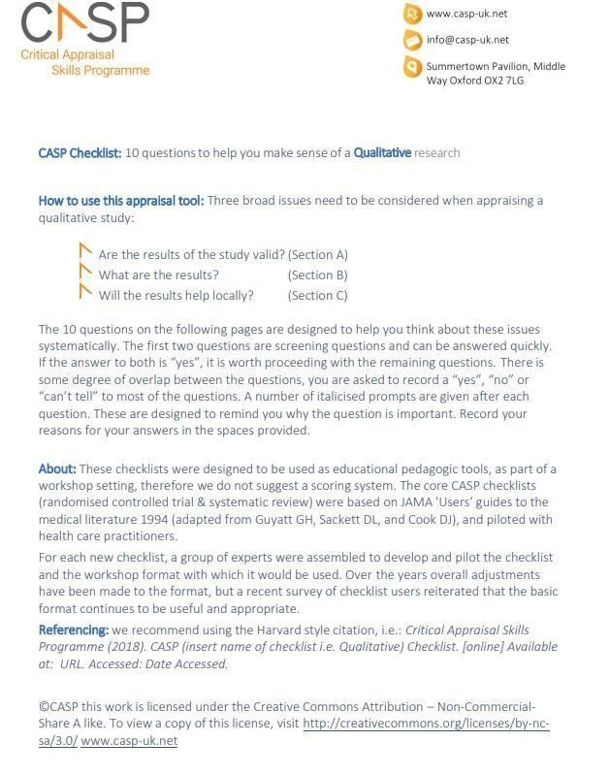

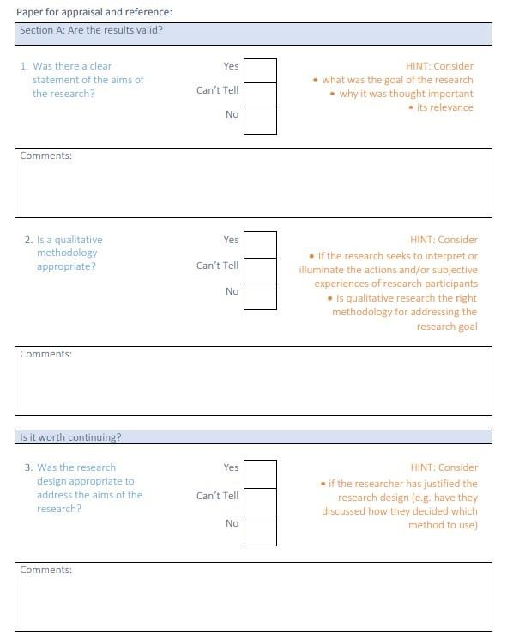
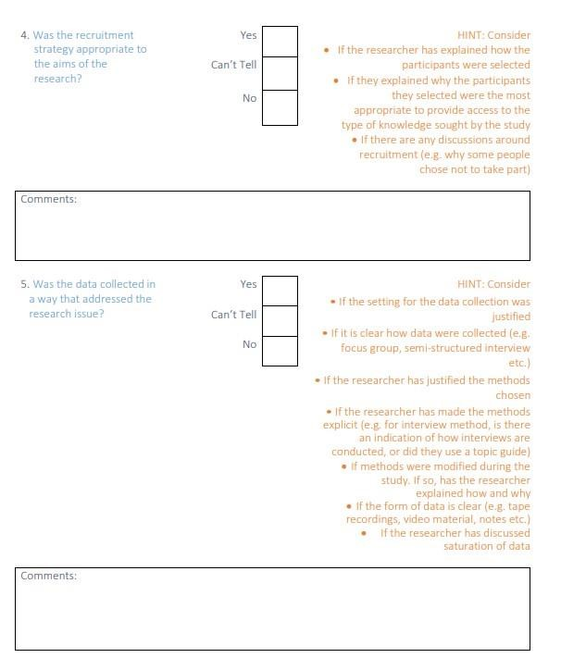

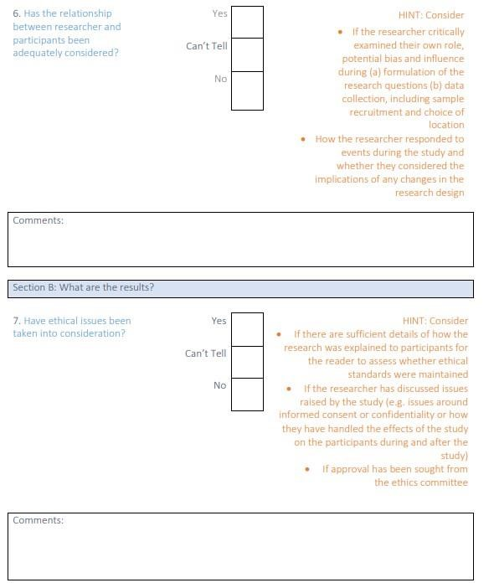

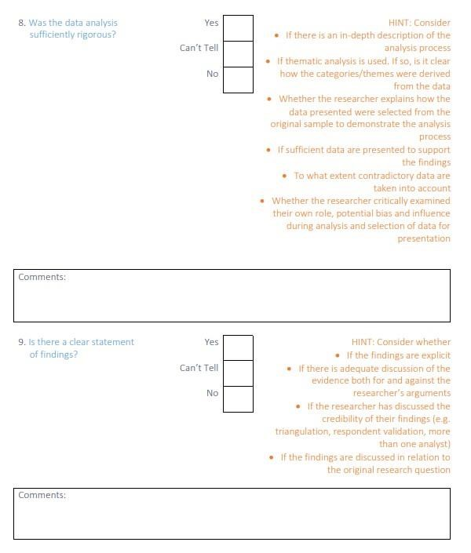

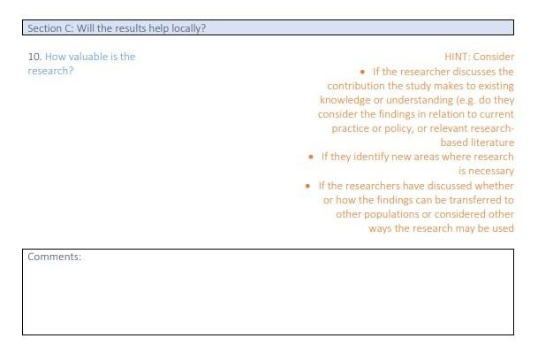

Appendix 1.5: CASP Results

Author(s) (year) | 1.  Clear statement of aims | 2. Methodology | 3. Research design | 4.  Recruitment  strategy | 5.  Data  collection | 6.  Relationship between researcher and participant | 7.  Ethical issues | 8.  Rigorous data analysis | 9.  Clear statement of findings  (for mixed-method studies, sufficient verbatim quotes from the interview transcripts are used to illustrate the themes) | 10.  How valuable is the research | 11.  Quality Rating
Bryant et al.  (2021) | Yes | Mixed | Yes | Yes | Yes | Yes | Yes | Yes | Yes | Discussed: findings in relation to previous research, discussion on further research areas & clinical implications | 10  High
Cliffe and  Stallard  (2023) | Yes | Qualitative | Yes | Yes | Yes | No | Yes | Yes | Yes | Discussed: findings in relation to previous research & limitations. Limited discussion on further research areas & clinical implications. Relationship between researcher and participants not discussed. | 8  High
Edmondson et  al.  (2018) | Yes | Qualitative | Yes | Yes | Yes | Yes | Yes | Yes | Yes | Discussed: findings in relation to previous research & limitations. Limited discussion on further research areas & clinical implications | 9  High
Edwards-Bailey  et al.  (2023) | Yes | Mixed | Yes | Yes | Yes | Yes | Yes | Yes | Yes | Discussed: findings in relation to previous research, discussion on further research areas & clinical implications | 10  High

Author(s) (year) | 1.  Clear statement of aims | 2. Methodology | 3. Research design | 4.  Recruitment  strategy | 5.  Data  collection | 6.  Relationship between researcher and participant | 7.  Ethical issues | 8.  Rigorous data analysis | 9.  Clear statement of findings  (for mixed-method studies, sufficient verbatim quotes from the interview transcripts are used to illustrate the themes) | 10.  How valuable is the research | 11.  Quality Rating
Miller et al.  (2021) | Yes | Qualitative | Yes | Yes | Yes | Yes | Yes | Yes | Yes | Discussed: findings in relation to previous research, discussion on further research areas & clinical implications | 10  High
Mughal et al.  (2023) | Yes | Qualitative | Yes | Yes | Yes | Yes | Yes | Yes | Yes | Discussed: findings in relation to previous research, discussed further research areas & clinical implications | 10  High
Norman et al.  (2023) | Yes | Qualitative | Yes | Yes | Yes | Yes | Yes | Yes | Yes | Discussed: findings in relation to previous research, discussed further research areas & clinical implications. | 10  High
Ogden &  Bennett (2015) | Yes | Qualitative | Yes | Yes | Yes | No | Yes | Yes | Yes | Discussed: findings in relation to previous research & limitations. Limited discussion on further research areas & clinical implications. Relationship between researcher and participants not discussed. | 8  High
Author(s) (year) | 1.  Clear statement of aims | 2. Methodology | 3. Research design | 4.  Recruitment  strategy | 5.  Data  collection | 6.  Relationship between researcher and participant | 7.  Ethical issues | 8.  Rigorous data analysis | 9.  Clear statement of findings  (for mixed-method studies, sufficient verbatim quotes from the interview transcripts are used to illustrate the themes) | 10.  How valuable is the research | 11.  Quality Rating
Ozen-Dursun et  al. (2023) | Yes | Qualitative | Yes | Yes | Yes | Yes | Yes | Yes | Yes | Discussed: findings in relation to previous research, discussed further research areas & clinical implications | 10  High
Shahwan et al.  (2021) | Yes | Qualitative | Yes | Yes | Yes | No | Yes | Yes | Yes | Discussed: findings in relation to previous research, limitations, further research areas & clinical implications. Relationship between researcher and participants not discussed. | 9  High
Stänicke et al.  (2020) | Yes | Qualitative | Yes | Yes | Yes | Yes | Yes | Yes | Yes | Discussed: findings in relation to previous research, limitations, further research areas & clinical implications. | 10  High
Stänicke (2021) | Yes | Qualitative | Yes | Yes | Yes | Yes | Yes | Yes | Yes | Discussed: findings in relation to previous research, limitations, further research areas & clinical implications. | 10  High
Author(s) (year) | 1.  Clear statement of aims | 2. Methodology | 3. Research design | 4.  Recruitment  strategy | 5.  Data  collection | 6.  Relationship between researcher and participant | 7.  Ethical issues | 8.  Rigorous data analysis | 9.  Clear statement of findings  (for mixed-method studies, sufficient verbatim quotes from the interview transcripts are used to illustrate the themes) | 10.  How valuable is the research | 11.  Quality Rating
Troya et al.  (2019) | Yes | Qualitative | Yes | Yes | Yes | Yes | Yes | Yes | Yes | Discussed: findings in relation to previous research, limitations, further research areas & clinical implications. | 10  High
Wadman et al.  (2017) | Yes | Mixed | Yes | Yes | Yes | Yes | Yes | Yes | Yes | Discussed: findings in relation to previous research, discussion on further research areas & clinical implications. | 10  High
Williams et al.  (2023) | Yes | Qualitative | Yes | Yes | Yes | Yes | Yes | Yes | Yes | Discussed: findings in relation to previous research, limitations, further research areas & clinical implications. | 10  High
Woodley et al.  (2021) | Yes | Qualitative | Yes | Yes | Yes | No | Yes | Yes | Yes | Discussed: findings in relation to previous research & limitations, discussion on further research areas & clinical implications. Relationship between researcher and participants not discussed. | 9  High

Appendix 1.6: Summary of Functions of Self-harm Found in Reviewed Study
Function of self-harm | Bryant et al. (2021) | Cliffe and  Stallard  (2023) | Edmondson  et al. (2018) | Edwards-  Bailey et al.  (2023) | Miller at al.  (2021) | Mughal et al. (2023) | Norman et al.  (2023) | Ogden and  Bennett  (2015) | Özen-Dursun et al. (2023 | Shahwan et al. (2021) | Stänicke  et al.  (2020) | Stänicke  (2021) | Troya et al. (2019) | Wadman et al.  (2017) | Williams  et al.  (2023) | Woodley et al.  (2021) | Total functions
Managing distress/affect  regulation |  |  |  |  |  |  |  |  |  |  |  |  |  |  |  |  | 13
Self - punishment |  |  |  |  |  |  |  |  |  |  |  |  |  |  |  |  | 10
Exerting inter-personal influence |  |  |  |  |  |  |  |  |  |  |  |  |  |  |  |  | 7
Averting suicide |  |  |  |  |  |  |  |  |  |  |  |  |  |  |  |  | 6
Dissociation |  |  |  |  |  |  |  |  |  |  |  |  |  |  |  |  | 5
Gratification |  |  |  |  |  |  |  |  |  |  |  |  |  |  |  |  | 4
Protection of others |  |  |  |  |  |  |  |  |  |  |  |  |  |  |  |  | 2
Sensation-seeking |  |  |  |  |  |  |  |  |  |  |  |  |  |  |  |  | 1
Experimental |  |  |  |  |  |  |  |  |  |  |  |  |  |  |  |  | 1
Expressing and coping with sexuality |  |  |  |  |  |  |  |  |  |  |  |  |  |  |  |  | 0
Personal mastery |  |  |  |  |  |  |  |  |  |  |  |  |  |  |  |  | 8
Validation: strength/toughness |  |  |  |  |  |  |  |  |  |  |  |  |  |  |  |  | 3
A sense of belonging |  |  |  |  |  |  |  |  |  |  |  |  |  |  |  |  | 0
Maintaining or exploring boundaries |  |  |  |  |  |  |  |  |  |  |  |  |  |  |  |  | 0
A personal language |  |  |  |  |  |  |  |  |  |  |  |  |  |  |  |  | 6
Total number of functions | 8 | 2 | 5 | 1 | 3 | 6 | 4 | 8 | 2 | 7 | 2 | 5 | 6 | 2 | 2 | 3

Appendix 1.7: Extracts From Studies

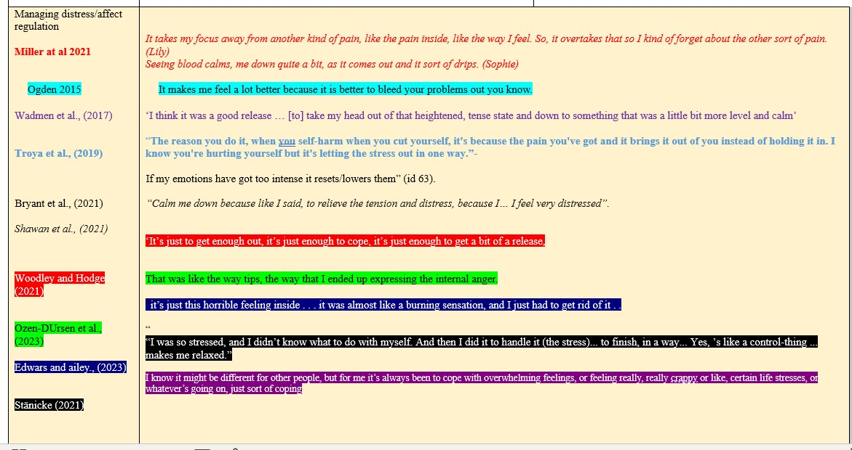

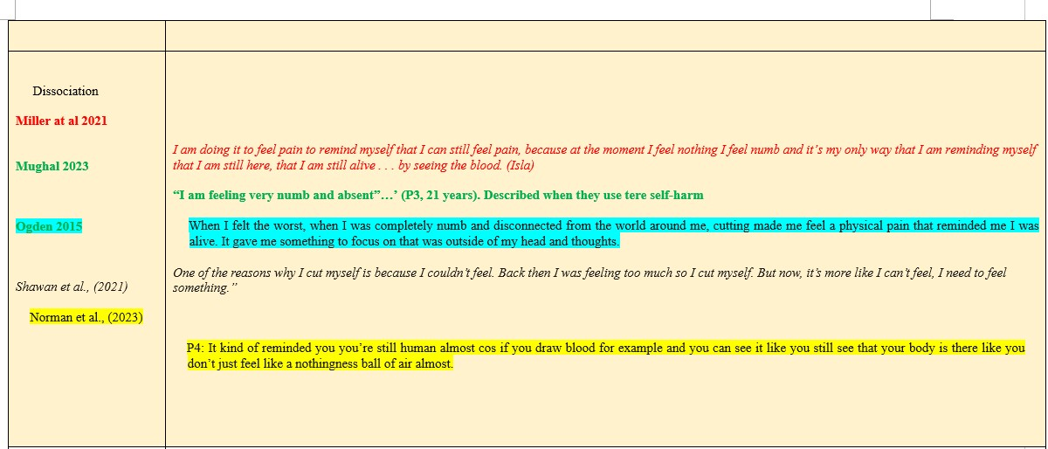

Appendix 1.8: Reflective Journal Excerpts
- Never really appreciate the task involved in undertaking a synthesis review. I’m beginning to learn the amount of time and attention it requires, and it feels intense. I’m doubting my skills and abilities.

- It feels like a big responsibility when reading the reviews and seeing if the findings in a study fit with the priori framework - don’t want to misrepresent the data and skew the findings. I’m thinking I’m experiencing imposter syndrome - I’m just a trainee and I’m trying to make sense of these findings that experienced researchers have revealed.

- I’ve noticed a lot more studies are better structured than they used to be, especially in terms of writing about their research’s clinical implications.

- I find qualitative studies are really powerful because of the way the findings are entrenched in the voice / quotes of their participants.

- The articles I’ve read so far are sad, but this one has particularly made me sad as I didn’t really think about self-harm in older adults. I’m upset that there’s not more support for older adults with self-harm. It looks like the principal author - Troya et al. (2019) - is really passionate about self-harm and older adults as I noticed in the references the other research she has undertaken. It makes me appreciate the important role research has in highlighting issues and bringing vulnerable peoples’ experiences to light.

- I was aware when coding and cross-refencing the evidence with the priori framework how the sexuality function of self-harm was empty and somewhere in my bias I was thinking I’ll surely find something in the William’s (2023) study with the LGBTQþ population. Now that I felt more aware of my bias towards the study, I was second guessing my interpretation and coding. I spoke to my research supervisor about this and how I was feeling a little stuck and frustrated with my approach. I shared the example of this quote from the study:

- “I think it was a lot of me feeling like I deserved it [self-harm]. Erm and that it was again a form of punishment for me because I genuinely thought that what I was feeling was sinful and that I needed to get it out for me.” (Williams et al., 2023, p.389)

- I wondered if I should cite this function under the punishment function or the function of expressing and coping with sexuality. In addition to acknowledging my tentativeness due to my earlier bias, we also talked about how there may not be one single function of self-harm and how the action may serve multiple functions. In the end, I was clear in my justification that the quote evidenced a punishment function, as the person talked about believing they felt they had committed a sin as opposed to stating they were struggling with feelings of sins.

Section Two: Research Report

Understanding Adult Self-Harm in a Community Sample: A Thematic Analysis

Abstract

Objectives
It is important to understand the populations that do not report to clinical services for self-harm and whose experiences remain hidden at a community level. This study aimed to identify the self-reported functions of self-harm for adults who self-harm in the community, and to explore their thoughts on the relationship between suicide and self-harm.
Design and Method
A qualitative design was adopted, with reflexive thematic analysis. Purposive sampling was used to recruit 23 adults (18+) who had accessed support from voluntary, community and social enterprise (VCSE) organisations for self-harm. Data were collected through online interviews, which were audio recorded and transcribed verbatim.
Results
Two themes emerged from the analysis: meaning behind the cuts, and a matter of life and death. In addition to managing distress and regulating emotions, a myriad of reasons were reported for the function of self-harm. Not all self-harm is intentional suicide; in fact, self-harm can be a protective factor against suicide. However, for some people self-harm is related to suicide ideation and the desire want to end life.

Conclusion
Motivations for self-harm and its relationship to suicide are complex and idiosyncratic. A person-centred approach to support individuals who self-harm can offer opportunities to reduce stigma, promote help-seeking behaviours, and lead to more meaningful support that aligns with the underlying reasons for self-harm.

Practitioner Points
- Self-harm serves diverse functions and may be perceived as positive by some individuals who self-harm, so personalized assessment is essential. Interventions should be tailored to an individual’s triggers, meanings, and needs.
- Self-harm’s link to suicidality varies—sometimes a coping strategy, other times a risk factor. Ongoing assessment ensures a person-centred approach, with interventions that evolve with the individual's needs.
- Proactive outreach using digital platforms, peer support, and anonymous helplines offers accessible care for individuals who conceal their self-harm.
- Keywords: Self-harm, community, thematic analysis, qualitative.

Introduction
Self-harm is defined by the National Institute for Health and Care Excellence as “any act of
self-poisoning or self-injury carried out by a person, irrespective of their motivation” (NICE, 2022). In the UK, 16.7% of women and 4.8% of men self-harm at some point in their life, with the prevalence increasing (Royal College of Psychiatrists, 2020), costing the NHS an estimated £162 million a year, constituting urgent public health challenges (Tsiachristas et al., 2017). In the UK, an estimated 50% of individuals who take their own life have a history of self-harm (Geulayov et al., 2016) suggesting it is a key risk factor for suicide and death (Hawton, 2015; Mayor, 2019). In 2023, 73,000 individuals reported to emergency services for self-harm (Office for Health Improvement and Disparities, 2024).
The true prevalence of self-harm is believed to be much higher as most studies draw on clinical sample groups which consist of individuals reporting to emergency departments, thus not accounting for the self-harm that goes unreported and remains hidden at a community level (Geulayov et al., 2018; McManus et al., 2019). Self-harm is a public health concern (Mughal et al., 2023) and a better understanding of it can improve interventions, better inform prevention strategies to reduce self-harm and suicide risk, and reduce the pressure on the NHS (Mughal et al., 2023; Özen-Dursun 2023; Townsend et al., 2016).
In an effort to better understand the prevalence of self-harm and suicide, the iceberg model of self-harm developed by Geulayov et al. (2018) presents estimates of suicide, reported self-harm and hidden self-harm (see Figure 1 and Appendix 2.1). Their retrospective study used national data on suicide, including data on hospital-presenting self-harm, with data from five hospitals and data on self-harm in the community from a large-scale schools’ survey to estimate the prevalence in adolescents in England. Suicide represents the tip of the iceberg, as the results of self-harm are overt and accounted for. Just below the tip of the iceberg are the rates of self-harm resulting in contact with emergency services, presenting opportunities to offer support. Most research into self-harm have drawn on samples from this population, as trends in rates of self-harm and suicide are collated by clinical services, as stipulated in suicide prevention policies (Department of Health and Social Care., 2023 and World Health Organisation., 2014); this sample population is contactable.

Figure 1
Iceberg model of self-harm and suicide (Geulayov et al., 2018)
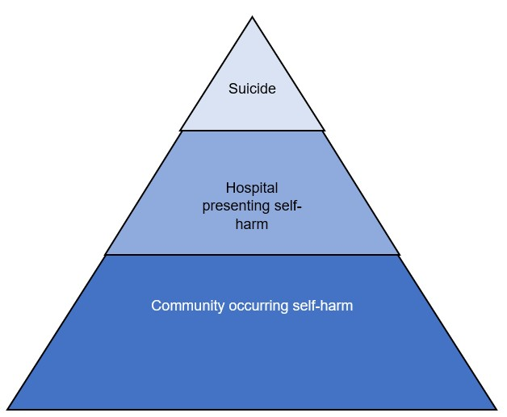

The vast hidden and submerged part of the iceberg epitomises self-harm that is estimated to take place at a community level. Community self-harm refers to that which is undertaken by individuals who do not report to emergency services (Peterson et al., 2023). A systematic review undertaken by Geulayov et al. (2018) estimated that self-harm in the community is almost ten times more common than among those who report to emergency services, indicating that less is known about their experiences in comparison to those of the population that seeks help from acute or emergency care. Research on self-harm has predominantly focused on clinical samples (those who report to health care services); for example, in the Edmondson et al. (2016) meta-synthesis on the functions of self-harm, only 1 out of 152 studies had a community dwelling population (Andover, 2014). Andover’s (2014) quantitative study reported a lifetime history of self-harm in 23% of participants, 11.2% of whom met the criteria for Non-Suicidal-Self-Injury Disorder (DSM-5, APA, 2013).
NICE self-harm guidelines (2004, 2022) recommend understanding the reason for self-harm as a means of helping healthcare professionals provide tailored support. This reflects the growing recognition that self-harm is a meaningful behavior that has a function and serves a personally significant purpose for the individual (Claes & Vandereycken, 2007). Understanding the function of self-harm from the individual’s perspective enables interventions to be person-centred, encouraging achievement of values-based goals which are likely to result in better outcomes (Bryant et al., 2020; Doyle et al., 2017; Edmondson et al., 2016).
Psychological models (Klonsky, 2007; Nock, 2009; Suyemoto, 1998) and studies on the functions of self-harm (Giles et al., 2018; Taylor et al., 2018) have broadened explanations beyond suicidal intent. Self-harm can serve several different functions. The Affect regulation model is the most frequently reported function of self-harm, and posits that self-harm is a means through which an individual manages or regulates intense emotional states (Tofthagen et al., 2021). In the Edmondson et al. (2016) review it was found to be reported in 93% of studies. A key contribution of the Edmondson et al. (2016) review is personal reports of self-harm being a positive and pleasurable experience for individuals. The review has contributed to a growing body of literature on self-harm that shifts the understanding from distress and coping to agency and self-care (Simopoulou and Chandler, 2020; Woodley et al., 2020). Furthermore, the review highlights the evolutionary process of research into self-harm as our insights and understanding evolve through continuous research.
Of the 152 studies included in the Edmondson et al. (2016) review, only 26% were qualitative studies, reflecting more broadly how much of the research into self-harm is undertaken using quantitative studies (74%). These studies are helpful in capturing prevalence, trends and correlations; however, they do not allow for subjective experiences of self-harm to be truly heard to appreciate the nuances that emerge from exploratory studies (Willig, 2013). Thus, more qualitative studies into the experiences of self-harm are needed to enrich understanding and inform interventions that are person-centred.
Despite the rise in self-harm and suicide (McManus et al., 2019), the number of people seeking medical or psychological support from statutory services for self-harm appears to be stagnant, meaning that a majority do not seek formal help (McManus et al., 2019; Steeg et al., 2021). Barriers to obtaining help from professional settings include unfavourable staff attitudes, feelings of shame and judgement for using NHS services, and guilt (Bellairs-Walsh et al., 2020; Farr et al., 2021). In contrast, people who reported receiving help from community-based settings expressed more positive experiences of feeling heard, supported, and cared for (Uddin et al., 2023). Research recently conducted in the north of England also described services as creating a sense of community and belonging (Hulin et al., 2023).
Some of those who self-harm in the community turn to informal help, which can be defined as support from family, friends, peers, religious leaders, or other non-health professions including non-statutory or VCSE organisations (Hulin et al., 2024). Research on support for broad categories of mental health difficulties has found that this type of support is very widely used (Brown et al., 2014). Increasingly, VCSE organisations are supporting people with mental health problems including self-harm (Newbigging et al., 2017, Royal College of Psychiatrists, 2010). This sample of people provides an opportunity to meet the gap in the literature described earlier – that most studies on the function of self-harm are from people recruited in the context of their use of healthcare services in hospitals or community mental health teams.
Research into self-harm with community populations is needed and slowly growing (Klonsky., 2007). Most research with self-harm community populations focuses on adolescents’ experiences which highlight multiple and diverse functions of self-harm (Miller et al. 2021; Mughal et al. 2022). Evidence suggests adolescents who self-harm may continue to do so into adulthood (Mars et al., 2014; O’Connor & Portzky 2018), and that the functions of self-harm evolve and change over time (Gardner et al., 2021), also increasing the risk of suicide. Self-harm studies with older adult community samples also provide insights into the similarities and differences of experiences of self-harm in later life, finding that self-harm helped avoid suicide, with some having used it over their life course as a coping strategy (Troya et al., 2019). Andover (2014) reported a lifetime history of self-harm in 23% of their sample. In comparison to adolescent and older adults, there is extremely limited literature exploring the experiences of self-harm using an adult community sample. This present study, therefore, aims to contribute to the literature on community self-harm by bridging this age-gap in the literature and expanding our understanding of self-harm that takes place at a community level.
Although self-harm is often considered distinct from suicidal behavior, research suggests a strong association between the two, even in non-clinical populations (Hawton et al., 2012; NICE, 2013). Studies indicate that individuals who engage in self-harm are at an elevated risk of suicide, regardless of whether they report suicidal intent at the time of self-harming (Hamza & Willoughby, 2016; Morris et al., 2013). In a community sample, where individuals may not have access to or seek professional intervention, the risk factors associated with self-harm—such as emotional dysregulation, social isolation, and distress intolerance—may persist unaddressed, increasing vulnerability to suicide. Many individuals who self-harm do not engage with healthcare or mental health services (Geulayov et al., 2018). Reasons for this include stigma, fear of being misunderstood, past negative experiences with services, or a belief that professional support is unnecessary (Hulin et al., 2024). This highlights the importance of studying self-harm beyond clinical settings, as traditional risk assessment models which are primarily based on hospital reported cases which may overlook those at risk in the community. Recognizing the relationship between self-harm and suicide within this population can help inform outreach efforts, reduce barriers to support, and develop alternative interventions outside formal clinical settings.

Research aims
The majority of research investigating self-harm has employed quantitative methods using clinical samples. This limits our understanding of the phenomenon within the community, which is where self-harm is evidenced to be most prevalent. Furthermore, the existing studies largely focus on adolescent or older adults’ experiences, and yet the evidence suggests some adolescents self-harm into adulthood and some older adults have also reported past self-harm. Less is known about the experiences of self-harm and its relationship to suicide in adults from a community sample. The aim of this research is to explore the experiences of adults who self-harm, focusing on two main research questions:
- What are the self-reported functions of self-harm for adults who self-harm in the community?

- What is the self-reported relationship to suicide for adults who self-harm in the community?
Method

Use of Secondary Data & Ethics
The present study conducts a secondary analysis of qualitative data derived from a primary study by Hulin et al. (2024), which explored the experiences of individuals (n=23, aged 18+) accessing support from VCSE organizations for self-harm in Yorkshire and the Humber. Their research focused on identifying barriers and facilitators to service engagement. While their primary aim was to examine service users’ perspectives on accessing and utilizing VCSE support, the present study takes a different analytical approach by re-examining the same dataset through a new lens. Specifically, this study aims to explore underlying motivations for self-harm and the relationship between self-harm and suicide, areas not explicitly addressed in the original analysis. Since the primary research was conducted by this study’s supervisory team, this secondary analysis represents the re-use of self-collected data (Heaton, 2008). The University of Sheffield’s Research Ethics Committee approved the Self-Declaration permitting this secondary analysis (registration number 210154995; see Appendix 2.3). By revisiting the data with a distinct research focus, this study seeks to generate novel insights into the psychological and contextual factors influencing self-harm behaviors.

Design

The primary study adopted a qualitative framework using semi-structured interviews for data collection, which aligned with the epistemological aspirations of the present study. The present study aimed to explore and understand the experiences of adults who self-harm in the community through a critical realism approach. This approach acknowledges that reality and knowledge are shaped by personal, societal, and cultural constructs (Carroll, 2017). By emphasizing participants’ subjective experiences, it seeks to uncover the meanings and reasons behind their actions (Cypress, 2017).
Qualitative research design is regarded as a means of giving marginalised groups a voice (Clarke et al., 2010), which in the context of this study related to the population who self-harm in the community; a group which is hidden and less understood, and thus described as the vast submerged part in the iceberg model of self-harm (Geulayov et al., 2018). The qualitative approach enabled individuals who self-harm and seek support from VCSE services to give rich in-depth accounts of their experiences (Rich & Gingsburg, 1999). Arguably, a positivist research paradigm, concerned with statistical measurements and objectivity (Percy et al., 2015), could not offer the same insight into participant experiences. Furthermore, the NICE guidelines (2011, 2022) highlight the importance of offering person-centred care, understanding the individual’s experience of self-harm, rather than focusing solely on risk assessment.
Reflexive thematic analysis (RTA) is considered to be a methodologically sound approach for analysing interview data and is widely used in health and psychology research (Braun & Clarke, 2014, 2021). RTA allows for an in-depth exploration of participants' perspectives while acknowledging the role of the researcher in shaping interpretation. It has been used to facilitate a deeper understanding of sensitive topics such as mental health, trauma and self-harm (Neill et al., 2022, Spencer et al., 2023, Troye et al., 2018), making it particularly relevant for exploring the lived experiences of individuals engaged in self-harming behaviours.
Alternative qualitative approaches for data analysis were considered but seemed less appropriate for the aims of this study. For instance, discourse analysis focuses more on the function of language that people use to construct accounts of their experiences (Starks & Trinidad, 2007), grounded theory aims to arrive at a conceptual framework, making it less concerned with participants’ experiences (Willig, 2013), while interpretative phenomenological analysis explores differences between individuals’ accounts, with a focus on idiographic experiences (Smith et al., 2022).

Reflexivity
Reflexivity is central to RTA, requiring researchers to critically engage with their positionality and its impact on data interpretation (Braun & Clarke, 2019). Unlike positivist approaches that seek objectivity, RTA recognizes that meaning is co-constructed between the researcher and the data, shaped by the researcher’s experiences, assumptions, and epistemological stance (Terry & Hayfield, 2021). As a British Pakistani, Muslim, disabled female, aged 44, with no lived experience of self-harm or suicidal ideation, my positionality influenced how I engaged with and interpreted the data. While I am an outsider to the experiences of self-harm, I acknowledged that my research lens may be shaped by cultural beliefs and personal experiences. The influence of these multiple subjective positions on the research was considered through engaging in reflexivity: writing a reflective log (Appendix 2.8), and reflections in research supervision.
An additional challenge was the distance I felt from the research, as I was using secondary data. Since I did not conduct the original interviews, I was unable to establish rapport with participants, shape the interview direction, or respond to emergent themes in real-time. As a result, my interpretations were based only on the transcripts, lacking the full interview experience—such as body language, tone, or pauses—that might have added another layer of meaning (Long-Sutehall et al., 2010). To address this, I engaged in rigorous contextual reading, ensuring my analysis remained grounded in the participants' narratives, rather than my own assumptions.
Rather than being a direct ‘co-constructor’ of data, I positioned myself as a critical interpreter, bringing an academic lens to pre-existing narratives. This shift required balancing analytical rigour with positioning the participants' voices at the centre of my interpretations (Irwin, 2013). Reanalysis with a fresh lens allowed me to explore previously unexplored themes in the dataset. RTA’s flexible and iterative approach enabled me to engage deeply with the data and its meaning-making process, turning secondary data analysis into a powerful tool for producing new insights (Braun & Clarke, 2019).
Participant Recruitment
Purposive sampling was employed in the primary study to select participants who had accessed VCSE support for self-harm in the Yorkshire and Humber region. This approach aligns with the present study’s methodology, ensuring that the data collected were relevant, in-depth, and directly addressed the study’s aim to explore the subjective experiences of individuals with lived experience of self-harm (Palinkas et al., 2015).
72 VCSE organisations, providing support for individuals who self-harm in the Yorkshire and Humber region were contacted and asked to advertise the study in their services and via social media. The inclusion criteria required participants to:
- Be aged 18 years or over
- Self-identify as having lived experiences of self-harm as defined by NICE (2022)
- Live in the Yorkshire and Humber region
Participants self-selected to take part by contacting a member of the study team via email or telephone. Eligible participants were provided with an information sheet (Appendix 2.4) and an online consent form (Appendix 2.5). Consenting participants also completed a sociodemographic form which collected data on age, gender, ethnicity, education, employment and location.

Sample Size
The existing data comprised 23 adult participants who shared their experiences of self-harm. RTA encourages a focus on analytic depth rather than the number of participants (Braun & Clarke, 2021). As such, the sample size aligns with RTA’s concept of information power (Malterud et al., 2016), which posits that the adequacy of a sample depends on the richness, relevance, and specificity of the data, rather than the size alone. Collectively, the sample size allowed for interviews that produced rich data for re-use in this study, permitting useful analysis to derive meaningful themes (Kiger & Varpio, 2020).

Data Collection
The primary study conducted online semi-structured interviews using a topic guide, from October 2021 to April 2022 (Appendix 2.6). The content of the topic guide was informed by existing literature, policy documents, and discussions with the Lived Experience Advisory Group (LEAG). For the online interviews, audio-visual and chat box messages were recorded using the in-built systems on Google Meet and Blackboard Collaborate Ultra. Visual recordings were converted to an mp3 format and the original mp4 recording was deleted. Audio from telephone interviews was recorded using dedicated, encrypted recording devices. All interviews were transcribed verbatim using Braun and Clark’s (2013) protocol for the transcription of data, i.e., exactly as spoken to ensure consistency and validity of the data analysis (Collins et al., 2019). This study accessed and analysed the full data set (23 participants’ transcripts and audio recordings) which was stored electronically in accordance with university data security guidance.
Data analysis

Braun and Clarke’s (2006) six-step guidelines for undertaking thematic analysis were followed to guide the data analysis process. To begin, the researcher immersed themselves in the data by listening to the audio recordings, reading through each transcript, and then simultaneously listening to and reading each transcript. This allowed the researcher to really get a feel for the content. Initial thoughts and notes were written down and taken to supervision for further discussion and reflection. Once the data felt familiar, the researcher moved on to the process of coding. This involved highlighting sentences and phrases that stood out and attaching codes to describe the context or meaning behind them, ensuring that the essence of the data was captured.
Next, the researcher looked for patterns in the codes. These were grouped together to identify commonalities and to begin forming themes. This was shared in supervision, which allowed for discussions about codes that did not seem to fit as well, permitting the researcher to confidently discard those, while others evolved into stronger themes. At this stage, the researcher returned to the data with a fresh perspective, after seeing how the codes had transformed into themes. The material was reviewed again, checking for any overlap between themes and ensuring that any significant codes that needed further attention were not missed.
Once the researcher felt confident with the themes, each was reviewed carefully. The names of some themes were reworded if they did not fully capture the essence of what the data showed. This ensured that each theme was named in a way that was as clear and accurate as possible (examples of this process can be found in Appendix 2.7). Finally, the analysis was written up, using the identified themes to structure the data analysis section. These themes then informed the discussion section, helping to tie everything together.

Validity and Quality Control

Yardley’s (2017) four principles for ensuring the validity and quality of qualitative research guided this study. First, sensitivity to context was demonstrated through the ethical approval process, ensuring the research was conducted with care and consideration for participants. Second, commitment and rigor were upheld by providing a strong rationale for the study, highlighting its relevance to the population being researched. Additionally, expert guidance was sought throughout the research process to enhance its quality and ensure that ethical safeguards were in place to prevent any unintentional reinforcement of oppressive practices or beliefs. Third, transparency and coherence were maintained by clearly outlining the data analysis process and incorporating excerpts from transcripts to illustrate findings. The analysis offers a compelling and structured interpretation of the themes, aligning with the study’s core principles. Finally, impact and importance were emphasized through a commitment to using the research findings to enhance understanding of self-harm and promote positive social change. Upon completion, the researcher, in collaboration with their supervisor, plans to share the findings with key stakeholders, including the Yorkshire and Humber Mental Health & Suicide Prevention Community of Improvement Network, to inform service development and practice.
Findings

Participants
All twenty-three interviews from the dataset were analysed. The majority of participants were female (n = 17) and White British (n = 19) (see Table 1). All participants were over 18 years of age, with the majority falling within the 26–35 age range (n = 8). Five participants were aged 56 or older. In terms of employment, 14 participants were employed, 6 were unemployed, 1 was a university student, 1 was retired, and 1 preferred not to answer the question.

Table 1
Demographic characteristics of participants
ID | Age | Gender | Ethnicity
P1 | 46-55 | Male | White and Black  Caribbean
P2 | 26-35 | Female | White British
P3 | 26-35 | Female | White British
P4 | 26-35 | Male | White British
P5 | 18-25 | Female | White British
P6 | 26-35 | Male | African
P7 | 18-25 | Female | Indian
P8 | 18-25 | Female | White British
P9 | 18-25 | Female | White British
P10 | 56-65 | Male | White British
P11 | 56-65 | Female | White British
P12 | >66 | Male | White British
P13 | 26-35 | Female | White British
P14 | 36-45 | Male | White British
P15 | 56-65 | Female | White British
P16 | 56-65 | Female | White British
P17 | 26-35 | Female | White British
P18 | 36-45 | Female | White British
P19 | 46-55 | Female | White Greek
P20 | 26-35 | Female | White British
P21 | 26-35 | Female | White British
P22 | 18-25 | Female | White British
P23 | 36-45 | Female | White British

Table 2
Themes and Contribution to Themes by Participant

Main theme | Subthemes | P1 | P2 | P3 | P4 | P5 | P6 | P7 | P8 | P9 | P10 | P11 | P12 | P13 | P14 | P15 | P16 | P17 | P18 | P19 | P20 | P21 | P22 | P23
Meaning behind the cuts | “Visceral release”
Meaning behind the cuts | Internal or external validation
Meaning behind the cuts | “Self-harm actually kept me alive”
A matter of life and death | Surviving or ending
A matter of life and death | A complex relationship

Two themes were identified from the data: ‘Meaning behind the cuts’, and ‘a matter of life and death’. Figure 2 summarises these main themes with explanatory sub-themes. Table 2 provides evidence for the themes with key supporting quotes from the data.

Figure 2
Map of themes and explanatory sub-themes

Table 3
Identified themes and sub-themes with supporting quotes
Themes | Sub-themes | Supporting quotes
Meaning behind the cuts | “Visceral release” | “It literally felt like such a visceral release.” (P2)
Meaning behind the cuts | Internal or external validation | “I don’t do it for attention but maybe underneath it’s a cry for help in some ways.” (P11)
Meaning behind the cuts | “Self-harm actually kept me alive” | “If I don’t self-harm then it would possibly lead up to a suicide attempt.” (P4)
A matter of life and death | Surviving or ending | “Self-harm is a way to manage and continue living. Suicide is the final solution.”(P19)
A matter of life and death | A complex relationship | “Cause it [self-harm] was a negative thing for me, there was probably a link to it [suicide].” (P13)

Meaning Behind the Cuts
This theme reveals how self-harm has complex, deeper meanings beyond the physical act. It explores the diverse functions of self-harm, as reported by participants. While all individuals described self-harm as a means of emotional regulation, the underlying reasons varied, revealing significant individual differences in how and why they engaged in the behaviour.

“Visceral release”
A central reason cited by participants for using self-harm was the alleviation of tension; the relief it provided by facilitating a calming effect on the body and mind. For some, this was described in almost physical terms, where the experience of self-harm was akin to releasing built-up pressure, providing a much-needed release of pent-up emotions. One participant vividly captured this feeling:
"It literally felt like such a visceral release, it literally felt like popping a balloon and all this tension was released." (P22)
The metaphor of "popping a balloon" reflects the intensity of the emotional build-up that was relieved through self-harm, demonstrating the perceived physicality of the emotional release.
Interestingly, while self-harm was primarily associated with managing negative emotions, some participants also noted that it could be a response to overwhelming positive emotions. This highlights the complexity of emotional regulation, where self-harm served as a tool not only for managing distress but also for navigating intense emotional experiences across the spectrum. One participant explained:
"Like I said would set off good emotions, but it was also things that would set really strong, good stuff as well, so it wasn’t just the bad." (P19)
Here, self-harm is recognized as a way to deal with both the highs and the lows, suggesting that the act may have provided a way to stabilize or ground the participant when emotions felt too intense, regardless of whether they were positive or negative. On the other hand, some participants emphasized that their self-harm was driven by the desire to disconnect from emotions altogether. This need to escape the intensity of their feelings led them to seek a numbness or emotional void. One participant described this experience:
"I wanted to stop feeling, because I wanted to feel numb." (P1)
In this context, self-harm was not just a means of managing emotions but a way to shut them down entirely, to stop feeling both positive and negative emotions in a bid to obtain relief from an overwhelming emotional state.
Overall, participants described the regulatory function of self-harm as a means of shifting from an emotional state that felt too intense or unmanageable, whether pleasant or distressing, to a calmer, more grounded state. For many, this shift enabled them to continue with their daily lives or to move forward from difficult emotional experiences. As one participant reflected:
"It was grounding…it was a release. It was just making me feel better. That’s all I cared about. Because if I feel better, that meant I could just ignore what had happened. I can deal with it…I could then look for solutions." (P19)
In this case, self-harm became a way to restore equilibrium, allowing the participant to regain a sense of control and proceed with life, even if it meant temporarily ignoring or avoiding the emotional sources of distress. This speaks to the overall utility of self-harm as a coping strategy for managing overwhelming emotional states, though it also reflects the limitations and potential consequences of such a coping mechanism, as it often serves as a short-term solution rather than addressing the underlying issues.

Internal or external validation
For some participants, self-harm functioned as a means of making their pain visible to others, though the underlying motivations varied. One participant described self-harm as a way to be acknowledged, even if the attention received was negative:
“You’ve got to remember, negative attention’s better than no attention at all…Cause even if they shouted at me that means they noticed me.” (P1)
In contrast, another participant reported using self-harm as a way to gain social capital among their peers, highlighting how self-harm can fulfil different interpersonal functions:
“I got to the point of bragging about it so that’s when I began to do more audacious cuts that would lead to more bruises.” (P6)
For some individuals, self-harm was not about seeking external validation, but rather an attempt to express distress in a way that might elicit care from others. One participant reflected on this complexity, acknowledging that while they did not perceive their actions as attention-seeking, they could recognize a deeper cry for help:
“I don’t do it for attention but maybe underneath it’s a cry for help in some ways? Yes, I can see that. But I’m not somebody who wants to pick a scab and say, ‘Poor me’ – I’m trying to express distress that I need help with.” (P11)
However, the notion of self-harm as an act to gain attention was perceived as judgmental and dismissive by some participants. One individual described their self-harm as an intensely private act, emphasizing the disconnect between personal intent and external interpretation:
“I’m so uncomfortable inside and I don’t understand the feeling, I need to put the feeling onto my body so that I can make something hurt …So that’s why I put it on my body…They keep saying it’s for attention and I’m like ‘it’s not for attention’, I’m really embarrassed about it, I don’t want anyone to see it, and I actually try to cover it up. I’m hidden away when I’m doing it. Yeah, it might be on my face, but I don’t want people to see it.” (P2)
In this way, they were addressing an internal need to link their emotional pain with their physical self, seeking a tangible, bodily expression of their distress. This participant’s experience underscores the difficulty individuals face in maintaining the privacy of their self-harm and preserving the personal meaning it holds, while simultaneously navigating external perceptions. In some cases, others' reactions to self-harm led to feelings of shame, reinforcing the desire to keep it hidden.
The findings highlight the importance of understanding self-harm as a complex behaviour that serves multiple functions, including communication, validation, and self-regulation, rather than reducing it to an oversimplified notion of attention-seeking.

“Self-harm actually kept me alive”
For many participants, self-harm was seen as a crucial tool that helped prevent them from engaging in more extreme actions, such as suicide. This function of self-harm as a life-preserving mechanism was described as a form of harm reduction. One participant explained that without self-harm, they feared they might eventually resort to suicide:
"Um, some of the time it’s been a case of if I don't self-harm, then it would possibly end up leading to a suicide attempt." (P4)
This sentiment suggests that self-harm, in some cases, served as a safety valve or an emotional outlet that allowed individuals to manage overwhelming feelings in a way that felt more controllable and less dangerous than taking their own life. The concept of ‘lesser harm for a greater good’ is especially relevant here, where self-harm was viewed as a way to manage intense emotional pain without resorting to suicide, which many participants considered to be the ultimate and irreversible action. Thus, the function of self-harm was to act as a means of averting suicide.
Interestingly, some participants seemed to gain a sense of mastery over their self-harm, asserting that they could control it in a way that minimized the risk to their own life. For instance, one participant reflected on how they were able to engage in self-harm while maintaining a sense of safety:
"I always self-harmed in a way that I knew would never put my life at risk." (P22)
This level of control suggests that, for some individuals, self-harm was a conscious coping mechanism that allowed them to regulate their emotional pain in a way that they felt was safer and more manageable. These participants seemed to have a sense of agency in their ability to self-harm without escalating it to more life-threatening behaviors. Similarly, another participant shared their perspective on how they never sought treatment for their self-harm because they believed they had control over it:
"I just know when I can stop, so I never really got treatment for it" (P7).
This quote highlights a potential misconception that individuals may have about their self-harm, where the belief in personal control and the lack of perceived immediate danger can sometimes prevent them from seeking the support that might help them address the underlying causes of their distress. However, there were instances when participants acknowledged that their self-harm could become dangerous if not carefully controlled. One participant reflected on a time when they felt they could no longer manage their self-harm in a safe manner, which led them to seek external support from friends. This recognition of risk suggests that self-harm can sometimes act as a warning sign of escalating distress, pushing individuals to reach out for help before the situation becomes more dangerous:
"I knew that I couldn’t self-harm because if I did, I wouldn’t be able to do it in any way that was even remotely safe because I felt so bad… I had a couple of friends who helped me through that and that just got me to time to sleep." (P9)
In this instance, the participant’s ability to assess the risks associated with self-harm and to seek help demonstrates a moment of self-awareness and vulnerability, which contrasts with their earlier sense of control. It shows that, for some individuals, self-harm may function as a kind of emotional ‘checkpoint’, where the individual recognizes when they have reached a dangerous point and may turn to others for support.
While self-harm may serve as a coping mechanism that prevents individuals from resorting to suicide, it also underscores the fragile balance between managing emotional distress and the risk of escalating to more life-threatening actions. The complexity of self-harm as both a coping strategy and a potential danger highlights the need for a nuanced understanding of its role in the lives of individuals struggling with intense emotional pain and suicidal thoughts.

A Matter of Life and Death

This theme captures the varying perspectives and experiences of participants regarding the relationship between self-harm and suicide. While some participants perceived no connection between the two, others viewed them as part of a continuum. Additionally, some participants expressed uncertainty about the relationship between self-harm and suicide, highlighting its complexity.

Surviving or ending
Several participants clearly distinguished self-harm from suicide, emphasizing that self-harm was a survival mechanism rather than an indication of suicidal intent. For these individuals, self-harm functioned as a means of coping, allowing them to continue living despite emotional distress:
“Self-harm is a way to manage and continue living. Suicide is the final solution.” (P1)

One participant elaborated on this perspective, explaining that self-harm affirmed their desire to exist:
“And so, it’s almost like proving that I want to be in the world and that I am in the world, and obviously alternatively suicide is absolutely not wanting to be in the world.” (P4)
Participants expressed frustration about the widespread conflation of self-harm and suicide, noting that such misunderstandings contribute to fear and stigma:
“This is what causes so many problems. Everybody’s terrified of self-harm because they think it leads to suicide.” (P23)
One participant described seeking medical assistance for self-harm related to depression and being asked whether they had suicidal thoughts. The participant explained that, for them, self-harm was separate from any desire to die, instead reflecting their aspirations and future hopes:
“I remember saying “I don’t want to die” like “I want to grow up and I want to be a good doctor and I want to be around my mum and sister and watch my sister have kids and stuff.” (P22)
Conversely, other participants described their self-harm as being closely tied to suicidal thoughts, particularly when they experienced a sense of hopelessness and a lack of meaningful relationships:
“I had no prospects, no future, my relationships had broken down, relationships with my family had broken down…I wanted it to end. The self-harming, the slitting my wrists and stuff with a razor, it wasn’t—it wasn’t to get a reaction from the self-harming, it was to end my life.” (P3)
The contrast between these perspectives underscores the importance of social connections as a protective factor against suicide. Participants who felt hopeful and connected to others viewed self-harm as a coping mechanism, whereas those who experienced social isolation and despair were more likely to see self-harm as linked to the intention to end their life.

A complex relationship
For some participants, the relationship between self-harm and suicide was ambiguous. While they maintained that self-harm and suicide were separate, they also acknowledged that self-harm could, under certain circumstances, lead to suicidal thoughts or behaviours:
“My overall response to that would be that they're separate … just because I'm self-harming doesn’t mean I'm suicidal…However, I guess when I was at my lowest, a combination of everything else … I guess during that period it was almost a stepping stone to my decision to say I wanted to end my life.” (P11)
Some participants reflected on how prolonged self-harm diminished its effectiveness as a coping mechanism, increasing their risk of suicide:
“Cause it [self-harm] was a negative thing for me, there was probably a link to it [suicide]…So I
don’t know if anybody who thought of self-harm as a good thing might link it to suicide but…I
feel like it was, it is kind of linked, that I was definitely probably rolling towards potentially you
know wanting to kill myself, yeah, and like I say the self-harming did get worse. The cuts got
deeper.” (P13)
This perspective supports the idea of a self-harm continuum, wherein persistent self-harm can gradually increase vulnerability to suicide. Some participants explicitly described self-harm as a preparatory step for suicide:
“Self-harm – was practising for a suicide attempt … that was the goal.” (P6)
For certain individuals, self-harm escalated in frequency and intensity over time. When it no longer provided relief, suicide became the perceived alternative:
“When I attempted my life…it was never a cry for help because nobody would have found me
because I lived on my own. I think I was at such a low point … and then doing it [self-harm],
and I did it three times over a month, each time increasing the amount, and I think I just
wanted things to stop.” (P22)
For some participants, self-harm was distinctly separate from suicide and served as a means of survival. For others, self-harm and suicide were closely connected, with self-harm acting as either a precursor to or a substitute for suicide. Additionally, some participants described a more complex and evolving relationship between the two, where self-harm initially served as a coping mechanism but eventually lost its effectiveness, increasing suicidal risk. These varied accounts highlight the importance of individualized understanding and support in addressing self-harm and suicide prevention.

Discussion
This study aimed to understand the self-reported functions of self-harm and its relationship to suicide for adults from a community population. Two overarching themes emerged from the participants experiences: meaning beyond the cuts and a matter of life and death. These findings contribute to the growing body of literature on self-harm, highlighting both the individualized nature of self-harm behaviours and the need for a nuanced understanding of their relationship with suicidality.

Self-harm is a purposeful behaviour
All participants described using self-harm as an emotional regulatory tool to manage distress. This is consistent with existing studies confirming affect regulation as a primary function of self-harm (Kuehn et al., 2022; McKenzie & Gross; 2014; Taylor et al., 2018). The visceral release described by participants aligns with Klonsky’s (2007) functional model of non-suicidal self-injury (NSSI), which emphasizes self-harm as a means of reducing emotional distress. However, beyond emotion regulation, participants also reported other diverse motivations, such as seeking validation, managing both positive and negative emotions, or expressing distress in ways that might be recognized by others. These findings align with those of a metasynthesis conducted by Edmondson et al. (2016), as well as with the findings presented in section one of this thesis.
Some participants reflected on self-harm as a private coping mechanism, emphasising their desire to conceal their behaviours, whereas others acknowledged its potential interpersonal function. The finding that self-harm was used as a form of communication aligns with Nock’s (2008) social signalling model, which suggests that for some, self-harm may serve to elicit care or recognition from others, particularly in the absence of other effective communication strategies. Importantly, participants rejected the notion that their self-harm was merely ‘attention-seeking’, highlighting the stigma associated with this perception and the ways in which such assumptions may discourage individuals from seeking support and keep it hidden (Chandler, 2018).
A key aspect of this study was that participants largely engaged in hidden self-harm, meaning they actively avoided professional services and often concealed their behaviours from those around them. This highlights an underrepresented group within self-harm research; individuals who do not seek formal support but continue to engage in self-harm as a private and sometimes long-term coping strategy. For these individuals, self-harm functioned as a deeply personal mechanism to maintain control over their emotional experiences, rather than something they wished to share with others. This aligns with previous findings that suggest hidden self-harm is associated with self-reliance, shame, and fear of judgment (Sheehy et al., 2019). Understanding this hidden nature reinforces the need for outreach strategies that do not rely solely on clinical services but also engage community-based and digital interventions which provide accessible, non-stigmatizing support.

The complex relationship between self-harm and suicide
The participants expressed a range of perspectives regarding the relationship between self-harm and suicide. For some there was no relationship between the two, as they were seen as polar opposites, one (self-harm) preserved life, and the other (suicide) ended it. These participants found it frustrating when family, friends, or clinicians conflated self-harm with suicide, as they felt they failed to appreciate that self-harm was used for many different reasons, such as a coping tool for emotional pain, distress or self-validation. The belief that self-harm may lead to suicide can reinforce the stigma experienced by individuals who self-harm, and may reinforce feelings of the need to hide their self-harm or discourage them from seeking support. The frustration expressed by participants regarding the conflation of self-harm with suicidality reflects concerns found in the existing literature about the stigma that arises from misinterpreting the motivations behind self-harm (Ferrey et al., 2016), which may explain why some prefer to keep it hidden.
In contrast, some participants did view self-harm as closely related to their suicidal thoughts and behaviour. Ending their life was perceived as the only way to escape or end the severity of distress or sense of hopelessness they were experiencing. Participants shared how they began by self-harm, but at times this was not giving them the desired emotional relief or was not effective in stopping the difficulties they experienced, in which case they attempted to end their life. These experiences fit with what Curtis (2016) called the cyclical pattern of self-harm, whereby self-harm behaviours become more frequent and severe “until a suicide attempt is made, if this is not fatal, a period of respite from self-harm follows before the pattern recommences” (p.2). The idea that self-harm can serve as a ‘stepping stone’ to suicide has been supported in research (Mars et al., 2019), underscoring the importance of monitoring changes in self-harm behavior over time. For this particular population who engage in hidden self-harm, the risk of suicide may be particularly concerning, as their reluctance to seek support means they may struggle alone with increasing distress. The absence of external intervention could mean that warning signs of escalation go unnoticed.

Strengths, Limitations, and Future Directions
This research study addresses literature gaps in relation to self-reported accounts of self-harm and its relationship to suicide for adults who self-harm in the community. The exploratory study gives insight into self-harm that takes place at a community level which has been described as hidden, as less is known about this population’s experience. The study thus contributes to expanding our understanding of self-harm and its relationship to suicide. Notwithstanding the study’s contribution on self-harm literature, there are limitations that need to be acknowledged.
One limitation of the study relates to the study utilising secondary data, and therefore the primary researcher did not experience interviewing the participants directly, which precluded asking follow-up questions or seeking clarification where participants responses were unclear. Furthermore, the relational experience between researcher and participant that is afforded through the qualitative research experience was compromised, and key elements of power imbalances, developing a rapport and trust were not directly experienced. As such the researcher acknowledged the privilege that had been afforded to them through access to the secondary data and committed to adhering to principles of rigour and transparency. For example, each audio recording was listened to several times and the transcripts were read and re-read. A journal was kept, capturing the researcher’s reflections as they engaged with the data, some of which were shared with their supervisor to aid exploration of any
bias or difficulties.
The original study by Hulin et al. (2024), from which data was used, had significant PPI input. However, due to time constraints, this research team could not engage sufficiently with members of the community impacted by this research. PPI contribution was a missed opportunity in this study, and a recommendation moving forward is to involve PPI contribution to ensure the study reflected the needs and priorities of those directly affected by the research topic (Jennings et al., 2018).
The 23 participants were recruited via VCSE organisations across the Yorkshire and Humber region with some areas having ethnically diverse populations. However, it is recognised that the participant group was not reflective of the diverse communities of the region (as they were predominantly white and female). A recommendation for future studies in addition to approaching VCSE organisations is also to reach out to faith groups within communities, as this may help widen the recruitment reach and diversify the sample group.

Clinical implications

The findings from this study have important clinical and practical implications, which are

discussed below.

Idiosyncratic nature of self-harm
Self-harm serves varied functions beyond emotional regulation, emphasizing the need for a personalised clinical approach. Clinicians should explore the unique meanings, triggers, and goals behind an individual’s self-harm rather than assuming a universal function. Given this diversity, interventions should be tailored to individual needs rather than following a one-size-fits-all model. While DBT and ERT can help manage distress (Kothgassner et al., 2021), additional considerations, such as the social and relational dimensions of self-harm, are crucial. Some individuals self-harm to elicit recognition or care, while others hide their behaviour. Compassion-Focused Therapy (CFT) may be particularly beneficial for those struggling with self-criticism and shame (Gilbert, 2010).

Flexibility in navigating the self-harm–suicide relationship
The link between self-harm and suicidality is fluid and individualised; for some, self-harm serves as a coping mechanism that delays suicidal actions, while for others, it increases vulnerability over time. Clinicians must avoid rigid assumptions and instead engage in ongoing conversations to assess how self-harm functions for each person at a given time. A person-centred approach allows for interventions that range from harm reduction and alternative coping strategies to suicide prevention, ensuring care aligns with the individual's evolving needs.

Proactive outreach
For individuals who engage in hidden self-harm, the risk of suicide may increase, as their reluctance to seek support means they may struggle alone with increasing distress. The absence of external intervention could mean that warning signs of escalation go unnoticed. This highlights the critical need for proactive outreach and self-help resources tailored to those who do not access traditional services. Digital mental health platforms, peer support networks, and anonymous helplines may serve as essential bridges to care for individuals who wish to remain private but require guidance in managing their distress safely.

Conclusion
This study provides insight into the self-harm experiences of adults who do not report to services, remaining largely hidden within the community level. Participants’ accounts demonstrate that the functions of self-harm are diverse; while many use it as a means by which to regulate distressing or overwhelming emotions, the specific reasons behind self-harm can be highly individual, making it difficult to fully understand its purpose. Similarly, the relationship between self-harm and suicide varies according to each individual’s unique motives and experiences. While some individuals may engage in self-harm without any suicidal intent, for others, the behaviour may be connected to suicidal thoughts or intentions. Additionally, some individuals may experience fluctuating or ambivalent feelings about life and death. As such, self-harm and suicide exist on a complex continuum. This nuanced relationship challenges the binary distinctions between 'non-suicidal' self-harm and suicidal behaviour, highlighting the importance for clinicians to explore and understand each individual’s unique trajectory and the meanings behind their self-harm.
Assessing the connection to suicidality can be particularly challenging with those who engage in hidden self-harm. Without external validation or intervention, their distress may escalate unnoticed, leading to a heavier emotional burden. The lack of support makes it harder for individuals to cope with feelings of despair, and in some cases, self-harm may evolve into a way of testing the boundary between life and death. This unpredictable progression underscores the need for greater community awareness and supportive environments that promote open discussions about self-harm, free from stigma or dismissal.

References
Andover, M. S. (2014). Non-suicidal self-injury disorder in a community sample of adults. Psychiatry Research, 219(2), 305–310. https://doi.org/10.1016/j.psychres.2014.06.001
Bellairs-Walsh, I., Perry, Y., Krysinska, K., Byrne, S. J., Boland, A., Michail, M., Lamblin, M., Gibson, K. L., Lin, A., Li, T. Y., Hetrick, S., & Robinson, J. (2020). Best practice when working with suicidal behaviour and self-harm in primary care: a qualitative exploration of young people’s perspectives. BMJ Open, 10(10), e038855–e038855. https://doi.org/10.1136/bmjopen-2020-038855
British Psychology Society. (2021). Code of Human Research Ethics. Leicester, UK: The British Psychological Society. BPS Code of Human Research Ethics | BPS
Brown, J. S. L., Evans-Lacko, S., Aschan, L., Henderson, M. J., Hatch, S. L., & Hotopf, M. (2014). Seeking informal and formal help for mental health problems in the community: A secondary analysis from a psychiatric morbidity survey in South London. BMC Psychiatry, 14(1), 275–275. https://doi.org/10.1186/s12888-014-0275-y
Clancy, M. (2013). Is reflexivity the key to minimising problems of interpretation in phenomenological research? Nurse Researcher, 20, 12–16. https://doi.org/10.7748/nr2013.07.20.6.12.e1209
Claridge, H., Stone, K., & Ussher, M. (2018). The ethnicity attainment gap among medical and biomedical science students: A qualitative study. BMC Medical Education, 18(1), 325–325. https://doi.org/10.1186/s12909-018-1426-5
Chandler, A. (2018). Seeking Secrecy: A Qualitative Study of Younger Adolescents’ Accounts of Self-harm. YOUNG, 26(4), 313–331. https://doi.org/10.1177/1103308817717367
Clarke, V. (2010). Review of the book “Interpretative Phenomenological Analysis: Theory, Method and Research”. Psychology Learning & Teaching. 9. 56-57.
Collins, H., Leonard-Clarke, W., & O’Mahoney, H. (2019). ‘Um, er’: how meaning varies between speech and its typed transcript. Qualitative Research : QR, 19(6), 653–668. https://doi.org/10.1177/1468794118816615
Crowe, M., Inder, M., & Porter, R. (2015). Conducting qualitative research in mental health: Thematic and content analyses. Australian & New Zealand Journal of Psychiatry, 49(7), 616– 623. https://doi.org/10.1177/0004867415582053
Cypress, B. S. (2017). Rigor or reliability and validity in qualitative research: Perspectives, strategies, reconceptualization, and recommendations. Dimensions of Critical Care Nursing, 36(4), 253-263. https://doi.org/10.1097/DCC.0000000000000253
Department of Health and Social Care. (2023) Suicide prevention in England: 5-year cross-sector strategy. GOV.UK. Suicide prevention in England: 5-year cross-sector strategy – GOV.UK (www.gov.uk)
Edmondson, A. J., Brennan, C. A., & House, A. O. (2016). Non-suicidal reasons for self-harm: A systematic review of self-reported accounts. Journal of Affective Disorders, 191, 109–117. https://doi.org/10.1016/j.jad.2015.11.043
Farooqi, A., Jutlla, K., Raghavan, R., Wilson, A., Uddin, M. S., Akroyd, C., Patel, N., Campbell-Morris, P. P., & Farooqi, A. T. (2022). Developing a toolkit for increasing the participation of black, Asian and minority ethnic communities in health and social care research. BMC Medical Research Methodology, 22(1),17. https://doi.org/10.1186/s12874-021-01489-2
Farr, J., Surtees, A. D. R., Richardson, H., & Michail, M. (2021). Exploring the processes involved in seeking help from a general practitioner for young people who have been at risk of suicide. International Journal of Environmental Research and Public Health, 18(4), 1–22. https://doi.org/10.3390/ijerph18042120
Favazza, A. R. (1996). Bodies under siege: Self-mutilation and body modification in culture and psychiatry. Johns Hopkins University Press.
Ferrey, A., Hughes, N., Simkin, S., Locock, L., Stewart, A., Kapur, N., Gunnell, D., & Hawton, K. (2016). The impact of self-harm by young people on parents and families: a qualitative study.
Gardner, K. J., Paul, E., Selby, E. A., Klonsky, E. D., & Mars, B. (2021). Intrapersonal and Interpersonal Functions as Pathways to Future Self-Harm Repetition and Suicide Attempts. Frontiers in Psychology, 12, 688472–688472. https://doi.org/10.3389/fpsyg.2021.688472
Geulayov, G., Kapur, N., Turnbull, P., Clements, C., Waters, K., Ness, J., Townsend, E., & Hawton, K. (2016). Epidemiology and trends in non-fatal self-harm in three centres in England, 2000–2012: findings from the Multicentre Study of Self-harm in England. BMJ Open, 6(4), e010538. https://doi.org/10.1136/bmjopen-2015-010538
Geulayov, G., Casey, D., McDonald, K. C., Foster, P., Pritchard, K., Wells, C., Clements, C., Kapur, N., Ness, J., Waters, K., & Hawton, K. (2018). Incidence of suicide, hospital presenting non-fatal self-harm, and community-occurring non-fatal self-harm in adolescents in England (the iceberg model of self-harm): a retrospective study. The Lancet. Psychiatry, 5(2), 167–174. https://doi.org/10.1016/S2215-0366(17)30478-9
Geulayov, G., Casey, D., Bale, L., Brand, F., Clements, C., Farooq, B., Kapur, N., Ness, J., Waters, K., Tsiachristas, A., & Hawton, K. (2019). Suicide following presentation to hospital for non-fatal self-harm in the Multicentre Study of Self-harm: a long-term follow-up study. The Lancet. Psychiatry, 6(12), 1021–1030. https://doi.org/10.1016/S2215-0366(19)30402-X
Hamdan, A. K. (2009). Reflexivity of Discomfort in Insider-Outsider Educational Research. McGill Journal of Education, 44(3), 377–404. https://doi.org/10.7202/039946ar
Hamza, C. A., & Willoughby, T. (2016). Non-suicidal Self-Injury and Suicidal Risk Among Emerging Adults. Journal of Adolescent Health, 59(4), 411–415. https://doi.org/10.1016/j.jadohealth.2016.05.019
Hawton, K., Bergen, H., Cooper, J., Turnbull, P., Waters, K., Ness, J., & Kapur, N. (2015). Suicide following self-harm: Findings from the Multicentre Study of Self-harm in England, 2000–2012. Journal of Affective Disorders, 175, 147–151. https://doi.org/10.1016/j.jad.2014.12.062.
Heaton, J. (2008). Secondary Analysis of Qualitative Data: An Overview. Historical Social Research / Historische Sozialforschung, 33(3 (125)), 33–45. http://www.jstor.org/stable/20762299
Hulin, J., Huddy, V., Oliver, P., Marshall, J., Mohindra, A., Delaney, B., & Mithchell, C. (2023). Experiences of support for people who access Voluntary, Community and Social Enterprise (VCSE) organisations for self-harm: a qualitative study with stakeholder feedback. Manuscript submitted for Publication.
Hulin, Joe., Huddy, Vyv., Oliver, Phillip., Marshall, Jack., Mohindra, Aarti., Delaney, Brigitte., & Mitchell., Caroline. (2022). Experiences of support for people who access Voluntary, Community and Social Enterprise (VCSE) organisations for self-harm: a qualitative study with stakeholder feedback. In review.
Irwin, S. (2013). Qualitative secondary data analysis: Ethics, epistemology and context. Progress in Development Studies, 13(4), 295–306. https://doi.org/10.1177/1464993413490479
Javadi, M., and Kourosh, Z. (2016). Understanding Thematic Analysis and its Pitfall. Journal of Client Care, 1, 34-40. https://doi.org/10.15412/J.JCC.02010107
Kiger, M. E., & Varpio, L. (2020). Thematic analysis of qualitative data: AMEE Guide No. 131. Medical Teacher, 42(8), 846–854. https://doi.org/10.1080/0142159X.2020.1755030
Kothgassner, O. D., Goreis, A., Robinson, K., Huscsava, M. M., Schmahl, C., & Plener, P. L. (2021). Efficacy of dialectical behavior therapy for adolescent self-harm and suicidal ideation: a systematic review and meta-analysis. Psychological Medicine, 51(7), 1057–1067. https://doi.org/10.1017/S00332917210
Kuehn, K. S., Dora, J., Harned, M. S., Foster, K. T., Song, F., Smith, M. R., & King, K. M. (2022). A meta-analysis on the affect regulation function of real-time self-injurious thoughts and behaviours. Nature Human Behaviour, 6(7), 964–974. https://doi.org/10.1038/s41562-022-01340-8
Long-Sutehall, T., Sque, M., & Addington-Hall, J. (2011). Secondary analysis of qualitative data: a valuable method for exploring sensitive issues with an elusive population? Journal of Research in Nursing, 16(4), 335–344. https://doi.org/10.1177/1744987110381553
Malterud, K., Siersma, V. D., & Guassora, A. D. (2016). Sample Size in Qualitative Interview Studies: Guided by Information Power. Qualitative Health Research, 26(13), 1753–1760. https://doi.org/10.1177/1049732315617444
Mars, B., Heron, J., Crane, C., Hawton, K., Lewis, G., Macleod, J., Tilling, K., & Gunnell, D. (2014). Clinical and social outcomes of adolescent self-harm: population-based birth cohort study. BMJ (Online), 349, p5954–5954. https://doi.org/10.1136/bmj.g5954
Mayor, S. (2019). Major rise in non-suicidal self-harm in England, study shows. BMJ (Online), 365, 14058–14058. https://doi.org/10.1136/bmj.l4058
McKenzie, K. C., & Gross, J. J. (2014). Non-suicidal Self-Injury: An Emotion Regulation Perspective. Psychopathology, 47(4), 207–219. https://doi.org/10.1159/000358097
McManus, S., Gunnell, D., Cooper, C., Bebbington, P. E., Howard, L. M., Brugha, T., Jenkins, R., Hassiotis, A., Weich, S., & Appleby, L. (2019). Prevalence of non-suicidal self-harm and service contact in England, 2000–14: repeated cross-sectional surveys of the general population. The Lancet Psychiatry, 6(7), 573–581. https://doi.org/10.1016/s2215-0366(19)30188-9
Miller, M., Redley, M., & Wilkinson, P. O. (2021). A qualitative study of understanding reasons for self-harm in adolescent girls. International Journal of Environmental Research and Public Health, 18(7), 3361. https://doi.org/10.3390/ijerph18073361
Morgan, C., Webb, R. T., Carr, M. J., Kontopantelis, E., Chew-Graham, C. A., Kapur, N., & Ashcroft, D. M. (2018). Self-harm in a primary care cohort of older people: incidence, clinical management, and risk of suicide and other causes of death. The Lancet Psychiatry, 5(11), 905–912. https://doi.org/10.1016/S2215-0366(18)30348-1
Morriss, R., Kapur, N., & Byng, R. (2013). Assessing risk of suicide or self-harm in adults. BMJ (Online), 347(7928), f4572–f4572. https://doi.org/10.1136/bmj.f4572
Mughal, F., Chew‐Graham, C. A., Babatunde, O. O., Saunders, B., Meki, A., & Dikomitis, L. (2023). The functions of self‐harm in young people and their perspectives about future general practitioner‐led care: A qualitative study. Health Expectations: an International Journal of Public Participation in Health Care and Health Policy, 26(3), 1180–1188. https://doi.org/10.1111/hex.13733
National Institute for Health and Clinical Excellence. (2022). Self-harm: assessment, management and preventing recurrence (NG 225). www.nice.org.uk/guidance/ng225
Neill, J. T., Goch, I., Sullivan, A., & Simons, M. (2022). The role of burn camp in the recovery of young people from burn injury: A qualitative study using long-term follow-up interviews with parents and participants. Burns, 48(5), 1139–1148. https://doi.org/10.1016/j.burns.2021.09.020
Newbigging, K., Mohan, J., Rees, J., Harlock, J., & Davis, A. (2017). Contribution of the voluntary sector to mental health crisis care in England: protocol for a multimethod study. BMJ Open, 7(11), e019238–e019238. https://doi.org/10.1136/bmjopen-2017-019238
O’Connor, R. C., & Portzky, G. (2018). The relationship between entrapment and suicidal behavior through the lens of the integrated motivational–volitional model of suicidal behavior. Current Opinion in Psychology, 22, 12–17. https://doi.org/10.1016/j.copsyc.2017.07.021
Office for National Statistics. (2022). Suicides in England and Wales: 2021 registrations. Suicides in England and Wales - Office for National Statistics (ons.gov.uk)
O’Loughlin, C. M., Culianos, D., Park, Y., Serang, S., & Ammerman, B. A. (2021). Implementing exploratory mediation to clarify the non-suicidal self-injury – suicidality connection. Journal of Psychopathology and Behavioral Assessment, 43(1), 206–215. https://doi.org/10.1007/s10862-020-09850-3
Palinkas, L. A., Horwitz, S. M., Green, C. A., Wisdom, J. P., Duan, N., & Hoagwood, K. (2015). Purposeful Sampling for Qualitative Data Collection and Analysis in Mixed Method Implementation Research. Administration and Policy in Mental Health and Mental Health Services Research, 42(5), 533–544. https://doi.org/10.1007/s10488-013-0528-y
Percy, W. H., Kostere, K., & Kostere, S. (2015). Generic qualitative research in psychology. Qualitative Report, 20(2), 76–85. https://doi.org/10.46743/2160-3715/2015.2097
Rich, M., & Ginsburg, K. R. (1999). The reason and rhyme of qualitative research: Why, when, and how to use qualitative methods in the study of adolescent health. Journal of Adolescent Health, 25(6), 371–37 https://doi.org/10.1016/S1054-139X(99)00068-3
Royal College of Psychiatrists. (2020, July). Self-harm and suicide in adults. college-report-cr229-self-harm-and-suicide.pdf (rcpsych.ac.uk)
Sheehy, K., Noureen, A., Khaliq, A., Dhingra, K., Husain, N., Pontin, E. E., Cawley, R., & Taylor, P. J. (2019). An examination of the relationship between shame, guilt and self-harm: A systematic review and meta-analysis. Clinical Psychology Review, 73, 101779. https://doi.org/10.1016/j.cpr.2019.101779
Smith, J. A., Flowers, P., & Larkin, M. (2022). Interpretative phenomenological analysis : theory, method and research (2nd edition). SAGE.
Spencer, H. M., Dudley, R., Johnston, L., Freeston, M. H., Turkington, D., & Tully, S. (2023). Case formulation—A vehicle for change? Exploring the impact of cognitive behavioural therapy formulation in first episode psychosis: A reflexive thematic analysis.
Starks, H., & Brown Trinidad, S. (2007). Choose your method: A comparison of phenomenology, discourse analysis, and grounded theory. Qualitative Health Research, 17(10), 1372-1380. doi:10.1177/104973230730703
Steeg, S., Bojanić, L., Tilston, G., Williams, R., Jenkins, D. A., Carr, M. J., Peek, N., Ashcroft, D. M., Kapur, N., Voorhees, J., & Webb, R. T. (2021). Temporal trends in primary care-recorded self-harm during and beyond the first year of the COVID-19 pandemic: Time series analysis of electronic healthcare records for 2.8 million patients in the Greater Manchester Care Record. EClinicalMedicine, 41, 101175–101175. https://doi.org/10.1016/j.eclinm.2021.101175
Terry, G., Hayfield, N., & American Psychological Association, issuing body. (2021). Essentials of thematic analysis. American Psychological Association.
Troya, M. I., Dikomitis, L., Babatunde, O. O., Bartlam, B., & Chew-Graham, C. A. (2019). Understanding self-harm in older adults: A qualitative study. EClinicalMedicine, 12, 52–61. https://doi.org/10.1016/j.eclinm.2019.06.002
Tsiachristas, A., McDaid, D., Casey, D., Brand, F., Leal, J., Park, A.-L., Geulayov, G., & Hawton, K. (2017). General hospital costs in England of medical and psychiatric care for patients who self-harm: a retrospective analysis. The Lancet. Psychiatry, 4(10), 759–767. https://doi.org/10.1016/S2215-0366(17)30367-X
Uddin, T., Pitman, A., Benson, G., Kamal, Z., Hawton, K., & Rowe, S. (2023). Attitudes toward and experiences of clinical and non-clinical services among individuals who self-harm or attempt suicide: A systematic review. Psychological Medicine, 1–19. https://doi.org/10.1017/S0033291723002805
World Health Organisation. (2014). Preventing suicide: A global imperative. https://www.who.int/publications/i/item/9789241564779
Williams, C. C. (2005). Ethical considerations in mental health research with racial and ethnic minority communities. Community Mental Health Journal, 41(5), 509–520. https://doi.org/10.1007/s10597-005-6358-y
Willig, C. (2013). Introducing qualitative research in psychology (Third edition.). Open University Press. Yardley, L. (2017). Demonstrating the validity of qualitative research. The Journal of Positive Psychology, 12(3), 295–296 https://doi.org/10.1080/17439760.2016.1262624
Yardley, L. (2017). Demonstrating the validity of qualitative research. The Journal of Positive Psychology, 12(3), 295–296. https://doi.org/10.1080/17439760.2016.1262624

Appendix 2.1: Iceberg model of suicide and self-harm
Shows the incidence of suicides, hospital presenting self-harm, and community-occurring self-harm, according to the different compartments of the iceberg model. Incidence of fatal and non-fatal self-harm per 100000 person-years by age group and sex.
(A) Age 12–14 years. Rate ratio of suicide to hospital self-harm and to community self-harm: 1:109:3067 for males and 1:1255:21995 for females. Rate ratio of hospital self-harm to community self-harm: 1:28 for males and 1:18 for females.
(B) Age 15–17 years. Rate ratio of suicide to hospital self-harm to community self-harm: 1:120:838 for males and 1:919:6406 for females. Rate ratio of hospital self-harm to community self-harm: 1:7 for males and 1:7 for females. The horizontal line represents the division between overt behaviour (suicide and hospital-presenting self-harm) and covert behaviour (non-fatal self-harm occurring in the community, which often does not come to the attention of clinical services).
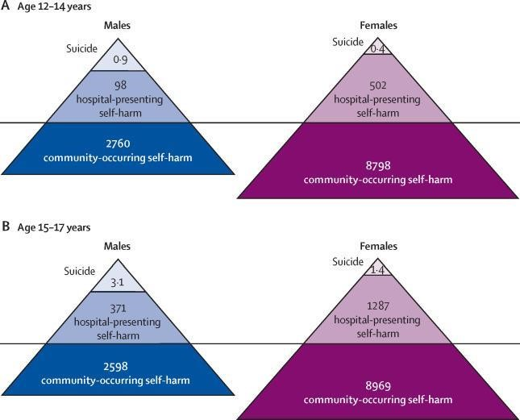
Appendix 2.2 Ethics approval for the primary study by Hulin et al., 2024
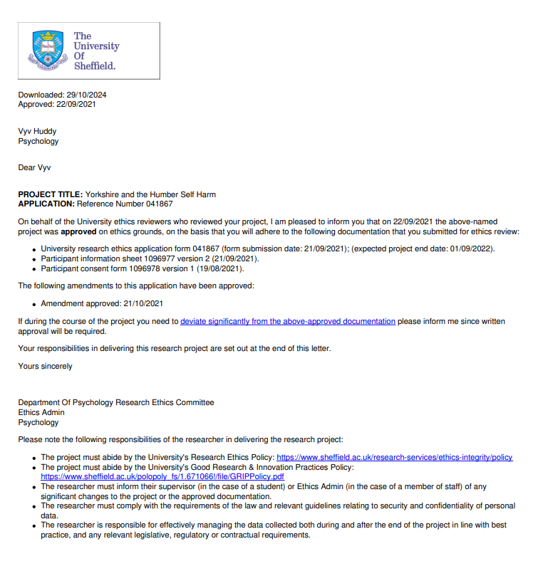

Appendix 2.3: Ethics approval for this study
University Research Ethics Committee Approved Self-Declaration Letter for secondary data analysis
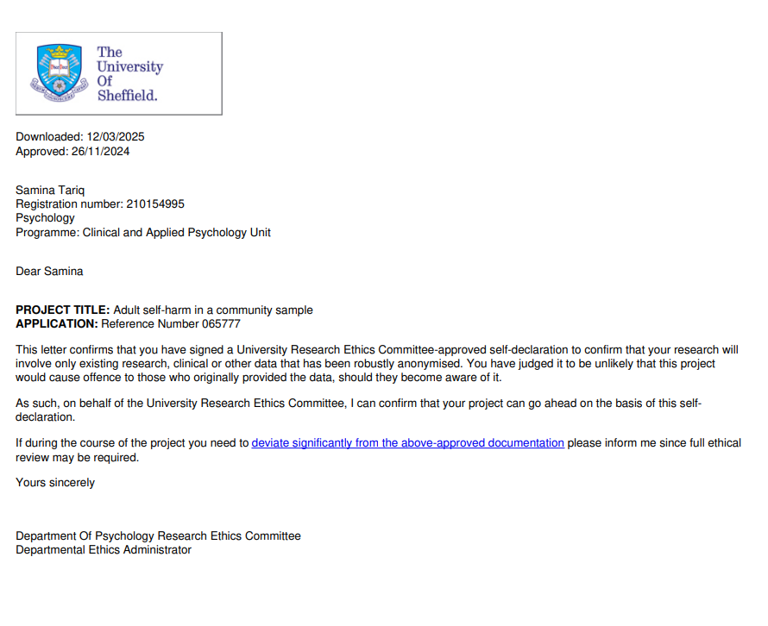

Appendix 2.4: Participant Information Sheet

Yorkshire and the Humber Self Harm Project

Participant information sheet - KEY INFORMATION
You are being invited to take part in a research study. This information sheet tells you why we are doing this research and what you will be asked to do if you take part. Please take your time to read the following information and discuss it with other people if you want to or ask us questions about anything that’s unclear.

Why are we doing this research?
- Self-harm is intentionally causing injury, self-poisoning or taking an overdose (with or without the intent to die). Self-harm can be a sign of serious distress. In some cases, distress has been linked to suicide.
- It is important that we gather experiences and information to design suitable supports and services for people who use self-harming behaviours.
Do I have to take part?
- Participation is completely voluntary. You can change your mind and stop taking part at any point without giving us a reason.

What happens if I choose to take part?
- You will be invited to take part in one interview with a researcher, either by telephone or video call. You will be asked questions about your experience of self-harm, and your opinions on what you consider as helpful or unhelpful in any support you’ve had.
- The interview will be audio (sound only) recorded. This recording is only used by the research team and nobody else will have access to this. This interview will be private and confidential between you and the research team. The only time this may change is if you said something that suggested you or someone else was at risk.
- Your contact details (telephone number or email address) will be deleted after they have been used.

What are the possible risks/disadvantages of taking part?
- The researcher does not expect there to be any significant risks to you for taking part in this study. It might be upsetting to talk about some of your experiences. We will support you during and after the interview if this is the case for you.

What do I do if I want to make a complaint?
- If you would like to make a complaint about this project, further information is provided below.

Participant information sheet - FULL INFORMATION

Project title: Yorkshire and the Humber Self Harm Project

You are being invited to take part in a research study. This information sheet tells you why we are doing the research and what you will be asked to do if you take part. Please take your time to read the following information and discuss it with other people if you want. If anything is unclear, or if you would like more information, please ask (** to be confirmed** )

Why are we doing this research?

Self-harm (intentionally causing injury, self-poisoning or taking an overdose with or without the intent to die) can be a sign of serious distress. In some cases, distress has been linked to suicide. It is important that we gather experiences and information to design suitable supports and services for people who use self-harming behaviours.
Whilst services in the Yorkshire and the Humber region have detailed suicide prevention plans in place, there is a gap in knowledge of what resources are needed at a local level in the community to support adults who self-harm. We will therefore conduct interviews with adults who have current or past lived experience of self-harm to address this gap.

Do I have to take part?

Participation is completely voluntary and you can change your mind and stop taking part at any point without giving a reason. Please note: Your decision whether or not to take part will not affect the care you are receiving from any mental health services or other organisations involved in supporting you.

What happens if I choose to take part?

- If you decide to take part, you will be invited to take part in one interview with a researcher, either by telephone or video call
- The interview will take place between the hours of 9am – 5pm and will last approximately one hour. The interview will be audio (sound only) recorded.
- Before the interview you will be asked some information about yourself including age and place of birth. These questions are asked so we have some background information about who took part. You do not have to answer these questions and can still take part without answering them.
- During the interview you will be asked questions about your experience of self-harm and your opinions on
what you consider as helpful or unhelpful in the support you’ve had. Some people may not have received any help or support at all and the questions will be tailored to allow for this.
- After the interview the audio recordings will be listened to and typed up by a member of the research team or somebody employed to do this (a 3rd party).
- The research team will read all the interviews and will look for things that more than one person talks about. These are called themes. These themes will be written up into a report.
- You will be given time before and after the interview to ask the researcher any questions.

Will my taking part in this project be kept confidential?
- All members of the research team follow confidentiality guidelines and sign a confidentiality agreement to maintain your privacy.
- We will not record your name and all identifiable information will be anonymised; for example if you spoke about your address, this information would be removed.
- The written version of your interview will have all personal details removed and will be saved as a number so that does not identify you.
- This interview and the audio recording will be private and confidential between you and the research team.
- The only time this may change would be if you said something that suggested you or someone else was at risk.
- The researcher may have to report this to relevant authorities and the researcher would talk to you about this. Only the information related to risk would be shared, everything else would remain private.

What will happen to the information I share in the interview and the results of the research study?

We are aiming to publish the results of the study so that other people can read them, for example, those people who manage mental health services that provide support for those who self-harm. No information will identify you as a participant. Some anonymous quotes from the interviews may be used to explain a theme or an idea. Anonymous quotes mean there will be no way of identifying that it was you who said this statement.

You can have a copy of the research results and the researcher will ask you if you would like this after the interview. Given we are interviewing many people it may be up to a year before we can provide a summary of the results.

What are the possible benefits of you taking part?

The researcher will ask about your experiences and your
views on things you consider as helpful or beneficial for your mental health. It is hoped that this will be meaningful for you and allow you some time to talk about what is important for you. You will also be offered a £10 Love2Shop voucher as a thank-you for your time.

What are the possible risks/disadvantages?

The researcher does not expect there to be any significant risks to you for taking part in this study. It might be upsetting to talk about some of your experiences. If this happens the researcher will offer to pause or cancel the interview. We will support you during and after the interview if this is something you would like. You can talk about as much or as little as you want during the interview, depending on how comfortable you feel.

What happens to my information once the research has finished?

Your contact details will be deleted after they have been used. If you would like a copy of the results, the researcher will save your contact details to be able to send you this at the end of the research. Once the results are sent these details will be deleted. Once the interviews have been typed up the audio recordings will be destroyed. The written version of your interview will be saved on a secure and protected computer at the University of Sheffield for 5 years and then deleted. Your signed consent form will be securely destroyed when the research is finished.

What is the legal basis for processing my personal data?
According to data protection legislation, we are required to inform you that the legal basis we are applying in order to process your personal information is that ‘processing is necessary for the performance of a task carried out in the public interest’ (Article 6(1)(e)).

As we will be collecting some data that is more sensitive, we also need to let you know that we are following the condition in law: that the use of your data is ‘necessary for scientific or historical research purposes’(9(2)(j)).

Further information can be found in the University’s Privacy Notice: https://www.sheffield.ac.uk/govern/data-protection/privacy/general.

Who is organising and funding the research?

The research is being funded by Kingston Upon Hull City council and organised by the University of Sheffield.

Who is the Data Controller?
The University of Sheffield will act as the Data Controller for this study. This means that the University is responsible for looking after your information and using it properly.

Who has ethically reviewed the project?
The project has been ethically approved via the University of Sheffield’s Ethics Review Procedure as administered by the Department of Psychology.

What if something goes wrong and I wish to complain about the research project or report an incident?

If you would like to make a complaint about this project, you can contact any member of the research team. Research team
Dr Vyv Huddy, Project Co-Lead, Clinical Psychologist and Lecturer at the University of Sheffield. Email: v.huddy@sheffield.ac.uk
Dr Phil Oliver, Project Co-Lead, GP and Clinical Lecturer at the University of Sheffield. Email: phillip.oliver@sheffield.ac.uk

University of Sheffield complaints team
Professor Elizabeth Milne, Head of Psychology Department, The University of Sheffield. Email: e.milne@sheffield.ac.uk
Dr Robert Schmidt & Dr Jilly Gibson-Miller, Joint chairs of the Department Ethics Subcommittee, The University of Sheffield. Email: psyethics@sheffield.ac.uk

Designated Safeguarding Contact (DSC)
Dr Phil Oliver, Project Co-Lead, GP and Clinical Lecturer at the University of Sheffield. Email: phillip.oliver@sheffield.ac.uk

Contact for reporting safeguarding concerns who is independent of the research team
Professor Chris Burton, Professor of Primary Medical Care, University of Sheffield. Email: chris.burton@sheffield.ac.uk

The process by which concerns will be dealt with by the DSC is outlined below. This is in accordance with The University of Sheffield’s Preventing Harm in Research and Innovation (Safeguarding) Policy. More information can be found on this website: https://www.sheffield.ac.uk/rs/ethicsandintegrity/safeguarding.
The incident or concern is reported to the Designated Safeguarding Contact (DSC)
The DSC will address any immediate safety concerns and provide immediate support to the individual(s) involved.
The DSC will gather as much information about the incident as possible whilst acting in a sensitive manner and gathering information from the individual(s) about what action they would like taken or not taken in response to the incident.
The DSC should notify the Principal Investigator (PI) for the study and the Head of Department as well as the Research Ethics and Integrity Manager for further advice and planning next steps in dealing with the incident or concern.

Thank you for your time.
Should you agree to take part in the research you will be supplied with a copy of this information sheet and also a copy of the consent form you and the researcher have signed.

Appendix 2.5: Participant consent form

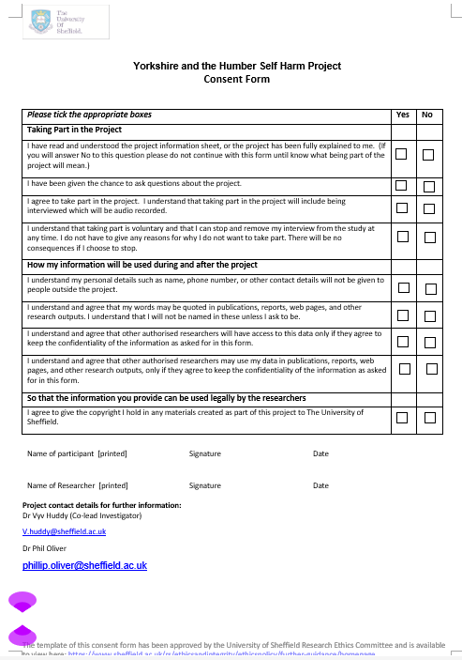

Appendix 2.6: Interview guide
Yorkshire & the Humber Self-Harm in Adults Research Project Interview Topic Guide
The interview will aim to explore participants experience of seeking and accessing help/support for self-harm and discuss experiences which has helped protect their mental wellbeing and prevented incidence of self-harm.
The facilitator will be open to the participant’s narratives and flexible in switching between topics and previously unrecognised issues.

- Introduction and background

- Researcher introduces themselves, the purpose of research and check if the consent has been signed
- Reiterate following points:
- The interview will be recorded, we can stop or pause the recording at any time.
- These recordings will not be heard by anyone outside of the research team. In the future we may quote something you have said today, however, no names will be attached to these quotes and there will be no way of identifying who has said it.
- The only time this may change would be if you said something that suggested you or someone else was at immediate risk.
- We may then have to report this information to relevant authorities and we will talk to you about this.
- However, only the information related to risk would be shared, everything else would remain private.
- Any questions?

- Opening question:

- “Tell me a bit about yourself”

- Topic: Individuals experience of self-harm

- Question: Would you mind talking a bit about your experiences of self-harm?
- Question: How does self-harm impact on your well-being?
Prompts for individual experience of self-harm:
- The positive function of self-harm to reduce mental distress
- Underlying reasons for self-harm

- Topic: Where individuals have chosen to seek support for self-harm and why
- Question: Can you tell me about your experience of getting help for self-harming?

- Topic: Barriers/facilitators which may have prevented them from accessing help/support
- Question: What have you found difficult about accessing help for self-harming?
- Question: What has helped you access support for self-harming?
Prompts: examples of specific barriers/facilitators:
- Availability/awareness of support available (including within the community)
- Relationships with individuals within services (e.g. power dynamics within health services)
- Issues surrounding trust and confidentiality
- Stigma
- Coordination of services (e.g. formal referral processes)

- Topic: Specific experiences which have helped/hindered in protecting their mental well-being and reducing self-harm behaviour

- Question: What helps you self-harm less or cope better with the feelings which lead you to self-harm?
- Question: Do you have any examples of support that you have received for self-harming which you have found particularly helpful?
Prompts: Examples of specific experiences which could influence self-harming behaviours:
Types of support accessed
- Their environment
- Employment
- Volunteering opportunities
- Personal activities
- Social activities
- Connecting with others
- Substance use
- Media

Appendix 2.7: Data analysis excerpts
Initial reflections
- Most participants spoke of self-harm as a protective factor that has helped prevent their mental health from deteriorating and/or suicide.

- A few participants spoke about self-harm as something they felt they needed to do but were ashamed of afterwards due to the visibility of scars and people’s negative assumptions about scars.

- There was frustration reported by some participants about how their self-harm is interpreted by the outside world (those who do not self-harm).

- Some participants shared how confused they were about self-harming, in that they needed time to process what led them to self-harming as well as recognising that at the time they needed to self-harm. There was a sense of self-harm taking them on a journey of self-reflection/realisation. This resulted in some participants seeking support with an aim to want to stop self-harming and for others to seek peer support to normalise it.

- Peer support has been a major source of support for most of the participants who have otherwise felt shame and stigma for self-harming. Examples of peer support were 1:1s, peer group meetings, online forums, in all of which they can share experiences and offer support, motivation, and humour. Some felt peer support was less time constraining or formal which was a stark contrast to their experiences of accessing formal support.

- The relationship between self-harm, suicidal ideation, and the act of suicide itself, seems complex. However, it appears that those who use self-harm as a positive coping tool regard it as separate from suicide. Equally, those who reported having attempted to end their life were clear that they were not self-harming. For a few the self-harm was ‘practice’ leading up to suicide – meaning there was a plan of escalation. For a few it was unclear as to whether they were self-harming or wanting to end their life – especially when they felt their mental health had significantly deteriorated.

Example of coding transcripts
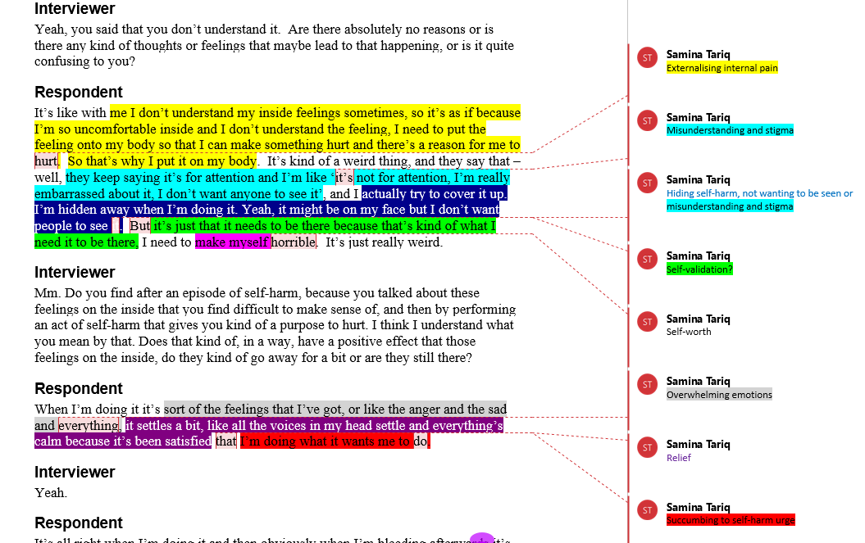
Participant 2

Participant 20
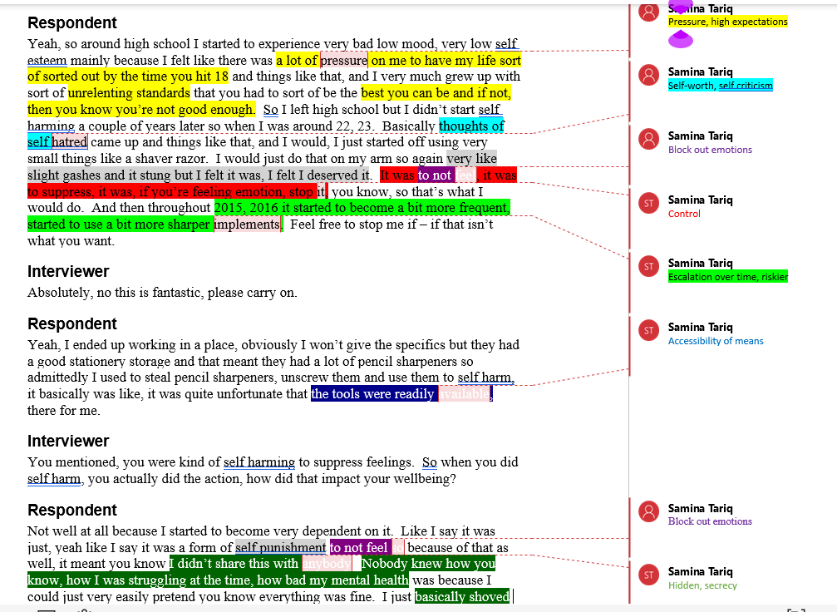

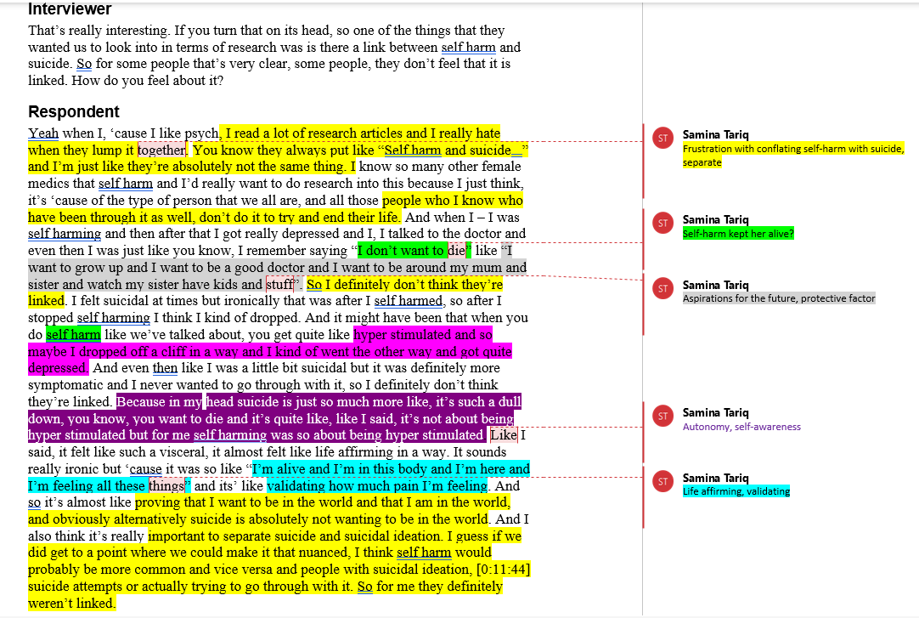
Participant 22

Clustering codes to create themes

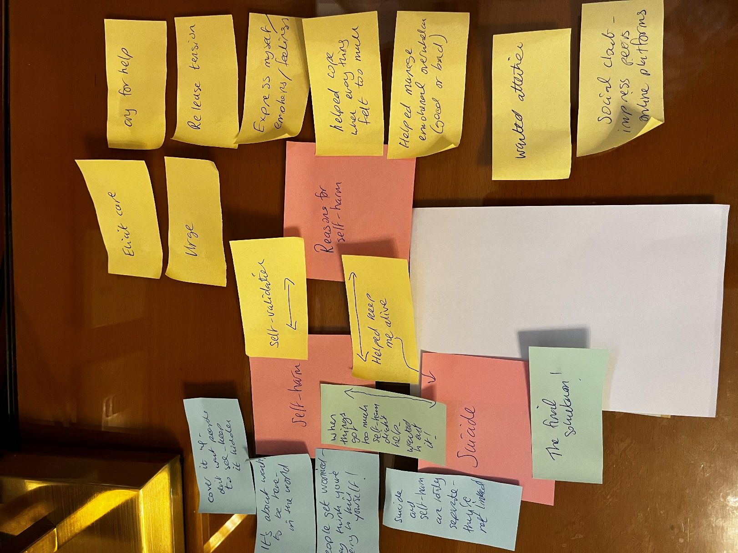

Appendix 2.8 Reflexivity excerpts
Reflections on a participant talking about how they self-harm:
“I’d either take two overdoses in a week or be you know one week in hospital and then in another, and you know in amongst all that cutting, burning and then sort of when I was 18, I set fire to myself and that was probably one of the most significant incidents, I guess, which was quite traumatic and also got me in trouble, and I got a criminal record for that so ... ”
Having burns on my face and hands from a childhood accident, I found it really uncomfortable and upsetting to hear the participant talk about burning themself as a form of self-harm. When I think of self-harm, my mind usually goes to cutting and blood, which is already distressing enough to read about or listen to. But hearing someone mention burns and skin grafts hit me on a much more personal level, bringing up feelings I wasn’t expecting. I had an immediate emotional reaction—sadness, unease—because I could vividly imagine the physical pain and the long-term impact of burns and scars. On top of that, I struggled to wrap my head around what it must have felt like for her to do that to themselves on purpose.
As I reflected on my reaction, I realised that my own experience as a burns survivor was shaping how I responded to this part of the data. Self-inflicted burning felt particularly difficult to process because it was the opposite of my own story—one of survival and healing. My burns were the result of an accident, something completely out of my control, whereas for this participant, burning was an intentional act of self-harm. That contrast stirred up a mix of emotions—discomfort, confusion—and really highlighted how personal and complex our responses to trauma can be.
To work through these feelings and stay reflexive in my research, I talked things over with my supervisor. It really helped to share my thoughts and emotions, especially the deep personal reaction I had to the participant’s experience. My supervisor encouraged me to explore these feelings further and think about how they might shape my interpretation of the data. One question that came up was whether it would have helped to explicitly discuss different types of self-harm before starting the research, so I’d be more prepared for what might come up. While I could see the logic in that, I wasn’t sure if any amount of preparation would have softened the emotional impact of something that resonated so personally.
In the end, this experience reinforced just how important reflexivity is in qualitative research. It reminded me that, as researchers, we bring our own histories, emotions, and perspectives into our work, and that being aware of these influences is key to maintaining both integrity and ethical sensitivity. Talking things through in supervision gave me the space to process my reaction in a way that supported both my well-being and the quality of the research. It allowed me to step back, acknowledge my feelings, and make sure that my personal experiences informed—rather than overshadowed—how I interpreted the participant’s story.
Reflections on the shift from feeling like an ‘outsider’ to the research, to an ‘insider’
When I started researching self-harm, I thought of myself as an outsider—someone trying to understand experiences that were different from my own. Since I’ve never self-harmed, I assumed my role was to observe and interpret, not to personally relate. But reading this participant’s words made me feel an unexpected connection.
She talks about self-harm as a way to externalise her inner turmoil, to make her emotional pain visible in a way she can understand. She also pushes back against the assumption that self-harm is about seeking attention—she hides her scars and sees the act as deeply personal, even though it happens to be visible. That really struck me because, in a different way, I’ve had similar experiences as a burns survivor.
Throughout my life, people have assumed I’m trying to hide my face—when I wear a headscarf, when I keep my head down in a book, when I’m looking at my phone. But those things weren’t about hiding at all; they were just part of how I existed in the world. Like the participant’s self-harm, my actions were misunderstood by others who imposed their own narratives on me. That realisation hit me hard. It made me think about how powerful other people’s assumptions can be, how they can shape and even distort how we see ourselves.
As a researcher, I’ve had to think about what this means for my work. Reflexivity is about being aware of how my own experiences influence how I engage with the data. This connection with the participant challenged me to reflect on my own feelings about bodily difference and external judgement. Instead of keeping my experiences separate from the research, I realised they could actually help me understand the data in a deeper way.
Supervision really helped me process all of this. Talking it through with my supervisor gave me space to unpack my reactions and figure out how to integrate them into my analysis in a meaningful way. Rather than seeing my personal connection as a bias, I was encouraged to use it to bring more depth to my interpretation. It reminded me that research isn’t just about being objective—it’s also about being honest and reflective.
In the end, this experience reinforced why reflexivity matters so much in thematic analysis. It’s not about pretending we’re separate from the research but recognising how our own experiences shape the way we engage with it. And sometimes, those unexpected connections can lead to the most meaningful insights.
Reflections on the challenge of using secondary data
At first, I found it quite difficult to engage with secondary data. It felt distant, like something that didn’t really belong to me, and that made it harder to connect with. Unlike primary data, where I might have been involved in collecting the narratives myself, this data had already been gathered and shaped by someone else. Because of this, I initially struggled to feel a sense of ownership over it, which made the process of analysis feel less intuitive and more detached than I expected.
This distance also made reflective thematic analysis more challenging. Since this approach requires engaging deeply with the data—interpreting meanings, drawing on my own perspectives, and acknowledging my position as a researcher—I found it hard to immerse myself in something that didn’t feel personal. It was as though I was working with someone else’s puzzle, trying to piece it together without fully feeling like I was part of the process.
However, as I progressed, I found ways to bridge this gap. One of the key turning points was allowing myself to engage with the data on a more personal level rather than seeing it as something purely external. I spent time reading and re-reading the transcripts, making detailed notes, and actively reflecting on my emotional and intellectual responses to what I was analysing. This process helped me feel more connected to the data, making it easier to see patterns and themes emerging naturally.
Supervision and discussions with peers also played a big role in shifting my perspective. Talking about the data with others allowed me to develop a sense of engagement that I hadn’t initially felt. Through these conversations, I realised that even though I hadn’t collected the data myself, my interpretation of it was still valuable and meaningful. I started to see that my role wasn’t just to summarise what was already there but to bring my own analytical lens to it, shaping new insights through the thematic analysis process.
By the end of the analysis, I no longer felt disconnected from the data. Instead, I had developed a sense of ownership through engagement, reflection, and interpretation. This experience reinforced the importance of reflexivity—not just in acknowledging my initial struggles, but in recognising how my relationship with the data evolved over time. It also highlighted that meaning-making in qualitative research isn’t just about the data itself but about the researcher’s interaction with it. In the end, the process of reflective thematic analysis helped me transform something that once felt distant into something I could fully engage with and interpret with confidence.

