CHEMICAL ECOLOGY OF DEFENCE IN FLOWERS AND LEAVES OF THE SOLANACEAE

Hannah Ronan-Brown

A thesis submitted in partial fulfilment of the requirements for the degree of Doctor of Philosophy

School of Biosciences
Faculty of Science

The University of Sheffield
August 2024

Abstract
Plants have evolved a range of defence strategies to protect themselves from herbivore attack. Defences can act either indirectly on the attacker, perhaps by attracting natural predators of the antagonist, or directly on the attacker by being toxic, however it is also known that defences can act negatively on pollinators resulting in pollinator deterrence. To reduce the effects of pollinator deterrence plants can rely on two evolutionary alternative mechanisms of defence: constitutive defences which are always present in the plant, and induced defence that is produced only when damaged is incurred by the plant. Much of the existing research into plant chemical defences focuses on leaf defences, despite the higher relative importance of flowers due to their role in reproduction, and there is a significant knowledge gap in the field of tissue-specific defence mechanisms in plants. The work detailed in this thesis work builds on previous research into the coevolution of plant mating system transitions to selfing and plant defence strategies, by incorporating analysis of both floral and leaf defences in populations and species of different mating systems within the Solanaceae. The first chapter of this thesis provides an introduction to plant-herbivore-pollinator interactions. In chapters two and three, I present a metabolomic and transcriptomic study using self-compatible and self-incompatible populations of the wild tomato species, Solanum pennellii, and provide evidence of mating system constraints on floral defence, and evidence of tissue-specific regulation of defence metabolites. The fourth chapter of this thesis provides a multispecies comparison of the floral and leaf defence metabolites in selfing and outcrossing species of three genera within the Solanaceae. The work presented here provides evidence for the convergent evolution of higher defences in flowers than in leaves, and evidence for adaptive phenotypic plasticity of leaf secondary metabolites when experiencing herbivory and an adaptive absence of plasticity in flower tissue. The results indicate that secondary metabolite production of herbivory-induced plants are tissue-specific, and may be mating system-specific in some taxa. To my knowledge, this thesis comprises one of the first comprehensive studies into the coevolution of plant mating system and defence strategies in both leaves and flowers, using comparative metabolomics and transcriptomics.

Acknowledgements

31,392 hours (or thereabouts). I have waited for a long time to write these acknowledgments. At times, it felt like it would never happen. I am unspeakably proud of myself for reaching this point.
Firstly, I offer my thanks to Stuart A. Campbell, my primary supervisor for his enthusiasm and advice during my project as his advice and support on experimental design, data analysis and writing have been invaluable. Secondly, I give my thanks to Katie Field, who joined my supervisory team rather late, but who has vastly improved my PhD experience. I also extend my thanks to my advisor, Mirre Simons for his timely advice and encouragement.
I am grateful to Heather Walker for her patience and humour, and for her support in teaching me HPLC analysis. Heather’s support and kindness has never failed to cheer me up, no matter how bad the day may have been going. I also extend my thanks to Maggi Killion for her support, advice and sympathetic ear during many weeks setting up and conducting greenhouse experiments.
The support of past and present members of the Campbell Lab group, and the Plant Biotic Interactions Lab groups has encouraged, improved and sculpted my work. I am particularly grateful for the time spent by Rachael Haw, Jamie Howe and Agnes Man Sum Chan who have helped feed caterpillars, weigh leaves and flowers, and conduct extractions in the lab; Agnes deserves particular merit for the effort she put into her project with me in which she went above and beyond to make our experiment run smoothly. I owe huge thanks to Upuli Wickramaarachchi for her help, support and understanding – she is an excellent colleague and deeply valued friend. I am hugely grateful to Adam Parker and Sam Wilkinson for their support particularly with RNA sequencing analysis, and I extend my thanks to David Pardo for his help with lab work throughout the years.
I am grateful to the University of Sheffield for providing a research scholarship, and for the Grantham Centre for providing additional funding, not just for research but for conference travel as well. I am also grateful for the training opportunities offered as part of the Grantham Centre, and the friendships made along the way. I am also grateful for the people at the John Innes Centre who were extremely helpful in supplying caterpillar eggs for my experiments.
I love and thank my family. My Mum and Dad, who have given me everything I could ask for, and more. I thank Nannan for being inspirational. She has shown me how big the world can be if you’re willing to explore it, and how full life should be.
I will be forever grateful to my partner, AJ, for loving, supporting and motivating me. He has been my rock through the final turbulent stages of my studies.
Finally, and most importantly, this is for Skye, who was the goodest girl.

Declaration and Co-Author Contributions

My thesis is formatted as stand-alone research papers. I take ownership of the work in this thesis. Contributions have been made by my first supervisor who is acknowledged as co-author at the beginning of each chapter. Lists of co-author contributions are included at the beginning of each chapter. I will be the first author on three papers that will be published based on the chapters included in this thesis.

List of Figures
Figure 1.1 Summary diagram of plant chemical defences
Figure 1.2 Constitutive and inducible defence strategies are evolutionary alternatives
Figure 1.3 Overview of the interaction between plant defence and pollinator reliance
Figure 1.4 Schematic of the phylogenetic relationships between Physalis, Solanum, and Nicotiana
Figure 2.1 Inflorescence of Solanum pennellii
Figure 2.2 Patterns in phenolic compound expression in control and treated leaves and flowers
Figure 2.3 Phenolic concentration in flowers and leaves of selfing and outcrossing Solanum pennellii
Figure 2.4 Trade-offs in plant defence between tissues and defence strategies in Solanum pennellii
Figure 2.5 Growth rate of Manduca sexta larvae fed on control and treated leaves and flowers of Solanum pennellii
Figure 3.1 Leaf and flower transcriptomes are strongly divergent.
Figure 3.2 Transcriptomic differences between control flowers and leaves of selfing and outcrossing plants.
Figure 3.3 Venn diagrams produced from lists of differentially expressed genes in control flowers and leaves.
Figure 3.4 Differences between control and MeJA-treated flower transcriptomes
Figure 3.5 Genes that are differentially expressed between control and MeJA-treated flowers of each accession.
Figure 3.6 Differences between control and MeJA-treated leaf transcriptomes
Figure 3.7 Number of genes that are significantly differentially expressed in flowers and leaves of each accession.
Figure 3.8 Few genes commonly respond to MeJA treatment in both leaves and flowers of each accession.
Figure 4.1 Schematic of phylogenetic relationships between species of Physalis, Solanum, and Nicotiana
Figure 4.2 Phenolic content of leaves and flowers in all species in the study.
Figure 4.3 Phenolic content in control and MeJA-treated selfing and outcrossing flowers and leaves.
Figure 4.4 Trends between induced phenolic content and constitutive phenolic content.
Figure 4.5 Bioassay with Manduca sexta feeding on flower or leaf tissue excised from Solanum plants and larval growth.
Figure 4.6 Trends between larval growth and phenolic content of leaves and flowers

List of Tables
Table 3.1 Solanum pennellii accessions used in this experiment, all sourced from Tomato Genetics Resource Centre, CA
Table 3.2 Genes upregulated in MeJA-treated flowers compared to control flowers.
Table 4.1 Species used in multispecies comparative study, including mating system information.

Table of Contents
Abstract 2
Acknowledgements 4
Declaration and Co-Author Contributions 6
Chapter 1 14
General Introduction 14
1.1 Background 14
1.1.1 Principles of Plant Defence against insect herbivory 16
1.1.2 Herbivory and jasmonic acid induced plant defences 18
1.1.3 Patterns in floral defence 20
1.1.4 Plant mating systems 22
1.1.5 Plant-pollinator interactions and defence patterns 24
1.1.6 The Solanaceae 28
1.2 Research Objectives and Thesis Outline 31
Chapter 2 43
Pollinator reliance constrains defence in flowers but not leaves of Solanum pennellii 43
2.1 Abstract 44
2.2 Introduction 45
2.3 Methods 49
2.3.1 Plant materials and growth conditions 49
2.3.2 Experimental design 50
2.3.3 Secondary metabolite analysis 50
2.3.4 Herbivore feeding assay to quantify chemical resistance 52
2.3.5 Data analysis 53
2.4 Results 54
2.4.1 Secondary metabolite analysis of flower and leaf tissue 54
2.4.2 Leaves, but not flowers, have inducible defence-related secondary metabolites 56
2.4.3 Flower-fed larvae growth lower than leaf-fed larvae 58
2.5 Discussion 59
2.5.1 Flowers have higher constitutive defences than leaves 59
2.5.2 Mating system predicts defence in flowers but not in leaves 61
2.5.3 No induced response to MeJA in flowers 62
2.6 Conclusions 63
2.7 References 64
2.8 Supplementary materials 68
Appendix S1 68
S1.1 Plant materials 68
S1.2 Methyl jasmonate treatment 68
S1.3 Plant accessions 69
Appendix S2 Supplementary results 70
Chapter 3 76
Investigating tissue-specific defence regulation in Solanum pennellii 76
3.1 Abstract 77
3.2 Introduction 78
3.3 Materials and Methods 81
3.3.1 Plant materials and growth conditions 81
3.3.2 Experimental design 82
3.3.3 Tissue harvesting and RNA extraction 83
3.3.4 mRNA library preparation and sequencing 84
3.3.5 Read alignment and counting 84
3.3.6 Global pattern assessment and differential expression analysis 85
3.3.7 Gene Ontology (GO) enrichment analysis 85
3.3.8 Kyoto encyclopaedia of genes and genomes (KEGG) pathway analysis 86
3.4 Results 86
3.4.1 Mating system differences in transcriptomic response to MeJA treatment 86
3.4.2 Mating system differences in the transcriptomes of untreated leaves and flowers 89
3.4.3 Mating system differences in transcriptomes of control leaves and flowers 92
3.4.4 Higher number of MeJA-induced genes expressed in outcrossing than selfing flowers 93
3.4.5 Differential response to MeJA treatment between flower populations 96
3.4.6 Differential response to MeJA treatment between selfing and outcrossing leaves 99
4.3.7 Differential response to treatment in leaves and flowers of each accession 101
3.5 Discussion 104
3.5.1 Mating system differences in flowers and leaves 104
3.5.2 Stability of floral gene expression in response to a ubiquitous biotic stress signal 107
3.5.3 Leaf induced response to MeJA treatment 109
3.5.4 Comparing MeJA-induced response between flowers and leaves 110
3.6 Conclusions and future directions 111
3.7 References 112
3.8 Supplementary Materials 118
Appendix S1: Materials and Methods 118
Appendix S2: Supplementary Results 119
Chapter 4 121
Investigating floral and leaf defence in selfing and outcrossing species of Solanaceae 121
4.1 Abstract 122
4.2 Introduction 123
4.3 Methods 125
4.3.1 Study system 125
4.3.2 Species Selection 127
4.3.3 Plant growth conditions 129
4.3.4 Experimental design 129
4.3.5 Secondary metabolite analysis 130
4.3.6 Herbivore feeding assay to measure plant chemical resistance 131
4.3.7 Data analysis 132
4.4 Results 133
4.4.1 Phenolic content higher in flowers than leaves 133
4.4.2 Genus-level differences in phenolic defence 136
4.4.3 Leaf phenolic content does not predict flower phenolic content 139
4.4.4 Larval growth lower for flower-fed larvae compared to leaf-fed larvae 141
4.5 Discussion 143
4.5.1 Flowers have stronger constitutive defences than leaves 143
4.5.2 Higher constitutive defences in selfing compared to outcrossing flowers 145
4.5.3 Flowers are not inducible, but neither are leaves 146
4.6 Conclusions 149
4.7 References 150
4.8 Supplementary Materials 154
Appendix S1 154
S1.1 Plant materials 154
S1.2 Methyl jasmonate treatment 155
Appendix S2 Supplementary Results 155
Chapter 5 163
General Discussion 163
5.1 Overview 163
5.2 Higher constitutive defence in flowers than leaves 166
5.3 Flower defences are not inducible 167
5.4 Mating system predicts defence in flowers but not leaves 169
5.5 Summary and future perspectives 171
5.6 References 174

Chapter 1

General Introduction

1.1 Background
Plants have evolved a range of defence strategies to protect themselves from herbivore attack (Mithöfer and Boland, 2012). Plant defences can act directly on the attacker, for example toxic or antinutritive secondary metabolites such as the glucosinolates produced in the family Brassicaceae, of phenolic acids produced in the genus Solanum. Defences can also act indirectly on the attacker, perhaps by attracting natural predators of the antagonist (Kessler and Heil, 2011). These defences can be broadly categorised into constitutive defences, which are produced continuously, and induced defence, which is produced in response to damage (Gatehouse, 2002). Induced and constitutive defence strategies are thought to represent evolutionary alternative strategies that allow plants to balance the cost of producing defences with the benefit of deterring attackers (Karban and Baldwin, 1997).
The predictive framework of Optimal Defence theory suggests that plant defences will be the most strongly concentrated in plant tissues that are most valuable to plants, which suggests that flowers would be strongly constitutively defended due to their important role in attracting pollinators and housing the reproductive structures of the plant. This framework can also be applied to predictions of allocation to constitutive or induced defences within plant tissues; where herbivory is highly likely, a constitutive defence strategy may be preferred, and where herbivory is less likely, induced defences would be the better strategy (Zangerl and Rutledge, 1996). Optimal Defence Theory predicts that plant tissues will be allocated defences according to their predicted relative value to the plant as well as the likelihood of damage to a particular tissue (McKey, 1974). Flowers have a high fitness value to plants, and therefore are predicted to have high levels of constitutive defences, which is supported by several studies (Damle et al., 2005; Frölich, Ober and Hartmann, 2007; Li et al., 2016; Alves et al., 2021).
Plant defences can have ecological costs to the plant through changes to the interactions of plants with pollinators. Pollinator visitation networks can be altered in plants that are producing induced chemical defences, and it has been shown that some pollinator species preferentially visit undamaged plants (Krupnick, Weis and Campbell, 1999; Kessler, Halitschke and Poveda, 2011; Jacobsen and Raguso, 2018). Plants that are reliant on pollinators for reproduction may therefore experience much higher ecological costs of defence than plants which are less reliant on pollinators. Physiological costs of defence are also experienced by plants. Production of defensive secondary metabolites requires involvement of precursor compounds, enzymes and co-factors from primary metabolism (Gershenzon, 1994a, 1994b), diverting resources away from primary metabolism. Photosynthetic rates are generally able to provide sufficient carbon substrates to meet the demands of defensive secondary metabolism, however nitrogen uptake by plants is limited, and therefore the production of nitrogen-containing compounds such as alkaloids may compete with protein synthesis for precursors (Harborne, 1993) which means that there may be a trade-off between defence production and some primary metabolic processes. This has led to the suggestion of a growth-defence trade-off, where investment in defence results in reduced allocation to growth. Some studies have shown that diversion of resources away from growth during induced defence periods could be due to reprogramming of metabolism, with some evidence that herbivore-induced hormones like jasmonic acid could be involved in the suppression of growth genes (Yang et al, 2012). This thesis focuses on the ecological costs of induced defence.
Plants which are highly reliant on pollinators may experience greater ecological costs of defence. Previous work in the Solanaceae family has found self-compatible taxa to be more inducible than self-incompatible taxa (Campbell and Kessler, 2013), and found a correlation between the concentration of floral and leaf defensive metabolites, with consistent mating system effects in both leaf and floral defences (Adler et al., 2012).
Much of the existing research into plant chemical defences focuses on leaf defences which are the primary intersection between plants and herbivores, however this has resulted in a knowledge gap around flower defence. Even in plants where flowers are not directly damaged by herbivores, systemic defences can be found in floral tissue. Further to this, relatively few studies investigating the effects of mating system on plant defence include analysis of both floral and leaf defences. Previous studies have looked at differences in leaf induced and constitutive defences across mating systems, or compared leaf and flower constitutive defences, however to our knowledge, there are no studies that have looked at the combined effects plant tissue, treatment and mating system on secondary metabolite production.

Principles of Plant Defence against insect herbivory

To protect themselves against herbivore attack, plants have evolved an array of defences that have direct effects against herbivores, preventing herbivore movement, growth, development, feeding and oviposition (Kessler and Baldwin, 2002; Mithöfer and Boland, 2012; Watts, Kaur and Kariyat, 2023), to ultimately protect the plant from further damage. Plants can also produce indirect defences against herbivores, for example by producing compounds that attract the natural enemies of herbivores (Arimura, 2021). Plant chemical defences are chemical compounds are found within plant tissues and include both volatile and non-volatile compounds such as those produced in the salicylic, ethylene and jasmonate pathways, including an array of secondary metabolites such as alkaloids, terpenes and phenolic acids (Kessler and Baldwin, 2002; Howe and Jander, 2008; Mithöfer and Boland, 2012).
Physical defences, also known as structural or mechanical defences, are structures that plants possess to deter herbivores and they act as a physical barrier against herbivore feeding (Kariyat et al., 2017). Trichomes are fine, hair-like protuberances found on different parts of a plant, commonly on leaves or stems. They can have a defensive function by acting as a barrier to feeding or impeding herbivore movement, slowing herbivore growth and movement and leaving the herbivore more vulnerable to predation (Kaur and Kariyat 2020). Spines are another physical defence; they are modified petioles, midrib, veins or stipules, and they protect plants against herbivory (Hanley, Lamont and Armbruster, 2009; Kariyat et al., 2017). Plants can employ a combination of physical and chemical defences against herbivory (summarised in Figure 1, adapted from War et al., 2012).

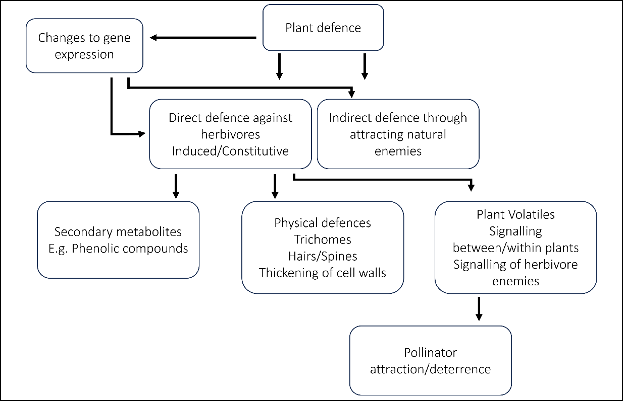
Plant defences can be constitutive; present even in the absence of herbivory (Gatehouse, 2002), and/or induced by damage incurred by the plant (Karban and Baldwin, 1997). Induced defences may be adaptive for plant populations that experience infrequent herbivory, whilst constitutive defence is more advantageous in populations that evolve in locations with higher frequency of herbivory. Further to this, induced resistance is a more successful method of defence against specialist herbivores than generalists in field conditions, as specialist pests have a restricted host range and do not adapt easily to broad ranges of defensive compounds that plants may produce, whereas generalist herbivores can feed on many types of host plants (Karban and Agrawal, 2002; Després, David and Gallet, 2007). Induced defence can be specific to the type of attack, thus producing a targeted defence against a specialist herbivore can be less costly, both ecologically and physiologically, than producing more general constitutive defence. Both direct and indirect defences can be produced either constitutively or induced following damage.
Figure 1: Summary diagram of plant chemical defences. Plant defences can be physical or chemical, the latter being separated into non-volatile secondary metabolites, and volatile compounds. Adapted from War et al. 2012.
Induced and constitutive defences are likely to represent evolutionary alternative methods for defence. A trade-off between induced and constitutive defence pathways has been observed in S. carolinense (Kariyat et al., 2013). Plants which invest heavily in constitutive defences may exhibit lower inducibility, suggesting the presence of a trade-off between constitutive and induced defences. Evidence supporting this theory has been found across several taxa, including in the Solanaceae (Campbell and Kessler, 2013), and the Pinaceae, in which a significant negative relationship was found between constitutive and inducible non-volatile defence (Moreira et al., 2014) . Inducible defence has evolved as a cost-saving strategy that allows resources to be directed mainly towards growth and reproduction when not under attack (Zangerl and Rutledge, 1996).
The diversity of species, growth habits and life history traits has led to the genus Solanum having significant degrees of variation in defence traits. The array of defence traits cannot be considered in isolation: plant defences have consequences for trophic interactions. Plant structural defences include trichomes, scleropyhlly, latex deposition, and waxes, and there is broad variability in these traits across species. Trichome number can increase following herbivore damage, which can reduce subsequent feeding rates by herbivores (Dalin and Björkman, 2003; War, Hussain and Sharma, 2013). The variation in defence is largely attributed to the wide range of interactions between plants and herbivores, which drives diversification of antiherbivore defences in plants, as well as counter-adaptive strategies in insect pests (Sharma, Sujana and Manohar Rao, 2009; Mithöfer and Boland, 2012). Current models of defence and many studies investigating plant defence focus on the interaction between plant and herbivore in isolation, however this is rarely the case, and other agents may influence the co-evolution of plant defences and herbivores.

1.1.2 Herbivory and jasmonic acid induced plant defences

Plants respond differentially to the type of herbivore damage that they incur. These differences are largely dependent on the feeding mode of the herbivore (Broekgaarden et al., 2011). Chewing insects will generally induce the jasmonic acid pathway in plants, whilst sucking or piercing insects more typically induce the salicylic acid pathway (Reymond and Farmer, 1998). The specificity in induced defence response is even specific to the species of herbivore that feeds on a plant (Blaakmeer et al., 1994; Dicke, 2007), which is thought to be due to several factors that differ between herbivores including mechanical differences in chewing, and also differences in the salivary components of feeding herbivores (Moreira et al., 2013). This specificity has been observed in plant volatile emission, for example Brassica rapa plants emit distinct volatile blends when attacked by the root herbivore Delia radicum compared to aboveground attack by Pieris brassicae larvae (Pierre et al., 2011). Tomato (Solanum lycopersicum) plants alter production of a greater number of metabolites when damaged by Helicoverpa zea than by Manduca sexta (Steinbrenner et al., 2011). It is hypothesised that herbivore species is an important factor in the activation of induced defence due to specific salivary compounds or chewing patterns unique to different herbivore species (Musser et al., 2002; Bede et al., 2006; Orians, Thorn and Gómez, 2011; Kant et al., 2015).
Jasmonic acid is produced locally following wounding and travels via the vascular system to other plant tissues to produce a whole-plant (systemic) response (Wasternack et al., 2006). Exogenous application of methyl jasmonate is known to result in systemic induction of the jasmonic acid pathway, resulting in a production of defensive secondary metabolites associated with chewing herbivore defences in plants (Karban and Baldwin, 1997). Such application of phytohormones such as jasmonic acid and methyl jasmonate have been proposed as tools for priming defence against chewing herbivores (Holopainen et al., 2009). Some studies have shown that exogenous application of jasmonic acid and methyl jasmonate can result in higher plant fitness and reduced herbivore abundance and performance (Thaler, 2002; Sheteiwy et al., 2022). Currently there is research interest in investigating the potential use of exogenous application of phytohormones to prime plant defences against enemies in economically important crop plants, thus understanding the effects of such treatment on both leaf and flower tissues would provide important knowledge.
In addition to herbivore defences, JA signalling is involved in the regulation of other stress responses and some plant developmental processes (Wasternack and Hause, 2013), including aspects of pollinator attraction (Sherif et al., 2015). The endogenous form of jasmonic acid that is involved in the early stages of defence response activation is (+)-7-iso-JA-Ile (JA-Ile). Perception of JA-Ile happens through a receptor complex formed of the F-box protein, coronatine-insensitive 1 (COI-1) and JASMONATE ZIM-domain (JAZ) protein (Sheard et al., 2010). In the absence of JA-Ile, JAZ proteins can repress transcription factors such as MYC2, which promotes the expression of JA-responsive genes. One role of JA-Ile is to act as a ligand between COI1 and JAZ proteins, which leads to the degradation of JAZ proteins, thus releasing the JA-responsive transcription factors from repression (Howe, Major and Koo, 2018). Genes involved in regulation of processes that are not involved in defence can be down-regulated in response to insect attack (Hermsmeier, Schittko and Baldwin, 2001), which could be due to reallocation of resources from growth to defence.
JA biosynthesis reprogrammes defence genes, to reduce repression of transcription factors and initiate the biosynthetic pathway for JA production (Wang et al., 2019). Other JA metabolites are transported out of the cell and act as long-distance signals that cause an induced response in undamaged leaves (Matsuura et al., 2012). Jasmonates can induce the production of compounds with repellent or toxic effects on herbivores, some of which are volatile organic compounds (VOCs) that are emitted by plants. Long-distance signalling from leaves can induce a systemic defence response, in addition to local defence against damage (Mithöfer, Boland and Maffei, 2018). Much of the previous research into the mechanisms of plant defence have been conducted in leaf tissue, with comparatively few studies on mechanisms specific to floral defence.

1.1.3 Patterns in floral defence

Plant chemical defences are generally studied in leaves, but many defence compounds are also present in floral tissue (Strauss, Irwin and Lambrix, 2004). Floral damage itself may be ecologically costly to plants as induced changes to flowers can affect pollination, plant reproduction and also floral sexual evolution (McCall and Irwin, 2006), and pollinators show preferential visitation to less-damaged plants (Krupnick, Weis and Campbell, 1999). Local induced responses in flowers resulting from florivory can induce systemic responses; damage to a single Impatiens capensis flower can induce resistance that reduces whole-plant herbivory (Boyer et al., 2016). Considering the potential costs of induced floral defence there is an apparent dilemma for the plant; balancing pollinator attraction with defence production. There are two possible reasons for the presence of defence compounds in flower tissue, as discussed in (Rusman et al., 2021). The first of these explanations is that vegetative-to reproductive tissue induction may help plants deal with current attackers, as many herbivores that initially feed on leaf tissue move onto flower tissue (Abdalsamee and Müller, 2015; Lucas‐Barbosa - 2013; Tsuji et al., 2018). Floral defence compounds may be produced in floral tissue, or alternatively, may be transported from leaf to flower tissue in a source-to-sink transport process, and indeed either of these explanations for the presence of defence in floral tissue may be applicable to specific compounds.
Currently the lack of literature on the mechanisms of floral defence represents a significant knowledge gap. Induced floral defences in response to leaf herbivory may protect flowers from subsequent attack by the leaf herbivores. The second explanation is that the vegetative-to-reproductive tissue induction may be adaptive by protecting flowers from other attackers; the chance of attack by other herbivores may be greater in areas where at least one herbivore is present. The induced defences in flowers in response to leaf herbivory can have protective effects for reproductive tissue, for example leaf herbivory can increase plant fitness by inducing resistance to seed predators (McArt, 2013).
Floral defences may be allocated to different tissues within the flower, and also to different types of defence. Both chemical and morphological flower traits may be altered by defence induction. Local florivory by Depressaria pastinacella on the wild parsnip Pastinaca sativa alters floral fragrance and thus alters pollination success (Zangerl and Berenbaum, 2009). Herbivore-induced changes to flower metabolism often include changes in the bouquet of volatile organic compounds released from the flower (Dicke and Baldwin, 2010; Bouwmeester et al., 2019; Rusman et al., 2019). Pollinators may be able to interpret the information from volatile emissions to determine the quality of floral rewards such as pollen and nectar (Kessler, Gase and Baldwin, 2008), and the volatile chemical signals from flowers are used by pollinators to locate nectar and pollen (Schiestl, 2015). Changes to volatile emissions may mean that pollinators cannot associate new volatile bouquets with those that they have previously learned to associate with quality food, thus reducing pollinator visitation (Wright and Schiestl, 2009). Herbivore-induced volatile emission can also serve the plant by attracting predators of the herbivore, however this could also attract natural predators of the pollinators, or directly deter pollinators (Kessler and Heil, 2011).
Floral scent emissions may be under conflicting selection from pollinators and herbivores, as volatile emissions may attract plant antagonists as well as pollinators, for example, the compound 1,4-dimethoxybenzene is emitted from the flowers of wild Texas gourd, Cucurbita pepo var texana, and attracts both pollinating bees and a beetle that eats both leaves and flowers of the plants (Theis and Adler, 2012). This study highlights how subtle changes to the volatile bouquet can have significant changes to ecological interactions of plants.

1.1.4 Plant mating systems

In addition to the antagonistic relationships between plants and herbivores, plants also have mutualistic relationships with pollinators, which drives diversity within both taxa (Mitchell et al., 2009). An estimated 87.5% of species of flowering plants are estimated to be pollinated by animals (Ollerton, Winfree & Tarrant 2011). The interactions between plants and pollinators are vital for angiosperm reproduction and pollinator survival. Pollination involves the transfer of pollen from the anthers; the male reproductive structures to the stigmas, the female reproductive structures, either within the same flower or between different flowers. Self-pollination occurs when pollen transfers between anther and stigma within one flower (autogamy), or when pollen from one flower is transferred to the stigma on a different flower of the same plant (geitonogamy). Cross-pollination occurs when pollen from the flower of one plant is transferred to the stigma of another plant, ensuring genetic diversity and therefore adaptability of plant populations (Ollerton, Winfree & Tarrant 2011). Self- and cross-pollination can be considered types of plant mating systems, and the transition from selfing to outcrossing is one of the most common transitions in angiosperms. Mixed mating systems are found in approximately 42% of seed plant species, with 14% of seed plant species being strongly or predominantly selfing (Goodwillie, Kalisz and Eckert, 2005).
The transition from self-incompatibility (SI) to self-compatibility (SC) selfing results in inbreeding depression in the short term; ie., reduced plant fitness compared to outcrossed plants (Charlesworth and Charlesworth, 1987; Charlesworth and Willis, 2009). Resulting from the exposure of deleterious alleles to selection, inbred progeny suffer from reduced tolerance and defence (Campbell et al., 2014), and a reduction in flower number and size, which reduces seed set. Despite this, self-compatibility is a successful strategy. Due to the exposure of deleterious alleles to selection, they can be lost from the population through purging, producing self-compatible plants that are no less fit than outcrossing relatives. The effects of inbreeding depression are lower in marginal populations, which could facilitate the transition to selfing from outcrossing, regardless of mating opportunities (Pujol et al., 2009).
Selfing can be advantageous, allowing plants to colonise new habitats where opportunities for mating are low and pollinators are scarce. Self-compatible plants are generally less reliant than self-incompatible plants on pollinators, as a reduction in pollinator recruitment for SI plants means fewer mating opportunities, and generally there is a reduced allocation of resources to pollinator attraction in selfers compared to outcrossers (Goodwillie et al., 2010). Plant responses to herbivory can affect pollinator networks (Hoffmeister, Wittköpper and Junker, 2016) and pollinator attraction (Rusman, Lucas-Barbosa and Poelman, 2018). Induced flower defences are known to deter pollinators which could convey a fitness cost to the plant (Kessler, Halitschke and Poveda, 2011b; Jacobsen and Raguso, 2018a). In plants with a lower reliance on pollinators for reproduction, such as self-compatible plants, the fitness cost of pollinator deterrence would be relatively lower than in plants which are more reliant on pollinators, such as self-incompatible plants. The lower relative cost of pollinator deterrence as a result of flower defence production in self-compatible plants could lead to a selection for greater floral defence in self-compatible plants compared to self-incompatible plants. Furthermore, as different communities of organisms interact with leaf and flower tissues, making it likely that plants experience conflicting selection pressures imposed by antagonistic plant-herbivore interactions and the mutualistic relationships between plants and pollinators.
The Solanaceae are a model plant family in studies looking at defence and mating systems, as there are both selfing and outcrossing species within the family, and several species within which there exist both selfing and outcrossing populations, thus allowing comparisons of phenotypic differences due to mating system in closely-related populations. In the Solanaceae, self-incompatibility is mediated by the S locus which encodes S-RNase that functions in both male and female determinants of specificity S-specific pollen rejection in the pistil, and the S-locus F-box protein determines specificity in the pollen (Lee, Huang and Kao, 1994; Murfett et al., 1994; Sijacic et al., 2004). Through this mechanism, self-incompatibility in Solanaceae is determined gametophytically: pollen is rejected if the S allele of the male pollen matches either S allele of diploid pistil (McClure et al., 1989; Kao and Tsukamoto, 2004). The dominant direction of reproductive mode transitions is from self-incompatibility to self-compatibility (Goldberg et al., 2010), and studies of the genetic basis of this transition in plants suggest that novel SI systems rarely occur (Steinbachs and Holsinger, 2002; Franklin-Tong, 2008). Self-incompatibility is often lost, but rarely, if ever, regained, and thus the transition to self-compatibility could be considered unidirectional (Igic, Lande and Kohn, 2008).

1.1.5 Plant-pollinator interactions and defence patterns

Plant-pollinator interactions can be interrupted by plant defence responses (Moreira et al., 2019). Studies measuring the impact of herbivore-induced responses on pollinators have found negative impacts of plant defences on pollinator visitation rates and performance (Hanley, Lamont and Armbruster, 2009; Moreira et al., 2019; Kessler and Chautá, 2020). These studies show that herbivory can indirectly affect the relationship between plants and pollinators (Figure 2a). Herbivore damage could have direct effects on pollinators by fully or partially destroying floral tissues and potentially the reproductive structures within those tissues (Strauss, Conner and Rush, 1996). In the case of floral herbivory, often referred to as florivory, the effects of herbivory are an example of direct effects on plant fitness that are not wholly mediated by pollinators (Kessler and Chautá, 2020). Plant-pollinator interactions can be interrupted by plant defence responses (Moreira et al., 2019). Studies measuring the impact of herbivore-induced responses on pollinators have found negative impacts of plant defences on pollinator visitation rates and performance (Hanley, Lamont and Armbruster, 2009; Moreira et al., 2019; Kessler and Chautá, 2020). These studies show that herbivory can indirectly affect the relationship between plants and pollinators. Herbivore damage could have direct effects on pollinators by fully or partially destroying floral tissues and potentially the reproductive structures within those tissues (Strauss, Conner and Rush, 1996). In the case of floral herbivory, often referred to as florivory, the effects of herbivory are an example of direct effects on plant fitness that are not wholly mediated by pollinators (Kessler and Chautá, 2020).
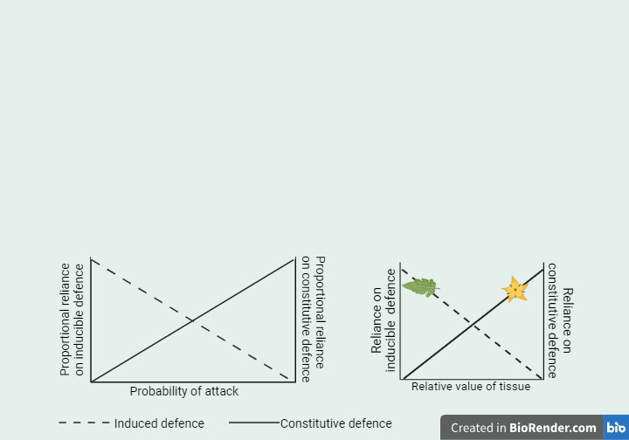
Herbivory can indirectly result in flower trait plasticity, through reduced allocation of resources to floral tissues or pleiotropy between leaf and flower defence which may result in changes such as a reduced floral display, shorter flowering period, or (Rusman et al., 2022). Furthermore, plant responses to herbivory and plant developmental processes are mediated by phytohormone and biosynthetic pathway crosstalk that are mediated by the same basic phytohormones including jasmonic acid, salicylic acid, ethylene, abscisic acid and indole acetic acid (Rusman et al., 2019). Consequently, plant phytohormonal and metabolic changes due to herbivory may also affect the growth, phenology and chemistry of flowers, thus altering the interactions of pollinators with those flowers (Kessler and Chautá, 2020). This demonstrates how plants can experience total costs of induced defence which may overall be much greater than the individual costs when considered in isolation (Zangerl et al., 2002), as herbivory results in a loss of photosynthetic tissue and the associated costs of reallocation of resources to defence and away from primary metabolism, which are experienced in addition to the ecological costs associated with induced changes in floral traits (Kessler and Halitschke, 2009). The type and strength of ecological effects of induced responses varies by plant species, type of damage, and the plant tissue that is subject to damage (Poveda et al., 2003; Gegear, Manson and Thomson, 2007), and also the location of defence metabolites within different tissues of a plant. The ecological costs of defence may be experienced differently in different plant tissues.
a)
b)
Figure 2: Constitutive and inducible defence strategies are evolutionary alternatives. a) Reliance on inducible defences reduces as the probability of attack increases, whilst reliance on constitutive defence is higher when the probability of attack is higher. b) Predictions based on Optimal defence theory state that more valuable tissue will be more strongly defended. If, as predicted, induced and constitutive defences are alternative strategies, then tissues with the highest constitutive defences will be less inducible. We might predict that leaves rely on inducible defences whilst flowers rely on constitutive defences.
As induced and constitutive defence are hypothesised to be alternative defence strategies, plants or pant tissue with high constitutive defence may be less inducible, and the reliance on constitutive defence is predicted to increase with the probability of attack or relative value of plant tissue (summarised in Figure 3a). Thus it may be predicted that flowers are strongly constitutively defended whilst leaves may be more likely to rely on an inducible defence strategy (Figure 3b). As plants have to balance the production of herbivore defence with pollinator attraction, it is reasonable to predict that pollinator selection on defence is stronger in flowers than leaves.
Pleiotropy has been hypothesised to link floral and leaf chemistry, therefore it could be expected that selection by herbivores for strong defences could impact interactions with pollinators. Despite this, there is mixed evidence for the predicted pleiotropic effects between leaf and flower defence. Floral secondary metabolism has been shown to differ from leaf secondary metabolism in Solanum peruvianum (Kessler and Halitschke, 2009), however leaf and flower nicotine levels were found to be correlated across several species of Nicotiana (Adler et al., 2012). From an evolutionary perspective, genetic linkage of leaf and flower defence traits could mean that there would be a strong interaction between plant-pollinator reliance and defence in plants.
A study across a large number of Solanaceae taxa showed a unidirectional shift from self-incompatibility to self-compatibility was associated with the evolution of inducible resistance strategies (Campbell and Kessler, 2013). A possible explanation for the link between transition to self-compatibility and inducible defences is that both often occur at range margins. At the edge of a habitat range, mating opportunities are likely to be scarce due to low population size or scarcity of pollinators, so the transition to self-compatibility provides reproductive assurance for plants (Charlesworth and Charlesworth, 1987; Griffin and Willi, 2014). Small and bottlenecked populations are often found at range margins, and selfing can be a mechanism to reduce the effects of bottlenecking and inbreeding depression, meaning that shifts to selfing are often hypothesised to occur frequently at range margins (Baker, 1955; Stebbins, 1957; Levin, 1975). Also, at range margins there may be fewer herbivores of a given plant species which would mean the chance of damage is reduced and therefore inducible defences would be the better defence strategy. Indeed, a study conducted in Brassica rapa found that plants under selection by bee pollinators as well as herbivores evolved greater levels of self-compatibility and selfing, whilst plants under selection by only bee pollinators selected for higher floral attractiveness (Ramos and Schiestl, 2019). Furthermore, a model developed using data collected using Solanum peruvianum (Kessler, Halitschke and Poveda, 2011a) showed that herbivore-induced changes to plant secondary metabolism can affect the stability and resilience of communities, including reduced pollinator visitation rates (Glaum and Kessler, 2017). These studies support the hypothesis that metabolites in leaves and flowers can be under selection by both herbivores and pollinators.
Floral traits evolution is also influenced by mating system. Self-incompatible plants must invest strongly in pollinator attraction, producing an attractive display, odour and floral rewards (Knauer and Schiestl, 2015). Floral volatiles are one component that attracts pollinators to flowers. When plants are damaged and a defence is induced, the floral volatile mix can change, as defence compounds are produced (Kessler, Halitschke and Poveda, 2011a). This can reduce pollinator recruitment, with pollinators being shown to prefer less-damaged plants (Strauss, 1997). The ecological cost of defence should therefore be greater in outcrossing plants than in selfing plants, due to the greater reliance of outcrossing plants on pollinators (Figure 2b), though this remains poorly understood.
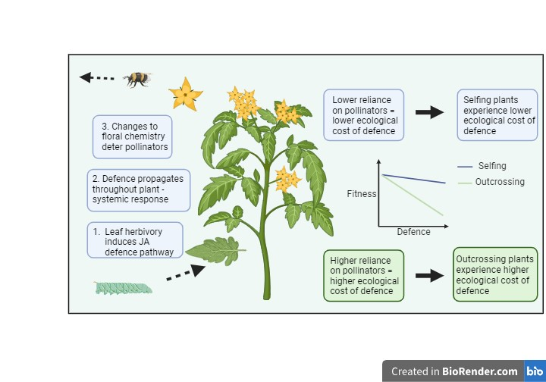
Much of the current literature into floral defences is focused on the plant volatile chemistry, as these are the compounds that are considered to strongly influence pollinator recruitment. Some research into the non-volatile chemical defences in flowers has been conducted, for example in Brassica nigra, glucosinolate levels in flowers were found to be significantly higher than in leaves (Smallegange et al., 2007). Studies linking pollinator reliance, or plant mating system with non-volatile plant defences are scarce.
Figure 3: Overview of the interaction between plant defence and pollinator reliance. a) Plant defence induction in leaves can propagate through the plant causing changes to flower chemistry that alter interactions with pollinators. b) Plants with a lower reliance on pollinators (selfers) experience lower ecological costs of defence than those that are more reliant on pollinators (outcrossers).
a)
b)

It is well-established that herbivores exert a selective pressure for high plant defences, however it could also be possible that pollinators exert a counter-pressure for low defences in plants in order to ensure pollinator attraction. The interface of the interaction between plants, herbivores and pollinators is at the level of the flowers, yet surprisingly little is yet understood about the effects of this three-way interaction on floral defence.

1.1.6 The Solanaceae

The Solanaceae family is one of the largest and most economically important families of angiosperms, and contains taxa with a diverse array of human uses, including food, spice, and drug plants (D’Arcy, 1979*). Recent estimates predict that the Solanaceae family includes over 3000 species, of which 49% are in the genus Solanum (Särkinen et al., 2013). The family has a widespread distribution, with a concentration of species diversity in Australia and Latin America. There is a high degree of diversity within the family, with a range of life history patterns from ephemeral herbs to long-lived trees. There are characteristic morphological traits that are largely conserved across the family; exstipulate, alternate and rarely opposite leaves, and hypogynous, regular cymose flowers. The flowers are typically comprised of a 5-lobed calyx, and a sympetalous corolla. Stamens are typically epipetalous, equal in length, and perfect except in a handful of genera, and usually there are an equal number of stamens and petals. The gynoecium of Solanaceae consists of two united carpels, occasionally composed of three or five carpels fused together. A notable feature of the Solanaceae is the numerous ovules and seeds within each flower. Species with the genus Solanum share a similar flower structure; a sympetalous corolla and anthers with opening terminal pores (Bohs, 2005). Many Solanum species are bumblebee-pollinated.
Within the Solanaceae, the self-incompatibility mechanism has been lost over 60 times (Igic, Bohs and Kohn, 2006). This is thought to be an irreversible shift from self-compatibility to self-incompatibility, mediated by the loss of the RNase-based self-incompatibility gametophytic system (Igic et al., 2007). Around 39% of Solanaceae are self-incompatible (Igic, Bohs and Kohn, 2006) and the rest of the species in the family are either self-compatible or exhibit a transition to selfing within mixed mating systems (Bedinger et al., 2010). Thus, the Solanaceae provides a useful framework to study the ecological implications of the transition from outcrossing to selfing.
The Solanum genus is a diverse group of plants that is a good study model due to it containing economically important food crops such as cultivated tomato (Solanum lycopersicum), potato (Solanum tuberosum) and aubergine (S. melongena), as well as drug plants and economically important weeds including horsenettle (S. carolinense). Solanaceous species are model systems for molecular and agronomic investigations (reviewed in Ganaie et al., 2018). Within the genus Solanum, there are species which are capable of self-pollination and species that are obligate outcrossers, as well as species with plasticity in self-incompatibility such as S. pennellii and S. habrochaites. Additionally, the availability of genomic resources for species including S. lycopersicum, S. tuberosum and reference genomes for S. pennellii and S. habrochaites make the genus moderately useful for genome-wide work for conspecifics (Kariyat et al., 2012; Watts, Kaur and Kariyat, 2023).
In Nicotiana (Solanaceae), defence compounds such as nicotine and other alkaloids are produced in the roots and transported to stems, leaves and flowers (Zenkner, Margis-Pinheiro and Cagliari, 2019). Plants in this genus are capable of producing a wide range of chemical defences (Kaplan et al., 2008). The genus Nicotiana is comprised of species that range from obligate outcrossing to highly selfing, which makes the Nicotiana another useful family for researching the effect of pollinator reliance on plant chemical defences.
The third genus that is described in this thesis is Physalis, which is also comprised of selfing and outcrossing species (Pretz and Smith, 2021). Species in this genus have not been broadly researched, though some studies have analysed the secondary metabolites of these species, including phenolic and antioxidant compounds (Gonzalez-mendoza et al., 2011; Medina Medrano et al., 2015). Physalis and Solanum diverged more recently with each other than with Nicotiana, which can be seen in the closer similarity of the flowers of Physalis and Solanum than with flowers of Nicotiana (Figure 4).
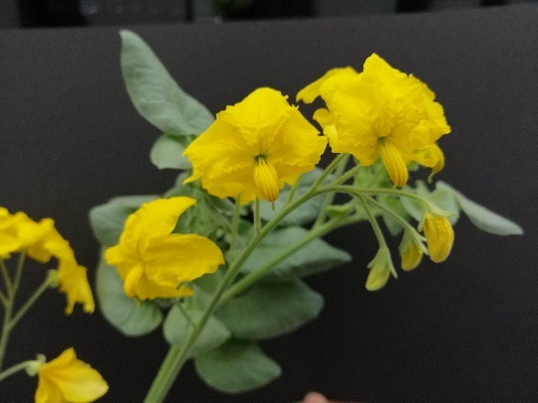
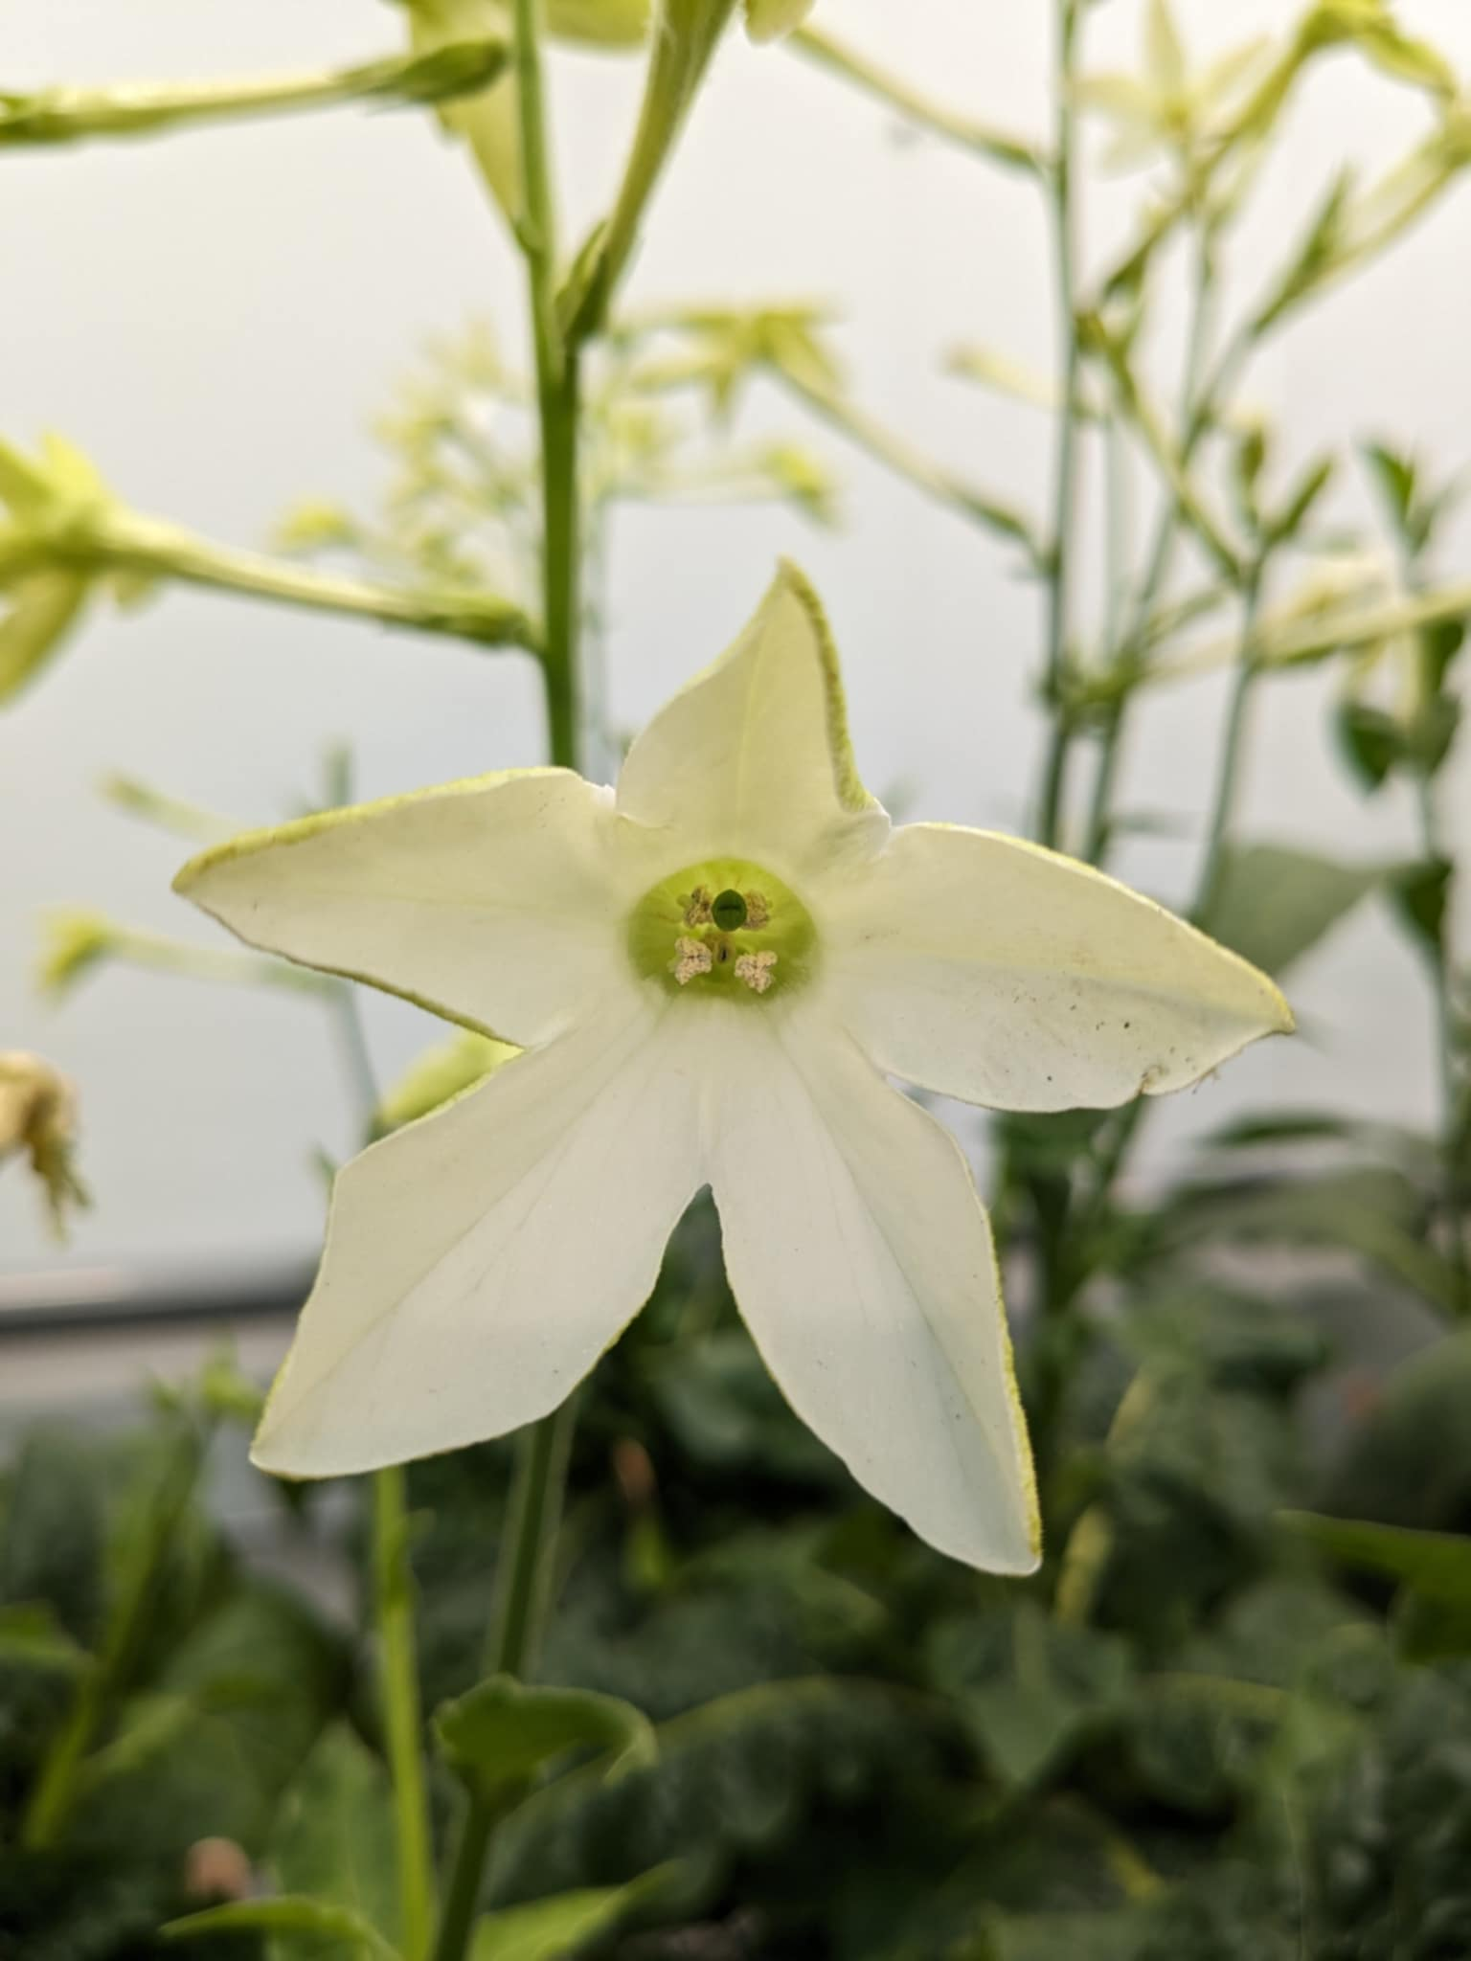
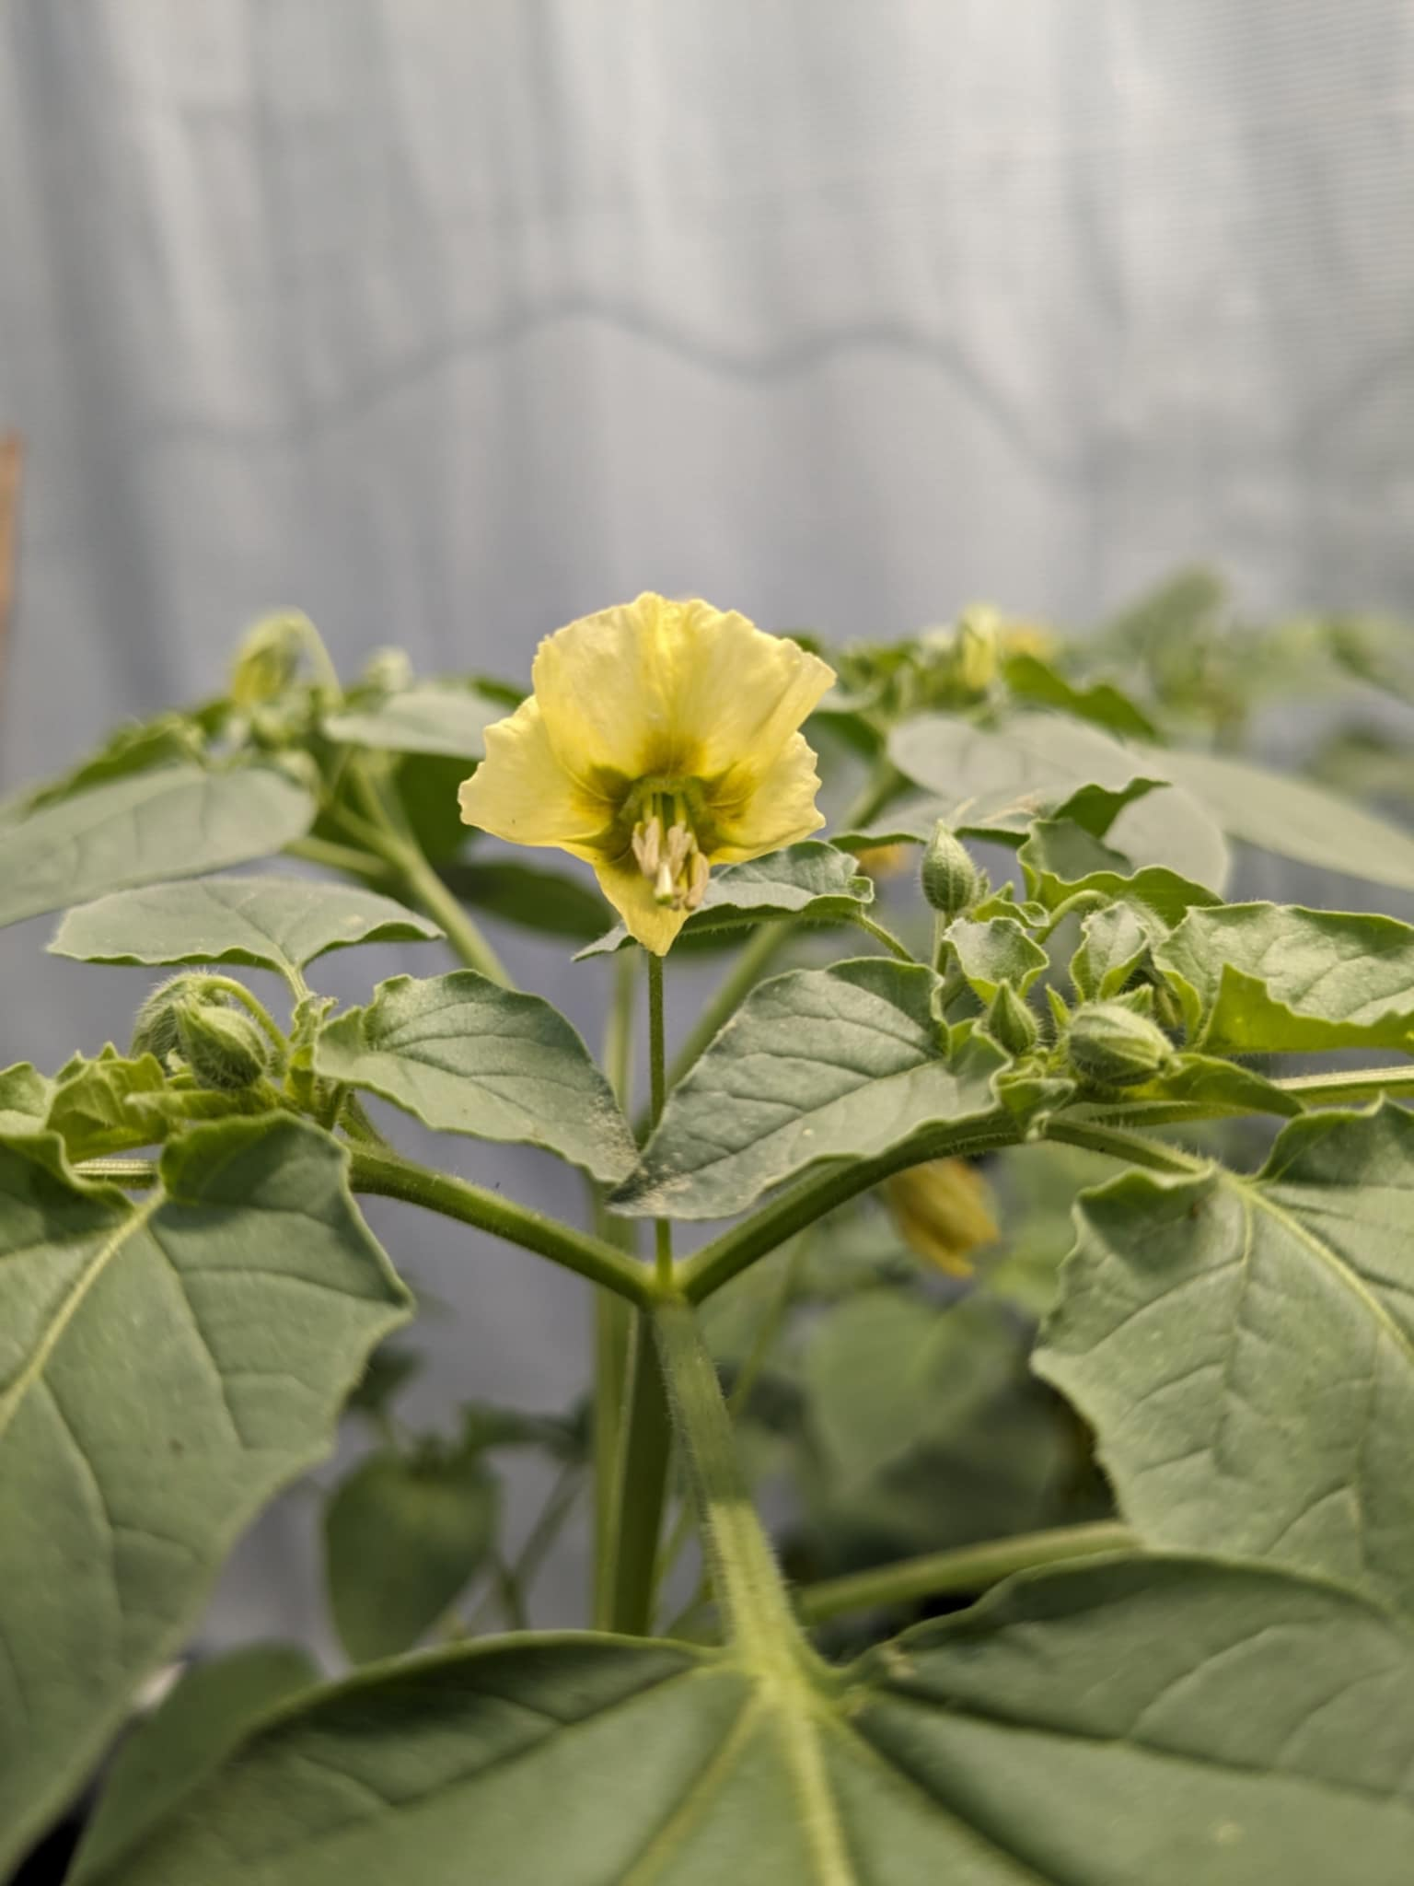
Figure 4: Schematic of the phylogenetic relationships between Physalis, Solanum, and Nicotiana (adapted from Särkinen et al 2013), including photographs of representative flowers from each genus, including Physalis cinarescens, Solanum pennellii and Nicotiana alata. Photographs are author’s own.
Solanum
Physalis
Nicotiana

1.2 Research Objectives and Thesis Outline
This thesis aims to investigate the effects of pollinator reliance on defensive secondary metabolite production in the Solanaceae in order to address a current knowledge gap in this topic. The experiments described in this thesis utilised the naturally occurring populations of selfing and outcrossing Solanaceae to compare defences between these two mating systems. A unique aspect of the experiments described in this thesis is the inclusion of comparisons between not just constitutive defence, but also defences induced in response to herbivory treatments, in both leaf and flower tissue. To the best of my knowledge, the experiments detailed in this thesis are some of the first studies to include analysis of both constitutive and induced defences in both leaf and flower tissues of selfing and outcrossing plants, therefore this thesis adds to current knowledge.
The aim of this thesis was addressed with three overall objectives:
Objective 1:
To analyse the differences in floral and leaf constitutive phenolic defences in different mating systems
Objective 2:
To analyse the differences in floral defence plasticity between plants of different mating systems
Objective 3:
To investigate the effect of pollinator dependence on patterns in defence in leaves and flowers across the Solanaceae

Chapter 2 of this thesis addresses the Objectives 1 and 2 using a single species, Solanum pennellii, a wild tomato species which has natural populations throughout Andean regions in northern Chile and Peru, and thrives in arid habitats (Bolger et al., 2014). Within the species there are distinct populations that are selfing and populations that are outcrossing. Each outcrossing population represents an independent transition to selfing, thus providing a system in which the populations are largely genetically similar to test the effects of the transition to selfing on plant phenotype. Solanum pennellii is of keen interest in research into germplasm donors for introducing stress tolerance to the cultivated tomato, Solanum lycopersicum, and thus investigations into the chemistry of this species are of importance to production of cultivated tomato. In this chapter I investigate how the concentration of a key group of defensive secondary metabolites, phenolic compounds, differs between leaves and flowers of selfing and outcrossing plants under control and mock herbivory-treatment conditions. This chapter addresses the research questions; how do constitutive plant defences differ in leaves and flowers of selfing and outcrossing plants, and do leaves and flowers respond differently to mock herbivory-treatments between mating systems? Selfing plants benefit from being able to self-fertilise even if high levels of defences have a deterrent effect on pollinators, so it was predicted that constitutive defence would be higher in tissues of selfing plants than of outcrossing plants, and we predicted that flowers would be strongly defended, in line with Optimal Defence Theory predictions that valuable tissues are more strongly defended. We hypothesised that selfing plants would be more inducible than outcrossing plants, but that flowers would be less inducible than leaves due to their predicted higher levels of constitutive defences. We also hypothesised that outcrossing plants would be less inducible than selfing plants due to the higher ecological costs expected to be experienced by outcrossing plants, due to the risk of pollinator deterrence caused by induced defences reducing plant reproductive output. Understanding the patterns in defence in a complex system provides more insight into the evolutionary strategies of plants in response to antagonistic interactions with herbivores and the limitations imposed by pollinators.
Chapter 2 describes a greenhouse experiment conducted using selfing and outcrossing populations of S. pennellii. The plants were either given a control treatment or a mock herbivory treatment of methyl jasmonate to induce the jasmonate pathway in the plants, and chemical analysis was conducted on leaf and flower tissue collected from the plants. Further assessment of the level of defence in these plants was conducted using a herbivore feeding bioassay with Manduca sexta to assess how larval growth was affected by feeding on the different tissues and treatments of selfing and outcrossing plants.
In Chapter 3, I present the overall findings of an RNA sequencing experiment that address Objectives 1 and 2 of this thesis. Leaf and flower samples from control and treated selfing and outcrossing S. pennellii plants were used in this experiment. This chapter contains novel comparisons that show interesting preliminary differences in the pathways responding to herbivore treatment in the different tissues and mating systems. We hypothesised that leaves and flowers would have distinct transcriptomic profiles, and expected that genes associated with defence would be upregulated in response to MeJA in leaves but not in flowers if flowers rely on a constitutive rather than inducible defence strategy. We also hypothesised that defence-related genes would be differentially expressed between leaves and flowers, with leaves and flowers expected to rely on different defensive pathways.
In Chapter 4, I present a multispecies study using three genera from the Solanaceae: Solanum, Nicotiana and Physalis in which I investigated the constitutive and induced defences in selfing and outcrossing taxa. This chapter addresses all three research objectives of this thesis by assessing the level of defensive secondary metabolites in leaf and flower samples in selfing and outcrossing species across the Solanaceae. The overall aim of this chapter was to measure patterns in constitutive and induced defence using chemical analysis of the phenolic content of the tissues using the same method as Chapter 2, so that the results found in S. pennellii could be investigated in additional species. A herbivore feeding bioassay was also used to assess the level of chemical defence of the Solanum species used in the experiment detailed in this chapter. The bioassay used the growth rate of the herbivore Manduca sexta as a proxy for the level of chemical defence in the tissue on which the larvae were feeding. In this chapter I looked at how floral and leaf defence traits are linked with pollinator reliance of the plant, which provided a broader evolutionary ecological context to the within- and between-plant patterns in chemical defence. We hypothesised that flower defence would not be inducible, but that leaf defence would be inducible across all of the species. We also hypothesised that flowers would be better defended than leaves, due to the higher relative value of flowers compared to leaves. We further tested the hypothesis that phenolic content in selfing flowers would be higher than the phenolic content in outcrossing flowers.
Chapter 5 is a discussion of the main findings of this thesis. In this chapter I conclude that the effect of pollinator reliance on plant chemical defence is significant, and that the effects of pollinator reliance may be stronger on flower, rather than leaf, chemical defence. Including the contrasting phenotypic plasticity specific to plant tissue and the interaction between plant tissue and plant pollinator reliance into plant defence models adds an important layer of complexity that provides a more accurate representation of the natural ecological conditions under which the defence phenotypes have evolved.

1.3 References
Abdalsamee, M.K., Müller, C., 2015. Uncovering different parameters influencing florivory in a specialist herbivore. Ecological Entomology 40, 258–268. https://doi.org/10.1111/een.12182
Adler, L.S., Seifert, M.G., Wink, M., Morse, G.E., 2012. Reliance on pollinators predicts defensive chemistry across tobacco species. Ecology Letters 15, 1140–1148. https://doi.org/10.1111/j.1461-0248.2012.01838.x
Alves, F.M., Joshi, M., Djidonou, D., Joshi, V., Gomes, C.N., Leskovar, D.I., 2021. Physiological and Biochemical Responses of Tomato Plants Grafted onto Solanum pennellii and Solanum peruvianum under Water-Deficit Conditions. Plants 10, 2236. https://doi.org/10.3390/plants10112236
Arimura, G.-I., 2021. Making Sense of the Way Plants Sense Herbivores. Trends Plant Sci 26, 288–298. https://doi.org/10.1016/j.tplants.2020.11.001
Baker, H.G., 1955. Self-Compatibility and Establishment After “Long-Distance” Dispersal. Evolution 9, 347–349. https://doi.org/10.2307/2405656
Bedinger, P., Chetelat, R., McClure, B., Moyle, L., Rose, J., Stack, S., Knaap, E., Baek, Y.S., Lopez-Casado, G., Covey, P., Kumar, A., Li, W., Nunez, R., Cruz-García, F., Royer, S., 2010. Interspecific reproductive barriers in the tomato clade: Opportunities to decipher mechanisms of reproductive isolation. Sexual plant reproduction 24, 171–87. https://doi.org/10.1007/s00497-010-0155-7
Bohs, L., n.d. MAJOR CLADES IN SOLANUM BASED ON ndhF SEQUENCE DATA.
Bouwmeester, H., Schuurink, R.C., Bleeker, P.M., Schiestl, F., 2019. The role of volatiles in plant communication. The Plant Journal 100, 892–907. https://doi.org/10.1111/tpj.14496
Boyer, M.D.H., Soper Gorden, N.L., Barber, N.A., Adler, L.S., 2016. Floral damage induces resistance to florivory in Impatiens capensis. Arthropod-Plant Interactions 10, 121–131. https://doi.org/10.1007/s11829-015-9411-y
Broekgaarden, C., Voorrips, R.E., Dicke, M., Vosman, B., 2011. Transcriptional responses of Brassica nigra to feeding by specialist insects of different feeding guilds. Insect Science 18, 259–272. https://doi.org/10.1111/j.1744-7917.2010.01368.x
Campbell, S.A., Halitschke, R., Thaler, J.S., Kessler, A., 2014. Plant mating systems affect adaptive plasticity in response to herbivory. The Plant Journal 78, 481–490. https://doi.org/10.1111/tpj.12492
Campbell, S.A., Kessler, A., 2013. Plant mating system transitions drive the macroevolution of defense strategies. PNAS 110, 3973–3978. https://doi.org/10.1073/pnas.1213867110
Charlesworth, D., Charlesworth, B., 1987. Inbreeding Depression and its Evolutionary Consequences. Annual Review of Ecology and Systematics 18, 237–268.
Charlesworth, D., Willis, J.H., 2009. The genetics of inbreeding depression. Nat Rev Genet 10, 783–796. https://doi.org/10.1038/nrg2664
Chen, M.-S., 2008. Inducible direct plant defense against insect herbivores: A review. Insect Science 15, 101–114. https://doi.org/10.1111/j.1744-7917.2008.00190.x
Dalin, P., Björkman, C., 2003. Adult beetle grazing induces willow trichome defence against subsequent larval feeding. Oecologia 134, 112–118. https://doi.org/10.1007/s00442-002-1093-3
Damle, M.S., Giri, A.P., Sainani, M.N., Gupta, V.S., 2005. Higher accumulation of proteinase inhibitors in flowers than leaves and fruits as a possible basis for differential feeding preference of Helicoverpa armigera on tomato (Lycopersicon esculentum Mill, Cv. Dhanashree). Phytochemistry 66, 2659–2667. https://doi.org/10.1016/j.phytochem.2005.09.006
Després, L., David, J.-P., Gallet, C., 2007. The evolutionary ecology of insect resistance to plant chemicals. Trends in Ecology & Evolution 22, 298–307. https://doi.org/10.1016/j.tree.2007.02.010
Dicke, M., Baldwin, I.T., 2010. The evolutionary context for herbivore-induced plant volatiles: beyond the ‘cry for help.’ Trends in Plant Science, Special Issue: Induced biogenic volatile organic compounds from plants 15, 167–175. https://doi.org/10.1016/j.tplants.2009.12.002
Differences in Volatile Profiles of Turnip Plants Subjected to Single and Dual Herbivory Above- and Belowground | Journal of Chemical Ecology [WWW Document], n.d. URL https://link.springer.com/article/10.1007/s10886-011-9934-3 (accessed 8.2.24).
Franklin-Tong, V.E. (2008) Self-Incompatibility in Flowering Plants. Berlin, Heidelberg: Springer. Available at: https://doi.org/10.1007/978-3-540-68486-2
Frölich, C., Ober, D., Hartmann, T., 2007. Tissue distribution, core biosynthesis and diversification of pyrrolizidine alkaloids of the lycopsamine type in three Boraginaceae species. Phytochemistry 68, 1026–1037. https://doi.org/10.1016/j.phytochem.2007.01.002
Ganaie, M.M., Reshi, Z.A., Verma, V., Raja, V., 2018. Family Solanaceae: Taxonomy and modern trends. Ann.Pl.Sci. 7, 2403. https://doi.org/10.21746/aps.2018.7.9.1
Gatehouse, J.A., 2002. Plant resistance towards insect herbivores: a dynamic interaction. New Phytologist 156, 145–169. https://doi.org/10.1046/j.1469-8137.2002.00519.x
Gegear, R.J., Manson, J.S., Thomson, J.D., 2007. Ecological context influences pollinator deterrence by alkaloids in floral nectar. Ecol Lett 10, 375–382. https://doi.org/10.1111/j.1461-0248.2007.01027.x
Gershenzon, J., 1994a. Metabolic costs of terpenoid accumulation in higher plants. J Chem Ecol 20, 1281–1328. https://doi.org/10.1007/BF02059810
Gershenzon, J., 1994b. The Cost Of Plant Chemical Defense Against Herbivory: A Biochemical Perspective, in: Insect-Plant Interactions (1993). CRC Press.
Glaum, P., Kessler, A., 2017. Functional reduction in pollination through herbivore-induced pollinator limitation and its potential in mutualist communities. Nat Commun 8, 2031. https://doi.org/10.1038/s41467-017-02072-4
Goldberg, E.E. et al. (2010) ‘Species Selection Maintains Self-Incompatibility’, Science, 330(6003), pp. 493–495.
Gonzalez Mendoza, D., Ascencio-Martinez, D., Poox, A., Mendez-Trujillo, V., Grimaldo, O., Hernández, J., Díaz, L., Monica, S., Marin, A., 2011. Phenolic compounds and physiochemical analysis of Physalis ixocarpa genotypes. Scientific Research and Essays 6. https://doi.org/10.5897/SRE11.370
Goodwillie, C., Kalisz, S., Eckert, C., 2005. The Evolutionary Enigma of Mixed Mating Systems in Plants: Occurrence, Theoretical Explanations, and Empirical Evidence. Annu. Rev. Ecol. Evol. Syst 36, 47–79. https://doi.org/10.1146/annurev.ecolsys.36.091704.175539
Goodwillie, C., Sargent, R.D., Eckert, C.G., Elle, E., Geber, M.A., Johnston, M.O., Kalisz, S., Moeller, D.A., Ree, R.H., Vallejo-Marin, M., Winn, A.A., 2010. Correlated evolution of mating system and floral display traits in flowering plants and its implications for the distribution of mating system variation. New Phytologist 185, 311–321. https://doi.org/10.1111/j.1469-8137.2009.03043.x
Griffin, P.C., Willi, Y., 2014. Evolutionary shifts to self-fertilisation restricted to geographic range margins in North American Arabidopsis lyrata. Ecology Letters 17, 484–490. https://doi.org/10.1111/ele.12248
Hanley, M.E., Lamont, B.B., Armbruster, W.S., 2009. Pollination and plant defence traits co-vary in Western Australian Hakeas. New Phytologist 182, 251–260. https://doi.org/10.1111/j.1469-8137.2008.02709.x
Harborne, J.B. (Ed.), 1993. Front Matter, in: Introduction to Ecological Biochemistry (Fourth Edition). Academic Press, San Diego, p. iii. https://doi.org/10.1016/B978-0-08-091858-7.50001-2
Hermsmeier, D., Schittko, U., Baldwin, I.T., 2001. Molecular Interactions between the Specialist Herbivore Manduca sexta (Lepidoptera, Sphingidae) and Its Natural Host Nicotiana attenuata. I. Large-Scale Changes in the Accumulation of Growth- and Defense-Related Plant mRNAs. Plant Physiol 125, 683–700.
Holopainen, J., Heijari, J., Nerg, A.-M., Vuorinen, M., Kainulainen, P., 2009. Potential for the Use of Exogenous Chemical Elicitors in Disease and Insect Pest Management of Conifer Seedling Production. The Open Forest Science Journal 2. https://doi.org/10.2174/1874398600902010017
How many flowering plants are pollinated by animals? - Ollerton - 2011 - Oikos - Wiley Online Library [WWW Document], n.d. URL https://nsojournals.onlinelibrary.wiley.com/doi/full/10.1111/j.1600-0706.2010.18644.x (accessed 7.3.24).
Howe, G.A., Jander, G., 2008. Plant Immunity to Insect Herbivores. Annu. Rev. Plant Biol. 59, 41–66. https://doi.org/10.1146/annurev.arplant.59.032607.092825
Howe, G.A., Major, I.T., Koo, A.J., 2018. Modularity in Jasmonate Signaling for Multistress Resilience. Annu Rev Plant Biol 69, 387–415. https://doi.org/10.1146/annurev-arplant-042817-040047
Igic, B., Bohs, L., Kohn, J.R., 2006. Ancient polymorphism reveals unidirectional breeding system shifts. Proceedings of the National Academy of Sciences 103, 1359–1363. https://doi.org/10.1073/pnas.0506283103
Igic, B., Smith, W.A., Robertson, K.A., Schaal, B.A., Kohn, J.R., 2007. Studies of self-incompatibility in wild tomatoes: I. S-allele diversity in Solanum chilense Dun. (Solanaceae). Heredity 99, 553–561.
Igic, B., Lande, R. and Kohn, J.R. (2008) ‘Loss of Self‐Incompatibility and Its Evolutionary Consequences’, International Journal of Plant Sciences, 169(1), pp. 93–104.
Kao, T. and Tsukamoto, T. (2004) ‘The Molecular and Genetic Bases of S-RNase-Based Self-Incompatibility’, The Plant Cell, 16(suppl_1), pp. S72–S83. Available at: https://doi.org/10.1105/tpc.016154.
Kaplan, I., Halitschke, R., Kessler, A., Sardanelli, S., Denno, R.F., 2008. Constitutive and Induced Defenses to Herbivory in Above- and Belowground Plant Tissues. Ecology 89, 392–406. https://doi.org/10.1890/07-0471.1
Karban, R., Agrawal, A.A., 2002. Herbivore Offense. Annual Review of Ecology, Evolution, and Systematics 33, 641–664. https://doi.org/10.1146/annurev.ecolsys.33.010802.150443
Karban, R., Baldwin, I.T., 1997. Induced Responses to Herbivory. University of Chicago Press, Chicago, UNITED STATES.
Kariyat, R.R., Balogh, C.M., Moraski, R.P., De Moraes, C.M., Mescher, M.C., Stephenson, A.G., 2013. Constitutive and herbivore-induced structural defenses are compromised by inbreeding in Solanum carolinense (Solanaceae). American Journal of Botany 100, 1014–1021. https://doi.org/10.3732/ajb.1200612
Kariyat, R.R., Hardison, S.B., De Moraes, C.M., Mescher, M.C., 2017. Plant spines deter herbivory by restricting caterpillar movement. Biology Letters 13, 20170176. https://doi.org/10.1098/rsbl.2017.0176
Kariyat, R.R., Mena-Alí, J., Forry, B., Mescher, M.C., De Moraes, C.M., Stephenson, A.G., 2012. Inbreeding, herbivory, and the transcriptome of Solanum carolinense. Entomologia Experimentalis et Applicata 144, 134–144. https://doi.org/10.1111/j.1570-7458.2012.01269.x
Kessler, A., Baldwin, I.T., 2002. PLANT RESPONSES TO INSECT HERBIVORY: The Emerging Molecular Analysis. Annual Review of Plant Biology 53, 299–328. https://doi.org/10.1146/annurev.arplant.53.100301.135207
Kessler, A., Chautá, A., 2020. The ecological consequences of herbivore-induced plant responses on plant-pollinator interactions. Emerg Top Life Sci 4, 33–43. https://doi.org/10.1042/ETLS20190121
Kessler, A., Halitschke, R., 2009. Testing the potential for conflicting selection on floral chemical traits by pollinators and herbivores: predictions and case study. Functional Ecology 23, 901–912. https://doi.org/10.1111/j.1365-2435.2009.01639.x
Kessler, A., Halitschke, R., Poveda, K., 2011. Herbivory-mediated pollinator limitation: negative impacts of induced volatiles on plant-pollinator interactions. Ecology 92, 1769–1780. https://doi.org/10.1890/10-1945.1
Kessler, A., Heil, M., 2011. The multiple faces of indirect defences and their agents of natural selection. Functional Ecology 25, 348–357. https://doi.org/10.1111/j.1365-2435.2010.01818.x
Kessler, D., Gase, K., Baldwin, I.T., 2008. Field experiments with transformed plants reveal the sense of floral scents. Science 321, 1200–1202. https://doi.org/10.1126/science.1160072
Knauer, A.C., Schiestl, F.P., 2015. Bees use honest floral signals as indicators of reward when visiting flowers. Ecology Letters 18, 135–143. https://doi.org/10.1111/ele.12386
Krupnick, G.A., Weis, A.E., Campbell, D.R., 1999. The Consequences of Floral Herbivory for Pollinator Service to Isomeris arborea. Ecology 80, 125–134. https://doi.org/10.2307/176984
McArt 2013 - Leaf herbivory increases plant fitness via induced resistance to seed predators - - Ecology - Wiley Online Library [WWW Document], n.d. URL https://esajournals-onlinelibrary-wiley-com.sheffield.idm.oclc.org/doi/full/10.1890/12-1664.1 (accessed 3.21.24).
Lee, H.-S., Huang, S. and Kao, T. (1994) ‘S proteins control rejection of incompatible pollen in Petunia inflata’, Nature, 367(6463), pp. 560–563. Available at: https://doi.org/10.1038/367560a0
Levin, D.A., 1975. Pest Pressure and Recombination Systems in Plants. The American Naturalist 109, 437–451.
Li, D., Heiling, S., Baldwin, I.T., Gaquerel, E., 2016. Illuminating a plant’s tissue-specific metabolic diversity using computational metabolomics and information theory. Proceedings of the National Academy of Sciences 113, E7610–E7618. https://doi.org/10.1073/pnas.1610218113
Matsuura, H., Takeishi, S., Kiatoka, N., Sato, C., Sueda, K., Masuta, C., Nabeta, K., 2012. Transportation of de novo synthesized jasmonoyl isoleucine in tomato. Phytochemistry 83, 25–33. https://doi.org/10.1016/j.phytochem.2012.06.009
McCall, A.C., Irwin, R.E., 2006. Florivory: the intersection of pollination and herbivory. Ecology Letters 9, 1351–1365.
McClure, B.A. et al. (1989) ‘Style self-incompatibility gene products of Nicotlana alata are ribonucleases’, Nature, 342(6252), pp. 955–957. Available at: https://doi.org/10.1038/342955a0.
McKey, D., 1974. Adaptive Patterns in Alkaloid Physiology. The American Naturalist 108, 305–320. https://doi.org/10.1086/282909
Medina Medrano, J., Gonzalez-Elizondo, M.S., Natividad, U.-S., Gonzalez, L., Yolanda, H.-A., Almaraz, N., 2015. Phenolic constituents and antioxidant properties of five wild species of Physalis (Solanaceae). Botanical Studies 56. https://doi.org/10.1186/s40529-015-0101-y
Mitchell, R.J., Irwin, R.E., Flanagan, R.J., Karron, J.D., 2009. Ecology and evolution of plant–pollinator interactions. Annals of Botany 103, 1355–1363. https://doi.org/10.1093/aob/mcp122
Mithöfer, A., Boland, W., 2012. Plant Defense Against Herbivores: Chemical Aspects. Annu. Rev. Plant Biol. 63, 431–450. https://doi.org/10.1146/annurev-arplant-042110-103854
Mithöfer, A., Boland, W., Maffei, M.E., 2018. Chemical Ecology of Plant–Insect Interactions, in: Annual Plant Reviews Online. American Cancer Society, pp. 261–291. https://doi.org/10.1002/9781119312994.apr0369
Moreira, X., Castagneyrol, B., Abdala-Roberts, L., Traveset, A., 2019. A meta-analysis of herbivore effects on plant attractiveness to pollinators. Ecology 100, e02707. https://doi.org/10.1002/ecy.2707
Moreira, X., Mooney, K.A., Rasmann, S., Petry, W.K., Carrillo-Gavilán, A., Zas, R., Sampedro, L., 2014. Trade-offs between constitutive and induced defences drive geographical and climatic clines in pine chemical defences. Ecology Letters 17, 537–546.
Murfett, J. et al. (1994) ‘S-RNase expressed in transgenic Nicotiana causes S-allele-specific pollen rejection’, Nature, 367(6463), pp. 563–566.
Orians, C.M., Thorn, A., Gómez, S., 2011. Herbivore-induced resource sequestration in plants: why bother? Oecologia 167, 1–9. https://doi.org/10.1007/s00442-011-1968-2
Plant hormone jasmonate prioritizes defense over growth by interfering with gibberellin signaling cascade [WWW Document], n.d. URL https://www.pnas.org/doi/epdf/10.1073/pnas.1201616109 (accessed 8.1.24).
Poveda, K., Steffan-Dewenter, I., Scheu, S., Tscharntke, T., 2003. Effects of below- and above-ground herbivores on plant growth, flower visitation and seed set. Oecologia 135, 601–605. https://doi.org/10.1007/s00442-003-1228-1
Pretz, C., Smith, S.D., 2021. Intraspecific breakdown of self-incompatibility in Physalis acutifolia (Solanaceae). AoB Plants 14, plab080. https://doi.org/10.1093/aobpla/plab080
Pujol, B., Zhou, S.-R., Vilas, J.S., Pannell, J.R., 2009. Reduced inbreeding depression after species range expansion. PNAS 106, 15379–15383. https://doi.org/10.1073/pnas.0902257106
Ramos, S.E., Schiestl, F.P., 2019. Rapid plant evolution driven by the interaction of pollination and herbivory. Science 364, 193–196. https://doi.org/10.1126/science.aav6962
Reproductive escape: annual plant responds to butterfly eggs by accelerating seed production - Lucas‐Barbosa - 2013 - Functional Ecology - Wiley Online Library [WWW Document], n.d. URL https://besjournals-onlinelibrary-wiley-com.sheffield.idm.oclc.org/doi/full/10.1111/1365-2435.12004 (accessed 3.21.24).
Reymond, P., Farmer, E.E., 1998. Jasmonate and salicylate as global signals for defense gene expression. Current Opinion in Plant Biology 1, 404–411. https://doi.org/10.1016/S1369-5266(98)80264-1
Rusman, Q., Hooiveld-Knoppers, S., Dijksterhuis, M., Bloem, J., Reichelt, M., Dicke, M., Poelman, E.. H., n.d. Flowers prepare thyselves: Leaf and root herbivores induce specific changes in floral phytochemistry with consequences for plant interactions with florivores. New Phytologist n/a. https://doi.org/10.1111/nph.17931
Rusman, Q., Hooiveld-Knoppers, S., Dijksterhuis, M., Bloem, J., Reichelt, M., Dicke, M., Poelman, E.H., 2022. Flowers prepare thyselves: leaf and root herbivores induce specific changes in floral phytochemistry with consequences for plant interactions with florivores. New Phytologist 233, 2548–2560. https://doi.org/10.1111/nph.17931
Rusman, Q., Lucas-Barbosa, D., Poelman, E.H., Dicke, M., 2019. Ecology of Plastic Flowers. Trends in Plant Science 24, 725–740. https://doi.org/10.1016/j.tplants.2019.04.007
Särkinen, T., Bohs, L., Olmstead, R.G., Knapp, S., 2013. A phylogenetic framework for evolutionary study of the nightshades (Solanaceae): a dated 1000-tip tree. BMC Evolutionary Biology 13, 214. https://doi.org/10.1186/1471-2148-13-214
Schiestl, F.P., 2015. Ecology and evolution of floral volatile-mediated information transfer in plants. New Phytologist 206, 571–577. https://doi.org/10.1111/nph.13243
Sharma, H.C., Sujana, G., Manohar Rao, D., 2009. Morphological and chemical components of resistance to pod borer, Helicoverpa armigera in wild relatives of pigeonpea. Arthropod-Plant Interactions 3, 151–161. https://doi.org/10.1007/s11829-009-9068-5
Sheard, L.B., Tan, X., Mao, H., Withers, J., Ben-Nissan, G., Hinds, T.R., Kobayashi, Y., Hsu, F.-F., Sharon, M., Browse, J., He, S.Y., Rizo, J., Howe, G.A., Zheng, N., 2010. Jasmonate perception by inositol phosphate-potentiated COI1-JAZ co-receptor. Nature 468, 400–405. https://doi.org/10.1038/nature09430
Sherif, S., El-Sharkawy, I., Mathur, J., Ravindran, P., Kumar, P., Paliyath, G., Jayasankar, S., 2015. A stable JAZ protein from peach mediates the transition from outcrossing to self-pollination. BMC Biol 13, 11. https://doi.org/10.1186/s12915-015-0124-6
Sheteiwy, M.S., Ulhassan, Z., Qi, W., Lu, H., AbdElgawad, H., Minkina, T., Sushkova, S., Rajput, V.D., El-Keblawy, A., Jośko, I., Sulieman, S., El-Esawi, M.A., El-Tarabily, K.A., AbuQamar, S.F., Yang, H., Dawood, M., 2022. Association of jasmonic acid priming with multiple defense mechanisms in wheat plants under high salt stress. Front Plant Sci 13, 886862.
Sijacic, P. et al. (2004) ‘Identification of the pollen determinant of S-RNase-mediated self-incompatibility’, Nature, 429(6989), pp. 302–305. Available at: https://doi.org/10.1038/nature02523.

Smallegange, R.C., van Loon, J.J.A., Blatt, S.E., Harvey, J.A., Agerbirk, N., Dicke, M., 2007. Flower vs. leaf feeding by Pieris brassicae: glucosinolate-rich flower tissues are preferred and sustain higher growth rate. J Chem Ecol 33, 1831–1844. https://doi.org/10.1007/s10886-007-9350-x
Stebbins, G.L., 1957. Self Fertilization and Population Variability in the Higher Plants. The American Naturalist 91, 337–354.
Steinbachs, J.E. and Holsinger, K.E. (2002) ‘S-RNase–mediated Gametophytic Self-Incompatibility is Ancestral in Eudicots’, Molecular Biology and Evolution, 19(6), pp. 825–829.
Steinbrenner, A.D., Gómez, S., Osorio, S., Fernie, A.R., Orians, C.M., 2011. Herbivore-Induced Changes in Tomato (Solanum lycopersicum) Primary Metabolism: A Whole Plant Perspective. J Chem Ecol 37, 1294–1303. https://doi.org/10.1007/s10886-011-0042-1
Strauss, S., Conner, J., Rush, S., 1996. Foliar Herbivory Affects Floral Characters and Plant Attractiveness to Pollinators: Implications for Male and Female Plant Fitness. American Naturalist - AMER NATURALIST 147. https://doi.org/10.1086/285896
Strauss, S.Y., 1997. FLORAL CHARACTERS LINK HERBIVORES, POLLINATORS, AND PLANT FITNESS. Ecology 78, 1640–1645. https://doi.org/10.1890/0012-9658(1997)078[1640:FCLHPA]2.0.CO;2
Strauss, S.Y., Irwin, R.E., Lambrix, V.M., 2004. Optimal defence theory and flower petal colour predict variation in the secondary chemistry of wild radish. Journal of Ecology 92, 132–141. https://doi.org/10.1111/j.1365-2745.2004.00843.x
Thaler, J.S., 2002. Effect of jasmonate-induced plant responses on the natural enemies of herbivores. Journal of Animal Ecology 71, 141–150. https://doi.org/10.1046/j.0021-8790.2001.00586.x
Theis, N., Adler, L.S., 2012. Advertising to the enemy: enhanced floral fragrance increases beetle attraction and reduces plant reproduction. Ecology 93, 430–435. https://doi.org/10.1890/11-0825.1
Tsuji, J., Logan, T., Russo, A., 2018. A Hierarchy of Cues Directs the Foraging of Pieris rapae (Lepidoptera: Pieridae) Larvae. Environmental Entomology 47, 1485–1492. https://doi.org/10.1093/ee/nvy124
Wang, J., Wu, D., Wang, Y., Xie, D., 2019. Jasmonate action in plant defense against insects. J Exp Bot 70, 3391–3400. https://doi.org/10.1093/jxb/erz174
War, A.R., Hussain, B., Sharma, H.C., 2013. Induced resistance in groundnut by jasmonic acid and salicylic acid through alteration of trichome density and oviposition by Helicoverpa armigera (Lepidoptera: Noctuidae). AoB PLANTS 5, plt053. https://doi.org/10.1093/aobpla/plt053
War, A.R., Paulraj, M.G., Ahmad, T., Buhroo, A.A., Hussain, B., Ignacimuthu, S., Sharma, H.C., 2012. Mechanisms of plant defense against insect herbivores. Plant Signaling & Behavior 7, 1306–1320. https://doi.org/10.4161/psb.21663
Wasternack, C., Hause, B., 2013. Jasmonates: biosynthesis, perception, signal transduction and action in plant stress response, growth and development. An update to the 2007 review in Annals of Botany. Annals of Botany 111, 1021–1058. https://doi.org/10.1093/aob/mct067
Wasternack, C., Stenzel, I., Hause, B., Hause, G., Kutter, C., Maucher, H., Neumerkel, J., Feussner, I., Miersch, O., 2006. The wound response in tomato – Role of jasmonic acid. Journal of Plant Physiology 163, 297–306. https://doi.org/10.1016/j.jplph.2005.10.014
Watts, S., Kaur, S., Kariyat, R., 2023. Revisiting plant defense-fitness trade-off hypotheses using Solanum as a model genus. Front. Ecol. Evol. 10. https://doi.org/10.3389/fevo.2022.1094961
Wright, G.A., Schiestl, F.P., 2009. The evolution of floral scent: the influence of olfactory learning by insect pollinators on the honest signalling of floral rewards. Functional Ecology 23, 841–851. https://doi.org/10.1111/j.1365-2435.2009.01627.x
Zangerl, A.R., Berenbaum, M.R., 2009. Effects of florivory on floral volatile emissions and pollination success in the wild parsnip. Arthropod-Plant Interactions 3, 181–191. https://doi.org/10.1007/s11829-009-9071-x
Zangerl, A.R., Hamilton, J.G., Miller, T.J., Crofts, A.R., Oxborough, K., Berenbaum, M.R., de Lucia, E.H., 2002. Impact of folivory on photosynthesis is greater than the sum of its holes. Proceedings of the National Academy of Sciences 99, 1088–1091. https://doi.org/10.1073/pnas.022647099
Zangerl, A.R., Rutledge, C.E., 1996. The Probability of Attack and Patterns of Constitutive and Induced Defense: A Test of Optimal Defense Theory. The American Naturalist 147, 599–608.
Zenil-Ferguson, R., Burleigh, J.G., Freyman, W.A., Igić, B., Mayrose, I., Goldberg, E.E., 2019. Interaction among ploidy, breeding system and lineage diversification. New Phytologist 224, 1252–1265. https://doi.org/10.1111/nph.16184
Zenkner, F.F., Margis-Pinheiro, M., Cagliari, A., 2019. Nicotine Biosynthesis in Nicotiana: A Metabolic Overview. Tobacco Science 56, 1–9. https://doi.org/10.3381/18-063

Chapter 2

Pollinator reliance constrains defence in flowers but not leaves of Solanum pennellii

Authors:
Hannah Ronan-Brown & Stuart A. Campbell

Affiliations:
University of Sheffield

Authors’ contributions:
HRB: conceptualisation, experimental design, data curation, data analysis and visualisation, data management, results interpretation, writing, editing. SAC: conceptualisation, experimental design, review and editing

2.1 Abstract

Flowers and leaves have different roles within a plant, and as such, it is likely that they have different secondary metabolic profiles. Due to the high value of flowers to plants, it is predicted that flowers will be strongly defended, but defences in floral tissue can negatively impact pollination. This leads to the prediction that plants with a higher reliance on pollinators, such as outcrossing plants, may produce different defences to plants with lower pollinator reliance, such as selfing plants. Selfing plants rely less on pollinators and therefore may produce stronger floral defences than outcrossing flowers. Plant mating system may therefore be a strong predictor of floral defence. We predicted that defence traits in selfing plants would be less constrained by pollinator attraction, and that this effect would be stronger in flowers than in leaves. We investigated the influence of mating system on flower and leaf constitutive and jasmonate-inducible defence in outcrossing (pollinator reliant) and selfing populations of the wild tomato, Solanum pennellii. Chemical analysis revealed differential expression of defence-related secondary metabolites in leaves and flowers, and suggested that selfing flowers are better defended than outcrossing flowers. Feeding bioassays using Manduca sexta larvae showed a similar pattern, with flowers producing stronger constitutive defences than leaves. Feeding bioassays with Manduca sexta show that larval growth was lower when feeding on tissue with higher phenolic content. Larval growth was lower when feeding on flowers compared to leaves, and also on MeJA-treated leaves compared to control leaves. Larval growth was higher for larvae feeding on outcrossing compared to selfing flowers, corresponding to higher phenolic content in selfing flowers. Leaves show greater overall plasticity in defence expression compared to flowers, and few differences between mating systems, indicating that pollinator selection on induced defence acts more strongly in the flowers, with little evidence for indirect effects on leaves. While numerous studies have considered the multi-level interactions of plants, pollinators, and herbivores, this is one of only a few to have explicitly evaluated how variation in these interactions have shaped the evolution and function of plant defence traits. Our results highlight the importance of combining mechanistic and evolutionary approaches to the study of plant trait diversity.

2.2 Introduction
Plants interact with a range of organisms, from mutualistic interactions with pollinators, to antagonistic interactions with herbivores Plant-herbivore interactions are key drivers of diversification in plants (Gatehouse, 2002). The evolution of defensive traits is often studied exclusively in terms of the interaction between plant and herbivore, Despite the frequency of plant-herbivore-pollinator interactions (Moreira et al., 2019), notably little is currently known about the causes and implications of these interactions.
Plants produce a diverse array of secondary metabolites that mediate their complex biotic interactions. In the case of herbivory, plants defend themselves using deterrent, toxic, or anti-nutritive metabolites. Defences can be produced constantly even in the absence of herbivores, but the costs associated with defence expression have led to the evolution of inducible (phenotypically plastic) defences that are upregulated only in response to herbivory-associated cues (Karban and Baldwin, 1997). Herbivory-induced responses are typically mediated by the phytohormone, jasmonic acid (JA) (Gatehouse, 2002; War et al., 2012), and involve the rapid accumulation of JA and its derivatives such as methyl jasmonate (MeJA) as both local and systemic defences, which form part of a cascade of responses leading to the biosynthesis of both volatile and non-volatile defence compounds (War et al., 2012). Both volatile and non-volatile defences serve the purpose of deterring herbivore damage, however volatile cues from plants also interact strongly with pollinators. Induced defences can propagate through a plant to different tissues via the jasmonate-signalling pathway, however some defensive secondary metabolites are known to be produced in one plant tissue and transported to other tissues, for example, in response to foliar wounding, nicotine is produced in the roots of Nicotiana and transported to leaves (Zenkner, Margis-Pinheiro and Cagliari, 2019). Chemical defences have long been assumed to have resulted from natural selection by herbivores, and are relatively well-studied; conversely, the factors influencing the evolution of defence production in flowers is relatively less well-understood.
Patterns of defence expression across plant tissues have been hypothesised to follow cost-benefit models based on tissue value. Optimal defence theory, outlined initially by McKey (1974, 1979) and (Rhoades, 1979) predicts that costs of defence production, benefits of protection and probability of attack are key drivers in the patterns of defence: if a plant is likely to be attacked, the benefit of producing a high constitutive defence may outweigh the costs of producing a defence. There are physiological costs of defence, such as diversion of resources from their role in primary metabolism towards defence (Gershenzon, 1994b). The ecological costs associated with defence production can include pollinator deterrence and disruptions to pollinator networks which may mean visitation by fewer or non-optimal pollinators (Krupnick, Weis and Campbell, 1999). Optimal Defence Theory predicts that plant tissue with the highest relative value to the plant, such as reproductive tissue, will be the most strongly defended (Rhoades, 1979; McCall and Fordyce, 2010). Predictions of the reliance on constitutive or inducible defences can also be made using Optimal Defence Theory. In short-lived species such as annuals, the most valuable tissues (young leaves, flowers, buds, fruits) should be the most strongly constitutively-defended tissues, and induced defences should be allocated to less-valuable tissues that are less likely to be attacked (Zangerl and Rutledge, 1996). It is well-established that plant responses to herbivory can disrupt pollinator networks (Hoffmeister, Wittköpper and Junker, 2016) and pollinator attraction (Strauss, Conner and Rush, 1996; Rusman, Lucas-Barbosa and Poelman, 2018). Induced flower defences are known to deter pollinators (Kessler, Halitschke and Poveda, 2011b; Jacobsen and Raguso, 2018a), and pollinators preferentially visit less damaged plants in systems where leaf herbivory is present (Krupnick, Weis and Campbell, 1999). Both folivory and florivory have been shown to increase toxin concentrations in nectar and flower tissues (Euler and Baldwin, 1996; Adler et al., 2006; McCall, 2006), and by altering volatile production in flowers (Kessler and Halitschke, 2009). Different communities of organisms interact with leaf and flower tissues, making it likely that plants experience conflicting selection pressures imposed by antagonistic plant-herbivore interactions and the mutualistic relationships between plants and pollinators.
Previous work has found that the production of chemical defences varies across different plant tissues (Thipyapong, Joel and Steffens, 1997; Kaplan et al., 2008), whilst some studies have shown the presence and concentration of defence metabolites to be correlated in leaves and flowers (Kessler and Halitschke, 2009). In Brassica nigra, glucosinolate levels in flowers can be up to five times higher than in leaves (Smallegange et al., 2007). The same pattern was found in potato, in which flowers have over twenty-eight times higher chlorogenic acid levels than leaves (Im et al., 2008). While these patterns are consistent with Optimal Defence Theory, in some species of Asteraceae, the flowers contain lower concentrations of defence compounds than leaves (Oguro and Sakai, 2014) which suggests that more factors influence defence allocation than just the relative value of a given tissue. The pattern for higher defences in flowers can be partly explained using the predictive framework of Optimal Defence Theory (ODT). A key prediction of this hypothesis that plants which are more reliant on pollinators could experience a disproportionate cost of floral defence compared to plants which are less reliant on pollinators (Kessler and Halitschke, 2009). Comparison of plant species or populations which vary in pollinator reliance may thus provide important insight into the evolution of floral defence.
The complex selection pressures exerted by herbivores and pollinators are likely to have led to the co-evolution of mating systems and defence expression (Campbell, 2015a). Self-fertilising mating systems are thought to evolve in at range margins, where opportunities for pollination are scarce due to a lack of mates and/or pollinators (Moeller and Geber, 2005; Griffin and Willi, 2014). It is at these same range margins where encounters with herbivores are likely to be low, particularly encounters with specialised herbivores which means that plants may not need to invest in strong constitutive defences due to the reduced risk of herbivore damage (Griffin and Willi, 2014). In habitats where the chance of herbivory is uncertain, greater phenotypic plasticity in defence is adaptive as it saves the cost of defence production until attack, which appears to result in induced defences being favoured over constitutive defences in selfers (Campbell and Kessler, 2013). Plant damage can induce changes in floral volatiles, which can reduce pollinator recruitment (Kessler, Halitschke and Poveda, 2011b; Lucas-Barbosa, van Loon and Dicke, 2011), however this ecological cost of defence is likely lower in selfing compared to obligately outcrossing (eg., self-incompatible) taxa, also favouring an inducible defence strategy. Despite compelling evidence for an evolutionary interaction between mating systems and defence, we still lack a predictive understanding of the allocation to defence in different tissues within plants that takes into account the selection pressures imposed by different ecological interactions.
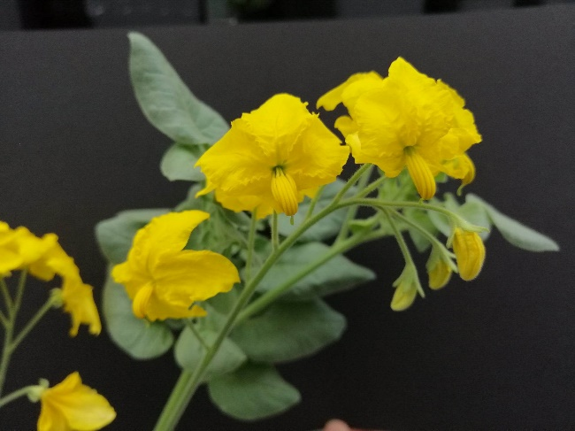
We tested the hypothesis that reliance on pollinators can predict the strength of constitutive and induced defence both within and between plants by investigating defence production in leaves and flowers of selfing (pollinator independent) and outcrossing (pollinator reliant) populations of the wild tomato, Solanum pennellii (Figure 1). Solanum pennellii (Solanaceae) is a species of wild tomato native to western South America. This species is predominantly outcrossing as a result of the gametophytic self-incompatibility (SI) system characteristic of the nightshade family. However, there have been numerous independent losses of self-incompatibility and transitions to self-compatibility (SC) in this species, with several selfing populations that represent replicate transitions from outcrossing to selfing. The presence of two mating systems within the same species provides an ideal system for studies investigating the effect of pollinator reliance/mating system on plant phenotype. Flowers are bumblebee-pollinated and inflorescences open and flowers produce pollen but not nectar as extrafloral rewards.
Figure 1: Solanum pennellii inflorescence

In order to address the overall hypothesis, we asked three predictions were tested: (1) Do flowers have higher constitutive defences than leaves? (2) Do selfers have better defended leaves and/or flowers than outcrossers? (3) Are defences in selfers more inducible than outcrossers, and is inducibility tissue-specific?

2.3 Methods

2.3.1 Plant materials and growth conditions
Seeds of 5 selfing and 7 outcrossing populations were used in this study (see Table S1 for accession information), sourced from the Tomato Genetics Resource Centre (TGRC), CA, USA. Accessions were originally sourced from wild populations along the west of Peru (Supplementary Figure 2). Seeds were pre-treated by soaking in bleach (household bleach diluted in water 5% bleach) for 30 minutes then thoroughly rinsing with water. Treated seeds were then germinated in 8cm x 8cm plastic pots according to the, in a soil-vermiculite mix (Levington F2 + sand – vermiculite, 3:1 (v/v)) and transplanted into individual 15cmx15cm plastic plant pots with the same compost mix at 4 weeks. Plants were grown in a greenhouse conditions (enhanced natural lighting, 14h light/10hr dark, 18ºC nighttime-23ºC daytime, 50-70% relative humidity) with ad libitum watering. Plants position within the greenhouse was randomized to minimise ambient environmental effects. Plants were fed weekly from 8 weeks onwards using MiracleGro NPK Fertiliser blend 24-8-16 with micro-nutrients at a concentration of 15ml in 5 litres of water. Once plants were at peak flowering (14 weeks), they were used in the experiment.

2.3.2 Experimental design
We tested the effects of pollinator reliance on induced and constitutive floral and foliar defence using a factorial experiment with 8 plants of each of 5 selfing and 7 outcrossing populations. Half the plants of each population (n=4) were treated with either a control or methyl jasmonate (MeJA) treatment. Leaf and flower samples were taken from the plants 48-hours after induction and phenolic content was analysed. Bioassays with Manduca sexta were also conducted to assess the level of MeJA-induced defence.
To manipulate induced responses to herbivory, we applied the methyl ester of the endogenous defence signalling hormone methyl jasmonate (MeJA). MeJA mediates plant response to herbivory (Kessler and Baldwin, 2002; Li et al., 2002; Howe and Jander, 2008) and exogenous application of MeJA induces generalist herbivore defences in the plant (Baldwin, 1996). While jasmonate induction does not completely mimic the effects of real herbivory (), it allows control over the strength of damage signal without the confounding effects of differential tissue damage that are unavoidable when using phenotypically divergent plant populations. Exogenous induction has the additional advantages of inducing defensive metabolite pathways using a uniformly systemic and generalised defence signal across both leaves and flowers, and avoiding confounding effects of herbivore salivary compounds or different feeding behaviours. MeJA was dissolved and applied in lanolin paste (10μg/ml) and applied to the basal stem of plants at a height of 5cm from the soil, in a 1cm-wide band around the entire stem (See Appendix S2 for MeJA-lanolin paste protocol). Previous studies have found this concentration of jasmonate sufficient to induce systemic defence responses (Kessler, Halitschke and Poveda, 2011b; Kaya and Doganlar, 2016).

2.3.3 Secondary metabolite analysis
We carried out a targeted analysis of defensive metabolites, focussing on phenolic compounds. Phenolics are a ubiquitous class of defensive compounds, and represent a significant component of the secondary metabolites used by Solanum species as defences against diverse insect herbivores, including the Manduca sexta caterpillars used in our bioassay (Campbell, Thaler and Kessler, 2013). Two leaflets and three flowers were removed per plant for metabolite analysis. The terminal leaflet of the highest leaf on the central stem was sliced from the leaf stem using a razor blade, and half a leaflet without the midvein (~100mg) was harvested, weighed, and flash frozen in liquid nitrogen. To collect flower tissue, three open flowers were cut from the inflorescence immediately above the leaf collection on the same half of the stem. Ovaries and calyx tissue were removed from the flowers, and two flowers from the same inflorescence were included in the sample to make up ca.100mg of flower tissue was collected. Tissue was placed in an microtube and flash frozen in liquid nitrogen and then stored at -80ºC until processing and extraction. Two leaflets and where possible, one to two flowers were also removed from each plant for use in the bioassay. The age of the flower was controlled as best as possible by using the most recently opened flowers on an inflorescence.
Frozen tissue samples were ground to a fine powder in a 2mL microtube using a Micropestle over liquid nitrogen, then transferred to a clean FastPrepTM tube containing 0.9g matrix D lysing beads (1.4mm zirconium-silicate spheres) (MP Biomedical). Then 1mL ice-cold extraction solvent (methanol:0.5% formic acid, 2:3 (v/v)) was added to the tube and homegenised before using a FastPrep 24 Instrument (MPBio) at speed 6.5m/s for 45 seconds, samples checked for leaks or dislodged caps, then run again for the same speed and duration, to homogenise the tissue. Samples were then centrifuged at 4ºC for 15 minutes at 14000 rpm (Eppendorf centrifuge with 30-tube, fixed-angle rotor: 20,800 x g). The extract was then transferred to a 2mL glass HPLC vial, with care taken to not disturb the pellet. Samples were placed back in the centrifuge for 5 minutes if the pellet was disturbed. Extracts were stored at -20ºC.
Phenolic compound separation was carried out by high performance liquid chromatography (HPLC), using a Waters Alliance 2695 HPLC model equipped with a Waters 2998 photodiode array detector allowing UV detection. 15µl of extract was injected and separated using a gradient of acetonitrile (A) and 0.25% phosphoric acid (B), with a flow rate of 1ml/minute. The initial gradient consisted of 0% acetonitrile, and 100% phosphoric acid, increasing to 12% (A) and 88% (B) at 6minutes, 18% (A) and 82% (B) at 10 minutes, and 58% (A) and 42% (B) at 30 minutes, as previously described (Keinänen, Oldham and Baldwin, 2001). The gradient returned to 0% acetonitrile at 31 minutes and the column was washed and equilibrated to 0% (A) and 100% (B) at for 5 minutes before the next injection. Data were recorded with MassLynx software. Samples were kept at 4ºC in the sample compartment during runs, and the column was held at 20ºC. Data were collected using a scan including wavelengths 210nm, 254nm, 320nm, 360nm.
We looked at two main groups of defence phenolics (polyphenols): chlorogenic acids (CAs) and their derivatives, such as caffeic acid, p-coumaric acid and ferulic acid, and flavonoids (FAs), such as rutin and quercetin, which are thought to play key roles in plant defence (Agrawal et al., 2012). Phenolic peaks were identified using UV absorbance spectra (Keinänen, Oldham and Baldwin, 2001) and integrated at a wavelength of 360nm (flavonoids ) and 320nm Chlorogenic acid derivatives).
We analysed constitutive and inducible levels of total CAs, total FAs, and total phenolics (all compounds). Plant inducibility was calculated by taking the difference between constitutive levels and induced levels, a measure of plasticity that allows unconfounded analysis of trade-offs between constitutive and induced defence.

2.3.4 Herbivore feeding assay to quantify chemical resistance
In order to provide an ecologically relevant estimate of plant defence variation across the diverse populations, herbivore feeding assays were carried out to measure plant resistance to herbivory. Herbivore bioassays can be effective measures of plant resistance in wild and cultivated tomato (Thaler et al., 1996; Campbell and Kessler, 2013). We used larvae of the tobacco hornworm, Manduca sexta (Lepidoptera: Sphingidae), a specialist herbivore of plants in the Solanaceae which is negatively affected by jasmonate-inducible secondary metabolites, such as chlorogenic acid and rutin (Osier, Traugott and Stamp, 1996; Campbell, Thaler and Kessler, 2013). Larval development is known to be slower when fed on leaves of Solanum species that contain higher levels of phenolic content and have greater emission of VOCs (Salazar-Mendoza et al., 2023). Manduca sexta have been observed to frequently eat both flowers and leaves in the field (S. Campbell, pers obs). Eggs were sourced from the John Innes Centre Insectary and used as newly hatched neonates.
One leaf or flower from each plant was weighed and placed in a petri dish, with the stem pushed into damp florists’ foam to keep the tissue fresh. Leaves were placed with the abaxial surface facing downwards, and flowers were placed fully intact and still attached to the calyx. A newly hatched M. sexta was weighed, then placed on the plant tissue in the petri dish and allowed to feed for 72 hours (supplementary figure 1). At which point, the M. sexta neonates were removed and weighed. Larvae that did not feed were removed from the trial.
The relative growth rate (RGR) of the caterpillars was calculated using the formula (final weight – initial weight)/(initial weight x number of days). Growth rates of the two replicate larvae per plant tissue were averaged.

2.3.5 Data analysis
Data analysis was carried out using R Studio version 4.2.3 (R Core Team, 2023) and used a significance threshold of P < 0.05. Phenolic content and herbivore growth were compared across treatments, mating systems and their interaction using general linear mixed models (LMMs) using the lmerTest package (Bates et al., 2015) using the residual maximum likelihood (REML) method to estimate variance. Model terms included tissue, mating system and treatment and their interaction as fixed effects. Random effects included accession nested with mating system to account for population variation, and experimental block to account for spatial greenhouse variation. If random factors explained less than 5% of the variation or were not statistically significant (p > 0.05), they were removed from the model. LMMs were tested with Type III Analysis of Variance (ANOVA) with lmerTest package (Kuznetsova, Brockhoff and Christensen, 2017) using the Satterthwaite’s method to scale F values. Tukey post-hoc tests were conducted in emmeans to determine groups which were significantly different. Data were checked for error normality and heteroscedasticity and log-transformed to fit normality assumptions prior to fitting the model.
A heatmap was produced using fold change of phenolic compounds obtained from the discriminative variable function in partial least squares discriminant analysis (PLS-DA) in MetaboAnalyst 5.0. Data were log-transformed and auto-scaled. PERMANOVA was conducted on the data and a p-value obtained based on 999 permutations.
T-tests to compare phenolic content of control flowers and leaves were carried out in base R. Linear regression analysis was conducted to test the association between phenolic content in different tissues or treatments, and also between phenolic content and larval growth. Pearson correlation coefficient (R) and scatter plots were used to show these data.

2.4 Results

2.4.1 Secondary metabolite analysis of flower and leaf tissue
Flowers had a significantly higher phenolic content than leaves in both control and treated groups (Figure 2A), with significant effects of tissue (F_{1,150} = 96.8133, P < 0.001). While there was no overall treatment effect (F_{1,150} = 2.0501, P = 0.1543), there was an marginally significant interaction effect between treatment and tissue (F_{1,150} = 3.0551, P = 0.08254), with MeJA induced leaves having higher phenolic content. The 2D-scores plot demonstrates that leaves and flowers are differentially defended, and the outgroup cluster of samples in the PCA is likely to be due to within-accession variation (Figure 2b) and PERMANOVA indicated that there is a significant difference between the clusters (F = 8.7206, R² = 0.2865, p = 0.001). PC1 is responsible for 41.3% of the variance, however some of this separation may be due to the outgroup, which contains a mix of samples across treatment combinations. PC2 accounts for 11.8% of the separation and represents tissue-specific differences in metabolite composition. Flowers contain higher concentrations of phenolic acids compared to leaves, with different compounds being induced in response to MeJA treatment in the two different tissues (Figure 2B). Many compounds present in leaves were also present in flowers, but the concentration and proportional composition of phenolics differ across the two tissues. A heatmap was produced to visualise patterns in secondary metabolite concentrations across treatment, mating system and tissue. Firstly, flowers have many more concentrated phenolic content than leaves. Secondly, the phenolic compounds present in the highest concentrations in leaves were different to those most concentrated in flowers (Figure 2C). Thirdly, within the flowers, the concentration of several phenolic compounds is higher in treated than control plants. And finally, more compounds are highly concentrated in treated selfing (SC) flowers than in treated outcrossing (SI) flowers (Figure 2C).

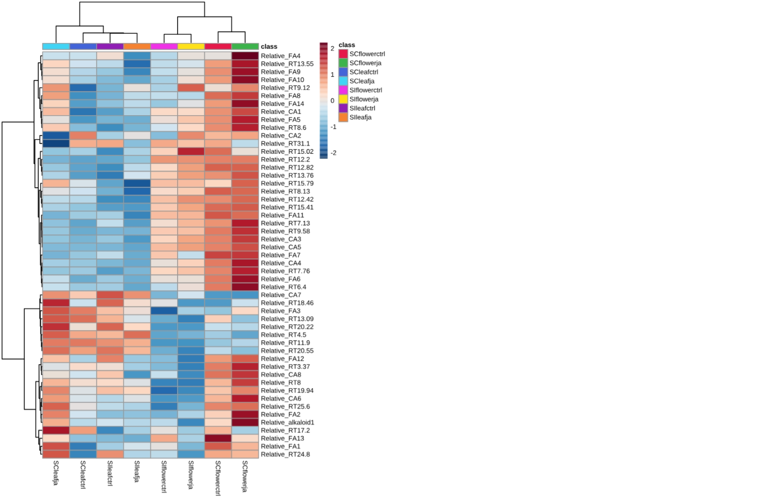
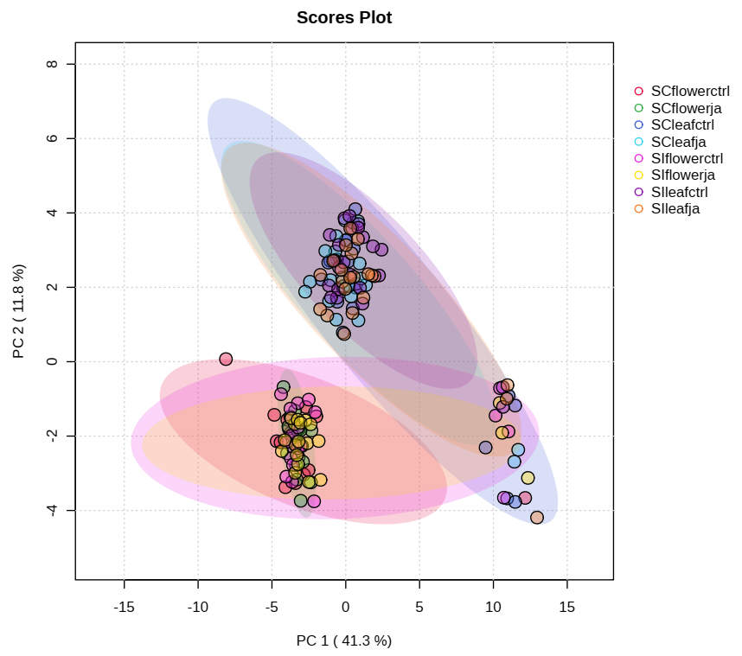
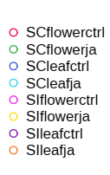
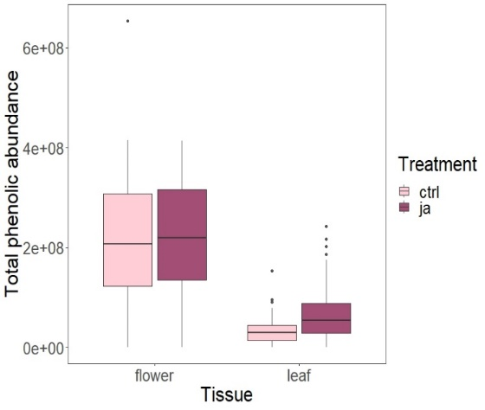
*
*
Figure 2. Patterns in phenolic compound expression in control and treated leaves and flowers. a) Phenolic concentration was significantly higher in flowers than in leaves (mixed effects model, tissue p < 0.001). b) 2-dimensional scores plot showing main clustering was by tissue. c) Heatmap comparing total phenolic concentration in damaged and undamaged leaves and flowers. Groupings are by class, which is a compound group of plant mating system, tissue, and treatment. Each row represents an individual compound identified in samples, calculated as peak area / mass sample. Colour variation represents concentration differences, high concentration is dark red (+2), and low concentration is dark blue (-2). Several patterns are evident in the heatmap, including pattern for greater concentration of phenolic compounds in flowers compared to leaves.
Treatment
Control
MeJA

a)
b)
c)

2.4.2 Leaves, but not flowers, have inducible defence-related secondary metabolites
Phenolic compounds in flowers were not inducible by MeJA treatment (Figure 3a), however phenolic content was significantly higher in MeJA-treated leaves than control leaves (Figure 3B). Phenolic content of flowers was higher in selfing flowers compared to outcrossing flowers, and this difference was marginally significant (F = 2.4982, P = 0.09492). Phenolic content of flowers was not significantly different between the control treatment (F = 0.4481, P = 0.5057) and there was no interaction between treatment and mating system (F = 0.6245, P = 0.4323).
Phenolic content in leaves was significantly affected by treatment (F_{1,} =11.78, P = 0.00097), but not by mating system (F = 0.3542, P = 0.5653) or the interaction of mating system and treatment (F = 0.4419, P = 0.5082). Linear mixed effect models for CA and FA concentrations in leaves showed that treatment was the only significant effect (F = 18.7513, P = 4.52e^{-0.5}) and (F = 4.7759, P = 0.03187) respectively. Full model outputs can be found in Supplementary Materials Appendix S2.

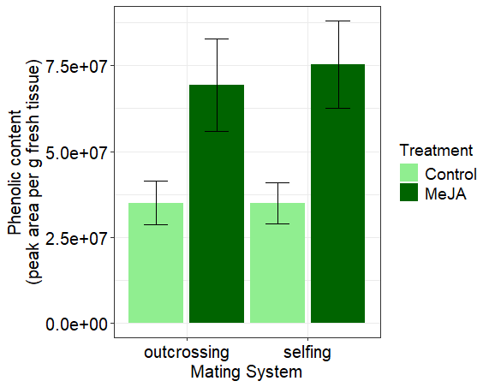
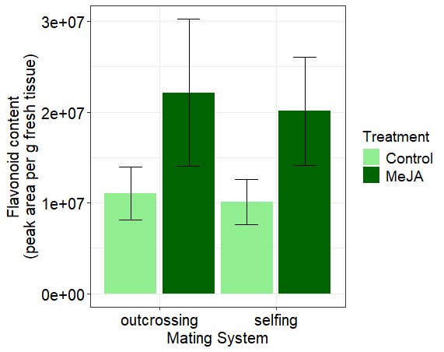
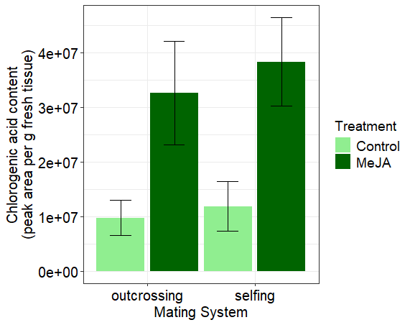
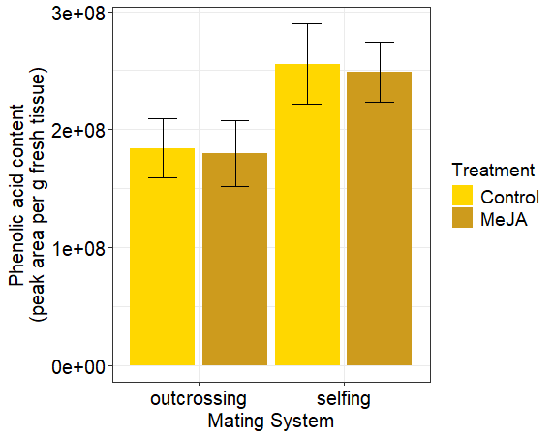
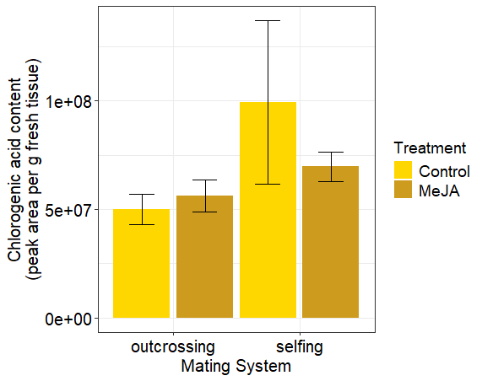
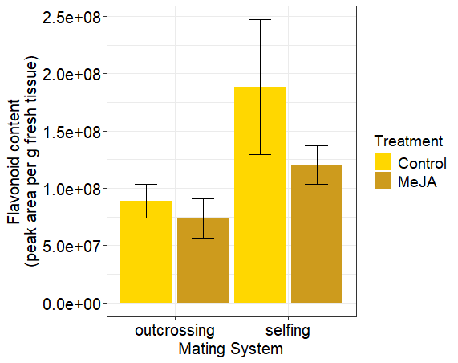
*
*
*
*
*
*
Figure 3: Phenolic concentration in flowers and leaves of selfing and outcrossing Solanum pennellii plants that were either control or treated with methyl jasmonate. a) Total phenolic content in selfing flowers was higher than in outcrossing flowers but does not differ between control and MeJA-treated plants. b) Total phenolic content in MeJA-treated leaves was higher than in control leaves, but does not significantly differ between selfing and outcrossing leaves. c) Total chlorogenic acid content was higher in selfing flowers than outcrossing flowers and is not different between control and MeJA-treated flowers. d) Total chlorogenic acid content was higher in MeJA-treated leaves than in control leaves. e) Total flavonoid content was slightly higher in selfing flowers than outcrossing flowers. f) Total flavonoid content was higher in MeJA-treated leaves than control leaves.
a)
c)
e)
b)
d)
f)
Leaf phenolic content did not predict flower phenolic content in selfing leaves and flowers (F_{1,32} = 2.506, adj-R²= 0.04365, P = 0.1232) (Figure 4a) or in outcrossing leaves and flowers (F_{1,38} = 0.002983, adj-R² = -0.02624, P = 0.9567) (Figure 4b).
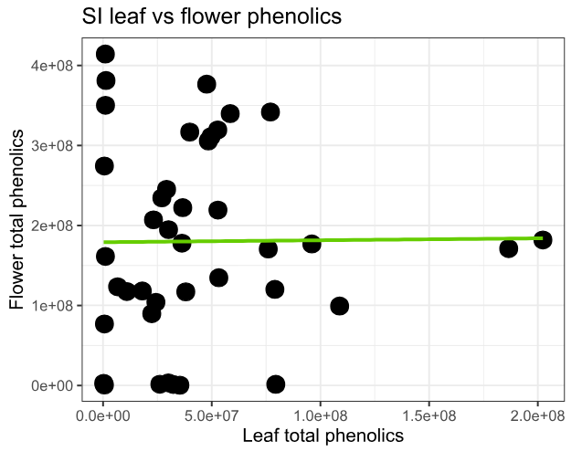
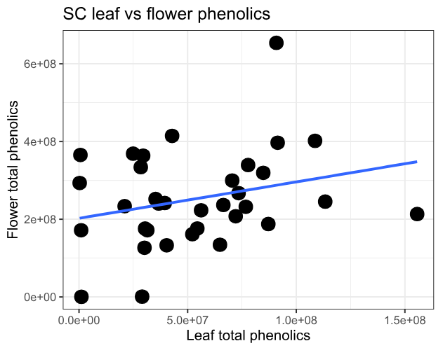
Linear models were fitted for control and MeJA-induced tissue phenolic content, with data points being calculated as the mean phenolic content for each treatment and accession. Phenolic concentration in control flowers did not predict phenolic concentration in treated flowers was (F_{1,10} = 0.1014, adj-R² = -0.08896, P = 0.7568). Phenolic content in control leaves did not predict phenolic content in treated leaves (F_{1,10} = 2.11, adj-R² = 0.09163, P = 0.177). Inducibility of total phenolics was significantly negatively correlated in flowers (F_{1,10} = 14.07, adj-R² = -0.5431, P = 0.003775) (Supplementary Figure 2b) but not significantly related in leaves (F_{1,10} = 2.11, adj-R² = 0.9163, P = 0.2317) (Supplementary figure 2a).
Figure 4: Trade-offs in plant defence between tissues and defence strategies in Solanum pennellii. a) Flower phenolic content increases with leaf phenolic content in selfing plants, but not significantly. b) Flower phenolic content is not significantly related to leaf phenolic content in outcrossing plants.
a)
b)

2.4.3 Flower-fed larvae growth lower than leaf-fed larvae
Tissue
Manduca sexta larval growth was negatively correlated with phenolic concentration in leaves but not in flowers (Figure 5a).
Larval growth was significantly lower on leaves of MeJA-treated plants than control plants (p < 0.05), but mating system did not significantly affect larval growth. There was no significant treatment effect in flowers (p = 0.512). The mating system of the flower fed to a larva did not significantly affect larval growth (p >0.05).
Larval growth was significantly lower on outcrossing flowers than on outcrossing leaves (Tukey’s post-hoc test, SE = 0.1734, df = 44.08, p = 0.0325). Larval growth was also
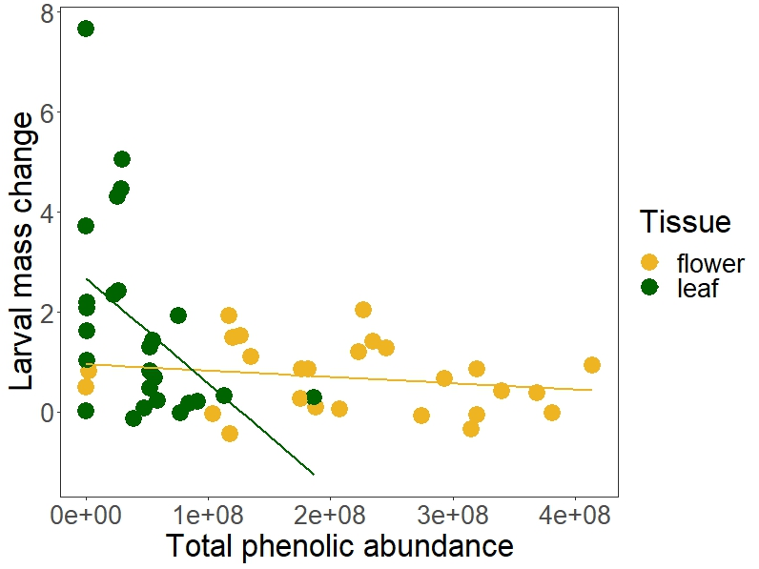
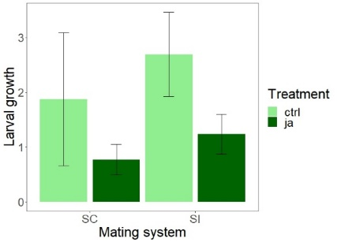
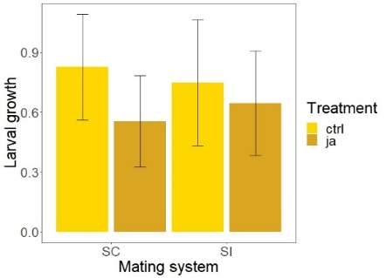
There was a negative relationship between leaf phenolic content and larval growth. (F1,24 = 6.823, p < 0.05). No significant relationship between larval growth and phenolic concentration in flowers (F1,24 = 1.011, p = 0.3247). (b) Larval growth of M. sexta larvae on control and MeJA-treated plants. There is a significant treatment effect in leaves (p < 0.05) but not in flowers (p = 0.512). The mating system and interaction term were not significant for neither leaves nor flowers.
Figure 5: Growth rate of Manduca sexta larvae fed on control and treated leaves and flowers of Solanum pennellii. a) Larval growth rate from 72 hours of feeding bioassay for larvae fed on flowers. b) Larval growth rate from 72 hours of feeding bioassay for larvae fed on leaves (c) Relationship between larval growth and phenolic abundance from leaf-fed M. sexta (green, N = 27) and flower-fed M. sexta (yellow, N = 32). SI = outcrossing, SC = selfing
.
a)
b)
c)

2.5 Discussion

2.5.1 Flowers have higher constitutive defences than leaves
Despite substantial genetic and compound-specific variation, flowers had significantly higher levels of defence-related secondary metabolites compared to leaves, and additionally that mating system and pollinator reliance have driven the evolution of floral defence in S. pennellii.,. This study indicates that plant reliance on pollinators influences flower defence more strongly than leaf defence.
Optimal defence theory posits that more valuable tissues will receive a greater allocation of defence resources compared to less valuable tissue: a prediction tested in this study by comparing the concentration in defensive phenolic compounds in flowers, which are a high-value tissue, with the phenolic concentration in leaves. In line with Optimal defence theory, flowers were found to have a significantly higher concentration of defence-related phenolics compared to leaves, across both constitutive and treated plants. This pattern has been previously been observed, for example in Brassica nigra, in which glucosinolate concentrations were significantly higher in flowers compared to leaves of B. nigra (Chrétien et al., 2022). Floral constitutive defences have previously been shown to be more concentrated in younger flowers (Li et al., 2017) which indicates defence specificity not just between tissues, but between tissue at different developmental stages, which may be explained if the degree of pollinator constraint or relative value of the tissue changes throughout flower development.
A high constitutive defence in flowers of S. pennellii could suggest that flowers have been exposed to high levels of herbivory which would make constitutive defence an adaptive strategy to protect flowers from damage. The variation in phenolic concentrations between different accessions could reflect that floral defence is potentially under differing strengths of selection from florivores in different environments. A potential explanation for the lack of plasticity in floral secondary metabolic profile is that changes to floral chemistry are linked with pollinator deterrence (Kessler, Halitschke and Poveda, 2011b; Lucas-Barbosa, van Loon and Dicke, 2011), so constitutive defences may reduce the ecological cost of induced changes to floral secondary metabolites, whilst still allowing the high-value flowers to be defended. In this study, larval growth was lower for flower-fed larvae than leaf-fed larvae, however larvae did feed on the flowers, suggesting that there may be toxic compounds in the flower tissue that negatively impact larval growth, or alternatively, that flowers are of low nutritional value which in itself can be a defensive trait which was suggested as a defensive strategy by Augner, (1995). Larval growth being lower for larvae fed on treated leaves compared to control leaves, suggesting that the phenolic compounds identified in this study are involved in defensive roles within the plant.
Flowers and leaves may also rely on distinct defence compounds (Figure 2a), as well as having different concentrations of defensive compounds (Figure 2c), and future work could focus on understanding why different compounds are present in each tissue. Principal component analysis showed that flowers and leaves have distinct phenolic profiles (Figure 2b). The outgroup of samples shown in the PCA have been investigated, and no common feature to these samples that could be driving the separation of the outgroup was found, including but not limited to features such as experimental block, watering habits and accession altitude.

2.5.2 Mating system predicts defence in flowers but not in leaves
The second hypothesis tested was that outcrossing flowers would have lower defence than selfing, due to the greater ecological costs of defence in outcrossers. A complementary explanation for selfing flowers having stronger defences, both in control and treated groups, could be that the flowers of selfers are of higher relative value to selfing plants than flowers on outcrossing plants, due to selfing taxa relying less on pollen export and having both male and female investment in reproduction. As flowers experience a stronger selection pressure for lower defence compared to leaves, the higher defences reported in floral tissue may seem counterintuitive, however the results from this study and others show that plants invest in defences in reproductive tissues.
Our results are partially consistent with a multispecies comparative study using 36 Nicotiana species, in which outcrossing species had lower nicotine concentrations, but across all tissues, including leaves, flowers and nectar, compared to selfing species (Adler et al., 2012). In Nicotiana, it was suggested that pleiotropic patterns in defence may constrain the production of two defence metabolites, nicotine and anabasine in the leaves and flowers (Adler et al., 2012). The results of this study with S. pennellii do not suggest strong pleiotropic patterns between flower and leaf phenolic profiles. In contrast, differences between mating systems in our study were restricted to flowers rather than leaves (Figure 2), suggesting that flower and leaf defences are differentially regulated in S. pennellii. This could be due to different taxa experience different selective pressures on floral and leaf defence.
One consideration is that non-volatile compounds commonly associated with defence may not act as pollinator deterrents unless present in the reward tissues (nectar and pollen) and therefore pollinator constraints do not act on these compounds. Future studies in Solanum species to better understand how floral defence allocation may vary within flower tissues. Alternatively, greater metabolite production in floral tissue may also reflect source-sink dynamics, if metabolites are produced in leaves and transported to flowers, which could lead to higher accumulation within flower tissue. Experiments using isotopic tracers could determine the validity of this suggestion.

2.5.3 No induced response to MeJA in flowers
We hypothesised that flowers are more inducible than leaves in order to reduce the ecological cost of pollinator deterrence associated with rapid changes in floral defensive metabolites. Our findings that leaves showed a greater plasticity in their metabolome response to MeJA treatment compared with non-inducible flowers (Figure 1) leading us to reject the hypothesis. This pattern was also reflected in the bioassay data; larval growth was significantly lower when larvae were fed on treated leaves compared to control leaves, and there was no significant treatment effect on flower-fed larvae (Figure 4). While there have been surprisingly few studies of induced floral resistance, our results are consistent with the lack of floral inducibility found in glucosinolates of B. nigra (Chrétien et al., 2022). One explanation for lack of floral inducibility is that flowers rely on constitutive, rather than inducible defences. Constitutive and inducible defences have previously been shown to be alternative strategies for defences (Stamp, 2003; Agrawal, Conner and Rasmann, 2010). In this study, as flowers have stronger constitutive defences than leaves, it could be that flowers rely on constitutive rather than induced defences.
The lack of inducibility in flowers could also be a cost-saving strategy: induced defence may result in higher pollinator deterrence, reducing the costs arising from high defence production in plants. Chlorogenic acids were significantly induced in leaves, whilst flavonoids were not significantly different between control and treated leaves, suggesting that the chlorogenic acids detected in this study are more strongly implicated in defence than flavonoids. Compounds which have the strongest deterrent effect on pollinators will be under greater selection by pollinators, so theorised mating system-driven constraints on defence may not act on all compounds. It is likely that specific compounds, rather than all of the polyphenols identified in this study are responsible for protection against herbivores (Moctezuma et al., 2014).
Constitutive and induced defences have long been posited to represent evolutionary alternatives, and consequently are negatively correlated across the Solanaceae, (Campbell and Kessler, 2013); however whether flowers exhibit similar trade-offs to leaves has rarely been tested. In this study a negative relationship between constitutive phenolic content and plasticity in phenolic production was found in flowers, but not leaves. This may be explained by flowers experiencing stronger constraints on defence production, with flowers that have high constitutive defences being much less likely to produce strong induced defences due to the pollinator constraint hypothesis. Conversely, leaves do not experience the direct constraint of pollinator attraction and therefore leaves which have high constitutive defences may not be constrained in their inducibility.

2.6 Conclusions
A general pattern in our results that secondary metabolite production is differentially regulated in leaves and flowers, with plant mating system and pollinator reliance constraints acting most strongly on floral rather than foliar defences. These data highlight the importance of considering multiple ecological interactions when assessing evolutionary drivers for patterns in plant defence, and show, for the first time, that the complexity of these interactions may drive within-plant tissue-specificity in defence expression. Understanding plant-herbivore-pollinator interactions has broad implications, including in food security and crop protection, as well as for improving on existing frameworks predicting plant defence allocation. While this study focuses on non-volatile phenolic compounds, it is likely that there are a range of volatile and non-volatile compounds, that also play key roles in plant ecological interactions. In this study, non-volatile defences were focused on due to their importance in plant-herbivore interactions. Further to this, whilst this study has identified tissue- and mating system-specific differences in phenolic concentration, the mechanisms responsible for these differences are yet to be determined, providing interesting future lines of enquiry.

2.7 References
Adler, L.S., Seifert, M.G., Wink, M., Morse, G.E., 2012. Reliance on pollinators predicts defensive chemistry across tobacco species. Ecology Letters 15, 1140–1148. https://doi.org/10.1111/j.1461-0248.2012.01838.x
Adler, L.S., Wink, M., Distl, M., Lentz, A.J., 2006. Leaf herbivory and nutrients increase nectar alkaloids. Ecology Letters 9, 960–967. https://doi.org/10.1111/j.1461-0248.2006.00944.x
Agrawal, A.A., Conner, J.K., Rasmann, S., 2010. Tradeoffs and Negative Correlations in Evolutionary Ecology.
Agrawal, A.A., Hastings, A.P., Johnson, M.T.J., Maron, J.L., Salminen, J.-P., 2012. Insect Herbivores Drive Real-Time Ecological and Evolutionary Change in Plant Populations. Science 338, 113–116. https://doi.org/10.1126/science.1225977
Augner, M., 1995. Low nutritive quality as a plant defence: Effects of herbivore-mediated interactions. Evol Ecol 9, 605–616. https://doi.org/10.1007/BF01237658
Baldwin, I.T., 1996. Methyl jasmonate-induced nicotine production in Nicotiana attenuata: inducing defenses in the field without wounding. Entomologia Experimentalis et Applicata 80, 213–220. https://doi.org/10.1111/j.1570-7458.1996.tb00921.x
Bates, D., Mächler, M., Bolker, B., Walker, S., 2015. Fitting Linear Mixed-Effects Models Using lme4. Journal of Statistical Software 67, 1–48. https://doi.org/10.18637/jss.v067.i01
Campbell, S.A., 2015. Ecological mechanisms for the coevolution of mating systems and defence. New Phytologist 205, 1047–1053. https://doi.org/10.1111/nph.13212
Campbell, S.A., Kessler, A., 2013. Plant mating system transitions drive the macroevolution of defense strategies. PNAS 110, 3973–3978. https://doi.org/10.1073/pnas.1213867110
Campbell, S.A., Thaler, J.S., Kessler, A., 2013. Plant chemistry underlies herbivore-mediated inbreeding depression in nature. Ecol Lett 16, 252–260. https://doi.org/10.1111/ele.12036
Chrétien, L.T.S., Khalil, A., Gershenzon, J., Lucas-Barbosa, D., Dicke, M., Giron, D., 2022. Plant metabolism and defence strategies in the flowering stage: Time-dependent responses of leaves and flowers under attack. Plant, Cell & Environment 45, 2841–2855. https://doi.org/10.1111/pce.14363
Euler, M., Baldwin, I.T., 1996. The chemistry of defense and apparency in the corollas ofNicotiana attenuata. Oecologia 107, 102–112. https://doi.org/10.1007/BF00582240
Gatehouse, J.A., 2002. Plant resistance towards insect herbivores: a dynamic interaction. New Phytologist 156, 145–169. https://doi.org/10.1046/j.1469-8137.2002.00519.x
Gershenzon, J., 1994. The Cost Of Plant Chemical Defense Against Herbivory: A Biochemical Perspective, in: Insect-Plant Interactions (1993). CRC Press.
Griffin, P.C., Willi, Y., 2014. Evolutionary shifts to self-fertilisation restricted to geographic range margins in North American Arabidopsis lyrata. Ecology Letters 17, 484–490. https://doi.org/10.1111/ele.12248
Hoffmeister, M., Wittköpper, N., Junker, R.R., 2016. Herbivore-induced changes in flower scent and morphology affect the structure of flower–visitor networks but not plant reproduction. Oikos 125, 1241–1249. https://doi.org/10.1111/oik.02988
Howe, G.A., Jander, G., 2008. Plant Immunity to Insect Herbivores. Annu. Rev. Plant Biol. 59, 41–66. https://doi.org/10.1146/annurev.arplant.59.032607.092825
Im, H.W., Suh, B.-S., Lee, S.-U., Kozukue, N., Ohnisi-Kameyama, M., Levin, C.E., Friedman, M., 2008. Analysis of Phenolic Compounds by High-Performance Liquid Chromatography and Liquid Chromatography/Mass Spectrometry in Potato Plant Flowers, Leaves, Stems, and Tubers and in Home-Processed Potatoes. J. Agric. Food Chem. 56, 3341–3349. https://doi.org/10.1021/jf073476b
Jacobsen, D.J., Raguso, R.A., 2018. Lingering Effects of Herbivory and Plant Defenses on Pollinators. Current Biology 28, R1164–R1169. https://doi.org/10.1016/j.cub.2018.08.010
Kaplan, I., Halitschke, R., Kessler, A., Sardanelli, S., Denno, R.F., 2008. Constitutive and Induced Defenses to Herbivory in Above- and Belowground Plant Tissues. Ecology 89, 392–406. https://doi.org/10.1890/07-0471.1
Karban, R., Baldwin, I.T., 1997. Induced Responses to Herbivory. University of Chicago Press, Chicago, UNITED STATES.
Kaya, A., Doganlar, Z.B., 2016. Exogenous jasmonic acid induces stress tolerance in tobacco (Nicotiana tabacum) exposed to imazapic. Ecotoxicology and Environmental Safety 124, 470–479. https://doi.org/10.1016/j.ecoenv.2015.11.026
Keinänen, M., Oldham, N., J., Baldwin, I.T., 2001. Rapid HPLC Screening of Jasmonate-Induced Increases in Tobacco Alkaloids, Phenolics, and Diterpene Glycosides in Nicotiana attenuata | Journal of Agricultural and Food Chemistry [WWW Document]. URL https://pubs-acs-org.sheffield.idm.oclc.org/doi/10.1021/jf010200%2B (accessed 3.11.24).
Kessler, A., Baldwin, I.T., 2002. PLANT RESPONSES TO INSECT HERBIVORY: The Emerging Molecular Analysis. Annual Review of Plant Biology 53, 299–328. https://doi.org/10.1146/annurev.arplant.53.100301.135207
Kessler, A., Halitschke, R., 2009. Testing the potential for conflicting selection on floral chemical traits by pollinators and herbivores: predictions and case study. Functional Ecology 23, 901–912. https://doi.org/10.1111/j.1365-2435.2009.01639.x
Kessler, A., Halitschke, R., Poveda, K., 2011. Herbivory-mediated pollinator limitation: negative impacts of induced volatiles on plant—pollinator interactions. Ecology 92, 1769–1780.
Krupnick, G.A., Weis, A.E., Campbell, D.R., 1999. The Consequences of Floral Herbivory for Pollinator Service to Isomeris arborea. Ecology 80, 125–134. https://doi.org/10.2307/176984
Kuznetsova, A., Brockhoff, P.B., Christensen, R.H.B., 2017. lmerTest Package: Tests in Linear Mixed Effects Models. Journal of Statistical Software 82, 1–26. https://doi.org/10.18637/jss.v082.i13
Li, L., Li, C., Lee, G.I., Howe, G.A., 2002. Distinct roles for jasmonate synthesis and action in the systemic wound response of tomato. PNAS 99, 6416–6421. https://doi.org/10.1073/pnas.072072599
Li, R., Wang, M., Wang, Y., Schuman, M.C., Weinhold, A., Schäfer, M., Jiménez-Alemán, G.H., Barthel, A., Baldwin, I.T., 2017. Flower-specific jasmonate signaling regulates constitutive floral defenses in wild tobacco. Proc Natl Acad Sci USA 114, E7205–E7214. https://doi.org/10.1073/pnas.1703463114
Lucas-Barbosa, D., van Loon, J.J.A., Dicke, M., 2011. The effects of herbivore-induced plant volatiles on interactions between plants and flower-visiting insects. Phytochemistry, Plant-Insect Interactions 72, 1647–1654. https://doi.org/10.1016/j.phytochem.2011.03.013
McCall, A.C., 2006. Natural and artificial floral damage induces resistance in Nemophila menziesii (Hydrophyllaceae) flowers. Oikos 112, 660–666. https://doi.org/10.1111/j.0030-1299.2006.13981.x
McCall, A.C., Fordyce, J.A., 2010. Can optimal defence theory be used to predict the distribution of plant chemical defences? Journal of Ecology 98, 985–992.
Moctezuma, C., Hammerbacher, A., Heil, M., Gershenzon, J., Méndez-Alonzo, R., Oyama, K., 2014. Specific Polyphenols and Tannins are Associated with Defense Against Insect Herbivores in the Tropical Oak Quercus oleoides. J Chem Ecol 40, 458–467. https://doi.org/10.1007/s10886-014-0431-3
Moeller, D.A., Geber, M.A., 2005. Ecological context of the evolution of self-pollination in Clarkia xantiana: population size, plant communities, and reproductive assurance. Evolution 59, 786–799. https://doi.org/10.1554/04-656
Moreira, X., Castagneyrol, B., Abdala-Roberts, L., Traveset, A., 2019. A meta-analysis of herbivore effects on plant attractiveness to pollinators. Ecology 100, e02707. https://doi.org/10.1002/ecy.2707
Oguro, M., Sakai, S., 2014. Difference in defense strategy in flower heads and leaves of Asteraceae: multiple-species approach. Oecologia 174, 227–239. https://doi.org/10.1007/s00442-013-2765-x
Osier, T.L., Traugott, M.S., Stamp, N.E., 1996. Allelochemicals in Tomato Leaves Affect a Specialist Insect Herbivore Manduca sexta Negatively but with No Ill Effects on a Generalist Insect Predator, Podisus maculiventris. Oikos 77, 481–488. https://doi.org/10.2307/3545937
R Core Team, 2023. . R: A Language and Environment for Statistical Computing.
Rhoades, D.F., 1979. Evolution of plant chemical defense against herbivores. Academic Press, New York, pp. 3–54.
Rusman, Q., Lucas-Barbosa, D., Poelman, E.H., 2018. Dealing with mutualists and antagonists: Specificity of plant-mediated interactions between herbivores and flower visitors, and consequences for plant fitness. Functional Ecology 32, 1022–1035. https://doi.org/10.1111/1365-2435.13035
Salazar-Mendoza, P., Magalhães, D.M., Lourenção, A.L., Bento, J.M.S., 2023. Differential defensive and nutritional traits among cultivated tomato and its wild relatives shape their interactions with a specialist herbivore. Planta 257, 76. https://doi.org/10.1007/s00425-023-04108-0
Smallegange, R.C., van Loon, J.J.A., Blatt, S.E., Harvey, J.A., Agerbirk, N., Dicke, M., 2007. Flower vs. leaf feeding by Pieris brassicae: glucosinolate-rich flower tissues are preferred and sustain higher growth rate. J Chem Ecol 33, 1831–1844. https://doi.org/10.1007/s10886-007-9350-x
Stamp, N., 2003. Out of the quagmire of plant defense hypotheses. Q Rev Biol 78, 23–55. https://doi.org/10.1086/367580
Strauss, S., Conner, J., Rush, S., 1996. Foliar Herbivory Affects Floral Characters and Plant Attractiveness to Pollinators: Implications for Male and Female Plant Fitness. American Naturalist - AMER NATURALIST 147. https://doi.org/10.1086/285896
Thaler, J.S., Stout, M.J., Karban, R., Duffey, S.S., 1996. Exogenous jasmonates simulate insect wounding in tomato plants (Lycopersicon esculentum) in the laboratory and field. J Chem Ecol 22, 1767–1781. https://doi.org/10.1007/BF02028503
Thipyapong, P., Joel, D.M., Steffens, J.C., 1997. Differential Expression and Turnover of the Tomato Polyphenol Oxidase Gene Family during Vegetative and Reproductive Development. Plant Physiology 113, 707–718.
War, A.R., Paulraj, M.G., Ahmad, T., Buhroo, A.A., Hussain, B., Ignacimuthu, S., Sharma, H.C., 2012. Mechanisms of plant defense against insect herbivores. Plant Signaling & Behavior 7, 1306–1320. https://doi.org/10.4161/psb.21663
Zangerl, A.R., Rutledge, C.E., 1996. The Probability of Attack and Patterns of Constitutive and Induced Defense: A Test of Optimal Defense Theory. The American Naturalist 147, 599–608.
Zenkner, F.F., Margis-Pinheiro, M., Cagliari, A., 2019. Nicotine Biosynthesis in Nicotiana: A Metabolic Overview. Tobacco Science 56, 1–9. https://doi.org/10.3381/18-063

2.8 Supplementary materials

Appendix S1

S1.1 Plant materials
Seeds were soaked in half-strength household bleach (2.7% sodium hypochlorite) for 30 minutes, until the hypocotyl was just visible through the seed coat. Seeds were then thoroughly rinsed before being sown directly onto 3:1 compost : vermiculite mix in 8x8cm plastic plant pots at a sowing density of 4 seeds per pot. A thin layer (~1mm) compost was sprinkled over the top of the seeds to prevent seeds from drying out. Pots were placed in drip trays, and transparent plastic cloches placed over the pots in the trays to maintain humidity. Soil was kept moist but not saturated during the germination process. Seedlings were pricked out, keeping roots intact, at 4 weeks and transplanted into individual 15cmx15cm plastic plant pots.

S1.2 Methyl jasmonate treatment
20 mL lanolin paste (Sigma-Aldrich number 392707) was warmed in a water bath (50-60ºC) until liquid. 200 mg of methyl jasmonate (MeJA) was weighed into the lanolin and stirred until dissolved. A similar volume of lanolin paste with no added MeJA was warmed until melted and allowed to cool; this was the control treatment.
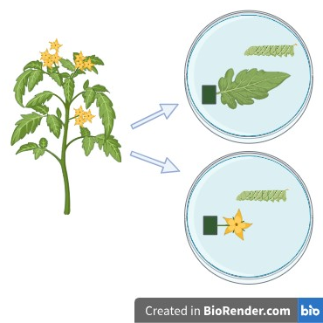
When plants were at peak flowering, with at least half of the inflorescences in flower, the treatment was applied. A 1cm band of either MeJA-lanolin paste or pure lanolin paste was applied 10cm above the soil level 48 hours before tissue collection.
Supplementary Figure 1: Diagram showing experimental set-up of Manduca sexta feeding bioassay. One leaf or one flower was excised from the plant and the stem placed into a piece of Oasis® floral foam that was saturated with water to keep tissue fresh. A single larva was placed on the plant tissue in a petri dish and allowed to feed to 72 hours.

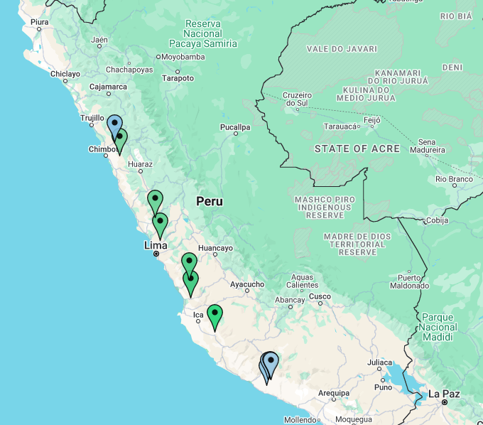
Key
Selfing
Outcrossing

Supplementary Figure 2: map showing Solanum pennellii accessions used in this experiment.

S1.3 Plant accessions
Supplementary Table 1: Solanum pennellii accession mating system and collection site information. Seeds were sourced from TGRC. The ID codes are used in this experiment to identify plants
Accession | ID | Mating system | Province | Country | Collection site | Status | Notes
LA1277 | J | SI | Lima | Peru | Trapiche | Active
LA1356 | M | SI | Ancash | Peru | Moro | Active
LA1376 | N | SI | Lima | Peru | Sayan | Active
LA1693 | K | SI | Lima | Peru | Quebrada Machuranga | Active
LA1912 | L | SI | Ica | Peru | Cerro Locari | Active
LA1946 | H | SI | Arequipa | Peru | Caraveli | Active
LA1940 | G | SC/SI | Arequipa | Peru | Rio Atico, Km 26 | Active
LA1941 | F | SC/SI | Arequipa | Peru | Rio Atico, Km 41 | Active
LA1942 | E | SC/SI | Arequipa | Peru | Rio Atico, Km 54 | Active
LA1943 | D | SC/SI | Arequipa | Peru | Rio Atico, Km 61 | Active
LA2560 | P | SI | Ancash | Peru | Santa to Huaraz | Active
LA5240 | A | SC | Arequipa | Peru | Atico | Active | (Schmidt et al., 2017)
LA2963 | B | SC | Arequipa | Peru | Acoy | Active
LA0716 | C | SC |  |  |  | Active

Appendix S2 Supplementary results
a)
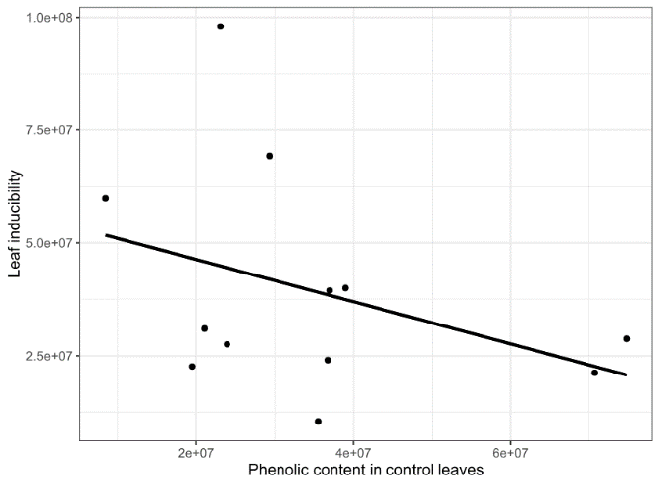
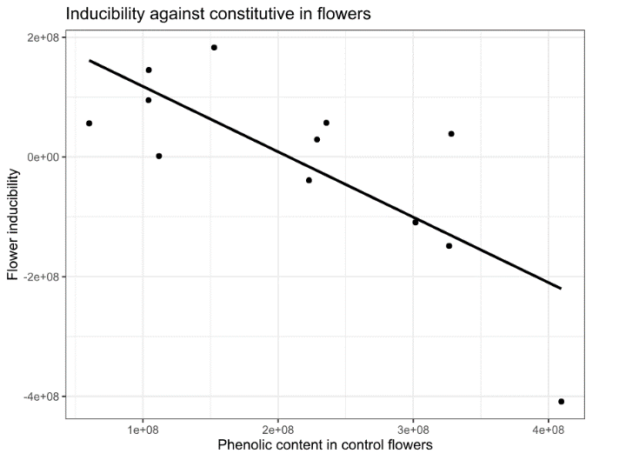
b)

Supplementary Figure 2: a) Flower inducibility decreases with constitutive defence. b) Leaf inducibility does not significantly change with constitutive defence. Shown are the raw phenotypic mean values for each accession of Solanum pennellii.

Supplementary Table 1: Summary of linear mixed effects model fitted to leaf and flower data for total phenolics
Variables | Sum sq | Num df | F | P
 |  | Den df
Tissue | 21.0473 | 1 | 38.6524 | 0.000000004751***
 |  | 150.411
Treatment | 1.1163 | 1 | 2.0501 | 0.15427
 |  | 150.334
Mating system | 0.9548 | 1 | 1.7535 | 0.21754
 |  | 9.157
Tissue x Treatment | 1.6636 | 1 | 3.0551 | 0.08254.
 |  | 149.499
Treatment x Mating system | 0.2368 | 1 | 0.4349 | 0.51061
 |  | 150.554
Tissue x Mating system | 0.4644 | 1 | 0.8528 | 0.35725
 |  | 150.533
Tissue x Treatment x Mating system | 0.4065 | 1 | 0.7466 | 0.38895
 |  | 149.756
*** p < 0.001, ** p < 0.01, * p < 0.05, . p < 0.1

Supplementary Table 2: Summary of linear mixed effects model fitted to leaves for total phenolics
Variables (leaf model) | Sum sq | Num df | F | P
 |  | Den df
Treatment | 0.211 | 1 | 0.3909 | 0.54615
 |  | 9.756
Mating system | 2.96777 | 1 | 5.4987 | 0.02164 *
 |  | 76.203
Treatment x mating system | 0.72444 | 1 | 1.3423 | 0.25026
 |  | 76.142
*** p < 0.001, ** p < 0.01, * p < 0.05, . p < 0.1

Supplementary Table 3: Summary of linear mixed effects model fitted to flowers for total phenolics
Variables (flower FA model) | Sum sq | Num df | F | P
 |  | Den df
Treatment | 1.27003 | 1 | 2.3236 | 0.1629
 |  | 8.701
Mating system | 0.03169 | 1 | 0.058 | 0.8105
 |  | 63.851
Treatment x mating system | 0.01894 | 1 | 0.0346 | 0.8529
 |  | 64.163
*** p < 0.001, ** p < 0.01, * p < 0.05, . p < 0.1

Supplementary Table 4: Summary of linear mixed effects model fitted to leaves for chlorogenic acid content.
Variables (leaf CA model) | Sum sq | Num df | F | P
 |  | Den df
Treatment | 0.4155 | 1 | 0.5487 | 0.4756
 |  | 10.17
Mating system | 8.5743 | 1 | 11.3233 | 0.001203
 |  | 75.939
Treatment x mating system | 0.8627 | 1 | 1.1393 | 0.2892
 |  | 75.903
*** p < 0.001, ** p < 0.01, * p < 0.05, . p < 0.1

Supplementary Table 5: Summary of linear mixed effects model fitted to flowers for chlorogenic acid content
Variables (flower CA model) | Sum sq | Num df | F | P
 |  | Den df
Treatment | 1.14056 | 1 | 1.6491 | 0.2306
 |  | 9.168
Mating system | 0.1015 | 1 | 0.1468 | 0.7029
 |  | 63.198
Treatment x mating system | 0.27429 | 1 | 0.3966 | 0.5311
 |  | 63.342
*** p < 0.001, ** p < 0.01, * p < 0.05, . p < 0.1

Supplementary Table 6: Summary of linear mixed effects model fitted to leaves for flavonoid content
Variables (leaf FA model) | Sum sq | Num df | F | P
 |  | Den df
Treatment | 0.09704 | 1 | 0.1255 | 0.731
 |  | 9.399
Mating system | 1.92587 | 1 | 2.4908 | 0.1186
 |  | 78
Treatment x mating system | 1.30448 | 1 | 1.6872 | 0.1978
 |  | 78
*** p < 0.001, ** p < 0.01, * p < 0.05, . p < 0.1
Supplementary Table 7: Summary of linear mixed effects model fitted to flowers for flavonoid content
Variables (leaf model) | Sum sq | Num df | F | P
 |  | Den df
Treatment | 2.00549 | 1 | 2.5841 | 0.1428
 |  | 8.906
Mating system | 0.07454 | 1 | 0.096 | 0.7576
 |  | 63.33
Treatment x mating system | 0.00291 | 1 | 0.0038 | 0.9513
 |  | 63.719
*** p < 0.001, ** p < 0.01, * p < 0.05, . p < 0.1

Supplementary Table 8: Summary of linear mixed effects model for larval growth of larvae feeding on leaves and flowers of control and MeJA-treated leaves and flowers of Solanum pennellii.
Variables | Sum sq | num df | F | P
(larval growth full model) |  | den df
Tissue | 0.78535 | 1 | 3.2289 | 0.07937 .
 |  | 43.045
Treatment | 0.87122 | 1 | 3.582 | 0.065 .
 |  | 44.007
Mating system | 0.00454 | 1 | 0.0186 | 0.89438
 |  | 9.015
Tissue x Treatment | 0.10153 | 1 | 0.4174 | 0.52161
 |  | 43.671
Treatment x Mating system | 0.0038 | 1 | 0.0156 | 0.90105
 |  | 43.393
Tissue x Mating system | 0.61192 | 1 | 2.5159 | 0.12043
 |  | 40.795
Tissue x Treatment x Mating system | 0.04145 | 1 | 0.1704 | 0.68174
 |  | 43.992
*** p < 0.001, ** p < 0.01, * p < 0.05, . p < 0.1

Supplementary Table 9: Summary of linear mixed effects models for growth of leaf-fed larvae
Variables (leaf model) | Sum sq | Num df | F | P
 |  | Den df
Treatment | 0.000058 | 1 | 0.0003 | 0.9874
 |  | 8.7397
Mating system | 0.25475 | 1 | 1.1703 | 0.2914
 |  | 21.3077
Treatment x mating system | 0.00141 | 1 | 0.0065 | 0.9366
 |  | 21.3077
*** p < 0.001, ** p < 0.01, * p < 0.05, . p < 0.1

Supplementary Table 10: Summary of linear mixed effects models for flower-fed larvae.
Variables (flower model) | Sum sq | Num df | F | P
 |  | Den df
Treatment | 0.102575 | 1 | 0.6438 | 0.4392
 |  | 11.1
Mating system | 0.207974 | 1 | 1.3054 | 0.2644
 |  | 24.276
Treatment x mating system | 0.012485 | 1 | 0.0784 | 0.7819
 |  | 24.276
*** p < 0.001, ** p < 0.01, * p < 0.05, . p < 0.1

Chapter 3

Investigating tissue-specific defence regulation in Solanum pennellii

Authors:
Hannah Ronan-Brown, Samuel W. Wilkinson, Stuart A. Campbell

Affiliations:
University of Sheffield

Authors’ contributions:
HRB: conceptualisation, experimental design, data curation, data analysis and visualisation, data management, results interpretation, writing, editing. SWW: guidance on data analysis. SAC: conceptualisation, experimental design, review and editing, supervised research

3.1 Abstract

Flowers are of higher relative value to plants compared to leaves, and as such it is predicted that flowers will be more strongly defended than leaves, however flower defence can negatively impact plant-pollinator interactions. It is predicted that plants with a higher reliance on pollinators such as outcrossing plants may produce different defences to plants which are less reliant on pollinators such as selfing plants. Selfing plants may produce stronger floral defences due to their lower reliance on pollinators, and plant mating system may be a predictor of floral defence. This study uses RNA-sequencing to explore regulatory differences between leaves and flowers of selfing and outcrossing plants of the wild tomato Solanum pennellii. We predicted that there would be transcriptomic differences in floral and leaf defence regulation between selfing and outcrossing plants. We investigated the influence of mating system on flower and leaf transcriptomes to identify genes responding to methyl-jasmonate treatment, which induces the herbivory defence pathways in the plants. The results reveal a significant upregulation of genes in treated leaves relative to control leaves, however only a handful of genes are differentially expressed in response to treatment in the flowers, suggesting that flowers are not strongly inducible. Lack of floral inducibility could suggest that flowers are under selection to minimise defence response to avoid changing floral phenotype. We also found mating system specificity in transcriptomic response to methyl-jasmonate treatment in leaves, suggesting that mating system may influence the regulation of leaf defence. This study highlights the potential for mating system constraints on regulation of plant defence, providing insights into the interactions between plants, herbivores and pollinators from a transcriptomic basis.

3.2 Introduction

Plant interactions with herbivores are key drivers of the diversification of both taxa (Gatehouse, 2002). As sessile organisms, plants cannot move away from antagonistic interactions and as such, have evolved an array of defensive traits that convey resistance against herbivory. Defences can be produced constantly (constitutive), but the costs associated with defence expression such as resource allocation costs and pollinator deterrence (Strauss et al., 2002; Cipollini, Walters and Voelckel, 2017) have led to the evolution of inducible defences that upregulated following herbivory. Defence in flowers can result in ecological costs to the plant such as pollinator deterrence (Kessler, Halitschke and Poveda, 2011c; Jacobsen and Raguso, 2018b; Moreira et al., 2019). Plants typically exhibit one of two defence strategies that are often proposed as evolutionary alternatives, including constitutive and induced defences. Plant defences that are produced constantly, even in the absence of herbivores are constitutive defences, whilst defences that are increased in response to damage are the inducible defences (Karban and Baldwin, 2007).

Despite the importance and frequency of multi-trophic interactions (Moreira et al., 2019), studies combining the interactions of plants, herbivores and pollinators are scarce. The evolution of plant defences is often studied in isolation from other plant-biotic interactions, such as plant-pollinator relationships, despite the well-established idea that plant responses to herbivory can disrupt pollinator networks (Hoffmeister, Wittköpper and Junker, 2016) and pollinator attraction (Rusman, Lucas-Barbosa and Poelman, 2018). Where plant defences have deterrent effects on pollinators, pollinator deterrence may be considered an ecological cost of defence. It may be predicted that plants with a strong reliance on pollinators (self-incompatible) for reproduction may experience higher ecological costs of defence than those that are less reliant on pollinators (eg. self-compatible). Plant taxa with genetic incompatibility systems such as the Solanaceae and Brassicaceae provide ideal systems in which to test this prediction, due to the numerous independent transitions in mating system from self-incompatible to self-compatible across the family.

The transition to selfing is associated with the evolution of inducible defence in leaves (Campbell and Kessler, 2013; Johnson, Campbell and Barrett, 2015). The predicted differences in relative defence cost experienced by self-compatible and self-incompatible plants suggest that the two mating systems may have diverged in their defence strategies (Johnson et al., 2014).Optimal defence theory predicts that across these two strategies plant tissues will be defended according to the relative value to a plant and the likelihood of predation of a particular tissue (McKey, 1974). Flowers have high fitness value to a plant due to their roles in reproduction, and are generally nutritious and frequently subject to herbivore damage, therefore Optimal Defence Theory predicts that flowers will have high levels of constitutively expressed defences; which is supported by several studies in the literature (Alves et al., 2021; Damle et al., 2005; Frölich et al., 2007; Ronan-Brown et al. in prep). In wild tobacco, Nicotiana attenuata, secondary metabolites accumulate at higher concentrations in flower tissue than in leaves (Li et al., 2016). However, relatively few studies consider differences in constitutive and MeJA-induced floral defence levels.

Induced response to herbivory of leaves is controlled by the phytohormone jasmonic acid (JA) and its derivatives, such as methyl jasmonate (MeJA). JA signalling is also involved in regulating other stress responses and some aspects of plant development (Wasternack and Hause, 2013), such as regulation of flower development and pollinator attraction (Sherif et al., 2015). Once these signalling molecules are perceived by plants, a distinct reprogramming of gene expression occurs. The endogenous bioactive form of JAs involved in activation of stress response is (+)-7-iso-JA-Ile (JA-Ile) (Fonseca et al., 2009). Perception and signalling of JA-Ile is through the F-box protein coronatine-insensitive 1 (COI-1) and JASMONATE ZIM-domain (JAZ) protein, which together form a receptor complex (Sheard et al., 2010). In the absence of JA-Ile, JAZs repress transcription factors such as MYC2 which promote the expression of JA-responsive genes (The JAZ family of repressors is the missing link in jasmonate signalling | Nature, no date). Once produced, JA-Ile acts as a ligand between COI1 and JAZs, which allows JAZs to be degraded (Chini et al., 2007). The targeting of JAZs for degradation releases JA-responsive transcription factors from repression (Howe, Major and Koo, 2018). The JA gene regulatory network is very complex (Hickman et al., 2017) and while changes in the regulation of important leaf metabolic pathways are well known (Pauwels, Inzé and Goossens, 2009), relatively little is currently known about how constitutive and induced herbivore responses differ between leaves and flowers, and how ecological interactions may have influenced these defence pathways. In N. attenuata , the JAZ gene NaJAZi functions as a flower-specific jasmonate repressor which regulates JAs and conveys greater resistance to herbivory in flowers (Li et al., 2017). JA signalling is involved in floral defence, and it has been found that the levels of defence compounds within a flower can change during its lifetime (Li et al., 2017), though the mechanisms responsible for these variations in floral defence are not well-understood; indeed, floral defence is relatively poorly understood when compared to the many studies into leaf defence mechanisms.

The Solanaceae have a comprehensive suite of defences to protect themselves against herbivore attackers. The phenylpropanoid pathway is partially regulated by jasmonates (Creelman and Mullet, 1997). Products of the phenylpropanoid pathway include flavonoids and phenolic acids such as caffeic acid and chlorogenic acid in Solanum species. Phenolics are a significant group of secondary metabolites which often have a defensive role within the plant, though many phenolic metabolites also play important roles in other plant processes, such as attracting pollinators or giving tissue a particular colour (Alasalvar et al., 2001). Phenolic compounds represent a significant component of the secondary metabolites used by Solanum species as defences against diverse insect herbivores (Campbell, Thaler and Kessler, 2013).

S. pennellii is a wild tomato species that is endemic to South America. The species is ancestrally outcrossing (self-incompatible, SI) with several selfing (self-compatible, SC) populations that each represent an independent transition from the ancestral outcrossing state to self-compatibility. Self-incompatibility is maintained in this species through the presence of a gametophytic self-incompatibility system which is present in around one third of the Solanaceae. This system reduces inbreeding by preventing pollen tube growth when incumbent pollen and shares a common allele at the S-locus of the female/maternal plant (Hosaka and Hanneman, 1998; Igic, Bohs and Kohn, 2006). There are some populations which represent a mixed mating system, denoted as SC/SI in the literature. These populations were noted to contain both obligate outcrossers as well as selfers when seeds from the source population were first collected. The presence of multiple mating systems within the species provide a useful system to investigate the effect of the mating system on plant phenotype, namely the plant defences, and here the system is used to identify mating system-specific differences in gene expression

We tested the overarching hypothesis that constitutive and induced defence strategies evolved as a result of tissue specific selection pressures and constraints imposed by different reproductive strategies. Specifically, we investigated constitutive and induced tissue-specific expression of defence genes using selfing and outcrossing accessions of Solanum pennellii. We conducted a prior study investigating phenolic content in leaves and flowers (Chapter 2) and found that leaves and flowers had distinct constitutive and induced phenolic content. This RNA sequencing study investigates the transcriptomic mechanisms that may underly the defence phenotype found in Solanum pennellii leaves and flowers. We tested three main predictions of our hypothesis: first, that leaves and flowers will have significantly different constitutive defence gene expression levels, as flowers have been shown to have higher constitutive phenolic content than leaves (Chapter 2) ; second, that defence pathways would be expressed at higher levels in selfers than outcrossers in flowers due to pollinator constraints on defence in outcrossers, as was observed for phenolic content (Chapter 2): and third, that flowers would be less inducible, and that there would be mating system specificity in inducibility.

3.3 Materials and Methods

3.3.1 Plant materials and growth conditions
.
Seeds of the three selfing and three outcrossing accessions were sourced from the Tomato Genetics Resource Centre (TGRC), CA, USA (Table 1). Phenolic content in these accessions is shown in Supplementary Figure 1. Seeds were pre-treated by soaking in diluted household bleach (2.5% hypochlorite) and germinated in 8cm x 8cm plastic pots in a soil-vermiculite mix (Levington M3 – vermiculite, 3:1 (v/v)). Seedlings were transplanted into 15cm x 15cm plastic plant pots in the same compost mix at 4 weeks. Plants were grown in a growth chamber in greenhouse conditions (enhanced natural lighting, 14h light/10h dark,18ºC nighttime – 23ºC daytime, 50-70% relative humidity) with ad libitum watering. Plant position within the growth chamber was randomized to minimise position effects. Plants were fed weekly from 8 weeks onwards using MiracleGro NPK fertiliser blend 24-8-16 with micronutrients at a concentration of 15ml in 5 litres of water. Once plants were at peak flowering (14 weeks) they were used in the experiment.
Accession | Accession code | Mating system | Accession year
LA5240 | A | SC | 1984
LA2963 | B | SC | 1989
LA1941 | F | SC/SI | 1979
LA1277 | J | SI | 1970
LA1693 | K | SI | 1976
LA1912 | L | SI | 1979

Table 1: Solanum pennellii accessions used in this experiment, all were sourced from the Tomato Genetics Resource Centre, CA (TGRC). Mating system information is from the TGRC database, SC denotes selfing, SI denotes outcrossing, and SC/SI denotes presence of both mating systems within the source population – this species is classed as selfing for this experiment as the plants autonomously set seed.

3.3.2 Experimental design
We tested the effects of pollinator reliance on constitutive and induced floral and foliar defence gene expression using a factorial experiment with six plants of three selfing and three outcrossing populations. Half the plants of each population (n = 3) were treated with either a control or methyl jasmonate (MeJA) treatment. Leaf and flower samples were collected 48 hours after treatment.
To manipulate induced response to herbivory, the defence signalling hormone MeJA was applied to the plants to induce the jasmonate pathway. MeJA mediated plant response to herbivory (Kessler and Baldwin, 2002; Li et al., 2002; Howe and Jander, 2008). Induction using MeJA does not completely mimic the real effects of herbivory but it allows control over the strength of damage signal whilst controlling for confounding effects of differential tissue damage that are likely when using phenotypically divergent plant populations and avoids the effects of herbivore salivary compounds or different feeding behaviours.

A MeJA-lanolin paste (10μg/ml) was applied to the basal stem of the plants at a height of 5cm from the soil in a 1cm-wide continuous band around the stem. To make the MeJA-lanolin paste, 200mg of jasmonic acid (Sigma-Aldrich number 392707) was added to 20mL of lanolin (Sigma-Aldrich number L7387) that had been warmed in a water bath at 50-60ºC, and the mixture was stirred thoroughly. MeJA mediates plant response to herbivory (Kessler and Baldwin, 2002; Howe and Jander, 2008). This concentration of jasmonate is sufficient to induce systemic plant defence responses (Kaya and Doganlar, 2016), allowing the induced response to be measured in leaves and flowers. Lanolin paste with no added MeJA was applied to control plants.

3.3.3 Tissue harvesting and RNA extraction

Leaf and flower samples were collected 48-hours post-MeJA application as induced response peaks around 24 hours and is sustained for at least 72 hours (Kessler, Halitschke and Poveda, 2011a), however the duration of induced response has previously been tested in leaves rather than flowers. Floral induced defence may be sustained for less time than leaf induced defence, however time course analysis of floral defence was outside the scope of the study. The leaflet adjacent to the terminal leaflet used for HPLC analysis (Chapter 2 of thesis) was excised from the youngest fully expanded leaf stem using a razor blade, and half the leaf, approximately 100mg, placed into a 2.0ml RNA-safe microtube and immediately flash frozen in liquid nitrogen. Flower samples for RNA sequencing were taken, where possible, from the same inflorescence as the HPLC samples, or if not possible, from the adjacent inflorescence. To collect a flower sample, two open flowers were cut from the inflorescence that was above the leaf from which leaflets were sampled. The entire flower was removed from the calyx. The flower was placed into an RNA-safe microtube and flash frozen in liquid nitrogen.

Samples were stored at -80ºC until processing. Three biological replicates were performed for each accession-treatment combination, giving a total of 72 samples. Samples were ground to a fine powder to disrupt cells by adding three 2mm stainless steel ball bearings to the microtube, and shaken at high speed on a Qiagen TissueLyser II. Blocks were dipped in liquid nitrogen prior to sample loading to ensure samples remained frozen.

Total RNA was extracted from 80-100mg of tissue powder using the Qiagen RNeasy Plant Mini Kit. In the first stage of RNA extraction, 0.5% β-mercaptoethanol (Sigma-Aldrich, M3148) was added to the extraction buffer to denature ribonucleases. In order to obtain a sufficiently high concentration of RNA, the pure RNA supernatant was recentrifuged through the filter in the final centrifugation step of the extraction process, resulting in a final volume of 40μL suspension of RNA in nuclease-free water. Prior to sequencing, quality and quantity of RNA was assessed using a Nanodrop and Aligent 2100 Bioanalyzer (Agilent Technologies, Santa Clara, CA, USA). All samples had a RIN score greater than 5; 68 of 72 samples had a RIN score greater than 6.

3.3.4 mRNA library preparation and sequencing
Library preparation and sequencing was conducted by BGI Tech Solutions (Tai Po, Hong Kong) using the DNBSEQ (DNBSEQ technology) platform. Two samples failed in library construction and were removed from the experiment. 70 samples were successfully sequenced; the mean number of read pairs per sample was 1363599. BGI removed adapter sequences, low-quality sequences and contamination using the SOAPNUKE technology developed by BGI (Y et al., 2018).

3.3.5 Read alignment and counting

Reads were trimmed using the package trimmomatic (version 0.39), (Bolger, Lohse and Usadel, 2014). The STAR package (version 2.7.11b) (Dobin et al., 2013) was used to align reads to the Solanum pennellii reference genome (Schmidt et al., 2017). The transcriptome was first indexed using STAR, and reads were aligned to the indexed genome with the parameters set to default with the additional parameter ‘–alignIntronMax 10000’. The number of uniquely aligned fragments that map to each gene were counted using the HTSeq-count function in the HTSeq library (version 2.0.5) with the following options specified in the htseq-count function; --format bam, --order pos, -t exon, --stranded=reverse (Anders, Pyl and Huber, 2015).

3.3.6 Global pattern assessment and differential expression analysis

To assess the global patterns in the data, count tables generated by HTSeq-count were loaded into R and all genes with <10 total read counts across all samples were removed. Remaining read counts were transformed with a variance stabilising transformation (vst) (Anders and Huber, 2010) using the DESeq-2 vst function with the option settings: ‘blind = TRUE’, ‘nsub = 1000’, test = “Wald”, ‘fitType = “parametric”’. The transformed count data was then used for a principal component analysis (PCA), hierarchical clustering analysis (HCA) and heatmap analysis of the sample-sample distances. The PCA was performed using DESeq-2 plot PCA function.

A false discovery rate adjusted P-value (p-adj) cutoff of p < 0.01 was used to select differentially expressed genes (DEGs). Due to the small number of DEGs in flowers, a p-adj < 0.05 was tested, but this did not change the number of significant DEGs between the control and treated flowers of each mating system.

3.3.7 Gene Ontology (GO) enrichment analysis
Enrichment analysis of biological function GO terms was conducted using the web based enrichment tool gProfiler (Kolberg et al., 2020). The target gene lists for S. pennellii were converted to S. lycopersicum gene IDs using a BLAST search against the Ensembl S. lycopersicum genome, and the resulting gene lists were used in GO term enrichment analysis against a reference of S. lycopersicum. The background for the analysis was automatically generated in the gProfiler software and consisted of all genes in the S.lycopersicum genome. For a GO term to be reported it had to be assigned to one or more transcript in a cluster and it had to have p-adj < 0.05. Results tables from GO term analysis can be found in the Appendix.

3.3.8 Kyoto encyclopaedia of genes and genomes (KEGG) pathway analysis

GhostKOALA was used where possible to annotate and map predicted protein sequences for differentially expressed genes to KEGG pathways. KEGG pathway enrichment analysis of DEGs was performed to predict what pathways may be significantly enriched among DEGs compared to the entire genome background. Results tables from KEGG term analysis can be found in the Supplementary Materials.

3.4 Results

3.4.1 Mating system differences in transcriptomic response to MeJA treatment
Selfing and outcrossing samples were analysed separately to assess whether leaves and flowers respond differentially to MeJA treatment. In total, 22780 and 21762 genes had non-zero read counts in SC and SI plants respectively. Fewer genes were significantly differentially expressed in response to treatment in selfing tissue compared to outcrossing tissue (Figure 1a and 1b). When filtered for significance (using padj < 0.05 and log2foldchange > 2) 178 genes were identified as being differentially expressed between control and treated tissue in SC plants, and 1085 genes were differentially expressed between control and treated tissue of SI plants. To examine global patterns in transcriptome response to MeJA treatment in both leaves and flowers of selfing and outcrossing plants, Principal Component Analysis (PCA) was conducted and showed clear clustering of flower samples and of leaf samples in both the selfing and outcrossing groups, whilst treatment was not responsible for obvious clustering of the samples. In the selfing plants, PC1 represents 97% of the variation, whilst PC2 represents 1% of the variation (Figure 1c). In outcrossing plants, PC1 is responsible for 97% of the variation, and PC2 just 1% of the variation (Figure 1d). For both selfing and outcrossing plants, the biggest driver of transcriptome divergence is the plant tissue.
More DEGs were identified in the treatment:tissue interaction in selfing plants than outcrossing plants. In treated selfing plants, 7278 DEGs between tissues; 4097 downregulated and 3182 upregulated in leaves compared to flowers, represented as a volcano plot (Figure 1e). In outcrossing treated plants 6829 DEGs, of which 3808 were downregulated, 3021 were upregulated (Figure 1f).
Gene ontology enrichment analysis was conducted to assess the roles of the genes involved in MeJA-response. In SC JA-treated plants, GO terms that were enriched among the genes upregulated in leaves compared to flowers included many associated with photosynthesis and chloroplasts, however the additional KEGG terms biosynthesis of secondary metabolites and alpha-Linolenic acid metabolism were also output from the GO term enrichment analysis. GO terms enriched in the downregulated gene list of JA-_{treated} SC leaves compared to flowers included terms associated with enzyme activity and transmembrane transport/signalling. The GO term ‘phosphoric ester hydrolase activity’ (GO: 0042578) and ‘pectate lyase activity’ (GO:0030570) (Supplementary Table 1).
In SI JA-treated plants, genes upregulated in leaves compared to flowers were associated with GO terms such as photosynthesis and chlorophyll, and KEGG results from the GO term enrichment included alpha-Linolenic acid metabolism (KEGG:00592). GO terms represented in genes downregulated in leaves included catalytic enzyme activity, calcium-dependent protein kinase activity (GO:0010857) and several GO terms associated with biological processes involved in transport activities. There were 23 cellular component GO terms associated with genes downregulated in JA-treated SI leaves compared to flowers, and two KEGG terms ‘pentose and glucuronate interconversions’ (KEGG:00040) and ‘motor proteins’ (KEGG:04814). GO terms associated with ‘phosphorus metabolic process’, ‘vesicle fusion’ and ‘organic acid metabolic process’ were associated with downregulated genes in leaves compared to flowers.
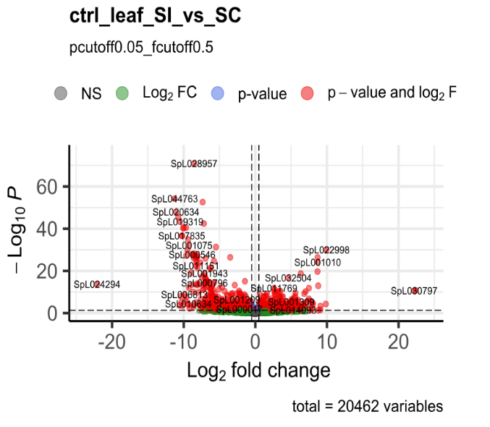
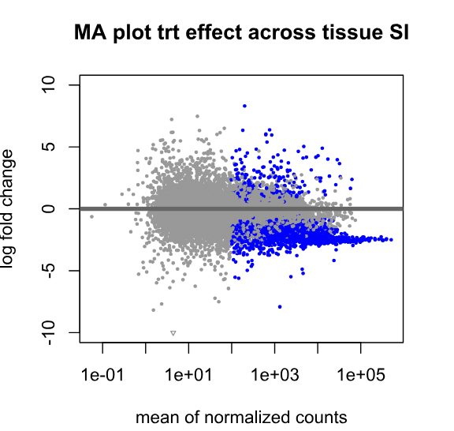
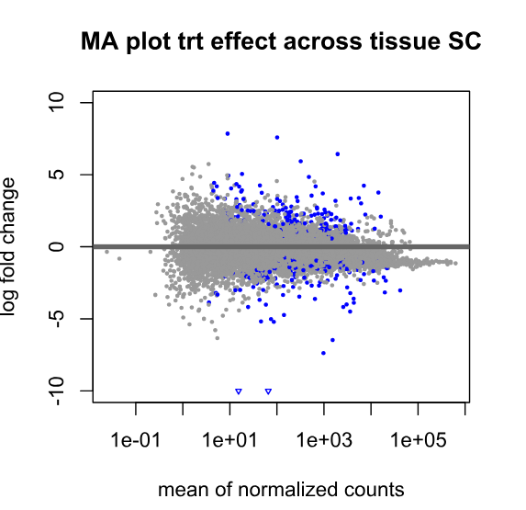
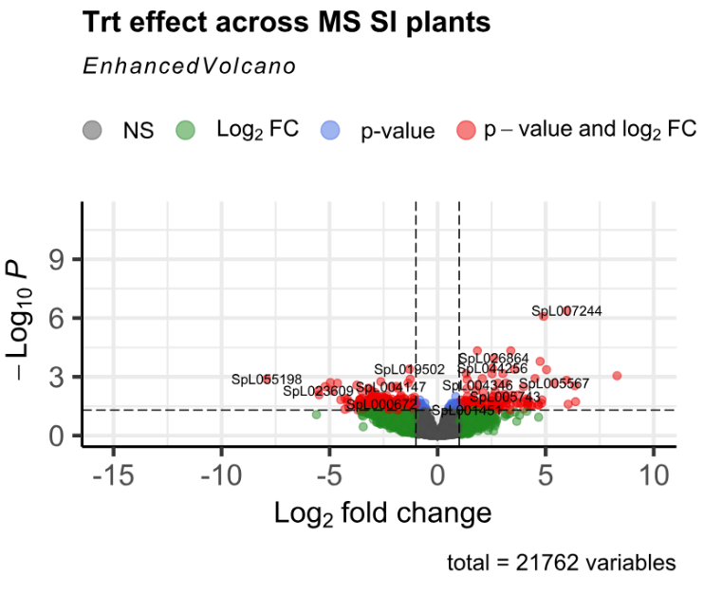
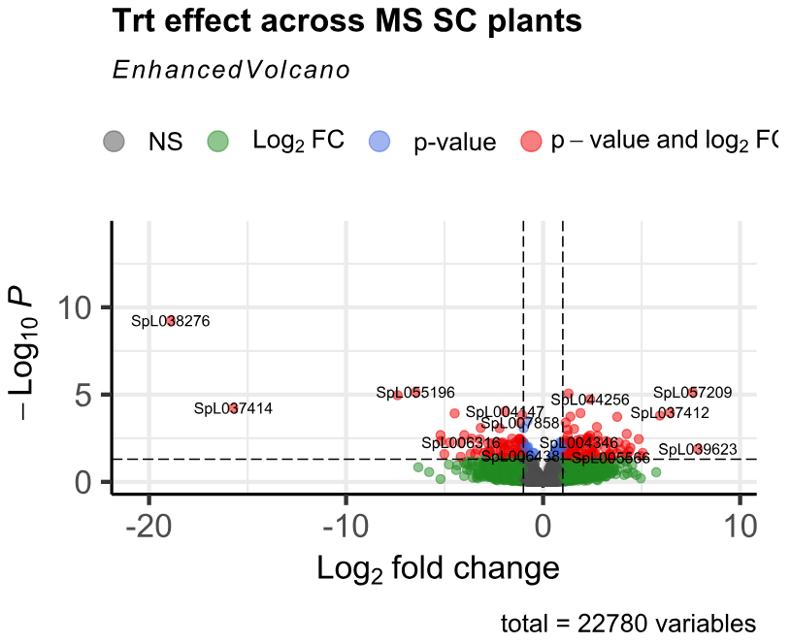
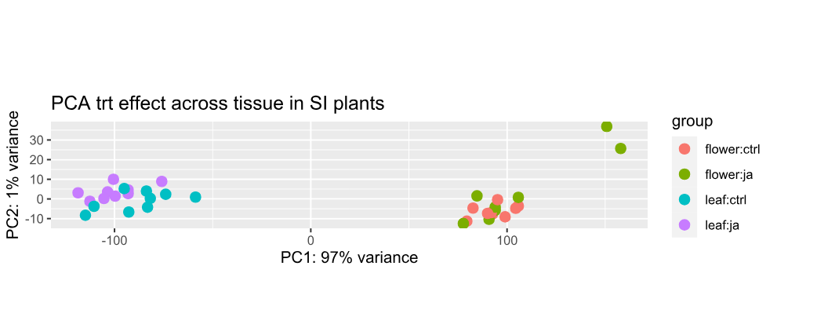
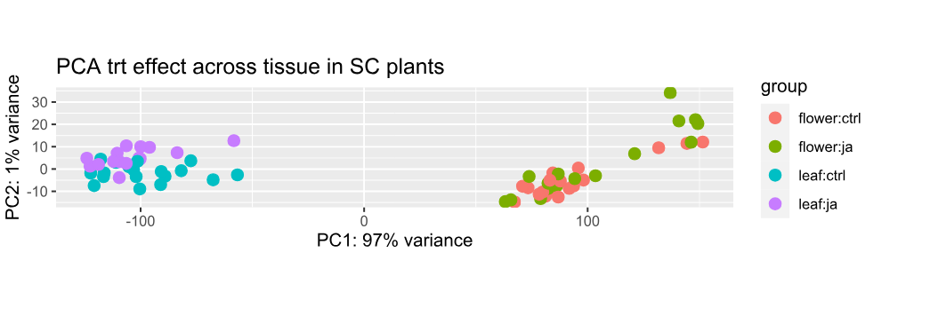
Selfing
Outcrossing
Figure 1: Leaf and flower transcriptomes are strongly divergent. Upregulated genes are higher in outcrossing (SI) plants and downregulated genes are higher in selfing (SC) plants. a) MA plot log fold change against normalised gene count showing treatment effect across tissue resulting from the Deseq2 model including interaction term of treatment and tissue in self-compatible plants. Genes with significant differential expression are highlighted in blue. B) MA plot log fold change against normalised gene count showing treatment effect across tissue resulting from the Deseq2 model including interaction term of treatment and tissue for self-incompatible plants. Genes with significant differential expression are highlighted in blue. C) Principal component analysis loading plot for self-compatible leaves and flowers, showing clear grouping by tissue. D) Principal component analysis loading plot for self-incompatible leaves and flowers, showing clustering by tissue. E) Volcano plot for self-compatible leaves and flowers. Red points denote significant genes. Blue points represent genes that pass the p-value cutoff for significance but not log2foldchange cutoff, and green points are genes that pass the log2foldchange cutoff but not the p-value. F) Volcano plot for self-incompatible leaves and flowers. Red points denote significant genes.
a)
b)
c)
d)
e)
f)
Outcrossing
Selfing
Outcrossing
Selfing

3.4.2 Mating system differences in the transcriptomes of untreated leaves and flowers
To examine global patterns in the transcriptome of control flowers, principal component analysis (PCA) (Figure 2c) was conducted to confirm that the replicates behave consistently. The results show distinct clustering of outcrossing accessions, and strong clustering of two selfing accessions, which have overlapping geographical range. The third selfing accession, which is documented as SC/SI, and may represent an intermediate mating system between populations of obligate outcrossers and fully self-compatible plants, and the samples from this accession form a small cluster between the outcrossing and selfing clusters. Global differences between selfing and outcrossing flower transcriptomes are in the MA plot (Figure 2a), and many genes were differentially expressed between selfing and outcrossing control flowers (Figure 2e).
PCA analysis was conducted to compare transcriptomes of the control leaves (Figure 2b). In the leaves, the transcriptomes of the two selfing accessions (A and B) are similar, as evidenced by the clustering of these two accessions (Figure 2d). The intermediate accession (F) shows closer clustering with the obligately outcrossing accessions than with the selfing accessions. While the selfing accessions were fairly similar and distinct from the outcrossing accessions, there considerable variability within and between the outcrossing accessions as well as accession F, which is demonstrated by these samples not clustering perfectly by accession. Many genes were downregulated in outcrossing leaves compared to selfing leaves which is represented in an MA plot (Figure 2b) and also in a volcano plot (Figure 2f).

Having shown that there mating system-specific differences in the global transcriptome (Figure 1), we next tested whether genes that showed a significant FDR-adjusted p-value (p.adj) < 0.05 exhibited altered expression profiles between the two mating systems. In total, 725 differentially expressed genes were identified, of which 200 genes were upregulated and 525 genes were downregulated in outcrossing flowers compared to selfing flowers.
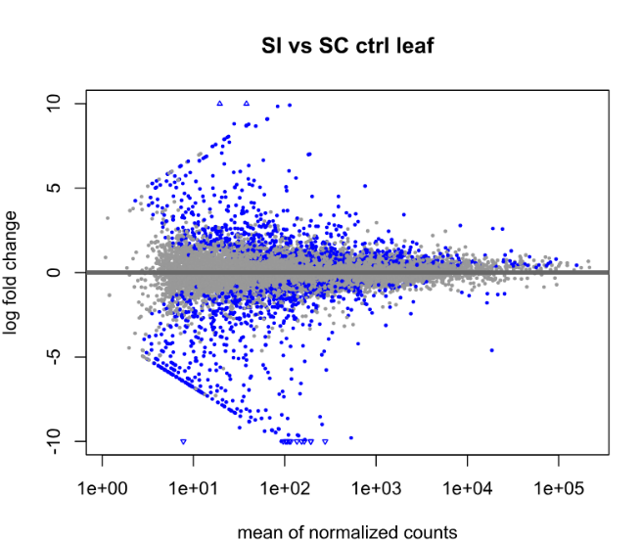
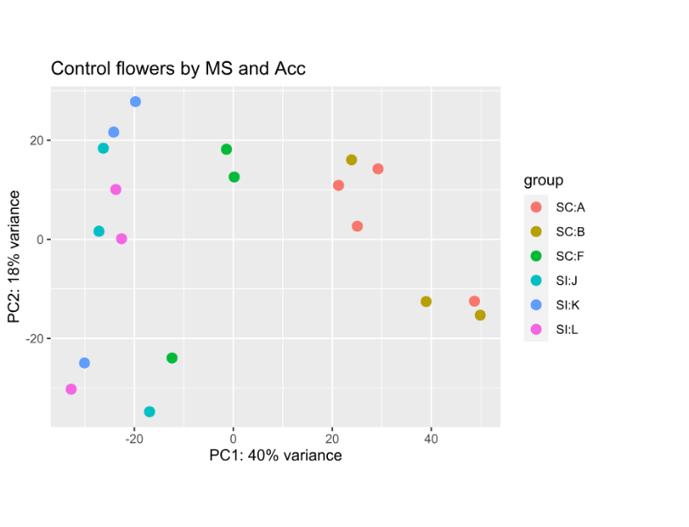
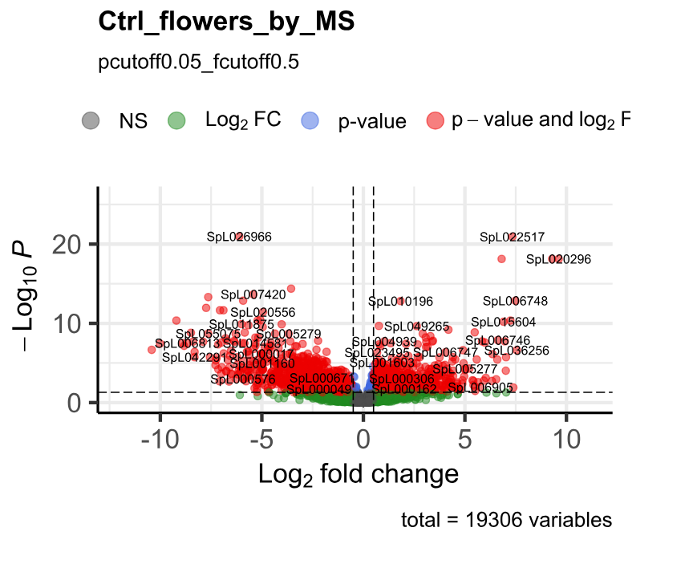
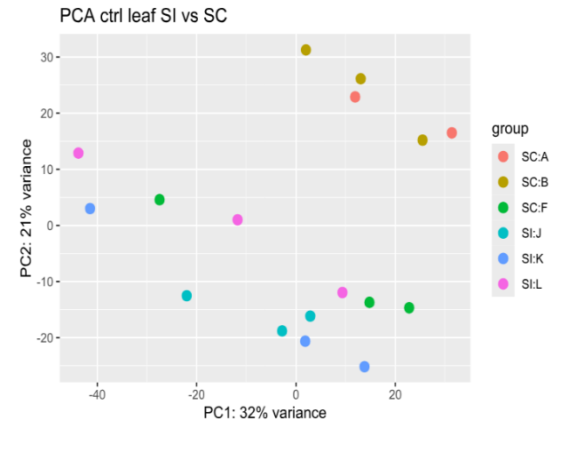
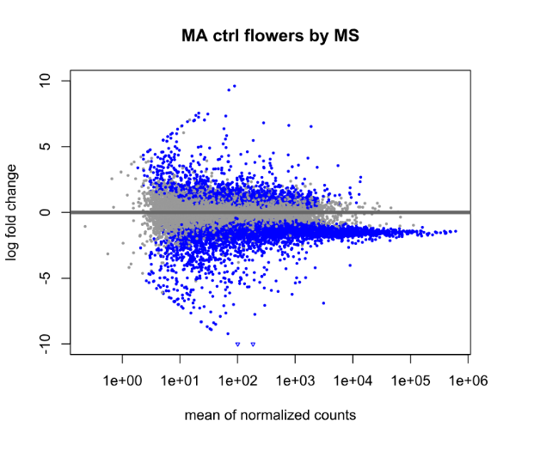
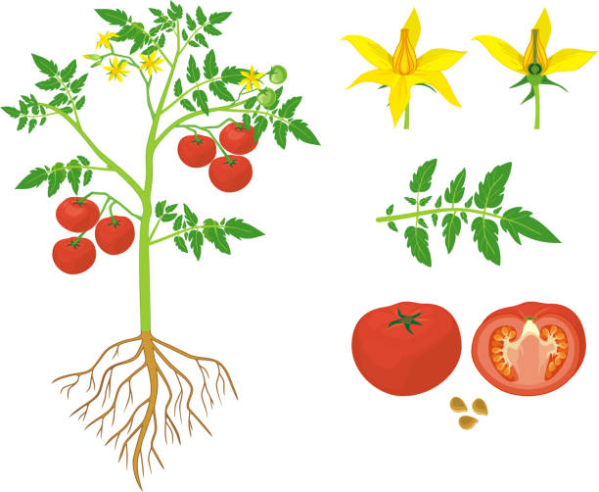
Figure 2: Transcriptomic differences between control flowers (right-hand column) and leaves (left-hand column) of selfing and outcrossing plants. a) MA plot showing distribution of differentially expressed genes in flowers. b) MA plot showing distribution of differentially expressed genes in leaves. c) Principal component analysis (PCA) for flowers d) Principal component analysis for leaves - all genes with a total read count of over 10 across the 18 samples were included in the PCA analysis. PCA utilised counts normalised with variance-stabilising transformation. Volcano plots e) flowers, f) leaves, shows significant differentially expressed genes plot showing distribution of log fold change (x-axis) and significance (p-adj) (y-axis) values for gene expression levels of the differentially expressed genes by mating system in response to treatment. Red dots denote the four significant DEGs that were identified. Green points represent genes with a logfoldchange above the cut-off of 0.5 used to check for significance in the flower data, but that did not pass the p-adj significance cut-off.
a)
c)
b)
d)
e)
f)

To assess whether there were particular functional annotations associated with each of the expression patterns, GO term enrichment analysis was performed for DEGs that were identified between selfing and outcrossing control flowers (Supplementary Table 3). Two GO terms that were identified as overexpressed in outcrossing flowers were GO:0009408 and GO:009266: response to heat and response to temperature stimuli respectively (Supplementary Table 3).

To compare expression of genes relating to defence, or other biological functions, KEGG pathway analysis was conducted on the list of downregulated DEGs in control outcrossing flowers compared to selfing flowers. 525 sequences were input, and 14.1% (74) of these were annotated. The KEGG terms associated with the downregulated genes in outcrossing control flowers included K22794 is an FG3 (flavonol-3-O-glucoside), K04125 (gibberellin 2beta-dioxygenase).
In control leaves, a total of 611 differentially expressed genes were identified using a padj < 0.05 and LFC cutoff of 2. A total of 261 genes were significantly upregulated in outcrossing leaves compared to selfing leaves, and 350 genes were significantly downregulated in outcrossing leaves. In leaves the GO terms found to be overexpressed in outcrossing compared to selfing plants included ‘iron ion binding’ (GO:0005506), ‘biosynthesis of secondary metabolites’ (KEGG:01110) and ‘zeatin biosynthesis’ (KEGG: 00908) (Supplementary Table 3). There were no results from the GO term enrichment analysis on genes that were downregulated in outcrossing compared to selfing leaves.
KEGG analysis was conducted to determine the pathways associated with genes differentially expressed between mating systems in the untreated leaves. Pathways including 12 ‘metabolic pathways’ (K01100) terms and 9 terms within the group ‘biosynthesis of secondary metabolites’ (K01110) were highly represented in the genes more highly expressed in untreated outcrossing leaves compared to selfing leaves. From the 261 genes input into this KEGG analysis, 37 were annotated (14.2%). Of the genes which were significantly underexpressed in untreated outcrossing leaves compared to untreated selfing leaves, 29 of 350 (8.3%) input genes were annotated. As in the upregulated genes, the genes downregulated in untreated outcrossing control leaves compared to selfing leaves were also associated with ‘metabolic pathways’ (K01100) and ‘biosynthesis of secondary metabolites’ (K01110) but fewer terms were associated with these pathways: 6 and 2 terms respectively.

3.4.3 Mating system differences in transcriptomes of control leaves and flowers
In selfing control plants, 7787 DEGs between leaves and flowers (padj < 0.05, log2FC > 2). Of these, 4203 genes were significantly downregulated in leaves, and 3584 genes were significantly upregulated in leaves. In outcrossing control plants, 6303 DEGS were identified between leaves and flowers (padj < 0.05, log2FC > 2). Of these DEGs, 2960 genes were upregulated in leaves and 3343 genes were downregulated in leaves. To assess what the roles of these genes are, GO term enrichment was conducted for each treatment-tissue combination. As flowers were found to have higher phenolic content than leaves (Ronan-Brown et al., in prep, CH2), GO term enrichment analysis focused on whether there were more defence-related genes in flowers than leaves. In selfing control plants, GO terms which were associated with upregulated DEGs in leaves included terms associated with photosynthesis and chloroplasts, whilst GO terms associated with genes downregulated in leaves compared to flowers included several terms associated with signal transduction and cellular structure, as well as the carbohydrate metabolic pathway. In outcrossing control plants, GO terms associated with upregulated DEGs in leaves included genes associated with chlorophyll and photosynthesis, whilst those associated with the downregulated genes included the glycerolipid metabolic process, signal transduction, as well as the carbohydrate metabolic pathway.
To identify potential mating system-specific genes in control leaves and flowers, lists of the DEGs across mating systems for each tissue were compared. The genes that are upregulated in both leaves and flowers within a mating system may be classed as ‘mating system-specific’ genes. Across the untreated leaves and flowers, 50 genes were more highly expressed in both leaves and flowers of outcrossing plants (Figure 3a), and 108 were more highly expressed both leaves and flowers of selfing plants (Figure 3b).
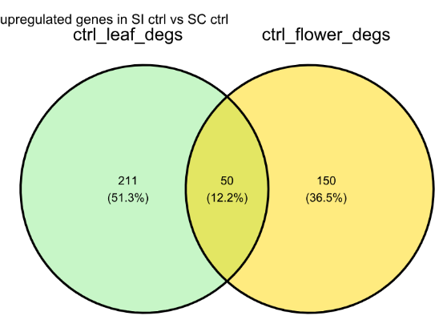
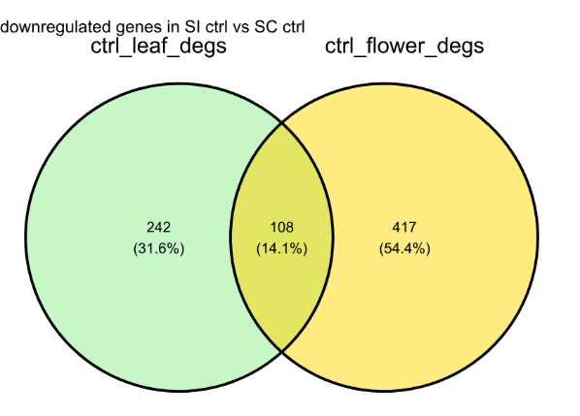
Figure 3: Venn diagrams produced from lists of differentially expressed genes in control flower and leaves. a) upregulated in SI tissues compared to SC tissues (green/left) and flowers (yellow/right) and b) downregulated in SI tissues compared to SC tissues. The intersect represents genes that are commonly differentially expressed in both leaves and flowers.
a)
b)

Genes that were commonly differentially expressed between leaves and flowers across mating systems were mapped to known biological pathways using KEGG pathway analysis. Of the 50 gene sequences commonly upregulated in SI leaves and flowers, 16% were annotated. Several terms associated with metabolism were identified: two terms associated with ‘Biosynthesis of secondary metabolites’ (M00113: K00454 Jasmonic acid biosynthesis; and module K00371: K09842 Abscisic acid biosynthesis) and one term associated with carotenoid biosynthesis (M00372: K09842) were identified in the list of genes that were more highly expressed in the untreated SI leaves and flowers (Supplementary Table 1). KEGG analysis of the genes that were more highly expressed in SC leaves and SC flowers relative to their SI counterparts found 10 of the 108 (9.3%) input genes were annotated. One term associated with the ‘biosynthesis of secondary metabolites’ pathway was identified, this was a primary-amine oxidase (module K1110: K00276) and other modules with associated KEGG terms included metabolism-related terms and genetic information processing (Supplementary Table 1).

3.4.4 Higher number of MeJA-induced genes expressed in outcrossing than selfing flowers
To determine the presence of differences in global expression patterns between control and MeJA-treated flowers, principal component analysis was conducted using the raw count data, and a degree of grouping by mating system was found (Figure 4a). The DESeq function was run using the interaction term of mating system with treatment. In total, 20078 genes with a non-zero read count were identified. A total of 4 genes with a significantly (p-adj < 0.01) different expression profile were identified (Figure 4b). The flowers were then analysed as separate mating systems to determine whether there were genes that were differentially expressed in treated flowers of just one mating system. Very few genes were differentially expressed between control and treated selfing flowers (Figure 4c), which differed to the expression pattern seen in the outcrossing flowers, in which many genes were significantly differentially expressed between control and treated flowers (Figure 4d).
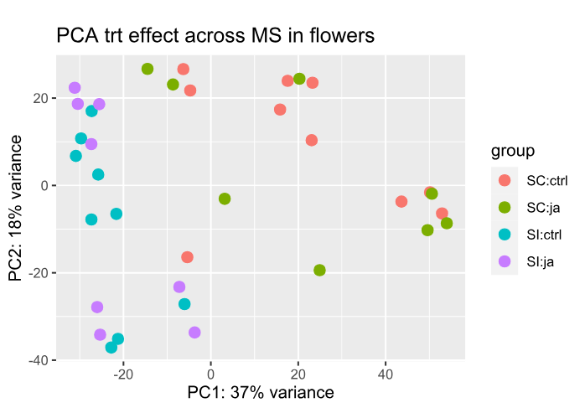
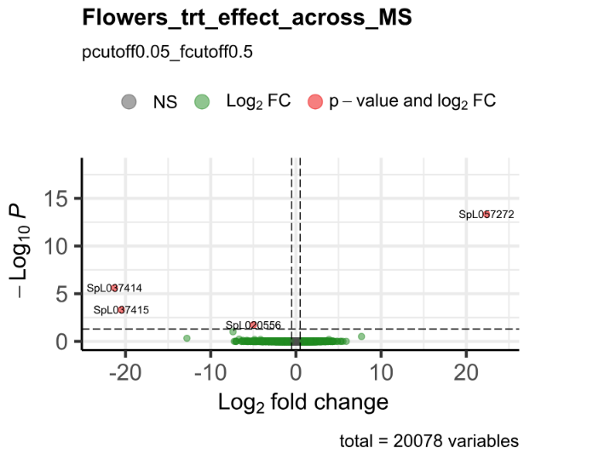
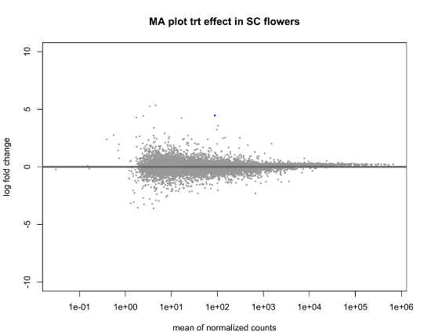
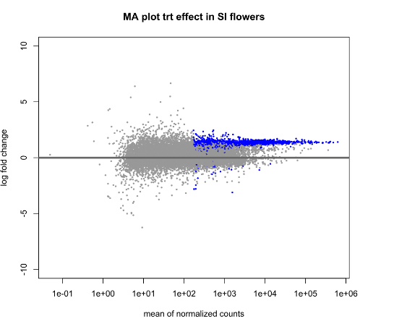
Figure 4: Differences between control and MeJA-treated flower transcriptomes. a) PCA shows clustering of the sample data points; slight clustering effect of the SC and SI samples along the X-axis (PC1) but no clear clustering patterns are observed on the y-axis (PC2). B) Volcano plot showing distribution of log fold change (x-axis) and significance (p-adj) (y-axis) values for gene expression levels of the differentially expressed genes. Red dots denote the four significant DEGs that were identified. Green points represent genes with a logfoldchange above the cut-off of 0.5 used to check for significance in the flower data, but that did not pass the p-adj significance cut-off of 0.05. c) MA plot showing few significant DEGs (blue) between control and treated selfing flowers. d) MA plot showing several DEGs (blue) between control and treated outcrossing flowers.
d)
c)
a)
b)

The 4 differentially expressed sequences were BLAST-searched against S. pennellii 28526 (TABLE/SUPPLEMENTARY). The S. pennellii annotations are predicted from the S. lycopersicum genome annotations with additional genes specifically annotated in S. pennellii. One gene was uncharacterised but had a strong match with a gene on chromosome 1 of the S. pennellii genome. Two genes, SpL037415 and SpL057272 are predicted to be ABC transporter genes. ABC transporters are membrane proteins that act as substrate transporters, such as hormones and phenolic compounds, and some ABC transporters are known to be induced by biotic stress (see review Hwang et al., 2016).

Gene | Mating system DEG significant | Log2FoldChange | Predicted role in S. pennellii
SpL021661 | SI | 6.472522 | Pectate lyase 1
SpL028324 | SI | 5.289652 | SEC1 family transport protein SLY1
SpL053762 | SI | 4.897517733 | ATPase
SpL037400 | SC | 5.54751 | Aspartic protease inhibitor 8-like
SpL052523 | SC | 6.121276 | Arginase 1 mitochondrial
Although there was no treatment effect when using the interaction term in the DESeq model, the lack of overlap prompted us to analyse SC and SI flowers separately to identify genes that are differentially expressed between treated and untreated flowers. In SI flowers, of 19056 genes were identified, only 3 were differentially expressed between treatments (log2FoldChange > 2 and padj <0.05) (Table 1). Using a lower log fold change cut-off did not change the number of significant DEGs (data not shown). In SC flowers, 18764 genes were identified, of which 2 were significantly differentially expressed between control and treated flowers (log2FoldChange > 2 and padj < 0.05). No genes were significantly downregulated in MeJA-treated flowers compared to control flowers. There were no similar genes upregulated in SC and SI flowers.
Table 2 Genes that were more highly expressed in MeJA-treated flowers compared to control flowers.

3.4.5 Differential response to MeJA treatment between flower populations
The low number of genes significantly induced by MeJA treatment in flowers overall may be due to divergent responses among populations, so the treatment response was then assessed for each accession individually. The accessions vary in the number of genes changing in response to damage; fewer genes are differentially expressed in selfing accessions than in outcrossing accessions (Figure 5). Accession F had one gene upregulated and one gene downregulated in MeJA-treated plants compared to control plants (Figure 5b), showing the lowest number of upregulated genes in treated plants out of all six accessions of S. pennellii used in this study.
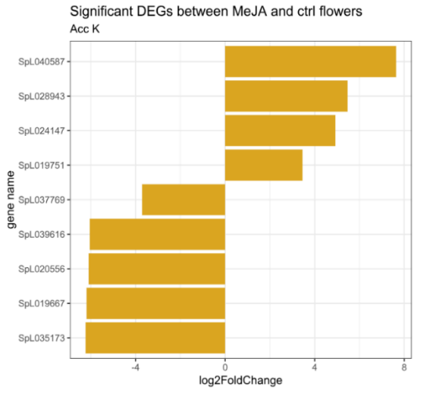
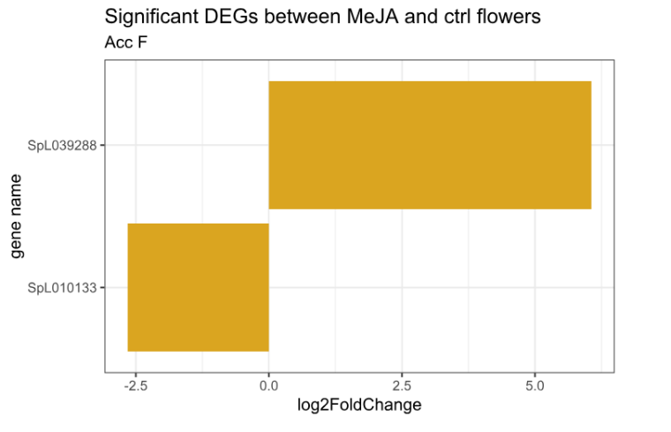
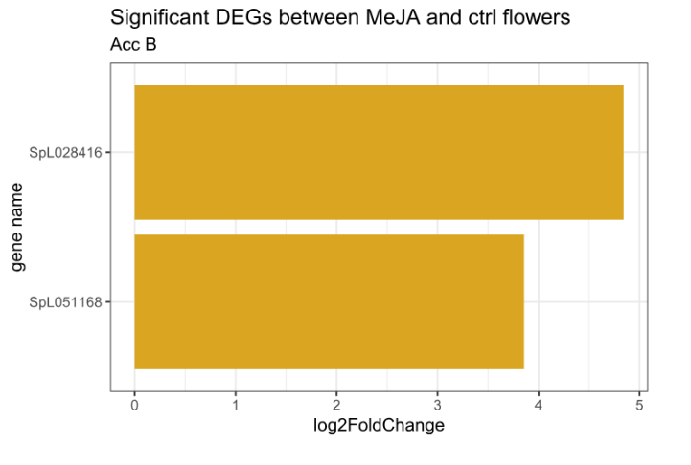
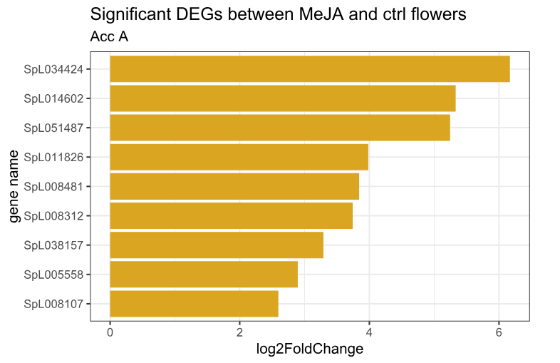
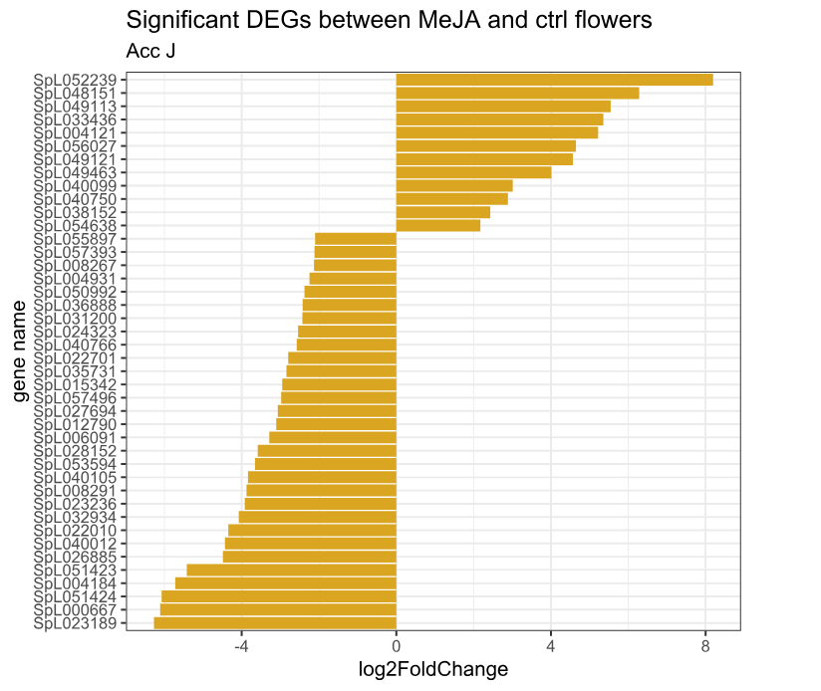
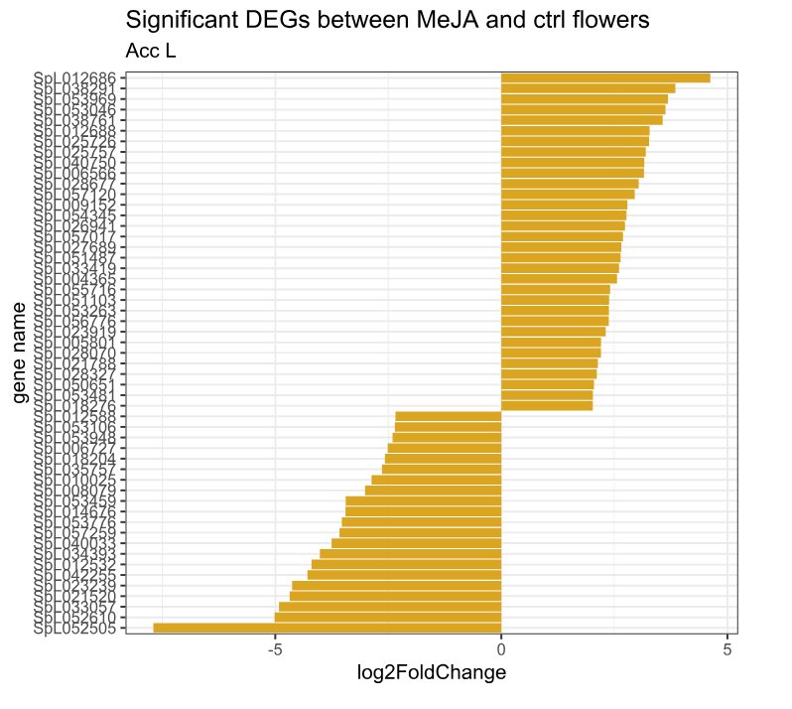
Figure 5: Genes that are differentially expressed between the control and MeJA-treated flowers of each accession: a) Accession A, b) Accession F, c) Accession B, d) Accession K, e) Accession L f) Accession J. Genes with positive log2FoldChange were overexpressed in MeJA-treated flowers compared to control flowers. Negative log2FoldChange indicates genes were more highly expressed in control flowers.
SC Accession A
SC Accession F
SC Accession B
SI Accession K
SI Accession L
SI Accession J
a)
b)
c)
d)
e)
f)
There was some overlap between accession DEGs in SC flowers, however there was no
overlap in genes significantly differentially expressed in response to treatment in the SI flowers which explains the lack of induced response noted when mating systems were grouped.
GO term enrichment analysis was conducted for lists of DEGs identified within flowers of each accession in response to MeJA treatment (supplementary). Genes upregulated in Accession A flowers were associated with one GO term (GO:0080065) which is involved with 4-alpha-methyl-delta7-sterol oxidation.
There were no GO terms enriched in the genes upregulated in Accession J flowers, but two GO terms were enriched in the downregulated genes; ‘quercetin 3-O-glucosyltransferase activity’ (GO:0080043) and ‘quercetin 7-O-glucosyltransferase activity’ (GO:0080044). KEGG analysis of the DEGs for accession J flowers showed terms involved in metabolism and information procession were downregulated associated with genes downregulated in the treated flowers, and that KEGG terms associated with metabolic pathways and energy metabolism were enriched in the genes upregulated in treated flowers.
One GO term enriched for the genes upregulated in treated flowers in Accession K: ‘isoleucine-tRNA ligase activity’ (GO:0004822). No GO terms were enriched in the list of downregulated genes.
Genes upregulated in Accession L flowers were associated with one GO term: ‘response to wounding’ (GO:0005576). One GO term was enriched in the downregulated genes in Accession L flowers ‘chloroplast rRNA processing’ (GO:1901259). KEGG analysis of the upregulated genes in treated accession L flowers yielded 15.6% of sequences annotated, and the KEGG terms that were associated with these included ‘metabolic pathways’ (K00679), ‘biosynthesis of secondary metabolites’ (K14641) as well as terms associated with environmental information processing pathways. KEGG analysis of downregulated genes in treated accession L flowers yielded 14.3% annotated genes, with two associated KEGG terms, one in the genetic information processing (00970) and a term associated with organismal systems (04750).

3.4.6 Differential response to MeJA treatment between selfing and outcrossing leaves
In leaves, a total of 21268 genes had a non-zero read count. A total of 5 genes were found to be significantly (p-adj < 0.01) differentially expressed in response to damage in both selfing and outcrossing leaves. When using a p-adj < 0.05, 6 DEGs were found to be significant. Of these, two genes were successfully identified using NCBI blastn: SpL012450 as a probable aquaporin gene, and SpL021942 as a DEFECTIVE IN MERISTEM SILENCING 3-like gene (Supplementary Table 3).
Selfing and outcrossing leaf data was then analysed separately to look for patterns that may be missed by introducing complexity (i.e., interaction term) to the Deseq model design. Analysing the leaf data by separate mating systems allowed identification of lists of genes expressed in control and MeJA-treated leaves, and produce lists of differentially expressed genes. In leaves, control plants were used as the baseline level, so genes classed as ‘upregulated’ had higher counts in treated leaves, and genes classed as ‘downregulated’ occurred less in treated than control leaves.
In SC leaves, 20341 genes had a non-zero read count, of which 236 genes were found to be significantly differentially expressed (padj < 0.05, log2FoldChange > 2). There were 216 upregulated genes and 20 downregulated genes identified in SC leaves in response to MeJA treatment. In SI leaves, 20256 genes were identified, of which 315 DEGs passed the significance cut-offs. There were 274 upregulated and 41 downregulated DEGs identified.
Blastn against Solanum lycopersicum was conducted for the overlapping genes downregulated in both SC and SI MeJA-treated leaves. Four of the five common DEGs were identified, two were protochlorophyllide oxidoreductase genes, one was a predicted kinesin-like protein, NACK2, and one was an a-b binding protein (Supplementary Table 3).

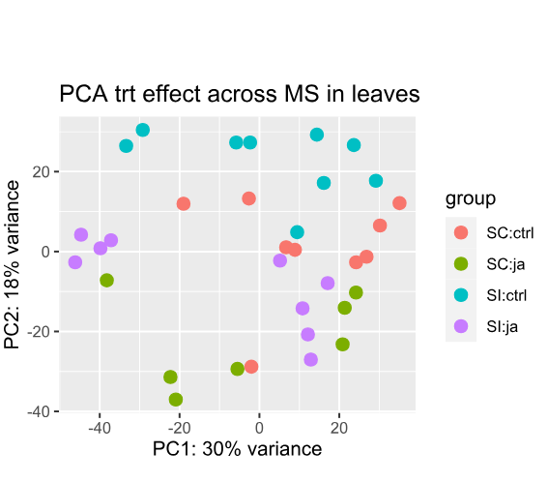
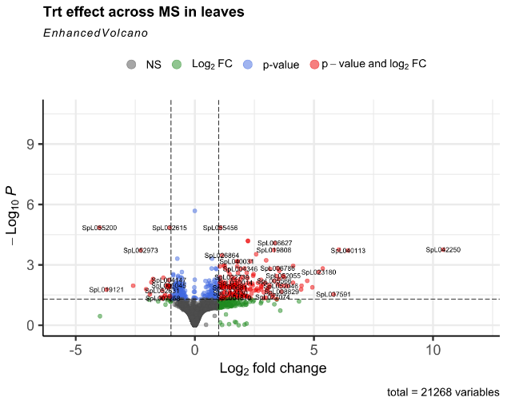
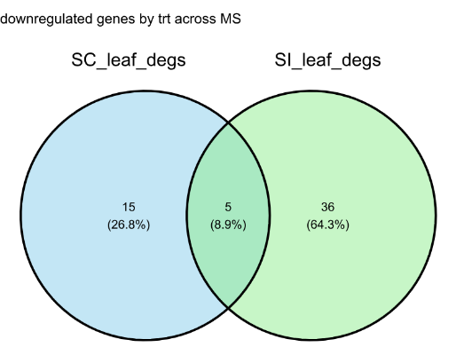
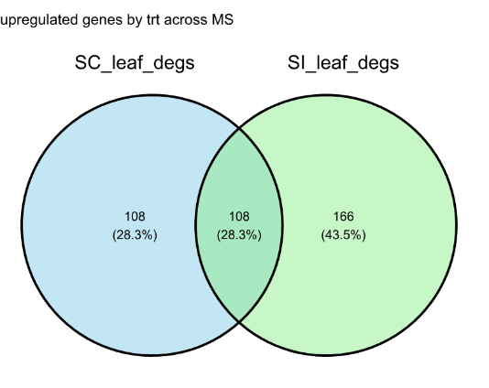
Figure 6: Differences between control and MeJA-treated leaf transcriptomes. a) Volcano plot showing genes significantly differentially expressed between control and MeJA-treated leaves. Red dots denote genes which have log2FoldChange > 2 and a P-value < 0.05. b) Principal component analysis loadings plot showing clustering of the leaf samples by mating system and slightly by treatment. C) Venn diagram shows comparison of genes upregulated in MeJA-treated self-compatible (blue, left) and self-incompatible leaves (green, right). d) Venn diagram illustrating comparison of DEGs downregulated in MeJA-treated self-compatible and self-incompatible leaves.
a)
b)
c)
d)

KEGG analysis of genes downregulated in MeJA-treated leaves revealed overrepresentation of protein family metabolism, metabolism of terpenoids and polyketides, environmental information processing and cellular processes in both SC and SI leaves. KEGG pathways that were overrepresented in the upregulated DEGs in response to treatment in SI leaves included terms such as ‘biosynthesis of other secondary metabolites’, ‘carbohydrate metabolism’ and ‘metabolism of cofactors and vitamins’. In SI leaves, 17 terms associated with ‘Biosynthesis of secondary metabolites’ were overrepresented in the upregulated by treatment genes, including K01723 which is linked with jasmonic acid biosynthesis. Fewer KEGG terms were found in the list of upregulated DEGs in SC leaves, but ‘biosynthesis of other secondary metabolites’ and ‘carbohydrate metabolism’ were overrepresented. In SC leaves, the KEGG term 00940 (phenylpropanoid biosynthesis) had two associated orthologies: K00430 which is a peroxidase in the phenylpropanoid pathway, and K12356 which is a coniferyl-alcohol glucosyltransferase in the phenylpropanoid pathway, and a third term K01601 which is in the secondary metabolite biosynthesis pathway (all three entries are in the ‘Biosynthesis of secondary metabolites’ pathway). KEGG analysis of the intersect of genes upregulated in treated leaves in both selfers and outcrossers had 19.4% of input genes (21 of 108 genes) annotated, including phenylpropanoid biosynthesis (K00940), flavonoid biosynthesis (00941) and stilbenoid, diarylheptanoid and gingerol biosynthesis (K00945).
Genes that were only upregulated in either SC or SI leaves were also investigated. No GO terms were found associated with the genes upregulated in SI leaves, so further analysis was conducted to attempt to determine the functions of the genes that were significantly upregulated in only SI leaves. KEGG analysis of the genes upregulated in only SI leaves had 21.2% annotated (35 out of 108 genes). KEGG pathways that were enriched in this list of genes included four genes in the phenylpropanoid biosynthesis pathway (KEGG 00940). In SI leaves, 12 genes upregulated in MeJA treated leaves were associated with the ‘biosynthesis of secondary metabolites pathway (KEGG 01110). The KEGG term K00487 associated with flavonoid biosynthesis was present.
Six GO terms representing biological processes were enriched in the genes upregulated in only SC leaves. These included ‘L-phenylalanine metabolic process’ (GO:0006558) which may be interesting as phenylalanine is a precursor molecule to several important secondary metabolites including phenylpropanoids and flavonoids, as well as other compounds involved in growth, reproduction and defence against biotic and abiotic stresses (Pascual et al., 2016). The KEGG analysis of genes upregulated in SC MeJA treated leaves found fewer genes associated with KEGG terms for ‘amino acid metabolism’ and ‘environmental information processing’ than in SI leaves. Fewer phenylpropanoid pathway genes (KEGG:00940) were identified in the KEGG pathway analysis of genes upregulated in SC leaves only, though there were 6 genes associated with the overview pathway of ‘Biosynthesis of secondary metabolites’ including K00626, K01601, K01648, K12356, K 14157 and K14641. Terms associated with zeatin biosynthesis were not found in the list of genes exclusively upregulated in SC leaves, but they were in SI leaves.

4.3.7 Differential response to treatment in leaves and flowers of each accession
Within each accession, fewer genes were differentially expressed between control and treated flowers than between control and treated leaves. Overall, more genes were upregulated in MeJA-treated leaves than were downregulated. The leaves of accession A had more genes responding to treatment than leaves of other accessions, and there was more variation in the number of DEGs identified in the leaves between the selfing accessions (A, B, F) than the outcrossing accessions (J, K, L).
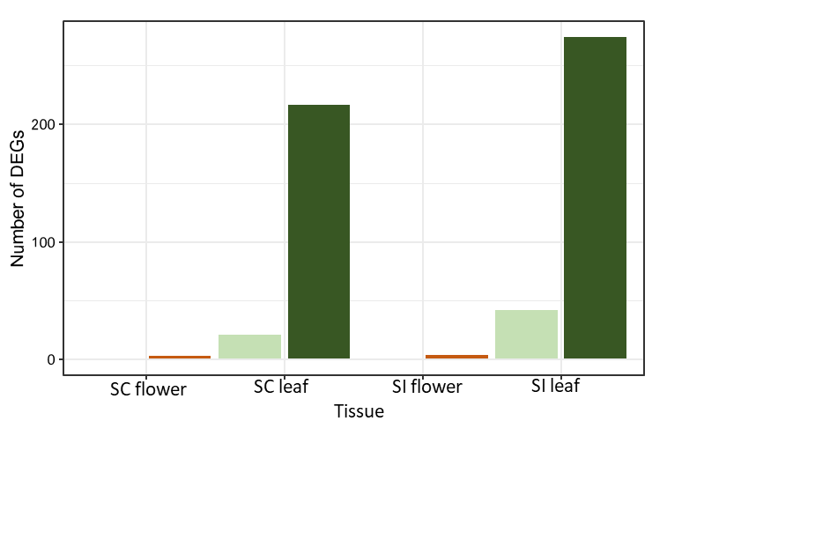
b)
a)
Figure 7: Number of genes that are significantly differentially expressed in flowers and leaves of each a) accession and b) averaged across mating system. Dark orange and dark green bars show upregulated genes, and pale yellow and pale green show downregulated genes.
SC
SI
SC
SI
Upregulated in MeJA plants
Accession
Downregulated in MeJA plants
To determine whether the transcriptomic changes observed in leaves and flowers may be similar, the genes that were differentially expressed between treated and control leaves and between treated and control flowers were compared. Very few genes were commonly upregulated in MeJA-treated leaves and flowers with no commonly upregulated genes between the leaves and flowers in Accession B, Accession F, and Accession K, and fewer than five common DEGs were upregulated in both leaves and flowers of Accession A, Accession J and Accession L (Figure 9a). No genes were commonly downregulated in MeJA- treated leaves and flowers in Accession F (Figure 9b). One single gene was commonly upregulated in the MeJA-treated leaves and flowers of Accessions J, K and L, however this was not the same gene across the accessions.

Figure 8: Few genes are commonly responding to MeJA treatment in the leaves and flowers of each accession. More genes are differentially expressed in leaves than flowers between treated and control plants. a) Venn diagrams showing genes upregulated in response to damage in leaves (green, left) and flowers (yellow, right) and the intersecting genes that are upregulated in both leaves and flowers of each accession. b) Venn diagrams showing genes downregulated in response MeJA-treated leaves (green, left) and flowers (yellow, right), and the genes downregulated in both treated leaves and flowers relative to control tissue.
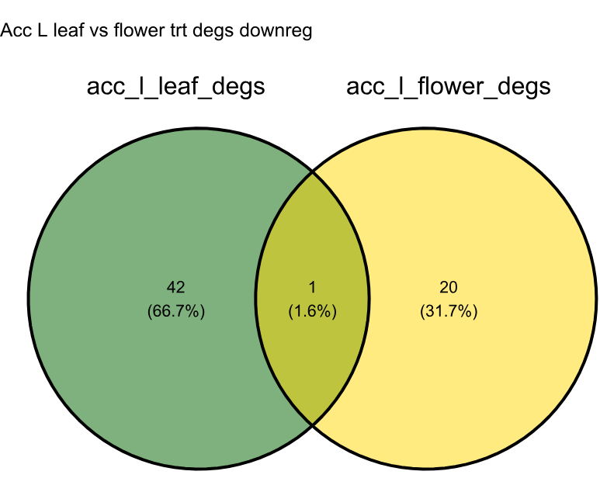
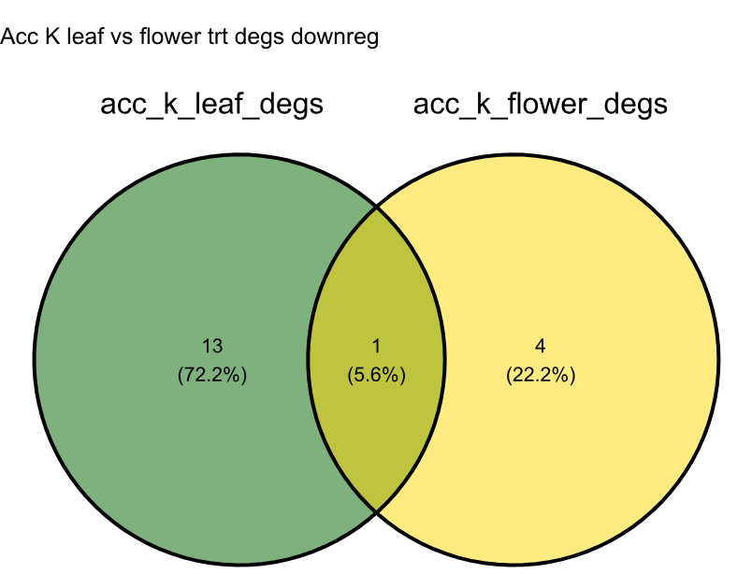
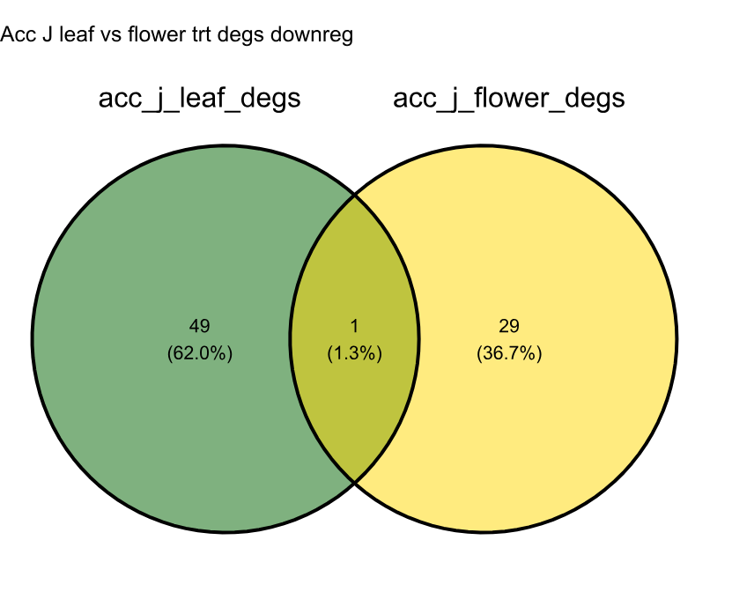
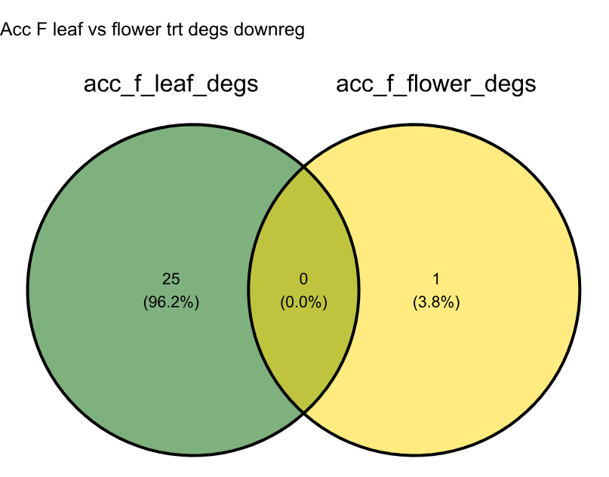
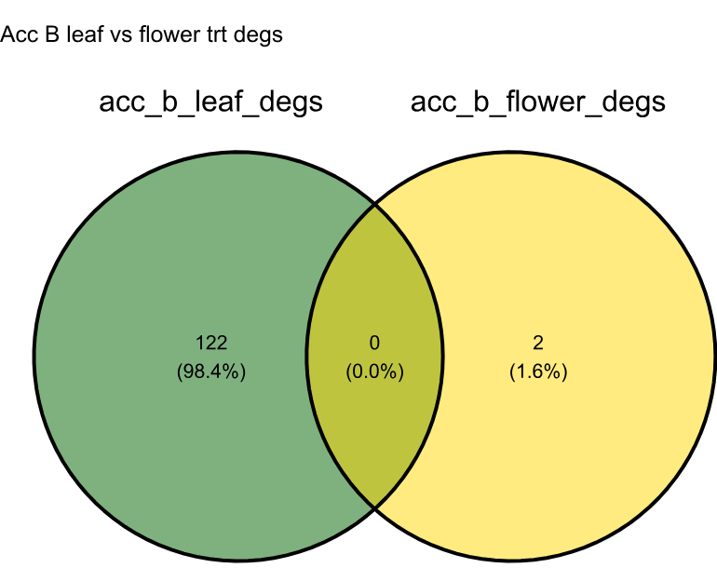
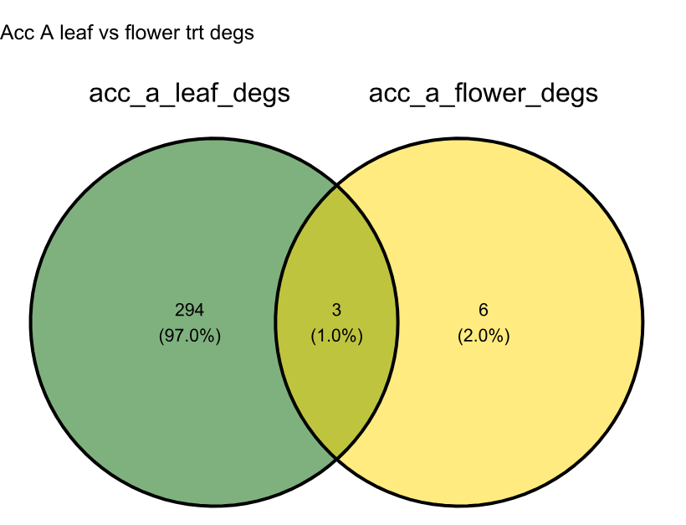
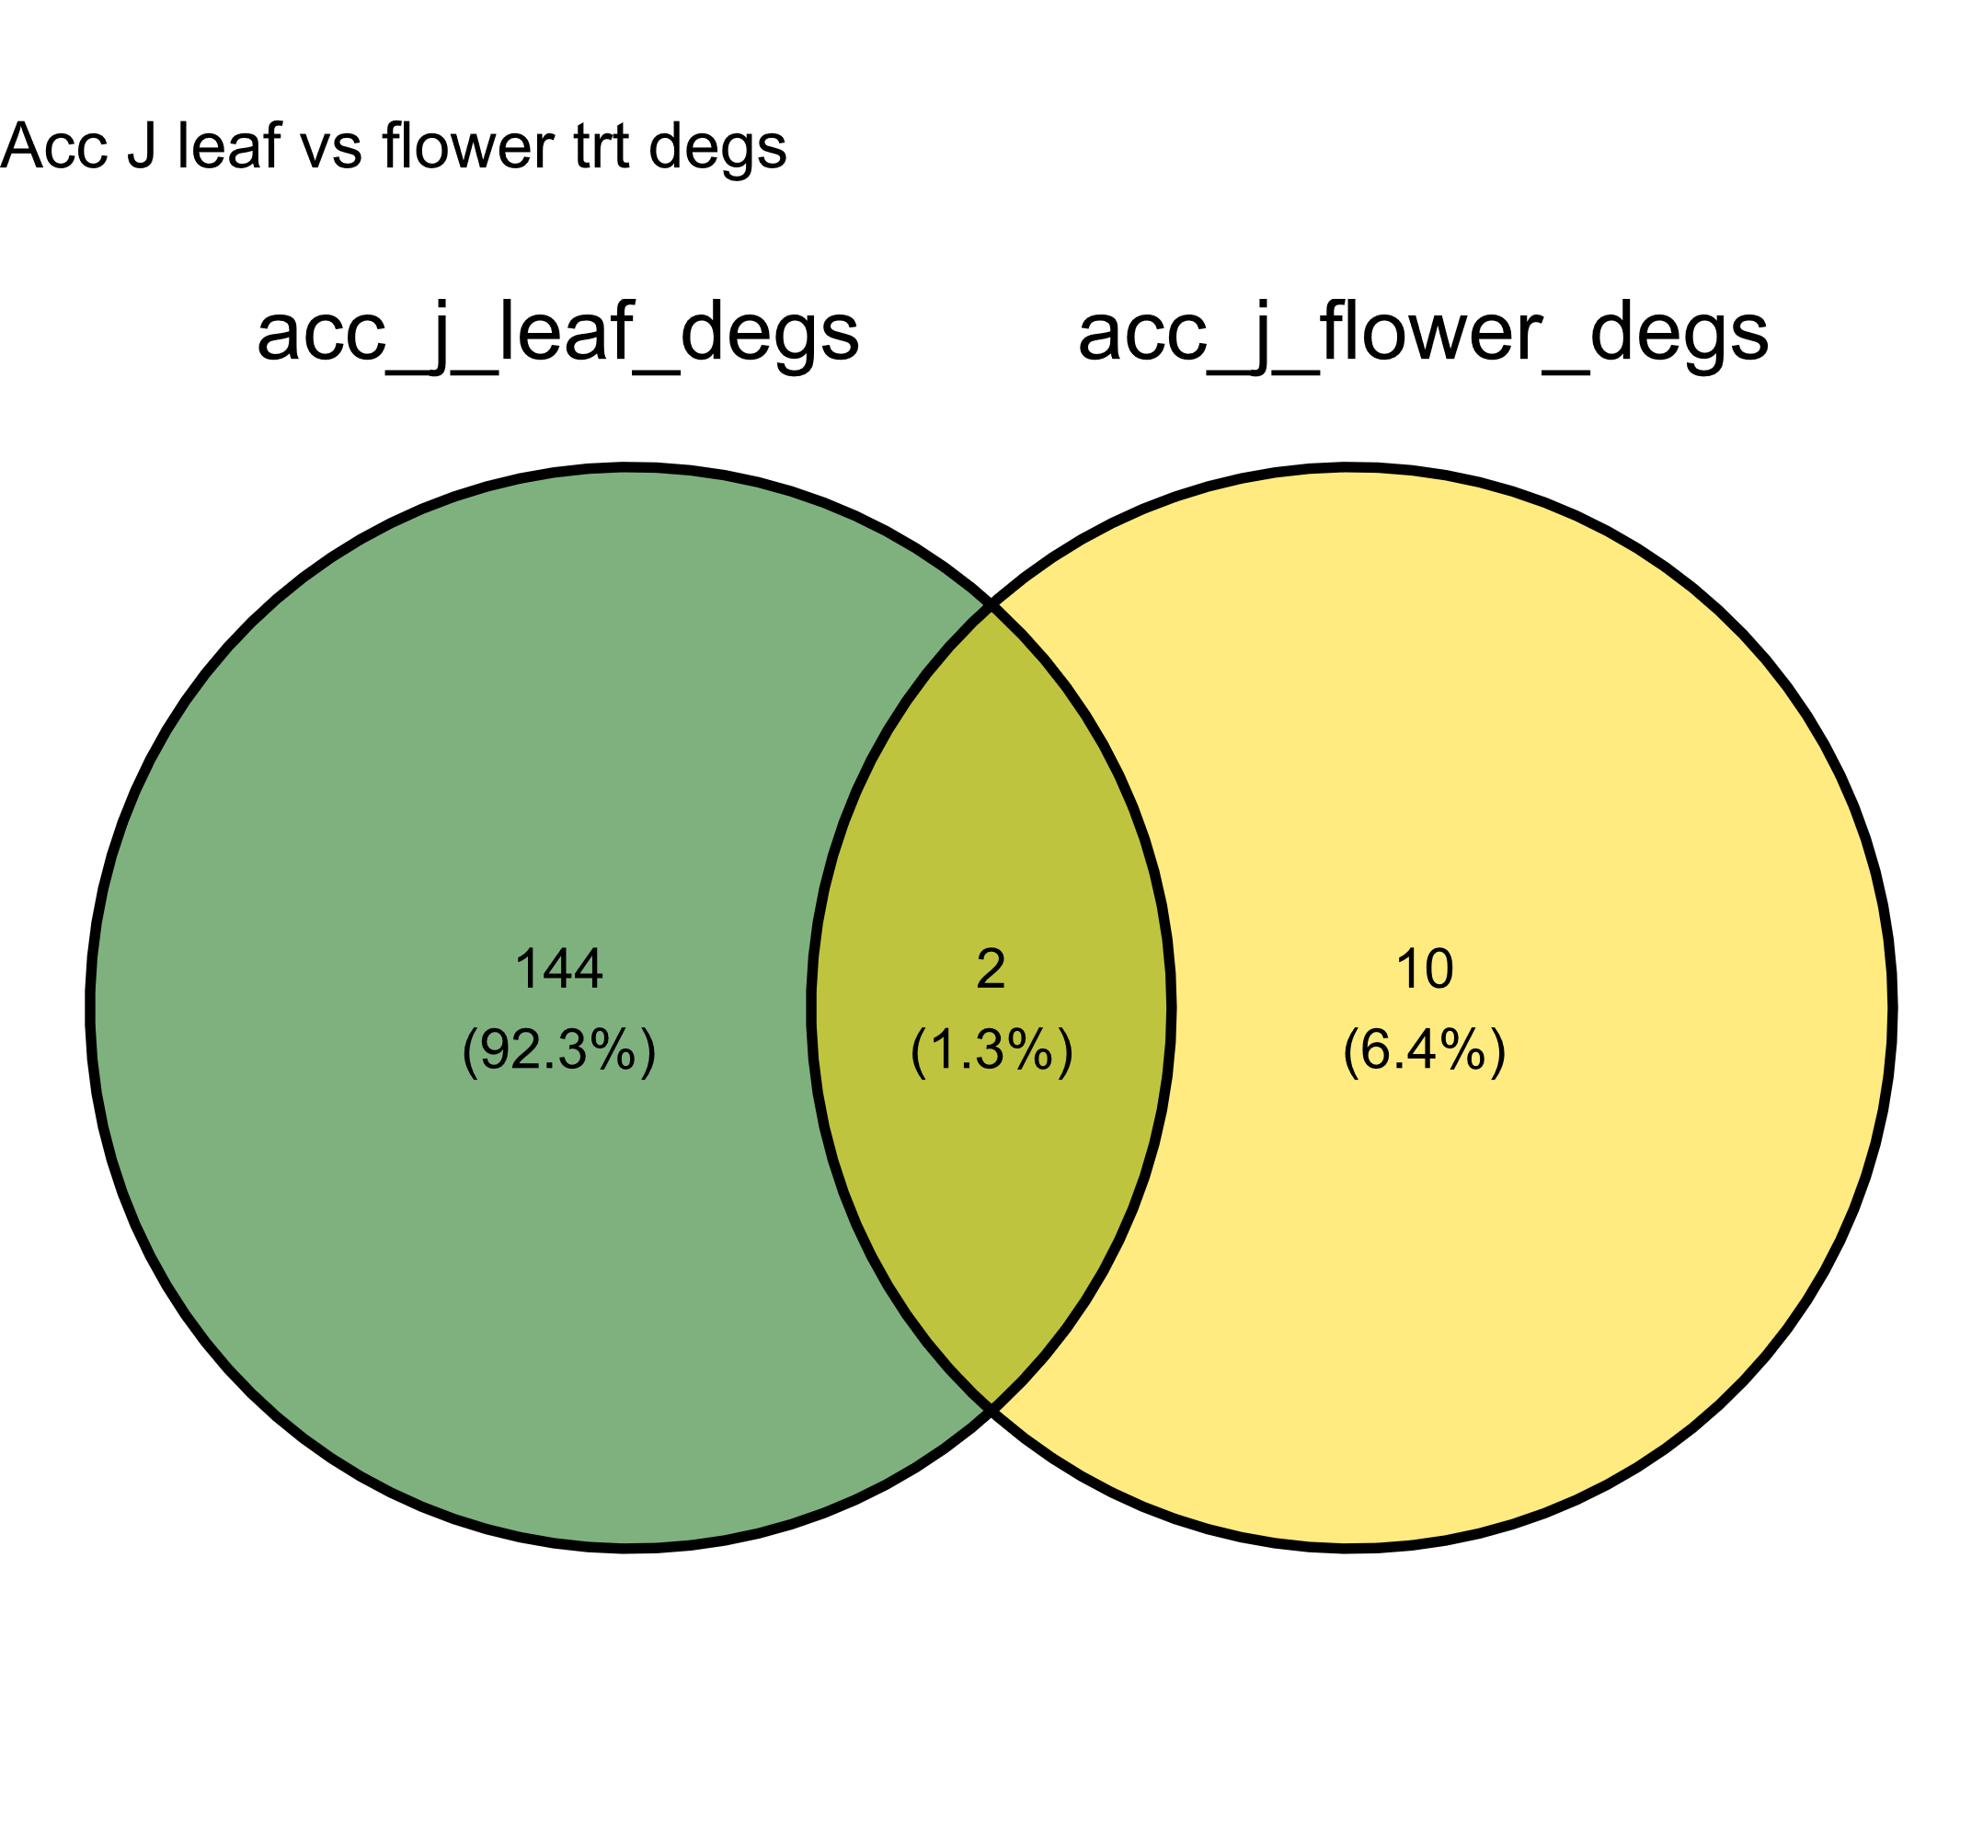
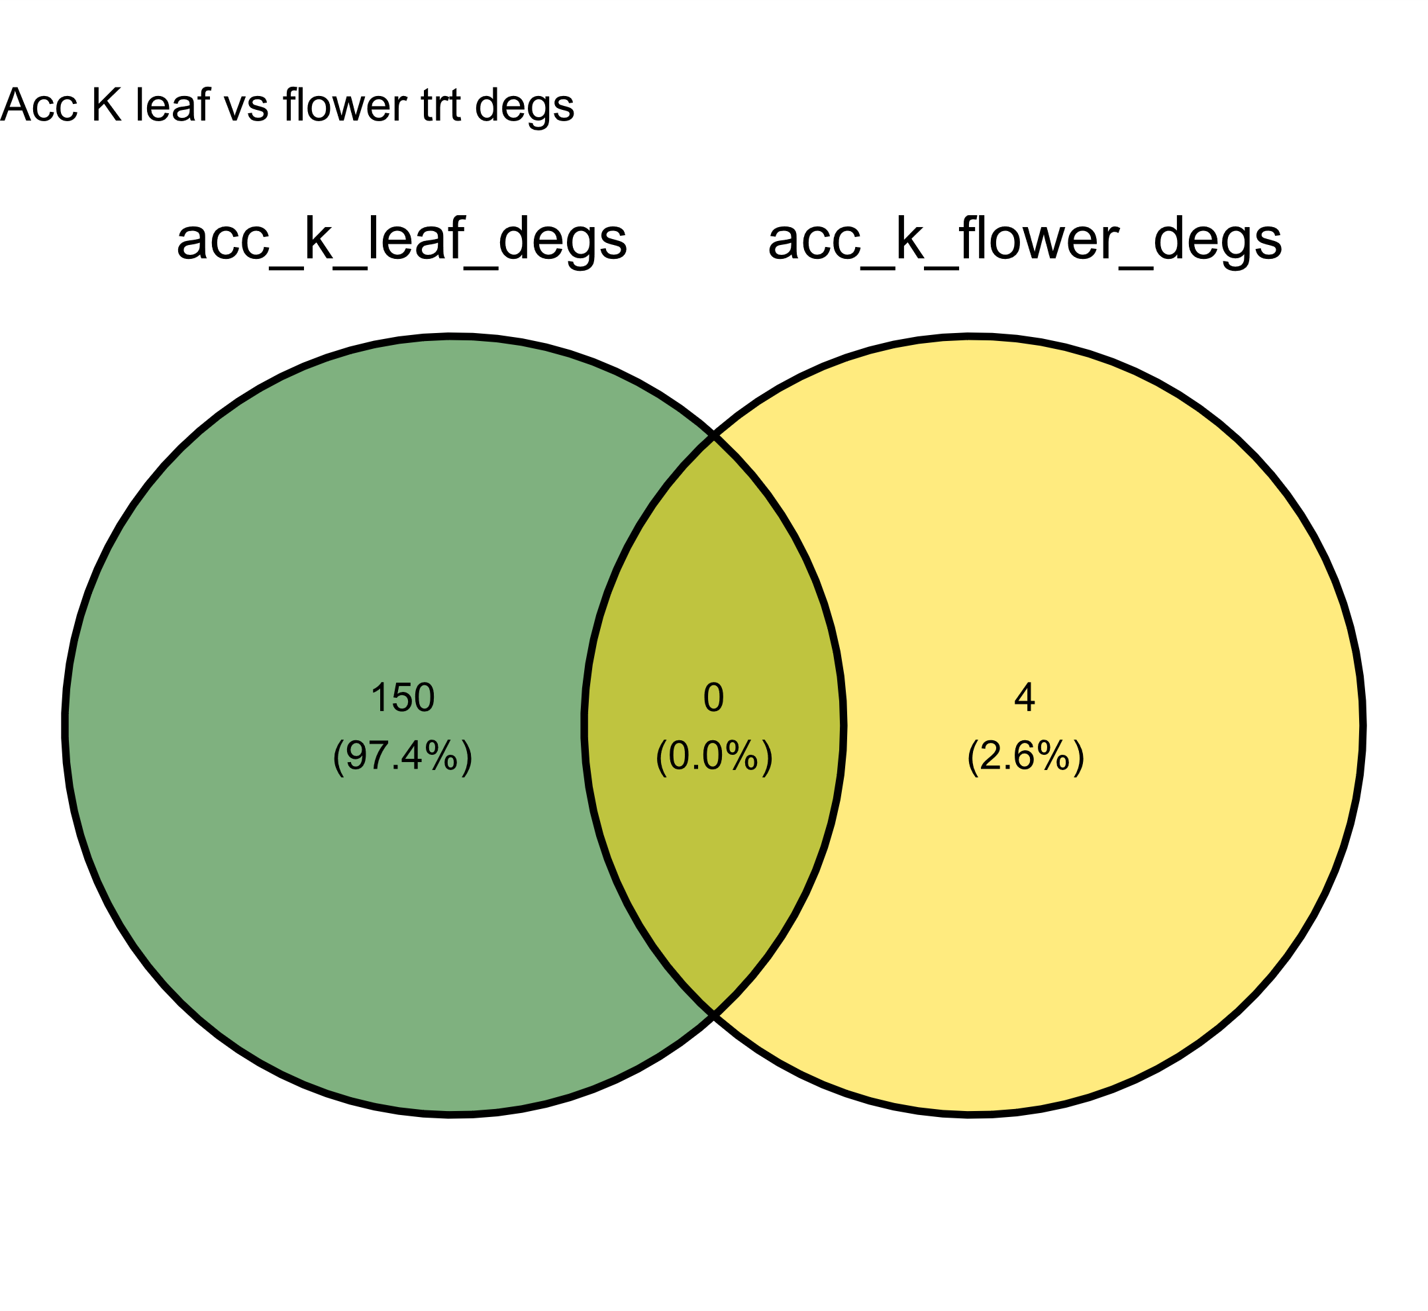
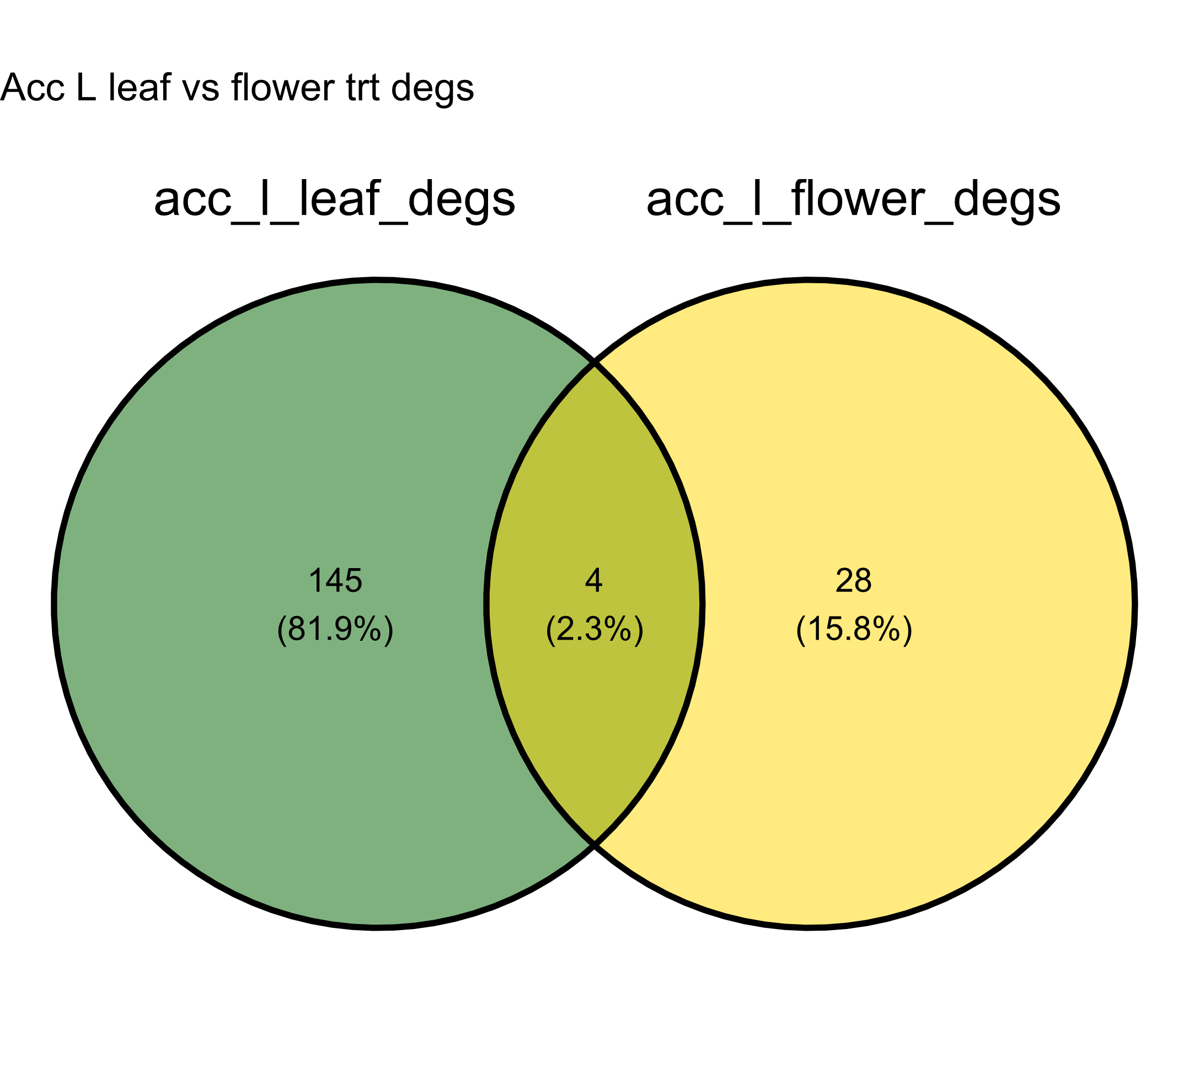
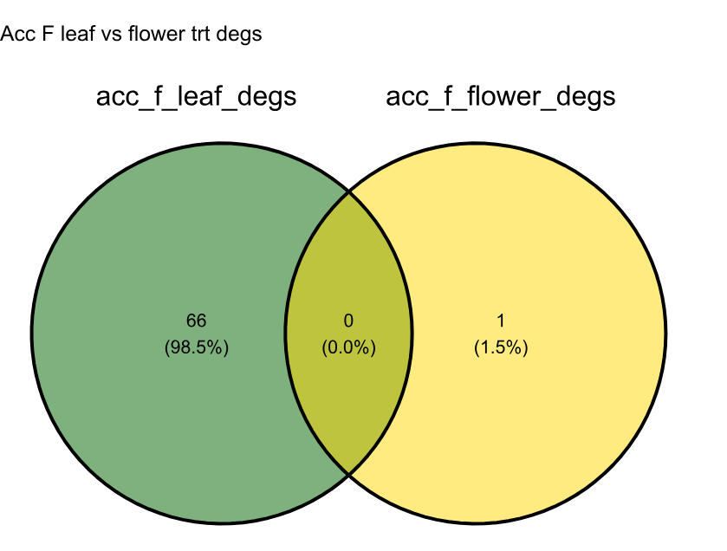
The single genes commonly downregulated in both leaves and flowers of accession J is SpL035731, accession K is SpL039616, and in accession L is SpL040033.
SI
SC
SI
SC
a)
b)
Of the genes commonly upregulated in both MeJA-treated leaves and flowers of each accession, none were common to multiple accessions. These genes can be found listed in Supplementary table 1.

3.5 Discussion
This study provided an understanding of the general transcriptional differences of leaves and flowers of selfing and outcrossing accessions of S. pennellii and shows that there may be patterns in defence driven by the transition from selfing to outcrossing, particularly in floral tissue. The results suggested that leaf and flower defence pathways are differentially regulated at a transcriptional level, and that mating system effects are different between the tissues. Pathways associated with secondary metabolite production were upregulated in MeJA-treated leaves, confirming that MeJA elicits induction in at least part of the plant. Only a handful of genes were upregulated in MeJA-treated flowers which provides strong evidence for reduced plasticity in flowers which is not present in leaves. There were some differences in the transcriptomes of SC and SI leaves and flowers, suggesting the potential for mating system-specific regulation of gene expression. This study is one of few studies to investigate constitutive and inducible defence in multiple wild populations (Campbell and Kessler, 2013; Carr and Eubanks, 2014), which allows us to identify patterns in defence that can be detected across the environmental range of S. pennellii, such as the pattern for reduced plasticity to MeJA-treatment in flowers compared to leaves. Stabilising selection for consistent floral traits acts across the populations used in this study.

3.5.1 Mating system differences in flowers and leaves
Several studies have shown flower constitutive defences to be higher than those of leaves (Strauss, Irwin and Lambrix, 2004; Damle et al., 2005; Alves et al., 2021; Chrétien et al., 2022), and as constitutive and induced defences are often presented as alternative strategies of defence (Karban and Baldwin, 1997), it may be reasonable to expect production of these defences to be moderated by different genes. In S. pennellii, chemical analysis revealed that constitutive levels of phenolic defences were higher in flowers than leaves, and significantly higher in selfing flowers compared to outcrossing flowers (Chapter 2, Figure 2). Comparing the genes that are differentially expressed between selfing and outcrossing flowers may allow the identification of the mechanisms for selfing floral defence compared to outcrossing floral defence. Mating system differences in gene expression in control flowers were identified in this study. The PCA plot revealed grouping between accessions A and B, which is to be expected as these selfing populations are geographically close and may experience periodic gene flow and/or similar selection pressures. The self-incompatible accessions cluster on the left of the PCA plot, whilst the intermediate SC/SI accession F clusters broadly between the selfing and outcrossing accessions, as would be expected due to the intermediate mating system of accession F. In contrast, mating system appears to have less effect on clustering of control leaves. This suggests that the pollinator reliance of plants has a greater influence on the floral transcriptome than that of leaves, which was consistent with the direct interaction between flowers and pollinator visitors.
The genes that were more highly expressed in outcrossing flowers compared to selfing flowers are associated with GO terms such as ‘response to heat’, ‘response to temperature stimulus’ and ‘protein folding’. These may be important to outcrossing flowers as ways to mediate flower attractiveness to pollinators which may increase in the warmer daytime temperatures than nighttime temperatures, due in part to the major pollinators of Solanum pennellii flowers being bees which forage within certain temperature ranges. Future work considering the implication of response to temperature being a mating system-specific trend would facilitate greater understanding of the interactions between pollinators and plant phenotype. These GO terms were not overexpressed in leaves, providing further evidence for tissue-specific mating system effects. The GO terms that were more highly expressed in outcrossing leaves compared to selfing leaves included ‘zeatin biosynthesis’ and ‘biosynthesis of secondary metabolites’ which could be involved in leaf chemical defence production.
Fewer genes were more highly expressed in both outcrossing leaves and flowers compared to selfing leaves and flowers. Outcrossing leaves and flowers commonly had higher expression of genes involved in secondary metabolite biosynthesis. A lipoxygenase (LOX2S) gene involved in the jasmonic biosynthesis pathway was identified as being more highly expressed in the outcrossing control leaves and flowers. LOX genes are widely distributed in plants and play key roles in resistance to biotic and abiotic stress (Viswanath et al., 2020). A gene involved in abscisic acid biosynthesis was expressed more highly in outcrossing leaves as well as outcrossing flowers; the orthologue gene in Arabidopsis thaliana was identified to encode for catalysis of the final step in the abscisic acid biosynthesis in the leaves of A. thaliana (Seo et al., 2000). Abscisic acid is involved in seed development and germination as well as responses to environmental stressors (Finkelstein, 2013; Bharath, Gahir and Raghavendra, 2021).

There is a greater tissue overlap in genes that are more highly expressed in the control selfing flowers and leaves (compared to outcrossing tissues) than genes that are more highly expressed in the control outcrossing flowers and leaves. This pattern is consistent with our hypothesis that flowers and leaves would be differentially defended. In the outcrossing plants, the flowers and leaves may experience greater differences in tissue-specific selection on defence gene expression due to their interactions with pollinators; the flowers must attract pollinators to ensure reproductive success whilst leaves do not have to fulfil this function. This degree of difference in ecological interactions between the leaves and flowers of selfing plants may be less extreme, so biochemical processes in the leaves and flowers may be more similar across the two tissues of the selfing plants. Flower and leaf defence may be linked (Adler et al., 2012), which could be due to pleiotropy and linkage between leaf and floral defence traits (Johnson, Campbell and Barrett, 2015), or duality in the roles of phytohormones regulating plant defence and flower traits (Dobritzsch et al., 2015; Rasmann et al., 2018). Despite this, we found evidence that the transcriptomes of flowers and leaves are divergent, suggesting leaf and flower defence are under selection by different agents (Campbell, 2015b; Roddy et al., 2021).

The genes that are commonly higher across the tissues in either mating system may be of interest in understanding the genetic mechanisms that are involved in maintaining either self-incompatibility, or in the case of the selfing plants, that are promoting self-compatibility. The genes that are ‘mating system-specific’ across both leaves and flowers have not been the source of many, if any, previous studies. These results suggest there may be interesting transcriptomic differences at many levels within the plant: leaves and flowers show mating system specificity in their transcriptomes, and whilst there is overlap between some of the genes and pathways in these two tissues, there are also differences that could be explored from both ecological and evolutionary perspectives. Few genes are commonly upregulated in both leaves and flowers in response to MeJA treatment which implies that the mechanisms responding to defence stimuli in the tissues are distinct, suggesting different agents for selection act on defence in leaves compared to flowers. The distinction between DEGs between leaves and flowers supports the results of our prior study investigating phenolic content in the plant tissues, in which distinct phenolic profiles were found between leaves and flowers (Chapter 2). The selection by pollinators for consistent floral chemistry does not seem to constrain leaf inducibility.

One of the main purposes of this study was to identify the potential for differential expression of induced defence genes across the leaves and flowers of selfing and outcrossing plants so further analysis of the transcriptomes of the untreated tissues is outside the scope of this study. Future work could build on the findings of this study, including searching for particular defence genes in the jasmonate pathway, and loci associated with defence production, which could allow further understanding of divergence of defence mechanisms between selfing and outcrossing leaves and flowers.

3.5.2 Stability of floral gene expression in response to a ubiquitous biotic stress signal
Fewer differentially expressed genes were identified in selfing flowers than outcrossing flowers between control and MeJA-treated plants. One explanation for this could be that flowers rely on a constitutive defence strategy due to the high importance of flowers to a plant, as predicted by Optimal Defence Theory (McKey, 1974). As constitutive and induced defences are evolutionarily alternative defence strategies (Campbell and Kessler, 2013), it may be the case that the plasticity of flowers is constrained by their reliance on high constitutive defences. In addition, pollinators may be deterred by increases in floral defence compounds (Kessler, Halitschke and Poveda, 2011a; Moreira et al., 2019), and the high constitutive defences in flowers may be at the highest threshold level that flowers can produce before the occurrence of negative impacts of floral defence on pollinator attraction. Consequently, flowers may not produce strong responses to damage as a method of reducing the ecological cost of defence. Changes to floral secondary chemistry can deter pollinators (Kessler, Halitschke and Poveda, 2011a), so it is possible that the lack of transcriptomic response to MeJA treatment is an adaptive strategy to ensure pollinator attraction, which could lead flowers to rely on a constitutive rather than inducible defence strategy.
In this study, the flowers of outcrossing plants had more genes that were differentially expressed between treated and control plants. This may indicate the presence of inbreeding depression in these populations, as it is known that inbreeding can lead to reduced plasticity of defence phenolics (Campbell et al., 2014). It is however unlikely that these plants were experiencing inbreeding depression as no phenotypic traits associated with inbreeding depression (Abdelaziz et al., 2014) were observed. This also seems unlikely when considering that transcriptomic differences were observed in treated plants of selfing accessions. The results of this study seem to suggest that the plasticity to damage is lower in selfing flowers than outcrossing flowers, but that this mating system difference is not observed as strongly in the leaves. Overall, the results from this transcriptomic study support the pattern for high constitutive defence and no induced response to MeJA treatment in the phenolic content of the flowers S. pennellii plants (Chapter 2). Lack of treatment effect on gene expression in flowers suggests a lack of inducibility in flowers, which reflects results from HPLC data using these samples in which no treatment effect was found. The one gene that was upregulated in MeJA-treated selfing flowers is predicted to be an apyrase gene which could have numerous roles in the plant, though apyrases are increasingly identified for their role in plant stress response (Clark et al., 2021). In S. pennellii, the flowers have much higher levels of phenolic defence compounds than do leaves, which could indicate a strong selection from floral herbivores.
Flower defence pathways have been found to be inducible in some species (McCall and Karban, 2006; Li et al., 2017; Chrétien et al., 2018), which could reflect that the flowers of these species are not often under attack by herbivores, and minimise the intrinsic and ecological costs of defence by using an inducible strategy. Exogenous MeJA application induced floral defences in Nicotiana attenuata, a self-compatible species (McCall and Karban, 2006). The induction of floral defences in response to leaf damage may be beneficial if they reduce the likelihood of herbivores damaging floral tissue after eating other plant tissues. The plants used in this study rely on constitutive rather than inducible defences, which may reflect a low likelihood of floral damage over evolutionary periods was experienced by these plants.
Accession-level analysis revealed more DEGs found in outcrossing flowers than selfing flowers. Outcrossing flowers have lower constitutive defences than selfing flowers (Chapter 2), and we may see greater transcriptomic response in outcrossing flowers if outcrossing flowers rely on induced defence strategy. That said, the overall transcriptomic response to MeJA treatment in flowers is significantly smaller than in leaves, and this was observed across all of the accessions used in this study. The genes that were found to be significantly differentially expressed between treatments were not constant between accessions, so there are no ancestral floral defence genes found in the flowers of this study, suggesting that there is no selection for inducible defences in the flowers of S. pennellii. Despite variability between the accessions used in this study, consistency in mating system patterns in transcriptomic trends were observed, providing evidence for convergent evolution of mating system-specific traits between accessions.

3.5.3 Leaf induced response to MeJA treatment
A potential cost of producing defences is a reduction in allocation to other processes such as growth or photosynthesis. Genes that are downregulated in both selfing and outcrossing MeJA-treated leaves compared to control leaves include protochlorophyllide oxidoreductase, which is involved in the light-dependent stages of photosynthesis (Silva and Cheng, 2022) which may suggest that photosynthesis is negatively affected by MeJA treatment. Other genes that were commonly downregulated in MeJA-treated leaves were associated with KEGG terms that may be involved in growth processes; perhaps providing some support for the growth-defence trade-off (GDT) hypothesis. Competition for the limited resources by growth and defence processes has been previously found in some studies.
Transcriptomic studies in Norway Spruce (Picea abies) and whitebark pine (Pinus albicaulis) revealed that MeJA treatment can result in upregulation of genes related to hormone signalling, phenylpropanoid and terpenoid biosynthesis genes (Liu et al., 2017; Wilkinson et al., 2022). These genes are similar to those genes upregulated in MeJA-treated leaves in this study with S. pennellii. In outcrossing leaves, twelve genes upregulated in MeJA-treated leaves were involved with biosynthesis of secondary metabolites, whilst only six genes were associated with this pathway in selfing MeJA-treated leaves. This could suggest a genetic bottleneck effect in the populations of selfing plants compared to outcrossing plants used in this study. The main difference between selfing and outcrossing leaves is the number of genes that are differentially expressed between control and treated tissue.
The GO term for zeatin was more highly expressed in untreated outcrossing leaves than selfing leaves; mechanisms for zeatin production may be lost in selfing leaves. Genes associated with flavonoid and caffeic acid metabolism were upregulated in MeJA-treated leaves, supporting secondary metabolite analysis of these tissues which found significantly higher CA and FA concentrations in treated leaves (Chapter 2).

3.5.4 Comparing MeJA-induced response between flowers and leaves
Lack of treatment effect on gene expression in flowers suggests a lack of inducibility in flowers, which reflects results from HPLC data using these samples in which no treatment effect was found (Chapter 2). Lack of responsiveness to treatment in flowers could be explained by the constraint of the role of flowers in pollinator attraction. As flowers of some accessions show responsiveness to treatment, with metabolic pathways being induced in some accessions, it is clear that flowers are exhibiting some plasticity to damage, but not to the extent of the leaves. There is very little overlap in the genes, or roles of genes, that are differentially expressed in leaves and flowers, even within accessions, supporting our hypothesis response to JA signalling is differentially regulated between leaves and flowers. That there is no similarity in leaf and flower response to treatment provides further evidence for there being a pollinator constraint on floral defence which does not constrain leaf defences as leaves are not directly interacting with pollinators. Previous studies have found that pollinators preferentially visit non-damaged plants (Strauss, 1997), and that changes to floral volatiles can deter pollinators (Moreira et al., 2019). The plants used in this study may avoid this cost of reduced pollinator visitation by limiting floral plasticity to damage, particularly when damage response is systemic rather than local to the flowers. This study has built on previous work in which only leaf without flower response to MeJA (Baldwin, 1996; Wu, Wang and Baldwin, 2008), or conversely, studies in which constitutive floral defences are investigated without investigating leaf defences (Adler et al., 2012; Li et al., 2017).
When leaves and flowers were compared within treatment-mating system combinations, across all of the combinations, GO terms associated with intracellular signalling and transport were overrepresented in the genes downregulated in leaves compared to flowers. GO terms that were overexpressed in leaves were associated with typical leaf functions and phenotypes, and were generally associated with photosynthesis and chloroplasts.

3.6 Conclusions and future directions
This study provides a novel set of comparisons in the field of plant defence; investigating tissue-differences in an experimental system containing plants that are more (outcrossing) and less (selfing) reliant on pollinators. The results of this study support our hypothesis that defence is differentially regulated in leaves and flowers, and has shown that flowers exhibit a significantly lower plasticity to damage than leaves, which is likely to be due to the role of flowers in pollinator attraction. This study has identified genes that are tissue-specific, as well as genes that may be mating system-specific, which provides additional knowledge about plant-herbivore-pollinator interactions. Future work could build on these findings and aim to identify the roles of the genes that are implicated in the production of defence in leaves and flowers of selfing and outcrossing plants.
Understanding the genetic basis of plant defence against herbivores whilst balancing this with pollinator attraction will allow better understanding into the co-evolution of plants, herbivores and pollinators, which has implications for practical development of pest-management strategies. Transcriptome studies such as this can identify genes that are involved in plant defence mechanisms which can inform breeding choices for plants that have naturally high defence against herbivory. That the defence genes in S. pennellii can be induced in leaves but not flowers in response to MeJA treatment is promising for ensuring that food crops can be well defended against attack without affecting the plant interaction with pollinators.
One consideration for future work should be to conduct further transcriptomic and chemical analysis of component flower parts to determine whether, in the case of Solanum species, the corolla tissue and anther cone tissue may be differentially defended, and whether this is under transcriptomic control. In Arabidopsis, it is thought that the sepal may act as a defensive chemical barrier against biotrophic pathogens (Ederli et al., 2015) and could therefore could also provide a defensive role against herbivore damage. A limitation of this study lies in the preliminary nature of this type of study; flower samples included the complete corolla and anther cone, and both male and female structures. This means that differences in gene expression within different flower tissues will be missed in this study for the sake of looking at the overall expression pattern within a flower rather than within its constituent parts.
This study has provided greater insight into the regulation of defence in flowers and leaves in selfing and outcrossing populations, contributing to knowledge on the dynamics of plant-herbivore-pollinator interactions. The study suggests the significant role of pollinators on the evolution of floral defence, and highlights the need for more comprehensive studies into the mechanisms underlying regulation of floral and leaf defence that consider the potential for pollinator reliance to be a key driver for selection on plant defence.

3.7 References
Abdelaziz, M. et al. (2014) ‘Association between inbreeding depression and floral traits in a generalist‐pollinated plant’, Journal of Evolutionary Biology, 27(11), pp. 2495–2506. Available at: https://doi.org/10.1111/jeb.12492.
Adler, L.S. et al. (2012) ‘Reliance on pollinators predicts defensive chemistry across tobacco species’, Ecology Letters, 15(10), pp. 1140–1148. Available at: https://doi.org/10.1111/j.1461-0248.2012.01838.x.
Alasalvar, C. et al. (2001) ‘Comparison of Volatiles, Phenolics, Sugars, Antioxidant Vitamins, and Sensory Quality of Different Colored Carrot Varieties’, Journal of Agricultural and Food Chemistry, 49(3), pp. 1410–1416. Available at: https://doi.org/10.1021/jf000595h.
Alves, F.M. et al. (2021) ‘Physiological and Biochemical Responses of Tomato Plants Grafted onto Solanum pennellii and Solanum peruvianum under Water-Deficit Conditions’, Plants, 10(11), p. 2236. Available at: https://doi.org/10.3390/plants10112236.
Anders, S. and Huber, W. (2010) ‘Differential expression analysis for sequence count data’, Genome Biology, 11(10), p. R106. Available at: https://doi.org/10.1186/gb-2010-11-10-r106.
Anders, S., Pyl, P.T. and Huber, W. (2015) ‘HTSeq—a Python framework to work with high-throughput sequencing data’, Bioinformatics, 31(2), pp. 166–169. Available at: https://doi.org/10.1093/bioinformatics/btu638.
Baldwin, I.T. (1996) ‘Methyl jasmonate-induced nicotine production in Nicotiana attenuata: inducing defenses in the field without wounding’, Entomologia Experimentalis et Applicata, 80(1), pp. 213–220. Available at: https://doi.org/10.1111/j.1570-7458.1996.tb00921.x.
Bharath, P., Gahir, S. and Raghavendra, A.S. (2021) ‘Abscisic Acid-Induced Stomatal Closure: An Important Component of Plant Defense Against Abiotic and Biotic Stress’, Frontiers in Plant Science, 12, p. 615114. Available at: https://doi.org/10.3389/fpls.2021.615114.
Bolger, A.M., Lohse, M. and Usadel, B. (2014) ‘Trimmomatic: a flexible trimmer for Illumina sequence data’, Bioinformatics, 30(15), pp. 2114–2120. Available at: https://doi.org/10.1093/bioinformatics/btu170.
Campbell, S.A. et al. (2014) ‘Plant mating systems affect adaptive plasticity in response to herbivory’, The Plant Journal, 78(3), pp. 481–490. Available at: https://doi.org/10.1111/tpj.12492.
Campbell, S.A. (2015) ‘Ecological mechanisms for the coevolution of mating systems and defence’, New Phytologist, 205(3), pp. 1047–1053. Available at: https://doi.org/10.1111/nph.13212.
Campbell, S.A. and Kessler, A. (2013) ‘Plant mating system transitions drive the macroevolution of defense strategies’, Proceedings of the National Academy of Sciences, 110(10), pp. 3973–3978. Available at: https://doi.org/10.1073/pnas.1213867110.
Carr, D.E. and Eubanks, M.D. (2014) ‘Interactions Between Insect Herbivores and Plant Mating Systems’, Annual Review of Entomology, 59(Volume 59, 2014), pp. 185–203. Available at: https://doi.org/10.1146/annurev-ento-011613-162049.
Chini, A. et al. (2007) ‘The JAZ family of repressors is the missing link in jasmonate signalling’, Nature, 448(7154), pp. 666–671. Available at: https://doi.org/10.1038/nature06006.
Chrétien, L.T.S. et al. (2018) ‘Caterpillars induce jasmonates in flowers and alter plant responses to a second attacker’, New Phytologist, 217(3), pp. 1279–1291. Available at: https://doi.org/10.1111/nph.14904.
Chrétien, L.T.S. et al. (2022) ‘Plant metabolism and defence strategies in the flowering stage: Time-dependent responses of leaves and flowers under attack’, Plant, Cell & Environment, 45(9), pp. 2841–2855. Available at: https://doi.org/10.1111/pce.14363.
Cipollini, D., Walters, D. and Voelckel, C. (2017) ‘Costs of Resistance in Plants: From Theory to Evidence’, in Annual Plant Reviews online. American Cancer Society, pp. 263–307. Available at: https://doi.org/10.1002/9781119312994.apr0512.
Clark, G. et al. (2021) ‘Recent Advances Clarifying the Structure and Function of Plant Apyrases (Nucleoside Triphosphate Diphosphohydrolases)’, International Journal of Molecular Sciences, 22(6), p. 3283. Available at: https://doi.org/10.3390/ijms22063283.
Creelman, R. and Mullet, J. (1997) BIOSYNTHESIS AND ACTION OF JASMONATES IN PLANTS | Annual Review of Plant Biology. Available at: https://www-annualreviews-org.sheffield.idm.oclc.org/doi/full/10.1146/annurev.arplant.48.1.355 (Accessed: 29 February 2024).
Damle, M.S. et al. (2005) ‘Higher accumulation of proteinase inhibitors in flowers than leaves and fruits as a possible basis for differential feeding preference of Helicoverpa armigera on tomato (Lycopersicon esculentum Mill, Cv. Dhanashree)’, Phytochemistry, 66(22), pp. 2659–2667. Available at: https://doi.org/10.1016/j.phytochem.2005.09.006.
Dobin, A. et al. (2013) ‘STAR: ultrafast universal RNA-seq aligner’, Bioinformatics, 29(1), pp. 15–21. Available at: https://doi.org/10.1093/bioinformatics/bts635.
Dobritzsch, S. et al. (2015) ‘Dissection of jasmonate functions in tomato stamen development by transcriptome and metabolome analyses’, BMC Biology, 13(1), p. 28. Available at: https://doi.org/10.1186/s12915-015-0135-3.
Ederli, L. et al. (2015) ‘Arabidopsis flower specific defense gene expression patterns affect resistance to pathogens’, Frontiers in Plant Science, 6. Available at: https://doi.org/10.3389/fpls.2015.00079.
Finkelstein, R. (2013) ‘Abscisic Acid Synthesis and Response’, The Arabidopsis Book / American Society of Plant Biologists, 11, p. e0166. Available at: https://doi.org/10.1199/tab.0166.
Fonseca, S. et al. (2009) ‘(+)-7-iso-Jasmonoyl-L-isoleucine is the endogenous bioactive jasmonate’, Nature Chemical Biology, 5(5), pp. 344–350. Available at: https://doi.org/10.1038/nchembio.161.
Frölich, C., Ober, D. and Hartmann, T. (2007) ‘Tissue distribution, core biosynthesis and diversification of pyrrolizidine alkaloids of the lycopsamine type in three Boraginaceae species’, Phytochemistry, 68(7), pp. 1026–1037. Available at: https://doi.org/10.1016/j.phytochem.2007.01.002.
Gatehouse, J.A. (2002) ‘Plant resistance towards insect herbivores: a dynamic interaction’, New Phytologist, 156(2), pp. 145–169. Available at: https://doi.org/10.1046/j.1469-8137.2002.00519.x.
Hickman, R. et al. (2017) ‘Architecture and Dynamics of the Jasmonic Acid Gene Regulatory Network’, The Plant Cell, 29(9), pp. 2086–2105. Available at: https://doi.org/10.1105/tpc.16.00958.
Hoffmeister, M., Wittköpper, N. and Junker, R.R. (2016) ‘Herbivore-induced changes in flower scent and morphology affect the structure of flower–visitor networks but not plant reproduction’, Oikos, 125(9), pp. 1241–1249. Available at: https://doi.org/10.1111/oik.02988.
Hosaka, K. and Hanneman, R.E. (1998) ‘Genetics of self-compatibility in a self-incompatible wild diploid potato species Solanum chacoense. 1. Detection of an S locus inhibitor (Sli) gene’, Euphytica, 99(3), pp. 191–197. Available at: https://doi.org/10.1023/A:1018353613431.
Howe, G.A. and Jander, G. (2008) ‘Plant Immunity to Insect Herbivores’, Annual Review of Plant Biology, 59(1), pp. 41–66. Available at: https://doi.org/10.1146/annurev.arplant.59.032607.092825.
Howe, G.A., Major, I.T. and Koo, A.J. (2018) ‘Modularity in Jasmonate Signaling for Multistress Resilience’, Annual Review of Plant Biology, 69, pp. 387–415. Available at: https://doi.org/10.1146/annurev-arplant-042817-040047.
Hwang, J.-U. et al. (2016) ‘Plant ABC Transporters Enable Many Unique Aspects of a Terrestrial Plant’s Lifestyle’, Molecular Plant, 9(3), pp. 338–355. Available at: https://doi.org/10.1016/j.molp.2016.02.003.
Igic, B., Bohs, L. and Kohn, J.R. (2006) ‘Ancient polymorphism reveals unidirectional breeding system shifts’, Proceedings of the National Academy of Sciences, 103(5), pp. 1359–1363. Available at: https://doi.org/10.1073/pnas.0506283103.
Jacobsen, D.J. and Raguso, R.A. (2018) ‘Lingering Effects of Herbivory and Plant Defenses on Pollinators’, Current Biology, 28(19), pp. R1164–R1169. Available at: https://doi.org/10.1016/j.cub.2018.08.010.
Johnson, M.T.J. et al. (2014) ‘Macroevolution of plant defenses against herbivores in the evening primroses’, New Phytologist, 203(1), pp. 267–279. Available at: https://doi.org/10.1111/nph.12763.
Johnson, M.T.J., Campbell, S.A. and Barrett, S.C.H. (2015) ‘Evolutionary Interactions Between Plant Reproduction and Defense Against Herbivores’, Annual Review of Ecology, Evolution, and Systematics, 46(1), pp. 191–213. Available at: https://doi.org/10.1146/annurev-ecolsys-112414-054215.
Karban, R. and Baldwin, I.T. (1997) Induced Responses to Herbivory. Chicago, UNITED STATES: University of Chicago Press. Available at: http://ebookcentral.proquest.com/lib/sheffield/detail.action?docID=408325 (Accessed: 1 June 2021).
Karban, R. and Baldwin, I.T. (2007) Induced Responses to Herbivory, Induced Responses to Herbivory. University of Chicago Press. Available at: https://www.degruyter.com/document/doi/10.7208/9780226424972/html (Accessed: 1 June 2021).
Kaya, A. and Doganlar, Z.B. (2016) ‘Exogenous jasmonic acid induces stress tolerance in tobacco (Nicotiana tabacum) exposed to imazapic’, Ecotoxicology and Environmental Safety, 124, pp. 470–479. Available at: https://doi.org/10.1016/j.ecoenv.2015.11.026.
Kessler, A. and Baldwin, I.T. (2002) ‘PLANT RESPONSES TO INSECT HERBIVORY: The Emerging Molecular Analysis’, Annual Review of Plant Biology, 53(1), pp. 299–328. Available at: https://doi.org/10.1146/annurev.arplant.53.100301.135207.
Kessler, A., Halitschke, R. and Poveda, K. (2011a) ‘Herbivory-mediated pollinator limitation: negative impacts of induced volatiles on plant–pollinator interactions’, Ecology, 92(9), pp. 1769–1780. Available at: https://doi.org/10.1890/10-1945.1.
Kessler, A., Halitschke, R. and Poveda, K. (2011b) ‘Herbivory-mediated pollinator limitation: negative impacts of induced volatiles on plant-pollinator interactions’, Ecology, 92(9), pp. 1769–1780. Available at: https://doi.org/10.1890/10-1945.1.
Kolberg, L. et al. (2020) ‘gprofiler2 -- an R package for gene list functional enrichment analysis and namespace conversion toolset g:Profiler’, F1000Research, 9, p. ELIXIR-709. Available at: https://doi.org/10.12688/f1000research.24956.2.
Li, D. et al. (2016) ‘Illuminating a plant’s tissue-specific metabolic diversity using computational metabolomics and information theory’, Proceedings of the National Academy of Sciences, 113(47), pp. E7610–E7618. Available at: https://doi.org/10.1073/pnas.1610218113.
Li, L. et al. (2002) ‘Distinct roles for jasmonate synthesis and action in the systemic wound response of tomato’, Proceedings of the National Academy of Sciences, 99(9), pp. 6416–6421. Available at: https://doi.org/10.1073/pnas.072072599.
Li, R. et al. (2017) ‘Flower-specific jasmonate signaling regulates constitutive floral defenses in wild tobacco’, Proceedings of the National Academy of Sciences, 114(34), pp. E7205–E7214. Available at: https://doi.org/10.1073/pnas.1703463114.
Liu, J.-J. et al. (2017) ‘Profiling methyl jasmonate-responsive transcriptome for understanding induced systemic resistance in whitebark pine (Pinus albicaulis)’, Plant Molecular Biology, 95(4), pp. 359–374. Available at: https://doi.org/10.1007/s11103-017-0655-z.
McCall, A.C. and Karban, R. (2006) ‘Induced defense in Nicotiana attenuata (Solanaceae) fruit and flowers’, Oecologia, 146(4), pp. 566–571. Available at: https://doi.org/10.1007/s00442-005-0284-0.
McKey, D. (1974) ‘Adaptive Patterns in Alkaloid Physiology’, The American Naturalist, 108(961), pp. 305–320. Available at: https://doi.org/10.1086/282909.
Moreira, X. et al. (2019) ‘A meta-analysis of herbivore effects on plant attractiveness to pollinators’, Ecology, 100(6), p. e02707. Available at: https://doi.org/10.1002/ecy.2707.
Pascual, M.B. et al. (2016) ‘Biosynthesis and Metabolic Fate of Phenylalanine in Conifers’, Frontiers in Plant Science, 7. Available at: https://doi.org/10.3389/fpls.2016.01030.
Pauwels, L., Inzé, D. and Goossens, A. (2009) ‘Jasmonate-inducible gene: what does it mean?’, Trends in Plant Science, 14(2), pp. 87–91. Available at: https://doi.org/10.1016/j.tplants.2008.11.005.
Rasmann, S. et al. (2018) ‘Pleiotropic effect of the Flowering Locus C on plant resistance and defence against insect herbivores’, Journal of Ecology, 106(3), pp. 1244–1255. Available at: https://doi.org/10.1111/1365-2745.12894.
Roddy, A.B. et al. (2021) ‘Towards the flower economics spectrum’, New Phytologist, 229(2), pp. 665–672. Available at: https://doi.org/10.1111/nph.16823.
Rusman, Q., Lucas-Barbosa, D. and Poelman, E.H. (2018) ‘Dealing with mutualists and antagonists: Specificity of plant-mediated interactions between herbivores and flower visitors, and consequences for plant fitness’, Functional Ecology, 32(4), pp. 1022–1035. Available at: https://doi.org/10.1111/1365-2435.13035.
Schmidt, M.H.-W. et al. (2017) ‘De Novo Assembly of a New Solanum pennellii Accession Using Nanopore Sequencing’, The Plant Cell, 29(10), pp. 2336–2348. Available at: https://doi.org/10.1105/tpc.17.00521.
Seo, M. et al. (2000) ‘The Arabidopsis aldehyde oxidase 3 (AAO3) gene product catalyzes the final step in abscisic acid biosynthesis in leaves’, Proceedings of the National Academy of Sciences, 97(23), pp. 12908–12913. Available at: https://doi.org/10.1073/pnas.220426197.
Sheard, L.B. et al. (2010) ‘Jasmonate perception by inositol phosphate-potentiated COI1-JAZ co-receptor’, Nature, 468(7322), pp. 400–405. Available at: https://doi.org/10.1038/nature09430.
Sherif, S. et al. (2015) ‘A stable JAZ protein from peach mediates the transition from outcrossing to self-pollination’, BMC Biology, 13(1), p. 11. Available at: https://doi.org/10.1186/s12915-015-0124-6.
Silva, P.J. and Cheng, Q. (2022) ‘An Alternative Proposal for the Reaction Mechanism of Light-Dependent Protochlorophyllide Oxidoreductase’, ACS Catalysis, 12(4), pp. 2589–2605. Available at: https://doi.org/10.1021/acscatal.1c05351.
Strauss, S.Y. (1997) ‘FLORAL CHARACTERS LINK HERBIVORES, POLLINATORS, AND PLANT FITNESS’, Ecology, 78(6), pp. 1640–1645. Available at: https://doi.org/10.1890/0012-9658(1997)078[1640:FCLHPA]2.0.CO;2.
Strauss, S.Y. et al. (2002) ‘Direct and ecological costs of resistance to herbivory’, Trends in Ecology & Evolution, 17(6), pp. 278–285. Available at: https://doi.org/10.1016/S0169-5347(02)02483-7.
Strauss, S.Y., Irwin, R.E. and Lambrix, V.M. (2004) ‘Optimal defence theory and flower petal colour predict variation in the secondary chemistry of wild radish’, Journal of Ecology, 92(1), pp. 132–141. Available at: https://doi.org/10.1111/j.1365-2745.2004.00843.x.
The JAZ family of repressors is the missing link in jasmonate signalling | Nature (no date). Available at: https://www-nature-com.sheffield.idm.oclc.org/articles/nature06006/briefing/signup/ (Accessed: 4 June 2021).
Viswanath, K.K. et al. (2020) ‘Plant Lipoxygenases and Their Role in Plant Physiology’, Journal of Plant Biology, 63(2), pp. 83–95. Available at: https://doi.org/10.1007/s12374-020-09241-x.
Wasternack, C. and Hause, B. (2013) ‘Jasmonates: biosynthesis, perception, signal transduction and action in plant stress response, growth and development. An update to the 2007 review in Annals of Botany’, Annals of Botany, 111(6), pp. 1021–1058. Available at: https://doi.org/10.1093/aob/mct067.
Wilkinson, S.W. et al. (2022) ‘Transcriptomic changes during the establishment of long-term methyl jasmonate-induced resistance in Norway spruce’, Plant, Cell & Environment, 45(6), pp. 1891–1913. Available at: https://doi.org/10.1111/pce.14320.
Wu, J., Wang, L. and Baldwin, I.T. (2008) ‘Methyl jasmonate-elicited herbivore resistance: does MeJA function as a signal without being hydrolyzed to JA?’, Planta, 227(5), pp. 1161–1168. Available at: https://doi.org/10.1007/s00425-008-0690-8.
Y, C. et al. (2018) ‘SOAPnuke: a MapReduce acceleration-supported software for integrated quality control and preprocessing of high-throughput sequencing data’, GigaScience, 7(1). Available at: https://doi.org/10.1093/gigascience/gix120.

3.8 Supplementary Materials

Appendix S1: Materials and Methods
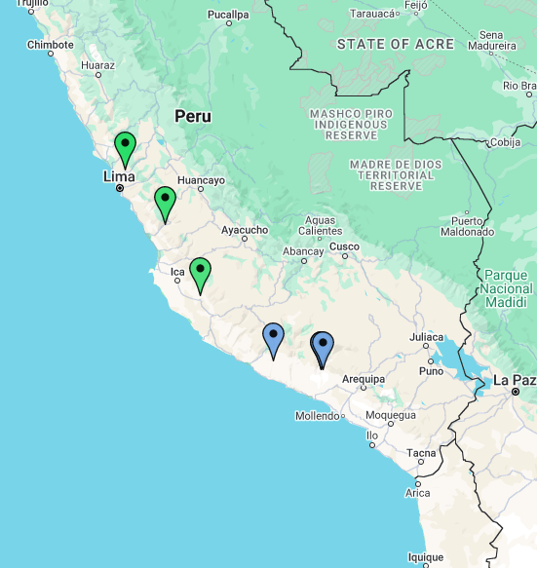
Key
Selfing
Outcrossing

Supplementary Figure 1: Map showing accessions of Solanum pennellii included in RNA sequencing study. Two accessions were collected from a similar location and map points for these accessions overlap.

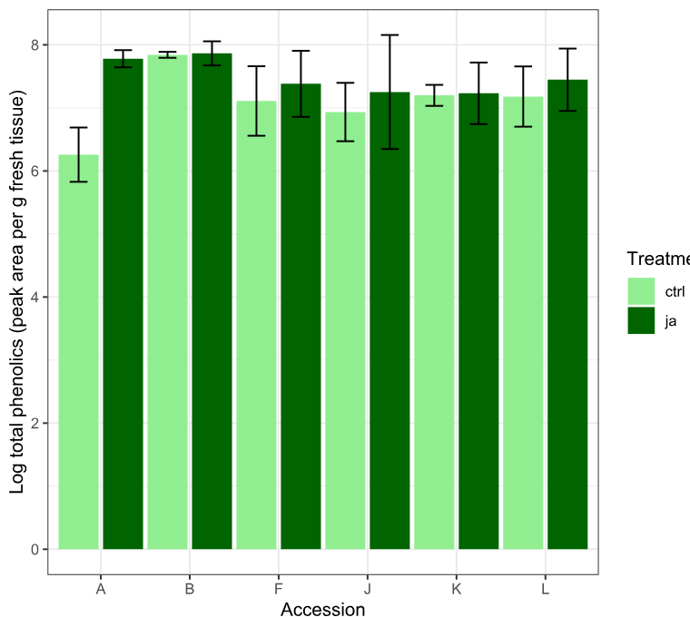
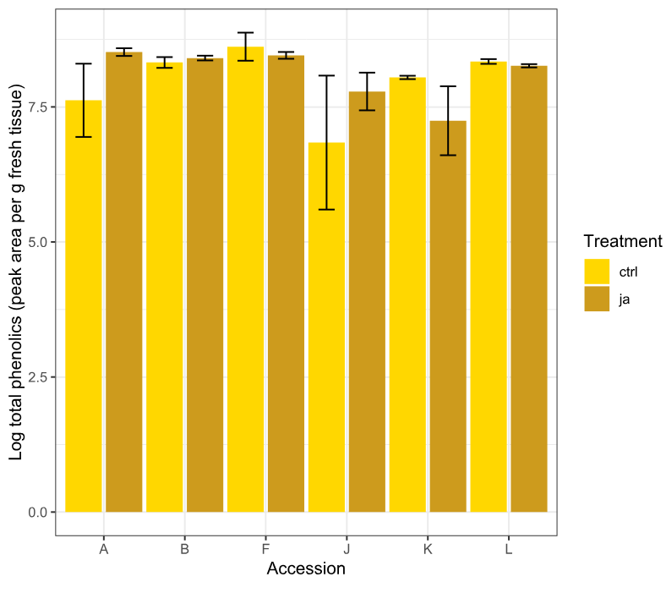
a)
b)
Supplementary Figure 2: Total phenolic content in the accessions of Solanum pennellii that were sequenced in this study. a) total phenolic content of flowers, b) total phenolic content of leaves.

Appendix S2: Supplementary Results
Supplementary results tables are attached.

Chapter 4

Investigating floral and leaf defence in selfing and outcrossing species of Solanaceae

Authors:
Hannah Ronan-Brown, Stuart A. Campbell

Affiliations:
University of Sheffield

Authors’ contributions:
HRB: conceptualisation, experimental design, data curation, data analysis and visualisation, data management, results interpretation, writing, editing. SAC: conceptualisation, experimental design, review and editing, supervised research

4.1 Abstract
Given the distinct roles that flower and leaves have within a plant, it is likely that their secondary metabolic profiles differ. Flowers are expected to be strongly constitutively defended due to their high value, though this could negatively impact pollination. This leads to the prediction that plants with greater reliance on pollinators, such as outcrossing plants, might develop different defences compared to those with lower pollinator reliance, like selfing plants. With their reduced reliance on pollinators, selfing plants may develop stronger floral defences than outcrossing plants. Therefore, plant mating system may serve as a key predictor of floral defence. We predicted that in selfing plants, defensive traits would be less influenced by the need to attract pollinators, and that this effect would be stronger in flowers than in leaves. We investigated the influence of mating system on the constitutive and jasmonate-inducible defence in outcrossing and selfing species of three genera in the Solanaceae family: Physalis, Nicotiana and Solanum. Chemical analysis revealed differential expression of defence-related secondary metabolites in leaves and flowers, and suggested that the effects of plant mating system on secondary metabolite defence varies by species and potentially plant life history. In this study, leaves showed greater plasticity in defence than flowers, and there was a greater variation in leaf defences than in flower defences between species, suggesting stabilising selection by pollinators acts on flower defences more than on leaf defences. Flowers of Nicotiana were more inducible than flowers of Physalis and Solanum, and self-incompatible Nicotiana showed greatest plasticity in leaf defence. While many studies have investigated the interactions of plants, pollinators and herbivores, this is one of few to investigate how these interactions have shaped the evolution of plant defence traits across several species. The results emphasise the significance of combining mechanistic and evolutionary frameworks in exploring plant defence trait diversity.

4.2 Introduction
Plants produce a wide variety of defences to protect themselves from attack by antagonists such as herbivores, however these defensive traits may have costs if they also deter mutualistic pollinators that are crucial for plant reproduction.
Flowers are critical for successful plant reproduction, and hypotheses explaining patterns in floral defence tend to focus on this important reproductive function. For example, optimal defence theory (ODT) offers a more developed theory for this. Optimal defence theory (ref McKey 1979) predicts that defence will be allocated to plant tissues with the highest relative value and are most likely to be attacked. There is a large amount of experimental work investigating ODT predictions, for example there is higher allocation to defence of reproductive tissue in Boechera stricta (Keith and Mitchell-Olds, 2017), and constitutive defences highest in plant tissues with highest probability of attack, and higher induced defences in the roots which were least likely to be subject to herbivore damage (Zangerl and Rutledge, 1996). The optimal defence theory suggests that flowers may be better defended than leaves overall, but could be extended to explain differences among taxa in floral defence. For example, plants that are more reliant on intact, undamaged flowers to attract pollinators for reproduction may have better defended flowers than those that are less reliant on pollinators, due to the higher relative value of flowers which must attract pollinators. This represents a significant knowledge gap in plant defence research.
Floral chemical defences can benefit plants by deterring antagonists from consuming high value floral tissue (McCall and Irwin, 2006), but these defences come with costs that may act as an evolutionary constraint on high floral defence. For example, induced volatiles can negatively impact plant interactions with pollinators (Kessler et al., 2011), reducing plant fitness. Pollinator deterrence can be considered an ecological cost of defence. This could mean that the magnitude of the cost of producing defence could vary according to the degree of a plant’s pollinator reliance: plants which are more reliant on pollinators for reproduction, such as obligately outcrossing (self-incompatible) plants may bear disproportionately high costs of defence production compared with plants which are less reliant on pollinators for reproduction such as self-fertilising (self-compatible) plants (Campbell and Kessler, 2013). Plant defence evolution appears to be linked with plant pollinator reliance, or plant mating system (Adler et al., 2012a; Campbell et al., 2014; Tsuchimatsu and Fujii, 2022). There have been relatively few studies investigating how these multi-level interactions have influenced floral defence (Moreira and de Souza Dias, 2018). (Adler et al., 2012a) showed that nectar, floral and leaf nicotine concentrations were positively correlated across several species of tobacco study (Adler et al., 2012a). Pleiotropy between mechanisms controlling leaf and flower defence could constrain the evolution of defence compounds within the two tissues; floral defences may be a continuation of leaf defences. This could explain the correlations found between leaf and flower concentrations of certain defence compounds (Adler et al., 2012a). If such pleiotropic effects do act on defence compounds, the ecological costs of producing floral defence may be unavoidable in species that rely on defences which happen to deter pollinators as well as herbivores.
Plant defences are characterised by their extensive levels of phenotypic plasticity, which could alter the benefits and costs of floral defence. However, prior studies have generally focused on constitutive defence. Most plants reduce the costs of defence is by producing high levels of defence, eg. defensive secondary metabolites only in response to damage (induced defence) rather than producing high levels of defence at all times (constitutive defence). Inducible defence strategies are adaptive in regions where plants experience unpredictable levels of herbivory, whereas, a constitutive defence strategy would be adaptive, as there is a high probability of damage from herbivores. Low herbivore density often occurs at range margins, and can coincide with low-pollinator density and the evolution of a selfing mating system. This may be why selfing taxa show inducibility in leaf defence (Campbell and Kessler, 2013). Induced floral responses to leaf damage can include changes to volatile signals that are unrelated to defence but which mediate pollinator attraction (Kessler et al., 2011).. The costs of induced changes in floral signalling have been predicted to be greater in outcrossing taxa, but this hypothesis has not been rigorously tested (Campbell et al., 2014). Plant induced defence responses can also lead to deposition of defence compound in nectar and pollen rewards (Adler, 2000). However, the mechanisms and distribution of floral defence are not fully understood.
Patterns in chemical defence expression between different plant tissues have been previously studied, for example, leaf and nectar alkaloids were positively correlated in Nicotiana tabacum (Adler et al., 2006).
Several studies have examined the potential for coevolution of plant mating system with different defence strategies. Across several species of Nicotiana, lower nectar, flower and leaf nicotine concentrations were observed in outcrossing than selfing species (Adler et al., 2012b), though this study considers only constitutive defences. Self-compatible species of Solanum were found to have greater levels of induced defence in leaves than self-incompatible species (Campbell and Kessler, 2013). Despite interesting and compelling results from past studies investigating the potential for pollinator influence over plant defence, there are few, if any, studies that compare constitutive and induced defences in both leaves and flowers between plant mating systems. Despite the importance of flower-pollinator interactions, relatively little is understood about floral defence, and how this may influence other ecological interactions of the plants.
In this study, we used a large-scale comparative approach to investigate whether patterns in floral defence are consistent with optimal defence theory, and/or consistent with predictions based on the ecological costs of pollinator limitation. Specifically we aimed to answer the following questions: 1) Are flowers better defended than leaves? 2) Are selfing flowers better defended than outcrossing flowers? 3) Are flower defences inducible and does inducibility vary by pollinator reliance? To address these questions, we conducted a large-scale comparative study using manipulative experiments with 22 wild species from three genera, including SI and SC tomato, groundcherry and tobacco taxa.

4.3 Methods

4.3.1 Study system
Our study spanned 22 species of Solanaceae from three genera. The Solanaceae are predominantly outcrossing due to the gametophytic self-incompatibility system that is characteristic of the family. There are numerous independent losses of self-incompatibility by transitions to self-compatibility in the family. To test the role of pollinator reliance on floral defence, we selected both self-compatible (SC) and self-incompatible (SI) species from each genus. We aimed to sample diploid taxa, to avoid the confounding effect of polyploidisation with mating system transition. The choices of species allows us to test the defence patterns across repeated, independent losses of SI both within the Solanaceae and within the chosen genera. The three genera used in this study: Nicotiana, Physalis, and Solanum have a broad suite of common phenolic defence compounds that are effective against specialist and generalist insects. Within each genus, multiple independent origins of selfing occur (Figure 1), allowing a more robust investigation of the effect of transition to self-compatibility on plant defence traits.
Key

Self-compatible

Self-incompatible
i

Mixed mating system
i

Figure 1: Schematic of phylogenetic relationships between species of Physalis, Solanum, and Nicotiana used in this study, adapted from Hu & Saedler 2007, Leitch et al 2008, Bedinger et al 2011, Särkinen et al 2013, and Wang et al 2023. Branch lengths are not drawn to scale and do not represent exact evolutionary distances. Dotted lines denote species for which evolutionary relationships are not definitively known.
Nicotiana attenuata SC
Nicotiana noctiflora SI
Nicotiana plumbaginifolia SC
Nicotiana longiflora SC
Nicotiana forgetiana SI
Nicotiana alata SI
Nicotiana miersii SC
Nicotiana sylvestris SI
Solanum
Physalis
Nicotiana
Solanum lycopersicoides SI
Solanum pennellii SI/SC
Solanum habrochaites SI/SC
Solanum chilense SI
Solanum peruvianum SI/SC
Solanum neorickii SC
Solanum pimpinellifolium SC
Physalis cinarescens SI
Physalis acutifolia SC
Physalis pubescens SC
Physalis crassifolia SI
Physalis ixocarpa SC
Physalis philadelphica SI

4.3.2 Species Selection
Six species of Physalis, 9 species of Nicotiana and 7 species of Solanum were chosen for this study. Species were chosen such that there were pairs of outcrossing and selfing species that were part of the same clade where possible. The wild tomatoes chosen for this study exhibit intraspecific transitions to selfing, and thus we sampled two accessions, one selfing and one outcrossing, of S. pennellii, S. habrochaites and S. peruvianum. Pollinator reliance was determined from the literature (Table 1).
Table 1: Species used in this multispecies comparative study, including mating system information.
Species | Mating system | Species code | Source
Physalis pubescens | Self-compatible | PHPUB | (Jacobsen, 2022)
Physalis ixocarpa | Self-compatible | PHIXO | (Jacobsen, 2022)
Physalis acutifolia | Self-compatible | PHACU | (Jacobsen, 2022) (Pretz and Smith, 2021)
Physalis philadelphica | Self-incompatible | PHPHI | (Jacobsen, 2022)
Physalis crassifolia | Self-incompatible | PHICRA | (Jacobsen, 2022)
Physalis cinerascens | Self-incompatible | PHICIN | (Jacobsen, 2022)
Nicotiana attenuata | Self-compatible | NIATT | (Sime & Baldwin 2003)
Nicotiana miersii | Self-compatible | NIMIER | (Adler et al., 2012b)
Nicotiana longiflora | Self-compatible | NILON | (Adler et al., 2012b)
Nicotiana plumbaginifolia | Self-compatible | NIPLUM | (Adler et al., 2012b)
Nicotiana tabacum | Self-compatible | NITABA | (Igic et al., 2006)
Nicotiana alata | Self-incompatible | NIALATA | (Adler et al., 2012b)
Nicotiana forgetiana | Self-incompatible | NIFOR | (Adler et al., 2012b)
Nicotiana sylvestris | Self-incompatible | NISYL | (Moon et al., 2008)
Nicotiana noctiflora | Self-incompatible | NINOCT | (Adler et al., 2012b)
Solanum neorickii | Self-compatible | SONEO | Tomato Genetics Resource Centre
Solanum pimpinellifolium | Self-compatible | SOPIMP | Tomato Genetics Resource Centre
Solanum habrochaites | Self-compatible/Self-incompatible | SOHAB-SC | Tomato Genetics Resource Centre
 |  | SOHAB-SI
Solanum pennellii | Self-compatible/Self-incompatible | SOPEN-SC | Tomato Genetics Resource Centre
 |  | SOPEN-SI
Solanum peruvianum | Self-compatible/Self-incompatible | SOPERU-SC | Tomato Genetics Resource Centre
 |  | SOPERU-SI
Solanum lycopersicoides | Self-incompatible | SOLYCO | Tomato Genetics Resource Centre
Solanum chilense | Self-incompatible | SOCHIL | Tomato Genetics Resource Centre

4.3.3 Plant growth conditions
Two-week-old Solanum sp. seedlings were transferred to a different chamber with the same growing conditions due to space constraints. Physalis and Nicotiana plants reached their flowering phase earlier than Solanum, so were sampled one week earlier than Solanum.
Seeds were pre-treated according to the protocols outlined in (Supplementary Materials S1.1) germinated in a greenhouse chamber under the same environmental conditions. Seedlings were transplanted to a soil-vermiculite mix (Levington M3 – vermiculite, 3:1 (v/v)) in 10x10cm pots when 4-weeks old, then transplanted to 25x25cm (11L) pots at 8 weeks old. Plants were grown in a growth chamber under greenhouse conditions (enhanced natural lighting, 12-hour light/12-hour dark, 18ºC nighttime, 23ºC daytime, 50-60% relative humidity) with ad libitum watering. Biological pest controls were used to keep plants free from herbivores, so control plants should represent constitutive phenolic content. Lacewings, Chrysoperla sp. (BioLine Agrosciences ™) and ladybird larvae Adalia bipunctata (Dragonfli ™) were used as biological control against aphids. Plant position within the greenhouse was randomised within genus to account for position effects within the greenhouse. Plants were fed weekly from 8 weeks onwards using MiracleGro NPK Fertiliser blend 24-8-16 with micronutrients at a concentration of 15ml in 5 litres of water. Once plants were flowering (10 weeks for Physalis and Nicotiana, 11 weeks for Solanum sp.), they were used in the experiment.

4.3.4 Experimental design
We investigated the effects of pollinator reliance on induced and constitutive flower and leaf defence using a factorial experiment with 8 plants of each species of each of the three genera used in this study. Half of the plants of each population (n=4) were treated with either a control or methyl jasmonate (MeJA-treatment) treatment. Leaf and flower samples were taken from the plants 48-hours after induction and phenolic content was analysed for all the species. Feeding bioassays using the herbivore Manduca sexta were conducted only using the genus Solanum due to limited number of M. sexta larvae.
MeJA mediates the herbivore response pathway within plants (Howe and Jander, 2008; Kessler and Baldwin, 2002) and exogenous application of MeJA is sufficient to induce systemic defence responses (Baldwin, 1996; Kaya and Doganlar, 2016). While it does not completely mimic the effects of herbivory with a real herbivore, MeJA treatment allows standardisation of the damage signal without the confounding effects of differential tissue response or herbivore-specific responses. Exogenous induction is also advantageous as it induces a uniformly systemic and generalised defence signal throughout the plant.
MeJA dissolved in lanolin paste (10μg/ml) was applied to the base of plant stems at a height of 10cm above soil in a 1cm-wide continuous band around the entire stem. This concentration of MeJA. Lanolin paste with no MeJA added was applied to control plants.

4.3.5 Secondary metabolite analysis
Leaf samples were collected by excising a leaf, or for species with compound leaves, a leaflet, from the plant and weighing 100mg of leaf tissue not including the midrib into a microtube. The sample was flash frozen in liquid nitrogen. Flower samples collected were between 600mg – 400mg, depending on the size of the flowers. This allowed the entire flower to be collected, flash frozen and stored along with leaf samples at -80ºC until samples were processed. Calyx tissue was pulled off from flower samples prior to freezing.
Frozen tissue was ground into a fine powder in a microtube with a micropestle over liquid nitrogen. Where flower samples were larger than 1200mg, 1000mg of frozen powdered sample were weighed into microtubes. The sample was then transferred to a clean 2ml FastPrep tube containing 0.9g matrix D lysing beads (1.4mm zirconium-silicate spheres). To this, 1ml of ice-cold extraction solvent (70% methanol : 0.5% formic acid) was added to the tube. A FastPrep 24 Instrument was used to homogenise the samples at speed 6.5 for 45 seconds, followed by a second run at the same speed and duration to homogenise the tissue. Samples were then centrifuged at 4ºC for 15 minutes at 14000 rpm (Eppendorf Centrifuge with a 30-tube, fixed-angle rotor: 20,800 x g). The extract was then transferred to a 2ml glass vial, with care taken to not disturb the pellet. Samples were placed back in the centrifuge for 5 minutes if the pellet was disturbed. Extracts were stored at -20ºC.
Phenolic compound separation was carried out by high performance liquid chromatography (HPLC), using a Waters Alliance 2695 HPLC model equipped with a Waters 2998 photodiode array detector allowing UV detection. 15µl of extract was injected and separated using a gradient of acetonitrile (A) and 0.25% phosphoric acid (B), with a flow rate of 1ml/minute. The initial gradient consisted of 0% acetonitrile, and 100% phosphoric acid, increasing to 12% (A) and 88% (B) at 6minutes, 18% (A) and 82% (B) at 10 minutes, and 58% (A) and 42% (B) at 30 minutes, as previously described (Keinänen et al., 2001). The gradient returned to 0% acetonitrile at 31 minutes and the column was washed and equilibrated to 0% (A) and 100% (B) at for 5 minutes before the next injection. Data were recorded with MassLynx software. Samples were kept at 4ºC in the sample compartment during run times, and the column was held at 20ºC. Data was collected using a scan including wavelengths 210nm, 254nm, 320nm, 360nm. Phenolic peaks were identified using UV absorbance spectra (Keinänen et al., 2001) and integrated at a wavelength of 360nm (FAs) and 320nm (CAs). We analysed constitutive and inducible levels of total phenolics. Plant inducibility was calculated by taking the difference between constitutive and induced levels, a measure of plasticity that allows unconfounded analysis of trade-offs between constitutive and induced defence.

4.3.6 Herbivore feeding assay to measure plant chemical resistance
Herbivore feeding bioassays with Manduca sexta were conducted using Solanum species only, due to availability of larvae. The bioassays were used to give estimates of the constitutive and induced defence in leaf and flower tissue, as they have previously been shown to be effective measures of plant resistance (Campbell and Kessler, 2013). M. sexta is a specialist herbivore of the Solanaceae, and compounds that are induced in the jasmonate pathway are known to reduce growth of M. sexta larvae (Osier et al., 1996). Larvae used in this experiment were sourced as eggs from the John Innes Entomology and Insectary Platform. Eggs were hatched on non-edible medium so that newly hatched neonates that had not begun to feed could be used in the bioassay.
A whole leaflet or an intact flower and pedicel were excised, and the stem inserted into a 1cm³ piece of saturated floral foam in a petri dish (Figure 7a). Leaves were placed with the abaxial surface facing downwards, and flowers were kept fully intact and still attached to calyx. A single newly hatched M. sexta larva was placed on either the leaf or corolla tissue and allowed to feed for 4 days, at which point the plant tissue and floral foam were removed from the petri dish leaving the larvae in the dish for 4 hours to eject their frass so that only assimilated mass was measured. Larvae were weighed using a 4-digit analytical balance.
Larvae initiated feeding on all species in this study. The use of larval bioassays provides an estimate of the combined resistance traits in the tissue, providing estimates of the effective defence traits despite variation in these traits (ie. specific metabolites) that may be present across different species.

4.3.7 Data analysis
Data analysis was conducted in R Studio version 3.4.2 (R Core Team, 2023) with an experimental Type I error rate at α = 0.05.
Linear mixed models were used to compare phenolic content across mating system and treatment. LMMs were fitted using the lmerTest package (Kuznetsova et al., 2017) using the residual maximum likelihood (REML) method to estimate variance components. LMMs were tested using Type III Analysis of Variance (ANOVA) with Satterthwaite’s method, again using the lmerTest package. Model terms included mating system and MeJA treatment as fixed effects, and mating system x treatment as the interaction term. Due to the taxon sampling being designed to use pairs of close relatives that represented independent transitions to selfing, phylogenetic relationship is accounted for by including genus as a nested term within mating system in models which contain multiple genera, rather than using a phylogeny for this purpose. When multiple species of a single genus are included in the model, the nested term of Mating system:Species was included as a random effect.
A linear mixed effects model was calculated using data across all genera, using the fixed effects terms of mating system and treatment, including interaction terms and the random effect was a nested variable of mating system, genus and species on the log-transformed phenolic content across all samples. This initial model included all genera, and where tissue effects were significant, models were then tested in leaf and flower data separately using the dataset for phenolic content in all three genera. A full model including the main terms of Treatment, mating system, genus, and pairwise and three-way interactions between the terms treatment, mating system and genus, with the random effects term of species/mating system was fitted for both leaf and flower log-transformed phenolic content separately. A reduced model which included the nested random effects variable of genus/species/mating system was also tested within leaves and flowers, which allowed the main effects to be tested without the confounding factor of genus. Tukey’s post-hoc tests were conducted on the reduced models to identify significant differences in phenolic content between treatments and mating systems for each of the leaf and flower models.
Where genus and the interaction term treatment x genus x mating system were significant, the analysis was then further separated into looking at patterns within each genus separately.
Phenolic content within each genus was analysed separately using LMMs investigating the main effects of treatment, tissue and mating system effects within each genus, including the random nested effects variable of mating system and species on log-transformed phenolic content data. Phenolic content is given as peak area / sample mass (g).
Principal component analysis was conducted in Metaboanalyst v5.0, and PERMANOVA was also conducted in Metaboanalyst v5.0. Data were log-transformed and auto-scaled prior to analysis.
T-tests and Pearson’s correlation calculations were carried out in base R. T-tests were used to investigate differences in phenolic content between leaves and flowers of each genus. Each species was considered to be a separate replicate, with a maximum n = 22, however for some analyses the sample size is lower as some traits or tissues could not be measured in some species. Both selfing and outcrossing accessions were included for three species of Solanum used in this study. The phenolic content of each of these accessions is included in plots showing data for individual species, with the selfing and outcrossing accessions of the same species denoted as separate species, eg. S. pennellii – SC and S. pennellii – SI, however the ancestral state is outcrossing, so only the outcrossing accessions were included in the analyses that compare at a mating-system level.
Inducibility was calculated as phenolic concentration in treated tissue – phenolic concentration in control tissue.

4.4 Results

4.4.1 Phenolic content higher in flowers than leaves
Leaves and flowers had different metabolic profiles in all three genera. Principal component analysis (PCA) showed leaves and flowers were differentially defended in Physalis species (Permanova F = 24.45, R² = 0.2589, p = 0.001) (Figure 2a). Principal component analysis showed some clustering by tissue in Nicotiana species (Permanova F = 39.14, R² = 0.2896, P = 0.001) (Figure 2b). Leaf and flower metabolic profiling showed clustering in Solanum (Permanova F = 239.05, R² = 0.646, p = 0.001) (Figure 2c).
Significant predictors of phenolic content in the data including all species used in this experiment were the interaction terms of tissue x mating system (F_{1, 287} = 3.914, P = 0.00152) and the three-way interaction between tissue x treatment x mating system (F_{1, 273} = 1.5623, P = 0.04407) (Supplementary Table 1). Control flowers had higher phenolic content than control leaves (Tukey’s post-hoc test P < 0.0001). Phenolic content was significantly higher in selfing control flowers compared to selfing control leaves (Tukey’s post-hoc test P < 0.0001), but phenolic content between outcrossing control flowers and outcrossing control leaves was not significantly different (Tukey’s post-hoc test P = 0.1520). Full output from Tukey’s post-hoc tests are in Supplementary materials.
In flowers, phenolic content was not significantly different control and MeJA-treated flowers in either selfing or outcrossing groups (Figure 2b). No terms were significant in the full mixed effects model in the flowers. Genus was not a significant factor or interaction term in the flowers, however the reduced model was still tested for flowers. No terms were significant in the reduced model which accounted for the random effects of genus (Supplementary table 2). Tukey’s post hoc tests showed no significant differences between control and treated selfing and outcrossing flowers (Supplementary materials).
In the leaves, the overall pattern showed no treatment response in either selfing or outcrossing leaves (Figure 2a). There was a slight mating system effect on phenolic content when genus was not included as a random variable, (F_{1,18} = 4.48, P = 0.0487). Treatment response was different in selfing leaves compared with outcrossing leaves, denoted by the significance of the interaction term of mating system x treatment (F_{1,148} = 4.596, P = 0.0337) and also varied by genus: the interaction term mating system x treatment x genus was significant in the model (F_{1,148} = 9.651, P = 0.000115). The treatment effect alone was not significant in either selfing or outcrossing leaves (Figure 2c). When genus was included in the model as a nested random effects variable and removed from the main effects, it showed that phenolic content significantly varied between selfing and outcrossing leaves (F_{1,19} = 4.897, P = 0.03708) and that the treatment effect on phenolic content was different between selfing and outcrossing leaves (F_{1,150} = 1.65, P = 0.0284). Phenolic content was significantly higher in MeJA-treated outcrossing leaves compared to MeJA-treated selfing leaves (Tukey’s post-hoc test P = 0.0207).
Leaves and flowers of each species were then analysed separately to investigate patterns in phenolic content within each genus.
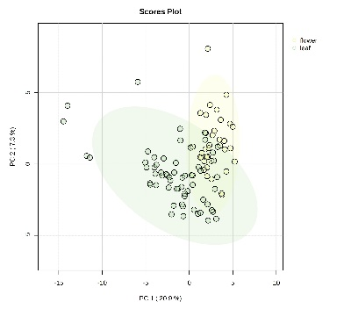
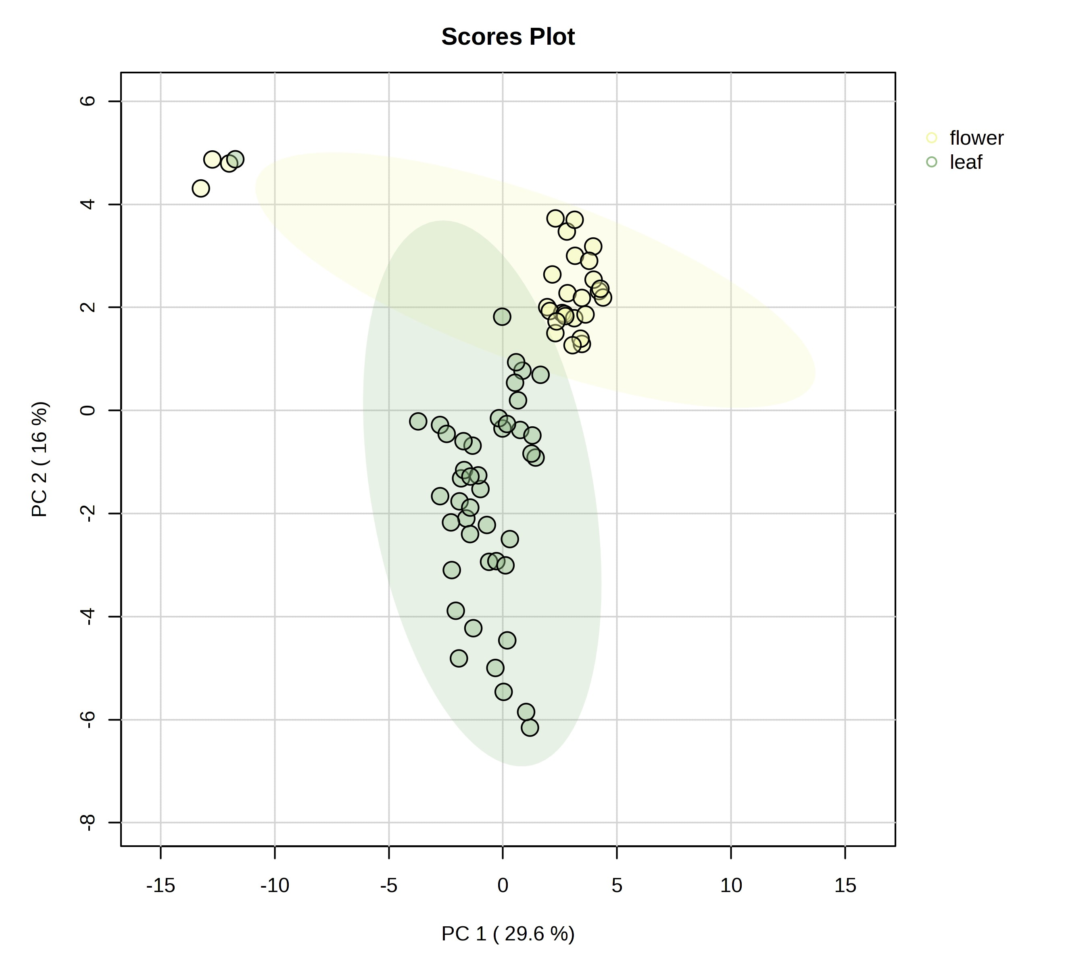
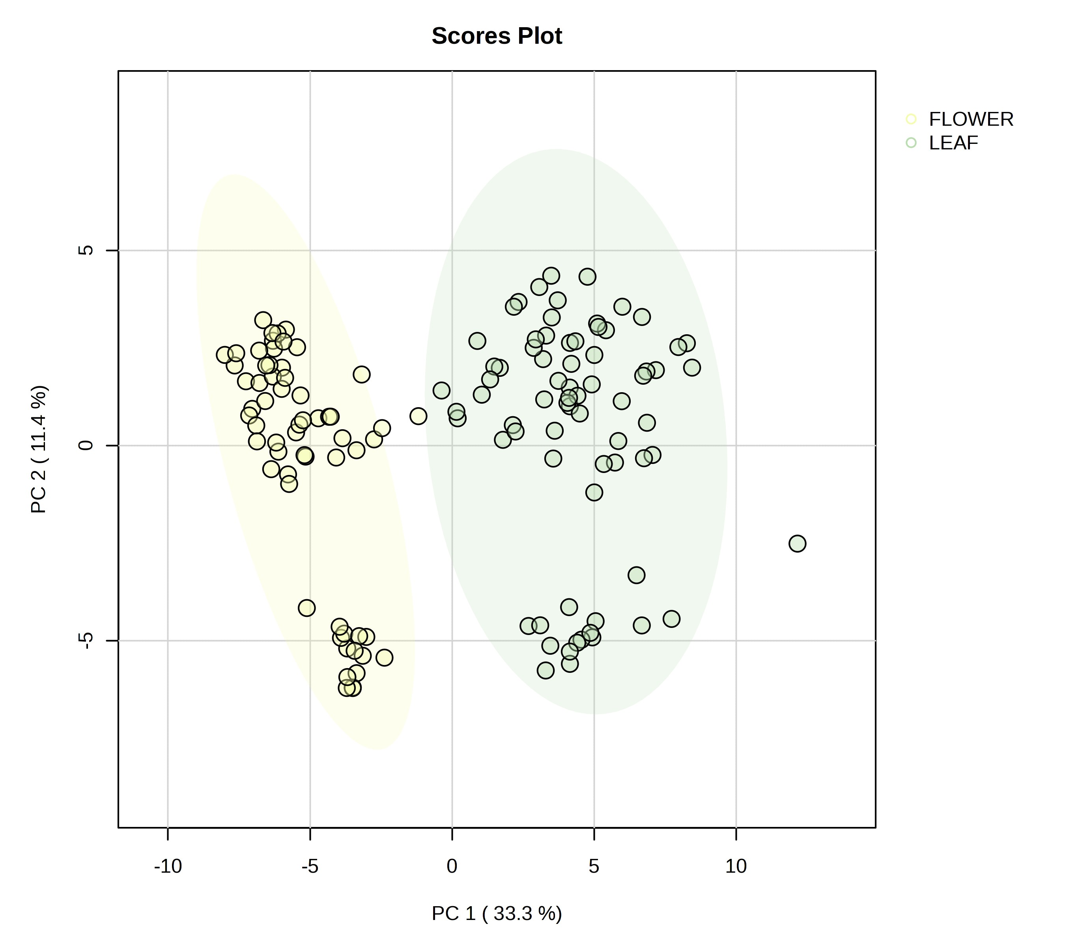
a)
b)
c)

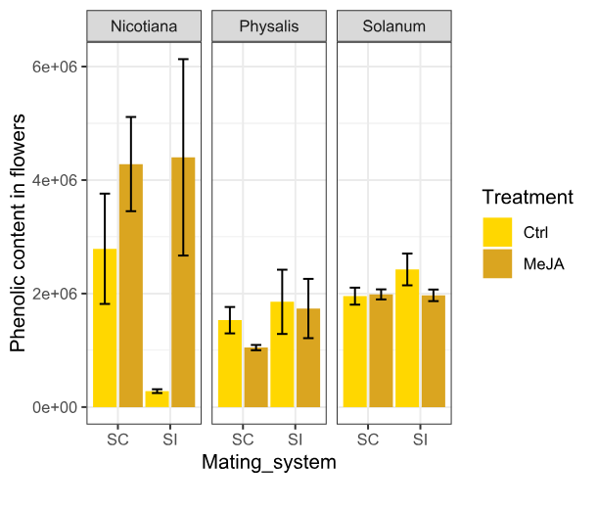
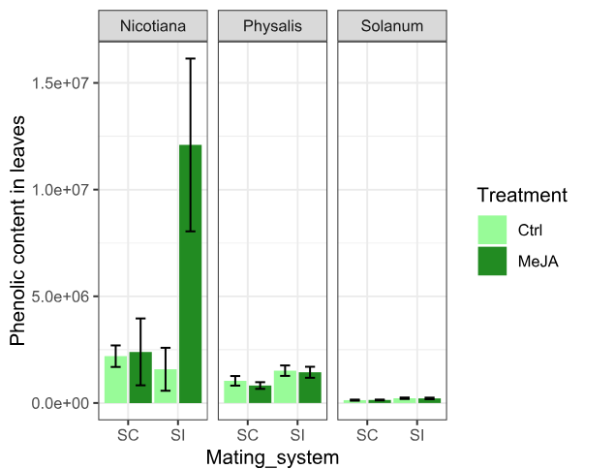
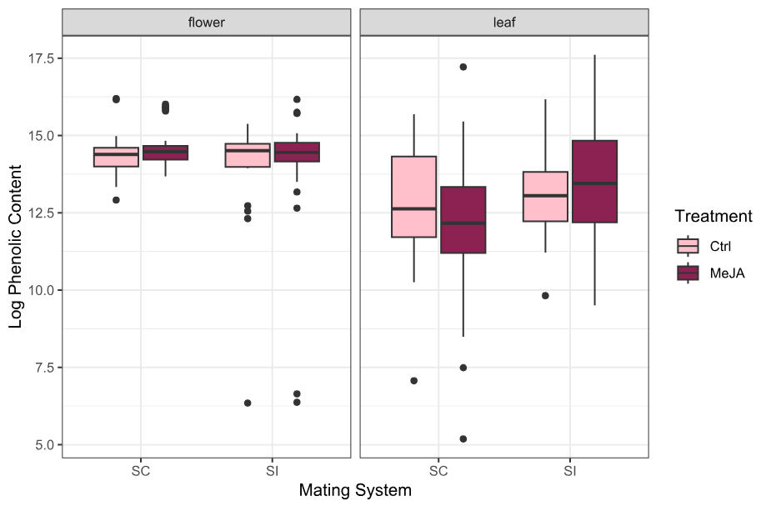
Figure 2: Phenolic content of leaves and flowers in all species in this study . Phenolic content calculated as peak area of peak on chromatogram divided by the wet mass of the tissue in tissue samples. a) PCA showing Physalis metabolic profiles. b) PCA showing Nicotiana metabolic profiles. C) PCA showing Solanum metabolic profiles of leaves and flowers. d) Phenolic content in flowers (right-hand plot) and leaves (left-hand plot). Means are for control and MeJA-treated selfing plants (SC) and outcrossing plants (SI), data are log-transformed for scale. e) Phenolic content in flowers, data is not log-transformed. Left plot shows Nicotiana, middle plot shows Physalis, and right-hand plot shows Solanum. f) Phenolic content in leaves. Left plot shows Nicotiana, middle plot shows Physalis, and right-hand plot shows Solanum. For all plots, phenolic content is given as mean peak area gFW⁻¹ + SE. Darker bars represent MeJA-treated plants whilst lighter-coloured bars represent the control plants
d)
Mating system
Mating system
Phenolic content in flowers (peak area/mass tissue)
Phenolic content in leaves (peak area/mass tissue)
Mating system
Log Phenolic content
(Peak area/mass tissue)
e)
f)

4.4.2 Genus-level differences in phenolic defence
Flowers of Physalis were not inducible; there was no difference in phenolic content between control and MeJA-treated flowers. Selfing and outcrossing flowers were also not differentially defended. The leaves of Physalis did also not show any inducibility when all the species were grouped, and there was no difference in the level of constitutive defence between selfing and outcrossing Physalis leaves.
Phenolic content did not differ between control and treated Physalis flowers, nor between selfing and outcrossing flowers (Figure 3a). Linear mixed effects models were performed on the Physalis data, looking at each tissue individually. Floral phenolic content did not significantly differ by treatment (F_{1,22} = 0.0093, P = 0.924), mating system (F_{1,3} = 0.7105, P = 0.459) (Figure 3A). The interaction term of treatment x mating system was also not significant (F_{1,22} = 0.0022, P = 0.963) (Supplementary Table 7). There was significant species-level variation in the phenolic content in Physalis flowers – the outcrossing species P. crassifolia has higher phenolic content than either of the two selfing species or the outcrossing species P. philadelphica (Supplementary Figure 1a). As there were only samples for control flowers of P. acutifolia, this species was excluded from analysis of phenolic content in the flowers but it is included in the leaf analysis as including the species with missing flower data in the leaf analysis provides additional power for mating system-treatment comparisons within the leaf data. There was no significant treatment effect in either SC flowers (Tukey’s post-hoc test P = 0.9996) or SI flowers (Tukey’s post-hoc test P = 0.9999).
In the Nicotiana flower model, mating system was marginally significant (F_{1,4} = 9.2574, P = 0.05359), treatment was marginally significant (F_{1,27} = 3.8774, P = 0.05935) and the interaction term was not significant (F_{1,27} = 0.1115, P = 0.74099) (Supplementary Table 9). There was no significant difference in phenolic content between control and MeJA-treated selfing Nicotiana flowers (Tukey’s post-hoc test P = 0.2309) or in outcrossing Nicotiana flowers (Tukey’s post-hoc test P = 0.3348). Solanum flower phenolic content not significantly effected by mating system (F_{1,9} = 3.395, P = 0.1004) or treatment (F_{1,51} = 1.571, P = 0.2159) (Figure 3c), and the treatment effect was not significantly different between mating systems (F_{1,51} = 3.318, P = 0.0744).
Leaf phenolic content in Physalis sp. was not significantly different between treatments (F_{1,36} = 0.0560, P = 0.814), mating systems (F_{1,3} = 1.31, P = 0.316), and the interaction term was also not significant (F_{1,36} = 0.412, P = 0.525) (Figure 3d). There was variation in the phenolic content of leaves of each species of Physalis that was used in this study. Two of the outcrossing species, P. crassifolia and P. cinerascens had higher phenolic content than leaves of the other species in this study (Supplementary Figure 1). There was also no significant treatment effect in SC leaves (Tukey’s post-hoc test P = 0.9491) or SI leaves (Tukey’s post-hoc test P = 0.9995).
In Nicotiana leaves, phenolic content was not significantly different between mating systems (F_{1,6} = 0.6965, P = 0.4341) or treatments (F_{1,48} = 0.1379, P = 0.7120), but the treatment effect was significantly different between selfing and outcrossing leaves (F_{1,48} = 8.345, P = 0.005808) (Supplementary Table 8). Phenolic content was significantly higher in Nicotiana control leaves compared to control flowers (t = 2.7073, df = 66, p = 0.008627).
Phenolic content of Solanum leaves did not significantly differ by mating system (F_{1,8} = 1.550, P = 0.2486), Treatment (F_{1,60} = 0.2397, P = 0.6262) (Figure 3f), or the interaction term mating system x treatment (F_{1,60} = 1.827, P = 0.1815). Flowers of the Solanum species in had significantly higher phenolic content than the leaves. Phenolic content was higher in control selfing Solanum flowers than in control selfing leaves (t = 14.44, df = 34, P = 4.548e⁻¹⁶), and also in control outcrossing flowers compared to control outcrossing leaves (t = 12.37, df = 26, p = 2.122e⁻¹²).
Low sample size reduces power in the Solanum dataset. The only species for which phenolic content differed between control and induced tissue was in the S. habrochaites SI flowers, in which the phenolic content was significantly lower in treated plants than control plants (Supplementary figure 1).

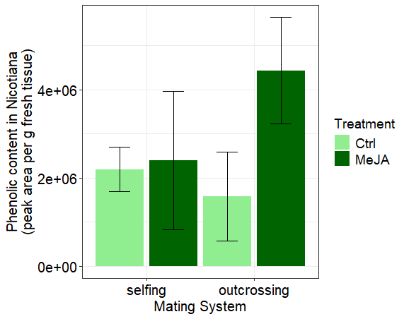
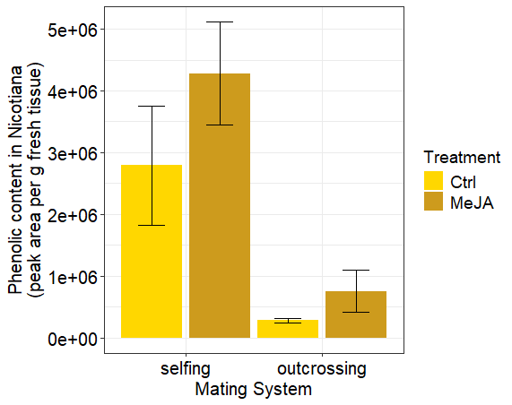
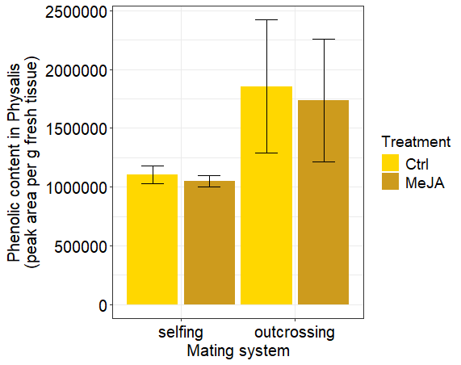
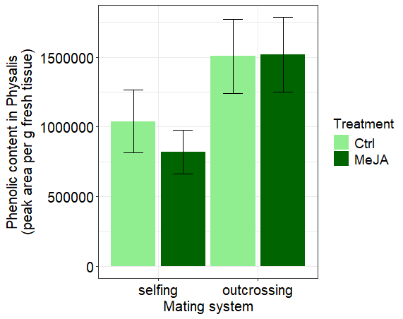
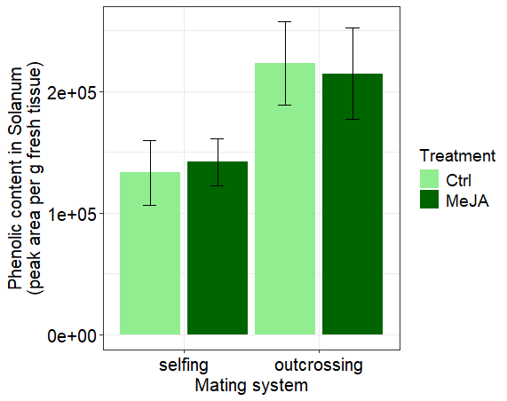
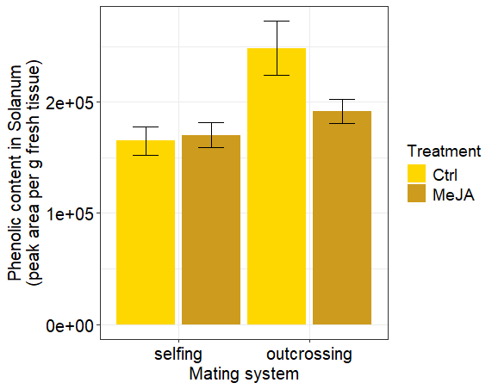
Figure 3: Phenolic content in control and MeJA-treated selfing and outcrossing flowers and leaves. Phenolic content is given as peak area gFW⁻¹ + SE. . a) Phenolic content in Physalis flowers in control (pale yellow) and MeJA-treated (dark yellow) selfing (SC) and outcrossing (SI) plants. b) Phenolic content in Nicotiana flowers. c) Phenolic content in Solanum flowers. d) Phenolic content in Physalis leaves in control (pale green) and MeJA-treated (dark green) selfing (SC) and outcrossing (SI) plants. d) Phenolic content in Nicotiana leaves. e) Phenolic content in Solanum leaves.

a)
b)
c)
d)
e)
f)

4.4.3 Leaf phenolic content does not predict flower phenolic content
There was no significant correlation between flower and leaf phenolic content (Pearson’s correlation coefficient = 0.00463). There was also no correlation between the flower and leaf phenolic content between control flowers and leaves (Pearson’s correlation coefficient = -0.166), nor between MeJA-treated flowers and leaves (Pearson’s correlation coefficient = 0.144) (Figure 4a).
Across the Solanaceae there was a negative relationship between induced phenolic and constitutive phenolics in SC leaves (R² = 0.8682, F_{1,10} = 73.4, P = 6.414e-06) and no significant relationship between induced phenolics and constitutive phenolics in SI leaves (R² = -0.0361, F_{1,9} = 0.6519, P = 0.4403) (Figure 4b). There was no significant relationship between induced and constitutive phenolic abundance in SC flowers (R²= -0.1196, F_{1,8} = 0.0385, P = 0.8493) or in SI flowers (R²= 0.0501, F_{1,5} = 1.316, P = 0.3032) (Figure 4c).

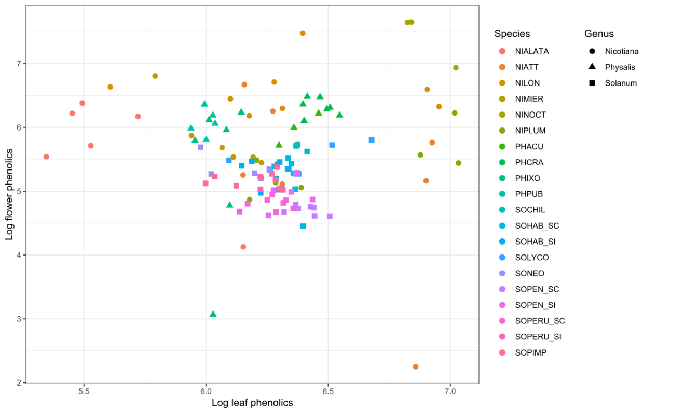
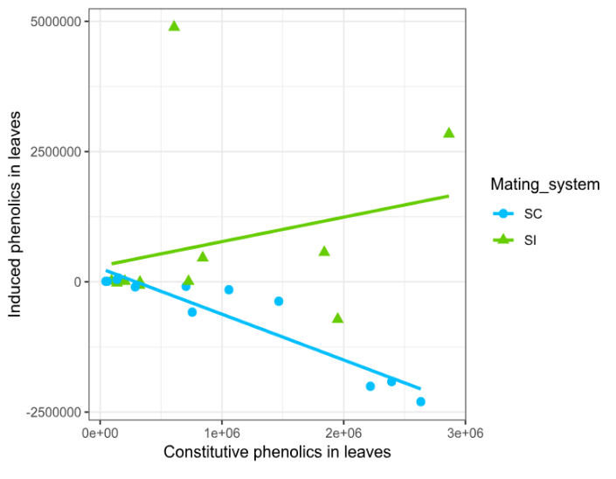
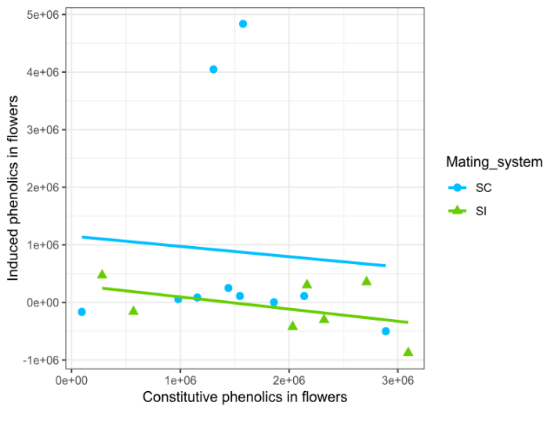
a)
Figure 4: Trends between induced phenolic content (difference between phenolic content in MeJA-treated tissue and control tissue) and constitutive phenolic content; phenolic content in control plants. a) Flower phenolics plotted against leaf phenolics using log-transformed data for all species included in this study for which both leaf and flower data was available. Each point represents the log of the total phenolic content of the flower and leaf sample from one individual plant. b) Induced phenolic content against constitutive phenolic content in leaves. Selfing (SC) leaves are shown as blue line and circle points, Outcrossing (SI) leaves are shown as a green line and triangle points. c) Induced phenolics against constitutive phenolic content in flowers, selfing samples are shown as blue line and circle points, outcrossing samples are shown as green line and triangle points.
b)
c)
Log leaf phenolic content (peak area/tissue mass)
Log flower phenolic content (peak area/tissue mass)

4.4.4 Larval growth lower for flower-fed larvae compared to leaf-fed larvae
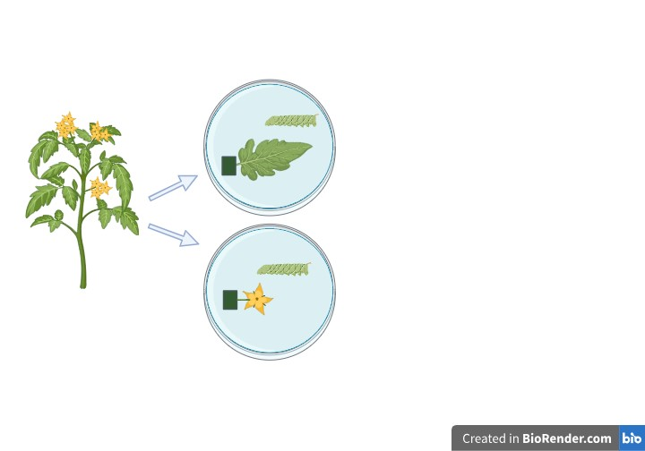
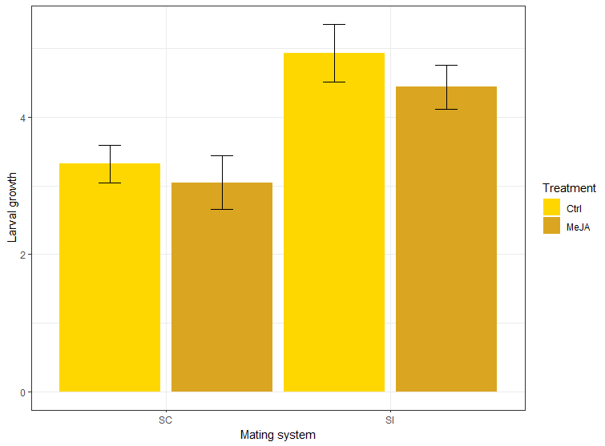
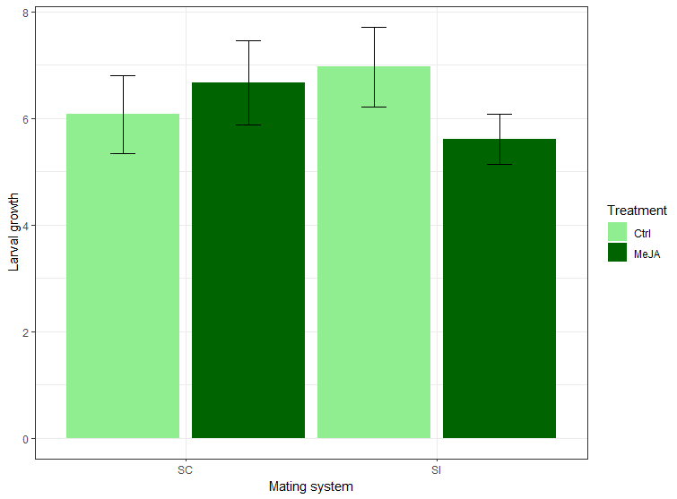
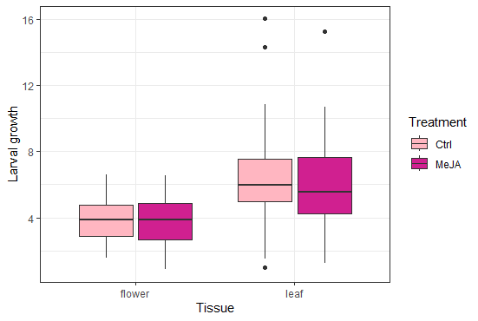
Larval feeding assay data showed larval growth was significantly lower on SC flowers than SI flowers (P < 0.001), but was not significantly different between treatments in flower-fed larvae (P = 0.3495) and the treatment effect did not differ between mating systems (P = 0.7713) (Figure 5c). In leaves, larval growth was not significantly different by mating system (P = 0.5771), treatment (P = 0.7521) and the treatment effect did not differ by mating system (P = 0.2100) (Figure 5d). Higher larval growth was observed in larvae fed on SI flowers than on SC flowers, and overall growth was lower for flower-fed larvae than leaf-fed larvae (Figure 5b).
Figure 5: Bioassay with Manduca sexta feeding on flower or leaf tissue excised from Solanum plants and larval growth measured as an indicator of defence level of plant tissue. Larval growth is given as mass change/initial mass. a) diagram showing set-up of bioassay. Leaf or flower tissue was excised from the plant, and the stem placed into floral foam saturated with water to keep tissue fresh. A single larva was placed on each tissue. b) Larval growth was significantly lower when fed on flowers compared than leaves of Solanum across all species tested in this study. c) Larval growth lower on SC flowers than SI flowers. d) Larval growth of leaf-fed larvae.
a)
b))
c)
d)
*

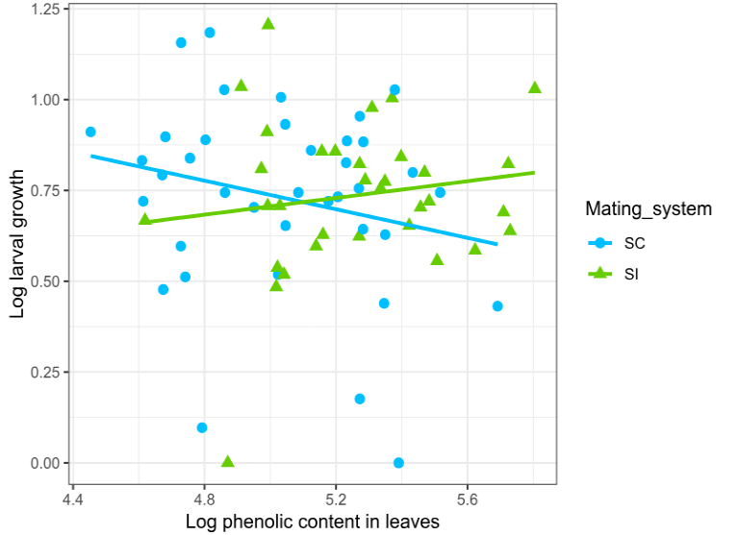
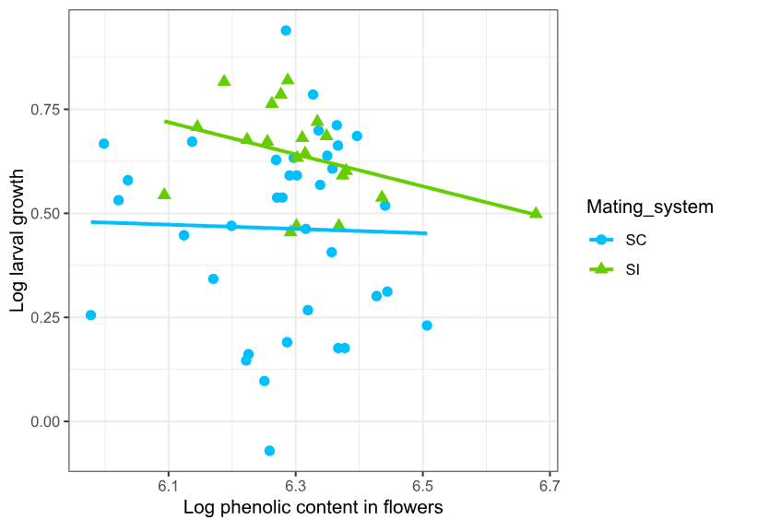
Larval growth was not significantly affected by phenolic content (F_{1,26} = 3.022, P = 0.0938) or treatment (F_{1, 32} = 0.790, P = 0.381) in SC leaves (Figure 6a). Larval growth was not significantly related to phenolic content (F_{1,24} = 0.578, P = 0.454) or treatment (F_{1,27} = 0.0205, P = 0.887) in SI leaves (Figure 6a). Larval growth was not significantly related to flower phenolic content in SC flowers (F_{1,33} = 0.126, P = 0.725) or in SI flowers (F_{1,14} = 2.504, P = 0.135) (Figure 6b). Larval growth was also not significantly affected by treatment in SC flowers (F_{1,30} = 0.589, P = 0.449) or SI flowers (F_{1,14} = 2.062, P = 0.173) (Figure 6b). Both larval growth (mass change) and phenolic content were log- transformed for the analysis as well as the plots to improve the scale of the plot.
Figure 6: Trends between larval growth and phenolic content of leaves and flowers. Larval growth is given as a proportional mass change. a) Larval growth vs phenolic content in leaves shows different direction of relationship between SC and SI tissues, though larval growth was not significantly related to phenolic content in leaves. b) larval growth vs phenolic content in flowers showed no significant relationship. Each data point represents an individual plant.
a)
b)

4.5 Discussion
Across all of the species used in this study we found that overall, flowers have a higher phenolic content than leaves (Figure 1a), implying that flowers are more strongly defended than leaves which is consistent with the initial hypothesis as guided by Optimal defence theory predictions (McKey, 1974). In line with the a priori hypothesis that pollinator reliance predicts defence compound concentration, we found that phenolic content was significantly higher in SC Nicotiana flowers than in SI Nicotiana flowers, however no significant differences in either flower nor leaf phenolic concentration were observed between mating systems in either Physalis or Solanum. The third hypothesis tested was that flowers would not be inducible due to their predicted high constitutive defences and the ecological cost of pollinator deterrence that is associated with floral induced response. Consistent with this prediction, we found no treatment effect in either selfing or outcrossing flowers in any of the three genera in this study A further interesting result of this study is that no correlation was found between flower and leaf phenolic content across all of the species, which builds on the same results previously found in S. pennellii (Chapter 2). Overall, our results show that there may be genetic divergence between phenolic concentrations between floral and leaf tissue, suggesting that selection on floral and leaf phenolics may be independent.

4.5.1 Flowers have stronger constitutive defences than leaves
Due to the relatively higher value of floral tissue than leaf tissue in terms of plant reproduction and therefore fitness, flowers are predicted to contain higher concentrations of defence compounds (McKey, 1974) and our results broadly suggest that patterns in leaf and flower defence follow these predictions. Despite variation in phenolic content between species, overall, the phenolic content of flowers was higher than that of leaves across all species in this study (Figure 1A), and there was slightly less variation in the phenolic content of flowers compared to leaves, suggesting a stronger selection on defence in flowers compared to leaves. Our results are broadly in agreement with other studies looking at the concentrations of defence compounds in leaves and reproductive tissue. Higher defensive secondary metabolite concentrations were found in flowers compared to leaves in several plant taxa, including Brassicaceae, Solanaceae and Boraginaceae (Chrétien et al., 2022; Ohnmeiss and Baldwin, 2000; Van Dam et al., 1996). Overall, the results support the predictions of optimal defence theory, however patterns in defensive phenolic compounds vary across the species in this study which could be better understood by considering the range of ecological interactions and the potential for differing roles of particular compounds across different species.
Predictions of optimal defence theory are based around the predicted relationship between tissue type and plant fitness (Rhoades, 1979; McKey, 1979), and whilst these relationships were not investigated in this study, previous research has found evidence for the greater fitness value of petals compared to leaf tissue (Conner et al., 1996; García and Ehrlén, 2002). If damage to flowers can have greater negative effects on plant fitness than leaf damage can, then the results of this study provide some support for patterns of constitutive defence predicted by optimal defence theory. Furthermore, defence allocation can also change throughout the lifetime of a plant, for example, floral defences are more highly concentrated in younger flowers (Li et al., 2017), as well as in younger leaves (Ohnmeiss and Baldwin, 2000), which could mean that patterns of investment in constitutive defence change throughout the lifetime of a plant. The three genera used in this study are perennials, so longer-term studies investigating allocation to defence throughout the lifetime of a plant could further our understanding of allocation to defence.
The results of the Solanum feeding bioassay are consistent with the a priori predictions that flowers would be better defended than leaves. When comparing the bioassay data with phenolic data, the patterns between phenolic content and larval growth are not completely consistent, which could suggest that not all of the phenolic compounds identified in the tissues have a defensive function, and that some compounds may convey stronger defence than others. Future work in comparative species using multiple species could focus on measuring defence both through chemical analysis as well as with larval feeding bioassays, since understanding the effectiveness of defence production can only really be done using real herbivores. The use of herbivores allows defence to be measured as a trait across species that differ in their defence metabolite compositions. Some of the observed variation in larval growth could be related to differences in the nutritional content of the flower and leaf tissues. However, nutrition quality alone is unlikely to explain the significantly lower larval growth observed on SC flowers compared to SI flowers and there is evidence that larval growth covaried with phenolic content across both tissues (Figure 4, Chapter 1).
Some species show strong response to treatment in either or both tissues, whilst others show a very small response. Despite high levels of interspecific variation, there is still a clear trend for higher constitutive defence in flowers compared to leaves.

4.5.2 Higher constitutive defences in selfing compared to outcrossing flowers
Floral phenolic content was lower in selfing plants than outcrossing plants in both Solanum and Nicotiana, however in the Physalis phenolic content was higher in the outcrossing flowers compared to selfing flowers, though this may be driven by the high phenolic content measured in P. crassifolia which is considerably higher than that of the second outcrossing species of Physalis, P. philadelphica.
The transition to selfing is associated with range edges, where pollinator numbers may be scarce (Griffin and Willi, 2014). It is at range margins where herbivore densities may also be lower, so an inducible defence strategy may be adaptive (Stamp, 2003), as a cost-saving strategy by not investing in strong constitutive defences. The range margin of the plant may not always correspond to the range margin of insect herbivores, so some variation may be observed in this pattern.There is a potential environmental link between the mating system transition to self-compatibility and evolutionary benefits of inducible, rather than constitutive defence strategy. Previous work in the Solanaceae has found an association between the transition to selfing and inducible defence strategies (Campbell and Kessler, 2013), however this study does not find as clear a pattern in defence across the taxa used in this experiment. In this study, phenolic content was not significantly different between mating systems across all of the species, but a significant mating system difference was seen in phenolic content between SC and SI flower and SC and SI leaves of Nicotiana, and between SC and SI leaves of Solanum.
A negative relationship was found between inducibility and constitutive defence in SC leaves across the taxa, though no significant relationship was found between SI leaf inducibility and constitutive defence, or between inducibility and constitutive defence in either SC or SI flowers. This negative relationship between inducibility and constitutive defence in SC leaves suggests that the two defence strategies are more divergent in the SC taxa than in the SI taxa and supports the theory that the two defence strategies represent alternate strategies for defence. The results from this chemical analysis show that several species exhibit induced suppression of defence, particularly in the SC leaves, which means that the relationship between inducibility and constitutive defence may actually be indicative of an association between induced suppression of defence in plants with higher constitutive defence levels. An important consideration for this dataset is that the focus is on non-volatile phenolic compounds; this allowed a standardised method of assessment of defence across these species, but there may be changes in volatile production that are not identified in this study. Future work in this field would benefit by combining studies of both volatile and non-volatile compounds.
This study focuses on non-volatile chemical defences, however induced changes in floral volatiles have been previously found in species including Nicotiana attenuata (Schuman et al., 2012). These herbivore-induced plant volatiles (HIPVs) can convey direct defence against herbivores, through deterring herbivores (Gegear et al., 2007), and indirect defences, by signalling to natural enemies of herbivores (Heil, 2008).

4.5.3 Flowers are not inducible, but neither are leaves
In this study we found limited evidence for induced defences in either leaves nor flowers, which suggests an overall lack of plasticity to damage in these plants. Leaves and flowers of outcrossing Nicotiana species had higher phenolic content in the treated tissue compared to control tissue (Figure 1b &c), and flowers and leaves of Nicotiana largely follow patterns previously observed in the taxa (Adler et al., 2012b). (Strauss et al., 2004). In Nicotiana attenuata, artificial leaf damage was found to increase nicotine content in corolla tissue (Euler and Baldwin, 1996). In this study, Nicotiana species showed a pattern for higher phenolic content in MeJA-treated flowers compared to control flowers, though this pattern may be driven by two species, N. attenuata and N. longiflora, in which phenolic content of MeJA-treated flowers was over three times higher than control flowers. There was no significant treatment effect in Physalis flowers or leaves, while in Solanum species, leaf phenolic content was not inducible but there was a decrease in phenolic content in MeJA-treated outcrossing flowers compared to the selfing flowers, which could suggest that induced suppression of defence is adaptive in these species. There was significant variation between the induced response both across and with the genera, which suggests that there are different ecological drivers of defence for each species.
The differences among genera in inducible floral metabolites could be driven by interactions experienced by the different species. For example, pollinators may be key agents of selection on floral chemical defences in some species, and as the species used in this experiment have a range of pollination syndromes there may be selection for differential expression of specific defence compounds between the species. Specific pollinators may interact with different plant compounds, and some pollinators may be less effected by the compounds produced in flowers than others.
Plant-pollinator interactions change on temporal scales, and phenological matching between flowering plants and pollinators can influence the dynamics of plant-pollinator networks (CaraDonna and Waser, 2020). Floral resources such as pollen and nectar are dynamic, as are visits by pollinators which vary according to floral resource availability (Pyke, 2016) which means that plant-pollinator interactions can be partially driven by plant circadian clocks and the response of plant secondary metabolism to light level (CaraDonna and Waser, 2020; Liebelt et al, 2019). The many species of Solanaceae used in this study interact with a range of different pollinators, for example many Nicotiana species are visited by nocturnal pollinators such as moths (phalaenophily), whilst Physalis are likely to rely on solitary bees for pollination (Sullivan, 1984) and Solanum tend to rely on bee-pollination as described in (Olmstead et al., 2008). Some of the variation in phenolic defence content between even closely related species could be due to the variation in plant-pollinator interactions resulting in different selection pressures on plant floral chemistry across the species. Furthermore, plant-herbivore interactions may also be subject to temporal variation, for example in N. attenuata, diurnal emission of herbivore-induced plant volatiles and the genes that are involved in green leaf volatile synthesis are mediated by plant circadian rhythm (He et al., 2021; Joo et al., 2019), which means that the interactions between plants, pollinators and herbivores are likely to experience spatial and temporal variation, even during the course of a single day. It is possible that some of the between-species variation in constitutive and inducible phenolic content seen in this experiment could be due to the differences in selection pressures that act on the natural populations of these plants. Night-pollinated Nicotiana may have inducible defence in flowers during the daytime as night-pollinators may not exert selection pressure for reduced daytime secondary metabolites, for example. Daily fluctuations in plant chemistry, driven by both biotic and abiotic factors could be important considerations for future work investigating plant herbivore and pollinator interactions.
Flowers may rely on constitutive defences as their primary method of defence, which could reflect the high relative value of flowers according to optimal defence theory predictions (Rhoades, 1979) but could also reflect selection by pollinators for stable floral signals as changes to floral chemistry can result in reduced pollinator visitation (Wright and Schiestl, 2009). Furthermore, the proposed trade-off between induced and constitutive defence could limit the ability of flowers to produce and induced-response to MeJA treatment (Kariyat et al., 2013). Contrary to this, some species in this study had higher phenolic content in MeJA-treated flowers compared to control flowers. Whilst phenolic compounds are associated with defence, it is possible that the non-volatile phenolic compounds in this study are not detected by pollinators of each species, such that pollinators may not exert selective forces on all of the phenolic compounds detected in this study. Investigating the influence of individual compounds on pollinator behaviour would improve our understanding of the evolution of floral defence.
The distinct metabolic profiles of leaves and flowers is likely due to the ecological interactions experienced by each tissue; flowers interact generally with mutualists such as pollinators, whilst leaves are perhaps more likely to interact with antagonists such as herbivores and pathogens. The ecological cost of defence in flowers may be relatively higher than in leaves, but the resource cost of defence higher in leaves. This could explain why flowers can be constitutively defended as long as they do not change their chemistry in response to damage, and also explain why leaves rely on an inducible defence strategy.
A non-adaptive hypothesis that could explain the presence of inducible defences in floral tissues is that floral defences might be a by-product of induction of leaf defences (Adler, 2000). This could be through genetic mechanisms such as pleiotropy and linkage between genes or transcription factors that mediate floral defences and leaf traits (Jacobsen and Raguso, 2018). Antagonistic pleiotropy between reproduction and defence could limit the ability for plants to both attract pollinators and deter herbivores when the same genes are involved in both pathways, however the trade-off between attractive and defensive floral phenotypes could change depending on the strength of selection by pollinators and herbivores (Johnson et al., 2015). The extent of these effects may vary between different species, depending on the ecological interactions experienced by each population. Previously in Nicotiana, a weak correlation between some leaf and flower defences was found (Adler et al., 2012b) however in this study we did not find a significant correlation between flower and leaf phenolic content across all species.
In this study, phylogenetic relationships between genera were accounted for in the models using genus as a term in the model, however a phylogenetic mixed model could provide a more robust analysis method, as it would take into account the extent to which relatedness has influenced the evolution of defence traits in these species. One consideration made in not including a phylogenetic mixed effects model in this study was that the research questions were designed to compare the effect of mating system on defence in leaves and flowers between the three genera, which have different pollination syndromes. Whilst phylogenetic relationships between species within a genus were also not accounted for using a phylogeny, species were initially chosen using phylogenetic models from the literature to ensure that independent origins of selfing were accounted for in the species selected for this study. This study presents novel findings that present compelling evidence that defence is differentially expressed in leaves compared to flowers, and future work that incorporates phylogenetic models would improve clarity in these results.

4.6 Conclusions
This comparative study is one of relatively few studies to investigate how both constitutive and induced plant defences may be influenced by plant pollinator reliance, and how this may have different effects in different plant tissues (Campbell and Kessler, 2013; Rasmann and Agrawal, 2011). These results support previous studies that have shown flowers to have stronger defences than leaves, and show that in some taxa, defence is constrained by plant pollinator reliance. Further to this, these results show that intraspecific variation in plant mating systems can alter plant defence production, complementing previous work (Campbell et al., 2013). Future work could combine volatile and non-volatile chemical analysis with herbivore bioassays to produce robust datasets that deepen understanding of how interactions between herbivory and mating systems could have consequences for the evolution of plant defence.

4.7 References
Adler, L.S., 2000. The ecological significance of toxic nectar. Oikos 91, 409–420. https://doi.org/10.1034/j.1600-0706.2000.910301.x
Adler, L.S., Seifert, M.G., Wink, M., Morse, G.E., 2012a. Reliance on pollinators predicts defensive chemistry across tobacco species. Ecology Letters 15, 1140–1148. https://doi.org/10.1111/j.1461-0248.2012.01838.x
Adler, L.S., Seifert, M.G., Wink, M., Morse, G.E., 2012b. Reliance on pollinators predicts defensive chemistry across tobacco species. Ecology Letters 15, 1140–1148. https://doi.org/10.1111/j.1461-0248.2012.01838.x
Adler, L.S., Wink, M., Distl, M., Lentz, A.J., 2006. Leaf herbivory and nutrients increase nectar alkaloids. Ecology Letters 9, 960–967. https://doi.org/10.1111/j.1461-0248.2006.00944.x
Baldwin, I.T., 1996. Methyl jasmonate-induced nicotine production in Nicotiana attenuata: inducing defenses in the field without wounding. Entomologia Experimentalis et Applicata 80, 213–220. https://doi.org/10.1111/j.1570-7458.1996.tb00921.x
Bedinger, P. et al. (2010) ‘Interspecific reproductive barriers in the tomato clade: Opportunities to decipher mechanisms of reproductive isolation’, Sexual plant reproduction, 24, pp. 171–87. Available at: https://doi.org/10.1007/s00497-010-0155-7.
Campbell, S.A., Halitschke, R., Thaler, J.S., Kessler, A., 2014. Plant mating systems affect adaptive plasticity in response to herbivory. The Plant Journal 78, 481–490. https://doi.org/10.1111/tpj.12492
Campbell, S.A., Kessler, A., 2013. Plant mating system transitions drive the macroevolution of defense strategies. PNAS 110, 3973–3978. https://doi.org/10.1073/pnas.1213867110
Campbell, S.A., Thaler, J.S., Kessler, A., 2013. Plant chemistry underlies herbivore-mediated inbreeding depression in nature. Ecol Lett 16, 252–260. https://doi.org/10.1111/ele.12036
CaraDonna, P.J., Waser, N.M., 2020. Temporal flexibility in the structure of plant–pollinator interaction networks. Oikos 129, 1369–1380. https://doi.org/10.1111/oik.07526
Chrétien, L.T.S., Khalil, A., Gershenzon, J., Lucas-Barbosa, D., Dicke, M., Giron, D., 2022. Plant metabolism and defence strategies in the flowering stage: Time-dependent responses of leaves and flowers under attack. Plant, Cell & Environment 45, 2841–2855. https://doi.org/10.1111/pce.14363
Conner, J.K., Rush, S., Jennetten, P., 1996. MEASUREMENTS OF NATURAL SELECTION ON FLORAL TRAITS IN WILD RADISH ( RAPHANUS RAPHANISTRUM ). I. SELECTION THROUGH LIFETIME FEMALE FITNESS. Evolution 50, 1127–1136. https://doi.org/10.1111/j.1558-5646.1996.tb02353.x
Euler, M., Baldwin, I.T., 1996. The chemistry of defense and apparency in the corollas ofNicotiana attenuata. Oecologia 107, 102–112. https://doi.org/10.1007/BF00582240
García, M.B., Ehrlén, J., 2002. Reproductive effort and herbivory timing in a perennial herb: fitness components at the individual and population levels. American Journal of Botany 89, 1295–1302. https://doi.org/10.3732/ajb.89.8.1295
Gegear, R.J., Manson, J.S., Thomson, J.D., 2007. Ecological context influences pollinator deterrence by alkaloids in floral nectar. Ecol Lett 10, 375–382. https://doi.org/10.1111/j.1461-0248.2007.01027.x
Griffin, P.C., Willi, Y., 2014. Evolutionary shifts to self-fertilisation restricted to geographic range margins in North American Arabidopsis lyrata. Ecology Letters 17, 484–490. https://doi.org/10.1111/ele.12248
He, J., Halitschke, R., Schuman, M.C., Baldwin, I.T., 2021. Light dominates the diurnal emissions of herbivore-induced volatiles in wild tobacco. BMC Plant Biol 21, 401. https://doi.org/10.1186/s12870-021-03179-z
Howe, G.A., Jander, G., 2008. Plant Immunity to Insect Herbivores. Annu. Rev. Plant Biol. 59, 41–66. https://doi.org/10.1146/annurev.arplant.59.032607.092825
Hu, J.-Y. and Saedler, H. (2007) ‘Evolution of the Inflated Calyx Syndrome in Solanaceae’, Molecular Biology and Evolution, 24(11), pp. 2443–2453. Available at: https://doi.org/10.1093/molbev/msm177.
Igic, B., Bohs, L., Kohn, J.R., 2006. Ancient polymorphism reveals unidirectional breeding system shifts. Proceedings of the National Academy of Sciences 103, 1359–1363. https://doi.org/10.1073/pnas.0506283103
Heil et al- 2008 Indirect defence via tritrophic interactions - - New Phytologist - Wiley Online Library [WWW Document], n.d. URL https://nph-onlinelibrary-wiley-com.sheffield.idm.oclc.org/doi/full/10.1111/j.1469-8137.2007.02330.x (accessed 5.7.24).
Jacobsen, D.J., 2022. Growth rate and life history shape plant resistance to herbivores. American Journal of Botany 109, 1074–1084. https://doi.org/10.1002/ajb2.16020
Jacobsen, D.J., Raguso, R.A., 2018. Lingering Effects of Herbivory and Plant Defenses on Pollinators. Current Biology 28, R1164–R1169. https://doi.org/10.1016/j.cub.2018.08.010
Johnson, M.T.J., Campbell, S.A., Barrett, S.C.H., 2015. Evolutionary Interactions Between Plant Reproduction and Defense Against Herbivores. Annu. Rev. Ecol. Evol. Syst. 46, 191–213. https://doi.org/10.1146/annurev-ecolsys-112414-054215
Joo, Y., Schuman, M.C., Goldberg, J.K., Wissgott, A., Kim, S.-G., Baldwin, I.T., 2019. Herbivory elicits changes in green leaf volatile production via jasmonate signaling and the circadian clock. Plant, Cell & Environment 42, 972–982. https://doi.org/10.1111/pce.13474
Kariyat, R.R., Balogh, C.M., Moraski, R.P., De Moraes, C.M., Mescher, M.C., Stephenson, A.G., 2013. Constitutive and herbivore-induced structural defenses are compromised by inbreeding in Solanum carolinense (Solanaceae). American Journal of Botany 100, 1014–1021. https://doi.org/10.3732/ajb.1200612
Kaya, A., Doganlar, Z.B., 2016. Exogenous jasmonic acid induces stress tolerance in tobacco (Nicotiana tabacum) exposed to imazapic. Ecotoxicology and Environmental Safety 124, 470–479. https://doi.org/10.1016/j.ecoenv.2015.11.026
Keinänen, M., Oldham, N., J., Baldwin, I.T., 2001. Rapid HPLC Screening of Jasmonate-Induced Increases in Tobacco Alkaloids, Phenolics, and Diterpene Glycosides in Nicotiana attenuata | Journal of Agricultural and Food Chemistry [WWW Document]. URL https://pubs-acs-org.sheffield.idm.oclc.org/doi/10.1021/jf010200%2B (accessed 3.11.24).
Keith, R.A., Mitchell-Olds, T., 2017. Testing the optimal defense hypothesis in nature: Variation for glucosinolate profiles within plants. PLoS One 12. https://doi.org/10.1371/journal.pone.0180971
Kessler, A., Baldwin, I.T., 2002. PLANT RESPONSES TO INSECT HERBIVORY: The Emerging Molecular Analysis. Annual Review of Plant Biology 53, 299–328. https://doi.org/10.1146/annurev.arplant.53.100301.135207
Kessler, A., Halitschke, R., Poveda, K., 2011. Herbivory-mediated pollinator limitation: negative impacts of induced volatiles on plant–pollinator interactions. Ecology 92, 1769–1780. https://doi.org/10.1890/10-1945.1
Kuznetsova, A., Brockhoff, P.B., Christensen, R.H.B., 2017. lmerTest Package: Tests in Linear Mixed Effects Models. Journal of Statistical Software 82, 1–26. https://doi.org/10.18637/jss.v082.i13
Leitch, I.J. et al. (2008) ‘The Ups and Downs of Genome Size Evolution in Polyploid Species of Nicotiana (Solanaceae)’, Annals of Botany, 101(6), pp. 805–814. Available at: https://doi.org/10.1093/aob/mcm326.
Li, R., Wang, M., Wang, Y., Schuman, M.C., Weinhold, A., Schäfer, M., Jiménez-Alemán, G.H., Barthel, A., Baldwin, I.T., 2017. Flower-specific jasmonate signaling regulates constitutive floral defenses in wild tobacco. Proc Natl Acad Sci USA 114, E7205–E7214. https://doi.org/10.1073/pnas.1703463114
McCall, A.C., Irwin, R.E., 2006. Florivory: the intersection of pollination and herbivory. Ecology Letters 9, 1351–1365. https://doi.org/10.1111/j.1461-0248.2006.00975.x
McKey, D., 1974. Adaptive Patterns in Alkaloid Physiology. The American Naturalist 108, 305–320. https://doi.org/10.1086/282909
Moon, H.S., Nicholson, J.S., Lewis, R.S., 2008. Use of transferable Nicotiana tabacum L. microsatellite markers for investigating genetic diversity in the genus Nicotiana. Genome 51, 547–559. https://doi.org/10.1139/G08-039
Moreira, G.C., de Souza Dias, F., 2018. Mixture design and Doehlert matrix for optimization of the ultrasonic assisted extraction of caffeic acid, rutin, catechin and trans-cinnamic acid in Physalis angulata L. and determination by HPLC DAD. Microchemical Journal 141, 247–252. https://doi.org/10.1016/j.microc.2018.04.035
Ohnmeiss, T.E., Baldwin, I.T., 2000. Optimal Defense Theory Predicts the Ontogeny of an Induced Nicotine Defense. Ecology 81, 1765–1783. https://doi.org/10.1890/0012-9658(2000)081[1765:ODTPTO]2.0.CO;2
Olmstead, R.G., Bohs, L., Migid, H.A., Santiago-Valentin, E., Garcia, V.F., Collier, S.M., 2008. A molecular phylogeny of the Solanaceae. TAXON 57, 1159–1181. https://doi.org/10.1002/tax.574010
Only a matter of time: the impact of daily and seasonal rhythms on phytochemicals | Phytochemistry Reviews [WWW Document], n.d. URL https://link.springer.com/article/10.1007/s11101-019-09617-z (accessed 8.16.24).
Osier, T.L., Traugott, M.S., Stamp, N.E., 1996. Allelochemicals in Tomato Leaves Affect a Specialist Insect Herbivore Manduca sexta Negatively but with No Ill Effects on a Generalist Insect Predator, Podisus maculiventris. Oikos 77, 481–488. https://doi.org/10.2307/3545937
Pretz, C., Smith, S.D., 2021. Intraspecific breakdown of self-incompatibility in Physalis acutifolia (Solanaceae). AoB Plants 14, plab080. https://doi.org/10.1093/aobpla/plab080
Pyke, G.H., 2016. Floral Nectar: Pollinator Attraction or Manipulation? Trends in Ecology & Evolution 31, 339–341. https://doi.org/10.1016/j.tree.2016.02.013
R Core Team, 2023. . R: A Language and Environment for Statistical Computing.
Rasmann, S., Agrawal, A.A., 2011. Latitudinal patterns in plant defense: evolution of cardenolides, their toxicity and induction following herbivory. Ecol Lett 14, 476–483. https://doi.org/10.1111/j.1461-0248.2011.01609.x
Rhoades, D.F., 1979. Evolution of plant chemical defense against herbivores. Academic Press, New York, pp. 3–54.
Särkinen, T., Bohs, L., Olmstead, R.G., Knapp, S., 2013. A phylogenetic framework for evolutionary study of the nightshades (Solanaceae): a dated 1000-tip tree. BMC Evolutionary Biology 13, 214. https://doi.org/10.1186/1471-2148-13-214
Schuman, M.C., Barthel, K., Baldwin, I.T., 2012. Herbivory-induced volatiles function as defenses increasing fitness of the native plant Nicotiana attenuata in nature. eLife 1, e00007. https://doi.org/10.7554/eLife.00007
Sime, K.R. and Baldwin, I.T. (2003) ‘Opportunistic out-crossing in Nicotiana attenuata (Solanaceae), a predominantly self-fertilizing native tobacco’, BMC Ecology, 3(1), p. 6. Available at: https://doi.org/10.1186/1472-6785-3-6.

Stamp, N., 2003. Out of the quagmire of plant defense hypotheses. Q Rev Biol 78, 23–55. https://doi.org/10.1086/367580
Strauss, S.Y., Irwin, R.E., Lambrix, V.M., 2004. Optimal defence theory and flower petal colour predict variation in the secondary chemistry of wild radish. Journal of Ecology 92, 132–141. https://doi.org/10.1111/j.1365-2745.2004.00843.x
Sullivan, J.R., 1984. Pollination Biology of Physalis viscosa var. cinerascens (Solanaceae). American Journal of Botany 71, 815–820. https://doi.org/10.2307/2443472
The distribution of secondary compounds within plants | CiNii Research [WWW Document], n.d. URL https://cir-nii-ac-jp.sheffield.idm.oclc.org/crid/1574231874860006784 (accessed 5.3.24).
Tsuchimatsu, T., Fujii, S., 2022. The selfing syndrome and beyond: diverse evolutionary consequences of mating system transitions in plants. Philosophical Transactions of the Royal Society B: Biological Sciences 377, 20200510. https://doi.org/10.1098/rstb.2020.0510
Van Dam, N.M., De Jong, T.J., Iwasa, Y., Kubo, T., 1996. Optimal Distribution of Defences: Are Plants Smart Investors? Functional Ecology 10, 128–136. https://doi.org/10.2307/2390271
Wang, S. et al. (2023) ‘Phylotranscriptomics supports numerous polyploidization events and phylogenetic relationships in Nicotiana’, Frontiers in Plant Science, 14. Available at: https://doi.org/10.3389/fpls.2023.1205683
Wright, G.A., Schiestl, F.P., 2009. The evolution of floral scent: the influence of olfactory learning by insect pollinators on the honest signalling of floral rewards. Functional Ecology 23, 841–851. https://doi.org/10.1111/j.1365-2435.2009.01627.x
Zangerl, A.R., Rutledge, C.E., 1996. The Probability of Attack and Patterns of Constitutive and Induced Defense: A Test of Optimal Defense Theory. The American Naturalist 147, 599–608.

4.8 Supplementary Materials

Appendix S1

S1.1 Plant materials
To germinate Nicotiana seeds, the seeds were soaked in a solution of 1:300 solution of Wright’s liquid smoke:water for one hour. The seeds were then sow onto the surface of a 5mm layer of sand saturated with water in a 60mm petri dish, and the lid kept on the petri dish. Once seeds germinated, seedlings were transplanted into compost (Levington F2 + sand) in plug pots and covered with a germination cloche before being up-potted into larger plant pots into a 3:1 soil-vermiculite mix.
Seeds of Physalis and Solanum species were soaked in half-strength household bleach (2.7%) hypochlorite for 30 minutes, then rinsed thoroughly in running water before being sown onto the surface of compost in plug trays and covered with a fine layer of compost. The trays were covered with a germination cloche to keep humidity high.

S1.2 Methyl jasmonate treatment
To prepare the methyl jasmonate treatment, 20mL lanolin paste (Sigma-Aldrich number 392707) was warmed in a water bath (50-60ºC) until dissolved. 200mg methyl jasmonate (MeJA) was added to the lanolin and mixed until dissolved. To prepare the control treatment, a similar volume of lanolin paste without MeJA added was warmed until melted and allowed to cool.
Treatment was applied once all the plants were flowering. A 1cm band of paste was applied 10cm above the soil level 48 hours before tissue collection.

Appendix S2 Supplementary Results
Supplementary Table 1: Summary of linear mixed effects model fitted to leaf and flower phenolic content for species of Physalis, Nicotiana and Solanum.
Variables | Sum sq | num df | F | P
(full model) |  | den df
Tissue | 22.976 | 1 | 60.1706 | 1.54E-13***
 |  | 286.5
Treatment | 0.0002 | 1 | 0.0004 | 0.98419
 |  | 276.612
Mating system | 0.2691 | 1 | 0.7049 | 0.41068
 |  | 20.828
Tissue x Treatment | 0.0741 | 1 | 0.1942 | 0.65982
 |  | 272.613
Treatment x Mating system | 0.2695 | 1 | 0.7059 | 0.40154
 |  | 276.781
Tissue x Mating system | 3.914 | 1 | 10.2504 | 0.00152**
 |  | 287
Tissue x Treatment x Mating system | 1.5623 | 1 | 4.0916 | 0.04407*
 |  | 272.521
*** p < 0.001, ** p < 0.01, * p < 0.05, . p < 0.1

Supplementary Table 2: Summary of linear mixed effects model for leaf phenolic content in Physalis, Nicotiana and Solanum with genus included as a main effect in the model.
Variables | Sum sq | num df | F | P
(leaf full model) |  | den df
Treatment | 0.0077 | 1 | 0.0251 | 0.874413
 |  | 148.013
Mating system | 1.379 | 1 | 4.4802 | 0.0486990*
 |  | 17.735
Genus | 8.1751 | 2 | 13.2797 | 0.0002977***
 |  | 17.735
Treatment x Mating system | 1.4148 | 1 | 4.5962 | 0.0336756*
 |  | 148.013
Mating system x Genus | 0.2451 | 2 | 0.3981 | 0.6774548
 |  | 17.753
Treatment x Genus | 0.0208 | 2 | 0.0337 | 0.966848
 |  | 147.967
Treatment x Mating system x Genus | 5.9414 | 2 | 9.6512 | 0.0001149***
 |  | 147.967
*** p < 0.001, ** p < 0.01, * p < 0.05, . p < 0.1

Supplementary Table 3: Summary of linear mixed effects model for leaf phenolic content in Physalis, Nicotiana and Solanum with genus as a random effect
Variables | Sum sq | num df | F | P
(leaf reduced model with genus as random effect) |  | den df
Treatment | 0.04755 | 1 | 0.1411 | 0.70771
 |  | 150.161
Mating system | 1.69652 | 1 | 5.0342 | 0.03708*
 |  | 18.832
Treatment x Mating system | 1.65023 | 1 | 4.8968 | 0.02841*
 |  | 150.365
*** p < 0.001, ** p < 0.01, * p < 0.05, . p < 0.1

Supplementary Table 4: Summary of linear mixed effects model for flower phenolic content in Physalis, Nicotiana and Solanum with genus included as a main term in the model
Variables | Sum sq | num df | F | P
(flower full model) |  | den df
Treatment | 0.23031 | 1 | 1.2287 | 0.2702
 |  | 105.39
Mating system | 0.37103 | 1 | 1.9794 | 0.1791
 |  | 15.591
Genus | 0.83981 | 2 | 2.2401 | 0.1397
 |  | 15.549
Treatment x Mating system | 0.02557 | 1 | 0.1364 | 0.7126
 |  | 105.39
Mating system x Genus | 0.41212 | 2 | 1.0993 | 0.3576
 |  | 15.549
Treatment x Genus | 0.64637 | 2 | 1.7241 | 0.1833
 |  | 104.946
Treatment x Mating system x Genus | 0.1051 | 2 | 0.2803 | 0.7561
 |  | 104.946
*** p < 0.001, ** p < 0.01, * p < 0.05, . p < 0.1

Supplementary Table 5: Summary of linear mixed effects model for flower phenolic content in Physalis, Nicotiana and Solanum with genus as a random effect in the model.
Variables | Sum sq | num df | F | P
(flower reduced model with genus as random effect) |  | den df
Treatment | 0.10248 | 1 | 0.5553 | 0.4578
 |  | 106.699
Mating system | 0.15564 | 1 | 0.8433 | 0.3711
 |  | 17.274
Treatment x Mating system | 0.017035 | 1 | 0.0923 | 0.7619
 |  | 106.705
*** p < 0.001, ** p < 0.01, * p < 0.05, . p < 0.1

Supplementary Table 6: Summary of linear mixed effects model for leaf phenolic content in Physalis species.
Variables | Sum sq | num df | F | P
Physalis leaf model |  | den df
Treatment | 0.35792 | 1 | 1.3896 | 0.3031
 |  | 4.045
Mating system | 0.03144 | 1 | 0.1221 | 0.7289
 |  | 34.215
Treatment x Mating system | 0.06361 | 1 | 0.2469 | 0.6224
 |  | 34.215
*** p < 0.001, ** p < 0.01, * p < 0.05, . p < 0.1

Supplementary Table 7: Summary of linear mixed effects model for flower phenolic content in Physalis species.
Variables | Sum sq | num df | F | P
flower model |  | den df
Treatment | 0.5048 | 1 | 0.7105 | 0.4586
 |  | 3.1433
Mating system | 0.00658 | 1 | 0.0093 | 0.9242
 |  | 22.0318
Treatment x Mating system | 0.00153 | 1 | 0.0022 | 0.9634
 |  | 22.0318
*** p < 0.001, ** p < 0.01, * p < 0.05, . p < 0.1

Supplementary Table 8: Summary of linear mixed effects model for leaf phenolic content in Nicotiana species
Variables | Sum sq | num df | F | P
leaf model |  | den df
Mating system | 0.4842 | 1 | 0.6965 | 0.434109
 |  | 6.377
Treatment | 0.0959 | 1 | 0.1379 | 0.712005
 |  | 47.532
Mating system x treatment | 5.8015 | 1 | 8.3449 | 0.005808**
 |  | 47.532
*** p < 0.001, ** p < 0.01, * p < 0.05, . p < 0.1

Supplementary Table 9: Summary of linear mixed effects model for flower phenolic content in Nicotiana species.
Variables | Sum sq | num df | F | P
flower model |  | den df
Mating system | 0.0488 | 1 | 0.4622 | 0.5359
 |  | 3.7819
Treatment | 0.61862 | 1 | 5.859 | 0.02162*
 |  | 30.675
Mating system x treatment | 0.05831 | 1 | 0.5522 | 0.463
 |  | 30.675
*** p < 0.001, ** p < 0.01, * p < 0.05, . p < 0.1

Supplementary Table 10: Summary of linear mixed effects model for leaf phenolic content in Solanum species
Variables | Sum sq | num df | F | P
leaf model |  | den df
Mating system | 0.35643 | 1 | 1.55 | 0.2486
 |  | 7.942
Treatment | 0.05513 | 1 | 0.2397 | 0.6262
 |  | 59.985
Mating system x treatment | 0.42016 | 1 | 1.8272 | 0.1815
 |  | 59.985
*** p < 0.001, ** p < 0.01, * p < 0.05, . p < 0.1
Supplementary Table 11: Summary of linear mixed effects model for flower phenolic content in Solanum species.
Variables | Sum sq | num df | F | P
flower model |  | den df
Mating system | 0.050533 | 1 | 0.903 | 0.368
 |  | 8.564
Treatment | 0.039422 | 1 | 0.7045 | 0.4052
 |  | 51.465
Mating system x treatment | 0.11917 | 1 | 2.1296 | 0.1506
 |  | 51.465
*** p < 0.001, ** p < 0.01, * p < 0.05, . p < 0.1

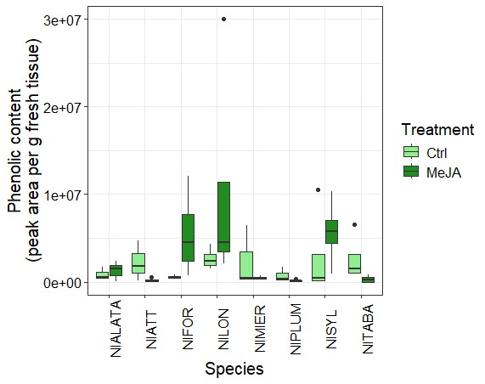
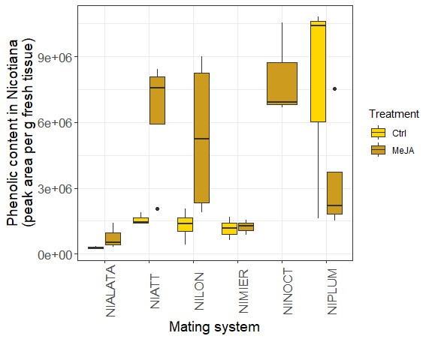
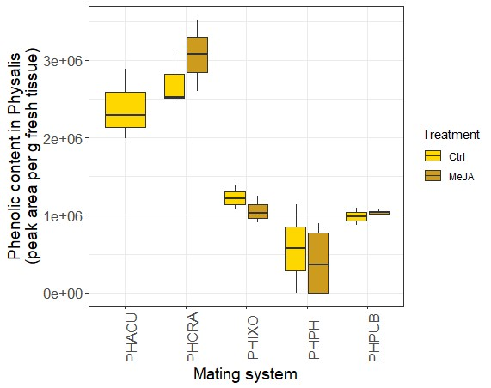
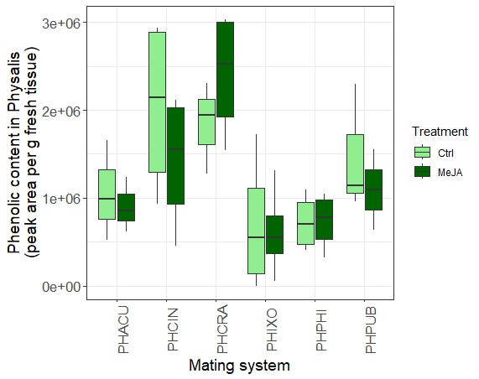
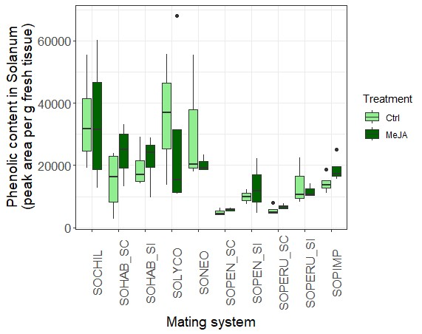
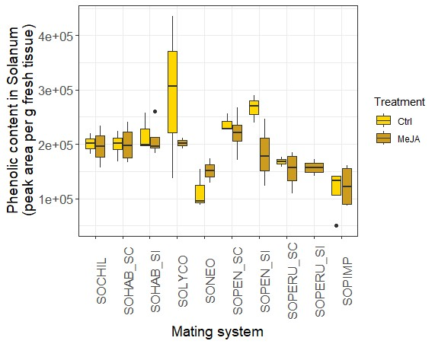
e)
e)
d)
c)
b)
a)
Flowers
Leaves
Supplementary Figure 1: Phenolic content given as peak area in flowers and leaves gFW⁻¹ + SE in each species of the three genera used in this study. a) Phenolic content in Physalis flowers, pale yellow represents control plants, dark yellow represents MeJA-treated plants. SC species are denoted as PHPUB, PHACU and PHIXO, whilst SI species are denoted by PHCRA, PHCIN and PHPHI. b) Phenolic content in Physalis leaves, pale green represents control plants, dark green represents MeJA-treated plants. c) Nicotiana flowers SC species are denoted as NIATT, NIMIER, NILON, NIPLUM and SI species are denoted as NITABA, NIALATA, NINOCT, NISYL and NIFOR d) Nicotiana leaves e) Solanum flowers SC species are denoted as SOLYCO, SOPEN_SC, SOCHIL, SOHAB_SC, SOPERU_SC and SI species are denoted as SOPEN_SI, SOPERU_SI, SOHAB_SI, SOPIMP and SONEO. f) Solanum leaves.

Chapter 5

Chapter 5

General Discussion

5.1 Overview
Interactions between plants and invertebrates are ecologically ubiquitous and have driven the extraordinary diversification of both taxa. Plant interactions with pollinators have resulted in the evolution of a plethora of pollination syndromes, as well as morphological and chemical traits in flowers (Armbruster, 2016), whilst interactions between plants and insect herbivores have resulted in a broad array of chemical defences in plants (Gatehouse, 2002). The evolution of defence traits in plants often focuses on the interaction between plant and herbivore (eg. Becerra, 2003; Futuyma & Agrawal, 2009), and relatively less is understood about how other ecological interactions, such as those between plants and pollinators, may also influence the evolution of defence traits. Understanding the dynamics of ecosystem and evolutionary pressures shaping species diversification can be achieved through studying multitrophic systems, such as the interactions between plants, herbivores and pollinators. The evolution of defence traits can be shaped by interactions with pollinators, and in turn, plant-pollinator interactions may be shaped by plant-herbivore interactions. Identifying the cross-interaction constraints is key to better understanding the dynamics of the evolution of plant defence.
Plants produce a range of defensive secondary metabolites to defend themselves against herbivory. These include compounds with deterrent, toxic, and anti-nutritive effects on herbivores (Gatehouse, 2002). Defences which are produced constantly are constitutive defences, however there are costs associated with constant defence expression such as resource allocation costs (Ballaré and Austin, 2019) which have led to the evolution of inducible defences that are upregulated in response to herbivory (Karban and Baldwin, 1997). The defence strategy evolved in a plant population should be affected by the relative costs and benefits of each strategy within a particular population (Núñez-Farfán et al., 2007).
Allocation to defence, either constitutively or after induction, can be predicted using Optimal Defence Theory, which predicts that more valuable tissues will be most strongly defended, whilst also that defence will be higher when the frequency of attack is greater (McKey, 1974). One drawback of Optimal Defence theory could be in the oversimplification of its predictions, which are based on the production costs of defence, which are assumed to be inherently costly to a plant, ignoring additional ecological costs. Nevertherless, Optimal Defence Theory remains one of the most influential theories to explain the distribution pattern of defence traits in plants (McKey, 1974; Rhoades, 1979). Much of the available experimental evidence supports the predictions of ODT, namely that within-plant allocation to defence can be predicted as a function of the relative fitness values of different plant tissues (Ohnmeiss and Baldwin, 2000; Strauss, Irwin and Lambrix, 2004; Keith and Mitchell-Olds, 2017). In this thesis, I have shown that ODT can be a useful framework, but additional factors including pollinator reliance, or plant mating system would allow for a more complete model of defence allocation.
Plant reproduction and defence are linked through plant secondary metabolism, and these links may explain in part why there is a trade-off between plant defence and reproduction (Thompson and Johnson, 2016; Garcia et al., 2021), particularly when induced defences occur in reproductive tissues (Kessler and Halitschke, 2009; Lucas-Barbosa et al., 2011). An important ecological cost of induced defence in floral tissue is reduced pollinator visitation which can reduce plant fitness, a phenomenon referred to as herbivore-induced pollinator limitation (Kessler, Halitschke and Poveda, 2011). This cost is often a result of changes to floral chemistry, either through increased production of volatile compounds (Burkle and Runyon, 2016; Lucas-Barbosa et al., 2011; Zangerl and Berenbaum, 2009), or increased concentration of defensive secondary metabolites in floral tissue and floral rewards such as pollen and nectar (Adler, 2000). Due to the high relative value of flowers, their role in attracting pollinators, and the negative impacts of altered scent or rewards, floral chemistry is likely to be under stabilising selection by pollinators, supported by the results presented in this thesis that show flowers are not inducible following damage (Chapter 2, Figure 1c; Chapter 3 Figure 5b; Chapter 4 Figure 1a). Furthermore, pollinator selection pressure is likely to be stronger in plants which have a greater reliance on pollinators, such as outcrossing plants, compared to those with lower reliance on pollinators such as selfing plants. Despite the high relative value of flowers to plants, and the importance of plant-pollinator relationships, relatively few studies into floral chemical defences have been conducted, so relatively little is understood about how plant-pollinator relationships may shape the evolution of floral chemical defence.
Reliance on pollinators has previously been shown to be a predictor of the strength of plant chemical defence in both floral and leaf tissues, particularly in the Solanaceae (Adler et al., 2012; Campbell et al., 2014; Campbell and Kessler, 2013). The transition to selfing may be accompanied by the evolution of inducible defence strategies as selfing commonly occurs at plant range margins due uncertain mating opportunities (Griffin and Willi, 2014). The occurrence of herbivory can also be unpredictable at range margins, so phenotypic plasticity in defence can be adaptive in these locations as it reduces the cost of producing defence until attack occurs. This could lead to inducible defences being the favoured defence strategy in selfing plants (Campbell and Kessler, 2013). Plants which are strongly reliant on pollinators may also experience greater ecological costs of induced defence if their defence metabolites have negative effects on pollination. If pollinator recruitment is not negatively affected by defence then there would be no detectable influence of mating system on strength of defence. Perhaps when selective pressures by herbivores and pollinators are stable over evolutionary time periods, plants can evolve inducible defences that effectively deter herbivores whilst simultaneously not negatively effecting pollinator recruitment.
In a changing global climate, understanding how plants may adapt to novel environmental challenges can be improved by developing a deeper understanding of the coevolution of plants and herbivores. Declining pollinator populations driven by loss of, or range changes to habitats, pesticide use and climate change pose threats to crop security. Meta-analyses have revealed that over 75% of the world’s main food crops are at least partially dependent on animal pollinators (Klein et al., 2006). Developing more comprehensive models of plant defence, including understanding how the degree of pollinator reliance of a particular food crop may influence the defence phenotype, and how defence may affect pollinator attraction, may help to shape the future of crop protection. The use of plant phytohormones as a method of crop protection from herbivory or pathogen damage may be advantageous in plants with non-inducible flowers. Linking metabolomic defence studies with transcriptomic studies could allow us to identify genes that are involved in defence without producing deterrent effects on pollinators. Research with wild plant species could reveal useful defence phenotypes that could be beneficial for introgression line research to improve crop plant defence capability.
In this thesis, phylogenetic relationships between taxa were assumed from either geographical isolation of species, accession collection data or phylogenetic models in the literature. Whilst building phylogenies for the accessions of S. pennellii, and the species included in Chapter 4 would allow relatedness to be formally accounted for in the models, building such a phylogeny was outside the scope of this thesis. Including phylogenies, particularly for multiple species, would allow us to determine whether each selfing species used in this study represents an independent origin of selfing. The species were selected using data from the literature to identify selfing and outcrossing pairs of species that were strongly likely to represent independent transitions to selfing. The potential for inclusion of non-independent transitions to selfing would be a confounding effect on the strength of the patterns observed in this data, for example, should two selfing species have the same origin of self-compatibility, and yet be counted as independent species, this would be an overrepresentation of the defence traits of these species. That being said, the taxa included in this thesis had distinct morphological features, such as distinct floral features, which may indicate that the taxa experienced differential selection for floral traits which could include floral defence traits. Future work would benefit from building on these data and research methodologies to utilise phylogenetic models to investigate the evolution of defence traits in selfing and outcrossing taxa, however gathering phylogenetic data was outside the scope and timing of this thesis.
The overarching aim of this thesis was to investigate specificity in plant defence in different plant tissues and mating systems. The research presented in this thesis explored how constitutive and induced defence varies in leaf and flower tissue in selfing and outcrossing flowers using metabolomics and transcriptomics and herbivore feeding bioassays to measure defence.

5.2 Higher constitutive defence in flowers than leaves
One aim of this thesis was to investigate differences in flower and leaf constitutive defence in selfing and outcrossing plants. Optimal defence theory predicts that flowers will have higher constitutive defences compared to leaves due to their high value to plants (Rhoades, 1979). Several studies have found that constitutive defences are higher in flowers than leaves (Damle et al., 2005; Smallegange et al., 2007), with some exceptions (Godschalx et al., 2016). As herbivore-induced defences in flowers may be particularly costly to plants as changes to flowers can reduce pollination and therefore reduce plant reproduction (Krupnick et al., 1999; McCall and Irwin, 2006), high constitutive defences could be adaptive in flowers as they reduce the reliance on inducible defences. Pollinators rely on floral cues to locate flowers (Schiestl, 2015), so strong constitutive defences may not have deterrent effects on pollinators, whilst induced changes to floral chemical defences can reduce pollinator visitation (Wright and Schiestl, 2009). We found that flowers had higher constitutive concentrations of phenolic compounds compared to leaves (Chapter 2, Figure 1c: Chapter 4, Figure 1a), supporting optimal defence theory predictions.
The prediction of Optimal Defence theory that plant tissues can differ in their relative value to a plant could extend to different tissues within a flower. A study investigating cyanogenic glycoside concentration in different flower tissues in several species of Protaceae found four patterns of allocation, including greater allocation in anthers, pedicels, pollen presenter and pistils compared to other flower parts (Ritmejerytė et al., 2023). In S. pennellii, the anther cone directly surrounds the reproductive parts of the flower and was subject to less herbivory than corolla tissue in herbivore feeding assays (Ronan-Brown, personal observation). In response to these observations, we conducted additional preliminary experiments that are not described in this thesis to investigate how phenolic content varied between corolla and anther cone tissue and found that the anther cone had significantly higher phenolic content than the corolla (Ronan-Brown et al, unpublished). Investigating patterns of defence within different flower tissues would improve our understanding of the relative value of each tissue which could allow further development of optimal defence theory predictions, as well as improving our understanding of how plants balance pollinator attraction with herbivore deterrence.

5.3 Flower defences are not inducible
Another aim of this thesis was to investigate whether there is plasticity in floral phenolic defences. Whilst defensive metabolites are found in the flowers of many species (e.g., McCall and Fordyce, 2010; Oguro and Sakai, 2014) and have been shown to act as defences against florivores (Johnson et al., 2008; Zangerl and Berenbaum, 2009), relatively few studies have found evidence of induced defence response in flowers, for example, in Nicotiana attenuata (Euler and Baldwin, 1996), Impatiens capensis (Boyer et al., 2016), and some Brassicaceae species (Lucas-Barbosa, 2016). Moreover, the type of damage can result in contrasting induced changes to floral chemistry (Rusman et al., 2022). Specificity in induced response to herbivore damage could result in specific changes to plant-pollinator interactions following herbivore damage, which could be a subject for future investigations in floral defence. We found a handful of species which had MeJA-inducible floral defences, including N. attenuata (Chapter 4, Supplementary Figure 2), however overall we found that floral phenolic defence was not inducible (Chapter 4, Figure 1a). Several studies have found that floral damage does not induce changes to floral secondary metabolites (Soper Gorden and Adler, 2016; Wakabayashi et al., 2018). In some plants, the induction of floral defences in response to leaf damage could protect flowers from herbivore damage (Karban et al., 1999; Karban and Baldwin, 1997). Induced floral defences would be most advantageous for plants if herbivores that feed on leaves subsequently feed on flowers (Ishizaki et al., 2016). We found that flowers are not inducible following defence in 22 species of Solanaceae which suggests that there is convergence for reliance on constitutive rather than inducible defences in flowers. This provides strong evidence that constitutive, rather than inducible defences are adaptive in flowers.
My results have contributed to the development of the long standing theories on plant defence by adding knowledge about the constraints and allocation to induced defence in flowers and leaves. Lack of plasticity in floral phenolic defence corresponds to optimal defence theory which predicts that induced defence would not be the primary defence strategy in flowers, due to their high fitness value (McKey, 1974; Rhoades, 1979; Stamp, 2003). Whilst there are many studies investigating induced response in leaves (Karban and Baldwin, 1997), relatively few studies investigate inducible non-volatile defence in flowers. I found that non-volatile defences in flowers are not inducible, likely due to selection pressure by pollinators for stable rather than inducible floral chemistry.
We found some evidence that leaf phenolic content is inducible in S. pennellii (Chapter 1, Figure 1c), however this was not consistent across the 22 species tested in Chapter 4. Inducible defences may be less advantageous in some species than others, for example if populations experience consistently frequent herbivory, then constitutive rather than inducible defences would be more advantageous (Damle et al., 2005; Smallegange et al., 2007). Divergence between leaf and flower defence strategies within a plant suggests that flowers are constrained by their role as pollinator attractants, and cannot therefore exhibit plasticity in response to damage as this would disrupt pollinator recruitment, whereas changes to leaf chemistry do not influence plant-pollinator interactions.
There is an inherent assumption that defence is costly to a plant, but perhaps non-volatile defences in flowers do not carry an ecological cost if they do not deter pollinators. In some plants, pollinators may not detect non-volatile defences, in which case, these defences would not result in an ecological cost to the plant. Furthermore, the production of non-volatile chemical defences may be less constrained than volatile defences by plant reliance on pollinators, and therefore be plant mating system. Volatile defences can be beneficial to the plant, acting to attract natural enemies of plant herbivores (reviewed in War et al., 2012), in which case inducible flower defence may be adaptive. Investigating both volatile and non-volatile response to herbivory would be interesting for future research. Future work in this field could also focus on the effects of particular compounds on both pollinators and herbivores, to deepen understanding of the duality of interactions. Additionally, it would be interesting to develop an understanding of when plants may rely on volatile or non-volatile defences, and whether the regulation of these defences is linked through pleiotropy or shared regulatory networks. Furthermore, the potential for a resource allocation trade-off between the production of volatile and non-volatile defences in flowers compared to leaves should be a focus for future work, particularly in the context of the different degrees of mating system influence over defence strategies in reproductive and vegetative tissues.

5.4 Mating system predicts defence in flowers but not leaves
Mating system has been shown to influence the evolution of plant defence (Adler et al., 2012; Campbell, 2015). Plants which are more reliant on pollinators (outcrossing) are likely to experience greater ecological costs of defence such as pollinator deterrence compared to plants which are less reliant on pollinators (selfing) (Campbell and Kessler, 2013).
Previously it has been shown that constitutive defence may be higher in both flower and leaf tissue of selfing plants compared to outcrossing plants (Adler et al., 2012), however we found that plant mating system predicts defence more strongly in flowers than leaves (Chapter 2, Figure 2). We found that plant mating system predicts defence in some species, however there was variation in the effect of mating system on defence between species, which suggests that additional factors can influence the evolution of defence. For example, plants which experience higher incidence of florivory may employ stronger constitutive defences in flowers than those which experience lower levels of florivory (de Vries et al., 2019). If florivory is higher in selfing species, then selfing flowers may have higher constitutive floral defences (Adler et al., 2012). Variation in floral defence between populations of a single species (Chapter 2) or between different species (Chapter 4) could reflect that natural populations experience different levels of floral herbivory. Traits that affect florivory are relatively poorly understood (McCall and Irwin, 2006), however it is likely that flowers which are more attractive, such as those with larger floral display, would experience greater levels of herbivory (Gómez, 2003). The selfing syndrome is associated with reduced floral display (Tsuchimatsu and Fujii, 2022), so selfing flowers may be subject to lower floral herbivory rates than outcrossing flowers which would select for lower defences in selfing compared to outcrossing flowers, however to the best of my knowledge, there are no studies investigating these predictions. Both flower and leaf herbivores could select for high defences and the selfing reproductive strategy if damage deters pollinators, however if leaf damage does not deter pollinators, then leaf herbivores may not exert strong selection on either floral defence or plant mating system.
There is a pattern for greater leaf herbivory in outcrossing compared to selfing species (Levin, 1975) which suggests lower defences in selfing species. Additionally, inbreeding is often associated with reduced resistance to herbivory (Johnson et al., 2009), however there is also evidence that inbreeding is associated with lower plasticity in defence against herbivory (Campbell et al., 2014). In contrast to this, reliance on inducibility was greater in selfing species of Solanaceae compared to outcrossing species, and constitutive defence was lower in selfers than outcrossers (Campbell and Kessler, 2013). In species which are newly self-compatible, it could be possible that the effects on inbreeding depression still constrain plant defence against herbivory (Campbell et al., 2013). This thesis presents evidence of the complexity of the evolution of plant mating system transitions and plant chemical defence, showing that pollinator reliance could predict plant defence differentially between flowers and leaves. Using transcriptome analysis, we found genes that are uniquely expressed in leaves and flowers of either mating system (Chapter 3), suggesting that there may be mating system-specific genes that could be involved in the regulation of mating system-specific traits, including patterns for higher defence in selfing flowers compared to outcrossing flowers of Solanum pennellii (Chapter 2).
The data presented in this thesis highlights the degree of variation in patterns in plant chemical defence, even between related taxa. This indicates a need to improve current models for predicting defence, which will require further investigation of relationships between specific ecological interactions and plant defence. Including plant interactions with mutualists such as pollinators, as well as herbivore antagonists may improve on current theories predicting defence.

5.5 Summary and future perspectives
Many studies on plant defence focus on leaf rather than flower defence, and fewer consider the how plant-pollinator interactions could have influenced the evolution of plant chemical defence. In this thesis I investigated the differences in expression of defensive secondary metabolites between leaves and flowers in selfing and outcrossing species of the Solanaceae, and generated new insight into the fundamental drivers of plant defence within and across species. I present data showing that leaves and flowers are differentially defended, and that plant pollinator reliance can constrain flower, rather than leaf defence. I utilised metabolomic and transcriptomic analysis, as well as herbivore feeding bioassays to investigate how contrasting selection pressures by pollinators and herbivores can influence the evolution of defence in flowers and leaves.
In summary this thesis presents numerous novel contributions to the fields of ecology, evolutionary biology and plant defence research:
- Flowers have higher constitutive defences than leaves. I found that in Solanum pennellii, floral defence is higher in selfing than outcrossing flowers whilst no mating-system specific effects on leaf defence were observed (Chapter 2). I also found evidence for convergence on higher constitutive defence in flowers compared to leaves in Solanaceae.
- Flower phenolic content showed lower plasticity to MeJA treatment than did leaf phenolic content
- Very few genes respond to MeJA treatment in flowers compared to leaves, suggesting that that any defence response in flowers may be regulated by systemic molecular changes, or perhaps flowers act as sinks for defence.
- Plant mating system may constrain floral defence more than leaf defence, suggesting that plant-pollinator interactions can differentially influence defence between different plant tissues.
My conclusions are particularly robust given that I took a multidisciplinary approach using organismal, phenotypic, and molecular approaches, and applied this approach across two evolutionary scales including work among populations and among species. The integrated strategy provides a more holistic understanding of the evolutionary forces that influence defence. Developing a better understanding of plant interactions with herbivores and pollinators will allow not just a deeper understanding into the complexities of the coevolution between the taxa, but will also provide insight into how to preserve diversity in plant defence mechanisms in order to conserve plant biodiversity and therefore the resilience of plant populations. Combining metabolomic and transcriptomic studies would provide greater detail about the interactions between flower and leaf defence. Furthermore, knowledge of the interactions between plant chemistry and herbivores can improve optimization of crops and allow the development of more robust food production systems. Learning more about the effects of herbivory on specific metabolites and the biological and ecological implications of these changes will increase understanding of how plants defend themselves against herbivory.
Focusing on integrated approaches will deepen our understanding of the ecology and evolution of plant chemical defence. More studies are needed to investigate how pollinator reliance may influence both volatile and non-volatile defences, and how molecular regulation of different classes of defence metabolites may cause propagation of defence to different plant tissues. Furthermore, studies investigating how plant mating system could regulate floral defence traits are scarce, and could offer key insight into understanding the ecological drivers of the evolution of floral defence. Relatively few studies have investigated the mechanisms of floral defence, and this should be an important focus for future research. I suggest that future work should consider the effects of plant defensive chemistry on both herbivores and pollinators, and investigating response to specific compounds would allow us to understand which compounds or chemical pathways are subject to the greatest selection by mutualists and antagonists.
Additionally, future work would benefit from considering the interplay between chemical pathways within a plant. Several studies have investigated a potential for hormonal interaction between jasmonic acid (JA) and other plant hormones, such as salicylic acid (SA) (Thaler, Fidantsef and Bostock, 2002; Thaler, Humphrey and Whiteman, 2012; Proietti et al., 2013), which is commonly associated with plant defence pathogens and phloem-feeding insects (Vlot, Dempsey & Klessig, 2009). In many dicotyledonous species, JA and SA defence signalling pathways are antagonistic (Koornneef and Pieterse, 2008), including in Arabidopsis, in which SA downregulated the expression of JA-responsive genes and genes in the JA biosynthesis pathway (Leon-Reyes et al., 2010). Crosstalk between JA and SA pathways involves many components, however research in this area has focused on the effect of the interactions on defence phenotype without considering the potential for a further interaction with pollinators. Future work could consider how pollinators may be affected by hormonal crosstalk, and in turn, how pollinators could exert selection pressure for interactions which promote stability in floral chemistry. Pollinator preference for consistency in floral chemistry could mean that crosstalk between phytohormone pathways may be adaptive to limit plasticity in floral defence, and future work should consider the potential for the influence of pollinators to extend to other defence pathways than those considered in this thesis.
To conclude, the results presented in this thesis provide novel insights into plant-herbivore-pollinator interactions. Important insights will be gained by investigating the mechanisms driving the patterns in defence, including the potential for antagonistic interactions between different taxa as well as the mechanisms that drive differential defence production in different plant tissues.

5.6 References
Adler, L.S. (2000) ‘The ecological significance of toxic nectar’, Oikos, 91(3), pp. 409–420. Available at: https://doi.org/10.1034/j.1600-0706.2000.910301.x.
Adler, L.S. et al. (2012) ‘Reliance on pollinators predicts defensive chemistry across tobacco species’, Ecology Letters, 15(10), pp. 1140–1148. Available at: https://doi.org/10.1111/j.1461-0248.2012.01838.x.
Armbruster, W.S. (2016) ‘Plant–Pollinator Interactions and Flower Diversification’, in R.M. Kliman (ed.) Encyclopedia of Evolutionary Biology. Oxford: Academic Press, pp. 297–300. Available at: https://doi.org/10.1016/B978-0-12-800049-6.00258-4.
Ballaré, C.L. and Austin, A.T. (2019) ‘Recalculating growth and defense strategies under competition: key roles of photoreceptors and jasmonates’, Journal of Experimental Botany, 70(13), pp. 3425–3434. Available at: https://doi.org/10.1093/jxb/erz237.
Becerra, J.X. (2003) ‘Synchronous coadaptation in an ancient case of herbivory’, Proceedings of the National Academy of Sciences, 100(22), pp. 12804–12807. Available at: https://doi.org/10.1073/pnas.2133013100.
Boyer, M.D.H. et al. (2016) ‘Floral damage induces resistance to florivory in Impatiens capensis’, Arthropod-Plant Interactions, 10(2), pp. 121–131. Available at: https://doi.org/10.1007/s11829-015-9411-y.
Burkle, L.A. and Runyon, J.B. (2016) ‘Drought and leaf herbivory influence floral volatiles and pollinator attraction’, Global Change Biology, 22(4), pp. 1644–1654. Available at: https://doi.org/10.1111/gcb.13149.
Campbell, S.A. et al. (2014) ‘Plant mating systems affect adaptive plasticity in response to herbivory’, The Plant Journal, 78(3), pp. 481–490. Available at: https://doi.org/10.1111/tpj.12492.
Campbell, S.A. (2015) ‘Ecological mechanisms for the coevolution of mating systems and defence’, New Phytologist, 205(3), pp. 1047–1053. Available at: https://doi.org/10.1111/nph.13212.
Campbell, S.A. and Kessler, A. (2013) ‘Plant mating system transitions drive the macroevolution of defense strategies’, Proceedings of the National Academy of Sciences, 110(10), pp. 3973–3978. Available at: https://doi.org/10.1073/pnas.1213867110.
Campbell, S.A., Thaler, J.S. and Kessler, A. (2013) ‘Plant chemistry underlies herbivore-mediated inbreeding depression in nature’, Ecology Letters, 16(2), pp. 252–260. Available at: https://doi.org/10.1111/ele.12036.
Damle, M.S. et al. (2005) ‘Higher accumulation of proteinase inhibitors in flowers than leaves and fruits as a possible basis for differential feeding preference of Helicoverpa armigera on tomato (Lycopersicon esculentum Mill, Cv. Dhanashree)’, Phytochemistry, 66(22), pp. 2659–2667. Available at: https://doi.org/10.1016/j.phytochem.2005.09.006.
Euler, M. and Baldwin, I.T. (1996) ‘The chemistry of defense and apparency in the corollas ofNicotiana attenuata’, Oecologia, 107(1), pp. 102–112. Available at: https://doi.org/10.1007/BF00582240.
Frontiers | The Price of the Induced Defense Against Pests: A Meta-Analysis (no date). Available at: https://www.frontiersin.org/journals/plant-science/articles/10.3389/fpls.2020.615122/full (Accessed: 18 August 2024).
Gatehouse, J.A. (2002) ‘Plant resistance towards insect herbivores: a dynamic interaction’, New Phytologist, 156(2), pp. 145–169. Available at: https://doi.org/10.1046/j.1469-8137.2002.00519.x.
Godschalx, A.L. et al. (2016) ‘Is protection against florivory consistent with the optimal defense hypothesis?’, BMC Plant Biology, 16(1), p. 32. Available at: https://doi.org/10.1186/s12870-016-0719-2.
Gómez, J.M. (2003) ‘Herbivory reduces the strength of pollinator-mediated selection in the Mediterranean herb Erysimum mediohispanicum: consequences for plant specialization’, The American Naturalist, 162(2), pp. 242–256. Available at: https://doi.org/10.1086/376574.
Griffin, P.C. and Willi, Y. (2014) ‘Evolutionary shifts to self-fertilisation restricted to geographic range margins in North American Arabidopsis lyrata’, Ecology Letters, 17(4), pp. 484–490. Available at: https://doi.org/10.1111/ele.12248.
Ishizaki, S. et al. (2016) ‘Seasonal variation of responses to herbivory and volatile communication in sagebrush (Artemisia tridentata) (Asteraceae)’, Journal of Plant Research, 129(4), pp. 659–666. Available at: https://doi.org/10.1007/s10265-016-0818-z.
Johnson, E.T., Berhow, M.A. and Dowd, P.F. (2008) ‘Colored and white sectors from star-patterned petunia flowers display differential resistance to corn earworm and cabbage looper larvae’, Journal of Chemical Ecology, 34(6), pp. 757–765. Available at: https://doi.org/10.1007/s10886-008-9444-0.
Johnson, M.T.J., Smith, S.D. and Rausher, M.D. (2009) ‘Plant sex and the evolution of plant defenses against herbivores’, Proceedings of the National Academy of Sciences, 106(43), pp. 18079–18084. Available at: https://doi.org/10.1073/pnas.0904695106.
Karban, R. et al. (1999) ‘Induced plant responses and information content about risk of herbivory’, Trends in Ecology & Evolution, 14(11), pp. 443–447. Available at: https://doi.org/10.1016/S0169-5347(99)01678-X.
Karban, R. and Baldwin, I.T. (1997) Induced Responses to Herbivory. Chicago, UNITED STATES: University of Chicago Press. Available at: http://ebookcentral.proquest.com/lib/sheffield/detail.action?docID=408325 (Accessed: 1 June 2021).
Keith, R.A. and Mitchell-Olds, T. (2017) ‘Testing the optimal defense hypothesis in nature: Variation for glucosinolate profiles within plants’, PLoS ONE, 12(7). Available at: https://doi.org/10.1371/journal.pone.0180971.
Kessler, A. and Halitschke, R. (2009) ‘Testing the potential for conflicting selection on floral chemical traits by pollinators and herbivores: predictions and case study’, Functional Ecology, 23(5), pp. 901–912. Available at: https://doi.org/10.1111/j.1365-2435.2009.01639.x.
Kessler, A., Halitschke, R. and Poveda, K. (2011) ‘Herbivory-mediated pollinator limitation: negative impacts of induced volatiles on plant–pollinator interactions’, Ecology, 92(9), pp. 1769–1780. Available at: https://doi.org/10.1890/10-1945.1.
Klein, A.-M. et al. (2006) ‘Importance of pollinators in changing landscapes for world crops’, Proceedings of the Royal Society B: Biological Sciences, 274(1608), pp. 303–313. Available at: https://doi.org/10.1098/rspb.2006.3721.
Koornneef, A. and Pieterse, C.M.J. (2008) ‘Cross Talk in Defense Signaling’, Plant Physiology, 146(3), pp. 839–844. Available at: https://doi.org/10.1104/pp.107.112029.
Krupnick, G.A., Weis, A.E. and Campbell, D.R. (1999) ‘The Consequences of Floral Herbivory for Pollinator Service to Isomeris arborea’, Ecology, 80(1), pp. 125–134. Available at: https://doi.org/10.2307/176984.
Leon-Reyes, A. et al. (2010) ‘Salicylate-mediated suppression of jasmonate-responsive gene expression in Arabidopsis is targeted downstream of the jasmonate biosynthesis pathway’, Planta, 232(6), pp. 1423–1432. Available at: https://doi.org/10.1007/s00425-010-1265-z.
Levin, D.A. (1975) ‘Pest Pressure and Recombination Systems in Plants’, The American Naturalist, 109(968), pp. 437–451.
Lucas-Barbosa, D., van Loon, J.J.A. and Dicke, M. (2011) ‘The effects of herbivore-induced plant volatiles on interactions between plants and flower-visiting insects’, Phytochemistry, 72(13), pp. 1647–1654. Available at: https://doi.org/10.1016/j.phytochem.2011.03.013.
Macroevolution and the biological diversity of plants and herbivores (no date). Available at: https://doi.org/10.1073/pnas.0904106106.
McCall, A.C. and Fordyce, J.A. (2010) ‘Can optimal defence theory be used to predict the distribution of plant chemical defences?’, Journal of Ecology, 98(5), pp. 985–992.
McCall, A.C. and Irwin, R.E. (2006) ‘Florivory: the intersection of pollination and herbivory’, Ecology Letters, 9(12), pp. 1351–1365. Available at: https://doi.org/10.1111/j.1461-0248.2006.00975.x.
McKey, D. (1974) ‘Adaptive Patterns in Alkaloid Physiology’, The American Naturalist, 108(961), pp. 305–320. Available at: https://doi.org/10.1086/282909.
Núñez-Farfán, J., Fornoni, J. and Valverde, P.L. (2007) ‘The Evolution of Resistance and Tolerance to Herbivores’, Annual Review of Ecology, Evolution, and Systematics, 38(Volume 38, 2007), pp. 541–566. Available at: https://doi.org/10.1146/annurev.ecolsys.38.091206.095822.
Oguro, M. and Sakai, S. (2014) ‘Difference in defense strategy in flower heads and leaves of Asteraceae: multiple-species approach’, Oecologia, 174(1), pp. 227–239. Available at: https://doi.org/10.1007/s00442-013-2765-x.
Ohnmeiss, T.E. and Baldwin, I.T. (2000) ‘Optimal Defense Theory Predicts the Ontogeny of an Induced Nicotine Defense’, Ecology, 81(7), pp. 1765–1783. Available at: https://doi.org/10.1890/0012-9658(2000)081[1765:ODTPTO]2.0.CO;2.
Proietti, S. et al. (2013) ‘Crosstalk between salicylic acid and jasmonate in Arabidopsis investigated by an integrated proteomic and transcriptomic approach’, Molecular bioSystems, 9(6), pp. 1169–1187. Available at: https://doi.org/10.1039/c3mb25569g.
Rhoades, D.F. (1979) ‘Evolution of plant chemical defense against herbivores’, in. New York: Academic Press, pp. 3–54. Available at: https://oceanrep.geomar.de/id/eprint/44480/ (Accessed: 31 March 2023).
Ritmejerytė, E. et al. (2023) ‘Diverse organ-specific localisation of a chemical defence, cyanogenic glycosides, in flowers of eleven species of Proteaceae’, PLOS ONE, 18(4), p. e0285007. Available at: https://doi.org/10.1371/journal.pone.0285007.
Rusman, Q. et al. (2022) ‘Flowers prepare thyselves: leaf and root herbivores induce specific changes in floral phytochemistry with consequences for plant interactions with florivores’, New Phytologist, 233(6), pp. 2548–2560. Available at: https://doi.org/10.1111/nph.17931.
Salicylic Acid, a Multifaceted Hormone to Combat Disease | Annual Reviews (no date). Available at: https://www-annualreviews-org.sheffield.idm.oclc.org/content/journals/10.1146/annurev.phyto.050908.135202 (Accessed: 15 February 2025).
Schiestl, F.P. (2015) ‘Ecology and evolution of floral volatile-mediated information transfer in plants’, New Phytologist, 206(2), pp. 571–577. Available at: https://doi.org/10.1111/nph.13243.
Smallegange, R.C. et al. (2007) ‘Flower vs. leaf feeding by Pieris brassicae: glucosinolate-rich flower tissues are preferred and sustain higher growth rate’, Journal of Chemical Ecology, 33(10), pp. 1831–1844. Available at: https://doi.org/10.1007/s10886-007-9350-x.
Soper Gorden, N.L. and Adler, L.S. (2016) ‘Florivory shapes both leaf and floral interactions’, Ecosphere, 7(6), p. e01326. Available at: https://doi.org/10.1002/ecs2.1326.
Stamp, N. (2003) ‘Out of the quagmire of plant defense hypotheses’, The Quarterly Review of Biology, 78(1), pp. 23–55. Available at: https://doi.org/10.1086/367580.
Strauss, S.Y., Irwin, R.E. and Lambrix, V.M. (2004) ‘Optimal defence theory and flower petal colour predict variation in the secondary chemistry of wild radish’, Journal of Ecology, 92(1), pp. 132–141. Available at: https://doi.org/10.1111/j.1365-2745.2004.00843.x.
Thaler, J.S., Fidantsef, A.L. and Bostock, R.M. (2002) ‘Antagonism Between Jasmonate- and Salicylate-Mediated Induced Plant Resistance: Effects of Concentration and Timing of Elicitation on Defense-Related Proteins, Herbivore, and Pathogen Performance in Tomato’, Journal of Chemical Ecology, 28(6), pp. 1131–1159. Available at: https://doi.org/10.1023/A:1016225515936.
Thaler, J.S., Humphrey, P.T. and Whiteman, N.K. (2012) ‘Evolution of jasmonate and salicylate signal crosstalk’, Trends in Plant Science, 17(5), pp. 260–270. Available at: https://doi.org/10.1016/j.tplants.2012.02.010.
Thompson, K.A. and Johnson, M.T.J. (2016) ‘Antiherbivore defenses alter natural selection on plant reproductive traits: PLANT DEFENSE AND SELECTION ON REPRODUCTIVE TRAITS’, Evolution, 70(4), pp. 796–810. Available at: https://doi.org/10.1111/evo.12900.
Tsuchimatsu, T. and Fujii, S. (2022) ‘The selfing syndrome and beyond: diverse evolutionary consequences of mating system transitions in plants’, Philosophical Transactions of the Royal Society B: Biological Sciences, 377(1855), p. 20200510. Available at: https://doi.org/10.1098/rstb.2020.0510.
Visual and odour cues: plant responses to pollination and herbivory affect the behaviour of flower visitors - Lucas‐Barbosa - 2016 - Functional Ecology - Wiley Online Library (no date). Available at: https://besjournals-onlinelibrary-wiley-com.sheffield.idm.oclc.org/doi/10.1111/1365-2435.12509 (Accessed: 29 August 2023).
de Vries, J. et al. (2019) ‘Ecological interactions shape the adaptive value of plant defence: Herbivore attack versus competition for light’, Functional Ecology, 33(1), pp. 129–138. Available at: https://doi.org/10.1111/1365-2435.13234.
Wakabayashi, K. et al. (2018) ‘Floral-induced and constitutive defense against florivory: a comparison of chemical traits in 12 herb species’, Plant Ecology, 219(8), pp. 985–997.
War, A.R. et al. (2012) ‘Mechanisms of plant defense against insect herbivores’, Plant Signaling & Behavior, 7(10), pp. 1306–1320. Available at: https://doi.org/10.4161/psb.21663.
Wright, G.A. and Schiestl, F.P. (2009) ‘The evolution of floral scent: the influence of olfactory learning by insect pollinators on the honest signalling of floral rewards’, Functional Ecology, 23(5), pp. 841–851. Available at: https://doi.org/10.1111/j.1365-2435.2009.01627.x.
Zangerl, A.R. and Berenbaum, M.R. (2009) ‘Effects of florivory on floral volatile emissions and pollination success in the wild parsnip’, Arthropod-Plant Interactions, 3(3), pp. 181–191. Available at: https://doi.org/10.1007/s11829-009-9071-x.

