

The influence of molar mass distribution on the effectiveness of polypropylene in laser sintering process

Talal Mansour AlGhamdi

A thesis submitted in partial fulfilment of the requirements for the degree of
Doctor of Philosophy

The University of Sheffield
Faculty of Engineering
Department of Mechanical Engineering

August 2024
Acknowledgements
I would like to thank God for giving me the strength to go through the ups and downs in my life journey and blessing me with my parents, wife, children and brothers, who stood by me when times were hard. Without their unconditional love and support, I would not have been able to pass through the hard times through this journey.
I would like to express my deepest gratitude to my first PhD supervisor, Dr Candice Majewski, for her unwavering support through hard times, guidance, and mentorship throughout my doctoral journey. Your insightful feedback, constant encouragement, and dedication to my academic and personal growth have been invaluable. Thank you for believing in me, for pushing me to reach my potential, and for being a source of knowledge and inspiration.
I would like to extend my thanks to my second supervisor, Prof. Patrick Fairclough, for his invaluable support and guidance throughout my PhD research. Your expertise, thoughtful insights, and constructive feedback have greatly enriched my work. Your willingness to aid and your availability for discussions and consultations have been crucial in navigating the complexities of my research. Your encouragement and belief in my abilities have been a source of motivation and confidence.
I am very grateful to the SABIC sponsorship and team, in particular Dr. Zahir Bashir and Dr. Imam Hadimani my industrial supervisors, for their support and for sharing their knowledge of polymer science processes; their vast expertise in polymers was invaluable throughout my doctoral journey.
Many thanks to Wendy Birtwistle, lab technician, for her time and patience in supporting me with the lab work. Your expertise and operational skills were outstanding and, at points, brought luck to the machine.

A special thanks to Kurt Bonser, lab technician, for introducing me to Alnomdi and supporting me with the lab work. Your spontaneous problem-solving when faced with lab issues was crucial.

I would like to finally thank all the friends I gained during my journey, Alec Shackleford, James Wingham, Ryan Brown, and Ryan Green, for sharing past/present experiences with their PhD experiences.

Abstract
This study investigates the intrinsic and extrinsic properties of polypropylene (PP) that significantly influence the tensile properties of laser sintering (LS). The study found that PP has a gap in performance compared to PA 12. From the literature, the study shows that molar mass distribution (MMD) is a fundamental property that impacts the tensile properties of injection moulding, but it was unknown in laser sintering (LS). The study used existing homopolymer PP powder with different Melt Flow index MFI’s, 12, 20, and 50 g/10minute (230˚C 2.16kg) with variations in MMD. High MFI resulted in high UTS and EAB, which were examined by the porosity, surface finish, and crystallinity.
The HC12 grade required further grinding to HC11 to meet the LS requirement. The HC11 powder failed during LS due to degradation, resulting in excessive curling. This was proven by high changes in the MMD after grinding. The other two grades showed that the high MFI grade resulted in superior ultimate tensile strength (UTS) and elongation-to-break (EAB). The long chains, shown by Mz+1 in the case of CP20, seem to have a negative effect in sintering, increasing porosity and resulting in a reduction in tensile values.
The study goes further by examining two powders, the SABIC PP 518A and the 511A, where both share an MFI of 25 and polymer dispersity of 6.34 to 3.52, respectively. The 518A demonstrated a higher UTS, and lower EAB. This shows that high MFI does not result in the highest tensile values in LS but a combination of MMD profile and how the polymer is processed during the LS.
The reusability of HM20/70P powder showed a slight increase in particle size D90, sintering window, and powder flow. However, the powder showed stable MMD up to the sixth cycle without noticeable degradation to polymer chains.
Higher lamellar length showed a strong trend with high UTS and EAB of the final LS specimens, which is dependent on many variables. These findings emphasise the importance of considering the entire molar mass distribution and polymer dispersity, rather than relying on single average values or MFI, to predict or optimise the mechanical properties of PP in laser sintering.

Nomenclature
AM Additive Manufacturing
LS Laser Sintering
UV Ultra-violet
DSC Differential Scanning Calorimetry
EMR Energy melt ratio
PPH Polypropylene homopolymer
PBF Powder Bed Fusion
HPLC High-performance liquid chromatography
GPC Gel permeation chromatography
SEM Scanning electron microscopy
HD-PE High-density polyethylene
MFI Melt flow index
MFR Melt flow rate
CNC Computer numerical control
CAD Computer-aided design
Tm Melt temperature
T_{c} Crystallization temperature
T_{g} Glass transition temperature
ffc Flow function ratio
HR Hausner ratio
M Molar mass
Mn Number average molar mass
Mw Weight average molar mass
Mz z- average molecular weight
MW Molecular weight
MWD Molecular weight distribution
PDI Polymer dispersity
µm Micrometre
STL (Derived from) Stereolithography
E Young’s Modulus
UTS Ultimate Tensile Strength
EAB Elongation at Break
E_{v} Energy volume
ED Energy Density
P laser power
v laser speed
h hatch distance
Lt Layer thickness
Tb bed temperature
PP Polypropylene
PET Polyethylene terephthalate
PA Polyamide
PC Polycarbonate
PE Polyethylene
TPU Thermoplastic polyurethane
$ρ_{tap}$ Tapped density
$ρ_{bluk }$ Bulk density (loose)
DRI Differential Refractive Index
HSM Hot stage microscopy
HCT Half crystallisation time
E Modulus of elasticity
Bt Build temperature.
MMA Molar mass average
XRD X-ray diffraction
SW Sintering window
SD Standard deviation
ZSV Zero shear viscosity
PBT Polybutylene terephthalate
PEG Polyethylene glycol
Delta H Enthalpy
EAB Elongation at break
UTS Ultimate tensile strength
E Modulus
TBC 1,2,4-trichlorobenzene (TCB)
UHMWPE Ultra-high molecular weight polyethylene
DOE Design of experiment
SW Sintering windows
T _{m}⁰ Equilibrium melting temperature of α-phase iPP (464 K)
ΔH_{f} Melting enthalpy of a perfect crystal (196 J/cm³)
φ Free surface energy of the end faces at which chains fold (102.9 J/cm²)
L_{n} The mean lamellar thickness
L_{max} the maximum lamellar thickness

Contents
Chapter 1: Introduction to additive manufacturing 22
1.1 History of additive manufacturing 22
1.2 Advantages of AM 24
1.3 Disadvantages of AM 24
1.4 Types of additive manufacturing 25
1.5 AM applications 25
1.6 Laser sintering technology 26
1.6.1 Materials used for LS 28
Chapter 2: Polymer overview 29
2.1 Polymerisation type 29
2.2 Polymer classification 30
2.3 Monomers 31
2.4 Molar mass distribution 32
2.5 Polypropylene (PP) 36
Chapter 3: Influence of laser sintering material properties 37
3.1 Extrinsic powder properties 38
3.1.1 Powder flow 38
3.1.2 Flow additives 40
3.1.3 Particle shape and size distribution 42
3.2 Intrinsic powder properties 46
3.2.1 Crystallinity 46
3.2.2 Optical properties 48
3.2.3 Melt viscosity 49
3.2.4 Molar mass distribution 51
3.2.5 Thermal degradation 54
3.3 Important LS process parameters 63
3.3.1 Laser energy density 63
3.3.2 Laser Speed 67
3.3.3 Sintering window 68
3.3.4 Part location 71
3.4 Polypropylene in LS 72
3.5 Research Gap 77
Chapter 4: Project definition 78
4.1 Novelty statement 78
4.2 Aim 78
4.3 Objectives 79
4.3 Research flow map 80
4.4 Hypothesis 80
4.5 Test methodology plan 81
Chapter 5: Impact of different MFI on laser sintering tensile data 82
5.1 Material selection 83
5.2 Powder characterisation 85
5.2.1 Particle size distribution (PSD) analysis 85
5.2.2 Particle shape and morphology analysis via scanning electron microscope (SEM) 87
5.2.3 Composition analysis via Energy Dispersive X-ray (EDX) 89
5.2.4 Molar Mass distribution (MMD) analysis 90
5.2.5 Powder flow analysis 94
5.2.5.1 Variable flow rate VFR 94
5.2.5.2 Shear cell 101
5.2.5.3 Permeability 104
5.2.6 Thermal analysis 106
5.2.6.1 Sintering window (SW) 106
5.2.6.2 Hot-stage microscopy (HSM) 109
5.3 Laser sintering process 116
5.3.1 LS production of CP 20 118
5.3.2 LS production of HM20/70P 121
5.3.2.1 Powder flow improvement analysis 122
5.3.2.2 Laser sintered HM20/70P +0.2%wt Alu C process condition 127
5.3.3 LS production HC11 130
5.3.3.1 Powder flow improvement analysis 131
5.3.3.2 Laser sintering HC 11 +0.2%wt TS610 process conditions 135
5.4 Tensile properties 138
5.4.1 Laser sintering builds Tensile testing 138
5.4.2 IM vs LS tensile properties 143
5.4.3 Laser speed impact on tensile properties 147
5.5 Overall discussion 149
5.5.1 Impact of extrinsic LS properties: 150
5.5.1.1 Flow additives as delivered: 151
5.5.1.2 Flow additives introduced: 152
5.5.1.3 Particle size distribution: 153
5.5.1.4 Particle shape: 153
5.5.1.5 Basic flow energy (BFE): 153
5.5.1.6 Specific energy (SE): 154
5.5.1.7 Conditioned bulk density (CBD): 154
5.5.1.8 Flow function ratio (ffc): 154
5.5.1.9 Change in permeability: 154
5.5.2 Impact of intrinsic LS properties: 156
5.5.2.1 Number average molecular weight (Mn): 156
5.5.2.2 Mass average molar mass (Mw): 157
5.5.2.3 Z- average (Mz): 157
5.5.2.4 Melt flow index (MFI): 157
5.5.2.5 Polymer dispersity (PDI): 158
5.5.2.6 Sintering window: 158
5.5.2.7 Powder Crystallinity: 159
5.6 Further specimen characterisation 159
5.6.1 The effect of flow additive on IM 159
5.6.2 Part density 161
5.6.3 Top surface analysis 164
5.6.4 Impact of crystallinity 166
5.7 Conclusion 172
Chapter 6: Impact of different MMD with the same MFI on tensile data 174
6.1 Materials selection 175
6.2 Powder characterisation 176
6.2.1 Size reduction and particle size analysis 176
6.2.2 Powder flow analysis 180
6.2.3 Thermal analysis 187
6.2.4 Powder LS printing 188
6.3 Specimen characterisation 191
6.3.1 Tensile properties 191
6.3.2 IM vs LS tensile properties 193
6.3.3 Part density 194
6.3.4 Changes in molar mass averages (MMA) during different processes 198
6.3.5 Impact of Crystallinity 201
6.4 Conclusion 204
Chapter 7: Impact of reusability on polypropylene LS powder 205
7.1 Reusability process 205
7.2 Impact of reuse on the PSD 207
7.3 Particle morphology 209
7.4 Re-used powder flow analysis. 211
7.5 Impact of reusability on thermal properties 214
7.6 Change in crystallinity with reused powder. 216
7.7 Impact of reusability on MMA 219
7.8 The impact of reused powder on the tensile data 221
7.9 Conclusion 223
Chapter 8: Further discussion 225
8.1 Viscosity 227
8.1.1 Effect of MFI on the laser sintering process 227
8.1.2 Effect of MFI on the tensile values 228
8.2 Polymer dispersity 230
8.2.1 Effect of polymer dispersity on laser sintering process 230
8.2.2 Effect of polymer dispersity on the tensile values 230
8.3 Crystallisation 232
8.3.1 Effect of crystallinity on the laser sintering process 232
8.3.2 Effect of crystallinity on the tensile values 232
8.3.3 Effect of lamellar length on the tensile values 234
8.4 Porosity 236
8.4.1 Effect of porosity on the laser sintering process 236
8.4.2 The effect of porosity on the tensile values. 237
Chapter 9: Conclusion 241
9.1 Further work 245
References 247
Appendices 256
Appendix A: Mn vs tensile data 256
Appendix B: Mw vs tensile data 257
Appendix C: Mz vs tensile data 258
Appendix D: Mz+1 vs tensile data 259

List of Figures
Figure ‎1.1 AM cycle. 22
Figure ‎1.2 Different types of AM according to the energy level used.[4] 25
Figure ‎1.3 Applications segments for AM, Wohlers Report 2022. [8] 26
Figure ‎1.4 Laser sintering process. 27
Figure ‎1.5 Materials used in the LS market according to the 2014 Wohlers report. [10] 28
Figure ‎2.1 Classification of polymers. 30
Figure ‎2.2 (left) Amorphous, (right) Semi-crystalline (in red, crystal structures) 30
Figure ‎2.3 Homopolymer structure repeating units of ‘A’ monomer. [11] 31
Figure ‎2.4 Random copolymer formation with ‘A’ and ‘B’ species in one chain.[11] 31
Figure ‎2.5 Schematic diagram of (a) statistical, (b) alternating, (c) block, (d) grafted (and branched) copolymer. [15] 31
Figure ‎2.6 A typical weight-fraction molar mass distribution curve. [16] 33
Figure ‎3.1 LS process and material requirement diagram. Schmid et al. [22] 37
Figure ‎3.2 Flowability of PE-HD particle uncoated, respectively, coated with hydrophobic fumed silica (T1) or hydrophilic fumed silica (T2) for 10 minutes. [14] 39
Figure ‎3.3 Powder morphologies of different methods of making LS powder. [4] 42
Figure ‎3.4 Duraform® PA exhibits a shape similar to potatoes ( left); Orgasol® particles are much more spherical (right), with a smooth and slightly wavy surface. [29] 43
Figure ‎3.5 Powder bed surface of different powders produced with different methods. [4] 45
Figure ‎3.6 DSC of neat Polypropylene[23] 46
Figure ‎3.7 Comparison of degrees of crystallinity of PA and PP [35] 47
Figure ‎3.8 Infrared absorbance of PA 12 and PP at 943 cm⁻¹. The absorption by PP is about half that of PA 12, which means the beam can penetrate below the layer thickness. [35] 48
Figure ‎3.9 Idealised sintering of two polymer particles, where a is the partial radius, a_{i} and x is the half-neck radius. [51] 50
Figure ‎3.10 Combined tensile and GPC results for PA 12. Vasquez et al. [52] 55
Figure ‎3.11 Isotactic polypropylene exposed to 190˚C for 40, 50, and 60 minutes. [65] 57
Figure ‎3.12 Tensile strength and elongation of PA-GF polymer as a function of a number of builds. [43] 58
Figure ‎3.13 a) a decrease in MFI or the rise in melt viscosity of reused PA 12 material, b) resulting “orange peel” texture on LS parts. [43] 59
Figure ‎3.14 (left) shows the impact of build temperature 172 ˚C for different cumulative times on MMD, (right) the impact of different build temperatures on MMD. [12] 59
Figure ‎3.15 Plot of normalized change in (Mw) from Duraform PA12 and PET powder. Both powders were held at typical build bed temperature (exposure temperatures were 163℃ for PA12 and 210℃ for PET). [45] 60
Figure ‎3.16 Variation of (a) tensile strength and (b) elongation-at-break as a function of laser power and scanning speed. Ituarte et al. [23] 65
Figure ‎3.17 Representative slices from each of the sample batches. The slices display the interlayer connection and the side view of the samples. The sample slices are organized as follows: top row: 2000 mm/s scanning speed; middle row: 2250 mm/s scanning speed; bottom row: 2500 mm/s scanning speed; left column: 15 W laser power; middle column: 16.5 W laser power; right column: 18 W laser power. Ituarte et al. [23] 65
Figure ‎3.18 laser beam travel in two lens types: Plano-Convex lens and F-Theta Lens. 66
Figure ‎3.19 Part density as a function of exposure speed (b)Fracture surface for low and (c)for high exposure at energy density 0.3 J/mm². Drexler et al. [77] 67
Figure ‎3.20 (a) Tensile properties as a function of exposure speed for energy level of (a) Energy density = 0.3 J/mm² and (b) Energy density = 0.4 J/mm². Drexler et al. [77] 68
Figure ‎3.21 Typical DSC-thermogram with nature of “sintering window” as LS temperatures. Schmid et al. [78] 69
Figure ‎3.22 LS processing problems for narrow “sintering window”: curling(left) or Lateral growth (right) Schmid et al. [78] 69
Figure ‎3.23 Sintering window of different PA and PP by Fiedler et al. [35] 70
Figure ‎3.24 Mechanical properties of ROWAK Rolaserit PP on two commercial machines DTM 2500, and EOS P100. Wegner et al. [80] 73
Figure ‎4.1 Thesis Workflow 80
Figure ‎4.2 Workflow for the testing methods 81
Figure ‎5.1 Experimental workflow 83
Figure ‎5.2 The Malvern M3000 to measure the PSD. [87] 85
Figure ‎5.3 PSD of the different powders used. 86
Figure ‎5.4 SEM a) HC 12, b) HC 11, c) CP20, d) HM20/70P. 88
Figure ‎5.5 SEM image targeting two EDX spots. (left) CP20, and (right) HM20/70P. 90
Figure ‎5.6 Molar mass distribution of the different PP grades. 92
Figure ‎5.7 (left) FT4 Machine with aeration unit (right) illustrates how the blade travels in the vessel to capture the resistance in force and torque. [92][93] 95
Figure ‎5.8 The vessel is split to measure the CBD. [93] 96
Figure ‎5.9 Typical data for stability index.[92] 97
Figure ‎5.10 Stability Index of all powders. 98
Figure ‎5.11 BFE values of three grades. 98
Figure ‎5.12 The specific energy of all three powders. 99
Figure ‎5.13 Conditioned bulk density. 99
Figure ‎5.14 FT4 shear cell unit operation. [93] 102
Figure ‎5.15 Shear stress vs normal stress showing the Yield locus and the major principal stress (sigma 1) and unconfined yield strength (sigma c). 102
Figure ‎5.16 Flow function ratio (ffc) 103
Figure ‎5.17 Permeability test showing the pressure drop across different Normal stresses (σ) as air flows through.[96] 104
Figure ‎5.18 The pressure drops change across the vessel at 1 kPa and 15 kPa. 105
Figure ‎5.19 DSC of CP20, HM20/70P, and HC 11). 108
Figure ‎5.20 Thermal couple located on the heated element on the hostage. 110
Figure ‎5.21 Hot stage images of CP20 heating and cooling cycle. 111
Figure ‎5.22 Hot-stage images of HC11. 112
Figure ‎5.23 HSM for the HM20/70P. 113
Figure ‎5.24 Tensile test specimens “Type I” were modelled using ASTM D638-14 117
Figure ‎5.25 Image taken from the front of the EOS P100 LS machine with tensile labels T1= XY1 from the bottom up to the sample T5=XY5 on the top. 119
Figure ‎5.26 Show the top view of the hopper, the CP20 powder bridging in the EOS P100 hopper (circled in red). 120
Figure ‎5.27 HM20/70P Surface defect on the powder at 96C build chamber temperature 121
Figure ‎5.28 HM20/70P VFR values BFE, SE, and CBD with different loads of Alu C 124
Figure ‎5.29 Permeability change across 1KPa to 15KPa for HM20/70P with different Alu C loading 125
Figure ‎5.30 Flow function ratio (ffc) of different Alu C loading for HM20/70P 125
Figure ‎5.31 Powder bed surface of HM20/70P +0.2% wt Alu C 127
Figure ‎5.32 The VFR values for the HC 11 blends. 132
Figure ‎5.33 The flow function ratio (ffc) HC11 with flow additives 133
Figure ‎5.34 The change in permeability from 15kPa to 1kPa for HC11 with flow additives. 133
Figure ‎5.35 Build 4 of HC11+0.2% wt TS610, Curl on the first sintered layer, build temp 130°C and laser powder at 26 W. 136
Figure ‎5.36 UTS for LS successful HM 20/70 +0.2% wt Alu C and CP20 builds. 139
Figure ‎5.37 EAB of LS successful HM 20/70P +0.2%wt Alu C (left) and CP 20 (right) builds. 140
Figure ‎5.38 Modulus for successful HM20/70P+0.2% wt Alu C (left) and CP20 (right) Ls builds . 140
Figure ‎5.39 UTS of LS vs IM both CP20 and HM20/70P +0.2%wt AluC 145
Figure ‎5.40 EAB of IM vs LS for both CP20 and HM20/70P +0.2%wt Alu C 145
Figure ‎5.41 Modulus E of IM vs LS for both CP20 and HM20/70P +0.2%wt Alu C 146
Figure ‎5.42 Tensile data for the CP20 with different speeds with P=25W and Bt=137°C 148
Figure ‎5.43 shows the tensile values for the HM20/70P injection moulding compared with 0.2% wt Alu C added. 161
Figure ‎5.44 Density determination kit by Mettler Toledo. [105] 162
Figure ‎5.45 Density sample location is shown in blue. 163
Figure ‎5.46 Density values for IM and LS samples for the HM20/70P+0.2%wt Alu C and CP20 164
Figure ‎5.47 The change in density between IM vs LS samples. 164
Figure ‎5.48 SEM of top surface of laser sintered CP20 (left), and HM20/70P +0.2wt% Alu C (right) 165
Figure ‎5.49 Crystallinity of Laser sinter article (LS), and Injection Moulded article (IM) 168
Figure ‎5.50 The mean lamellar thickness of LS and IM samples. 168
Figure ‎5.51 Maximum lamellar thickness for LS and IM samples. 169
Figure ‎5.52 Schematic illustration of the deformation behaviour (c=Crystiline, a= Amorphous). [16] 170
Figure ‎5.53 Schematic drawing of the melt zones [16] 171
Figure ‎6.1 Experimental workflow for two grades with the same MFI. 174
Figure ‎6.2 Cooling system using nitrogen with a dual rotation pin mill, manufactured by HIMMEL 177
Figure ‎6.3 Sieved unit with two 90 µ mesh feeds simultaneously. 177
Figure ‎6.4 SEM images after grinding, a) PP518A, b) PP 511A. 179
Figure ‎6.5 the CBD of PP 518A and PP 511A powders 181
Figure ‎6.6 BFE values of different flow additives with PP518A and PP511A. 182
Figure ‎6.7 Change in pressure drop from 1kPa to 15kPa in the FT4 permeability test for the PP 518A and 511A blends. 183
Figure ‎6.8 Flow function ratio (ffc) of PP 518 and PP 511 blends 183
Figure ‎6.9 Top surface of print bed in the EOS P100, a) PP 511A, b) PP 511A+0.2%wt T610, c) PP518A, and d) PP518A+0.2%wtT610. 184
Figure ‎6.10 SEM of powders a) PP518A+0.2%wt T610, b) PP 511A+0.2%wt T610, and c) PP 518A+0.2%wt Alu C 185
Figure ‎6.11 Build failure for PP518+0.2wt%T610 189
Figure ‎6.12 LS Tensile data of PP518A +0.2%wt T610 (left ) vs PP511A +0.2%wt T610 (right), 192
Figure ‎6.13 Modulus for the PP518A+0.2%wt T610 (left) vs PP511A +0.2%wt T610 (right) 192
Figure ‎6.14PP518A and PP511A tensile data for IM vs LS 194
Figure ‎6.15 Density for the injection moulding (IM) vs laser sintered (LS) specimens. 195
Figure ‎6.16 The change in density between IM and LS. The highest density change average builds. 196
Figure ‎6.17 SEM images of 518 (left) and 511 (right) top surface. 196
Figure ‎6.18 Overlay of molar mass distribution PP 511A with PP 518A in powder, LS, IM form. 199
Figure ‎6.19 Molar mass averages for the PP 518 and 511 199
Figure ‎6.20 Crystallinity of PP 518 and PP 511 at different phases. 201
Figure ‎6.21 PP 518 vs PP 511 Mean lamellar thickness in different stats. 202
Figure ‎6.22 Maximum lamellar thickness for PP 518 vs 511 at different phases. 202
Figure ‎7.1 The average PSD of all the re-used powders. 208
Figure ‎7.2 SEM images of a)(left) HM20/70P +0.2%wt Alu C virgin,(right) magnification to powder surface, b)the Used 1 powder, c) the Used 3 powder, d) the used 6 powder. 210
Figure ‎7.3 BFE of re-used HM20+0.2%wt Alu C powder. 212
Figure ‎7.4 PD of re-used HM20+0.2%wt Alu C powder. 212
Figure ‎7.5 ffc of used HM20+0.2%wt Alu C powder several cycles. 213
Figure ‎7.6 The sintering window of the used powder. 215
Figure ‎7.7 Melt Delt H for the HM 20/70P as it goes through the LS cycle, 1 is the cycle before the use on the EOS P100 machine. 215
Figure ‎7.8 Crystallisation enthalpy Delt H of HM20/70P +0.2%wt Alu C 216
Figure ‎7.9 XRD pattern of the crystal phases for the reused powders. 218
Figure ‎7.10 Molar mass distribution of reused HM2/70P+0.2wt% Alu C powder 219
Figure ‎7.11 Molar mass Averages of reused HM2/70P+0.2wt% Alu C powder 220
Figure ‎7.12 UTS and EAB for reused powders 222
Figure ‎7.13 The Modulus tensile data of the reused powder. 223
Figure ‎8.1 Flow chart showing the sequential link between MMD and Tensile properties 225
Figure ‎8.2 MFI Vs UTS and EAB for all the LS samples. 228
Figure ‎8.3 MFI vs. UTS and EAB for the IM samples. 229
Figure ‎8.4 PDI vs. the UTS and EAB for LS samples 231
Figure ‎8.5 PDI vs the UTS and EAB for IM samples 231
Figure ‎8.6 Percentage of crystallinity vs. the UTS and EAB in LS specimens 233
Figure ‎8.7 Percentage of crystallinity vs. the UTS and EAB in IM specimens 233
Figure ‎8.8 Maximum Lemalle length vs UTS and EAB in LS 235
Figure ‎8.9 Maximum Lemalle length vs UTS and EAB in LS 235
Figure ‎8.10 Permeability vs porosity 236
Figure ‎8.11 UTS vs porosity 238
Figure ‎8.12 EAB vs Porosity 238
Figure ‎8.13 Ultimate Tensile Strength for IM vs LS 239
Figure ‎8.14 Elongation at Break for IM Vs LS 240
Figure ‎8.15 Mn vs the UTS and EAB of LS PP sample 256
Figure ‎8.16 Mn vs. the UTS and EAB for IM PP sample. 256
Figure ‎8.17 Mw vs. the UTS and EAB for the LS samples 257
Figure ‎8.18 Mw vs. the UTS and EAB for the IM samples. 257
Figure ‎8.19 Mz vs. the UTS and EAB for the LS specimens 258
Figure ‎8.20 Mz vs. the UTS and EAB for the IM samples. 258
Figure ‎8.21 Mz+1 vs. the UTS and EAB of LS samples 259
Figure ‎8.22 Mz+1 vs. the UTS and EAB for the IM samples 259

List of tables
Table ‎3.1 Shear cell of Schulze ring shear tester. Christian et al. [14] 39
Table ‎3.2 Two different commercial PA grades with a conclusion from Schmid et al. [29] 43
Table ‎3.4 Factors and levels for full factorial of DOE for PP. Ituarte et al. [23] 64
Table ‎3.5 Materials investigated for LS. Fiedler et al. [35] 70
Table ‎3.6 Data-sheet of Ricoh's S5500P. [80] 73
Table ‎3.7 Literature summary of LS properties using polypropylene. 75
Table ‎5.1 Cumulative particle size volume. 81
Table ‎5.2 Summary of molar mass avrages 87
Table ‎5.3 Thermal values from the DSC 102
Table ‎5.4 Build parameters CP20. 113
Table ‎5.5 Tensile data for different CP20 builds 115
Table ‎5.6 Tensile properties of all CP20 sources. 119
Table ‎5.7 LS process paramter for HM20/70P 121
Table ‎5.8 The table shows the VFR data for additive blends with HM20/70P 124
Table ‎5.9 The flow test values before and after improvement. 127
Table ‎5.10 Goonvean HM20/70 LS build parameters for the type I ASTM 638-14 specimens. 128
Table ‎5.11 Tensile data for different HM20/70P +0.2% wt AluC builds 131
Table ‎5.12 HC11 process conditions on EOS P100 machine 134
Table ‎5.13 VER of HC 11 with different blends 135
Table ‎5.14 Build parameters for the HC11+ 0.2% wt TS610 139
Table ‎5.15 Summary of all the extrinsic properties in the study described previously in section ‎3.1 143
Table ‎5.16 Summary of all the intrinsic properties 148
Table ‎5.17 Summary of the process parameters for LS. 158
Table ‎6.1 The MMA for all powders used. 171
Table ‎6.2 Particle size of final powders produced. 174
Table ‎6.3 VFR for both PP511A & PP518A 176
Table ‎6.4 DSC thermal analysis values for PP518A and PP11A 183
Table ‎6.5 Laser sintering outcome for PP518A+ 0.2wt% T610. 185
Table ‎6.6 Laser sintering outcome for PP511A+0.2%wt T610. 186
Table ‎7.1 Reusability builds for HM20/70P+0.2%wt Alu C 204
Table ‎7.2 Virgin Powder vs Used 6 205
Table ‎7.3 Shows all the MMA and PDI of the reused cycles. 218
Table ‎8.1 Summary of MMA, MFI, PDI, tensile data and density change of LS grades 223

Declaration

I, the author, confirm that the Thesis is my own work. I am aware of the University’s Guidance on the Use of Unfair Means (www.sheffield.ac.uk/ssid/unfair-means). This work has not been previously been presented for an award at this, or any other, university.

Introduction to additive manufacturing
Additive manufacturing (AM), commonly known as “3D printing”, is a way of manufacturing parts layer by layer from the ground up. In contrast to subtractive manufacturing, the material is subtracted from a solid block to produce a part, for example, milling and computer numerical control (CNC). Most additive manufacturing processes follow the same cycle, as shown in Figure ‎1.1. The process starts with the designer generating a computer-aided design (CAD) model, then is taken into slicer software to allow the printer to build the layers to produce a final part.
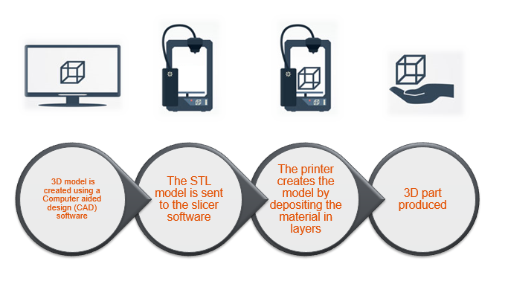
Figure ‎1.1 AM cycle.

History of additive manufacturing
According to Lonjon [1], AM was first introduced in May 1980 by Dr Hideo Kodama, who had applied for a patent for his rapid prototyping system in Japan. He described his system as follows: “a vat of photopolymer material is exposed to a UV light that hardens the part and builds up the model in layers”. Unfortunately, the patent application was not filed within the one-year deadline due to funding issues.
In 1985, a French team from the French National Centre of Scientific Research (CNRS) started development when Alain Le Mechaute, a young electrochemical engineer who, wanted to create a “fractal object” which he explained to be ‘an object with local properties that are equivalent to its global properties’. Due to the complexity of the part, fabrication was impossible. He discovered from his colleagues that when two lasers cross each other, a liquid (monomer) could become a solid (polymer). From that point, they started to build a machine that used a laser to build Alain’s ‘fractal object’. Alain and two of his colleagues successfully printed a 3D part with photopolymer using laser beams, for which they later filed a patent.
AM started with stereolithography technology shortly after, in 1988. Carl Deckard, a mechanical engineering undergraduate student at Texas University, was credited with inventing selective laser sintering (SLS), a form of additive manufacturing where the feedstock was a powder. During a summer camp, Deckard worked at an iron-based machine shop in Houston that made parts for the oil fields. This machine was advanced, using CAD in programs that controlled machine tools. However, Carl Deckard considered there were still too many castings. Deckard then worked for over two and a half years on developing a technology that enabled the machine to produce parts without any casting using laser sintering (LS). Carl Deckard filed a patent for LS in 1987, granted it in 1989, and then licensed it to DTM Inc., which was acquired by 3D Systems in 2001.
Since then, there have been many developments in AM. AM technology has been developed since the 1980s and has evolved from making prototypes in days to making functional parts in minutes.

Advantages of AM
- Complex part: AM has the ability to make parts with inner channels or intermingled shapes in one process.
- No tooling: No tools are needed to make the parts, such as moulds, saving time and cost.
- Product flexibility: The ability to change or edit a product to meet short-term needs in the market.
- Material efficiency: Compared to subtractive manufacturing, the material is deposited in required areas only, resulting in minimal waste. In addition, the ability to reduce weight via topology optimisation to use less material while maintaining the structural integrity of the part.
- Customisation of design: Parts are manufactured based on individual needs, such as prosthetics, without the cost of manufacturing moulds.
- Digitisation of parts: eliminating the need for warehouses where all parts are stored in digital files, saving space. Also, the ability to transfer files digitally and print them at the end destination without transporting the physical parts. [2]

Disadvantages of AM
- Part strength: Most AM parts are pores, therefore reducing the mechanical properties. In addition, the print direction shows a weak point due to low interlayer adhesion as the AM process builds layer by layer.
- Surface finish: When building layer by layer, the resolution of the part can be poor, requiring a secondary process, thus increasing the time and cost to produce an AM part with a smooth finish.
- Cost: Material cost is too high due to the conversion cost to produce AM materials, especially in the case of powders.
- Time: The time from design to part is short, but the part's manufacturing process is slow, which hinders the option of mass production.
- Copyright: Digital parts can be easily replicated by other users and can not be tracked.

Types of additive manufacturing
According to the ASTM F2792 [3], there are seven main types of AM technologies. Each process uses a different level of energy, as shown in Figure 1.2.
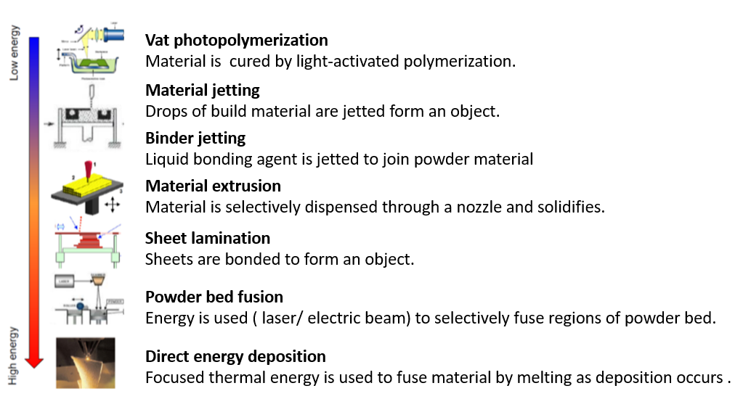
Figure ‎1.2 Different types of AM according to the energy level used.[4]
Each technology in AM has different feeding materials to meet the final application requirement. The feed materials can range from paper sheets, liquid polymers, plastics and metals. Each material requires a level of energy to fuse the layers successfully.

AM applications
Figure ‎1.3 shows the application's segments of AM, with the functional parts taking the largest share of 33.1 %. It is also the fastest growing sector as the demand for metal AM increased as a result of large companies adopting AM as a manufacturing method in their production process. For example, GE aviation fuel nozzle for the LEAP engine produced 30,000 nozzles in March 2016 using AM. The new AM fuel nozzle design was 25% lighter and five times more durable than the conventionally produced nozzle. [5]
The reduction of weight of components due to AM geometric freedom is now feasible. This weight reduction is known as topology and is mostly adopted in aerospace and performance vehicles where small numbers are made, and weight reduction is critical. For example, the Bugatti Chiron brake calliper is now produced using AM, reducing the calliper weight by 40% at a higher strength than the old part.[6]
AM is widely used for customised products such as prosthetics that are produced using FDM and cost around $50 compared to the conventional method, which costs $10,000 to $80,000 and has a longer lead time to manufacture. [7]
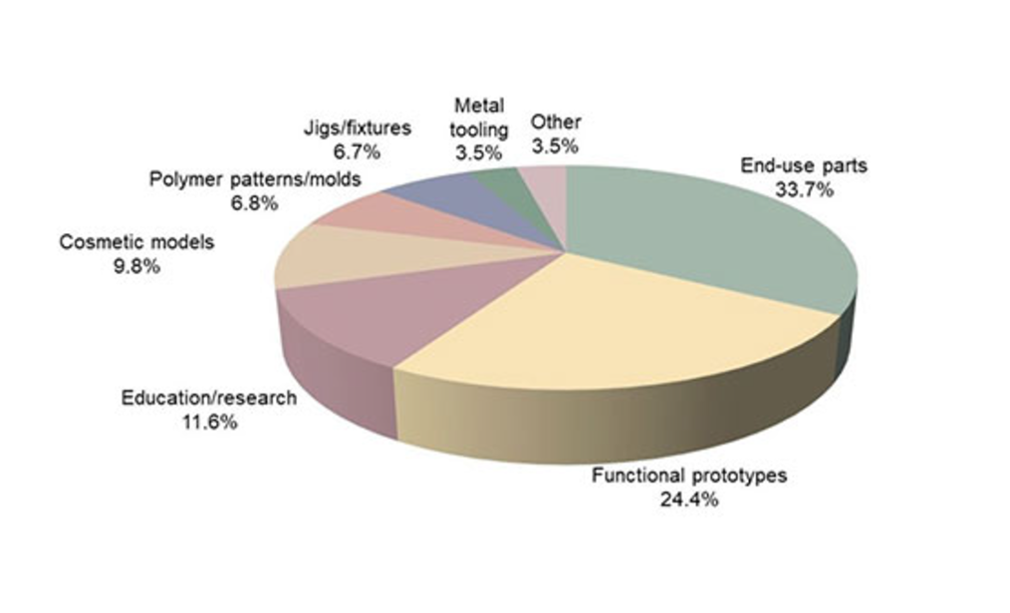
Figure ‎1.3 Applications segments for AM, Wohlers Report 2022. [8]

The increase in functional parts in AM will require the introduction of more materials that can be processed in AM and offer different material properties for different applications.

Laser sintering technology
Laser sintering is one of the powder bed fusion (PBF) technologies. PBF is an AM method that uses a powder as the feedstock. This is placed in a powder bed, and selected areas are then sintered to create a part. There are different methods of sintering the polymer powders. Some methods use infrared light and infrared ink absorbers to sinter the parts; this is known as “high-speed sintering” (HSS). LS, on the other hand, uses a laser to sinter the part, as shown in Figure ‎1.4.
LS works by laying a thin layer of powder and using a laser to fuse the polymer powder in the areas that represent the cross-section of the part. This process is repeated layer by layer to build a three-dimensional model. [9]
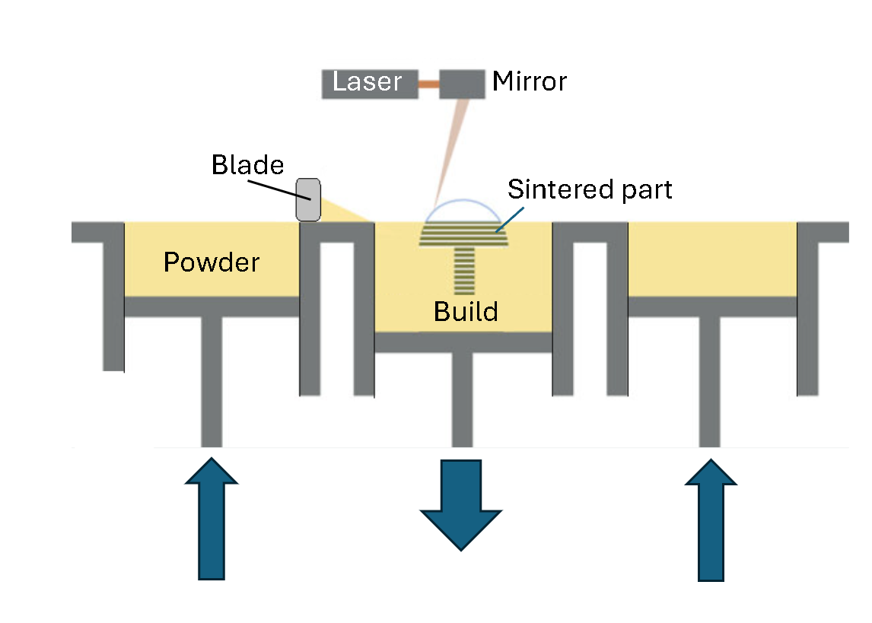
Figure ‎1.4 Laser sintering process.
LS is a very complex process, which makes it challenging to find the optimal process conditions with consistent results. Whereas most thermoplastic polymers can be injection moulded, very few polymers work in LS.
There are many applications for LS, such as prosthetics manufacturing, due to its ease of modification and customised design for individuals, as well as the ability for adjusting the part as the user's body changes with time, making it an excellent fit for LS process.

Materials used for LS
There are several materials in the LS market. According to the 2014 Wohlers report, the LS market is dominated mainly by nylon, also known as polyamide (PA), as shown in Figure ‎1.5. More materials need to be introduced in PBF technology to introduce functional parts. Polypropylene PP is a commodity material with a wide range of applications due to chemical resistance and fatigue properties. The PP powder has a low success rate in LS. Figure ‎1.5 shows that PP powder has a market share of 2% compared to the 85% nylon market share. PP demonstrates a deficiency in research in understanding why it is challenging for PP to be processed in LS.
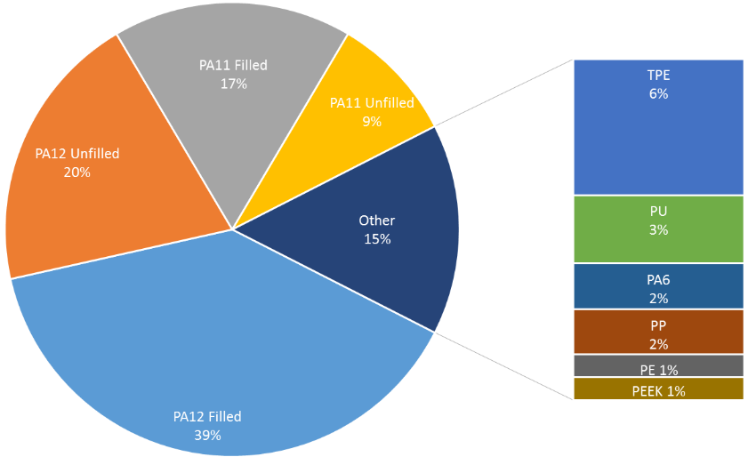
Figure ‎1.5 Materials used in the LS market according to the 2014 Wohlers report. [10]

Polymer overview
Before moving further, several essential terms and concepts must be understood. This chapter covers all the basics of polymer science and an overview of polypropylene to help further understand the concepts of this research.

Polymerisation type
A polymer is a large molecule constructed from many smaller structural units called monomers, bonded together in any conceivable pattern.[11] These monomers are linked together through a process called polymerisation.
There are two main types of polymerisation. One in which the polymer chains grow step-wise by reactions that can occur between any two molecular species; this is known as step-growth polymerisation. Second, is the polymerisation process in which a polymer chain grows only by reaction of a monomer with a reactive end-group on the growing chain, this is known as chain-growth polymerisation and usually requires an initial reaction between the monomer and an initiator to start the chain's growth.
An example of step polymerisation is nylon, which undergoes a process of polycondensation that is formed by a reaction involving eliminating a small molecule, such as water, at each step when chains are binding in the process. [12]
Polypropylene (PP) is made via chain-growth polymerisation. PP is synthesised from propylene in the presence of a catalyst, allowing the monomers to link together one by one to form a long chain.[13]

Polymer classification
The polymers are classified into three main groups: thermoplastic, elastomer, and thermoset. Thermosets are typically rigid materials in which cross-linking greatly restricts chain motion [14], therefore, they are non-recyclable. The polymer forms bonds that start to cross-link, not allowing the polymer to re-melt.
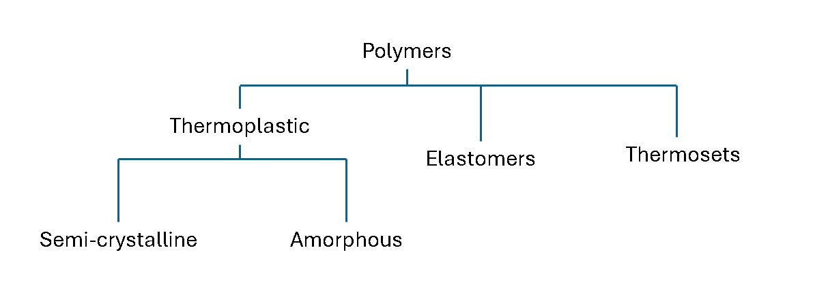
Figure ‎2.1 Classification of polymers.
Thermoplastics can be re-melted many times to be re-shaped when heated. There are two types of thermoplastics: Amorphous and semi-crystalline.
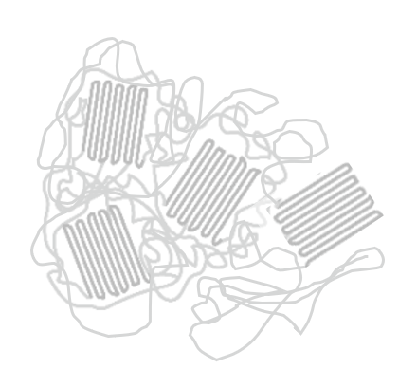

Figure ‎2.2 (left) Amorphous, (right) Semi-crystalline (in red, crystal structures)
Amorphous polymers have a random structure with no crystal structures, as shown in Figure ‎2.2; they are incapable of crystallisation. Amorphous polymers soften when heated. This type of polymer is used in the melt extrusion process due to low shrinkage properties and melting behaviour, which makes it desirable for melt extrusion AM processes.
Semi-crystalline polymers contain crystal-structured regions due to the way chains fold on each other, shown in red in Figure ‎2.2. This type of polymer has a sharp melting point. The transition from solid to liquid occurs suddenly at the melting point, which makes it desirable for LS. As the laser travels over the powder, melting it instantly and then solidifies when the temperature drops below the crystallisation temperature.

Monomers
A polymer is made up of repeat units of monomers. Different types of monomers can be added to the polymerisation process. If single species units of monomers are added, then the polymer is known as a homopolymer. This can be represented by multiple repetitions of a single type of repeat unit that may contain one species, as shown in Figure ‎2.3.
When another species of monomer is introduced, it is known as a copolymer. Thus, copolymer is more commonly used to describe polymers whose molecules contain two or more different types of repeat units [11]. For example, when ethylene monomer is introduced to a polypropylene, it results in a PP copolymer. Furthermore, the addition of the second monomer impacts the polymer properties from mechanical, rheological, and chemical resistance.

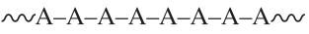
Figure ‎2.3 Homopolymer structure repeating units of ‘A’ monomer. [11]
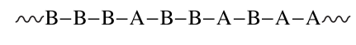
Figure ‎2.4 Random copolymer formation with ‘A’ and ‘B’ species in one chain.[11]
The different species can be laid out in different formations, as shown in Figure ‎2.4.
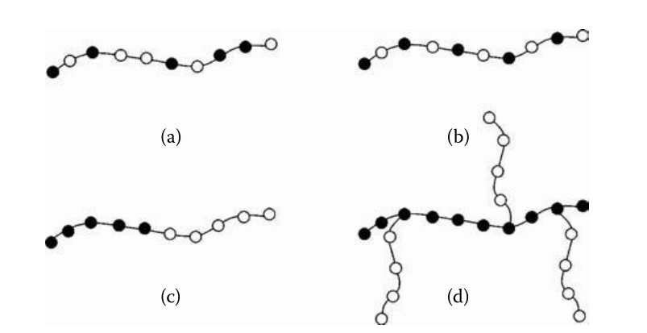
Figure ‎2.5 Schematic diagram of (a) statistical, (b) alternating, (c) block, (d) grafted (and branched) copolymer. [15]
Each polymer structure can influence the melting and crystallisation behaviour of the polymer. Moreover, PP polymers may have more than two monomers.

Molar mass distribution
The polymerisation process produces polymer chains with different lengths. The reaction is controlled to create different polymer lengths. Robert et al. [16] stated that many properties of polymers depend on the size of the polymer chains, so it is essential to characterise their dimensions. A molar mass M of polymer is simply the mass of 1 mol of the polymer with units of g mol⁻¹ or kg mol⁻¹. The term “molecular weight” is often used instead of molar mass; this is not preferred as it can be misleading and is a dimensionless quantity.
The molar mass of a homopolymer is related to the degree of polymerisation x, which is the number of repeat units in the polymer chain, shown by the simple relation.
$$M=xM_{0}$$
Equation ‎2.1
Where M₀ is the molar mass of a single chain length repeat unit, and x is the mole fraction.
The molar mass distribution (MMD) of a polymer describes how the individual polymer chains are distributed by their respective molar mass species, denoted as M.
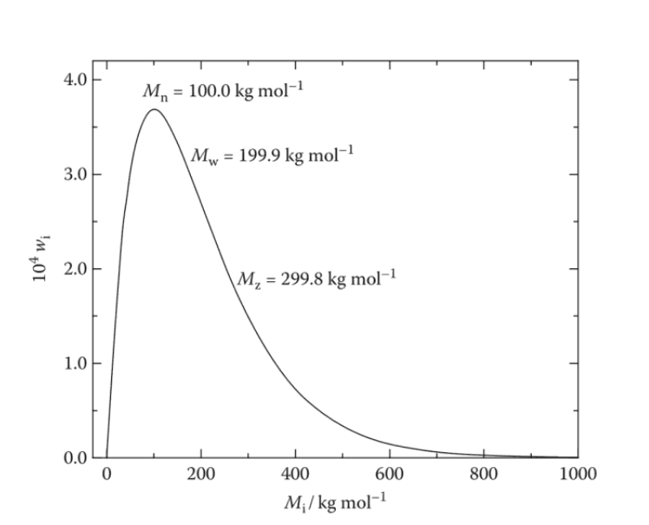
Figure ‎2.6 A typical weight-fraction molar mass distribution curve. [16]
The “number-average molar mass”, denoted as Mn, also known as the “number average molecular weight”, is a measure of the average molecular weight of polymer chains in a sample, calculated by giving equal weight to each polymer molecule regardless of its size. It is determined by dividing the total mass of the polymer by the total number of polymer molecules, making it particularly sensitive to the presence of short chains.

$${\overline{M}}_{n}=\frac{\sum{N_{i}M_{i}}}{\sum{N_{i}}}$$
Equation ‎2.2
‘i’ Discrete fraction
N_{i} The total number of molecules of molecular mass M_{i}

The mass average molar mass, also known as weight average molecular weight, denoted as Mw, is defined as the sum of the product of the molar mass of each type multiplied by its weight fraction.
$${\overline{M}}_{w}=\frac{\sum{N_{i}M_{i}^{2}}}{\sum{N_{i}M_{i}}}$$
Equation ‎2.3
Robert et al. further explain the ratio. $\overline{M}$_{w}/ $\overline{M}$_{n} is the polymer dispersity or heterogeneity index (often referred to as PDI). It is used as a simple measure of the breadth of the molar mass distribution.
A higher molar mass average than Mw is defined by using the third power average molar mass, as shown in Equation ‎2.4; this is also known as “z-average” or “size average molecular weight”. [16]

$${\overline{M}}_{z}=\frac{\sum{N_{i}M_{i}^{3}}}{\sum{N_{i}M_{i}^{2}}}$$
Equation ‎2.4
The Mz+1 is the fourth power average molar mass of the polymer. It is calculated using the following equation:
$${\overline{M}}_{z+1}=\frac{\sum{N_{i}M_{i}^{4}}}{\sum{N_{i}M_{i}^{3}}}$$
Equation ‎2.5
The Mz+1 average measures the highest molar mass chains, located on the high end of the distribution curve after the Mz average. Mz+1 is not commonly reported as it is difficult to precisely measure the high averages. The Mz+1 is related to properties such as melt elasticity and processability that are influenced by extremely high molar mass species. [17]
In terms of chain length, Mn, Mw, Mz, and Mz+1 represent different averages that describe the distribution of polymer chain lengths in a sample. Mn reflects the average chain length by counting each molecule equally, thus highlighting shorter chains. Mw gives more weight to longer chains, making it more sensitive to higher molecular weights. Mz further emphasises the longest chains, and Mz+1 is the most sensitive to the very longest chains in the distribution.
The polymerisation process is subject to variation; a polymer material most often has no single chain length but a wide range of lengths. The molecular weight distribution can be measured using gel permeation chromatography (GPC), which gives a curve, as shown in Figure ‎2.6. The different molar averages can be obtained from the GPC data. [16] there are different test methods are used to measure the molar mass distribution of a polymer, such as: membrane osmometry, which measures the Mn of a polymer by determining the osmotic pressure of the polymer solution across a semi-permeable membrane. Also, vapour pressure osmometery (VPO) measures the Mn by detecting the change in vapour pressure of a polymer solution, which is related to the number of particles in the solution. Another method, known to use Light scattering techniques, such as multi-angle laser light scattering (MALS) coupled with GPC provides the absolute MMD without requiring calibration standards. The GPC combined with MALS is the most commonly used method to identify the molar mass distribution of a given polymer.[18]

Polypropylene (PP)
PP is synthesised from propylene monomers (CH₃-CH=CH₂), which contain a carbon-carbon double bond. In the presence of a catalyst, the double bonds open up, allowing monomers to link and gather one by one in a chain reaction, forming a long PP chain through a process called chain-growth polymerisations. [13]

Polypropylene was first discovered in 1951 by researchers J. Paul Hogan and Robert L. Banks at Phillips Petroleum Company. During the process of converting propylene into petrol, researchers made the unexpected discovery of a high-melting crystalline hydrocarbon. Further analysis revealed that this substance was polypropylene. [19] In 1954, the polymerisation of propylene to produce isotactic polypropylene was later discovered by German chemist Karl Ziegler and Italian chemist Giulio Natta. PP was commercially produced In 1957. The constant demand for PP led to an increase in yield in the Ziegler-Natta catalyst and the development of new metallocene catalysts, allowing PP to be tailor-made during synthesis with a low polymer dispersity (PDI).[20]

For PP, different configurations of the methyl groups along the main chain skeleton are possible because of the orientation of the propylene monomer; this is known as tacticity. The common form of tacticity in PP is known as isotactic PP (iPP) where the methyl groups are arranged on the same side of the polymer backbone chain in a regular repeating pattern. This structure allows isotactic PP to crystallise and form a rigid, high-strenth material suitable for applications like containers, pipes and automotive parts.[21] When the methyl groups are arranged in alternating patterns on the opposite side of the polymer chain, this is known as syndiotactic PP (sPP). This arrangement is also susceptible to crystallisation, forming a semicrystalline material with a stiffness lower than iPP.[21] The atactic PP (aPP) has the methyl groups in a random arrangement along the backbone with no pattern. This arrangement prevents the aPP from crystallising and forming amorphous, soft, and sticky PP used for adhesives and sealant applications. [21]

Influence of laser sintering material properties

The LS process is a complex process with many variables. Schmid et al. [22], showed the most influential extrinsic and intrinsic properties in LS, as shown in Figure ‎3.1. There are three main intrinsic properties in the study: optics, thermal characteristics, and melt behaviour. Each contains different properties, which further complicates the process. These intrinsic properties are challenging to alter for the LS process, making it difficult to understand how changes to the polymer microstructure impact the final mechanical properties in LS, however, the extrinsic properties vary during the production of the powder. These are the powder particle shapes and sizes, which also impact the tensile properties of the final LS part.
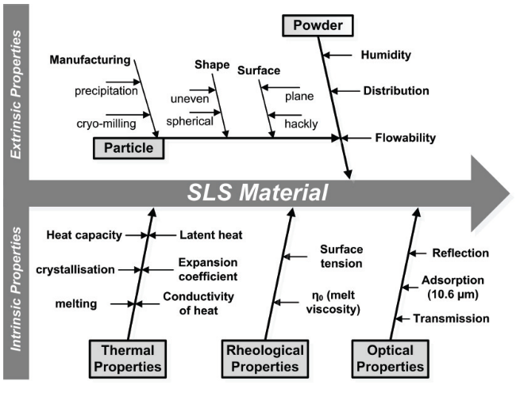
Figure ‎3.1 LS process and material requirement diagram. Schmid et al. [22]

For an investigation into the impact on mechanical properties of using the LS powder, key properties of LS must be reviewed to understand which ones show a significant impact. The literature review covers key PP extrinsic and intrinsic powder properties that impact the final mechanical properties of the LS parts. Moreover, the LS process conditions have a direct impact on the mechanical properties. Therefore, key parameters are also reviewed in the literature search to show impact on mechanical properties in LS.

Extrinsic powder properties

Powder flow
Powder flow is an essential property for LS, many studies attempt to improve and characterise the powder flow. The powder flow depends mainly on the particle shape and particle size distribution. Without adequate powder flow, the powder will not print or will result in a poor-quality print. Commonly in LS, powder flow is characterised using the Hausner ratio HR. Schmid et al. [22] indicated that if the value HR < 1.25, result in a free flow and if HR > 1.4, the powder is cohesive with poor flow.
$$H_{R}= \frac{ρ_{tap}}{ρ_{bulk }}$$

Equation ‎3.1
Where,
$ρ_{tap}$ = Tapped density
$ρ_{bulk }$= Bulk density (loose)
Another characterisation method was used in a study by Christian et al. [14], on PE-HD powder dry coated with two types of nano-silica particles. The research compares hydrophobic and hydrophilic silica nanoparticles. The flowability measurements were carried out in a Schulze ring shear tester RST-01.01. The unconfined yield strength σ_{c} as a function of the consolidation stress σ₁ characterises the flowability of a bulk solid. A numerical classification of the flowability is given by Jenike, 1967, as a flow function ratio (ff_{c}), expressed as:
$${ff}_{c}\text{= }\frac{σ_{1}}{σ_{c}}$$
Equation ‎3.2
Where,
σ₁ =Consolidation stress
σc.= unconfined yield strength
Large ff_{c} values represent good bulk flowability, whereas small ff_{c} values stand for cohesive bulk solids with poor flow. For good powder flow for LS, the range of ff_{c} should be between 4 and 10 for easy flow, as shown in Table ‎3.1. Furthermore, this test does not consider the influence of the elevated temperatures of the LS machine on powder flow.
Table ‎3.1 Shear cell of Schulze ring shear tester. Christian et al. [14]
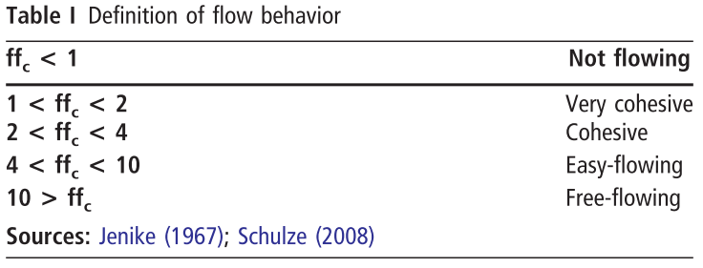
Using flow promoters such as silica will improve the flow of the powder, but not in all cases. There are various types of powder flow promoters. Christian et al. [14] demonstrated how hydrophobic silica improves the flow compared with hydrophilic silica when mixed with high-density polyethylene (HDPE) powder using the flow function ratios. The study explains an absence of even coating and an occurrence of agglomeration formation on the surface of the HDPE powder by highly porous hydrophilic fumed silica.

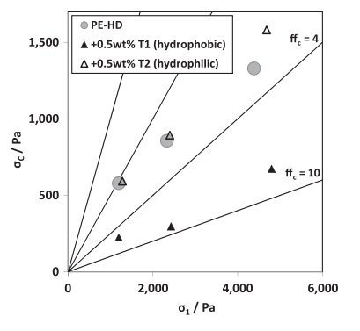
Figure ‎3.2 Flowability of PE-HD particle uncoated, respectively, coated with hydrophobic fumed silica (T1) or hydrophilic fumed silica (T2) for 10 minutes. [14]

Flow additives
Flow additives are commonly used for LS powder to improve flow properties, improving the part finish and mechanical properties. Ituarte et al. [23] developed a design experiment to improve the mechanical properties of PP, reviewing different process parameters in LS. During the trials, the Coathylene® sint polypropylene (PP) provided by Axalta Polymer Powders was mechanically mixed with 0.25%wt fumed nano-silica (SiO₂) composite. This further demonstrates the importance of using flow additives to build successfully in LS.
A study conducted by Cooke et al. [24] examined the two powders, one from corn starch and another from potato starch. Nine blends of each starch were produced using a Plough shear mixer, with the amount of AEROSIL® 200 (fumed nan-silica) additive ranging from 0% to 0.8%. The potato starch had a more spherical particle morphology compared to the rock-like shape of corn starch, with the average particle of corn starch size being 11.8 µm, and 22.1 µm for the potato starch. The study goes further by explaining the effect of the shape of the particle on the interlocking between the particles; thus, a smoother shape is likely to reduce the friction coefficient, resisting the sliding of adjacent starch particles. However, with the use of flow additives, the interlocking effect is reduced, preventing the powders from locking up despite the poor particle shape.
Furthermore, another study by Freeman Technology [25], implemented a study on polyoxymethylene (POM) powder for laser sintering, comparing pigments and flow additives on the FT4 machine designed by Freemen Technology to test powder properties. Using the different powder flow test such as variable flow rate (VFR), shear cell and Permeability tests. The study demonstrated the impact of paint pigments and flow additives on the flow of POM. The results from the study further explain how each test reflects on flow behaviour that impacts the LS process. The VFR, shows the high basic flow energy (BFE) for the powder with flow additives compared to a low BFE for the powder with colour pigment. It explains that the FT4 blade requires more energy to move through the powder, indicating sufficient packing within the bulk and suggesting that the flow additive has resulted in more free-flow material. The study goes further by comparing the change in pressure drop across the powder bed during the permeability test at 1 kPa to 15 kPa with consolidation pressure difference at the top of the bulk. The results from the permeability study show that all blends have increased in pressure at a higher consolidation of 15 KPa, yet the flow additive blend showed the lowest change in that increase. It explains that no sensitivity to change and consolidation is a further indicator of a more efficiently packed bulk, meaning there are fewer avoids for the particles to move into when subjected to an external force. Finally, the report used the shear cell test to show that it is not a sufficient stand-alone technique for characterising powder flow properties at low stress.
Moreover, from the literature, flow additives, such as silica, in small quantities of around 0.2-0.5 %wt, have proven to improve the flow without understanding the implication of the flow additive on the mechanical properties of the final LS part.[26][27][27] The study by Majewski et al. [28] was the only study to show the impact of glass filler on the mechanical properties of the PA12, where the ratio of 12.5%wt was used during initial dosing for the testing, reporting an increased Young’s modulus and reduction of tensile strength and a sharp drop in elongation after the addition of the glass filler. Nevertheless, that study used glass beads and a large amount of filler, which is different from the 0.2-0.5 %wt flow additives used in LS.

Particle shape and size distribution
The shape of the powder particle impacts the powder flow behaviour. LS powders require a particle shape that allows the powder to flow freely. Spherical particles are preferable in order to allow a decent amount of powder to spread during the transfer from the reservoir to the bed [23]. The powder production method determines the particle shape. There are several ways of producing LS powders. Each method results in a different particle shape, as demonstrated in Figure ‎3.3. The melt blending method and precipitation demonstrated the best outcome for powder bed surfaces compared to the commonly used method of grinding/milling.
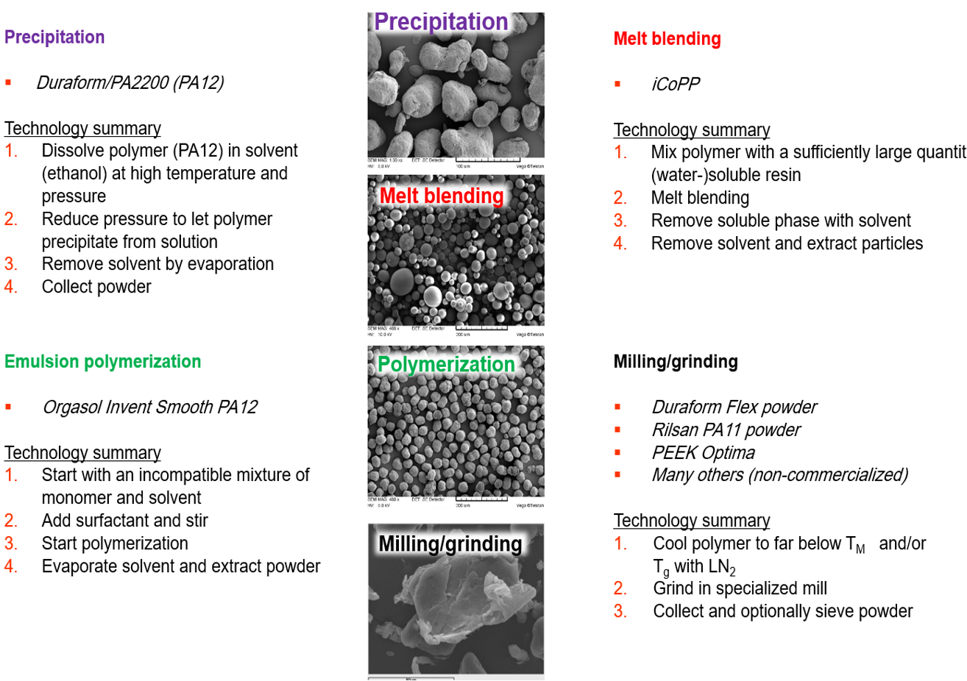
Figure ‎3.3 Powder morphologies of different methods of making LS powder. [4]
Each method produces a unique powder surface morphology, impacting the quality and mechanical properties of the sintered article. Illustrated in a study by Schmid et al.[29], which displayed different polymer powders produced using different methods and processed on an LS build chamber.
Nylon, which is commonly used in LS, is mainly made by precipitation from a polymer solution or direct polymerisation; due to the nature of the polymer, it is easily mass-commercialised. A study by Schmid et al. [29] compares two commercial PA grades produced by precipitation and direct polymerisation, displayed in Figure ‎3.4. The two powders were processable in LS; the study highlights the observed differences in properties, shown in Table ‎3.2.
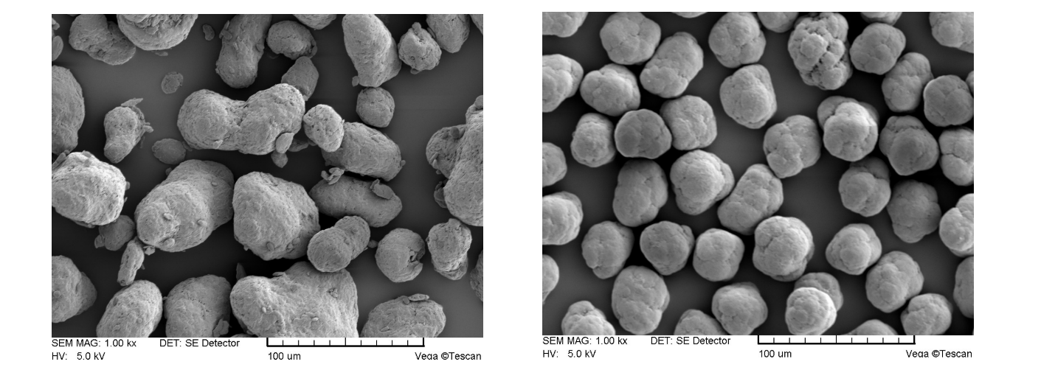
Figure ‎3.4 Duraform® PA exhibits a shape similar to potatoes ( left); Orgasol® particles are much more spherical (right), with a smooth and slightly wavy surface. [29]

Table ‎3.2 Two different commercial PA grades with a conclusion from Schmid et al. [29]
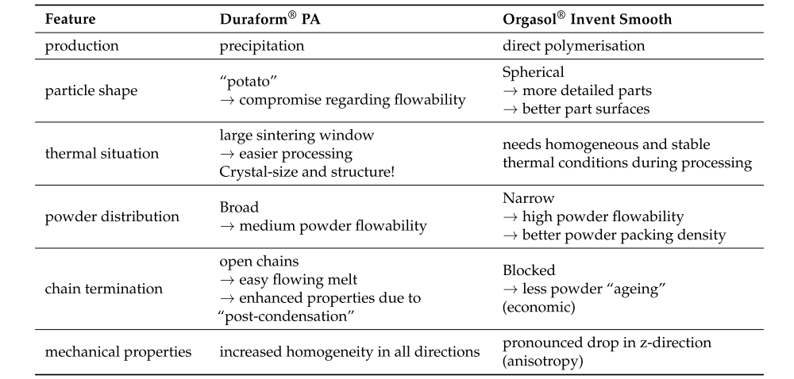

The study further explains that the mechanical properties in Table ‎3.2 show that a highly spherical shape does not necessarily increase the mechanical properties in the z-direction of the LS printed part. Furthermore, the broad powder distribution showed poor flow but good mechanical properties, whereas the narrow particle size distribution resulted in a drop in the z-direction. The broad particle sizes had a medium flowability for Duraform® PA compared to the narrow particle size, which improved the powder bulk density and, consequently, the part density.
Other studies by Kleijnen et al. [30] used the melt-blending method to produce polybutylene terephthalate (PBT) droplets in polyethylene glycol (PEG) a water-soluble thermoplastic polymer and remove water soluble solution leaving the PBT droplets, producing highly spherical powders, shown in Figure ‎3.3. This method is not feasible for mass production of powders for LS due to the slow process of removing the water soluble solution.
Cryogenic grinding of powders from pellets leads to particles with sharp edges, described as “rock-like” and platy morphology, such powder generally has poor flow properties. Depending on the polymer composition, each method can have cost implications. Producing the powders and yielding the correct particle size and shape is proven to be an expensive process.

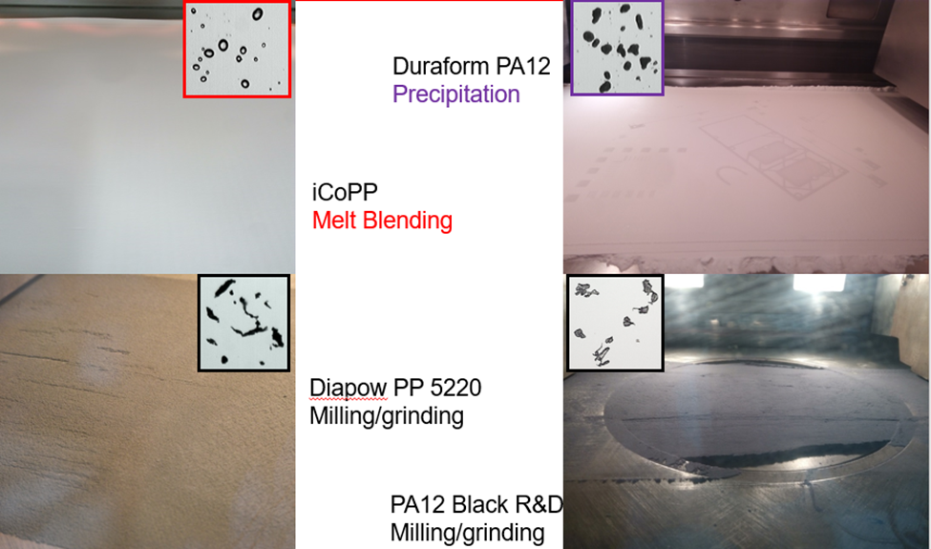
Figure ‎3.5 Powder bed surface of different powders produced with different methods. [4]
According to the literature, [31][32][33][34] the optimum particle size range for LS powders falls in the range 30-125 µm. The upper limits are set by the limited penetration depth of the infrared beam; beyond this size, the beam will not penetrate and melt the particle. [35] A lower limit is put in place as well to prevent the fine particles from degrading at a faster rate, thus generating smoke that degrades the polymer. [36] [34]
Powder flow behaviour varies from one LS machine to another. Some use blades, and others use rollers for powder re-coating. Each powder coating method brings a different result. This is shown in a study by Drummer et al., [37] when using a roller, imperfections are more tolerable due to lack of friction dragging the powder across the print bed. The study further shows that applied forces might cause higher bulk densities and consequently change beam penetration and heat conduction properties. Due to these changes in bulk properties, the molten polymer's area enlarges when using a roller. In addition, some machines may have a fixed layer thickness, restricting the particles from passing freely before the specified layer thickness.
A patent on two-tier distribution powder size for LS by Dickens, Jr et al. [38] claims the rate of heat into the mass of small particles is so much higher than into large particles, resulting in the fine particles filling the voids in LS sample increasing the final density of the LS part. Dickens' claim does not fall in line with the law of physics, which means the rate of heat transfer into the particle is the same, however, the mass is different.
In conclusion, the powder production for LS comes in different forms and has proven to be costly. Variations in size and shape may impact the final mechanical properties. In addition, the use of different machine setups may result in variations in the outcome, especially when attempting to understand the impact of intrinsic properties.

Intrinsic powder properties

Crystallinity
Semi-crystalline polymers are mainly used for LS due to the melt and crystallisation peaks. The melting peak is the most important feature related to crystallinity. By heating the semi-crystalline polymer in the DSC (differential scanning calorimeter) test, the crystalline region melts by absorbing the heat. The endothermic process appears as a sharp peak in the thermogram curve, as shown in Figure ‎3.6. [23][39][40][41] During cooling, the molten polymer can crystallise, releasing heat. This exothermic process appears as a crystallisation peak in the DSC curve.[42] The area under the melting peak is proportional to the enthalpy or latent heat of fusion (ΔHm) of the crystalline region, which represents the energy required to melt the polymer.
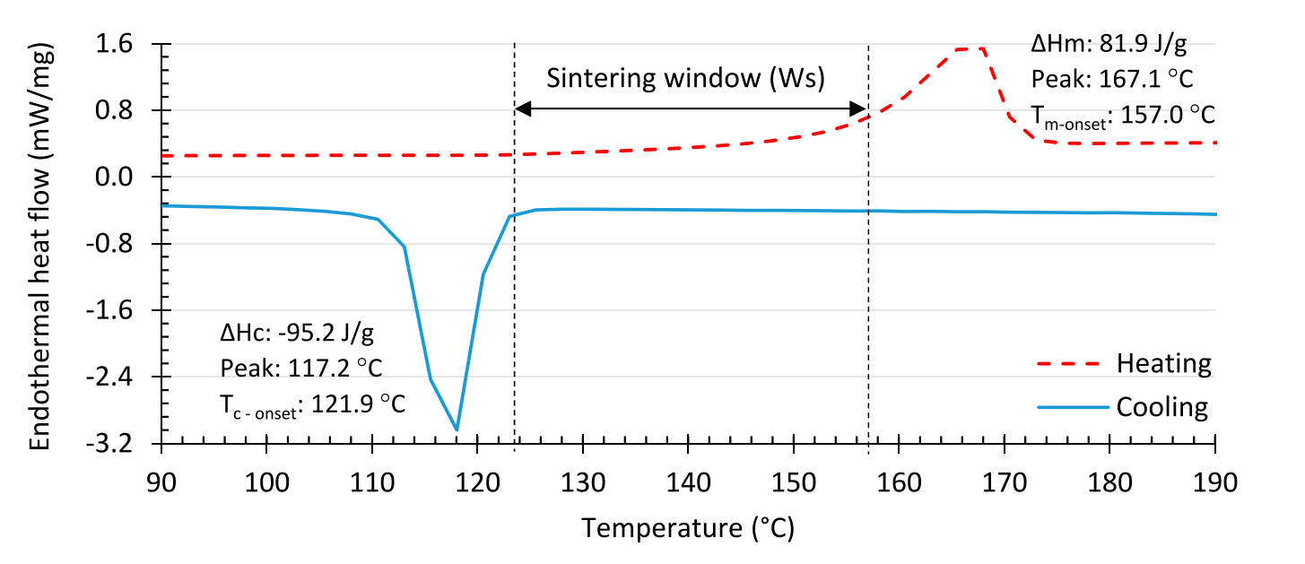
Figure ‎3.6 DSC of neat Polypropylene[23]
Fiedler et al.[35] mentioned the importance of the crystallinity of the powder in the final part of the LS. Therefore, the lower the crystallinity of the powder, the lower the shrinkage and the better the dimensional accuracy of the part. Fiedler indicates that in terms of the processing window, PP should be as good as PA 12, however, PP is difficult to process. The study highlights that PP has twice the degree of crystallinity of PA 12. The PA 12 powder had a crystallinity of ~20%, while PP was around 50%,shown in Figure ‎3.7, causing it to be more susceptible to shrinkage and curls, which is problematic for LS despite the wide sintering window.
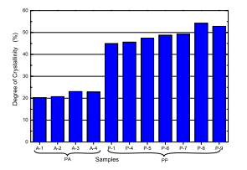
Figure ‎3.7 Comparison of degrees of crystallinity of PA and PP [35]

Kruth et al.[43] disclosed that the crystallisation rate should be kept relatively slow (relative to the vertical build rate) in order to avoid part distortion due to gradient freezing shrinkage localized in the upper layer. The study further explained that crystallization and uniform shrinkage are then obtained by keeping the powder bed at a high temperature for a sufficiently long time after sintering.
Bashir et al.[44] investigated polyethylene terephthalate (PET) in LS. The study expressed the importance of slow crystallisation as an intrinsically desirable property for LS. Adding that the crystallisation half times of polymers is as essential in the LS behaviour as the sintering window. Bashir noted that polyethylene (PE) has a crystallization half time of the order of microseconds, whereas PET is in minutes, and polycarbonate (PC) has a crystallisation time of about 12 days. It was noted that PET articles made by LS were always crystalline, whereas, by injection moulding, they could be amorphous or semi-crystalline. PET can be amorphous or crystalline based on the cooling rate from the melt.[45]
During the LS process, as the melt cools, the polymer is prone to curl or warp [46]. According to Tan et al. [46], the tendency for premature crystallisation and curling depends on the build temperature used within the sintering window. Variations in LS machines were noted by Bourell et al. [9] to be around 5˚C within the optimal build area, which may cause polymers with narrow sintering windows to crystallise prematurely, resulting in some powder working well in LS machines but not others.

In LS, the crystallisation impacts not only the print quality but also the mechanical properties. In LS low crystallinity is desired for ease of processing, however, high crystallinity is desired for higher mechanical properties. The crystallinity is also a temperature dependent , which makes it a complex area to investigate in LS.

Optical properties
The optics of the materials is an important intrinsic property. Generally, a single wavelength CO₂ laser is used in LS machines, and the absorption/ transmission characteristics of polymers may be intrinsically different, as shown in Figure ‎3.8.
Fiedler et al. [35] illustrate the different optical properties between PA 12 and PP. At a wavenumber of 943 cm⁻¹, corresponding to the CO₂ laser wavelength of 10.6 µm, PP has an absorption that is about half that of PA 12, as shown in Figure ‎3.8, resulting in the laser beam being transmitted beyond the layer thickness, leading to undefined z-direction growth.
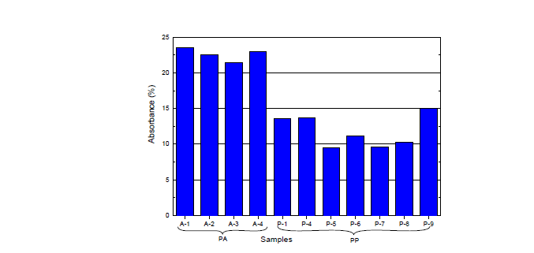
Figure ‎3.8 Infrared absorbance of PA 12 and PP at 943 cm⁻¹. The absorption by PP is about half that of PA 12, which means the beam can penetrate below the layer thickness. [35]
Fiedler recommended placing an inorganic filler in the PP or an organic additive with functional groups absorbing around 943 cm⁻¹ (based on a laser emitting a monochrome infrared light at a wavelength of 10.6 µm) to enhance the absorption or the use of larger PP particles and higher layer thickness to reduce the transmission from the laser.

Melt viscosity
The melt viscosity increases with molecular weight.[47][22] For excellent interfusion of the polymer chains, enough to provide adequate layer-to-layer adhesion, low melt viscosity is desired, resulting in increased part density; [48][45] however, low viscosity results in high shrinkage and poor part accuracy. Thus, an optimum molar mass range exists but is not easily controllable, neither at the polymer production nor during ageing when processing. The melt flow index (MFI) is an assessment of the molar mass distribution and is an inverse measure of the melt viscosity; the lower the molecular weight, the higher the MFI.[49]The MFI gives an overall value for the MMD without providing in-depth information on the distribution of the polymer chain lengths. Higher MFI reflects short polymer chain length, as short polymer chains tend to flow faster than long polymer chains in a melt state due to chain entanglements.
The MFI is measured by how long the material takes to pass through a specified channel at a specific temperature and load at a given time. For PP, the industry standard for the mass and temperature is 2.16 kg at 230°C, following the ISO 1133 standard. The amount of eluting material was measured after 10 minutes, giving the MFI in a (g/10minute) unit.
Vasquez et al. [48] study on LS of nylon 12 noted that the melt flow properties are also dependent on the polymer’s molecular weight. However, the molecular weight of the polymer can be affected while inside the machine if temperature and atmospheric conditions are favourable for chain extension (polymerisation reactions), which increases the viscosity during the process.
Furthermore, the process of the LS does not apply any acting forces such as shear or pressure force. It is mainly affected by the gravity of the melt and flow. The sintering of the particle melt droplets is affected by the surface energy and the barrier between the melt and unsintered powder. The deformation of melt is low due to the low-driving mechanical processes.
The particle interaction was examined by investigating the necking growth, which is influenced by viscosity and the surfaced tension of the particle. Frankel first attempted to numerically predict neck growth in 1945. The Frenkel-Eshelby equation (Equation ‎3.3) is used to estimate the sintering rate given by measurable material fundamental properties, which are the viscosity and surface energy of the polymer melt. As the temperature of the particle increases, the surface energy and the viscosity decrease, which makes the mathematical equation challenging to predict. This process is driven by the viscosity, which allows the individual particles to merge, as stated by Sheintuch et al. [50]

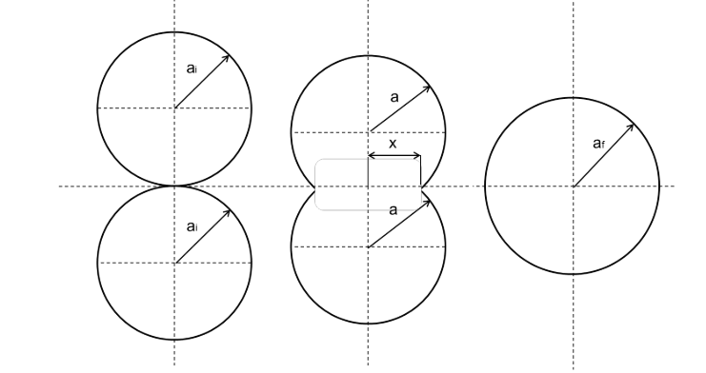
Figure ‎3.9 Idealised sintering of two polymer particles, where a is the partial radius, a_{i} and x is the half-neck radius. [51]
Frenkel -Eshelby equation:
$$\frac{x}{a_{f}}={\left(\frac{Γt}{{ηa}_{i}}\right)}^{1/2}$$
Equation ‎3.3

Where x= half neck thickness, a_{f}= particle radius, a_{i}=initial particle radius, t= sintering time, Γ= surface energy, and η= viscosity.
It has been observed using the Frenkel model that the sintering time is slower than the equation suggests. This is because the Frenkel model is based on Newtonian behaviour. Other polymers have much longer molecular chains that tend to entangle.
Vasquez et al. [52], used the same model to predict the necking in their study for LS powders; the study shows that melt duration has an impact on the LS time of the particles to fully merge. Wiria et al.[53] expressed that when the laser energy increased, the neck growth proceeded more quickly. Polymers are known for poor thermal conductivity, so heating may not be consistent through a particle or on different surfaces of the particle. Vasquez et al. [52] claim this is one of the primary reasons for porosity in a final sintered part. While there have been several attempts to predict neck growth by deriving the Frankel model, the results are not accurately produced due to the known process temperatures that influence the viscosity during the LS process. To conclude, neck growth is complex and challenging to predict numerically. Therefore, it does not reflect the actual melt viscosity behaviour that occurs during the consolation of two particles in LS.
In summary, melt viscosity is an intrinsic parameter proportional to the molecular weight. Lower melt viscosity favours melt fusion and reduces voids; however, it increases shrinkage in LS. The melt viscosity increases or decreases based on the polymer chain reaction to the degradation process conditions that subsequently impact the mechanical properties. Maintaining a stable MFI is key to having a consistent outcome when reusing the powder.

Molar mass distribution
Flory et al.[54] attempted the earliest mathematical model of the relationship between molar mass and mechanical properties for injection moulding in 1945 using Equation ‎3.4, which outlines the empirical and analytical proposal for a link between mechanical properties and molecular weight.
$$P=c_{1}+\frac{c_{2}}{Mw}$$
Equation ‎3.4
Where c1 and c2 are constants, Mw is the molecular weight, and P is the mechanical property.
Previously, Flory's equation was mostly used for polystyrene. Ogawa et al. [55] disclosed that Flory's mathematical equation correlation suited the flexural strength and elastic tensile modulus quite well, depending on the molar mass. Nevertheless, it was not able to link the tensile strength and strain at break to the molecular weight using Equation ‎3.4. It was summarised that the method of sample preparation in the instance of PP might have an impact on the outcome.
Lastly, this straightforward mathematical model Equation ‎3.4 may be utilised to approximately estimate the mechanical characteristics. However, in practise, there is a more complex than what is implied above between the molecular structure and the final qualities; this is especially true when no freshly formed polymer is utilised. As a result, this equation is ineffective for characterising the link between Mw and mechanical properties.
Philips et al. [56] noted variations in crystallite orientation are related to material characteristics such as Mw, MMD, and tacticity. The study was unable to identify any noticeable variations in the crystallinity and stiffness of polypropylene samples based on molecular weight. Similar results were found by Incarnato et al. [57], where the mechanical characteristics of many films produced from recycled polypropylene (PP) using the casting technique were compared. While the processability and rheological behaviour have zero shear viscosity and shear thinning but varied with molecular weight, all moulded polypropylene samples had the same mechanical characteristics, such as tensile strength, elongation at break, and Young's modulus.
While other research supports the findings of Philips et al. and Incarnato et al., other studies have likewise produced different findings. For instance, the findings of Fujiyama et al. [58] showed that the usage of homopolymers with varying molecular weights resulted in different mechanical and thermal characteristics of injection-moulded samples. They investigated the characteristics of flexural test specimens created during melt processing from six distinct polypropylene (PP) compounds with different ranges of Mw at injection moulding barrel temperatures between 200°C and 320°C. The results indicate that, due to increased crystallinity, the specimen's stiffness and strength increase with rising molecular weight and cylinder temperature.
In the solid state, the crystalline PP macromolecules usually take the shape of a helix. During the crystallisation phase, these helical strands fold into lamellar. The lamellar structure consists of a three-dimensional folded configuration arranged in crystalline order. The lamella thickness are governed by the length of the macromolecule, crystallisation temperature, and degree of supercooling. [59][60]
Stern et al. [16] studied a series of homopolymer polypropylenes, with Mw ranging from 100-1600 kg/mol to understand the impact of MMD on the mechanical properties. The study further indicated that the lamellar thickness increased as the Mw increased. Increasing stiffness and jump in tensile strength.
Highly crystalline samples have a high degree of stiffness and strength. This is caused by the diverse ways that lamellar forms depending on molecular weight. Lamellar structure changes when molecular weight changes. According to Gahleitner et al. [61], the samples with lower molecular weight demonstrated higher crystallisation temperatures. Michler [62] noted a rise in lamellar thickness for HDPE as molecular weight increases. The final qualities vary as a result of the different crystal morphology. Bowden et al.’s [63] study shows that the thicker lamellar resulted in high-yield stress. Stern et al. [16] investigated the mechanical properties of injection moulded homopolymer PP with different molecular weights; the study further highlights that the amorphous region deforms prior to the yield point of the tensile testing. When the semicrystalline polymer further deforms after the yield point, crystallite sliding takes place. Thus, the lamellar start to orientate themselves parallel to the deformation direction, which causes interlamellar slippage, resulting in permanent deformation.
Brown et al.[64] showed that with longer molecules and fast cooling rates from the melt, the probability that a given molecule will be tied into two adjoining crystals becomes higher. The tie molecules increase the strength, elongation-to-break and impact strength. Moreover, having a high molecular weight tail in the PP (i.e. a PP with high Mz) should lead to higher connectivity between crystals, even in unoriented systems.
Kruth et al.’s [43] study gives an overview of the materials that were successfully processed by LS, excluding PP. The researchers found that the molecular weight of the polymer indeed influences the molten viscosity. In addition to complexity, with the mixed findings, the final attributes are determined by the circumstances and processing method. Low cooling rates during crystallisation are generally recognised to increase crystallinity, which in turn increases sample stiffness. Higher cooling rates, on the other hand, result in a more significant impact strength. Kruth further explains that higher molecular weight polymers are desired to fabricate robust LS components. However, a material with a high molecular weight may exhibit elevated viscosities, which may impede the merging of particles.
A high molecular weight can lead to difficulty in placing and forming the material because of the high viscosities, but it can reduce shrinkage and thus improve dimensional accuracy. [43] It is possible to achieve high strength and good flow by using bimodal molecular weight distribution, and currently commercially produced for blow moulding using two reactors to produce a bimodal distribution MMD. Therefore, it combines high strength for high MW and high flow with low MW
In general, as molecular weight increases, so do the strength, toughness, and stress crack resistance. Lower molecular weight will typically induce flow. Mechanically, a high molecular weight increases how far the material can stretch before rupturing. The higher degree of entanglement allows the material to be pulled further before the chains fail. In addition, higher molecular weight increases the impact resistance of the material. However, in the LS process, this may have a different outcome.
Overall, the majority of the intrinsic properties, such as crystallinity, lamellar thickness, and viscosity, that impact the mechanical properties are related to the molar mass distribution of the polymer. In summary, the molar mass is the core property that impacts the rheological and mechanical properties. The relationship between the molar mass and mechanical properties is complex, with many studies showing contradicting results.

Thermal degradation
Qian et al. [65] explained that isotactic polypropylene (iPP) is usually degraded by chain scission, resulting in a shift in the molecular weight distribution to the lower side according to the type and extent of the degradation.
There are two leading causes of degradation that impact the PP polymer chains during the LS process. First, excessive laser energy input during the sintering. Second, the reusability of the processed powder in LS. Both may lead to the degradation of the powder, reducing the mechanical properties of the final LS article.
Vasquez et al. [52] investigated the laser power degradation of three types of polymers: polyamide, thermoplastic polyurethane (TPU), and elastomers. Vasquez explained that elastomer materials, which undergo a lengthier process compared to polyamide materials, which undergo phase changes to melt quite rapidly. This would have practical ramifications for laser sintering, to attain a same part density, the elastomer materials require more energy in relation to their melting point. Tensile characteristics and molecular weight changes were assessed at a range of energy input levels, extending from the lowest end of the spectrum to a point beyond the polymer degradation was predicted, as shown in Figure ‎3.10.

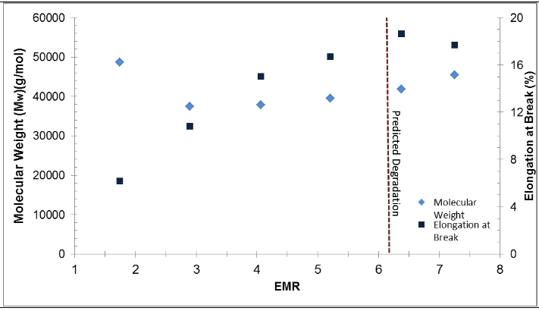
Figure ‎3.10 Combined tensile and GPC results for PA 12. Vasquez et al. [52]
The PA-12 results in Figure ‎3.10 showed a clear upward trend, peak, and decline for elongation at break. This peak seemed to occur at the point predicted by the TGA results for 1% degradation. It seems clear that 1% degradation (represented by the dotted red line in Figure ‎3.10) is a reasonable value for the PA-12 material, and energy settings that exceed this point could lead to inconsistent parts that would show sub-optimal mechanical properties. The prediction of the degradation might have been accurate for PA 12, however, the other polymers did not show a drop after the degradation prediction.
Vasquez explained that at the low end of the input energy, the molecular weight is high, and the mechanical properties are low. The fact that the polymer's flow is restricted by the large molecular weight implies that insufficient energy is available to completely melt and consolidate the polymer particles. The molar mass decreased to about 40 kg/mol as the input energy rose, and the mechanical characteristics began to improve. This could suggest that the additional energy altered the molecular weight, which would have improved the particle’s ability to move with less viscosity. As a result, some of the viscosity barriers that were present at the lower energy levels would be removed, enabling the particles to sinter more thoroughly.
As the input energy approaches the predicted degradation point, the molar mass increases again. At the same parameters, the mechanical properties start to reach a maximum before starting to decline, leading to conditions that induce chemical chain growth for PA12.
In the case of PP exposed to high temperature for a long period of time, Qian et al. [65] investigated the degradation of iPP by placing the polymer in an oven at 190˚C for 40, 50 and 60 minutes. The results show a change in MMA where a bimodal distribution starts to occur as the time increases, as shown in Figure ‎3.11. The formation of a low molar mass peak indicates that the longer chains are degrading into shorter chains.
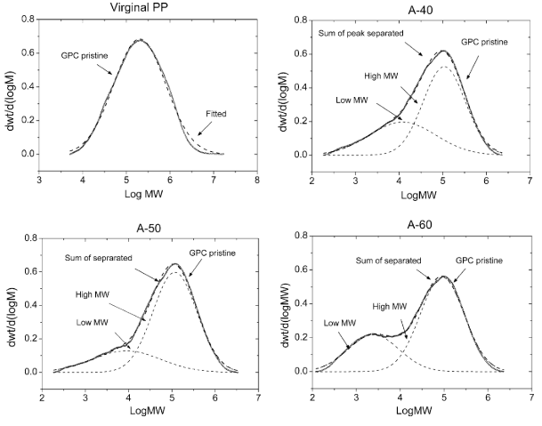
Figure ‎3.11 Isotactic polypropylene exposed to 190˚C for 40, 50, and 60 minutes. [65]
Gu et al. [45] explained that prolonged thermal exposure to semi-crystalline polymers might lead to an increase in crystallinity, molecular weight change due to polymerisation or depolymerisation, intermolecular reactions such as cross-linking, and thermo-oxidation causing discolouration. The free radical addition polymers will tend to thermo-oxidatively degrade in the build chamber. Most commercial LS machines use low-pressure nitrogen blanket in the build chamber, preventing the polymer from thermo-oxidation. Using a nitrogen atmosphere during the process can create an oxygen-free environment and prevent thermos-oxidation degradation reactions that require oxygen. [66] Despite having nitrogen in the chamber, excessive energy, as demonstrated by Vasquez's study, may lead to changes in molar mass in the case of Nylon.
Other studies by Vouyiouka et al. [67] showed that solid-state polymerisation had been known to occur during LS in semi-crystalline materials such as nylon-12 by chain extension in the region above the glass transition temperature and below the melt temperature. These conditions are often met inside an LS machine while the unsintered powder is kept constantly at elevated temperatures, which can account for increases in molecular weight.
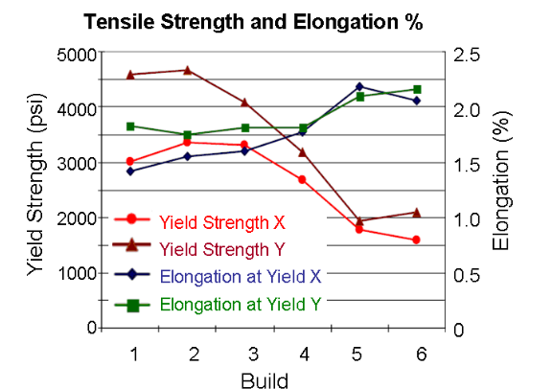
Figure ‎3.12 Tensile strength and elongation of PA-GF polymer as a function of a number of builds. [43]

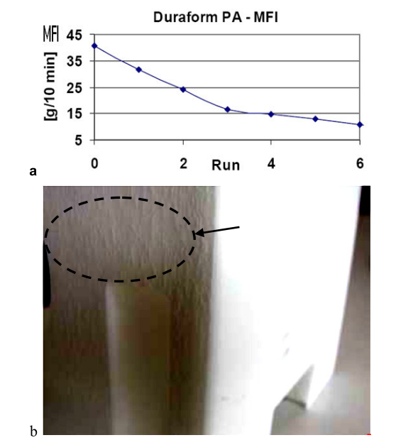
Orange peel
Figure ‎3.13 a) a decrease in MFI or the rise in melt viscosity of reused PA 12 material, b) resulting “orange peel” texture on LS parts. [43]

The impact of reusing the powder on LS was discussed by Kruth et al. [43] whose study explained that the reuse of the same PA 12 powder in LS leads to chain growth and a rise in Mw and viscosity. The MFI drops with the increase of melt viscosity, preventing reasonable sintering, leading to imperfection on the surface known as “orange peel” texture, as shown in Figure ‎3.13 (b). Moreover, the change in MFI, as shown Figure ‎3.13 (a), shows a drop in MFI as the runs increase. To overcome these defects, Kruth suggested increasing the building temperature to overcome the increase in viscosity, with a limiting effect. An optimal approach is to mitigate these issues by consistently mixing virgin and re-used powder with a recommended ratio of 70% fresh powder and 30% recycled powder, specifically for nylon. Furthermore, the impact of reused powder showed a rapid decline in tensile strength for a glass-filled PA 12, as shown in Figure ‎3.12. The study expressed that each polymer has an ageing effect that may impact the final component.
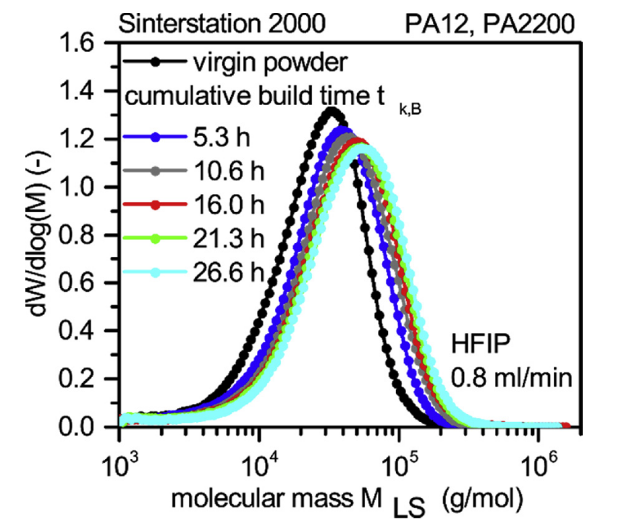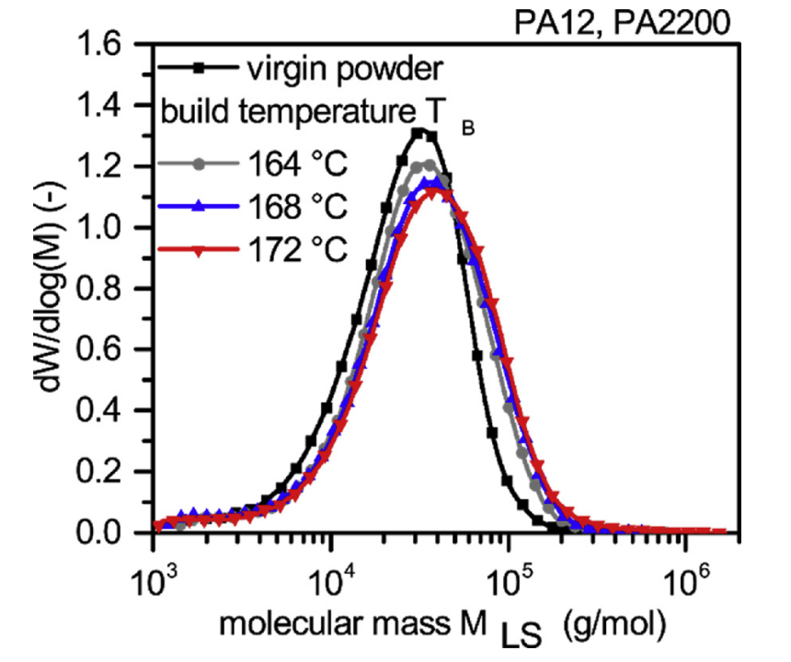
Figure ‎3.14 (left) shows the impact of build temperature 172 ˚C for different cumulative times on MMD, (right) the impact of different build temperatures on MMD. [12]
The study by Wudy et al. [12] showed the increase in Mw was observed not only for longer exposure time but also for an increase in Mw with higher build temperature used in LS for PA 12, as shown in Figure ‎3.14. Both cases show a shift to the high molar mass due to the chain growth known to occur with PA12.
Gu et al. [45] simulated the thermal ageing behaviour of polyethylene terephthalate (PET) powder in a vacuum oven and found that PET molecular weight did not drastically increase, unlike PA 12, as displayed in Figure ‎3.15. In PET, there is a slight drop in the molecular weight at 24 h, followed by a slight rise after 96 h at 210°C compared with PA 12, Figure ‎3.15 shows that within 2 hours at 163 °C, the molecular weight increases by more than double. Gu describes that PET has active end-groups (COOH and OH), but even under the condition of low nitrogen flow in the printer, the solid-state polymerisation rate is slower compared with PA 12, which has active COOH and NH2 end-groups.

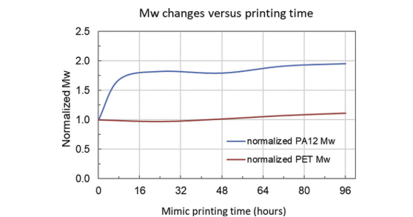
Figure ‎3.15 Plot of normalized change in (Mw) from Duraform PA12 and PET powder. Both powders were held at typical build bed temperature (exposure temperatures were 163℃ for PA12 and 210℃ for PET). [45]

The molar mass averages are susceptible to change during and after re-processing the polymer, even in the case of PP. Typically, polymers like PE and PP are more prone to chain scission. A study by Spicker et al.[68] examined the influence of multiple processing cycles on rheological, thermal, and mechanical properties. The study highlights an increase of MFI and a reduction of Mw after multiple extrusion using PP. Another study by Aurrekoetxea et al.[69] where PP underwent many injection moulding processes to simulate the impact of recycling methods. The study further examines the impact of recycling by monitoring alterations in chemical composition, melt viscosity, crystallisation patterns, as well as tensile and fracture characteristics. The results show that recycling primarily reduces melt viscosity by causing a drop in molecular weight. Aurrekoetxea shows similar results to Spicker et al.’s [68] however result for Spicker showed an increase in MFI from re-processing PP in extrusion process from the first cycles, whereas Aurrekoetxea showed a stable MFI value up to the fourth cycle; Aurrekoetxea further explains that the absence of change in MFI for the first four cycles is due to the presence of stabilisers. As the degradation starts at the fifth cycle, a point for the depletion stabilisers is set. Recycled injection moulded polypropylene (PP) demonstrates a faster rate of crystallisation, increased crystallinity, and a higher melting temperature compared to virgin PP. The elastic modulus and yield stress exhibit a positive correlation with the number of recycling iterations. Nevertheless, the elongation at break and fracture toughness exhibits a reduction. The degradation impact observed in the injection moulding is induced due to the lack of nitrogen in the system and the presence of shear forces that are not present in the LS process.

The degradation of PP powder was studied by F. Mwania et al. [70] using the PP 75 powder from Diamond Plastic Ltd developed for laser sintering. The study shows the reusability of PP up to 8 cycles in the EOSINT 380 EOS. The study highlights the increase in MFI started after the 5th cycle. Mwania further added that the ageing of polymers leads to chain scission, chain branching, or cross-linking caused by high temperatures. Moreover, the study shows that PP 75 has a melting point of 134˚C, indicating it is a copolymer. Furthermore, SEM images shared in the report showed highly spherical particles with the irregular rock shape of PP powder, suggesting the use of fillers. This may impact the mechanical properties of the LS specimen as the melting and crystallinity behaviours are affected by the copolymer and fillers used, thus not reflecting the true impact of reusability on single-chain homopolymer PP polymer in the LS processes. This leaves a gap in the literature for investigating the reusability of homopolymer PP.
The reusability of the LS powders also impacts the thermal properties. Wudy et al.’s [12] study showed a shift to higher Tm and Tc as the PA 12 reuse cycle increases. Conversely, other PA12 reusability studies on LS by Gunputh et al. [71] and B. Sanders et al. [72] show the opposite effect, where the increase in the number of cycles resulted in a shift of Tm and Tc to lower temperatures. For PP, the study by Spicker et al. [68] shows a shift to a higher Tc and Tm after heating for 15 minutes at 210˚C in a vacuum oven. This was not the case for the study conducted by Aurrekoetxea et al., as the re-processed injection moulded samples showed a random variation up to the fourth cycle, then a jump in the equilibrium temperature, suggesting the chain session occurs after the depletion of the stabilisers.
The enthalpy change associated with the degradation of polypropylene exhibits variability contingent upon the specific degradation process and prevailing conditions. The degradation of polypropylene (PP) can be affected by various factors, including temperature, the presence of antioxidants, and the specific degradation method used. During the degradation of PP, there might be changes in its thermal characteristics, such as changes in enthalpy caused by phase transitions or chemical reactions that take place during degradation processes. The enthalpy change during the degradation of PP is a crucial characteristic that indicates the energy consumed in these processes and can offer valuable information about the material's stability and behaviour under various conditions.[73]
Overall, thermal degradation may occur in the LS process during high laser energy usage or prolonged exposure to high temperatures when powders are re-processed in the LS machine. Different polymers react to degradation differently due to their chemical structures. In the case of PP, the chains break down, unlike the chain growth that occurs in nylon. These changes in PP chain length may lead to different outcomes in tensile properties, which are known in injection moulding but are unknown in LS.

Important LS process parameters
The energy input to the polymer in LS is related to intrinsic properties. In the LS system, the energy inputs are introduced through two methods: by the build chamber temperature and the laser beam.

Laser energy density
A study carried out by Ituarte et al. [23] using industrial polypropylene shows some of the essential processing parameters involved in the polymer powder bed fusion (PBF) process are laser power (P), laser scan speed (V), laser scan spacing or hatch distance (S), layer thickness (L_{t}), and part bed temperature (T_{b}).
The energy for LS is described in the literature as the energy volume (Ev) or the energy density (ED). The ED, expressed in Equation ‎3.5, is used in the majority of the literature, as it was established first. The only variation of the calculation is taking account of the layer thickness (Lt) in the Ev Equation ‎3.6.
$$ED=\frac{P}{h.v}$$

Equation ‎3.5
The energy density gives the relationship between some of these variables (Ev), which is defined as the relative applied laser energy per volume of material. This relationship is often used to describe the correlation between key process variables in PBF and is calculated by Equation ‎3.6 for the LS process.
$Ev=\frac{P}{v.Lt.h}$
Equation ‎3.6
Pilipović et al. [74] proposed a further refinement to take into account the hatch distance with the energy density (ED) Equation ‎3.5, determined by Equation ‎3.7.
$$ED=\frac{P}{h.v} \frac{d}{h}$$
Equation ‎3.7
The equation now accounts for the overlay ratio x=d/h where (ED) is the energy density, (d) laser beam diameter, (h) hatch distance, (v) laser scanning speed.
Pilipović et al. [74] concluded that the highest tensile properties are achieved with the higher energy density, but the energy density should not exceed ED= 0.0667 J/mm² since the result of overheating reduces the mechanical properties for PA 2200.
A study by Ituarte et al. [23] shows two of the most influential process parameters, laser power and laser scanning speed, were altered at discrete intervals, while the other parameters were set as constant, as shown in Table ‎3.3. This study’s test material was a mechanically mixed Coathylene® sint polypropylene (PP) (Axalta Polymer Powders, Bulle, Switzerland) and fumed nano-silica (SiO₂) composite. [23]
Table ‎3.3 Factors and levels for full factorial of DOE for PP. Ituarte et al. [23]
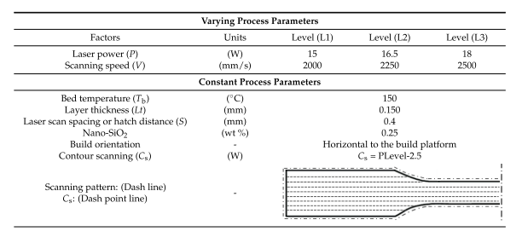
Trial and error led to the establishment of an initial process window. In this investigation, the top and lower limits of Ev were 0.100 J/mm³ and 0.150 J/mm³, respectively. It was found that geometric distortion, warping, and curling were caused by high Ev values. Higher energy levels also resulted in build failure because the re-coating blade came into touch with the curled sintered layers. Low Ev values, on the other hand, indicated low fusion between layers, resulting in weak specimens. [23]
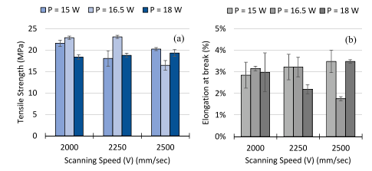
Figure ‎3.16 Variation of (a) tensile strength and (b) elongation-at-break as a function of laser power and scanning speed. Ituarte et al. [23]
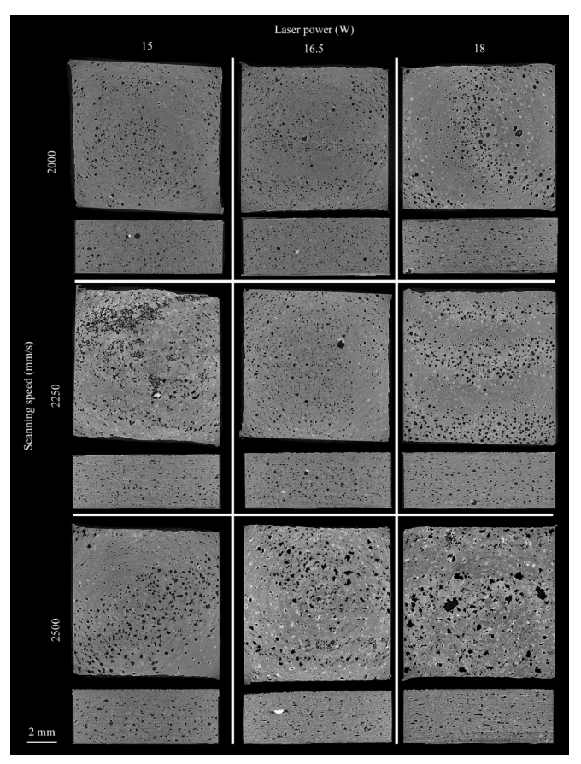
Figure ‎3.17 Representative slices from each of the sample batches. The slices display the interlayer connection and the side view of the samples. The sample slices are organized as follows: top row: 2000 mm/s scanning speed; middle row: 2250 mm/s scanning speed; bottom row: 2500 mm/s scanning speed; left column: 15 W laser power; middle column: 16.5 W laser power; right column: 18 W laser power. Ituarte et al. [23]
Moreover, the study revealed that increasing energy density resulted in higher tensile strength at the cost of decreasing the elongation-at-break. Simultaneously, Figure ‎3.17 shows porosity is also reduced at higher energy densities. Based on the results, a narrow window of 0.122 ≤ E_{v} ≤ 0.138 J/mm³ led to maximum tensile strength as well as increased elongation-at-break. In this regard, a P = 16.5 W and 2000 ≤ V ≤ 2250 mm/s led to the best results, as shown in Figure ‎3.17 [23]. Commercial LS machines using PA12 reach 211 mm/s scanning speed. However, PP has a similar melting range to PA 12. The study suggests that PP had performance limitations with strengths in the region of 17 to 22 MPa, even at scanning speeds of 2 to 2.5 m/s.
Moreover, the laser mechanism has an impact on the final build quality. There are two types of laser lenses found in the LS machines. The plano-convex lens only accurately sinters 50% of the build surface due to the shift of the focal point, as shown in Figure ‎3.18. where the F-theat lens, also known as a flat field lens, offers a flat focal point across the powder bed, thus providing even laser power across the sintered layer. [75]

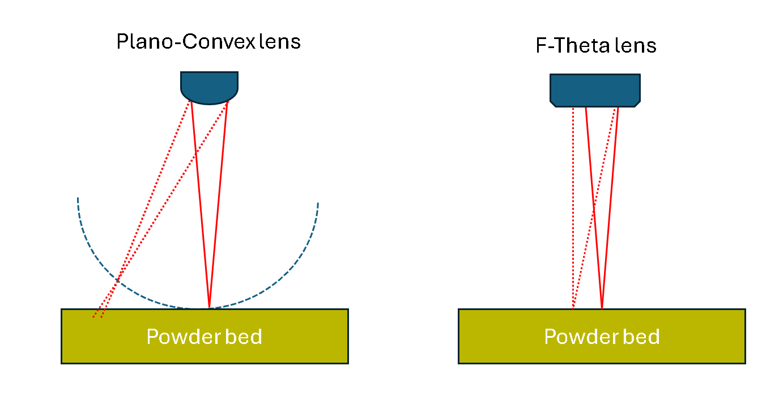
Figure ‎3.18 laser beam travel in two lens types: Plano-Convex lens and F-Theta Lens.

Lexow et al. [27] showed the value of Energy density for PP falls in the region of 0.013-0.057 J/mm² based on previous experimental work with different types of PP. The study further explains that low energy density for the contours appears to give sharper edges, and higher energy causes unsintered particles to agglomerate on the contour melt, creating a rough surface finish for PP. The study further shows that a double laser scan technique used on PP showed an improvement in the stability of the melt and reduction of curl. L. Fiedler et al. [35] showed that PP has a lower energy absorption than PA12, correlating to the double scan requiring more energy to hold the melt down as discussed by Lexow et al. [27]. Another study on Ultra-high molecular weight polyethylene (UHMWPE) by Goodridge et al. [76] stated that double scan speed delivers energy more gradually resulting in greater definition and considerably less shrinkage.

Laser Speed
A study conducted by Drexler et al.[77] show that the laser travel speed influences the LS specimen's mechanical properties. The study shows a design of experiment (DOE) on PA12 using two energy densities 0.3 and 0.4 J/mm ^{2,} with a different range of laser powers and scanning speeds. The results from the study show that higher laser travel speed results in a reduction of the tensile strength and elongation-to-break, as shown in Figure ‎3.20. The study explains that the change is caused by the contact between the laser beam and the polymer powder shown in Figure ‎3.19 (b and c). This interaction leads to the accumulation of heat on the surface of the powder bed, but only for extremely brief periods with the laser. A high amount of laser power in a short period may result in unmelted powder, resulting in weaker layer interaction, as shown in Figure ‎3.19 (c). Furthermore, the study shows no changes in the surface roughness as the laser speed changes.

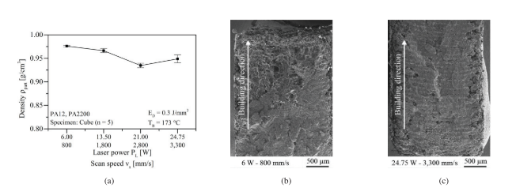

Figure ‎3.19 Part density as a function of exposure speed (b)Fracture surface for low and (c)for high exposure at energy density 0.3 J/mm². Drexler et al. [77]
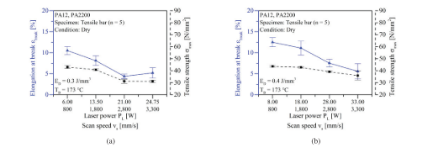

Figure ‎3.20 (a) Tensile properties as a function of exposure speed for energy level of (a) Energy density = 0.3 J/mm² and (b) Energy density = 0.4 J/mm². Drexler et al. [77]

Sintering window
Ituarte et al. [23] studied initial screening using DOE to identify the most impactful processing properties in LS that result in both a relatively high part density and mechanical properties. The study concluded that two process conditions had an impact on mechanical properties: the energy density and defining a suitable temperature process parameters window for semi-crystalline polypropylene.
The sintering window is a critical property in LS and is obtained by the “differential scanning calorimetry” (DSC) test. The DSC provides a thermal profile of the polymer showing two distinct peaks, reflecting the melt and crystallisation phases. Most often, the sintering window is the area between the melting temperature onset (Tm^{onset}) and crystallisation temperature onset (Tc^{onset}), as shown in Figure ‎3.21. The powder bed temperature is set to keep the sintering polymer in a melt state while keeping the surrounding powder unmelted. If the bed temperature is kept slightly higher during processing, early crystallisation can be averted.
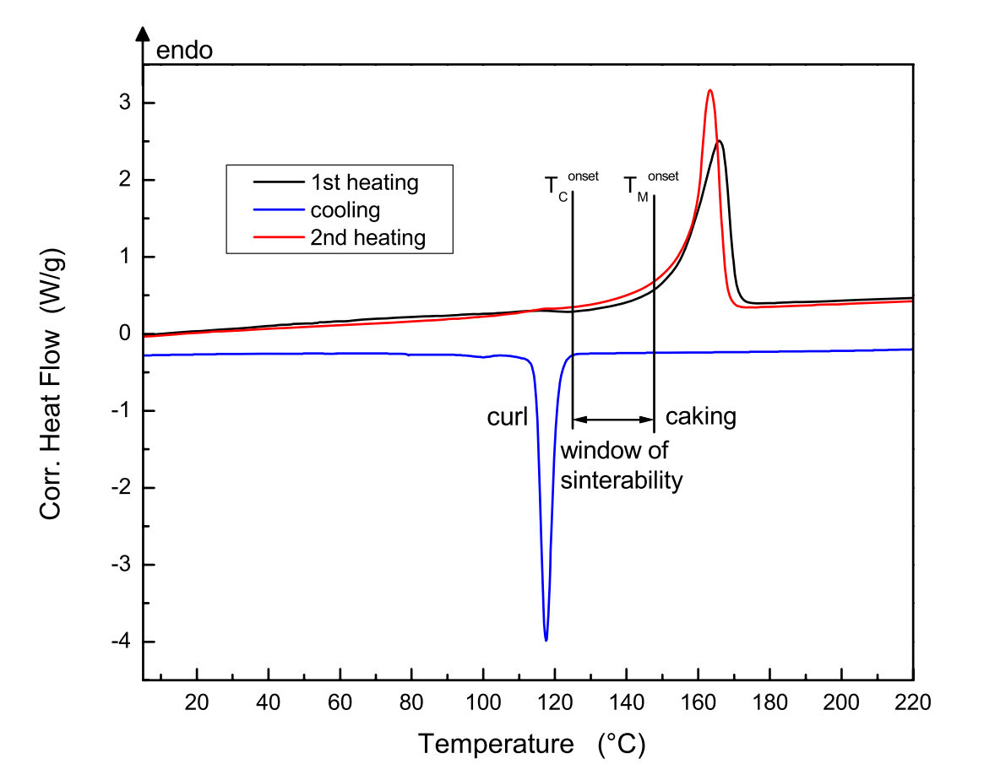
Figure ‎3.21 Typical DSC-thermogram with nature of “sintering window” as LS temperatures. Schmid et al. [78]
Schmid et al. [78] further explain that if the melting temperature (Tm) is too close to the crystallisation temperature (Tc), premature crystallisation may cause a curl in part. In addition, If the bed temperature is set just slightly lower during processing, an early crystallisation can occur, resulting in part curling, as shown in Figure ‎3.22(left), and if the temperature is too close to the Tm, it leads to lateral growth, shown in Figure ‎3.22(right). To avoid curl and lateral growth, a wide window over 15°C was recommended.
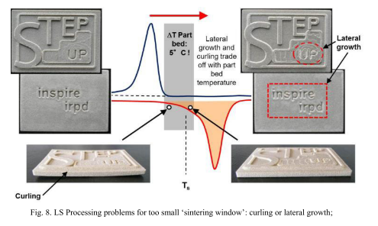
Figure ‎3.22 LS processing problems for narrow “sintering window”: curling(left) or Lateral growth (right) Schmid et al. [78]
Fiedler et al. [35] report a similar outcome to Schmid, where the window of sinterability is the first important parameter in LS. A small window leads to premature crystallisation of the sintered layers, causing a curl effect.

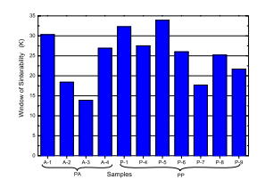
Figure ‎3.23 Sintering window of different PA and PP by Fiedler et al. [35]
The study further compares the sintering windows (SW) of PP and PA grades, shown in Table ‎3.4. The sintering window for some of the polypropylene grades is in the same range or even wider than P12, as shown in Figure ‎3.23 P-1, as copolymer and P-5 homopolymer PP showed a higher sintering window compared to the different PA grades examined. This shows that the wider SW does not always result in sintered articles; however, the crystallinity should also be taken into consideration.
Table ‎3.4 Materials investigated for LS. Fiedler et al. [35]
Code | Application | T_{m} (°C) | MFI (g/10min)  @ 190 °C, 2.16 kg | Type
P-1 | Whit rotational moulding powder | 166 | 12.2 | PP Copolymer
P-4 | Black peg rotational moulding powder | 166 | 14.4 | PP Homopolymer
P-5 | Precipitation powder, ultrafine round particles | 163 | 24.6 | PP Homopolymer
P-6 | Pellet injection molding grade, antistatic and nucleated. High flow | 170 | 27.6 | PP Homopolymer
P-7 | Masterbatch powder with anticaking additives | 163 | 23.1 | PP Homopolymer
P-8 | Masterbatch powder | 164 | 28.8 | PP Homopolymer
P-9 | Pellet injection molding grade, antistatic and nucleated. Mid flow | 169 | 15.3 | PP Homopolymer
A-1 | LS powder | - | - | PA12
A-2 | A-1 and A-3 dry blend, recycled | - | - | PA11 and PA 12
A-3 | High melt flow coating | - | - | PA11
A-4 | A-1 and A-3 dry blend | - | - | PA11 and PA12
Note: Tm and MFI for PA grades was not disclosed in Fiedler et al.[35]
In a study by Lexow et al. [27] PP powder was laser sintered with a build temperature set at 156 °C, at the high end of the window, less than the Tm onset by 9°C, reporting uniform powder flow, and smooth part bed at a selected temperature. The study further suggested that all previous LS experiments reviewed had a range between 150°C and 160°C built temperatures for PP, however, the composition of the PP powder is unknown.

Part location
The temperatures obtained from the DSC are highly accurate; the same cannot be said for some LS machines. The temperature accuracy and homogeneity of the machine may impact the mechanical properties. Majewski et al. [79] explained that the orientation had no demonstrable effect on the tensile strength and modulus. Contrarily, the location of the build had an impact on the mechanical properties. This was reconfirmed by Goodridge et al.'s [76] study, which showed the variation in mechanical properties when parts were printed in different locations in the print bed for UHMWPE.

Polypropylene in LS
Fiedler et al.[35] published a paper on the development of polypropylene for laser sintering. In the study, different types of polypropylene (six homopolymers and one copolymer) with different MFI and melting points were used, as shown in Table ‎3.4. The paper states at the start that in comparison with polyamide, the application of PP for laser sintering has not led to satisfying results.
Fiedler's study concluded that the thermal stability, sintering window, and viscosity properties of PP are similar or better than those of polyamide, however, significant differences in crystallinity and laser energy absorption are different (discussed previously in more detail in section ‎3.2.2). Nevertheless, the study did not produce tensile data to be analysed.
Wegner et al. [80] studied the mechanical properties of PP developed by Rowak Rolaserit for LS. The result shows the powder with Tm ~125°C with the tensile data peaking at Young's modulus of ~860 MPa, tensile strength of ~18 MPa, and elongation-to-break ~ 15%, as shown in Figure ‎3.24. The sintering window for Rolaserit PP was indicated as 27°C versus 35°C for PA2200. Usually, the Tm of PP homopolymer is around 165°C, which indicates that Rolaserit PP could be a copolymer. Wegner further highlighted that a larger sintering window does not always guarantee an adequate process in LS. Moreover, Wegner’s study highlights how the tensile values vary from one LS machine to another, as shown in Figure ‎3.24.
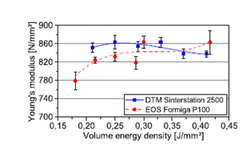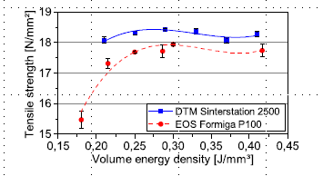
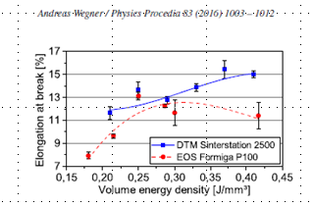
Figure ‎3.24 Mechanical properties of ROWAK Rolaserit PP on two commercial machines DTM 2500, and EOS P100. Wegner et al. [80]

PP powders are available commercially for LS. The data sheets of suppliers of PP powders claim the powders are processable in LS and provide mechanical properties in their commercially available data sheets. These do not give the polymer composition and molecular weight data; they are hidden to maintain a competitive advantage.
Ricoh's PP S5500P powder is sold as LS powder and used in automotive prototyping. From the provided data sheet, the powder density is 0.84 g/cm³ and has a melting point of 125°C. The values are not of homopolymer PP powder. Ricoh powder claims a modulus of 907 MPa, a strength of 21 MPa, and an extremely high elongation-to-break of 529%, as shown in Table ‎3.5.[81] The powder is only provided with their LS system and is not available to be used on other LS machines.
Table ‎3.5 Data-sheet of Ricoh's S5500P. [81]
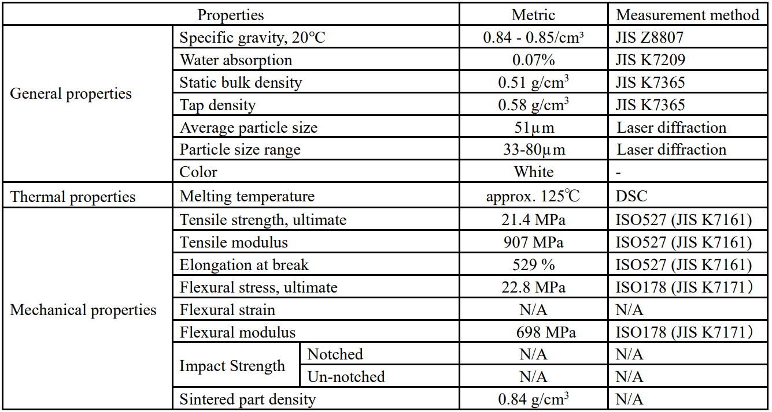

Another PP powder in LS is EOS PP 1101; their datasheet claims a modulus of 1.2 GPa, a strength of 27 MPa and an elongation-to-break of 12% with a melting temperature of around 140°C which implies the use of a PP copolymer.[30]
CP 20 from Diamond Plastics GmbH is another PP powder developed for LS. The data sheet provided by Diamond Plastics GmbH shows a modulus of 1990 N/mm², tensile strength of 20 MPa, and elongation at a break of 12% using an EOS 395P. Unlike the other two PP commercial powders discussed previously, the tensile values of CP20 were investigated in a study by Tan et al. [46]. The studies' data shows lower CP20 tensile values than those claimed in the data sheet, where a tensile strength of 14 MPa and elongation at break of 1% were reported on the EOS 395P machine.
When comparing the LS tensile data with the IM, a study by Athreya et al. [82] exhibits tensile modulus, and the UTS of PA-12 in LS is higher by 35% and around 10% higher than in injection moulding (IM). The study relates the increase in tensile properties to the cooling rate between the two processes that result in different crystal spherulites forming. Zhu et al.[26] went further and compared PP for LS with IM. Zhu explained that the higher degree of crystallinity and existence of γ phase crystal structures in the PP LS samples resulted in a 20% increase in the tensile strength and 29% in modulus when compared with IM. The study links the high tensile values to the cooling rate after LS processing, which influences the degree of crystallisation and the presence of γ phase crystals.
Table ‎3.7 gives a summary of the literature that used PP in LS and showed a range of proprieties that are useful in identifying key process parameter ranges. Moreover, the literature shows ultimate tensile strength (UTS) ranging from 15 to 23.1 MPa and an elongation at break (EAB) between 0.94-200[%]. The high elongation of 200% was established by a copolymer polypropene CP60 grade. [46] [23] [80] [83] [26] [84]
Table ‎3.6 Literature summary of LS properties using polypropylene.
Ref | [26] | [83] | [84] | [80] | [80] | [23] | [46] | [46]
^{Material} | ^{PP-R201 trial Corp. (Japan)} | ^{iCoPP} | ^{PP CP22(Diamond Plastics)} | ^{Rolaserit PP (ROWAK)} | ^{Rolaserit PP (ROWAK)} | ^{Coathylene+ 0.25wt%SiO2} | ^{PP CP20 (Daimond plastics)} | ^{PP CP60 (Diamond plastic)}
^{Machine} | ^{HRPS-IV SLS system} | ^{DTM Sinterstation 2000} | ^{DTM Sinterstation 2000} | ^{EOS P100} | ^{DTM Sinterstation 2500} | ^{Open system} | ^{EOS P395} | ^{EOS P395}
^{Bt [˚C]} | ¹⁵⁰ | ¹²² | ¹⁴⁸ | ^{N/A} | ^{N/A} | ¹⁵⁰ | ¹⁴⁶ | ¹²³
^{SW [˚C]} | ²¹ | ^{N/A} | ^{34.1} | ^{27.3} | ^{27.3} | ^{35.1} | ^{26.3} | ^{2.2}
^{PSD [µm](D10,D50,D90)} | ^{38.1, 63.6, 106} | ^{N/A} | ^{D50 (70)} | ^{N/A} | ^{N/A} | ^{30.29, 49.01, 76.63} | ^{D50=48} | ^{D50 =52}
^{P [W]} | ^{8.25,11,13.75,16.5} | ^{15, 20, 25} | ^{15, 20, 25} | ^{18, 21.5, 25} | ^{21, 41} | ^{15, 16.5, 18} | ⁶⁻²⁵ | ¹⁶⁻³²
^{Lt [mm]} | ^{0.15} | ^{0.1} | ^{0.1} | ^{0.06, 0.1, 0.12} | ^{0.1, 0.3} | ^{0.15} | ^{0.1} | ^{0.15}
^{v [mm/s]} | ¹⁵⁰⁰⁻³⁰⁰⁰ | ⁵⁰⁸⁰ | ³⁵⁰⁰⁻⁵⁰⁸⁰ | ⁴⁰⁰⁰⁻⁵⁰⁰⁰ | ⁵⁰⁰⁰ | ²⁰⁰⁰⁻ ²⁵⁰⁰ | ³⁰⁰⁰ | ⁴⁵⁰⁰
^{h [mm]} | ^{0.2} | ^{0.23} | ^{0.23} | ^{0.15, 0.2, 0.25} | ^{0.2} | ^{0.3} | ^{0.2} | ^{0.3}
^{ED [J/mm2]} | ^{0.01-0.0367} | ^{0.0128-0.0214} | ^{0.0128-0.0311} | ^{0.0120-0.0694} | ^{0.0070-0.0410} | ^{0.01-0.015} | ^{0.014-0.040} | ^{0.008-0.016}
^{UTS [MPa]} | ^{19.9} | ^{19.5} | ^{N/A} | ¹⁸ | ^{18.5} | ^{23.1} | ¹⁵ | ¹⁹
^{EAB [%]} | ^{N/A} | ^{N/A} | ^{N/A} | ¹³ | ¹⁵ | ^{3.5} | ^{0.94} | ²⁰⁰

In summary, attempts have been made with LS with PP; however, it is clearly not understood why PP is underperforming compared to nylon UTS of 48MPa. [85] On average, PP injection moulding has a UTS of around 34 MPa compared to the PP range of 15-23.1 MPa.[23] The literature shows that the laser sintering PP strengths are too low to be considered usable or stronger than IM. Moreover, the literature shows an insufficient understanding of the effect of molar mass on the mechanical properties of PP.
Table ‎3.7 Key Findings from Literature Summarized
Aspect | Findings | Gaps Identified | References
LS Material Landscape | Nylon (PA12) dominates LS due to low crystallinity, flowability, and mechanical properties. | PP has only a 2% market share due to processability challenges; limited focus on improving PP for LS. | Schmid et al. (2014), "Additive Manufacturing: Polymers in Laser Sintering" [22]; Fiedler et al. (2017), "Material Properties and LS Sintering Behavior" [35]
Powder Flowability | Improved by additives like silica; spherical particles improve flow but not always mechanical properties. | Minimal focus on optimising PP's particle shape and flow additives specifically for LS. | -Christian et al. (2018), "Flow Behavior of Polymers in Laser Sintering" [14]; Cooke et al. (2019), "Powder Flow Additives for Polymers" [24]
Mechanical Properties | PA12 shows superior UTS and EAB due to better interlayer adhesion and crystallinity. | The influence of PP chain length (MMD) on UTS and EAB in LS parts is unclear. | Wegner et al. (2016), "Mechanical Property Comparison of LS Materials" [79]; Vasquez et al. (2017), "Impact of Tensile Properties on LS Performance" [52]
Thermal Properties | Wide sintering windows and high crystallinity enhance processability in LS. PA12 absorbs more laser energy due to its higher crystallinity, while PP’s lower crystallinity results in poorer sintering outcomes. | PP's thermal degradation and narrow sintering windows remain barriers to LS success. | Schmid et al. (2014), "Additive Manufacturing: Polymers in Laser Sintering" [22]; Drexler et al. (2018), "Thermal Properties of LS Powders" [76]; Fiedler et al. (2017), "Material Properties and LS Sintering Behavior" [35]
Reusability of Powders | PA12 maintains properties after multiple uses; PP copolymer (with ethylene comonomer) shows better reusability than homopolymer PP but introduces variability due to the PE content. | No studies focus exclusively on the reusability of homopolymer PP without the influence of PE comonomer, leaving the impact of single-chain PP unexplored. | Frederick M. Mwania et al. (2021), "Reusability of PP Copolymers in Additive Manufacturing" [40]; Majewski et al. (2015), "Reusability of LS Powders" [28]
Energy Absorption | PP absorbs less laser energy compared to PA12 due to differences in infrared absorbance at key wavelengths, affecting layer adhesion and mechanical properties. | Limited work on improving PP's energy absorption characteristics for LS applications. | Fiedler et al. (2017), "Material Properties and LS Sintering Behavior" [35]
Intrinsic Polymer Properties | Studies focus on melt viscosity and crystallization temperatures. | Limited understanding of MMD’s role (e.g., Mn, Mw, Mz, Mz+1) in determining PP part performance in LS. | Vasquez et al. (2017), "Impact of Molar Mass Distribution on Mechanical Properties" [52]; Schmid et al. (2014), "Material Intrinsics for LS" [22]
Processing Parameters | Laser speed, energy density, and build temperature affect part quality. | Lack of parameter studies for PP with different chain lengths and their influence on final properties. | Ituarte et al. (2018), "Processing Parameters in Laser Sintering for Optimal Results" [23]; Drexler et al. (2018), "Energy Density Effects in LS" [76]

Research Gap
M. Mwania et al's [70] investigated the reusability of PP copolymers in LS and highlighted that the addition of ethylene as a comonomer significantly enhanced powder stability over multiple cycles. While this finding is valuable for applications requiring more durable materials, it complicates the interpretation of PP’s intrinsic properties in LS. The presence of a PE comonomer alters key attributes such as crystallinity, thermal stability, and molar mass distribution, making it impossible to isolate the effects of the homopolymer PP chain length on mechanical properties.
This leaves a critical gap in understanding how homopolymer PP, with a single polymer chain structure, behaves in LS, particularly during reuse cycles. By focusing exclusively on homopolymer PP, this study aims to clarify the role of chain length and molar mass distribution on mechanical properties such as ultimate tensile strength (UTS) and elongation at break (EAB). This will provide a clearer foundation for optimising PP in LS, free from the confounding effects of PE comonomers.

Project definition

Novelty statement
The novelty of this study is defined by the gap found in the literature, which shows no prior work was implemented to understand the impact of different chain lengths on the mechanical properties of a homopolymer PP on the LS article.
From the literature search, all the intrinsic properties are linked back to the molar mass of the polymer. The literature highlights that molar mass influences the melt strength, crystallinity, and mechanical properties. Attempting to correlate the impact of the polymer chain length to LS mechanical properties with copolymer PP is challenging due to the complex polymer structure configuration. Therefore, the novelty in this study is to explore the impact of homopolymer PP, with different chain lengths represented by MFI, to understand what influence chain length has on mechanical properties in LS.
Furthermore, this study will be the first attempt to investigate the reusability of homopolymer PP in the field of LS will be carried out. The reusability of the homopolymer PP will show how the reusability impacts the LS key properties rather than examining a complex copolymer PP structure.
This study will give a new approach to selecting PP powder for LS, where the polymer chains are examined to give an indication of what tensile properties can be achieved with different chain lengths in the LS process. This fits well in the field of material development for LS, as it assists in understanding how to improve PP mechanical production in LS. In addition, the LS polymer market is dominated by nylon. Diversification in materials is required to increase the functional parts in LS. PP has high potential in the LS market due to properties such as fatigue, elongation, and chemical resistance that will increase the curricle of applications used in LS. By understating the impact of the single chain lengths of PP on the LS mechanical properties, the desired application can have the PP powder with the chain length that provides the required mechanical properties after LS.

Aim
The project aims to explore how the chain length of polypropylene (PP) homopolymers influences the solid-state mechanical properties of LS specimens. The effect of homopolymer PP chain length on the mechanical properties of LS parts is unknown. The study will examine specifically PP homopolymers with varying single-chain lengths, achieved through different Melt Flow Index (MFI), affect the mechanical performance of LS materials. This approach is a novel aspect of the research.
The literature shows work done on the reusability of PP copolymer, but this does not reflect the actual behaviour of PP. The literature covers the use of a copolymer with a side monomer to the polymer backbone, which impacts the degradation process and the final mechanical properties. The novel work is to examine the impact of reusability on a single chain of homopolymer PP.
PP is a common polymer with highly desired properties, such as fatigue and chemical resistance, which are not found in PA. For this reason, understanding the molar mass properties is key to optimising the LS part's mechanical properties, thus increasing the functionality of the application used in LS. Moreover, PP may be utilised for the low cost compared to PA12 and for diversification of materials in the LS market.

Objectives
- Determine the impact of different homopolymer polypropylene MFIs on the tensile properties of LS specimens.
- Determine the impact of homopolymer PP with the same MFI and different molar mass averages on the LS tensile properties.
- Determine the impact of the reusability of LS homopolymer polypropylene powder on LS process.
- The impact of low dosage flow additives on the mechanical properties of LS samples

4.3 Research flow map

Figure ‎4.1 Thesis Workflow
This research was structured by initially introducing an overview of AM and laser sintering, then providing fundamental information on polymer science for PP to aid with understanding polymer behaviour in a further section, and then narrowing down to MMD after reviewing the literature on key extrinsic and intrinsic properties on LS. Furthermore, gaps in the literature were examined to find key areas for identifying the novel work. The novelty identified in this thesis is to examine homopolymer PP with different chain lengths to understand how it impacts the mechanical properties of the final LS sample. This study initially covers three different PP powders with a range of MFIs, discussed in Chapter 5, then moves on to Chapter 6, where two PP homopolymer grades with the same MFI but different polymer chain distributions are investigated to examine if the MFI is more impactful than the molar average on the LS mechanical properties. Finally, the impact of the reusability of a homopolymer PP on LS cycles without the copolymers was investigated to examine any changes to the powder after reusing the powder. Finally, key parameters that have an impact on the outcome of the mechanical properties are discussed and compared to the IM to draw a conclusion on the impact of MFI's on the LS process on the different homopolymer PP powders.

Hypothesis
The hypothesis is that long polymer chains in polypropene will increase the chances of polymer entanglement, thus increasing mechanical properties; however, it will increase viscosity and porosity in LS. The short polymer chains will melt faster, improving the flow and, therefore, reducing the voids and surface tension between particles, resulting in a better fusion of particles. However, the long chains will reduce the shrinkage (reduction in crystallinity) and improve the elongation and mechanical properties. Therefore, a bimodal distribution will result in both effects improving the mechanical properties of the laser-sintered polypropylene.

Test methodology plan

Figure ‎4.2 Workflow for the testing methods
The chosen order of the test methodology starts with the material selection, powder characterisation, laser sintering, injection moulding and specimen characterisation, respectively, following a logical progression to systematically investigate the impact of homopolymer polypropylene on LS mechanical performance. Starting with material selection ensures that only suitable powders, such as homopolymers, are used to isolate the intrinsic effects of PP without the influence of comonomers. The selected powders are characterised to find key properties, including MMD, particle size, morphology, and thermal behaviour, which are used to support the set-up of the LS process. These are critical for understanding how each MMD varies and attempting to keep the other characterised properties as similar as possible to isolate the true impact of the MMD on the final tensile values in LS.
LS was performed after characterisation to assess the processability of the powders under controlled parameters, informed by the initial characterisation results. This step also incorporates adjustments, such as flow additives, if required, to address practical challenges like poor powder flowability. Each grade was processed with the aim of obtaining the highest tensile values from the parameter range produced in LS to compare with the other grades.
Furthermore, Injection moulding was also implemented as a benchmark to remove variables like particle size or compaction, which can influence porosity. Therefore, it ensures that the observed mechanical properties are directly linked to the material's intrinsic properties rather than differences in the powder properties.
Finally, the tensile specimens produced were characterised by testing the mechanical, which linked these key properties to the final performance. This sequential approach ensures that each step builds upon the previous one, providing a clear and systematic pathway for analysing the relationship between chain length and key properties in LS processing.

Impact of different MFI on laser sintering tensile data
This chapter investigates the tensile properties of laser sintering of three homopolymer polypropylene (HPP) powders with different MFI. The MFI provides an overall assessment of the molar mass distribution. As the molar mass of the polymer increases, the MFI generally decreases; however, the MFI does not provide how skewed the high molar mass is in the distribution curve.[86]
In this section, initially, all three powders underwent various powder characterisations, MMD, particle size distribution (PSD), flow analysis, and thermal analysis, to examine the powder’s main characteristics required prior to processing in LS.
Furthermore, process conditions were investigated during the LS of each powder to maximise tensile properties from the EOS P100 machine, such as the building temperature, laser speed, laser power, and flow additives.
After the production and tensile testing of the LS samples, the samples are further characterised based on the key intrinsic and extrinsic parameters reviewed in the previous chapter to ensure factors impact the tensile results.
Lastly, the LS specimens were characterised to determine the impact of different MFI with different MMDs on the LS process outcome.
Figure ‎5.1, shows the workflow conducted in this section, initially characterising the powders, then producing the LS part, and finally examining the produced part to draw a conclusion on the influence of MFI.
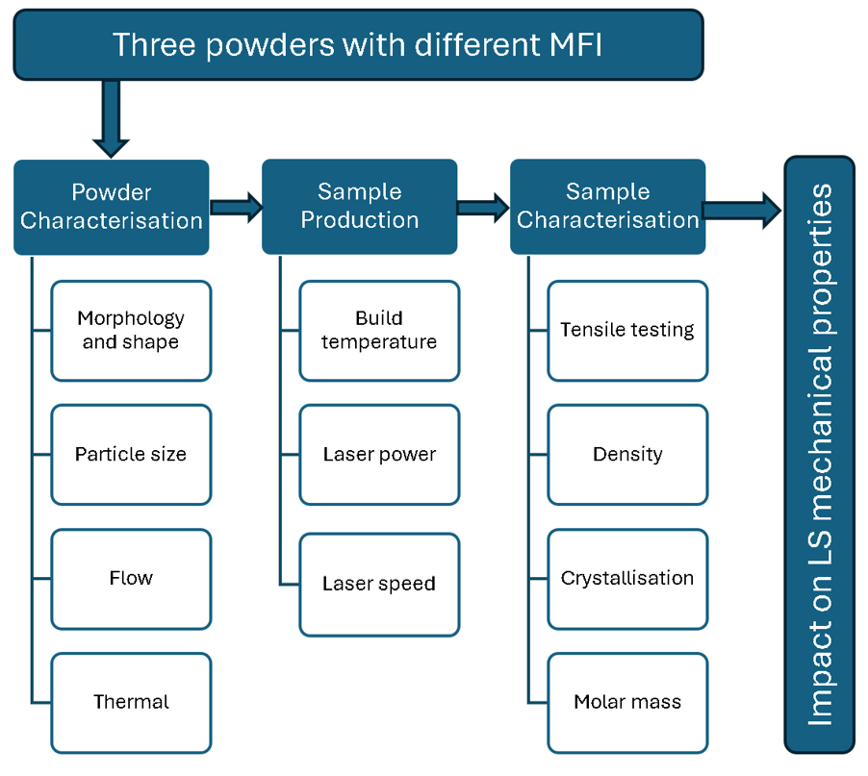
Figure ‎5.1 Experimental workflow

Material selection
The MFI gives a general value for the MMD without providing in-depth information on the distribution of the polymer chain lengths. Higher MFI reflects a shorter polymer chain length, as short polymer chains tend to flow faster than long polymer chains in a melt state due to chain entanglements. [86]
For this study, three HPP powders were selected based on their different MFIs. The first powder, PP HC-12, was produced directly from the metallocene gas phase reactor—in the PP 510P production line in the “SABIC Yannsab” plant. This has no additives. The second was Goonvean Ltd HM20/70P, commercially sold for construction applications such as paint and carpet backing. The third was Diamond CP20, commercially available as a laser sintering powder. All the grades are homopolymer isotactic polypropylene with a single-chain polymer structure with MFI’s, as specified on the manufacturer datasheets, of 12, 20, and 50 g/10min (2.16kg @230 C°) for HC12, CP20, and HM20/70P, respectively.

Powder characterisation

Particle size distribution (PSD) analysis
Aim:
This section aims to ensure that the particle size meets the LS printing requirement.
Method:
Particle size distribution (PSD) can influence powder flow and compaction. The EOS P100 has a layer gap of 100 µm and can tolerate up to 110 µm, as shown in most of the literature. [46] [23] [80] [83] [26] [84] The particle size of different grades must be below 125 µm sized particle.
The characterisation of PSD was carried out on the Malvern MS 3000, shown in Figure ‎5.2. The machine uses laser diffraction to determine the particle size between a range of 0.01 to 3000 µm. Ten grams of powder were poured into a hopper on the dry dispersion unit. The gap between the hopper unit and the feeding channel was adjusted to 1mm, allowing a steady powder flow into the dry cell. The feeding channel used ultrasonic vibration to feed a steady stream of powder flow into the dry dispersion unit. The powder is then dispersed by air pressure in the dry cell.
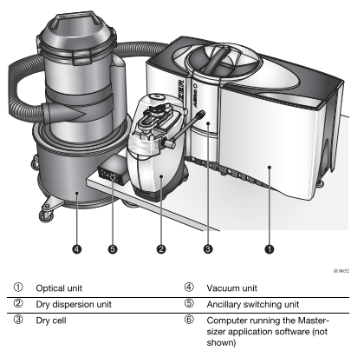
Figure ‎5.2 The Malvern M3000 to measure the PSD. [87]
In the dry cell chamber, a laser beam hits the particle and then reflects off it into an optical receiver in the optical unit at different angles relative to the beam. The size was captured ten times to get an average value and ensure the stability of the measurement. Influential figures such as D10, D50 and D90 represent percentiles of particle sizes below 10%, 50% (midpoint) and 90% of the total powder sizes in the distribution curve. [87][88]
Results & discussion:

Figure ‎5.3 PSD of the different powders used.
Table ‎5.1 Cumulative particle size volume.
Grade | D10 [µm] | D50 [µm] | D90 [µm]
PP HC 12 | 365 | 521 | 756
PP HC 11 | 22.8 | 43.4 | 72
PP HM20/70P | 31.9 | 66.3 | 110
PP CP 20 | 9.04 | 53.7 | 105

The average (D50) sizes are relatively similar across all powders with differences, excluding the HC-12. Therefore, further milling was done by British Rema UK using a jet mill to reduce the size from D90 at 756 to 72 µm to produce the HC11 grade.
CP 20 contained small particles that are identified as a second peak average size of 10µm in the PSD shown in Figure ‎5.3. As discussed in section ‎3.1.3, bimodal PSD will result in denser LS parts when sintered as small particles fill the cavities between the larger particles.
The particle sizes were not similar in values. Nevertheless, the powders show D50 values to be similar, with a variation of D90 for the HC11 and minor fines in the CP20 at D10. However, the powders showed similar values with a slight variation that is within the range required for the LS process up to 125 µm. [89][31][32] Further grinding the powder to match the PSD would have be costly and uneffective to match the small changes that are negligible.

Particle shape and morphology analysis via scanning electron microscope (SEM)
Aim:
This section aimed to examine the particle's shape and morphology.
Methodology:
The SEM of the powders was carried out by Tescan Vega 3 LMU SEM, SE detector, and a scanning electron microscope at an operation voltage of 20 kV. To avoid charging, the SEM samples were coated in gold via an Edwards S150B sputter coater operated at a heat setting of 7-1 Kv and ~20 mA under vacuum for 200 seconds. A random sample was taken from each powder bag to perform the SEM. Three random areas were captured, and the clearer images were used for analysis with a 100 µm scale.

Results:
Material suppliers do not usually disclose information regarding additives or grinding processes. Using the SEM, the process used can be determined based on the particle shape, which can indicate what process was used to make the powders, as shown in Figure ‎3.3.
The SEM images in Figure ‎5.4 (c) of CP20 show two distinct particle sizes around 80 and 20 µm. The CP 20 PP powder has a rock-like shape, suggesting a cryogenic grinding method was used, as suggested in Figure ‎3.3. The production of these powders was a trade secret and not disclosed by the powder manufacturer.
a) 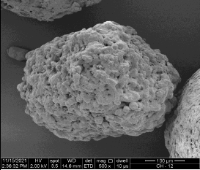 b) 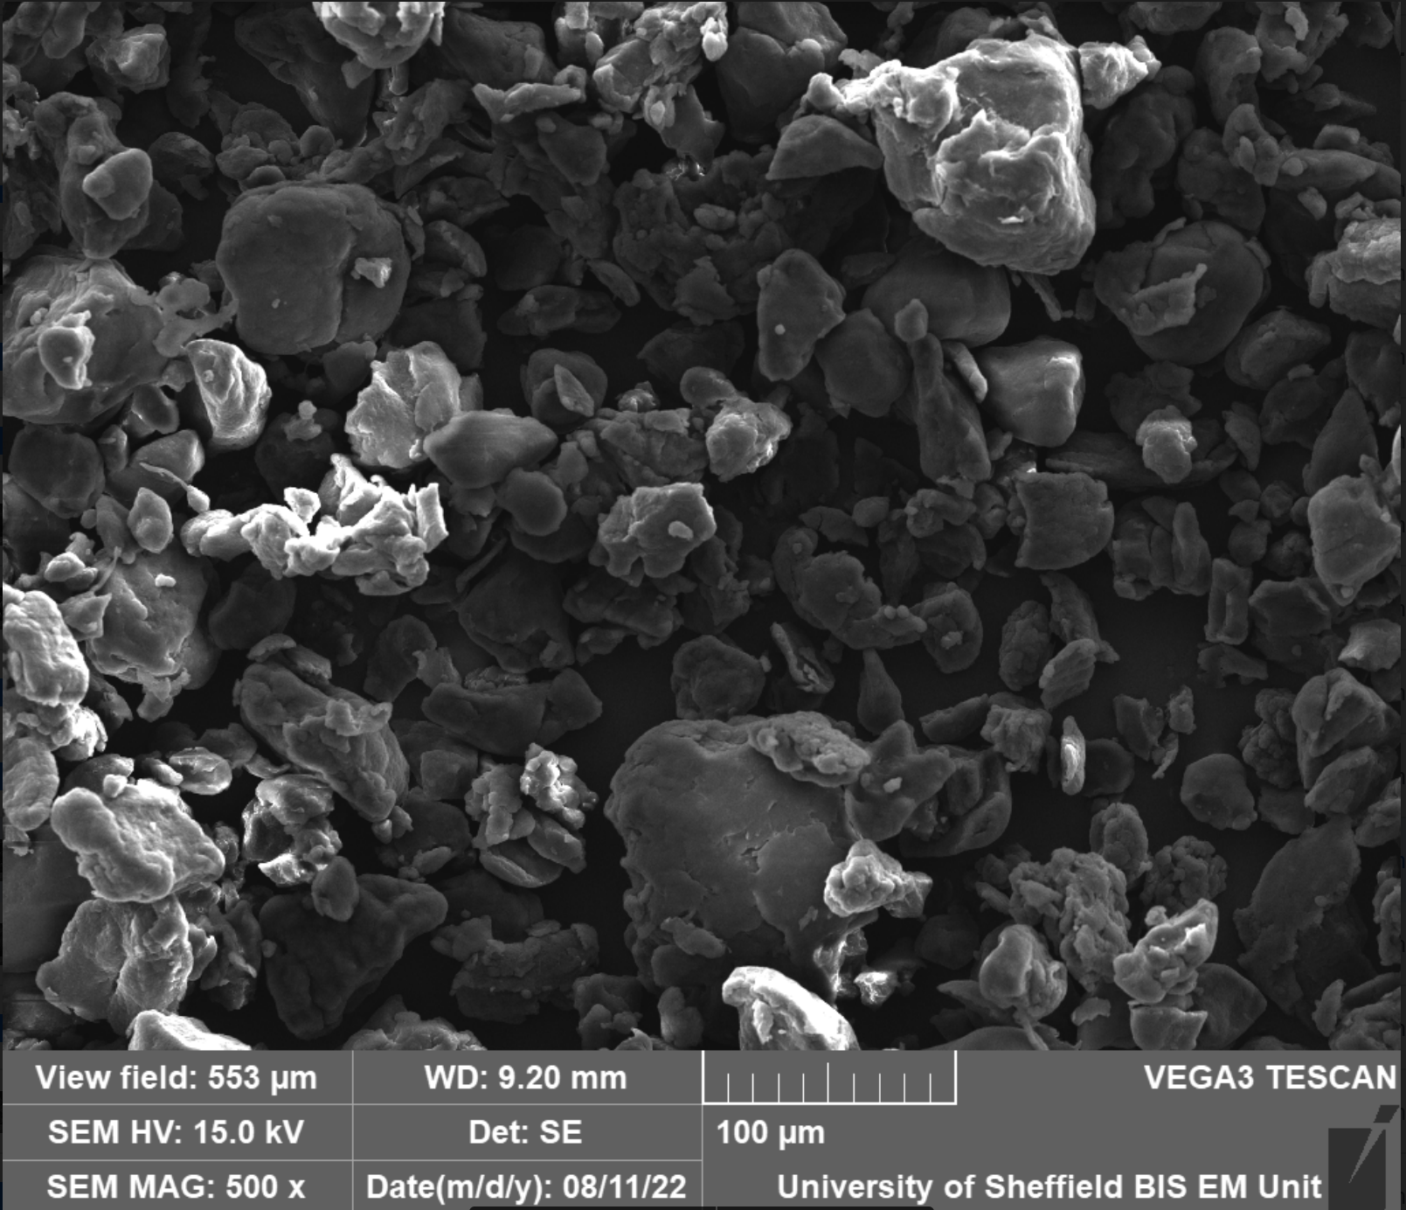
c)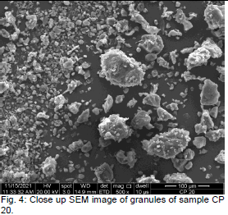 d) 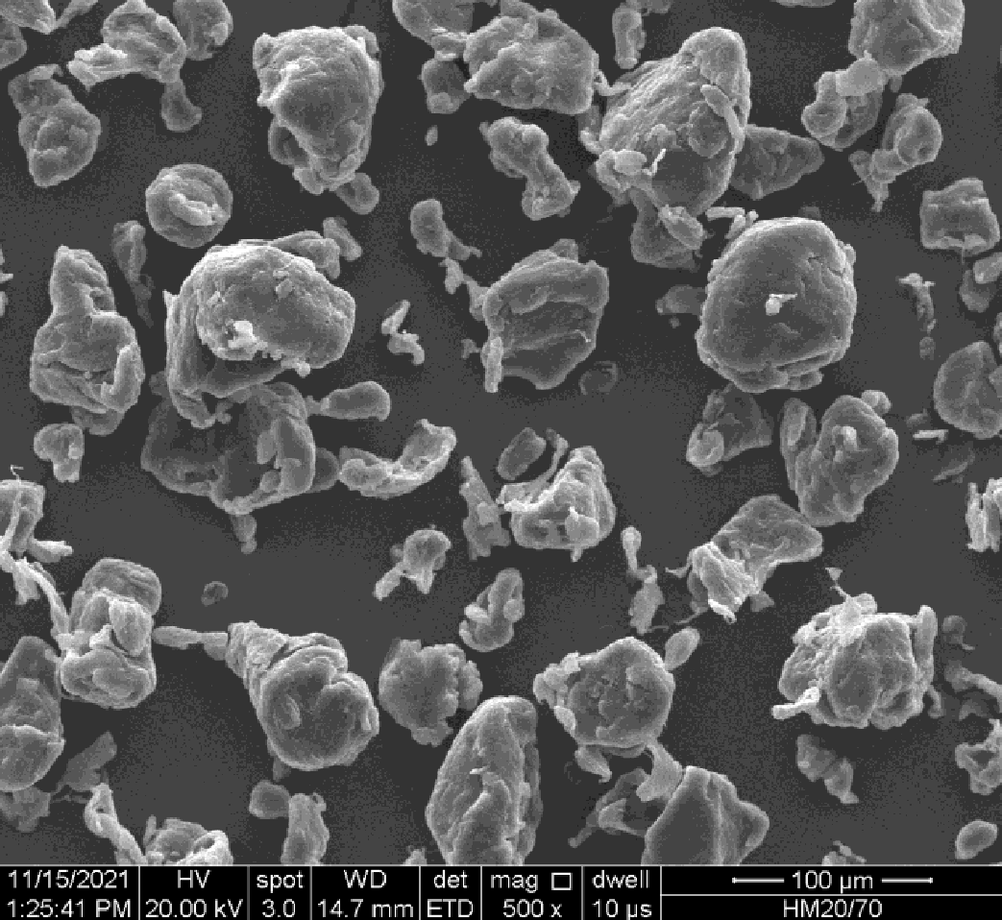
Figure ‎5.4 SEM a) HC 12, b) HC 11, c) CP20, d) HM20/70P.
Goonvean Fibres Ltd provided the PP HM20/70P, mainly used for paint and surface coating applications. Figure ‎5.4 (d) shows particles with a rounded surface with an even particle size variation. The HM20/70P shows a similar powder particle shape to the cryogenic grinding powder, shown in Figure ‎3.3.
The CP20 Shown in Figure ‎5.4 (c) displayed two different particle sizes, small fines in the 10 µm and large particles in the 100 µm. Other than the small fines, the powder had a similar shape to the PP HM/70P.
PP HC 12 showed the largest particle size of around 400µm with a popcorn-like shape, as shown in Figure ‎5.4 (a), produced directly from the metallocene gas phase reactor—in line with the PP 510 grade production in the “SABIC Yannsab” plant without the addition of any additives.
Further analysis was conducted on the CP20 and HM20/70P to examine whether any other additives were included in the powder.

Composition analysis via Energy Dispersive X-ray (EDX)
Aim:
The composition analysis aims to identify any other elements that are present in the powder blends.
Method:
The powders were examined using the Energy Dispersive X-ray spectroscopy (EDX) analysis to identify the elements. EDX works by stimulation of X-ray emission from the sample. The energy emitted by the X-ray photon is captured to give the characteristic of the element; each atom will have a unique energy level to identify it. [90] The EDX was carried out on SEM samples with the beam targeting specific areas that are suspected to be other elements.

Results and discussion:
Figure ‎5.5 shows the EDX on CP20, which picked up traces of 0.2% silicon (Si). Fumed silica is a commonly used flow additive to improve powder flow in LS. Fumed silica acts as a flow promoter, reducing the agglomeration between the PP particles and allowing the particles to move with less friction. [91]

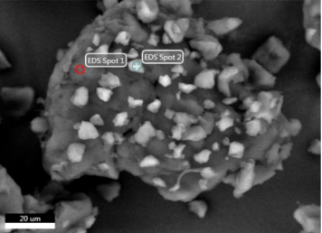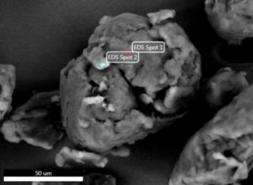
Spot 1 | CP20 | Spot 2 | CP20
Element | Weight [%] | Element | Weight [%]
C | 94.9 | C | 88.4
O | 5.1 | O | 11.4
 |  | Si | 0.2
Spot 1 | HM20/70P | Spot 2 | HM20/70P
Element | Weight [%] | Element | Weight [%]
C | 95.8 | C | 94.5
O | 4.2 | O | 5.5

Figure ‎5.5 SEM image targeting two EDX spots. (left) CP20, and (right) HM20/70P.
The composition of PP HC-12 was directly produced from the reactor without the addition of any additives. Therefore, HC-11 or HC-12 did not require EDX analysis.

Molar Mass distribution (MMD) analysis
Aim:
This section aims to identify the molar mass distribution of each grade. This was undertaken in addition to MFI, as MFI does not fully define the distribution of different chain lengths in each powder.

Method:
The MMD was obtained using the Water Alliance GPC 2000 gel permeation chromatography (GPC) with a differential refractive index detector. Following ASTM D 6474-2013, the polymer sample (approximately 30 mg weight) was weighed into an empty 22 mL headspace vial. 1,2,4-trichlorobenzene (TCB) (sufficient to generate a 2.0 mg per mL solution) was added, and then the vial was sealed using a Teflon-lined silicone septum and an aluminium crimp-able closure. The TCB stabilises by Butylated hydroxytolvene (BHT) (500 mg /litre). The polymer/TCB mixture was then heated using the PL-260 sample preparation unit set at 160° C. The vials are heated with agitation by gentle shaking for four hours while maintaining a temperature of 160°C. [19] The columns and detector operated at 160°C. The recommended solvent flow is 1.0 mL per minute for 7.5 mm columns. The solution was then injected automatically into an injector port and conveyed through the column by means of a flow-controlled solvent. Separation takes place when in the column according to molecular sizes. Components of large molecular sizes elute first since they do not permeate many pores of the gel. Upon exiting the column, the separated component, along with the solvent, flows to the differential refractive index (DRI) detector. The refractive index of the solvent was then subtracted from the sample's refractive index. The DRI signals are then received with Alliance software and processed by GPC Data Station within EMPOWER. Calibration was done using polystyrene PS standards.

Results:
The molar mass distribution curves, shown in Figure ‎5.6, show the CP20 with bimodal distribution with two peaks, one at 117,493 g/mol and a lower peak at 13,708 g/mol. Furthermore, the HC11 showed a shift to lower molar mass after regrinding the HC12.

Figure ‎5.6 Molar mass distribution of the different PP grades.

The molar mass averages shown in Table ‎5.2 show similar values of Mn for CP20 and HC11. However, CP20 showed higher values in all other averages, including the polymer dispersity (PDI). The HM20/70P showed the highest Mw, with the lowest PDI. Furthermore, the Mz values were similar for the HM20/70P and the CP20. The Mz+1 showed extremely high values for the CP20. The HC11 showed a drop in all values compared to the HC12, with a slight increase in PDI.
Table ‎5.2 Summary of molar mass avrages
Material | Mn  [g/mol] | Mw  [g/mol] | Mz  [g/mol] | Mz+1  [g/mol] | PDI
HM20/70P | 34,910 | 169,111 | 451,534 | 1,014,283 | 4.87
HC 12 | 26,782 | 170,260 | 616,347 | 2,186,523 | 6.35
HC 11 | 14,000 | 105,000 | 325,000 | 660,000 | 7.3
CP20 | 13,708 | 130,447 | 452,153 | 8,438,739 | 9.8

Discussion:
The molar mass distribution curves, shown in Figure ‎5.6, show different peaks. Three results stand out from the GPC data: change of HC11 to HC12 values, a bimodal peak for CP20, and polymer dispersity.
The HC12 showed the highest Mw, however, after regrinding the HC12, all the molar mass averages dropped to the HC11 value, as indicated in Table ‎5.2. The HC11 has changed dramatically with Mn, Mz and Mz+1. Changes in Mz and Mz+1 due to chain scission impact the melt strength and particle sintering.
Moreover, the Mw was higher for the HM20/70P than for the CP20. Polymers with high Mw tend to have better mechanical properties but lower processability in injection moulding. No previous work was done on Mw's impact on LS, which is what this study is trying to achieve. From Table ‎5.2 CP20 and HM20/70P had similar Mz, but the Mz+1 showed a significant variation, with CP20 at 8,000 kg/mol compared to 1,000 kg/mol. This CP20 has extremely high Mz+1 values, which gives higher viscosity, resulting in a poor consolation of particles due to the surface tension of the melt.
Furthermore, the PDI indicates the distribution broadness of the molar masses—a narrower PDI results in constant process properties. The PDI was narrow for the HM20/70P compared to the broad CP20 at 9.8. The high PDI for CP20 was due to the bi-model MMD, as shown in Figure ‎5.6. Usually, broad PDI polypropylene is used in applications such as blow moulding and extrusion due to the stretchability of the polymer.
CP20 showed a dual peak representing a large amount of two different chain lengths in the polymer. Initially, it was assumed that the second peak was silica, as found in the EDX analysis in Figure ‎5.5 The silica particles targeted in the EDX, ranging from ~0.3 -7 µm, will not pass the 0.2 µm filter on the GPC, therefore, the two peaks are confirmed to be two different chain lengths of PP. A similar bimodal distribution, shown in Figure ‎3.11, is described in the literature as the degradation of polypropylene in an oven at 190˚C for 60 minutes. The backbone chains are degraded by chain scission with an overall shift of the MMD curve toward a lower value.
In summary, HC12 had the highest Mw, and Mz, however, after grinding HC12 to HC 11 the values dropped. CP 20 had the broadest PDI with the bimodal distribution. The Mz+1 did not correlate with the MFI.

Powder flow analysis

The powder flow analysis aims to quantify the flow behaviour of each of the three selected powders. From the literature review, the powder flow was quantified using the variable flow rate, shear cell and permeability (as discussed in Literature Section ‎3.1.1‎).

Variable flow rate VFR
Aim:
The aim of using the VFR is to ensure the powder flow is stable for each grade and to compare the characteristics of powder flow between each grade with each other and how they compare with the PA2200 grade by EOS that is successfully used in the P100 machine.

Method:
The FT4 powder rheometer shown in Figure ‎5.7 was used for the CP20, HM20/70P and HC11 powder flow analysis. The FT4 measures the powder flow resistance while the powder is in motion. This causes thousands of particles to interact or flow relative to one another. The resistance experienced by the blade, shown in Figure ‎5.7, represents the energy required to move the particles.

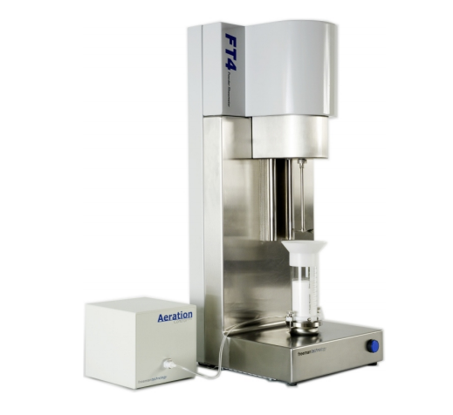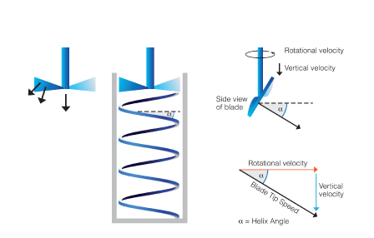

Figure ‎5.7 (left) FT4 Machine with aeration unit (right) illustrates how the blade travels in the vessel to capture the resistance in force and torque. [92][93]
The VFR test produces different flow values: the basic flow energy (BFE), specific energy (SE), and conditioning bulk density (CBD) on the same run. First, in a stability test, the blade travels in and out of the bulk of the powder, as shown in Figure ‎5.7 (right). This method was repeated seven times to ensure the energy produced from the powder bulk was constant by giving stability index values between 0.9 and 1.1, as displayed in Figure ‎5.9. When the powder falls out of that range, further work is required to investigate the cause of the unstable powder, as shown in Figure ‎5.9. [92]
The higher the BFE, the higher the powder packing within the bulk, resulting in higher energy required to move the FT4 blade through the powder. In LS, the high packing order of the powder is desired to improve powder compaction in the print bed, resulting in denser parts.. Powder compaction depends on particle size, shape, and flow. Vibration can also influence powder compaction, causing a change in powder bulk density and limiting powder movement.
The SE measures the energy when the blade moves out of the powder bulk, reflecting how much resistance it takes to move the powder in a low stress environment, unlike the BFE, where the bulk compressibility can impact the flow energy. This reflects how the powder can flow from the hopper during the LS process. SE <5 is considered low cohesion. [94]

The conditioned bulk density (CBD) provides the conditioned bulk density of the powder after the blade travels in and out seven times. The CBD was calculated by measuring the split vessel volume and the weight of the powder, as shown in Figure ‎5.8. The CBD provides consistent bulk density values across all powders that were tested to ensure the same conditions without compaction or agglomeration during vessel transportation.

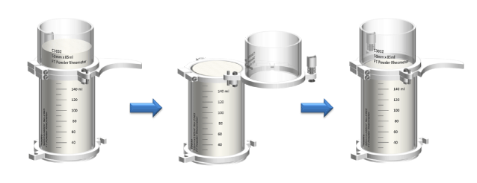

Figure ‎5.8 The vessel is split to measure the CBD. [93]
The blade tip travels at 100 mm/s into the split vessel, measuring the BFE and the SI as the blade travels out. The process was repeated seven times to obtain stability index (SI) values. The SI was obtained by measuring the BFE variations, as shown in Figure ‎5.9. A flat curve shows a consistent powder across all cycles, demonstrating the powder flow repeatability.
Moreover, for this study, three different batches of powders were tested for the VFR for each grade. The flow results are benchmarked with the PA2200 developed by EOS, which works well in the EOS P100 with excellent flow. The PA2200 might exhibit higher values than the other grades; however, it will be used to show the trend of powder flow values needed for LS powder.

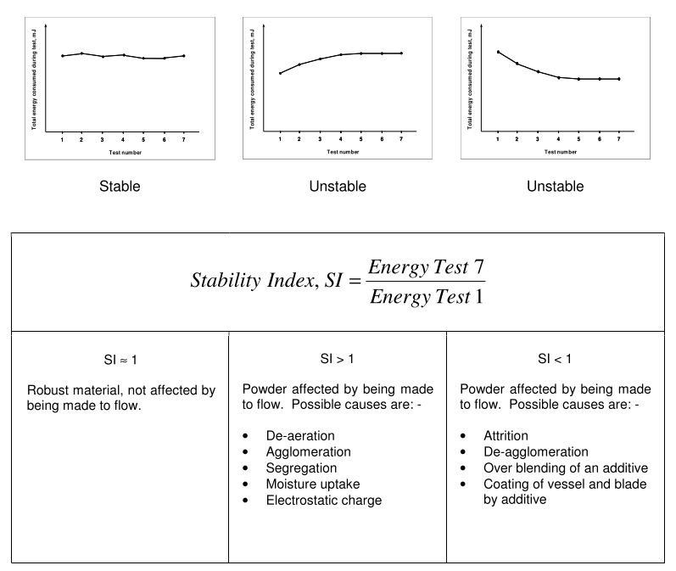
Figure ‎5.9 Typical data for stability index.[92]
All the powder flow tests on the FT4 were conducted at ambient temperature. This does not represent the actual process in the LS machine, where powders are exposed to heat and vibrations, even though these tests are used to give measurable flow data for all grades at room temperature.

Results:
All SI values show values within the tolerance range of 0.9 and 1.1, which reflects the powder flow repeatability.

Figure ‎5.10 Stability Index of all powders.

Figure ‎5.11 BFE values of three grades.
The CP20 and HM20/70P powders showed similar BFE values, and the HC 11 was slightly lower when benchmarking with the PA2200 of 148 mJ.

Figure ‎5.12 The specific energy of all three powders.
The SE results show similar values across all grades with a variation of +/-1.06 mJ/g, including the PA 2200. The variations were significantly low and are within LS requirements, as PA2200 values are in the range, as demonstrated by Figure ‎5.12.

Figure ‎5.13 Conditioned bulk density.
Figure ‎5.13 shows that the CBD was the highest for PA2200 followed by the CP20. The HM 20/70P and HC 11 had very similar CBD values. However, the HC11 showed a wider range of values. The CBD results correlate with the BFE, where a trend of CP20 has the highest values.

Discussion:
The three grades have passed the stability index test, and all SI values fall between 0.9 and 1.1, as shown in Figure ‎5.10. All grades indicate stable flow for all powders. No further investigation is required to modify the powder flow properties to produce consistent flow.
The variations between powders are more visible with the BFE value displayed in Figure ‎5.11, where CP20 had the highest energy value, and after the PA2200, HC 11 showed the lowest BFE. The HC 11 did not contain flow additives such as silica fumes that were found in CP20, which improves the powder compaction.
The BFE data correlates with the CBD, where CP20 has the Highest bulk density, requiring more energy for the blade to pass through the powder bulk. This suggests that CP 20 has the best powder compaction. The PSD of two sizes could be the reason for better compaction, where fine particles fill in the cavities created by the larger particles. In addition, the HC11 showed irregular sizes and shapes, as shown in Figure ‎5.4.
The lowest SE was shown by the PA2200. The Low SE reflects fewer agglomerations in the powder, demonstrating no powder consolidation after powder flow in a confined space like the hopper. The SE values in Figure ‎5.12 show relative values within +/-1.0 6 mJ/Kg. The variations are minimal and do not require further examination.
Overall, when considering the characteristics measured via the VFR test, all three powders show similar flow behaviour for the SE and slight differences in the BFE and CBD. There is no literature suggesting the minimal requirement for any of the VFR values for LS; each machine has a different setup, making it difficult. However, much literature on LS powder flow values is provided for the shear cell test.

Shear cell
Aim:
The shear cell test aims to understand how the powder moves from a stationary to an easy flow. The Sher cell test in the FT4 can generate the flow function ratio (ffc). This is particularly relevant to systems such as the EOS P100, which uses a gravimetric fed powder delivery system.

Method:
The ffc was used to represent the powder's tipping point after the powder was placed in a confined space. Reflecting how well the powder flows after being subjected to its own weight in the hopper. The higher the ffc, the less resistance there is to flow in the system—for example, a sandcastle or avalanche flowing after a loading point. For adequate flow in the EOS P100, the ffc value must be higher than four. [14]
The shear cell test was conducted on the FT4 Freemen machine. The shear cell uses a shaft that contains blades, displayed in Figure ‎5.14. The shear cell operates by applying a normal shear force on the upper layer of powder whilst the adjacent lower layer is restricted from movement at low speeds. The shear stress (τ) force continues to increase until the powder “yields”, and the upper layer of powder slips against the lower.
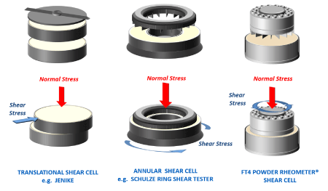
Figure ‎5.14 FT4 shear cell unit operation. [93]
Several shear tests were repeated at various normal stress (σ) levels. To obtain different yield points across σ. Figure ‎5.15 shows the yield points produced by σ, plotted to define the powder’s yield locus where the shear stress flattened at the highest point in the σ. The higher the shear stress for a given σ, the less likely the powder will yield and begin to flow when confined.

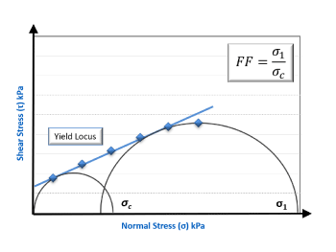
Figure ‎5.15 Shear stress vs normal stress showing the Yield locus and the major principal stress (sigma 1) and unconfined yield strength (sigma c).
The Mohr stress circle is used to identify the yield locus. By dividing the major Principle Stress (σ1) by unconfined yield strength (σc ), the ffc value is obtained. During the LS process, the weight of the powder placed in the hopper will result in low normal stresses applied by the powder's own weight. In the FT4, the normal stress was set to the lowest value achievable of 3 kPa by the machine. This mimics the normal stress of the powder in the hopper. From the literature for powder flow in the LS system, the aim is for ffc >4. [95] [27] [14]
Results:
The ffc results show the HC11 to have the highest ffc of 6.59, followed by the CP 20 at 5.66, and the HM20/70P at 4.42.

Figure ‎5.16 Flow function ratio (ffc)

Discussion:
The aim was to have a ffc >4. Figure ‎5.16 shows all the powder passing that threshold but at different levels. The HC11 showed the highest ffc value, followed by the CP20 and the HM20/70P at 4.42. The high ffc shows the HC11 with the highest flow from a confined space. This powder contains the smallest particle size, resulting in a high increase in the ffc values despite the VFR data showing the opposite outcome for the HC11.
In conclusion, when processed at room temperature on the FT4, all three powders show ffc values within the adequate flow range.

Permeability
Aim:
The aim of the permeability test is to show the pressure drop across the powder bed at low consolidation stress, indicating reduced permeability, which reflects a denser packing state in the print bed.

Method:
The process for the permeability test starts with steps similar to those used for the VFR test. The powder was pre-conditioned, and then the vessel was split, as shown in Figure ‎5.8. The difference is that the powder was placed in a split vessel with a vented piston at the bottom, which contacted the aeration unit, providing it with constant airflow, and the blade shaft was replaced with a compaction shaft, as shown in Figure ‎5.17. Normal stresses were then applied as the airflow passed through the vessel. The pressure drop (ΔP) was measured as the piston moved down the vessel.
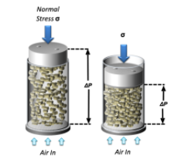
Figure ‎5.17 Permeability test showing the pressure drop across different Normal stresses (σ) as air flows through.[96]
The relative difference in air pressure between the bottom and the top of the powder column is a function of the powder’s permeability. A low-pressure drop is desired for LS, as fewer air voids are present in the powder bed. No specific value is given for LS, however, PA2200 showed a PD of 1.43 mBar.
The FT4 contains pre-set-up conditions for the normal stress conditions from 1 kPa up to 15 kPa, and the pressure was measured at each point. The permeability values for the required LS powder are changed from 1 kPa to 15 kPa, showing the pressure change when the higher load is applied. The higher the changes, the larger the voids in the powder, allowing less powder compaction.

Results:
Figure ‎5.18 shows the permeability test results, with the Diamond CP 20 with a most significant drop of 4.21 mBar, with a change in pressures drop of 0.88 mBar and the lowest drop was PP HM20/70P at 1.29 mBar, with a change of 0.33 mBar and the HC 11 with a change of 0.84 mBar.
The change in pressure drop was the lowest for the HM20/70P, showing less change across the normal stress from 1 kPa to 15 kPa, suggesting that the powder has fewer voids and is more compact.

Figure ‎5.18 The pressure drops change across the vessel at 1 kPa and 15 kPa.
Discussion:
The permeability test shows high variation between the three grades. The highest change in pressure occurred with the CP20, the LS commercial powder from Diamond. A Large pressure drop indicates a high air void in the powder bed. The high-pressure drop from 1 kPa to 15 kPa for the CP20 was influenced by the bimodal particle size, where fine particles increase the pressure drop in both normal stresses. This can impact the mechanical properties of the final printed article as air voids result in a weaker LS part.
The change in the pressure between the 1kPa and 15 kPa normal load shows the HM20/70P to have higher compaction with fewer voids in the powder. The other two grades in Figure ‎5.18 show a similar change between 1 and 15 kPa.
In summary, for the flow analysis, the VFR and shear cells reflect more on the powder flow behaviour. The powders selected show similar flow behaviour with minor variations. The BFE show a similar behaviour between CP20 and HM20/70P, showing the free flow of the powder. The ffc values showed the HC11 to have the highest value, suggesting that there is higher flow from the hopper than the other two grades. According to the permeability data, the HM20/70P showed better powder compaction. All powders showed flow data with in an acceptable range for the LS process.

Thermal analysis

Sintering window (SW)
Aim:
The thermal analysis aims to identify each powder's sintering window to determine the build chamber temperature parameters in the EOS P100.
Method:
All three blends underwent a thermal analysis using differential scanning calorimetry (DSC). The thermal properties of the selected polymer blend were analysed using the Perkin Elmer DSC 8500. The melting and recrystallisation temperature of the powder was determined using the DSC peaks. A sample between 5 and 10 mg was placed in an aluminium sample pan. The pan was then crimped and placed in one of the DSC furnaces, and another empty crimped sample pan was placed in the second furnace as a reference. [36] The sample then underwent a temperature cycle program as follows:
- Held at 20˚C for 1 minute.
- Heated from 20˚C to 200˚C at a rate of 10˚C/minute.
- Held at 200˚C for 1 minute.
- Cooled from 200˚C to 20˚C at a rate of 10˚C/minute.
- Held at 20˚C for 1 minute.
The programme starts by holding the temperature at 20°C for one minute to ensure the chamber material stabilises at room temperature without any heat fluctuation. Then the sample was heated at a rate of 10˚C/minute up to 200˚C, then at 200°C, then held for 1 minute to avoid overshooting of readings. The sample was then cooled at 10˚C/minute to 20˚C to cover all the peaks usually present in PP materials. The sintering window is calculated by subtracting the crystallisation temperature onset from the melt onset of the DSC curves.

Results:

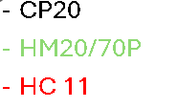
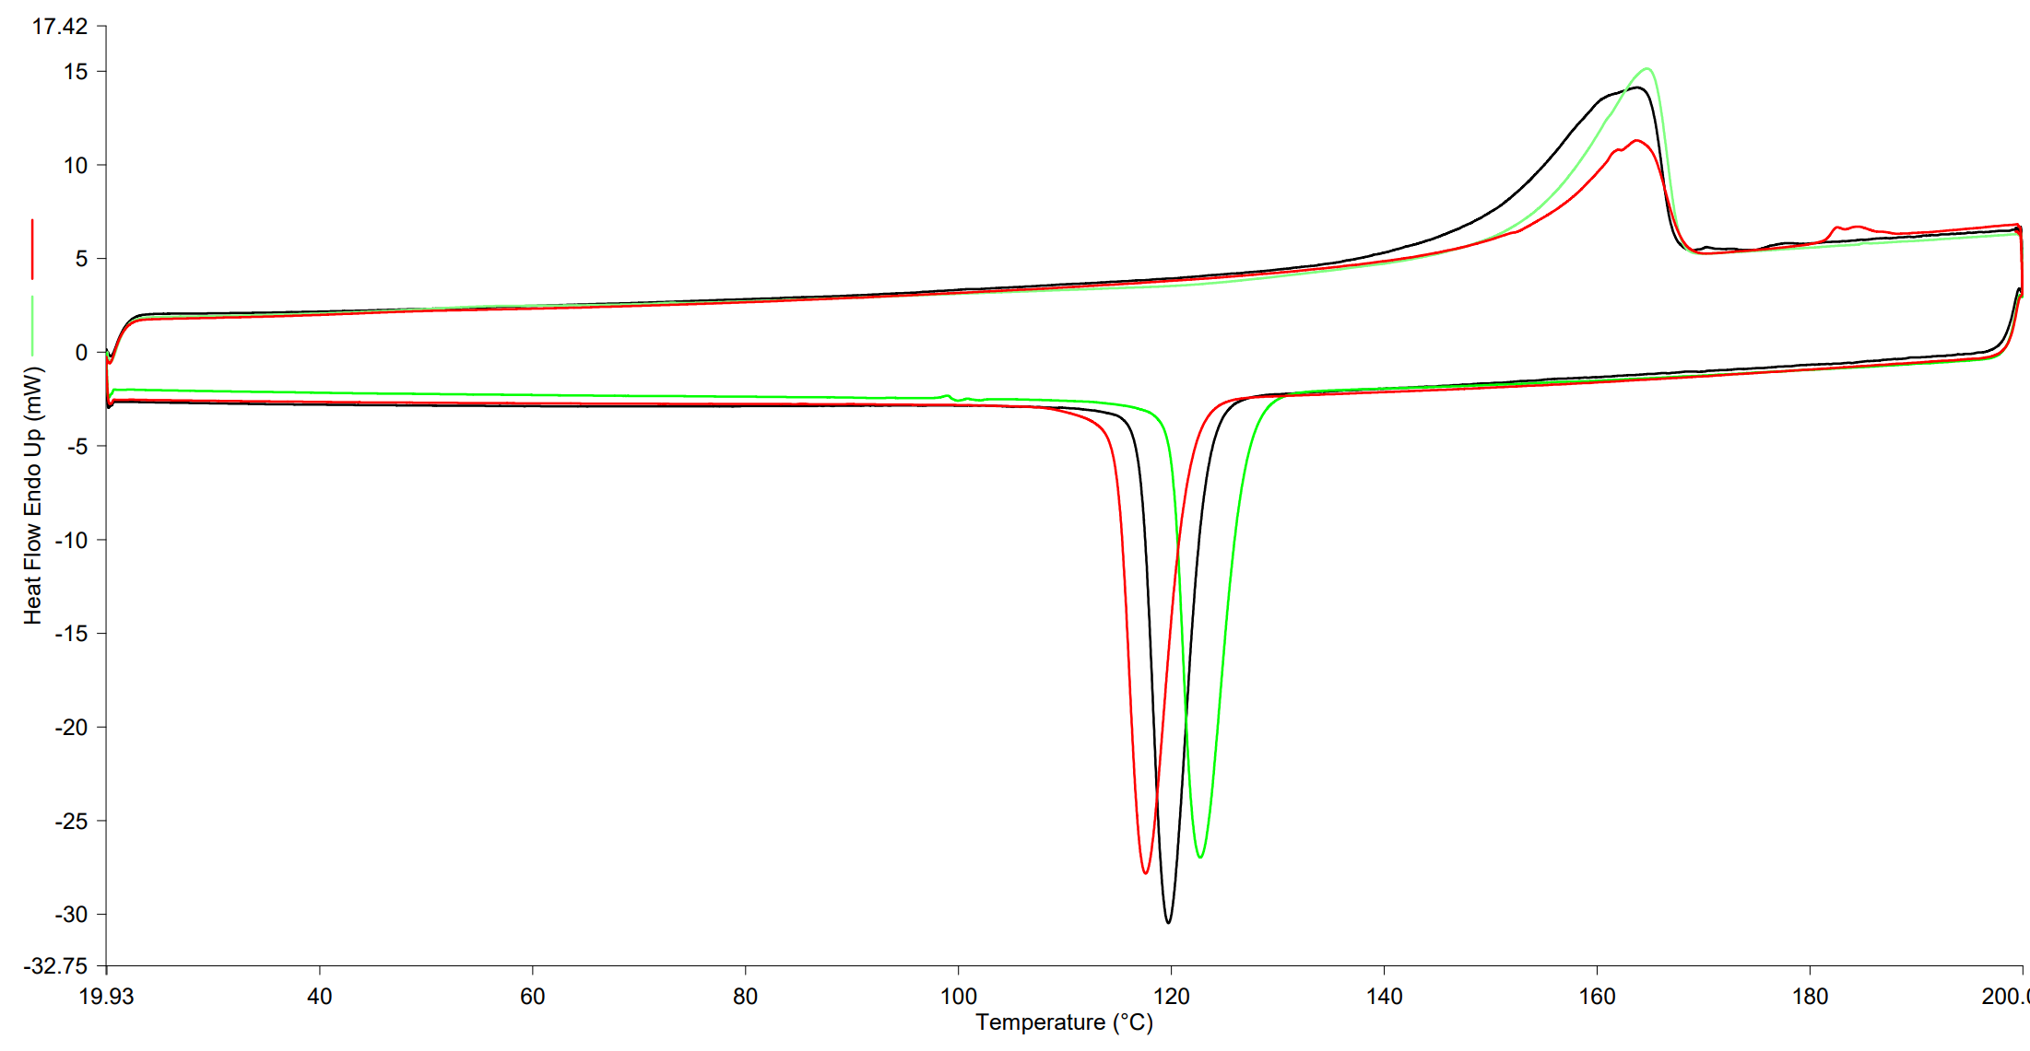
Figure ‎5.19 DSC of CP20, HM20/70P, and HC 11).

Table ‎5.3 Thermal values from the DSC
Material | Delta Hm [J/g] | Delta Hc [J/g] | Tm On set [˚C] | Tm peak [˚C] | Tc On set [˚C] | SW [˚C]
HM20/70P | 73.99 | 92.73 | 155 | 163 | 130 | 25
HC 11 | 60.25 | 106.90 | 156 | 164 | 123 | 33
CP 20 | 74.89 | 92.28 | 145 | 163 | 125 | 20
The grades show a variation in the sintering window, with HC11 showing the highest window of 33˚C and the CP20 with the narrowest process window of 20˚C with a slightly lower melt on set temperature than the HC11 and HM 20/70P. The HM 20/70P has a higher onset crystallisation temperature at 130˚C, as shown in Figure ‎5.18. The DSC thermal map of all three grades shows a variation in crystallisation onset, and the slope of the melt on set varies for each grade, changing the broadness of the SW. The area under the curves during the melt and re-crystallisation phase shows the enthalpy of the materials, denoted as Delta H.

Discussion:
The DSC shows different peaks of melts. All three PP grades show similar melt behaviour where the melt temperature was in the range of 160˚C and the re-crystallisation temperature around the peak at around 120˚C.
The DSC obtained the sintering window by subtracting the crystallisation temperature onset from the melt onset. The CP20 showed the lowest sintering window, and the HC11 had the highest. The impact of SW was discussed in the literature; a wide sintering window might result in a broader processing window but does not necessarily result in a good print. The SW is critical in the LS process. The wider the LS window, the easier it is to maintain the melt in the melt state at a broader build chamber temperature, making it easier to build a layer without deformation of the melt due to premature crystallisation.
Overall, all three powders show a broad sintering window, suggesting that the powders can be processed in the EOS P100.

Hot-stage microscopy (HSM)
Aim:
The HSM aims to observe how the particles behave when melting and how each particle interacts under the microscope. The melt and recrystallisation temperatures are observed visually under HSM. The formation of crystal structures and the size of spherulites are analysed under HSM.
Method:
The hot-stage microscopy analysis was done using the Linkam THMS600 and PR 600 microscope stage temperature controller on the Olympus BX50 microscope. The magnification was set up at 4x magnification, resulting in a scale of 1:40 of the actual size of the particles.
Two thermo couples were added to the hot stage to ensure the accuracy of the temperature control unit. The location of the thermo couples is displayed in Figure ‎5.20. The top thermo couple measures the surface of the powder, and the bottom measures the heating element. The temperature for the microscope images was based on the bottom thermo couple in the heating element, as it gave a stable reading compared to the thermocouple on the surface of the powder.
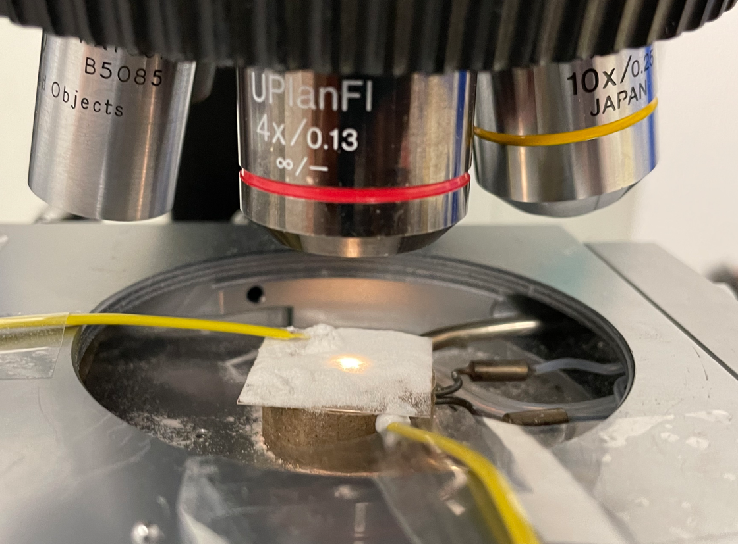
Figure ‎5.20 Thermal couple located on the heated element on the hostage.
The powder was placed on a 25mm x 25mm x 0.1mm microscope slide glass. The slide was then placed on top of the heating element on the hot-stage, as shown in Figure ‎5.20, with a heating rate of 10 ˚C per minute. The light and focus were then adjusted to allow the PIXELINK camera to capture clear images.
Results and discussion:
The hot stage analysis for the CP20 unveils the fine powder melting at around 170°C, and then shortly after, at 183°C, the large particle melts, as shown in Figure ‎5.21.
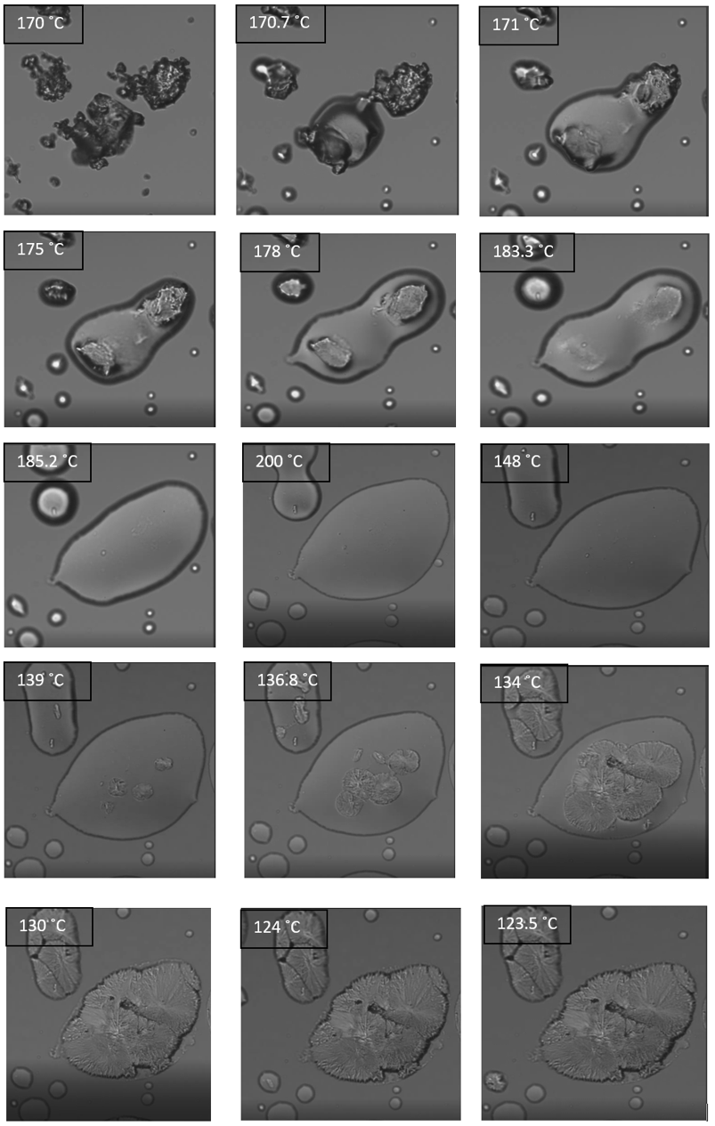
Figure ‎5.21 Hot stage images of CP20 heating and cooling cycle.
When 200°C was reached, the sample was cooled to room temperature. The recrystallisation for the CP20 in Figure ‎5.21 shows that the crystal spherulites started forming in the large particles at 139˚C. The sphalerites in the large particles are fully developed at 130˚C. The fine melt particles start recrystallising at a lower temperature of around 124˚C. All the CP 20 particles are fully recrystallized below 110˚C.
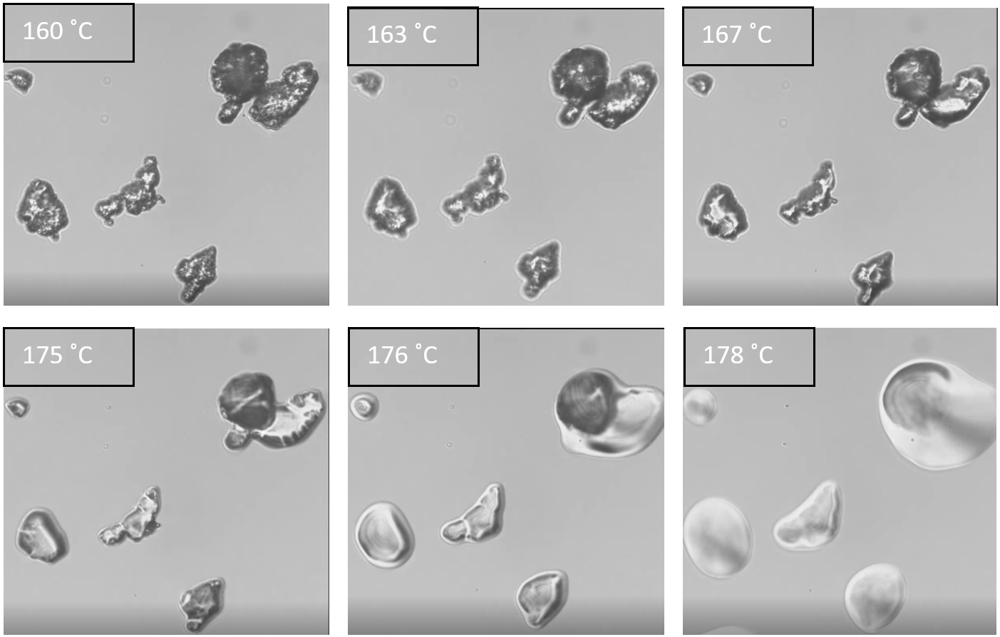
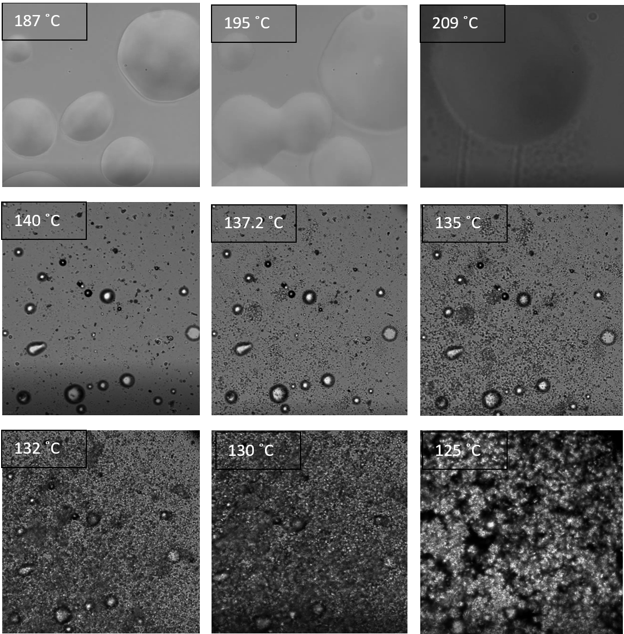
Figure ‎5.22 Hot-stage images of HC11.
The HC11 powder started to melt around 165˚C and was fully melted at 187˚C with the particles fully fused at melt state, leaving a melt pool with trapped bubbles as shown in Figure ‎5.22. with the images show small spherulites than CP20.
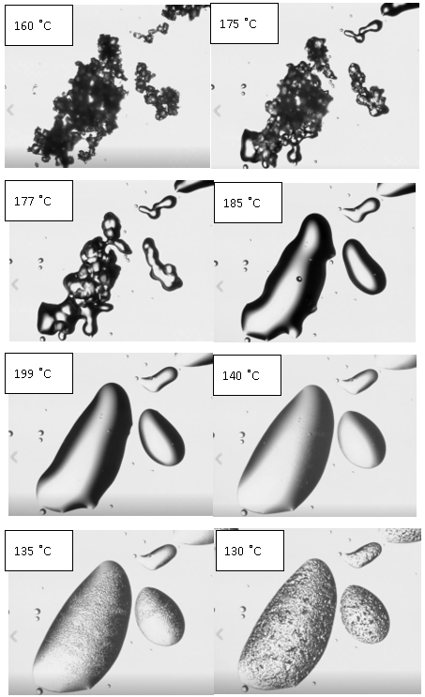
125 ˚C
Figure ‎5.23 HSM for the HM20/70P.
The HM20/70P shows melting at around 175˚C and recrystallisation at 135˚C with small spherulites forming.
Discussion:
The two outcomes from the HSM are the two melt phases that the CP20 demonstrated and the size of the spherulites between the grades.
The two melt phases could be due to the particle size distribution, where the data shows two peaks at 10 µm and 95 µm, suggesting two sizes present in the CP20. The PSD could influence the melting behaviour seen in the HSM. The images show that the fine particles are prematurely melting.
The CP20 crystallinity phase under the hot stage showed a similar melting behaviour where the large particles in the range of 80 µm started to form and recrystallize at 135˚C and after the finer particles of 10 µm at 120 ˚C. It was unclear if this effect was due to the dual peak in MMD or the particle size difference.
In a patent by Dickens et al.[38] discussed in section 3.1.2 shows a two-tier distribution PBT powder with particle sizes 180 µm and 53µm resulted in a denser article. The theory was that fine particles fall between the large particles, resulting in a denser part. The patent further explains that fine particles have a higher melt rate than large particles, which melt at lower temperatures. Moreover, if there was insufficient heat to melt the large particles, the fine particles could sinter without fully melting the large particles in the entire sintered article. Smaller particles are reported to melt before large particles. [44] The CP 20 shows similar melt behaviour in the study, where finer particles melt first. In the case of CP20, the same large particle showed two phases of melt taking place. Another cause of the two melt phases could be related to bimodal MMD. The GPC data showed two peaks, suggesting the presence of two different chain lengths. The small chains require less energy to untangle than the larger molar mass chains, resulting in premature melting. Reduction in chain length results in shorter lamellar length, thus requiring lower temperatures.[16]
During the melt of an entire layer of 100 µm of HC 11, as shown in Figure ‎5.22, trapped bubbles appeared at 140˚C. The trapped air bubbles could contribute to the LS porosity, even at complete melt. The lack of force or shear exerted on the melt could result in trapped air bubbles. Furthermore, recrystallisation started at around 137˚C with small spherulites that started at about 125˚C. Similar spherulites were identified in the literature for homopolymer polypropylene that contained a nucleating agent. However, HC11 did not have any additives to support this claim.
The HC20/70P shown in Figure ‎5.23 melting was initiated at 175°C and then recrystallised at 130°C. The values are higher than the DSC peaks. The formed spherulites were smaller in size compared to the CP20. The high MFI means small chains in the HM20/70P, resulting in smaller spherulites. The HC 20/70P has the lowest Mz+1, as shown in Table ‎5.2, supporting this claim.
Overall, the HSM showed CP20 with two melt phases that could be related to the bimodal distribution of MMD. For the HC 11, the fully melted powder had a high flow with bubbles trapped in the melt. The bubbles in the melt may increase the voids in the sintered sample, thus reducing the mechanical properties. Finally, large spherulites for the CP20 were compared to the other two grades, giving the CP20 the highest crystallinity value. Studies show that small spherulites generally result in improved mechanical properties.[97][98] No further work was required for all grades as they show melting and recrystallisation behaviour that are processable on the EOS P100.

Laser sintering process
This section aims to LS the powders on the EOS P100 to produce tensile data at the highest reachable process parameters. The parameters tested in this section were chamber temperature, laser powder, and laser speed.
The key novelty of this work lies in its systematic exploration of processing parameters tailored for difficult-to-sinter materials, specifically high-crystallinity homopolymer polypropylene and reactor-grade powders such as HC11, which were tested directly in laser sintering (LS) without prior optimisation. This section addresses significant challenges such as poor powder flow, narrow sintering windows, and curling or delamination caused by high crystallinity, offering innovative solutions including the use of variable laser powers, build temperature and flow additives to improve powder behaviour and produce testable LS specimens.
Method:
First, the powder was passed through a 500 µm sieve to remove impurities or agglomerations. The powder was then tumbled in the EOS mixing station P1 for 45 minutes, rotating at 12.5 revolutions/minute in clockwise and anti-clockwise directions. The powder was then placed in the gravimetric hopper on the EOS Formiga P100 using 5 kg drums designed to fit in the EOS P100 feeding system. This machine has a CO₂ laser that has a maximum set output of 26 W, a laser wavelength of 10.6µm, a laser beam diameter of 0.47mm, and a build area of 200mm x 250mm x 330 mm, with a maximum build temperature of 200 °C. The hopper feeds the material into a nitrogen-filled chamber to avoid polymer degradation. The powder is then laid on the print bed using a single pivoting point blade from the back of the machine. The powder is then moved side to side as the build platform goes down in 0.1mm increments, thus creating a layer of powder.
In this study, type I tensile ASTM 638-14, shown in Figure ‎5.24, were designed in “Magic 22.0” software and then transferred to the EOS P 100 machine for LS printing.
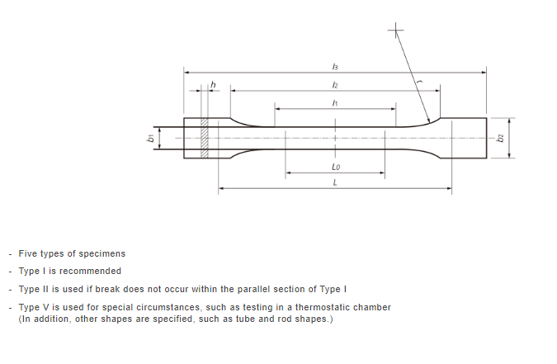
 | l ₃ | l₂ | l₁ | L₀ | b₁ | b₂ | h | L
Type I | 165 mm | 57mm | 57mm | 50mm | 13mm | 19mm | 3.2mm | 115mm

Figure ‎5.24 Tensile test specimens “Type I” were modelled using ASTM D638-14
Each build contained five tensile specimens, spaced out by 25 mm vertically in the y-direction, as displayed in Figure ‎5.25. Each sample was pre-labelled in the design software with an engravement on the side of the tensile specimen with XY1 up to XY5. For each build, 40 blank layers were included before the start of the sintering layer to give insulation to the sintered article from the hot elements in the machine and maintain a homogenous temperature in part during the LS process.
Using the DSC data, an initial build temperature was obtained. The DSC for the CP20 shows a processing window between 125°C and 145°C and a melt temperature (Tm) around 163°C. Although studies in the literature discussed in the sintering window section, PP powders with similar DSC profiles were set at a higher build temperature, 9°C below the Tm. Nonetheless, for this study, a lower starting temperature was used to prevent any powder from melting in the machine. For the initial run, the building temperature was set at 135°C, 28 °C below Tm.
As an initial point for the LS parameters, on the EOS P100, data from the literature showed similar machines used energy density (ED) in the range of 0.057 J/mm². [99][74][27] The LS machines do not use ED as an input parameter; therefore, the ED was used in Equation ‎3.7 to calculate the laser speed of v = 2,639 mm/s after applying a mid-range laser power of 21W on the EOS P100, with the hatch distance of h=0.25mm, and laser diameter d=0.47 mm for the EOS P100. This was done to ensure the machine parameters were considered when fixing the laser speed variable. Moreover, the value of the estimated laser speed was within the range found in the literature for PP laser sintering between 1500 to 5080 mm/s.
To identify the laser power, a range of laser power was used for the first build, ranging from 18 W for the first sample XY1 and up by 2 W for the following sample until the final sample XY5 at the back of the build with 26 W, this provides a range of laser power to be scanned at the first build, with sample XY3= 22 W at the centre. For the sample that shows no delamination at the last few layers, similar laser power was used for the next build for the full set of tensile samples.
The machine was fully cooled to room temperature at the end of the builds and thoroughly cleaned before starting the next build to ensure consistent builds with a similar cooling rate.
Before tensile testing, all samples were air-jet cleaned to remove any powder residuals and avoid samples slipping from the tensile machine grippers.

LS production of CP 20
First, the DSC in CP20 shows a sintering window starting around 125˚C. The first built temperature (Bt) was set initially at 135˚C, slightly higher than the temperature at the start of the sintering window, to avoid premature crystallisation.

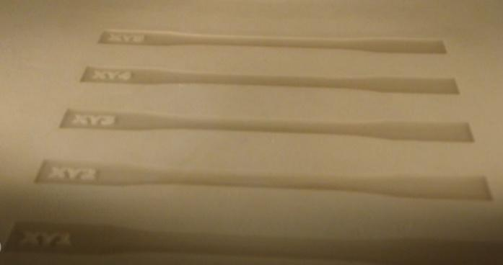
Figure ‎5.25 Image taken from the front of the EOS P100 LS machine with tensile labels T1= XY1 from the bottom up to the sample T5=XY5 on the top.
Table ‎5.4 Build parameters CP20.
Build | P [W] | Bt [°C] | Full print | Comments
B1 | 18-26 | 135 | No | Laser variation was used for XY1=18W up by 2W to XY5=26W. Short feeding was done to the powder bed, and next, the Bt was increased by 1 °C
B2 | 18-26 | 136 | No | Laser variation was used for XY1=18 W up by 2 W to XY5=26 W. Powder flow was improved as the Bt increased, and the short-feed occurred halfway. Next, increase the Bt by 1°C
B3 | 18-26 | 137 | No | Laser variation used for XY1=18 W up by 2 W to XY5=26 W. Specimen XY3=22 w did not delaminate or curl during the first layer. Next, P =22 W was set for all the samples.
B4 | 22 | 137 | No | Curling, all the samples delaminated from the first layer. Next P increased to 23 W
B5 | 23 | 137 | No | Reduction in curling, all the samples delamination from the first layer, next P increased to 24 W
B6 | 24 | 137 | No | After the machine refilled the hopper, the powder stopped flowing due to (bridging). Next, reduce the powder in the hopper and increase laser power up to 25 W.
B7 | 25 | 137 | No | The hopper is half full—still short feeding from the hopper, with T5 failing at layer 62. Next, the powder from the hopper is reduced, and the laser power is reduced to 24 W.
B8 | 24 | 137 | No | The powder was agitated in the hopper during the process. Powder flow stopped at layer 63. Next, remove all the powder, clean the machine, and use manual feeding to the hopper to avoid Automated feeding, which leaves the hopper full of powder.
B9 | 25 | 137 | yes | Manual powder feeding produced tensile specimens. Next, increased P=26 W.
B10 | 26 | 137 | Yes | Laser power increased, and powder was poor to the end of the print after the sintering layers. Powder required agitation in the hopper for the final layers. Next reduced P=24 W.
B11 | 24 | 137 | Yes | Powder flow was poor at the label layers. Next reduced P=23 W.
B12 | 23 | 137 | Yes | Powder flow was poor at the label layers. There is a slight curling of the edge to the sample XY1. Next, reduced P=22 W.
B13 | 22 | 137 | No | Curling, all the samples delaminated from the first layer. Next, P increased to 23 W.
B14 | 24 | 138 | No | The powder stopped flowing before reaching the first layer. Next, increase the temperature.
B15 | 26 | 139 | No | The powder stopped flowing before reaching the first layer. Next, increase the temperature.
B16 | 26 | 140 | No | The powder stopped flowing before reaching the first layer. Next, increase the temperature.
Note: Hatching distance =0.25mm, with a layer thickness of 0.1mm, and laser speed of 2639 mm/s fixed for all builds.
From Table ‎5.5, a range of laser powers between 23 W to 26 W, with Bt=137˚C was printed successfully with a higher ED ranging from 0.059 to 0.066 J/mm².
Moreover, the powder seems to flow well from the hopper at Bt=137˚C with a small amount of powder in the hopper.
Furthermore, during build B5, the laser sintering started well at layer 41, and at layer 63, the powder was short-feeding from the hopper. The dosing was increased from -0.3 to 0 for B6 and onwards. By doing so, the gap at the base of the hopper increases, allowing more powder to flow into the build chamber. Despite increasing the dosing, the powder did not flow until reaching 137˚C. However, at a point, the machine had to refill the hoppers; when the machine automatically refills the hopper, it dumps a large amount of powder in the hopper, causing the powder to compact and bridge on its weight, as seen in Figure ‎5.26, not allowing the powder to pass. Therefore, the powder was manually fed into the hopper, which resolved the flow issue.

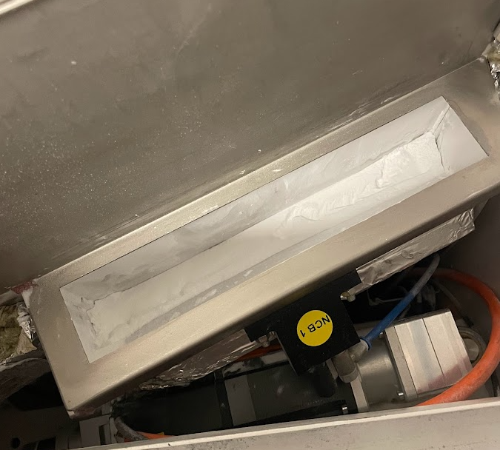
Figure ‎5.26 Show the top view of the hopper, the CP20 powder bridging in the EOS P100 hopper (circled in red).
All builds up to B8 failed due to reduced powder flow at higher layers. It was observed that the powder was sticking to the hopper and the blade at layers even before the build started. During the process, the powder in the hopper was bridging, preventing it from flowing into the chamber, as shown in Figure ‎5.26. The hopper has a lip at the base, making it challenging to agitate all the powder. For build B9, a small amount of powder was fed into the hopper to avoid powder bridging. Tensile dog bones were produced after following the dosing method to feed the powder.
All the issues discussed with powder flow could be related to the PSD, where small fines inhibit flow movements. Zahir et al.[45] disclosed that fine powder is affected by the cohesive forces of the powder particles, creating a blocking effect and causing the powder not to flow.

LS production of HM20/70P

Initially, virgin HM20/70P was trialled on the LS machine following the same methodology used previously, using the flowing parameters.
Table ‎5.5 LS process parameter for HM20/70P
Build | P [W] | BT [°C] | Full Print | Comments
B1 | 18,20,22,24,26 | 137 | No | No powder flow after BT=120°C. Poor powder flow and disposition  Figure ‎5.31, Next increased Bt=139 °C
B2 | 18,20,22,24,26 | 139 | No | No powder flow from the hopper after layer 52 at Bt= 110 °C
B3 | 18,20,22,24,26 | 141 | No | The powder was not flowing well at elevated temperatures.

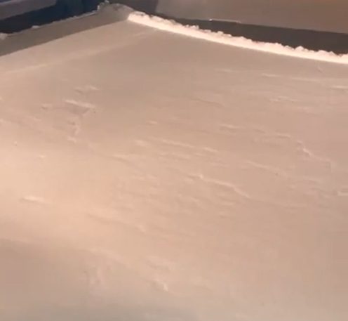
Figure ‎5.27 HM20/70P Surface defect on the powder at 96C build chamber temperature
From the first build, issues with the power flow were noticed when it reached 96°C. After 110°C, the powder stopped flowing from the hopper. The powder was clunky and bridging in the hopper. The powder surface was uneven, as shown in Figure 5.31, even when the fresh powder was added to the chamber manually.
Discussion:
The powder was not flowing from the hopper at low Bt prior to reaching the desired temperature of 137˚C. Despite the flow analysis in ‎5.2.5, showing initial data of adequate flow values for the HM20/70P powder at room temperature, during laser sintering, poor powder flow was observed at around Bt=110°C during the heat up of the machine.
Nevertheless, for the powder to sinter, the Bt must be within the sintering window without short-feeding the powder leaving an uneven surface with defects, as shown Figure ‎5.31. When compared to the CP20 shown in Figure ‎5.25, the improvement was noticeable due to the flow agent used in the CP20, as identified in the EDX images in Figure 5.5, which the HM20/70P did not contain. Therefore, the HM20/70P did not flow in the P100 EOS machine and required follow additives.

Powder flow improvement analysis
Aim:
As discussed in the previous section, HM20/70P was not flowing. The powder was bridging in the hopper when the building temperature reached 110°C before reaching the desired temperature of 137°C. Therefore, this section aims to use flow additives to improve powder flow to produce tensile specimens on the EOS P100 machine.
Method:
The flow additive was investigated following the same method discussed in the powder flow analysis section ‎5.2.5. Three flow additives were investigated to improve the powder flow: CAB-O-SIL ®TS-610, SIPERNAT® 820A, and Aeroxide Alu C. CAB-O-SIL ®TS-610 is a treated fumed silica produced by CABOT with an average particle size of 0.3 µm and used broadly as a flow agent. The flow additive SIPERNAT® 820A was provided by Evonik GmdH, which contains precipitated silica, aluminium and calcium silicates with a high level of whiteness and reduced coarse particles. This additive is used as a white pigment filler in emulsion paint and a matting agent for glossy silk paint. The flow additive is hydrophobic with a tap density of 215 g/l following the ISO 787-11 and an average particle size of 7.0 µm. AEROXIDE® Alu C is a high purity, highly dispersed fumed aluminium oxide with a positive surface charge that controls the electric charge and improves the flow of finer particles with high to static charge. This additive is mainly used in ceramic materials as a binding agent.
The flow additives were mixed with HM 20/70P powder at different loadings: 0.2, 0.4, and 0.8%wt. The powder blends were mixed with flow additive using the EOS station mixer P1 for 45 minutes at 13 RPM on each side. Initially, the blends falling out of the stability range between 1.1 and 0.9 were eliminated. The stable powders were further tested for their BFE, SE, permeability and ffc.
Results:
The PA2200 is shown as a reference to what is considered excellent powder flow data on the VFR test. From the PA2200 data, shown in Table ‎5.8, trends of high BFE and CBD with a low SE is desired for LS.
The blends in red, shown in Table ‎5.8, fell out of the stability range and were eliminated from further testing. Only blends with Alu C additive showed stable flow results. Therefore, all the HM20/70P blends that contain the Alu C blends are further tested.

Table ‎5.6 The table shows the VFR data for additive blends with HM20/70P
Blends | BFE [mJ] | SI | SE[g/mJ] | CBD[g/ml]
PA2200 | 148 | 1.04 | 5.35 | 0.48
HM20/70P +0.2% TS610 | 189.72 | 1.29 | 7.56 | 0.35
HM20/70P +0.2% 820A | 107.93 | 0.84 | 5.21 | 0.34
HM20/70P +0.2% Alu C | 148.40 | 0.93 | 4.95 | 0.35
HM20/70P +0.4% TS610 | 212.96 | 1.24 | 8.01 | 0.36
HM20/70P +0.4% 820A | 115.73 | 0.86 | 5.45 | 0.35
HM20/70P +0.4% Alu C | 140.97 | 0.91 | 5.07 | 0.36
HM20/70P +0.8% TS610 | 210.67 | 1.28 | 8.24 | 0.37
HM20/70P +0.8% 820A | 123.27 | 0.89 | 5.76 | 0.36
HM20/70P +0.8% Alu C | 140.43 | 0.99 | 5.27 | 0.35

Figure ‎5.28 HM20/70P VFR values BFE, SE, and CBD with different loads of Alu C
The BFE results show the highest value for the 0.2%wt Alu C loading, with the highest BFE and lowest SE values. CBD peaked with the addition of the 0.4 wt% Alu C.

Figure ‎5.29 Permeability change across 1KPa to 15KPa for HM20/70P with different Alu C loading
The permeability results are shown in Figure ‎5.33, with 0.2% wt dosing of Alu C and the lowest change permeability across the blends.

Figure ‎5.30 Flow function ratio (ffc) of different Alu C loading for HM20/70P
The ffc values, displayed in Figure ‎5.34, show the most significant improvement by adding 0.2% wt Alu C with an increase in ffc from 4.42 to 6.1.

Discussion:
The Flow analysis indicates that Alu C was the only stable powder for the HM20/70P. The high dispersity of Alu C resulted in a stable powder compared to the other flow additives.
Table ‎5.7 The flow test values before and after improvement.
Flow properties | HM20/70P | HM20/70P+0.2%wt AluC
BFE [mJ] | 112.41 | 148.4
SE [g/mJ] | 5.99 | 4.95
CBD[g/ml] | 0.33 | 0.35
Permeability [mBar] | 0.44 | 0.31
ffc | 4.42 | 6.1

The BFE showed an increase in flow properties compared to the virgin HM20/70P. The 0.2%wt showed the highest BFE with the lowest SE. The HM20/70P+0.2%wt Alu C powder compacts well, with a low resistance to the blade when it exits the powder. The CBD in Figure ‎5.32 showed 0.4% wt of Alu C, which resulted in the highest value. Across all blends, CBD increased compared to the virgin powder from 0.33 g/ml to 0.35 g/ml with 0.2wt% Alu C.
The low drop in permeability with the 0.2%wt Alu C suggests lower voids are present in the 0.2%wt compared to the other blends.
The ffc, shown in Figure ‎5.34, indicated the highest increase when 0.2%wt Alu C was added to the virgin powder.
The 0.2%wt Alu C was selected based on the highest BFE, lowest permeability change, and highest ffc value. Therefore, the HM20/70P+0.2%wt was selected to produce a tensile sample on the EOS P100 machine.
The flow data show an improvement in all flow values, as shown in Table 5.9, showing that the addition of 0.2%wt Alu C will improve the powder flow. Next, the powder was mixed and tested on the machine.

Laser sintered HM20/70P +0.2%wt Alu C process condition
Aim:
This section aims to produce the highest testable tensile sample with the optimal Bt and laser power to compare the tensile values with the other two grades.

Method:
The methodology used was the same as that in section ‎5.3.1 to produce tensile type I specimens on the EOS P100 LS machine.
Initial Bt was set up at 137˚C, slightly higher by the onset of 130˚C shown at the start of the sintering window for the DSC of the HM20/70P, shown in Figure ‎5.19, to avoid over-melting of the powder in the machine.

Results and discussion:
The powder blend of 0.2% wt Alu C was then processed in the EOS P100 machine to examine the surface. An improvement of the powder surface in the build chamber was observed, as shown in Figure ‎5.35, compared to the surface in Figure ‎5.31.


Figure ‎5.31 Powder bed surface of HM20/70P +0.2% wt Alu C
Table ‎5.8 Goonvean HM20/70 LS build parameters for the type I ASTM 638-14 specimens.
Build | P [W] | Bt[°C] | Full Print | Comments
B1 | 18- 26 | 137 | No | Adding Alu C 0.2 %wt improved flow and compaction, resulting in a smoother surface, as shown in Figure ‎5.35. XY5 sample did not curl at the first layer, while the other samples delaminated. Next, 26W laser power was used for all samples.
B2 | 26 | 137 | No | Delamination of the first layer after laser melt. Next, increase the Bt by +2°C.
B3 | 26 | 139 | No | Delamination of the first layer after laser melt. Next, increase the Bt by +2°C.
B4 | 26 | 141 | No | Delamination of the first layer after laser melt. Next, increase the Bt by +2°C.
B5 | 26 | 141 | No | Delamination of the first layer due to curling of all samples, due to short feeding . Next, increase the Bt by +2°C.
B6-B14 | 26 | 143-157 | No | Delamination of melt to all build temperatures. The temperature increased by 2°C increments. Reaching melt peak temperatures. Next, increase Bt by +1°C
B15 | 26 | 158 | No | Print failed, and poor powder flow from the hopper stopped at layer 53 due to short feeding.
B16 | 26 | 159 | Yes | Complete set of tensile bars printed. Samples XY5 and XY4, after more layers, were pre-melt of powder when placed on the melt before the laser came across. Next, Laser power is reduced to 24W to reduce the pre-melt.
B17 | 24 | 159 | Yes | Print well with pre-melt powder and fresh powder at XY5. Complete set of tensile bars printed.
B18 | 18 | 159 | No | The pre-melt of fresh powder at sample XY 5 started at layer 58. The corner of sample XY1 lifting/curling was then delaminated. Next, increase the Bt to 160°C with a low laser power of 18 W.
B19 | 18 | 160 | No | Delamination, curling, and folding of XY2 sample edge, and the powder surface was caking. Next, reduce Bt to 159°C and increase laser power to 22 W.
B20 | 22 | 159 | Yes | Melt fusion accrued at layer 53 of the build on sample XY5. Complete set of tensile bars printed. Next, reduce the P to 20 W.
B21 | 20 | 159 | Yes | Decent powder flow. Melt fusion did not show. Full set of tensile bars printed. Next, attempted to reduce the Bt=158°C.
B22 | 20 | 158 | No | The XY2 sample delaminated due to the curling of the sample edge.

From Table ‎5.10, the first build shows that the 26 W that was used for sample XY5 did not delaminate compared to the other sintered specimens. Therefore, 26 W was used with the 137˚C build temperature as a starting point for build B2.
The maximum laser powder in the machine was 26 W. After the 26 W was set, the build temperatures were explored from 137˚C up to 158˚C, no specimens were successfully produced due to the initial layer's curling.
At build B16, the first set of tensile bars was printed successfully with Bt=159°C and P= 26 W. At the elevated Bt=160°C, the powder surface started to melt in the build chamber, showing cracking, which suggests the powder was softening. At 159˚C, the increase of Bt increment was reduced to 1˚C, to avoid powder from melting in the machine.
For build B17, the laser power was reduced to 24 W, and the Bt remained at 159 °C. The pre-melt on the fresh powder was still occurring, starting from the back sample XY 5, as that sample had the least amount of time for the melt to cool down before the new layer of powder was laid. The blade motion when laying the powder and the laser travel caused this effect.
For build B18, the laser power was reduced to 18 W. When reaching layer 58, the melt on sample XY5 started to melt the fresh powder before the laser beam. For build 19, Bt was at 159°C, resulting in an improved powder surface in the chamber during the process.
During build B20, at layer 53, the pre melt penetrated the fresh powder, causing it to melt prematurely, starting with sample XY5 prior to the laser contact.
For build B21, parts printed well with no melt or curl issues at Bt=159°C and laser power at 20 W.
For build B22, Bt was reduced to 158°C and laser power was set at 20W. XY 2 curled and delaminated first. This indicated that lower than 159°C Bt had caused the build to fail and higher Bt caused caking of the powder.
In conclusion, the Bt at 159 ˚C was the only successful build, with a P range of 20W to 26W. Pre-melting of the powder on the fresh layer on the sintered article started appearing mostly in samples XY5 at Bt=159˚C, at around the 58th layer of the build, except at laser power 20 W.

LS production HC11
Aim:
This section aimed to identify the highest process conditions for HC11 to produce tensile type I in the EOS P100 LS machine.
Method:
The same method in section ‎5.4.1 was used to produce the HC11. The initial build temperature was set to 130°C, at the lower end of the sintering window to avoid pre-melting the powder in the build chamber. The Bt was then increased by 2°C increments until the powder stopped flowing from the hopper.
Results:
Table ‎5.9 HC11 process conditions on EOS P100 machine
Build | P (W) | Bt (°C) | Full Print | Comments
B1 | 18,20,22,24,26 | 130 | No | No powder flow after BT=125°C. Poor powder flow and disposition  Figure ‎5.31, Next increased Bt=132°C
B2 | 18,20,22,24,26 | 132 | No | No powder flow from hopper Bt 120°C, next increase Bt=132°C
B3 | 18,20,22,24,26 | 134 | No | Fresh powder was added manually to the chamber. No powder flow from hopper Bt 120°C

In the case of the HC11 powder, the powder stopped flowing from the hopper when Bt reached 120˚C.
Discussion:
Initially, HC 11 had issues flowing; the powder was not flowing from the hopper at Bt =120 °C, before reaching the desired Bt of 130°C. Despite the initial flow additive data done in section ‎5.2.5, the HC11 powder required flow improvement using the aid of flow additives.

Powder flow improvement analysis
Aim:
This section aimed to improve the powder flow of HC 11 in the EOS P100 LS machine, using flow additives to produce testable tensile specimens.
Method:
The same method in section ‎5.4.2 was used for HC 11 to improve powder flow, incorporating all three flow additives discussed previously.
Results:
First, as shown in red in Table ‎5.13 eliminate all unstable blends outside 1.1 > SI > 0.9 SI from the VFR test.
Table ‎5.10 VER of HC 11 with different blends
Blends | BFE [mJ] | SI | SE [mJ/g] | CBD[g/ml]
HC 11 +0.2% TS610 | 117.52 | 1.09 | 6.25 | 0.36
HC 11 +0.2% 820A | 112.62 | 1.01 | 7.66 | 0.34
HC 11 +0.2% Alu C | 100.47 | 0.87 | 6.48 | 0.35
HC 11 +0.4% TS610 | 137.58 | 1.31 | 7.17 | 0.37
HC 11 +0.4% 820A | 99.43 | 0.91 | 6.51 | 0.37
HC 11 +0.4% Alu C | 94.72 | 0.93 | 5.85 | 0.34
HC 11 +0.8% TS610 | 117.39 | 1.16 | 7.09 | 0.37
HC 11 +0.8% 820A | 83.82 | 0.93 | 6.10 | 0.35
HC 11 +0.8% Alu C | 80.61 | 0.82 | 5.50 | 0.34

Fields in red are all the blends outside the SI window, making these powder blends unpredictable when investigating the flow properties. Therefore, all the blends falling out of the SI range were not used or examined further.

Figure ‎5.32 The VFR values for the HC 11 blends.

The VFR results revealed in Figure ‎5.39, show an increase in BFE by adding flow additives. The 0.2% wt of TS610 displayed the highest increase from 92.4 to 117.52 mJ, and the highest CBD=36 g/ml compared to all the other tested blends. The lowest SE of 5.85 mJ/g resulted from the 0.4% wt Alu C.

Figure ‎5.33 The flow function ratio (ffc) HC11 with flow additives

Figure ‎5.34 The change in permeability from 15kPa to 1kPa for HC11 with flow additives.
The results show HC 11 0.2%wt TS610 with the highest ffc value and the lowest change in permeability.
Discussion:
The result indicates that adding 0.2% wt TS610 increased BFE to 117.52 mJ from 92.4mJ, with a slight increase in SE of 6.25 mJ/g from 6.04 mJ/g from the virgin HC11. In addition, the 0.2% wt TS610 resulted in the highest CBD of 0.36 g/ml. All the VFR results indicate that adding 0.2% wt TS610 will improve the flow properties.
Moreover, the ffc data shows a similar outcome for 0.2%wt TS610, with the highest value recorded in Figure ‎5.40. Also, a low permeability drop, as shown in Figure ‎5.41, indicates high particle compaction.
In conclusion, the HC 11 0.2wt % TS610 was selected based on the high BFE, ffc and low permeability compared to the other blends.

Laser sintering HC 11 +0.2%wt TS610 process conditions
Aim:
This section aimed to laser sinter the HC 11+ 0.2%wt TS610 to produce type I specimens and compare the tensile values with the other PP grades.
Method:
The same method was used for CP20, and HM20/70 P was used for HC 11. From the DSC, the building temperature was set at the lower end of the sintering window at 130°C to prevent powder melting in the chamber. The optimal outcome was adjusted by investigating the Bt and the laser power to produce the highest tensile data.
Results:
Table ‎5.11 Build parameters for the HC11+ 0.2% wt TS610
Build | P [W] | Bt [°C] | Full Print | Comments
B1 | 18,20,22,24,26 | 130 | No | No powder flow issues. The first sintered layer was delaminated for all different laser powers due to the curl. Next, P=26W to explore Bt +2°C.
B2-B8 | 26 | 132-144 | No | No powder flow issues. The first sintered layer was delaminated for all different laser powers for all builds, due to curl (see Figure ‎5.42). Next, increase Bt by +1°C
B9 | 26 | 145 | No | Powder caking in print bed and issues with powder flow. Stopped before laser sintering. Next, increase Bt by +1°C.
B10 | 26 | 146 | No | Manually added powder in the print bed; powder flow issues at layer 50. Curling of the parts, delamination of the first layer. XY 1 sample, first to delaminate. Next, reduce the Bt =144°C to explore the low energy with P=16 W.
B11 | 16 | 144 | No | Curl reduced in samples XY 1, XY2, and XY3, still delamination of all parts. Next, reduce P to 14 W.
B12 | 14 | 144 | No | Delimitation of the first sintered layer due to curl, XY1 first. Next, a double scan (D) was used.
B13 | 14 (D) | 144 | No | Reduced curl due to double scan, delamination of first sintered layer due to curl. Next, reduce the P to 12 W using a double scan.
B14 | 12 (D) | 144 | No | Sample XY1 delamination at first sintering layer. Next, reduce the P to 10 W (D).
B15 | 10 (D) | 144 | No | Delamination of all samples due to curl. Next, a single scan using 10W
B16 | 10 | 144 | No | The samples XY2 and XY4 were delaminated first, followed by others. Next, use the lowest P=8W
B17 | 8 | 144 | No | Delamination of all samples due to curl.

The first build failed when attempting to find the laser power, and curling occurred, causing delamination after the first layer for all laser powers. In the next build, an attempt to explore the high end of laser power was set at 26 W, Bt was increased by two increments up to 144°C, for the next builds, an increase by one increment as the powder was caking until the powder stopped flowing from the hopper. Even when the powder was manually added at the start to avoid the powder not flowing from the hopper, however, the powder did not sinter due to high curl for all builds, as shown in Figure ‎5.42.
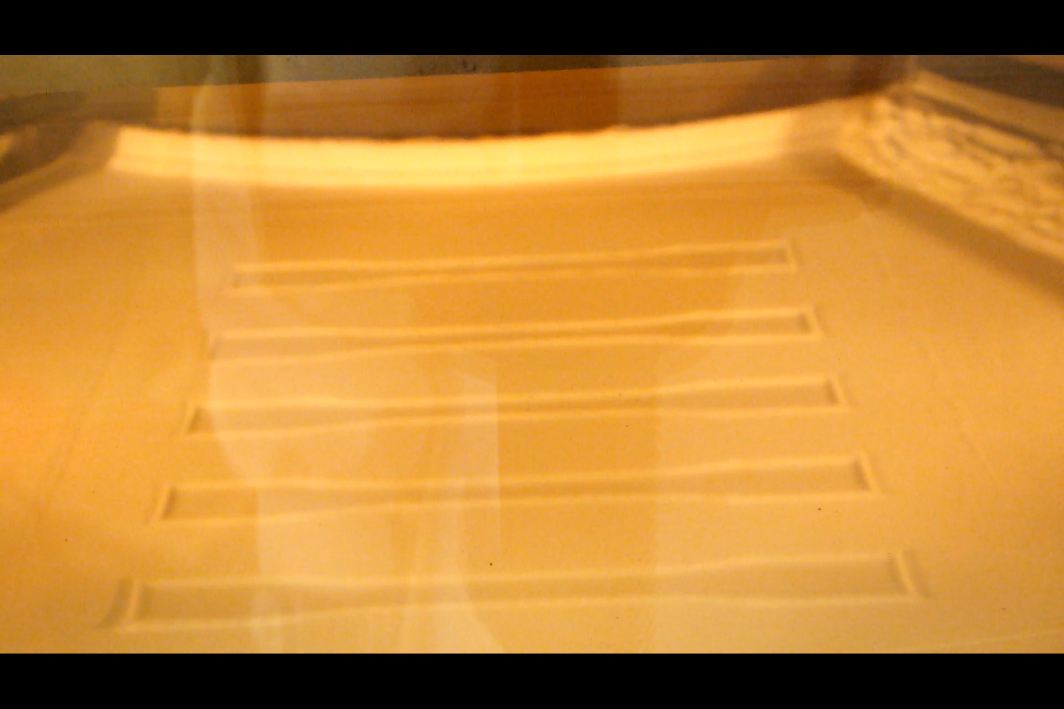
Figure ‎5.35 Build 4 of HC11+0.2% wt TS610, Curl on the first sintered layer, build temp 130°C and laser powder at 26 W.

When the laser powder dropped to 16 W, the curl reduced but was still delaminating. Furthermore, the laser power was reduced by 2 W increments to the lowest value of 8W. The parts were failing even at the lowest limitation of laser power at 8 W.
As a final attempt, a double scan was carried out at 144°C at 12 W, 10 W, and 8W. All parts were still curling and delaminated on the first sintered layer. Curl was still present during all the double scans. The same XY1 sample tends to first delaminate in most builds due to the high level of curl present. Due to the high curl of the HC 11+0.2% wt TS610, no tensile specimens were produced.

Discussion:

The curling frequently appeared first on sample XY1 and then gradually on the following samples in the build chamber. The curl starts immediately when the laser hits the powder. The sintered article curled more as the melt exposure duration increased in the chamber.
The HC11 was processed at an elevated Bt of 144°C, far from the re-crystallisation temperature of 125°C. The parts were curling before adding the new layer, suggesting that the melt did not cool to reach the crystallisation temperature. Therefore, the idea of premature re-crystallisation is not plausible.
Moreover, the HC 11 0.2% wt TS610 did not contain additives such as heat stabilisers [16]. These additives are commonly used to prevent PP from degrading at room temperature, leaving degradation as the main suspect for the cause of the curling. Moreover, the HC12 showed the highest Mw. After regrinding the HC 12, all the molar mass averages dropped, as indicated in Table ‎5.2 by the HC11 values, showing the instability of the powder as the chains break down during the grinding. This shows the importance of heat stabiliser additives in preserving the polymer chains from degradation. [100]
In conclusion, HC 11 could not produce any samples due to the lack of heat stabiliser additives that prevent the degradation of the polymer chains, so no further work can be done to produce samples for this grade.

Tensile properties

Laser sintering builds Tensile testing
The section aims to test the tensile properties of the LS samples produced using the HM20/70P+0.2wt % Alu C and the CP20 in the EOS P100 machine to compare them with the other grades.
Method:
All the produced tensile specimens were kept for 24 hours before tensile testing to allow the polypropylene time to crystallise fully.
Tensile testing was done according to ASTM D638-14 [47] with a “type I” specimen using a Tinius Olsen 5K tensile testing machine. The tensile machine provides Young’s modulus (E), ultimate tensile strength (UTS), and elongation at break (EAB). The specimens were tested at a rate of 5 N/min. The displacement was measured using a model 500LC laser extensometer by manually placing reflective tape as markers for the gauge length at a distance of 50 mm from the centre of the specimen.
Results:
For the HM20/70P +0.2% wt, the Bt=159˚C resulted in a successful build with a different P for each build. Build B16 had the highest laser power, displayed in Table ‎5.11. The tensile values for each build will be arranged in ascending order based on the P values.
Table ‎5.12 Tensile data for successful HM20/70P +0.2% wt AluC builds
Build | Energy density [J/mm²] | Av Modules [MPa] | STD | Av UTS [MPa] | STD | Av EAB [%] | STD
B16 | 0.074 | 1028 | 448.96 | 14.06 | 1.88 | 1.52 | 0.26
B17 | 0.068 | 1025 | 199.38 | 14.64 | 1.68 | 1.37 | 0.18
B20 | 0.062 | 1295 | 125.10 | 15.35 | 1.46 | 1.62 | 0.13
B21 | 0.056 | 1279.2 | 376.53 | 16.07 | 1.01 | 1.83 | 0.24

Table ‎5.13 Tensile data for successful CP20 builds
Build | Energy density [J/mm²] | Av Modules [MPa] | STD | Av UTS [MPa] | STD | Av EAB [%] | STD
B9 | 0.064 | 1632.60 | 68.95 | 9.79 | 1.35 | 0.60 | 0.09
B10 | 0.066 | 1248 | 207.77 | 7.19 | 2.11 | 0.56 | 0.22
B11 | 0.061 | 1300 | 303 | 6.14 | 0.53 | 0.39 | 0.13
B12 | 0.059 | 1060 | 277.50 | 4.15 | 1.15 | 0.28 | 0.12

For the CP20, at 137˚C Bt the powder seemed to flow more smoothly from the hopper and produce tensile samples when the laser power was between 23 W to 26 W. In addition, the reduction of powder used in the hopper improved the flow of powder after build B9. The successful tensile specimens built were tested and compared with different energy densities used during the LS builds, as shown in

Figure ‎5.36 UTS for LS successful HM 20/70 +0.2% wt Alu C and CP20 builds.
The UTS data for CP20 show B9 with the highest value of 10 MPa, with UTS dropping to 7 MPa at 0.066 J/mm² for build B10 with a wider range of results for UTS and EAB, suggesting that B10 has a large variation in outcome. Concluding, build 9 has the highest achievable tensile values.

Figure ‎5.37 EAB of LS successful HM 20/70P +0.2%wt Alu C (left) and CP 20 (right) builds.
The same was observed with the EAB for CP20, showing the highest value for elongation at 0.6% EAB, for B9 with the 0.064 J/mm². The elongation fell when the ED =0.066 J/mm² for B10, which showed a high variation in values.

Figure ‎5.38 Modulus for successful HM20/70P+0.2% wt Alu C (left) and CP20 (right) Ls builds .
For the HM20/70P +0.2%wt Alu C, the modulus values show significant variations in the repeated tests, with 0.074 J/mm² showing the highest variation. Build B21 had 0.056 J/mm² with an average modulus value of 1279 MPa.
For CP20, the modulus peaked at 1632 MPa for build B9 with an ED of 0.064 J/mm² and build 12 showed the lowest E, using the lowest energy density of 0.059 J/mm³. The modulus dips after build B9 when the ED reaches 0.066 J/mm².
Discussion:
During the LS of HM 20/70 +0.2%wt AluC, when exceeding Bt of 159°C, premature melting of the new layer of powder occurred on the melt before the laser beam came into contact with the area. Also, the powder stopped flowing from the hopper, and the powder around the bed started to cake. The optimal temperature was identified at 159°C, where the parts did not curl.
The laser power was reduced to 20 W to minimise the premature melting in the sintered melt. Higher laser powers resulted in unwanted powder sticking to the sides of the specimens.
Overall, the build B21 for HM20/70P + 0.2%wt Alu C powder had the highest tensile properties with ED= 0.052 J/mm². The optimal E, UTS, and EAB are 1279 MPa, 16.07 MPa, and 1.83% when processed at Bt 159°C with a laser power of 20 W.
The CP20 Tensile results show that the E, UTS and EAB peaked at a laser power of 25 W and Bt of 137 ˚C, indicating that 0.064 J/mm² was the optimal process condition for the CP20. For CP20 Increasing the building temperature from 135°C to 137°C improved powder flow from the hopper and reduced the curl of the parts. At a maximum build temperature of 140°C, the powder was short-feeding, with particles sticking to the surface of the blade. Moreover, changes in the powder bed surface were noticed, as caking patches appeared on the powder surface across the blade direction.
The powder in the hopper was reduced to overcome the poor powder flow when reaching the 63rd layer; therefore, the same manual feeding method was used from all builds after build B8. The CP 20 powder required continuous agitation in the hopper throughout all builds to ensure the powder flowed into the chamber.
As discussed previously, the CP 20 powder is produced as LS powder. Therefore, the material supplier provided the technical data sheet with LS tensile values. In addition, other studies were done on CP20 in different LS machines, as shown in Table ‎5.6. When comparing the tensile values, the results show a difference of more than double for UTS and an EAB of 0.6 % for B9 compared to the 12% shown in the Diamond plastics data sheet.

Table ‎5.14 Tensile properties of all CP20 sources.
 | UTS [MPa] | EAB [%] | E [MPa]
Diamond CP20 TDS [99]ISO 527,EOS 395P | 20 | 12 | 1990
Build B9 CP20  ASTM D638, EOS P100 | 9 | 0.6 | 1600
CP20 (Tan et al. )[46]  ASTM D638, EOS 395P | 14 | 1 | -

The test standards are different when comparing the tensile data with the datasheet from Diamond Plastic for CP20, where “type A” specimen size was used from the ISO 527 method. Moreover, in the Tan et al. [46] study, “type IV” ASTM 638 specimens were sintered. In this study, the ASTM 638 “type I” tensile specimen size was used. Different standards or sample sizes could result in variation in the results. Furthermore, the differences in machines used may result in variation in tensile values.
Furthermore, a study by Kagan et al. [101] compares tensile test results for ISO 527 with ASTM 638. The study concluded that the ISO tensile test data for UTS and modulus are found to be slightly higher than that of ASTM by 4 to 7 MPa for reinforced and non-reinforced injection moulding semicrystalline specimens like PA6, PET, and PP. [101]
When comparing the values for build B9 with the diamond datasheet, the values seemed much lower than those shown, especially for elongation. Each CP20 powder was processed in a different machine using different parameters and different tensile testing standards. Furthermore, the EOS P 385 machine produced the tensile specimens for the datasheet by Diamond Plastics using different process parameters such as 35 W for laser power, a Build temperature of 150°C and a layer height of 150 µm. This was different from the EOS P100 used in this study, where the laser power was 25 W and layer thickness was fixed at 100 µm. This shows how LS parts process conditions can significantly impact a printed article, which challenges the repeatability of the sample properties.
The second factor that could influence elongation is the print removal temperature, which influences the cooling rate and recrystallisation of the polymer. This study removed parts at room temperature, whereas the datasheet from Daimond removed the samples at 145˚C. Nevertheless, the process conditions used in the study remain the same for all builds to draw the comparison between the different MFI grades.
Overall, The CP20 powder works on the EOS P100. Due to different process conditions, the tensile samples did not show values like those of the Diamond datasheet. The impact of layer thickness on PP was discussed in previous chapters under optical properties, where the study by Fiedler et al. [35] suggested using larger PP particles and higher layer thickness to reduce the transmission in PP.
Nevertheless, the objective of this study was to compare the powders on the EOS P100 machine; therefore, the highest tensile data from the EOS P100 machine was for Build 9 for CP 20 and Build 21 for the HM20/70P and will be representing the tensile properties for the grades moving forward.
In conclusion, HM20/70P + 0.2% wt AluC exhibits superior tensile properties, particularly in UTS and EAB, making it more suitable for applications requiring strength and ductility. However, CP20 shows a higher modulus, which may be useful for stiffness-focused applications. Processing HM20/70P is more stable under optimal conditions, whereas CP20 requires more adjustments to address flow and caking issues.

IM vs LS tensile properties
Aim:
The aim of this section is to produce injection moulding tensile data for the two PP grades to compare with the LS results obtained for build 9 and 21 to identify the true impact of MMD on the two grades without the presence of air voids that are present during the LS process.
Method:
In this section Build 9 for CP 20 and Build 21 for the HM20/70P tensile data are sued to compare with the Type I ASTM D638-14 tensile specimens, fabricated in the injection moulding Battenfeld HM1000/750, which operates a hydraulic toggle system with 1000 kN clamping force, with a screw diameter of 45 mm and L/D of 22. Ten samples were produced for each blend with a barrel temperature of 240°C and a mould temperature of 60°C.
All the produced tensile IM specimens were kept for 24 hours before tensile testing to allow the polypropylene time to crystalise fully.
Tensile testing was done according to ASTM D638-14 [47] with a “type I” specimen using a Tinius Olsen 5K tensile testing machine. The tensile machine provides Young’s modulus (E), ultimate tensile strength (UTS), and elongation at break (EAB). The specimens were tested at a rate of 5 N/min. The displacement was measured using a model 500LC laser extensometer by manually placing reflective tape as markers for the gauge length at a distance of 50 mm from the centre of the specimen.
Results and discussion:
The low shear in the LS process requires a higher flow for the polymers to overcome the porosity and surface tension when the particles melt and fuse. PP with excessive Mz+1 creates a higher surface tension between the melts, resulting in a porous material, which results in low UTS and EAB values for CP20. The modulus in Figure ‎5.51 shows a higher value for the LS samples than the IM. The LS specimens showed a brittle failure compared to the IM, which displayed a higher elasticity.
In conclusion, the IM tensile values show the HM20 +0.2%wt Alu C with superior UTS and EAB than the CP20, even without voids, supporting the impact of high Mw in HPP will result in higher UTS and EAB in LS. To understand why the tensile values are higher for HM20/70P, the maximum lamellar length was further examined in the next section.

Figure ‎5.39 UTS of LS vs IM both CP20 and HM20/70P +0.2%wt AluC

Figure ‎5.40 EAB of IM vs LS for both CP20 and HM20/70P +0.2%wt Alu C

Figure ‎5.41 Modulus E of IM vs LS for both CP20 and HM20/70P +0.2%wt Alu C
The E shown in Table ‎5.16 shows that CP20 was higher, which could be related to the high crystallinity of the powder. The HSM shows large spherulites, as shown in Figure ‎5.21, which contributed to the rigidity of the CP20 polymer, which was noticed in the solid state. [97][98] Moreover, the E values showed a large variation in repeatability with high error bars. Most of the literature summarised in Table ‎3.6 did not disclose the modulus. These studies focus more on the failure of parts using the UTS and EAB due to the complex non-linear material behaviour due to the anisotropic properties in the LS parts.

Table ‎5.16 shows the UTS data increase with the Mw values, which were HM20/70P+0.2% wt Alu C was higher than the CP20. Further investigation into the part porosity could unveil if the drop in UTS was due to the porosity in the LS sample or if it is related to the intrinsic material properties. To find out, injection moulding of the powder grades will show the comparison without porosity. Further work on crystallinity and lamellar thickness is required to understand if the lamellar contributes to the UTS.
The tensile data show elongation was nearly double for HM 20/70P when compared to the CP20. This could indicate that the powder particles are easily fused intrinsically due to viscosity and surface tension compared to the lower 20 MFI for CP20. However, it is unknown if the porosity of the LS samples caused this effect; therefore, further tensile testing on the same grades with injection moulding shows whether the viscosity of the melt increased porosity or the actual molar mass distribution of the chains resulted in the variation of the results between the two grades. Further work on the crystallinity and lamellar thickness is required to understand if the lamellar has a contribution to the EAB, with the addition of an SEM to show the top surface of the LS article and how the particles fused, to identify the voids in the LS samples visually.

Laser speed impact on tensile properties
Aim:
This section aims to examine the impact of laser speed on the machinal propers for the CP20 Powder during the sintering process.

Method:
Tensile testing was done according to ASTM D638-14 [47] with a “type I” specimen using a Tinius Olsen 5K tensile testing machine. The tensile machine provides Young’s modulus (E), ultimate tensile strength (UTS), and elongation at break (EAB). The specimens were tested at a rate of 5 N/min. The displacement was measured using a model 500LC laser extensometer by manually placing reflective tape as markers for the gauge length at a distance of 50 mm from the centre of the specimen.
Different laser speeds were built to ensure the highest values were obtained. By only changing the laser speed and keeping the 25 W and Bt=137˚C for all builds and using the initial 2100, 2300, and 2800 mm/s,

Results:

Figure ‎5.42 Tensile data for the CP20 with different speeds with P=25W and Bt=137°C
The CP 20 powder was built using the laser speed from 2100 to 2800 mm/s, with B9 at 2,639mm/s, which showed the highest value obtained from the laser powder study. Figure ‎5.30 shows that B9 with the 2,639mm/s resulted in the highest tensile values. Therefore, the laser speed will be fixed through the study at 2,639 mm/s to avoid variation in data. The laser speed outside the specified range failed due to curl and delamination on the print bed.
Discussion:
Increasing the power of the laser to 25 W increased E, UTS, and elongation, peaking at ED= 0.064 J/mm². Overall, build B9 showed the highest tensile properties compared to the other build with laser powder 25 W, temperatures of 137°C and laser speed of 2,639 mm/s.
Increasing the building temperature from 135°C to 137°C improved powder flow from the hopper and reduced the curl of the parts. At a maximum build temperature of 140°C, the powder was short-feeding, with particles sticking to the surface of the blade. Moreover, changes in the powder bed surface were noticed, as caking patches appeared on the powder surface across the blade direction.

Overall discussion
Three homopolymer PP powder grades (in some cases including additional dry flow additives) were processed in the EOS P100 LS machine using the following PP powder grades: HM20/70P + 0.2 wt% Alu C, CP20 and HC 11. These grades were selected based on the MFI to cover a range of different melt viscosities at 50, 20, and 12 g/10 minutes ( 2.16kg @230˚C).

The tensile results showed that the CP 20 modulus was 1623 MPa, the UTS was 9 MPa, and the EAB was 0.6%, which resulted in brittle behaviour. For the HM 20/70P +0.2% wt Alu C, the modulus was lower at 1279 MPa, with a tensile strength of 16.07 MPa, but the strain at break was 1.83%. The modulus showed a large variation in standard deviation, which makes it broad to draw any conclusion. The build temperature had a significant impact on the process of the powders. The build temperature limitation at lower build temperatures was determined by the delamination occurring from the first layer due to curl, and at the higher boundary of build temperature, it was determined when the powder was not flowing from the hopper.

For HC 11 the first layer kept curling and was occurring at all build temperatures ranging from 130˚C to 144˚C. A reduction in curl was observed when the laser power was reduced from 26W to 8W. Unfortunately, no tensile samples could have been produced at lower than 8 W due to machine limitations, as the laser power cannot go any lower.

Overall, the two primary outcomes of the trials were identified: First, the difference in the tensile properties for the CP20 and the HM20/70P+0.2%wt Alu C. Second, the tendency of HC11 to curl in the initial layers and not produce a tensile sample.

Impact of extrinsic LS properties:

Table ‎5.15 shows a list of all the LS extrinsic properties that can influence how polymer powders behave during the laser sintering process. To identify the reason(s) for the differences in the three PP grades tested, the following sections discuss any differences in key properties and their possible effect on the laser sintering outcomes identified and highlight any areas that need further expansion. This will allow for the determination of the significance of the MFI values of the powders investigated with respect to these other extrinsic LS properties.
Table ‎5.15 Summary of all the extrinsic properties in the study described previously in section ‎3.1
Properties | CP 20 | HM20/70+0.2%AluC | HC11+0.2wt T610
Flow additives % (as delivered) | Silica | None | None
Flow additives % (introduced) | None | 0.2% wt Alu C | 0.2% wt T610
PSD: D90,D50, and D10 [µm] | 105, 53, 9 | 110, 66, 32 | 69, 43, 22
Particle shape [SEM’s] | 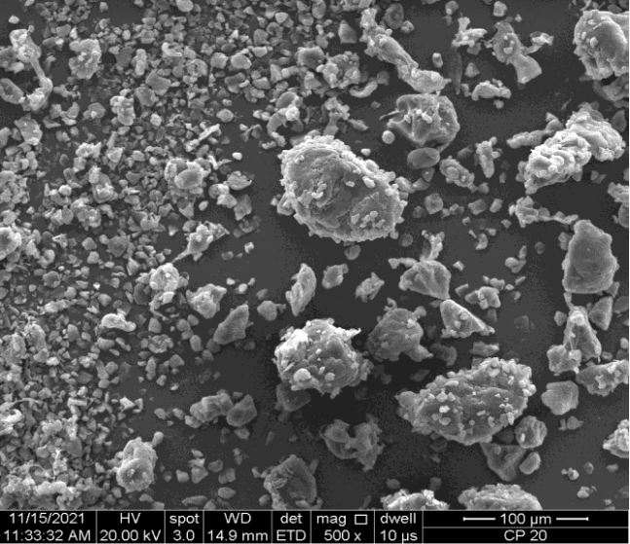  Rock-like shapes with small fines. | 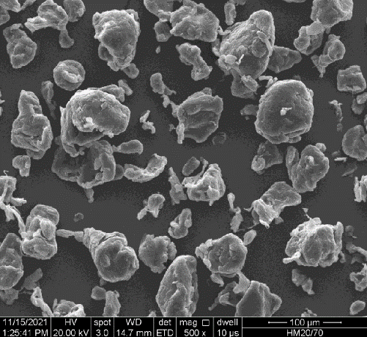  Potato shape with extended tails. | 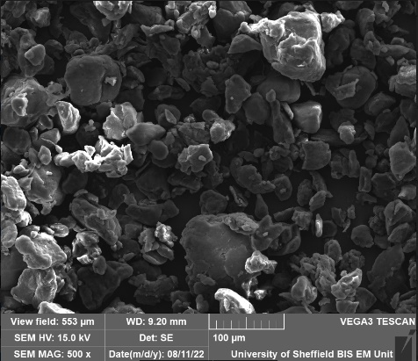  Fine potato-like shapes with tails
BFE [mJ] | 117.76 | 148.40 | 112.62
SE [mJ/g] | 6.41 | 4.95 | 6.25
Conditioning Bulk Density [g/ml] | 0.41 | 0.35 | 0.36
Permeability ¬1KPa [mBar] | 3.33 | 0.96 | 1.39
Permeability  ¬15kPa [mBar] | 4.21 | 1.29 | 2.23
Change in 1kPa to 15 kPa [mBar] | 0.88 | 0.33 | 0.84
Flow function ratio | 6.52 | 6.1 | 5.38
Stability Index | 1.09 | 0.93 | 1.03
The following sections discuss how each property is compared with the different grades and examined to see if they had an impact on the outcome. Further examination was conducted for areas where more information can help determine the cause of the two identified outcomes.

Flow additives as delivered:
The CP 20 and HM 20/70P are commercially available powders, with minimal information regarding any additives used. The EDX, in section ‎5.2.3, showed traces of silica on the CP20, which indicated that the material supplier added a flow additive. The addition of silica is common in polymer laser sintering powder as a flow promoter using a load ranging from 0.05 to 0.5%wt [27][14][91][102], as the CP 20 was mainly used for LS application, it was expected Silica would be found in the powder. The HC20/70p and HC11 did not contain dry mixed additives.
Furthermore, other additives could be added during the production of the polymers and mixed during the melt phase into the polymer. For HC11, the powder was produced from the reactor and does not contain any melt additives, whereas the other powders may have unknown additives included in the melt, such as heat stabiliser. Heat stabilizers are widely used as melt additives for PP. The heat stabiliser additives are used to prevent the polymer from degrading when exposed to heat and UV. PP without heat stabiliser causes the powder to start to degrade even at room temperature. [103] The molar mass averages, as shown in Table ‎5.2, indicate a drop in HC12 molar mass averages when compared to HC11, suggesting the degradation of the chains reducing the molar mass averages. [65] In conclusion, the HC11 showed a sharp reduction in chain length due to degradation from grinding the HC12, proving the HC11 was processable in the LS machine even after the powder flow was improved. No further examination is required to show the impact of additives on the powder as it was proven by the molar mass change.

Flow additives introduced:
After processing the virgin powder, it was apparent that the flow was poor and that the powder flow needed to be improved.
As shown in Table ‎5.15, the CP20 produced tensile samples; however, HM20/70P required the addition 0.2% wt of Alu C to produce tensile samples when flow additives were present. Moreover, the HC11 flowed wall from the hopper with 0.2% wt TS620 flow additives, but no samples were produced due to the high curl after laser sintering.
Depending on the amount and the type of additives, they can act as nucleating agents and alter the crystallisation. More information on the impact of the flow additives is shown in the study conducted in section ‎5.7.1. A low quantity of additives is required to process the powder in the LS machine; without the flow additives, the powder could not build due to flow issues. All three powders were processed on the LS machine to attempt to produce parts to be tested.
Moreover, no literature on the impact of 0.2% wt dry mixed flow additives on the mechanical properties of an LS powder was found. Therefore, the effect of 0.2%wt flow additives will be investigated further using IM samples using the HM20/70P with 0.2%wt Alu C.

Particle size distribution:
Table ‎5.15 shows a slight difference in the particle size between the CP20 and the HM20/ 70P. The D10 shows smaller particles present in CP20 with a range of 10 µm compared to the 30 µm range for the HM20/70P and HC11. The small particles in CP20 are shown in the SEM, where M20/ 70P contained a narrower particle size distribution. Referring to the literature, the particle size distribution section 5.3.2, demonstrated that a broader particle size provided a larger sintering window. In addition, the study concluded that powder flow does not always indicate superior mechanical properties for LS, with a similar outcome for CP 20 powder observed in this study. The difference between the particle sizes was insignificant across all powders, therefore, the particle size does not need to be investigated further.

Particle shape:
The particle shape can influence the powder flow, as discussed in section 3.1.2. The SEM in Table ‎5.15 shows the particle shapes for all three grades. The CP 20 has rock-like shapes, suggesting it was cryogenically ground. HC11 was jet milled after being produced directly from the reactor with 800 µm. Finally, HM 20/70P particles with a more rounded shape and small tails suggest a jet mill process was used to produce particles in the range of 110 µm. The shape impacts the flow and compaction of the powder and can be quantified using the other flow values discussed next.

Basic flow energy (BFE):
The BFE of the three blends shows similar values. However, with HM20/70P +0.2% wt Alu C was slightly higher. Nevertheless, the changes are low and negligible. No further work is required as all the powders were processed with acceptable flow for laser sintering.

Specific energy (SE):
The SE value in Table ‎5.15 shows similar values in the range of 4.9 to 6.5 mJ/g. The change is not significant. This factor is unlikely to cause the differences observed in the laser sintering trials; therefore, no further investigations are required.

Conditioned bulk density (CBD):
From Table ‎5.15, the CP20 has the highest value of 0.41 g/ml, indicating that CP20 has low voids in the bulk. The fine particles in the distribution fill the voids, increasing the CBD. Further work is required to investigate the CBD as the permeability shows different information on the powder packing. Therefore, further examination of the voids in the final sintered samples is needed.

Flow function ratio (ffc):
The ffc values reconfirm similar flow behaviour where all powders fall in the same “easy flow” range, with the ffc values falling between 4 and 10. No further work is required; all the powders flow well to the print bed from the hopper.

Change in permeability:
The permeability showed the highest variation identified in Table ‎5.15. The pressure drop from the higher consolidation (15 KPa) to the low consolidation of (1 KPa) shows how sensitive the powder is to compaction and packing density.
The high BFE correlates to the low change in permeability when the applied normal stresses increase from 1 KPa to 15 KPa. Table ‎5.15 shows the pressure drop change of 0.33 mBar for the HM 20/70P compared to the CP20 at 0.88 mBar, supporting the fact that CP20 has more voids in the bulk. The high change in permeability and the low BFE could result in high part porosity and a subsequent reduction in the tensile properties. Therefore, further investigation is required to examine the porosity of the sintered articles produced using CP 20 and HM20/70P. In the next section, further investigation on the porosity was carried out to provide more evidence that can relate to the tensile values obtained.

Overall Summary:
In summary, the effect of 0.2% wt flow additive on mechanical properties requires further investigation. As it can effect all the extrinsic properties listed. The injection moulding of the powder will show how the flow additive can impact the tensile values even with a small dosing of 0.2%.wt. In addition, it will be a reference for the material tensile properties without the voids that are usually found in LS samples. All other extrinsic properties have been shown to be unlikely to be the cause of the identified differences between the three powders.

Impact of intrinsic LS properties:
This section introduced several intrinsic LS properties that can influence how polymer powders behave during the laser sintering process. The following sections will discuss any differences in each of these properties and their possible effect on the laser sintering outcomes identified.

Table ‎5.16 Summary of all the intrinsic properties
Properties | CP20 | HM20/70P+0.2%wt Alu C | HC 11+0.2%wt TS620
Mn [Kg/mol] | 14 | 35 | 28
Mw [Kg/mol] | 130 | 169 | 170
Mz [Kg/mol] | 469 | 440 | 616
Mz+1 [Kg/mol] | 8,438 | 1,014 | 1,784
PDI | 9.5 | 4.8 | 6.4
MFI  [2.16kg/10min @260 ˚C] | 20 | 50 | 12
UTS (LS) [MPa] | 9 | 16.07 | -
EAB (LS) [%] | 0.6 | 1.83 | -
E (LS) [MPa] | 1632.6 | 1279.2 | -
Tm on set [˚C] | 145 | 155 | 156
Tc on set [˚C] | 125 | 130 | 123
Sintering window[˚C] | 20 | 25 | 33
Powder Crystallinity [%] | 45 | 35 | 32

Number average molecular weight (Mn):
The Mn values shown in Table ‎5.16 show high HM20/70P +0.2% wt Alu C of 35 kg/mol compared to the CP20 at 14 kg/mol. Higher Mn typically corresponds to longer polymer chains. Longer polymer chains can contribute to greater entanglement and chain overlap, leading to increased UTS. The UTS obtained for the LS samples show the same trend with Mn.

Mass average molar mass (Mw):
The Mw from the CP20 was lower than the HM20/70P+0.2%wt AluC. Mw accounts for the contribution of larger molecules, which can have a significant impact on the mechanical properties of PP. Higher Mw generally correlates with improved UTS due to the presence of longer polymer chains. Additionally, higher Mw can enhance the resistance to deformation. This study shows a similar outcome for LS tensile data where the UTS and EAB have increased for the grade with the higher Mw, which in this case was the HM 20/70P.

Z- average (Mz):
The Mz values are lower for both grades, with CP20 being slightly higher. Mz provides insights into the presence of high molecular weight species. This can influence tensile properties by affecting the polymer's ability to deform under stress. Large aggregates, as shown in the case of Mz+1, may act as stress concentrators, leading to reduced UTS and increased susceptibility to failure under applied load.
In summary, the molecular weight parameters Mn, Mw, Mz, and Mz+1 of HPP play a crucial role in determining its tensile properties. Higher molecular weights generally result in improved UTS and EAB due to increased chain entanglement and overlap. However, excessively high molecular weights or the presence of large aggregates can have negative effects on tensile properties, such as reduced flexibility and increased susceptibility to failure. Therefore, optimising the molecular weight distribution is essential to achieve the desired tensile properties for LS in polypropylene. Further work is required at the end of the study to compare the averages with the UTS and EAB to establish any correlation.

Melt flow index (MFI):
The high Mz+1 results in higher viscosity material, as confirmed by the low melt flow index (MFI) for CP20 at 20 g/10mins compared to the 50 g/10mins for HM20/70P. During LS, the higher the melt viscosity, the more flow is limited, thus creating more voids and not allowing the powder particles to fuse fully. Further work to quantify porosity will show if the impact of porosity is related to MFI. This can be done by comparing the LS with IM sample density. This will be covered in more detail in specimen characterisation sections to follow.

Polymer dispersity (PDI):
Polymer dispersity (PDI) measures the broadness of the molar mass distribution. The wider the distribution, the more long or small chains are present on both sides of the distribution curve. The large chains result in higher viscosity, and the small chains flow much more easily. The PDI index is much higher for the CP20 compared to the MH20/70P. The CP20 contains a bimodal distribution, which then gives the distribution a wider Polymer dispersity value. The PDI for HC11 falls between the CP20 and HM20/70P; nevertheless, it was not processed in the LS machine. The change in PDI from the HC12 shows the instability of the HC11 after grinding. Furthermore, the HM20/70 with a lower PDI resulted in the highest ultimate tensile strength (UTS) and elongation at break (EAB) compared to the broad CP20; therefore, no further work on the PDI is required.

Sintering window:
Table ‎5.16 shows a difference in the sintering window between the three grades. The CP20 was flexible during processing with a wider laser power range to produce tensile specimens compared to the MH20/70 P, despite HM20/70P having a broader centring window, according to the DSC. This might be more related to the CP20 broad particle size distribution, which contained small fines. HC 11 had the highest sintering window and was unprintable. This shows that the wide sintering window does not always suggest the best tensile properties or producibility in LS.
Moreover, most of the literature suggests that low-crystallisation polymers are desired for laser sintering due to low shrinkage. The cause of failure for HC11 was not related to crystallinity due to processing at elevated temperatures of 144˚C, higher than the crystallisation temperature of 110˚C.

Powder Crystallinity:
Table ‎5.16 shows the crystallinity of the powder from the DSC results. The crystallinity for the HC 11 was the highest compared to the other two grades. The powder introduced to the top of the build could provide a low temperature to initiate the curl at 144 ˚C. However, in this case, the HC11 was curling before the new layer was placed; however, the powder showed unstable MMD values and could not be printed since no heat stabilisers were used.
The literature suggests that the crystallinity has an impact on the tensile properties of the polymer. Crystallinity is a complex property that is influenced by many factors, such as cooling rates, chain lengths, and additives.
From the literature, the lamellar length formation shows a strong relationship with the tensile properties of the polymer. The longer the lamellar formation, the higher the elongation properties are. In addition, the Mw showed an impact on the length of the lamellar thickness, where high Mw increases the lamellar thickness. [16] Further investigation on the lamellar thickness in relation to the Mw was conducted in the next section to measure the lamellar thickness for the LS parts and identify its impact on the tensile data.

Further specimen characterisation
This section aims to characterise the LS parts by investigating differences in the effect of flow additives, porosity, and crystallisation, which are the properties identified in the previous section that influence the mechanical properties of both grades.

The effect of flow additive on IM
Aim:
The aim is to understand how the low quantities of 0.2% wt of flow additive can impact the tensile properties of the HM 20/70P.

Method:
Moreover, the flow additives could alter the tensile values, which do not accurately represent the impact of the variation on the molecular mass distribution. Examining the injection moulding tensile of the powder with and without flow additives is critical. In this section, an examination of the flow additive with a low loading of 0.2wt% will be mixed with HM20/70P to understand the impact of the low dosage of flow additives on the tensile properties.
Type 5A tensile specimens ISO 527-02 were produced from injection moulding to evaluate the flow additives' mechanical impact on the powder tensile properties without the porosity found in LS. The LS powder was directly used in the TRAVIN MINI Moulder TP1, which operates manually via a toggle system with 4.5-tonne clamping pressure with a heated barrel and a plunger system that uses air pressure to inject the melt at 80 psi. Ten samples were produced for each blend with a barrel temperature of 240 °C. All the IM specimens were kept for more than 24 hours before tensile testing.
Then, the gauge length of 20 mm was marked with reflective silver tape. The strain was measured using a laser gauge extensometer that was fixed on the Tinius Olsen 5K tensile machine.
The Youngs modulus (E), ultimate tensile strength (UTS), and elongation at break (EAB) were generated using the “Herizon” software provided by Tinius Olsen.
Result:
The results in Figure ‎5.43 show a reduction of around ~6% in EAB and ~4% UTS, with an increase of ~ 20% E when 0.2% wt Alu C was added to the HM20/70P powder. However, all the data are within the error bars, suggesting no significant change in data.

Figure ‎5.43 shows the tensile values for the HM20/70P injection moulding compared with 0.2% wt Alu C added.

Discussion:
The tensile result concludes that adding 0.2 % wt of flow additive had no significant impact on the tensile values. The 0.2 % wt Alu C has reduced the EAB and UTS by 6% and 4%, with an increase of 20% in E when including the additive. However, all the values fall within the error bars, which indicates no significant change when 0.2% wt Alu C is added. Other studies show significant trends with an increase in E when more than 10% wt fillers are used [104].

Part density
Aim:
This section aims to quantify the porosity of the LS specimens produced in build B9 for the CP20 and build B21 from HM20/70P+ 0.2% wt Alu C.
Method:
The density of the LS and IM specimens was measured using Mettler Toledo's density determination kit. The system uses Archimedes' principle, which states that every solid body immersed in a fluid loses weight by the amount equal to that of the fluid it displaces. [105]

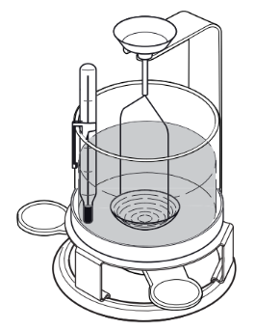
Figure ‎5.44 Density determination kit by Mettler Toledo. [105]
The density of a solid was determined with the aid of liquid density (ρ₀) and the density of air (ρ_{a}) 0.0012 g/cm³. The weight of the solid (A) was measured in air and then in liquid (B) and the density of the sample density (ρ) was calculated using the following equation:
$ρ=\frac{A}{A-B}\left(ρ_{0}-ρ_{a}\right)+ρ_{a}$ Equation ‎5.1
The beaker was filled with methanol, with a density of 0.792 cm³. Usually, distilled water is used, however, methanol was used as the LS samples did not sink in water. The samples must be immersed in the liquid by at least 1 cm.
The test process starts by entering the temperature of the liquid measured using the thermometer, as shown in Figure ‎5.44, and then the scale was then zeroed. A small section of the LS tensile sample was manually snapped off and weighed in the air by placing the sample on the small round disc beside the beaker, displayed in Figure ‎5.44, and then measuring the sample in the air. The sample was then placed in the methanol basket and lowered into the methanol to be weighed in liquid, where all air bubbles must be removed using a fine brush before the weight can be recorded. After recording both weights, the density of the part was obtained.
Each sample was measured three times using three different locations from the mid-section of the tensile specimen, as shown in Figure ‎5.45. Both LS and IM samples were measured using the same setup. The IM samples were produced using the same method discussed in ‎5.7.1.

Figure ‎5.45 Density sample location is shown in blue.
Results and discussion:
The results show changes between the LS and IM part density, which was in line with the literature values. The HM20/70P+0.2%wt Alu C laser sintered sample shown Figure ‎5.46 has a slightly higher part density compared to the CP20. The density of the LS specimens showed similar values, but the difference becomes noticeable when comparing the IM with the LS density, showing the change in density, as shown in Figure ‎5.47, with the IM with the LS samples. The IM density of CP20 was at 0.9 g/cm³ compared to the LS sample at 0.86 g/cm³, resulting in a change of 0.044 g/cm³. This change represents the porosity in the CP20 sintered specimen.

Figure ‎5.46 Density values for IM and LS samples for the HM20/70P+0.2%wt Alu C and CP20

Figure ‎5.47 The change in density between IM vs LS samples.
For further work, the top surface analysis of the LS specimens may indicate the porosity visually to provide more evidence of the presence of higher porosity in the CP20 sample.

Top surface analysis
Aim:
The aim was to visually inspect the top surface of the LS article to see the porosity in each laser-sintered specimen.

Method:
The same method described in 5.2.2 was used to obtain the SEM images.

Results and discussion:
Overall, all the powder was deposited successfully onto the print bed. The size and shape of particles have an impact on the mechanical properties of the final article; conversely, powder compaction can vary in shape and size. It is not only dependent on the flow. The compaction can impact the porosity, resulting in changes in the mechanical properties. Furthermore, from Table 5.17 for producing the highest tensile values samples on LS, the energy densities and the Bt were different. This change may impact the melt flow of the particles and result in different formations of voids, therefore, the SEM shows the variation of void sizes on the top surface of the tensile sample CP20, and HM20/70P +0.2%wt Alu C, shown in Figure ‎5.48.
Table ‎5.17 Summary of the process parameters for LS.
Key parameters | PP CP 20 | HM 20/70P + 0.2% wt Alu C
Bt | 137 °C | 159 °C
Laser power | 24 W | 20 W
Laser scan speed | 2,639 mm/s | 2,639 mm/s
Hatching distance | 0.25 mm | 0.25mm
Layer thickness | 0.1 mm | 0.1 mm
ED | 0.064 J/mm² | 0.057 J/mm²

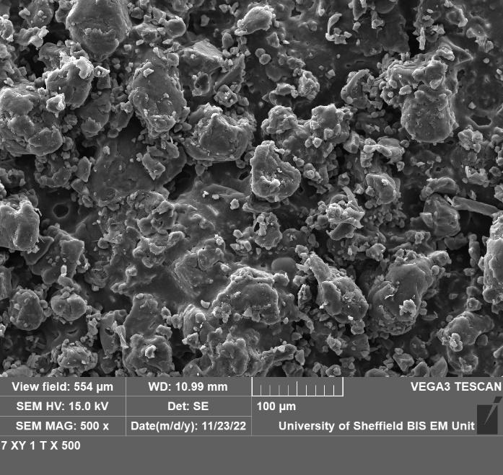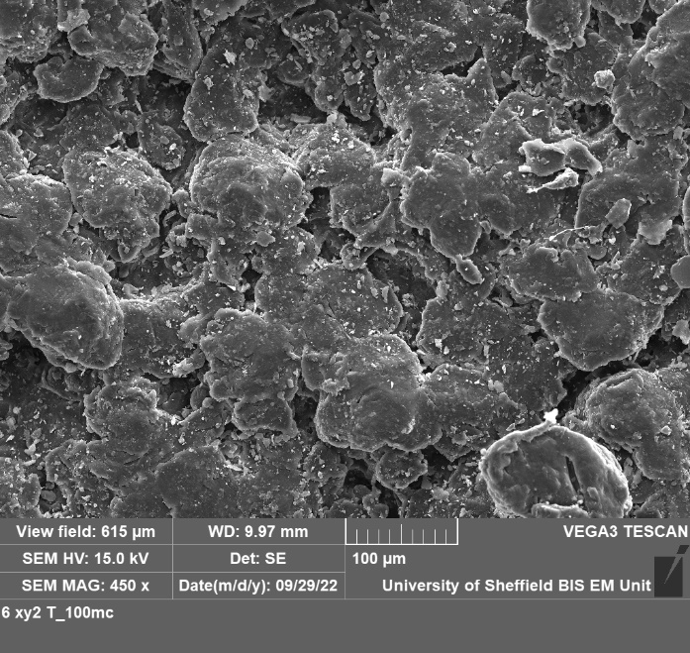
Figure ‎5.48 SEM of top surface of laser sintered CP20 (left), and HM20/70P +0.2wt% Alu C (right)
From the SEM images in Figure ‎5.48 the CP 20 seems to have a rougher surface with deeper cavities compared to the HM20/70P+0.2%wt Alu C, which shows a flatter, smoother surface. Visually, the CP20 seems to contain more voids. From the permeability data in Figure ‎5.18, HM 20/70P showed the lowest change, confirming high compaction.
Moreover, not only compaction will reduce the voids. The HM20/70P melt flow was nearly twice as much as the CP20, and the Mz+1 for the HM20/70P was lower, allowing the particles to fuse easily into the shape displayed in Figure ‎5.48.
Furthermore, the LS part density shows CP20 with a higher change in density Figure ‎5.47, which reconfirms that higher porosity was present in the CP20.
Despite changes in density values between the two grades, the LS comparison with IM tensile properties clarifies whether the drop in tensile properties is related to the polymers' porosity or intrinsically MMD variation. Further, the IM tensile properties were compared to the LS in the next section.

Impact of crystallinity
Aim
This section investigates the changes in crystallinity during LS and IM and the impact of lamellar length on the tensile properties.
Method
Using the DSC data on the LS, and IM specimens to obtain the melting enthalpy (ΔH_{m}) from the DSC heat flow thermogram following the same method ‎5.2.6. The melting enthalpy was represented by the area under the melting peak, which was used to calculate crystallinity and lamellar lengths.
The percentage of crystallinity (%X) was calculated using Equation ‎5.2, by dividing the melting enthalpy (ΔH_{m}) by the melting enthalpy of PP with a 100% crystallinity (ΔH_{100%}= 207 J/g).[46] [106]
$\%X=\frac{ΔH_{m}}{207}× 100\%$
Equation ‎5.2
The lamellar thickness is calculated from the DSC; the average lamellar thickness was calculated using Equation ‎5.3, showing the melting temperature (T_{m}), which can represent any point on the melt curve in the DSC, to identify any average lamellar thickness at any given point (L; i.e., the crystal's longitudinal dimensions), the thicker lamellar melt at the higher temperature, as shown in Figure ‎5.56.
$$L=\frac{2φ T_{m}^{0}}{ΔH_{f}(T_{m}^{0}-T_{m})}$$

Equation ‎5.3
Where T _{m}⁰ is the equilibrium melting temperature of α-phase iPP (464 K), ΔH_{f} is the melting enthalpy of a perfect crystal (196 J/cm³), and φ is the free surface energy of the end faces at which chains fold (102.9 J/cm²). [16][23] Note (L_{n}= the mean lamellar thickness) calculated using the Tm at the peak from the DSC, and (L_{max}= the maximum lamellar thickness) calculated using the end-set temperature of the DSC melt peak.

Result:
The result in Figure ‎5.52 showed a high crystallinity in the HM20/70P + 0.2%wt Alu C than CP20 for both LS and IM. The %X of HM20/70P+0.2%wt Alu C showed a crystallinity of 53% compared to the CP20 at 50%. The IM samples had lower crystallinity at 41% for HM20/70P+0.2% wt Alu C and 36% for the CP20.

Figure ‎5.49 Crystallinity of Laser sinter article (LS), and Injection Moulded article (IM)

Figure ‎5.50 The mean lamellar thickness of LS and IM samples.

Figure ‎5.51 Maximum lamellar thickness for LS and IM samples.

Discussion:
The cooling rate can influence the crystallinity dynamics despite having a similar MMD profile for the same polymer. For the laser sintering, the samples were removed after the machine had fully cooled down, allowing more time for the LS melt to re-crystallise in the print bed, resulting in a higher degree of crystallinity, seen in Figure ‎5.52, compared to the low crystallinity in IM, which is cooled rapidly from the mould. Therefore, the results show that Mw has an impact on the crystallinity as well as the cooling rate. As the cooling rate was maintained the same for the LS sample, the CP20 showed lower crystallinity after LS. The Mw shows a higher impact on lamellar length, which correlates to the UTS and EAB for both LS and IM specimens.
HM20/70 has a higher degree of crystallinity than CP 20, as shown in the previous section. The lamellar thickness was higher in the HM20/70P+0.2%wt Alu C, as indicated in Figure ‎5.54, causing an increase in higher UTS and EAB. The studies indicate that the higher the lamellar thickness, the more energy is required to pull them apart, resulting in higher UTS and EAB.

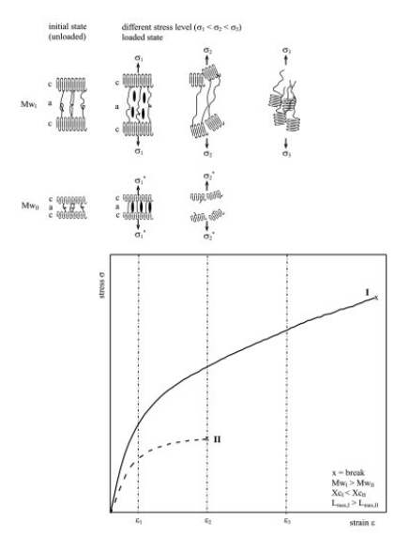
Figure ‎5.52 Schematic illustration of the deformation behaviour (c=Crystiline, a= Amorphous). [16]
The literature discusses the relationship of Mw with crystallinity, mainly in the injection moulding process. The literature by Stern et al.[16] describes the reduction in the crystallisation rate with increasing molecular weight due to entanglements and viscosity effects. The study then describes crystallinity in lamellar formation in the DSC melt peak with an increase in lamellar thickness size as the temperatures increase under the melting zone, as shown in Figure ‎5.56. Furthermore, lamellar thickness governs the tensile stress as well as the strain hardening effect rather than the overall crystallinity when PP was injection moulded. To conclude, the lamellar thickness appears to increase with Mw.
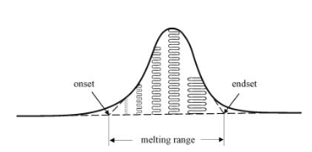
Figure ‎5.53 Schematic drawing of the melt zones [16]
The study then describes that elongation of the samples in the tensile direction causes stretching of the amorphous phase. This process is purely elastic; once the load on the sample is removed, it fully recovers. When the semicrystalline polymer is further deformed, plastic yielding occurs, at which crystallite sliding takes place, as illustrated in Figure ‎5.55. Thus, the lamellar start to orientate themselves parallel to the deformation direction; correspondingly, interlamellar slipping occurs, coupled with the unfolding of the lamellae until the ultimate break. [16]
In addition, the cooling rate influences the %X. The IM values for lamellar length are lower than LS due to the rapid cooling when the specimens were ejected from the mould, which prevented the polymer chains from realigning to form thicker lamellar, in comparison with the samples in the LS, where crystallisation occurred at a lower cooling rate in the powder bed.
In summary, the tensile data indicates that a homopolymer PP powder's lower Mz+1 and high Mw with a high melt flow show higher UTS and EAB values. The excessive Mz+1 increase caused a reduction in the EAB and UTS. The average Lamellar length, shown in Figure ‎5.53, was higher for the low Mz+1 powder, indicating that Mw has a larger impact on the lamellar than the Mz+1. Therefore, the Mw impacts the average lamellar length that was linked to the UTS and EAB in a solid state of the polymer. The Mz+1 impacted the MFI in the melt state of the polymer. The HM20/70P showed a higher Mw than the CP20, resulting in a higher lamellar length, giving the HM20/70P higher UTS and EAB. Crystallinity also depended on the cooling rate; the LS showed higher crystallinity due to the slow cooling process. The lamellar length correlates to the tensile data for LS and IM.

Conclusion
In conclusion, the LS and IM demonstrated that HM20 +0.2% wt Alu C showed superior UTS, and EAB than the CP20. The CP20 showed higher stiffness with higher E values; however, E values showed inconclusiveness with high error bars. HM20+0.2%wt Alu C showed high MFI combined with high Mw, generating longer lamellar length when the cooling rate was consistent in the LS process. The hypothesis that higher Mz+1 would result in higher entanglement, increasing the tensile values, was not true in the case of the polypropylene LS samples.
The HC11 powder was not processable due to the degradation and instability of the polymer chains. In addition, the powders produced directly from the reactor require essential additives to preserve the polymer chains from degradation.
Other than the two main conclusions discussed previously, several other factors were concluded, and they are as follows:
- The materials CP 20, HM20/70P, and the HC11 +0.2%wt TS610 showed similarities in BFE, SI and ffc, which flowed well in the EOS P100 machine.
- The permeability results do not match. Higher change in pressure drop for the CP20 grade than the other two.
- Porosity was the most impactful property identified in LS. The porosity was influenced by intrinsic and extrinsic properties such as PSD, shape, powder flow, compaction and melt flow.
- Cooling rate impacts crystallography and lamellar growth. The IM showed a lower average lamellar length than the LS. The higher tensile values for IM compared to the lower tensile data from the LS are influenced by the porosity in the specimens.
- The use of bimodal PSD does not show higher UTS and EAB.
- High Mw increases the lamellar thickness when the cooling rate remains constant.
- High lamellar thickness correlates to an increase in UTS and EAB.
- High Mz+1 results in Low MFI.
- Excessive amounts of Mz+1 resulted in a negative effect on the UTS and EAB for LS.

The study conducted in this chapter shows that the High MFI and Mw result in superior UTS and EAB for Homopolymer PP powder in LS. In the next chapter, two homopolymer PP grades with the same MFI were investigated to confirm if any variation in molar mass averages are more impactful than the MFI.

Impact of different MMD with the same MFI on tensile data
This chapter examines how two grades with the same MFI and different molar mass averages impact the tensile properties. The previous chapter showed a relationship between different commercial powders with different MFIs and how high MFI resulted in higher UTS and EAB in LS samples.
In this chapter, the LS powder was developed from pellets. Both powders went through the same process in an attempt to maintain similar powder properties. The PP powders underwent flow and thermal analysis before LS. After producing LS tensile sample, the crystallinity, porosity, and MMAs were examined.
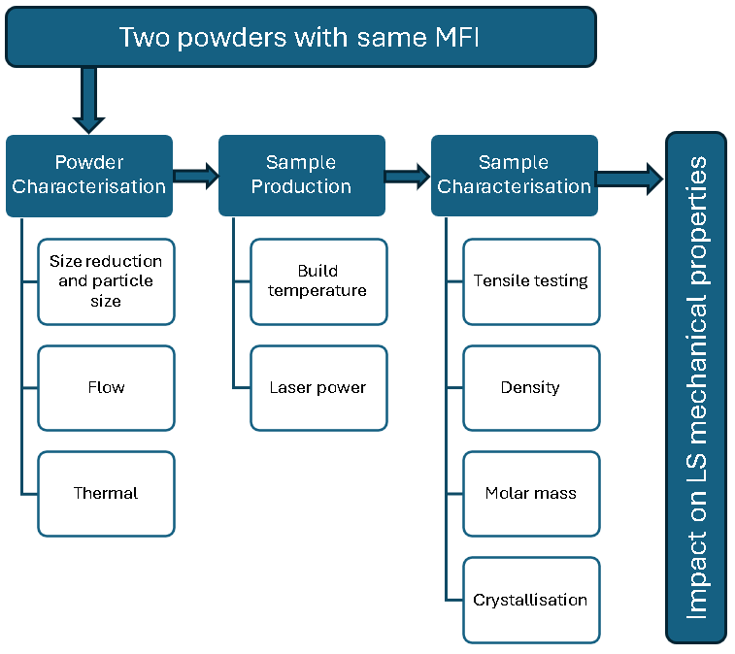
Figure ‎6.1 Experimental workflow for two grades with the same MFI.
Literature on the MMD in ‎3.2.4 suggests that changes in the MMD profile would affect the tensile properties, and it is expected that the high PDI would result in higher tensile strength and better consolidation of melt. The literature also reflects that the higher Mz while maintaining a constant cooling rate would improve the tensile strength and elongation in elastomers. [107] However, no study has been conducted on PP.

Materials selection
The study used two grades provided by SABIC, PP 518A and PP 511A. They were selected based on both homopolymer grades having the same MFI of 25 g/10min (2.16kg@260°C). Moreover, the 511A was produced from the PP 518A, by using hydrogen peroxide to narrow the PDI from 6.34 to 3.52, thus changing the Mn, Mz, and Mz+1, as shown in Table ‎6.1, but maintaining the MFI relatively the same. The data shows a significant Mz, and Mz+1 reduction from 1.1M to 793 kg/mol and an increase of Mn from 34 to 60 kg/ mol.
Table ‎6.1 The MMA for all powders used.
Material | MFI |  | Mn [g/mol] |  | Mw [g/mol] | Mz [g/mol] | Mz+1 [g/mol] | PDI
HM20/70P* |  | 50 |  | 34,910 | 169,111 | 451,534 | 1,014,283 | 4.87
CP 20* |  | 20 |  | 13,708 | 130,447 | 452,153 | 8,438,739 | 9.8
PP 518A |  | 25 |  | 34,893 | 221,080 | 600,000 | 1,100,000 | 6.34
PP 511A |  | 25 |  | 60,000 | 215,000 | 478,000 | 793,000 | 6.34

*Grades used in the previous chapter study of different MFI.

Powder characterisation

Size reduction and particle size analysis
Aim:
The two grades were obtained in pellet form, which required further grinding to be used for LS. The objective in this section was to convert the PP518A and the PP 511A pellets to useable powder for LS with a particle size range of approximately D10 of 20µm, D50 of 55µm and D90 of 90µm as these are the desired sizes for LS according to the literature, as discussed in section 3.1.2.
Methodology:
SABIC provided the two grades in this study in pellet form, and cryogenic grinding was conducted by SETUP PerformanceTM, located in Lyon, France, to convert the pellets to usable powders for LS. In the first step in the process, the pellets were passed through a cooling system at - 40 ˚ C using nitrogen before being fed into a dual rotation pin mill manufactured by HIMMEL, as shown in Figure ‎6.2. The pins were counter-rotating to each other at 8,880 rpm, producing an output of 3 kg/hour.
After the grinding process, the powder was then transferred using a vacuum system to the top of the sieve unit to be sieved through two 90 µm mesh simultaneously using an ultrasonic vibration and a fan at the base to push the small particles out, as displayed in Figure ‎6.3. The large particles are then recycled back to the pin mill to be re-grinded, thus increasing the yield of the desired powder.
During the grinding process, a sample was taken after 30 minutes of each parameter change to maintain a stable outflow. The particle size of the powder sample was then measured using the Marven 2000 PSD machine following the method discussed in section ‎5.2.1.
Upon completion of the grinding of the two grades, the powder was packaged in 15 kg bags and air-sealed. When the powder was received, random samples of 100 g were taken from three random bags from each bag labelled A, B, and C to measure the different particle sizes, shown in Table 6.2, to ensure the sizes were consistent within the tolerance range of +/- 10 µm throughout all the batches.
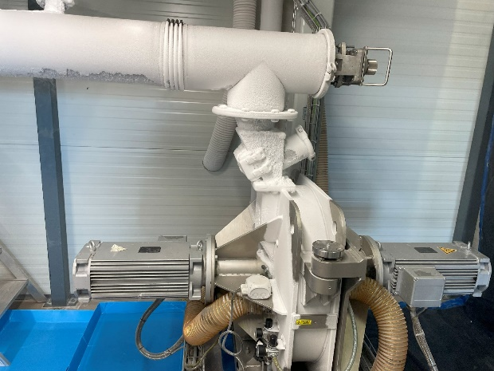
Figure ‎6.2 Cooling system using nitrogen with a dual rotation pin mill, manufactured by HIMMEL
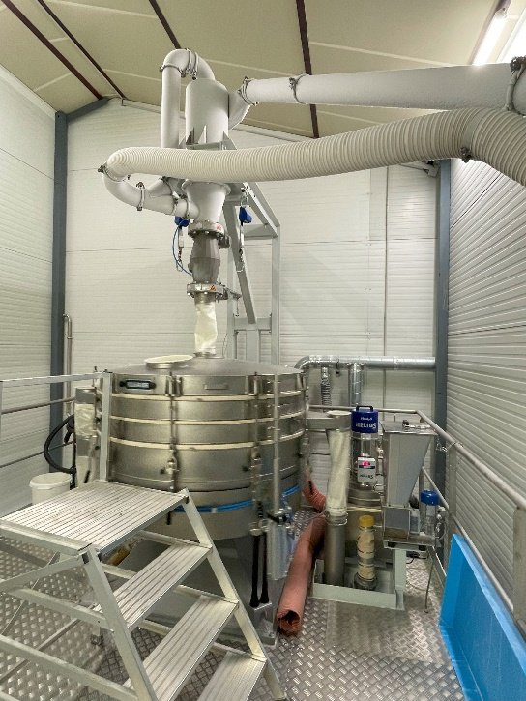
Figure ‎6.3 Sieved unit with two 90 µ mesh feeds simultaneously.
Results and discussion:
For both grades, the throughput of the production was around 2kg/h, lower than expected due to clogging of the sieve. The sieve was cleaned a few times during the production, but after some hours of running, the sieve kept clogging. The conditions required constant adjustment to achieve stable output without clogging the sieve. It was apparent that running the grinding system for a long duration caused temperature variations. Each time the sieve clogged, the PSD decreased, resulting in the powder with a slightly different particle size than the desired sizes, as shown in Table ‎6.2 .
Table ‎6.2 Particle size of final powders produced.
Batch | D10 [ µm] | D50 [µm] | D90 [µm]
PP511A_A | 26.8 | 51.2 | 87.2
PP511A_B | 25.7 | 49.7 | 83.4
PP511A_C | 24.8 | 45.7 | 78.5
PP511A_Av | 25.8 | 48.9 | 83.0
SD | 2.07 | 5.37 | 8.54
Batch | D10 [ µm] | D50 [µm] | D90 [µm]
PP 518A_A | 28 | 53.7 | 90.1
PP 518A_B | 28.6 | 55.6 | 93.9
PP 518A_C | 28.6 | 55.9 | 95
Av | 28.4 | 55.1 | 93
SD | 0.35 | 1.19 | 2.57

The particle size of the D10, 50, and 90 for both PP518A and PP 511A was within an acceptable range of +/- 10 µm of D10 of 20µm, D50 of 55µm and D90 of 90µm.
The two powders were examined under the SEM to look at the particle morphology. Both powders displayed potato-shaped particles, but the 518 powders showed long tails, as shown in Figure ‎6.4 (a). The 518 has high Mz values, as seen in Table ‎6.1, which could have caused this effect. As discussed in the MMD literature ‎3.2.4, the high Mz values are used to improve melt strength during the extrusion process.[108]
a)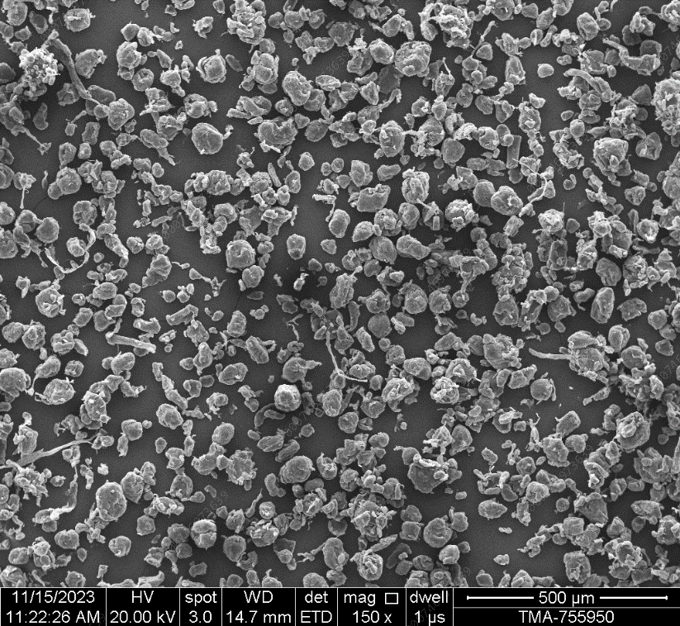 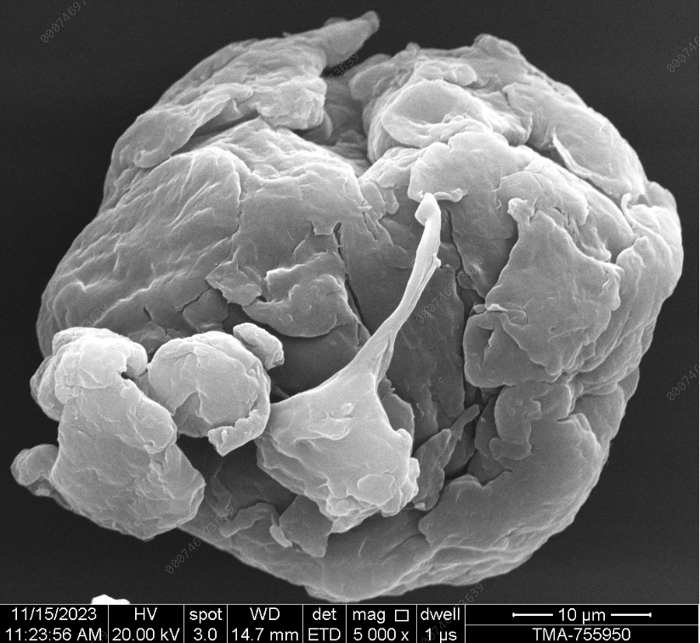
b)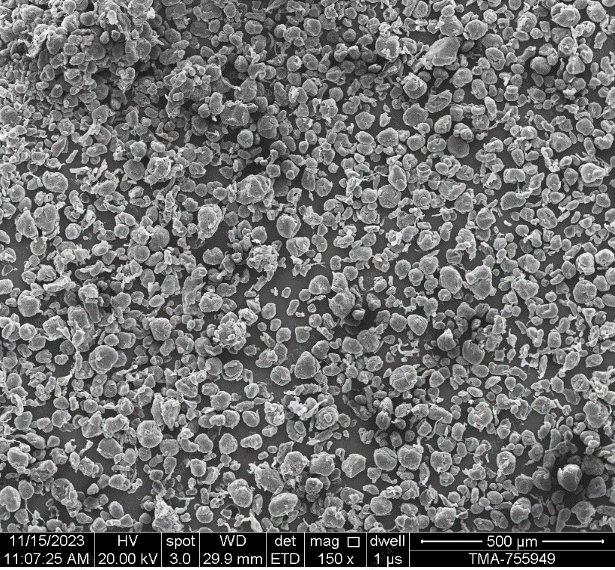 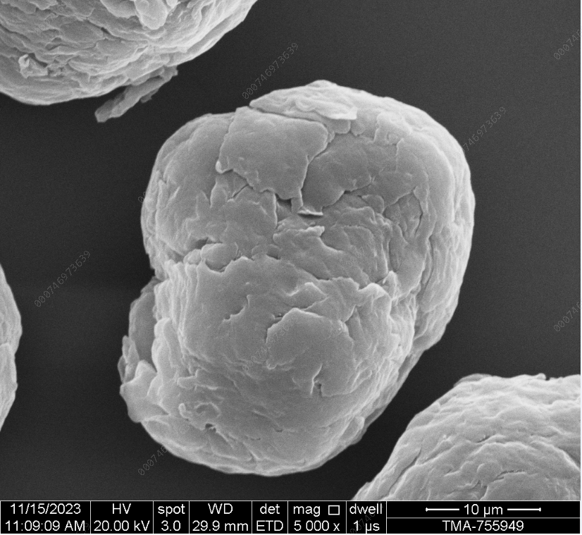
Figure ‎6.4 SEM images after grinding, a) PP518A, b) PP 511A.

Overall, the SABIC pellets PP grades of 518A and 511A were successfully cryogenically grounded to meet the particle size requirement for LS, which are less than 125 µm, and the particle size distribution of D10= 20µm, D50 =55µm, and D90 = 90µm with a +/- 10 µm. After obtaining the desired powder sizes, the powder must flow in the EOS P100 machine. Next, the powder underwent a flow analysis.

Powder flow analysis

Aim:
The powder flow analysis aimed to measure the flow of the virgin powder to ensure both powders meet LS flow requirements in the EOS P100 machine.
Methodology:
Initially, the virgin powder was processed on the LS machine to ensure the powder flow and surface were processable in the LS. The powder surface of the first few layers is examined visually in the machine to determine whether flow additives are needed.
The flow properties were measured, and the FT4 Freemen flow analysis machine was used following the same methodology discussed in section ‎5.2.5. If the powder requires improvement, the virgin powder is then tested with the flow additives used in the previous chapter. However, only 0.2%wt of the flow additives were blended. The flow additives are explained in more detail in section 5.4.2. The powder blend was selected based on the highest flow with high values of BFE, PD and ffc.
The flow test on the machine was set up at a build temperature of 130 ˚ C without any build, stopping the build at layer 44, to replicate the first few layers of the build.

Results:
The table below shows all the VFR data with the standard deviation of each result. The SI value with T610 blends, shown in Table ‎6.3, was on the borderline for the PP511A at 1.1 and PP518A at 1.180, despite PP 518A+0.2%wt T610 falling out of the range by 0.080 the value was low and negligible.
Table ‎6.3 VFR for both PP511A & PP518A
 | BFE, mJ | SI | FRI | SE, mJ/g | CBD, g/ml
PP 518A Av | 91.93 | 1.18 | 1.30 | 5.40 | 0.28
SD | 5.928 | 0.062 | 0.046 | 0.582 | 0.007
PP 518A+0.2 A830 Av | 80.100 | 1.025 | 1.445 | 5.235 | 0.303
SD | 8.619 | 0.010 | 0.021 | 0.032 | 0.016
PP 518A +0.2 T610 Av | 102.267 | 1.180 | 1.283 | 6.503 | 0.313
SD | 2.194 | 0.060 | 0.040 | 0.281 | 0.007
PP 518A +0.2 AluC Av | 76.30 | 0.973 | 1.437 | 5.147 | 0.297
SD | 4.8042 | 0.0196 | 0.0252 | 0.0751 | 0.0085

PP 511A Av | 79.067 | 1.100 | 1.703 | 5.170 | 0.302
SD | 3.717 | 0.010 | 0.060 | 0.147 | 0.010
PP 511A +0.2 A830 Av | 79.900 | 1.050 | 1.623 | 5.647 | 0.303
SD | 5.242 | 0.010 | 0.012 | 0.110 | 0.004
PP 511A +0.2 AluC Av | 74.667 | 0.977 | 1.557 | 5.480 | 0.329
SD | 2.892 | 0.048 | 0.057 | 0.464 | 0.012
PP 511A+0.2 T610 Av | 80.733 | 1.100 | 1.337 | 5.203 | 0.308
SD | 3.386 | 0.080 | 0.006 | 0.122 | 0.016

The CBD result in Figure ‎6.5 shows the Alu C blend to have the highest CBD for the 511 and the 518 grades.

Figure ‎6.5 the CBD of PP 518A and PP 511A powders
In the second flow test, the FT4 had three flow properties to measure BFE from the VFR test, ffc from the shear cell test, and change in pressure drop from the permeability test.

Figure ‎6.6 BFE values of different flow additives with PP518A and PP511A.
From the VFR test, shown in Figure ‎6.5, the highest BFE was for the 518, with the addition of + 0.2%wt of T610, which was 102.267 mJ. The same flow additive with 511 resulted in the highest BFE of 80.733 mJ.
The permeability results for PP 518A, indicated in Figure ‎6.7, show that the blend with T610 had the lowest change in permeability drop of 0.284 mBar compared to the virgin powder at 0.4 mbar. The PP 511A blend with the T610 displayed the lowest permeability of 0.340 mbar compared to the highest value of 0.5 mbar for the Alu C blend.

Figure ‎6.7 Change in pressure drop from 1kPa to 15kPa in the FT4 permeability test for the PP 518A and 511A blends.

Figure ‎6.8 Flow function ratio (ffc) of PP 518 and PP 511 blends
Finally, the ffc results from the shear cell test, shown in Figure ‎6.8, for 0.2% wt T610 increased the ffc from 4.55 to 8.26, reflecting the most significant improvement for flow additive for the 511. Likewise, the 518 shows ffc value increased from 4.30 to 10.24 by adding 0.2% wt of T610.
a)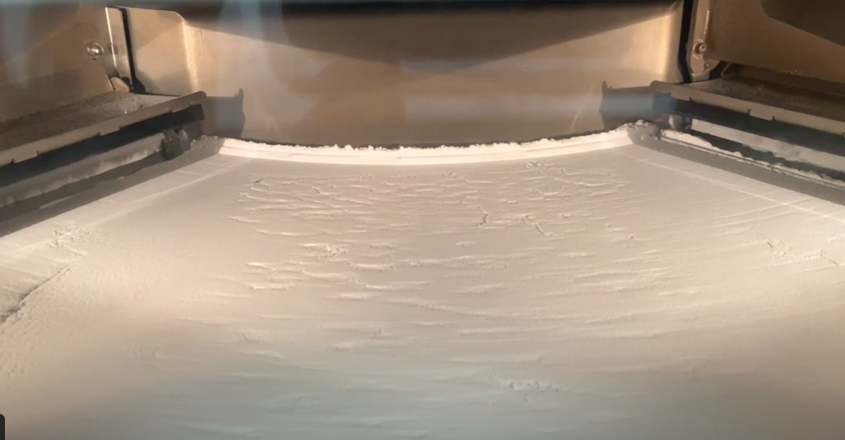 b)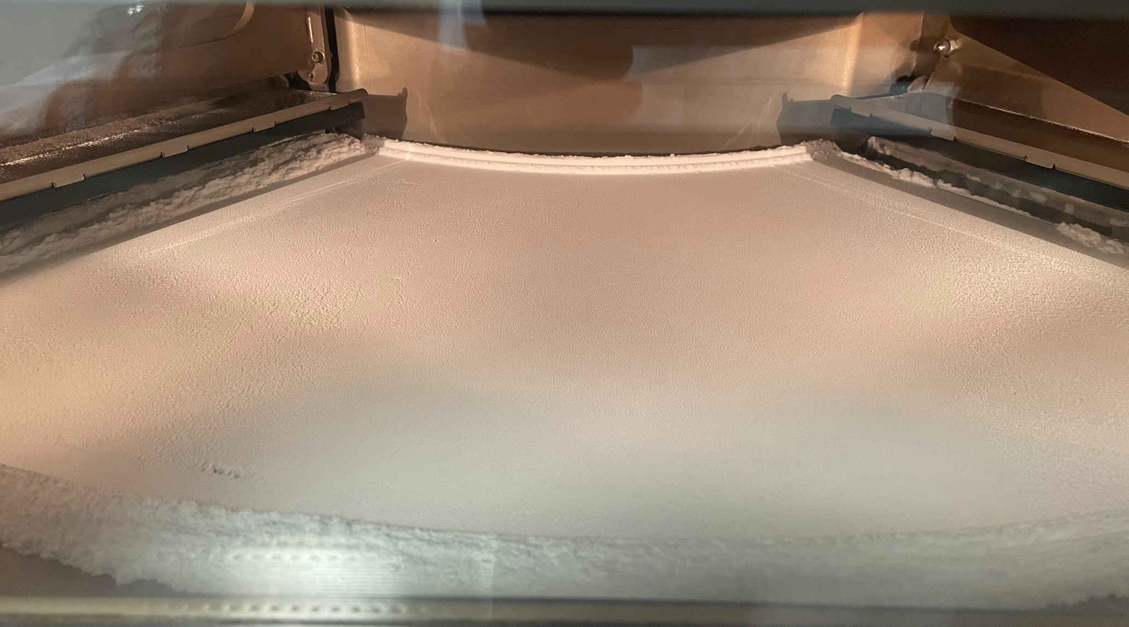
c)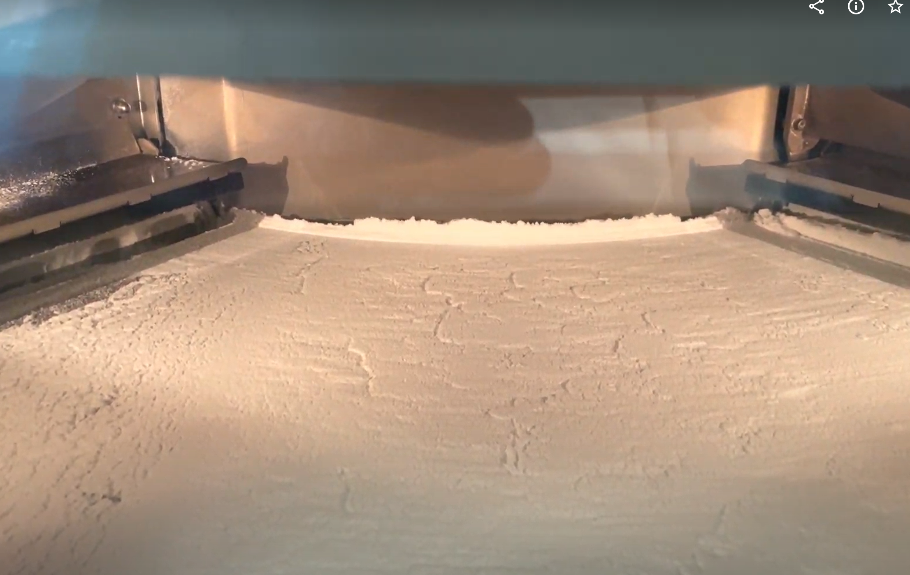 d) 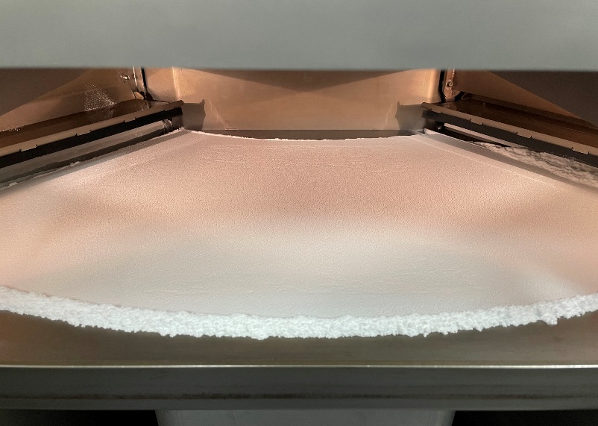
Figure ‎6.9 Top surface of print bed in the EOS P100, a) PP 511A, b) PP 511A+0.2%wt T610, c) PP518A, and d) PP518A+0.2%wtT610.
The powder blends with 0.2%wt T610 were then processed in the EOS P100 machine to show how the first layers improved after adding 0.2%wt T610. Both grades show an improvement in powder surface, as shown in Figure ‎6.9.
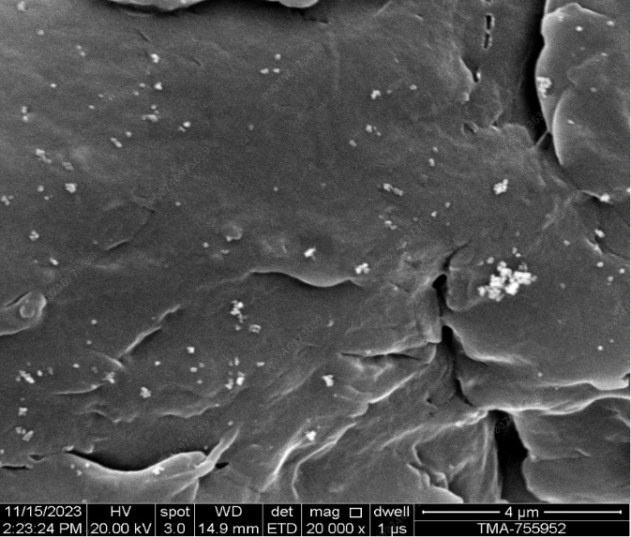
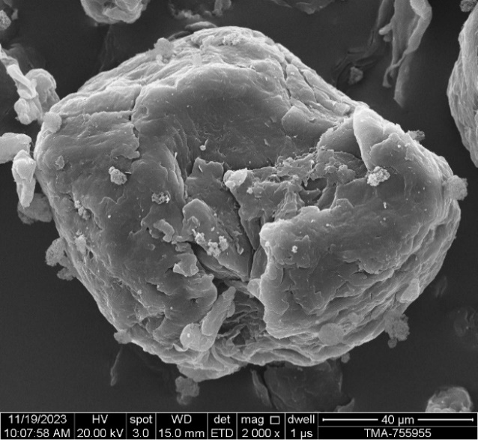
a) 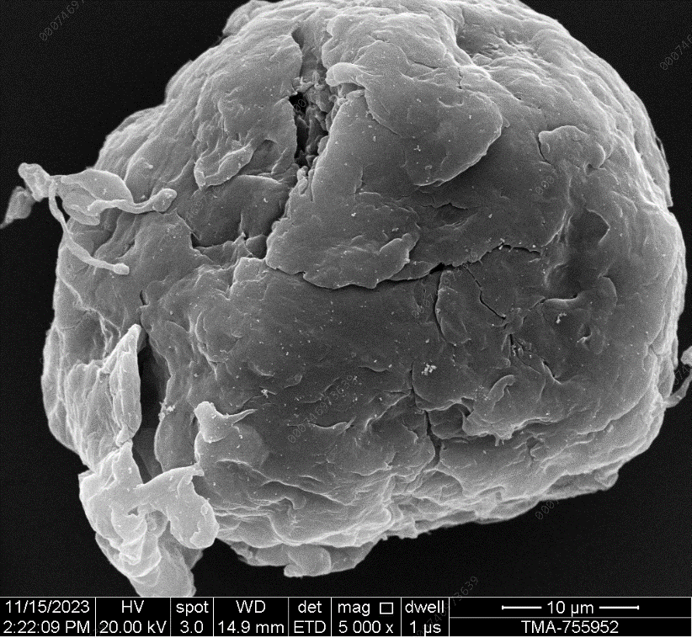 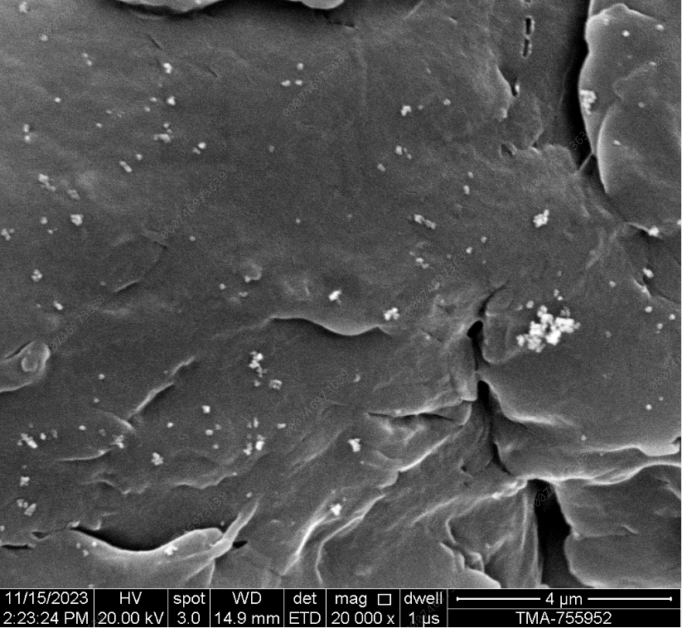
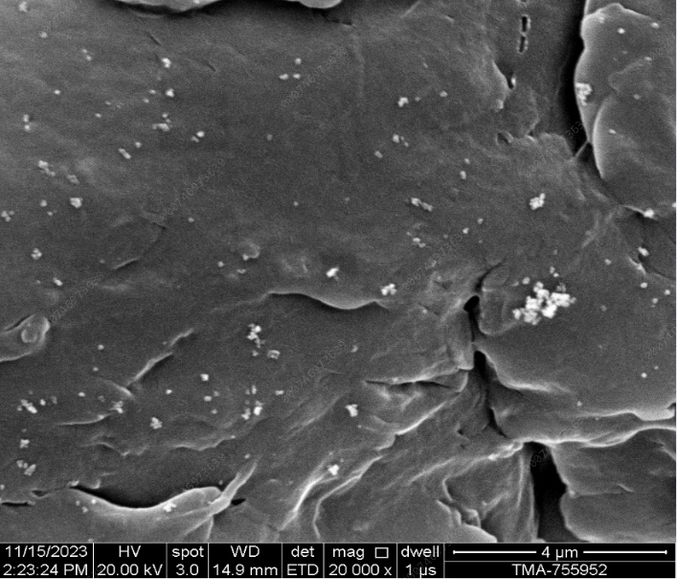
b) 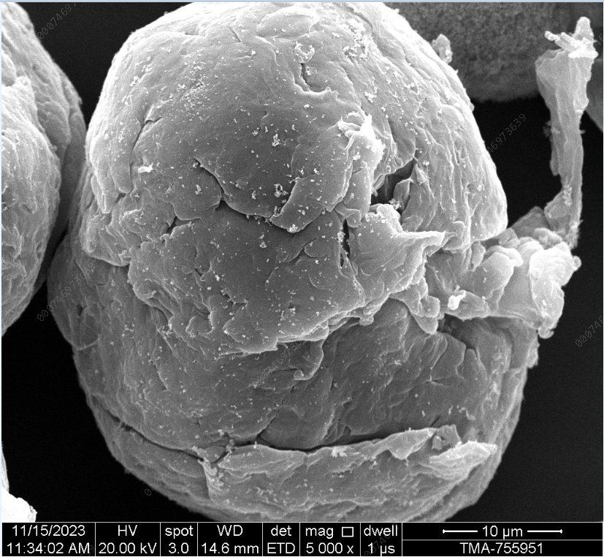 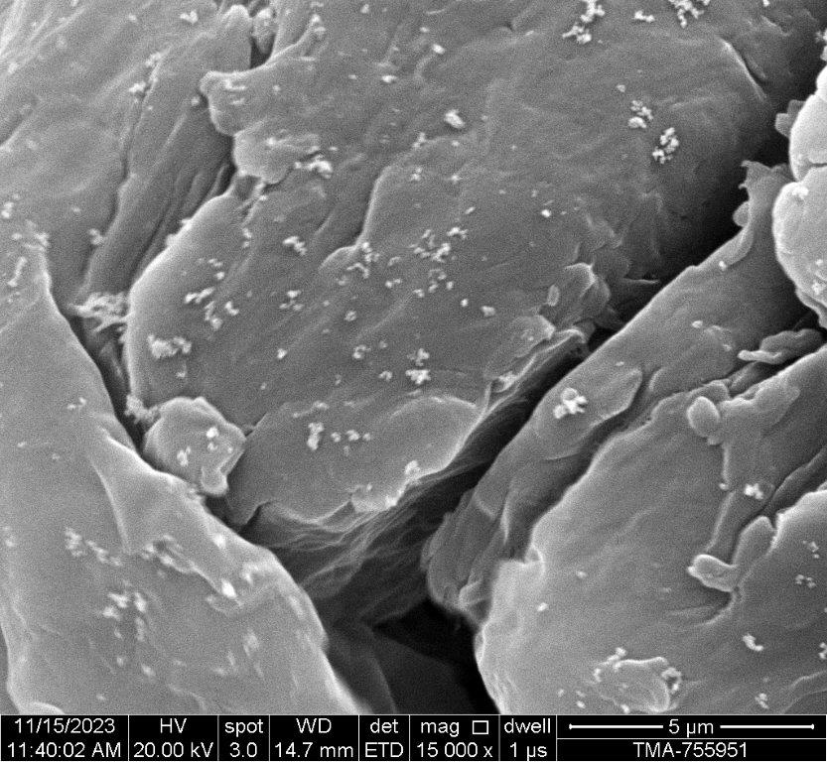

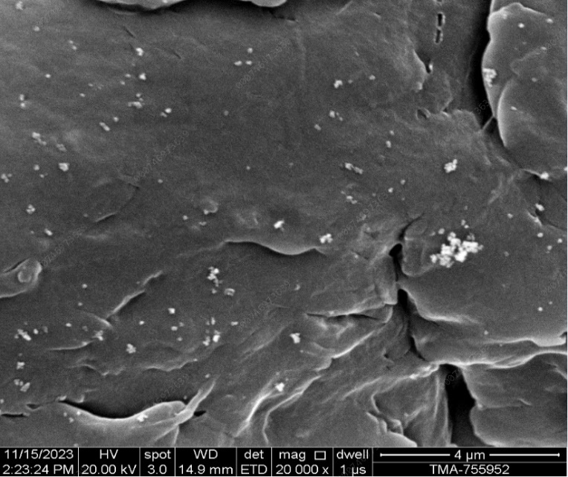
c) 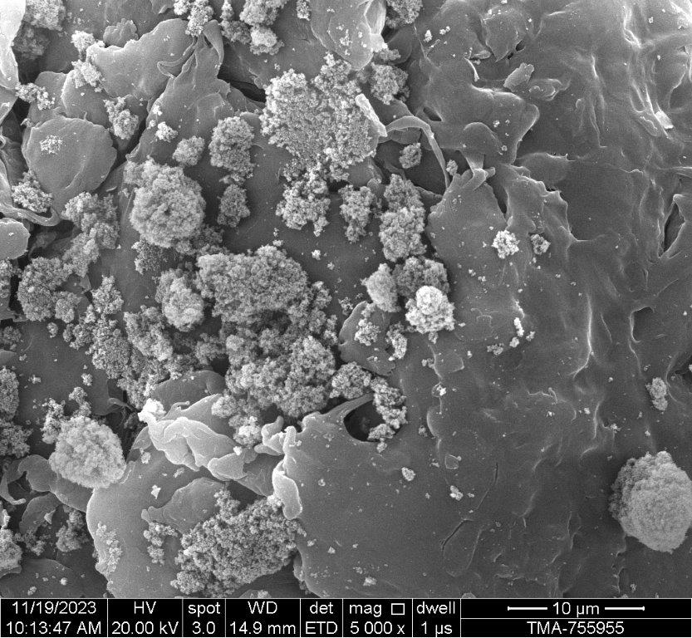
Figure ‎6.10 SEM of powders a) PP518A+0.2%wt T610, b) PP 511A+0.2%wt T610, and c) PP 518A+0.2%wt Alu C
The dispersity of the powder influences the powder flow. The powder flow will reduce when additive flow agents unevenly coat the particle's surface. The flow additive on 518 and 511 surfaces shows homogeneity of T610 flow particles on the surface, as shown in Figure ‎6.10 (a and b). The Alu C additive blend, displayed in Figure ‎6.10 (c), showed a high concentration of Alu C particles in cavities found on the particle surface, supporting the previous poor flow results.

Discussion:
This concludes, from both flow studies and powder laying trial in LS, that the addition of 0.2%wt T610 improved the powder print surface dramatically, as shown in Figure ‎6.9, confirmed by the BFE, ffc and permeability values. Therefore, PP518A and PP511A are blended with 0.2%wt T610 for final LS trials.
The BFE data shows that the highest energy value was for the T610 blends; the energy required to push the blade is higher for this blend due to the excellent compaction of the powder. The PP 518 powder showed higher BFE values than the 511, with an energy of 102.27mJ in contrast with 80.37mJ for PP511A. Nevertheless, both grades showed higher BFE values when using the T610 than the other flow additives.
Permeability pressure drop data showed the T610 blend with the lowest change in permeability, where 511 had a slightly higher pressure drop for 511 at 0.34 mBar compared to the 0.28 mBar for the PP518A.
The high ffc value for the T610 blend also confirmed the higher flowability of the powder. The 518 showed higher ffc values than the 511, where the 518 had an ffc of 10.24, higher than the 8.26 for the 511.
Overall, it was established that the T610 had better flow properties for both grades compared to the other flow additives used. This was shown by the low pressure drop with high BFE, and ffc. When comparing the grades PP 511A and PP 518A with the T610, the PP 518A showed better flow properties than the PP511. This could be related to the particle shape of the PP 518A, which contains large tails, as displayed in Figure ‎6.4, which could influence the flow behaviour of the powder. However, the variation could be negligible as both powders showed flow improvement and a similar powder bed surface.

Thermal analysis
Aim:
The aim was to identify any differences in thermal behaviour and find the sintering window for the LS process to be used as the build chamber temperature.
Methodology:
The DSC was implemented following the same method used in ‎5.2.6.1. with the test DSC test repeated three times for the two grades.
Result and discussion:
The results from the thermal analysis show that both PP grades have relatively consistent values, with a low variation in temperatures in the range of +/- 1 ˚ C. Table ‎6.4 shows PP518A has a slightly lower repeatability. Overall, the thermal values are considerably similar.
Table ‎6.4 DSC thermal analysis values for PP518A and PP11A
 | Delt Hm [J/g] | Delt Hc  [J/g] | Tm On set [˚ C] | Tm peak [˚ C] | Tm end [˚C] | Tc On set [˚ C] | Tc peak  [˚ C] | Tc end  [˚ C] | SW  [˚ C]
PP 518A Av | 91.55 | -105.16 | 156.09 | 165.11 | 168.60 | 119.70 | 115.49 | 112.61 | 36.39
SD | 6.51 | 2.94 | 2.17 | 0.27 | 0.39 | 0.12 | 0.20 | 0.31 | 2.07
PP 511A Av | 94.30 | -104.43 | 156.16 | 164.35 | 167.77 | 120.92 | 116.97 | 114.09 | 35.24
SD | 2.20 | 1.38 | 0.72 | 0.27 | 0.34 | 0.10 | 0.06 | 0.13 | 0.71

Another key parameter shown in Table ‎6.4 was the sintering window (SW). The PP 518 displayed a slightly wider window at 36.39 ˚ C compared to the 511 at 35.24 ˚ C. However, the repeatability for PP518 was higher at 2.07 compared to 0.71 for 511, suggesting a broader range of SW for the repeated tests for PP518.
Overall, the thermal analysis conducted by the DSC test shows little difference between the thermal behaviour in terms of sintering window, melt, and crystallisation temperature between 518 and 511 with changes by nearly +/- 1˚ C. The only significant difference was the "Delt H melt" which showed a difference of 2.9% from 518 and 511. However, the standard deviation (SD) value for the 518 at 6.51 shows a broader range. In conclusion, the thermal properties are similar for both grades, suggesting the appropriate part bed temperature should be the same for both grades.
The sintering window shows a processing window between 120 ˚ C and 156˚ C. The build chamber temperature must be within that range. The "Tc on set" value was used to determine the first build chamber temperature, which is usually set up slightly higher. The 511 shows a slightly higher Delts H, which may require a slight increase in energy density.
In conclusion, both grades show similar thermal properties, suggesting that the same process parameter could be used for both grades on the LS machine.

Powder LS printing
Aim:
The aim is to produce testable tensile samples for both grades and attempt to produce the same samples using the same print conditions for both grades.
Methodology:
Initially, the powder preparation was managed in 4 kg batches and placed in EOS drums designed to fit the machine into the intake system. All batches underwent a manual sieving process with a 500-micron sieve to remove agglomeration. After, the 0.2% wtT610 flow additive was dry mixed using the same method in ‎5.5.2. Each batch was placed in the EOS buckets and then attached to the feeding system; each bucket had a capacity of 5kg. The feeding system was managed manually to avoid filling the hopper with powder, reducing the chances of powder compaction, which causes a blockage in the hopper.
The LS process was implemented following the same methodology used previously in section ‎5.4.2.

Results and discussion:
Initially, the virgin 518 powder was processed on the EOS P100 machine. The attempts were unsuccessful due to the poor powder flow quality. Therefore, T610 %wt flow additives were added to both grades, which led to the improvement of the powder surface, as shown in Figure ‎6.9. This resulted in the printability of the powder after reaching Bt of 158°C and an ED of between 0.0331 and 0.0407 J/mm², as shown in Table ‎6.5.
Table ‎6.5 Laser sintering outcome for PP518A+ 0.2wt% T610.
Build | P [W] | Bt [°C] | ED [J/mm²] | Full print
B1 | 18-26 | 130 | 0.045-0.066 | No
B2-20 | 18 | 132-156* | 0.0458 | No
B21 | 16 | 158 | 0.0407 | yes
B22 | 18 | 158 | 0.0458 | No
B23 | 16 | 160 | 0.0407 | No
B24 | 14 | 158 | 0.0356 | yes
B25 | 12 | 158 | 0.0306 | No
B26 | 13 | 158 | 0.0331 | yes
B27 | 13 | 159 | 0.0331 | No
B28 | 13 | 160 | 0.0331 | No

*Bt increased by two increments from B2 up to B20
All the samples that were labelled as "No" in the "full print" in Table ‎6.5 and Table ‎6.4 failed due to delamination when the blade came across the first layer of recoating, as shown in Figure ‎6.11. Moreover, due to the high curl after laser melt during build B20, the laser powder was reduced, and the build temperature increased, resulting in the first successful build.
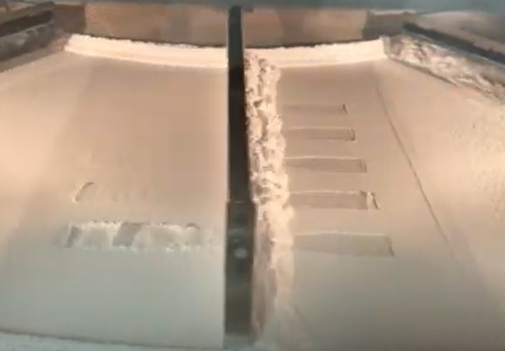
Figure ‎6.11 Build failure for PP518+0.2wt%T610
For PP518A, builds were successful with an energy density range between 0.0331 to 0.0407 J/mm² and Bt at 158˚ C.
For the PP511A, the same laser range was set up for the first build using different laser powers. The outcome of the first build showed that the 18 W power did not delaminate the sample. Therefore, after the laser power scan, the build was set at 18 W with 130 ˚ C. After the build chamber temperature was increased to 140 ˚ C, no samples were produced due to curling after the powder layer, suggesting higher Bt was required. Next, the same parameters for the successful build using PP518A were used for the next three builds, as shown in Table ‎6.6. The same successful print parameter for PP518A did not produce any parts for PP511A. Reducing the laser power showed a reduction in curling after the laser melted the PP511A powder. Laser power was reduced to 10 W, resulting in successful builds; any lower or higher than 10 W caused the build to fail.
Table ‎6.6 Laser sintering outcome for PP511A+0.2%wt T610.
Build | LP [W] | BT [°C] | ED [J/mm²] | Full print
B1 | 18-26 | 130 | 0.0458- 0.0658 | No
B2 | 18 | 140 | 0.0458 | No
B3 | 18 | 158 | 0.0458 | No
B4 | 16 | 158 | 0.0407 | No
B5 | 14 | 158 | 0.0356 | No
B6 | 13 | 158 | 0.0331 | No
B13 | 10 | 158 | 0.0255 | Yes
B14 | 10 | 159 | 0.0255 | Yes
B19 | 10 | 160 | 0.0255 | Yes
B20 | 9 | 160 | 0.0229 | No
B21 | 11 | 160 | 0.0280 | No
B22 | 11 | 158 | 0.0280 | No
B23 | 9 | 158 | 0.0255 | No
B25 | 10 | 156 | 0.0255 | No

For the PP511A, builds were successful with the parameters for laser power at 10W, resulting in an ED of 0.0255 J/mm², with the BT between 158°C and 160°C, as shown in Table ‎6.6.
During the build trials for the PP511, the increase of Bt showed a reduction of the curl, and high laser power resulted in a high curl. Therefore, dropping the laser power to 10 W resulted in successful builds. When reducing the power to 9 W, the build failed. A range of Bt between 158°C and 160°C combined with 10 W laser power produced tensile specimens for 511.
Overall, both grades successfully produce three builds, each with a different combination of ED and Bt. Despite similar thermal properties, the same process parameter could not be used for both grades. The PP511 builds only with 10 W laser power with a range of Bt 158°C to 160°C, compared to the PP 518, which produced specimens with 13, 14, and 16 W laser power at only Bt=158˚ C. This reflects how the DSC values do not always result in similar parameters in LS. However, the difference in molar mass, shown in Table ‎6.1, may lead to variation in energy inputs to sinter the homopolymer polypropylene powder. Therefore, showing the narrow PDI required less energy density to sinter, with slight tolerance to change in Bt.

Specimen characterisation

Tensile properties

Aim :
This section aims to obtain the tensile properties of the LS samples produced and compare both grades in LS.
Method:
The same methodology used in section 5.4 was followed to test the LS and IM parts to implement the tensile testing.
Results and discussion:
The results in Figure ‎6.12 for the tensile data show UTS for PP 518 was at the maximum value of 14.30 MPa at the highest energy density of 0.041 J/mm². As the energy density was reduced, the UTS and EAB values dropped. Higher ED resulted in builds failing.

Figure ‎6.12 LS Tensile data of PP518A +0.2%wt T610 (left ) vs PP511A +0.2%wt T610 (right),

Figure ‎6.13 Modulus for the PP518A+0.2%wt T610 (left) vs PP511A +0.2%wt T610 (right)
The 511 parameters that produced testable samples were obtained with different build chamber temperatures 158, 159, and 160˚ C only when using the laser powder at 10 W equivalent of ED=0.0225 J/mm². Therefore, each table had a different axis reflecting the range of parameters that produced tensile samples. The increase in Bt did not show a significant change in UTS and EAB.
Moreover, tensile data shows UTS for PP 518 was at the maximum value of 14.30 MPa at the highest energy density of 0.041 J/mm², compared to the 2.60 MPa for PP 511 at Bt=159˚ C, shown in Figure ‎6.12. The elongation for the PP 518 was slightly lower than the PP511 at 0.95% compared to the 1.06 % elongation at break. Despite the variation in the process parameters, the results clearly show that the UTS for the 518 was superior to the 511, and the elongation was slightly higher for the 511. However, the repeatability of PP511A was wider for the UTS, as shown by the error bars.
Modulus values for both grades showed that the PP 518A showed higher average values of E than the PP 511A, as shown in Figure ‎6.13. However, the high variation in repeatability of E values obtained for the 511 and 518 made it difficult to draw an outcome from the modulus. Moreover, the literature on LS PP showed more data on UTS and EAB, excluding the modulus due to the complexity of LS material behaviour.

IM vs LS tensile properties
Aim:
The aim is to find the true impact of MMD on the two grades without the presence of air voids that are present during the process of LS.
Method:
The same method was discussed in 5.4 for the IM and tensile testing was implemented in this section.
Results and discussion:
A trend appears when comparing the LS samples of 518 with the 511 with the injection moulding. Figure ‎6.14 shows that 518 has higher UTS than 511 grade, with nearly elongation values for LS and IM.
A comparison of grades 518 and 511 reveals differing trends in tensile performance between injection moulding (IM) and laser sintering (LS). For IM specimens, both grades exhibit similar ultimate tensile strengths (UTS), with overlapping error bars indicating no significant difference. Importantly, IM specimens showed no porosity, contributing to their high UTS performance. In contrast, LS specimens display distinct UTS values, with grade 511 experiencing an 80% reduction in UTS compared to grade 518. This significant disparity suggests that porosity or another key parameter, such as molar mass, is a critical factor influencing the mechanical properties in LS. The differences in porosity levels between the LS specimens likely explain the variation in UTS, underscoring the importance of assessing porosity and its impact on LS-processed materials.
Moreover, a reduction in elongation for the LS samples dropped from around 7.3 % IM to 1% for both 511 and 518 in LS. These significant drops in UTS and EAB in LS samples could be related to the LS part containing voids.

Figure ‎6.14PP518A and PP511A tensile data for IM vs LS

In conclusion, the UTS and EAB for IM fell within the error bars for the 518. However, the 511 showed an 83% drop in LS UTS values, and the EAB showed a drop of 86% in LS values for both LS grades when comparing it to the IM. Further examination of the printed specimen's porosity will show if the high porosity caused this significant drop in UTS properties.

Part density
Aim:
This section aims to identify any differences in density in the LS specimens when compared to the IM density, showing the density of voids present in the LS samples.
Methodology:
The porosity test was implemented using the same method discussed in section 5.6.2.
Results:
A comparison of the part density between LS and the IM tensile specimens shows how many voids are present in the LS samples of all builds, shown in Figure ‎6.17. The average change in density between all three sensual builds for each grade was then compared to give an overall average of the void density. PP511A blend contains the highest density difference from IM, as represented in Figure ‎6.18.

Figure ‎6.15 Density for the injection moulding (IM) vs laser sintered (LS) specimens.

Figure ‎6.16 The change in density between IM and LS. The highest density change average builds.
When comparing the average change in density in the LS samples, the average PP 511A+0.2%wt T610 has a higher change in density when compared to the solid IM sample, a change of 0.07 compared to 0.056 g/mm³ for PP518+0.2%wt T610, as demonstrated in Figure ‎6.16.

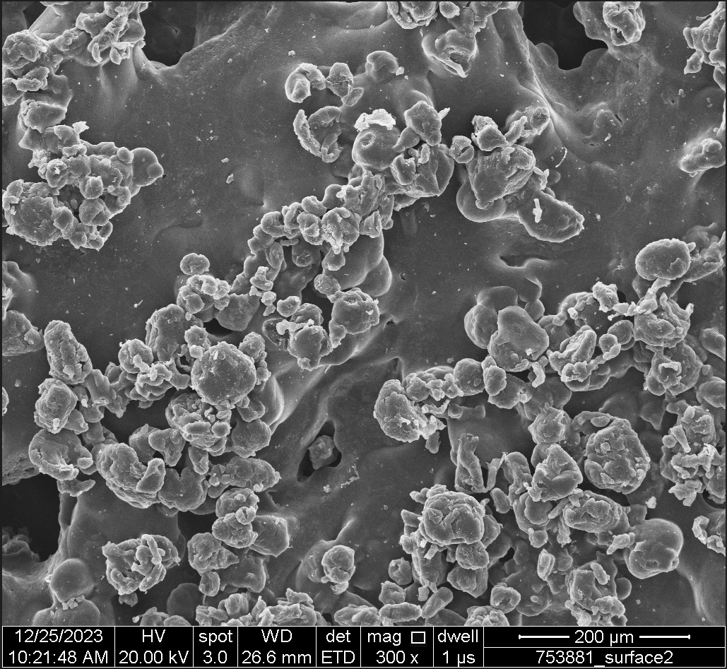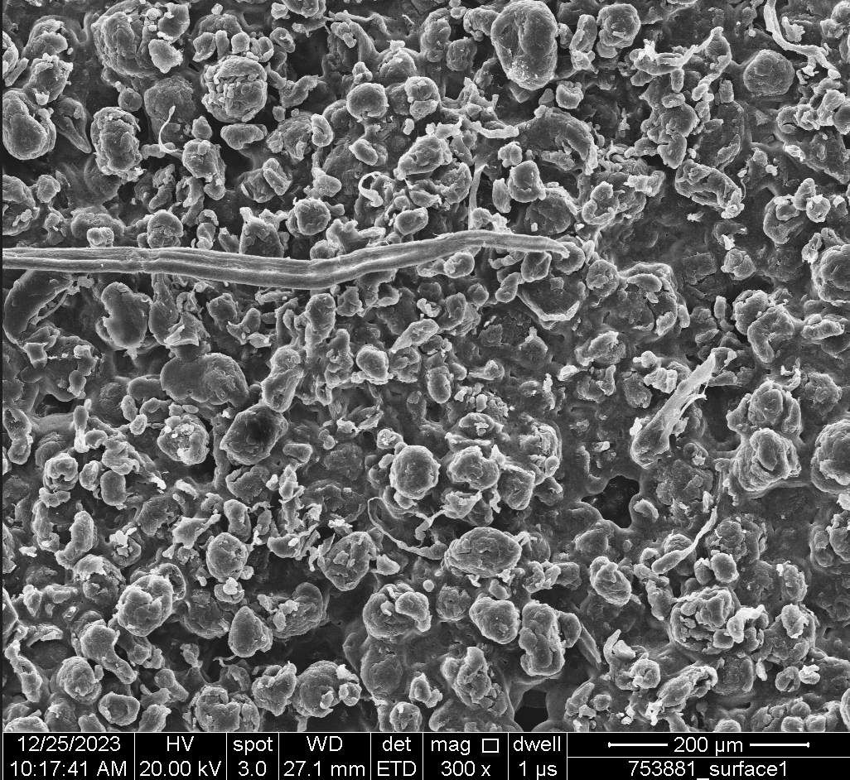
Figure ‎6.17 SEM images of 518 (left) and 511 (right) top surface.
Furthermore, the top surface SEM images shown in Figure ‎6.17, implemented following the same method discussed in ‎5.2.2, show less porosity in the PP518 with more melt fusion surface than the PP 511, which shows fewer regions of fused melt pools. The images further support the results in Figure ‎6.16, showing that the average change in density data was higher in the 511 grades.
Discussion:
The change in density shows the LS 511 specimens to have less dense tensile specimens than the 518. This also reflects on the tensile strength, illustrating a sharp drop in tensile strength, as shown in Figure ‎6.12. However, the elongation data showed similarity in values.
To further explain, using the IM data in Figure ‎6.12 for the tensile strength shows a drop for the 518 by 4 MPa and 13 MPa for the 511 when compared to LS tensile values, suggesting more voids were present in the 511 specimens. Intrinsically, without the presence of porosity in the specimens, the IM tensile values showed PP 518 to have superior UTS, with a similar trend to the LS samples.
For the elongation, both grades show a drop of around 6%, which also confirms the presence of voids in both LS parts. The change in the density of the 511 specimens was slightly greater, as indicated in Figure ‎6.16, and was re-confirmed by the SEM images in Figure ‎6.17. In addition, the energy input by the laser for the 518 was at 16 W, and for the 511was 10 W, thus resulting in less energy to melt and fuse the powder. Increasing the laser power to the 511 did not lead to a successful build, causing the parts to delaminate from the print bed. The narrow PDI impacts the viscosity of the melt net, allowing the particles to fuse and compact.
In conclusion, the LS samples showed 511 lower tensile strength, density, and consolidation of powder melt; however, both grades show a similar drop in elongation values for the LS and IM.
To further understand why the 511 underperformed with the UTS values in LS compared to IM, changes to the MMD average required further analysis.

Changes in molar mass averages (MMA) during different processes
Aim:
The aim was to investigate any changes in MMA across the processing steps from powder to IM and LS to eliminate the changes in chains causing the drop in tensile properties.
Methodology:
The GPC test was done to obtain the MMD values following the same methodology discussed in section ‎5.2.4.
Results:
From 6.20, the molar mass averaged Mn, Mw results show no difference with the virgin powder, flow additive blend, after LS, and IM for 518. After IM processing, there was a slight drop in Mz for the PP518 from 980 K to 905 K. For the 511, a similar trend was observed, with a more significant drop in all molar mass averages for the IM sample.

Figure ‎6.18 Overlay of molar mass distribution PP 511A with PP 518A in powder, LS, IM form.

Figure ‎6.19 Molar mass averages for the PP 518 and 511
When comparing the molar mass averages of 518 with 511 for LS, the Mn value shows that 518 was 25 kg/mol, compared to 511 averaging 33 kg/mol. For the Mw, the 518 was slightly higher at 210 kg/mol than the 511 at 190 kg/mol. The Mz for the 518 showed 895 kg/mol, higher than the 455 kg/mol for 511. The Mz+1 showed a similar trend to the Mz, where the 518 was higher than the 511 LS. These differences are shown in Figure ‎6.18, as a molar mass distribution curve.
All the molar mass averages fall within the error bar, suggesting no significant change, even with the addition of flow additives.

Discussion:
The results across different powder processes were similar, with no significant changes when the powder was LS. However, a slight drop in IM was noticeable in Figure ‎6.19 for the PP511A+0.2%wt T610 (IM) caused by the shear forces applied during the IM process, causing chain scission.
The significant variation in Mz and Mz+1 impacted the tensile strength, with higher chain lengths in the 518. However, the elongation values were similar for LS for both grades with the same MFI. The MFI showed more impact on the elongation values. Furthermore, no changes to the molar average for the 511 and 518, further confirm the instability of HC11 due to a sharp drop in molar mass averages noted in Table ‎5.2.
In conclusion, the MMA value did not change during the powder processing in the LS machine. This indicates that the PP511 intrinsically had a lower UTS due to the low Mz and Mz+1. Moreover, similar Mw for 518 and 511 showed the same MFI, with both grades exhibited similar elongation.

Impact of Crystallinity
Aim:
This section investigates the changes in crystallinity differences between 518 and 511 in IM, and LS samples, examining the relationship with the tensile properties.

Methodology:
The crystallinity was obtained using the DSC data that was recorded on the injection moulded and the laser sintered samples following the test method described in section ‎5.2.6.1. The lamellar thicknesses were calculated following the steps shown in section ‎5.6.4.

Results:
The crystallinity data in Figure ‎6.22 show higher crystallinity for the 518 than the 511 for both IM and LS phases. In addition, the LS phase shows the highest crystallinity compared to injection moulding.

Figure ‎6.20 Crystallinity of PP 518 and PP 511 at different phases.
The average lamellar thickness of the samples, shown in Figure ‎6.21, shows the same high values present in the average lamellar thickness (Ln), where the 518 was superior to the 511. Moreover, both samples show a drop in Ln in the injection moulding phase compared to the LS.

Figure ‎6.21 PP 518 vs PP 511 Mean lamellar thickness in different stats.
For the maximum lamellar thickness, the 518 showed higher lamellar thicknesses compared to the 511 across all phases. The IM phase again shows the lowest lamellar thickness compared to LS.

Figure ‎6.22 Maximum lamellar thickness for PP 518 vs 511 at different phases.
Discussion:
From the crystallinity data, the lowest values for the crystallinity and the lamellar thicknesses were shown for the injection moulding phase, in which the polymer was rapidly cooled, therefore, the crystallisation was reduced due to the cooling rate.
Furthermore, the maximum lamellar and average lamellar thickness was higher in the 518. The 518 showed higher Mz, suggesting the long chains increase the lamellar thickness, thus increasing the tensile strength. The lamellar thickness showed no impact on the elongation. Despite variation in lamellar thickness and MMD, both grades showed similar elongation values throughout phases with the same MFI values.
Overall, the LS samples showed the highest crystallinity due to the long period the polymer takes to cool down, allowing more polymer chains to fold compared to the rapid cooling during the IM. In addition, the 518 showed high Mz and Mz+1 values, reducing the crystallisation of the 511. Moreover, the 518 showed a high lamellar thickness, as high Mz caused longer chains to fold, increasing lamellar length.
To conclude, this case showed that high Mz and Mz+1 resulted in higher UTS, with a minimal impact on the elongation in this case. The elongation seems to correlate to the MFI and Mw. The narrow PDI for LS resulted in a more significant drop in mechanical values compared to the high PDI value for 518. The 518 SEM images in Figure ‎6.17 support this hypothesis, showing better melt fusion of the particles than the 511 grade for the LS samples.

Conclusion

In conclusion, both grades have an MFI of 25 g/10min (2.16 kg @ 230˚ C), with similar Mw, and different Mn, Mz, and Mz+1. This variation limited the powders' ability to be processed using the same LS parameters even though the thermal properties were similar. This meant that the 511 required lower laser power to produce samples. Despite the similarity in the thermal behaviours of both grades, the 511 build was successful with build temperatures between 158˚ C to 160˚ C with lower laser power, while the 518 builds were only at 158˚ C with a range of laser power 14-16 W. This reflects how the DSC values do not always result in similar LS parameters.
Nevertheless, the different molar mass averages resulted in different tensile properties for LS. 518 was superior in tensile strength compared to 511, with both grades showing similar elongation values. In this case, lower Mn, higher Mz, and Mz+1 resulted in higher tensile strength, and the same MFI and Mw showed similar elongation values.
Moreover, even with the slight variation in flow properties, the tensile values still reflected the same trend as demonstrated with the injection moulding, which did not contain flow variation or porosity in the final tensile specimen—suggesting that the tensile properties are intrinsically material inherited.
Furthermore, as demonstrated in the part density value, this molar mass combination for the 518 grades resulted in a denser LS part than the 511 samples. The SEM images show a better fusion of the particles for the 518 and a low fusion of the 511.
Finally, a relationship between the maximum lamellar and average lamellar thickness with the UTS was observed. The PP 518 A showed higher lamellar thickness and higher UTS. The 518 showed higher Mz and Mz+1, suggesting the long chains increase the lamellar thickness, thus increasing the tensile strength. The lamellar thickness showed no impact on the elongation. Despite variation in lamellar thickness and MMD, both grades showed similar elongation with the same MFI.

Impact of reusability on polypropylene LS powder
This section analysed the impact of reusability on the powder molar mass distribution. The reused powder is subjected to change during the LS process. In the literature, studies show changes to PA 12, where there is an increase in molar mass due to the nature of the polymer[52][109]. For homopolymer polypropylene, the degradation results in chain scission, however, there is very little data on the effect of ageing on molar mass when homopolymer PP is processed in laser sintering. Therefore, within this section, the ageing behaviour of homopolymer polypropylene is studied by examining the impact of reusability on the thermal, flow and molar mass properties after several laser sintering cycles.

Reusability process
Aim:
This section aimed to process the powder through the EOS P100 machine several times to obtain reused powder for characterisation.
Method:
First, mixing the flow additive, 8kg of HM20/70P was mixed with 0.2%wt Alu C, following the same method discussed in ‎5.4.3. The mixed powder was then placed in two separate buckets, each containing 4kg, and placed on the machine. The powder was then processed in the EOS P100 using the parameters that produced the highest tensile properties for the HM20/70P+0.2%wt Alu C powder.
The objective is to pass the same powder through the build for six cycles and extract 200g of powder from each cycle for characterisation. The machine requires a part to be built to process the powder. Therefore, the same build used in previous studies, following section 5.3.1 , was placed at the top of the build, resulting in 13.5 hours of build time, allowing the machine to fill the entire build chamber with used powder. The powder was then collected from the top of the build after allowing the machine to fully cool down to room temperature. Upon completion, the powder was removed from the build chamber and then passed through a 500 µm sieve and mixed for 45 minutes, following the same method discussed in ‎5.4.3. to remove any impurities of agglomerations for the next cycle. The described process is repeated six times on the same powder.
Results and discussion:
Table ‎7.1 Reusability builds for HM20/70P+0.2%wt Alu C
HM20/70P  +0.2%wt Alu C | P [W] | Bt [ ˚C] | V [mm/s] | Successful build
Virgin | 20 | 159 | 2,639 | Yes
Used 1 | 20 | 159 | 2,639 | Yes
Used 2 | 20 | 159 | 2,639 | Yes
Used 3 | 20 | 159 | 2,639 | Yes
Used 4 | 20 | 159 | 2,639 | Yes
Used 5 | 20 | 159 | 2,639 | Yes
Used 6 | 20 | 159 | 2,639 | No, powder depleted

The initial 8kg of powder was reduced to 2.66 kg after subtracting powder on the successful build samples, machine cleaning, and extraction of 200g for powder characterisation from each cycle. Due to the reduction of powder after each run, the build layer was reduced to allow as much powder as possible to pass through to the next cycle.
The 200g of powder that was collected at each run was then characterised for any variation on the following tests. Each build produced a tensile sample at the top of the build to allow as much powder to pass through. Table ‎7.1 shows that all reused powders were processed with the same parameters for all cycles. On the sixth cycle, the samples at the top of the build failed halfway through the build due to no powder left. Further characterisation of the powder will reveal any changes.

Impact of reuse on the PSD
Aim:
This section aims to examine any changes that might occur to the powder particle size distribution (PSD) during the reuse of PP powder.
Method:
The particle size was measured using the same method in section ‎5.2.1. Ten grams were taken randomly from the 200g bags and placed into the machine. A total of ten measurements for each powder sample were measured, and the same process was repeated three times using different sample batches of each powder reuse. The machine displays the averaged particle size traces of the aged powders within the D(10), D(50), and D(90) ranges.
Results and discussion:
Table ‎7.2 presents the average particle sizes of D(10), D(50) and D(90) of re-cycled HM20/70P+0.2%wt powder. The results show an increase in size for D(10), D(50)and D(90). For D(10) there was an increase from 31.9 to 34.2 µm for the virgin powder to (Used 6) powder, showing an increase of 6.7%. The D(50) showed an increase of 4.6% from the virgin powder of 66.3 µm compared to the sixth cycle particle size of 69.5 µm. However, the most significant change was observed with the D(90), with the particle size increased by 7.1% from the virgin powder at 110.7 µm to the Used 6 powder size of 119.2 µm.
Table ‎7.2 Virgin Powder vs Used 6
 | D(10) [mµ] | SD | D(50) [mµ] | SD | D(90) [mµ] | SD
Virgin | 31.9 | 0.37 | 66.3 | 2.35 | 110.7 | 5.77
Used 1 | 32.4 | 0.33 | 67.8 | 2.44 | 111.9 | 4.85
Used 2 | 32.1 | 0.36 | 68.2 | 3.23 | 115.1 | 3.94
Used 3 | 32.2 | 0.40 | 68.4 | 2.45 | 116.5 | 4.46
Used 4 | 33.6 | 0.39 | 68.8 | 3.66 | 117.1 | 5.18
Used 5 | 33.9 | 0.32 | 69.1 | 2.11 | 118.4 | 5.32
Used 6 | 34.2 | 0.36 | 69.5 | 3.53 | 119.2 | 4.51

Furthermore, Figure ‎7.1 shows a linear trend of the size increase as the powder is recycled for all percentiles. The trend line for D(10) sizes shows a very low variation in size due to the small fines measured with a low upward trend. The same trend was shown for the D(50); however, the standard deviation (SD) was slightly higher and followed a similar upward trend. Nevertheless, the D(90) showed the highest increase in size with a higher upward trend line and the highest SD, which also followed the trend line.

Figure ‎7.1 The average PSD of all the re-used powders.
The experimental findings indicate that the powder used tended towards greater particle size, although the D90 showed a higher gradient of trend increase than the tiny particles.
An increase in particle size is not desired in LS. The large increase in particle size affects the powder spreading, reduces fusion, and increases porosity. [70]
The same trend was observed in the literature for CP22 powder on the high-speed sintering (HSS) system, where the increase was related to small particles melting and fusing to large particles, thus resulting in an increase in particle size.[110] Nonetheless, the HSS uses infrared light in non-nitrogen-filled chambers. To further understand if the change shown in Figure ‎7.1 is related to fine particles melting and sticking to large ones in the surrounding powder, the powder morphology was examined next.

Particle morphology
Aim:
The aim is to identify changes in the particle morphology that may happen to the surface of the powder when the powder is used.

Methodology:
The same methodology used in section 5.2.2 was followed to carry out the SEM. Three samples were taken from Virgin, Used 1, Used 3, and Used 6 powders.

Results and discussion:
From Figure ‎7.2, the particle shapes did not change significantly when comparing the virgin powder with all the reused. They all showed similar potato-shaped particles. However, after increasing the magnification, the images showed different surface morphology. The initial virgin powder surfaces are shown in Figure ‎7.2 (a) displaced flow additives on the surface of the powder with some agglomeration zones. After the powder was used, the surface showed dispersed flow additive, with some fines fusing to the surface. The fusion effect increases for Used 3 powder, where a smoother bump forms on the surface. After the U6, the surface develops shavings, as can be seen in Figure ‎7.2 (d).

a) 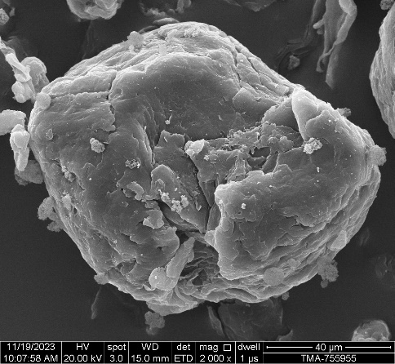 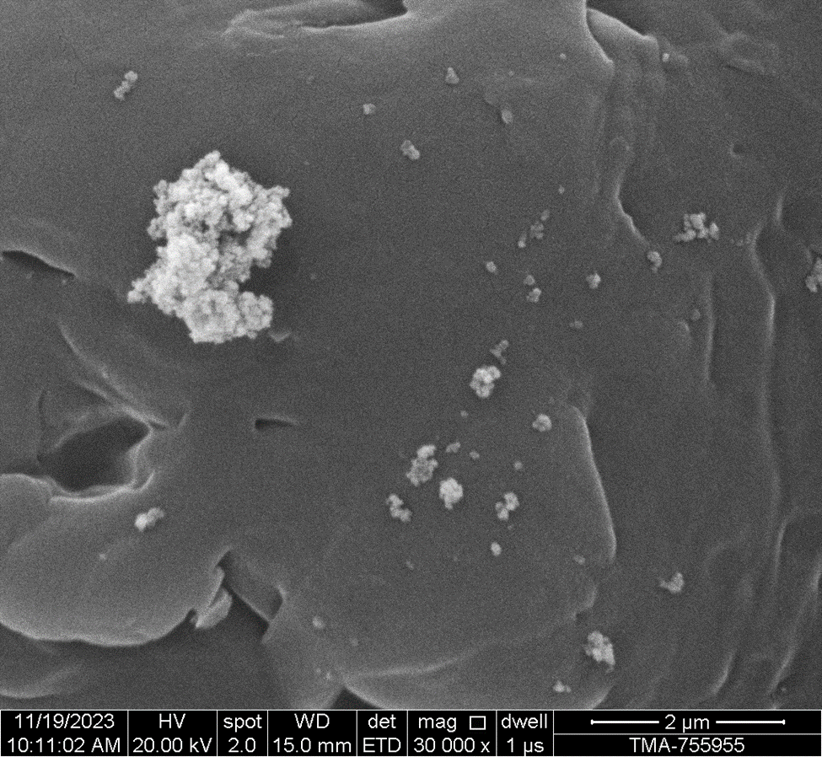
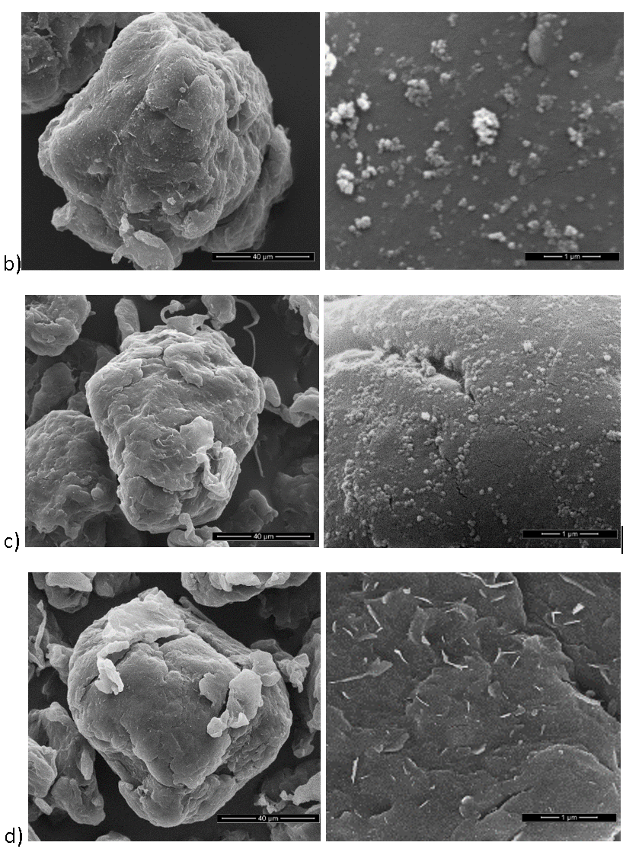
Figure ‎7.2 SEM images of a)(left) HM20/70P +0.2%wt Alu C virgin,(right) magnification to powder surface, b)the Used 1 powder, c) the Used 3 powder, d) the used 6 powder.
In conclusion, from the SEM images, there seems to be a change in surface morphology, in which the interaction with the flow additives could cause the particle size to increase when re-processed in the EOS P100 machine. Each cycle alters the formation of the surface, which may affect the powder flow. Moreover, the flow additive seems to show better dispersity and removal of agglomerates on the powder surface after the third use. Both observations may change the powder flow. Therefore, powder flow analysis may show any differences in flow due to the observed powder surfaces reported.

Re-used powder flow analysis.

Aim:
The flow analysis aims to show any difference in the flow behaviour of the used powder using the FT4 method.

Methodology:
The powder flow analysis was done using the same method discussed in ‎‎5.2.5. to obtain the BEF, Permeability, and ffc on the FT4 on each powder cycle. Each reused powder was tested three times.

Results:
The VFR test results show that the BFE had a slight increase after the first use of the powder, as shown in Figure ‎7.3, from 143 to 160 mJ, the BFE values then dropped to lower than the virgin (V) powder for the third and sixth used powder to 142 mJ and 139 mJ. The Used 6 powder showed a wider range in values compared to the other cycles.
Moreover, the permeability data indicates a pattern with a drop in the permeability from 28 mBar to 20 mBar, as shown in Figure ‎7.4. Then change in permeability increased after Used 2 to 0.21 mBar and further to 0.25 mBar for the Used 6 powder.
The ffc data demonstrated high increases in the ffc value from virgin powder to used powders, as shown in Figure ‎7.5, where the Used 6 powder increased from up to 9.45 ffc from the virgin powder at 4.87 ffc. The data shows an increase in the ffc across all used powders with a random pattern.

Figure ‎7.3 BFE of re-used HM20+0.2%wt Alu C powder.

Figure ‎7.4 PD of re-used HM20+0.2%wt Alu C powder.

Figure ‎7.5 ffc of used HM20+0.2%wt Alu C powder several cycles.
Discussion:
The VFR test results show that the BFE had a slight increase after the first use of the powder, as shown in Figure ‎7.3. This is reflected on the powder surface shown in Figure ‎7.2 (b). The powder surface showed a flow additive dispersity from the virgin powder, which contains a concentrated area of Alu C additive around the particle surface. This resulted in an increase in BFE, which reflects improvement in powder compaction. The Used 3 showed a drop of BFE to lower values than the original powder, which suggests the surface shown in Figure ‎7.2 (c) has reduced the BFE. Finally, the results show a further drop in BFE for the Used 6 samples, suggesting the surface shown in Figure ‎7.2 (d) caused the particles to interlock, reducing the powder compaction.
Moreover, the permeability shows Used 1 has the lowest change in pressure drop, suggesting better compaction, which correlates with the BFE values.
The ffc data demonstrated high increases in the ffc value from the original powder to all used powders, as shown in Figure ‎7.5. Other than the increase of ffc values in the used cycles, there is no distinct trend between the samples examined.
In summary, the powder used changed its flow properties after the first use, which then caused the flow to deteriorate due to changes found on the powder surface. The Used 1 samples showed the highest error bar in ffc value; however, the Used 3 showed the highest ffc value, suggesting the Used 3 moves freely after compaction due to the surface morphology shown in Figure ‎7.2 (c). Therefore, concluding that extrinsic properties changed after the powder was reused for the HM20/70P+0.2%wt Alu C powder, which could result in a variation in flow and compaction properties.
Next, the intrinsic properties were investigated to identify any changes that could impact the powder's mechanical properties.

Impact of reusability on thermal properties
Aim:
This section aims to show the impact of reused powder on the thermal properties of the powder.
Method:
The DSC test was implemented following the method discussed in ‎5.2.6.1. Three random samples were used from each used batch to collect: Tm peak, Tc peak, Tm on set, Tc On set, melt enthalpy/Delta H melt, and enthalpy crystallisation/Delta H crystallisation.
Results:
The results from the thermal analysis for the used powders, shown in Figure ‎7.6, illustrate a slight increase in the Tm and Tc onset, which may reduce the sintering window by a small amount; however, they are unlikely to have a significant difference in sintering quality.

Figure ‎7.6 The sintering window of the used powder.
The melt enthalpy, shown in Figure ‎7.7, displays an increase after the powder was used. The Used 1 shows a higher jump to 115 J/g compared to the line of best fit. The line of best fit shows a strong correlation with an increase in melt enthalpy.

Figure ‎7.7 Melt Delt H for the HM 20/70P as it goes through the LS cycle, 1 is the cycle before the use on the EOS P100 machine.
The crystallisation enthalpy obtained from the DSC test on the used powder showed no charge in enthalpy. However, there was an increase in Used 1, which was also noticed in the melt enthalpy.

Figure ‎7.8 Crystallisation enthalpy Delt H of HM20/70P +0.2%wt Alu C

Discussion:
The enthalpy in a DSC curve signifies the quantity of heat that is either absorbed or emitted during the process of melting and crystallisation. Within a DSC curve, the melt enthalpy represents the amount of energy necessary to induce the transformation of a substance to melt. Conversely, the enthalpy of crystallisation denotes the energy dissipated during the transition of a substance from a liquid to a solid state. The determination of these enthalpies involves the measurement of the area beneath the peaks observed in the DSC curve. Positive values are indicative of endothermic activities, such as melting, whereas negative values are indicative of exothermic processes, such as crystallisation.[111][112]
The melt enthalpy, demonstrated in Figure ‎7.7, shows a slightly increased increase in enthalpy, as more energy was required to melt the used powder, thus increasing the melt temperature, as shown Figure ‎7.6. The re-crystallisation enthalpy displayed no variation. Broad sintering windows can lead to a shift in enthalpy due to the size distribution of crystallites.[111] This results in larger lamella stacks, as shown in Figure ‎5.56, when the particles are annealed. Further examination of the crystal size distribution may determine any variation during the reuse of powder.

Change in crystallinity with reused powder.
Aim:
The purpose of this section is to describe the alteration in crystal structures of the powder that has been reprocessed.
Method:
The used powder was measured on the X-ray diffraction (XRD) machine by a Malvern Panaalytical Aeris machine, which operates by emitting X-rays onto a specimen, subsequently detecting diffracted X-rays. The diffraction pattern is then analysed to ascertain crystallographic information, thereby yielding significant insights into the structure and properties of the materials being investigated.
2θ represents the angle between the incident X-ray beam and the diffracted beam. It is used instead of θ because the diffractometer measures an angle twice that of the theta angle for practical reasons. The 2θ angle is crucial in XRD analysis as it helps in determining the diffraction pattern and provides information about the crystal structure of materials.
The powder sample is positioned within the sample holder, which consists of a ring equipped with a rear plate. The powder was further compressed using a glass slide to achieve a level surface. The specimen was thereafter positioned in the designated area within the Aeris apparatus, where grippers conveyed the specimen into the machine for the purpose of conducting XRD analysis. [113]

Results and discussion:
Typically, polypropylenes have three distinct crystalline structures known as the α, β and γ crystal phases. The monoclinic α phase is the most thermodynamically stable and often occurring phase. The trigonal β phase and the orthorhombic γ phase are two metastable variants that arise under specific conditions.[114] The XRD technique was used to analyse the crystalline structures of the original HM 20/70P+0.2%wt Alu C and the processed powder in the LS machine. The XRD patterns in Figure ‎7.9 show that all the used powders exhibit distinct peaks at 2θ = 14.08°, 16.7°, 18.5°, 21.2°, and 21.85°, which correspond to the crystallographic planes (110), (040), (130), (111), and (131) of an α crystalline phase without the presence of the other phases.[26]
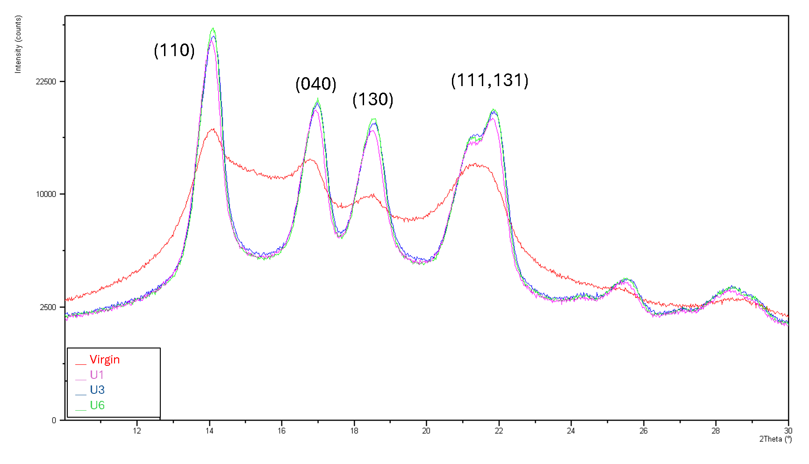
Figure ‎7.9 XRD pattern of the crystal phases for the reused powders.

The peaks observed in an XRD pattern exhibit a direct correlation with crystallinity. The strength and position of these peaks play a crucial role in determining the level of order and organisation within the crystal structure of a given material. Sharp and intense peaks are evidence of a high degree of crystallinity, whereas diffraction peaks that are broader and weaker are observed in materials with lesser crystallinity or amorphous structures. The powder used showed an increase in peak intensity as it was processed again in the LS machine.
Other studies show that the decrease of the Mw resulted in an increase in crystallinity. [115] The crystallinity increases with the mobility of the chain after the chain scission, allowing the polymer chains to rearrange in a more orderly manner. Furthermore, the lamellar stack size changes due to the shift of melt enthalpy, which increases the peak sizes as the powder is annealed. [23] Other reasons for the crystallinity increase when impurities contaminate the powder, acting as nucleating zones and increasing the crystallinity. [69]
To conclude, the XRD results in Figure ‎7.9 show a shift in the sintering window as the degree of the crystallinity increased after the powder usage. The GPC analysis may help determine if the chain scission or the impurities impact the crystallinity.

Impact of reusability on MMA
Aim
This section aims to find any changes in the MMA when the powder was processed on six repeat builds on the LS machine.
Method
The GPC test was carried out using the same method discussed in section ‎5.2.4 on the re-used powders.
Results and Discussion:
The MMD results shown in Figure ‎7.10 showed no change when the powder was reused up to six cycles. Molar mass averages are further expressed in Figure ‎7.11, numerically displaying the averages that are not visible in the distribution curves.

Figure ‎7.10 Molar mass distribution of reused HM2/70P+0.2wt% Alu C powder

Figure ‎7.11 Molar mass Averages of reused HM2/70P+0.2wt% Alu C powder
Table ‎7.3 Shows all the MMA and PDI of the reused cycles.
Sample | Mn  [kg/mol] | Mw  [kg/mol] | Mz  [kg/mol] | PDI
Virgin | 31 | 188 | 535 | 6.2
Used 1 | 28 | 190 | 540 | 6.8
Used 2 | 29 | 191 | 543 | 6.8
Used 3 | 27 | 193 | 560 | 7.0
Used 4 | 26 | 190 | 536 | 6.4
Used 5 | 29 | 194 | 554 | 6.7
Used 6 | 28 | 190 | 535 | 6.9

The result from Table ‎7.3 shows the MMA and PDI of all the cycles of the reused powders. The results show no significant changes that occurred during the reusability of the powder to the molar mass averages and the PDI.
Most studies examining the PP's reusability in injection moulding and extrusion show no changes to the MMD values, up to a point, due to the polymer chemical structure.[69][100][110] In the case of PA12, the polymer chains seem to increase in mass due to the nature of the polymerisation via polycondensation, which causes the molar mass to increase during the reuse in LS. [70] [116] In the case of PP, changes to polymer chains occur during process conditions with elevated temperatures and a high share rate, leading to chain scission, resulting in a reduction of molar mass impacting the mechanical properties.
In the case of LS, these extreme conditions are not present in the surrounding powder. Nonetheless, the build-up of thermal stresses adds up on each cycle of the powder. For PP, changes start to appear after several cycles when heat stabiliser additives are depleted, as shown in a study where PP was injection moulded for up to twenty cycles [100]. The decrease started after the tenth Injection moulding cycle, where Mw and PDI decreased due to chain scission. Depletion of additives such as heat stabilisers in PP can result in polymer degradation, causing changes in the mechanical properties. [69] Heat stabilisers protect PP from thermal degradation by inhibiting the formation of free radicals and preventing chain scission. When heat stabilisers are depleted, PP can become more susceptible to thermal degradation, leading to changes in its mechanical properties, such as reduced tensile strength and elongation. However, in LS the process is less extreme; therefore, HM20/70P+0.2%wt Alu C powder showed no change in molar mass averages when the powder was reused up to the sixth cycle.
Moreover, the lack of change in polymer chains shows the stability of the powder despite the slight changes in melt enthalpy, and the crystallite is a temperature-dependent. Therefore, it may change depending on the process. If the enthalpy increases, more energy is needed to melt the powder from the LS system. However, the molar mass averages remained constant throughout the reused cycles of powder. Therefore, the change in melt enthalpy is negligible to the degradation of the reused powder but may impact the process conditions.

The impact of reused powder on the tensile data

Aim:
The aim of this section is to show any changes in tensile values for the reused powder on the LS samples.

Method:
The same method used for the previously tested tensile samples, explained in section ‎5.3.2, was implemented to test the LS tensile samples of the used powder.

Results and discussion:
The results of the UTS and EAB, in Figure ‎7.12, show no significant change in values when the powder was reused. Moreover, the modulus data, shown in Figure ‎7.13 did not indicate any change to the reused powder.
Furthermore, the tensile results show that the changes observed in the extrinsic properties, such as particle size and surface morphology, did not have a significant impact on the tensile data of the reused powder when reused up to six cycles.

Figure ‎7.12 UTS and EAB for reused powders

Figure ‎7.13 The Modulus tensile data of the reused powder.
Moreover, the slight increase in melt enthalpy of the powder did not impact the tensile data. In conclusion, the HM20/70P+0.2%wt Alu C showed stable tensile values up to the fifth use.

Conclusion
In conclusion, the homopolymer polypropylene did not show changes in molar mass values. The LS process used for each cycle did not impact the MMD values up to the sixth cycle. The heat stabiliser additive seems to preserve the PP powder from chain scission. Furthermore, crystallisation increases randomly when the powder is re-used. The random increase in crystallisation is a result of impurities, as other studies have shown similar trends. [117][118]
Furthermore, The changes were shown in the extrinsic properties, where the large particle size showed a slight increase, impacting the powder flow properties up to a point. Moreover, the particle surface morphology showed changes to the surface, which improved the flow after the first use. The surface changes kept occurring, resulting in a reduction in flow properties after the first use, as shown in Figure ‎7.2. Nevertheless, the dimensions and surface morphology of PP particles may vary throughout the reuse step; however, there was no impact on the mechanical properties, as shown in Figure ‎7.12.
Moreover, the thermal properties showed a slight increase in melt enthalpy as the powder was reused. This change did not impact the tensile data up to the fifth cycle. Further increasing the reuse cycles could be problematic as the thermal stress accumulates in the LS process. Other processes with extreme shear melt and high temperatures reported an increase of MFI due to chain scission after the fourth cycle due to heat stabiliser depletion. [69] [100]
To conclude, the powder used showed no significant intrinsic changes to the MMD, and there was a slight increase in melt enthalpy. Changes were observed due to impurities contaminating the powder after processing the powder through the LS machine or due to changes in process conditions. Furthermore, the reused powder showed changes in extrinsic properties such as powder size, surface and flow without impacting the tensile properties of laser sintering HM20/70P+0.2%wt Alu C up to the fifth cycle. Further cycles were not achievable due to powder depletion at the sixth cycle.

Further discussion
This section will discuss the effects of different molar mass averages on laser sintering processability and tensile properties for all the powder grades that have been investigated in chapters 5, 6, and 7.
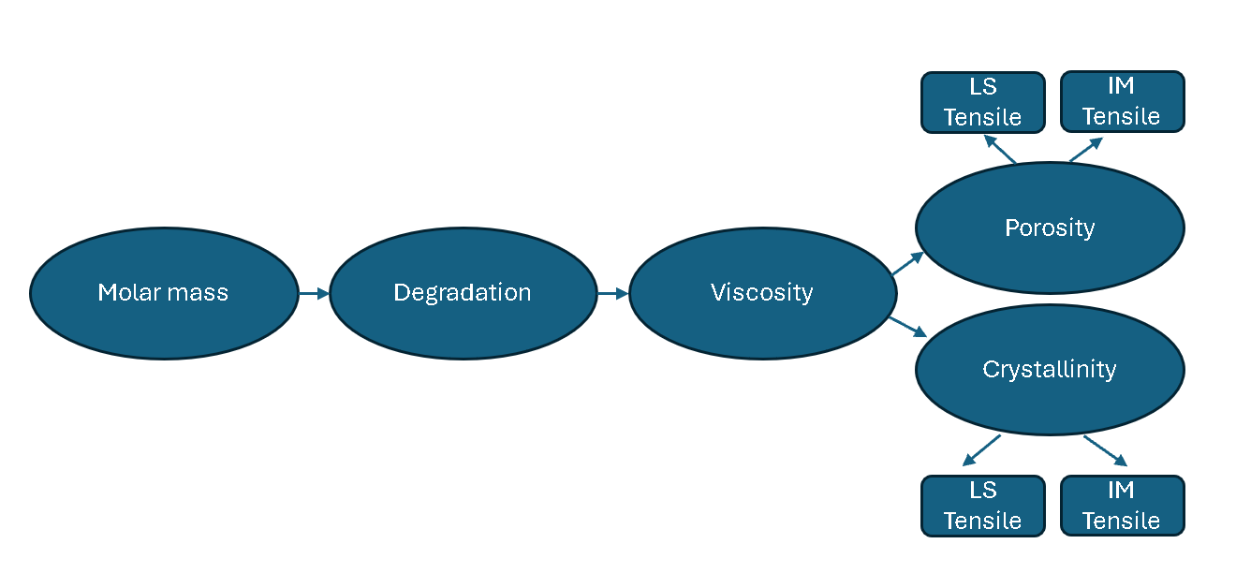
Figure ‎8.1 Flow chart showing the sequential link between MMD and Tensile properties
From the molar mass to the tensile properties, a large number of variables may impact the mechanical properties; however, intrinsically, To identify a direct correlation between molar mass and the final measured properties, a sequential analysis is presented where claims of relationship and rends are directly supported by the experimental data, which are shown in Figure ‎8.1.
The flow chart in Figure ‎8.1 shows a series of direct sequential effects of molar mass properties, that subsequently affect the tensile properties of the produced tensile specimens. The first impact may be related to the degradation of the polymer, which may occur during the cryogenic grinding process. The drop in HC 11 molar mass proves that grinding resulted in a drop in MMA of the HC12 grade when polymer additives were not used. However, the 511 and 518 did not show a drop in molar mass averages, as shown in section 6.3.4. Nevertheless, the reusability of the powder can further alter and degrade the polymer chains, according to a study by Aurrekoetxea et al.[69] showed a drop in molar mass after running the PP in injection moulding after four cycles, claiming the stabilisers were depleted after that point. This concludes that the Molar mass changes up to a point with PP when reprocessed.
Furthermore, changes to the molar mass of the PP after grinding may affect the viscosity of the polymer due to the chain session. However, the viscosity is temperature and pressure-dependent, making the values absolute and difficult to draw a conclusion from. The physical pressure during LS is non-existent; therefore, it is negligible in LS. Alternatively, the MFI provides a constant measurement where all the grades can be compared with a standard temperature and load rather than using the build temperature and laser speed to measure the viscosity during LS process.
All grades have different MFI’s, which relates to the overall MMD average configuration. A comparison between each grade tensile with MFI in LS and a comparison of the difference between LS and IM tensile values shows the influence of the processing with different MMD.
Porosity is affected by the powder melt viscosity and how the powder flow influences the fusion between the particles. Therefore, the impact of porosity on the UTS and EAB in LS is compared to the IM tensile data, indicating the impact of MMD on the different key properties, such as porosity in LS and how it differs from IM material inherent mechanical properties without the porosity.
The other key property related to the inherent mechanical properties is crystallinity. Cryistanilty is a complex process that is affected by polymer structure properties, additives, processing temperature and cooling rate, making it challenging to predict. For this reason, the crystallinity of the final LS articles is used to compare crystallinity with the grades of the LS properties. However, due to the porosity in the LS sample, the inherent tensile properties may not be fully represented. Therefore, the IM samples will be compared to the LS sample, which shows the impact of the process on the inherited tensile properties.

In addition, this section aims to identify any trend with key properties that impacted the tensile data from the previous results, such as crystallinity and lamellar length. Moreover, the modulus data was excluded from this section due to high variation in repeatability, making it inconclusive.
Table ‎8.1 Summary of MMA, MFI, PDI, tensile data and density change of LS grades
Material | MFI | Mn [kg/mol] | Mw  [kg/mol] | Mz [g/mol] | Mz+1 [g/mol] | PDI | UTS  [MPa] | EAB  [%] | Density change/ Porosity
HM20/70P* | 50 | 34,910 | 169,111 | 451,534 | 1,014,283 | 4.87 | 16.07 | 1.83 | 0.032
CP 20* | 20 | 13,708 | 130,447 | 452,153 | 8,438,739 | 9.8 | 9.79 | 0.60 | 0.044
PP 511A | 25 | 60,000 | 215,000 | 478,000 | 793,000 | 3.52 | 2.60 | 1.06 | 0.070
PP 518A | 25 | 34,893 | 221,080 | 600,000 | 1,100,000 | 6.34 | 14.30 | 0.95 | 0.056

Furthermore, to statistically show any linear relationship, the R-squared (RSQ), also known as the coefficient of determination, was used to statistically determine if each average and other key properties have a strong correlation with the molar averages. The RSQ measures the variance in the dependent variable that is predictable from the independent variables. The RSQ value provides an indication of how well the data fits a statistical model with values lying between 0 and 1, where values close to 1, indicate a good fit.

Viscosity

Effect of MFI on the laser sintering process
The MFI is an intrinsic property that showed no direct impact on extrinsic processability properties, such as the powder flow of all the sintered powder. The results from Table ‎8.1 highlight that MFI correlates with the melt viscosity. A higher MFI generally indicates better flowability, which is crucial for the laser sintering process. However, similar MFIs do not always indicate the same outcome as shown in the case of 518 and 511. The 518 was processed at an energy density ranging from 0.0331 to 0.0407 J/mm², compared to the 0.0225 J/mm² for the 511 powder, showing a wider energy density to process in LS. The porosity is also lower for 518, with 0.056 g/cm² than the 511, with 0.07g/cm². The difference in process conditions is caused by the high Mz and Mz+1 in the 518.
Furthermore, the reusability of the PP powder did not show any significant change to all MMA; therefore, the MFI can be assumed to have remained the same for up to the sixth cycle for PP in LS in this study.

Effect of MFI on the tensile values
Figure ‎8.9 shows a trend line when the MFI increases, the UTS and EAB increase. During LS, the higher melt viscosity creates a higher surface tension during the melt phase, thus creating more voids and not allowing the powder particles to fuse fully. Furthermore, the interaction of the melt surface merging may not fully fuse due to the high surface tension present in low MFI samples, creating weak weld lines in the sample, especially when there is no shear force exerted on the melt. Moreover, the two grades with the same MFI showed a significant difference in UTS; however, the EAB showed similar values, indicating that the MFI is not always an accurate representation of the UTS. There is a significant difference between the two grades with the same MFI, as shown in Figure ‎8.9. Furthermore, the IM values, shown in Figure ‎8.10, showed a similar trend to the LS tensile values with a stronger correlation that was less scattered than the LS sample, confirming the trend of the MFI with the UTS and EAB in the LS process.

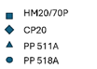
Figure ‎8.2 MFI Vs UTS and EAB for all the LS samples.
Figure ‎8.3 MFI vs. UTS and EAB for the IM samples.
The overall combination of all the molar mass averages must be considered to determine the impact of tensile properties; however, the MFI gives an overall outcome based on those averages. The data for the single molar mass average that impacts the tensile properties are shown in Appendix A. However, no strong correlation was identified with single molar averages. In this study, the laser sintering of MFI between 20 and 50 g/10minutes (2.16 @ 230˚ C) showed an upward trend in UTS and EAB, yet the two grades with the 25 MFI gave different UTS values. Therefore, the MFI does not reflect the variation in averages that impact the UTS and EAB. Similar MFI showed different UTS, which can be misleading, reflecting the influence of porosity in LS. The high MFI showed an upward trend with the UTS and EAB, even with IM suggesting that without the porosity, the high MFI results in superior tensile properties inherently, with the exception of PP 511 and 518 due to a wider PDI.
Moreover, statistically, the UTS shows a low correlation of RSQ value of 0.32 with MFI and a high correlation of EAB at 0.95 RSQ, for LS. However, for IM the RSQ was 0.79 for EAB, and 0.93, indicating a stronger RSQ correlation for LS and IM for EAB.

Polymer dispersity

Effect of polymer dispersity on laser sintering process
The polymer dispersity is an intrinsic property which showed no direct impact on the extrinsic processability properties of the powder before sintering for all grades. The effect of polymer dispersity is observed only during the melt phase of the polymer during sintering. The results from Table ‎8.1 highlight that polymer dispersity does not correlate with MFI, but does with the Mz+1, as higher Mz+1 broadens the distribution. A higher dispersity generally indicates better flowability, which is crucial for the laser sintering process. The high dispersity shows the presence of long and short chains that aid the melt flow of the polymer. The same MFI may have different dispersity values, as shown in the case of the 518 and 511. The difference was shown by the energy used to sinter the powder. The 518 was processed at an energy density ranging from 0.0331 to 0.0407 J/mm², compared to the 0.0225 J/mm² required for the 511 powders. The presence of the higher chains requires more energy to melt the 518 powder. The impact of polymer dispersity is shown by the 518, displaying a change in density of 0.056 g/cm² compared to the 511 grade with 0.07g/cm². This reflects the ease of melt flow for the highly polymer dispersed grade.
Furthermore, the reusability of the PP powder did not show any significant change to all MMA; therefore, the dispersity will remain the same for up to the sixth cycle for PP in LS in this study.

Effect of polymer dispersity on the tensile values
Figure ‎8.4 displays a trend with the polymer dispersity (PDI) values, where there is a peak in the UTS and EAB for the LS samples at around 4.87 PDI. Moreover, the two grades with similar MFI, vary in values for PDI where PP 518 has a PDI of 6.34 and 511 with 3.52, showing different UTS and EAB, as shown in Figure ‎8.4, where higher PDI resulted in superior UTS but similar EAB. Furthermore, Figure ‎8.5 reflects a similar pattern with a higher UTS and EAB peaking at PDI 4.87 for the HM20/70P when injection moulded.
Moreover, a similar outcome was observed in the study conducted by G. Kurt et al. [119], which concluded that homopolymer PP with different PDI showed an increase of creep strain by 35% when PDI was increased from 2.92 to 4.25 using compression moulding, showing similar values to the peak PDI of 4.87 in this study. However, there are no other detailed studies to compare the PDI with the PP solid-state tensile properties in LS. In conclusion, the MFI showed a trend with the UTS and EAB; however, similar MFI grades show different PDI, which showed differences in UTS.

Figure ‎8.4 PDI vs. the UTS and EAB for LS samples

Figure ‎8.5 PDI vs the UTS and EAB for IM samples
Therefore, the PDI showed changes that were undetected by the MFI. However, statistically, the correlation was low, with RSQ of 0.06 and 0.41 for the UTS and EAB, respectively. For IM, the UTS of 0.4 and for EAB a 0.59 RSQ. Showing a weak trend for UTS but a high EAB for IM.

Crystallisation

Effect of crystallinity on the laser sintering process

Crystallinity is an intrinsic property that has no direct impact on the processability of all the sintered powder in relation to powder flow. Conversely, during the sintering process, high crystalline PP is more susceptible to curl; this is why low crystalline polymers are more desirable for LS; however, high crystallinity increases the mechanical properties of the polymer. Moreover, the cooling rate of the polymer impacts the crystallinity in the final solid article. Faster cooling results in low crystallinity, as there is less time for the chains to align during the cooling process. In this study, the cooling was implemented using the same method for each LS process, thus eliminating the variable for the cooling rate.

Effect of crystallinity on the tensile values
From Figure ‎8.6, the increase in crystallinity did not show a trend in UTS or EAB; however, the HM20/70P+0.2%wt Alu C showed the highest UTS and EAB with 53% crystallinity.

Figure ‎8.6 Percentage of crystallinity vs. the UTS and EAB in LS specimens

Figure ‎8.7 Percentage of crystallinity vs. the UTS and EAB in IM specimens

When comparing the crystallinity data between LS and IM, as shown in Figure ‎8.6 and Figure ‎8.7, the observed differences can be attributed to the cooling rates inherent to each process. IM, characterised by a rapid cooling rate, results in lower crystallinity values as the polymer melt has less time to organise into a crystalline structure. Conversely, LS involves a slower cooling process, allowing more time for crystallisation and thereby achieving higher crystallinity values.
Furthermore, the data reveals that in LS, higher crystallinity does not necessarily correspond to the highest UTS or EAB. This suggests that porosity, which is often prevalent in LS specimens, plays a more significant role in determining the mechanical properties than crystallinity alone. The presence of pores can weaken the material's structure, thus limiting its UTS and EAB despite higher crystallinity.

Finally, no trend was observed on the crystallinity of laser sintering that impacted the UTS and EAB with a RSQ of 0.03 and 0.01, respectively. The IM showed an RQS of 0.68 and 0.58 for UTS and EAB, respectively. Crystallisation is a temperature-dependent. The orientation of crystals can significantly affect the tensile properties. Crystal structures take different orientations and forms that may impact the outcome of tensile values. The alignment of crystal grains can lead to anisotropic behaviour, resulting in different strengths in different orientation directions, making it difficult to predict. [120] From this study, the crystallinity was random, with no trends. Many variables, including molar mass averages, make it complex and difficult to predict. On the other hand, in IM specimens, the relationship between crystallinity and mechanical properties is more direct. Higher crystallinity values in IM specimens lead to improved UTS and EAB, likely because the rapid cooling minimises porosity and results in a more uniform structure. This highlights the interplay between processing conditions, crystallinity, and mechanical performance, with porosity being a critical factor in LS and crystallinity having a dominant influence in IM.

Effect of lamellar length on the tensile values
The maximum lamellar length shows a trend where an increase is observed in the UTS and EAB, as shown in Figure ‎8.14, with the UTS plateauing as the lamellar increases to 16 MPa at the maximum lamellar length of 30.80 Å for the HM20/70P sample. Moreover, the EAB showed an increase with an offset of the PP511+0.2%wt T610, showing higher elongation at 1.06 % at around 22 Å L max. The studies indicate that the higher the lamellar thickness, the more energy is required to pull them apart, resulting in higher UTS and EAB.
This study showed results similar to those of the literature by Stern et al.[16] states that the lamellar thickness governs the tensile stress as well as the strain hardening effect rather than the overall crystallinity when PP was IM. However, the Mw did not increase with lamellar thickness with Mw in LS.

Figure ‎8.8 Maximum Lemalle length vs UTS and EAB in LS

Figure ‎8.9 Maximum Lemalle length vs UTS and EAB in LS
Figure ‎8.8 and Figure ‎8.9 illustrate the relationship between the maximum lamellar length and the tensile properties, UTS and EAB, for LS and IM properties. In the LS samples, it is evident that as the maximum lamellar length increases, both the UTS and EAB improve significantly, indicating a positive correlation between Lmax and mechanical performance. This suggests that the structural arrangement facilitated by the lamellar length in LS has a substantial impact on the tensile properties.
In contrast, the IM samples exhibit a UTS, and EAB remains similar within the error bars for most materials except HM20/70, which shows a notably higher UTS and EAB than the others.
The laser sintering maximum lamellar length (L max) showed an RSQ of 0.7 and 0.73 for the UTS and EAB, respectively. This reflects a strong link in LS compared to the low 0.34 and 0.001 for IM, respectively.

Porosity

Effect of porosity on the laser sintering process
Prior to the melt of the PP powder in the LS system, several key properties may influence the porosity of the final article, such as particle size distribution and particle shape. These powder features play a role in the size of air pockets present in the powder before melting with the laser. The larger the void, the longer it takes to fuse the particles together, resulting in higher porosity. This can be represented by the permeability values obtained of the powder.

Figure ‎8.10 Permeability vs porosity
Figure ‎8.8 shows CP20 has the highest porosity 0.044 g/cm³, and permeability 0.88 mBar, indicating less dense packing of particles. HM20/70P+0.2%wt AluC shows a lower porosity of 0.032 g/cm³ and permeability of 0.33 mBar, suggesting better particle packing and fewer voids. Grades 511 and 518 follow the general trend where lower porosity corresponds to lower permeability. 518, with better packing and fewer voids, shows superior mechanical properties compared to 511, reinforcing the importance of optimising porosity and permeability to achieve high-performance LS parts; however, the fines and bimodal particle size distribution of CP20 effectively reduce porosity compared to the 511 and 518 grades which create conditions that increase permeability. The results show that even with low permeability, the porosity outcome may vary due to viscosity changes during the melt.

The effect of porosity on the tensile values.
Porosity is a critical factor influencing the mechanical properties of materials processed through LS, particularly their tensile performance. High porosity in sintered materials introduces voids and defects that act as stress concentrators, significantly reducing ultimate UTS and elongation at break EAB. These voids disrupt the continuity of the material, weakening the inter-particle bonds and limiting the load-bearing capacity of the sintered structure. Furthermore, increased porosity correlates with reduced density, compromising the overall stiffness and durability of the material. Studies have also shown that optimising parameters such as particle size distribution, build temperature, and laser energy density can minimise porosity, leading to enhanced tensile properties.

Figure ‎8.11 UTS vs porosity

Figure ‎8.12 EAB vs Porosity
Figure ‎8.9 and Figure ‎8.10 highlight the critical influence of porosity on the tensile properties of LS specimens. Among the tested grades, HM20/70P+0.2%wt AluC demonstrated the best performance with the highest UTS of 16.07 MPa and EAB of 1.83%, attributed to its low porosity, efficient particle packing, and optimised processing conditions. 518+0.2%wt T610 achieved a high UTS of 14.30 MPa but a lower EAB of 0.95%, reflecting strong particle bonding but slightly reduced flexibility due to its marginally higher porosity. In contrast, CP20 showed moderate UTS 9.79 MPa and the lowest EAB 0.60%, influenced by its bimodal particle size distribution and higher porosity, which compromised its tensile performance. 511+0.2%wt T610 exhibited the weakest tensile properties, with the lowest UTS 2.60 MPa and an EAB of 1.06%, largely due to its high porosity and poor particle fusion. These results underscore the importance of minimising porosity and optimising melt flow properties to enhance tensile strength and flexibility in LS applications.
The RSQ values for the tensile values against the porosity show a value of 0.62 for the UTS, and for the EAB, a lower value of 0.022. This indicates a higher linear relation of porosity with the UTS than with EAB.

Figure ‎8.13 Ultimate Tensile Strength for IM vs LS

Figure ‎8.14 Elongation at Break for IM Vs LS
The comparison of UTS and EAB for LS and IM reveals distinct sensitivities in mechanical properties for LS. EAB shows a consistently lower value in LS compared to IM across all materials, indicating that LS is more sensitive to elongation-related properties due to the brittle structures formed during the slower cooling process with the addition of porosity. In contrast, the behaviour of UTS between LS and IM is more variable. For instance, material 511 shows a significant drop in UTS for LS, which is linked to its high porosity, as highlighted in Figure 8.12. Porosity creates voids that weaken the material's ability to bear loads, making UTS more affected in LS. However, materials like 518 exhibit less pronounced differences in UTS between LS and IM, suggesting that other factors, such as porosity, influence the variability. Overall, while EAB demonstrates a similar pattern for LS with IM at much lower values, the UTS trends are more random, with porosity playing a key role in tensile properties duction, such as in the case of 511.

Conclusion
For the first time, this study showed novel work on how a single chain homopolymer PP length had an impact on the tensile values of an LS process. This study aimed to identify the influence of the polypropylene chain length on the effect of laser sintering on different grades of polypropylene. Several significant findings were identified; they are concluded as follows:
- Effect of MFI on the porosity
Porosity affects the density of the sintered part—increased porosity results in a lower density, which impacts the part integrity. When comparing the porosity with tensile data, the UTS and EAB showed a drop as the porosity increased. Furthermore, this drop in tesnile values is more significant for EAB than the UTS values, as shown when comparing the IM with the LS tesnile data, suggesting EAB is more sensitive to LS process. This is due to pores acting as stress concentrators, which can initiate cracks and lead to premature failure. The IM samples showed higher tensile values than the LS due to porosity. This study showed that higher MFI with a broad dispersity increases UTS and EAB for homopolymer isotactic polypropylene powders. Laser sintering is a rapid process that occurs in a short time with a high burst of laser energy. For this reason, high melt flow is desired and achieved by high MFI and broad dispersity to reduce porosity.
- Effect of MMD on thermal properties
The study between the 518 and 511 showed similar thermal values in the DSC; however, each was laser sintered with different parameters. This reflects how the DSC values do not always result in similar parameters in LS. However, the difference in molar mass led to variation in energy inputs to sinter the homopolymer polypropylene powder. Therefore, showing the narrow PDI required less energy density to sinter, with slightly lower tolerance to change in Bt.
- Effect of flow additives
Flow additives are necessary to enhance powder flow during the LS process. The silica base flow additives serve as a nucleating agent by increasing the crystallisation rate and altering the spherulite size, which impacts the mechanical properties.[121] This study concluded for the first time that the low dose of 0.2%wt of flow additive had no significant impact on the tensile values in laser sintering. Mahdi et al. [104] showed that after 10%wt of fillers, the mechanical properties are affected.
- Impact of melt additive on preserving MMD during processing
The HC 12, required further grinding to finer powder to produce HC 11, to meet the LS powder size requirement. The HC11 powder failed during LS due to the lack of any melt additive that could preserve the polymer, which caused the chains to degrade during grinding, resulting in excessive curling during LS. This was proven by showing significant changes in the MMD after grinding.
Furthermore, the HM20/70P powder was examined by looking at the impact of reusing the powder on six cycles. The results showed a slight increase in the particle size D90, the sintering window, and an improvement in powder flow. There was a change in the powder surface, and different surface defects appeared after the cycles, which developed into shaving, leading to a reduction of powder flow. Also, a random increase in crystallinity was related to contamination by impurities when the powder was reused. No significant changes were reported regarding the molar mass distribution. The PP powder showed stable MMD up to the final sixth cycle. The supplied PP grades, apart from HC 12, contain stabilisers, which prevent the polymer from degradation. In the case of HM20/70P, the stabilisers did not deplete up to the sixth cycle in LS. Other studies showed a drop in tensile data after the fourth cycle in IM. [69] [100] This makes PP more cost-effective and sustainable than PA 12, which, after the first cycle, requires fresh powder to be added to the used powder.

- The effect of MFI on the mechanical properties.
The study showed that the high MFI grade resulted in superior ultimate tensile strength (UTS) and elongation at break (EAB) after attempting to match the other properties with each other. While the initial hypotheses suggest a bimodal distribution will result in higher mechanical properties, the analysis uncovered that the bimodal MMD CP 20, had a lower UTS of 9 MPa and EAB of 0.6% compared to the normal distribution of HM20/70P at 16.07 MPa and 1.83 % EAB for LS. HM20/70P showed higher Mw at 169 kg/mol compared to the 130 kg/mol, which did not reflect on the MFI. The Mz+1 for CP20 at 8,438 kg/mol resulted in a low MFI. The excessive chain length, in the case of LS, seems to have a negative effect when sintering the particles, as shown by the tensile data and reconfirmed by porosity and SEM. Moreover, statistically, the MFI showed the highest linear correlation with the EAB at RSQ of 0.95 between the four grades investigated.

- The effect of polymer dispersity PDI on mechanical properties
The first part of the study showed that high MFI results in higher tensile properties for LS parts. The second part of the study goes further by examining two powders, the SABIC PP 518A and the 511A, where 511 was grafted from the 518 to reduce the PDI from 6.34 to 3.52. Both homopolymer polypropylene grades share an MFI of 25 and Mw of 220 kg/mol. The 518A demonstrated a higher UTS of 14.3 MPa, whereas the 511A showed 2.59 MPa on the LS samples. Moreover, this study showed that a polymer dispersity of 4.75 seems to produce the highest UTS and EAB between PP grades, which correlates to other studies with 4.25 PDI [119]. Higher PDI has excessive Mz+1 and will result in a reduction in tensile values due to an increase in surface tension inhibiting the powder from sintering. These findings emphasise the importance of considering the entire molar mass distribution and polymer dispersity rather than relying on single average values or MFI to predict the mechanical properties of polypropylene in laser sintering.
This study showed that wider MMD with high Mz, Mz+1 resulted in higher consolidation of melt. Excessive Mz+1 would have resulted in a negative effect on the mechanical properties of LS, as demonstrated with the CP20.
- The effect of lamellar length on mechanical properties
Furthermore, higher lamellar length showed a strong trend with the UTS and EAB with RSQ values of 0.7 and 0.73, respectively. However, attempting to predict the outcome of lamellar length is complex. Predicting the lamellar length requires a comprehensive understanding of chain length kinetics during different cooling rats and nucleation during the crystallisation phase. Further research into these relationships could provide deeper insights into advancements in polypropylene performance in laser sintering.
Stern et al. [16] studied a series of homopolymer polypropylenes, with Mw ranging from 100 -1600 kg/mol to understand the impact of MMD on the mechanical properties in injection moulding. The study further indicated that the lamellar thickness increased as the Mw increased, resulting in increased stiffness and a jump in tensile strength. This study conducted on the 518 and 511 showed a different outcome where the maximum lamellar was higher in the 518. The 518 showed higher Mz and Mz+1, suggesting the long chains increase the lamellar thickness even with the polymer having the same Mw. In conclusion, Mw or MFI does not increase the lamellar length in laser sintering; other averages must be taken into consideration.

Further work
Several areas for further work are as follows:
- The reused cycle of PP showed no change for up to the sixth cycle in this LS. Exploring additional cycles was not possible as the powder was depleted. Other studies showed clear changes to mechanical properties due to more extreme processes than LS. Therefore, for PP in LS, the number of cycles (e.g. length of time at elevated temperature) needs to be increased to see whether and when the powder properties start to fail. The challenge is to set up a method to produce as much powder as possible to reuse for the next cycle.

- Different PP homopolymer grades were used in the study. Each grade was different from the other, which made it challenging to draw a comparison between them despite the fact that they are homopolymers with a single chain structure. In an ideal case, the PP powders would be more comparable, with the same MMD, additives and flow properties; this could not be achieved in the study due to the difficulty of controlling these variables. A more stable approach for further work is to investigate different Molar mass distributions derived from the same polymer backbone to predict the impact of lamellar thickness on tensile properties by producing the PP polymer with different MMD profiles from the reactor. This will result in further control over shifting the entire MMD curve to a lower molar mass. The challenge is to reproduce the powder with similar particles and incorporate all the additives in the melt. After producing all the powder from the different MMD values, the effectiveness of different MMDs on LS will be more apparent with a more controlled method of producing the MMD.

- One major drawback during this study was the curling of the articles during the LS process for many builds due to high crystallinity, which limited the production of samples with different process conditions. As concluded in the study, the lamellar length has a strong correlation with the UTS and EAB; increasing the lamellar length might be problematic in LS due to high curl. Airbus Industries has developed the ThermoMeltTM process, which uses a steel grid anchor to reduce the building temperature without curling. The technology works by printing an anchor on the initial layers of the grid, and the actual build is printed over the base plate and attached with thin printed ligaments. This technology may allow PP to print without curling and produce higher mechanical properties. This is not limited to PP; other polymers that have excessive curl can be produced in LS, thus introducing more polymers to laser sintering.

- Investigating the effect of laser infrared absorption on PP in laser sintering. PP has a lower infrared absorption than PA. Most LS machines are set up with a wavelength of 10.6 µm to meet the infrared absorption for PA at 943 cm⁻¹. [35] PP has infrared absorption of around 2900 cm⁻¹.[122] This requires a change in hardware to have a different infrared light wavelength. The different laser infrared absorption may result in different outcomes for melt and mechanical properties, which is unknown. This will show that different polymers may require different laser setups.

References
[1] C. Lonjon, “The history of 3d printer: from rapid prototyping to additive fabrication.” [Online]. Available: https://www.sculpteo.com/blog/2017/03/01/whos-behind-the-three-main-3d-printing-technologies/. [Accessed: 25-Nov-2019].
[2] R. Berger, “AM a game changer for the manufacturing industry?,” 2017.
[3] ASTM International, “F2792-12a - Standard Terminology for Additive Manufacturing Technologies,” Rapid Manuf. Assoc., pp. 10–12, 2013.
[4] T. Alghamdi, “Introduction to Additive Manufacturing,” 2019, pp. 1–17.
[5] G. Aviation, “CFM International Jet Engines - LEAP,” GE Aviation, 2016. .
[6] B. Automobiles, “WORLD PREMIERE: BRAKE CALIPER FROM 3-D PRINTER,” © 2024 Bugatti Automobiles S.A.S., 2018. [Online]. Available: https://newsroom.bugatti.com/press-releases/world-premiere-brake-caliper-from-3-d-printer.
[7] 3D Universe, “A New Hand for Lily,” 2017. .
[8] T. T. Wohlers, “‘Global state of the industry s,’ in Wohlers report 2022: 3D printing and additive manufacturing state of the industry annual worldwide progress report,” 2022.
[9] D. L. Bourell, T. J. Watt, D. K. Leigh, and B. Fulcher, “Performance limitations in polymer laser sintering,” Phys. Procedia, vol. 56, no. C, pp. 147–156, 2014.
[10] T. Wholers, “Wohlers Report 2014: 3D Prnting and Additive Manufacturing State of the Industry Annual Worldwide Progress Report,” 2014.
[11] E. M. Pearce, “Polymers: Chemistry and physics of modern materials,” J. Polym. Sci. Part A Polym. Chem., vol. 30, no. 8, pp. 1777–1777, 1992.
[12] K. Wudy and D. Drummer, “Aging effects of polyamide 12 in selective laser sintering: Molecular weight distribution and thermal properties,” Addit. Manuf., vol. 25, no. September 2018, pp. 1–9, 2019.
[13] T. E. Patten, “Well-defined Polysaccharides, Chemical Synthesis of,” Encycl. Mater. Sci. Technol., pp. 9564–9570, Jan. 2001.
[14] C. Blümel et al., “Increasing flowability and bulk density of PE-HD powders by a dry particle coating process and impact on LBM processes,” Rapid Prototyp. J., vol. 21, no. 6, pp. 697–704, 2015.
[15] P. A. lovell Industry, T Pobert j, Young, “Introduction to polymers,” pp. 3–14, 2011.
[16] C. Stern, “Relationship Between the Structure and Mechanical Properties of Polypropylene: Effects of the Molecular Weight and Shear-Induced Structure,” J. Appl. Polym. Sci., vol. 116, no. 5, pp. 2658–2667, 2010.
[17] Agilent Technologies Inc., “An Introduction to Gel Permeation Chromatography and Size Exclusion Chromatography,” Primer, pp. 1–32, 2015.
[18] X. M. Liu, E. P. Maziarz, D. J. Heiler, and G. L. Grobe, “Comparative studies of poly(dimethyl siloxanes) using automated GPC-MALDI-TOF MS and on-line GPC-ESI-TOF MS,” J. Am. Soc. Mass Spectrom., vol. 14, no. 3, pp. 195–202, 2003.
[19] K. B. Triebel, B. E. Hauger, D. E. Parsons, L. H. Carver, and K. M. Powell, “Discovery of polypropylene and the development of an new high-density polyethylen,” Acs, p. 2, 1999.
[20] S. Zhu and A. Hamielec, “Polymerization Kinetic Modeling and Macromolecular Reaction Engineering,” Polym. Sci. a Compr. Ref. Vol. 1-10, vol. 1–10, pp. 779–831, Jan. 2012.
[21] V. Arrighi, D. Batt-Coutrot, C. Zhang, M. T. F. Telling, and A. Triolo, “Effect of tacticity on the local dynamics of polypropylene melts,” J. Chem. Phys., vol. 119, no. 2, pp. 1271–1278, 2003.
[22] M. Schmid and K. Wegener, “Additive Manufacturing: Polymers applicable for laser sintering (LS),” Procedia Eng., vol. 149, no. June, pp. 457–464, 2016.
[23] I. F. Ituarte, O. Wiikinkoski, and A. Jansson, “Additive manufacturing of polypropylene: A screening design of experiment using laser-based powder bed fusion,” Polymers (Basel)., vol. 10, no. 12, 2018.
[24] J. Cooke, R. Freeman, and F. Technology, “The Flowability of Powders and the Effect of Flow Additives 1 INTRODUCTION 2 INSTRUMENTATION AND METHODOLOGIES USED,” vol. 5, no. Orlando, pp. 1–12, 2006.
[25] P. For, “Polymers for 3d printing,” pp. 15–16, 2015.
[26] W. Zhu, C. Yan, Y. Shi, S. Wen, J. Liu, and Y. Shi, “Investigation into mechanical and microstructural properties of polypropylene manufactured by selective laser sintering in comparison with injection molding counterparts,” Mater. Des., vol. 82, pp. 37–45, 2015.
[27] M. M. Lexow and D. Drummer, “New Materials for SLS: The Use of Antistatic and Flow Agents,” J. Powder Technol., vol. 2016, pp. 1–9, 2016.
[28] C. E. Majewski, D. Toon, H. Zarringhalam, N. Hopkinson, and M. P. Caine, “Tailoring the mechanical properties of Selective Laser Sintered parts,” 19th Annu. Int. Solid Free. Fabr. Symp. SFF 2008, pp. 94–103, 2008.
[29] M. Schmid, R. Kleijnen, M. Vetterli, and K. Wegener, “Influence of the Origin of Polyamide 12 Powder on the Laser Sintering Process and Laser Sintered Parts,” Appl. Sci., vol. 7, no. 5, p. 462, 2017.
[30] R. G. Kleijnen, M. Schmid, and K. Wegener, “Production and processing of a spherical polybutylene terephthalate powder for laser sintering,” Appl. Sci., vol. 9, no. 7, 2019.
[31] D. Drummer, M. Medina-Hernández, M. Drexler, and K. Wudy, “Polymer powder production for laser melting through immiscible blends,” Procedia Eng., vol. 102, pp. 1918–1925, 2015.
[32] X. Yang, Y. Wei, S. Xi, Y. Huang, M. Kong, and G. Li, “Preparation of spherical polymer powders for selective laser sintering from immiscible PA12/PEO blends with high viscosity ratios,” Polymer (Guildf)., vol. 172, no. January, pp. 58–65, 2019.
[33] S. J. Wang, J. Y. Liu, L. Q. Chu, H. Zou, S. J. Zhang, and C. J. Wu, “Preparation of polypropylene microspheres for selective laser sintering via thermal-induced phase separation: Roles of liquid–liquid phase separation and crystallization,” J. Polym. Sci. Part B Polym. Phys., vol. 55, no. 4, pp. 320–329, 2017.
[34] S. Dadbakhsh, L. Verbelen, T. Vandeputte, D. Strobbe, P. Van Puyvelde, and J. P. Kruth, “Effect of powder size and shape on the SLS processability and mechanical properties of a TPU elastomer,” Phys. Procedia, vol. 83, pp. 971–980, 2016.
[35] M. L. U. H.-W. L. Fiedler, Luis Osvaldo Garcia Correa, M.Sc., Prof. Dr.-Ing. Hans-Joachim Radusch, “Evaluation of Polypropylene Powder Grades in Consideration of the Laser Sintering Processability,” vol. 9, no. 3461, 2013.
[36] Y. Khalil, N. Hopkinson, A. Kowalski, J. Patrick, and A. Fairclough, “Characterisation of UHMWPE Polymer Powder for Laser Sintering,” MDPI, 2019.
[37] D. Drummer, M. Drexler, and K. Wudy, “Density of laser molten polymer parts as function of powder coating process during additive manufacturing,” Procedia Eng., vol. 102, pp. 1908–1917, 2015.
[38] J. Dickens, “SINTERABLE SEMI-CRYSTALLINE POWDER AND NEAR-FULLY DENSE ARTICLE FORMED THEREWITH,” 1996.
[39] Y. Kong and J. N. Hay, “The measurement of the crystallinity of polymers by DSC,” Polymer (Guildf)., vol. 43, no. 14, pp. 3873–3878, 2002.
[40] K. L. Manuel and T. C. Folsom, “Instar sizes, life cycles, and food habits of five Rhyacophila (Trichoptera: Rhyacophilidae) species from the Appalachian Mountains of South Carolina, U.S.A.,” Hydrobiologia, vol. 97, no. 3, pp. 281–285, 1982.
[41] T. Instrument, “Modulated DSC #6: Measurement of Initial Crystallinity in Semi-crystalline Polymers,” TA Instruments Tech. Pap., no. 1, p. TP011, 2005.
[42] Humboldt UNniversitat zu Berlin, “Investigation of polymers with differential scanning calorimetry,” Adv. Lab DSC Investig. Polym., pp. 1–17, 2009.
[43] J. Kruth, G. Levy, R. Schindel, T. Craeghs, and E. Yasa, “Consolidation of Polymer Powders by Selective Laser Sintering.”,2016
[44] Z. Bashir, H. Gu, and L. Yang, “Evaluation of poly(ethylene terephthalate) powder as a material for selective laser sintering, and characterization of printed part,” Polym. Eng. Sci., vol. 58, no. 10, pp. 1888–1900, 2018.
[45] H. Gu, Z. Bashir, and L. Yang, “The re-usability of heat-exposed poly (ethylene terephthalate)powder for laser sintering,” Addit. Manuf., vol. 28, no. April, pp. 194–204, 2019.
[46] L. J. Tan, W. Zhu, K. Sagar, and K. Zhou, “Comparative study on the selective laser sintering of polypropylene homopolymer and copolymer: processability, crystallization kinetics, crystal phases and mechanical properties,” Addit. Manuf., no. September, p. 101610, 2020.
[47] R. H. Colby, L. J. Fetters, and W. W. Graessley, “Melt Viscosity-Molecular Weight Relationship for Linear Polymers,” Macromolecules, vol. 20, no. 9, pp. 2226–2237, 1987.
[48] M. Vasquez, “Analysis and Development of New Materials for Polymer Laser Sintering,” Loughbrgh. Univ., vol. 1, p. 224, 2012.
[49] L. A. Baldenegro-Perez, D. Navarro-Rodriguez, F. J. Medellin-Rodriguez, B. Hsiao, C. A. Avila-Orta, and I. Sics, “Molecular weight and crystallization temperature effects on poly(ethylene terephthalate) (PET) homopolymers, an isothermal crystallization analysis,” Polymers (Basel)., vol. 6, no. 2, pp. 583–600, 2014.
[50] M. Sheintuch, B. Tartakovsky, N. Narkis, and M. Rebhun, “Substrate inhibition and multiple states in a continuous nitrification process,” Water Res., vol. 29, no. 3, pp. 953–963, 1995.
[51] C. T. Bellehumeur, M. Kontopoulou, and J. Vlachopoulos, “The role of viscoelasticity in polymer sintering,” Rheol. Acta, vol. 37, no. 3, pp. 270–278, 1998.
[52] M. Vasquez, B. Haworth, and N. Hopkinson, “Optimum sintering region for laser sintered nylon-12,” pp. 2240–2248, 2011.
[53] F. Edith Wiria, K. Fai Leong, and C. Kai Chua, “Modeling of powder particle heat transfer process in selective laser sintering for fabricating tissue engineering scaffolds,” Rapid Prototyp. J., vol. 16, no. 6, pp. 400–410, 2010.
[54] P. J. Flory, “J. Am. Chem. So,” vol. 67, no. 1, pp. 2048–2050, 1945.
[55] T. Ogawa, “Effects of molecular weight on mechanical properties of polypropylene,” J. Appl. Polym. Sci., vol. 44, no. 10, pp. 1869–1871, 1992.
[56] R. Phillips, “High modulus Polypropylene: Effect of Polymer and Processing Variables on Morphology and properties,” J. Allergy Clin. Immunol., vol. 130, no. 2, p. 556, 1998.
[57] L. Incarnato, P. Scarfato, and D. Acierno, “Rheological and mechanical properties of recycled polypropylene,” Polym. Eng. Sci., vol. 39, no. 4, pp. 749–755, 1999.
[58] H. I. T. MITSUYOSHI FUJIYAMA, YOSHIYUKI KITAJIMA, “Structure and properties of injection‐molded polypropylenes with different Molecular Weight Distribution and Tacticity Characteristics.” .
[59] R. Kitamura, F. Horii, and K. Murayama, “Phase structure of lamellar crystalline polyethylene by solid-state high-resolution 13C NMR: Detection of the crystalline-amorphous interphase (Macromolecules (1986) 19, 3, (636)),” Macromolecules, vol. 19, no. 6, p. 1778, 1986.
[60] L. Dong, R. H. Olley, and D. C. Bassett, “On morphology and the competition between crystallization and phase separation in polypropylene-polyethylene blends,” J. Mater. Sci., vol. 33, no. 16, pp. 4043–4048, 1998.
[61] M. Gahleitner, C. Bachner, E. Ratajski, G. Rohaczek, and W. Neißl, “Effects of the catalyst system on the crystallization of polypropylene,” J. Appl. Polym. Sci., vol. 73, no. 12, pp. 2507–2516, 1999.
[62] G. H. Michler, “Correlations between molecular weight, morphology and micromechanical deformation processes of polyethylenes,” Colloid Polym. Sci., vol. 270, no. 7, pp. 627–638, 1992.
[63] P. B. Bowden and R. J. Young, “Deformation mechanisms in crystalline polymers,” J. Mater. Sci., vol. 9, no. 12, pp. 2034–2051, 1974.
[64] N. Brown and I. M. Ward, “The influence of morphology and molecular weight on ductile-brittle transitions in linear polyethylene,” J. Mater. Sci., vol. 18, no. 5, pp. 1405–1420, 1983.
[65] S. Qian, T. Igarashi, and K. H. Nitta, “Thermal degradation behavior of polypropylene in the melt state: Molecular weight distribution changes and chain scission mechanism,” Polym. Bull., vol. 67, no. 8, pp. 1661–1670, 2011.
[66] M. Altepeter, V. Schöppner, S. Wanke, L. Austermeier, P. Meinheit, and L. Schmidt, “Polypropylene Degradation on Co-Rotating Twin-Screw Extruders,” Polymers (Basel)., vol. 15, no. 9, 2023.
[67] S. N. Vouyiouka, C. D. Papaspyrides, J. Weber, and D. Marks, “Polyamide solid state polymerization: Evaluation of pertinent kinetic models,” J. Appl. Polym. Sci., vol. 97, no. 2, pp. 671–681, 2005.
[68] C. Spicker, N. Rudolph, I. Kühnert, and C. Aumnate, “The use of rheological behavior to monitor the processing and service life properties of recycled polypropylene,” Food Packag. Shelf Life, vol. 19, no. January, pp. 174–183, 2019.
[69] J. Aurrekoetxea, M. A. Sarrionandia, I. Urrutibeascoa, and M. L. Maspoch, “Effects of recycling on the microstructure and the mechanical properties of isotactic polypropylene,” J. Mater. Sci., vol. 36, no. 11, pp. 2607–2613, 2001.
[70] F. M. Mwania, M. Maringa, and J. G. van der Walt, “Investigating the Recyclability of Laser PP CP 75 Polypropylene Powder in Laser Powder Bed Fusion (L-PBF),” Polymers (Basel)., vol. 14, no. 5, 2022.
[71] U. F. Gunputh, G. Williams, M. Pawlik, Y. Lu, and P. Wood, “Effect of Powder Bed Fusion Laser Sintering on Dimensional Accuracy and Tensile Properties of Reused Polyamide 11,” Polymers (Basel)., vol. 15, no. 23, 2023.
[72] B. Sanders, E. Cant, H. Amel, and M. Jenkins, “The Effect of Physical Aging and Degradation on the Re-Use of Polyamide 12 in Powder Bed Fusion,” Polymers (Basel)., vol. 14, no. 13, 2022.
[73] E. Esmizadeh, C. Tzoganakis, and T. H. Mekonnen, “Degradation behavior of polypropylene during reprocessing and its biocomposites: Thermal and oxidative degradation kinetics,” Polymers (Basel)., vol. 12, no. 8, 2020.
[74] A. Pilipović, T. Brajlih, and I. Drstvenšek, “Influence of processing parameters on tensile properties of SLS polymer product,” Polymers (Basel)., vol. 10, no. 11, 2018.
[75] A. Franco, M. Lanzetta, and L. Romoli, “Experimental analysis of selective laser sintering of polyamide powders : an energy perspective,” J. Clean. Prod., vol. 18, no. 16–17, pp. 1722–1730, 2010.
[76] R. D. Goodridge, R. J. M. Hague, and C. J. Tuck, “Journal of Materials Processing Technology An empirical study into laser sintering of ultra-high molecular weight polyethylene ( UHMWPE ),” vol. 210, pp. 72–80, 2010.
[77] M. Drexler, M. Lexow, and D. Drummer, “Selective Laser Melting of Polymer Powder - Part Mechanics as Function of Exposure Speed,” Phys. Procedia, vol. 78, no. August, pp. 328–336, 2015.
[78] M. Schmid, A. Amado, and K. Wegener, “Polymer powders for selective laser sintering (SLS),” AIP Conf. Proc., vol. 1664, no. May 2015, 2015.
[79] C. Majewski and N. Hopkinson, “Effect of section thickness and build orientation on tensile properties and material characteristics of laser sintered nylon-12 parts,” Rapid Prototyp. J., vol. 17, no. 3, pp. 176–180, 2011.
[80] A. Wegner, “New polymer materials for the laser sintering process: Polypropylene and others,” Phys. Procedia, vol. 83, pp. 1003–1012, 2016.
[81] RICOH Data sheet, “Material Data Sheet,” p. 7072, 2001.
[82] S. R. Athreya, K. Kalaitzidou, and S. Das, “Mechanical and microstructural properties of Nylon-12 / carbon black composites : Selective laser sintering versus melt compounding and injection molding,” Compos. Sci. Technol., vol. 71, no. 4, pp. 506–510, 2011.
[83] R. G. Kleijnen, J. P. W. Sesseg, M. Schmid, and K. Wegener, “Insights into the development of a short-fiber reinforced polypropylene for laser sintering,” AIP Conf. Proc., vol. 1914, no. March 2019, 2017.
[84] R. G. Kleijnen, M. Schmid, and K. Wegener, “Nucleation and impact modification of polypropylene laser sintered parts,” AIP Conf. Proc., vol. 1779, no. October 2016, 2016.
[85] A. M. C. Corporation, “Material Data Sheet: PA 2200 Balance,” 2001.
[86] E. E. Ferg and L. L. Bolo, “A correlation between the variable melt flow index and the molecular mass distribution of virgin and recycled polypropylene used in the manufacturing of battery cases,” Polym. Test., vol. 32, no. 8, pp. 1452–1459, 2013.
[87] I. L. Malvern, “Mastersizer 3000 User Manual,” Transport, 2017.
[88] M. I. Worldwide, “WHITEPAPER A Basic Introduction to Rheology,” 2016.
[89] R. G. Kleijnen, M. Schmid, and K. Wegener, “Production and processing of a spherical polybutylene terephthalate powder for laser sintering,” Appl. Sci., vol. 9, no. 7, pp. 0–17, 2019.
[90] M. Kohutiar et al., “Study of selected thermoplastics using dynamic mechanical analysis,” in MATEC Web of Conferences, 2018, vol. 157.
[91] Z. Wu et al., “Large-Scale, Abrasion-Resistant, and Solvent-Free Superhydrophobic Objects Fabricated by a Selective Laser Sintering 3D Printing Strategy,” Adv. Sci., vol. 10, no. 9, Mar. 2023.
[92] W. Ding, “Stability Methods,” Self-Excited Vib., no. C, pp. 59–79, 2010.
[93] Freeman Technology Ltd, “Freeman Technology _ FT4 powder rheometer.” 2016.
[94] Freeman Technology, “Specific Energy W7031,” 2008.
[95] S. Berretta, O. Ghita, K. Evans, A. Anderson, and C. Newman, “Size, shape and flow of powders for use in Selective Laser Sintering (SLS),” High Value Manuf. Adv. Res. Virtual Rapid Prototyp., pp. 49–54, 2013.
[96] S. Søgaard, M. Bryder, M. Allesø, and J. Rantanen, “Characterization of powder properties using a powder rheometer,” vol. 11, no. 1, p. 825, 2019.
[97] Y. A. Mubarak, “Thermal and mechanical properties of biodegradable isotactic polypropylene,” 2022.
[98] Q. Dou and J. Duan, “Melting and Crystallization Behaviors , Morphology , and Mechanical Properties of b -Polypropylene / Polypropylene- Graft -Maleic anhydride / Calcium Sulfate Whisker Composites,” 2016.
[99] EOS Data sheet, “Parameters for DiaPow PP CP 20 EOS P 385,” 2018.
[100] M. Mihelčič, A. Oseli, M. Huskić, and L. Slemenik Perše, “Influence of Stabilization Additive on Rheological, Thermal and Mechanical Properties of Recycled Polypropylene,” Polymers (Basel)., vol. 14, no. 24, 2022.
[101] N. Jia and V. A. Kagan, “Compatibility analysis of tensile properties of polyamide using ASTM and ISO testing procedures,” Annu. Tech. Conf. - ANTEC, Conf. Proc., vol. 2, no. April, pp. 1706–1712, 1998.
[102] M. A. Dechet et al., “Production of polyamide 11 microparticles for Additive Manufacturing by liquid-liquid phase separation and precipitation,” Chem. Eng. Sci., vol. 197, pp. 11–25, 2019.
[103] L. Cerrada, R. Benavente, E. Pe, and E. Bla, “Identi fi cation of Additives in Polypropylene and Their Degradation under Solar Exposure Studied by Gas Chromatography − Mass Spectrometry,” 2020.
[104] E. Mahdi and A. Dean, “The effect of filler content on the tensile behavior of polypropylene/cotton fiber and poly(vinyl chloride)/cotton fiber composites,” Materials (Basel)., vol. 13, no. 3, 2020.
[105] “Operating_Instructions_Density Kit_(OP-EN).”
[106] K. Nomura and P. Terwilliger, “Self-dual Leonard pairs Effect of different nucleating agent crystallization F -linear on kinetics and morphology of polypropylene,” pp. 32–39, 2019.
[107] S. I. Rosenbloom, D. T. Gentekos, M. N. Silberstein, and B. P. Fors, “Tailor-made thermoplastic elastomers: Customisable materials: Via modulation of molecular weight distributions,” Chem. Sci., vol. 11, no. 5, pp. 1361–1367, 2020.
[108] G. N.-V. & J. L. A.-Sb. V. A. Gonzilez-Gonzilez, “Polypropylene chain scissions and molecular weight changes in multiple extrusion,” ELSEVIER, vol. 3910, no. September, 2018.
[109] A. Martínez, A. Ibáñez, A. Sánchez, and M. A. León, “Comparison of aged polyamide powders for selective laser sintering,” AIP Conf. Proc., vol. 1431, no. April 2012, pp. 5–13, 2012.
[110] L. M. Fox, “Investigation into the Use of Polypropylene in High Speed Sintering,” no. September, 2018.
[111] J. Shawe, R. Riesen, J. Widmann, and M. Schubnell, “UserCom,” Mettler Toledo, pp. 1–28, 2000.
[112] C. C. Facility and T. Analysis, “Measuring the enthalpy and temperature of melting,” pp. 0–1.
[113] S. Whittle and R. Moorehead, “Standard Operating Procedures : PANalytical Aeris,” pp. 0–9, 2021.
[114] D. Li et al., “Crystalline modification of isotactic polypropylene with a rare earth nucleating agent based on ultrasonic vibration,” Polymers (Basel)., vol. 11, no. 11, 2019.
[115] M. Anhydride, “Crystallization, Structures, and Properties of Di ff erent Polyolefins with Similar Grafting Degree of Maleic Anhydride,” 2020.
[116] B. Haworth, N. Hopkinson, D. Hitt, and X. Zhong, “Shear viscosity measurements on Polyamide-12 polymers for laser sintering,” Rapid Prototyp. J., vol. 19, no. 1, pp. 28–36, 2013.
[117] J. Vallejo-Montesinos, U. M. Muñoz, and J. A. Gonzalez-Calderon, “Mechanical properties, crystallization and degradation of polypropylene due to nucleating agents, fillers and additives,” Polypropyl. Prop. Uses Benefits, no. November, pp. 83–139, 2016.
[118] M. Rezaei Abadchi and A. Jalali-Arani, “Crystallization and melting behavior of polypropylene (PP) in (vulcanized nanoscale polybutadiene rubber powder/PP) polymer-nanocomposites,” Thermochim. Acta, vol. 617, pp. 120–128, 2015.
[119] G. Kurt and A. Kasgoz, “Effects of molecular weight and molecular weight distribution on creep properties of polypropylene homopolymer,” J. Appl. Polym. Sci., vol. 138, no. 30, 2021.
[120] Y. Li, W. Shi, Z. Sun, Y. Pan, X. Sheng, and J. Li, “The structure and properties of polyamide/liquid crystal polymer blends,” J. Macromol. Sci. Part B Phys., vol. 52, no. 8, pp. 1064–1072, 2013.
[121] M. Al-Samhan, F. Al-Attar, J. Al-Fadhli, and M. Al-Shamali, “The influence of nano caco3 on nucleation and interface of pp nano composite: Matrix processability and impact resistance,” Polymers (Basel)., vol. 13, no. 9, 2021.
[122] S. Turmanova, S. Genieva, and L. Vlaev, “Obtaining Some Polymer Composites Filled with Rice Husks Ash-A Review,” Int. J. Chem., vol. 4, no. 4, 2012.
[123] S. A. Umoren and M. M. Solomon, “Polymer Characterization: Polymer Molecular Weight Determination,” Polym. Sci. Res. Adv. Pract. Appl. Educ. Asp., no. March, pp. 412–419, 2016.

Appendices

Appendix A: Mn vs tensile data
Figure ‎8.15 Mn vs the UTS and EAB of LS PP sample
Figure ‎8.16 Mn vs. the UTS and EAB for IM PP sample.
To conclude, Mn showed a peak of around 35 kg/mol for the HM20/70P grade; however, the 518A had lower UTS and EAB with the same Mn value. There is no trend of Mn with the UTS and EAB, as demonstrated by the RSQ values of 0.29 and 0.11, respectively.

Appendix B: Mw vs tensile data

Figure ‎8.17 Mw vs. the UTS and EAB for the LS samples
Figure ‎8.18 Mw vs. the UTS and EAB for the IM samples.
For the Mw, the UTS and EAB peaked at around 169 kg/mol for the HM20/70P grade, with the RSQ data showing 0.04 and 0.02, indicating no trend for UTS and EAB data, respectively.

Appendix C: Mz vs tensile data
Figure ‎8.19 Mz vs. the UTS and EAB for the LS specimens
Figure ‎8.20 Mz vs. the UTS and EAB for the IM samples.
Moreover, the Mz, which reflected no trend with an RSQ of 0.06 and 0.05 for UTS and EAB data, respectively, with HM 20/70P and the CP20 at around 450 kg/mol, both showed different UTS and values.

Appendix D: Mz+1 vs tensile data
Figure ‎8.21 Mz+1 vs. the UTS and EAB of LS samples
Figure ‎8.22 Mz+1 vs. the UTS and EAB for the IM samples
Furthermore, the increase in Mz+1 in laser sintering showed a dip in UTS and EAB, with no statistical trend shown, with the RSQ values of 0.005 and 0.42, respectively.

CP20 Tensile data sheet.

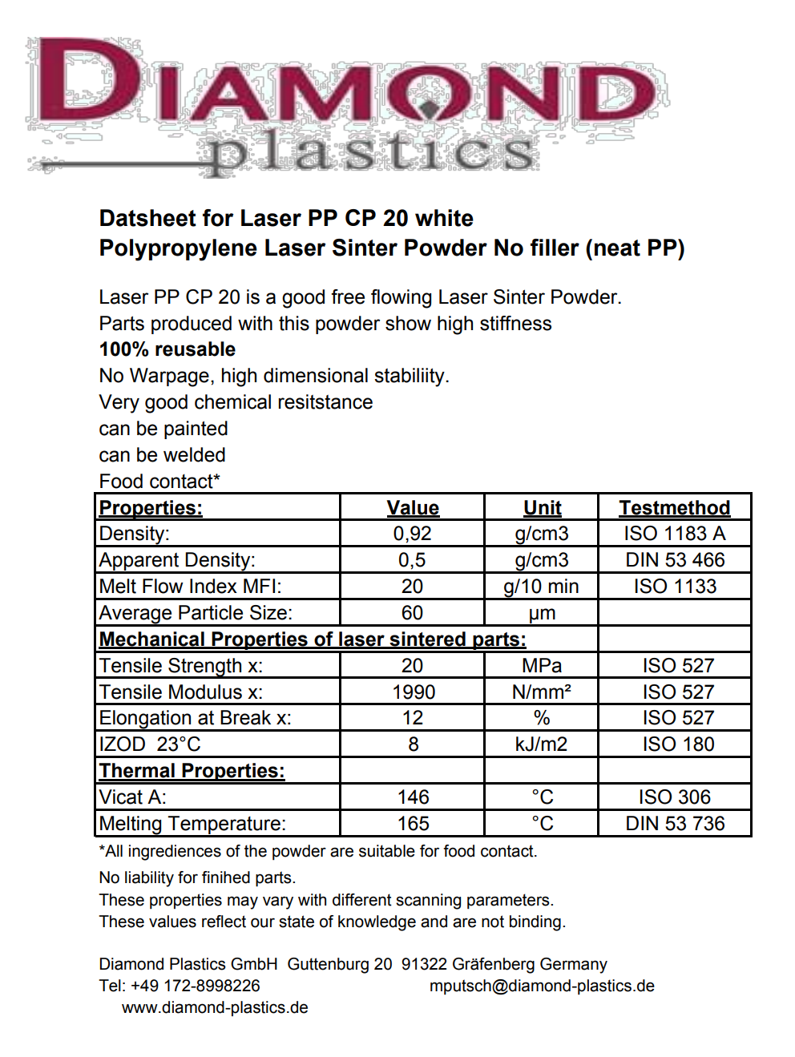
Appendix B: HM20/70P data sheet
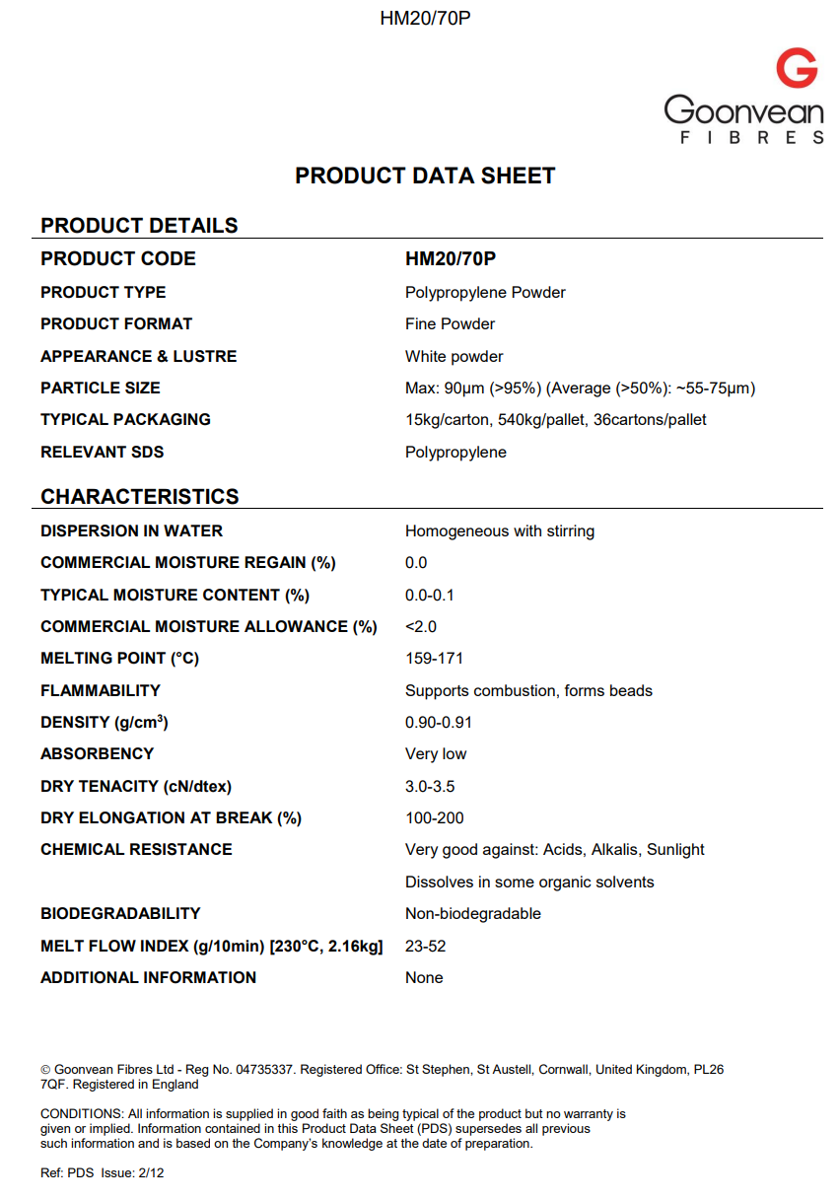

Appendix C: SABIC PP 518A data sheet
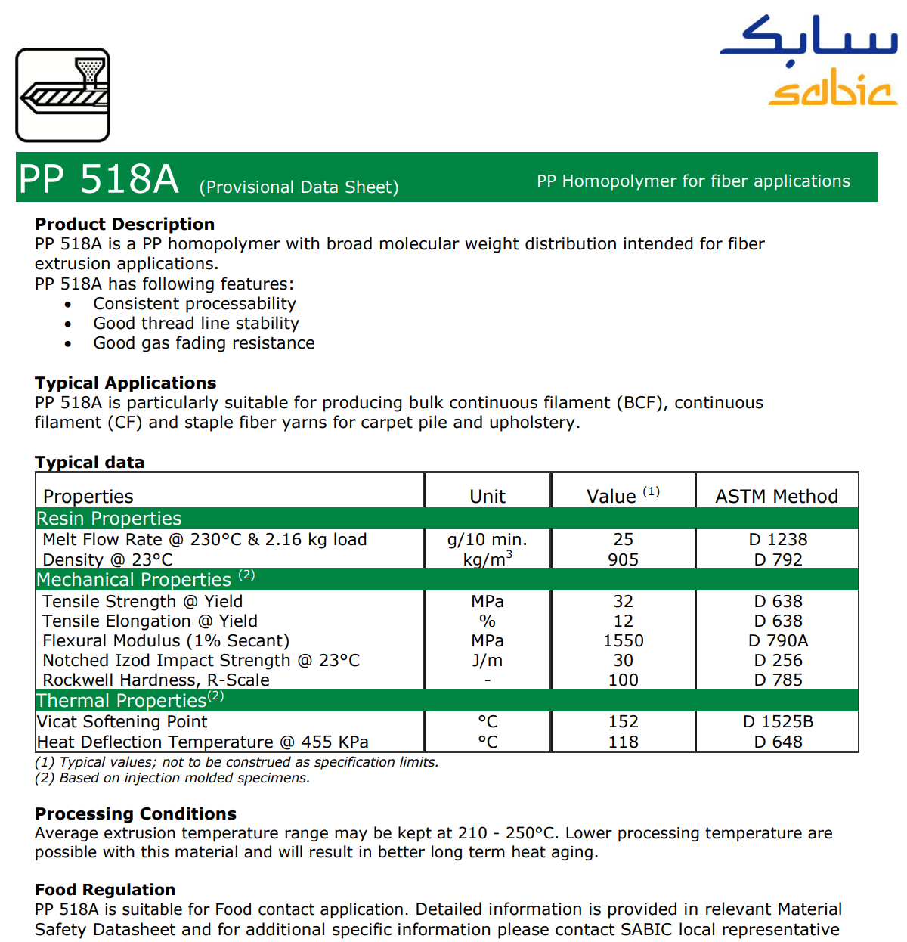

Appendix D: SABIC PP 511A data sheet
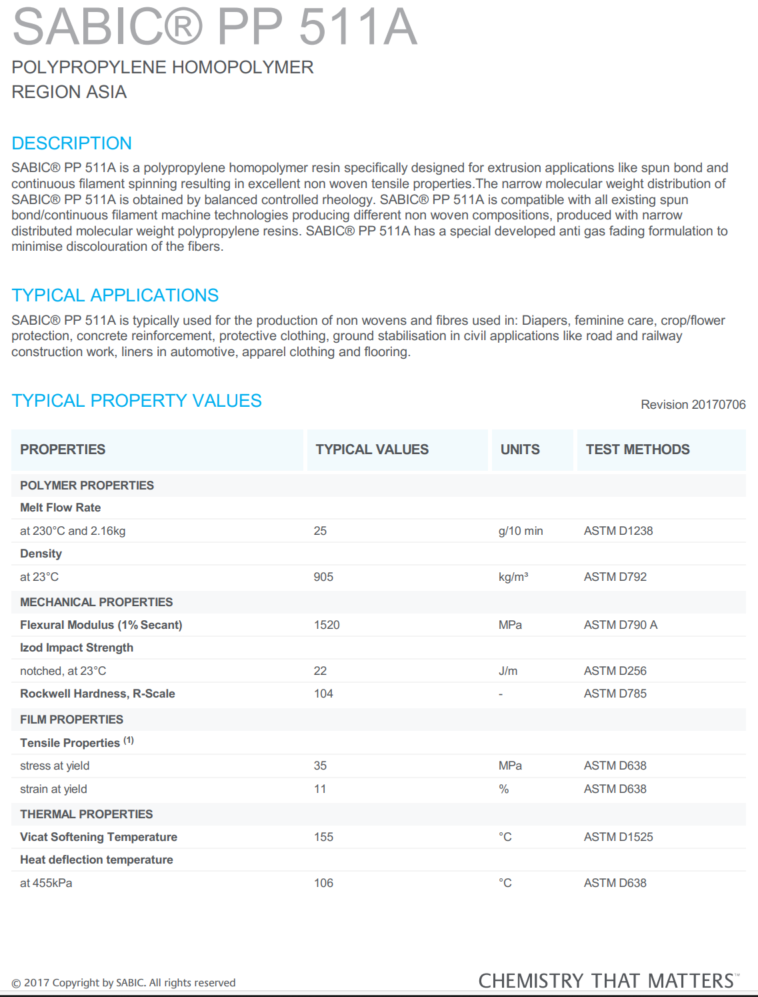

Appendix E: Flow additive TS-610 data sheet
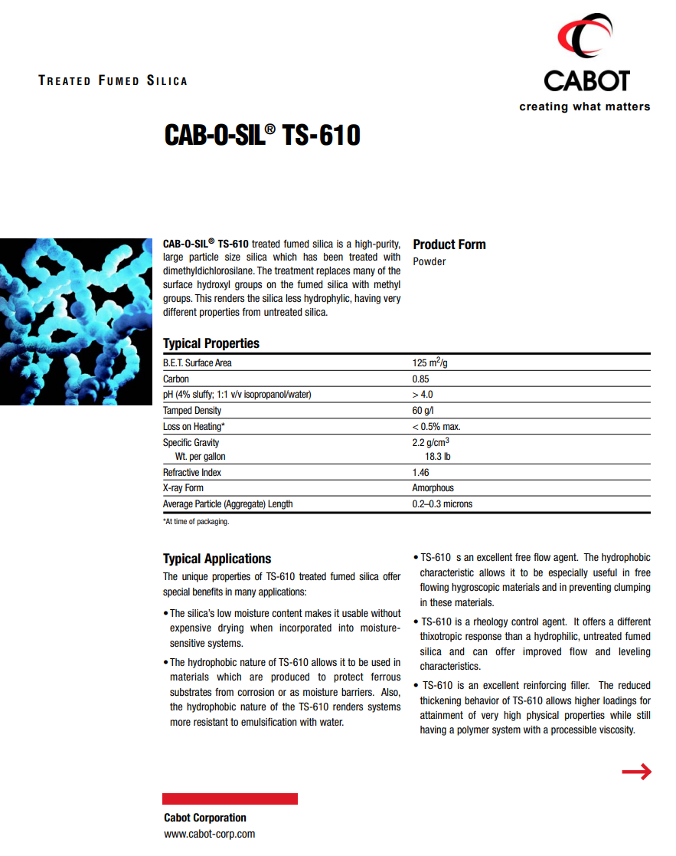
Appendix F: Flow additive Alu C data sheet
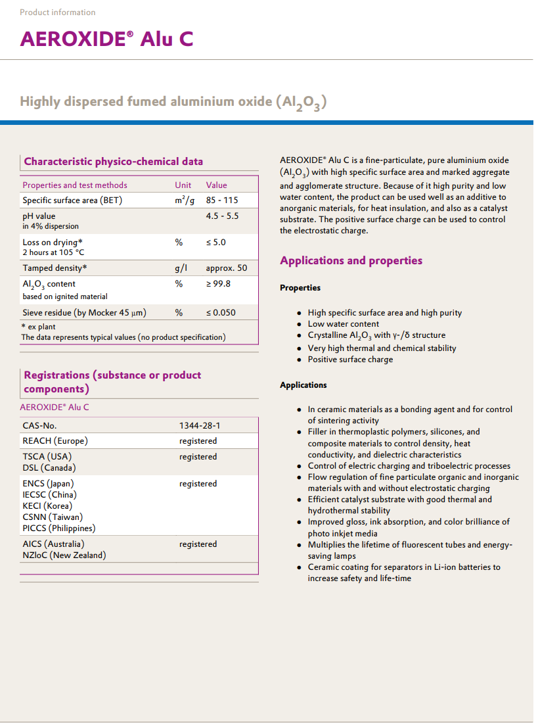

Appendix G: Flow additive 820A data sheet
