

Mobility in Multiple Sclerosis Patients

Tarub Binshalan

Registration number:190299950

A thesis submitted in partial fulfilment of the requirements for the degree of Doctor of Philosophy

The University of Sheffield Faculty of Medical School, Department of Neuroscience

Primary Supervisor: Dr Alisdair Mcneill Secondary Supervisor: Dr Claudia Mazzá

March 2024

Acknowledgements

Thank you, Almighty Allah, for giving me strength, resilience, and guidance throughout this challenging yet rewarding journey. Completing this PhD thesis has been a journey filled with challenges, growth, and support from many individuals whom I would like to express my deepest gratitude towards.

My heartfelt thanks to my supervisors, Dr Alisdair McNeill and Dr Claudia Mazzá, for their guidance, mentorship, and scholarly expertise throughout this research endeavour. Their insightful feedback, encouragement, and constructive criticism have shaped the trajectory of this thesis. During moments of distress, Dr. Alisdair McNeill provided not only academic guidance but also support, compassion, and understanding. His empathetic approach and consideration for my well-being served as a guiding light during challenging times, reminding me that I was not alone and helping me navigate through this journey. I extend my thanks to my clinical advisors, Professor Sivaraman Nair and Dr Ellen Buckley, for their guidance, expertise, and support throughout this journey.

A special note of appreciation goes to my children Sarah and Sulaiman. Their love, patience, and sacrifices have been the cornerstone of my academic pursuits. Throughout this demanding journey, you have selflessly sacrificed precious moments of story times and family gatherings, understanding the necessity of late-night study sessions and countless revisions are deeply appreciated. A special acknowledgement owes to my husband Musab. Your willingness to take on additional shifts and shoulder extra responsibilities to ensure I could pursue my academic aspirations speaks volumes of your love and dedication. Together, we have weathered storms and celebrated achievements, and for that, I am profoundly grateful. My small family, you are my greatest blessing, and I am forever thankful for your love, sacrifices, and unwavering belief in me.

I also express my heartfelt thanks to my sisters, brothers, nephews, and nieces. I am immensely grateful for their support and encouragement, and belief in my abilities. Their love and prayers have sustained me through this doctoral journey.

I dedicate this PhD thesis to my beloved parents, whose spirits I carry throughout this journey. Though you are no longer here to celebrate this milestone, your love, guidance, and belief in me continue to shape my path.
I extend my grateful acknowledgement to Shaqra University and the Saudi Arabian Cultural Bureau in the UK for funding my scholarship. I would like to thank everyone who played a part in this endeavour, no matter how small. Your contributions have been deeply appreciated.

Table of content

- Acknowledgements 2
- Table of content 4
- List of Tables 8
- List of Figures 10
- List of Abbreviation 13
- Achievements 13
- Declaration 15
- Abstract 16
Chapter 1. General Thesis Introduction 17
  - Clinical Aspects of MS 18
  - Epidemiology of MS 19
  - Clinical features of MS 19
  - Diagnostic Biomarkers 21
  - Causes and Pathophysiology of MS 22
    - Environmental risk factors 22
    - Genetic risk factors 23
  - Pathophysiology of MS 24
  - Treatment options for MS 25
    - Disease modifying treatments for MS 25
    - Multidisciplinary care for pwMS 25
  - Semi-objective clinical assessment of disability in MS 26
    - Clinical outcome assessments designed specifically for MS 26
    - Generic clinical outcome assessments applicable to MS 28
    - Multiple Sclerosis Quality of Life Inventory 29
    - Weaknesses of MS clinical outcome assessments 30
  - The Role of Physiotherapy in Managing MS 31
    - Physical Deconditioning In PWMS 35
    - Evidence of Physiological Deconditioning in PwMS 35
    - Mechanisms of deconditioning in pwMS 36
    - Loss of motivation to exercise 36
  - Human Gait 39
  - What Is Neuroplasticity In MS? 40
  - Design of clinical studies 41
    - Observational studies 42
    - Interventional studies 42
    - Phases of the clinical trials in physical therapy 43
  - Hypothesis and Study Rationale 44
  - REFERENCES 44
Chapter 2. The Effectiveness of Physiotherapy Interventions for Mobility in Severe Multiple Sclerosis: A Systematic Review and Meta-Analysis 47
  - Abstract 48
  - Introduction 49
  - Methods 50
    - Search strategy 50
    - Study Screening Process 50
    - Data extraction 51
    - Data synthesis & Meta-analysis 51
    - Quality assessment 51
  - Results 52
    - Study selection 52
    - critical appraisal 52
    - Quality assessment 53
    - Meta-analysis results 53
      - Robot Assisted Gait Training (RAGT) 53
      - Body Weight Supported Training (BWST) 53
      - Conventional Walking Training (CWT) 54
    - Vote counting results 54
  - Discussion 54
  - Tables and Figures 57
  - References 78
Chapter 3. Analysis Of Home Activity Monitor Data From Baseline Phase Of The Multiple Sclerosis Ischaemic Preconditioning (MSIPC) Study 83
  - Abstract 83
  - Introduction 84
  - Physical Activity Monitoring Has Greater Ecological Validity than Lab Gait Analysis 85
  - Physical Activity Monitoring to assess functional performance in pwMS 88
  - Evidence against the use of step count in PAM in pwMS 90
  - MSIPC-2: protocol for a randomised controlled trial of ischaemic preconditioning in people with MS 93
  - Material and methods 96
    - Research Ethics and Governance 96
    - Participants 96
    - Outcome measures 97
    - Remote Physical Activity Monitor 97
    - Procedure 99
    - Statistical Analysis 100
  - Results 101
    - Participants 101
    - Quality control metrics for McRobert’s PA data 103
    - Correlation of McRobert’s PA data with validated lab-based measures of mobility107
    - McRobert's 107
    - Correlation of McRobert’s PA data with validated measures of fatigue 124
    - Correlation of 6MWT with the MFIS and Its Subscales 128
    - Correlation of Mcrobert’s PA Data with Validated Measures of Quality of Life In MS
129
    - Correlation of 6MWT with validated measures of quality of life in MS 139
    - Correlation of McRobert’s PA data with validated measures of disability in MS
Multiple linear regression of 6MWT using McRobert's PA data 140
    - Multiple linear regression of 6MWT using PROMs 142
    - Multiple linear regression analysis using MaRobert's data versus PROMs to predict 6MWT. 143
    - Multiple linear regression of McRobert's PA data with neurological impairment as measured by MSIS-29 143
  - Discussion: 147
  - REFERENCS 154
Chapter 4. Analysis of post-intervention data from ischemic preconditioning study 159
  - Introduction 159
  - Material and methods 162
    - Research ethics 162
    - Participants 162
    - Procedure 162
    - Equipment 164
    - Statistical analysis 164
  - Results 165
    - participants 165
    - Within group analysis 168
      - Comparison of validated lab-based measures of mobility before and after intervention 168
      - Comparison of validated measures of life quality before and after intervention: 169
      - Comparison of validated measures of fatigue before and after intervention: 169
    - Quality control metrics for McRobert’s PAM data 169
  - Discussion 170
  - REFERENCES 176
Chapter 5. Variability of Multiple Sclerosis Walking Scale and Multiple Sclerosis Impact Scale Scores in People without Multiple Sclerosis 179
  - Abstract 181
  - Introduction 182
  - Materials and Methods 183
    - Participant recruitment 183
    - Data collection 183
    - Statistical analysis 184
    - Data availability 184
    - Declarations 184
      - Ethics approval and consent to participate 184
    - Availability of data and materials 184
    - Competing interests 184
    - Acknowledgements 184
  - Results 184
    - MSIS-29 and MSWS-12 scores compared between pwoMS and pwMS 192
  - Discussion 196
  - Funding Statement 198
  - Conflict of interest 198
  - References 198
Chapter 6. General Discussion 200
  - Summary of principle findings 200
  - Limitations of studies reported in this thesis 202
  - Future Work 203
  - Clinical Implication 204

List of Tables

Chapter 1. General Thesis Introduction 17
Table 1.1:the 2017 MacDonald criteria for diagnosis with an attack at onset 20
Table 1.2: multiple modes of exercise training and associated consequences foe domains of physiological and clinical outcomes 37
Table 1.3: selected gait parameters 38
Chapter 2. The Effectiveness of Physiotherapy Interventions for Mobility in Severe Multiple Sclerosis: A Systematic Review and Meta-Analysis 47
Table 2.1: PICO describing inclusion criteria/exclusion criteria 57
Table 2.2: list of authors who we contacted for data and who responded 58
Table 2.3:Pedro Scores for Included Studies (Total Score Out Of 10) 60
Table 2.4:main characteristics of studies included in the review (including both cohorts with only severe MS and mixed cohorts) 62
Table 2.5:Vote Counting Of Studies For Severe MS Patients, Not Included In The Meta Analysis 71
Chapter 3. Analysis Of Home Activity Monitor Data From Baseline Phase Of The Multiple Sclerosis Ischaemic Preconditioning (MSIPC) Study 83
Table 3.1: PROMs included in the baseline assessment 97
Table 3.2: gait variables captured by PAM 97
Table 3.3: Demographic data and outcome measures 102
Table 3.4: Weekday and weekend comparisons of McRobert's PA data at home 104
Table 3.5: comparison of PERIODS active and PERIODS inactive within weekdays and weekends 107
Table 3.6: Correlation of MacRobert's PA data with validated measures of mobility 108
Table 3.7: Correlation of McRobert's PA data with validated measure of fatigue 125
Table 3.8: Correlation of 6MWT with the MFIS 129
Table 3.9: Correlation of McRobert's PA data with validated measure of quality of life 130
Table 3.10: Correlation of 6MWT with validated measures of quality of life in MS 140
Table 3.11: Multiple linear regression of 6MWT using MacRobert’s PA data 141
Table 3.12: Multiple linear regression of 6MWT using Patients reported Outcomes Measures (PROMs) data 142
Table 3.13: Comparison between two models of multiple linear regression in predicting 6MWT 143
Table 3.14: Multiple linear regression of Mean DUR max active using the neurological impairment items from (MSIS-29) as independent variables 144
Table 3.15: Multiple linear regression of Mean DUR max moving using the neurological impairment items from (MSIS-29) as independent variables 145
Table 3.16: Multiple linear regression of Mean DUR total moving using the neurological impairment items from (MSIS-29) as independent variables 146
Chapter 4. Analysis of post-intervention data from ischemic preconditioning study 159
Table 4.1: clinical characteristics of sham and RIPC groups 166
Table 4.2: Comparing baseline PROMs and MacRobert's data for RIPC and sham groups 167
Table 4.3: Within-group comparisons of lab-based measures and PROMs before and after intervention
. 168
Table 4.4: Real world measures of mobility assessed by McRobert’s PA 170
Chapter 5. Variability of Multiple Sclerosis Walking Scale and Multiple Sclerosis Impact Scale Scores in People without Multiple Sclerosis 179
Table 5.1: Demographic data of participants 185
Table 5.2: PROMs difference within the pwoMS group 187
Table 5.3: MSIS-29 and MSWS-12 scores of participants with comorbidity 188
Table 5.4: PROMs difference within pwoMS based on age level using One Way ANOVA 189
Table 5.5:Post Hoc multiple comparison of MSWS-12 scores and age 191
Table 5.6: Comparison of PROM scores between pwMS and pwoMS 192
Table 5.7: PROMs difference between pwoMS and pwMS based on gender 195

List of Figures

Chapter 1. General Thesis Introduction 17
Figure 1.1:possible cycle of physical inactivity, deconditioning, and mobility disability in pwMS 35
Chapter 2. The Effectiveness of Physiotherapy Interventions for Mobility in Severe Multiple Sclerosis: A Systematic Review and Meta-Analysis 47
Figure 2.1: PRISMA chart outlining selection of papers for systematic review 74
Figure 2.2: Standardized Mean Difference in a) 6 mintue walk test (m) , b)10 meter walk test (m/s) post RAGT intervention 75
Figure 2.3: Standardized Mean Difference in a) time up and go (Sec), b) fatigue severity scale post RAGT intervention, and c) berg balance scale 76
Figure 2.4: Standardized Mean Difference in a) timed 25-foot walk post body weight supported training and, b) 6 minute walk test post conventional walking training 77
Chapter 3. Analysis Of Home Activity Monitor Data From Baseline Phase Of The Multiple Sclerosis Ischaemic Preconditioning (MSIPC) Study 83
Figure 3.1: flow chart of baseline assessment for MSIPC study 99
Figure 3.2: multiplane of comparison between mean value of DUR_max_active, inactive and moving measured at home in weekdays and weekends 105
Figure 3.3: multiplane of comparison between mean value of DUR_total_active, inactive and moving measured at home weekdays and weekend 106
Figure 3.4: multiplane of comparison between mean value of PERIODS active, inactive and moving measured at home in weekdays and weekends 106
Figure 3.5: Scatterplots of correlation of Expand Disability Status Scale (EDSS) with mean DUR_total active, inactive moving of McRobert's PA data measured at home 110
Figure 3.6: scatterplots of correlation of Expand Disability Status Scale (EDSS) with mean DUR_max_active, inactive and moving of McRobert's PA data measured at home 111
Figure 3.7:. scatterplots of correlation of Expand Disability status Scale (EDSS) with mean
PERIODS_active, inactive and moving of McRobert’s PA data at home 112
Figure 3.8: scatterplots of correlation of 6 Minutes Walk Test (6MWT) with mean value of DUR_total_active, inactive, and moving of McRoberts at home 113
Figure 3.9: scatterplots of correlation of 6 Minutes Walk Test (6MWT) with mean DUR_max_active , inactive and moving of MacRobert's data measured at home 114
Figure 3.10: Scatterplots of correlation of 6 Minutes Walk test (6 MWT) with mean PERIODS active, inactive and moving of McRobert's PA data measured at home 115
Figure 3.11: Scatterplots of correlation of Borg Rating of perceived exertion (RPE) with mean DUR_total_active, inactive and moving of McRobert's PA data measured at home 116
Figure 3.12: Scatterplots of correlation of Borg Rating of perceived exertion (RPE) with mean DUR_max_active, inactive and moving of McRobert's PA data measured at home. 117
Figure 3.13: Scatterplots of correlation of Borg Rating of perceived exertion (RPE) with mean PERIODS_active, inactive and moving of McRobert's PA data measured at home. 118
Figure 3.14: Scatterplots of correlation of Multiple Sclerosis walking Scale_12 (MSWS_12) with mean DUR_total_active, inactive, and moving of McRobert's PA data measured at home 119
Figure 3.15: Scatterplots of correlation of Multiple Sclerosis walking Scale_12 (MSWS_12) with mean DUR_max_active, inactive and moving of McRobert's PA data measured at home. 120
Figure 3.16: Scatterplots of correlation of Multiple Sclerosis walking Scale_12 (MSWS_12) with mean PERIODS_active, inactive and moving of McRobert's PA data measured at home. 121
Figure 3.17: Scatterplots of correlation of Physical Impact of Multiple Sclerosis Impact Scale (MSIS-29) with mean DUR_total_active, inactive and moving of McRobert's PA data measured at home. 122
Figure 3.18: Scatterplots of correlation of Physical Impact of Multiple Sclerosis Impact Scale (MSIS-29) with mean DUR_max_active, inactive and moving of McRobert's data measured at home 123
Figure 3.19: Scatterplots of correlation of Physical Impact of Multiple Sclerosis Impact Scale (MSIS-29) with mean PERIODS_active, inactive and moving of McRobert's PA data measured at home 124
Figure 3.20: Scatterplots of correlation of fatigue Impact Fatigue Scale (MFIS) with DUR_max active, inactive and moving of McRobert's PA data measured at home 126
Figure 3.21: Scatterplots of correlation of fatigue Impact Fatigue Scale (MFIS) with DUR_total active, inactive and moving of McRobert's PA data measured at home 127
Figure 3.22: Scatterplots of correlation of fatigue Impact Fatigue Scale (MFIS) with PERIODS active, inactive and moving of McRobert's PA data measured at home 128
Figure 3.23: Scatterplots of correlation of Psychological Impact of Multiple Sclerosis Impact Scale (MSIS-29) with mean DUR_total_active, inactive and moving of McRobert's PA data measured at home 131
Figure 3.24: Scatterplots of correlation of Psychological Impact of Multiple Sclerosis Impact Scale (MSIS-29) with mean DUR_max_active, inactive and moving of McRobert's PA data measured at home.
. 132
Figure 3.25: Scatterplots of correlation of Psychological Impact of Multiple Sclerosis Impact Scale (MSIS-29) with mean PERIODS_active, inactive and moving of McRobert's PA data measured at home.
. 133
Figure 3.26: Scatterplots of correlation of Index Value (EQ-5D-5L) with mean DUR_total_active, inactive and moving of McRobert's PA data measured at home 134
Figure 3.27: Scatterplots of correlation of Index Value (EQ-5D-5L) with mean DUR_max_active, inactive and moving of McRobert's PA data measured at home 135
Figure 3.28: Scatterplots of correlation of Index Value (EQ-5D-5L) with mean PERIODS_active, inactive and moving of McRobert's PA data measured at home 136
Figure 3.29: Scatterplots of correlation of Visual Analogue Scale (VAS) of EQ-5D-5L with mean total_DUR_active, inactive and moving of McRobert's PA data measured at home 137
Figure 3.30: Scatterplots of correlation of Visual Analogue Scale (VAS) of EQ-5D-5L with mean max_DUR_active, inactive and moving of McRobert's PA data measured at home. 138
Figure 3.31: Scatterplots of correlation of Visual Analogue Scale (VAS) of EQ-5D-5L with mean PERIODS_active, inactive and moving of McRobert's PA data measured at home. 139
Chapter 4. Analysis of post-intervention data from ischemic preconditioning study 159
Figure 4.1: Flow chart of pre- and post-assessments for MSIPC study 162 Chapter 5. Variability of Multiple Sclerosis Walking Scale and Multiple Sclerosis Impact Scale Scores in People without Multiple Sclerosis 179
Figure 5.1:boxplot of the MSIS-29 showing the overlapping between pwMS and pwoMS 193
Figure 5.2: boxplot of the percentage score of MSWS-12 showing the overlapping between pwMS and pwoMS 194

List of Abbreviation

MS, Multiple Sclerosis 6MWT, 6 Meter Walk Test 10MWT, 10 Meter Walk Test
Borg (RPE) Scale, Borg Rating of Perceived Exertion Scale BP, Blood pressure
BWSTT, Body Supported Walking Treadmill Training EDSS, Expand Disability Status Scale
EQ-5D-5L , EuroQol Five Dimensions Five Levels questionnaire FES-I, Falls Efficacy Scale – International
LLFDI, Late Life Function and Disability Instrument MBI, Body Mass Index
MFIS, Modified Fatigue Impact Scale; MSIS-29, MS Impact Scale; EQ-5D-5L MSWS-12, MS Walking Scale-12
MVPA, Moderate-to-Vigorous Physical Activity PA, Physical Activity
PAM, Physical Activity Monitor PPMS, Primary Progressive MS
PROMs, Patient Reported Outcome Measures pwMS, People With Multiple Sclerosis
RCT, Randomize Control Trial RRMS, Relapsing-Remitting MS
RIPC, Remote Ischemic Preconditioning SPMS, Secondary Progressive MS
T25 FW, Time 25 Foot Walk TUG, Timed Up and Go VAS, Visual Analog Scale

Achievements:
Publication
Chapter 2: The Effectiveness of Physiotherapy Interventions for Mobility in Severe Multiple Sclerosis: A Systematic Review and Meta-Analysis., cited 5 times.
Binshalan, T., Nair, K.P.S. and McNeill, A., 2022. The Effectiveness of Physiotherapy Interventions for Mobility in Severe Multiple Sclerosis: A Systematic Review and Meta-Analysis. Multiple sclerosis international, 2022.
Chapter 5: Variability of Multiple Sclerosis Walking Scale and Multiple Sclerosis Impact Scale Scores in People Without Multiple Sclerosis
Binshalan, T., Buckley, E., Nair, S. and Mcneill, A., 2024. Variability of Multiple Sclerosis Walking Scale and Multiple Sclerosis Impact Scale Scores in People Without Multiple Sclerosis. Cureus, 16(1).
Prizes:

Poster: "The Effectiveness of Physiotherapy Interventions for Mobility in Severe Multiple Sclerosis: A Systematic Review and Meta-Analysis", was awarded second place in the University of Sheffield (University-Wide Poster Exhibition) within the faculty of Medicine, Dentistry and Health.

Declaration

I, Tarub Binshalan, confirm that the Thesis is my own work. I am aware of the University’s Guidance on the Use of Unfair Means (www.sheffield.ac.uk/new-students/unfair-means).
licensing and copyright:

This thesis includes two published papers, which have a CC-BY license and the authors retain copyright.
- Binshalan, T., Nair, K.P.S. and McNeill, A., 2022. The Effectiveness of Physiotherapy Interventions for Mobility in Severe Multiple Sclerosis: A Systematic Review and Meta- Analysis. Multiple sclerosis international, 2022. https://pubmed.ncbi.nlm.nih.gov/35860179/
- Binshalan, T., Buckley, E., Nair, S. and Mcneill, A., 2024. Variability of Multiple Sclerosis Walking Scale and Multiple Sclerosis Impact Scale Scores in People Without Multiple Sclerosis. Cureus, 16(1). https://pubmed.ncbi.nlm.nih.gov/38322083/
The were no objection of the co-authors, Professor Sivaraman Nair and Dr Ellen Buckley, and Dr Alisdair McNeill to include these 2 papers in my final thesis.

Abstract

Multiple Sclerosis (MS) is a chronic autoimmune disease that is highly associated with gait limitations in people with MS (pwMS), and severely disabled patients are particularly affected.
Currently, clinicians use objective and semi-objective rating scales to assess ambulation. These scales lack accuracy and sensitivity to real-world mobility changes and disease progression. As the disease progresses physical therapy interventions for mobility become more limited. This thesis aimed at providing new tools to improve walking assessment procedures, as well as providing physical therapy interventions for improving mobility in this population. This thesis comprises four studies:
- A systematic review and meta-analysis examined the effects of physical therapy interventions on mobility in severe MS patients. Results indicated that robot assisted gait training (RAGT) improved walking endpoints except timed up and go (TUG).
- We validated free-living walking measurements derived from a physical activity monitor (PAM) against standard mobility outcome assessments. In a cohort of 35 pwMS, the PAM was highly correlated with clinically validated measurements of mobility and endurance. This suggests that PAM could be a valuable clinical trial output.
- An RCT examined remote ischemic preconditioning (RIPC) as an intervention to improve mobility in severe pwMS. RIPC for 6 weeks, (n=14) received intervention while(n=11) in sham group. Results showed that RIPC did not improve mobility nor PROMs in pwMS.
- We studied the range of responses for the multiple sclerosis impact scale (MSIS) and multiple sclerosis walking scale (MSWS) in the general population without MS. Both PROMs scores of (n=198) were significantly affected by comorbidities, while the MSWS score was directly related to age.
This thesis highlighted physical therapy interventions for severe MS patients, offering practical measures of real-world activity. Additionally, it explored factors affecting MSIS and MSWS scores in the general population. Future research and implications of these findings were discussed.

Chapter 1. General Thesis Introduction
Multiple sclerosis (MS) is a chronic disorder of the central nervous system, being the most frequent neurological disease which causes disability in young and middle-aged adults (Koch-Henriksen and Sørensen, 2010). In the UK, MS affects over 130,000 people while it affects more than 2.5 million people worldwide (Allen-Philbey et al., 2020). MS causes a variety of neurological defects which often interact with each other to cause mobility problems. 80% of patients have walking problems after 10- 15 years of disease onset (Kesselring and Beer, 2005, Martin et al., 2006). People with MS (pwMS) tend to decrease their physical activities as they are afraid exertion will increase disease progression (Dalgas et al., 2008). Therefore, they are more likely to be less physically active compared to the general population. Approximately 78 percent of pwMS are not involved in any physical activity regularly (Backus and rehabilitation, 2016). Ambulation loss in pwMS is triggered by various features such as muscle weakness, spasticity, ataxia and proprioception impairment (Souza et al., 2010). Along with disease progression and deconditioning, the inactivity process is advancing in a self-fulfilling cycle. The importance of gait rehabilitation arises from the fact that pwMS who cannot ambulate may become more predisposed to have adverse health problems related the sedentary lifestyle such as, cardiovascular disease, Diabetes Mellitus, obesity, frequent falls, osteoporosis and deconditioning (Chotiyarnwong et al., 2020, Cattaneo et al., 2002, Warburton, 2006). As a result, the average healthcare costs increase with increasing co-morbidity as the disease progresses (Kobelt, 2006).
It has been demonstrated that regular physical activity improves physical health, quality of life, fatigue and gait as well as decreasing the risk of disability progression in pwMS (Streber et al., 2016). There is also some evidence suggesting that exercise has the potential to slow down disease progression (Dalgas and Stenager, 2012). In a study by Prakash et al. (2010), they evaluated the effect of aerobic fitness exercise in the measurement of grey matter atrophy and white matter integrity. A voxel-based approach was utilised to analyse the grey matter and white matter for 21 female patients to assess
whether their high fitness levels are correlated with preserved grey matter volume and white matter integrity. A positive association was reported between cardiorespiratory fitness and regional volumes of grey matter, and higher focal fractional anisotropy values. Both conserve volume of grey matter and integrity of the white matter tract were associated with improved performance on processing speed measures.

Clinical Aspects of MS
Here we provide an overview of clinical aspects of MS and current clinic diagnostic criteria (MacDonald criteria). The key to a diagnosis of MS is evidence of central nervous system demyelination at more than one anatomical site (including optic nerve or spine) at more than one point in time (i.e. temporal and spatial dissemination of lesions). Dissemination in time can be evidenced by either distinct symptomatic episodes or imaging evidence of old demyelinating lesions.
In MS, the neurodegeneration impacts the central nervous system from the earliest disease stages; marked by axonal loss in white matter and neuronal death in grey matter. This is linked to the progressive course of the disability and especially during the advanced stage of the disease, determines tissue loss and atrophy (Cortese et al., 2019). The current principles of MS diagnosis are from the McDonald criteria that have been further developed in 2017 to form the most recent diagnostic guidance lines for both research and clinical diagnosis. The key to diagnosis is evidence of demyelinating CNS lesions disseminated in both time and space (ie lesions in different regions of the brain occurring at different points in time). There are clinical, radiographic and laboratory criteria. Brain MRIs should, therefore, be done for all patients for diagnosis of MS at the onset of an attack, as shown in (Table 1.1). The disease course should be determined at the time of diagnosis (relapse remitting, primary progressive or secondary progressive) and whether it’s active or not; or whether it’s progressive or not depending on the history of previous years. Periodically re-evaluation of phenotype should be administered based on accumulated information (Thompson et al., 2018). However, The updated McDonald criteria for 2017 are correlated with higher sensitivity but less
specificity for a second attack compared to the prior 2010 version (Van Der Vuurst De Vries et al., 2018).

Epidemiology of MS
It is estimated that around 2.8 million people globally are affected by MS. The prevalence of MS differs globally. It is highest in the World Health Organisation (WHO) defined Western European and North American regions (111–300 cases per 100 000)(Olek and Mowry, 2021). MS prevalence is lowest in the WHO defined African reason (5 cases per 100 000)(Amezcua and McCauley, 2020).MS is more common in females with a ratio of 3 females:1 male affected by MS (Greydanus et al., 2023).The global average age of diagnosis is 32 years old. MS poses a significant economic burden, in the European Union mean costs per annum of 22 800 euros for mild disease and 57 500 euros for severe disease. Most of this is in direct medical care costs(Imani et al., 2020).

Clinical features of MS
MS is broadly classified into relapsing-remitting, primary progressive or secondary progressive. This phenotype should be provisionally assigned an initial diagnosis. At presentation, up to 85% of patients present with a clinically isolated syndrome: this means a single set of symptoms related to a single demyelinating lesion. The majority of these will progress to have a second episode and meet diagnostic criteria for MS (Chung et al., 2020).
Most pwMS have a relapsing-remitting clinical course. They have episodes of acute neurological dysfunction (relapse) interspersed with periods of stable (or absent) neurological symptoms (remission). Relapses are defined by new neurological symptoms which last for more than 24 hours (e.g. visual disturbance, balance disturbance, weakness) (Gold et al., 2020). pwMS have on average 1 relapse per year. Left untreated, up to 50% would develop secondary progressive at 15 years after diagnosis. Initiation of disease modifying treatments substantially reduces the risk of secondary progressive MS (Cree et al., 2021).

Secondary progressive MS is characterised by disability worsening without episodes of new acute inflammation (Ziemssen et al., 2022). Superimposed clinical deterioration and new MRI lesions can occur; so called active secondary progressive MS. It can be difficult to diagnose secondary progressive MS, and the diagnosis/reclassification is often made retrospectively. It is not possible to consistently predict who will develop secondary progressive disease.
However, gadolinium enhancing lesions on MRI, spinal cord lesions and cortical lesions at diagnosis are all predictive of secondary progressive disease (Filippi et al., 2021). Primary progressive MS affects 10-15% of pwMS. In primary progressive MS, disability accrual starts from the time of diagnosis without a relapsing-remitting picture. It is unclear if this is a separate phenotype of MS, or if these individuals have had a long unrecognised course of relapsing-remitting MS prior to clinical diagnosis.
Cognitive impairment is common in pwMS. Around 30-40% of pwMS who have relapsing-remitting disease have cognitive impairment (Folstein et al., 1985). However, up to 70% of pwMS who have progressive disease have cognitive dysfunction. However, deficits are present even in some people with clinically isolated syndromes. Information processing speed and episodic and working memory are most commonly affected. Executive function and visuospatial processing are less commonly affected. Cognitive impairment negatively affects relationships in pwMS and can be associated with job loss and social isolation (Silvaggi et al., 2020).

Table 1.1:the 2017 MacDonald criteria for diagnosis with an attack at onset

adapted from (Thompson et al., 2018)
Number Of Lesions and Objective Clinical Evidence |  | Additional Data Needed to confirm the diagnosis
≥2 clinical attacks | with ≥2 lesions with objective clinical evidence | with no additional data needed
≥2 clinical  attacks | with 1 lesion with objective clinical  evidence and a clinical history | with no additional data needed
 | suggestive of a previous lesion
≥2 clinical attacks | with 1 lesion with objective clinical evidence and no clinical history  suggestive of a previous lesion | with dissemination in space evident on MRI
1 clinical attack | with ≥2 lesions with objective clinical  evidence | with dissemination in time evident on MRI  or demonstration of CSF-specific oligoclonal bands
1 clinical attack | with 1 lesion with objective clinical evidence | - with dissemination in space evident on MRI. And  - with dissemination in time evident on MRI or demonstration of CSF-specific oligoclonal bands.

Diagnostic Biomarkers
MRI remains the key diagnostic and monitoring tool for MS. However, MRI based measures are not sufficiently accurate to predict disease progression in a clinical setting. For diagnosis, it is recommended that brain sagittal 3D fluid-attenuated inverse recovery (FLAIR) is used along with axial T2 and T1 weighted imaging is used for diagnosis and monitoring (Jakimovski et al., 2020). Spinal cord imaging should be 2 or more of sagittal T2, proton density weighted images and sagittal T1 after contrast. 7T images may be needed to detect cortical plaques (Ineichen et al., 2021).
Evoked potentials (visual and auditory) may detect evidence of brain dysfunction in areas which do not have lesions visible on clinical MRI (Zafeiropoulos et al., 2021). Oligoclonal bands in cerebrospinal fluid can also be used in the diagnostic process.

Causes and Pathophysiology of MS
The cause(s) of MS are not fully understood. It is conceptualised as a multifactorial disease. MS is proposed to be caused by an interaction of environmental and lifestyle factors with genetic susceptibility (Belbasis et al., 2020). Both epidemiological and genomics research has helped unravel the causes of MS.

Environmental risk factors
Infection with Epstein-Barr virus (EBV) and the onset of MS has been extensively studied (Robinson and Steinman, 2022). For example, in a case-control study of US military personnel 97% of the 35 cases of MS were negative for EBV at baseline and seroconverted (ie developed antibodies) before MS diagnosis). This meant that seroconversion for EBV gave a hazard ratio of 32.4 for developing MS, compared to non-seroconverters. The precise role of EBV in MS pathogenesis is unknown. It may serve as a trigger for the autoimmune process (Bjornevik et al., 2022).
Hypovitaminosis D (low vitamin D blood levels) has received considerable attention, as it is proposed to be a risk factor for MS development and disease activity and is a potential treatment target (Miclea et al., 2020). The association between low ultraviolet radiation exposure and MS may be mediated by an effect on Vitamin D. Vitamin D has anti-inflammatory properties and so may suppress MS. There is an association with lower levels of vitamin D level and risk of MS (increased MS risk with lower serum levels and with genetic predisposition to vitamin D deficiency), and in some studies disease activity in MS (Bäcker-Koduah, 2021). In an observational study, it was identified that women using a vitamin D supplement had a 40% lower risk of developing MS (Feige et al., 2020). In the SOLAR trial, vitamin D supplements were associated with lower MRI burden of MS plaques but no reduction in clinical relapse rates (Piędel et al., 2021). In a randomised controlled trial in people with high risk clinically isolated syndrome (at least 3 T2 MRI lesions), vitamin D supplementation did not reduce risk of developing MS (Butzkueven et al., 2023). The evidence around vitamin D supplementation for MS treatment and preventing progression remains inconclusive.Head trauma (traumatic brain injury), is an emerging risk factor for development of MS. A Swedish population-based case-control study of 2807 incident cases of MS (Johansson et al., 2024), with HLA genotyping found a 30% increased risk of MS in those with head trauma (and a trend towards increasing MS risk with increasing number of head injuries). They also found that in people with a genetic predisposition to MS, a history of head trauma was an even greater risk factor for development of MS (18-fold increased risk). It is proposed that head injury results in release of neuronal antigens into the cerebrospinal fluid; potentially triggering an autoimmune response against the brain and leading to demyelination.
Other identified environmental factors are low ultraviolet radiation exposure, tobacco exposure, obesity, smoking, shift work, night working. While alcohol and coffee consumption having modest protective effects (McKay and Tremlett, 2021).

Genetic risk factors
Evidence of genetic risk factors comes from family studies. For example, a monozygotic twin of a pwMS has a 20-30% chance of themselves developing MS (Gerdes et al., 2020). Genome Wide Association Studies (GWAS) have found more than 200 genetic risk variants for MS (Patsopoulos, 2018). The strongest being linked to HLA genes (Human Leukocyte Antigen), which regulate inflammation. These studies have confirmed that MS is an inflammatory disorder and not a primary neurodegenerative disease (since the identified genetic risk factors do not overlap with genetic causes of neurodegenerative diseases).
For example, the HLA DRB1*15:01 allele encodes a protein that presents antigens to immune cells, it is associated with a 3 fold increased risk of developing MS (Watanabe et al., 2021). The A*02:01 allele is associated with protection from MS (odd ratio 0.6) (Watanabe et al., 2021). Several studies have identified an interaction between these genetic risk factors and environmental factors that could trigger MS (Olsson et al., 2017). For example, smoking is an environmental risk factor for MS; in those with HLA genotypes which predispose to MS and who also smoke the risk of MS is very elevated at an odds ratio of 14.

Pathophysiology of MS
Immune cells (T and B lymphocytes) are the key factors in the hypothesised pathogenesis of MS, especially for development of focal demyelination and relapse (Melnikov et al., 2021, Salou et al., 2015). It is proposed that these cells are “autoreactive” - that they falsely identify brain tissue (autoantigens) as being an immune system target and damage the tissue. The nature of these autoantigens needs to be clarified.
In relapsing-remitting MS, inflammatory foci develop around veins in the CNS. These are MS lesions/plaques (Tur and Thompson, 2015). They occur throughout the CNS white and grey matter. These plaques are due to acute inflammation and associated with loss of myelin, oligodendrocytes, and axons. In contrast, chronic plaques have few infiltrating inflammatory cells and no active myelin destruction. Chronic plaques feature gliosis rather than regeneration of myelin sheathed axons (Papiri et al., 2023).
During relapse, autoreactive lymphocytes directed against CNS autoantigens, are reactivated, infiltrate the CNS, and initiate inflammatory cascades (Rodríguez Murúa et al., 2022). This leads to focal oedema, destruction of myelin and oligodendrocytes and neuroaxonal injury. This can lead to a focal neurological syndrome, i.e., a clinical relapse.
During the phase of remission, it is proposed that there is ongoing “smouldering inflammation”. This refers to chronic mild inflammation restricted to the CNS, impairment of neuronal function and repair and neurodegeneration. Microglia (the CNS resident phagocytic and antigen presenting cells) are proposed to be key drivers of smouldering CNS inflammation in MS (Voet et al., 2019, Pukoli and Vécsei, 2023). The chronic inflammatory response is also thought to be associated with neuronal
injury due to oxidative stress, glutatamate toxicity, ion channel dysfunction and mitochondrial dysfunction. Chronic inflammation can also trigger/exacerbate tissue hypoxia (Blagov et al., 2022).

Treatment options for MS

Disease modifying treatments for MS

Clinical guidelines recommend initiation of a disease modifying treatment (DMT) in people with relapsing-remitting MS (Brownlee et al., 2022). Most DMTs have a primarily anti-inflammatory effect. DMTs decrease clinical relapse rate, MRI based lesion load and short-term accumulation of disability. There is no evidence to consistently guide which DMT will be the best treatment for a particular patient. However, DMT use cuts the risk of progression from a single demyelinating event to relapsing-remitting MS by 40-50% (Förster et al., 2019). Emergence of new inflammatory lesions or clinical relapse should prompt consideration of a switch of DMT.

Multidisciplinary care for pwMS
Medical care for pwMS also must include symptom management and consideration for quality of life. A multidisciplinary team is essential (Feys et al., 2016). Neurologists, general practitioners, specialist nurses, radiologists, physiotherapists, occupational therapists, social workers and speech and language therapists all have a role to play. For example, symptomatic therapy for urinary incontinence or constipation can be managed by general practitioners. Low mood may benefit from anti-depressants or talking therapy from a psychotherapist. Occupational therapists can assist with adjustments to the home, to help preserve independence. Management of co-morbid conditions (e.g. obesity, hypertension, hypercholesterolaemia) is a priority to prevent exacerbation of disability associated with MS.
Impaired mobility can be effectively managed by a physiotherapist. This can involve a range of strategies, which we will consider further below. Physiotherapy interventions can improve mobility
and so prevent a vicious cycle of immobility and deconditioning. These interventions could also target the underlying disease by increasing neuroplasticity.

Semi-objective clinical assessment of disability in MS
A range of clinical outcome assessments have been developed specifically for MS. As discussed above, MS is associated with a range of motor and non-motor symptoms. Some of these features of MS are associated with objective physical signs (e.g., spasticity) while others are subjective phenomena (e.g. fatigue). In addition, a range of generic clinical outcome assessments can be utilised to assist with in depth characterisation of MS symptoms.

Clinical outcome assessments designed specifically for MS
In order to assess the overall disability in a pwMS, the Expanded Disability Status Scale (EDSS) is the most widely used scale (Noseworthy et al., 1990). EDSS rates the disability of the patient, with scoring between 0 to 10. Zero-points is intact neurological evaluation. 10 points suggest severe neurological deficits linked to MS. PwMS who have EDSS scores of 5 or less are ambulatory without assistance. Up to this level, functional system (FS) is the key determinant of EDSS, the ambulation status being the fundamental determinant in the degree of disability after point 5. FS represents brain networks responsible for specific tasks. They are in total 8 functional systems plus ambulation as listed: Visual (Optic) Functions, Brainstem Functions, Pyramidal Functions, Cerebellar Functions, Sensory Functions, Bowel and Bladder Functions, Cerebral Functions and Ambulation (Şen, 2018).
In 2001 the first validated disease-specific and patient-rated scale, the Multiple Sclerosis Impact Scale (MSIS-29), was released. The MSIS-29 was one of the first MS specific clinical outcome assessments developed using psychometric techniques. The items on the MSIS-29 were developed from patient interviews, expert opinion and literature review. Thus, it captures symptoms and clinical features important to pwMS. The MSIS-29 contains 29 questions, of which 20 measure the physical impact of
MS and nine measure the psychological impact. This can produce a composite score, or both components can be recorded separately (McGuigan et al., 2004).
In 2012, a group of experts developed the Brief International Cognitive Assessment for Multiple Sclerosis (BICAMS). This is based on the level of cognitive processing and verbal and visual memory. It involves three tests: Symbol Digits Modalities Test (SDMT) assessing memory of speed/working memory, California Verbal Learning Test-Second Edition (CVLT-II) used to assess learning and verbal memory, and Brief Visuospatial Memory Test-Revised (BVMT-R) used to assess learning and visuospatial memory. It should take 15 minutes and needs only a stopwatch, paper and pen to be completed (Langdon et al., 2012). BICAMS has been commonly used in different cultures and languages to measure cognition in MS. BICAMS provides a practical, cost-effective way of measuring cognition in MS around the world (Corfield and Langdon, 2018).
The 12-item Multiple Sclerosis Walking Scale (MSWS-12) is a PROM of walking ability in pwMS. The items on the MSWS-12 were generated from patient interviews, expert opinion and literature review. The MSWS-12 has undergone psychometric validation, demonstrating both reliability and validity for mobility assessment. MSWS-12 “benchmark scores” have been identified that correlate with functional status in pwMS. For example, scores of 0-24.99 were associated with working outside the home while scores over 75 were associated with inability to work in paid employment and difficulty with activities of daily living. The MSWS-12 is extensively used in both clinical trials of investigative medicinal products and observational studies of pwMS (Goldman et al., 2017).
The Modified Fatigue Impact Scale (MFIS) is a modified form of the Fatigue Impact Scale, based upon findings from interviews of pwMS around the symptom of fatigue. The full scale has 21 items: covering physica, cognitive and psychosocial impact of fatigue. MFIS is scored from 0-84 (physical, 0 to 36; cognitive, 0 to 40; and psychosocial, 0 to 8), with higher scores indicating more severe impact of fatigue on quality of life. A score of 38 is taken to distinguish fatigued from non-fatigued individual (Larson, 2013).

Generic clinical outcome assessments applicable to MS
The modified Ashworth scale (MAS) has been used as an indicator of spasticity in clinical and research settings. The aim of this scale is to measure muscle spasticity ranged from 0, which means no increase in muscle tone to 4, which means rigidity in affected parts (Ansari et al., 2008).
The Borg rating of perceived exertion (RPE) is a semi-objective measure of the perceived intensity of physical activity. Participants are asked to rate their exertion based upon all their physical sensations of exertion (breathlessness, sweating, muscle aches etc). Exertion is rated 6 “no exertion” to 20 “maximal exertion”. There is some correlation between the RPE score and heart rate during exertion (ie a score of 6 correlates with a heart rate of 60 beats per minute). Ratings of 12-14 are agreed as representing moderate exertion. In pwMS undergoing a submaximum cycling exercise, RPE was highly correlated with maximum oxygen consumption and workload (Cleland et al., 2016). Morrison et al. (2008) found a strong correlation between RPE score and maximum oxygen consumption and heart rate in pwMS undergoing a graded aerobic exercise programme.
Impaired mobility and neurodisability in MS is associated with an increased risk of falls. The Falls Efficacy Scale-International (FES-I) measures an individual's concern about or fear of falling. It is a 16- item scale, where participants are asked to respond on a 4-point Likert-scale from 1(no fear of falling) to 4(very concerned). Items include cleaning the house, getting dressed, preparing meals, showering, going to the shops, getting into a chair, going up or down stairs, walking, reaching for something above or below you, rushing to answer a phone, walking on a slipper surface, visiting a friend/relative, walking in a crowd, walking on uneven surface, up/down slope and going to a social event. The maximum total score is 64 (severe concern about falling) (van Vliet et al., 2013). Mazumder et al. (2015) report that the FES-I score correlates with recurrent falls in pwMS, and therefore can be used as a measure of falls risk in pwMS.
The Late Life Function and Disability Instrument (LLFDI) was developed to measure functional impairment in community-dwelling older adults (Jette et al., 2002). It has been validated in pwMS (Motl et al., 2007).
The WHO defines quality of life as “an individual's perception of their position in life in the context of the culture and value systems in which they live and in relation to their goals, expectations, standards and concerns”. A frequently used measure of quality of life is the EQ-5D instrument. The EQ-5D measures 5 dimensions of health: mobility, usual activities, pain & discomfort, and anxiety & depression. Each dimension has 3 levels: no problems, some problems, or severe problems. The EQ Visual Analogue Scale (VAS) allows participants to rate their health from 0-100. Clearly, all of these dimensions can be affected in pwMS. The EQ-5D has been used in several studies to assess quality of life in pwMS. Jones et al. (2013) reported EQ-5D values for over 4 500 UK pwMS. The mean ED-5D score was 59.73, compared to a UK average for people without MS of 82.48. This suggests a significant impairment of quality of life in pwMS. The majority of pwMS in the study reported some degree of impairment to quality of life in one or more dimensions. Visser et al. (2021) performed a multicentre study of quality if life in pwMS in several European countries. They confirmed that impairment of quality of life in pwMS is found across countries and cultures.

Multiple Sclerosis Quality of Life Inventory
The Multiple Sclerosis Quality of Life Inventory (MSQLI) is a set of 10 individual clinical outcome assessments (patient reported), both generic and MS specific, that measure quality of life. It takes 30
- 45 minutes to complete. Fatigue is assessed with the MFIS (discussed above). The Short Form-36 is used to measure generic health related quality of life. The MOS Pain Effects Scale assesses the way pain affects mood, mobility, sleep, recreation, and enjoyment. Genitourinary symptoms are assessed with the sexual satisfaction scale, bowel control scale and bladder control scale. Visual function is assessed with the impact of visual assessment scale (IVIS). The perceived deficits questionnaire is a self-reported measure of cognition. It covers attention, memory, planning and organisation. The
mental health inventory (MHI) asks about mental health issues such as anxiety, while the modified social support survey (MSSS) queries perceived social support. The MSQLI is designed to measure key concerns of pwMS.

Weaknesses of MS clinical outcome assessments
Despite the proven utility and the extensive use of EDSS in measuring disease progression in MS population, it has several major drawbacks. The EDSS is an ordinal assessment tool, and the variations between each score are not comparable. That means moving from EDSS 1.0 to 2.0 would be quite different from the 6.0 to 7.0 transition. This makes the statistical analysis of the outcome measure more complicated; it is not appropriate to compare mean changes between groups when using the EDSS, due to the nonlinearity nature of the scale. Time spent at each step also varies significantly due to the ordinal nature of the EDSS, with the shortest period of time spent at the mid-range between
3.0 and 6.0. The rate of progression on the EDSS during a 2-year clinical trial will, therefore, depend on the levels of EDSS at the entry to the trial. If this is not balanced across treatment groups, there may be spurious results on worsening EDSS score (Goldman et al., 2010). Indeed, evaluation of the sensitivity of EDDS responsive to change is generally disappointing and appear weakest at the lower and higher range of the scale (Goldman et al., 2010). These findings may be explained the modest correlation between the patient’s imaging profile parameters and the score in EDSS (Bar-Zohar et al., 2008). Together these findings provide important insights into exercise interventions studies. A meta- analysis study found that exercise has positive impacts on walking; no improvements were observed in the EDSS in any of the included studies (Snook and Motl, 2009). This finding supports previous research by Dalgas and Stenager (2012) reveals that various modalities of exercise interventions lasting 3–26-weeks generally have no impact on EDSS scores, Suggesting low sensitivity to change in exercise interventions.
There are also potential issues with MSWS-12 as a measure of walking mobility in pwMS. Correlations between MSWS-12 and objective measures of balance were reported to be low in a Swedish study(Nilsagård, 2008). The total MSWS-12 score was found to correlate poorly with the Berg Balance Scale, Four Square Step Test and Timed Up and Go. This suggests that objective measures of balance may be needed to explore mobility impairments as well as the MSWS-12 subjective assessment.
In contrast, a previous review that aimed to investigate the effect of exercise interventions on disease progression by using various assessment measures. It concluded that fMRI studies in patients with MS appear to indicate a protective effect of cardiorespiratory activity on brain function and structure (Dalgas and Stenager, 2012). Furthermore, technology, particularly in the field of neuroimaging and novel assessment tools can now satisfy the growing demand for new markers and predictors of disease recovery (Lipp and Tomassini, 2015).
Recent developments in the field of physical activity assessment have led to an increased interest in monitoring physical performance in everyday settings. According to a review conducted by Casey et al. (2018) in pwMS, uniaxial accelerometers is the most common instrument that used to objectively measure physical activity in daily life. However, when studied patients’ functions clinically is different from when they are in natural environments. This discrepancy in outcomes may influence not just aspects relevant to clinical treatment that provided but also in clinical research settings as functional outcomes provide evidence support for new treatments. Considering interventions are not directed
to improving a test but to improving individuals in their everyday settings (Mate and Mayo, 2020).

The Role of Physiotherapy in Managing MS
Physical therapy interventions for pwMS have increased over the past few years, and there is more evidence of the positive effects of exercise in MS than in other neurological disorders. (Lai et al., 2018) . The use of exercise interventions is safe and should be recommended as soon as the diagnosis of a disease has been made (Learmonth and Motl, 2021). Data from exercise intervention trials suggest that exercise is effective at improving brain imaging results and peripheral biomarkers of neural health (Negaresh et al., 2021), as well as aiding in overall brain preservation (Kjølhede et al., 2018).
Several physical therapy programs that are suitable for pwMS and provide benefits in a variety of ways are available today. It has been shown in systematic reviews and meta-analyses that strength and resistive exercise are beneficial for enhancing functional capacity, strength, balance, and decreasing fatigue in pwMS (Andreu-Caravaca et al., 2023). A study by Amin et al. (2023) proposes that resistance exercise may serve as a disease-modifying strategy in individuals with MS. Because it can improve functional capacity and quality of life, as well as reduce fatigue and depression (Amin et al., 2023). Other studies emphasis that exercise has been demonstrated to reduce depression (Dalgas et al., 2015, Ensari et al., 2014).
Balance exercises and vestibular training can improve proprioception and balance, resulting in fewer falls and more stable walking. According to the World Health Organization's 2020 guidelines on physical activity and sedentary behavior, balance training at moderate to high intensity three times a week is highly recommended for improving functional capacity and preventing falls in older adults and individuals with chronic conditions such as multiple sclerosis (Bull et al., 2020). According to the findings of a systematic review and meta-analysis conducted recently, balance exercise, particularly task-oriented training, is the best method for people with MS to improve their balance and mobility, and longer training sessions are associated with better results in this regard. Further, an analysis of systematic reviews and meta-analyses has shown that virtual reality balance training has a positive impact on postural and functional balance (Cortés-Pérez et al., 2023). Similarly, vestibular training is beneficial for MS patients in order to improve postural control when standing upright and to alleviate dizziness (García-Muñoz et al., 2020).
In the meta-analysis done by (Reina‐Gutiérrez et al., 2023) aerobic exercise appears to be the most effective type of exercise in improving cardiorespiratory capacity in pwMS. Additionally, electrical stimulation plays a crucial role in improving clinical symptoms of MS. A recent study by Almuklass et al.(2018) found that electrical stimulation enhanced muscle strength, walking endurance, and gait speed. Furthermore, electrical stimulation, when combined with resistance exercise, is associated with improvements in muscle endurance and self-perceived fatigue in people who use walking aids for mobility purposes (Coote et al., 2015). According to a systematic review and meta-analysis conducted recently, electrical stimulation had the greatest impact on fatigue and the least effect on mobility (Uygur-Kucukseymen et al., 2023).
In MS patients, stretching exercise is especially beneficial for spastic lower limbs. In people with MS, static and functional stretching of the lower extremities for four weeks can decrease spasticity and pain, increase range of motion, improve functional capacity, and improve quality of life (ErgÜL et al., 2021). Moreover, pwMS often have joint motion limitations due to spasticity and prolonged inactivity. Flexibility exercises aim to lengthen the muscles, improve joint movement, reduce spasticity and maintain a good posture and balance (White and Dressendorfer, 2004).
The term aquatic exercise refers to exercise performed in water while immersed in it. A systematic review and meta-analysis published in 2020 concluded that the aquatic exercise program can improve the quality of life, psychological aspects, as well as emotion and motivation in pwMS. Furthermore, it improves walking and fatigue and could be a replacement for conventional exercise (Amedoro et al., 2020).
Yoga is a physical activity involving breathing techniques and meditation. According to a systematic review of RCTs, yoga is considered to be an effective intervention for pwMS. It has a positive impact on psychological well-being and fatigue in this population (Shohani et al., 2020). A new emerging intervention to improve gait and mobility in neurological diseases is robotic assistive gait training. In a systematic review and meta-analysis of severely disabled MS patients conducted by Binshalan et al. (2022), RAGT was found to be the most effective intervention to improve mobility.
When blood flow restriction is combined with exercise, it provides the same benefits as high-load exercise. Blood flow restriction may be performed at low loads of 20-40% of the repetition maximum or at low-moderate intensities of aerobic exercise to achieve the same benefits as high-load exercise. A blood pressure cuff is used to limit blood flow to the proximal portion of the extremities that are involved in the exercise, which can partially reduce arterial flow and fully restrict venous flow to the muscles. This strategy is found to be effective in maximizing the therapeutic effect of exercise programs in people with MS (Reina-Ruiz et al., 2023).
PwMS are prone to foot drop, which interferes with their ability to walk and has a number of negative consequences. According to a systematic review by Burns et al. (2023), orthoses that prevent drop feet and functional electrical stimulation are effective interventions for patients who suffer from drop feet. As well as improving walking ability, independence, and confidence, it can also increase social involvement (Burns et al., 2023).
It is also important to note that exercise sessions may be performed individually or in groups. There is some evidence that group sessions have been shown to positively impact compliance levels and decrease the dropout rate. Patients who participate in this kind of exercise program may feel a sense of belonging to a community with similar concerns and goals, which may encourage them to stay motivated (Heinrich et al., 2022). However, during the COVID-19 period onwards, several telerehabilitation programs emerged, allowing patients at home to continue their physical activity and rehabilitation program (Doherty et al., 2023, Prvu Bettger and Resnik, 2020). A tele-rehabilitation program focusing on gait and balance could be an effective alternative to clinic-based programs in people with MS (Doherty et al., 2023). Based on a systematic review published in 2022, it appears that home-based fall prevention training programs are effective in reducing the incidence of falls among pwMS (Abou et al., 2022).
Exercise intervention has been shown to reduce MS symptoms in several studies. Exercise may even improve the quality of sleep (Sadeghi Bahmani et al., 2019), as well as comorbidities associated with
cardiovascular and metabolic disease (Wens et al., 2016, Ewanchuk et al., 2018). physical activity also has positive impact on cognitive function in pwMS (Sandroff et al., 2016). Furthermore, it is associated with a reduction in the rate of relapses (Pilutti et al., 2014).

Physical Deconditioning In PWMS
As explained in the introduction, MS is associated with prolonged physical inactivity as the disease progresses. It has been hypothesised that this may consequently cause physiological deconditioning of various physiological functions such as aerobic capacity, balance, and muscle strength. The deconditioning process, when it reaches a threshold, will be associated with impairment, i.e. mobility impairment (Motl, 2010). This illustrated in (Figure 1.1) adapted from (Motl, 2010). Exercise as a management intervention for pwMS could improve symptoms that arise from physiological deconditioning (Sandoval, 2013).

Figure 1.1:possible cycle of physical inactivity, deconditioning, and mobility disability in pwMS

Evidence of Physiological Deconditioning in PwMS
There is very strong evidence of increased physical inactivity and increased sedentary behaviour in pwMS, which is proposed to lead to physiological deconditioning. Physical inactivity is defined as fewer than 10 minutes per week of vigorous physical activity. Sedentary behaviour occurs when a person is awake, sitting, lying, or reclined which spend only 1.5 METs of energy expenditure and is a recognized independent risk factor for a variety of morbidities and deaths (Rawlings et al., 2019). Sedentary behaviour is more prevalent in pwMS than in the general population, as reported by a recent systematic review and meta-analysis (Zheng et al., 2023). Sedentary behaviour was also more prevalent in females with MS than male MS cohorts (Mezini and Soundy, 2019, Zheng et al.,
2023). Interestingly, It has been shown that physical activity is a significant behavioural predictor of disability progression in MS patients, regardless of disease activity (Motl, 2010). A cyclical relationship exists between physical inactivity and cardiorespiratory, muscular, motor, and morphological deconditioning in MS patients (Motl et al., 2013).

Mechanisms of deconditioning in pwMS
In healthy individuals, early muscular deconditioning takes place during the first few days of lack of activity (Fovet et al., 2021). On the other hand, there is evidence that people with MS are less involved in physical activity in the moderate-to-vigorous physical activity (low MVPA)(Baird et al., 2018). Further, they are predisposed to be physiologically deconditioned (a decrease in aerobic capacity), both factors are associated with impaired walking abilities in pwMS and as they get older the gait impairment gets worse (Sandroff et al., 2015, Baird et al., 2018). Another aspect, in PwMS, altered neuromotor transmission directly affects muscle function, resulting in weakening and atrophy of skeletal muscles (Willingham et al., 2023). Consequently, skeletal muscle dysfunctions cause higher levels of physical fatiuge, resulting in walking impairment (Taul-Madsen et al., 2020). As a result, deconditioning in MS is exacerbated by a sedentary lifestyle adopted in reaction to MS symptoms (Backus and rehabilitation, 2016).

Loss of motivation to exercise
The inactivity of people with MS can be attributed to a number of factors limiting them from participation in PA. the variety of barriers including fatigue, difficulty accessing appropriate facilities, and the fear of falls or pushing themselves beyond their capabilities (Mezini and Soundy, 2019). Further, there is a lack of knowledge regarding exercise safety, concern about the future, as well as socio-psychological factors involved (Mezini and Soundy, 2019). In this content, women with MS face a greater number of barriers than men, including financial limitations, a lack of time, a greater level of fatigue, and a lack of knowledge about exercise and accessible facilities (Krysko et al., 2020). Inactivity caused by the MS disease process leads to physiological deconditioning, resulting in
impairments. As MS worsens, more physical inactivity and physiological deconditioning follow. In this way, physical inactivity, deconditioning, and MS are linked in a vicious circle of negative feedback loops that keep getting worse over time (Motl and Sandroff, 2015).
Appropriate exercise can result in significant and essential improvements in various areas of cardiorespiratory fitness, respiratory function, muscle strength, flexibility, balance, fatigue, cognition, quality of life (Motl and Sandroff, 2015). Different physical therapy approaches lead to different functional and clinical benefits, as shown in (Table 1.2)

Table 1.2: multiple modes of exercise training and associated consequences foe domains of physiological and clinical outcomes
adapted from (Motl and Sandroff, 2015)
Exercise training mode | Physiological / functional domain | Clinical consequences
Aerobic Exercise | Improve Aerobic capacity | Improve Mobility and  Decrease Disability
Resistance Exercise | Increase Muscle strength and function | Improve Mobility and  Decrease Disability
Balance Exercise | Improve Postural control | Improve Mobility and  Decrease Disability
Flexibility Exercise | Decrease Spasticity | Improve Mobility and  Decrease Disability

There is a large volume of published studies describing the role of strengthening exercise for pwMS. These have been demonstrated to improve muscle strength, increase gait velocity and endurance. However, strengthening exercise in the included studies were conducted mainly in weight machines in different positions. None of which is practical, task-specific posture needed for walking (Mañago et al., 2019). Furthermore, A review by (Kjølhede et al., 2012) conducted on the effect of progressive resistive training (PRT) in pwMS shows that PRT was consistently accompanied with increase muscle strength but was unable to demonstrate an improvement in gait performance. One explanation would be that the sensitivity of gait assessment tests is different; with no single study has tested the
sensitivity of the multiple walking measures in pwMS. For example, the time 25 Foot Walk (T25 FW) tends to have decreased sensitivity to change in the moderate disability patients who EDSS score is (mean ± SD of 5.6 ± 1.1) (Hobart et al., 2003). Similarly, low sensitivity to detect changes in the lower range scale (EDSS < 4.0) (Van Winsen et al., 2010). They were likely suggesting a floor effect in those patients with mild disability. Despite that, walking tests for long distance such as 2MWT or 6MWT are not constrained by a floor effect. As a result, they are more able to detect changes when used to assess the effect of PRT on walking performance in pwMS (Paltamaa et al., 2005). Also, Paltamaa et al. (2005) determined 92 m as a minimal detectable change in the 6 MWT and a change in maximum walking speed in PwMS is 0.26 m/s (acquired from 10 MWT). Therefore, some aspects of walking performance significantly improved, but these effects may not be clinically important. For future studies, a consensus walking assessment measure should be established to allow direct comparisons (Paltamaa et al., 2008).

Table 1.3: selected gait parameters
Gait Variables | Definition
Gait Cycles | Starts when one-foot contacts the ground till the same foot successfully contacts the  ground again, and it is divided into swing and stance phases.
Swing Phase | When one limb is not weight-bearing and lasts for 60% of the total gait cycle.
Stance Phase | When both feet are in contact with the ground and last for 40% of the total gait  cycle.
Stride Length | Refers to the distance between two successive placement of the same foot, i.e., right  to the right or left to the left
Step Length | Refers to the distance between the heel contact point of one foot and that of the  other foot, i.e., half stride length from left to the right or vice versa.
Cadence | Refers to a number of steps taken in a given time, usually steps/ min.
Step Width | Refers to the horizontal distance between contralateral footfalls.

Human Gait
The word gait is generally understood to mean walking. In this study, certain gait terminology that will be frequently used needs to be clarified as summarised in (Table 1.3) (Levine et al., 2012). Motor deficiencies associated with MS are commonly due to muscle weakness, alteration of normal gait mechanics, balance issues, spasticity, and fatigue (Halabchi et al., 2017). PwMS prioritise gait as the most valuable function effected by MS either in early or late stages (Heesen et al., 2008). 85% of pwMS are concerned about their gait problems (Larocca, 2011).
Assessing gait function is a complicated task in which the assessment measure selected depends on what variable of gait function is of interest. The 6-minute walk test (6MWT) measures endurance and thus is more likely to fatigue the patient. In the 6MWT, Patients were instructed to walk as fast as they could for longer distance in 6 minutes. The 6 MW was demonstrated to detect motor fatigue, as the test may influence the gait pattern and reveal any change in motor strategies after the intervention (Leone et al., 2016). Another aspect of gait is walking speed which usually measured by the Timed 25-foot Walk (T25FW). In this test, the participants are asked to complete a 25-foot walk as fast as they can to measure their walking speed (Leone et al., 2016). Whereas the Time Up and Go test (TUG), measures the time needed for the participants to rise from a chair, then walk for 3 meters and turn 180°, walk back to the chair and finish in sitting position. Perhaps pwMS with moderate to severe disabilities become more instable in making sharp turns; therefore, they need more time to create 180 turns (Cederberg et al., 2019). The six-spot step test (SSST) includes walking as fast as possible across a rectangular path and kicking out five blocks from their circles outlined on the ground. SSST can be viewed as a complex task, requiring patients to adapt limb support, velocity, and movement orientation to complete the task. Therefore, SSST could be used to measure overall lower limb function (Callesen et al., 2018).
According to Morris (2002), throughout these studies, the consistent gait abnormalities findings associated with MS patients are decreased walking speed, short steps and alternations of gait patterns which tends to be stable over the day, unlike perceived fatigue which is increased over the day.
Interestingly, there were also differences in the gait parameters among MS population depends on the disease severity. A recent study conducted by Angelini et al. (2020) investigates the alternation of gait characteristics to differentiate between healthy, moderate (MSm) and severe disabled MS (MSs) patients. They found that MSs has more variability in their gait patterns with less rhythmic synergic compared to the MSm. Besides that, normal consistency in pwMS is less than healthy subjects; however, its more prominently with MSs measured by step and stride regularity and symmetry.

Digital technology to capture gait in the real world.
Digital technology to measure mobility in a “real world” setting includes a wide range of different technologies to detect movement, software to extract the relevant data and statistical analyses to interpret the data (including artificial intelligence and machine learning approaches). The technologies used to detect movement can be catagorised as research instruments (e.g. Axivity) or mass market commercially available devices (e.g Smartphones, Fitbit). The use of wearable digital devices to measure mobility was initially undertaken in the context of gait laboratory studies to validate the devices, and has now evolved into a focus on long-term monitoring of human mobility in real-world, unsupervised settings.
Since their initial introduction in the early 2000s, wearable sensors to detect mobility have become increasingly sophisticated. Such wearables incorporate 3 broad types of sensor to detect movement. Gyroscopes (which use the principle of angular momentum to detect movement), magnetometers (which detect movement relative to the earth’s magnetic field) or accelerometers (which detect movements via linear acceleration-deceleration). Accelerometers can be uniaxial, biaxial or triaxial. Early wearable sensors incorporated only 1 type of sensor. State of the art sensors, such as used in this thesis, incorporate all 3 types of sensor. Such sensors can detect a variety of mobility outcomes and also motor features such as tremor or bradykinesia. Walking related mobility measures include physical activity (i.e. minutes of activity, step count etc) or gait characteristics (e.g. step length, cadence) or balance (e.g. postural sway). In this thesis we focus only on walking related mobility measures, and only these will be discussed in this introduction.
Recent reviews have highlighted the large number and diversity of wearable technologies used for real world activity monitoring. Woelfle et al report a systematic review of wearable, digital sensors for mobility monitoring in pwMS. The most common type of wearable used in studies of mobility in pwMS was an accelerometer (93.8% of studies), followed by gyroscope (10%) and magnetometer (3.4%). The review identified that from 2000 - 2023, accelerometers used in such studies moved from being predominantly uniaxial to triaxial accelerometers. Over the same period, mechanical pedometers were no longer used in studies of mobility in pwMS while magnetometers, gyroscopes and touchscreen devices were introduced. More than 10 different sensor positions were identified in the review; the most common being the lower back (54.5% of studies identified). The vast majority of real world studies in pwMS used a single sensor (83%). This provides a summary of the “state-of-the-art” of real world activity monitoring in pwMS: a single, body worn sensor using a tri-axial accelerometer (ideally incorporating a gyroscope and/or magnetometer).

The validity, reliability, and accuracy of the PAM have been extensively examined for both healthy individuals and pathological populations. According to a study by Encarna Micó-Amigo et al. 2023, they examined differences in six cohorts using PAM data that focused on foot detection, gait sequence detection, initial contact detection , cadence and stride length. It concludes that the algorithm used to estimate gait sequence detection and cadence should be cohort-specific (i.e., slow walkers and those with gait impairments). The algorithms' performance was adversely affected by short walking bouts and slow walking speeds. In a study by Cameron Kirk, 2024 the authors presented the most accurate estimate of the expected error ranges of a low-back wearable device used to estimate walking speed. Based on the present state-of-the-art algorithm pipeline, digital mobility outcomes can be reliably estimated across a broad range of scenarios, providing a solid basis for future research. Their study demonstrated that, despite the superior performance provided by camera-based motion capture systems in lab settings and wearable multimodal sensor systems in real-world scenarios, a single affordable and easy-to-use wearable device can provide movement monitoring across a wide range of clinical indications. In this way, gait related parameters from long-term real-world recordings can be easily accessed for clinical decisions. Several factors can influence digital mobility outcomes, requiring a multifaceted analysis in order to understand their capabilities in full. Therefore, it is recommended that additional context information be captured during real-world measurements in order to focus analysis on highly reliable signal areas. The captured dataset will be crucial for the development of future algorithms specifically targeting unsupervised real-world recordings, as well as areas where future algorithm pipelines can still be improved. In the review study by Christina Salchow-Hömmen, 2022, The article discusses portable technologies for gait analysis in neurological disorders, emphasizing the importance of quantitative assessment tools. It discusses various wearable and vision-based motion analysis technologies developed in the last decade, particularly for conditions like Parkinson's disease and Multiple Sclerosis. There are several challenges associated with data analysis, including the need for expert knowledge, the length of time required for data collection, and the lack of standardization. The authors highlight the potential for user-friendly automated devices to be used in long-term monitoring and telemedicine applications. As well, they discuss how video recording and pose estimation can improve the accuracy of gait analysis. wearable devices, they are small, lightweight, and easy to use in a variety of settings, including at home. Patients can collect data independently of their physician by using these devices, which often feature graphical user interfaces and validated software. Wearables can capture a wide range of gait parameters, thus enhancing understanding of mobility disorders. In contrast to vision-based technologies, wearable devices do not require a direct line of sight, thereby allowing them to be used in a more flexible manner. It can, however, be difficult to compare the results of different studies because there is no standardization in the data analysis process. Also, to set up and interpret the data effectively, users may require some level of expertise. Although advancements have been made in the field of wearable devices, accuracy can still vary depending upon the type of technology being utilized.

What Is Neuroplasticity In MS?
Neuroplasticity is the ability of the nervous system to adapt through responding to intrinsic or extrinsic stimuli by reorganising its structure, function and connections (Cramer et al., 2011). The brain is a self-organising mechanism that adapts during pre- and post-natal life to its particular environment. Self-organising means when a system evolution in order to organise form in the absence of external pressures (Khan et al., 2017). In MS, several studies have been provided evidence indicates that plasticity limits the clinical effect of damage by creating patterns of brain activity that are different from those of healthy participants and enhances changes in motor function with practice through adaptively reorganising these altered patterns (Lipp and Tomassini, 2015). In particularly, Functional recovery is accomplished by repairing damage by remyelination, with inflammation control, and functional reorganisation. Remyelination after acute inflammatory demyelination is an important mechanism for restoring axonal function. Functional reorganisation depends on molecular and cellular pathways to cause improvements in functional responses at the system level, which are the proximal effectors of sensory, motor and cognition (Tomassini et al., 2012).A number of studies have found that the capacity of learning motor skills in PwMS is preserved in early stages. However, it could be increasingly affected with a higher degree of disability (Leocani et al., 2007, Casadio et al., 2008). Nevertheless, the findings of Tomassini et al. (2011) study does not support the previous research. They examined the preservation ability in learning new motor skills in healthy, mild and severe MS patients (EDSS < 4 and EDSS > 4) respectively. There were three groups received short-term motor learning (for one day) or long-term motor learning (for 2 weeks). The most important clinically relevant finding was that the dynamics and extent of improvements were comparable between pwMS and control group for both short- and long-term learning, despite differences in the baseline performance. Even the severed disabled patients were capable of improving their performance to a degree comparable to those in the control group.

Design of clinical studies
Clinical research is designed to address a significant question or questions within a specific field, based on which the most appropriate study design should be chosen. Several factors should be considered before starting the study design, including:
- A study sample should reflect the population that is being studied, with defined inclusion and exclusion criteria to minimize confounding factors.
- Determine the recruitment strategy that will be used in order to identify and enrol eligible participants.
- The assignment of participants should consider the randomization of participants to either an intervention or control group so that bias can be avoided.
- The use of blinding or masking is a method of reducing bias by withholding certain information from study participants (single-blinded) or from participants and investigators (double-blinded), which is considered the gold standard for clinical trials. Triple blinded when participants, investigators and analysts are unaware of the treatment assignment.
- Clearly defined endpoints to measure the relevant variables.
- Select appropriate statistical analysis.

- Obtain the ethical approval.

The clinical research divided into two main types, observational and interventional (experimental) studies. The differentiation between these types depending on the existence or lack of intervention used on humans in the research.

Observational studies
When there is no intervention, and it includes several study designs:

Case control: A case-control study compares a group of persons with a specific outcome (cases)
against a group of individuals without the outcome (controls) in order to determine the potential risk factors involved.
Cohort studies: The aim of cohort studies is to monitor a group of people over a period of time in

order to uncover the relationship between exposure and disease development. There are two types of studies: prospective (following an individual from exposure to a disease development) and retrospective (adopting an existing data set).
Cross sectional studies: A cross-sectional study collects data at a single point in time to estimate

disease prevalence; however, it cannot establish causal relationships over time.

Interventional studies
This type of research includes several study designs intended to examine how an intervention affects a particular outcome through active intervention or manipulation of variables:
Randomize control trials: Randomised controlled trials (RCTs) are recognised as the gold standard for

assessing the effectiveness and safety of the intervention. A random allocation of participants is conducted into one of two groups: intervention or control, and their outcomes are compared.
Allocation of participants to intervention or control arm is blinded and at random. Neither participant nor investigator knows the treatment or control arm status; this reduces bias in assessment of outcome.
Non-randomization trails (quasi experimental): The subjects in non-randomized controlled trials are

allocated without randomization to control and intervention groups. The use of these trials is beneficial in situations in which randomization may not be feasible or ethical.
Single arm trials: In single-arm studies, the intervention is given to a single set of individuals, and the

results are contrasted with past or outside control data. (Kim, 2023) (Noordzij et al., 2009)

Phases of the clinical trials in physical therapy
Clinical trials Phase I: Phase I trials are the initial stage of human testing for a new intervention. They

are often small-scale studies that examine the intervention's safety and dose.

Clinical trials Phase II: Phase II testing is conducted if the intervention passes Phase I testing. Phase II

studies contain a greater number of participants and are designed to investigate the intervention's effectiveness and further safety.
Clinical trials Phase III: The intervention reaches Phase III if Phase II has been successful. Phase III trials

are large-scale research studies that evaluate the new intervention against established therapies or a placebo. These trials give more evidence of the intervention's, safety, side effects and therapeutic effectiveness.
Clinical trials Phase IV: Phase IV studies are done after the intervention has been authorised and are

designed to examine its long-term safety and efficacy in a broader population.(Frontera, 2015)

Hypothesis and Study Rationale

The initial narrative, literature review contained in this introduction has identified several gaps in the evidence relating to physiotherapy for pwMS and mobility assessment in pwMS. We identified that multiple different physiotherapy interventions are utilised for pwMS. For example, aerobic exercise for cardiorespiratory fitness, yoga for flexibility and balance training exercises for stability. However, we could not identify any consensus evidence on the most effective physiotherapy interventions for people with severe MS. We identified multiple studies demonstrating the ability of wearable devices/digital technologies to assess mobility in real world settings in both “normal” people and people with neurological conditions. However, there were limited studies demonstrating the validity of wearable technologies for real world mobility assessments in pwMS, in particular pwMS who had a range of disabilities. We identified a range of non-drug, non-physiotherapy interventions for mobility in pwMS. Other than our initial pilot study of RIPC for pwMS, we could not identify any other studies of either single episode or repeated RIPC for pwMS.
Based on the evidence gaps we identified, we aim to:
- Systematically review the literature to identify, and compare, the effect of interventions designed to improve mobility for severely disabled MS patients (further details in Chapter 2)
- Study the validity of a home activity monitor to measure real world mobility in pwMS as a clinical trial endpoint in MS Ischaemic Preconditioning study (further details in Chapter 3).
- Examine the effectiveness of ischaemic preconditioning to improve mobility in pwMS, by examining pre and post intervention data (further details in Chapter 4).
- Investigate the range of scores on standard patient reported outcomes of mobility in MS in a large cohort of people without MS (further details in Chapter 5).

1.15 Thesis structure.
This thesis will address these issues and evidence gaps identified in the introduction . Firstly, a systematic literature review of evidence of which physical therapy interventions significantly improve mobility for severely disabled MS patients is presented. This highlights gaps in the evidence and weaknesses in study design for this patient group, in particular small sample size. Small sample sizes may reflect the difficulty that severely disabled patients may have travelling to and from hospital for research assessment visits. We therefore present evidence that a PAM, worn at home to assess real-world mobility, could replace the need for burdensome visits to hospital for research assessments. Given that many interventions to improve mobility in MS require active participation, we report the use of remote ischaemic preconditioning (RIPC) as a mobility intervention for people with severe MS, since this does not require active leg movements or ambulation as part of the intervention. We then present the range of scores for MSWS-12 and MSIS-29 for a cohort of people without MS. This will help inform the selection of control groups for studies investigating interventions for mobility in pwMS. Finally, this thesis will provide recommendations for future research in the field of physical therapy and particularly for severely affected MS patients

REFERENCES
ABOU, L., QIN, K., ALLURI, A., DU, Y. & RICE, L. A. 2022. The effectiveness of physical therapy interventions in reducing falls among people with multiple sclerosis: A systematic review and meta-analysis. Journal of bodywork and movement therapies, 29, 74-85.

ALLEN-PHILBEY, K., MIDDLETON, R., TUITE-DALTON, K., BAKER, E., STENNETT, A., ALBOR, C. &
SCHMIERER, K. 2020. Can We Improve the Monitoring of People With Multiple Sclerosis Using Simple Tools, Data Sharing, and Patient Engagement? Frontiers in Neurology, 11.

ALMUKLASS, A. M., DAVIS, L., HAMILTON, L. D., HEBERT, J. R., ALVAREZ, E., ENOKA, R. M. J. N. &
REPAIR, N. 2018. Pulse width does not influence the gains achieved with neuromuscular electrical stimulation in people with multiple sclerosis: double-blind, randomized trial. 32, 84- 93.

AMEDORO, A., BERARDI, A., CONTE, A., PELOSIN, E., VALENTE, D., MAGGI, G., TOFANI, M., GALEOTO,
G. J. M. S. & DISORDERS, R. 2020. The effect of aquatic physical therapy on patients with multiple sclerosis: a systematic review and meta-analysis. 41, 102022.
AMEZCUA, L. & MCCAULEY, J. L. 2020. Race and ethnicity on MS presentation and disease course.
Multiple Sclerosis Journal, 26, 561-567.
AMIN, N. S., EL TAYEBI, H. M. J. M. S. & DISORDERS, R. 2023. More gain, less pain: How resistance training affects immune system functioning in multiple sclerosis patients: A review. 69, 104401.

ANDREU-CARAVACA, L., RAMOS-CAMPO, D. J., CHUNG, L. H., MARTINEZ-RODRIGUEZ, A., RUBIO-
ARIAS, J. A. J. D. & REHABILITATION 2023. Effects and optimal dosage of resistance training on strength, functional capacity, balance, general health perception, and fatigue in people with multiple sclerosis: a systematic review and meta-analysis. 45, 1595-1607.

ANGELINI, L., HODGKINSON, W., SMITH, C., DODD, J. M., SHARRACK, B., MAZZÀ, C. & PALING, D. 2020.
Wearable sensors can reliably quantify gait alterations associated with disability in people with progressive multiple sclerosis in a clinical setting. Journal of Neurology.
ANSARI, N. N., NAGHDI, S., ARAB, T. K. & JALAIE, S. 2008. The interrater and intrarater reliability of the Modified Ashworth Scale in the assessment of muscle spasticity: Limb and muscle group effect. NeuroRehabilitation, 23, 231-237.
BÄCKER-KODUAH, P. 2021. The impact of hypovitaminosis D and vitamin D supplementation on disease activity and immune profile in patients with multiple sclerosis.
BACKUS, D. J. A. O. P. M. & REHABILITATION 2016. Increasing physical activity and participation in people with multiple sclerosis: a review. 97, S210-S217.
BAIRD, J. F., SANDROFF, B. M. & MOTL, R. W. 2018. Therapies for mobility disability in persons with multiple sclerosis. Expert Review of Neurotherapeutics, 18, 493-502.
BAR-ZOHAR, D., AGOSTA, F., GOLDSTAUB, D. & FILIPPI, M. 2008. Magnetic resonance imaging metrics and their correlation with clinical outcomes in multiple sclerosis: a review of the literature and future perspectives. Multiple Sclerosis Journal, 14, 719-727.
BELBASIS, L., BELLOU, V., EVANGELOU, E. & TZOULAKI, I. 2020. Environmental factors and risk of multiple sclerosis: findings from meta-analyses and Mendelian randomization studies. Multiple Sclerosis Journal, 26, 397-404.
BINSHALAN, T., NAIR, K. P. S. & MCNEILL, A. J. M. S. I. 2022. The Effectiveness of Physiotherapy Interventions for Mobility in Severe Multiple Sclerosis: A Systematic Review and Meta- Analysis. 2022.

BJORNEVIK, K., CORTESE, M., HEALY, B. C., KUHLE, J., MINA, M. J., LENG, Y., ELLEDGE, S. J., NIEBUHR,
D. W., SCHER, A. I. & MUNGER, K. L. 2022. Longitudinal analysis reveals high prevalence of Epstein-Barr virus associated with multiple sclerosis. Science, 375, 296-301.

BLAGOV, A. V., SUKHORUKOV, V. N., OREKHOV, A. N., SAZONOVA, M. A. & MELNICHENKO, A. A. 2022.
Significance of Mitochondrial Dysfunction in the Progression of Multiple Sclerosis.
International Journal of Molecular Sciences, 23, 12725.

BROWNLEE, W. J., WOLF, C., HARTUNG, H.-P., DINGERMANN, T., ANSHASI, N., CLARK, R. A., TROJANO,
M., SELMAJ, K., UITDEHAAG, B. M. & TUR, C. 2022. Use of follow-on disease-modifying treatments for multiple sclerosis: Consensus recommendations. Multiple Sclerosis Journal, 28, 2177-2189.
BULL, F. C., AL-ANSARI, S. S., BIDDLE, S., BORODULIN, K., BUMAN, M. P., CARDON, G., CARTY, C., CHAPUT, J.-P., CHASTIN, S. & CHOU, R. J. B. J. O. S. M. 2020. World Health Organization 2020
guidelines on physical activity and sedentary behaviour. 54, 1451-1462.
BURNS, F., CALDER, A., DEVAN, H. J. D. & REHABILITATION 2023. Experiences of individuals with multiple sclerosis and stroke using transcutaneous foot drop electrical stimulators: a systematic review and meta-synthesis of qualitative studies. 45, 1923-1932.
BUTZKUEVEN, H., PONSONBY, A.-L., STEIN, M. S., LUCAS, R. M., MASON, D., BROADLEY, S., KILPATRICK, T., LECHNER-SCOTT, J., BARNETT, M. & CARROLL, W. 2023. Vitamin D did not
reduce multiple sclerosis disease activity after a clinically isolated syndrome. Brain.
CALLESEN, J., CATTANEO, D., BRINCKS, J. & DALGAS, U. J. N. 2018. How does strength training and balance training affect gait and fatigue in patients with Multiple Sclerosis? A study protocol of a randomized controlled trial. 42, 131-142.
CASADIO, M., SANGUINETI, V., MORASSO, P. & SOLARO, C. 2008. Abnormal sensorimotor control, but intact force field adaptation, in multiple sclerosis subjects with no clinical disability. 14, 330- 342.
CASEY, B., COOTE, S. & DONNELLY, A. 2018. Objective physical activity measurement in people with multiple sclerosis: a review of the literature. Disability and Rehabilitation: Assistive Technology, 13, 124-131.
CATTANEO, D., DE NUZZO, C., FASCIA, T., MACALLI, M., PISONI, I. & CARDINI, R. 2002. Risks of falls in
subjects with multiple sclerosis. Archives of Physical Medicine and Rehabilitation, 83, 864-867.CEDERBERG, K. L. J., SIKES, E. M., BARTOLUCCI, A. A., MOTL, R. W. J. G. & POSTURE 2019. Walking
endurance in multiple sclerosis: Meta-analysis of six-minute walk test performance. 73, 147- 153.

CHOTIYARNWONG, C., NAIR, K., ANGELINI, L., BUCKLEY, E., MAZZA, C., HEYES, D., RAMIZ, R., BASTER,
K., ISMAIL, A., DAS, J., ALI, A. & ET AL. 2020. Effect of remote ischaemic preconditioning on walking in people with multiple sclerosis: double-blind randomised controlled trial. BMJ Neurology Open, 2, e000022.

CHUNG, K. K., ALTMANN, D., BARKHOF, F., MISZKIEL, K., BREX, P. A., O'RIORDAN, J., EBNER, M.,
PRADOS, F., CARDOSO, M. J. & VERCAUTEREN, T. 2020. A 30‐Year Clinical and Magnetic Resonance imaging observational study of multiple sclerosis and clinically isolated syndromes. Annals of neurology, 87, 63-74.
CLELAND, B. T., INGRAHAM, B. A., PITLUCK, M. C., WOO, D. & NG, A. V. 2016. Reliability and validity of
ratings of perceived exertion in persons with multiple sclerosis. Archives of Physical Medicine and Rehabilitation, 97, 974-982.

COOTE, S., HUGHES, L., RAINSFORD, G., MINOGUE, C., DONNELLY, A. J. A. O. P. M. & REHABILITATION
2015. Pilot randomized trial of progressive resistance exercise augmented by neuromuscular electrical stimulation for people with multiple sclerosis who use walking aids. 96, 197-204.
CORFIELD, F. & LANGDON, D. 2018. A Systematic Review and Meta-Analysis of the Brief Cognitive Assessment for Multiple Sclerosis (BICAMS). Neurology and Therapy, 7, 287-306.
CORTÉS-PÉREZ, I., OSUNA-PÉREZ, M. C., MONTORO-CÁRDENAS, D., LOMAS-VEGA, R., OBRERO- GAITÁN, E., NIETO-ESCAMEZ, F. A. J. J. O. N. & REHABILITATION 2023. Virtual reality-based
therapy improves balance and reduces fear of falling in patients with multiple sclerosis. a systematic review and meta-analysis of randomized controlled trials. 20, 1-18.
CORTESE, R., COLLORONE, S., CICCARELLI, O. & TOOSY, A. T. 2019. Advances in brain imaging in multiple sclerosis. Therapeutic Advances in Neurological Disorders, 12, 175628641985972.
CRAMER, S. C., SUR, M., DOBKIN, B. H., O'BRIEN, C., SANGER, T. D., TROJANOWSKI, J. Q., RUMSEY, J.
M., HICKS, R., CAMERON, J., CHEN, D., CHEN, W. G., COHEN, L. G., DECHARMS, C., DUFFY, C.
J., EDEN, G. F., FETZ, E. E., FILART, R., FREUND, M., GRANT, S. J., HABER, S., KALIVAS, P. W., KOLB, B., KRAMER, A. F., LYNCH, M., MAYBERG, H. S., MCQUILLEN, P. S., NITKIN, R., PASCUAL- LEONE, A., REUTER-LORENZ, P., SCHIFF, N., SHARMA, A., SHEKIM, L., STRYKER, M., SULLIVAN,
E. V. & VINOGRADOV, S. 2011. Harnessing neuroplasticity for clinical applications. Brain, 134, 1591-1609.

CREE, B. A., ARNOLD, D. L., CHATAWAY, J., CHITNIS, T., FOX, R. J., POZO RAMAJO, A., MURPHY, N. &
LASSMANN, H. 2021. Secondary progressive multiple sclerosis: new insights. Neurology, 97, 378-388.
DALGAS, U. & STENAGER, E. 2012. Exercise and disease progression in multiple sclerosis: can exercise slow down the progression of multiple sclerosis? Therapeutic Advances in Neurological Disorders, 5, 81-95.
DALGAS, U., STENAGER, E. & INGEMANN-HANSEN, T. 2008. Review: Multiple sclerosis and physical exercise: recommendations for the application of resistance-, endurance- and combined training. Multiple Sclerosis Journal, 14, 35-53.
DALGAS, U., STENAGER, E., SLOTH, M. & STENAGER, E. J. E. J. O. N. 2015. The effect of exercise on
depressive symptoms in multiple sclerosis based on a meta‐analysis and critical review of the literature. 22, 443-e34.
DOHERTY, F., POWELL, P., MCBRIDE, C. & MONAGHAN, K. 2023. Physical telerehabilitation interventions for gait and balance in multiple sclerosis: A scoping review. Journal of the Neurological Sciences, 122827.
ENSARI, I., MOTL, R. W. & PILUTTI, L. A. J. J. O. P. R. 2014. Exercise training improves depressive symptoms in people with multiple sclerosis: results of a meta-analysis. 76, 465-471.

ERGÜL, M., MOGHADAM, A. N. & BIGLARIAN, A. J. T. F. V. R. D. 2021. EFFECTS OF STATIC AND FUNCTIONAL STRETCHING EXERCISES ON LOWER LIMB SPASTICITY AND FUNCTION IN PEOPLE WITH MULTIPLE SCLEROSIS: A RANDOMIZED CONTROLLED TRIAL. 32, 43-51.
EWANCHUK, B. W., GHARAGOZLOO, M., PEELEN, E., PILUTTI, L. A. J. M. S. & DISORDERS, R. 2018.
Exploring the role of physical activity and exercise for managing vascular comorbidities in people with multiple sclerosis: A scoping review. 26, 19-32.
FEIGE, J., MOSER, T., BIELER, L., SCHWENKER, K., HAUER, L. & SELLNER, J. 2020. Vitamin D
supplementation in multiple sclerosis: a critical analysis of potentials and threats. Nutrients,
12, 783.

FEYS, P., GIOVANNONI, G., DIJSSELBLOEM, N., CENTONZE, D., EELEN, P. & LYKKE ANDERSEN, S. 2016.
The importance of a multi-disciplinary perspective and patient activation programmes in MS management. Multiple Sclerosis Journal, 22, 34-46.

FILIPPI, M., PREZIOSA, P., BARKHOF, F., CHARD, D. T., DE STEFANO, N., FOX, R. J., GASPERINI, C.,
KAPPOS, L., MONTALBAN, X. & MORAAL, B. 2021. Diagnosis of progressive multiple sclerosis from the imaging perspective: a review. JAMA neurology, 78, 351-364.
FOLSTEIN, M., ANTHONY, J. C., PARHAD, I., DUFFY, B. & GRUENBERG, E. M. 1985. The meaning of
cognitive impairment in the elderly. Journal of the American Geriatrics Society, 33, 228-235.
FÖRSTER, M., GRAF, J., MARES, J., AKTAS, O., HARTUNG, H.-P. & KREMER, D. 2019. Drug treatment of
clinically isolated syndrome. CNS drugs, 33, 659-676.

FOVET, T., GUILHOT, C., STEVENS, L., MONTEL, V., DELOBEL, P., ROUMANILLE, R., SEMPORÉ, M.-Y.,
FREYSSENET, D., PY, G. & BRIOCHE, T. J. I. J. O. M. S. 2021. Early deconditioning of human skeletal muscles and the effects of a thigh cuff countermeasure. 22, 12064.
FRONTERA, W. R. 2015. Clinical trials in physical medicine and rehabilitation. LWW.

GARCÍA-MUÑOZ, C., CORTÉS-VEGA, M.-D., HEREDIA-RIZO, A. M., MARTÍN-VALERO, R., GARCÍA-
BERNAL, M.-I. & CASUSO-HOLGADO, M. J. J. J. O. C. M. 2020. Effectiveness of vestibular training for balance and dizziness rehabilitation in people with multiple sclerosis: A systematic review and meta-analysis. 9, 590.

GERDES, L. A., JANOSCHKA, C., EVESLAGE, M., MANNIG, B., WIRTH, T., SCHULTE-MECKLENBECK, A.,
LAUKS, S., GLAU, L., GROSS, C. C. & TOLOSA, E. 2020. Immune signatures of prodromal multiple sclerosis in monozygotic twins. Proceedings of the National Academy of Sciences, 117, 21546-21556.

GOLD, R., ARNOLD, D. L., BAR-OR, A., FOX, R. J., KAPPOS, L., CHEN, C., PARKS, B. & MILLER, C. 2020.
Safety and efficacy of delayed-release dimethyl fumarate in patients with relapsing-remitting multiple sclerosis: 9 years’ follow-up of DEFINE, CONFIRM, and ENDORSE. Therapeutic advances in neurological disorders, 13, 1756286420915005.
GOLDMAN, M. D., MOTL, R. W. & RUDICK, R. A. 2010. Possible clinical outcome measures for clinical trials in patients with multiple sclerosis. Therapeutic Advances in Neurological Disorders, 3, 229-239.

GOLDMAN, M. D., WARD, M. D., MOTL, R. W., JONES, D. E., PULA, J. H. & CADAVID, D. 2017.
Identification and validation of clinically meaningful benchmarks in the 12-item Multiple Sclerosis Walking Scale. Multiple Sclerosis Journal, 23, 1405-1414.
GREYDANUS, D. E., PATEL, D. R. & MERRICK, J. 2023. Role of Gender and Neurodevelopmental Disabilities. Neurodevelopmental Pediatrics: Genetic and Environmental Influences. Springer.
HALABCHI, F., ALIZADEH, Z., SAHRAIAN, M. A. & ABOLHASANI, M. J. B. M. C. N. 2017. Exercise
prescription for patients with multiple sclerosis; potential benefits and practical recommendations. 17, 185.
HEESEN, C., BÖHM, J., REICH, C., KASPER, J., GOEBEL, M. & GOLD, S. M. J. M. S. J. 2008. Patient
perception of bodily functions in multiple sclerosis: gait and visual function are the most valuable. 14, 988-991.

HEINRICH, K. M., KURTZ, B. K., PATTERSON, M., CRAWFORD, D. A. & BARRY, A. J. H. B. R. 2022.
Incorporating a Sense of Community in a Group Exercise Intervention Facilitates Adherence. 5, 1.
HOBART, J., RIAZI, A., LAMPING, D., FITZPATRICK, R. & THOMPSON, A. J. N. 2003. Measuring the
impact of MS on walking ability: the 12-Item MS Walking Scale (MSWS-12). 60, 31-36.
IMANI, A., GHARIBI, F., KHEZRI, A., JOUDYIAN, N. & DALAL, K. 2020. Economic costs incurred by the patients with multiple sclerosis at different levels of the disease: a cross-sectional study in Northwest Iran. BMC neurology, 20, 1-10.
INEICHEN, B. V., BECK, E. S., PICCIRELLI, M. & REICH, D. S. 2021. New prospects for ultra-high-field magnetic resonance imaging in multiple sclerosis. Investigative Radiology, 56, 773.
JAKIMOVSKI, D., RAMASAMY, D. P. & ZIVADINOV, R. 2020. Magnetic resonance imaging and analysis in multiple sclerosis. Clinical Neuroimmunology: Multiple Sclerosis and Related Disorders, 109- 136.

JETTE, A. M., HALEY, S. M., COSTER, W. J., KOOYOOMJIAN, J. T., LEVENSON, S., HEEREN, T. & ASHBA, J.
2002. Late life function and disability instrument: I. Development and evaluation of the disability component. The Journals of Gerontology Series A: Biological Sciences and Medical Sciences, 57, M209-M216.
JOHANSSON, E., ALFREDSSON, L., STRID, P., KOCKUM, I., OLSSON, T. & HEDSTRÖM, A. K. 2024. Head
trauma results in manyfold increased risk of multiple sclerosis in genetically susceptible individuals. Journal of Neurology, Neurosurgery & Psychiatry.

JONES, K. H., FORD, D. V., JONES, P. A., JOHN, A., MIDDLETON, R. M., LOCKHART-JONES, H., PENG, J.,
OSBORNE, L. A. & NOBLE, J. G. 2013. How people with multiple sclerosis rate their quality of life: an EQ-5D survey via the UK MS register. PLoS One, 8, e65640.
KESSELRING, J. & BEER, S. J. T. L. N. 2005. Symptomatic therapy and neurorehabilitation in multiple sclerosis. 4, 643-652.
KHAN, F., AMATYA, B., GALEA, M. P., GONZENBACH, R. & KESSELRING, J. 2017. Neurorehabilitation:
applied neuroplasticity. Journal of Neurology, 264, 603-615.
KIM, S. 2023. Overview of clinical study designs. Clinical and Experimental Emergency Medicine. KJØLHEDE, T., SIEMONSEN, S., WENZEL, D., STELLMANN, J.-P., RINGGAARD, S., PEDERSEN, B. G.,
STENAGER, E., PETERSEN, T., VISSING, K., HEESEN, C. & DALGAS, U. 2018. Can resistance
training impact MRI outcomes in relapsing-remitting multiple sclerosis? Multiple Sclerosis Journal, 24, 1356-1365.
KJØLHEDE, T., VISSING, K. & DALGAS, U. J. M. S. J. 2012. Multiple sclerosis and progressive resistance training: a systematic review. 18, 1215-1228.
KOBELT, G. 2006. Costs and quality of life of patients with multiple sclerosis in Europe. Journal of Neurology, Neurosurgery & Psychiatry, 77, 918-926.
KOCH-HENRIKSEN, N. & SØRENSEN, P. S. J. T. L. N. 2010. The changing demographic pattern of multiple sclerosis epidemiology. 9, 520-532.

KRYSKO, K. M., GRAVES, J. S., DOBSON, R., ALTINTAS, A., AMATO, M. P., BERNARD, J., BONAVITA, S.,
BOVE, R., CAVALLA, P. & CLERICO, M. 2020. Sex effects across the lifespan in women with multiple sclerosis. Therapeutic advances in neurological disorders, 13, 1756286420936166.

LAI, B., CEDERBERG, K., VANDERBOM, K. A., BICKEL, C. S., RIMMER, J. H. & MOTL, R. W. 2018.
Characteristics of adults with neurologic disability recruited for exercise trials: a secondary analysis. Adapted Physical Activity Quarterly, 35, 476-497.
LANGDON, D., AMATO, M., BORINGA, J., BROCHET, B., FOLEY, F., FREDRIKSON, S., HÄMÄLÄINEN, P., HARTUNG, H. P., KRUPP, L., PENNER, I., REDER, A. & BENEDICT, R. 2012. Recommendations
for a Brief International Cognitive Assessment for Multiple Sclerosis (BICAMS). Multiple Sclerosis Journal, 18, 891-898.
LAROCCA, N. G. 2011. Impact of Walking Impairment in Multiple Sclerosis. The Patient: Patient- Centered Outcomes Research, 4, 189-201.
LARSON, R. D. 2013. Psychometric properties of the modified fatigue impact scale. International journal of MS care, 15, 15-20.
LEARMONTH, Y. C. & MOTL, R. W. 2021. Exercise Training for Multiple Sclerosis: A Narrative Review of History, Benefits, Safety, Guidelines, and Promotion. International Journal of Environmental Research and Public Health, 18.

LEOCANI, L., COMI, E., ANNOVAZZI, P., ROVARIS, M., ROSSI, P., CURSI, M., COMOLA, M., MARTINELLI,
V., COMI, G. J. N. & REPAIR, N. 2007. Impaired short-term motor learning in multiple sclerosis: evidence from virtual reality. 21, 273-278.

LEONE, C., SEVERIJNS, D., DOLEŽALOVÁ, V., BAERT, I., DALGAS, U., ROMBERG, A., BETHOUX, F.,
GEBARA, B., SANTOYO MEDINA, C. & MAAMÂGI, H. 2016. Prevalence of walking-related motor fatigue in persons with multiple sclerosis: decline in walking distance induced by the 6- minute walk test. Neurorehabilitation and neural repair, 30, 373-383.
LEVINE, D., RICHARDS, J. & WHITTLE, M. W. 2012. Whittle's Gait Analysis-E-Book, Elsevier Health Sciences.
LIPP, I. & TOMASSINI, V. J. F. I. N. 2015. Neuroplasticity and motor rehabilitation in multiple sclerosis.
6, 59.

MAÑAGO, M. M., GLICK, S., HEBERT, J. R., COOTE, S. & SCHENKMAN, M. J. I. J. O. M. S. C. 2019.
Strength training to improve gait in people with multiple sclerosis: a critical review of exercise parameters and intervention approaches.

MARTIN, C. L., PHILLIPS, B. A., KILPATRICK, T. J., BUTZKUEVEN, H., TUBRIDY, N., MCDONALD, E. &
GALEA, M. P. 2006. Gait and balance impairment in early multiple sclerosis in the absence of clinical disability. Multiple Sclerosis Journal, 12, 620-628.
MATE, K. K. V. & MAYO, N. E. 2020. Clinically Assessed Walking Capacity Versus Real-World Walking Performance in People with Multiple Sclerosis. International Journal of MS Care, 22, 143-150.
MAZUMDER, R., LAMBERT, W. E., NGUYEN, T., BOURDETTE, D. N. & CAMERON, M. H. 2015. Fear of
falling is associated with recurrent falls in people with multiple sclerosis: a longitudinal cohort study. International journal of MS care, 17, 164-170.
MCGUIGAN, C., HUTCHINSON, M. J. J. O. N. N. & PSYCHIATRY 2004. The multiple sclerosis impact scale (MSIS-29) is a reliable and sensitive measure. 75, 266-269.
MCKAY, K. A. & TREMLETT, H. 2021. Epidemiology of Multiple Sclerosis and Environmental Risk Factors. Neuroimmunology: Multiple Sclerosis, Autoimmune Neurology and Related Diseases, 137-153.

MELNIKOV, M., ROGOVSKII, V., LOPATINA, A., SVIRIDOVA, A., VOLKOV, A. & BOYKO, A. 2021. MECHANISMS OF B LYMPHOCYTE INVOLVEMENT IN THE PATHOGENESIS OF MULTIPLE
SCLEROSIS. Extreme medicine, 99-105.
MEZINI, S. & SOUNDY, A. 2019. A Thematic Synthesis Considering the Factors which Influence Multiple Sclerosis Related Fatigue during Physical Activity. Behavioral Sciences, 9, 70.
MICLEA, A., BAGNOUD, M., CHAN, A. & HOEPNER, R. 2020. A brief review of the effects of vitamin D on multiple sclerosis. Frontiers in immunology, 11, 781.
MORRIS, M. E. 2002. Changes in gait and fatigue from morning to afternoon in people with multiple sclerosis. Journal of Neurology, Neurosurgery & Psychiatry, 72, 361-365.

MORRISON, E. H., COOPER, D. M., WHITE, L. J., LARSON, J., LEU, S.-Y., ZALDIVAR, F. & NG, A. V. 2008.
Ratings of perceived exertion during aerobic exercise in multiple sclerosis. Archives of physical medicine and rehabilitation, 89, 1570-1574.
MOTL, R. W. 2010. Physical Activity and Irreversible Disability in Multiple Sclerosis. Exercise and Sport Sciences Reviews, 38, 186-191.
MOTL, R. W., PILUTTI, L. A., LEARMONTH, Y. C., GOLDMAN, M. D. & BROWN, T. 2013. Clinical
Importance of Steps Taken per Day among Persons with Multiple Sclerosis. PLoS ONE, 8, e73247.
MOTL, R. W. & SANDROFF, B. M. 2015. Benefits of Exercise Training in Multiple Sclerosis. Current Neurology and Neuroscience Reports, 15.
MOTL, R. W., ZHU, W., PARK, Y., MCAULEY, E., SCOTT, J. A. & SNOOK, E. M. 2007. Reliability of Scores
from Physical Activity Monitors in Adults with Multiple Sclerosis. Adapted Physical Activity Quarterly, 24, 245-253.

NEGARESH, R., GHARAKHANLOU, R., SAHRAIAN, M. A., ABOLHASANI, M., MOTL, R. W. & ZIMMER, P.
2021. Physical activity may contribute to brain health in multiple sclerosis: An MR volumetric and spectroscopy study. Journal of Neuroimaging.
NILSAGÅRD, Y. 2008. Walking ability, balance and accidental falls in persons with Multiple Sclerosis.
Örebro universitet.
NOORDZIJ, M., DEKKER, F. W., ZOCCALI, C. & JAGER, K. J. 2009. Study designs in clinical research.
Nephron Clinical Practice, 113, c218-c221.
NOSEWORTHY, J. H., VANDERVOORT, M. K., WONG, C. J. & EBERS, G. C. 1990. Interrater variability
with the Expanded Disability Status Scale (EDSS) and Functional Systems (FS) in a multiple sclerosis clinical trial. 40, 971-971.
OLEK, M. J. & MOWRY, E. 2021. Pathogenesis and epidemiology of multiple sclerosis. Up to Date [internet].
OLSSON, T., BARCELLOS, L. F. & ALFREDSSON, L. 2017. Interactions between genetic, lifestyle and environmental risk factors for multiple sclerosis. Nature Reviews Neurology, 13, 25-36.
PALTAMAA, J., SARASOJA, T., LESKINEN, E., WIKSTRÖM, J. & MÄLKIÄ, E. 2008. Measuring
Deterioration in International Classification of Functioning Domains of People With Multiple Sclerosis Who Are Ambulatory. Physical Therapy, 88, 176-190.
PALTAMAA, J., WEST, H., SARASOJA, T., WIKSTRÖM, J. & MÄLKIÄ, E. 2005. Reliability of physical
functioning measures in ambulatory subjects with MS. Physiotherapy Research International,
10, 93-109.

PAPIRI, G., D’ANDREAMATTEO, G., CACCHIÒ, G., ALIA, S., SILVESTRINI, M., PACI, C., LUZZI, S. &
VIGNINI, A. 2023. Multiple sclerosis: inflammatory and neuroglial aspects. Current Issues in Molecular Biology, 45, 1443-1470.
PATSOPOULOS, N. A. 2018. Genetics of multiple sclerosis: an overview and new directions. Cold Spring Harbor perspectives in medicine, 8, a028951.
PIĘDEL, F., ROCKA, A., PIWEK, M., JASIELSKI, P. P., PETIT, V. & REJDAK, K. 2021. Correlation between
vitamin D and alterations in MRI among patients with multiple sclerosis. Annals of Agricultural & Environmental Medicine, 28.
PILUTTI, L. A., PLATTA, M. E., MOTL, R. W. & LATIMER-CHEUNG, A. E. J. J. O. T. N. S. 2014. The safety
of exercise training in multiple sclerosis: a systematic review. 343, 3-7.
PRAKASH, R. S., SNOOK, E. M., MOTL, R. W. & KRAMER, A. F. 2010. Aerobic fitness is associated with gray matter volume and white matter integrity in multiple sclerosis. Brain Research, 1341, 41- 51.
PRVU BETTGER, J. & RESNIK, L. J. J. P. T. 2020. Telerehabilitation in the age of COVID-19: an opportunity for learning health system research. 100, 1913-1916.
PUKOLI, D. & VÉCSEI, L. 2023. Smouldering Lesion in MS: Microglia, Lymphocytes and Pathobiochemical Mechanisms. International Journal of Molecular Sciences, 24, 12631.
RAWLINGS, G. H., WILLIAMS, R. K., CLARKE, D. J., ENGLISH, C., FITZSIMONS, C., HOLLOWAY, I., LAWTON, R., MEAD, G., PATEL, A. & FORSTER, A. J. B. M. C. P. H. 2019. Exploring adults’
experiences of sedentary behaviour and participation in non-workplace interventions designed to reduce sedentary behaviour: a thematic synthesis of qualitative studies. 19, 1-16.

REINA-RUIZ, Á. J., MARTÍNEZ-CAL, J., MOLINA-TORRES, G., ROMERO-GALISTEO, R.-P., GALÁN- MERCANT, A., CARRASCO-VEGA, E., GONZÁLEZ-SÁNCHEZ, M. J. I. J. O. E. R. & HEALTH, P.
2023. Effectiveness of Blood Flow Restriction on Functionality, Quality of Life and Pain in Patients with Neuromusculoskeletal Pathologies: A Systematic Review. 20, 1401.
REINA‐GUTIÉRREZ, S., MESEGUER‐HENAREJOS, A. B., TORRES‐COSTOSO, A., ÁLVAREZ‐BUENO, C., CAVERO‐REDONDO, I., NÚÑEZ DE ARENAS‐ARROYO, S., GUZMÁN‐PAVÓN, M. J., SÁNCHEZ‐LÓPEZ, M., MARTÍNEZ‐VIZCAÍNO, V. J. S. J. O. M. & SPORTS, S. I. 2023. Effect of
different types of exercise on fitness in people with multiple sclerosis: A network meta‐analysis.
ROBINSON, W. H. & STEINMAN, L. 2022. Epstein-Barr virus and multiple sclerosis. Science, 375, 264- 265.
RODRÍGUEZ MURÚA, S., FAREZ, M. F. & QUINTANA, F. J. 2022. The immune response in multiple sclerosis. Annual Review of Pathology: Mechanisms of Disease, 17, 121-139.
SADEGHI BAHMANI, D., KESSELRING, J., PAPADIMITRIOU, M., BANSI, J., PÜHSE, U., GERBER, M., SHAYGANNEJAD, V., HOLSBOER-TRACHSLER, E. & BRAND, S. J. F. I. P. 2019. In patients with
multiple sclerosis, both objective and subjective sleep, depression, fatigue, and paresthesia improved after 3 weeks of regular exercise. 10, 265.
SALOU, M., NICOL, B., GARCIA, A. & LAPLAUD, D.-A. 2015. Involvement of CD8+ T cells in multiple sclerosis. Frontiers in immunology, 6, 604.
SANDOVAL, A. E. G. 2013. Exercise in Multiple Sclerosis. Physical Medicine and Rehabilitation Clinics of North America, 24, 605-618.
SANDROFF, B. M., KLAREN, R. E. & MOTL, R. W. 2015. Relationships Among Physical Inactivity, Deconditioning, and Walking Impairment in Persons With Multiple Sclerosis. Journal of Neurologic Physical Therapy, 39, 103-110.
SANDROFF, B. M., MOTL, R. W., SCUDDER, M. R. & DELUCA, J. 2016. Systematic, Evidence-Based
Review of Exercise, Physical Activity, and Physical Fitness Effects on Cognition in Persons with Multiple Sclerosis. Neuropsychology Review, 26, 271-294.
ŞEN, S. 2018. Neurostatus and EDSS calculation with cases. Archives of Neuropsychiatry, 55, S80.
SHOHANI, M., KAZEMI, F., RAHMATI, S. & AZAMI, M. J. C. T. I. C. P. 2020. The effect of yoga on the
quality of life and fatigue in patients with multiple sclerosis: A systematic review and meta- analysis of randomized clinical trials. 39, 101087.
SILVAGGI, F., LEONARDI, M., TIRABOSCHI, P., MUSCIO, C., TOPPO, C. & RAGGI, A. 2020. Keeping
people with dementia or mild cognitive impairment in employment: a literature review on its determinants. International journal of environmental research and public health, 17, 842.
SNOOK, E. M. & MOTL, R. W. 2009. Effect of Exercise Training on Walking Mobility in Multiple Sclerosis: A Meta-Analysis. Neurorehabilitation and Neural Repair, 23, 108-116.
SOUZA, A., KELLEHER, A., COOPER, R., COOPER, R. A., IEZZONI, L. I. & COLLINS, D. M. 2010. Multiple
sclerosis and mobility-related assistive technology: systematic review of literature. J Rehabil Res Dev, 47, 213-23.
STREBER, R., PETERS, S. & PFEIFER, K. 2016. Systematic Review of Correlates and Determinants of Physical Activity in Persons With Multiple Sclerosis. Archives of Physical Medicine and Rehabilitation, 97, 633-645.e29.

TAUL-MADSEN, L., DALGAS, U., KJØLHEDE, T., HVID, L. G., PETERSEN, T., RIEMENSCHNEIDER, M. J. N.
& REPAIR, N. 2020. A head-to-head comparison of an isometric and a concentric fatigability protocol and the association with fatigue and walking in persons with multiple sclerosis. 34, 523-532.

THOMPSON, A. J., BANWELL, B. L., BARKHOF, F., CARROLL, W. M., COETZEE, T., COMI, G., CORREALE, J., FAZEKAS, F., FILIPPI, M., FREEDMAN, M. S., FUJIHARA, K., GALETTA, S. L., HARTUNG, H. P., KAPPOS, L., LUBLIN, F. D., MARRIE, R. A., MILLER, A. E., MILLER, D. H., MONTALBAN, X., MOWRY, E. M., SORENSEN, P. S., TINTORÉ, M., TRABOULSEE, A. L., TROJANO, M., UITDEHAAG,
B. M. J., VUKUSIC, S., WAUBANT, E., WEINSHENKER, B. G., REINGOLD, S. C. & COHEN, J. A.
2018. Diagnosis of multiple sclerosis: 2017 revisions of the McDonald criteria. The Lancet Neurology, 17, 162-173.

TOMASSINI, V., JOHANSEN-BERG, H., LEONARDI, L., PAIXÃO, L., JBABDI, S., PALACE, J., POZZILLI, C. &
MATTHEWS, P. M. 2011. Preservation of motor skill learning in patients with multiple sclerosis. Multiple Sclerosis Journal, 17, 103-115.
TOMASSINI, V., MATTHEWS, P. M., THOMPSON, A. J., FUGLØ, D., GEURTS, J. J., JOHANSEN-BERG, H., JONES, D. K., ROCCA, M. A., WISE, R. G., BARKHOF, F. & PALACE, J. 2012. Neuroplasticity and
functional recovery in multiple sclerosis. Nature Reviews Neurology, 8, 635-646.
TUR, C. & THOMPSON, A. J. 2015. Early accurate diagnosis crucial in multiple sclerosis. Practitioner,
259, 22-23.

UYGUR-KUCUKSEYMEN, E., PACHECO-BARRIOS, K., YUKSEL, B., GONZALEZ-MEGO, P., SOYSAL, A.,
FREGNI, F. J. M. S. & DISORDERS, R. 2023. Non-invasive brain stimulation on clinical symptoms in multiple sclerosis patients: A systematic review and meta-analysis. 104927.

VAN DER VUURST DE VRIES, R. M., MESCHERIAKOVA, J. Y., WONG, Y. Y. M., RUNIA, T. F., JAFARI, N., SAMIJN, J. P., DE BEUKELAAR, J. W. K., WOKKE, B. H. A., SIEPMAN, T. A. M. & HINTZEN, R. Q.
2018. Application of the 2017 Revised McDonald Criteria for Multiple Sclerosis to Patients With a Typical Clinically Isolated Syndrome. JAMA Neurology, 75, 1392.
VAN VLIET, R., HOANG, P., LORD, S., GANDEVIA, S. & DELBAERE, K. 2013. Falls efficacy scale-
international: a cross-sectional validation in people with multiple sclerosis. Archives of physical medicine and rehabilitation, 94, 883-889.

VAN WINSEN, L. M., KRAGT, J. J., HOOGERVORST, E. L., POLMAN, C. H. & UITDEHAAG, B. M. 2010.
Outcome measurement in multiple sclerosis: detection of clinically relevant improvement.
Multiple Sclerosis Journal, 16, 604-610.
VISSER, L. A., LOUAPRE, C., UYL-DE GROOT, C. A. & REDEKOP, W. K. 2021. Health-related quality of life of multiple sclerosis patients: a European multi-country study. Archives of Public Health, 79, 1-12.
VOET, S., PRINZ, M. & VAN LOO, G. 2019. Microglia in central nervous system inflammation and multiple sclerosis pathology. Trends in molecular medicine, 25, 112-123.
WARBURTON, D. E. R. 2006. Health benefits of physical activity: the evidence. Canadian Medical Association Journal, 174, 801-809.

WATANABE, M., NAKAMURA, Y., SATO, S., NIINO, M., FUKAURA, H., TANAKA, M., OCHI, H., KANDA, T.,
TAKESHITA, Y. & YOKOTA, T. 2021. HLA genotype-clinical phenotype correlations in multiple sclerosis and neuromyelitis optica spectrum disorders based on Japan MS/NMOSD Biobank data. Scientific reports, 11, 607.
WENS, I., EIJNDE, B. O. & HANSEN, D. J. J. O. T. N. S. 2016. Muscular, cardiac, ventilatory and metabolic dysfunction in patients with multiple sclerosis: Implications for screening, clinical care and endurance and resistance exercise therapy, a scoping review. 367, 107-121.
WHITE, L. J. & DRESSENDORFER, R. H. 2004. Exercise and Multiple Sclerosis. Sports Medicine, 34, 1077-1100.
WILLINGHAM, T. B., MCCULLY, K. & BACKUS, D. 2023. Skeletal muscle dysfunction in people with multiple sclerosis: a physiological target for improving physical function and mobility. Archives of Physical Medicine and Rehabilitation, 104, 694-706.
ZAFEIROPOULOS, P., KATSANOS, A., KITSOS, G., STEFANIOTOU, M. & ASPROUDIS, I. 2021. The
contribution of multifocal visual evoked potentials in patients with optic neuritis and multiple sclerosis: a review. Documenta Ophthalmologica, 142, 283-292.

ZHENG, P., DEJONGE, S. R., FLORES, V. A., JENG, B., MOTL, R. W. J. M. S. & DISORDERS, R. 2023.
Systematic review and meta-analysis of sedentary behavior in persons with multiple sclerosis. 105124.

ZIEMSSEN, T., BHAN, V., CHATAWAY, J., CHITNIS, T., CAMPBELL CREE, B. A., HAVRDOVA, E. K., KAPPOS,
L., LABAUGE, P., MILLER, A. & NAKAHARA, J. 2022. Secondary progressive multiple sclerosis: a review of clinical characteristics, definition, prognostic tools, and disease-modifying therapies. Neurology: Neuroimmunology & Neuroinflammation, 10, e200064.

Chapter 2. The Effectiveness of Physiotherapy Interventions for Mobility in Severe Multiple Sclerosis: A Systematic Review and Meta-Analysis

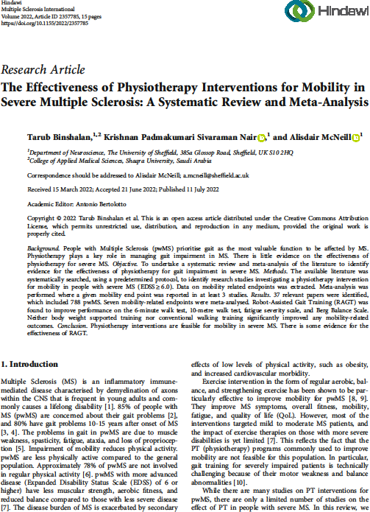

Abstract
Background

People with Multiple Sclerosis (pwMS) prioritise gait as the most valuable function to be affected by MS. Physiotherapy plays a key role in managing gait impairment in MS. There is little evidence on the effectiveness of physiotherapy for severe MS.
Objective

To undertake a systematic review and meta-analysis of the literature to identify evidence for effectiveness of physiotherapy for gait impairment in severe MS.
Methods

The available literature was systematically searched, using a predetermined protocol, to identify research studies investigating a physiotherapy intervention for mobility in people with severe MS (EDSS >6.0). Data on mobility related endpoints was extracted. Meta-analysis was performed where a given mobility end point was reported in at least 3 studies.
Results
37 relevant papers were identified, which included 788 pwMS. On the PEDro scale 12 studies were rated “good”, 15 studies were rated “fair”, and 9 studies were rated “poor”.Seven mobility-related assessments were meta-analysed. Robot-Assisted Gait Training (RAGT) was found to improve performance on the 6-minute walk test, 10-metre walk test, fatigue severity scale, and Berg Balance Scale. Neither body weight supported training nor conventional walking training significantly improved any mobility-related outcomes
Conclusion
Physiotherapy interventions are feasible for mobility in severe MS. There is some evidence for the effectiveness of RAGT. Several of the included studies were rated poor on Pedro scales, resulting in an overall weak strength of evidence. We recommend that future research focuses on larger cohorts with standardised mobility assessments across studies.

Introduction
People with Multiple sclerosis (pwMS), irrespective of the severity of the disease, prioritise gait as the most valuable function to be affected by MS ¹. 85% of pwMS are concerned about their gait problems ², and 80% have gait problems 10-15 years after onset of MS ^{3,} ⁴. The problems in gait in pwMS are due to muscle weakness, spasticity, fatigue, ataxia and loss of proprioception ⁵. Impairment of mobility reduces physical activity. pwMS are less physically active compared to the general population. Approximately 78 % of pwMS are not involved in regular physical activity ⁶.PwMS with more advance disease (EDSS of 6 or higher) have less muscular strength, aerobic fitness, and reduced balance compared to those with less severe disease ⁷. The disease burden of MS is exacerbated by secondary effects of low levels of physical activity, such as obesity, and increased cardiovascular morbidity.
Exercise intervention in the form of regular aerobic, balance and strengthening exercise has been shown to be particularly effective to improve mobility for pwMS^{8,} ⁹. They Improve MS symptoms, overall fitness, mobility, fatigue, and QoL. However, most of the interventions targeted mild to moderate MS patients and the impact of exercise therapies on those with more severe disabilities is yet limited.(reference7) This reflects the fact that the PT (physiotherapy) programs commonly used to improve mobility are not feasible for this population. In particular, gait training for severely impaired patients is technically challenging because of their motor weakness and balance abnormalities (reference 10).
While there are many studies on physical therapy (PT) interventions for pwMS, there are only a limited number of studies on the effect of PT in people with severe MS. This reflects the fact that the PT programs commonly used to improve mobility are not feasible for this population. In this review, we sought to answer the question: what are the most beneficial PT interventions to improve walking in people severely MS (EDSS ≥ 6)?

Methods
The available literature was systematically searched using a predetermined protocol (https://www.crd.york.ac.uk/PROSPERO/display_record.php?RecordID=204284). The PICO framework was used to structure the design of the systematic review and determine the inclusion and exclusion criteria (table 2.1). Studies of interest (including randomised controlled trials [RCT], prospective studies, case-control studies and cohort studies) investigated the effect of a physiotherapy intervention on mobility endpoints for adults (>18 years old), who are diagnosed with MS with severe mobility disability (reported EDSS score >6.0 or narrative description of mobility disability, e.g. use of walking aid). Articles were excluded when written in a language other than English, when more than one intervention (including trials of medication) was used or mobility endpoints were not reported.
Table 2.1: PICO describing inclusion criteria/exclusion criteria
Study Component | Inclusion Criteria | Exclusion Criteria
Population | -Diagnosed With Multiple Sclerosis according to McDonald criteria  -Adults (>18 Years Old)  - Severe Mobility Disability (Reported EDSS Score >6.0 Or Narrative Description Of Mobility Disability E.G.  Use Of Walking Aid) | -Not MS patients  -Paediatric Participant (< 18 Years Old)  -Mild-Moderate Mobility Disability (EDSS  <6.0)
Intervention | - physical therapy intervention | -Study Group Includes Physiotherapy Intervention and Concomitant Drug or Other Intervention  - Study Group Includes More Than One Type of Physiotherapy
Comparison | No intervention or sham
Outcomes | Paper Reports Mobility Related Endpoints or Outcome | Study Reports Only Non-Mobility Related Outcomes

Search strategy
The search strategy and search terms were agreed by 2 researchers (TB and AM) to reflect and address the research question. Titles and abstracts were searched in 3 databases (Scopus, Pedro, and Web of Science) from 2000 till April 2022. The keyword combinations utilised as search terms as follows: “multiple sclerosis” AND “Physical therapy” OR Exercise OR Physiotherapy OR Training OR Rehabilitation OR Neurorehabilitation OR “Virtual reality” OR “Balance training” OR “Robot∗ assisted” OR Exoskeleton OR Aerobic OR “Strength training” OR Resistance OR “Treadmill training” OR “Exercise bike” OR Cycling OR Exergaming OR “Tai Chi” OR “Core stability” OR Yoga OR Pilates OR “Assistive device.” Papers were downloaded into EndNote and duplicates removed. Searches were performed in July 2021; repeated in April 2022. Citation lists of included articles were hand searched and identified studies assessed according to the search strategy

Study Screening Process:
Article screening was guided by the pre-established inclusion/exclusion criteria (Table 2.1). Two independent reviewers (TB and AM) screened the titles, and 10% of the titles were checked by both reviewers for agreement. Initially, 19 692 papers were identified and 11 884 were removed as duplicates. Title and abstract screening was applied to 7172. The screening process is summarised in (Figure 2.1). (PRISMA chart). Articles, which passed screening, went on to full text evaluation, decisions on inclusion being undertaken in discussion by 2 researchers (TB and AM).

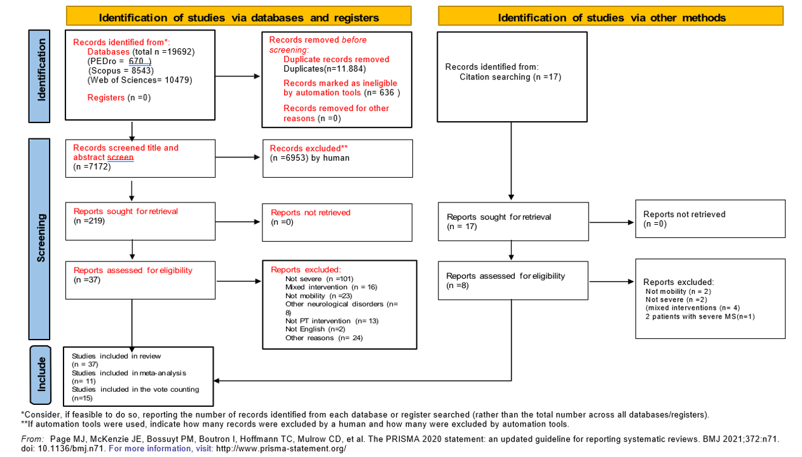
Figure 2.1: PRISMA chart outlining selection of papers for systematic review.

Data extraction
Participant demographic and clinic information along with pre- and post-intervention mobility endpoint data was extracted from included studies. All data was collated in Microsoft Excel. Studies were grouped according to exercise modalities. Where studies included a mixed cohort of MS patients with mild, moderate and severe disease (according to EDSS score) authors were contacted to provide individual data for severe MS participants (Table 2.2).

Data synthesis & Meta-analysis
Cohort demographic descriptive statistics (mean, standard deviation, and range) were calculated using PASW statistics for Windows (IBM). Meta-analysis was completed using the Comprehensive Meta-Analysis software (Biostat, New Jersey). For mobility end-points where results were available for at least 3 studies, meta-analysis was undertaken. Standardised Mean Difference (SMD), 95% confidence intervals and Z-score for overall effect were calculated using a random effects model. Heterogeneity was assessed with I2 statistic. Forest plots were generated to visualise the effect of a given PT intervention on mobility end-points. We assessed the robustness of our results in sensitivity analyses by using fixed-effects models, an alternative statistical metric of mean difference (MD), and by repeating meta-analysis with exclusion of the lowest quality study (largest standard error).
For PT interventions where meta-analysis could not be performed, the intervention was included in a vote counting exercise. The PT intervention was counted as successful if it significantly improved at least one mobility related outcome.
Statistical considerations from the Cochrane Handbook for Systematic Reviews of Interventions were followed to handle missing data. In case of missing standard deviation or standard error, we used the formula SD = SE × √N. To obtain the standard deviations in cases where 95% confidence intervals were presented for the small sample size, we followed this formula SD = √N × (upper limit − lower limit)/4.128. Where only the median and interquartile ranges are presented. A multiple of 0.75 times the interquartile range or 0.25 times the range was used as a proxy for the standard deviation values, while the median was used as a proxy for the mean.

Quality assessment
Included studies underwent quality assessment using the Pedro scale (Table 2.3). Two reviewers (TB, AM) undertook the quality assessment and resolved differences through discussion.

Results

Study selection
A total of 19,692 studies were identified via searches of 3 databases and reference lists (Figure 2.1). Thirty-seven articles were selected for data extraction ( reference 12-48) (Table 2.4) ¹⁰⁻³⁹ In 19 articles, authors were contacted and asked to provide data for severe MS patients from their cohort and only 4 authors responded (Table 2.2).
Table 2.2: list of authors who we contacted for data and who responded
NO. | AUTHORS | RESPONDED
1. | Androwis, G. J., et al (2021) | NO
2. | Berriozabalgoitia, et al., (2021) | NO
3. | Druzbicki, M., et al., (2021) | NO
4. | Sconza, C., et al., (2021) | NO
5. | Chotiyarnwong, C., et al.,(2020) | YES
6. | Berchicci et al.(2020) | NO
7. | CL Barrett et al.(2009) | NO
8. | Claude et al.(2012 ) | NO
9. | Daniele et al.(2020) | YES
10. | De Bolt et al.(2004) | NO
11. | Hayes et al.(2011) | NO
12. | Jackson et al. (2012) | YES
13. | JE Esnouf et al.(2010) | NO
14. | Jonsdottir et al. (2018) | YES
15. | Lee et al.(2017) | NO
16. | Lo et al.(2008) | NO
17. | McGibbon et al.(2018) | NO
18. | S Briken et al.(2013) | NO
19. | Straudi et al.(2013) | NO

critical appraisal
Table 2.3 and 2.4 presents a summary of the 37 included studies (quality assessment in 2.3). In total, these include 788 MS patients, with 59.6% female and a mean age of 51.88 (standard deviation 3.54). These studies assessed 11 different PT interventions, including robot-assisted-gait training (RAGT) (17 studies), body-weight-supported treadmill training (BWSTT) (5 studies), home-based-exercise (resistance and task specific training) (2 studies), electrical stimulation (2 studies), conventional exercise training (resistance and aerobic exercise) (3 studies), community-based exercise (1 study), total body recumbent stepper training (1study), blood flow restriction (2 study), exergaming (1study), assistive device training (1 study), community exercise (2 study), and ankle robotic training (1 study). In 7 studies, conventional walking training (CWT) was used in a control arm of severe MS patients.
These studies reported more than 15 distinct mobility assessments including 6-minute walk test (6MWT) (16 studies), 25-Foot Walk Test (T25FW) (7 studies), Timed Up and Go (TUG) (11 studies), 10-Meter Walk Test (10WMT) (7 studies), 2-minute walk test (2MWT) (5 studies), step length (4 studies), stance phase (%) (4 studies), swing phase (%) (4 studies), total double support phase (2 studies), stride length (2 studies), 20-meter walk test (1 study), five times sit to stand (1study), fast walking speed (1 study), self-selected walking speed (1 study), step length ratio (SLR) (2 studies), step time (1 study), 3- minute walking speed (1 study). Other mobility-related clinical rating scales reported included the Berg Balance Scale (BBS) (4 studies), the Fatigue Severity Scale (FSS) (10 studies), and Multiple Sclerosis Impact Scale (MSIS-29) (6 studies).
From 15 distinct mobility-related assessments that were reported, only the 6MWT, T25FWT, TUG, 10WMT, BBS, and FSS were described in at least 3 studies of the same PT intervention to enable meta-analysis to be undertaken. We meta-analysed mobility-related assessments that are related to patients' ambulation, to investigate which PT intervention could alleviate issues that affect mobility in pwMS.

Quality assessment
Using the Pedro scale, 1 study was rated “excellent” (score 9-10), 12 studies were rated “good” (score 8-6), 15 studies were rated “fair” (score 6-4), and 9 studies were rated “poor” (score<4). The quality assessment is summarised in (Table 2.3).

Table 2.3: Pedro Scores for Included Studies (Total Score Out Of 10)
Study | Score (/ 10) | Eligibility Criteria (external validity) | Random allocation | Concealed allocation | group similar in baseline | Participant blinding | Therapist blinding | Assessor blinding | <15%  dropout | Intention  -to-treat | Between- group difference | Point Estimate and Variability
Afzal, et al.(2020) | 2 | Y | N | N | N | N | N | N | Y | N | N | Y
Androwis, G. J., et  al (2021) | 5 | Y | Y | N | N | N | N | Y | Y | N | Y | Y
Beer et al.(2008) | 5 | Y | Y | N | Y | N | N | N | N | N | Y | Y
Berchicci et  al.(2020) | 4 | Y | Y | N | Y | N | N | N | N | N | Y | Y
Berriozabalgoitia  et al. (2021) | 5 | Y | Y | Y | N | N | N | N | Y | N | Y | Y
Chotiyarnwong, C  et al.(2020) | 8 | Y | Y | N | N | Y | Y | Y | Y | Y | Y | Y
CL Barrett et  al.(2009) | 5 | Y | Y | Y | N | N | N | N | Y | N | Y | Y
Claude et  al.(2012 ) | 4 | Y | Y | Y | N | N | N | N | N | N | Y | Y
Daniele et  al.(2020) | 7 | Y | Y | Y | Y | N | N | Y | Y | N | Y | Y
De Bolt et  al.(2004) | 5 | Y | Y | N | Y | N | N | N | Y | N | Y | Y
Devasahayam et  al. (2020) | 1 | Y | N | N | N | N | N | N | N | N | N | Y
Druzbicki, M., et  al. (2021) | 1 | Y | N | N | N | N | N | N | N | N | N | Y
Giesser et al. | 2 | Y | N | N | N | N | N | N | Y | N | N | Y

(2007)
Hayes et  al.(2011) | 5 | Y | Y | N | Y | N | N | N | Y | N | Y | y
Hogan et  al.(2014) | 4 | Y | Y | N | N | N | N | Y | N | N | Y | Y
Jackson et al.  (2012) | 2 | Y | N | N | N | N | N | N | Y | N | N | Y
JE Esnouf et  al.(2010) | 5 | Y | Y | N | Y | N | N | N | Y | N | Y | Y
Jonsdottir et al.  (2018) | 8 | Y | Y | Y | Y | N | N | Y | Y | Y | Y | Y
KL Williams, et  al.(2021) | 7 | Y | Y | Y | N | N | N | Y | Y | Y | Y | Y
Lamberti et  al.(2020) | 8 | Y | Y | Y | Y | N | N | Y | Y | Y | Y | Y
Lee et al.(2017) | 2 | Y | N | N | N | N | N | N | Y | N | N | Y
Lo et al.(2008) | 5 | Y | Y | N | N | N | N | N | Y | Y | Y | Y
Manfredini et  al.(2020) | 4 | Y | Y | N | N | N | N | Y | N | N | Y | Y
Martini et  al.(2018) | 7 | Y | Y | N | Y | N | N | Y | Y | Y | Y | Y
McGibbon et  al.(2018) | 6 | Y | Y | N | Y | N | N | N | Y | Y | Y | Y
Miller et al.  ( 2011) | 6 | y | Y | N | Y | N | N | Y | Y | N | Y | Y
Pilutt et al. (2011) | 2 | Y | N | N | N | N | N | N | Y | N | N | Y
Pilutti et  al.( 2016) | 4 | Y | Y | N | N | N | N | N | Y | N | Y | Y
Pompa et  al.(2017) | 8 | Y | Y | Y | Y | N | N | Y | Y | Y | Y | Y

Robinson et  al.(2015) | 5 | Y | Y | N | Y | N | N | N | N | Y | Y | Y
S Briken et  al.(2013) | 6 | Y | Y | Y | N | N | N | N | y | Y | Y | Y
Schwartz et  al.(2012) | 5 | Y | Y | N | Y | N | N | Y | N | N | Y | Y
Sconza, C., et  al.(2021) | 9 | Y | Y | Y | Y | N | Y | Y | Y | Y | Y | Y
Straudi et  al.(2016) | 7 | Y | Y | Y | Y | N | N | Y | N | Y | Y | Y
Straudi et  al.(2020) | 8 | Y | Y | Y | Y | Y | N | N | Y | Y | Y | Y
Straudi et  al.(2013) | 3 | Y | Y | N | N | N | N | N | Y | N | Y | Y
Willingham et al.  (2019) | 1 | Y | N | N | N | N | N | N | N | N | N | Y

Table 2.4: main characteristics of studies included in the review (including both cohorts with only severe MS and mixed cohorts)
Study Characteristics |  |  | Participant Characteristics |  |  |  | Exercise training characteristics |  |  |  | outcomes
Ref. (quality) | n | Exercise type | gender (% F) | EDSS | Diseas e duratio  n(y) M± SD | Age  M ± SD | Duratio n (weeks) | Frequency (x/week) | Time (min/  session) | Intensity | outcomes post intervention
Robotic Assistive Gait Training (RAGT)( 17 studies )

Androwis,  G. et al (2021) | 6 | RAGT | 50% | Ambulation Index ≥ 2 | NR | 46.5 ±5.2 | 4 weeks | 2/week | 45 min | gradually  ↓ BWS | ↑cognitive function,  ↑Thalamocortical resting- state functional  connectivity, ↓TUG
Berriozabalg oitiaet al., (2021) | 18 | RAGT +  gait training Ex. | 50% | 4.5-7.0 | 12.94_  8.11 | 49.8±7.26 | 3  months | 2/week | 40 min | Gradually  ↑ time and ↓ BWS | ↓10mWT,↑balance,↓ fatigue, ↓TUG
Druzbicki, M et al.(2021) | 14 | RAGT | 57% | 5-6 | NR | 48.08±7.6 | 3 weeks | 5/week | 45-60  min | gradually  ↓ BWS | ↔balance, ↓  fatigue ,↓T25-FW*
Sconza, C.,et al.(2021) | 10 | RAGT +  general Ex. (cross- over design) | 84.2% | 3.5-7 | NR | (36-74) | 5 weeks | 5/week | 90 min | 40% BWS +  treadmill speed of  1.5 km  (↓graduall  y) | ↑6MWT*, ↓EDSS,  ↓T25FW*, SLR,  ↓spasticity
Afzal et al.(2020) | 10 | RAGT | 80% | 6.0-7.5 | 15 ±  7.1 | 54.3±12.4 | 3 weeks | 5/week | 90 min | gradually  ↑  intensity | ↔ 6MWT,↑T25FW-self- selected *, ↔ T25FW-fast speed, ↓ NVO2 peak*,  ↔TUG
Berchicci et al. (2020) | 5 | RAGT | 40% | 5.0-7.0 | NR | 49.0±7.3 | 6 weeks | 2X/5/week | 45 min | NR | ↑T25FW*, ↑2MWT*,  ↑Tinetti test*, ↑BBS*,↓ fatigue *,↑FSS*, ↑EBI*,  ↓EDSS*
Daniele Munaria et  al.(2020) | 8 | RAGT-VR | 62.50% | 3.0-6.0 | 17.7±  9.62 | 57±5.83 | 6 weeks | 2/week | 40 min | gradually  ↓ BWS | ↑2MWT*,↓10mWT*,  ↑mental function*,  ↑BBS*, ↓sway area*
Manfredini et al.(2020) | 23 | RAGT | 67% | 6.0- 7.0 | 13.30  ±6.55 | 56 ±10 | 6 weeks | 2/week | 40 min | gradually  ↑ (distance, speed),  ↓guidance | ↑6MWT*, improve mitochondrial function biomarker, ↑rmVO2

 |  |  |  |  |  |  |  |  |  | force
Straudi et al. (2020) | 36 | RAGT | 67% | 6.0- 7.0 | 12 (6-  9) | 56 ± 11 | 4 weeks | 3/week | 120 min | gradually  ↑ (distance, speed),  ↓guidance  force | ↓T25FW*, ↑6MWT*,  ↓TUG, ↑PHQ-9, ↓FSS,  ↑balance*, ↑ QoL,  ↑mental health *
McGibbon et al.(2018) | 35 | home lower exoskelet on (Keeogo) (cross- over design) | 58.60% | 4-6.5 | NR | 49.2±10.6 | 6 weeks | 4 weeks at  home (2 week with Keeogo,  2  weeks wit hout Keeogo) | all the day | NR | 6MWT + keeogo  < without keeogo, TUG  + Keeogo > TUG without Keeogo*, TST + keeogo > TST without  Keeogo; post 2 weeks with Keeogo at home → ↑unassisted 6MWT distance*,↑ unassisted stair climbing  performance*
Pompa et al.(2017) | 25 | RAGT | 47.60% | 6.0–7.5 | 17.05 ±  9.12 | 47.00 ±  11.17 | 4  weeks | 3/week | 40 | 40-50% BWS  (↓graduall  y ) | ↑2MWT*, ↑FAC*,  ↓EDSS*,↓FSS**,↑RMI**  ,↑mBI**,↓VAS*
Straudi at al.(2016) | 30 | RAGT | 62.90% | 6.0-7.0 | 13.30  ±6.55 | 52.26  ±11.11 | 6 week | 2/week | 60 min (30:walk ing) | 100%  guidance + 50% BWS  (↓graduall  y )) | ↑6MWT*,  ↓10mWT,↑BBS*, ↓PHQ-  9*, ↑QoL*, ↓FSS
Straudi et al. (2013) | 9 | RAGT | 50% | 4.5–6.5 | 17.1±1  2.0 | 49.6±12.0 | 6 weeks | 2/week | 60 min (30min/ walking) | gradually  (↑ distance,sp eed), (↓g uidance | improvements in spatiotemporal parameters (↑gait speed*, ↑cadence*,  ↓double support*, ↓step

 |  |  |  |  |  |  |  |  |  | force) | length* and step time*),  ↑6MWT*
Claude Vaney etal.(2012) | 26 | RAGT | NR | 3.0 - 6.5 | NR | 58.23(9.42) | 3 weeks | 3/week | (30min/ walking) | 50%  BWS (↓gr  adually) ,  ↑speed to normal gait speed | ↑QoL*,↑ 3-minute walking speed*,  ↓fatigue*, ↑balance*,  ↓spasticity*, ↓activity  level,  ↔10mWT,↔ RMI, ↔  pain level.
Schwartz et al.(2012) | 15 | RAGT | 57% | 5.5–7 | 11.3 ±  6.7 | 46.8 ± 12.0 | 4  weeks | 2-3/week | 45 min (30min/  walking) | 40%  BWS (↓gr  adually) | ↑6MWT,  ↓10mWT,↓TUG*,↑BBS*  , ↓EDSS*,↑FIM**
Beer et al.(2008) | 19 | RAGT | 63.20% | 6.0–7.5 | 15.0±8.  0 | 49.7±11.0 | 3 weeks | 5/week | 30 min | 40–80% BWS,  gradually  ↑ (distance, speed),  ↓BWS | ↑ 20m walking  velocity*,↑6MWT*,  ↑knee extensor strength*, ↑EBI*
Lo et al.(2008) | 13 | RAGT+BW  ST (cross- over design) | 48% F | 3.0 - 7.0 | NR | 49.8 ±11.1 | 6  weeks (3  weeks  /phase) | 2/week | 40 min | 30%- 40% BWS  (↓graduall  y),  ↑speed | ↓T25FW**, ↑6MWT*,  ↓DST**, ↓EDSS**, SLR
Body weight supported treadmill training BWSTT ( 5
studies)
Devasahaya m et al.(2020) | 10 | BWSTT+  Cooling room (16 °C) | 90% | 6.0- 7.0  (sensi-tive to heat) | 17.6±1  0.17 | 53.2 ±  15.6 | 10  weeks | 3/week | 40 min | gradually increased to vigorous intensity  (40–65% | ↑fast walking speed*,↑self selected walking speed,↓stance  phase (%),↓ swing phase (%), ↓total double

 |  |  |  |  |  |  |  |  |  | HRR) | support phase, ↓T25FW*,  ↓mFIS*,↓FSS, ↑QoL,  ↑Aerobic Fitness,  ↓fatigue*
Willingham et al.(2019) | 6 | BWSTT+  antigravity treadmill training | 50% | 6.0-6.5 | NR | 50 ± 4.9 | 8 weeks | 2/week | 20 min | 35%-70% BWS,  speed (0.2-  2.5 mph) <  RPE of 8.0 | ↑muscle oxidative capacity*,↑muscle  endurance*, ↑2MWT
Jonsdottir et al.(2018) | 26 | BWSTT if  needed  +daul task training | 44.70% | 3.5–7 | 16.3 ±  7.1 | 51.4 ± 10.7 | 4  weeks | 5/week | 30 min | ↑treadmill speed + slope =  14–16 RPE | ↑2MWT**,↓10mWT,  ↓TUG*,↑DGI*
Pilutti et al.(2011) | 6 | BWSTT | 66% | 5.5–8.0 | 11.5±6.  60 | 48.2±9.30 | 12  weeks | 3/week | 30 min | gradually  ↑ speed,  ↓BWS | ↓T25-FW, ↓fatigue,  ↑QoL, ↓EDSS
Giesser et al.(2007) | 4 | BWSTT | 75% | 7.0-8.0 | 20±5 | 47±5.3 | 20 week | 2/week | 60 min | 100%  BWS (↓gr  adually) ,  ↑speed to normal gait speed | ↓10mWT,↑  6MWT,↑balance, ↑QoL,  ↓Spasticity,↑ Muscle strength( not all patients were able to complete the  10mWT ,6MWT)
Total-Body Recumbent Stepper Training (TBRST) (1
study)
Pilutti et al.(2016) | 5 | TBRST | 40% | 6.0-8.0 | 15.2  ±8.9 | 58.8 (3.0) | 12  weeks | 3/week | 30 min | gradually  ↑ according to  participant ability | ↓fatigue, ↑QoL, ↔  T25FW
Home Based Exercise ( 2 studies)

de Bolt et al.(2004) | 19 | Home based resistance Ex. | 78.95% | 1.0 - 6.5. | 15±  12.23 | 51.6±7.26 | 8  weeks | 3/week | 50 min | resistance by 0.5% of body weight,  ↑(.05%–  1.5%)  every 2  weeks | ↓TUG,↑Leg Extensor Power*, ↑balance,
Miller et al. ( 2011) | 15 | home Ex. of task- specific programm  e | 73.30% | 6.5–8 | 13 ±9.1 | 56.3±9.0 | 8 weeks | 2/week | 60 min | NR | ↑MSIS-29,↓10mWT,  ↑muscle strength,  ↓timed sit-stand, ↓EDSS,  ↓FIM
Electrical Stimulation ( 2 studies)
JE Esnouf et al.(2010) | 32 | FES(ODFS) | 61.50% | 4.0-6.5 | 12.5 | 53 | 18  weeks | daily mobility | all the day | NR | ↓effort for walking,  ↓ tripping ,↑ confidence  while walking,↑walking  distance
CL Barrett et al.(2009) | 25 | FES(ODFS) | 75% | 4.0-6.5 | 13.6 ±  8.3 | 52.1± 6.7 | 18  weeks | daily mobility | all the day | gradually to be worn all the day | ↑walking speed,↑walking distance, ↔physiological cost  index
Blood Flow-Restriction( 2 study)
Chotiyarnwo ng, C et al.(2020) | 39 | Remote ischaemic preconditi oning (RIPC) | 44.7% | 1.0 -7.0 | 10 ±  10.6 | 47.6±11.3 | 1  session | Blood pressure cuff inflated to (30mm Hg)  above resting | Inflation for 5 min followe d by  deflatio n for 5 | NR | ↑ 6MWT*, ↑walking speed*, ↓Borg RPE test

 |  |  |  |  |  |  |  | systolic pressure | min / 3X
Lamberti et al.(2020) | 12 | Blood flow restricted slow walking  (BFR-W) | 46% | 6.1 ± 0.2 | 14 ± 9 | 54 ± 11 | 6  weeks | 2/week | 60 min | ↑ speed by 3 steps  /min, BFR stable | ↑walking speed*,  ↓perceived exertion*,↑ 6MWT*, ↓ MSIS-  29(psychological)*,  ↓MSIS-29(motor),  ↓ MFIS*, ↓5STS time *
Conventional Exercise Training (3 studies )
Resistance Training
S Briken et al.(2013) | 12 | arm  ergometry | 50% | 4.0-6.0 | 17.1±7.  2 | 49.1±8.5 | 8-10  weeks | 2-3/week | 15-45  min | gradually increase | ↑6MWT*, ↓fatigue*, ↓  depression*
S Briken et al.(2013) | 12 | rowing | 36.60% | 4.0-6.0 | 14.1±6.  1 | 50.9±9.2 | 8-10  weeks | 2-3/week | 15-45  min | gradually increase | ↔ 6MWT
S Briken et al.(2013) | 12 | bicycle ergometry | 54.50% | 4.0-6.0 | 13.3±5.  4 | 48.8±6.8 | 8-10  weeks | 2-3/week | 15-45  min | gradually increase | ↑6MWT*,↑ VO2 peak*,  ↓depression*
Hayes et al.(2011) | 11 | Lower limb resistance  Ex. | 55.50% | 3.5-6.5 | 11.9  ±7.3 | 48.0 (11.9) | 12  weeks | 3/week | 45-60  min | gradually increase | ↑Lower limb strength, ↔  TUG, ↔10mWT, ↔  6MWT, ↑balance, ↔  fatigue
Aerobic Exercise
Jackson etal. (2012) | 15 | kick boxing | 81.80% | 1.0-6.0 | 12.09±  5.5 | 52.27 ±8.8 | 5  weeks | 3/week |  | gradually increased ≤ 75% HRR  or ≤ 5 RPE | ↑gait speed*, ↓ TUG*,  ↑balance, ↑Mini- BESTest*
Exergaming (1 study)
Robinson et al.(2015) | 20 | (exergami ng)  Nintendo | 70% | 6.00 | NR | 52.6 6.1 | 4  weeks | 2/week | 40-60  min | ↑difficulty | ↓postural  sway,↑balance,↑step  length, ↑stride length,

 |  | Wii Fit |  |  |  |  |  |  |  |  | ↓MSWS-12
 | 18 | balance training | 63% | 6.00 | NR | 53.9 6.5 | 4  weeks | 2/week | 40-60  min | ↑difficulty | ↓postural  sway,↑balance,↑step  length, ↑stride length,  ↓MSWS-12
Assistive Device Selection, Training and Education Program (ADSTEP) ( 1 study)
Martini et al.(2018) | 20 | ADSTEP | 14% | 6.0±0,  (history of fall) | NR | 56.0±9 | 6  weeks | 1/week | 40 min | aid selection, fitting, task- oriented gait  training | ↓falling*, ↓time spent setting* ,↔TUG, ↔ T25FW,  ↔2MWT,↔FSS,↓MSWS  -12, ↓MSIS-29,↑walking  aid satisfaction
Community Exercise (2 study)
KL Williams et al.(2021) | 26 | Communit y group exercise | 65.4% | 0-5 Disease step rating scale | 12.4(1  0.2) | 52.7(11.9) | 8 weeks | 2/week | 60 min | ↑intensity | ↑6MWT, ↑10mWT,  ↑Balance
Hogan et al.(2014) | 66 | group physio- therapy | 62.50% | 3 - 4 on the mobility section of (GNDS) | 18(9) | 57 (10) | 10  weeks | 1/week | 60 min | increase the set of (12  repetitions) | ↑6MWT, ↑balance **, ↑ QOL*, ↓MSIS-29v2  physical component*,  ↓MFIS*
Hogan et al.(2014) | 45 | 1:1  physio- therapy | 57% | 3 - 4 on the mobility section of (GNDS) | 13(8) | 52 (11) | 10  weeks | 1/week | 60 min | increase the set of (12  repetitions) | ↑balance **, ↑ QOL*,↓MSIS-29v2  physical component*,  ↓MSIS-29v2 psychological

component*,↓MFIS*,↑6
MWT*
 | 16 | yoga | 61.50% |  | 15(8) | 58 (8) | 10  weeks | 1/week | 60 min | NR | ↑balance **, ↑ QOL,↓MSIS-29v2 physical component, ↓MSIS-29v2 psychological component,↓MFIS,↑6M  WT
Ankle Robotic Training ( 1 study)
Lee Y et al.(2017) | 7 | ankle robotic training for impaired  leg | 83.30% | 5.2 ± 2.5 | 16.0 ±  6.5 | 55.3 ± 11.2 | 6 weeks | 3/week | 45 min | NR | ↑ROM*, ↑balance*, ↑  walking  performance ,↑6MWT*,  ↓10mWT*
2MWT, 2 minutes walking test; 5TST, 5-time sit to stand; 6 MWT, 6 min Walk Test; 10mWT, Ten Meters Walking Test; ADSTEP, Assistive Device Selection Training and Education Program; BBS,Berg Balance Scale; BFR-W, Blood Flow-Restricted Slow Walking;BWS, Body weight support; BWST, Body weight supported training; DGI, dynamic gait index; DST, double support time; EBI, Extended Barthel Index; EDSS, Expanded Disability Status Scale; FAC, Functional Ambulation Category; FSS, Fatigue Severity score; FES, Functional electrical stimulation; FSST, Four Square Step Test; FIM, Functional Independence Measure; GNDS, The Guy's Neurological Disability Scale; MAS, Modified Ashworth Scale; mBI, modified Barthel Index; mFIS, modified Fatigue Impact Scale; Mini-BESTest, mini Balance Evaluation System Test, MSIS-29, multiple sclerosis impact scale; MSWS, Multiple Sclerosis Walking Scale questionnaire; ODFS, Odstock dropped foot stimulator; PHQ, patient health questionnaire; QoL, Quality of life; RAGT, Robot-assisted Gait Training; RAGT-VR, Robot-assisted Gait Training combined with Virtual Reality; rmVO2, resting muscle oxygen consumption; RMI, Rivermead Mobility Index; ROM, Range of motion; RPE,rating of perceived exertion; SLR, Step Length ratio ; TBRST, Total-Body Recumbent Stepper Training; T25FW,timed 25-foot walk test; TST,Timed stair test; TUG, Timed Up and Go; VAS, Visual Analogue Scale.; VO2peak, peak oxygen consumption; NR, not reported. Disease duration in years presented in (Mean ± SD), otherwise Mean (range), Abbreviations are presented in alphabetical order.
*Statistically significant at P ≤0.05 or **P ≤ .001

Meta-analysis results

Robot Assisted Gait Training (RAGT)
Five studies [14, 22, 29, 36, 43] reported the effect of RAGT on the 6MWT (n = 96 patients), with a significant improvement post-intervention (SMD 0.444, 95% CI [0.199-0.689], P ≤ 0.001, I2 = 19.49%) (Figure 2.2A). The mean increase in 6MWT of all included studies achieved the MCID with a 7% increase in the distance walked except for one study by Afzal et al. [36]. After sensitivity analysis by excluding the lowest quality studies [22, 36], the result remained statistically significant (SMD 0.498, 95% CI [0.124-0.873], p = 0.009, I2 = 58.43%). An alternative analysis using the fixed model and the mean difference showed similar results (MD 9.030, 95% CI [4.944-13.117], p ≤ 0.001, I2 = 38.92%).
Three studies [22, 29, 42] reported the effect of RAGT on the 10WMT (n = 34 patients), with a significant effect postintervention (SMD 0.424, 95% CI [0.072-0.777], p = 0.018, s%) (Figure 2.2B). Four studies [22, 29, 36, 43] described a nonsignificant effect of RAGT on TUG (n = 76 patients) (SMD 0.2, 95% CI [-0.056-0.52], p = 0.155, I2 = 24.9%) (Figure 3A). Three studies [29, 31, 43] reported a significant effect of RAGT on the FSS postintervention (n = 82 patients) (SMD 0.54, 95% CI [0.027-1.06], p = 0.039, I2 = 77.7%)(Figure 2.3B).
Three studies [29, 42, 43] reported a significant effect of RAGT on the BBS post-intervention (n = 64 patients) (SMD 0.46, 95% CI [0.06-0.863], p = 0.024, I2 = 43%) (Figure 2.3C). Sensitivity analysis by using the fixed model and the mean difference showed also similar results (MD 2.646, 95% CI [1.330-3.962], p ≤ 0.001, I2 = 0%).

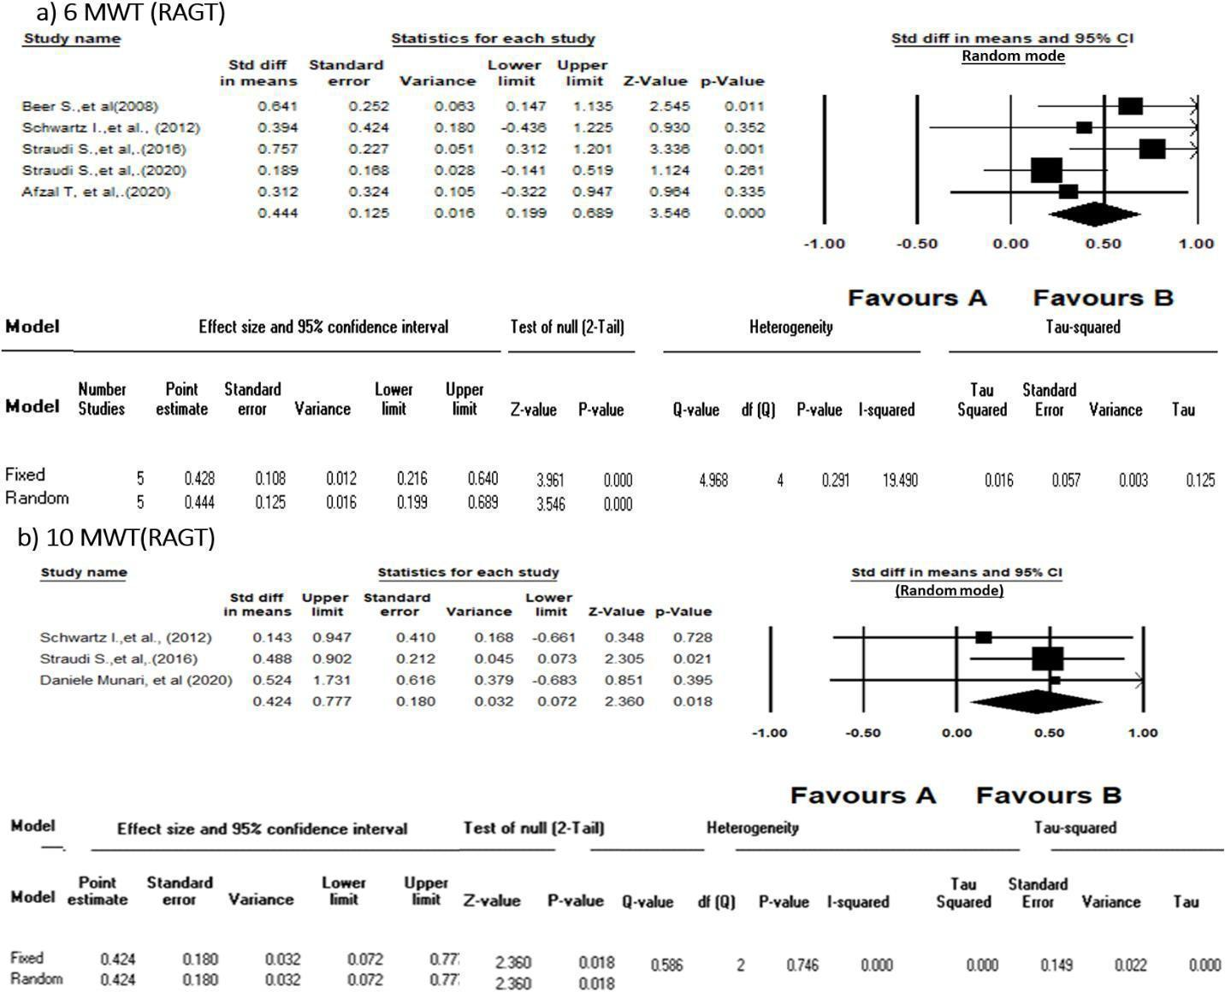
Figure 2.2: Standardized Mean Difference in a) 6 minute walk test (m) , b)10 meter walk test (m/s) post RAGT intervention

Body Weight Supported Training (BWST)
Three studies [20, 28, 39] described the effect of BWSTT on the T25FW for (n = 21 patients), showing no significant effect of intervention (SMD 242, 95% CI [-0.192-0.677], p = 0.275, I2 = 0% (Figure 2.4A).

Conventional Walking Training (CWT)

Five studies [14, 22, 29, 40, 43] examined the effect of CWT on the 6mwt for (n = 91 patients), showing no significant effect (SMD 0.162, 95% CI [-0.046-0.369], p = 0.127, I2 = 0%) (Figure 2.4B).
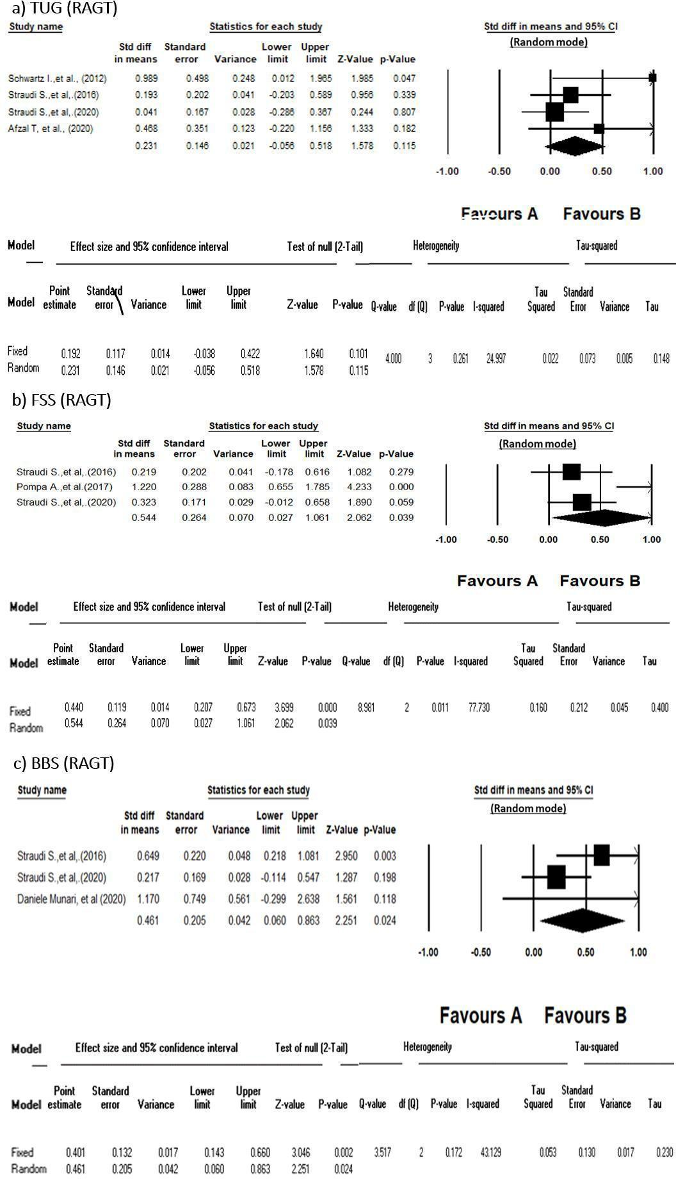
Figure 2.3: Standardized Mean Difference in a) time up and go (Sec), b) fatigue severity scale post RAGT intervention, and c) berg balance scale.

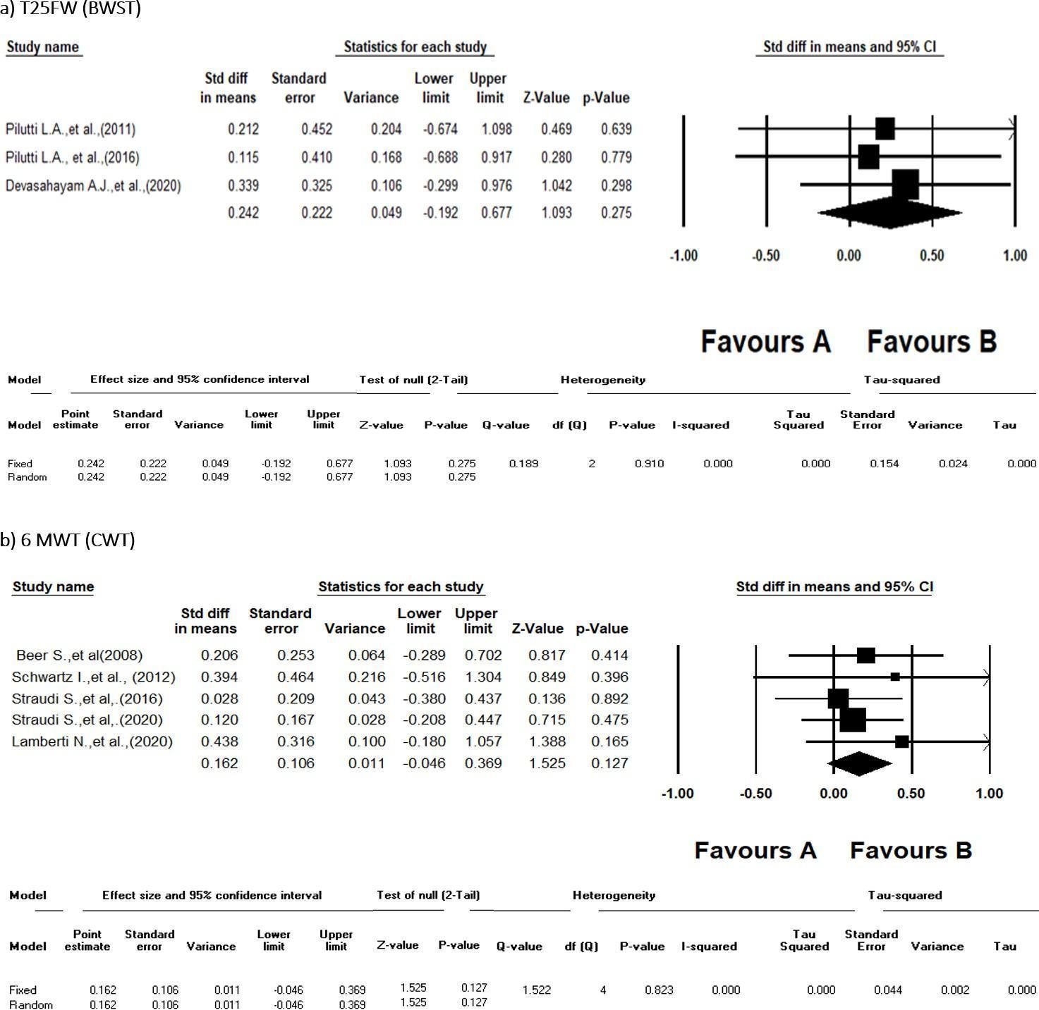
Figure 2.4: Standardized Mean Difference in a) timed 25-foot walk post body weight supported training and, b) 6 minute walk test post conventional walking training.

Vote counting results
16 interventions from 15 studies (Table 5) were included in the vote counting (RAGT [41], RAGT+VR [42], CWT [31, 41], BWSTT+ antigravity treadmill training [35],BWSTT [13], BWSTT+ dual tasks [32], blood flow restriction [38, 40], total body recumbent stepper training [28], home exercise [19], exergaming [27], balance training [27], ADSTEP [33], group physiotherapy [26, 44], 1 : 1 physiotherapy [26], yoga [26], and kickboxing [21]).
Seven interventions from 6 studies were defined as beneficial in improving mobility in severely disabled MS patients (RAGT, CWT, BWSTT+ dual task training, BFR, group physiotherapy, 1 : 1 physiotherapy and Yoga) [26, 31, 32, 40, 41, 44].
The significant findings from the vote counting results can be summarised as follows: A study by Manfredini et al. [41] showed that RAGT and CWT significantly increased the distance in 6MWT. The Rivermead Mobility Index was significantly improved post CWT in severely disabled MS patients [31]. A study by Jonsdottir et al. [32] reported that a treadmill with dual task training significantly improved 2MWT. Blood flow restricted walking study demonstrated a significant improvement in the 6MWT, walking speed, 5 time sit to stand, and FSS [40]. In addition, a study by Williams et al. [44] found that group physiotherapy significantly improved the 10WMT. Hogan et al.'s study [26] with three intervention groups showed that individual physiotherapy significantly improved 6MWT, balance, and fatigue and group physiotherapy significantly improved balance and fatigue, while yoga only improved balance significantly after the intervention

Table 2.5:Vote Counting Of Studies For Severe MS Patients, Not Included In The Meta Analysis
Study Characteristics |  |  |  |  | intervention |  |  | Outcomes | Vote Counting
Studies |  |  | N | PT Intervention | Disability Scale | Duration (Weeks) | Frequency (X/Week) | Outcomes Post Intervention | Significant Mobility Related Outcomes
Williams et al. (2021) |  |  | 26 | Community group exercise | 3-5 Disease step rating scale | 8 weeks | 2/week | ↑6MWT, ↑10mWT*, ↑Balance | ↑10mWT*
Chotiyarnwong et al.  (2020) |  |  | 10 | BFR | 6.0-7.0 | 1 session | 1 day | ↑6MWT, ↑waking speed, ↓  perceived exertion | none
Daniele Munaria et al. (2020) |  |  | 5 | RAGT +VR | EDSS ≥ 6 | 6 weeks | 2/week | ↑2MWT, ↓10MW,  ↑BBS,↑cognitive function,  ↓double support time, ↓sway  area, | none
Manfredini (2020) | et | al. | 23 | RAGT | 6.0-7.0 | 6 weeks | 2/week | ↑6MWT*, improve mitochondrial  function biomarker, ↑rmVO2* | ↑6MWT*
Manfredini (2020) | et | al. | 23 | CWT | 6.0-7.0 | 6 weeks | 2/week | ↑6MWT*, improve mitochondrial  function biomarker, ↑rmVO2 | ↑6MWT*
Lamberti (2020) | et | al. | 12 | BFR-W | 6.1 ± 0.2 | 6 weeks | 2/week | ↑ 6MWT*, ↓5STS time *, ↓ mFIS*, ↓ MSIS-29(psychological)*,  ↓MSIS-29(motor), ↑walking speed*,↓perceived exertion* | ↑walking speed*, ↑ 6MWT*, ↓5STS  time*, ↓ mFIS*
Willingham (2019) | et | al. | 6 | BWST+  antigravity  treadmill training | 6.0-6.5 | 8 weeks | 2/week | ↑2MWT, ↑muscle oxidative capacity*, ↑muscle endurance* | none
Jonsdottir (2018) | et | al. | 8 | BWST if needed +  dual task training | EDSS ≥ 6 | 4 weeks | 5/week | ↑2MWT*, ↓10mWT, ↑Balance,  ↑DGI, ↓TUG | ↑2MWT*
Jonsdottir (2018) | et | al. | 2 | resistance Ex. |  | 4 weeks | 5/week | ↑2MWT, ↓10mWT, ↑Balance, ↑  DGI, ↓TUG | none
Martini et al. (2018) |  |  | 20 | ADSTEP | 6.0±0, (history of | 6 weeks | 1/week | ↔2MW, ↓falling*, ↔FSST, | none

 |  |  | fall) |  |  | ↓MSIS-29, ↓MSWS-12,  ↔T25W ,↓time spent setting* ,↔TUG,↑ walking aid satisfaction
Pompa et al. (2017) | 25 | CWT | 6.0–7.5 | 4 weeks | 3/week | ↑2MWT, ↓EDSS, ↑FAC ↓FSS,  ↑mBI**, ↓↑RMI**,↓VAS | RMI **
Pilutti et al.  (2016) | 5 | TBRST | 6.0-8.0 | 12 weeks | 3/week | ↓fatigue, ↑QoL, ↔ T25FW | none
Robinson et al. (2015) | 20 | (exergaming)  Nintendo Wii Fit | 6.00 | 4 weeks | 2/week | ↑balance, ↓MSWS-12, ↓postural  sway, ↑step length, ↑stride length | none
Robinson et al. (2015) | 18 | balance training | 6.00 | 4 weeks | 2/week | ↑balance, ↓MSWS-12, ↓postural  sway, ↑step length, ↑stride length | none
Hogan et al. (2014) | 66 | group physio- therapy | 3 - 4 mobility section of (GNDS) | 10 weeks | 1/week | ↑6MWT, ↑balance **, ↑ QOL*,  ↓MSIS-29v2 physical component*,  ↓mFIS* | ↑balance **,  ↓mFIS*
Hogan et al. (2014) | 45 | 1:1 physio- therapy | 3 - 4 mobility section of (GNDS) | 10 weeks | 1/week | ↑balance **, ↑ QOL*, ↓MSIS- 29v2 physical component*, ↓MSIS- 29v2 psychological  component*,↓mFIS*,↑6MWT* | ↑balance **,  ↓mFIS*,↑6MWT*
Hogan et al. (2014) | 16 | yoga | 3 - 4 mobility section of (GNDS) | 10 weeks | 1/week | ↑balance **, ↑QOL, ↓MSIS-29v2 physical component, ↓MSIS-29v2 psychological component,  ↓mFIS,↑6MWT | ↑balance **
Jackson et al. (2012) | 4 | kickboxing | 6.0-6.5 | 5 weeks | 3/week | ↑balance, gait speed, ↑Mini-  BESTest ,↓ TUG | none
Miller et al. (2011) | 15 | home Ex. | 6.5–8 | 8 weeks | 2/week | ↓10mWT, ↓FIM, ↓EDSS, ↑MSIS  29, ↑muscle strength, ↓timed sit- stand, | none
Giesser et al. (2007) | 4 | BWST | 7.0-8.0 | 20 weeks | 2/week | ↓10mWT, ↑6MWT, ↑balance, ,↑ Muscle strength,↑QoL, ↓Spasticity ( not all patients were able to  complete the 10mWT ,6MWT) | none

2MWT, 2 minutes walking test; 5TST, 5-time sit to stand; 6 MWT, 6 min Walk Test; 10mWT, Ten Meters Walking Test; ADSTEP, Assistive Device Selection Training and Education Program; BBS,Berg Balance Scale; BFR-W, Blood Flow-Restricted Slow Walking; BWST, Body weight supported training; DGI, dynamic gait index; DST, double support time; EBI, Extended Barthel Index; EDSS, Expanded Disability Status Scale; FAC, Functional Ambulation Category; FSS, Fatigue Severity score; FES, Functional electrical stimulation; FSST, Four Square Step Test; FIM, Functional Independence Measure; GNDS, The Guy's Neurological Disability Scale; MAS, Modified Ashworth Scale; mBI, modified Barthel Index; mFIS, modified Fatigue Impact Scale; Mini-BESTest, mini Balance Evaluation System Test, MSIS-29, multiple sclerosis impact scale; MSWS, Multiple Sclerosis Walking Scale questionnaire; ODFS, Odstock dropped foot stimulator; PHQ, patient health questionnaire; QoL, Quality of life; RAGT, Robot-assisted Gait Training; RAGT-VR, Robot-assisted Gait Training combined with Virtual Reality; rmVO2, resting muscle oxygen consumption; RMI, Rivermead Mobility Index; ROM, Range of motion; SLR, Step Length ratio ; TBRST, Total-Body Recumbent Stepper Training; T25FW,timed 25-foot walk test; TST,Timed stair test; TUG, Timed Up and Go; VAS, Visual Analogue Scale.; VO2peak, peak oxygen consumption; NR, not reported. Abbreviations are presented in alphabetical order.

*Statistically significant at P≤0.05 or **P ≤ .001

Discussion
We report a systematic review and meta-analysis of the evidence for PT interventions to improve walking performance in severely disabled pwMS (defined as EDSS ≥ 6.0). We include 37 studies that investigated a range of PT interventions in 788 pwMS. Forty three percent of studies included only severely affected pwMS (EDSS ≥ 6.0), and 57% had mixed cohorts with mild, moderate, and severely affected pwMS. Overall study quality was variable; with only 1/37, study rated “excellent,” 12/37 included papers rated “good” on the Pedro scale and 9/30 rated poor. Weaknesses of study design included lack of blinding (for participant, therapist and/or assessor), nonconcealment of allocation, missing data, and lack of intention-to-treat analysis.
A major concern limiting the use of PT interventions for mobility in severely disabled pwMS is increasing the barrier to exercise [49], in particular, health and cognitive barriers. As disease progresses, the health and cognitive status of patients are significantly impaired. Moreover, severely disabled PwMS suffer from fatigue, mobility disability, depression, safety concerns, and hesitation to engage in tasks they cannot perform as simply or effectively as they did previously and an inaccessibility to appropriate places. Moreover, they are uncertain of their capacity to engage in physical activity [49]. Therefore, they need more social and physical support to overcome these obstacles compared to other less affected pwMS [49]. However, our systematic review indicates that severely disabled pwMS can utilise a variety of PT interventions. Of note, 27/37 (73%) studies had a dropout rate of less than 15%, suggesting that the majority of people with severe MS can complete PT protocols for mobility.
There was significant heterogeneity in the mobility outcome measures and statistical analyses reported. There were more than 15 mobility-related outcome measures reported in 37 studies, but there was little overlap in the outcome measures used between studies. Because of this, we could only meta-analyse 6 outcomes (Figure 3.2),(Figure 3.3) and (Figure 3.4)from 11 studies.
Based on our meta-analysis, RAGT is the PT intervention for which there is most evidence of effectiveness to improve mobility in severe MS. RAGT significantly improved scores on the 6MWT [14, 22, 29, 36, 43], 10WMT [22, 29, 42], FSS [29, 31, 43], and BBS [29, 42, 43]. In addition, one paper from the vote counting exercise demonstrated a significant effect of RAGT on the 6MWT [31]. Improvements in 6MWT scores likely reflect improved aerobic capacity and endurance. Improvements in the 10WMT scores reflect increases in walking speed after RAGT [50].
Fatigue in MS is multifactorial, reflecting both physical and psychological factors [13]. It is likely that improved aerobic capacity and endurance could lead to reduce perceived fatigue (as measured by the FSS) [31]. Improvements in the BBS are likely associated with general improvements in mobility after RAGT. In contrast, there was no significant effect of RAGT on the TUG. This is likely because TUG is a demanding function particularly for severely disabled patients that requires the patient to stand upright from sitting position, then walk (acceleration-deceleration), and turn to return to the starting point [51]. Moreover, RAGT is designed to improve dynamic walking as an independent function; it is not targeting tasks like sit-to-stand or turning [52]. This suggests that RAGT may need to be complemented with additional PT interventions to target activities like getting up from sitting or transfers.
Seven studies with (n = 150 patients) reported the use of CWT in severely disabled pwMS. However, meta-analyses of 6MWT did not show any improvement post-CWT. CWT as a stand-alone intervention might not improve the distance walked in 6 minutes in pwMS. CWT bearing has other advantages like reducing osteoporosis, improving balance, improving self-esteem, and better control of spasticity [29, 53]. It also does not require specialist equipment and could be delivered widely in community [29]. We did not look into these aspects. Further research is required to understand the role of CWT in people with advanced MS.
Five studies investigated the role of BWSTT, though no clear evidence of benefit on mobility related outcomes emerged from our meta-analysis. A number of other PT interventions were identified as being utilised for severely disabled pwMS, including kickboxing [21], exergaming [27], and electrical stimulation [16, 17]. Although there are various rehabilitation programs that work empirically for MS patients, there was relatively few studies on the effect of PT in people with severe mobility impairment [54, 55]. Therefore, further studies are needed particularly for this population.
It may however be noted that the RAGT included studies have been administered to patients with EDSS score ranges (3-7.5), and no study has examined the feasibility of RAGT for patient of EDSS higher than 7.5. On the other hand, 4 studies have been applied to patients with EDSS ≤ 8. Two studies used BWSTT [13, 20] and another study used home Exercise of task-specific programme [19], while Pilutti et al.'s study [28] used total body recumbent stepper training for this population. Although not all severely disabled participants were able to complete the intervention protocol or the outcome measures, the overall effect was positive by increasing the mobility related outcomes and decreasing their disability. We cannot discount that there may be significant numbers of unpublished clinical studies that failed to recruit sufficient numbers of severely disabled pwMS (or in which the intervention could not be completed). Such publication bias may lead to an overestimation of the feasibility of certain PT for severely disabled pwMS. Nonetheless, a range of PT interventions are likely to be feasible for severely disabled pwMS.
There are several factors, which might explain the apparent superiority of RAGT compared to other PT interventions for severely disabled pwMS. Appropriate PT intervention programs must be tailored to the patient's abilities with sufficient stimulus to push present competence to produce effect [49]. Therefore, it possible that RAGT is less demanding for severely disabled pwMS, who might not be able to complete other forms of PT effectively. Moreover, progression in RAGT is easily adjusted by increasing the intensity (frequency and duration) of the training session to challenge patients' abilities [5, 41]. There is evidence that personalised RAGT program might more effectively activate motor areas of the brain and have the potential to induce neuroplastic compensatory mechanisms that might benefit gait and mobility [42]. Moreover, RAGT might also target underlying factors in MS pathogenesis. RAGT has been demonstrated to improve blood mitochondrial function biomarkers, blood oxidative stress markers, and resting muscle oxygen consumption in severely disabled pwMS [41]..
There are several limitations to our systematic review. We did not systematically search the grey literature to identify unpublished studies of PT interventions for severely disabled pwMS. We attempted to obtain patient level data on severely disabled pwMS from studies that reported cohorts of mixed MS severity. However, only 4 authors provided the requested data. So, data that could not be obtained was excluded from further analysis. The overall quality of our systematic review and meta-analysis is also influenced by the quality of the included studies. A significant number of included studies were rated “poor” on the Pedro scale. Besides, significant heterogeneity in the mobility-related outcomes was reported. These limited our ability to undertake a meta-analysis.

Our systematic review and meta-analysis provides evidence to guide design of future clinical trials for PT interventions in severely disabled pwMS. The strongest evidence of efficacy is for RAGT. Future clinical trials could focus upon further investigating the effectiveness of RAGT in larger cohorts and defining the most effective and feasible treatment protocols: for example, optimal exercise intensity, duration, and frequency of training episodes. Agreement on a consensus package of mobility-related outcome measures across studies would also be beneficial. There is evidence that longer duration walking tests (e.g., 2MWT) and the Multiple Sclerosis Walking Scale (MSWS-12) are the most sensitive to changes in mobility after PT [56]. A recent systematic review also identified that the 6MWT can discriminate between mild, moderate, and severe MS and in theory measure response to PT [50]. Clinical trials of PT interventions for severely disabled pwMS should be considered a priority given that mobility impairment is considered the most disabling feature of MS by pwMS.
In this meta-analysis and systematic review, we found some evidence that physical therapy interventions can improve mobility in severe MS patients. RAGT is the physical therapy intervention with the most evidence for improving mobility in this population. However, we note the generally poor quality of studies, with small sample sizes and a lack of standardised mobility assessments. One factor contributing to small cohort sizes is likely to be poor mobility in people with severe MS. Which will limit the ability of participants to travel to research facilities to participate in studies. Accordingly, researchers are looking for effective alternatives that can be used at home to assess mobility. One such solution would be the use of physical activity monitors to measure mobility in a real world environment, rather than in a formal gait laboratory setting. We address this in Chapter 3 of this thesis by examining correlations between physical activity monitor data and laboratory gait assessments in a cohort of pwMS.

References:

- Geurts J. J., Barkhof F. Grey matter pathology in multiple sclerosis. The Lancet Neurology . 2008;7(9):841–851. doi: 10.1016/s1474-4422(08)70191-1. [PubMed] [CrossRef] [Google Scholar]
- Larocca N. G. Impact of walking impairment in multiple sclerosis. The Patient: Patient-Centered Outcomes Research . 2011;4(3):189–201. doi: 10.2165/11591150-000000000-00000. [PubMed] [CrossRef] [Google Scholar]
- Kesselring J., Beer S. Symptomatic therapy and neurorehabilitation in multiple sclerosis. Lancet
Neurology . 2005;4(10):643–652. doi: 10.1016/S1474-4422(05)70193-9. [PubMed] [CrossRef] [Google Scholar]
- Martin C. L., Phillips B. A., Kilpatrick T. J., et al. Gait and balance impairment in early multiple sclerosis in the absence of clinical disability. Multiple Sclerosis Journal . 2006;12(5):620–628.
doi: 10.1177/1352458506070658. [PubMed] [CrossRef] [Google Scholar]
- Halabchi F., Alizadeh Z., Sahraian M. A., Abolhasani M. Exercise prescription for patients with multiple sclerosis; potential benefits and practical recommendations. BMC Neurology . 2017;17:1–11. [PMC free
article] [PubMed] [Google Scholar]
- Backus D. Increasing physical activity and participation in people with multiple sclerosis: a review. Archives of Physical Medicine and Rehabilitation . 2016;97(9):S210–S217. doi: 10.1016/j.apmr.2015.09.027. [PubMed] [CrossRef] [Google Scholar]
- Edwards T., Pilutti L. A. The effect of exercise training in adults with multiple sclerosis with severe mobility disability: a systematic review and future research directions. Multiple Sclerosis and Related
Disorders . 2017;16:31–39. doi: 10.1016/j.msard.2017.06.003. [PubMed] [CrossRef] [Google Scholar]
- Mañago M. M., Glick S., Hebert J. R., Coote S., Schenkman M. Strength training to improve gait in people with multiple sclerosis: a critical review of exercise parameters and intervention approaches. International Journal of MS Care . 2019;21(2):47–56. doi: 10.7224/1537-2073.2017-079. [PMC free article] [PubMed] [CrossRef] [Google Scholar]
- Rietberg M. B., Brooks D., Uitdehaag B. M., Kwakkel G. Exercise therapy for multiple sclerosis. Cochrane Database of Systematic Reviews . 2005;1 [PMC free article] [PubMed] [Google Scholar]
- Schwartz I., Meiner Z. Robotic-assisted gait training in neurological patients: who may benefit? Annals of Biomedical Engineering . 2015;43(5):1260–1269. doi: 10.1007/s10439-015-1283-x. [PubMed] [CrossRef] [Google Scholar]
- Cashin A. G., McAuley J. H. Clinimetrics: Physiotherapy Evidence Database (PEDro) Scale. Journal of Physiotherapy . 2019;66:59–59. [PubMed] [Google Scholar]
- de Bolt L. S., McCubbin J. A. The effects of home-based resistance exercise on balance, power, and mobility in adults with multiple sclerosis. Archives of Physical Medicine and Rehabilitation . 2004;85(2):290–
297. [PubMed] [Google Scholar]
- Giesser B., Beres-Jones J., Budovitch A., Herlihy E., Harkema S. Locomotor training using body weight support on a treadmill improves mobility in persons with multiple sclerosis: a pilot study. Multiple
Sclerosis . 2007;13(2):224–231. doi: 10.1177/1352458506070663. [PubMed] [CrossRef] [Google Scholar]
- Beer S., Aschbacher B., Manoglou D., Gamper E., Kool J., Kesselring J. Robot-assisted gait training in multiple sclerosis: a pilot randomized trial. Multiple Sclerosis . 2008;14(2):231–236.
doi: 10.1177/1352458507082358. [PubMed] [CrossRef] [Google Scholar]
- Lo A. C., Triche E. W. Improving gait in multiple sclerosis using robot-assisted, body weight supported treadmill training. Neurorehabilitation and Neural Repair . 2008;22(6):661–671. doi: 10.1177/1545968308318473. [PubMed] [CrossRef] [Google Scholar]
- Barrett C. L., Mann G. E., Taylor P. N., Strike P. A randomized trial to investigate the effects of functional electrical stimulation and therapeutic exercise on walking performance for people with multiple sclerosis. Multiple Sclerosis Journal . 2009;15(4):493–504. [PubMed] [Google Scholar]
- Esnouf J. E., Taylor P. N., Mann G. E., Barrett C. L. Impact on activities of daily living using a functional electrical stimulation device to improve dropped foot in people with multiple sclerosis, measured by the Canadian Occupational Performance Measure. Multiple Sclerosis Journal . 2010;16(9):1141–1147. [PubMed] [Google Scholar]
- Hayes H. A., Gappmaier E., Lastayo P. C. Effects of high-intensity resistance training on strength, mobility, balance, and fatigue in individuals with multiple sclerosis: a randomized controlled trial. Journal of Neurologic Physical Therapy . 2011;35(1):2–10. doi: 10.1097/NPT.0b013e31820b5a9d. [PubMed] [CrossRef] [Google Scholar]
- Miller L., Paul L., Mattison P., McFadyen A. Evaluation of a home-based physiotherapy programme for those with moderate to severe multiple sclerosis: a randomized controlled pilot study. Clinical
Rehabilitation . 2011;25(8):720–730. doi: 10.1177/0269215511398376. [PubMed] [CrossRef] [Google Scholar]
- Pilutti L. A., Lelli D. A., Paulseth J. E., et al. Effects of 12 weeks of supported treadmill training on functional ability and quality of life in progressive multiple sclerosis: a pilot study. Archives of Physical Medicine and Rehabilitation . 2011;92(1):31–36. doi: 10.1016/j.apmr.2010.08.027. [PubMed] [CrossRef] [Google Scholar]
- Jackson K., Edginton-Bigelow K., Cooper C., Merriman H. A group kickboxing program for balance, mobility, and quality of life in individuals with multiple sclerosis: a pilot study. Journal of Neurologic Physical
Therapy . 2012;36(3):131–137. doi: 10.1097/NPT.0b013e3182621eea. [PubMed] [CrossRef] [Google Scholar]
- Schwartz I., Sajin A., Moreh E., et al. Robot-assisted gait training in multiple sclerosis patients: a randomized trial. Multiple Sclerosis Journal . 2012;18(6):881–890. doi: 10.1177/1352458511431075. [PubMed]
[CrossRef] [Google Scholar]
- Vaney C., Gattlen B., Lugon-Moulin V., et al. Robotic-assisted step training (Lokomat) not superior to equal intensity of over-ground rehabilitation in patients with multiple sclerosis. Neurorehabilitation and Neural Repair . 2012;26(3):212–221. doi: 10.1177/1545968311425923. [PubMed] [CrossRef] [Google Scholar]
- Straudi S., Benedetti M. G., Venturini E., Manca M., Foti C., Basaglia N. Does robot-assisted gait training ameliorate gait abnormalities in multiple sclerosis? A pilot randomized-control
trial. NeuroRehabilitation . 2013;33(4):555–563. doi: 10.3233/NRE-130990. [PubMed] [CrossRef] [Google Scholar]
- Briken S., Gold S., Patra S., et al. Effects of exercise on fitness and cognition in progressive MS: a randomized, controlled pilot trial. Multiple Sclerosis Journal . 2014;20(3):382–390. doi: 10.1177/1352458513507358. [PubMed] [CrossRef] [Google Scholar]
- Hogan N., Kehoe M., Larkin A., Coote S. The effect of community exercise interventions for people with MS who use bilateral support for gait. Multiple Sclerosis International . 2014;2014:8.
doi: 10.1155/2014/109142.109142 [PMC free article] [PubMed] [CrossRef] [Google Scholar]
- Robinson J., Dixon J., Macsween A., van Schaik P., Martin D. The effects of exergaming on balance, gait, technology acceptance and flow experience in people with multiple sclerosis: a randomized controlled trial. BMC Sports Science, Medicine and Rehabilitation . 2015;7(1):p. 8. doi: 10.1186/s13102-015-0001-1. [PMC free
article] [PubMed] [CrossRef] [Google Scholar]
- Pilutti L. A., Paulseth J. E., Dove C., Jiang S., Rathbone M. P., Hicks A. L. Exercise training in progressive multiple sclerosis: a comparison of recumbent stepping and body weight-supported treadmill training. International Journal of MS Care . 2016;18(5):221–229. doi: 10.7224/1537-2073.2015-067. [PMC free article] [PubMed]
[CrossRef] [Google Scholar]Straudi S., Fanciullacci C., Martinuzzi C., et al. The effects of robot-assisted gait training in progressive multiple sclerosis: a randomized controlled trial. Multiple Sclerosis Journal . 2016;22(3):373–384.
doi: 10.1177/1352458515620933. [PubMed] [CrossRef] [Google Scholar]
- Lee Y., Chen K., Ren Y., et al. Robot-guided ankle sensorimotor rehabilitation of patients with multiple sclerosis. Multiple Sclerosis and Related Disorders . 2017;11:65–70. doi: 10.1016/j.msard.2016.12.006. [PubMed] [CrossRef] [Google Scholar]
- Pompa A., Morone G., Iosa M., et al. Does robot-assisted gait training improve ambulation in highly disabled multiple sclerosis people? A pilot randomized control trial. Multiple Sclerosis . 2017;23(5):696–703.
doi: 10.1177/1352458516663033. [PubMed] [CrossRef] [Google Scholar]
- Jonsdottir J., Gervasoni E., Bowman T., et al. Intensive multimodal training to improve gait resistance, mobility, balance and cognitive function in persons with multiple sclerosis: a pilot randomized controlled trial. Frontiers in Neurology . 2018;9 doi: 10.3389/fneur.2018.00800. [PMC free article] [PubMed] [CrossRef] [Google Scholar]
- Martini D. N., Zeeboer E., Hildebrand A., Fling B. W., Hugos C. L., Cameron M. H. ADSTEP: preliminary investigation of a multicomponent walking aid program in people with multiple sclerosis. Archives of Physical Medicine and Rehabilitation . 2018;99(10):2050–2058. doi: 10.1016/j.apmr.2018.05.023. [PMC free
article] [PubMed] [CrossRef] [Google Scholar]
- McGibbon C. A., Sexton A., Hughes G., et al. Evaluation of a toolkit for standardizing clinical measures of muscle tone. Physiological Measurement . 2018;39(8) doi: 10.1088/1361-6579/aad424. [PubMed] [CrossRef] [Google Scholar]
- Willingham T. B., Melbourn J., Moldavskiy M., McCully K. K., Backus D. Effects of treadmill training on muscle oxidative capacity and endurance in people with multiple sclerosis with significant walking limitations. International Journal of MS Care . 2019;21(4):166–172. doi: 10.7224/1537-2073.2018-021. [PMC free article] [PubMed] [CrossRef] [Google Scholar]
- Afzal T., Tseng S. C., Lincoln J. A., Kern M., Francisco G. E., Chang S. H. Exoskeleton-assisted gait training in persons with multiple sclerosis: a single-group pilot study. Archives of Physical Medicine and
Rehabilitation . 2020;101(4):599–606. doi: 10.1016/j.apmr.2019.10.192. [PubMed] [CrossRef] [Google Scholar]
- Berchicci M., Lucci G., Pitzalis S., et al. Exoskeleton-assisted rehabilitation training improves cognitive and motor functions in multiple sclerosis patients. 2019.
- Chotiyarnwong C., Nair K., Angelini L., et al. Effect of remote ischaemic preconditioning on walking in people with multiple sclerosis: double-blind randomised controlled trial. BMJ Neurology Open . 2020;2(1, article e000022) [PMC free article] [PubMed] [Google Scholar]
- Devasahayam A. J., Chaves A. R., Lasisi W. O., et al. Vigorous cool room treadmill training to improve walking ability in people with multiple sclerosis who use ambulatory assistive devices: a feasibility study. BMC Neurology . 2020;20(1):p. 33. doi: 10.1186/s12883-020-1611-0. [PMC free article] [PubMed] [CrossRef] [Google Scholar]
- Lamberti N., Straudi S., Donadi M., Tanaka H., Basaglia N., Manfredini F. Effectiveness of blood flow-restricted slow walking on mobility in severe multiple sclerosis: a pilot randomized trial. Scandinavian Journal of Medicine and Science in Sports . 2020;30(10):1999–2009. doi: 10.1111/sms.13764. [PubMed] [CrossRef] [Google Scholar]
- Manfredini F., Straudi S., Lamberti N., et al. Rehabilitation improves mitochondrial energetics in progressive multiple sclerosis: the significant role of robot-assisted gait training and of the personalized
intensity. Diagnostics . 2020;10(10):p. 834. doi: 10.3390/diagnostics10100834. [PMC free article] [PubMed] [CrossRef] [Google Scholar]
- Munari D., Fonte C., Varalta V., et al. Effects of robot-assisted gait training combined with virtual reality on motor and cognitive functions in patients with multiple sclerosis: a pilot, single-blind, randomized controlledtrial. Restorative Neurology and Neuroscience . 2020;38(2):151–164. doi: 10.3233/RNN-190974. [PubMed] [CrossRef] [Google Scholar]
- Straudi S., Manfredini F., Lamberti N., Martinuzzi C., Maietti E., Basaglia N. Robot-assisted gait training is not superior to intensive overground walking in multiple sclerosis with severe disability (the RAGTIME study): a randomized controlled trial. Multiple Sclerosis Journal . 2020;26(6):716–724.
doi: 10.1177/1352458519833901. [PubMed] [CrossRef] [Google Scholar]
- Williams K., Low Choy N. L., Brauer S. G. Center-based group and home-based individual exercise programs have similar impacts on gait and balance in people with multiple sclerosis: a randomised trial. PM&R . 2021;13:9–
18. [PubMed] [Google Scholar]
- Androwis G. J., Sandroff B. M., Niewrzol P., et al. A pilot randomized controlled trial of robotic exoskeleton- assisted exercise rehabilitation in multiple sclerosis. Multiple Sclerosis and Related Disorders . 2021;51, article 102936 [PubMed] [Google Scholar]
- Berriozabalgoitia R., Bidaurrazaga-Letona I., Otxoa E., Urquiza M., Irazusta J., Rodriguez-Larrad A. Overground robotic program preserves gait in individuals with multiple sclerosis and moderate to severe impairments: a randomized controlled trial. Archives of Physical Medicine and Rehabilitation . 2021;102(5):932–
939. [PubMed] [Google Scholar]
- Drużbicki M., Guzik A., Przysada G., et al. Effects of robotic exoskeleton-aided gait training in the strength, body balance, and walking speed in individuals with multiple sclerosis: a single-group preliminary study. Archives Of Physical Medicine And Rehabilitation . 2021;102:175–184. doi: 10.1016/j.apmr.2020.10.122. [PubMed]
[CrossRef] [Google Scholar]
- Sconza C., Negrini F., Di Matteo B., et al. Robot-assisted gait training in patients with multiple sclerosis: a randomized controlled crossover trial. Medicina . 2021;57, article 713 doi: 10.3390/medicina57070713. [PMC free article] [PubMed] [CrossRef] [Google Scholar]
- Kalb R., Brown T. R., Coote S., et al. Exercise and lifestyle physical activity recommendations for people with multiple sclerosis throughout the disease course. Multiple Sclerosis Journal . 2020;26(12):1459–1469.
doi: 10.1177/1352458520915629. [PMC free article] [PubMed] [CrossRef] [Google Scholar]
- Dalgas U., Severinsen K., Overgaard K. Relations between 6 minute walking distance and 10 meter walking speed in patients with multiple sclerosis and stroke. Archives of Physical Medicine and
Rehabilitation . 2012;93(7):1167–1172. doi: 10.1016/j.apmr.2012.02.026. [PubMed] [CrossRef] [Google Scholar]
- Kalron A., Dolev M., Givon U. Further construct validity of the Timed Up-and-Go Test as a measure of ambulation in multiple sclerosis patients. European Journal of Physical and Rehabilitation Medicine . 2017;53:841– 847. [PubMed] [Google Scholar]
- Yeh S. W., Lin L. F., Tam K. W., Tsai C. P., Hong C. H., Kuan Y. C. Efficacy of robot-assisted gait training in multiple sclerosis: a systematic review and meta-analysis. 2020;41102034 [PubMed] [Google Scholar]
- Benedetti M. G., Furlini G., Zati A., Letizia Mauro G. The effectiveness of physical exercise on bone density in osteoporotic patients. 2018;2018:10. doi: 10.1155/2018/4840531.4840531 [PMC free article] [PubMed] [CrossRef] [Google Scholar]
- Besios T., Nikolaos A., Vassilios G., Giorgos M. Effects of the neurodevelopmental treatment (NDT-Bobath) in the mobility of adults with neurological disorders. Open Journal of Therapy and Rehabilitation . 2019;7(3):120–130. doi: 10.4236/ojtr.2019.73008. [CrossRef] [Google Scholar]
- Lopez L. P., Palmero N. V., Ruano L. G., et al. The implementation of a reflex locomotion program according to Vojta produces short-term automatic postural control changes in patients with multiple sclerosis. Journal of Bodywork and Movement Therapies . 2021;26:401–405. doi: 10.1016/j.jbmt.2021.01.001. [PubMed]
[CrossRef] [Google Scholar]Baert I., Freeman J., Smedal T., et al. Responsiveness and clinically meaningful improvement, according to disability level, of five walking measures after rehabilitation in multiple sclerosis. Neurorehabilitation and Neural Repair . 2014;28(7):621–631. doi: 10.1177/1545968314521010. [PubMed] [CrossRef] [Google Scholar]

Chapter 3. Validation of a physical activity monitor as a measure of “real world” mobility in MS by comparison against clinical assessment

Abstract
Background: Clinicians are currently using objective and semi-objective rating scales to monitor and assess mobility in pwMS. These scales, however, do not adequately represent movement in the real world, nor do they provide enough sensitivity to accurately detect minor changes over time as the disease progresses.
Objective: To evaluate the validity of Physical Activity Monitor (PAM) in real life settings against the validated measures of mobility, quality of life and fatigue.
Method:
A total of 35 patients with MS with a mean Expanded Disability Status Scale (EDSS)=4(2-6) completed the Borg rating of perceived exertion after completing the 6-minute walk test (6MWT) in the clinic. They were also asked to fill out several patient reported outcome measures: the Modified Fatigue Impact Scale (MFIS), the 12-Item Multiple Sclerosis Walking Scale (MSWS-12) and the EuroQol Five Dimensions Five Levels questionnaire (EQ-5D-5L). A Physical Activity Monitor (PAM) was given to each patient to be used at home for the next seven days.
Results:
PAM variables were significantly correlated with validated mobility measures. EDSS correlated significantly with Mean_Dur_Total_Moving and Mean_Dur_Max_Moving. 6-MWT correlated with Mean_Dur_Total_Active, Mean_Dur_Total_Moving, Mean_Dur_Max_Active and Mean_Dur_Max_Moving. MSWS-12 correlated with Mean_Dur_Max_Active and Mean_Dur_Max_Moving. The Borg scale correlated with Mean_Dur_Total_Moving and. Mean_Dur_Max_Moving. MSWS-12 correlated with Mean_Dur_TotaL_Moving, Mean_Dur_Max_Active and Mean_Dur_Max_Moving. There was no correlation between any PAM variable and the MFIS. There was a weak correlation of Mean_Dur_Max_moving and EQ-5D-5L.
Conclusion: Mobility measured by PAM in a real world environment is associated with validated clinical mobility measures. PAM could replace burdensome clinical assessments in clinical studies.

Introduction
Multiple Sclerosis (MS) is a neurological disorder defined as an autoimmune disease characterised by demyelination of the CNS. The prevalence of MS has increased markedly by 10.1% from 1990 to 2020 in many regions, reaching 2.8 million persons worldwide in 2020 (Qian et al., 2023). MS symptoms include muscle weakness, spasticity, fatigue, balance disturbance, vision and bladder problems. It may affect cognitive and psychological functions. Physical Activity (PA) is also affected in people with MS (pwMS). When comparing ambulatory activity over four weeks of continuous monitoring using a physical activity monitor (PAM) in pwMS and healthy controls. PwMS had a lower average daily step count than age and gender-matched controls, which was associated with a greater level of MS disability (Block et al., 2017). The significance of gait arises from the fact that people with MS who are unable to walk may be more susceptible to adverse health issues linked to a sedentary lifestyle, such as osteoporosis, cardiovascular deconditioning, cardiovascular disease, diabetes, and obesity (Chotiyarnwong et al., 2020)
In MS, ambulatory impairment is a defining feature of disease progression. Commonly used MS disability metrics are based on ambulatory dysfunction. For example, the Expanded Disability Status Scale (EDSS) is the most widely used scale (Noseworthy et al., 1990). The EDSS focuses on the patient's mobility, scoring from 0 to 10, with a higher score indicating more disability. This scale suffers from high variability of inter and intra- rater reliability, non-linearity and limited sensitivity to response (Van Munster and Uitdehaag, 2017) . In addition, timed walking tests (such as the 6-minute walking test) are commonly used in pwMS to assess patients' ambulation. To complement these patient-reported outcome measures (PROMS), such as the MS walking scale (MSWS-12), are used to semi-objectively quantify walking performance in pwMS. However, these assessments only provide a snapshot of disability at a particular point in time, in a controlled environment. Fatigue is one of the most complicated symptoms of MS because it is multifactorial in nature and is primarily determined by the patient's perception. MS Fatigue is defined by a panel of Ms experts as "a subjective lack of physical and/or mental energy perceived by the individual or caregiver as interfering with regular activities."
Fatigue can be divided into subjective fatigue, which means a patient feeling of fatigue and measured by validated self-reported outcomes, and objective fatigue, "fatigability ", which objectively measures the performance decline in cognitive and physical activity (Block et al., 2022). Therefore, there is an absolute need to utilize both subjective and objective measures to quantify fatigue in clinical and research settings.
These examples of mobility outcome measures assess only functional capacity. Functional capacity means what a person is capable of doing when executing a task in a controlled environment (such as a clinical research facility), while functional performance describes what people do in their daily lives and how they interact with their natural environment (World Health Organization,2001). However, measuring both functional capacity and functional performance are crucial to determining the overall functional status of pwMS. These principles are outlined in the International Classification of Functioning, Disability, and Health (ICF), developed by the World Health Organization in 2001.

Physical Activity Monitoring Has Greater Ecological Validity than Lab Gait Analysis
Multiple research studies have identified consistent differences between the gait variables measured by laboratory-based analysis and PAM in the participant’s home environment. This strongly supports the view that PAM has greater ecological validity and is a more useful measure of mobility.
Researchers compare gait measures in the lab and in real-life environments in (Shah et al., 2020). They recruited 15 people with MS and matched healthy controls, as well as 16 people with Parkinson's disease (PD) and matched healthy controls. At lab, patients wore 3 different kinds of inertial sensors. A sensor was placed on top of each foot and another around the waist, over the lumbar region. Participants were instructed to perform an Instrumented Stand and Walk test that assessed posture sway, gait, step initiation, turning, as well as complete various patient-reported outcomes. In order to record the patient's activity at home, participants wore PAMs on each foot and an inertial sensor over their lower lumbar region for a week while doing their normal daily activities. The lab and home gait comparisons were based on bouts that had a similar number of strides during the Instrumented Stand and Walk test and during activities of daily living. They found that In both lab and real-world environments, both diseased and healthy participants had different gait measures. It was found the best metrics for comparing gait features between MS and PD were different in the laboratory compared to in real life. The toe-off angle was the most discriminating factor in the lab, but gait speed was the most discriminating factor in daily life for patients with MS. A person with Parkinson's disease's lumbar coronal range of motion was most discriminatory in the laboratory, while foot striking angle was the most discriminative in reality. Walking speed was slower at home in all groups than in the lab, which suggests that walking in the lab is less complex and less distracting and is not representative of the environment experienced daily at home. Gait in daily life monitoring may be more sensitive to neurological illness deficits because of the variations associated with it.
Current methods of assessing motor deficits in people with neurological disease can be improved by PAM. A periodic clinical assessment requires a regular schedule of daily, weekly, or monthly appointments. Consequently, that would cause more pressure on financial and strategic health services since these visits are expensive and time-consuming for both subjects and clinicians. Alternatively, wearable motion tracking can be utilized at home in a cost-effective way and allows for objective performance measurements. A study by Albert et al. (2017) of thirty ambulatory spinal cord injury patients participated in this study to investigate the accuracy of PAM to detect different types of activities in 2 different settings. A set of activities was developed include (lying, sitting, standing, climbing stair, walking, wheelcharing) for the participants to perform in both lab and at-home settings while wearing Actigraph wGT3X tri-axial accelerometer on their waist using a waist strap.Participants were asked to perform these activities in the lab first and evaluate in-lab activity
recognition, and then they were asked to do the same set of activities unsupervised at home. Data gathered
at home was then classified using classifiers trained on previous in-lab data. Researchers found that based on the data gathered in the lab environment, they were able to categorize activities in lab with 91.6% accuracy using within-subject cross-validation. In contrast, using the in-lab training data for creating classifiers at home, only 54.6% of the classifications were accurate. It was found that after utilizing at-home training data to restore accuracy of home activity recognition, the accuracy improved significantly to 85%. It was evident thatmovement patterns recorded in the clinic under supervision differed from those recorded at home. Patients tend to behave differently when asked to complete a series of movements in a controlled clinical setting. Patients often act in stereotypical ways that are in contrast to their normal movement patterns. Overall, there was a misclassification of similar physical activities, which led to reduced accuracy of PAM. Particularly, patients with motor disabilities experience a variety of mobility difficulties; some need walkers, while others may need various types of assistance. Higher accuracy would be anticipated if these activity groups were categorised in a more generic way (such as active or sedentary) (Albert et al., 2017).
Moreover, using broader labels may make it possible for researchers to identify sedentary behaviour in patients on an everyday basis. A systematic review and meta-analysis were published recently by Macdonald et al. (2023) that assessed sedentary behavior in patients with MS compared with controls using PAM from inception to 2019. A total of 21 papers were identified with 1098 participants (controls = 519, pwMS = 579). It was found that in pwMS, average sedentary time was higher than in controls, and sedentary time was longer during the day by 5.46%. pwMS were less engaged in light PA by 24.38 min than controls who spent 20.43 min in Moderate to vigorous PA more than pwMS. The importance of this arises from the fact that pwMS have a greater amount of sedentary time than comparable controls, which support the hypothesis that inactivity may be a contributing factor to a higher cardiovascular disease risk among persons with multiple sclerosis. (Baert et al., 2014). Research indicates that increasing episodes of moderate to vigorous physical activity (MVPA) might reduce the risk associated with high levels of sedentariness but not completely eliminate it, suggesting that this risk results from a specific pathological mechanism (Duvivier et al., 2018). As a consequence, more attention should be paid to sedentary behavior in persons living with MS since there is now very solid evidence that an increase in sedentary time, and a decrease in time spent in MVPA, directly increases the risk of a range of comorbidities (Health, 2020).

Physical Activity Monitoring to assess functional performance in pwMS
In recent years, there has been an increasing interest in investigating functional performance in pwMS, as this is likely to have greater ecological validity (as discussed above). Physical Activity Monitoring (PAM) has been used to measure functional performance in pwMS in several studies.
Casey et al. (2018) reports a systematic review of the literature from 2000 - 2016 on PAM in pwMS. The review aimed to identify what devices and activity measures were used in PAM in pwMS. The systematic review identified 32 eligible papers. Sixty-nine percent of studies used a uni-axial accelerometer, 14% a pedometer and only 3% a multi-sensor system. PAM sensors were worn for 7 days in 28/32 studies. The most common measures of activity were step count (21 studies) and activity counts (11 studies) per day. This review highlighted the need for studies to use more modern multi-sensor/multi-axial accelerometers in PAM in pwMS. It also highlighted issues of quality in many studies; in particular the lack of reporting of number of days the sensor was worn and duration of wear per day in pwMS.
Macdonald et al. (2023) published a systematic review and meta-analysis of objectively measured PA in pwMS. Twenty-one eligible papers were identified in the systematic review, this included a total of 519 controls and 579 pwMS. The majority of studies used a standard 7-day period of assessment. The meta- analysis found that pwMS were sedentary for 25 minutes longer than healthy controls. In addition, pwMS spent 35 minutes per day on moderate-vigorous physical activity compared to 56 minutes for healthy controls. Healthy controls took 2880 steps more per day on average than pwMS. This review provides clear evidence that, as a group, pwMS are significantly more sedentary and undertake significantly less vigorous exercise than healthy controls. The health implications of this have been noted elsewhere in this thesis.
Stuart et al. (2020) designed a longitudinal study that assessed patients' PA for 6 days every 6 months for 2.5 years. They found that annual changes in mobility variables (daily step count, energy expenditure, and metabolic rate) are associated with an annual percentage change of brain volume. As the disease progressed, pwMS with an EDSS > 6 at the baseline assessment had significantly lower remotely measured PA than those
with EDSS <6. Among those variables, step count was found to be the most responsive variable to disease progression.
Quality of life is also affected in pwMS who have less ambulation activity according to remote monitoring, therefore, higher levels of disability are linked with a lower quality of life (Block et al., 2017).
A study by Guicciardi et al. (2019) aimed to investigate whether self-efficacy in goal planning and self-efficacy in symptom management modulate the association between physical activity and health-related quality of life. A total of 28 MS patients were recruited. The participants completed questionnaires regarding physical activity, health-related quality of life, self-efficacy in managing Multiple Sclerosis, self-efficacy in goal setting, and exercise self-efficacy. The statistical analysis indicated that self-efficacy in goal setting moderated the association between PA and mental health better than self-efficacy in exercise. This study suggested that pwMS who are effective in setting goals are more likely to continue exercising regularly for a longer period of time, which improves their mental quality of life. . A systematic review conducted by Gil-González et al. (2020) found that A variety of factors have been identified as QoL risk factors, including disability, fatigue, depression, cognitive decline, and unemployment; however, increased self-esteem, self-efficacy, resilience, and social support have been proven to be protective factors.
An observational study of 114 self-reported MS patients who were recruited via an interactive platform instructed to use a remote PA monitor (fit bit one) for 3-4 months. Step count for at least 7 days was used as a proxy for PA. Mean step count in the home environment was correlated with self-reported disability scores and could distinguish between different MS types. They found That the mean step count of 2 days has a high- reliability representative of the mean step count of the whole week (Dasmahapatra et al., 2018). This is an important finding, since it strongly suggests that shorter durations of PAM could be reliable assessments of mobility in pwMS.
We could identify a few studies that reported PAM in pwMS on weekdays compared with weekends. A study by Sagawa et al. (2021) compared activity levels at weekends and weekdays between pwMS and matched
healthy controls in a 7-day period using an accelerometer. PwMS have stable activity levels during the week, which is lower than healthy controsl who have peak activity on Saturday. More recently, in pediatric MS patients < 18 years old, a PA monitor was used for 7 days to assess their PA. Although young MS patients were more active during the week compared to the weekend, it was comparable to the control group (Sikes et al., 2022). As far as we are aware, no research has been conducted to investigate objective physical activity measures in pwMS and how self-reported symptoms are a meaningful reflection of their actual physical activity status.
These studies support the clinical application of PAM to objectively quantify functional performance of pwMS. PAM capture a variety of mobility measures, depending on the precise sensor system used (reviewed in the general introduction to this thesis). The most straightforward measure is step count. Despite the intuitive appeal of using step count for PAM in pwMS, the accuracy and validity of step count detection in this context remains unproven and somewhat controversial.

Evidence against the use of step count in PAM in pwMS
A study by Sellers et al. (2016) investigated the ActivPAL3 monitor step count detection in healthy adults during day-day activities. The authors reported that older adults' step detection accuracy during routine daily activities was only 40.4%, compared to young people's step detection accuracy of 76.1%. Although they claimed that the ActivPAL3 could detect "purposeful stepping" with accuracy, it also had poor accuracy for detecting smaller stepping movements during daily activities. Given that people with neurological conditions tend to walk more slowly (as older adults do) and take smaller steps, inaccuracies in step count detection with this sensor may be exacerbated in pwMS.
The above finding is consistent with the study by Mandigout et al. (2019) which compared the step counts provided by wrist-worn and hip-worn Actigraph GT3X sensors. Measurements of step count at the wrist were significantly higher than measurements at the hip. In older adults, the mean step count provided by the wrist- worn sensor was almost twice the value provided by the hip-worn sensor. The wrist-worn sensor tended to
overestimate step counts at low walking speed and underestimate step count at high walking speed. Since people with neurological disease tend to have a slower walking speed than healthy controls, wrist worn sensors would potentially have a higher error in step count in populations affected by neurological disease. The accuracy of the measurement of the step count would thus increase if the Actigraph GT3X was worn on the hip compared to the wrist during standardized activities such as walking and running. This significant variability in step count associated with different sites of the sensor (and different walking speeds) argues against using step count in PAM in neurological disease since movement of certain body segments could be impaired by the neurological condition independent of reduced walking.
A further limitation in using step count in PAM in neurological disorders is the frequent use of walking aids by people with neurological disorders. To investigate this, De Ridder and De Blaiser (2019) assessed step count using the Garmin Vivofit-3 in 30 healthy controls walking 400-meters, first without a crutch then with 1- and 2-crutches. Manual step count was used as the gold standard. When compared with manual step count, the Garmin Vivofit-3 showed no concurrent validity when walking with 1- or 2-crutches. This strongly suggests that PAM with body worn sensors is not yet viable in people with neurological disorders who use walking aids.
Several studies in healthy controls demonstrate that step count is less reliable at slower walking speeds. Since people with neurological disorders tend to walk more slowly than healthy controls, this might negatively impact accuracy of step count with PAM in this population. For example, Negrini et al. (2020) studied the accuracy of step count with PAM in post-stroke patients. They compared accuracy of step count with the sensor at different anatomical sites and between stroke patients with different preferred walking speeds. For stroke patients who walked slower than .8 metres/second there was poor correlation of the PAM with manual step counting. This site on which the sensor was placed (lower limb, upper limb or hip) also influenced accuracy of step count detection. There is also evidence that slow walking speed impairs step count detection in pwMS. Sandroff et al. (2015) demonstrated that PAM had decreased accuracy at step detection (compared to manual counting) at slower walking speeds and in pwMS who had severe
disability. With the Actigraph accuracy of step count dropped from 90.9% at fast walking speed in severely disabled pwMS to 87.3% at slow walking speed. Both slow walking speed and neurological impairments resulting in altered gait kinematics were found to impair accuracy of step count in pwMS. This is in keeping with the findings of Motl et al. (2011) They used a waist worn Actigraph to count steps at a variety of walking speeds. They found a larger error (4%) in step counts at slow walking speeds in pwMS. A study undertaken by Storm et al. (2018) compared the gait of people with MS in laboratory and daily life conditions. The study demonstrated that pwMS walked at a slower pace in daily life compared to the gait in the laboratory. The error in the number of steps detected by the wearable sensor was high when the gait speed was less than 0.6m\s. Take together, these papers clearly demonstrate that walking speed can confound the use of step count detection in PAM in neurological diseases.
In previous work, our group compared step count detection, and discrimination between different activity types by 7 PA monitors (Storm et al., 2015). Sixteen healthy adults participated in the study to compare 7 commercially available activity monitors in terms of step count detection accuracy. The Movemonitor and the ActivPAL were also tested within a nine-minute activity recognition protocol. Seven different PAMs were assessed during this study: Movemonitor, Up, Jawbone, One, Fitbit, Activ-PAL, Nike+ Fuelband, Tractivity and Sensewear Armband Mini. During the protocol, participants wore all seven monitors and walked along a 20- meter-long indoor straight walkway, descending 24 steps, walking in a 300 m2 office space, walking along a regular crowded sidewalk, and walking at self-selected natural, slow, and fast speeds. No PAM was consistently reliable in detecting types of activity being undertaken (i.e. sitting vs standing). This is consistent with the study of Hollewand et al. (2016) who reported that the Dynaport MoveMonitor had a sensitivity of 59% for detecting sitting and 69% for detecting standing. The MoveMonitor performed best at step detection, with an error rate of under 2%, but the MoveMonitor still consistently underestimated step count (especially at slow speeds). This suggests that the Dynaport MoveMonitor is the most accurate product for PAM; though step count detection is still likely not to be accurate enough for clinical studies. We selected MoveMonitor paramaters which our pilot workshowed were accurately detected and gave useful information.

Measure | Definition | Justification for selecting
Mean_DUR_total_ active | Duration of consecutive standing, shuffling, walking, stair walking and cycling | More robust measure than attempting to detect and sum individual bouts of standing, shuffling, walking, stair walking and cycling.
Mean_Dur_total_ moving | Duration of consecutive  walking, stair walking and cycling | More robust measure than attempting to detect and sum individual bouts of walking, stair walking and cycling.
Mean_Dur_Max_ active | Maximum period duration of consecutive standing, shuffling, walking, stair walking and cycling | May help serve as a proxy measure of endurance.
Mean duration max moving | Maximum period duration of consecutive  walking, stair walking and cycling | May help serve as a proxy measure of endurance.
Mean periods active | Mean number of bouts of mobility defined as “activity” | Reduced bouts of movement reflect sedentary behaviour.
Mean periods moving | Mean number of bouts of mobility defined as “moving” | Reduced bouts of movement reflect sedentary behaviour.

n this chapter, we analysed the baseline data collected as part of this clinical trial of RIPC for people with MS to investigate if PAM is feasible in pwMS and could be utilised as an alternative to clinical measures and PROMs to track disease progression in pwMS.We sought to investigate the following hypotheses:
- That PA measured in the home would correlate with laboratory-based assessments of gait such as the 6-minute walk test in pwMS.
- That reduced PA measured in the home would correlate with fatigue (as measured by MFIS) in pwMS.
- That reduced PA measured in the home would correlate with neurological impairment (as measured by the MSIS-29) in pwMS
- That reduced PA measured in the home would correlate with reduced quality of life (as measured by EQ-5D-5L) in pwMS
- That PA measured in the home would correlate with mobility (as assessed by the 6-minute walk test) to a greater extent than PROMs (MSIS-29, MSWS-12).

Material and methods

Research Ethics and Governance
The Yorkshire & The Humber - Bradford Leeds Research Ethics Committee approved the study protocol (19/YH/0187).

Participants
Participants were recruited from the regional MS outpatient clinic at Sheffield Teaching Hospitals NHS Foundation Trust (Royal Hallamshire Hospital). Eligible participants were screened and identified by Dr Siva Nair (Consultant Neurologist). Participant information sheets were posted to potential participants prior to their clinic appointment. A week later, the research nurse contacted potential participants. Those interested in participating were invited to attend the hospital to learn more about the study and ask any questions they may have. Written informed consent was obtained from patients who agreed to participate.
Inclusion criteria were a definite diagnosis of MS according to McDonald criteria, >18 years of age, cognitive ability to comprehend spoken language, provide informed consent and complete questionnaires, ability to walk for 6 minutes without rest and a resting systolic blood pressure of no lower than 100mmHg or no higher than 170mmHg at rest. The following exclusion criteria were applied: inability to give informed consent or to understand study questionnaires due to cognitive difficulties or inadequate English skills, inability to walk, other systemic illnesses that adversely affect exercise tolerance or a resting systolic blood pressure of less than 100 or greater than 170 mmHg.

Outcome measures
The outcome measures were collected at the baseline visit undertaken as part of the MSIPC study. Data collected included demographics, medical history relevant to MS and a range of patient-reported outcomes measures (PROMs) as shown in (Table 3.1).

Table 3.1: PROMs included in the baseline assessment
PROMs | Definition
Multiple Sclerosis Walking Scale (MSWS- 12) | It measures walking ability in MS patients and range from 12 to 60. the sum transformed into 0 to 100 (%) scores. A higher score indicates greater walking impairment (McGuigan and Hutchinson, 2004)
Modified Fatigue Scale (MFIS) | It measured perceived fatigue and range from 0 to 84 (as computed by adding scores); higher scores indicated a greater impact of fatigue on a person's activities. (Larson, 2013). A total score of 38 as a cutoff to discriminate between fatigued and non-fatigued individuals (Téllez et al., 2005)
Multiple Sclerosis Impact Scale (MSIS-29) | It consists of 29 questions, 20 of which assess the physical impact of MS and nine of which address the psychological impact in the past two weeks (McGuigan et al., 2004)
EuroQol Instrument EQ-5D-5L | There are two instruments in the EQ-5D-5L that assess patient health in that day; (Herdman et al., 2011)  - the descriptive system covers five domains (mobility, self-care, usual activity, pain/discomfort, anxiety/depression), and each dimension has five response levels: from no problems to extreme problems.  - the visual analogue scale (VAS) ranging from 0 to 100; a score of 100 represents the best possible health, while a score of 0 represents the worst possible health

Remote Physical Activity Monitor:
The McRoberts Move Test is a Dynaport Tri-axial accelerometer Movemonitor (McRoberts B.V., The Hague, The Netherlands) that measures gait variables in a real-life environment. It is a small device that is secured around the patient's waist by an elastic belt. It measured various variables of gait as shown in (Table 3.2).

Table 3.2: gait variables captured by PAM
Gait variables | Definition

Table 3.2: gait variables captured by PAM
Steps | number of steps (including steps from walking stairs)
DUR_Max_active | maximum period duration of consecutive standing, shuffling, walking, stair walking and cycling
DUR_Max_inactive | maximum period duration of consecutive lying and sitting
DUR_Max_moving | maximum period duration of consecutive walking, stair walking and cycling
DUR_total_active | total duration of standing, shuffling, walking, stair walking and cycling periods combined
DUR_ total _inactive | total duration of lying and sitting periods combined
DUR_ total _moving | total duration of walking, stair walking and cycling periods combined
PERIODS_active | number of periods of consecutive standing, shuffling, walking, stair walking and cycling
PERIODS_inactive | number of periods of consecutive lying and sitting
PERIODS_moving | number of periods of consecutive walking, stair walking and cycling

Procedure:
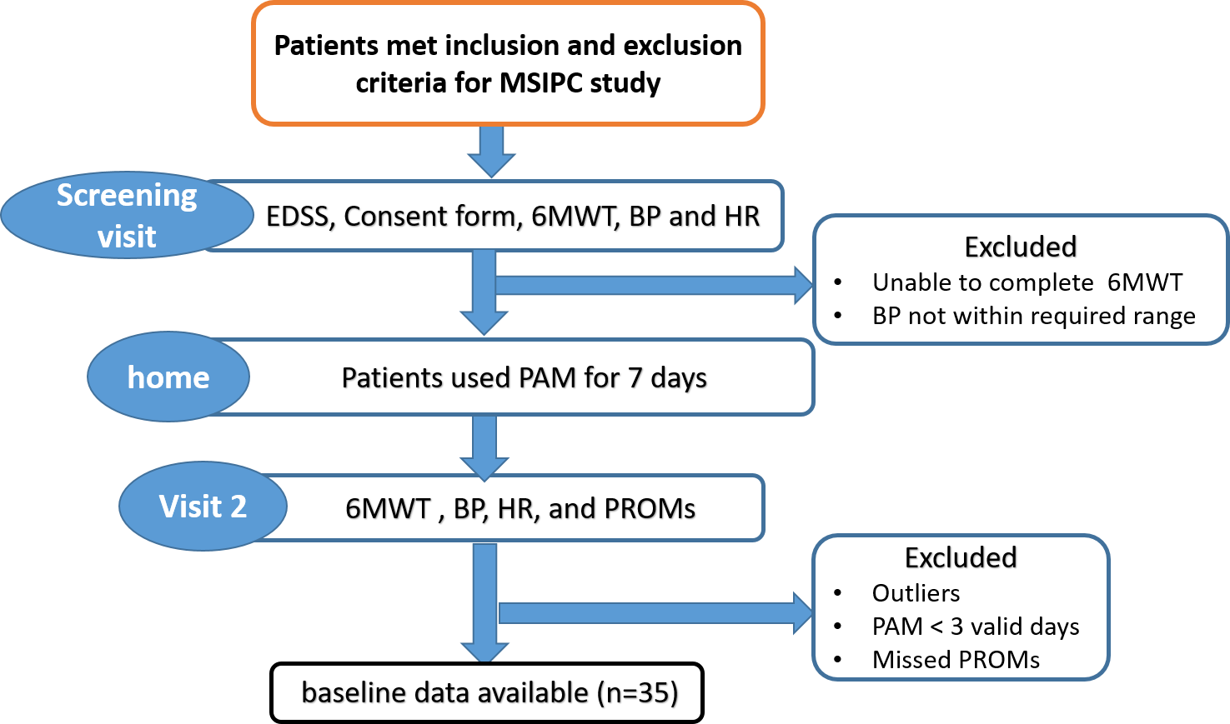

Figure 3.1: flow chart of baseline assessment for MSIPC study

At the screening visit (week 0) informed consent was obtained and patients were screen for inclusion and exclusion criteria. Patients were asked to complete 6MWT in corridor of 10 meters at their peaceful walking speed while attaching inertial sensors to forehead, neck, trunk, arm and legs; they can use their assistive aids if necessary. The Borg Rating of Perceived Exertion (RPE) scale was measured after 6 MWT. The heart rate and blood pressure were measured before and after 6MWT, as well as 10 minutes later at rest. Those who meet the inclusion criteria, which are to be able to walk 6 minutes without resting and to have a resting systolic blood pressure between 100mmHg and 170mmHg, were invited to participate; however, patients who failed to meet these criteria were informed and their visit was terminated.
Participants were shown how to wear PAM (Dynaport Move monitoring system) and were instructed to wear the PAM in the whole time for the next seven days while conducting their daily activities, and only remove it during bathing or showering.
At visit 2(week 1), patients were randomly assigned to either the IPC group or the sham group; This was done online using a randomization tool, and they were asked to return their PAM in order to download the data.
participants were given various patients reported outcome measures (PROMs) to be completed. Then, 6 MWT was measured followed by Borg RPE. Heart rate and blood pressure were also measured before and after the 6MWT.Procedure is illustrated in (Figure 3.1)

Statistical Analysis
Participants with missing clinical, PROMS or McRoberts MoveMonitor data were excluded from further analysis. Whether data was distributed in a parametric or non-parametric manner was determined using Kolmogorov-Smirnov and Shapiro-Wilk tests. Continuous variables were reported using mean±SD when the data were normally distributed, or median with IQRs for non-normal distributed data. While Numbers (percentages) were presented for categorical variables. Students t-tests and Wilcoxon tests were used to assess the difference between MacRoberts data in weekdays and weekends. Correlation coefficient was calculated by either spearman’s or Pearson’s according to the type and distribution of the data. Correlation coefficient was used to determine the bivariate association between MacRoberts data and clinic-based and patient-reported outcome variables. Bonferroni correction was used for multiple comparisons by reducing the level of significance to p=. 005 (0.05/9).
Linear regression was done for continuous dependent variable 6MWT with different types of independent variables. A p-value of 0.05 was considered significant for all statistical analyses using SSPS Statistics V.26.0.
For quality control purposes, we adopted several rules to decrease the mistaken characteristics of the actual activity by excluding data that below the threshold value of wear time (≥ 3 days/week, ≥ 80%/day), A threshold of 80% was determined by inspecting our raw data as well as observations of wear time in previous MS studies. For analysis, the average values of all valid days were used.
EQ-5D-5L, consists of 5 dimensions with 5 levels of answers. Patients selected their level of each dimension to create a combination of 5-digit codes, The mapping-derived EQ-5D-5L index score was calculated using an index value set calculator electronically to convert the 5-digit code to a country specific single index value. The UK index value set was chosen for this study. (Devlin et al., 2018)
MSWS-12 score is calculated as the sum numbers of the 12 answers and then transformed to a 0 to 100 scale by applying this formula: (Total score - 12/48) X 100. (Hobart et al., 2003)
The MSIS-29 measures both physical and psychological impacts of MS. 20 items are associated with physical impact, and 9 items are associated with the psychological impact of MS. the sum of responses for each domain is then converted to a scale from 0-100, where 100 indicates high impact of MS in patients' life. The physical impact is computed by the sum of the first 20 items and utilises this formula: (100 * (observed score- 20)) /(100-20). While the psychological impact is calculated by summing the score of the last 9 items. Then using this formula= (100*(observed score 9)) / (45-9) (Hobart, 2001).

Results

Participants

A total of 51 participants (63% female, mean age 48 years [23-71 years]) were recruited from the baseline MSIPC study. 16 participants were excluded because of missing data, leaving data for 35 participants. Of the 35 individuals included in this cohort, 21 (60%) had relapsing MS, and 7 (20%) had primary progressive MS, 7 (20%) had secondary progressive MS; the median disease duration was 12 years (inter quartile range, 3.0- 15 years), and the median EDSS score was 4.0 (range,1-7). PAM data were missed in (n=3) , outlier data in PAM was found in (n=2) , PAM and PROMs were missed in (n=5), PROMs were missed in (n=2), < 3 valid days in PAM in ( n= 2), paused due to Covid (n=2). Data are summarized in ( Table 3.3).

Table 3.3: Demographic data and outcome measures
Variables |  | included in data analysis N= 35 |  | Excluded =16
Sex (Female %) |  |  | 63 % | 62.5 %
Age (years) |  |  | 48.5 ± 13 (27 -71) | 51.5 ± 21.7(30-74)
Disease duration (years) median (IQR) |  |  | 12 (3-15) | 8.5(5-19.7)
MS types
RRMS |  |  | 60% | 62.5%
PPMS |  |  | 20% | 12.5%
SPMS |  |  | 20% | 25%
BMI
 | Healthy Range |  | 23% | 25.5%
 | Overweight Range |  | 43% | 47%
 | Obese Range |  | 34% | 25.5%
Disease Modifying Drugs |  |  | 66% | 62.5%
EDSS, median (IQR) |  |  | 4 (2 -6) | 5 ( 2.7-6.4)
EDSS score, n (%)
1 |  |  | 3 (9%) | 2(12%)
1.5 |  |  | 5 (14%) | 1 (6%)
2 |  |  | 3 (9%) | 0
2.5 |  |  | 2 (6%) | 1 (6%)
3 |  |  | 3 (9%) | 0
3.5 |  |  | 0 | 1(6%)
4 |  |  | 3 (9%) | 2(12%)
4.5 |  |  | 0 | 1 (6%)
5.5 |  |  | 0 | 2(12%)
6 |  |  | 12 (34%) | 2(12%)
6.5 |  |  | 3 (9%) | 4 (25%)
7 |  |  | 1 (3%) | 0
6 MWT (m) |  |  | 302 ± 138 (31-590) | NA
MSWS-12 |  |  | 58 ± 29 (4 - 100) | NA
MFIS |  |  | 48 ± 19 (7- 76) | NA
MSIS-29 |  |  | 79 ± 25 (40 - 126) | NA

EQ-5D-5L (Index Value) | .57 ± .2 (.013 -1) | NA
EQ-5D-5L (VAS), median (IQR) | 65 (45-80) | NA
Borg (RPE) scale, median (IQR) | 11(10-13) | NA
Data shown as mean ± S.D (rang) or median (IQR)
EDSS, Expand Disability Status Scale; 6MWT, 6 Meter Walk Test; Borg (RPE) Scale, Borg Rating of Perceived Exertion Scale; MSWS-12, MS Walking Scale-12; MFIS, Modified Fatigue Impact Scale; MSIS-29, MS Impact Scale; EQ-5D-5L, EuroQol Five Dimensions Five Levels questionnaire; VAS, Visual Analog Scale; RRMS, Relapsing-Remitting MS; PPMS, Primary Progressive MS; SPMS, Secondary Progressive MS; MBI, Body Mass Index.

Quality control metrics for McRobert’s PA data
The PAM was worn for 7 days by 91.4 % of Participants, and 75% of them had a compliance rate of > 80% of the time. No devices during the baseline assessment were lost There was no significant difference in PAM wear time between weekdays and weekend days. The comparison of McRobert's PA data collected at home over the weekdays and weekends is summarised in (Table 3.4). We found that the mean values for DUR_max active, DUR_max_inactive, and DUR_max_moving were not significantly different on weekdays and weekends as shown in (Figure 3.2).Additionally, there was no significant difference in mean DUR_total active, DUR_tota_inactive, and DUR_total_ moving values between weekdays and weekends as shown in (Figure 3.3). There was a significant difference between PERIODS _active and PERIODS_inactive between weekdays and weekends as shown in (Figure 3.4)
Further analysis was done in PERIODS _active and PERIODS_inactive within weekdays and within weekends as shown in (Table 3.5). A significant difference was observed between PERIODS active and inactive on weekdays (P value =.000). According to mean difference (24. 88), PERIODS inactive are significantly higher than PERIODS active during the week. Meanwhile, there were significant differences between PERIODS active and inactive at weekends (P = .000). Over the weekend, the amount of PERIODS inactive is significantly higher than theamount of PERIODS active by a mean difference of 1.27. In summary, during weekdays, participants are 24 times more likely to be inactive than during weekends.

Table 3.4: Weekday and weekend comparisons of McRobert's PA data at home
Variable | Weekdays (n=35) | Weekends (n=33) | P-value
DUR_ max_active | 1827 ± 2224 | 1295 ± 513 | .796 †
DUR_max_inactive | 21378 ± 9009 | 20463 ± 5647 | .492 †
DUR_max_moving | 266 ± 326 | 277 ± 360 | .736 †
DUR_total_active | 14453± 5183 | 14672± 6590 | .885 *
DUR_total_inactive | 67502± 12507 | 68063± 13318 | .586 †
DUR_total_moving | 4157 ± 2083 | 4364 ± 2667 | .754 *
PERIODS_active | 113 ± 39 | 103 ± 40 | .004 *
PERIODS_inactive | 138 ± 141 | 105 ± 39 | .000 †
PERIODS_moving | 390 ± 200 | 388 ± 194 | .633 *
Data presented as mean±SD
*Paired t- test.
†Wilcoxon signed- rank test.
Significance level after Bonferroni correction (p<0.005)

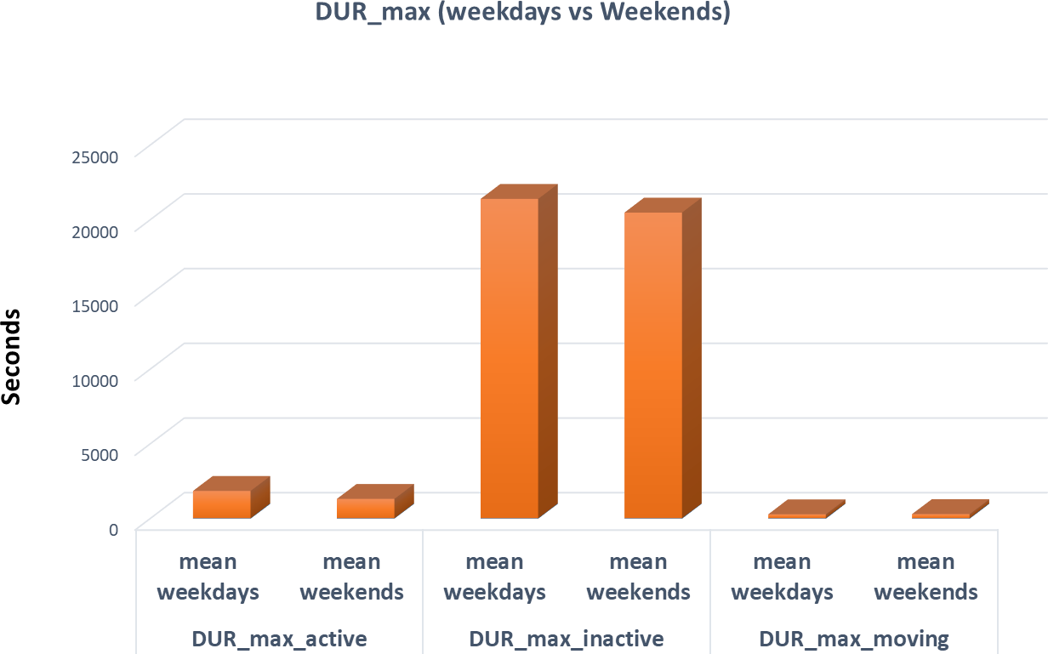
Figure 3.2: multiplane of comparison between mean value of DUR_max_active, inactive and moving measured at home in weekdays and weekends

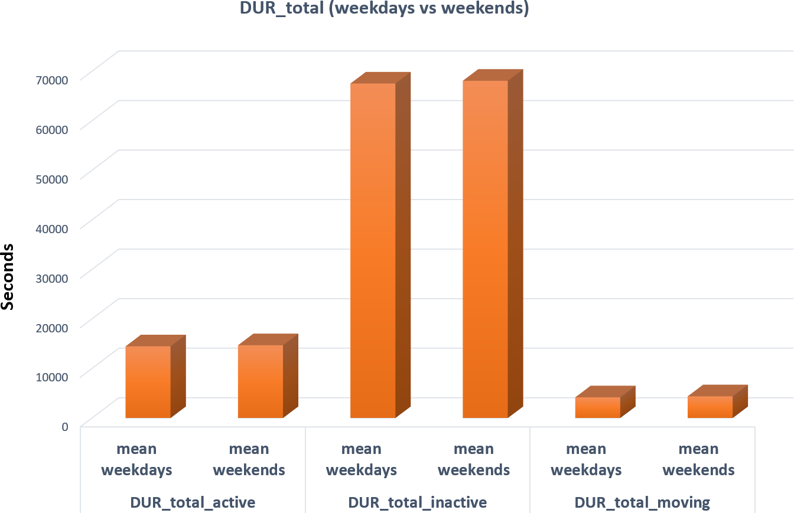
Figure 3.3: multiplane of comparison between mean value of DUR_total_active, inactive and moving measured at home weekdays and weekend

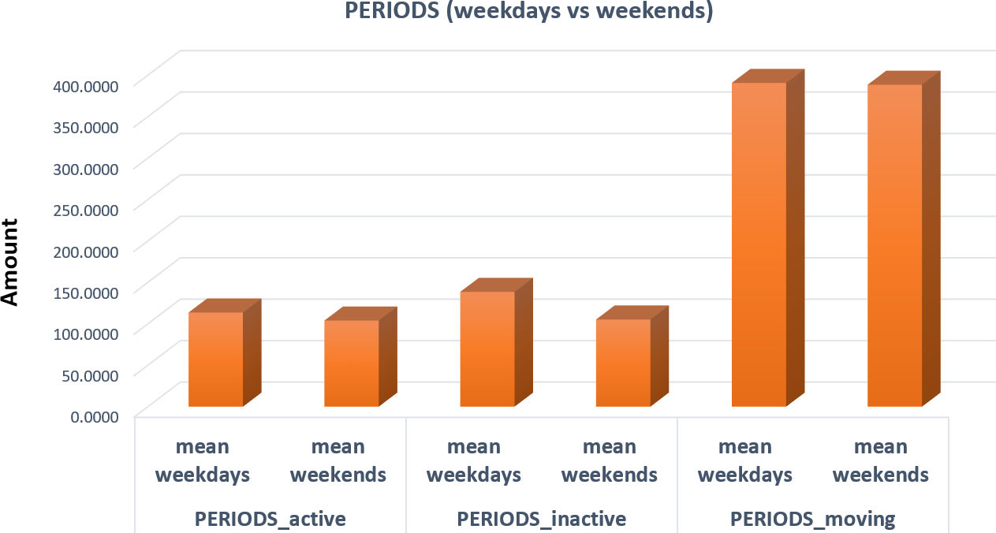
Figure 3.4: multiplane of comparison between mean value of PERIODS active, inactive and moving measured at home in weekdays and weekends

Table 3.5: comparison of PERIODS active and PERIODS inactive within weekdays and weekends
Variables | Mean | SD | Correlation | Mean difference | P value
PERIODS_active (weekdays) | 113.63 | 39.77 | .18 | -24.88 | .000ᵚ
PERIODS_inactive (weekdays) | 138.51 | 141.3 | .18 | -24.88 | .000ᵚ
PERIODS_active (weekends) | 103.9 | 40.01 | 1.00** | -1.27 | .000ᵗ
PERIODS_inactive (weekends) | 105.18 | 39.9 | 1.00** | -1.27 | .000ᵗ
ᵗPaired t- test.
ᵚWilcoxon signed- rank test. ·
Significance level after Bonferroni correction (p<0.005)

Correlation of McRobert’s PA data with validated lab-based measures of

McRobert's
McRobert's PA data obtained from home environment correlated with clinical and mobility outcomes measured in the clinic as shown in (Table 3.6). EDSS score correlated negatively with most of mean values of McRobert's PA data as it shown in figures (Figure 3.5), (Figure 3.6), and(Figure 3.7). Moderate correlation of EDSS with mean total and mean maximum moving (-.564), (-.541), respectively, and a weaker correlation with mean total and mean maximum active (-.445), (-.322), respectively.
A positive correlation was found between 6 MWT and mean value of total and maximum activity measured at home as shown in figures (Figure 3.8), (Figure 3.9) and(Figure 3.10). It strongly correlated with mean max moving by (.718**), while it correlated moderately with mean value of total moving and Max active (.685**) and (.576**), respectively. Comparatively, it has a weak correlation with mean total active, mean total inactive and mean periods moving.

Borg perceived exertion (RPE) that measured after completing the 6MWT correlated negatively with most of the mean values of McRobert's PA data as shown in figures (Figure 3.11), (Figure 3.12) and (Figure 3.13). It moderately correlated with mean total and mean max moving by (-.659**, P = .000) and (-.685**, P = .000) respectively. However, it correlated weakly with mean values of total and max activity measured at home by (-.380, P = .024) and (-.344, P = .043) respectively.

It was found that MSWS_12 correlated negatively with the majority of the mean values of McRobert's data measured at home as shown in figures (Figure 3.14), (Figure 3.15) and (Figure 3.16). There is a strong correlation between MSWS and DUR_max_moving (-.707**, P = .000), while it is moderately correlated with DUR_total_moving (-.550*, P = .001) and DUR_max_active (-.446, p =.007), respectively.
Physical impact of MSIS-29 significantly correlated with some of the McRobert's PA data. There were negative weak correlations with mean values of DUR_total_moving (-.498*, P = .002) ,DUR_max_moving (-492* , P
= .003), as well as DUR_max_active (-.480*, P = .004) as shown in figures (Figure 3.17),(Figure 3.18) and (Figure 3.19).

Table 3.6: Correlation of MacRobert's PA data with validated measures of mobility
McRobert's variables | Correlation | EDSS | 6MWT | MSWS-12 | Borg (RPE) Scale | MSIS-29  (Physical Impact)
Mean DUR total active(sec) | r | -.322 | .491* | -.240 | -.380 | -.307
Mean DUR total active(sec) | P-value | .059 | .003 | .166 | .024 | .073
Mean DUR total  moving(sec) | r | -.564** | .685** | -.550* | -.659** | -.498*
Mean DUR total  moving(sec) | P-value | .000 | .000 | .001 | .000 | .002

Mean DUR total  inactive(sec) | r | .145 | -.369 | .131 | .089 | .167
Mean DUR total  inactive(sec) | P-value | .407 | .029 | .452 | .613 | .337
Mean DUR max  active (sec) | r | -.445* | .576** | -.446 | -.344 | -.480*
Mean DUR max  active (sec) | P-value | .007 | .000 | .007 | .043 | .004
Mean DUR max  moving(sec) | r | -.541* | .718** | -.707** | -.685** | -.492*
Mean DUR max  moving(sec) | P-value | .001 | .000 | .000 | .000 | .003
Mean DUR max  Inactive(sec) | r | .058 | -.223 | -.100 | .006 | -.079
Mean DUR max  Inactive(sec) | P-value | .740 | .197 | .569 | .974 | .652
Mean periods Active (sec) | r | -.168 | .256 | -.071 | -.206 | -.124
Mean periods Active (sec) | P-value | .334 | .137 | .684 | .235 | .477
Mean periods  moving (sec) | r | -.296 | .488* | -.225 | -.393 | -.290
Mean periods  moving (sec) | P-value | .084 | .003 | .194 | .019 | .092
Mean periods inactive(sec) | r | -.171 | .253 | -.067 | -.211 | -.119
Mean periods inactive(sec) | P-value | .327 | .142 | .702 | .224 | .494
EDSS, Extended Disability status scale 6MWT, 6 Meter Walk Test; Borg (RPE) Scale, Borg Rating of Perceived Exertion Scale; MSWS-12, MS Walking Scale-12; MSIS-29, MS Impact Scale

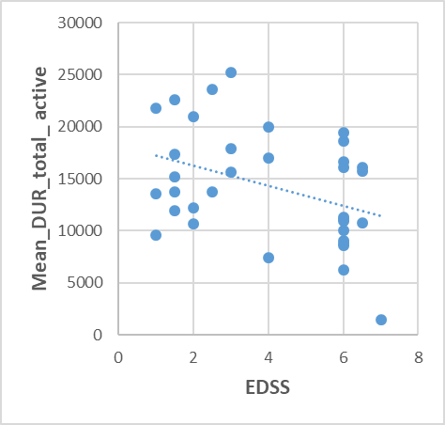 | 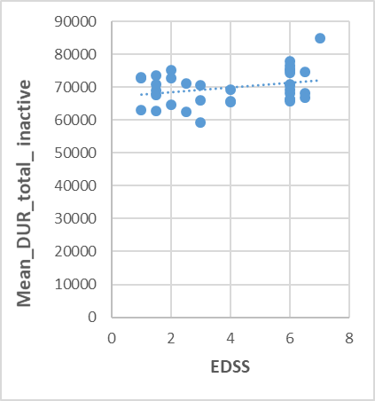
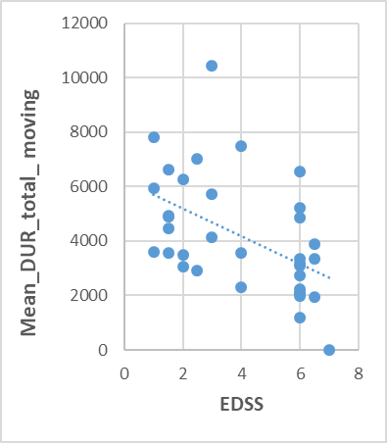
Figure 3.5: Scatterplots of correlation of Expand Disability Status Scale (EDSS) with mean DUR_total active, inactive moving of McRobert's PA data measured at home.
Correlation of EDSS with mean DUR_total active (r, -.322) (P value, .059) , inactive (r, .145)(P value,.407) and moving (r,-.564**)(P value, .000) of McRobert's PA data measured at home

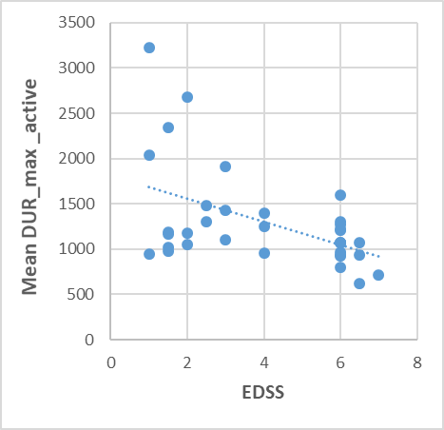 | 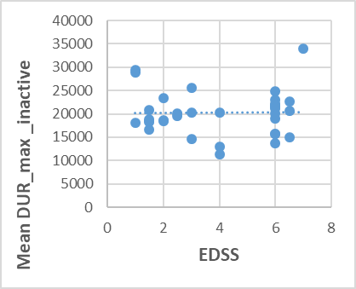
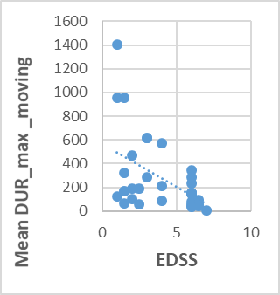
.
Figure 3.6: scatterplots of correlation of Expand Disability Status Scale (EDSS) with mean DUR_max_active, inactive and moving of McRobert's PA data measured at home Correlation of EDSS with mean DUR_max_active (r,-.445*)(P value,.007), inactive (r,.058)(P value,.740) and moving (r,-.541*)( P value,.001)of McRobert's PA data measured at home.

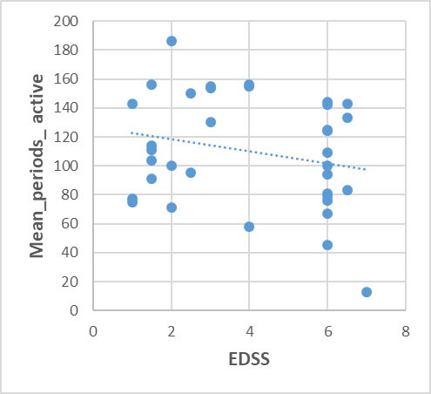 | 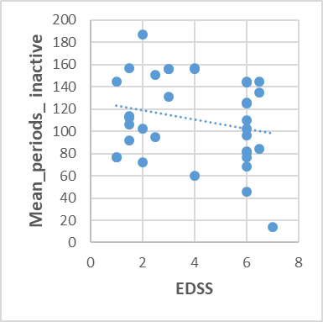
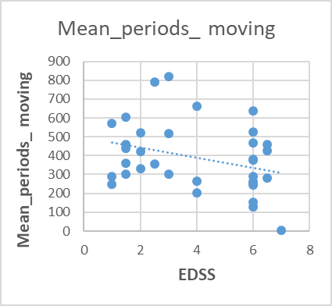
Figure 3.7:. scatterplots of correlation of Expand Disability status Scale (EDSS) with mean
PERIODS_active, inactive and moving of McRobert’s PA data at home.
Correlation of EDSS with mean PERIODS_active(r,-.168)(P value, .334), inactive (r, -.171)( P value, .327)and moving (r, -.296)(P value, .084)of McRobert's PA data measured at home.

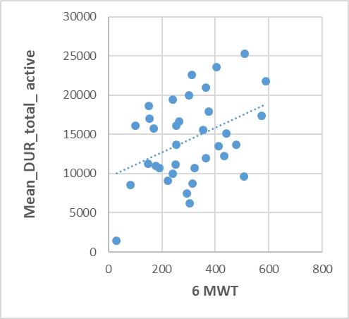 | 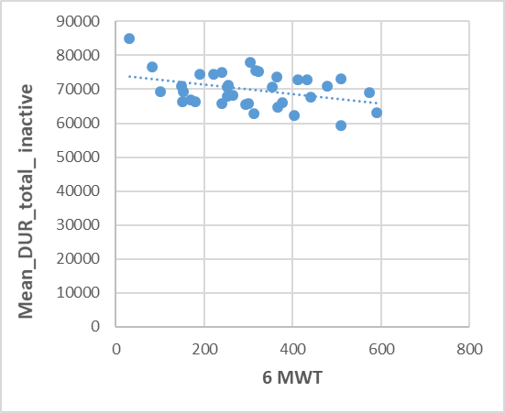
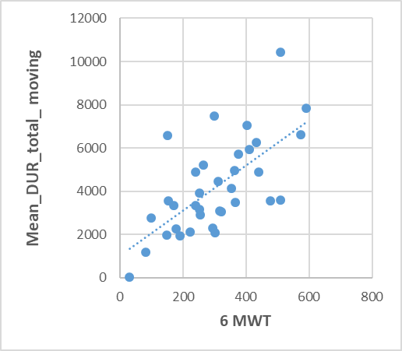
.
Figure 3.8: scatterplots of correlation of 6 Minutes Walk Test (6MWT) with mean value of DUR_total_active, inactive, and moving of McRoberts at home
Correlation of 6 Minutes Walk test (6 MWT) with mean DUR_total_ active (r,.491*) (P value,.003)
, inactive (r, -.369) (P value, .029) and moving (r,.685**)(P value, .000)of McRobert's PA data measured at home.

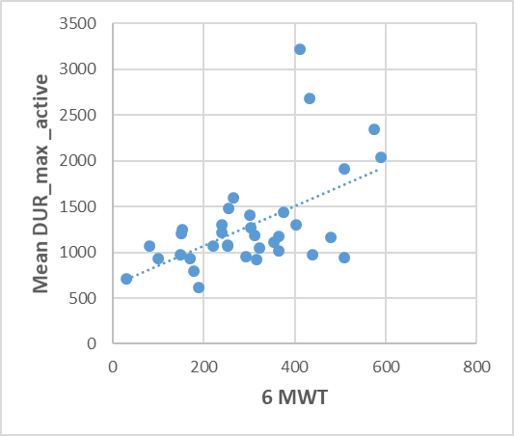 | 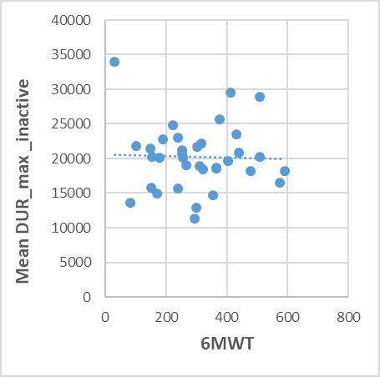
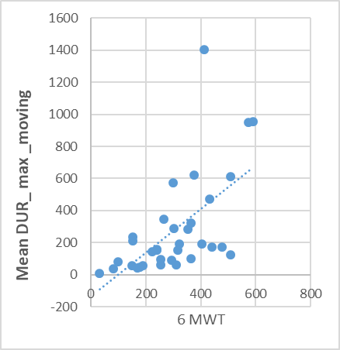
Figure 3.9: scatterplots of correlation of 6 Minutes Walk Test (6MWT) with mean DUR_max_active , inactive and moving of MacRobert's data measured at home
Correlation of 6 Minutes Walk test (6 MWT) with mean DUR_max_ active (r,.576**)( P value, .000), inactive (r, -.223)(P value, .197)and moving (r, .718**)(P value, .000)of McRobert's PA data measured at home

.

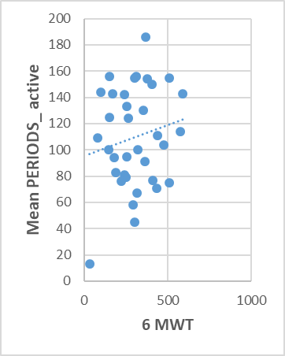 | 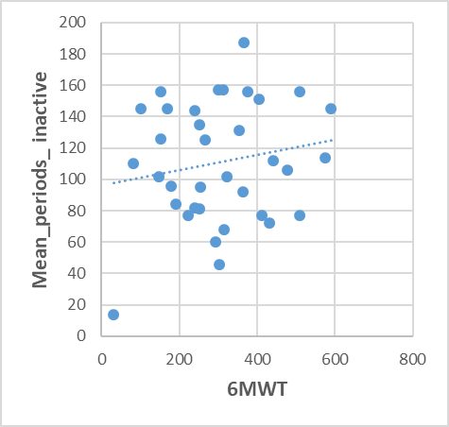
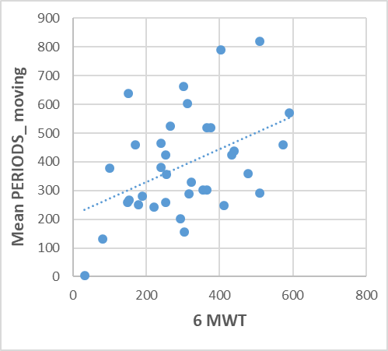
Figure 3.10: Scatterplots of correlation of 6 Minutes Walk test (6 MWT) with mean PERIODS active, inactive and moving of McRobert's PA data measured at home.
Correlation of 6 Minutes Walk test (6 MWT) with mean PERIODS active (r, -.071)(P value,.684)
, inactive (r, -.067) (P value,.702)and moving (r, -.225)( P value, .194)of McRobert's PA data measured at home

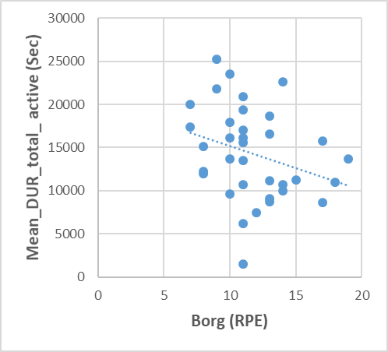 | 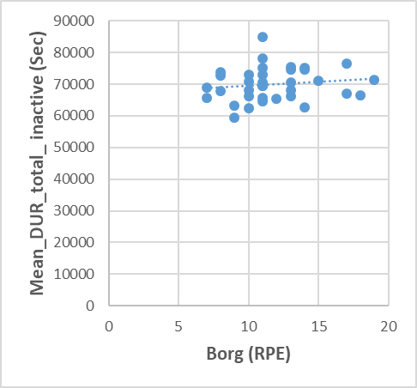
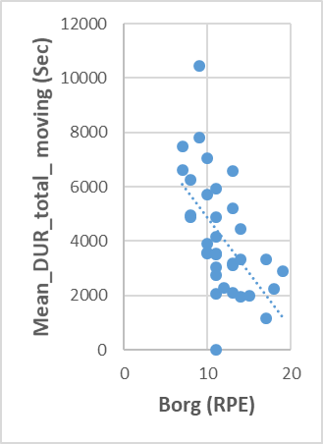
Figure 3.11: Scatterplots of correlation of Borg Rating of perceived exertion (RPE) with mean DUR_total_active, inactive and moving of McRobert's PA data measured at home.
Correlation of Borg Rating of perceived exertion (RPE) with mean DUR_total_active (r,-.380)(P value, .024), inactive (r,.089)(P value, .613) and moving (r,-.659**)(P value,.000)
of McRobert's PA data measured at home.

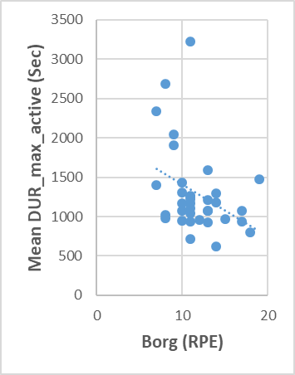 | 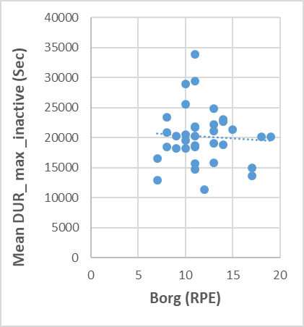
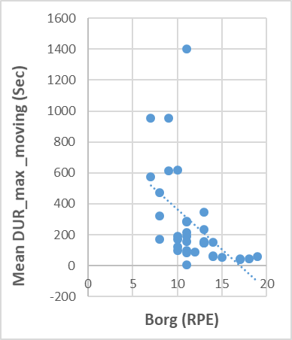
Figure 3.12: Scatterplots of correlation of Borg Rating of perceived exertion (RPE) with mean DUR_max_active, inactive and moving of McRobert's PA data measured at home.

Correlation of Borg Rating of perceived exertion (RPE) with mean DUR_max_active (r,-.344)(P value,.043), inactive (r,.006)(Pvalue,.974)and moving (r,-.685**)(P value, .000) of McRobert's PA data measured at home.

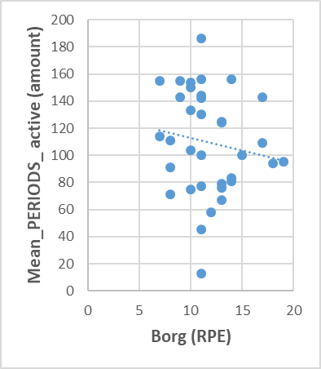 | 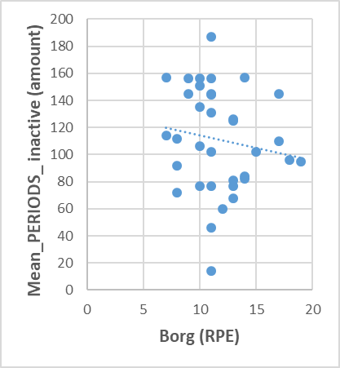
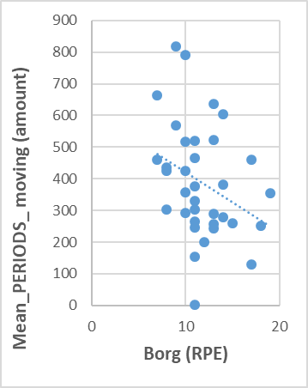
Figure 3.13: Scatterplots of correlation of Borg Rating of perceived exertion (RPE) with mean PERIODS_active, inactive and moving of McRobert's PA data measured at home.
Correlation of Borg Rating of perceived exertion (RPE) with mean PERIODS_active (r,-.206)(P
value, .235), inactive (r,-.211)(P value,.224)and moving (r,-.393)(P value, .019)of McRobert's PA data measured at home.

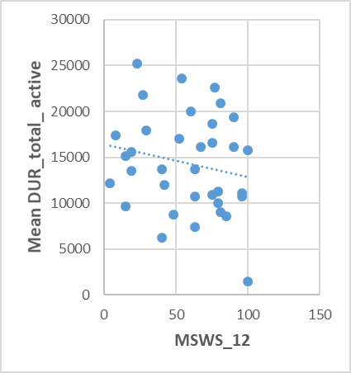 | 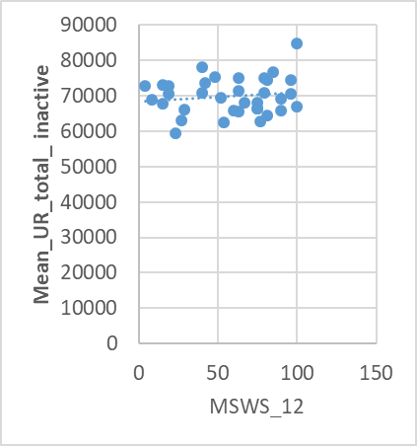
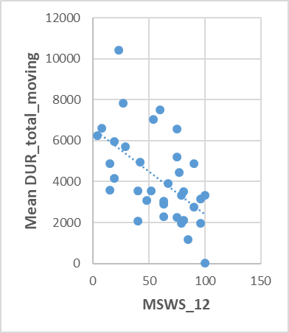
Figure 3.14: Scatterplots of correlation of Multiple Sclerosis walking Scale_12 (MSWS_12) with mean DUR_total_active, inactive, and moving of McRobert's PA data measured at home.
Correlation of MSWS_12 with mean DUR_total_active (r,-.240)( P value, .166), inactive (r,.131)(P value,.452)and moving (r,-.550*)( P value, .001)of McRobert's PA data measured at home.

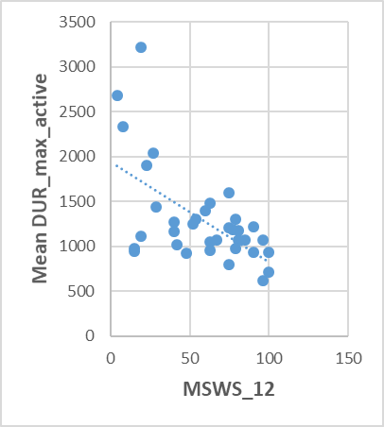 | 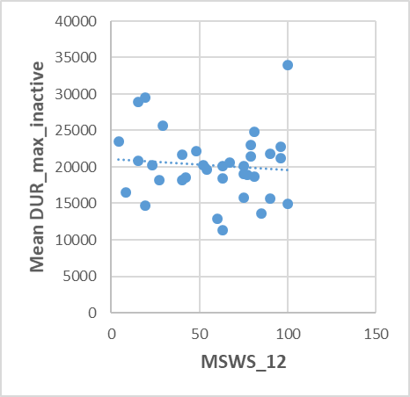
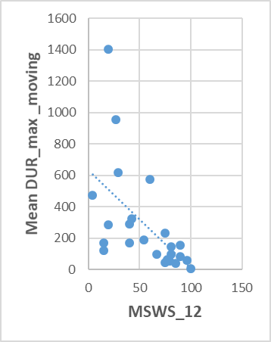
Figure 3.15: Scatterplots of correlation of Multiple Sclerosis walking Scale_12 (MSWS_12) with mean DUR_max_active, inactive and moving of McRobert's PA data measured at home.
Correlation of MSWS_12 with mean DUR_max_active (r,-.344)(P value,.043), inactive (r,.006)(P value,.974)and moving (r,-.685**)(P value,.000)of McRobert's PA data measured at home.

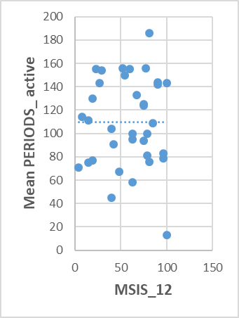
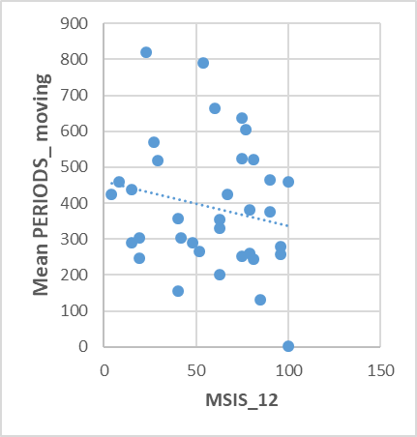
Figure 3.16: Scatterplots of correlation of Multiple Sclerosis walking Scale_12 (MSWS_12) with mean PERIODS_active, inactive and moving of McRobert's PA data measured at home.
Correlation of MSWS_12 with mean PERIODS_active (r, -.071)(P value,.684)
, inactive (r,-.067)(P value,.702) and moving (r,-.225)(P value, .194) of McRobert's PA data measured at home.

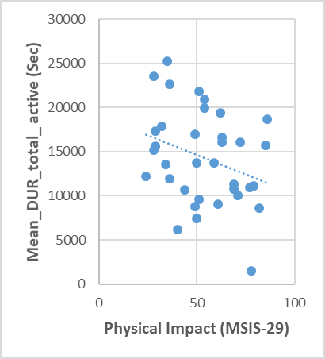 | 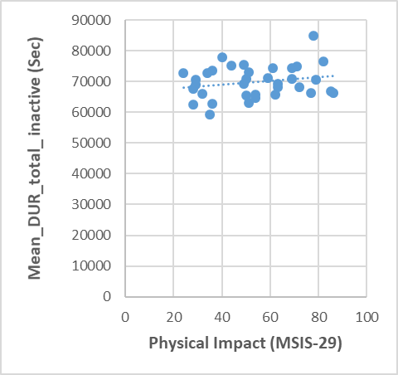
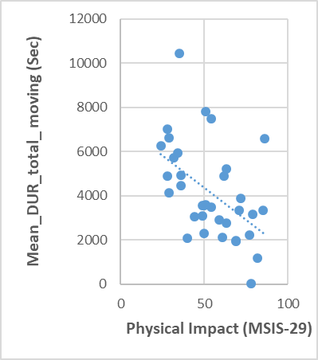
Figure 3.17: Scatterplots of correlation of Physical Impact of Multiple Sclerosis Impact Scale (MSIS-29) with mean DUR_total_active, inactive and moving of McRobert's PA data measured at home.

Correlation of Physical Impact of MSIS-29 with mean DUR_total_active (r,-.307)(P value,.073)
, inactive (r,.167) (P value,.337) and moving (r,-.498*)(P value,.002) of McRobert's PA data measured at home.

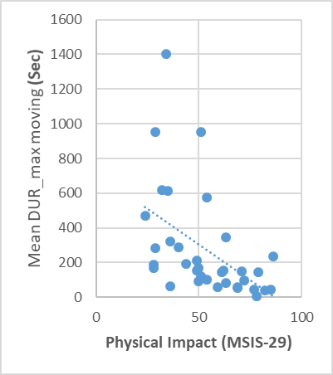 | 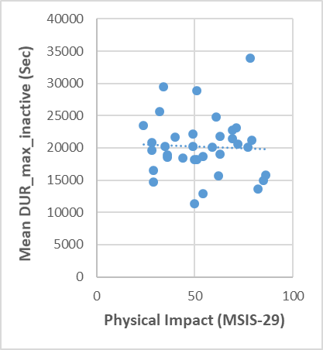
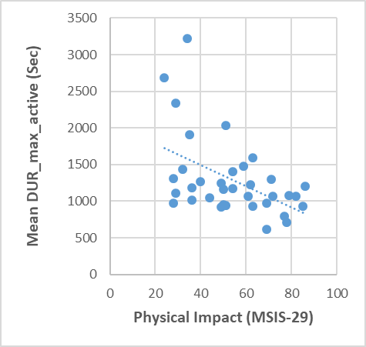
Figure 3.18: Scatterplots of correlation of Physical Impact of Multiple Sclerosis Impact Scale (MSIS-29) with mean DUR_max_active, inactive and moving of McRobert's data measured at home.
Correlation of Physical Impact of (MSIS-29) with mean DUR_max_active (r, -.480*)(P value,.004), inactive (r,-.079)(P value, .652)and moving (r, -.492*)(P value, .003) of McRobert's data measured at home.

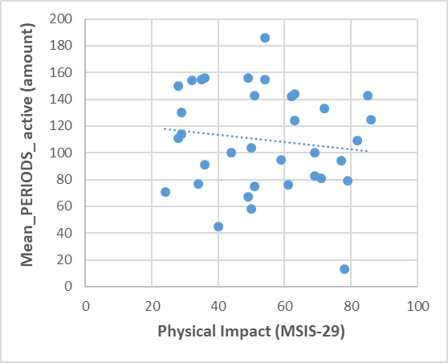 | 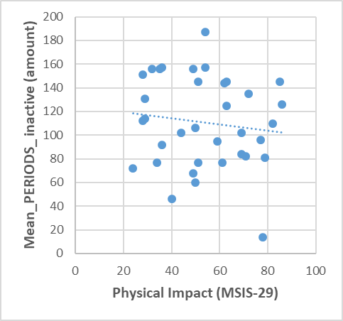
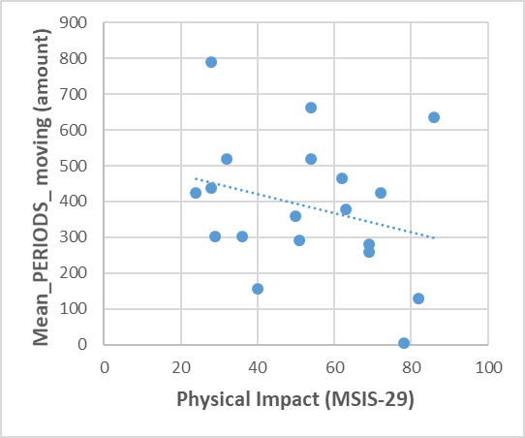
Figure 3.19: Scatterplots of correlation of Physical Impact of Multiple Sclerosis Impact Scale (MSIS-29) with mean PERIODS_active, inactive and moving of McRobert's PA data measured at home.
Correlation of Physical Impact of (MSIS-29) with mean PERIODS_active (r,-.124)(P value, .477)
, inactive (r,-.119)(P value,.494)and moving (r, -.290)(P value, .092) of McRobert's PA data measured at home.

Correlation of McRobert’s PA data with validated measures of fatigue
As it showed in (Table 3.7).There was no significant correlation between McRobert's PA data with validated measure of fatigue as assessed by MFIS. Visualised in figures (Figure 3.20),(Figure 3.21) and(Figure 3.22).

Table 3.7: Correlation of McRobert's PA data with validated measure of fatigue
McRobert's variables | correlation | MFIS
Mean DUR total active(sec) | r | -.111
Mean DUR total active(sec) | P-value | .525
Mean DUR total moving(sec) | r | -.236
Mean DUR total moving(sec) | P-value | .173
Mean DUR total inactive(sec) | r | .128
Mean DUR total inactive(sec) | P-value | .464
Mean DUR max active (sec) | r | -.074
Mean DUR max active (sec) | P-value | .672
Mean DUR max moving(sec) | r | -.266
Mean DUR max moving(sec) | P-value | .123
Mean DUR max inactive (sec) | r | .081
Mean DUR max inactive (sec) | P-value | .642
Mean periods active (sec) | r | -.052
Mean periods active (sec) | P-value | .768
Mean periods moving (sec) | r | -.129
Mean periods moving (sec) | P-value | .460
Mean periods inactive (sec) | r | -.052
Mean periods inactive (sec) | P-value | .768
MFIS, modified fatigue impact scale

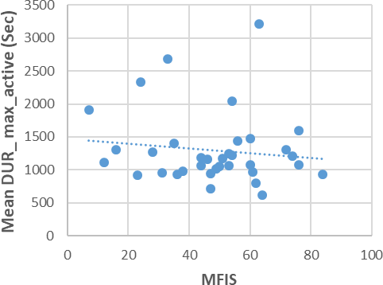 | 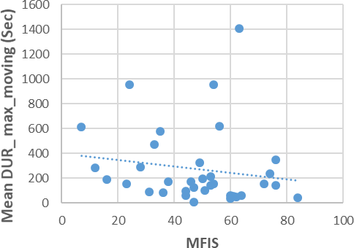
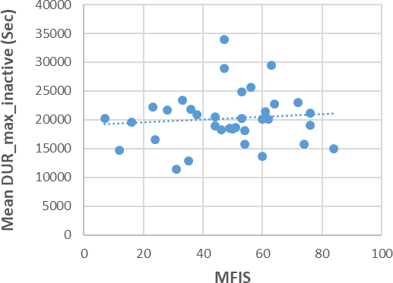
Figure 3.20: Scatterplots of correlation of fatigue Impact Fatigue Scale (MFIS) with DUR_max active, inactive and moving of McRobert's PA data measured at home.
Correlation of MFIS with DUR_max active (r, -.111) (P value,.525), inactive (r,.128) (P value,.464)and moving (r,-.236)(P value, .173)of McRobert's PA data measured at home.

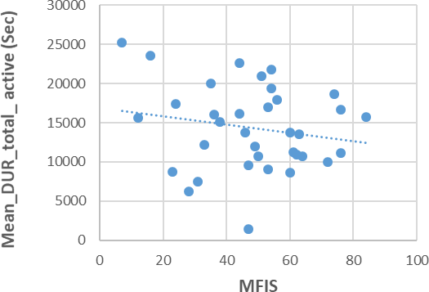 | 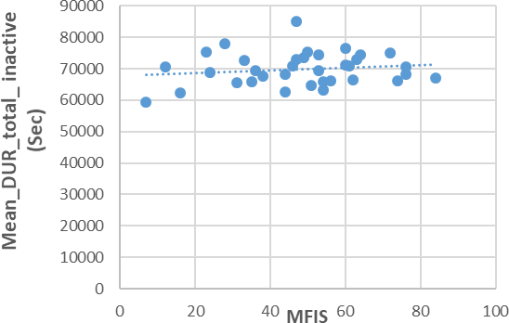
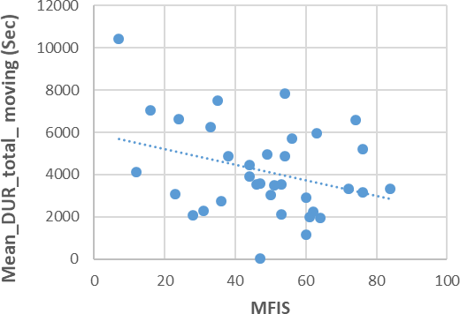
Figure 3.21: Scatterplots of correlation of fatigue Impact Fatigue Scale (MFIS) with DUR_total active, inactive and moving of McRobert's PA data measured at home.
Correlation of MFIS with DUR_total active (r, -.074) (P value, .672), inactive (r,.081) (P value, .642) and moving (r,-.266)(P value,.123) of McRobert's PA data measured at home.

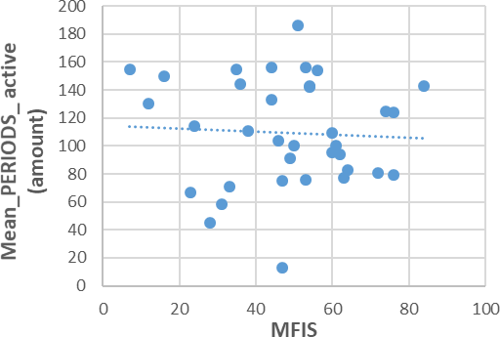 | 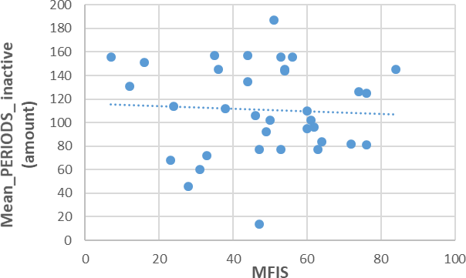
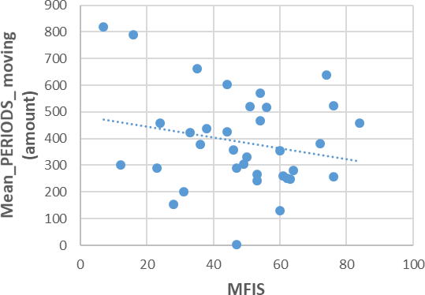
Figure 3.22: Scatterplots of correlation of fatigue Impact Fatigue Scale (MFIS) with PERIODS active, inactive and moving of McRobert's PA data measured at home.

Correlation of MFIS with PERIODS active (r, -.052)(P value,.768), inactive (r,-.052)(P value,.768) and moving (r,-.129)(P value,.460)of McRobert's PA data measured at home.

Correlation of 6MWT with the MFIS and Its Subscales
It was intended to determine whether the validated fatigue measure has similar relationships with 6MWT as they had with McRobert's PA variables. The correlation coefficient between 6MWT with MFIS was computed as shown in (Table 3.8).
A significant moderate relationship was found between 6MWT and MFIS (r = -.449**, P =.007), which is different from that found between MFIS and McRobert's PA data.

Table 3.8: Correlation of 6MWT with the MFIS
Outcome | correlation | 6MWT
MFIS | r | -.449**
MFIS | P-value | .007
MFIS, modified fatigue impact scale; 6MWT, 6mintue walk test

Correlation of Mcrobert’s PA Data with Validated Measures of Quality of Life In MS
Correlation coefficients were commuted to determine the relationship between McRobert's PA data and the quality of life measures as shown in (Table 3.9)
No significant correlation were found between McRobert's PA data and Psychological Impact subscales of MSIS-29 as shown in figures (Figure 3.23),(Figure 3.24) and(Figure 3.25).
Weak association only found between the two instruments of the EQ-5D-5L with some of McRobert's PA data as shown in figures (Figure 3.26)(Figure 3.27)(Figure 3.28)Figure 3.29)(Figure 3.30)(Figure 3.31) . A weak positive correlation was found between mean_DUR_max_moving with index value and VAS of the EQ-5D-5L (r= .457, P = .006), (r =.376, P =.026) respectively. Index value was also weakly correlated with mean during total moving (r =.352, p = .038).

Table 3.9: Correlation of McRobert's PA data with validated measure of quality of life
McRobert's PA variables | correlation | MSIS-29  (Psychological Impact) N=35 | EQ-5D-5L  (Index value) N=35 | EQ-5D-5L (VAS) N=35
Mean DUR total active(sec) | r | .006 | .130 | .117
Mean DUR total active(sec) | P-value | .974 | .455 | .503
Mean DUR total moving(sec) | r | -.056 | .352 | .217
Mean DUR total moving(sec) | P-value | .749 | .038 | .211
Mean DUR total inactive(sec) | r | -.046 | -.076 | -.196
Mean DUR total inactive(sec) | P-value | .795 | .665 | .260
Mean DUR max active (sec) | r | -.120 | .243 | .189
Mean DUR max active (sec) | P-value | .493 | .160 | .278
Mean DUR max moving(sec) | r | -.036 | .457 | .376
Mean DUR max moving(sec) | P-value | .835 | .006 | .026
Mean DUR max inactive (sec) | r | .151 | -.066 | -.030
Mean DUR max inactive (sec) | P-value | .388 | .708 | .863
Mean periods Active (sec) | r | .155 | .042 | .071
Mean periods Active (sec) | P-value | .375 | .809 | .686
Mean Periods moving (sec) | r | .056 | .108 | .112
Mean Periods moving (sec) | P-value | .749 | .539 | .522
Mean periods inactive (sec) | r | .185 | .028 | .070
Mean periods inactive (sec) | P-value | .363 | .875 | .690
MSIS-29, MS Impact Scale; EQ-5D-5L, EuroQol Five Dimensions Five Levels questionnaire; VAS, Visual Analog Scale

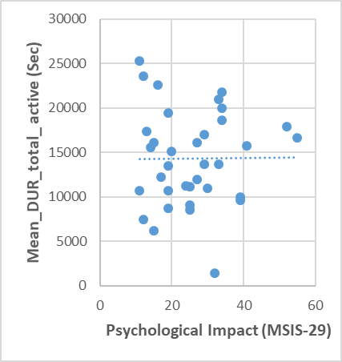 | 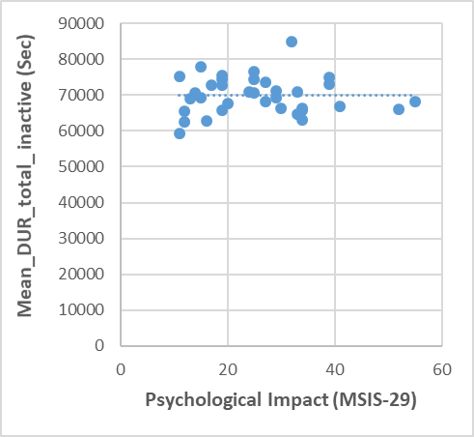
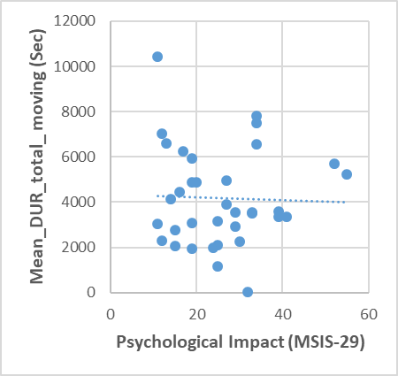
Figure 3.23: Scatterplots of correlation of Psychological Impact of Multiple Sclerosis Impact Scale (MSIS- 29) with mean DUR_total_active, inactive and moving of McRobert's PA data measured at home.
Correlation of Psychological Impact of MSIS-29 with mean DUR_total_active (r,.006)(P value,.974)
, inactive (r,-.046)(P value,.795)and moving (r,-.056)(P value,.749)of McRobert's PA data measured at home.

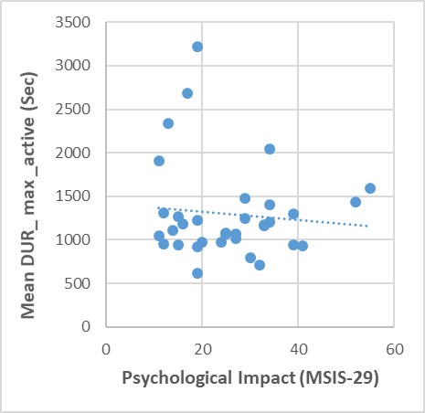 | 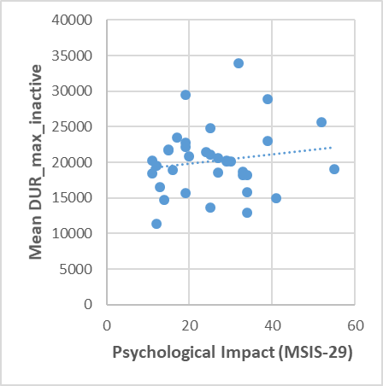
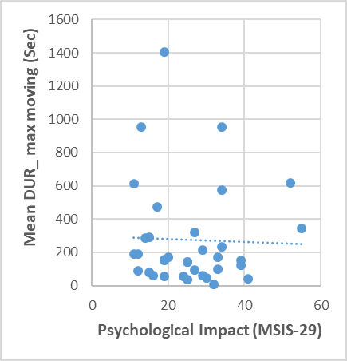
Figure 3.24: Scatterplots of correlation of Psychological Impact of Multiple Sclerosis Impact Scale (MSIS- 29) with mean DUR_max_active, inactive and moving of McRobert's PA data measured at home.

Correlation of Psychological Impact of MSIS-29 with mean DUR_max_active (r,-.120)(P value,.493), inactive (r,.151)(P value,.388)and moving (r,-.036)(P value,.835) of McRobert's PA data measured at home.

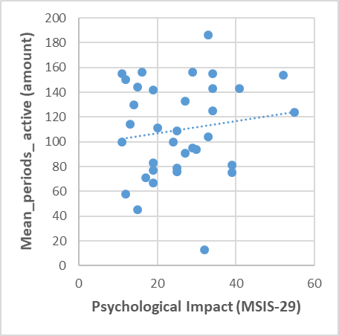 | 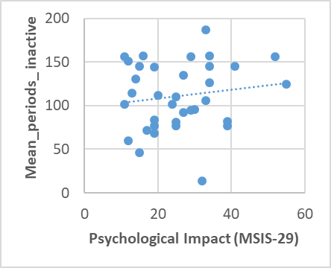
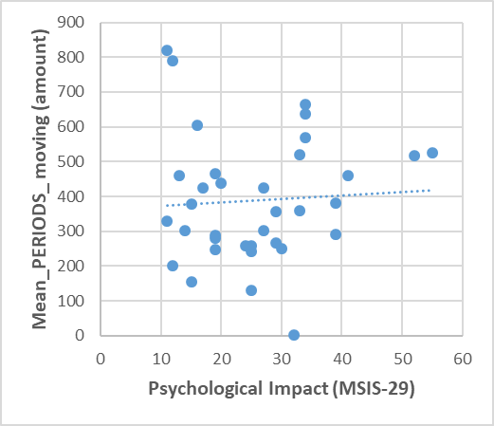
Figure 3.25: Scatterplots of correlation of Psychological Impact of Multiple Sclerosis Impact Scale (MSIS- 29) with mean PERIODS_active, inactive and moving of McRobert's PA data measured at home.
Correlation of Psychological Impact of MSIS-29 with mean PERIODS_active (r,.155) (P value,.375)
, inactive (r,.185) (P value,.363)and moving (r,.056)(P value,.749) of McRobert's PA data measured at home.

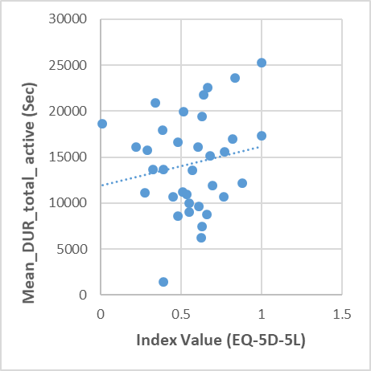 | 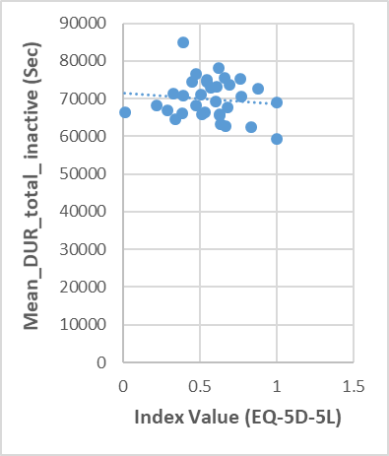
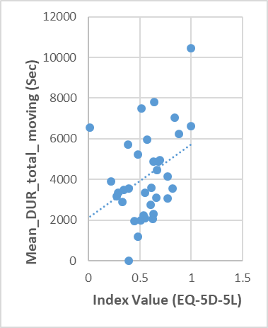
Figure 3.26: Scatterplots of correlation of Index Value (EQ-5D-5L) with mean DUR_total_active, inactive and moving of McRobert's PA data measured at home.
Correlation of Index Value (EQ-5D-5L) with mean DUR_total_active(r, .130)(P value,.455), inactive (r,-
.076)(P value,.665)and moving (r,.352)(P value,.038)of McRobert's PA data measured at home.

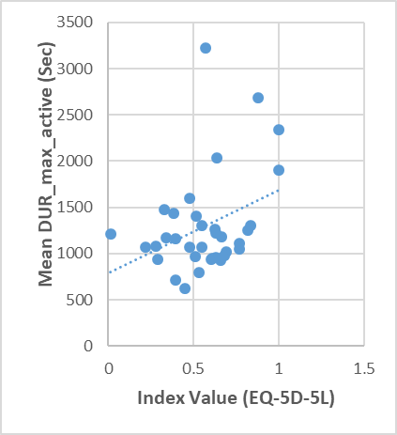 | 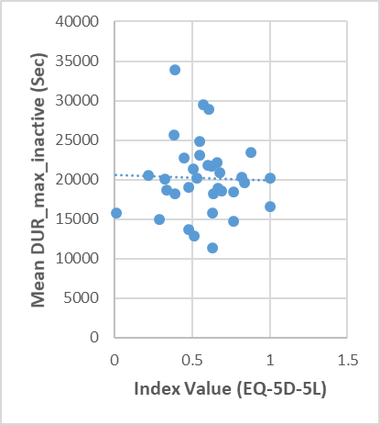
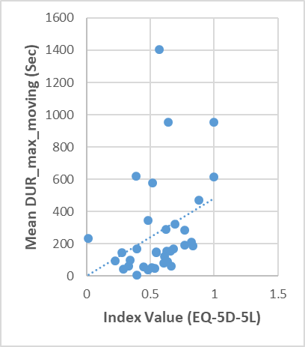
Figure 3.27: Scatterplots of correlation of Index Value (EQ-5D-5L) with mean DUR_max_active, inactive and moving of McRobert's PA data measured at home.
Сorrelation of Index Value (EQ-5D-5L) with mean DUR_max_active (r,.243)(P value,.160), inactive (r,-.066)(P value,.708)and moving (r,.457)(P value,.006)of McRobert's PA data measured at home.

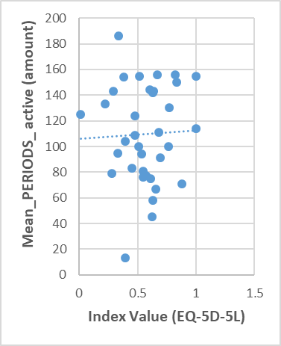 | 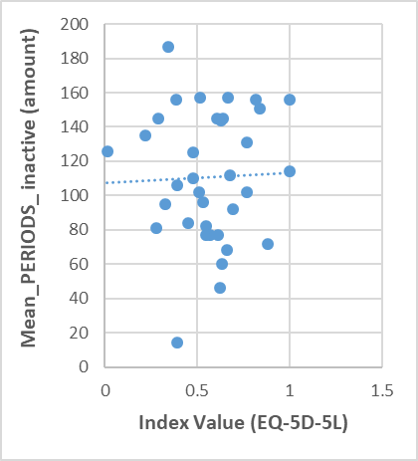
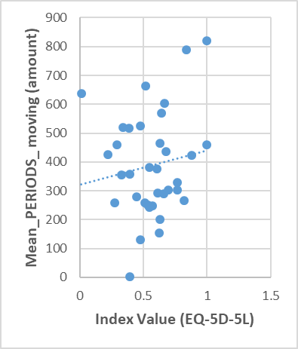
Figure 3.28: Scatterplots of correlation of Index Value (EQ-5D-5L) with mean PERIODS_active, inactive and moving of McRobert's PA data measured at home.
Correlation of Index Value (EQ-5D-5L) with mean PERIODS_active (r,.042)(P value,.809), inactive (r,.028)(P value, .875)and moving (r,.108)(P value,.539)of McRobert's PA data measured at home.

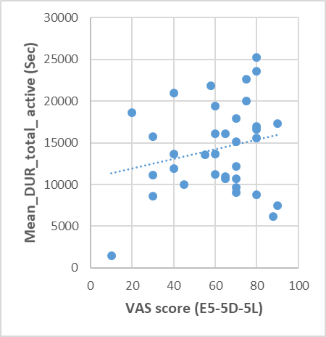 | 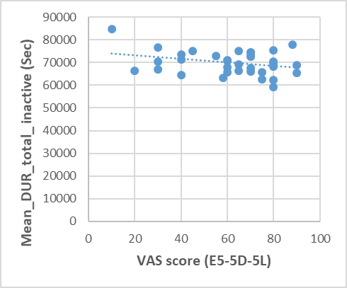
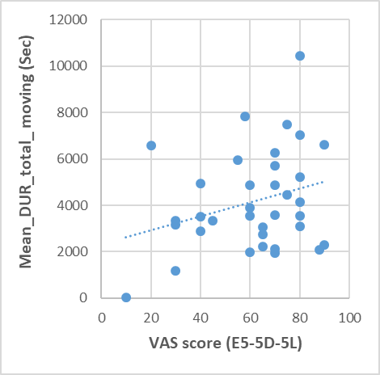
Figure 3.29: Scatterplots of correlation of Visual Analogue Scale (VAS) of EQ-5D-5L with mean total_DUR_active, inactive and moving of McRobert's PA data measured at home.
Correlation of Visual Analogue Scale (VAS) of EQ-5D-5L with mean total_DUR_active (r,.117)(P value,.503), inactive (r,-.196)(P value,.260)and moving (r,.217)(P value, .211)of McRobert's PA data measured at home.

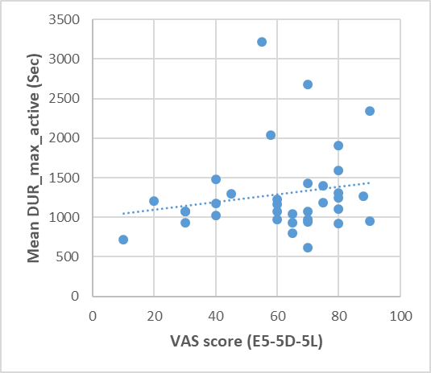 | 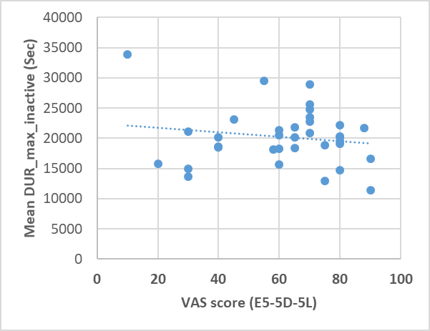
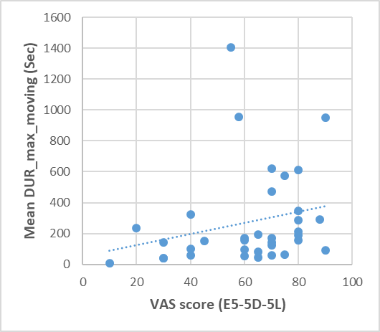
Figure 3.30: Scatterplots of correlation of Visual Analogue Scale (VAS) of EQ-5D-5L with mean max_DUR_active, inactive and moving of McRobert's PA data measured at home.
Correlation of Visual Analogue Scale (VAS) of EQ-5D-5L with mean max_DUR_active (r,.189)(P value,.278), inactive (r,-.030)(P value,.863)and moving (r,.376)(P value,.026) of McRobert's PA data measured at home.

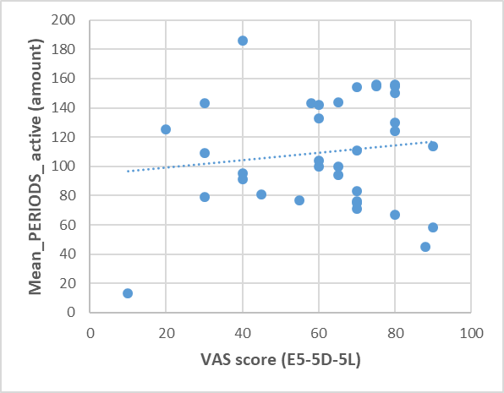 | 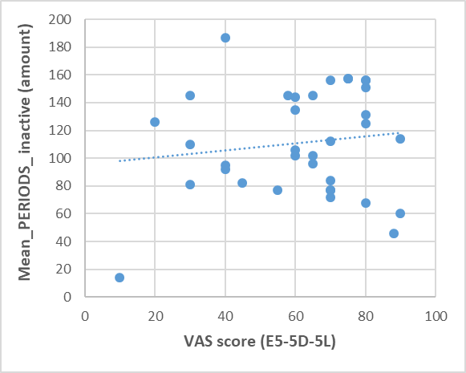
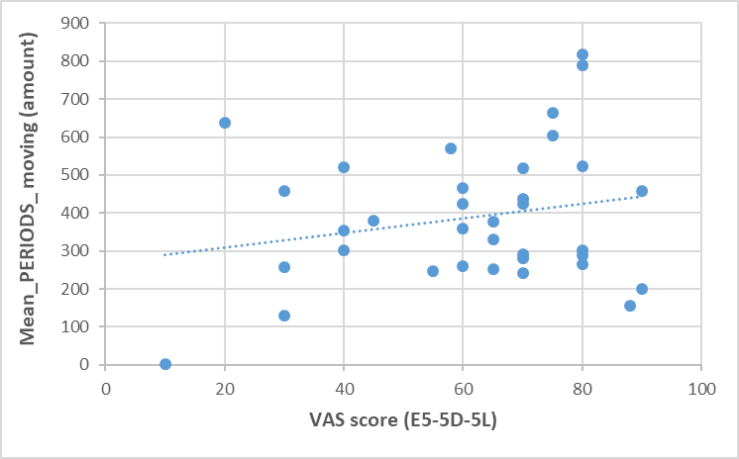
Figure 3.31: Scatterplots of correlation of Visual Analogue Scale (VAS) of EQ-5D-5L with mean PERIODS_active, inactive and moving of McRobert's PA data measured at home.
Correlation of Visual Analogue Scale (VAS) of EQ-5D-5L with mean PERIODS_active (r,.071)(P value,.686), inactive (r,.070)(P value,.690)and moving (r,.112)(P value,.522) of McRobert's PA data measured at home.

Correlation of 6MWT with validated measures of quality of life in MS
In order to determine whether the validated quality of life measures have similar relationships with 6MWT as they did with McRobert's variables.Correlation coefficient was commuted to determine the relationship between quality of life measures and 6MWT and bonferroni correction was used to reduce the level of significance to P= 0.016 ( 0.05/3).
Based on (Table 3.10), which showed the relationship between 6MWT and quality of life measures, there was a similar association between QoL measures with both McRoberts PA data and 6MWT.
No significant correlation was found between 6MWT and both Psychological Impact subscales of MSIS-29 and VAS of the EQ-5D-5L.Only significant Positive correlation was found between the 6MWT with index value of the EQ-5D-5L (r = .474**, P = .004).

Table 3.10: Correlation of 6MWT with validated measures of quality of life in MS
Quality of life measures | correlation | 6MWT
MSIS-29 (psychological- Impact) | r | -.245
MSIS-29 (psychological- Impact) | P-value | .155
EQ-5D-5L (index value) | r | .474**
EQ-5D-5L (index value) | P-value | .004
EQ-5D-5L (VAS) | r | .348
EQ-5D-5L (VAS) | P-value | .040
6MWT, 6 Meter Walk Test; MSIS-29, MS Impact Scale; EQ-5D-5L,
EuroQol Five Dimensions Five Levels questionnaire ; VAS, Visual Analog Scale

Correlation of McRobert’s PA data with validated measures of disability in MS

Multiple linear regression of 6MWT using McRobert's PA data:
A multiple linear regression was employed to test whether McRobert's PA data that measured patients' physical activity at home could significantly predict clinical mobility measures conducted in the clinic (6 MWT). Therefore, we used McRobert's PA data, and included data that were significantly correlated with 6 MWT, as shown in (Table 3.6).
Based on McRobert's PA data, Mean_DUR_total_moving and Mean_DUR_max_moving were found to be the best fitted regression model for predicting 6 MWT as shown in (Table 3.11).

Table 3.11: Multiple linear regression of 6MWT using MacRobert’s PA data
Model | Dependent | Independent | Model summary |  |  | ANOVA |  | Coefficients |  | t | Sig. | VIF  factor
 |  |  |  |  |  |  |  | Un standardised | Standardised | t | Sig. | VIF  factor
Model | Dependent | Independent | R | _{R}2 | Adjusted  _{R}2 | F | sig. | Beta |  | t | Sig. | VIF  factor
1 | 6MWT | Mean DUR total moving | .733 | .537 | .508 | 18.55 | .000 | .029 | .454 | 2.821 | .008 | 1.789
1 | 6MWT | Mean DUR max moving |  |  |  |  |  | .157 | .348 | 2.161 | .038 | 1.789

The results of the regression model demonstrated that there was a significant relationship between 6MWT and the explanatory variables.
In this model, the R2 was 0. 537, which indicated that 54 % of the variance in the 6MWT can be explained by the data obtained from PAM showing a moderate relationship between 6mwt and McRobert's PA data. Based on the F value (18.551 ) and its P value (.000 ) , the model appears to be valid. To verify the existence of the mentioned relationship, a multicollinearity test was conducted, and the result indicated the VIF factor of the model was low (< 5), indicating the absence of multicollinearity as shown in (Table 3.11)
Thus the result indicate the following equation:

The fitted regression model was: 6MWT= 126.719 + .029 * (Mean_DUR_total_moving) + .157* ( Mean_DUR_max_moving).
The overall regression was statistically significant (R² = .491, F(2, 32) = 18.551, p = .000).

It was found that Mean_DUR_total_moving significantly predicted 6MWT (β = .029, p = .008) as well as the Mean_DUR_max_moving significantly predict 6MWT (β = .157, p = .038). All the remaining McRobert's PA variables were not fit to the model or significantly predicted 6MWT.

Multiple linear regression of 6MWT using PROMs:
In order to test whether PROM data could significantly predict clinical mobility measures conducted in the clinic (6MWT), multiple linear regression was employed. Therefore, we utilised mobility self-reported measures, including the physical impact of MSIS-19, borg (RPE), and MSWS-12 as independent variables and 6MWT as dependent variables.
Based on PROMs, the physical impact of MSIS-29 and MSWS-12 were found to be the best-fitted regression model for predicting 6 MWT, as shown in (Table 3.12).

Table 3.12: Multiple linear regression of 6MWT using Patients reported Outcomes Measures (PROMs) data
Model | Dependent | Independent | Model summary |  |  | ANOVA |  | Coefficients |  | t | Sig. | VIF  factor
 |  |  |  |  |  |  |  | Un standardised | Standardised | t | Sig. | VIF  factor
Model | Dependent | Independent | R | _{R}2 | Adjusted  _{R}2 | F | sig. | Beta |  | t | Sig. | VIF  factor
1 | 6MWT | Physical impact of MSIS-29 | .740 | .547 | .519 | 19.31 | .000 | -3.349 | -.444 | -2.150 | .039 | 3.012
1 | 6MWT | MSWS-12 |  |  |  |  |  | -1.598 | -.331 | -1.603 | .119 | 3.012

The fitted regression model was: 6MWT = 560.012 - 3.349 * (Physical Impact of MSIS-29) -1.598 * (MSWS-12) The overall regression was statistically significant (R2 = .547, F (2, 32) = 19.31, p = .000).
It was found that physical impact of MSIS-29 significantly predicted 6MWT (β = -3.349, p = .039).

It was found that MSWS-12 did not significantly predict 6MWT (β = - 1.598, p = .119). All the remaining mobility self-reported outcome measures were not fit to the model or significantly predicted 6MWT.

Multiple linear regression analysis using MacRobert's data versus PROMs to predict 6MWT.
In order to identify which multiple linear regression model is more effective at predicting 6MWT, we compared these two models in (Table 3.13). It was found that the two models predicted 6MWT similarly. Therefore, in terms of predicting 6MWT, McRobert's data, which was collected in a home environment, were comparable with PROMs as validated measures of disability in MS.

Table 3.13: Comparison between two models of multiple linear regression in predicting 6MWT
Model | Independent |  | R | _{R}2 | Adjusted R² | F | Sig.
1 | McRobert's data | mean DUR total moving &  mean DUR max moving | .740 | .547 | .519 | 19.31 | .000
2 | PROMs | physical impact of MSIS- 29 &  MSWS-12 | .733 | .537 | .508 | 18.55 | .000

Multiple linear regression of McRobert's PA data with neurological impairment as measured by MSIS-29
Multiple linear regression was used to determine whether 4 selected items from the MSIS-29 that reflect physical neurological impairments associated with pwMS could significantly predict McRobert's PA data obtained from everyday setting. The four items are: (question 4, related to balance problems), (question 7, related to stiffness), (question 9, related to tremors), and (question 10, related to spasms). The neurologic impairment items were used as explanatory variables and McRobert's PA data as dependent variables.
Thus, only three models fit the regression models for predicting McRobert's PA variables the best, as shown in tables (Table 3.14) (Table 3.15)(Table 3.16)

Table 3.14: Multiple linear regression of Mean DUR max active using the neurological impairment items from (MSIS-29) as independent variables.
Model | Dependent | Independent | Model summary |  |  | ANOVA |  | Coefficients |  | t | Sig. | VIF  factor
 |  |  |  |  |  |  |  | Un standardised | Standardised | t | Sig. | VIF  factor
Model | Dependent | Independent | R | _{R}2 | Adjusted  _{R}2 | F | sig. | Beta |  | t | Sig. | VIF  factor
1 | Mean DUR  max active | Balance problems | .589 | .347 | .260 | 3.981 | .010 | -133.686 | -.295 | -1.797 | .082 | 1.237
1 | Mean DUR  max active | stiffness |  |  |  |  |  | -201.182 | -.456 | -2.426 | .021 | 1.621
1 | Mean DUR  max active | tremor |  |  |  |  |  | 33.923 | .074 | .377 | .709 | 1.775
1 | Mean DUR  max active | spasm |  |  |  |  |  | -22.347 | -.054 | -.261 | .796 | 1.975

As shown in (Table 3.14), the results of the multiple regression model indicated a significant relationship between mean DUR max active and the explanatory variables.
In this model, the R2 was 0.347, indicating that 34.7% of the variance in the mean DUR max active can be explained by self-reported neurological impairments as assessed by the MSIS-29. According to the F value (3.981) and its P value (.010), the model appears to be valid. A multicollinearity test was conducted to confirm the existence of the mentioned relationship, and the results indicated that the VIF factor of the model was low (< 5), indicating the absence of multicollinearity as shown in (Table 3.14).
The fitted regression model was: mean DUR_max_active = 2269.567 -133.68 * (balance problem) - 201.182 * (stiffness) - 22.347 * (spasm) + 33.923 *(termer)
The overall regression was statistically significant (R2 = .347, F(4, 30) = 3.981, p = .010).

It was found that stiffness significantly predicted mean DUR max active (β = -.201, p = .021). However, the balance problem did not significantly predict mean DUR max active (β = -133.686 , p = .082) but it was significant at the level of (0.1). None of the remaining variables were significantly predict mean DUR max active.

Table 3.15: Multiple linear regression of Mean DUR max moving using the neurological impairment items from (MSIS-29) as independent variables.
Model | Dependent | Independent | Model summary |  |  | ANOVA |  | Coefficients |  | t | Sig. | VIF  factor
 |  |  |  |  |  |  |  | Un standardised | Standardised | t | Sig. | VIF  factor
Model | Dependent | Independent | R | _{R}2 | Adjusted  _{R}2 | F | sig. | Beta |  | t | Sig. | VIF  factor
1 | Mean DUR  max moving | Balance problems | .540 | .291 | .247 | 6.572 | .004 | -78.435 | -.309 | -2.029 | .051 | 1.050
1 | Mean DUR  max moving | stiffness |  |  |  |  |  | -93.762 | -.380 | -2.491 | .018 | 1.050

In (Table 3.15), the result of the multiple regression model indicates that mean DUR max moving is significantly related to the explanatory variables.
This model had an R2 of 0.291, indicating that 29% of the variance in the DUR max moving could be explained by self-reported neurological impairments associated with stiffness and balance disturbances as assessed by MSIS-29. It appears that the model is valid based on its F value (6.572) and its P value (.004). A multicollinearity test was conducted to confirm the existence of the mentioned relationship, and the results indicated that the VIF factor of the model was low (< 5), indicating the absence of multicollinearity, as shown in (Table 3.15).
The fitted regression model was: mean DUR max moving = 784.112 -78.435 (balance problem) - 93.762 (stiffness)
The overall regression was statistically significant (R2 = .291, F (2,32) = 6.572, p = .004).

It was found that stiffness significantly predicted mean DUR max moving (β = -93.762, p = .018). Balance problems, however, marginally predicted mean DUR max moving (β = -78.435, p = .051). All the remaining variables were not fit to the model or significantly predicted mean DUR max moving.

Table 3.16: Multiple linear regression of Mean DUR total moving using the neurological impairment items from (MSIS-29) as independent variables.
Model | Dependent | Independent | Model summary |  |  | ANOVA |  | Coefficients |  | t | Sig. | VIF  factor
 |  |  |  |  |  |  |  | Un standardised | Standardised | t | Sig. | VIF  factor
Model | Dependent | Independent | R | _{R}2 | Adjusted  _{R}2 | F | sig. | Beta |  | t | Sig. | VIF  factor
1 | Mean DUR  total moving | Balance problems | .499 | .249 | .202 | 5.309 | .010 | -485.756 | -.271 | -1.725 | .094 | 1.050
1 | Mean DUR  total moving | stiffness |  |  |  |  |  | -636.834 | -.365 | -2.323 | .027 | 1.050
As shown in (Table 3.16), the multiple regression model indicates that the explanatory variables significantly influence the mean DUR total moving.
According to the model, 24.9 % of the variance in the DUR total moving could be explained by self-reported neurological impairments associated with stiffness and balance disturbances as evaluated by the MSIS-29. As seen by the F value (5.309) and the P value (.01), the model appears to be valid. A multicollinearity test was conducted in order to confirm the existence of the relationship, and the results indicated a low VIF factor (< 5), indicating the absence of multicollinearity, as shown in (Table 3.16).
The fitted regression model was: mean DUR total moving = 7487.683 - 485.756 * (balance problem) - 636.834
*(stiffness)

The overall regression was statistically significant (R2 = .249, F (2,32) = 5.309, p = .010).

It was found that stiffness significantly predicted mean DUR total moving (β = -636.834, p = .027). Balance problems, however, did not significantly predicted mean DUR total moving (β = -485.756, p = .094) but it was significant at the level of (0.1). All the remaining variables were not fit to the model or significantly predicted mean DUR total moving. These results indicate that neurological impairment as measured by (MSIS-29) can impact daily PA in persons with MS. Stiffness appears to be the most self-reported symptom associated with daily PA, followed by problems with balance.

Discussion:
The current study of baseline analysis of pwMS with a wide range of ambulatory disability confirms that one week of PAM is feasible for these patients. There were three key findings: 1) PAM measurements of walking mobility correlate with validated clinical assessments of gait, mobility and perceived exertion utilised in a clinical setting (EDSS, 6mwt, Borgs RPE).
- There was no correlation between a PROM measuring perceived fatigue (MFIS) and PAM variables, suggesting that perceived fatigue does not explain impaired mobility in pwMS.
- McRobert's PA data can be explained partially by neurological impairment measured by the MSIS-29 instrument.
This study confirmed that PAM used in the lower back is feasible and tolerable to be worn for 24 hours over a seven-day period with compliance rate 91.4 % , which is in line with the findings of (Supratak et al., 2018). PAM is comfortable for 90% of the participants in the clinic and at home for prolonged time (week). According to Tudor-Locke et al. (2015) it was found that step outputs from the hip accelerometers were more accurate than from the wrist against direct observation when carried out in controlled settings. Wearing an accelerometer on the wrist is associated with greater step counts than wearing it on the hip under free-living settings; for example: [2500 steps] were recorded with a wrist-placed accelerometer compared to a hip- placed accelerometer under free-living settings. In addition, Higher wear-time compliance with 24-hour protocols, this finding is consistent in various compared to waking-hour protocols was found in children and adolescence; considering that countries (Tudor-Locke et al., 2015)
The time spent on movement and activity did not differ significantly during the week and the weekend, which is in agreement with Sagawa's findings (Sagawa et al., 2021). The current study, however, found that the number of consecutive sitting or lying periods tended to be greater during the week than at the weekend. In this context, we regret not having employment status data as it is one of the demographic factors that contribute to physical activity variation in pwMS (Motl et al., 2007). Consequently, it may have an influence on how manyactivities/inactivities were performed during the weekday as opposed to the weekend. Since more than half of our cohort (EDSS score of < 4), we assume that they have jobs and their work schedules and daily routines do not require excessive amounts of movement during the weekdays. Instead, they require repetitive sitting at a desk or in front of a computer. Fatigue might also be a contributing factor. After a busy day at work during the week, they tend to relax and spend most of their time sitting or lying down. In contrast, they may be more flexible with their schedules on weekends, which provides them with more opportunities for activity such as social engagement and leisure activities.
In terms of associations between 6 MWT and McRobert's PA variables, the strongest correlations were found between 6 MWT and the mean value of maximum movement (r=.718** ) and with the mean value of total movement (r= .685**), which means in reality the maximum and total duration of consecutive walks, stair walks, and cycling in real world settings strongly to moderately related to clinical validated walking measure in control settings. Suggesting that maximum movement is the best reflection of the 6 MWT and serves as an indicator of walking performance in real-world walking. That aligns with the Gijbels et al. (2010) study, every- day walking performance is best reflected by longer walking capacity tests (6MWT, 2MWT). It has been demonstrated that in patients with severe walking impairments, those who completed the 6MWT with a walking distance of 300 meters or less, with more than half of this cohort walking less than 300 meters in the 6MW, walk more consistently during free-living walking and when assessed clinically because they have limited capacity to increase their walking (Mate and Mayo, 2020) MS with severe disability (EDSS <4) in 6 MWT test walked around 90% of the expected walking distance based on their EDSS score with no time constraints. This study found that 54% of participants had EDSS scores ranging from (4-7), which may explain why McRobert's PA data correlate well with the 6MWT (Hadouiri et al., 2021).
On the other hand, the 6 MWT shows a weaker correlation with maximum and total activity, as measured by PAM. There are several possible explanations for this. Given the large number of statistical tests we undertook, this might represent statistical “noise” with a nominally significant finding which does not have any clinical or real world significance. It might also reflect the fact that the mobility captured by the moving variables more closely reflects the brisk walking undertaken during the 6MWT. In contrast, the active variables capture standing and shuffling, pwMS spend a significant amount of their gait cycle in these, however they do not represent the type of walking undertaken during the 6MWT. This likely explains why Mean DUR total moving and Mean DUR max moving correlate more strongly with the 6MWT than Mean DUR total active and Mean DUR max active. EDSS scores were less correlated with McRobert's PA data and were not significantly predictive of 6MWT. This may not be surprising since it measures impairment exclusively as a whole rather than only mobility. Additionally, the EDSS has known limitations, including its low sensitivity and inter- and intra-rater reliability (Goldman et al., 2010).
MSWS-12 was negatively correlated with maximum and total movement as well as with maximum activity. Similar results were observed in another study of daily activity associated with perceived quality of walking as assessed by MSWS-12 (Torchio et al., 2022). Also, we found that the physical impact subscale of MSIS-29 negatively correlated with total and maximum activity and movement. Similar results was found of Borg (RPE) Scale which correlated negatively with McRobert’s PA data. Among other measures, including the EDSS, Borg (RPE) Scale, MSIS-29, EQ-5D-5L (index value) and EQ-5D-5L (VAS), the MSWS-12 and the physical impact subscale of the MSIS-29 were found to predict 6MWT significantly.
All validated mobility outcomes (6MWT, MSWS_12, borg PRE) and (EDSS, physical subscale of MSIS_29) were significantly associated with maximum and total moving as well as with maximum activity of McRobert's PA data. These clear and consistent relationships could be explained by the following: McRoberts PA variables that measure mobility in real world correlated consistently significantly with validated mobility outcome measure in clinic. In the real world, the maximum and total moving variables measure the amount of time devoted to walking, climbing stairs and cycling. While maximum activity refers to the maximum duration spent on an activity (from shuffling to cycling), this implies an activity that requires a significant amount of time to perform, which is walking again, not just shuffling. Therefore, it is understandable why total activity did not correlate with all mobility measures because it represents the total amount of time spent on various activities, not just mobility. Based on these findings, McRobert's PAM appears to be highly sensitive and accurate.
In both this and previous studies, fatigue has been identified as a common symptom of pwMS. It is a multifactorial symptom and psychological factors may play a significant role in the perceived fatigue in pwMS (Gümüş, 2018). Our MFIS data is normally distributed with a minimum score of 7 and a maximum score of 84MFIS scores range from 0 to 84. This is similar to the data obtained from n=181 from different 4 European countries (Kos et al., 2005). A cut-off score of 38 is used for the MFIS to distinguish fatigued patients from those who are not fatigued (Larson, 2013). The results of this study indicate that 67% of the participants are fatigued (MFIS > 38). Even though fatigue was frequently reported, it was not associated with PAM in our study.This was in line with the finding of daily self-reported symptoms and how they relate to daily walking measured by three-dimensional depth imaging, they also found that self-reported fatigue does not correlate with actual daily walking (Newland et al., 2020). Similar findings were found in a study of RRMS and clinical isolated syndrome, which indicated that perceived fatigue did not correlate with clinical outcomes (Håkansson et al., 2019). Therefore, we can conclude that perceived fatigue, as measured by the MFIS, does not necessarily drive physical activity in our cohort.
In contrast, the MFIS score was significantly related to the 6MWT. Several factors may explain this result. First, 6MWT is a walking test conducted in a controlled setting for a specific period. This is as opposed to daily walking, in which the pace, intensity, and distance may vary according to the patient’s preferences, activities and environment. Due to this variability, it may be difficult to measure the relationship between fatigue and daily walking. As MFIS and 6MWT were conducted relatively at the same time in the clinic, 6MWT may be more sensitive to fatigue than daily walking, which is an average walking for seven days. This would reflect the finding from Powell et al. (2017) study, they found that fatigue fluctuations during the day reached their highest point late in the afternoon in people with relapsing remitting MS. However, there are several issues with MFIS and confounding factors, especially with pwMS, which suggest limitations in its interpretation (Larson, 2013).
The quality of life of pwMS, as measured by two instruments of the EQ-D5-L5, appeared to be weakly but significantly associated with 6MWT and both the maximum and total movement of McRobert's PA. These findings suggest that the quality of lives of pwMS may be influenced in part by their mobility. That is similar to (Block et al., 2017) findings. Nevertheless, the psychological aspect of the patient's condition, as assessed by MSIS-29, did not interfere with the patient's mobility. These inconsistent results suggested that in pwMS,there may be a difficulty in accurately assessing quality of life as a result of cognitive and emotional changes caused by MS. Furthermore, impairment of autobiographical memory in pwMS may impact the ability of this population to subjectively evaluate their quality of life (Kenealy et al., 2000). Because, in order to estimate the impact of MS on quality of life, it is crucial to have information about one's prior life and to be able to recall what life was like before the MS. Due to this, the loss of information about a person's past life and/or life outside of the institutional or home environment may greatly impact a person's perception of QoL (Kenealy et al., 2000).
It is also known that other factors can account for variations in physical activity among pwMS. This can be attributed to a number of clinical factors (e.g., assistive device use and MS type) and demographic parameters (e.g. age and employment status) which were independently associated with physical activity variability (Motl et al., 2007). It is also essential to consider other environmental factors, including the presence and accessibility of transit stops, shopping facilities, and recreation facilities within walking distance (Doerksen et al., 2007). Additionally, depression, sensory deficiency and urinary incontinence symptoms that are associated with pwMS may also be associated with a variation in daily walking (Newland et al., 2020).
Based upon the linear regressions, which were performed due to clinical considerations (How different are PROMs and McRobert's PA data predictability scores for 6MWT?). Both PROM (physical subscale of MSIS-29 and MSWS-12) and McRobert's data (total and maximum moving) were able to explain half of the variance of 6MWT distances. Our results indicate that using McRobert's data (total and Maximum moving) from the home environment were able to predict 6 MWT measured in clinical settings as equivalent to well-established validated outcome measures for MS i.e. (physical subscale of MSIS-29 and MSWS-12).
The use of objective PA measurements is crucial. Large-scale evaluations have shown that correlations between self-report and objective measurements rarely exceed excellent in the general population (Prince et al., 2008). The results of a large-scale EU study investigating 1713 healthy individuals showed significant differences in the prevalence rates of sufficient physical activity between self-reported levels (84.2%) and objective measures (41.6%) (Steene-Johannessen et al., 2016). The same study recommended that large-scale cohort research should use objective assessments, and caution should be taken when estimating PA using self-reported data. A study comparing a physical activity questionnaire to accelerometry data of 154 people found that the accuracy of the physical activity questionnaire was higher for men than for women and for those with a lower body mass index, which corresponds with a review findings that, on average female participants tend to overestimate their self-reported physical activity in comparison to PAM by the mean difference of 138% (Ferrari et al., 2007, Prince et al., 2008). This would negatively affect the reliability of self- reported physical activity measures, particularly for pwMS, because women have a higher prevalence of MS, which is reflected in our sample, in which 63% of the participants are female. Another advantage of PAM as a result of technological advancements, large amounts of raw acceleration data can now be recorded and stored, which provides new opportunities for PA characterisation and analysis (Troiano et al., 2014). In general, remote clinical examinations and electronic health services were demonstrated to be cost-effective and satisfying experiences for both patients, as well as highly valued by neurologists handling pwMS. (Yeroushalmi et al., 2020)
In clinical trials, there are challenges from participants' perspectives that impact recruitment and retention rates that need to be addressed. Geographic distance was identified as a barrier to recruitment and retention by 16.7% of respondents. In addition, financial issues arise because they lose their daily wages because they need to take time off from work to attend study visits (Kadam et al., 2016, Chaudhari et al., 2020).
On the other hand, Each PROM and clinical measure are designed to evaluate a specific aspect of mobility in MS, and it must be completed independently over a period of time. The more outcome measures completed, the more information you may learn about a person's walking. Moreover, PROMs are subordinate to perception and recall, which are cognitive resources. It has been shown that autobiographical memory relates specifically to MS neuropathology (Ernst et al., 2013). Approximately 60% of some MS populations suffer from autobiographical memory impairment (Kenealy et al., 2000). In view of the fact that PROMs may also be perceived differently over time depending on other factors than actual deterioration, they are not able todetect changes equally across different MS types and stages as the disease progresses (van‘t Hullenaar et al.,

2021).

It would therefore appear that it may not be necessary to complete several PROMs during routine clinical visits. Instead, the emphasis should be placed on incorporating PAM into routine healthcare, especially for pwMS. McRobert’s variables of PAM that correlated with the validated clinical mobility measures and most of the PROMs can be an early indicator of adverse outcomes in pwMS. Using the PAM that correlated with validated clinical and PROMs measures has potential to provide information to health care providers as well as the MS patients and would save time for both in regular clinical visits.
Among the measures recognized from regression analysis as significant predictors of actual daily walking, self- perceived stiffness was significant followed by balance problem by lesser degree in predicting MacRobert’s PA data (maximum and total activity and maximum moving); this indicates that these neurological symptoms directly and partially impact daily walking in pwMS. This result reflects the findings of previous cross-sectional research by Bethoux and Marrie (2016) found that stair climbing, walking, and sleeping were the most frequently reported activities that were affected by spasticity. This is in line with the findings of Norbye et al. (2020) where a significant correlation was found between spasticity, gait, and balance using clinical assessment methods. Spasticity scores of the lower limbs measured by Modified Ashworth Scale were moderately associated with walking distance as measured by 2MWT as well as with balance. As spasticity of the lower limb increased, there was a significant decrease in both walking distance and balance (Norbye et al., 2020). Although the current study focuses on objective measures of everyday walking, it should be noted that it only relies on MSIS-29 scores to measure subjective stiffness. Patients refer to spasticity by using words such as stiffness, cramping, or muscle tension because spasticity is difficult for them to understand and use (Özkan et al., 2023). However, future studies should administer objective spasticity measures, and additional research is required to determine the extent to which stiffness and balance contribute to decreased everyday mobility.Several limitations were identified in this study. The fact that all participants in this study were referred to and consented to a rehabilitation program. This may not represent the entire MS population. Another limitation, we did not include a validated measure of balance and spasticity, as it would have provided greater insight into our findings. The same can be said of the cognitive and depression measures, as these may provide a deeper understanding of the quality-of-life assessment results. In addition, same-day clinical variations are frequently reported by people with MS. However, no research has been conducted to examine these variations in gait. It would be ideal if people were routinely examined at the same time of day to minimise this fluctuation. Although, it may not be possible to achieve this since it was too difficult to organise, future studies should take this aspect into consideration. From this and similar data, other potentially relevant information could be extracted. It may be possible to determine the frequency of activity phases and their variations throughout the week, as well as patterns of sleep and activity during the night. Several of these areas may be explored in future work.
This study demonstrates the feasibility and utility of using wearable accelerometry to objectively assess the mobility of pwMS. We identify strong correlations between PAM variables and clinical gait assessments. The strongest correlations were between total moving and max moving durations and the 6MWT. The PAM variables of total moving and max moving also correlated strongly with mobility related PROMs: the MSWS-12, Borg scale, MSIS-29 and EDSS. The strong correlation of the total moving and max moving PAM variables with this wide range of clinical assessments and PROMs, suggests that these could be the most robust PAM variables for utilisation in clinical studies of mobility in pwMS. Notably, we could not demonstrate a correlation between PAM variables and fatigue (measured with the MFIS). This might reflect confounding factors from our study methodology, and we cannot conclude if PAM data correlates with fatigue or not, since the MFIS responses were collected after the period in which participants wore the PAM. We conclude that exploring further the ability of wearable devices, measuring real world activity, to replace burdensome clinical assessments should be a priority in MS research.

REFERENCES
ALBERT, M. V., AZEZE, Y., COURTOIS, M. & JAYARAMAN, A. 2017. In-lab versus at-home activity recognition in ambulatory subjects with incomplete spinal cord injury. Journal of NeuroEngineering and Rehabilitation, 14.

BAERT, I., FREEMAN, J., SMEDAL, T., DALGAS, U., ROMBERG, A., KALRON, A., CONYERS, H., ELORRIAGA, I., GEBARA, B., GUMSE, J., HERIC, A., JENSEN, E., JONES, K., KNUTS, K., MAERTENS DE NOORDHOUT, B., MARTIC, A., NORMANN, B., EIJNDE, B. O., RASOVA, K., SANTOYO MEDINA, C., TRUYENS, V., WENS, I. &
FEYS, P. 2014. Responsiveness and Clinically Meaningful Improvement, According to Disability Level, of Five Walking Measures After Rehabilitation in Multiple Sclerosis. Neurorehabilitation and Neural Repair, 28, 621-631.
BETHOUX, F. & MARRIE, R. A. 2016. A Cross-Sectional Study of the Impact of Spasticity on Daily Activities in Multiple Sclerosis. The Patient - Patient-Centered Outcomes Research, 9, 537-546.
BLOCK, V. J., BOVE, R. & NOURBAKHSH, B. 2022. The role of remote monitoring in evaluating fatigue in multiple sclerosis: a review. Frontiers in Neurology, 13, 878313.

BLOCK, V. J., LIZÉE, A., CRABTREE-HARTMAN, E., BEVAN, C. J., GRAVES, J. S., BOVE, R., GREEN, A. J.,
NOURBAKHSH, B., TREMBLAY, M., GOURRAUD, P. A., NG, M. Y., PLETCHER, M. J., OLGIN, J. E.,
MARCUS, G. M., ALLEN, D. D., CREE, B. A. C. & GELFAND, J. M. 2017. Continuous daily assessment of multiple sclerosis disability using remote step count monitoring. Journal of Neurology, 264, 316-326.
CASEY, B., COOTE, S. & DONNELLY, A. 2018. Objective physical activity measurement in people with multiple sclerosis: a review of the literature. Disability and Rehabilitation: Assistive Technology, 13, 124-131.
CHAUDHARI, N., RAVI, R., GOGTAY, N. J. & THATTE, U. M. 2020. Recruitment and retention of the participants in clinical trials: challenges and solutions. Perspectives in clinical research, 11, 64.

CHOTIYARNWONG, C., NAIR, K., ANGELINI, L., BUCKLEY, E., MAZZA, C., HEYES, D., RAMIZ, R., BASTER, K., ISMAIL, A., DAS, J., ALI, A., LINDERT, R., SHARRACK, B., PRICE, S. & PALING, D. 2020. Effect of remote
ischaemic preconditioning on walking in people with multiple sclerosis: double-blind randomised controlled trial. BMJ Neurology Open, 2, e000022.
DASMAHAPATRA, P., CHIAUZZI, E., BHALERAO, R. & RHODES, J. 2018. Free-Living Physical Activity Monitoring in Adult US Patients with Multiple Sclerosis Using a Consumer Wearable Device. Digital Biomarkers, 2, 47-63.
DE RIDDER, R. & DE BLAISER, C. 2019. Activity trackers are not valid for step count registration when walking with crutches. Gait & posture, 70, 30-32.
DEVLIN, N. J., SHAH, K. K., FENG, Y., MULHERN, B. & VAN HOUT, B. 2018. Valuing health‐related quality of life: An EQ‐5 D‐5 L value set for England. Health economics, 27, 7-22.
DOERKSEN, S. E., MOTL, R. W. & MCAULEY, E. 2007. Environmental correlates of physical activity in multiple sclerosis: A cross-sectional study. International Journal of Behavioral Nutrition and Physical Activity, 4, 49.

DUVIVIER, B. M., BOLIJN, J. E., KOSTER, A., SCHALKWIJK, C. G., SAVELBERG, H. H. & SCHAPER, N. C. 2018.
Reducing sitting time versus adding exercise: differential effects on biomarkers of endothelial dysfunction and metabolic risk. Scientific reports, 8, 8657.
ERNST, A., BLANC, F., VOLTZENLOGEL, V., DE SEZE, J., CHAUVIN, B. & MANNING, L. 2013. Autobiographical
memory in multiple sclerosis patients: Assessment and cognitive facilitation. Neuropsychological Rehabilitation, 23, 161-181.
FERRARI, P., FRIEDENREICH, C. & MATTHEWS, C. E. 2007. The role of measurement error in estimating levels of physical activity. American journal of epidemiology, 166, 832-840.
GASTIN, P. B. 2001. Energy System Interaction and Relative Contribution During Maximal Exercise. Sports Medicine, 31, 725-741.

GIJBELS, D., ALDERS, G., VAN HOOF, E., CHARLIER, C., ROELANTS, M., BROEKMANS, T., OP'T EIJNDE, B. & FEYS,
P. J. M. S. J. 2010. Predicting habitual walking performance in multiple sclerosis: relevance of capacity and self-report measures. 16, 618-626.
GIL-GONZÁLEZ, I., MARTÍN-RODRÍGUEZ, A., CONRAD, R. & PÉREZ-SAN-GREGORIO, M. Á. 2020. Quality of life in
adults with multiple sclerosis: a systematic review. BMJ open, 10, e041249.
GOLDMAN, M. D., MOTL, R. W. & RUDICK, R. A. 2010. Possible clinical outcome measures for clinical trials in patients with multiple sclerosis. Therapeutic Advances in Neurological Disorders, 3, 229-239.
GUICCIARDI, M., CARTA, M., PAU, M. & COCCO, E. 2019. The Relationships between Physical Activity, Self- Efficacy, and Quality of Life in People with Multiple Sclerosis. Behavioral Sciences, 9, 121.
GÜMÜŞ, H. 2018. Fatigue can be objectively measured in multiple sclerosis: multipl sklerozda yorgunluk
objektif olarak ölçülebilir. Archives of Neuropsychiatry, 55, S76.
HADOUIRI, N., MONNET, E., GOUELLE, A., DECAVEL, P. & SAGAWA, Y. 2021. Evaluation of Prolonged Walking in Persons with Multiple Sclerosis: Reliability of the Spatio-Temporal Walking Variables during the 6- Minute Walk Test. Sensors, 21.
HÅKANSSON, I., JOHANSSON, L., DAHLE, C., VRETHEM, M. & ERNERUDH, J. 2019. Fatigue scores correlate with
other self-assessment data, but not with clinical and biomarker parameters, in CIS and RRMS. Multiple Sclerosis and Related Disorders, 36, 101424.
HEALTH, P. 2020. Health matters: physical activity - prevention and management of long-term conditions [Online]. UK government Available: https://www.gov.uk/government/publications/health-matters- physical-activity/health-matters-physical-activity-prevention-and-management-of-long-term- conditions [Accessed].

HERDMAN, M., GUDEX, C., LLOYD, A., JANSSEN, M., KIND, P., PARKIN, D., BONSEL, G. & BADIA, X. 2011.
Development and preliminary testing of the new five-level version of EQ-5D (EQ-5D-5L). Quality of life research, 20, 1727-1736.
HOBART, J. 2001. The Multiple Sclerosis Impact Scale (MSIS-29): A new patient-based outcome measure.
Brain, 124, 962-973.

HOBART, J., RIAZI, A., LAMPING, D., FITZPATRICK, R. & THOMPSON, A. J. N. 2003. Measuring the impact of MS
on walking ability: the 12-Item MS Walking Scale (MSWS-12). 60, 31-36.

HOLLEWAND, A. M., SPIJKERMAN, A. G., BILO, H. J., KLEEFSTRA, N., KAMSMA, Y., VAN HATEREN, K. J. J. J. O. A.
& ACTIVITY, P. 2016. Validity of an accelerometer-based activity monitor system for measuring physical activity in frail older adults. 24, 555-558.

HOUGAARD, K. D., HJORT, N., ZEIDLER, D., SØRENSEN, L., NØRGAARD, A., HANSEN, T. M., VON WEITZEL- MUDERSBACH, P., SIMONSEN, C. Z., DAMGAARD, D., GOTTRUP, H., SVENDSEN, K., RASMUSSEN, P. V., RIBE, L. R., MIKKELSEN, I. K., NAGENTHIRAJA, K., CHO, T.-H., REDINGTON, A. N., BØTKER, H. E.,
ØSTERGAARD, L., MOURIDSEN, K. & ANDERSEN, G. 2014. Remote Ischemic Perconditioning as an Adjunct Therapy to Thrombolysis in Patients With Acute Ischemic Stroke. Stroke, 45, 159-167.
INCOGNITO, A. V., BURR, J. F. & MILLAR, P. J. 2016. The Effects of Ischemic Preconditioning on Human Exercise Performance. Sports Medicine, 46, 531-544.
KADAM, R. A., BORDE, S. U., MADAS, S. A., SALVI, S. S. & LIMAYE, S. S. 2016. Challenges in recruitment and retention of clinical trial subjects. Perspectives in clinical research, 7, 137.
KENEALY, P. M., BEAUMONT, G. J., LINTERN, T. & MURRELL, R. 2000. Autobiographical Memory, Depression and Quality of Life in Multiple Sclerosis. Journal of Clinical and Experimental Neuropsychology, 22, 125-131.
KOS, D., KERCKHOFS, E., CARREA, I., VERZA, R., RAMOS, M. & JANSA, J. J. M. S. J. 2005. Evaluation of the
Modified Fatigue Impact Scale in four different European countries. 11, 76-80.
LARSON, R. D. 2013. Psychometric Properties of the Modified Fatigue Impact Scale. International Journal of MS Care, 15, 15-20.
MACDONALD, E., BUCHAN, D., CEREXHE, L., RENFREW, L. & SCULTHORPE, N. 2023. Accelerometer measured
physical activity and sedentary time in individuals with multiple sclerosis versus age matched controls: A systematic review and meta-analysis. Multiple Sclerosis and Related Disorders, 69, 104462.

MANDIGOUT, S., LACROIX, J., PERROCHON, A., SVOBODA, Z., AUBOURG, T. & VUILLERME, N. J. F. I. M. 2019.
Comparison of step count assessed using wrist-and hip-worn Actigraph GT3X in free-living conditions in young and older adults. 6, 252.
MATE, K. K. V. & MAYO, N. E. 2020. Clinically Assessed Walking Capacity Versus Real-World Walking Performance in People with Multiple Sclerosis. International Journal of MS Care, 22, 143-150.
MCGUIGAN, C., HUTCHINSON, M. J. J. O. N. N. & PSYCHIATRY 2004. The multiple sclerosis impact scale (MSIS- 29) is a reliable and sensitive measure. 75, 266-269.
MCGUIGAN, C. & HUTCHINSON, M. J. N. 2004. Confirming the validity and responsiveness of the Multiple Sclerosis Walking Scale-12 (MSWS-12). 62, 2103-2105.
MOTL, R. W., SNOOK, E. M. & AGIOVLASITIS, S. 2011. Does an accelerometer accurately measure steps taken under controlled conditions in adults with mild multiple sclerosis? Disability and Health Journal, 4, 52- 57.
MOTL, R. W., ZHU, W., PARK, Y., MCAULEY, E., SCOTT, J. A. & SNOOK, E. M. 2007. Reliability of Scores from
Physical Activity Monitors in Adults with Multiple Sclerosis. Adapted Physical Activity Quarterly, 24, 245-253.
NEGRINI, F., GASPERINI, G., GUANZIROLI, E., VITALE, J. A., BANFI, G. & MOLTENI, F. 2020. Using an
accelerometer-based step counter in post-stroke patients: validation of a low-cost tool. International Journal of Environmental Research and Public Health, 17, 3177.

NEWLAND, P., SALTER, A., FLACH, A., FLICK, L., THOMAS, F. P., GULICK, E. E., RANTZ, M. & SKUBIC, M. J. R. N. J.
2020. Associations between self-reported symptoms and gait parameters using in-home sensors in persons with multiple sclerosis. 45, 80-87.
NORBYE, A. D., MIDGARD, R. & THRANE, G. 2020. Spasticity, gait, and balance in patients with multiple sclerosis: A cross‐sectional study. Physiotherapy Research International, 25.
NOSEWORTHY, J. H., VANDERVOORT, M. K., WONG, C. J. & EBERS, G. C. 1990. Interrater variability with the Expanded Disability Status Scale (EDSS) and Functional Systems (FS) in a multiple sclerosis clinical trial. 40, 971-971.

ÖZKAN, İ., POLAT DUNYA, C. & DEMIR, S. J. C. N. R. 2023. Life Experiences of Patients With Multiple Sclerosis About Their Spasticity: A Phenomenological Study. 32, 49-59.
POWELL, D. J. H., LIOSSI, C., SCHLOTZ, W. & MOSS-MORRIS, R. 2017. Tracking daily fatigue fluctuations in multiple sclerosis: ecological momentary assessment provides unique insights. Journal of Behavioral Medicine, 40, 772-783.

PRINCE, S. A., ADAMO, K. B., HAMEL, M., HARDT, J., CONNOR GORBER, S. & TREMBLAY, M. 2008. A
comparison of direct versus self-report measures for assessing physical activity in adults: a systematic review. International Journal of Behavioral Nutrition and Physical Activity, 5, 56.
QIAN, Z., LI, Y., GUAN, Z., GUO, P., ZHENG, K., DU, Y., YIN, S., CHEN, B., WANG, H. & JIANG, J. 2023. Global,
regional, and national burden of multiple sclerosis from 1990 to 2019: Findings of global burden of disease study 2019. Frontiers in Public Health, 11, 1073278.
SAGAWA, Y., WATELAIN, E., MOULIN, T. & DECAVEL, P. 2021. Physical Activity during Weekdays and Weekends in Persons with Multiple Sclerosis. Sensors, 21, 3617.
SALVADOR, A. F., DE AGUIAR, R. A., LISBÔA, F. D., PEREIRA, K. L., CRUZ, R. S. D. O. & CAPUTO, F. 2016. Ischemic
preconditioning and exercise performance: a systematic review and meta-analysis. International Journal of Sports Physiology and Performance, 11, 4-14.
SANDROFF, B. M., KLAREN, R. E. & MOTL, R. W. 2015. Relationships Among Physical Inactivity, Deconditioning, and Walking Impairment in Persons With Multiple Sclerosis. Journal of Neurologic Physical Therapy, 39, 103-110.
SELLERS, C., DALL, P., GRANT, M. & STANSFIELD, B. 2016. Validity and reliability of the activPAL3 for measuring posture and stepping in adults and young people. Gait & posture, 43, 42-47.

SHAH, V. V., MCNAMES, J., MANCINI, M., CARLSON-KUHTA, P., SPAIN, R. I., NUTT, J. G., EL-GOHARY, M.,
CURTZE, C. & HORAK, F. B. 2020. Laboratory versus daily life gait characteristics in patients with multiple sclerosis, Parkinson’s disease, and matched controls. Journal of NeuroEngineering and Rehabilitation, 17.

SIKES, E. M., IRUTHAYANATHAN, R., GROVER, S. A., VIGUILIOUK, E., KAMANI, Z., STEPHENS, S., BERENBAUM,
T., NOGUERA, A., EBRAHIMI, N., O’MAHONY, J., NARANG, I., WEISS, S. K., FINLAYSON, M., BANWELL,
B., MARRIE, R. A., YEH, E. A. & MOTL, R. W. 2022. Physical Activity and Sedentary Behavior Patterns Across Weekdays and Weekend Days in Youth With Multiple Sclerosis and Controls. International Journal of MS Care, 24, 8-12.

STEENE-JOHANNESSEN, J., ANDERSSEN, S. A., VAN DER PLOEG, H. P., HENDRIKSEN, I. J. M., DONNELLY, A. E.,
BRAGE, S. & EKELUND, U. 2016. Are Self-report Measures Able to Define Individuals as Physically Active or Inactive? Medicine & Science in Sports & Exercise, 48, 235-244.
STORM, F. A., HELLER, B. W. & MAZZÀ, C. 2015. Step detection and activity recognition accuracy of seven physical activity monitors. PloS one, 10, e0118723.
STORM, F. A., NAIR, K. P. S., CLARKE, A. J., VAN DER MEULEN, J. M. & MAZZÀ, C. 2018. Free-living and
laboratory gait characteristics in patients with multiple sclerosis. PLOS ONE, 13, e0196463.
STUART, C. M., VARATHARAJ, A., DOMJAN, J., PHILIP, S., GALEA, I. & GROUP, S. S. 2020. Physical activity
monitoring to assess disability progression in multiple sclerosis. Multiple Sclerosis Journal– Experimental, Translational and Clinical, 6, 2055217320975185.
SUPRATAK, A., DATTA, G., GAFSON, A. R., NICHOLAS, R., GUO, Y. & MATTHEWS, P. M. J. F. I. N. 2018. Remote
monitoring in the home validates clinical gait measures for multiple sclerosis. 9, 561.
TÉLLEZ, N., RÍO, J., TINTORÉ, M., NOS, C., GALÁN, I. & MONTALBAN, X. 2005. Does the Modified Fatigue
Impact Scale offer a more comprehensive assessment of fatigue in MS? Multiple Sclerosis Journal, 11, 198-202.

TORCHIO, A., CORRINI, C., ANASTASI, D., PARELLI, R., MEOTTI, M., SPEDICATO, A., GROPPO, E., D'ARMA, A.,
GROSSO, C., MONTESANO, A., CATTANEO, D. & GERVASONI, E. 2022. Identification of modified dynamic gait index cutoff scores for assessing fall risk in people with Parkinson disease, stroke and multiple sclerosis. Gait & Posture, 91, 1-6.
TROIANO, R. P., MCCLAIN, J. J., BRYCHTA, R. J. & CHEN, K. Y. 2014. Evolution of accelerometer methods for physical activity research. British journal of sports medicine, 48, 1019-1023

TUDOR-LOCKE, C., BARREIRA, T. V., SCHUNA, J. M., MIRE, E. F., CHAPUT, J.-P., FOGELHOLM, M., HU, G.,
KURIYAN, R., KURPAD, A. & LAMBERT, E. V. 2015. Improving wear time compliance with a 24-hour waist-worn accelerometer protocol in the International Study of Childhood Obesity, Lifestyle and the Environment (ISCOLE). International Journal of Behavioral Nutrition and Physical Activity, 12, 1-9.
VAN MUNSTER, C. E. P. & UITDEHAAG, B. M. J. 2017. Outcome Measures in Clinical Trials for Multiple Sclerosis. CNS Drugs, 31, 217-236.

VAN‘T HULLENAAR, C. A. A., COERVER, E., KALKERS, N. F., VAN KEMPEN, Z., KOCH, M., UITDEHAAG, B. M. J.,
KILLESTEIN, J., STRIJBIS, E. M. M. J. M. S. & DISORDERS, R. 2021. The use of multi-domain patient reported outcome measures for detecting clinical disease progression in multiple sclerosis. 55, 103165.
WAHLSTRØM, K., BJERRUM, E., GÖGENUR, I., BURCHARTH, J. & EKELOEF, S. 2021. Effect of remote ischaemic
preconditioning on mortality and morbidity after non-cardiac surgery: meta-analysis. BJS open, 5, zraa026.
YEROUSHALMI, S., MALONI, H., COSTELLO, K., WALLIN, M. T. J. J. O. T. & TELECARE 2020. Telemedicine and
multiple sclerosis: a comprehensive literature review. 26, 400-413

Chapter 4. A 6-Week Randomised Controlled Trial of Repeated Remote Ischaemic Preconditioning in Multiple Sclerosis

Abstract
Background
Remote ischaemic preconditioning (RIPC) involves occlusion of blood flow to a limb to cause ischaemia. A previous study demonstrated that a single session of RIPC improved the distance walked on the 6-minute walk test in pwMS. In this chapter we investigate the effect of repetitive RIPC over a 6-week period in pwMS.
Objective

To evaluate the effectiveness of repeated remote ischemic preconditioning (RIPC) for 6 weeks on Physical Activity Monitor (PAM), fatigue and quality of life measures in pwMS.
Method
A total of 26 MS patients completed the study protocol. Fourteen patients were randomly assigned to the RIPC group and 11 to the sham group. In the clinic, following the 6-meter walk test (6MWT), patients completed the Borg rating of perceived exertion. Several questionnaires were also completed: the Modified Fatigue Impact Scale (MFIS), the 12-Item Multiple Sclerosis Walking Scale (MSWS-12), and the EuroQol Five Dimensions Five Levels questionnaire (EQ-5D-5L). All patients were provided with a Physical Activity Monitor (PAM) to use at home during the next seven days. The patients returned to the clinic after seven days to return the PAM and receive RIPC three times. Participants were then required to repeat the intervention (either RIPC or sham) daily over the next six weeks. During week six, the assessment procedure was repeated. A comparison was made between the assessment before and after the intervention.
Results
There were no significant changes in PAM variables or PROM scores following six weeks of intervention (either daily RIPC or sham groups).
Conclusion /
We could not identify any significant impact of RIPC on any mobility related outcomes or PROMs. This may reflect a true lack of beneficial effect of RIPC in pwMS, or be due to confounding factors masking the true effect of RIPC. This is an area that requires further research.

Introduction
The term remote ischemic preconditioning (RIPC) refers to the process of occluding blood flow to a limb, most commonly with a blood pressure (BP) cuff, to induce ischaemia, followed by reperfusion before permanent tissue injury. The goal being to induce release of mediators which affect distant organs to act as a protective mechanism against ischaemic injuries. As reviewed in Chapter 3, there is some evidence that RIPC has a positive effect on cardiovascular diseases, spinal ischaemic cord injuries and cerebrovascular conditions (Gurcun et al., 2006).
Multiple Sclerosis (MS) is autoimmune disease-causing demyelination of the central nervous system in middle-aged adults. The loss of independence in mobility is one of the most common symptoms of MS (Van der Feen et al., 2020). Ten years after being diagnosed with MS, 93% of patients have difficulty walking (Miller et al., 2015). MS is often associated with impaired walking, and this impairment causes significant burden to people with MS (Smrtka et al., 2016). Therefore, maintaining mobility is a major concern for those suffering from MS (Sutliff and opinion, 2010).
It has recently gained increased attention that RIPC may have therapeutic potential in MS (Camara- Lemarroy et al., 2018). There is some evidence that hypoxia-inflammation related cascades are potentially associated with MS (detailed in Chapter 1 Introduction). Some MS brain lesions resemble histologically brain lesions associated with neurovascular disease, and the parts of the brain most vulnerable to MS are those most vulnerable to hypoxia. Both human and animal studies have shown evidence of hypoxia as a global phenomenon in MS brain tissue. In rat models of experimental
autoimmune encephalitis, it has been shown in vivo that brain tissue has reduced partial pressures of oxygen. Several studies have shown, using MRI, that there is reduced cerebral blood flow in MS. This is correlated with grey matter loss and cognitive impairment. Brain hypoxia in MS has also been shown using near infrared spectroscopy, demonstrating reduced haemoglobin oxygen saturation. It is hypothesised that hypoxia in MS might then lead to inflammation, which in turn exacerbates hypoxia by obstructing small blood vessels and impairing vasodilation by endothelial injury. Inflammatory cells and mediators can also damage mitochondria. In MS, hypoxia is proposed to lead to inflammation by low oxygen levels leading to inactivation of the PHD class of proteins, with subsequent activation of NF-KB and induction of pro-inflammatory cascades. RIPC is proposed to protect mitochondrial function and reduce inflammation, and so the above evidence is the basis for its proposed use in MS (Yang and Dunn, 2019).
In view of the fact that the RIPC procedure is relatively new in the field of MS, there have been a limited number of studies that have examined its effectiveness in improving mobility and gait dysfunction in pwMS. The immediate effect of RIPC was investigated by (Chotiyarnwong et al., 2020). In the RIPC group, walking distance increased by 5.7% compared to 1.9% in the sham group, and 34.2% of the intervention group exceeded the minimal clinically important difference. This is discussed in more detail in Chapter 3
Additionally, some studies have combined low resistance exercise with RIPC and demonstrated a positive impact on the strength and walking of MS patients. The addition of low resistance exercise was proposed to exacerbate ischaemia induced by RIPC and so boost its effect. In a recent feasibility study of 14 severe disabled MS patient who received IPC with low-intensity resistance exercise for 8 weeks. The authors found that there were improvement in MSWS-12 scores and modified fatigue impact scale as well as the berg balance test and 30-Second Sit-to-Stand Test. Muscle strength showed an improvement which reaches to (16%-28%) of the involved muscles (Mañago et al., 2023). The same positive response was observed in a case study of a primary progressive MS patient who
used RIPC with low intensity training after 12 weeks, both MSWS-12 and Fatigue Severity Scale scores improved, although neither scored above the minimal clinically important difference. In eight of the fourteen strength tests, the improvements exceeded the minimal clinically important difference (Cohen et al., 2021). However, as far as we are aware, no longitudinal study has explored objectively the effect of RIPC on physical activity in persons with MS.A systematic review published in (Incognito et al., 2016) investigated the effect of RIPC on exercise performance in healthy volunteers. 21 studies were identified with 374 participants from 1985 to 2015. Researchers focused on time-trial performance, power output, peak VO2, Borg (RPE), and blood lactate levels in order to measure exercise capacity or performance. Cardiorespiratory variables (e.g., heart rate, blood pressure, and ventilation) were also included as secondary outcomes. Ten of the 21 studies found statistically significant improvements in exercise performance, such as better time-trial performance, higher peak VO2 levels, higher power output, or lower ratings of perceived Borg RPE. In comparison, eleven studies found no influence of RIPC on exercise performance. Cardiorespiratory changes and their impact on power output, VO2, RPE, and blood lactate accumulation were less apparent. In spite of the heterogeneity of the study outcomes, there was a consistent improvement in time trial performance for exercise tests of predominantly lactic aerobic capacity and anaerobic capacity.
Multiple studies have also been undertaken to examine the effect of RIPC on surgical outcomes. (Wahlstrøm et al., 2021) undertook a systematic review and meta-analysis of RIPC in non-cardiac surgery (general, vascular, orthopaedic and neurosurgery). This included data from a total of 3660 patients. Meta-analysis demonstrated a statistically significant reduction in cardiovascular injury after RIPC in these types of surgery. There was no statistically significant effect on short- or long-term mortality. Interestingly, 6 trials identified a potential neuroprotective effect of RIPC with reductions in blood biomarkers of neuronal injury (e.g. neuron specific enolase) in treated versus non-treated patients. This provides indirect evidence that RIPC might be of benefit in primary neurological disorders.
On the other hand, only a few studies of RIPC have been done on people with neurological diseases. In a preliminary study, researchers randomly assigned 443 patients with acute ischemic stroke to receive either pre-hospital RIPC or a sham procedure before thrombolysis. The IPC was created by inflating a standard arm BP cuff to either 200- or 25-mm Hg over the patient's systolic blood pressure lasting for 5 minutes followed by cuff deflation for 5 minutes and this cycle was repeated for four times. RIPC began in the ambulance immediately after the onset of symptoms until the patient reached the stroke unit. The MRI was done after 1hour after the patient’s admission and at 3 months follow-up. The results showed that there was a trend toward less tissue infarction in the RIPC group, despite the fact that overall clinical and imaging endpoints were not significantly different (Hougaard et al., 2014).
In previous work, our group conducted the first double blinded RCT using RIPC for pwMS. The purpose of this study was to investigate the effect of RIPC on mobility. A total of 75 MS patients were recruited and randomized into the RIPC and shame groups. A blood pressure (BP) cuff was used to produce the ischemic effect on the upper arm by inflating it 30 mm above resting systolic blood pressure, holding it for 5 minutes, then deflating it for 5 minutes and repeating the cycle for 3 times. In the sham group, the BP cuff was inflated at 30 mm Hg below resting diastolic levels. The 6 MWT, gait speed, borg EPR, discomfort scale from 0-10 and adverse events were measured and reported before and after the intervention. The study found that RIPC is a safe and tolerable technique in people with MS. The distance walked in the 6 MWT was increased significantly in the intervention group. As compared to sham group participants, a greater percentage of participants in the RIPC group achieved the minimal clinically important difference (MCID) in 6MWT(Chotiyarnwong et al., 2020). There are, however, some limitations in the previous study since it only investigated the immediate effect of RIPC on 6MWT in clinical settings after only one cycle is induced.

4.2 MSIPC-2: protocol for a randomised controlled trial of ischaemic preconditioning in people with MS
Remote ischaemic preconditioning (RIPC) is when brief, reversible episodes of ischaemia and reperfusion in the vascular bed of a tissue or organ result in protection of distant organs from ischaemia-reperfusion injury. Even though the exact mechanism is still unknown, it has been suggested that RIPC has a protective role at the cellular level. Due to its ability to cause mitochondria to adapt to metabolic stress and leucocyte activation, this results in an improvement in mitochondrial ATP-dependent potassium channel function, attenuates ATP depletion, promotes phosphocreatine resynthesis, increases metabolic efficiency, and decreases lactate synthesis. Moreover, RIPC may also lead to vasodilation of blood vessels to compensate for the reduction of blood flow in skeletal muscles, therefore, enhancing subsequent endurance performance (Incognito et al., 2016, Salvador et al., 2016)
The anaerobic energy system has two main components: the alactic and lactic processes. These processes involve the splitting of stored phosphagens, ATP, and phosphocreatine (PCr), the nonaerobic involves the breakdown of carbohydrates into lactic acid via glycolysis. Anaerobic processes (without oxygen pathways) are typically divided into two categories: alactic (in which lactic is not produced) and lactic (in which lactic is produced) (Gastin, 2001). The aerobic energy system refers to the oxygen-aided burning of fat and carbohydrates. Anaerobic pathways have the capability of regenerating ATP at high rates, but their efficiency is limited by the amount of energy that can be released during a single bout of intense exercise. The aerobic system, on the other hand, has an enormous capacity, but it is somewhat limited in its ability to deliver energy quickly.
Several studies of RIPC have been performed on athletes and healthy individuals and suggest that RIPC has a positive impact on improving exercise capacity and performance (Incognito et al., 2016, Salvador et al., 2016)
In this study, RIPC was extended to include more cycles of RIPC and was conducted over a longer time frame to examine the impact of RIPC on patients' activity in the clinic and day-to-day activities. A baseline assessment was established by assessing 6 MWT and other patients' reported outcome measures, as well as seven days of wearing a remote PA monitor at home. Participants were randomised to RIPC or sham groups. The intervention group were assigned to perform RIPC 5 cycles a day for 6 weeks. Lastly, The baseline tests were repeated at the end of the sixth week.

In the previous work (Chapter 3), the baseline assessment of the pwMS of 7 days of MacRoberts physical activity monitors (PAM) and PROMs revealed that clinical outcome measures were correlated with some variables of the physical activity monitor. However, only three of the MacRoberts variables were significantly correlated with the 6mwt. Since these variables (mean_dur_max_active, mean_dur_max_moving and total_moving) show sensitivity to disease severity and significantly predict the clinical measures of mobility, here we explore these variables in the context of pre-post analysis after implementing the RIPC intervention. Therefore, the aim of this study is to investigate the impact of repeated RIPC for 6 weeks on physical activity and PROMs in pwMS.
We hypothesise that:

- If 6 weeks of repeated RIPC has a beneficial effect on mobility in pwMS, then this will be associated with an improvement in selected PAM variables (Mean DUR max moving (Sec), Mean DUR total moving (Sec), Mean DUR max active (Sec)).
- If 6 weeks of repeated RIPC has a beneficial effect on mobility in pwMS, then this will be associated with an improvement in 6-mwt and MSWS-12 scores.
- If 6 weeks of repeated RIPC has a beneficial effect on mobility in pwMS, then this will be associated with an improvement in quality of life (as measured by EQ-5D-5L).
- If 6 weeks of repeated RIPC has a beneficial effect on mobility in pwMS, then it will be associated with improvements in fatigue (as measured by the MFIS).

Material and methods

Research ethics
The study protocol was approved by the Yorkshire & The Humber - Bradford Leeds Research Ethics Committee (19/YH/0187). All testing and procedures took place at the Royal Hallamshire hospital, Sheffield. All participants signed an informed consent form.

Participants
Participants enrolled and screened for eligibility in the baseline assessment (Chapter 3) were invited to complete the study protocol for 6 weeks and for reassessment.

Procedure:

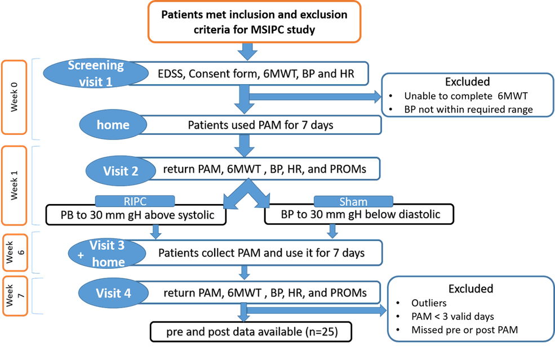/
Figure 4.1: Flow chart of pre- and post-assessments for MSIPC study

As described in (Chapter 3) pwMS were invited to participate in the MSIPC study. In the (visit1) patients were screened for eligibility. pwMS who met the eligibility criteria were given PROMs to be completed and PAM to be used for 7 days.
In visit 2 (week 1), pwMS were randomly assigned based on randomisation web services to the RIPC group or to the sham group using a randomization tool online. They had also to return the completed PROMs and their PAM to download the data for further analysis. Then, pwMS were asked to complete 6MWT followed by Borg RPE. Heart rate and blood pressure measured pre and post the 6 MWT.
After a ten-minute break, the researcher measured blood pressure and heart rate again before administering either RIPC or a sham therapy (depending on the random allocation). Then the intervention take place by placing a blood pressure cuff over patients’ arm (non-dominant) for 5 minutes, then relaxing it for 5 minutes. This procedure was repeated for three times. Then pwMS were asked to report any pain or discomfort they have experienced during this procedure.
In the RIPC group, the BP cuff of the intervention group was inflated 30 mm Hg above the resting systolic blood pressure of the patients, and the number required for blood pressure was written on the instruction sheet given to them. The 30 mm Hg or higher, above the resting systolic BP was considered the occlusion pressure for the upper limb (Sharma et al., 2014). As for the sham group, the BP cuff was inflated for 30 mm Hg below resting diastolic blood pressure, and the required number was also written in the patient instructions sheet.
After another ten-minute break, patients were asked to walk again for six minutes. Then blood pressure and heart rate were measured. Participants were asked to assess their level of exertion after walking.
At the end of the visit, the researcher demonstrated to the participant or the carer how to execute the RIPC or sham therapy (depending on which group patient was allocated). Three times, the cuff will be inflated for five minutes and then deflated for five minutes. To ensure that the patient understood the method correctly, patients were asked to describe and show the procedure to the researcher. Patients were asked to do the procedure once a day at home for the following six weeks until the final follow up hospital appointment. Every day, the procedure takes approximately 30 minutes. Participants were given a phone number to contact if they have any questions or encounter any issues.
After five weeks, the participant was contacted by telephone to check that all was well and to inform them that the PAM would be mailed to them to use for one more week while the intervention was still in progress. After receiving their PAM device, the participant used it for a period of seven weeks. Procedure illustrated in (Figure 4.1)

Equipment:
As discussed in (Chapter 3), with the McRoberts Move Test (McRoberts B.V., The Hague, The Netherlands), gait variables are measured in a real-life environment using a Dynaport Tri-axial accelerometer Movemonitor. A small device secured by an elastic belt around the waist of the patient.

Statistical analysis
Whether data was distributed in a parametric or non-parametric manner was determined using Kolmogorov-Smirnov and Shapiro-Wilk tests. Continuous variables were reported using mean ± SD when the data were normally distributed, or median with IQRs for non-normal distributed data. For categorical variables, raw numbers were presented as percentages. Difference between pre and post intervention was calculated by paired t test. While difference between groups was calculated by independent t-test, Mann-whitney test. Bonferroni correction was used for multiple comparisons of the PROMs by reducing the level of significance to p=0.005 (0.05/9). All analyses were performed using PASW (IBM statistics).
The MSWS-12 score is calculated as the sum numbers of the 12 answers and then transformed to a 0 to 100 scale by applying this formula: (Total score - 12/48) X 100. (Hobart et al., 2003).
The MSIS-29 measures both physical and psychological impacts of MS. 20 items are associated with physical impact, and 9 items are associated with the psychological impact of MS. The sum of responses for each domain is then converted to a scale from 0-100, where 100 indicates high impact of MS in patients' life. The physical impact is computed by the sum of the first 20 items and utilises this formula: (100 * (observed score-20)) /(100-20). While the psychological impact is calculated by summing the score of the last 9 items. Then using this formula= (100*(observed score-9)) / (45-9) (Hobart, 2001).
The quality control process for the PAM as discussed in (Chapter 3), the following rules were applied in order to reduce the possibility of mistaken characteristics of the actual activity monitor by excluding data that falls below the threshold wear time of 3 days per week and 80% per day. Based on our raw data and observations of wear time from previous MS studies. we determined a threshold of 80%. The average values of all valid days were used for analysis.

Results

participants
A total of 51 participants (63% female, mean age 48 years [23-71 years]) were recruited from the baseline MSIPC study. Demographic and clinical data are summarised in (Table 4.1). 26 participants were excluded due to missing data. Reasons for exclusion included missing PAM data at baseline (n=15, due to participants not wearing PAM), not attending follow up visits due to COVID restrictions (n=8), less than 3 days of PAM data in post-intervention phase (n=3). This left 25 participants who were able to complete the pre and post assessment and, therefore, included in this study. Of the 25 individuals included in this cohort, 14 of them were randomly allocated to RIPC while 11 of them were randomly allocated to the sham group.

Table 4.1: clinical characteristics of sham and RIPC groups
Variables | Sham intervention (n=11) | RIPC intervention (n=14)
Age (years), mean SD | 47.9 ± 12.8 | 48.8 ± 16.5
Female, n (%) | 6 (54.5%) | 11 (78.6%)
Male, n (%) | 5 (45.5%) | 3 (21.4%)
Type of MS
Relapsing remitting, n (%) | 6 (54%) | 10 (66.6%)
Secondary progressive, n (%) | 2 (18%) | 1 (6.6%)
Primary progressive, n (%) | 3 (27.2%) | 3 (20%)
Time since diagnosis (years), mean SD | 16.2 ± 9.7 | 8.2 ± 7
EDSS score, median (IQR) | 6 (2.5-6) | 2.5 (2.5-6)
EDSS score, n (%)
1 | 1 (9.1%) | 2 (14.3 %)
1.5 | 1 (9.1%) | 2 (14.3 %)
2 | 0 | 3 (21.4%)
2.5 | 1 (9.1%) | 1 (7.1%)
3 | 0 | 1 (7.1%)
3.5 | 0 | 0
4 | 1 (9.1%) | 1 (7.1%)
4.5 | 0 | 0
5 | 0 | 0
5.5 | 0 | 0
6 | 5 (45.5%) | 3 (21.4%)
6.5 | 2 (18.2%) | 0
7 | 0 | 1 (7.1%)
EDSS, Extended Disability status scale: MS, multiple sclerosis; N, number of patients; RIPC, remote ischemic precondition

In the RIPC group (66.6%) had relapsing MS, and (20%) had primary progressive MS, 7 (6.6%) had secondary progressive MS. In the RIPC group, the mean disease duration was 8.2 ± 7 years, and the median EDSS score was 2.5 (range, 2.5-7). While in the sham group (54%) had relapsing MS, and (27.2%) had primary progressive MS, (18%) had secondary progressive MS. In the sham group
the mean disease duration was 16.2 ± 9.7 years, and the median EDSS score was 6.0 (range ,2.5-6). There is no significant difference between 2 groups as showed in (Table 4.2).

Table 4.2: Comparing baseline PROMs and MacRobert's data for RIPC and sham groups
Outcomes | RIPC | Sham | p-value
EDSS (median, IQR) | 2 (2.5-6) | 6 (2.5-6) | .115ᵐ
6MWT | 324.7 ± 143 | 273.5 ± 145 | .863ᵗ
Borg PRE | 11 ± 3 | 12 ± 3 | .467ᵐ
MSWS-12 | 53.78 ± 31.4 | 64.9 ± 24.7 | .22ᵗ
MSIS-29 (physical impact) | 37.14 ± 18.9 | 51.9 ± 24.6 | .347ᵗ
MSIS-29 (psychological impact) | 46.8 ± 28.3 | 46.7 ± 19.5 | .103ᵗ
EQoL (index value) | .59 ± .18 | .49 ± .22 | .975ᵗ
EQoL (VAS) | 58 ± 19 | 60 ± 18 | .851ᵐ
MFIS | 48 ± 14 | 51 ± 16 | .647ᵐ
Mean DUR max moving (Sec) | 278.85 ± 347 | 230.8 ± 284 | .918ᵗ
Mean DUR total moving (Sec) | 3847.5 ± 1583 | 4296 ± 2549.9 | .015ᵗ
Mean DUR max active (Sec) | 1385.7 ± 703.5 | 1135 ± 374.6 | .188ᵗ
Data presented as mean ±SD
ᵗ Independent t- test.
ᵐ Mann-Whitney test
6MWT, 6 Meter Walk Test; Borg (RPE) Scale, Borg Rating of Perceived Exertion Scale; MSWS-12, MS Walking Scale-12; MFIS, Modified Fatigue Impact Scale; MSIS-29, MS Impact Scale; EQ-5D-5L, EuroQol Five Dimensions Five Levels questionnaire; VAS, Visual Analog Scale

Within group analysis

Comparison of validated lab-based measures of mobility before and after intervention/

Table 4.3: Within-group comparisons of lab-based measures and PROMs before and after
intervention
Validated lab-based measures of mobility
measures | intervention | preintervention | postintervention | p-value
6MWT | RIPC | 324 ± 143 | 324 ± 151 | .942ᵗ
6MWT | Sham | 273 ± 145 | 285 ± 143 | .027ᵗ
Borg PRE | RIPC | 11 ± 3 | 10 ± 2 | .322ᵚ
Borg PRE | Sham | 12 ± 3 | 11± 2 | .721ᵚ
MSWS-12 | RIPC | 53 ± 14 | 48 ± 33 | .076ᵗ
MSWS-12 | Sham | 65 ± 24 | 52 ± 27 | .009ᵗ
MSIS-29 (physical  impact) | RIPC | 37 ± 18 | 34 ± 22 | .456ᵗ
MSIS-29 (physical  impact) | Sham | 52 ± 24 | 46 ± 24 | .169ᵗ
Validated measures of quality of life
MSIS-29 (psychological  impact) | RIPC | 47 ± 28 | 36.7 ± 22 | .051ᵗ
MSIS-29 (psychological  impact) | Sham | 47 ± 19 | 44 ± 21 | .515ᵗ
EQoL (index value) | RIPC | .59 ± .18 | .65 ± .17 | .162ᵗ
EQoL (index value) | Sham | .49 ± .22 | .56 ± .2 | .07ᵗ
EQoL (VAS) | RIPC | 58 ± 19 | 59 ± 23 | .533ᵚ
EQoL (VAS) | Sham | 60 ± 18 | 58 ± 19 | 1.00ᵚ
Validated measures of fatigue
MFIS | RIPC | 48 ± 14 | 40 ± 14 | .026ᵚ
MFIS | Sham | 51 ± 16 | 45 ± 20 | .153ᵚ
ᵗPaired t- test.
ᵚWilcoxon signed- rank test. ·
Significance level after Bonferroni correction (p<0.006)
6MWT, 6 Meter Walk Test; Borg (RPE) Scale, Borg Rating of Perceived Exertion Scale; MSWS-12, MS Walking Scale-12; MFIS, Modified Fatigue Impact Scale; MSIS-29, MS Impact Scale; EQ-5D-5L, EuroQol Five Dimensions Five Levels questionnaire; VAS, Visual Analog Scale

The lab-based measurements of mobility in both groups did not differ significantly before and after intervention, as shown in Table 3. According to the RIPC study, the pre 6MWT was (324 ± 143), and with no difference following the intervention (324 ± 151). While there was an improvement in the sham group as the distance of the 6MWT was (273 ± 145) before and (285 ± 143) after the intervention, with a (p-value, 0.027). However, neither was significant after the Bonferroni correction.
Furthermore, both the RIPC and sham groups did not show significant differences in perceived exertion (RPE) before and after the intervention (p-value, 0.322) (p-value, 0.721) respectively, with only one score reduced in both groups. The MSWS-12 following the intervention, showed an improved trend, particularly in the sham group (p-value, 0.027), and with lesser degree in the RIPC group (p-value, 0.076), but none of those were significant after Bonferroni correction. There was no significant difference between the MSIS-29 (physical impact) before and after the intervention in either group, RIPC (p-value, 0.456) and the sham group (p-value, 0.169).

Comparison of validated measures of life quality before and after intervention:/
There were no significant different in quality of life before and after intervention as shown in table 3. Following the intervention, the MSIS-29 (psychological impact) showed an improved trend, particularly in the RIPC group (p-value, 0.051), while in the sham group there was no change, (p-value, 0.515), but none of those were significant. There was no significant difference between the EQoL (index value) and the (VAS) scores before and after the intervention in either groups, RIPC (p-value, 0.162 )and ( p-value, 0.533) while in the sham group ( p-value, 0.07) and ( p-value, 1.00 ), respectively.

Comparison of validated measures of fatigue before and after intervention:/

There were no significant different in validated measures of fatigue before and after intervention as shown in table 3. Following the intervention, the MFIS showed an improved trend, but no significant difference when Bonferroni correction was applied.

Quality control metrics for McRobert’s PAM data
PAM quality control metrics were acceptable. The PAM was worn for a minimum of three days by all participants, with wear times exceeding 80%. No PAM devices during the baseline nor the follow up assessment were lost.
There was no significant difference in PAM wear time between RIPC and sham groups. The comparison of McRobert's PAM data collected at home over the 7 days is summarised in (Table 4.4).
We found that the mean values for DUR_max active, DUR_max_moving, and DUR_total_moving were not significantly different pre- and post-intervention.

Table 4.4: Real world measures of mobility assessed by McRobert’s PA
Outcomes | Intervention | Preintervention | Postintervention | P-value
Mean DUR max moving (Sec) | RIPC | 278.9 ± 347.4 | 181.2 ± 122 | .366ᵗ
Mean DUR max moving (Sec) | Sham | 230.8 ± 284.2 | 276.6 ± 412.3 | .334ᵗ
Mean DUR total moving (Sec) | RIPC | 3847.5 ± 1583 | 3638.4 ± 1659.8 | .366ᵗ
Mean DUR total moving (Sec) | Sham | 4296 ± 2549 | 4016.8 ± 2442.3 | .252ᵗ
Mean DUR max active (Sec) | RIPC | 1385.7 ± 703 | 1232.8 ± 514 | .207ᵗ
Mean DUR max active (Sec) | Sham | 1135 ± 374.6 | 1324 ± 452 | .027ᵗ
ᵗPaired t-test/
Significant level after Bonferroni correction (p<0.016)

Discussion
Here we present the results of a community-based study designed to measure the effects of daily RIPC for 6 weeks on mobility, daily activities, fatigue, and quality of life in pwMS. Approximately 50% of the patients enrolled in this study have dropped out. However, more than half of those who discontinued the study were not included in the analysis because of PAM data issues, either because outliers’ data were caught during the quality control process or because the patients did not wear the devices as requested. It appears that no patients were withdrawn as a result of the intervention (RIPC) being unacceptable to them. In the current study, it was difficult to assess the RIPC's acceptability because of COVID-19. Patients may use this as an excuse to avoid participating or withdrawing from the study. Further research is required to assess the acceptability of the RIPC and gain a deeper understanding of the impact of RIPC on pwMS. A longitudinal study with a larger sample size is also necessary to better understand the effect of repeated RIPC and its long-term effects.
The acceptability of an intervention in healthcare may be measured in several ways, including the dropout rate, feelings toward the intervention, perceptions, or a combination of these measures (Sekhon et al., 2017).No studies in this review established a threshold criterion, i.e., the number of/
participants who needed to discontinue or withdraw treatment, in order for the intervention to be considered unacceptable (Sekhon et al., 2017).
For the purpose of this study, a patients' diary was collected over a period of seven days (twice) while patients were wearing the PAM in order to ensure their compliance and to compare their diary with the data provided by the device. However, there is no clear indication of the level of compliance of patients with the intervention. The only method implemented was that patients receive a call from the team to inquire about the intervention, which runs smoothly, and the team is willing to answer questions from the patients. Because this study was conducted during Covid 19 and recruitment and on-site assessments were suspended as a result of the government's lockdown to prevent Covid 19 transmission, the study was extended to compensate for repeated suspensions. In response to Covid 19, a modification was made to the protocol. It was decided to discontinue the use of PAM for assessments and follow-ups before trial completion due to repeated suspensions. However, other assessment procedures were continuous until the end of the trial.
It is argued that many clinical trials may fail to demonstrate an effect of the intervention due to weaknesses in clinical outcome measures, such as PROMs. For example, a floor effect on the MSIS-29 was reported in 5% of pwMS in a longitudinal study. EDSS is the most widely used clinical trial outcome measure in pwMS, however it has limitations. For example, EDSS has been shown to be less sensitive to changes in mobility than timed walking tests. Since PROMs are self-reported, perceptions of changes in impairment may vary over time depending on factors other than actual decline. Response shift is an example of this phenomenon. Interestingly, Sprangers and Schwartz (1999). found that patients grade their impairment differently at later, more impacted stages than at the beginning. This may cause a lower disability/impairment score on PROMs in more severe individuals, as compared to relatively high scores in less disabled individuals, and vice versa. Moreover, The results of a recent systematic review by Campbell et al. (2021) of PROMs exclusively used with patients in clinical studies indicate that although there are several benefits of utilizing PROMs in clinical trials, many studies indicate that PROMs can underestimate or overestimate patients' symptoms, as patients have difficulty qualifying their symptoms. Therefore, there is apparently a challenge in longitudinal studies in which patients are required to evaluate their symptoms twice, even though they may have difficulty quantifying them at first. Patients also find some PROMS difficult to answer because they are unclear or irrelevant, whereas clinicians find that some PROMS provide information that is not clinically relevant. According to many clinicians, PROMS may pose a challenge for elderly, cognitively impaired and low literacy patients (Campbell et al., 2021). To avoid such drawback, it is essential to administer endpoints that objectively assess patients' impairment. We sought to overcome this in the current study by using multiple PROMs, each assessing different aspects of MS symptomatology, and highly sensitive, objective assessments of mobility (McRobert’s PAM). In particular, we hoped that the use of the 6MWT and McRobert’s PAM would detect improvements in mobility not detected by EDSS.

This is the first study to examine the effects of repeated RIPC on daily activity among pwMS. Three variables were selected from the MacRobert's PAM data based on the baseline analysis in (Chapter 3). Mean duration max moving, mean duration total moving time, and mean duration max active time were selected as the PAM variables to compare pre- and post- intervention. These were selected because in (Chapter 3) we found that these PAM variables correlated best with validated measures of mobility in pwMS such as the 6mwt. However, after the 6 weeks of intervention, none of these PAM variables improved significantly in either RIPC or sham group. There was also no improvement pre- and post-intervention in scores on PROMs measuring mobility. Neither the MSWS-12 nor MSIS-29 scores differed significantly in either RIPC or sham group pre- and post- intervention. We also compared validated measures of fatigue and quality of life pre- and post-intervention. There was no significant difference for scores on the MSIS-29 psychological subscale, EQoL or MSFIS in either the RIPC or sham group.
There were no significant changes in PAM variables or PROM scores following six weeks of intervention (either daily RIPC or sham groups). This might reflect a true lack of effect of RIPC on mobility in pwMS or be due to confounding factors masking a true effect. In this cohort, the sample size was relatively small in each group. Our power calculation indicated that a total of 74 participants would be needed to complete the protocol to demonstrate a 10% chance in the 6mwt with a p<0.05. Given our significantly smaller sample size, this may mean that the study was underpowered to detect pre- and post-intervention effects on PAM variables and PROM scores.
Since the RIPC has an effect not only locally but also systematically. IPC daily for seven days could improve resting skin microcirculation and conduit artery endothelial function locally (intervention arm) and systemically (contralateral arm). On both sides, the effects of IPC persist after the late period of protection has ended (Jones et al., 2014). Moreover, there has been some evidence suggesting that disruption of the blood-brain barrier (BBB) has been associated with the CNS's degenerative alterations, which may play a role in a variety of neurodegenerative diseases, including multiplesclerosis (Chang et al., 2021). BBB integrity would be affected more adversely in severe cases of MS (Balasa et al., 2021). Therefore, IPC mediators may penetrate the BBB in order to produce beneficial effects, but this may only occur in cases of severe MS. Accordingly, the intervention group in the present study was primarily comprised of mild to moderate cases of EDSS, 2.5 (2.5-6), which may explain our findings in comparison to previous study in which the patients were more severely affected EDSS, 5 (3.4–6.0) and RIPC group exhibited a higher level of improvement (Chotiyarnwong et al., 2020). There are no conclusive results in this regard, and more clinical studies on people living with MS with different disease severity are required.
Alternatively, it might be that the limb ischaemia induced by the protocol was not sufficient to cause RIPC. There are no reliable biomarkers to indicate that RIPC has been successfully induced. (Koch et al., 2014). Therefore, we cannot be certain that our protocol induced an ischaemic preconditioning response. To confirm engagement of RIPC we would need a biomarker in an accessible body fluid (e.g. blood, saliva or urine). Experiments have identified a range of transcriptional, metabolic, anti- inflammatory, haemodynamic and fibrinolytic responses to RIPC. However, none have been translated into a clinical biomarker. In addition, it is possible that, even if our protocol was sufficient to induce ischaemic preconditioning, research participants were not able to repeat the same RIPC procedure every day at home. For example, because the device required assistance from a carer to operate. Considering this, future research may need to confirm RIPC response along with functional endpoints to confirm RIPC has occurred. Moreover, using an automated blood pressure cuff rather than a manual one would ensure consistency of technique.
Though the RIPC and sham groups were randomised, they were not well matched for disease stage. The sham group had a significantly higher EDSS score than the RIPC group. This could potentially confound our results. In addition, poor matching of co-morbidities could obscure any benefit of RIPC on mobility and other outcomes in pwMS. This is well illustrated by our research in chapter 5 of this thesis. This reports the effect of cardiac, respiratory, and musculoskeletal conditionson mobility related outcomes in people without MS. It is reasonable to suggest that in pwMS, who have impaired mobility, the effect of these non-neurological comorbidities could be even greater.
Moreover, clinical medicine and drug discovery continue to face challenges in distinguishing responders from non-responders. It is not always possible to predict whether a particular treatment will induce the desired biological activity in all patients and, therefore, the desired clinical effect. Considering this, it is possible that not all pwMS included in this study responded to the RIPC, and therefore, no biological effect was generated. According to preliminary clinical trials in cardiac medicine, ischemia preconditioning has been inconsistently demonstrated to be effective, suggesting some people react to preconditioning stimuli while others do not (Brevoord et al., 2012) Future studies may implement studying the effects of preconditioning at the level of genomic expression which may assist in identifying responders from non-responders (Koch et al., 2014, Konstantinov et al., 2004).
Problems related to choice and measurement of endpoints and outcome measures are well known to confound clinical trial results. However, we selected a wide range of measures, assessing mobility, quality of life and fatigue as well as an objective assessment of mobility (McRobert’s PAM). These were selected to cover a spectrum of clinical features in pwMS. It is unlikely we missed a clinically relevant effect of RIPC in a non-assessed body system or set of symptoms. Many of the PROMs and assessments we utilised are semi-objective or subjective and prone to bias. However, they are all standard measures and widely used in clinical trials and studies. It is possible that the effect of RIPC was so subtle as to be not detected by our relatively small study. However, the McRoberts PAM can detect very small changes in physical activity. If our study failed to detect a true, but small effect, of RIPC then this effect is likely to have been so small that it is not clinically relevant. Poor quality data collection can also obscure treatment effects in clinical trials. However, the data was collected by trained and experienced raters and the McRobert’s PAM data was rigorously quality controlled.It is also possible that the timing of data collection resulted in a failure to identify an effect of RIPC. RIPC is proposed to have an early phase, with protection occurring for about 12 hours, and a late phase, with protection lasting from around 20 - 72 hours after RIPC induction. It is conceivable that if the study assessments were done in the window between the early and late phase, or after the effect of a bout of RIPC has worn off, that no effect of RIPC would be detected. Even if this were the case, it would imply that RIPC has an inconsistent effect on neurological disability in pwMS, making it a non-viable treatment.
Perhaps most significant is the fact that RIPC may have a limited effect on the central nervous system in general. The literature suggests that RIPC appears to have an impact that is more consistent on cardiovascular parameters than on walking and functional outcomes, which were not the focus of this chapter. The results of a recent study by Xin et al. (2023) showed that RIPC reduced heart rate rise after 6MWT; however, in the sham group, there was no change. Gardner et al. (2020) also found that RIPC resulted in a reduced resting heart rate in healthy subjects. According to a recent systematic review and meta-analysis of repeated RIPC implementation in various populations, repeated RIPC is associated with enhanced antihypertensive effects. The study determined that repeated RIPC reduced blood pressure by 3 millimetres of mercury in both healthy and chronically diseased individuals by lowering systolic and diastolic blood pressure, as well as mean arterial pressure.(Baffour-Awuah et al., 2021).This suggests that RIPC might be less effective for neurological diseases, such as MS, rather than cardiovascular disorders.
This chapter reports results from the first double-blind trial to examine the effect of RIPC on daily activity in pwMS. It is important to note that despite the well-designed nature of this study, there are a number of points that should be considered in future research. This study has a control group, of which 50% of the RIPC studies did not include a comparison group (Althouse, 2016). In order to minimize confounding factors, it is recommended that patients be stratified and randomly assigned based on their disease severity, physical morbidity, MS subtype, and age. This will be discussed inChapter 5, in which it is demonstrated that physical co-morbidity negatively impacts mobility, quality of life, and the age associated with mobility disabilities. It is also crucial to consider power calculation to avoid false negative results and to ensure the reliability of the analysis results. It should be noted that the sample size calculation in this chapter was based on the 6MWT; however, the retention rate was lower than expected due to COVID-19. The endpoint measures should be carefully selected, as some PROMs have limitations, and the chosen outcomes should be suitable for the study cohort (van‘t Hullenaar et al., 2021). Use objective measures to detect subtle changes and to avoid PROMs' apparent limitations. During the intervention, patients should also be monitored for compliance and to report any adverse event that may arise, and researchers may need to check with patients to ensure that the intervention is working as expected. Further, it is necessary to implement a biomarker for the ischemic precondition in order to evaluate the physiological changes generated and ensure that a sufficient IPC is achieved. The use of automatic devices that could save settings would be more effective in ensuring proper operation. It may be advantageous to have long-term follow-ups to assess effectiveness if there are any.

REFERENCES
ALTHOUSE, A. D. 2016. Adjust for multiple comparisons? It’s not that simple. The Annals of thoracic surgery, 101, 1644-1645.
BAFFOUR-AWUAH, B., DIEBERG, G., PEARSON, M. J. & SMART, N. A. J. I. J. O. C. H. 2021. The effect of
remote ischaemic conditioning on blood pressure response: A systematic review and meta- analysis. 8, 100081.
BALASA, R., BARCUTEAN, L., MOSORA, O. & MANU, D. J. I. J. O. M. S. 2021. Reviewing the significance
of blood–brain barrier disruption in multiple sclerosis pathology and treatment. 22, 8370.
BREVOORD, D., KRANKE, P., KUIJPERS, M., WEBER, N., HOLLMANN, M. & PRECKEL, B. 2012. Remote
Ischemic Conditioning to Protect against Ischemia-Reperfusion Injury: A Systematic Review and Meta-Analysis. PLoS ONE, 7, e42179.

CAMARA-LEMARROY, C. R., METZ, L., SMITH, E. E., DUNN, J. F. & YONG, V. W. J. F. I. N. 2018.
Expanding the potential therapeutic options for remote ischemic preconditioning: use in multiple sclerosis. 9, 475.
CAMPBELL, R., JU, A., KING, M. T. & RUTHERFORD, C. J. Q. O. L. R. 2021. Perceived benefits and
limitations of using patient-reported outcome measures in clinical practice with individual patients: a systematic review of qualitative studies. 1-24.
CHANG, Y.-C., HEE, S.-W. & CHUANG, L.-M. 2021. T helper 17 cells: A new actor on the stage of type 2 diabetes and aging? Journal of Diabetes Investigation, 12, 909-913.
CHOTIYARNWONG, C., NAIR, K., ANGELINI, L., BUCKLEY, E., MAZZA, C., HEYES, D., RAMIZ, R., BASTER, K., ISMAIL, A., DAS, J., ALI, A., LINDERT, R., SHARRACK, B., PRICE, S. & PALING, D. 2020. Effectof remote ischaemic preconditioning on walking in people with multiple sclerosis: double- blind randomised controlled trial. BMJ Neurology Open, 2, e000022.
COHEN, E. T., CLEFFI, N., INGERSOLL, M. & KARPATKIN, H. I. 2021. Blood-Flow Restriction Training for a Person With Primary Progressive Multiple Sclerosis: A Case Report. Physical Therapy, 101.
GARDNER, R. N., SABINO‐CARVALHO, J. L., KIM, J., VIANNA, L. C. & LANG, J. A. 2020. Two weeks of
remote ischaemic preconditioning alters sympathovagal balance in healthy humans.
Experimental physiology, 105, 1500-1506.

GURCUN, U., DISCIGIL, B., BOGA, M., OZKISACIK, E., BADAK, M. I., YENISEY, C., KURTOGLU, T. &
METEOGLU, I. J. J. O. S. R. 2006. Is remote preconditioning as effective as direct ischemic preconditioning in preventing spinal cord ischemic injury? 135, 385-393.
HOBART, J. 2001. The Multiple Sclerosis Impact Scale (MSIS-29): A new patient-based outcome measure. Brain, 124, 962-973.
HOBART, J. C., RIAZI, A., LAMPING, D. L., FITZPATRICK, R. & THOMPSON, A. J. J. N. 2003. Measuring the
impact of MS on walking ability: the 12-Item MS Walking Scale (MSWS-12). 60, 31-36.

JONES, H., HOPKINS, N., BAILEY, T. G., GREEN, D. J., CABLE, N. T. & THIJSSEN, D. H. J. J. A. J. O. H. 2014.
Seven-day remote ischemic preconditioning improves local and systemic endothelial function and microcirculation in healthy humans. 27, 918-925.
KOCH, S., DELLA-MORTE, D., DAVE, K. R., SACCO, R. L. & PEREZ-PINZON, M. A. 2014. Biomarkers for
Ischemic Preconditioning: Finding the Responders. Journal of Cerebral Blood Flow & Metabolism, 34, 933-941.
KONSTANTINOV, I. E., ARAB, S., KHARBANDA, R. K., LI, J., CHEUNG, M. M. H., CHEREPANOV, V., DOWNEY, G. P., LIU, P. P., CUKERMAN, E. & COLES, J. G. J. P. G. 2004. The remote ischemic
preconditioning stimulus modifies inflammatory gene expression in humans. 19, 143-150.

MAÑAGO, M. M., COHEN, E. T., ALVAREZ, E., HAGER, E. R., OWENS, J. G. & BADE, M. J. P. T. 2023.
Feasibility of Low-Load Resistance Training Using Blood Flow Restriction for People With Advanced Multiple Sclerosis: A Prospective Cohort Study. pzad135.

MILLER, D. M., THOMPSON, N. R., COHEN, J. A., FOX, R. J., HARTMAN, J., SCHWETZ, K., CONWAY, D. S.
& RUDICK, R. A. 2015. Factors associated with clinically significant increased walking time in multiple sclerosis: results of a survival analysis of short-term follow-up data from a clinical database. Multiple Sclerosis Journal, 21, 457-465.
SEKHON, M., CARTWRIGHT, M. & FRANCIS, J. J. 2017. Acceptability of healthcare interventions: an overview of reviews and development of a theoretical framework. BMC health services research, 17, 1-13.
SHARMA, V., CUNNIFFE, B., VERMA, A. P., CARDINALE, M. & YELLON, D. 2014. Characterization of
acute ischemia‐related physiological responses associated with remote ischemic preconditioning: a randomized controlled, crossover human study. Physiological reports, 2, e12200.
SMRTKA, J., BROWN, T. & BJORKLUND, G. J. P. M. 2016. Loss of mobility and the patient burden of multiple sclerosis: expert opinion on relevance to daily clinical practice. 128, 145-151.
SPRANGERS, M. A. & SCHWARTZ, C. E. 1999. Integrating response shift into health-related quality of life research: a theoretical model. Social science & medicine, 48, 1507-1515.
SUTLIFF, M. H. J. C. M. R. & OPINION 2010. Contribution of impaired mobility to patient burden in multiple sclerosis. 26, 109-119.

VAN DER FEEN, F. E., DE HAAN, G. A., VAN DER LIJN, I., HEERSEMA, D. J., MEILOF, J. F., HEUTINK, J. J.
M. S. & DISORDERS, R. 2020. Independent outdoor mobility of persons with multiple sclerosis–a systematic review. 37, 101463.

VAN‘T HULLENAAR, C. A. A., COERVER, E., KALKERS, N. F., VAN KEMPEN, Z., KOCH, M., UITDEHAAG, B.
M. J., KILLESTEIN, J., STRIJBIS, E. M. M. J. M. S. & DISORDERS, R. 2021. The use of multi-
domain patient reported outcome measures for detecting clinical disease progression in multiple sclerosis. 55, 103165.XIN, N. C. K., NAIR, K., CHOTIYARNWONG, C., BASTER, K., BUCKLEY, E., MAZZA, C., ALI, A. & BAIG, S. J.
A. O. I. A. O. N. 2023. Effect of remote ischemic conditioning on heart rate responses to walking in people with multiple sclerosis. 26, S10.
YANG, R. & DUNN, J. F. 2019. Multiple sclerosis disease progression: contributions from a hypoxia– inflammation cycle. Multiple Sclerosis Journal, 25, 1715-1718.

Chapter 5. Variability of Multiple Sclerosis Walking Scale and Multiple

Sclerosis Impact Scale Scores in People without Multiple Sclerosis
//

Abstract
Background

80% of pwMS experience problems with mobility at some point in their disease course. The Multiple Sclerosis Impact Scale (MSIS) and Multiple Sclerosis Walking Scale (MSWS) are validated patient reported outcome measures of physical impairment in pwMS. The range of scores on MSIS and MSWS in people without MS (pwoMS) are not well understood.
Methods

People over the age of 16 who did not have a diagnosis of Multiple Sclerosis (MS) were invited to complete an online survey consisting of a general health questionnaire, MSIS and the MSWS. Scores for MSIS and MSWS were compared between 35 people with MS (pwMS) and people without MS (pwoMS). Scores for MSIS and MSWS were correlated with age, gender and comorbidities in pwoMS. Full ethical approval was granted by the University of Sheffield.
Results

189 ambulant pwoMS were recruited (52.5% female) age ranged (16-70+). 99% reported no difficulty with walking, 89.4% were non-smokers, 14% had a physical co-morbidity. None used a walking aid. For pwoMS the MSIS score was a mean of 39.14 ± 13.75 (range 29 - 127), compared to a mean of
77.2 ± 24.94 (range 40 - 126) for pwMS. For pwoMS the mean MSWS score was 8.46 ± 16.2 (0 -87) compared to a mean of 56.9 ± 28.9 (4 - 100) for pwMS. There was no significant effect of gender or smoking on MSIS or MSWS scores in pwoMS. Presence of a physical co-morbidity was associated with significantly higher MSIS and MSWS scores in pwoMS. There was a significant correlation of increasing age with increasing MSWS score in pwoMS but no correlation of age with MSIS score.

Conclusion
There is significant variability in MSWS and MSIS scores in pwoMS. The presence of age and comorbidities influence both MSWS and MSIS scores. Our findings have implications for the selection of control groups for clinical studies.

Introduction

MS is an inflammatory neurological disorder characterized by demyelination of the central nervous system, resulting in a lifelong non-traumatic neurological deficit in young adults. The disease causes various neurological symptoms that affect physical, psychological, and cognitive functions in people with MS (pwMS) (Hauser and Cree, 2020). Capturing MS symptoms is challenging due to the heterogeneous nature of the disease over time. Therefore, several Patient Reported Outcome Measures (PROMs) have been developed over the years to assess various aspects of functioning and quality of life-related to MS (Hobart et al., 2006, Vickrey et al., 1995, Cella et al., 1996). Some PROMS assess specific functions related to MS, for example, the Multiple Sclerosis Walking Scale-12 (MSWS- 12). While other questionnaires, such as the MSIS-29, evaluate multiple aspects associated with MS.
The MSWS-12 developed by Hobart et al., (2003). is used to assess the impact of MS in patients’ walking in the past 2 weeks. The score is transformed to a scale ranging from 0 to 100. A higher score indicates worse walking ability as rated by patients. The validity and responsiveness of MSWS-12 were verified in a community sample of 149 PwMS as well as in 53 hospital outpatients (McGuigan et al., 2004). Validity was also confirmed with accelerometery in community-based MS sample (Motl and Snook, 2008). There was a strong correlation between MSWS-12 scores and Oxygen (O2 cost when patients performed comfortable peace walking (Motl et al., 2010). Learmonth et al found acceptable reliability measures for MSWS-12 within six months (2013). Based on the results of a large-scale EU study of 290 MS patients, MSWS-12 proved to be a superior measure for detecting changes after physical therapy intervention, especially in patients with moderate to severe MS (Baert et al., 2014). The patient considered an improvement of 8 points in MSWS-12 over a 24-week period to be meaningful (Mehta et al., 2015).

The MSIS-29 measures the quality of life as perceived by patients. (Hobart, 2001). A total of 29 questions are divided into 20 that assess the physical health impacts of MS and nine that assess the
psychological health impacts of MS within the past two weeks. Scores are transformed into a range from 0-100, with higher scores indicating poorer health. It has been validated for use in clinical settings (McGuigan et al., 2004). Both the physical and psychological domains of MSIS-29 were found to be responsive when compared to other PROMs for people with MS; the physical subscale was the most effective measure, while the psychological domain was the second most effective measure (Hobart, 2005). Several validated studies have confirmed the psychometric quality of the MSIS-29, with a minimal clinically meaningful change in the physical subscale reported to be 7.5 - 8.5 points (Costelloe et al., 2007, Phillips et al., 2014).
As the majority of the literature on MSWS-12 and MSIS-29 is for MS patients, it is necessary to take into account the variability in values on these PROMS within the general population when compiling the results for pwMS (Pavletic, 2020). Due to the lack of literature on MSWS-12 and MSIS-29 norms in people without MS (pwoMS), the purpose of this study is to collect these data to gain a better understanding of MS results as well as provide insight into establishing inclusion criteria for control groups in clinical trials.

Materials and Methods

Participant recruitment
Ethical approval was obtained from the University of Sheffield (approval number 051763). Written informed consent was taken from all participants. Participants were recruited from people without a diagnosis of neurological disease at the University of Sheffield.

Data collection
Data was collected via an online survey using Google Forms. The general questionnaire asked for demographic information (age, gender, smoking) and presence and type of comorbidity. MSIS-29 and
MSWS-12 were also collected via google forms. MSIS and MSWS scores were available from 35 pwMS (collected in a separate study, NCT03967106).

Statistical analysis.
All analyses were performed using PASW (IBM statistics).

Data availability
Anonymised data for MSIS-29 and MSWS-12 are available from the authors upon reasonable request.

Declarations

Ethics approval and consent to participate./
Ethical approval was obtained from the University of Sheffield (approval number 051763). Written informed consent was taken from all participants. Participants were recruited from people without a diagnosis of neurological disease at the University of Sheffield.
Consent for publication

Availability of data and materials

Data is available from the authors upon reasonable request.

Competing interests
There are no financial or other conflicts of interest.

Acknowledgements
We thank the study participants.

Results

A total of 198 individuals without MS (52% female, age ranged [16 - 70+ years]) participated in this study. Of the 198 participants included in the study, 13(6.6%) have a lung condition, 6 (3%) have diabetes, 6 (3%) have arthritis, 3 (1.5%) have heart disease, and one (0.5%) has kidney disease. Only 21 (10.6%) were current smokers, and two (1%) have difficulty walking. Among the 35 pwMS

included in this study, 21 (60%) had relapsing and remitting MS, 7 (20%) had primary progressive MS, and 7 (20%) had secondary progressive MS. The median disease duration was 12 years (interquartile range, 3.0- 15 years), and the median EDSS score was 4.0 (range,1-7). Demographic details for both groups are summarised in (Table 5.1).

Table 5.1: Demographic data of participants
Variables | PwoMS (n=198) | pwMS (n=35)
Sex
Male | 94 (47.5%) | 22 (62.9%)
Female | 104 (52.5 %) | 13 (37.1)
Age Level
1 (16-30) | 44 (22.2%) | 5 (14.3%)
2 (30-35) | 48 (24.2 %) | 3 (8.6%)
3 (35-40) | 50 (25.3%) | 3 (8.6%)
4 (40-50) | 35 (17.7 %) | 7 (20%)
5 (50-70+) | 21 (10.6%) | 17 (48.6%)

Difficulty Walking No  Yes | 196 (99%)  2 (1%) | N/A
Tobacco Smoking No  Yes | 177 (89.4%)  21 (10.6%) | N/A
Medical Diagnosis
· ● Arthritis | 6 (3%) | N/A
· ● Lung Condition (e.g., Asthma or COPD) | 13 (6.6 %) | N/A
· Diabetes | 6 (3%) | N/A
- Heart Condition (e.g., ischemic heart disease) | 3 (1.5%) | N/A
- Kidney Condition (e.g., Renal Impairment) | 1(0.5%) | N/A
- None | 169 (85%) | N/A
Data presented as frequency (percentage %)

N/A, non-applicable

3.1. The effect of smoking, age, sex and comorbidities in pwoMS on MSIS-29/MSWS-12

For pwoMS, no significant difference was found between smokers and non-smokers for total MSIS-29 (P value = 0.95), physical subscale (P value = 0.61) or psychological subscale (P value = 0.28). For pwoMS, smoking did not affect MSWS-12 scores (p-value = 0.77). In contrast, there was a significant difference between pwoMS with a physical comorbidity and those without on the MSIS-29 (P value = 0.000), including the physical subscale (P value = 0.003) and the psychological subscale (P value = 0.000)] as well as the MSWS-12 (P value = 0.000) as shown in (Table 5.2). The difference in MSIS-29 and MSWS-12 scores according to the participants' comorbidity is detailed in (Table 5.3).
Table 5.2: PROMs difference within the pwoMS group
PROMS | Factor | Status | PwoMS  n =198 | P value
 |  | Smokers | 39.9±14.9
MSIS_29 (overall score) |  |  |  | .950 †
 | Smoking | Non-smokers | 39.05±13.45
 |  | Smokers | 8.75 ± 13.9
Physical subscale (MSIS_29) |  |  |  | .610 †
 | Smokers | Non-smokers | 6.62 ± 10.95
 | (n=21) | Smokers | 10.84 ± 16.5
Psychological subscale (MSIS_29) |  |  |  | .289 †
 | Non-smokers | Non-smokers | 13.19 ± 16.24
 | (n= 177) | Smokers | 7.14 ± 15.08
MSWS-12 |  |  |  | .771 †
 |  | Non-smokers | 8.99 ± 16.04

MSIS_29 (overall score) | Co-morbidity | Diseased  Non-diseased | 45.75 ± 15.08  38.0 ± 13.01 | .000 †
 |  | Diseased | 11.29 ± 13.39
Physical subscale (MSIS_29) |  |  |  | .003 †
 | Diseased | Non-diseased | 6.08 ± 10.73
 | (n=29) | Diseased | 21.45 ± 17.53
Psychological subscale (MSIS_29) |  |  |  | .000 †
 | Non-diseased | Non-diseased | 11.48 ± 15.6
 | (n=169) | Diseased | 20.21 ± 17.78
MSWS-12 |  |  |  | .000 †
 |  | Non-diseased | 6.81 ± 14.74
Data presented as mean±SD.
*Paired t-test.

†Wilcoxon signed- rank test.

Significance level after Bonferroni correction (p<0.0125)

Table 5.3: MSIS-29 and MSWS-12 scores of participants with comorbidity
Morbidity | MSIS-29 | Physical subscale | Psychological subscale | MSWS-12
Arthritis (n=6) | 42.16 ± 13.77 | 9.17 ± 15.13 | 16.2 ± 19.11 | 21.8 ± 20.61
Lung condition (n=13) | 49.2 ± 18.3 | 13.65 ± 15.7 | 25.85 ± 19.97 | 16.35 ± 12.81
Diabetes (n=6) | 46.83 ± 12.85 | 11.25 ± 10.9 | 24.3 ± 13.99 | 17.95 ± 16.6
Heart condition (n=3) | 39.67 ± 6.65 | 9.2 ± 6.4 | 9.3 ± 4.24 | 45.0 ± 21.07
Only one person has a kidney condition.

Data presented as Mean ± SD

A one-way ANOVA was performed to compare the effect of age on MSIS-29 and MSWS-12 in pwoMS as shown in (Table 5.4). There were no statistically significant differences in the overall MSIS-29 score (F=0.85, P value=.491), as well as the physical (F=1.27, P value =.491) and psychological subscales (F=5.95, P value =1.41) of the MSIS-29. MSWS-12, however, showed a significant increase in score based on age (F=5.95 P=0.000).
Using the Scheffe test for multiple comparisons, we found that the mean value of MSWS-12 was significantly high in the age group 50 and above compared to younger age groups, (Table 5.5). A significant difference was found (Mean difference = 17.26, P = 0.002) between the age groups 50and above and 16-30. While it was (mean difference= 16.83**, P =0.002) between age groups (50-70+) and (30-35), and it was (mean difference=14.74**, P=.009) between age groups (50-70+) and (30-40). There was no significant association between age and MSIS-29. However, there was a trend towards an increase in psychological MSIS scores in the younger group. While for the physical MSIS scores, there was an inconsistent association of score with increased age.
Table 5.4: PROMs difference within pwoMS based on age level using One Way ANOVA
PROMs | Age Level | n | Mean | SD | F | Sig
MSIS-29  (Overall score) | 16-30 | 44 | 40.63 | 12.07 | .856 | .491
MSIS-29  (Overall score) | 30-35 | 48 | 36.62 | 7.58 | .856 | .491
MSIS-29  (Overall score) | 35-40 | 50 | 38.46 | 14.59 | .856 | .491
MSIS-29  (Overall score) | 40-50 | 35 | 41.57 | 20.63 | .856 | .491
MSIS-29  (Overall score) | 50-70+ | 21 | 39.33 | 9.48 | .856 | .491

Physical subscale (MSIS_29) | 16-30 | 44 | 6.56 | 8.06 | 1.27 | .282
Physical subscale (MSIS_29) | 30-35 | 48 | 4.24 | 5.21 | 1.27 | .282
Physical subscale (MSIS_29) | 35-40 | 50 | 7.15 | 12.85 | 1.27 | .282
Physical subscale (MSIS_29) | 40-50 | 35 | 9.71 | 17.63 | 1.27 | .282
Physical subscale (MSIS_29) | 50-70+ | 21 | 7.91 | 9.13 | 1.27 | .282
Psychological subscale (MSIS_29) | 16-30 | 44 | 17.73 | 19.85 | 1.41 | .23
Psychological subscale (MSIS_29) | 30-35 | 48 | 11.74 | 12.79 | 1.41 | .23
Psychological subscale (MSIS_29) | 35-40 | 50 | 10.38 | 14.70 | 1.41 | .23
Psychological subscale (MSIS_29) | 40-50 | 35 | 13.33 | 20.06 | 1.41 | .23
Psychological subscale (MSIS_29) | 50-70+ | 21 | 11.11 | 8.87 | 1.41 | .23
MSWS-12 | 16-30 | 44 | 4.89 | 9.07 | 5.95 | .000
MSWS-12 | 30-35 | 48 | 5.32 | 8.64 | 5.95 | .000
MSWS-12 | 35-40 | 50 | 7.41 | 18.48 | 5.95 | .000
MSWS-12 | 40-50 | 35 | 12.2 | 21.07 | 5.95 | .000

 | 50-70+ | 21 | 22.15 | 16.08
Significance level after Bonferroni correction (p<0.0125)

Table 5.5:Post Hoc multiple comparison of MSWS-12 scores and age
Age Level
Group 1 | Group 2 | Mean Difference (2-1) | Sig.
30-35 | 16-30 | .425 | 1.0
35-40 | 16-30 | 2.52 | .958
35-40 | 30-35 | 2.09 | .977
40-50 | 16-30 | 7.31 | .346
40-50 | 30-35 | 6.89 | .39
40-50 | 35-40 | 4.79 | .724
50-70+ | 16-30 | 17.26** | .002

50-70+ | 30-35 | 16.83** | .002
50-70+ | 35-40 | 14.74** | .009
50-70+ | 40-50 | 9.94 | .232
*The mean level is significant at the 0.05 level. ** The mean level is significant at the 0.01 level.

MSIS-29 and MSWS-12 scores compared between pwoMS and pwMS.

As shown in (Table 5.6), there were significant differences in PROMs scores between pwoMS and pwMS. MSIS-29 overall scores were significantly higher in pwMS (P = .000) as well as the physical (P=.000) and the psychological subscales (P=.000). There was also a significant difference in MSWS-12 between pwoMS individuals and pwMS (P =.000). As shown in (Figure 5.1) and (Figure 5.2), there are overlaps between groups in scores of both MSIS and MSWS. The within-group analysis of physical and psychological subscales, however, found no significant differences in the pwMS (P=.484). Whereas for pwoMS, this difference was significant (P=.000) with higher psychological than physical subscale scores for MSIS-29.
Table 5.6: Comparison of PROM scores between pwMS and pwoMS
Group | MSIS-12 | MSIS-29  Overall score | Physical  Subscale | Psychological  Subscale | Comparison of  Physical & psychological  P value
PwoMS  n =198 | 8.46±16.2 | 39.14±13.57 | 6.8±11.28 | 12.95±16.24 | .000

pwMS  n =35 | 6.9±28.9 | 77.2±24.94 | 42.1±23.14 | 45.55±29.23 | .48
P Value | .000 | .000 | .000 | .000
- Data presented as mean ± SD

- Significance level after Bonferroni correction (p<0.0125)

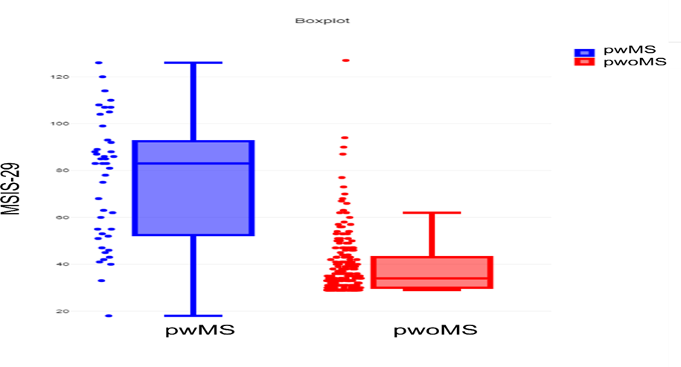/
Figure 5.1:boxplot of the MSIS-29 showing the overlapping between pwMS and pwoMS

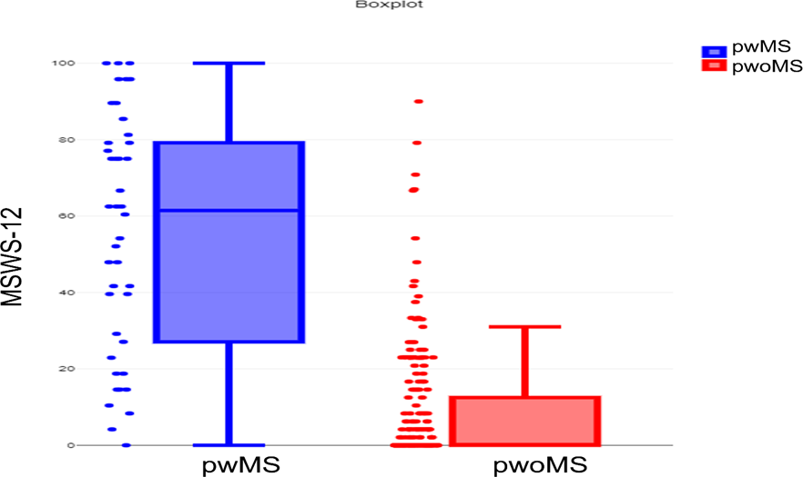/
Figure 5.2: boxplot of the percentage score of MSWS-12 showing the overlapping between pwMS and pwoMS
Table 5.7 shows there were no significant differences between males and females in pwoMS after applying the Bonferroni adjustment with regard to the MSIS-29 (P value = 0.019), the physical subscale (P value = 0.043), the psychological subscale (P value = 0.021) or MSWS-12 (P value = 0.081). This aligns with the PwMS findings. Females and males were not statistically different on the MSIS-29 (P value = .833), physical subscale (P value =.262), and psychological subscale (P value = .620). As well, no significant differences were found in MSWS-12 between males and females (P value = .32).

Table 5.7: PROMs difference between pwoMS and pwMS based on gender
PROMS | gender | pwoMS  n =198 | PwMS  n=35 | Between groups  P value
MSIS_29 (overall score) | Female  Male | 41.2±16.02  36.77±9.8 | 76.5±26.35  78.38±23.34 | .000  .000
P value |  | .019 | .833
Physical subscale (MSIS_29) | Female  Male | 8.4±13.49  5.1±7.9 | 38.69±24.52  47.88±20.17 | .000  .000
P value |  | .043 | .262
Psychological subscale (MSIS_29) | Female  Male | 15.46±17.98  10.16±13.6 | 47.47±31.75  42.30±25.28 | .000  .000
P value |  | .021 | .62
MSWS-12 | Female  Male | 10.4±18.8  6.3±12.4 | 53.13±27.70  63.23+30.94 | .000  .000

P value |  | .081 | .32
Data presented as mean±SD. Significance level after Bonferroni correction (p<0.0125)

Discussion
The purpose of this study was to document the range of scores of the MSIS-29 and MSWS-12 among pwoMS. MSIS-29 and MSWS-12 are frequently used both in observational studies and clinical trials in MS. Therefore, it is important to understand the range of scores for these PROMS in pwoMS, with a range of ages and co-morbidities, in order to inform selection of appropriately matched control groups. In order to understand the impact of co-morbid, non-MS conditions on MSIS-29 and MSWS- 12 the only exclusion criteria we set was a diagnosis of MS. This provides insight into the “real world” factors influencing MSIS-29 and MSWS-12 scores, rather than scores from an idealised “healthy” control cohort.
However, it should be noted that the PROMs used in this chapter (MSIS-29 and MSWS-12) were developed to assess mobility in pwMS, and are not validated for use in the general population of pwoMS. It is likely that our findings in pwoMS therefore reflect a floor effect. MSIS-29 and MSWS-12 are ordinal scales, with each item ranked from 1 - 5 (with 5 reflecting the most severe impairment). Our results demonstrate a clear skewed distribution in the pwoMS, with predominantly lower scores on both MSIS-29 and MSWS-12 in pwoMS. This likely represents a floor effect, with most participants not experiencing impairment in the items on the PROMs. For example, items on the MSIS-29 which ask about spasms in the limbs or “body not doing what you want it to” are unlikely to be experienced in the population of pwoMS. Neither the MSWS-12 nor MSIS-29 ask about challenging movement activity such as running or cycling. Such items would be required to capture subtle mobility impairment in pwoMS. It is likely therefore that neither MSIS-29 nor MSWS-12 are suitable for measuring mobility in pwoMS.
There are some studies suggesting that there are relationships between comorbidities and MS. Several factors may contribute to this relationship. There could be a direct causal relationship, common risk factors for MS and the comorbid disease, or a secondary relationship (for example, elevated cardiovascular diseases among immobile pwMS).( Magyari, M. and Sorensen, P.S., 2020.). In the UK, pwMS are more likely to have more comorbid diseases than pwoMS. In a large cohort study done by Susan S. Jick 2015, they analyzed the data of the MS patients registered in primary care from 1993 to 2006 to explore the characteristics of this population. They found that MS population had more comorbidities than pwoMS. 80% of pwMS had recurrent infections and 46% a diagnosis of depression. COPD and asthma (20%), hypertension (14.8%), cancer (6.4%), diabetes (5.4%) and heart disease (3.9%) were also prevalent. Due to the fact that physical comorbidities have an adverse impact on the scores of the MSIS and MSWS in pwoMS, it is likely that it will also adversely affect the scores of these scales in the pwMS. A particular emphasis is usually placed on the healthy control group in clinical research studies to ensure they are free of disease. However, our findings argue that for studies of mobility interventions in pwMSthe control group needs to match the pattern of non-neurological co-morbidity in MS. Since, as these comorbidities influence MSIS-29 and MSWS-12 scores, they could confound the results of mobility interventions for pwMS.

Matching for age and sex is an accepted principle when recruiting control groups. Understanding the effect of these variables on MSIS-29 and MSWS-12 in pwoMS is therefore crucial. There was no significant difference between males and females for MSIS-29 or MSWS-12 total scores. Increasing age was not associated with MSIS-29 total scores. However, increasing age was associated with increased MSWS-12 scores. Post-hoc analysis revealed that this was driven by higher MSWS-12 scores in the 50-70 years old age group. In the general population, increasing age is associated with decreased mobility (Yamada et al., 2021).

Neurological conditions clearly impact both the MSIS-29 and MSWS-12 scores. The impact of non- neurological comorbidities on MSIS-29 and MSWS-12 is less well documented. Participants from thepwoMS group who reported any physical comorbidity scored significantly less well on both the MSIS- 29 (including total, physical and psychological sub-scales) and MSWS-12. There is a large body of evidence documenting how cardio-respiratory disease and arthritis can impair mobility (van den Berg et al., 2007, Dimitroulas et al., 2017, Yamamoto et al., 2016). It is therefore unsurprising that MSWS- 12 scores are higher in pwoMS who have these co-morbid conditions. The psychological subscale of MSIS-29 was also significantly higher in pwoMS who had a co-morbid condition. This is in keeping with studies demonstrating a higher prevalence of conditions such as anxiety and depression in people with chronic illnesses (DeJean et al., 2013). Smoking status had no impact on MSIS-29 or MSWS-12 scores. This may reflect a lack of sensitivity for MSWS-12 to detect any subtle decrease in mobility associated with the cardio-respiratory effects of smoking.

At the group level, MSIS-29 and MSWS-12 scores were significantly higher in pwMS than in the pwoMS group. However, for both MSIS-29 and MSWS-12 there was overlap between scores in the pwoMS and the pwMS group. For MSWS-12, the majority of pwoMS (85.7%) scored in the unimpaired range for mobility. However, 15 pwoMS scored 25-49.99, which is associated with gait disability in pwMS. Four pwoMS scored 50-74.99, which is associated with unemployment in pwMS, and 2 scored 75-100 (associated with inability to perform activities of daily living in pwMS) (Goldman et al., 2017). These threshold scores on the MSWS-12 have been associated with a variety of measures of disability in pwMS, it requires further study to ascertain if there are similar associations of MSWS-12 score in pwoMS.

Here we report the range of scores for MSIS-29 and MSWS-12 in pwoMS, and the factors influencing the scores on these PROMs. Our findings have implications for the design of clinical studies. In pwoMS, increasing age is associated with increased MSWS-12 scores. Careful age matching between cases and controls in studies is therefore vital, to prevent confounding. Physical comorbidities (e.g., cardio-respiratory disease, arthritis) are associated with high scores on MSIS-29 and MSWS-12. Thepresence of these in control groups must be carefully considered, since the presence of comorbidities in the control group could result in elevated MSIS-29 or MSWS-12 scores which confound statistical analyses. Our paper provides a useful dataset of MSIS-29 and MSWS-12 for the design of clinical studies of MS. Given the prevalence of elevated scores on MSIS-29 and MSWS-12 in pwoMS; future work might usefully investigate the profile of scores of other PROMS utilised in clinical studies of MS in pwoMS.

Funding Statement
Tarub Binshalan was funded by a PhD Scholarship from the Saudi Arabian government.

Conflict of interest

The authors have no conflicts of interest to declare.

References:

BAERT, I., FREEMAN, J., SMEDAL, T., DALGAS, U., ROMBERG, A., KALRON, A., CONYERS, H., ELORRIAGA, I., GEBARA, B., GUMSE, J., HERIC, A., JENSEN, E., JONES, K., KNUTS, K., MAERTENS DE NOORDHOUT, B., MARTIC, A., NORMANN, B., EIJNDE, B. O., RASOVA, K., SANTOYO MEDINA, C., TRUYENS, V., WENS, I. &
FEYS, P. 2014. Responsiveness and Clinically Meaningful Improvement, According to Disability Level, of Five Walking Measures After Rehabilitation in Multiple Sclerosis. Neurorehabilitation and Neural Repair, 28, 621-631.

CELLA, D., DINEEN, K., ARNASON, B., REDER, A., WEBSTER, K., KARABATSOS, G., CHANG, C., LLOYD, S., MO,
F. & STEWART, J. J. N. 1996. Validation of the functional assessment of multiple sclerosis quality of life instrument. 47, 129-139.

COSTELLOE, L., O'ROURKE, K., KEARNEY, H., MCGUIGAN, C., GRIBBIN, L., DUGGAN, M., DALY, L., TUBRIDY,
N. & HUTCHINSON, M. 2007. The patient knows best: significant change in the physical component of the Multiple Sclerosis Impact Scale (MSIS-29 physical). Journal of Neurology, Neurosurgery &amp;amp; Psychiatry, 78, 841-844.
DEJEAN, D., GIACOMINI, M., VANSTONE, M. & BRUNDISINI, F. J. O. H. T. A. S. 2013. Patient experiences of
depression and anxiety with chronic disease: a systematic review and qualitative meta-synthesis. 13, 1.

DIMITROULAS, T., SANDOO, A., SKEOCH, S., O’SULLIVAN, M., YESSIRKEPOV, M., AYVAZYAN, L., GASPARYAN,
A. Y., METSIOS, G. & KITAS, G. D. 2017. Rheumatoid Arthritis. The Heart in Rheumatic, Autoimmune and Inflammatory Diseases, 129-165.
GOLDMAN, M. D., WARD, M. D., MOTL, R. W., JONES, D. E., PULA, J. H. & CADAVID, D. 2017. Identification
and validation of clinically meaningful benchmarks in the 12-item Multiple Sclerosis Walking Scale.
Multiple Sclerosis Journal, 23, 1405-1414.
HAUSER, S. L. & CREE, B. A. J. T. A. J. O. M. 2020. Treatment of multiple sclerosis: a review. 133, 1380-1390. e2.
HOBART, J. 2001. The Multiple Sclerosis Impact Scale (MSIS-29): A new patient-based outcome measure.
Brain, 124, 962-973.HOBART, J., RIAZI, A., LAMPING, D., FITZPATRICK, R. & THOMPSON, A. J. N. 2003. Measuring the impact of
MS on walking ability: the 12-Item MS Walking Scale (MSWS-12). 60, 31-36.

HOBART, J., RIAZI, A., THOMPSON, A., STYLES, I., INGRAM, W., VICKERY, P., WARNER, M., FOX, P. & ZAJICEK, J.
J. B. 2006. Getting the measure of spasticity in multiple sclerosis: the Multiple Sclerosis Spasticity Scale (MSSS-88). 129, 224-234.
HOBART, J. C. 2005. How responsive is the Multiple Sclerosis Impact Scale (MSIS-29)? A comparison with some other self report scales. Journal of Neurology, Neurosurgery &amp; Psychiatry, 76, 1539-1543.
LEARMONTH, Y. C., DLUGONSKI, D. D., PILUTTI, L. A., SANDROFF, B. M. & MOTL, R. W. J. M. S. J. 2013. The
reliability, precision and clinically meaningful change of walking assessments in multiple sclerosis. 19, 1784-1791.
MCGUIGAN, C., HUTCHINSON, M. J. J. O. N., NEUROSURGERY & PSYCHIATRY 2004. The multiple sclerosis
impact scale (MSIS-29) is a reliable and sensitive measure. 75, 266-269.

MEHTA, L., MCNEILL, M., HOBART, J., WYRWICH, K. W., POON, J.-L., AUGUSTE, P., ZHONG, J. & ELKINS, J.
2015. Identifying an important change estimate for the Multiple Sclerosis Walking Scale-12 (MSWS- 12v1) for interpreting clinical trial results. Multiple Sclerosis Journal - Experimental, Translational and Clinical, 1, 205521731559699.

MOTL, R. W., DLUGONSKI, D., SUH, Y., WEIKERT, M., AGIOVLASITIS, S., FERNHALL, B., GOLDMAN, M. J. G. &
POSTURE 2010. Multiple Sclerosis Walking Scale-12 and oxygen cost of walking. 31, 506-510.
MOTL, R. W. & SNOOK, E. M. J. J. O. T. N. S. 2008. Confirmation and extension of the validity of the Multiple Sclerosis Walking Scale-12 (MSWS-12). 268, 69-73.
PAVLETIC, A. J. 2020. Why knowing healthy controls matters. International Journal of Clinical Practice, 74. PHILLIPS, G. A., WYRWICH, K. W., GUO, S., MEDORI, R., ALTINCATAL, A., WAGNER, L. & ELKINS, J. 2014.
Responder definition of the Multiple Sclerosis Impact Scale physical impact subscale for patients with physical worsening. Multiple Sclerosis Journal, 20, 1753-1760.

VAN DEN BERG, M. H., DE BOER, I. G., LE CESSIE, S., BREEDVELD, F. C. & VLIELAND, T. P. V. J. J. J. O. C. R.
2007. Are patients with rheumatoid arthritis less physically active than the general population? 13, 181-186.
VICKREY, B., HAYS, R., HAROONI, R., MYERS, L. & ELLISON, G. J. Q. O. L. R. 1995. A health-related quality of
life measure for multiple sclerosis. 4, 187-206.
YAMADA, K., YAMAGUCHI, S., ITO, Y. M. & OHE, T. 2021. Factors associated with mobility decrease leading to disability: a cross-sectional nationwide study in Japan, with results from 8681 adults aged 20- 89 years. BMC Geriatrics, 21.
YAMAMOTO, S., HOTTA, K., OTA, E., MORI, R. & MATSUNAGA, A. 2016. Effects of resistance training on muscle strength, exercise capacity, and mobility in middle-aged and elderly patients with coronary artery disease: A meta-analysis. Journal of Cardiology, 68, 125-134.
DEJEAN D, GIACOMINI M, VANSTONE M, BRUNDISINI F: Patient experiences of depression and anxiety with chronic disease: a systematic review and qualitative meta-synthesis. Ont Health Technol Assess Ser. 2013, 13:1-33. 23.
SHARMA A: Body mass index and mobility limitations: an analysis of middle-aged and older Black, Hispanic, and White women in the U.S. Obes Res Clin Pract. 2018, 12:547-54. 10.1016/j.orcp.2018.06.001

Chapter 6. General Discussion

Summary of principle findings

Chapter 2: Following searching the literature for the past 22 years, we identified 37 studies that

evaluated physical therapy intervention as a method of improving mobility in severe MS patients as indicated by clinical mobility measures to answer the research question, “what are the most effective physiotherapy interventions for improving walking performance in severely disabled MS patients?”
A meta-analysis of 13 studies was conducted using standardized mean differences and the following findings were reached:
    - That robot assisted gait training significantly improved the 6MWT, 10MWT, and the Berg Balance Test, but not the TUG.
    - A body weight-supported treadmill training did not improve timed 25-foot walk measures.

    - Conventional walking training failed to improve the 6MWT.

A total of 15 studies, which were included in the vote counting process, showed that several physical therapy interventions were recognized as appropriate interventions for people with severe MS.
In summary, we find the following:

- Robot assisted gait training is the best available physical therapy intervention to improve mobility in people with severe MS.
- Physical therapy is feasible for people with severe MS, since 73% of participants are able to complete their intervention.
- Other physical therapy modalities may also be feasible; however, they have not been studied since researchers assume that severe MS patients will not be able to complete the

standard measures of mobility, gait, and perceived exertion in the clinic.
Chapter 3. Here, we demonstrate that PAM at home can show a good to excellent correlation with several standard MS clinical assessments. Perhaps the most relevant correlations were observed between the 6 MWT and a range of PAM measures. The correlations between the 6 MWT and “moving” variables and “active” variables were nominally more significant. This might reflect the fact that “moving” captures brisker activities which more strongly resemble the brisk walking in the 6 MWT. However, given the minimal differences in the strength of the statistical correlation, it might be reasonable to use either (or both) PAM measures in studies of mobility in pwMS. The 6 MWT is widely accepted as a “gold standard” assessment and the strong correlation between the 6 MWT and the PAM variables provides support for our hypothesis that a PAM could perhaps replace burdensome clinical visits for assessments.
Perceived fatigue (MFIS), on the other hand, exhibits the weakest correlation with PAM, suggesting that perception of fatigue does not explain impaired mobility in pwMS as assessed by PAM. However, we cannot exclude that our study design (in which MFIS was completed at a different time to PAM data collection) obscured relationships between fatigue and PAM variables, and so firm conclusions cannot be drawn from our data. In addition, the QoL measures were not consistently correlated with the PAM variables.
To conclude, PAM for pwMS at home for seven days is feasible with a high compliance rate in pwMS, and it correlates with objective mobility measures in the clinic. Therefore, it is a viable alternative to a clinic visit for study assessments.
Chapter 4: Here, a community-based study was conducted to evaluate the effectiveness of 6 weeks of

remote ischaemic preconditioning (RIPC) in improving mobility in pwMS. However, neither PAMs nor PROMs showed any significant improvement. These results may be attributed to a number of factors.
It is possible that RIPC has no effect on mobility in pwMS or that confounding factors mask the true effect of RIPC on mobility in pwMS as follows:
- The effect cannot be detected due to the small sample size.

- There was insufficient ischemia induced by the cuff to cause an ischemic effect.

- The procedure cannot be repeated at home since it requires the assistance of a carer.

- Unmatched groups and the possibility of morbidities among intervention and control groups.

- Possibly, Not all pwMS included in this study are responders to the IPC

- Factors related to the choices of the endpoints and the time of measuring the effect.

Chapter 5: Here, we explore the elements that could affect the MSIS-29 and MSWS-12 scores in a large cohort of people without MS. We identified clear skewing of results for MSIS-29 and MSWS-12 scores in people without MS - representing floor and ceiling effects. This likely reflects the fact that the items which ask about significant neurological symptoms and impairments will not be reported by people without MS. It also reflects the fact that these scales do not ask about more challenging activities such as running or cycling. They are therefore not suitable to identify more subtle mobility impairments. This limitation would also apply to assessing people with MS as well as those without MS - and highlights there is a need to develop validated scales to assess impairments of more challenging activities which might occur in early MS.
We identified that non-neurological physical morbidities are associated with higher scores of MSIS-29 and MSWS-12 in people without MS. Therefore, non-neurological physical comorbidities in MS patients would lead to even greater scores. This has clinical implications in selecting a control group of people without MS and considering matching groups for clinical research. In addition, for people without MS, only MSWS-12 scores, not MSIS-29 scores, were associated with age. Increased age was associated with higher MSWS -12 scores, which emphasises the importance of matching age between case and control groups in clinical research

Limitations of studies reported in this thesis:
The strengths and limitations of each of the thesis's individual chapters have been discussed in the corresponding chapter. In order to address the thesis goals, this section will concentrate on the more general limitations of this work, even though we acknowledge some limitations, such as the small sample size for the randomised controlled trial of Chapters 3 and 4 and the observational study design of Chapter 5.
The first restriction regards the findings' generalizability in considering the subjects sampled in the randomised controlled trial (Chapters 3 and 4) and observational research (Chapter 5). The participants in Chapters 3 and 4 were selected at random from the larger research to participate in the PAM sub-study. The RIPC trial was done at RHH in Sheffield, and participants were required to return to the clinic three times for follow-up and have a career to assist them in using the BP cuff, which may not be suitable for all pwMS. Furthermore, COVID-19 began in the middle of the trial, which may have had a psychological effect on pwMS, causing them to avoid coming to hospitals because this was the only site for recruiting and conducting the study. These limitations may restrict the findings' generalisability to the overall MS population.
The observational study of Chapter 5 recruited a relatively large sample size. However, it is missing some demographic data like race, income, lifestyle, education, occupation, weight and height. Therefore, we cannot be sure how representative of the general population of the UK our sample is. Moreover, it did not involve PAM and was limited to only two questionnaires. In spite of the fact that the study design addressed the thesis aim by administering questionnaires designed for MS to general populations without MS, we acknowledge that this may limit the generalizability of the study findings to general populations. Second, our findings were taken from the general population, thus applying them to certain diagnostic groupings is not straightforward: and further investigation is required. Unfortunately, we don’t have the PAM of the similar non-selected control dataset that would provide more reliable information for our results. Also, it would be beneficial if we included other PROMs data from this cohort. We would, however, point out that the statistical analysis in all chapters was controlled, and the results were made more conservative by applying Bonferroni correction and post hoc Scheffe test as necessary

Despite the promising findings we outline, we accept that there are challenges to using PAMs as alternatives to standard clinical measures. There are numerous issues of technical validity. Most obvious are issues around which sensor(s) to use and where to position the sensors - indeed this may differ depending on the patient population being studied. Adoption of an optimal sensor(s) will require validation of the sensor against a “gold standard” panel of assessments, to demonstrate comparable performance. The vast number of different sensors and wearable devices now available further complicates this task. In addition, this will need to be undertaken for each different neurological disorder being studied - it is recognised that the gait characteristics of different disorders pose different challenges for gait analysis and PAM. We also need to acknowledge the large variability in gait and mobility characteristics from person to person, which complicates technical validation. Advancements in signal processing and algorithms to extract the clinically relevant mobility signals will be required to help account for these technical issues, perhaps in the form of “personalised signal processing”.
There are also issues with the acceptability of PAM to patients and research participants. There is relatively little research on the views of people with neurological disorders on PAM or wearable devices to monitor health. Reid et al (2024) surveyed neurological patients and carers attending clinics to assess their perceptions of digital technology to monitor neurological health and potential barriers to use. They found that PAM must be comfortable to wear and interfere minimally with day-day activities. In addition, people wearing PAM may feel stigmatised or embarrassed if the PAM is not easy to conceal. For most PAM, large amounts of data about mobility and location are collected and streamed to a third party - this may result in participants being reluctant to use a PAM due to privacy concerns. Individuals with low educational status and technological literacy may be less likely to accept use of a PAM if they do not understand how it works or how to use it. PAM may not be perceived as a valid medical assessment by participants, and so they may be reluctant to use one if they do not feel they will benefit from it. Physical impairments may also hamper people with neurological conditions from using PAM/wearable technology.
In addition to considerations of technical validity, consideration must be given as to how to implement the use of PAM, and other wearable technologies, in clinical and research practice. To encourage use of PAM and wearable technology, the priorities of clinicians and patients must be understood and addressed.

Future Work
Some of the limitations discussed in each chapter serve as a foundation for future work that was not completed in this thesis. Therefore, future studies may concentrate on the following recommendations. There are four major areas of investigation that directly expand the work covered in this thesis.
Currently, there is limited evidence regarding physical therapy interventions for severe MS patients. There would be a demand for an initiative to critically appraisal the current available evidence, and suggest interventions that would be feasible to this population who need the most effort and support to slow down the disease progression and to help those patients become more independent in their lives.
PAM used for pwMS was discussed in Chapter 3, a number of variables were associated with objective validated measure of mobility, therefore, future improvement of the study will allow the findings to be extensively adopted into clinical practice to monitor the disease progression and used as a substitute to the regular clinical visit. To validate their application in clinical practice, thesecorrelations needed to be further characterised in a larger, more precisely defined cohort and in comparison, to other disease groups during a longer follow-up period.
Chapter 4 presented data from a relatively small study, to propose a novel approach of using RIPC to improve walking in pwMS. The study should be extended to include a larger sample size. Moreover, the methodology should be cautious, with matched groups, and the intervention should be tested by examining biomarkers of ischemia in MS patients with different disease severity to investigate any differences in responses. The investigation could also be extended to gait spatial parameters.
As part of the broader goal, it would be necessary to contribute to developing evidence-based guidelines for promoting physical activity among pwMS. Currently, there is little evidence regarding behavioural interventions, which can effectively promote physical activity in those with MS. As research findings found those with MS have lower levels of activity compared to healthy population, future research should aim to encourage an active lifestyle in pwMS
To establish normative values, a larger sample size should be recruited, and a broader range of heterogeneity should be represented in the demographic data as well as basic information in order to control for confounding factors. It would also be beneficial to include additional data such as PAM.

Clinical Implications
In this thesis, evidence-based practices based on systematic review and meta-analysis were presented for physical therapists and healthcare providers who deal with severely disabled MS patients. It has been shown that RAGT is the most effective physical therapy intervention available for improving mobility in this population, as indicated in Chapter 2. A combination of RAGT and exercise that enhances sit-to-stand function was also suggested.
In addition, this thesis also provided a significant contribution, which shows that using a wearable monitor for 7 days could provide data that are highly correlated with clinical validation measures of mobility. According to the PAM, total moving and maximum moving are the most correlated variables. Monitoring these variables would allow patients and healthcare providers to save time, money, and transport and doctor visit expenses. Therefore, this could be a cost-effective alternative to clinical research visits.
This thesis also showed the importance of specifying control group criteria in clinical trials, including MS patients. Indeed, pwMS should also be asked about any physical comorbidities they may have besides MS in order to eliminate confounding factors that might impact the statistical results. Age matching of groups is also a critical aspect that should be considered if MSWS will be used as an endpoint measure.

