

Investigation of the feasibility and utility of electronic patient-reported outcome measures in Paediatric Dentistry clinical practice

A thesis submitted in the fulfilment of the requirement for the Degree of Doctor of Philosophy

Sultan Attamimi
Supervisors:
Dr F. Gilchrist, Professor Z. Marshman & Professor C. Deery
School of Clinical Dentistry
Faculty of Health
University of Sheffield
June 2024
Acknowledgements

First and foremost, praises and thanks to Allah, the Almighty, for the blessings throughout my thesis work to complete it successfully. There are many individuals to whom I am grateful and thankful for their support and encouragement.

First, I would like to thank the University of Hail and the Saudi Culture Bureau for sponsoring and giving me the chance to conduct this PhD project. I would like to express my deep and sincere gratitude and appreciation to my supervisors Dr. Fiona Gilchrist, Professor Zoe Marshman and Professor Chris Deery for their invaluable guidance. They have supported me both academically and personally with their enthusiasm, encouragement, and motivation that have deeply inspired me. It was a great privilege and honour to work and study under their supervision.

I would like to thank the clinical director of the ePAQ systems company, Professor Stephen Radley and the technical team, Mr. Craig Swift and Mr. Ryan Neal for their work and support in developing the ePAQ-PD system. I am grateful to all clinical staff, children and parents at Charles Clifford Dental Hospital for their time and contribution, without whom this PhD project would not have been possible.

On a personal note, I am deeply grateful to my beloved mother and my father who left the world before witnessing this moment, for their endless love and support that I live by. I cannot express enough thanks to my beloved wife for her countless sacrifices that allow me to reach this point. Also, I want to thank my daughter Yara and my son Faisal for their love and continuous support throughout this entire process and provided the requisite breaks from learning and motivation to finish my journey.

Abstract
Background: There is a shift within healthcare services towards incorporating Patient-Reported Outcome Measures (PROMs) rather than relying solely on clinical outcomes. There is a lack of evidence exploring the routine clinical use of PROMs in children’s oral health.

Aim: To explore the feasibility and utility of web-based electronic PROMs in routine clinical practice in paediatric dentistry.

Design: The first stage involved the development of the electronic Personal Assessment Questionnaire-Paediatric (ePAQ-PD) using paediatric oral health PROMs, Caries Impacts and Experiences Questionnaire for Children (CARIES-QC) and Children’s Experiences of Dental Anxiety Measure-short form (CEDAM-8) and additional free-text questions. Next, technical and usability testing was conducted to ensure readiness of the ePAQ-PD for routine use. This was followed by implementation of the ePAQ-PD in routine practice with a purposive sample of children, parents/carers and clinical staff interviewed to explore their views on the feasibility and utility of the ePAQ-PD. Finally, the psychometric properties of the eCARIES-QC were evaluated using classical test theory and Rasch model analysis.

Results: The ePAQ-PD showed acceptable technical and usability performance. Children (n=237) and their parents/carers with varying socio-demographic characteristics completed the ePAQ-PD with a response rate of 69.5%. A range of views were captured in terms of children’s preferences, acceptability of the electronic format, role in clinical effectiveness and potential impact on treatment planning. The ‘Question to Dentist’ item was found to be effective in capturing information and concerns from children and parents/carers. Areas for improvement were suggested including the content of the invitation text, intuitiveness and child-friendliness of the design. Clinical staff requested improvements in accessibility and readability to facilitate faster interpretation. The eCARIES-QC showed strong construct validity (p < 0.001) and a high Cronbach's alpha of 0.91 with a good fit to the Rasch model. The free-text question captured additional impacts mainly related to pain, sensitivity, aesthetics and anxiety.

Conclusion: The ePAQ-PD had acceptable feasibility and utility for routine use in paediatric dental practice. The ePAQ-PD has been shown to improve children’s involvement in their oral care, their clinical experience and communication with clinical staff. eCARIES-QC had acceptable psychometric properties for a wider age range than initially designed and appeared to capture the impacts of non-caries-related oral conditions with high reliability. The free-text questions captured further valuable impacts that should be used to complement the eCARIES-QC in routine clinical practice.

Publications, presentations and awards

The following is a list to date of the research outputs arising from the work in this thesis.

Publications

Attamimi, S., Marshman, Z., Deery, C., Radley, S. & Gilchrist, F. (2022) Novel validation method of a newly developed electronic platform to routinely collect patient-reported outcomes (Conference Abstracts). 7th UK Patient Reported Outcome Measures (PROMs) Research Conference 2022, Sheffield, UK

Attamimi, S., Marshman, Z., Deery, C., Radley, S. & Gilchrist, F. (2023) Measurement equivalence of electronically converted patient-reported outcome measures in paediatric dentistry- British Society of Paediatric Dentistry (BSPD) (Conference Abstracts). International Journal of Paediatric Dentistry, 33, 21.

Attamimi, S., Marshman, Z., Deery, C., Radley, S. & Gilchrist, F. (2024) Evaluation of routine use of electronic CARIES-QC in Paediatric Dentistry clinical practice (Conference Abstract: accepted for oral presentation). 8th UK Patient Reported Outcome Measures (PROMs) Research Conference 2024, Exeter, UK

Attamimi, S., Marshman, Z., Deery, C., Radley, S. & Gilchrist, F. 2024. A Behavior
Based Model to Validate Electronic Systems Designed to Collect Patient-Reported
Outcomes: Model Development and Application. JMIR Form Res, 8, e56370.

Attamimi, S., Marshman, Z., Deery, C., Radley, S. & Gilchrist, F. (2024) Feasibility and utility of routine use of ePROMs in paediatric dentistry (Conference Abstract). British Society of Paediatric Dentistry (BSPD) (Conference Abstracts). International Journal of Paediatric Dentistry, 34: 14

Presentations
Attamimi, S., Marshman, Z., Deery, C., Radley, S. & Gilchrist, F. (2023) Novel validation method of a newly developed electronic platform to routinely collect patient-reported outcomes (poster). 7th UK Patient Reported Outcome Measures (PROMs) Research Conference: 'PROMs Across the Lifespan' 2023, Sheffield, UK

Attamimi, S., Marshman, Z., Deery, C., Radley, S. & Gilchrist, F. (2023) Measurement equivalence of electronically converted patient-reported outcome measures in Paediatric Dentistry (poster). British Society of Paediatric Dentistry (BSPD) Annual Scientific Conference 2023, Newcastle upon Tyne, UK

Attamimi, S., Marshman, Z., Deery, C., Radley, S. & Gilchrist, F. (2024) Feasibility and utility of routine use of ePROMs in paediatric dentistry (oral presentation). British Society of Paediatric Dentistry (BSPD) Annual Scientific Conference 2024, Cardiff, UK

Frequently used abbreviations
CARIES-QC | Caries Impacts and Experiences Questionnaire for Children
CCDH | Charles Clifford Dental Hospital
CEDAM-8 | Children’s Experiences of Dental Anxiety Measure-short form
COSMIN | COnsensus-based Standards for the selection of health Measurement INstruments
CTT | Classical Test Theory
DIF | Differential Item Functioning
ePAQ-PD | Electronic Patient Assessment Questionnaire-Paediatric Dentistry
GA | General Anaesthetic
HRQoL | Health-Related Quality of Life
IMD | Index of Multiple Deprivation
IRT | Item Response Theory
ISOQOL | International Society for Quality of Life Research
ISPOR | International Society for Pharmacoeconomics and Outcomes Research
MIH | Molar Incisor Hypomineralisation
NHS | National Health Service
OHRQoL | Oral Health-Related Quality of Life
PROs | Patient-reported outcomes
PROMs | Patient-reported outcomes measures
PSI | Person Separation Index
QoL | Quality of Life
STH | Sheffield Teaching Hospitals
TDI | Traumatic dental injury
UAT | User Acceptance Testing
WHO | World Health Organization

Contents
Chapter 1 Introduction 1
1.1 Overview 1
1.2 Aims and objectives 2
1.3 Thesis structure 4
Chapter 2 Literature review 6
2.1 Health and oral health 6
2.1.1 Concepts of health and oral health 6
2.1.2 Quality of life 8
2.2 Children’s oral health 13
2.2.1 Psychological development 14
2.2.2 Dental development 15
2.2.3 Dental caries 16
2.2.4 Periodontal health 18
2.2.5 Dental anomalies 19
2.2.6 Traumatic dental injuries 22
2.3 Potential impacts of poor oral health in children 24
2.4 Measuring children’s oral health impact 32
2.4.1 Children’s OHRQoL measures 32
2.4.2 Patient-reported outcome measures 40
2.4.3 Summary 71
2.5 Literature gaps for future research 71
Chapter 3 Aims and objectives 73
3.1 Rationale 73
3.2 Aim and objectives 74
Chapter 4 Methodological consideration 75
4.1 Research with children 75
4.1.1 Completion of ePROMs by children 76
4.1.2 Interviews with children 80
4.2 Ethical consideration 82
4.2.1 Informed consent and assent 83
4.2.2 Privacy and confidentiality 84
4.3 Electronic conversion of paper-based PROMs 84
4.3.1 Measurement comparability 85
4.3.2 Level of evidence for measurement comparability 86
4.3.3 Limitations of the ISPOR recommendations 88
Chapter 5 Electronic Personal Assessment Questionnaire-Paediatric Dentistry (ePAQ-PD) 90
5.1 Development of electronic Personal Assessment Questionnaire- Paediatric Dentistry (ePAQ-PD) 90
5.1.1 electronic Personal Assessment Questionnaire (ePAQ®) 90
5.1.2 Patient-reported outcome measures 91
5.1.3 Development of ePAQ-Paediatric Dentistry 93
5.2 ePAQ-PD user acceptance testing 95
5.2.1 Overview 95
5.2.2 Rationale for ePAQ-PD UAT 96
5.2.3 Aim and objectives 97
5.2.4 Methods 98
5.2.5 Results 111
5.2.6 Discussion and long-term plan 118
5.2.7 Novel aspect 122
5.2.8 Conclusion 122
5.3 Publications arise from the work presented in this chapter. 123
Chapter 6 Measurement comparability study 124
6.1 Overview 124
6.2 Rationale 125
6.3 Aim and Objectives 126
6.4 Methods 127
6.5 Results 136
6.6 Discussion 143
6.6.1 Amendments to the ePAQ-PD 147
6.6.2 Novel aspects 148
6.6.3 Limitations of the study 149
6.6.4 Clinical staff training 152
6.6.5 Conclusion 154
6.6.6 Implications for this thesis 154
6.7 Publications arise from the work presented in this Chapter 154
Chapter 7 Feasibility of Routine Clinical Use of ePAQ-PD 155
7.1 Introduction 155
7.2 Rationale 160
7.3 Aim and objectives 161
7.4 Methods 161
7.5 Results 176
7.5.1 Quantitative and descriptive findings 176
7.5.2 Qualitative findings 184
7.6 Discussion 220
7.6.1 Quantitative and descriptive findings 220
7.6.2 Qualitative findings 226
7.6.3 Strengths and limitations 231
7.6.4 Novel aspect 234
7.6.5 Conclusion 235
7.7 Publications arise from the work presented in this Chapter 235
Chapter 8 Evaluation of eCARIES-QC 236
8.1 Introduction 236
8.2 Rationale 244
8.3 Aim and objectives 245
8.4 Methods 245
8.5 Results 252
8.6 Discussion 265
8.6.1 Strengths and limitations 273
8.7 Conclusion 275
8.8 Publications arise from the work presented in this Chapter 275
Chapter 9 Discussion 276
9.1 Outline 276
9.2 Overview 276
9.3 Main findings 276
9.4 Strengths 279
9.5 Limitations 282
9.6 Implications for clinical practice 289
9.7 Implications for policy 291
9.8 Implications for future research 292
Chapter 10 Conclusion and recommendations 293
10.1 Summary of findings 294
10.2 Recommendations for clinical care 295
10.3 Implications for policy 296
10.4 Recommendations for clinical care 296
Appendices 328
Appendix A. Content of ePAQ-PD. 328
Appendix B. ePAQ-PD skip logic system based on the participants’ age range. 329
Appendix C. Incident and assistance reporting sheet. 330
Appendix D. Ethical approval letter. 331
Appendix E. Usability testing data collection sheet. 335
Appendix F. Age-appropriate child and parent/cares study information sheets for 337
measurement comparability study. 337
Appendix G. Child consent and parent/carer consent forms for measurement comparability study. 354
Appendix H. Study amendment documentation. 359
Appendix I. Reminder signs were distributed in patient waiting area. 361
Appendix J. Reminder cards for clinical staff 362
Appendix K. Clinical data collection sheet 363
Appendix L. Age-appropriate child, parent/cares study and clinical staff information sheets for feasibility study. 365
Appendix M. Child consent, parent/carer and clinical staff consent forms for feasibility study. 388
Appendix N. Topic-guides for interviews 394
Appendix O. A copy of the ePAQ-PD final report 396
Appendix P. Content of observation notes. 397

List of tables

Table ‎2.1 Description and methodological quality of the most common generic child-reported OHRQoL measures. (Gilchrist et al., 2014). 36
Table ‎2.2 CARIES-QC questions and response format (Gilchrist et al., 2018). 39
Table ‎2.3 Other applications of OHRQoL measures as proposed byRobinson et al. (2003) . 40
Table ‎2.4 CEDAM-8 items and response options (Porritt et al., 2021). 46
Table ‎2.5 Patient-reported outcome measure properties and definitions (Reeve et al., 2013). 50
Table ‎2.6 Facilitators and barriers to the use of PROs in research and clinical practice 57
Table ‎2.7 Strategies to minimise the rate of missing PROM data. Adapted from (Mercieca-Bebber et al., 2018) 67
Table ‎4.1 Practical advice in designing child-specific questionnaires. Adapted from 79
Table ‎4.2 Speech and language milestones for children from two to five-year-olds. Adapted from The American Speech-Language-Hearing Association (ASHA) 82
Table ‎4.3 ISPOR taskforce recommendations on measurement comparability from PROM to ePROM. Adapted from (Coons et al., 2009) and (Shields et al., 2006). 86
Table ‎5.1 User acceptance testing checklist for positive test cases. 103
Table ‎5.2 Details of alpha test cases components. 106
Table ‎5.3 List of possible negative actions in using the ePAQ-PD system. 110
Table ‎5.4 Age range and number of participants in the beta testing stage. 112
Table ‎5.5 Summary of errors detected and outcome of debriefing meetings of positive testing. 115
Table ‎5.6 Results of negative testing of the third iteration of ePAQ-PD. 117
Table ‎6.1 Participants’ characteristics and electronic devices used in the hands-on sessions. 136
Table ‎6.2 A summary of performance metrics collected during the hands-on sessions. 137
Table ‎6.3 Participants’ comments regarding the usability of the ePAQ-PD. comments are categorised into Impressions, issues and suggestions. 140
Table ‎6.4 Verbal and non-verbal cues observed by the moderator. 142
Table ‎6.5 Requests submitted to the ePAQ-PD development team. 148
Table ‎6.6 Staff training Curriculum. Adapted from ePRO Consortium recommendation for best practice (Ly et al., 2019). 153
Table ‎7.1 Demographics and clinical variables of the participating children (n = 237) 179
Table ‎7.2 Quotes from clinical staff were reported through the incident reporting sheet. 180
Table ‎7.3 Purposive sampling framework for interviews with children and parents/carers. 185
Table ‎7.4 Clinical diagnoses for the included children in interviews. 186
Table ‎7.5 Facilitators and barriers to the clinical use of the ePAQ-PD per theme. 212
Table ‎7.6 . Demographic and clinical characteristics and outcomes from the ePAQ-PD items for children included in clinical observations. 214
Table ‎8.1 Demographics and clinical variables of the participating children (n = 219) 254
Table ‎8.2. Residual correlation between eCARIES-QC items 256
Table ‎8.3 Fit of eCARIES-QC items to the Rasch model. 257
Table ‎8.4 eCARIES-QC fit to the Rasch model. 257
Table ‎8.5 Number and proportion of participants (N=219) who responded positively (“a bit” or “a lot”) per eCARIES-QC item. 260
Table ‎8.6 Median, interquartile range, and range of overall eCARIES-QC score. 261
Table ‎8.7 Correlation (Spearman rho) between overall eCARIES-QC scores and the global question and participants’ personal/clinical variables. 262
Table ‎8.8 Additional impacts reported by participants (n=97,44%). 264

List of figures

Figure ‎2.1 Wilson and Cleary’s health-related quality of life conceptual model 9
Figure ‎2.2 Dimensions comprising oral health-related quality of life (OHRQoL) (Sischo and Broder, 2011). 13
Figure ‎5.1 ePAQ log-in screen 91
Figure ‎5.2 Age range-based skip logic rules of CARIES-QC, CEDAM-8 and general question. 94
Figure ‎5.3 User’s behaviour-based plan 100
Figure ‎5.4. Summary of the ePAQ-PD iterations and errors detected. 112
Figure ‎6.1 Task success criteria 133
Figure ‎6.2 ePAQ-PD satisfaction survey reported by participants following the hands-on sessions. Two young children (<7 years old) completed the survey with binary response options whereas the remaining seven children (>7 years old) completed the survey with three response options. 139
Figure ‎7.1 Flowchart of recruitment process 164
Figure ‎7.2 An example of an ePAQ-PD invitation text. 167
Figure ‎7.3 Flowchart of the recruitment process. 178
Figure ‎7.4 Recruitment details for qualitative approaches. 184
Figure ‎8.1 An example of a good individual item fitting the linear model. 237
Figure ‎8.2 CARIES-QC raw scores were transformed into logit scores with linear measurements ‘adapted from (Gilchrist, 2015a)’. On the x-axis, a raw score of the CARIES-QC is shown, and logit scores are shown on the y-axis. The sigmoid curve distorts scores that are more prominent with extreme values. As illustrated, a 4-point difference in the raw score is equivalent to a 5.17 to 6.24 difference in logit units where only equal to 2.37 units mid-part. 239
Figure ‎8.3 An example of ordered responses. 248
Figure ‎8.4 Distribution of participants based on who completed the eCARIES-QC. 253

Glossary

Term | Definition
Acceptable | Agreed or approved of by most of the researchers and/or participants.
Feasible | The state or degree of being easily or conveniently done.
Reliable/Reliability | The degree to which the measure of a construct is consistent or dependable.
Sensitivity | The ability of a test or a measure to detect slight changes occurred.
Satisfaction | Fulfilment of participants’ expectations, wishes or needs.
Valid/Validity | The degree of accuracy a measure in measuring what it is intended to measure

Introduction
________________________________________

Overview

Poor oral health has a significant impact on the physical and psychosocial aspects of children's lives, including eating, sleeping, and playing (Goes et al., 2008). The impact of oral health conditions also extends to family life, social relationships and society as a whole. Approximately one-third (29.5%) of families in the UK are indirectly affected by their child's oral health (Abed et al., 2019). The impact includes negative psychological feelings such as guilt and self-blame (Abanto et al., 2012). At a societal level, the National Health Service (NHS) estimates that treatment of oral conditions in children cost more than £64.3 million in the financial year 2022 to 2023 (Department of Health, 2023).

There are a variety of methods to measure the impact of poor oral health on children's daily lives. The most commonly used method is the measurement of Oral Health-related Quality of Life (OHRQoL). These are validated measures designed to capture the impact of overall oral health status caused by various conditions. Self-report of oral health status through the use of oral health-related quality of life measures is a specific subset of a broader concept known as patient-reported outcomes (PROs). PROs can be defined as "any report of a patient's health condition that comes directly from the patient without interpretation of the patient's response by a clinician or anyone else' (Food and Drug Administration, 2009). PRO measures (PROMs) are the instruments used to collect PROs in the form of questionnaires with different constructs and measurement schemes. PROMs can be used to assess the health of patients for research or clinical purposes. There is a shift towards a modern method of administering PROMs to patients through the use of electronic formats. Electronic PROMs (ePROMs) have the advantage over traditional paper-based administration in that they minimise clinic workflows and the burden on clinic staff (Mercieca-Bebber et al., 2018). The wide adoption of electronic technologies in contemporary society provides an opportunity to assess the impact on children's oral health in an innovative way.

The routine use of PROMs in clinical practice has potential benefits for the quality of patient care (Osoba, 2007), identifying overlooked issues (Valderas et al., 2008), monitoring outcomes over time (ISOQOL, 2015) and improving clinician-patient communication. In the field of children's oral health, most studies have examined the impact of oral health on children's lives for research purposes, and the merits of routine clinical use of PROMs have not been sufficiently explored. There is a lack of evidence in the literature evaluating the routine electronic administration of PROMs for oral health in children. This research project will therefore contribute to the field of paediatric dentistry by presenting a novel method to assess the impact of poor oral health in children by exploring the routine clinical use of ePROMs and the associated benefits and barriers.

Aims and objectives

The aim of this project was to explore the feasibility and utility of self-administered web-based electronic PROM in routine clinical practice in paediatric dentistry.

The specific objectives to fulfil the aim were to:
- develop an ePROMs system and assess its technical performance and the reliability of the underpinning informatics

- compare psychometric properties of the electronic format of the selected PROMs to their original method of administration

- identify the facilitators and barriers and elicit valuable insights into the design, structure, implementation, and delivery method of the ePROMs and their utility in routine clinical practice in paediatric dentistry.

- assess the quantitative data generated from the ePROMs system with regard to participants’ demographic and clinical characteristics, response rate, and whether assistance was provided, and

- assess the reliability and validity of the electronic version of the CARIES-QC when used with children aged three years and older with different oral conditions.

To achieve the aim and satisfy the objectives, a web-based electronic system was developed using the Electronic Patient Assessment Questionnaire ePAQ® platform (ePAQ, Sheffield, UK; epaq.co.uk) platform. The ePAQ-Paediatric Dentistry (ePAQ-PD) was developed and designed based on the consensus outcome between the members of the paediatric dental department and the e-PAQ developer under the coordination of the PhD candidate (SA). The ePAQ-PD aimed to provide a patient-reported comprehensive overview of the impact of oral conditions on children’s physical and psychological health with minimal burden on clinical staff. The ePAQ-PD can be completed independently by children and their parents/carers prior to the dental appointment. A series of preparatory studies were conducted on the ePAQ-PD to verify that the system is user-friendly and functions appropriately to ensure accurate and reflective results in relation to the aim of this project.

The first objective was achieved by testing the ePAQ-PD with a small number of children and their parents/carers to ensure that it is technically robust before further investigations were undertaken. Clinical staff were appropriately trained in the use of the ePAQ-PD and will support children and their parents/carers as required. To achieve the second objective, a study of the ePROMs integrated into the ePAQ-PD was conducted to measure the comparability of the electronic method with the paper-based administration method.

The third and fourth objectives were addressed through a mixed-method study with qualitative and quantitative components. Participants' perspectives were explored through interviews and focus groups regarding the routine clinical administration of ePROMs. The fifth objective was achieved by assessing the reliability and validity of the electronic version of the CARIES-QC.

These studies were conducted taking into account various methodological, ethical and governance factors. Detailed descriptions of these factors are discussed in ‎Chapter 4.

Thesis structure

This thesis is structured as follows:

- Chapter 2 is a thorough review of the contemporary literature on the concept of children's oral health, common oral conditions and their associated impacts. This chapter highlights the methods available to measure the impact of poor oral health in children. The chapter discusses the methods and modes for administering child oral health measures and their potential impact on the adequacy of the data collected. Gaps in the literature that require further research were highlighted, particularly the lack of routine clinical use of electronic PROMs in paediatric dentistry.

- Chapter 3 describes the rationale, aim and objectives of the thesis.

- Chapter 4 discusses the methodological, ethical and governance considerations that informed the design and conduct of the studies included in this thesis.
- Chapter 5 describes the content and process of developing and technically testing the electronic platform (ePAQ-PD) used to deliver ePROMs to children and their parents/carers.

- Chapter 6 is a measurement comparability study that investigated the integrity of the psychometric properties of the ePROMs integrated into the ePAQ-PD compared to the original paper delivery method.

- Chapter 7 describes the methods for the mixed-method study. The results of the mixed-method study are presented, including the views of children, their parents/carers and clinical staff in relation to the ePAQ-PD. In addition, this chapter contains a summarised descriptive and statistical analysis of the quantitative data.

- Chapter 8 describes the methods and results of the evaluation of the psychometric properties of eCARIES-QC and its potential to measure the impact on oral health in younger age group and other oral conditions experienced by children.

- Chapter 9 discusses the findings of previous studies, highlights the strengths and limitations and reflects on implications for clinical practice, policy and further research.

- Chapter 10 presents the overall conclusion and recommendations arising from this thesis.

Literature review

This chapter contains a review of the relevant literature on the concept of children’s oral health and the measurement of oral health-related quality of life (OHRQoL). Gaps in the literature requiring future research are highlighted.

Health and oral health

Oral health is a fundamental and integral component of individual general health. The general concept of health was recognised and defined by the World Health Organization (WHO) as ‘a state of complete physical, mental and social well-being and not merely the absence of disease or infirmity’ (WHO, 1946). Based on this underlying concept, oral health can be defined as ‘a standard of health of the oral and related tissues, which enables an individual to eat, speak and socialise without active disease, discomfort or embarrassment and which contributes to general well-being’ (Department of Health, 1994). Recently, a new definition of oral health was overwhelmingly approved by the FDI World Dental Federation General Assembly that defines oral health as ‘multifaceted and includes the ability to speak, smile, smell, taste, touch, chew, swallow, and convey a range of emotions through facial expressions with confidence and without pain, discomfort, and disease of the craniofacial complex’ (FDI, 2016). Therefore, health and oral health are broad, complex and dynamic concepts where definitions may vary depending on the context in which they are used.

Concepts of health and oral health

A further description of health and oral health can be addressed by how health and illness are perceived through conceptual models. The two main health models that could explicitly describe oral conditions and their impacts on children are the biomedical model and the biopsychosocial model (Deep, 1999). The biomedical model focuses exclusively on the causal relationship between oral health status and physical illness based on biological findings. The biomedical model is a function-oriented model that is able to capture the functional impact of oral health conditions, mainly by clinical staff. The greatest strength of the biomedical model in measuring the impact on oral health is its clinical ability to recognise oral dysfunction and individual treatment needs. The subjective and exclusive nature of the biomedical model, which is based on the judgement of clinical staff, is obviously susceptible to many forms of influence that can lead to less valid and reliable outcomes. The often-high normative requirements of the biomedical model may omit minor physical or psychological impact. In addition, the norms of clinical staff may not correspond with the patient's functional norms. The biomedical model is only applicable in the occurrence of a disease, as the definition of health in the biomedical model is the absence of disease, which usually leaves no room for consideration of social constructs, motivating factors, or even health promotion and prevention. As a result, patients and the public are seen as passive objects of healthcare in the biomedical model and their active role is overlooked (Wade and Halligan, 2004).

In line with the WHO’s endeavour to define health as not merely the absence of disease, the dimensions of health were expanded by adapting the psychosocial model in research and healthcare (WHO, 1946). The integration of the newly adapted model with the existing biomedical model has led to a more holistic approach. The biopsychosocial model is a multidimensional model for understanding health and illness through the dynamic interaction of biological, social and psychological parameters (Engel, 1977). The biopsychosocial model, which recognises well-being as a subjective perception of the relationship between a patient’s physical and mental abilities and their social environment, combines the advantages of the two previous models to overcome the dualistic nature of the biomedical model. The biopsychosocial model goes beyond clinical assessment and has placed the patient at the centre of healthcare and research. Patient involvement has therefore been emphasised by researchers and health professionals to fulfil the fundamental principles of the biopsychosocial model. Disease impact on patients’ quality of life is one of the means of utilising patient involvement.

Quality of life

The concept of quality of life (QoL) can be defined as a ‘complex concept that is based on the individual’s subjective evaluation of a variety of life aspects that may be influenced by personal, spiritual and cultural values’ (WHOQOL, 1995). An individual's overall life quality can be determined by assessing basic living standards in the areas of education, mental and physical health, employment, wealth, environment, religious beliefs, social life, safety, freedom and security (Johnston et al., 2009). The QoL concept has been adapted as an evaluation indicator in a variety of contexts, including employment, politics and healthcare.

Health and quality of life

On the basis of the biopsychosocial model, general well-being is recognised as the ability to perform daily activities with high quality according to individual-based standards. Therefore, researchers have gradually considered gaining insight into patients’ lives to better understand the impact of the disease from their perspective. This consideration has led researchers to develop measures that examine the impact of health and related factors on patients’ quality of life. The term Health-Related Quality of Life (HRQoL) was introduced to capture the role of health in influencing overall QoL based on an individual’s personal views, preferences and judgements. HRQoL can be defined as the "physical, psychological and social domains of health, seen as distinct areas that are influenced by person’s experiences, beliefs, expectations and perceptions" (Testa and Simonson, 1996).

There are conflicting opinions on the relationship between QoL and health. Locker and Allen (2007) argued that HRQoL encompasses a broader view of individual experience than health, while others argued for equality of representation between HRQoL and the definition of health. The multidimensional nature of HRQoL across a variety of health diseases has led researchers to develop models to systematically guide clinical and research fields. The conceptual model is a heuristic scheme that provides a better understanding of a concept by representing relationships between different content areas (Bakas et al., 2012). One of the recognised conceptual models of QoL was developed by Wilson and Cleary (1995) who provided a comprehensive view of pathways that link clinical variables and concepts of QoL (Figure ‎2.1). The model has split the principles of the biopsychosocial model of health into five measurable domains: biological and physiological, symptoms, functional status, general health perceptions and overall quality of life.

The main pathway of the conceptual model describes a theoretical, one-way link between the core domains. Biological variables are assumed to influence symptom status, which in turn influences functional status, which in turn influences general health perceptions and ultimately affects overall QoL. Other individual and environmental influencing factors are also considered in the model. The proposed model has guided the researchers to relate clinical variables to the assessment of HRQoL. Therefore, the underlying factors and concepts can be highlighted, which can help in planning and implementing effective interventions and improving HRQoL.

Figure ‎2.1 Wilson and Cleary’s health-related quality of life conceptual model
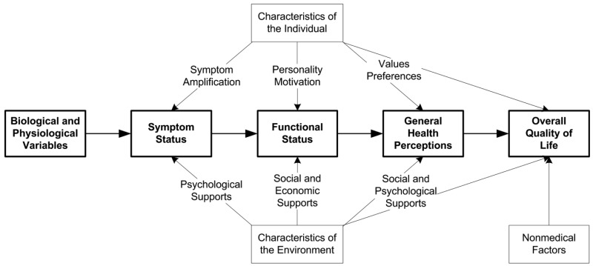
(Wilson and Cleary, 1995)

Health-related quality of life measures

Following the recognition of the biopsychosocial model of health, many attempts have been made to develop methods to assess the impact of health on QoL. Patients are seen as experts in their own lives. Therefore, these measures have been mainly based on patient-reported outcomes to capture all potential aspects of the direct and indirect burden of disease on their lives (Megari, 2013). Different types of HRQoL measures were introduced to assess the impact of diseases in clinical trials and epidemiological studies or to assess individual treatment outcomes (Wells et al., 2011). They are reliable to meet their objective and target population and can be administered in different ways. All HRQoL measures can be categorised into two main categories: generic and disease-specific.

Generic HRQoL measures are applicable to different types of diseases and interventions that can provide a comparable spectrum of impact and outcomes for different demographic and cultural groups (Churruca et al., 2021). They are useful for identifying the potential impact and side effects of treatment that may not have been predicted. Therefore, the results of generic measures are of greatest interest to stakeholders and policy makers (Guyatt et al., 1993). However, generic measures may not be suitable for detecting minor changes in HRQoL in specific diseases (Wells et al., 2011).

In contrast, disease-specific HRQoL measures are developed to capture the extent of a particular disease of interest in order to assess its impact or treatment outcomes for a group of patients. Similar to generic HRQoL measures, the development process of disease-specific HRQoL usually relies on qualitative research methods such as focus groups or in-depth interviews with patients. However, disease-specific HRQoL focuses on recruiting patients affected by a particular disease to ensure the production of relevant, specific and acceptable questions (Guyatt et al., 1986). The underpinnings of the disease-specific measures allow for greater sensitivity to how the disease affects quality of life. They can also be used to monitor minor changes over time or to assess the success of a disease-specific intervention (Nanda and Andresen, 1998). The only drawback of disease-specific measures is their specificity, which limits their applicability for comparisons with other health conditions. Therefore, careful and appropriate application of disease-specific HRQoL measures is required to obtain accurate outcomes.

Other types of HRQoL measures focus on a specific area and can be considered subcategories; for example, population-specific measures that focus on specific age groups such as children. Population-specific measures can be divided into two main categories: generic and disease-specific. There are several HRQoL measures that are suitable for use in children, but children have rarely been included in their development. In contrast to the adult population, children require greater effort and a better understanding of their psychological and mental development in order for researchers to develop a reliable and psychometrically robust measure. The first attempt to identify the available HRQoL measures for children was conducted through a systematic review by Eiser and Morse (2001). From 1980 to 1999, they identified 43 HRQoL measures for children, of which 19 were generic and 24 were disease-specific. Almost half of the identified measures (n = 20) were self-reported by the children. Interestingly, the study identified 15 measures that were developed either for children or their parents to measure their impact. In most cases, parental self-report contradicts the biopsychosocial model of health, as response bias was observed in many studies (Roydhouse et al., 2018; Li et al., 2015). Fortunately, the value of children’s perceptions of their own health, illnesses and treatment provision has been recognised over the last two decades (Germain et al., 2019). Children have been fully engaged in the development of various measures to ensure the reliability and appropriateness of the measures, such as the Child Health Utility questionnaire (CHU9D) (Stevens, 2009), Child Amblyopia Treatment Questionnaire (CAT-QoL) (Carlton, 2013), and the Canadian Haemophilia Outcomes-Kids Life Assessment Tool (CHO-KLAT) (Young et al., 2013). Several studies have demonstrated successful methods on how to involve children in the development of HRQoL measures (Gale and Carlton, 2023; Tomlinson et al., 2019; Patel et al., 2016b)

Oral health-related quality of life

Cohen and Jago (1976) development of socio-dental indicators was the first historical evidence of the application of the biopsychosocial model of health to assess the impact of oral health conditions on patients since the 1948 WHO definition. In the early 1980s, the notion of oral health-related quality of life (OHRQoL) emerged in the literature, almost two decades after the emergence of HRQoL. The delayed recognition of oral health conditions and their impact was attributed to poor awareness and denial of the link between oral health and general health (Dunnell and Cartwright, 1972).

Following the recognition of the HRQoL concept, oral health researchers realised that the objective clinical indicators of oral health were not able to fully capture the different aspects of its impact on individuals. Therefore, researchers were keen to develop robust and standardised measures that reflect the impact of oral health from physical, psychological and social aspects; the resulting measures were termed OHRQoL.

OHRQoL has been defined as ‘the impact of oral diseases and disorders on aspects of everyday life that a patient or person values, that are of sufficient magnitude, in terms of frequency, severity or duration to affect their experience and perception of their life overall’ (Locker and Allen, 2007). This definition emphasises that oral health is part of an individual’s overall health. Therefore, the theoretical models that served as the basis for the constructs of the OHRQoL measures are closely aligned with the core principles of the conceptual models of HRQoL. Therefore, most OHRQoL measures are multidimensional constructs that incorporate biological, functional, psychological, environmental and social factors as illustrated in Figure ‎2.2. Understanding definitions of health and models of health is important to adequately recognise concepts of diseases and measure their impact on individuals and populations. In the next section, a discussion of the concept of oral health in children and the potential impact of poor oral health is provided.
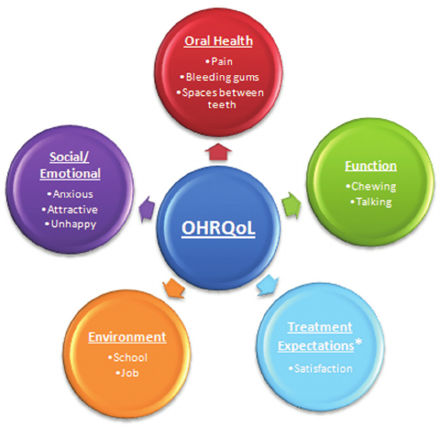
Figure ‎2.2 Dimensions comprising oral health-related quality of life (OHRQoL) (Sischo and Broder, 2011).

Children’s oral health

The general concept of oral health in children is similar to that of the adult population in terms of oral hygiene, function, condition control, pathogens and the basics of treatment modalities. However, there are differences in some aspects of oral health in children that present different challenges due to changes associated with growth, psychological development and the manifestation of congenital disorders in childhood. The nature of oral health challenges depends on the child’s physical and psychological maturity, lifestyle factors, genetic susceptibility and treatment modalities. This section addresses children's oral health-related development and a variety of oral health conditions and their challenges from a child’s perspective.

Psychological development

The psychological development of children is a coherent and integrated process of cognitive, emotional, social and intellectual development. Meggitt (2006) described the normative development of children in six age groups of babies (<2 years), toddlers (2-4 years), preschoolers (5 years), children (8-12 years) and adolescents (13-16 years). Each age group represents a normal range of expected cognitive, linguistic, emotional and social behaviours that may have an impact on oral health. Babies tend to learn through touch and begin to understand cause and effect and usually fearful of strangers and require plenty of reassurance by being slowly introduced to all objects by clinical staff. Simple instructions and explanations can be introduced using toys, picture books or games with toddlers to encourage the expression of feelings. Preschool children have a longer attention span and speak more fluently, so participation in conversations, activities and procedures should be encouraged in this age group. Children aged eight to 12 years are more able to think, reason and understand complex conversations with increasing independence and confidence. In this age group, recognising their own contribution and promoting autonomy should be supported by a good level of information that enables the child and parent to make informed decisions. Adolescents are more socially competent, able to think about options, plan ahead and maybe more anxious about their appearance.

In addition, parents play an important role in the psychological development of children, which can have an impact on treatment provision. Baumrind (1971) have established a connection between parenting style and a child’s psychological behaviour. Authoritarian parents who apply restrictive limits and controls, for example, can affect a child’s communication skills and anxiety levels, while children with independent and socially competent behaviour are usually seen with authoritarian parents who allow extensive communication and encourage independence. An indulgent parenting style may be related to the child’s ability to exercise self-control and self-esteem.

Children are in an ongoing psychological developmental process that needs special consideration by clinical staff in terms of social interaction, information sharing, encouragement methods and treatment methods compared to the adult population. In addition, neurodiverse conditions such as autism spectrum disorder (ASD) and attention deficit hyperactivity disorder (ADHD) pose further challenges for the child, family and treatment provision.

Dental development

Dental development is a natural physiological process and an important milestone in a child’s life. With two sets of dentitions, children go through different stages of dental development. Each stage has a different onset and unique challenges that only children and adolescents experience. The first stage of dental development is the primary dentition stage, which begins with the eruption of the first tooth at six months of age and ends around six years of age. There are some challenges associated with this stage, such as the introduction of appropriate oral hygiene and nutrition, an increased risk of traumatic dental injury (TDI) as a result of falls (Petti et al., 2018), and poor oral habits such as thumb-sucking and bottle-feeding during bedtime, which can be detrimental to oral health.

The transitional stage between the two dentitions usually occurs between six to 12 or 13 years of age. In the mixed dentition stage, the definitive occlusal relation of the teeth begins to form when the permanent teeth emerge into the oral cavity. The only oral health issue at this stage is therefore occlusion-related problems. Different types of malocclusions can occur during this stage of dental development, as longitudinal studies show (Dimberg et al., 2015; Góis et al., 2012). There are a variety of factors that can interfere with the path of eruption including retention and/or premature loss of primary teeth, non-nutritive sucking habits, ectopic eruption, dental crowding and abnormalities in the size and shape of teeth. Another factor that could interfere with the formation of a normal dental occlusion is the increased risk of TDIs in the mixed-dentition age group. A recent meta-analysis found that the overall prevalence of TDIs in 12-year-olds was 18.1%, the highest figure among the age groups (Petti et al., 2018). In addition, the consequences of TDIs in the primary dentition can extend to the mixed dentition by affecting the permanent successor teeth (Lenzi et al., 2015). Further details of TDIs are discussed in Section ‎2.2.6.

Another oral health problem associated with mixed dentition is dental anomalies in the permanent dentition. Most dental anomalies manifest upon eruption and are more common in the permanent dentition e.g. enamel hypomineralisation (Fatturi et al., 2019) and hypodontia (Rakhshan, 2015). Children suffering from these abnormalities may undergo a series of temporary measures, as definitive treatment can only take place once the growth spurt is complete. Therefore, the oral health of children with certain conditions may be considered differently from that of adults, even with complete permanent dentition. Further details of dental anomalies are discussed in Section ‎2.2.5.

Dental caries

Dental caries refers to the ‘localised destruction of susceptible dental hard tissues by acidic by-products from the bacterial fermentation of dietary carbohydrates’ (Marsh et al., 2009). The concept of dental caries development is based on the consecutive cycle of demineralisation and remineralisation of the mineral substance of the tooth structure (Abou Neel et al., 2016). Dental caries is the most common oral health problem in children, with untreated caries in primary teeth being the tenth most common disease, affecting around 514 million children worldwide (WHO, 2022). Based on the dental development stage, the children’s experience of dental caries may differ in terms of progression, consequences, prevention and management.

In primary dentition, morphological characteristics, poor oral habits and the limited life span of the teeth are the main factors that can lead children to experience a different impact of dental caries. Due to the thinner, less dense enamel and dentin layers, caries progression is significantly faster in primary teeth than in permanent teeth (Hummel et al., 2019). Therefore, the chance of developing dental abscesses is higher in primary teeth if left untreated. The unique dental caries consequence that can only occur in children is the spread of infection into the developing successor tooth space, which can cause a future structural abnormality (Broadbent et al., 2005). In addition, some children’s poor oral habits may contribute to the caries progression rate in the primary dentition. Early Childhood Caries (ECC) is defined as ‘the presence of one or more decayed, missing or filled tooth surfaces in any primary tooth in a child 71 months of age or younger’ (AAPD, 2008). The aetiology of ECC is the same as that of other carious lesions, but the distinctive feature is the atypical pattern of caries attack on the smooth surfaces of the upper anterior teeth and the main risk factor is prolonged bottle feeding, especially during the sleeping period. The impact of ECC is not limited to oral health but also associated with other health problems including infections, malnutrition, lower body weight and growth rate, increased risk of iron deficiency anaemia, sleep disturbances and inability to learn or perform usual activities (Dimaisip-Nabuab et al., 2018; Schroth et al., 2013; Sheiham, 2006).

Between 1995 and 2019, 54% of all children worldwide were affected by caries in their permanent teeth, according to a meta-analysis (Kazeminia et al., 2020). In addition to the role of plaque and sugar and other factors that cause tooth demineralisation, there is an additional risk factor in children related to erupting permanent teeth, especially molars. According to clinical data, the risk of developing caries is greater with erupting molars than with molars in functional occlusion (Alves et al., 2014). One proposed explanation is the enamel post-eruptive maturation phenomena (Hicks et al., 2004). The last stage of enamel development is the maturation stage, in which the final mineral content occurs. The phenomena of post-eruptive maturation of the enamel indicate that the final mineralisation is probably not completed until after the eruption, when the enamel is more porous and therefore more susceptible to caries. A more reasonable explanation lies in the difficulties of plaque control in partially erupted teeth due to the infra-occlusal position and tenderness of the gums, which may result in these teeth being overlooked or avoided during tooth brushing (Lynch, 2013; Ekstrand et al., 1998).

The management of dental caries in primary dentition is mainly influenced by the lifespan of the primary teeth and the child's ability to cope. Therefore, temporary caries measures in the permanent teeth can be used as definitive measures in the primary teeth due to their limited lifespan. These include restorative materials such as glass ionomer cement (Tiro et al., 2021) and temporary dental prostheses like the preformed metal crown (Ahmadifard, 2018). Extraction of the carious primary tooth is widely considered due to the concept of future natural replacement. Unfortunately, high caries rates in children are indicative of caries continuing into adulthood, as shown in a prospective cohort study of a population-based sample from birth to 38 years of age (Broadbent et al., 2013). Therefore, the implementation of preventive measures with comprehensive management of dental caries in children is crucial for a person’s lifelong oral health.

Periodontal health

The periodontal tissues are a group of different tissues that support the tooth structure and include gingiva, periodontal ligaments, cementum and alveolar bone. The characteristics of the normal periodontium in children differ from the periodontium in adults. The periodontium in children is softer, redder, more vascular and has wider and less dense fibres (Oh et al., 2002). The alveolar bone in children has a lower density and calcification and large marrow spaces with a higher blood supply. With increasing age, the alveolar bone gradually becomes denser and more compact with narrower bone marrow. The growth process of alveolar and facial bones can have both positive and negative influences on the oral health of children. In childhood and adolescence, the alveolar bone heals quickly, skeletal discrepancies can be corrected orthodontically without surgical intervention and a dry socket after tooth extraction rarely occurs due to rich blood supply (Fleming, 2017; Kamal et al., 2020). On the other hand, parafunctional habits can deform the alveolar bone in children, leading to malocclusions such as an open anterior bite and a narrowing of the maxillary arch (Nogueira Fialho et al., 2014).

Regarding gingival health, based on the most recent national surveys in the UK, gingival inflammation in 15-year-olds is lower than in adults (CDH, 2013; PHE, 2019). Children’s gingival health can be affected by plaque-induced and non-plaque induced inflammation. However, children may undergo or be exposed to several recognised factors that may increase the risk of inflammation. With poor plaque control, children may experience gingivitis with tooth eruption, puberty, habitual mouth-breathing and self-inflicted gingival injury such as habitual fingernail biting (Ghanizadeh, 2011). In addition, there are systemic and genetic conditions in children that may influence gingival inflammation such as diabetes mellitus and iron deficiency anaemia (Al-Ghutaimel et al., 2014) The options for the management of gingival and periodontal disease in children vary between increased oral hygiene measures and surgical interventions, depending on the severity of the disease. However, knowledge of the different diseases and an interdisciplinary approach are essential to ensure careful therapeutic intervention in children, especially when the periodontal disease is influenced by an underlying systemic disease.

Dental anomalies

Dental anomalies are a series of oral conditions that can be defined as a marked deviation from the average norm of morphology, eruption, quantity or structure of the teeth due to a developmental disturbance (Shrestha et al., 2014). Several local or systemic factors can disrupt the normal stages of tooth development of both dentitions, which can occur before or after birth. The deviation from normal tooth development can be influenced by polygenetic and environmental factors or even by pathological and physical interference. The type of dentition affected, the prevalence and the predominant sex vary according to the aetiology and type of anomaly. The congenital nature of dental anomalies has categorised them as a specific oral health issue in children, resulting in unique burdens and challenges that only children and adolescents experience. However, some complications can extend into adulthood.

Morphological anomalies of the teeth are quantitative defects of the tooth structure that lead to a change in shape and size. Increased production of tooth structure can cause different types of morphological anomalies, such as talon cusps, double teeth, dens evaginatus, dens invaginatus, macrodont and taurodontism. Other morphological anomalies such as microdontia are an example of the reduced quantity of structural tooth components. The main complications of these morphological anomalies are occlusal interference, displacement and eruption of teeth, dental caries and poor aesthetics (Shrestha et al., 2014). The management objectives for morphological anomalies depend on early diagnosis, caries risk and orthodontic assessment, pulp vitality and improvement of aesthetics. Treatment can be delayed until adulthood, especially prosthetic replacement.

The oral health of children can be impacted by anomalies related to the number of teeth. The congenital incomplete number of teeth is referred to as ‘hypodontia‘, while 'hyperdontia’ is a term for additional teeth. The aetiology of hypodontia can be genetic or due to environmental factors (e.g., radiotherapy), whereas hyperdontia is mainly caused by genetic disorders. The permanent dentition is more affected by both anomalies (Al-Ani et al., 2017). The number of missing teeth is used to classify hypodontia and determine its severity, with the position and shape of the additional teeth, such as conical or odontoma, being the indicators for the severity and classification of hyperdontia. Function and aesthetics are the main aspects of oral health in children affected by tooth number anomalies and usually require a multidisciplinary approach to management (Al-Ani et al., 2017). Especially for hypodontia, children may spend their entire childhood receiving interim measures as definitive treatment is usually indicated when the craniofacial growth is completed.

The eruption of teeth can deviate from the natural process of emerging into the oral cavity. In children, premature eruption of teeth may occur before birth ‘natally' or after birth ‘neonatally'. Extraction of these teeth may be considered due to the possibility of inhalation or ingestion, feeding difficulties and tongue ulcers. Children may also experience delayed eruption of teeth, which can be caused by a variety of local and systemic factors. Local factors that may affect the pattern and timing of eruption include physical obstructions such as an additional tooth, scar tissue, tumours and mucosal barriers, traumatic injury, tooth ankylosis, cyst formation and lack of arch length (Alshukairi, 2019). Delayed eruption of teeth is linked with systemic factors that are associated with impairment of growth such as nutritional deficiency, preterm birth, HIV infection, Down syndrome and anaemia (Alshukairi, 2019; Deps et al., 2015). The management of delayed erupted or impacted teeth depends on the stage of tooth development, the removal of the physical barrier, the available space in the dental arch and the treatment of the underlying systemic condition. Surgical and orthodontic interventions may be required to facilitate or initiate the eruption of these teeth into their normal position.

The last type of developmental anomaly that can affect children’s oral health is structural defects in the dentition. In the case of enamel defects, the type, location and type of dentition affected by the defect are directly related to the stage of enamel formation at the time of interference. The resulting defect can affect either the quantity ‘hypoplasia’ or the quality ‘hypomineralisation’ of the enamel structure. The developmental defect of enamel (DDE) may be localised due to local aetiological factors such as trauma, infection or radiation, while hereditary or systemic diseases such as amelogenesis imperfecta, cleft lip and palate, vitamin D-resistant rickets, excessive fluoride intake or ectodermal dysplasia may cause a generalised defect. The most common DDE is Molar Incisor Hypomineralisation (Lizzio et al., 2019) with a worldwide prevalence of 13% (Schwendicke et al., 2018). MIH usually affects the permanent first molars and incisors and the severity varies from a slight change in colour ("enamel opacity") to complete loss of the enamel surface. There is conflicting evidence about the causative mechanism and factors, but the developmental interference that causes MIH usually occurs between the prenatal period and the first two years of age, depending on the development of the affected teeth (Lygidakis et al., 2008). Children with DDE may experience dentin exposure, pulp inflammation, tooth loss, poor aesthetics, dental anxiety and tooth sensitivity, which can lead to poor oral hygiene and thus increased susceptibility to dental caries (Lygidakis et al., 2008). Dental caries may rapidly progress in permanent teeth that have developmental defects as reported by a recent meta-analysis (Vargas-Ferreira et al., 2015). This could be due to the poor enamel and dentin structure or the fact that teeth with developmental defects exhibit sensitivity which can lead to avoidance behaviour in complying with effective oral hygiene measures. These teeth are usually treated with caries preventive measures and temporary restorative treatment to alleviate sensitivity until the end of the growth spurt. However, children’s growth can be used to the advantage of these teeth, as occlusal compensation and balance can be achieved if tooth extraction is performed at the right time (Cobourne et al., 2014).

The malformation of the dentine structure is another type of structural developmental anomaly. Dentinogenesis Imperfecta (DI) is an inherited dental anomaly that affects both dentitions and is characterised by irregularly formed and poorly mineralised dentin, which can lead to significant tooth discolouration and is highly susceptible to enamel fractures due to lack of support. Poor aesthetics, poor function, pulp involvement and loss of vertical facial height are the main clinical implications of DI. Dentine dysplasia (DD) is another inherited dental anomaly associated with a disturbance of dentin formation in both primary and permanent dentition. The pulp chambers of teeth affected by DD can either be reduced or obliterated due to the deposition of mineralised tissue or enlarged due to the lack of dentin formation. Children with DD may experience tooth mobility, premature exfoliation and spontaneous abscess formation, even in the absence of dental caries. Children with DI and DD usually undergo an endless cycle of restorative treatments that require lifelong care (Barron et al., 2008; Alhilou et al., 2018).

Children’s experience with oral symptoms caused by dental anomalies can be worse if they are affected by several anomalies at the same time. There are established associations between the occurrence of different types of dental anomalies. For example, there is a high prevalence of hypodontia in children with MIH (Walshaw et al., 2020) and a significant correlation is found between hypodontia and microdontia (Gungor and Turkkahraman, 2013).

Traumatic dental injuries

Traumatic dental injury (TDI) is an oral health condition that affects approximately 3% of children worldwide. The highest incidence per 1000 individuals is up to the age of 12 years, with a decreasing incidence in older children (Andersson, 2013). Children may have a much poorer experience with TDI due to anxiety, level of cooperation, tooth maturation, and the availability of definitive treatment options. Growth is the most important key factor in the nature, potential complications and management options of TDI in children and adolescents (Born et al., 2019).

The aetiology of TDI in children is usually related to age-related activities, with falls and bumping into objects being the main aetiological factors in primary dentition and sports, assaults and road traffic accidents being the most common causes in permanent dentition (Andersson, 2013). In addition, TDI could be a sign of a non-accidental injury, as the head and neck are the most common sites of injury (Cairns et al., 2005). Luxation is the most common form of TDI in primary teeth, while uncomplicated crown fracture is more common in permanent teeth, as the alveolar bone and supporting structures are more elastic in younger children (Goswami et al., 2020). Crown fractures may occur in primary teeth where the management of uncomplicated crown fractures is based on the restoration of the missing crown structure. Extraction of primary teeth is the often-favoured option in cases of severe crown fracture and also for displaced root and alveolar fractures (Day et al., 2020).

The complication of TDI in the primary dentition is not limited to the primary tooth but can also extend to the successor tooth. Depending on the type of TDI, the primary tooth may become discoloured, develop an infection, resorb and exfoliate with a delay or prematurely (Day et al., 2020). Consequently, the permanent successor could be affected and exhibit DDE, abnormal tooth/root morphology or delayed eruption (Day et al., 2020).

TDI to permanent teeth can lead to tooth fracture, infection, malocclusion, root resorption, tooth loss and ankylosis, and can arrest the development of immature teeth where the oral soft tissue may be affected in the form of lacerations, bruising or abrasions (Bourguignon et al., 2020). The management of TDI affecting permanent dentition is divided into hard tissue, periodontal and pulp management. Hard tissue management aims to restore the function and position of the dental hard tissue by restoring the missing crown structure, stabilising root and alveolar fractures or initiating their healing (Bourguignon et al., 2020). The objective of periodontal management of TDI is to maintain the viability and function of the periodontal ligament by orthodontic or surgical repositioning and splinting of displaced and avulsed teeth (Fouad et al., 2020). A favourable periodontal outcome is achieved when the tooth shows normal mobility, a normal percussion sound and no radiographic signs of root resorption. The pulpal management of a tooth receiving a TDI depends on the type of TDI and accurate diagnosis. Depending on the vitality, the options vary from indirect pulp capping to complete pulp tissue removal (Bourguignon et al., 2020).

The growth process in children could be advantageous for the healing process of the pulp and the continuity of root formation, since in vitally traumatised, immature teeth a natural revascularisation of the pulp is to be expected due to the rich blood supply through the wide apex, which may enable continuous differentiation of the apical and periodontal stem cells (Namour and Theys, 2014). In the case of ankylosis, however, growth is unfavourable, as an infraposition of the tooth is highly likely to lead to a disruption of occlusion and alveolar bone growth. The infraposition is caused by the retention of the ankylosed tooth, while the alveolar growth of the other teeth continues (Arhakis and Boutiou, 2016). Interim measures for ankylosed or lost traumatised teeth usually place the child in consecutive maintenance cycles until growth is complete. These include decoration with root burial, temporary dentures such as a retained bridge or removable prosthesis and orthodontic space closure with restorative modifications (Bourguignon et al., 2020).

Potential impacts of poor oral health in children

The impact of poor oral health on children’s daily lives encompasses a wide-ranging effect within the biopsychosocial model. The impact can be affecting children’s physical, social and psychological well-being, their surrounding social relationships such as family and school peers and ultimately the society as a whole as an economic burden.
Pain
Oral pain is one of the most common impacts of oral conditions in children. It has been reported to have a significant impact on children’s physical activities such as sleeping, eating, playing, and school attendance and performance (Goes et al., 2008). Dental pain can be described by several indicators such as frequency, degree, location, incidence and stimulus, which are generally used for clinical situations to achieve optimal individualised oral health care. However, the degree of pain cannot be described at a population level, even with numerical and face-guided scales. This is due to the subjective nature of pain as well as the different pain thresholds and cognitive abilities of individual children (Fillingim, 2017). Therefore, the incidence of oral pain is the most useful indicator to describe its impact in a population.

Based on a recent worldwide meta-analysis found that around 32.7% of children or adolescents have experienced oral pain in the past. The UK was found to have the lowest pooled prevalence of oral pain of all countries analysed, at 18% (Pentapati et al., 2021). Globally, the experience of children with oral pain has not improved over the past three decades. However, the reported results on the prevalence of oral pain may be underestimated due to the different recall intervals in the included studies, which ranged up to 12 months, and lifelong experience. The ability of children to accurately recall past pain experiences is limited (Coombes et al., 2021a; Chogle et al., 2012).

Effective oral hygiene can be a difficult task for children experiencing oral pain, causing anxiety and avoidance behaviours that can negatively impact their oral health (Armfield et al., 2007). The likelihood is high that these children will have further episodes of oral pain if the consecutive cycle is not ended by breaking the avoidance behaviour and managing the current oral pain. Failure to end the cycle will lead to the progression of the disease and the spread of the infection.

Infection
Most non-physical oral health conditions (i.e., traumatic dental injury or non-nutritive sucking habits) in children are caused or influenced by microorganisms. Viral infections such as herpetic gingivostomatitis and Epstein-Barr virus are generally self-limiting and have a low chance of progression (Santosh and Muddana, 2020). On the other hand, cariogenic bacteria are more destructive and may progress if they are not controlled. Dental caries initially affects oral health by demineralising the tooth structure, which can develop into a life-threatening condition if the infection is not controlled. The cariogenic bacteria can reach the pulp area and eventually lead to tooth necrosis, if left untreated. Cariogenic bacteria can cause further damage by invading the alveolar bone or the periodontal space and forming abscesses or cystic lesions. In severe cases, the infection can spread further into the facial areas and cause swelling of the face, which can obstruct the child’s airway (Bali et al., 2015). Gingival inflammation is another oral disease which can progress if not controlled. Uncontrolled gingivitis can progress and become periodontal inflammation if there is a loss of the periodontium. As a result of uncontrolled periodontal inflammation, tooth loss and loss of vertical height of the face can eventually occur (Baratti-Mayer et al., 2017).

The urgency of controlling oral infections increases with the spread and progression of the disease. Prevention and early intervention are necessary to prevent further and serious complications that can jeopardise children’s oral health.

Loss of function

Oral function in children can be temporarily or permanently disturbed. It may be temporarily disturbed by premature loss of primary teeth, self-limiting soft tissue lesions, gingival inflammation and spontaneous eruption and alignment of teeth. These types of dysfunctions do not usually require major intervention. However, other oral conditions can lead to a lifelong loss of function if appropriate measures are not provided (Bhujel et al., 2016). The loss of several permanent teeth can impact on oral function, especially in children, as definitive restorative treatment can only be carried out after the growth spurt has been completed (Cobourne et al., 2014). The impact of the dysfunction increases with the number of permanent teeth lost. Children with several missing permanent teeth may suffer from malocclusion, reduced chewing ability and lower facial height (Rakhshan, 2015).

Children born with congenital disorders that have oral manifestations, e.g., orofacial clefts, may require multidisciplinary interventions to help them achieve oral function (Ladeira and Alonso, 2012). Destructive oral hard and soft tissue malformations, as they occur in oral tumours such as lymphomas and sarcomas, can lead to partial or complete impairment of oral function in children (Chen, 2019). Unlike other types of impact, the extent of the loss of oral function is a personal experience that can only be described by the affected child.

Economic impact

Based on global estimates, the WHO reports that around 43% of children are affected by oral conditions (WHO, 2022). Dental caries in permanent teeth is the most widespread disease worldwide, with carious lesions affecting the primary teeth of more than 514 million children worldwide which was ranked as the 10th most common disease (WHO, 2022). These reports also highlight the direct and indirect economic burden of oral health conditions. The direct economic impact includes the cost of treatment and provision of services, as well as patient absenteeism from work or school – or more generally the loss of productivity – which is seen as the indirect impact of oral conditions on the economy. The direct and indirect impacts of oral conditions on the global economy have been investigated by Listl and others (2015) , who reported that in 2010, the global economic burden of oral health conditions was estimated to be around $442 billion annually, of which direct treatment cost was around $298 billion, with the remaining $144 billion in estimated indirect costs. In Western Europe, the direct cost was estimated at 91 billion dollars and the indirect costs at a further 41 billion dollars. A recent global study found a 16.5% increase in direct treatment cost ($356.8 billion) and a 23.3% increase in productivity losses ($187.6 billion) between 2010 and 2015 (Righolt et al., 2018). In Western Europe, direct treatment cost has risen to $102 billion (+10.8%) and the cost of lost productivity to $57 billion (+28%) within the same timeframe. In both studies, tooth loss was reported to be the largest contributor to lost productivity. Despite the differences in the number of countries included, the findings of both studies confirm the increase in the economic burden of oral conditions in recent years. However, it should be noted that the outcome of these comparisons may be influenced by population growth and economic inflation between years.

Unfortunately, most studies report aggregate data that make no distinction between the economic impact of oral conditions in children and adults. This may be due to the lower priority given by politicians and policymakers in some countries to treating age-specific oral conditions and documenting the associated costs. The only global estimate of the economic burden specifically related to children is that of productivity losses associated with untreated dental caries in the primary dentition. A recent systematic review and meta-analysis found an association between untreated dental caries in children and poor school attendance and inadequate performance (Rebelo et al., 2019). In 2010, estimates for lost productivity in Western Europe totalled 40 billion US dollars; unfortunately, in 2015, the cost rose to 57 billion US dollars (Righolt et al., 2018; Listl et al., 2015). This increase in lost productivity may be influenced by the increase in productivity and total population between the five years. At a national level, some countries have provided figures on the overall economic burden of oral condition in children in official reports. In the UK, the National Health Service (NHS) spends more than £81 million a year on teeth extractions in children under general anaesthetic (GA) (The Office for Health Improvement and Disparities, 2022). The number of hospital admissions of children under the age of 19 for the treatment of dental caries in 2021/2022 was 42,180 this was the most common reason for hospitalisation of children for treatment under GA (The Office for Health Improvement and Disparities, 2022). There are no reports that illustrate the economic burden of other oral conditions in children.

Impact on the family
Children’s oral health can have an indirect impact on their families. Parents /carers may experience negative emotions, financial burdens and interference with daily activities because of their children’s oral health. Children’s oral symptoms have a negative impact on their families (Abed et al., 2019). Children’s oral pain can affect parents’ emotional stability, normal household activities, social life and sleep quality (Goes et al., 2008). The impact on the family varies depending on the different types of oral conditions that affect their children. Caries-related impacts on parents include self-blame and guilt because the disease is preventable, worries about the poor aesthetics of their child’s teeth and concerns that their child may have fewer life opportunities (Abanto et al., 2012). Based on a secondary analysis of the 2013 Child Dental Health Survey (CDHS), around a third (29.5%) of parents in the UK reported that the impact on their child’s oral health had an impact on their lives (Abed et al., 2019). The most commonly reported impact was related to absenteeism from work, followed by feelings of stress, increased need for attention, feelings of guilt, financial burden, disrupted normal activities and impaired sleep quality. The authors found positive associations between the level of family impact and other variables such as the severity of the child’s dental caries, parents with manual jobs, low or no educational qualification and living in deprived areas. These associations emphasise the role of the psychosocial model in addressing the real wide-ranging impact of dental caries in children. There is further evidence in the literature of negative outcomes for parents of children suffering from AI and DI (Alqadi and O'Connell, 2018), MIH (Leal et al., 2017) and orofacial clefts (Aslan et al., 2018).

The parental impact of children’s oral health can be improved by appropriate control and management of their child’s oral condition. A recent meta-analysis has shown that dental treatment under GA for children had a significant positive impact on parents regardless of the reason for admission (Park et al., 2019). In a caries-specific study, the Family Impact Scale (FIS) showed that parents’ quality of life improved significantly after the treatment of their children's dental caries under GA (Knapp et al., 2021). In addition, TDIs in children can have a major impact on their family due to their sudden onset, associated traumatic symptoms such as pain and bleeding, financial considerations and the problematic initial treatment of TDI (Arhakis et al., 2017). However, TDI-related impacts usually subside over time with appropriate dental management. In the UK, a study used PedsQ Healthcare Satisfaction Generic Module in a dental hospital and found that parents who sought dental care for their children who had suffered a TDI were worried about the child’s future and the effectiveness of dental treatment, and exhibited anxious behaviour (Porritt et al., 2013). When parents were approached six months after their children's dental treatment, they reported a significantly lower impact on all predictors of except parental worry over time. These findings support the importance of dental care and the behaviour of clinical staff for the psychosocial well-being of parents.

Impact on children

Children’s oral health may affect their social life and psychological well-being. Over the years, as the psychosocial aspect of oral conditions has been recognised and adopted, researchers have moved to assess the impact of oral conditions on an individual's overall quality of life (QoL) (see Section ‎2.1.1). The Oral Health Related Quality of Life (OHRQoL) measures are validated tools that systematically assess the functional and psychosocial impact of oral conditions based on reports from children or their parents/carers. Further details of the OHRQoL measurement designed for children are discussed in Section ‎2.4.1.

As the most prevalent oral disease (United Nations General Assembly, 2011), dental caries have far-reaching negative impacts on children. A systematic review has shown that dental caries has a negative impact on children’s QoL and that this is exacerbated by the severity of the dental caries and its presence in the anterior teeth (Nora et al., 2018). These results are consistent with a study on a caries-specific measure of the quality of life, according to which children’s quality of life appears to be more affected by dental caries if it causes pain, affects the front teeth, has spread to the pulp area or affects several teeth (Gilchrist et al., 2018). However, the same study also reported a significant improvement in the quality of life of children with dental caries after appropriate treatment. The children reported a strong reduction in negative behaviours such as irritation, crying, feeling cross and chewing on one side. These findings confirm the true benefit of dental treatment, which is to improve children's function and emotional and social well-being.

Children’s psychological development and personality appear to be related to the extent and perception of the impact of oral health conditions. TDIs have a significant negative impact in preschool and primary school-aged children when they are complicated and involve the pulp, while aesthetics play a greater role in adolescents (Antunes et al., 2020). Several oral conditions were reported to have a greater psychosocial impact on girls than boys, such as orofacial cleft (Nolte et al., 2019), MIH (Dantas-Neta et al., 2016) and malocclusion (Iranzo-Cortés et al., 2020). In a qualitative study examining the impact of DDE on children, it was also found that the effects are particularly strong in children who define their self-esteem by their appearance and rely on others to recognise their appearance (Marshman et al., 2009). Therefore, the nature and extent of the psychosocial impact of oral health conditions is subjective and should be assessed individually to achieve better outcomes.

The psychosocial impact of children’s oral health may be reflected in their behaviour in the dental clinic. These behaviours range from normal reactions, such as fear of new experiences and lack of cooperation in younger children, to more complex psychological reactions. Dental anxiety (DA), a general term encompassing abnormal psychological behaviours associated with dental treatment, is defined as "a state of apprehension that something dreadful is going to happen in relation to dental treatment, and it is coupled with a sense of losing control" (Klingberg and Broberg, 2007). In the UK, around 63% and 54% of 12- and 15-year-olds respectively report moderate dental anxiety (CDH, 2013). The aetiology of DA is a complex of individual, social and dental factors. DA in children can be influenced by the perception of negative dental experiences through personal encounters, the observation of others in the dental environment or the acquisition of fear through social processes such as parents, media and peers. Other factors include age, gender, pre-existing general anxiety and psychological behavioural disorders such as autism spectrum disorder (ASD) and attention deficit hyperactivity disorder (ADHD). In addition, the type of dental treatment and the behaviour of dental staff may also be related to the presence or extent of DA (Zhou et al., 2011). DA is a major barrier to routine dental attendance and to the child’s ability to complete the course of treatment (CDH, 2013). Thus, children with DA tend to attend with an acute dental problem that usually requires immediate and unpleasant procedures – leading to greater dental anxiety that results in a consecutive cycle of deteriorating oral health. The vicious cycle of DA has inspired researchers to develop child-reported measures for clinical use to address sensitive areas for effective discussion and management. Further details on the methods available to measure the impact on children’s oral health are discussed in the next section.

Measuring children’s oral health impact

The impact of poor oral health on children’s lives can be measured using a variety of methods that differ in terms of the scope of measurement, construct, and method of reporting. The development of children’s OHRQoL measures has increased recently due to the high demand for more specific measures. Children’s OHRQoL measures can be generic to capture the overall status of oral health across different diseases or specific to one scope. Specific measures are more focused on measuring a particular biological disease, such as dental caries (Gilchrist et al., 2018), a specific psychological behaviour such as dental anxiety (Porritt et al., 2018), and specific oral health symptoms such as oral pain (Wong and Baker, 1988).

Children’s OHRQoL measures

The development of OHRQoL measures for children faces additional challenges, most of which are associated with children’s biological and cognitive maturity and their ability to accurately describe the impact. Therefore, OHRQoL measures for children must be sensitive and have a robust evaluation to ensure suitability for the targeted age group. In addition, several factors of QoL that are specific to children need to be assessed to capture the impact on oral health, such as school environment (Genderson et al., 2013). Some researchers have been able to control for these challenges and have produced validated measures based on children’s reports, while others have avoided the challenges or have been unable to overcome them by using parents'/carers' reports as a proxy.

Proxy-reported children’s OHRQoL measures

A few validated OHRQoL measures for children have been developed to capture parental/carer perceptions of their children’s oral health. The reasons for soliciting ratings from parents/carers rather than the children themselves vary for the proposed measures. The limited cognition and immaturity of very young children to meet basic psychometric standards has been a motivating factor in the development of parent-centred measures such as the Early Childhood Oral Health Impact Scale (ECOHIS) (Pahel et al., 2007). Jokovic and colleagues (2003) developed the Parental–Caregivers Perceptions Questionnaire (P-CPQ) and used parents’ principal role of parents/carers in decision-making to justify proxy reporting. However, the authors recognised the benefit of the supplementary use of the measure with child-reported measures.

Despite the reason for using parental rating to describe children’s oral health, few limitations in this regard have been identified in the literature. Barbosa and Gavião (2008) reported that with the use of appropriate measures, information obtained from parents about their children’s oral health is valid and reliable, but incomplete. It was hypothesised that the discrepancy in ratings was highly dependent on the dimension of the QoL being investigated. Social well-being was the item for which the ratings of parents and their children differed most frequently. The inaccuracy is more pronounced in older children, highlighting the inability of parental perception to capture children’s internal emotions and relationships outside the home. Therefore, it was recommended that the information provided by parents/carers should only be used to complement the children’s reports or when the use of a proxy is unavoidable (Marshman et al., 2007).

Child-reported OHRQoL measures

The development of child-reported OHRQoL measures to allow children to express their feelings about their oral health was part of a movement in the field of research. Child-centred research (CCR) is an approach based on the recognition of children as active participants with a voice in the research process on topics that affect their interests. The promotion of children’s entitlement as persons with rights and as users of health services has led to more meaningful outcomes (Attaran et al., 2024). ​The CCR has been found to be feasible with different methods such as interviews, diaries, drawings and questionnaires in different age groups (Gilchrist et al., 2013). The undeniable impact of oral health diseases on children, combined with the recent shift towards recognising children's perspectives, has led researchers to develop child-tailored OHRQoL measures that can be completed with a generic and disease-specific focus.

Generic measures

There are a few OHRQoL measures developed for children to complete. Based on a recent systematic review (Hettiarachchi et al., 2019), the Child Oral Health Impact Profile (COHIP) (Broder et al., 2007), Child Perception Questionnaire (CPQ) (Jokovic et al., 2004; Jokovic et al., 2002; Jokovic et al., 2006) and Child Oral Impacts on Daily Performance (C-OIDP) (Gherunpong et al., 2004) were the generic child-reported OHRQoL measures most commonly used in the literature. Full descriptions and methodological quality assessments of these measures are summarised in Table ‎2.1. The broad applicability of these measures to capture the impact of different oral diseases was validated by testing these measures during their development in children with different diseases and different clinical severities. The generic child-reported measures have been widely accepted by oral health researchers worldwide, resulting in adaptation to different cultures and translation into multiple languages. However, limitations of these measurement methods have also been identified in the literature (Gilchrist et al., 2014).
The involvement of children in the development of the CPQ measures was considered when creating the items, however, authors failed to describe how children were involved, which could explain the low quality of the content validity of the measure (Gilchrist et al., 2014). The adult origin of the C-OIDP measure might not capture aspects of daily life that children value due to the irrelevant content of the questionnaire (Marshman and Robinson, 2007). It has been suggested that the content of the QoL measures must include both ‘positive’ and ‘negative’ items to capture all aspects of the impact of disease on health (Patrick et al., 2002). The inclusion of positive items may promote the measure to capture positive attributes or increased well-being, such as confidence, rather than the absence of negative aspects that are otherwise difficult to identify (Edwards et al., 2002). Of these measures, COHIP is the only measure to incorporate positive items suggested by parents and endorsed by children during the development of the measure. Adapting the child-centred approach in the development of OHRQoL measures helps to capture aspects of daily life that are important from the children’s perspective. One of the limitations of these measures is the broad coverage of oral diseases and their impact, which may restrict their ability to detect and measure slight changes associated with a particular oral disease (Wells et al., 2011). Therefore, researchers were motivated to develop disease-specific measures to fill the gap and address those changes.

Table ‎2.1 Description and methodological quality of the most common generic child-reported OHRQoL measures. (Gilchrist et al., 2014).
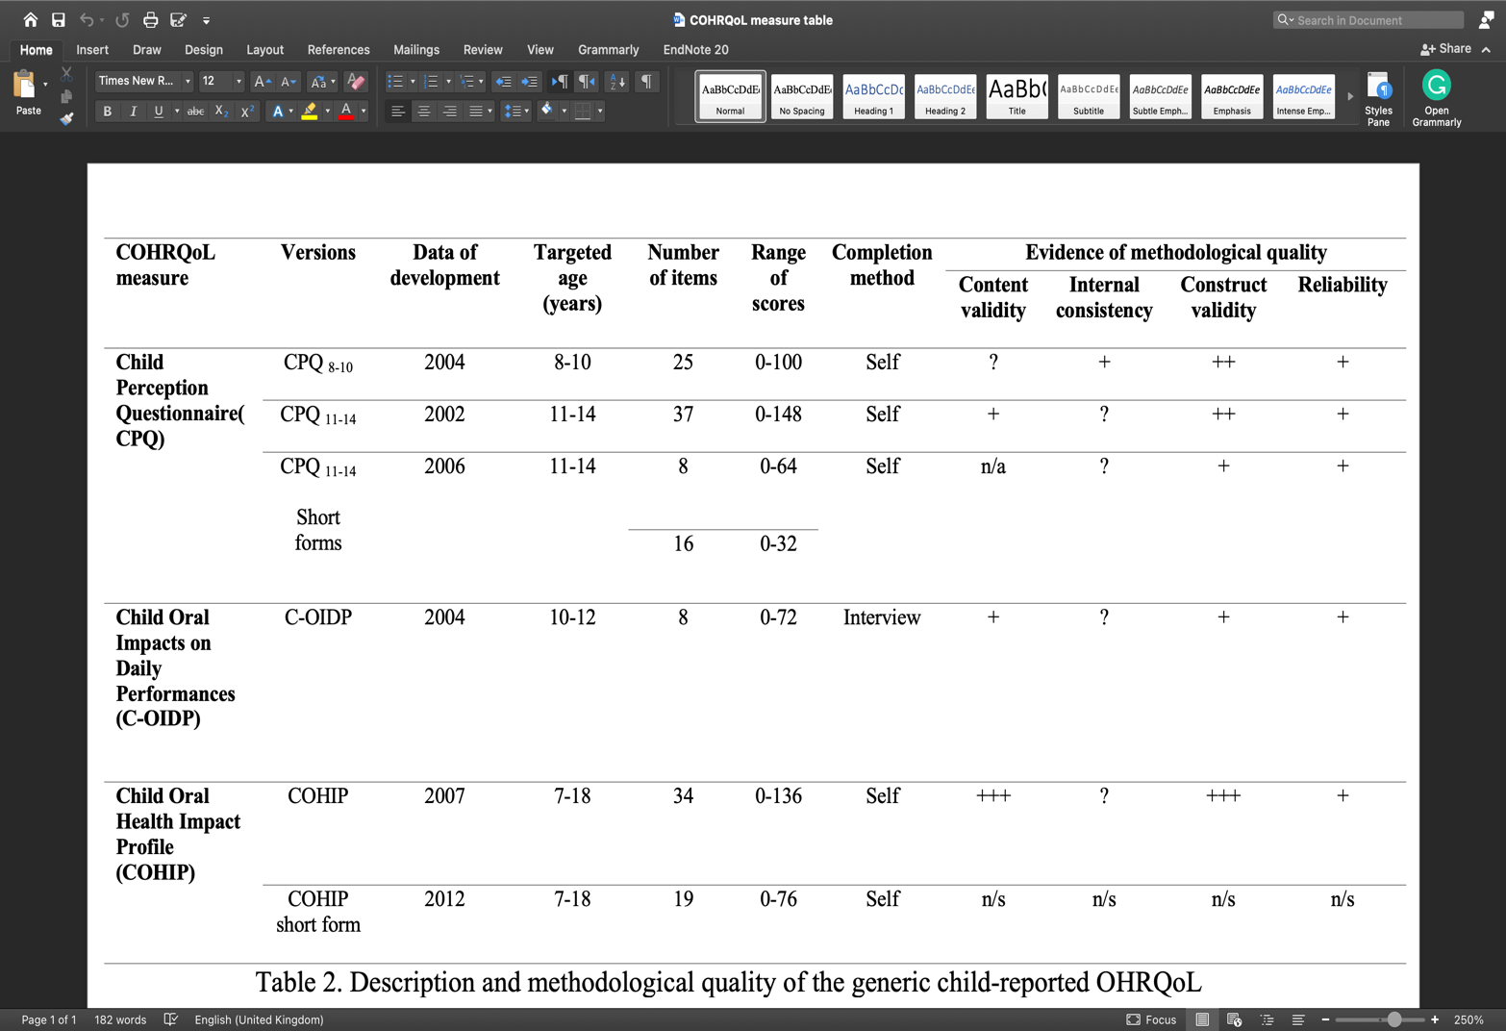
+++ = strong evidence of positive result; ++ = moderate evidence of positive result; + = limited evidence of positive result; ? = unknown due to poor methodological quality of study, n/a = no information available; n/s = not assessed.

Disease-specific measures

Disease-specific OHRQoL measures are advantageous in terms of responsiveness and clinical utility over generic measurements because they focus on measurement within a specific population (Wiebe et al., 2003). In general health, only 27 disease-specific measures for self-completion by children exist (Solans et al., 2008). The reported results are significantly lower than the number of diseases that may affect children. However, the authors were optimistic and noted an exponential growth in the number of measures, especially in the last five years after the date of the systematic search. Unfortunately, there is no current data on the number of disease-specific OHRQoL measures available.
In oral health, there are few disease-specific measures reported by children that have been developed for various oral diseases. The Malocclusion Impact Questionnaire (MIQ) is a 17-item orthodontic questionnaire developed by and for children aged 10 to 16 years to assess the impact of the appearance and arrangement of their teeth on their lives (Patel et al., 2016a). Hypodontia was selected for the development of a disease-specific measure as an oral disease that affects children. OHRQoL Hypodontia is a disease-specific measure that was developed based on input collected from children aged 11 to 18 years during a series of focus group interviews (Akram et al., 2011). The measure comprises questions on four sections: Treatment, activities, appearance and reactions of others. OHRQoL Hypodontia has been shown to be valid for measuring the impact and treatment needs of hypodontia in children. However, the measure is not suitable for children suffering from hypodontia as part of a syndrome or cleft lip and palate. There are disease-specific HRQoL reporting measures for children in which oral health is integrated as a separate domain. For example, the CLEFT-Q is a valid, child-administered questionnaire developed for children with cleft lip and palate (Riff et al., 2017).

The aforementioned self-administered measures are indeed developed and designed for children with oral diseases. However, they describe the impact from a different perspective than that of paediatric dentistry. Unsurprisingly, dental caries is the main oral disease for which there are specifically developed OHRQoL measures that relate to paediatric dentistry due to its high prevalence and impact. One example is Caries Impacts and Experiences Questionnaire for Children (CARIES-QC), a caries-specific measure developed based on information from children at all stages of development. Gilchrist and co-workers (2018) accurately addressed the important aspects of the impact of dental caries on children’s daily lives by actively involving them in the generation of the items, the reduction of the items and the development of the measures. CARIES-QC consists of 12 items and a global question with a 3-point scale to assess severity, with a higher score indicating a greater impact. Further details on the CARIES-QC can be found in Table 2.2.

In contrast to the generic child-reported measures, during the development of CARIES-QC, the children emphasised the severity of the impact when discussing their experiences of caries more than the frequency of occurrence (Gilchrist et al., 2018). This discrepancy in reporting emphasises the importance of including children and the benefits of disease-specific measures. Therefore, CARIES-QC is a severity-based measure that is able to reflect children’s experience with caries with a language used by the children themselves, with acceptable validity, reliability and responsiveness (Gilchrist et al., 2018). The literature showed that CARIES-QC was reliable and valid for research use across different populations (Foster Page et al., 2019;(Rogers et al., 2020; He and Wang, 2020; Arrow et al., 2021) and randomised trials (Innes et al., 2024). A recent pilot study has shown that the information provided by the CARIES-QC has been valued and has informed treatment planning when used routinely in clinical practice (Graham et al., 2021). Interestingly, the CARIES-QC also showed good reliability and validity in children with other oral diseases when a free-text box was added in which the children could indicate other impacts not covered by the CARIES-QC (Graham et al., 2021). These findings highlight gaps for future studies investigating the routine use of the CARIES-QC in clinical practice in a larger population to confirm the hypothesis of the generic applicability of the CARIES-QC in different conditions.

Table ‎2.2 CARIES-QC questions and response format (Gilchrist et al., 2018).
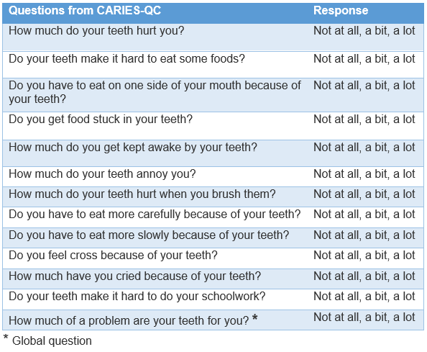

Other applications of OHRQoL measures

In addition to measuring the impact on oral health, there are other applications of OHRQoL measures that depend on the scope of the investigation. Robinson and others (2003) categorised the use of OHRQoL measures into three broad aspects: theoretical, practical and political (Table ‎2.3). The theoretical application involves describing the factors that may influence oral health by exploring models of oral health that can provide guidance for practical and policy application. OHRQoL measures may be used in practice as an index to assess the success of an intervention over time or as an evaluation measure for service provision. Finally, in the political realm, OHRQoL measures can help set policy that reflects the public's priorities by incorporating them into health care and research. Because OHRQoL measures can be self-administered, they have greater potential for use and are no longer just tools for measuring impact. This shift is driven by the fact that patient-reported OHRQoL measure is part of a broader topic known as Patient-Reported Outcome Measure (PROMs). Further details of PROMs are discussed in the next section.

Table ‎2.3 Other applications of OHRQoL measures as proposed byRobinson et al. (2003) .
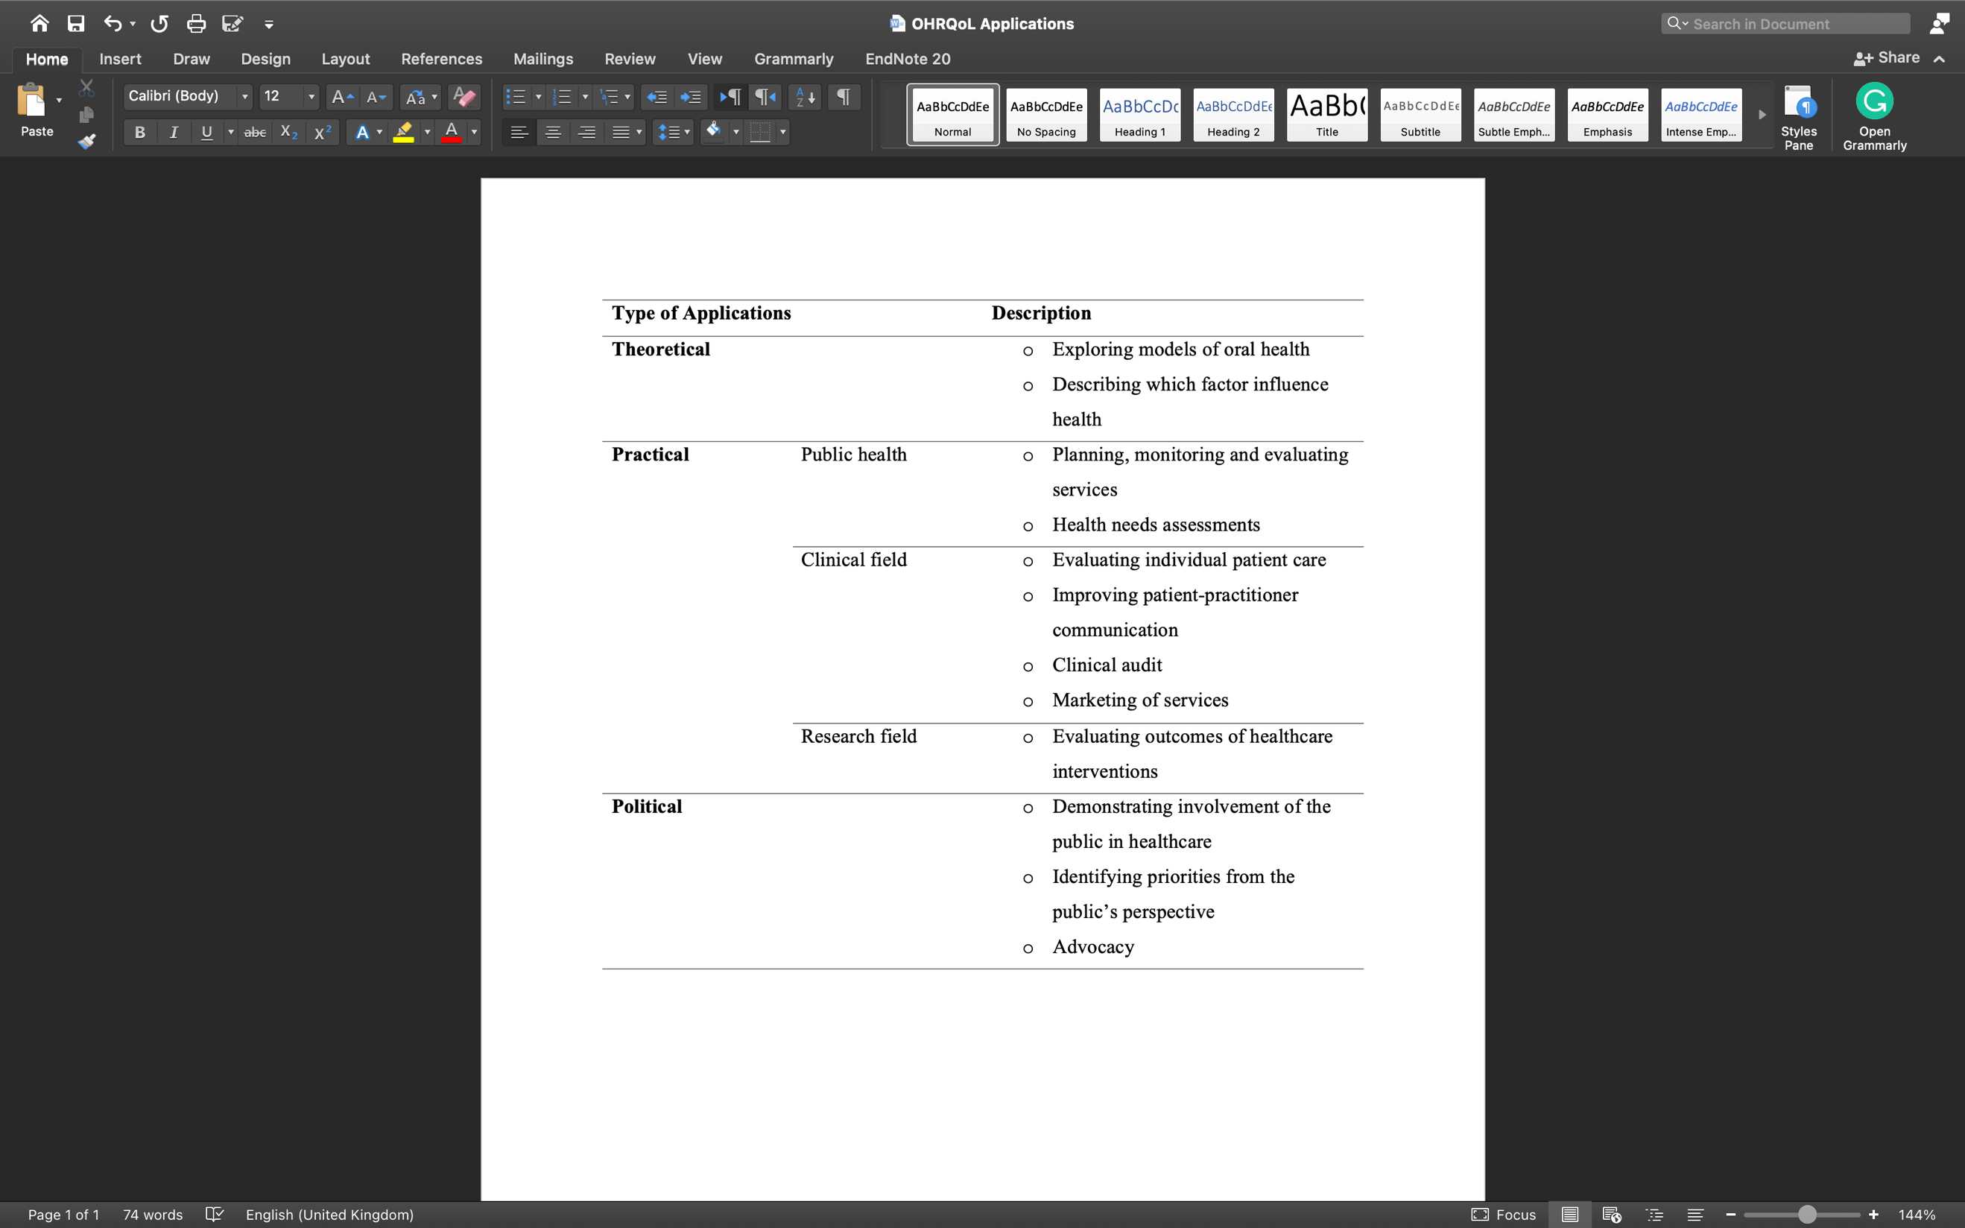

Patient-reported outcome measures

Recently, there has been a fundamental shift in the focus of healthcare systems, putting patients at the centre of care to improve service satisfaction and outcomes. This shift has been clearly described in several national healthcare initiatives and by research funding organisations (Department of Health and Social Care, 2021). This trend is reflected in the growing use of patient-reported outcomes (PROs), which are defined as ‘any report of the status of a patient's health condition that comes directly from the patient without interpretation of the patient's response by a clinician or anyone else’ (Food and Drug Administration, 2009). PROs are increasingly recognised and employed as indicators for the evaluation of services and quality measurement and they have been come to be embraced in the clinical decision-making process (Churruca et al., 2021). Subsequently, the regular use of PROs has created the need for valid and reliable tools that would systematically guide patients to report appropriate and related information. Patient-reported outcome measures (PROMs) are the instruments or tools used to capture PROs, commonly in the form of self-completed questionnaires. PROMs are usually designed in uni- or multidimensional measurement schemes to produce information about a specific construct that should be clearly described by the developers of the measurement. PROMs can be categorised based on the constructs they are designed to measure.

PROM construct categories

PROMs are widely used in the assessment of health-related concepts. The main constructs that PROMs typically measure are HRQoL, health behaviour, treatment experience, psychological well-being, symptoms and symptom burden. Each construct has different characteristics and specific applications. Due to the lack of standardisation in the literature, the aforementioned categories of PROM constructs are assembled based on their relevance to the scope of this review and may differ from other proposed categories. The following subsections focus on the scope of the different constructs of PROMs, including strengths, limitations, and examples of available oral health-related measures.

Health-related quality of life

HRQoL measures are broad, multidimensional constructs that capture an individual’s perspective on the impact of illness on their lives in a variety of aspects. HRQoL measures can be self-reported by patients (in which case they are referred to as PROMs) or reported by proxies such as parents. To avoid misinterpretation of the results, careful consideration of the design of the HRQoL measures and the target population is required. Further details on (oral) HRQoL measures and limitations have already been discussed in Section ‎2.4.

Health behaviours

Patient health behaviour is another construct that can be assessed with PROMs. Health behaviour PROMs are risk assessment tools that capture generic or specific actions of individuals that may have a positive or negative impact on their health. In the area of oral health, for example, positive behaviours would include a healthy diet and regular tooth brushing, while negative behaviours would include smoking and a high-sugar diet. A valid PROM for health behaviours can provide useful information across multiple domains for clinical and health promotion purposes. Clinical staff can use PROMs to monitor and identify behaviours that potentially deteriorate health or increase the risk of treatment failure. In the area of oral health, the Oral Health Behaviour Questionnaire for Adolescents based on the Health Belief Model (OHBQAHBM) is a recently developed PROM that reliably measures factors that influence adolescents' oral health behaviours and beliefs and can predict oral health status (Xiang et al., 2020). The greatest strength of PROMs for health behaviour is that they can be targeted to specific behaviours depending on the developer’s interests. However, their validity can be affected by social desirability and cultural beliefs, which can lead the patient to produce biased information when reporting socially conflicting behaviours (Cella et al., 2015).

Treatment satisfaction

Treatment can be described as the application of health care and intervention for the management of a disease or disorder and its associated symptoms. Satisfaction with treatment is described as the patient’s evaluation or report of important aspects of the process and outcomes of their treatment experience (Weaver et al., 1997). Patients’ perspectives on medical treatment can be assessed through their reports on the quality of medical care they received and the outcomes of their health condition. Therefore, treatment satisfaction can be captured through an integral process of two different patient-reported concepts: PROMs and Patient-Reported Experience Measures (PREMs). While PROMs are measures that assess the impact of healthcare interventions and outcomes, PREMs explore the quality of care that matters to the patient, from specific interactions (such as staff attitudes) to a broader assessment of the performance of the entire healthcare system. Validated PROMs and PREMs can provide valuable and important information for the patient-centred healthcare system to improve patient satisfaction with treatment and services.

Increasingly, PROMs are being used to capture patients’ subjective assessment of their experience of an intervention or proposed interventions in terms of different aspects such as implementation, side effects, effectiveness and convenience. They are beneficial for patients and their families in decision-making and outcome expectations of an intervention, which can increase adherence and improve health behaviours (Cella et al., 2015). In addition, treatment satisfaction PROMs may guide policymakers to set financial projections and predict the direction of care. Several validated treatment satisfaction PROMs are applicable to oral health conditions, such as the Post-Surgical Patient Satisfaction Questionnaire (PSPSQ) (Kiyak et al., 1986), the Cleft Evaluation Profile (Noor and Musa, 2007) and the McGill Denture Satisfaction Questionnaire (MDSQ) (Grandmont et al., 1994). In the oral health literature, children’s views on their treatment experience are almost completely overlooked; instead, parental reports are the predominant method of measuring children’s treatment satisfaction. There is no plausible explanation for the omission of children’s feelings about treatment outcomes and physical and psychological experience.

Following the recognition of treatment satisfaction PROMs and their benefits, the NHS implemented nationwide use of PROMs in all NHS-funded hospitals in 2009 (Department of Health, 2011). The national PROMs programme covers four specific surgical procedures: Knee replacement, hip replacement, groin hernia surgery and varicose vein surgery. Patient satisfaction and health status were measured by administering the PROMs questionnaire twice, before and after the surgical procedures. The data obtained from these PROMs are published monthly on the official website of the Health and Social Care Information Centre (HSCIC). The most recent annual report showed that the PROMs recorded an excellent improvement in health following hip and knee replacements (NHS Digital, 2023).

There are some potential challenges and limitations when using PROMs to measure treatment satisfaction. Confidentiality is a key factor to consider when using PROMs to measure treatment satisfaction to ensure that patients are comfortable with disclosing adverse outcomes. Depending on the type of treatment, this is usually followed by a recovery period where the expected efficacy has not been achieved and symptoms have not fully resolved. Therefore, the timing of PROM administration is critical to prevent patients from reporting inaccurate data. Interestingly, evidence suggests that the majority of patients overestimate the benefits of interventions and underestimate their risks (Hoffmann and Del Mar, 2015). The lack of accurate expectations of the treatment outcome may lead to patients providing biased information about the treatment. This emphasises the importance of combining realistic expectations with clear, informed decisions and combining PROMs with functional outcomes to more accurately identify improvement or deterioration in health.

Psychological health status

The general health of the individual is composed mainly of two inseparable and equally important components: physical and psychological health. In contrast to physical health, mental health is difficult for healthcare providers to address because there are no objective biomarkers. However, some psychological health disorders may be reflected in the individual’s behaviour, which is interpreted through the subjective assessment of healthcare providers. Therefore, the use of PROMs in the field of psychological health is immensely important to provide a systematic and valid description of psychological disorders or experiences.
Treatment-related psychological behaviours can be assessed and monitored by specially developed PROMs. In the field of oral health, dental anxiety is a major psychological condition that usually interferes with treatment provision, especially in children. Indeed, the development of a child-tailored PROM for dental anxiety encounters further challenges, in addition to those associated with the development of PROMs (the minimum standards of PROMs developed are discussed in the next section). The main challenges concern the inclusion of children throughout PROMs development process to address relevant areas with age-appropriate language (Folayan and Kolawole, 2004). In addition, the research-based development of the PROM should be followed by clinical validation to ensure the suitability of the measure for clinical use, as treatment options and modalities are highly dependent on the results of the measurement. The researchers have succeeded in developing valid and reliable PROMs for dental anxiety in children.

Children’s Experiences of Dental Anxiety Measure (CEDAM-14) is a child-centred PROM of dental anxiety designed for children aged between nine and 16 years (Porritt et al., 2018). The CEDAM-14 has proved appropriate for research with good psychometric properties (Porritt et al., 2018). The theoretical framework underpinning the CEDAM-14 is based on the five areas of the Cognitive Behavioural Therapy (CBT) model by Williams and Garland (2002). Thoughts, feelings, physical symptoms and behaviour are areas of interest derived from interviews with children. The CEDAM-14 items are designed to assess the aforementioned domains, which may identify discussion points for effective management of the child’s anxiety and modification of treatment.

Recently, a short form of CEDAM-14 was developed to facilitate the implementation of the measure. CEDAM-8 is a brief PROM of dental anxiety that provides a quick and easy overview of children’s concerns and identifies factors that maintain dental anxiety in children (Porritt et al., 2021). CEDAM-8 scores can range from 8 to 24, with higher scores indicating higher levels of dental anxiety. As this is a recently developed PROM, it should be carefully considered as clinical validation is required to confirm the utility of CEDAM-8 for use in a clinical setting. The CEDAM-8 items and response options are summarised in Table 2.4.

Table ‎2.4 CEDAM-8 items and response options (Porritt et al., 2021).
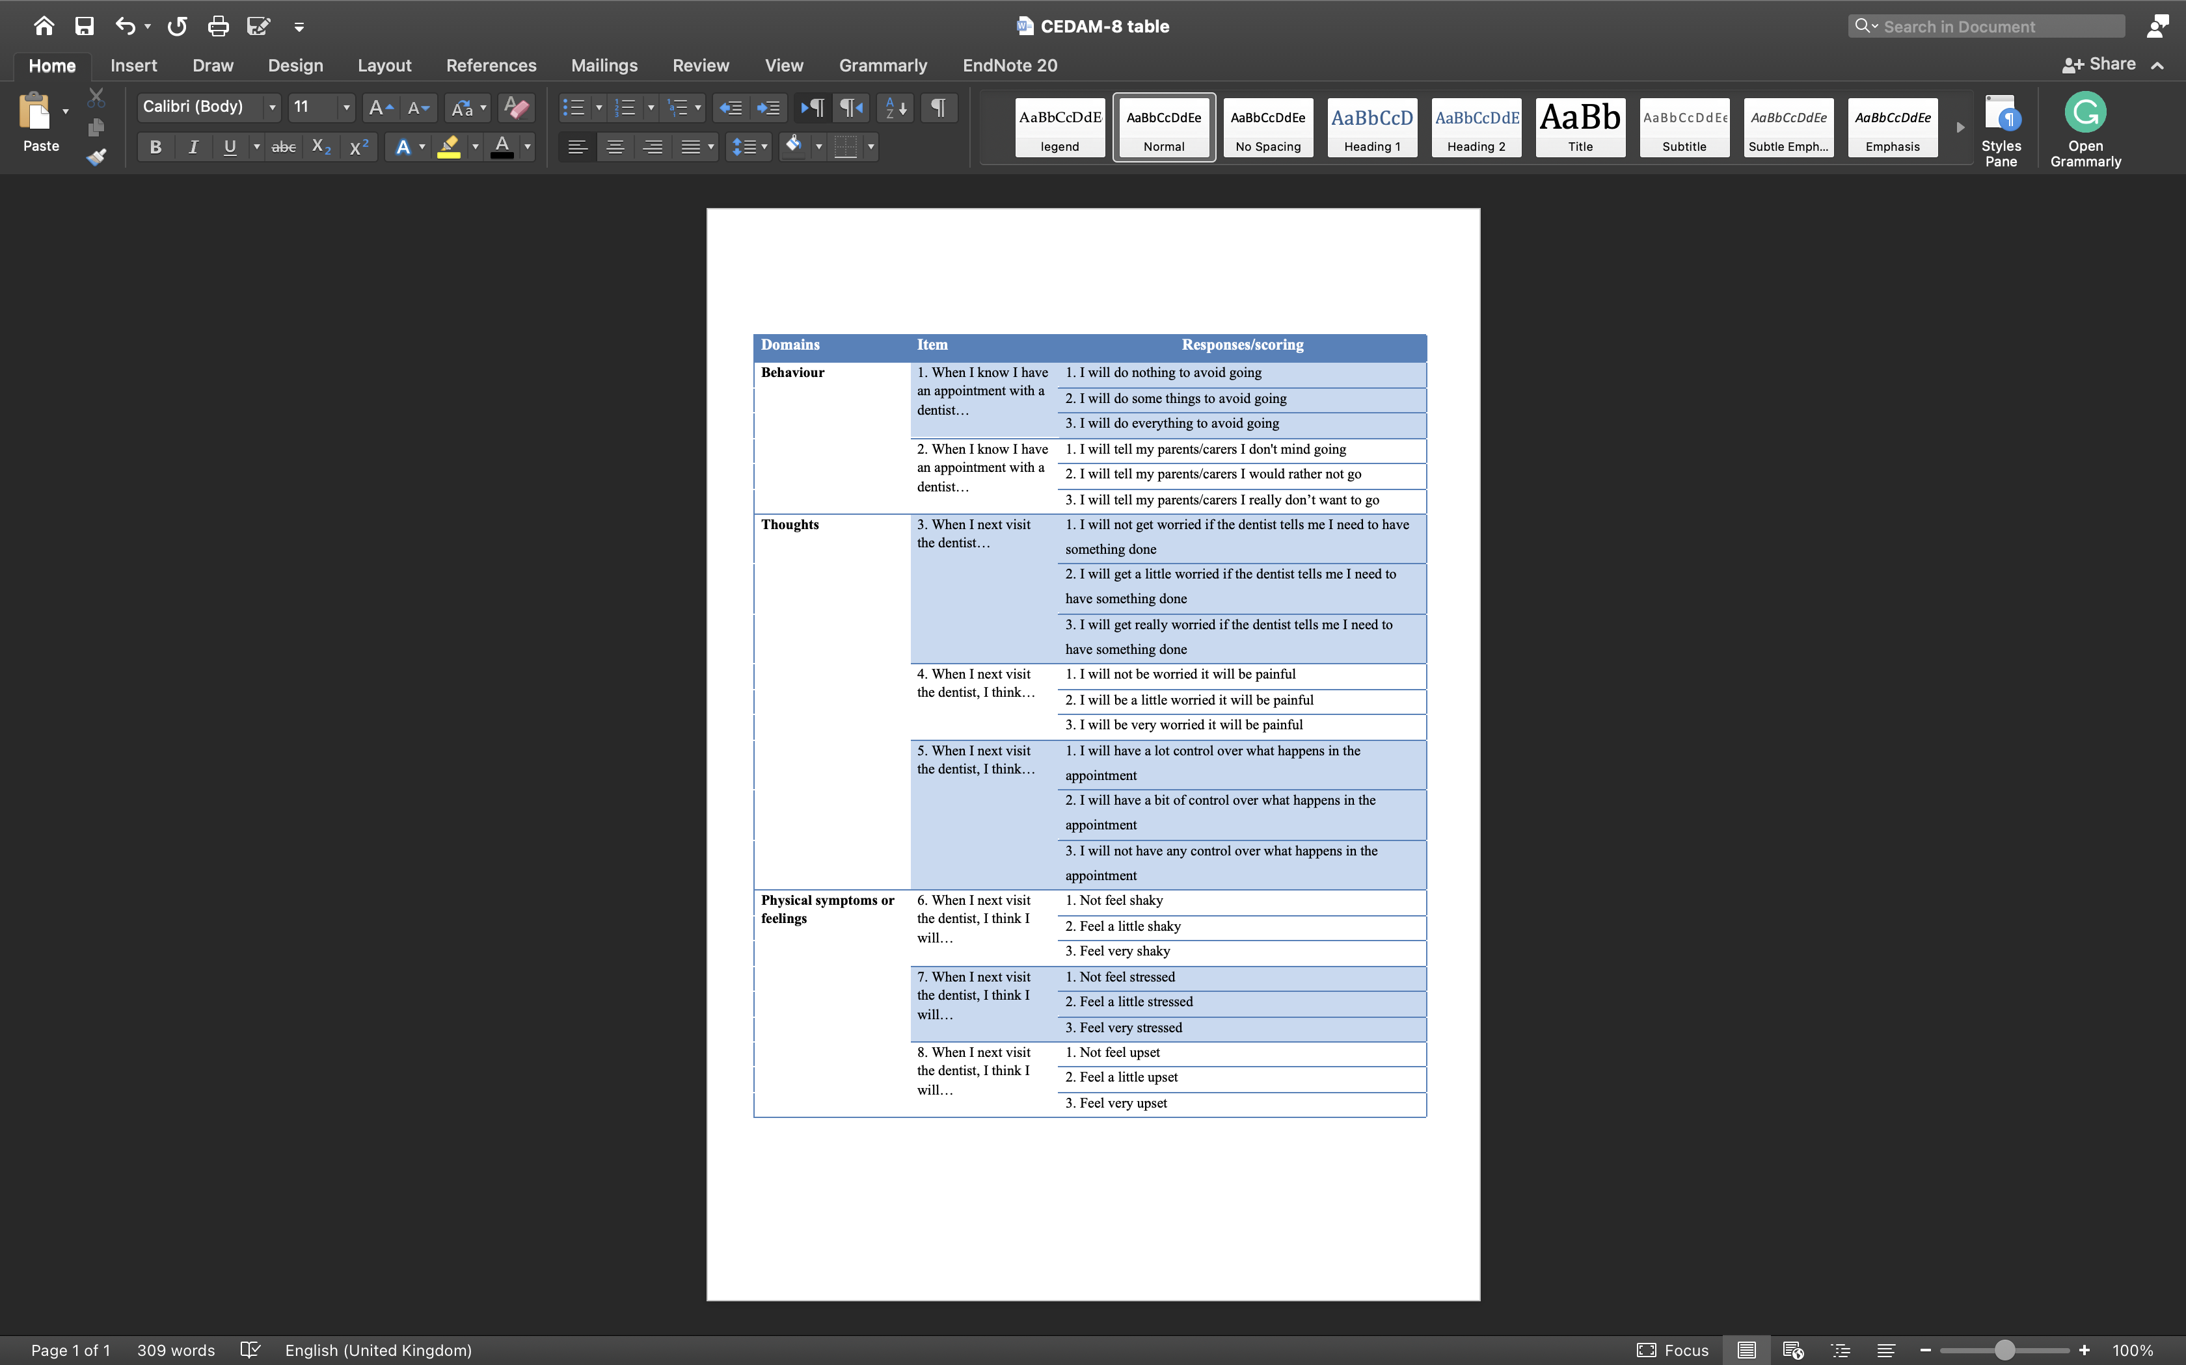
Symptoms and symptoms burden

Typically, symptoms are negative experiences that vary in onset, intensity and duration from person to person and are best assessed by PROMs (Cleeland, 2007). The impact of symptoms on an individual’s usual functioning is at the centre of PROMs for symptom measurement. The use of PROMs for symptom measurement may strengthen the clinician–patient relationship by developing confidence and trust bonds, thus reducing levels of anxiety and fear (Damman et al., 2020). Symptoms and symptom burden constitute a fundamental element of PROs that has been incorporated into different constructs of PROMs, particularly generic unidimensional pain measuring PROMs designed to measure specific aspects of pain, such as intensity (Aitken, 1969), as well as pain control methods (Rosenstiel and Keefe, 1983).

In children’s oral health, dental pain is the most important oral symptom that requires immediate management. Nevertheless, there is no specific PROM that can be used in both clinical and research settings in all contexts of pain measuring in paediatric dentistry. Arguably, the main barrier to the development of oral pain-specific PROMs for children is the inclusion of pain in other available multidimensional PROMs such as OHRQoL. Most child-specific PROMs for measuring dental pain are generic and focused on intensity, such as face scales, numerical rating scales and coloured scales. The face scales are suitable for children aged three years and older and can be completed by selecting the most representative face from a series of line diagrams of faces with expressions represent escalating pain intensity (Wong and Baker, 1988). Numerical rating scales and coloured scales follow the same procedure for indicating pain intensity, albeit using a numerical scale (usually from zero to ten) or on a scale of colours that gradually progresses from white or green to dark red (McGrath et al., 1996; Aitken, 1969).

The main limitation of pain-measuring PROMs, in general, is their inability to generalise or compare outcomes between individuals – even with the same disease. It has been proven that pain severity is very subjective and influenced by the patient’s personality, so the experience of pain is completely individualised (Fillingim, 2017). Few drawbacks have been identified with the PROMs available to measure dental pain in children. Numerical rating scales such as the Visual Analogue Scale (Nidhra and Dondeti, 2012) are not as representative as other PROMs with descriptors such as mild, moderate or severe pain (Younger et al., 2009). Furthermore, the descriptions of pain differ between adults and children, with the latter may wish to add their own words to adequately explain their pain sensations. It is important to involve children in the development process of PROMs for pain-measuring PROMs to ensure that appropriate language is used.

Applications of PROMs

The widespread adaptation of the patient-centred approach in healthcare and research has granted PROs almost unlimited application possibilities. Mainly, the application of PROMs is categorised into clinical, research or economic applications depending on the purpose of the outcome use. Each category of PROM application is associated with different areas of investigation and brings specific challenges, facilitators and barriers in the overall application process.

The common challenge that arises in all application categories is the selection of an appropriate PROM. The rapid development and change of PROMs in the literature has made the selection of appropriate PROMs much more complex. According to the Patient-Related Outcome and Quality of Life Instrument Database (ProQolid), more than 6000 PROMs on different constructs and domains of health are currently registered in the database (Mapi Research Institute, 2024). Nevertheless, the plethora of registered PROMs is not fully reflecting the actual development rate of PROMs and may represent an underestimation due to the limitations of the inclusion criteria. In addition, the registered PROMs were not subjected to psychometric and methodological assessment as part of the inclusion process. Therefore, it can be argued that the complexity of PROM selection is limited to the ability to select a high-quality PROM that is appropriate for addressing the project objectives.

The process of selecting PROMs should commence with determining an appropriate construct and content that is applicable to the target population in order to obtain relevant and accurate outcomes. Subsequently, the next step should be to identify sufficiently robust PROMs to ensure acceptability, feasibility and change detection, and to reduce measurement error and burden. High-quality PROMs are easy to identify through robust psychometric development. Psychometrically robust PROMs are carefully developed and tested to increase confidence that they consistently measure what they are intended to measure. This is achieved through a systematic development process with high measurement standards. The International Society for Quality of Life Research (ISOQOL) has identified eight core properties with recommendations on minimum standards that must be taken into account when developing PROMs (Reeve et al., 2013). The definitions of the eight-core properties are shown in Table ‎2.5. After achieving an understanding of the core properties of PROM development, the nominated PROMs can be comprehensively assessed using a valid PROM checklist. The COnsensus-based Standards for the selection of health Measurement INstruments (COSMIN) initiative has proposed a checklist specifically for assessing the methodological quality of PROM studies (Mokkink et al., 2016). The COSMIN checklist consists of twelve boxes that can be used to assess the properties of PROMs and the generalisability of the study results. Indeed, the checklist can also serve as a tool for the design of future studies on PROM development.

Selecting the most appropriate and psychometrically robust PROM can help to ensure that reliable and relevant outcomes are obtained in the different categories of PROM application. However, it should be noted that there are other properties and barriers associated with each category of clinical, research, or economic assessment application, which are discussed in the following subsections.
Table ‎2.5 Patient-reported outcome measure properties and definitions (Reeve et al., 2013).



PROMs in clinical practice

Traditionally, routine clinical practice is directed mainly at ensuring that patients are asymptomatic and recover function; patients’ reports of their own well-being and function are rarely evaluated. However, such reports can be used to complement clinical diagnostic tools such as visual examination and radiological imaging for patient management. In the UK, interest in the introduction of PROMs into routine clinical practice for individualised patient assessment has increased significantly as the NHS encourages the collection and use of PROMs wherever possible to assess the quality of services (Department of Health, 2010). Integrating PROMs into individualised clinical care can enable better communication and improve clinical outcomes by tailoring care to the issues identified (Luckett et al., 2009). The process of implementing PROMs into routine clinical practice to support individualised patient care involves numerous considerations and decisions. To facilitate proper implementation, ISOQOL has published a practical guide entitled ‘User’s Guide for Implementing Patient-Reported Outcomes Assessment in Clinical Practice’ (ISOQOL, 2015). The guide provides detailed descriptions of the options, the resources required and the relative advantages and disadvantages of the different methods by addressing nine core questions that represent all the implementation steps. Regardless of the type of PROM construct used, patients and clinical staff may benefit from the provision of PROMs in routine clinical practice throughout the course of treatment, particularly at the three distinct stages of initial assessment, decision making and outcome evaluation (Scott et al., 2023; Elwyn et al., 2017; ISOQOL, 2015).

The initial assessment stage is usually performed during the first appointment to capture the clinically relevant data to determine the disease diagnosis and develop a treatment plan. The PROMs can be completed at this stage either before or during the appointment, depending on preference. The PRO information can serve as baseline data for future reference to a specific disease or general well-being and increase the sensitivity of the patient's physical examination (Scott et al., 2023). Overlooked issues or issues related to another domain, such as social wellbeing, may be identified by the clinical staff if PROMs are integrated into the patient’s initial assessment (Valderas et al., 2008). In addition, PROMs may also serve as screening checklists to alert clinical staff to the degree of a specific disease’s severity (Boyce and Browne, 2013). Finally, the clinical assessment usually concludes with a definitive diagnosis. In this regard, a systematic review has shown that PROs may have a positive impact on disease diagnosis when integrated into the patient assessment process (Scott et al., 2023).

In the decision-making stage, PROMs may provide information that allows clinical staff to gain insight into the patient's perspective to enable a more informed discussion about the most appropriate treatment options. This allows patients and clinical staff to make a shared decision by weighing up the benefits and harms. The principles of shared decision-making are generally accepted, but clinical staff do not tend to follow a standardised approach. Elwyn et al. (2017) developed pragmatic guidelines for achieving shared decisions by translating existing conceptual descriptions into a three-talk model. The model consists of three steps: ‘team talk’, ‘option talk’ and ‘decision talk’. The current literature shows that PROMs can be actively integrated into the talk model and may serve as a tool for patient decision-making.

In most clinical situations, the course of care does not conclude with the delivery of treatment; rather, it usually extends much further to ensure the effectiveness of the treatment or intervention by monitoring prognosis, satisfaction and any potential adverse effects. The existing literature indicates that very few attempts have been made to use PROMs as outcome monitoring tools in routine clinical practice. One of the most important attempts to routinely use PROMs as outcome monitoring tools is the national PROMs programme (Department of Health, 2011). In addition to measuring treatment satisfaction, the national PROMs programme monitors four specific surgical procedures by using PROMs to measure health status before and after the six-month procedure. Routine use of PROMs to monitor outcomes may improve clinical staff’s ability to track changes in outcomes over time, evaluate the effectiveness of an intervention, and promote intervention modification (ISOQOL, 2015). Nevertheless, their use may require an abundance of resources and commitment.

PROMs data can be used for the economic evaluation of different interventions. This economic evaluation can be defined as ‘a comparative analysis of alternative courses of action in terms of both their costs and consequences’ (Drummond et al., 1997). PROMs can play an important role in cost-utility analysis for the comparison between alternative interventions to inform decision-making. Patient-reported quality of life status is a key element in economic decision-making. The quality-adjusted life year (QALY) is a widely used cost–utility measure to estimate the remaining years of life of patients after an intervention by weighting with scores of quality of life measures (NICE, 2013). The incorporation of both the quantity and quality of life impact has extended PROMs’ applications into health economics. There are studies measuring QALY based on routinely collected national PROMs in hernia surgery (Coronini-Cronberg et al., 2013) and hip replacement (Appleby et al., 2013). Existing evidence has identified the most cost-effective procedures and made corresponding recommendations to commissioners. In oral health literature, the use of PROMs in cost-effectiveness analysis is evident; however, these analyses are apparently conducted using study data and details of whether routine clinical data has been used for this purpose routinely collected is not clear. Two recent systematic reviews of cost-effectiveness articles reported a disparity of incorporating PROMs in economic evaluation between general and paediatric dentistry articles: 65% and 4%, respectively (Hettiarachchi et al., 2018; Rogers et al., 2019). The paucity of PROMs used for economic evaluation in the field of paediatric oral health highlights the lack of meaningful involvement of children and, therefore, related issues that are potentially being overlooked.

Many studies have investigated the feasibility of PROMs for routine clinical use. However, it is not clear whether the PROMs found to be feasible have been implemented subsequently for routine use. In general health, many PROMs have been proven to be feasible for clinical use in different constructs (Scott et al., 2023). The oral health literature does not appear to contain any attempts to assess the feasibility of routine clinical use of PROMs (Scott et al., 2023). Rather, most studies have implemented PROMs in a clinical setting for research purposes to clinically validate new or modified PROMs (Gilchrist et al., 2018), disease impact measuring (Antunes et al., 2020) and service or treatment evaluation (Dakkouri, 2015). Recently, NHS England issued guidance on clinical standards for Paediatric Dentistry and recommended clinicians to consider routine use of PROMs to evaluate treatment success (NHS England, 2023). The guidance noted the novelty of routine clinical use of PROMs, which require several considerations including the full understanding of childhood development. This highlights a literature gap for future studies to explore the feasibility of routine clinical use of PROMs in Paediatric Dentistry.

In general, the routine clinical application of PROMs is a relatively new approach and related evidence remains insufficient to standardise robust application methods. Based on systematic reviews of different healthcare specialities, studies on the routine application of PROMs in clinical practice are limited and lack heterogeneity (Bele et al., 2020), exhibit a general lack of clarity (Marshall et al., 2006), and have a high risk of bias and (Graupner et al., 2021). The reported results underscore the need to identify facilitators and barriers to encourage reliable implementation. A list of identified barriers and facilitators of the application of PROMs in routine clinical practice are summarised in Table ‎2.6.

PROMs in research

PROMs were used in research for different purposes of developing of new measures (Gilchrist et al., 2018), short forms of pre-existing measures (Porritt et al., 2021) and measuring disease impact (Nora et al., 2018). PROMs are developed in a robust and systematic process that includes several stages of identification and validation of appropriate items. High-quality PROMs are usually developed using a mixed method of quantitative and qualitative research designs. Further details of the PROM development process and associated quality assessment tools have been explicitly discussed in the literature (Rothrock et al., 2011; Comins et al., 2021; Mokkink et al., 2010).

Indeed, PROMs are able to provide an accurate measure of the impact of health and its treatment from patients’ perspectives (Department of Health, 2011). Therefore, PROs have often used in research as an outcome to assess interventions or to address hypothetical statements. In clinical trials, the use of PROs increased from 14% to 27% between 2004 and 2013, based on trial registrations on clinicaltrials.gov (Vodicka et al., 2015;(Scoggins and Patrick, 2009). PROs can be used in research as a primary outcome, as a secondary outcome to complement the primary outcome or other objectives, or, in some studies, as an exploratory outcome to address gaps and formulate a hypothesis for future studies. A systematic review of health studies with PRO data published before 2018 showed that almost half of the studies included PROs as a primary outcome and reported more impact than those that had PROs as a secondary outcome (Rivera et al., 2019). In the field of oral health, PROs have rarely been used as the primary outcome in clinical trials, suggesting there is undue emphasis on clinically orientated outcomes (Fleming et al., 2016). However, it should be recognised that the use of PROs as a secondary outcome may enable optimal measurement if the principles of PRO analysis described in reporting guidelines such as CONSORT-PRO Extension are followed (Calvert et al., 2013).

In addition to the general benefits of PROMs, their inclusion in clinical trials contributes positively to research quality, participants and the public. The quality of research may improve through the use of PROMs as the subjective judgement of the observer is controlled and unique data is collected from those who have experienced the intervention (Mercieca-Bebber et al., 2018). Other benefits include: informing future trials design, regulatory decisions and clinical guidelines; increasing understanding of the benefits and costs of treatment and the promotion of public participation (Mercieca-Bebber et al., 2018). To ascertain the aforementioned benefits, it is crucial to select an appropriate PROM that aligns with trial objectives and the targeted population (details of selecting appropriate PROMs were previously discussed in this section). In addition, the appropriate application of PROMs and the quality of the trial are also important factors that certainly influence the accuracy and representativity of the trial outcomes. Several facilitators that may promote the PRO-specific impact were also identified in the review (Table ‎2.6).

There are several guidelines and checklists available for different study designs that, if followed, will ensure high standards of design, conduct, analysis and reporting. They are either design-specific, such as CONSORT (Moher et al., 2010), or generic, such as Quality Assessment Tool for Studies with Diverse Designs (QATSDD) (Sirriyeh et al., 2012). For PRO reporting studies, few guidelines are available; some of them are extensions of pre-existing guidelines. The CONSORT-PRO extension consists of evidence-based recommendations in the form of a 14-item checklist to facilitate optimal reporting in randomized controlled trials (RCTs) that included PROs as primary or secondary outcomes (Calvert et al., 2013). Recently, the COSMIN initiative issued a reporting guideline that is applicable to all study designs that report PRO data (Gagnier et al., 2021). Consensus among the international group of experts, putting forward a set of 71 items that were retrieved from current recommendations in the literature.

Table ‎2.6 Facilitators and barriers to the use of PROs in research and clinical practice
Table 2.7

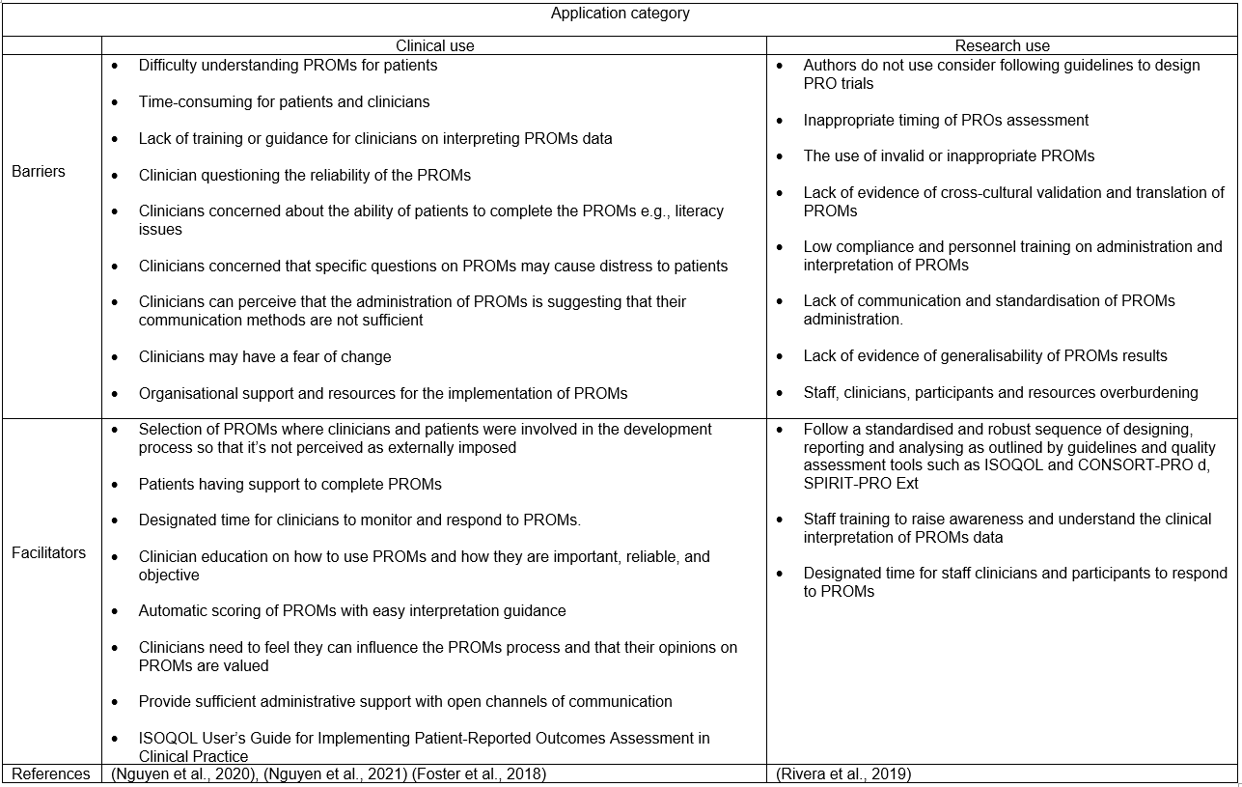

Administration of PROMs

An optimised selection and application of PROMs leads to more meaningful and relevant outcomes. As discussed in the previous sections, the selection of PROMs typically follows a systematic process of identifying the most relevant construct, selecting high-quality measures that are appropriate for the target population, and determining the scope and associated barriers and facilitators. The application process includes the administration of PROMs and the collection of generated data. General considerations for the administration of PROMs include maintaining a balance between patients and clinical staff as well as decision-maker preferences and burden of administration. In addition, the length of PROMs, the level of patient knowledge, the timing of administration and the reference period are potential confounding factors that need to be well-controlled (Snyder et al., 2012).

The application of PROMs requires practical decisions regarding the mode and method of administration to enable proper data collection. In the literature, the terms mode and method are used interchangeably. In this review, the term mode of administration refers to the approach of capturing PROM information (self-administration or interview), and method of administration is reserved for the input tools used to capture information (paper-based or electronic administration). An appropriate combination of the two aspects of administration is important to ensure that outcome reporting is feasible and unbiased. This section provides comprehensive details of the modes and methods of administration and their associated properties as described in the literature.

Mode of Administration

The concept of PROs is defined as the direct reporting of health-related issues by patients without clinical staff or anyone else interpreting their response (Food and Drug Administration, 2009). Patient reports can be captured through the patients themselves, by completing an appropriate PROM, or by another person in the form of an interview. The self-administered PROMs require either electronic or paper-based input mediums to facilitate completion. In general, self-administered PROMs are considered more cost-effective, least burdensome on staff, and safer for collecting sensitive information as patient anonymity is preserved, especially when submitted electronically (Gnambs and Kaspar, 2015). Based on the method of administration, the self-administered measures are favourable in terms of visual appearance and the accompanying features of design and layout, suitability for a large group of heterogeneous patients and the possibility of being treated at the patients’ convenience and pace (Dillman and Christian, 2005). However, this mode is unable to clarify ambiguous items or response options, lacks motivational factors, cannot assess patients’ literacy levels, and there is no certainty as to who completed the measure (Dillman and Christian, 2005; ISOQOL, 2015). Therefore, supervised completion of the self-administered PROM by trained staff may facilitate accurate and reliable reports.

The reliability and validity of the self-administration mode depend on its appropriateness for the target population. This mode is generally appropriate for the PROM target population, but may be burdensome for patients with low literacy, poor mental capacity, and physical disabilities (such as visual impairments or insufficient hand and finger dexterity) (Bowling, 2005). For such patients, the administration of PROMs by a trained interviewer is often more feasible.

The interview administration can be conducted face-to-face or remotely via auditory and visual media. The least burdensome interviewing method is likely to be face-to-face communication, where language is the only potential barrier and only basic verbal and listening skills are required (Bowling, 2005). Remote interviewing has the same characteristics as face-to-face interviewing, but requires possession of – or access to – equipment such as a telephone or computer and a good connection; also, some patients may not be computer literate. Administering PROMs by interviewing patients has both advantages and drawbacks compared to self-administration. Interviewing is more personalised, which may allow to get more detail, reassure reluctant patients, motivate them to complete particularly long measurements, clarify items and accommodate patients with literacy difficulties or physical impairment. However, the interview is more resource and time-consuming, offers no anonymity and risks pressurising participants to give socially desirable answers, increasing the risk of bias (Cella et al., 2015; ISOQOL, 2015 ).

In children and adolescents, the mode of PROMs administration is related to the cognitive ability to validly complete the measurements. There is no age limit that is universally appropriate for all PROMs to determine the appropriate mode of administration. Children aged three years and older are able to competently engage with self-administered HRQoL measures (Ravens-Sieberer and Bullinger, 1998;(Chaplin et al., 2008;(Lawford et al., 2001). Moreover, another study revealed that three-year-old children were reliable in self-reporting pain intensity (Chadha et al., 2013). Therefore, in the clinical setting, the mode of administration of PROMs for individual assessment of children under five should be based on the child’s ability and available assistance, while for population-level information gathering, face-to-face interview administration is the preferred mode, unless the applicability of self-administration is proven.

Children above the age of five years are reliably able to report their health status through age-appropriate PROMs (Gilchrist et al., 2018). The recommended mode of administration is usually specified by the developers of PROM, although a high degree of agreement and satisfactory psychometric properties between the modes of administration have been demonstrated in the oral health literature (Ramos-Jorge et al., 2012;(Rosel et al., 2010;(Tsakos et al., 2008). Careful interpretation of such evidence is required and the feasibility of either mode of administration should be limited to the measures tested. Selection of the mode of administration should be based on evidence where possible to avoid potential impact on the quality of the data. The impact of the modes of administration on data quality is discussed later in a separate subsection.

Method of Administration
The administration of PROMs requires a vehicle or medium type that facilitates the reporting and collection of relevant data. The two main methods available to deliver and obtain PROMs are paper or electronic versions. Many measures have been developed in a paper-based format. However, most are also suitable for conversion to an electronic format (Coons et al., 2009). The paper format method of administration is more compatible with self-completion mode and can be delivered in-person (such as in clinical settings) or remotely through the post. The cost-effectiveness and simplicity of the tools are the main advantages of paper administration. Other advantages include: a lower risk of completed questionnaires being lost if they are administered and collected in one setting, a lower risk of technical errors, applicability in any environment and the fact that only basic reading and writing skills are required to complete them (Mercieca-Bebber et al., 2018).

The literature mentions a number of drawbacks of paper-based administration, most of which relate to data entry and analysis. Data entry by pen is time-consuming for patients and prone to error due to the potential difficulties in reading handwriting for open-ended questions by administrators. Questionnaires completed remotely also increase the risk of missing data or questionnaires not being returned (Mercieca-Bebber et al., 2018). The analysis of paper-administrated PROMs is prone to human error and requires time to transfer data to analytic software programmes (Cella et al., 2015).

Electronic resources have created new opportunities and potential for PROMs. Technological adaptation has provided PROMs with alternative methods to traditional paper-based administration. Electronic PROMs (ePROMs) can be delivered to patients via telephone, touchscreen devices and web-based platforms. Telephone administration of PROMs is an audio interaction-based method that is applicable to both modes of administration, either through traditional voice interviewing or self-completion via interactive response to audio recordings of PROM questions by pressing the appropriate number (Coons et al., 2009). Touchscreen devices are increasingly being used to administer PROMs in clinic waiting areas. Some advanced touchscreen devices can display questions and option text in a larger font and are able to automatically read PROM questions aloud to facilitate data collection from patients with varying levels of language and computer literacy (Hahn et al., 2004). Web-based platforms require access to an electronic device with internet service for PROM administration. Web-based platforms allow patients to follow a web link to complete PROM questions at their convenience (Coons et al., 2009). The increasing availability of new mobile technologies with internet connectivity such as smartphones, tablets and laptops has made web-based platforms a promising method of PROM administration (Coons et al., 2009).

The modern method of electronically administering PROMs has both advantages and disadvantages compared to the traditional paper-based administration. One advantage is that, when completed remotely, ePROMs may minimise clinic flow and burden on staff (Cella et al., 2015). The risk of missing items can be controlled by programming the system to ensure full completion of all questions are completed and by sending an automatic reminder to those who have not completed the measure (Mercieca-Bebber et al., 2018). ePROMs can dramatically reduce the burden on patients by implementing the concept of skip logic, where irrelevant parts of the questionnaire can be skipped automatically (Mercieca-Bebber et al., 2018). Other advantages include faster completion, cost-effectiveness from a human resources perspective, greater environmental friendliness, constant availability and accessibility for patients in rural and international areas via multiple devices (Meirte et al., 2020). In addition, ePROMs may facilitate automated data collection for routine clinical use that can improve patient-clinician communication by generating automated screening (Andikyan et al., 2012). It may also reduce symptom burden and potential complications as a benefit of early detection of adverse events and instantaneous provision of actions (Wintner et al., 2015). The digital nature of ePROMs and the ability to generate a graphic summary of the outcome may allow better insight, self-management and more interactive discussion of patients’ health (Hochstenbach et al., 2016).

Nonetheless, the aforementioned advantages should not be considered without discussing several significant drawbacks. ePROMs are prone to be entirely overlooked by patients, especially if remotely delivered due to a higher chance of unintentional missing email or text reminders (Mercieca-Bebber et al., 2018). Compared to paper-based administration, ePROMs require a series of financially burdensome processes of infrastructure setup such as purchasing platforms and technological equipment, setting up databases, hiring programmers and performing regular maintenance (Meirte et al., 2020). Despite the interactive touch-screen devices and other methods to control traditional literacy, technological literacy is a well-recognised disadvantage in the literature, encompassing different aspects of navigation skills, internet availability, new media affinity and user experience (Cella et al., 2015). Other disadvantages include technical errors of connectivity and server issues (Mercieca-Bebber et al., 2018) as well as data privacy concerns (Hartkopf et al., 2017; Liu et al., 2016).

A few attempts have been made in the literature to conduct a multi-aspect comparative analysis between the two methods of PROM administration. Meirte and others (2020) systematically reviewed the evidence to provide a comprehensive comparison of PROM administration methods. The advantages and disadvantages of the different PROM administration methods were identified and described in 32 publications of moderate methodological quality. From the patients’ perspective, electronic administration was the preferred method; the importance of preference and positive satisfaction levels were associated with those of younger age, living in an urban district, having a higher level of education and better digital skills. A comparison of completion time was inconclusive; articles reporting longer completion time for ePROMs attributed this result to the longer log-on procedure. ePROMs were superior in terms of data completion, staff-related costs and overall costs when implemented in a large population. Studies analysing response rates came to contradictory conclusions. However, a positive correlation was found between the reminder message and the higher response rate of ePROMs. In child health literature ePROMs were found to be more preferred to the paper format due to their remote nature where children reported being less embarrassed to complete PROMs on the computer than with clinical staff (Scott et al., 2023).

Effects of mode and method of administration on data quality

Data quality refers to the degree of validity and reliability of a data set. For PROMs and other types of questionnaires, data quality is primarily influenced by the content of the measure and the modes and methods of data collection. Bowling (2005) proposed a categorisation of the effect of questionnaires’ mode and method of administration on data quality into measurement errors and non-measurement errors.

Measurement errors in the administration of PROMs refer to the factors influencing data quality that may arise from the administration process. Differences in social interactions between modes and methods of administration can lead to bias in the social environment. For example: in self-administration mode and paper-based methods, the order in which questions are answered cannot be controlled and interviews tend to have a high pace that may not allow patients adequate time to think, leading to inaccurate responses (Tourangeau et al., 2000).

There are other measurement errors inherent to the interview administration mode. Interviewer bias refers to the lower chance of patients sharing accurate personal beliefs and thoughts due to the presence of an interviewer (Bowling, 2005). Social desirability bias is another error related to the social interaction in interviews. Participants may over-report or under-report attitudes where their social acceptability are in question (Latkin et al., 2017). Interview administration of PROMs may increase participants’ tendency to express more agreement with the questions without actual reflection of their own thoughts. This form of error is termed acquiescence bias and its impact on the quality of PROMs data has been demonstrated in the literature (Cabitza et al., 2019). These errors could be minimised by the assurance of anonymity and confidentiality of the information, indirect questioning, and correlation of responses against clinical findings and medical facts.
PROMs and other patient-reported questionnaires depend on the patient’s ability to accurately recall experiences related to the outcome being assessed.
Interview-administration has less recall bias in data acquisition compared to self-administered questionnaires, where the interviewer can guide patients to more relevant information and may employ memory promoting techniques (Bowling, 2005). For example; younger children may recall better if the time frame is anchored to a specific event that they would remember such as the last clinical appointment (Matza et al., 2004). There is no standardised recall period for all PROMs, although patients' cognitive abilities and the outcome of interest are important factors in determining a suitable recall period for PROMs during their developmental process. For children, it has been suggested that the recall period be limited to 48 hours and 14 days for children under and over eight years of age, respectively (Coombes et al., 2021). Disclosure of sensitive information by patients can lead to measurement error if incorrect or incomplete sensitive information is shared due to a lack of a sense of security or a social desirability effect. Self-administration mode and the electronic administration method are the most preferred approach for disclosing sensitive information in adults and children due to greater anonymity and weak social interaction (Bowling, 2005; Coombes et al., 2021).

Non-measurement errors refer to the inherent characteristics of the modes and methods of administration that may influence the amount of data collected. Response rate is an important factor in determining the generalisability of the results of the measure. Low response rates can lead to a bias in the sample, resulting in unrepresentative and poor-quality data. Possible reasons for non-response include lack of interest in completing the questionnaires, inability to administer the PROMs (e.g. patients miss appointments, provide incorrect contact details, do not have an electronic device or internet access), language barriers (e.g. poor literacy, need an interpreter) and physical and sensory impairments (Bowling, 2005; Ho et al., 2019). Thus, the mode and method of PROM administration can influence the response rate. It is often reported that face-to-face interviewing has a higher response rate than self-administration, which can be explained by the greater control and motivation provided by the interviewer (Christensen et al., 2014). the electronic administration method appears to have a better long-term response rate than the paper-based method (Nguyen et al., 2022). Incorporating reminders into the administration of any type of questionnaire significantly increases the response rate (Hocking et al., 2006; Christensen et al., 2014). Another non-measurement error is the incomplete completion of PROMs due to missing one or more items. Item response rates are low for self-administered questionnaires compared to face-to-face interview-administration, where PROMs are more likely to be completed fully and correctly (Bowling, 2005). Other forms of interview administration, such as remote or automated telephone programmes, are good modes for gaining high item-response rates by reducing the chance of skipping items; however, premature termination cannot be prevented. Conflicting findings are reported regarding item response rates between the methods of administration. Mercieca-Bebber and co-workers (2018) conducted a systematic search for strategies to minimise the rate of missing PROM items related to administration procedures. The identified strategies and specific recommendations are summarised in Table 2.7.

Table ‎2.7 Strategies to minimise the rate of missing PROM data. Adapted from (Mercieca-Bebber et al., 2018)
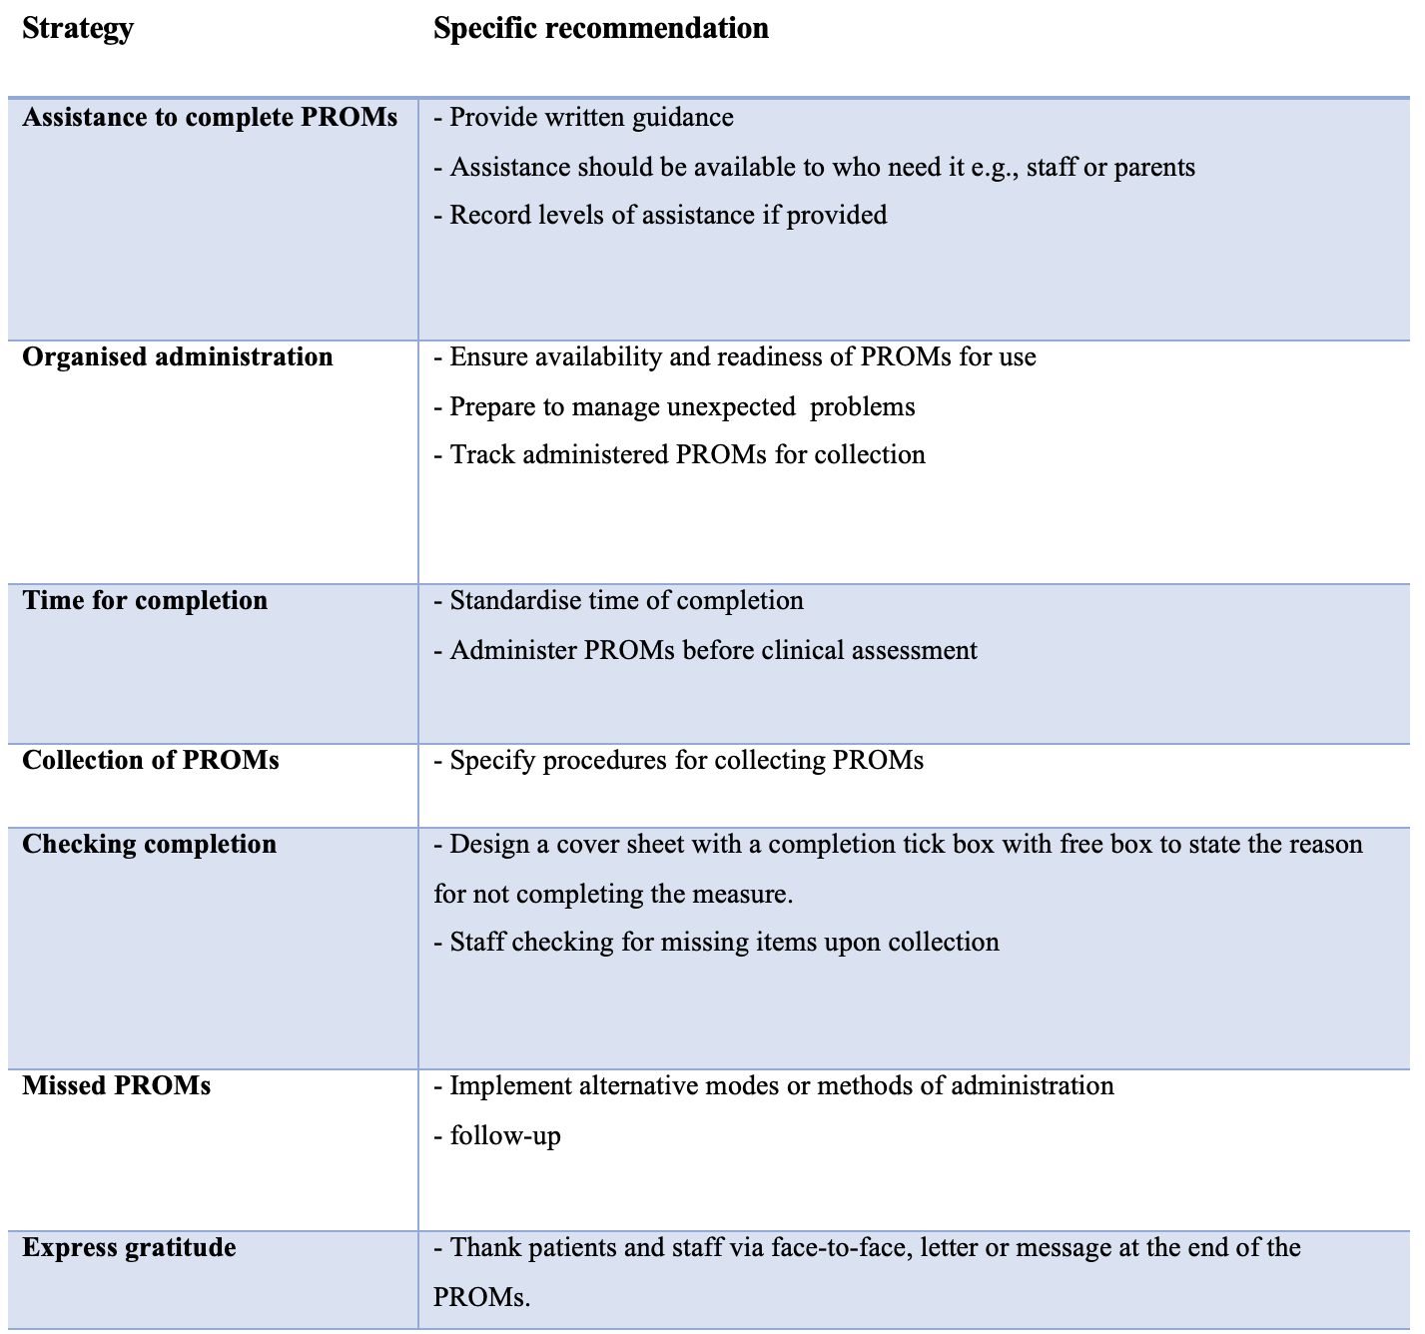

Children and ePROMs

Few studies in the field of children’s oral health have administered PROMs electronically. One study used a web-based platform to administer a child OHRQoL PROM with children with rare orofacial conditions in a mixed-method study (Friedlander et al., 2019). The Child Oral Impacts on Daily Performances (C-OIDP) measure, with free-response questions at the end to express feelings and impacts, was administered to children via an electronic website with secure access requiring a personal login and password. The research team recognised the beneficial addition of verbatim responses, which captured themes and issues that have not explored using the C-OIDP. Otherwise, they did not report any additional or related data for electronic administration of the C-OIDP.

In another study, a touchscreen device was used to collect ePROMs data on dental anxiety in children in New Zealand. Jones and Buchanan (2010) asked children aged 5–13 years to complete a computerised Smiley Faces Programme-Revised scale (SFP-R) to investigate measurement validity against the paper-based Modified Child Dental Anxiety Scale (MCDAS). The authors used a computerised game called ‘Dental Jungle’ to facilitate the electronic migration of the SFP-R questions. The resulting electronic migration included two versions (interactive and non-interactive formats) without any changes to the original measurement. The interactive version of the SFP-R included audio and visual instructions explaining how to use and navigate the system, as well as a large facial icon where facial expression was determined by clicking multiple times on the ‘happier’ and ‘sadder’ options. The authors concluded that the electronic SFP-R is valid and reliable for assessing dental anxiety in children. In general, the ePROMs were preferred to the paper format, and the interactive version was favoured by children aged eight years and older, while the non-interactive version was preferred by younger children. The main reason for favouring the interactive version was entertainment and 'more fun', while the preference for the non-interactive version was ambiguous as younger children could not identify any reason. However, the authors attributed younger children's preference for the non-interactive version to the fact that they are unable to develop a range of symbolic feelings due to their limited experience with interactive programmes. In addition, the authors failed to compare the completion time between the paper version and the electronic version and to identify the barriers to completion in the group of participants with missing data.

There is a paucity of literature on the telephone administration of oral health PROMs, whereas parental reporting through proxy-designed measures such as ECOHIS and P-CPQ has been the predominant method of reporting children’s oral health through the use of telephone interviews (Farsi et al., 2021; Gaynor and Thomson, 2012; Anderson et al., 2004). In some of these studies where a telephone PROM was conducted, proxy-designed OHRQoL results were unjustifiably used to capture the oral health of children who are competent and of an appropriate age to self-report. Such exclusion of children’s voices and the use of proxies may indicate that the researchers question children’s ability to report outcomes in telephone interviews. Further research is needed to clarify this point.

The electronic administration of PROMs is more frequent in other child health specialities such as rheumatology, orthopaedic, respiratory, speech problems and haematology, as well as specific somatic symptoms including pain (Scott et al., 2023). A considerable amount of child-specific data and barriers related to the use of ePROMs have been addressed and discussed in the child health literature. Children produced strongly correlated and comparable scores on different constructs of PROMs administered in both electronic and paper formats (Yu et al., 2021; Sabatino et al., 2019; Sun et al., 2015). The completion rate of ePROMs was reported to be around 87% in one study (Yu et al., 2021) and 83%, compared to 46% completion rate of the paper-based versions, in a study that investigated the compliance of children with juvenile idiopathic arthritis in daily reporting of pain intensity (Palermo et al., 2004). Children were reported to be faster in the completion of ePROMs (Yu et al., 2021; Sabatino et al., 2019) and to deliver fewer missing data (Palermo et al., 2004). Based on satisfaction surveys, a high proportion of children reported preference for electronic administration over paper format (Yu et al., 2021; Sabatino et al., 2019; Wood et al., 2011; Sun et al., 2015) and children’s preference for the electronic format was found to be higher when compared to adults (Bushnell et al., 2003). Reasons for children’s preference for ePROMs were explored and found to be related mainly to the simplicity of usage (Bushnell et al., 2003; Yu et al., 2021). Parents had positive opinions regarding ePROMs and stated that the electronic format is easier to use, more explanatory, and adequately reflected their children’s HRQoL (Haverman et al., 2013; Gupta et al., 2016).

There is evidence that ePROMs have been modified and new elements and features have been added to improve children’s experience of recording results. For example, Gupta and colleagues (2016) slightly modified the instructions of the SFP-R (e.g. from ‘shows very much pain’ to ‘worst pain possible’) to make it more appropriate for children with sickle cell disease. However, the change in wording led to confusion and inability to understand the new concepts, resulting in misreporting, particularly in young children. These findings highlight the importance of pre-testing the modifications in pilot studies and exploring children’s views through qualitative assessments. Sun and colleagues (2015) took advantage of electronic features and modified the SFP-R faces. They designed the faces to enlarge when the child’s finger was dragged across the screen to enhance the visualisation of the highlighted face. Unfortunately, this modification was not evaluated, although it may have influenced the increased preference for ePROMs over paper formats reported in this study. Children were able to suggest viable changes and modifications, such as increasing the size of the text and options buttons to make them easier to press (Yu et al., 2021), as well as adding more meaningful instructions to coloured pain scales (Gupta et al., 2016). Children stated in a satisfaction survey that they prefer web-based ePROMs compared to touchscreens to reduce time spent in the clinic (Sabatino et al., 2019).

Several studies have identified barriers to the use of ePROMs by children. As previously mentioned, minor language changes to a validated PROM can jeopardise the reliability of the outcome. Gupta and colleagues (2016) applied linguistic modifications to the FPS-R and found that younger children did not appear to understand the meaning of specific descriptive words such as ‘discomfort’ and some were unable to articulate the differences between worst and a lot when describing the severity of pain. Another barrier to reliable ePROM outcomes is parental guidance of children when completing the ePROMs. Especially with younger children, parents can provide good assistance by rephrasing the PROM items into simple and more understandable terms. However, parental assistance may also omit essential elements of the instructions and misinterpret some of the PROM items, which can lead to misreporting by the child (Gupta et al., 2016). Other barriers reported were related to electronic administration and included poor connections, damaged and missing parts, and malfunction of the devices used or power failure (Yu et al., 2021; Palermo et al., 2004).

Summary

There are a variety of PROM constructs available with different applications and methods of administration to assess health-related concepts. Selection of an appropriate PROM is critical to ensure accurate and meaningful outcomes. Based on the available evidence, a conclusion can be drawn regarding PROMs and the use of ePROMs in children. Overall, electronic administration of PROMs at the population level is more efficient and reliable in terms of data completion, disclosure of sensitive information, and response rate, especially when automatic reminders are incorporated. Children scores are strongly correlated and are comparable across different constructs of PROMs in both electronic and paper formats. ePROMs are favourable in terms of completion time, missing data and are preferred by children compared to the paper format. Several factors should be considered to ensure that ePROMs capture high quality data from children. These include ensuring anonymity and confidentiality of information, recall period should be limited and anchored to a specific event, and the addition of free-response questions to express issues and impact that have not been explored by PROMs.

The routine clinical use of ePROMs to assess children’s oral health has not been sufficiently explored. In order to make a valuable contribution to the literature, further gaps in the literature need to be identified and potential ethical and methodological issues considered before conducting the research.

Literature gaps for future research

The review of the literature on the impact of oral conditions in children and the available validated impact measuring methods in regard to their scope of measuring, properties and modes and methods of administration, have identified some areas of limitations and gaps that require further exploration which can be summarised as follows:

1) Most studies have explored the impact of oral health on children’s lives for research purposes, the merits of routine clinical assessment of children’s oral health via the application of appropriate PROMs have been recommended but not been sufficiently explored (NHS England, 2023).

2) The wide adoption of electronic technology in contemporary society provides an opportunity to assess children’s oral health impact in innovative ways. There is a need for future research to evaluate the electronic administration of oral health-related PROMs with children.

3) CARIES-QC is a child-centred caries-specific PROM. Based on preliminary data, CARIES-QC was appropriate for children aged three years and more and was applicable across other oral conditions (Graham et al., 2021). Further exploration is required of the potential applicability of the CARIES-QC measure to very young children and other oral conditions.

Aims and objectives

Rationale

Previous attempts to investigate the potential benefits of PROMs on the quality of patient care have been thoroughly explored in the literature review chapter (Chapter ‎2.4.2.4). In the field of children's oral health, national health guidance has recognised and recommended the routine use of PROMs in Paediatric Dentistry clinical practice (NHS England, 2023). Most contemporary studies have examined the impact of oral health on children's lives for research purposes, and the merits of routine clinical use of PROMs in Paediatric Dentistry have not been sufficiently explored. In addition, the widespread use of electronic technologies in contemporary society provides an opportunity to assess the impact on children's oral health in innovative ways (see literature gaps for future research in Chapter ‎2.5).

A pilot study was conducted in the Department of Paediatric Dentistry at Charles Clifford Dental Hospital (CCDH) to explore the potential feasibility and usefulness of the routine use of paper-based PROM (CARIES-QC). It was found that clinical staff valued the information provided by the PROM and felt that it assisted their treatment planning (Graham et al., 2021). Administrative staff suggested that using an electronic system to submit PROMs would reduce the administrative burden. An exploratory study with a larger sample size was required to ascertain the outcomes of the pilot study and to explore further areas regarding the feasibility of routine clinical use of PROMs. The preliminary results of the pilot study were incorporated into the design and conduct of this study to ensure high quality in resemblance to real-world situations.

Research question
This thesis was designed to explore and address the research question of how feasible and clinically useful the routine use of ePROMs in Paediatric Dentistry clinical practice is and to identify associated facilitators and barriers.

Aim and objectives

The aim of this thesis was to explore the feasibility and utility of self-administered electronic PROMs in routine clinical practice in paediatric dentistry.

The specific objectives to fulfil the aim were to:

- develop ePROMs system and assess the technical performance and reliability of the underpinning informatics,

- compare psychometric properties of the electronic format of the selected PROMs to their original method of administration,

- identify the facilitators and barriers and elicit valuable insights into the design, structure, implementation, and delivery method of the ePROMs and utility in Paediatric Dentistry routine clinical practice,

- assess the quantitative data generated from the ePROMs system with regards to participants’ demographic and clinical characteristics, response rate, and whether assistance was provided, and

- assess the reliability and validity of the electronic version of the CARIES-QC when used with children aged three years and older with different oral conditions.

Conducting research with children requires consideration of potential issues that may be methodological, ethical and sociological. There are further considerations related to assessing the comparability of the converted electronic format with the original paper-based PROM. These will be described in the next chapter.

Methodological consideration
_______________________________________

Research with children

In recent decades, the position of children in society has changed considerably. Children’s views have gradually been recognised, as they have been valued as persons with rights. In 1989, the recognition of children as persons with rights was implemented in political legislation upon the foundation of the United Nations Convention on the Rights of the Child (UNCRC). According to Article 12 of the UNCRC, children have the right to be heard when decisions are made that affect their lives (UN General Assembly, 1989). In 2004, the UK Children Act urged health, education and social care organisations to take account of children's views as well as what is best for them (Children Act, 2004). The notion of children’s rights has been reflected in the National Service Framework 'Quality Standards for National Health and Social Care Services' (NSF). The NSF clearly advocated for children’s rights in healthcare by encouraging empowerment, shared decision-making and greater participation in the planning of healthcare services (Department of Health, 2004). Recently, the British Society of Paediatric Dentistry (BSPD) issued a statement in which it advocates for the right of children to raise their voices and be heard in research and clinical practices (Harris, 2023). The aforementioned legislation on children’s rights and wishes applies to all healthcare services for children, including health-related research.

The acknowledgement of children’s rights in research is reflective of respecting the autonomy of the child. Legally, children are not in a position to give informed consent to participate in research. However, children have the right to be informed with information appropriate to their linguistic and cognitive abilities and therefore the researcher acts on their ‘assent’ or ‘dissent’ to participate (Waligora et al., 2014). Further considerations related to consent and assent are discussed later in Section ‎4.2.1.

The participatory approach in child health research has shifted from viewing children as "objects" to "participants", and research "with" children has become common practice (Larsson et al., 2018). Emphasising the involvement of children in the co-creation of new knowledge has increased the likelihood of developing more meaningful and effective assessment and implementation of knowledge into appropriate practice. Children are recognised as experts with the ability to share unique experiences and knowledge that are unlikely to be explored without active participation (Attaran et al., 2024). Involvement of children in research is a unique process related to a specific methodological approach, and it is often feasible when children are invited to participate in an age-appropriate way. Consideration of children’s age-related abilities and the potential challenges that may arise when conducting research with children would ensure more robust and meaningful participation (Attaran et al., 2024). The following subsections will explore relevant methodological procedures involving children in this project.

Completion of ePROMs by children

It is only in the last three decades that researchers have begun to investigate children’s views directly using questionnaires, rather than relying on qualitative data or proxy reports (Scott, 1997). Despite the genuine concerns about the quality of the data, the researchers were able to collect valid and reliable data directly from the children using written questionnaires. In addition, several factors were identified that were associated with the ability to obtain high-quality responses from children (Bell, 2007). The factors are mainly related to the design of the questionnaire, which is based on the children’s cognitive abilities.

The question-answer model of investigation is based on four key cognitive stages in which participants would produce a valid response to a questionnaire (Schwarz, 1996). Firstly, the participant's understanding of the question involves understanding the content and the task required to answer the question. Second, retrieving information from memory that is relevant to the scope of the question. Thirdly, the participant decides which information should be passed on as an answer. And finally, the participant documents their answer on the questionnaire. Missing one or more stages would impact the quality of the questionnaire data. The term satisficing strategy means participants are not following the robust cognitive stages described in the question-answer model when completing the questionnaire, e.g., the random selection of options or the selection of only positive answers. The occurrence of the satisficing strategy can be attributed to the interaction of factors related to the question design and the participants themselves. Participant-related factors may include feelings of boredom and lack of interest (Bell, 2007). Furthermore, human nature tends to avoid unnecessary cognitive effort by providing answers with the least demanding method (Krosnick and Alwin, 1987). Limited cognitive abilities in children are also a factor that would increase the likelihood of the satisficing strategy.

Bell (2007) proposed evidence-based practical advice for the design of child-specific questionnaires based on the question-answer model and satisficing theory. The advice focuses on the general principles of questionnaire content and design that can serve as standard components of child-specific questionnaires. A summary of the practical advice and the relevant cognitive abilities of children can be found in Table ‎4.1. The aforementioned question-answer model and advice on designing a questionnaire apply to both paper-based and electronic methods of PROM administration. However, with electronic administration, there are specific challenges in terms of access and devices, electronic literacy, and electronic features that need to be considered.

Electronic technology has become embedded in children’s daily lives. Children are frequent users of technology for a variety of formal and informal educational, entertainment and communication activities. More than 96% of households in the UK have internet access, and among households with children, the estimated proportion is 100% (ONS, 2020). Children today have a high level of digital literacy and can intuitively control and operate electronic devices and online platforms. In 2020, in the UK, the proportion of children aged 5–15 years and 3–4 years who accessed online media via various electronic devices was 97% and 82%, respectively. The average ownership of electronic devices among 5–15 year olds was 61% for tablets and 56% for mobile phones (Ofcom, 2021). Arguably, the reported data has been intensified by the nationwide lockdown and social restrictions associated with the pandemic spread of the coronavirus, which has necessitated a shift to remote learning and working, as well as an increasing reliance on digital forms of entertainment. Nevertheless, the aforementioned data shows that children are very accepting and comfortable with electronic technologies and devices, which favours the feasibility of using ePROMs with children.

The literature describes previous attempts to use ePROMs that have addressed some of the considerations and limitations associated with ePROMs and children. General considerations were discussed by Meirte et al. (2020) , who proposed several recommendations for the design and implementation of ePROMs based on a systematic review of relevant articles. In general, ePROMs must be simple, free of charge, as short as possible and should provide positive reinforcement to the patient. The design should be clear, provide a good user experience and use a readable font size with an age-appropriate user interface. It is strongly recommended that staff training is provided prior to implementation to ensure there is sufficient patient support. Regular review of results is crucial to identify errors and maximise benefits.

Specific considerations on ePROMs for children can be derived from the child-related literature. The addition of a free-box question at the end of the questionnaire to capture verbatim responses has proved beneficial in identifying impact that may not be covered by the ePROMs (Friedlander et al., 2019). The interactive completion of ePROMs through the development of an interactive version can lead to children collecting valid and reliable data. However, very young children may have difficulty understanding the interactive process and therefore the quality of the data is questionable (Jones and Buchanan, 2010). The use of words that have close and similar descriptive meanings, such as ‘a lot’ and ‘worst’ together may create confusion for younger children (Gupta et al., 2016). Parental assistance in completing ePROMs, especially for young children, may be unavoidable in certain situations. However, parents may omit essential components of the ePROM questions, leading to misinterpretation and inaccurate information from children (Gupta et al., 2016).
In summary, the consideration of children’s cognitive and linguistic skills during the development of a new ePROM or electronically adapting an existing validated PROM would ensure the feasibility of electronic administration and the collection of high-quality data. After considering children’s abilities, pretesting the design and content of ePROMs for children is essential.

Table ‎4.1 Practical advice in designing child-specific questionnaires. Adapted from
(Bell, 2007).
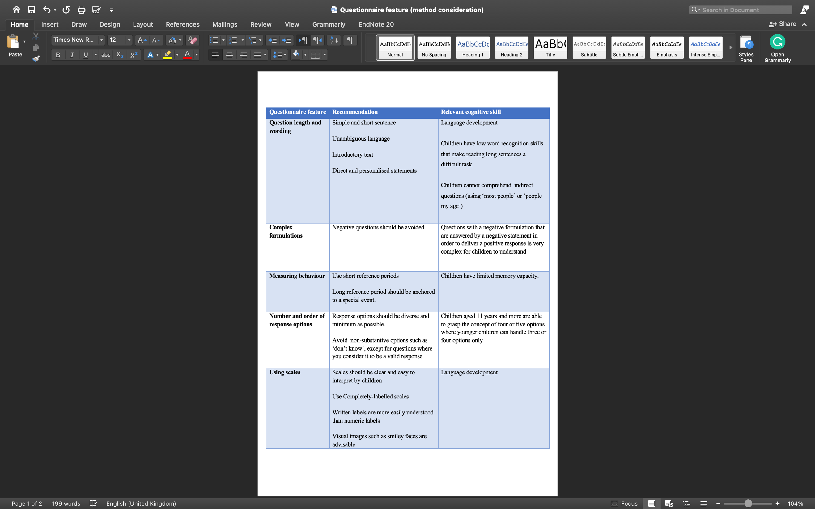

Interviews with children

The participation of children in interviews and focus groups is a valid method to collect explicit information by actively involving them to express their views. The interview is a data collection method to obtain qualitative data and explore children’s thoughts, opinions, feelings and experiences. In the health-related literature, interviews and other qualitative data collection methods are typically used to broaden and deepen the understanding of data obtained from quantitative analyses such as questionnaires (Tenny et al., 2021). Conducting interviews with children involves challenges that should be considered in order to collect valid and reliable data.

The United Nations International Children's Emergency Fund (UNICEF) has developed guidelines for interviewing children and young people (UNICEF, 2010). The guideline was primarily developed to support journalists in reporting on issues affecting children. Nevertheless, the principles of the guidelines serve as a cornerstone when conducting interviews with children in any manner. The UNICEF guidelines advocate for the dignity and rights of children by avoiding negative attitudes such as judgemental comments, discrimination, exposing a child to humiliation and any other form of action that could directly or indirectly harm the child. In general, researchers working with children's health must consider the application of the principles outlined in the UNICEF report when conducting interviews with children.

Conducting qualitative interviews with children, some similar principles apply as when conducting interviews with adults, e.g. using understandable and clear questions, building rapport, using relevant and appropriate terms and being an attentive listener (Arksey and Knight, 1999). There are additional methodological challenges that need to be considered when interviewing children. One of these is the adults’ power that inherently have in their relationships with children (Clark, 2010). Children may view questions during an interview conducted by an adult researcher as ‘test questions’ asked to assess their knowledge rather than to seek their opinion (Naughton et al., 2001). In addition, children may feel obligated to respond to a question in order to please the adult interviewer even if they do not have a valid opinion (Naughton et al., 2001). Informing children that they can reply with 'I don't know' if they are not sure can reduce the sense of obligation to respond and the quality of the data will not be affected by speculative answers (Gill et al., 2008). The creation of a child-friendly environment and encouraging children to express their opinions more freely can control the influential effect of power–submission relationships (Sahimi and Said, 2012). In addition, positively reinforcing children to respond more confidently by frequently affirming their views through verbal and non-verbal interaction, such as a nod of the head while expressing their feelings, can equalise the power relationship between the child and the interviewer (Moir and Kwansa 2000).

Another challenge when conducting interviews with children is fluency and comprehension. Interviewers need to be mindful of limited language skills, especially with preschoolers. The American Speech Language Hearing Association (ASHA) proposed speech and language milestones for children aged five and under that can help the interviewer to conduct reliable age-appropriate interviews (Table ‎4.2). In addition, the interviewer must take into account that the pragmatics of social communication in preschool children are limited and that they cannot always respond to every question asked (Moir and Kwansa 2000). Displaying objects or colour photographs related to the topic of interest can help to elicit valid responses from children between three and five years of old (Meyer, 1992). Interviewing children under the age of three may not be feasible as they do not seem to comprehend the symbolic representation of an object (DeLoache and Marzolf, 1995). School-age children have rapidly developing cognitive and verbal communication skills where they are expected to describe themselves in concrete terms, such as their physical appearance, and distinguish between emotional experiences of happiness and sadness (Moir and Kwansa, 2000).

Table ‎4.2 Speech and language milestones for children from two to five-year-olds. Adapted from The American Speech-Language-Hearing Association (ASHA)
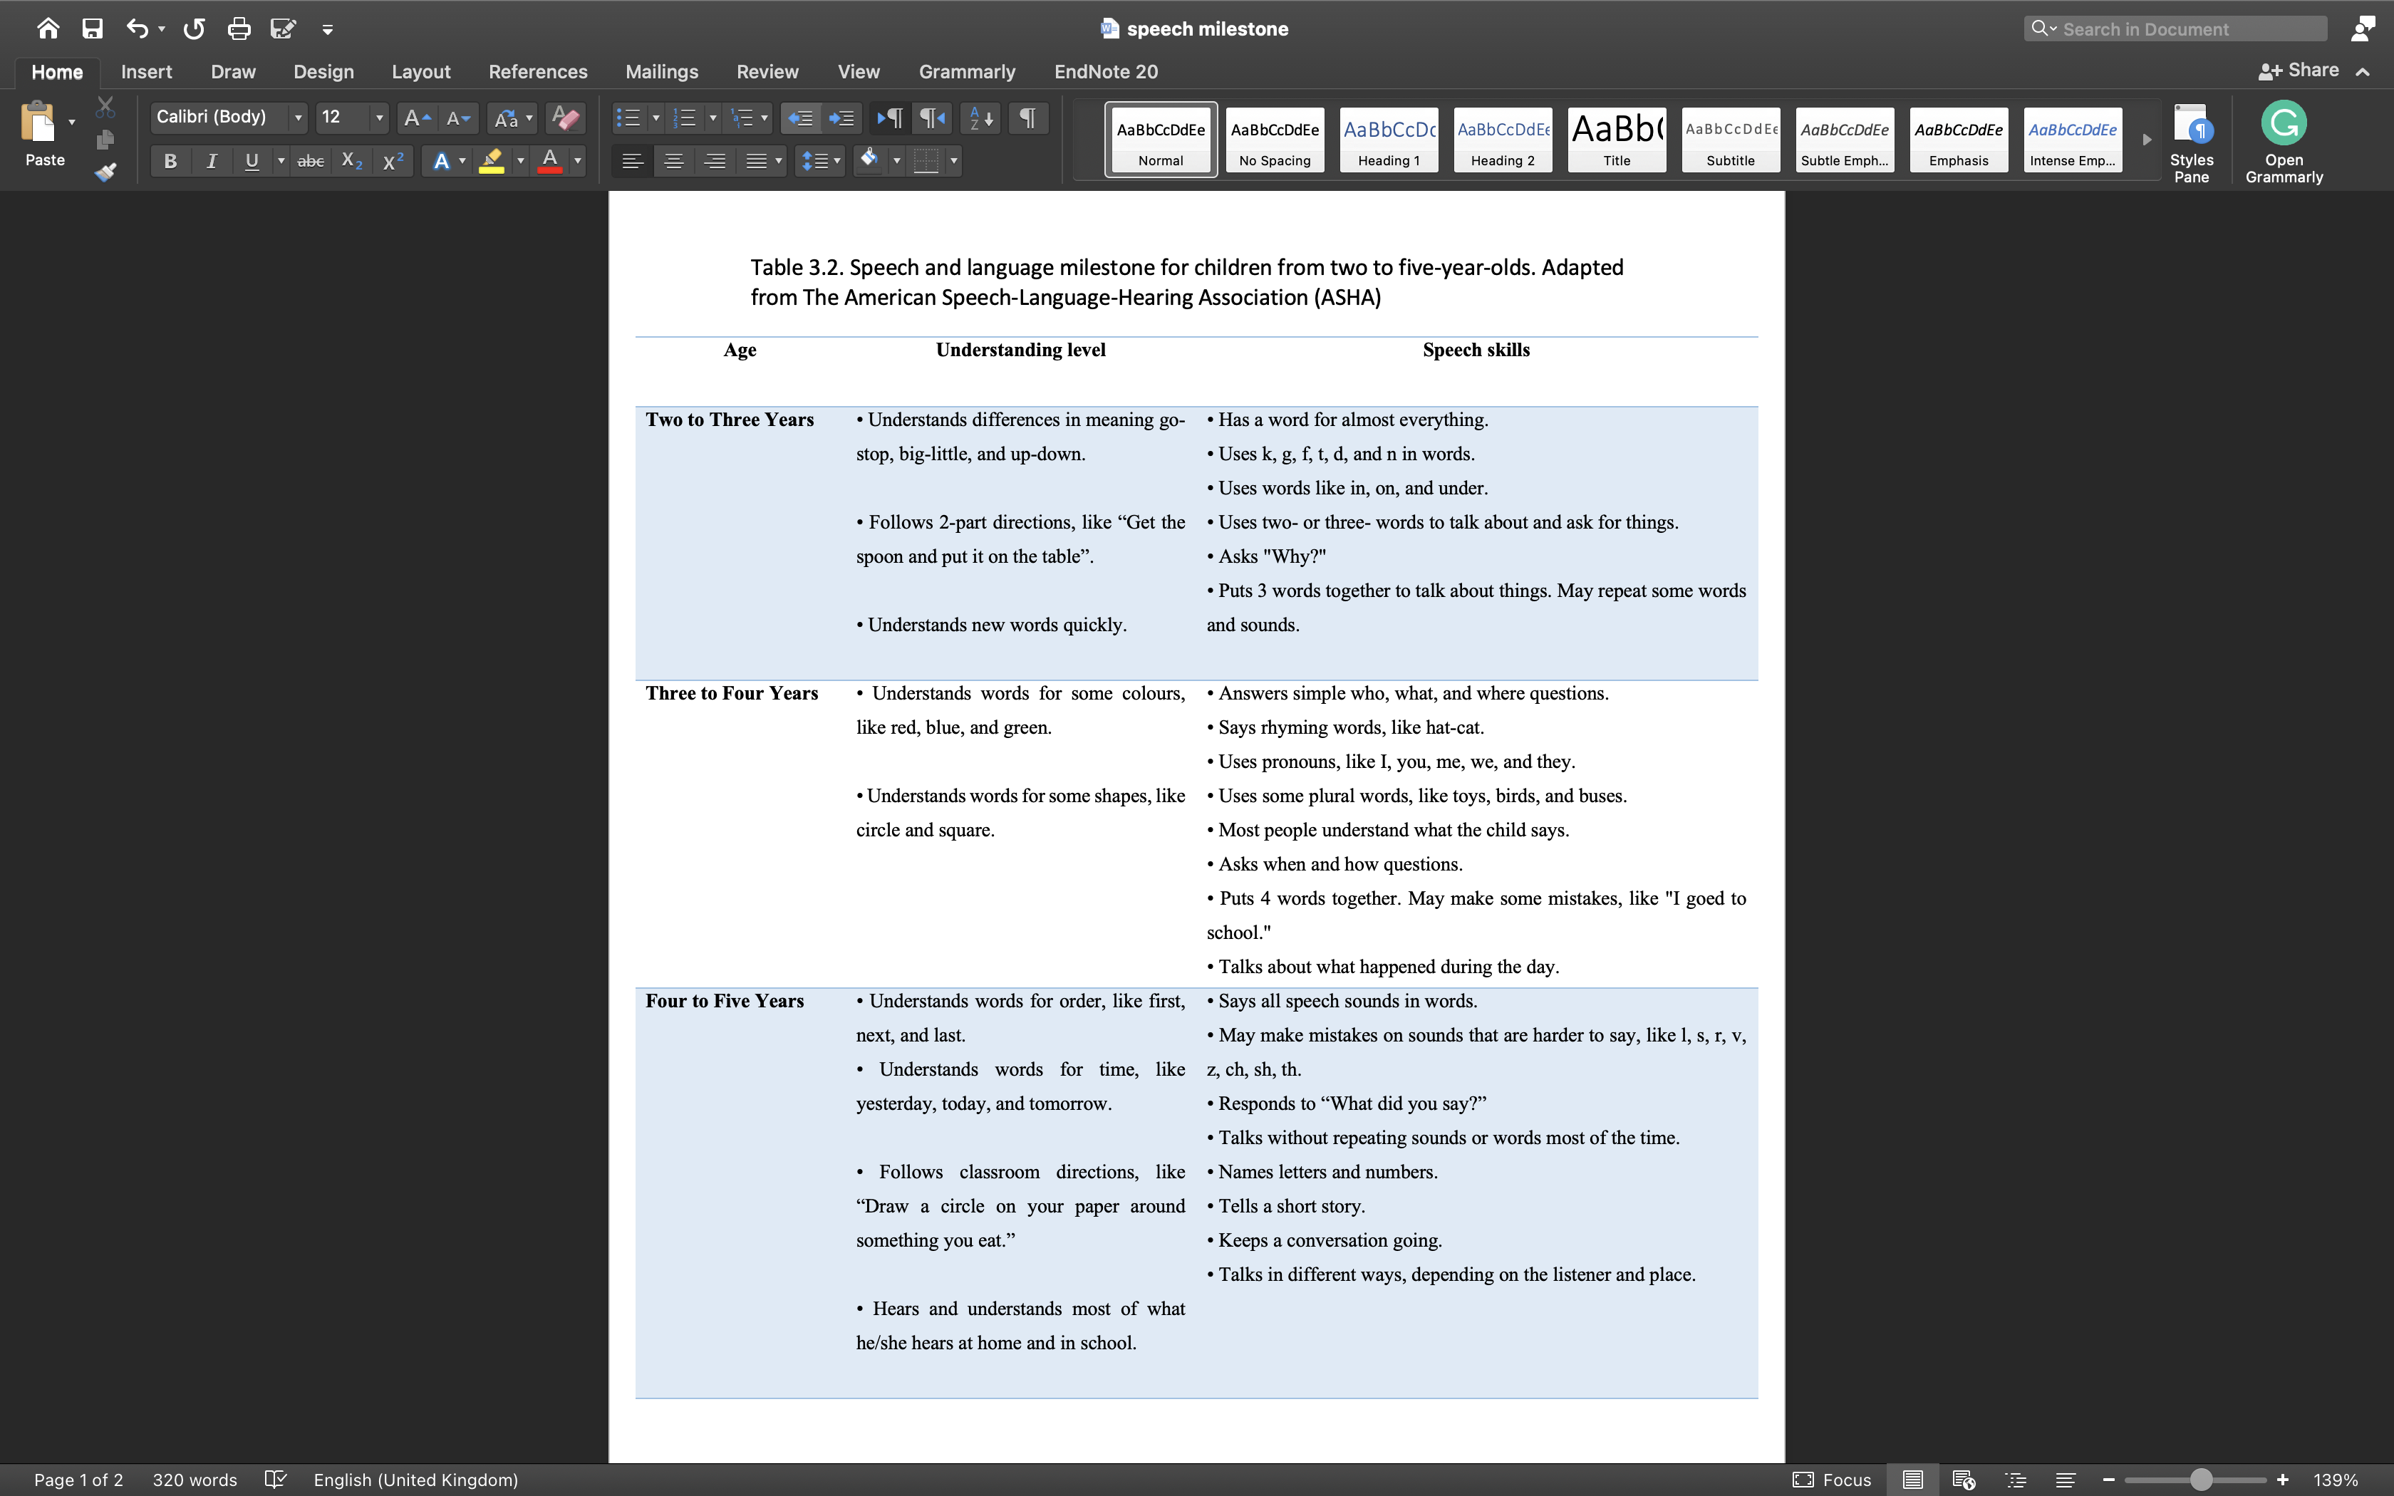

Ethical consideration

There are some ethical issues to consider when conducting research with children, which may relate to obtaining proper consent and assent, as well as data protection and confidentiality. The potential ethical issues are not specific to research with children, but aspects relating to children and electronic methods should be considered before conducting the research.

Informed consent and assent

Informed consent is one of the core principles of research ethics and basic human rights (Menon, 2000). Obtaining valid informed consent from research participants is a compulsory ethical and legal requirement (Rao, 2008). Children are not considered to be sufficiently mature or cognitive to provide informed consent to participate in research projects. Therefore, parents/carers are usually used as legal proxies to obtain consent for their child. The concept of assent is defined as "agreement obtained from those who are not able to enter into a legal contract", which involves more than passive assent by the child (Alderson and Morrow, 2004). Child assent must contain almost the same elements as the consent of adults: the ability to understand and make a decision, disclosure of information, voluntary participation and approval of a plan (Kirk, 2007). In addition, the content of the children’s assent should be framed in an age-appropriate format to facilitate their understanding of the research objective and what is expected of them as participants (Dockett and Perry, 2011).

The Royal College of Paediatrics, Child Health: Ethics Advisory Committee has published a guideline for the ethical conduct of medical research involving children (Paediatrics Royal College, 2000). The guideline covered the aforementioned aspects of children's assent and provided further recommendations for researchers on how to obtain valid consent and assent. Recommendations include: not putting pressure on families, giving families more time to consider participation, informing families of the option to decline or withdraw participation at any time, and reassuring families that withdrawing from research will not affect the child's treatment.

The use of the electronic method to obtain consent and assent encompasses further considerations. The Medicines and Healthcare products Regulatory Agency (MHRA and NHS) and NHS have issued a joint statement to set out the legal and ethical requirements for obtaining electronic consent (eConsent) (MHRA and NHS, 2018). The main focus of the joint statement was on clinical trials of investigational medicinal products, although the basic concepts are applicable to all research conducted using electronic methods. The statement emphasises that all researchers using eConsent must date the signature either manually or by the participant or automatically by the eConsent system, and that the consent format must verify what information the electronic signature refers to. For studies with negligible or minimal risk, such as surveys or non-sensitive qualitative research, the joint statement recommends that a simple electronic signature is usually sufficient. The format of consent and assent should be designed to best suit the nature of the information and support its understanding.

Privacy and confidentiality

When conducting research with children, confidentiality cannot be absolutely maintained as there may be conflicts with child protection protocols. Children may disclose issues that raise concerns where a researcher may consider breaching the child’s privacy and the confidentiality of the information shared in order to protect the child from harm. The literature lacks an explicit description of the circumstances in which researchers are obliged to breach the confidentiality of participants (Matthew et al., 2019). This can be explained by the different definitions of confidentiality and privacy in the various health services. Nevertheless, researchers must prioritise the best interests of the child. Researchers can make children and their families aware of the limits of privacy and confidentiality before the study is conducted in order to create an expectation of the type of information that can be shared (Davis, 1998).

The welfare and safety of children should be protected at all times. Strategies to ensure that children are protected from harm should be planned and put in place before a research project is undertaken.

Electronic conversion of paper-based PROMs

Most PROMs were originally developed and validated using the paper-based delivery method. Conversion to electronic formats may require modifications that may affect the original psychometric properties. Therefore, adapted ePROMs should be modified as little as possible to ensure that their validity and reliability are still comparable to those of the original PROMs. This comparability can be assessed using measurement comparability. This is the process of measuring the comparability of psychometric properties using the data generated by the original and adapted administration methods (O’Donohoe et al., 2023). Based on the level of modification during electronic conversion, the International Society for Pharmacoeconomics and Outcomes Research (ISPOR) taskforce has proposed recommendations on the types of evidence required to assess the comparability of measurements between the original and adapted methods of administration.

Measurement comparability

Measurement comparability is ‘a function of the comparability of the psychometric properties of the data obtained via the original and adapted administration mode’ (Coons et al., 2009). The US Food and Drug Administration (FDA) defined measurement comparability as ‘the extent of additional validation recommended depends on the type of modification made’. Both definitions highlight that measurement comparability is driven by the amount of modification that occurred during the conversion process.

The ISPOR taskforce has categorised the amount of modification that may occur during conversion into minor, moderate and substantial (O’Donohoe et al., 2023). The minor to moderate changes proposed in the recommendations do not require compatibility testing if there is sufficient evidence in the literature to support the assumption of compatibility (O’Donohoe et al., 2023). The lack of evidence for compatibility necessitates additional investigation. ISPOR taskforce has proposed four types of evidence to establish comparability, the requirement for which correlates with the modification level. Further details on the evidence required for comparability are discussed in the following subsection. A summary of the modification types with examples and the level of evidence required can be found in Table ‎4.3.

Table ‎4.3 ISPOR taskforce recommendations on measurement comparability from PROM to ePROM. Adapted from (Coons et al., 2009) and (Shields et al., 2006).
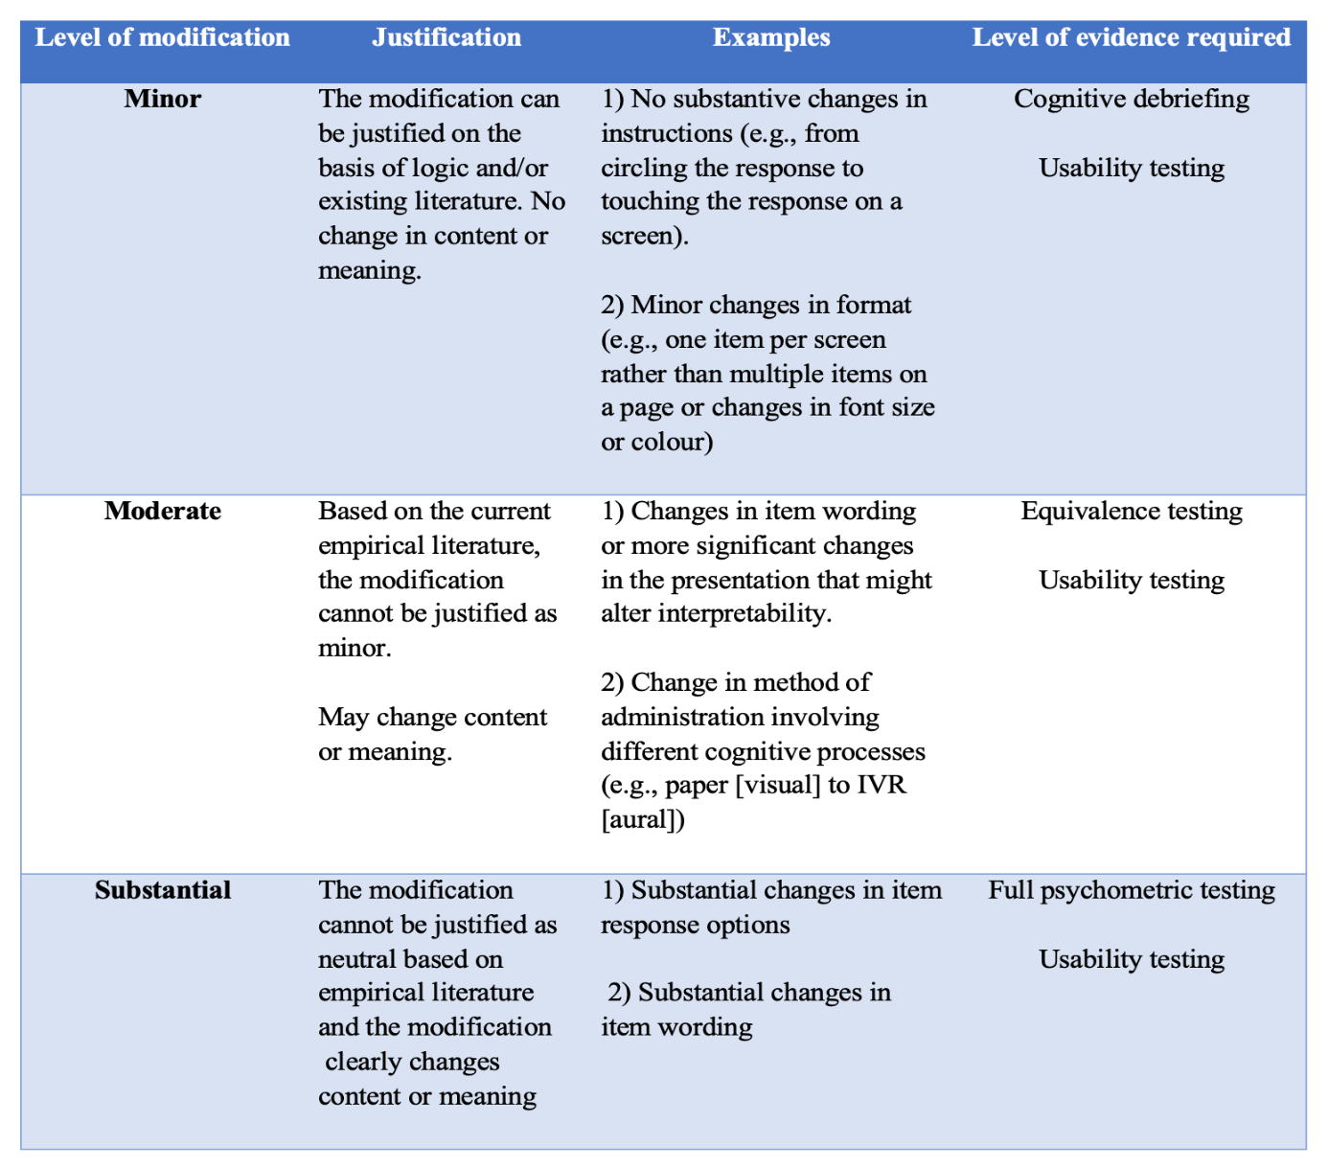

Level of evidence for measurement comparability

The level of evidence proposed by ISPOR taskforce required to assess the comparability of the ePROMs with the paper-based format includes cognitive debriefing, usability testing, comparability testing and a full psychometric evaluation. The indication of each type of evidence is based on the amount of change during the conversion process.
Cognitive debriefing is also known as cognitive testing or interviewing which is a method for assessing the cognitive process underlying participants' understanding of the concept and items of questionnaires and the generation of a response to a questionnaire by interviewing representatives of the target population (Willis et al., 2004). Cognitive debriefing has been increasingly used in the development and evaluation of questionnaires (Willis, 2005). In addition, cognitive debriefing can be used with an existing validated measure to evaluate the alternative modes and methods of administration. The process of cognitive debriefing mainly involves verbal probing techniques and the think-aloud method. The verbal probing technique is usually conducted after the questionnaire has been completed, with the interviewer probing for the types of challenges that participants may have experienced when completing the questionnaire (Willis, 2005). Information from verbal probing techniques determines the clarity of the meaning of the items, the response options and general comments on the complexity and appropriateness of the questionnaire (Schwarz, 1996). The think-aloud method is usually conducted while the participant is completing the questionnaire. The interviewer encourages the participants to verbalise their thoughts as they complete the questionnaire (Willis, 2005). The think-aloud method is advantageous as it eliminates interviewer bias and does not require an interviewer with a high level of skills (Davison et al., 1997). In the context of assessing ePROMs, cognitive debriefing can be used to determine whether the new format changes participants’ interpretation of the question, decides on an option, and whether there were any issues or confusion (Coons et al., 2009). ISPOR taskforce recommended the use of cognitive debriefing with 5 to 10 participants when the conversion of PROMs resulted in minor modifications only (Coons et al., 2009). In addition, ISPOR taskforce emphasised that the number of patients required to conduct a cognitive debriefing should adequately reflect the target population of the study.

Usability testing is the evaluation of a sample of participants from the target population on their ability to use the electronic device and platform. The usability testing procedure must be based on the physical and cognitive abilities required to properly complete the ePROM (Coons et al., 2009). The process consists of formal documentation of participants' ability to access the platform, navigate the system correctly, follow instructions and respond to questions. ISPOR taskforce recommends a sample of 5 to 10 patients for ePROM with a simple electronic system and a sample of 20 or more for a complex system that requires more physical and cognitive effort (Coons et al., 2009). The lack of explicit criteria to define simple and complex systems may lead to biased and subjective judgement by the ePROM developers, especially if the target participants have different levels of cognitive ability, such as children.

Comparability testing is the method of assessing the comparability of scores between the paper-based PROM and adapted ePROM (Coons et al., 2009). It is recommended when migration of PROMs to electronic formats has led to moderate changes. Comparability of ePROM scores should not differ significantly from paper format scores. ISPOR taskforce recommends testing comparability by conducting a study with balanced confounders in a randomised parallel group design or a randomised crossover design (Coons et al., 2009).

Full psychometric evaluation is recommended when there has been a substantial change in the conversion from a paper-based PROM to an electronic format. The argument that forms the basis for the ISPOR taskforce recommendation of a full psychometric evaluation is to consider a substantially changed PROM as a completely new measure where comparative testing is not applicable. The minimum level of evidence to achieve a sufficient psychometric evaluation of a new PROM is to conduct a study with quantitative and qualitative components to determine content validity, construct validity, test–retest reliability and internal consistency of measurement (Frost et al., 2007).

Limitations of the ISPOR taskforce recommendations

The ISPOR taskforce members were able to establish an evidence-based framework to determine the extent of modification that may occur in the electronic conversion of paper-based PROMs and the level of evidence required to establish comparability. However, a few contingencies were not considered within the recommendation report. Firstly, the report does not include considerations for special populations such as children or those with disabilities. This could be due to the paucity of evidence for such populations for which a recommendation cannot be confidently drawn. Researchers may rely on techniques and sample sizes outlined by paper-based PROM that match the population of interest, particularly for usability testing and cognitive debriefing. Second, the report failed to outline the limits of the level of modifications in relation to the different ePROM devices. Screen size and technical features differ between electronic devices, which may affect font size and handling. However, the recommendation report emphasises the need for usability testing even with a simple migration, which may well control the different electronic characteristics of the various devices. Therefore, the practical outcomes derived from population-appropriate methods of cognitive debriefing and usability testing can determine the comparability of ePROMs with the paper format and the appropriateness of the electronic platform for the target patient population.

Electronic Personal Assessment Questionnaire-Paediatric Dentistry (ePAQ-PD)
________________________________________
This chapter focuses on the development process of an electronic system designed to capture child oral health PROMs data. This chapter details of preparatory stages of technical testing of the ePROMs system.

Development of electronic Personal Assessment Questionnaire- Paediatric Dentistry (ePAQ-PD)

electronic Personal Assessment Questionnaire (ePAQ®)

ePAQ® (ePAQ, Sheffield, UK; epaq.co.uk) is a validated web-based clinical assessment system that was developed and designed for use in routine clinical care to capture detailed and reliable data of validated PROM through an interactive and secure web page. The server of ePAQ® is hosted and integrated with NHS N3-based informatics systems. It was developed at the Sheffield Teaching Hospitals NHS Foundation Trust as a gynaecological clinical assessment tool (Radley et al., 2006). Since its inception, several studies have incorporated a variety of PROMs in gynaecology (Jha et al., 2009; Elenskaia et al., 2013) and pre-anaesthetic assessment (Goodhart et al., 2017; Taylor et al., 2018). The ePAQ® system received further recognition by the National Institute for Clinical Excellence (NICE, 2015) and the British Society of Urogynaecology (BSUG, 2015) as a valid, reliable and valuable electronic tool to administer PROMs.

The ePAQ® is accessible from any networked device of smartphone, tablet or computer within and external to healthcare settings. Patients can securely access the ePAQ® system at their convenience through a unique voucher code that can be delivered to patients through email/letter. Vouchers allow the patient to log on, utilising their unique voucher code and date of birth (Figure 5.1). ePAQ® supports the use of illustrative images, reminder service and skip logic rule where irrelevant or inapplicable questions can be automatically skipped to reduce the burden on patients. Patient responses are compiled into comprehensive reports showing descriptive or numerical summary and in-depth report of the PROMs scores and any additional questions.


Figure ‎5.1 ePAQ log-in screen

Patient-reported outcome measures

Poor oral health impacts children’s physical and phycological wellbeing. As previously discussed in Chapter ‎2.3, dental caries is the most prevalent oral condition and dental anxiety can have an impact on attendance and ability to treat oral conditions (WHO, 2022; CDH, 2013). The selection of valid and reliable PROMs specifically designed to capture the impact of these conditions would allow a comprehensive overview on children’s oral health status with the least possible burden on them. The following are the condition-specific PROMs selected for this research project:

Caries Impacts and Experiences Questionnaire for Children (CARIES-QC)
CARIES-QC is a caries-specific measure that evaluates the severity of dental caries-related impact on children as discussed in Section ‎2.4.1 (Gilchrist et al., 2018). The CARIES-QC was developed with children and utilises language and a response format chosen by children. The measure has been validated for use in children aged 5-16 years (Gilchrist et al., 2018). More recently it has been used in a pilot study with participants aged 3 years and older and was found to be reliable in this small population, although further psychometric analysis in a larger sample is required (Graham et al., 2021). CARIES-QC consists of 12 items and one global question with a three‐point severity-based Likert scoring system, ranging from 0 (not at all), 1 (a bit), and 2 (a lot). The total raw scores of the 12 items range from 0 to 24, where higher scores indicate higher impact. The global question (‘How much of a problem are your teeth for you?’) is scored in the same way.

During the development of CARIES-QC, the wording of the items was guided by the language of the youngest children (5-year-olds) to ensure likely comprehension by all children. In addition, items that capture oral impacts relevant to caries may be relevant to children with other oral conditions. A pilot study found that the paper-based administration of the CARIES-QC in routine clinical care was feasible and had good reliability and validity in children between 3-15 years old with a range of oral conditions (Graham et al., 2021). One of this project’s objectives is to ascertain the feasibility and applicability of the CARIES-QC through electronic administration in a larger population.

Children's Experiences of Dental Anxiety Measure (CEDAM-8)

The CEDAM-8 is a child-reported dental anxiety measure designed for children aged between nine and 16 years (Porritt et al., 2021). It is a short form of a previously developed longer version to promote the incorporation of the measure into routine use in clinical practice (Porritt et al., 2018). CEDAM-8 was developed based on the five areas of the Cognitive Behavioural Therapy (CBT) model by Williams and Garland (2002). It assesses dental anxiety from a variety of aspects of behaviour, thoughts, physical symptoms and feelings which may facilitate more effective management of dental anxiety in children. The total score of the CEDAM-8 items range from 8 to 24, where higher scores indicate higher levels of dental anxiety.

Development of ePAQ-Paediatric Dentistry

The ePAQ-Paediatric Dentistry (ePAQ-PD) was developed and designed based on the consensus outcome between the members of the paediatric dental department and the e-PAQ developer, coordinated by the PhD candidate (SA). ePAQ-PD aimed to provide a patient-reported comprehensive overview of oral condition impact on children’s physical and psychological health with minimal burden on clinical staff. The ePAQ-PD can be completed independently by the children and their parents prior to the dental appointment. Items of ePAQ-PD by page are detailed in Appendix A. The e-mail service was selected as the delivery method for the invitation letter, which contains the ePAQ-PD weblink and the voucher code. The standards for migration described by Muehlhausen and colleagues (2018) were adhered to as far as possible during development and design.

Patients can securely access the ePAQ® system at their convenience through a unique voucher code that can be delivered to patients through email. Parents will be able to consent for their children to complete the ePAQ-PD by agreeing to a consent statement that was approved by the Information Governance team at Sheffield Teaching Hospitals NHS Foundation Trust. Following permission to complete the ePAQ-PD, the parent can enter their child’s age by selecting one of four age-group categorical options to inform the skip logic rule. More details of the age range-based skip logic system are illustrated in Appendix B.

Introductory text appears on the screen explaining the importance of the following questions to allow clinicians to gain an understanding of the child’s oral health and asking that the child complete the questions with parental assistance if needed. Based on skip logic, the child can then complete the CARIES-QC and/or CEDAM-8 questions. A general question ‘Are there any questions you would like us to answer at your appointment?’ with a free text box to record responses was added to the ePAQ-PD to allow children and their families to raise any concerns or issues important to them that were not covered by the questionnaires. Age-based skip logic for CARIES-QC, CEDAM-8 and the general question is summarised in Figure ‎5.2. Other questions related to who completed and assisted with the completion were included in the ePAQ-PD to allow an analysis of who completed the questions. Another skip logic rule was incorporated in the item ‘who completed the ePROMs?’, if the response was ‘child without any help’ the following question related to assistance in completion will be skipped.

Figure ‎5.2 Age range-based skip logic rules of CARIES-QC, CEDAM-8 and general question.
: question/measure will be viewed and answered by participants.
: question/measure will be skipped.

Children and their parents can track their progress through the ePAQ-PD by header text showing the number of the current page out of the total number of pages for example, ‘pages 6 out of 33’. Parental consent and child age-appropriate assent to use the data for service evaluation and research purposes were added at the end of the questionnaire. If parents and/or children do not consent or assent, the ePAQ-PD data was only used for clinical purposes.

Clinical staff can access and view the ePAQ-PD final report. The report consists of the patient’s demographic details derived from the patient record system, patient response to the general question and overall and in-depth score of CARIES-QC and CEDAM questions. The CARIES-QC and CEDAM responses appear in the report in descriptive text format instead of numerical format. The responses appear on a table of two columns where negative or normal responses such as ‘not at all’ or ‘a bit’ on the left-hand column and positive or abnormal responses such as ‘a lot’ are on the right-hand column. It was felt that descriptive format in a two-column table will be more meaningful and easily interpreted by the clinician as the scoring algorithm of the included PROMs are not consistent (CARIES-QC: Not at all=0, a bit=1, a lot=2; CEDAM-8. Answer 1=1, Answer 2=2, Answer 3=3).

The development process was refined over multiple meetings and discussions with the ePAQ clinical lead and software engineers. The prototype of ePAQ-PD was successfully produced and incorporated into the internal Health and Social Care Network (HSCN).

ePAQ-PD user acceptance testing

Overview

The software development life cycle (SDLC) includes standard and iterative phases of planning, coding and testing software. The testing of electronic systems is an important phase in the SDLC, in which the quality of the design, functionality and maintainability are checked (Pandey and Banerjee, 2015). As in the SDLC, system testing is a repetitive and sequential process that should be performed by the development team and the software vendor. The development team typically performs internal testing to verify code integration and interface functionality. After successful internal testing, an electronic system prototype should be released and delivered to the system provider for final testing. As the business customer, the system provider should review the prototype against the proposed business requirements and make a decision whether to accept or reject the current prototype. In the SDLC, this process is referred to as "User Acceptance Testing (UAT)".

User Acceptance Testing (UAT) is the final phase of the testing process for electronic systems, which is usually carried out by electronic system providers before implementation in the intended environment (Pandey and Banerjee, 2015). The International Organization for Standardization (ISO) defined user acceptance as the degree to which a product or system can be used by specific users to meet their needs to achieve specific goals with effectiveness, efficiency, freedom from risk, and satisfaction in specific contexts of use" (ISO, 2011). Based on the ISO definition, UAT aims to formally validate the performance of a new system and determine whether it meets the necessary user requirements from the providers and end users’ perspectives within the end users’ environment before the system is routinely implemented (Suman and Sahibuddin, 2019). UAT should not involve testing the internal structure of the system, but rather aspects of the input and output functions (black box testing). The black box testing technique is usually used for acceptance tests that focus on system functionality compared to the requirements of the electronic system without peering into the internal structures of the system (Madhavan, 2014).

UAT tends to uncover errors that could not be detected during internal testing because they are performed in an environment that is closer to the intended use of the system (Ehmer and Khan, 2012). Other advantages of UAT include ensuring the release of a mature system, minimising support and maintenance costs, minimising process risk, and assessing system quality (Dertinger, 2003). However, the efficiency of error detection in UAT depends entirely on the ability of system providers to define a robust plan for efficient error detection with test cases that cover all input and output functions of the system. In addition, a lack of robust planning can lead to a time burden that can outweigh the benefits of UAT (Pandey and Banerjee, 2015).

Rationale for ePAQ-PD UAT

The ePAQ-PD is a newly developed system that successfully fulfils the requirements of software engineering. The involvement of end users is an essential further step in outlining the degree of readiness of ePAQ-PD for routine clinical use. Furthermore, ePAQ-PD is an electronic system for medical use where technical security must be ensured through appropriate testing to provide a robust and stable service to healthcare professionals (Department of Health and Social Care, 2021).
UAT must include specific success criteria to determine whether or not to accept the performance of the system (Talby et al., 2005). The success criteria of the UAT are that the system has no errors in the specification and functions and fulfils the specified requirements (Glenford et al., 2012). Therefore, the success criterion of the UAT for ePAQ-PD is to achieve a stable performance where the participant's answers (input side) and the final report (output side) work as intended, and no errors are detected. In addition, errors that occur due to system misuse must be identified and controlled if the user acts contrary to the instructions and limitations of the system. Examples of system misuse include overfilling free textbox or skipping essential elements. Further testing of the ePAQ-PD would indeed lead to better identification of potential errors and further assessment of performance reliability (Gordon et al., 2022).

In healthcare, there is generally no standard method for UAT that is applicable to all electronic health systems. The US Food and Drug Administration recommends that electronic systems be exposed to the widest possible range of conditions and events during testing to detect latent defects that are not apparent during normal activities (Food and Drug Administration, 2009). Therefore, this stage of this thesis focuses on bridging the gap between informatics and healthcare to ensure the validity of the newly developed ePAQ-PD and to outline a structured validation methodology for prospective electronic systems for recording PROs as data collection tools.

Aim and objectives

Aim
This stage of the thesis aimed to evaluate the ePAQ-PD user acceptance in paediatric dentistry clinical practice at CCDH.

Objectives
The objectives of this study were:

- To assess the implementation of the ePAQ-PD prototype with regards to weblink and voucher code generation, patient access, completion of questionnaires, clinician access and summary report generation

- To identify errors and performance stability of the ePAQ-PD prototype through multiple uses with children and parents/carers

- To discuss the outcome of acceptance testing with the ePAQ-PD clinical lead and software engineers to inform of the development of subsequent iterations.

- To identify and control errors that occur due to misuse of ePAQ-PD system.

- To repeat acceptance testing of subsequent iterations until ePAQ-PD reaches an acceptable performance level.

Methods

Study design

This study was approved by the Clinical Effectiveness Unit of Sheffield Teaching Hospitals NHS Foundation Trust as a service evaluation project (project number: 11057) in March 2022. This study was conducted using an ePAQ-PD specific UAT plan of different cycles of ePAQ-PD iterations until acceptability was achieved.

User Acceptance Testing plan

The UAT is a unique method because each software or electronic system must have a defined plan that fulfils the requirements set by the research team. The test plan for this study was developed based on software engineering literature and a consensus among the members of the research team. When planning and conducting UAT, some basic principles must be observed: Members of the development team should not be involved, each test depends on previous successful test phases, and the success criteria of UAT must not be the fulfilment of business requirements but must be meaningful in a real-world environment (Cimperman, 2006). In addition, the number of test cases should be based on the context of the system, the end environment, and the manner of usage (Ahmad and Sazali, 2021).

The ePAQ-PD is a web-based system in which patients are asked to complete a series of questionnaires remotely, but their behaviour in relation to the system's instructions is unpredictable and cannot be monitored by the clinical team. Furthermore, ePAQ-PD is designed for clinical use, where the provision of an accurate and secure system is critical to ensure high quality healthcare delivery. The simplicity of ePAQ-PD as a low-risk, questionnaire-based system does not argue against a thorough testing. The Medicines and Healthcare products Regulatory Agency (MHRA) advocated that it is important not to overlook systems with seemingly less complexity, as even with repeated testing there is limited opportunity for error detection (MHRA, 2018). Therefore, the UAT plan should be based on the patient’s perspective of how they respond to the ePAQ-PD. As end-users, patients can either use the ePAQ-PD system as it is intended (positive pathway) or against the system specification (negative pathway). Negative use of the ePAQ-PD system can result from unintended patient actions or a lack of clear instructions in the system interface. The development of a UAT method that places the patient at the centre of planning is based on the overarching goal of using PROMs to engage patients in healthcare (Department of Health, 2010)

A UAT plan based on user behaviour was designed, focusing on the development of deliberate positive and negative test cycles to verify applicable input and output functions of the ePROs system (Figure ‎5.3). In addition, the model includes testing the ePAQ-PD system in an internal, closed environment (alpha testing) without actual end-users and an external, open environment (beta testing) with participants as end-users to ensure the resemblance of the real world and control of potentially influential factors. A further description of the model components can be found in the following subsections.
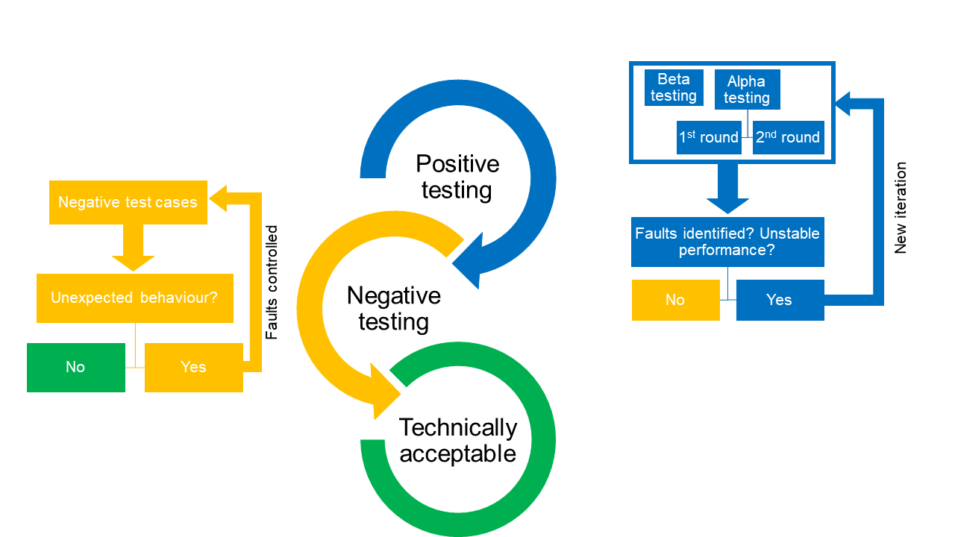
Figure ‎5.3 User’s behaviour-based plan

Positive testing

Positive testing is described as a test of the validity of system specifications under responses expected to valid inputs (Arts et al., 2006). The positive testing for ePAQ-PD is performed in two consecutive phases of alpha and beta testing. Alpha testing is a form of internal acceptance testing conducted primarily by a member of the management team, while beta testing is external testing performed by a group of external users. Alpha and beta testing are equally important for identifying system errors and potential risks (Hai, 2019). The significance is based on the methodological diversity of the two phases in terms of representativeness, environment, structure and flexibility, all of which are important for testing the quality of system performance. The cycle of identifying defects and correcting their specification is carried out in the form of system iterations until technical acceptance is achieved. Positive testing requires a test script or checklist to ensure a systematic review of the system items.

Development of a positive UAT checklist

According to the Electronic Patient-Reported Consortium recommendation, UAT can be conducted in a technique that is thorough and fits the nature of the electronic system (Gordon et al., 2022). The consortium recommended the use of test scripts that describe each step that a tester performs to test the system. The test scripts provide a guide for testing what is expected of the system and allow an indication of whether the step was successful or not. However, the recommendation is intended for multi-centre testing where multiple testers are likely to be involved. The ePAQ-PD is intended for use in departments where a checklist is appropriate to ensure a thorough review of the system steps. Checklists are a common practice and a well-accepted technique. They have been used in many formal developments of software products to ensure that all important software requirements have been considered (Edwards and Steinke, 2007).

The users of the ePAQ-PD can be divided into input users (children and parents/carers) and output users (clinical staff). On this basis, a checklist for the UAT was developed by the PhD candidate based on a thorough inspection of the input and output functions of the ePAQ-PD in terms of content, design, selection of options, navigation and others. Checklist items were generated and organised according to their appearance in the ePAQ-PD completion process. Some items were collapsed to ensure that the checklist is effective and as short as possible. The checklist was developed iteratively and discussed by the research team until a consensus was reached. The UAT checklist was piloted and it was able to check the important ePAQ-PD functions in a consistent manner.

UAT checklist consists of categories and subcategories with 27 items of the expected functions that ePAQ-PD should fulfil from the input and output users’ perspective (Table ‎5.1). The checklist allows the tester to mark each expected function as successful or failure with the option to further comment on the nature of the failure if required. In addition, the designed checklist allows the tester to categorise the errors into critical and non-critical. Critical errors are the errors that prevent the full completion of ePAQ-PD or the display of the final report. Five items in the UAT checklist have been identified as the main items where failure of these items would lead to system critical errors (Table ‎5.1). The UAT checklist was applied during alpha and beta testing.

Table ‎5.1 User acceptance testing checklist for positive test cases.
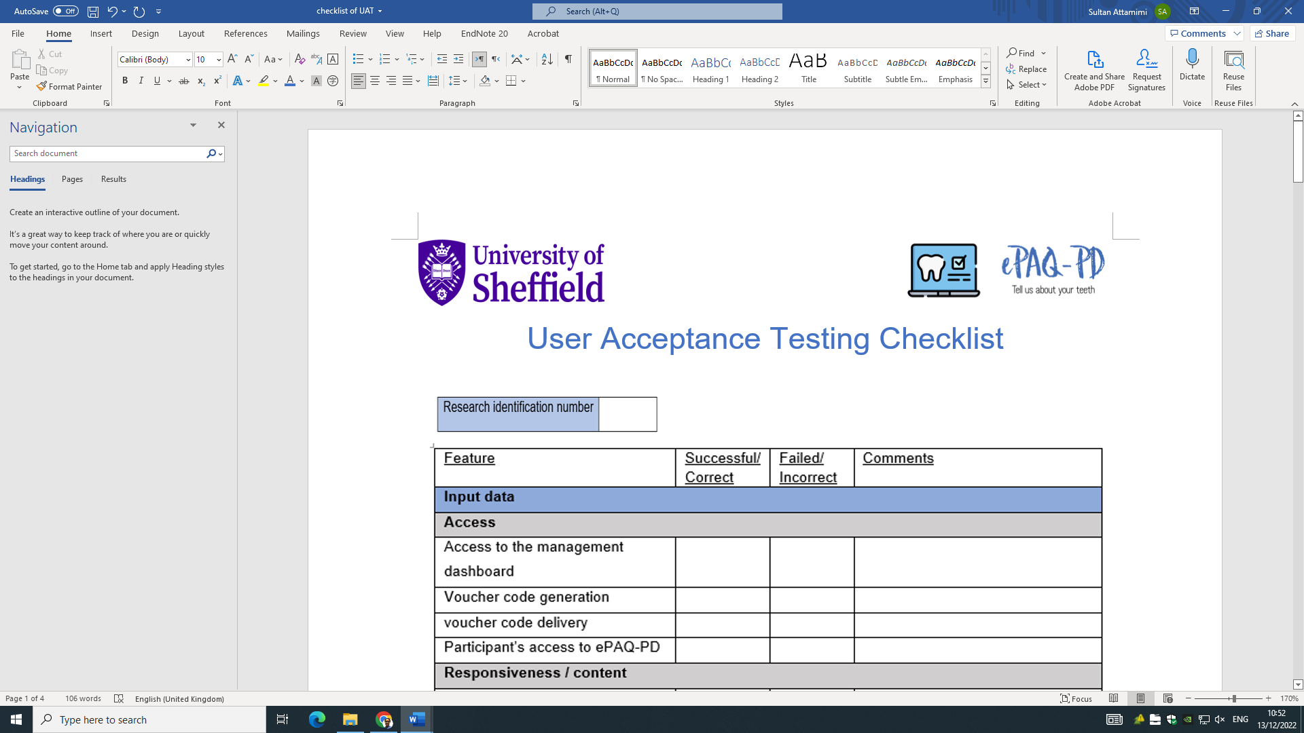
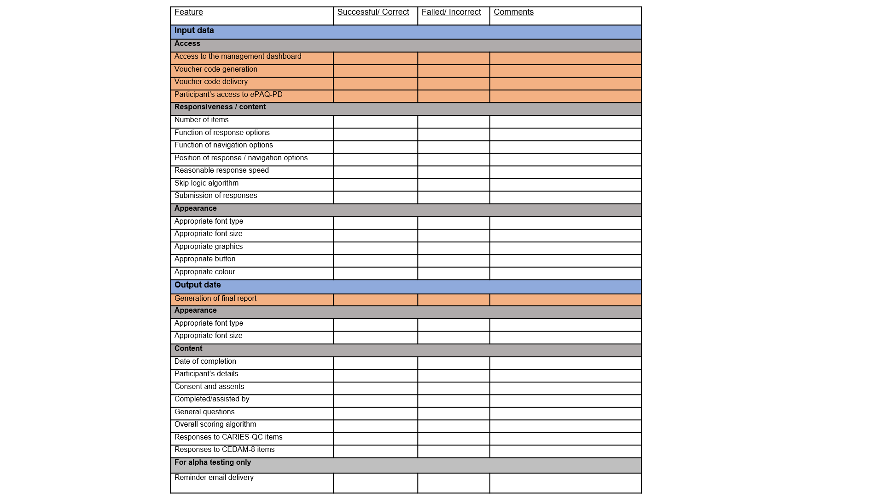
Type of data Categories Items Main items
Alpha testing

Alpha testing is the first form of testing and should be rigorously structured, with case-driven tests aimed at testing ePRO iterations in stimulating technical situations to check the compatibility of the system with various operational elements (Zhang et al., 2015). Alpha testing requires the formulation of multiple test cases with defined external influencing factors that may affect the performance of the ePROs system in terms of displaying features and functions. Alpha testing aims to identify factors that may affect the normal course of completion in a closed environment to save time and cost of recruitment.

The alpha tests were carried out by the PhD candidate (SA) using four test cases. The test cases were developed and critically reviewed by the research team to mimic four different situations with factors that may influence how the ePAQ-PD system might be accessed and completed. The test cases include the use of different age groups to test the roles of the skip logic and the output in the final report. Various technology-based situations were also included, such as the use of different electronic devices, operating systems, email providers, web browsers and internet connections via cable, wireless and mobile networks (Table ‎5.2). Test cases also include accessing and completion of ePAQ-PD at different times of the day to ensure that performance is stable. Consideration was given to testing the ePAQ-PD in different areas. The inclusion of city-wide testing areas is not practically possible. Therefore, four common locations were selected for children and their parents/carers to access and complete the ePAQ-PD in and around the hospital.

The PhD candidate (SA) issued four voucher codes using his details registered in the Health and Social Care Network (HSCN) and shared them independently with different service providers via four different email addresses, as described in the proposed test cases (Table ‎5.2). The time between issuing and receiving the voucher code was recorded in minutes. SA accessed and simulated the completion of the ePAQ-PD by inputting different age groups, using different devices and from different locations. The UAT checklist was applied concurrently with each step in all test cases. If an error occurred in a test case, the test case was repeated several times with changing categories until the source of the error was found.

Following the completion of the ePAQ-PD tests, four new voucher codes were issued and sent to the same email addresses and email providers used in the test cases, with a reminder email sent after seven days. The voucher codes and the primary emails with the ePAQ-PD weblink were not used or tested. The second cycle of the Alpha UAT was conducted using the four test cases and a checklist following the successful receipt of the reminder emails and attached credentials. The categories were reassigned to the test cases to ensure consistency of tested performance in different technical situations.

Table ‎5.2 Details of alpha test cases components.
Category  Cases | Case 1 | Case 2 | Case 3 | Case 4
Age group used | < 3 years old | 3-8 years old | 9- 10 years old | > 11 years old
Electronic device | Mobile phone¹ | Desktop computer² | Laptop³ | Tablet⁴
Email provider | Outlook ª | Gmail ^{b} | Yahoo ^{c} | iCloud ^{d}
Web browser | Chrome * | Microsoft Edge⁺ | Firefox ^ | Safari #
Venue | Outside the Charles Clifford Dental Hospital | Clinic area in the Paediatric Dental Department- Charles Clifford Dental Hospital | The waiting area in the Radiology Department- Charles Clifford Dental Hospital | The waiting area in the Paediatric Dental Department- Charles Clifford Dental Hospital
Operating system | Android¹ | Windows² | Mac Os³ | Mac iSO⁴
Internet connection | Cellular data | STH network | Partially with local wireless ^{ˠ} and partially with cellular data | Partially local wireless ^{ˠ} and partially with cellular data
Time of completion | 6 A.M – 9 A.M | 9 A.M -12 P.M | 12 P.M - 3 P.M | 3 P.M – 6 P.M
1 Galaxy note 10 plus 5G, Samsung Group, Seoul, South Korea. Operated by android 12.0, Google LLC, California, USA.
2 Sheffield Teaching Hospital (Shrestha et al.) desktop computer, Dell Optiplex 5050, Texas, USA. Operated by Windows 10 Enterprise 21H2, Microsoft Corporation, Washington, USA.
3 MacBook pro 16", macOS 12.0.1 Monterey system, Apple Inc, California, United States
4 iPad mini-4, iSO 15.7, Apple Inc, California, USA.
a Outlook email, Microsoft Corporation, Washington, USA.
b Gmail, Google LLC, California, USA.
c Yahoo mail, Yahoo Inc., California, USA.
d iCloud mail, Apple Inc, California, USA.
* Chrome 106.0.5249.92, Google LLC, California, USA.
# Safari 12.0.1, Apple Inc, California, USA.
+ Microsoft Edge 106.0.1370.34, Microsoft Corporation, Washington, USA.
^ Firefox 91.0.1, Mozilla Firefox, California, USA.
ˠ Sheffield teaching hospital secure wi-fi (Guest-Wi-Fi).

Beta testing

The term “beta testing” usually refers to any form of testing performed in an external open environment to evaluate the system’s behaviour in real-world scenarios with end-users (Veenendaal, 2007). In this model, the beta testing aims to test the ePAQ-PD system with a small group of children and their parents/carers in the Paediatric Dentistry Department of the Charles Clifford Dental Hospital (CCDH). Involving the patients in the testing process would reveal undetectable errors from the alpha testing and show the actual status of the ePAQ-PD system due to different user behaviour and the use of other devices with different configurations. After completing two cycles of alpha testing, the children and their parents/carers were included in the second stage of the UAT. The beta tests were conducted independently of the errors identified in the alpha testing as further testing of the ePAQ-PD system would lead to the identification of further potential errors and an additional assessment of performance reliability (Gordon et al., 2022). However, the beta testing is excluded if the alpha tests have failed completely in all test cases.

Children and their parents/carers attending the paediatric dentistry department at Charles Clifford Dental Hospital were recruited regardless of the reason for the visit. clinical staff were informed of the nature of the UAT and their role in the recruitment process during the preclinical session. The PhD candidate (SA) selected potential participants based on the age of the children. During the clinical session, once the potential participants were selected, SA informed the treating clinical staff nonverbally using hand gestures (waving or thumbs up) to avoid interrupting the dental appointment. Clinical staff were instructed to verbally introduce the potential participants to the ePAQ-PD system before sending the family to the radiology department. Children and their parents/carers who agreed to participate were approached by SA and invited to a private room in the waiting area of the Radiology Department.

SA shared more information about the ePAQ-PD system and the reasons for testing and explained their role in the testing process. Following their verbal consent, a web link to the ePAQ-PD log-in page and a 16-digit voucher code were generated and sent to patients via the parent’s/carer’s email address. Children and their parents/carers were asked to access the ePAQ-PD, provide consent and assent, and complete the PROMs using their device. SA observed the access and completion process and applied the UAT checklist to each step and the final report. New patient clinics were selected for recruitment to ensure that participating children and their parents/carers were not involved in further investigation of the ePAQ-PD system, as their prior knowledge of the system may affect the integrity of the investigation (Gordon et al., 2022). A convenience sample of 8 to 10 participants of different age groups was deemed adequate. Participants were recruited at the clinic for new patients in the Paediatric Dental Department.

The completion of a positive testing cycle should be concluded with reporting outcomes and the errors found to the development team. The positive testing cycle should be repeated until the ePAQ- PD system has reached an iteration with stable and error-free performance.

Negative testing
The technique of negative testing is the opposite of positive testing, where the normal flow of logic is tested. Negative tests are performed to ensure that the system is able to process incorrect or inappropriate responses (Melnik et al., 2006).
According to the International Software Testing Qualification Board (ISTQB), negative testing is defined as “testing a component or system in a way for which it was not intended to be used” (Veenendaal, 2007). Negative testing is a recognised method of assessing the ability of a software or system to detect threats and conflicts and understand sources of invalid output (Alexander, 2002).

There is no defined negative test plan that is applicable to all software or electronic systems due to differences in design and specifications. Therefore, the development of a system-specific negative test scenario is required to cover potential misuse of the input and output items as set by the research team. However, the ePAQ-PD system is a basic questionnaire-based system with strict specifications that limit the user's ability to intentionally or unintentionally select or write invalid inputs. Therefore, the definition and execution of possible actions that could interfere with the normal process of completion and impact the integrity of the output data (ePAQ-PD final report) is deemed to be sufficient. The outcome of the negative was used to support decision-making in identifying the source of the invalid output if it occurs.

Normal or positive behaviours of using the ePAQ-PD system have been outlined previously in the development section of this Chapter (Section ‎5.1.3). On the basis of executing opposite or neglectful actions of inputting wrong data, skipping items and deleting output data; a list of possible negative actions per item from input and output perspectives has been assembled (Table ‎5.3). Errors are reported to the development team, who can rectify them at their own discretion depending on the nature of the error. In a further test cycle, only negative actions that have led to errors are taken into account until all errors have been checked.

Table ‎5.3 List of possible negative actions in using the ePAQ-PD system.
Negative actions | Applicable item | Favourable outcome
Input of wrong data | Participant’s voucher code and data of birth in log-in page. | - Access should be denied
Input data with different formats | Participant’s data of birth in log-in page. | - The format displayed in light grey front in the data of birth box (dd/mm/yyyy) or similar.
Using skip option | All items | - All items should be skippable except item no.1 (consent to use ePAQ-PD) and item no. 2 (age range selection)
Selecting more than one option | All items | - Only one option can be selected.
Input of long sentences. | Free text box items (item no.16 and item no.28) | - Limited character capacity  - Final report format is not significantly altered.
Closure of webpage during completion | All items | - Participant can access the ePAQ-PD system again.
Delete final report | Final report in management dashboard | - Final reports cannot be deleted or can be retrieved when deleted.

Data analysis
The data collected during the positive testing using the checklist items were transferred to an Excel spreadsheet (version 2202, Microsoft®, Washington, U.S.). Items were either scored as successful/correct or failed/incorrect. The main items have an impact on the subsequent steps of the ePAQ-PD completion. Therefore, the main items are always scored as failed/incorrect, and the remaining checklist items are skipped.

The results of the UAT were summarised using frequencies of successful and failed categories, while the comments on the nature of errors were summarised in a table. Following the data analysis of the UAT, a summary of the test report was produced, listing the location and number of errors and adverse events. The UAT report contained clear screenshots with comments on the error descriptions and the expected system requirements. The UAT report was shared and discussed with the development team (ePAQ® clinical lead and software engineers (PACE Software Development Ltd, Sheffield, UK). The results of the debriefing and UAT report were used to develop an action plan for the production of a new iteration of the ePAQ-PD system. The cycle of the UAT model was repeated for the second and each subsequent iteration until the ePAQ-PD system was error-free and reliable (Figure ‎5.3).

Results

The UAT model was executed as described in the Methods section. The ePAQ-PD system reached technical acceptable performance after three positive test cycles and two negative test cycles. Further information on the UAT results is detailed as follows:

Positive testing
The ePAQ-PD system achieved technical acceptable performance after three test cycles and iterations (Figure ‎5.4) . Alpha testing was conducted five times with 25 test cases. For the beta tests, 30 participants and their parents/carers were recruited from different age groups: 13 participants aged three to eight years, five participants aged nine to 10 years and 12 participants aged over 11 years (Table ‎5.4). The participants used various email providers to receive the invitations. The participants' email providers were the same as those used in the alpha test cases (Table ‎5.4).


Figure ‎5.4. Summary of the ePAQ-PD iterations and errors detected.

Table ‎5.4 Age range and number of participants in the beta testing stage.
Beta testing | Age range | Number of participants
1st iteration | From 3 to 8 years | 3
1st iteration | From 9 to10 years | 2
1st iteration | Older than 11 years | 5
1st iteration | Total | 10
2nd iteration | From 3 to 8 years | 4
2nd iteration | From 9 to10 years | 1
2nd iteration | Older than 11 years | 5
2nd iteration | Total | 10
3rd iteration | From 3 to 8 years | 6
3rd iteration | From 9 to10 years | 2
3rd iteration | Older than 11 years | 2
3rd iteration | Total | 10
In the alpha and beta test cycles, several errors and unstable performance were detected over several iterations. The descriptions of the system errors and adverse events are detailed below:

1st iteration (ePAQ-PD 1.0)

The ePAQ-PD system performed flawlessly when it met the specifications defined in the predefined test cases in the first round of testing. The time between issuing and receiving the voucher codes by email was less than three minutes. The second round of alpha testing showed that the current iteration of the ePAQ-PD system was not able to generate reminder emails in all predefined test cases. Therefore, the second round of testing with randomly reassigned test cases was not performed.

Ten participants were recruited from different age groups (Table ‎4.4). Three participants were unable to complete the ePAQ-PD due to encountering critical errors that reduced the completion rate to 70% (Table ‎5.5). Two of the critical errors were related to the function of the ePAQ-PD to deliver voucher codes to participants' emails. For one participant, the ePAQ-PD system failed to generate the final report. For the remaining seven participants who completed the ePAQ-PD system, three non-critical errors were found in the final reports. The ePAQ-PD system reported an incorrect total ePROM score three times and did not indicate the child's response to the assent question once. Only three out of 10 attempts managed to complete the 1st iteration of the ePAQ-PD system without error. The research and development teams agreed to discard this iteration.

2nd iteration (ePAQ-PD 1.1)

The second iteration of the ePAQ-PD system showed optimal performance with no errors in completing and generating the final reports according to the specifications defined in the predefined test cases. The time between issuing and receiving the voucher code by email was less than four minutes. However, in case number two, the invitation letter was received after 11 minutes. The second round of alpha testing showed that the current iteration of the ePAQ PD system was able to generate reminder emails in all predefined test cases. The second round of testing with randomly reassigned categories showed no errors when completing the questionnaire.

Ten participating children and their parents/carers from different age groups (Table ‎5.4) successfully received the invitation letter during their visit to the paediatric dentistry department. ePAQ-PD was successfully completed by all participants without any errors occurring. The current iteration was only able to produce an error-free final report for eight participants. Two participants were found to have non-critical errors related to the functioning of the overall scoring algorithm, with the system providing incorrect scores in one report and not functioning in another.
3rd iteration (ePAQ-PD 1.2)
The third iteration of the ePAQ-PD system showed error-free in both rounds of the alpha and beta testing with 10 participants of different age groups (Table ‎5.4) The research team agreed to accept the third iteration of the ePAQ-PD system and consider it for negative testing. A summary of the number and type of errors and debriefing meetings for all iterations can be found in Table ‎5.5.

Table ‎5.5 Summary of errors detected and outcome of debriefing meetings of positive testing.
ePAQ-PD iteration | No. of errors | Description of errors | Decision | Action
1st iteration | 2 | The system failed to deliver the voucher code | Reject | ePAQ® development team to revise the system specification to resolve the reported system errors. In-house functionality testing to be conducted on the new iteration prior to set-up on HSCN network for UAT testing.
1st iteration | 1 | The system failed to produce a final report | Reject
1st iteration | 3 | The system produced incorrect overall scoring of ePROMs | Reject
1st iteration | 4 | The system failed to produce reminder emails. | Reject
2nd iteration | 2 | The system produced incorrect overall scoring of ePROMs | Reject | ePAQ® development team to debug scoring algorithm codes and test functionality.
3rd iteration | 0 | No errors or unexpected events occurred | Accept | ePAQ-PD showed a satisfactory performance. ePAQ® development team to provide support for any future undesirable events

Negative testing

As an acceptable iteration from the positive testing, the 3rd iteration of the ePAQ-PD system was nominated for negative testing. The majority of the negative actions showed favourable responses in the 3rd iteration of the ePAQ-PD system. The current iteration only showed an unfavourable response to negative actions by allowing the user to skip the age range item. By default, the ePAQ-PD system assumes that the user is between three and eight years old when skipping this item. This response is considered unfavourable as it may lead the ePAQ-PD system to produce invalid results. Further descriptions of the negative actions performed and the response of ePAQ-PD are summarised in Table ‎5.6.

The error related to skipping the age range item was discussed with the development team and it was decided to control the error by disabling the skip function to prevent the user from skipping this item. The deactivation of the skip function was confirmed by the second round of testing of the individual age range entries.

Table ‎5.6 Results of negative testing of the third iteration of ePAQ-PD.
Negative action | ePAQ-PD response | Favourable outcome?
Input incorrect voucher code and date of birth. | Deny access | Yes
Input the correct date of birth with different formats | ePAQ-PD only accepts the following formats:  - dd/mm/yyyy (e.g; 06/09/2015) or - d/m/yy (e.g; 6/9/15).  - dd.mm.yyyy (e.g; 06.09.2015) or - d.m.y (e.g; 6.9.15). | Yes
Skipping consent to use ePAQ-PD | The skip function is not activated for this item | Yes
Skipping age range option | ePAQ-PD allows skip function and assumes the patient’s age to be between three to eight years (allow completion of CARIES-QC and skip CEDAM-8). | Action: report to development team to deactivate the skip function.
Skipping remaining items | The final report shows a cross mark (X) in the response options for all skipped items. | Yes
Selecting more than one option | ePAQ-PD allows the selection of the last clicked option | Yes
Input long sentences in the free text boxes | -The character limit of each free text box is 101 characters which fits with the box size in the final report with a smaller font size. The final report appeared on one page but was longer to accommodate the long text with good readability in a standard page zoom of 100%. | Yes
Closure of the webpage during completion | - The voucher code generated and delivered to the e-mail address is still active and can be used again to access ePAQ-PD questions. | Yes
Delete the final report | - ePAQ-PD does not allow the deletion of final reports but instead archives them.  - The archived final reports are retrievable by clicking on the restore data option in the archived file sections | Yes

Discussion and long-term plan

A novel model based on user acceptance testing concepts was developed to test newly developed electronic systems designed to collect PROM data. The application of behaviour-based model principles on ePAQ-PD system showed that the ePAQ-PD system achieved technically acceptable performance after three positive test cycles and one cycle with negative testing.

Software development is an ongoing process in which the intrinsic and extrinsic functions are designed, produced and tested according to the requirements of an end-user or customer. For the ePAQ-PD system, the requirements for the extrinsic features (content, appearance and scoring algorithm) are defined by the research team. The strength of this method is its antipodal nature, which covers the system's reactions to normal user behaviour and misbehaviour as indicated in the system specification. Therefore, this testing method has been adapted as the ePAQ-PD system is intended for clinical use where robust testing is critical to ensure the delivery of safe and effective healthcare services. Another reason for adopting a rigorous testing method is that the ePAQ-PD system is designed for remote use, where the behaviour of participants cannot be monitored. Another strength point is the decision to develop and use a UAT checklist to ensure the thoroughness of the tests and reduce the risk of certain functions being omitted. The components of the checklist were based on the functions that the ePAQ-PD system must fulfil according to the requirements of the development team. During the design process, some features were added to the checklist to ensure ease of use. These include the division of items into colour-coded categories, major and minor items and input and output data. The addition of comment boxes was beneficial to allow testers to provide more details about the nature of the errors and to add errors that were not covered by the checklist items. In this study, the alpha testing was rigorously structured and included case-controlled tests aimed at testing the iterations of the ePAQ-PD in different simulated situations. Global and national statistics influenced the selection of the type of electronic devices (Ofcom, 2020) and email providers (Litmus, 2021) used in the test cases. Other categories were chosen due to the limited availability of technical options such as operating systems and the type of internet connection. The time of completion was chosen subjectively to test the performance of the ePAQ-PD iterations in different time periods. The categories were randomly reassigned in the second round of alpha testing to reduce the risk of performance differences due to inconsistencies between categories (e.g., operating system provider and web browser). Another strength point is the repetition of the test case when errors are detected to make it easier to identify the exact source of the error.

The beta testing was conducted in an open environment with a sample of participants and their parents/carers as end-users. The inclusion of actual end-users is critical to the reliability of the UAT (Otaduy and Diaz, 2017). There is no evidence to support the number of participants required to achieve a significant probability of detecting the majority of errors in specific software iterations. The sample size was limited to 10 participants and their parents/carers, which was subjectively considered sufficient in this study for several reasons. For each iteration, beta testing was pre-empted by internal testing by the development team and alpha testing in a closed environment where test cases could be counted as a simulation of participant completion. In addition, the testing cycle of ePAQ-PD was based on the production of iterations rather than system versions where the system had not yet been officially released for routine clinical use. The iterative cycle of ePAQ-PD resulted in a cumulative effect of testing, as the same specifications are tested and therefore fewer test cases or participants are needed. Finally, the study was ethically approved as a service evaluation project where the number of participants that can be recruited is limited.

The proposed model shows broad conceptual pathways that ePRO providers should consider when planning the validation of electronic systems. Some limitations need to be considered to ensure appropriate application in future work. The model failed to include clinical staff as output end-users in the beta testing of the ePAQ-PD, where their inclusion could reveal additional undetectable errors in system management functions and final reports. Another limitation that requires a long-term consideration is the lack of a defined post-implementation monitoring plan and maintenance strategy to detect and address issues that may arise after the system is implemented.

Indeed, the developed UAT checklist has increased the meticulousness of the two-stage positive UAT. The pilot phase and use of the UAT checklist in this study across all test cases and participants proved its reliability, as no errors were recorded that were not covered by the checklist items. Nevertheless, some disadvantages were also identified during its use. The evaluation of the items can be affected by factors such as the screen size of the device, e.g., the appropriate font size and graphic elements, and the brightness of the screen can affect the perception of the colours. However, these disadvantages relate to device’s display features that do not significantly affect the accuracy of the tests. Furthermore, SA was the only tester for all test cases where the influence of subjectivity was minimal. The participation of children and parents/carers in the negative testing was excluded as it was considered inappropriate to ask patients to deliberately misuse the ePAQ-PD system. A few negative actions by users were not included in the negative UAT plan.

In addition to testing system responses, negative testing is usually used to test software or system security (Alexander, 2002). The security of the ePAQ-PD system was not considered in the negative UAT plan developed, as the security testing is beyond the technical knowledge of the research team members. Furthermore, the ePAQ-PD system is a version of the ePAQ® platform where data security is the responsibility of the developing company (PACE Software Development Ltd, Sheffield, UK). Since its inception, the ePAQ® platform has successfully produced other versions of the electronic questionnaire used in gynaecology (Jha et al., 2009; Elenskaia et al., 2013) and pre-anaesthetic assessment (Goodhart et al., 2017; Taylor et al., 2018) without any reports of security issues.

In order to ensure appropriate application in future work, some limitations must be taken into account. The behaviour-based model failed to include the output end-users of researchers and/or clinicians in the beta testing, where their inclusion could reveal additional, undetectable errors in the system management functions and final reports. The exclusion of output end-users in this model is based on a cost-effectiveness assumption because, unlike patients/participants for whom no prior knowledge or experience is required, clinical staff require training to access the system management dashboard and view the final reports. Providing training session would be an unnecessary burden on the trial system prototype where ePROs providers can fairly act on their behalf. The proposed model lacks a defined post-implementation monitoring plan and long-term maintenance strategy.

To summarise, the developed UAT model has provided novel methods for the field of ePROMs. The rigorous structure of the behaviour-based UAT plan would ensure the reliability of the ePAQ-PD system as a data collection tool for subsequent studies in this thesis. Further testing in a real-world environment would confirm the result of this study. The subsequent study (i.e., Chapter 7) explored this. However, in order to implement ePAQ-PD system in routine practice, clinical staff needed to be trained in all aspects of the ePAQ-PD. Details of clinical staff can be found in the next chapter.

Future technical maintenance plan

The exclusion of output end-users in this model is based on a cost-effectiveness assumption because unlike children and their parents/carers, for whom no prior knowledge or experience is required, clinical staff must be trained to access the system management dashboard and view final reports. The provision of training would create an unnecessary burden on the testing of the prototype system where SA can fairly act on their behalf. As the ePAQ-PD has achieved technically acceptable performance, the provision of training is required prior to routine implementation in clinical practice. Details of training for clinical staff can be found in section ‎6.6.4. As discussed, another limitation that requires long-term consideration is the lack of a defined post-implementation monitoring plan and maintenance strategy to identify and address any issues that may arise after the system is implemented. An incident reporting sheet has been developed for clinical staff to report technical errors that may occur during the implementation of the ePAQ-PD (Appendix C). Further elements have been added to the reporting sheet to enable clinical staff to report details of support for children and their parents/carers in completing the ePAQ-PD during an appointment whenever requested. The incident and assistance reporting sheets were introduced to clinical staff during the training session (details of the training session are demonstrated in Chapter ‎6.6.4) and hard copies were made available in a designated area in the clinical area. The results of the incident and assistance reporting items are analysed as part of the feasibility study (‎Chapter 7).

Novel aspect

This study managed to bridge the gap between two fields of computer science and healthcare. Contemporary literature lacks technical testing forms for electronic systems designed to collect PROM data. In this study, a novel and structured model was introduced to facilitate the application of UAT principles to newly developed ePROMs systems. The behaviour-based model has a generic structure to ensure its applicability to different PROM data acquisition systems. The proposed model has increased confidence in the ePAQ-PD as an electronic system. It is anticipated that the development and application of the behaviour-based model will inspire researchers to draw attention to the importance of technical testing of ePROMs systems and the development of further models.

Conclusion

The electronic conversion of two child-specific PROMs on oral health (CARIES-QC and CEDAM-8) was successful and led to the development of the ePAQ-Paediatric Dentistry version. The ePAQ-PD is intended for routine clinical use, where relevant items of invitation letter, consents and free-text questions were integrated to facilitate patient remote completion. The ePAQ-PD achieved acceptable technical performance following the application of a novel model of user acceptance testing concept.

Publications arise from the work presented in this chapter.

Published manuscript:
Attamimi, S., Marshman, Z., Deery, C., Radley, S. & Gilchrist, F. 2024. A Behavior
Based Model to Validate Electronic Systems Designed to Collect Patient-Reported
Outcomes: Model Development and Application. JMIR Form Res, 8, e56370.

Attamimi, S., Marshman, Z., Deery, C., Radley, S. & Gilchrist, F. (2022) Novel validation method of a newly developed electronic platform to routinely collect patient-reported outcomes (Conference Abstracts). 7th UK Patient Reported Outcome Measures (PROMs) Research Conference 2022, Sheffield, UK

Presentation:
Attamimi, S., Marshman, Z., Deery, C., Radley, S. & Gilchrist, F. (2023) Novel validation method of a newly developed electronic platform to routinely collect patient-reported outcomes (poster). 7th UK Patient Reported Outcome Measures (PROMs) Research Conference: 'PROMs Across the Lifespan', Sheffield, UK

Measurement comparability study
________________________________________

This chapter focuses on investigating the measurement comparability of ePROMs integrated into the ePAQ-PD with their original paper format by assessing its usability with children and their parents/carers. In addition, details of clinical staff training session on the use of ePAQ-PD system are demonstrated in this chapter.

Overview

Patient-reported outcome measures (PROMs) are a valid method for capturing patients’ views on their health in various aspects of health behaviour, treatment experience, psychological well-being and health-related quality of life. PROMs collect relevant and meaningful results when selected and applied appropriately as developed. The validity or psychometric properties of PROMs may be affected by external factors that are not part of their content, such as the method by which they are administered and delivered to patients. The vast majority of PROMs have been developed and validated using a paper-based method of administration (Coons et al., 2009). Alteration to the method of administration of PROMs might lead to measurement errors due to a lack of investigation of the potential impact (see Section ‎4.3.1).

Nowadays, electronic technology has become an integral part of modern life and has found its way into various professions, including patient care services. The latest technology has made it possible to deliver PROMs to patients electronically to reduce the burden on staff and minimise the impact on clinical workflow (Cella et al., 2015). As previously discussed, this modern method of electronic administration of PROMs may jeopardise the psychometric properties of paper-validated PROMs. Indeed, a full psychometric evaluation would provide optimal evidence of the extent to which the new method of administration has impacted the validity of the PROMs. However, a full psychometric evaluation is a costly and time-consuming procedure. As a non-inherent modification, evidence-based recommendations have been proposed on how to analyse the impact of a new method of administration on the psychometric properties of PROMs using alternative assessment methods. The International Society for Pharmacoeconomics and Outcomes (ISPOR) taskforce proposed a recommendation on the evidence required for the comparability of measurements between electronic and paper-based PROMs. ISPOR taskforce recommended different assessment methods depending on the level of modification made to the electronic conversion of paper-based PROMs. The details of the ISPOR taskforce recommendations have been discussed in Section ‎4.3.1.

Rationale

The ePAQ-PD is an electronic system that facilitates the administration of the electronic format of PROMs. The integrated PROMs (CARIES-QC and CEDAM-8) were originally developed and validated with children in a paper format (Gilchrist et al., 2018; Porritt et al., 2021). During development, CARIES-QC and CEDAM-8 were electronically converted to the ePAQ-PD system. The electronic conversion of CARIES-QC and CEDAM-8 resulted in some changes. The changes include the display of one item per screen instead of multiple items per page, without significantly reducing the font size. Also, the responses to PROMs items have changed to clicking or touching the screen instead of circling with a pen as in the paper format. Patients must click/touch the button ‘Next’ or ‘Previous’ to navigate between items instead of turning pages. These changes are inherent to the nature of the electronic format and are considered minor changes according to the ISPOR taskforce recommendations on measurement comparability (Table ‎4.3).

Several versions of the ePAQ have been developed and used in clinical settings in gynaecology (Jha et al., 2009; Elenskaia et al., 2013) and pre-anaesthetic assessment (Goodhart et al., 2017; Taylor et al., 2018), which have been shown to be acceptable for these populations. However, the ePAQ has not been used in a paediatric population where cognitive and behavioural abilities are highly variable. Furthermore, there is no evidence in the literature to support the electronic comparability of the CARIES-QC and the CEDAM-8 with paper formats. Therefore, an investigation of comparability is required as the existing evidence is insufficient (O’Donohoe et al., 2023).

​ISPOR taskforce recommends conducting usability testing and cognitive debriefings as the evidence required to establish comparability for electronic conversion with minor changes (Coons et al., 2009). Usability testing is used to test participants’ physical ability to use the ePROMs platform efficiently, while cognitive debriefing is used to test the accuracy of their interpretation of the instructions and content, and thus the selection of a response (Coons et al., 2009). The ePAQ-PD was developed to assess the oral health of children in different age groups with different cognitive and physical abilities, as described in section ‎4.3.1, which represents a further need for pre-testing the usability of the ePAQ-PD by children.

The ePAQ-PD was developed to assess oral health in children of different age groups. Therefore, it is necessary to test the usability and perform cognitive debriefings. The measurement comparability testing was used to investigate the children’s ability to understand and use the ePAQ-PD system and provide information on whether or not the psychometric properties of the integrated ePROMs have been compromised. In addition, the testing would identify any potential difficulties the children may encounter with the non-PROMs items, such as accessing the system, open-ended questions and navigation. Therefore, conducting tests of measurement comparability is an important aspect that should be investigated prior to the routine implementation of ePROMs to ensure the suitability and collection of meaningful data.

Aim and Objectives

Aim
To determine the measurement comparability of the electronic format of PROMs integrated into ePAQ-PD compared with the original paper-based administration.

Objectives
The objectives of this study were to:
- determine if children are able to easily navigate the ePAQ-PD system.
- determine whether children can successfully complete the ePROMs on their own, if not, what is the level of assistance they need.
- determine the average time spent, and the number and type of errors during the completion of the ePAQ-PD questions.
- determine the clarity and level of satisfaction with the ePAQ-PD interface, and
- capture any suggestions that may improve user satisfaction and performance.

Methods

Study design

Both qualitative and quantitative designs were used to achieve the objectives of the study. The usability tests were followed by a topic-guided cognitive debriefing according to ISPOR taskforce guidelines and recommendations (O’Donohoe et al., 2023). Data were collected in the form of numerical descriptions, quotations and observational notes.

Ethical approval

The study was approved by the Wales Research Ethics Committee 3 (Reference 22/WA/0353) and received Health Research Authority (HRA) approval in January 2022 (Appendix D). Project authorisation was granted by STH Clinical Research and Innovation Office in March 2023 (STH21510). Documents regarding this approval are listed in Appendix D.

Study setting

The Charles Clifford Dental Hospital (CCDH) in Sheffield, South Yorkshire, England, is the host site for this project. CCDH is part of the Sheffield Teaching Hospitals NHS Foundation Trust and is affiliated with the University of Sheffield. The CCDH provides secondary and tertiary dental care covering a large geographical area including South Yorkshire, Nottinghamshire, Derbyshire and Lincolnshire. The Paediatric Dental Department at CCDH provides a comprehensive range of oral health care for children and young people up to the age of 16. This includes the treatment of children with additional needs, those with dental anxiety and specialist oral care for children and young people. There are also facilities for comprehensive oral care under sedation and general anaesthesia at Sheffield Children’s Hospital (SCH). Participating patients and clinical staff were recruited from consultant-led clinics for new patients in the Paediatric Dental Department.

Study Recruitment and Process

The children and their parents/carers were recruited between 15 March and 20 May 2023 in the Department of Paediatric Dentistry at Charles Clifford Dental Hospital in Sheffield, between 15th March and 20th May 2023. The aim and objectives of this study were fulfilled by carrying moderated usability sessions with children and their parents/carers completing the ePAQ-PD system, followed by a topic-guided cognitive debriefing.

Participants

There is no consensus on the number of participants needed to evaluate the physical and cognitive usability of an electronic system by end-users. However, the sample size should be no less than five and no more than 20 participants and their parents/carers to ensure a reasonable cost-benefit ratio of the testing (Nielsen and Landauer, 1993). The lower limit was set on the basis of the heuristic evaluation proposed by Nielsen and Landauer (1993) which states that a sample size of five testers is able to detect around 83% of errors. Whereby the upper limit was determined on the basis of the ISPOR taskforce for usability testing of complex systems. Therefore, recruitment of 8 to 10 participants was deemed sufficient (Aiyegbusi et al., 2018). The physical and cognitive abilities of children vary according to their chronological age. Therefore, several participants and their parents/carers were recruited from four different age groups (3-5 years, 6-7 years, 8-9 years and 10 years and older). The proposed age range of each group was selected based on stages of literacy development theory (Wolf and Stoodley, 2008).

Inclusion and exclusion criteria

The following inclusion and exclusion criteria were used to determine whether to approach potential participants for the study:
Inclusion criteria
- Children attending new patient clinics at the Paediatric Dentistry Department.
- Children aged three years or more.
- Children and parents/carers who speak and understand English and able to complete the ePAQ-PD independently or with assistance.
Exclusion criteria
- Lack of informed consent by a parent/carer or assent by the child.
- Children and/or parents/ parents/carers who cannot understand the PROM even with help.
- Children with severe learning difficulties who would be unable to complete the ePAQ-PD even with support.

The PhD candidate (SA) approached potential participant in the waiting room area prior to their appointment. Potential participating Children and their parents/carers were provided with participants’ information leaflets with a brief discussion about the study. They were provided time to read participants’ information leaflets and ask questions and responded with their decision following their attendance at the dental appointment. Children frequently require radiographs at their new patient assessment, which requires them to attend the radiography department with a waiting time of 30-60 minutes. This therefore provided the opportunity to read the study information leaflets, think of any further questions and reflect on their willingness to participate. Children and parents/carers who agreed to participate were consented by the PhD candidate (SA).

The description of the moderated usability sessions is detailed in the following subsection:

Moderated usability sessions plan

The children and their parents/carers who agreed to participate gave their consent using age-appropriate assent and consent forms (Appendix F and G) and were informed about how the usability session would be conducted. Information on how the sessions were conducted can be found below:

Purpose
The sessions aimed to explore the comparability of the ePROMs with the original paper-based delivery format by testing the usability of the third iteration of the ePAQ-PD with children and their parents/carers and capturing their experiences and suggestions. The usability testing focussed on the ease of access to the ePAQ-PD, selection of responses, navigation and submission of responses.

Roles
The PhD candidate (SA) acted as a moderator, responsible for leading the session by delivering instructions, answering questions, issuing invitation letters, observing and collecting data. The children acted as system users who were asked to complete the ePAQ-PD and participate in a topic-guided interview. Parents/carers were asked to help with both tasks only if needed.

Location and duration

Following the children and their parents/carers’ approval to participate in the study. The sessions took place in a private room in the School of Clinical Dentistry, which is located next to the Department of Paediatric Dentistry. Each session was scheduled to last no longer than 20 minutes, including the usability testing and debriefings.

Equipment

The PhD candidate (SA) acted as the moderator and used an NHS computer in the Department of Paediatric Dentistry (Sheffield Teaching Hospital (STH) desktop computer, Dell Optiplex 5050, Texas, USA. Operated by Windows 10 Enterprise 21H2, Microsoft Corporation, Washington, USA) to access the ePAQ platform using a web browser (Chrome 106.0.5249.92, Google LLC, California, USA) to issue an invitation letter to the children using their parents/carer’s email address. The children used their own electronic device or their parent’s/carer’s device to connect to the internet network via their mobile phone data or a free wireless connection provided by the hospital. Alternatively, children were offered the opportunity to complete the ePAQ-PD using the moderator’s NHS computer. An encrypted digital recording device (EVIDA 2324, Model V618, EVIDA INC., USA) was used to record and later transcribe the cognitive debriefing interview.

Scenario

The usability session commenced by situating the request to access and complete the ePAQ-PD in a short scenario to provide context and ensure user engagement. The scenario was told in simple terms such that the child and parents/carer were asked to assume that they were at home or in a public place and had received an ePAQ-PD invitation letter on the parent’s electronic device. Then the moderator asked them to look at the invitation letter and gave no further information. The child and parents/carers complete the ePAQ-PD, following exactly the same steps as in a real-life situation, including accessing the platform, obtaining consent and assent, completing the questionnaire and submitting responses. The request for assistance from the moderator when completing the ePAQ-PD was rated as an error. A further description of the errors and usability assessment is explained in the following subsections.

Data collection

The quality of the system from a user’s point of view combines the two main experience aspects of performance and satisfaction (Newell and Rosenbloom, 1980). User performance was measured quantitatively through defined performance-based metrics, while user satisfaction was measured through a self-reported rating scale. Cognitive debriefing interviews were conducted to explore users’ feelings, thoughts and suggestions about the content and completion process of the ePAQ-PD. A further description of the data collection methods can be found below:

Performance metrics
Electronic system usability is a quality feature that evaluates the user-friendliness of user interfaces. User performance represents the user's interaction with the electronic product, i.e., the extent to which the user can successfully complete a task or a series of tasks. Albert and Tullis (2013) proposed four basic quantitative metrics that can measure and reflect user performance with different electronic systems as the following:
- Task success
Task success is the most commonly used metric for usability (Albert and Tullis, 2013). The success of a task can be measured quite easily by marking the user experience as successful, failed or withdrawn without the need to use measurement or statistical techniques. However, the addition of exploratory metrics such as the number and type of problems encountered by users and whether assistance was provided highlights the level of difficulty and therefore the extent of system adjustment required to improve usability. In the ePAQ-PD usability tests, the target users were children of different age groups, where the help of parents/carer is expected, especially for young children. Therefore, parental/carer assistance was taken into account when determining the user's success in completing the ePAQ-PD system in order to identify vulnerable groups. The success criteria for the ePAQ-PD system are illustrated in the figure below:

Figure ‎6.1 Task success criteria

The completeness of success depends on the presence of any form of user error, which was further assessed in the third metric. The provision of assistance was based on the corresponding response in the final report. A request for assistance from the moderator was categorised as an error.

- Task completion time

The time spent using an electronic system reflects the level of difficulty experienced by the user. The time to complete a task is simply the time elapsed between the start of a task and the end of a task, usually expressed in minutes and seconds. The ePAQ-PD system records the start and end time for each individual user, starting from the time of login and ending with the submission of the last task (child's assent). The time for completion was determined based on the difference between the start and end recording by the ePAQ-PD system and expressed in minutes and seconds. The time spent on completion was exported from the ePAQ-PD system dashboard to the data collection sheet (Appendix E).

- User errors

The frequency and severity of user errors are a possible outcome of an underlying issue with the electronic system that needs to be addressed. User error is an important metric that needs to be measured to ensure that the data collected from users through the electronic system is meaningful. In this study, the user errors were described numerically and categorically to ensure a better representation of the errors and their causes. The errors were documented in numbers and categorised into minor and major errors based on the actions required by the moderator to correct them (Aiyegbusi et al., 2018). Minor errors are those that the child and parent/carer can correct themselves with simple instructions from the moderator, e.g., informing participants how to navigate between items. Major errors are those that require moderator intervention, such as accidentally closing the ePAQ-PD webpage.

Self-reported metrics

The quantitative measures discussed earlier are performance-based measures that measure the complexity of the ePAQ-PD based on different aspects of child and parent/carer performance. User satisfaction is a second fraction and is a critical factor in measuring the user experience and therefore in determining the usability of the system (Newell and Rosenbloom, 1980). The perceptions of users of the ePAQ-PD system were recorded in the form of verbatim comments and the outcome of the self-reported rating. Children and their parents/carers were offered the opportunity to complete a short questionnaire on paper. The satisfaction questionnaire contains four questions focussing on ease of use and navigation, content, visual presentation and overall satisfaction with a 3-point rating scale (1-poor/no, 2-not bad/maybe and 3-excellent/yes). The four questions on satisfaction were adapted from Aiyegbusi et al. (2018) and the answer options were reduced to a 3-point scale to ensure appropriateness for children (Appendix E). For young children (< 7 years old), the response options were reduced to dichotomous options (1 -poor/no and 2 - excellent/yes) to suit their cognitive abilities (Coombes et al., 2021).

After completing the satisfaction questionnaire, the children and their parents/carers were involved in cognitive debriefing interviews. The interview guide designed for this session contains some open-ended questions that allow the children to express their opinions about the ePAQ-PD system under different aspects of general impression, issues faced and suggestions (Aiyegbusi et al., 2018). In addition, the children and their parents/carers are encouraged to make suggestions on various aspects of the ePAQ-PD system for access, completion and other suggestions that could improve the experience of future users during a debriefing discussion.

Data analysis

The demographic and metric data collected during the items were transferred to an Excel spreadsheet (version 2202, Microsoft®, Washington, U.S.). Audio recordings of the cognitive debriefings were transcribed verbatim, reviewed, and transferred to a password-protected computer in the department. Participating children’s demographic data, including age and sex, and details of the electronic device used to access and complete the ePAQ-PD (mobile phone, tablet, computer, or other) were summarised in a table. The results of the performance metrics and self-reported rating scales were summarised in a table. Due to the limited sample size, bivariate analyses were not conducted to assess the correlation between the study variables. The results of the debriefing interviews are presented as quotes in a table and categorised as comments, issues, suggestions and moderator observations.

Data handling and governance

Participants were anonymised and only the participants' identification numbers were used on the data collection sheet. Participants were asked to provide a pseudonym instead of their real name during the audio-recorded cognitive debriefing. The audio recordings of the interviews were deleted immediately after they had been transcribed, reviewed and stored securely for analysis. The data were transferred to a password-protected desktop computer in a secure room within the department. Long-term archiving of the analysed data was considered, and participants were asked to read age-appropriate information sheets and sign consent and assent forms (Appendix F and G). All researchers who had contact with participants had appropriate Criminal Records Bureau identification and had received safeguarding training.

Results

Nine children and their parents/carers took part in the ePAQ-PD usability sessions. This included six boys and three girls from different age groups. Table ‎6.1 presents the participants’ characteristics and electronic devices used.

Table ‎6.1 Participants’ characteristics and electronic devices used in the hands-on sessions.
Characteristic |  | n (%)
Age group
 | 3-5 years old | 2 (22)
 | 6-7 years old | 3 (33)
 | 8-9 years old | 2 (22)
 | 10 years and older | 2 (22)
Sex
 | Male | 6 (66)
 | Female | 3 (33)
Devices used
 | Smartphone | 9 (100)
 | Tablet | 0 (0)
 | Computer | 0 (0)
 | Other | 0 (0)

Performance metrics

All participants (100%) completed the ePAQ-PD usability session with only one minor error. Details of the performance metrics recorded during the usability session are summarised in Table ‎6.2.

Table ‎6.2 A summary of performance metrics collected during the hands-on sessions.
ID | Child’s age (years) | Sex | Task completion |  |  | Task completion time | User errors
ID | Child’s age (years) | Sex | Completed | Assisted | errors | Task completion time | User errors
1 | 11 | Male | 🗸 | ─ | ─ | 6 min:59 sec | 0
2 | 7 | Female | 🗸 | 🗸 | ─ | 4 min:39 sec | 0
3 | 8 | Female | 🗸 | 🗸 | ─ | 3 min:52 sec | 0
4 | 7 | Male | 🗸 | 🗸 | 🗸 | 4 min:27 sec | 1 minor
5 | 4 | Male | 🗸 | 🗸 | ─ | 5 min:49 sec | 0
6 | 5 | Male | 🗸 | 🗸 | ─ | 4 min:37 sec | 0
7 | 15 | Female | 🗸 | ─ | ─ | 4 min:13 sec | 0
8 | 7 | Male | 🗸 | ─ | ─ | 4 min:38 sec | 0
9 | 8 | Male | 🗸 | 🗸 | ─ | 2 min:46 sec | 0

Task success

Five children (56%) managed to successfully complete the test with the assistance of their parents/carers. Three children (33%) aged seven, 11 and 15 years were able to complete the ePAQ-PD without any assistance. Only one child (11%) completed the questionnaire with the help of a parent/carer and encountered one usability error. The extent and examples of assistance provided by parents/carers are presented later in the moderator’s reflections in the self-reporting subsection.

Task completion time

The average completion time for the ePAQ-PD for all participating children was 4.5 minutes with a range of 2.8 minutes to 6.9 minutes.

User errors
All participating children were able to complete the ePAQ-PD without any major errors. There was only one minor usability error occurred that required the moderator to address the issue verbally. One child and parent requested the moderator for assistance on how to proceed with an introductory item. The moderator instructed them to use the ‘Next’ option.

Self-reported metrics
All participating children completed the satisfaction survey at the end of the ePAQ-PD usability sessions. Only two young children (<7 years old) completed the satisfaction survey with binary response option scale. Both young children selected the excellent/yes option to all questions if the survey. Out of the remaining seven children (with three response option scale), five participants (71%) selected the excellent/yes option when asked about the ease of use, appearance and content of the ePAQ-PD. All participating children (100%) reported an overall excellent experience completing the ePAQ-PD. Further details of the satisfaction survey are illustrated in Figure ‎6.2.

Figure ‎6.2 ePAQ-PD satisfaction survey reported by participants following the hands-on sessions. Two young children (<7 years old) completed the survey with binary response options whereas the remaining seven children (>7 years old) completed the survey with three response options.

All children and their parents/carers agreed to participate in the cognitive debriefing interviews. Several comments on the usability of the ePAQ-PD were recorded in the debriefing interviews. Comments from the children and parents/carers were transcribed verbatim and categorised as impressions, issues and suggestions for improving usability. The comments are categorised and listed in Table ‎6.3.

Table ‎6.3 Participants’ comments regarding the usability of the ePAQ-PD. comments are categorised into Impressions, issues and suggestions.
Impressions | … it fits the criteria for all the younger ages and all the older ages because they can all read it and I think that's a very good thing.  Sam (11 years old)
Impressions | I like the fact that it gave a kind of progress thing so you know how many screens or questions you had to go through.  Sam’s parent
Impressions | .. the block went dark for that particular option and so you can then click on the next button.  Sam’s parent
Impressions | He didn’t have to write anything within those, because you didn’t feel like it was something you had to fill out.  Michael’s parent
Impressions | It was good. It works. It was fast … colourful and bright!  Apple (8 years old)
Impressions | .. it was very detailed … you can just press the "Help" button and then it explains to you and that was really good.  Sally (15 years old)
Impressions | It was easy. I don’t think of any easier ways than this!  Gregory’s parent
Impressions | It was clear.  Paul (5 years old)
Impressions | Yeah, it's easy. It's all right!  Rose (7 years old)
Impressions | Pretty easy. I liked how it was really short!  Michael (8 years old)
Issues | .. some of the questions the colour changes which I think kind of makes it…it's hard to explain really!  Sam (11 years old)
Issues | … colours used and that wouldn’t be good for somebody who's colour blind.  Sam’s parent
Issues | .. people are becoming very aware of being careful about not clicking … especially children, because it's taught in schools, about e-safety.  Sally (15 years old) and parent
Issues | some younger children would probably struggle … It seemed like it had been designed on a computer and then that was just like the website on a mobile phone.  Sally (15 years old)
Issues | I did notice that all three buttons and everything was right at the top and then there's all this space below with nothing in it  Sally’s parent
Issues | he couldn’t find where the next was, because mostly next are down here. But once he got that, he got it straight away.  Steve’s parent
Suggestions | maybe an app you can download and then you can sign into your details you know…  Sam (11 years old)
Suggestions | text message is better than signing in, logging into your email, password, and then text message will just come straight through  Spiderman’s parent
Suggestions | Maybe by text message because text message goes a bit faster!  Sally (15 years old)
Suggestions | One of my friends she's dyslexic and she normally likes to read orange in the background. And it just helps her a lot to be able to read it better.  Sally (15 years old)
Suggestions | I would have expected Charles Clifford Dental Hospital or NHS to be in the...the line of the e-mail!  Sally’s parent
Suggestions | Like we could choose the colour. They were blue. I really like orange.  Steve (7 years old)
Suggestions | .. it’d probably a bit easier without pressing the green box?  Michael (8 years old)

The moderator observed the usability session and recorded several verbal and non-verbal cues. Usability-related cues are summarised as follows in Table ‎6.4.

Table ‎6.4 Verbal and non-verbal cues observed by the moderator.
Moderator’s observations | Noticed that Sam (11 years old) and his parent spent time how to type in the voucher before they realised it was auto-paste automatically. They spent more time discussing the questionnaire and responses compared to using the system.
Moderator’s observations | Two Participants (Sam and Apple) and their parents thought that the ePAQ-PD item had ended with the last item of the CARIES-QC.
Moderator’s observations | Six participants’ parents (Rose 7y, Apple 8y, Gregory 7y, Spiderman 4y, Paul 5y, and Michael 8y) were holding the phone and were reading and discussing with their children.  The remaining three participants (Sam 11y, Sally 15y, and Steve 7y), their parents have passed the phone to them to complete.
Moderator’s observations | No parents have completed child-related items without reading, discussing and asking for their response including the assent item.
Moderator’s observations | Two young children (Spiderman 4y and Paul 5y) only responded with yes or no and nod or shake their heads which seemed that they did not comprehend the three options concepts. Parents further probed when the child replied with ‘yes’ with a follow-up question whether it was a bit of a lot.
Moderator’s observations | Steve (7 years old) requested his parent’s help to explain the open questions. Both thought they have to complete all of the three free-text boxes.
Moderator’s observations | Sally (15 years old) and Sam (11 years old) spent more time completing CEDAM-8 items than CARIES-QC item.
Moderator’s observations | Steve (7 years old) could not understand the introductory item and the parent told the child to press next and move forward.

Discussion

The children and their parents/carers who participated in this study found the ePAQ-PD has acceptable usability. However, the outcome of the usability sessions showed some discrepancies that need to be discussed and addressed. The ePAQ-PD is a web-based system that is compatible with various electronic devices. In this cohort, a smartphone was the only electronic device used to test the usability of the ePAQ-PD. This was to be expected due to the portability of smartphones and the fact that they are the most commonly used electronic device by adults in the UK (Office of Communications, 2021). In addition, invitation letters were sent to the email addresses of parents/carers in the clinic area, where access to various personal devices is restricted.

The responses of the children and their parents/carers to the assistance item from the final report were considered to determine whether the assistance was provided, rather than the subjective assessment of the moderator. The results show that children aged eight years and younger are more likely to require assistance from their parents/carers. It appears that parents/carers are aware of their children's ability to complete the ePAQ-PD independently by handing them their smartphones, as reported in the moderator observation section. None of the parents/carers completed the ePAQ-PD on behalf of their children, even for very young children (5 years and under). This result supports the evidence showing that children as young as three years old are able to competently answer self-administered PROMs (Chaplin et al., 2008; Lawford et al., 2001). However, the nature of the moderated useability session could influence compliance with the completion instructions in the ePAQ PD by the children and their parents/carers.

There is no clear relationship between age and time spent completing the ePAQ-PD and whether parental assistance was provided. It should be noted that the number of items to be completed in the ePAQ-PD varies from child to child due to the age-appropriateness of the CEDAM-8. Children aged eight years and younger had 22 items to complete, while older children aged nine years and older had 32 items to complete. Further information on the age-dependent skip logic of the ePAQ-PD system can be found in detail in Figure ‎5.2. The difference of 10-item points between younger and older children could explain the significantly longer completion time. In addition, one child spent more time discussing the questionnaire and answers with his parent, as mentioned in the moderator's observations section. Nevertheless, the completion time of seven minutes is relatively acceptable and is not seen as a barrier to completion. Interestingly, for children completing only the eCARIES-QC (8 years and younger), the time taken was between 2 and 5 minutes, which is the same as the time reported for the paper-based version (Gilchrist, 2015). This reflects the high level of digital literacy among children, as evidenced in the literature (Sabatino et al., 2019; Vinney et al., 2012). However, a further comparative study of the completion time between the CARIES-QC administration formats would provide more accurate results.

The minor usability error reported was felt that the error was due to the child and parent relying on the moderator’s ability to resolve usability issues. It is most likely that this error can be resolved and handled with items without the moderator's help if it occurs during the remote completion as in real-life situations. This is because the introductory item is preceded by two items that assume the child’s and parent's knowledge of the location and function of the ‘Next’ option. As this error only occurred in one of nine children, it was decided that this error did not require any action to change this item.

A range of thoughts about the usability of the ePAQ-PD were captured in cognitive debriefing interviews. These interviews were conducted in accordance with the methodological considerations outlined in Section ‎4.1.2 to ensure meaningful data collection from the children. As expected, all children were able to reflect on their experiences of completing the ePAQ-PD. Children younger than seven years old tended to provide shorter and less in-depth responses, but they were able to reflect on their experiences when supported by their parents/carers.

Children and parents commented favourably on the suitability of the ePAQ-PD for different ages, progress monitoring, freedom of use, simplicity and other features such as being quick, clear and easy to use. These comments are reflected in the children’s responses to the satisfaction survey, as illustrated in Figure ‎6.2. Children and parents/carers raised some concerns about changing the background colour between PROM items, cyber security and optimising the ePAQ-PD for mobile phones. Children and parents/carers also identified areas for improvement which focused on changing the delivery method of the invitation letters from email to text messages, labelling the invitation letters with CCDH or NHS as the sender to increase trustworthiness, and making the ePAQ-PD accessible for children with dyslexia.

The concerns and suggestions reported have been reviewed to ensure they impact the usability of the ePAQ-PD. Changing the background colour does not seem to have an impact on the completion of the ePAQ-PD by children and their parents/carers. The background colour was not used to illustrate information or indicate an answer, but as a visual feature that does not exclude children suffering from colour blindness. The ePAQ-PD was designed with a blue and light green background colour to differentiate between CARIES-QC and CEDAM-8 items. It was felt that the colour change would alert children and their parents/carers to the new questionnaire, which has a different focus. In addition, the change in background colour was seen as a positive feature. For example, the ePAQ-PD was described as “colourful and bright” (Table ‎6.3; Impressions). Another comment related to the background colour was reported as a suggestion for an inclusive design of the ePAQ-PD for children with dyslexia (Table ‎6.3; Suggestions). As suggested, warm background colours such as peach and orange significantly improved the readability of the screen compared to cool background colours such as blue or green for people with dyslexia (Rello and Bigham, 2017). A request to change the background colour to warm orange has been submitted to the ePAQ-PD development team. A list of requests to the ePAQ-PD development team and their responses are summarised and discussed later in the Amendments to the ePAQ-PD subsection.

Some children and their parents/carers commented on the impact of increased awareness of cyber security measures on the ePAQ-PD response rate. Nowadays, children are more cautious about cyber breaches and scam messages as they have been educated about online safety in schools (Department of Eductation, 2023). There is a possibility that children and their parents/carers may ignore the ePAQ-PD invitation letters and view them as untrustworthy emails. Participants made suggestions to increase the trustworthiness of ePAQ-PD invitation letters. Suggestions include changing the delivery method from email to text messages and labelling the sender as NHS or CCDH. These suggestions are considered valuable as they could encourage the correct delivery of invitation letters if the registered telephone number was used directly rather than contacting parents/carers to obtain email addresses where the incidence of non-response and misspelt email addresses is high. Clicking on the ePAQ-PD link in a text message could be quicker and more intuitive than logging into an email. In addition, the children and their parents/carers who attend CCDH have different backgrounds, languages and levels of education where regular use of email is not expected. The notion of using text messaging to deliver invitation letters instead of email was conceptualised by the research team in the early stages of ePAQ-PD development. However, all previous versions of ePAQ used email and evidence was required for the paediatric dentistry version to support this request and secure funding for this change. A formal request to change the delivery method for the invitation letters from email to text messages was submitted to the ePAQ- PD development team.

Some children and their parents/carers commented on the location of the response and navigation options. One child objected to the need to select the 'Next' option in order to progress, stating "It would probably be easier if you did not have to press the green box...". The 'Next' option was to ensure that the children and their parents/carers had sufficient time to confirm that they had selected the appropriate response option. In addition, this function was intended to limit the random selection of responses, which is referred to in the literature as a satisficing strategy (see section ‎2.4.2.3). One participant noticed that all the options were at the top of the webpage with a lot of unused space below. She attributed this to inaccurate phone optimisation of the ePAQ-PD website, which was originally developed for the screen size of a computer.

From the moderator’s perspective, almost all of the observed actions were consistent with the performance metrics and self-reported outcomes. With the exception of very young children (≤ 5 years) who could not understand the three option concepts without help from parents/carers. It has been shown in the literature that children under the age of seven can respond accurately to a question with dichotomous options (Coombes et al., 2021b). During the development of CARIES-QC, it was reported that some younger children (aged 5-7 years) expressed themselves through "yes" or "no" responses or by nodding or shaking their heads (Gilchrist, 2015). Nevertheless, the CARIES-QC with three response options showed excellent validity and reliability for children aged five years. Therefore, this question is explicitly investigated in Chapter 7 of this thesis using Item Response Theory (IRT) to ensure the applicability of the eCARIES-QC with very young children. Another unique observed action was that participants felt obliged to complete all three free-text boxes in the item ‘question to the dentist’ (Table ‎6.4). This was due to a lack of information about this item being optional. The ePAQ-PD development team was asked to add the word 'optional' next to the item text.

Amendments to the ePAQ-PD

Some requests from children and their parents/carers were shared with the ePAQ-PD development team to implement the changes as far as possible. The responses from the development team were as follows:

Table ‎6.5 Requests submitted to the ePAQ-PD development team.
Request | ePAQ-PD Development team responses
Change the background colour to a warm orange to accommodate children with dyslexia. | The amendment requires a high cost. Advice to postpone until the research project has been completed.
Change invitation letter delivery method from email to text message | Approved and implemented.
Add the word “optional” next to the text for the open questions. | Approved and implemented.

A subsequent amendment was made to the study to change the method of delivery of the invitation letters to participants from an email service to text message service. This upgrade was developed and implemented at the request of the members of this research project and was supported by the results of the usability study. It was felt that texting the invitation letter would increase the response rate compared to the email service (Romeiser et al., 2021). In addition, the parent/carer’s telephone number is already registered in the patient record systems (Lorenzo™, DXC technology, Virginia, United States), which proved to be a more efficient method than calling the parent/carer to provide an email address. Texting invitation letters is thought to increase response rates compared to email, as parents/carers may not respond to phone calls, may not have email and the researcher may make errors when entering their email addresses. This amendment was approved by the research ethics committee as a substantial amendment. The documentation for this amendment approval can be found in Appendix H.

Novel aspects

Overall, the electronic administration of PROMs is an evolving concept that has not yet been sufficiently explored in paediatric dentistry, as outlined in the literature review chapter (‎2.4.2.4). This study was conceptualised to ensure that robust planning and preparation is undertaken to ensure that post-implementation feasibility investigations of the ePAQ-PD is not compromised by clinically irrelevant factors. This study was guided by an evidence-based framework to establish comparability. To the best of the researcher's knowledge, this is the first study in the oral health literature. In other fields, some of the ePROMs studies published in the literature follow the principles of measurement comparability, while others rely on the subjective judgement of the authors or the response rate of participants between the different formats as indicators of compatibility (Kortbeek et al., 2023; Campbell et al., 2015; Kedzierawski et al., 2019). It is hoped that this study will encourage future research to consider the principles of measurement comparability prior to utilising the converted PROM format in research and/or clinical practices.

Limitations of the study

Some limitations were identified in some aspects of the study design and recruitment process, that can be discussed in various topics such as the following:

Sample size

In the usability testing literature, the sample size required to achieve adequate representativeness and high precision in detecting usability errors is a debatable topic (Nielsen and Landauer, 1993;(Faulkner, 2003; Macefield, 2009; Coons et al., 2009). Faulkner (2003) thoroughly investigated the sensitivity of the number of participants in detecting usability errors by randomly assigning participants with different electronic skills into different groups in multiples of five. Faulkner (2003) found that a group of five participants was able to detect an average of 85.5% (SD =9.3%) of problems, while a group of 10 and 20 participants were able to detect an average of 94.7% (SD =3.2%) and 97% (SD =2.1%), respectively. The reported results are from a usability testing of a web-based data sheet for recording employee attendance, rather than an online questionnaire or ePROM. Nielsen and Landauer (1993) suggested that a sample size of five testers is generally able to detect about 83% of a system's problems. The only recommendation related to the usability of ePROs was published by ISPOR taskforce as part of the measurement comparability recommendations (Coons et al., 2009). ISPOR taskforce recommends a sample of 5 to 10 participants for a simple ePRO system and 20 or more for a complex system. The recommendation does not take into account special population groups such as children (other limitations of the ISPOR taskforce recommendations were discussed in Section ‎4.3.1). There have been attempts to test the usability of ePRO systems with children (Meryk et al., 2021; Wang et al., 2017; Muilekom et al., 2022); however, in these studies, usability testing was designed to measure acceptance and satisfaction with use, not to detect usability issues. Unfortunately, there is no evidence of usability testing (as described in this study) of ePROMs with children. Therefore, a sample size of nine participants from different age groups was considered appropriate and representative to test the usability of the ePAQ-PD, as it exceeds the minimum number of five participants and was similar to a previous ePROMs usability study (Aiyegbusi et al., 2018).

Data quality

In this study, all usability sessions and debriefing interviews were conducted in a private room in the School of Clinical Dentistry. The results may be biased as the children and their parents/carers may proceed and reflect differently if they were completing the ePAQ-PD without observation and facilitation by a moderator. The impact of the presence of an interviewer or moderator on data quality has already been discussed in Section ‎2.4.2.3. In addition, data quality could be affected by the cognitive debriefing technique used (verbal probing), which relies on the moderator's interviewing skills compared to the think-aloud technique (Davison et al., 1997). In designing the study, a number of measures were considered in order to control the performance bias of the children and the quality of data reporting as much as possible. The provision of a real-life scenario before the usability session began seemed to add some meaning to the context of the session to some extent. Scenario-based testing is a common method in usability testing to bridge the gap between the conceptual model of the system and that of real-world practice (Rogers et al., 2005). The think-aloud technique was not included as it could distract the children and lead to a delay in responding to the ePAQ-PD compared to verbal probing after the task (Als et al., 2005). The moderator’s ability to conduct age-appropriate interviews is crucial to obtaining valid and meaningful data from children, as explained in the Methodological Considerations chapter (Section ‎4.1.2). The moderator (SA) is a paediatric dentist who has experience in interpreting children’s body language. SA had formal training in conducting and analysing qualitative research through participation in a semester-long module entitled "Qualitative Research Design and Analysis module" (module code: HAR6531) offered by the University of Sheffield.

Satisfaction survey

In this study, participants were asked to reflect on their experiences with the usability of ePAQ-PD in a satisfaction survey and in structured and semi-structured interviews. The decision to include the satisfaction questionnaire in the usability testing was made in order to obtain standardised and comparable results between participants. However, some disadvantages were identified with the satisfaction questionnaire used. The main drawback is the lack of psychometric validity, i.e. the accuracy of the questionnaire in capturing relevant and important aspects of usability satisfaction is unknown. There are validated usability satisfaction questionnaires in the literature, including the System Usability Scale (SUS) (Brooke, 1996)and the Post-Study Usability Questionnaire (PSSUQ) (Lewis, 1992). However, there is no evidence in the literature of validated usability questionnaires developed for children, but rather the unjustified use of questionnaires for adults or reliance on proxies (Tasfia et al., 2023; Al-Wakeel et al., 2015). The 4-item questionnaire used in this study was developed subjectively based on different satisfaction domains adapted from Aiyegbusi and others (2018) and modified to better suit the age of the children. Another disadvantage is the lack of a free-text box for children to elicit more information about satisfaction with user-friendliness, which was not included in the questionnaire. However, a short questionnaire was deemed sufficient and would be less burdensome for participants who are interviewed and have the opportunity to provide information that was not captured in the satisfaction questionnaire.

Lack of clinical staff involvement

The purpose of the usability testing is to identify usability issues in a sample group of system end-users. The ePAQ-PD is to be used routinely in clinical practice, with the end users being children and their parents/carers (as input end-users) and clinical staff (as output end-users), as described in the previous chapter. Investigation of the usability of the ePAQ-PD from the perspective of clinical staff was not included in this study. However, all clinical staff involved in the use of the ePAQ-PD were trained by SA prior to the introduction of the ePAQ-PD into routine clinical practice. Details of the clinical staff training were described in the next Section ‎6.6.4.

Clinical staff training

As strongly recommended by Meirte and co-workers (2020), clinical staff with different roles, including consultants, dentists and dental nurses, had received training from SA prior to the clinical implementation of the ePAQ-PD. The training took place during one of the regular department audit meetings. The training lasted 20 minutes, during which the ePAQ-PD was introduced, and questions were answered. The training curriculum included topics and learning objectives as described in the ePRO consortium best practice recommendations (Table ‎6.6). During the training, an engaging and friendly environment was established and the exchange of questions and comments was encouraged from the outset. The aim and objectives of the PhD project were clearly described, followed by the presentation of the main results of the technical and usability testing of the ePAQ-PD (as described in Chapters 5 and 6) to demonstrate system readiness for implementation in routine clinical practice. Accessing the ePAQ-PD system, issuing the invitation letter and the process of completing the ePAQ-PD from children and their parents/carers perspective was demonstrated using screen recordings with voice-over videos to enable clinical staff to familiarise themselves with the system features and provide assistance to children and their parents/carers, if required. An example of an ePAQ-PD final report was shown and its content was explained in detail, emphasising the potential implications on clinical practice. The training concluded with a demonstration of the incident reporting sheets which are designed to allow clinical staff to report details of assistance to children and their parents/carers, technical issues with the ePAQ-PD system and how to communicate with the PhD candidate (SA), if necessary. Clinical staff were enthusiastic and showed a clear understanding of their role in this research project. Questions and comments from clinical staff were addressed with provision of examples from clinical practice where possible. The main concern was regarding the clinical usefulness of the ePROMs (eCARIES-QC and eCEDAM-8) overall scores. They were advised that the overall scores of the ePROMs will be used primarily for psychometric evaluation but their potential clinical usefulness will be explored during in the focus group as part of the feasibility study (Chapter 7). On completion of the training, presentation slides and screen recordings with voice-over videos demonstrating the individual management steps of the ePAQ-PD were shared with clinical staff through their NHS emails for their future reference.

Table ‎6.6 Staff training Curriculum. Adapted from ePRO Consortium recommendation for best practice (Ly et al., 2019).
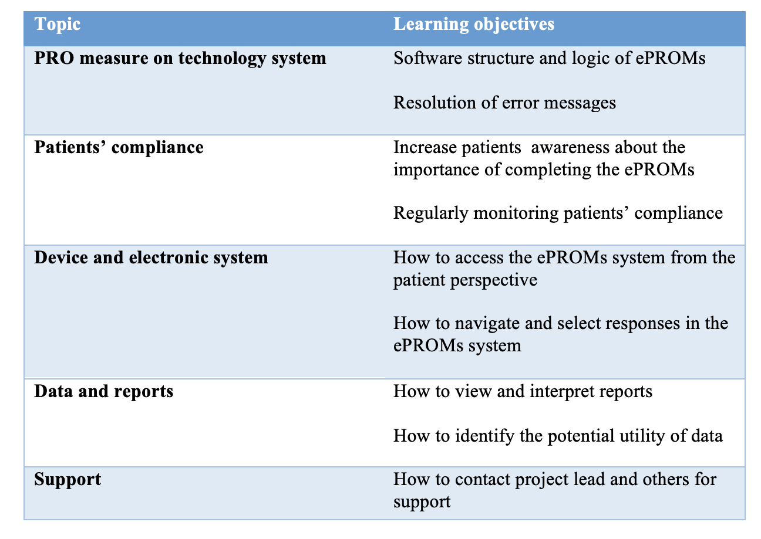

Conclusion

Children and their parents/carers found the ePAQ-PD acceptable and easy to use. The psychometric properties of eCARIES-QC and eCEDAM-8 are comparable to their paper-based formats following testing based on ISPOR taskforce recommendation (Coons et al., 2009). Suggestions were followed to improve the clarity of instructions and accessibility of the ePAQ-PD. The outcome of this study has increased the utility of ePAQ-PD to capture accurate and meaningful outcomes in clinical and research fields.

Implications for this thesis

The findings of this study have ensured that children are able to access and complete the ePAQ-PD and determine the extent of assistance may be provided by parents/carers. The UAT study (Chapter ‎5.2) and this study are considered to be cost-effective measures that have been undertaken to ensure that the ePAQ-PD readiness prior to routine implementation in clinical practice. Omission of this stage of the thesis may result in the collection of questionable quality data that may only detected when the research project has concluded. In addition, the qualitative findings have highlighted areas that should be considered in the development and planning of the subsequent feasibility study. The findings regarding changing the delivery method of invitation letters from email to text messaging were used to support the researchers' enquiry and secure funding.

Publications arise from the work presented in this Chapter

Published abstract:
Attamimi, S., Marshman, Z., Deery, C., Radley, S. & Gilchrist, F. (2023) Measurement equivalence of electronically converted patient-reported outcome measures in Paediatric Dentistry (poster). British Society of Paediatric Dentistry (BSPD) Annual Scientific Conference, Newcastle upon Tyne, UK.

Feasibility of Routine Clinical Use of ePAQ-PD

This chapter focuses on exploring the feasibility and utility of routine use of the ePAQ-PD in clinical practice. This chapter describes the conduct of a mixed-method study that included details on completion of the ePAQ-PD, clinical observation and interviews with children, parents/carers and clinical staff.

Introduction

The term feasibility has been used synonymously with the term pilot study in the literature. A clear distinction was established through a Delphi survey of experts during the trial methodology conference in 2015 (Eldridge et al., 2016). A consensus was reached that pilot studies are a subset of feasibility studies and that the terms are not mutually exclusive. In general, a pilot study has the same research question and design as a full trial, however, is conducted on a smaller scale. A feasibility study is a multi-component study with a less rigid structure that may also include qualitative research and development-related questions. The term “feasibility study” has been frequently used in the literature to describe an evaluation of a proposed project plan or method to assess appropriateness for implementation or further investigation (Leeman et al., 2017; Pearson et al., 2020). Feasibility studies play an essential role in either identifying factors that improve the feasibility of intervention trial methods or in evaluating the preliminary impacts of implementing an intervention into specific settings (Leeman et al., 2017). Prior to conducting clinical trials, it is good practise to conduct a feasibility study to identify risks, maintain resources and improve the trial design, as outlined in the Consolidated Standards of Reporting Trials (CONSORT 2010) for Pilot and Feasibility trials (Eldridge et al., 2016). Feasibility can be defined when used to evaluate implementation of an intervention as “ the study of strategies to integrate evidence-based interventions into specific settings” (National Cancer Institute, 2015). The design of the feasibility study must be appropriate to the nature of implementation strategies (dissemination, implementation process, integration or capacity building) in order to facilitate clearer and comparable reporting (Leeman et al., 2017). The feasibility of implementation with integration strategies can be evaluated by assessing the effectiveness of changes in the targeted determinants and also their effects on implementation outcomes (Proctor et al., 2011)

Examples of appropriate objectives of a feasibility study of integration strategies include assessing the recruitment process, evaluating the feasibility of study protocols and exploring the acceptability and reactions of participants to an intervention (Donald, 2018). Researchers may collect data through observations, checklists, administrative records, or by capturing participants' perceptions or other methods appropriate to the context of the study (Pearson et al., 2020). In PROMs literature, feasibility studies have been frequently conducted to identify facilitators and barriers to implementation as well as suggestions to inform future amendments or other studies (Scott et al., 2023). In addition, the feasibility analysis can establish an expectation regarding the benefits and efficiency of an implementation strategies (Curran et al., 2012).

The broad concept of feasibility studies to evaluate an implementation process requires the collection of data in an exploratory and investigative fashion. A mixed methods research design is considered the most appropriate methodological design for feasibility studies as it is able to generate nuanced and useful information (Aschbrenner et al., 2022). Mixed-methods research is a study design that combines components of qualitative and quantitative research approaches.

It is crucial to define and describe different research methods to justify the selection of a mixed-method design for the ePAQ-PD feasibility assessment. Research paradigms can be broadly described as “a system of beliefs and assumptions about the development of knowledge" (Saunders et al., 2016). The most common research paradigms are constructivism/interpretivism, positivism and pragmatism. These paradigms differ in the way reality is perceived. Reality can be viewed as subjective from the researcher's perspective in interpretivism, objective in positivism and both subjective and objective in pragmatism (Creswell, 2003). The interpretivism paradigm tends to explore data inductively and develop a theory from it by using quantitative approaches. Interpretivists tend to focus on the research participants’ views of the situation/subject under study. In contrast, positivism tends to develop a hypothesis using a deductive approach based on a pre-existing theory. Positivists usually use quantitative approaches to address research questions. Pragmatism, on the other hand, focuses on combining qualitative and quantitative approaches (mixed-method) to address research questions by understanding data and theory (Mackenzie and Knipe, 2006). It can be argued that pragmatists utilise the abduction approach where they respond to issues of incommensurability (intersubjectivity) and inference from data (transferability) (Morgan, 2007). The philosophy of paradigms focuses on the concept that can be appropriately applied to understand a specific issue and determine what has valid practical and functional value (Long et al., 2018). Due to the nature of this study and the intended outcomes, the pragmatism paradigm was considered a well-established, valid approach that has been used in several previous studies with similar aims to this study (Foster et al., 2018). Common mixed-method design approaches that were used to investigate the feasibility of implementing the ePAQ-PD, where appropriate, are outlined below.

Qualitative approaches

Qualitative research is a type of research that explores perspectives and provides deeper insights into real-world issues. Qualitative research collects data about participants' experiences, behaviours or perceptions to answer questions of why and how rather than how many or how much (Tenny et al., 2022). There are some qualitative data collection methods to explore participants’ experiences and perspectives, including interviews, focus groups and observations.

The interview is a fundamental qualitative research method that facilitates capturing the experiences, motivations and beliefs of the participants. Interviews can be structured, semi-structured or unstructured and can contain closed or open questions. Less structured interviews and a flexible approach are likely to gather more qualitative information (Gill and Baillie, 2018). Audio recordings are a common practice in interviews to ensure that the interviewer can concentrate on the interview and is not distracted by memorisation and note-taking (Edwards and Holland, 2013). The verbatim transcription of the recorded interviews is crucial to ensure proper analysis. There are several principles to consider when conducting an interview, including building rapport, using understandable and clear questions, using appropriate terms and being able to listen carefully (Arksey and Knight, 1999). When interviewing children, additional methodological challenges must be taken into account. Children may have varied ability in terms of language comprehension, fluency and social interaction (Moir and Kwansa 2000). Furthermore, children tend to feel obliged to answer a question from an adult interviewer, even if they do not have an opinion (Naughton et al., 2001). Further details regarding methodological considerations when interviewing children are discussed and addressed previously in Chapter ‎4.1.2.

A focus group is a moderated group discussion on a specific topic for research purposes. In health research, focus groups are used to explore perspectives, experiences and behaviour based on a discussion or arguments between the participants. The social interaction between participants is beneficial and can lead to the exploration of overlooked areas and the collection of meaningful data. It is less likely that personal and sensitive information will be revealed in a focus group discussion as participants may feel uncomfortable disclosing such information in a group setting (Gill and Baillie, 2018). In addition, organising and leading a focus group is a difficult and complex task. The considerations made when conducting interviews also apply to focus groups in terms of consent, rapport building, use of comprehensible questions, audio recording and transcription. However, conducting a focus group requires two researchers, each of whom either moderates the discussion or observes non-verbal responses. Non-verbal responses such as behaviour, facial expressions, order of speech and others are valuable data for analysis (Morgan et al., 1998).

Observation is also a widely used approach for collecting qualitative data in many research areas. Compared to interviews and focus groups, the observation methodology focuses more on noticing or perception of data from the social interactions and body language of the participants. As a data collection method, observation can capture relevant data in a structured way, counting instances of predefined events, or without structure and predetermined terms (Mulhall, 2003). Structured observation follows a systematic observation method, usually guided by a checklist of behaviours or actions that may occur during the observation session (Bowling, 2001). This method has the advantage that it allows for an accurate description of behaviour from different aspects, but also that the freedom of the observer is limited, which can lead to unique events being overlooked. In contrast, unstructured observation allows the observer to determine what is relevant by taking notes of the participants' behaviour and quotes. Flexibility and data richness are the main advantages of unstructured observation. Unstructured observations have some disadvantages, including dependence on the skills of the observer, difficulties in conducting without recording equipment and difficulties in analysing (Turnock and Gibson, 2001).

There are a variety of qualitative data analysis methods that focus on transforming the data into some sort of explanation of the observed behaviours and quotes to outline the findings of the area being explored. There are a plethora of different qualitative analysis methods, including thematic analysis (Braun and Clarke, 2021), framework analysis (Ritchie and Spencer, 2002), content analysis (Schreier, 2012), and discourse analysis (Wood and Kroger, 2000).

Quantitative approaches

The feasibility study is an exploratory study that sets the framework for subsequent implementation by identifying and predicting the challenges and outcomes. In addition to qualitative data, the collection of numerical data is crucial for achieving the aim of the feasibility study, namely predicting the effort, time and cost required for implementation (Donald, 2018). Furthermore, the extent of compliance with the implementing provisions can only be determined by quantitative analysis. Examples of quantitative analyses in feasibility studies are the intervention dose, the response rate and the comparative analysis between participants.

Overall, qualitative and quantitative approaches are simply research tools that are suitable for a variety of situations and their use should be based on the purpose of the feasibility study and the paradigmatic philosophy (Paley and Lilford, 2011).

Rationale

The overall aim of this part of the study was to assess the feasibility and clinical utility of the routine use of ePROMs in paediatric dental practice. Previous attempts to investigate the potential benefits of PROMs on the quality of patient care have been thoroughly explored in the literature review chapter (Chapter ‎2.4.2). In the field of children's oral health, most studies have examined the impact of oral health on children's lives for research purposes, and the merits of routine clinical use of PROMs have not been sufficiently explored. In addition, the widespread use of electronic technologies in contemporary society provides an opportunity to assess the impact on children's oral health in innovative ways (see literature gaps for future research in chapter ‎2.5).
A pilot study was conducted in the Department of Paediatric Dentistry at the Charles Clifford Dental Hospital (CCDH) to explore the potential feasibility and usefulness of the routine use of paper-based PROM (CARIES-QC). It was found that clinicians valued the information provided by the PROM and felt that it assisted their treatment planning (Graham et al., 2021). Administrative staff suggested that using an electronic system to submit PROMs would reduce the administrative burden. An exploratory study with a larger sample size was required to ascertain the outcomes of the pilot study and to explore further areas regarding the feasibility of routine clinical use of PROMs. The preliminary results of the pilot study were incorporated into the design and conduct of this study to ensure high quality in resemblance to real-world situations. A version of the ePAQ system for paediatric dentistry was developed to facilitate the remote delivery of PROMs as proposed in the pilot study. Subsequent investigations were conducted to ensure the accuracy of the ePAQ-PD as a data collection tool, including user acceptance testing (Chapter ‎5.2) and measurement equivalence testing (‎Chapter 6). Other recommendations from the pilot study, such as the addition of free-text questions to capture further impact and recording who completes the PROM, were adapted during the development of the ePAQ-PD (Chapter ‎5.1). This chapter addresses the overall aim of this thesis and the research question of the feasibility and utility of routine use of ePROMs in paediatric dentistry clinical practice.

Aim and objectives

The aim of this study was to explore the feasibility and utility of the ePAQ-PD in routine clinical practice in paediatric dentistry.
The specific objectives were to:

- explore the experiences of children, parents/carers and clinical staff with the ePAQ-PD system and elicit valuable insights into the design, structure, implementation and delivery method of the ePAQ-PD in routine clinical practice,
- explore the impact of routine use of the ePAQ-PD in the provision of oral care service to children, and
- identify facilitators and barriers to the routine use of the ePAQ-PD.

Methods

Study design
This study aimed to fulfil the aforementioned objectives by conducting a mixed-method research design with qualitative (interviews and observations) and quantitative components to ensure a comprehensive assessment. The mixed-method research design is frequently found in the literature, particularly in health research (O'Cathain et al., 2010). It was proposed that the mixed-method design would provide a voice to research participants, allow the capturing of their views and interests, and add a sense of flexibility to data collection (Wasti et al., 2022). A further justification for the selection of the mixed method is based on the nature of providing an in-depth understanding of the feasibility and, moreover, a general explanation and generalisability of the qualitative data (O'Cathain et al., 2010). In addition, the mixed-method design combines the strengths of both methodological approaches and controls potential individual weaknesses to some extent (O'Cathain et al., 2010). However, the integration of the two methodological approaches can pose a challenge, which is discussed later in the discussion section.

Study setting

The setting for this study was that the same as for the measurement comparability study previously described in Chapter ‎6.4

Ethical approval

The study was approved by the Wales Research Ethics Committee 3 (reference 22/WA/0353) and received Health Research Authority (HRA) approval in January 2022 (Appendix D). Project authorisation was granted by the STH Clinical Research and Innovation Office in March 2023 (STH21510). The documents relating to this authorisation are listed in the Appendix D.

Sample size and eligibility

Completion of the ePAQ-PD

All children who registered at the paediatric dental clinic for new patients within a three-month period from July to October 2023 were eligible for recruitment, regardless of age, oral health condition, dental diagnosis and reason for the visit. The exclusion criteria were as follows:
- Lack of informed consent by parents/guardians or assent by the child to participate in research.
2) Children and their parents/guardians who cannot understand the PROM even with help.
3) Children with severe learning difficulties who would be unable to complete the ePAQ-PD even with support.
4) Children who failed to attend new patient clinics.

Patient participants for interviews

Based on previous qualitative studies conducted with similar aims to this study, a sample size of 15 to 30 children and their parents/carers is required for the interviews (Aiyegbusi et al., 2017). Five children of different age groups eligible to complete ePROMs (3-5 years old, 6-8 years old, 9-11 years old, and 12 years old and older) were purposively recruited to ensure sample diversity. Children and their parents/carers who had either completed or not completed the ePAQ-PD were recruited to identify facilitators and barriers. The exclusion criteria follow the same logic as outlined in the Completion of the ePAQ-PD subsection.

Clinical staff participants in a focus group

The aim was to recruit between 15 to 30 clinical staff participants with different professional roles (consultants, dentists, nurses) to ensure information was elicited from different perspectives (Damman et al., 2019; Dowrick et al., 2009).

Patient participants for observations

A maximum of 10 new patient appointments were purposively selected based on children’s gender and clinical diagnosis for direct observation to obtain accurate and intimate notes and reflections on the clinical utility of the ePAQ-PD (Nielsen et al., 2023).

Recruitment and Process

The recruitment process includes different stages and target groups in order to address the objectives of the study (Figure ‎7.1). Details of recruitment process and data collection were as follows:
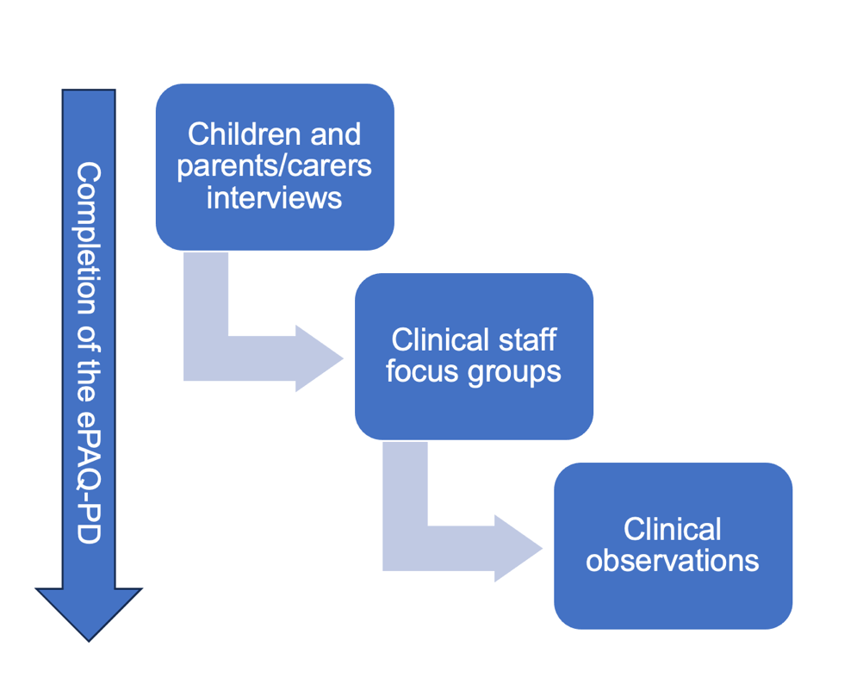
Figure ‎7.1 Flowchart of recruitment process

Completion of the ePAQ-PD

All children who were offered to attend new patient clinics Paediatric Dentistry Department between from July to October 2023 were sent invitations regardless of dental diagnosis and reason for attendance. The convenience sampling method was chosen to give an accurate representation of routine clinical practice and thus robustly test the feasibility and utility of routine administration of ePROMs.

SA issued ePAQ-PD invitation texts to potential participants through phone numbers registered as text messages in the NHS Trust patient record systems (Lorenzo™, DXC technology, Virginia, United States). SA issued invitation texts two to three days before the appointment at around 5 pm. Reminder texts were automatically set to be sent one day before the appointment at 4 pm if children and parents/carers had not completed the ePAQ-PD from the first text. An example of an invitation text can be found in Figure ‎7.2. Invitation texts were issued based on appointment lists where some children may receive several invitation texts if they failed to attend their appointment and were rebooked. The text of the invitation text does not contain any personal information as it has been limited to 160 characters to comply with the SMS requirement of text limit (further details on the invitation texts are described in Chapter ‎6.6.1). Reminder signs were placed in the waiting area to encourage children and their parents/carers to complete the ePAQ-PD (Appendix I).

As concluded from the user acceptance testing stage (Chapter ‎5.2), hard copies of incident reporting sheets were provided in a dedicated area of the Paediatric Dental Department to allow clinical staff to document the nature and type of any technical issues with the ePAQ-PD. In addition, participants’ details and the level of assistance in accessing or completing the ePAQ-PD by clinical staff were documented whenever help was requested (Appendix C).

Participant data were collected at the end of each new patient clinic. Clinical staff were instructed to file clinical notes in a designated area in the clinic. Clinical notes were only accessed when children and parents/carers had completed the ePAQ-PD and given consent/assent for the data to be used for research purposes (Item no. 30,31 and 32 (see Appendix A). Reminder cards (Appendix J) were distributed to clinical staff at the end of several new patient clinics to ensure compliance with instructions. In case of missing clinical notes, SA requested note retrieval from the Medical Records Department.

Clinical data were extracted from patients’ clinical notes using a clinical data collection sheet (Appendix K), which recorded participants’ ethnicity (white or other ethnicities), postcode, the reason for referral and clinical diagnosis (dental caries, TDIs dental anomalies, soft tissue disease and others). Other items on the data collection sheet such as the treatment modality and anxiety face scale, were used for another research project designed to assess the psychometric properties of CEDAM-8. Clinical staff were approached by SA to record the reason for exclusion of patients who failed to complete the ePAQ-PD. The reasons for exclusion were categorised into failed to attend, neurodiversity, language barrier, refusal to complete the questionnaire.

Data collected via the ePAQ-PD, including participant age, completion time, issue of reminder text, PROMs responses and overall score, responses to the question to the dentist, who completed the questionnaire and who assisted with completion, were exported from the ePAQ-PD. The data from the ePAQ-PD and the clinical data collection sheet were transferred to an Excel spreadsheet (version 2202, Microsoft®, Washington, U.S.). Each participant was assigned a research identification number. No personally identifiable information was collected.
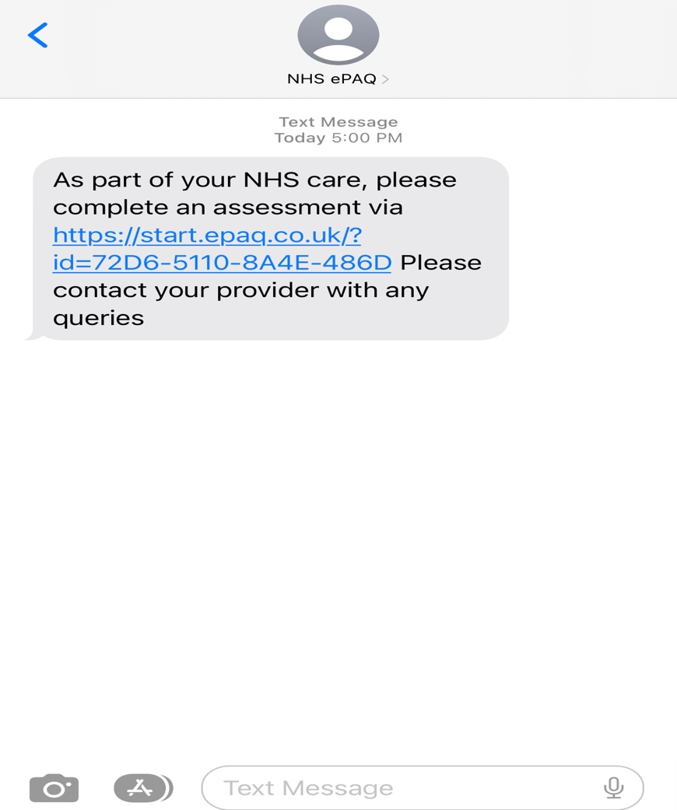
Figure ‎7.2 An example of an ePAQ-PD invitation text.

Children and parent(s)/carer(s) interviews

A purposive sample of children from age groups (3-5 years old, 6-8 years old, 9-11 years old, and 12 years old and older) were approached by the PhD candidate (SA) at the new patient clinics at the Paediatric Dental Department, Charles Clifford Dental Hospital (CCDH), and invited to participate in the study between from July to October 2023. The PhD candidate (SA) approached the potential participants and their parents/carers in the waiting area before attending the new patient dental appointment, explained the purpose of the study in simple terms, and provided the parent/carer and child with an age-appropriate information sheet with consent and assent forms (Appendix L). Children often require radiographic imaging as part of the examination for new patient assessment and have to wait 30 to 45 minutes in the Radiography Department. The waiting time before the appointment and in the Radiography Department allowed enough time for potential participants and their parents/carers to read the information sheets, think of further questions and reflect on their willingness to participate. Potential participants and their parents/carers were informed that they would receive a £10 shopping voucher after taking part in the interviews as a thank-you for their time and effort, as outlined in the NIHR guidance (NIHR, 2023)

After attending the dental appointment, potential participants and their parents/carers were approached and asked about their decision to participate in the study. Each child was asked to complete an age-appropriate assent form and the parent/carer who agreed to participate was asked to complete a written parental consent form (Appendix M). Participating children and their parents/carers were informed verbally and in writing that they had the option to terminate their participation in the study without giving a reason.

The topic-guided, semi-structured interviews were conducted with participants in a quiet room separate from the paediatric dental clinic to ensure privacy and high-quality audio recording. The interviews were conducted by SA, a paediatric dentist, who had completed formal training in qualitative research design and analysis at the University of Sheffield, Sheffield, UK. SA has recently completed two years of clinical training at CCDH as part of his MClinDent degree and is accustomed to dealing with a wide range of issues. As a paediatric dentist, SA has experience in interpreting children’s body language, which was used to determine the continuity or termination of the conversation. SA introduced himself as a ‘researcher’ who is interested in how children can use technology to tell dentists how they feel about their teeth. The methodological considerations described in chapter ‎4.1.2 guided the conduct of the interviews with the children and their parent(s)/carer(s).

Topics of discussion for participants who successfully completed the ePAQ-PD included capturing their views on the design, structure, implementation and delivery method of the ePAQ-PD and exploring responses to the general question and whether they were considered by clinical staff. For participants who failed to complete the ePAQ-PD, the interview focussed on identifying barriers and reasons for non-response. The content of the topic guide for children who completed the ePAQ-PD and for children who failed to complete it was developed iteratively (Appendix N). A screenshot of an item from the ePAQ-PD was provided to the children and parents/carers during the interview to ensure that accurate design and content considerations were captured.

Parents/carers were advised that they could support their children at any time and share their views during the interview. In accordance with the ethical considerations discussed in chapter ‎4.2, the children and parents/carers were informed that the decision to withdraw from the study was permissible and that they could stop the interview at any time and that their decision would not prejudice their current and future dental care. The child’s sex, age and duration of the interview were documented. An encrypted digital recording device (EVIDA 2324, Model V618 model, EVIDA INC., USA) was used to record all interviews.

Clinical staff interviews

Clinical staff involved in the new patient clinics were invited by the PhD candidate to participate in focus group interviews, at a date and time chosen by consensus. The clinical staff were split into two groups. One interview was scheduled for dentists, nurses and receptionists, while consultants were given a separate focus group interview to gather their views. The decision to split the interviews into two focus groups was based on the availability of clinical staff. All clinical staff who agreed to take part in the study were given information sheets and consented (Appendix L and M) focus group sessions were moderated by one moderator (SA) due to the small size of the focus groups. The discussion followed a topic guide to ensure that all relevant aspects were discussed (Appendix N). Hard copies of the final ePAQ-PD report (which did not include patient data) were distributed to participants to allow them to reflect on the design and content report (Appendix O) During the session, SA recorded the session using an encrypted digital audio recorder (EVIDA 2324, Model V618, EVIDA INC., USA). Each focus group session was to be completed within one hour.

Clinical observation

Children and their parents/carers attending new patient clinics at the Paediatric Dental Department who successfully completed the ePAQ-PD were approached by SA and invited to participate in the observation component of the study. The PhD candidate (SA) approached the potential participants and their parents/carers in the waiting area before attending the new patient appointment with the dentist, explained in simple terms the purpose of the observation component of the study and provided an age-appropriate information sheet with consent and assent forms to the parents/carers and the child. The potential participants and their parents/carer(s) were informed that after their participation in the observation, they would receive a £10 shopping voucher as a thank-you for their time and effort, as described in the NIHR recommendations (NIHR, 2023). Each child was asked to complete an age-appropriate assent form and parent/carer who agreed to participate was asked to complete a written parental consent form. Participating children and their parents/carers were informed verbally and in writing that they had the option to withdraw from the study of their own free will before the data was analysed, without being asked for reasons.

SA accompanied the children and their parents/carers to their new patient appointment to carry out the observations. The observations took place in the clinic without SA expressing any forms of interference to ensure accurate data collection. The observations aimed to capture verbal and non-verbal data generated by the children, parents/carers and clinical staff that were directly or indirectly related to the ePAQ-PD. The data collected were recorded in the form of field notes, quotes and observer reflections, which were integrated into text for inductive framework analysis (Grove et al., 2023). The children’s demographics, clinical diagnosis, ePROMs scores and responses to the open-ended questions were documented to provide additional context to the observational reports.

Data analysis

Completion of the ePAQ-PD

The ePAQ-PD and the clinical data from the Excel spreadsheet (version 2202, Microsoft®, Washington, U.S.) were transferred to SPSS Statistics 27 (IBM, New York, United States) for analysis. The level of deprivation of the areas in which the participant’s lived were analysed based on the Index of Multiple Deprivation (IMD) (2015) by applying GeoConvert to participants’ postcodes (UK Data Service). The ePAQ-PD and clinical data from the Excel spreadsheet (version 2202, Microsoft®, Washington, U.S.) were transferred to SPSS Statistics 27 (IBM, New York, United States) for analysis. Descriptive statistics were used to summarise data on participants’ demographic and clinical characteristics, those who completed the questionnaire and whether assistance was provided. The age of the participants was summarised using the mean, range and standard deviation (SD). The median and the interquartile range (IQR) were used if the age of the participants was not normally distributed. The age of participants was categorised into different groups (less than 3 years, 3–4 years, 5–7 years, 8–11 years and 12–16 years) to provide an accurate representation of the age of children attending a new patient clinic. The response rate was calculated using a simple proportion and expressed as a percentage. Unfortunately, there is no clear consensus in the literature on what response rate is acceptable. Based on the recommendations of the International Society of Arthroplasty Registries (ISAR) PROMs Working Group (Rolfson et al., 2016), a response rate of more than 60% is considered acceptable. The completion time was based on the difference between the start and end of recording by the ePAQ-PD and was expressed in minutes and seconds. The ePROMs data were not considered for analysis at this stage of the thesis. eCARIES-QC was evaluated in detail in the next chapter (‎Chapter 8), whereas eCEDAM-8 was evaluated as part of a separate research project.

Responses to ‘question to dentist’ item

As part of the ePAQ-PD, an open-ended question was added to allow participants to ask clinical staff any questions or raise concerns. The free text question ‘Are there any questions you would like us to answer at your appointment?’ was designed to appear after the ePROMs items (Appendix A). The data collected from this question was used for clinical purposes and to identify areas of concern.

Technical errors and clinician assistance

The data from the incident reported sheets were collected from the Paediatric Dental Department and extracted into the Excel spreadsheet (version 2202, Microsoft®, Washington, U.S.). The data on technical errors and clinical assistance in completing the ePAQ-PD were summarised in a table showing the type and frequency of technical errors and/or the level of assistance.

Qualitative data analysis

All audio recordings were transcribed verbatim via Dictate2us (Dictate2us© Ltd., Manchester, UK), a private company that has an agreement with the University of Sheffield. All data were anonymised by personal numbers and the audio recordings of the interviews were immediately deleted once they had been interpreted or transcribed, reviewed and securely stored. The data was analysed using a framework analysis (Ritchie and Spencer, 2002). Coding was undertaken by SA and FG independently, followed by a discussion to resolve disagreements with coding. Codes from the transcripts and notes were selected and transferred to an Excel spreadsheet (version 2202, Microsoft®, Washington, U.S.) to generate themes. Initial themes were discussed and these themes were then refined. A largely inductive approach was taken without an a priori framework. SA had formal training in Qualitative Research Design and Analysis provided by the University of Sheffield, although his experience in qualitative analysis was limited. FG, on the other hand, is an experienced researcher who has expertise in research with children.

Framework analysis

Qualitative analysis comprises various methods that serve to identify similarities and differences and to draw explanatory and/or descriptive conclusions. The most suitable method of analysis to achieve the aim of this stage of the thesis was framework analysis (Ritchie and Spencer, 2002). Framework analysis was developed by Jane Ritchie and Liz Spencer in the late 1980s for use in large-scale policy research (Ritchie and Spencer, 2002). It has been used frequently in different areas of health research (Jones, 2000). Framework analysis is based on the use of a matrix with rows (participants), columns (codes) and "cells" of summarised data that allow the researcher to analyse the data in an organised fashion (Ritchie and Spencer, 2002).

The analytical approach involves the following stages (Ritchie and Spencer, 2002):

- Familiarisation
The analysis commences with familiarisation with the data by FG and SA reading and re-reading transcriptions to ensure the accuracy of the interpretation.

- Coding
The first three transcripts were read line by line by SA and labelled with a ‘code’ describing what they interpreted as important in the passage. This step was used to organise the data from the transcripts. Coding was applied to capture any data that might be relevant to the feasibility and utility of ePAQ-PD.

- Developing a working analytical framework
The coding of the first three transcripts was reviewed by FG and disagreements were resolved with discussion. The topic guide for subsequent interviews was amended as a result of the analysis of the first three transcripts.

- Applying the analytical framework
The subsequent transcripts were indexed using codes by SA and FG, independently. Each code has been assigned an abbreviation for easier identification. The indexing of the transcripts and the interviews were conducted concurrently to ensure that all relevant areas were covered as far as possible.

- Charting data into the framework matrix
All codes were transferred to an Excel spreadsheet (version 2202, Microsoft®, Washington, U.S.) to create a data matrix labelled with the participants' pseudonyms. Loading the data allows the individual transcripts to be summarised while retaining the original meaning of the participants’ words.

- Interpreting the data
In this stage, the initial themes were reviewed and discussed with the other researchers (FG, ZM and CD) to generate the final themes.

Data handling and governance

Data handling

Participants were anonymised and only participant identification numbers were used. Personally identifiable data was collected, transferred or stored on a password-protected computer in a secure room within the department. The data files were only accessible to members of the research team. The anonymised data collected and generated as part of this study will be transferred to the University of Sheffield data repository Online Research Data (ORDA) where it will be archived for a maximum of 10 years for future research and learning purposes and then destroyed. The data was handled according to the Data Protection Act 2018 (Data Protection Act, 2018), the NHS Code of Practice (Department of Health, 2003), and the University of Sheffield Research Data Management Policy (University of Sheffield).

Confidentiality

The participants’ personal data collected in this study was maintained as described above. The company ePAQ® Systems Ltd was responsible for maintaining the confidentiality of participants’ personal data collected via the ePAQ platform, including name, date of birth and NHS hospital number. SA was granted a letter of authority issued by the STH Medical Human Resource Department to access and obtain patients’ data for research purposes.

Protection from harm

The methodological considerations for conducting research with children discussed in Chapter ‎4.1 were taken into consideration. There are no known risks associated with participation. However, potentially disruptive issues may arise during the interview. Strategies were implemented to control disruptive issues and concern including the clarity of consent and opting out procedures. At each stage, it was emphasised that participation was voluntary and that participants could withdraw at any time without giving reasons. Participating clinical staff were informed that their withdrawal was only possible prior to their participation in the focus group discussion, as it would be difficult to distinguish their data from that of the other participants. It was emphasised that the decision to withdraw from the study would not affect their employment or training. In the event of issues arising the interview would be stopped. SA is a paediatric dentist who has recently completed two years of clinical training at CCDH as part of his MClinDent degree and is accustomed to dealing with a variety of issues. As a paediatric dentist, SA is experienced in interpreting children’s body language, which he used to determine whether the conversation should continue or be brought to a close. Provision of information and resources would be provided as appropriate to the nature of the distress.

In summary, the method section provided details on the process of conducting a mixed-method study using quantitative approaches to address the aim of the study by assessing data collected in relation to the completion of the ePAQ-PD and responses to the ‘question to dentist’ item by children and their parents/carers, the occurrence and nature of technical errors and clinician assistance. Qualitative approaches were used to capture the views of children, parents/carers and clinical staff on the design, implementation method and impact of the ePAQ-PD on clinical practice. In addition, several new patient appointments were observed to capture all relevant information, as possible. The following section describes the findings of this mixed-method study

Results

Quantitative and descriptive findings

The total number of electronic invitation texts issued to children and their parents/carers who had appointments to attend new patient clinics was 602 texts. After applying the exclusion criteria, 367 children and their parents/carers were removed from the analysis (Figure ‎7.3). The number of children and their parents/carers who completed the ePAQ-PD was 275 (69.5%). Of these, 237 children and their parents/carers consented to the data being used for the research study. In total, 108 (45.6%) participants received a reminder text, 120 (50.6%) were male participants and the remaining 117 (49.4%) were female participants. Registered postcodes showed that 186 (78.5%) of children lived in Sheffield where the remaining 51 (21.5%) children were living surrounding areas such as in Derby, Lincoln and Nottingham.

The age of the participants was not normally distributed according to the Shapiro-Wilk test for normality (P < 0.001). The age range of the participants was between 0-16 years with a median age of 8 years (IQR= 4 years). Distribution of participants into age groups showed that most participants were in the 8–11 age group (n=86; 36.3%), while the under-3 age group had the lowest number of participants (n=17; 7.1%).

Over two-thirds of participants completing the ePAQ-PD were of white ethnicity (n=159; 67.1%), 29.5% (n=70) were of other ethnicities (Asian, Black, Arab, Mixed and others) and 3.4% (n=8) were form unknown ethnicity. The IMD ranking of deprivation showed that 106 of the participants (44.7%) lived in areas in the most deprived quintile (UK Data Service). Over half of the participants who completed the ePAQ-PD were diagnosed with dental caries (n=123; 51.9%). More than half of the children completed the ePAQ-PD with the help of their parents/carers (n=137; 57.8%), parents/carers completed on behalf of their children (n=58;24.5%), while only 42 children (17.7%) completed it, independently. The median time to completion was five minutes and six seconds (IQR= 05:44). Further details of the personal and clinical variables of participants completing the ePAQ-PD are summarised in Table ‎7.1. Further details and analyses of the eCARIES-QC scores and correlations between groups are described in the next chapter (‎Chapter 8).
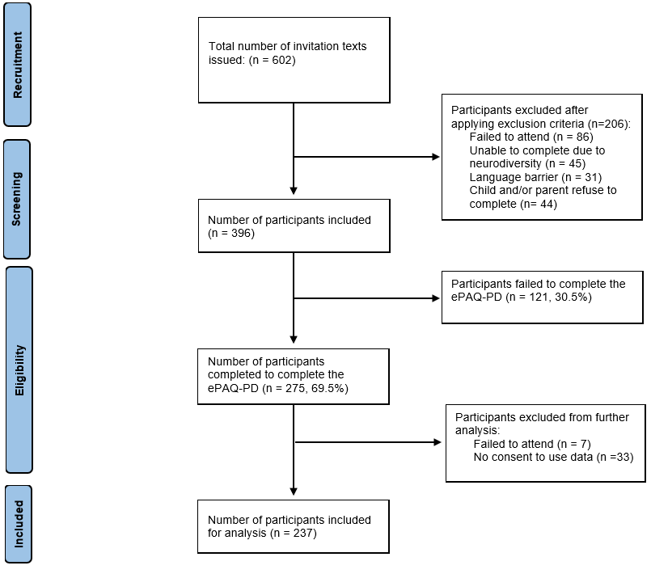
Figure ‎7.3 Flowchart of the recruitment process.

Table ‎7.1 Demographics and clinical variables of the participating children (n = 237)
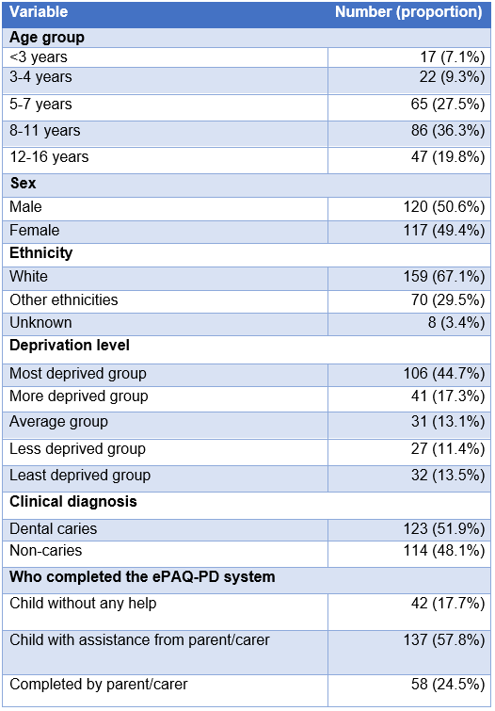

Technical errors and clinician assistance
Five incident report sheets were completed by clinical staff. No assistance reporting sheets were completed by clinical staff. Clinical staff reported issues regarding the ePAQ-PD relating to participants receiving invitation texts, access and technical errors in computing the overall score of ePROMs. None of the incidents were permanent or required reporting to the ePAQ clinical lead or software engineers. Quotes from the clinical staff reports can be found in Table ‎7.2.

Table ‎7.2 Quotes from clinical staff were reported through the incident reporting sheet.
Incident reporting sheet
- “Child and family could not open the ePAQ but it worked after clinic and they have completed it”
- “Family have never received a text or reminder. The phone number is up to date on the system”
- “Domain score did not work for one patient”
- “The parent said that they had completed the questionnaire but at the end, the system took them back to the first page. The report had no responses at all”
- “Overall scores did not work”

Responses to ‘Question to Dentist’ item

Of the 237 participants, 48 (20.3%) completed the free text question "Are there any questions you would like us to answer at your appointment?". The total number of responses was 102 with an average of two responses per participant. The participants who responded to this item were of different ages, clinical diagnoses and levels of deprivation, with no discernible trends. The responses to the item "Question to the dentist" can be categorised into three categories based on the meaning of the content: Questions, Reports and Requests.
Questions

The responses, categorised as ‘questions’, have a variety of concerns about their oral health and dental treatment. Some questions related to the nature and safety of a treatment modality:

“Can you die from gas and air? Will it affect my mental health?” (Female, aged 11 years)

“what are the risks for anesthesia?” (Female, aged 4 years)

These children stated that they were genuinely concerned and believed that pharmacological behaviour could cause life-threatening complications. They probably expect the clinical staff to provide detailed explanations and reassure them. Other children were concerned about the complications of treatment:

“Is it gonna hurt? Will you remove any?” (Female, aged 10 years)

“Will you do anything too serious like a drill? Will it hurt?” (Male, aged 8 years)

It seemed that the children's main concern was feeling pain caused by the various dental treatments. The children were able to specifically report the cause of their anxiety. Some children questioned the aetiology of the oral condition they were experiencing:

“Why plaque gathers so much” (Male, aged 8 years)

“Why do I have such big teeth?” (Female, aged 11 years)

“What has caused the condition at the back of my teeth?” (Male, aged 10 years)

The use of the ‘question to the dentist’ item was beneficial as it allowed children to express their concerns in their own words. The concerns reported varied from child to child, which necessitated the use of open-ended questions to capture which concerns were important to an individual child.

Reports

The responses categorised as ‘reports’ were more of information intended to inform clinical staff about the child’s health, behaviour and other matters. Most of the reports appeared to be written by the parents/carers rather than the children. Parents/carers used this item as a means of communication to inform and forewarn clinical staff about their child’s condition that could impact clinical care. For example, a parent/carer reported a medical condition and wondered if it would impact dental treatment:

“ .. is diagnosed with CRMO. Will this affect any further treatment?” (Male, aged 14 years).

Another example of a parent/carer reporting information on a child’s behaviour and level of anxiety:

“ .. will probably not let you look at his tooth I will take a photo” (Parent/care of male, aged 6 years).
This report seemed to facilitate the clinical staff to prepare for what to expect during the appointment. Other children and parents/carers used this item to report current symptoms and outcomes from previous dental visits:

“I have spots on my gums” (male, aged 6 years).

“Previous xray shown wearing away of the tissue is this the reason for a clicking and painful jaw?” (Female, aged 14 years).

These responses can be documented in the general dental referral. However, it is more effective to use the words of the child's parents/carers to facilitate the discussion and identify personal needs and expectations.

Requests
The ‘question to dentist’ item was sometimes used to make an enquiry from children and parents/carers to the clinical staff before they attended the appointment. Responses categorised as ‘requests’ were mainly used to ask clinic staff for advice on how to improve their oral health:

“what makes a teeth strong ..” (Parent/care of male, aged 3 years).

“Is there anything I can do at home to make them better?”. (Female, aged 9 years).

“How can I make them white when tooth paste doesn't work” (Male, aged 9 years).
Some children have used this item to ask clinical staff to ease their anxiety during the appointment:

“can you make me less scared?” (Male, aged 6 years).

The ‘question to dentist’ item seemed to be a valued addition to the ePAQ-PD, with around a fifth of children's parents/carers using it to raise concerns, information and questions with clinical staff prior to their appointment.

Qualitative findings

Several children of different age groups and their parents/carers and clinical staff with different roles were involved in the qualitative approaches. Details of the number of participants involved in the qualitative approaches are shown in Figure ‎7.4. The findings of the individual approaches are described in detail in the following subsections.
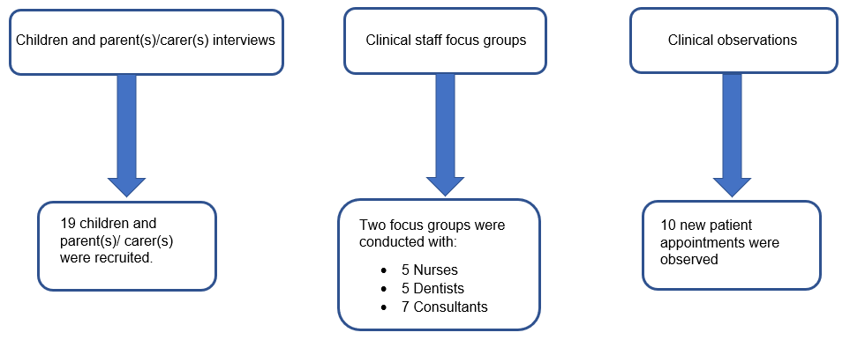
Figure ‎7.4 Recruitment details for qualitative approaches.

Children and parent(s)/carer(s) interviews

The participants in the interviews were 19 children and 21 parents/carers. The participating children were recruited purposively from different age groups, with 10 males and 9 females (Table ‎7.3) and different clinical diagnoses (Table ‎7.4). The length of the interviews varied from 7 minutes to 28 minutes with an average duration of 14 minutes. Children and parents/carers shared a variety of views about the ePAQ-PD and its use in clinical practice. Young children (aged less than 7 years) typically did not express themselves in full sentences but nodded their heads and responded with a single word such as 'good' or with ‘yes’ or ‘no’ when answering questions. Nevertheless, their short responses were quoted and included in the analysis to reflect their views. Themes were related to general impressions, the electronic format, content and design, and clinical effectiveness. These themes are explored using quotes from children and parents/carers to demonstrate their views on the ePAQ-PD and its use in clinical practice. These themes are reported in an order based on the relevance of the quotes as facilitators, barriers or suggestions for clinical use of the ePAQ-PD. It was felt that this method would facilitate the presentation of different narratives for each theme.

Table ‎7.3 Purposive sampling framework for interviews with children and parents/carers.
Age group (years) | Male | Female | Total
3-5 | 2 | 1 | 3
6-8 | 3 | 3 | 6
9-11 | 3 | 2 | 5
12-16 | 2 | 3 | 4
Total | 10 | 9 | 19

Table ‎7.4 Clinical diagnoses for the included children in interviews.
Oral condition | Number
Caries | 6
Molar incisor hypomineralisation | 5
Traumatic dental injury | 5
Dens invaginatus | 1
Amelogenesis imperfecta | 1
Soft tissue | 1
Total | 19

Impressions
Participants expressed different views to reflect their general feelings about using the ePAQ-PD. All views were positive but varied in perspectives on how participants found the ePAQ-PD. Some participants described their feelings about the ePAQ PD in general:

“They’re very good. I like them” (Gorege, male, aged 8 years)

“I love multiple choice questions. That's so fun” (Jerry, male, aged 10 years)

These views reflected the age appropriateness of the ePROMs (eCARIES-QC and eCEDAM-8) and the quality of their development and validation process.. Other participants described how the ePAQ-PD impacted their experience of attending new patient appointments:

"I felt a lot calmer and happier " (Lavender, female, aged 8 years)

“I think it’s good. Because they know that I’m scared and make me feel better” (Sam, male, aged 8 years)

These views showed that the ePAQ-PD facilitates positive experiences for children attending the new patient clinic. Some parents acknowledged that the ePAQ-PD promotes parent-child communication and encourages children to disclose hidden impacts that parents were not aware of before using the questionnaire:

"when I asked him, I didn't realise he was worrying about being put to sleep… because we had had a chat, so it was handy when I asked him, well, what's actually worrying you?" (Parent of Jake, male child, aged 9 years)

“It opened up quite a lot of good communication for me and Emily” (Parent of Emily, female child, aged 9 years)

“She had never mentioned to me that she was getting pain, but from us from answering the questions" (Parent of Miles, male child, aged 6 years)

These reports identified an unexpected benefit of the ePAQ-PD. It seemed that the systematic impact-capturing nature of the included ePROMs led the children to reveal impacts hidden from their parents. The ePAQ-PD appeared to play an effective role in promoting communication between the child and parents/carers regarding the child’s oral health prior to the dental appointment.
Electronic format

The electronic nature of the ePAQ-PD was discussed by the participants in terms of intuitiveness, navigation, delivery, security and preference over paper formats. Participants commented on the intuitiveness of the ePAQ PD. These comments were reflected in the fact that the ePAQ-PD is easy to use, user-friendly and similar to other online questionnaires:

"We have it like that in our school when we're doing like computing and things like that" (Lavender, female, aged 8 years)

“I think it’s quite easy enough to follow, it were easy enough to follow, so I think it’s quite reasonable for people to answer it" (Parent of George , male child, aged 5 years)

“when I got to the bit that said it was about your child needs to fill it in, I then just saved the browser page and waited until I got Jerry back from school” (Parent of Jerry, male child, aged 10 years)

"Yeah, it was easy to see that the next and the previous were in green, so you could click on them. And then I didn't need to skip anywhere. It was easy to see that you could " (Parent of Jake, male child, aged 9 years).

The ePAQ-PD was found to be intuitive with clear instructions and some children and their parents/carers appeared to be able to complete it remotely without support from clinical staff. The progress indicator built into the ePAQ-PD (e.g. 6 out of 32 pages) seemed to be appreciated by participants as they found it useful in encouraging the completion:

“we're getting through it really fast, you're doing really well. I think having knowing that is a good thing“ (Parent of John, male child, aged 3 years).
However, participants identified some factors that could limit the intuitiveness of the ePAQ-PD. These factors included some children and their parents/carers having difficulty completing the ePAQ-PD:

“it was quite hard because all the like keyboards are like close together" (Elizabeth, female, aged 14 years)

“There were typeface over it .. where it says next .. I’d have to sort of pull down to refresh in order to go on to the next one" (Parent of Elizabeth, female, aged 14 years)

These difficulties were not related to the content of the ePAQ-PD, but rather to the electronic device used and the automatic save message generated by the ePAQ platform. Some children and their parents/carers reported that they had difficulty navigating between items:

" it was a bit confusing because you need to press it and then you need to press next" (Maria, female, aged 13 years).

“it took us maybe about 30 seconds to realise actually we needed to click the answer and then press next” (Parent of Emily, female child, aged 9 years).

When the children and their parents/carers were asked how to improve the intuitiveness of the ePAQ-PD, the answers were mainly related to improving the navigation method between the items. They suggested changing the position of the navigation options or removing the options and incorporating automated navigation feature:

" I was expecting it to move on and then I found that to go to the green, next … I suppose, … you have bit better off sticking the next in that space, it would've been better " (2nd parent of Jackson, male child, aged 10 years)

“normally if you just press an answer it automatically moves on to the next question, whereas this didn’t" (Parent of George, male child, aged 5 years)

It seems that automatic navigation is more convenient than manual navigation to the next item. The electronic delivery of the invitation texts was discussed with the children and their parents/carers. They liked that the texts were delivered electronically as text messages, but asked for advance notice to improve the likelihood of the texts being perceived as from a trustworthy source:

"Yeah. I think it's just good if the actual dental appointment does then tell you this is going to come " (Parent of Theo, male child, aged 12 years)
"So, it might help if all the information or a link or something is within that letter so you can actually fill it out at that time" (Meredith, female, aged 14 years)

Some participants appreciated the reminder texts and felt that they were prompted to respond to the ePAQ-PD:

“I saw the first one and I put it straight back in my bag thinking I'll do it later, later never happened. But then I got the reminder. So, I found that helpful." Parent of Pikachu, male child, aged 8 years)

“I think if you haven’t sent the reminder, I wouldn’t have done it all" (Parent of Sam, male child, aged 8 years)

The authentication method on the ePAQ-PD login page, which requires the child’s date of birth to be entered, was highly appreciated by participants. Participants reflected on this security measure to prove the validity of the system:

“I had to confirm his date of birth, I think. So, I don't think it would let me do it if…it wasn’t for Jake " (Parent of Jake, male child, aged 9 years)

“it was safe because it's .. like a safe password for Pikachu's date of birth, and that was like a doubly thing to make sure for me to make it safe" (Parent of Pikachu, male child, aged 8 years)

The participants held conflicting views on the method of administering PROMs. The majority favoured the electronic method for various reasons, including that it is faster, simpler, more sustainable and personally preferable:

“Electronic. it’s good for the environment" (Parent of Zoe, female child, aged 7 years)
" It's quicker and if you lose the paper, you don't get another one" (Jake, male, aged 9 years)

“Electronic, yeah okay. Because there's a chance you might lose the paper. Or it gets ripped or coffee spills on it, I've worked in schools, anything could happen to paper” (Parent of Emily, female child, aged 9 years)

Other participants preferred the paper-based method mainly out of personal preference and to overcome the limitations of the electronic method such as accessibility and technical errors:

“Not that many people might have a phone that they could use, so it would be helpful if they have some like paper copies as well" (Elizabeth, female, aged 14 years)

“ So, we tried to do the questionnaire, got all the way through to the end of the questionnaire, and then it just said they had technical problems, and it took me back to the first screen. Now, I don't know whether that was a system error or a Wi-Fi error, we were just travelling." (Parent of Meredith, female child, aged 14 years)

“Paper. Because it’s more fun (laugh)" (Sam, male, aged 8 years)

One participant suggested changing the method of response selection method from "clicking" to "circling", which was seen as a more child-friendly method:

“.. like instead of writing it you could like sit, like use your pen like a pen on your phone and circle it. Yeah, instead of clicking it, circle it” (Emily, female, aged 9 years)
This suggestion seemed to combine the merits of electronic and paper formats. The current electronic features and delivery method of the ePAQ-PD appear to be practical and acceptable to participants. Some areas for improvement were identified in terms of readability, advance notice and navigation between items.

Content and design

The children and their parents/carers shared interesting views on the content and display of the ePAQ-PD. They reflected on the content of the invitation text, the PROMs items, and the other items. The content of the invitation text, including the text and where it was sent from was thoroughly discussed by the participants (Figure 6.1). Some participants reported their reactions of confusion and doubt when they received the invitation text:

“Just because the title’s NHS ePAQ. So, the ePAQ doesn't mean anything to me, then the last line contact your provider for any queries. I don't have a provider, I don't know who that is!" (Parent of Elizabeth, female child, aged 14 years)

“.. wasn't sure if it came from the NHS or if it was some kind of a scam. So, we was very unsure whether to click it or not, so we didn't." (Parent of Theo, male child, aged 12 years)

The children and their parents/carers made some suggestions to improve the content of the invitation text to ensure clarity and legitimacy. They suggested that the text should be more child-specific and describe the purpose of the questionnaire more clearly:

“I think you should send a text from the actual dentist place first .. so therefore, the people know then it is legitimate kind of thing" (Parent of Theo, male child, aged 12 years)

“Maybe the date of the appointment or for your upcoming appointment on the 2nd of November" (Parent of Miles, male child, aged 6 years)

“if you mentioned Sam’s name on the text it would be more convincing .. I had got like three appointments for three different children .. I wouldn’t have necessarily linked it to Sam" (Parent of Sam, male child, aged 8 years)

“we want your child to have a positive experience when coming to the dentist. If you please can you fill this question out more information will be passed on to your dentist” (Parent of Emily, female child, aged 9 years)

It appears that the current invitation text is very generic, which may be a barrier to accessing and completing the ePAQ-PD. The aforementioned suggestions should be taken into account in the future use of the ePAQ-PD. The timing for sharing the invitation texts to participants appears to be critical from their perspective. Some participants found the current time used to share the texts (two days before the appointment between 4 and 5 pm) appropriate and served as an appointment reminder:

" That gave me reassurance that it must be to do with our appointment, I think because it came the day before. I think if the message had come a few days prior, I would've been more concerned." (Parent of Meredith, female, aged 14 years)

“It was good because it made me think about what I might ask the dentist today” (Jerry, male, aged 10 years)

The timing of sharing the invitation texts appeared to increase trustworthiness as some children and their parents/carers associated them with their appointment. Some children and their parents/carers considered different days and times to be more appropriate for receiving the invitation text:

" Because if they're still at work at 4:30, well then they'll probably go, "I'll do it later" and forget about it. Whereas, if you send it more six, five to six, then they might have gone, "Oh, I'm at home now I can fill it in." (Parent of Theo, male child, aged 12 years).
“Probably a week before rather than two days just because work-wise .. two days feels a bit short" (Parent of Maria, female child, aged 13 years)

With regard to the ePAQ-PD items, the children and their parents/carers were positive about the length, wording and position of the questionnaire and the responses:

" Yeah, the questions aren't too lengthy. I thought that was quite good. I think the answers that you give, they're straightforward .." (Meredith, female, aged 14 years)

“It’s a short question. It is cool” (Sam, male, aged 8 years)

Another child found it a long questionnaire, especially for young children:

“It was quite long; I think it took us about 15 minutes. And I noticed that Cat became .. a little awry because she felt as though I'd asked her quite a lot” (Parent of Cat, female child, aged 4 years)

Some suggestions were made for adding new items to the questionnaire and responses to ensure capturing more relevant and important data. One child suggested adding the option ‘sometimes’ to the eCARIES QC responses as the oral impact tends to be more intermittent:

“There needs to be an extra one. Sometimes" (Sam, male, aged 8 years)
One parent suggested the inclusion of a separate section for parents/carers to provide direct sensitive information about their children to clinical staff:

“.. could the questionnaire be split into complete this section with your child and complete this section just for the parents maybe .. I did write an additional note to hand in about a phobia that Zoe has that’s relevant, which I didn’t feel any of the questions and any of the questionnaires enabled me to give information about that" (Parent of Zoe, female child, aged 7 years)

The position of the questions, responses, and navigation were discussed by the children and their parents/carers. Their main concern was the position of the questions and navigation options at the top of the screen:

“On the phone though, the text, it's all bunched up at the top" (Meredith, female, aged 14 years)

" I didn't know where to press next because you need to look at the top. The "next" button should be below the button rather than at the top. That's normal" (Parent of Lavender, female child, aged 8 years).

The colour of the ePAQ PD content was discussed during the interviews. The current background colour of dark blue and white (see Figure 6.2) does not seem to be preferred by the children and their parents/carers. Their comments referred to suggestions for other colours to improve clarity and better include children with neurodiversity:

“ I'd say the colour of the writing was pretty faded so, you couldn't go see it" (Lavender, female, aged 8 years)

“Dyslexia friendly colours might be good, so. Such as if you’ve got kind of pale blue text on a dark blue background, it stands out better. also with the text, dyslexics find it easier to read comic sans than other fonts" (Parent of Zoe, female child, aged 7 years)

Others suggested changing the colour of the responses and navigation options to add more context and be more child-friendly:

“.. like a traffic light type system. So, green, not at all. A little bit if it's orange. And a lot red" (Miles, male, aged 6 years)

“switch like either the previous or the next to a yellow. So, then if they can't read properly, then they can know which one's which” (Jerry, male, aged 10 years)

The shape of the ePAQ PD content was discussed and it was recommended to change the current shape of the navigation options to improve readability:

"… it might be easier to have arrows or something rather than next, just if, if they can't read.. " (Parent of Jake, male child, aged 9 years)
Other children suggested adding pictures to add more context to the questions and responses and make the experience more enjoyable for young children:

"Pictures. Like what the question is basically asking you. So, because some younger children can't read" (Lavender, female, aged 7 years)
“Thumb up! And then a bit like maybe to the side. Thumb down for not at all" (Zoe, female, aged 7 years)

" so they would be doing this sort of smiley face; does it hurt, does it not hurt? Or, you know sad face…sad face, yeah" (Meredith, female, aged 14 years)

“ Maybe at the end instead of saying click here to send something, instead it could be like confetti with like a medal .. " (Elizabeth, female, aged 14 years)

These quotes suggest that the ePAQ-PD needs further changes to its content and design to improve its legitimacy, readability and appearance to meet children’s expectations and preferences.

Clinical effectiveness

The clinical application of the ePAQ-PD was reflected upon by the children and their parents/carers. They shared their views on the importance and benefits of routine use of ePROMs in clinical practice in different settings. Suggestions were identified on how to improve patient experience and their willingness to complete the ePAQ-PD. Some children and their parents/carers perceived the effectiveness of the ePAQ-PD once they had completed it:

“ Well, that’s what we assumed, pre-warn the dentist of any worries that she’s got beforehand" (Parent of Zoe, female child, aged 7 years)

This quote shows that some children and their parents/carers were aware that the clinical staff would see their responses. However, some children felt uncertain about the reason for completing the questionnaire as the invitation texts they received were not clear enough:

“I don't think it was particularly clear at the beginning that your child's dentist would get to see this and see how they would feel” (Parent of Emily, female child, aged 9 years)

“I was not sure what the assessment for? Is it a survey of how we got the appointment? or how long we are waiting for the appointment?" (Harry, male, aged 14 years)

The children and their parents/carers suggested amending the content of the invitation text to make clearer the purpose of the questionnaire and the fact that clinical staff will see their responses:

“So, if that would've said, "This will help us build a picture of your dental health before you arrive and help us like, know more about you”, then people will have a reason to fill it in, whereas they probably think, "oh, they just want to have something, what does it really matter?" (Parent of Theo, male child aged 12 years)

In addition to the quotes from the content and design theme on the content of the invitation text, which should be child-specific, the texts must include a clear purpose of the questionnaire. Children and parents/carers found that the remote completion function of the ePAQ-PD was effective in systematically reporting the impact of poor oral health that would be overlooked during the appointment:

" I'd forgotten about the ulcers" (Elizabeth, female, aged 7 years)

“I don’t think they’re always as open or as willing to share that sort of information when put on the spot" (Parent of Maria, female child, aged 13 years)
The completion of the ePAQ-PD before the appointment seems to be beneficial for the children's emotional preparation, as they know that clinical staff have seen their responses:

“I didn’t feel worried or scared or anything, I felt glad that they knew, and that they know what I wanted them to know, and what I wanted to be answered" (Gerald, male, aged 10 years)

“it's helpful.. like dentist know their personality better..” (Pikachu, male, aged 8 years)

Children and parents/carers confirmed that the ePAQ-PD had supported clinical staff in addressing their concerns and they felt that it had improved their experience and the care provided:

“Absolutely, I was sad, I was crying everywhere. She made me feel a lot better” (Emily, female, aged 9 years)

“.. they could see that he was really nervous, and that's why he’s got five stickers” (Parent of Pikachu, male child, aged 8 years)

" … So, she was reassuring you all the time saying, we're not doing anything today… So, it was really helpful. Yeah" (Parent of Jackson, male child, aged 10 years)

The children felt that the ePAQ-PD allowed for more focused care, focusing on what was important to them which reduced appointment time:

" she was able to focus on a specific spot on the teeth which is good. So, it shortened down the whole time" Maria, female, aged 13 years)

" they know what equipment you will need .. I was quite pleased" (Elizabeth, female, aged 13 years)

Some children and their parents/carers shared their feelings of disappointment when clinical staff overlooked their responses from the ePAQ-PD. They felt annoyed when clinical staff asked them again about oral impacts that had already been shared.

"I thought they would have asked me. They didn't. They didn't ask me. I thought, what's the point of filling it in, they didn't ask me " (Parent of John, male child, aged 3 years)

“It just felt like we’ve answered them all yesterday and then she re-asked us anyway. he doesn’t necessarily have to be brought it all up to make them rethink it" (Parent of Sam, male child, aged 8 years)

It was evident from the quotes on this theme that the ePAQ-PD is beneficial in comprehensive impact reporting, in guiding clinical staff to address impacts and concerns, and in shortening appointment time. The main barrier was uncertainty about the content of the invitation text and whether clinical staff would view the responses. A summary of the facilitators and barriers to clinical use of the ePAQ-PD identified by the children and parents/carers is summarised in Table 6.

Clinical staff focus groups

The participants in the two focus groups were a total of five dentists, five nurses and seven consultants (Figure ‎7.3). The duration of the non-consultants and consultants focus group interviews were 45 minutes and 15 minutes, respectively. The clinical staff shared a variety of views on the ePAQ-PD and its use in clinical practice from their perspective. The views reported by clinical staff differ between the two groups due to their different roles in clinical practice, with consultants placing more emphasis on administrative aspects. As with the analysis of the children and parents/carers, the transcripts were initially analysed according to the themes of facilitators, barriers and suggestions to gain an understanding of the areas discussed.

The final themes were related to children’s voice, practical tool, clinician-patient interaction, accessibility and readability. These themes are explored using quotes from clinical staff to illustrate their views on the ePAQ-PD and its use in clinical practice. These themes are presented in an order based on the relevance of the quotes as a facilitator, barrier or suggestions to clinical use of the ePAQ-PD. It was felt that this method would facilitate the presentation of different narratives for each theme.

Children’s voice

Clinical staff valued the ePAQ-PD as a medium in which the children’s voices could be heard. Clinical staff were fully aware of the role of children and their right to be involved in their oral healthcare process. Various aspects of children’s empowerment were discussed, such as how the children felt during the appointment and how the ePAQ-PD could be made more inclusive. Clinical staff were surprised at how many children and parents/carers completed the ePAQ-PD:

“.. the children and the parents do seem to be engaging with it” (Female, dentist 1)

“I’ve actually been pleasantly surprised by how many have filled it in” (Female, dentist 2)

The ePAQ-PD was the first ePROM system ever to be used routinely in the paediatric department at CCDH. The clinical staff reaction to the response rate by children and parents/carers reflects the promising future for the clinical use of the ePAQ-PD. In addition, clinical staff shared children’s positive reactions when clinical staff reviewed their responses from the ePAQ-PD:

“ ..it’s really good for the patients to be able to see that the clinicians are acknowledging that they’ve taken the time to fill it in” (Female, dental nurse 1)

“..you can see that the patients are appreciative that they’ve been acknowledged in what they’ve put it in” (Female, dentist 4)

The benefits of completing the ePAQ-PD remotely by children and their parents/carers were recognised by clinical staff. They noted that the ePAQ-PD encouraged children to report the impact and gain confidence:

“It’s just helping giving them confidence to ask what they want ” (Female, dentist 2)

“..help them like troubleshoot everything so they know exactly what they want to say when they come” (Female, dentist 1)

“.. maybe if they haven’t had the opportunity to say it when we’ve asked them questions, they know that they’ve been able to document it” (Male, dentist 3)

Areas for improvement were discussed to ensure that the children’s voices were heard as much as possible. Clinical staff urged making the ePAQ-PD more inclusive for children with visual disability and those who do not speak English:

“can we put down different languages and then we can translate that to English?” (Female, dentist 2)

“could there be an option where it’s recorded and you press it and they can hear the questions” (Female, dental nurse 1)

The ePAQ-PD has been well received by clinical staff as it allows children the opportunity to express their opinions about their oral health. Benefits observed include encouraging children to outline what matters to them regarding their oral health. Suggestions have been made to further improve the involvement of a wide range of patients.

Practical tool

Clinical staff were encouraged to share their thoughts on the implementation of the ePAQ-PD as a practical tool for patients to report oral health impacts. They seemed to value the information collected and believed it would add professional value to the clinical care service:

“it’s collecting really useful information” (Female, dentist 1)

“I think it’s good, it’s quite complete as it is, has all in that one nice place” (Dental nurse 1)

“I think that it’s very professional. I like it” (Female, dentist 4)

Some clinical staff felt that routine use of the ePAQ-PD could be useful as an appointment reminder for children and their parents/carers:

“it’s good reminder for them to come to the appointment” (Female, dentist 5)

Other staff suggested extending the utility of the ePAQ-PD by using it to assess treatment, monitor anxiety levels and establish a priority-based waiting list:

“..it’s a good tool to see if we met patients expectations or needs, potentially like to as a way of assessing the outcome of your treatment” (Female, dentist 2)

“..if they do one at discharge after they’ve had the treatment, has their anxiety changed compared to when they first filled it in” (Female, dental nurse 1)

“..we may influence the scores of this and what they've said into their urgency or priority” (Female, consultant 3)

The notion of routinely using ePROMs in clinics to assess new patients appears to be well-accepted by clinical staff. Suggestions have been made to use the ePAQ-PD in other clinics to assess and monitor physical and psychological outcomes and guide waiting list structuring.

Clinician-patient interaction

In-depth discussions between the clinical staff revealed more detailed benefits and limitations regarding the clinical utility of the ePAQ-PD. The discussion included arguments about how the ePAQ-PD impacts the relationship between the child and clinical staff during the new patient appointment. Clinical staff recognised the benefits of the ePROMs items and the free-text questions:

“I think lots of the questions are relevant .. I do think, different conditions are affected by similar things” (Female, dentist 2)

“I think that free text box is really good, it’s really freeing for a lot of people” (Female, dental nurse 2)

These quotes indicate that the use of ePROMs as part of ePAQ-PD (eCARIES-QC and eCEDAM-8) with free-text fields provides a wide range of clinically important information. Regarding the use of this information, clinical staff reported that the ePAQ-PD facilitated communication with children and their parents/carers. They reported that this effect was more pronounced for anxious children:

“..it gives you some really good points to start off on when discussing with the child” (Female, dentist 2)

“It’s really useful for anxious patients, it help us to address their anxiety … and make the treatment less anxious for them” (Female, dentist 5)

“..I tend to get the information from that discussion as to how anxious they are. And I think this information definitely informs that conversation but it doesn’t replace it” (Female, dentist 4)

In addition, clinical staff indicated that the ePAQ-PD was able to capture information about oral health impacts from anxious children, which is difficult to capture during the appointment:

“it’s almost safe if you’re at home and you can just type it into a box, it takes away that almost fear of the face-to-face interaction that particularly from anxious people’s point of view” (Female, dental nurse 1)

“it gives them a chance to do it in a sort of comfortable environment, have a good think about it, have a discussion between themselves” (Female, dentist 2)

Treatment planning was the only other aspect of new patient appointments where information from the ePAQ-PD appeared to be utilised. Clinical staff noted that the information from the ePAQ-PD could indirectly facilitate discussion of the treatment plan, but not the prioritisation of treatment options:

“.. treatment plan is like a conclusion that depends on everything not only the questionnaire” (Female, dentist 2)

“I think it improves how we discuss treatment plan but do not inform treatment options” (Female, dentist 1)

The ePAQ-PD appears to be effective in capturing sensitive information, facilitating communication and discussion of the treatment plan between clinical staff and children and their parents/carers. Treatment options do not appear to be determined by the results of the ePAQ-PD.

Accessibility
One of the main limitations discussed by clinical staff related to the accessibility of the current version of the ePAQ-PD. Clinical staff noted that access to the ePAQ-PD may be limited for a variety of reasons. High patient flow may limit the ability of clinical staff to access or remember the ePAQ-PD:

“it’s quite busy, it’s really hard to remember to open it basically..” (Female, dentist 1)

“ .. when time becomes a bit more pressured to do it, perhaps we don’t do it as effectively using this as we could” (Male, dentist 3)

“If it’s a busy clinic, the clinician don’t open it” (Female, dental nurse 2)

Clinical staff expressed their regret for not being able to access the ePAQ-PD when it was overlooked in a busy clinic:

“I feel sad that I’m not looking at it because I know someone has taken the time to complete it and I know it’s valuable information” (Female, consultant 1)

Another reason limiting access to the ePAQ-PD is the clinic's hybrid environment, where paper and electronic formats are integrated into routine practice. Clinical staff found that this environment distracted them from using the ePAQ-PD. In addition, the ePAQ-PD has limited accessibility as it is a separate from the other systems used in the clinic:

“I think the challenge is because we use a hybrid system of paper notes and then digital x-rays, it adds just that extra layer of complexity and just another administrative burden” (Male, dentist 3)

“.. so in terms of not having to log in to this thing. I just think the modality is hard … a bit of admin” (Female, dentist 1)

Another barrier to using and accessing the ePAQ-PD was the platform's strict security measures. The platform user must log in after being inactive for 15 minutes. This measure seems to affect the willingness of clinical staff to use the system:

“It’s only when the ePAQ log you off every 15 minutes, that was the only problem, you need to log in every 15 minute” ( Female, consultant 1)

Some suggestions have been made to reduce the burden on clinical staff and enable greater utilisation of the ePAQ-PD by improving access methods, including integration with other electronic systems, provision of paper copies and constant reminders:

“We’re such a paper-based clinic, that having the ePAQ printed off and filed is a good way to go” (Female, dental nurse 1)

“We use standard templates for new patient assessments.. So there is an element of it that there is another tick box of it's been reviewed not” (Female, consultant 3)
“hopefully, in the Cerner system (a new electronic patient record system to be implemented) and it's easier to see within the patient's notes, I think we're going to use it a lot more” (Female, consultant 4)
Accessibility is the main barrier to the use of the ePAQ-PD by clinical staff. Several suggestions have been made on how to improve access and reduce the burden on clinical staff.

Readability

The clinical utility of the ePAQ-PD depends on the interpretation of the final report by the clinical staff. Clinical staff discussed the readability of the ePAQ-PD final report from various aspects of appearance and content and pointed out some areas for improvement. The division of patients’ negative and positive responses to ePROMs items into two-hand columns was found to be acceptable and easy for clinical staff to read:

“I agree that the columns where you’ve got the good and bad side is helpful” (Female, dentist 1)

Some clinical staff suggested colour-coding or changing font of the two-hand response columns to improve visibility and highlight the severity of the impact:

“it would be really helpful to just highlight .. what needs to have a looking at, if there’s a way to do that, a bit like a traffic light thing” (Female, dentist 1)

“ Colour, italics, a different child-like font, anything like that, I would find that for my brain much easier” (Female, consultant 5)
The clinical staff asked to improve the clarity of the overall score of the ePROMs whereas others reported more familiarisation is required. Their suggestions related to the meaningfulness and appearance of the scores:

“ .. if that number correlated to like a traffic light system, so use the colour, and then you can see that really quickly..” (Female, dental nurse 1)

“Just out of 24, I think it’s a bit harder to get your head around.. the smaller the number the more easier it is in my head” (Male, dentist 3)

“I think a numerical value tells me nothing unless I know I'm very familiar with the scale” (Female, consultant 4)

It seemed that clinical staff requested a display format that would allow for faster interpretation. Some clinical staff acknowledged the value of the eCEDAM-8 questionnaire and suggested adding one item. They suggested the inclusion of a summary of the eCEDAM-8 questionnaire, such as an anxiety scale:

“..is there any way of being able to quantify that set of questions into a little anxiety scale? .. it just means that we see the questionnaire but we see something quite quickly” (Dentist 3)

“.. sort of set faces or a set of illustrations that they can point to because sometimes they don’t want to talk” (Female, dental nurse 3)

Clinical staff recognised the benefits of the ePAQ-PD final report. However, they emphasised the importance of improving the clarity of the final report by improving the presentation of responses, simplifying the overall ePROMs results and adding summary features to the eCEDAM-8. A summary of the facilitators and barriers to clinical use of the ePAQ-PD identified by clinical staff is summarised in Table ‎7.5.

Table ‎7.5 Facilitators and barriers to the clinical use of the ePAQ-PD per theme.
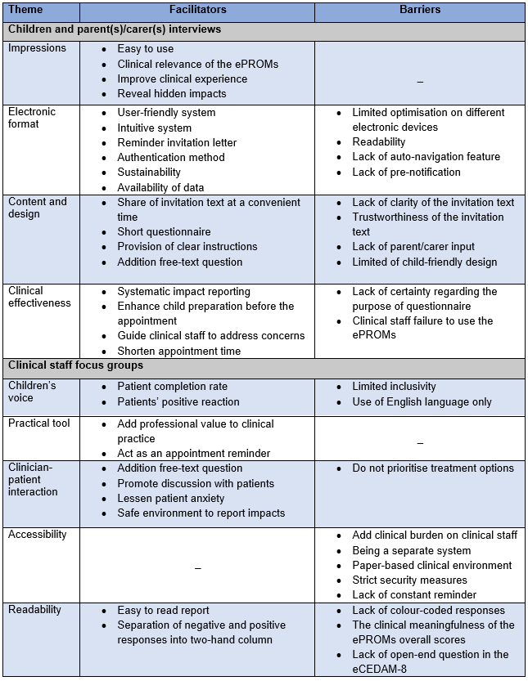

Clinical observations

Ten children and their parents/carers and 16 clinical staff (consultants, dentists and dental nurses) agreed to be observed during their appointments in the new patient clinics. The children observed ranged in age from 5-15 years and were evenly split between males and females. Observed children were diagnosed with dental caries (n=4;60%), dental anomalies (n=3;30%) and TDI (n=3;30%). All children and parents/carers who participated in the clinical observations had completed the ePAQ-PD. In two out of ten appointments, clinical staff failed to access and view the ePAQ-PD final report. The children’s responses to open-ended questions in the ePAQ-PD (other impacts and question to dentist items) and other information are presented in Table ‎7.6.

Data collected at these appointments included observer (SA) notes on behaviour, interactions and body language as well as quotes from children, parents/carers and clinical staff in relation to the ePAQ-PD. Observed data were documented and transferred to an Excel spreadsheet (version 2202, Microsoft®, Washington, U.S.) for analysis. The final themes related to child-clinician interaction, efficiency of assessment, and decision aid. These themes are reported in the order in which they emerged. Quotes from children, parents/carers and clinical staff are transcribed verbatim in the text to support the structured themes. The context of the observation notes is used in the result section where the exact content is summarised (Appendix P).
Table ‎7.6 . Demographic and clinical characteristics and outcomes from the ePAQ-PD items for children included in clinical observations.
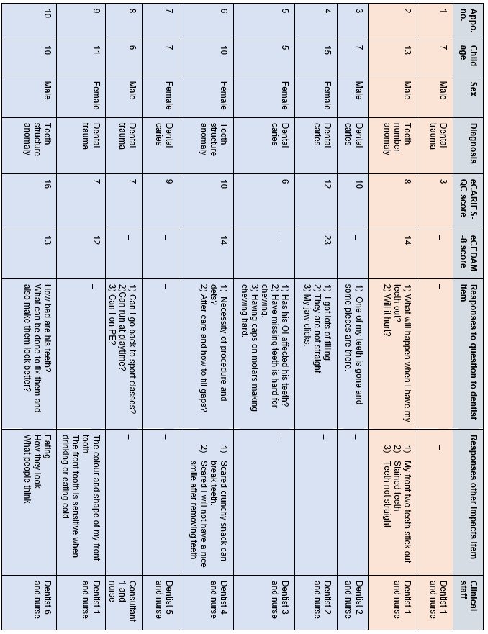 Clinical staff failed to view the final report. Clinical staff viewed the final report.
Child-clinician interaction

The interaction between the child and clinical staff was one of the main observable aspects of the new patient appointment process that the ePAQ-PD influenced. Typically, the new patient assessment commences with the clinical staff discussing and recording the history of the main dental concern with the children and parents/carers. It appeared that the children were more involved in the discussion of dental problems when the clinical staff read through the ePAQ-PD final report. Clinical staff tended to start the conversation by directing questions to children using information from the ePAQ-PD. They tend to pose open-ended questions that make it easier to capture further impact and build rapport:

Dentist 4: "Thanks for completing the forms. I know that you are struggling with chewing food. Can you tell me what’s happening with you?”
(Appointment transcript 6)

Some clinical staff used information from the ePAQ-PD during the conversation to reassure the children about their concerns about their dental condition and treatment:

Dentist 4: "we know you have some concerns about treatment. We will work on a plan that suits you. Is that all right?"
(Appointment transcript 6)

Dentist 6 " .. you asked me on the forms about how bad your teeth are? Will they aren't bad but need a bit of treatment so don't worry about that”
(Appointment transcript 10)
Clinical staff used an empathetic tone when the child expressed anxiety prior to the oral examination and used information from the ePAQ-PD final report to reassure the child and gain trust:

Dentist 4: ".. we are not going to take out any teeth today, we're just going to make a plan today and we will consider everything, okay?"

(Appointment transcript 6)

A contrast in interaction with children during opening conversation was observed by an individual clinical staff that seemed to be based on the viewing the ePAQ-PD final report. Omission of viewing final report appeared to limit the child’s communication when asked later (observation 1) where view report seemed to prompt conversation by clinical staff asking open-ended questions:

Dentist 1: " you mentioned in the online questionnaire that you experience pain and sensitivity. Can you tell me about that?"
(Appointment transcript 9)

Sometimes children might be omitted during the conversation if clinical staff had the impression that the child was not anxious (observation 2). Different body language reactions of children were observed when clinical staff used information from the ePAQ-PD. Anxious children appeared to express more noticeable reactions than non-anxious children. The immediate reactions were body language signs that reflected a sense of approval and confidence (observation 3). Further reactions from the children were observed at the appointments, although the ePAQ-PD does not appear to be the sole cause of these reactions. It was suggested that the information from the ePAQ-PD, along with clinical staff skills and behaviour management techniques such as ‘tell, show and do’, contributed to the children’s responses (observation 4,5).
The use of the ePAQ-PD in new patient clinics seemed to facilitate child engagement, child-clinician communication, and the management of concerns. The use of the ePAQ-PD as an adjunct to traditional behaviour management techniques could improve children’s experience of attending new patient clinics.

Efficiency of assessment

The use of information from the ePAQ-PD was perceived to improve the clinical staff's assessment during new patient appointments. The assessment appeared to be more focused and targeted through the use of the ePAQ-PD, which appeared to reduce the time taken to make an appointment. The ePAQ-PD appeared to enable clinical staff to focus on what matters most to the children, which is the main aim of new patient appointments. The ePAQ-PD not only facilitated communication between the children and the clinical staff but also seemed to enable the children to elaborate more on oral impacts:

Dentist 6: “ .. on the questions you have filled out, you said it's difficult for you to eat?"

Child: "Yeah, it hurts"

Dentist 6 " what do you do when it hurts?"

Child: "I eat on the on back teeth"
(Appointment transcript 10)
At another appointment, clinical staff used the information from the ePAQ-PD to explore the concerns and identify the causes of anxiety. Identifying the reasons for dental anxiety can help clinical staff to suggest appropriate behaviour management techniques:

Dentist 2: “What are you worried about? “

Child: “Blood when tooth removed”

Dentist 2: Why is that?

Child: “I think it's the taste of blood in my mouth”

(Appointment transcript 4)

These impacts might be recognised without the ePAQ-PD, as they may arise in conversations. However, the use of the ePAQ-PD encourages the impacts to be introduced into the conversation and thus guides clinical assessment. Clinical staff were observed to focus more on addressing the impact reported in the free-text options rather than the responses to the ePROMs items (observation 6). However, clinical staff tend to use the child’s responses to each item if the free-text options have not been completed by the child and parent/carer:

Dentist 5: " can you tell me why your teeth annoyed you?"
(Appointment transcript 7)

It has been observed that clinical staff sometimes rely on another PROM to assess anxiety instead of using the eCEDAM-8 items such as faces anxiety scale. This could be due to the clinical staff favouring shorter and faster PROMs (observation 7). Another observed behaviour of clinical staff, reflecting their preference for shorter and quicker ways to collect information about oral impacts on children, was noticed in their focus on using the ePROMs overall scores instead of responses to individual items (Observation 8). It was observed that not utilising important information from the ePAQ-PD may result in clinical staff overlooking important aspects of new patient assessment such as instructing a child diagnosed with TDI and who does karate to avoid participation in contact sports (observation 9).

It appeared that the ePAQ-PD assisted clinical staff in performing more comprehensive assessments at new patient appointments. To ensure the clinical utility of ePROMs, the behaviour of clinical staff in using more rapid means of reflecting the oral impacts in children needs to be considered.

Role in decision-making

The treatment planning stage was one of the aspects of new patient appointments where the ePAQ-PD could have an impact. New patient consultations usually conclude with formulating a child-specific dental treatment plan. The information from the ePAQ-PD does not appear to directly influence the decision on treatment option selection or prioritisation. In some appointments, it was observed that the information from the ePAQ-PD was not utilised (observation 10,11). In some appointments, clinical staff offered different treatment modalities, such as dental treatment under general anaesthesia, which was apparently suggested as part of routine practice for anxious children and those who required complex treatment (observation 12,13). The use of information from the ePAQ-PD was observed when clinical staff explained the reason for prioritising a treatment option over another:

Dentist 6: " .. we will focus on how to control infection first then will focus on how to make them look better, is that all right?"
(Appointment transcript 10)
The information from the ePAQ-PD does not appear to have a direct influence on the decision on the choice of treatment options and their prioritisation. However, treatment planning depends on the cumulative information gathered during the appointment, and the information from the ePAQ-PD may have played an indirect role.

Discussion

The aim of this chapter was to assess the feasibility and utility of routine use of the ePAQ-PD in clinical practice. The study had a mixed-method design where quantitative approaches were used to address the study aim by assessing data collected in relation to the completion of the ePAQ-PD and responses to the ‘question to dentist’ item by children and their parents/carers, as well as the occurrence and nature of technical errors and clinician assistance. Qualitative approaches were used to capture the views of children, parents/carers and clinical staff on the design, implementation method and impact of the ePAQ-PD on clinical practice. Several facilitators and barriers were identified that could influence the future clinical use of ePROMs in children’s oral health. The following discussion focuses on the criticisms of the findings and addresses limitations and areas for future improvement.

Quantitative and descriptive findings

Completion of the ePAQ-PD

This study explored the feasibility and utility of routine clinical use of ePROMs over a period of three months, which was considered sufficient due to the richness of data collected. The convenience sampling method was the most appropriate recruitment method to represent the routine implementation of ePROMs and to ensure the diversity and representativeness of participants from the target population (Etikan, 2016). According to the aim of this part of the thesis, the number and details of children and parents/carers and their responses to the ePAQ-PD need to be explored as part of the exploration process to determine the feasibility and utility of ePAQ-PD use in paediatric dentistry clinical practice. The eCARIES-QC data are thoroughly analysed and psychometrically tested in the next chapter (Chapter 7). The eCEDAM-8 data will be analysed as part of another research project that is not part of this thesis.

Overall, the response rate for the ePAQ-PD was 69.5%, which is considered good and reflects the acceptance of the system and its content (Fayers and Machin, 2013; Rolfson et al., 2016). The total number of invitation texts (n=602) does not reflect the actual number of children booked for new patient appointments in the Department during the three-month period. This is due to the number of children who did not attend their appointments, meaning that several invitation texts could be issued to the same child for each missed appointment. Therefore, the number reported reflects the number of appointments available during this period and not the number of children who attended. Reminder texts were issued for 108 (45.6%) participants, which may have contributed to the high response rate reported by the children and their parents/carers in the interviews. In addition, the PROM literature found a positive correlation between the reminder message and a higher response rate (Hocking et al., 2006; Christensen et al., 2014). The high response rate confirms the children's high level of literacy in using electronic technology, as explained in the methodological considerations in chapter ‎4.1.1. The distribution of children according to their sex is almost balanced (M=50.6%; F=49.4%). A similar ratio was found in another study conducted in the department (Gilchrist et al., 2018) where the number of female participants were slightly higher than the males. This comparison does not indicate a change in the population of children attending the CCDH, as the recruitment method and inclusion criteria are different between the two studies. In the current study, a variance was found in other demographic details of participants, namely age group, ethnicity and deprivation level. The majority of participants (n=86; 36.3%) were aged between eight to 11 years, with only 17 (7.1%) participants aged under three years. These findings are in accordance with those reported in national oral health surveys (CDH, 2013; PHE, 2019) with regard to the age group most affected by oral conditions. The distribution of ethnicity among participants, the majority of whom were from a white background (n=159; 67.1%), is similar to the distribution of ethnicity in the Sheffield census (ONS, 2020) and studies conducted in the same setting (Gilchrist et al., 2018; Graham et al., 2021). It should be noted that the diversity of ethnicity groups was dichotomised in this study due to limited diversity in both groups and to allow analysis and comparison with other findings.

The majority of participants (44.7%) were from the most deprived areas (1st quintile) in England according to the 2019 English Indices of Deprivation (Ministry of Housing, 2019). This is a higher proportion for Sheffield as a whole, where nearly 34% of residents live in the most deprived areas. Inequalities in oral health are frequently reported in the literature on children's oral health (Masood et al., 2019). It should be noted that the study setting (CCDH) covers a large geographical area where some participants live outside Sheffield. This study showed that 21.5% (n=51) of children were not living in Sheffield. Further Sheffield-based studies are required to affirm this comparison.

Unsurprisingly, dental caries was the most prevalent oral disease in the children included in the study, which concurs with what has been shown in national study to be the most common oral condition (CDH, 2013). TDIs was the most common non-carious condition in this sample (n=48;20.3%), which could be explained by the need for specialised treatment that is not usually offered in primary dental care. In addition, the data collection was completed during the summer holidays, when the risk of TDI is higher as children participate more in outdoor physical activities and play more contact sports (Weusmann et al., 2020).

More than half of the children who completed the ePAQ-PD were supported by their parents/carers. Parent/carer involvement was to be expected due to the involvement of very young children and the remote nature of the ePAQ-PD. The involvement of parents/carers in the ePAQ-PD with their children could facilitate communication and reveal hidden impacts as reported in the interviews. The median time to complete was five minutes and six seconds (IQR= 05:44). The prolonged completion time could be explained by the behaviour of children and parents/carers accessing the ePAQ-PD and completing it at a later time when it is more convenient, as reported in the interviews. Therefore, median values and interquartile ranges were used to summarise completion time as there were extreme values. Completion time was explored qualitatively during the interviews with the children and their parents/carers.

The ePAQ-PD appears to be suitable for routine clinical use with children and parents/carers attending new patient clinics at the paediatric dentistry department at CCDH. This assertion is based on the high response rate and the diversity of children who completed the ePAQ-PD in terms of age, ethnicity, level of deprivation and clinical diagnosis, which were comparable with studies conducted in the same setting and with national surveys.

Technical errors and clinician assistance

The involvement of clinical staff in reporting technical errors that might occur in relation to the ePAQ-PD was based on the recommendation as concluded from the user acceptance testing stage (Chapter ‎5.2.6). The aim was to open communication channels with clinical staff to facilitate performance monitoring and incident reporting. As a data collection tool, meaningful research and clinical outcomes can only be ensured if the ePAQ-PD functions as intended without major failures. There is no evidence in the ePROM-related literature of post-implementation technical monitoring, reflecting the novelty of this method.

Clinical staff were instructed as part of their training to report technical errors and any support to assess the feasibility of the ePAQ-PD in clinical practice. Reported errors on the incident reporting sheet were considerably low compared to the overall successful use of the ePAQ-PD. Twice it was reported by clinical staff that the ePAQ-PD failed to compute the overall score of the ePROMs. The nature and frequency of the error do not appear to be critical as clinical staff still have the information recorded in each item. The errors reported by clinical staff, where two families had difficulty accessing and completing the ePAQ-PD, may have been caused by the network connection. This is one of the limitations of the electronic method of delivering PROMs. Nevertheless, the frequency of errors is insignificant. One family reported that they did not receive an invitation text even though the correct phone number was available in the clinical records. This could be due to human error, as the invitation texts were shared manually by SA, where the possibility of omissions is to be expected. It is possible that these technical errors are under-reported and that some children and parents/carers did not complete the ePAQ-PD due to technical errors. However, this limitation is difficult to control. The lack of reports from clinical staff on the level of support provided to children may reflect the heavy workload of clinical staff, so their support in completing the ePAQ-PD with children was probably not provided. However, it is possible that some support was provided without reporting.

Based on the reported minor errors with low frequency, it can be concluded that the ePAQ-PD is a technically robust system for capturing ePROMs data for clinical use. Clinical staff are not expected to assist children in completing the ePAQ-PD.

Responses to ‘question to dentist’ item

The addition of a free text question for children to share queries with clinical staff was beneficial as approximately 20% of children who completed the ePAQ-PD used it to pose questions and/or report concerns. The notion of the addition of free text items to the PROMs items was described in the literature as a beneficial feature (Bell, 2007;(Friedlander et al., 2019). Interestingly, free text items were conceptualised from early versions of HRQoL to allow respondents to add supplemental information (Guyatt et al., 1986; Gill and Feinstein, 1994). Other benefits include respecting the autonomy of the children and their right to express their opinion on their oral health, as outlined in the United Nations Convention on the Rights of the Child and national oral health initiatives (UN General Assembly, 1989; Harris, 2023). It could be argued that the free-text questions may limit the tendency of children to engage in satisficing strategies when completing long PROMs with a multiple-choice format, which could lead to the recording of invalid responses (for more information on satisficing theory, see Chapter 3.1). In addition, children and parents/carers appeared to use the ‘question to dentist’ item to highlight priority discussion points (Primdahl et al., 2020).

The children’s responses to the ‘question to dentist’ item reflected serious concerns about discomfort and safety of treatment options and modalities. The most important way to address these concerns is through effective communication and the provision of education (Singh et al., 2021). In addition to the communication skills of the clinical staff, some communication tools can support the interpersonal exchange between clinical staff and children (Jones, 2015; Rodd et al., 2019). Recently, a CBT-based resource for reducing child dental anxiety has been developed which includes a 'Message to Dentist’ (MTD) communication tool, which can be delivered by clinical staff (Rodd et al., 2019). The tool consists of a series of self-report questions about the children’s levels of dental anxiety, anticipated pain scores, specific procedural concerns, the type of care they are willing to accept, the agreed stop signal and the selection of rewards at the end of the appointment. The MTD tool was found to be a helpful means of facilitating communication and personalising coping strategies. In future, the MTD tool may add value to the clinical use of the ePAQ-PD by guiding clinical staff on utilising sensitive information reported in the ePAQ-PD. Future research could focus on how to integrate the benefits of these two tools and investigate their effectiveness in improving children’s oral health experiences.

The responses to the ‘question to dentist’ item categorised as reports and requests, seem to facilitate the examination process during new patient appointments. These types of responses could be part of the ePAQ-PD where children and their parents/carers expressed that they guided the clinical staff to prepare the right equipment and focus on the main concern, thus potentially shortening the appointment time. However, communication to address and discuss concerns may prolong the appointment time. The child health literature shows conflicting results regarding the effect of PROMs on the length of appointments (Bele et al., 2020). This gap presents an opportunity for future research to investigate this correlation in dental settings in a robust fashion.

The other part of what children and parents/carers seemed to need from clinical staff was the provision of education on various aspects of oral condition and its treatment, as indicated in the ‘question to the dentist’ item. Patients’ lack of health literacy may result in a poor understanding of clinical staff instructions and therefore incomplete management of their own health and limited utilisation of healthcare (Wills, 2009). In addition, patient education has been shown to be effective in improving self‐care behaviour, better oral hygiene, coping with dental treatment and clinician-patient communication (Albano et al., 2019). There are a number of tools available to help educate patients about oral health, including leaflets, pictures, videos and computer programmes (Albano et al., 2019). As the ePAQ-PD was able to capture children’s concerns about the aetiology and potential complications of oral conditions and their treatment, it may be useful to include electronic child-friendly leaflets with the ePAQ-PD. The availability of electronic leaflets could increase children’s awareness of their oral conditions, enabling them to raise further questions to clinical staff and affirm the benefits of patient education as previously mentioned.

It can be concluded that the ‘question to dentist’ item was a useful addition to the ePAQ-PD as it was able to capture children’s views on their oral health status, which promotes their autonomy and right to express their opinions. Some tools were outlined that could potentiate the clinical utility of the ePAQ-PD if integrated in the future.

Qualitative findings

The interviews with children and their parents/carers highlighted important aspects of the current version of the ePAQ-PD from their perspective. Overall, the current version appeared to be well accepted by the children and their parents/carers as they reflected. Unsurprisingly, the included ePROMs (eCARIES-QC and eCEDAM-8) were accepted, indicating a robust development and validation process and confirming the outcome of the measurement comparability study (‎Chapter 6). The concept of clinical use of the ePAQ-PD at new patient appointments was found to be beneficial as it was reported to facilitate positive and less traumatic experiences, promote parent-child communication, and encourage children to reveal hidden impacts that parents were unaware of prior to using the ePAQ-PD. Similar findings have been reported in the literature (Bele et al., 2020; Carfora et al., 2022). Promoting parent-child communication and uncovering hidden impacts are benefits of using ePROMs pre-treatment that might be difficult to observe if PROMs were only used for research purposes. The term ‘to stop and think’ was frequently used in the literature to describe the systematic way in which patients reported impacts when PROMs were used in clinical practice (Bartlett et al., 2020; Talib et al., 2018; Dowrick et al., 2009). The pilot study conducted in the department was unable to capture these benefits as the views of children and parents/carers were not included (Graham et al., 2021). It was to be expected that the views of children and parents/carers were not taken into account, as pilot studies tend to have simple and focused aims and limited funding. However, this comparison between the results of the current study and the pilot study emphasises the importance of public participation in research and the right of children to have their voices heard (Department of Health, 2004; Gilchrist et al., 2013; Harris, 2023).

Clinical staff were interviewed in two separate focus group interviews based on their roles into consultants and non-consultants groups. The decision to split the interviews was based on the availability of clinical staff. The difference between the clinical roles and duties of the two groups led to different discussions and therefore different views. The non-consultants were trainees who interacted directly with the children, providing oral health care and using the ePAQ-PD, whereas the consultants usually supervised the clinical sessions and were more involved in the administrative and decision-making roles. Overall, clinical staff acknowledged the value of the ePAQ-PD as a medium for children to raise their voices as the main theme was drawn from their focus group discussion. This recognition reflects their professionalism and commitment to delivering oral healthcare at high standards and considers the ePAQ-PD as a supportive tool. Furthermore, clinical observations confirmed these benefits and showed how the ePAQ-PD encouraged clinical staff to engage children by asking open-ended questions and reassuring them in an empathetic tone. This trend of empowering children in oral health shows a promising future for the clinical use of the ePAQ-PD. The main barriers to children's participation in the ePAQ-PD were the lack of use of languages other than English and the lack of inclusivity for children with visual impairments. These barriers also appear in the literature for other ePROMs used for clinical purposes (Spaulding et al., 2019; Teela et al., 2021; Zhang et al., 2019) which were considered as limitations for this study and are explained in more detail in the limitations subsection.

The electronic administration of PROMs was reflected upon in detail by the children, parents/carers and clinical staff from different perspectives. There were favourable comments on the intuitiveness and readability of the ePAQ-PD items and the final report, which were attributed to careful consideration during the development process and following the practical advice discussed in chapter ‎4.1.1. Other integrated features such as the authentication method, the progress tracker and the reminder texts were accepted. It appears that the suggestions and barriers expressed by children, parents/carers and clinical staff in relation to the electronic formatting of the ePAQ-PD relate to improving the speed of completion and interpretation of outcomes, accessibility and child-friendliness. The desire for faster methods of completing and interpreting the ePAQ-PD was reflected in the wishes of children and parents/carers regarding the implementation of the automatic navigation function and clinical staff's suggestion to add a colour coding feature and simplify the overall scoring. Similar requests aimed at shortening the processing time were described in the literature (Aiyegbusi et al., 2020; Primdahl et al., 2020). Completing tasks using the least demanding method is part of human nature (Krosnick and Alwin, 1987) that needs to be considered to ensure future compliance with the clinical use of the ePAQ-PD. Furthermore, it appears that faster interpretation would facilitate the management of clinical burden by clinical staff. Interestingly, there were no reports of improvement in ePAQ-PD completion/interpretation time by deleting items reflecting the value of the ePAQ-PD components.

The accessibility of the ePAQ-PD has often been discussed from various aspects. Children and parents/carers reported a lack of clarity in the invitation texts, which led them to question the legitimacy of the text. In addition to their suggestions to make the content of the text child-specific and provide information about the purpose of the questionnaire, it may be beneficial to install tablet computers in the patient waiting area in the department. In addition, the ePAQ-PD weblink can be shared with children and parents/carers by post along with the appointment details, as suggested in the interviews. The use of combined methods to deliver an invitation text has proven to be effective in increasing the response rate (Roberts et al., 2014; Agarwal et al., 2022). It would provide patients with alternative options as the use of digital technology in general continues to change (Hollander and Carr, 2020).

Clinical staff had different views on the accessibility of the ePAQ-PD from their perspective. Their concerns centred on the inclusion of the system in routine care, the clinical burden and the fact that it is a separate system. The current environment in the department is inconsistent, with patient notes in paper form and medical diagnostic tools such as radiographs in electronic form. However, Sheffield Teaching Hospitals have a plan to integrate different healthcare systems into one main system and have agreed on a new electronic patient record system (Oracle Cerner ®, Cerner Corporation, Missouri, United States). The plan is to integrate the ePAQ-PD with other systems to facilitate accessibility. Any suggestions made by children, parents/carers and clinical staff will be shared with the ePAQ® software team to be considered where possible prior to integration into the electronic patient record system.

Children and parents/carers reported mixed preferences regarding the paper versus the electronic formats of PROMs. Those who favoured electronic PROMs justified their preference for several reasons, such as faster completion, ease of use and environmental friendliness. Those who favoured the paper format, on the other hand, praised the advantages of easier accessibility and freedom from technical errors. A personal preference was reported in both groups. Conflicting preferences have been reported in PROMs studies across different clinical specialities and populations (Carfora et al., 2022). Complex factors must be considered when choosing the method of administering PROMs, including patient and clinical staff preferences, availability of equipment and appropriate infrastructure. It seemed that the electronic format would be more appropriate for routine clinical use in the department, especially as the new fully integrated system is being rolled out and the current format is in line with the NHS digital transformation initiative (NHS, 2019). As suggested by a child during an interview, it would be possible to incorporate paper format fill-in features, such as ‘circling' responses instead of ‘clicking', to include children who prefer the paper format. This suggestion will be discussed with the development team to see if it is possible.

Routine clinical use of the ePAQ-PD was found to be effective in some aspects of new patient assessment. Children and their parents/carers perceived the effectiveness of the ePAQ-PD as enabling them to report systematically, be emotionally prepared, improve their experience during the appointment and perform the clinical assessment in a more focused way, thus saving appointment time. Feelings of happiness, calmness and joy were frequently reported when clinical staff used information from the ePAQ-PD and reflected on it during appointments. In contrast, feelings of disappointment were reported when clinical staff overlooked the information shared via the ePAQ-PD, and some reported being annoyed when asked again about the impact on oral health. It is clear that trying to engage children in their oral health through the ePAQ-PD is beneficial but can also have a negative impact if overlooked by clinical staff. Another negative impact was noted during the clinical observations when clinical staff failed to provide important post-appointment instructions because they had not heeded the information from the ePAQ-PD. Similar findings were reported in the literature when patients raised their voices when using PROMs but were not heard by clinical staff, resulting in reduced motivation and questioned effort in completing the PROMs (Talib et al., 2018; Mejdahl et al., 2017). These negative effects of clinic staff not using the ePAQ-PD can be controlled by addressing their concerns and suggestions, as mentioned earlier.

Clinical staff perceive the clinical effectiveness of the ePAQ-PD to be primarily that it improves the relationship with children by facilitating communication and the utilisation of information from anxious children who are difficult to capture at appointments. These reports were consistent with the results of clinical observations where the information from the ePAQ-PD was used to reassure children, facilitate capturing further impacts and influence clinical staff’s behaviour. The effect of PROMs on clinician-patient communication is well-established in the literature (Chen et al., 2013; Carfora et al., 2022). In the decision-making stage, the information from the ePAQ-PD does not appear to have a direct influence on treatment options or prioritisation. This was evident in clinical staff reports and clinical observations. It is possible that it was used as part of the cumulative information collected during the appointment, but there was no clear evidence of this regard.

Strengths and limitations

Strengths

This study explored the feasibility and clinical utility of routine use of the ePAQ-PD in new patient appointments. This study consisted of mixed-method approaches that were conducted in multiple steps to ensure the high quality of the study. The greatest strength point of this study is the inclusion of a diverse sample that utilised the ePAQ-PD in the qualitative study from both sides. The children were recruited from different age groups, sex, deprivation levels and dental diagnoses. In addition, the involvement of parents/carers in this study is beneficial to capture comprehensive views on the clinical use and content of the ePAQ-PD, as parents/carers are the ones more likely to receive invitation texts and support their children. Clinical staff were diverse in their clinical roles and responsibilities. Overall, all participants in the qualitative approaches were enthusiastic to share their views and feelings openly, reflecting their interest in the research topic and its value to clinical practice. Furthermore, this reflects the appropriateness and relevance of the topic guides used in the interviews, allowing participants to describe their experiences and consider how the ePAQ-PD can be improved. The comprehensive research ensured that the true extent of feasibility and benefits were captured and served as a basis for subsequent changes to the ePAQ-PD.

Another strength was the pre-implementation process carried out for this study, including the technical and usability testing of the ePAQ-PD (Chapters 5 and 6), training of clinical staff and post-implementation support through regular newsletter exchanges and addressing any queries to remind and encourage clinical staff to use the ePAQ-PD. These strategies have ensured that non-measurement errors (see chapter ‎2.4.2.3) are monitored and controlled as far as possible. Strategies were employed to ensure research quality and that include the collaborative development of the study protocol, which was independently reviewed from a scientific and ethical perspective and amended accordingly. The process of conducting the qualitative approaches was guided by the COnsolidated criteria for REporting Qualitative research (COREQ) to ensure the quality of the research (Tong et al., 2007). Another strategy was regarding the enrolment of the PhD candidate (SA) in the Qualitative Research Design and Analysis module provided by the University of Sheffield, Sheffield, UK. In addition, the PhD researcher (SA) was supported and guided throughout the study by an experienced team of supervisors.

Limitations

Several limitations were identified in this study that need to be addressed. The ePAQ-PD was developed in English, so children and parents/carers who are not proficient in English were not included in the interviews and may not have been able to complete it remotely. The inclusion of different languages in the ePAQ-PD depends on the availability of translated and psychometrically validated versions of the included PROMs. Various translated and validated versions in Arabic are available for the CARIES-QC (Azab and Yousry, 2022), Mandarin (He and Wang, 2020), Dutch (Rogers et al., 2019b), and Turkish (Duman and Inceoglu, 2023). The inclusion of these versions could be beneficial, but a cost-effectiveness assessment is required.

In the current study, we succeeded in recruiting a sample of all direct users of the ePAQ-PD. However, indirect users who could influence the implementation of the ePAQ-PD in the long term, such as the ePAQ providers and the decision-makers in the hospitals, were not included. Their involvement would allow clearer navigation towards a sustainable future for the use of the ePAQ-PD and highlight potential challenges and opportunities for use in different clinics within the department. Reception staff in the department were not included in the focus groups, although their role in encouraging patients to complete the ePAQ-PD and addressing any issues is crucial. Future research could focus on extending the scope of the feasibility study by including participants with administrative roles.

Other limitations in this study are related to the inherent drawbacks of mixed-method research design. Overall, such a design requires an enormous amount of resources and time to plan and execute, especially when conducted by one researcher as in this case. However, some methodological and ethical considerations were applied to achieve the research aim with credibility and validity, as explained in Chapter 3. The integration of quantitative and qualitative approaches was challenging and there were a few barriers were encountered and controlled including the development and testing of the ePAQ-PD, acquiring appropriate research skills, recruiting different target groups and the administrative burden of managing the ePAQ-PD and issuing invitation texts to all children attending the new patient clinic over a three-month period. Another limitation is the difficulty in combining the analysis of the two different types of data to provide an integration analysis and outcome (Bryman, 2014).

In qualitative approaches, the inherent limitations must be explained, including the limited reproducibility and generalisability. Arguably, forms of ‘representational generalisation’ to child populations within oral healthcare can be drawn from the findings of this study (Ritchie and Lewis, 2003). This argument is based on the appropriate use of the data collected, appropriate display of the analytical approach and interpretation, and the design and conduct of the research. In addition, several pieces of evidence support the results of this study and confirm the notion of the clinical use of ePROMs in children (Scott et al., 2023). As qualitative approaches tend to collect data from a small number of participants, there are some concerns about the transferability of the study findings to other contexts and settings ‘inferential generalisation’ (Ritchie and Lewis, 2003). However, some aspects of the overall findings may be applicable and useful to some extent in other areas of paediatric dental care in the NHS sector and provide the framework for future clinical implementations of ePROMs. The findings of this study are likely to have relevance to those providing secondary care services to children (similar to the setting of this study). This is because the nature secondary care paediatric dental services are similar across the country as they tend to cover wide geographical areas where the children seen are more likely to have different levels of oral impacts and deprivation as in this study. Information technology services and human resources differ between services that some features may differ such as delivery of PROMs. However, the benefit to patients and clinical staff is likely to be the same as found in this study.

The naturalistic, non-structured observations conducted as part of this study have unique limitations that need to be declared. The observation followed an overt method where children, parents/carers and clinical staff were aware that they were being observed. This method leads to a bias termed the ‘Hawthorne effect’, in which those who are observed tend to change or improve their behaviour (Gould et al., 2017). Unfortunately, this form of bias cannot be controlled, as the observation and other research activities of participants are not compatible with medical and research ethical standards (Data Protection Act, 2018). The aim of including clinical observations in the study methodology was to affirm outcomes from other qualitative approaches and to capture overlooked information related to the study aim which this method appears to achieve. Another limitation was that the information was mainly captured when there were interactions between children, parents/carers and clinical staff. Further work could place more emphasis on capturing a more comprehensive description of communication processes.

Novel aspect

To the best of the researcher's knowledge, this is the first study to comprehensively investigate the feasibility and utility of ePROMs for routine use in clinical practice in paediatric dentistry. The use of a mixed-method design to explore the perceptions of children, parents/carers and clinical staff in relation to the routine clinical use of ePROMs with the identification of facilitators and barriers is expected to add a significant contribution to the paediatric dentistry and PROM-related literature. In addition, the inclusion of clinical observations in the exploration process is considered relatively novel as this has rarely been used in the current literature to explore the clinical utility of PROMs (Carfora et al., 2022). It is anticipated that this study will inspire future clinical practices and research to draw more focus on the clinical use of PROMs in children’s oral health and the dentistry field in general.

Conclusion

In summary, the ePAQ-PD has acceptable feasibility and utility when used in paediatric dental practice to assess new patients. The ePROMs (eCARIES-QC and eCEDAM) and the free-text question used as part of the ePAQ-PD were efficient in capturing information, concerns and requests from children and their parents/carers in a systematic fashion. The ePAQ-PD has been shown to improve children’s involvement in their oral care, their clinical experience and communication with clinical staff. Areas for improvement were identified from the children’s and parents'/carers’ perspectives, including the content of the invitation text, intuitiveness and child-friendliness of the design. Clinical staff suggested some improvements to the accessibility and readability of the ePAQ-PD to facilitate faster interpretation. The ePAQ-PD does not appear to have a direct impact on treatment planning.

Publications arise from the work presented in this Chapter

Published abstract:
Attamimi, S., Marshman, Z., Deery, C., Radley, S. & Gilchrist, F. (2024) Feasibility and utility of routine use of ePROMs in paediatric dentistry (Conference Abstract). British Society of Paediatric Dentistry (BSPD) (Conference Abstracts). International Journal of Paediatric Dentistry, 34: 14

Presentations:

Attamimi, S., Marshman, Z., Deery, C., Radley, S. & Gilchrist, F. (2024) Feasibility and utility of routine use of ePROMs in paediatric dentistry (oral presentation). British Society of Paediatric Dentistry (BSPD) Annual Scientific Conference 2024, Cardiff, UK

Evaluation of eCARIES-QC

This chapter focuses on the evaluation of the psychometric properties of eCARIES-QC and its clinical usefulness in measuring oral impacts in a wider age range (3-16 years) and from other oral conditions in addition to dental caries.

Introduction

CARIES-QC and other PROMs are measures developed to systematically capture (oral) health-related impacts. The standardised nature of PROMs, involving the same questions presented to all patients, affords PROMs comparability, reliability, and validity as data collection tools, resulting in accurate and meaningful outcomes (Churruca et al., 2021). Similar to other tools, PROMs were developed according to the theory that the items measure disease impacts that are not directly observable (latent) via observed responses or scores (Brzezińska, 2016). The evaluation process of PROMs ability to measure what they are intended to measure is termed psychometric validation. A summary of PROM psychometric properties and definitions is shown in Chapter 2 (Table ‎2.5). Mainly, two types of investigations are frequently used to evaluate psychometric properties of PROMs which include item response theory and classical test theory. The following subsections will detail these investigations and other applicable investigations used to evaluate a PROM.

Item response theory

Item response theory (IRT) is one of the main approaches to the evaluation of PROMs. The aim of IRT is to explain the relationship between observed item responses on a scale and an underlying concept. IRT models involve mathematical equations using a nonlinear monotonic function to express the relationship between participants on a latent variable and the likelihood of a certain response to an item (Cappelleri et al., 2014). An item characteristic curve is a fundamental IRT that demonstrates differences between the observed and expected values.

Several IRT models using different mathematical analyses applicable to measures with dichotomous and polytomous responses are available. The Rasch model is a one-parameter IRT approach frequently used in healthcare (da Rocha et al., 2013). This mathematical model calculates proportions between the respondents’ ability and item difficulty to produce a linear scale (Bock et al., 2016). An example of a linear model is demonstrated in Figure ‎8.1. The production of a linear scale allows a comparison of the measurement precision and reliability of items to fit the model, facilitating decision-making regarding amendments to the proposed items and responses (Packham and MacDermid, 2013).

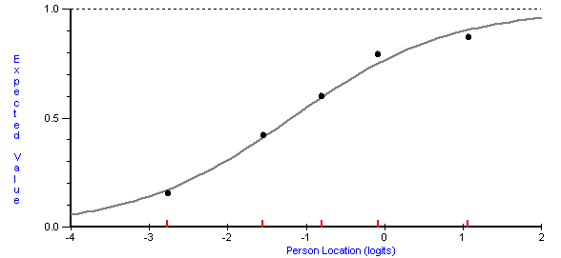
Figure ‎8.1 An example of a good individual item fitting the linear model.
Rasch model item characteristic curve of observed (black dots) and expected (linear curve) scores based on the respondent's ability (X-axis) and item difficulty (Y-axis).

Rasch measurement model

The Rasch measurement model was originally used for educational assessment; however, over the last four decades, its use has progressed, and it is frequently applied in the development and evaluation of PROMs (Bock et al., 2016). Traditionally, classical test theory (CTT) was used solely to evaluate the psychometric principles of the internal consistency of PROMs. CCT tests the effect of random error within the study sample with the possibility for systematic biases, such as a lack of assessment of the relationship between respondents' sex and how they select responses (Williams et al., 2010). In addition, CTT frequently averages the ratings from ordinal-level scales as if they were from an interval-level scale (Packham and MacDermid, 2013). In contrast to CTT, the Rasch model has an alternate robust framework for evaluating PROM characteristics. The Rasch model has many advantages compared to CTT methods, providing a more thorough analysis of PROM items, allowing comparisons of scores between different PROMs, evaluating the performance variation in items between respondent groups, and facilitating the development of efficient PROMs with fewer items (Embretson and Hershberger, 1999; Thissen and Wainer, 2001).

The mathematical principles of Rasch analysis were first proposed by George Rasch (Rasch, 1960). The key principle of the model is to mathematically transform the ordinal scale measurements of individual test items into interval-level scaling, identify systematic biases between groups according to their answer patterns, and detect response dependency between items beyond what is described by the underlying trait (Streiner, 2010). These principles are applied by linearising ordinal summed scores through paired comparisons of persons and items defined by the model expectations of logarithm probabilities. The Rasch model expresses items that represent a level of difficulty (impact) that have been reported by respondents given the level of experience of the difficulty (ability) as a logistic function to articulate a probabilistic Guttman structure of the relative distance (Rasch, 1960; Guttman, 1950). The difference in distance between item difficulties and respondents' ability is expressed in logits, facilitating an interval scale instead of ordinal scores obtained from item responses. The transformation of data into intervals facilitates more accurate and meaningful analysis than that obtained with ordinal data. In the interval scale, values become more extreme as they move toward curve margins, therefore covering more underlying traits than nonextreme values at the centre of the curve (Figure ‎8.2).
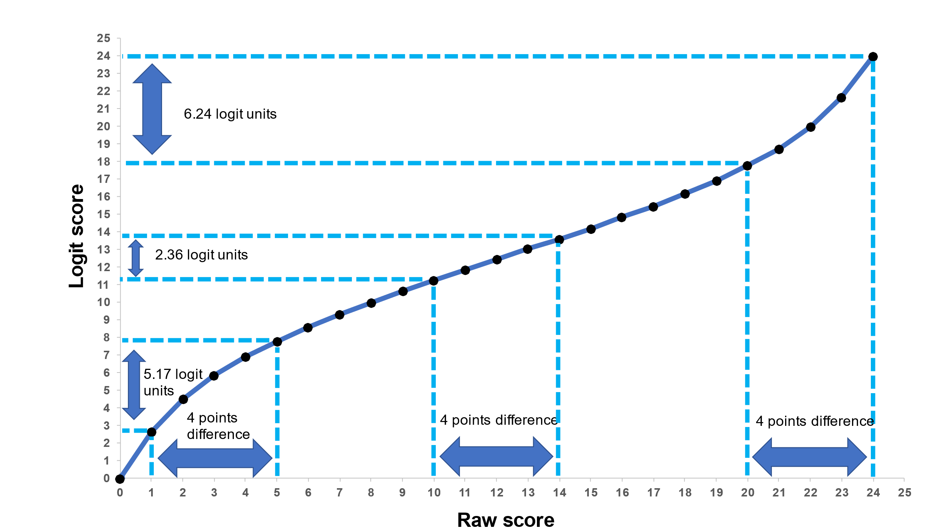
Figure ‎8.2 CARIES-QC raw scores were transformed into logit scores with linear measurements ‘adapted from (Gilchrist, 2015a)’. On the x-axis, a raw score of the CARIES-QC is shown, and logit scores are shown on the y-axis. The sigmoid curve distorts scores that are more prominent with extreme values. As illustrated, a 4-point difference in the raw score is equivalent to a 5.17 to 6.24 difference in logit units where only equal to 2.37 units mid-part.

Rasch analysis is an integrated framework that assesses whether an outcome measure has internal validity and fits the model from the outset. Assumptions of unidimensionality, local independence, and invariance across groups must be met to fit the model expectations (Tennant and Conaghan, 2007). These assumptions are described below.

Unidimensionality
The Rasch model requires the outcome measure to measure only one dimension or construct, which can be investigated by creating two subsets of items of negative and positive loading sets identified by a principal component analysis of the item residuals. Then, an independent t test can be applied to analyse the two estimates derived from the subtests for each respondent (Marais and Andrich, 2008; Tennant and Conaghan, 2007).
Local independence

Outcome measures should demonstrate independence between items, as described by the underlying trait, to achieve internal validity. Respondents must select responses according to their trait level and not how they answered previous items. Item independence can be determined by investigating the residual correlations between items, which should not exceed 0.2 above the average residual correlation. A lack of item independence may lead to an over- or underinflation of the total scores and impact the unidimensionality of the measure where deletion of one of the dependent items is desirable (Marais and Andrich, 2008). However, this principle is crucial for research purposes where comparisons within the population are anticipated. If the measure is to be used for clinical purposes, the independence threshold may not be critical as the measure items are used for individualised care where clinical utility is the main determinant, if the measure unidimensionality has been established. The decision to delete items should make conceptual sense to the research question (Christensen et al., 2017).

Invariance

Outcome measure items must maintain the same difficulty across respondents from different groups, such as ethnicity and age group. Items of similar difficulty or invariance can be investigated by analysis of the variance of the residuals using groups as the key factor. Differential Item Functioning (DIF) is indicated if variance is observed in the analysis. DIF can be uniform (bias is consistent across the trait) or nonuniform (bias is not consistent across the trait) (Holland and Wainer, 1993). Chi-square difference tests has been frequently used to compare the fit of a model that assumes the factor loadings (discrimination) and thresholds (severity) parameters are the same across the two groups (no DIF) to a model that allows them to differ (DIF) (Holland and Wainer, 1993). The level of significance of 0.05 adjusted for multiple comparisons by Bonferroni correction is usually used to determine the DIF.

Internal consistency

Internal consistency is another psychometric property that requires investigation to ensure valid outcome measures. Internal consistency can generally be defined as “the consistency of the results delivered in a test, ensuring that the various items measuring the different constructs deliver consistent scores” (Graham, 2006). Internal consistency has been used interchangeably in the literature with other terms, such as internal consistency reliability, homogeneity, structural reliability, and intra-item reliability, when describing the characteristics of an item's precision in measuring the same construct (Mokkink et al., 2010). The assessment of internal consistency involves the calculation of each domain/item of the outcome measure separately and for the measure as a whole to ensure that various items measuring the different domains deliver consistent scores. This approach should be considered only if the assumption of unidimensionality is met to ensure that the true internal consistency is not overestimated (Mokkink et al., 2010).

Internal consistency can be measured using factor analysis, CTT, or Rasch analysis. Similar to Rasch model analysis, factor analysis can be used to assess dimensionality and internal consistency and guide decisions regarding item reduction (Williams et al., 2010). However, the underlying method fails to capture scale invariance or measure individual ability and item difficulty; additionally, it is not designed to transform nonlinear ordinal observations into an interval (Piquero et al., 2000). As described in the previous subsection ‎8.1, Rasch model analysis overcomes the disadvantages of factor analysis and computes standard errors of measurement that differ for different individuals, allowing the generalisability of the measure if it fits the model. CTT is a conventional quantitative approach to testing the reliability and validity of measures based on their items. CTT assumes that observed scores are a combination of an underlying true score and random error. CTT can be applied to test the internal consistency of outcome measures using Cronbach’s alpha calculation on at least 30 respondents, where a value ≥0.7 is usually deemed acceptable (Streiner, 2003). Rasch analysis incorporates the equivalent test to Cronbach’s alpha, which is the Person Separation Index (PSI) statistic. The PSI is an indicator of the number of significantly different strata (groups) that the test can identify in the sample using logit scores instead of raw scores. The PSI outcome is interpreted similarly to Cronbach’s alpha, with values exceeding 0.7 indicating an acceptable level (Wright, 1996).

Construct validity

The meaningfulness of the data collected using PROMs is a crucial aspect that must be investigated as part of the PROM evaluation process. Unidimensionality and internal consistency investigations are internal evaluation methods typically considered prior to external evaluation of data integrity and relation with other factors. Construct validity is a form of investigation that assesses the degree to which scores on the PRO measure relate to other measures in a manner consistent with theoretically derived a priori hypotheses concerning the concepts being measured (Reeve et al., 2013). In other words, construct validity is a hypothesis-based investigation of the correlation of the PROM overall score to predefined observed variables and, therefore, a demonstration of representativeness. The predefined variables are any variables that the PROM is intended to measure or directly influence, such as clinical characteristics. Global rating is frequently used in the PROM design process as a predictor to determine construct validity (Guyatt et al., 2007). It is a single-question item that summarises how people perceive their overall health status. The global rating is considered a ‘gold standard’ indicator in assessing the construct validity of a PROM by correlating its responses to the overall score (Jokovic et al., 2005).

Convergent validity is a subtype of construct validity that investigates whether PROM scores under study correlate with scores of another comparator PROM to the degree that one would expect. It is iterative where the more hypotheses are investigated reflects stronger the evidence towards the PROM being valid. An appropriate bivariate correlation can be used to investigate both construct and convergent validity.

Floor or ceiling effect

The investigation of floor or ceiling effects is one of the components of the evaluation of a measure. The floor or ceiling effect can be defined as the proportion of respondents scoring the lowest (floor) or the highest (ceiling) across any given domain (Terwee et al., 2007). This effect indicates the accuracy of a questionnaire is to distinguish between respondents at the extreme ends of the scores (Terwee et al., 2007). A high floor or ceiling effect indicates inadequate questionnaire performance, measurement inaccuracy, and response bias. The floor or ceiling effect is considered significant if the proportion of respondents with the lowest or highest possible score exceeds 15% (Bernstein et al., 2019).

Interpretability

Sample-related information must be investigated and adequately interpreted in psychometric validation. Information collected regarding participants’ demographics and mean scores of different groups should be statistically summarised and tested for correlation to ensure the applicability of PROMs.

Missing data

In addition to the aforementioned methods of evaluation, it is also important to assess the levels of missing data when a PROM is used. Incomplete or missing data should be reported with a description of how missing data was handled. Several methods are available, including using multiple imputation algorithm and individual mean imputation. In most cases, multiple imputation algorithms are the most accurate method for handling missing data (Shrive et al., 2006). Rubin (1976) proposed the multiple imputation method to estimate a missing value with a plausible set of values by creating multiple copies of the dataset and using standard statistical methods to calculate standard errors in Rubin’s rules. The multiple imputation method considers the variability in results between the imputed datasets and reflects the uncertainty by averaging the distribution of the missing data given the observed data (Sterne et al., 2009).

Individual mean imputation is another appropriate method for handling missing data that shows comparable accuracy with multiple imputations in some applications (Shrive et al., 2006). The individual mean is simpler to conduct for clinical researchers and may be more easily interpreted. Individual mean imputation estimates missing values using a calculated average of the remaining completed values. For example, if a participant fails to respond to three items in a 20-item questionnaire, the values of the three responses are filled with the mean score of the 17 answered items. However, this means that individual imputation is applicable if the assumption that data are missing completely at random (MCAR) is met; otherwise, it can introduce bias. This assumption means that the probability of a value being missing is independent of any other variables, such as age group, sex, or clinical characteristics. This can be checked by applying Little’s chi-squared test for MCAR, which indicates whether observed data can predict missing data (Little and Rubin, 1987). In addition, a thorough investigation of possible conceptual explanations and common sense for missing data is important before deeming it MCAR.

Rationale

As highlighted in Chapter ‎2.4.1, CARIES-QC was designed according to children’s input at all stages of development (Gilchrist et al., 2018). The active involvement of children is considered the main strength of the measure, where children’s experiences are reflected by a language used by children themselves. The CARIES-QC showed acceptable reliability and validity when used across different populations (Rogers et al., 2020; Arrow et al., 2021; He and Wang, 2020). Recently, the concept of CARIES-QC ability to measure impacts from non-caries-related oral conditions was conceived and piloted by Graham and others (2021) in the same setting as this project. Good reliability and validity were observed when CARIES-QC was used by children with oral conditions other than dental caries. In addition, there is evidence in the literature that children as young as three years of age can competently complete self-administered HRQoL measures (Ravens-Sieberer and Bullinger, 1998; Chaplin et al., 2008; Lawford et al., 2001). These findings suggest further research is needed into the applicability of the measure with non-caries-related oral conditions and its age-appropriateness.

In this project, eCARIES-QC was used to assess a large number of children with different oral conditions and age groups as part of the feasibility testing of the ePAQ-PD system. The psychometric properties of CARIES-QC were not impacted by the electronic conversion, as concluded from the measurement equivalence chapter (‎Chapter 6). Therefore, evaluation of the eCARIES-QC psychometric properties, across other oral conditions, and appropriateness with very young children will affirm or reject the preliminary finding (Graham et al., 2021).

Aim and objectives

This chapter of the thesis aimed to evaluate the psychometric properties of eCARIES-QC and its potential to measure oral impact in young children and a variety of oral conditions experienced by children.

The specific objectives were as follows:
- Conduct a Rasch model analysis of eCARIES-QC data collected from children of different age groups to evaluate unidimensionality, local dependency, presence of DIF, and internal consistency.
- Evaluate how the measure performed in children with different socio-demographic characteristics.

Methods

Study design
This study aimed to address the aforementioned objective by conducting a quantitative analytical study to assess the reliability and validity of the electronic version of the CARIES-QC. The study hypotheses were as follows:
- eCARIES-QC fits the Rasch model and demonstrates high reliability and freedom of Differential Item Functioning (DIF) across all demographic and clinical variables.
- eCARIES-QC demonstrates acceptable internal consistency of Cronbach’s alpha more than 0.7.
- eCARIES-QC demonstrates acceptable construct validity by indicating positive correlations between the eCARIES-QC overall score and global rating.

Sample size and eligibility

All participants who completed the eCARIES-QC as part of the feasibility study were recruited. Details on the recruitment method and participants’ consent are provided in Chapter ‎7.4. For Rasch analysis, a sample size of at least 150 participants is recommended to provide 99% confidence that the estimate is within 0.5 logits (Linacre, 1994). The inclusion and exclusion criteria were as follows:

Inclusion criteria:
- Participants aged three years or older who completed the eCARIES-QC as part of routine use of the ePAQ-PD system at the Paediatric Dentistry Department, at the Charles Clifford Dental Hospital regardless of the reason for their attendance or clinical characteristics.
Exclusion criteria:
- Lack of informed consent by parent/carer or assent by the participant.
- Participants who failed to attend their appointment at the new patient clinic.

Data collection

All children three years or older who attended new patient clinics in the Paediatric Dentistry Department between July and October 2023 were recruited regardless of their oral health condition, dental diagnosis, and reason for attendance. Data related to eCARIES-QC scores and responses to free text questions were extracted from the ePAQ-PD system. Participants’ demographics, including age, sex, ethnicity (white or other ethnicities), and postcode, were derived from their clinical records. Participants’ dental diagnoses were also extracted from their clinical records and categorised as dental caries or non-caries (more details of oral conditions affecting children are summarised in Chapter ‎2.2). Whenever more than one diagnosis was documented in the participant’s clinical note, the primary diagnosis was determined according to the reason for the referral described in the general dentist's letter to the hospital. Following the data collection, the anonymised Excel spreadsheet dataset was transferred to SPSS Statistics 27 (IBM, New York, United States) for analysis.

Data analysis

The Rasch Unidimensional Measurement Model Software (RUMM2030) (RUMM Laboratory Pty Ltd, Perth, WA, Australia) was used for all Rasch analyses, which were based on a partial credit or unrestricted model (Andrich et al., 2004). All other analyses were conducted using SPSS Statistics 27 (IBM, New York, United States). The Index of Multiple Deprivation score/rank (IMD) (2019) using GeoConvert was applied to the participants’ postcodes (UK Data Service). The IMD measures relative deprivation in geographic areas of England in five categories, with quintile 1 representing the most deprived areas and quintile 5 the least deprived.

Rasch measurement model

All raw eCARIES-QC scores, participant demographics (age group, sex, and ethnicity), and clinical characteristics were transferred to RUMM2030 (RUMM Laboratory Pty Ltd, Perth, WA, Australia) for the Rasch analysis. Items that did not fit the model or demonstrated local dependency or DIF were identified to inform future research. For eCARIES-QC evaluation, a sample size of at least 150 participants is recommended to obtain 99% confidence that the estimate is within 0.5 logits (Linacre, 1994).

A likelihood-ratio test was performed before conducting the analyses to evaluate whether the rating scale or partial credit model would be the most appropriate version of the polytomous Rasch model to use. As in the original CARIES-QC study, an ordered set of response thresholds for each item (“not at all”, “a bit”, and “a lot”) was considered to outline expected discrimination (Gilchrist et al., 2018; Tennant and Conaghan, 2007). If a disordered response category was detected with an item, that reflects that participants could not adequately distinguish between response options (Figure ‎8.3). This may occur because an item has many responses or responses with close meanings, such as occasionally, sometimes, or often, which can make it difficult for participants to discriminate between different frequency levels.

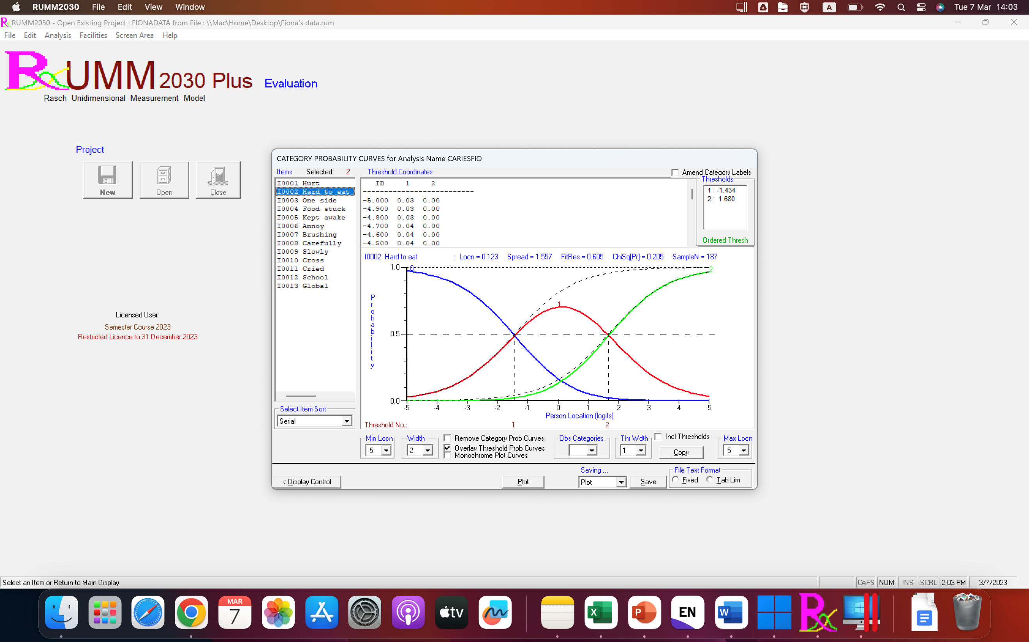
Figure ‎8.3 An example of ordered responses.

In general, response options can be reduced by collapsing response categories or removing the question to address disordered response categories. However, eCARIES-QC has three response options where the collapsing option is not appropriate, as the response options will then be dichotomous. Therefore, the wording of the response must be changed for it to make sense. Local dependency is determined if residual correlations are more than 0.2 above the average residual correlation (Kersten et al., 2014). DIF was assessed by sex, age group (3–5 years, 6–8 years, 9–11 years, and 12–16 years), deprivation based on the IMD five quintiles, clinical characteristics (dental caries or non-caries), and ethnicity (white or other ethnicities). If DIF arose from a particular group/demographic, a subset analysis excluding that group/demographic was conducted to confirm the applicability of eCARIES-QC to other groups/demographics.

Regarding item fitting, if the data fit the Rasch model, each item and person fit residual should be within the range of +/− 2.5, where the mean item and person residual fit statistics should be close to zero with a standard deviation of one (Kersten et al., 2014). In addition, if the individual items and summary chi-square interaction statistics are nonsignificant (p > 0.05), Bonferroni adjustment should be applied. An independent t test on two subsets of items (items with positive load vs. items with negative load) using a component analysis of item residuals was performed to examine strict unidimensionality. Unidimensionality was confirmed if the 95% confidence interval of these t tests included 5%.

The Person Separation Index (PSI) was used to estimate the internal reliability. The PSI is conceptually equivalent to Cronbach’s alpha, with a similar outcome interpretation of greater than 0.7 required to determine good internal consistency. However, the logit value is usually used with PSI instead of the raw score (Tennant and Conaghan, 2007). The item-person distribution threshold was plotted on a logit scale as part of the Rasch analysis. The rationale for this parameter is to visualise the person location (ability) and item location (difficulty) and determine whether items are appropriately targeted to participants within the dataset (Tennant and Conaghan, 2007). ANOVA between personal and clinical variables was applied on the item-person distribution map to determine the difference in impact level based on mean logit values.

Missing Data

Where two or fewer values were missing per participant, the individual mean of the participants was used (missing values were filled with computed mean for the participant’s complete items) (Shrive et al., 2006). The assumption that the probability of a missing value being independent of any other variables (age group, sex, clinical characteristics, deprivation index) was checked using Little’s chi-squared test for MCAR (Little and Rubin, 1987). If the assumption of independence was not met, the missing items were reviewed for possible conceptual explanations; otherwise, a multiple imputation algorithm was conducted. If a participant failed to respond to more than two eCARIES-QC questions, that participant was excluded from further analysis. The decision made to use two missing values as a cut-off for the exclusion of participant data from further analysis was based on evidence of near-perfect agreement (Kappa ≥ 80) observed with individual mean imputation when 10% or less of values were missing (equal to two values in eCARIES-QC). No estimation of missing values was applied for Rasch model analysis, which considers missing data; thus, substituting missing data with mean values is unnecessary (Waterbury, 2019).

Internal consistency and construct validity

In addition to the PSI from the Rasch analysis, internal consistency was examined by calculating Cronbach’s alpha, where >0.7 was considered a cut-off to indicate the homogeneity of an outcome measure (Streiner, 2003). Construct validity was examined using appropriate bivariate correlations to test the null hypothesis of positive correlation between the eCARIES-QC overall score and global rating.

Interpretability

All participants' demographic and clinical characteristic information was statistically summarised. Participants were divided into subgroups based on their age range (3–4 years, 5–7 years, 8–11 years, and 12–16 years). The eCARIES-QC overall scores were calculated for all subgroups (age group, sex, ethnicity, deprivation level, clinical diagnosis, and who completed the questionnaire) using the mean, range, and standard deviation (SD). The median and interquartile range (IQR) were used if the overall score data were not normally distributed. Differences in overall scores within the subgroups were calculated using an independent t test or one-way ANOVA. If overall score data were not normally distributed, the Mann–Whitney U or Kruskal–Wallis tests were used.

The number and proportion of participants responding positively to each item were also summarised. The correlation between different subgroups (age group, sex, ethnicity, deprivation level, and type of clinical diagnosis [dental caries and non-caries]) and the overall scores were calculated using the appropriate correlation coefficient of Pearson’s or Spearman's rank. The floor or ceiling was defined when 15% or more of the participants in the sample scored the lowest possible score (overall score =0) or the highest possible score (overall score =24) (Terwee et al., 2007).

Responses to the free-text question

As part of the ePAQ-PD, an open-ended question was added to allow participants to address any further impacts not covered by the eCARIES-QC items. The free-text question ‘Is there anything else about your mouth or teeth that bothers you?’ was designed to appear after the eCARIES-QC items (Appendix A). The data collected with this question were used for clinical purposes and to identify areas of impact missed by eCARIES-QC. The data were extracted and categorised into different themes.
Data handling and governance
Data handling

All data related to eCARIES-QC and participants’ demographic and clinical variables were derived from the master Excel spreadsheet used in the feasibility chapter (‎Chapter 7). This study does not necessitate obtaining further data from or about the participants. eCARIES-QC-related data, including individual items, overall scores, participant identification numbers, and demographic and clinical variables, were transferred to SPSS Statistics 27 (IBM, New York, United States) for analysis. Data were stored on a password-protected desktop computer in a secure room within the department. The data collected and generated for this study will be archived and kept for ten years in the University data repository for future research and learning.

Results

Of the 237 participants and parents/carers (Figure ‎7.2) who completed the ePAQ-PD system, 219 completed the eCARIES-QC. Of the remaining 18 participants, one (0.4%) failed to complete the eCARIES-QC, and the other 17 were younger than three years of age. Reminder texts were sent to 102 (46.6%) participants. One hundred fourteen participants (52.1%) were male, and 105 (47.9%) were female. Participants’ ages were not normally distributed according to the Shapiro‒Wilk test for normality (P < 0.001). The participants’ age ranged from 3–16 years, with a median age of 8 years (IQR = 4 years). The distribution of participants into age groups showed that most participants were 8–11 years old (n = 86; 39.1%); those aged 3–4 represented the smallest group (n = 22; 10%).

Over two-thirds of the participants who completed the eCARIES-QC were white (n = 147; 67.1%); 29.7% (n = 65) were other ethnicities and 3.2% (n = 7) were unknown ethnicity The IMD deprivation ranking score showed that 97 participants (44%) lived in the most deprived areas of England (UK Data Service). Over half of the participants who completed the eCARIES-QC were diagnosed with dental caries (n = 115; 52.7%). The non-caries diagnoses included traumatic dental injury (TDI) (n = 43; 41.3%), tooth structure anomalies (n = 28;27%), tooth number anomalies (n = 10;9.6%), soft tissue conditions (n = 9;8.7%), tooth position anomalies (n = 1;0.9%), and others (n = 13;12.5%) (e.g tooth impaction, poor restorative treatment and crowding). Only 42 participants (19.1%) completed the eCARIES-QC independently without parental/carer assistance (Figure ‎8.4). Further details on the personal and clinical variables of participants who completed the eCARIES-QC are summarised in Figure 8.4.

Figure ‎8.4 Distribution of participants based on who completed the eCARIES-QC.

Table ‎8.1 Demographics and clinical variables of the participating children (n = 219)
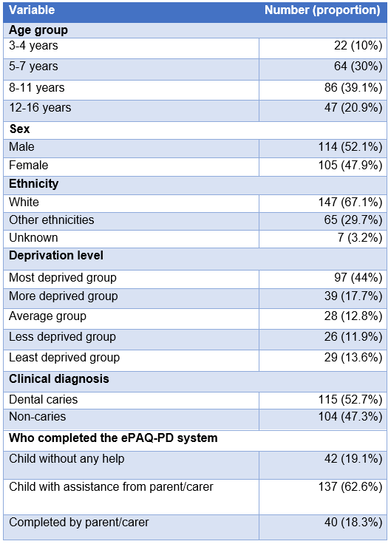

Missing data
The total number of participants eligible to complete the eCARIES-QC (aged 3 years or older) as part of the ePAQ-PD system was 220. Of the 220 participants, only one participant (0.4%) completely failed to complete the eCARIES-QC. As a result, this participant was eliminated from any further analysis regarding the eCARIES-QC. Two participants (0.8%) had one missing value; the skipped items were item 7 (hurt when brushing) and item 12 (interfering with schoolwork). The missing values for these two items were replaced with the individual participant’s overall mean value before conducting the correlation analysis with the overall score.

Rasch analysis
Two hundred and nineteen participants were included in the Rasch analysis. No disorder threshold was detected with the eCARIES-QC. The likelihood ratio test showed a significant chi-square statistic difference (p < 0.001). Therefore, the polytomous unrestricted (partial credit) model was selected for subsequent analysis. An independent t test of the positive and negative loading sets of item residuals confirmed the assumption of eCARIES-QC unidimensionality (< 5%). Dependency between items was observed between items 6 (feeling annoyed) and 10 (feeling cross) and items 8 (eating more carefully) and 9 (eating more slowly), where the fit residual was > 0.121 (Table ‎8.2). No DIF was observed across personal (sex, age group, depravation level and ethnicity) and clinical (caries and non-caries) variables at 0.05 level of significant (Bonferroni adjusted).

The eCARIES-QC demonstrated good reliability (PSI = 0.86) on logit separation on Rasch measurement. The overall item residual was - 0.59 (SD = 2.5), with a significant misfit to the Rasch model (p < 0.004; Bonferroni adjusted). The subsequent individual item fit analysis showed that item 4 (food stuck) has a significant difficulty (fit residual > 2.5), whereas item 6 (feeling annoyed) demonstrated significance in being an easy item (fit residual < - 2.5) (Table ‎8.3). Item 3, ‘Eating on one side’, and item 10, ‘Feeling cross’, had a fit residual near 0 (-0.02 and -0.38, respectively), indicating a good fit to the model. Individual person fit analysis indicated eight participants (3.6%) with misfits to the assumption of the Rasch model. Data from those participants were removed. Following their removal, the second full analysis showed no significant change (Table ‎8.3).
When all items were centred on zero logits, the mean person location was -1.00 (SD = 1.72). Further details on the skewness of a person's location are visualised in the person-item threshold map (Figure 8.5). This skewness indicates that the eCARIES-QC targets a population with a higher impact than the current participants, which is expected due to the routine use of the eCARIES-QC in the the current study in a diverse population with a variety of diagnoses. ANOVA on the distribution of person factor groups on the threshold map showed that participants would have a greater impact if they were diagnosed with dental caries (mean logit difference =0.8; p <0.05), from another ethnicities (mean logit difference = 1; p < 0.05), or living in the most (1st quintile; mean logit difference = 0.3; p <0.05) or least (5th quintile; mean logit difference =0.7; p <0.05) deprived areas.

Table ‎8.2. Residual correlation between eCARIES-QC items
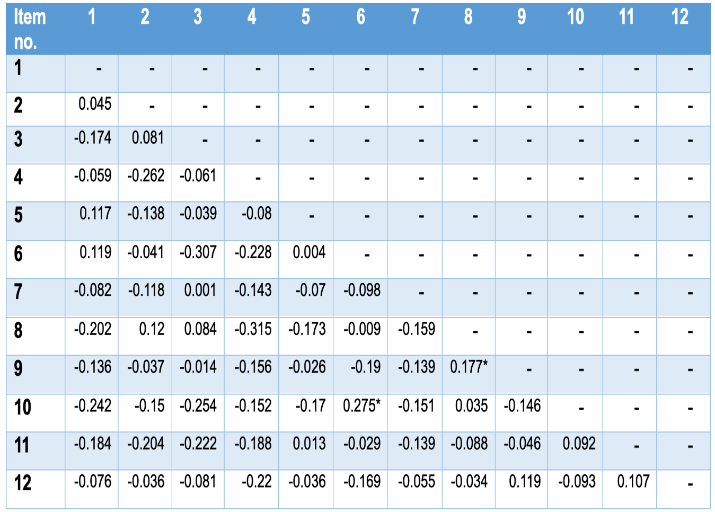Average item residual correlation = - 0.079
Average item residual correlation + 0.2 = 0.121
* Above than 0.2 + average residual correlation

Table ‎8.3 Fit of eCARIES-QC items to the Rasch model.
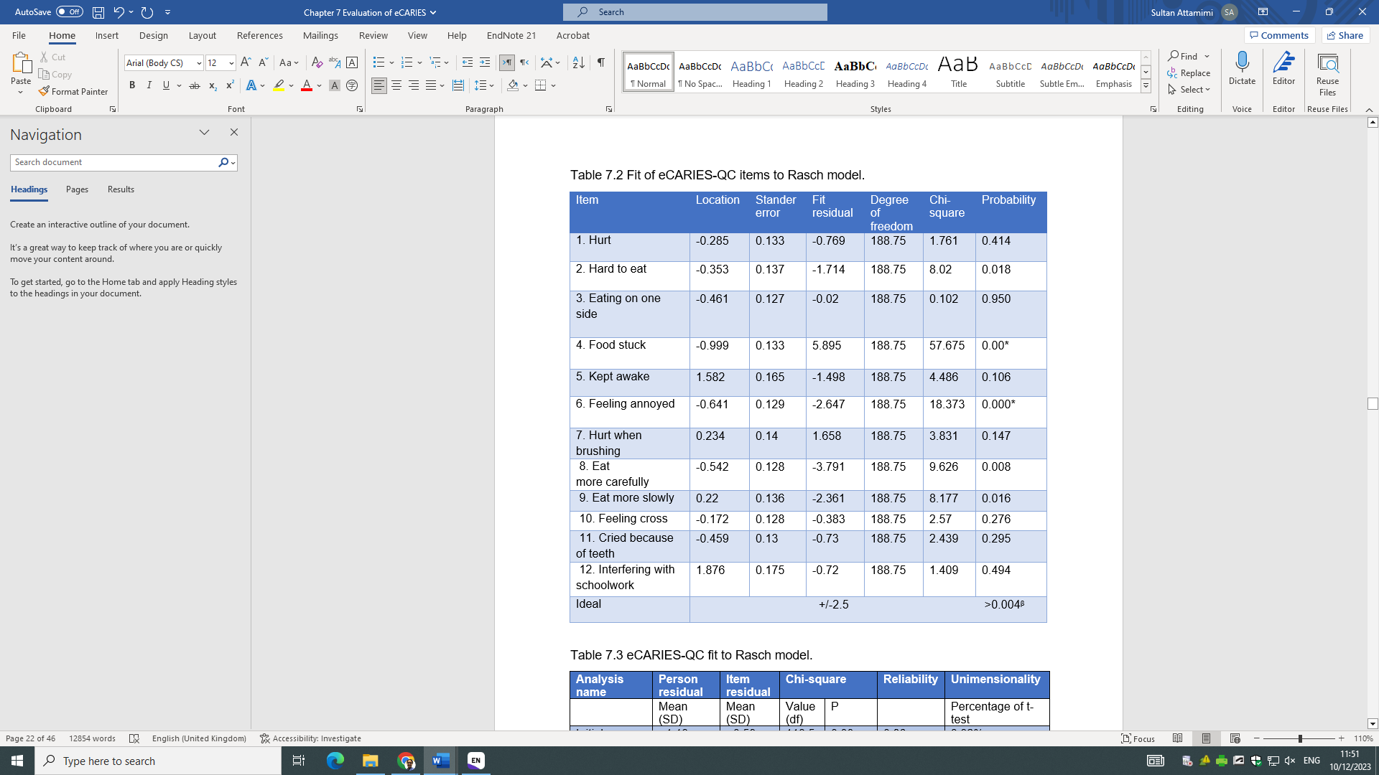
Table ‎8.4 eCARIES-QC fit to the Rasch model.
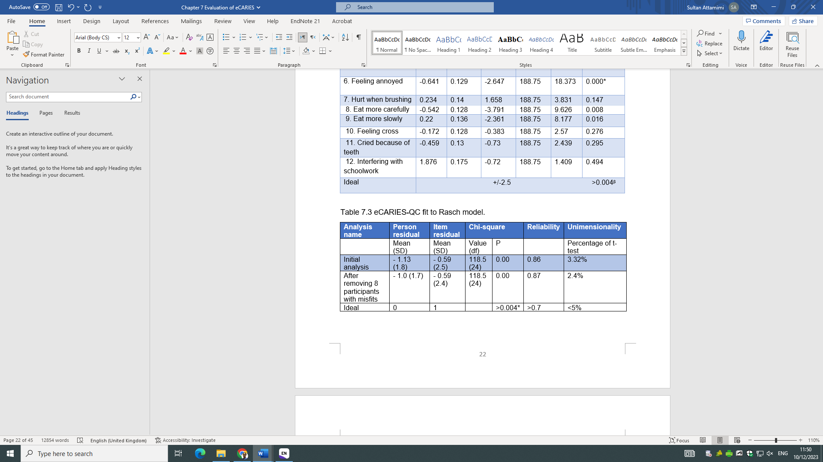
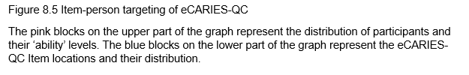
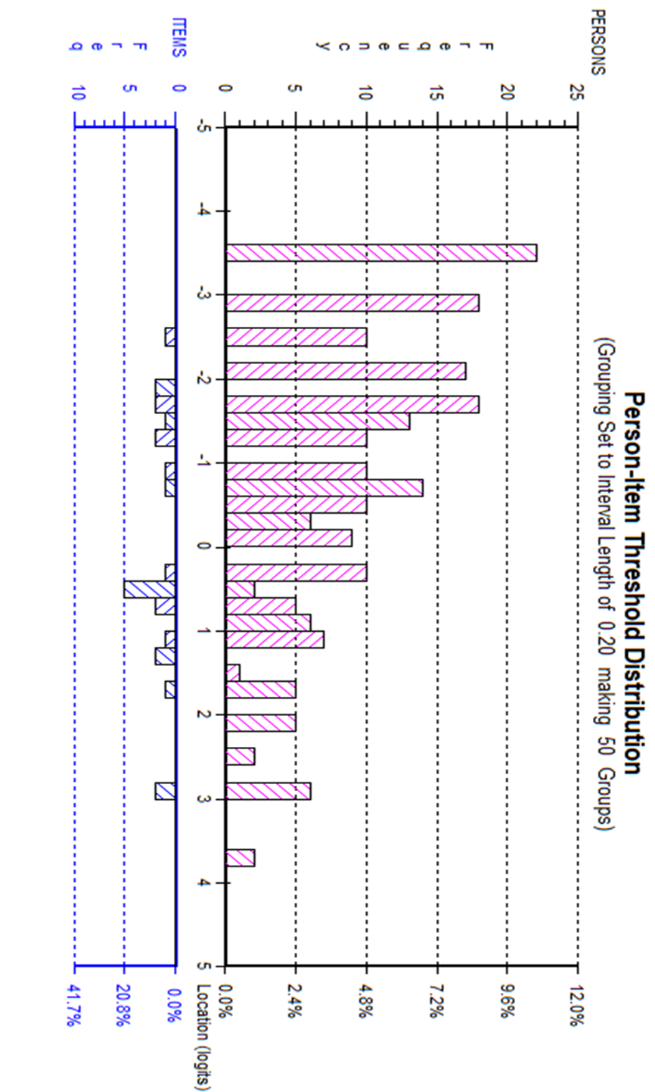
Interpretability

The floor and ceiling effects were within normal limits; only 8 (3.3%) participants scored the lowest possible score (0), and no participant scored the highest possible score (24). Data from the eCARIES-QC overall score showed positive skewness (Shapiro‒Wilk test for normality; p < 0.001). The median overall eCARIES-QC score was 7 (IQR = 9, range 0–21). The item with the most impact reported by participants was “food stuck” (n = 170; 76.9%), and that with the least impact was ‘interfering with schoolwork’ (n = 51; 23.1%). Interestingly, there were no reports of high impact (“a lot”) in response to the global question. Details of the number and proportion of participants who responded positively to the eCARIES-QC are illustrated in Table ‎8.4.

No significant difference was observed in the overall score mean rank between children’s age group, sex, or deprivation level. Participants from other ethnicities reported a higher impact (p < 0.001; CI= 1.3 – 4.8) than white participants. A significantly higher impact was captured from participants diagnosed with dental caries (p < 0.01; CI= 0.8 – 3.8) than that among those with other oral conditions. A significant difference was found between participants depending on who completed the eCARIES-QC (p <0.05). Children who completed the eCARIES-QC alone reported a lower impact than those who received assistance (p < 0.05; CI= -4.1 – -0.4) and had the questionnaire completed by proxy (p < 0.05; CI= -5.7 – -0.7). Further details on the participants’ eCARIES-QC overall scores and comparisons between variables are summarised in Table ‎8.6.

Table ‎8.5 Number and proportion of participants (N=219) who responded positively (“a bit” or “a lot”) per eCARIES-QC item.
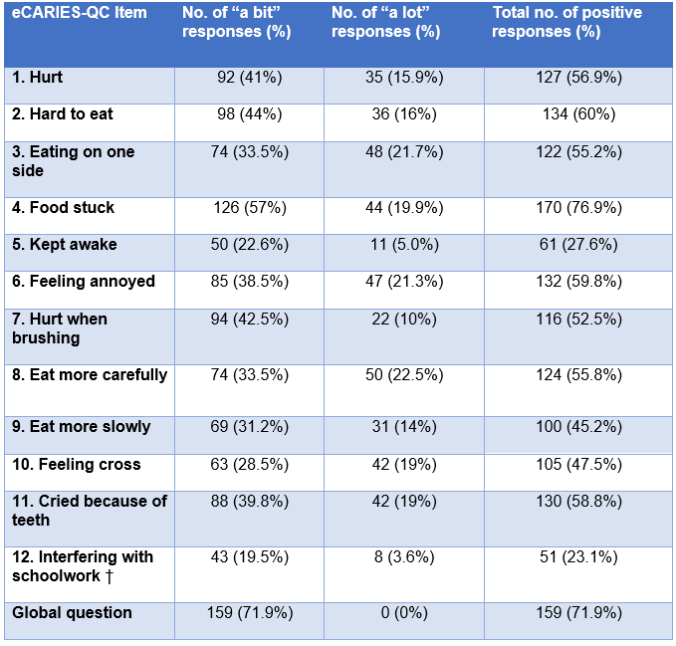
† Not applicable to 3-4 years age group.

Table ‎8.6 Median, interquartile range, and range of overall eCARIES-QC score.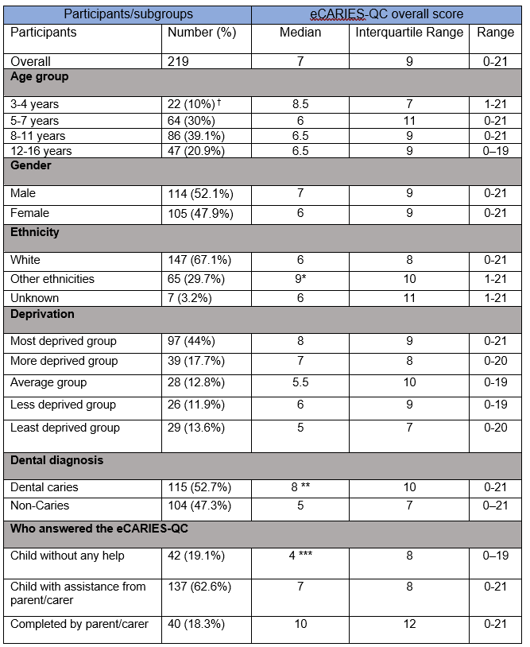

Internal consistency and correlations

Cronbach's alpha of the eCARIES-QC in this population was 0.91. Cronbach's alpha only increased to 0.92 if item 4 (food stuck) was deleted. Item total correlation ranged from 0.07 (food stuck) to 0.73 (eat more carefully). There was a strong correlation between the overall eCARIES-QC score and the global question (r = 0.65; CI = 0.56–0.72) (p < 0.001). No significant correlation was found between the overall eCARIES-QC score and age group, sex, or deprivation level. A weak positive correlation was observed between the overall eCARIES-QC score and other ethnicities (r = 0.22; CI = 0.13–0.36) (p < 0.001) and dental caries (r = 0.19; CI = 0.05–0.31) (p < 0.01) (Table ‎8.7).

Table ‎8.7 Correlation (Spearman rho) between overall eCARIES-QC scores and the global question and participants’ personal/clinical variables.
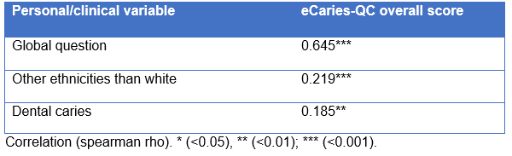

Responses to free text question

Of the 219 participants, 97 (44%) reported a further impact of oral conditions in answering the free-text question, “is there anything else about your mouth or teeth that bothers you?”. The age range of participants who completed the open question was from 3 to 16 years, with a median age of 9 years (IRQ = 6), and over half of them were female (n = 52; 53.6%) and diagnosed with non-carious conditions (n = 58; 58.5%). The median overall eCARIES-QC score for this group was 8 (IQR = 8), with a range between zero and 21. The additional impacts reported by participants in the free text box were related to five themes—pain, sensitivity, aesthetics, anxiety, and symptoms of non-carious conditions. Examples of responses to the free-text question are summarised in Table ‎8.8. Participants reported impacts covered by the eCARIES-QC items. The repeated impacts were related to item 2, ‘hard to eat’, item 3, ‘eating on one side’, item 7, ‘hurt when brushing’, and item 11, ‘cried because of teeth’.

Table ‎8.8 Additional impacts reported by participants (n=97,44%).
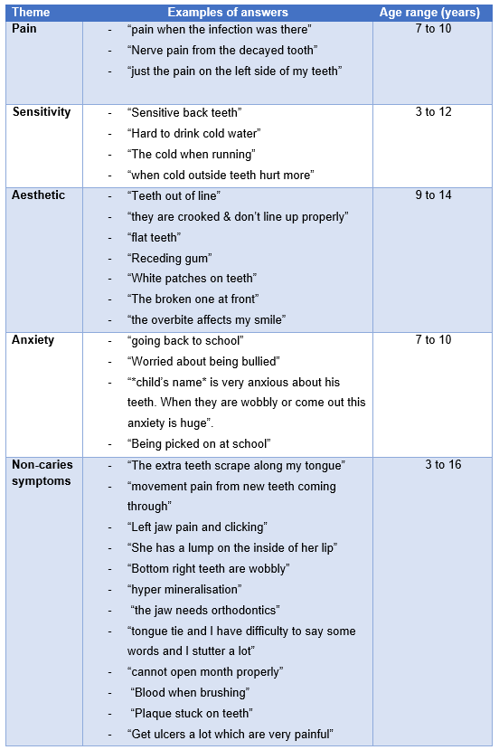

Discussion

The CARIES-QC was designed to measure the impact of dental caries on participants aged five years and older (Gilchrist et al., 2018). This chapter aimed to assess the psychometric properties of the eCARIES-QC when used to measure the impact of other oral conditions and in those at younger ages. The combined method of contemporary psychometric investigation and classical test theory, as recommended by the COSMIN group (Mokkink et al., 2010), showed that the eCARIES-QC has more potential than designed in capturing oral impacts in younger age groups and other conditions. However, modifications are required to ensure the scale accurately captures all relevant oral impacts.

Missing data

The response rate of the ePAQ-PD system as a whole, as mentioned in the previous chapter, was 69.5%, which is considered good and reflects the acceptability of the system and its content (Fayers and Machin, 2013). Of those who accessed the ePAQ-PD system and were three years and older, only one participant failed to complete the eCARIES-QC (response rate 99.5%), and two had one missing value each. As discussed in Chapter ‎2.4.2.3, the data quality of the eCARIES-QC does not appear to be impacted by non-measurement errors, such as low or incomplete responses (Bowling, 2005). This might be attributed to the electronic method of administration of the CARIES-QC and the use of a reminder text. Reminder texts were sent to 102 (46.6%) participants eligible to complete the eCARIES-QC. In addition, strategies to minimise the rate of missing data, as described by Mercieca-Bebber et al. (2018) , were followed during the development of the ePAQ-PD system (strategies are summarised in Table 2.7.

In comparison with the paper-based CARIES-QC (Gilchrist et al., 2018), the eCARIES-QC had a similar response rate (99% and 99.5%, respectively). A few issues were reported in the paper-based study that were overcome by the electronic format, including more missing data, omission of entire pages, and selection of more than one response per item (Gilchrist et al., 2018). Similar response issues were reported with the paper-based CARIES-QC in other studies (Graham et al., 2021). Both studies involved approaching participants in the waiting room area and asking them to complete the paper form of the CARIES-QC while waiting for radiographs to be taken. The time constraint was the main barrier to full completion; it was speculated that completion was interrupted as entire pages were missed. Completing the eCARIES-QC remotely allows participants to complete it at their convenience. The process tracking feature could be the main reason the electronic format is advantageous in terms of missing data. Another data-impacting behaviour was observed among participants using the paper format, where participants would circle an option from the preceding or following item by accident (Gilchrist, 2015). It could be argued that this error was controlled with the electronic format, where only one item for participants to complete was displayed per screen.

Another indicator of eCARIES-QC acceptability is the time participants need to complete it. Unfortunately, this able to be assessed in isolation, as the eCARIES-QC was a part of the ePAQ-PD system items. The time to complete the ePAQ-PD system was inaccurate due to unexplained prolonged completion, as discussed in the previous chapter (Chapter 7.6.1). However, the mean time to complete the eCARIES-QC was 4.5 minutes when assessed during usability testing (Chapter 6.5). This completion time would be assumed acceptable for children (Matza et al., 2004), and a similar time was reported in the evaluation study (Gilchrist et al., 2018). Other acceptability aspects of the eCARIES-QC were qualitatively assessed in the previous chapter.

Interpretability

The participant data used in this study were part of the data collected in the previous feasibility study (‎Chapter 7). As described in the previous chapter, a time-framed convenience sampling method was used to recruit participants and their parents/carers to assess the routine clinical use of ePROMs. The main advantage of convenience sampling is the representativeness of participants from the targeted population (Etikan, 2016). However, in nonprobability sampling, there is a risk of outliers, and a robust identification method for outliers must be conducted to control sample bias (Leiner, 2014). According to the aim of this part of the thesis, an outlier can be described only as a participant with an extreme overall eCARIES-QC score that might impact the psychometric investigation process. Participants with extreme overall scores were identified and removed from subsequent analysis as part of the Rasch analysis.

Participant demographics and clinical diagnosis details have been thoroughly discussed in the previous chapter (Chapter ‎7.5.1). Only 18 (7.5%) participants were excluded from the previous analysis, and the significance of the comparison was relatively unchanged. The impact of poor oral health on participants in this cohort varied between subgroups and domains. Nevertheless, none of the participants reported the highest possible overall eCARIES-QC score across all subgroups. In this study, participants from other ethnicities reported a more significant overall eCARIES-QC score than their peers from white backgrounds. However, there was no correlation with their clinical diagnosis, and none of the eCARIES-QC items had a DIF. Interestingly, similar ethnic disparity was reported in the original paper on the CARIES-QC (Gilchrist et al., 2018). A larger sample size with more data collected regarding social, behavioural, and financial status might reveal underlying factors explaining the ethnic disparity in child oral health in the area. In the UK, several factors that may explain poor oral health among other ethnicities children have been identified, including being less likely than white children to start brushing their teeth early in life, brush regularly, and attend dental check-ups (bin Hayyan et al., 2023). Exploring these hidden factors is a future opportunity to tackle ethnic inequality in this area.

Dental diagnosis showed a significant association with the eCARIES-QC overall score. Dental caries seems to have a greater impact on participants than other oral conditions (more details of oral conditions affecting children and their impact are summarised in Chapters 2.3–4). This finding is expected due to how widespread dental caries is, reflected in this sample (n = 115; 52.7%), and the symptomatic nature of the condition. The reported median overall score (n = 8; IQR=10) of eCARIES-QC is relatively similar to the overall mean score obtained with the paper format questionnaire (Gilchrist et al., 2018; Graham et al., 2021). This finding reflects the precision of the CARIES-QC in capturing caries-related impact. It was anticipated that the overall eCARIES-QC score would differ significantly between participants from the most and least deprived areas since caries is more prevalent in the former (Masood et al., 2019). The inclusion of non-carious conditions could have lowered the significance of the association between caries and deprivation in this study. In addition, the limited diversity and lower number of non-caries cases in this sample did not allow the assessment of the impact of individual oral conditions. Further investigation with a larger and more diverse sample is needed to reflect the true impact of specific conditions and the application of eCARIES-QC as an impact-capturing tool for those conditions.

Rasch analysis

The participants who completed the eCARIES-QC had various demographic and clinical characteristics, and it was difficult to anticipate how they would answer the questionnaire. As in any sample, a proportion of the participants would answer differently in an unexpected way, which may impact the psychometric analysis of a measure. There were a few participants (n = 8; 3.6%) who completed the eCARIES-QC in an unexpected way. As expected, removing participants with extreme values did not significantly improve the misfit or person residual. In addition, the PSI (=0.86), which indicates how reliable the measure is on an individual level, was within an acceptable range. No DIF was observed with the eCARIES-QC when compared with participants' demographic and clinical variables. Therefore, the misfit of the eCARIES-QC was not significantly influenced by the participants’ answer behaviour or demographic/clinical characteristics.

Some misfit was identified and may be due to some items appearing to have similar meanings or items which are not sufficiently discriminating in this diverse population. For example, it seemed that participants failed to distinguish between Items 6 (annoyed) and 10 (cross). The word ‘cross’ might not be fully understood by participants from a non-British culture, where it might be understood as a synonym of ‘annoyed’. The similarity between the terms ‘annoy’ and ‘cross’ was reported by children in a previous study, with older children preferring the term ‘annoy’ over ‘cross’ (Rogers et al., 2020).

A significant number of participants responded similarly to item 8 (eating more carefully) and item 9 (eating more slowly). This significant correlation demonstrates participants' failure to differentiate between the pace of chewing and being cautious when consuming food while experiencing oral conditions as both actions can occur simultaneously. They may find it confusing as both actions are interchangeable; there was no significant correlation between these two items and other items relating to eating of ‘hard to eat’ and ‘eating on one side’. The misconception might be caused by the inclusion of non-carious conditions. Deletion of the least endorsed item or changing the wording of these items might reduce the overall dependency between the eCARIES-QC items (Guyatt et al., 1986). However, in this study the eCARIES-QC was used for clinical purposes and the qualitative exploration does not appear to support the dependency effect on the provision of individualised oral care (‎Chapter 7). Therefore, the deletion of items is not indicated as the notion of generalisability and comparisons are not intended.

Another item-related misfit in the Rasch model was the unexpected response pattern to item 4 ‘food stuck’, and item 6 ‘annoyed’. The underdiscriminating pattern of item 4 ‘food stuck’ (Fit residual > 2.5), unable to capture probabilistic and meaningful responses, demonstrates a lack of relevance to the participants. This can be explained by the lack of clarity regarding whether it refers to food stuck in the holes, cavities, or between the teeth in general (Rogers et al., 2020). Another reason for the lack of relevance is the inapplicability of the question to participants with non-carious conditions. Conversely, Item 6 (annoy) showed a considerable overdiscriminating pattern (Fit residual < 2.5), where responses were more predictable than what the model expected. The dependency of this item on item 10 (cross) is the main cause for this item being significantly easy for participants to affirm (Andrich, 2006). Further qualitative exploration is needed to ascertain the reasons for the misfit of these items.

In agreement with the outcome of the statistical comparison of the overall raw score, the logit scores showed a significant correlation between reporting more impact and being diagnosed with dental caries (p<0.05) and being from other ethnicities (p<0.05). Smiliar findings were reported by previous studies (Gilchrist et al., 2018, Graham et al., 2021). The outcome of both comparisons emphasises the vulnerability of these two subgroups to oral impacts (Knapp et al., 2021; Ravaghi et al., 2016; PHE, 2019).

Interestingly, the ANOVA testing of logit scores spread on the threshold map showed a significant difference between participants’ levels of deprivation, which was not noted with the overall raw score comparison. It could be that the skewness of the overall raw score distribution and the use of a nonparametric test (Kruskal‒Wallis) led to distinct outcomes where the mean ‘rank’ is being compared instead of the mean ‘value’ (McDonald and Delaware, 2009). Logit score comparison identified that participants living in the most (1st quintile) and the least deprived areas (5th quintile) had significantly higher impact from oral conditions. In general, participants from the most deprived areas are more likely attend dental appointments infrequently (Salomon-Ibarra et al., 2020), are affected by inequality in service utilisation (Gallagher et al., 2009), and are more affected by dental caries (PHE, 2019), which is evident in this sample, where over half of the participants diagnosed with dental caries (n = 69;60%) were living in the most deprived areas. Surprisingly, participants from the least deprived areas (5th quintile) were also significantly impacted by oral conditions. This finding challenges outcome reported in national and international dental epidemiological studies (PHE, 2019) that suggest that participants from less deprived areas usually experience a lower impact from oral conditions. This could be due to the fact that the participants in this study were recruited from a specialised centre, where generalisability is limited compared to studies with a cross-sectional design. In addition, the number of participants in this study who lived in the least deprived areas was too low (n = 29; 13.6%) to draw a valid conclusion.
Rasch analysis is a well-established statistical procedure for testing the psychometric properties of a measure by assessing the discriminative ability of each item (Tennant and Conaghan, 2007). However, eCARIES-QC is a child-centred measure in which the modification or deletion of items should be determined mainly by the children’s views. In addition, the eCARIES-QC was used for clinical purposes in this study. The results of the Rasch analysis should complement the information collected from the children and clinical staff to ensure the accuracy of the measurement in the clinical context.

Internal consistency and correlations

The eCARIES-QC demonstrated a high Cronbach's alpha of 0.91, indicating high internal consistency. The Cronbach's alpha only increased if item 4 (food stuck) was deleted. This finding was highlighted in the Rasch analysis, where item 4 showed a significant underdiscriminating pattern. Item 8 (eating more carefully) had the highest inter-item correlation (0.73) when compared with item 9 (eating more slowly). Dependency was identified between these items in the Rasch analysis.

Participants diagnosed with dental caries or from other ethnicities demonstrated a weak but significant positive correlation which may indicate the need for a larger population to establish accurate correlation. A negative correlation was found if the child completed the measure independently. As an inherent limitation of the correlation comparison, these outcomes do not imply causation but rather a relationship (Janse et al., 2021).

Responses to free text question

The addition of free-text question to capture further impacts that the eCARIES-QC did not cover was considered based on recommendations from previous studies (Guyatt et al., 1986; Friedlander et al., 2019; Graham et al., 2021). The free-text question was beneficial in identifying impacts missed by the eCARIES-QC, especially from participants diagnosed with non-carious conditions. The free-text question allowed participants with dental caries to report information additional to the eCARIES-QC. Some of the verbatim reported impacts were already covered by the eCARIES-QC; however, participants provided further details in regard to the extent (e.g ‘Really hurt when brushing’), duration (e.g. ‘It hurts many months ago’), and description of the impact (e.g. ‘I cry when food hits it’). Examples in the ‘pain’ theme seemed to describe similar impacts of those covered in item 1 ‘hurt’. This issue was noted during the development of the CARIES-QC, and the term ‘hurt’ was selected to describe acute pain, as the aim was not to produce a pain measure but rather a descriptive impact measure (Gilchrist, 2015b) . None of the verbatim reports seemed to describe chronic dental pain, which may indicate that children do not recognise this as pain but rather as an “annoying” feeling, as hypothesised in the original paper (Gilchrist et al., 2018). A wide age range of participants reported tooth sensitivity when provoked by cold stimuli. As discussed in Chapter ‎2.2, tooth sensitivity may be caused by non-caries conditions, including dental anomalies (Lygidakis et al., 2008).

The eCARIES-QC failed to capture aesthetics-related impacts, potentially due to the inherent limitations of the measure and inclusion of conditions other than caries. Aesthetic-related impacts have been mainly reported by older participants (≥ 9 years) and only for younger children when parents/carers completed the eCARIES-QC on their behalf. Children's perception regarding dental aesthetics becomes more considerable in early adolescence (Tiro et al., 2021). The original CARIES-QC was developed using the language used by the youngest children, where aesthetic items were deemed to have failed to fit the Rasch model and were inconsistently answered by children (Gilchrist et al., 2018). Further qualitative enquiry with older children is required to ascertain the need for a new item to capture aesthetic impacts. It might be useful to explore different areas of dental aesthetics, as reported in this study, which include teeth alignment, smiling, and tooth shape, colour, and occlusion, to ensure the generalisability of the measure. Nevertheless, the free-text question was able to capture aesthetic-related impacts, reflecting its clinical value as a complement to the eCARIES-QC.
Some participants reported anxiety and social impact when responding to the free-text question. Most of these participants were under the age of nine; thus, CEDAM-8 did not apply to them and was therefore automatically skipped by the ePAQ-PD system (see Appendix B). These reports represent one of the benefits of including a free-text question that allows participants to describe further impacts. Some terms used by older children in these reports, such as ‘bullied’ and ‘picked on’, are worth considering in the development and modification of PROMs on children's dental anxiety. The non-caries symptoms theme covered a wide range of functional and emotional descriptions of the oral conditions, its impact, and treatment needs.

The eCARIES-QC showed good performance in capturing the impacts of different oral conditions; it was free from DIF and had high reliability. The addition of a free-text question was found to be effective in capturing various impacts that are clinically valuable. The eCARIES QC and free-text question provided good coverage in capturing the impact of various oral conditions in children attending new patient clinics with a wider age range than designed. The results of this study confirm the findings of the pilot study by Graham and colleagues (2021).

Strengths and limitations

Strengths

This psychometric evaluation of the electronic format of the CARIES-QC and its applicability to a broader age group with a variety of oral conditions is novel and has not been sufficiently investigated before. The overall response rate was acceptable for the ePAQ-PD system (Figure ‎7.2) and excellent for those who accessed the eCARIES-QC, with only one participant declining to complete it. This study used some strategies to ensure a higher completion rate where essential details were captured. As part of the ePAQ-PD features, reminder texts significantly increased the response rate. Almost half of the participants (46.6%) completed the eCARIES QC after receiving a text reminder. With 219 participants, this study exceeded the minimum number of participants (n=150) required to obtain 99% confidence that the estimate is within 0.5 logits (Linacre, 1994). This forms evidence that support claims of significance reported in the study. Another strength in terms of completion is the recording of who completed the eCARIES-QC and who provided assistance where necessary. This provided an accurate picture of children's ability and family engagement in the completion of child oral health PROMs.

The convenience sampling method over three months led to the recruitment of a representative population; therefore, accurate outcomes regarding the impact of oral conditions on children in secondary dental care in Sheffield were obtained. The use of modern and traditional psychometric testing methods is a key strength of this study. The identification of misfitted items would inform future studies on improving the eCARIES-QC if used in a similar population. The findings of a free-text question were beneficial in the current study to identify missed impacts. This question also provides an opportunity to explore ways to ensure the generalisability of the eCARIES-QC in future studies.

Limitations

Several limitations were identified in this study that need to be addressed. First, recruitment was conducted in a secondary dental care centre, where most participants were referred due to the severity of oral conditions or the need for advanced dental treatment. Therefore, the impacts of oral conditions reported in this study may be intensified and do not truly represent the status of children's oral health in Sheffield and the surrounding areas. Second, it was clear that this study would benefit from recruiting more participants with diverse oral conditions to establish an accurate evaluation of the applicability of eCARIES-QC for each condition rather than categorising them as ‘non-caries’. However, the timeframe for the project was limited, and it was not possible to recruit more participants once a sufficient target had been reached.

In Sheffield, approximately 20% of the population are from other ethnicities than white and live in communities where English might not be the first language (ONS, 2021). The eCARIES-QC used in the current study is not adequately inclusive for children from these communities as it is only in English. Other valid versions in different languages, such as Arabic (Azab and Yousry, 2022), Mandarin (He and Wang, 2020), Dutch (Rogers et al., 2019b), and Turkish (Duman and Inceoglu, 2023) exist. The inclusion of the eCARIES-QC in different languages in future studies would capture the impact of oral conditions on those overlooked children and could improve the response rate. Other limitations are inherent due to the electronic administration of the CARIES-QC, such as the lack of monitoring and support during completion, the fact that the reasons for non-response are unknown, and issues with internet availability, as outlined in the previous chapter. In addition, the pace of completion was not measured at item level, which is one of the limitations of the remote completion method. Therefore, participants’ behaviour when completing the eCARIES-QC and the occurrence of satisficing strategy, i.e., the quick and unmeaningful ways of response selection was not monitored (further details on satisficing strategy were discussed in Chapter 4.1.1).

Conclusion

In conclusion, the eCARIES-QC has acceptable psychometric properties for a wider age range than designed and appears to be effective in capturing the impacts of non-carious oral conditions that are clinically valuable. Analysis of the Rasch model demonstrated the unidimensionality of the eCARIES-QC, high reliability and freedom of DIF across all demographic and clinical variables. The free-text questions captured further valuable impacts that should be used to complement the eCARIES QC. Further investigation with a larger and more diverse group, especially with very young children, is needed.

Publications arise from the work presented in this Chapter

Published abstract:

Attamimi, S., Marshman, Z., Deery, C., Radley, S. & Gilchrist, F. (2024) Evaluation of routine use of electronic CARIES-QC in Paediatric Dentistry clinical practice (Conference Abstract: accepted for oral presentation). 8th UK Patient Reported Outcome Measures (PROMs) Research Conference 2024, Exeter, UK

Discussion

Outline

This thesis has presented four linked studies that have contributed to the feasibility and utility of investigating the use of electronic patient-reported outcome measures in clinical practice in paediatric dentistry. This chapter focuses on the presentation of key findings, discussion of important aspects of study design, and the strengths and limitations of these studies. Discussion of the implications of this research project for future research, clinical care and oral health policy are also included.

Overview

A thorough review of the relevant literature on children's oral health has shown that the impact on oral health can be assessed using relevant patient-reported outcome measures (PROMs). Gaps in the literature were identified that required future research. Most studies have investigated the impact of oral health on children’s lives for research purposes. The merits of routine clinical assessment of children’s oral health through the use of appropriate PROMs have not been adequately explored. In addition, preliminary data have shown that CARIES-QC may be suitable for children aged three years and older and can be applied to other oral conditions (Graham et al., 2021). The potential applicability of the CARIES-QC measure to very young children and other oral conditions requires further investigation. Therefore, the four linked studies aimed to address these gaps. The next section discusses the main findings of these studies.

Main findings

The aim of this thesis was to explore the feasibility and utility of the self-administered electronic PROMs in routine clinical practice in paediatric dentistry, which was achieved by fulfilling the following objectives:
- To develop an ePROMs system and to assess its technical performance and the reliability of the underpinning informatics.
This objective was met by developing the ePAQ-PD and applying the principles of user acceptance testing as described in ‎Chapter 5. This chapter concluded with the successful electronic conversion of two child-specific PROMs on oral health (CARIES-QC and CEDAM-8) leading to the development of the ePAQ-Paediatric Dentistry version. The ePAQ-PD is intended for routine clinical use, with the invitation letter, consents and free-text questions integrated to facilitate remote completion by patients. In addition, the ePAQ-PD demonstrated acceptable technical validity following the application of a novel model of user acceptance testing.

- To compare the electronic administration of the selected ePROMs to their original method of administration.

This objective was achieved by conducting the measurement comparability investigations as recommended by ISPOR taskforce (Coons et al., 2009) as described in ‎Chapter 6. This study found the ePAQ-PD to be acceptable and easy to use for children and their parents/carers, suggesting that the psychometric properties of the eCARIES-QC and the eCEDAM-8 are comparable to those of the paper-based format. The usability testing also tested non-PROM items such as access to the system, open-ended questions and navigation. The outcome of this study has ensured that the validity of the two measures has not been compromised by conversion to an electronic delivery platform and that ePAQ-PD is fit for purpose.

- To identify the facilitators and barriers and elicit valuable insights into the design, structure, implementation, and delivery method of the ePROMs and their utility in routine clinical practice in paediatric dentistry.

This objective was achieved by conducting a mixed-method study that aimed to explore the feasibility and utility of the ePAQ-PD in routine clinical practice in paediatric dentistry as described in ‎Chapter 7. The qualitative approaches used in this study demonstrated that the ePAQ-PD has acceptable feasibility and utility when used in paediatric dental practice to assess new patients. The ePROMs (eCARIES-QC and eCEDAM) and the free-text questions used as part of the ePAQ-PD were effective in systematically capturing information, concerns and requests from children and their parents/carers in a systematic fashion. The ePAQ-PD has been shown to improve children’s involvement in their oral care, their clinical experiences and communication with clinical staff. Areas for improvement were identified by children and their parents/carers, including the content of the invitation letter, intuitiveness and child-friendliness of the design. Clinical staff suggested some improvements to the accessibility and readability of the ePAQ-PD to facilitate faster interpretation. The ePAQ-PD does not appear to have a direct impact on treatment planning although it contributes to the richness of the history obtained from the children and their families.

- To assess the quantitative data generated from the ePROMs system with regards to participants’ demographic and clinical characteristics, response rate, and whether assistance was provided.

This objective was met by using quantitative approaches as part of the mixed-method study described in ‎Chapter 8. It was concluded that the ePAQ-PD appeared to be suitable for routine clinical use as a high response rate and a diversity of children completed the ePAQ-PD based on age, ethnicity, level of deprivation and clinical diagnosis.

- To assess the reliability and validity of the electronic version of the CARIES-QC when used with children aged three years and older with different oral conditions.

This objective was achieved by conducting an assessment of the psychometric properties of the eCARIES-QC to investigate the validity of the measure for capturing oral impacts in a younger age group and other oral conditions experienced by children, as described in ‎Chapter 8. This study found that the eCARIES-QC has acceptable psychometric properties for a wider age range than designed and appears to be effective in capturing the impact of non-carious oral conditions that are clinically valuable. Analysis of the Rasch model demonstrated the eCARIES-QC's unidimensionality, high reliability and freedom of DIF across all demographic and clinical variables. The free-text questions captured further valuable impacts that should be used to complement the eCARIES-QC.

These four linked studies were conducted to meet the objectives of the project. Strengths and limitations for each study of the individual studies in this thesis are discussed below.

Strengths

ePAQ-PD user acceptance testing

The strength of this model is its antipodal nature, which covers the system's reactions to normal user behaviour and misbehaviour as indicated in the system specification. Another strength point is the decision to develop and use a UAT checklist to ensure the thoroughness of the tests and reduce the risk of certain functions being omitted. The components of the checklist were based on the functions that the ePAQ-PD system must fulfil according to the requirements for the development team. During the design process, some features were added to the checklist to ensure ease of use. These include the division of items into colour-coded categories, major and minor items and input and output data. The addition of comment boxes was beneficial to allow testers to provide more details about the nature of the errors and to add errors that were not covered by the checklist items. In this study, the alpha testing was rigorously structured and included case-controlled tests aimed at testing the iterations of the ePAQ-PD in different simulated situations. Global and national statistics influenced the selection of the type of electronic devices (Ofcom, 2020) and email providers (Litmus, 2021) used in the test cases. Other categories were chosen due to the limited availability of technical options such as operating systems and the type of internet connection. The time of completion was chosen subjectively to test the performance of the ePAQ-PD iterations in different time periods. The categories were randomly reassigned in the second round of alpha testing to reduce the risk of performance differences due to inconsistencies between categories (e.g., operating system provider and web browser). Another strength point is the repetition of the test case when errors are detected to make it easier to identify the exact source of the error.

Measurement comparability study

This study followed an evidence-based recommendation that considered a novel method of using ePROs in paediatric dentistry and dentistry in general. The outcome of this study would facilitate the successful clinical implementation of ePAQ-PD as a data collection tool by reducing the risk of usability errors. To the best of the researcher's knowledge, this is the first study in the oral health literature. There have been attempts to test the usability of ePRO systems with children in other health fields (Meryk et al., 2021; Wang et al., 2017; van Muilekom et al., 2022; Rumbold et al., 2013); however, in these studies, usability testing was conceptualised as acceptance and satisfaction of use rather than detection of usability issues. It seems that there is no evidence of usability testing (as described in this study) of ePROMs with children.

Feasibility of Routine Clinical Use of ePROMs

This study explored the feasibility and clinical utility of routine use of the ePAQ-PD in new patient appointments. This study consisted of mixed-method approaches that were conducted in multiple steps to ensure the high quality of the study. The greatest strength point of this study is the inclusion of a diverse sample that utilised the ePAQ-PD in the qualitative study from both sides. The children were recruited from different age groups, sex, deprivation levels and dental diagnoses. In addition, the involvement of parents/carers in this study is beneficial to capture comprehensive views on the clinical use and content of the ePAQ-PD, as parents/carers are the ones more likely to receive invitation letters and support their children. Clinical staff were diverse in their clinical roles and responsibilities. Overall, all participants who took part in the qualitative parts of the study were enthusiastic to share their views and feelings openly, reflecting their interest in the research topic and its value to clinical practice. Furthermore, this reflects the appropriateness and relevance of the topic guides used in the interviews, allowing participants to describe their experiences and consider how the ePAQ-PD can be improved. The comprehensive research ensured that the true extent of feasibility and benefits were captured and served as a basis for subsequent changes to the ePAQ-PD.

Another strength point is the pre-implementation process carried out for this study, including the technical and usability testing of the ePAQ-PD (‎Chapter 5 and ‎Chapter 6), training of clinical staff and post-implementation support through regular newsletter exchanges and addressing any queries. These strategies have ensured that non-measurement errors (see Section 2.4.2.3) are monitored and controlled as far as possible.

Evaluation of eCARIES-QC

This psychometric evaluation of the electronic format of the CARIES-QC and its applicability to a broader age group with a variety of oral conditions is novel and has not been sufficiently investigated before. The overall response rate was acceptable for the ePAQ-PD system and excellent for those who accessed the eCARIES-QC, with only one participant declining to complete it. This study used some strategies to ensure a higher completion rate where essential details were captured. As part of the ePAQ-PD features, reminder texts significantly increased the response rate. Almost half of the participants (46.6%) completed the eCARIES QC after receiving a text reminder. Another strength point in terms of completion is the recording of who completed the eCARIES-QC and who provided assistance where necessary. This provided an accurate picture of children's ability and family engagement in the completion of child oral health PROMs.

The convenience sampling method over three months led to the recruitment of a representative population; therefore, accurate outcomes regarding the impact of oral conditions on children in secondary dental care in Sheffield were obtained. The use of modern and traditional psychometric testing methods is a key strength of this study. The identification of misfitted items would inform future studies on improving the eCARIES-QC if used in a similar population. The outcome of a free-text question was beneficial in the current study to identify missed impacts. This question also provides an opportunity to explore ways to ensure the generalisability of the eCARIES-QC in future studies.

Limitations

ePAQ-PD user acceptance testing

The model failed to include clinical staff as output end-users in the beta testing of the ePAQ-PD, where their inclusion could reveal additional undetectable errors in system management functions and final reports. Another limitation that requires a long-term consideration is the lack of a defined post-implementation monitoring plan and maintenance strategy to detect and address issues that may arise after the system is implemented. An incident reporting sheet has been developed for clinical staff to report technical errors that may occur during the implementation of the ePAQ-PD (Appendix C).

The participation of children and parents/carers in the negative testing was excluded as it was considered inappropriate to ask patients to deliberately misuse the ePAQ-PD system. A few potential negative actions by users were not included in the negative UAT plan. Saving data while completing ePAQ-PD by screenshotting or copying text was not considered for inclusion as no sensitive or personal information is included. The final reports contain personal identification data. However, only clinical staff and members of the research team have access to the final reports, so that the confidentiality of the participants is maintained.

In addition to testing system responses, negative testing is usually used to test software or system security (Alexander, 2002). The security of the ePAQ-PD system was not considered in the negative UAT plan developed, as the security testing is beyond the technical knowledge of the research team members. Furthermore, the ePAQ-PD system is a version of the ePAQ® platform where data security is the responsibility of the developing company (PACE Software Development Ltd, Sheffield, UK). Since its inception, the ePAQ® platform has successfully produced other versions of the electronic questionnaire used in gynaecology (Jha et al., 2009; Elenskaia et al., 2013) and pre-anaesthetic assessment (Goodhart et al., 2017; Taylor et al., 2018) without any reports of security issues.

In order to ensure appropriate application in future work, some limitations must be taken into account. The behaviour-based model failed to include the output end-users of researchers and/or clinicians in the beta testing, where their inclusion could reveal additional, undetectable errors in the system management functions and final reports. The exclusion of output end-users in this model is based on a cost-effectiveness assumption because, unlike patients/participants for whom no prior knowledge or experience is required, clinical staff require training to access the system management dashboard and view the final reports. Providing training session would be an unnecessary burden on the trial system prototype where ePROs providers can fairly act on their behalf.

Measurement comparability study

In the usability testing literature, the sample size required to achieve adequate representativeness and high precision in detecting usability errors is a debatable topic (Nielsen and Landauer, 1993; Faulkner, 2003; Macefield, 2009; Coons et al., 2009). Faulkner (2003) thoroughly investigated the sensitivity of the number of participants in detecting usability errors by randomly assigning participants with different electronic skills into different groups with multiples of five. Faulkner (2003) found that a group of five participants was able to detect an average of 85.5% (SD =9.3%) of problems, while a group of 10 and 20 participants were able to detect an average of 94.7% (SD =3.2%) and 97% (SD =2.1%), respectively. The reported results are from a usability testing of a web-based data sheet for recording employee attendance, rather than an online questionnaire or ePROM. Nielsen and Landauer (1993) suggested that a sample size of five testers is generally able to detect about 83% of a system's problems. The only recommendation related to the usability of ePROs was published by ISPOR taskforce as part of the measurement comparability recommendations (Coons et al., 2009). ISPOR taskforce recommends a sample of 5-10 participants for a simple ePRO system and 20 or more for a complex system. The recommendation does not take into account special population groups such as children (other limitations of the ISPOR taskforce recommendations were discussed in Section ‎4.3.1). There have been attempts to test the usability of ePRO systems with children (Meryk et al., 2021; Wang et al., 2017; van Muilekom et al., 2022); however, in these studies, usability testing was designed to measure acceptance and satisfaction with use, not to detect usability issues. Unfortunately, there is no evidence of usability testing (as described in this study) of ePROMs with children. Therefore, a sample size of nine participants from different age groups was considered appropriate and representative to test the usability of the ePAQ-PD, as it exceeds the minimum number of five participants and data saturation was considered to have been reached.

In this study, all usability sessions and debriefing interviews were conducted in a private room in the School of Clinical Dentistry. The results may be biased as the children and their parents/carers may proceed and reflect differently if they were completing the ePAQ-PD without observation and facilitation by a moderator. The impact of the presence of an interviewer or moderator on data quality has already been discussed in Section ‎2.4.2.3. In addition, data quality could be affected by the cognitive debriefing technique used (verbal probing), which relies on the moderator's interviewing skills compared to the think-aloud technique (Davison et al., 1997). In designing the study, a number of measures were considered in order to control the performance bias of the children and the quality of data reporting as much as possible. The provision of a real-life scenario before the usability session began seemed to add some meaning to the context of the session to some extent. Scenario-based testing is a common method in usability testing to bridge the gap between the conceptual model of the system and that of real-world practice (Rogers et al., 2005). The think-aloud technique was not included as it could distract the children and lead to a delay in responding to the ePAQ-PD compared to verbal probing after the task (Als et al., 2005). The moderator’s ability to conduct age-appropriate interviews is crucial to obtaining valid and meaningful data from children, as explained in the Methodological Considerations chapter (Section ‎4.1.2). The moderator (SA) is a paediatric dentist who has experience in interpreting children’s body language. SA had formal training in conducting and analysing qualitative research through participation in a semester-long module entitled "Qualitative Research Design and Analysis module" (module code: HAR6531) offered by the University of Sheffield.

In this study, participants were asked to reflect on their experiences with the usability of ePAQ-PD in a satisfaction survey and in structured and semi-structured interviews. The decision to include the satisfaction questionnaire in the usability testing was made in order to obtain standardised and comparable results between participants. However, some disadvantages were identified with the satisfaction questionnaire used. The main drawback is the lack of psychometric validity, i.e., the accuracy of the questionnaire in capturing relevant and important aspects of usability satisfaction is unknown. There are validated usability satisfaction questionnaires in the literature, including the System Usability Scale (SUS) (Brooke, 1996) and the Post-Study Usability Questionnaire (PSSUQ) (Lewis, 1992). However, there is no evidence in the literature of validated usability questionnaires developed for children, but rather the unjustified use of questionnaires for adults or reliance on proxies (Tasfia et al., 2023; Al-Wakeel et al., 2015). The 4-item questionnaire used in this study was developed subjectively based on different satisfaction domains adapted from Aiyegbusi and others (2018) and modified to better suit the age of the children. Another disadvantage is the lack of a free-text box for children to elicit more information about satisfaction with the user-friendliness, which was not included in the questionnaire. However, a short questionnaire was deemed sufficient and would be less burdensome for participants who are interviewed and have the opportunity to provide information that was not captured in the satisfaction questionnaire.

The purpose of the usability testing is to identify usability issues in a sample group of system end-users. The ePAQ-PD is to be used routinely in clinical practice, with the end users being children and their parents/carers (as input end-users) and clinical staff (as output end-users), as described in the previous chapter. Investigation of the usability of the ePAQ-PD from the clinical staff's perspective was completely omitted from this study. Arguably, the omission of clinical staff can be justified in some respects. Clinical staff is familiar with the use of various electronic software and systems as part of their routine practice, so a high level of electronic literacy can be assumed and the usability of the ePAQ-PD would not be a problem. In addition, the number of tasks that need to be performed by clinical staff is far less extensive and complex compared to children and their parents/carers. Prior to the introduction of the ePAQ-PD into routine clinical practice, all clinical staff involved in the use of the ePAQ-PD were trained. The details of the clinical staff training were described in section ‎5.3.

Feasibility of Routine Clinical Use of ePROMs

Several limitations were identified in this study that need to be addressed. The ePAQ-PD was developed in English, so children and parents/carers who are not proficient in English were not included in the interviews and may not have been able to complete it remotely. The inclusion of different languages in the ePAQ-PD depends on the availability of translated and psychometrically validated versions of the included PROMs. Various translated and validated versions in Arabic are available for the CARIES-QC (Azab and Yousry, 2022), Mandarin (He and Wang, 2020), Dutch (Rogers et al., 2019b), and Turkish (Duman and Inceoglu, 2023) exist. The inclusion of these versions could be beneficial but would have cost implications and may limit the clinician’s ability to review the content of the free text question.

In the current study, we succeeded in recruiting a sample of all direct users of the ePAQ-PD. However, indirect users who could influence the implementation of the ePAQ-PD in the long term, such as the ePAQ providers and the decision-makers in the hospitals, were not included. Their involvement would allow clearer navigation towards a sustainable future for the use of the ePAQ-PD and highlight potential challenges and opportunities for use in different clinics within the department. Reception staff in the department were not included in the focus groups, although their role in encouraging patients to complete the ePAQ-PD and addressing any issues is crucial. Future research could focus on extending the scope of the feasibility study by including participants with administrative roles.

Other limitations in this study are related to the inherent drawbacks of mixed-method research design. Overall, such a design requires an enormous amount of resources and time to plan and execute, especially when conducted by one researcher as in this project. However, some methodological and ethical considerations were applied to achieve the research aim with credibility and validity, as explained in Chapter 3. The integration of quantitative and qualitative approaches was challenging and there were a few barriers were encountered and controlled including the development and testing of the ePAQ-PD, acquiring appropriate research skills, recruiting different target groups and the administrative burden of managing the ePAQ-PD and issuing invitation letters to all children attending the new patient clinic over a three-month period. Another limitation is the difficulty in combining the analysis of the two different types of data to provide an integration analysis and outcome (Bryman, 2014). Another potential limitation is the future publication of this study, as many scientific journals limit the number of words, so publishing a mixed-method study without losing essential details is a challenge (Bryman, 2014). Therefore, details and data are usually appended as a supplementary document, or the two approaches are published separately, which requires careful consideration so that the merits of integration are not lost.

In qualitative approaches, the inherent limitations must be explained, including the lack of reproducibility and generalisability, as well as the bias associated with the subjective judgement of the researcher throughout the study process, from design to interpretation of the findings (Creswell, 2003). However, in assessing the quality of the qualitative approaches in this study, the principles of trustworthiness (credibility, transferability, reliability and confirmability) were followed (Stahl et al., 2020). As qualitative approaches tend to collect data from a small number of participants, there are some concerns about the transferability of the study findings to other contexts and settings. Some aspects of the overall findings may be applicable and useful to some extent in other areas of paediatric dental care in the NHS sector and provide underpinning research for future clinical implementation of ePROMs. The naturalistic, non-structured observations conducted as part of this study have unique limitations that need to be declared. The observation followed an overt method where children, parents/carers and clinical staff were aware that they were being observed. This method leads to a bias termed the ‘Hawthorne effect’, in which those who are observed tend to change or improve their behaviour (Gould et al., 2017). Unfortunately, this form of bias cannot be controlled, as the observation and other research activities of participants are not compatible with medical and research ethical standards (Data Protection Act, 2018). The aim of including clinical observations in the study methodology was to affirm outcomes from other qualitative approaches and to capture overlooked information related to the study aim which this method appears to achieve.

Evaluation of eCARIES-QC

Several limitations were identified in this study that need to be addressed. First, recruitment was conducted in a secondary dental care centre, where most participants were referred due to the severity of oral conditions or the need for advanced dental treatment. Therefore, the impacts of oral conditions reported in this study may be intensified and do not truly represent the status of children's oral health in Sheffield and surrounding areas. Second, it was clear that this study would benefit from recruiting more participants with diverse oral conditions to establish an accurate evaluation of the applicability of eCARIES-QC for each condition rather than categorising them as ‘non-caries’. However, the timeframe for the project was limited, and it was not possible to recruit more participants once a sufficient target had been reached.

In Sheffield, approximately 20% of the population are other ethnicities than white and live in communities where English might not be the first language (ONS, 2021). The eCARIES-QC used in the current study is not adequately inclusive for children from these communities as it is only in English. Other limitations are inherent due to the electronic administration of the CARIES-QC, such as the lack of monitoring and support during completion, the fact that the reasons for non-response are unknown, and issues with internet availability, as outlined in Section ‎8.6.1.

The results of the studies included in this thesis represent scientific knowledge that can inform clinical practice, policy and future research. Theoretical and practical implications and areas for future research are discussed below.

Implications for clinical practice

The findings of these studies have several implications for clinical practice when introducing PROMs into routine care. The selection of appropriate, relevant and validated PROMs should be considered before introducing PROMs into routine clinical practice. Investigations on feasibility and utility of implementation of PROMs is recommended to ensure that they capture information that is clinically valuable with least burden on patients and clinical staff. As this research project is considered novel to the field, CARIES-QC with a free-text question is the only child oral health PROM that has been shown to be feasible and effective for routine clinical use.

For routine clinical use, the electronic format of PROMs is more efficient and acceptable to children, parents/carers and clinical staff, as concluded in Chapter 7. Most oral health PROMs have been developed and validated in paper formats where forms of technical and usability testing are strongly recommended as cost-effective strategies following electronic conversion. Post-implementation monitoring of ePROMs system is crucial to ensure the integrity of the electronic system as a data collection tool. Some considerations can be made in the electronic conversion of PROMs that would facilitate the completion of PROMs, improve children's experiences and reduce the burden on both children and clinical staff. Full utilisation of electronic features is recommended as facilitators and that include the use of the skip-logic role, reminder texts, clear content and a child-friendly design. Clinical staff tend to prefer features that facilitate faster interpretation of ePROMs responses in terms of accessibility and readability.

There are several benefits can be expected when implementing PROMs with free-text questions into routine clinical practice. Routine clinical use of PROMs may improve children’s clinical experience by promoting communication between parents and children, revealing hidden impacts and supporting clinical staff in addressing children’s concerns. These benefits can be ensured by using validated PROMs, practical and child-specific method of invitation such as text messaging, sharing the invitation letter/text in convenient and closed time to the appointment and using inclusive colours and languages for children with neurodiversity and those who speak languages other than English. From a clinical staff perspective, routine PROMs may improve clinical care by giving children a voice to outline what is important to them, gain confidence particularly for anxious children, and encourage communication. PROMs may indirectly facilitate discussion about the treatment plan, but may not be used to prioritise treatment options.

It should be noted that the findings of this research project are based on the investigation of the implementation of PROMs in routine dental care in one setting. Smiliar findings of PROMs implementation may be expected if conducted in other dental clinics or in primary dental care. Further studies are needed to ascertain generalisability.

Implications for policy

The findings of this research project clearly show that the routine clinical use of PROMs in new patient appointments has numerous benefits for children and dental care provision. Overall, children’s oral health must be a national priority with policies and initiatives being developed to address and prevent poor oral health in children and therefore minimise oral impacts. The majority of children who participated in this project lived in the most deprived areas and have reported high oral impacts as they responded positively to the eCARIES-QC global question. Access to dental services is a crucial aspect that commissioners need to ensure in order to minimise the impact of poor oral health in children. It has been shown that children’s quality of life improves after dental treatment when it is carried out in a dental clinic and under general anaesthesia (Milani et al., 2021).

The findings of this research project support the objectives of the national vision in healthcare as outlined by the NHS Outcomes Framework (Department of Health, 2012). The framework emphasises the importance of providing patients, service users and carers with a positive experience of care by capturing direct feedback on the quality of their experience, treatment and care. Recently, NHS England issued guidance on clinical standards specifically for Paediatric Dentistry (NHS England, 2023). Guidance stated that paediatric dental services need to capture PROM data as part of clinical care, regardless of the presenting condition or treatment. The routine use of PROMs in Paediatric Dentistry clinical practice will be a growing field in the future. Findings of this research project and the principles of user acceptance testing and measurement comparability used in this project may guide commissioners of these services to outline implementation standards for providers.

Implications for future research

This research project has demonstrated the feasibility and utility of the routine use of ePROMs in paediatric dental practice to assess new patients. Some important areas for future research can be drawn from the limitations outlined in this research project. Further studies could focus more on the inclusion of larger samples from different settings. A multi-centre study would be valuable to further investigate the feasibility and utility of routine use of PROMs in primary and specialised dental practices in a larger population. Future studies could modify some of the methods used in this project to capture future and relevant information on the feasibility and utility of routine use of ePROMs. This includes use of child-specific invitation text, capturing a more comprehensive description of child-clinician communication and involving decision makers as part of the investigation.

The use of current PROMs in different languages and other child oral health PROMs may allow future studies to further identify some areas that were overlooked in this project. The use of different methods of PROMs administration, such as touch-screen devices, and the routine use of PROMs in clinics other than new patient assessment are important areas for further investigation in future studies. The role of PROMs in assessing treatment success, monitoring anxiety levels and other outcomes and establishing priority-based waiting lists are future areas worth exploring. In the present project, the oral conditions of the participating children were categorised into ‘caries’ and 'non-caries’ conditions when evaluating the eCARIES-QC. Further studies could place more emphasis on establishing more accurate evaluation of the applicability of eCARIES-QC for each oral conditions. There are other areas that future studies should focus on by addressing the suggestions raised by children, parents/carers and clinical staff as reported in this project. These suggestions include the use of a traffic light system to highlight response options, the use of child-friendly pictures, the inclusion of a separate item for parents/carers and the integration of the ePROMs system into the practice main system.

Conclusion and recommendations

The studies presented within this thesis aimed to explore the feasibility and utility of self-administered web-based electronic PROM in routine clinical practice in Paediatric Dentistry. The specific objectives to fulfil the aim are to:

- develop an ePROMs system and assess the technical performance and reliability of the underpinning informatics,

- compare psychometric properties of the electronic format of the selected PROMs to their original method of administration,

- identify the facilitators and barriers and elicit valuable insights into the design, structure, implementation, and delivery method of the ePROMs and its utility in Paediatric Dentistry routine clinical practice,

- assess the quantitative data generated from the ePROMs system with regards to participants’ demographic and clinical characteristics, response rate, and whether assistance was provided, and

- assess the reliability and validity of the electronic version of the CARIES-QC when used with children aged three years and older with different oral conditions.

These objectives were fulfilled by the development of an ePROMs system and the conduct of four interlinked studies using a variety of novel methods. The research project presented in this thesis provides novel knowledge regarding the feasibility and utility of routine use of ePROMs in Paediatric Dentistry clinical practice. This chapter focuses on the summarising of key findings and recommendations arising from the studies.

Summary of findings

- An electronic system (ePAQ-Paediatric Dentistry) was successfully developed using two child-specific PROMs on oral health (CARIES-QC and CEDAM-8) and free-text questions, to facilitate delivery and use of PROMs to children, parents/carers and clinical staff.

- A novel user acceptance testing model was developed to evaluate technical performance of ePROMs systems prior implementation into routine clinical practice. The ePAQ-PD showed acceptable technical performance.

- The ePAQ-PD was found to be acceptable and easy to use by children and their parents/carers indicating measurement comparability of ePROMs used as part of the ePAQ-PD (eCARIES-QC and eCEDAM-8) to their paper-based format based on ISPOR taskforce recommendation (O’Donohoe et al., 2023).

- The ePAQ-PD demonstrated acceptable feasibility and utility when used in Paediatric Dental practice to assess new patients. The ePROMs (eCARIES-QC and eCEDAM) and the free-text question used as part of the ePAQ-PD were efficient in capturing information, concerns and requests from children and their parents/carers in a systematic fashion.

- The ePAQ-PD has been shown to improve children’s involvement in their oral care, their clinical experience and communication with clinical staff. Areas for improvement were identified and discussed.

- The eCARIES-QC showed acceptable psychometric properties for a wider age range (3-16 years) than designed and appears to be effective in capturing the impacts of non-carious oral conditions that are clinically valuable. The free-text questions captured further valuable impacts that should be used to complement the eCARIES QC.

Recommendations for clinical care

- The electronic format of PROMs is more efficient and acceptable according to children, parents/carers and clinical staff.

- Most oral health PROMs have been developed and validated in paper formats where forms of technical and usability testing are strongly recommended as cost-effective strategies following electronic conversion.

- Post-implementation monitoring of ePROMs system is crucial to ensure the integrity of the electronic system as a data collection tool.

- Full utilisation of electronic features is recommended as facilitators and that includes the use of the skip-logic role, reminder texts, clear content and a child-friendly design. Clinical staff tend to prefer features that facilitate faster interpretation of ePROMs responses in term of accessibility and readability.

- Some benefits can be expected when implementing PROMs with free-text questions into routine clinical practice that include improving children’s clinical experience by promoting communication between parents and children, revealing hidden impacts and supporting clinical staff in addressing children’s concerns. Clinical staff may found PROMs beneficial in giving children a voice to outline what is important to them, gain confidence particularly for anxious children, and encourage communication. PROMs may indirectly facilitate discussion about the treatment plan, but may not be used to prioritise treatment options.

- This research project is the first to use CARIES-QC with a free-text question and it is now the only child oral health PROM that has been shown to be feasible and effective for routine clinical use.

Implications for policy

- Children’s oral health must be a national priority with policies and initiatives being developed to address and prevent poor oral health in children and therefore minimise the impacts of oral conditions on children.

- The majority of children who participated in this project lived in the most deprived areas and reported high oral impacts as they responded positively to the eCARIES-QC global question. Access to dental services is a crucial aspect that commissioners need to ensure in order to minimise the impact of poor oral health on children.

- The routine use of PROMs in Paediatric Dentistry clinical practice will be a growing field in the future as it has recently been recommended in a national guidance (NHS England, 2023) . The findings of this research project and the principles of user acceptance testing and measurement comparability used in this project may guide commissioners of these services to outline implementation standards for providers.

Recommendations for research

- A multi-centre study would be valuable to further investigate the feasibility and utility of routine use of PROMs on a larger sample of children from different settings of primary and specialised dental practices.

- Future studies may focus on investigating the feasibility and utility of the routine use of PROMs in different languages, different methods of PROMs administration, such as touch-screen devices, and routine use of PROMs in clinics other than new patient assessment.

- The role of PROMs in assessing treatment success, monitoring anxiety levels and establishing priority-based waiting lists are future areas that need to be explored.

- Further studies could place more emphasis on establishing more accurate evaluation of the applicability of eCARIES-QC for each oral conditions.

- There are other areas that future studies should focus on by addressing the suggestions raised by children, parents/carers and clinical staff as reported in this project.

In conclusion, the studies within this thesis have demonstrated the feasibility and utility of self-administered web-based electronic PROM in routine clinical practice in Paediatric Dentistry. Future studies are required to ascertain the findings from this thesis in a larger sample and other sittings.

References
Aapd 2008. Policy on early childhood caries (ECC): classifications, consequences, and preventive strategies. Pediatr Dent, 30, 40-3.
Abanto, J., Paiva, S. M., Raggio, D. P., Celiberti, P., Aldrigui, J. M. & Bönecker, M. 2012. The impact of dental caries and trauma in children on family quality of life. Community Dent Oral Epidemiol, 40, 323-31.
Abed, R., Bernabe, E. & Sabbah, W. 2019. Family Impacts of Severe Dental Caries among Children in the United Kingdom. International journal of environmental research and public health, 17, 109.
Abou Neel, E. A., Aljabo, A., Strange, A., Ibrahim, S., Coathup, M., Young, A. M., Bozec, L. & Mudera, V. 2016. Demineralization-remineralization dynamics in teeth and bone. International journal of nanomedicine, 11, 4743-4763.
Agarwal, A. K., Ali, Z. S., Shofer, F., Xiong, R., Hemmons, J., Spencer, E., Abdel-Rahman, D., Sennett, B. & Delgado, M. K. 2022. Testing Digital Methods of Patient-Reported Outcomes Data Collection: Prospective Cluster Randomized Trial to Test SMS Text Messaging and Mobile Surveys. JMIR Form Res, 6, e31894.
Ahmad, N. a. N. & Sazali, P. N. N. a. M. Performing User Acceptance Test with System Usability Scale for Graduation Application. 2021 International Conference on Software Engineering & Computer Systems and 4th International Conference on Computational Science and Information Management (ICSECS-ICOCSIM), 2021. IEEE, 86-91.
Ahmadifard, A. 2018. Hall technique: the treatment of choice? British Dental Journal, 224, 24-24.
Aitken, R. C. 1969. Measurement of feelings using visual analogue scales. Proceedings of the Royal Society of Medicine, 62, 989-993.
Aiyegbusi, O. L., Isa, F., Kyte, D., Pankhurst, T., Kerecuk, L., Ferguson, J., Lipkin, G. & Calvert, M. 2020. Patient and clinician opinions of patient reported outcome measures (PROMs) in the management of patients with rare diseases: a qualitative study. Health Qual Life Outcomes, 18, 177.
Aiyegbusi, O. L., Kyte, D., Cockwell, P., Marshall, T., Dutton, M., Slade, A., Marklew, N., Price, G., Verdi, R., Waters, J., Sharpe, K. & Calvert, M. 2017. Using Patient-Reported Outcome Measures (PROMs) to promote quality of care and safety in the management of patients with Advanced Chronic Kidney disease (PRO-trACK project): a mixed-methods project protocol. BMJ Open, 7, e016687.
Aiyegbusi, O. L., Kyte, D., Cockwell, P., Marshall, T., Dutton, M., Walmsley-Allen, N., Auti, R. & Calvert, M. 2018. Development and usability testing of an electronic patient-reported outcome measure (ePROM) system for patients with advanced chronic kidney disease. Computers in Biology and Medicine, 101, 120-127.
Akram, A. J., Jerreat, A. S., Woodford, J., Sandy, J. R. & Ireland, A. J. 2011. Development of a condition-specific measure to assess quality of life in patients with hypodontia. Orthod Craniofac Res, 14, 160-7.
Al-Ani, A. H., Antoun, J. S., Thomson, W. M., Merriman, T. R. & Farella, M. 2017. Hypodontia: An Update on Its Etiology, Classification, and Clinical Management. Biomed Res Int, 2017, 9378325.
Al-Ghutaimel, H., Riba, H., Al-Kahtani, S. & Al-Duhaimi, S. 2014. Common periodontal diseases of children and adolescents. International journal of dentistry, 2014, 850674-850674.
Al-Wakeel, L., Al-Ghanim, A., Al-Zeer, S. & Al-Nafjan, K. 2015. A usability evaluation of Arabic mobile applications designed for children with special needs--Autism. Lecture Notes on Software Engineering, 3, 203.
Albano, M. G., D’ivernois, J. F., De Andrade, V. & Levy, G. 2019. Patient education in dental medicine: A review of the literature. European Journal of Dental Education, 23, 110-118.
Albert, B. & Tullis, T. 2013. Measuring the user experience: collecting, analyzing, and presenting usability metrics, Newnes.
Alderson, P. & Morrow, V. 2004. Ethics, social research and consulting with children and young people.
Alexander, I. Initial industrial experience of misuse cases in trade-off analysis. Proceedings IEEE joint international conference on requirements engineering, 2002. IEEE, 61-68.
Alhilou, A., Beddis, H. P., Mighell, A. J. & Durey, K. 2018. Dentin dysplasia: diagnostic challenges. BMJ case reports, 2018, bcr2017223942.
Alqadi, A. & O'connell, A. C. 2018. Parental Perception of Children Affected by Amelogenesis Imperfecta (AI) and Dentinogenesis Imperfecta (DI): A Qualitative Study. Dentistry journal, 6, 65.
Als, B. S., Jensen, J. J. & Skov, M. B. 2005. Comparison of think-aloud and constructive interaction in usability testing with children. Proceedings of the 2005 conference on Interaction design and children. Boulder, Colorado: Association for Computing Machinery.
Alshukairi, H. 2019. Delayed tooth eruption and its pathogenesis in paediatric patient: a review. Dent Health Oral Disord Ther, 10, 209‒212.
Alves, L. S., Zenkner, J. E. A., Wagner, M. B., Damé-Teixeira, N., Susin, C. & Maltz, M. 2014. Eruption stage of permanent molars and occlusal caries activity/arrest. Journal of dental research, 93, 114S-119S.
Anderson, H. K., Drummond, B. K. & Thomson, W. M. 2004. Changes in aspects of children's oral-health-related quality of life following dental treatment under general anaesthesia. International Journal of Paediatric Dentistry, 14, 317-325.
Andersson, L. 2013. Epidemiology of traumatic dental injuries. J Endod, 39, S2-5.
Andikyan, V., Rezk, Y., Einstein, M. H., Gualtiere, G., Leitao, M. M., Jr., Sonoda, Y., Abu-Rustum, N. R., Barakat, R. R., Basch, E. M. & Chi, D. S. 2012. A prospective study of the feasibility and acceptability of a Web-based, electronic patient-reported outcome system in assessing patient recovery after major gynecologic cancer surgery. Gynecologic oncology, 127, 273-277.
Andrich, D. 2006. Item discrimination and Rasch-Andrich thresholds revisited. Rasch Measurement Transactions, 20, 1055-1057.
Andrich, D., Sheridan, B. & Luo, G. 2004. Interpreting RUMM2030. Perth, WA: RUMM Laboratory.
Antunes, L. a. A., Lemos, H. M., Milani, A. J., Guimarães, L. S., Küchler, E. C. & Antunes, L. S. 2020. Does traumatic dental injury impact oral health-related to quality of life of children and adolescents? Systematic review and meta-analysis. International Journal of Dental Hygiene, 18, 142-162.
Appleby, J., Poteliakhoff, E., Shah, K. & Devlin, N. 2013. Using patient-reported outcome measures to estimate cost-effectiveness of hip replacements in English hospitals. Journal of the Royal Society of Medicine, 106, 323-331.
Arhakis, A., Athanasiadou, E. & Vlachou, C. 2017. Social and Psychological Aspects of Dental Trauma, Behavior Management of Young Patients Who have Suffered Dental Trauma. The open dentistry journal, 11, 41-47.
Arhakis, A. & Boutiou, E. 2016. Etiology, Diagnosis, Consequences and Treatment of Infraoccluded Primary Molars. The open dentistry journal, 10, 714-719.
Arksey, H. & Knight, P. 1999. Interviewing for Social Scientists. London.
Armfield, J. M., Stewart, J. F. & Spencer, A. J. 2007. The vicious cycle of dental fear: exploring the interplay between oral health, service utilization and dental fear. BMC Oral Health, 7, 1.
Arrow, P., Brennan, D., Mackean, T., Mcphee, R., Kularatna, S. & Jamieson, L. 2021. Evaluation of the ECOHIS and the CARIES-QC among an Australian “Aboriginal” population. Quality of Life Research, 30, 531-542.
Arts, T., Hughes, J., Johansson, J. & Wiger, U. Testing telecoms software with Quviq QuickCheck. Proceedings of the 2006 ACM SIGPLAN Workshop on Erlang, 2006. 2-10.
Aschbrenner, K., Kruse, G., Gallo, J. & Clark, V. 2022. Applying mixed methods to pilot feasibility studies to inform intervention trials. Pilot and Feasibility Studies, 8.
Asha. How Does Your Child Hear and Talk? [Online]. The American Speech-Language-Hearing Association. Available: https://www.asha.org/public/speech/development/chart/ [Accessed 5 November 2021].
Aslan, B. I., Gülşen, A., Tirank Ş, B., Findikçioğlu, K., Uzuner, F. D., Tutar, H. & Üçüncü, N. 2018. Family Functions and Life Quality of Parents of Children With Cleft Lip and Palate. J Craniofac Surg, 29, 1614-1618.
Attaran, N., Garber, P., Dudubo, O., Salem, A., Carnevale, F. A. & Macdonald, M. E. 2024. Enhancing children's participation in dental research: A commentary. Community Dentistry and Oral Epidemiology, n/a.
Azab, M. M. & Yousry, Y. M. 2022. Validation of the Arabic translation of the caries impacts and experiences questionnaire for children. Int J Paediatr Dent, 32, 660-667.
Bakas, T., Mclennon, S. M., Carpenter, J. S., Buelow, J. M., Otte, J. L., Hanna, K. M., Ellett, M. L., Hadler, K. A. & Welch, J. L. 2012. Systematic review of health-related quality of life models. Health and quality of life outcomes, 10, 134-134.
Bali, R. K., Sharma, P., Gaba, S., Kaur, A. & Ghanghas, P. 2015. A review of complications of odontogenic infections. National journal of maxillofacial surgery, 6, 136-143.
Baratti-Mayer, D., Gayet-Ageron, A., Cionca, N., Mossi, M. A., Pittet, D. & Mombelli, A. 2017. Acute necrotising gingivitis in young children from villages with and without noma in Niger and its association with sociodemographic factors, nutritional status and oral hygiene practices: results of a population-based survey. BMJ Global Health, 2, e000253.
Barbosa, T. & Gavião, M. 2008. Oral health-related quality of life in children: Part III. Is there agreement between parents in rating their children’s oral health-related quality of life? A systematic review. International Journal of Dental Hygiene, 6, 108-113.
Barron, M. J., Mcdonnell, S. T., Mackie, I. & Dixon, M. J. 2008. Hereditary dentine disorders: dentinogenesis imperfecta and dentine dysplasia. Orphanet Journal of Rare Diseases, 3, 31.
Bartlett, S. J., De Leon, E., Orbai, A. M., Haque, U. J., Manno, R. L., Ruffing, V., Butanis, A., Duncan, T., Jones, M. R., Leong, A., Perin, J., Smith, K. C. & Bingham, C. O. 2020. Patient-reported outcomes in RA care improve patient communication, decision-making, satisfaction and confidence: qualitative results. Rheumatology (Oxford), 59, 1662-1670.
Baumrind, D. 1971. Current patterns of parental authority. Developmental Psychology Monograph, 4, p 101–103.
Bele, S., Chugh, A., Mohamed, B., Teela, L., Haverman, L. & Santana, M. J. 2020. Patient-Reported Outcome Measures in Routine Pediatric Clinical Care: A Systematic Review. Front Pediatr, 8, 364.
Bell, A. 2007. Designing and testing questionnaires for children. Journal of Research in Nursing, 12, 461-469.
Bernstein, D. N., Houck, J. R. & Hammert, W. C. 2019. A Comparison of PROMIS UE Versus PF: Correlation to PROMIS PI and Depression, Ceiling and Floor Effects, and Time to Completion. The Journal of Hand Surgery, 44, 901.e1-901.e7.
Bhujel, N., Duggal, M. S., Saini, P. & Day, P. F. 2016. The effect of premature extraction of primary teeth on the subsequent need for orthodontic treatment. Eur Arch Paediatr Dent, 17, 423-434.
Bin Hayyan, F. M. F., Heidari, E. & Bernabé, E. 2023. Ethnic inequalities in child oral health behaviours among five- and eight-year-old children from England, Wales and Northern Ireland. British Dental Journal.
Bock, E., Williams, P., Tugaut, B. & Guillemin, I. 2016. Four Decades of Rasch Analysis on Patient-Reported Outcomes Instruments Validation: A Systematic Literature Review. Value in Health, 19, A362.
Born, C. D., Jackson, T. H., Koroluk, L. D. & Divaris, K. 2019. Traumatic dental injuries in preschool-age children: Prevalence and risk factors. Clinical and experimental dental research, 5, 151-159.
Bourguignon, C., Cohenca, N., Lauridsen, E., Flores, M. T., O'connell, A. C., Day, P. F., Tsilingaridis, G., Abbott, P. V., Fouad, A. F., Hicks, L., Andreasen, J. O., Cehreli, Z. C., Harlamb, S., Kahler, B., Oginni, A., Semper, M. & Levin, L. 2020. International Association of Dental Traumatology guidelines for the management of traumatic dental injuries: 1. Fractures and luxations. Dent Traumatol, 36, 314-330.
Bowling, A. 2001. Measuring disease, Buckingham: Open University Press.
Bowling, A. 2005. Mode of questionnaire administration can have serious effects on data quality. Journal of Public Health, 27, 281-291.
Boyce, M. B. & Browne, J. P. 2013. Does providing feedback on patient-reported outcomes to healthcare professionals result in better outcomes for patients? A systematic review. Qual Life Res, 22, 2265-78.
Braun, V. & Clarke, V. 2021. Thematic Analysis: A Practical Guide, SAGE Publications Ltd, London.
Broadbent, J. M., Page, L. a. F., Thomson, W. M. & Poulton, R. 2013. Permanent dentition caries through the first half of life. British Dental Journal, 215, E12-E12.
Broadbent, J. M., Thomson, W. M. & Williams, S. M. 2005. Does Caries in Primary Teeth Predict Enamel Defects in Permanent Teeth? A Longitudinal Study. Journal of Dental Research, 84, 260-264.
Broder, H. L., Mcgrath, C. & Cisneros, G. J. 2007. Questionnaire development: face validity and item impact testing of the Child Oral Health Impact Profile. Community Dentistry and Oral Epidemiology, 35, 8-19.
Brooke, J. 1996. Sus: a “quick and dirty’usability. Usability evaluation in industry, 189, 189-194.
Brundage, M., Blazeby, J., Revicki, D., Bass, B., De Vet, H., Duffy, H., Efficace, F., King, M., Lam, C. L. K., Moher, D., Scott, J., Sloan, J., Snyder, C., Yount, S. & Calvert, M. 2013. Patient-reported outcomes in randomized clinical trials: development of ISOQOL reporting standards. Quality of Life Research, 22, 1161-1175.
Bryman, A. 2014. June 1989 and beyond: Julia Brannen’s contribution to mixed methods research. International Journal of Social Research Methodology, 17, 121-131.
Brzezińska, J. 2016. Latent Variable Modelling and Item Response Theory Analyses in Marketing Research. Folia Oeconomica Stetinensia, 16.
Bsug. 2015. National Surgical Database [Online]. Available: https://nww.bsug.nhs.uk/bsug/ [Accessed].
Bushnell, D. M., Martin, M. L. & Parasuraman, B. 2003. Electronic versus paper questionnaires: a further comparison in persons with asthma. J Asthma, 40, 751-62.
Cabitza, F., Dui, L. G. & Banfi, G. 2019. PROs in the wild: Assessing the validity of patient reported outcomes in an electronic registry. Computer Methods and Programs in Biomedicine, 181, 104837.
Cairns, A. M., Mok, J. Y. Q. & Welbury, R. R. 2005. Injuries to the head, face, mouth and neck in physically abused children in a community setting. International Journal of Paediatric Dentistry, 15, 310-318.
Calvert, M., Blazeby, J., Altman, D. G., Revicki, D. A., Moher, D. & Brundage, M. D. 2013. Reporting of patient-reported outcomes in randomized trials: the CONSORT PRO extension. Jama, 309, 814-22.
Campbell, N., Ali, F., Finlay, A. Y. & Salek, S. S. 2015. Equivalence of electronic and paper-based patient-reported outcome measures. Quality of Life Research, 24, 1949-1961.
Cappelleri, J., Jason, L. & Hays, R. 2014. Overview of Classical Test Theory and Item Response Theory for the Quantitative Assessment of Items in Developing Patient-Reported Outcomes Measures. Clinical Therapeutics, 36, 648-662.
Carfora, L., Foley, C. M., Hagi-Diakou, P., Lesty, P. J., Sandstrom, M. L., Ramsey, I. & Kumar, S. 2022. Patients' experiences and perspectives of patient-reported outcome measures in clinical care: A systematic review and qualitative meta-synthesis. PLoS One, 17, e0267030.
Carlton, J. 2013. Identifying potential themes for the Child Amblyopia Treatment Questionnaire. Optom Vis Sci, 90, 867-73.
Cdh. 2013. Children’s Dental Health Survey Executive Summary: England, Wales and Northern Ireland [Online]. Available: https://files.digital.nhs.uk/publicationimport/pub17xxx/pub17137/cdhs2013-executive-summary.pdf [Accessed 20 April 2021].
Cella, D., Hahn, E., Jensen, S. E., Butt, Z., Nowinski, C., Nowinski, Rothrock, N. & Lohr, K. N. 2015. Patient-Reported Outcomes in Performance Measurement, RTI Press, North Carolina USA.
Chadha, N. K., Lam, G. O., Ludemann, J. P. & Kozak, F. K. 2013. Intranasal topical local anesthetic and decongestant for flexible nasendoscopy in children: a randomized, double-blind, placebo-controlled trial. JAMA Otolaryngol Head Neck Surg, 139, 1301-5.
Chaplin, J. E., Koopman, H. M. & Schmidt, S. 2008. DISABKIDS smiley questionnaire: the TAKE 6 assisted health-related quality of life measure for 4 to 7-year-olds. Clin Psychol Psychother, 15, 173-80.
Chen, J., Ou, L. & Hollis, S. J. 2013. A systematic review of the impact of routine collection of patient reported outcome measures on patients, providers and health organisations in an oncologic setting. BMC Health Serv Res, 13, 211.
Chen, S.-C. 2019. Oral Dysfunction in Patients With Head and Neck Cancer: A Systematic Review. Journal of Nursing Research, 27, e58.
Children Act. 2004. Available: https://www.legislation.gov.uk/ukpga/2004/31/contents [Accessed].
Chogle, A., Sztainberg, M., Bass, L., Youssef, N. N., Miranda, A., Nurko, S., Hyman, P., Cocjin, J., Di Lorenzo, C. & Saps, M. 2012. Accuracy of pain recall in children. J Pediatr Gastroenterol Nutr, 55, 288-91.
Christensen, A. I., Ekholm, O., Glümer, C. & Juel, K. 2014a. Effect of survey mode on response patterns: comparison of face-to-face and self-administered modes in health surveys. Eur J Public Health, 24, 327-32.
Christensen, A. I., Ekholm, O., Kristensen, P. L., Larsen, F. B., Vinding, A. L., Glümer, C. & Juel, K. 2014b. The effect of multiple reminders on response patterns in a Danish health survey. European Journal of Public Health, 25, 156-161.
Christensen, K. B., Makransky, G. & Horton, M. 2017. Critical Values for Yen's Q(3): Identification of Local Dependence in the Rasch Model Using Residual Correlations. Appl Psychol Meas, 41, 178-194.
Churruca, K., Pomare, C., Ellis, L. A., Long, J. C., Henderson, S. B., Murphy, L. E. D., Leahy, C. J. & Braithwaite, J. 2021. Patient-reported outcome measures (PROMs): A review of generic and condition-specific measures and a discussion of trends and issues. Health Expectations.
Cimperman, R. 2006. Uat defined: A guide to practical user acceptance testing (digital short cut), Pearson Education.
Clark, A. 2010. Transforming Children's Spaces: children's and adults' participation in designing learning environments.
Cleeland, C. S. 2007. Symptom burden: multiple symptoms and their impact as patient-reported outcomes. J Natl Cancer Inst Monogr, 16-21.
Cobourne, M. T., Williams, A. & Harrison, M. 2014. A Guideline for the Extraction of First Permanent Molars in Children [Online]. London Royal college of surgeons. Available: https://www.rcseng.ac.uk/-/media/files/rcs/fds/publications/a-guideline-for-the-extraction-of-first-permanent-molars-in-children-rev-sept-2014.pdf [Accessed 16 April 2021].
Cohen, L. K. & Jago, J. D. 1976. Toward the formulation of sociodental indicators. Int J Health Serv, 6, p 681-98.
Comins, J. D., Brodersen, J., Siersma, V., Jensen, J., Hansen, C. F. & Krogsgaard, M. R. 2021. How to develop a condition-specific PROM. Scandinavian Journal of Medicine & Science in Sports, 31, 1216-1224.
Coombes, L., Bristowe, K., Ellis-Smith, C., Aworinde, J., Fraser, L. K., Downing, J., Bluebond-Langner, M., Chambers, L., Murtagh, F. E. M. & Harding, R. 2021a. Enhancing validity, reliability and participation in self-reported health outcome measurement for children and young people: a systematic review of recall period, response scale format, and administration modality. Quality of life research : an international journal of quality of life aspects of treatment, care and rehabilitation, 30, 1803-1832.
Coombes, L., Bristowe, K., Ellis-Smith, C., Aworinde, J., Fraser, L. K., Downing, J., Bluebond-Langner, M., Chambers, L., Murtagh, F. E. M. & Harding, R. 2021b. Enhancing validity, reliability and participation in self-reported health outcome measurement for children and young people: a systematic review of recall period, response scale format, and administration modality. Quality of Life Research, 30, 1803-1832.
Coons, S. J., Gwaltney, C. J., Hays, R. D., Lundy, J. J., Sloan, J. A., Revicki, D. A., Lenderking, W. R., Cella, D. & Basch, E. 2009. Recommendations on Evidence Needed to Support Measurement Equivalence between Electronic and Paper-Based Patient-Reported Outcome (PRO) Measures: ISPOR ePRO Good Research Practices Task Force Report. Value in Health, 12, 419-429.
Coronini-Cronberg, S., Appleby, J. & Thompson, J. 2013. Application of patient-reported outcome measures (PROMs) data to estimate cost-effectiveness of hernia surgery in England. Journal of the Royal Society of Medicine, 106, 278-287.
Creswell, J. W. 2003. Research Design: Qualitative, Quantitative, and Mixed Methods Approaches, SAGE Publications.
Curran, G. M., Bauer, M., Mittman, B., Pyne, J. M. & Stetler, C. 2012. Effectiveness-implementation hybrid designs: combining elements of clinical effectiveness and implementation research to enhance public health impact. Med Care, 50, 217-26.
Da Rocha, N. S., Chachamovich, E., De Almeida Fleck, M. P. & Tennant, A. 2013. An introduction to Rasch analysis for Psychiatric practice and research. Journal of Psychiatric Research, 47, 141-148.
Dakkouri, L. 2015. Patient reported outcome measures (proms) assessment of inhalation sedation patients London: UCL Eastman Dental Institute.
Damman, O. C., Jani, A., De Jong, B. A., Becker, A., Metz, M. J., De Bruijne, M. C., Timmermans, D. R., Cornel, M. C., Ubbink, D. T., Van Der Steen, M., Gray, M. & Van El, C. 2020. The use of PROMs and shared decision-making in medical encounters with patients: An opportunity to deliver value-based health care to patients. Journal of Evaluation in Clinical Practice, 26, 524-540.
Damman, O. C., Verbiest, M. E. A., Vonk, S. I., Berendse, H. W., Bloem, B. R., De Bruijne, M. C. & Faber, M. J. 2019. Using PROMs during routine medical consultations: The perspectives of people with Parkinson’s disease and their health professionals. Health Expectations, 22, 939-951.
Dantas-Neta, N. B., Moura, L. F., Cruz, P. F., Moura, M. S., Paiva, S. M., Martins, C. C. & Lima, M. D. 2016. Impact of molar-incisor hypomineralization on oral health-related quality of life in schoolchildren. Braz Oral Res, 30, e117.
Data Protection Act. 2018. Data Protection Act [Online]. legislation.gov.uk. Available: https://www.legislation.gov.uk/ukpga/2018/12/contents/enacted [Accessed].
Davis, J. M. 1998. Understanding the meanings of children: a reflexive process. Children & Society, 12, 325-335.
Davison, G. C., Vogel, R. S. & Coffman, S. G. 1997. Think-aloud approaches to cognitive assessment and the articulated thoughts in simulated situations paradigm. J Consult Clin Psychol, 65, 950-8.
Day, P. F., Flores, M. T., O'connell, A. C., Abbott, P. V., Tsilingaridis, G., Fouad, A. F., Cohenca, N., Lauridsen, E., Bourguignon, C., Hicks, L., Andreasen, J. O., Cehreli, Z. C., Harlamb, S., Kahler, B., Oginni, A., Semper, M. & Levin, L. 2020. International Association of Dental Traumatology guidelines for the management of traumatic dental injuries: 3. Injuries in the primary dentition. Dental Traumatology, 36, 343-359.
De Grandmont, P., Feine, J. S., Taché, R., Boudrias, P., Donohue, W. B., Tanguay, R. & Lund, J. P. 1994. Within-subject Comparisons of Implant-supported Mandibular Prostheses: Psychometric Evaluation. Journal of Dental Research, 73, 1096-1104.
De Ladeira, P. R. S. & Alonso, N. 2012. Protocols in cleft lip and palate treatment: systematic review. Plastic surgery international, 2012, 562892-562892.
Deep, P. 1999. Biological and biopsychosocial models of health and disease in dentistry. J Can Dent Assoc, 65, 496-7.
Deloache, J. S. & Marzolf, D. P. 1995. The use of dolls to interview young children: issues of symbolic representation. J Exp Child Psychol, 60, 155-73.
Department of Eductation 2023. Teaching online safety in schools.
Department of Health. 1994. An Oral Health Strategy for England [Online]. Available: https://webarchive.nationalarchives.gov.uk/20130124071526/http://www.dh.gov.uk/prod_consum_dh/groups/dh_digitalassets/@dh/@en/documents/digitalasset/dh_4123253.pdf [Accessed 9 April 2021].
Department of Health 2003. Confidentiality; NHS Code of Practice.
Department of Health 2004. National Service Framework for Children, Young People and Maternity Services. United Kingdom
Department of Health 2010. Equity and excellence Liberating the NHS. London
Department of Health. 2011. Patient Reported Outcome Measures (PROMs) in England: A Methodology for Identifying Potential Outliers [Online]. London. Available: https://assets.publishing.service.gov.uk/government/uploads/system/uploads/attachment_data/file/216651/dh_128447.pdf [Accessed 11 July 2021].
Department of Health 2012. The NHS Outcomes Framework 2011/12
Department of Health 2023. Hospital tooth extractions in 0 to 19 year olds: 2023. London.
Department of Health and Social Care. 2021a. Data strategy to support delivery of patient centred care [Online]. Department of Health and Social Care. Available: https://www.gov.uk/government/news/data-strategy-to-support-delivery-of-patient-centred-care [Accessed 8 May 2024].
Department of Health and Social Care. 2021b. A guide to good practice for digital and data-driven health technologies [Online]. Department of Health and Social Care. Available: https://www.gov.uk/government/publications/code-of-conduct-for-data-driven-health-and-care-technology/initial-code-of-conduct-for-data-driven-health-and-care-technology [Accessed 25/9/2022 2022].
Deps, T. D., Angelo, G. L., Martins, C. C., Paiva, S. M., Pordeus, I. A. & Borges-Oliveira, A. C. 2015. Association between Dental Caries and Down Syndrome: A Systematic Review and Meta-Analysis. PloS one, 10, e0127484-e0127484.
Dertinger, N. 2003. Lessons Learned in Software Testing. Software Quality Professional, 5, 43-44.
Dillman, D. A. & Christian, L. M. 2005. Survey Mode as a Source of Instability in Responses across Surveys. Field Methods, 17, 30-52.
Dimaisip-Nabuab, J., Duijster, D., Benzian, H., Heinrich-Weltzien, R., Homsavath, A., Monse, B., Sithan, H., Stauf, N., Susilawati, S. & Kromeyer-Hauschild, K. 2018. Nutritional status, dental caries and tooth eruption in children: a longitudinal study in Cambodia, Indonesia and Lao PDR. BMC Pediatrics, 18, 300.
Dimberg, L., Lennartsson, B., Arnrup, K. & Bondemark, L. 2015. Prevalence and change of malocclusions from primary to early permanent dentition: a longitudinal study. Angle Orthod, 85, 728-34.
Dockett, S. & Perry, B. 2011. Researching with Young Children: Seeking Assent. Child Indicators Research, 4, 231-247.
Donald, G. 2018. A brief summary of pilot and feasibility studies: Exploring terminology, aims, and methods. European Journal of Integrative Medicine, 24, 65-70.
Dowrick, C., Leydon, G. M., Mcbride, A., Howe, A., Burgess, H., Clarke, P., Maisey, S. & Kendrick, T. 2009a. Patients' and doctors' views on depression severity questionnaires incentivised in UK quality and outcomes framework: qualitative study. Bmj, 338, b663.
Dowrick, C., Leydon, G. M., Mcbride, A., Howe, A., Burgess, H., Clarke, P., Maisey, S. & Kendrick, T. 2009b. Patients’ and doctors’ views on depression severity questionnaires incentivised in UK quality and outcomes framework: qualitative study. BMJ, 338, b663.
Drummond, M., O’brien, B., Torrance, G. & Stoddart, G. 1997. Methods for the Economic Evaluation of Health Care Programmes., Oxford University Press, Oxford.
Duman, S. & Inceoglu, F. 2023. The caries impacts and experiences questionnaire for Turkish children by age groups'. BMC Oral Health, 23, 592.
Dunnell, K. & Cartwright, A. 1972. Medicine takers, prescribers, and hoarders, Routledge & Kegan Paul Books.
Edwards, R. & Holland, J. 2013. What is qualitative interviewing?, Bloomsbury Academic.
Edwards, T. C., Huebner, C. E., Connell, F. A. & Patrick, D. L. 2002. Adolescent quality of life, Part I: conceptual and measurement model. Journal of Adolescence, 25, 275-286.
Ehmer, M. & Khan, F. 2012. A Comparative Study of White Box, Black Box and Grey Box Testing Techniques. International Journal of Advanced Computer Science and Applications, 3, 12-15.
Ekstrand, K. R., Ricketts, D. N. J., Kidd, E. a. M., Qvist, V. & Schou, S. 1998. Detection, Diagnosing, Monitoring and Logical Treatment of Occlusal Caries in Relation to Lesion Activity and Severity: An in vivo Examination with Histological Validation. Caries Research, 32, 247-254.
Eldridge, S. M., Chan, C. L., Campbell, M. J., Bond, C. M., Hopewell, S., Thabane, L. & Lancaster, G. A. 2016a. CONSORT 2010 statement: extension to randomised pilot and feasibility trials. BMJ, 355, i5239.
Eldridge, S. M., Lancaster, G. A., Campbell, M. J., Thabane, L., Hopewell, S., Coleman, C. L. & Bond, C. M. 2016b. Defining Feasibility and Pilot Studies in Preparation for Randomised Controlled Trials: Development of a Conceptual Framework. PLoS One, 11, e0150205.
Elenskaia, K., Thakar, R., Sultan, A. H., Scheer, I. & Onwude, J. 2013. Effect of childbirth on pelvic organ support and quality of life: a longitudinal cohort study. International Urogynecology Journal, 24, 927-937.
Elwyn, G., Durand, M. A., Song, J., Aarts, J., Barr, P. J., Berger, Z., Cochran, N., Frosch, D., Galasiński, D., Gulbrandsen, P., Han, P. K. J., Härter, M., Kinnersley, P., Lloyd, A., Mishra, M., Perestelo-Perez, L., Scholl, I., Tomori, K., Trevena, L., Witteman, H. O. & Van Der Weijden, T. 2017. A three-talk model for shared decision making: multistage consultation process. BMJ, 359, j4891.
Embretson, S. & Hershberger, S. 1999. The New Rules of Measurement: What Every Psychologist and Educator Should Know. http://lst-iiep.iiep-unesco.org/cgi-bin/wwwi32.exe/[in=epidoc1.in]/?t2000=020240/(100).
Engel, G. L. 1977. The need for a new medical model: a challenge for biomedicine. Science, 196, 129-36.
Etikan, I. 2016. Comparison of Convenience Sampling and Purposive Sampling. American Journal of Theoretical and Applied Statistics, 5, 1.
Farsi, N. J., Farsi, D. J., Aldajani, M. B., Farsi, N. M. & El-Housseiny, A. A. 2021. Sustainability of Improvement in Oral Health-Related Quality of Life in Children After Dental Treatment. Patient preference and adherence, 15, 271-281.
Fatturi, A. L., Wambier, L. M., Chibinski, A. C., Assunção, L. R. D. S., Brancher, J. A., Reis, A. & Souza, J. F. 2019. A systematic review and meta-analysis of systemic exposure associated with molar incisor hypomineralization. Community Dentistry and Oral Epidemiology, 47, 407-415.
Faulkner, L. 2003. Beyond the five-user assumption: Benefits of increased sample sizes in usability testing. Behavior Research Methods, Instruments, & Computers, 35, 379-383.
Fayers, P. M. & Machin, D. 2013. Quality of Life: The Assessment, Analysis and Interpretation of Patient-reported Outcomes, Wiley.
Fdi. 2016. FDI’s Definition of Oral Health [Online]. Available: https://www.fdiworlddental.org/fdis-definition-oral-health [Accessed 3 December 2021].
Fillingim, R. B. 2017. Individual differences in pain: understanding the mosaic that makes pain personal. Pain, 158 Suppl 1, S11-S18.
Fleming, P. 2017. Timing orthodontic treatment: early or late? Australian Dental Journal, 62, 11-19.
Fleming, P. S., Koletsi, D., O'brien, K., Tsichlaki, A. & Pandis, N. 2016. Are dental researchers asking patient-important questions? A scoping review. J Dent, 49, 9-13.
Folayan, M. & Kolawole, K. 2004. A critical appraisal of the use of tools for assessing dental fear in children. African Journal of Oral Health, 1, 54-63.
Food and Drug Administration. 2009. Guidance for Industry: patient-reported outcome measures: use in medical product development to support labelling claims [Online]. Available: https://www.fda.gov/downloads/Drugs/GuidanceComplianceRegulatoryInformation/Guidances/UCM193282.pdf [Accessed 7 July 2021].
Foster, A., Croot, L., Brazier, J., Harris, J. & O’cathain, A. 2018. The facilitators and barriers to implementing patient reported outcome measures in organisations delivering health related services: a systematic review of reviews. Journal of Patient-Reported Outcomes, 2, 46.
Foster Page, L., Gilchrist, F., Broder, H. L., Clark, E. & Thomson, W. M. 2019. A Comparison of Three Child OHRQoL Measures. Dent J (Basel), 7.
Fouad, A. F., Abbott, P. V., Tsilingaridis, G., Cohenca, N., Lauridsen, E., Bourguignon, C., O'connell, A., Flores, M. T., Day, P. F., Hicks, L., Andreasen, J. O., Cehreli, Z. C., Harlamb, S., Kahler, B., Oginni, A., Semper, M. & Levin, L. 2020. International Association of Dental Traumatology guidelines for the management of traumatic dental injuries: 2. Avulsion of permanent teeth. Dental Traumatology, 36, 331-342.
Friedlander, L., Berdal, A., Boizeau, P., Licht, B. A., Manière, M.-C., Picard, A., Azzis, O., Vazquez, M.-P., Alberti, C. & Molla, M. D. L. D. 2019. Oral health related quality of life of children and adolescents affected by rare orofacial diseases: a questionnaire-based cohort study. Orphanet Journal of Rare Diseases, 14, 124.
Frost, M. H., Reeve, B. B., Liepa, A. M., Stauffer, J. W. & Hays, R. D. 2007. What is sufficient evidence for the reliability and validity of patient-reported outcome measures? Value Health, 10 Suppl 2, S94-s105.
Gagnier, J. J., Lai, J., Mokkink, L. B. & Terwee, C. B. 2021. COSMIN reporting guideline for studies on measurement properties of patient-reported outcome measures. Quality of Life Research, 30, 2197-2218.
Gale, V. & Carlton, J. 2023. Including Young Children in the Development and Testing of Patient Reported Outcome (PRO) Instruments: A Scoping Review of Children's Involvement and Qualitative Methods. Patient, 16, 425-456.
Gallagher, J. E., Cooper, D. J. & Wright, D. 2009. Deprivation and access to dental care in a socially diverse metropolitan area. Community Dent Health, 26, 92-8.
Gaynor, W. N. & Thomson, W. M. 2012. Changes in young children's OHRQoL after dental treatment under general anaesthesia. Int J Paediatr Dent, 22, 258-64.
Genderson, M. W., Sischo, L., Markowitz, K., Fine, D. & Broder, H. L. 2013. An overview of children's oral health-related quality of life assessment: from scale development to measuring outcomes. Caries research, 47 Suppl 1, 13-21.
Germain, N., Aballéa, S. & Toumi, M. 2019. Measuring the health-related quality of life in young children: how far have we come? Journal of market access & health policy, 7, 1618661-1618661.
Ghanizadeh, A. 2011. Nail biting; etiology, consequences and management. Iranian journal of medical sciences, 36, 73-79.
Gherunpong, S., Tsakos, G. & Sheiham, A. 2004. Developing and evaluating an oral health-related quality of life index for children; The CHILD-OIDP. Community Dental Health, 21, 161-169.
Gilchrist, F. 2015a. Development of a child-centred, caries-specific measure of oral health-related quality of life. University of Sheffield.
Gilchrist, F. 2015b. Development of a child-centred, caries-specific measure of oral health-related quality of life. PhD, University of Sheffield.
Gilchrist, F., Rodd, H., Deery, C. & Marshman, Z. 2014. Assessment of the quality of measures of child oral health-related quality of life. BMC oral health, 14, 40-40.
Gilchrist, F., Rodd, H. D., Deery, C. & Marshman, Z. 2013. Involving children in research, audit and service evaluation. Br Dent J, 214, 577-82.
Gilchrist, F., Rodd, H. D., Deery, C. & Marshman, Z. 2018. Development and evaluation of CARIES-QC: a caries-specific measure of quality of life for children. BMC Oral Health, 18, 202.
Gill, P. & Baillie, J. 2018. Interviews and focus groups in qualitative research: an update for the digital age. Br Dent J.
Gill, P., Stewart, K., Treasure, E. & Chadwick, B. 2008. Conducting qualitative interviews with school children in dental research. British Dental Journal, 204, 371-374.
Gill, T. M. & Feinstein, A. R. 1994. A critical appraisal of the quality of quality-of-life measurements. Jama, 272, 619-26.
Glenford, M., Tom, B. & Corey, S. 2012. Testing Internet Applications. The Art of Software Testing.
Gnambs, T. & Kaspar, K. 2015. Disclosure of sensitive behaviors across self-administered survey modes: a meta-analysis. Behavior Research Methods, 47, 1237-1259.
Goes, P. S., Watt, R. G., Hardy, R. & Sheiham, A. 2008. Impacts of dental pain on daily activities of adolescents aged 14-15 years and their families. Acta Odontol Scand, 66, 7-12.
Góis, E. G., Vale, M. P., Paiva, S. M., Abreu, M. H., Serra-Negra, J. M. & Pordeus, I. A. 2012. Incidence of malocclusion between primary and mixed dentitions among Brazilian children. A 5-year longitudinal study. Angle Orthod, 82, 495-500.
Goodhart, I. M., Andrzejowski, J. C., Jones, G. L., Berthoud, M., Dennis, A., Mills, G. H. & Radley, S. C. 2017. Patient-completed, preoperative web-based anaesthetic assessment questionnaire (electronic Personal Assessment Questionnaire PreOperative): Development and validation. Eur J Anaesthesiol, 34, 221-228.
Gordon, S., Crager, J., Howry, C., Barsdorf, A. I., Cohen, J., Crescioni, M., Dahya, B., Delong, P., Knaus, C. & Reasner, D. S. 2022. Best Practice Recommendations: User Acceptance Testing for Systems Designed to Collect Clinical Outcome Assessment Data Electronically. Therapeutic Innovation & Regulatory Science, 56, 442-453.
Goswami, M., Rahman, B. & Singh, S. 2020. Outcomes of luxation injuries to primary teeth-a systematic review. Journal of oral biology and craniofacial research, 10, 227-232.
Gould, D. J., Creedon, S., Jeanes, A., Drey, N. S., Chudleigh, J. & Moralejo, D. 2017. Impact of observing hand hygiene in practice and research: a methodological reconsideration. J Hosp Infect, 95, 169-174.
Graham, A., Knapp, R., Rodd, H. D., Marshman, Z., Zaitoun, H. & Gilchrist, F. 2021. The Utility and Feasibility of Routine Use of a Patient-Reported Outcome Measure in Paediatric Dentistry. Oral, 1, 290-299.
Graham, J. M. 2006. Congeneric and (Essentially) Tau-Equivalent Estimates of Score Reliability:What They Are and How to Use Them. Educational and Psychological Measurement, 66, 930-944.
Graupner, C., Kimman, M. L., Mul, S., Slok, A. H. M., Claessens, D., Kleijnen, J., Dirksen, C. D. & Breukink, S. O. 2021. Patient outcomes, patient experiences and process indicators associated with the routine use of patient-reported outcome measures (PROMs) in cancer care: a systematic review. Supportive care in cancer : official journal of the Multinational Association of Supportive Care in Cancer, 29, 573-593.
Grove, B. E., Valen Schougaard, L. M., Ivarsen, P., Hjollund, N. H., De Thurah, A. & Mejdahl, C. T. 2023. Remote follow-up based on patient-reported outcomes in patients with chronic kidney disease: A qualitative study of patient perspectives. PLoS One, 18, e0281393.
Gungor, A. Y. & Turkkahraman, H. 2013. Tooth sizes in nonsyndromic hypodontia patients. Angle Orthod, 83, 16-21.
Gupta, N., Naegeli, A. N., Turner-Bowker, D. M., Flood, E. M., Heath, L. E., Mays, S. M. & Dampier, C. 2016. Cognitive Testing of an Electronic Version of the Faces Pain Scale-Revised with Pediatric and Adolescent Sickle Cell Patients. The Patient - Patient-Centered Outcomes Research, 9, 433-443.
Guttman, L. The Basis for Scalogram Analysis. 1950.
Guyatt, G. H., Bombardier, C. & Tugwell, P. X. 1986. Measuring disease-specific quality of life in clinical trials. CMAJ : Canadian Medical Association journal = journal de l'Association medicale canadienne, 134, 889-895.
Guyatt, G. H., Feeny, D. H. & Patrick, D. L. 1993. Measuring health-related quality of life. Ann Intern Med, 118, 622-9.
Guyatt, G. H., Ferrans, C. E., Halyard, M. Y., Revicki, D. A., Symonds, T. L., Varricchio, C. G., Kotzeva, A., Valderas, J. M., Alonso, J. L. & Group, C. S. C. M. Exploration of the value of health-related quality-of-life information from clinical research and into clinical practice. Mayo Clinic Proceedings, 2007. Elsevier, 1229-1239.
Hahn, E. A., Cella, D., Dobrez, D., Shiomoto, G., Marcus, E., Taylor, S. G., Vohra, M., Chang, C. H., Wright, B. D., Linacre, J. M., Weiss, B. D., Valenzuela, V., Chiang, H. L. & Webster, K. 2004. The talking touchscreen: a new approach to outcomes assessment in low literacy. Psychooncology, 13, 86-95.
Hai-Jew, S. 2019. Alpha Testing, Beta Testing, and Customized Testing. In: HAI-JEW, S. (ed.) Designing Instruction For Open Sharing. Cham: Springer International Publishing.
Harris, J. C. 2023. Rights from the start: the place of children's rights in clinical dentistry. Br Dent J, 234, 796-799.
Hartkopf, A. D., Graf, J., Simoes, E., Keilmann, L., Sickenberger, N., Gass, P., Wallwiener, D., Matthies, L., Taran, F.-A., Lux, M. P., Wallwiener, S., Belleville, E., Sohn, C., Fasching, P. A., Schneeweiss, A., Brucker, S. Y. & Wallwiener, M. 2017. Electronic-Based Patient-Reported Outcomes: Willingness, Needs, and Barriers in Adjuvant and Metastatic Breast Cancer Patients. JMIR cancer, 3, e11-e11.
Haverman, L., Van Rossum, M. a. J., Van Veenendaal, M., Van Den Berg, J. M., Dolman, K. M., Swart, J., Kuijpers, T. W. & Grootenhuis, M. A. 2013. Effectiveness of a Web-Based Application to Monitor Health-Related Quality of Life. Pediatrics, 131, e533-e543.
He, S. & Wang, J. 2020. Validation of the Chinese version of the Caries Impacts and Experiences Questionnaire for Children (CARIES-QC). International Journal of Paediatric Dentistry, 30, 50-56.
Hettiarachchi, R. M., Kularatna, S., Byrnes, J. & Scuffham, P. A. 2019. Pediatric Quality of Life Instruments in Oral Health Research: A Systematic Review. Value Health, 22, 129-135.
Hettiarachchi, R. M., Kularatna, S., Downes, M. J., Byrnes, J., Kroon, J., Lalloo, R., Johnson, N. W. & Scuffham, P. A. 2018. The cost-effectiveness of oral health interventions: A systematic review of cost-utility analyses. Community Dentistry and Oral Epidemiology, 46, 118-124.
Hicks, J., Garcia-Godoy, F. & Flaitz, C. 2004. Biological factors in dental caries enamel structure and the caries process in the dynamic process of demineralization and remineralization (part 2). J Clin Pediatr Dent, 28, 119-24.
Ho, A., Purdie, C., Tirosh, O. & Tran, P. 2019. Improving the response rate of patient-reported outcome measures in an Australian tertiary metropolitan hospital. Patient Relat Outcome Meas, 10, 217-226.
Hochstenbach, L. M., Zwakhalen, S. M., Courtens, A. M., Van Kleef, M. & De Witte, L. P. 2016. Feasibility of a mobile and web-based intervention to support self-management in outpatients with cancer pain. Eur J Oncol Nurs, 23, 97-105.
Hocking, J. S., Lim, M. S., Read, T. & Hellard, M. 2006. Postal surveys of physicians gave superior response rates over telephone interviews in a randomized trial. J Clin Epidemiol, 59, 521-4.
Hoffmann, T. C. & Del Mar, C. 2015. Patients’ Expectations of the Benefits and Harms of Treatments, Screening, and Tests: A Systematic Review. JAMA Internal Medicine, 175, 274-286.
Holland, P. W. & Wainer, H. 1993. Differential item functioning, Lawrence Erlbaum Associates, Inc, Hillsdale, NJ, US.
Hollander, J. E. & Carr, B. G. 2020. Virtually Perfect? Telemedicine for Covid-19. New England Journal of Medicine, 382, 1679-1681.
Hummel, R., Akveld, N. a. E., Bruers, J. J. M., Van Der Sanden, W. J. M., Su, N. & Van Der Heijden, G. J. M. G. 2019. Caries Progression Rates Revisited: A Systematic Review. Journal of dental research, 98, 746-754.
Innes, N., Fairhurst, C., Whiteside, K., Ainsworth, H., Sykes, D., El yousfi, S., Turner, E., Chestnutt, I. G., Keetharuth, A., Dixon, S., Day, P. F., Seifo, N., Gilchrist, F., Hicks, K., Kellar, I., Al-Yaseen, W., Araujo, M., Dey, D., Hewitt, C., ... & Marshman, Z. 2024. Behaviour change intervention for toothbrushing (lesson and text messages) to prevent dental caries in secondary school pupils: The BRIGHT randomized control trial. Community Dentistry and Oral Epidemiology, n/a.
Iranzo-Cortés, J. E., Montiel-Company, J. M., Bellot-Arcis, C., Almerich-Torres, T., Acevedo-Atala, C., Ortolá-Siscar, J. C. & Almerich-Silla, J. M. 2020. Factors related to the psychological impact of malocclusion in adolescents. Scientific Reports, 10, 13471.
Iso 2011. ISO/IEC 25010:2011, Systems and software engineering – Systems and software Quality Requirements and Evaluation (SQuaRE) – System and software quality models.
Isoqol. 2015. User’s Guide to Implementing Patient-Reported Outcomes Assessment in Clinical Practice [Online]. Milwaukee, USA: International Society for Quality of Life Research. Available: https://www.isoqol.org/wp-content/uploads/2019/09/2015UsersGuide-Version2.pdf [Accessed 21 July 2021].
Janse, R. J., Hoekstra, T., Jager, K. J., Zoccali, C., Tripepi, G., Dekker, F. W. & Van Diepen, M. 2021. Conducting correlation analysis: important limitations and pitfalls. Clinical Kidney Journal, 14, 2332-2337.
Jha, S., Jones, G., Radley, S. & Farkas, A. 2009. Factors influencing outcome following the tension-free vaginal tape (TVT). Eur J Obstet Gynecol Reprod Biol, 144, 85-7.
Johnston, R., Gregory, D., Pratt, G. & Watts, M. 2009. The Dictionary of Human Geography.
Jokovic, A., Locker, D. & Guyatt, G. 2005. What do children's global ratings of oral health and well-being measure? Community Dent Oral Epidemiol, 33, 205-11.
Jokovic, A., Locker, D. & Guyatt, G. 2006. Short forms of the Child Perceptions Questionnaire for 11-14-year-old children (CPQ11-14): development and initial evaluation. Health Qual Life Outcomes, 4, 4.
Jokovic, A., Locker, D., Stephens, M., Kenny, D., Tompson, B. & Guyatt, G. 2002. Validity and reliability of a questionnaire for measuring child oral-health-related quality of life. J Dent Res, 81, 459-63.
Jokovic, A., Locker, D., Stephens, M., Kenny, D., Tompson, B. & Guyatt, G. 2003. Measuring parental perceptions of child oral health-related quality of life. J Public Health Dent, 63.
Jokovic, A., Locker, D., Tompson, B. & Guyatt, G. 2004. Questionnaire for measuring oral health-related quality of life in eight- to ten-year-old children. Pediatr Dent, 26, 512-8.
Jones, L. 2015. Validation and randomized control trial of the e-SAID, a computerized paediatric dental patient request form, to intervene in dental anxiety. Child Care Health Dev, 41, 620-5.
Jones, L. M. & Buchanan, H. 2010. Assessing children's dental anxiety in New Zealand. N Z Dent J, 106, 132-6.
Jones, R. K. 2000. The unsolicited diary as a qualitative research tool for advanced research capacity in the field of health and illness. Qual Health Res, 10, 555-67.
Kamal, A., Salman, B., Abdul Razak, N. H., Qabbani, A. A. & Samsudin, A. R. 2020. The Efficacy of Concentrated Growth Factor in the Healing of Alveolar Osteitis: A Clinical Study. International Journal of Dentistry, 2020, 9038629.
Kazeminia, M., Abdi, A., Shohaimi, S., Jalali, R., Vaisi-Raygani, A., Salari, N. & Mohammadi, M. 2020. Dental caries in primary and permanent teeth in children's worldwide, 1995 to 2019: a systematic review and meta-analysis. Head Face Med, 16, 22.
Kersten, P., White, P. J. & Tennant, A. 2014. Is the pain visual analogue scale linear and responsive to change? An exploration using Rasch analysis. PLoS One, 9, e99485.
Kirk, S. 2007. Methodological and ethical issues in conducting qualitative research with children and young people: A literature review. International journal of nursing studies, 44, 1250-1260.
Kiyak, H. A., Mcneill, R. W., West, R. A., Hohl, T. & Heaton, P. J. 1986. Personality characteristics as predictors and sequelae of surgical and conventional orthodontics. Am J Orthod, 89, 383-92.
Klingberg, G. & Broberg, A. G. 2007. Dental fear/anxiety and dental behaviour management problems in children and adolescents: a review of prevalence and concomitant psychological factors. Int J Paediatr Dent, 17, 391-406.
Knapp, R., Marshman, Z., Gilchrist, F. & Rodd, H. 2021. The impact of dental caries and its treatment under general anaesthetic on children and their families. European archives of paediatric dentistry : official journal of the European Academy of Paediatric Dentistry, 22, 567-574.
Kopycka-Kedzierawski, D. T., Cacciato, R., Hennessey, R., Meyerowitz, C., Litaker, M. S., Heft, M. W., Johnson, K. S., Reyes, S. C., Johnson, J. D., Baltuck, C. T., Gilbert, G. H. & Group, N. D. P. C. 2019. Electronic and paper mode of data capture when assessing patient-reported outcomes in the National Dental Practice-Based Research Network. Journal of Investigative and Clinical Dentistry, 10, e12427.
Kortbeek, S., Pawaria, A. & Ng, V. L. 2023. Equivalence of Paper and Electronic-Based Patient Reported Outcome Measures for Children: A Systematic Review. Journal of Pediatric Gastroenterology and Nutrition, 76.
Krosnick, J. & Alwin, D. 1987. An Evaluation of A Cognitive Theory of Response-Order Effects in Survey Measurement. Public Opinion Quarterly, 51.
Larsson, I., Staland-Nyman, C., Svedberg, P., Nygren, J. M. & Carlsson, I.-M. 2018. Children and young people’s participation in developing interventions in health and well-being: a scoping review. BMC Health Services Research, 18, 507.
Latkin, C. A., Edwards, C., Davey-Rothwell, M. A. & Tobin, K. E. 2017. The relationship between social desirability bias and self-reports of health, substance use, and social network factors among urban substance users in Baltimore, Maryland. Addictive behaviors, 73, 133-136.
Lawford, J., Volavka, N. & Eiser, C. 2001. A generic measure of Quality of Life for children aged 3-8 years: results of two preliminary studies. Pediatr Rehabil, 4, 197-207.
Leal, S. C., Oliveira, T. R. M. & Ribeiro, A. P. D. 2017. Do parents and children perceive molar–incisor hypomineralization as an oral health problem? International Journal of Paediatric Dentistry, 27, 372-379.
Leeman, J., Birken, S. A., Powell, B. J., Rohweder, C. & Shea, C. M. 2017. Beyond “implementation strategies”: classifying the full range of strategies used in implementation science and practice. Implementation Science, 12, 125.
Leiner, D. 2014. Convenience Samples from Online Respondent Pools: A case study of the SoSci Panel.
Lenzi, M. M., Alexandria, A. K., Ferreira, D. M. T. P. & Maia, L. C. 2015. Does trauma in the primary dentition cause sequelae in permanent successors? A systematic review. Dental traumatology : official publication of International Association for Dental Traumatology, 31, 79-88.
Lewis, J. R. 1992. Psychometric Evaluation of the Post-Study System Usability Questionnaire: The PSSUQ. Proceedings of the Human Factors Society Annual Meeting, 36, 1259-1260.
Li, M., Harris, I. & Lu, Z. K. 2015. Differences in proxy-reported and patient-reported outcomes: assessing health and functional status among medicare beneficiaries. BMC medical research methodology, 15, 62-62.
Linacre, J. 1994. Sample Size and Item Calibration Stability. Rasch Measurement Transactions, 7, 328.
Listl, S., Galloway, J., Mossey, P. A. & Marcenes, W. 2015. Global Economic Impact of Dental Diseases. J Dent Res, 94, p 1355-61.
Litmus. 2021. Market share of the most used e-mail clients in 2021 [Online]. tatista. Statista Inc. Available: https://www.statista.com/statistics/265816/most-used-e-mail-service-by-market-share/ [Accessed 7 March 2023].
Little & Rubin, D. 1987. Statistical Analysis With Missing Data.
Liu, X., Wang, R., Zhou, D. & Hong, Z. 2016. Feasibility and acceptability of smartphone applications for seizure self-management in China: Questionnaire study among people with epilepsy. Epilepsy & Behavior, 55, 57-61.
Lizzio, V. A., Dekhne, M. S. & Makhni, E. C. 2019. Electronic Patient-Reported Outcome Collection Systems in Orthopaedic Clinical Practice. JBJS Reviews, 7, e2.
Locker, D. & Allen, F. 2007. What do measures of 'oral health-related quality of life' measure? Community Dent Oral Epidemiol, 35, p 401-411.
Long, K. M., Mcdermott, F. & Meadows, G. N. 2018. Being pragmatic about healthcare complexity: our experiences applying complexity theory and pragmatism to health services research. BMC Medicine, 16, 94.
Luckett, T., Butow, P. N. & King, M. T. 2009. Improving patient outcomes through the routine use of patient-reported data in cancer clinics: future directions. Psycho-Oncology, 18, 1129-1138.
Ly, J. J., Crescioni, M., Eremenco, S., Bodart, S., Donoso, M., Butler, A. J. & Dallabrida, S. M. 2019. Training on the Use of Technology to Collect Patient-Reported Outcome Data Electronically in Clinical Trials: Best Practice Recommendations from the ePRO Consortium. Ther Innov Regul Sci, 53, 431-440.
Lygidakis, N. A., Dimou, G. & Marinou, D. 2008. Molar-incisor-hypomineralisation (MIH). A retrospective clinical study in Greek children. II. Possible medical aetiological factors. Eur Arch Paediatr Dent, 9, 207-17.
Lynch, R. J. 2013. The primary and mixed dentition, post-eruptive enamel maturation and dental caries: a review. Int Dent J, 63 Suppl 2, 3-13.
Macefield, R. 2009. How to specify the participant group size for usability studies: a practitioner's guide. Journal of usability studies, 5, 34-45.
Mackenzie, N. & Knipe, S. 2006. Research dilemmas: Paradigms, methods and methodology. Issues in Educational Research, 16, 193-205.
Madhava Menon, N. 2000. Medical ethics and health care-issues and perspectives. Karnataka Med J, 71, 2-9.
Madhavan, A. 2014. Semi Automated User Acceptance Testing using Natural Language Techniques.
Mapi Research Institute. 2024. Patient-reported outcome and quality of life instruments database (PROQOLID) [Online]. Lyon, France. Available: https://www.qolid.org/ [Accessed 30 January 2024].
Marais, I. & Andrich, D. 2008. Effects of varying magnitude and patterns of response dependence in the unidimensional Rasch model. J Appl Meas, 9, 105-24.
Marsh, P. D., Lewis, M. A., Williams, D. & Martin, M. V. 2009. Oral microbiology Elsevier health sciences.
Marshall, S., Haywood, K. & Fitzpatrick, R. 2006. Impact of patient-reported outcome measures on routine practice: a structured review. J Eval Clin Pract, 12, 559-68.
Marshman, Z., Gibson, B. & Robinson, P. G. 2009. The impact of developmental defects of enamel on young people in the UK. Community Dentistry and Oral Epidemiology, 37, 45-57.
Marshman, Z., Gibson, B. J., Owens, J., Rodd, H. D., Mazey, H., Baker, S. R., Benson, P. E. & Robinson, P. G. 2007. Seen but not heard: a systematic review of the place of the child in 21st-century dental research. International Journal of Paediatric Dentistry, 17, 320-327.
Marshman, Z. & Robinson, P. G. 2007. Child and Adolescent Oral Health-Related Quality of Life. Seminars in Orthodontics, 13, 88-95.
Masood, M., Mnatzaganian, G. & Baker, S. R. 2019. Inequalities in dental caries in children within the UK: Have there been changes over time? Community Dentistry and Oral Epidemiology, 47, 71-77.
Matthew, L., Barron, I. & Hodson, A. C. 2019. Participatory Action Research: Confidentiality and Attitudes of Victimized Young People Unknown to Child Protection Agencies. International Journal on Child Maltreatment: Research, Policy and Practice, 2, 79-97.
Matza, L. S., Swensen, A. R., Flood, E. M., Secnik, K. & Leidy, N. K. 2004. Assessment of health-related quality of life in children: a review of conceptual, methodological, and regulatory issues. Value Health, 7, 79-92.
Mcdonald, J. H. & Delaware, U. O. 2009. Handbook of Biological Statistics, Sparky House Publishing.
Mcgrath, P. A., Seifert, C. E., Speechley, K. N., Booth, J. C., Stitt, L. & Gibson, M. C. 1996. A new analogue scale for assessing children's pain: an initial validation study. Pain, 64, 435-443.
Megari, K. 2013. Quality of Life in Chronic Disease Patients. Health psychology research, 1, e27-e27.
Meggitt, C. 2006. Child Development: An illustrated guide, 2nd Edition Heinemann Educational Publisher, Portsmouth.
Meirte, J., Hellemans, N., Anthonissen, M., Denteneer, L., Maertens, K., Moortgat, P. & Van Daele, U. 2020. Benefits and Disadvantages of Electronic Patient-reported Outcome Measures: Systematic Review. JMIR perioperative medicine, 3, e15588-e15588.
Mejdahl, C. T., Schougaard, L. M. V., Hjollund, N. H., Riiskjær, E., Thorne, S. & Lomborg, K. 2017. PRO-based follow-up as a means of self-management support - an interpretive description of the patient perspective. J Patient Rep Outcomes, 2, 38.
Melnik, G., Maurer, F. & Chiasson, M. Executable acceptance tests for communicating business requirements: customer perspective. AGILE 2006 (AGILE'06), 2006. IEEE, 12 pp.-46.
Mercieca-Bebber, R., King, M. T., Calvert, M. J., Stockler, M. R. & Friedlander, M. 2018. The importance of patient-reported outcomes in clinical trials and strategies for future optimization. Patient related outcome measures, 9, 353-367.
Meryk, A., Kropshofer, G., Hetzer, B., Riedl, D., Lehmann, J., Rumpold, G., Haid, A., Holzner, B. & Crazzolara, R. 2021. Implementation of daily patient-reported outcome measurements to support children with cancer. Pediatric Blood & Cancer, 68, e29279.
Meyer, D. 1992. Children's responses to nursing attire. Pediatr Nurs, 18, 157-60.
Mhra & Nhs 2018. Joint statement on seeking consent by electronic methods.
Mhra, G. 2018. Data integrity guidance and definitions. Medicines and Healthcare products (Regulatory Agency, London, United Kingdom, 2018).
Ministry of Housing, C. a. L. G. 2019. The English Indices of Deprivation 2019 (IoD2019). GOV. UK.
Moher, D., Hopewell, S., Schulz, K. F., Montori, V., Gøtzsche, P. C., Devereaux, P. J., Elbourne, D., Egger, M. & Altman, D. G. 2010. CONSORT 2010 Explanation and Elaboration: updated guidelines for reporting parallel group randomised trials. BMJ, 340, c869.
Moir, J. & Kwansa , T. 2000. Interviewing children for the purposes of research in primary care. Primary Health Care Research and Development, 1, 113-130.
Mokkink, L. B., Prinsen, C. A., Bouter, L. M., Vet, H. C. & Terwee, C. B. 2016. The COnsensus-based Standards for the selection of health Measurement INstruments (COSMIN) and how to select an outcome measurement instrument. Braz J Phys Ther, 20, 105-13.
Mokkink, L. B., Terwee, C. B., Knol, D. L., Stratford, P. W., Alonso, J., Patrick, D. L., Bouter, L. M. & De Vet, H. C. 2010. The COSMIN checklist for evaluating the methodological quality of studies on measurement properties: a clarification of its content. BMC Med Res Methodol, 10, 22.
Morgan, D. L. 2007. Paradigms lost and pragmatism regained: Methodological implications of combining qualitative and quantitative methods. Journal of mixed methods research, 1, 48-76.
Morgan, D. L., Morgan, D. L. & Krueger, R. A. 1998. The focus group guidebook, Sage.
Muehlhausen, W., Byrom, B., Skerritt, B., Mccarthy, M., Mcdowell, B. & Sohn, J. 2018. Standards for Instrument Migration When Implementing Paper Patient-Reported Outcome Instruments Electronically: Recommendations from a Qualitative Synthesis of Cognitive Interview and Usability Studies. Value in Health, 21, 41-48.
Mulhall, A. 2003. In the field: notes on observation in qualitative research. Journal of Advanced Nursing, 41, 306-313.
Namour, M. & Theys, S. 2014. Pulp revascularization of immature permanent teeth: a review of the literature and a proposal of a new clinical protocol. TheScientificWorldJournal, 2014, 737503-737503.
Nanda, U. & Andresen, E. M. 1998. Health-related quality of life. A guide for the health professional. Eval Health Prof, 21, 179-215.
National Cancer Institute. 2015. Implementation
science: about IS [Online]. National Institutes of Health. Available: https://cancercontrol.cancer.gov/IS/html [Accessed 10 March 2024].
Naughton, G., Rolfe, S. A. & Siraj-Blatchford, I. 2001. Doing early childhood research: International perspectives on theory and practice, Open University Press, Maidenhead, BRK, England.
Newell, A. & Rosenbloom, P. S. 1980. Mechanisms of skill acquisition and the law of practice. CARNEGIE-MELLON UNIV PITTSBURGH PA DEPT OF COMPUTER SCIENCE.
Nguyen, H., Butow, P., Dhillon, H., Morris, L., Brown, A., West, K. & Sundaresan, P. 2020. Using patient-reported outcomes (PROs) and patient-reported outcome measures (PROMs) in routine head and neck cancer care: What do health professionals perceive as barriers and facilitators? Journal of Medical Imaging and Radiation Oncology, 64, 704-710.
Nguyen, H., Butow, P., Dhillon, H. & Sundaresan, P. 2021. A review of the barriers to using Patient-Reported Outcomes (PROs) and Patient-Reported Outcome Measures (PROMs) in routine cancer care. Journal of Medical Radiation Sciences, 68, 186-195.
Nguyen, M. P., Rivard, R. L., Blaschke, B., Vang, S., Schroder, L. K., Cole, P. A. & Cunningham, B. P. 2022. Capturing patient-reported outcomes: paper versus electronic survey administration. OTA International, 5, e212.
Nhs 2019. The NHS Long Term Plan. NHS.UK.
Nhs Digital, P. a. T. 2023. Provisional Patient Reported Outcome Measures (PROMs) in England for Hip and Knee Replacement Procedures (April 2021 to March 2022) [Online]. London: NHS Digital. Available: https://digital.nhs.uk/data-and-information/publications/statistical/patient-reported-outcome-measures-proms/finalised-hip-and-knee-replacement-procedures-april-2021-to-march-2022 [Accessed 30 January 2024].
Nhs England. 2023. Paediatric dentistry [Online]. NHS England. Available: https://www.england.nhs.uk/long-read/paediatric-dentistry/ [Accessed 8 May 2024].
Nice 2013. Guide to the methods of technology appraisal 2013. London.
Nice. 2015. Primary and secondary care for women with urinary incontinence – under one roof [Online]. London: National Institute for Clinical Excellence Available: https://www.nice.org.uk/sharedlearning/primary-and-secondary-care-for-women-with-urinary-incontinence---under-one-roof [Accessed 12 Oct 2021].
Nidhra, S. & Dondeti, J. 2012. Black box and white box testing techniques-a literature review. International Journal of Embedded Systems and Applications (IJESA), 2, 29-50.
Nielsen, B. K., Terkildsen, M. D., Jensen, A. L., Pedersen, M. Z., Hollesen, M. R. & Lomborg, K. 2023. Endocrinologists’ use of patient-reported outcome measures in the care of people with diabetes: A qualitative study. Diabetes Epidemiology and Management, 12, 100159.
Nielsen, J. & Landauer, T. K. A mathematical model of the finding of usability problems. Proceedings of the INTERACT'93 and CHI'93 conference on Human factors in computing systems, 1993. 206-213.
Nihr. 2023. Payments guidance for researchers and professionals [Online]. NIHR. Available: https://www.nihr.ac.uk/documents/payment-guidance-for-researchers-and-professionals/27392#how-to-cite-this-guidance [Accessed 10 March 2023].
Nindel-Edwards, J. & Steinke, G. 2007. The development of a thorough test plan in the analysis phase leading to more successful software development projects. Journal of International Technology and Information Management, 16, 5.
Nogueira Fialho, M. P., Pinzan-Vercelino, C. R. M., Nogueira, R. P. & Gurgel, J. A. 2014. Relationship between facial morphology, anterior open bite and non-nutritive sucking habits during the primary dentition stage. Dental press journal of orthodontics, 19, 108-113.
Nolte, F. M., Bos, A. & Prahl, C. 2019. Quality of Life Among Dutch Children With a Cleft Lip and/or Cleft Palate: A Follow-Up Study. Cleft Palate Craniofac J, 56, 1065-1071.
Noor, S. N. F. M. & Musa, S. 2007. Assessment of Patients’ Level of Satisfaction with Cleft Treatment Using the Cleft Evaluation Profile. The Cleft Palate-Craniofacial Journal, 44, 292-303.
Nora, D., Da Silva Rodrigues, C., De Oliveira Rocha, R., Soares, F. Z. M., Minatel Braga, M. & Lenzi, T. L. 2018. Is Caries Associated with Negative Impact on Oral Health-Related Quality of Life of Pre-school Children? A Systematic Review and Meta-Analysis. Pediatr Dent, 40, 403-411.
O'cathain, A., Murphy, E. & Nicholl, J. 2010. Three techniques for integrating data in mixed methods studies. Bmj, 341, c4587.
O’donohoe, P., Reasner, D. S., Kovacs, S. M., Byrom, B., Eremenco, S., Barsdorf, A. I., Arnera, V. & Coons, S. J. 2023. Updated Recommendations on Evidence Needed to Support Measurement Comparability Among Modes of Data Collection for Patient-Reported Outcome Measures: A Good Practices Report of an ISPOR Task Force. Value in Health, 26, 623-633.
Ofcom. 2020. Which is the most important device you use to connect to the internet, at home or elsewhere? [Online]. Statista. Statista Inc. Available: https://www.statista.com/statistics/387447/consumer-electronic-devices-by-internet-access-in-the-uk [Accessed 07 March 2023].
Ofcom, O. O. C. 2021. Children and parents: media use and attitudes report. London
Office of Communications 2021 Online Nation.
Oh, T. J., Eber, R. & Wang, H. L. 2002. Periodontal diseases in the child and adolescent. J Clin Periodontol, 29, 400-10.
Ons, O. F. N. S. 2020a. Households with children with internet access, by connection type, Great Britain, 2019 [Online]. Office for National Statistics. Available: https://www.ons.gov.uk/peoplepopulationandcommunity/householdcharacteristics/homeinternetandsocialmediausage/adhocs/11183householdswithchildrenwithinternetaccessbyconnectiontypegreatbritain2019 [Accessed 5 Sep 2021].
Ons, O. F. N. S. 2020b. Internet access – households and individuals, Great Britain: 2020 [Online]. Office for National Statistics. Available: https://www.ons.gov.uk/peoplepopulationandcommunity/householdcharacteristics/homeinternetandsocialmediausage/bulletins/internetaccesshouseholdsandindividuals/2020 [Accessed 5 Sep 2021].
Ons, O. F. N. S. 2021. How life has changed in Sheffield: Census 2021. Office for National Statistics.
Osoba, D. 2007. Translating the Science of Patient-Reported Outcomes Assessment Into Clinical Practice. JNCI Monographs, 2007, 5-11.
Otaduy, I. & Diaz, O. 2017. User acceptance testing for Agile-developed web-based applications: Empowering customers through wikis and mind maps. Journal of Systems and Software, 133, 212-229.
Packham, T. & Macdermid, J. C. 2013. Measurement properties of the Patient-Rated Wrist and Hand Evaluation: Rasch analysis of responses from a traumatic hand injury population. J Hand Ther, 26, 216-23; quiz 224.
Paediatrics Royal College 2000. Guidelines for the ethical conduct of medical research involving children. Archives of Disease in Childhood, 82, 177-182.
Pahel, B. T., Rozier, R. G. & Slade, G. D. 2007. Parental perceptions of children's oral health: the Early Childhood Oral Health Impact Scale (ECOHIS). Health Qual Life Outcomes, 5, 6.
Paley, J. & Lilford, R. 2011. Qualitative methods: an alternative view. BMJ, 342, pp. 956-958.
Pandey, A. & Banerjee, S. 2015. Search based software testing: An emerging approach for automating the software testing phase of SDLC. Proc. ICRCWIP.
Park, J. S., Anthonappa, R. P., King, N. M. & Mcgrath, C. P. 2019. The family impact of dental general anaesthesia in children: A meta-analysis. International Journal of Paediatric Dentistry, 29, 149-161.
Patel, N., Hodges, S. J., Hall, M., Benson, P. E., Marshman, Z. & Cunningham, S. J. 2016a. Development of the Malocclusion Impact Questionnaire (MIQ) to measure the oral health-related quality of life of young people with malocclusion: part 1 - qualitative inquiry. J Orthod, 43, 7-13.
Patel, Z. S., Jensen, S. E. & Lai, J.-S. 2016b. Considerations for conducting qualitative research with pediatric patients for the purpose of PRO development. Quality of Life Research, 25, 2193-2199.
Patrick, D. L., Edwards, T. C. & Topolski, T. D. 2002. Adolescent quality of life, Part II: initial validation of a new instrument. Journal of Adolescence, 25, 287-300.
Pearson, N., Naylor, P.-J., Ashe, M. C., Fernandez, M., Yoong, S. L. & Wolfenden, L. 2020. Guidance for conducting feasibility and pilot studies for implementation trials. Pilot and Feasibility Studies, 6, 167.
Pentapati, K. C., Yeturu, S. K. & Siddiq, H. 2021. Global and regional estimates of dental pain among children and adolescents—systematic review and meta-analysis. European Archives of Paediatric Dentistry, 22, 1-12.
Petti, S., Glendor, U. & Andersson, L. 2018. World traumatic dental injury prevalence and incidence, a meta-analysis-One billion living people have had traumatic dental injuries. Dent Traumatol, 34, 71-86.
Phe. 2019. Public Health England, National Dental Epidemiology Programme for England [Online]. Available: https://assets.publishing.service.gov.uk/government/uploads/system/uploads/attachment_data/file/891208/AiP_survey_for_England_2018.pdf [Accessed 20 April 2021].
Piquero, A. R., Macintosh, R. & Hickman, M. 2000. DOES SELF-CONTROL AFFECT SURVEY RESPONSE? APPLYING EXPLORATORY, CONFIRMATORY, AND ITEM RESPONSE THEORY ANALYSIS TO GRASMICK ET AL.'S SELF-CONTROL SCALE*. Criminology, 38, 897-930.
Porritt, J., Morgan, A., Rodd, H., Gupta, E., Gilchrist, F., Baker, S., Newton, T., Creswell, C., Williams, C. & Marshman, Z. 2018. Development and evaluation of the children's experiences of dental anxiety measure. International Journal of Paediatric Dentistry, 28, 140-151.
Porritt, J. M., Morgan, A., Rodd, H., Gilchrist, F., Baker, S. R., Newton, T. & Marshman, Z. 2021. A Short Form of the Children's Experiences of Dental Anxiety Measure (CEDAM): Validation and Evaluation of the CEDAM-8. Dent J (Basel), 9.
Porritt, J. M., Rodd, H. D. & Baker, S. R. 2013. Parental quality-of-life impacts following children's dento-alveolar trauma. Dent Traumatol, 29, 92-8.
Primdahl, J., Jensen, D. V., Meincke, R. H., Jensen, K. V., Ziegler, C., Nielsen, S. W., Dalsgaard, L., Kildemand, M., Hetland, M. L. & Esbensen, B. A. 2020. Patients' Views on Routine Collection of Patient-Reported Outcomes in Rheumatology Outpatient Care: A Multicenter Focus Group Study. Arthritis Care Res (Hoboken), 72, 1331-1338.
Proctor, E., Silmere, H., Raghavan, R., Hovmand, P., Aarons, G., Bunger, A., Griffey, R. & Hensley, M. 2011. Outcomes for implementation research: conceptual distinctions, measurement challenges, and research agenda. Adm Policy Ment Health, 38, 65-76.
Radley, S., Jones, G., Tanguy, E., Stevens, V., Nelson, C. & Mathers, N. 2006. Computer interviewing in urogynaecology: concept, development and psychometric testing of an electronic pelvic floor assessment questionnaire in primary and secondary care. BJOG: An International Journal of Obstetrics & Gynaecology, 113, 231-238.
Rakhshan, V. 2015. Congenitally missing teeth (hypodontia): A review of the literature concerning the etiology, prevalence, risk factors, patterns and treatment. Dental research journal, 12, 1-13.
Ramos-Jorge, M. L., Vieira-Andrade, R. G., Martins-Júnior, P. A., Cordeiro, M. M., Ramos-Jorge, J., Paiva, S. M. & Marques, L. S. 2012. Level of agreement between self-administered and interviewer-administered CPQ₈₋₁₀ and CPQ₁₋₁₄. Community Dent Oral Epidemiol, 40, 201-9.
Rasch, G. 1960. Probabilistic Models for Some Intelligence and Attainment Tests, Danmarks Paedagogiske Institut.
Ravaghi, V., Holmes, R. D., Steele, J. G. & Tsakos, G. 2016. The impact of oral conditions on children in England, Wales and Northern Ireland 2013. Br Dent J, 221, 173-8.
Ravens-Sieberer, U. & Bullinger, M. 1998. Assessing health-related quality of life in chronically ill children with the German KINDL: first psychometric and content analytical results. Qual Life Res, 7, 399-407.
Rebelo, M. a. B., Rebelo Vieira, J. M., Pereira, J. V., Quadros, L. N. & Vettore, M. V. 2019. Does oral health influence school performance and school attendance? A systematic review and meta-analysis. International Journal of Paediatric Dentistry, 29, 138-148.
Reeve, B. B., Wyrwich, K. W., Wu, A. W., Velikova, G., Terwee, C. B., Snyder, C. F., Schwartz, C., Revicki, D. A., Moinpour, C. M., Mcleod, L. D., Lyons, J. C., Lenderking, W. R., Hinds, P. S., Hays, R. D., Greenhalgh, J., Gershon, R., Feeny, D., Fayers, P. M., Cella, D., Brundage, M., Ahmed, S., Aaronson, N. K. & Butt, Z. 2013. ISOQOL recommends minimum standards for patient-reported outcome measures used in patient-centered outcomes and comparative effectiveness research. Qual Life Res, 22, 1889-905.
Rello, L. & Bigham, J. P. 2017. Good Background Colors for Readers: A Study of People with and without Dyslexia. Proceedings of the 19th International ACM SIGACCESS Conference on Computers and Accessibility. Baltimore, Maryland, USA: Association for Computing Machinery.
Riff, K. W. Y., Tsangaris, E., Goodacre, T., Forrest, C. R., Pusic, A. L., Cano, S. J. & Klassen, A. F. 2017. International multiphase mixed methods study protocol to develop a cross-cultural patient-reported outcome instrument for children and young adults with cleft lip and/or palate (CLEFT-Q). BMJ Open, 7, e015467.
Righolt, A. J., Jevdjevic, M., Marcenes, W. & Listl, S. 2018. Global-, Regional-, and Country-Level Economic Impacts of Dental Diseases in 2015. J Dent Res, 97, 501-507.
Ritchie, J. & Lewis, J. 2003. Qualitative Research Practice: A Guide for Social Science Students and Researchers, SAGE Publications.
Ritchie, J. & Spencer, L. 2002. Qualitative data analysis for applied policy research. Analyzing qualitative data. Routledge.
Rivera, S. C., Kyte, D. G., Aiyegbusi, O. L., Slade, A. L., Mcmullan, C. & Calvert, M. J. 2019. The impact of patient-reported outcome (PRO) data from clinical trials: a systematic review and critical analysis. Health Qual Life Outcomes, 17, 156.
Roberts, N., Bradley, B. & Williams, D. 2014. Use of SMS and tablet computer improves the electronic collection of elective orthopaedic patient reported outcome measures. Ann R Coll Surg Engl, 96, 348-51.
Robinson, P., Carr, A. & Higginson, I. 2003. How to choose a quality of life measure, BMJ Books, London.
Rodd, H., Timms, L., Noble, F., Bux, S., Porritt, J. & Marshman, Z. 2019. 'Message to Dentist': Facilitating Communication with Dentally Anxious Children. Dent J (Basel), 7.
Rogers, H. J., Gilchrist, F., Marshman, Z., Rodd, H. D. & Rowen, D. 2020. Selection and validation of a classification system for a child-centred preference-based measure of oral health-related quality of life specific to dental caries. Journal of Patient-Reported Outcomes, 4, 105.
Rogers, H. J., Rodd, H. D., Vermaire, J. H., Stevens, K., Knapp, R., El Yousfi, S. & Marshman, Z. 2019a. A systematic review of the quality and scope of economic evaluations in child oral health research. BMC oral health, 19, 132-132.
Rogers, H. J., Vermaire, J. H., Gilchrist, F. & Schuller, A. A. 2019b. The Relationship between Caries-Specific Quality of Life and Generic Wellbeing in a Dutch Pediatric Population. Dent J (Basel), 7.
Rogers, M. L., Patterson, E., Chapman, R. & Render, M. 2005. Usability Testing and the Relation of Clinical Information Systems to Patient Safety, Agency for Healthcare Research and Quality (US), Rockville (MD).
Rolfson, O., Bohm, E., Franklin, P., Lyman, S., Denissen, G., Dawson, J., Dunn, J., Eresian Chenok, K., Dunbar, M., Overgaard, S., Garellick, G. & Lübbeke, A. 2016. Patient-reported outcome measures in arthroplasty registries Report of the Patient-Reported Outcome Measures Working Group of the International Society of Arthroplasty Registries Part II. Recommendations for selection, administration, and analysis. Acta Orthop, 87 Suppl 1, 9-23.
Romeiser, J. L., Cavalcante, J., Richman, D. C., Singh, S. M., Liang, X., Pei, A., Sharma, S., Lazarus, Z., Gan, T. J. & Bennett-Guerrero, E. 2021. Comparing Email, SMS, and Concurrent Mixed Modes Approaches to Capture Quality of Recovery in the Perioperative Period: Retrospective Longitudinal Cohort Study. JMIR Form Res, 5, e25209.
Rosel, E., Tsakos, G., Bernabé, E., Sheiham, A. & Bravo, M. 2010. Assessing the level of agreement between the self- and interview-administered Child-OIDP. Community Dent Oral Epidemiol, 38, 340-7.
Rosenstiel, A. K. & Keefe, F. J. 1983. The use of coping strategies in chronic low back pain patients: relationship to patient characteristics and current adjustment. Pain, 17, 33-44.
Rothrock, N. E., Kaiser, K. A. & Cella, D. 2011. Developing a valid patient-reported outcome measure. Clinical pharmacology and therapeutics, 90, 737-742.
Roydhouse, J. K., Gutman, R., Keating, N. L., Mor, V. & Wilson, I. B. 2018. Proxy and patient reports of health-related quality of life in a national cancer survey. Health and Quality of Life Outcomes, 16, 6.
Rubin, D. B. 1976. Inference and missing data. Biometrika, 63, 581-592.
Rumbold, P. L. S., Dodd-Reynolds, C. J. & Stevenson, E. 2013. Agreement between paper and pen visual analogue scales and a wristwatch-based electronic appetite rating system (PRO-Diary©), for continuous monitoring of free-living subjective appetite sensations in 7–10year old children. Appetite, 69, 180-185.
Sabatino, M. J., Gans, C. V., Zynda, A. J., Chung, J. S., Miller, S. M., Wilson, P. L., Jo, C. H. & Ellis, H. B. 2019. An electronic patient-reported outcomes measurement system in paediatric orthopaedics. Journal of children's orthopaedics, 13, 431-437.
Sahimi, N. N. & Said, I. 2012. Young Children Selections of the Physical Elements in the Preschool Environment. Procedia - Social and Behavioral Sciences, 38, 176-183.
Salomon-Ibarra, C. C., Rezaee, A., Morris, A. J. & Ravaghi, V. 2020. Deprivation and child dental attendance in England: exploring the shape and moderators. Community Dent Health, 37, 161-166.
Santosh, A. B. R. & Muddana, K. 2020. Viral infections of oral cavity. Journal of family medicine and primary care, 9, 36-42.
Satyanarayana Rao, K. H. 2008. Informed consent: an ethical obligation or legal compulsion? Journal of cutaneous and aesthetic surgery, 1, 33-35.
Saunders, M., Lewis, P. & Thornhill, A. 2016. Research Methods for Business Students, Pearson Education Limited.
Schreier, M. 2012. Qualitative content analysis in practice, Sage publications.
Schroth, R. J., Levi, J., Kliewer, E., Friel, J. & Moffatt, M. E. K. 2013. Association between iron status, iron deficiency anaemia, and severe early childhood caries: a case–control study. BMC Pediatrics, 13, 22.
Schwarz, N., Sudman, S. 1996. Answering questions: Methodology for determining cognitive and communicative processes in survey research, Jossey-Bass/Wiley, Hoboken, NJ, US.
Schwendicke, F., Elhennawy, K., Reda, S., Bekes, K., Manton, D. J. & Krois, J. 2018. Global burden of molar incisor hypomineralization. J Dent, 68, 10-18.
Scoggins, J. F. & Patrick, D. L. 2009. The use of patient-reported outcomes instruments in registered clinical trials: evidence from ClinicalTrials.gov. Contemp Clin Trials, 30, 289-92.
Scott, H. M., Braybrook, D., Harðardóttir, D., Ellis-Smith, C., Harding, R., Anderson, A. K., Bayly, J., Bate, L., Bluebond-Langner, M., Box, D., Bristowe, K., Burman, R., Chambers, L., Coombes, L., Craft, A., Craig, F., Delaney, A., Downie, J., Downing, J., Farsides, B., Fovargue, S., Fraser, L., Green, J., Halbert, J., Hall-Carmichael, J., Higginson, I., Hills, M., Hocaoglu, M., Holme, V., Hughes, G., Laddie, J., Logun, A., Malam, E., Marshall, S., Maynard, L., Mccormack, A., Mckeating, C., Meates, L., Murtagh, F., Namisango, E., Neefjes, V., Norman, C., Picton, S., Ramsenthaler, C., Roach, A., Smith, E., Ward, M., Whiting, M. & On Behalf Of, C. P. 2023. Implementation of child-centred outcome measures in routine paediatric healthcare practice: a systematic review. Health and Quality of Life Outcomes, 21, 63.
Scott, J. 1997. Children as Respondents: Methods for Improving Data Quality. Survey Measurement and Process Quality.
Sheiham, A. 2006. Dental caries affects body weight, growth and quality of life in pre-school children. Br Dent J, 201, 625-6.
Shields, A., Gwaltney, C., Tiplady, B., Paty, J. & Shiffman, S. 2006. Grasping the FDA's PRO Guidance Appl Clin Trials, 15, 69-72.
Shrestha, A., Marla, V., Shrestha, S. & Maharjan, I. 2014. Developmental anomalies affecting the morphology of teeth - A review. RSBO, 12.
Shrive, F. M., Stuart, H., Quan, H. & Ghali, W. A. 2006. Dealing with missing data in a multi-question depression scale: a comparison of imputation methods. BMC Med Res Methodol, 6, 57.
Singh, D., Anand, P., Malik, M. & Sachdev, V. 2021. Parents and children perception towards the nitrous oxide inhalation sedation as behavioural management technique during pediatric dental care. International Journal of Current Research, 13.
Sirriyeh, R., Lawton, R., Gardner, P. & Armitage, G. 2012. Reviewing studies with diverse designs: the development and evaluation of a new tool. J Eval Clin Pract, 18, 746-52.
Sischo, L. & Broder, H. L. 2011. Oral health-related quality of life: what, why, how, and future implications. J Dent Res, 90, 1264-70.
Snyder, C. F., Aaronson, N. K., Choucair, A. K., Elliott, T. E., Greenhalgh, J., Halyard, M. Y., Hess, R., Miller, D. M., Reeve, B. B. & Santana, M. 2012. Implementing patient-reported outcomes assessment in clinical practice: a review of the options and considerations. Quality of Life Research, 21, 1305-1314.
Solans, M., Pane, S., Estrada, M. D., Serra-Sutton, V., Berra, S., Herdman, M., Alonso, J. & Rajmil, L. 2008. Health-related quality of life measurement in children and adolescents: a systematic review of generic and disease-specific instruments. Value Health, 11, 742-64.
Spaulding, A., Nordan, L., Blanchfield, L., Asiedu, G. B., Saltivan, J., Pecenka, S., Uitti, R., Naessens, J. & Niazi, S. 2019. Qualitative study of implementation of patient self-reported measures in a consultation-liaison psychiatry practice. J Eval Clin Pract, 25, 482-490.
Sterne, J. a. C., White, I. R., Carlin, J. B., Spratt, M., Royston, P., Kenward, M. G., Wood, A. M. & Carpenter, J. R. 2009. Multiple imputation for missing data in epidemiological and clinical research: potential and pitfalls. BMJ, 338, b2393.
Stevens, K. 2009. Developing a descriptive system for a new preference-based measure of health-related quality of life for children. Quality of Life Research, 18, 1105-1113.
Streiner, D. L. 2003. Starting at the Beginning: An Introduction to Coefficient Alpha and Internal Consistency. Journal of Personality Assessment, 80, 99-103.
Streiner, D. L. 2010. Measure for Measure: New Developments in Measurement and Item Response Theory. The Canadian Journal of Psychiatry, 55, 180-186.
Suman, R. & Sahibuddin, S. 2019. User Acceptance Testing in Mobile Health Applications: An overview and the Challenges. Proceedings of the 2019 2nd International Conference on Information Science and Systems. Tokyo, Japan: Association for Computing Machinery.
Talby, D., Nakar, O., Shmueli, N., Margolin, E. & Keren, A. 2005. A process-complete automatic acceptance testing framework. IEEE International Conference on Software - Science, Technology & Engineering (SwSTE'05).
Talib, T. L., Dechant, P., Kean, J., Monahan, P. O., Haggstrom, D. A., Stout, M. E. & Kroenke, K. 2018. A qualitative study of patients' perceptions of the utility of patient-reported outcome measures of symptoms in primary care clinics. Qual Life Res, 27, 3157-3166.
Tasfia, S., Islam, M. N., Nusrat, S. A. & Jahan, N. Evaluating Usability of AR-based Learning Applications for Children Using SUS and Heuristic Evaluation. In: KAISER, M. S., WAHEED, S., BANDYOPADHYAY, A., MAHMUD, M. & RAY, K., eds. Proceedings of the Fourth International Conference on Trends in Computational and Cognitive Engineering, 2023// 2023 Singapore. Springer Nature Singapore, 87-98.
Taylor, S. K., Andrzejowski, J. C., Wiles, M. D., Bland, S., Jones, G. L. & Radley, S. C. 2018. A prospective observational study of the impact of an electronic questionnaire (ePAQ-PO) on the duration of nurse-led pre-operative assessment and patient satisfaction. PLoS One, 13, e0205439.
Teela, L., Van Muilekom, M. M., Kooij, L. H., Gathier, A. W., Van Goudoever, J. B., Grootenhuis, M. A., Haverman, L. & Van Oers, H. A. 2021. Clinicians' perspective on the implemented KLIK PROM portal in clinical practice. Qual Life Res, 30, 3267-3277.
Tennant, A. & Conaghan, P. G. 2007. The Rasch measurement model in rheumatology: what is it and why use it? When should it be applied, and what should one look for in a Rasch paper? Arthritis Rheum, 57, 1358-62.
Tenny, S., Brannan, G. D., Brannan, J. M. & Sharts-Hopko, N. C. 2021. Qualitative Study. StatPearls. Treasure Island (FL): StatPearls Publishing
Copyright © 2021, StatPearls Publishing LLC.
Tenny, S., Brannan, J. M. & Brannan, G. D. 2022. Qualitative Study. StatPearls. Treasure Island (FL): StatPearls Publishing
Copyright © 2022, StatPearls Publishing LLC.
Terwee, C. B., Bot, S. D. M., De Boer, M. R., Van Der Windt, D. a. W. M., Knol, D. L., Dekker, J., Bouter, L. M. & De Vet, H. C. W. 2007. Quality criteria were proposed for measurement properties of health status questionnaires. Journal of Clinical Epidemiology, 60, 34-42.
Testa, M. A. & Simonson, D. C. 1996. Assessment of quality-of-life outcomes. N Engl J Med, 334, 835-40.
The Office for Health Improvement and Disparities 2022. Hospital tooth extractions in 0 to 19 year olds 2022. 23.
Thissen & Wainer 2001. Test scoring, Lawrence Erlbaum Associates Publishers, Mahwah, NJ, US.
Tiro, A., Nakas, E., Arslanagic, A., Markovic, N. & Dzemidzic, V. 2021. Perception of Dentofacial Aesthetics in School Children and Their Parents. Eur J Dent, 15, 13-19.
Tomlinson, D., Hyslop, S., Stein, E., Spiegler, B., Vettese, E., Kuczynski, S., Schechter, T., Dupuis, L. L. & Sung, L. 2019. Development of mini-SSPedi for children 4–7 years of age receiving cancer treatments. BMC Cancer, 19, 32.
Tong, A., Sainsbury, P. & Craig, J. 2007. Consolidated criteria for reporting qualitative research (COREQ): a 32-item checklist for interviews and focus groups. International Journal for Quality in Health Care, 19, 349-357.
Tourangeau, R., Rips, L. & Rasinski, K. 2000. The psychology of survey response, Cambridge University Press, Cambridge.
Tsakos, G., Bernabé, E., O'brien, K., Sheiham, A. & De Oliveira, C. 2008. Comparison of the self-administered and interviewer-administered modes of the child-OIDP. Health and Quality of Life Outcomes, 6, 40.
Turnock, C. & Gibson, V. 2001. Validity in action research: a discussion on theoretical and practice issues encountered whilst using observation to collect data. Journal of Advanced Nursing, 36, 471-477.
Uk Data Service. Available: http://geoconvert.mimas.ac.uk/ [Accessed].
Un General Assembly 1989. Convention on the rights of a child.
Unicef 2010. UNICEF guidelines for interviewing children.
United Nations General Assembly. 2011. Political Declaration of the High-level Meeting of the General Assembly on the Prevention and Control of Noncommunicable Diseases [Online]. Available: https://digitallibrary.un.org/record/710899/?ln=en [Accessed 26 MAY 2021].
University of Sheffield. GOOD RESEARCH AND INNOVATION PRACTICES IN MANAGING RESEARCH DATA [Online]. Available: https://www.sheffield.ac.uk/polopoly_fs/1.553350!/file/GRIPPolicyextractRDM.pdf [Accessed 30 November 2021].
Valderas, J. M., Kotzeva, A., Espallargues, M., Guyatt, G., Ferrans, C. E., Halyard, M. Y., Revicki, D. A., Symonds, T., Parada, A. & Alonso, J. 2008. The impact of measuring patient-reported outcomes in clinical practice: a systematic review of the literature. Quality of Life Research, 17, 179-193.
Van Muilekom, M. M., Teela, L., Van Oers, H. A., Van Goudoever, J. B., Grootenhuis, M. A. & Haverman, L. 2022. Patients’ and parents’ perspective on the implementation of Patient Reported Outcome Measures in pediatric clinical practice using the KLIK PROM portal. Quality of Life Research, 31, 241-254.
Van Veenendaal, E. 2007. ISTQB-Glossary-of-Testing-Terms-2-0. Glossary Working Party.
Vargas-Ferreira, F., Salas, M. M., Nascimento, G. G., Tarquinio, S. B., Faggion, C. M., Jr., Peres, M. A., Thomson, W. M. & Demarco, F. F. 2015. Association between developmental defects of enamel and dental caries: A systematic review and meta-analysis. J Dent, 43, 619-28.
Vinney, L. A., Grade, J. D. & Connor, N. P. 2012. Feasibility of using a handheld electronic device for the collection of patient reported outcomes data from children. Journal of Communication Disorders, 45, 12-19.
Vodicka, E., Kim, K., Devine, E. B., Gnanasakthy, A., Scoggins, J. F. & Patrick, D. L. 2015. Inclusion of patient-reported outcome measures in registered clinical trials: Evidence from ClinicalTrials.gov (2007-2013). Contemp Clin Trials, 43, 1-9.
Wade, D. T. & Halligan, P. W. 2004. Do biomedical models of illness make for good healthcare systems? BMJ (Clinical research ed.), 329, 1398-1401.
Waligora, M., Dranseika, V. & Piasecki, J. 2014. Child’s assent in research: Age threshold or personalisation? BMC Medical Ethics, 15, 44.
Walshaw, E. G., Noble, F., Conville, R., Anne Lawson, J., Hasmun, N. & Rodd, H. 2020. Molar incisor hypomineralisation and dental anomalies: A random or real association? International Journal of Paediatric Dentistry, 30, 342-348.
Wang, J., Yao, N., Liu, Y., Geng, Z., Wang, Y., Shen, N., Zhang, X., Shen, M. & Yuan, C. 2017. Development of a Smartphone Application to Monitor Pediatric Patient-Reported Outcomes. CIN: Computers, Informatics, Nursing, 35, 590-598.
Wasti, S. P., Simkhada, P., Van Teijlingen, E. R., Sathian, B. & Banerjee, I. 2022. The Growing Importance of Mixed-Methods Research in Health. Nepal J Epidemiol, 12, 1175-1178.
Waterbury, G. 2019. Missing Data and the Rasch Model: The Effects of Missing Data Mechanisms on Item Parameter Estimation. Journal of applied measurement, 20, 1-12.
Weaver, M., Patrick, D. L., Markson, L. E., Martin, D., Frederic, I. & Berger, M. 1997. Issues in the measurement of satisfaction with treatment. Am J Manag Care, 3, 579-94.
Wells, G. A., Russell, A. S., Haraoui, B., Bissonnette, R. & Ware, C. F. 2011. Validity of quality of life measurement tools--from generic to disease-specific. J Rheumatol Suppl, 88, 2-6.
Weusmann, J., Schmitt, H., Braun, B., Sagheb, K., Willershausen, B. & Mahmoodi, B. 2020. Gender-Specific Differences of Dental Emergency Patients and the Use of Antibiotics: A 4-Year Retrospective Study. Oral Health Prev Dent, 18, 263-269.
Who. 1946. Preamble to the Constitution of the World Health Organization as adopted by the
International Health Conference, New York, [Online]. Available: https://core.ac.uk/download/pdf/79556235.pdf [Accessed 9 April 2021].
Who 2022. Global oral health status report: towards universal health coverage for oral health by 2030. Geneva.
Whoqol 1995. The World Health Organization Quality of Life assessment (WHOQOL): position paper from the World Health Organization. Soc Sci Med, 41, 1403-9.
Wiebe, S., Guyatt, G., Weaver, B., Matijevic, S. & Sidwell, C. 2003. Comparative responsiveness of generic and specific quality-of-life instruments. J Clin Epidemiol, 56, 52-60.
Williams, B., Brown, T. & Onsman, A. 2010. Exploratory Factor Analysis: A Five-Step Guide for Novices. Australasian Journal of Paramedicine, 8, 1-13.
Williams, C. & Garland, A. 2002. A cognitive–behavioural therapy assessment model for use in everyday clinical practice. Advances in Psychiatric Treatment, 8, 172-179.
Willis, G. 2005. Cognitive Interviewing: A Tool For Improving Questionnaire Design.
Willis, G., Reeve, B. & Barofsky, I. 2004. Invited Paper C The use of cognitive interviewing techniques in quality of life and patient-reported outcomes assessment.
Wills, J. 2009. Health literacy: new packaging for health education or radical movement? Int J Public Health, 54, 3-4.
Wilson, I. B. & Cleary, P. D. 1995. Linking clinical variables with health-related quality of life. A conceptual model of patient outcomes. Jama, 273, p 59-65.
Wintner, L. M., Giesinger, J. M., Zabernigg, A., Rumpold, G., Sztankay, M., Oberguggenberger, A. S., Gamper, E. M. & Holzner, B. 2015. Evaluation of electronic patient-reported outcome assessment with cancer patients in the hospital and at home. BMC Med Inform Decis Mak, 15, 110.
Wolf, M. & Stoodley, C. J. 2008. Proust and the squid: The story and science of the reading brain, Harper Perennial New York.
Wong, D. L. & Baker, C. M. 1988. Pain in children: comparison of assessment scales. Pediatr Nurs, 14, 9-17.
Wood, L. A. & Kroger, R. O. 2000. Doing discourse analysis: Methods for studying action in talk and text, Sage.
Wright, B. 1996. Reliability and separation. Rasch measurement transactions, 9, 472.
Xiang, B., Wong, H. M., Cao, W., Perfecto, A. P. & Mcgrath, C. P. J. 2020. Development and validation of the Oral health behavior questionnaire for adolescents based on the health belief model (OHBQAHBM). BMC Public Health, 20, 701.
Young, N. L., Wakefield, C., Burke, T. A., Ray, R., Mccusker, P. J. & Blanchette, V. 2013. Updating the Canadian hemophilia outcomes-kids life assessment tool (CHO-KLAT Version2.0). Value Health, 16, 837-41.
Younger, J., Mccue, R. & Mackey, S. 2009. Pain outcomes: a brief review of instruments and techniques. Current pain and headache reports, 13, 39-43.
Yu, J. Y., Goldberg, T., Lao, N., Feldman, B. M. & Goh, Y. I. 2021. Electronic forms for patient reported outcome measures (PROMs) are an effective, time-efficient, and cost-minimizing alternative to paper forms. Pediatric Rheumatology, 19, 67.
Zhang, R., Burgess, E. R., Reddy, M. C., Rothrock, N. E., Bhatt, S., Rasmussen, L. V., Butt, Z. & Starren, J. B. 2019. Provider perspectives on the integration of patient-reported outcomes in an electronic health record. JAMIA Open, 2, 73-80.
Zhang, T., Gao, J., Cheng, J. & Uehara, T. Compatibility Testing Service for Mobile Applications. 2015 IEEE Symposium on Service-Oriented System Engineering, 30 March-3 April 2015 2015. 179-186.
Zhou, Y., Cameron, E., Forbes, G. & Humphris, G. 2011. Systematic review of the effect of dental staff behaviour on child dental patient anxiety and behaviour. Patient Educ Couns, 85, 4-13.

Appendices

Appendix A. Content of ePAQ-PD.
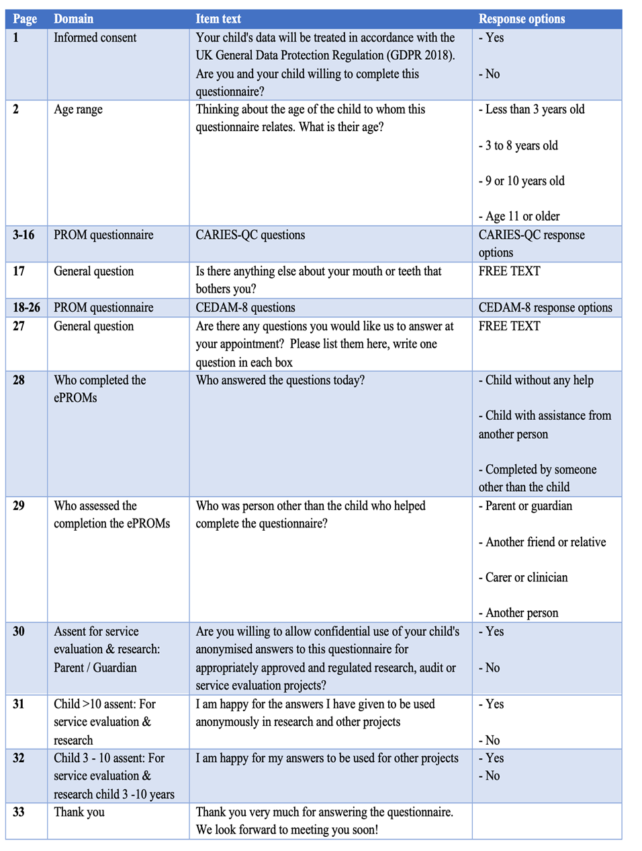

Appendix B. ePAQ-PD skip logic system based on the participants’ age range.
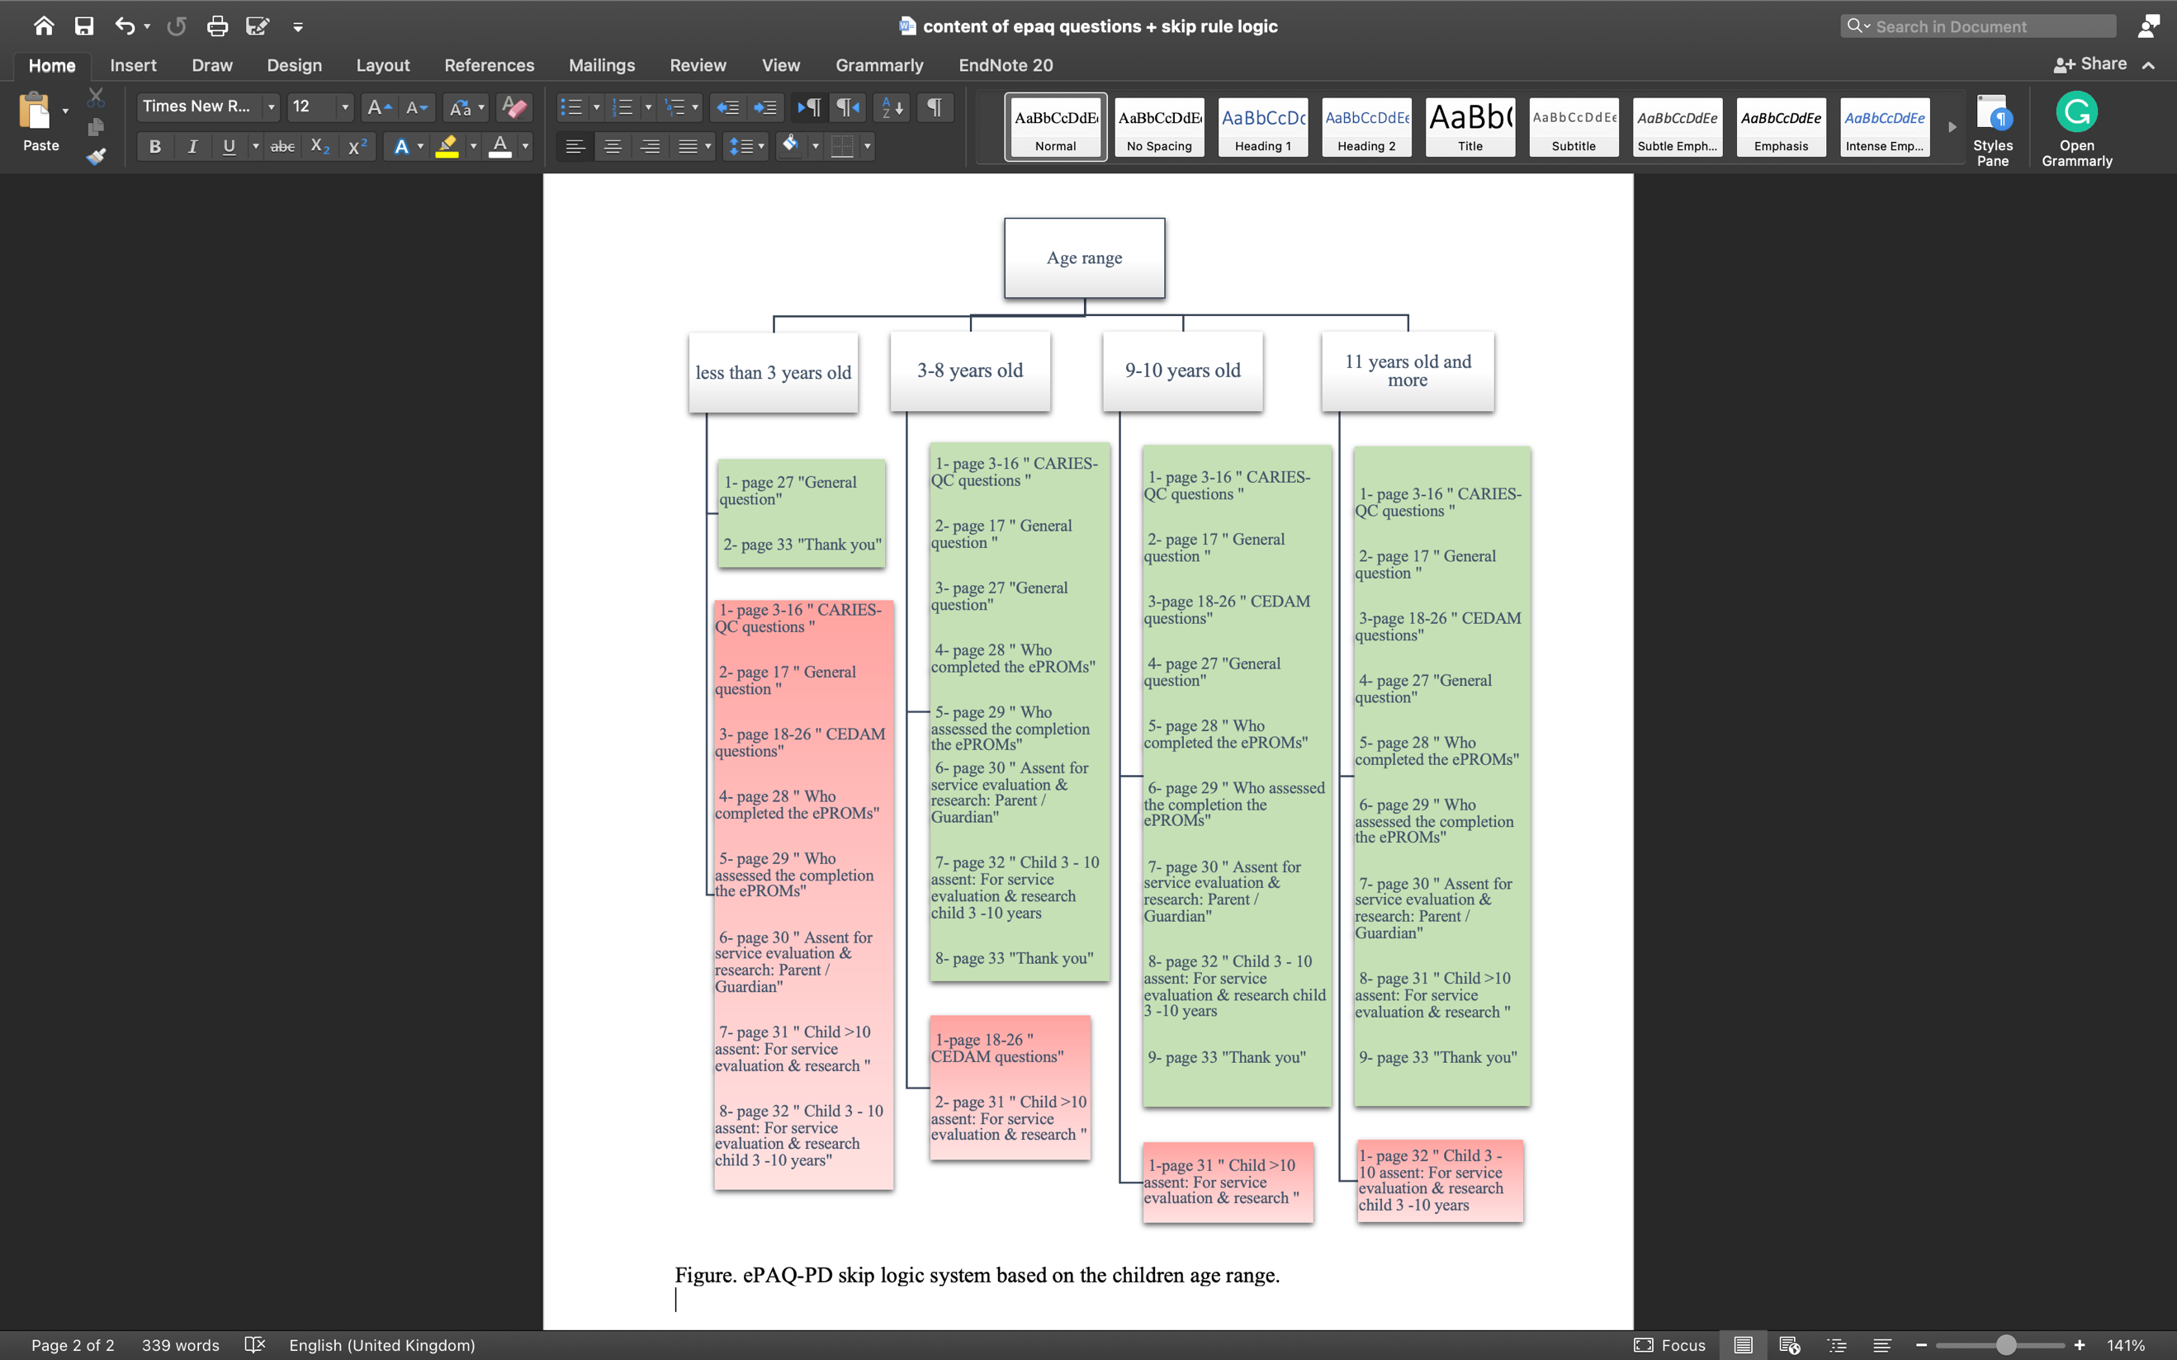

Appendix C. Incident and assistance reporting sheet.

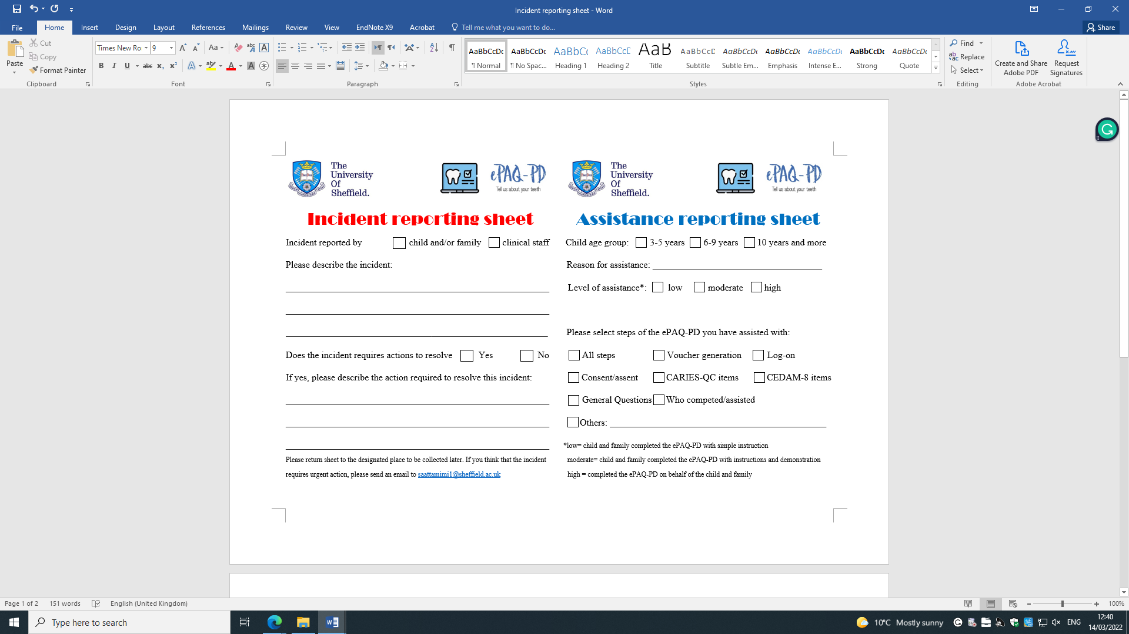

Appendix D. Ethical approval letter.
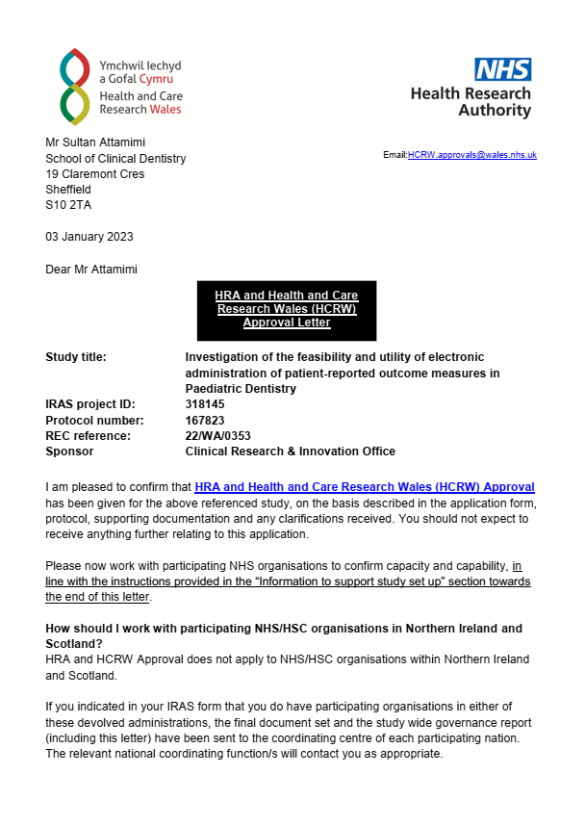


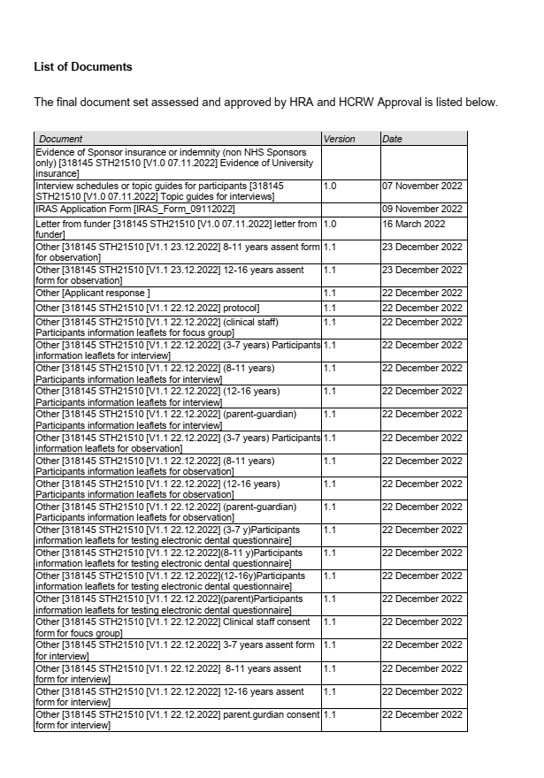
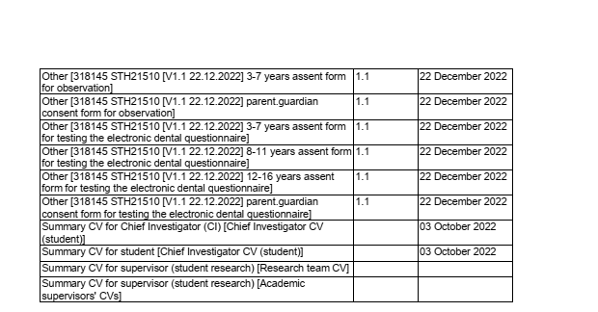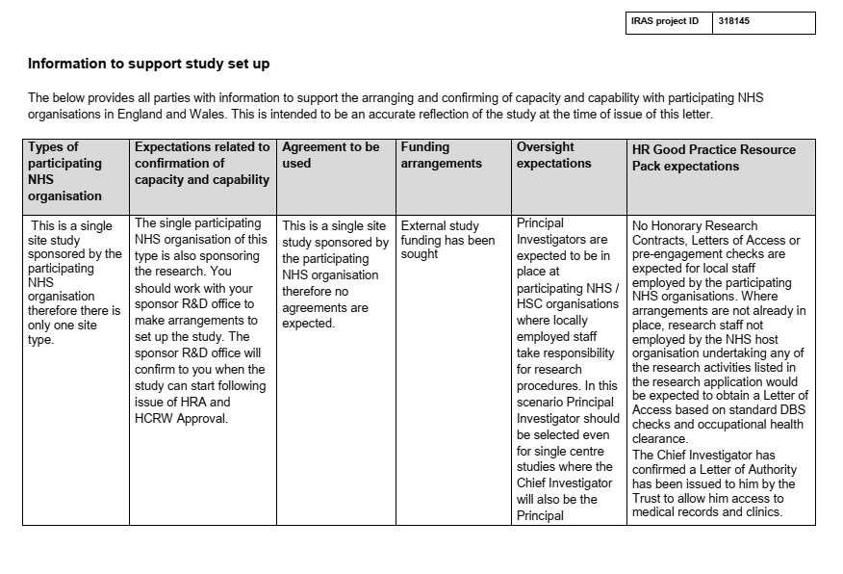
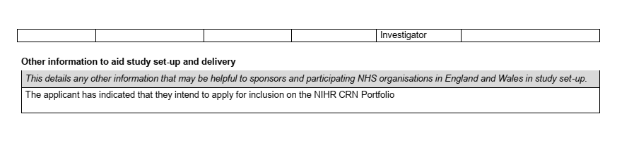

Appendix E. Usability testing data collection sheet.

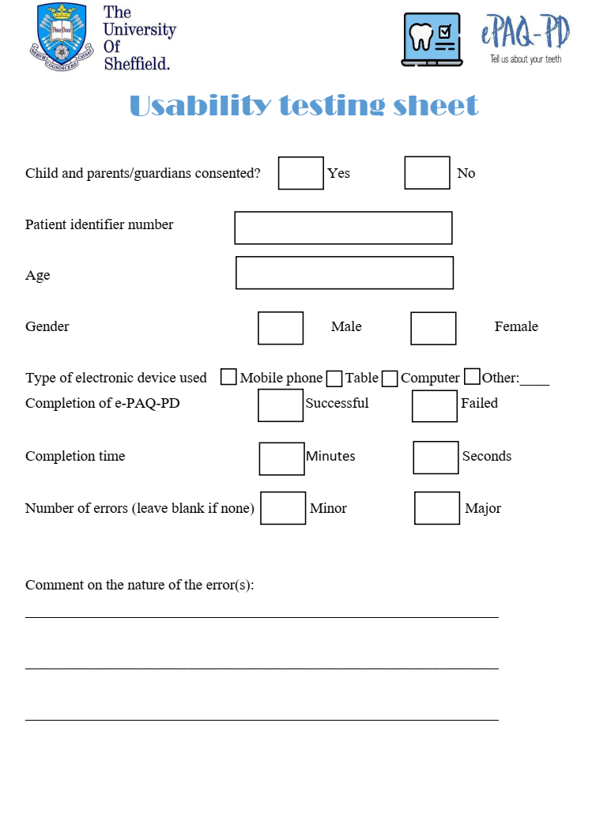

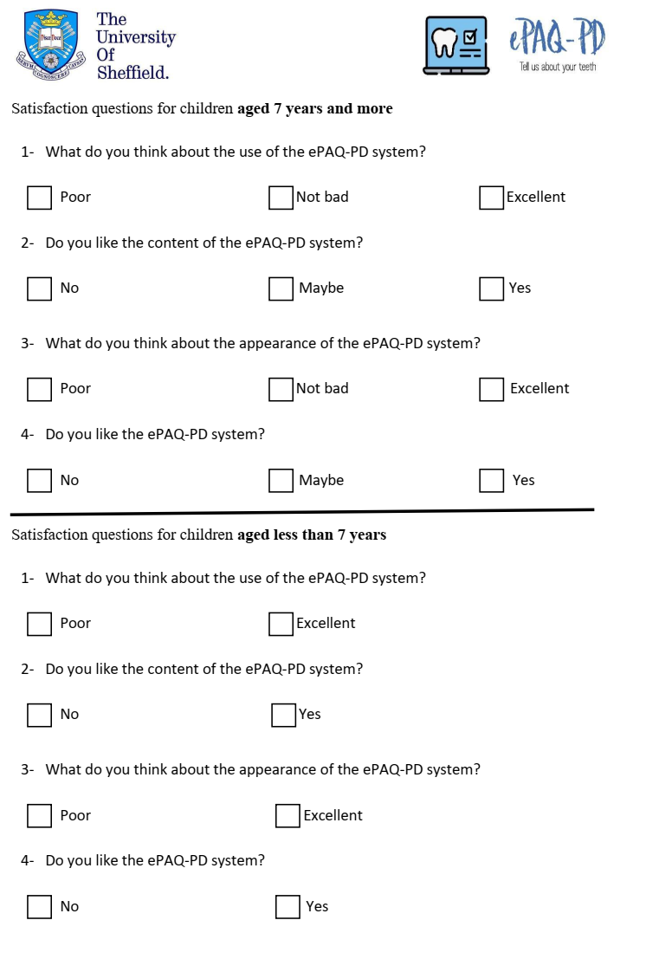

Appendix F. Age-appropriate child and parent/cares study information sheets for

measurement comparability study.

Age-appropriate information sheets were provided as follows, for children aged 3-7 years, 8-11 years and 12-16 years, and to parent/cares. 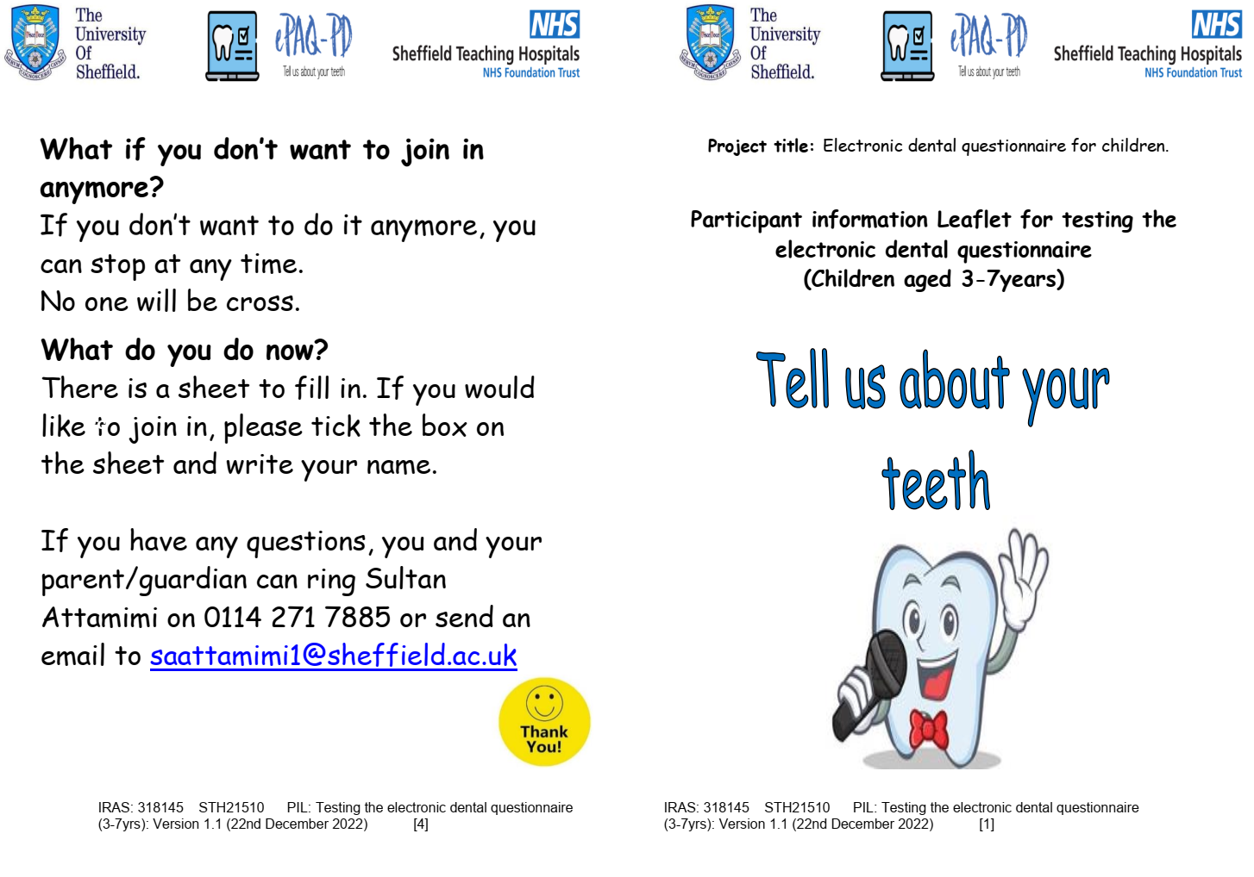
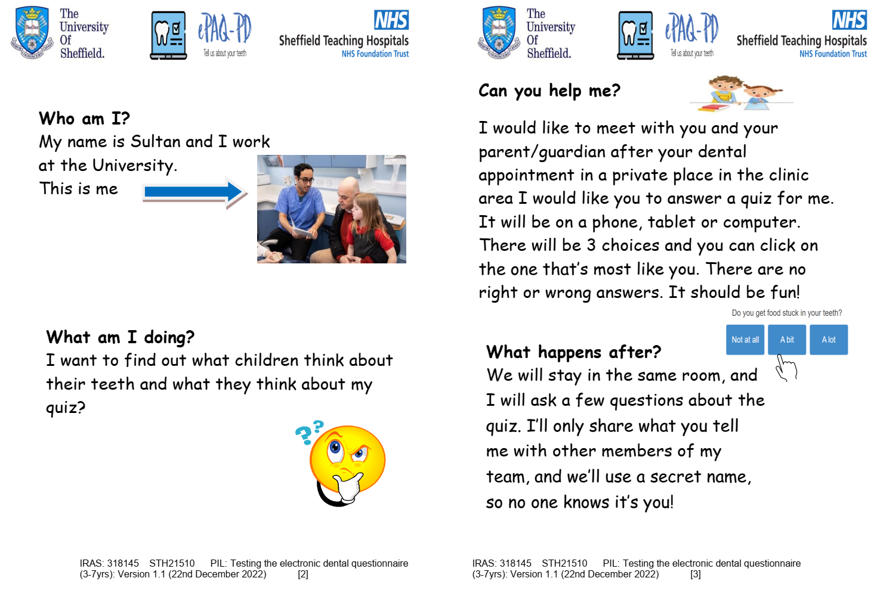
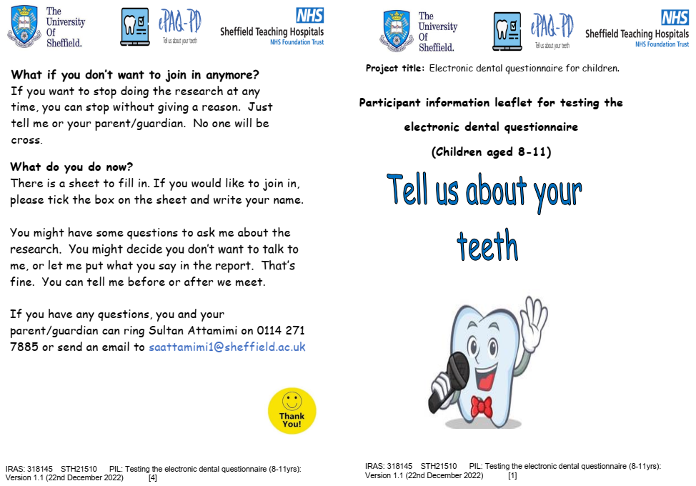
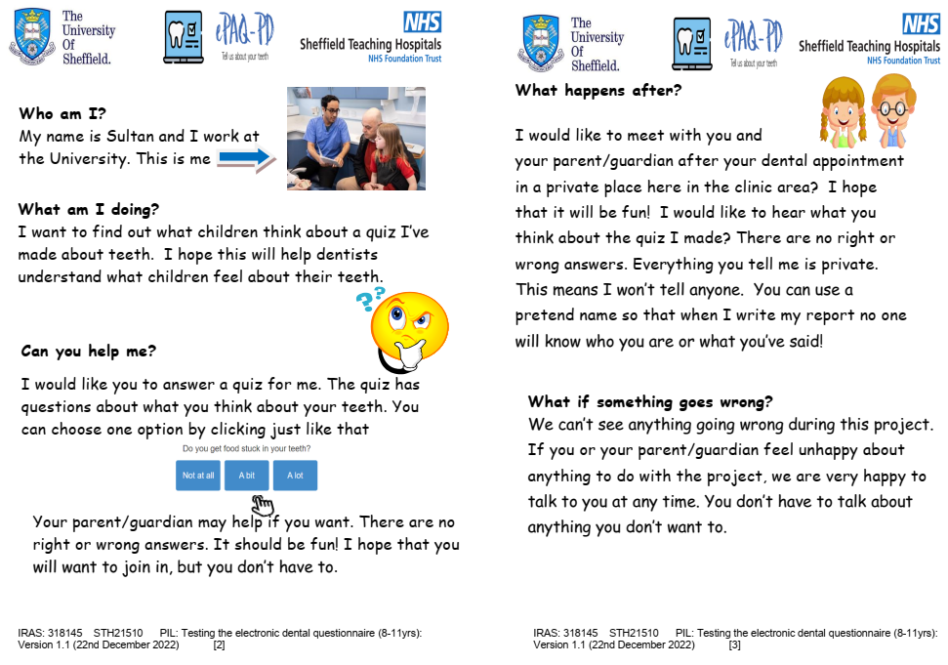
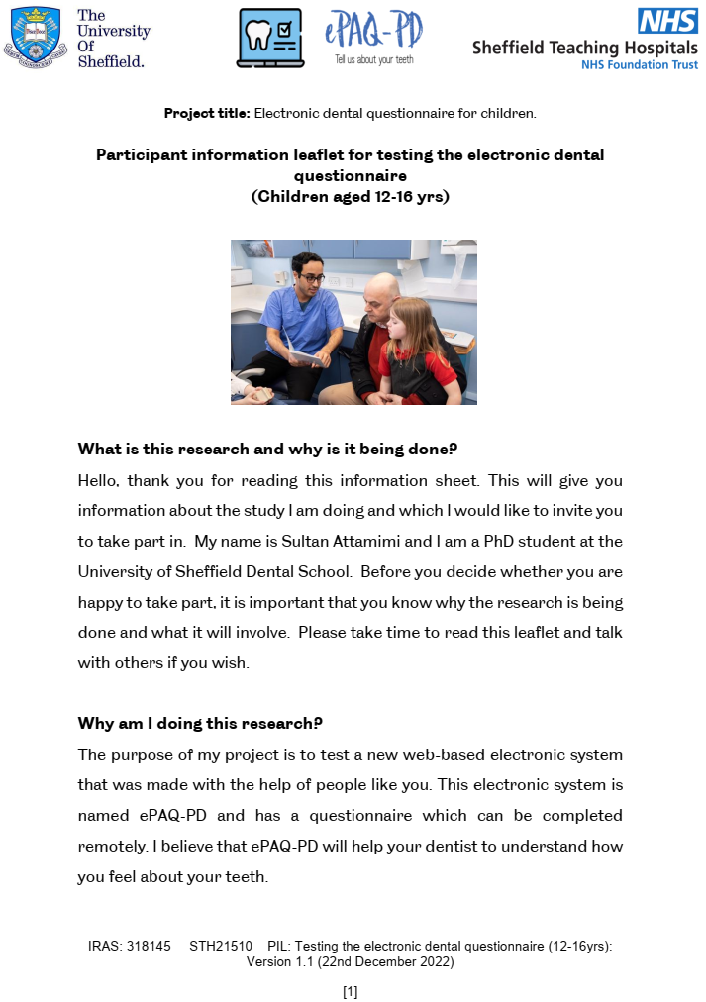
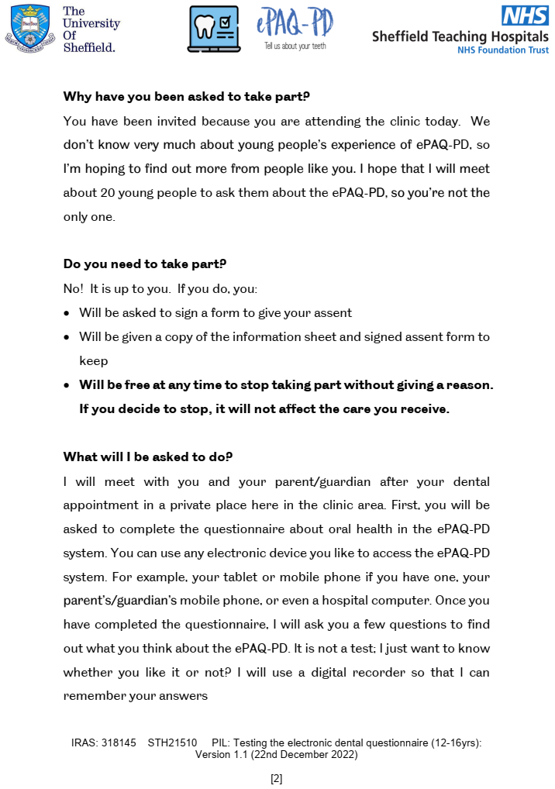
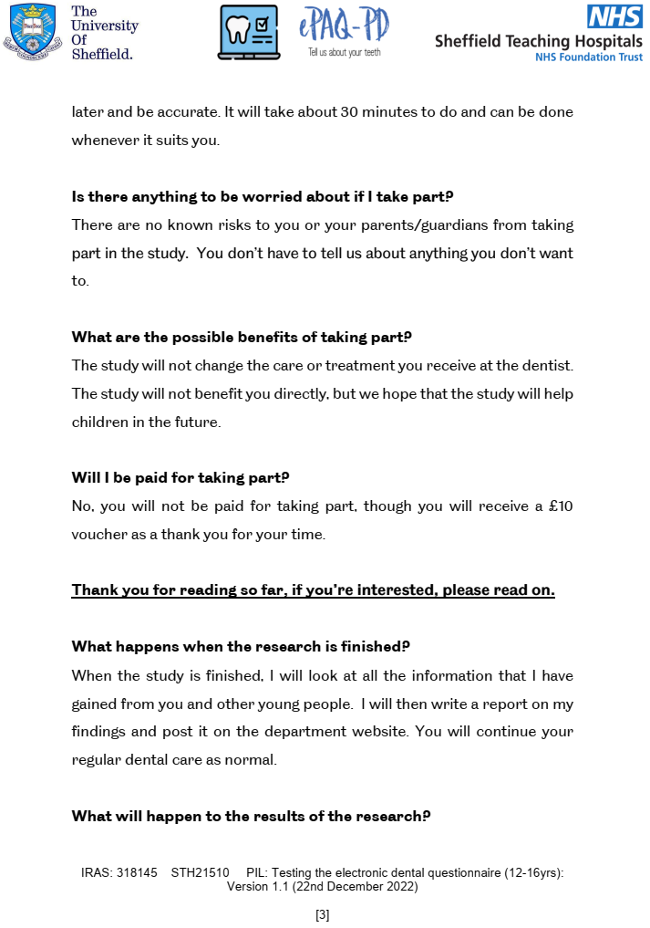


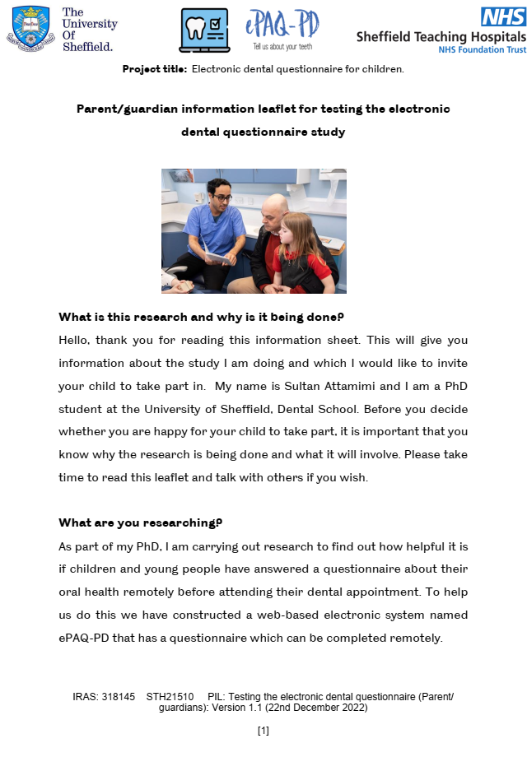
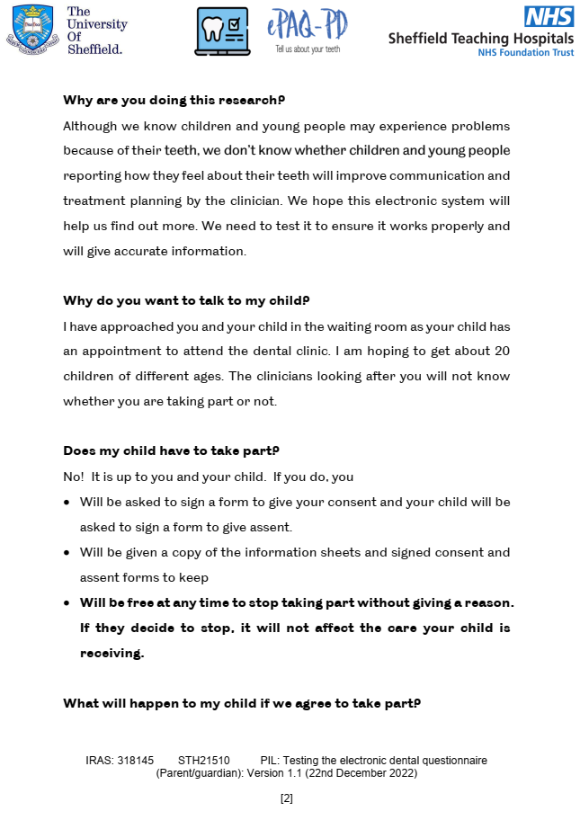
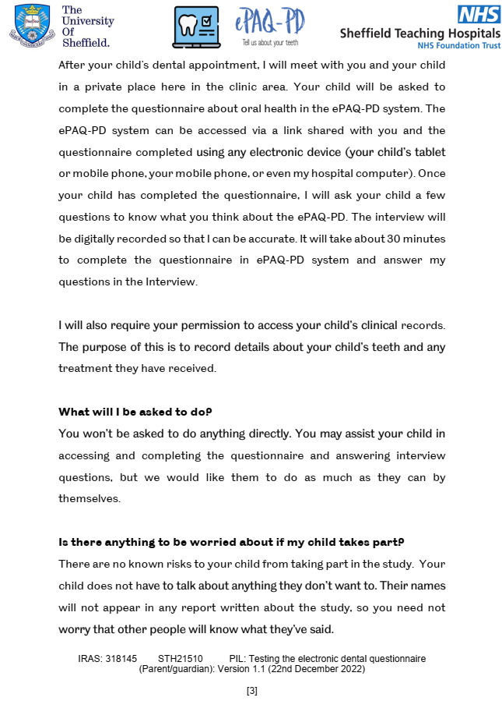






Appendix G. Child consent and parent/carer consent forms for measurement comparability study.

Age-appropriate assent forms for children aged 3-7 years, 8-11 years and 12-16 years, and parent/cares consent form.
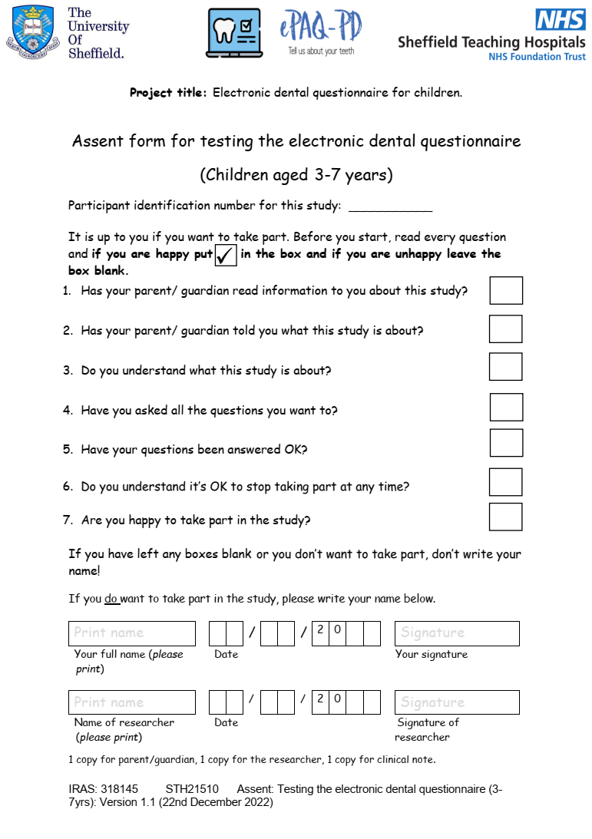
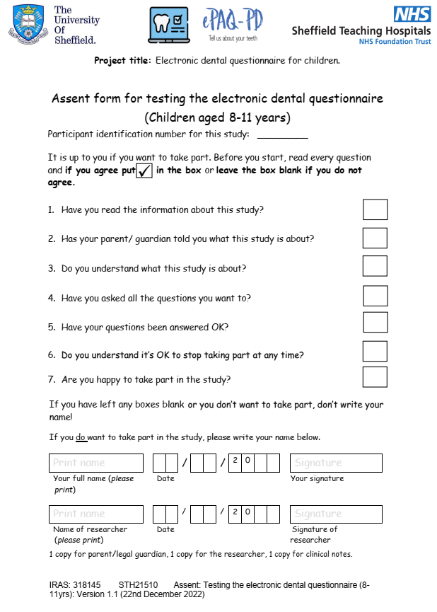

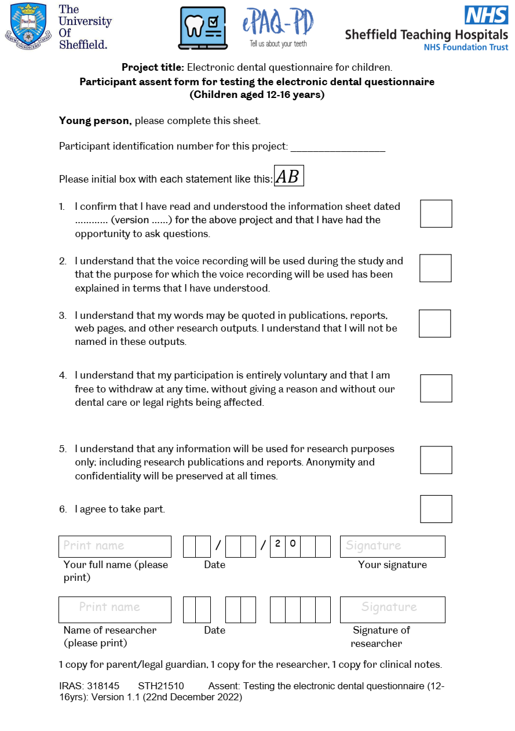

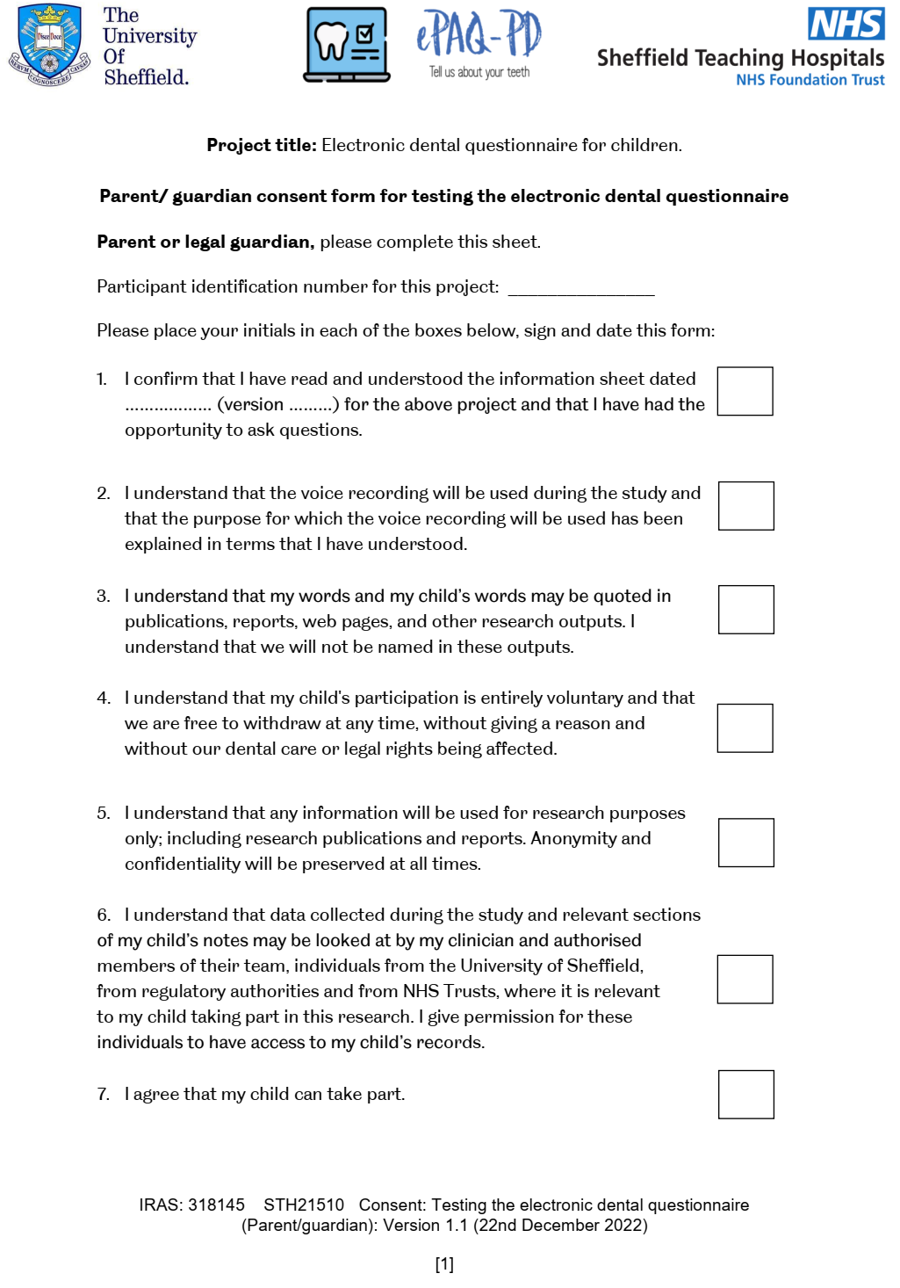
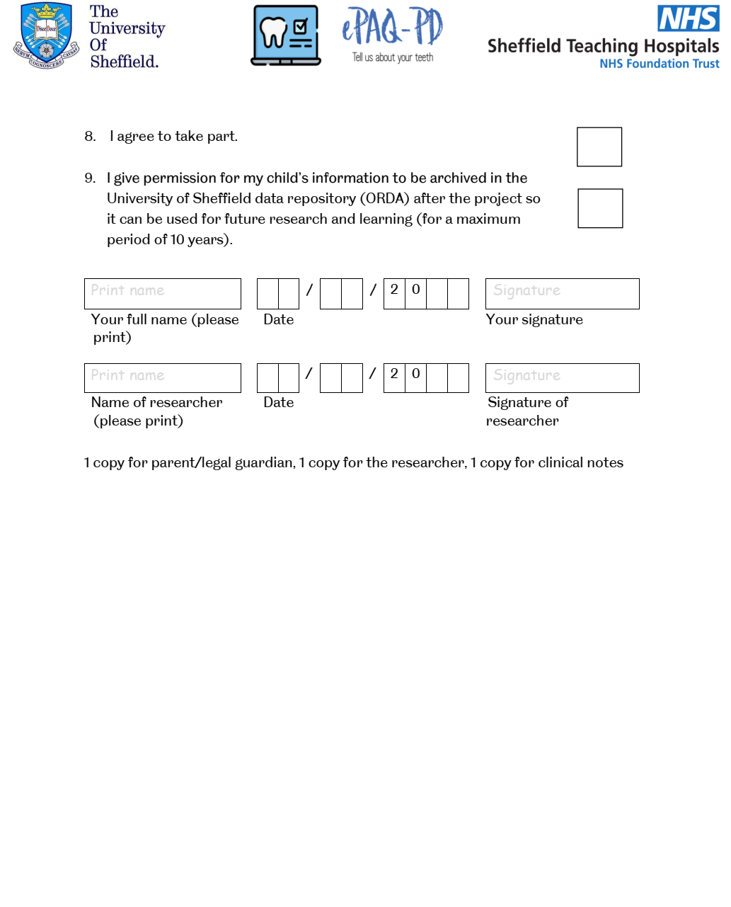

Appendix H. Study amendment documentation.

Approval letter on amendments to the original IRAS application, to change delivery method of invitation letter from email to text messaging service.
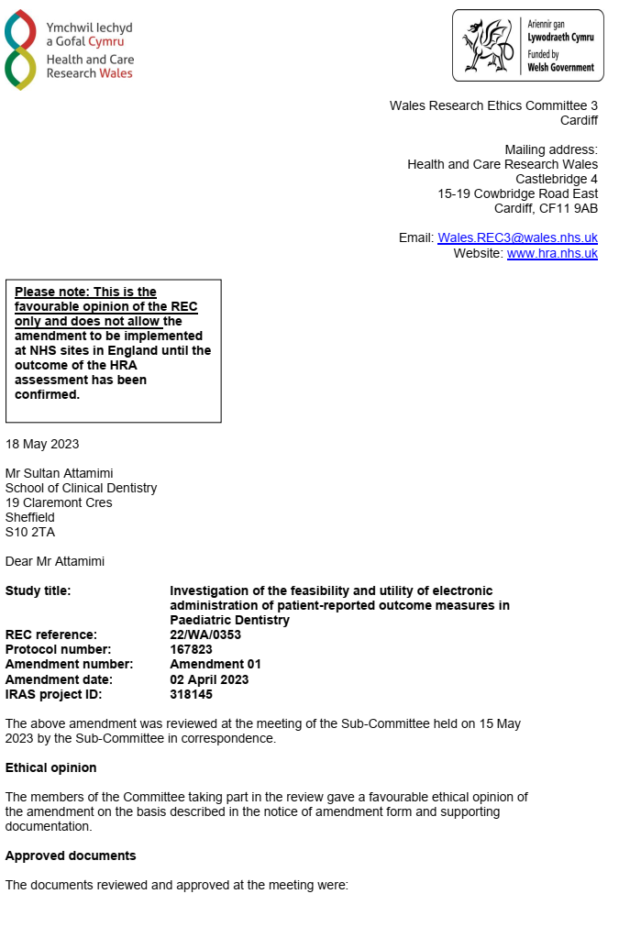

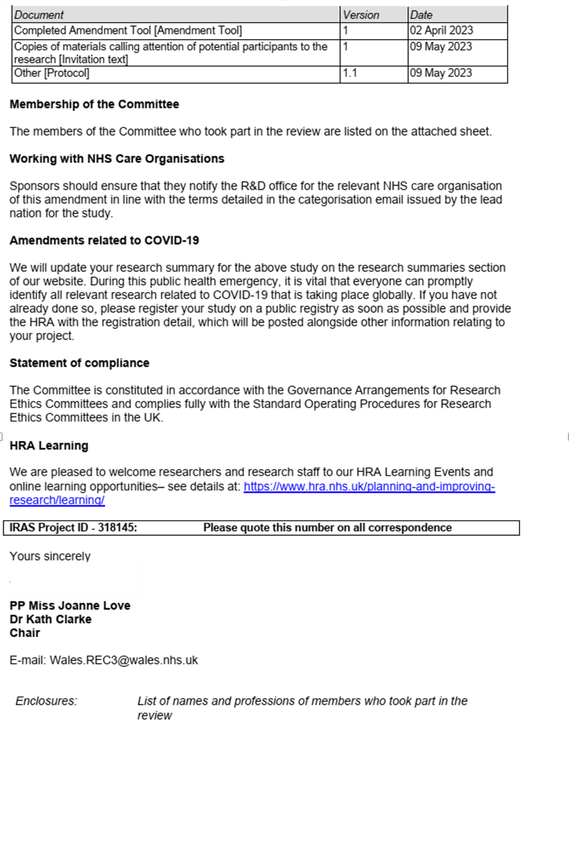

Appendix I. Reminder signs were distributed in patient waiting area.



Appendix J. Reminder cards for clinical staff

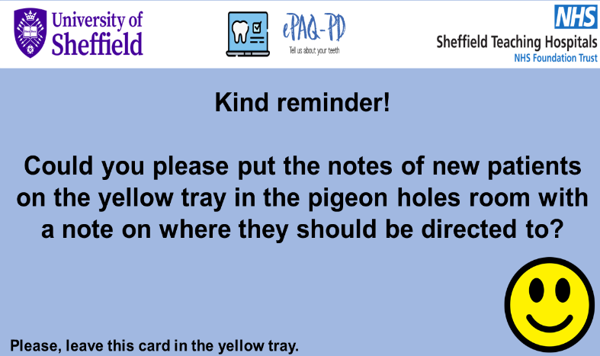

Appendix K. Clinical data collection sheet





Clinical datasheet

Patient identifier number

Completed e-PAQ-PD? Yes No

If no, what’s the reason:

Ethnicity White Other ethnicities Unknown

Postcode

Primary reason for referral

Clinical diagnosis: Dental caries Traumatic dental injuries

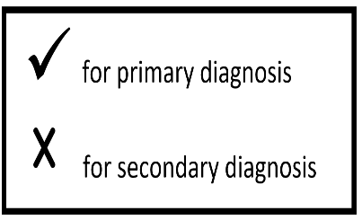
MIH Hypoplasia

Fluorosis AI

DI Tooth number anomalies

Soft tissue Tooth position anomalies

Other (please describe): _____________________________________________

Treatment modalities planned: LA RA GA No ana No tx

5-faces anxiety scale completed? Yes No

If yes, which face was selected?

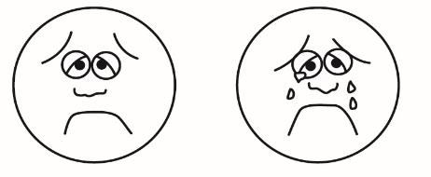
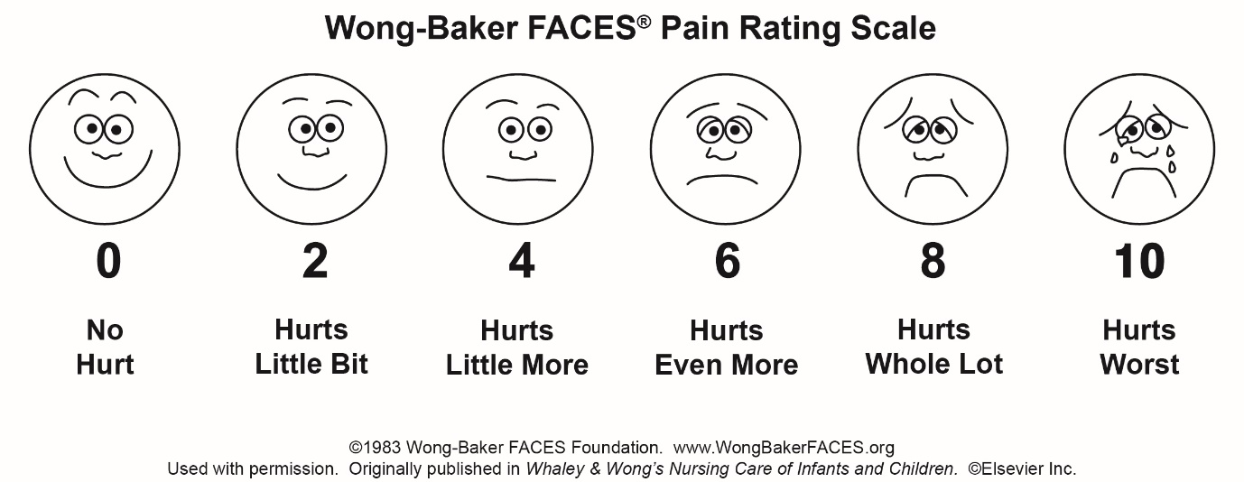
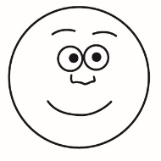

Very slightly worried
2
Worried a lot ss
4
Very worried
5
Relaxed/not worried
1
Fairly worried
3

Appendix L. Age-appropriate child, parent/cares study and clinical staff information sheets for feasibility study.

Age-appropriate information sheets were provided as follows, for children aged 3-7 years, 8-11 years and 12-16 years, to parent/cares and clinical staff.
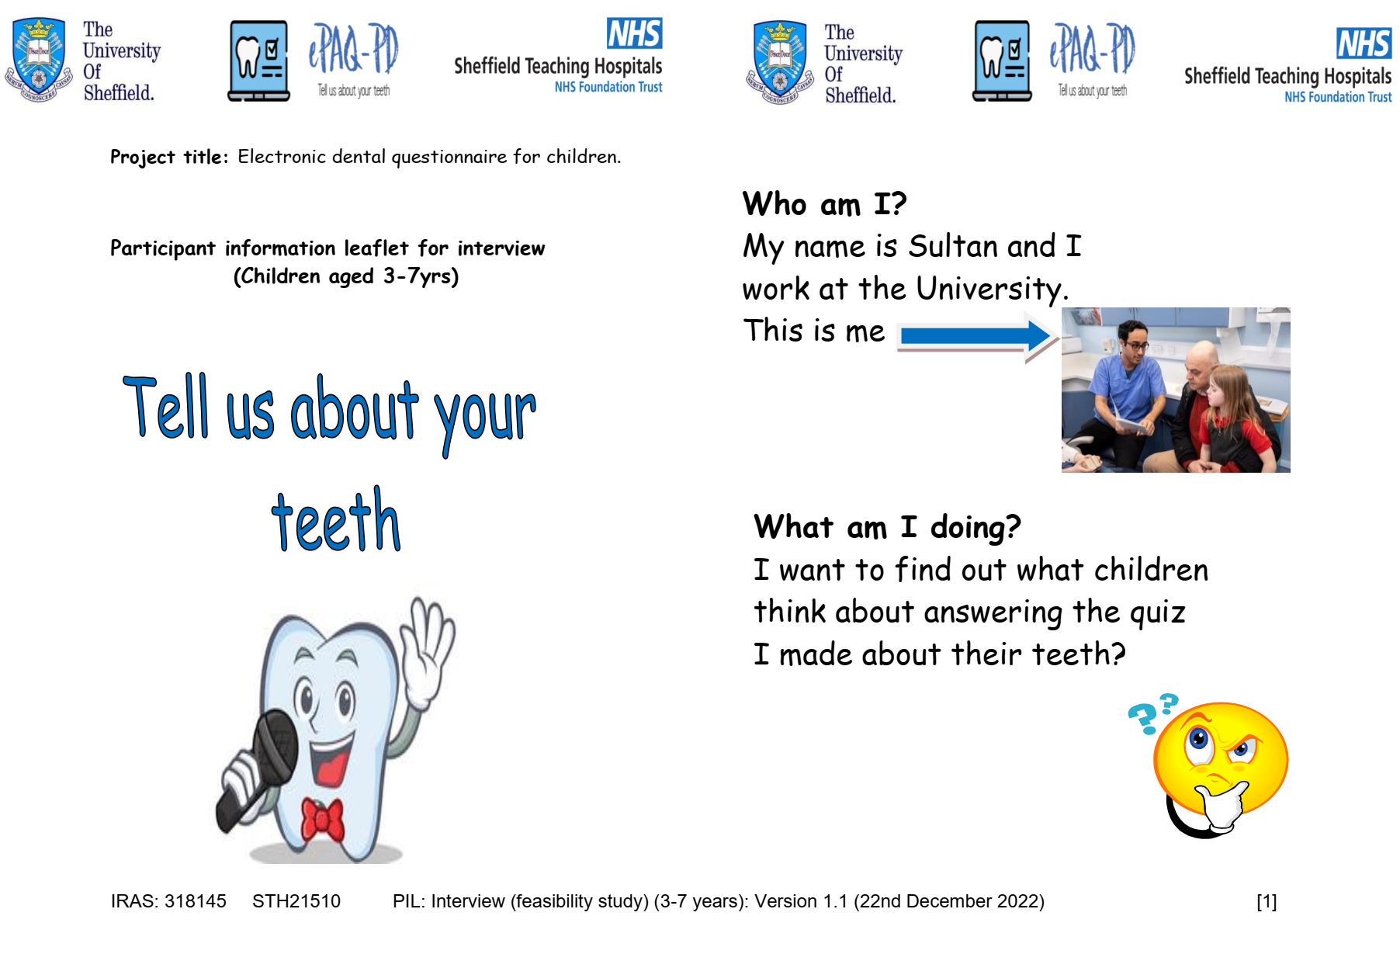
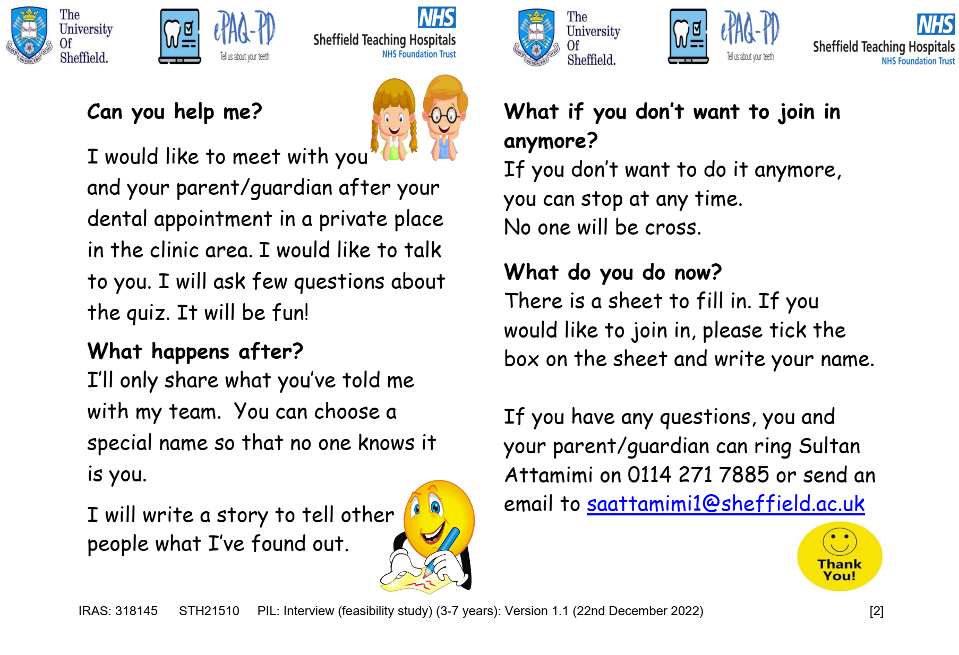

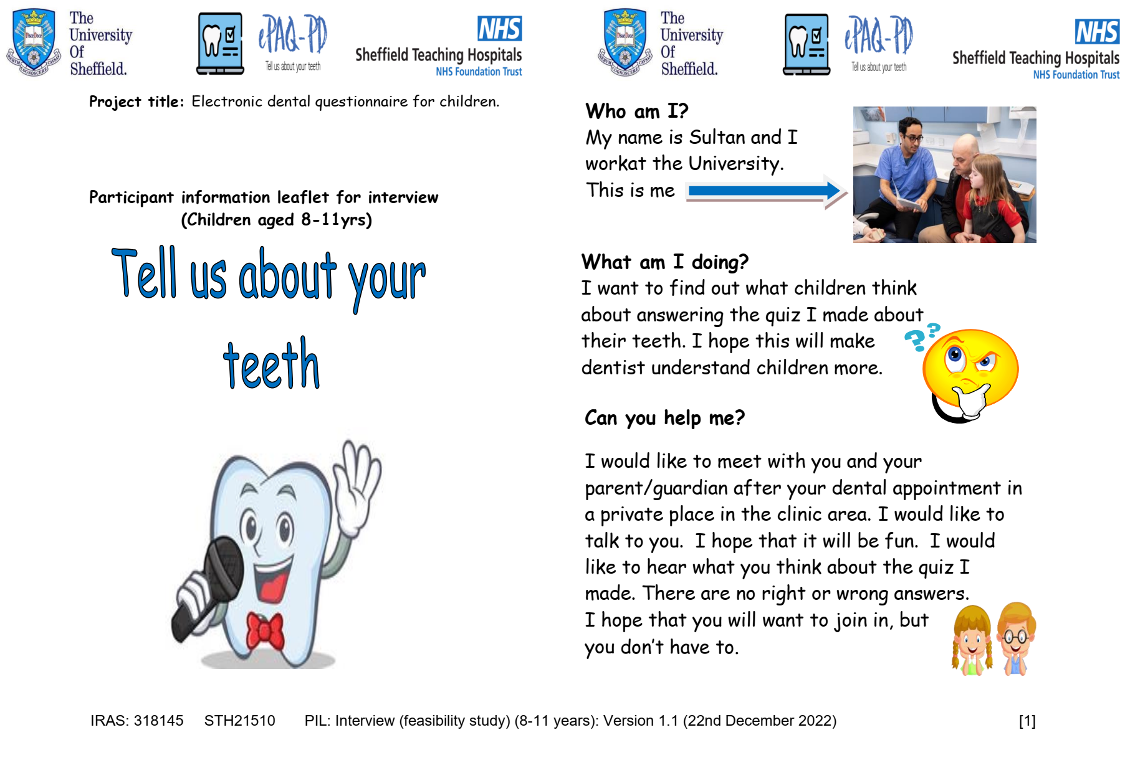

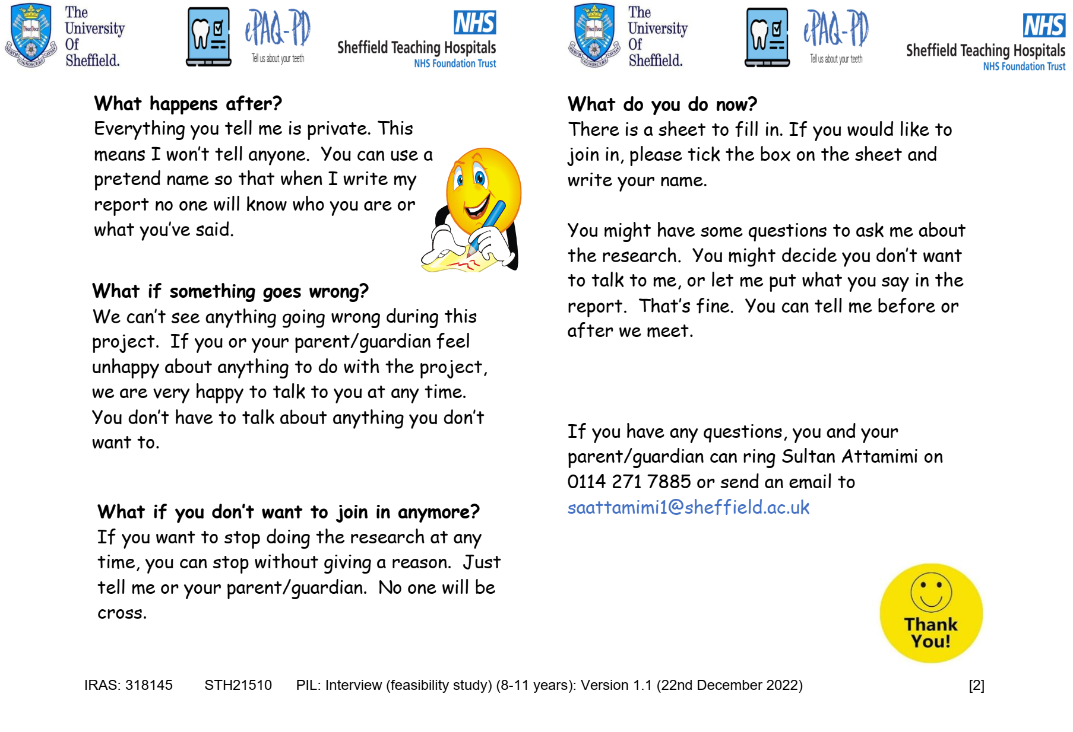

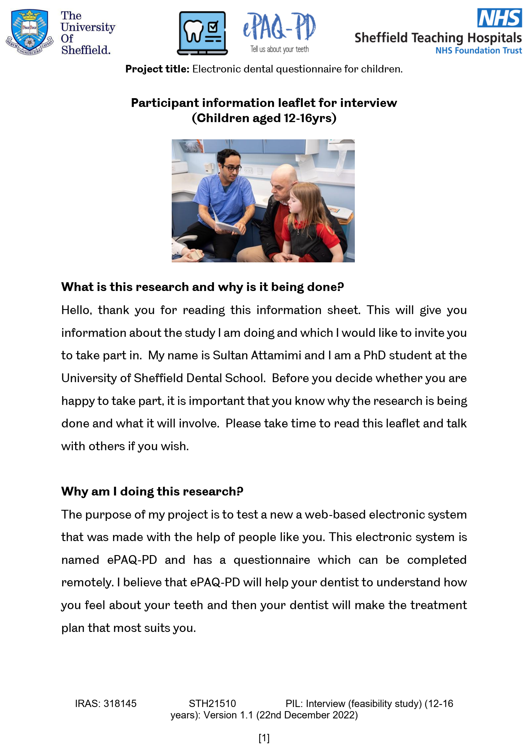
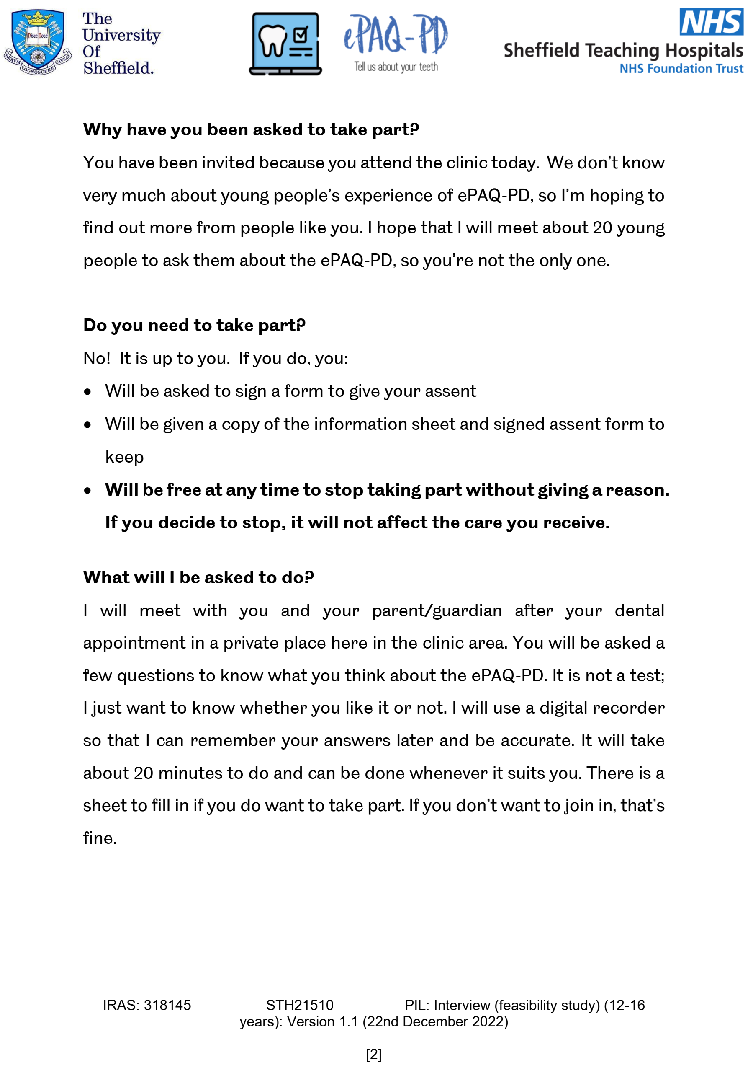

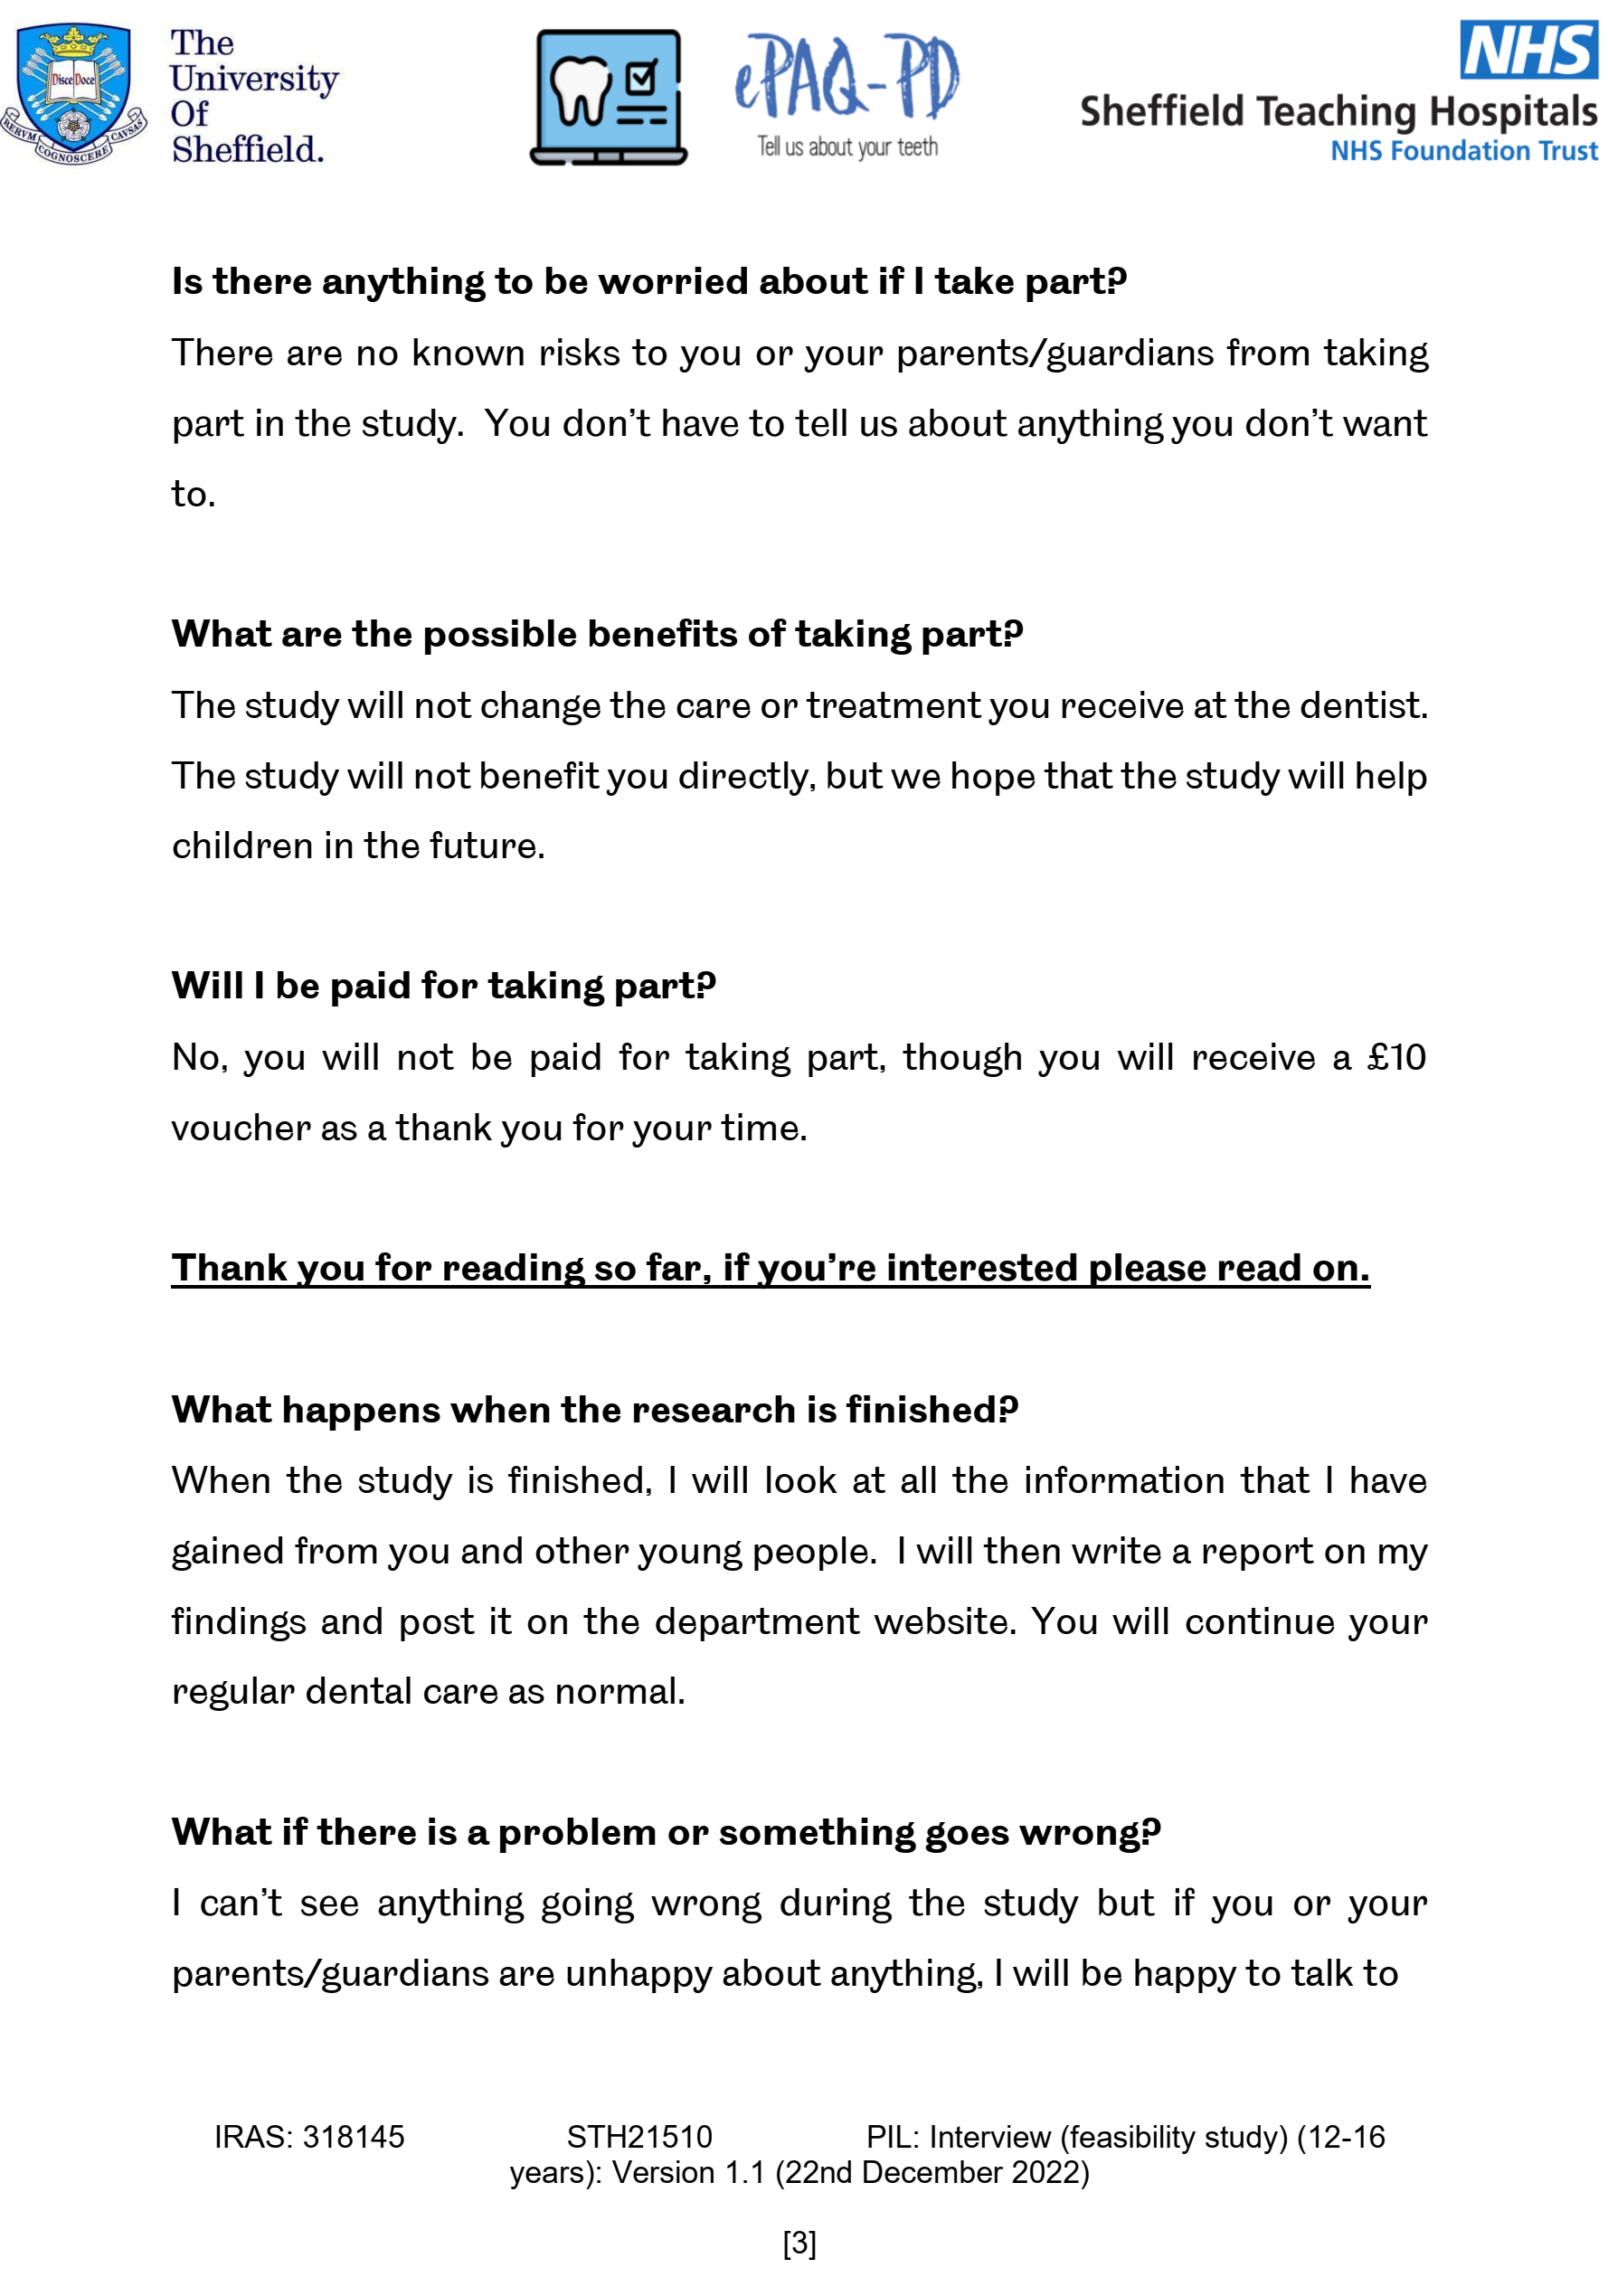





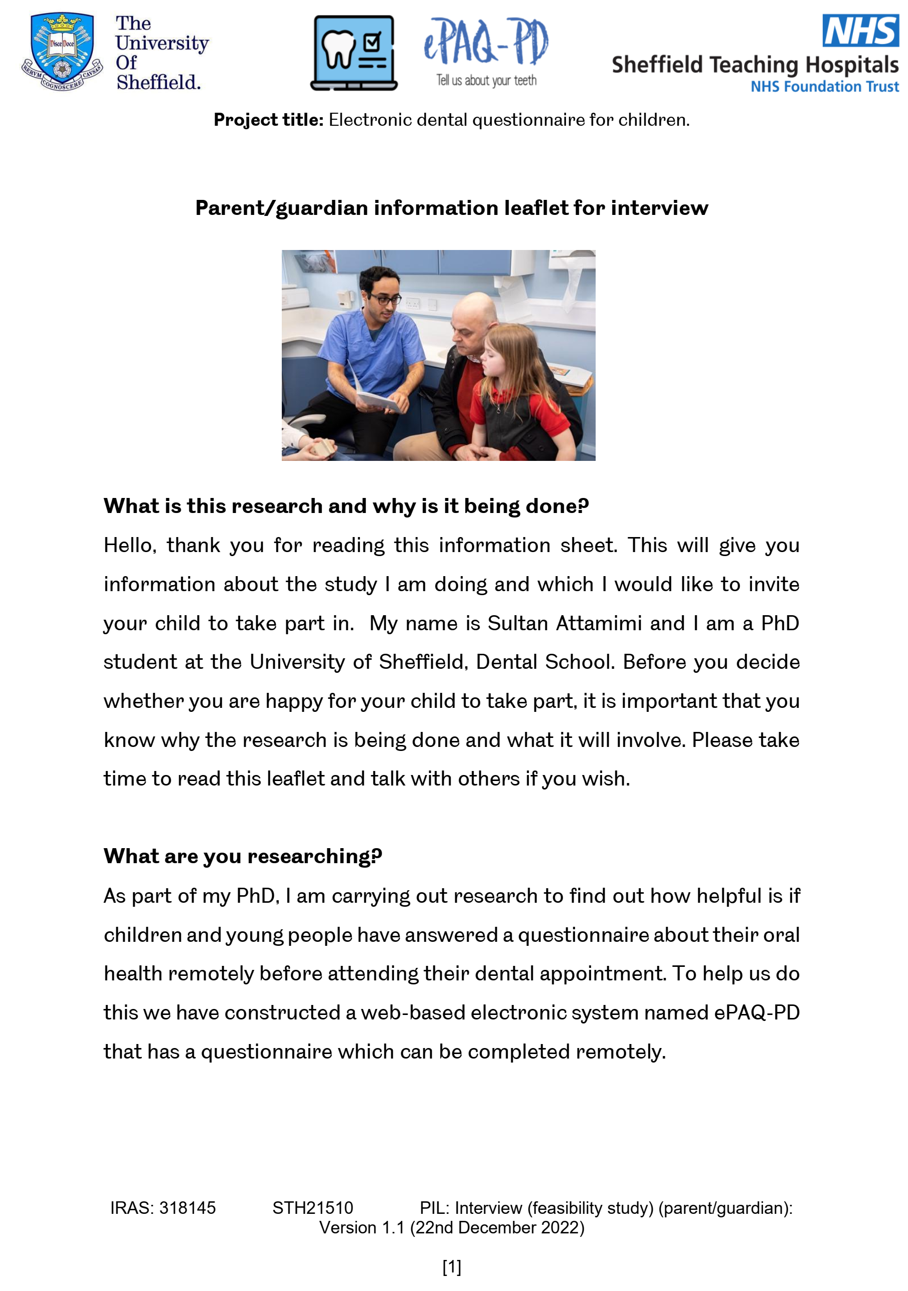
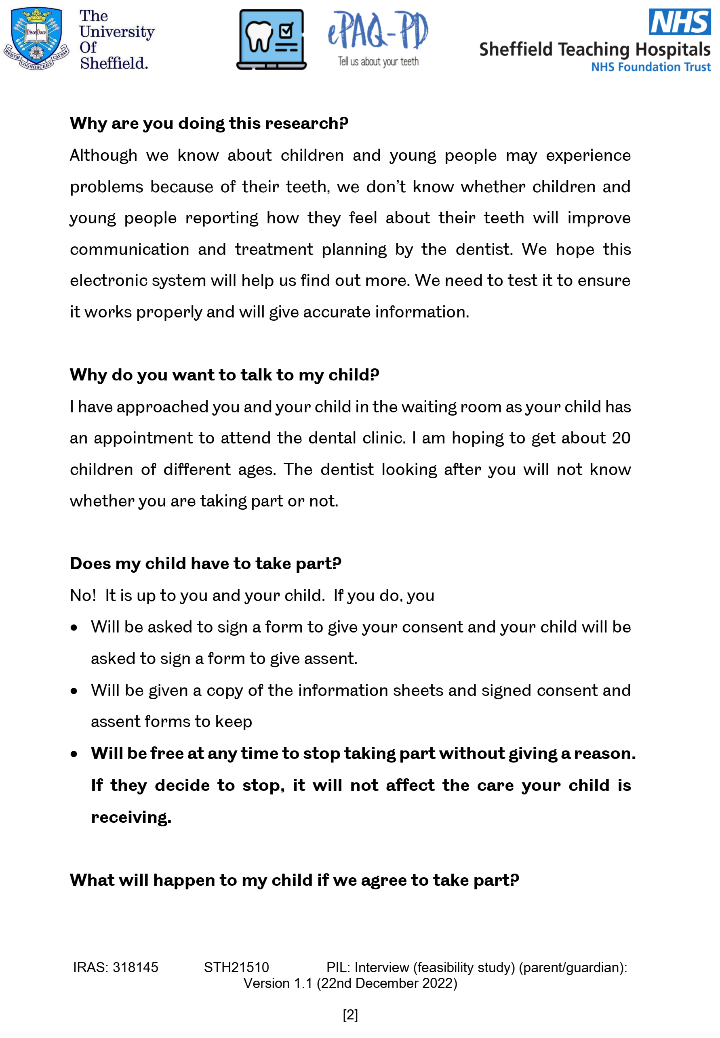

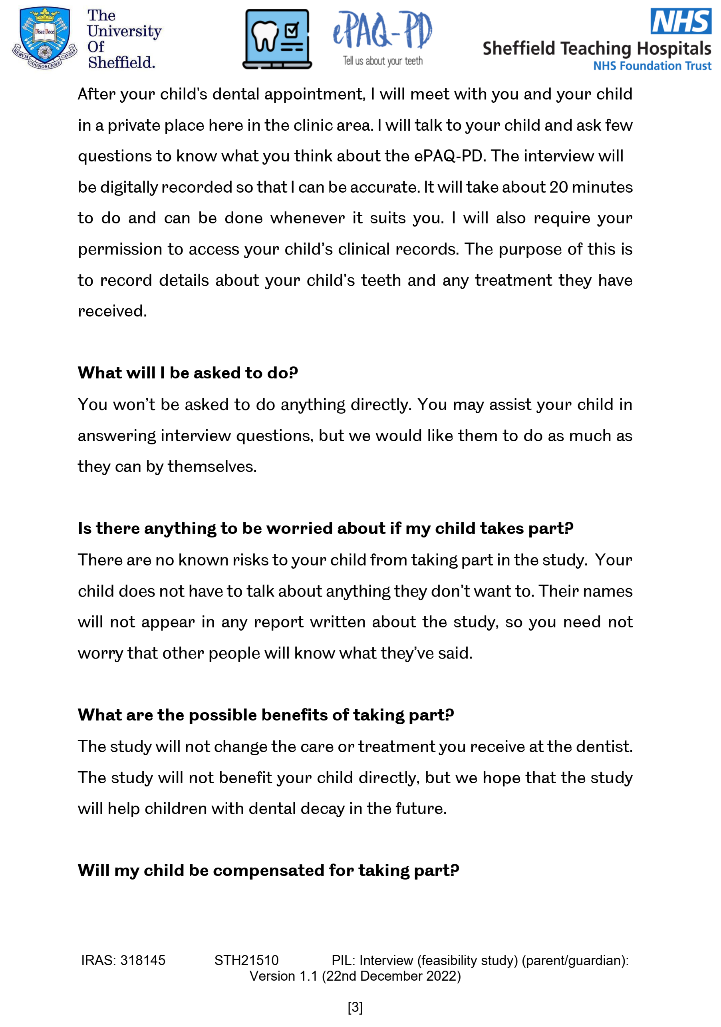










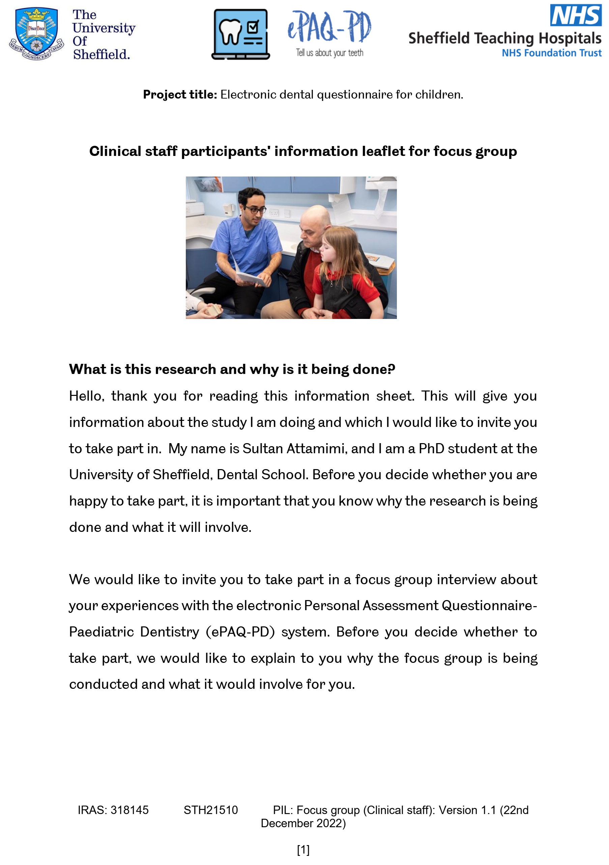

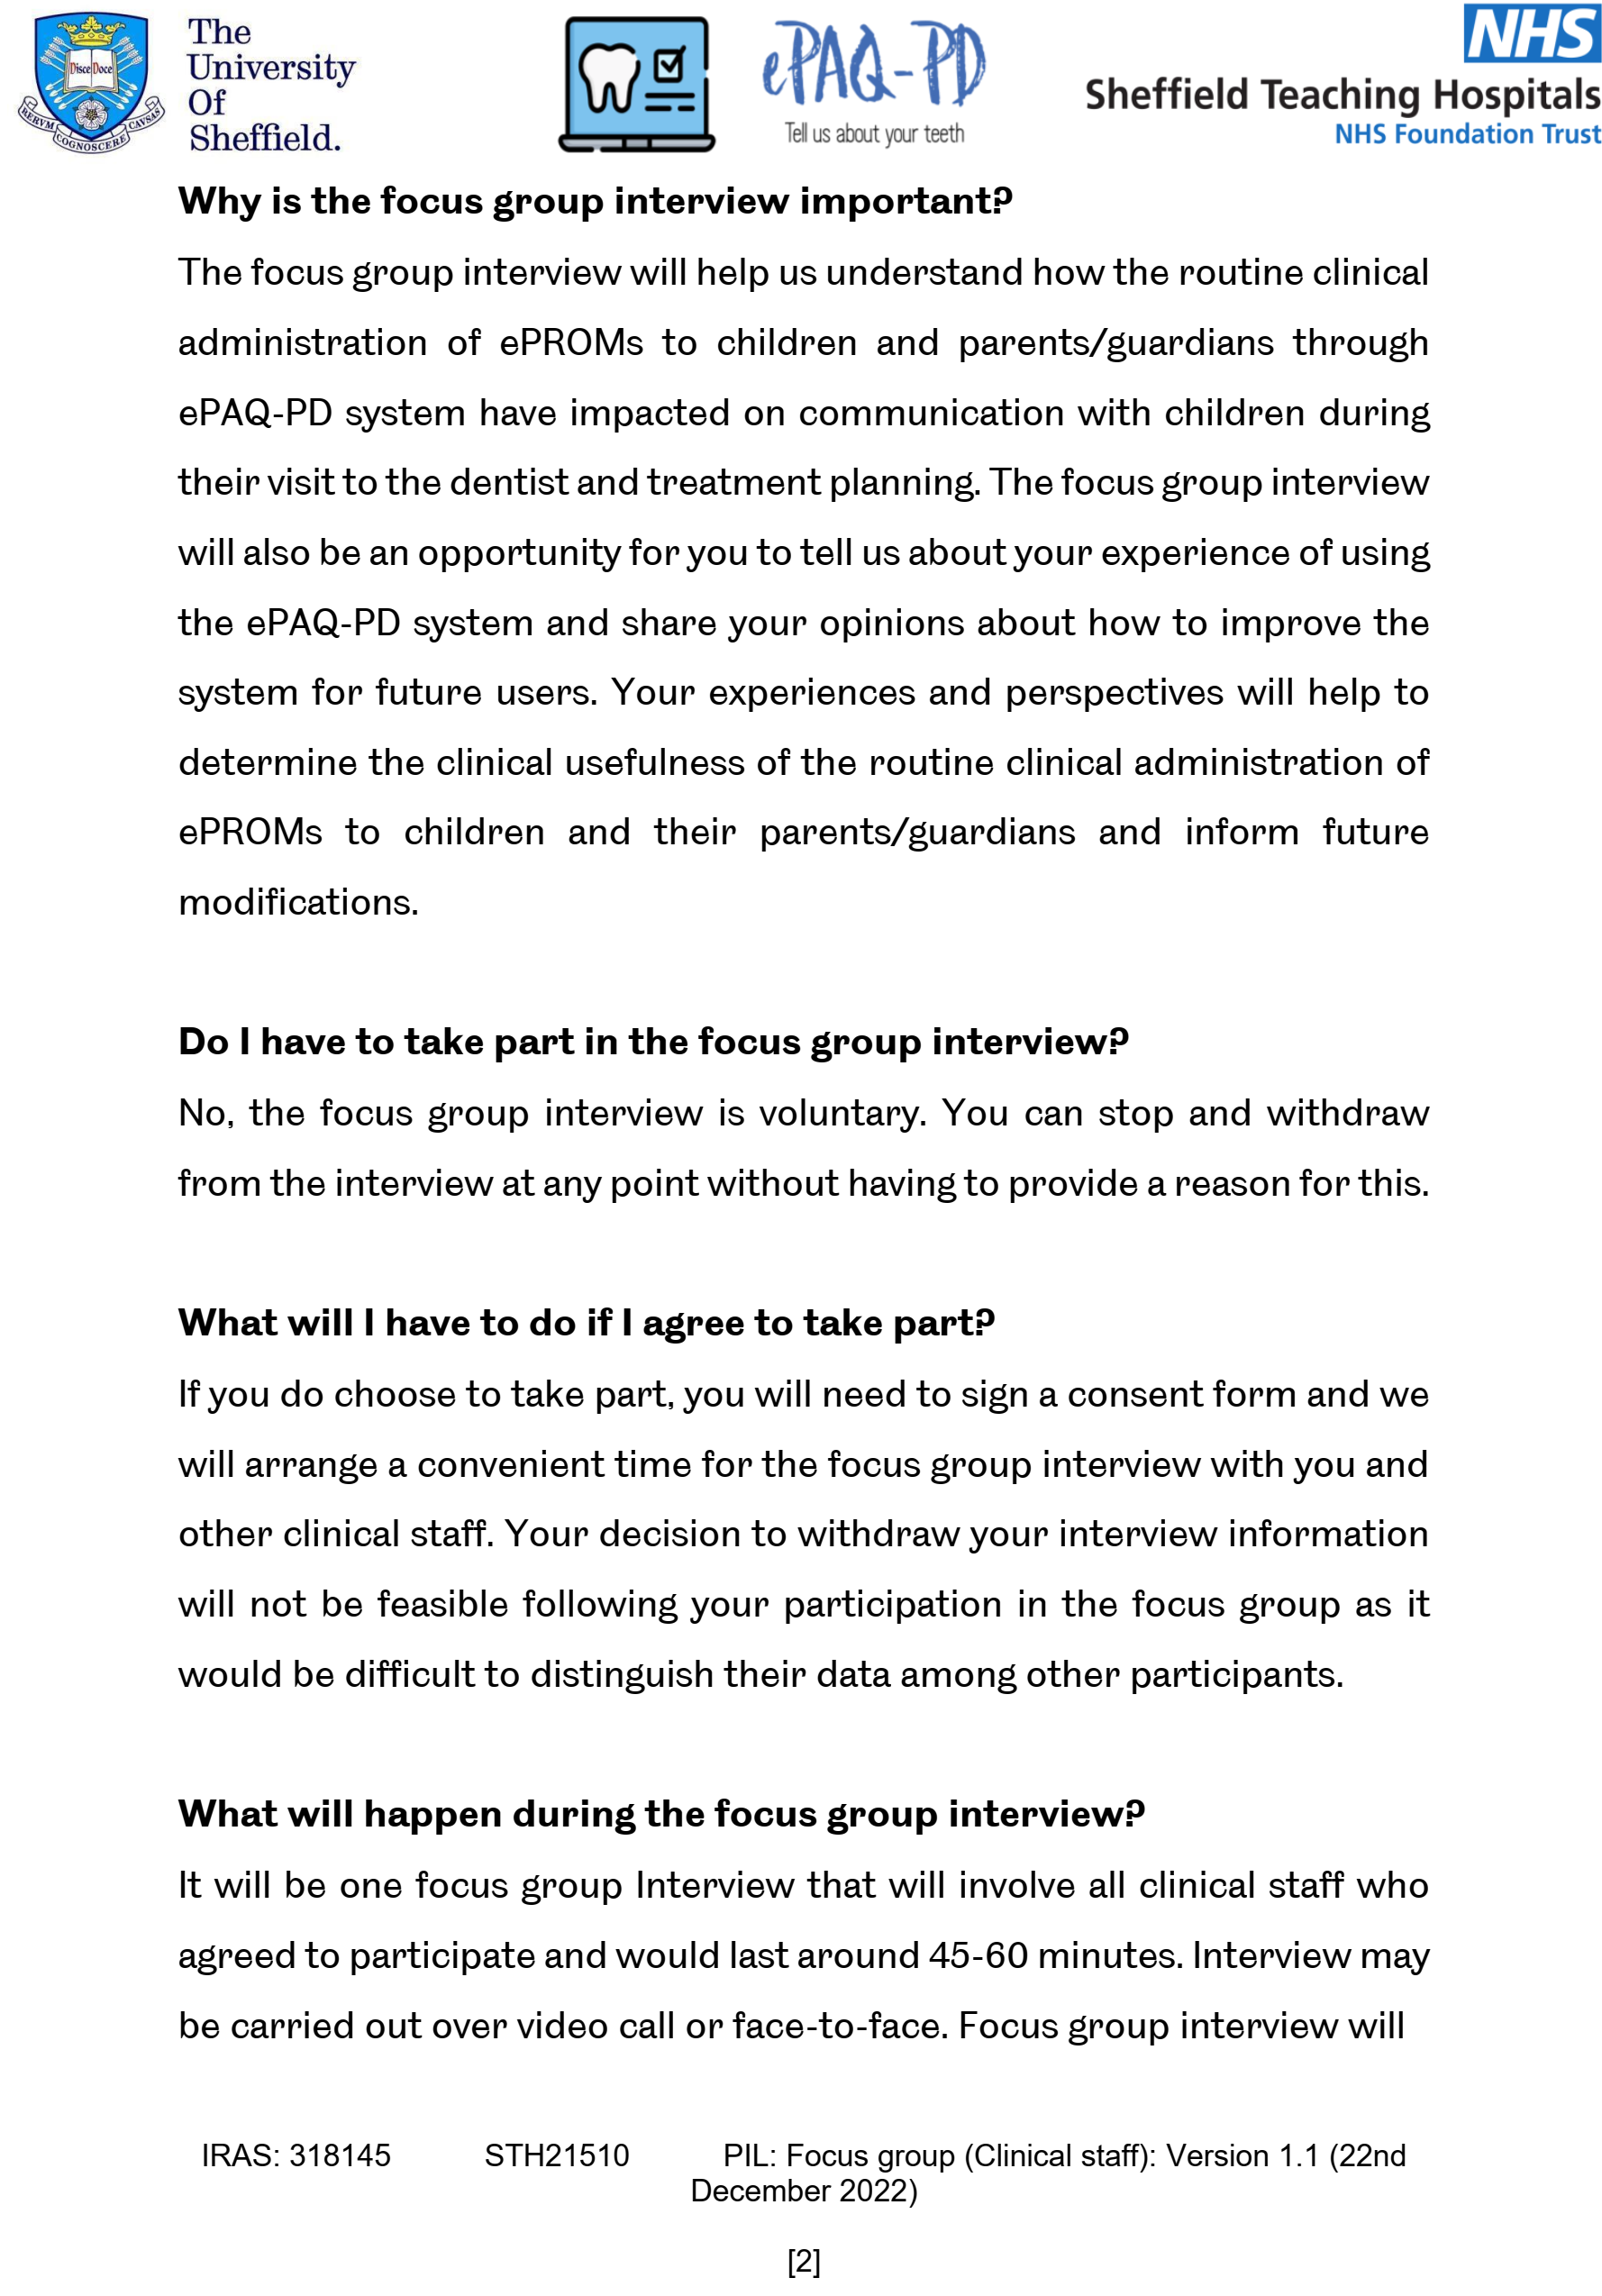

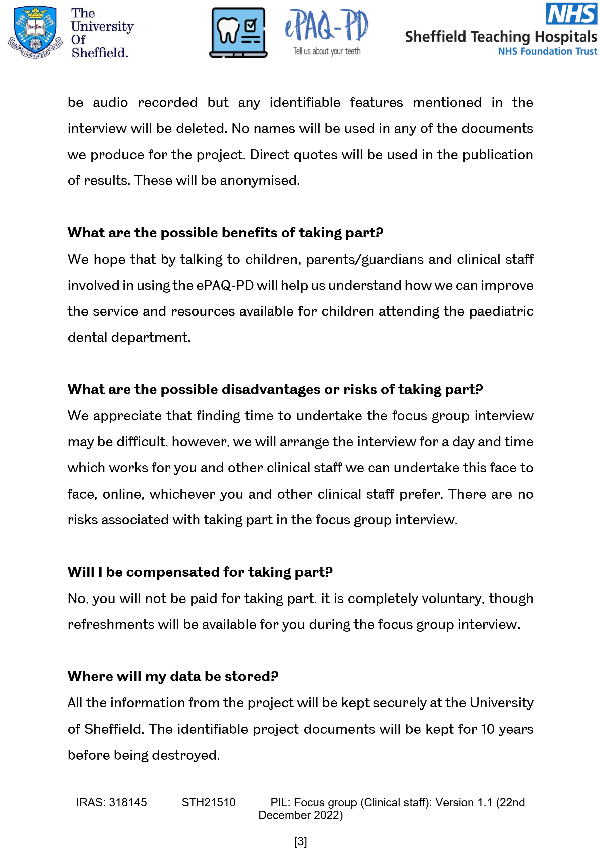


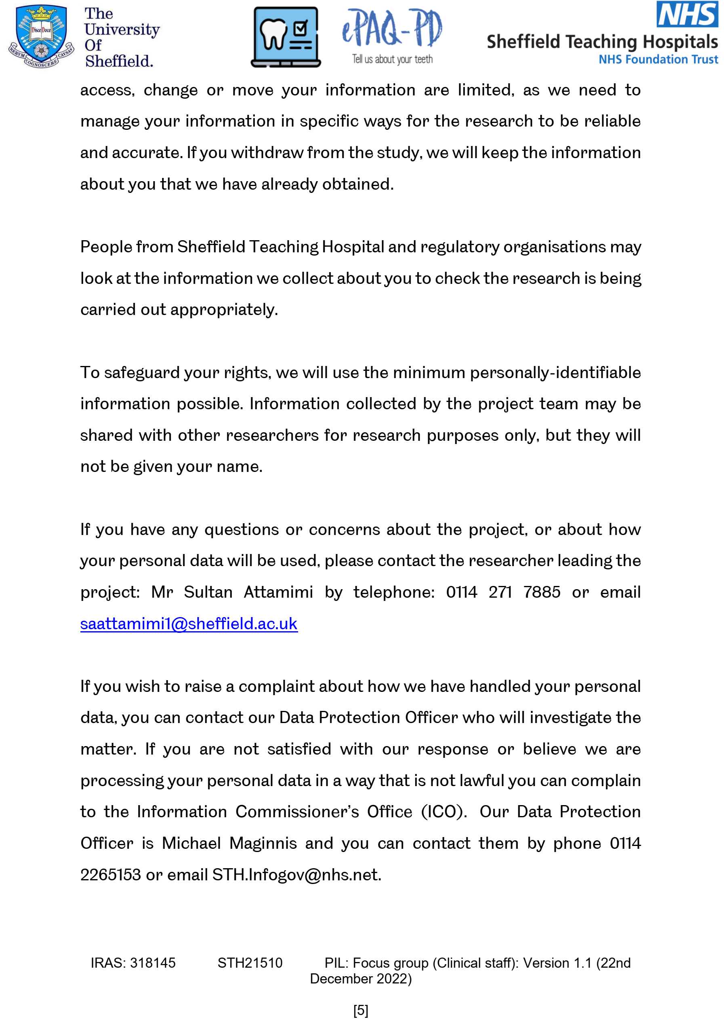

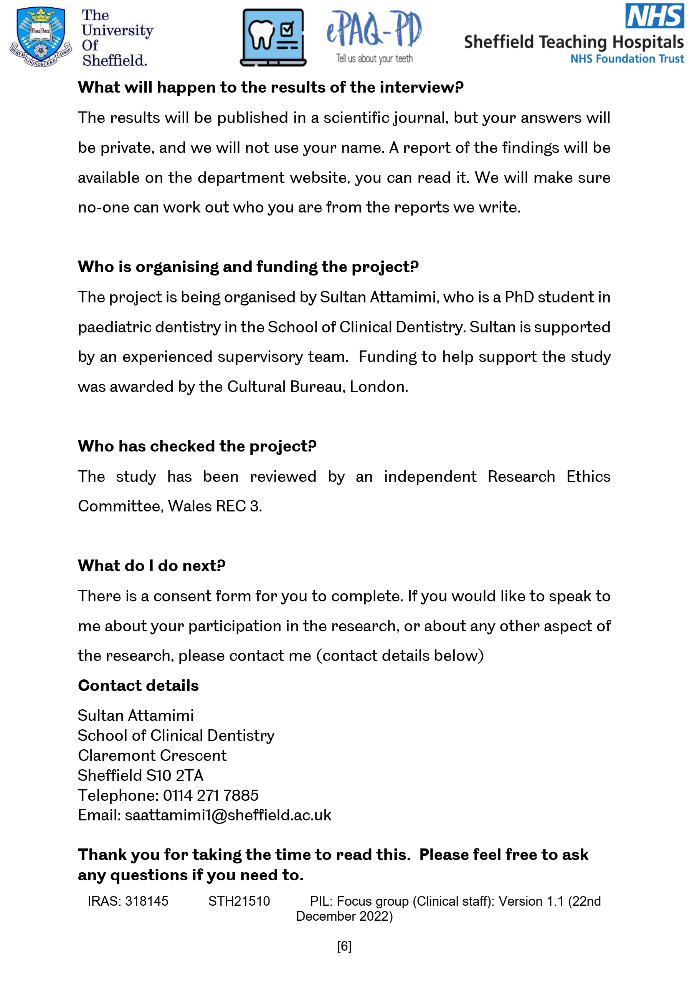

Appendix M. Child consent, parent/carer and clinical staff consent forms for feasibility study.

Age-appropriate assent forms for children aged 3-7 years, 8-11 years and 12-16 years, parent/cares and clinical staff consent form.
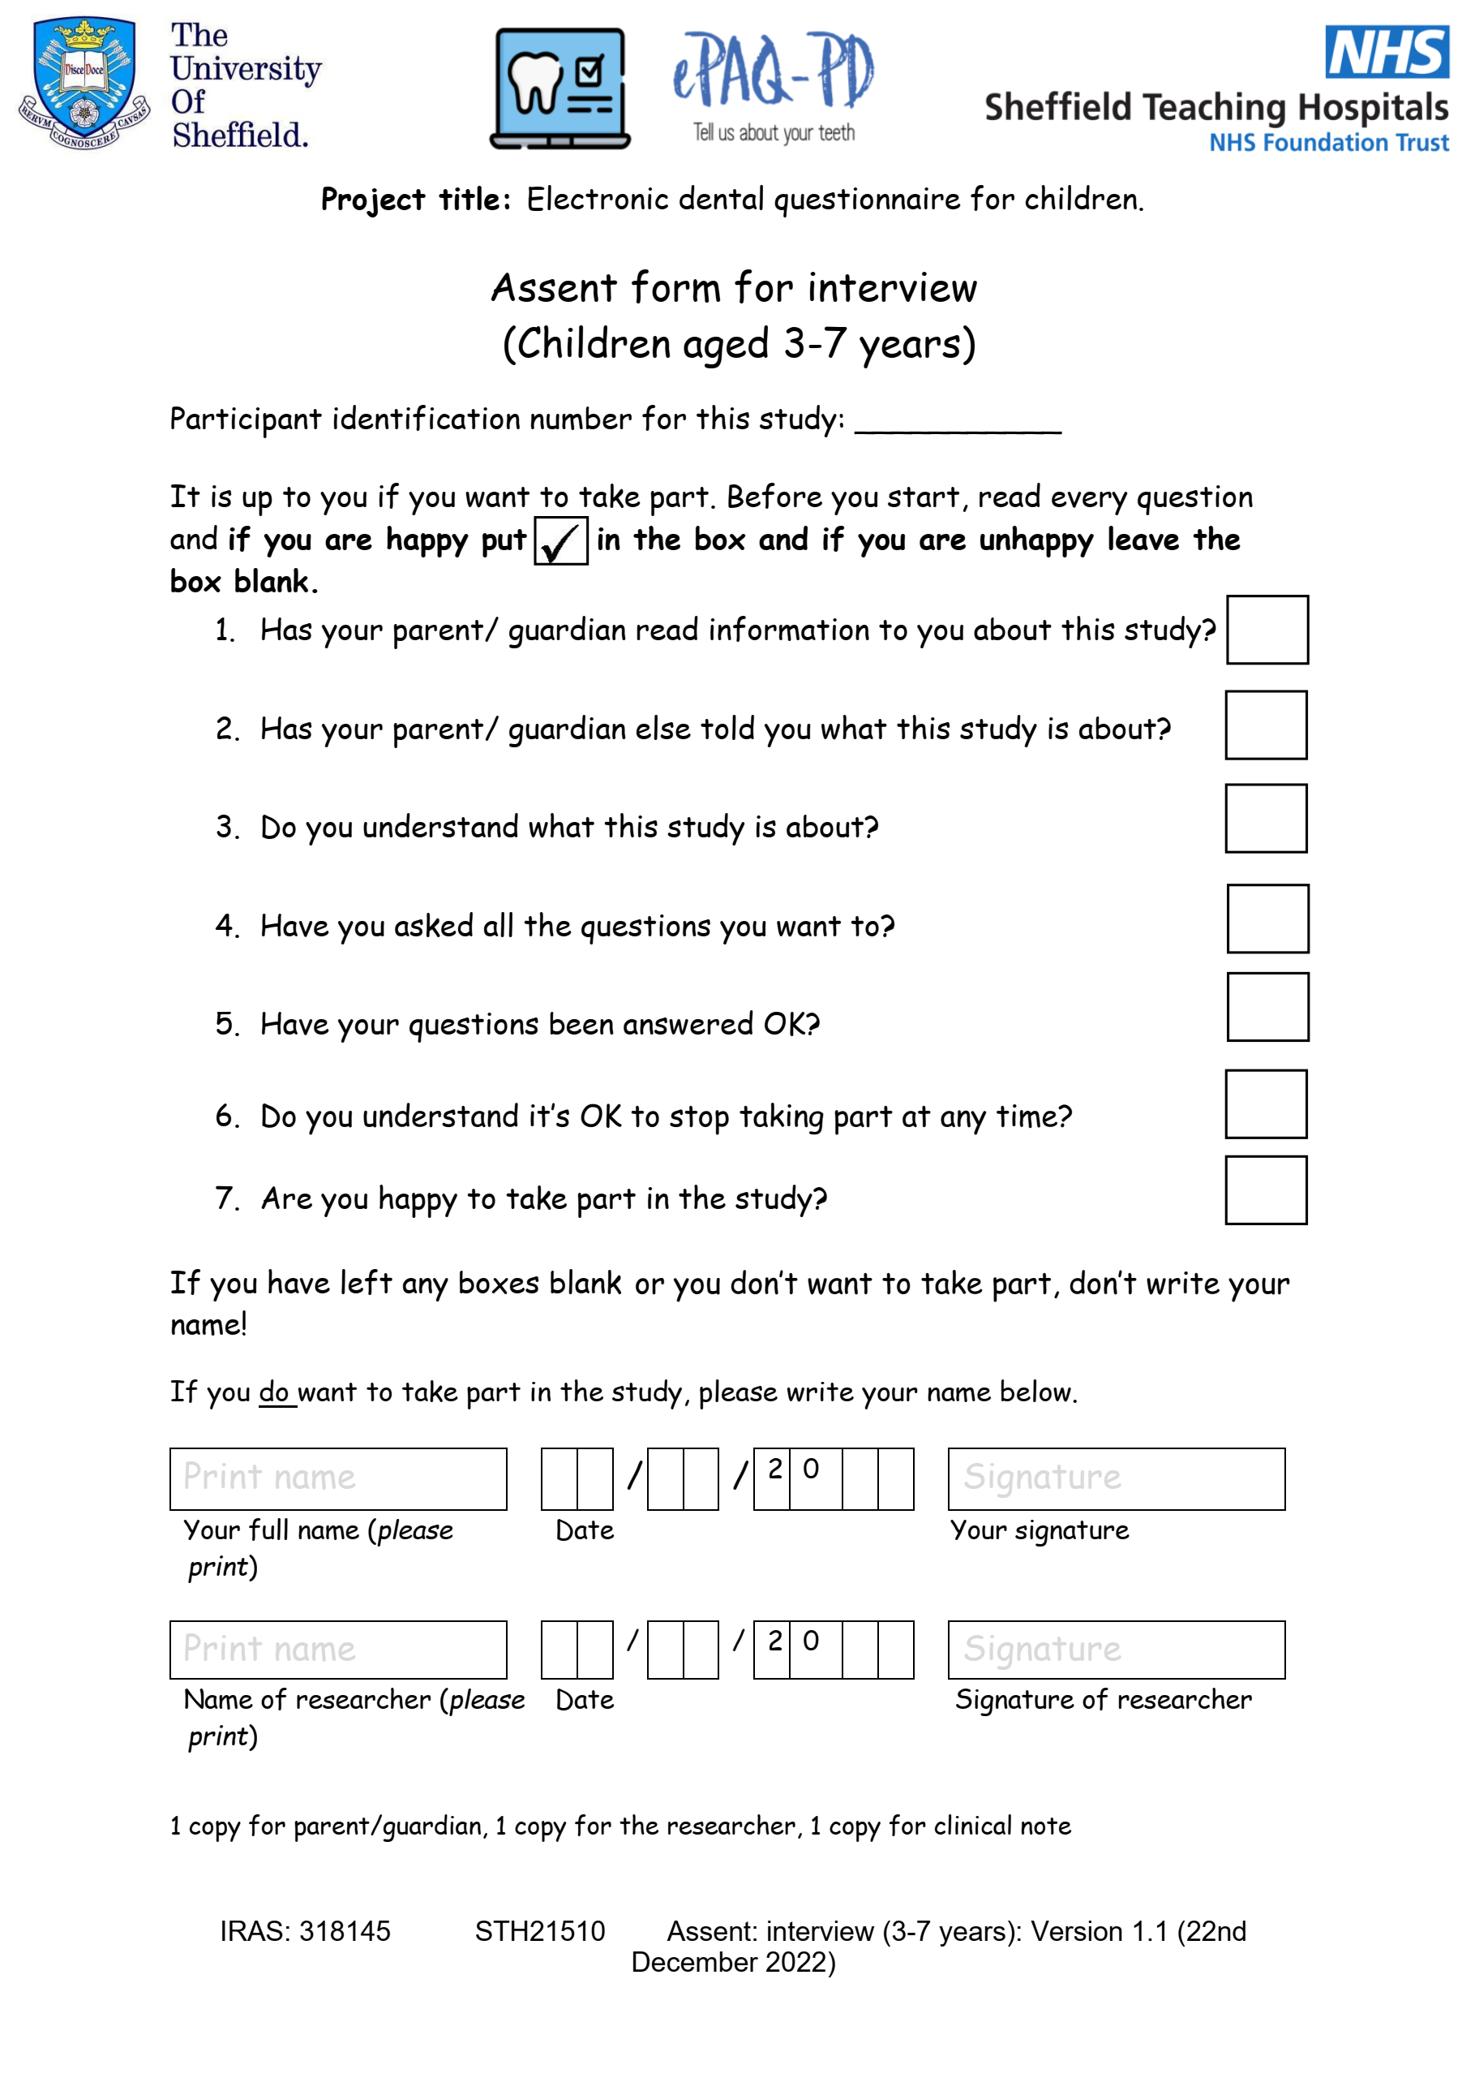
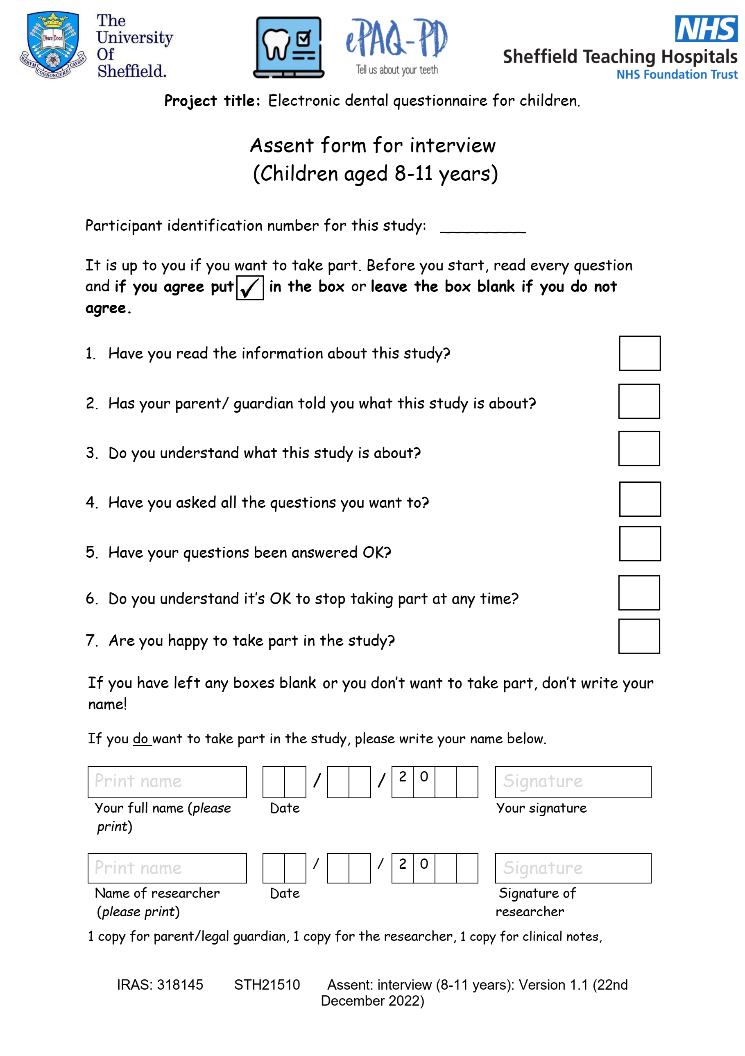

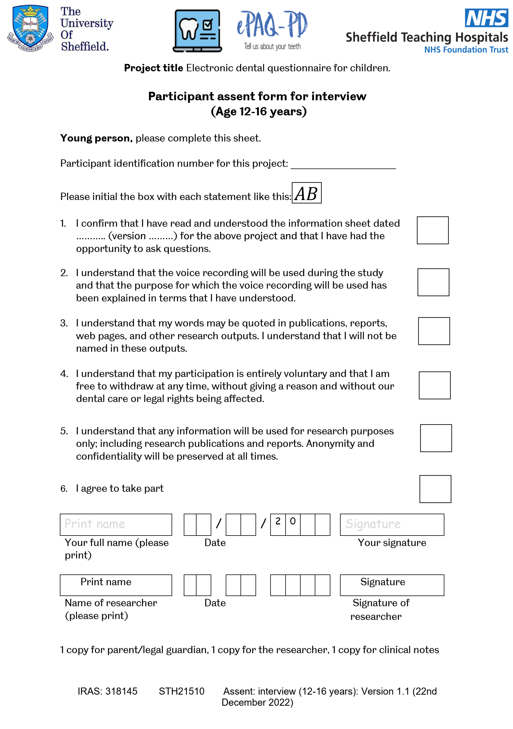

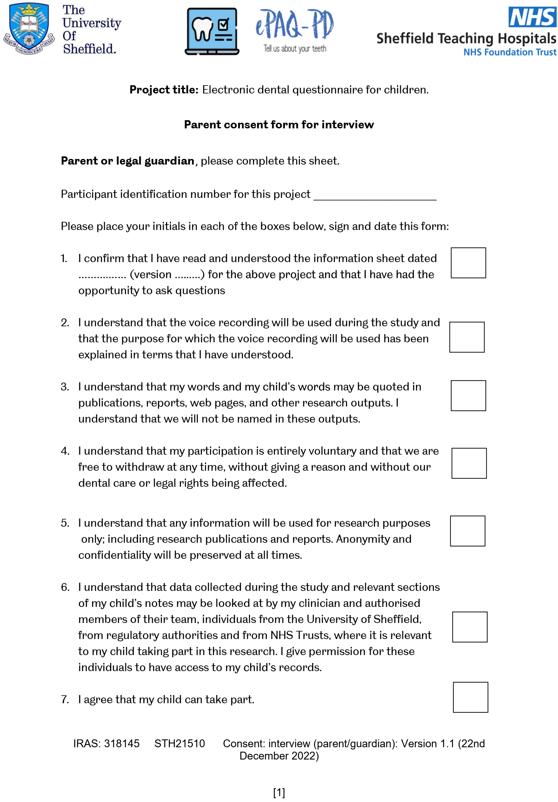

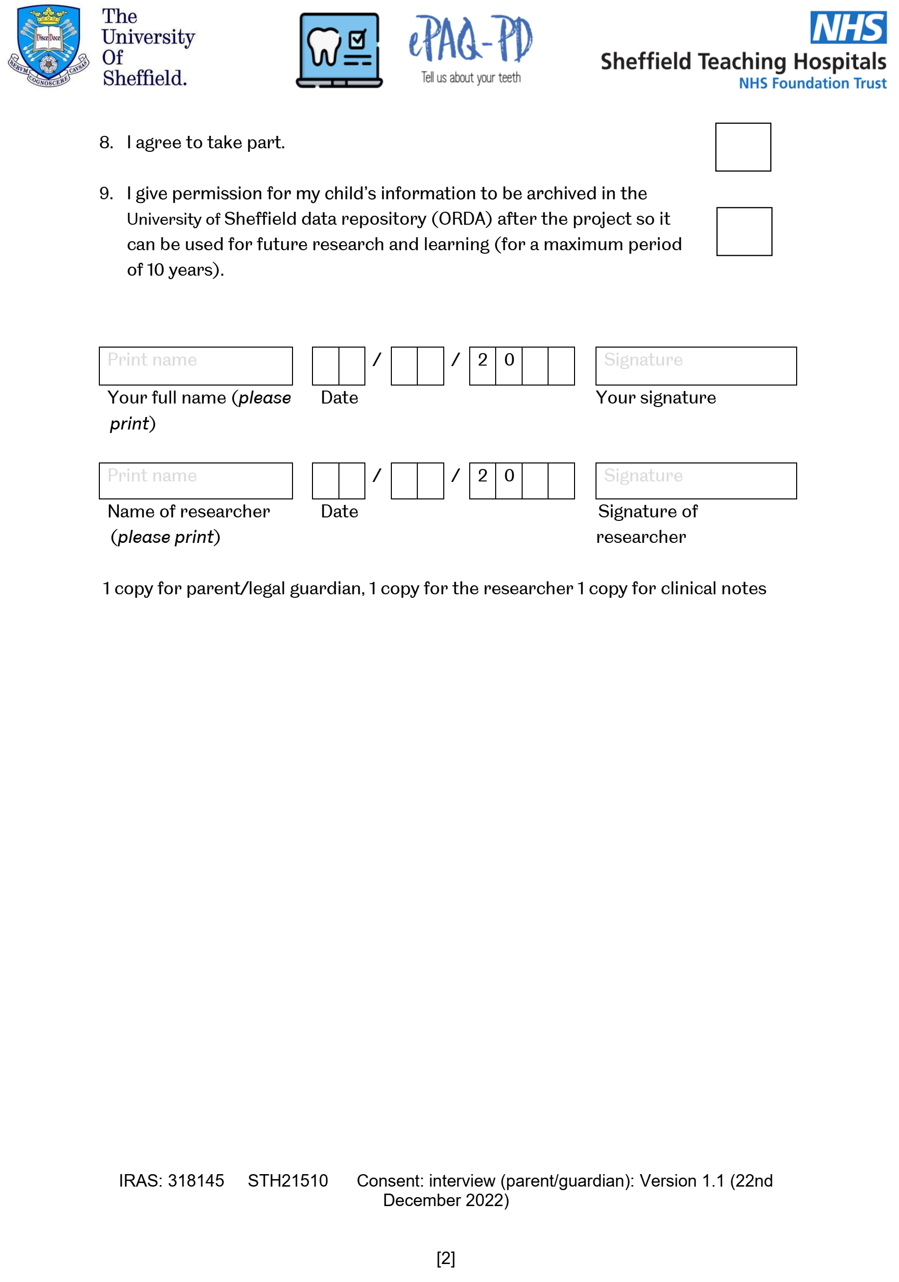

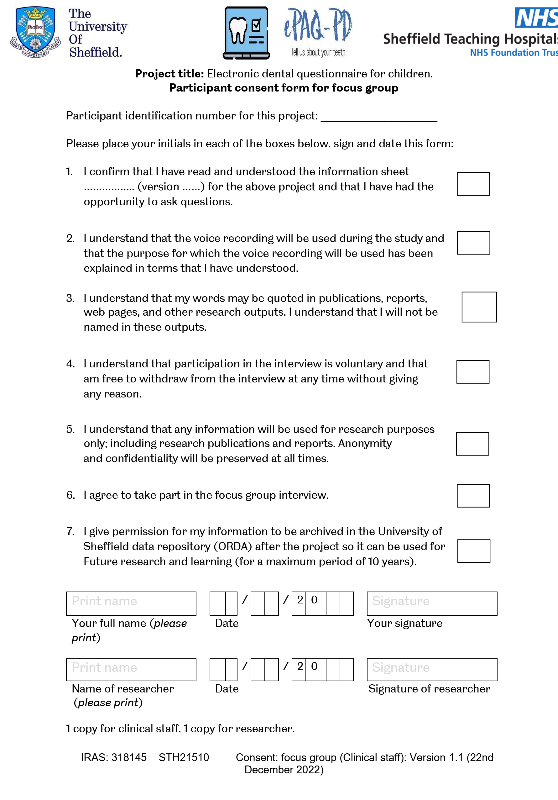

Appendix N. Topic-guides for interviews
N.1. Interview topics and questions for children and parents/carers
Accessing the ePAQ-PD
- Could you tell me first, what you know about the online dental questionnaire (ePAQ-PD)?
- Why did you decide to use the online dental questionnaire (ePAQ-PD)? How was it?
- Do you think other children may find it hard to get to the dental questionnaire website?
- Do you think of any better way to ask children to complete the dental questionnaire?
- Why did you decide not to use the online dental questionnaire (ePAQ-PD)?
Child and parent/guardian experience completing the ePAQ-PD
- What do you think about the questions? How long did it take?
- How easy or difficult do you think it is to complete the questionnaires?
- Could you tell me, what did you like and dislike about the online questionnaire?
- What do you think of the design and colour of the online questionnaire?
- Could you tell me what your family/ friends/caregivers think about you using the electronic dental questionnaire?
- There was a question that says, ‘any questions you would like us to answer at your appointment?’, what do you think about it?
- If one of your friends/siblings had to fill in the dental questionnaire, and asked you for advice what advice would you say to your friend/sibling?
- If you are responsible for the dental questionnaire, what would you change or add to get more children to complete the dental questionnaire?
Clinical use
- When you attended your appointment, what did you feel knowing that your dentist had read your answers?
- Do think the dental questionnaire (ePAQ-PD) has helped the dentist? If yes, how so?
N.2. Focus group topics and questions for clinical staff.
Routine use of ePROMs
- What are your thoughts on the routine use of ePROMs in the management of patients in new patient clinics?
- Do you think the routine use of ePROMs will benefit patients? If so, why and how? If not, why?
- How often would you like patients to complete questionnaires electronically?
- How do you think that the routine use of ePROMs data by clinical staff can be improved?
- Do think of any factors that may discourage the routine use of ePROMs data by clinical staff?
- Could you tell us what your peers and colleagues think about you using ePROMs, routinely?
- Are there any issues about using ePROMs that you would like to mention?
- Do you think that patients will benefit from using ePROMs in dental clinics other than new patient clinics?
- Is there anything else anyone would like to say on the use of ePROMs for the new patients in the paediatric dental clinic?
Views on the ePAQ-PD
- How would you like the display of the final report?
- What are your thoughts on the ePROMs used in the ePAQ-PD (CARIES-QC and CEDAM-8)?
- What are your thoughts on the lengths of questionnaires?
- What are your thoughts on the resources and support of ePAQ-PD?
- Do you think of any better way to ask children to complete the dental questionnaire (ePAQ-PD)? What about the scope of the questionnaires? Do individual ePROM cover all aspects that might be important to new patients, or are any elements missing?
- What are your thoughts on the item ‘general questions to the clinician’?
- Are there any questions that you suggested be included?

Appendix O. A copy of the ePAQ-PD final report

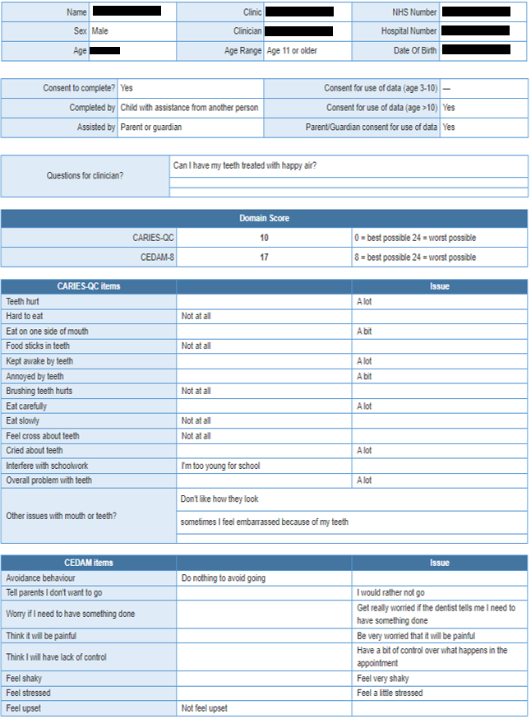

Appendix P. Content of observation notes.

No. | Observation notes
1 | “.. child was overlooked during history taking. it was felt that because the child was not anxious. The consultant did not use or refer to information from the ePAQ-PD “  (Observer notes; appointment 8)
2 | “.. child gave shy smile and without making eye contact with the dentist, parent replied: yes *child's name* has been like this for a while”  (Observer notes; appointment 5)
3 | “.. child replied by nodding her head with a smile..”  (Observer notes; appointment 4)
4 | “Child was holding his hand tight and did not establish eye contact with the dentist. His concerns were not visible in her behaviour but were obvious in his body language. It was felt that as the appointment goes, trust was established, and the child looked more calmer and stopped holding his hands tightly”.  (Observer notes; appointment 10)
5 | “Upon oral examination, the child said once he opened his mouth " here I can’t eat here" and was pointing to lower back teeth. " this was his first words in the appointments”  (Observer notes; appointment 5)
6 | “Tooth sensitivity was reported in the eCARIES-QC " hurt when brushing " item as a lot. Dentist only focused on open question responses”  (Observer notes; appointment 5)
7 | “Dentist used face scale on medical history form to assess anxiety, eCEDAM scores and responses were overlooked by the dentist”  (Observer notes; appointment 9)
8 | “Dentist focused more on anxiety as it was scored 23 without any sign of using responses of individual items but the anxiety was well discussed and controlled during appointment”  (Observer notes; appointment 4)
9 | “child's concerns regarding when he can run at playtime and to go back to do sport (Karate) were not addressed by consultant nor mentioned by child or parent”  (Observer notes; appointment 8)
10 | “No sign of ePAQ-PD information on treatment planning, it was pure clinical-based judgment”  (Observer notes; appointment 7)
11 | “Information from the epaq was not used when discussing treatment planning”  (Observer notes; appointment 8)
12 | “ RA (relative analgesia) was discussed which seemed like routine practice”  (Observer notes; appointment 4)
13 | “ ..general anaesthesia option was offered due to the number of teeth planned for extraction”  (Observer notes; appointment 3)

